Characterisation of extracellular vesicles released by HPV+ and HPV- oropharyngeal carcinoma cells in vitro
By Ben Peacock

A thesis submitted in partial fulfilment of the requirements for the degree of
Doctor of Philosophy

The University of Sheffield
Faculty of Medicine, Dentistry and Health
School of Clinical Dentistry

September 2018

Abstract

Key differences between Human papilloma virus positive (HPV+) and negative (HPV-) oropharyngeal squamous cell carcinoma (OPSCCs), such as tumour stability and patient prognosis, have yet to be fully understood resulting in insufficient treatment and detection options for patients. Extracellular vesicles (EV) are involved in complex cellular signalling and can be secreted from tumour cells to manipulate their environment aiding in tumour growth and survivability through the transfer of protein and RNA molecules. As such, EV research is becoming increasingly important to biomarker and drug development. EVs secreted from four cell lines were characterized by tunable resistive pulse sensing (TRPS) analysis showing a higher rate of EV secretion from 2 HPV- OPSCC lines compared to 2 HPV+ OPSCC lines. Utilizing size exclusion chromatography (SEC) and ultracentrifugation, EVs were purified and RNA and protein cargo extracted. Next generation sequencing showed miRNA profiles differ between these two cancers as hierarchical clustering grouped cell lines by HPV status and differential expression identified 14 miRNAs more abundant in the EVs of HPV+ OPSCC and 19 miRNAs more abundant in HPV- OPSCC EVs. Protein cargo of HPV- OPSCC EVs showed a greater variety of proteins than HPV+, approximately doubling the number of HPV+ EV proteins, and showing an association to cell-adhesion and ECM interactions. Exposing fibroblasts to EVs from both OPSCC types induced changes to α-SMA expression, with immune-fluorescent imaging highlighting a myo-fibroblastic phenotype similar to TGF-β treatment. EVs also stimulated tubule formation of endothelial cells on a matrigel layer suggesting pro-angiogenic properties of these EVs in the tumour stroma. This study demonstrates the importance of EVs in OPSCC development and identifies several key differences between HPV+ and HPV- tumours which may aid in future biomarker and drug development studies.

Contents

Abstract 2
Contents 3
Figures 9
Tables 10
Acknowledgements 11
Publications 11
Abbreviations 12
1 – Introduction 15
1.1 - HNSCC epidemiology 15
1.1.1 - HNSCC deaths 15
1.1.2 - Role of tobacco and alcohol in incidence 15
1.1.3 - Rise in HPV+ incidence of OPSCC 15
1.1.4 - Sexual behaviour as a cause of current incidence and geographical variance 16
1.2 - Patient differences between HPV+ and HPV- OPSCC 17
1.2.1 - Prognosis differences 17
1.2.2 - Biological distinctions - what's happening inside cells? 17
1.3 - Human papillomavirus 19
1.3.1 - HPV types 19
1.3.2 - HPV genome 19
1.3.3 - Viral entry and life cycle 20
1.3.4 - Viral life cycle in standard productive infection 20
1.4 - Roles of HPV gene products 23
1.4.1 -E1 and E2 23
1.4.2- E4 and E5 23
1.4.3 - E6 and E7 24
1.4.4 - Roles in neoplasia 25
1.5 – MiRNA 27
1.6 - HPV+ OPSCC is closer to cervical cancer than HPV- OPSCC 31
1.7 - Extracellular vesicles 32
1.7.1 - Exosomes 32
1.7.2 - Microvesicles 33
1.8 – The role of vesicles in cancer progression 36
1.8.1 - Escaping apoptosis 36
1.8.2 - Drug resistance and metastasis 37
1.8.3 – Angiogenesis 37
1.9 – Tumour derived EV cargo 38
1.9 – EV RNA in cancers 38
1.9.2 – EV proteome changes in cancers 39
1.10 - Viral interactions with endosomes and exosomes 41
1.10.1 - Evading host immune system 41
1.10.2 - Increasing infectivity and cell susceptibility 42
1.10.3 - Control of potentially oncogenic viral proteins 42
1.11 - Viral miRNAs in cancers 44
1.11.1 - EBV miRNA 44
1.11.2 - EBV exosomal viral miRNA transfer 44
1.11.3 - HPV encoded miRNAs 47
1.12 - Conclusion 48
1.13 - Hypothesis and aims: 49
2 - Materials and methods 50
2.1 - Materials 50
2.1.1 - Sources of materials 50
2.2 - Cell culture and cell lines 52
2.2.1 - Cell lines 52
2.2.2 - Growth medium 52
2.2.3 - Storage and resurrection of cells 52
2.2.4 - Passaging cells 53
2.2.5 - Cell counting 53
2.2.6 - Vesicle depletion of serum 53
2.3 - Extracellular vesicle collection 54
2.3.1 - Conditioned medium 54
2.3.2 - Differential centrifugation 54
2.3.3 - Ultra-filtration 54
2.4 - Size exclusion chromatography 54
2.4.1 - Column generation 54
2.4.2 - Vesicle purification by size exclusion chromatography 55
2.4.3 - Fraction pooling 55
2.5 - Tunable resistive pulse sensing 55
2.5.1 - Mean EV diameter, rate of EV secretion, EV size profile 55
2.5.2 - SEC EV elution profile 56
2.6 - Protein extraction for western blotting 56
2.7 - Measurement of protein concentration 56
2.8 - SDS-PAGE analysis 56
2.8.1 - Gel electrophoresis 56
2.9 - Western blotting 57
2.10 – Protein band densitometry 58
2.11 - Mass spectrometry 60
2.11.1 - EV protein preparation 60
2.11.2 - Label free mass spectrometry 60
2.11.3 - ITRAQ 61
2.12 - Mass spectrometry data analysis 62
2.12.1 - Label free MS data analysis 62
2.12.2 - ITRAQ data analysis 62
2.13 - RNA extraction 63
Standard laboratory procedure is to use the Qiagen miRNeasy kit to isolate RNA from cell samples. However, in order to isolate EV RNA the miRCURY RNA isolation kit (Exiqon) was used as it has been shown to acquire a higher concentration of EV RNA (Théry et al, 2006). 63
2.13.1 – Qiagen miRNeasy kit 63
2.13.2 – miRCURY RNA isolation kit (Exiqon) 63
2.14 – cDNA synthesis 64
2.15 - E1 qPCR 65
2.16 – Bioanalyser RNA assessment 65
2.17 - Next generation sequencing 65
2.18 - NGS Data analysis 66
2.18.1 - Deseq2 and EDGER through app 66
2.18.2 - RPM calculation 66
2.19 - Pathway analysis of NGS data 66
2.19.1 - MirTarbase and DAVID 66
2.20 – NGS validation by qPCR 67
2.20.1 – Reverse transcription 67
2.20.2 – RT-qPCR validation of selected NGS results 68
2.21 - Treating NOFs with EVs to determine effects upon α-SMA 69
3 - Isolation and characterisation of small extracellular vesicles 73
3.1 - Introduction 73
3.2 – Cell line analysis 74
3.2.1 – HPV status analysis – qPCR 74
3.2 – Isolation of small EVs 77
3.2.1 - Size exclusion chromatography 77
3.2.2 – SEC fraction analysis by TRPS 77
3.2.4 SEC fraction pooling – cumulative data 81
3.3 - EV markers – Western blotting 83
3.4 - EV characterization by TRPS 85
3.4.1 - Characterisation of EVs in conditioned medium 85
3.4.2 - EV secretion rate 85
3.4.3 – Modal EV diameter 87
3.4.4 – EV size distribution 89
3.5 - Characterization of EVs after SEC and ultracentrifugation 91
3.5.1 - SEC EVs modal size 91
3.5.2 - SEC EVs size distribution profile 91
3 - Discussion 94
3.6 - HPV status confirmation 94
3.7 - Effectiveness of size exclusion chromatography in EV purification 95
3.7.1 - EV and protein elution profiles 95
3.7.2 - Separation of protein and EVs 95
3.7.3 - Western blotting for EV presence in SEC and UC isolation 95
3.8 - EV characterisation 96
3.8.1 - EV secretion rates in OPSCC’s – HPV+ vs HPV- 96
3.8.2 - Determining EV sizes – Best practice and potential pitfalls 98
3.8.3 - SCC89 EVs are more numerous and are larger 99
4. Small RNA sequencing analysis of oropharyngeal cancer EV cargo 102
4.1. Introduction 102
4.2. EV RNA isolation and Bioanalyser analysis 103
4.2 – Small RNA sequencing of EV RNA 105
4.2.1 – RNA species in EVs 105
4.2.2 – Abundance of miRNAs 105
4.3 – Differential expression analysis 109
4.3.1 DEseq2 analysis 109
4.3.2 – Hierarchical clustering and PCA analysis 109
4.3.3 – Differentially expressed miRNAs associating with OPSCC HPV status 113
4.3.4 – Shared miRNAs between all OPSCC EV RNA samples 113
4.3.5 – Additional miRNAs of interest 115
4.4 – Pathway analysis of EV miRNAs 118
4.4.1 - Pathways targeted by EV miRNAs more abundant in HPV+ OPSCC than HPV- 118
4.4.2 - Pathways targeted by EV miRNAs more abundant in HPV- OPSCC than HPV+ 119
4.4.3 - Shared pathways 121
4.5 – qPCR validation of selected miRNAs from NGS results 123
4 - Discussion 125
4.6 - EV RNA isolation 125
4.7 - OPSCC EV miRNA profiles 126
4.7.1 - Distinguishing between HPV+ and HPV- samples 126
4.7.2 - Moving towards biomarker identification 128
4.8 - miR-34a-5p - A tumour suppressive miRNA more abundant in HPV+ EVs than HPV- 130
4.8.1 - Tumour suppressive roles of miR-34 and relation to p53 130
4.9 - miR-9 is associated with HPV+ OPSCC EVs but to what end? 132
4.10 – miRNA clusters associated with OPSCC EVs 134
4.10.1 - miR-363 is upregulated in HPV+ OPSCC EVs and down regulated in HPV- OSPCC EVs 134
4.10.2 - miRNA cluster miR-23a,-27a,-24 136
4.11 - miR143-3p and miR-126 suggested to be down regulated in HPV+ cancers yet elevated in our HPV+ EVs 137
4.11.1 - miR-143-3p 137
4.11.2 - miR-126 137
4.11.3 - miR-126 and miR-143 acting upon the cancer microenvironment 138
4.12 -TNF signalling and PI3K/Akt signalling in relation to cancer cell invasion and metastasis 140
4.12.1 - TNF signalling 140
4.12.2 - PI3K/Akt pathway 140
4.12.3 - MMPs - extracellular proteinases potentially targeted by HPV+ and HPV - associated EVs 141
4.13 - P53s regulation of miRNAs – and its disruption in both OPSCCs 144
4.13.1 - What happens to P53 in OPSCCs 144
4.13.2 - P53 impact on miRNA expression 144
4.13.3 - Is P53 the key player in HPVs miRNA regulation? 145
4.14 - HIF-1 signalling 146
5 – EV protein 147
5.1 – Introduction 147
5.2 – Label free mass spectrometry 148
5.2.1 – Unique protein abundances 148
5.2.2 – PCA and Hierarchical clustering 151
5.2.3 – Differential expression of proteins 153
5.2.4 – Most abundant proteins in EV samples 156
5.3 - GO term analysis 158
5.3.1 – HPV- EV associated protein activity 158
5.3.2 – Top 10 protein analysis 160
5.3.3 –Pathway targets shared between HPV+ and HPV- OPSCC EV proteins 166
5.4 – Label-free mass-spec validation 172
5.4.1 – ITRAQ 172
5.4.2 – Label-free MS relative abundances of select proteins 175
5.4.3 – Western blotting 177
5- Discussion 181
5.5 - Degree of similarity between OPSCC EV protein profiles 181
5.6 - Lectin galactoside-binding soluble 3 binding protein 183
5.7 - EGFR in HPV- OPSCC EVs 185
5.7.1 - EGFR in EVs 186
5.8 – Versican – a HPV+ OPSCC EV associated protein 187
5.9 - Histones in OPSCC EVs 189
5.10 - ITGA6 191
5.11 - Invasion and metastasis – the role of OPSCC EV proteins in cell adhesion 192
5.11.1 - Cell-cell adhesion 192
5.11.2 - Cell-ECM adhesion – focal adhesion 192
5.11.3 - EVs in adhesion 194
6 – Functional impact of OPSCC EVs on stromal cells 195
6.1 – Introduction 195
6.2 – NOF α-SMA qPCR 196
6.3 – NOF α-SMA western blot 199
6.4 – α-SMA stress fibre formation in NOF cells 202
6.5 – Pro-angiogenic activity 205
6– Discussion 209
6.6 – Angiogenic potential of OPSCC derived EVs 209
6.7 – OPSCC EVs and fibroblasts 212
7 – Final Discussion 214
7.1 - Cell adhesion and ECM interactions – pathways targeted by OPSCC EV protein and RNA cargo 214
7.1.1 - MiRNAs targeting MMPs – Working with or against EV protein content? 215
7.2 - Cell adhesion and Angiogenesis 216
7.3 - Opposing interactions in EVs 217
7.4 – Limitations of study 218
7.5 – Future work 218
7.6 - Closing remarks 219
References 221

Figures
Figure 1.1 - Stages of High risk HPV life cycle in regulated and deregulated conditions. 22
Figure 1.2 - Schematic representation of exosome and microvesicle biogenesis. 35
Figure 3.1 - RT-qPCR of HPV E1 for four cell lines 75
Figure 3.2 SEC EV elution profile 78
Figure 3.3 – SEC soluble protein elution profile 80
Figure 3.4 – Cumulative totals of EVs and soluble contaminate protein 82
Figure 3.5 – EV protein markers 84
Figure 3.6 – EV secretion rate over 24 hours 86
Figure 3.7 – EV modal diameter 88
Figure 3.8– 24h incubation EV size distribution 90
Figure 3.9 – SEC + ultracentrifugation purified EVs mode diameter 92
Figure 3.10 – SEC purified EV size distribution 93
Figure 3.11 – Size profiles of 2 EV subpopulations. 101
Figure 4.1 - Bioanalyser analysis of EV RNA. 104
Figure 4.2 – RNA species abundance 107
Figure 4.3 – Hierarchical clustering of NGS miRNAs by deseq2 111
Figure 4.4 – Multidimensional scaling of miRNA profiles 112
Figure 4.5 – Unique miRNAs more abundant in HPV+ EV RNA not identified by DEseq2 116
Figure 4.6 – Unique miRNAs more abundant in HPV- EV RNA not identified by DEseq2 117
Figure 4.7 – RT-qPCR validation of two miRNAs from NGS 124
Figure 5.1 – Unique protein abundance and replicate similarity 150
Figure 5.2 – Cell line correlation 152
Figure 5.3 – Differentially expressed EV proteins 154
Figure 5.4 – ITRAQ relative protein abundances 173
Figure 5.5 – Relative of abundance of select proteins determined by label-free MS 176
Figure 5.6 – Western blot validation of select proteins 179
Figure 6.1 – NOF α-SMA transcript expression 198
Figure 6.2 – α-SMA protein quantity 200
Figure 6.3 – IF α-SMA stress fibres 204
Figure 6.4 – HMEC tubule formation in response to EV treatment 207
Figure 6.5 – Total tubule length 208

Tables
Table 2.1 - Sources of reagents 51
Table 2.2 – Antibody list 59
Table 3.1 – HPV testing results by Hallamshire hospital cytology laboratory 76
Table 4.1 – Small RNA NGS read information 108
Table 4.2 – EV miRNAs associated with OPSCC HPV status 114
Table 4.3– DAVID pathway analysis of mirTarbase gene targets 120
Table 4.4 – Shared abundant miRNA pathway analysis 122
Table 4.5 – miRNAs associated with HNSCC’s when under or over expressed according to a 2017 meta-analysis (Lubov et al, 2017) and also identified in our research as in the EVs of HPV+ OPSCC or HPV- OPSCC. 129
Table 4.6 – MMP targeting of OPSCC EV miRNAs 143
Table 5.1 – Differentially expressed EV proteins 155
Table 5.2 – Most abundant EV proteins 157
Table 5.3 – GO term and pathway analysis of 49 HPV- associated proteins. 159
Table 5.4 –GO terms and KEGG pathway analysis of 10 most abundant SCC2 EV proteins 162
Table 5.5 –GO terms and KEGG pathway analysis of 10 most abundant SCC90 EV proteins 163
Table 5.6 –GO terms and KEGG pathway analysis of 10 most abundant SCC72 EV proteins 164
Table 5.7 –GO terms and KEGG pathway analysis of 10 most abundant SCC89 EV proteins 165
Table 5.8 – Pathways targeted by all OPSCC EV proteins 168

Acknowledgements

Thank you Stuart Hunt. I’m so grateful that I was able to work with you, your guidance and dedication have made this a fantastic experience for me and I know future students will continue to benefit from your wisdom and kindness.
I’d also like to take this opportunity to thank the people of Sheffield Dental School. I am grateful for the knowledge shared by Dan Lambert. I want to thank Helen Colley, whose supervision during my Masters inspired me to take on a PhD. I’d like to thank Caroline Evans for guiding me through mass spectrometry, it was a pleasure working with you. I thank Mark Ofield for working alongside me during our PhDs, and Amir Zaki for always being there.
A special thanks to my family. My love of science has always been nurtured at home and I’m glad I get make my parents proud by finishing this. Thank you Pops, for making all of this possible. And thanks to Beth for everything really.

Publications
Peacock et al: Extracellular vesicle microRNA cargo is correlated with HPV-status in oropharyngeal carcinoma; Journal of Oral Pathology & Medicine

Abbreviations
Word | Abbreviation
Amino acid | aa
Automatic Gain Control | AGC
Bicinchoninic acid protein assay | BCA
B‐Cell Lymphoma 2 | BCL-2
Biological process | BP
Bovine serum albumin | BSA
Cancer-associated fibroblasts | CAFs
Cajal bodies | CB
Cellular component | CC
Cyclin-dependent kinase | CDK
CDK inhibitors | CKI
Chronic lymphocytic leukemia | CLL
Cytomegalovirus | CMV
Counts per million | CPM
Cancer stem cells | CSCs
Damage-associated molecular pattern | DAMP
Data dependent acquisition | DDA
Differential expression | DE
Double-stranded DNA | dsDNA
Extracellular matrix | ECM
Epidermal growth factor receptor | EGFR
Epithelial–mesenchymal transition | EMT
Endosomal sorting complexes required for transport | ESCRT
Exosomal shuttle RNA | esRNA
Extracellular vesicle | EV
Focal adhesion kinase | FAK
Fold change | FC
Foetal calf serum | FCS
Formalin-fixed, paraffin-embedded | FFPE
Family of transcription factors | FoxOs
Glycosaminoglycan | GAG
Glioblastoma | GBM
Gene ontology | GO
Histamine H1 receptor | H1HR
Hepatocellular carcinoma | HCC
High density exosomes | HD-exo
Hepatocyte growth factor | HGF
Hypoxia-inducible factor-1 | HIF-1
Head and neck squamous cell carcinomas | HNSCC
High-performance liquid chromatography | HPLC
Human papillomavirus | HPV
HPV-negative | HPV-
HPV-positive | HPV+
Hypoxia-resistant | HR
Heparan sulfate proteoglycan | HSPG
Herpes simplex virus-1 | HSV-1
Invasive cervical carcinomas | ICC
Interferon-induced tetratricopeptide repeat 5 | IFIT5
Ubiquitin-like interferon | IFN
Intraluminal vesicles | ILVs
Invasive squamous cell carcinomas | ISCC
Injection time | IT
Integrin-alpha-6 | ITGA6
Isobaric tags for relative and absolute quantitation | iTRAQ
Latent membrane protein | LMP1
Long control region | LCR
Low density exosomes | LD-exo
Lectin galactoside-binding soluble 3 binding protein | LGALS3BP
Log2 FoldChange | log2 FC
Multidimensional scaling | MDS
MiRNA-loaded RISC | miRISC
MicroRNA | miRNA
Multiple myeloma | MM
Metalloproteinases | MMP
Tandem mass spectrometry | MS/MS
Mesenchymal stem cells | MSCs
Multivesicular bodies | MVBs
Molecular weight cut off | MWCO
Myosin 1B | MYO1B
Next generation sequencing | NGS
Normal oral fibroblasts | NOFs
Normal oral keratinocytes | NOK
Nasopharyngeal carcinomas | NPC
Non-small cell lung cancer | NSCLC
Nanoparticle tracking analysis | NTA
Oropharyngeal squamous cell carcinoma | OPSCC
Oral squamous cell carcinoma | OSCC
Dulbecco’s phosphate buffered saline | PBS
PBS-Tween-20 | PBST
Principal-components analysis | PCA
Podoplanin | PDPN
Pyruvate kinase | PK
Pyruvate kinase type M2 | PKM2
Retinoblastoma protein | pRB
Post-translational modifications | PTMs
RNA-induced silencing complex | RISC
RNA interference | RNAi
Reads per million | RPM
Sodium dodecyl sulfate polyacrylamide gel electrophoresis | SDS-PAGE
Size exclusion chromatography | SEC
Smooth muscle actin | SMA
Standard error of the mean | SEM
Small interfering RNAs | siRNA
Synaptosome-associated protein | SNAP
Soluble N-ethylmaleimide-sensitive factor attachment protein receptor | SNARE
Sprout-related EVH1 domain-containing protein 1 | SPRED1
Tris-buffered saline + 0.1% (w/v) Tween 20 | TBST
The cancer genome atlas | TCGA
Tetraspanin-enriched microdomains | TEMs
Transforming growth factor-β1 | TGF-β1
Tumour-derived microvesicles | TMV
Tumour necrosis factor | TNF
Tunable resistive pulse sensing | TRPS
Tonsillar squamous cell carcinoma | TSCC
Tumour susceptibility gene 101 protein | TSG101
Urokinase-type plasminogen activator | uPa
Vascular growth factor receptor | VEGF
Whole exome sequencing | WES
α-smooth muscle actin | α-SMA

1 – Introduction

1.1 - HNSCC epidemiology

1.1.1 - HNSCC deaths
Head and neck squamous cell carcinomas (HNSCC) are the sixth most common malignancy worldwide with an estimated annual incidence of ∽633,000 cases, resulting in 355,000 deaths. This group of malignancies is comprised of carcinomas from five anatomical sites; the oral cavity, oropharynx, nasopharynx, hypopharynx, and larynx (Ferlay et al, 2010).

1.1.2 - Role of tobacco and alcohol in incidence
These cancers are heavily linked to alcohol consumption and tobacco exposure with as many as 80% of HNSCC cases being partially attributable to tobacco exposure (Sturgis et al, 2007). These two risk factors are dose dependent with studies indicating clear dose-response relationships for the frequency and duration of cigarette smoking. Perhaps most disturbing is the suggestion that, as shown in one study of over 25,000 subjects, approximately 24% of the tobacco linked cases would not have occurred in the absence of tobacco exposure (Hashibe et al, 2007).

1.1.3 - Rise in HPV+ incidence of OPSCC
Whilst it can be said that the overall incidence of HNSCC associated with tobacco and alcohol has been declining due to cultural changes in consumption rate of these two carcinogens, oropharyngeal squamous cell carcinoma (OPSCC) associated with human papillomavirus (HPV) infection has seen rapid increase in incidence rates particularly in developed countries (Chai et al, 2015).
One study indicated that the incidence of HPV-positive (HPV+) oropharyngeal cancers increased by 225% from 1988 to 2004 in the U.S (Chaturvedi et al, 2011). This shift in OPSCC prevalence has led to the estimation that 22,000 out of 85,000 worldwide OPSCC cases were HPV+ in 2008 (De Martel et al, 2012).

1.1.4 - Sexual behaviour as a cause of current incidence and geographical variance
A more recent global analyses suggested 25.6% of worldwide OPSCC cases are HPV+ with great variance between geographical regions, ranging from 56% in North America to 17% in Southern Europe (Gillison et al, 2014; Benson et al, 2014). Geographical variance and the rise in HPV+ OPSCC can be attributed to changes in sexual behaviour in specific regions which have led to an increase in sexual transmission of the HPV virus (Psyrii, 2007).
In a study of 5579 healthy men and women aged 14 to 69 years in the United States oral HPV infection was detected in 6.9% of individuals with prevalence being higher among men than among women. HPV infection also increased in groups with higher numbers of sexual partners. (Gillison et al, 2012).

1.2 - Patient differences between HPV+ and HPV- OPSCC

1.2.1 - Prognosis differences
Patients with HPV+ OPSCC have a better prognosis than HPV-negative (HPV-) patients showing significantly improved overall survival and disease-free survival (Weinberger et al, 2006; Elrefaey et al, 2014). The HPV+ tumours also remain more confined than the HPV- tumours which are more aggressive in their local invasive properties (Benson et al, 2014).
A significant reason for the better prognosis is the improved response to treatment seen in HPV+ tumours. A comparison of HPV-positive and negative OPSCC patient response showed response to chemotherapy (82% vs. 55%) and chemoradiation (84% vs. 57%) in favour of the HPV+ patients. The same study showed a 95% 2 year survival for the HPV+ patients compared to 62% in the HPV- group (Fakhry et al, 2008).
A noteworthy issue with HPV+ OPSCC is an association with distant metastases. These can often occur much later than in HPV- OPSCC patients, commonly involving a greater number of subsites in areas not associated with HPV- OPSCC (Trosman et al, 2015).

1.2.2 - Biological distinctions - what's happening inside cells?
The differences in genetic alterations and cellular activity are likely to play a role in the separate prognoses. HPV+ oropharyngeal cancer is associated with the degradation of tumour suppressing p53, down regulation of retinoblastoma protein (pRB), and the up regulation of P16 as a result of oncogenic HPV proteins. Conversely, HPV- oropharyngeal cancers are associated with mutations in p53, the up regulation of pRB, and the down regulation of p16 (Chu et al, 2013).
Furthermore, HPV- OPSCCs are prone to much more genetic mutation, suffering deletions of large parts of chromosomal arms, whereas HPV+ OPSCCs may only suffer occasional chromosomal deletions or allelic imbalance (Dahlgren et al, 2013).
As an epidemiologically distinct form of oropharyngeal cancer, understanding how HPV manipulates, transforms and progresses HPV+ tumours is important fundamental knowledge which can be translated to clinical relevance.

1.3 - Human papillomavirus

1.3.1 - HPV types
With over 200 genotypes of papillomaviridiae, evincing at least 10% nucleotide divergence in the L1 capsid gene, there are a variety of classification and grouping methods. The ability to infect either mucosal or cutaneous keratinocytes is a classification which mostly aligns with the alpha and beta genera respectively. The capacity to induce malignancy in a host cell also determines classification of a HPV genotype as either high or low risk (Woods et al, 2014).
Genotypic prevalence of oncogenic HPV varies between the HNSCCs (even between subsets) and cervical cancer. Whilst HPV-16 is the most prevalent genotype associated with all cancers, it has been shown to be present in ~90-95% of HPV+ OPSCC (Gillison et al, 2000) and yet only present in ~74% of HPV+ non-oropharyngeal HNSCCs. In cervical cancers the prevalence of HPV-16 drops further to ~61% (Woods et al, 2014). We also see a difference in the variety of HPV genotypes identified in specific cancers, with many variants able to induce malignancy in the cervix but only a few in the oropharyngeal region (Chaturvedi et al, 2011).

1.3.2 - HPV genome
HPV is a double-stranded DNA (dsDNA) virus capable of infecting mucosal or cutaneous epithelial tissue. Infection sites can occur at a variety of anatomical locations and can develop benign or malignant lesions (Ganguly et al, 2007). HPV has a non-enveloped circular genome of 8kb which can be separated into three regions; the early gene region is ~4 kb, the late gene region ~3 kb, and the long control region (LCR) is ~1 kb (Qian et al, 2013).
The LCR controls transcription of the early and late genes and hence production of early (E1, E2, E4, E5, E6 and E7) and late (L1 and L2) proteins. Transcription of the early genes occurs soon after entry into host cells and are involved in regulating viral DNA replication and transcription, transformation of the host cell and eventually viral assembly and release. L1 and L2 are structural proteins for formation of the viral capsid. Expression of these genes is determined by differentiation stage of the infected epithelial cell and the utilization of early and late promoters which determines where transcription of polycistronic mRNA begins (Longworth et al, 2004).

1.3.3 - Viral entry and life cycle
As HPV is epitheliotropic, successful HPV infection requires the virion to reach the basal layer of epithelial tissue as shown in figure 1.1. This is assumed to be made possible through micro-abrasions which leave the basal layer exposed temporarily (Doorbar, 2015).
Upon reaching the basal epithelial cells the virion binds to the glycosaminoglycan (GAG) chains of heparan sulfate proteoglycan (HSPG) inducing a conformational change of the virion to expose a furin/proprotein convertase cleavage site at the amino terminus of L2. Proteolytic cleavage of this exposed site is required for infection, but a full or clear description of the endocytosis of HPV is not yet described (Day et al, 2014).
E1 protein contains a nuclear localization signal important for the genome of the endocytosed HPV to be delivered to the nucleus as it is trafficked through the endosomal system (Miller et al, 2012). During this process the virus is at least partially uncoated with L1 proteins and L2 proteins being trafficked separately (Schelhaas et al, 2012).
The HPV genome and L2 undergo nuclear import and upon entry into the nucleoplasm both co-localise at ND10 domains, a nuclear substructure important in transcription. The virus can then initiate transcription and begin its post entry program (Tavalai et al, 2008; Fay et al, 2015).

1.3.4 - Viral life cycle in standard productive infection
In general the viral genome enters the nucleus of a basal epithelial cell and transcription of the genome allows the generation of episomes to a low copy number (~ 50 - 200 per cell). The viral proteins E1 and E2 are essential for initial episome generation (Maglennon et al, 2011).
Development from single cell infection to a reservoir infection of multiple basal cells requires division of the host cells (figure 1.1). Whilst this is likely to occur naturally, the wound healing environment and viral proteins of high risk HPV, E6 and E7, are able to aid in cellular proliferation. In low risk variants the E6 and E7 do not promote cellular proliferation, at least not the same extent (Doorbar, 2006; Egawa et al, 2015)
Daughter cells of the basal epithelia are driven towards the surface and undergo differentiation. It is the cellular differentiation that triggers a different set of viral protein production so that E4, E5, and E2 expression may drive an increase in episomal copies into the thousands (Doorbar, 2006; Egawa et al, 2015)
Once near the surface, late genes L1 and L2 become expressed and whole virions can be generated and released from the epithelial surface (figure 1.1). What is key to note is that disruptions to the virus' ability to correctly undergo this ordered expression lead to both non-productive/abortive infections as well as the neoplastic lesions which can be lethal to the host.
In the next section the roles of the viral gene products are further discussed leading to a brief discussion of how malignancies can arise.
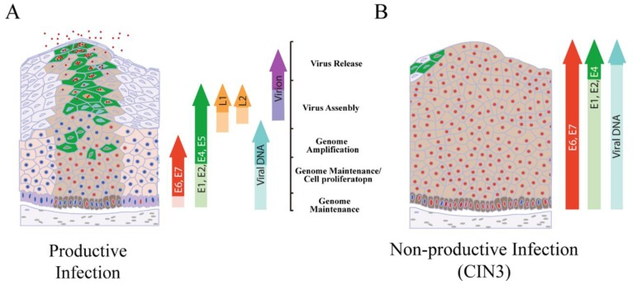
Figure 1.1 - Stages of High risk HPV life cycle in regulated and deregulated conditions.
A) Cell cycle progression of basal layer cells is driven by E6 and E7 (Red Nuclei). Genome amplification is initially driven by E1 and E2 in the basal layer before E4 and E5 proteins are active to drive genome amplification as the cells enter the upper epithelium (Red and green). L1 and L2 production allows for viral particle assembly and release is aided by E4. B) Expression of the late genes is impaired as E1 and E2 expression is suppressed by elevated E6/E7 expression restricting the area in which infectious virions are created until the infection is non-productive or abortive. DNA integration becomes a risk which in turn can further deregulate E6/E7 expression (Egawa et al, 2015).

1.4 - Roles of HPV gene products

1.4.1 -E1 and E2
E1 and E2 facilitate genome amplification. These proteins form a complex to bind at the viral origin of replication as the recognition sites for E1 and E2 are adjacent and the E2 protein loads E1 onto the origin (Miller et al, 2012; Ganguly, 2012).
Host cell polymerases are then recruited to form a replication complex and the E1 protein allows for replication through its own helicase activity unwinding the DNA ahead of the replication complex. As a transcription factor; E2 levels regulate early gene transcription, binding to the promoter region at low levels or blocking/binding host factors which are stimulatory for early gene expression (Ganguly et al, 2009; Schweiger et al, 2007). If E2 becomes unable to regulate E6/E7 production the chances of malignancy are increased. This is commonly seen if the viral genome becomes integrated due to a preferential integration point within the E2 open reading frame (Jeon et al, 1995).

1.4.2- E4 and E5
Of the early genes, E4 becomes most important at later stages of epithelial differentiation. This is due to the utilization of late gene promoters following epithelial differentiation which promote E4 transcription (Miller et al, 2012). Once expressed, its primary role is to aid in viral particle assembly and release but it also indirectly aids in optimization of genome amplification through its binding to E1 (Wang et al, 2004).
E5 aids in genome amplification as it stabilizes epidermal growth factor receptor (EGFR). E5 localizes to membrane-bound compartments such as endosomes where it binds endosomal vacuolar ATPase which indirectly results in increased recycling of receptors to the cell surface amplifying EGFR signalling (DiMaio et al,2013; Miller et al, 2012).
The E5 oncoprotein also indirectly increases the proliferative impact of E6 and E7 in early carcinogenesis, yet is often lost after viral integration as E5 gene expression is prevented. The episomal DNA is however sufficient to allow transcription of E6 and E7 oncogenes (Woods et al, 2014).

1.4.3 - E6 and E7
The 160 amino acid (aa) HPV E6 oncoprotein is sufficient for inducing cellular transformation. A major role of E6 is the degradation of the tumour suppressor protein p53, preventing cell cycle arrest at the G1 phase if DNA damage is detected. As a result E6 expressing cells are associated with genomic instability and mitotic stress (Woods et al, 2014). In this way E6 can be important for enhanced cellular proliferation but also in high risk HPV its primary role becomes cellular transformation, demonstrated by its dysregulation in over 50% of tumours (Muller et al, 2013), and as such it is therefore likely to be involved in the evolution of HPV's oncogenic behaviour. As will be discussed later, P53 also plays a role in the regulation of microRNAs (miRNAs) and exosomes (Azmi et al, 2013).
E7 oncoprotein has a length of ~100aa and is important for enhancing cellular proliferation through its action upon retinoblastoma protein (pRb), a protein responsible for G1/S check point control.
In its hypophosphorylated state pRB binds to the E2F transcription factor, preventing the cell from entering S Phase. In order to progress through the cell cycle pRB is phosphorylated by cyclin D1/cyclin-dependent kinase (CDK)4 and cyclin E/CDK2 complexes, deactivating its binding potential and allowing E2F to promote S-phase progression (Jo et al, 2005).
E7 binds and inactivates hypophosphorylated pRb preventing it from binding E2F transcription factor allowing cell cycle progression (Dyson et al, 1989). High and low risk E7 variants have different affinities for members of the pRB family. The high risk types affect a larger array including p105, p107, and p130 over multiple epithelial layers whilst low affinity types have weaker associations and mostly impact cell cycle progression in lower epithelial layers (Barrow-Laing et al, 2010).
E7 can also activate specific kinases which inactivate pRB through phosphorylation such as CDK2/cyclin A and CDK2/cyclin E. Furthermore E7 binds CDK inhibitors (CKIs) p27 and p21, also preventing G1/S checkpoint control (Ganguly et al, 2009). High risk E7 also contributes to oncogenesis through its ability to deregulate the centrosome cycle during proliferation of the basal cells (Doorbar et al, 2012).

1.4.4 - Roles in neoplasia
Due to the importance of proper transcriptional maintenance during HPV's life cycle and its reliance on temporal and spatial cues, interference in cellular differentiation is capable of inducing carcinogenesis as the cell becomes resistant to growth regulation and apoptosis. Uncontrolled cellular proliferation then further contributes to malignancy as chromosomal instability leads to the accumulation of genetic mutations (Doorbar et al, 2012).
One of the most noteworthy facts is the relatively low percentage of HPV infections that lead to tumour development. More frequently the oral HPV infection is cleared by the host immune system and malignancy is avoided (Kreimer et al, 2013). Yet if the immune response is evaded and the infection persists, the continued effects of E6 and E7 oncoproteins make carcinogenesis more and more likely.
For a long time it was unclear whether genomic integration is required for HPV+ OPSCC progression as is seen in cervical carcinomas (Jeon et al, 1995). Originally, studies observed that integration was likely to occur in tonsillar crypts potentially explaining the predominance of HPV related SCCs at this site (Begum et al, 2005). However, more recent studies have shown that episomal HPV is sufficient for OPSCC progression and integration of the HPV genome occurs far less frequently in OPSCC than it does in cervical cancer (Gao et al, 2014; Jung et al, 2010).
In one study, HPV genomes were not integrated in three of nine HPV+ HNC tumours whilst the other six tumours showed genomic integration. Sequence analysis of the latter tumour samples and a selection of HPV+ human keratinocyte cell clones showed that viral integration could occur in a variety of chromosomes and were often located within or close to growth control genes. This suggests HPV integration to be a stochastic process which can result in the clonal selection of cells with increased proliferative potential (Lace et al, 2011). The ultimate triggers which lead to tumourigenesis in episomal HPV+ cells remains unclear but imbalances in HPV protein levels are likely highly important.

1.5 – MiRNA
MicroRNAs (miRNAs) are endogenous, small non-coding RNAs that are key to the regulation of gene expression. Mature miRNAs are single-stranded and 21-25 nucleotides in length following progression from primary miRNA (pri-miRNA) to precursor miRNA (pre-miRNA) to mature miRNA (Lee et al, 2002). Pri-miRNA are often several kilobases long and form stem loop/hairpin structures by folding to match base pairs along the strand. Primary processing is carried out by Drosha and other proteins cleaving at the base of the structures, producing the 60-70 nucleotide pre-miRNA (Zeng et al, 2003). Exportin-5 helps transport pre-miRNA out to the cytoplasm through nuclear pores where it is further processed. Pre-miRNA undergoes further cleavage by Dicer proteins before the 21-25 nt double strand is loaded into and Argonaute protein complexes and the strands are separated (Lee et al, 2002).
In order to impede translation, miRNA aids in guiding associated RISC proteins to target mRNA, known as miRISC complexes, by miRNA–mRNA complementary binding. This can result in mRNA degradation or translational repression (Bagga et al, 2005).

1.5.1 – Cancer miRNAs
It is well understood that miRNA expression is dysregulated in human cancers with clear downstream effects. Multiple mechanisms exist which drive these changes to miRNA levels and subsequently mRNA levels. miRNA genes may be amplified or lost, for example in lung cancers miR-143 and miR-145 have been shown to be deleted whilst the miR-17–92 cluster is often amplified (Hayashita et al, 2005; Calin et al, 2006). miRNA regulators which control transcription of miRNA are often found to be altered in tumour cells such as c-Myc and p53 (Peng et al, 2006).

1.5.2 - Host miRNA expression in HPV+ tumours
MiRNAs are important for the HPV viral life cycle and progression of cancer. A study in 2005 showed that over the range of differentiation states for multiple tumour types the miRNA profile of these tumours was altered to such a degree that the tumour stage could be estimated from the miRNA profile alone (Lu et al, 2005).
Studies focused on HPV+ cervical cancers show similar results. A comparison of the miRNA profiles between early stage invasive squamous cell carcinomas (ISCC) and normal cervical squamous epithelial tissues identified 70 miRNAs that were differentially expressed. Several of these impact pathways important in cancer such as miR-199's association with cell growth and proliferation and miR-127's association with lymph node metastasis (Lee et al, 2008).
A comparison of miRNA profiles of HPV+ tumour sections to histology throughout a spectrum of cervical tissue biopsies, CIN 2-3, SCC and normal HPV- control identified 31 unique miRNAs with significantly increased expression. One of these was miR-29 which targets YY1, a transcription factor involved in histone modification. Further study of miR-29 suggested it is regulated by the HPV E6 and E7 proteins (Li et al, 2011).
These HPV oncoproteins are continually implicated in the regulation of miRNAs specifically linked to aspects of cancer progression.
As previously mentioned the oncoproteins of high risk HPV, E6 and E7, impact many molecules and pathways that are related to pro-tumourigenic processes. An important aspect of this is the effect of E6 and E7 on the miRNA profile of the host cell.
The effects of E6 and E7 on pathways altered in cancer can be reversed as shown by silencing and inhibition studies which allow reactivation of the impaired or dormant tumour suppressor pathways. In one study, E6-binding peptide aptamers were used to inhibit E6 activity, resulting in the induction of apoptosis (because E6 related anti-apoptotic activity was inhibited) in HPV+ cell lines and this activity was not observed in the HPV- controls (Butz et al,2000).
It should also be noted that that E6 and E7 can effect miRNA expression indirectly through interaction with other molecules, such as transcription factors E2F and c-Myc and the previously mentioned tumour suppressors such as pRB and P53 (Zheng et al, 2011).
An example of a miRNA regulated indirectly is miR-23b, which has been shown to be downregulated in HPV+ cervical carcinomas. This down regulation allows for the accumulation of urokinase-type plasminogen activator (uPA), a serine protease linked to malignancies. uPa is not detectable in normal cervical tissue yet becomes detectable in HPV+ cervical carcinomas. Using human cervical carcinoma SiHa and CaSki cells it has been shown that the presence of E6 decreases miR-23b expression resulting in increased migration potential of cells. This interaction was mediated by p53, a tumour suppressor inactivated by E6 (Au Yeung et al, 2011).
A recent transcriptome study of HPV+ cervical cancer cell lines showed that both intracellular and exosomal miRNA levels were greatly influenced by E6 and E7 expression (Honegger et al, 2015). Both cellular and exosomal miRNAs were affected by E6 and E7 expression or experimental silencing of these two oncoproteins. The 10 miRNAs most affected are linked to regulating cell proliferation, senescence and apoptosis thereby highlighting their role in tumourigenesis (Honegger et al, 2015). Interestingly, 8 out of these 10 heavily influenced miRNAs were being modulated by E6/E7 silencing in a p53 independent manner.
This group's work also showed that E6/E7 silencing led to changes in the types of RNA species sorted into exosomes, with silencing leading to an increase in exosomal miRNAs. Having scrutinized their list of affected exosomal miRNAs; seven were validated by qRT-PCR indicating that E6 and E7 play a role in the upregulation of let-7d-5p, miR-20a-5p, miR-378a-3p, miR-423–3p, miR-7–5p, miR-92a-3p and a downregulation of miR-21–5p. All of these can be linked to tumourigenic processes; for example miR-20a-5p is known to block oncogene-induced senescence via p21 repression (Hong et al, 2010). Interestingly E6/E7 activity downregulates miR-21–5p, a miRNA which is associated with pro-tumourigenic activity (Honegger et al, 2015).
One study of 213 primary cervical cancer patients and 158 control subjects attempted to identify the circulatory miRNAs in serum that could be used as biomarkers. The results indicated that 5 miRNAs showed potential, these being miR-21, −29a, −25, −200a and −486-5p (Jia et al, 2015). Whilst the group did not attempt to identify whether these circulatory miRNAs were encapsulated in vesicles the likelihood is that they are. These 5 miRNAs were upregulated by approximately 1.8-fold in patients with CIN, with miR-29a and miR-200a levels showing great differences between patients with poorly differentiated tumours and those with moderately differentiated tumours (Jia et al, 2015).

1.6 - HPV+ OPSCC is closer to cervical cancer than HPV- OPSCC
With so much scientific attention on HPV in cervical cancer, it has been shown that many of the mechanisms involved in HPV+ OPSCC can be extrapolated from cervical cancer data (Lajer et al, 2012).
Whilst there are some similarly affected downstream pathways between both HPV+ and HPV- OPSCC, such as E6 expression resulting in p53 degradation and subsequently inhibition of the mTOR pathway (in HPV+ cases), as does mutation of TP53 in tobacco related HPV- cases (Iglesias-Bartolome et al, 2013). It is still the case that HPV+ OPSCC has more similarities with HPV+ cervical cancer.
Chromosomal profiling and hierarchical clustering of 10 HPV+ cervical cancers, 12 HPV+ OPSCC and 30 HPV- OPSCCs highlighted 4 regions with similar changes between HPV+ OPSCC and HPV+ cervical cancer, 3q and 20q gain, 11q and 13q loss, with 3q gain and 11q loss also being shared with the HPV- HNSCC's (Wilting et al, 2009). Interestingly the 20q chromosomal region has been shown to be amplified during increased expression of HPV-16 E7 in epithelial cells (Klingelhutz et al, 2005).
Whole exosome sequencing studies of HPV+ and HPV- HNSCC have identified distinct genetic landscapes even when accounting for other associated risk factors such as smoking status (Agrawal et al, 2011; Stransky et al, 2011). For example, mutations of the tumour suppressor gene TP53 are highly associated with HPV negative tumours unlike HPV+ tumours, with a 78% mutation rate compared to 0% in one study (Agrawal et al, 2011).
Another way in which HPV+ HNSCCs are more comparable to cervical cancer is the patterns of DNA methylation (Sartor et al, 2011). It has been suggested that the viral induction of DNA methylation acts as an immune evasive technique. Conversely it has also been suggested that the additional DNA methylation is a defensive mechanism of the host cell (Benson et al, 2014).
The progress made within cervical cancer research may aid in the ongoing progression of HPV+ OPSCC research, however ultimately there is much more to discover and both the similarities and differences that have been identified could be clinically significant for translation of research findings in the future.

1.7 - Extracellular vesicles
The ability for cells to provide signals for surrounding compatriots is essential and extensive. Aside from secretory molecules and direct cell-cell contact, a relatively recently discovered mode of intercellular communication termed extracellular vesicular signaling has shown to be important to tissue environments (Raposo et al, 2013).
There are a variety of extracellular vesicle (EV) types, including exosomes, microvesicles, and apoptotic bodies, each classified by their morphology, composition of their membrane surfaces, and their specific biogenesis (Zhang et al, 2014). EVs are bilayered membrane vesicles and are released by all cell types into the interstitial space or circulating bodily fluids allowing for short or long range communication (Sato-Kuwabara et al, 2014). Encapsulated are a variety of signaling molecules such as proteins, mRNA, miRNA, and lipids which can be deposited into cells through vesicular binding. Apart from vesicular contents, vesicular membranes can also contain signaling components important in their intercellular signaling function (Azmi et al, 2013).

1.7.1 - Exosomes
The two major classes of EVs are microvesicles and exosomes. Whilst microvesicles form through budding of the cell membrane, ranging in size from 100 nm to 1.0 μm, exosomes are formed within endosomes, organelles produced from invagination of the plasma membrane (figure 1.2) (Zhang et al, 2014). Endosomes collect vesicles with a size range or 30-100nm within their lumen through invagination of the endosomal membrane maturing into multivesicular bodies (MVBs) housing 'intraluminal vesicles' (ILVs). The release of the ILVs occurs when MVB membranes fuse with the plasma membrane at which point they are termed exosomes (Raposo et al, 2013). Alternatively, the ILVs are delivered to lysosomes for degradation (Hannafon et al, 2013).
Whether or not exosomes should be degraded or expelled is a process not yet completely understood, yet key components are the 'endosomal sorting complexes required for transport' (ESCRT) a group of five distinct complexes (ESCRT-0, -I, -II, -III and Vsp4) involved in multiple aspects of endosomal sorting (Hannafon et al, 2013). An alternative mechanism for the biogenesesis, sorting and release of exosomes is the sphingomyelinase pathway also termed the ESCRT-independent pathway (van Niel et al, 2011). This alternative pathway has been validated in multiple studies including one which involved depleting cells of ESCRT complex sub-units and yet still detecting CD63+ exosomes and MVBs (Stuffers et al, 2009), whilst another study showed that inhibition of sphingomyelinase decreased the number of exosomes formed and released (Trajkovic et al, 2008).

1.7.2 - Microvesicles
Biogenesis of microvesicles is regulated by intracellular calcium-dependent pathways triggered by membrane receptor binding events, cytoskeleton contractions and phospholipid redistribution (figure 1.2) (Principe et al, 2013). In order for microvesicles to be shed into the extracellular environment the cell membrane must undergo outward budding and pinching, encapsulating the cellular contents near the surface and displaying receptors of the cell membrane (Shifrin et al, 2013). This budding event makes the contents of microvesicles highly representative of the donor cell as matrix constituents and lipid raft components are incorporated (van Doormal et al, 2009; Clancy et al, 2015).
However, prior to the budding event it appears that some molecules are selectively transported to zones of vesicular shedding for incorporation into microvesicles. Whilst not fully understood, an important aspect of intracellular trafficking of elements to be incorporated into microvesicles is the soluble N-ethylmaleimide-sensitive factor attachment protein receptor (SNARE) protein family (Jahn et al, 2006). Specific packaging of these microvesicles means that they can carry a range of specific messengers and bioactive molecules regulating the extracellular microenvironment (Clancy et al, 2015).
As with exosomes, microvesicular content often becomes altered upon disease onset, progression and remission. As such, when the disease is neoplastic they are often referred to as tumour-derived microvesicles (TMVs) (Clancy et al, 2015). In a study of TMVs collected from the sera of HNSCC patients the contents of TMVs were shown to represent whether the tumour was active or in remission (Bergmann et al, 2009).
Both of these major EV classes present a range of possible clinical benefits from their use as biomarkers to potential drug targets. Thus fundamental research into the EVs’ functional activity to exploit these developing uses will be extremely valuable and useful.

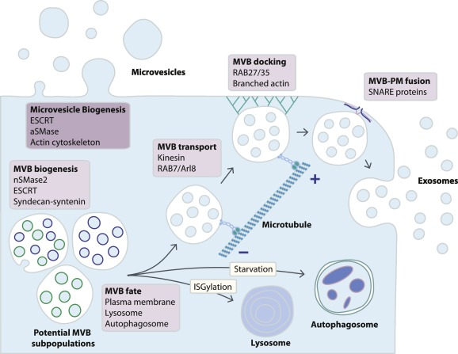
Figure 1.2 - Schematic representation of exosome and microvesicle biogenesis.
Exosomes are formed within MVB subpopulations which mature and fuse with the plasma membrane for EV secretion. Alternativaly MVBs may fuse with lysosomes or with autophagosomes. MVB fusion with the plasma membrane is a tightly regulated multistep process that includes MVB trafficking along microtubules, docking at the plasma membrane and SNARE-mediated fusion. Microvesicles are formed by budding of the plamsa membrane (Bebelman et al, 2018).

1.8 – The role of vesicles in cancer progression
The successful development of a tumour relies on the ability of neoplastic cells to signal pro-tumourigenic changes in surrounding cells (Carvalho et al, 2014). This may involve positive feedback of growth signaling, inhibition of immunogenic cells, and switching off anti-tumoural activities (Carvalho et al, 2014).
Studies have indicated that tumours release far more exosomes than regular cells/tissue. Some cancer cells have been shown to release three times as many EVs. The increased release is detectable even in blood samples from cancer patients (Van Doormaal et al, 2009).
There is also a great deal of molecular evidence which suggest manipulation of exosomes is an important strategy for cancer progression. For instance, Rab mutations have long been associated with tumourigenesis as dysregulation of Rab GTPases and other receptor signaling pathways allows for many pro-tumourigenic processes to go unchecked (Stenmark et al, 2009). Over expression of RAB25 not only stimulates cell culture proliferation but also is also often over expressed in breast and ovarian cancers (Cheng et al, 2004).
The Rab family play important roles in exosome secretion and exosome-dependent and independent tumour progression (Azmi et al, 2013). Following an RNA interference (RNAi) screen on HeLa cells which identified five Rab GTPases which promote exosome secretion, the individual functions of Rab27a and Rab27b were further elucidated. Whilst both effecting MVB to plasma membrane docking, silencing Rab27a led to larger MVBs whilst silencing Rab27b caused the MVBs to be redistributed around the nucleus (Ostrowski et al, 2010).

1.8.1 - Escaping apoptosis
Microvesicles can be released from cells to protect against intracellular stress and the resulting consequences such as apoptosis. One of the proposed mechanisms is by removal of caspase 3, an instigator of apoptosis, through microvesicles release. This is indicated by the presence of caspase 3 in the conditioned media from cell cultures but not within the cells. Upon inhibition of microvesicle release apoptosis has been shown to increase. Notably, caspase 3 may be involved in vesicle release from some cell lines such as the breast cancer line, mcf-7 (Boing et al, 2013).

1.8.2 - Drug resistance and metastasis
In an assessment of cancer cell response to 171 drugs the GI₅₀ index (50% inhibitory drug concentration) was positively associated with vesicle release for most of the drugs. Further examination of the vesicles released by chemo-resistant cell lines showed that they contained the doxorubicin drug (Shedden et al, 2003).
EVs have been shown to contribute to angiogenesis and metastasis also. One study examining how tumour derived vesicles aid in forming pre-metastatic niches showed tumour vesicles targeted non transformed cells of pre-metastatic organs. These vesicles were able to manipulate the cells of the pre-metastatic organ, primarily through the transfer of miRNAs which targeted a host of metastatic pathways involving chemokine and protease production, cell cycle and angiogenesis-promoting genes, amongst others (Rana et al, 2013). The horizontal transfer of miRNAs is in fact utilized by cancers and other diseases in a considerable number of cases.

1.8.3 – Angiogenesis
Throughout tissue or tumour stroma the balance of pro- vs anti- angiogenic signalling dictates vascular formation and stabilization (Nishida et al, 2006). EV signalling can play a significant role in this and, in cancers, EV transfer is commonly associated with pro-angiogenic signalling. Skin cancer derived EVs have been shown to interact with endothelial cells to promote migration throughout the tumour and begin formation of vessels (Al-Nedawi et al, 2009; Gajos-Michniewicz et al, 2014). The effect upon endothelial cells is often increased during stages of hypoxia as endothelial cells become more receptive to tumour derived EVs (Umezu et al, 2014).

1.9 – Tumour derived EV cargo

1.9 – EV RNA in cancers
MiRNAs are a class of small non-coding RNAs which are capable of interfering with protein translation through binding target mRNA. MiRNA impact on target gene expression has been shown to occur both within cell as well as in distal sites and the circulation. Circulatory miRNA have been shown to be stable in the blood and have implications in disease detection. MiRNAs in other bodily fluids such as urine and saliva have also been suggested as potential biomarkers (Mitchell et al, 2008; Cortez et al, 2011). However, it's been shown that the majority of these miRNAs detectable in human saliva and serum are actually contained within exosomes (Gallo et al, 2012). A database for circulatory miRNAs has been compiled and continues to grow providing researchers with multiple options for their research such as assembly of biomarker screening programs (Russo et al, 2012).
One of the earliest examples of EV RNA exchange between cells was provided by Valadi et al in 2007. Microarray assessment of exosomes from mast cells from mouse and human cell lines detected mRNA which was not detectable in the cytoplasm of the donor cells. Potential reasons for this include selective packaging of mRNA or even EV mRNA machinery (but this has only been shown in cancer/disease states) (Valadi et al, 2007). These EV mRNAs were shown to be functional when transferred between same cell types as well as from mouse to human cells. Further analysis of the exosomal RNA population highlighted the presence of miRNAs, leading the group to coin the term, exosomal shuttle RNA (esRNA) (Valadi et al, 2007).
In 2009 Gibbings et al showed that GW-bodies which contain important components of the RNA-induced silencing complex (RISC), such as GW182 and AGO2, congregate with endosomes and MVBs also finding that miRNAs and miRNA-repressible mRNAs are enriched at their membranes. The exosomes (or pre-exosomes) secreted from MVBs were enriched in GW182 and contained a small amount of the miRNA-repressible mRNA and AGO2 suggesting a mechanism for miRNA-loaded RISC (miRISC) (Gibbings et al, 2009). This study highlights the idea that exosomal communication utilizes miRNAs.
In 2010 a group reported that cells selectively release specific miRNA's, through the use of extracellular vesicles, and that malignant transformation of cells within breast tissue altered the array of miRNA released from cells. Four breast cancer cell lines selectively released miR-1246 and miR-451, with these miRNAs being released at much lower levels in the non-tumourigenic comparative cell lines. These miRNA's were detectable in the circulation of mice xenografted with the breast cancer cells (Pigati et al, 2010).
Following this the group developed terminology for the differently released miRNA based on ratios of miRNA release and retention; selectively released miRNAs, or ‘s-miRNA’ are characterized by excessive release from the malignant breast cancer cells with low concentrations of miRNA retained in the cell. The normal version of the cell releases very little of these miRNA's (Palma et al, 2012).

1.9.2 – EV proteome changes in cancers
The proteomes of cancer cells are very different from normal cells and this is often reflected by their EV secretions. EVs taken from the plasma of lung cancer patients have shown distinct proteomes compared to normal patient EVs, as a 30 protein biomarker panel was able to distinguish between the two groups (Jakobsen et al, 2015). In some cases an individual EV protein stands out. For instance, Glypican-1 was shown to be overexpressed in breast and pancreatic cancers and was only found in EVs secreted from malignant cells when compared to normal cell EVs (Melo et al, 2015).
Comparison of EV proteomes derived from primary colorectal cancer cells and their metastatic derivatives showed over 200 proteins more enriched in either cancer EV population (Choi et al, 2012). Bioinformatics analysis also showed differences in functions of EV proteins with primary cancer EV proteins involved in cell adhesion, whilst EV proteins derived from the metastatic cancer associated with cancer progression and metastasis (Choi et al, 2012).
It has also been documented that cancers secrete EVs containing a greater assortment of proteins. EVs isolated from urine of bladder cancer patients contained 100 additional proteins compared to the proteome of EVs isolated from healthy urine (Lee et al, 2018)
Since EV cargo has been shown to be highly influenced by disease states such as cancer, there is a great deal of research focusing on the potential for EV related biomarker discovery.

1.10 - Viral interactions with endosomes and exosomes
There have been several studies which highlight the potential for viruses to utilize the host cell endosomal/exosomal machinery to increase chances of survival including immune evasive tactics and increased infectivity. Awareness of these mechanisms increases the likelihood of identifying mechanisms utilized in HPV+ tumours.

1.10.1 - Evading host immune system
In response to primary viral infection the host can initiate both humoral and cell-mediated immune responses to destroy the virus and remove it from the system. This may include antibody production to neutralize the threat or destruction of infected cells through cytotoxic T cell activation. However, these methods can be insufficient in completely removing the virus, especially if evasive tactics are deployed by the virus (Meckes et al, 2015).
It was identified a couple of decades ago that during herpes simplex virus-1 (HSV-1) infection, extracellular vesicles (at the time termed L-particles) were capable of transferring functional viral proteins into host cells and this was found to be important during early infection stages. (Mclauchlan et al, 1992) This mechanism of viral protein and DNA transport was shown to increase the infectivity of HSV-1 and its ability to replicate (Dargan et al, 1997). Whilst the viral contents of these exosome are incapable of initiating a replication-infective cycle they can quickly aid intact viral particles to establish within a cell, providing the newly arrived virion with proteins, such as transcription factors, so that a viral population can be quickly established and less likely to be removed (Dargan et al, 1997).
HSV-1 utilizes another interesting method of viral immune evasion whereby glycoprotein B, encoded by HSV-1, alters the processing of HLA-DR, an MHC class II cell surface receptor important for antigen presentation in immune response, so that instead of fixing in the plasma membrane the HLA-DR is sorted into exosomes (Temme, 2010).

1.10.2 - Increasing infectivity and cell susceptibility
A method utilized by cytomegalovirus (CMV) to promote cellular susceptibility to new CMV virion infection relies on vesicular encapsulated C-type lectin complexed with the CMV glycoprotein B. C-type lectin is expressed on dendritic cells to capture and internalize pathogens but by transferring this to other cells by vesicular transport infection of new host cells becomes much easier (Plazzolles et al, 2011).
Hepatitis C also utilizes vesicular transport to increase infectivity. HCV + patients have been shown to release extracellular vesicles which contain E2-CD81. E2 is a HCV envelope protein and CD81 is a cellular membrane protein. The exosomal E2-CD81 complexes make naive cells more susceptible to viral fusing and infection. Some of these extracellular vesicles also contained HCV RNA and continued to be infectious even in the presence of neutralizing antibodies (Masciopinto et al, 2004).

1.10.3 - Control of potentially oncogenic viral proteins
An EBV protein particularly important in NPC tumourigenesis is LMP1, latent membrane protein 1, an oncoprotein homologous to human CD40 which is constitutively activated and is involved in NF-κB signaling and also responsible for cell survival, proliferation and immunity (Lavorgna et al, 2012). Human CD40 is part of the tumour necrosis factor (TNF) receptor family, which in healthy B cells, becomes activated when a T cell recognises a B-cell presented antigen/peptide and then uses its CD40L (ligand) to bind the CD40 receptor. This results in resting B cell activation allowing for B cell division and differentiation. Therefore as viral LMP1 pushes the cell to develop into memory B cells, LMP1 levels and impact on NF-κB is well regulated, preventing transformation/lymphomagenesis (Kaneda et al, 2012).
Deregulation of NF-κB signaling is associated with malignancies thus LMP1 expression, as well as other gene products, are tightly regulated during EBVs latency II (default) and latency III (growth program) to prevent malignant conversion (Verweij et al, 2015)
One suggested mechanism for control of LMP1 levels is the exosomal packaging of LMP1. C-terminal modifications lead to association with CD63 allowing for LMP1 to accumulate within ILVs/ endosomes where they are unable to activate NF-κB signaling and thus chronic activation of NF-κB is prevented (Verweij et al, 2011). Exosomal packaging of LMP1 has been an established occurrence for some time though the original idea was that exosomal LMP1 was secreted to aid in immune evasion (Dukers et al, 2000).
The many varied types of interaction described here highlight the need to research differences between HPV+ and HPV- OPSCC since this illustrates the concomitant abundance of possible interactions also available within viral tumours.

1.11 - Viral miRNAs in cancers

1.11.1 - EBV miRNA
In 2004 the first set of 5 Eptein-barr virus (EBV) encoded pre- miRNAs were identified, the first for any virus, in EBV driven in vitro LCL line (lymphoblastoid cell line made by EBV transformation of primary B cells) (Pfeffer et al, 2004). The list has since been expanded to include 25 pre-miRNA's capable of producing at least 44 mature miRNAs (Grundhoff et al, 2011).
EBV and other herpes viruses appear to have a wider range of miRNAs at their disposal and it's been suggested that this may allow for the manipulation of host and/or viral gene expression whilst limiting the use of proteins which host cells may use as antigens for an immune response. Notably, these viruses express miRNA primarily during latency when viral gene expression is restricted (Grundhoff et al, 2011).
An interesting study used deep sequencing, amongst other techniques, to determine the viral and cellular microRNA targetome of an EBV+ lymphoblastoid line. The results showed that the viral miRNAs were able to regulate over 500 mRNAs and were primarily targeting host cellular transcripts and hence capable of manipulating the host environment. These targets were involved in a variety of processes which relate to viral infection showing that these viral miRNAs were effecting the innate immune system, host cell proliferation, and cell survival pathways (Skalsky et al, 2012). This study also discovered that 20-25% of the cellular miRNA within EBV+ cells were actually EBV encoded, showing that EBV uses its miRNA based mechanisms to maximize its chances of success (Skalsky et al, 2012).

1.11.2 - EBV exosomal viral miRNA transfer
With EBV miRNAs being so important, the transfer of these RNA molecules to surrounding cells is likely highly beneficial to the virus.
Being able to transfer EBV-encoded small RNAs (EBERs) into EBV- cells has long been demonstrated as a potential mechanism for manipulation of neighboring cells. Transfecting EBER expression vectors into EBV negative epithelial cell lines derived from NPCs provides a growth advantage to cells in a dose-dependent manner (Yoshizaki et al, 2007).
A study of EBV miRNA transfer used RT-QPCR to show that exosomal mature EBV-encoded miRNAs were internalized by co-cultured EBV- cells and these miRNAs remained functional, initiating a dose-dependent miRNA-mediated repression of EBV target genes. Notable amongst these target genes was CXCL11/ITAC, an immunoregulatory gene which is down-regulated in primary EBV-associated lymphomas (Pegtel et al, 2010).
The same study also examined blood mononuclear cells in patients with a high EBV load showing EBV BART miRNAs to be present in both B-cell and non-B-cell fractions despite EBV DNA only being detectable in the B-cell population (Pegtel et al, 2010).
Comparisons of EBV exosomal and intracellular miRNA levels in NPC cell lines shows specific viral miRNAs levels are elevated in exosomes suggesting the selective enrichment of particular viral miRNAs (Meckes et al, 2010). When cells are exposed to these exosomes the EBV miRNA is internalized at detectable levels superbly demonstrating that there are mechanisms in place for the transfer of specific EBV RNAs by vesicles (Meckes et al, 2010).
EBERs have become increasingly implicated in immune activation and potentially pro-tumourigenic processes. A 2009 study suggested that EBERs are released from EBV-infected cells and induce toll-like receptor 3 signaling (TLR3) which induces type I IFN and pro-inflammatory cytokines in neighboring cells (Iwakiri et al, 2009).
This was later corroborated by another group investigating whether two of the most abundantly expressed EBERs, EBER-1 and EBER-2, could be released in exosomes. Using conditioned media from 3 EBV+ cell lines, an EBER-1 transfected cell line and two EBV- cell lines exosomes were isolated through differential centrifugation. The presence of exosomes was determined through western blotting for the exosomal tetraspanin CD63 and electron microscopy. Using RT-PCR it was shown that EBER-1 and EBER-2 were present in the exosomal fractions of EBV+ cell line, as was EBER-binding protein (La) (Lerner et al, 1981) determined through western blotting, with EBER-1 also found in the exosomal fraction from EBER-1 transfected cells albeit with a weaker signal (Ahmed et al, 2014).
With vesicular transfer of EBERs being a well demonstrated phenomena understanding the impact to tumour growth and host health is highly important.
Multiple in vitro studies have demonstrated how EBERs contribute to EBV- mediated oncogenesis. One of the mechanisms through which EBERs enhance growth potential of cells is through binding and re-localization of ribosomal protein L22 from nucleoli to the nucleoplasm. Mutations preventing EBER binding L22 not only inhibited L22 re-localization, but significantly reduce Burkitt lymphoma cell growth (Houmani et al, 2009).
EBERs are also able to induce insulin-like growth factor 1 (IGF-1) to act as an autocrine growth factor. Biopsies of EBV+ NPC consistently show increased levels of IGF-1 further suggesting EBERs contribute to cancer development (Iwakiri et al, 2005).

1.11.3 - HPV encoded miRNAs
For a time, studies which attempted to find viral miRNAs in HPV infected cells were unable to detect their presence, leading to the proposal that HPV did not express viral miRNAs (Cai et al, 2006). However, in 2013 a study identified and validated HPV encoded miRNAs beginning by sequencing small RNA libraries from HPV+ cell lines and 10 fixed tissue samples from HPV cervical epithelium (Qian et al, 2013). This data allowed for the prediction of nine novel putative HPV encoded miRNAs, of which five were encoded by HPV16. Two HPV16 encoded miRNAs, HPV16-miR-H1-1 and HPV16-miR-H2-1, were subsequently used in qPCR, DNA PCR and p16 staining studies, validating their expression in HPV-positive cell lines and/or cervical tissues (Qian et al, 2013). Target prediction for HPV16-miR-H1-1 and HPV16-miR-H2-1 showed 137 and 176 gene targets, respectively, in the human genome as well as 2 gene targets each in the HPV16 genome. Of the human gene targets of these two validated HPV16 miRNAs, 15 were targeted by both. With gene targets of these miRNAs being important in immune functions, immune development, focal adhesion, cell migration and more, it was identified that there is the potential for HPV miRNAs to be highly influential in cancer progression (Qian et al, 2013). Whilst this group intend to perform validation studies on the rest of the miRNAs in cervical tissues, identifying their presence in HPV-positive oral tissues has yet to be attempted and could result in novel data.

1.12 - Conclusion
It is now well documented that cancers, including virally associated cancers, demonstrate a variety of molecular changes including protein and RNA changes which prove important in tumour progression. It is also clear that, through the use of extracellular vesicular trafficking and messaging, surrounding cells and distant cells can be altered to promote the propagation of cancer. Comprehension of the mechanisms involved, the molecules and the pathways relating to extracellular vesicles in disease states could help progress future therapeutic technologies, improve clinical outcomes, and aid in early diagnoses. Studies have already demonstrated that differences between HPV+ and HPV- OPSCC may be partially related to EV secretion, especially considering the potential for EV manipulation by oncogenic viruses. It is therefore clear that a more comprehensive understanding of these differences would lead to further important developments in biomarker and therapeutic research.

1.13 - Hypothesis and aims:
As discussed, cancers and viruses are capable of altering EVs to aiding cell/tumour growth, host immune modulation, and even tumourigenesis. The extent of HPV's oncogenic properties relating to vesicle release in oropharyngeal cancers is not well understood and there is an array of potential EV related mechanisms which could separate HPV+ and HPV- OPSCC.
We hypothesize that vesicles released by HPV+ OPSCC cells will differ from those released by HPV- OPSCC. This study aims to investigate the characteristic differences between extracellular vesicles of HPV+ and HPV- cell line to better understand how EV biology may account for differences seen between these two types of tumours.
Initially the study will evaluate differences in size, quantity, and contents of extracellular vesicles released by two HPV+ and two HPV- OPCC cell lines. This will be achieved through use of the IZON qNano and TRPS analysis. Size exclusion chromatography (SEC) will be used to isolate and purify EVs from conditioned media allowing for use on further experiments. EV RNA cargo will be isolated for use in next generation sequencing and EV protein cargo will be used in mass spectrometry. Differences in EV cargo will be assessed between HPV+ and HPV- OPSCCs. The functional impact of OPSCC EVs in the tumour microenvironment will assessed by dosing fibroblasts and endothelial cells with isolated EVs.

2 - Materials and methods

2.1 - Materials

2.1.1 - Sources of materials
Product name | Manufacturer
Dulbecco's Modified Eagle's Medium (DMEM) | Sigma-Aldrich
Foetal calf serum (FCS) | Sigma-Aldrich
Cryovials | Sigma-Aldrich
Dulbecco’s phosphate buffered saline (PBS) | Sigma-Aldrich
Tryple Express - Trypsin | Invitrogen
Dimethyl sulfoxide (DMSO) | Sigma-Aldrich
Mr. Frosty™ Freezing Container | Thermo Scientific
Centrifuge bottles - polycarbonate | Beckman Coulter
0.22 µm syringe filter | Millex-GP
Vivaspin 20 MWCO cut-off columns | GE Healthcare Biosciences
Sepharose CL-2B | GE Healthcare Biosciences
EconoPac disposable chromatography columns | Biorad
Tween20 | Sigma-Aldrich
Ultra-centrifuge tubes - polycarbonate | Beckman coulter
SDS-PAGE loading buffer 5x | Biorad
EZ-Run™ Prestained Rec Protein Ladder | Fisher Scientific
Instant blue - protein stain | Expedeon
Novex iblot gel transfers kit - nitrocellulose | Thermo Fisher Scientific
Primary anti-CD63 antibody | Santa Cruz
Secondary anti-rabbit antibody | Abcam
PierceTM ECL Western Blotting Substrate | Thermo-Fisher Scientific
PierceTM bicinchoninic acid protein assay kit | Thermo-Fisher scientific
Bovine serum albumin (BSA) | Sigma-Aldrich
Triethylammonium bicarbonate buffer (TEAB) | Sigma-Aldrich
MiRNA easy mini kit | Qiagen
Nanodrop 1000 spectrophotometer | Thermo Fischer Scientific
DYAD^{tm} 'DNA engine' PCR machine | Thermo Fischer Scientific
Tecan Infinite® 200 PRO series spectrophotometer | Thermo Fischer Scientific
miRCURY™ RNA Isolation Kits | Exiqon
ProLong® Gold Antifade Mountant with DAPI | Thermo Fischer Scientific
7900 Fast real-time PCR machine | Thermo Fischer Scientific
Small RNA reverse transcription kit | Applied biosystems
Picochip | Agilent
Bioanalyser | Agilent

Table 2.1 - Sources of reagents

2.2 - Cell culture and cell lines

2.2.1 - Cell lines
Four oropharyngeal carcinoma cell lines were used in this study: SCC2, SCC72, SCC89, and SCC90. Both SCC2 and SCC90 are HPV16-positive whilst SCC72 and SCC89 are HPV-negative. This was validated by HPV DNA testing at the cytology department of Hallamshire hospital, Sheffield. Cell lines are further described in the table below.
Cell line | Site | Nature | HPV status | Stage
SCC2 | Hypopharynx | - | HPV-16 | T1N2M0
SCC72 | Tonsil | New primary | Negative | T3N2b
SCC89 | Tonsil | New primary | Negative | T4N2b
SCC90 | Base of tongue | Recurrence | HPV-16 | T2N0

2.2.2 - Growth medium
Cells were cultured in DMEM containing 1000 mg/L glucose with sodium bicarbonate, and pyridoxine. Standard medium was supplemented with 10% (v/v) foetal calf serum (FCS), and 2 mM L-glutamine, prior to use. When medium was used for conditioning and extracellular vesicle collection DMEM was supplemented with 2% (v/v) exosome-free foetal calf serum (FCS), and 1% (v/v) L-glutamine.

2.2.3 - Storage and resurrection of cells
Cells (1x10⁶) suspended in 1 ml freezing medium consisting of 50% FCS, 40% DMEM and 10% DMSO were stored in liquid nitrogen in 1.5 ml cryovials. For resurrection, cells were thawed quickly and added to 8.5 ml of growth medium before centrifugation at 1000 x g for 5 min. The supernatant was then removed and cell pellets were resuspended in 10 ml of fresh growth medium to be transferred into T75 tissue culture flasks at a density of 1x10⁴ cells/cm². Cells were incubated at 37°C, 5% CO_{2.}

2.2.4 - Passaging cells
Cell cultures were allowed to reach 80-90% confluency before passaging (approximately every 3-4 days). Confluent monolayers were washed in Dulbecco’s phosphate buffered saline (PBS) before incubation with trypsin at 37°C, 5% CO₂ for 3-5 min. Growth medium was used to neutralise the trypsin and the cell suspension was centrifuged at 1000 x g for 5 min. The supernatant was discarded and the cell pellet resuspended in growth medium for cell counting. Cells were reseeded at densities dependant on cell line and experimental requirements.

2.2.5 - Cell counting
10 μL of cell suspension (see above) was removed for cell counting using a haemocytometer. Four 4x4 grids were used to count cells and the average was multiplied by 10,000 to give cell concentration (cells per ml) of the suspension.

2.2.6 - Vesicle depletion of serum
FCS was transferred to ultracentrifuge bottles for exosome depletion. FCS was centrifuged at 100,000 x g for 18 h at 4ºC. The vesicle-free supernatant was filter sterilised using a 0.22 µm syringe filter and transferred to sterile 50 ml tubes for storage at -20ºC.

2.3 - Extracellular vesicle collection

2.3.1 - Conditioned medium
Cells were seeded in culture flasks and incubated with vesicle depleted medium for 72 at 37°C, 5% CO_{2.} After 72 h the conditioned medium was collected in 50 ml falcon tubes and kept on ice until needed.

2.3.2 - Differential centrifugation
Conditioned medium was kept cold whenever possible and clarified by differential centrifugation. The conditioned medium was centrifuged at 300 x g at 4ºC for 10 min (to pellet whole cells) before being centrifuged at 2,000 x g for 15 min (to pellet cellular debris) followed by a 30 min spin at 10,000 x g (to pellet large vesicles and small debris). The supernatant was then transferred to a fresh tube and either placed on ice until needed or stored at -20ºC.

2.3.3 - Ultra-filtration
Molecular weight cut off (MWCO) columns with a 100 kDa pore size and 20 ml capacity were used to concentrate the vesicles in the conditioned medium and partially remove soluble proteins below 100 kDa. The columns were centrifuged at 6,000 x g at 14ºC for approximately 20 min or until conditioned medium was concentrated down to ~0.5 ml. Up to 60 ml of medium was used per column with repeated centrifugation steps.

2.4 - Size exclusion chromatography

2.4.1 - Column generation
Disposable 20 ml chromatography columns fitted with a polystyrene filter at the bottom were filled with 20 ml of ethanol/Sepharose CL-2B slurry. The slurry was left for approximately 1 h for the gel beads to settle. A polystyrene filter was placed directly above the settled gel. The funnel cap was removed and the ethanol drained. If this resulted in additional settling of the Sepharose the upper polystyrene filter was pushed down to the top of the gel with care not to allow the formation of bubbles beneath the filter. The column was equilibrated with 60 ml sterile PBS + 0.03% (v/v) Tween-20 (PBST). Column caps were added to both ends for storage of up to a few days.

2.4.2 - Vesicle purification by size exclusion chromatography
Size exclusion chromatography (SEC) was performed by adding 0.5 ml of concentrated conditioned medium to the top of the gel column with the cap removed from the bottom. Once the medium soaked into the polystyrene filter 1 ml of PBST was gently added and allowed to soak through. Following this PBST was repeatedly added maintaining around 1-3 ml of PBST above the gel column. During the process, PBST eluted from the column was collected in microcentrifuge tubes as 0.5 ml fractions.

2.4.3 - Fraction pooling
Fractions of purified vesicles in PBST were pooled through ultracentrifugation. Pooled fractions were centrifuged at 100,000 x g for 1 h at 4ºC. The supernatant was then removed, and pelleted vesicles were resuspended dependent on downstream application.

2.5 - Tunable resistive pulse sensing
Tunable resistive pulse sensing (TRPS) analysis was performed using a qNano instrument (iZON). The machine was calibrated using calibration particles (carboxylated polystyrene beads) averaging 114 nm in diameter at a concentration of 2.5x10⁹ particles per ml. Analysis was performed using an NP150 nanopore. Samples were measured with approximately 10 mbar pressure, 45.5 mm stretch and 0.5 V. Samples were analysed until 500 vesicles were counted. Measurements were normalised and analysed using iZON Control Suite software.

2.5.1 - Mean EV diameter, rate of EV secretion, EV size profile
2 million cells were seeded in T75 flasks and allowed to adhere overnight. Medium was replaced with EV free growth medium (containing 5% (v/v) EV depleted FCS) and cells were incubated for 24 h at 37°C, 5% CO2. Conditioned medium was transferred to microcentrifuge tubes and debris was removed by differential centrifugation. Medium was diluted 1 in 3 in PBST and passed through 0.22 µm centrifugal filter at 10,000 x g for 1 min. TRPS was then performed on samples as above.

2.5.2 - SEC EV elution profile
SEC fractions of PBST containing suspended EVs were passed through 0.22 µm centrifugal filter at 10,000 x g for 1 min before TRPS. Samples were diluted 1:1 to 1:100 depending on EV concentration.

2.6 - Protein extraction for western blotting
SEC purified EV pellets and cell pellets were resuspended in RIPA buffer supplemented with protease inhibitors and vortexed for 15 s before 30 min incubation at 4ºC. Cell lysate samples were passed through a 26 gauge needle to shear genomic DNA if necessary.

2.7 - Measurement of protein concentration
A bicinchoninic acid protein assay (BCA) kit (Thermo-Fisher Scientific) was used to assess protein concentration of samples. Bovine serum albumin (BSA) standards were made in either TEAB + 0.01% (w/v) SDS, RIPA buffer or PBS, dependent on buffer used to suspend samples, to concentrations of 0.2, 0.4, 0.6, 0.8, 1, 2 mg ml⁻¹. 10 µl of sample or BSA standard was added to 200 µl BCA working reagent in a 96 well plate. Each sample or standard was assayed in duplicate. The plate was sealed and incubated at 37ºC for 30 min. The absorbance of each well was measured at 562 nm using a Tecan Infinite® 200 PRO series spectrophotometer.

2.8 - SDS-PAGE analysis

2.8.1 - Gel electrophoresis
Sodium dodecyl sulfate polyacrylamide gel electrophoresis (SDS-PAGE) gels of 1mm thickness were made using a standard protocol with reagents in the table below.
SDS-PAGE Tank buffer | 25 mM Tris, 192 mM glycine, 0.1% SDS, pH8.3
5 ml of 5% stacking gel | 0.625ml of 40% Polyacrylamide, 0.625 ml of 1M Tris pH6.8, 0.05 ml of 10% (w/v) ammonium persulphate, 0.05 ml of 10% (w/v) SDS, 0.005 ml of TEMED, 3.65 ml of distilled water
10 ml of 12% resolving gel | 3 ml of 40% Polyacrylamide, 2.5 ml of 1M Tris pH6.8, 0.1ml of 10% (w/v) Ammonium persulphate, 0.1 ml of 10% (w/v) SDS, 0.004 ml of TEMED, 4.3 ml of distilled water

20 µl of sample i.e. SEC elute, was added to 5 µl of 5x loading buffer and heated to 95ºC in a heating block for 5 min before being transferred to ice. After pulse centrifugation the samples were added to sample wells of the gel plates in an SDS-PAGE tank filled with SDS-PAGE running buffer. Proteins were separated at 200 V for approximately 1 h with the EZ-Run protein ladder as a molecular weight marker.

2.9 - Western blotting
Proteins separated by SDS-PAGE were transferred to nitrocellulose membranes using either the iBlot system (Invitrogen) or Trans-Blot® Turbo™ system (Biorad). Membranes were incubated with blocking buffer (5% (w/v) dried milk powder in tris-buffered saline + 0.1% (w/v) Tween 20 (TBST)) at room temperature for 1 h on a horizontal shaker. Primary antibody was added diluted in blocking buffer according the table below (table 2.2) and the membrane was incubated overnight at 4ºC on a horizontal shaker. Nitrocellulose membranes were washed three times in TBST (TBS + 0.1% (v/v) Tween-20) for 10 min per wash. HRP-conjugated secondary antibody diluted in blocking buffer was added to membrane and incubated for 1 h at room temperature on a horizontal shaker. The membrane was washed again three times in TBST for 10 min per wash.
Protein bands were visualized by the addition of a chemiluminescence substrate (Pierce ECL) as per the manufacturer's instructions. Membranes were placed in an X-ray cassette and exposed to X-ray film to be developed and fixed using a Compact X4 automatic processor (Xograph Imaging Systems).

2.10 – Protein band densitometry
Scanned images of western blots were opened in imageJ software. Gel analysis tools were used to measure the area of each band. Normalized values for α-SMA protein were calculated relative to β-actin control. Treated samples were normalized to negative controls.

Antibody target | Clone | Company | Dilution | Secondary | Expected weight (kDa)
CD63 | EPR5702 | Abcam (Cambridge, UK) | 1:1000 | Rabbit | 26-65
TSG101 | 51/TSG101 | BD Bioscience (New Jersey, USA) | 1:500 | Mouse | 44
CD9 | EPR2949 | Abcam (Cambridge, UK) | 1:2000 | Rabbit | 23
GM130 | EP892Y | Abcam (Cambridge, UK) | 1:1000 | Rabbit | 125
ITGA6 | ab97760 | Abcam (Cambridge, UK) | 1:2000 | Rabbit (polyclonal) | 127
MVP | [EPR13227(B)] (ab175239) | Abcam (Cambridge, UK) | 1:2000 | Rabbit (Monoclonal) | 110
EEF2 | ab40812 | Abcam (Cambridge, UK) | 1:10000 | Rabbit (polyclonal) | 95
LGALS3BP | ab67353 | Abcam (Cambridge, UK) | 1:500 | Mouse (polyclonal) | 80
β-actin | ab8227 | Abcam (Cambridge, UK) | 1:2000 | Rabbit (polyclonal) | 42
α-Smooth muscle actin (α-SMA) | ab5694 | Abcam (Cambridge, UK) | 1:1000 | Rabbit (polyclonal) | 42

Table 2.2 – Antibody list

2.11 - Mass spectrometry

2.11.1 - EV protein preparation
EVs were purified by SEC from the medium conditioned by approximately 30 million cells for 72 h. Purified SEC fractions were combined and centrifuged at 100,000 x g for 1 h. The pellet was suspended and protein extracted using a mass spectrometry compatible detergent, Rapigest. Vesicles were collected on different occasions to provide multiple protein samples representative of each cell line to provide pooled biological repeats.

2.11.2 - Label free mass spectrometry
All mass spectrometry was carried out by Dr Caroline Evans at the Chemistry Mass Spectrometry Facility.
EV protein solubilised in Rapigest detergent was used to generate peptides by denaturing, reducing, alkylating and digesting the proteins. The peptide samples were then separated into multiple fractions by High-performance liquid chromatography (HPLC). Briefly, peptides were eluted in a HPLC loading buffer (97% v/v Acetonitrile, 0.1 v/v Trifluoroacetic acid), and then passed through HPLC capillary (0.075 x 500 mm) from buffer A (Water, 0.1% v/v Formic Acid) to buffer B (80% Acetonitrile, 0.1% v/v formic acid) with 9 fractions being eluted.
These fractions were then used in an Orbitrap ion trap mass analyser. Briefly, a 105 minute data dependent acquisition (DDA) method was set up on the QExactive HF. The full MS scan was from 375-1500 m/z was acquired in the Orbitrap at a resolution of 120,000 in profile mode. Subsequent fragmentation was Top 10 in the HCD cell, with detection of ions in the Orbitrap using centroid mode, resolution 30,000. The following MS method parameters were used: MS1, Automatic Gain Control (AGC) target 1e6 with a maximum injection time (IT) of 60 ms. MS2, Automatic Gain Control (AGC) target 1e5, maximum injection time (IT) of 60 ms and isolation window 2 Da. The intensity threshold was 3.3e4, normalized collision energy 27, charge exclusion was set to unassigned, 1, exclude isotopes was on, apex trigger deactivated. The peptide match setting was preferred with dynamic exclusion of 20 s.

2.11.3 - ITRAQ
EV protein eluted in TEAB lysis buffer + 0.1% SDS was used to generate peptides by denaturing, reducing, alkylating and digesting the proteins. Peptides were then labelled with iTRAQ™ Reagents before samples were combined. Labelled proteins were used in an Orbitrap ion trap mass analyser as described above. Relative quantitation was achieved by comparison of samples specific labels attached to peptides.
Initial fractionation was carried out by Hypercarb™ separation on a Dionex UltiMate 3000 Autosampler linked to a flow manager and pump system (Thermo Scientific). Samples were re-suspended in 120 µL Buffer A (3% ACN, 0.1% TFA) and loaded onto a Hypercarb™ Porous Graphitic. A gradient was established in a Carbon LC reversed phase analytical column (Thermo Scientific) using Buffer A and Buffer B (97% ACN, 0.1% TFA). Peptide fractions were collected and dried before use in LC-MS/MS.
LC MS/MS was performed using an Orbitrap ion trap mass analyser. iTRAQ labelled-peptides were separated on an Easy-Spray C18column (75 µm x 50 cm) using a 2-step gradient from 97% solvent A (0.1% formic acid in water) to 10% solvent B (0.08% formic acid in 80% acetronitrile) over 5 min then 10% to 50% B over 75 min at 300 nL/min. The mass spectrometer was used in data dependent acquisition mode with 10 product ion scans 102 (resolution 15000, automatic gain control 54, maximum injection time 20 ms, isolation window 1.2 Da, normalised collision energy 32, intensity threshold 2.55) per full MS scan (resolution 60000, automatic gain control 36, maximum injection time 100 ms).

2.12 - Mass spectrometry data analysis

2.12.1 - Label free MS data analysis
MaxQuant v1.5.3.30 was used for pre-processing of initial data. Samples were aligned to a custom database of the human proteome and HPV proteome. Briefly, Group specific parameters were applied to represent label free data ‘Type Standard Multiplicity 1 no labels’. Trypsin digestion and label free analysis were selected. Global parameters used included methylthio addition to allow for the changes caused to protein structure by the reduction and alkylation reactions detailed in the processing steps. Intensity values were converted to LFQ intensity values normalizing total intensity between samples.
Following this pre-processed data was imported into Perseus v1.5.2.6 for further analysis. Contaminant proteins were removed and label free values converted to Log2x score.

2.12.2 - ITRAQ data analysis
Relative quantification of proteins was determined by applying an in-house data analysis pipeline (Ow et al., 2009). Initial raw data was converted to generic MGF peaklists. Centroided data were interrogated for identifications using an in-house Phenyx algorithm cluster (binary version 2.6; Genebio Geneva) at the ChELSI Institute, University of Sheffield. The 8-plex data were interrogated using the latest UniProt Human database with the following modifications set 8-plex iTRAQ mass shifts (+304 Da, K and N-term), methylthiol (+46 Da, C) and oxidation of methionine (+16 Da, M).
Stringent mass tolerances of 0.4 Da on both MS and MS/MS were used along with peptide level filters of a z-score of 5.0 and a p-value significance of 0.0001 to filter the hits. Phenyx protein scores were set using a total z-score of 20. MS/MS peptides that met these criteria were then used as the basis for calculations. In order to confirm relative quantification, the iTRAQ reporter intensities for these peptides were referenced directly to the centroided data provided in the MGF peaklists. Appropriate isotopic and median corrections were applied to the reporter ions intensities to compensate for systematic errors in the sample loading.

2.13 - RNA extraction

Standard laboratory procedure is to use the Qiagen miRNeasy kit to isolate RNA from cell samples. However, in order to isolate EV RNA the miRCURY RNA isolation kit (Exiqon) was used as it has been shown to acquire a higher concentration of EV RNA (Théry et al, 2006).

2.13.1 – Qiagen miRNeasy kit
RNA extraction was performed using the Qiagen miRNeasy kit. Cell pellets were suspended in 750 µl trizol lysis reagent and left to homogenate for 5 min at room temperature. 140 µl of chloroform was added and mixed by shaking for 15 s. After 3 min at room temperature the suspension was centrifuged for 15 min at 12,000 x g at 4ºC. The upper aqueous phase was collected and added to a fresh microcentrifuge tube with 525 µl of ethanol. Immediately after mixing by pipetting the solution was added into RNeasy mini spin column to be centrifuged at 8,000 x g for 15 s. 350 µl of buffer RWT was added to the column before repeating the centrifugation at 8,000 x g for 15 s. 80 µl of DNase1 in RDD buffer was added to column and incubated at room temperature for 15 min. Another 350 µl of buffer RWT was added to the column and centrifuged at 8,000 x g for 15 s. 500 µl of RPE buffer was added before centrifugation at 8,000 x g for 15 s followed by a second addition of 500 µl RPE buffer and centrifugation at 8,000 x g for 2 min. The column was then placed in a collection tube and the RNA eluted in 30 µl of RNase-free water by centrifugation at 8,000 x g for 1 minute. RNA concentration and purity was assessed using a Nanodrop 1000 spectrophotometer. RNA was stored at -80ºC.

2.13.2 – miRCURY RNA isolation kit (Exiqon)
Harvested EVs were pelleted at 100,000 x g for 1 hour and supernatant completely removed. Pellets were resuspended in 300 µl lysis buffer. For cellular RNA acquisition, approximately 1 million cells were washed in PBS (more) and pelleted. Pellets were resuspended in 300µl lysis buffer and passed through a gauge needle to break up genomic DNA.
Suspension was transferred to RNase free tubes and 200 µl of 100% ethanol was added before vortexing. The suspension was transferred to isolation columns and centrifuged at 3000 x g for 2 min with further centrifugation at 14,000 x g if needed. Waste tubes were emptied of supernatant and replaced before addition of 400 µl of washing buffer. Columns were centrifuged at 14,000 x g for 1 min and a fresh waste tube attached. 80 µl Qiagen DNase was added to the column and centrifuged at 200 x g for 2 min before a 5 min incubation. The column was centrifuged at 14,000 x g for 1 min and the DNase that passed through was reapplied to the column for a further 10 min incubation. 400 µl wash buffer was added and centrifuged at 14,000 x g for 1 min. This was repeated once more. The column was centrifuged at 14,000 x g for 2 min to thoroughly dry the tube before being transferred to a collection tube. 50 µl of elution buffer was added to the centre of the column and centrifuged at 200 x g for 1 min and 14,000 x g for 1 min. RNA was stored at -80ºC.

2.14 – cDNA synthesis
RNA samples were diluted to 500 ng µl⁻¹ and 10 µl was added to 10 µl reverse transcription reagent mixture (2µl of 10x RT Buffer, 0.8 µl of 25x dNTP Mix 100mM, 2 µl of 10x RT Random primers, 1 µl of MultiscribeTM reverse transcriptase, 4.2 µl of nuclease-free water). cDNA synthesis was performed using a DYAD^{tm} DNA engine PCR machine. The thermal cycling program used was:
- 25ºC for 10 min
- 37ºC for 2 hours
- 85ºC for 5 min
- 4ºC indefinitely

2.15 - E1 qPCR
A Tagman probe for HPV16 E1 (FAM reporter) was supplied by Applied Biosystems UK. A probe for the B2M housekeeping gene (VIC reporter) was used in conjunction with the E1 probe. 0.5 µl of cDNA from each cell lines was added to 9.5 µl of PCR reagent mixture (5 µl of mastermix, 0.5 µl of B2M reporter, 0.5 µl of E1 probe, 3.5 µl of nuclease-free water). The 10 µl mixture was centrifuged for 1 min at 1,000 rpm before undergoing the PCR reaction using a 7900 Fast real-time PCR machine.
The PCR cycling program used was:
- 50ºC for 2 min
- 95ºC for 10 min
- 40 cycles at
  - 95ºC for 15 s
  - 60ºC for 1 minute
PCR Reagent mixture per 9.5 µl – 5 µl of master mix, 0.5 µl of B2M reporter, 0.5 µl of E1 probe, 3.5 µl of nuclease-free water. Kit supplied by Applied Biosystems UK.

2.16 – Bioanalyser RNA assessment
RNA was denatured at 70°C for 2 min. Gel dye mix was added to the Picochip (Agilent) and RNA conditioning solution and marker were added to the appropriate wells. 1 µl of ladder and sample were added to the appropriate wells and the chip inserted into the instrument.

2.17 - Next generation sequencing
NGS was carried out by technicians at the Clinical Research Facility, Edinburgh.
EV RNA concentration was quantified using the Qubit 2.0 fluorometer and the Qubit RNA HS Assay Kit. Library preparation was performed using the Ion Total RNA-Seq Kit v2. RNA was hybrised and ligated before being reverse transcribed to cDNA and purified using magnetic beads. cDNA was amplified with Ion Torrent adapters and barcodes for 18 cycles of PCR before being purified. Library yields were quantified using the Qubit 2.0 fluorometer and the dsDNA HS Kit. Libraries were combined in equimolar amounts for template preparation before sequencing on the Ion Proton Instrument on a P1 v3 chip. Output files were converted to BAM files by an automated workflow using the Torrent Suite software v5.0.4. In addition, the smallRNA_analysis plug-in v5.0.3.0 was used to analyse microRNA reads. Unmapped reads were aligned to the whole genome to rescue miRBase unaligned reads.

2.18 - NGS Data analysis

2.18.1 - Deseq2 and EDGER through app
Raw count data generated from NGS was used to perform deseq2 analysis through the web app developed by the bioinformatics core, Center for Research Informatics (CRI), University of Chicago (https://gallery.shinyapps.io/DEApp/). Briefly, the four cell lines were grouped by HPV status and the raw counts normalized. An exclusion criteria of <50 counts per million (CPM) in at least 2 columns/cell lines reduced the number of miRNAs analysed from 575 to 233. Differential expression (DE) analysis was then performed on the two groups with a cutoff for log2 Fold Change (log2 FC) of at least 1.5 and a P value <0.05.

2.18.2 - RPM calculation
Raw miRNA reads were converted to reads per million (RPM) using the total number of miRNA reads for each individual cell line.

2.19 - Pathway analysis of NGS data

2.19.1 - MirTarbase and DAVID
Significant miRNAs, i.e. those identified by Deseq2 as enriched in HPV+/- EV sets or those perceived to be relevant, were individually input into the miRTarBase (Chou et al, 2018) miRNA target search. MiRNA targets which had been experimentally validated by at least two validation studies or had been identified in multiple NGS studies were selected for potential use in pathway analysis. The gene transcripts which were targeted by multiple selected miRNAs were analysed using DAVID (Huang et al, 2009). DAVID identified pathways most strongly associated with the gene list provided and used the stringency criteria Benjamini-Hochberg correction (<0.05) to order the list .The list of pathways identified by DAVID was then reduced based on relevance to HNSCC studies.

2.20 – NGS validation by qPCR

2.20.1 – Reverse transcription
The small RNA reverse transcription kit was used with individual RT primers (Applied biosystems) being used for each miRNA target. 10ng of RNA was used for each sample. Master mix was made according to manufacturer’s instructions (modified to be 10 µl instead of 15 µl total). In order to make 10µl total RT mix, 4.67 µl of master mix , 2µl of RT primer, and 3.33 µl of RNA sample (containing 10ng of RNA) was added to RNAse free PCR tubes. Master mix was made according to recipe below. The PCR reaction was run on a DYAD^{tm} DNA engine PCR machine using a cycling program of:
- 16ºC for 30 min
- 42ºC for 30 min
- 85ºC for 5 min
- 4ºC indefinitely

Small RNA reverse transcription kit - Master mix recipe
Reagent | µl
100mM dNTPs | 0.1
MultiScribe™ Reverse Transcriptase | 0.67
10✕ Reverse Transcription Buffer | 1
RNase Inhibitor | 0.13
Nuclease-free water | 2.7
Total volume | 4.67

2.20.2 – RT-qPCR validation of selected NGS results
RT-qPCR was performed using Taqman mastermix, the appropriate primer/probe sets and cDNA from specific miRNA RT. The small RNA reverse transcription kit (Applied biosystems) was used according to manufacturer’s instructions to make 20 µl total in unique PCR tubes. The recipe was 1 µl TaqMan small RNA assay primer (20x), 1.33 µl cDNA from RT, 10 µl TaqMan universal PCR master mix 2 (2x), and 7.67 µl of nuclease free-water. The RT-qPCR was run on a Rotor Gene Q thermal cycler (Qiagen) using a PCR cycle program:
- 10 min at 95ºC
- 40x cycle of
  - A - 15 s at 95ºC
  - B - 60 s at 60ºC
The channel was set to green dye for the FAM fluorochrome and captured on cycle b (60 s).
Data was normalised to hsa-let-7a-5p (a miRNA expressed at constant levels according to our data) and expressed relative to the sample with lowest abundance/expression using the ΔΔCt method.

2.21 - Treating NOFs with EVs to determine effects upon α-SMA
2.21.1 - Treating NOF cells for protein and RNA collection
Normal oral fibroblasts (NOFs) from three different patients were used to assess the effect of EVs harvested from the four OPSCC cell lines upon oral fibroblasts. These 3 NOF lines were NOF316, NOF 319, NOF343 each of which were collected in agreement with ethical permission (ethics code 09/H1308/66.), which was facilitated by Dr Helen Colley.
NOF cells were serum starved for 24 h before seeding approximately 200,000 cells into each well of a 6 well plate. NOF cells were allowed to adhere overnight before media was replaced with 2 ml of treatment media. Approximately 1x10⁹ OPSCC EVs were used, equivalent to 5000 EVs per fibroblast, to make 2 ml of treatment media. The positive control was 5 ng/ml TGF-β1 in the 2 ml media and the negative control was media alone. NOFs were incubated for a further 24 h.
2.21.2 - NOF RNA harvesting
After 24 h incubation media was removed from NOFs in 6 well plates and cells were washed thrice in PBS. The cells were then bathed in 400µl of lysis media, and incubated for 30 min. A cell scraper was used to pool as much of the RNA and cellular debris which was then transferred to RNase free microcentrifuge tubes. Suspensions were vortexed and left for a further 5 min. Cell debris was removed by centrifugation at 3,000 x g for 5 min. NOF RNA concentrations was determined using the Nanodrop and stored at -80°C.

2.21.3 - NOF Protein harvesting
Following the 24 h incubation treated NOFS were washed thrice in PBS and incubated with 100µl of RIPA buffer for 30 min. Cells were scraped from the 6 well plate and transferred to microcentrifuge tubes. Suspensions were vortexed and incubated for a further 10 min. Cell debris was removed by centrifugation at 3,000 x g for 5 min. NOF protein concentrations was calculated by BCA and was stored at -80ºC.
2.22 - NOF α-SMA qPCR
2.22.1 - Reverse transcription
RNA samples were diluted to 500 ng µl⁻¹ and 10 µl was added to 10 µl reverse transcription reagent mixture (2µl of 10x RT Buffer, 0.8 µl of 25x dNTP Mix 100mM, 2 µl of 10x RT Random primers, 1 µl of MultiscribeTM reverse transcriptase, 4.2 µl of nuclease-free water). cDNA synthesis was performed using a DYAD^{tm} DNA engine PCR machine. The thermal cycling program used was:
- 25ºC for 10 min
- 37ºC for 2 hours
- 85ºC for 5 min
- 4ºC indefinitely

2.22.2 - Real time PCR
Taqman α-SMA probes and B2M probes were used. 0.5 µl of cDNA from each cell lines was added to 9.5 µl of PCR reagent mixture (5 µl of mastermix, 0.5 µl of B2M reporter, 0.5 µl of α-SMA probe, 3.5 µl of nuclease-free water). The 10 µl mixture was centrifuged for 1 min at 1,000 rpm before undergoing the PCR reaction using a 7900 Fast real-time PCR machine.
The PCR cycling program used was:
- 50ºC for 2 min
- 95ºC for 10 min
- 40 cycles at
  - 95ºC for 15 s
  - 60ºC for 1 min
2.23 - NOF a-sma immunofluorescence microscopy
2.23.1 - α-SMA staining
NOFs were serum starved for 24 h before being seeding onto sterile glass cover slips in 24 well plates, at approximately 50,000 cells per well. Cells were allowed to adhere overnight. Medium was replaced with 1 ml of treatment media. Treatment media either contained 2.50x10⁰⁸ EVs (equivalent to 5000 EVs per NOF) harvested from OPSCC cell lines, 5ng/µl TGF-β1, or was a negative control.
Cells were the incubated for 24 h at 37°C. Medium was removed and the cells washed thrice with PBS for 5 min. Cells were fixed to coverslips using 100% methanol for 20 min at room temperature. Cells were quickly washed with 4 mM sodium deoxycholate before a 10 minute incubation with 4 mM sodium deoxycholate to permeabilize cells. Cells were then incubated with a blocking buffer of 2.5% (w/v) BSA in PBS for 1 h at room temperature on a shaker. Cells were then incubated with an α-SMA FITC-conjugated antibody diluted 1:100 in blocking buffer at 37°C for 1h whilst protected by a tin foil sheath. Coverslips were then washed thrice with PBS before being mounted.
ProLong® Gold Antifade Mountant with DAPI was added to microscope slides and the stained coverslips placed face down on top. Coverslips were immobilized using nail polish. Slides were stored in the dark before viewing by fluorescence microscope.
2.24 - Tubule formation assay
Frozen growth factor reduced matrigel was thawed on ice before 50 µl was layered into wells of 96 well plates. Plates were incubated at 37°C for 30 min. HMECS, previously serum starved O/N, were removed from culture flasks using trypsin. 2x10⁵ HMECs suspended in 100 µl of serum free media were seeded into matrigel covered wells. After a short adherence period, 10-20 min, a further 100 µl of media, supplemented with EVs, was carefully added. Images were taken at time points 0 h and 8 h under an x4 light microscope.
Images were processed to black and white using imageJ software. Angiosys 2.0 software was used to calculate total tubule length.

3 - Isolation and characterisation of small extracellular vesicles

3.1 - Introduction
Whilst EV biogenesis and secretion is a normal part of cell and tissue functionality, it is often altered in disease states such as cancer (Bebelman et al, 2018). Multiple cancer models have been shown to overexpress ESCRT components, syntenins and other EV biogenesis molecules corresponding to the increased EV secretion rate observed in cancer cells compared to non-malignant cells (Bebelman et al, 2018). Recent studies in HNSCC have implicated the upregulation of Dsg2 in increased EV secretion rate as well as loading EVs with pro-tumourigenic cargo (Overmiller et al, 2017). Changes to EV populations secreted by tumour cells can often be observed in fluids isolated from patients with many researchers aiming to identify clinically relevant EV biomarkers for multiple diseases (Whiteside, 2017). As techniques for EV isolation and characterisation have progressed it is becoming more and more likely that EV research can lead to changes in the clinic.
In the past EVs have been isolated by ultra-centrifugation alone, often co-purifying small amounts of contaminant matter (Gardiner et al, 2016). An improvement upon this is size exclusion chromatography (SEC). SEC is a column-based technique used to enrich EVs from multiple sources including plasma or serum samples, urine, saliva, and conditioned media (Böing et al, 2014). Separation occurs as smaller molecules such as proteins travel tortuous routes through the porous beads whilst larger objects move around the beads taking a shorter route, eluting purified EVs early in the procedure with minimal impact upon EV integrity (Gámez-Valero et al, 2015).
A modern approach to characterizing EVs is tunable resistive pulse sensing (TRPS), through use of devices such as the iZON qNano. Using this approach, the size of each vesicle passing through a pore can be measured, whilst counting the number that pass through to calculate the concentration of EVs in a given sample. This is achieved by measuring changes in the current across the pore as a particle passes through, known as a blockade event. Vesicle enriched fractions can then be pooled and tested for common EV markers such as CD9, CD63, and TSG101.
EVs secreted from our OPSCC lines were characterized from SEC eluate, pooled fractions, and conditioned media to assess differences between EVs secreted by cell lines and to assess changes to EV populations following purification. The level of purification was assessed by BCA to allow acceptable SEC fractions to be pooled for further study.

3.2 – Cell line analysis

3.2.1 – HPV status analysis – qPCR
Prior to the isolation and characterisation of EVs the HPV status of cell lines used in this study was confirmed by two methods, in-house qPCR and HPV DNA testing by the cytology department of the Royal Hallamshire hospital, Sheffield. qPCR was performed for HPV E1 expression. Presence of this transcript indicates that the HPV genome has been integrated into the cell line and that it can be deemed HPV+.
As expected, the reportedly HPV- cell lines SCC72 and SCC89 were negative for E1 expression, whilst SCC2 and SCC90 cell lines both expressed HPV E1 (figure 3.1). None of the triplicate data sets show any great variation around their mean but there is some difference between data from each cell line. CT values for detected transcripts in cell lines SCC2, SCC72, and SCC89 all fell in the range of 20-25. However, detection of both B2M and E1 transcripts in SCC90 gave CT values of ~30. DNA testing confirmed the HPV status of cell lines (table 3.1)

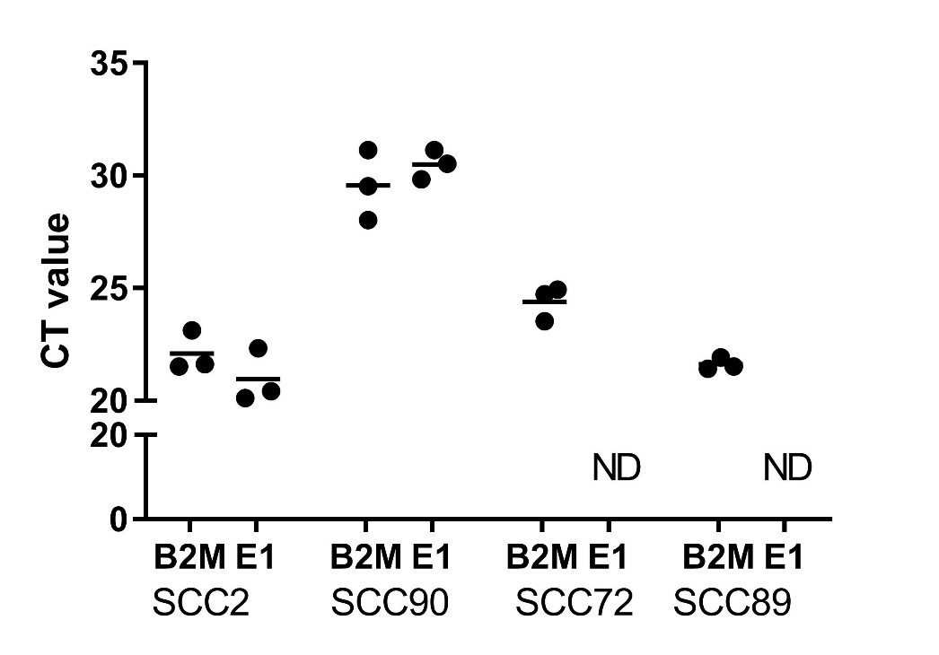
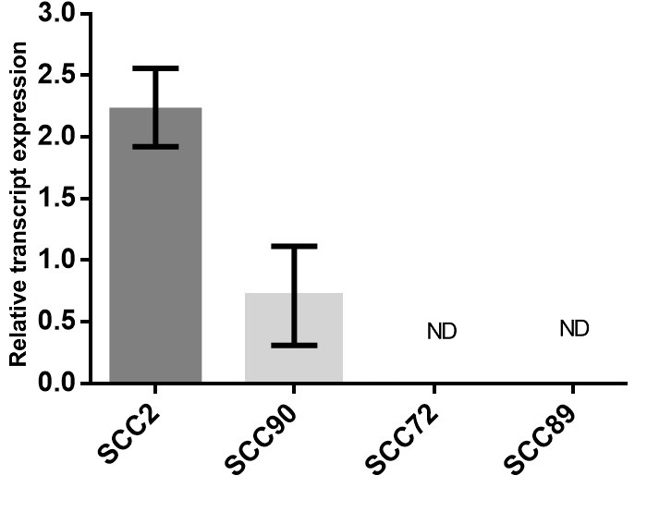
B)
A)
Figure 3.1 - RT-qPCR of HPV E1 for four cell lines
Cell pellets of approximately 3x10⁶ cells from each cell line were used for RNA extraction. RNA was converted to cDNA for qPCR of the HPV E1 gene, with B2M used as the endogenous control. A) Ct values generated are indicated by individual plots with a horizontal line indicating the mean. B) Expression of E1 was calculated relative to B2M (∆∆Ct). N=3 biological triplicate with error bars representing SEM.

 | Cell name | HPV status
1 | SCC2 | HR HPV 16 positive
2 | SCC72 | Negative
3 | SCC89 | Negative
4 | SCC90 | HR HPV 16 positive

Table 3.1 – HPV testing results by Hallamshire hospital cytology laboratory

3.2 – Isolation of small EVs

3.2.1 - Size exclusion chromatography
The commonly used extracellular vesicle (EV) isolation protocol of differential centrifugation followed by ultracentrifugation is associated with protein and RNA contamination (Gardiner, 2016). This can prove insufficient when analysing both RNA and protein content of isolated EVs. SEC has shown some potential as a purification method that can isolate EVs with limited contamination (Gardiner, 2016). We therefore chose to utilise SEC as our isolation method throughout this study.
Conditioned medium from four selected cell lines (SCC2, SCC72, SCC89, and SCC90) was cleared of cell debris, large EVs and apoptotic bodies by differential centrifugation and ultrafiltration. Molecular weight cut off columns (MWCO) were used to generate an EV enriched concentrated sample of 0.5ml to be fractionated by SEC, resulting in EV rich fractions.
With the intention of maximising the yields of EV RNA and protein, 60 ml of conditioned medium was concentrated prior to SEC.

3.2.2 – SEC fraction analysis by TRPS
Resulting SEC fractions were refrigerated overnight at 4°C. TRPS was performed immediately the following day with samples being diluted (1:1 - 1:100) in PBST and passed through 0.22 µm centrifugal filters. TRPS was performed using a NP100 nanopore with typical settings of 45 mm stretch, 0.7 V, 125 nA, and 10 mbar pressure.
EVs were rarely found in fraction 8 and approximately <10% of EVs were found in fraction 9 or fractions 15-16 (figure 3.2). Positively skewed normal distribution was shown by all four cell lines with fraction 11 containing the most EVs. Error bars indicate some variation between repeats. However, the overall pattern of elution was consistent (figure 3.2).

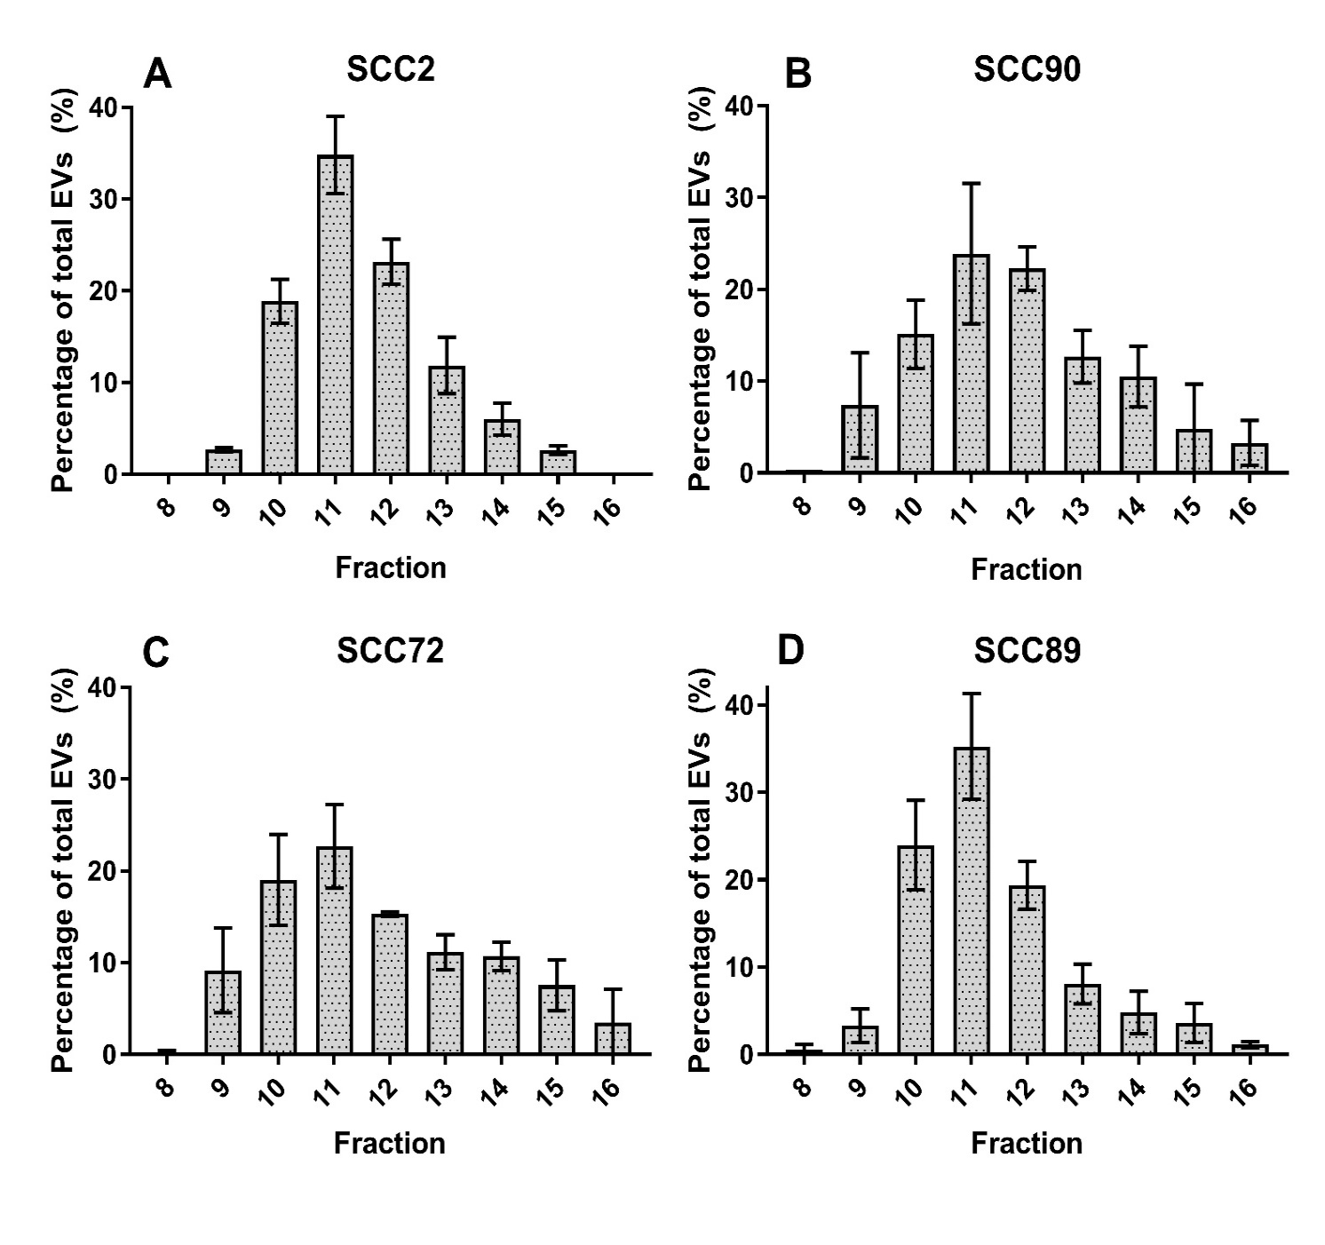
Figure 3.2 SEC EV elution profile
60ml of 72-h conditioned medium was pre-cleared by multi-step centrifugation and was concentrated to 0.5 ml before being fractionated on a 14 ml SEC column. 0.5 ml fractions were collected and analysed by TRPS, using an NP100 nanopore. >500 vesicles were detected for each sample and data for each fraction was expressed as percentage of the total EVs detected. N=3 biological triplicate in biological triplicate with bars showing average values and error bars indicating standard deviation.
3.2.3 SEC soluble protein elution profile
BCA assays were performed on EV rich SEC fractions to determine which fractions could be pooled for pelleting of EVs by ultracentrifugation with minimal contaminate protein (figure 3.3).
Across all SEC EV isolations, fractions 8 and 9 contained almost no detectable soluble protein and low levels of soluble protein began eluting from the column at fraction 10. Protein elution profiles for SEC of SCC2, SCC72, and SCC90 conditioned medium were all similar with protein concentration in fraction 10 of ~0.01 mg/ml. However, this was increased to ~0.04 mg/ml protein in fraction 10 of SCC89 conditioned medium. Fraction 11 for all SEC isolations contained 0.02-0.05 mg/ml soluble protein.
The protein concentration of fraction 12 was approximately 0.05 mg/ml for SEC of SCC2, SCC72, SCC90 conditioned medium. However, SCC89 SEC elution profile data showed that fraction 12 contained 0.06 mg/ml of contaminate protein. The peak elution of contaminate protein in fraction 16 was similar across SEC isolations (0.20 – 0.25mg/ml) (figure 3.3).
As with figure 3.2, the error bars show that there can be some variation when collecting SEC fractions. In particular the HPV- cell lines SCC72 and SCC89 show the largest deviation.

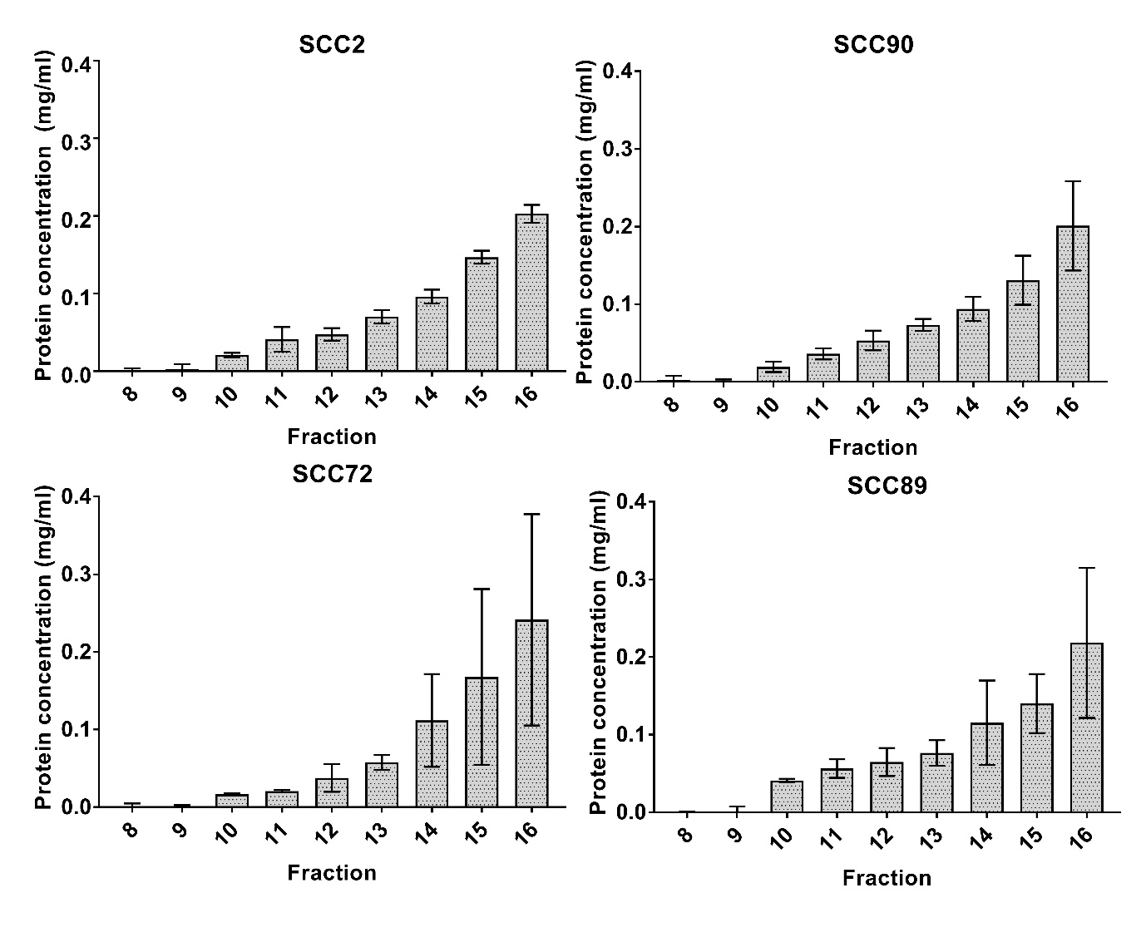
Figure 3.3 – SEC soluble protein elution profile
60 ml of 72 h conditioned medium was pre-cleared by multi-step centrifugation and was concentrated to 0.5 ml before being fractionated on a 14 ml SEC column. 0.5 ml fractions were collected and stored at -20ºC. Protein concentrations were estimated by BCA assay. N=3 in biological triplicate with bars showing average values and error bars indicating standard deviation.

3.2.4 SEC fraction pooling – cumulative data
To identify the SEC fractions to be pooled and used in subsequent ultracentrifugation to isolate EVs, cumulative data graphs were created indicating the proportion of EVs and the total amount of protein that would be included in pooled fractions.
Resultant SEC fractions 8-12 from fractionation of SCC2, SCC90, and SCC72 conditioned medium could be pooled to isolate at least 60-70% of detected EVs whilst only retaining 0.05 mg of soluble protein (figure 3.4). The pooled SCC2 elute from fractions 8-12 contained approximately 80% of detected EVs. Only fractions 8-11 were chosen to be pooled for the SCC89 SEC elute as this still included >60% of detected EVs and kept the contaminate protein low at 0.05 mg. Therefore, fractions 12 and above were excluded from EV pooling for the SCC89 samples. Whereas fractions 13-16 we excluded from EV pooling for the remaining samples.

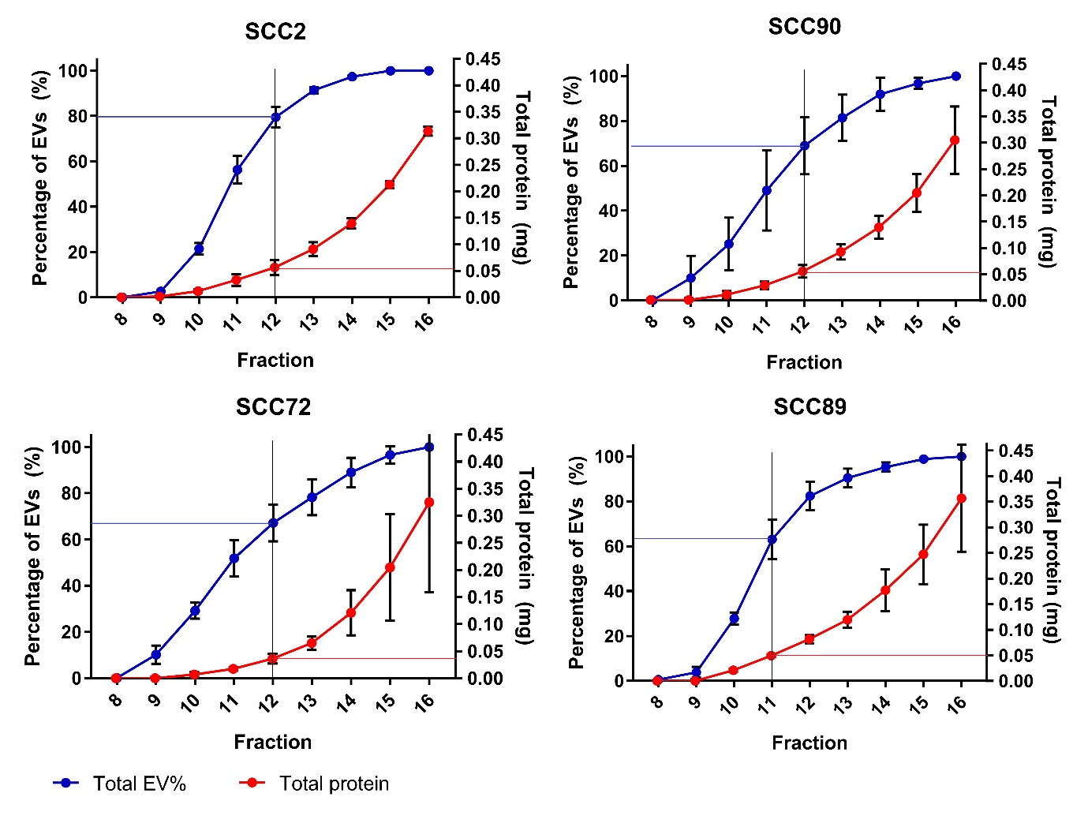
Figure 3.4 – Cumulative totals of EVs and soluble contaminate protein
Cumulative totals for both percentage of EVs and total amount of protein were calculated. Data points in blue show the percentage of total EVs that would be collected if fractions were pooled. Data points in red show the total amount of soluble contaminate protein (mg) that would be in the pooled fractions prior to pelleting of EVs by ultracentrifugation. N=3 biological triplicate with error bars indicating standard deviation. Vertical black lines indicate the highest fraction number chosen to be included in pooling. Blue and red horizontal lines indicate the percentage of EVs and the total contaminate protein that would be collected in the pooled fractions, respectively.

3.3 - EV markers – Western blotting
To confirm that the particles isolated by SEC were in fact EVs, pooled SEC fractions were centrifuged at 100,000 x g for 1 hour, the resulting pellet was solubilised with RIPA buffer and protein markers examined by western blot analysis. Whilst there is no bona fide list of EV markers there are several key markers known be enriched in small EVs. Two of these are CD9 and CD63, tetraspanins which are highly enriched in EVs as the microdomains they form, tetraspanin-enriched microdomains (TEMs), interact with many signalling proteins and are involved in EV biogenesis (Andreu et al, 2014).
As tetraspanins are also a key component of the plasma membrane and thereby likely to be present in other vesicle subpopulations (Andreu et al, 2014) it is important to include other markers.
Tumour susceptibility gene 101 protein (TSG101) is another widely used EV marker as it is a component of the ESCRT-I complex involved in the regulation of vesicular trafficking. TSG101 binds to ubiquitinated cargo proteins and is required for the sorting of endocytic ubiquitinated cargos into multivesicular bodies (MVBs).
Western blot analysis detected EV protein markers in the putative EV samples (figure 3.5). The negative control marker GM130 was apparent only in cell lysate samples indicating that the EV protein is free from contamination by intracellular components.
Both markers for TSG101 and CD9 are apparent in EV and cell lysate samples. However, these are both very faint for the SCC2 EV sample. Nevertheless, the CD9 marker can clearly be seen in all EV samples.
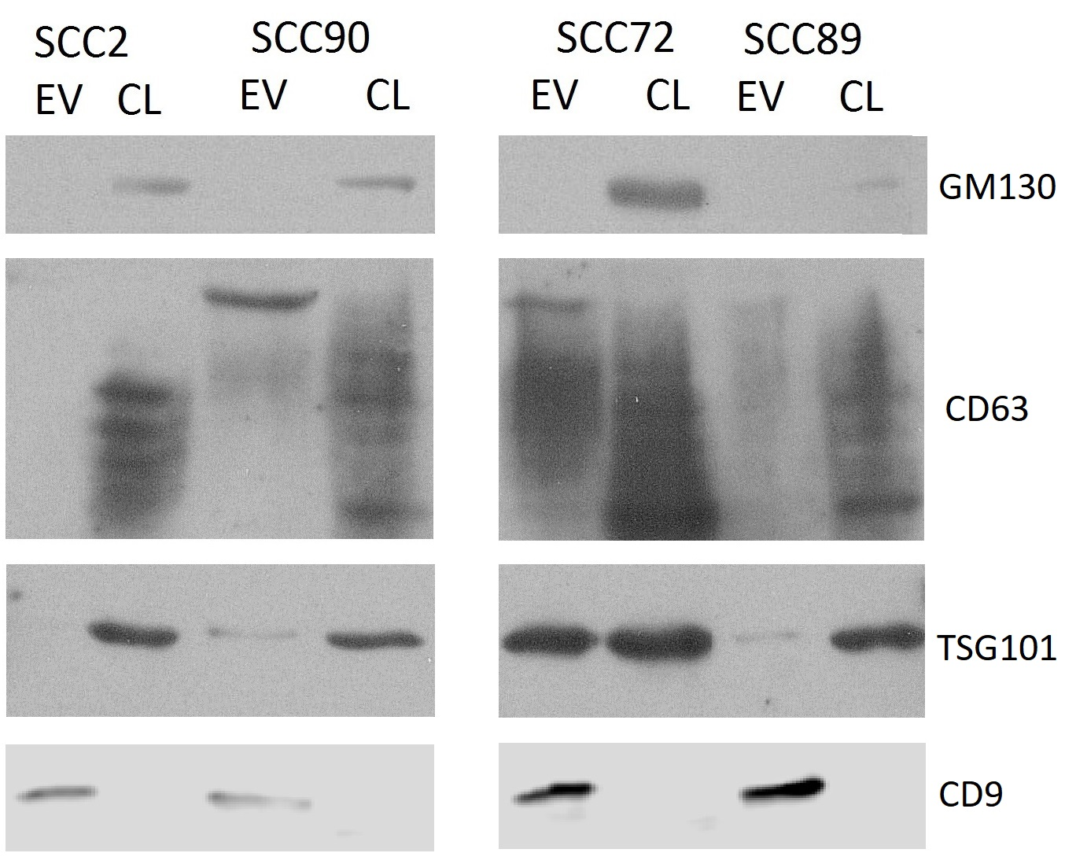
Figure 3.5 – EV protein markers
EVs were isolated by SEC and ultracentrifugation. EV pellets were resuspended in RIPA buffer containing protease inhibitors to solubilise EV protein. Approximately 1-2 million cells from each cell line were washed in PBS and pelleted by centrifugation. Cells were lysed by suspension in RIPA buffer containing protease inhibitors. 20 µg of protein was separated by SDS-PAGE and transferred to a nitrocellulose membrane for subsequent western blot analysis. Blocked membranes were incubated with primary antibodies overnight at 4ºC. Membranes were washed before incubation with HRP-conjugated secondary antibodies at room temperature for 1 h. Luminescent substrate solution was applied for 2 min and the membranes were exposed to x ray film before automatic processing.

3.4 - EV characterization by TRPS

3.4.1 - Characterisation of EVs in conditioned medium
TRPS is capable of providing a great deal of information on particles in a given sample including particle concentration, particle modal and average sizes, and a size distribution profile of particles in a sample. We sought to examine the size and concentration of EVs present in conditioned medium prior to isolation by SEC and ultracentrifugation to understand any differences in secretion rates between our cell lines and to inform future experiments.
1.5 million cells were seeded into a 25 cm² flask and incubated in 3 ml of EV free medium for 24 hours before multi-step centrifugation and filtering. Medium volume was kept to a minimum during incubation to ensure EV concentration was high enough to be analysed by TRPS. The number of cells in each flask was counted at the end of the incubation period to allow secretion rates to be calculated (i.e. EVs per cell per 24 hours).

3.4.2 - EV secretion rate
HPV+ cell lines secreted similar amounts of EVs with SCC2 and SCC90 releasing ~1900 and ~1700 EVs per cell, respectively (figure 3.6). HPV- cell lines secreted more EVs with SCC72 and SCC89 releasing ~2500 EVs and ~4000 EVs per cell, respectively. Statistical analysis showed that both HPV+ cell lines had significantly slower secretion rates than the HPV- cell lines.

Figure 3.6 – EV secretion rate over 24 hours
Medium was conditioned for 24 hours and cleared of larger particles by multi-step centrifugation and 0.22 μm centrifugal filters. Samples were diluted 1:3 in PBST to be used in TRPS analysis. NP100 nanopores were used with typical settings of 45 mm stretch, 0.7 V, 125 nA, and 10 mbar pressure. Samples were analysed for 10 minutes or until at least 500 vesicles were detected. N=3 biological triplicate with error bars representing standard error of the mean (SEM). One-way ANOVA was performed with multiple comparisons corrected for with a false discovery rate (FDR) cut-off of 0.05. FDR method was two-stage step-up method of Benjamini, Krieger and Yekutieli. * = q-value <0.05 ***=q-value <0.001.

3.4.3 – Modal EV diameter
NP100 nanopores were selected that allowed detection of EVs between the range of 50-330 nm. Average EV size from SCC2, SCC72, SCC90 samples ranged between 76-79nm. EVs secreted by SCC89 cells were ~90nm in diameter on average. T-tests between SCC89 and the other samples indicate a significant difference in modal EV size.
Error bars show that there was some variation for average EV sizes from all cell lines with SEM ranges of +/- 2-3mm for SCC2, SCC72, and SCC90. Variation appears greatest for the SCC89 EVs where the SEM was +/- ~5mm.

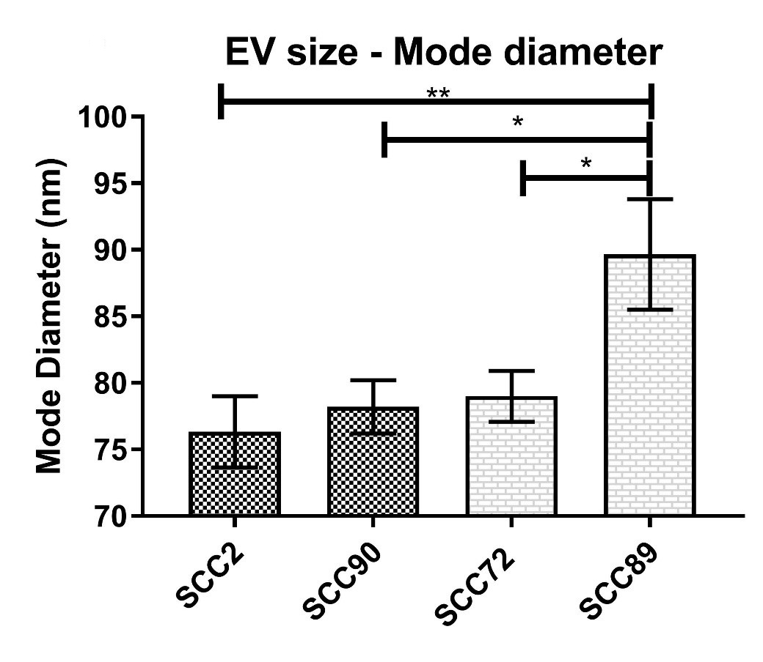
Figure 3.7 – EV modal diameter
Medium was conditioned for 24 hours and cleared of larger particles by multi-step centrifugation and 0.22 μm centrifugal filters. Samples were diluted 1:3 in PBST to be used in TRPS analysis. NP100 nanopores were used with typical settings of 45 mm stretch, 0.7 V, 125 nA, and 10 mbar pressure. Samples were analysed for 10 minutes or until at least 500 vesicles were detected. N=3 biological triplicate with error bars representing standard error of the mean (SEM). One-way ANOVA was performed with multiple comparisons corrected for with a false discovery rate (FDR) cut-off of 0.05. FDR method was two-stage step-up method of Benjamini, Krieger and Yekutieli. * = q-value <0.05. ** = q-value <0.01

3.4.4 – EV size distribution
The size profiles of EVs present in conditioned medium from SCC2, SCC72, and SCC90 are very similar showing positively skewed normal distribution with peaks at 72.5 nm (corresponding to EVs 70-75 nm diameter) representing approximately 12-13% of the total EVs (figure 3.8). The EV size profile for SCC89 has a more normal distribution with a plateau around the peak of 87.5 nm (85-90 nm) which represents only ~9% of the total EVs. These results correlate with figure 3.7 showing similar modal averages and further highlighting SCC89 EVs as being larger than those of the other 3 cell lines.
Figure 3.8 highlights the minimum detection limit as being ~50nm. It is also likely that EVs between 50-60nm aren’t being detected optimally as indicated by the steep incline of the size profiles prior to the 67.5nm (65-70nm) bins.

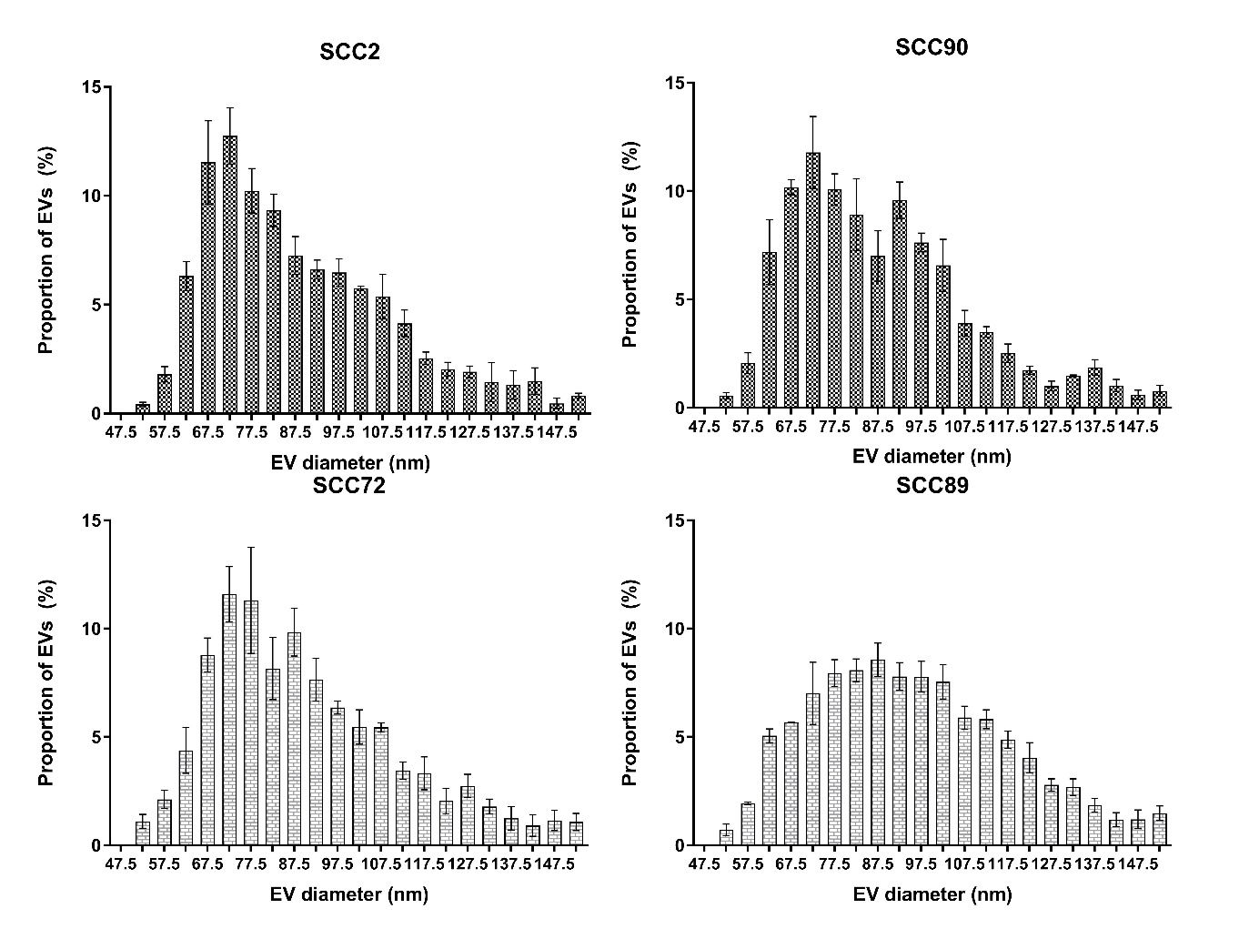
Figure 3.8– 24h incubation EV size distribution
Medium was conditioned for 24 hours and cleared of larger particles by multi-step centrifugation and 0.22 μm centrifugal filters. Samples were diluted 1:3 in PBST to be used in TRPS analysis. NP100 nanopores were used with typical settings of 45 mm stretch, 0.7 V, 125 nA, and 10 mbar pressure. Samples were analysed for 10 minutes or until at least 500 vesicles were detected. Histogram bins are 5nm in range and are labelled with the bin average i.e. bin 67.5 = bin 65-70. X axis shows percentage of EVs calculated from the total. Error bars show SEM with N=3 biological triplicate.

3.5 - Characterization of EVs after SEC and ultracentrifugation
As pooled vesicles needed to be quantified by TRPS the opportunity arose to assess changes in sizes of EVs in response to the chosen purification protocol of SEC followed by ultracentrifugation.

3.5.1 - SEC EVs modal size
SEC isolated EVs secreted by HPV + cell lines SCC2 and SCC90 were on average ~2-3 mm smaller in diameter than EVs secreted by SCC72 and SCC89. However, statistical analysis shows this difference to not be significant (figure 3.9).
Comparison of EVs from SCC2 and SCC90 before and after SEC EVs show that when pooled the modal EV size is ~74 nm and ~75 nm for SCC2 and SCC90, respectively, merely 2 nm smaller than those prior to purification (figure 3.6; figure 3.9). However, once EVs have been isolated by SEC, mode size of EVs from the HPV+ cell lines appears smaller than those of the HPV- cell lines (figure 3.9). The mode size of EVs from HPV- cell lines SCC72 and SCC89 is approx. 78 nm which is around ~4 nm larger than the HPV+ EVs. As before the error bars which indicate SEM show variance of around ~3 nm (figure 3.9).

3.5.2 - SEC EVs size distribution profile
The size profiles for the SEC purified EVs of all cell lines look similar to each other. Histograms for SCC2, SCC89 and SCC90 have 3 bin plateaus at bins 72.5, 77.5, 82.5. For SCC2 and SCC89 each of these represents approx. 9-10% of EVs whereas in the SCC90 histogram these 3 bins each represent 8-9.5% of EVs. The size profile for SCC72 is similar to these with the 2 tallest peaks being 72.5 nm and 77.5 nm each containing ~9.5% of EVs (figure 3.10).
These plateaus are different from what we see prior to SEC where the size profiles of SCC2, SCC72, and SCC90 had clear peaks which contained >12% of EVs (figure 3.7). In Figure 3.10 all size profiles have a positively skewed distribution with larger diameter vesicles showing a higher proportion of detected EVs than was seen in figure 3.7.
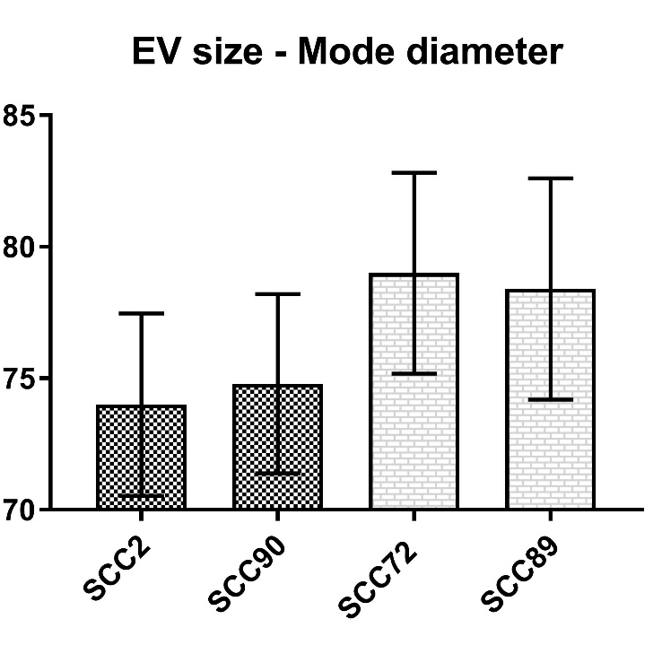
Figure 3.9 – SEC + ultracentrifugation purified EVs mode diameter
SEC elute was pooled by ultra-centrifugation. EV pellets were resuspended in approximately 100 µl of PBST. Samples were diluted between 1:50 and 1:250 in PBST before filtering through centrifugal filters. TRPS was performed using NP100 nanopores with qNano settings of approx. 45 mm stretch, 0.7 V, 125 nA, 10 mbar. Samples were collected from 5 separate EV collections (N=5) and at least 500 EVs were detected for each sample. Modal EV diameter was calculated automatically by qNANO software. Error bars show SEM.

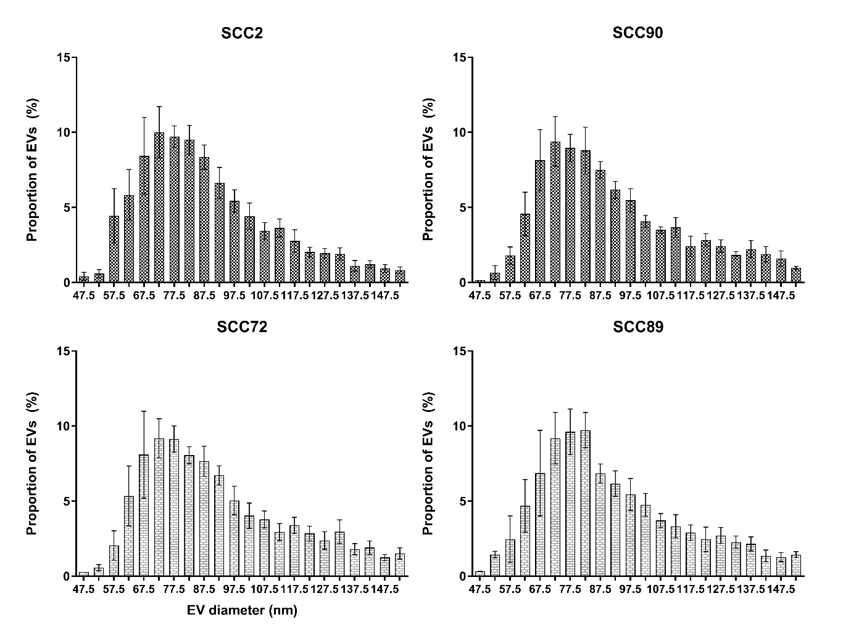
Figure 3.10 – SEC purified EV size distribution
SEC elute was pooled by ultra-centrifugation. EV pellets were resuspended in approximately 100 µl of PBST. Samples were diluted between 1:50 and 1:250 in PBST before filtering through centrifugal filters. TRPS was performed using NP100 nanopores with qNANO settings of approx. 45 mm stretch, 0.7 V, 125 nA, 10 mbar. Samples were collected from 5 separate EV collections (N=5) and at least 500 EVs were detected for each sample. Histogram bins are 5 nm in range and are labelled with the bin average i.e. bin 67.5 = bin 65-70. X axis shows percentage of EVs calculated from the total. Error bars show SEM.

3 - Discussion

3.6 - HPV status confirmation
HPV DNA was identified only in SCC2 and SCC90 cell lines confirming the HPV status of our 4 OPSCC cell lines. qPCR showed ~3 times more E1 RNA transcript present in SCC2 cells that SCC90 (figure 3.1). Possible reasons for variations in HPV gene transcription levels include; number of HPV integrations, transcription rate throughout the cell or at the HPV integration site, episomal vs integrated HPV transcription.
It has been reported that ~75% of HPV+ cancers have integrated HPV DNA (Deng et al, 2013). However, recent work on HPV integration within OPSCC cell lines has shown that both SCC2 and SCC90 contain integrated HPV DNA. SCC2 had two integration sites; the first was fusion of HPV E1 to intron 14 of JAK1 and the second was HPV from E2 into an intergenic region of chromosome 17q12 (Walline et al, 2017). SCC90 shows integration from HPV E1 into intron 1 of ETV6 and another from HPV E1 into the intergenic region of 9q31.1 (Walline et al, 2017). Examination of HPV transcripts in SCC2 and SCC90 has also shown that E2, E6, and E7 were expressed between 1.44-3.86 times more in SCC2 cells (Olthof et al, 2015).
Therefore, the difference we observed between HPV transcript levels of SCC2 and SCC90 correlates with what others have seen. If, like E1, E6 and E7 is transcribed more readily in SCC2 then there is the potential for variations in the abundances of downstream targets of HPV molecules.

3.7 - Effectiveness of size exclusion chromatography in EV purification

3.7.1 - EV and protein elution profiles
SEC elution profiles were similar across all cell lines with only minor differences (figures 3.2 and 3.3). Error bars showed some variation during repeats, in particular the HPV- cell lines SCC72 and SCC89 show the widest error bars (figure 3.3). A possible cause of this could be the timing of SEC elution, as the 0.5 ml fractions were collected by hand and measured by eye. These sources of small errors can also become compounded leading to shifts in data sets. There could also have been issues with the samples movement through the column as the viscosity of the concentrated samples often varied leading to samples forming streaks through the column most likely affecting EV elution.

3.7.2 - Separation of protein and EVs
SEC proved effective at separating soluble proteins from the majority of eluted EVs as long as appropriate SEC fractions were selected for pelleting of EVs (figure 3.4). Fraction selection allowed for 60-80% of EVs eluted from SEC to be collected for pelleting whilst retaining only ~0.05 mg protein. It should also be noted that whilst the aim was to collect the most EVs with the least soluble protein contamination possible, ultracentrifugation and careful removal of supernatant should have produced clean EV pellets.
GM130 was not detectable by western blotting of EV samples suggesting that intracellular proteins were not contaminating the pooled EVs. The effectiveness of this procedure is further discussed in chapter 4 “EV RNA” referencing the bioanalyser traces.

3.7.3 - Western blotting for EV presence in SEC and UC isolation
It has been suggested that whilst CD9 is a highly reliable EV marker, TSG101 and CD63 can often be found to be present at varying levels and may even not be detectable in EV samples (Yoshioka et al, 2013). Indeed, whilst CD9 was clearly present in protein samples isolated from EVs of all cell lines, there was some variability in band clarity when blotting for TSG101 and CD63 in both EV and cell lysate samples. Whilst TSG101 and CD63 expression is seen in many cancer derived EVs, their expression has been shown to vary greatly between different cancers and different cell lines (Yoshioka et al, 2013). Interestingly, depletion of TSG101 can reduce the quantity of CD63+ EVs secreted from cells (Colombo et al, 2013). This correlates with our blots as the strongest CD63+ signals are shown in samples showing strong TSG101 bands.
Despite this, the detection of multiple EV protein markers and the size of particles observed by TRPS, is consistent with isolation of EVs secreted by the cancer cell lines.

3.8 - EV characterisation
Characterisation of EVs is still a relatively new area of research with previous studies relying on TEM to characterise EVs and protein measurement to assess EV quantities. With TRPS analysis providing so much data such as particle concentration, particle modal v mean sizes, and a size distribution profile of particles in a sample, it seemed prudent to fully analyse the EVs secreted by our cancer cell lines. As such an experiment was designed where the EVs were least disturbed by isolation and purification processes and EVs could be measured for size and concentration.

3.8.1 - EV secretion rates in OPSCC’s – HPV+ vs HPV-
Cancer cells are known to secrete significantly more EVs compared to non-malignant cells (Martins et al, 2013; Rackov, 2018). Primary keratinocytes have been reported to release ~95 EVs (exosomes) over 48 h whilst HaCaT cells, an immortalized keratinocyte cell line, secreted ~31 EVs over 48 h (Than, 2017). The OPSCC cell lines utilised in this study released 1700 - 4200 EVs over 24 h.
It stands to reason that different cancers may affect EV secretion in different ways. Over a 24 h period results showed that whilst HPV+ OPSCC lines secreted almost 2000 EVs, SCC72 produced ~25% more EVs whilst SCC89 secreted 100% more. This difference may be attributable to HPV proteins or RNA species reducing EV secretion or distinct qualities of each of these 2 types of cancer affecting EVs differently.
To address the role of HPV proteins on EV secretion other studies have used small interfering RNAs (siRNA) to knock-down HPV encoded E6/E7 and assess changes in quantities and/or contents of EVs secreted from HPV-infected cancer cells, in this case Hela cells. Following successful silencing of E6/E7 expression for 96 h, EV morphology remained the same but there was an increase in the number of EVs secreted (Honegger et al, 2013). P53, downregulated in HPV+ OPSCCs and often mutated in HPV- OPSCCs, has been shown to effect EV secretion. P53 was shown to directly upregulate transcription of TSAP6 resulting in an increase of EV secretion in vitro (Yu et al, 2006).
Some studies indicate that hypoxia resistant cancer cells produce more EVs. In a study of multiple myeloma (MM), hypoxia-resistant MM (HR-MM) cells, generated by growth in in vitro chronic hypoxia, secreted significantly more EVs, approximately twice as many as their parent cells even when exposed to hypoxic conditions (Umezu et al, 2014). A similar effect is seen in breast cancer cells as inducing hypoxia also promoted the release of EVs (King et al, 2012)
It is interesting to consider what part of exosome/EV biogenesis is impacted by cancer cells. Altering MVB fate is a possibility as, upon maturation, MVBs can either fuse with the plasma membrane and secrete exosomes or fuse to lysosomes and degrade their cargo (Bebelman et al, 2018).
A recently described method of tumour cells altering exosome secretion involves the often upregulated and phosphorylated, tumour associated, pyruvate kinase type M2 (PKM2) protein. PKM2 enables formation of the SNARE complexes at plasma membranes through its action upon synaptosome-associated protein 23 (SNAP-23). Knockdown of PKM2 reduced exosome release (Wei et al, 2017). Phosphorylation of SNAP23 has also been shown to increase exosome secretion in HeLa cells as a response histamine H1 receptor (H1HR) stimulation (Verweij et al, 2018). Other oncogenic signalling pathways which can influence EV secretion include, EGFRvIII and H-RASV12 (Al-Nedawi et al, 2008; Lee et al, 2014).
A group studying exosome secretion from cancer cells identified invadopodia, Extracellular cellular matrix (ECM)-invasive actin structures, as playing a critical role in docking of MVBs to plasma membrane and secretion of the contained exosomes. It was also suggested that exosome cargoes could be important in altering this process and thus exosome secretion (Hoshino et al, 2013). As cancers are known to alter EV cargo, a positive feedback mechanism could increase EV release. Differences in EV cargo between the HPV+ and HPV- OPSCC are discussed later.
It’s also possible to manipulate MVBs to increase their delivery to lysosomes. A recent study has shown that ISGylation, an ubiquitin-like modification, of MVB protein TSG101, an important ESCRT-I component, promoted fusion of MVBs with lysosomes thus decreasing exosome secretion (Villarroya-Beltri et al, 2016). Ubiquitin-like interferon (IFN) stimulated gene 15 (ISG15) is a key component of this, guiding conjugated targets to the lysosome aided by autophagic factors HDAC6 and p62 (Nakashima et al, 2014).
With a wealth of possible pathways and signalling molecules able to alter EV biogenesis we can speculate many differences in our cancer cell lines which may be attributable to the observed discrepancy in EV secretion between HPV+ and HPV- OPSCC and may be able to identify protein or RNA cargo responsible.

3.8.2 - Determining EV sizes – Best practice and potential pitfalls
Whilst EVs can be as small as 30 nm, the qNano detection range is still better than most other available methods. The qNANO software automatically generates histogram bins sized to create a standard distribution and provides the best estimation of the modal average. This is preferred over the mean average when looking at EV populations due to the presence of larger vesicles or aggregates skewing the normal distribution (figure 3.8).
Figure 3.8 highlights the minimum detection limit as being ~50 nm. It is also likely that EVs between 50-60 nm aren’t being detected optimally as indicated by the steep incline of the size profiles prior to the 67.5 nm (65-70 nm) bins.
Error bars show that there was some variation for average EV sizes from all cell lines with SEM ranges of +/- 2-3 nm for SCC2, SCC72, and SCC90 (figure 3.7). Variation appears greatest for the SCC89 EVs where the SEM was +/- ~5 nm. This highlights some of the problems faced by using the qNANO over other devices. Because of the need to replace the nanopore for each session, small changes in elasticity, pore size, etc. settings vary between sessions and even during some sessions on the qNANO. The most notable issue with this is that forming triplicate data from samples analysed on different weeks shows drifts in data that, whilst maintaining similar patterns, introduce variance. It should also be noted that the qNANO takes a great deal of expertise to operate and that beginners using this device may be less equipped to avoid introducing variance.
These issues however, may be worth the effort as the data provided can be considered superior to other techniques. Nanoparticle tracking analysis (NTA) is another popular approach using a light-scattering method in which EVs are illuminated by laser light passed through particles in suspension. The light scattered by each EV is detected by the image sensor of a video camera allowing NTA software to track individual EVs, calculating particle size through the Stokes-Einstein equation (Filipe et al, 2010). However the use of light and complexity of the calculating size from movement of EVs means that there are multiple sources of variability including incorrect assessment of viscosity, operator proficiency, and multiple features of the camera and laser array (Gardiner et al, 2013).

3.8.3 - SCC89 EVs are more numerous and are larger
Having discussed that HPV- OPSCCs secrete more EVs (Figure 3.6) it is also interesting that average modal diameter of SCC89 EVs was 10-15 nm greater than those secreted by SCC2, SCC90 and SCC72 cells (figure 3.7). These differences in EV sizes are further highlighted by the size profiles generated in triplicate for each cell lines which shows a greater proportion of SCC89 EVs in the range of 80-100 nm than the other cell lines.
A possibility for this which unites all 3 observations is the presence of 2 distinct EV populations within the conditioned media collected from these cell lines.
Willms et al. (2016) describe how their bottom loaded sucrose density gradient isolation method separated EV populations from B16F10 melanoma cells in to Low density exosomes (LD-exo) and high-density exosomes (HD- exo) which is not seen in most isolation methods. The LD-Exos showed a mode diameter of 117 nm, proving to be a larger population than the HD-Exos which showed a mode size of 66 nm (figure 3.11) (Willms et al, 2016).
If one was to overlap the EV size profiles of LD-exos and HD-exos into a single EV size profile it would look similar to our SCC89 EV profile (figure 3.7). Furthermore, an increase in LD-exos secretion in SCC89 only, might explain the elevated EV secretion rate in SCC89.
When looking at modal diameter and size profiles of EVs isolated by SEC we see SCC89 EVs are far more similar to those of the other cell lines (figures 3.8 and 3.9). In the study of Willms et al experiment they suggest migration speed of EVs through the sucrose gradient might explain the separation, as movement depends on EV density and size (Willms et al, 2016). Size exclusion chromatography separates particles primarily by size and the larger LD-exos (hypothetically secreted in abundance by SCC89) could be eluted in later fractions not included in fraction pooling. This could explain the discrepancy in SCC89 EV sizes seen before and after SEC isolation. Whilst this is just speculation it highlights one possibility which could explain some of the interesting results seen during EV characterization of our OPSCC cell lines.
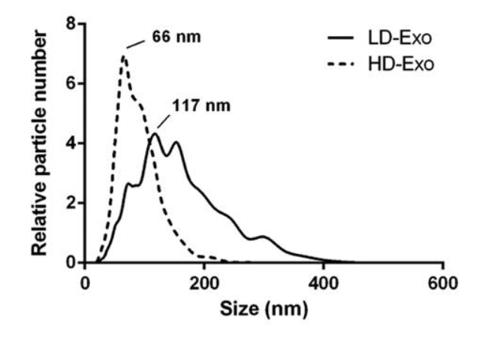
Figure 3.11 – Size profiles of 2 EV subpopulations.
EVs from B16F10 melanoma cells were loaded onto the bottom of a sucrose density gradient cushion as a pellet and centrifuged for 16 h. EV populations were gathered from separate fractions (3–5 LD-Exo, 8–9 HD-Exo). Size distribution profiles were determined by NTA. (Willms et al, 2016).

4. Small RNA sequencing analysis of oropharyngeal cancer EV cargo

4.1. Introduction
Ratajczak et al in 2006 first suggested that RNA could be passed by horizontal transfer between donor and recipient cells through EVs (Ratajczak et al, 2006). It was later demonstrated that mRNA was transferred via EVs into recipient cells and that these mRNAs were translated into protein (Valadi et al, 2007). Since then EV mRNA transfer has been shown in vivo through the use of CRE recombinase-controlled reporter systems (Ridder et al, 2015). Multiple RNA species have been found as EV cargo. Pegtel et al showed EBV encoded viral miRNAs were transferred between infected B-cells and dendritic cells with miRNAs altering gene expression upon receipt (Pegtel et al, 2010).
RNA cargo has been shown to be altered or manipulated under a variety of conditions including cancer progression. MiRNA profiles of EVs secreted from tumour cells have been shown to differ from those of normal cells (Tűzesi et al, 2017). There are two main possible impacts of these shifts in EV RNA; functional impact on cells, and removal of RNA from the cellular environment. Through the use of a CRE recombinase-controlled reporter system it was shown that cancer EVs, containing oncogenic RNA species, can be transferred and malignant traits induced into neighbouring cells suggesting a physiological role for EV RNA transfer (Zomer et al, 2015). Others have shown that tumour suppressor miRNAs can become enriched in cancer EVs and when EV release is blocked tumorigenic phenotypes of the cells are suppressed (Ostenfeld et al, 2014).
With regards to our work there is evidence to suggest that HPVs have specific impacts upon cellular and EV miRNAs. The introduction of HPV16 E6/E7 into human foreskin keratinocytes affected miRNA levels in cellular and EV RNA populations. 48 intracellular miRNAs and 31 EV miRNAs were differentially expressed as a result of E6/E7 expression (Harden and Munger, 2015). Silencing of E6/E7 in HeLa cells has demonstrated their involvement in miRNA regulation, affecting 23 of the 52 most abundant miRNAs in 1 study with similar effects being seen in the HPV+ CC SiHa cell line despite differences in cervical location and HPV type (Honegger et al, 2015).
With all of this in mind we hypothesized that distinct RNA profiles would be apparent between HPV+ and HPV- OPSCCs with a primary focus on miRNA profiles. To investigate potential differences in EV RNA cargo of our cell lines the miRCURY RNA isolation kit (Exiqon) was used. EV RNA was then assessed by Bioanalyser and next generation sequencing (NGS). MiRNAs data was used in differential expression analysis by Deseq2 which identified key similarities between the cell lines of each HPV+ and HPV- group. Pathway analysis highlighted potential cellular mechanisms that could be targeted by each group identifying some shared and some different molecular targets. qPCR validation of 2 selected miRNAs showed similar relative abundances seen in NGS with both cellular and EV RNA.

4.2. EV RNA isolation and Bioanalyser analysis
Total RNA was extracted from EVs using the miRCURY RNA kit (Exiqon) and RNA integrity was assessed using a Bioanalyser instrument and picochip, which is suitable for RNA concentrations 50-5000 pg/µl. The Bioanalyser traces have skewed normal distributions and show peaks between 30-100 nt highlighting the enrichment of small RNA species in EV RNA (figure 4.1).
SCC2 and SCC89 show very tight peaks at ~25-40 nt with a secondary peak at ~50-80 nt. SCC90 shows a slightly wider area with two additional peaks at 100 nt and 180 nt. SCC72 shows an even wider area with multiple peaks (figure 4.1).
SCC90 and SCC89 traces show noticeable ribosomal RNA peaks at ~1800 nt and ~3600 nt, which are larger than those seen in SCC72. There are no apparent ribosomal RNA peaks in the SCC2 trace. Indeed, SCC2 RNA contains negligible large RNA species. SCC89 RNA contains abundant species between 500-4000 nt (figure 4.1.)

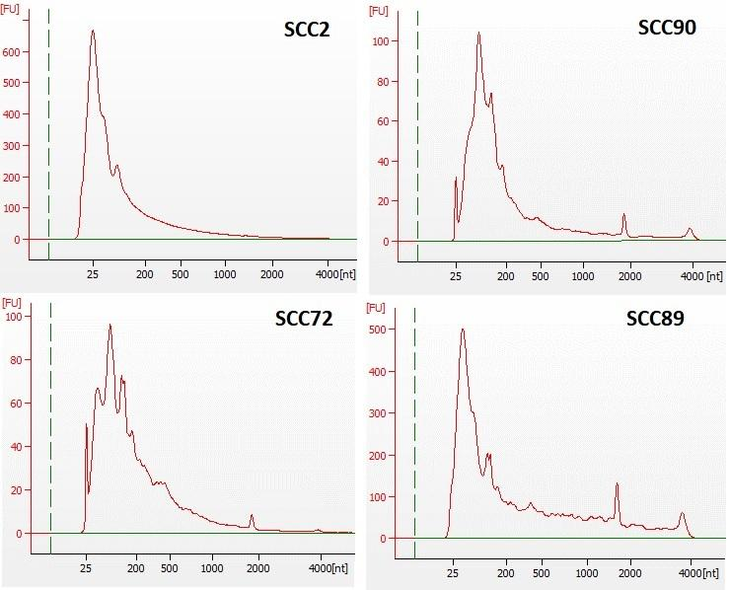
Figure 4.1 - Bioanalyser analysis of EV RNA.
EV RNA was analysed on an Agilent 2100 Bioanalyser Instrument with the RNA 6000 Pico Kit at the Clinical Research Facility, University of Edinburgh. A 25 nt fragment was introduced into samples as a marker. The X axis shows number of nucleotides (nt). The Y axis shows fluorescence units (FU).

4.2 – Small RNA sequencing of EV RNA
Small RNA sequencing was performed at the Clinical Research Facility, University of Edinburgh on an IonTorrent platform. RNA quality and integrity were determined by an Agilent 2100 Bioanalyser instrument with the RNA 6000 Pico Kit and RNA concentration was quantified with the Qubit 2.0 fluorometer and the Qubit RNA HS Assay Kit to ensure equivalent amounts of EV RNA were used in each library preparation.

4.2.1 – RNA species in EVs
The Ion Torrent software automatically performed bioinformatics analysis to categorise identified RNAs into species, which included miRNA, rRNA, tRNA, snoRNA, snRNA, lincRNA and mRNA (figure 4.2A).
The proportion of miRNA in RNA samples was between 2-15%, with SCC2 containing the least and SCC89 containing the most (figure 4.2.A). There was a higher percentage of mRNA in the SCC2 EV RNA (~20%) than in the EV RNA of the 3 other cell lines (12-13%). There was a varying amount of rRNA present in the samples ranging from 2% in SCC2 to 20% in SCC89, which is consistent with the 18s and 36s ribosomal RNA peaks seen in the bioanalyser traces (figure 4.1).
The most abundant RNA species is ‘Other RNA’ for all EV RNA samples ranging from ~37 – 40% of reads from SCC90, SCC72, and SCC89 and up to 60% for EV RNA of SCC2. 5-10% of RNAs were unmapped to either the human genome or the HPV viral genome.

4.2.2 – Abundance of miRNAs
MiRNAs were the primary focus of this study and so the sequencing data related to this species of RNA was taken forward for further analysis. Raw miRNA counts were converted to reads per million (RPM) using the total number of miRNAs detected. For each sample 343-443 unique miRNA were identified with SCC72 EV RNA containing the most unique miRNAs. Abundance levels did not vary greatly between samples, showing 63-82 miRNA were present at high abundance (>1000 RPM), 73-92 miRNA at intermediate abundance (100-1000 RPM) and 117-133 miRNA at low abundance (10-100 RPM) (figure 4.2B).
Bases read from EV samples with high quality score (Q), indicative of a smaller probability of error, ranged from 236 million in SCC90 to 509 million in SCC89 (table 4.1). RNA reads aligned to either the human or HPV genome ranged from 6.4 million to 12.2 million in SCC90 and SCC2, respectively. The percentage of reads that represented miRNAs varied between samples as mentioned (figure 4.2A). SCC2 RNA contained the least with a total of 225,232 miRNAs whilst SCC72 EV RNA had the most with over a million miRNAs (table 4.1).

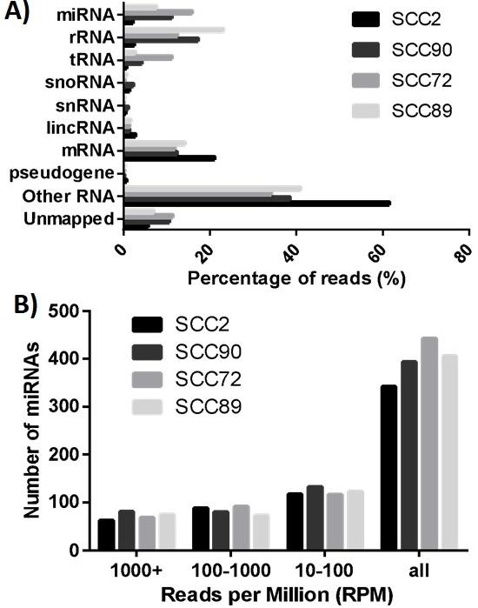
Figure 4.2 – RNA species abundance
Ion Torrent software mapped sequencing data to the human genome and categorised identified RNA into species (A). miRNA reads were processed to determine the reads per million (RPM) for each unique miRNA representing relative abundance; 1000+ RPM, 100-1000 RPM, 10-100 RPM. The total number of unique miRNAs for each EV RNA sample is shown by the group named ‘all’. N=1 (B).

Sample | Bases | Base quality score ≥ Q20 | Reads | Aligned reads | Percent aligned | Mean read length | miRNA reads | Percent miRNA reads
SCC2 | 416,158,927 | 373,732,904 | 13,194,941 | 12,219,229 | 92.61% | 32 | 225,232 | 2.08%
SCC90 | 266,670,258 | 236,403,445 | 7,932,771 | 6,488,330 | 81.79% | 34 | 558,364 | 10.60%
SCC72 | 312,029,946 | 273,174,660 | 10,158,234 | 8,744,738 | 86.09% | 31 | 1,066,501 | 15.14%
SCC89 | 591,849,290 | 509,657,708 | 12,566,794 | 11,470,536 | 91.28% | 47 | 762,204 | 7.44%

Table 4.1 – Small RNA NGS read information

4.3 – Differential expression analysis

4.3.1 DEseq2 analysis
To compare miRNA profiles between our HPV+ and HPV- EV RNA samples DEseq2 differential expression analysis was used. Firstly, low-abundance miRNAs were removed, with exclusion criteria set at an RPM <50 in at least 2 samples. This reduced the pool of unique miRNAs from 575 to 233. Relative abundances of miRNA reads were calculated for unique miRNAs allowing for visualization of sample profiles. Cell lines were grouped by HPV status and deseq2 analysis was performed to compare the relative expression of each unique miRNA and estimate whether they were differentially expressed based on their group. The cut-off for being considered differentially expressed was a log2 fold change (Log2FC) of 1.5 with a p-value of 0.05. Unique EV miRNAs that were differentially expressed based on HPV status of the OPSCC cell line are discussed in 4.3.3.

4.3.2 – Hierarchical clustering and PCA analysis
Two key ways of visualizing overarching sample details are hierarchical clustering and multidimensional scaling (MDS). Hierarchical clustering was performed using the relative abundances of each unique miRNA compared with the average across all samples to produce a heatmap of each sample profile, with dendrograms showing the degree of relationship between miRNAs as well as between each sample. MDS is used to convert complex data into a 2D format allowing for observers to try to find patterns or groupings. Principal-components analysis (PCA), a form of MDS, was performed on NGS data to highlight the degree of similarity between samples.
Hierarchical clustering of miRNA abundance grouped samples from SCC2 and SCC90 (HPV+) together and samples derived from SCC89 and SCC72 (HPV-) together. The degree of distinction between the HPV+ group and HPV- group, whilst significant, was relatively low as shown by the height of the group separators in the top most dendrogram (figure 4.3).
The miRNA profiles of SCC89 and SCC72 are more similar to each other than those of SCC2 and SCC90 are to each other. This is corroborated by the PCA plot which shows the 2D plots for EV miRNA profiles of SCC72 and SCC89 overlapping each other (figure 4.4). The PCA plot also shows that whilst the HPV+ samples are on the other side of the x-axis to the HPV- samples, SCC2 and SCC90 are separated along the y-axis (figure 4.4).

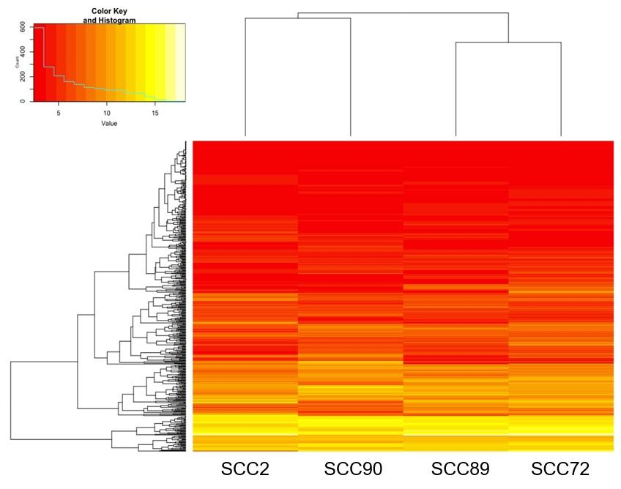
Figure 4.3 – Hierarchical clustering of NGS miRNAs by deseq2
Raw count data for miRNA reads was pre-processed, cutting unique miRNAs down to 253 ready for DEseq2 analysis. Relative abundances of unique miRNAs were calculated for each sample and hierarchical clustering was performed for the miRNA profile of each sample. The results are displayed as a heatmap with the dendrogram on the left relating to unique miRNA clustering and the dendrogram on the top showing sample clustering.

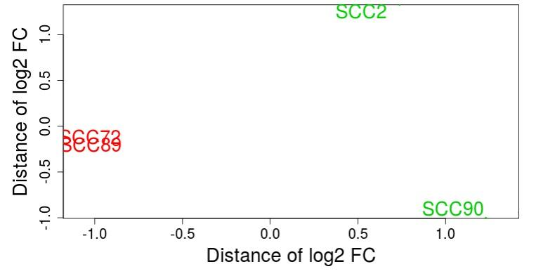
Figure 4.4 – Multidimensional scaling of miRNA profiles
Following removal of low abundance miRNA, profiles were compared by multidimensional scaling. Sample to sample distance is shown by principal component analysis, with HPV+ samples in green and HPV- samples in red.

4.3.3 – Differentially expressed miRNAs associating with OPSCC HPV status
With profile visualization methods indicating that miRNA profiles were different between HPV- and HPV+ our next objective was to examine the detailed deseq2 analysis of differentially expressed miRNAs.
With the cut-off parameters of >1.5 Log2FC and p-value <0.05, 14 miRNAs were found to be more abundant in the EVs of HPV+ OPSCC cell lines when compared to the HPV- EV samples (table 4.2). Of these miR-363-3p showed greatest difference between HPV+ and HPV- being 7.3 times more abundant in HPV+ EVs. miR-20b-3p and miR-20b-5p were 5 times more abundant in HPV+ EVs. 19 miRNAs were more abundant in HPV- cell lines (table 4.2). miR-105-5p was 5-fold more abundant in HPV- EVs as were miR-574-5p and miR-100-5p.
Some miRNAs derived from the same pri-miRNA were identified as differentially expressed such as miR-20b, with both 5p and 3p strands being more abundant in the HPV+ samples (table 4.2). The same is true for miR-9 as both 5p and 3p strands are associated with HPV+ samples. In addition, mature miR-9 appears to be produced from multiple precursor homologues, (i.e. miR-9-1, miR-9-2, miR-9-3). miR-105-5p is another example of multiple mature miRNAs originating from multiple pri-miRNAs although these are in higher abundance in HPV- OPSCC EVs.

4.3.4 – Shared miRNAs between all OPSCC EV RNA samples
We also examined miRNA that were present at high abundance (>5000 RPM) in all samples (table 4.2), which identified 9 miRNA (miR-20a-5p, miR-23a-3p, miR-26a-5p (miR-26a-1/2), miR-27a-3p, miR-27b-3p, miR-30d-5p, miR221-3p, miR-3074-5p). Of these miR-23a-3p was the most abundant with over 130,000 RPM in the SCC72 sample. The 5p strand is of low abundance in all samples (<100 RPM) (data not shown).

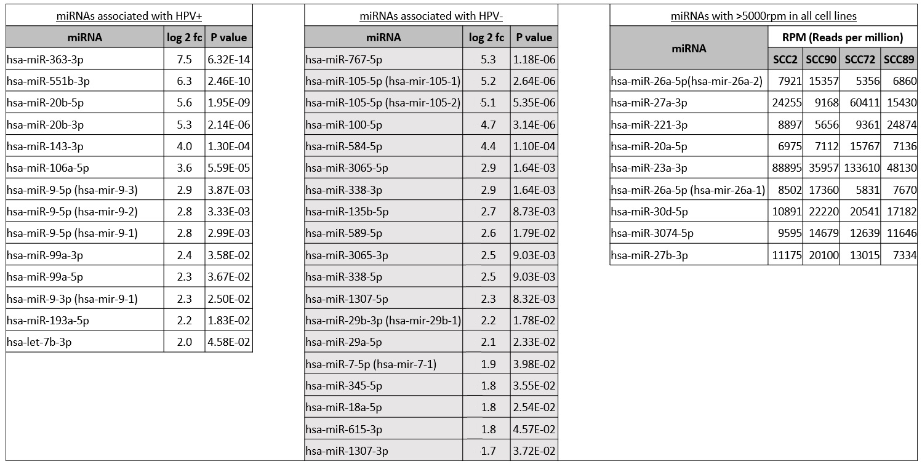
Table 4.2 – EV miRNAs associated with OPSCC HPV status
MiRNAs differentially expressed between HPV+ and HPV- lines as well as miRNAs abundant in all cell lines.

4.3.5 – Additional miRNAs of interest
DEseq2 analysis identified many interesting miRNA candidates for further study. However, working with RPM normalised data highlighted interesting miRNAs that may not be identified by statistical analysis. Several unique miRNAs were identified which demonstrated a fold change >2 (when working outside of log2 data) that have been previously associated with cancer and HPV biology (figures 4.6 and 4.7).
7 additional miRNAs are more abundant in the 2 HPV+ samples than the HPV- samples with average fold changes ranging between 2-4. MiR-16-1-5p and miR-16-2-5p show the greatest abundance ranging from 11,000-17-000 RPM in the HPV+ samples whilst less than 6,000 RPM are detected in the HPV- samples. The relative fold change for these miRNAs between the HPV+ and HPV- is 2.69 and 2.48, respectively.
MiR-92-3p abundance was 3.81-fold higher in HPV+ samples, with ~1000-1100 RPM. The miRNA with the lowest fold difference (2.12) was miR-126-5p. However, the 3p strand, miR-126-3p, shows a fold difference of 2.81.

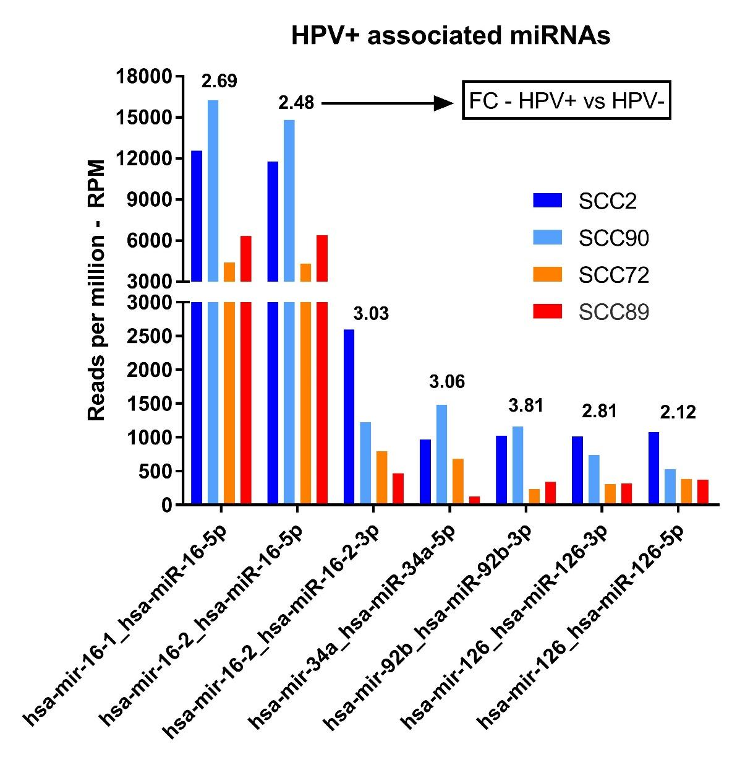
Figure 4.5 – Unique miRNAs more abundant in HPV+ EV RNA not identified by DEseq2
RPM data for all unique miRNAs not identified by deseq2 analysis was assessed for differences between HPV+ and HPV- groups. Unique miRNAs with >2-fold change (FC) between HPV+ and HPV- EV RNA were included. RPM for the HPV+ cell lines are shown in blue and light blue whilst RPM for HPV- cell lines are in orange and red. The fold difference between each group is shown above the bars for each unique miRNA.

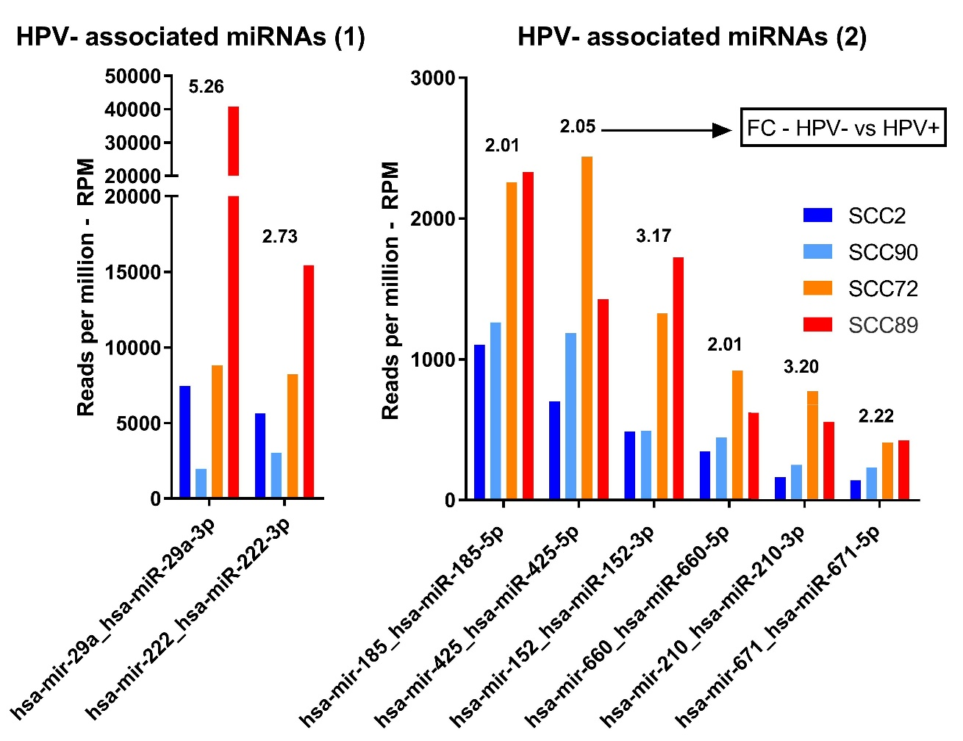
Figure 4.6 – Unique miRNAs more abundant in HPV- EV RNA not identified by DEseq2
RPM data for all unique miRNAs not identified by DEseq2 analysis was assessed for differences between HPV+ and HPV- groups. Unique miRNAs with >2-fold change (FC) between HPV+ and HPV- EV RNA were included. RPM for the HPV+ cell lines are shown in blue and light blue whilst RPM for HPV- cell lines are in orange and red. The fold difference between each group is shown above the bars for each unique miRNA. The graphs were separated into graph A and B to allow for different ranges on the y axis.

4.4 – Pathway analysis of EV miRNAs
Having identified EV miRNAs which may be associated with the HPV status of the producing cell, pathway analysis was used to explore the potential roles these could play in tumour progression.
Pathway analysis was performed using the results from the DEseq2 differential expression analysis. miRNAs identified by DEseq2 analysis as being associated/more abundant with either HPV+ or HPV- samples were individually input into miRTarBase, a database of known and predicted miRNA-target interaction (Chou et al, 2018). Gene targets which have been experimentally validated by at least 2 of the following assays; reporter assay, western blot, qPCR, were accepted for pathway analysis. In the rare case that validation studies were not available for the targets of selected miRNAs i.e. miR-let7b-3p, gene targets were included which had been identified in at least 2 NGS studies. This allowed for inclusion of gene targets for all unique miRNAs identified by differential expression analysis.
The lists generated were used to identify gene transcripts targeted by multiple selected miRNAs with the premise that these targets may highlight the most important pathways. These were subsequently input into DAVID, a web-accessible program which can assess the functional pathways targeted by genes (Huang et al, 2009). DAVIDs KEGG pathway analysis was run with the stringency criteria of Benjamini-Hochberg correction <0.05. Of the pathways identified by DAVID as likely downstream targets, those which were most likely related to cancer-associated pathways were selected for inclusion (table 4.3).

4.4.1 - Pathways targeted by EV miRNAs more abundant in HPV+ OPSCC than HPV-
23 cancer-associated pathways were identified as potential targets of the miRNAs found to be more abundant in the EVs of HPV+ OPSCC cell lines. 10 of these pathways were not identified by the HPV- associated pathway analysis.
When the 12 miRNAs associated with HPV+ OPSCC EVs were input into miRTarBase, 280 gene targets were identified with 40 of these being targeted by multiple miRNAs. The 40 miRNA-targets input into DAVID were associated with 75 pathways, 23 of which are cancer associated.

4.4.2 - Pathways targeted by EV miRNAs more abundant in HPV- OPSCC than HPV+
18 cancer-associated pathways were identified as potential targets of the EV miRNAs more associated with the HPV- OSPCC cell lines, with 6 pathways being unique.
18 miRNAs associated with HPV- OPSCC EVs were input into miRTarBase yielding 484 gene targets, over 200 more targets than seen from the HPV+ associated miRNAs. 51 genes/gene transcripts were targeted by multiple miRNAs and when input into DAVID 36 pathways were identified as potential targets, with 18 of these pathways being associated with cancer biology.

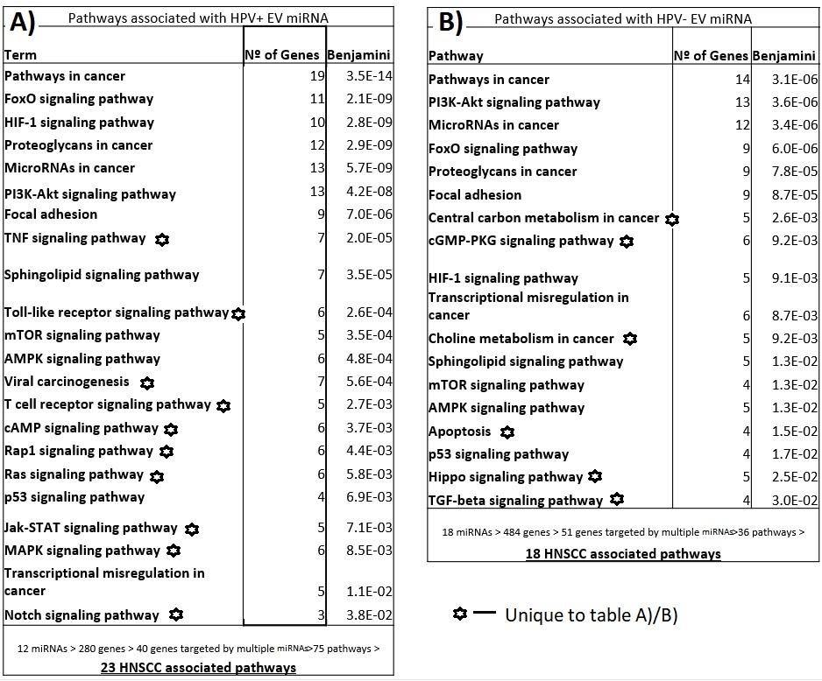
Table 4.3– DAVID pathway analysis of mirTarbase gene targets
KEGG pathways relating to gene targets of miRNAs associated with OPSCC HPV identified using miRTarBase and DAVID pathway analysis. Pathways associated with HPV+ OPSCC EV miRNAs (A). Pathways associated with HPV- OPSCC EV miRNAs (B). Underneath each table workflows are shown demonstrating the number of miRNAs/genes/pathways used in each step. Pathway results unique to either table are identified by a star symbol as shown in the key.

4.4.3 - Shared pathways
Despite unique miRNA being identified as enriched in EVs from HPV+ and HPV- cells, 12 out of the 23 pathways associated with the HPV+ EV miRNA (table 4.3) were also identified as pathways potentially targeted by HPV- miRNAs. Many of these are very broad terms such as ‘pathways in cancer’ and ‘miRNA in cancer’. Family of transcription factors (FoxOs) and PI3-AKT signalling are also quite broad being associated with a multitude of cancers.
Pathway analysis of miRNA highly abundant (>5000 RPM) (table 4.4) across all samples identified many of the same pathways and group terms as previously identified (table 4.2) with the only exception being ‘erbB signalling’. ‘Pathways in cancer’ was the most associated term with 22/79 gene targets being linked (table 4.4).
The 9 abundant miRNAs showed to target 544 gene transcripts, a much higher miRNA to target ratio than seen with the HPV status associated miRNAs. 79 of these were targeted by multiple miRNAs and 46 pathways were associated with these (table 4.4).
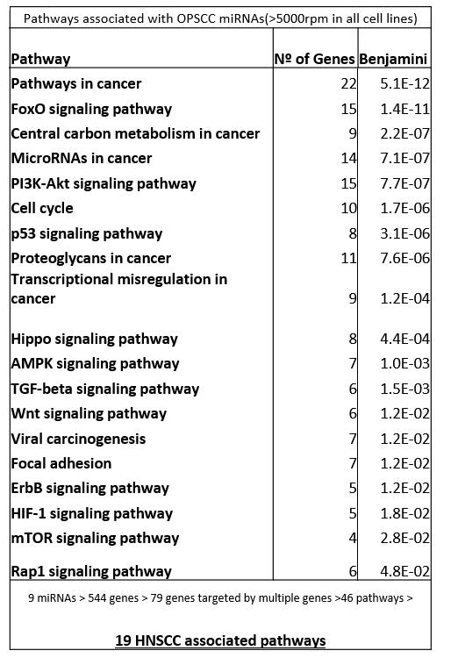
Table 4.4 – Shared abundant miRNA pathway analysis
KEGG pathway analysis of miRNAs found in high abundance in all samples (>5000 RPM’s) by use of miRTarBase and DAVID pathway analysis. Underneath the table is shown the workflow indicating the number of miRNAs/genes/pathways used in each step.

4.5 – qPCR validation of selected miRNAs from NGS results
Small RNA sequencing results were validated by qPCR using two selected miRNAs; miR-29b-3p which was shown to be more abundant in EVs of HPV- OPSCC cell lines, and miR-20b-5p which was more abundant in HPV+ cell line-derived EVs. A comparison of HPV+ HNSCCs, HPV- HNSCCs and HPV+ cervical carcinomas showed miR-20b was increased in both HPV+ cancers making it a likely target of HPV (Lajer et al, 2012). It has also been implicated in progression of cancers such as oesophageal cancer through its action upon PTEN (Wang et al, 2016). MiR-29b has been associated with cancer cell metastasis, cell proliferation and apoptosis (Yan et al, 2015), and has been shown to be suppressed in cervical cancer yet becomes up-regulated upon treatment with cisplatin (Li et al, 2017). Whilst only two miRNAs could be selected for qPCR validation this should provide an indication of how accurate the NGS was.
One of the challenges of validating EV RNA sequencing studies is that there is no universal reference miRNA. Therefore, sequencing data were analysed for potential candidates resulting in let-7a-5p being selected as a reference miRNA due to stable levels across all samples.
RNA was isolated from the EVs and the cell lysates of the 4 cell lines and, using primers specific to each of the 3 miRNAs, cDNA was made for qPCR analysis. Relative abundances of miR-29b-3p in EV and cell RNA samples were very similar to the results of small RNA sequencing, showing highest abundance in SCC72 and SCC89 with much less being detected in SCC2 and SCC90 (figure 4.7). The fold difference between the HPV- and HPV+ is greater in the qPCR samples than the NGS.
miR-20b-5p was more abundant in SCC90 EV RNA and cell RNA than other samples, consistent with small RNA sequencing data (figure 4.7). Very little miR-20b-5p was detected in HPV- samples by small RNA sequencing or qPCR.

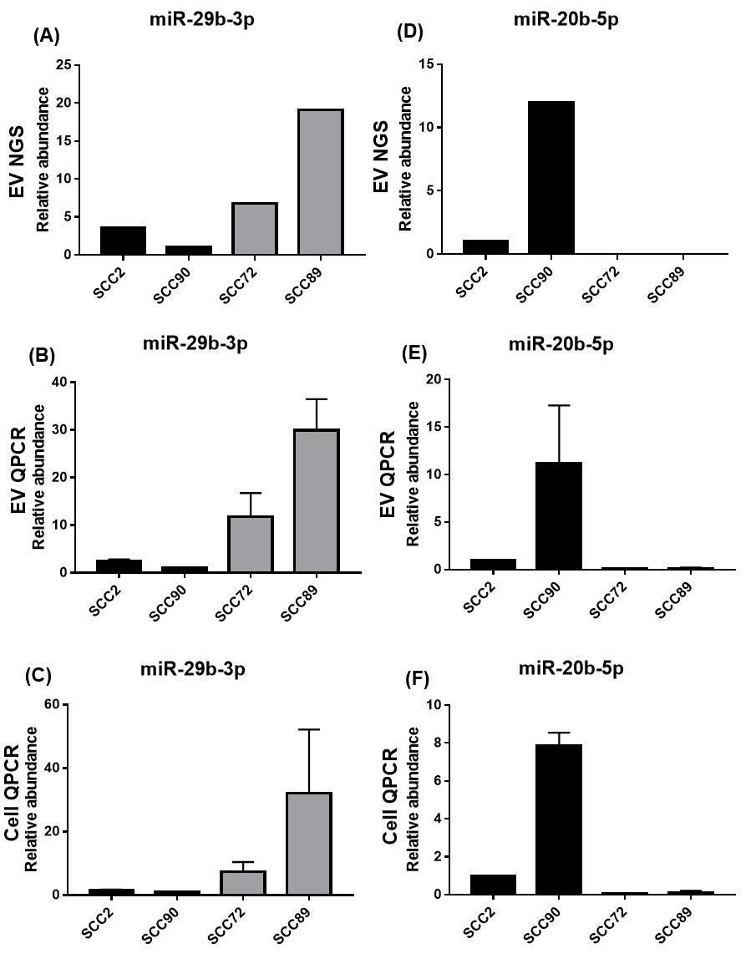
Figure 4.7 – RT-qPCR validation of two miRNAs from NGS
qPCR was performed using EV RNA and cellular RNA from the 4 cell lines. Primers for miR-29b-3p, miR-20b-5p and let-7-a-5p (reference mIRNA) were used to make cDNA by reverse transcription. cDNA was used in qPCR and ΔCT was calculated from the CT values of the two miRNAs of interest and the reference miRNA. 2^{-ΔCT} was used to calculate relative abundances. A) and D) show the NGS RPM results converted to relative abundance. B) and E) show relative abundance of EV miRNAs by RT-qPCR. C) and F) show relative abundance of cellular miRNAs by RT-qPCR.

4 - Discussion

4.6 - EV RNA isolation
Whilst all Bioanalyser traces of EV RNA showed enrichment of small RNA species, consistent with other reports (Wei et al, 2017), some differences in rRNA 18s and 28s peaks were seen between samples. Whilst EVs from SCC72 and SCC90 contained negligible amounts of rRNA and SCC2 showed none, SCC89 showed noticeable peaks.
Some groups isolating EVs from fluids such as blood plasma or urine report the absence of 18s and 28s (Huang et al, 2013). 18s and 28s ribosomal RNA has also been reported to be undetectable in EVs secreted in cell culture by some groups (Eldh et al, 2012). However, it is also common to find small amounts of intact rRNA within EVs secreted from normal cells and cancer cells (Valadi et al, 2007; Jenjaroenpun et al, 2013).
Willms et al. (2016) showed LD-exos to have higher 18s and 28s peaks, similar to our traces for EV RNA derived from SCC89. This again supports the hypothesis that SCC89 cells may secrete more LD-exos than our other cell lines.
Overall EV RNA appears free of contamination and rRNA peaks are likely showing a genuine presence of rRNA within a small number of EVs.

4.7 - OPSCC EV miRNA profiles

4.7.1 - Distinguishing between HPV+ and HPV- samples
Unbiased hierarchical clustering grouped our OPSCC EV miRNA profiles by HPV status (figure 4.3). We also identified 14 miRNAs more abundant in the EVs of HPV+ OPSCC cell lines when compared to the HPV- EV samples and 19 miRNAs more abundant in HPV- cell lines (table 4.2).
Miller et al identified the differences in intracellular miRNA of OPSCC tumours (15 HPV+ and 8 HPV-) by performing miRNA expression profiling of 23 formalin-fixed, paraffin-embedded samples (Miller et al, 2015). Unbiased hierarchical clustering of all miRNAs (meeting cut-off criteria) did not separate samples into two groups based on HPV status. Group 1 contained 10 samples, 8 (out of 15) of these were HPV+ and 2 (out of 8) were HPV-. Group 2 contained 13 samples, 7 were HPV+ and 6 were HPV- (Miller et al, 2015).
The group also used publicly available clinical and miRNAseq data of 22 primary OPSCC cases from the cancer genome atlas (TCGA), 11 of which were HPV+ and 11 HPV-. Unsupervised clustering of the miRNAs in this cohort, showed much greater separation of HPV+ and HPV- samples. Group 1 contained only 9 samples all of which were HPV+ whilst group 2 contained all the HPV- samples plus 2 HPV+ samples (Miller et al, 2015).
Some groups have identified EV miRNA as highly representative of the miRNA abundances in the parent tumour cells (Rabinowits et al, 2009) whilst others highlight preferential packaging of some miRNAs into the cancer derived EVS (Pigati et al., 2010).
We might deduce from this that elements of HPV within tumours directly alter either the abundance of cellular, and by association EV miRNA, or the loading of miRNA into EVs. Certainly our qPCR validations showed concordance between cellular and EV levels of miR-20b and miR-29b (figure 4.7).
Key HPV oncoproteins have been implicated in regulation of miRNA expression. In an experiment which introduced expression of HPV16 E6/E7 into human foreskin keratinocytes both cellular and EV miRNA abundances were altered (Harden and Munger, 2015). Particularly interesting was the identification of 16 miRNAs that were regulated by E6/E7 both within the cell and EV samples, often upregulated, whilst 7 miRNAs were altered differently between the 2 EV RNA populations (Harden and munger, 2015). This suggests a role for HPV proteins to influence both miRNA transcription and packaging of select miRNAs into EVs.
Silencing of E6/E7 in HeLa cells, which are HPV18+, has demonstrated their involvement in miRNA regulation, affecting 23 of the 52 most abundant cellular miRNAs with qPCR data validating ten miRNAs: miR-17–5p, miR-186–5p, miR-378a-3p, miR-378f, miR-629–5p and miR-7–5p were down-regulated whereas upregulation of miR-143–3p, miR-23a-3p, miR-23b-3p and miR-27b-3p, was seen upon E6/E7 silencing. Similar effects were seen in the HPV16+ SiHa cervical cancer cell line despite differences in cervical location and HPV type (Honegger et al, 2015). Upon E6/E7 silencing 21/47 of the most expressed EV miRNAs were upregulated and 4/47 were downregulated following E6/E7 silencing with qPCR validating 75% of targets including, let-7d-5p, miR-20a-5p, miR-378a-3p, miR-423-3p, miR-7-5p, miR-92a-3p which were downregulated and miR-21-5p which was upregulated. Again, results were similar in E6/E7 siRNA-treated SiHa cells suggesting E6/E7 expression as the main factor in determining EV miRNA content rather than the location of the tumour or HPV subtype (Honegger et al, 2015).

4.7.2 - Moving towards biomarker identification
A meta-analysis review of 116 studies involving miRNAs and HNSCC outcomes suggested 27 upregulated miRNAs were associated with poor prognosis whilst down regulation of 26 were correlated with lower survival and increased metastasis (Lubov et al, 2017). Of these 53 miRNAs, 16 were identified in our data as differentially abundant in the EVs of HPV+ or HPV- OPSCC (table 4.5).
Of the 27 upregulated miRNAs, 8 were identified in our data as upregulated in at least one form of OPSCC, six of which were more abundant in HPV- EVs (table 4.5). Out of the 26 miRNAs that low expression was associated with reduced survival, 8 were identified in our differential expression analysis (table 4.5). Of these, 5 were found in lower abundance in our HPV- EVs.
As the meta-analysis by Lubov et al. (2017) did not clarify between HPV+ and HPV- when distinguishing which tumour miRNAs were associated with poor patient outcome, it is interesting to see that of the miRNAs also identified in our research most correlated with the signature of HPV- OPSCC EVs. This may be especially relevant as HPV- OPSCC patients have poorer outcomes than HPV+ patients. Alternatively it could be reflective of the lower prevalence of HPV+ tumours.
Our data demonstrate that the presence of HPV within a cancer can alter miRNA profiles as we showed distinct EV miRNA profiles between HPV+ and HPV- OPSCCs, similar to other studies of HPV tumours. The accumulation of this sort of research will hopefully drive biomarker research and benefit the clinic, with both cellular and EV RNAs as possible predictors of OPSCC cancers and prognosis.

Alignment of results from a meta-analysis of microRNAs expression in HNSCC's and our NGS of EV miRNA
MiRNAs associated with poor prognosis and survival when upregulated in HNSCC's *
 | Elevated in HPV+ EVs ** | Elevated in HPV-EVs **
miR-9 | X
miR-15 | X
miR-18 |  | X
miR-23 | X | X
miR-99 |  | X
miR-210 |  | X
miR-222 |  | X
miR-345 |  | X
total | 3 | 6
MiRNAs associated with poor prognosis and survival when under expressed in HNSCC's*
 | Low levels in HPV+ EVs ** | Low levels in HPV-EVs **
miR-26
miR-29 | X
miR-34 |  | X
miR-126 |  | X
miR-143 |  | X
miR-152 | X
miR-363 |  | X
let-7 |  | X
total | 2 | 5
* - according to the meta-analysis of microRNAs expression in HNSCC's (Lubov et al, 2017)
** - according to NGS of EV miRNA in our study

Table 4.5 – miRNAs associated with HNSCC’s when under or over expressed according to a 2017 meta-analysis (Lubov et al, 2017) and also identified in our research as in the EVs of HPV+ OPSCC or HPV- OPSCC.

4.8 - miR-34a-5p - A tumour suppressive miRNA more abundant in HPV+ EVs than HPV-
MiR-34a was highlighted as a miRNA of interest with results showing 3 fold higher levels in HPV+ OPSCC EVs compared to HPV- OPSCC EVs but not meeting statistical significance (figure 4.5). In a study of different cervical lesions, ranging from normal cervical epithelium to invasive cervical carcinomas (ICC), miR-34a expression was shown to be increased 2-fold in normal HPV infected epithelium and in ICC but not in low-grade or high grade intraepithelial squamous lesions (Ribeiro et al, 2015). This suggests that miR-34a expression is stimulated to promote the viral life cycle and can be targeted again to promote tumour progression.
HPV related miR-34a expression is not isolated to cervical cancer. Comparison of HPV+ and HPV- tonsillar squamous cell carcinoma (TSCC) showed that, 22 miRNAs were upregulated in HPV+ tumours, including miR-34a with a difference of 1.7-fold (Lajer et al, 2012).

4.8.1 - Tumour suppressive roles of miR-34 and relation to p53
MiR-34 genes were the first reported miRNA targets of p53 and showed pronounced upregulation in transcription upon P53 activation (Tarasov et al, 2007). As such miR-34 expression confers multiple tumour suppressive properties including cell cycle arrest. MiR-34 directly downregulates several components of G1 phase to S phase transition, (which are also shown to be controlled by p53) including, cyclin-dependent kinase 4 (CDK4), CDK6, cyclin E2, E2F3, MYC and NMYC (Hermeking, 2012). Cyclin D2 and D3 are also targeted by the P53 upregulated miR-15/16 family, which according to our data was abundant in HPV+ EVs.
One of the key processes which can drive tumour related epithelial–mesenchymal transition (EMT) is the transforming growth factor-β1 (TGF-β1)-mediated activation of SNAIL. SNAIL is a target of miR-34 (and vice versa) meaning p53-mediated upregulation of miR-34 is antagonistic of EMT decreasing the likelihood of invasion and migration of cells (Siemen et al, 2011; Kim et al, 2011). There is also an array of complex feedback loops between P53 and miR-34a. MiR-34 acts to prevent P53 inactivation by targeting SIRT1, a member of the sirtuin signalling molecules (Slabáková et al, 2015). Interestingly, the miR-29s which were identified as HPV- EV associated by our research, have a similar effect on P53 activation through targeting of PI3K transcript, another P53 inhibitor (Slabáková et al, 2015).
Whilst p53-mediated upregulation of miR-34 is functionally relevant in many tumour suppressive roles, p53 can exert its function even in the absence of miR-34a. The response to genotoxic stress which was seen to be mediated by p53 and miR-34a remained intact in miR-34 KO cells and animals (Navarro et al, 2015). miRNA based mechanisms of p53-mediated cell cycle arrest are known to have several redundancies for single miRNA or miRNA families, which may render manipulations of these miRNAs incapable of strong effects (Choi et al, 2011).
MiR-34 is also regulated in a P53 independent manner. MiR-34 transcripts contain a CpG island in their promoter region which can be exploited in numerous cancers. CpG methylation of the miR-34a promoter was seen in ~80% of primary prostate carcinomas whilst cancer cell lines showed miR-34a methylation varied from 13% in colon cancer to 43% in melanomas (Lodygin et al, 2008).
In relation to EVs, low abundance of miR-34a in EVs has been suggested as a predictive marker for docetaxel resistance in castration-resistant prostate cancer (Corcoran et al, 2014). Inhibition of miR-34a increased expression of B‐Cell Lymphoma 2 (BCL‐2) mRNA, a mechanism proposed to be at least partially responsible for drug resistance (Corcoran et al, 2014).
A miRNA study of breast cancer comparing MCF7 cell line cellular and EV RNA showed miR-34a to be amongst those miRNAs that were retained by the cell and found in lower abundance in the EV RNA species (-3 log2 fold) (Pigati et al, 2010).
Whilst miR-34 was identified in our research without statistical significance in Log2 differential expression, a 3-fold difference was seen (figure 4.5) and multiple studies indicate its relationship with both HPV and p53. Others have suggested its potential as a predictive marker and it may be applicable in a panel relating to HPV+ OPSCC.

4.9 - miR-9 is associated with HPV+ OPSCC EVs but to what end?
Differential expression analysis on EV miRNAs identified miR-9 as associated with HPV+ OPSCC EVs. The 5p and 3p strands from miR-9-1 were 2.8-fold and 2.3-fold more abundant in the HPV+ samples, respectively. The miR-9 5p strands were also produced from multiple precursor homologues i.e. miR-9-1, miR-9-2, miR-9-3.
MiR-9 is transcribed from three independent genomic loci mapping to chromosomes 1q22 (miR-9-1), 5q14.3 (miR-9-2) and 15q26.1 (miR-9-3). Both miR-9 mature miRNAs (miR-9-5p and miR-9-3p) are functionally active (Roese-Koerner et al, 2016).
MiR-9-5p is associated with several cancers but is another miRNA shown to be regulated differently between tumours with variable functional roles. Whilst miR-9-5p has been shown to be over expressed in brain tumours, osteosarcoma, and hepatocellular carcinoma it has also been shown to be down-regulated in gastric carcinoma, ovarian cancer, and malignant mesothelioma (Barbano et al 2017).
Whilst miR-9-3p is less studied in cancer it has been shown that decreased levels were associated with a worse prognosis in colorectal cancer (Slattery et al, 2015). The potentially tumour suppressive function of miR-9-3p was further elucidated in two other studies; one of hepatocellular carcinoma cells which identified specific targeting of TAZ (PDZ-binding motif)/YAP (yes-associated protein) expression (Higashi et al, 2015), and another which suggested miR-9-3p targeting of β1 integrin was capable of sensitizing breast cancer cell lines to pharmacological MEK1/2 inhibition (Zawistowski et al, 2013).
Of particular interest is the work done by Baroni et al (2016), which showed miR-9 upregulation in multiple breast cancer cell lines as well as miR-9 EV transfer to normal fibroblasts. MiR-9 was shown to promote CAF phenotypes such as invasion and migration in normal fibroblasts, properties which were reduced by miR-9 inhibition. MiR-9 expression was also shown to regulate cell motility and extracellular matrix remodelling pathways (Baroni et al, 2016).
Another study had previously shown EV-mediated transfer of miR-9 to endothelial cells from five human tumour cell lines which included non-small cell lung cancer (NSCLC), melanoma, pancreatic cancer, glioblastoma, colorectal cancers. MiR-9 targeted SOCS5 mRNA levels with the resultant reduction in protein leading to activation of the JAK-STAT pathway and thus increased endothelial cell migration and tumour angiogenesis. Upon inhibition of miR-9 EV-induced cell migration was reduced in vitro and tumour burden in vivo was reduced (Zhuang et al, 2012).
This suggests a tumour beneficial role for the secretion of miR-9 in EVs relating specifically to stromal interactions that promote tumorigenesis.
MiR-9 was upregulated 2.2-fold in a study of 101 HPV+ cervical cancer tumours through the action of HPV E6, although this was not as a result of P53 inactivation (Liu et al, 2014). In multiple cohorts of HNSCC, Miller et al. (2015) identified miR-9 as a miRNA that was highly influenced by HPV, originating from multiple homologues (Miller et al, 2015), as our own results have identified. However, unlike other studies which identified miR-9s interference of E-cadherin as a key part of its tumour promotion (Ma et al, 2010), no relationship between miR-9 and E-cadherin levels was identified in HNSCC (Miller et al, 2015). Indeed other studies have indicated higher expression of E-cadherin in HPV+ OPSCC (Rampias et al, 2013). Whether miR-9-mediated reduction of E-cadherin is abrogated in some fashion or sequestration of miR-9 into EVs limits the impact on E-cadherin remains to be elucidated.
MiR-9 is a complex molecule to study with varying impacts on tumour progression. Yet it seems highly likely that HPV+ tumours upregulate its expression, with EV transfer of miR-9 conferring multiple pro-tumorigenic properties.

4.10 – miRNA clusters associated with OPSCC EVs

4.10.1 - miR-363 is upregulated in HPV+ OPSCC EVs and down regulated in HPV- OSPCC EVs
Differential expression analysis identified miR-363-3p to be 7.5 fold more abundant in HPV+ OPSCC EVs. This is consistent with another study that showed of 36 differentially expressed miRNA in HPV+ and HPV- TSCC, miR-363 showed the largest difference (10-fold higher in HPV+ tumours) (Lajer et al, 2012).
In a comparison of Normal oral keratinocytes (NOK) cells, HPV- HNSCC cells, and HPV+ HNSCC cells (including SCC2 and SCC90) miR-363 proved in multiple validations to be consistently upregulated in HPV+ lines when compared to NOKs: SCC2 (6.3-fold), SCC90 (28.9-fold) (Wald et al, 2011). Additionally, miR-363 expression was 7-12-fold lower in HPV- lines compared to NOK cells (Wald et al, 2011).
Some miRNAs are arranged in clusters and are transcribed as a single polycistronic transcript such as the miR-106a-363 cluster (Zhang et al, 2016). The miR-106a-363 cluster, located on human chromosome X, encodes six miRNAs: miR-106a, miR-18b, miR-20b, miR-19b-2, miR-92-2, and miR-363 (Khuu et al, 2014). Lajer et al (2012) identified 5 of these miRNAs as upregulated in cervical cancer lines; miR-106a, miR18b, miR-20b miR92a and miR-92b, whilst the HPV+ OPSCCs only showed upregulation of miR-363 and miR-20b (Lajer et al, 2012). Transfection of miR-363 and miR-20b mimics into cultured human squamous oral carcinoma cells caused a reduction in proliferation by 25 and 45%, respectively (Khuu et al, 2014).
Our data is consistent with that of other studies, showing multiple members of the cluster (miR-106a, miR-20b, miR-363 (table 4.2), miR-92b (figure 4.5)) to be upregulated in HPV+ tumour EVs and that miR-363 has the greatest fold increase. This may be in part due to interplay of miR-363 with other members of the cluster as its been shown to decrease expression of these other miRNAs (Khuu et al, 2014).
In another study showing high levels of miR-363 in HPV+ HNSCC comparative to HPV- HNSCC, myosin 1B (MYO1B), a motor protein involved in cellular motility, was identified as a target (Chapman et al, 2015). Interestingly, when miR-363 was overexpressed in HPV- HNSCC, MYO1B mRNA and protein levels were reduced, resulting in reduced motility of these cells (Chapman et al, 2015). HPV+ HNSCC tumours are often described as less invasive when compared to HPV- tumours, resulting in a better prognosis and survival rate (Fakhry et al, 2008).
A study of HNSCC tissues (irrespective of HPV status) associated miR-363 downregulation with increased invasive capacity and chance of lymph node metastasis suggesting methylation of the miR-363 gene promoter in HNSCC (Sun et al, 2013). They also identified podoplanin (PDPN), another protein involved in cell motility, as a target of miR-363 (Sun et al, 2013).
Overall miR-363, as well as other members of its cluster, appear to be both upregulated by HPV and down regulated in HPV- OPSCC. Cell motility appears to be a major function targeted by miR-363 and may be partially responsible for the difference in invasive potential we see between HPV+ and HPV- OPSCCs whereby HPV- OPSCC is considered more aggressive.

4.10.2 - miRNA cluster miR-23a,-27a,-24
Both miR-23a-3p and miR-27a-3p were identified in our data as highly abundant in both HPV+ and HPV- OPSCC EVs. These are 2 members of the miR-23a cluster (miR-23a,-27a,-24) (Amado et al, 2015).
In metastatic or pre-metastatic stage nasopharyngeal carcinomas (NPC), miR-23a expression was found to be significantly elevated and its levels were correlated with microvessel density (Bao et al, 2018). The study went on to show elevated EV-encapsulated miR-23a isolated from NPC patients and NPC cell lines. Injection of these EVs into nude mice caused increased vessel formation relative to miR-23 levels within EVs (Bao et al, 2018).
In human CD8+ T cells expression of all three members of this miRNA cluster (miR‐23a,‐27a,‐24) exerted a suppressive effect upon CD8+ T-cell effector functions. TGF-β1 promoted expression of the miR-23a cluster, but was not needed to aid immunosuppressive effects of the miR-23a cluster (Chandran et al, 2014). MiR‐23a targeted CD107a, an essential component of the cytotoxic granule machinery whilst, miR‐27a and miR‐24 were shown to target the proinflammatory cytokine IFN‐γ (Chandran et al, 2014).
It is worth noting that IFN‐γ is also inhibited by miR-29 (Ma et al, 2011), a miRNA identified in our data as more abundant in HPV- OPSCC EVs. IFN‐γ has also been linked to miR-363 as interferon-induced tetratricopeptide repeat 5 (IFIT5) transcription is activated by IFN‐γ which leads to degradation of pre-miR-363. This was identified as one of the ways in which IFN-γ contributes to the induction of epithelial-to-mesenchymal in multiple tumour types (Hsieh et al, 2018).
MiRNA clusters abundant in OPSCC EVs, whether associated with HPV status or not, could prove to be valuable biomarkers as deregulation of multiple members of a cluster can be more reliable.

4.11 - miR143-3p and miR-126 suggested to be down regulated in HPV+ cancers yet elevated in our HPV+ EVs

4.11.1 - miR-143-3p
Differential expression analysis showed a strong association of miR-143-3p with HPV+ EVs with a log2 fold difference of 4 (table 4.2).
In opposition to this, comparison of cervical cancer tissue to adjacent normal tissue identified downregulation of miR-143 (and upregulation of miR-16 and miR-199a). Combating low miR-143 levels with over-expression in HeLa cells inhibited proliferation and promoted apoptosis by direct suppression of BCL-2 (Liu et al, 2012). The pro-tumourigenic decrease of miR-143–3p has also been linked to enhanced glucose metabolism by aerobic glycolysis (Warburg effect) in breast cancer cells (Jiang et al, 2012).
Whilst miR-143-3p has been described to be upregulated by p53-mediated post-transcriptional miRNA maturation (Suzuki et al, 2009) other mechanisms may be more important in some cancers as demonstrated by p53-independent increase in miR-143–3p when HPV E6 and E7 are silenced (Honegger et al, 2015).

4.11.2 - miR-126
MiR-126-3p and miR-126-5p were shown to be more abundant in HPV+ EVs by 2.81-fold and 2.12-fold, respectively (figure 4.5). The RPM for these 2 miRNAs was relatively low at ~1000 RPM in SCC2 EVs and between 600-800 RPM in SCC90 EVs.
In a comparison of HPV+ cervical cell lines to normal cervical cells down regulation of miR-126 (and miR-143) was related to the presence of HPV (Martinez et al, 2008). PCR-based miRNA profiling of tissue samples from HPV+ from HPV- OPSCC identified miR-126 (and miR-143) as down regulated in HPV+ OPSCC (Miller et al, 2015). Lajer et al also described a HPV related reduction in miR-126 (and miR-143) in miRNA signatures of oral and oropharyngeal squamous cell carcinomas (Lajer et al, 2011).
MiR-126 is commonly described as a tumour suppressive miRNA due to its role in reducing cancer cell proliferation, migration, invasion and survival (Qu et al, 2018). Increased miR-126 expression in breast cancer cell lines was associated with decreased cancer cell motility and migration potential (Li et al, 2009). In in vivo and in vitro experiments of human gastric cancer, miR-126 was shown to be downregulated compared to normal cells, whilst ectopic increase in miR-126 levels inhibited tumour growth and metastasis (Feng et al, 2010). Transfection of miR-126 mimics into colon cancer cells led to the degradation of CXCR4 reducing the cell viability as well as migratory and invasive potential of the cells (Li et al, 2013). If CXCR4 is allowed to function it can activate NF-kB pathways and increased MMP-2, MMP-9, Image result for vascular endothelial growth factor (VEGF) and nitric oxide expression, promoting tumour cell invasion through promotion of angiogenesis and degradation of the extracellular matrix (Qu, et al 2018). In hepatocellular carcinoma (HCC) miR-126-3p levels are down-regulated and when transfected with mimics of miR-126-3p HCC cell lines showed a reduction in cell invasion and migration (Du, 2014).
As such, down regulation of both miR-126 and miR-143 can be pro-tumourigenic and is apparently seen in HPV+ cancers. This could make EV evacuation of these miRNAs a tumour promoting process. As we see upregulation in HPV+ OPSCC EVs we should also consider their impact on stromal cells.

4.11.3 - miR-126 and miR-143 acting upon the cancer microenvironment
In endothelial cells miR-126 has been shown to be proangiogenic, amplifying the PI3K-ATK signalling pathway through its repression of PIK3R2. A similar effect is seen upon the proangiogenic MAPK-ERK signalling pathway through miR-126-mediated inhibition of Sprout-related EVH1 domain-containing protein 1 (SPRED1). In this fashion miR-126, potentially supplied by OPSCC EVs, can aid in VEGF targeted angiogenesis pathways (Fish et al, 2008; Yan, 2013).
Whilst the potential transfer of miR-126 to endothelial cells in the tumour microenvironment seems positive for tumour growth, understanding pro-tumorigenic transfer of miR-143 is more difficult. In HUVECs overexpression of miR-143 suppressed glycolysis through direct targeting and reduction of HK2 miRNA, leading to EC dysfunction an effect reversed by restoration of HK2 expression (Xu et al, 2016).
Interestingly, in response to altered blood flow miR-143 expression in endothelial cells was shown to be increased and subsequently transferred to SMCs by EV transfer (Hergenreider et al, 2012). MiR-143 has been implicated in the fate of smooth muscle cells, as it is transcribed in multipotent murine cardiac progenitors before becoming localized to vascular smooth muscle cells. Furthermore, miR-143 was able to promote differentiation and repress proliferation of smooth muscle cells stabilizing vascular formations (Cordes et al, 2009).
Microarray and PCR experiments showed downregulation of miR-143 in malignant breast cancer tumours compared to normal tissue. However, miR-143 was present in malignant epithelial cells and stromal fibroblasts in breast cancers (Johannessen et al, 2017). It has also been shown in mouse models that miR-143 in the tumour microenvironment can promote tumour growth by stimulating the proliferation of endothelial cells (Dimitrova et al, 2016).
Whilst both miR-126 and miR-143 are involved in complex and often cell/tissue specific functions, it appears that the expulsion of these from tumour cells should promote tumour growth by both reducing their tumour suppressive functions intracellularly and promoting pro-tumour stromal interactions. As these 2 miRNAs are found to be more abundant in our HPV+ OPSCC EVs, yet commonly described to be downregulated in HPV related cancers, it is tempting to speculate that they are selectively targeted for incorporation into EVs by a pathway over which HPV has influence.
A mechanism by which this might be possible is posttranscriptional modifications as 3' end adenylated miRNAs have been shown poorly incorporated into EVs, remaining in the cellular environment, whereas 3' end uridylated isoforms have been shown to be overrepresented in EVs (Koppers-Lalic et al, 2014).

4.12 -TNF signalling and PI3K/Akt signalling in relation to cancer cell invasion and metastasis
Seven out of forty HPV+ EV miRNAs are associated with the TNF signalling pathway, a term unique to the HPV+ miRNAs (table 4.3). In contrast PI3K/Akt signalling was identified by 13 gene targets of both HPV+ EV miRNAs and HPV- miRNAs (table 4.3) as well as 15 gene targets identified using the most abundant OPSCC EV miRNAs (table 4.4).

4.12.1 - TNF signalling
TNF‐α, a major component of TNF signalling, can increase expression of HPV‐16 E6/E7 at the RNA level (Gaiotti et al, 2010). A mechanism for this is TNF‐α dependent stabilization of the RNA for amphiregulin, an EGF receptor ligand, which increases HPV‐16 E6/E7 and cyclin A transcripts which enhance activity of cyclin‐dependent kinase (cdk)2 and cdc2 (Gaiotti et al, 2010). Interestingly, Ras pathways were unique to HPV+ EV miRNA pathway analysis, and can promote TNF signalling. Ras inactivation can reduce TNF‐α-mediated promotion of cell proliferation (Gaiotti et al, 2010).
Tumor necrosis factor (TNF) signalling pathways have previously been implicated in the pathogenesis of cancer with TNF-α being suggested as a potential salivary biomarker for the diagnosis of oral squamous cell carcinoma (OSCC) (Sahibzada et al, 2017). In oral cancers TNF-α promoted oral cancer cell invasion and metastasis through activation of the NF-κB signalling pathway with inhibition of the NF-κB signalling pathway partially reducing this effect (Tang et al 2017). NF-κB is also involved in expression of matrix metalloproteinases (MMPs), especially the expression of MMP9 (Ricca et al, 2009).

4.12.2 - PI3K/Akt pathway
The PI3K/Akt pathway also acts through NF-κB activation and has been shown to increase invasion in lung cancer (Chen et al, 2011). The PI3K/Akt signalling pathway has also been shown to upregulate Snail and Slug, inhibiting expression of E-cadherin, as well as promoting expression of MMPs which helped trigger epithelial-mesenchymal transition (EMT) and promote invasion of tumour cells (Kang et al, 2011).
Members of the pathway, such as p85, are often mutated in HPV- HNSCC cancers. Mutations to PIK3R1, a gene encoding p85α, the regulatory subunit of Class IA PI3K, are oncogenic promoting PI3K activity without stimulation by growth factors (Luo et al, 2005). It should also be noted that EGFR, which was identified as a component of the OPSCC EV cargo in the proteomics chapter, is an upstream activator of the PI3K signalling.
With both of these pathways being linked to MMPs the additional ways in which these enzymes could be targeted by OPSCC EVs should be explored.

4.12.3 - MMPs - extracellular proteinases potentially targeted by HPV+ and HPV - associated EVs
Our data identified miR-9 and miR-143 to be associated with EVs derived from HPV+ cells whilst miR-29b and miR-100 were associated with HPV- EVs (table 4.6). These miRNAs target MMPs, enzymes related to TNF and PI3K/Akt signalling pathways.
Following up on the observation of 3.8-fold upregulation of laminin-1 and 5.2-fold increase of SMA in the interstitial stroma in cervical cancers, one study showed that HPV+ cervical cancer cells could increase fibroblasts production of a laminin for the ECM (Fullár et al, 2015). Another study of cervical cancer cells showed that these cells enhanced MMP production in human uterine cervical fibroblasts resulting in improved tumour invasion (Sato et al, 2009). Upregulation of the expression of several MMPs has been linked to HPV E6/E7 thereby promoting tumour cell migration in cervical cancers (Zhu et al, 2015).
The regulation of MMPs by EV miRNAs could oppose a pro-tumorigenic stromal interaction for both HPV+ and HPV- OPSCCs particularly when HPV appears to strategize towards MMP expression. However MMPs do appear to be putative targets of miRNAs and associated pathways found in EVs of both OPSCC types. It is possible that packaging of these miRNA into EVs could be a mechanism to derepress cellular MMP expression in OPSCC cells.
TNF signalling and PI3K/Akt signalling pathways utilize similar pathways such as NF-κB signalling pathway in cancer cells. Both were identified in our pathway analysis for different reasons. The association of miRNAs to PI3K/Akt signalling from both HPV+ and HPV- OPSCC EVs could imply that similar cancer-associated mechanisms are in play. Alternatively an increased repression of NF-κB signalling by miRNAs targeting TNF signalling could be seen in either cancer, dependent on whether the miRNAs are being selectively expelled by HPV+ OPSCCs or whether their expression is simply downregulated in HPV- OPSCC.

OPSCC EVs | miRNA | mRNA target
HPV+ | hsa-miR-9-5p | MMP13
HPV+ | hsa-miR-143-3p | MMP14
HPV+ | hsa-miR-143-3p | MMP2
HPV+ | hsa-miR-143-3p | MMP9
HPV+ | hsa-miR-143-3p | MMP13
HPV- | hsa-miR-100-5p | MMP13
HPV- | hsa-miR-29b-3p | MMP15
HPV- | hsa-miR-29b-3p | MMP2
HPV- | hsa-miR-29b-3p | MMP24
HPV- | hsa-miR-29b-3p | MMP9

Table 4.6 – MMP targeting of OPSCC EV miRNAs

4.13 - P53s regulation of miRNAs – and its disruption in both OPSCCs
P53 signalling pathway was identified in all miRNA pathway analyses with 4 gene target counts from HPV+ associated miRNAs and HPV- associated miRNAs as well as 8 shown in the shared abundant pathway analysis.

4.13.1 - What happens to P53 in OPSCCs
p53 is a crucial tumour suppressor, often disrupted in cancer, but is particularly interesting in OPSCC due to the way it is targeted by HPV+ and HPV- cancers (Slabáková et al, 2017). NGS studies based on using formalin-fixed, paraffin-embedded (FFPE) HNSCC tumour samples have shown TP53 mutations in 87% (Chung et al, 2015) and 81% (Seiwert et al, 2015) of cases. Additionally, whole exome sequencing (WES) data from The Cancer Genome Atlas Network has shown TP53 mutations in 86% of 279 HPV-negative HNSCC samples (Cancer Genome Atlas Network, 2015). When these mutations are loss of function mutations there is a significant reduction in survival after surgical treatment (Poeta et al, 2007).
HPV E6 targets P53 for degradation by formation of a trimeric complex of p53, E6 and E6-AP, a cellular ubiquitination enzyme. Upon degradation P53 can no longer function as a tumour suppressor allowing cell cycle progression and increased tumour cell growth (Crook et al, 1991).

4.13.2 - P53 impact on miRNA expression
P53 is down-regulated in both OPSCCs, either through HPV E6 interaction or mutational events, and is itself a regulatory molecule of a variety of miRNAs. Most genes targeted by P53 are upregulated and only ∼15% of targets are repressed (Rinn and Huarte, 2011). Many of the p53-regulated miRNAs are involved in stress response contributing to restoring cells to health though a variety of feedforward and feedback loops. As such P53 expression is also regulated by miRNAs. The importance of these p53-regulated miRNAs in tumour suppression is highlighted by the fact that they are common targets for inactivation by genetic and epigenetic mechanisms in human tumours (Hermeking, 2012). Some of the mechanisms they regulate include; cell cycle progression, migration, epithelial–mesenchymal transition, stemness, metabolism, differentiation and cell survival.

4.13.3 - Is P53 the key player in HPVs miRNA regulation?
An E6/E7 silencing experiment comparing miRNA expression in parental HeLa cells and “p53-null” HeLa cells showed that out of a selection of 10 miRNAs (that has shown E6/E7 related upregulation), only miR-186–5p and miR-378f (and miR-34a as a control) expression was not upregulated in P53 null cells upon E6/E7 silencing. The other 8 are presumably modulated by E6/E7 expression in a p53-independent manner (Honegger et al, 2015).
Interestingly, cervical cancer cell lines containing episomal HPV confer a greater pro-angiogenic potential, promoting angiogenesis more efficiently than cell lines expressing only E6/E7, suggesting that more HPV encoded molecules such as viral miRNAs could be aiding in the promotion of angiogenesis (Chen et al, 2007).

P53 downregulation is important to both HPV+ and HPV- OPSCC tumours. Our results suggest that miRNAs related to P53 pathways can be found in EVs from both OPSCCs. This may amplify the down-regulation of P53 or they may be secreted from the cell as a counter balance.

4.14 - HIF-1 signalling
Pathway analysis showed 10 out of the 40 HPV+ associated EV miRNAs targeted members of the HIF-1 signalling pathways compared to 5/51 HPV- EV miRNAs (table 4.3). MiRtarbase showed miR-20b-5p and miR-106a-5p, both of which were enriched in HPV+ cell derived EVs, directly interact with HIF-1α.
Hypoxia-inducible factor-1 (HIF-1) has been associated with a number of cancers with elevated levels of HIF-1 correlating with tumour metastasis angiogenesis and poor patient prognosis. It has even been discussed as a plausible therapeutic target as it can aid in tumour therapy resistance (Masoud and Li, 2015).
In HNSCC lines early activation of HIF-1α was seen in response to certain radiation treatment and hypoxia, stabilizing the cells. Inhibition of HIF-1α can also sensitize cancer cells to treatment, particularly in cancer stem cells (CSCs) localised in hypoxic niches (Wozny et al, 2017).
Immunohistochemistry of oral squamous cell carcinoma (OSCC) tumours from patients showed elevated HIF-1α protein expression in HPV+ compared to the HPV- tumours (Rodolico et al, 2011). Further labelling of both HIF-1α and HPV16 E7 showed a significantly positive correlation indicative of positive and direct association (Rodolico et al, 2011). In vitro studies have shown HPV+ HNSCC cells have higher HIF-1α and PHD2 protein levels than HPV- under both normoxic and hypoxic conditions. Silencing HIF-1α reduced the capacity of HPV+ HNSCC for migration and proliferation (Knuth et al, 2017). HPV+ cells were able to maintain their migration and proliferation despite application of deferoxamine (DFO), an iron chelating agent which did impair HPV- cancer cell migration and proliferation (Knuth et al, 2017).
In HPV+ cervical cancer lines it was shown HPV16 E6 prevented VHL-mediated degradation of HIF-1α thus allowing for increased HIF-1α accumulation (Guo et al, 2014). EV-mediated export of miRNA that target HIF-1α (such as miR-20b-5p and miR-106a-5p) could be another mechanism by which HPV+ cancer cells increase HIF-1α abundance.

5 – EV protein

5.1 – Introduction
Proteins are an important component of EVs often found to be delivered as functional signalling molecules as well as being involved in membrane surface/bound ligand interactions (Ratajczak et al, 2006). Indeed, the most abundant EV proteins are the most common way of identifying EVs experimentally such as the key tetraspanins CD63, CD9, CD81. Protein profiles of EVs are often affected by disease states of cells, partially reflecting the changes the secretory cell is undergoing whilst also changing the biological properties and functions of EVs as they interact with neighbouring cells (Pegtel et al, 2014). Therefore, EV proteomic work can lead to clinical developments in the future once more comprehensive fundamental research is carried out.
An EV proteomic study separated a mast cell secreted EV proteome into 3 distinct parts using proteinases and biotinylating of EV surface proteins; whole EV proteome, luminal EV proteome, and EV surface proteome (Cvjetkovic et al, 2016). 14 proteins were determined to be surface-accessible proteins with a further 641 proteins which were likely to be surface-accessible, many of these being cytosolic and nuclear proteins (Cvjetkovic et al, 2016). Their work is helping to build a concept for reverse topology EV proteins and inside-out EVs.
One of the caveats of EV proteomic studies is the high level of purification needed to allow EV proteins to be more visible than the contaminating proteins often isolated in conjunction with EVs (Greening et al, 2017). Modern EV isolation procedures that take advantage of multiple separate techniques have allowed more rigorous proteomic work, yet other issues are still apparent and difficult to avoid. For instance, attempts to minimize the use of contaminating serum proteins in culture can affect the quantity and composition of EV proteomes (Li et al, 2015). Nevertheless this is an exciting time to be studying EV proteomics with great potential for new discoveries.
Discovery proteomics has taken large strides with improvements to mass spectrometry‐based proteomic technologies allowing for protein identification and quantification. Label-free mass spectrometry allows for relative quantification of whole proteomes in a sample. These samples, whilst requiring high purity, can contain as little as 0.5 μg of protein per replicate making label-free a superior choice of comparable proteomic workflows.
Major vesicular protein databases have been formed such as EVpedia (Kim et al, 2015), ExoCarta (Mathivanan and Simpson, 2009), and Vesiclepedia (Kalra et al, 2015) compiling data from increasing numbers of studies focusing on EV proteomic analyses from diverse cell types, body fluids and disease states. The accumulation of this information allows for better pathway analysis, corroborative data, and drives EV based diagnostics and therapeutic EV protein targets.

5.2 – Label free mass spectrometry
Protein isolated from SEC purified EVs was solubilised in Rapigest and analysed by label-free mass spectrometry in the Department of Chemical and Biological Engineering, The University of Sheffield. Samples were analysed in technical duplicate using reverse phase HPLC-MS. Samples were reduced, alkylated and then digested using trypsin. Peptide data generated by the Orbitrap Velos instrument was analysed and quantified using Maxquant software, identifying relative abundances of proteins based on peptide hits. A profile of “LFQ” intensities was calculated for each protein as the best estimate proxy for absolute protein abundance. Perseus software was used to assess profile similarities/discrepancies between replicates, samples, and cancer types.

5.2.1 – Unique protein abundances
Across the 8 samples (4 samples analysed in duplicate) a total of 624 unique proteins were identified following post processing by Perseus software, such as removal of contaminants. Multiple scatter plots show high similarity between replicates yet there were many cases of proteins being identified in only 1 of the 2 replicates (figure 5.1A). Across the SCC2 EV replicates 178 proteins were identified, but only 118 of these were identified in both. Similar numbers were seen with SCC90 EV samples which showed a total of 158 proteins identified with 94 of these being identified in both replicates (figure 5.1B).
More proteins were detected in HPV- EV samples than the HPV+ EV samples. 409 proteins were detected across the SCC72 samples and even though only 214 were found in both replicates this is still approximately twice as many as either of the HPV+ samples. A similar number of proteins were detected in SCC89 samples with 363 in total and 212 proteins shared between replicates (figure 5.1B).

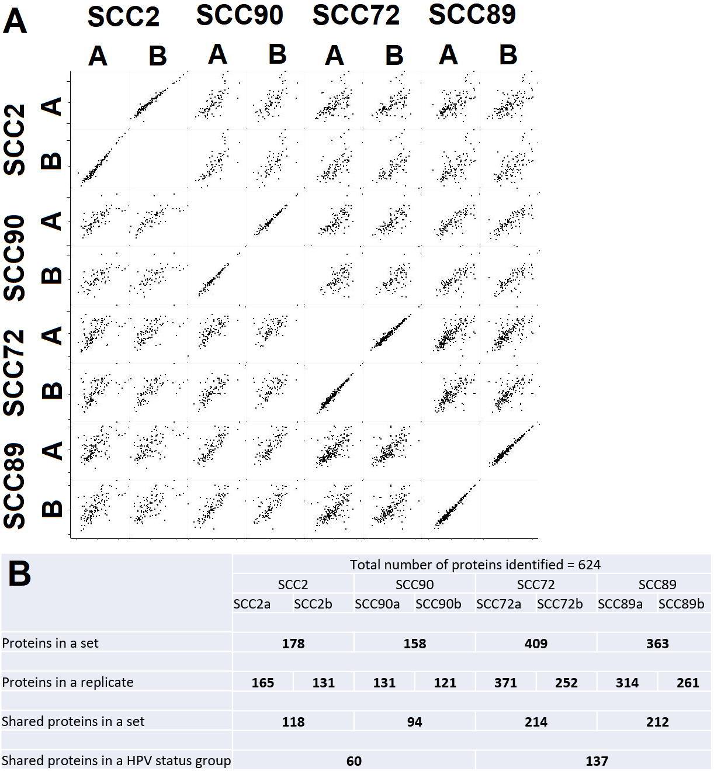
Figure 5.1 – Unique protein abundance and replicate similarity
EV Protein data from Maxquant software was processed in Perseus software to exclude proteins identified as contaminates. A) Multiple scatter plots of the proteins identified in a sample are arrayed. B) The number of proteins identified by Mass spectrometry of each sample and those shared by groups.

5.2.2 – PCA and Hierarchical clustering
As mentioned previously both PCA and hierarchical clustering can indicate the degree of similarity between samples and potentially group them based on the most abundant proteins or the entire profiles respectively.
The replicates of SCC90, SCC72, and SCC89 EV samples show high similarity of the key proteins by PCA. Only SCC2 replicates show slight dissimilarity, which is illustrated by horizontal separation of replicates (figure 5.2A). The PCA plot separates SCC2 from the other 3 cell lines horizontally by component 1. SCC 72, SCC89 and SCC90 are grouped along the X axis. SCC72 and SCC89 show high similarity in comparison to the HPV+ cell lines based on their grouping (figure 5.2A).
The protein profile of SCC2 EVs is dissimilar to those derived from the other 3 cell lines. This is shown by PCA, as SCC2 occupies a separate area of the graph (figure 5.2A), and by hierarchical clustering as the column dendrogram separates SCC2 away from the other cell lines (figure 5.2B).
Despite both being derived from HPV- cells, hierarchical clustering does not group SCC72 and SCC89 EV samples together as SCC90 is marginally more similar to SCC89 (figure 5.2B). Interestingly the PCA plot places SCC90 and SCC89 equidistant from SCC72 on opposite sides suggesting that the core proteins found in highest abundance are more similar between the SCC72 and SCC89 samples than between SCC89 and SCC90 (figure 5.2A).
The heatmap shows that a large number of proteins are unique to EVs from only one cell line, in particular SCC72 and SCC89 (figure 5.2B).

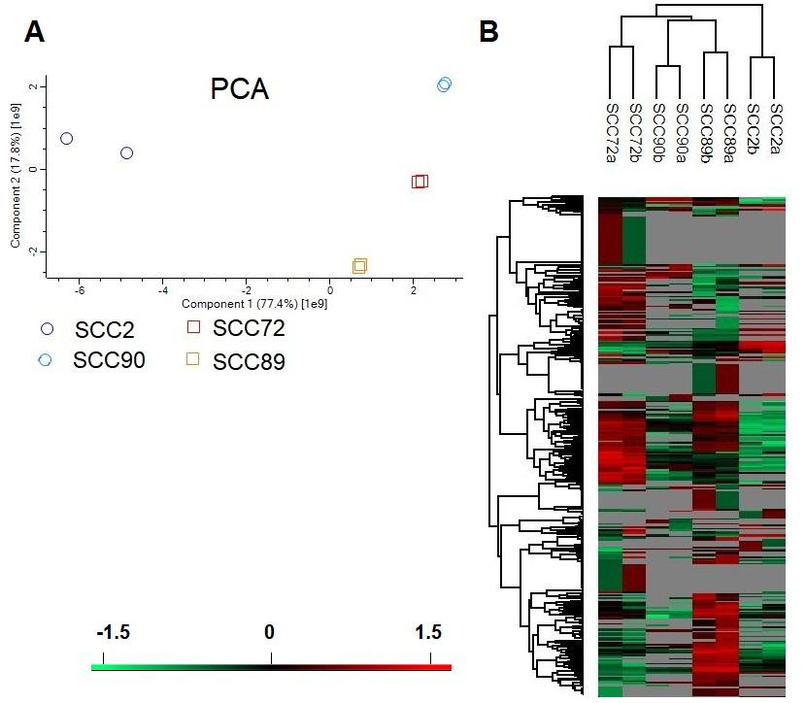
Figure 5.2 – Cell line correlation
A) Principal component analysis of EV protein profiles derived from 4 cell lines (2 replicates per sample). LFQ intensities were transformed by LOG2. Only proteins which were identified in both replicates from at least one cell line are included (total 314). Circles with blue/purple colour represent HPV+ profiles. Squares with red/orange colour represent HPV- profiles.
B) Unbiased hierarchical clustering of protein profiles. LFQ intensities were transformed by LOG2 before Z-scores was calculated. Only proteins which were identified in both replicates from at least one cell line are included (total 314). The column dendrogram indicates cell line grouping whilst the row dendrogram indicates protein grouping. Colour gradient is indicated at the bottom left. Boxes in grey represent 0 readings.

5.2.3 – Differential expression of proteins
Data sets were grouped by HPV status to be input into a volcano plot which combines the functions of the two-sample t-test and the scatter plot. A total of 51 proteins were identified as differentially expressed between the two groups by student t-test, shown in colour on the volcano plot (figure 5.3A). 34 of these proteins met the FDR criteria of <0.05 (Benjamini-Hochberg) (identified by red squares).
The majority of these proteins were primarily abundant in the EVs derived from HPV- cell lines falling to the left of the volcano plot. Two proteins were shown to be more abundant in HPV+ cell line derived EVs, versican and low-density lipoprotein receptor-related protein 1, but only versican met the FDR cut-off (table 5.1).
Proteins with differential abundance, displayed by heatmap, were most commonly only found in HPV- cell derived samples (figure 5.3). Approximately 25% of proteins with differential abundance were also detected in HPV+ cell derived samples. The majority of these did not meet the FDR cut-off except for elongation factor 2, peptidyl-prolyl cis-trans isomerase A, cofilin-1, and a group of heat shock related proteins; heat shock 70 kDa protein 1A/1B, heat shock protein HSP 90-alpha, heat shock cognate 71 kDa protein. EGFR showed the lowest Benjamini-Hochberg value. It should be noted that the levels of EGFR vary between replicates but that the average intensity in samples SCC72 and SCC89 are similar (figure 5.3B - labelled in pink).

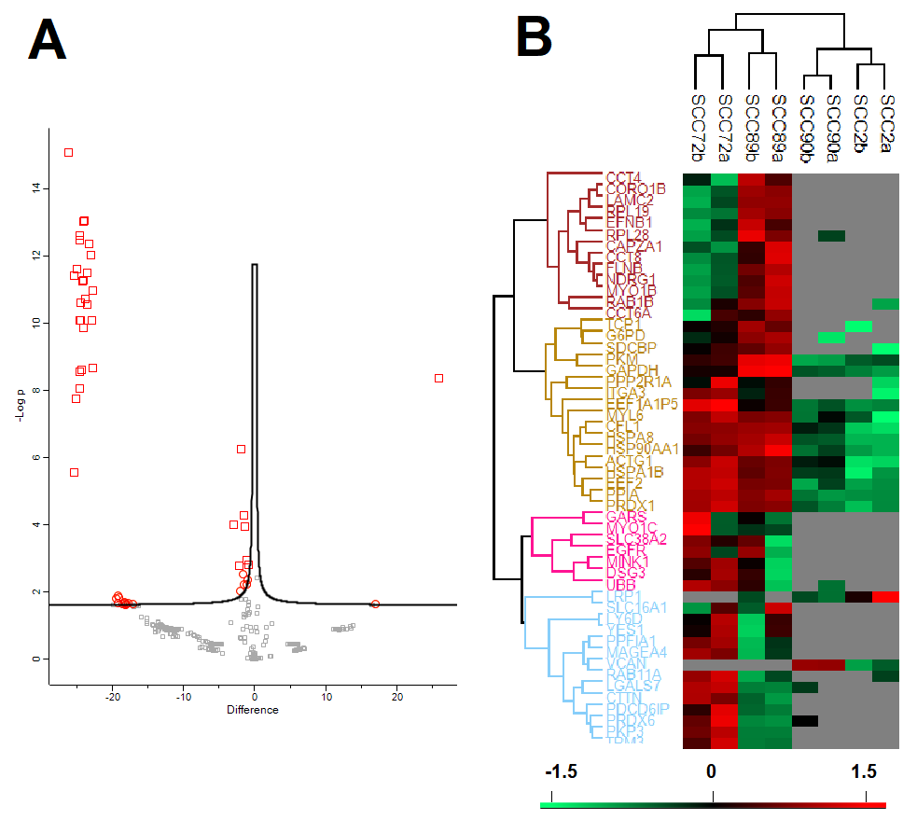
Figure 5.3 – Differentially expressed EV proteins
Samples were grouped by HPV status and Log2 LFQ intensities were used in a two-tailed student T-test with Benjamini-Hochberg FDR <0.05. Volcano plot arranges proteins based on their P value, colouring those with a P-value of <0.05 red and orange. Red squares represent proteins which met the FDR cut-off, orange circles represent those that did not (A). Proteins identified by the volcano plot as having a p-value <0.05 are displayed by heat map. Cell lines are indicated by the dendrogram at the top. Colour gradient is shown at the bottom (B).

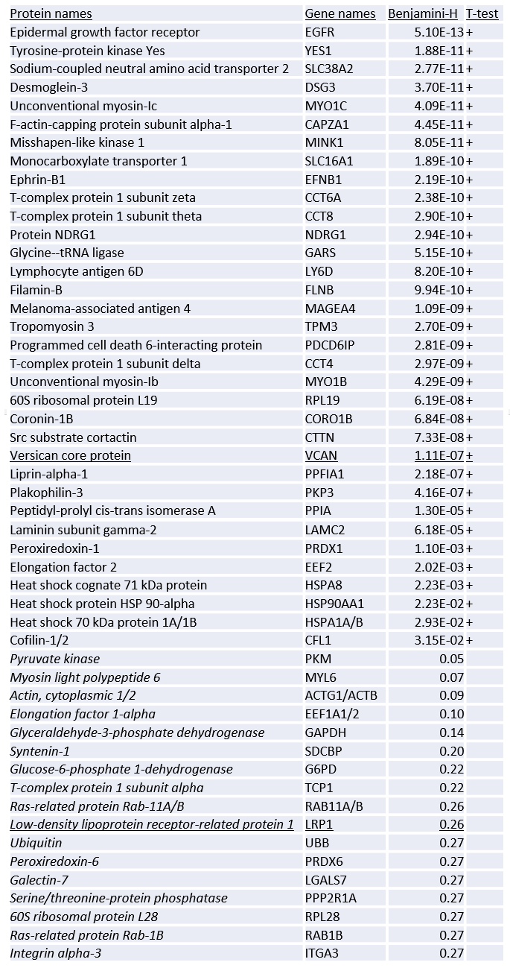
Table 5.1 – Differentially expressed EV proteins
Volcano plot results showing Benjamini-Hochberg calculations. Results in Italic met the initial P-value <0.05 but not the additional FDR <0.05. Underlined results are more abundant in HPV+ cell lines.

5.2.4 – Most abundant proteins in EV samples
LFQ intensities of proteins were converted to percentages of the total protein in each sample and averaged to determine the top 10 most abundant proteins (Table 5.2).
Histone proteins were highly abundant in the SCC2 EVs accounting for 65% of total protein. Of these, histone H2B type 1-M accounted for 28% of SCC2 EV protein and was also abundant in the other 3 cell lines as the 6th most abundant protein in SCC90 and SCC89 samples, and the 7th in SCC72.
Actin was the most abundant protein in HPV- EVs accounting for ~15% of protein in SCC72 EVs and ~11% in SCC89 EVs. It was also found abundantly in both HPV+ cell derived EVs as the 2nd and 6th most abundant proteins in SCC90 and SCC2 EVs, respectively.
Pyruvate kinase was also found abundantly in all EVs ranking as the 3rd and 4th most abundant protein in SCC89 and SCC72 derived samples, as well as 8th and 9th most abundant in SCC90 and SCC2, respectively.
Tenascin accounted for ~32% of SCC90 EV protein, the highest individual percentage across all samples. Tenascin was also the 2nd most abundant protein in SCC72 EVs at 10%.
Three Laminin sub-units were identified in the top 10 most abundant SCC89 EV proteins. None of these 3 proteins were found amongst the top 10 most abundant in any other EV sample (table 5.2).

Gene names | Protein names | SCC2 |  | SCC90 |  | SCC72 |  | SCC89
 |  | Rank | Percentage  (%) | Rank | Percentage  (%) | Rank | Percentage  (%) | Rank | Percentage  (%)
HIST1H2BM | Histone H2B type 1-M | 1 | 28.05 | 6 | 2.16 | 7 | 1.57 | 6 | 4.37
HIST1H4A | Histone H4 | 2 | 15.29 |  | 1.20 |  | 0.95 |  | 1.66
HIST2H3A | Histone H3.2 | 3 | 9.34 |  | 1.03 |  | 0.48 |  | 1.32
HIST2H2AC | Histone H2A type 2-C | 4 | 7.41 | 9 | 1.78 |  | 0.65 |  | 1.39
HIST1H1D | Histone H1.3 | 5 | 5.52 | 7 | 1.51 |  | 0.17 |  | 1.23
ACTG1;ACTB | Actin | 6 | 4.12 | 2 | 12.41 | 1 | 14.82 | 1 | 11.04
FN1 | Fibronectin | 7 | 3.51 | 10 | 1.48 |  | 0.95 | 8 | 3.08
AGRN | Agrin | 8 | 1.71 | 4 | 2.51 |  | 1.23 | 5 | 4.39
PKM | Pyruvate kinase | 9 | 1.32 | 8 | 1.52 | 4 | 2.69 | 3 | 4.90
HIST1H1B | Histone H1.5 | 10 | 1.25 |  | 0.24 |  | 0.00 |  | 0.28
TNC | Tenascin |  | 0.00 | 1 | 31.83 | 2 | 10.54 |  | 0.59
HSPG2 | Heparan sulfate proteoglycan |  | 0.31 | 3 | 10.05 |  | 1.34 | 7 | 3.33
HSPB1 | Heat shock protein beta-1 |  | 0.70 | 5 | 2.49 | 5 | 2.65 |  | 1.69
JUP | Junction plakoglobin |  | 0.01 |  | 0.23 | 3 | 3.39 |  | 0.24
SLC3A2 | 4F2 cell-surface antigen heavy chain |  | 0.09 |  | 0.01 | 6 | 1.81 |  | 0.66
EEF1A1/2 | Elongation factor 1-alpha |  | 0.32 |  | 0.61 | 8 | 1.74 |  | 0.65
PPIA | Peptidyl-prolyl cis-trans isomerase A |  | 0.39 |  | 0.66 | 9 | 1.74 |  | 1.35
CTNND1 | Catenin delta-1 |  | 0.01 |  | 0.12 | 10 | 1.66 |  | 0.06
LAMA5 | Laminin subunit alpha-5 |  | 0.37 |  | 0.34 |  | 0.20 | 2 | 5.38
LAMC1 | Laminin subunit gamma-1 |  | 0.33 |  | 0.61 |  | 0.22 | 4 | 4.58
GAPDH | Glyceraldehyde-3-phosphate dehydrogenase |  | 0.34 |  | 0.74 |  | 0.95 | 9 | 2.85
LAMB1 | Laminin subunit beta-1 |  | 0.26 |  | 0.00 |  | 0.05 | 10 | 2.30

Table 5.2 – Most abundant EV proteins
LFQ intensities were used to calculate the percentage abundance of proteins in each sample. The top 10 from each cell line were selected for tabulation showing both ranking and percentage abundance.

5.3 - GO term analysis
Protein lists compiled by Perseus software were input into DAVID (Huang et al, 2009) for gene ontology (GO) assessment. The GO project provides an ontology of defined terms representing gene product properties and describing how gene products behave in a cellular context. The two domains used for analysis were cellular component (CC), implying the location of key activity for a proportion of the proteins, and biological process (BP), operations or sets of molecular events that form part of, but do not fully represent, a biological pathway.

5.3.1 – HPV- EV associated protein activity
The 49 proteins more abundant in HPV- cell line derived EVs were used in DAVID analysis, which showed that 14 out of 49 proteins were associated with cell-cell adhesion. The p-value and Benjamini score were significantly lower for this BP than any others.
Four of the 9 BPs identified are related to Cajal bodies (CB), interacting with proteins and RNA as well as telomerase. All of these related processes were identified by the presence of 4 proteins in the input list. Protein folding and stability was associated with 3 BPs out of 9 relating to either 7 or 3 proteins in the HPV- associated protein list. Virion assembly is also included in this list of BPs.
26 GO CC terms were identified through DAVID as being linked with the HPV- associated proteins with a Benjamini score of <0.05. 40 of the 49 proteins are common to extracellular vesicles with a Benjamini score of 2.2x10⁻²². 15-16 proteins are associated with cell-cell adherens junctions and focal adhesion.
KEGG pathway analysis was only able to associate 22 of the proteins to pathways. p-values are quite high for the few identified KEGG pathways with Benjamini scores above the recommended 0.05 cut-off. Endocytosis and focal adhesion pathways have the 2 highest number of proteins associated with them at 6 and 5, respectively.
 | Term | Count | p-value | Benjamini
GO - Biological Process | cell-cell adhesion | 14 | 3.30E-13 | 1.80E-10
 | positive regulation of protein localization to Cajal body | 4 | 1.10E-06 | 3.10E-04
 | positive regulation of establishment of protein localization to telomere | 4 | 1.70E-06 | 3.10E-04
 | protein stabilization | 7 | 2.10E-06 | 2.80E-04
 | positive regulation of telomerase RNA localization to Cajal body | 4 | 9.10E-06 | 9.90E-04
 | protein folding | 7 | 1.00E-05 | 9.40E-04
 | positive regulation of telomere maintenance via telomerase | 4 | 9.60E-05 | 7.40E-03
 | virion assembly | 3 | 5.00E-04 | 3.30E-02
 | protein refolding | 3 | 7.90E-04 | 4.60E-02
GO - Cellular component | extracellular exosome | 40 | 1.50E-24 | 2.40E-22
 | cytosol | 35 | 7.40E-16 | 6.50E-14
 | cell-cell adherens junction | 16 | 1.80E-15 | 9.80E-14
 | focal adhesion | 15 | 6.20E-13 | 2.60E-11
 | extracellular matrix | 11 | 3.30E-09 | 1.10E-07
 | membrane | 22 | 2.60E-08 | 7.20E-07
 | myelin sheath | 8 | 1.20E-07 | 2.80E-06
 | cytoplasm | 32 | 1.20E-07 | 2.50E-06
 | chaperonin-containing T-complex | 4 | 1.30E-06 | 2.50E-05
 | melanosome | 6 | 6.00E-06 | 1.00E-04
 | brush border | 5 | 1.70E-05 | 2.60E-04
 | actin filament | 5 | 2.30E-05 | 3.20E-04
 | perinuclear region of cytoplasm | 10 | 2.50E-05 | 3.20E-04
 | plasma membrane | 24 | 6.60E-05 | 7.80E-04
 | zona pellucida receptor complex | 3 | 2.30E-04 | 2.60E-03
 | vesicle | 5 | 3.30E-04 | 3.40E-03
 | stress fiber | 4 | 3.60E-04 | 3.50E-03
 | extracellular space | 12 | 5.00E-04 | 4.60E-03
 | cell body | 4 | 5.70E-04 | 5.00E-03
 | centrosome | 7 | 7.50E-04 | 6.20E-03
 | ruffle membrane | 4 | 1.20E-03 | 9.70E-03
 | membrane raft | 5 | 1.90E-03 | 1.50E-02
 | cell periphery | 3 | 4.50E-03 | 3.20E-02
 | blood microparticle | 4 | 7.10E-03 | 4.80E-02
 | extracellular vesicle | 3 | 7.40E-03 | 4.80E-02
 | myosin complex | 3 | 7.40E-03 | 4.80E-02
KEGG_PATHWAY | Legionellosis | 4 | 1.60E-03 | 1.50E-01
 | Endocytosis | 6 | 4.60E-03 | 2.10E-01
 | Estrogen signaling pathway | 4 | 8.70E-03 | 2.50E-01
 | Focal adhesion | 5 | 1.10E-02 | 2.50E-01
 | Tight junction | 4 | 2.10E-02 | 3.50E-01
 | Oxytocin signaling pathway | 4 | 3.00E-02 | 4.00E-01
 | Central carbon metabolism in cancer | 3 | 3.10E-02 | 3.60E-01
 | Adherens junction | 3 | 3.80E-02 | 3.80E-01
 | Antigen processing and presentation | 3 | 4.30E-02 | 3.80E-01
 | Hypertrophic cardiomyopathy (HCM) | 3 | 4.50E-02 | 3.70E-01
 | 22 out of 49 Gene products included in KEGG analysis (Kegg excluded 27)
Table 5.3 – GO term and pathway analysis of 49 HPV- associated proteins.
EV proteins associated with HPV- cell lines were input into DAVID for GO and KEGG analysis.

5.3.2 – Top 10 protein analysis
The 10 most abundant proteins in EVs of each cell line, shown in table 5.2, were used in DAVID GO and KEGG analysis.
Five out of the 10 most abundant proteins in the SCC2 EVs were associated with nucleosome assembly. Regulation of epigenetic gene expression and chromatin silencing were also identified by GO as biological processes associated with 2 proteins. 9 out of 10 SCC2 EV proteins are classified as extracellular vesicle proteins. Viral carcinogenesis and ECM-receptor interaction were suggested by KEGG as potential targeted pathways.
The only GO BP term identified for SCC90 abundant EV proteins with a Benjamini score under 0.05 was ‘extracellular matrix organization’ which is targeted by 4 out of the 10 proteins. Nucleosome was targeted by 2 proteins as was ‘vascular endothelial growth factor receptor signalling pathway’. The two most common SCC90 GO-CC terms were ‘extracellular matrix’ and ‘extracellular exosome’ with 7 and 8 protein counts respectively. Focal adhesion, nucleosome, and basal lamina were also identified terms. ECM-receptor interaction was the top KEGG pathway for abundant SCC90 EV proteins with a Benjamin-Hochberg score of 4.60x10⁻⁰³ and 4 out of 10 counts.
No GO-BP terms met a Benjamini score cut-off of 0.05 when the 10 most abundant SCC72 EV proteins were input into DAVID. However, 3 proteins are associated with cell adhesion and other notable terms include ‘vascular endothelial growth factor receptor signalling pathway’ and ‘leukocyte migration’. No Kegg pathways were identified with a P-value under the 0.05 cut-off.
Six out of the 10 SCC89 EV proteins target extracellular matrix organization processes and 3 proteins target extracellular matrix disassembly. Both these GO-BP terms passed the Benjamini FDR cut-off as did ‘substrate adhesion-dependent cell spreading’. All 10 proteins are known to be associated with extracellular vesicles. KEGG analysis showed 6 proteins are involved with ‘ECM-receptor interaction’ and 5 proteins with ‘Focal adhesion’. ‘PI3K-Akt signalling pathway’, ‘pathways in cancer’, and proteoglycans in cancer were also associated with SCC89 EV proteins.

SCC2 – Top 10 protein GO terms and KEGG pathway analysis
 | Term | Count | P-Value | Benjamini
GO - Biological Process | nucleosome assembly | 5 | 2.90E-07 | 2.60E-05
 | chromatin silencing at rDNA | 2 | 2.00E-02 | 5.80E-01
 | negative regulation of gene expression, epigenetic | 2 | 2.60E-02 | 5.40E-01
 | positive regulation of gene expression, epigenetic | 2 | 3.30E-02 | 5.20E-01
 | negative regulation of transcription from RNA polymerase II promoter | 3 | 5.40E-02 | 6.20E-01
 | gene silencing by RNA | 2 | 5.80E-02 | 5.80E-01
 | cellular protein metabolic process | 2 | 6.20E-02 | 5.50E-01
GO - Cellular component | nucleosome | 6 | 4.10E-10 | 1.70E-08
 | extracellular exosome | 9 | 2.50E-06 | 5.10E-05
 | extracellular matrix | 5 | 8.10E-06 | 1.10E-04
 | nuclear chromatin | 3 | 3.80E-03 | 3.90E-02
 | basal lamina | 2 | 7.40E-03 | 5.90E-02
 | extracellular region | 4 | 3.90E-02 | 2.40E-01
 | myelin sheath | 2 | 7.30E-02 | 3.60E-01
 | blood microparticle | 2 | 7.30E-02 | 3.60E-01
 | nucleus | 6 | 9.50E-02 | 4.00E-01
KEGG PATHWAY | Systemic lupus erythematosus | 4 | 2.40E-04 | 9.60E-03
 | Alcoholism | 4 | 5.40E-04 | 1.10E-02
 | Viral carcinogenesis | 3 | 1.70E-02 | 2.10E-01
 | Bacterial invasion of epithelial cells | 2 | 7.60E-02 | 5.60E-01
 | ECM-receptor interaction | 2 | 8.50E-02 | 5.20E-01

Table 5.4 –GO terms and KEGG pathway analysis of 10 most abundant SCC2 EV proteins
The most abundant proteins identified in table 5.2 were input into DAVID
SCC90 – Top 10 protein GO terms and KEGG pathway analysis
 | Term | Count | P-Value | Benjamini
GO - Biological Process | extracellular matrix organization | 4 | 1.20E-04 | 1.30E-02
 | glycosaminoglycan catabolic process | 2 | 1.40E-02 | 5.10E-01
 | glycosaminoglycan metabolic process | 2 | 1.50E-02 | 4.10E-01
 | retina homeostasis | 2 | 2.10E-02 | 4.20E-01
 | platelet aggregation | 2 | 2.20E-02 | 3.60E-01
 | glycosaminoglycan biosynthetic process | 2 | 2.20E-02 | 3.20E-01
 | retinoid metabolic process | 2 | 3.20E-02 | 3.80E-01
 | response to wounding | 2 | 3.30E-02 | 3.50E-01
 | vascular endothelial growth factor receptor signaling pathway | 2 | 3.80E-02 | 3.50E-01
 | extracellular matrix disassembly | 2 | 4.00E-02 | 3.40E-01
 | wound healing | 2 | 4.20E-02 | 3.30E-01
 | movement of cell or subcellular component | 2 | 4.50E-02 | 3.20E-01
 | nucleosome assembly | 2 | 6.20E-02 | 3.90E-01
GO - Cellular Component | extracellular matrix | 7 | 1.40E-09 | 5.90E-08
 | extracellular exosome | 8 | 5.60E-05 | 1.20E-03
 | focal adhesion | 4 | 7.50E-04 | 1.00E-02
 | nucleosome | 3 | 9.30E-04 | 9.70E-03
 | extracellular space | 5 | 2.80E-03 | 2.30E-02
 | basal lamina | 2 | 7.40E-03 | 5.10E-02
 | basement membrane | 2 | 3.80E-02 | 2.10E-01
 | extracellular region | 4 | 3.90E-02 | 1.90E-01
 | lysosomal lumen | 2 | 4.10E-02 | 1.80E-01
 | Golgi lumen | 2 | 4.60E-02 | 1.80E-01
 | blood microparticle | 2 | 7.30E-02 | 2.50E-01
 | myelin sheath | 2 | 7.30E-02 | 2.50E-01
 | nuclear chromatin | 2 | 9.10E-02 | 2.80E-01
KEGG Pathway | ECM-receptor interaction | 4 | 1.00E-04 | 4.60E-03
 | Proteoglycans in cancer | 3 | 2.10E-02 | 3.80E-01
 | Focal adhesion | 3 | 2.20E-02 | 2.80E-01
 | Bacterial invasion of epithelial cells | 2 | 8.70E-02 | 6.40E-01

Table 5.5 –GO terms and KEGG pathway analysis of 10 most abundant SCC90 EV proteins
The most abundant proteins identified in table 5.2 were input into DAVID

SCC72 – Top 10 protein GO terms and KEGG pathway analysis
 | Term | Count | P-Value | Benjamini
GO - Biological Process | adherens junction organization | 2 | 2.00E-02 | 8.90E-01
 | retina homeostasis | 2 | 2.10E-02 | 6.90E-01
 | platelet aggregation | 2 | 2.20E-02 | 5.50E-01
 | cell adhesion | 3 | 2.40E-02 | 4.80E-01
 | vascular endothelial growth factor receptor signaling pathway | 2 | 3.80E-02 | 5.70E-01
 | movement of cell or subcellular component | 2 | 4.50E-02 | 5.70E-01
 | single organismal cell-cell adhesion | 2 | 5.30E-02 | 5.70E-01
 | leukocyte migration | 2 | 6.40E-02 | 5.90E-01
 | regulation of cell proliferation | 2 | 9.50E-02 | 7.00E-01
GO - Cellular Component | extracellular exosome | 9 | 2.50E-06 | 1.30E-04
 | extracellular matrix | 5 | 8.10E-06 | 2.10E-04
 | focal adhesion | 5 | 2.40E-05 | 4.10E-04
 | nucleus | 9 | 4.00E-04 | 5.10E-03
 | cell-cell adherens junction | 4 | 4.30E-04 | 4.40E-03
 | extracellular space | 5 | 2.80E-03 | 2.30E-02
 | zonula adherens | 2 | 4.40E-03 | 3.20E-02
 | cytosol | 6 | 1.30E-02 | 8.00E-02
 | cytoskeleton | 3 | 1.40E-02 | 7.40E-02
 | cytoplasm | 7 | 2.00E-02 | 9.80E-02
 | plasma membrane | 6 | 3.30E-02 | 1.40E-01
 | Z disc | 2 | 5.70E-02 | 2.20E-01
 | myelin sheath | 2 | 7.30E-02 | 2.60E-01
 | cell-cell junction | 2 | 8.20E-02 | 2.70E-01
 | membrane | 4 | 8.40E-02 | 2.60E-01
KEGG Pathway | Arrhythmogenic right ventricular cardiomyopathy (ARVC) | 2 | 7.00E-02 | 9.60E-01
 | Adherens junction | 2 | 7.00E-02 | 9.60E-01

Table 5.6 –GO terms and KEGG pathway analysis of 10 most abundant SCC72 EV proteins
The most abundant proteins identified in table 5.2 were input into DAVID

SCC89 – Top 10 protein GO terms and KEGG pathway analysis
 | Term | Count | P-Value | Benjamini
GO - Biological Process | extracellular matrix organization | 6 | 2.50E-08 | 2.60E-06
 | substrate adhesion-dependent cell spreading | 4 | 8.90E-07 | 4.70E-05
 | extracellular matrix disassembly | 3 | 7.10E-04 | 2.50E-02
 | angiogenesis | 3 | 5.90E-03 | 1.40E-01
 | glycosaminoglycan catabolic process | 2 | 1.40E-02 | 2.50E-01
 | canonical glycolysis | 2 | 1.40E-02 | 2.50E-01
 | endodermal cell differentiation | 2 | 1.40E-02 | 2.20E-01
 | glycosaminoglycan metabolic process | 2 | 1.50E-02 | 2.10E-01
 | glycosaminoglycan biosynthetic process | 2 | 2.20E-02 | 2.60E-01
 | cell adhesion | 3 | 2.40E-02 | 2.40E-01
 | positive regulation of epithelial cell proliferation | 2 | 3.20E-02 | 2.90E-01
 | retinoid metabolic process | 2 | 3.20E-02 | 2.70E-01
 | cytoskeleton organization | 2 | 8.30E-02 | 5.30E-01
 | cell migration | 2 | 8.90E-02 | 5.30E-01
GO - Cellular Component | extracellular matrix | 9 | 3.90E-14 | 1.90E-12
 | extracellular exosome | 10 | 4.90E-08 | 1.20E-06
 | laminin-10 complex | 3 | 6.50E-07 | 1.10E-05
 | basement membrane | 4 | 6.50E-06 | 7.90E-05
 | basal lamina | 3 | 2.30E-05 | 2.20E-04
 | extracellular space | 6 | 2.10E-04 | 1.70E-03
 | extracellular region | 6 | 5.00E-04 | 3.50E-03
 | laminin-11 complex | 2 | 1.50E-03 | 9.00E-03
 | laminin-1 complex | 2 | 1.50E-03 | 9.00E-03
 | lysosomal lumen | 2 | 4.10E-02 | 2.00E-01
 | Golgi lumen | 2 | 4.60E-02 | 2.10E-01
 | vesicle | 2 | 6.10E-02 | 2.50E-01
 | myelin sheath | 2 | 7.30E-02 | 2.60E-01
 | blood microparticle | 2 | 7.30E-02 | 2.60E-01
KEGG Pathway | ECM-receptor interaction | 6 | 3.40E-08 | 1.50E-06
 | Focal adhesion | 5 | 8.60E-05 | 1.90E-03
 | Small cell lung cancer | 4 | 1.40E-04 | 2.10E-03
 | Amoebiasis | 4 | 2.80E-04 | 3.10E-03
 | PI3K-Akt signaling pathway | 4 | 8.30E-03 | 7.20E-02
 | Toxoplasmosis | 3 | 9.60E-03 | 7.00E-02
 | Pathways in cancer | 4 | 1.20E-02 | 7.40E-02
 | Proteoglycans in cancer | 3 | 2.60E-02 | 1.40E-01
 | Glycolysis / Gluconeogenesis | 2 | 8.40E-02 | 3.60E-01
 | Biosynthesis of amino acids | 2 | 9.20E-02 | 3.50E-01
 | Bacterial invasion of epithelial cells | 2 | 9.70E-02 | 3.40E-01
Table 5.7 –GO terms and KEGG pathway analysis of 10 most abundant SCC89 EV proteins
The most abundant proteins identified in table 5.2 were input into DAVID

5.3.3 –Pathway targets shared between HPV+ and HPV- OPSCC EV proteins
Fifty-three proteins were found in all 8 samples and were input into DAVID. Focal adhesion and PI3K-Akt signalling pathways were identified as influenced pathways, each with 13 proteins targeting them, the highest number of proteins on the list.
ECM-receptor interaction is targeted by 10 proteins and had the lowest Benjamini-Hochberg score. This was also identified as a targeted pathway by the 10 most abundant proteins in SCC2, SCC90 and SCC89.
The 2 most targeted biological processes were ‘extracellular matrix organization’ and ‘cell-cell adhesion’ with 12 and 11 proteins being involved respectively. Nucleosome positioning, nucleosome assembly and histone H3-K27 trimethylation were also identified as targeted biological processes.

 | Term | Count | P-Value | Benjamini
KEGG Pathway | ECM-receptor interaction | 10 | 5.90E-09 | 7.10E-07
 | Focal adhesion | 13 | 9.70E-09 | 5.90E-07
 | PI3K-Akt signaling pathway | 13 | 2.70E-06 | 1.10E-04
 | Pathogenic Escherichia coli infection | 6 | 2.40E-05 | 7.30E-04
 | Leukocyte transendothelial migration | 7 | 1.50E-04 | 3.60E-03
 | Toxoplasmosis | 7 | 1.50E-04 | 3.60E-03
 | Rap1 signaling pathway | 8 | 5.50E-04 | 1.10E-02
 | Epstein-Barr virus infection | 7 | 1.90E-03 | 3.20E-02
 | Platelet activation | 6 | 2.00E-03 | 2.90E-02
 | Proteoglycans in cancer | 7 | 2.40E-03 | 3.20E-02
 | Small cell lung cancer | 5 | 2.70E-03 | 3.30E-02
 | Phagosome | 6 | 4.00E-03 | 4.30E-02
 | Estrogen signaling pathway | 5 | 4.80E-03 | 4.70E-02
GO - Biological process | extracellular matrix organization | 12 | 7.10E-11 | 4.40E-08
 | cell-cell adhesion | 11 | 3.20E-08 | 9.80E-06
 | nucleosome assembly | 7 | 3.70E-06 | 7.60E-04
 | response to unfolded protein | 5 | 1.40E-05 | 1.70E-03
 | platelet aggregation | 5 | 1.30E-05 | 2.00E-03
 | protein stabilization | 6 | 1.10E-04 | 1.20E-02
 | regulation of cellular response to heat | 5 | 1.40E-04 | 1.20E-02
 | histone H3-K27 trimethylation | 3 | 1.80E-04 | 1.40E-02
 | movement of cell or subcellular component | 5 | 2.40E-04 | 1.60E-02
 | nucleosome positioning | 3 | 3.40E-04 | 2.10E-02
 | cell junction assembly | 3 | 7.80E-04 | 4.30E-02
GO – Cellular Component | extracellular matrix organization | 29 | 7.50E-35 | 1.50E-32
 | extracellular exosome | 51 | 5.10E-32 | 5.20E-30
 | cell-cell adherens junction | 18 | 1.50E-16 | 7.50E-15
 | focal adhesion | 18 | 3.80E-15 | 1.90E-13
 | melanosome | 11 | 8.70E-13 | 3.50E-11
 | membrane | 27 | 8.30E-10 | 2.80E-08
 | myelin sheath | 10 | 1.40E-09 | 4.00E-08
 | nucleosome | 8 | 2.10E-08 | 5.40E-07
 | cytosol | 30 | 5.90E-08 | 1.30E-06
 | basal lamina | 5 | 1.30E-07 | 2.70E-06
 | vesicle | 8 | 1.80E-07 | 3.30E-06

Continued…
GO – Cellular Component | basement membrane | 6 | 5.60E-06 | 9.50E-05
 | extracellular region | 18 | 8.50E-06 | 1.30E-04
 | extracellular space | 16 | 1.80E-05 | 2.60E-04
 | extracellular vesicle | 5 | 2.00E-05 | 2.80E-04
 | laminin-11 complex | 3 | 3.10E-05 | 3.90E-04
 | membrane raft | 7 | 5.30E-05 | 6.40E-04
 | ruffle membrane | 5 | 1.40E-04 | 1.60E-03
 | lysosomal lumen | 5 | 1.60E-04 | 1.80E-03
 | ruffle | 5 | 2.10E-04 | 2.10E-03
 | protein complex | 8 | 3.60E-04 | 3.40E-03
Table 5.8 – Pathways targeted by all OPSCC EV proteins
Proteins found in all 4 EV samples were input into DAVID for KEGG and GO analysis. Only hits meeting the Benjamini-Hochberg FDR cut-off of 0.05 are shown.

 | Term | Count | P-Value | Benjamini
GO - Biological process | extracellular matrix organization | 12 | 7.10E-11 | 4.40E-08
 | cell-cell adhesion | 11 | 3.20E-08 | 9.80E-06
 | nucleosome assembly | 7 | 3.70E-06 | 7.60E-04
 | response to unfolded protein | 5 | 1.40E-05 | 1.70E-03
 | platelet aggregation | 5 | 1.30E-05 | 2.00E-03
 | protein stabilization | 6 | 1.10E-04 | 1.20E-02
 | regulation of cellular response to heat | 5 | 1.40E-04 | 1.20E-02
 | histone H3-K27 trimethylation | 3 | 1.80E-04 | 1.40E-02
 | movement of cell or subcellular component | 5 | 2.40E-04 | 1.60E-02
 | nucleosome positioning | 3 | 3.40E-04 | 2.10E-02
 | cell junction assembly | 3 | 7.80E-04 | 4.30E-02
GO-Cellular component | extracellular matrix | 29 | 7.50E-35 | 1.50E-32
 | extracellular exosome | 51 | 5.10E-32 | 5.20E-30
 | cell-cell adherens junction | 18 | 1.50E-16 | 7.50E-15
 | focal adhesion | 18 | 3.80E-15 | 1.90E-13
 | melanosome | 11 | 8.70E-13 | 3.50E-11
 | membrane | 27 | 8.30E-10 | 2.80E-08
 | myelin sheath | 10 | 1.40E-09 | 4.00E-08
 | nucleosome | 8 | 2.10E-08 | 5.40E-07
 | cytosol | 30 | 5.90E-08 | 1.30E-06
 | basal lamina | 5 | 1.30E-07 | 2.70E-06
 | vesicle | 8 | 1.80E-07 | 3.30E-06
 | basement membrane | 6 | 5.60E-06 | 9.50E-05
 | extracellular region | 18 | 8.50E-06 | 1.30E-04
 | extracellular space | 16 | 1.80E-05 | 2.60E-04
 | extracellular vesicle | 5 | 2.00E-05 | 2.80E-04
 | laminin-11 complex | 3 | 3.10E-05 | 3.90E-04
 | membrane raft | 7 | 5.30E-05 | 6.40E-04
 | ruffle membrane | 5 | 1.40E-04 | 1.60E-03
 | lysosomal lumen | 5 | 1.60E-04 | 1.80E-03
 | ruffle | 5 | 2.10E-04 | 2.10E-03
 | protein complex | 8 | 3.60E-04 | 3.40E-03
KEGG Pathway | ECM-receptor interaction | 10 | 5.90E-09 | 7.10E-07
 | Focal adhesion | 13 | 9.70E-09 | 5.90E-07
 | PI3K-Akt signaling pathway | 13 | 2.70E-06 | 1.10E-04
 | Pathogenic Escherichia coli infection | 6 | 2.40E-05 | 7.30E-04
 | Leukocyte transendothelial migration | 7 | 1.50E-04 | 3.60E-03
 | Toxoplasmosis | 7 | 1.50E-04 | 3.60E-03
 | Rap1 signaling pathway | 8 | 5.50E-04 | 1.10E-02
 | Epstein-Barr virus infection | 7 | 1.90E-03 | 3.20E-02
 | Platelet activation | 6 | 2.00E-03 | 2.90E-02
 | Proteoglycans in cancer | 7 | 2.40E-03 | 3.20E-02
 | Small cell lung cancer | 5 | 2.70E-03 | 3.30E-02
 | Phagosome | 6 | 4.00E-03 | 4.30E-02
 | Estrogen signaling pathway | 5 | 4.80E-03 | 4.70E-02

5.4 – Label-free mass-spec validation

5.4.1 – ITRAQ
Isobaric tags for relative and absolute quantitation (iTRAQ) is a quantitative proteomics technique utilizing isobaric labelling of peptides/proteins to determine the relative abundance of proteins between two or more sources. Following protein digestion, peptides were covalently labelled at the N-terminus and side chain amines with tags of varying known mass. Samples were then pooled and fractionated by liquid chromatography before analysis by tandem mass spectrometry (MS/MS). Fragmentation data was used identify the labelled peptides, corresponding proteins, and the sample origin based on the attached tag which generates a low molecular mass reporter ion (Fujita, 2017).
As ITRAQ runs samples at the same time, pairwise comparison between samples can be achieved with greater accuracy, helping to confirm results seen in label-free mass spectrometry. However, complications during the ITRAQ procedure lead to a depletion of SCC72 EV protein samples. As such SCC2 and SCC90 samples were compared to SCC89 only. A selection of proteins which exhibited differential abundance between the two HPV+ samples and the SCC89 sample have been included in figure 5.4 whilst the relative LFQ intensities, normalized to the largest value, are shown in figure 5.5.
EEF2 was found at 45% and 70% abundance in SCC2 and SCC90 EVs, respectively, relative to SCC89 EVs (figure 5.4). LGALS3BP was significantly less abundant in both HPV+ samples with ~38% of the levels found in SCC89 EVs. MVP showed one of the greatest discrepancies between HPV+ and SCC89 EVs with SCC90 and SCC2 EVs having 20% and 30% the levels of SCC89. Integrin-α6 (ITGA6) had ~40% abundance in HPV+ samples relative to SCC89 EVs. The proteins described above were selected for validation by western blotting.

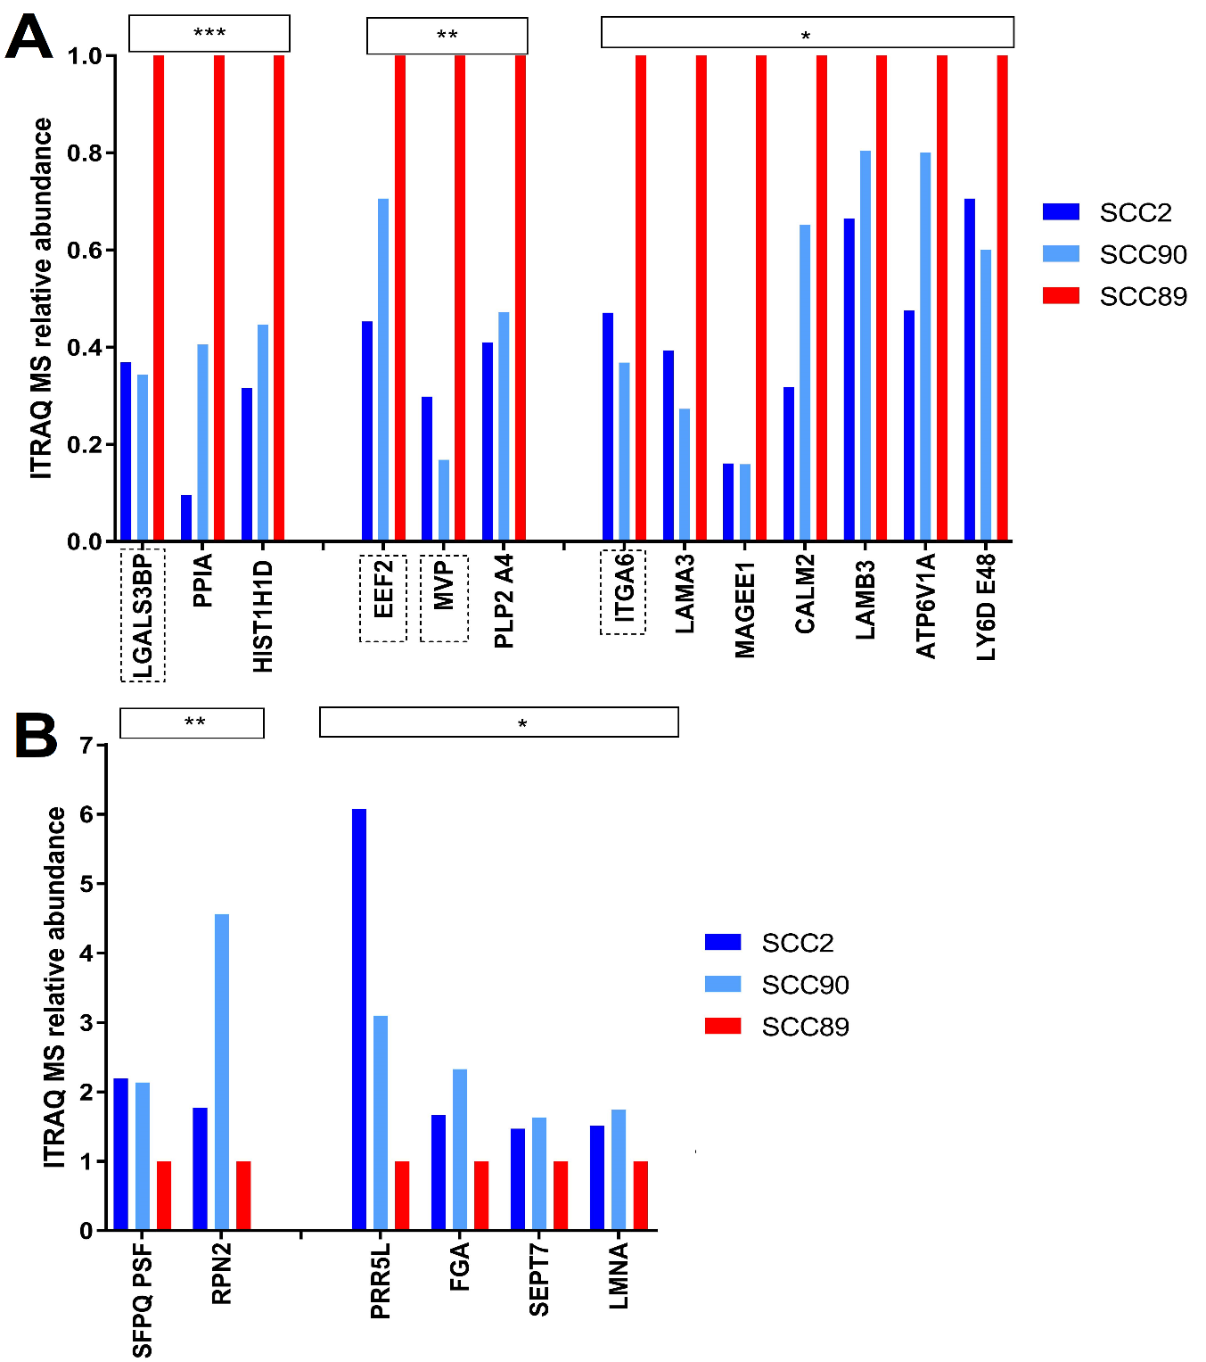
Figure 5.4 – ITRAQ relative protein abundances
Trypsin digested EV protein samples were labelled with isobaric tags. Samples were pooled and fractionated by liquid chromatography before MS/MS using the orbitrap. Peptides were matched to their protein and sample origin. Protein abundances were calculated relative to those originating from SCC89 EVs. A) Abundant in SCC89 B) Abundant in HPV+ samples. ***=p-value <0.05 multiple test correction applied. **=p-value<0.01 no multiple test correction. ***=p-value <0.05 no Multiple test correction. Boxed protein names were selected for western blotting.

5.4.2 – Label-free MS relative abundances of select proteins
5 proteins were selected for further western blot validation to assess the accuracy of mass spectrometry analysis. 4 of these proteins, LGALS3BP, EEF2, MVP, and ITAG6 were identified by ITRAQ as being significantly lower abundance in SCC2 and SCC90 compared to SCC89. EGFR was selected as label-free mass spectrometry showed it was only found in SCC72 and SCC89. The label-free mass spectrometry data for these 5 proteins were assembled into a separate graph (figure 5.5).
EEF2 protein was approximately 4-5-fold more abundant in SCC89 EVs than in HPV+ EVs and 7-8-fold more abundant in SCC72 EVs (figure 5.5). LGALS3BP was highly abundant in SCC89 EVs compared to SCC2 and SCC90 (where it was not detected). However, levels of LGALS3BP were also low in SCC72 EVs.
MVP was only detected in SCC2 and SCC89 samples, differing from ITRAQ results which detected MVP in SCC90 EVs at similar levels to SCC2 derived EVs. MVP abundance in SCC2 EVs was lower than in SCC89 with only one third of the protein being detected. ITGA6 was also undetected in SCC90 samples despite being identified by ITRAQ. SCC89 EVs contained ~30% more ITGA6 protein than SCC2 derived EVs and was also found to be twice as abundant in SCC72 as SCC2 EVs (figure 5.5).
EGFR was not identified by ITRAQ as differentially expressed between cell lines however label free MS showed similar levels between SCC72 and SCC89 whilst it was undetectable in HPV+ EV samples (figure 5.5).

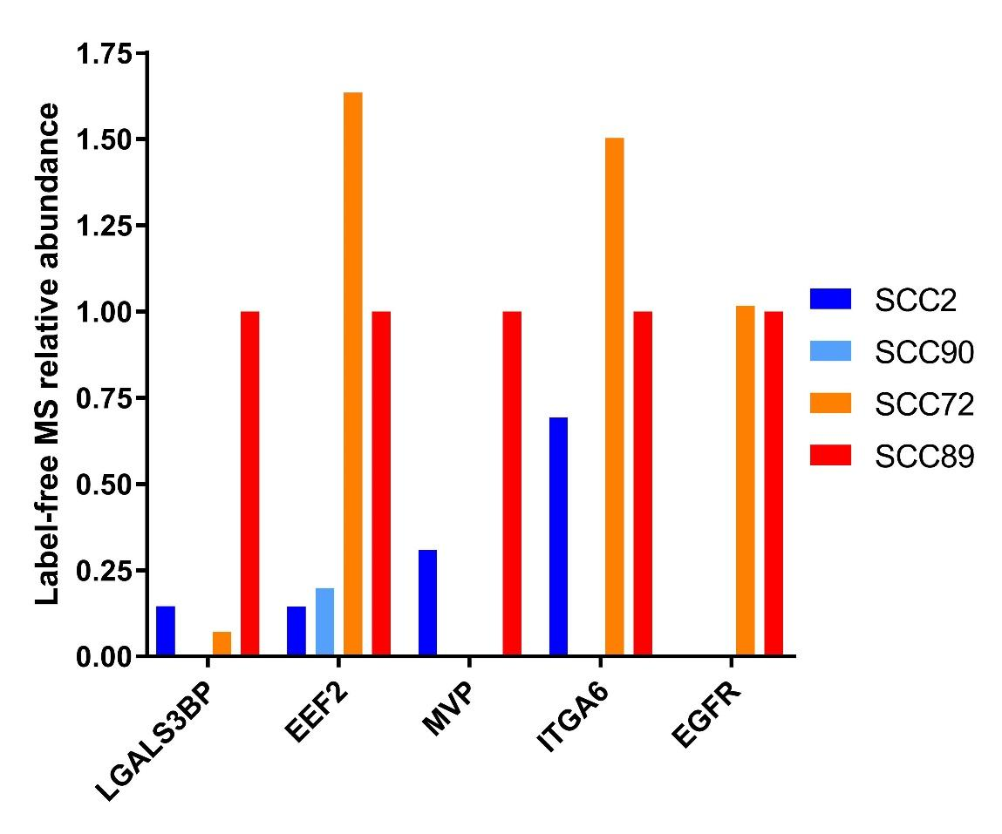
Figure 5.5 – Relative of abundance of select proteins determined by label-free MS
LFQ intensities of select proteins determined by label-free MS were normalized to SCC89.

5.4.3 – Western blotting
In HPV+ derived samples LGAL3SBP was more abundant in the cell lysate than the EVs. However, in HPV- samples there was vastly more LGAL3SBP in the 10 µg of EV protein than the equivalent amount of cell lysate protein. Cellular LGAL3SBP abundance was similar across all cell lines with slightly more in HPV- samples. There was more LGAL3SBP in SCC89 EVs than in SCC72 EVs (figure 5.6).
MVP was most abundant in SCC89 EV and cell lysate samples. In EV samples MVP was second most abundant in SCC2 with slightly less in SCC72 EVs and almost none detected in SCC90 EVs. Across most samples MVP abundance in EVs was only slightly lower than cellular levels of the protein (figure 5.6).
EGFR was detected in all samples but was barely detected in SCC2 EVs. EGFR levels were highest in HPV- samples with slightly more protein in SCC72 samples than SCC89 samples. In HPV- samples there was slightly less EV EGFR than cellular EGFR. There was much more cellular EGFR in SCC2 than there was vesicular EGFR. SCC90 cell lysate showed 2 distinct bands for EGFR. These may be present in others but could have merged. There appears to be slightly more EV EGFR in SCC90 samples than cellular EGFR (figure 5.6).
Several cell lysate samples contained multiple variants of ITGA6 with up to 3 distinct bands being identified in SCC2, SCC90, and SCC72 (figure 5.6). The higher MW bands were not seen in any EV samples. The lower MW band was seen across all samples and was the largest in lanes with multiple bands. In SCC2 there was significantly less vesicular ITGA6 than cellular protein. However, in all other samples there was slightly more ITGA6 in EVs, with SCC90 and SCC72 EVs containing the highest levels (figure 5.6). Cellular levels of ITGA6 were similar across SCC2, SCC90 and SCC72 with a less prominent and slightly smaller band in SCC89. When considering enrichment of ITGA6 into EVs the increase in vesicular EVs is highest in SCC89, although the faded nature of the cellular ITGA6 band may be an artefact.
(Due to longer exposure requirements EEF2 was analysed by licor) EEF2 was detected in all EV and cell lysate samples. Cellular EEF2 was similar in most cell lines with slightly more in SCC72 cell lysate. EV EEF2 was also similar across all cell lines.

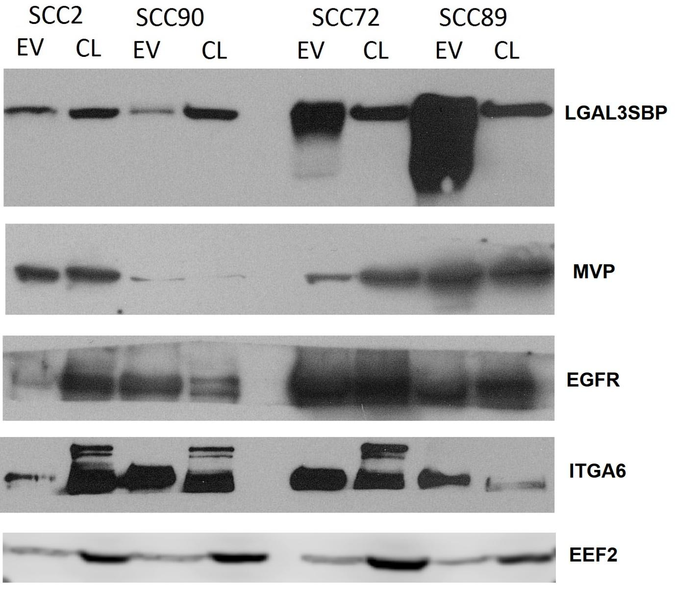
Figure 5.6 – Western blot validation of select proteins
EVs were isolated by SEC and ultracentrifugation. EV pellets were resuspended in RIPA buffer containing protease inhibitors to solubilise EV protein. Approximately 1-2 million cells from each cell line were washed in PBS and pelleted by centrifugation. Cells were lysed by suspension in RIPA buffer containing protease inhibitors. 10 ug of protein was separated by SDS-PAGE and transferred to a nitrocellulose membrane for subsequent western blot analysis. Blocked membranes were incubated with primary antibodies overnight at 4ºC. Membranes were washed before incubation with HRP-conjugated secondary antibodies at room temperature for 1h. Luminescent substrate solution was applied for 2 min and the membranes were exposed to x ray film before automatic processing. EV – Extracellular vesicle protein / CL – Cell lysate protein.

5- Discussion

5.5 - Degree of similarity between OPSCC EV protein profiles
Label-free MS showed far fewer proteins in the EVs of HPV+ samples than HPV-. The number of proteins found in both replicates for HPV+ samples ranged between 90-120 whereas over 210 proteins were found in each of the HPV- EV samples.
A hypothetical reason for this difference could be that in HPV- OPSCC altered pathways have increasing protein encapsulation into EVs, whilst also reducing the selectivity of this process. Pathway analysis, particularly KEGG analysis of the HPV- associated proteins, did not identify much interconnectivity between the actions of these proteins, the exception being a high association with cell-cell adhesion (Table 5.3). There is evidence for certain cancers to incorporate additional proteins into EVs. EVs isolated from urine of bladder cancer patients contained over 100 additional unique proteins compared to healthy patient urine EV proteomes (Lee et al, 2018).
HPV+ EV samples were highly enriched in a particular set of proteins potentially reducing the signal quality of other proteins after LFQ normalization. It certainly would have affected principal component analysis and may partially explain the separation seen between SCC2 and SCC90 EVs (figure 5.2). Approximately 37 of the 49 proteins identified as more abundant in HPV- EVs (Figure 5.3 and table 5.1) were not detected in HPV+ samples. Differential expression analysis was hampered by both of these factors.
ITRAQ data (figure 5.4), whilst showing similarities to label free MS data in that highlighted proteins such as LGALS3BP, EEF2, ITGA6, were elevated in SCC89, also showed slightly different fold changes (e.g. EEF2 showed an 8-fold change in label-free MS but ~2-fold change in ITRAQ) further suggesting that LFQ normalization may have under represented proteins in SCC2 and SCC90 EVs. Counter to this ITRAQ results for MVP and ITGA6 showed similar fold changes observed in abundance as did western blotting of LGALS3BP.
Whilst hierarchical clustering did not show grouping of EV protein profiles by HPV status of the producing cell, the abundance of proteins in HPV- OPSCC EVs, as well as the presence of numerous unique proteins, is highly interesting. The results certainly warrant validation as they may indicate a difference in EV protein cargo sorting between HPV+ and HPV- OPSCCs.

5.6 - Lectin galactoside-binding soluble 3 binding protein
ITRAQ data showed a 2.5 fold greater abundance of Lectin galactoside-binding soluble 3 binding protein (LGALS3BP) in SCC89 EVs over HPV+ OPSCC EVs (figure 5.4). Label-free MS also showed higher LGALS3BP levels in SCC89 EVs although SCC72 EVs did not contain more than SCC2 EVs. Western blotting clearly demonstrated enrichment of LGALS3BP in HPV- OPSCC EVs, particularly SCC89, despite only a moderate increase in cellular LGALS3BP.
LGALS3BP is a heavily N-glycosylated protein secreted into the extracellular matrix. Due to previous research into the function of this protein it is also referred to as Mac-2 binding protein and other aliases.
LGALS3BP and its receptor/ligand LGALS3 interact with each other within the ECM to promote cell-to-cell adhesion and initiate proinflammatory signalling cascades (DeRoo et al, 2015). Higher LGALS3BP expression has been associated with numerous cancers (Park et al, 2017) including oral cancer in which it has been suggested as a drug target utilizing the tumour suppressive function of miR-596 to target LGALS3BP mRNA (Endo et al, 2013). In breast cancer patients elevated serum levels of LGALS3BP have been associated with poor prognosis and increased likelihood of distant recurrences (Tinari et al, 2009).
EVs secreted from ovarian cancer cells have been shown to be enriched with LGALS3BP (Escrevente et al, 2013). EVs derived from neuroblastoma cells have also been shown to be enriched with LGALS3BP, which was suggested to be involved in the stimulation of IL-6 expressions in Mesenchymal stem cells (MSCs) (Nakata et al, 2017).
Interestingly, it’s been shown that glycosylation of LGALS3BP is a critical determinant for its sorting into EVs and not simply its transport to the plasma membrane (Liang et al, 2014). This glycosylation based enrichment was identified as a mechanism utilized in ovarian cancer cells which again showed EV LGALS3BP enrichment (Gomes et al, 2015). Because many binding partners of LGALS3BP are present on the cell surface such as collagens, fibronectin, galectin-3 and integrin beta-1, EV-LGALS3BP could be highly influential in binding with ECM proteins, and triggering pro-tumorigenic processes (Dutta et al, 2015).
Our results not only show a higher abundance of LGALS3BP in HPV- EVs compared to HPV+, but western blotting suggests a particular EV enrichment in HPV- OPSCC cells. Multiple bands were also identified possibly relating to the glycosylation process identified by other studies as critical to LGALS3BP recruitment into EVs. Due to its role in adhesion, invasion and metastasis it’s a worthy candidate for further work and if other studies are suggesting it should be targeted in some cancers, then testing for its presence in EVs could help identify those most likely to benefit.

5.7 - EGFR in HPV- OPSCC EVs
Higher EGFR expression is observed in ~90% of HNSCC cases, with increased expression of EGFR or EGFR gene amplification being a strong independent prognostic indicator for survival and potential to relapse. However, little correlation is seen with likelihood of distant metastasis (Ang et al, 2002).
The high level of influence EGFR proteins have over HNSCC cancer progression is highlighted by the number of EGFR related proteins implicated in HPV- HNSCC such as; EGFR family member HER2, regulators of EGFR activity and expression such as CBL, GRB2, and NSDHL; and proteins downstream of EGFR signalling such as PTEN, PI3K, AKT, and BCAR1 (Beck et al, 2016).
Despite this, genetic mutations to EGFR occur in only (21%) of HNSCC, more commonly in HPV− HNSCCs (15% HPV− vs. 6% HPV+) (Dok and Nuyts, 2016).
Multiple comparison studies of HPV+ and HPV- OPSCCs have shown clear inverse correlation between HPV positivity and EGFR expression (Kumar et al, 2008; Hong et al, 2010). It has been suggested that this is related to the EGFR amplification which is significantly more associated with HPV- OPSCC as demonstrated in multiple studies including tonsillar carcinomas (Kim et al, 2007). However attempts to identify a correlation between EGFR copy number and EGFR expression in OPSCCs have failed to do so (Temam et al, 2007).
An inverse correlation between EGFR expression and inactivated retinoblastoma 1 (RB1) suggesting a potential link between high EGFR expression and RB1-dependent cell-cycle regulation (Beck et al, 2016). RB1 is a major target of HPV proteins.
HPV E7 directed inactivation of tumour suppressor RB1 allows for continuous activation of E2F1-dependent transcriptional programs which drive the cell cycle progression from G₁ to S-phase (Wu et al, 2001). Similar interruptions take place in HPV- OPSCC as the frequently mutated tumour suppressor p16 (CDKN2A) can no longer down regulate kinases 4/6 (CDK4/CDK6), allowing them to phosphorylate RB1 and cause dissociation from E2F1 (Beck et al, 2015).
Importantly, EGFR overexpression in either HPV+ or HPV- HNSCCs is associated with poor overall survival (Olthof et al, 2012).

5.7.1 - EGFR in EVs
Multiple bands were observed when probing for EGFR by western blot, suggesting the presence of multiple variants of EGFR. In a study of glioma cells, EGFR and EGFRvIII, an oncogenic form, were observed in cell lysate as well as vesicular protein with levels being reduced in EVs but showing a similar proportion of the two variants (Al-Nedawi et al, 2008). Transfer of these EVs affected expression of EGFR regulated genes such as p27, VEGF, and Bcl as well as MAPK and AKT signalling pathways (Al-Nedawi et al, 2008).
Another study identified EGFR in EVs extracted from plasma of glioblastoma (GBM) xenograft mice and GBM patients. It was also suggested that EV levels of EGFR phospho-isoforms, AKT and ERK were not reflective of the cellular levels suggesting selective EV cargo loading possibly as a method of EGFR recycling (Montermini et al, 2015).
EGFR has also been found to be enriched in EVs isolated from the plasma of lung cancer patients (Yamashita et al, 2013). In a study of 276 NSCLC patients EGFR was suggested as a possible biomarker when EVs were isolated from patient plasma. Additionally, it was suggested that the relation to prognosis was concentration-dependent with higher EGFR levels identifying poor overall survival (Sandfeld-Paulsen et al, 2016).
Multiple cancers are associated with EGFR overexpression, this is true with HPV- OPSCC. Our results suggest high EGFR expression can be identified by EVs secreted from tumour cells. This has been suggested as a prognostic marker from plasma but the potential for salivary biomarkers should also be explored when considering OPSCCs.

5.8 – Versican – a HPV+ OPSCC EV associated protein
Versican was one of two proteins identified in our analysis to be HPV status associated and the only protein to meet the FDR cut-off.
Versican is a large extracellular matrix proteoglycan with roles in cell adhesion, proliferation, migration, and assembly of the ECM (Wight, 2002). It is not associated with many EV orientated studies and its size calls into question whether it is in fact an EV enclosed protein. However, as there are several isoforms of Versican which are significantly smaller, and its functional roles relate to cancer progression, it is worth discussing.
High expression of Versican has previously been associated with several malignant tumours including breast, ovary and prostate carcinomas (Pukkila et al, 2004). When elevated in tumour stroma Versican cell-ECM adhesion becomes impaired allowing for increased local tumour invasion and metastasis (Sakko et al, 2001). Enhanced Versican expression in epithelial tumour cell lines has also been associated with increased mitotic activity promoting increased cell growth (Gulyás et al, 2003).
Both Versican protein and mRNA can be found in the tumour stroma with studies suggesting that peritumoral expression of Versican can be induced in stromal cells through secretion of factors by cancer cells (Ricciardelli et al, 2002).
An analysis of cervical cancers showed an association between stromal Versican over expression and lymph node metastasis (Kodama et al, 2007). A study of OPSCC and HPSCC (oropharynx or hypopharynx) showed strong stromal Versican staining of lymph node metastases whereas only 50% of primary tumours showed strong Versican staining. It was also associated with earlier stages of disease (Pukkila et al, 2004). This is interesting as HPV+ OPSCC present as earlier stage tumours, something which has prompted new staging systems distinct from HPV- cancers (Panwar et al, 2017).
Interestingly, in vitro and in vivo assays have demonstrated that CSPG, the gene encoding Versican, is a direct target of p53, with Versican expression correlating with p53 dosage (Yoon et al, 2002). In tongue squamous cell carcinoma (TSCC) it was shown that Versican was directly targeted by miR-23b and that downregulation of miR23b, by IL-17A expression activating NF-κB signalling pathway, promoted migration and invasion (Wei et al, 2017).
Versican is an ECM protein associated with poor prognosis in multiple cancers including cervical and HNSCCs. Its role in the tumour stroma could make it an important EV cargo with studies suggesting increased invasive and metastatic potential with higher stromal Versican levels. However, due to its size, at least of the main isoform, it could be questioned whether it can truly be an EV related protein. Vesiclepedia and ExoCarta only list 4 studies in total to have identified Versican in EVs with only one of these being a cancer-EV proteome study (Lazar et al, 2015). An interesting idea is that Versican could bind to exposed proteins on the surface of EVs having been secreted as free protein. In any case, its discovery in our HPV+ OPSCC EV protein is of interest and should be validated in the future.

5.9 - Histones in OPSCC EVs
Histones were the predominant protein group in SCC2 EVs (six out of the 10 most abundant proteins), accounting for 65% of total protein. 3 out of 10 high abundance proteins in SCC90 were histones also whilst only one histone protein, Histone H2B type 1-M, was identified as highly abundant in HPV- OPSCC EVs.
Core histone proteins play major roles in regulation of chromatin structure and therefore allowing or preventing access to transcriptional sites. Their activity is highly dependent on post-translational modifications (PTMs) a mechanism often awry is cancers (Esteller, 2007). As such, epigenetic modification by abnormal expressions of specific histone PTMs is considered a common hallmark of human cancer (Fraga et al, 2005).
The presence of histones in small EV isolations was once considered an identifier for contamination by apoptotic bodies (Thery et al, 2001). However, it is now known that histones are also associated with exosome populations. A comparison of proteomes in exosomes, microvesicles, and apoptotic bodies isolated from cultured melanoma cells identified the enrichment of histones in exosomes with the ten most abundant proteins including multiple histones (H2A, H2B, H3.1 and H4) (Muhsin-Sharafaldine et al, 2016).
EVs isolated from the ascites of ovarian cancer patients were found to have Histone H2A on the surface of exosomes (Keng et al, 2011). Histones were also shown to coat breast cancer secreted EVs (Nangami et al, 2014).
Extracellular histones have been shown to induce cytotoxic and inflammatory effects through toll-like receptor signalling (Marsman et al, 2016). Additionally, elevated levels of extracellular histones and nucleosomes have been identified in several cancers (Chen et al, 2014). Response to stress can promote extracellular histone levels and can act as cytotoxic damage-associated molecular pattern (DAMP) proteins, particularly in injury (Silk et al, 2017). Both HPV E6 and E7 have been associated with multiple epigenetic pathways including modulating the activity of histone modification enzymes as well as chromatin remodelling enzymes (Durzynska et al, 2017). For example, E7 has been shown to induce dissociation of HDACs, histone deacetylases, from the transcription factor HIF-1α allowing for increased expression of a variety of genes (Bodily et al, 2011).
Histones play important roles in chromatin remodelling and stress responses are often seen to alter histones pathways. Extracellular histones have been shown to be associated with injury and disease states including cancers. Whilst HPV proteins do impact a variety of histone related events it is unclear as to why we should see such vast quantities associated with SCC2 EVs. However, the identification of histones associated with EVs acquired from multiple sources suggests that it is not an artefact of working with culture medium.

5.10 - ITGA6
ITRAQ data showed ITGA6 levels in SCC89 EVs to be twice that of HPV+ cell lines EVs (figure 5.4). Label free MS also showed SCC89 levels to be 2-fold greater than SCC2 although it was not detected in SCC90 (figure 5.5). Western blotting showed an abundance of ITGA6 in SCC90 EVs, and was present in cell lysate and EVs of all cell lines (figure 5.6).
Integrin alpha-6/beta-4 is a receptor for laminin in epithelial cells and it plays a critical structural role in the hemidesmosome (Herfs et al, 2017). An early study of differential expressed genes in HNSCC identified ITGA6 as being significantly upregulated (Lemaire et al, 2003). Another study using paired normal and tumour tissues of patients with early stage oral cancer as well as patient sera, showed ITGA6 expression to be increased 6-fold in tumour samples. Additionally both EGFR and LGAL3SBP were shown to be increased in oral tumours (Lo et al, 2012). Recent studies continue to identify ITGA6 as associated with poor OS of patients in HNSCC, suggesting it as a potential future biomarker (Yang et al, 2017)
An in vitro study of HNSCC cell lines showed that silencing of ITGA6 inhibited cell cancer cell migration and invasion. Interestingly, luciferase reporter assays showed that miR-29 directly regulated LAMC2 and ITGA6 and that in 23 clinical HNSCC specimen’s expression levels of miR-29 were significantly lower in tumour tissues adjacent noncancerous epithelia (Kinoshita et al, 2013). We identified miR-29a and miR-29b to be associated with HPV- OPSCC EVs.
Whilst our experiments regarding the presence of ITGA6 showed varying results, ITGA6 could prove to be an important protein in OPSCC and is detectable in OPSCC derived EVs.

5.11 - Invasion and metastasis – the role of OPSCC EV proteins in cell adhesion

5.11.1 - Cell-cell adhesion
The most significant GO-BP identified for the HPV- associated proteins was cell-cell adhesion with 14 out of 49 proteins being part of this pathway. Additionally, 16 proteins were identified to be common to cell-cell adherens junctions.
Foremost it is probably unsurprising that cell-cell adhesion be identified in EV protein pathways as many of these proteins are involved in endocytosis of the EVs such as Tim4, lactadherin/MFG-E8 (Bern, 2017).
The invasion of tumours into surrounding ECM and tissues, as well as movement of individual tumour cells, is highly dependent on cell-cell adhesion dynamics. Proteins involved in these dynamics such as E-cadherin, are often down regulated in advanced and metastatic cancers (Schmidt and Friedl, 2010). In vitro the ability for a breast carcinoma cell line to adhere to either plastic or ECM protein coated surfaces such as laminin and fibronectin was heavily reliant on the number of exosomes. Additionally, when cancer cells became detached cells responded with a large release of EVs which subsequently attached to cellular surfaces (Koumangoye et al, 2011).
The progression towards an invasive tumour phenotype is not only dependent on cell-to-cell adhesion, but the balance between cell-to-cell and cell-ECM adhesion (Gkretsi and Stylianopoulos, 2018).

5.11.2 - Cell-ECM adhesion – focal adhesion
Fifteen out of 49 HPV- associated EV proteins were common to focal adhesion sites.
Two out of the 10 most abundant SCC2 EV proteins were associated with ECM-interaction by KEGG pathway analysis, despite the list primarily containing histone proteins. 4 of the most abundant SCC90-derived EV proteins were also part of ECM-interaction with GO-CC and KEGG analysis highlighting focal adhesion and GO-BP highlighting ECM organization (4/10) and ECM disassembly (2/10).
Focal adhesion was associated with 5 of the 10 most abundant SCC72 EV proteins according to GO-CC. Additionally, ‘adherens junctions’ (cell-cell) were identified in all 3 pathway analyses of SCC72 EV abundant proteins.
SCC89 EV proteins were related to cell-ECM processes with the top 3 GO-BP terms being; extracellular matrix organization (6/10), substrate adhesion-dependent cell spreading (4/10), extracellular matrix disassembly (3/10). Additionally, the top 2 KEGG terms were ECM-receptor interaction (6/10) and focal adhesion (5/10).

Focal adhesion sites connect the ECM with the interior of the cell, primarily through integrins, allowing for extracellular signals to be transmitted. These focal assemblies rely on multiple protein complexes capable of forming strong attachments to the actin cytoskeleton (Hynes, 2002).
Activation of integrin, by external ECM factors, can promote cytoskeletal changes within the cell. Downstream effects, mediated by Rho GTPases, Rho, Rac, and Cdc42, as well as protein tyrosine kinases Src and focal adhesion kinase (FAK), include cell adhesion, proliferation, survival, migration, and invasion. High expression of these types of proteins are commonly associated with increased metastases and poor survival (Gkretsi and Stylianopoulos, 2018).
HPV+ OPSCC have often been described as primary lesions with well-defined borders but with a likelihood of cystic nodal metastases, whereas HPV- OPSCC primary tumours show poorly defined borders and invasion of adjacent muscle (Cantrell et al, 2013). The higher incidence of lymph node metastasis is a common trend in HPV+ OPSCC despite improved prognosis (Paz et al, 1997).
A proteomics comparison of HPV- OPSCC to normal epithelium identified KEGG terms ECM interactions and focal adhesion to be enriched in in HPV− OPSCC (Slebos et al, 2013)

5.11.3 - EVs in adhesion
In vivo imaging studies have previously shown EV transfer from malignant cells to less malignant cells increase migration of recipient cells in xenograft tumours in mice, an effect seen both locally and at distant sites (Zomer et al, 2015). Analyses of tumour EV proteomes can often identify enrichment of adhesion molecules such as annexins, α₃integrin, and ADAM10 and also show that these EVs can stimulate invasion and cell migration (Keerthikumar et al, 2015). Migratory tumour cells have been shown to enhance directional cell movement through tissue by secreting EVs at the leading edge which promote the formation of focal adhesions. This stabilizes the lead edge, driving migration in an autocrine manner (Sung et al, 2015).
All OPSCC samples showed abundances in proteins relating to cell adhesion, particularly cell-ECM adhesion, as exemplified by the analysis of shared pathways which highlighted ECM-receptor interaction and Focal adhesion as the top 2 KEGG pathways as well as extracellular matrix organization and cell-cell adhesion in GO-BPs (Table 5.8). However, the HPV- EVs appear to contain far more of the proteins in higher abundance than HPV+ EVs, possibly relating to the invasive phenotype of these tumours. As these proteins are so abundant they may even be candidates for future biomarker panels for tumour derived EVs.

6 – Functional impact of OPSCC EVs on stromal cells

6.1 – Introduction
Once EVs have been secreted into the surrounding environment they are capable of interaction with neighbouring cells. Upon binding to cellular receptors, vesicles can fuse with the membrane of recipient cells and deposit their cargo into the cytoplasm as well as incorporating the EV membrane into the recipient cell (Théry et al, 2009; Rackov et al, 2018). EVs secreted by cancer cells are capable of transferring their cargo to normal cells or benign tumour cells, near or far, causing the recipient cells to emulate pro-tumorigenic processes, such as migratory and metastatic behaviour in benign tumour cells (Zomer et al, 2015), or pro-tumorigenic differentiation of stromal cells, such as fibroblast-to-myofibroblast differentiation (Webber et al, 2010).
Oral fibroblasts play important roles in the synthesis of the ECM and wound healing. As such, they are intimately associated with cancer growth and progression at all stages, fuelling the tumour with growth factors and chemokines as well as ECM interactions which facilitate the angiogenic recruitment of endothelial cells and pericytes (Kalluri et al, 2006). With EVs, as well as other communicative molecules, which transport back and forth between cancer and fibroblast cells, there is the potential for pro-tumorigenic positive feedback loops. In such cases, these cancer-associated fibroblasts (CAFs) take on an activated myofibroblast-like phenotype typically associated with the up-regulation of markers such as α-smooth muscle actin (α-SMA) (Sappino et al, 1988; Li et al, 2015).
Tumour cell promotion of angiogenesis (and lymphangiogenesis) serve two key purposes, supplying the tumour with nutrients and oxygen, and providing an exit route for metastasizing cells (Nishida et al, 2006). Endothelial cells form the vascular network and their migration, proliferation and stability are influenced by tumour cell secretions including EVs (Huang and Feng, 2017). Tumours with enhanced angiogenesis are associated with poor prognosis and tumour vasculature is a current drug target in a number of cancers (Nishida et al, 2006).
This part of the study aims to measure changes in oral fibroblast α-SMA expression in response to EVs isolated from OPSCC cell lines as well as proangiogenic potential of EVs upon endothelial cells. EVs were collected from the four OPSCC cell lines by SEC and ultracentrifugation and applied to normal oral fibroblasts (NOFs) isolated from 3 patients. α-SMA was assessed by qPCR, western blotting, and immunofluorescence microscopy to identify changes in quantity and organisation within the NOFs. EVs were also applied to HMECs in a dose dependent manner to examine the angiogenic potential of EVs released from the two OPSCC groups. Changes to tubule formation relative to controls were quantified by Angiosys 2.0.

6.2 – NOF α-SMA qPCR
Monolayers of NOF316, NOF319, NOF343, were treated with 5000 EVs per NOF for 24 h. 5ng/ml TGF-β1 was used as a positive control whilst negative control samples received no supplement.
The results from the 3 NOFs were intended to be used to calculate mean average. However, response to EVs was variable between different NOF batches, making it more appropriate to display results individually.
NOF316 showed a strong response to EV and TGF-β1 treatment. Both SCC2 and SCC90 EVs increased the amount of α-SMA transcript ~5-fold. SCC72 and SC89 were over twice as effective, increasing α-SMA transcripts by ~11-12-fold. EV treatment was less effective than TGF-β1 treatment, which stimulated NOF316 cells to produce ~25-fold more α-SMA transcript, therefore making it twice as effective as the HPV- OPSCC derived EVs.
Whilst NOF319 responded greatly to TGF-β1 treatment, with α-SMA transcript levels increasing by ~18-fold compared to the negative control, EV treatment was a less effective stimulant as α-SMA transcript levels only increased by 1.5-2-fold. SCC2 EVs had the greatest effect (2-fold increase), SCC89 the least effect (1.5-fold increase), whilst SCC90 and SCC72 increased α-SMA transcript levels 1.7-fold.
TGF-β1 treatment of NOF343 cells increased α-SMA transcript 10-fold, which is half the inductive effect seen in the other NOF batches. SCC72 and SCC89 EVs had little effect on α-SMA transcript expression. SCC2 and SCC90 EVs, however, stimulated a 1.5-1.7-fold increase in α-SMA transcript expression.

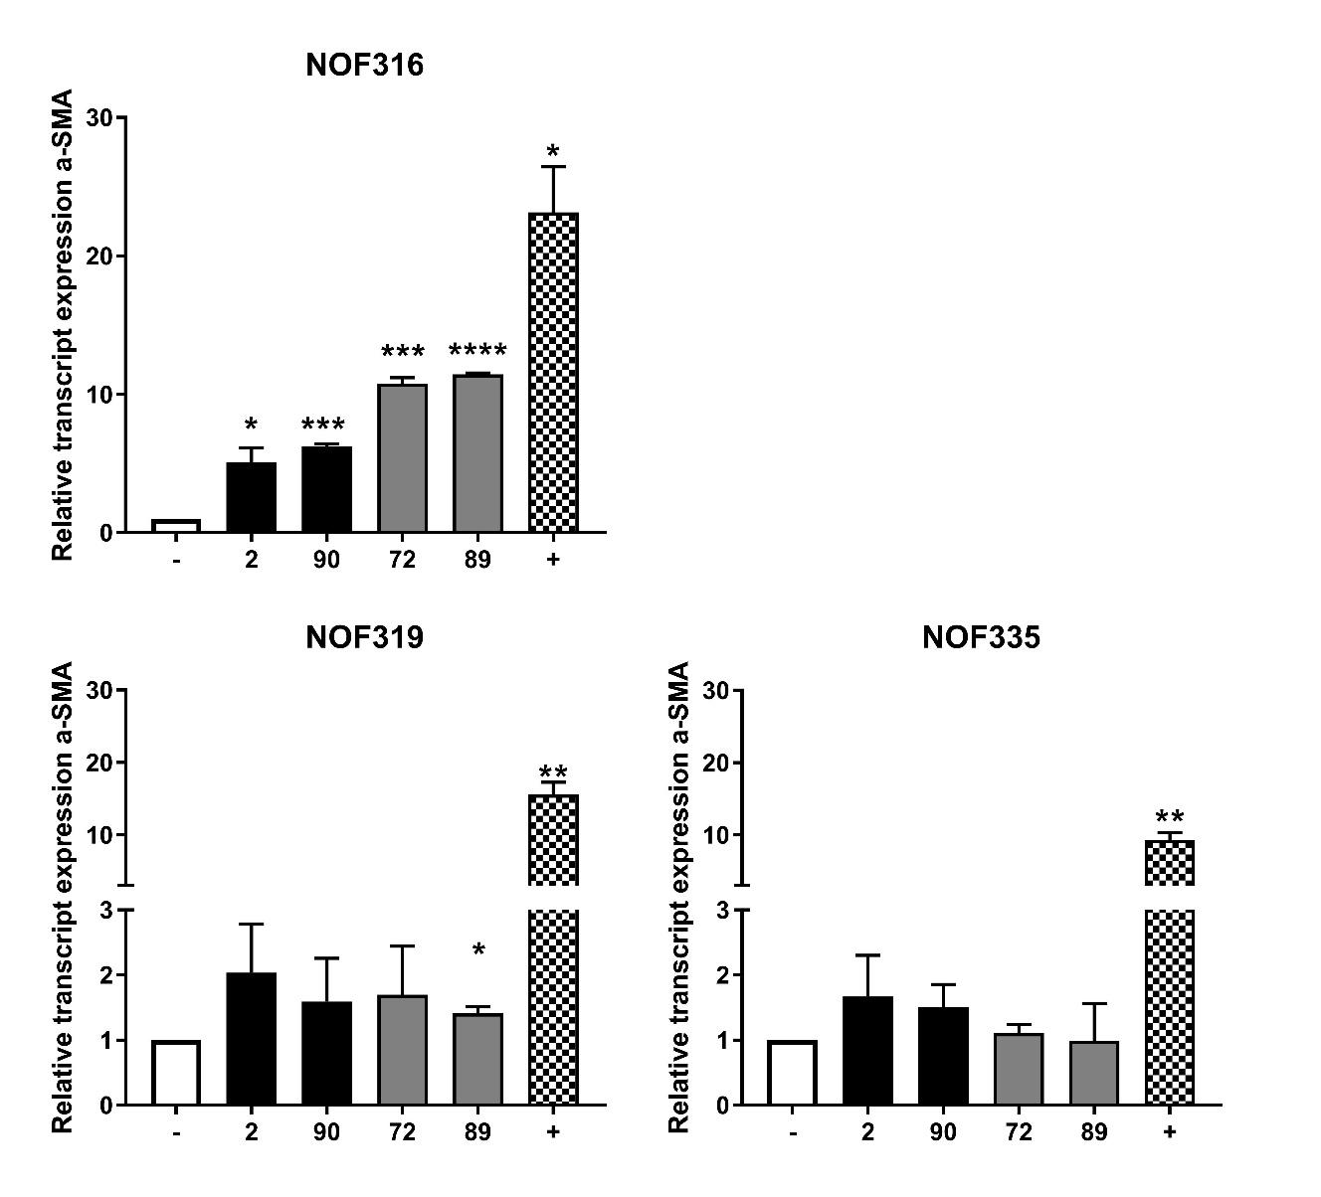
Figure 6.1 – NOF α-SMA transcript expression
NOFs were incubated for 24 h with serum free medium supplemented with either 5000 EVs per cell, 5ng/ml TGF-β1 (+ control), or no supplement (- control). RNA was harvested from cells and used to make cDNA libraries for qPCR using primers for α-SMA and U6 as a control. ΔCT values were calculated between α-SMA and U6 CT values and used to determine 2^{ΔΔct} values. N=2 with error bars showing SD. Unpaired two tailed T-tests were performed between samples and the negative control. * = P-value <0.05. **= P-value <0.01. ***= P-value <0.001. ****=P-value <0.0001.

6.3 – NOF α-SMA western blot
Protein isolated from treated NOF cells was used in SDS-PAGE and western blotting to estimate the abundance of α-SMA protein relative to the negative control.
NOF316 α-SMA protein was ~2.7-fold higher in TGF-β1 treated cells than in the negative control. SCC72 and SCC89 EVs were almost as effective, increasing α-SMA by 2 and 2.4-fold, respectively. Whilst SCC90 EVs increased α-SMA 1.6-fold, SCC2 EVs reduced the amount of α-SMA protein. β-actin levels were similar across all NOF316 samples (figure 6.2.B).
α-SMA protein levels in NOF319 negative control samples were high (figure 6.2.B) with SCC2 and SCC90 EV treated NOFs containing approximately 20% less α-SMA protein. TGF-β1 and SCC89 EV treatment resulted in a 1.25-fold increase in α-SMA protein, whilst SCC72 EV treatment had little effect. It should be noted that whilst the negative control band was thin, a gel warping effect may have caused overestimation of α-SMA in the negative control. NOF343 cells treated with SCC2 and SCC90 EVs contained 1.5-fold and 1.6-fold more α-SMA protein than the negative control, respectively. SCC72 EV treatment led to a 2-fold increase in α-SMA protein whilst SCC89 EV treatment and TGF-β1 treatment caused a 1.4-1.5-fold increase in α-SMA, respectively.
Averaged results show α-SMA protein levels were highest in TGF-β1 treated samples (1.7-fold higher than the negative controls), marginally more than SCC72 and SCC89 EV treated samples which showed a 1.6-fold increase in α-SMA. SCC90 EV treatment resulted in a 1.4-fold increase in α-SMA whilst, on average, SCC2 EVs had no effect on α-SMA expression. Standard deviation is high due to variation in response between NOF batches.

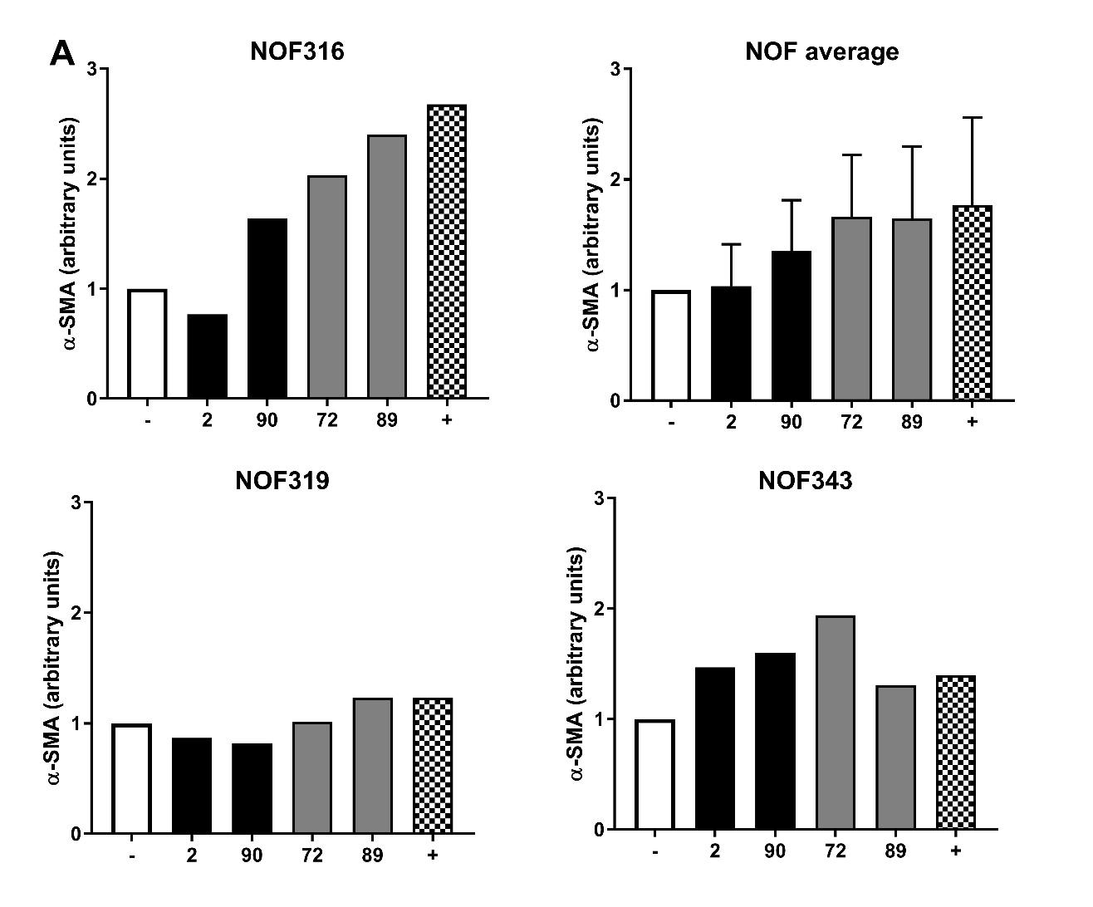
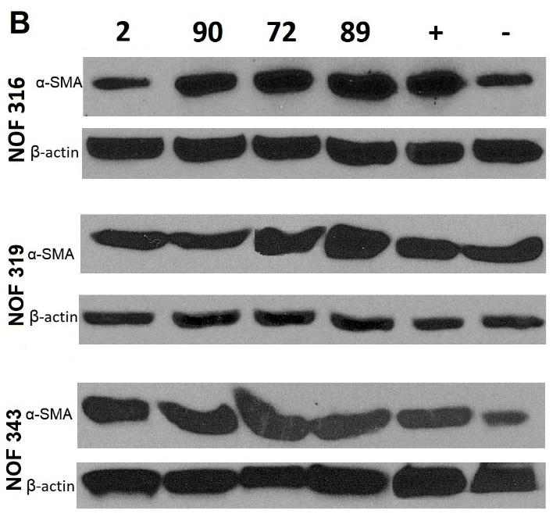
Figure 6.2 – α-SMA protein quantity
NOFs were incubated for 24 h with serum free medium supplemented with either 5000 EVs per cell, 5ng/ml TGF-β1 (+ control), or no supplement (- control). Cells were lysed by suspension in RIPA buffer containing protease inhibitors. 10 µg NOF protein was separated by SDS-PAGE and transferred to a nitrocellulose membrane for subsequent western blot analysis, as previously described. A) Images of protein bands were used to estimate the amount of α-SMA protein relative to β-actin control. α-SMA protein abundance in treated samples was calculated in proportion to negative control samples. All three NOF batches are also shown as mean average with error bars depicting standard deviation. B) Protein band images.

6.4 – α-SMA stress fibre formation in NOF cells
NOF cells seeded onto glass coverslips were treated in the same manner as previously described. Once fixed and stained with α-SMA FITC-conjugated antibody and DAPI, they were imaged under a fluorescence microscope.
Untreated NOF cells (incubated in serum free medium) showed limited α-SMA staining that had a less ordered structure. α-SMA fibres often appear tortuous (figure 6.3.A) and do not span the entire length of the cell (figure 6.3.B). TGF-β1 treatment increased α-SMA abundance and structure in all NOF batches. The α-SMA fibres became much more aligned and spanned the entire length of the cells.
When NOF cells were treated with EVs they resembled the positive control cells, with well-structured α-SMA stress fibres in greater abundance than the negative control (figure 6.3). NOF343 cells treated with SCC90 EVs displayed slightly lower abundance of these fibres but they remain well organized (figure 6.3.L).

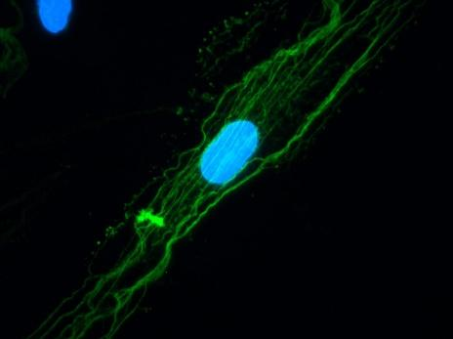  A – NOF316 – Negative | 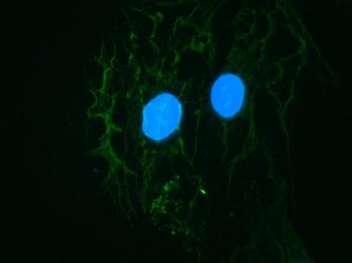  B – NOF319 – Negative | 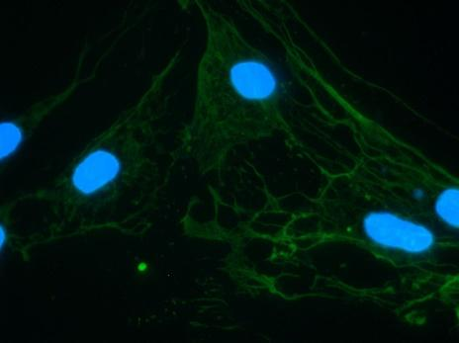  C – NOF343 – Negative
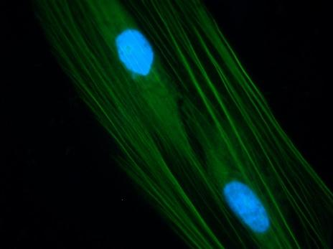  D – NOF316 – Positive | 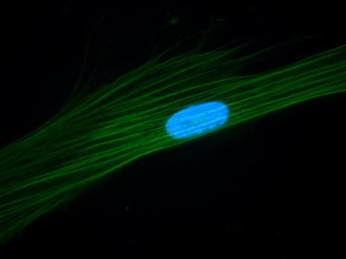  E – NOF319 – Positive | 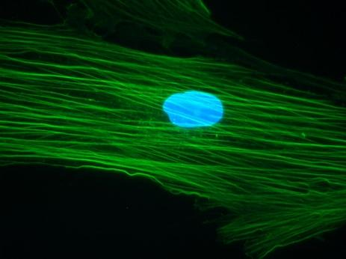  F – NOF343 – Positive
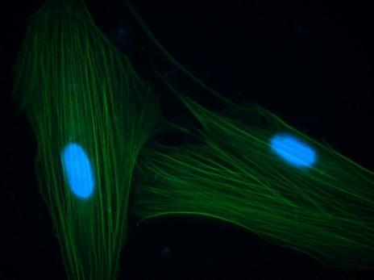  G – NOF316 –SCC2 EV treated | 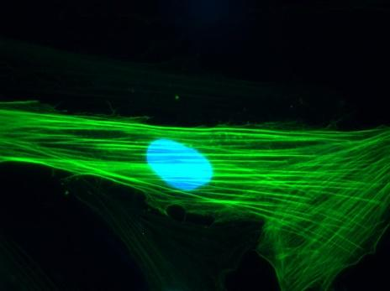  H – NOF319 –SCC2 EV treated | 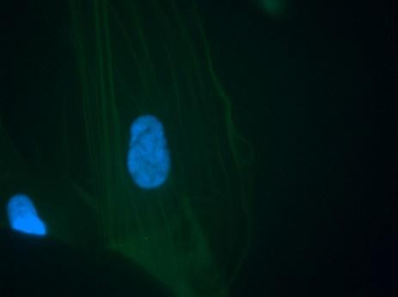  I – NOF343 –SCC2 EV treated
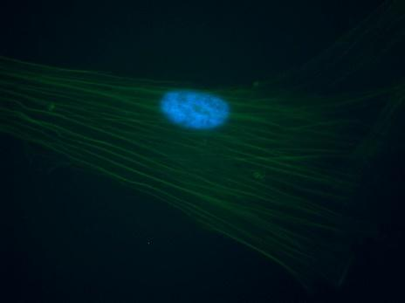  J – NOF316 –SCC90 EV treated | 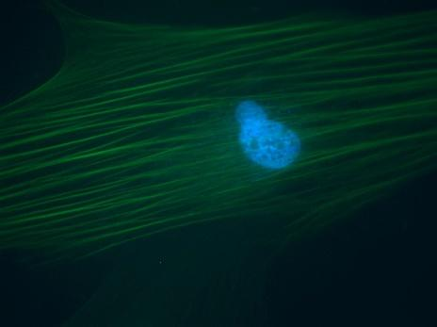  K – NOF319 –SCC90 EV treated | 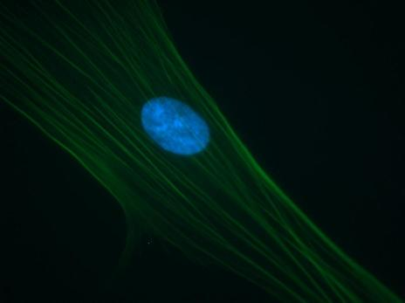  L – NOF343 –SCC90 EV treated
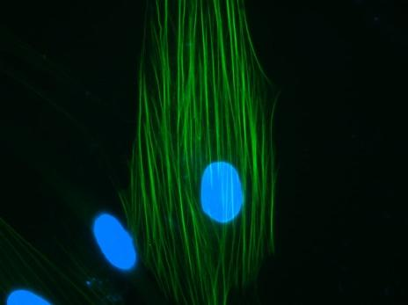  M – NOF316–SCC72 EV treated | 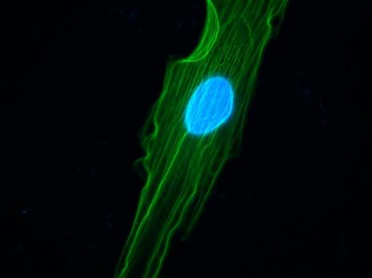  N – NOF319 –SCC72 EV treated | 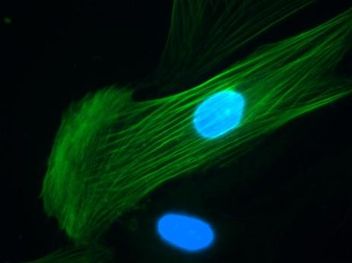  O – NOF343–SCC72 EV treated
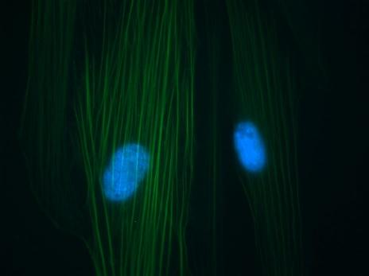  P – NOF316 –SCC89 EV treated | 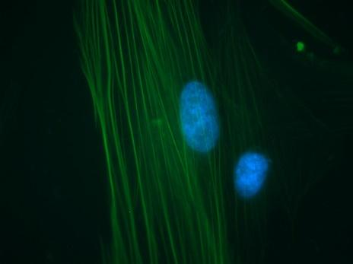  Q – NOF319–SCC89 EV treated | 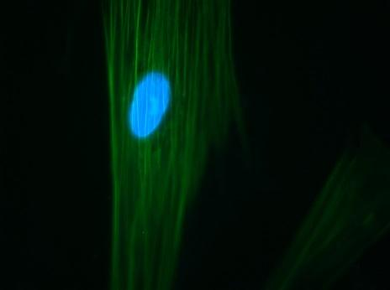  R – NOF343 –SCC89 EV treated

Figure 6.3 – IF α-SMA stress fibres
NOFs were incubated for 24 h with serum free medium supplemented with either 5000 EVs per cell, 5ng/ml TGF-β1 (+ control), or no supplement (- control). Cells were washed and fixed to coverslips using 100% methanol for 20 min at room temperature. Cells were permeabilized with 4 mM sodium deoxycholate before blocking and incubation with an α-SMA FITC-conjugated antibody. Coverslips were mounted onto microscope slides with Gold antifade and DAPI mounting media. Slides were stored in the dark before being viewed by fluorescence microscopy. Columns represent NOF lines whilst rows represent treatment.

6.5 – Pro-angiogenic activity
Recruitment of endothelial cells throughout tumours is vital to combat hypoxia and nutrient starvation. HMEC cells were used in tubule formation assays to measure angiogenic potential of OPSCC EVs. HMEC seeded on Matrigel layers were incubated with EVs for 8 h, allowing time for movement of cells to form tubules. EVs were applied at varying concentrations; 1,000 per cell, 5,000 per cell, or 20,000 per cell. Images were processed through ImageJ and analysed by Angiosys 2.0 software which identified and measured tubules to calculate total tubule length per image.
Image analysis showed that EV treatment increased the number of tubules throughout the tubule matrix. There was a distinct increase in the number of tubules when more EVs were applied.
Almost all EV treatments caused a significant increase in tubule formation with most treatments causing a 12-25% increase in total tubule length.
The lowest dose (1,000 EVs per cell) treatment of HMECs with SCC2 EVs caused only a 5% increase in tubule formation. However, increasing the dose to 5,000 EVs and 20,000 EVs per cell increased tubule formation by 16% and 19%, respectively. Low and intermediate (5,000 EVs per cell) treatment with SCC90 EVs increased tubule formation by 15%, with the higher dose (20,000 EVs per cell) increasing tubule formation by 25%.
Whilst treatment with both HPV+ OPSCC EVs demonstrated dose dependant effects, SCC72 EVs did not, with low and high doses causing a 16% increase and the intermediate dose only increasing formation by 14%. SCC89 EVs were most effective at increasing tubule formation, with low, intermediate, and high doses causing an 18%, 20% and 25% increase, respectively.

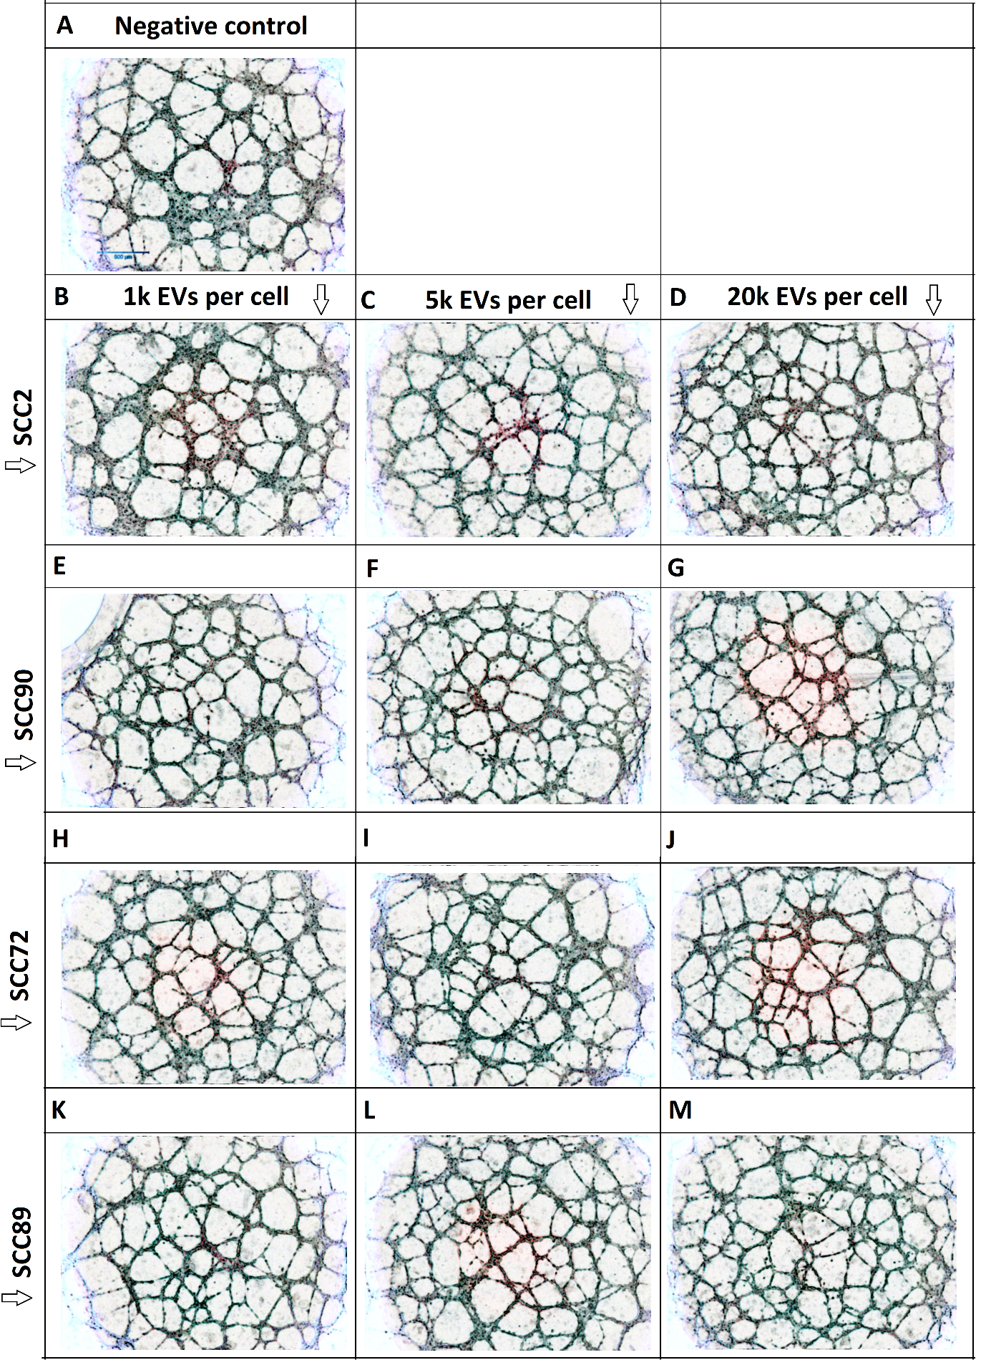

Figure 6.4 – HMEC tubule formation in response to EV treatment
HMECs seeded onto Matrigel layers were incubated for 8 h with EVs derived from OPSCC lines. Images were taken before and after incubation under a light microscope with a 4x objective lens. Images were removed of colour by ImageJ. A) shows a representative image of a negative control. Columns represent the number of EVs per cell used in treatment. Rows represent the cell line from which EVs were derived.

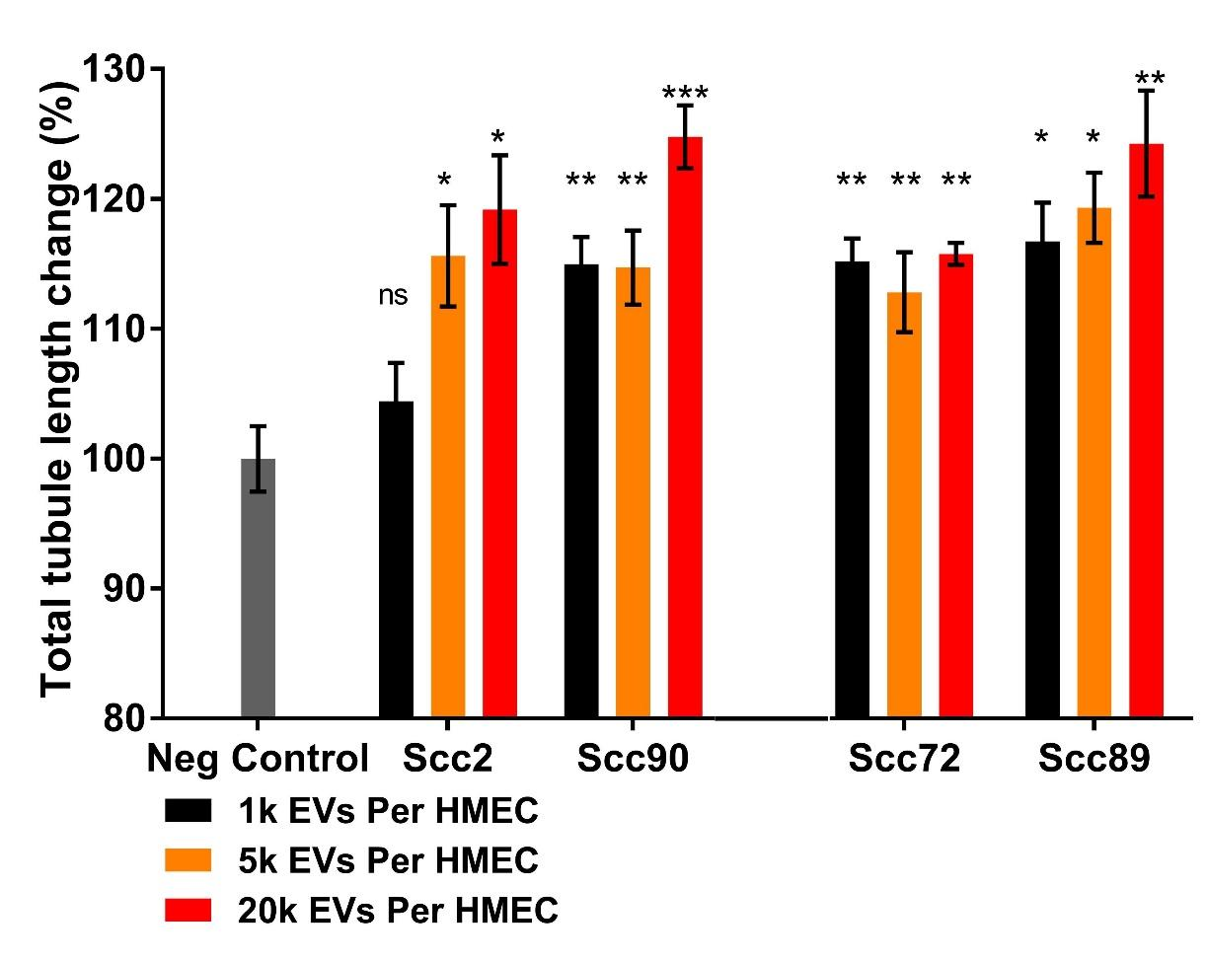
Figure 6.5 – Total tubule length
HMECs seeded onto Matrigel layers were incubated for 8 h with EVs derived from OPSCC lines. Images were taken before and after incubation under a light microscope with a 4x objective lens. Images were removed of colour by ImageJ before input into Angiosys 2.0 software to measure total tubule length of tubule matrix. Results were normalized to the negative control. N=3 biological triplicate with error bars showing SD. Unpaired two tailed T-tests were performed between samples and the negative control. * = P-value <0.05. **= P-value <0.01. ***= P-value <0.001.

6– Discussion

6.6 – Angiogenic potential of OPSCC derived EVs
Tubule formation assays demonstrated that EVs derived from all four OPSCC cell lines enhanced endothelial cell formation of tubules (figures 6.4 and 6.5). Additionally, this pro-angiogenic effect was dose-dependent for most EVs except those derived from SCC72. The lowest dose of 1000 EVs per endothelial cell was still capable of causing a significant increase in tubule formation, with the exception of SCC2 EVs.
The EV dosages were chosen to relate to the secretion rate seen by our OPSCCs. The quantity/concentration of cancer derived EVs available in tumour environments is still relatively unknown. However, by moving on from past practices of using EV protein concentration as an estimation of EV dosage, we better enable current research to be more relevant in the future.
The low dose required to stimulate endothelial cells is particularly interesting as it suggests quite a strong influence over the formation of tumour vasculature. Of course, within the tumour microenvironment, there is a complex milieu of signalling taking place with secretions from a variety of stromal cells, and it is the balance of all these signals (pro- vs anti angiogenic), which can affect the vascular formations (Nishida et al, 2006). Therefore, the EV signalling is more likely to make smaller shifts in balance. EVs are often acquired from blood and other fluids, and the tumour EV signalling is often distinguishable in these fluids (Buzás et al, 2018), which implies that these shifts are perceptible to stromal cells within the tumour.
Skin cancer derived EVs enriched in EGFR and miR-9 have been shown to interact with endothelial cells to promote angiogenesis (Al-Nedawi et al, 2009; Gajos-Michniewicz et al, 2014). Tumour EVs can also increase vascular leakiness promoting metastasis of cancer cells (Peinado et al, 2012). Other very recent work has also demonstrated the pro-angiogenic potential of EVs from both HPV and HPV- HNSCCs with EVs stimulating proliferation, migration, and tube formation in oral tumour mouse models (Ludwig et al, 2018).
When EVs collected from multiple melanoma (MM) cells, hypoxic MM cells, and hypoxia-resistant (HR-MM) cells were applied to HUVECs, significant changes to tubule formation were observed. EVs from hypoxic MM cells significantly increased tubule formation almost 4-fold greater than control, and HR-MM EVs increased tubule formation 7-fold. A dose dependent effect was also seen as application of half the usual HR-MM EV dose increased tubule formation by only 4-fold (Umezu et al, 2014). When the same experiment was done using hypoxic HUVECs similar results were seen, except that the impact of a half dose of HR-MM EVs was far more similar to the full dose, suggesting an increased receptivity of the endothelial cells to respond to these EVs.
The dose dependent effect is especially important considering that, whilst equal numbers of EVs were applied during dosing, we had previously demonstrated that HPV- OPSCCs secrete increased quantities of EVs. It is therefore tempting to infer that the EV related pro-angiogenic activity of HPV- OPSCC is greater than HPV+ OPSCC.
In a small study of 30 patients, P16- HNSCC’s (representative of HPV-) showed elevated levels of serum angiopoietin-1 and VEGF, vascular growth factors prominent in tumour angiogenesis. This was in comparison to normal and P16+ HNSCC (representative of HPV+) patients (Baruah et al, 2015). In a study of tonsillar carcinomas, a significant inverse relationship between EGFR and HPV status was shown as well as a correlation between high VEGF expression, increased microvessel density and likelihood of poor tumour differentiation (Fei et al, 2009).
A study involving a larger cohort of 241 OPSCC tumours showed similar results, with tumour VEGFA expression being low in over half of HPV+ tumours whilst less than a third of HPV- cancers showed low VEGFA expression (Dok et al, 2017). In vivo mouse models associated low P16 expression with a higher number of blood vessels as well as a growth advantage. Whilst the expression of P16 in HPV+ tumours was associated with reduced angiogenesis, lymphangiogenesis and nodal spread was upregulated by P16 (Dok et al, 2017). These effects could partially explain some of the differences described in these two cancers.
Our analysis of the impact of EVs secreted from HPV+ and HPV- OPSCCs shows both are capable of influencing endothelial cells, arguably indicating an increased effect of HPV- OPSCCs. This correlates with what is shown in multiple studies of these cancers and further suggests EVs as a causative agent within tumours. Such information will hopefully be relevant to future clinical studies.

6.7 – OPSCC EVs and fibroblasts
EVs from both HPV+ and HPV- OPSCCs increased α-SMA transcript expression and protein levels in NOFs. The high responder NOF316 showed HPV- EVs increased α-SMA mRNA levels and protein more effectively than HPV+ EVs, though less than the positive control. Low responders NOF319 and NOF335 showed slightly higher α-SMA transcript levels in response to HPV+ OPSCC EVs compared to HPV- OPSCC EVs (Figures 6.1 and 6.2). Whilst western blotting results showed mixed fibroblast responses to EVs, immuno-fluorescent imaging confirmed that all EVs were capable of increasing α-SMA stress fibre formation in a manner reminiscent of TGF-β1 dosing (figure 6.3).
It is well established that cancer cells recruit fibroblasts to the tumour as well as reprogram them into cancer associated fibroblasts (CAFs) with a phenotype resembling myofibroblasts (Kalluri and Zeisberg, 2006). CAFs secrete a variety of signalling molecules including hepatocyte growth factor (HGF), CXCL12, and TGF-β with downstream effects on important ECM proteins like MMPs and HIF-1α (Curry et al, 2014). This contributes to the accumulation of important traits of metastasis by the cancer cells, including increased local growth, invasiveness, and EMT. This has been exemplified by studies in mice in which transplanted cancer cells were less malignant than those also transplanted with CAFs (Bhowmick et al, 2006).
A study of fibroblasts in oral cancer showed that increased levels of α-SMA and ITGA6 were correlated with poor prognosis implicating the recruitment of CAFs as a characteristic of more aggressive tumours (Lim et al, 2011). Similar effects are seen in oesophageal cancer with HGF secretion by CAFs promoting angiogenesis and invasiveness (Grugan et al, 2010).
EVs secreted by chronic lymphocytic leukemia (CLL) have be shown to transfer to fibroblasts as well as endothelial cells and myeloid cells. An important feature of EV transfer was the requirement of EV surface proteins, such as tetraspanins and integrins, as well as the presence of heparan sulfate proteoglycans on recipient stromal cells – the latter of which is lacking on the CLL cell membrane (Paggetti et al, 2015). This suggests a directionality to EV transfer as autocrine effects are impeded. Uptake of CLL EVs by fibroblasts induced nuclear factor κB–dependent signalling and an upregulation of transcription of genes relating to inflammatory responses during the transformation to the CAF phenotype (Paggetti et al, 2015). The effects of CAF secreted EVs upon tumour cells are also important. CAF to OSCC EV transfer has been shown to stimulate TGFβ signalling in cancer cells that are unresponsive to TGFβ ligand in the absence of EV transfer (Languino et al, 2016).
We have demonstrated that EVs from all four cell lines were capable of inducing expression of the myo-fibroblastic indicator α-SMA when applied to NOFs. This effect was highly dependent on individual NOF batches. Differences between HPV+ and HPV- OPSCC EVs were difficult to determine, with IF imaging identifying similar properties in NOF α-SMA alignment when either EV population was applied. Despite this, it could be argued that HPV- OPSCC EVs have a greater impact on the RNA and protein levels of α-SMA, especially in high responder NOFs, as HPV- OPSCCs secreted greater numbers of EVs.

7 – Final Discussion
To summarize, TRPS analysis showed EVs were secreted by HPV- OPSCC lines at a greater rate the HPV+ OPSCC lines. Hierarchical clustering of NGS results grouped EV miRNA profiles based on the HPV status of the cell of origin. Differential expression identified 14 miRNAs more abundant in the EVs of HPV+ OPSCC and 19 miRNAs more abundant in HPV- OPSCC EVs. HPV- OPSCCs secreted twice as many EV proteins as HPV+ OPSCCs with pathway analysis suggesting a roll in cell-adhesion and ECM interactions.
Despite the differences in EV cargo, application of EVs to stromal cells from all cell lines often yielded similar results. Fibroblasts exposed to OPSCC EVs showed changes to α-SMA expression, with immune-fluorescent imaging highlighting a myo-fibroblastic phenotype similar to TGF-β treatment. OPSCC EVs also stimulated tubule formation of endothelial cells on a matrigel layer suggesting pro-angiogenic properties of these EVs in the tumour stroma.

7.1 - Cell adhesion and ECM interactions – pathways targeted by OPSCC EV protein and RNA cargo
Interrogation of EV protein data highlighted the abundance of proteins involved in cell adhesion and ECM interactions. However, a number of miRNAs identified in our OPSCC EVs also target transcripts encoding proteins associated with these processes such as the MMPs. In this section the implications of secreting this array of molecules in EVs will be discussed with a focus on whether or not this relationship is to counteract or facilitate downstream effects.
Firstly, previous experiments have highlighted the importance of changes in expression of even singular miRNAs. In glioblastoma cells, forced expression of miR-1, a tumour suppressive miRNA usually downregulated in glioblastomas, altered the EV proteome secreted with 462 downregulated and 11 upregulated proteins compared to control EV samples (Bronisz et al, 2014). Specifically the EVs contained reduced abundances of 3 validated miR-1 targets, ANXA2, FASN and 14-3-3ζ, as well as increased miR-1 abundance. Application of these EVs onto unaltered GBM cell lines showed miR-1-mediated downregulation of ANXA2 expression (Bronisz et al, 2014).
This highlights the impact of miRNA overexpression as, by EV transfer, a population of cells can share their overexpression with others, causing the recipients to behave like the originator.

7.1.1 - MiRNAs targeting MMPs – Working with or against EV protein content?
We have discussed the enticing hypothetical idea that miR-126 could be a selectively packaged miRNA in HPV+ OPSCCs, specifically as it is tumour suppressive when retained inside the cell yet confers pro-tumour properties once transferred to stromal cells.
MMPs are enzyme proteins importantly upregulated in HNSCC tumour stroma. If miR-126 levels are decreased it allows CXCR4 levels to be de-repressed and MMP and VEGF levels can increase, upregulated by NF-kB pathway (Qu, et al 2018). As mentioned, EV related sequestering could therefore aid in the MMP upregulation sometimes associated with HPV+ tumours (Sato et al, 2009), or the increased metastatic potential seen in HPV+ OPSCC (Vermeer et al, 2016).
More direct targeting can be seen from several of our highlighted EV miRNAs including, miR-9 and miR-143 from HPV+ cell lines, as well as miR-29b and miR-100 from HPV- cell lines. MiR-143 was discussed as another HPV associated EV miRNA, however miR-9, miR-29b and miR-100 have been shown to be increased in the cellular environment of their respective OPSCC (Miller et al, 2015; Wald eta, 2011; Lajer et al, 2012). In these types of cases we might expect that MMP production is reduced in the cancer cell (and recipient cells after EV transfer) by the elevation of specific miRNAs and that the increased targeting of MMP could be detected by examination of the tumour derived EVs. However, overexpression of multiple MMPs and MMP inhibitors has been seen in HNSCC with advanced T stage, infiltrative pattern of growth and with lymph node involvement (O-Charoenrat et al, 2001).
Data highlighting the importance of tumour microenvironment interactions are accumulating and whilst difficult to unravel, EV RNA and protein cargo should be included as major players especially regarding cell adhesion and ECM reorganisation.

7.2 - Cell adhesion and Angiogenesis
Modulation of cell adhesion has implications for many cell types and processes. Having already discussed that OPSCC EV proteins are associated with these processes it is interesting that some EV miRNAs identified in this study can also affect cell adhesion.
MiR-23a was the most abundant miRNA in our OPSCC EVs and EV-mediated transfer of miR-23a from lung cancer cells has previously been shown to inhibit tight junctions between endothelial cells by targeted downregulation of ZO-1 protein. As a result vascular permeability was increased better allowing cancer cells to enter vascular networks (Hsu et al, 2017). Our results also identified miR-105 as significantly more abundant in HPV- OPSCC EVs. MiR-105 also targets ZO-1 and its transfer from breast cancer cells via EVs has been shown to affect endothelial cells in a similar manner and potentially increase metastasis (Zhou et al, 2014).
Coinciding with this, pathway analysis of the most abundant proteins in SCC72 and SCC89 identified terms such as ‘angiogenesis’ and ‘VEGFR signalling pathway’ as well as many cell-cell and ECM interactions.
We might infer from this that, whilst EVs from both OPSCCs may alter endothelial cell cohesion and improve metastasis, HPV- OPSCC EVs have a significant advantage, incorporating more cell adhesion proteins and additional miRNAs. This is in opposition of the idea that HPV+ OPSCCs are more commonly associated with lymph node metastasis.

7.3 - Opposing interactions in EVs
We demonstrated a higher abundance of miR-29s (miR-29b-3p, miR-29a-3p, miR-29a-5p) in HPV- OPSCC EVs (or lower in HPV+ OPSCC). Higher abundance of ITGA6 was associated with HPV- OPSCC EVs in mass spectrometry experiments and multiple laminin subunits were amongst the most abundant proteins in SCC89 despite these proteins being targets of miR-29 (Kinoshita et al, 2013).
Whilst studies of HNSCC tissues, irrespective of HPV status, have identified downregulation of miR-29s (Koshizuka et al, 2018) it appears that HPV is a strong driving force in miR-29 downregulation in both cervical cancers (Li et al, 2017) and HPV+ HNSCC (Wald et al, 2010; Emmett, 2018).
Following on from an identification of miR-29 downregulation in HNSCCs, luciferase reporter assays in HPV- HNSCC cell lines with restored miR-29 expression showed that miR-29s directly regulated LAMC2 and ITGA6. Silencing the expression of these 2 proteins inhibited migration and invasive potential of cancer cells (Kinoshita et al, 2013).
It seems strange to associate the presence of both a miR family and several of their target genes within the same EV populations. However, these contradictions help to remind us of the varied interconnected pathways within these tumour cells and EVs. ITGA6 expression is upregulated by multiple proteins such as Fra-1, an upregulated protein in oral cancer the high expression of which is associated with poor survival (Xu et al, 2017). Fra-1 upregulation is a direct result of K-Ras/MAPK/ERK signaling cascade commonly activated in HNSCC by EGFR activation (Rampias et al 2014; Zhang et al, 2017). EGFR was shown to be upregulated in our HPV- OPSCC EVs agreeing with these other studies. Fra-1 elevation might not be seen in HPV+ OPSCC as it has been shown to be directly targeted by a HPV upregulated miRNA, mir-34a, in other cancers such as breast cancer (Yang et al, 2013).
Elevated levels of EGFR in HPV- OPSCC EVs, seen in our data, could correspond to the elevated ITGA6 despite the abundance of miR-29s which target it. Whilst elevated levels of miR-34a in HPV+ OPSCCs could limit its expression. It is also tempting to speculate that the selective sequestering of miR-29s in MVBs/EVs could allow for an increase in cellular protein levels of ITGA6 which results in its elevated packaging in EVs.

7.4 – Limitations of study
As with all small studies some compromises were made to reduce cost and allow for completion of study. Foremost was the choice to include only 4 cell lines in this study as this often left statistical analysis at low power. However, as working with EVs can be so time consuming, using only 2 HPV+ and 2 HPV- OPSCCs allowed for a variety of investigations with several interesting findings.
When analysing NGS results we chose to work only with miRNA over other RNA species as miRNA are the best-studied and annotated particularly regarding current EV research. Additionally, validation of NGS was carried out with only two miRNA’s due to the difficulty of acquiring enough EV RNA for RT-qPCR quickly.

7.5 – Future work
Several findings in this study show promise for additional study. Clarification and potential validation of the selective miRNA sequestering theory could be particularly interesting as it could highlight a currently under appreciated aspect of EV biology. Indeed, tracking of miR-126 and miR-143 interactions with MVB and EV biogenesis machinery could help elucidate key players in selective packaging.
The identification of LGALS3BP being highly enriched in HPV- OPSCCs is really interesting. It is rare to see that level of protein enrichment and LGALS3BP has been linked to several pro-tumorigenic behaviours particularly immune evasion (Läubli et al, 2014). Silencing of LGALS3BP prior to EV transfer to stromal cells, particularly immune cells, could help to unravel any potential function in modulation of the immune system. It is also another molecule which could be tracked to identify which aspect of EV biogenesis and packaging is utilized in HPV- OPSCC.
Whilst several individual molecules proved to be thought provoking, we also showed that the EV miRNA and protein profiles of HPV+ and HPV- OPSCCs are very different. Future work could include more cell lines and site matched primary epithelial cells. The inclusion of more OPSCC cell lines would reveal if the miRNA profiles of OPSCC EVs could continue to be differentiated into HPV status groups by unbiased hierarchical clustering.
However this could be taken a step further. Biomarker panels for saliva samples are of key clinical focus currently due to the ease of acquisition. Oral cancer and OPSCC could be excellent models for this type of research due to the location of these tumours, which is already being explored by some research groups (Gai et al, 2018). Identification of a select set or miRNAs or proteins present in tumour derived EVs would be preferential over whole miRNA/protein profiles. However, this would likely be driven by discovery-based experiments akin to ours with potential leads being linked to data from cell culture experiments.

7.6 - Closing remarks
As discussed, a common difficulty of working in EV research is falling for the notion that EV secretion is primarily a method of communication. It is easy to forget that enrichment of molecules within MVBs and EVs sequesters these molecules away from interacting intracellularly. Thus, whilst we can hypothesize cases where enrichment into EVs is always pro-tumourigenic, such as our identified miR-126 and miR-143, other cases may retard tumour cell growth but promote growth of surrounding stromal cells or vice versa. Then there is the opposing idea that signalling molecules can be highly abundant in both the cell and secreted EVs. In an ideal study the impact of incorporation of a single miRNA/protein into EVs would be assessed for all associated cells including the secretory cell.
We are still at an early stage in EV research. We know that EVs are heterogeneous in nature, but current technical limitations prevent us from single EV analysis. Current methodology relies on analysis on of mixed EV populations and therein lies the problem. Perhaps some EVs are primarily involved in molecule sequestration whereas others are vehicles for molecular messages? Unravelling the complexities of EV biology will likely keep budding EV researchers employed for many years to come.

References

Agrawal, N. et al. (2011) ‘Exome sequencing of head and neck squamous cell carcinoma reveals inactivating mutations in NOTCH1.’, Science (New York, N.Y.), 333(6046), pp. 1154–7. doi: 10.1126/science.1206923.
Al-Nedawi, K. et al. (2008) ‘Intercellular transfer of the oncogenic receptor EGFRvIII by microvesicles derived from tumour cells’, Nature Cell Biology, 10(5), pp. 619–624. doi: 10.1038/ncb1725.
Amado, T. et al. (2015) ‘Review Cross-regulation between cytokine and microRNA pathways in T cells’, Eur. J. Immunol, 45, pp. 1584–1595. doi: 10.1002/eji.201545487.
Andreu, Z. et al. (2016) ‘Comparative analysis of EV isolation procedures for miRNAs detection in serum samples.’, Journal of extracellular vesicles. Taylor & Francis, 5, p. 31655. doi: 10.3402/JEV.V5.31655.
Andreu, Z. and Yáñez-Mó, M. (2014) ‘Tetraspanins in extracellular vesicle formation and function.’, Frontiers in immunology. Frontiers Media SA, 5, p. 442. doi: 10.3389/fimmu.2014.00442.
Ang, K. K. et al. (2002) ‘Impact of epidermal growth factor receptor expression on survival and pattern of relapse in patients with advanced head and neck carcinoma.’, Cancer research, 62(24), pp. 7350–6. Available at: http://www.ncbi.nlm.nih.gov/pubmed/12499279 (Accessed: 4 September 2018).
Au Yeung, C. L. et al. (2011) ‘Human papillomavirus type 16 E6 induces cervical cancer cell migration through the p53/microRNA-23b/urokinase-type plasminogen activator pathway.’, Oncogene, 30(21), pp. 2401–10. doi: 10.1038/onc.2010.613.
Azmi, A. S., Bao, B. and Sarkar, F. H. (2013) ‘Exosomes in cancer development, metastasis, and drug resistance: a comprehensive review.’, Cancer metastasis reviews, 32(3–4), pp. 623–42. doi: 10.1007/s10555-013-9441-9.
Bagga, S. et al (2005) Regulation by let-7 and lin-4 miRNAs Results in Target mRNA Degradation. Cell. 122(4), pp.553--563.

Bao, L. et al. (2018) ‘Metastasis-associated miR-23a from nasopharyngeal carcinoma-derived exosomes mediates angiogenesis by repressing a novel target gene TSGA10.’, Oncogene. Nature Publishing Group, 37(21), pp. 2873–2889. doi: 10.1038/s41388-018-0183-6.
Baroni, S. et al. (2016) ‘Exosome-mediated delivery of miR-9 induces cancer-associated fibroblast-like properties in human breast fibroblasts’, Cell Death & Disease, 7(7), pp. e2312–e2312. doi: 10.1038/cddis.2016.224.
Barrow-Laing, L., Chen, W. and Roman, A. (2010) ‘Low- and high-risk human papillomavirus E7 proteins regulate p130 differently.’, Virology, 400(2), pp. 233–9. doi: 10.1016/j.virol.2010.01.034.
Baruah, P. et al. (2015) ‘Impact of p16 status on pro- and anti-angiogenesis factors in head and neck cancers.’, British journal of cancer. Nature Publishing Group, 113(4), pp. 653–9. doi: 10.1038/bjc.2015.251.
Bebelman, M. P. et al. (2018) ‘Biogenesis and function of extracellular vesicles in cancer’, Pharmacology & Therapeutics. Pergamon, 188, pp. 1–11. doi: 10.1016/J.PHARMTHERA.2018.02.013.
Beck, T. N. et al. (2015) ‘Phospho-&lt;sup&gt;T356&lt;/sup&gt;RB1 predicts survival in HPV-negative squamous cell carcinoma of the head and neck’, Oncotarget, 6(22), pp. 18863–74. doi: 10.18632/oncotarget.4321.
Beck, T. N. et al. (2016) ‘EGFR and RB1 as Dual Biomarkers in HPV-Negative Head and Neck Cancer.’, Molecular cancer therapeutics. NIH Public Access, 15(10), pp. 2486–2497. doi: 10.1158/1535-7163.MCT-16-0243.
Begum, S. et al. (2005) ‘Tissue distribution of human papillomavirus 16 DNA integration in patients with tonsillar carcinoma.’, Clinical cancer research : an official journal of the American Association for Cancer Research, 11(16), pp. 5694–9. doi: 10.1158/1078-0432.CCR-05-0587.
Benson, E. et al. (2014) ‘The clinical impact of HPV tumor status upon head and neck squamous cell carcinomas.’, Oral oncology, 50(6), pp. 565–74. doi: 10.1016/j.oraloncology.2013.09.008.
Bergmann, C. et al. (2009) ‘Tumor-derived microvesicles in sera of patients with head and neck cancer and their role in tumor progression.’, Head & neck, 31(3), pp. 371–80. doi: 10.1002/hed.20968.
Bern, M. M. (2017) ‘Extracellular vesicles: how they interact with endothelium, potentially contributing to metastatic cancer cell implants.’, Clinical and translational medicine. Springer, 6(1), p. 33. doi: 10.1186/s40169-017-0165-2.
Bhowmick, N. A., Neilson, E. G. and Moses, H. L. (2004) ‘Stromal fibroblasts in cancer initiation and progression.’, Nature. NIH Public Access, 432(7015), pp. 332–7. doi: 10.1038/nature03096.
Bodily, J. M., Mehta, K. P. M. and Laimins, L. A. (2011) ‘Human papillomavirus E7 enhances hypoxia-inducible factor 1-mediated transcription by inhibiting binding of histone deacetylases.’, Cancer research. NIH Public Access, 71(3), pp. 1187–95. doi: 10.1158/0008-5472.CAN-10-2626.
Böing, A. N. et al. (2013) ‘Active caspase-3 is removed from cells by release of caspase-3-enriched vesicles.’, Biochimica et biophysica acta, 1833(8), pp. 1844–52. doi: 10.1016/j.bbamcr.2013.03.013.
Böing, A. N. et al. (2014) ‘Single-step isolation of extracellular vesicles by size-exclusion chromatography’, Journal of Extracellular Vesicles. Available at: http://www.journalofextracellularvesicles.net/index.php/jev/article/view/23430/35577 (Accessed: 12 November 2014).
Bronisz, A. et al. (2014) ‘Extracellular vesicles modulate the glioblastoma microenvironment via a tumor suppression signaling network directed by miR-1.’, Cancer research. NIH Public Access, 74(3), pp. 738–750. doi: 10.1158/0008-5472.CAN-13-2650.
Butz, K. et al. (2000) ‘Induction of apoptosis in human papillomaviruspositive cancer cells by peptide aptamers targeting the viral E6 oncoprotein.’, Proceedings of the National Academy of Sciences of the United States of America, 97(12), pp. 6693–7. doi: 10.1073/pnas.110538897.
Buzás, E. I. et al. (2018) ‘Molecular interactions at the surface of extracellular vesicles’, Seminars in Immunopathology. Springer Berlin Heidelberg, pp. 1–12. doi: 10.1007/s00281-018-0682-0.Cancer Genome Atlas Network, T. C. G. A. N. (2015) ‘Comprehensive genomic characterization of head and neck squamous cell carcinomas.’, Nature. NIH Public Access, 517(7536), pp. 576–82. doi: 10.1038/nature14129.
Calin, G. et al. (2006). MicroRNAs and chromosomal abnormalities in cancer cells. Oncogene. 25(46), pp.6202--6210.
Cantrell, S. C. et al. (2013) ‘Differences in Imaging Characteristics of HPV-Positive and HPV-Negative Oropharyngeal Cancers: A Blinded Matched-Pair Analysis’, American Journal of Neuroradiology, 34(10), pp. 2005–2009. doi: 10.3174/ajnr.A3524.
Carvalho, J. and Oliveira, C. (2014) ‘Extracellular Vesicles - Powerful Markers of Cancer EVolution.’, Frontiers in immunology, 5, p. 685. doi: 10.3389/fimmu.2014.00685.
Chai, R. C. et al. (2015) ‘Current trends in the etiology and diagnosis of HPV-related head and neck cancers.’, Cancer medicine. doi: 10.1002/cam4.424.
Chandran, P. A. et al. (2014) ‘The TGF-β-inducible miR-23a cluster attenuates IFN-γ levels and antigen-specific cytotoxicity in human CD8 ⁺ T cells’, Journal of Leukocyte Biology, 96(4), pp. 633–645. doi: 10.1189/jlb.3A0114-025R.
Chapman, B. V. et al. (2015) ‘MicroRNA-363 targets myosin 1B to reduce cellular migration in head and neck cancer’, BMC Cancer. BioMed Central, 15(1), p. 861. doi: 10.1186/s12885-015-1888-3.
Chaturvedi, A. K. et al. (2011) ‘Human papillomavirus and rising oropharyngeal cancer incidence in the United States.’, Journal of clinical oncology : official journal of the American Society of Clinical Oncology, 29(32), pp. 4294–301. doi: 10.1200/JCO.2011.36.4596.
Chen, R. et al. (2014) ‘Release and activity of histone in diseases.’, Cell death & disease. Nature Publishing Group, 5(8), p. e1370. doi: 10.1038/cddis.2014.337.
Chen, W. et al. (2007) ‘Human papillomavirus causes an angiogenic switch in keratinocytes which is sufficient to alter endothelial cell behavior’, Virology, 367(1), pp. 168–174. doi: 10.1016/j.virol.2007.05.030.
Chen, W. et al. (2011) ‘NF-kappaB in lung cancer, a carcinogenesis mediator and a prevention and therapy target.’, Frontiers in bioscience (Landmark edition). NIH Public Access, 16, pp. 1172–85. Available at: http://www.ncbi.nlm.nih.gov/pubmed/21196225 (Accessed: 23 September 2018).
Choi, D.-S. et al. (2012) ‘Quantitative proteomics of extracellular vesicles derived from human primary and metastatic colorectal cancer cells.’, Journal of extracellular vesicles. Taylor & Francis, 1. doi: 10.3402/jev.v1i0.18704.
Choi, Y. J. et al. (2011) ‘miR-34 miRNAs provide a barrier for somatic cell reprogramming.’, Nature cell biology. NIH Public Access, 13(11), pp. 1353–60. doi: 10.1038/ncb2366.
Chou, C.-H. et al. (2018) ‘miRTarBase update 2018: a resource for experimentally validated microRNA-target interactions’, Nucleic Acids Research, 46(D1), pp. D296–D302. doi: 10.1093/nar/gkx1067.
Chu, A. et al. (2013) ‘A patient-centered approach to counseling patients with head and neck cancer undergoing human papillomavirus testing: a clinician’s guide.’, The oncologist, 18(2), pp. 180–9. doi: 10.1634/theoncologist.2012-0200.
Chung, C. H. et al. (2015) ‘Genomic alterations in head and neck squamous cell carcinoma determined by cancer gene-targeted sequencing’, Annals of Oncology, 26(6), pp. 1216–1223. doi: 10.1093/annonc/mdv109.
Clancy, J. W. et al. (2015) ‘Regulated delivery of molecular cargo to invasive tumour-derived microvesicles.’, Nature communications, 6, p. 6919. doi: 10.1038/ncomms7919.
Colombo, M. et al. (2013) ‘Analysis of ESCRT functions in exosome biogenesis, composition and secretion highlights the heterogeneity of extracellular vesicles’, Journal of Cell Science, 126(24), pp. 5553–5565. doi: 10.1242/jcs.128868.
Colombo, M., Raposo, G. and Théry, C. (2014) ‘Biogenesis, Secretion, and Intercellular Interactions of Exosomes and Other Extracellular Vesicles’, Annual Review of Cell and Developmental Biology, 30(1), pp. 255–289. doi: 10.1146/annurev-cellbio-101512-122326.
Corcoran, C., Rani, S. and O’Driscoll, L. (2014) ‘miR-34a is an intracellular and exosomal predictive biomarker for response to docetaxel with clinical relevance to prostate cancer progression’, The Prostate, 74(13), pp. 1320–1334. doi: 10.1002/pros.22848.
Cortez, M. A. et al. (2011) ‘MicroRNAs in body fluids--the mix of hormones and biomarkers.’, Nature reviews. Clinical oncology, 8(8), pp. 467–77. doi: 10.1038/nrclinonc.2011.76.
Crook, T., Tidy, J. A. and Vousden, K. H. (1991) ‘Degradation of p53 can be targeted by HPV E6 sequences distinct from those required for p53 binding and trans-activation.’, Cell, 67(3), pp. 547–56. Available at: http://www.ncbi.nlm.nih.gov/pubmed/1657399 (Accessed: 30 August 2018).
Curry, J. M. et al. (2014) ‘Tumor Microenvironment in Head and Neck Squamous Cell Carcinoma’, Seminars in Oncology. W.B. Saunders, 41(2), pp. 217–234. doi: 10.1053/J.SEMINONCOL.2014.03.003.
Cvjetkovic, A. et al. (2017) ‘Extracellular vesicles in motion’, Matters. ScienceMatters AG, 3(6), p. e201704000003. doi: 10.19185/matters.201704000003.
Cvjetkovic, A. et al. (2016) ‘Detailed Analysis of Protein Topology of Extracellular Vesicles–Evidence of Unconventional Membrane Protein Orientation’, Scientific Reports. Nature Publishing Group, 6(1), p. 36338. doi: 10.1038/srep36338.
Dahlgren, L. et al. (2003) ‘Comparative genomic hybridization analysis of tonsillar cancer reveals a different pattern of genomic imbalances in human papillomavirus-positive and -negative tumors.’, International journal of cancer. Journal international du cancer, 107(2), pp. 244–9. doi: 10.1002/ijc.11371.
Dargan, D. J. and Subak-Sharpe, J. H. (1997) ‘The effect of herpes simplex virus type 1 L-particles on virus entry, replication, and the infectivity of naked herpesvirus DNA.’, Virology, 239(2), pp. 378–88. doi: 10.1006/viro.1997.8893.
Day, P. M. and Schelhaas, M. (2014) ‘Concepts of papillomavirus entry into host cells.’, Current opinion in virology, 4, pp. 24–31. doi: 10.1016/j.coviro.2013.11.002.
de Martel, C. et al. (2012) ‘Global burden of cancers attributable to infections in 2008: a review and synthetic analysis’, The Lancet Oncology, 13(6), pp. 607–615. doi: 10.1016/S1470-2045(12)70137-7.
Deng, Z. et al. (2013) ‘Viral load, physical status, and E6/E7 mRNA expression of human papillomavirus in head and neck squamous cell carcinoma’, Head & Neck, 35(6), pp. 800–808. doi: 10.1002/hed.23034.
DeRoo, E. P. et al. (2015) ‘The role of galectin-3 and galectin-3-binding protein in venous thrombosis.’, Blood. American Society of Hematology, 125(11), pp. 1813–21. doi: 10.1182/blood-2014-04-569939.
DiMaio, D. and Petti, L. M. (2013) ‘The E5 proteins.’, Virology, 445(1–2), pp. 99–114. doi: 10.1016/j.virol.2013.05.006.
Dimitrova, N. et al. (2016) ‘Stromal Expression of miR-143/145 Promotes Neoangiogenesis in Lung Cancer Development’, Cancer Discovery, 6(2), pp. 188–201. doi: 10.1158/2159-8290.CD-15-0854.
Dok, R. et al. (2017) ‘Dual role for p16 in the metastasis process of HPV positive head and neck cancers.’, Molecular cancer. BioMed Central, 16(1), p. 113. doi: 10.1186/s12943-017-0678-8.
Dok, R. and Nuyts, S. (2016) ‘HPV Positive Head and Neck Cancers: Molecular Pathogenesis and Evolving Treatment Strategies.’, Cancers. Multidisciplinary Digital Publishing Institute (MDPI), 8(4). doi: 10.3390/cancers8040041.
Doorbar, J. (2006) ‘Molecular biology of human papillomavirus infection and cervical cancer.’, Clinical science (London, England : 1979), 110(5), pp. 525–41. doi: 10.1042/CS20050369.
Doorbar, J. et al. (2015) ‘Human papillomavirus molecular biology and disease association.’, Reviews in medical virology, 25 Suppl 1, pp. 2–23. doi: 10.1002/rmv.1822.
Doorbar, J. et al. (2012) ‘The biology and life-cycle of human papillomaviruses.’, Vaccine, 30 Suppl 5, pp. F55-70. doi: 10.1016/j.vaccine.2012.06.083.
Du, C. et al. (2014) ‘MiR-126-3p suppresses tumor metastasis and angiogenesis of hepatocellular carcinoma by targeting LRP6 and PIK3R2’, Journal of Translational Medicine. BioMed Central, 12(1), p. 259. doi: 10.1186/s12967-014-0259-1.
Dukers, D. F. et al. (2000) ‘Direct immunosuppressive effects of EBV-encoded latent membrane protein 1.’, Journal of immunology (Baltimore, Md. : 1950), 165(2), pp. 663–70. Available at: http://www.ncbi.nlm.nih.gov/pubmed/10878338 (Accessed: 7 January 2016).
Durzynska, J., Lesniewicz, K. and Poreba, E. (2017) ‘Human papillomaviruses in epigenetic regulations’, Mutation Research/Reviews in Mutation Research. Elsevier, 772, pp. 36–50. doi: 10.1016/J.MRREV.2016.09.006.
Dutta, S. et al. (2015) ‘Proteomics profiling of cholangiocarcinoma exosomes: A potential role of oncogenic protein transferring in cancer progression’, Biochimica et Biophysica Acta (BBA) - Molecular Basis of Disease. Elsevier, 1852(9), pp. 1989–1999. doi: 10.1016/J.BBADIS.2015.06.024.
Dyson, N. et al. (1989) ‘The human papilloma virus-16 E7 oncoprotein is able to bind to the retinoblastoma gene product.’, Science (New York, N.Y.), 243(4893), pp. 934–7. Available at: http://www.ncbi.nlm.nih.gov/pubmed/2537532 (Accessed: 7 January 2016).
Egawa, N. et al. (2015) ‘Human Papillomaviruses; Epithelial Tropisms, and the Development of Neoplasia.’, Viruses, 7(7), pp. 3863–90. doi: 10.3390/v7072802.
Eldh, M. et al. (2012) ‘Importance of RNA isolation methods for analysis of exosomal RNA: evaluation of different methods.’, Molecular immunology, 50(4), pp. 278–86. doi: 10.1016/j.molimm.2012.02.001.
Elrefaey, S. et al. (2014) ‘HPV in oropharyngeal cancer: the basics to know in clinical practice.’, Acta otorhinolaryngologica Italica : organo ufficiale della Societa italiana di otorinolaringologia e chirurgia cervico-facciale. Pacini Editore, 34(5), pp. 299–309. Available at: http://www.ncbi.nlm.nih.gov/pubmed/25709145 (Accessed: 4 May 2017).
Louise Emmett, S. (2018) Evaluating cellular microRNA expression in human papillomavirus associated head and neck squamous cell carcinoma. Available at: https://espace.library.uq.edu.au/view/UQ:673437/s4141645_final_thesis.pdf (Accessed: 13 September 2018).
Uyen Thi Trang Than. (2017) Extracellular membranes vesicles from keratinocytes. Available at: https://eprints.qut.edu.au/108959/1/Thi%20Trang%20Uyen_Than_Thesis.pdf
Endo, H. et al. (2013) ‘Potential of tumor-suppressive miR-596 targeting LGALS3BP as a therapeutic agent in oral cancer’, Carcinogenesis, 34(3), pp. 560–569. doi: 10.1093/carcin/bgs376.
Escrevente, C. et al. (2013) ‘Sialoglycoproteins and N-glycans from secreted exosomes of ovarian carcinoma cells.’, PloS one. Public Library of Science, 8(10), p. e78631. doi: 10.1371/journal.pone.0078631.
Esteller, M. (2007) ‘Cancer epigenomics: DNA methylomes and histone-modification maps’, Nature Reviews Genetics. Nature Publishing Group, 8(4), pp. 286–298. doi: 10.1038/nrg2005.
Fakhry, C. et al. (2008) ‘Improved Survival of Patients With Human Papillomavirus-Positive Head and Neck Squamous Cell Carcinoma in a Prospective Clinical Trial’, JNCI Journal of the National Cancer Institute, 100(4), pp. 261–269. doi: 10.1093/jnci/djn011.
Fakhry, C. et al. (2014) ‘Human papillomavirus and overall survival after progression of oropharyngeal squamous cell carcinoma.’, Journal of clinical oncology : official journal of the American Society of Clinical Oncology, 32(30), pp. 3365–73. doi: 10.1200/JCO.2014.55.1937.
Fay, N. and PantÃ©, N. (2015) ‘Nuclear entry of DNA viruses’, Frontiers in Microbiology, 6, p. 467. doi: 10.3389/fmicb.2015.00467.
Fei, J. et al. (2009) ‘Prognostic Significance of Vascular Endothelial Growth Factor in Squamous Cell Carcinomas of the Tonsil in Relation to Human Papillomavirus Status and Epidermal Growth Factor Receptor’, Annals of Surgical Oncology, 16(10), pp. 2908–2917. doi: 10.1245/s10434-009-0579-1.
Feng, R. et al. (2010) ‘miR-126 functions as a tumour suppressor in human gastric cancer’, Cancer Letters, 298(1), pp. 50–63. doi: 10.1016/j.canlet.2010.06.004.
Ferlay, J. et al. (2010) ‘Estimates of worldwide burden of cancer in 2008: GLOBOCAN 2008.’, International journal of cancer. Journal international du cancer, 127(12), pp. 2893–917. doi: 10.1002/ijc.25516.
Filipe, V., Hawe, A. and Jiskoot, W. (2010) ‘Critical Evaluation of Nanoparticle Tracking Analysis (NTA) by NanoSight for the Measurement of Nanoparticles and Protein Aggregates’, Pharmaceutical Research, 27(5), pp. 796–810. doi: 10.1007/s11095-010-0073-2.
Fraga, M. F. et al. (2005) ‘Loss of acetylation at Lys16 and trimethylation at Lys20 of histone H4 is a common hallmark of human cancer’, Nature Genetics. Nature Publishing Group, 37(4), pp. 391–400. doi: 10.1038/ng1531.
Fujita, K. et al. (2017) ‘Proteomic analysis of urinary extracellular vesicles from high Gleason score prostate cancer.’, Scientific reports. Nature Publishing Group, 7, p. 42961. doi: 10.1038/srep42961.
Fullár, A. et al. (2015) ‘Remodeling of extracellular matrix by normal and tumor-associated fibroblasts promotes cervical cancer progression.’, BMC cancer. BioMed Central, 15, p. 256. doi: 10.1186/s12885-015-1272-3.
Gai, C. et al. (2018) ‘Salivary extracellular vesicle-associated miRNAs as potential biomarkers in oral squamous cell carcinoma’, BMC Cancer. BioMed Central, 18(1), p. 439. doi: 10.1186/s12885-018-4364-z.
Gaiotti, D. et al. (2000) ‘Tumor necrosis factor-? promotes human papillomavirus (HPV) E6/E7 RNA expression and cyclin-dependent kinase activity in HPV-immortalized keratinocytes by aras-dependent pathway’, Molecular Carcinogenesis. Wiley-Blackwell, 27(2), pp. 97–109. doi: 10.1002/(SICI)1098-2744(200002)27:2<97::AID-MC5>3.0.CO;2-V.
Gajos-Michniewicz, A., Duechler, M. and Czyz, M. (2014) ‘MiRNA in melanoma-derived exosomes’, Cancer Letters, 347(1), pp. 29–37. doi: 10.1016/j.canlet.2014.02.004.
Gallo, A. et al. (2012) ‘The majority of microRNAs detectable in serum and saliva is concentrated in exosomes.’, PloS one, 7(3), p. e30679. doi: 10.1371/journal.pone.0030679.
Gámez-Valero, A. et al. (2016) ‘Size-Exclusion Chromatography-based isolation minimally alters Extracellular Vesicles’ characteristics compared to precipitating agents’, Scientific Reports. Nature Publishing Group, 6(1), p. 33641. doi: 10.1038/srep33641.
Ganguly, N. (2012) ‘Human papillomavirus-16 E5 protein: oncogenic role and therapeutic value.’, Cellular oncology (Dordrecht), 35(2), pp. 67–76. doi: 10.1007/s13402-011-0069-x.
Ganguly, N. and Parihar, S. P. (2009) ‘Human papillomavirus E6 and E7 oncoproteins as risk factors for tumorigenesis.’, Journal of biosciences, 34(1), pp. 113–23. Available at: http://www.ncbi.nlm.nih.gov/pubmed/19430123 (Accessed: 8 July 2015).
Gao, G. et al. (2013) ‘A microRNA expression signature for the prognosis of oropharyngeal squamous cell carcinoma.’, Cancer, 119(1), pp. 72–80. doi: 10.1002/cncr.27696.
Gao, G. et al. (2014) ‘Mate pair sequencing of oropharyngeal squamous cell carcinomas reveals that HPV integration occurs much less frequently than in cervical cancer.’, Journal of clinical virology : the official publication of the Pan American Society for Clinical Virology, 59(3), pp. 195–200. doi: 10.1016/j.jcv.2013.12.006.
Gao, Y. et al. (2014) ‘Regulation of HPV16 E6 and MCL1 by SF3B1 inhibitor in head and neck cancer cells.’, Scientific reports. Nature Publishing Group, 4, p. 6098. doi: 10.1038/srep06098.
Garbuglia, A. R. (2014) ‘Human papillomavirus in head and neck cancer.’, Cancers, 6(3), pp. 1705–26. doi: 10.3390/cancers6031705.
Gardiner, C. et al. (2013) ‘Extracellular vesicle sizing and enumeration by nanoparticle tracking analysis.’, Journal of extracellular vesicles. Taylor & Francis, 2. doi: 10.3402/jev.v2i0.19671.
Gibbings, D. J. et al. (2009) ‘Multivesicular bodies associate with components of miRNA effector complexes and modulate miRNA activity.’, Nature cell biology, 11(9), pp. 1143–9. doi: 10.1038/ncb1929.
Gillison, M. L. et al. (2000) ‘Evidence for a causal association between human papillomavirus and a subset of head and neck cancers.’, Journal of the National Cancer Institute, 92(9), pp. 709–20. Available at: http://www.ncbi.nlm.nih.gov/pubmed/10793107 (Accessed: 23 July 2015).
Gillison, M. L. et al. (2012) ‘Prevalence of Oral HPV Infection in the United States, 2009-2010’, JAMA, 307(7), p. 693. doi: 10.1001/jama.2012.101.
Gillison, M. L. et al. (2014) ‘Eurogin Roadmap: Comparative epidemiology of HPV infection and associated cancers of the head and neck and cervix’, International Journal of Cancer, 134(3), pp. 497–507. doi: 10.1002/ijc.28201.
Gillison, M. L. et al. (2012) ‘Tobacco Smoking and Increased Risk of Death and Progression for Patients With p16-Positive and p16-Negative Oropharyngeal Cancer’, Journal of Clinical Oncology, 30(17), pp. 2102–2111. doi: 10.1200/JCO.2011.38.4099.
Gkretsi, V. and Stylianopoulos, T. (2018) ‘Cell Adhesion and Matrix Stiffness: Coordinating Cancer Cell Invasion and Metastasis’, Frontiers in Oncology. Frontiers, 8, p. 145. doi: 10.3389/fonc.2018.00145.
Greening, D. W. et al. (2017) ‘Proteomic insights into extracellular vesicle biology – defining exosomes and shed microvesicles’, Expert Review of Proteomics, 14(1), pp. 69–95. doi: 10.1080/14789450.2017.1260450.
Grugan, K. D. et al. (2010) ‘Fibroblast-secreted hepatocyte growth factor plays a functional role in esophageal squamous cell carcinoma invasion’, Proceedings of the National Academy of Sciences, 107(24), pp. 11026–11031. doi: 10.1073/pnas.0914295107.
Grundhoff, A. et al. (2011). Virus-encoded microRNAs. Virology. 411(2), pp.325--343.
Gulyás, M. and Hjerpe, A. (2003) ‘Proteoglycans and WT1 as markers for distinguishing adenocarcinoma, epithelioid mesothelioma, and benign mesothelium’, The Journal of Pathology, 199(4), pp. 479–487. doi: 10.1002/path.1312.
Guo, Y. et al. (2014) ‘Human papillomavirus 16 E6 contributes HIF-1α induced Warburg effect by attenuating the VHL-HIF-1α interaction.’, International journal of molecular sciences. Multidisciplinary Digital Publishing Institute (MDPI), 15(5), pp. 7974–86. doi: 10.3390/ijms15057974.
Hannafon, B. N. and Ding, W.-Q. (2013) ‘Intercellular communication by exosome-derived microRNAs in cancer.’, International journal of molecular sciences, 14(7), pp. 14240–69. doi: 10.3390/ijms140714240.
Harden, M. E. and Munger, K. (2017) ‘Human papillomavirus 16 E6 and E7 oncoprotein expression alters microRNA expression in extracellular vesicles.’, Virology. NIH Public Access, 508, pp. 63–69. doi: 10.1016/j.virol.2017.05.005.
Hashibe, M. et al. (2007) ‘Alcohol drinking in never users of tobacco, cigarette smoking in never drinkers, and the risk of head and neck cancer: pooled analysis in the International Head and Neck Cancer Epidemiology Consortium.’, Journal of the National Cancer Institute, 99(10), pp. 777–89. doi: 10.1093/jnci/djk179.
Hayashita, Y et al. (2005). A Polycistronic MicroRNA Cluster, miR-17-92, Is Overexpressed in Human Lung Cancers and Enhances Cell Proliferation. Cancer Research. 65(21), pp.9628--9632.
Herfs, M. et al. (2017) ‘Deciphering the Multifactorial Susceptibility of Mucosal Junction Cells to HPV Infection and Related Carcinogenesis.’, Viruses. Multidisciplinary Digital Publishing Institute (MDPI), 9(4). doi: 10.3390/v9040085.
Hergenreider, E. et al. (2012) ‘Atheroprotective communication between endothelial cells and smooth muscle cells through miRNAs’, Nature Cell Biology, 14(3), pp. 249–256. doi: 10.1038/ncb2441.
Higashi, T. et al. (2015) ‘miR-9-3p plays a tumour-suppressor role by targeting TAZ (WWTR1) in hepatocellular carcinoma cells’, British Journal of Cancer, 113(2), pp. 252–258. doi: 10.1038/bjc.2015.170.
Honegger, A. et al. (2013) ‘Silencing of human papillomavirus (HPV) E6/E7 oncogene expression affects both the contents and the amounts of extracellular microvesicles released from HPV-positive cancer cells.’, International journal of cancer. Journal international du cancer, 133(7), pp. 1631–42. doi: 10.1002/ijc.28164.
Honegger, A. et al. (2015) ‘Dependence of intracellular and exosomal microRNAs on viral E6/E7 oncogene expression in HPV-positive tumor cells.’, PLoS pathogens, 11(3), p. e1004712. doi: 10.1371/journal.ppat.1004712.
Hong, B. et al. (2009) ‘Colorectal cancer cell-derived microvesicles are enriched in cell cycle-related mRNAs that promote proliferation of endothelial cells’, BMC Genomics. BioMed Central, 10(1), p. 556. doi: 10.1186/1471-2164-10-556.
Hong, L. et al. (2010) ‘The miR-17-92 cluster of microRNAs confers tumorigenicity by inhibiting oncogene-induced senescence.’, Cancer research, 70(21), pp. 8547–57. doi: 10.1158/0008-5472.CAN-10-1938.
Hoshino, D. et al. (2013) ‘Exosome Secretion Is Enhanced by Invadopodia and Drives Invasive Behavior’, Cell Reports. Cell Press, 5(5), pp. 1159–1168. doi: 10.1016/J.CELREP.2013.10.050.
Houmani, J. et al. (2009). Growth-promoting properties of Epstein-Barr virus EBER-1 RNA correlate with ribosomal protein L22 binding. Journal of virology. 83(19), pp.9844--9853.
Hsieh, J.-T. et al. (2018) ‘IFN-γ induces epithelial-to-mesenchymal transition of cancer cells via an unique microRNA processing’, bioRxiv. Cold Spring Harbor Laboratory, p. 355263. doi: 10.1101/355263.
Hsu, Y.-L. et al. (2017) ‘Hypoxic lung cancer-secreted exosomal miR-23a increased angiogenesis and vascular permeability by targeting prolyl hydroxylase and tight junction protein ZO-1’, Oncogene. Nature Publishing Group, 36(34), pp. 4929–4942. doi: 10.1038/onc.2017.105.
Huang, D. W., Sherman, B. T. and Lempicki, R. A. (2009) ‘Systematic and integrative analysis of large gene lists using DAVID bioinformatics resources’, Nature Protocols, 4(1), pp. 44–57. doi: 10.1038/nprot.2008.211.
Huang, X. et al. (2013) ‘Characterization of human plasma-derived exosomal RNAs by deep sequencing.’, BMC genomics, 14, p. 319. doi: 10.1186/1471-2164-14-319.
Huang, Z. and Feng, Y. (2017) ‘Exosomes Derived From Hypoxic Colorectal Cancer Cells Promote Angiogenesis Through Wnt4-Induced β-Catenin Signaling in Endothelial Cells’, Oncology Research Featuring Preclinical and Clinical Cancer Therapeutics, 25(5), pp. 651–661. doi: 10.3727/096504016X14752792816791.
Hui, A. B. Y. et al. (2013) ‘Potentially prognostic miRNAs in HPV-associated oropharyngeal carcinoma.’, Clinical cancer research : an official journal of the American Association for Cancer Research, 19(8), pp. 2154–62. doi: 10.1158/1078-0432.CCR-12-3572.
Hynes, R. O. (2002) ‘Integrins: bidirectional, allosteric signaling machines.’, Cell, 110(6), pp. 673–87. Available at: http://www.ncbi.nlm.nih.gov/pubmed/12297042 (Accessed: 7 September 2018).
Iglesias-Bartolome, R., Martin, D. and Gutkind, J. S. (2013) ‘Exploiting the head and neck cancer oncogenome: widespread PI3K-mTOR pathway alterations and novel molecular targets.’, Cancer discovery, 3(7), pp. 722–5. doi: 10.1158/2159-8290.CD-13-0239.
Iwakiri, D. (2015). Multifunctional non-coding Epstein-Barr virus encoded RNAs (EBERs) contribute to viral pathogenesis. Virus research.
Iwakiri, D. et al. (2005). Epstein-Barr virus-encoded small RNA induces insulin-like growth factor 1 and supports growth of nasopharyngeal carcinoma-derived cell lines. Oncogene. 24(10), pp.1767--1773.
Iwakiri, D. et al. (2009). Epstein-Barr virus (EBV)-encoded small RNA is released from EBV-infected cells and activates signaling from Toll-like receptor 3. The Journal of experimental medicine. 206(10), pp.2091--2099.
Jahn, R. and Scheller, R. H. (2006) ‘SNAREs--engines for membrane fusion.’, Nature reviews. Molecular cell biology, 7(9), pp. 631–43. doi: 10.1038/nrm2002.
Jakobsen, K. R. et al. (2015) ‘Exosomal proteins as potential diagnostic markers in advanced non-small cell lung carcinoma.’, Journal of extracellular vesicles, 4, p. 26659. Available at: http://www.ncbi.nlm.nih.gov/pubmed/25735706 (Accessed: 20 September 2018).
Jenjaroenpun, P. et al. (2013) ‘Characterization of RNA in exosomes secreted by human breast cancer cell lines using next-generation sequencing.’, PeerJ, 1, p. e201. doi: 10.7717/peerj.201.
Jeon, S., Allen-Hoffmann, B. L. and Lambert, P. F. (1995) ‘Integration of human papillomavirus type 16 into the human genome correlates with a selective growth advantage of cells.’, Journal of virology, 69(5), pp. 2989–97. Available at: http://www.pubmedcentral.nih.gov/articlerender.fcgi?artid=188998&tool=pmcentrez&rendertype=abstract (Accessed: 27 October 2015).
Jia, W. et al. (2015) ‘Expression profile of circulating microRNAs as a promising fingerprint for cervical cancer diagnosis and monitoring.’, Molecular and clinical oncology, 3(4), pp. 851–858. doi: 10.3892/mco.2015.560.
Jiang, S. et al. (2012) ‘A novel miR-155/miR-143 cascade controls glycolysis by regulating hexokinase 2 in breast cancer cells’, The EMBO Journal, 31(8), pp. 1985–1998. doi: 10.1038/emboj.2012.45.
Jo, H. and Kim, J. W. (no date) ‘Implications of HPV infection in uterine cervical cancer Review Article’. Available at: https://www.researchgate.net/publication/237715709_Implications_of_HPV_infection_in_uterine_cervical_cancer_Review_Article (Accessed: 7 January 2016).
Johannessen, C. et al. (2017) ‘Expression and function of the miR-143/145 cluster in vitro and in vivo in human breast cancer.’, PloS one. Public Library of Science, 12(10), p. e0186658. doi: 10.1371/journal.pone.0186658.
Jung, A. C. et al. (2010) ‘Biological and clinical relevance of transcriptionally active human papillomavirus (HPV) infection in oropharynx squamous cell carcinoma.’, International journal of cancer. Journal international du cancer, 126(8), pp. 1882–94. doi: 10.1002/ijc.24911.
Kalluri, R. and Zeisberg, M. (2006) ‘Fibroblasts in cancer’, Nature Reviews Cancer, 6(5), pp. 392–401. doi: 10.1038/nrc1877.
Kalra, H. et al. (2012) ‘Vesiclepedia: A Compendium for Extracellular Vesicles with Continuous Community Annotation’, PLoS Biology. Public Library of Science, 10(12), p. e1001450. doi: 10.1371/journal.pbio.1001450.
Kaneda, A. et al. (2012) ‘Epstein-Barr virus infection as an epigenetic driver of tumorigenesis.’, Cancer research, 72(14), pp. 3445–50. doi: 10.1158/0008-5472.CAN-11-3919.
Kang, M. H. et al. (2011) ‘Metastatic function of BMP-2 in gastric cancer cells: The role of PI3K/AKT, MAPK, the NF-κB pathway, and MMP-9 expression’, Experimental Cell Research, 317(12), pp. 1746–1762. doi: 10.1016/j.yexcr.2011.04.006.
Keerthikumar, S. et al. (2015) ‘Proteogenomic analysis reveals exosomes are more oncogenic than ectosomes’, Oncotarget, 6(17), pp. 15375–96. doi: 10.18632/oncotarget.3801.
Keng, P., Yan, Y. and Keng, S. (2011) ‘Exosomes in the ascites of ovarian cancer patients: origin and effects on anti-tumor immunity’, Oncology Reports, 25(3), pp. 749–62. doi: 10.3892/or.2010.1119.
Khuu, C. et al. (2014) ‘An investigation into anti-proliferative effects of microRNAs encoded by the miR-106a-363 cluster on human carcinoma cells and keratinocytes using microarray profiling of miRNA transcriptomes.’, Frontiers in genetics. Frontiers Media SA, 5, p. 246. doi: 10.3389/fgene.2014.00246.
Kim, D.-K. et al. (2015) ‘EVpedia: a community web portal for extracellular vesicles research’, Bioinformatics, 31(6), pp. 933–939. doi: 10.1093/bioinformatics/btu741.
Kim, D.-K. et al. (2014) ‘EVpedia: A Community Web Portal for Extracellular Vesicles Research.’, Bioinformatics (Oxford, England). doi: 10.1093/bioinformatics/btu741.
Kim, N. H. et al. (2011) ‘A p53/miRNA-34 axis regulates Snail1-dependent cancer cell epithelial–mesenchymal transition’, The Journal of Cell Biology, 195(3), pp. 417–433. doi: 10.1083/jcb.201103097.
Kim, S.-H. et al. (2007) ‘HPV integration begins in the tonsillar crypt and leads to the alteration of p16, EGFR and c-myc during tumor formation’, International Journal of Cancer, 120(7), pp. 1418–1425. doi: 10.1002/ijc.22464.
King, H. W., Michael, M. Z. and Gleadle, J. M. (2012) ‘Hypoxic enhancement of exosome release by breast cancer cells.’, BMC cancer, 12(1), p. 421. doi: 10.1186/1471-2407-12-421.
Kinoshita, T. et al. (2013) ‘Tumour-suppressive microRNA-29s inhibit cancer cell migration and invasion by targeting laminin-integrin signalling in head and neck squamous cell carcinoma.’, British journal of cancer. Nature Publishing Group, 109(10), pp. 2636–45. doi: 10.1038/bjc.2013.607.
Klingelhutz, A. J. et al. (2005) ‘Amplification of the chromosome 20q region is associated with expression of HPV-16 E7 in human airway and anogenital epithelial cells.’, Virology, 340(2), pp. 237–44. doi: 10.1016/j.virol.2005.06.027.
Knuth, J. et al. (2017) ‘Hypoxia-inducible factor-1α activation in HPV-positive head and neck squamous cell carcinoma cell lines.’, Oncotarget. Impact Journals, LLC, 8(52), pp. 89681–89691. doi: 10.18632/oncotarget.20813.
Kodama, J. et al. (2007) ‘Versican expression in human cervical cancer’, European Journal of Cancer. Elsevier, 43(9), pp. 1460–1466. doi: 10.1016/j.ejca.2007.02.007.
Koppers-Lalic, D. et al. (2014) ‘Nontemplated Nucleotide Additions Distinguish the Small RNA Composition in Cells from Exosomes’, Cell Reports, 8(6), pp. 1649–1658. doi: 10.1016/j.celrep.2014.08.027.
Koshizuka, K. et al. (2018) ‘Inhibition of integrin β1-mediated oncogenic signalling by the antitumor microRNA-29 family in head and neck squamous cell carcinoma.’, Oncotarget. Impact Journals, LLC, 9(3), pp. 3663–3676. doi: 10.18632/oncotarget.23194.
Koumangoye, R. B. et al. (2011) ‘Detachment of breast tumor cells induces rapid secretion of exosomes which subsequently mediate cellular adhesion and spreading.’, PloS one. Public Library of Science, 6(9), p. e24234. doi: 10.1371/journal.pone.0024234.
Kreimer, A. R. et al. (2013) ‘Incidence and clearance of oral human papillomavirus infection in men: the HIM cohort study.’, Lancet (London, England), 382(9895), pp. 877–87. doi: 10.1016/S0140-6736(13)60809-0.
Kriegel, A. J. et al. (2012) ‘The miR-29 family: genomics, cell biology, and relevance to renal and cardiovascular injury.’, Physiological genomics. American Physiological Society, 44(4), pp. 237–44. doi: 10.1152/physiolgenomics.00141.2011.
Kumar, B. et al. (2012) ‘Dysregulation of microRNA-34a expression in head and neck squamous cell carcinoma promotes tumor growth and tumor angiogenesis.’, PloS one, 7(5), p. e37601. doi: 10.1371/journal.pone.0037601.
Lace, M. J. et al. (2011) ‘Human papillomavirus type 16 (HPV-16) genomes integrated in head and neck cancers and in HPV-16-immortalized human keratinocyte clones express chimeric virus-cell mRNAs similar to those found in cervical cancers.’, Journal of virology, 85(4), pp. 1645–54. doi: 10.1128/JVI.02093-10.
Lajer, C. B. et al. (2012) ‘The role of miRNAs in human papilloma virus (HPV)-associated cancers: bridging between HPV-related head and neck cancer and cervical cancer’, British Journal of Cancer, 106(9), pp. 1526–1534. doi: 10.1038/bjc.2012.109.
Lajer, C. B. et al. (2011) ‘Different miRNA signatures of oral and pharyngeal squamous cell carcinomas: a prospective translational study.’, British journal of cancer, 104(5), pp. 830–40. doi: 10.1038/bjc.2011.29.
Lässer, C., Eldh, M. and Lötvall, J. (2012) ‘Isolation and characterization of RNA-containing exosomes.’, Journal of visualized experiments : JoVE, (59), p. e3037. doi: 10.3791/3037.
Lavorgna, A. and Harhaj, E. W. (2012) ‘EBV LMP1: New and shared pathways to NF-κB activation.’, Proceedings of the National Academy of Sciences of the United States of America, 109(7), pp. 2188–9. doi: 10.1073/pnas.1121357109.
Lazar, I. et al. (2015) ‘Proteome characterization of melanoma exosomes reveals a specific signature for metastatic cell lines’, Pigment Cell & Melanoma Research, 28(4), pp. 464–475. doi: 10.1111/pcmr.12380.
Lee, Y. et al. (2002). MicroRNA maturation: stepwise processing and subcellular localization. The EMBO journal. 21(17), pp.4663--4670.
Lee, J.-W. et al. (2008) ‘Altered MicroRNA expression in cervical carcinomas.’, Clinical cancer research : an official journal of the American Association for Cancer Research, 14(9), pp. 2535–42. doi: 10.1158/1078-0432.CCR-07-1231.
Lee, J. et al. (2016) ‘Exosomal proteome analysis of cerebrospinal fluid detects biosignatures of neuromyelitis optica and multiple sclerosis’, Clinica Chimica Acta, 462, pp. 118–126. doi: 10.1016/j.cca.2016.09.001.
Lee, J. et al. (2018) ‘Altered Proteome of Extracellular Vesicles Derived from Bladder Cancer Patients Urine.’, Molecules and cells. Korean Society for Molecular and Cellular Biology, 41(3), pp. 179–187. doi: 10.14348/molcells.2018.2110.
Lee, T. H. et al. (2014) ‘Oncogenic ras-driven cancer cell vesiculation leads to emission of double-stranded DNA capable of interacting with target cells’, Biochemical and Biophysical Research Communications, 451(2), pp. 295–301. doi: 10.1016/j.bbrc.2014.07.109.
Lemaire, F. et al. (2003) ‘Differential expression profiling of head and neck squamous cell carcinoma (HNSCC).’, British journal of cancer. Nature Publishing Group, 89(10), pp. 1940–9. doi: 10.1038/sj.bjc.6601373.
Li, B. et al. (2010) ‘Reduced miR-34a expression in normal cervical tissues and cervical lesions with high-risk human papillomavirus infection.’, International journal of gynecological cancer : official journal of the International Gynecological Cancer Society, 20(4), pp. 597–604. doi: 10.1111/IGC.0b013e3181d63170.
Li, J. et al. (2013) ‘Exosomes mediate the cell-to-cell transmission of IFN-α-induced antiviral activity.’, Nature immunology. Nature Publishing Group, a division of Macmillan Publishers Limited. All Rights Reserved., 14(8), pp. 793–803. doi: 10.1038/ni.2647.
Li, J. et al. (2015) ‘Serum-free culture alters the quantity and protein composition of neuroblastoma-derived extracellular vesicles.’, Journal of extracellular vesicles. Taylor & Francis, 4, p. 26883. doi: 10.3402/JEV.V4.26883.
Li, L. et al. (2016) ‘Exosomes Derived from Hypoxic Oral Squamous Cell Carcinoma Cells Deliver miR-21 to Normoxic Cells to Elicit a Prometastatic Phenotype.’, Cancer research. American Association for Cancer Research, 76(7), pp. 1770–80. doi: 10.1158/0008-5472.CAN-15-1625.
Li, M. et al. (2014) ‘Analysis of the RNA content of the exosomes derived from blood serum and urine and its potential as biomarkers’, Philosophical Transactions of the Royal Society B: Biological Sciences, 369(1652), pp. 20130502–20130502. doi: 10.1098/rstb.2013.0502.
Li, X. et al. (2009) ‘Regulation of miRNA expression by Src and contact normalization: effects on nonanchored cell growth and migration’, Oncogene, 28(48), pp. 4272–4283. doi: 10.1038/onc.2009.278.
Li, Y. et al. (2011) ‘Progressive miRNA expression profiles in cervical carcinogenesis and identification of HPV-related target genes for miR-29.’, The Journal of pathology, 224(4), pp. 484–95. doi: 10.1002/path.2873.
Li, Y. et al. (2017). Chemotherapy-mediated miR-29b expression inhibits the invasion and angiogenesis of cervical cancer. Oncotarget. 8(9), pp.14655--14665.
Liang, Y. et al. (2014) ‘Complex N-linked glycans serve as a determinant for exosome/microvesicle cargo recruitment.’, The Journal of biological chemistry. American Society for Biochemistry and Molecular Biology, 289(47), pp. 32526–37. doi: 10.1074/jbc.M114.606269.
Lim, K. P. et al. (2011) ‘Fibroblast gene expression profile reflects the stage of tumour progression in oral squamous cell carcinoma’, The Journal of Pathology, 223(4), pp. 459–469. doi: 10.1002/path.2841.
Liu, B., Li, J. and Cairns, M. J. (2014) ‘Identifying miRNAs, targets and functions.’, Briefings in bioinformatics. Oxford University Press, 15(1), pp. 1–19. doi: 10.1093/bib/bbs075.
Liu, J. et al. (2014) ‘Increased exosomal microRNA-21 and microRNA-146a levels in the cervicovaginal lavage specimens of patients with cervical cancer.’, International journal of molecular sciences, 15(1), pp. 758–73. doi: 10.3390/ijms15010758.
Liu, W. et al. (2014) ‘Activation of miR-9 by human papillomavirus in cervical cancer’, Oncotarget, 5(22), pp. 11620–30. doi: 10.18632/oncotarget.2599.
Lo, W.-Y. et al. (2012) ‘miR-27b-regulated TCTP as a novel plasma biomarker for oral cancer: From quantitative proteomics to post-transcriptional study’, Journal of Proteomics, 77, pp. 154–166. doi: 10.1016/j.jprot.2012.07.039.
Lodygin, D. et al. (2008) ‘Inactivation of miR-34a by aberrant CpG methylation in multiple types of cancer’, Cell Cycle, 7(16), pp. 2591–2600. doi: 10.4161/cc.7.16.6533.
Longworth, M. S. and Laimins, L. A. (2004) ‘Pathogenesis of human papillomaviruses in differentiating epithelia.’, Microbiology and molecular biology reviews : MMBR, 68(2), pp. 362–72. doi: 10.1128/MMBR.68.2.362-372.2004.
Lu, J. et al. (2005) ‘MicroRNA expression profiles classify human cancers.’, Nature, 435(7043), pp. 834–8. doi: 10.1038/nature03702.
Lubov, J. et al. (2017) ‘Meta-analysis of microRNAs expression in head and neck cancer: uncovering association with outcome and mechanisms.’, Oncotarget. Impact Journals, LLC, 8(33), pp. 55511–55524. doi: 10.18632/oncotarget.19224.
Ludwig, N. et al. (2018) ‘Exosomes from HNSCC Promote Angiogenesis through Reprogramming of Endothelial Cells.’, Molecular cancer research : MCR. American Association for Cancer Research, p. molcanres.0358.2018. doi: 10.1158/1541-7786.MCR-18-0358.
Luo, J. and Cantley, L. C. (2005) ‘Then Negative Regulation of Phosphoinositide 3-Kinase Signaling by p85 and Its Implication in Cancer’, Cell Cycle, 4(10), pp. 1309–1312. doi: 10.4161/cc.4.10.2062.
Ma, F. et al. (2011) ‘The microRNA miR-29 controls innate and adaptive immune responses to intracellular bacterial infection by targeting interferon-γ’, Nature Immunology, 12(9), pp. 861–869. doi: 10.1038/ni.2073.
Ma, H. et al. (2014) ‘MicroRNA-mediated cancer metastasis regulation via heterotypic signals in the microenvironment.’, Current pharmaceutical biotechnology, 15(5), pp. 455–8. Available at: http://www.ncbi.nlm.nih.gov/pubmed/24846069 (Accessed: 10 September 2015).
Ma, L. et al. (2010) ‘miR-9, a MYC/MYCN-activated microRNA, regulates E-cadherin and cancer metastasis.’, Nature cell biology, 12(3), pp. 247–56. doi: 10.1038/ncb2024.
Maglennon, G. A., McIntosh, P. and Doorbar, J. (2011) ‘Persistence of viral DNA in the epithelial basal layer suggests a model for papillomavirus latency following immune regression.’, Virology, 414(2), pp. 153–63. doi: 10.1016/j.virol.2011.03.019.
Marsman, G., Zeerleder, S. and Luken, B. M. (2016) ‘Extracellular histones, cell-free DNA, or nucleosomes: differences in immunostimulation.’, Cell death & disease. Nature Publishing Group, 7(12), p. e2518. doi: 10.1038/cddis.2016.410.
Martinez, I. et al. (2008) ‘Human papillomavirus type 16 reduces the expression of microRNA-218 in cervical carcinoma cells.’, Oncogene. NIH Public Access, 27(18), pp. 2575–82. doi: 10.1038/sj.onc.1210919.
Martins, V. R., Dias, M. S. and Hainaut, P. (2013) ‘Tumor-cell-derived microvesicles as carriers of molecular information in cancer’, Current Opinion in Oncology, 25(1), pp. 66–75. doi: 10.1097/CCO.0b013e32835b7c81.
Masciopinto, F. et al. (2004) ‘Association of hepatitis C virus envelope proteins with exosomes.’, European journal of immunology, 34(10), pp. 2834–42. doi: 10.1002/eji.200424887.
Masoud, G. N. and Li, W. (2015) ‘HIF-1α pathway: role, regulation and intervention for cancer therapy’, Acta Pharmaceutica Sinica B. Elsevier, 5(5), pp. 378–389. doi: 10.1016/J.APSB.2015.05.007.
Mathivanan, S. and Simpson, R. J. (2009) ‘ExoCarta: A compendium of exosomal proteins and RNA’, PROTEOMICS, 9(21), pp. 4997–5000. doi: 10.1002/pmic.200900351.
McLauchlan, J. et al. (1992) ‘Noninfectious L-particles supply functions which can facilitate infection by HSV-1.’, Virology, 190(2), pp. 682–8. Available at: http://www.ncbi.nlm.nih.gov/pubmed/1325700 (Accessed: 26 July 2015).
Meckes, D. G. (2015) ‘Exosomal communication goes viral.’, Journal of virology, 89(10), pp. 5200–3. doi: 10.1128/JVI.02470-14.
Meckes, D. G. et al. (2013) ‘Modulation of B-cell exosome proteins by gamma herpesvirus infection.’, Proceedings of the National Academy of Sciences of the United States of America, 110(31), pp. E2925-33. doi: 10.1073/pnas.1303906110.
Meckes, D. G. et al. (2010) ‘Human tumor virus utilizes exosomes for intercellular communication.’, Proceedings of the National Academy of Sciences of the United States of America, 107(47), pp. 20370–5. doi: 10.1073/pnas.1014194107.
Meckes, D.G. (2015). Exosomal communication goes viral. Journal of virology. 89(10), pp.5200--5203.
Melo, S. A. et al. (2015) ‘Glypican-1 identifies cancer exosomes and detects early pancreatic cancer’, Nature, 523(7559), pp. 177–182. doi: 10.1038/nature14581.
Melo, S. A. et al. (2014) ‘Cancer Exosomes Perform Cell-Independent MicroRNA Biogenesis and Promote Tumorigenesis’, Cancer Cell, 26(5), pp. 707–721. doi: 10.1016/j.ccell.2014.09.005.
Miller, D. L. et al. (2015) ‘Identification of a Human Papillomavirus–Associated Oncogenic miRNA Panel in Human Oropharyngeal Squamous Cell Carcinoma Validated by Bioinformatics Analysis of The Cancer Genome Atlas’, The American Journal of Pathology. Elsevier, 185(3), pp. 679–692. doi: 10.1016/J.AJPATH.2014.11.018.
Miller, D. L. and Stack, M. S. (no date) Human papillomavirus (HPV)-associated oropharyngeal cancer. Available at: https://books.google.co.uk/books?id=5MNOCgAAQBAJ&pg=PA140&lpg=PA140&dq=angiogenesis+opscc+pathology&source=bl&ots=AqAE5loo3U&sig=TUOZFaDnWJLF19K8ZYTQOaZmZ10&hl=en&sa=X&ved=0ahUKEwif8e-L4tbTAhWIKsAKHZu0ABkQ6AEINTAE#v=onepage&q=angiogenesis opscc pathology&f=false (Accessed: 4 May 2017).
Miller, D. L., Puricelli, M. D. and Stack, M. S. (2012) ‘Virology and molecular pathogenesis of HPV (human papillomavirus)-associated oropharyngeal squamous cell carcinoma.’, The Biochemical journal. NIH Public Access, 443(2), pp. 339–53. doi: 10.1042/BJ20112017.
Mitchell, P. S. et al. (2008) ‘Circulating microRNAs as stable blood-based markers for cancer detection.’, Proceedings of the National Academy of Sciences of the United States of America, 105(30), pp. 10513–8. doi: 10.1073/pnas.0804549105.
Montermini, L. et al. (2015) ‘Inhibition of oncogenic epidermal growth factor receptor kinase triggers release of exosome-like extracellular vesicles and impacts their phosphoprotein and DNA content.’, The Journal of biological chemistry. American Society for Biochemistry and Molecular Biology, 290(40), pp. 24534–46. doi: 10.1074/jbc.M115.679217.
Moustafa, A. et al. (2018). MicroRNAs in prostate cancer: From function to biomarker discovery. Experimental Biology and Medicine. 243(10), pp.817--825.
Muhsin-Sharafaldine, M.-R. et al. (2016) ‘Procoagulant and immunogenic properties of melanoma exosomes, microvesicles and apoptotic vesicles.’, Oncotarget. Impact Journals, LLC, 7(35), pp. 56279–56294. doi: 10.18632/oncotarget.10783.
Muller, L. et al. (2014) ‘Isolation of biologically-active exosomes from human plasma.’, Journal of immunological methods, 411, pp. 55–65. doi: 10.1016/j.jim.2014.06.007.
Muller, P. A. J. and Vousden, K. H. (2013) ‘p53 mutations in cancer.’, Nature cell biology, 15(1), pp. 2–8. doi: 10.1038/ncb2641.
Nakashima, H. et al. (2014) ‘ISG15 associates with HDAC6 and p62 1 ISG15 and ISG-15 linked proteins Can Associate with Members of the Selective Autophagic process, HDAC6 and SQSTM1/p62* Downloaded from’. doi: 10.1074/jbc.M114.593871.
Nakata, R. et al. (2017) ‘Contribution of neuroblastoma-derived exosomes to the production of pro-tumorigenic signals by bone marrow mesenchymal stromal cells.’, Journal of extracellular vesicles. Taylor & Francis, 6(1), p. 1332941. doi: 10.1080/20013078.2017.1332941.
Nangami, G. et al. (2014) ‘Fetuin-A associates with histones intracellularly and shuttles them to exosomes to promote focal adhesion assembly resulting in rapid adhesion and spreading in breast carcinoma cells’, Experimental Cell Research, 328(2), pp. 388–400. doi: 10.1016/j.yexcr.2014.08.037.
Navarro, F. and Lieberman, J. (2015) ‘miR-34 and p53: New Insights into a Complex Functional Relationship.’, PloS one. Edited by F. Martelli, 10(7), p. e0132767. doi: 10.1371/journal.pone.0132767.
Nishida, N. et al. (2006) ‘Angiogenesis in cancer.’, Vascular health and risk management. Dove Press, 2(3), pp. 213–9. Available at: http://www.ncbi.nlm.nih.gov/pubmed/17326328 (Accessed: 8 September 2018).
O-Charoenrat, P., Rhys-Evans, P. H. and Eccles, S. A. (2001) ‘Expression of matrix metalloproteinases and their inhibitors correlates with invasion and metastasis in squamous cell carcinoma of the head and neck.’, Archives of otolaryngology--head & neck surgery, 127(7), pp. 813–20. Available at: http://www.ncbi.nlm.nih.gov/pubmed/11448356 (Accessed: 19 September 2018).
Olthof, N. C. et al. (2012) ‘Next-generation treatment strategies for human papillomavirus-related head and neck squamous cell carcinoma: where do we go?’, Reviews in Medical Virology, 22(2), pp. 88–105. doi: 10.1002/rmv.714.
Olthof, N. C. et al. (2015) ‘Viral load, gene expression and mapping of viral integration sites in HPV16-associated HNSCC cell lines.’, International journal of cancer. NIH Public Access, 136(5), pp. E207-18. doi: 10.1002/ijc.29112.
Ostenfeld, M. S. et al. (2014) ‘Cellular Disposal of miR23b by RAB27-Dependent Exosome Release Is Linked to Acquisition of Metastatic Properties’, Cancer Research, 74(20), pp. 5758–5771. doi: 10.1158/0008-5472.CAN-13-3512.
Ostrowski, M. et al. (2010) ‘Rab27a and Rab27b control different steps of the exosome secretion pathway.’, Nature cell biology, 12(1), pp. 19-30; sup pp 1–13. doi: 10.1038/ncb2000.
Overmiller, A. M. et al. (2017) ‘Desmoglein 2 modulates extracellular vesicle release from squamous cell carcinoma keratinocytes.’, FASEB journal : official publication of the Federation of American Societies for Experimental Biology. The Federation of American Societies for Experimental Biology, 31(8), pp. 3412–3424. doi: 10.1096/fj.201601138RR.
Ow, S. Y. et al. (2009) ‘iTRAQ Underestimation in Simple and Complex Mixtures: “The Good, the Bad and the Ugly”’, Journal of Proteome Research, 8(11), pp. 5347–5355. doi: 10.1021/pr900634c.
Paggetti, J. et al. (2015) ‘Exosomes released by chronic lymphocytic leukemia cells induce the transition of stromal cells into cancer-associated fibroblasts.’, Blood. American Society of Hematology, 126(9), pp. 1106–17. doi: 10.1182/blood-2014-12-618025.
Palma, J. et al. (2012) ‘MicroRNAs are exported from malignant cells in customized particles.’, Nucleic acids research, 40(18), pp. 9125–38. doi: 10.1093/nar/gks656.
Panwar, A., Interval, E. and Lydiatt, W. M. (2017) ‘Emergence of a Novel Staging System for Oropharyngeal Squamous Cell Carcinoma Based on HPV Status.’, Oncology (Williston Park, N.Y.), 31(12), pp. e33–e40. Available at: http://www.ncbi.nlm.nih.gov/pubmed/29297174 (Accessed: 5 September 2018).
Park, S.-Y. et al. (2017) ‘Glycoprotein 90K Promotes E-Cadherin Degradation in a Cell Density-Dependent Manner via Dissociation of E-Cadherin-p120-Catenin Complex.’, International journal of molecular sciences. Multidisciplinary Digital Publishing Institute (MDPI), 18(12). doi: 10.3390/ijms18122601.
Paz, I. B. et al. (1997) ‘Human papillomavirus (HPV) in head and neck cancer. An association of HPV 16 with squamous cell carcinoma of Waldeyer’s tonsillar ring.’, Cancer, 79(3), pp. 595–604. Available at: http://www.ncbi.nlm.nih.gov/pubmed/9028373 (Accessed: 7 September 2018).
Pegtel, D. M. et al. (2010) ‘Functional delivery of viral miRNAs via exosomes.’, Proceedings of the National Academy of Sciences of the United States of America, 107(14), pp. 6328–33. doi: 10.1073/pnas.0914843107.
Pegtel, D. M., van de Garde, M. D. B. and Middeldorp, J. M. ‘Viral miRNAs exploiting the endosomal-exosomal pathway for intercellular cross-talk and immune evasion.’, Biochimica et biophysica acta, 1809(11–12), pp. 715–21. doi: 10.1016/j.bbagrm.2011.08.002.
Pegtel, D. M., Middeldorp, J. and Thorley-Lawson, D. A. (2004) ‘Epstein-Barr virus infection in ex vivo tonsil epithelial cell cultures of asymptomatic carriers.’, Journal of virology, 78(22), pp. 12613–24. doi: 10.1128/JVI.78.22.12613-12624.2004.
Peinado, H. et al. (2012) ‘Melanoma exosomes educate bone marrow progenitor cells toward a pro-metastatic phenotype through MET’, Nature Medicine, 18(6), pp. 883–891. doi: 10.1038/nm.2753.
Peng, Y. et al (2016). The role of MicroRNAs in human cancer. Signal Transduction and Targeted Therapy. 1(1), p15004.
Pigati, L. et al. (2010) ‘Selective release of microRNA species from normal and malignant mammary epithelial cells.’, PloS one, 5(10), p. e13515. doi: 10.1371/journal.pone.0013515.
Plazolles, N. et al. (2011) ‘Pivotal advance: The promotion of soluble DC-SIGN release by inflammatory signals and its enhancement of cytomegalovirus-mediated cis-infection of myeloid dendritic cells.’, Journal of leukocyte biology, 89(3), pp. 329–42. doi: 10.1189/jlb.0710386.
Poeta, M. L. et al. (2007) ‘TP53 Mutations and Survival in Squamous-Cell Carcinoma of the Head and Neck’, New England Journal of Medicine, 357(25), pp. 2552–2561. doi: 10.1056/NEJMoa073770.
Principe, S. et al. (2013) ‘Tumor-derived exosomes and microvesicles in head and neck cancer: implications for tumor biology and biomarker discovery.’, Proteomics, 13(10–11), pp. 1608–23. doi: 10.1002/pmic.201200533.
Psyrri, A. and DiMaio, D. (2008) ‘Human papillomavirus in cervical and head-and-neck cancer.’, Nature clinical practice. Oncology. Nature Publishing Group, 5(1), pp. 24–31. doi: 10.1038/ncponc0984.
Pukkila, M. J. et al. (2004) ‘Versican expression in pharyngeal squamous cell carcinoma: an immunohistochemical study.’, Journal of clinical pathology. BMJ Publishing Group, 57(7), pp. 735–9. doi: 10.1136/jcp.2003.014589.
Qian, K. et al. (2013) ‘Identification and validation of human papillomavirus encoded microRNAs.’, PloS one. Public Library of Science, 8(7), p. e70202. doi: 10.1371/journal.pone.0070202.
Qu, M.-J. et al. (2018) ‘MicroRNA-126 is a prospective target for vascular disease’, Neuroimmunology and Neuroinflammation, 5(4), p. 10. doi: 10.20517/2347-8659.2018.01.
Rabinowits, G. et al. (2009) ‘Exosomal MicroRNA: A Diagnostic Marker for Lung Cancer’, Clinical Lung Cancer, 10(1), pp. 42–46. doi: 10.3816/CLC.2009.n.006.
Rackov, G. et al. (2018) ‘Vesicle-Mediated Control of Cell Function: The Role of Extracellular Matrix and Microenvironment.’, Frontiers in physiology. Frontiers Media SA, 9, p. 651. doi: 10.3389/fphys.2018.00651.
Rampias, T. et al. (2014) ‘Cancer Therapy: Preclinical RAS/PI3K Crosstalk and Cetuximab Resistance in Head and Neck Squamous Cell Carcinoma’. doi: 10.1158/1078-0432.CCR-13-2721.
Rana, S., Malinowska, K. and Zöller, M. (2013) ‘Exosomal tumor microRNA modulates premetastatic organ cells.’, Neoplasia (New York, N.Y.), 15(3), pp. 281–95. Available at: http://www.pubmedcentral.nih.gov/articlerender.fcgi?artid=3593151&tool=pmcentrez&rendertype=abstract (Accessed: 8 September 2015).
Raposo, G. and Stoorvogel, W. (2013) ‘Extracellular vesicles: exosomes, microvesicles, and friends.’, The Journal of cell biology, 200(4), pp. 373–83. doi: 10.1083/jcb.201211138.
Ribeiro, J. et al. (2015) ‘miR-34a and miR-125b Expression in HPV Infection and Cervical Cancer Development.’, BioMed research international. Hindawi Limited, 2015, p. 304584. doi: 10.1155/2015/304584.
Ricca, T. I. et al. (2009) ‘Tissue inhibitor of metalloproteinase 1 expression associated with gene demethylation confers anoikis resistance in early phases of melanocyte malignant transformation.’, Translational oncology, 2(4), pp. 329–40. Available at: http://www.ncbi.nlm.nih.gov/pubmed/19956395 (Accessed: 23 September 2018).
Ricciardelli, C. et al. (2002) ‘Regulation of stromal versican expression by breast cancer cells and importance to relapse-free survival in patients with node-negative primary breast cancer.’, Clinical cancer research : an official journal of the American Association for Cancer Research, 8(4), pp. 1054–60. Available at: http://www.ncbi.nlm.nih.gov/pubmed/11948113 (Accessed: 5 September 2018).
Ridder, K. et al. (2015) ‘Extracellular vesicle-mediated transfer of functional RNA in the tumor microenvironment.’, Oncoimmunology, 4(6), p. e1008371. doi: 10.1080/2162402X.2015.1008371.
Rinn, J. L. and Huarte, M. (2011) ‘To repress or not to repress: This is the guardian’s question’, Trends in Cell Biology, 21(6), pp. 344–353. doi: 10.1016/j.tcb.2011.04.002.
Rodolico, V. et al. (2011) ‘Hypoxia inducible factor-1 alpha expression is increased in infected positive HPV16 DNA oral squamous cell carcinoma and positively associated with HPV16 E7 oncoprotein’, Infectious Agents and Cancer, 6(1), p. 18. doi: 10.1186/1750-9378-6-18.
Roese-Koerner, B. et al. (2016) ‘Reciprocal Regulation between Bifunctional miR-9/9(∗) and its Transcriptional Modulator Notch in Human Neural Stem Cell Self-Renewal and Differentiation.’, Stem cell reports. Elsevier, 7(2), pp. 207–19. doi: 10.1016/j.stemcr.2016.06.008.
Russo, F. et al. (2012) ‘miRandola: extracellular circulating microRNAs database.’, PloS one, 7(10), p. e47786. doi: 10.1371/journal.pone.0047786.
Sahibzada, H. A. et al. (2017) ‘Salivary IL-8, IL-6 and TNF-α as Potential Diagnostic Biomarkers for Oral Cancer.’, Diagnostics (Basel, Switzerland), 7(2), p. 21. doi: 10.3390/diagnostics7020021.
Sakko, A. J. et al. (2001) ‘Versican accumulation in human prostatic fibroblast cultures is enhanced by prostate cancer cell-derived transforming growth factor beta1.’, Cancer research, 61(3), pp. 926–30. Available at: http://www.ncbi.nlm.nih.gov/pubmed/11221884 (Accessed: 5 September 2018).
Sandfeld-Paulsen, B. et al. (2016) ‘Exosomal proteins as prognostic biomarkers in non-small cell lung cancer’, Molecular Oncology, 10(10), pp. 1595–1602. doi: 10.1016/j.molonc.2016.10.003.
Sappino, A. P. et al. (1988) ‘Smooth-muscle differentiation in stromal cells of malignant and non-malignant breast tissues.’, International journal of cancer, 41(5), pp. 707–12. Available at: http://www.ncbi.nlm.nih.gov/pubmed/2835323 (Accessed: 18 July 2018).
Sartor, M. A. et al. (2011) ‘Genome-wide methylation and expression differences in HPV(+) and HPV(-) squamous cell carcinoma cell lines are consistent with divergent mechanisms of carcinogenesis.’, Epigenetics, 6(6), pp. 777–87. Available at: http://www.pubmedcentral.nih.gov/articlerender.fcgi?artid=3142368&tool=pmcentrez&rendertype=abstract (Accessed: 7 January 2016).
Sato, T. et al. (2009) ‘Identification of an active site of EMMPRIN for the augmentation of matrix metalloproteinase-1 and -3 expression in a co-culture of human uterine cervical carcinoma cells and fibroblasts’, Gynecologic Oncology, 114(2), pp. 337–342. doi: 10.1016/j.ygyno.2009.04.004.
Sato-Kuwabara, Y. et al. (2014) ‘The fusion of two worlds: Non-coding RNAs and extracellular vesicles - diagnostic and therapeutic implications (Review)’, International Journal of Oncology, 46(1), pp. 17–27. doi: 10.3892/ijo.2014.2712.
Schelhaas, M. et al. (2012) ‘Entry of human papillomavirus type 16 by actin-dependent, clathrin- and lipid raft-independent endocytosis.’, PLoS pathogens, 8(4), p. e1002657. doi: 10.1371/journal.ppat.1002657.
Schmidt, S. and Friedl, P. (2010) ‘Interstitial cell migration: integrin-dependent and alternative adhesion mechanisms’, Cell and Tissue Research, 339(1), pp. 83–92. doi: 10.1007/s00441-009-0892-9.
Seiwert, T. Y. et al. (2015) ‘Integrative and Comparative Genomic Analysis of HPV-Positive and HPV-Negative Head and Neck Squamous Cell Carcinomas’, Clinical Cancer Research, 21(3), pp. 632–641. doi: 10.1158/1078-0432.CCR-13-3310.
Shedden, K. et al. (2003) ‘Expulsion of small molecules in vesicles shed by cancer cells: association with gene expression and chemosensitivity profiles.’, Cancer research, 63(15), pp. 4331–7. Available at: http://www.ncbi.nlm.nih.gov/pubmed/12907600 (Accessed: 8 November 2015).
Shifrin, D. A. et al. (2013) ‘Extracellular vesicles: communication, coercion, and conditioning.’, Molecular biology of the cell, 24(9), pp. 1253–9. doi: 10.1091/mbc.E12-08-0572.
Silk, E. et al. (2017) ‘The role of extracellular histone in organ injury.’, Cell death & disease. Nature Publishing Group, 8(5), p. e2812. doi: 10.1038/cddis.2017.52.
Skalsky, R. et al. (2012). The viral and cellular microRNA targetome in lymphoblastoid cell lines. PLoS pathogens. 8(1), pe1002484.
Slabáková, E. et al. (2017) ‘Alternative mechanisms of miR-34a regulation in cancer.’, Cell death & disease. Nature Publishing Group, 8(10), p. e3100. doi: 10.1038/cddis.2017.495.
Slabáková, E. et al. (2015) ‘Opposite regulation of MDM2 and MDMX expression in acquisition of mesenchymal phenotype in benign and cancer cells.’, Oncotarget, 6(34), pp. 36156–71. doi: 10.18632/oncotarget.5392.
Slattery, M. L. et al. (2015) ‘An evaluation and replication of miRNAs with disease stage and colorectal cancer-specific mortality’, International Journal of Cancer, 137(2), pp. 428–438. doi: 10.1002/ijc.29384.
Slebos, R. J. C. et al. (2013) ‘Proteomic analysis of oropharyngeal carcinomas reveals novel HPV-associated biological pathways’, International Journal of Cancer. Wiley-Blackwell, 132(3), pp. 568–579. doi: 10.1002/ijc.27699.
Stenmark, H. (2009) ‘Rab GTPases as coordinators of vesicle traffic.’, Nature reviews. Molecular cell biology. Nature Publishing Group, 10(8), pp. 513–25. doi: 10.1038/nrm2728.
Stransky, N. et al. (2011) ‘The mutational landscape of head and neck squamous cell carcinoma.’, Science (New York, N.Y.), 333(6046), pp. 1157–60. doi: 10.1126/science.1208130.
Stuffers, S. et al. (2009) ‘Multivesicular Endosome Biogenesis in the Absence of ESCRTs’, Traffic, 10(7), pp. 925–937. doi: 10.1111/j.1600-0854.2009.00920.x.
Sturgis, E. M. and Cinciripini, P. M. (2007) ‘Trends in head and neck cancer incidence in relation to smoking prevalence: an emerging epidemic of human papillomavirus-associated cancers?’, Cancer, 110(7), pp. 1429–35. doi: 10.1002/cncr.22963.
Sun, Q. et al. (2013) ‘Dysregulated miR-363 affects head and neck cancer invasion and metastasis by targeting podoplanin’, The International Journal of Biochemistry & Cell Biology, 45(3), pp. 513–520. doi: 10.1016/j.biocel.2012.12.004.
Sun, Y. and Liu, J. (2014) ‘Potential of cancer cell-derived exosomes in clinical application: a review of recent research advances.’, Clinical therapeutics, 36(6), pp. 863–72. doi: 10.1016/j.clinthera.2014.04.018.
Sung, B. H. et al. (2015) ‘Directional cell movement through tissues is controlled by exosome secretion’, Nature Communications. Nature Publishing Group, 6(1), p. 7164. doi: 10.1038/ncomms8164.
Tang, D. et al. (2017) ‘TNF-Alpha Promotes Invasion and Metastasis via NF-Kappa B Pathway in Oral Squamous Cell Carcinoma.’, Medical science monitor basic research. International Scientific Information, Inc., 23, pp. 141–149. doi: 10.12659/MSMBR.903910.
Tarasov, V. et al. (2007) ‘Differential Regulation of microRNAs by p53 Revealed by Massively Parallel Sequencing: miR-34a is a p53 Target That Induces Apoptosis and G1-arrest’, Cell Cycle, 6(13), pp. 1586–1593. doi: 10.4161/cc.6.13.4436.
Tavalai, N. and Stamminger, T. (2008) ‘New insights into the role of the subnuclear structure ND10 for viral infection.’, Biochimica et biophysica acta, 1783(11), pp. 2207–21. doi: 10.1016/j.bbamcr.2008.08.004.
Temam, S. et al. (2007) ‘Epidermal Growth Factor Receptor Copy Number Alterations Correlate With Poor Clinical Outcome in Patients With Head and Neck Squamous Cancer’, Journal of Clinical Oncology, 25(16), pp. 2164–2170. doi: 10.1200/JCO.2006.06.6605.
Temme, S. et al. (2010) ‘The herpes simplex virus-1 encoded glycoprotein B diverts HLA-DR into the exosome pathway.’, Journal of immunology (Baltimore, Md. : 1950), 184(1), pp. 236–43. doi: 10.4049/jimmunol.0902192.
Théry, C. et al. (2001) ‘Proteomic analysis of dendritic cell-derived exosomes: a secreted subcellular compartment distinct from apoptotic vesicles.’, Journal of immunology (Baltimore, Md. : 1950), 166(12), pp. 7309–18. Available at: http://www.ncbi.nlm.nih.gov/pubmed/11390481 (Accessed: 23 September 2018).
Théry, C., Ostrowski, M. and Segura, E. (2009) ‘Membrane vesicles as conveyors of immune responses’, Nature Reviews Immunology, 9(8), pp. 581–593. doi: 10.1038/nri2567.
Tinari, N. et al. (2009) ‘High expression of 90K (Mac-2 BP) is associated with poor survival in node-negative breast cancer patients not receiving adjuvant systemic therapies’, International Journal of Cancer, 124(2), pp. 333–338. doi: 10.1002/ijc.23970.
Trokovic, N. et al. (2012) ‘Exosomal secretion of death bullets: a new way of apoptotic escape?’, American journal of physiology. Endocrinology and metabolism, 303(8), pp. E1015-24. doi: 10.1152/ajpendo.00139.2012.
Trosman, S. J. et al. (2015) ‘Effect of Human Papillomavirus on Patterns of Distant Metastatic Failure in Oropharyngeal Squamous Cell Carcinoma Treated With Chemoradiotherapy’, JAMA Otolaryngology–Head & Neck Surgery, 141(5), p. 457. doi: 10.1001/jamaoto.2015.136.
Tűzesi, Á. et al. (2017) ‘Pediatric brain tumor cells release exosomes with a miRNA repertoire that differs from exosomes secreted by normal cells.’, Oncotarget. Impact Journals, LLC, 8(52), pp. 90164–90175. doi: 10.18632/oncotarget.21621.
Umezu, T. et al. (2014) ‘Exosomal miR-135b shed from hypoxic multiple myeloma cells enhances angiogenesis by targeting factor-inhibiting HIF-1’, Blood, 124(25), pp. 3748–3757. doi: 10.1182/blood-2014-05-576116.
Valadi, H. et al. (2007) ‘Exosome-mediated transfer of mRNAs and microRNAs is a novel mechanism of genetic exchange between cells’, Nature Cell Biology, 9(6), pp. 654–659. doi: 10.1038/ncb1596.
van der Pol, E. et al. (2014) ‘Particle size distribution of exosomes and microvesicles determined by transmission electron microscopy, flow cytometry, nanoparticle tracking analysis, and resistive pulse sensing.’, Journal of thrombosis and haemostasis : JTH, 12(7), pp. 1182–92. doi: 10.1111/jth.12602.
van Doormaal, F. F. et al. ‘Cell-derived microvesicles and cancer.’, The Netherlands journal of medicine, 67(7), pp. 266–73. Available at: http://www.ncbi.nlm.nih.gov/pubmed/19687520 (Accessed: 4 December 2014).
van Niel, G. et al. (2011) ‘The tetraspanin CD63 regulates ESCRT-independent and -dependent endosomal sorting during melanogenesis.’, Developmental cell, 21(4), pp. 708–21. doi: 10.1016/j.devcel.2011.08.019.
Verweij, F. J. et al. (2015) ‘Exosomal sorting of the viral oncoprotein LMP1 is restrained by TRAF2 association at signalling endosomes.’, Journal of extracellular vesicles, 4, p. 26334. Available at: http://www.pubmedcentral.nih.gov/articlerender.fcgi?artid=4394166&tool=pmcentrez&rendertype=abstract (Accessed: 29 July 2015).
Verweij, F. J. et al. (2011) ‘LMP1 association with CD63 in endosomes and secretion via exosomes limits constitutive NF-κB activation.’, The EMBO journal, 30(11), pp. 2115–29. doi: 10.1038/emboj.2011.123.
Verweij, F. J. et al. (2018) ‘Quantifying exosome secretion from single cells reveals a modulatory role for GPCR signaling.’, The Journal of cell biology. Rockefeller University Press, 217(3), pp. 1129–1142. doi: 10.1083/jcb.201703206.
Villarroya-Beltri, C. et al. (2016) ‘ISGylation controls exosome secretion by promoting lysosomal degradation of MVB proteins’, Nature Communications. Nature Publishing Group, 7, p. 13588. doi: 10.1038/ncomms13588.
Wald, A. I. et al. (2011) ‘Alteration of microRNA profiles in squamous cell carcinoma of the head and neck cell lines by human papillomavirus.’, Head & neck. NIH Public Access, 33(4), pp. 504–12. doi: 10.1002/hed.21475.
Walline, H. M. et al. (2017) ‘Integration of high-risk human papillomavirus into cellular cancer-related genes in head and neck cancer cell lines’, Head & Neck. Wiley-Blackwell, 39(5), pp. 840–852. doi: 10.1002/hed.24729.
Wang, Q. et al. (2004) ‘Functional analysis of the human papillomavirus type 16 E1=E4 protein provides a mechanism for in vivo and in vitro keratin filament reorganization.’, Journal of virology, 78(2), pp. 821–33. Available at: http://www.pubmedcentral.nih.gov/articlerender.fcgi?artid=368840&tool=pmcentrez&rendertype=abstract (Accessed: 8 November 2015).
Webber, J. et al. (2010) ‘Cancer Exosomes Trigger Fibroblast to Myofibroblast Differentiation’, Cancer Research, 70(23), pp. 9621–9630. doi: 10.1158/0008-5472.CAN-10-1722.
Wei, T. et al. (2017) ‘Interleukin-17A promotes tongue squamous cell carcinoma metastasis through activating miR-23b/versican pathway.’, Oncotarget. Impact Journals, LLC, 8(4), pp. 6663–6680. doi: 10.18632/oncotarget.14255.
Wei, Y. et al. (2017) ‘Pyruvate kinase type M2 promotes tumour cell exosome release via phosphorylating synaptosome-associated protein 23’, Nature Communications. Nature Publishing Group, 8, p. 14041. doi: 10.1038/ncomms14041.
Wei, Z. et al. (2017) ‘Coding and noncoding landscape of extracellular RNA released by human glioma stem cells.’, Nature communications. Nature Publishing Group, 8(1), p. 1145. doi: 10.1038/s41467-017-01196-x.
Weinberger, P. M. et al. (2006) ‘Molecular classification identifies a subset of human papillomavirus--associated oropharyngeal cancers with favorable prognosis.’, Journal of clinical oncology : official journal of the American Society of Clinical Oncology, 24(5), pp. 736–47. doi: 10.1200/JCO.2004.00.3335.
Whiteside, T. L. (2017) ‘Extracellular vesicles isolation and their biomarker potential: are we ready for testing?’, Annals of translational medicine. AME Publications, 5(3), p. 54. doi: 10.21037/atm.2017.01.62.
Wight, T. N. (2002) ‘Versican: a versatile extracellular matrix proteoglycan in cell biology.’, Current opinion in cell biology, 14(5), pp. 617–23. Available at: http://www.ncbi.nlm.nih.gov/pubmed/12231358 (Accessed: 5 September 2018).
Wilting, S. M. et al. (2009) ‘Genomic profiling identifies common HPV-associated chromosomal alterations in squamous cell carcinomas of cervix and head and neck.’, BMC medical genomics, 2, p. 32. doi: 10.1186/1755-8794-2-32.
Woods, R. et al. (2014) ‘Role of human papillomavirus in oropharyngeal squamous cell carcinoma: A review.’, World journal of clinical cases, 2(6), pp. 172–93. doi: 10.12998/wjcc.v2.i6.172.
Wozny, A.-S. et al. (2017) ‘Differential pattern of HIF-1α expression in HNSCC cancer stem cells after carbon ion or photon irradiation: one molecular explanation of the oxygen effect.’, British journal of cancer. Nature Publishing Group, 116(10), pp. 1340–1349. doi: 10.1038/bjc.2017.100.
Wu, L. et al. (2001) ‘The E2F1–3 transcription factors are essential for cellular proliferation’, Nature, 414(6862), pp. 457–462. doi: 10.1038/35106593.
Wu, Y. et al. (2017) ‘MicroRNA-126 Regulates Inflammatory Cytokine Secretion in Human Gingival Fibroblasts Under High Glucose via Targeting Tumor Necrosis Factor Receptor Associated Factor 6’, Journal of Periodontology, 88(11), pp. e179–e187. doi: 10.1902/jop.2017.170091.
Xu, H. et al. (2017) ‘Prognostic value from integrative analysis of transcription factors c-Jun and Fra-1 in oral squamous cell carcinoma: a multicenter cohort study’, Scientific Reports. Nature Publishing Group, 7(1), p. 7522. doi: 10.1038/s41598-017-05106-5.
Yamashita, T. et al. (2013) ‘Epidermal growth factor receptor localized to exosome membranes as a possible biomarker for lung cancer diagnosis.’, Die Pharmazie, 68(12), pp. 969–73. Available at: http://www.ncbi.nlm.nih.gov/pubmed/24400444 (Accessed: 5 September 2018).
Yan, T. et al. (2013) ‘MicroRNA-126 regulates EPCs function: Implications for a role of miR-126 in preeclampsia’, Journal of Cellular Biochemistry, 114(9), pp. 2148–2159. doi: 10.1002/jcb.24563.
Yang, B. et al. (2017) ‘Identification of potential biomarkers and analysis of prognostic values in head and neck squamous cell carcinoma by bioinformatics analysis.’, OncoTargets and therapy. Dove Press, 10, pp. 2315–2321. doi: 10.2147/OTT.S135514.
Yang, J. et al. (2014) ‘Detection of tumor cell-specific mRNA and protein in exosome-like microvesicles from blood and saliva.’, PloS one, 9(11), p. e110641. doi: 10.1371/journal.pone.0110641.
Yoon, H. et al. (2002) ‘Nonlinear partial differential equations and applications: Gene expression profiling of isogenic cells with different TP53 gene dosage reveals numerous genes that are affected by TP53 dosage and identifies CSPG2 as a direct target of p53’, Proceedings of the National Academy of Sciences, 99(24), pp. 15632–15637. doi: 10.1073/pnas.242597299.
Yoshioka, Y. et al. (2013) ‘Comparative marker analysis of extracellular vesicles in different human cancer types.’, Journal of extracellular vesicles. Taylor & Francis, 2. doi: 10.3402/jev.v2i0.20424.
Yoshizaki, T. et al. (2007). Oncogenic role of Epstein-Barr virus-encoded small RNAs (EBERs) in nasopharyngeal carcinoma. Auris, nasus, larynx. 34(1), pp.73--78.
Yu, X., Harris, S. L. and Levine, A. J. (2006) ‘The Regulation of Exosome Secretion: a Novel Function of the p53 Protein’, Cancer Res, 66(9), pp. 4795–802. doi: 10.1158/0008-5472.CAN-05-4579.
Zawistowski, J. S. et al. (2013) ‘MicroRNA 9-3p Targets 1 Integrin To Sensitize Claudin-Low Breast Cancer Cells to MEK Inhibition’, Molecular and Cellular Biology, 33(11), pp. 2260–2274. doi: 10.1128/MCB.00269-13.
Zhang, H.-G. and Grizzle, W. E. (2014) ‘Exosomes: a novel pathway of local and distant intercellular communication that facilitates the growth and metastasis of neoplastic lesions.’, The American journal of pathology, 184(1), pp. 28–41. doi: 10.1016/j.ajpath.2013.09.027.
Zhang, J. et al. (2016) ‘MiR-106b-5p Inhibits Tumor Necrosis Factor-α-induced Apoptosis by Targeting Phosphatase and Tensin Homolog Deleted on Chromosome 10 in Vascular Endothelial Cells’, Chinese Medical Journal, 129(12), p. 1406. doi: 10.4103/0366-6999.183414.
Zheng, Z.-M. and Wang, X. ‘Regulation of cellular miRNA expression by human papillomaviruses.’, Biochimica et biophysica acta, 1809(11–12), pp. 668–77. doi: 10.1016/j.bbagrm.2011.05.005.
Zhou, W. et al. (2014) ‘Cancer-secreted miR-105 destroys vascular endothelial barriers to promote metastasis.’, Cancer cell. NIH Public Access, 25(4), pp. 501–15. doi: 10.1016/j.ccr.2014.03.007.
Zhu, D., Ye, M. and Zhang, W. (2015) ‘E6/E7 oncoproteins of high risk HPV-16 upregulate MT1-MMP, MMP-2 and MMP-9 and promote the migration of cervical cancer cells.’, International journal of clinical and experimental pathology, 8(5), pp. 4981–9. Available at: http://www.ncbi.nlm.nih.gov/pubmed/26191191 (Accessed: 19 August 2018).
Zhuang, G. et al. (2012) ‘Tumour-secreted miR-9 promotes endothelial cell migration and angiogenesis by activating the JAK-STAT pathway.’, The EMBO journal. European Molecular Biology Organization, 31(17), pp. 3513–23. doi: 10.1038/emboj.2012.183.
Zomer, A. et al. (2015) ‘In Vivo imaging reveals extracellular vesicle-mediated phenocopying of metastatic behavior.’, Cell. Elsevier, 161(5), pp. 1046–1057. doi: 10.1016/j.cell.2015.04.042.

