Table of Contents
List of Figures 5
List of Tables 8
List of Abbreviations 9
Acknowledgements 10
Contributions 11
Summary 12
Publications 13
Grants 13
1 Introduction 14
1.1 Vitamin D Production and Metabolism 14
1.1.1 Photoproduction of Vitamin D 15
1.1.2 Sources of Vitamin D 15
1.1.3 Dietary Uptake of Vitamin D 16
1.1.4 Transport 16
1.1.5 Distribution 16
1.1.6 25-Hydroxylation 17
1.1.7 1α-Hydroxylation 18
1.1.8 24-Hydroxylation 18
1.1.9 3-Epimerisation 19
1.2 The Binding Proteins 21
1.2.1 VDBP 21
1.2.2 Albumin 22
1.2.3 The Effect of Binding Protein Levels on 25OHD 22
1.3 Cellular Uptake 23
1.3.1 Megalin 23
1.3.2 Cubulin 23
1.3.3 Passive Diffusion 23
1.4 Actions of Vitamin D 25
1.4.1 Genomic Actions 25
1.4.2 Calcium Homeostasis 26
1.4.3 PTH Regulation 27
1.4.4 Phosphate Homeostasis 27
1.4.5 Immune Function 27
1.4.6 Cancer 27
1.5 Vitamin D as an Acute Phase Reactant 28
1.6 Measurement of Vitamin D and Thresholds of Adequacy 28
1.7 The Free Hormone Hypothesis and Free Hormone Measurement. 30
1.7.1 Glucocorticoids 30
1.7.2 Thyroid Hormones 30
1.7.3 Sex Hormones 30
1.8 Methods of Measuring Free 25OHD 31
1.8.1 Equilibrium Dialysis 31
1.8.2 Centrifugal Ultrafiltration 31
1.8.3 Calculation 32
1.8.4 Salivary 25OHD 32
1.8.5 Immunoassay 33
1.9 Initial results of measuring free 25OHD 33
1.10 Thesis Aims 35
2 Salivary 25OHD₃ Method Development 36
2.1 Background 36
2.2 Materials for Method Development 37
2.2.1 Equipment for LC-MS/MS 37
2.2.2 Reagents for LC-MS/MS 37
2.2.3 Sample Preparation and Extraction Equipment 37
2.2.4 Reagents for Sample Preparation 38
2.2.5 Statistical analysis 38
2.3 Salivary 25OHD method development 39
2.3.1 Isotopic dilution 39
2.3.2 Initial tuning of the mass spectrometer 39
2.3.3 Chromatography development 41
2.3.4 Sample preparation and extraction 43
2.3.5 Method Validation 49
2.4 Results 50
2.4.1 Method development of underivatised samples 50
2.4.2 Method development of samples derivatised with PTAD 56
2.4.3 Method development of samples derivatised with Amplifex diene 60
2.5 Discussion 64
3 Measurement of VDBP and albumin in saliva 66
3.1 Background 66
3.2 Method 67
3.3 Results 68
3.4 Discussion 69
4 The effect of an acute inflammatory challenge on vitamin D status 70
4.1 Background 70
4.2 Aims 72
4.3 Study design 72
4.3.1 Methodology 72
4.3.2 Biochemical Measurements 74
4.3.3 Statistical Analysis 80
4.3.4 Inclusion Criteria 80
4.3.5 Exclusion Criteria 80
4.4 Results 81
4.4.1 Total 25OHD₃ by LC-MS/MS 82
4.4.2 Total 25OHD by Immunoassay 84
4.4.3 CRP 86
4.4.5 Albumin 88
4.4.6 VDBP 90
4.4.7 PINP 92
4.4.8 CTX 94
4.4.9 PTH 96
4.4.10 Directly measured free 25OHD by Immunoassay 98
4.4.11 Calculated Free 25OHD 100
4.4.12 1,25(OH)₂D by Immunoassay 102
4.5 Discussion 104
5 Discussion 111
5.1 Main findings 111
5.2 How this study was unique 112
5.3 Strengths and weaknesses 112
5.4 Future work 113
5.5 Conclusion 113
6 References 114

List of Figures
Figure 1.1: Production of vitamin D from ergosterol and 7-dehydrocholesterol. (Bikle, 2014) 14
Figure 1.2: C-3 epimerisation, (Kamao et al., 2004) 20
Figure 1.3: Binding affinities of C-3 epimers of vitamin D metabolites, (Kamao et al., 2004) 20
Figure 1.4: Renal uptake of VDBP, (Chun et al., 2014). 24
Figure 1.5: Interaction of 1,25(OH)₂D with the VDR, (DeLuca, 2004). 25
Figure 1.6: The role of 1,25(OH)₂D and PTH in regulating calcium levels in plasma, (DeLuca, 2004). 26
Figure 2.1: Standard curve showing the standards (X), and QCs (O) when prepared in methanol without derivatisation and using A1 and B1 mobile phases. 51
Figure 2.2: Standard curve showing the standards (X), and QCs (O) when diluted in BSA/PBS without derivatisation and using A2 and B2 mobile phases. 53
Figure 2.3: Standard curve showing the standards (X), QCs (O), and salivary samples (triangles) when diluted in water without derivatisation and using A2 and B2 mobile phases. 55
Figure 2.4: Standard curve showing the standards (X), QCs (O), and salivary samples (triangles) when diluted in water after derivatisation with PTAD and using A2 and B2 mobile phases. 57
Figure 2.5: Standard curve showing the standards (X), QCs (O) when diluted in water after derivatisation with PTAD and using A2 and B2 mobile phases. 59
Figure 2.6: Chromatographic separation of 25OHD₂ (D2) and 25OHD₃ (D3) when derivatised with Amplifex diene 61
Figure 2.7: Within run imprecision analysis with Amplifex diene 63
Figure 3.1: LC-MS data from digest of a saliva sample. Prepared by Lewis Couchman. 68
Figure 4.1: Change in total 25OHD₃ measured by LC-MS/MS. The points show the individual values of each participant and the line connecting them shows the relationship between the points of that participant. 83
Figure 4.2: Mean total 25OHD₃ (points) and 95% confidence intervals (error bars) by time point, measured by LC-MS/MS. 83
Figure 4.3: Change in total 25OHD by time point. The points show the individual values of each participant and the line connecting them shows the relationship between the points of that participant. 85
Figure 4.4: Mean total 25OHD (points) and 95% confidence intervals (error bars) by time point. 85
Figure 4.5: Change in CRP by time point. The points show the individual values of each participant and the line connecting them shows the relationship between the points of that participant. 87
Figure 4.6: Mean CRP (points) and 95% confidence intervals (error bars) by time point. 87
Figure 4.7: Change in albumin by time point. The points show the individual values of each participant and the line connecting them shows the relationship between the points of that participant. 89
Figure 4.8: Mean albumin (points) and 95% confidence intervals (error bars) by time point. 89
Figure 4.9: Change in VDBP by time point. The points show the individual values of each participant and the line connecting them shows the relationship between the points of that participant. 91
Figure 4.10: Mean VDBP (points) and 95% confidence intervals (error bars) by time point. 91
Figure 4.11: Change in PINP by time point. The points show the individual values of each participant and the line connecting them shows the relationship between the points of that participant. 93
Figure 4.12: Mean PINP (points) and 95% confidence intervals (error bars) by time point. 93
Figure 4.13: Graph showing the change in CTX by time point. The points show the individual values of each participant and the line connecting them shows the relationship between the points of that participant. 95
Figure 4.14: Graph showing the mean CTX (points) and 95% confidence intervals (error bars) by time point. 95
Figure 4.15: Graph showing the change in PTH by time point. The points show the individual values of each participant and the line connecting them shows the relationship between the points of that participant. 97
Figure 4.16: Graph showing the mean PTH (points) and 95% confidence intervals (error bars) by time point. 97
Figure 4.17: Graph showing the change in directly measured free 25OHD by time point. The points show the individual values of each participant and the line connecting them shows the relationship between the points of that participant. 99
Figure 4.18: Graph showing the mean directly measured free 25OHD (points) and 95% confidence intervals (error bars) by time point. 99
Figure 4.19: Graph showing the change in calculated free 25OHD by time point. The points show the individual values of each participant and the line connecting them shows the relationship between the points of that participant. 101
Figure 4.20: Graph showing the mean directly measured free 25OHD (points) and 95% confidence intervals (error bars) by time point. 101
Figure 4.21: Graph showing the change in 1,25(OH)₂D by time point. The points show the individual values of each participant and the line connecting them shows the relationship between the points of that participant. 103
Figure 4.22: Graph showing the mean 1,25(OH)₂D (points) and 95% confidence intervals (error bars) by time point. 103

List of Tables
Table 1.1: Total vitamin D content in tissue (Heaney et al., 2009) 16
Table 1.2: VDBP binding coefficients, adapted from Arnaud and Constans (1993). 22
Table 2.1: HPLC gradient for underivatised samples. (Flow 0.450ml/min) 41
Table 2.2: HPLC gradient for PTAD derivatised samples: (Flow rate: 0.450ml/min) 42
Table 2.3: HPLC gradient for Amplifex derivatised samples: (Flow rate 0.400ml/min) 42
Table 2.4: Standard and QC concentrations for underivatised samples after dilution with 66% methanol or PBS/BSA. 43
Table 2.5: Standard and QC concentrations for underivatised samples after dilution with water. 44
Table 2.6 Standards and QC concentrations in PTAD derivatised samples for comparison of sample diluents. 46
Table 2.7: Standard and QC concentration in PTAD derivatised samples for the imprecision study in QC samples. 46
Table 2.8: Standards and QCs used in Amplifex diene derivatised samples for imprecision study in QC samples. 47
Table 2.9: Standard and QC concentrations used in Amplifex diene derivatised samples for the imprecision and accuracy study in saliva. 48
Table 2.10: Standard and QC concentrations for underivatised samples after dilution with 66% methanol and analysed with A1 and B1 mobile phases. 51
Table 2.11: Standard and QC concentrations for underivatised samples after dilution with BSA/PBS and analysed with A2 and B2 mobile phases. 53
Table 2.12: Standard and QC concentrations for underivatised samples after dilution with water and analysed with A2 and B2 mobile phases. 55
Table 2.13: Standard and QC concentrations in samples derivatised with PTAD after dilution with water and analysed with A2 and B2 mobile phases. 57
Table 2.14: Recovery analysis of salivary 25OHD after derivaitsation with Amplifex diene 63
Table 4.1: Baseline characteristics of the study group showing mean and standard deviation, or values and percentages. 81

List of Abbreviations
1,24,25(OH)₃D | 1,24,25-trihydroxyvitamin D
1,25(OH)₂D | 1,25-dihydroxyvitamin D
24,25(OH)₂D | 24,25-dihydroxyvitamin D
25OHD | 25-hydroxyvitamin D
ANOVA | Analysis of Variance
CRP | C-Reactive Protein
CV | Coefficient of Variation
CYP27A1 | 27-hydroxylase
CYP27B1 | 1-α-hydroxylase
CYP2R1 | 25-hydroxylase
DRE | Vitamin D Response Element
ELISA | Enzyme-linked Immunosorbent Assay
ESI | Electrospray Ionisation
FGF23 | Fibroblast Growth Factor 23
GC | Group Specific Component
GC-MS | Gas Chromatography Mass Spectrometry
IPA | Isopropanol
LC-MS/MS | Liquid Chromatography Tandem Mass Spectrometry
LLOD | Lower limit of detection
LLOQ | Lower limit of quantitation
MeCN | Acetonitrile
MeOH | Methanol
MTBE | Methyl-tert-bytyl-ether
PMCP | Plasma Membrane Calcium Pump
PTAD | 4-Phenyl-1,2,4-triazoline-3,5-dione
PTH | Parathyroid Hormone
QC | Quality Control
RXR | Retinoid X Receptor
SHBG | Sex Hormone Binding Globulin
SPE | Solid Phase Extraction
VDBP | Vitamin D Binding Protein
VDR | Vitamin D Receptor

Acknowledgements
Thank you to my supervisors Professor Richard Eastell, Dr. Jennie Walsh and Dr. Kim Naylor for giving me the opportunity to study under your guidance and for all your help and support along the way, and to my colleagues in the Academic Unit of Bone Metabolism for your support and friendships.
Thank you to Professor Brian Keevil from the Biochemistry Department in Wythenshawe Hospital, Manchester, for your help in the salivary 25-hydroyvitamin D method development, and for measuring total 25-hydroxyvitamin D₂ and D₃ in the clinical study. Thank you also to Dr Lewis Couchman in Toxicology at Kings College Hospital in London for measuring vitamin D binding protein and albumin in saliva.
Thank you to the research nurses in Sheffield Teaching Hospitals clinical research facility for your help with the clinical study, especially for pre-screening and approaching potential participants. Thank you to all the staff from the Sheffield Teaching Hospitals pre-operative assessment clinic, theatre assessment unit, and from the wards and outpatients for allowing me to consent participants and conduct visits within your departments; and thank you to the participants for taking part in the clinical study.
Thank you to Dr Richard Jacques for your guidance with the statistical analysis for my clinical study.
Thank you to the Biochemistry Department in Sheffield Teaching Hospitals and Dr Fatma Gossiel in the Bone Biochemistry Laboratory in Sheffield Medical School for analysing the study samples.
Thank you to the National Osteoporosis Society and to Immunodiagnostic Systems for financial contributions.
Thank you to everyone at MSACL for teaching me about clinical mass spectrometry, especially Dr Russ Grant and Brian Rappold for teaching me about method development; and Dr Daniel Holmes, and Dr Stephen Master for your course on R statistical programming.
Thank you to my boyfriend Dan for all your love and support.

Contributions
I performed the sample preparation for the salivary 25-hydroxyvitamin D method development. Professor Brian Keevil operated the instrument and provided guidance on method development.
Dr Lewis Couchman performed the analysis of vitamin D binding protein and albumin in saliva.
In the vitamin D in arthroplasty study I wrote the protocol and submitted amendments with the guidance of Dr Walsh and Professor Eastell. I applied for ethical approval and for local approval. I co-wrote the participant information sheet with Daniel Blackwell. The consent form and workbook were written by the research nurses in the clinical research facility.
Pre-screening was performed by the research nurses in the clinical research facility. The research nurses initially approached potential participants. I performed the screening, consenting, and visits with the help of the research nurses.
The biochemical analysis for the clinical study was performed by the biochemistry department in Sheffield Teaching Hospitals and the biochemistry department in Wythenshawe hospital, and the bone biochemistry laboratory in the medical school, University of Sheffield.
I performed statistical analysis under the guidance of Dr Richard Jacques in the school of health and related research, University of Sheffield.
Dr Walsh, Dr Naylor and Professor Eastell supervised me and provided guidance.

Summary
Introduction: Vitamin D is routinely assessed by measuring total 25-hydroxyvitamin D (25OHD). Measuring the free fraction of 25OHD may reflect the vitamin D status better in conditions where binding proteins are altered, as most of 25OHD is tightly bound to vitamin D binding protein or loosely bound to albumin and the free fraction is less than 1%. Free 25OHD can be measured by calculation or directly by immunoassay. Saliva is also thought to be a source of free 25OHD.
Aims: To develop a salivary 25OHD method; to assess whether saliva contains binding proteins; and to investigate whether measurements of free 25OHD remain unchanged during an inflammatory insult despite a decrease in total 25OHD.
Methods: Liquid chromatography mass spectrometry method development was performed for salivary 25OHD. Saliva was also assessed for the presence of binding proteins. 22 participants undergoing surgery for total hip or knee replacement was assessed for total and free levels of vitamin D.
Results: 25OHD was able to be measured as low as 6.7pmol/L, however the recovery of 25OHD in saliva was unsatisfactory. No vitamin D binding protein or albumin were detected in saliva. Total 25OHD, vitamin D binding protein and albumin decreased by 23% (p=0.001), 20% (p<0.001) and 20% (p=0.001) following arthroplasty, whereas free 25OHD remained stable.
Conclusion and future work: The salivary 25OHD method is promising, however there was inadequate recovery of 25OHD in salivary samples so the method requires improvement. The free fraction was shown to be more stable than total 25OHD during an acute inflammatory response, and this could be due to the free fraction not being as affected by the levels of binding proteins. Future research aims to assess whether salivary 25OHD also remains stable during an acute inflammatory response and therefore could be used as a surrogate marker of serum free 25OHD.

Publications
Gopal-Kothandapani SJ, Evans LF, Walsh JS, Gossiel F, Rigby AS, Eastell R, Bishop NJ. (in press) Effect of vitamin D supplementation on free and total vitamin D: A comparison of Asians vs Caucasians. Clinical Endocrinology. DOI: 10.1111/cen.13825

Grants
This work was supported by a research grant from the national osteoporosis society.

Introduction

Vitamin D Production and Metabolism
Vitamin D has two forms: D₃ and D₂ (figure 1.1). Vitamin D₃, also known as cholecalciferol, is produced from 7-dehydrocholesterol in the skin of humans and other animals. Vitamin D₂, also known as ergocalciferol is produced from ergosterol in plants and fungi. Both forms are converted to 25-hydroxyvitamin D (25OHD) primarily in the liver. 25OHD is the major circulating form and is used to assess vitamin D adequacy. 25OHD is converted into the active form 1α,25-dihydroxyvitamin D (1,25(OH)₂D) primarily in the kidney by a tightly regulated process, (Holick, 2008).
Figure 1.1: Production of vitamin D from ergosterol and 7-dehydrocholesterol. (Bikle, 2014)

Photoproduction of Vitamin D
7-dehydrocholesterol is located primarily between the fatty acid side chains and polar head groups in the plasma membrane. Exposure of 7-dehydrocholesterol in the epidermis to UV-B rays from sunlight at wavelength 290-315nm causes the opening of the B ring to form pre-vitamin D₃. Pre-vitamin D₃ then undergoes isomerisation to form vitamin D₃ in a heat dependent reaction. Vitamin D, it is sterically incompatible with remaining in the plasma membrane, so it can diffuse out of the membrane and can eventually diffuse from the avascular epidermis to the dermal capillary bed. Excess sunlight exposure results in a greater proportion of pre-vitamin D₃ and vitamin D₃ being converted to inactive photoproducts known as “over-irradiated products” (Holick, 1981) within the skin to avoid overproduction, (Holick, 2008, Holick, 2007).

Sources of Vitamin D
In the UK, over 90% of the vitamin D required is supplied by sunlight exposure. A fair skinned person can gain 2000IU of vitamin D by exposing their face and forearms for 20-30 minutes at midday in the summer, (Pearce and Cheetham, 2010). However, vitamin D synthesis in the skin is markedly decreased in the UK during the winter months and levels of 25OHD shows seasonality due to decreased photoproduction in the winter, (Webb et al., 2010).
Less than 10% is provided by the diet in the form of vitamin D₂ or D₃. Oily fish (e.g. trout, salmon, mackerel, herring, sardines, anchovies, pilchards, and fresh tuna) and cod liver oil are rich sources of vitamin D₃. Animal products contain varying amounts of vitamin D₃, with an egg yolk containing around 20IU. Vitamin D₂ can only be obtained in the diet, usually from eating plants and fungi. There is statutory supplementation of infant formula milk and margarine in the UK, (Pearce and Cheetham, 2010).

Dietary Uptake of Vitamin D
Vitamin D₂ and vitamin D₃ obtained from the diet are taken up by chylomicrons and transported from the lymphatic system to the circulation, (Holick, 2007).

Transport
As Vitamin D is lipophilic, it does not readily diffuse into the blood plasma. Vitamin D binding protein (VDBP) has a high affinity for vitamin D and increases its solubility prior to transport. Vitamin D can also be transported by other proteins such as albumin, (Chun et al., 2014). Transport of vitamin D and its metabolites will be further discussed in section 1.2.

Distribution
Studies by Heaney et al. (2009), Jakobsen et al. (2007) and Blum et al. (2008) indicate that the greatest proportion of Vitamin D and 25OHD is distributed in adipocytes and muscle tissue prior to conversion to 25OHD (table 1.1), due to the larger mass of fat and muscle tissue relative to the mass of blood plasma and liver tissue. The same studies found 25OHD to be widely distributed in fat and muscle tissues due to their relatively large mass, however the largest concentration of 25OHD was in serum.
Abboud et al. (2013) found that VDBP containing 25OHD was endocytosed by megalin (see section 1.3) expressed on the muscle cell surface. VDBP was then able to bind actin and remain in the cell. This indicates a possible extravascular storage mechanism of 25OHD
Table 1.1: Total vitamin D content in tissue (Heaney et al., 2009)
 | Vitamin D (IU)
Tissue | Vitamin D | 25OHD | Total
Fat | 6960 | 1763 | 8723
Muscle | 1527 | 1055 | 2581
Liver | 168 | 214 | 382
Serum | 271 | 1559 | 1830
Remainder | 571 | 578 | 1149
Total | 9496 | 5169 | 14665

25-Hydroxylation
The conversion of vitamin D to 25OHD is not regulated by hormones. 25OHD production primarily occurs in the liver but can occur in a number of different tissues. The main enzymes responsible for the conversion of vitamin D to 25OHD are 25-hydroxylase (CYP2R1) and 27-hydroxylase (CYP27A1), (Zhu et al., 2013).
CYP2R1 is found abundantly in the liver and testes and in many other tissues, (Cheng et al., 2003). It is the main enzyme for the conversion of vitamin D to 25OHD. In CYP2R1 knockout mice, there was a decrease of more than 50% in the levels of 25OHD, however levels of 1,25(OH)₂D remained unchanged, (Zhu et al., 2013). Cheng et al. (2004) studied a Nigerian man with a mutation in CYP2R1, he had a decrease in 25OHD but had normal levels of 1,25(OH)₂D.
Guo et al. (1993) found CYP27A1 25-hydroxylates vitamin D. It is the only mitochondrial 25-hydroxylase and is found in many tissues, however it does not 25-hydroxylate vitamin D₂ at the same rate as vitamin D₃, (Holmberg et al., 1986).
In CYP27A1 knockout mice, levels of 1,25(OH)₂D were maintained and levels of 25OHD actually increased, possibly due to an increase in CYP2R1 production, (Zhu et al., 2013).
Humans with genetic mutations that inactivate CYP27A1 present with cerebrotendinous xanthomatosis, a disease characterised by abnormal bile and cholesterol metabolism and leads to the accumulation of cholestanol. However this disease does not lead to rickets, (Moghadasian, 2004).
In mice with a double knockout of both CYP2R1 and CYP27A1, the levels of 25OHD did not drop to zero, suggesting there are other enzymes that can 25-hydroxylate vitamin D. These mice were also able to maintain normal levels of 1,25(OH)₂D, (Zhu et al., 2013).

1α-Hydroxylation
1-α-hydroxylase (CYP27B1) is the major enzyme that converts 25OHD to 1,25(OH)₂D. This enzyme is present in abundance in the kidneys where its action is tightly regulated: CYP27B1 is stimulated by parathyroid hormone (PTH) and inhibited by fibroblast growth factor 23 (FGF23). CYP27B1 is also suppressed by increased levels of 1,25(OH)₂D. Increased levels of calcium suppress production of CYP27B1 directly or by suppressing production of PTH. Phosphate suppresses CYP27B1 by stimulating FGF23 (Bikle et al., 1975, Bikle and Rasmussen, 1975, Bergwitz and Juppner, 2010). CYP27B1 is also present in other tissues, where it is regulated by other factors, for example in keratinocytes it is induced by tumor necrosis factor-α (Bikle et al., 1991) and interferon-γ, (Bikle et al., 1989). In granulomatous disease, such as sarcoidosis, there is overproduction of 1,25(OH)₂D within activated macrophages within the granuloma, (Fuss et al., 1992).

24-Hydroxylation
CYP24A1 has 24-hydroxylase activity where it converts 25OHD and 1,25(OH)₂D to 24,25-hydroxyvitamin D (24,25(OH)₂D) and 1,24,25-trihydroxyvitamin D (1,24,25(OH)₃D) respectively, (Tanaka et al., 1977). It has a higher affinity for 1,25(OH)₂D as a substrate rather than 25OHD, (Armbrecht et al., 1998). 24-hydroxylase activity is promoted by increased levels of 1,25(OH)₂D and PTH but is not influenced by increased levels of 24,25(OH)₂D or 1,24,25(OH)₃D, (Armbrecht et al., 1998).
FGF23, along with its co-receptor αKlotho, promotes 24-hydroxylase activity primarily in the kidney. Loss of function mutations in FGF23 or αKlotho result in increased synthesis of 1,25(OH)₂D, with hyperphosphataemia and vascular calcification, (Christakos et al., 2016).
Loss of function mutations in the gene encoding CYP24A1 causes hypercalcaemia with hypercalciuria and nephrocalcinosis with decreased levels of PTH, normal to high levels of 1,25(OH)₂D and low levels of 24,25(OH)₂D. This suggests that CYP24A1 prevents toxicity from high levels of 1,25(OH)₂D, (Schlingmann et al., 2011).
Wolf et al. (2014) also reported a case of idiopathic infantile hypercalcaemia that presented as hypercalciuria and nephrolithiasis in adolescence due to a reduced function mutation in the gene encoding CYP24A1.

3-Epimerisation
25OHD, 1,25(OH)₂D and 24,25(OH)₂D can undergo epimerisation on their third carbon in the A ring to form 3-epi-25OHD, 3-epi-1,25(OH)₂D and 3-epi-24,25(OH)₂D respectively (figure 1.2). These epimers have decreased binding affinity to the VDR and to VDBP (figure 1.3). 3-epi-25OHD interferes with most liquid chromatography tandem mass spectrometry (LC/MS-MS) assays for 25OHD as it elutes at the same time with the same mass to charge ratio, (Flynn et al., 2014). Specificity can be improved by using a longer run time or the use of pentafluorophenylpropyl chromatographic columns, (Flynn et al., 2014). Most immunoassays do not detect the C-3-epimers. C-3-epimers are increased in children but adults can also have detectable levels, (Bailey et al., 2013, Strathmann et al., 2012).

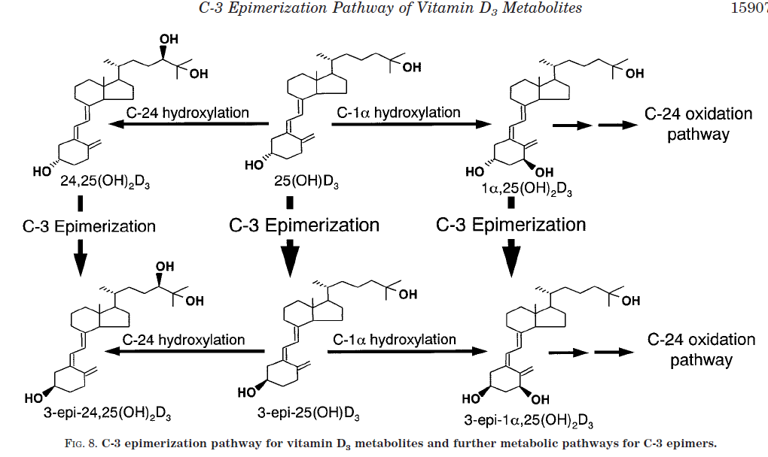
Figure 1.2: C-3 epimerisation, (Kamao et al., 2004)

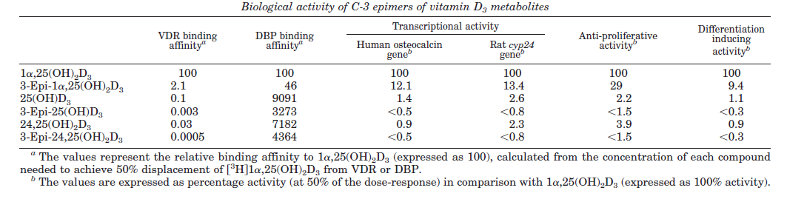
Figure 1.3: Binding affinities of C-3 epimers of vitamin D metabolites, (Kamao et al., 2004)

The Binding Proteins
As previously mentioned in section 1.1.4, vitamin D and its metabolites are hydrophobic and do not readily dissolve in water. 85-90% of 25OHD in the circulation is bound to VDBP, 10-15% is bound to albumin, and less than 1% remains free in the circulation, (Bikle et al., 1986).

VDBP
VDBP was isolated by Hirschfeld (1959) from the α₂-globulin portion of plasma and initially described as a group specific component (Key et al., 2003). Thomas et al. (1959) reported the presence of a vitamin D binding α-globulin, and Daiger et al. (1975) identified GC as the binding protein for vitamin D. Coue et al. (1983) found the molecular weight of VDBP to be 56kDa (±1kDa).
VDBP is maintained at levels of 300-600µg/ml, (Kawakami et al., 1981). It shows a diurnal variation: it is at its lowest during the morning and will plateau during the day, similar to 1,25(OH)₂D and albumin, (Rejnmark et al., 2002). It does not show seasonal variation and is not affected by age, (Bouillon et al., 1981). It is widely distributed in the body, (Speeckaert et al., 2006).
It is encoded by DBP gene located at 4q12-q13, on the long arm of chromosome 4. There are three major polymorphisms of the allele: Gc-1F (pI 4.94-4.84), Gc-1S (pI 4.95-4.85) and Gc-2 (pI 5.1) but there are over 120 variants of the gene, (Cleve and Constans, 1988).
The different polymorphisms of the gene encoding VDBP give rise to different binding coefficients, (Arnaud and Constans, 1993). The binding coefficients for the three most common alleles are listed in table 1.2.

Table 1.2: VDBP binding coefficients, adapted from Arnaud and Constans (1993).
VDBP Phenotype | 25OHD Binding coefficient | 1,25(OH)₂D Binding coefficient
Gc-1S | 6 × 10⁸ M | 6.4 × 10⁶ M
Gc-1F | 11.2 × 10⁸ M | 18 × 10⁶ M
Gc-2 | 3.6 × 10⁸ M | 4.2 × 10⁶ M

Albumin
Albumin belongs to the same family of proteins as VDBP and α-fetoprotein, (Cooke and David, 1985). The binding affinity of albumin to 25OHD and 1,25(OH)₂D was found to be 6 x 10⁵ M (Bikle et al., 1986) and 5.4 x 10⁴ M (Bikle et al., 1984) respectively.

The Effect of Binding Protein Levels on 25OHD
Black and Asian people most commonly have the Gc-1F variant of VDBP, which has the highest affinity for 25OHD and 1,25(OH)₂D. Levels of VDBP were initially thought to differ by race, (Powe et al., 2013). However this study used a monoclonal enzyme-linked immunosorbent assay (ELISA) that underestimates the Gc-1F variant of VDBP when compared to methods using polyclonal antibodies or LC-MS/MS to measure VDBP. Levels of VDBP did not differ by race when polyclonal antibodies or LC-MS/MS were used to measure VDBP, (Henderson et al., 2016, Denburg et al., 2016, Nielson et al., 2016).
During pregnancy there is an increase in VDBP, however the affinity of VDBP for 25OHD appears to decrease and levels of free 25OHD and 1,25(OH)₂D appear to be conserved, (Bikle et al., 1984, Schwartz et al., 2014b).
Patients with cirrhotic liver disease have a decreased capacity to produce VDBP and albumin. Levels of 25OHD appeared to be increased in this group due to the decreased binding to VDBP and albumin, (Schwartz et al., 2014b).

Cellular Uptake

Megalin
Megalin is a receptor in the membrane of renal proximal tubules. It binds to the VDBP and takes it into the cells via endocytosis (figure 1.4). CYP27B1 is expressed abundantly in these cells and can convert 25OHD to 1,25(OH)₂D when required. When Nykjaer et al. (1999) bred megalin knockout mice, only 2% survived to adulthood, they had an 80% reduction in 25OHD levels and had growth retardation and bone abnormalities. They excreted VDBP, and therefore the carrier bound 25OHD, in their urine and were unable to adequately convert 25OHD to 1,25(OH)₂D in the proximal tubules. Megalin has been detected in a number of cells, including renal cells (Nykjaer et al., 1999), osteoblasts (Atkins et al., 2007), and mammary gland cells (Rowling et al., 2006)

Cubulin
Nykjaer et al. (2001) found VDBP to be lost in urine when dogs and patients had loss of function mutations in the gene that encodes cubulin. Cubulin was therefore found to be a co-receptor that binds VDBP before its uptake by megalin.

Passive Diffusion
When 25OHD or 1,25(OH)₂D is unbound, it can also enter the cells via passive diffusion, (Chun et al., 2014).

Figure 1.4: Renal uptake of VDBP, (Chun et al., 2014).

Actions of Vitamin D

Genomic Actions
Once in the cell, 1,25(OH)₂D can bind the vitamin D receptor (VDR) in the nucleus (figure 1.5). This receptor is the mediator of all genomic actions of 1,25(OH)₂D. The ligand binding domain structure has been reported, (Rochel et al., 2000). Once 1,25(OH)₂D has bound to the VDR it heterodimerises with retinoid X receptor (RXR) and binds to the vitamin D response element (DRE). Recruitment of co-activators and transcription machinery occurs and mediates the transcription of vitamin D responsive elements, (DeLuca, 2004).

Figure 1.5: Interaction of 1,25(OH)₂D with the VDR, (DeLuca, 2004).

Calcium Homeostasis
1,25(OH)₂D stimulates absorption of calcium in the intestine and the kidney (figure 1.6). Binding of 1,25(OH)₂D to VDR in the nucleus stimulates the production of calbindin, an intracellular transporter of calcium in intestinal cells, (Li et al., 1997) and in renal cells in the distal tubule (Sooy et al., 2000). It also stimulates the production of the plasma membrane calcium pump (PMCP) which extrudes calcium from the basolateral membrane of enterocytes in the intestine, (Cai et al., 1993). It is possible that 1,25(OH)₂D can increase the number of calcium ion channels in the intestine, (Peng et al., 1999, Van Cromphaut et al., 2001), and in renal cells in the distal tubules (Peng et al., 2000).
Figure 1.6: The role of 1,25(OH)₂D and PTH in regulating calcium levels in plasma, (DeLuca, 2004).

PTH Regulation
The parathyroid gland expresses VDR, (Brumbaugh et al., 1975). 1,25(OH)₂D suppresses production of PTH and prevents proliferation of parathyroid tissue, (Demay et al., 1992, Darwish and DeLuca, 1999). This results in a negative feedback loop as 1,25(OH)₂D production is promoted by PTH, (section 1.1.7). The suppression of PTH production also suppresses the resorption of calcium and phosphate from bone, (Bellido et al., 2013).

Phosphate Homeostasis
Phosphate is regulated by both 1,25(OH)₂D and FGF23, (Bergwitz and Juppner, 2010). 1,25(OH)₂D promotes the absorption of phosphate by the intestines and also promotes the production of FGF23 by osteocytes, (Bergwitz and Juppner, 2010). FGF23 then suppresses the production of 1,25(OH)₂D by suppressing CYP27A1 production (section 1.1.7).

Immune Function
1,25(OH)₂D is involved in both the innate and adaptive immune response. In the innate immune response it induces the expression of cathelicidin by toll like receptors in myeloid and epithelial cells, (Gombart et al., 2005, Wang et al., 2004). In the adaptive immune response it acts on B cells to suppress production of immunoglobulins and slows their differentiation into plasma cells, (Chen et al., 2007). It also suppresses proliferation of T cells, (Rigby et al., 1984).

Cancer
1,25(OH)₂D promotes cell differentiation by promoting expression of cell cycle inhibitors p21 and p27, (Liu et al., 1996, Wang et al., 1996). It also promotes cell adhesion by the expression of E-cadherin and inhibits transcription activity of β-catenin, (Palmer et al., 2001). It promotes DNA repair (Dixon et al., 2005), reduces apoptosis (De Haes et al., 2003), and increases p53 (Gupta et al., 2007) after UVR damage in keratinocytes.

Vitamin D as an Acute Phase Reactant
It is thought that 25OHD could act as an acute phase reactant. Louw et al. (1992) reported that vitamin D levels decreased after an acute phase response in patients having uncomplicated orthopaedic elective surgery. Reid et al. (2011) and Waldron et al. (2013) found 25OHD levels to decrease after surgery with an increase in C-reactive protein from normal levels to those indicating an inflammatory response. They also found the levels of VDBP and albumin had significantly decreased, indicating that the decrease in 25OHD could have been due to a loss of binding proteins.
Barth et al. (2012) measured 25OHD levels in patients after a myocardial infarction while Newens et al. (2006) measured 25OHD levels during the course of a malarial infection. Neither study saw a decrease in 25OHD during the course of the disease, however it is possible that the levels had already decreased in these patients, as baseline samples were unavailable due to the nature of the conditions.

Measurement of Vitamin D and Thresholds of Adequacy
25OHD is the analyte of choice for the assessment of vitamin D status as it is the major circulating form, has the longest half-life, and is the best indicator of the total availability, (Holick, 1990). LC-MS/MS analysis of serum or plasma is currently the gold standard method. Immunoassay methods are often used in order to decrease the cost of analysis and to allow a higher throughput even though they give discordant results from LC-MS/MS and from each other, (Farrell et al., 2012). In order to minimise variability, reference materials and a quality control (QC) scheme have been developed, (Phinney et al., 2012, Carter et al., 2004).
Sattar et al. (2012) discuss the increased testing for vitamin D in the UK and ask whether it is necessary. They state that testing of 25OHD in Glasgow Royal Infirmary had increased from 8,682 to 37,830 between 2008 and 2010. While one of the London hospitals had an increase in requests from 7537 in 2007 to just under 46000 in 2010. They say this costs the NHS around £20 per test.
Although it is agreed that a level above 25nmol/L is required to prevent rickets in children and osteomalacia in adults, (Wharton and Bishop, 2003), the Institute of Medicine guidelines state that a level below 50nmol/L is ‘inadequate’ (Ross et al., 2011) and these are also recommended by the national osteoporosis society in the UK, (Francis et al., 2013). The Endocrine Society agree that a level under 50nmol/L should be considered deficient, however they also state that a level under 75nmol is insufficient, (Holick et al., 2011). In a cohort of 45 year olds, nearly half had a 25OHD level under 40nmol/L and 90% had a level under 75nmol/L in winter and spring, while 60% had a level under 75nmol/L year round, (Hypponen and Power, 2007). This means that as much as half of the population of the UK could have an inadequate level of vitamin D in the winter and spring according to the levels recommended by the Endocrine Society guidelines.
The threshold for vitamin D adequacy is difficult to determine as 25OHD does not directly affect bone. The correlation of 25OHD to PTH concentration and/or bone mineral density has been used, (Dawson-Hughes et al., 2005). Lips et al. (1988) supplemented elderly women and found the inflection point of PTH to be a 25OHD level of 30nmol/L. Further studies gave the inflection point of PTH to be levels of 25OHD at various points between 50 and 99nmol/L, (Dawson-Hughes et al., 2005), however different methods were used to measure these analytes compared to the study by Lips et al. (1988). Ooms et al. (1995) found a correlation between BMD and levels of 25OHD under 30nmol/L due to secondary hyperparathyroidism and increased bone turnover.

The Free Hormone Hypothesis and Free Hormone Measurement.
The free hormone hypothesis states that only hormones free in the plasma and not bound to carrier proteins are biologically active as only unbound hormones are able to cross over the plasma membrane due to their small size and phospholipid permeability, while carrier bound hormones are thought to be inactive because they are unable to enter target cells, (Mendel, 1989). However, megalin has recently been discovered to facilitate the endocytosis of binding proteins such as albumin (Cui et al., 1996), VDBP (section 1.3), and sex hormone binding globulin (SHBG) (section 1.7.3). This indicates that carrier proteins such as VDBP and SHBG could enter cells expressing megalin.

Glucocorticoids
Free glucocorticoids are routinely measured as opposed to the total level, (Frey and Frey, 1990), as the free level better reflects the amount that is bioavailable, (Jusko and Rose, 1980, Gatti et al., 1984). A urinary cortisol collection over 24 hours was required for the diagnosis of hypercortisolism as cortisol shows a diurnal rhythm, (Knutsson et al., 1997). Three consecutive 24 hour collections are required in order to increase the sensitivity of the test, (Petersenn et al., 2014). These collections were the gold standard measurement for the diagnosis of hypercortisolism, however, a single late night salivary cortisol measurement has recently been shown to be superior, (Elias et al., 2014).

Thyroid Hormones
Free thyroid hormone measurements are also thought to be biologically relevant, (Midgley, 1993) and experiments have shown that the free and not the total level correlates better with the amount in the target cell, (Mendel et al., 1988a, Mendel et al., 1988b).

Sex Hormones
It is not known whether the free hormone hypothesis is relevant for sex hormones. Early experiments, such as those performed by Giorgi and Stein (1981) and Damassa et al. (1991) showed that androgens and oestrogens were prevented from entering cultured cells when the media contained SHBG, whereas the free steroids could permeate through the membrane freely via passive diffusion. This finding supported the free hormone hypothesis.
However, this could be due to the cell lines used not expressing megalin. Megalin is expressed on the surface of cells in sex-steroid responsive tissues such as the epididymis, prostate, ovaries, and uterus, (Zheng et al., 1994). Recent work by Hammes et al. (2005) showed that SHBG bound androgens and oestrogens were taken into cultured cells when the cells expressed megalin. Hammes et al. (2005) also found that megalin knockout mice had sexual maturation deformities due to sex hormone insensitivity. Despite these deformities, levels of androgens and oestrogens in these mice were similar to wild-type mice.

Methods of Measuring Free 25OHD

Equilibrium Dialysis
Equilibrium dialysis is the gold standard method of measuring free hormones and was used by Bikle et al. (1984) and Fairney and Saphier (1987) in an attempt to measure free 1,25(OH)₂D and 25OHD respectively. However they both found this method unusable. Bikle et al. (1984) found the radioactive isotope failed to equilibrate and that 1,25(OH)₂D had bound to the sides of the tank and was not eluted when the assay was performed. Fairney and Saphier (1987) found that 25OHD bound to the dialysis membrane.

Centrifugal Ultrafiltration
Bikle et al. (1986) had much more success in measuring 25OHD using centrifugal ultrafiltration based on the method described by Hammond et al. (1980). Fairney and Saphier (1987) also measured free 25OHD using a centrifugal ultrafiltration method described by Beisel et al. (1964). This method is still the reference method for free 25OHD, although it is not widely used as it is very time consuming and costly.

Calculation
Calculations for the levels of free 25OHD are available. Bikle et al. (1986) determined the affinity constant of VDBP and albumin in serum and developed a calculation that takes the levels of these proteins into account. Using these affinity constants, Powe et al. (2011) modified a calculation originally developed for the measurement of free sex hormones by Vermeulen et al. (1999) for the affinities of VDBP and albumin. Later Powe et al. (2013) modified the equation to include information on the phenotype of VDBP.
Powe et al. (2013) found VDBP to be decreased in people with the Gc-1F variant of VDBP compared with those with the Gc-1S variant and concluded that free 25OHD levels did not differ by race, despite a lower total 25OHD concentration in black people. However, this study used a monoclonal antibody to detect VDBP and it is thought that this monoclonal antibody has different binding affinities for the different variants of VDBP, (Bouillon et al., 2014). Henderson et al. (2016) compared this monoclonal immunoassay to an LC-MS/MS method of measuring VDBP and found that the immunoassay underestimates the Gc-1F variant, and found that VDBP concentrations did not differ by race.

Salivary 25OHD
Saliva is thought to be a source of free 25OHD. 25OHD can diffuse across the acinar cells by intracellular diffusion or by ultrafiltration through the tight junctions between the acinar cells, (Vining et al., 1983). Fairney and Saphier (1987) measured salivary 25OHD using a gas chromatography-mass spectrometry (GC-MS) method that they had developed to measure total 25OHD levels in serum. They measured free 25OHD by centrifugal ultrafiltration and were able to compare their salivary method with this method.

Derivatisation
Due to the lipophilic nature of 25OHD and its low concentrations in saliva, 25OHD is poorly ionised by LC-MS/MS in saliva. Higashi et al. (2008) found derivatisation with 4-Phenyl-1,2,4-triazoline-3,5-dione (PTAD) increased the ionisation efficiency and therefore the increased sensitivity for measurement 25OHD₃ 100-fold when compared to measurement without derivatisation. When they measured 25OHD₃ in the saliva and serum of 10 men and 10 women they found a significant (t-test p>0.05) difference between the sexes in both the serum and saliva samples. The saliva sample concentration was 9.17±3.52 pg/ml in men and 5.79±3.15 pg/ml in women. Hedman et al. (2014) used Amplifex™ diene to measure serum 1,25(OH)₂D₃ and compared their method to using PTAD. At a concentration of 15.6pg/ml they found the signal to noise ratio to be 30:1 for Amplifex™ diene and 3:1 for PTAD, giving estimated lower limits of detection of 2pg/ml and 15pg/ml of 25(OH)₂D₃ respectively. It may be possible to adapt this method for measurement of salivary 25OHD₃.

Immunoassay
An immunoassay that directly measures free 25OHD in serum has recently been developed (Future Diagnostics B.V., Wijchen, The Netherlands). This has been used by Schwartz et al. (2014a) and has been calibrated against a dialysis method.

Initial results of measuring free 25OHD
Total 25OHD level is positively correlated to the amount of VDBP in the serum (Powe et al., 2011). It is possible that a patient could have a low total 25OHD level but a normal free 25OHD level due to low levels of VDBP or due to a VDBP polymorphism with a different binding affinity for 25OHD, (Chun et al., 2014).
The calculated free and bioavailable levels of 25OHD were found to be better correlated to BMD than the total 25OHD in a healthy population, (Powe et al., 2011). The calculated bioavailable 25OHD level was found by Bhan et al. (2012) to be a better indicator of PTH levels in patients undergoing haemodialysis for end stage renal disease.
Dastani et al. (2014) found that the effect of 25OHD levels on PTH was independent of the level of VDBP, however they did not take into consideration the different genotypes of VDBP, which may explain their finding. Bhan et al. (2012) found that PTH levels were higher in black people than in white people even when they had the same amount of calculated bioavailable 25OHD. However, when the binding affinities of the different genotypes of the patients were taken into account, Powe et al. (2013) did not find a difference between black people and white people in the level of calculated bioavailable 25OHD level at different concentrations of PTH. Using the same calculation and taking into account the different binding affinities of the genotypes, Johnsen et al. (2014) found that the calculated free and bioavailable, and the total level correlated with PTH, however only the calculated free and bioavailable 25OHD correlated with the BMD.
Schwartz et al. (2014a) measured free 25OHD directly using an ELISA method in patients with liver cirrhosis, in pregnant women and in a comparator group. They found patients with liver cirrhosis had the highest level of free 25OHD despite having a decreased amount of VDBP. They found that levels did not differ between the pregnant group and the comparator despite an increase in VDBP during pregnancy. They also found that free 25OHD levels were not affected by race.
When comparing the free 25OHD direct ELISA to the free 25OHD calculation Schwartz et al. (2014a) found that the ELISA method correlated to PTH levels and to calcium but the calculation did not, possibly due variability in the binding protein affinities which were not taken into account.

Thesis Aims
The aims of this thesis are:
- Chapter 2: To develop and validate a method of measuring salivary 25OHD.
- Chapter 3: To determine whether VDBP and albumin can be detected in saliva.
- Chapter 4: To determine whether free 25OHD remains stable despite a decrease in total 25OHD, VDBP and albumin after hip and knee replacement surgery.

Salivary 25OHD₃ Method Development

Background
As discussed in chapter 1, vitamin D metabolites are bound to binding proteins in the blood and only a small fraction remains unbound (section 1.3). The direct measurement of the free fraction of 25OHD is thought to be important in conditions where there is a disruption in the levels or affinities of binding proteins which may cause total 25OHD levels to be unreliable. As discussed in section 1.8, the measurement of free 25OHD is technically challenging. LC-MS/MS is recommended for the measurement of total 25OHD, however this method cannot be used directly to measure the free fraction of 25OHD, as LC-MS/MS sample preparation includes a deproteinisation step that releases bound 25OHD from its binding proteins.
Saliva is thought to be a source of free 25OHD (section 1.8) and saliva is routinely used as a surrogate marker for free hormone measurement. A single late night salivary cortisol measurement has been shown to be superior than urinary cortisol for the diagnosis of hypercortisolism (Elias et al., 2014).
The aim of this chapter is to develop and validate a method of measuring salivary 25OHD by LC-MS/MS so that it can be biologically validated as a surrogate measure of free 25OHD in chapter 4.

Materials for Method Development

Equipment for LC-MS/MS
- HPLC was performed by an Acquity HPLC system (Waters Manchester, UK) with a sample manager, column manager and online solid phase extraction (SPE) manager.
- Mass spectrometry was performed by a Xevo TQ-S (Waters, Manchester, UK) with a Z spray electrospray ionisation (ESI) chamber which was later changed to a unispray ESI chamber (Waters, Manchester, UK).
- A PC (Lenovo) running windows 7 and MassLynx software (Waters, Manchester, UK) was used as an interface.
- Sogevac SV65 B1 FC was used to produce the vacuum for the mass spectrometry.
- Argon collision gas was purchased from Air Liquide Ltd. (Manchester, UK).
- A Sunfire C8 2.1 x 50mm 35µm column was used for chromatography, (Waters, Manchester).
- The column was later changed to a UPLC BEH 2.1 x 50 1.7µm (Waters, Manchester) to improve chromatography.
- A C8 guard cartridge 4.0 x 2.0 (Phenomenex, Macclesfield, UK) was used.

Reagents for LC-MS/MS
- Isopropanol (VWR, Leicestershire, UK).
- Methanol, Mass spectrometry grade (Sigma-Aldrich, UK).
- Formic acid, ‘AnalaR’ (BDH, UK).

Sample Preparation and Extraction Equipment
- Biotage SPE dry 96 for solvent evaporation (Cardiff, UK).
- K biosystems EFLY to heat seal plates (iBiosys Solutions Ltd, UK).
- VWR VX-2500 to vortex samples.
- Polypropylene 2ml deep square well plates (Porvair Sciences).
- Peelable heat-sealed foil sheets (ABGENE).

Reagents for Sample Preparation
- Hexadeuterated (d6)-25OHD₃ (Synthetica, Norway).
- ≥99.0% 25OHD₃ for tuning (Sigma-Aldrich, UK).
- Hexane (Sigma-Aldrich, UK).
- Phosphate buffered saline (PBS) (Sigma-Aldrich, UK).
- Bovine serum albumin (BSA) (Sigma-Aldrich, UK).
- Utak vitamin D plus low control (Grifols, UK).
- Utak vitamin D plus level 1 control.
- Utak vitamin D plus level 2 control.
- Chromsystems (Germany) 25OHD₃ serum calibration standard.
- Chromsystems 25OHD₃ serum control level 1.
- Chromsystems 25OHD₃ serum control level 2.

Statistical analysis
Standard curves were generated by the MassLynx software and these were edited in R studio using the ggplot2 package where required.
Within batch imprecision is calculated by repeating the QC or salivary sample and determining the CV of the repeats. Acceptance criteria for within batch imprecision are met when the CV is less than 10%, (Honour, 2011).
Recovery will be calculated using the following formula:
$\frac{Measured concentration of saliva pool 2, 3 or 4}{Measured saliva pool 1 + concentration of the spike}$ x 100

Acceptance criteria are met when recovery is between 90% and 110% (Honour, 2011).

Salivary 25OHD method development

Isotopic dilution
One of the greatest advantages of LC-MS/MS compared to immunoassay methods is the inclusion of an isotopically labelled internal standard within the sample that accounts for loss of analyte through sample preparation and analysis. For routine 25OHD measurement, deuterated versions of the target analytes, d6-25OHD₃ and d3-25OHD₂, are often used as internal standards as they have the same chromatographic properties as 25OHD₃ and 25OHD₂ but are 6 and 3 mass units different respectively so are able to be separated by mass spectrometry, (Coldwell et al., 1990, Schleicher et al., 2011). The use of d6-25OHD₂ as an internal standard is not recommended because the loss of a water molecule from d6-25OHD₂ produces the same mass transition as 25OHD₃ (van den Ouweland et al., 2013).

Initial tuning of the mass spectrometer
Tuning the LC-MS/MS system involves directly infusing the analyte of interest into the mass spectrometer via a syringe infusion pump, and assessing the signal while optimising the mass spectrometer parameters. The initial tuning was performed by injecting 25OHD₃ (purity >99.0%) and d6-25OHD₃ (purity 95%) in methanol, either underivatised, derivatised with PTAD, or derivatised with Amplifex diene. 25OHD₂ and d3-25OHD₂ were only tuned after derivatisation with Amplifex diene as the concentration of in saliva was thought to be too low to quantify without derivatisation or with derivatisation with PTAD (Higashi et al., 2008).
The instrument was operated in positive electrospray ionisation mode. The following parameters were also optimised for mass spectrometry: cone voltage: 25V, collision energy: 15 electron volt, dwell time: 0.056 seconds. Desolvation temperature: 600°C, desolvation gas flow: 800L/hr, cone gas flow: 150L/hr, nebuliser: 7 bar, LM resolution 1: 3, HM resolution 1: 15, ion energy 1: 0.5, LM resolution 2: 3, HM resolution 2: 15, ion energy 2: 2, collision gas flow 0.25ml/min.

Mass transitions for underivatised 25OHD
The mass transitions selected after optimisation were 383.2>257.2 and 389.2>263.2 for 25OHD₃ and d6-25OHD₃ respectively. Tsugawa et al. (2005) and Baecher et al. (2012) selected similar mass transitions of 401.4>257.0 and 407.4>263.4 for 25OHD₃ and d6-25OHD₃ respectively. A stronger signal was obtained when accounting for the loss of a water molecule from the protonated precursor ions: [M+H - H₂O]⁺, meaning the precursor ions have a mass transition 18 Da less than the precursor ions selected by Tsugawa et al. (2005) and Baecher et al. (2012).

Mass transitions for 25OHD derivatised with PTAD
The mass transitions after optimising PTAD derivatised standards were 558.6>298.1 for 25OHD₃ and 564.6>298.1 for d6-25OHD₃. Like underivatised 25OHD₃ and d6-25OHD₃, we found a stronger signal when accounting for the loss of a water molecule from the protonated precursor ions: [M+H - H₂O]⁺. These mass transitions were also used by other studies, (Ogawa et al., 2013, Ogawa et al., 2016, Strathmann et al., 2011, Teegarden et al., 2015).

Mass transitions for 25OHD derivatised with Amplifex diene
The mass transitions after optimising Amplifex diene derivatised standards were 732.7>673.45 and 738.7>679.45 for 25OHD₃ and d6-25OHD₃ respectively; and 741.7>682.5 and 747.7>688.5 for 25OHD₂ and d3-25OHD₂ respectively. At the time of method development, only literature on derivatisation of 1,25(OH)₂D with amplifex diene was available, (Hedman et al., 2014), however derivatisation with amplifex diene has since been used to measure 25OHD₂ and 25OHD₃ (Muller et al., 2016). The mass transitions selected in this method development and by other authors correspond to a protonated precursor ion and the loss of a positively charged quaternary ammonium group: [M + H]⁺ → [(M + H)−(N(CH₃)₃)]⁺, (Hedman et al., 2014, Muller et al., 2016). The Waters Unispray source was used instead of the ESI source in this method. The other mass spectrometry parameters for method development remained the same as in the underivatised method.

Chromatography development
The column used in method development was a Waters SunFire C8 (100Å, 3.5 µm, 2.1 mm X 50mm) column with a C8 guard cartridge (4.0 x 2.0 mm). A Waters BEH (18 2.1 x 50 1.7µM) column was also compared for use in samples derivatised with Amplifex diene.

Chromatography for underivatised 25OHD
The following mobile phase solutions were assessed for chromatography. The amount of formic acid added to the mobile phase was compared. Initially 0.1% formic acid and 2mmol/L ammonium acetate were used (A1 and B1) as these were in use for routine serum total 25OHD quantitation. However the use of 1% formic acid was also assessed (A2 and B2). The gradient for HPLC is described in table 2.1.
A1: 2mmol/L ammonium acetate and 0.1% (v/v) formic acid in water
B1: 2mmol/L ammonium acetate and 0.1% (v/v) formic acid in methanol
A2: 1% (v/v) formic acid in water
B2: 1% (v/v) formic acid in methanol
Table 2.1: HPLC gradient for underivatised samples. (Flow 0.450ml/min)
Time (minutes) | % mobile phase A | % mobile phase B
Initial | 35 | 65
3.5 | 15 | 85
3.51 | 2 | 98
4.51 | 35 | 65

Chromatography for PTAD derivatised salivary 25OHD
The mobile phase was the same as A1 and B1 used previously. The gradient used for liquid chromatography was as described in table 2.2.
Table 2.2: HPLC gradient for PTAD derivatised samples: (Flow rate: 0.450ml/min)
Time (minutes) | % mobile phase A | % mobile phase B | Curve
Initial | 60 | 40 | Initial
3.0 | 30 | 70 | 6
3.01 | 5 | 95 | 11
3.51 | 60 | 40 | 11

Chromatography for Amplifex diene derivatised salivary 25OHD
Two columns were compared for chromatography: the Waters SunFire C8 (100Å, 3.5 µm, 2.1 mm X 50mm) and the Waters BEH (18 2.1 x 50 1.7µM). The mobile phase was the same as A1 and B1 used previously. The gradient used for liquid chromatography was as described in table 2.3.
Table 2.3: HPLC gradient for Amplifex derivatised samples: (Flow rate 0.400ml/min)
Time (minutes) | % mobile phase A | % mobile phase B | Curve
Initial | 70 | 30 | Initial
3.0 | 20 | 80 | 6
3.01 | 5 | 95 | 11
3.80 | 70 | 30 | 11

Sample preparation and extraction
Before 25OHD can be analysed, it needs to undergo deproteinisation and extraction from the sample matrix, this is to remove salts and other matrix components from interfering with chromatography. There are two widely used methods of extraction: liquid liquid extraction and solid phase extraction. Liquid liquid extraction has the advantages of being simple, flexible, and affordable, however it has the drawbacks that it suffers from low efficiency due to matrix effects in the sample compared to solid phase extraction (Musteata and Musteata, 2011).
As salivary 25OHD is expected to be much lower than total 25OHD, the standards and QCs used for routine 25OHD analysis needed to be diluted into the expected analytical range. Three diluents were compared:
- 66% methanol:water
- 1% bovine serum albumin in phosphate buffered saline (pH 7.4)
- Water

Sample preparation and extraction for underivatised samples
The routine standards and QCs for total 25OHD measurement were diluted 1/100 in either 66% methanol or PBS/BSA to give the concentrations shown in table 2.4.
Table 2.4: Standard and QC concentrations for underivatised samples after dilution with 66% methanol or PBS/BSA.
Standard/QC | Dilution | Final concentration (pmol/L)
Standard 1 | 1/100 | 0
Standard 2 | 1/100 | 164
Standard 3 | 1/100 | 270
Standard 4 | 1/100 | 666
Standard 5 | 1/100 | 1841
QC A | 1/100 | 346
QC B | 1/100 | 857
QC C | 1/100 | 1316
The sample preparation method was adapted from routine 25OHD measurement and was as follows:
- 200µl of each diluted standard and QC was aliquoted into eppendorf tubes.
- 10µl of internal standard at concentration of 40µg/L was aliquoted into the eppendorf.
- 1ml of Hexane was added to the eppendorf and inverted for 1 minute.
- The supernatant was removed and transferred to a 96 well polypropylene tray.
- The hexane was evaporated and the sample was reconstituted in 100µl 66% methanol:water.
- The plate was then vortexed and sealed.
Another set of standards and QCs were assessed using distilled water as the sample diluent to give the concentrations listed in table 2.5.
Table 2.5: Standard and QC concentrations for underivatised samples after dilution with water.
Standard/QC | Dilution (water) | Final concentration (pmol/L)
Standard 1 | 1/100 | 0
Standard 2 | 1/1600 | 10.25
Standard 2 | 1/800 | 20.5
Standard 2 | 1/400 | 41
Standard 2 | 1/200 | 82
Standard 2 | 1/100 | 164
Standard 3 | 1/100 | 270
Standard 4 | 1/100 | 666
Standard 5 | 1/100 | 1841
QC A | 1/100 | 346
QC B | 1/100 | 857
QC C | 1/100 | 1316

The sample preparation for the samples prepared as stated in table 2.5 was as follows:
- 500µl of each diluted standard and QC was aliquoted into eppendorf tubes.
- 6 saliva samples were used neat, 500µl of each was pipetted into eppendorf tubes.
- 20µl of internal standard at concentration of 100µg/L was added to each eppendorf.
- 300µl of 66% methanol:water was added and the tubes were capped and vortexed for 2 minutes.
- 800µl of Hexane and 800µl of methyl-tert-bytyl-ether (MTBE) was added to each sample and the samples were vortexed again for 2 minutes.
- The supernatant was removed and transferred to a well in a 96 well plate. The hexane was then evaporated and the samples were reconstituted in 100µl of 66% methanol.
- The plate was then vortexed and sealed.

Sample preparation and extraction for samples derivatised with PTAD
For the assessment of PTAD as a derivatising agent, the standard and QC concentrations were the same as used in table 2.5 so that the derivatisation method could be compared with the underivatised method. The same 6 salivary samples were also used. Sample preparation for all method development with samples derivatised with PTAD was as follows:
- 500µl of calibrants and QCs diluted in water to the concentrations listed table 2.5 was pipetted into eppendorf tubes.
- 6 saliva samples were used, 500µl of each was pipetted into eppendorf tubes.
- 20µl of internal standard at concentration of 100µg/L was added to the samples.
- 300µl of 50% methanol:isopropanol was added and the tubes were capped and vortexed for 2 minutes.
- 800µl of hexane and 800µl of MTBE was added to each sample and the samples were vortexed again for 2 minutes.
- The supernatant was removed and transferred to a well in a 96 well plate. The hexane was then evaporated.
- 0.5mg PTAD in 1ml acetonitrile was made and 50µl was added to the wells.
- The samples were vortexed for 1 minute and left in the dark for 1 hour.
- The reaction was stopped by adding 50µl ethanol which was then evaporated.
- 60µl of 66% methanol:water was added to each well and the wells were vortexed for 1 minute.
The next experiment compared BSA/PBS and water as diluents. The sample preparation was the same as used for PTAD derivatised samples initially, except the final concentrations listed in table 2.6 were used.
Table 2.6 Standards and QC concentrations in PTAD derivatised samples for comparison of sample diluents.
Standard/QC | Dilution | Final concentration (pmol/L)
Standard 1 | 1/200 | 0
Standard 2 | 1/3200 | 5.1
Standard 2 | 1/800 | 20.5
Standard 2 | 1/200 | 82
Standard 3 | 1/200 | 135
Standard 4 | 1/200 | 333
Standard 5 | 1/200 | 920.5
QC A | 1/200 | 173
QC B | 1/200 | 857
QC C | 1/200 | 1316

In order to assess the intra-assay imprecision of the method, QC 1-4 were repeated 10 times each. The standards were diluted in water to the concentrations listed in table 2.7. The sample preparation was the same as used for PTAD derivatised samples previously.

Table 2.7: Standard and QC concentration in PTAD derivatised samples for the imprecision study in QC samples.
Standard/QC | Dilution (H₂O) | Final concentration (pmol/L)
Standard 1 | 1/1000 | 0
Standard 2 | 1/2000 | 8.2
Standard 2 | 1/1000 | 16.4
Standard 3 | 1/1000 | 27.0
Standard 4 | 1/1000 | 66.6
Standard 5 | 1/1000 | 184.1
QC A (now QC 1) | 1/2000 | 17.3
QC A (now QC 2) | 1/1000 | 34.6
QC B (now QC 3) | 1/1000 | 85.7
QC C (now QC 4) | 1/1000 | 131.6

Derivatisation with Amplifex Diene
In order to assess the imprecision of the Amplifex diene derivatisation method in QC samples, standards and QC material were diluted in 66%MeOH:H₂O to the concentrations listed in table 2.8. QC level will be analysed 6 times to assess the within batch imprecision. A pooled saliva sample will also be analysed 7 times.
Table 2.8: Standards and QCs used in Amplifex diene derivatised samples for imprecision study in QC samples.
Standard/QC | Dilution (66% MeOH:H₂O) | Final concentration (pmol/L)
Standard 1 | 1/4000 | 0
Standard 2 | 1/4000 | 4.1
Standard 3 | 1/4000 | 6.75
Standard 4 | 1/4000 | 16.65
Standard 5 | 1/4000 | 46.025
QC A | 1/4000 | 6.75
QC B | 1/4000 | 9.625
QC C | 1/4000 | 23.625

The sample preparation for these samples was as follows:
- 200µl of the standards, QC material and the salivary samples were aliquoted into tubes.
- 50µl of 20:80 IPA:MeOH was added to the tubes.
- 10µl of internal standard at a concentration of 1µg/L was added to each tube.
- 800µl of hexane was then added to each tube.
- The samples were vortexed for 1 minute then the hexane was evaporated.
- 50µl of Amplifex diene was added to each tube and the tubes were left for 30 minutes.
- After the 30 minutes had passed, 50µl of H₂O was added to stop the reaction and the samples were ready for analysis.

In order to assess the imprecision and accuracy of measuring 25OHD in salivary samples, stock standards and QCs were diluted 1/2000 in water to give the concentrations listed in table 2.9. A salivary pool was split into 4 samples and each was spiked with the following concentrations: saliva pool 1: 0.00, saliva pool 2: 8.98, saliva pool 3: 23.29, and saliva pool 4: 37.05pmol/L.
Table 2.9: Standard and QC concentrations used in Amplifex diene derivatised samples for the imprecision and accuracy study in saliva.
Standard/QC | Dilution (66% MeOH:H₂O) | Final concentration (pmol/L)
Standard 1 | 1/2000 | 0
Standard 2 | 1/2000 | 6.5
Standard 3 | 1/2000 | 12.82
Standard 4 | 1/2000 | 32.94
Standard 5 | 1/2000 | 97.5
QC A | 1/2000 | 18.4
QC B | 1/2000 | 47.74
QC C | 1/2000 | 68.44

The sample preparation for these samples was as follows:
- 500µl of the standards, QC material and the salivary samples was aliquoted into tubes.
- 50µl of internal standard at a concentration of 1µg/L was added to each tube.
- 50µl of 20:80 IPA:MeOH was added to the tubes.
- 700µl of hexane was then added to each tube.
- The samples were vortexed for 2 minutes then the hexane was evaporated.
- 50µl of Amplifex diene was added to each tube and the tubes were left for 30 minutes.
- After the 30 minutes had passed, 50µl of H₂O was added to stop the reaction and the samples were ready for analysis.

Method Validation
The method will need to be validated to the following criteria (Honour, 2011):
- The selectivity of the method for 25OHD₃ will be assessed by comparing its retention time to that of the reference material and to ensure that the retention time of the analyte and internal standard differs less than 2.5% between samples, as this could be caused by interferences.
- Multiple mass transitions will be monitored and their relative intensity will be calculated to improve selectivity for the target analyte.
- An assessment of matrix interferences will need to be undertaken. This is best demonstrated by a post-column infusion test, however as the samples will be derivatised, this may not be possible. It may be more feasible to compare the LC-MS/MS response of a buffer solution to the response of a sample when both contain a spiked known concentration of the analyte.
- The linearity of the standard curve will be assessed using a minimum of five concentrations in addition to the blank matrix and a zero standard. The response is assumed to be linear if the correlation co-efficient R² is greater than 0.99.
- The lower limit of detection (LLOD) will be determined by the lowest concentration of a serially diluted sample that gives a peak with a signal to noise ratio of 3.
- The lower limit of quantitation (LLOQ) will be determined by the lowest concentration of a serially diluted sample that gives a peak with a signal to noise ratio of 10 with less than 20% imprecision and 80-120% accuracy.
- The within run imprecision of the method will be assessed by analysing levels of pooled saliva at high, medium and low concentrations of 25OHD₃ at least five times within one run.

Results

Method development of underivatised samples
Table 2.10 and figure 2.1 show the values from the standard curve when A1 and B1 were used as mobile phases and 66% methanol in water was used as the sample diluent and the samples were not derivatised. The linearity of the curve is not acceptable as the R² is 0.973576, which is not sufficient for this method.

Table 2.10: Standard and QC concentrations for underivatised samples after dilution with 66% methanol and analysed with A1 and B1 mobile phases.
Standard/QC | Expected Conc. (pmol/L) | Analyte peak area | Internal standard peak area | Response | Calculated Conc. (pmol/L) | % Deviation
Standard 2 | 164 | 203.504 | 7843.078 | 0.026 | 195.249 | 19.1
Standard 3 | 270 | 372.307 | 7578.981 | 0.049 | 257.042 | -4.8
Standard 4 | 666 | 1312.721 | 8716.166 | 0.151 | 527.618 | -20.8
Standard 5 | 1841 | 5140.738 | 7469.224 | 0.688 | 1961.0 | 6.5
QC A | 346 | 404.418 | 6474.293 | 0.062 | 292.613 | -15.4
QC B | 857 | 1317.079 | 7617.437 | 0.173 | 587.062 | -31.5
QC C | 1316 | 1755.298 | 7342.293 | 0.239 | 763.467 | -42.0

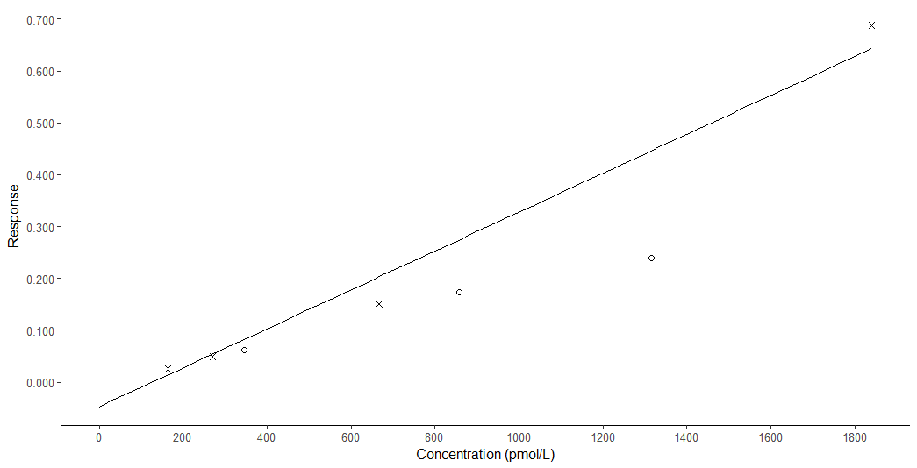
Slope = 0.000375067* x + -0.0472844
R² = 0.973576
Figure 2.1: Standard curve showing the standards (X), and QCs (O) when prepared in methanol without derivatisation and using A1 and B1 mobile phases.

Table 2.11 and figure 2.2 show the values from the standard curve when A2 and B2 were used as mobile phases and 1% BSA was used in PBS as a sample diluent. The linearity of the curve is not acceptable as the R² of the method is 0.98794 which is not adequate for this method. The internal standard peak area in table 2.11 was lower and more variable than it was previously in table 2.10.

Table 2.11: Standard and QC concentrations for underivatised samples after dilution with BSA/PBS and analysed with A2 and B2 mobile phases.
Standard/QC | Expected Conc. (pmol/L) | Analyte peak area | Internal standard peak area | Response | Calculated Conc. (pmol/L) | % Deviation
Standard 1 | 0 | 92.097 | 12415.928 | 0.007 | 46.415
Standard 2 | 164 | 202.077 | 8734.072 | 0.023 | 127.586 | -22.2
Standard 3 | 270 | 335.625 | 7496.569 | 0.045 | 239.301 | -11.4
Standard 4 | 666 | 1559.024 | 10549.913 | 0.148 | 771.208 | 15.8
QC A | 346 | 728.092 | 11142.234 | 0.065 | 345.546 | -0.1
QC B | 857 | 1706.047 | 9905.480 | 0.172 | 897.499 | 4.7
QC C | 1316 | 2608.777 | 11516.624 | 0.227 | 1177.8 | -10.5

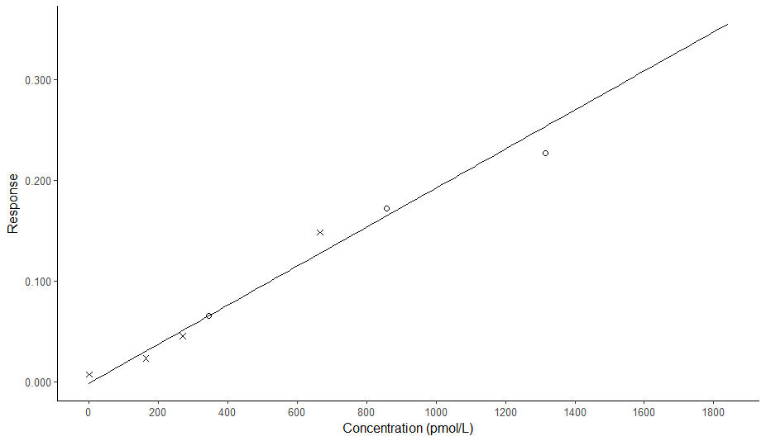
Slope = 0.000193653* x + -0.00511861
R² = 0.98794
Figure 2.2: Standard curve showing the standards (X), and QCs (O) when diluted in BSA/PBS without derivatisation and using A2 and B2 mobile phases.
Table 2.12 and figure 2.3 show the values from the standard curve when A2 and B2 were used as mobile phases and water was used as a sample diluent. Although the linearity of the standard curve is acceptable with an R² 0.994889, there is evidence of loss of the internal standard in the saliva samples, shown as a decrease in the peak area of the internal standard in these samples.

Table 2.12: Standard and QC concentrations for underivatised samples after dilution with water and analysed with A2 and B2 mobile phases.
Standard/QC | Expected Conc. (pmol/L) | Analyte peak area | Internal standard peak area | Response | Calculated Conc. (pmol/L) | % Deviation
Standard 1 | 0 | 71.8 | 33201.4 | 0.002 | N/A | N/A
Standard 2 | 10.3 | 397.5 | 70565.0 | 0.006 | 12.8 | 24.4
Standard 2 | 20.5 | 527.1 | 64127.9 | 0.008 | 22.7 | 10.7
Standard 2 | 41 | 682.0 | 60558.1 | 0.011 | 34.4 | -16.1
Standard 2 | 82 | 1773.1 | 75891.8 | 0.023 | 80.9 | -1.3
Standard 2 | 164 | 1752.7 | 50115.9 | 0.035 | 125.5 | -23.5
Standard 3 | 270 | 5047.0 | 71403.1 | 0.071 | 262.8 | -2.7
Standard 4 | 666 | 12929.3 | 81213.7 | 0.159 | 603.0 | -9.5
Standard 5 | 1841 | 45362.1 | 91595.4 | 0.495 | 1894.6 | 2.9
QC A | 346 | 5157.6 | 50019.7 | 0.103 | 387.4 | 12.0
QC B | 857 | 11233.8 | 47458.0 | 0.237 | 900.9 | 5.1
QC C | 1316 | 17913.5 | 53093.2 | 0.337 | 1287.9 | -2.1
Saliva sample 1 | N/A | 1597.2 | 75930.0 | 0.021 | 72.0 | N/A
Saliva sample 2 | N/A | 625.2 | 5313.1 | 0.118 | 443.4 | N/A
Saliva sample 3 | N/A | 459.4 | 2429.3 | 0.189 | 718.0 | N/A
Saliva sample 4 | N/A | 571.8 | 4463.5 | 0.128 | 483.5 | N/A
Saliva sample 5 | N/A | 632.8 | 5266.3 | 0.120 | 452.9 | N/A
Saliva sample 6 | N/A | 403.1 | 2487.7 | 0.162 | 613.9 | N/A

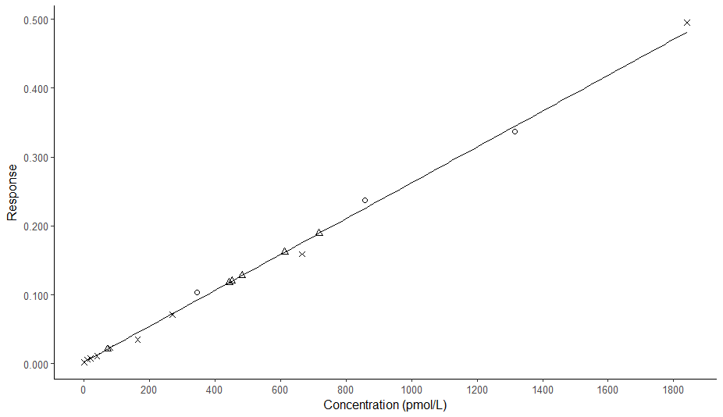
Slope = 0.00026017 * x + 0.00231496
R² = 0.994889

Figure 2.3: Standard curve showing the standards (X), QCs (O), and salivary samples (triangles) when diluted in water without derivatisation and using A2 and B2 mobile phases.

Method development of samples derivatised with PTAD
Table 2.13 and figure 2.4 show the results from the same sample preparation as used in underivatised samples in table 2.12 however this time the samples were derivatised with PTAD. The R² of the method was good at 0.996078, and there is no evidence of internal standard loss as there was seen previously in table 2.12, however the saliva samples now range from 3.6 to 148.1pmol/L, whereas the analytical range as determined by the standards is 10.3-1841pmol/L, meaning that the analytical range needs to be decreased.

Table 2.13: Standard and QC concentrations in samples derivatised with PTAD after dilution with water and analysed with A2 and B2 mobile phases.
Standard/QC | Expected Conc. (pmol/L) | Analyte peak area | Internal standard peak area | Response | Calculated Conc. (pmol/L) | % Deviation
Standard 1 | 0 | 126.221 | 21215.377 | 0.006 | 4.495 | N/A
Standard 2 | 10.3 | 92.414 | 14259.300 | 0.006 | 6.731 | -34.3
Standard 2 | 20.5 | 448.382 | 44639.230 | 0.010 | 21.725 | 6.0
Standard 2 | 41 | 588.114 | 40746.570 | 0.014 | 40.190 | -2.0
Standard 2 | 82 | 946.870 | 40865.203 | 0.023 | 76.951 | -6.2
Standard 2 | 164 | 1361.783 | 36969.172 | 0.037 | 134.446 | -18.0
Standard 3 | 270 | 2702.190 | 38707.172 | 0.070 | 273.187 | 1.2
Standard 4 | 666 | 5776.014 | 36726.188 | 0.157 | 641.173 | -3.7
Standard 5 | 1841 | 15805.411 | 34705.230 | 0.455 | 1895.598 | 3.0
QC A | 346 | 3805.365 | 41800.828 | 0.091 | 362.487 | 4.8
QC B | 857 | 8393.395 | 39094.496 | 0.215 | 882.774 | 3.0
QC C | 1316 | 13673.624 | 41029.613 | 0.333 | 1381.635 | 5.0
Saliva sample 1 | N/A | 414.942 | 38219.023 | 0.011 | 25.143 | N/A
Saliva sample 2 | N/A | 264.368 | 46020.699 | 0.006 | 3.633 | N/A
Saliva sample 3 | N/A | 194.438 | 30189.492 | 0.006 | 6.561 | N/A
Saliva sample 4 | N/A | 283.112 | 42346.363 | 0.007 | 7.592 | N/A
Saliva sample 5 | N/A | 1292.057 | 32231.787 | 0.040 | 148.123 | N/A
Saliva sample 6 | N/A | 210.859 | 32196.369 | 0.007 | 7.018 | N/A

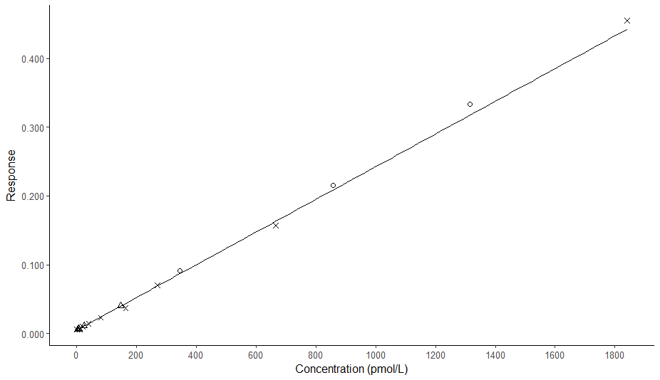
Slope = 0.000237676* x + 0.00488117
R² = 0.996078
Figure 2.4: Standard curve showing the standards (X), QCs (O), and salivary samples (triangles) when diluted in water after derivatisation with PTAD and using A2 and B2 mobile phases.

Figure 2.5 shows the results from the assessment of imprecision of the method after derivatisation with PTAD, a CV of 20.1% at 17.3pmol/L in the imprecision study above will not give the sensitivity required for this method. The R² at this concentration is also not acceptable (should be >0.99).

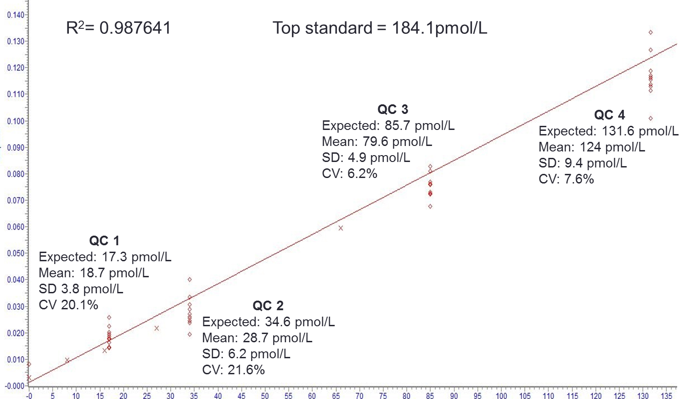
Figure 2.5: Standard curve showing the standards (X), QCs (O) when diluted in water after derivatisation with PTAD and using A2 and B2 mobile phases.

Method development of samples derivatised with Amplifex diene
Figure 2.6 shows the chromatographic separation of 25OHD₂ and 25OHD₃ after derivatisation with Amplifex diene. The analytes and their internal standards eluted at different times and on different mass transitions.

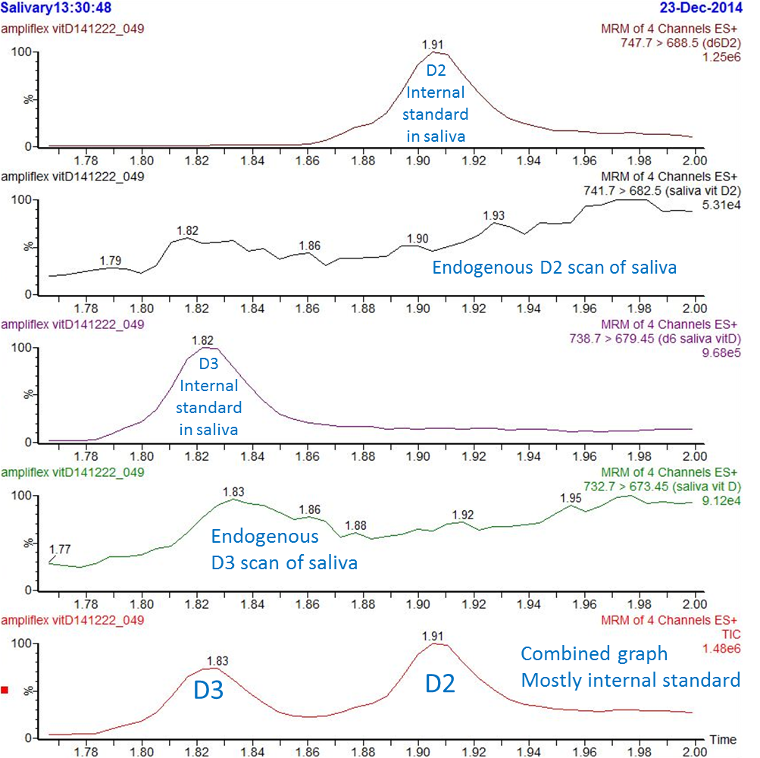
Figure 2.6: Chromatographic separation of 25OHD₂ (D2) and 25OHD₃ (D3) when derivatised with Amplifex diene

Figure 2.7 shows the standard curve after derivatisation with Amplifex diene and also the within run imprecision values at different QC concentrations. The linearity of the method was good with an R² of 0.991643 which is acceptable. The imprecision at lower concentrations was greatly improved by derivatising with Amplifex diene compared with derivatising with PTAD (Figure 2.5). Using Amplifex diene as a derivatising agent the CV is now 10.88% at 6.7pmol/L whereas when PTAD was used as a derivatising agent the CV was 20.1% at 17.3pmol/L. The CV of the salivary pool when the sample is derivatised with Amplifex diene is also acceptable at 7.75%.
Table 2.14 shows the recovery of the method in salivary samples after derivatisation with Amplifex diene. The recovery of the method was not deemed acceptable as the recovery should be between 90% and 110%

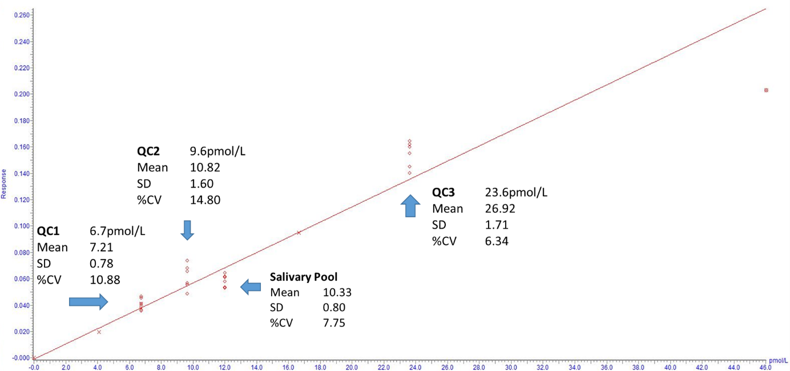
Slope = 0.00577929* x + -0.0014001
R² = 0.991643
Figure 2.7: Within run imprecision analysis with Amplifex diene

Table 2.14: Recovery analysis of salivary 25OHD after derivaitsation with Amplifex diene
Saliva pool | Added  (pmol/L) | Measured  (pmol/L) | Recovery (%)
1 | 0.00 | 28.86
2 | 8.98 | 28.74 | 75.97
3 | 23.29 | 39.00 | 74.77
4 | 37.05 | 67.30 | 102.10

Discussion
In this study we aimed to develop a method of measuring salivary 25OHD by LC-MS/MS. Our findings show that salivary 25OHD₃ can be detected in underivatised samples and in samples after derivatisation with PTAD or Amplifex diene.
PTAD improved the sensitivity of the method compared to the measurement of underivatised samples. The sensitivity of the method was improved further with the use of Amplifex diene as a derivatising agent compared to PTAD. These findings correlate with other studies: Higashi et al. (2008) found a hundredfold improvement in the sensitivity of the salivary 25OHD₃ method when PTAD was used compared to no derivatisation; and Hedman et al. (2014) found a tenfold improvement in the signal to noise ratio at 15.6pg/ml when Amplifex diene was used instead of PTAD as a derivatising agent for serum 1,25(OH)₂D analysis.
Unlike PTAD, Amplifex diene was specifically designed to be used for LC-MS/MS, as the reaction with 25OHD produces hydrophilic compounds that contain a quaternary amine functional group. This causes the derivatised analyte to produce a more efficient ionisation when it is ionised in the ESI unit after chromatography and immediately prior to entering the mass spectrometer (Hedman et al., 2014). The improved ionisation efficiency compared to PTAD could explain our findings that derivatisation with Amplifex diene improves the sensitivity of the method compared to using PTAD.
Although the initial results of method development are promising, further method development and validation had to be postponed due to the poor recovery of 25OHD in saliva in table 2.14. There was also poor recovery of the internal standard seen in table 2.12 as a decrease in the internal standard in salivary samples compared to standard and QC samples. The poor recovery of 25OHD in saliva could be due to decreased liquid/liquid extraction efficiency, or due to decreased ionisation in the mass spectrometer due to matrix effects.
We observed the formation of an emulsion in salivary samples after the addition of the internal standard and the deproteinisation solvent, so it is possible that this emulsion in salivary samples decreased the extraction efficiency of the liquid/liquid extraction method. As the emulsion is formed prior to extraction, the use of a solid phase extraction method instead of liquid/liquid extraction is unlikely to increase the extraction efficiency. No publications on the reasons for formation of emulsion in saliva samples could be found. Sonication was attempted to break up the emulsion but when this was performed, the internal standard still showed a decreased recovery in salivary samples compared to standards and QC samples. Ion suppression due to matrix effects was also investigated in both derivatisation techniques and there was no evidence of ion suppression at the time that 25OHD eluted.
The reason for the 25-hydroxyvitamin D method development was so that salivary 25OHD could be measured in participants undergoing hip and knee replacement surgery (chapter 4) in order to assess whether salivary 25OHD could be used as a surrogate marker of free 25OHD levels at times when the levels of binding proteins are disrupted.
Future work should concentrate on improving the recovery of 25OHD and its internal standard and performing a thorough validation as described in section 2.3.5 so that the method can be tested biologically as a surrogate of free 25OHD measurement.

Measurement of VDBP and albumin in saliva

Background
If salivary 25OHD is to be developed as a surrogate marker of serum free 25OHD, it is important to determine whether saliva contains the serum binding proteins for 25OHD.
Joneja et al. (1982) found that VDBP was present in parotid saliva and that it migrated as an α2-β component by crossed immunoelectrophoresis. Krayer et al. (1987) also found VDBP in the parotid saliva in both normal subjects, and in subjects with periodontal disease when measured with an ELISA method. More recently, LC-MS methods have become available for the measurement of binding proteins in saliva. Hirtz et al. (2016) detected both VDBP and albumin in stimulated saliva when measured by LC-MS.
In order to assess whether saliva contains these binding proteins, we collaborated with Dr Lewis Couchman in Toxicology at Kings College Hospital in London and adapted his method of measuring VDBP in serum by LC-MS, to investigate whether VDBP or albumin could be quantified in saliva using this method.

Method

Sample preparation for protein analysis
1. Add 20uL of 8M Urea/2.5% n-propanol/300mM Tris/10mM DTT pH 8.5 to a LoBind tube
2. Add 5uL sample, incubate the plate at 37°C for one hour
3. Add 2uL of 500mM iodoacetic acid to each sample, alkylate samples in the dark at room temperature for one hour.
4. Add 111uL of 50mM Tris/5mM CaCl₂ pH 8.0 to each sample
5. Add 60uL of tryptic buffer to each well (0.2 mg/mL)
6. Digest samples at 37°C for 1-2 hours.
7. Quench digestion with the additional of 2uL of formic acid.
8. Dilute digest and analyse by LC-MS (we did 1-part digest to 3-parts mobile phase A)

HPLC conditions
- Water/MeCN/0.1% formic acid eluent
- Gradient – 2 to 100 % B (MeCN) over 28 min, 0.200 mL/min

VDBP peptide transitions
- YTFELSR (and heavy-labelled YTFELSR – heavy R)
- VLEPTLK (and heavy-labelled VLEPTLK – heavy K)
- m/z values – all [M+2H]²⁺
  - YTFELSR – 458.2321
  - Heavy YTFELSR – 463.2360
  - VLEPTLK – 400.2498
  - Heavy VLEPTLK – 404.2570

Results
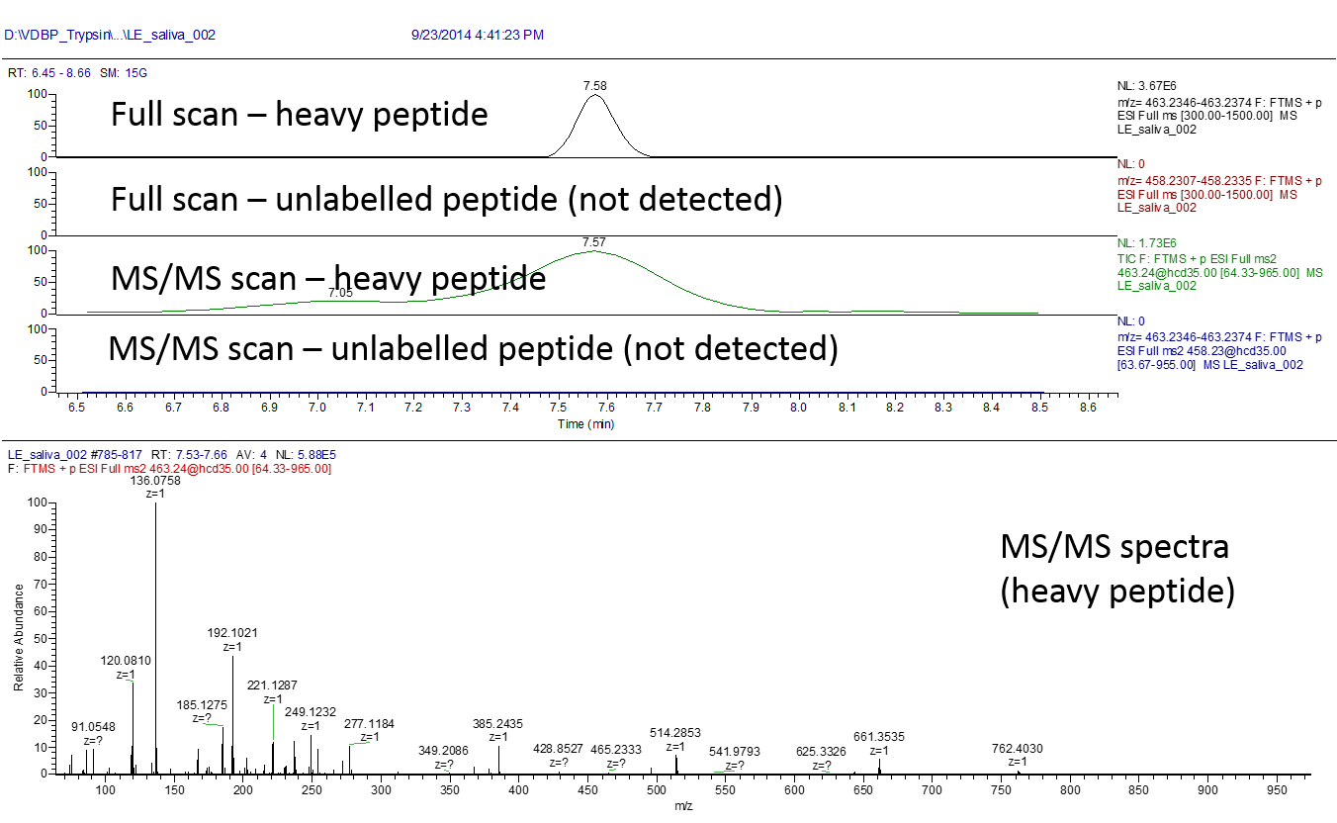
Figure 3.1: LC-MS data from digest of a saliva sample. Prepared by Lewis Couchman.

Figure 3.1 shows the LC-MS data from analysing a saliva sample after tryptic digest. We did not detect VDBP peptide fragments YTFELSR and VLEPTLK in this sample. Labelled heavy peptides of YTFELSR and VLEPTLK were used as markers in this method. Dr Couchman also searched the saliva sample for peptides of albumin (LVNEVTEFAK and QTALVELVK) and these also could not be detected.

Discussion
In this study we aimed to determine whether VDBP and albumin are present in saliva. Using LC-MS after tryptic digest we did not detect peptide fragments of VDBP or albumin in saliva.
However, previous studies, including the recent method by Hirtz et al. (2016) detected both VDBP and albumin in saliva by LC-MS, although they do not mention excluding patients who may have periodontal disease and therefore the salivary proteins could have be due to blood contamination of the saliva.
The strength of this study is the use of an LC-MS method for the determination of salivary VDBP and albumin. The main weakness is that only one salivary sample was able to be measured in this study.
As salivary samples are available from the clinical study described in chapter 4, measurement of vitamin D binding proteins could be performed in saliva in addition to the planned measurement of salivary 25OHD in order to elucidate whether vitamin D binding proteins in saliva change during an inflammatory response and therefore whether salivary 25OHD reflects the free fraction or the total concentration of 25OHD.

The effect of an acute inflammatory challenge on vitamin D status

Background
Total 25OHD is routinely measured by LC-MS/MS or by immunoassay in order to assess vitamin D status (section 1.6). Total 25OHD has been found to be inversely related to markers of inflammation, however the causal relationship is debated. As 1,25(OH)₂D has a role in the innate and adaptive immune response (section 1.4), it is possible that suboptimal 25OHD levels lead to the development of inflammatory illnesses, however it is also possible that the reverse is true: that the inflammatory illness itself could lead to a decrease in total 25OHD.
Total 25OHD has been shown to decrease during an acute inflammatory insult such as triggered by elective hip or knee replacement surgery (section 1.5). 85-90% of 25OHD in the circulation is bound to VDBP, 10-15% is bound to albumin, and less than 1% remains free in the circulation (section 1.2). These binding proteins have also been shown to decrease during the inflammatory response (section 1.5), and this decrease in binding proteins could explain the decrease in total 25OHD.
Despite the decrease in total 25OHD seen during the acute inflammatory response, it is possible that the free fraction of 25OHD remains stable. The gold standard method of measuring the free fraction of 25OHD is by equilibrium dialysis or centrifugal ultrafiltration followed by LC-MS/MS however this is technically challenging so 25OHD is most often calculated from total 25OHD and the amount of binding proteins and their affinity constants based on the law of mass action, it can also be measured directly by immunoassay. Saliva is thought to be a source of free 25OHD so this could be used as a surrogate marker of free 25OHD status (section 1.6).
Recent studies have investigated the change in total and free 25OHD over the course of an acute inflammatory challenge triggered by total hip or knee replacement (Reid et al., 2011, Waldron et al., 2013, Binkley et al., 2017, Jensen et al., 2018). The acute phase response is characterised by synthesis of acute phase proteins in hepatocytes, such as amyloid A, CRP, haptoglobin, and fibrinogen; and the decreased production of negative acute phase proteins such as fibronectin, transferrin and albumin. This process is thought to be regulated by cytokines such as IL-6 being released by macrophages at the surgical site (Castell et al., 1989).
Total joint arthroplasty is known to trigger the acute phase response as measured by CRP (Yombi et al., 2015, Oelsner et al., 2017). In one study, the peak CRP for participants undergoing total knee arthroplasty and total hip arthroplasty was 184.3 mg/L and 134.6 mg/L, respectively, and these peaked during the inpatient stay, usually at day 2 and was mostly resolved by 2 weeks after surgery (Oelsner et al., 2017).
Although osteoarthritis pathogenesis includes the production of inflammatory cytokines including IL-1β, IL-6, and TNF-α, osteoarthritis is understood to be a local disease confined to the affected joint (Glyn-Jones et al., 2015) and so the acute phase response has been studied in osteoarthritis patients as they are an example of otherwise healthy individuals who are undergoing an elective inflammatory event.

Aims
The aim of this study was to determine whether directly measured free 25OHD levels remain unchanged during the acute phase response, despite a decrease in total 25OHD and decrease in the levels of binding proteins.

Study design
The vitamin D in arthroplasty study was a single centre, prospective observational study. It was conducted in Sheffield Teaching Hospitals. Ethical approval was granted by City and East NRES Committee, London, (study number 15/LO/2199).

Methodology
Participants were recruited from patients with osteoarthritis who were undergoing elective hip or knee replacement surgery. Potential participants were initially approached and screened at their pre-operative assessment appointment. Participants provided informed consent prior to enrollment, in accordance with Good Clinical Practice guidelines. Height and weight measurements were recorded from participants’ pre-operative assessment.
Samples and study measurements were collected on the morning of surgery, on the following two mornings while the participant was recovering from surgery in hospital, and at their post-operative assessment appointment (follow-up) around 6 weeks after surgery. All samples were taken after an overnight fast, except for the follow-up samples due to appointments sometimes being in the afternoon. All participants rinsed their mouth out with water 5-10 minutes before the salivary sample was collected.

The following samples and study measurements were collected:

Morning of day of surgery, day 0:
- Blood pressure and heart rate
- Serum collected for measurement of CRP and eGFR in real time
- Serum and plasma collected and stored
- Saliva collected and stored

Morning of day 1:
- Serum collected for measurement of CRP and eGFR in real time
- Serum and plasma collected and stored
- Saliva collected and store

Morning of day 2:
- Serum collected for measurement of CRP and eGFR in real time
- Serum and plasma collected and stored
- Saliva collected and stored

Post-operative assessment (follow-up):
- Serum collected for measurement of CRP and eGFR in real time
- Serum and plasma collected and stored
- Saliva collected and stored

Biochemical Measurements
The following biochemical measurements were performed:

Total 25OHD₂ and 25OHD₃ by LC-MS/MS
25OHD₂ and 25OHD₃ was measured in the biochemistry department in Wythenshawe hospital, Manchester, using an in-house method. The method consists of separating 25OHD₂ and 25OHD₃ from the binding proteins in serum by adding methanol/isopropanol and subsequently extracting using a hexane liquid-liquid extraction. Deuterated 25OHD₂ and 25OHD₃ are used as internal standards. Analysis is undertaken on a Waters Xevo TQD MS with Acquity I-Class with a Waters Acquity UPLC BEH phenyl 1.7 mm IVD 2.1x50 mm column. Intra-assay and inter-assay imprecision studies performed in-house reported the CV as 9.5% and 8.4% at 52 and 76 nmol/L, respectively for 25OHD₂; and were 5.1% and 5.6% at 55 and 87 nmol/L, respectively for 25OHD₃.

Total 25OHD by immunoassay
Total 25OHD was measured in the bone biochemistry laboratory in Sheffield Medical School at the end of the study on the IDS-iSYS using the IDS 25OHD assay, (Tyne & Wear, UK). This is an indirect immunoassay based on chemiluminescence: binding proteins in the sample are first denatured and then an acridinium anti-25OHD antibody is added. 25OHD coated magnetic particles are then added and after an incubation step these magnetic particles are captured with a magnet while the sample is washed. The intensity of light emitted by the acridinium label is then measured photometrically and this is indirectly proportional to the concentration of 25OHD in the sample. Intra-assay and inter-assay imprecision studies performed by the manufacturer reported the CV as ≤16.9%, (IDS-iSYS 25OHD method sheet IS-2700PLv06, 2012-07-13).

CRP
CRP was measured in real time in the biochemistry department in Sheffield Teaching Hospitals using the C-Reactive Protein Gen.3 assay on a Cobas c701, (Roche Diagnostics, Mannheim, Germany). This is an immunoturbidimetric assay: CRP from the sample agglutinates with latex particles coated with monoclonal anti‐CRP antibodies. The amount of agglutination is determined turbidimetrically. This is not the high sensitivity method, although the lower limit of detection of this assay is 0.3mg/L. Intra-assay and inter-assay imprecision studies performed by the manufacturer reported the CV as ≤4%, (C-Reactive Protein Gen.3 method sheet version 8.0, 2017-01).

EGFR
EGFR was calculated in real time in the biochemistry department in Sheffield Teaching Hospitals using the Creatinine Jaffé Gen.2 assay on a Cobas c701, (Roche Diagnostics, Mannheim, Germany). This is a colorimetric assay: creatinine combines with picric acid at alkaline pH forming a yellow-orange complex. The colour intensity of the complex is proportional to the creatinine concentration in the sample and is measured photometrically. Intra-assay and inter-assay imprecision studies performed by the manufacturer reported the serum creatinine CV as ≤5%, (Creatinine Jaffé Gen.2 method sheet version 10.0, 2015-02).

The creatinine concentration is used to calculate eGFR using the Modification of Diet in Renal Disease calculation (Levey et al., 1999):
eGFR = 141 * min(Scr/κ,1)α * max(Scr/κ,1)-1.209 * 0.993Age * 1.018 [if female]
Where Scr is serum creatinine (mg/dL), κ is 0.7 for females and 0.9 for males, α is -0.329 for females and -0.411 for males, min indicates the minimum of Scr/κ or 1, and max indicates the maximum of Scr/κ or 1. The eGFR calculation is multiplied by 1.159 if patients are black, however we only included Caucasian participants so this was not necessary.

Albumin
Albumin was measured in a batch at the end of the study in the biochemistry department in Sheffield Teaching Hospitals using the Albumin Gen.2 assay on a Cobas c701, (Roche Diagnostics, Mannheim, Germany). This is a colorimetric assay: albumin combines with bromcresol green at a pH value of 4.1 to form a blue-green complex. The colour intensity of the blue-green colour is proportional to the amount of albumin in the sample and is determined photometrically. Intra-assay and inter-assay imprecision studies performed by the manufacturer reported the CV as ≤1.5%, (Albumin Gen.2 method sheet version 6.0, 2015-03).

VDBP
VDBP was measured in the bone biochemistry laboratory in Sheffield Medical School at the end of the study using a polyclonal ELISA (Genway Biotech Inc., San Diego, California, USA). This is an ELISA method: diluted sample is added to an ELISA plate coated with anti-VDBP antibody. The plate is then washed and another anti-VDBP antibody is added. This antibody is conjugated with horseradish peroxidase. After another washing step, 3,3’,5,5’-tetramethylbenzidine is added which reacts with the bound horseradish peroxidase to form a chromogenic product. After incubation, the reaction is stopped with sulfuric acid and the absorbance at 450nm is read. The amount of absorbance at 450nm is directly proportional to the amount of VDBP in the sample. Intra-assay and inter-assay imprecision studies performed by the manufacturer reported the CV as <10%.

PINP
PINP was measured in the bone biochemistry laboratory in Sheffield Medical School at the end of the study on the IDS-iSYS using the IDS PINP assay, (Tyne & Wear, UK). This assay is based on chemiluminescence: The sample is incubated with an anti-PINP monoclonal antibody conjugated with biotin and an anti-PINP monoclonal antibody labelled with acridinium. Streptavidin coated magnetic particles bind to biotin and a magnet captures the complex while the sample is washed. The intensity of light emitted by the acridinium label is then measured photometrically and this is directly proportional to the concentration of PINP in the sample. Intra-assay and inter-assay imprecision studies performed by the manufacturer reported the CV as ≤5.3%, (IDS-iSYS Intact PINP method sheet IS-4000PLV02, 2009-12-22).

CTX
CTX was measured by the bone biochemistry laboratory in Sheffield Medical School at the end of the study on the IDS-iSYS using the IDS CTX-I CrossLaps® assay, (Tyne & Wear, UK). This assay is based on chemiluminescence: The sample is incubated with a monoclonal antibody conjugated with biotin and a monoclonal antibody labelled with acridinium. These antibodies only bind to CTX when two chains of the amino acid sequence EKAHD-β-GGR are crosslinked. Streptavidin coated magnetic particles bind to biotin and a magnet captures the complex while the sample is washed. The intensity of light emitted by the acridinium label is then measured photometrically and this is directly proportional to the concentration of PINP in the sample. Intra-assay and inter-assay imprecision studies performed by the manufacturer reported the CV as ≤8.8%, (IDS-iSYS CTX method sheet IS-3000PLV03, 2011-11-29).

PTH
Intact PTH was measured in the bone biochemistry laboratory in Sheffield Medical School at the end of the study on the IDS-iSYS using the IDS intact PTH assay, (Tyne & Wear, UK). This assay is based on chemiluminescence: Two polyclonal antibodies are used in this method. The first antibody is a biotin conjugated capture antibody and recognises the C-terminal region of PTH. The second is an acridinium labelled detection antibody and recognises the N-terminal region of PTH. After an incubation stage, magnetic particles coated with streptavidin are added. These streptavidin coated magnetic particles bind to biotin on the capture antibody and a magnet captures the complex while the sample is washed. The intensity of light emitted by the acridinium label is then measured photometrically and this is directly proportional to the concentration of PTH in the sample. Intra-assay and inter-assay imprecision studies performed by the manufacturer reported the CV as ≤8.2%, (IDS-iSYS Intact PTH method sheet IS-3200PLv04 2013-02-08).

1,25(OH)₂D
1,25(OH)₂D was measured in the bone biochemistry laboratory in Sheffield Medical School at the end of the study on the IDS-iSYS using the IDS 1,25(OH)₂D assay, (Tyne & Wear, UK). This is an indirect immunoassay based on chemiluminescence: binding proteins in the sample are first denatured and then an acridinium anti-1,25(OH)₂D antibody is added. 1,25(OH)₂D coated magnetic particles are then added and after an incubation step these magnetic particles are captured with a magnet while the sample is washed. The intensity of light emitted by the acridinium label is then measured photometrically and this is indirectly proportional to the concentration of 1,25(OH)₂D in the sample. Intra-assay and inter-assay imprecision studies performed by the manufacturer reported the CV as ≤13.0%, (IDS-iSYS 1,25(OH)₂D method sheet IS-2000PL v04, 27-June-2016).

Directly Measured Free 25OHD
Free 25OHD was directly measured in the bone biochemistry laboratory in Sheffield Medical School at the end of the study using the Future Diagnostics ELISA commercially available from DIAsource Immunoassays, (Belgium). The manufacturer determined the CV for total imprecision as 10.2% at 6.0 pg/mL, 7.6% at 10.9 pg/mL, and 5.5% at 24.9 pg/mL.

Calculated Free 25OHD
Free 25OHD was also calculated using the following calculation (Bikle et al., 1986):
$$Calculated free 25OHD =\frac{Total 25OHD}{1+(6×{10}^{5}×\left[Albumin\right])+\left(7×{10}^{8}×\left[VDBP\right]\right)}$$
Where [Albumin] is serum albumin in g/L$÷$66,430g/mol and [VDBP] is serum VDBP in g/L$÷$58,000g/mol.

Statistical Analysis
One-way repeated measures analysis of variance (ANOVA) was used to evaluate differences between analyte concentrations by time point. Before statistical analysis, the normality of residuals by time point was verified for all analytes to ensure that one-way repeated measures ANOVA would be a reliable method of analysis. Sphericity was assumed where Mauchly’s test of Sphericity was p > 0.05. Where sphericity cannot be assumed, the p value from the Greenhouse-Geisser correction was used. Tukey’s honest significant difference test was used for post-hoc analysis. The relationship between directly measured free 25OHD and calculated free 25OHD was assessed using Passing and Bablok regression.
Statistical analysis was performed using the R statistical programming language and RStudio with the following packages: mcr, tidyr, ggplot2, plyr, car, BlandAltmanLeh, multcomp.

Inclusion Criteria
We will recruit male and female Caucasian patients who attend the orthopaedic pre-operative clinic for elective knee or hip replacement. We chose to include elective patients having orthopaedic surgery to give us an opportunity to observe the acute phase reaction developing in relatively healthy participants undergoing surgery. We will only look at participants with a BMI between 18 and 33 kg/m² to reduce the effects of BMI on vitamin D levels.

Exclusion Criteria
- Any disease or are taking any medication likely to affect vitamin D metabolism or acquisition of study measurement.
- Vitamin D supplementation within the last month
- Calcium supplementation within the last month
- Evidence of a systemic inflammatory response (CRP >10 mg/L) at the initial visit.
- Renal impairment as determined by an EGFR <60 at any point.
- Chronic inflammatory diseases

Results
This study took place between June 2016 and May 2017. 536 potential participants were prescreened prior to their pre-operative appointment. 109 potential participants were approached and screened during their appointment, 52 participants were eligible and consented to the study. Frequent reasons for exclusion after screening were: not interested (17 people), a BMI above 33 kg/m² (11 people), and taking vitamin D or calcium (12 people). 38 of the consented participants were recruited on the morning of surgery, and 22 participants completed the study. The baseline characteristics of the 22 that completed the study are shown in table 4.1. For those that completed the study, there were on average 53 days (standard deviation: 7.9) between surgery and the post-operative assessment appointment (follow up visit).
Table 4.1: Baseline characteristics of the study group showing mean and standard deviation, or values and percentages.
 | Subjects
Age (years) | 67 (9.3)
Height (cm) | 170 (8.6)
Weight (kg) | 78.8 (11.6)
BMI (kg/m²) | 27.2 (3.4)
Gender | 10 Female (45%), 12 Male (55%)
Joint replacement | 13 Hip (59%), 9 Knee (41%)
Prior to statistical analysis, normality checks were carried out on the residuals for each analyte and these were found to be approximately normally distributed, so a one-way repeated measures ANOVA was performed for each analyte. Greenhouse-Geisser correction was required for total 25OHD₃ by LC/MS-MS, total 25OHD by immunoassay, CRP, VDBP, and PINP.
Samples were available on the 22 participants that completed, except for on participants VDA008 and VDA042 on day 2, and on participant VDA048 at the follow up visit.

Total 25OHD₃ by LC-MS/MS
Following LC-MS/MS analysis of total 25OHD₂ and 25OHD₃, total 25OHD₂ could only be quantified in one sample at a concentration of 11.5nmol/L and was unmeasurable (<10nmol/L) in the remainder of the samples. Therefore, total 25OHD₃ alone was used for statistical analysis.
Figure 4.1 shows the individual change in total 25OHD₃ by time point, while figure 4.2 shows the mean and 95% confidence intervals by time point. One-way repeated measures ANOVA revealed that total 25OHD₃ differed significantly between time points (p = 0.001). Tukey post hoc testing revealed that total 25OHD₃ decreased by an average of 11.2 nmol/L (27%) between day 0 and day 1 (p = < 0.001); and decreased by 9.6 nmol/L (23%) between day 0 and day 2 (p = 0.001). There was no significant difference in total 25OHD₃ concentration between day 0 and the follow-up visit.
Overall, 3 participants had a 25OHD₃ level less than 25nmol/L prior to surgery. After surgery, 10 participants had a 25OHD₃ level less than 25nmol/L.
Two participants had an unmeasurable level of 25OHD₃ (<15nmol/L) on the morning of surgery. All unmeasurable values are shown on figure 4.1 and included in the statistical analysis at the assay lower limit of quantitation: 15nmol/L. Results from these two participants remained unmeasurable after surgery but recovered by the follow up visit.
Two participants had a substantial increase in 25OHD₃ by the follow up visit. This is likely due to these samples being taken at the end of the study and therefore show increased production of vitamin D due to the season.

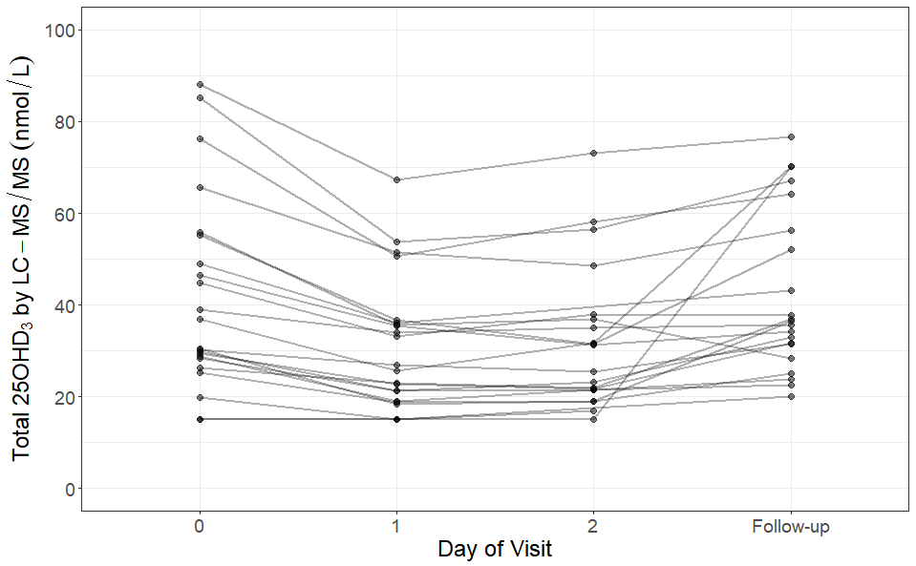
Figure 4.1: Change in total 25OHD₃ measured by LC-MS/MS. The points show the individual values of each participant and the line connecting them shows the relationship between the points of that participant.



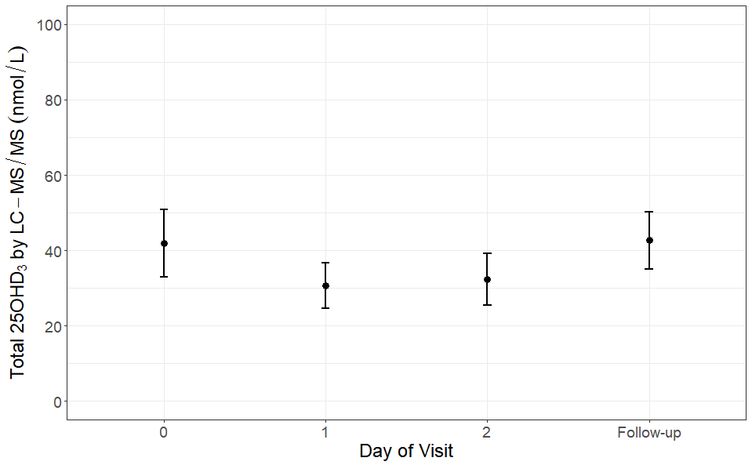
No significant difference
p = 0.001
p = <0.001
One-way repeated measures ANOVA: p = 0.001
Figure 4.2: Mean total 25OHD₃ (points) and 95% confidence intervals (error bars) by time point, measured by LC-MS/MS.

Total 25OHD by Immunoassay
Figure 4.3 shows the individual change in total 25OHD by time point, while figure 4.4 shows the mean and 95% confidence intervals by time point. One-way repeated measures ANOVA revealed that total 25OHD did not change significantly between time points (p = 0.052).
One sample that had an unmeasurable level of 25OHD₃ by LC-MS/MS and had a total 25OHD level of 24.5nmol/L by immunoassay. The remaining 4 of the 5 samples that were unmeasurable (<15nmol/L) by LC-MS/MS were also unmeasurable (<17.5nmol/L) by immunoassay and are displayed on figure 4.3 at the lower limit of quantitation of the method: 17.5nmol/L.

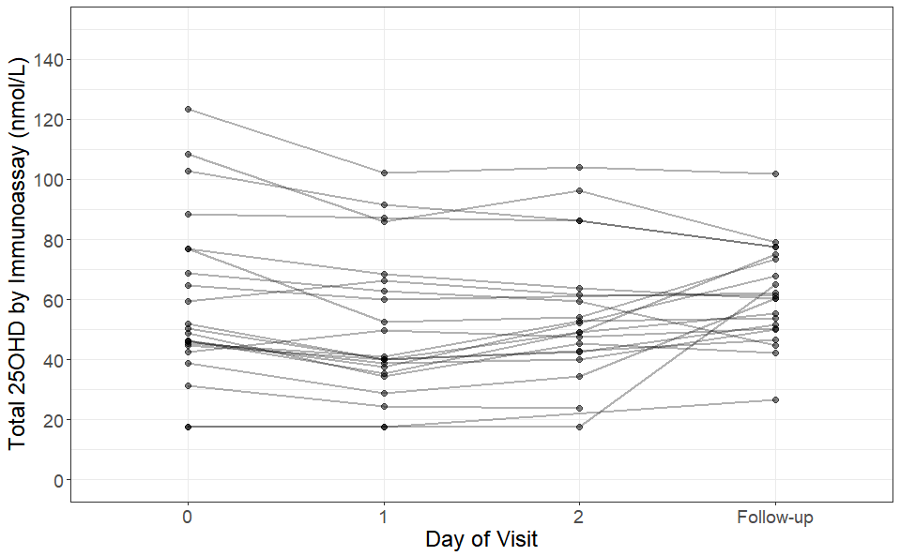
Figure 4.3: Change in total 25OHD by time point. The points show the individual values of each participant and the line connecting them shows the relationship between the points of that participant.
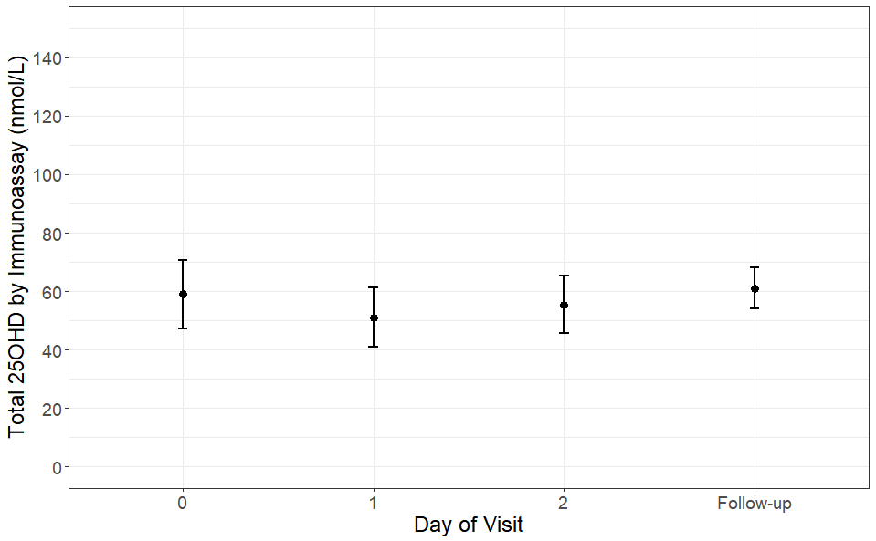
One-way repeated measures ANOVA: no significant difference
Figure 4.4: Mean total 25OHD (points) and 95% confidence intervals (error bars) by time point.

CRP
Figure 4.5 shows the individual change in CRP by time point, while figure 4.6 shows the mean and 95% confidence intervals by time point. One-way repeated measures ANOVA revealed that CRP differed significantly between time points (p = <0.001). Tukey post hoc testing revealed that CRP increased by an average of 28.1 mg/L (11%) between day 0 and day 1 (p = 0.01); and increased by 138.3 mg/L (53%) between day 0 and day 2 (p = <0.001). There was no significant difference in CRP concentration between day 0 and the follow-up visit.
The reference range in adults reported by the kit manufacturer is <5mg/L (C-Reactive Protein Gen.3 method sheet version 8.0, 2017-01), so as well as being statistically significant, the increase in CRP at day 1 and day 2 is clinically significant as it indicates that the acute phase response has been triggered.
4 samples had a CRP less than the limit of quantitation: 0.3mg/L so they are included in the statistical analysis and on figure 4.5 at 0.3mg/L.

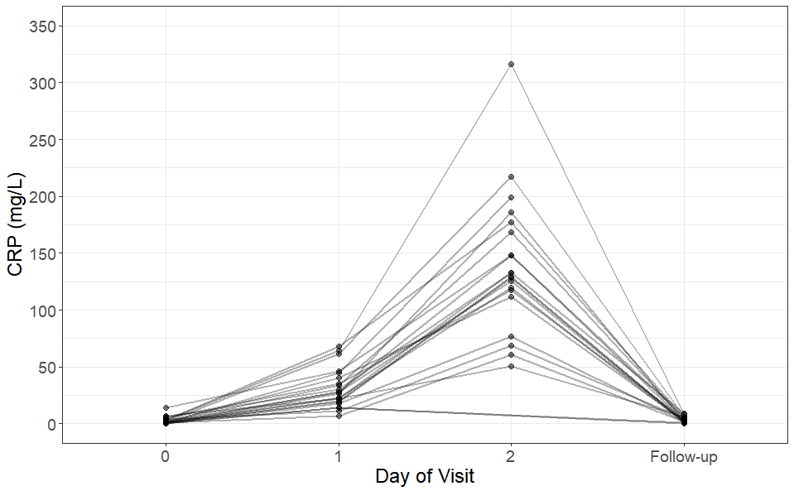
Figure 4.5: Change in CRP by time point. The points show the individual values of each participant and the line connecting them shows the relationship between the points of that participant.
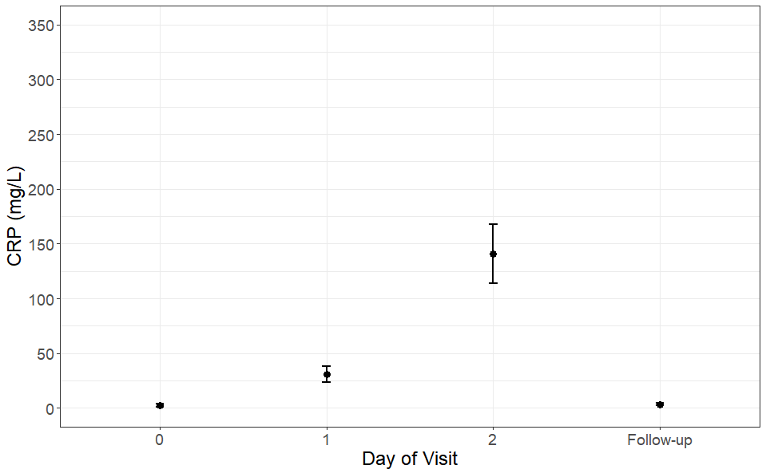
p = 0.01
No significant difference
p = <0.001
One-way repeated measures ANOVA: p = <0.001
Figure 4.6: Mean CRP (points) and 95% confidence intervals (error bars) by time point.

Albumin
Figure 4.7 shows the individual change in albumin by time point, while figure 4.8 shows the mean and 95% confidence intervals by time point. One-way repeated measures ANOVA revealed that Albumin differed significantly between time points (p = <0.001). Tukey post hoc testing revealed that albumin decreased by an average of 8.6 g/L (19%) between day 0 and day 1 (p = <0.001); and decreased by 9.0 g/L (20%) between day 0 and day 2 (p = <0.001). There was no significant difference in albumin concentration between day 0 and the follow-up visit.
The reference range in adults reported by the kit manufacturer is 39.7-49.4 g/L (Albumin Gen.2 method sheet version 6.0, 2015-03). All participants had results within the reference range at day 0 and the follow-up visit, however most participants had results below the reference range at day 1 and day 2.

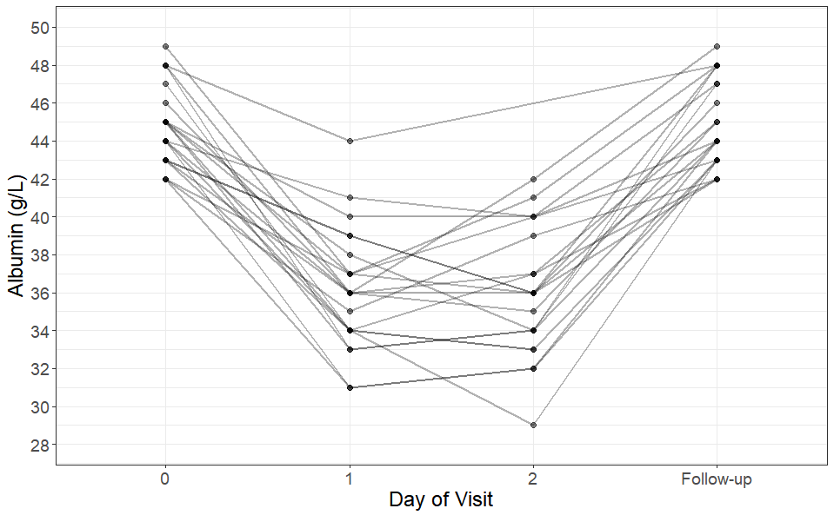
Figure 4.7: Change in albumin by time point. The points show the individual values of each participant and the line connecting them shows the relationship between the points of that participant.

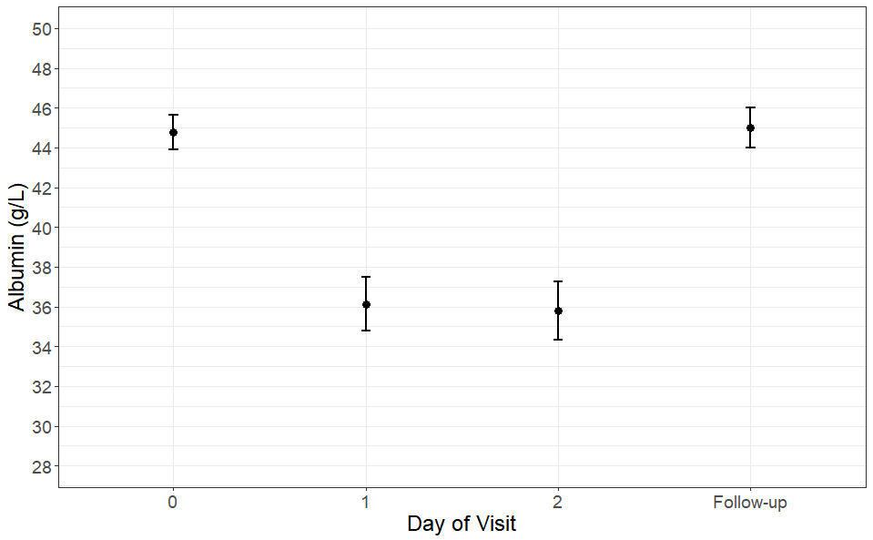
p = <0.001
p = <0.001
No significant difference
One-way repeated measures ANOVA: p = <0.001
Figure 4.8: Mean albumin (points) and 95% confidence intervals (error bars) by time point.

VDBP
Figure 4.9 shows the individual change in VDBP by time point, while figure 4.10 shows the mean and 95% confidence intervals by time point. One-way repeated measures ANOVA revealed that VDBP differed significantly between time points (p = 0.006). Tukey post hoc testing revealed that VDBP decreased by an average of 61.8 mg/L (20%) between day 0 and day 1 (p = 0.001) and by an average of 61.7mg/L (20%) between day 0 and day 2 (p = 0.001). There was no significant difference in VDBP concentration between day 0 and the follow-up visit. One participant had VDBP levels of 731.5 on day 0. Grubb’s test showed this result to be a significant outlier (p = 0.05). When one-way repeated measures ANOVA was conducted excluding this value, there remained a significant difference between time-points (p = <0.001) and Greenhouse-Geisser correction was not required.

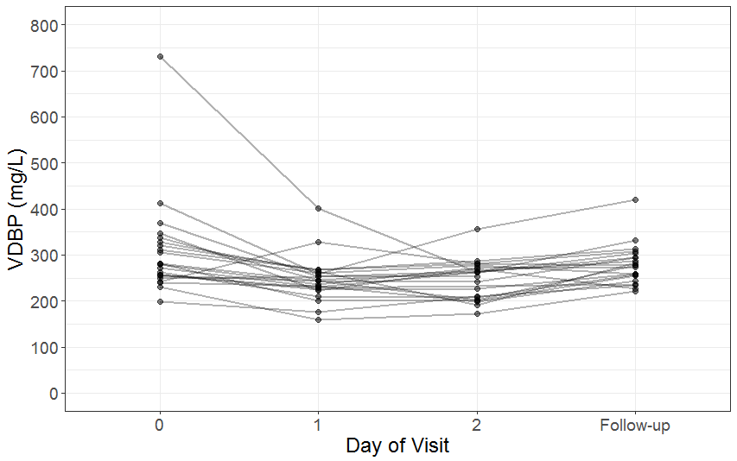
Figure 4.9: Change in VDBP by time point. The points show the individual values of each participant and the line connecting them shows the relationship between the points of that participant.
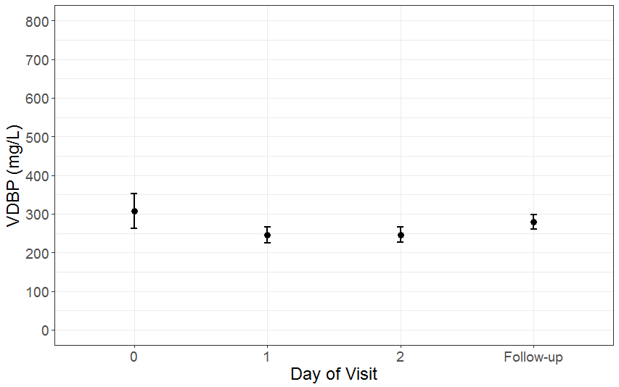
p = 0.001
p = 0.001
No significant difference
One-way repeated measures ANOVA p = 0.006
Figure 4.10: Mean VDBP (points) and 95% confidence intervals (error bars) by time point.

PINP
Figure 4.11 shows the individual change in PINP by time point, while figure 4.12 shows the mean and 95% confidence intervals by time point. One-way repeated measures ANOVA revealed that PINP differed significantly between time points (p = <0.001). Tukey post hoc testing revealed that PINP decreased by an average of 12.1 ng/ml (25%) between day 0 and day 1 (p = 0.03). There was no significant difference between day 0 and day 2. PINP increased by 48.5 ng/ml (123%) between day 0 and the follow up visit (p=<0.001).

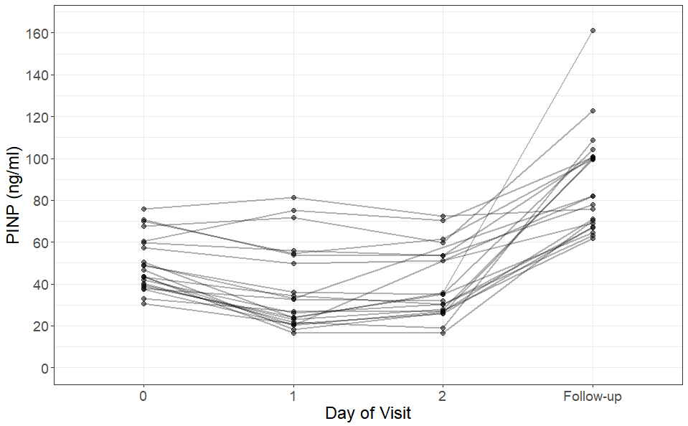
Figure 4.11: Change in PINP by time point. The points show the individual values of each participant and the line connecting them shows the relationship between the points of that participant.
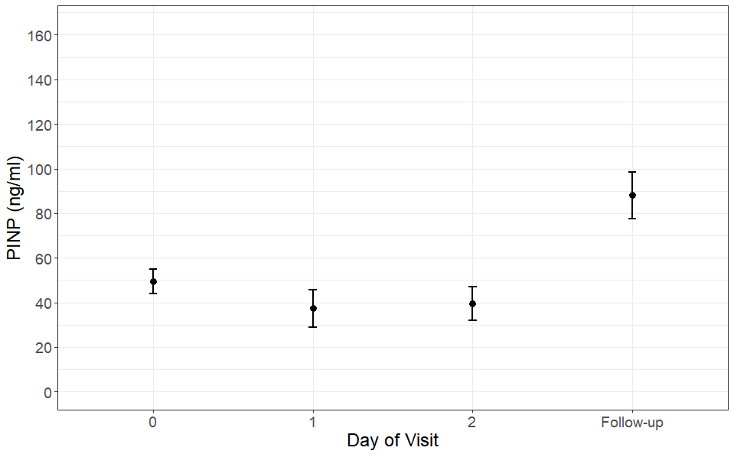
p = 0.03
One-way repeated measures ANOVA p = <0.001
No significant difference
p = <0.001
Figure 4.12: Mean PINP (points) and 95% confidence intervals (error bars) by time point.

CTX
Figure 4.13 shows the individual change in CTX by time point, while figure 4.14 shows the mean and 95% confidence intervals by time point. One-way repeated measures ANOVA revealed that CTX differed significantly between time points (p = <0.001). Tukey post hoc testing revealed that CTX decreased by an average of 0.112 ng/ml between day 0 and day 1 (p = 0.005); decreased by an average of 0.177 between day 0 and day 2 (p=<0.001). The follow up visit was not fasting so CTX could not be measured in the follow up sample.

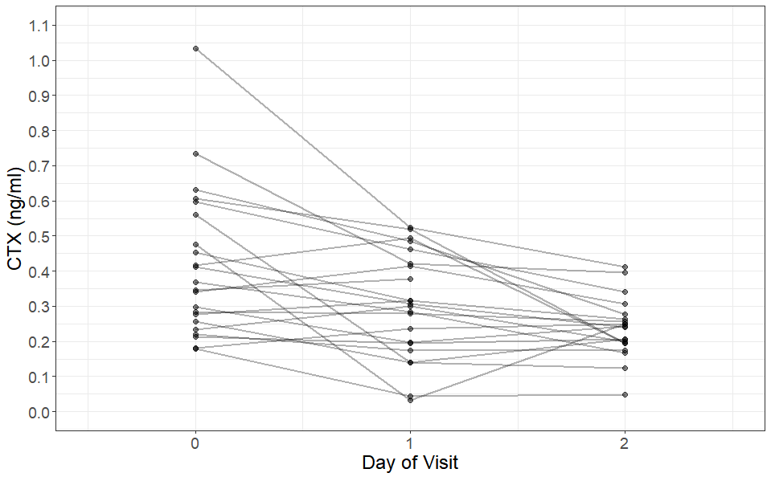
Figure 4.13: Graph showing the change in CTX by time point. The points show the individual values of each participant and the line connecting them shows the relationship between the points of that participant.


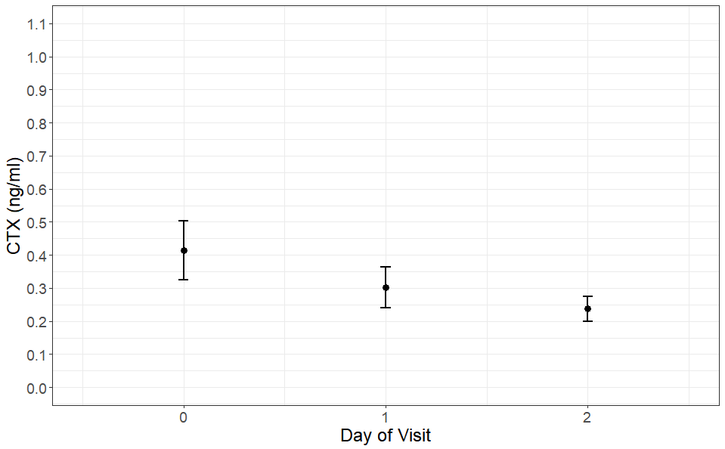
p = 0.005

p = <0.001
One-way repeated measures ANOVA p = <0.001
Figure 4.14: Graph showing the mean CTX (points) and 95% confidence intervals (error bars) by time point.

PTH
Figure 4.15 shows the individual change in PTH by time point, while figure 4.16 shows the mean and 95% confidence intervals by time point. One-way repeated measures ANOVA revealed that PTH did not differ significantly between time points. Two participants had a result <5 pg/ml.

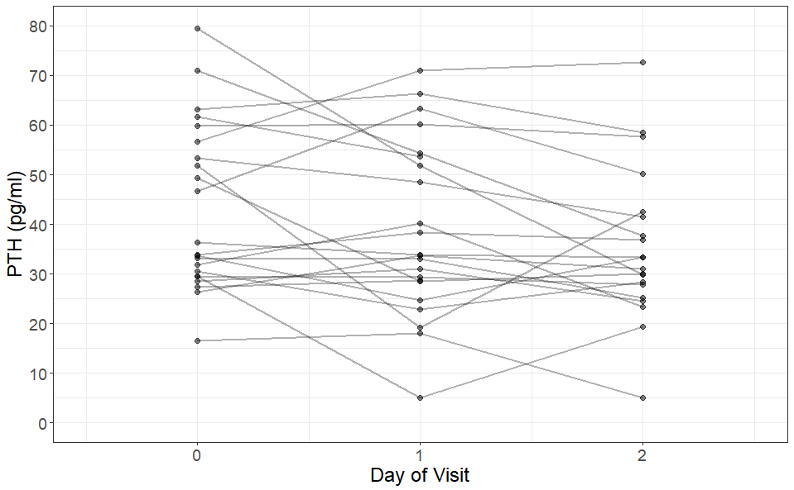
Figure 4.15: Graph showing the change in PTH by time point. The points show the individual values of each participant and the line connecting them shows the relationship between the points of that participant.

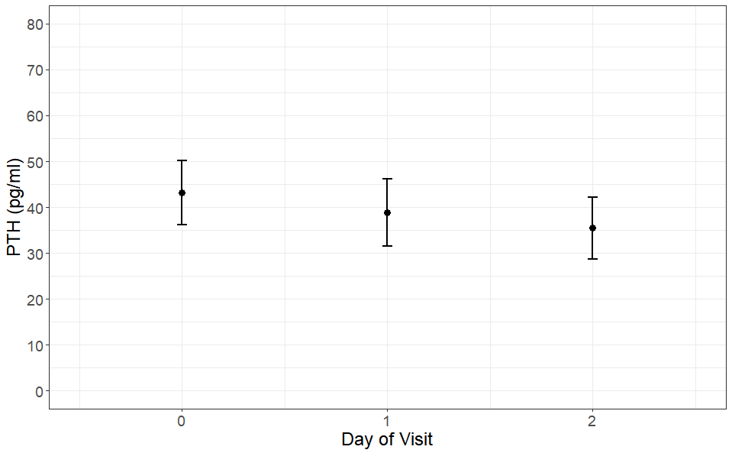
Figure 4.16: Graph showing the mean PTH (points) and 95% confidence intervals (error bars) by time point.

Directly measured free 25OHD by Immunoassay
Figure 4.17 shows the individual change in directly measured free 25OHD₃ by time point, while figure 4.18 shows the mean and 95% confidence intervals by time point. One-way repeated measures ANOVA revealed that directly measured free 25OHD did not differ significantly between time points.
One participant had free 25OHD levels of 10.6 and 14.8 pmol/L on days 0 and 1 respectively. Grubb’s test showed that both of the results are significant outliers at their time points (p = 0.05). Excluding this participant from analysis did not change the outcome of the one-way repeated measures ANOVA. It is unknown whether these outliers are due to biological variation or due to an analytical error. Other analytes measured in this participant do not fully explain these high free 25OHD results, as the other analytes are similar to other participants at these time points, apart for a much lower VDBP: On days 0 and 1 respectively, this participant had total 25OHD₃ levels of 76.3 and 50.7 nmol/L when measured by LC-MS/MS; their calculated free 25OHD was 15.7 and 15.1 pmol/L; their albumin level was 45 and 33 g/L; and their VDBP was 368.3 and 253.6 mg/ml.

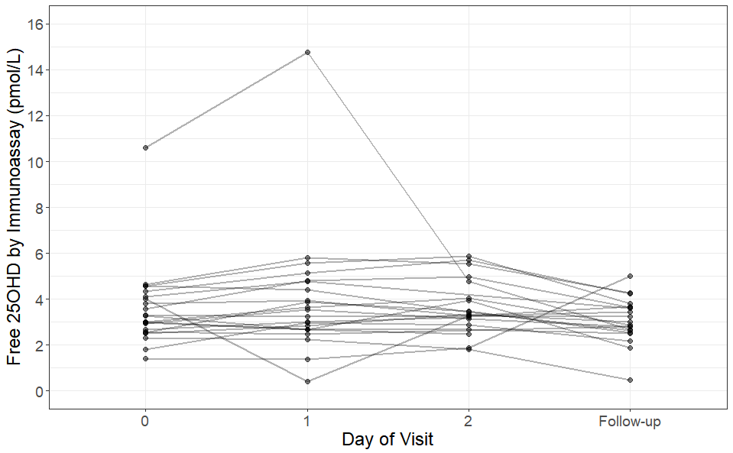
Figure 4.17: Graph showing the change in directly measured free 25OHD by time point. The points show the individual values of each participant and the line connecting them shows the relationship between the points of that participant.
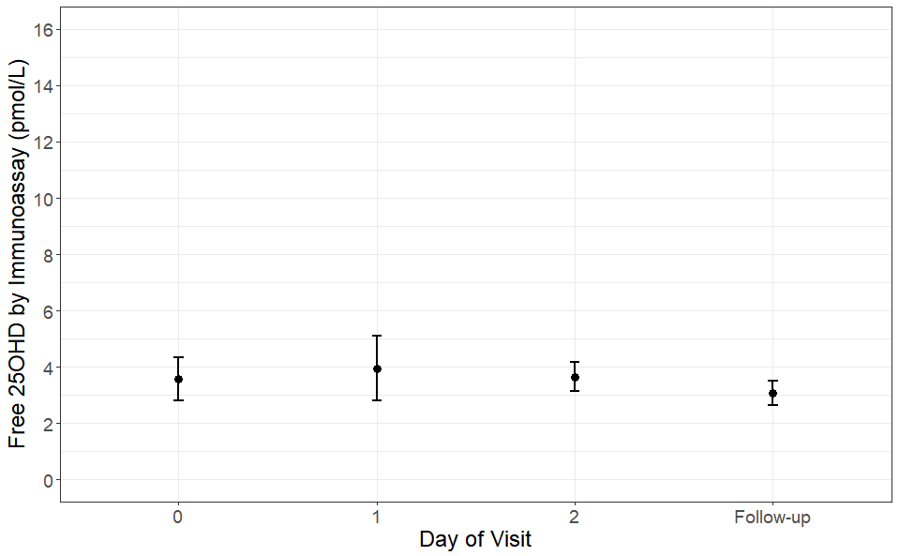
Figure 4.18: Graph showing the mean directly measured free 25OHD (points) and 95% confidence intervals (error bars) by time point.

Calculated Free 25OHD
Figure 4.19 shows the individual change in calculated free 25OHD₃ by time point, while figure 4.20 shows the mean and 95% confidence intervals by time point. One-way repeated measures ANOVA revealed that calculated free 25OHD did not differ significantly between time points.

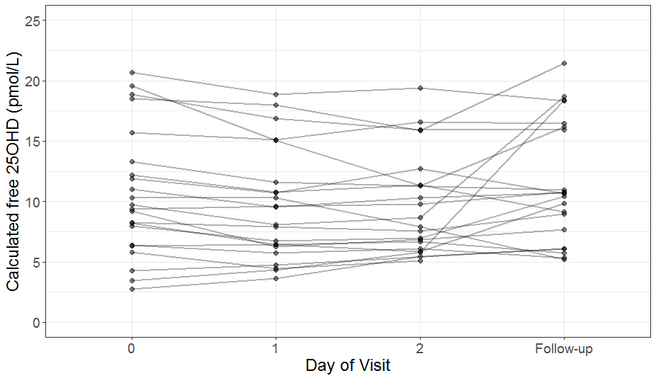
Figure 4.19: Graph showing the change in calculated free 25OHD by time point. The points show the individual values of each participant and the line connecting them shows the relationship between the points of that participant.
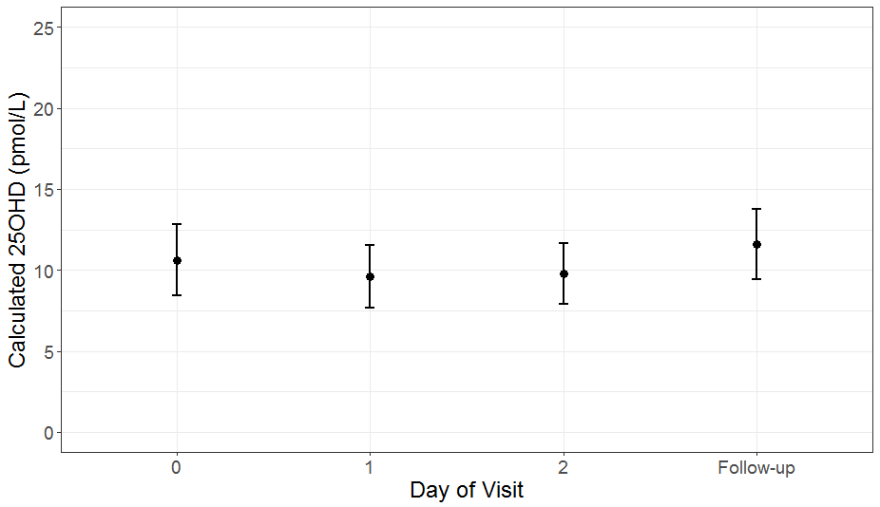
Figure 4.20: Graph showing the mean directly measured free 25OHD (points) and 95% confidence intervals (error bars) by time point.

1,25(OH)₂D by Immunoassay
Figure 4.21 shows the individual change in 1,25(OH)₂D by time point, while figure 4.22 shows the mean and 95% confidence intervals by time point. One-way repeated measures ANOVA revealed that 1,25(OH)₂D did not differ significantly between time points.
One participant had 1,25(OH)₂D levels of 41.1 and 30.8 on days 1 and 2 respectively. Grubb’s test showed that both of the results are significant outliers at their time points (p = 0.05). Excluding this participant from analysis did not change the outcome of the one-way repeated measures ANOVA. It is unknown whether these outliers are due to biological variation or due to an analytical error. Other analytes measured in this participant do not fully explain these high 1,25(OH)₂D results, as the other analytes are similar to other participants at these time points. Their PTH was 63 and 50 pg/ml and their vitamin D was 51.5 and 48.6 pmol/L at day 1 and 2 respectively, which is within the normal range.

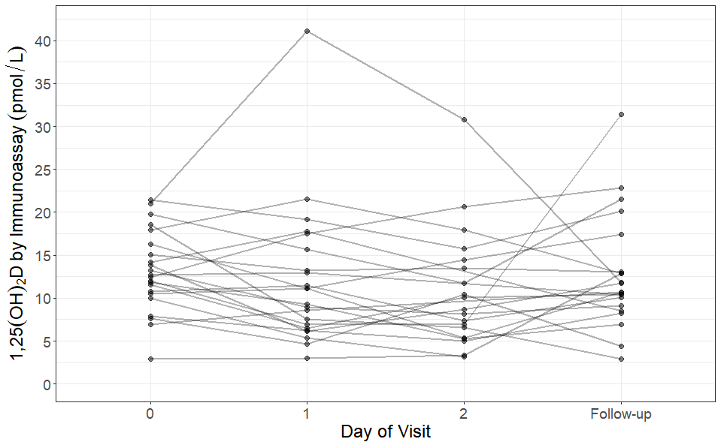
Figure 4.21: Graph showing the change in 1,25(OH)₂D by time point. The points show the individual values of each participant and the line connecting them shows the relationship between the points of that participant.
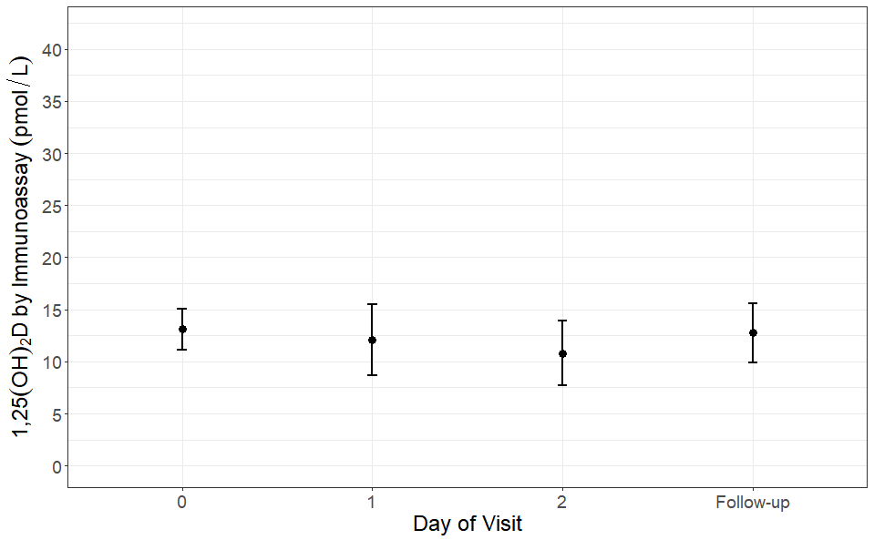
Figure 4.22: Graph showing the mean 1,25(OH)₂D (points) and 95% confidence intervals (error bars) by time point.

Discussion
In this study we hypothesised that there would be a decrease in total 25OHD levels during the first two days after surgery and that the free fraction of 25OHD would remain stable in this time frame, indicating that measuring total 25OHD during the acute phase response is not a true indication of vitamin D status. We recruited elective joint replacement patients with osteoarthritis that were otherwise well so that we could investigate the acute phase response as it developed following an acute inflammatory insult triggered by arthroplasty.
As expected, there was a significant decrease in total 25OHD, albumin, and VDBP in the immediate post-operative period (1 day and 2 days after surgery), this returned to baseline by the follow up visit which was on average 53 days after surgery. The decrease in these analytes was accompanied by an increase in CRP levels which also resolved by the follow up visit. Three other studies found total 25OHD to decrease significantly and by at least 10nmol/L (18%) by 24 hours after surgery (Binkley et al., 2017, Waldron et al., 2013, Reid et al., 2011). One study (Jensen et al., 2018) did not observe a significant decrease in total 25OHD levels until 48 hours after surgery, and only in male participants. One study investigating the change in total 25OHD during acute pancreatitis also found a significant decrease in total 25OHD between admission and 2 days later (Bang et al., 2011). Studies investigating the change in total 25OHD during the course of a malarial infection or after myocardial infarction did not observe a change in total 25OHD (Newens et al., 2006, Barth et al., 2012), however this is likely due to the decrease in total 25OHD occurring acutely before the first blood sample was collected and not decreasing significantly afterwards.
There are many potential mechanisms for the decrease in total 25OHD following arthroplasty, such as reduction in available binding proteins, loss of protein bound 25OHD in urine, increased conversion to 1,25(OH)₂D, catabolism to 24,25(OH)₂D and 1,24,25(OH)₃D, or haemodilution. These are discussed in more detail below:
The decrease in total 25OHD could be due to reduced availability of its binding proteins which are decreased during the inflammatory response. Orthopaedic surgery is known to trigger the acute inflammatory response, although the decrease in 25OHD is unlikely to be mediated by CRP, as the decrease in total 25OHD occurred before the significant increase in CRP. Reid et al. (2011) did not find CRP to be correlated with 25OHD levels, however it is possible that other factors present during the acute-phase response could mediate the decline in albumin and VDBP. TNF-α, IL-1β, and IL-6, which are released during the acute phase response, have all been observed to decrease levels of albumin production by hepatocytes (Castell et al., 1989). The mechanism for the reduction of VDBP is likely to be more complicated. Unlike albumin, the production and secretion of VDBP by hepatocytes increases in response to IL-6, however after surgery there is a net loss (Dahl et al., 2001). The loss of VDBP during the inflammatory response could be explained by two mechanisms: VDBP acts as an actin scavenger, and its half-life decreases from 12-24 hours to 30 minutes when it is complexed with actin (Dahl et al., 2001) the release of large amounts of actin following surgery could be saturating this mechanism resulting in a loss of VDBP from the circulation. VDBP is also converted to macrophage-activating factor by activated T and B cells during the inflammatory response (Dahl et al., 2001) so the decrease in VDBP could be due to its loss as a substrate.
The decrease in total 25OHD could be due to urinary loss of 25OHD bound to carrier proteins, as two studies have found that VDBP and albumin excretion in urine is increased by at least 32% on day one after surgery (Binkley et al., 2017, Waldron et al., 2013), although the mechanism for this is not known.
Another potential mechanism of decreased total 25OHD is intracellular uptake of the free fraction of 25OHD and its subsequent activation to 1,25(OH)₂D in immune cells such as macrophages. In granulomatous diseases; such as sarcoidosis, lymphoma, and tuberculosis; there is extra-renal 1-α-hydroxylation of 25OHD within the granuloma mediated by activated macrophages (section 1.1.7). It is possible that in the acute inflammatory response, there is also an increase in extra-renal 1-α-hydroxylation. Measuring levels of intracellular 25OHD and 1,25(OH)₂D in immune cells such as macrophages during the acute inflammatory response could shed light on this possibility. However, if 1,25(OH)₂D production was increased in immune cells during the inflammatory response, it is likely that 1,25(OH)₂D would increase significantly, which we did not observe. The only other study that measured 1,25(OH)₂D following arthroplasty did not observe a significant change in 1,25(OH)₂D in the 48 hours after arthroplasty, and found a decrease in 1,25(OH)₂D after 3 weeks (Jensen et al., 2018). If the decrease in total 25OHD is due to increased conversion to 1,25(OH)₂D, supplementation may be considered. 25OHD levels <20ng/ml in critically ill surgical patients have been found to correlate with length of stay in hospital, organ dysfunction, and infection rates (Flynn et al., 2012). In a meta-analysis of randomised clinical trials, critically ill patients supplemented with vitamin D appeared to have decreased mortality when compared to the control group, however this will need to be confirmed with a large, multicenter randomised clinical trial before vitamin D administration to critically ill patients can be recommended (Putzu et al., 2017).
To our knowledge, no study has investigated the levels of 24,25(OH)₂D and 1,24,25(OH)₃D during the inflammatory response, so increased catabolism of 25OHD is a possible mechanism for the decrease in total 25OHD. 24-hydroxylation is mediated by an increase in PTH or a decrease in FGF23, so if increased catabolism were a cause of the decrease in 25OHD, there would likely be a concurrent rise in PTH, or a concurrent decrease in FGF23.
Haemodilution effects during surgery cannot be ruled out as a potential mechanism for the decrease in 25OHD, albumin and VDBP during the immediate postoperative period. Indeed, Krishnan et al. (2010) found 25OHD and albumin to decrease following haemodilution as part of cardiac surgery, however the levels resolved when the excess of fluids subside. Bertoldo et al. (2010) excluded blood loss and intravenous fluids as potential confounders by measuring the change in 25OHD concentration following zoledronate 5mg diluted in 100ml 0.9% saline as a model for the acute inflammatory response. They found that the total 25OHD concentration decreased by 30% following the infusion, which shows that total 25OHD decreases during the inflammatory response even in the absence of haemodilution.
In our study, the concentration of free 25OHD as determined by a direct ELISA and by calculation remained unchanged despite the decrease in total 25OHD. The decrease in binding proteins postoperatively could explain the reason for the decrease in total 25OHD while the free 25OHD remains unchanged. Reid et al. (2011) found a significant decrease in calculated free 25OHD on day 1, day 2 and day 5 after arthroplasty, whereas Jensen et al. (2018) did not observe a change in calculated free 25OHD post operatively. Binkley et al. (2017) directly measured free 25OHD and observed a decrease at day 1 after surgery.
The decrease in protein bound 25OHD and its carrier proteins may affect cells that receive the protein bound fraction of 25OHD via megalin, whereas cells that do not express megalin and rely on the free fraction for their supply of 25OHD should not be affected. Renal tubular cells receive carrier bound 25OHD from the luminal site by megalin mediated endocytosis, (Bouillon, 2016, Marzolo and Farfan, 2011). This endocytosis of carrier proteins is likely to be reduced due to reduced availability of carrier proteins and total 25OHD. This is coupled with a likely reduction of megalin assisted endocytosis of the available carrier proteins in the renal tubules, as studies have shown that the VDBP:creatinine ratio in urine to increase 32% on day 1 after surgery and by 250% after 48 hours following surgery. The albumin:creatinine ratio in urine was also found to increase by 247% 48 hours after surgery, (Binkley et al., 2017, Waldron et al., 2013), showing that even the available store of 25OHD bound to carrier proteins may not be able to meet the requirements of renal tubule cells for 25OHD.
However, despite this possible reduction in megalin mediated endocytosis of carrier proteins in the luminal site, renal tubule cells also have access to free 25OHD via the serosal membrane (Bouillon, 2016, Marzolo and Farfan, 2011). It is not known whether this source could be sufficient for adequate 1,25(OH)₂D production in the renal tubules.
We did not detect a significant decrease in 1,25(OH)₂D or PTH directly after surgery or at the follow up visit, however Jensen et al. (2018) found 1,25(OH)₂D to be significantly decreased after 3 weeks following arthroplasty, this decrease was not accompanied with an increase in PTH however so the significance of this finding is unknown.
We observed a significant decrease in PINP on day 1 after surgery, with a significant increase at the follow-up appointment. PINP is a marker of osteoblast activity and could be initially decreased in response to increased cortisol levels following arthroplasty. Osteocalcin, another marker of osteoblast activity, is known to be suppressed by cortisol: it has been found to decrease during corticosteroid treatment (Ekenstam et al., 1988), and in response to traumatic fracture, acute myocardial infarct and after undergoing elective abdominal surgery (Napal et al., 1993). It is likely then that the decrease in PINP could reflect the same decrease in osteoblast activity as is detected by a decrease in osteocalcin. The significant increase in PINP at the follow up appointment is likely due to bone healing at the site of arthroplasty, this increase in PINP is also seen in other studies after arthroplasty or fracture and can remain increased for 6-12 months (Ingle et al., 1999a, Ingle et al., 1999b, Wilkinson et al., 2001). CTX decreased initially after surgery, CTX could not be measured at the follow-up appointment as a random blood sample could only be collected at this visit as opposed to the fasting morning sample required for CTX measurement. The mechanism for an initial decrease is uncertain, however studies have shown that, similarly to bone formation markers such as PINP, bone resorption markers would remain raised by the follow up appointment due to healing of the bone at the site of arthroplasty (Wilkinson et al., 2001).
Some of the strengths of this study are that we measured total 25OHD by an established LC-MS/MS method used routinely in a hospital setting, and we measured free 25OHD directly using an ELISA method, as the calculation of free 25OHD depends on accurate measurements of 25OHD, VDBP, and albumin. We used a prospective longitudinal model of elective arthroplasty patients so that we can detect the change before and after the inflammatory insult.
Our weaknesses are: The salivary method could not be included at this time as the method is still being developed. Equilibrium dialysis or centrifugal ultrafiltration followed by LC-MS/MS would have been superior methods of measuring the free fraction of 25OHD, however these methods were not available. Measuring 1,25(OH)₂D by LC-MS/MS would have been preferred, but this method was not available to us. We did not account for the genotype of VDBP in our calculation of the free fraction, however we aimed to recruit only Caucasians to minimise the effect of VDBP genotype on our findings, and as we are assessing the change in VDBP concentration in participants over time, the genotype is not as important as it would have been if we were investigating the differences between individuals.
Future work is required to determine whether salivary 25OHD remains stable following an inflammatory insult and whether it correlates with serum free 25OHD. The effect of the inflammatory insult on the intracellular concentrations of vitamin D metabolites in macrophages are yet to be elucidated. Measurement of 24,25(OH)₂D and 1,24,25(OH)₃D could show whether there is increased catabolism of 25OHD and 1,25(OH)₂D following surgery. As our model may be affected by the surgical procedures, such as blood loss or haemodilution, a different model of assessing vitamin D over the time course of an inflammatory insult could be used, such as is seen during bisphosphonate therapy.
In summary, this study has shown that total 25OHD is decreased during the acute phase response, despite no significant change in free 25OHD, PTH, or 1,25(OH)₂D. Care should be taken when diagnosing vitamin D deficiency in patients following an inflammatory insult, especially during a fracture assessment when low vitamin D levels could be perceived as a causative factor. It would be prudent to assess the vitamin D status in patients after the insult has resolved.

Discussion
The original aim of this thesis was to develop a method of measuring salivary 25OHD and to assess whether this method could be used as a surrogate marker of free vitamin D status in situations where it could be clinically useful, such as during inflammatory illnesses where total 25OHD is thought to act as an acute phase reactant and therefore not give a true indication of vitamin D status. Elective hip and knee replacement surgery was chosen as a model to demonstrate the acute inflammatory response. As total 25OHD decreases during an inflammatory insult, likely due to the decrease in VDBP and albumin, it is thought that measurement of free 25OHD, which would be less affected by binding protein concentrations, might give a better indication of vitamin D status in inflammatory conditions. Saliva is thought to be a source of free 25OHD and therefore could be used as a surrogate marker for free vitamin D measurement.

Main findings
We found increased sensitivity of the salivary 25OHD method into the analytical range after derivatising with Amplifex diene, however the method could not be fully validated due to technical challenges with the assay.
We did not detect VDBP or albumin in a salivary sample. The reported detection of vitamin D binding proteins in saliva in the literature was surprising because hormones were thought to be unbound in saliva. 25OHD is also found in much lower levels in saliva than in serum, at concentrations similar to the circulating free 25OHD concentration. Measurement of salivary proteins alongside salivary 25OHD during the inflammatory response may elucidate whether salivary 25OHD reflects serum total or free 25OHD levels.
During the inflammatory response, total 25OHD, albumin and VDBP decreased, however directly measured 25OHD and calculated 25OHD remained stable. Measures of 1,25(OH)₂D and PTH also remained stable which indicates that the total 25OHD may be artificially lowered due to the loss of binding proteins during the inflammatory response and that there is sufficient circulating free 25OHD to regulate levels of PTH and to provide a reservoir for conversion to 1,25(OH)₂D.

How this study was unique
This is the first study to use Amplifex diene for salivary 25OHD measurement. During method development there was no literature on Amplifex diene for 25OHD measurement, however a method of measuring serum 25OHD after derivatisation with Amplifex diene has since been published by Muller et al. (2016).
When the clinical study was first developed, directly measured free 25OHD had not yet been measured in patients undergoing hip and knee replacement surgery, however another study has now reported on directly measured free 25OHD by ELISA (Binkley et al., 2017).
There has been little biological validation of the salivary 25OHD method. Once the method has been improved so that acceptance criteria are met and the method is ready for clinical use, it will be necessary to perform biological validation to determine whether it is a reliable marker of free 25OHD status.

Strengths and weaknesses
The strengths of this thesis are that free 25OHD was able to be measured directly by ELISA and the measurement of total 25OHD by LC-MS/MS in patients undergoing hip and knee replacement.
The main limitation of this thesis is that the salivary method was not able to be biologically validated in the clinical study. In the salivary method development, recovery of the internal standard and spiked 25OHD in salivary samples was found to be inadequate, which would likely be resolved by improving the sample preparation technique as an emulsion formed in salivary samples and not in calibrants or quality control samples.

Future work
The measurement of 25OHD in the salivary samples collected in the clinical study in chapter 4 is still interesting and is planned in the future once the salivary 25OHD method is established. The measurement of vitamin D binding proteins in saliva would also help to determine whether salivary 25OHD is able to be used as a surrogate marker of serum free 25OHD.
Equilibrium dialysis followed by LC-MS/MS is theoretically the gold standard measure of free 25OHD. Therefore ideally it would be useful to measure free 25OHD using this method in our clinical study.
The mechanism for the decrease in VDBP is still not known and requires further investigation.

Conclusion
In this thesis we have performed a comprehensive evaluation of vitamin D status during the inflammatory response. We have shown that total 25OHD measurement is not a reliable measure of vitamin D status during the acute phase and that care should be taken when interpreting vitamin D concentrations in patients after an acute trauma that triggers the inflammatory response, or during a chronic inflammatory illness.

References
Abboud, M., Puglisi, D. A., Davies, B. N., Rybchyn, M., Whitehead, N. P., Brock, K. E., Cole, L., Gordon-Thomson, C., Fraser, D. R. & Mason, R. S. 2013. Evidence for a specific uptake and retention mechanism for 25-hydroxyvitamin D (25OHD) in skeletal muscle cells. Endocrinology, 154, 3022-30.
Armbrecht, H. J., Hodam, T. L., Boltz, M. A., Partridge, N. C., Brown, A. J. & Kumar, V. B. 1998. Induction of the vitamin D 24-hydroxylase (CYP24) by 1,25-dihydroxyvitamin D3 is regulated by parathyroid hormone in UMR106 osteoblastic cells. Endocrinology, 139, 3375-81.
Arnaud, J. & Constans, J. 1993. Affinity differences for vitamin D metabolites associated with the genetic isoforms of the human serum carrier protein (DBP). Hum Genet, 92, 183-8.
Atkins, G. J., Anderson, P. H., Findlay, D. M., Welldon, K. J., Vincent, C., Zannettino, A. C., O'loughlin, P. D. & Morris, H. A. 2007. Metabolism of vitamin D3 in human osteoblasts: evidence for autocrine and paracrine activities of 1 alpha,25-dihydroxyvitamin D3. Bone, 40, 1517-28.
Baecher, S., Leinenbach, A., Wright, J. A., Pongratz, S., Kobold, U. & Thiele, R. 2012. Simultaneous quantification of four vitamin D metabolites in human serum using high performance liquid chromatography tandem mass spectrometry for vitamin D profiling. Clin Biochem, 45, 1491-6.
Bailey, D., Veljkovic, K., Yazdanpanah, M. & Adeli, K. 2013. Analytical measurement and clinical relevance of vitamin D(3) C3-epimer. Clin Biochem, 46, 190-6.
Bang, U. C., Novovic, S., Andersen, A. M., Fenger, M., Hansen, M. B. & Jensen, J. E. 2011. Variations in serum 25-hydroxyvitamin D during acute pancreatitis: an exploratory longitudinal study. Endocr Res, 36, 135-41.
Barth, J. H., Field, H. P., Mather, A. N. & Plein, S. 2012. Serum 25 hydroxy-vitamin D does not exhibit an acute phase reaction after acute myocardial infarction. Ann Clin Biochem, 49, 399-401.
Beisel, W. R., Diraimondo, V. C., Chao, P. Y., Rosner, J. M. & Forsham, P. H. 1964. The Influence of Plasma Protein Binding on the Extra-Adrenal Metabolism of Cortisol in Normal, Hyperthyroid and Hypothyroid Subjects. Metabolism, 13, 942-51.
Bellido, T., Saini, V. & Pajevic, P. D. 2013. Effects of PTH on osteocyte function. Bone, 54, 250-7.
Bergwitz, C. & Juppner, H. 2010. Regulation of phosphate homeostasis by PTH, vitamin D, and FGF23. Annu Rev Med, 61, 91-104.
Bertoldo, F., Pancheri, S., Zenari, S., Boldini, S., Giovanazzi, B., Zanatta, M., Valenti, M. T., Dalle Carbonare, L. & Lo Cascio, V. 2010. Serum 25-hydroxyvitamin D levels modulate the acute-phase response associated with the first nitrogen-containing bisphosphonate infusion. J Bone Miner Res, 25, 447-54.
Bhan, I., Powe, C. E., Berg, A. H., Ankers, E., Wenger, J. B., Karumanchi, S. A. & Thadhani, R. I. 2012. Bioavailable vitamin D is more tightly linked to mineral metabolism than total vitamin D in incident hemodialysis patients. Kidney Int, 82, 84-9.
Bikle, D. D. 2014. Vitamin D metabolism, mechanism of action, and clinical applications. Chem Biol, 21, 319-29.
Bikle, D. D., Gee, E., Halloran, B. & Haddad, J. G. 1984. Free 1,25-dihydroxyvitamin D levels in serum from normal subjects, pregnant subjects, and subjects with liver disease. J Clin Invest, 74, 1966-71.
Bikle, D. D., Gee, E., Halloran, B., Kowalski, M. A., Ryzen, E. & Haddad, J. G. 1986. Assessment of the free fraction of 25-hydroxyvitamin D in serum and its regulation by albumin and the vitamin D-binding protein. J Clin Endocrinol Metab, 63, 954-9.
Bikle, D. D., Murphy, E. W. & Rasmussen, H. 1975. The ionic control of 1,25-dihydroxyvitamin D3 synthesis in isolated chick renal mitochondria. The role of calcium as influenced by inorganic phosphate and hydrogen-ion. J Clin Invest, 55, 299-304.
Bikle, D. D., Pillai, S., Gee, E. & Hincenbergs, M. 1989. Regulation of 1,25-dihydroxyvitamin D production in human keratinocytes by interferon-gamma. Endocrinology, 124, 655-60.
Bikle, D. D., Pillai, S., Gee, E. & Hincenbergs, M. 1991. Tumor necrosis factor-alpha regulation of 1,25-dihydroxyvitamin D production by human keratinocytes. Endocrinology, 129, 33-8.
Bikle, D. D. & Rasmussen, H. 1975. The ionic control of 1,25-dihydroxyvitamin D3 production in isolated chick renal tubules. J Clin Invest, 55, 292-8.
Binkley, N., Coursin, D., Krueger, D., Iglar, P., Heiner, J., Illgen, R., Squire, M., Lappe, J., Watson, P. & Hogan, K. 2017. Surgery alters parameters of vitamin D status and other laboratory results. Osteoporos Int, 28, 1013-1020.
Blum, M., Dolnikowski, G., Seyoum, E., Harris, S. S., Booth, S. L., Peterson, J., Saltzman, E. & Dawson-Hughes, B. 2008. Vitamin D(3) in fat tissue. Endocrine, 33, 90-4.
Bouillon, R. 2016. Free or Total 25OHD as Marker for Vitamin D Status? J Bone Miner Res, 31, 1124-7.
Bouillon, R., Jones, K. & Schoenmakers, I. 2014. Vitamin D-binding protein and vitamin D in blacks and whites. N Engl J Med, 370, 879.
Bouillon, R., Van Assche, F. A., Van Baelen, H., Heyns, W. & De Moor, P. 1981. Influence of the vitamin D-binding protein on the serum concentration of 1,25-dihydroxyvitamin D3. Significance of the free 1,25-dihydroxyvitamin D3 concentration. J Clin Invest, 67, 589-96.
Brumbaugh, P. F., Hughes, M. R. & Haussler, M. R. 1975. Cytoplasmic and nuclear binding components for 1alpha25-dihydroxyvitamin D3 in chick parathyroid glands. Proc Natl Acad Sci U S A, 72, 4871-5.
Cai, Q., Chandler, J. S., Wasserman, R. H., Kumar, R. & Penniston, J. T. 1993. Vitamin D and adaptation to dietary calcium and phosphate deficiencies increase intestinal plasma membrane calcium pump gene expression. Proc Natl Acad Sci U S A, 90, 1345-9.
Carter, G. D., Carter, R., Jones, J. & Berry, J. 2004. How accurate are assays for 25-hydroxyvitamin D? Data from the international vitamin D external quality assessment scheme. Clin Chem, 50, 2195-7.
Castell, J. V., Gomez-Lechon, M. J., David, M., Andus, T., Geiger, T., Trullenque, R., Fabra, R. & Heinrich, P. C. 1989. Interleukin-6 is the major regulator of acute phase protein synthesis in adult human hepatocytes. FEBS Lett, 242, 237-9.
Chen, S., Sims, G. P., Chen, X. X., Gu, Y. Y., Chen, S. & Lipsky, P. E. 2007. Modulatory effects of 1,25-dihydroxyvitamin D3 on human B cell differentiation. J Immunol, 179, 1634-47.
Cheng, J. B., Levine, M. A., Bell, N. H., Mangelsdorf, D. J. & Russell, D. W. 2004. Genetic evidence that the human CYP2R1 enzyme is a key vitamin D 25-hydroxylase. Proc Natl Acad Sci U S A, 101, 7711-5.
Cheng, J. B., Motola, D. L., Mangelsdorf, D. J. & Russell, D. W. 2003. De-orphanization of cytochrome P450 2R1: a microsomal vitamin D 25-hydroxilase. J Biol Chem, 278, 38084-93.
Christakos, S., Dhawan, P., Verstuyf, A., Verlinden, L. & Carmeliet, G. 2016. Vitamin D: Metabolism, Molecular Mechanism of Action, and Pleiotropic Effects. Physiol Rev, 96, 365-408.
Chun, R. F., Peercy, B. E., Orwoll, E. S., Nielson, C. M., Adams, J. S. & Hewison, M. 2014. Vitamin D and DBP: the free hormone hypothesis revisited. J Steroid Biochem Mol Biol, 144 Pt A, 132-7.
Cleve, H. & Constans, J. 1988. The mutants of the vitamin-D-binding protein: more than 120 variants of the GC/DBP system. Vox Sang, 54, 215-25.
Coldwell, R. D., Trafford, D. J. H., Varley, M. J., Kirk, D. N. & Makin, H. L. J. 1990. Stable Isotope-Labeled Vitamin-D, Metabolites and Chemical Analogs - Synthesis and Use in Mass-Spectrometric Studies. Steroids, 55, 418-432.
Cooke, N. E. & David, E. V. 1985. Serum vitamin D-binding protein is a third member of the albumin and alpha fetoprotein gene family. J Clin Invest, 76, 2420-4.
Coue, M., Constans, J., Viau, M. & Olomucki, A. 1983. The effect of serum vitamin D-binding protein on polymerization and depolymerization of actin is similar to the effect of profilin on actin. Biochim Biophys Acta, 759, 137-45.
Cui, S., Verroust, P. J., Moestrup, S. K. & Christensen, E. I. 1996. Megalin/gp330 mediates uptake of albumin in renal proximal tubule. Am J Physiol, 271, F900-7.
Dahl, B., Schiodt, F. V., Gehrchen, P. M., Ramlau, J., Kiaer, T. & Ott, P. 2001. Gc-globulin is an acute phase reactant and an indicator of muscle injury after spinal surgery. Inflamm Res, 50, 39-43.
Daiger, S. P., Schanfield, M. S. & Cavalli-Sforza, L. L. 1975. Group-specific component (Gc) proteins bind vitamin D and 25-hydroxyvitamin D. Proc Natl Acad Sci U S A, 72, 2076-80.
Damassa, D. A., Lin, T. M., Sonnenschein, C. & Soto, A. M. 1991. Biological effects of sex hormone-binding globulin on androgen-induced proliferation and androgen metabolism in LNCaP prostate cells. Endocrinology, 129, 75-84.
Darwish, H. M. & Deluca, H. F. 1999. Identification of a transcription factor that binds to the promoter region of the human parathyroid hormone gene. Arch Biochem Biophys, 365, 123-30.
Dastani, Z., Berger, C., Langsetmo, L., Fu, L., Wong, B. Y., Malik, S., Goltzman, D., Cole, D. E. & Richards, J. B. 2014. In healthy adults, biological activity of vitamin D, as assessed by serum PTH, is largely independent of DBP concentrations. J Bone Miner Res, 29, 494-9.
Dawson-Hughes, B., Heaney, R. P., Holick, M. F., Lips, P., Meunier, P. J. & Vieth, R. 2005. Estimates of optimal vitamin D status. Osteoporos Int, 16, 713-6.
De Haes, P., Garmyn, M., Degreef, H., Vantieghem, K., Bouillon, R. & Segaert, S. 2003. 1,25-Dihydroxyvitamin D3 inhibits ultraviolet B-induced apoptosis, Jun kinase activation, and interleukin-6 production in primary human keratinocytes. J Cell Biochem, 89, 663-73.
Deluca, H. F. 2004. Overview of general physiologic features and functions of vitamin D. Am J Clin Nutr, 80, 1689S-96S.
Demay, M. B., Kiernan, M. S., Deluca, H. F. & Kronenberg, H. M. 1992. Sequences in the human parathyroid hormone gene that bind the 1,25-dihydroxyvitamin D3 receptor and mediate transcriptional repression in response to 1,25-dihydroxyvitamin D3. Proc Natl Acad Sci U S A, 89, 8097-101.
Denburg, M. R., Hoofnagle, A. N., Sayed, S., Gupta, J., De Boer, I. H., Appel, L. J., Durazo-Arvizu, R., Whitehead, K., Feldman, H. I., Leonard, M. B. & Chronic Renal Insufficiency Cohort Study, I. 2016. Comparison of Two ELISA Methods and Mass Spectrometry for Measurement of Vitamin D-Binding Protein: Implications for the Assessment of Bioavailable Vitamin D Concentrations Across Genotypes. J Bone Miner Res, 31, 1128-36.
Dixon, K. M., Deo, S. S., Wong, G., Slater, M., Norman, A. W., Bishop, J. E., Posner, G. H., Ishizuka, S., Halliday, G. M., Reeve, V. E. & Mason, R. S. 2005. Skin cancer prevention: a possible role of 1,25dihydroxyvitamin D3 and its analogs. J Steroid Biochem Mol Biol, 97, 137-43.
Ekenstam, E., Stalenheim, G. & Hallgren, R. 1988. The acute effect of high dose corticosteroid treatment on serum osteocalcin. Metabolism, 37, 141-4.
Elias, P. C., Martinez, E. Z., Barone, B. F., Mermejo, L. M., Castro, M. & Moreira, A. C. 2014. Late-night salivary cortisol has a better performance than urinary free cortisol in the diagnosis of Cushing's syndrome. J Clin Endocrinol Metab, 99, 2045-51.
Fairney, A. & Saphier, P. W. 1987. Studies on the measurement of 25-hydroxy vitamin D in human saliva. Br J Nutr, 57, 13-25.
Farrell, C. J., Martin, S., Mcwhinney, B., Straub, I., Williams, P. & Herrmann, M. 2012. State-of-the-art vitamin D assays: a comparison of automated immunoassays with liquid chromatography-tandem mass spectrometry methods. Clin Chem, 58, 531-42.
Flynn, L., Zimmerman, L. H., Mcnorton, K., Dolman, M., Tyburski, J., Baylor, A., Wilson, R. & Dolman, H. 2012. Effects of vitamin D deficiency in critically ill surgical patients. Am J Surg, 203, 379-82; discussion 382.
Flynn, N., Lam, F. & Dawnay, A. 2014. Enhanced 3-epi-25-hydroxyvitamin D3 signal leads to overestimation of its concentration and amplifies interference in 25-hydroxyvitamin D LC-MS/MS assays. Ann Clin Biochem, 51, 352-9.
Francis, R., Aspray, T., Fraser, W., Gittoes, N. & Javaid, K. 2013. Vitamin D and Bone Health: A Practical Clinical Guideline for Patient Management. The National Osteoporosis Society.
Frey, B. M. & Frey, F. J. 1990. Clinical pharmacokinetics of prednisone and prednisolone. Clin Pharmacokinet, 19, 126-46.
Fuss, M., Pepersack, T., Gillet, C., Karmali, R. & Corvilain, J. 1992. Calcium and vitamin D metabolism in granulomatous diseases. Clin Rheumatol, 11, 28-36.
Gatti, G., Perucca, E., Frigo, G. M., Notarangelo, L. D., Barberis, L. & Martini, A. 1984. Pharmacokinetics of prednisone and its metabolite prednisolone in children with nephrotic syndrome during the active phase and in remission. Br J Clin Pharmacol, 17, 423-31.
Giorgi, E. P. & Stein, W. D. 1981. The transport of steroids into animal cells in culture. Endocrinology, 108, 688-97.
Glyn-Jones, S., Palmer, A., Price, A., Vincent, T., Weinans, H. & Carr, A. J. 2015. Osteoarthritis. The Lancet, 386, 376-387.
Gombart, A. F., Borregaard, N. & Koeffler, H. P. 2005. Human cathelicidin antimicrobial peptide (CAMP) gene is a direct target of the vitamin D receptor and is strongly up-regulated in myeloid cells by 1,25-dihydroxyvitamin D3. FASEB J, 19, 1067-77.
Guo, Y. D., Strugnell, S., Back, D. W. & Jones, G. 1993. Transfected human liver cytochrome P-450 hydroxylates vitamin D analogs at different side-chain positions. Proc Natl Acad Sci U S A, 90, 8668-72.
Gupta, R., Dixon, K. M., Deo, S. S., Holliday, C. J., Slater, M., Halliday, G. M., Reeve, V. E. & Mason, R. S. 2007. Photoprotection by 1,25 dihydroxyvitamin D3 is associated with an increase in p53 and a decrease in nitric oxide products. J Invest Dermatol, 127, 707-15.
Hammes, A., Andreassen, T. K., Spoelgen, R., Raila, J., Hubner, N., Schulz, H., Metzger, J., Schweigert, F. J., Luppa, P. B., Nykjaer, A. & Willnow, T. E. 2005. Role of endocytosis in cellular uptake of sex steroids. Cell, 122, 751-62.
Hammond, G. L., Nisker, J. A., Jones, L. A. & Siiteri, P. K. 1980. Estimation of the percentage of free steroid in undiluted serum by centrifugal ultrafiltration-dialysis. J Biol Chem, 255, 5023-6.
Heaney, R. P., Horst, R. L., Cullen, D. M. & Armas, L. A. 2009. Vitamin D3 distribution and status in the body. J Am Coll Nutr, 28, 252-6.
Hedman, C. J., Wiebe, D. A., Dey, S., Plath, J., Kemnitz, J. W. & Ziegler, T. E. 2014. Development of a sensitive LC/MS/MS method for vitamin D metabolites: 1,25 Dihydroxyvitamin D2&3 measurement using a novel derivatization agent. J Chromatogr B Analyt Technol Biomed Life Sci, 953-954, 62-7.
Henderson, C. M., Lutsey, P. L., Misialek, J. R., Laha, T. J., Selvin, E., Eckfeldt, J. H. & Hoofnagle, A. N. 2016. Measurement by a Novel LC-MS/MS Methodology Reveals Similar Serum Concentrations of Vitamin D-Binding Protein in Blacks and Whites. Clin Chem, 62, 179-87.
Higashi, T., Shibayama, Y., Fuji, M. & Shimada, K. 2008. Liquid chromatography-tandem mass spectrometric method for the determination of salivary 25-hydroxyvitamin D3: a noninvasive tool for the assessment of vitamin D status. Anal Bioanal Chem, 391, 229-38.
Hirschfeld, J. 1959. Immune-electrophoretic demonstration of qualitative differences in human sera and their relation to the haptoglobins. Acta Pathol Microbiol Scand, 47, 160-8.
Hirtz, C., Vialaret, J., Nowak, N., Gabelle, A., Deville De Periere, D. & Lehmann, S. 2016. Absolute quantification of 35 plasma biomarkers in human saliva using targeted MS. Bioanalysis, 8, 43-53.
Holick, M. F. 1981. The cutaneous photosynthesis of previtamin D3: a unique photoendocrine system. J Invest Dermatol, 77, 51-8.
Holick, M. F. 1990. The use and interpretation of assays for vitamin D and its metabolites. J Nutr, 120 Suppl 11, 1464-9.
Holick, M. F. 2007. Vitamin D deficiency. N Engl J Med, 357, 266-81.
Holick, M. F. 2008. Vitamin D: a D-Lightful health perspective. Nutr Rev, 66, S182-94.
Holick, M. F., Binkley, N. C., Bischoff-Ferrari, H. A., Gordon, C. M., Hanley, D. A., Heaney, R. P., Murad, M. H., Weaver, C. M. & Endocrine, S. 2011. Evaluation, treatment, and prevention of vitamin D deficiency: an Endocrine Society clinical practice guideline. J Clin Endocrinol Metab, 96, 1911-30.
Holmberg, I., Berlin, T., Ewerth, S. & Bjorkhem, I. 1986. 25-Hydroxylase activity in subcellular fractions from human liver. Evidence for different rates of mitochondrial hydroxylation of vitamin D2 and D3. Scand J Clin Lab Invest, 46, 785-90.
Honour, J. W. 2011. Development and validation of a quantitative assay based on tandem mass spectrometry. Ann Clin Biochem, 48, 97-111.
Hypponen, E. & Power, C. 2007. Hypovitaminosis D in British adults at age 45 y: nationwide cohort study of dietary and lifestyle predictors. American Journal of Clinical Nutrition, 85, 860-868.
Ingle, B. M., Hay, S. M., Bottjer, H. M. & Eastell, R. 1999a. Changes in bone mass and bone turnover following ankle fracture. Osteoporos Int, 10, 408-15.
Ingle, B. M., Hay, S. M., Bottjer, H. M. & Eastell, R. 1999b. Changes in bone mass and bone turnover following distal forearm fracture. Osteoporos Int, 10, 399-407.
Jakobsen, J., Maribo, H., Bysted, A., Sommer, H. M. & Hels, O. 2007. 25-hydroxyvitamin D3 affects vitamin D status similar to vitamin D3 in pigs--but the meat produced has a lower content of vitamin D. Br J Nutr, 98, 908-13.
Jensen, M. B., Husted, H., Bjerrum, P. J., Juul, A. & Kehlet, H. 2018. Compromised activation of vitamin D after elective surgery: a prospective pilot study. JBMR Plus.
Johnsen, M. S., Grimnes, G., Figenschau, Y., Torjesen, P. A., Almas, B. & Jorde, R. 2014. Serum free and bio-available 25-hydroxyvitamin D correlate better with bone density than serum total 25-hydroxyvitamin D. Scand J Clin Lab Invest, 74, 177-83.
Joneja, J. M., Greenstein, P. M., Revis, G. J. & Crowle, A. J. 1982. Identification of transcalciferin as a major component of human parotid saliva by crossed immunoelectrophoretic mapping. Arch Oral Biol, 27, 51-8.
Jusko, W. J. & Rose, J. Q. 1980. Monitoring prednisone and prednisolone. Ther Drug Monit, 2, 169-76.
Kamao, M., Tatematsu, S., Hatakeyama, S., Sakaki, T., Sawada, N., Inouye, K., Ozono, K., Kubodera, N., Reddy, G. S. & Okano, T. 2004. C-3 epimerization of vitamin D3 metabolites and further metabolism of C-3 epimers: 25-hydroxyvitamin D3 is metabolized to 3-epi-25-hydroxyvitamin D3 and subsequently metabolized through C-1alpha or C-24 hydroxylation. J Biol Chem, 279, 15897-907.
Kawakami, M., Blum, C. B., Ramakrishnan, R., Dell, R. B. & Goodman, D. S. 1981. Turnover of the plasma binding protein for vitamin D and its metabolites in normal human subjects. J Clin Endocrinol Metab, 53, 1110-6.
Key, T. J., Appleby, P. N., Reeves, G. K., Roddam, A., Dorgan, J. F., Longcope, C., Stanczyk, F. Z., Stephenson, H. E., Jr., Falk, R. T., Miller, R., Schatzkin, A., Allen, D. S., Fentiman, I. S., Key, T. J., Wang, D. Y., Dowsett, M., Thomas, H. V., Hankinson, S. E., Toniolo, P., Akhmedkhanov, A., Koenig, K., Shore, R. E., Zeleniuch-Jacquotte, A., Berrino, F., Muti, P., Micheli, A., Krogh, V., Sieri, S., Pala, V., Venturelli, E., Secreto, G., Barrett-Connor, E., Laughlin, G. A., Kabuto, M., Akiba, S., Stevens, R. G., Neriishi, K., Land, C. E., Cauley, J. A., Kuller, L. H., Cummings, S. R., Helzlsouer, K. J., Alberg, A. J., Bush, T. L., Comstock, G. W., Gordon, G. B., Miller, S. R., Longcope, C. & Endogenous Hormones Breast Cancer Collaborative, G. 2003. Body mass index, serum sex hormones, and breast cancer risk in postmenopausal women. J Natl Cancer Inst, 95, 1218-26.
Knutsson, U., Dahlgren, J., Marcus, C., Rosberg, S., Bronnegard, M., Stierna, P. & Albertsson-Wikland, K. 1997. Circadian cortisol rhythms in healthy boys and girls: relationship with age, growth, body composition, and pubertal development. J Clin Endocrinol Metab, 82, 536-40.
Krayer, J. W., Emerson, D. L., Goldschmidt-Clermont, P. J., Nel, A. E., Werner, P. A. & Galbraith, R. M. 1987. Qualitative and quantitative studies of Gc (vitamin D-binding protein) in normal subjects and patients with periodontal disease. J Periodontal Res, 22, 259-63.
Krishnan, A., Ochola, J., Mundy, J., Jones, M., Kruger, P., Duncan, E. & Venkatesh, B. 2010. Acute fluid shifts influence the assessment of serum vitamin D status in critically ill patients. Crit Care, 14, R216.
Levey, A. S., Bosch, J. P., Lewis, J. B., Greene, T., Rogers, N. & Roth, D. 1999. A more accurate method to estimate glomerular filtration rate from serum creatinine: a new prediction equation. Modification of Diet in Renal Disease Study Group. Ann Intern Med, 130, 461-70.
Li, Y. C., Pirro, A. E., Amling, M., Delling, G., Baron, R., Bronson, R. & Demay, M. B. 1997. Targeted ablation of the vitamin D receptor: an animal model of vitamin D-dependent rickets type II with alopecia. Proc Natl Acad Sci U S A, 94, 9831-5.
Lips, P., Wiersinga, A., Van Ginkel, F. C., Jongen, M. J., Netelenbos, J. C., Hackeng, W. H., Delmas, P. D. & Van Der Vijgh, W. J. 1988. The effect of vitamin D supplementation on vitamin D status and parathyroid function in elderly subjects. J Clin Endocrinol Metab, 67, 644-50.
Liu, M., Lee, M. H., Cohen, M., Bommakanti, M. & Freedman, L. P. 1996. Transcriptional activation of the Cdk inhibitor p21 by vitamin D3 leads to the induced differentiation of the myelomonocytic cell line U937. Genes Dev, 10, 142-53.
Louw, J. A., Werbeck, A., Louw, M. E., Kotze, T. J., Cooper, R. & Labadarios, D. 1992. Blood vitamin concentrations during the acute-phase response. Crit Care Med, 20, 934-41.
Marzolo, M. P. & Farfan, P. 2011. New insights into the roles of megalin/LRP2 and the regulation of its functional expression. Biol Res, 44, 89-105.
Mendel, C. M. 1989. The free hormone hypothesis: a physiologically based mathematical model. Endocr Rev, 10, 232-74.
Mendel, C. M., Cavalieri, R. R. & Weisiger, R. A. 1988a. Uptake of thyroxine by the perfused rat liver: implications for the free hormone hypothesis. Am J Physiol, 255, E110-9.
Mendel, C. M., Weisiger, R. A. & Cavalieri, R. R. 1988b. Uptake of 3,5,3'-triiodothyronine by the perfused rat liver: return to the free hormone hypothesis. Endocrinology, 123, 1817-24.
Midgley, J. E. 1993. The free thyroid hormone hypothesis and measurement of free hormones. Clin Chem, 39, 1342-4.
Moghadasian, M. H. 2004. Cerebrotendinous xanthomatosis: clinical course, genotypes and metabolic backgrounds. Clin Invest Med, 27, 42-50.
Muller, M. J., Stokes, C. S., Lammert, F. & Volmer, D. A. 2016. Chemotyping the distribution of vitamin D metabolites in human serum. Sci Rep, 6, 21080.
Musteata, M. L. & Musteata, F. M. 2011. Overview of extraction methods for analysis of vitamin D and its metabolites in biological samples. Bioanalysis, 3, 1987-2002.
Napal, J., Amado, J. A., Riancho, J. A., Olmos, J. M. & Gonzalez-Macias, J. 1993. Stress decreases the serum level of osteocalcin. Bone Miner, 21, 113-8.
Newens, K., Filteau, S. & Tomkins, A. 2006. Plasma 25-hydroxyvitamin D does not vary over the course of a malarial infection. Trans R Soc Trop Med Hyg, 100, 41-4.
Nielson, C. M., Jones, K. S., Chun, R. F., Jacobs, J. M., Wang, Y., Hewison, M., Adams, J. S., Swanson, C. M., Lee, C. G., Vanderschueren, D., Pauwels, S., Prentice, A., Smith, R. D., Shi, T., Gao, Y., Schepmoes, A. A., Zmuda, J. M., Lapidus, J., Cauley, J. A., Bouillon, R., Schoenmakers, I., Orwoll, E. S. & Osteoporotic Fractures in Men Research, G. 2016. Free 25-Hydroxyvitamin D: Impact of Vitamin D Binding Protein Assays on Racial-Genotypic Associations. J Clin Endocrinol Metab, 101, 2226-34.
Nykjaer, A., Dragun, D., Walther, D., Vorum, H., Jacobsen, C., Herz, J., Melsen, F., Christensen, E. I. & Willnow, T. E. 1999. An endocytic pathway essential for renal uptake and activation of the steroid 25-(OH) vitamin D3. Cell, 96, 507-15.
Nykjaer, A., Fyfe, J. C., Kozyraki, R., Leheste, J. R., Jacobsen, C., Nielsen, M. S., Verroust, P. J., Aminoff, M., De La Chapelle, A., Moestrup, S. K., Ray, R., Gliemann, J., Willnow, T. E. & Christensen, E. I. 2001. Cubilin dysfunction causes abnormal metabolism of the steroid hormone 25(OH) vitamin D(3). Proc Natl Acad Sci U S A, 98, 13895-900.
Oelsner, W. K., Engstrom, S. M., Benvenuti, M. A., An, T. J., Jacobson, R. A., Polkowski, G. G. & Schoenecker, J. G. 2017. Characterizing the Acute Phase Response in Healthy Patients Following Total Joint Arthroplasty: Predictable and Consistent. J Arthroplasty, 32, 309-314.
Ogawa, S., Kittaka, H., Shinoda, K., Ooki, S., Nakata, A. & Higashi, T. 2016. Comparative evaluation of new Cookson-type reagents for LC/ESI-MS/MS assay of 25-hydroxyvitamin D3 in neonatal blood samples. Biomed Chromatogr, 30, 938-45.
Ogawa, S., Ooki, S., Morohashi, M., Yamagata, K. & Higashi, T. 2013. A novel Cookson-type reagent for enhancing sensitivity and specificity in assessment of infant vitamin D status using liquid chromatography/tandem mass spectrometry. Rapid Commun Mass Spectrom, 27, 2453-60.
Ooms, M. E., Lips, P., Roos, J. C., Van Der Vijgh, W. J., Popp-Snijders, C., Bezemer, P. D. & Bouter, L. M. 1995. Vitamin D status and sex hormone binding globulin: determinants of bone turnover and bone mineral density in elderly women. J Bone Miner Res, 10, 1177-84.
Palmer, H. G., Gonzalez-Sancho, J. M., Espada, J., Berciano, M. T., Puig, I., Baulida, J., Quintanilla, M., Cano, A., De Herreros, A. G., Lafarga, M. & Munoz, A. 2001. Vitamin D(3) promotes the differentiation of colon carcinoma cells by the induction of E-cadherin and the inhibition of beta-catenin signaling. J Cell Biol, 154, 369-87.
Pearce, S. H. & Cheetham, T. D. 2010. Diagnosis and management of vitamin D deficiency. BMJ, 340, b5664.
Peng, J. B., Chen, X. Z., Berger, U. V., Vassilev, P. M., Brown, E. M. & Hediger, M. A. 2000. A rat kidney-specific calcium transporter in the distal nephron. J Biol Chem, 275, 28186-94.
Peng, J. B., Chen, X. Z., Berger, U. V., Vassilev, P. M., Tsukaguchi, H., Brown, E. M. & Hediger, M. A. 1999. Molecular cloning and characterization of a channel-like transporter mediating intestinal calcium absorption. J Biol Chem, 274, 22739-46.
Petersenn, S., Newell-Price, J., Findling, J. W., Gu, F., Maldonado, M., Sen, K., Salgado, L. R., Colao, A., Biller, B. M. & Pasireotide, B. S. G. 2014. High variability in baseline urinary free cortisol values in patients with Cushing's disease. Clin Endocrinol (Oxf), 80, 261-9.
Phinney, K. W., Bedner, M., Tai, S. S., Vamathevan, V. V., Sander, L. C., Sharpless, K. E., Wise, S. A., Yen, J. H., Schleicher, R. L., Chaudhary-Webb, M., Pfeiffer, C. M., Betz, J. M., Coates, P. M. & Picciano, M. F. 2012. Development and certification of a standard reference material for vitamin D metabolites in human serum. Anal Chem, 84, 956-62.
Powe, C. E., Evans, M. K., Wenger, J., Zonderman, A. B., Berg, A. H., Nalls, M., Tamez, H., Zhang, D., Bhan, I., Karumanchi, S. A., Powe, N. R. & Thadhani, R. 2013. Vitamin D-binding protein and vitamin D status of black Americans and white Americans. N Engl J Med, 369, 1991-2000.
Powe, C. E., Ricciardi, C., Berg, A. H., Erdenesanaa, D., Collerone, G., Ankers, E., Wenger, J., Karumanchi, S. A., Thadhani, R. & Bhan, I. 2011. Vitamin D-binding protein modifies the vitamin D-bone mineral density relationship. J Bone Miner Res, 26, 1609-16.
Putzu, A., Belletti, A., Cassina, T., Clivio, S., Monti, G., Zangrillo, A. & Landoni, G. 2017. Vitamin D and outcomes in adult critically ill patients. A systematic review and meta-analysis of randomized trials. J Crit Care, 38, 109-114.
Reid, D., Toole, B. J., Knox, S., Talwar, D., Harten, J., O'reilly, D. S., Blackwell, S., Kinsella, J., Mcmillan, D. C. & Wallace, A. M. 2011. The relation between acute changes in the systemic inflammatory response and plasma 25-hydroxyvitamin D concentrations after elective knee arthroplasty. Am J Clin Nutr, 93, 1006-11.
Rejnmark, L., Lauridsen, A. L., Vestergaard, P., Heickendorff, L., Andreasen, F. & Mosekilde, L. 2002. Diurnal rhythm of plasma 1,25-dihydroxyvitamin D and vitamin D-binding protein in postmenopausal women: relationship to plasma parathyroid hormone and calcium and phosphate metabolism. Eur J Endocrinol, 146, 635-42.
Rigby, W. F., Stacy, T. & Fanger, M. W. 1984. Inhibition of T lymphocyte mitogenesis by 1,25-dihydroxyvitamin D3 (calcitriol). J Clin Invest, 74, 1451-5.
Rochel, N., Wurtz, J. M., Mitschler, A., Klaholz, B. & Moras, D. 2000. The crystal structure of the nuclear receptor for vitamin D bound to its natural ligand. Mol Cell, 5, 173-9.
Ross, A. C., Manson, J. E., Abrams, S. A., Aloia, J. F., Brannon, P. M., Clinton, S. K., Durazo-Arvizu, R. A., Gallagher, J. C., Gallo, R. L. & Jones, G. 2011. The 2011 report on dietary reference intakes for calcium and vitamin D from the Institute of Medicine: what clinicians need to know. Journal of Clinical Endocrinology & Metabolism, 96, 53-58.
Rowling, M. J., Kemmis, C. M., Taffany, D. A. & Welsh, J. 2006. Megalin-mediated endocytosis of vitamin D binding protein correlates with 25-hydroxycholecalciferol actions in human mammary cells. J Nutr, 136, 2754-9.
Sattar, N., Welsh, P., Panarelli, M. & Forouhi, N. G. 2012. Increasing requests for vitamin D measurement: costly, confusing, and without credibility. Lancet, 379, 95-6.
Schleicher, R. L., Encisco, S. E., Chaudhary-Webb, M., Paliakov, E., Mccoy, L. F. & Pfeiffer, C. M. 2011. Isotope dilution ultra performance liquid chromatography-tandem mass spectrometry method for simultaneous measurement of 25-hydroxyvitamin D2, 25-hydroxyvitamin D3 and 3-epi-25-hydroxyvitamin D3 in human serum. Clin Chim Acta, 412, 1594-9.
Schlingmann, K. P., Kaufmann, M., Weber, S., Irwin, A., Goos, C., John, U., Misselwitz, J., Klaus, G., Kuwertz-Broking, E., Fehrenbach, H., Wingen, A. M., Guran, T., Hoenderop, J. G., Bindels, R. J., Prosser, D. E., Jones, G. & Konrad, M. 2011. Mutations in CYP24A1 and idiopathic infantile hypercalcemia. N Engl J Med, 365, 410-21.
Schwartz, J. B., Lai, J., Lizaola, B., Kane, L., Markova, S., Weyland, P., Terrault, N. A., Stotland, N. & Bikle, D. 2014a. A comparison of measured and calculated free 25(OH) vitamin D levels in clinical populations. J Clin Endocrinol Metab, 99, 1631-7.
Schwartz, J. B., Lai, J., Lizaola, B., Kane, L., Weyland, P., Terrault, N. A., Stotland, N. & Bikle, D. 2014b. Variability in free 25(OH) vitamin D levels in clinical populations. J Steroid Biochem Mol Biol, 144 Pt A, 156-8.
Sooy, K., Kohut, J. & Christakos, S. 2000. The role of calbindin and 1,25dihydroxyvitamin D3 in the kidney. Curr Opin Nephrol Hypertens, 9, 341-7.
Speeckaert, M., Huang, G., Delanghe, J. R. & Taes, Y. E. 2006. Biological and clinical aspects of the vitamin D binding protein (Gc-globulin) and its polymorphism. Clin Chim Acta, 372, 33-42.
Strathmann, F. G., Laha, T. J. & Hoofnagle, A. N. 2011. Quantification of 1alpha,25-dihydroxy vitamin D by immunoextraction and liquid chromatography-tandem mass spectrometry. Clin Chem, 57, 1279-85.
Strathmann, F. G., Sadilkova, K., Laha, T. J., Lesourd, S. E., Bornhorst, J. A., Hoofnagle, A. N. & Jack, R. 2012. 3-epi-25 hydroxyvitamin D concentrations are not correlated with age in a cohort of infants and adults. Clin Chim Acta, 413, 203-6.
Tanaka, Y., Castillo, L. & Deluca, H. F. 1977. The 24-hydroxylation of 1,25-dihydroxyvitamin D3. J Biol Chem, 252, 1421-4.
Teegarden, M. D., Riedl, K. M. & Schwartz, S. J. 2015. Chromatographic separation of PTAD-derivatized 25-hydroxyvitamin D3 and its C-3 epimer from human serum and murine skin. J Chromatogr B Analyt Technol Biomed Life Sci, 991, 118-21.
Thomas, W. C., Jr., Morgan, H. G., Connor, T. B., Haddock, L., Bills, C. E. & Howard, J. E. 1959. Studies of antiricketic activity in sera from patients with disorders of calcium metabolism and preliminary observations on the mode of transport of vitamin D in human serum. J Clin Invest, 38, 1078-85.
Tsugawa, N., Suhara, Y., Kamao, M. & Okano, T. 2005. Determination of 25-hydroxyvitamin D in human plasma using high-performance liquid chromatography--tandem mass spectrometry. Anal Chem, 77, 3001-7.
Van Cromphaut, S. J., Dewerchin, M., Hoenderop, J. G., Stockmans, I., Van Herck, E., Kato, S., Bindels, R. J., Collen, D., Carmeliet, P., Bouillon, R. & Carmeliet, G. 2001. Duodenal calcium absorption in vitamin D receptor-knockout mice: functional and molecular aspects. Proc Natl Acad Sci U S A, 98, 13324-9.
Van Den Ouweland, J. M., Vogeser, M. & Bacher, S. 2013. Vitamin D and metabolites measurement by tandem mass spectrometry. Rev Endocr Metab Disord, 14, 159-84.
Vermeulen, A., Verdonck, L. & Kaufman, J. M. 1999. A critical evaluation of simple methods for the estimation of free testosterone in serum. J Clin Endocrinol Metab, 84, 3666-72.
Vining, R. F., Mcginley, R. A. & Symons, R. G. 1983. Hormones in saliva: mode of entry and consequent implications for clinical interpretation. Clin Chem, 29, 1752-6.
Waldron, J. L., Ashby, H. L., Cornes, M. P., Bechervaise, J., Razavi, C., Thomas, O. L., Chugh, S., Deshpande, S., Ford, C. & Gama, R. 2013. Vitamin D: a negative acute phase reactant. J Clin Pathol, 66, 620-2.
Wang, Q. M., Jones, J. B. & Studzinski, G. P. 1996. Cyclin-dependent kinase inhibitor p27 as a mediator of the G1-S phase block induced by 1,25-dihydroxyvitamin D3 in HL60 cells. Cancer Res, 56, 264-7.
Wang, T. T., Nestel, F. P., Bourdeau, V., Nagai, Y., Wang, Q., Liao, J., Tavera-Mendoza, L., Lin, R., Hanrahan, J. W., Mader, S. & White, J. H. 2004. Cutting edge: 1,25-dihydroxyvitamin D3 is a direct inducer of antimicrobial peptide gene expression. J Immunol, 173, 2909-12.
Webb, A. R., Kift, R., Durkin, M. T., O'brien, S. J., Vail, A., Berry, J. L. & Rhodes, L. E. 2010. The role of sunlight exposure in determining the vitamin D status of the U.K. white adult population. Br J Dermatol, 163, 1050-5.
Wharton, B. & Bishop, N. 2003. Rickets. Lancet, 362, 1389-400.
Wilkinson, J. M., Stockley, I., Peel, N. F., Hamer, A. J., Elson, R. A., Barrington, N. A. & Eastell, R. 2001. Effect of pamidronate in preventing local bone loss after total hip arthroplasty: a randomized, double-blind, controlled trial. J Bone Miner Res, 16, 556-64.
Wolf, P., Muller-Sacherer, T., Baumgartner-Parzer, S., Winhofer, Y., Kroo, J., Gessl, A., Luger, A. & Krebs, M. 2014. A Case of "Late-Onset" Idiopathic Infantile Hypercalcemia Secondary to Mutations in the CYP24A1 Gene. Endocr Pract, 20, e91-5.
Yombi, J. C., Schwab, P. E. & Thienpont, E. 2015. Serum C-reactive protein distribution in minimally invasive total knee arthroplasty do not differ with distribution in conventional total knee arthroplasty. PLoS One, 10, e0124788.
Zheng, G., Bachinsky, D. R., Stamenkovic, I., Strickland, D. K., Brown, D., Andres, G. & Mccluskey, R. T. 1994. Organ distribution in rats of two members of the low-density lipoprotein receptor gene family, gp330 and LRP/alpha 2MR, and the receptor-associated protein (RAP). J Histochem Cytochem, 42, 531-42.
Zhu, J. G., Ochalek, J. T., Kaufmann, M., Jones, G. & Deluca, H. F. 2013. CYP2R1 is a major, but not exclusive, contributor to 25-hydroxyvitamin D production in vivo. Proc Natl Acad Sci U S A, 110, 15650-5.

