Implementing an Ecosystem Approach:

The case of the Teesmouth and Cleveland Coast European Marine Site

Katherine Hannah Simpson

MSc by Research

University of York

Environment Department

December 2011

### Abstract

Coastal wetlands are among the most productive ecosystems in the world. One such example is the Teesmouth and Cleveland European Marine Site (EMS) which is recognised under Article 4.1 and 4.2 of the Birds Directive (79/409/EEC) for supporting waterbird populations of European importance. Until recently the major negative impact on waterbirds was industry which saw the loss of over 90% of the intertidal mudflats and sandbanks since 1850. As land reclamation has ceased and industry has started to behave responsibly the dominant negative impact on waterbirds are now recreational activities.

The research undertaken for this thesis was embedded within the Ecosystem Approach framework. This approach aims to maintain, and increase the benefits humans gain from ecosystems by recognising the social, cultural and economic benefits ecosystems have to offer, as well as the biodiversity benefits.

Mapping the ecosystem service provision throughout the EMS showed that recreation has the highest level of provision; however sites along the Tees Estuary encompassed a wider range of services due to the greater variety of habitats.

The social dimensions of the EMS were examined through on-site visitor surveys, whilst the ecological impacts of recreation were explored through a waterbird disturbance survey. Jointly these surveys allowed the identification of those which factors contribute to a negative site condition assessment, visitors understanding of the conservation importance of the EMS and which management measures visitors prefer.

Interviewing the relevant authorities highlighted the difficulties in managing an EMS for recreation, conservation and economic development. The plethora of policies from Europe, through to local government would make it very difficult for the management group to wholly adopt the Ecosystem Approach. Instead it is recommended that a programme for inclusion and action for the local users is developed by the management group focussing on voluntary management measures.

### Table of Contents

Abstract 1

Table of Contents 2

List of Tables 5

List of Figures 6

Acknowledgement 9

Declaration 10

**Chapter 1: Introduction 11**

An Introduction to the Ecosystem Approach 11

Valuation and the Ecosystem Approach 13

The Role of the Ecosystem Approach in Policy Making 14

The Role of the Ecosystem Approach in Coastal and Marine Planning 15

Research Focus 17

**Chapter 2: Identifying the Ecosystem Services Provided by the Teesmouth and Cleveland European Marine Site** 19

Abstract 19

Introduction 20

Research Focus 26

Methodology 28

Results 33

Discussion 37

**Chapter 3: An Analysis of Recreational Disturbance at the Teesmouth and Cleveland European Marine Site** 40

Abstract 40

Introduction 41

Research Focus 46

Methodology 49

Results 60

Discussion 85

Management Conclusions 93

**Chapter 4: Public Awareness of Conservation Designations** 94

Abstract 94

Introduction 95

Methodology 97

Results 101

Discussion 113

**Chapter 5: The Current and Future Management of the Teesmouth and Cleveland European Marine Site** 118

Abstract 118

Introduction 119

Methodology 123

Results 128

Discussion 139

Towards an Ecosystem Approach for the management of the Teesmouth and Cleveland Coast 139

The Social Approach and Policy Implications 143

Future Management of the Teesmouth and Cleveland EMS 146

Take Home Messages for the Teesmouth and Cleveland European Marine Site Management Group 147

Conclusions 154

Appendix 1: Waterbird Survey and Visitor Survey Forms 156

Appendix 2: The Stakeholder Survey 163

Appendix 3: The Voluntary Code of Conduct 164

Appendix 4: Potential Sites for the Interpretation Boards 167

Key Points for Interpretation Boards 167

Appendix 5: The Focus Group Agenda 173

Appendix 6: Proposed Bird Monitoring Strategy 179

Appendix 7: Data Included on the CD 184

List of References 185

### List of Tables

Table 1: A description of the six coastal margin habitats 21

Table 2: A description of the five Priority Habitats identified for the Teesmouth & Cleveland Coast EMS 29

Table 3: The importance of different coastal habitats for delivering ecosystem services 32

Table 4: Stakeholder Groups: A combination of theories 47

Table 5: Fieldwork dates and times 50

Table 6: Summary of events by site 61

Table 7: Total number of completed surveys by site 66

Table 8: Survey results: Question 5: Do any of the other recreational activities taking place at the site bother you and how much? 75

Table 9: Model summary statistics for conditional backwards input 78

Table 10: Regression results step one 80

Table 11: Regression results step four 83

Table 12: Model summary statistics for conditional backwards regression 106

Table 13: Regression results: final model 108

Table 14: Regulatory roles within Teesmouth and Cleveland EMS……………..121

Table 15: Management group members and EMS stakeholders 123

Table 16: Stakeholder questionnaire 125

Table 17: General comments on the code of conduct. 135

Table 18: Management measures to minimise disturbance at the Teesmouth and Cleveland Coast EMS 150

### List of Figures

Figure 1: The four types of ecosystem services 12

Figure 2: The relationship between biodiversity, ecosystem function and human wellbeing 13

Figure 3: The Impact Pathway. 14

Figure 4: The location of UK estuaries and their subsequent habitat distiribution 22

Figure 5: Location of the Tees Estuary 26

Figure 6: Land use change at the Tees Estuary from 1861 to 1993. 26

Figure 7: The Teesmouth and Cleveland Coast SPA and SSSI Units 28

Figure 8: The level of ecosystem provision for all SSSI units combined across the Teesmouth and Cleveland Coast EMS, divided in regulatory, provisioning and cultural ecosystem service categories 34

Figure 9: Ecosystem service provision ranked in terms of relative importance for each SSSI site at the Teesmouth and Cleveland Coast SPA 36

Figure 10: Summary of the condition status for the EMS 42

Figure 11: The disturbance gradient for recreational activities 44

Figure 12: North Sands and Hartlepool Headland 51

Figure 13: North Gare 51

Figure 14: South Gare, Coatham Sands and Redcar Rocks 52

Figure 15: Mean numbers of birds counted over three hour period for each site 60

Figure 16: The total number of activities occurring at high and low tide at each site 62

Figure 17: Mean response and mean impact of disturbance to birds from each activity across all sites 63

Figure 18: Survey results: Question 14: The observed and expected age profile of the respondents 67

Figure 19: Survey results: Question 13: The observed and expected genders of the respondents 67

Figure 20: Survey results: Question 15: Distances travelled to each of the survey sites 68

Figure 21: Survey results: Question 1: Recreational activities undertaken at each site 70

Figure 22: Survey results: Question 2: The most important attributes of each site 72

Figure 23: Survey results: Question 3: Frequency of respondents visits to the sites 74

Figure 24: Survey results: Question 7: The effects of recreational activities on coastal birds- responses by activity group 101

Figure 25: Survey results: Question 7: The effects of recreational activities on coastal birds – responses by site 102

Figure 26: Survey results: Questions 4 a-e: Responses to conservation motivation questions 103

Figure 27: Boxpolt of grouped average responses to conservation motivation statements 104

Figure 28: Survey results: Question 16: Respondent’s awareness of designations 105

Figure 29: Survey results Question 17: Group membership 110

Figure 30: Survey results: Questions 9, 10, 11 & 12a: The code of conduct 111

Figure 31: Survey Results: Questions 9: Details of the codes of conduct people already adhere to 112

Figure 32: Survey results: Question 8: How best to communicate the code of conduct 112

Figure 34: Key concerns of stakeholders at the Teesmouth and Cleveland EMS 131

Figure 35: A summary of responses to communication questions 131

Figure 35: Network of Communication between the Stakeholders 133

Figure 36: Stakeholder responses to ranking nature conservation, recreation, heritage and industry 134

Figure 37: Stakeholder responses to future management options 136

Figure 38: Future Management Options: Policy, Education & Site Management 138

Figure 39: The categorical breakdown of total economic value 140

## 

## Acknowledgement

This dissertation is based on the report commissioned by the Teesmouth and Cleveland Coast European Marine Site management group and was funded by the management group and Natural England.

My thanks primarily to Aisling Lannin (Natural England), firstly for managing the contract and secondly for her continued support throughout the project. Other members of the management group included Bob Pailor (INCA), Ian Bond (Hartlepool Borough Council), Rob Lunan (Redcar & Cleveland Borough Council), Jerry Drewitt (PD Ports), Alexé Finlay (Tees & Hartlepool Port Users), Allan Snape (Northumbrian Water), Jonathon Hart-Woods (British Waterways), Paul Lane (NESFC), David Weighill (MMO), Jill McCormick (Environment Agency), Martin Kerby (RSPB), Niall Benson (Durham Heritage Coast) and Graham Clingan (Stockton Borough Council).

I am particularly grateful to Bob Pailor for organising the management group meetings and his ideas as to how the project should progress. Also thank you to Allan Snape for introducing my project to the Teesmouth Bird Club and the Tees Valley Wildlife Trust. Special thanks to Ian Bond for accompanying me on my initial visits to the EMS and sharing his knowledge of birdwatching with me and my fellow surveyors, as well as providing me with subsequent disturbance data for North Gare.

I am grateful to Mike Leakey (Natural England) for his information and guidance about the Teesmouth National Nature Reserve and his critical analysis throughout the drafting of the Natural England report. Thanks also to Tania Davey (Humber EMS) and Katherine Gray (Flamborough EMS) for their thoughts on the draft code of conduct and the local user group. Also thanks to Alistair McLee and the members of the Teesmouth Bird Club for inviting me to present my project to them.

I would also like to thank those from the University of York who have supported me throughout the project, in particular my supervisors Dave Raffaelli and Piran White for their advice on the fieldwork and the writing of this report.

Finally thank you to Frankie O’Keeffe, Ruth Hoban, Hayley Walsh, Rebecca Wilson, Alice Cornthwaite and Tom Holmes for accompanying me throughout the fieldwork and helping me to circulate so many surveys.

## Declaration

I declare that the work in this dissertation was carried out in accordance with the Regulations of the University of York. All work is original except where indicated by special reference in the text and no part of this dissertation has been submitted for any other degree.

### Chapter 1: Introduction

# An Introduction to the Ecosystem Approach

The Convention on Biological Diversity (CBD) was the first time that biodiversity was recognised as a common concern for human kind (CBD, 1992). The treaty not only addressed the need manage the use of biodiversity sustainably, but also covered access and use of genetic resources, sharing of benefits from the use of genetic material and access to technology (Glokwa et al, 1994). The CBD was furthered in 1998 through the adoption of the 12 Malawi Principles. These recognised humans as integral components of the ecosystem, and hence the need to understand and manage the landscape in an economic context; that the management of resources are a matter of societal choice; and an appropriate balance should be sought between the sustainable use of natural systems and their conservation (CBD, 1998).

The Malawi Principles fostered the development of the ‘Ecosystem Approach’ to management (Olsson et al, 2004). This approach aims to maintain, and increase the benefits humans gain from ecosystems through “integrated management of land, water and living resources and living resources that promotes conservation and sustainable use in an equitable way” (CBD, 1992). Within the Ecosystem Approach, ecosystem services are used to describe the “benefits people obtain from ecosystems” (MEA, 2005).

There is no single system for categorising ecosystem services but the Millennium Ecosystem Assessment (MEA) framework is widely accepted as the useful starting point (Defra, 2010a). Ecosystem services are underpinned by biodiversity, which drives the ecosystem processes to produce the services valued by people (NEA, 2011). These drivers are known as ‘supporting services’ and include processes such as nutrient cycling, soil formation and primary production (MEA, 2005). In total there are four types of ecosystem service; supporting, regulating, provisioning and cultural (Figure 1).

Figure 1: The four types of ecosystem services (modified from MEA, 2005)

The MEA was the first work of its kind to assess and demonstrate the consequences of ecosystem change for human wellbeing and found that many of these services are being lost, or degrading at the global scale (MEA, 2005). Within this framework 24 services were valued and of these only four services were found to be increasing in their benefits, 15 were in decline and five were stable, but decreasing in some areas. This information can be used in ecological forecasting in decision making processes regarding the state of the services and natural capital under specified uncertainties and scenarios including climate change and human population changes at varying spatial scales (Clark et al, 2001).

This work was furthered by the UK National Ecosystem Assessment (NEA). This developed the MEA ecosystem service typology by defining ‘final ecosystem services’ as services which directly contribute to the goods valued by people (these also tend to be managed by people), and ‘ecosystem processes’ as the intermediate services which underpin the final service (which are less often a focus for management) (Figure 2) (NEA, 2011). The UK NEA recognised the role of biodiversity in supporting ecosystem process, the provision of genes and species, and how these contribute to the value of biodiversity and finally the value of ecosystem services to people in terms of direct, personal benefits (NEA, 2011; Defra, 2010a).

Figure 2: The relationship between biodiversity, ecosystem function and human wellbeing (Haines – Young & Potschin, 2010)

# Valuation and the Ecosystem Approach

Ecosystem services are underpinned by three values as discussed by de Groot et al (2002). Ecologically, the value is determined by integrity, resistance and reliance. Social and cultural values play a part in forming the valuation, with the natural world being a crucial source on non-material satisfaction. Finally there is economic valuation which addresses the problem that ecosystem services are public goods, and as such they have no specific market value. It is believed by economists (see Costanza et al, 1997; Balmford et al, 2002) that by placing a value on ecosystem services, they will no longer be undervalued and as such gives us an incentive to conserve them, rather than degrading them (Yung, 2004).

Both the MEA and the Defra guides to ecosystem services focus on valuing the services in terms of their total economic value. Total economic value is defined as the “total gain in wellbeing from a policy measured by the net sum of willingness to pay or willingness to accept, relating to the policy” (Garrod & Wills, 1999). This value can then be used in policy to assess how ecosystem services and in turn human welfare changes as a result of policy, known as the ‘Impact Pathway’ (Figure 3) (Defra, 2007). For example, the Economics of Ecosystems and Biodiversity (TEEB) international study estimated that globally, the degradation of our planet’s ecosystems is costing us €50 billion each year (TEEB, 2010).

Figure 3: The Impact Pathway (adapted from Defra, 2007).

# The Role of the Ecosystem Approach in Policy Making

Management of ecosystems is highly complex due to their dynamic nature and the absence of complete knowledge and understanding of their functioning (Hopkin, 2005). Centralised bureaucracies are often limited in their ability to respond to rapid-social ecological transformations due to the fragmented interests and values of non-communicating departments which favour short term goals (Armitage et al, 2009). The Ecosystem Approach offers an alternative to ‘top down’ management promoting stakeholder involvement at the lowest feasible level of the organisation (Kooiman, 2003; Sellman, 2003). This favours informal governance systems which stimulate collaboration between the state, public and private stakeholders creating a mechanism for which individual learning can be shared by members, and ultimately leading to collective action (Folke et al, 2005; Berkes, 2009). Many resources are contested by multiple stakeholders and a form of partnership working between these stakeholders through local and regional user groups adds to the governance process (Armitage et al, 2009; Edson Jones & Paramor, 2010). By placing issues in a wider social and economic context and that geographical and temporal perspectives are considered, all of which ultimately create joined-up policies (Potschin et al, 2008).

From the original 12 Malawi principles, Defra has developed six principles for the application of the Ecosystem Approach in England. The principles are based around a holistic approach to policy making which ensures the value of ecosystem services are fully reflected in decision making and this decision making is taken at the relevant spatial scale. Ideally this will be undertaken through adaptive management measures which identify and involve all relevant stakeholders in the decision and plan making process (Defra, 2010a).

# The Role of the Ecosystem Approach in Coastal and Marine Planning

The Jakarta Mandate (CBD 1995) was the first policy to focus specifically on marine and coastal biodiversity, and resulted in the adoption of the precautionary and ecosystem approaches for the conservation of these environments (Hopkin, 2005). This was furthered through the European Marine Strategy “towards a strategy to protect and conserve the marine environment” (COM(2002) 539 final) which focussed on the concept of an integrated Ecosystem Approach to management, including the principles of stakeholder participation and societal decision making, the consideration of geographical and temporal timescales, and sustainable, adaptive management (Hopkin, 2005).

Since the early 2000s, European Directives have emphasised the increasing need to protect European coastal and estuarine ecosystems and to move towards marine integrative management (Borja et al, 2008). One of the most prolific of these is Integrated Coastal Zone Management (ICZM) which has been developing over the past 40 years (Shipman & Stojanovito, 2007). ICZM includes many of the principles associated with the Ecosystem Approach including local stakeholder decision making, bridging all sectors of policy such as transport, environment, economic growth and waste management (Defra, 2006). The “Recommendation Concerning the Implementation of Integrated Coastal Zone Management in Europe” (2002/413/EC) aimed to overcome the major problem of coastal development decisions being taken at a sector level. This sector level decision making has contributed to the inefficient use of resources and has undermined some sustainable development efforts (EC, 2011). However, a recent review highlights that the complexity of responsibilities at the coast continues to prevent agencies from taking a ‘joined-up’ approach (Shipman & Stojanovito, 2007). At present policy is constraining the implementation of changes from national to local scales and there is with little opportunity for local coastal stakeholders to participate in decision making (Shipman & Stojanovito, 2007).

The Marine and Coastal Access Act 2010 is underpinned by many facets of the Ecosystem Approach. Future marine plans are expected to deliver the vision set out in the UK Marine Policy Statement (MPS) of “clean, healthy, safe, productive and biologically diverse oceans and seas”. The ecosystem service framework was used as the formal evidence base for the Act whilst the Marine Plans which will help inform decisions on the location of Marine Conservation Zones will be developed with local stakeholders (Defra, 2010a; MMO, 2011).

Within the UK, local non-regulatory actions are seen as the best aligned with ICZM and the Ecosystem Approach and are expected to be utilised in the development of the MMO’s Marine Plans (Defra, 2006; MMO, 2011). Many organisations, groups and individuals engage and influence coastal management, either on a single issue such as recreation or in multi-disciplinary partnerships bringing together different interests to resolve conflicts or find common ground (Defra, 2006).

Sitting alongside the EUs integrated management initiatives are the Habitats and Wild Birds Directives (Council Directive 92/43/EEC and Council Directive 2009/147/EC respectively). These are considered the pillars of Europe’s legislation on nature conservation and biodiversity and together, both Directives form the most ambitious and large scale initiative undertaken to conserve Europe’s biodiversity, with the implementation of a network of protected areas Natura 2000 lying at their heart (Jacobs, 2005). These protected areas consist of:

* Special Areas of Conservation (SACs) for certain habitat types/species under the Habitats Directive;
* And Special Protection Areas (SPAs) for the protection of certain wild bird species and their habitats under the Wild Birds Directive.

# Research Focus

It is widely discussed throughout coastal zone literature the role the public have in driving forward coastal zone management (see Taussick & Mitchell, 1996). Following the suggestions of Glaeser (2004), Chaniotis & Stead (2007) highlighted the “importance of adopting participatory survey techniques to gain a local understanding of important coastal issues”. This thesis will explore the development and implementation of the Ecosystem Approach for an area of coastal wetland and its role in Coastal and Marine Planning. Translating the principles of the Ecosystem Approach the vision for these areas should be maintaining benefits for local people whilst improving the biodiversity value of the wetland through future management. This research will focus on identifying the ecosystem services provided by a specific European estuary and explore the potential to shift management towards and Ecosystem Approach.

This study will aim to:

* Quantify the type and scale of the ecosystem services provided by the study site and understand who benefits from these at the local, regional and national level.
* Identify the current level of disturbance at the site and analyse to what degree whether recreation contributes to the current site condition.
* Assess the public understanding of the conservation designations at the site.
* Critique the current management of the site and explore the potential to move towards and ecosystem based approach for management.

Chapter 2 introduces the study site and then identifies the ecosystem service provided by the site, the scale of these and the potential conflicts arising from managing these services at differing scales.

Chapter 3 examines who benefits from recreation at the site, what predicts the level of recreation and considers whether, and to what extent recreation may be affecting the current site condition status.

Chapter 4 concentrates on the issue of environmental education by assessing the public understanding of conservation designations at the study site and their motivations for conservation.

Chapter 5 critiques the current management of the site by engaging with the regulatory authorities responsible for managing the site. This is followed by a discussion of the main findings and identifies the potential for the site management to move towards and ecosystem based approach.

### Chapter 2: Identifying the Ecosystem Services Provided by the Teesmouth and Cleveland European Marine Site

## Abstract

Biodiversity underpins and drives ecosystem process to produce services valued by people, collectively known as ecosystem services. The Millennium Ecosystem Assessment identified that coastal ecosystems support the widest range ecosystem services due to their highly productive nature. This chapter will explore the ecosystem service provision at the Teesmouth and Cleveland Coast European Marine Site (EMS).

Following the methods developed by Haines-Young & Potschin (2007), the EMS was divided into seven SSSI units. Each of the Biodiversity Action Plan Priority Habitats within the units were given a score ranging from 0 (unimportant) to 5 (very important) based on the wider benefits these provide in terms of ecosystem services. The areas of the Priority Habitats within each unit were calculated and then multiplied by the ecosystem service score to derive the ecosystem service provision for the whole EMS.

Cultural services were found to have the highest level of provision with the stretches of beach, marine cliffs and estuarine habitats providing numerous recreational opportunities. However, SSSIs found on or near the estuary provided a wider variety of services than the sea front sites due to the greater variety of habitats including salt marsh, intertidal sand flats, and coastal floodplain and grazing marsh.

Locally, recreation is highly valued socially and economically, contributing to the tourist industry and providing human wellbeing benefits to highly deprived region. Globally there is a need to conserve international populations of waterbirds at the EMS which are in decline due to human disturbance. These conflicts are difficult to resolve at the local scale due to inconsistencies in European Union polices concerning the management of the EMS. Consequently it is recommended that an alternative approach to management should be considered which conserves and protects ecosystem functioning, without compromising the needs of the local people to whom recreation is fundamental.

## Introduction

# An Introduction to Coastal Ecosystem Services

The Ramsar Convention on Wetlands defines wetlands as (Article 1.1): "areas of marsh, fen, peatland or water, whether natural or artificial, permanent or temporary, with water that is static or flowing, fresh, brackish or salt, including areas of marine water the depth of which at low tide does not exceed six metres".

The Millennium Ecosystem Assessment MEA (2005) concluded that coastal wetlands are among the most productive ecosystems in the world with relative greater species richness than both terrestrial and marine ecosystems (World Resource Institute, undated). The services provided cover a range of EMStial and temporal scales from local and global climate change stabilisation, storm and flood buffering capacity through to the provision of natural environment amenities such as recreation, food and wood (see Brander et al, 2006). However, the system is also one of the most threatened in the world due to human development pressures altering and degrading coastal resources including fish stocks, wildlife habitats and water quality (MEA, 2005).

Within the UK there are six coastal margin habitats () accounting for only 0.6% of the UK’s land area (NEA, 2011). In line with MEA findings, the NEA identified these areas as accounting for a great wealth of ecosystem services with the overall contribution estimated at £48 billion (NEA, 2011). Cultural services were found to be most valued at coastal margins, particularly in the form of tourism and leisure, followed by coastal defence (NEA, 2011). Coastal margin habitats were also identified as having a high biodiversity value; this is reflected in the number of Special Area for Conservation (SAC), Special Protection Area (EMS) and Site of Special Scientific Interest (SSSI) designations along the UK coastline (NEA, 2011; Natural England, 2011 a) (Figure 4).

|  |
| --- |
| Table 1: A description of the six coastal margin habitats (adapted from NEA, 2011) |
| Sand Dunes   * Found throughout the UK. * Provide a highly diverse mix of habitats in one area due to the management history, local disturbance and variance in succession age. |
| Saltmarsh   * Found throughout the UK. * Saltmarshes occur between mean high water spring tides and mean high water neap tides. * Generally develop in estuaries where there is an accumulation of mud. * Salt tolerant species pioneer and colonise there marsh, with species richness improving as the land becomes more elevated. * Mudflats develop at the seaward limit, whilst further elevations of the land result in fresh water marshes. |
| Shingle   * Shingle habitats often occur as fringing beaches or in exposed areas. * Vegetated communities are uncommon due to the poor nutrient availability and exposure to wind and sea. |
| Sea Cliffs   * Hard cliffs are widely distributed throughout the UK and provide little sediment. * Soft cliffs occur mainly on the east and central coasts of England and are characterised by slips and slumps which eventually become vegetated. * Soft cliffs also provided sediments to sand and shingle beaches, as well as salt marshes. |

|  |
| --- |
| Coastal Lagoons   * Saline lagoons are shallow, quiet water bodies varying from saline to nearly freshwater. * A wide variety of flora are found there from reeds through to saltmarsh vegetation. |
| Machair   * Machair is similar to sand dune systems but is only found on the north-west coasts of Scotland and Ireland. |

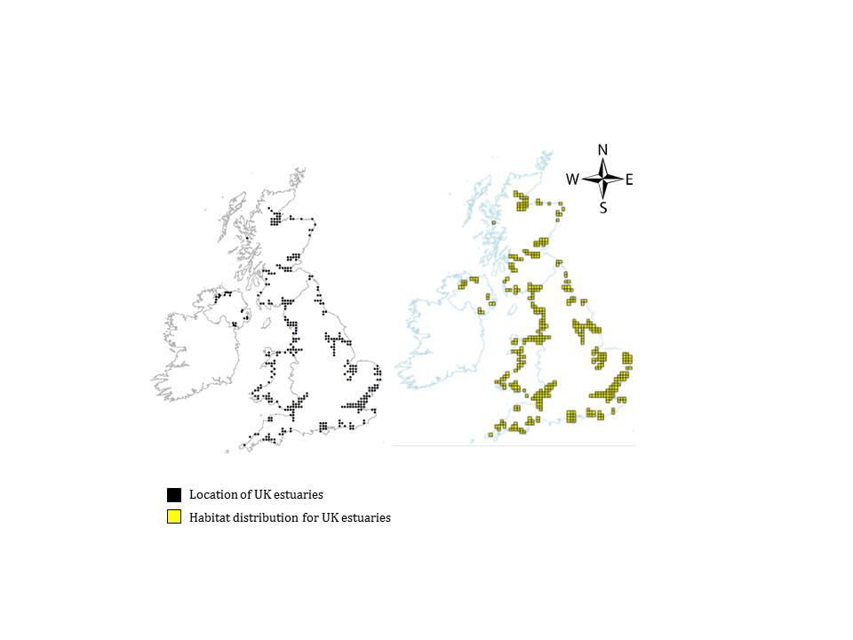

Figure : The location of UK estuaries and their subsequent habitat distiribution (JNCC, undated)

# 

# The Degradation of Coastal Wetlands

Wetlands account for less than 5% of the world’s terrestrial land mass (Tiner, 1984), however they have been a focal point for human settlements for millennia (Lotze et al, 2006). The “cradles of civilization” developed in, and around the coastal estuaries of the Middle East, India and China and from as early as 25 BC there is evidence of humans draining and modifying wetland habitats (Bildstein et al, 1991).

Since 1900, 50% of global wetlands have been either lost or modified (Tiner, 1984) due to industrialisation and rapid population growth which have resulted in long term environmental problems plaguing estuaries and coastal wetlands (Michener et a., 1997; Kennish, 2002). At present 60% of the human population live within 100 km of the coastline (UK NEA, 2011) and consequently many estuarine habitats are now facing intensive human pressures (Burton, 2007). Anthropogenic stressors include pollution inputs, loss and alteration of the estuarine habitat, nutrient enrichment and harvesting of native species (Kennish, 2002; Bildstein et al, 1991, Crooks & Turner, 1999; Smith, 2003). By 2025 it is expected that habitat loss will be the most significant damaging factor for wetlands and have far more severe ecological consequences for the biodiversity and health of the ecosystem (Kennish, 2002) with climate change and rising sea levels further exacerbating the impacts (Nicholas, 2004; Morris et al, 2002).

This is particularly relevant to estuarine habitats where the economic gains from the development of ports, barrages and industry are often favoured over conservation (Coombes & Jones, 2010). Further to this, 12% (41,910 hectares) of intertidal estuarine areas have been lost due to land reclamation in historical times (Davidson et al, 1991).

An additional problem for many estuarine habitats is coastal squeeze. As sea levels rise, the outermost parts of the intertidal habitats stay underwater all of the time, however flood defences prevent the intertidal habitat migrating inland, resulting in a loss of habitat (Environment Agency, undated).

There is growing evidence that many wetland dependent species are in decline, the most well documented of these being migratory waterbirds; 21% of waterbirds are extinct or globally threatened a greater percentage than those birds dependent only on inland wetlands and in Europe 39% of populations are decreasing (World Resources Institute, undated). To manage this problem under the European Union Directive 79/409/EEC for the conservation of wild birds, Member States are required to conserve the habitats of listed species through the designation of Special Protection Areas (SPAs) with many estuaries being designated as SPAs and European Marine Sites (EMSs) (Durrell et al, 2005). Whilst the directives provide protection for bird species and their habitat, they can also be at the root of conflicts between birds and human activities (Young, 2005).

In 2008, Defra commissioned Natural England to undertake a strategic review of the risks posed from all ongoing activities within EMSs. Natural England classed activities as those which could pose a high, medium, low, or no risk to designated Natura 2000 features (Coyle & Wiggins, 2010). Activities classed as a high risk are those which have been prioritised by Natural England as potentially requiring additional management measures to avoid deterioration and disturbance in line with the obligations under Article 6(2) of the Habitats Directive (Coyle & Wiggins, 2010). There were a large number of ongoing activities ranging from commercial vessels through to recreation. However only 2% posed a high risk to sites, whilst 66% of activities posed a low risk, suggesting that the activity was either well managed, had a low harm potential or was not taking place (Coyle & Wiggins, 2010).

For many EMSs the relevant authorities are fulfilling their legal obligations to protect the wetland areas, for example industrial discharge and planning consents, however difficulties arise in managing unregulated activities, such as recreation which can be equally damaging to sites (Coyle & Wiggins, 2010). In many situations, disturbance caused by humans through recreational activities has a far greater effect than that caused by natural factors (Kirby, Clee & Seager, 1993). An analysis of the Wetland Bird Survey Counts (WeBS) data for the UK showed that over 26% of human activities were responsible for disturbance to waterbirds (Robinson & Pollit, 2002). Consequently, in areas of high levels of human activity, repeated disturbance can result in a reduction in the survival or reproductive success of waterbirds (Finney et al, 2005).

Recreation however is considered an important asset to coastal communities. Many coastal areas suffer from various problems such as poor quality housing and high levels of social depravation (White et al, 2010) and it has been identified that residents who undertake activities along the coastline have a greater sense of place, wider social interactions and an overall improved quality of life (Cox et al, 2005). Recent research has highlighted the human wellbeing benefits derived from outdoor recreational activities, in particular the physical and mental health benefits from visiting open areas (Pretty et al, 2007; Fuller et al, 2007; Tzoula et al, 2007).

Consequently the issue of human disturbance is a complex: there is a justifiable need to conserve wetland biodiversity as instructed by EU Policy, but this should not be at a cost of societies benefits from coastal recreation (NEA, 2011; Scheffer, Brock & Westley, 2000).

# Research Focus

This chapter will focus on identifying the ecosystems services provided by the Tees Estuary and its surrounding coastline (Figure 5) The estuary has been subject to intense land reclamation and industrialisation, indeed the Tees Estuary has lost 90% of its intertidal area in the last 200 years (Figure 6) (McKlusky & Elliott, 2004).

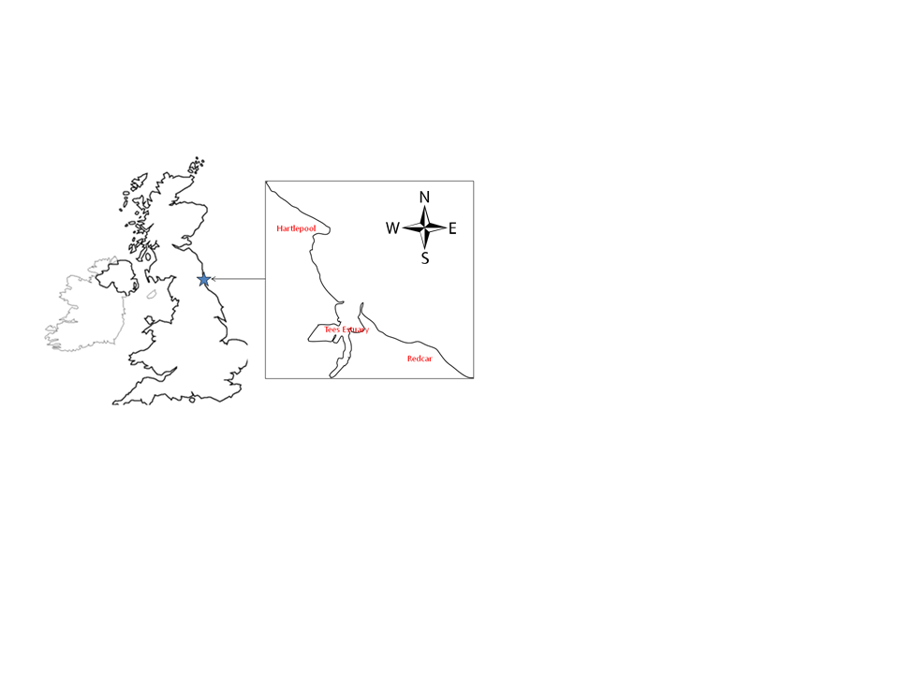

Figure : Location of the Tees Estuary

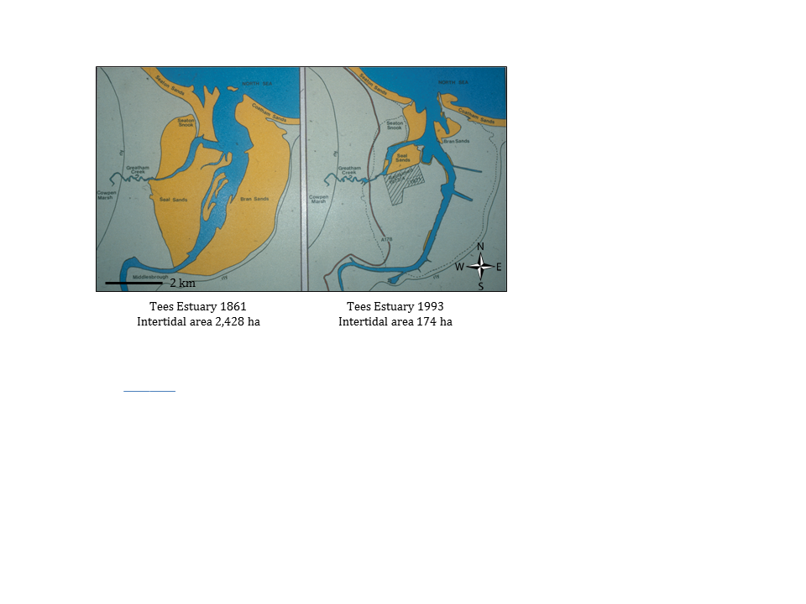

Figure 6: Land use change at the Tees Estuary from 1861 to 1993 (courtesy of INCA).

The Teesmouth and Cleveland Coastline qualifies as a Special Protection Area (SPA) under Article 4.1 of the Birds Directive (79/409/EEC) for supporting waterbird populations of European importance listed in Annex I of the Directive. It also qualifies under Article 4.2 of the Directive (79/409/EEC) by supporting migratory waterbird populations of European importance (JNCC, 2001). The intertidal and sub-tidal areas of the SPA are known as the European Marine Site (EMS). In 1995 the site was designated as a Ramsar Site for its status as an internationally important wetland (INCA, 2009). However, under future flood defence scenarios it is expected that there will be an overall loss of intertidal habitat within the EMS of approximately 13 ha over the 100 year lifetime of the Tees Estuary Flood Defence Strategy (Environment Agency, undated).

The aim of this chapter is to identify, rather than value the ecosystem services provided by the Teesmouth and Cleveland EMS as a starting point for the implementation of an Ecosystem Approach to management (as outlined in Chapter 1). As discussed by Daily & Matson (2008) the mapping of ecosystem services provided by the EMS provides a focus for stakeholder engagement by integrating social and ecological aspects of the Ecosystem Approach, as well as providing a baseline to advance local policy. As yet however there is no standardised methodology with many organisations developing their own frameworks for applying an Ecosystem Approach (Raffaelli & Frid, 2009). This thesis follows the methods developed by Haines-Young & Potschin, (2007) as part of the Defra Project NR017.

## Methodology

# The Research Boundary

The Teesmouth and Cleveland Coast SPA covers nearly 1250 ha of which the intertidal areas are designated as the EMS. The SPA is composed of six SSSI units () which are again divided into further sub units for JNCC site condition reporting. It was decided that the ecosystem services would be calculated for all SSSI units within the SPA (rather than only those forming the EMS) as all areas are subject to disturbance and should be considered in future management of the area (Natural England, 2011a).

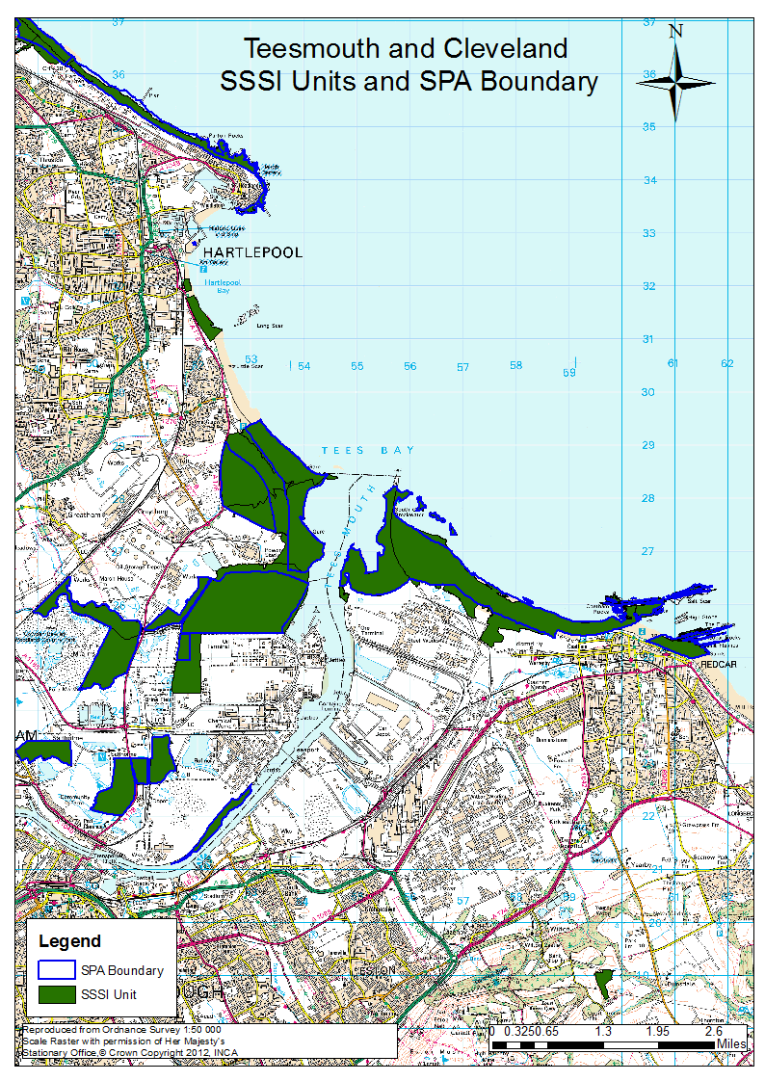

Figure 7: The Teesmouth and Cleveland Coast SPA and SSSI Units

# Estimating Habitat Area

For each SSSI, the areas (in hectares) of each Biodiversity Action Plan (BAP) Priority Habitats were calculated using Natural England’s Nature on the Map (URL: http://www.natureonthemap.naturalengland.org.uk/) and Defra’s Magic Map (URL: http://magic.defra.gov.uk/). Five priority habitats were identified ().

For consistency in calculations each Magic Map was produced on a 1:23000 scale. For all maritime cliff identified the perimeter was estimated at the 1:23000 scale and a standard one metre width was applied to convert the perimeter to the area.

|  |
| --- |
| Table 2: A description of the five Priority Habitats identified for the Teesmouth & Cleveland Coast EMS (JNCC, 2010) |
| Improved Grassland (Coastal and Floodplain Grazing Marsh)  The UK BAP defines improved grassland as ‘periodically inundated pasture, or meadow with ditches which maintain the water levels, containing standing brackish or fresh water’. The ditches are characterised by a high species richness of plants and invertebrates. Many areas are grazed but some contain permanent ponds with emergent swamp communities, although not to the extent of tall fen communities (JNCC, 2010).  For the Teesmouth and Cleveland Coast grazing marsh is particularly important for breeding waders including lapwing and curlew. |
| Coastal Saltmarsh  Coastal saltmarshes are found in the vegetated portions of intertidal mudflats between mean high water neap tides and mean high water spring tides and are restricted to sheltered locations. Natural saltmarsh systems show a clear zonation in species depending on the frequency of inundation by tides, exhibiting an increase in species richness as inundation decreases (JNCC, 2010).  For the Teesmouth and Cleveland Coast coastal saltmarsh is found in the estuary and saline lagoons to the north of the estuary. These areas are an important resource for wading birds and waterfowl:   * They act as high tide refuges for birds feeding on adjacent mudflats. * In summer are used as breeding sites for waders, gulls and terns. * In winter they are an important food source for migratory waterbirds. |
| Fen, Marsh and Swamp  Fen, marsh and swamp are vegetated, non-woodland, habitats that are groundwater fed and either permanently, seasonally or periodically waterlogged. They usually exist as marginal vegetation at the edge of lakes and ponds, along river edges and within wet ditches and pools (JNCC, 2010). |
| Intertidal Mud Flats  The UK BAP defines intertidal mudflats as ‘sedimentary intertidal habitats created by deposition in low energy coastal environments, particularly estuaries and other sheltered areas’ (JNCC, 2010). The sediment has a high organic content consisting of silts and clays, although the proportion of sand increases towards the estuary mouth.  Mudflats have an important role in coastal defence through dissipating wave energy and thus limiting the flooding of saltmarshes and grazed land (JNCC, 2010).  The mudflats of the Tees Estuary have been subjected to intensive land claim (Davidson et al, 1991) and due to the natural role of mudflats in nutrient chemistry, the organic sediments have sequestered contaminants and contain high concentrations of heavy metals (INCA, 2009).  However the area is still highly productive supporting internationally important populations of migrant and wintering waterfowl (INCA, 2009). |
| Maritime Cliff  The UK BAP defines maritime cliffs and slopes as ‘vertical faces on the coastline where a break in slope is formed by slippage and/or coastal erosion’ (JNCC, 2010). However there is no generally accepted definition of the minimum height or angle of slope which constitutes a cliff. On the landward side it should extend to the limit of maritime influence and on the seaward side extend to the limit of the supralittoral zone (JNCC, 2010).  Maritime cliffs can broadly be classified as ‘hard cliffs' or 'soft cliffs';   * Hard cliffs are vertical or steeply sloping and support little vegetation. * Soft cliffs are formed in less resistant rocks such as shales or in unconsolidated materials such as boulder clay and result in shallower slopes. As such they are more easily colonised by vegetation.   Maritime cliffs are often significant for their populations of breeding seabirds, many of which are of international importance; for the Teesmouth and Cleveland Coast the areas are important for shag (JNCC, 2010; INCA, 2009). |

# 

# Estimating Ecosystem Services

Each Priority Habitat will provide a variety ecosystem services. However, quantitative measures of service provision are limited, in particularly those used to identify services on small scale local levels, and cultural services, both of which are essential to this report. Instead a score is used to determine the importance of each Priority Habitat in terms of the level of each ecosystem service it provides () as suggested by Raffaelli et al, (2007) and Haines-Young & Potschin (2007). The scores for each Priority Habitat were developed as part of the Defra project NR017. A questionnaire was sent to the lead-name cited in documentation relating to the target revision for each Priority Habitat. Respondents were asked to consider the wider benefits that these habitats might provide in terms of the ecosystem typology provided by the MA for 16 Priority Habitats (Haines-Young & Potschin, 2007). This resulted in a score for the level of ecosystem service provision each habitat provides ranging from 0 (unimportant) to 5 (very important).

The scores were then used to estimate the services provided by each habitat type. For example, Seal Sands SSSI had a total of 0.8 hectares of Maritime Cliff, therefore it’s recreation score was 0.8 (hectares) x 5 (very important) = 4. This was repeated for each habitat within the individual SSSIs to derive the level of ecosystem service provision for area. Service provision for the whole of the EMS was obtained by adding up the scores for each individual SSSI.

|  |  |  |  |  |  |  |  |  |  |  |  |  |  |
| --- | --- | --- | --- | --- | --- | --- | --- | --- | --- | --- | --- | --- | --- |
| Table 3: The importance of different coastal habitats for delivering ecosystem services (adapted from Haines-Young & Potschin, 2007 ) | | | | | | | | | | | | | |
|  | **Ecosystem Services** | | | | | | | | | | | | |
| **Regulatory** | | | | | | **Provisioning** | | | | **Cultural** | | |
| Climate Regulation | Pollination | Pest Control | Water Regulation | Water Quality | Erosion Prevention | Food Protection | Potable Water Supply | Genetic Resources | Raw Materials | Recreation | Aesthetics | Heritage |
| Improved Grassland (Coastal & Floodplain grazing marsh) | 2 | 1 | 1 | 3 | 1 | 3 | 4 | 4 | 1 | 1 | 4 | 2 | 1 |
| Fen, Marsh & Swamp | 2 | 1 | 0 | 3 | 5 | 2 | 1 | 4 | 4 | 2 | 2 | 2 | 2 |
| Maritime Cliff | 0 | 0 | 0 | 0 | 0 | 4 | 0 | 0 | 3 | 0 | 5 | 5 | 0 |
| Coastal Salt Marsh | 3 | 2 | 0 | 4 | 2 | 4 | 2 | 0 | 4 | 0 | 3 | 4 | 3 |
| Intertidal Flats | 3 | 0 | 0 | 0 | 0 | 3 | 1 | 0 | 4 | 0 | 4 | 4 | 3 |

## Results

There were variations in the areas of each SSSI ranging from 30 hectares for Redcar Rocks, up to 396 hectares for Coatham Sands. To account for this, the ecosystem service data are presented as percentages of total service provision for each SSSI, rather than absolute values. The Tees and Hartlepool Foreshore & Wetland SSSI was divided two units for the calculation based on geographical distributions, with sub-unit one accounting for Hartlepool North Sands (unit 1 for JNCC reporting) and sub-unit two accounting for Tees Estuary (units 2 -7 for JNCC reporting).

Recreation was found have the highest level of ecosystem service provision across the whole of the SPA, followed by the provisioning services of food production and potable water supply. Of the regulatory services, erosion prevention and water regulation were found to be the most important for the SPA (Figure 8).

Recreation also had the highest level of ecosystem service provision within each SSSI (Figure 9). The SSSIs along the coastline recorded high levels of cultural services (recreation and aesthetics) as well as erosion prevention. The SSSIs found further inland and along the estuary edges supported a wider range of services with three out of the four inland SSSIs providing all services to some degree.

Figure 8: The level of ecosystem provision for all SSSI units combined across the Teesmouth and Cleveland Coast EMS, divided in regulatory, provisioning and cultural ecosystem service categories

Figure : Ecosystem service provision ranked in terms of relative importance for each SSSI site at the Teesmouth and Cleveland Coast SPA

## Discussion

Overall cultural services were found to have the highest level of ecosystem service provision across the whole of the SPA, with recreation the most significant of these. Indeed recreation was found to be the most provided service at all of the SSSIs. The NEA recognised that cultural ecosystem services provided by the coast are very important due to the economic benefits gained from tourism with seaside tourism currently valued at £17 billion (NEA, 2011) with the stretches of beach, marine cliffs and estuarine habitats provide numerous recreational opportunities (MEA, 2005).

The UK NEA found that provisioning services in the coastal margins were relatively minor (NEA, 2011), however at the Teesmouth & Cleveland EMS food supply and potable water supply were the second, and third highest provided services after recreation. The SSSI sites found on, or near the estuary were the highest providers of these, rather than the seafront sites. Indeed the sites of Seaton Dunes, Cowpen Marsh and the Tees Estuary provided some level of all 13 ecosystem services. These areas included a greater variety of habitats covering maritime cliff, salt marsh, intertidal sand flats and coastal floodplain and grazing marsh which results in a wider variety of ecosystem service provision. In comparison the coastal sites of Hartlepool Headland, Coatham Sands and Redcar had far fewer services due to marine cliff being the only BAP habitat recorded. However, the Coatham Sands SSSI included a large area of sand dunes, a BAP habitat but one which did not have an ecosystem service score under the methodology followed which may have limited the identification of the ecosystem services provided in this area.

It is important to note that the ecosystem service provision calculated is the level that could be potentially provided, not necessarily the current level of provision (Haines-Young & Potschin, 2007). For example the coastal defence system of the estuary is currently being developed by the Environment Agency. Greathem Creek North West has been identified as a managed realignment site following the work to improve the flood defences at Greathem North East and Redcar Seafront. By partially removing sections along the existing sea defence along the north bank of Greatham Creek 29 ha of intertidal habitat will be created including 9 ha of UK BAP habitat (Environment Agency, undated). The managed re-alignment will limit the effect of coastal squeeze at the estuary following the £30 million development of the sea defences at Redcar Promenade (RCBC, 2011a). The Ecosystem Approach was used by the Environment Agency in planning the managed realignment of Alkborough Flats at the Humber Estuary. The approach demonstrated that the loss of provisioning services (arable land) would provide beneficial regulatory, cultural and supporting services in terms of flood defence for the wider Humber area (Defra, 2010b).

At the Teesmouth and Cleveland SPA walking, dog walking, bird watching and angling are highly popular activities (INCA, 2009). Redcar Rocks SSSI and Coatham Sands SSSI are both found in close vicinity to the seaside resort. Indeed the tourism sector accounts for 7.8% of total employment in Redcar compared to 5.2% across the Tees Valley (nomis, undated; Tees Valley Unlimited, undated) with £17 million generated from tourism annually (Beaty et al, 2010). The current seafront development forms part of an overall £75 million regeneration of Redcar. Recreation was also significant for the Hartlepool Headland sub-unit of the Tees & Hartlepool SSSI. Tourism in this area has increased 106% between 1997 and 2006 with 7.6% of employees working in the tourism sector (HBC, 2010). Throughout the Tees Valley the tourist industry increasing with the industry accounting for an estimated 5.8% of total Gross Value Added (GVA) compared to the process industries at 6.5% GVA which have traditionally dominated the Tees Valley (HBC, 2010). Wildlife recreation is recognised as forming an important part of the continued growth of the tourism industry, indeed RCBC are aiming to increase visitor’s numbers by 10,000 per annum by 2025, as a result of enhanced wildlife in the area (RCBC, 2010).

Alongside the economic benefits of recreation, there are the human wellbeing benefits through a sense of belonging at coastal areas (Holt et al, *in press*). The Tees Valley has high levels of depravation with 18% of Tees Valley Lower Super Output Layers in the national most deprived 5% (Communties.gov.uk). Recreational activities available at the coastline improve the quality of life for these residents, affecting their mental and physical wellbeing (Pretty et al, 2007; Cox et al, 2005).

However, the social and economic benefits from recreation are considered most important at the local scale, considering the global picture biodiversity support, water quality improvement, flood abatement, and carbon management are considered the most important services (Zedler & Kercher, 2005). Whilst the protection of these is highly detailed under European Law (including the Habitats Directive, the Water Framework Directive and Natura 2000 all of which are integrated into the Marine Strategy Framework Directive) (Wakefield, 2010), current recreational activities have been found to be having a detrimental effect on the biodiversity and wildlife in the area (Coyle & Wiggins, 2010). There is discussion in literature that the current range of EU Environmental policies are failing to consistently link together, which has resulted in segmented protection of specific components of biodiversity, rather than creating a framework to manage the whole area, and integrating humans into this system (Holt et al, *in press*; Wakefield, 2010). This makes it particularly difficult for those who are concerned with managing the area at local scale, for example local authorities, where their focus lies on maintaining and improving the area for local people.

Consequently it is recommended that an alternative approach to the present management of the Teesmouth and Cleveland EMS should be considered. There is a clear need to achieve a balance between the need to conserve the site and protect the ecosystem functioning, without the compromising the needs of the local people to whom recreation is fundamental to not only their economy, but also their physical and mental wellbeing.

### Chapter 3: An Analysis of Recreational Disturbance at the Teesmouth and Cleveland European Marine Site

## Abstract

At present 69% of the Teesmouth and Cleveland Coast European Marine Site (EMS) is currently classified as being in ‘unfavourable condition’ due to high declines in waterbird numbers. In many situations, disturbance caused by humans to waterbirds has a far greater effect than that caused by natural factors, resulting in a growing need to manage recreational activities.

To fully understand the impacts of recreational disturbance at the EMS a waterbird disturbance survey and visitor survey were undertaken at six public access sites.

Statistical analyses for the waterbird survey focussed on calculating the mean response of birds and mean impact on birds from disturbance events. Results indicated that off-road vehicles had the greatest negative effects on birds across all sites with a mean response and mean impact disturbance of 2.75. Birds had a low mean response dog walkers, however, when these activities did disturb birds the mean impact of disturbance was relatively high (2 and 1.9 respectively).

The visitor survey highlighted that visitors showed a distinct lack of awareness for the conservation status of the EMS and the potential impacts they could have on waterbirds. However, visits did consider the natural environment as one of the most important attributes of the survey sites.

Regression analysis indicated that sites were more likely to be classified as in unfavourable condition when users visited the site daily and their main activity was walking. Sites which were visited less often and by people who were more aware of the impact their activity may have on coastal birds were less likely to be in unfavourable condition.

There is a clear need to inform users of the potential impacts that their recreational activity is having on the EMS. Following the Ecosystem Approach managers should be encouraged to engage with local stakeholders, to develop a plan for the management of recreational activities.

## Introduction

Chapter 2 identified and discussed the ecosystem services provided by the Teesmouth and Cleveland Coast Special Protection Area with recreation accounting for the highest level of ecosystem service provision. This chapter explores who benefits from recreation at the EMS, and the potential negative impacts on the conservation status of the site arising from recreational use.

# Requirement for Conservation

The Convention on Biological Diversity recognised for the first time in international law that conservation is "a common concern of humankind" and brought together elements of the Berne Convention on the conservation of European Wildlife and natural habitats and the Ramsar Convention on Wetlands of International Importance (Jackson et al, 2004). Within these conventions there is a requirement for parties to establish protected areas for conservation. Under the European Union Directive 79/409/EEC for the conservation of wild birds, Member States are required to conserve the habitats of listed species through the designation of EMSs (Durell et al, 2005).

The Teesmouth and Cleveland Coast qualifies as an EMS under Article 4.1 of the Birds Directive (79/409/EEC) for supporting waterbird populations of European importance listed in Annex I of the Directive. It also qualifies under Article 4.2 of the Directive (79/409/EEC) by supporting migratory waterbird populations of European importance (JNCC, 2001). In accordance with this the EMS is subject to special conservation measures to protect the waterbirds breeding, roosting and foraging sites (INCA, 2009).

Many features protected under EU Law for conservation also safeguard those features which attract people for recreation and tourism (Farrell & Runyan, 1991). As identified in Chapter 2 the Teesmouth and Cleveland EMS is an important site for recreation with the ecosystem service mapping highlighting the important cultural values provided by the area. As discussed by Hillery et al, (2001) a site characterised by high cultural values, as well as rich biodiversity will become more popular. This which raises the concern that visitors are impacting on the very values which attracts them to the site (McCool, 1995; Lynn & Brown, 2003).

At present 71% of the SSSI units which form the Teesmouth & Cleveland SPA are classed as being in unfavourable condition () (Natural England, 2011a). The unfavourable condition statements are a result of the decline in waterbird numbers (for example knot *Calidris canutus,* and sanderling *Calidris alba* have declined by 64% and 51%, respectively, over the past 25 years (Natural England, 2011b).

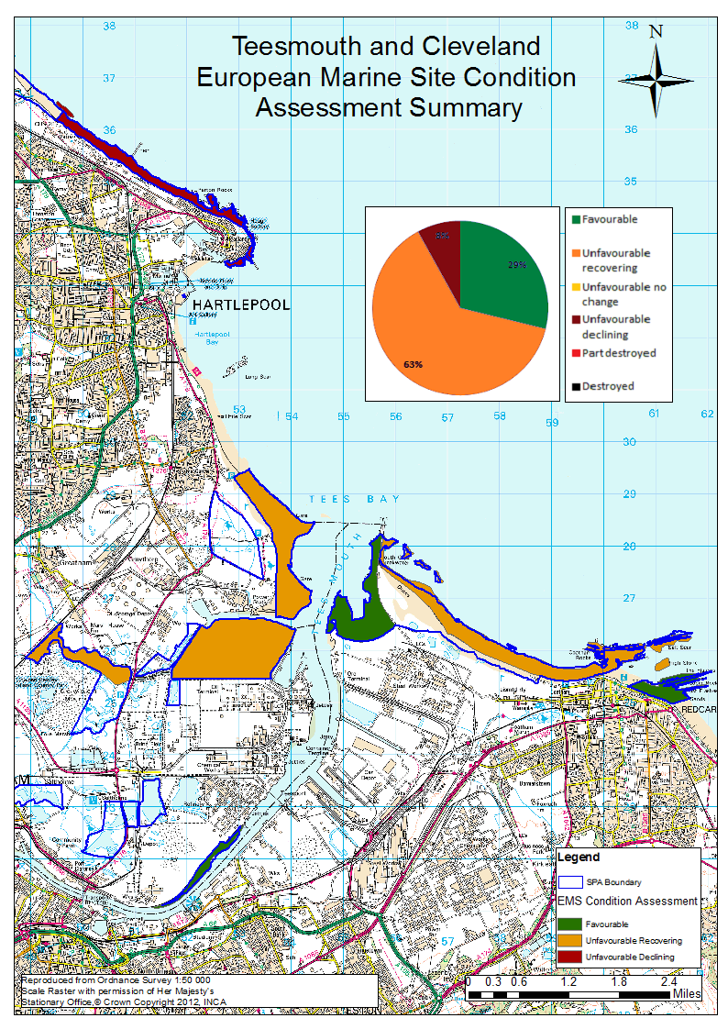

Figure 10: Summary of the condition status for the EMS (Natural England, 2011b)

The causes of the decline in waterbirds are subject to continued debate, with the present focus on unregulated pressures. One possible cause of decline is the nutrient enrichment of the estuary. This leads to eutrophication of the estuarine waters and the growth of *Entermorpha* which may limit the macro-invertebrate prey available for the waterbirds (Donoghue et al, undated). The Environment Agency undertook monitoring of *Entermorpha* growth at Seal Sands during 2008 and 2009 and it is expected the survey will be repeated during summer 2011 if required for the Water Framework Directive. The second unregulated pressure derives from increasing recreational activities throughout the EMS. The Defra 2008 strategic review of the risks posed from all ongoing activities within EMS identified one high risk, seven medium risks, and 11 low risks. Disturbance caused by recreational activities has been identified as a generic high risk to many EMSs including the Teesmouth and Cleveland Coast EMS (Coyle & Wiggins, 2010).

# Defining Disturbance

The EU Commission defines disturbance as “any phenomenon that causes a significant change in the dynamics or ecological characteristics of populations of birds”(EU Commission, 1992). Within this there is much variance both in terms of disturbance level itself (magnitude, frequency, spatial distribution and duration), and the susceptibility of different species (with respect to age, season, weather, and habituation) (Hockin et al, 1992). Disturbance is often highly localised in time and space ().

Figure 11: The disturbance gradient for recreational activities (Hockin et al, 1992)

In many situations, disturbance caused by humans has a far greater effect than that caused by natural factors (Kirby, Clee & Seager, 1993). An analysis of the Wetland Bird Survey Counts (WeBS) data for the UK showed that over 26% of human activities were responsible for disturbance to waterbirds (Robinson & Pollit, 2002).

Indirect disturbance arises from people removing flora and fauna either through direct removal from the sub-strata or trampling of the sediment (Schaefer et al, 2000). These result in changes to algal assemblages (Schiel and Taylor, 1999) and subsequently alter the food supply available to waterbirds.

Direct disturbance arises from activities which cause birds to be flushed from the area. Activities which involve rapid movement or close proximity to roosting birds (for example running) cause them to flush more frequently than slower activities (for example birdwatching) (Burger, 1981). Distance is also a key factor; birds are more likely to be flushed when the activity is close, but are less responsive in the water where they are rarely flushed regardless of the activity (Burger, 1981). Research has shown that recreational disturbance is concentrated on the upper shore, mainly in daylight hours, and is greatest at the weekends and during summer (Cayford, 1993) when visitor numbers are highest (Burton, 2007). The UK WeBS counts found that disturbance was greatest during the summer months with 35 - 40% of activities causing disturbance from June through to September (Robinson & Pollit, 2002).

Walking and dog walking are the most frequently recorded activities at the coast (Robinson & Pollit, 2002) and dog walking is more likely to disturb birds than walking, as the birds see the dogs as predators (Burger, 1981; Lafferty, 2001). Bait digging can also have significant negative effects on the waterbirds. The act of removing bait reduces the prey available for the waterbirds, whilst the presence of bait diggers displaces the waterbirds from the area, especially more sensitive species such as curlew *Numenius arquata* and redshank *Tringa totanus* (Burton, Rehfisch & Clark, 2002). However it has been suggested that waterbirds habituate to disturbance, in time becoming less responsive to the activity (Fitzpatrick & Bouchez, 1998).

Consequently, increased use of the coastal zone for recreation may result in negative effects on breeding populations (Scheafer et al, 2000; Gill, 2007).

# Measuring Disturbance

Disturbance studies have tended to focus on the behavioural responses of waterbirds to disturbance, such as flight and changes in foraging behaviour (Ward & Andrews, 1993). These responses are relatively easy to measure, but it is difficult to quantify the impacts on populations (Gill, Sutherland & Norris, 1998).

Waterbirds have a strong capacity to vary their intake rate in response to environmental and physiological demands (Dugan et al, 1981) and their tolerance to activities will vary according to the local conditions (Burton, 2007). The decision for birds to move away will be determined by a variety of factors, including the quality of the present site, the distance to and quality of other sites, the risk of predation at other sites and the investment that the individual has made at the present site (Gill, Norris & Sutherland 2001). This raises the question that when a bird leaves the site due to disturbance it may be because alternative sites are available. In contrast when birds choose to stay, appearing undisturbed, there may in fact be another suitable site so that they are forced to remain regardless of the reduction in foraging or roosting opportunities (Gill, 2007).

Localisation of disturbance can make it difficult to determine whether an activity is causing temporary displacement of birds, or inducing a more severe impact on the population (Hill et al, 1997). Research needs to focus on those species which have already shown declines in population, for which human disturbance is already implied, rather than restricting human access in areas where disturbance has no proven effect (Gill, Sutherland & Norris, 1998).

# Research Focus

The relevant authorities need to be definitive in their approach to managing recreational activities at the EMS in order to instigate the necessary changes (Welford & Ytterhus, 2004). Following the Ecosystem Approach, the management of recreation and conservation is dependent on how they are perceived by local people (Daily, 1997; Daily 2000). Managers should be encouraged to investigate, and consider visitor perceptions when planning management actions involving recreation and conservation (Yorio et al, 2001; Burger 2000), alongside obtaining empirical data to clarify the level of disturbance (Burger et al, 2003).

The results of Chapter 2 suggest that the Teesmouth and Cleveland Coast has a high cultural value and subsequently there is now a need to establish which aspects of the area (benefits) encourage local people and tourists to visit coastal areas (Booth et al, 2010). The UK NEA (2011) discusses that a range of participatory and deliberative techniques, both quantitative and qualitative is needed to identify ecosystem services.

One potential assessment option would be to undertake an economic valuation exercise to ascertain the costs and benefits associated with managing the Teesmouth and Cleveland Coast SPA. Following the work of Jacobs et al (2004) who researched the value of the Scottish Natura 2000 network this would involve assessing:

* Direct costs (for example site management and policy related costs)
* Opportunity costs (for example limitations on industry from not being able to develop on the SPA)
* Indirect costs (for example impacts of visitors trampling the sand dune system)
* Direct use value (for example walking or shore angling)
* Non-use value (people willing to pay to know the area still exists)
* Indirect use values (realting to ecosystem functions such as storm buffering capacity of saltmarsh).

At present there is a bias towards economic assessment (Hein et al, 2006) and not enough information on shared social, ethical and aesthetic values for conservation areas (Booth et al 2010; UK NEA 2011). When the Teesmouth and Cleveland Coast Management Group were approached with the idea of a valuation exercise at the start of the research project many of the group felt that a valuation exercise at this stage in the management would have few tangible benefits on the conservation status of the SPA. Instead the social research technique of participatory resource management was favoured by the Management Group. This technique engages stakeholders on multiple levels of decision making, with the aim of forming, and strengthening relationships amongst stakeholders (Brett et al, 2010; Prell et al, 2009). For the Teesmouth and Cleveland EMS local residents are considered to be the primary stakeholders and members of the management group are the secondary stakeholders or frontline deliverers ().

|  |  |
| --- | --- |
| Table 4: Stakeholder Groups: A combination of theories (Rawlins, 2008) | |
| Stakeholder Levels | |
| *Strategic decision makers:*  These tend to lead on developing local visions and fundamental decisions about the resource  For example senior local authority leaders | *Tertiary stakeholders:*  The broader committees which the primary and secondary stakeholders belong to |
| *Frontline deliverers:*  Responsible for translating policy into action  Many are in an advisory role on management groups | *Secondary stakeholders:*  Organisations and bodies whose interests will be directly impacted by a change in management |
| *Local residents and community groups:*  People who live within the management area | *Primary stakeholders:*  Individuals who will be directly impacted by a change in management of the EMS |

For the Teesmouth and Cleveland EMS it is believed the recreational activities are disturbing the waterbirds. This needs to be clarified by establishing baseline data for waterbird disturbance at the public access areas of the site. This ensures that resources are directed to appropriate areas and that public access is not limited unnecessarily. It was decided that a bird disturbance survey would be undertaken at the public access areas of the EMS.

There is also a need to understand the relationship between conservation and recreation:

* *Who benefits from recreation at the site?*
* *What predicts the level of recreational use?*
* *Does the general public believe any particular recreational activities are having more of a negative impact on the site?*
* *To what extent do visitors influence the Natural England Site Condition Status?*

Recent work on recreational disturbance has recommended focussing on ‘behavioural and access patterns’ which allows areas of high visitor pressure or particular problems to be identified (see Liley, 2007). Detailed visitor surveys can be used to determine the frequency of activities, in which locations, and under what conditions (see Cruickshanks, 2010). It was decided that visitor surveys would act as the first step in engaging with the local users of the EMS.

## Methodology

# Data Collection

To fully understand the impacts of recreational disturbance at the Teesmouth and Cleveland Coast EMS a waterbird disturbance survey and visitor survey were completed. The fieldwork took place from September to October 2010 () with the surveys conducted alongside one another allowing the findings to be linked and ensuring that practical management recommendations could be made based on the results (Liley, 2007).

Six field work sites were chosen; Hartlepool North Sands, Hartlepool Headland, North Gare Sands, South Gare, Coatham Sands and Redcar Rocks (Figures 12 - 14), based on their nature of access (that is they were all public access sites and readily accessible for members of the public) and to achieve good spatial coverage of the estuary. Selection of sites was also guided by ongoing bird counts and the advice about suspected disturbance on all but one of these sites (Hartlepool Headland) (advice was taken from Natural England and Hartlepool Borough Council).

The dates and times of each survey were determined by the tidal cycle. Prior to study taking place it was deemed necessary to separate the effects of the tidal cycle on disturbance meaning each site was surveyed once at high tide and once at low tide (as recommended by Liley, 2007). Each survey lasted three hours commencing one and half hours before high/low tide until one and half hours after high/low tide. Where possible the surveys were undertaken at different times of the day and differing days of the week. The sites where disturbance was expected to be greatest (Redcar Rocks, Coatham Sands and North Gare) were surveyed on at least one weekend day when it was expected that recreational use would be greater. It is recognised that that this is a small sampling frame for bird disturbance work and it is important to state that this was used as a scoping study to assess the potential for a more detailed disturbance study to be conducted at a later date by the Teesmouth and Cleveland Coast Management Group.

|  |  |  |  |  |
| --- | --- | --- | --- | --- |
| **Table 5: Fieldwork dates and times** | | | | |
| **Location** | **Date** | **Start** | **High Tide** | **Low Tide** |
| Hartlepool Headland | 14/09/2010 | 13.30 | - | 14.25 |
| Coatham Sands | 15/09/2010 | 14.00 | - | 15.40 |
| Redcar Rocks | 15/09/2010 | 14.00 | - | 15.40 |
| Hartlepool North Sands | 17/09/2010 | 10.30 | 12.02 | - |
| Redcar Rocks | 18/09/2010 | 12.00 | 13.34 | - |
| Coatham Sands | 18/09/2010 | 12.00 | 13.34 | - |
| South Gare | 20/09/2010 | 13.30 | 15.11 | - |
| Hartlepool Headland | 21/09/2010 | 14.00 | 15.35 | - |
| North Gare | 25/09/2010 | 10.00 | - | 11.42 |
| Hartlepool North Sands | 27/09/2010 | 11.00 | - | 12.34 |
| South Gare | 30/09/2010 | 13.15 | - | 14.45 |
| North Gare | 04/10/2010 | 11.00 | 12.35 | - |

|  |  |
| --- | --- |
| **Key** | |
|  | Bird survey: surveyor with set position or roam up to 10 m |
|  | Bird survey: surveyor with no set position, move freely between points |
|  | Visitor survey: surveyor can move freely around the survey site |
|  | Sample area |

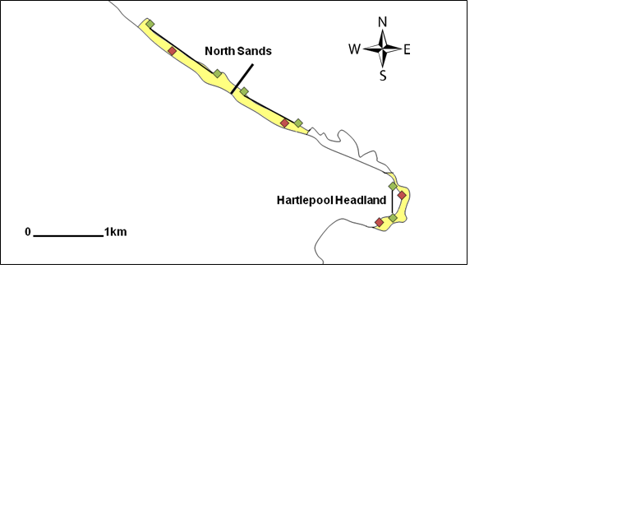

Figure 12: North Sands and Hartlepool Headland

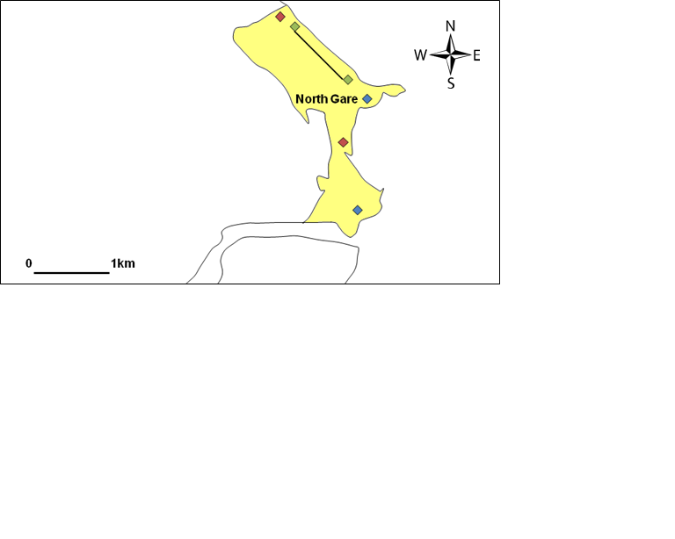

Figure 13: North Gare

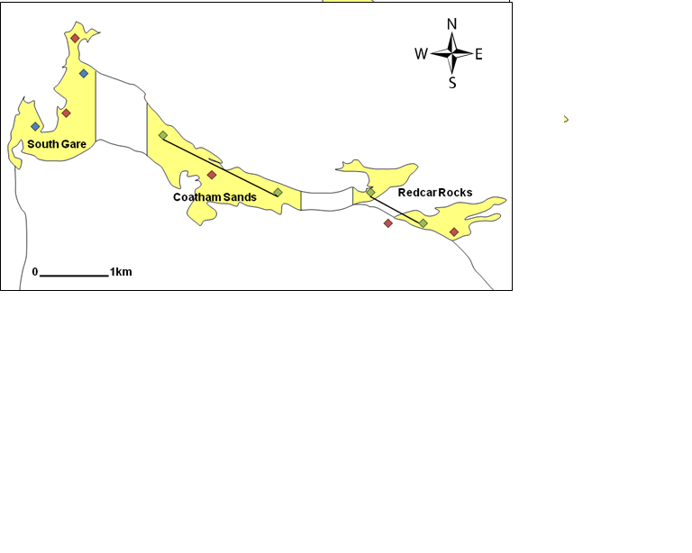

Figure 14: South Gare, Coatham Sands and Redcar Rocks

# 

# The Waterbird Survey

The waterbird survey methodology follows the work of Ravenscroft et al, (2007) on recreational disturbance at the Stour - Orwell Estuary. A count of the number and species of waterbirds at each site was undertaken at the beginning of each survey, with a second count at high/low tide and a count one and half hours after high/low tide. The survey was conducted by the same two people at each site.

All recreational activities (events) which occurred during the three-hour period were recorded on a tally chart, regardless of whether they caused disturbance to birds. The events were categorised as angling, bait digging, bird watching, diving, dog walking, horse riding, kite-surfing, vehicles, walking, windsurfing and other.

The events which caused disturbance were recorded on a scale of 0 – 3:

* 0: No disturbance to birds
* 1: Birds move less than 50 m
* 2: Birds move over 50m
* 3: Birds leave the study site

The number and species of birds which were disturbed were also recorded (see Appendix 1 for the bird survey form).

The bird survey data were recorded in an Excel spreadsheet. For the subsequent analysis, events were classified as any recreational activity at the study site, and disturbance events classified as any recreational activity causing disturbance to the birds:

* The mean response of birds to events was calculated from the disturbance indices 0 – 3.
* The mean impacts of events on the birds were calculated using disturbance indices 1 – 3.

The data were analysed by site, tide and event using SPSS (*H* = Kruskal Wallis, *U=* Mann Whitney). The mean numbers of birds at each site were calculated for high and low tide by calculating the mean from each hour and an half count.

# The Visitor Survey

It was decided that the visitor survey would take the form of a semi structured questionnaire. These questionnaires improve the context of which to evaluate findings due to the range of structured and open ended data (Chaniotis & Stead, 2007). It was decided that face to face questionnaires should be conducted at the coast itself as this allows the respondents to view all coastal aspects and increases the likelihood that the sampling frame will include local and non-local visitors, as well as being more cost effective than postal surveys (Floyd & Fowler, 1988).

The visitor survey was piloted at Filey Brigg, a SSSI on the Yorkshire Coastline. The survey took place for 3 hours on Wednesday 1st September 2010, and of the 15 people approached to take part 11 people agreed to complete the survey form. Following the pilot study it was decided that the interviewer would talk the questions through with the respondent, rather than leaving them to complete the survey as this improved the response rate. Questions which were difficult to answer or elicited a low response rate were also removed (Table 5).

As the surveys were undertaken at the sample site it was decided to approach people randomly to complete the questions. At the quietest sites (North Sands, Hartlepool Headland and North Gare each ‘passer by’ was asked if they would wish to take part in the survey. At the busier sites (South Gare, Coatham Sands and Redcar Rocks) every fifth person who passed the interview was asked if they would like to participate. Potential interviewees were approached with a brief ‘cheap talk introduction’ to explain the purpose of the survey and who the interviewer was, with the aim of placing the survey in a real life setting (see Cummings and Taylor, 1999). Respondents were guided through the questions by the interviewer with the survey taking between 5 and 10 minutes. The questionnaires were conducted by seven different people, with at least three being present for each session, one of which conducted all twelve sessions with one person continually present. Consistency between the interviewers was achieved through a training session to ensure each person was interviewing in the same format. The key aspect of the survey for Natural England was how respondents felt about the potential code of conduct. To place the code of conduct in context a copy of the countryside code was shown to each respondent to ensure that each respondent was clear of what a code of conduct entailed.

|  |  |  |  |  |
| --- | --- | --- | --- | --- |
| Table 5: Survey questions and reasons for their inclusion | | | | |
| 1. Using the following list, please rank the top three activities you carry out at this site. | | *To establish the main activities occurring at each site in order to establish the similarities and differences between the six survey sites* | | |
| 1. What is it about this particular site that makes you visit it? Please rank the top three features. | | *To establish which features attract people to each site and to assess similarities and differences between the survey sites* | | |
| 1. How often do you visit the site? | | *To establish how often each site was visited and how this relates to the activities and features at each site* | | |
| Question 4 was a series of statement questions measured on a Likhert scale (range 1 = strongly disagree to 5 = strongly agree)  The six questions covered three motivational axes towards conservation i.e. self (personal satisfaction), altruism (concerns for society outside of one’s self) and the environment (concern for wider environmental issues) | | | | |
| a) Visiting the coastline makes me happy. | | | *Self* | |
| b) It is important to me that my grandchildren can visit the site in the future. | | | *Altruism* | |
| c) The needs of people should be a priority in managing the coastline. | | | *Altruism* | |
| d) Nature conservation has little relevance to my life. | | | *Self* | |
| e) Some areas of the coastline should be regulated to protect it for the future. | | | *Environment* | |
| f) The Hartlepool and Cleveland Coastlines contain important habitats which need to be preserved. | | | *Environment* | |
|  | | | | |
| 1. Do any of the other recreational activities happening at the site bother you and how much. | | *To establish which activities have a negative effect at the sites and to what extent*  *The ten recreational activities occurring at the site were listed with along with a Likhert scale with four points ranging from no negative effects through to not returning to the site* | | |
| 1. Do you think the site could be improved in any way? | | *Open question where the respondent could write as much as little as he/she desired* | | |
| 1. How strongly do you agree or disagree with the following statement “My main recreational activity has no effect on coastal birds using the site.” | | *To establish respondents awareness of their activity on the coastal birds*  *Measured on a Likhert scale (range 1 = strongly disagree to 5 = strongly agree)* | | |
| 1. A potential code of conduct is being proposed outlining best practice for all users of the site. How do you think this should be communicated? | | *The list included local newspapers, website and interpretation boards* | | |
| 1. Does your main recreational activity already have its own code of conduct? Please give details. | | *To establish which activities already have codes of conduct and whether these could be used in the development of the new code* | | |
| 1. If you already have a code of conduct do you follow it? | | *To establish whether people take notice of the existing codes of conduct* | | |
| 1. Do you believe you would follow a code of conduct for this site? | | *To establish whether respondents would be willing to follow a code of conduct* | | |
| a) Do you believe other users would follow a code of conduct at this site? | | *To establish whether respondents believe other people would follow a code of conduct* | | |
| b) Are there any particular groups you feel are less likely to follow a code of conduct? | | *To establish which groups a code of conduct should be targeted towards* | | |
| 1. Do you think this site is a... (List of potential designations at the coastline)? | | *To establish the respondents understanding of the area and how well publicised the EMS is currently* | | |
| Socio - Demographic Variables (Questions 13, 14, 15 & 17) | | | | |
| Age | | *Age of respondent: eight age classes (ranges from 17 and under up to 65 and over)* | | |
| Gender | | *Male or female* | | |
| Postcode | | *Perceived income level of respondents: four income classes* | | |
| Local group membership | | *Groups were chosen based on the expected recreational activities at the EMS* | | |

# 

# Data Analysis

1. *Who benefits from recreation at the site?*

A local reference population was created using 2001 Census Data from the Office for National Statistics covering three unitary authorities; Hartlepool, Middlesbrough and Redcar and Cleveland. Chi-squared tests were then used to establish whether responses were representative of the local reference population in terms of age and gender based on the responses to the survey questions.

The distance respondents travelled to each of the survey sites was calculated using the website [www.postcode.org.uk](http://www.postcode.org.uk). Respondents were placed in one of eight distance bands ranging from ‘at site’ (band one) up to ‘over 50 miles’ (band eight). As respondents were not asked for their full postcode (only the first four characters) it was not possible to use the postcode as a detailed indicator of wealth for the respondents.

1. *What predicts the level of recreational use?*

The mean (*M*), standard error (*SE*) and skew (*Z*) were calculated using the descriptive statistics function in SPSS to outline main themes within the responses for Questions 1, 2, & 3. As the data were non-parametric Kruskal Wallis (*H*) and Mann Whitney (*U*) tests were used to analyse whether there were significant differences between respondents at each survey site.

1. *Does the general public believe any particular recreational activities are having more of a negative impact on the site?*

The final stage of the analysis considered the responses to Question 5. Each respondent was asked to what extent each recreational impacted on their enjoyment of the survey site. The mean (*M*), standard error (*SE*) and skew (*Z*) were calculated using the descriptive statistics function in SPSS to outline main themes within the responses. As the data were non-parametric significant differences were calculated using Kruskal Wallis (*H)* test followed up by Mann Whitney tests (*U*) to establish where the differences were found.

1. *To what extent do visitors influence the Natural England Site Condition Status?*

In order to assess which visitor attributes influenced the site condition status a binary logistic regression was run using SPSS. The response variable was the Natural England site condition status. Using Nature on the Map (URL: <http://www.natureonthemap.naturalengland.org.uk/>) each survey site was assigned a value of 0 or 1. It was decided that sites considered in favourable condition would be assigned the score of 0 to act as a baseline by which sites scoring 1 (those classed as unfavourable) could be compared. This would allow for a less complex assessment of which attributes excerpted the most influence over wither a positive or negative condition status.

Independent variables included visit rate, distance travelled to the survey site, the respondent’s main recreational activity, their response to the statement ‘my recreational activity has no effect on coastal birds (Question 7), their awareness of the site conservation status and the level of signage present at each site.

The level of signage was based on a score of 0 – 2. A score of zero meant that no signage was present at the site; a score of 1 indicated that some signage was present, although it did not directly refer to the protected area at the site; and a score of 2 indicated that the site had detailed signage relating to the protected area. As the data were categorical no signage (i.e. 0) was used as the baseline for which signage level 1 and 2 could be compared to. For an improved model fit it was decided that only the four most popular recreational activities should be included in the model (walking, dog walking, sea angling and bird watching, collectively these accounted for 80% of the respondents). Each category was given a score of 1 if the respondent had ranked this as their most preferred activity on the questionnaire; otherwise a score of 0 was given. The visit rate was divided into six categories ranging from daily (6) through to less often (1) with ‘rarely’ used as the baseline category for comparison purposes. A score of 1 was given when the respondent belonged to that category or 0 otherwise. The responses to Question 7 ranged from ‘strongly agree’ through to ‘strongly disagree’. As the variable was categorical it was decided that strongly agree would be the baseline to which all other scores would be compared to.

To determine the percentage of respondents who were aware of each designation by site respondents were grouped by their survey site and each correctly identified designation was given a score of 1. This was then used to calculate the percentage of respondents who were aware of each individual designation. Following this an overall site awareness score was calculated for each respondent to calculate their overall knowledge of each site. For example, North Gare has five designations and if a respondent correctly knew three of these they would receive a score of three. This would then equate to a score of 60% for that site.

It was decided a conditional backwards stepwise regression would be undertaken with all the variables entered initially and then removed based on their significance level until only the most significant variables remained in the model. The optimal model fit was determined by an increased Pseudo R2 and decreased log likelihood statistic. The proportional by chance criteria was also computed to determine the accuracy of each model (Booth et al, 2010).

## Results

289 visitor surveys were completed across the six survey sites. Twelve bird surveys were completed, with each site being sampled once at high tide and once at low tide.

# The Bird Survey

*Bird Activity*

South Gare had the greatest mean number of birds at high tide (106) followed by Redcar Rocks (99) (Figure 15). At low tide Redcar Rocks had the greatest mean number of birds (60) followed by South Gare and North Gare (51 each). North Sands had the most consistent mean number of birds with 45 at high tide and 49 at low tide. Consequently there were no significant differences between the bird numbers counted at high and low tide across all sites (*U* = 20.5, *ns*), nor were there significant differences between the numbers of the birds counted at each site (*U* = 5, *ns*). Hartlepool Headland had the greatest variety of bird species with all birds being recorded except terns. North Gare had the smallest variety of species with only oystercatchers and curlews present.

Figure 15: Mean numbers of birds counted over three hour period for each site

*The General Distribution of Disturbance*

Redcar Rocks and South Gare recorded the greatest number of events, whilst North Sands recorded the least (). Conversely, 13% of events caused disturbance at North Sands and North Gare, but only 6% of events caused disturbance at Redcar Rocks, whilst no events caused disturbance at Hartlepool Headland. Consequently, there were slight differences between the mean responses of birds at sites (*H* = 10.40, *n* = 719, *P* = 0.065). However, there were no differences between the mean response of birds at high tide and low tide (*U* = 56184, *ns*).

|  |  |  |  |  |  |  |
| --- | --- | --- | --- | --- | --- | --- |
| **Table 6: Summary of events by site** | | | | | | |
| **Site** | **North Sands** | **Hartlepool Headland** | **North Gare** | **South Gare** | **Coatham Sands** | **Redcar Rocks** |
| Low Tide Events | 16 | 33 | 43 | 45 | 30 | 63 |
| High Tide Events | 7 | 27 | 35 | 55 | 34 | 331 |
| Total Events | 23 | 60 | 78 | 100 | 64 | 394 |
| Low Tide Disturbance Events | 0 | 0 | 7 | 3 | 6 | 10 |
| High Tide Disturbance Events | 3 | 0 | 3 | 6 | 1 | 16 |
| Total Disturbance Events | 3 | 0 | 10 | 9 | 7 | 26 |
| Percentage of Disturbance | 13% | 0% | 13% | 9% | 11% | 7% |

Walking was the most frequent event (65%), followed by dog walking (17%). All other events accounted for less than 5% of the activity at the sites (Figure 16). Consequently, 55% of disturbance events were caused by walkers and 32% were caused by dog walkers, resulting in significant differences between the mean response of birds to different activities (*H* = 56.50, *n* = 719, *P* < 0.001).

Figure 16: The total number of activities occurring at high and low tide at each site

Off-road vehicles had the greatest negative effects on birds across all the sites with a mean response and mean impact disturbance of 2.75 (Figure 17). Birds also had an increased mean response to bait digging. Birds had a low mean response to both windsurfers and dog walkers, however, when these activities did disturb birds the mean impact of disturbance was relatively high (2 and 1.9 respectively).

Figure 17: Mean response and mean impact of disturbance to birds from each activity across all sites

*North Sands*

North Sands was the only site to have relatively consistent bird counts at high and low tide (45 and 49 respectively). At high tide only oystercatchers, *Haematopus ostralegus* were present; at low tide purple sandpipers, *Calidris maritima* were also recorded. North Sands had the fewest events (23), but had the greatest level of disturbance (13%). Walking was the only event which caused disturbance and only occurred at high tide. The mean impact of disturbance from walking was relatively high (1.5) compared to other sites. The results for North Sands should be treated with caution, the bird surveys were undertaken during poor weather conditions which may have reduced the levels of recreational compared to other sites.

*Hartlepool Headland*

Hartlepool Headland recorded the greatest variety of bird species. At high tide there were fewer species (only oystercatchers, turnstones, *Arenaria interpres* and cormorants, *Phalacrocorax carbo* were present) but greater numbers with an average count of 48 birds. At low tide redshanks, *Tringa totanus*, purple sandpipers and curlews, *Numenius arquata* were also present but average number of birds recorded was lower (21). The birds were feeding and roosting in areas which were less accessible to the public resulting in no disturbance events.

*North Gare*

This site was divided into Seaton Sands and Blue Lagoon. The bird count was lower at high tide with an average of 12 oystercatchers compared to an average of 51 oystercatchers and curlews at low tide. Nearly all birds were counted at the Blue Lagoon site on the estuary mouth. The feeding and roosting habitats found here are of a far greater quality than on Seaton Sands.

In total there were 78 events recorded (43 at low tide, and 35 at high tide) with 13% of these causing disturbance. Disturbance increased at low tide when both bird numbers and activity levels were greatest. Both walkers and dog walkers affected birds (mean response of 0.2 and 0.32 respectively), however the mean impact of disturbance was greater for dog walkers compared to walking (1.75 and 1 respectively).

*South Gare*

South Gare recorded the second greatest number of birds (157) and the second highest number of events (100). Unlike other sites, the average bird count was greater at high tide, compared to low tide (106 and 51 respectively). However, there was a greater variety of species at low tide in line with the other sites.

South Gare had the greatest range of activities but only walking, dog walking and off-road vehicles caused disturbance:

* Sea angling took place on the pier at a distance from the birds.
* Bait digging occurred in an area of rocks where there were no birds present.
* Windsurfing and kite surfing took place at Bran Sands where there was no bird activity.

Consequently, only 9% of events caused disturbance to the birds, with most disturbances occurring at high tide.

Four off-road vehicles were recorded at high tide just before the second bird count was due to take place. Consequently, all cormorants, oystercatchers and turnstones left the site resulting in a mean response of 2.67 and mean impact of disturbance of 2.67. The oystercatchers and turnstones did return before the final count, but in reduced numbers, but the cormorants did not return. This highlights the severe negative impacts off-road vehicles have on birds. However, this survey should be treated with caution; the off-road vehicles in question were on an RNLI training exercise which only occurs once a year at South Gare. There were few differences between the impacts of walkers and dog walkers at high tide and low tide. Both had a mean response of less than 0.5 and a mean impact of 1 at both tides.

*Coatham Sands*

Coatham Sands had an increased bird count at high tide compared to low tide (48 and 23 respectively) and had a greater variety of species at high tide including redshanks, oystercatchers, turnstones and curlews. This was the opposite of the other five survey sites.

The number events were relatively consistent with tide (30 events at low tide and 34 at high tide) but there were more dog walkers and high tide, and more walkers at low tide. Disturbance events accounted for 11% of events, with 87% of these occurring at low tide.

At low tide the mean response of birds to dog walkers was 0.86 and the mean impact of disturbance was 3. This shows that even though the numbers of dog disturbance events were low, when disturbance occurred the impacts were very high. This pattern is repeated for walkers at both high and low tide (mean response of birds less than 0.5 and a mean impact of disturbance of 3 for high tide and 2 for low tide) and windsurfers at low tide (mean response less than 0.5, but a mean impact of disturbance of 2).

*Redcar Rocks*

Redcar Rocks had both the highest number of birds recorded (159) and the highest number of events (over 394). At high tide there were more birds (99) but fewer species; only oystercatchers, turnstones and purple sandpipers were present. At low tide there were fewer birds (60) but a greater variety of species including redshanks, oystercatchers, turnstones, purple sandpipers and curlew.

Redcar Rocks had the lowest levels of disturbance with only 7% of events affecting birds. There were more disturbance events at high tide compared with low tide (16 and 10 respectively), however the mean impacts were far greater at low tide.

Activities at low tide included birdwatching, bait digging, diving, angling, walking and dog walking. Of these off-road vehicles caused the greatest mean response (3) followed by bait digging (2.75), dog walking (0.25) and walking (0.04). Off-road vehicles had the greatest mean impact of disturbance (3) whilst dog walking had the least (1.25).

# The Visitor Survey

In total 289 visitor surveys were completed (). North Sands was sampled on three occasions due to poor weather conditions for the first and second visits which limited the numbers of potential interviewees.

|  |  |
| --- | --- |
| **Table 7: Total number of completed surveys by site** | |
| Location | Total Surveyed |
| North Sands | 32 |
| Hartlepool Headland | 39 |
| North Gare | 68 |
| South Gare | 56 |
| Coatham Sands | 48 |
| Redcar Rocks | 46 |

*Who benefits from recreation at the site?*

It was found the recreational benefits of the EMS were enjoyed most by the 45 - 59 and 60 - 64 age groups, whilst the 30 - 44 age group were under-represented. Consequently the chi-squared test highlighted that the sample was not representative of the regional population (χ2 (6) = 103.9, p > 0.05) (Figure 18). Considering gender there was a clear bias towards male visitors (χ2 (1) = 182.25, p > 0.05) (Figure 19).

Figure 18: Survey results: Question 14: The observed and expected age profile of the respondents

Figure 19: Survey results: Question 13: The observed and expected genders of the respondents

The majority of visitors travelled only short distances to the sites with 32% of visitors living within the same area (Figure 20). However, there were significant differences between the distances travelled to each individual survey site (*H* (5) = 20.97, *n* = 272, *P* < 0.001). Over 60% of respondents at North Sands either lived near the site, or travelled between 1 and 2 miles (*M* = 2.5, *SE* = 0.4, *Z* = 1.5). This was significantly different to South Gare (*U* = 384, *P* < 0.001), Coatham Sands (*U* = 455, *P* < 0.001) and Redcar Rocks (*U* = 426, *P* = 0.01). Hartlepool Headland was visited more by people living close to the site with over 50% of respondents living at the site or travelling between 1 and 2 miles (*M* = 3.0, *SE* = 0.4, *Z* = 1.1). Respondents visiting South Gare travelled the greatest distances with over 60% of respondents arriving from 5 miles away or more *(M* = 4.0, *SE* = 0.3, *Z* = 0.1).

Figure 20: Survey results: Question 15: Distances travelled to each of the survey sites

*What predicts the level of recreational use?*

Firstly respondents were asked which recreational activities they undertook at the site and to rank these in order of preference. Over 60% of respondents either chose walking or dog walking as their main activity (Figure 21). Both Sea angling and birdwatching accounted for 8% of responses and all activities accounted for less than 8% of responses.

When analysing the data by site there were significant differences between the preferred activities undertaken at each site.

The number of walkers was significantly different between the six sites (*H* (5) = 32.13, *n* = 289, *P* < 0.001). Hartlepool Headland had the greatest number of walkers (47%). Mann Whitney tests identified this was significantly higher than North Gare (*U* = 860, *P* = 0.01); South Gare (*U* = 514, *P* < 0.001); and Redcar Rocks (*U* = 599.5, *P* = 0.04). South Gare had the least number of walkers (18.5%) which was significantly lower than North Sands (*U* = 586, *P* = 0.01) and North Gare (*U* = 1477, *P* = 0.02).

The number of dog walkers was significantly different between the six sites (*H* (5) = 51.40, *n* = 289, *P* < 0.001). North Gare had the greatest number of dog walkers (47%) and Mann Whitney tests showed this was significantly higher than Hartlepool Headland (*U* = 799.5, *P* < 0.01); South Gare (*U* = 881, *P* < 0.001); and Redcar Rocks (*U* = 810.5, *P* < 0.01). South Gare had the least number of dog walkers (13%) which was significantly lower than North Sands (*U* = 564.5, *P* = 0.001); Hartlepool Headland (*U* = 857.5, *P* = 0.03) and Coatham Sands (*U* = 717, *P* < 0.001).

South Gare recorded the most anglers (16%) however, there were no significant differences between the numbers of anglers at each of the six sites (*H* (5) = 7.73, *n* = 289, *P* > 0.05).

The number of birdwatchers was significantly different between the six sites (*H* (5) = 12.89, *n* = 289, *P* = 0.02). South Gare had the greatest number of bird watchers (17%) with Mann Whitney tests revealing this was significantly higher than Coatham Sands (*U* = 799.5, *P* < 00.01) and Redcar Rocks (*U* = 1068, *P* = 0.02).

Figure 21: Survey results: Question 1: Recreational activities undertaken at each site

Respondents were also asked to ranked site which attributes attracted them to the site and rank these in order of preference. The most important site attribute overall was found to be convenience/close to home (23% of responses). This relates to the previous finding from the postcode information that 32% of respondents live within the same area as the site. This was closely followed by the natural environment and what it provides (22%). Other important site attributes included views (15%), access (14%), tranquillity (10%) and to a lesser extent parking (6%). All other features accounted for less than 5% of the total responses (Figure 22).

When analysing the data by site there were some differences between the rankings of attributes at each site. Convenience/ close to home was rated significantly different between the six sites (*H* (5) = 19.55, *n* = 289, *P* < 0.001). South Gare had the lowest percentage of respondents citing convenience as a feature (13%). Mann Whitney tests revealed this was statistically different from Hartlepool Headland (*U* = 698, *P* < 0.01); North Gare (*U* = 1252, *P* < 0.001); Coatham Sands (*U* = 1009.5, *P* = 0.01); and Redcar Rocks (*U* = 987.5, *P* = 0.02). This result was expected following as people have to travel greater distances to reach South Gare compared to the other sites.

Access was rated significantly different between the six sites (*H* (5) = 34.12, *n* = 289, *P* < 0.001) Redcar Rocks was the most easily accessible site with 28% of responses ranking this feature highly. Mann Whitney tests revealed this was significantly different from North Sands (*U* = 438, *P* < 0.001); Hartlepool Headland (*U* = 753, *P* = 0.03); North Gare (*U* = 1118, *P* < 0.001); South Gare (*U* = 705, *P* < 0.01) and Coatham Sands (*U* = 549, *P* < 0.001).

Views was rated significantly different between the six sites and views (*H* (5) = 15.86, *n* = 289, *P* < 0.001). Both North Gare and Redcar Rocks had fewer people ranking views as one of the most important features of the sites (10% and 12% respectively). Mann Whitney tests revealed this was significantly different to North Sands (*U* = 707.5, *P* = 0.02; *U* = 510, *P* = 0.01).

There were no significant differences in responses between the sites for the natural environment (*H* (5) = 10.30, *n* = 289, *P* > 0.05) indicating that respondents across all sites valued this attribute equally. This was also the case for tranquillity (*H* (5) = 5.88, *n* = 289, *P* > 0.05) and parking (*H* (5) = 9.58, *n* = 289, *P* > 0.05).

Figure 22: Survey results: Question 2: The most important attributes of each site

Respondents were also asked how often they visited the EMS with 24% of the respondents visiting the EMS “a couple of times a week”, followed by 18% visiting the site daily and 15% weekly (Figure 23).

When analysing the data by site there were significant differences between the visit rates (*H* (5) = 36.49, *n* = 289, *P* < 0.01).Hartlepool Headland was the most frequently visited site with over 60% of respondents visiting the site daily or a couple of times a week (*M* = 2.44, *SE* = 0.3, *Z* = 1.5).

Over 60% of respondents at North Sands, North Gare and Redcar Rocks visited the site either daily, a couple of times a week or weekly, with all sites having a mean response of weekly (North Sands, *M* = 2.8, *SE* = 0.2, *Z* = 0.6); North Gare, *M* = 2.8, *SE* = 0.2, *Z* = 0.6; Redcar Rocks, *M* = 3.4, *SE* = 0.3, *Z* = 0.43).

The mean visit to Coatham Sands was a couple of times a month (*M* = 3.65, *SE* = 0.3, *Z* = -0.02). This was significantly different to the more frequently visited Hartlepool Headland and North Gare (*U* = 582, *P* < 0.001 and *U* = 1224.5, *P* = 0.02 respectively).

South Gare was visited less frequently resulting in the mean visit being monthly (*M* = 4.6, *SE* = 0.2, *Z* = -0.38). The visit rate was significantly different from all the other sites (North Sands *U* = 567, *P* < 0.001; Hartlepool Headland, *U* = 424.5, *P* < 0.01; North Gare, *U* = 917, *P* < 0.001; Coatham Sands, *U* = 973, *P* = 0.01; Redcar Rocks, *U* = 903, *P* < 0.001).

Figure 23: Survey results: Question 3: Frequency of respondents visits to the sites

*Does the general public believe any particular recreational activities are having more of a negative impact on the site?*

Table 8 details the results of Question 5. Of the 10 activities listed for comments the activity which appears to cause the most problems is off-road vehicles. Overall 40% of respondents stated that off-road vehicles had a negative effect on their enjoyment of the site. However, it is unknown whether this affects the number of visits to sites that people choose to make. Statistically there were no differences in responses between sites (*H* (5) = 6.15, n = 289, *P* >0.05).

As well as this, dog walking had a very small negative effect on enjoyment at all sites and statistically there were no differences in responses between sites (*H* (5) = 9.66, *n* = 289, *P* >0.05). Bait digging also had negative effects across all sites and statistically there were no differences in responses between sites (*H* (5) = 8.42, *n* = 289, *P* >0.05).

There was small problem with horse riding at all sites other than South Gare. Statistically there were differences between the sites (*H* (5) = 27.36, *n* = 289, *P* <0.01) with North Sands considered the most problematic site; over 30% of respondents stated horse riding had a negative effect on their enjoyment at this site.

Sand yachting was a minor problem at all sites other than Hartlepool Headland and North Sands Statistically there were differences between the sites (*H* (5) = 11.72, *n* = 289, *P* = 0.04), with North Gare being considered the most problematic site.

Table : Survey results: Question 5: Do any of the other recreational activities taking place at the site bother you and how much?

|  |  |  |  |  |  |
| --- | --- | --- | --- | --- | --- |
|  | **Location** | **No negative effects** | **Negative effects but stay in the same area** | **Move to another area** | **Leave the site** |
| **Bait Digging** | North Sands | 88.9 | 11.1 | 0.0 | 0.0 |
| Hartlepool Rocks | 94.9 | 5.1 | 0.0 | 0.0 |
| North Gare | 95.6 | 2.9 | 0.0 | 1.5 |
| South Gare | 89.3 | 10.7 | 0.0 | 0.0 |
| Coatham Sands | 91.7 | 0.0 | 8.3 | 0.0 |
| Redcar Rocks | 82.6 | 10.9 | 4.3 | 2.2 |
| Total | 91.0 | 6.0 | 2.3 | 0.8 |

|  |  |  |  |  |  |
| --- | --- | --- | --- | --- | --- |
| **Bird-watching** | North Sands | 100.0 | 0.0 | 0.0 | 0.0 |
| Hartlepool Rocks | 100.0 | 0.0 | 0.0 | 0.0 |
| North Gare | 100.0 | 0.0 | 0.0 | 0.0 |
| South Gare | 100.0 | 0.0 | 0.0 | 0.0 |
| Coatham Sands | 100.0 | 0.0 | 0.0 | 0.0 |
| Redcar Rocks | 100.0 | 0.0 | 0.0 | 0.0 |
| Total | 100.0 | 0.0 | 0.0 | 0.0 |
| **Diving** | North Sands | 100.0 | 0.0 | 0.0 | 0.0 |
| Hartlepool Rocks | 100.0 | 0.0 | 0.0 | 0.0 |
| North Gare | 100.0 | 0.0 | 0.0 | 0.0 |
| South Gare | 100.0 | 0.0 | 0.0 | 0.0 |
| Coatham Sands | 100.0 | 0.0 | 0.0 | 0.0 |
| Redcar Rocks | 95.7 | 4.3 | 0.0 | 0.0 |
| Total | 99.2 | 0.8 | 0.0 | 0.0 |
| **Dog walking** | North Sands | 100.0 | 0.0 | 0.0 | 0.0 |
| Hartlepool Rocks | 87.2 | 12.8 | 0.0 | 0.0 |
| North Gare | 94.1 | 5.9 | 0.0 | 0.0 |
| South Gare | 78.6 | 19.6 | 1.8 | 0.0 |
| Coatham Sands | 93.8 | 6.3 | 0.0 | 0.0 |
| Redcar Rocks | 82.6 | 17.4 | 0.0 | 0.0 |
| Total | 88.0 | 11.7 | 0.4 | 0.0 |
| **Horse Riding** | North Sands | 100.0 | 0.0 | 0.0 | 0.0 |
| Hartlepool Rocks | 92.3 | 7.7 | 0.0 | 0.0 |
| North Gare | 89.7 | 5.9 | 4.4 | 0.0 |
| South Gare | 100.0 | 0.0 | 0.0 | 0.0 |
| Coatham Sands | 90.2 | 7.8 | 2.0 | 0.0 |
| Redcar Rocks | 97.8 | 2.2 | 0.0 | 0.0 |
| Total | 94.0 | 4.5 | 1.5 | 0.0 |
| **Off-road Vehicles** | North Sands | 55.6 | 22.2 | 22.2 | 0.0 |
| Hartlepool Rocks | 56.4 | 30.8 | 12.8 | 0.0 |
| North Gare | 66.2 | 10.3 | 17.6 | 5.9 |
| South Gare | 64.3 | 21.4 | 7.1 | 7.1 |
| Coatham Sands | 75.0 | 10.4 | 2.1 | 12.5 |
| Redcar Rocks | 60.9 | 13.0 | 23.9 | 2.2 |
| Total | 64.7 | 16.5 | 13.2 | 5.6 |

|  |  |  |  |  |  |
| --- | --- | --- | --- | --- | --- |
| **Sand Yachting** | North Sands | 100.0 | 0.0 | 0.0 | 0.0 |
| Hartlepool Rocks | 100.0 | 0.0 | 0.0 | 0.0 |
| North Gare | 89.7 | 5.9 | 2.9 | 1.5 |
| South Gare | 98.2 | 1.8 | 0.0 | 0.0 |
| Coatham Sands | 95.8 | 4.2 | 0.0 | 0.0 |
| Redcar Rocks | 97.8 | 2.2 | 0.0 | 0.0 |
| Total | 95.9 | 3.0 | 0.8 | 0.4 |
| **Sea Angling** | North Sands | 100.0 | 0.0 | 0.0 | 0.0 |
| Hartlepool Rocks | 97.4 | 2.6 | 0.0 | 0.0 |
| North Gare | 100.0 | 0.0 | 0.0 | 0.0 |
| South Gare | 94.6 | 5.4 | 0.0 | 0.0 |
| Coatham Sands | 100.0 | 0.0 | 0.0 | 0.0 |
| Redcar Rocks | 97.8 | 2.2 | 0.0 | 0.0 |
| Total | 98.1 | 1.9 | 0.0 | 0.0 |
| **Walking** | North Sands | 100.0 | 0.0 | 0.0 | 0.0 |
| Hartlepool Rocks | 100.0 | 0.0 | 0.0 | 0.0 |
| North Gare | 100.0 | 0.0 | 0.0 | 0.0 |
| South Gare | 100.0 | 0.0 | 0.0 | 0.0 |
| Coatham Sands | 100.0 | 0.0 | 0.0 | 0.0 |
| Redcar Rocks | 100.0 | 0.0 | 0.0 | 0.0 |
| Total | 100.0 | 0.0 | 0.0 | 0.0 |
| **Wind/kite surfing** | North Sands | 100.0 | 0.0 | 0.0 | 0.0 |
| Hartlepool Rocks | 100.0 | 0.0 | 0.0 | 0.0 |
| North Gare | 95.6 | 2.9 | 1.5 | 0.0 |
| South Gare | 92.9 | 5.4 | 1.8 | 0.0 |
| Coatham Sands | 93.8 | 0.0 | 4.2 | 2.1 |
| Redcar Rocks | 97.8 | 2.2 | 0.0 | 0.0 |
| Total | 95.9 | 2.3 | 1.5 | 0.4 |

*To what extent do visitors influence the Natural England Site Condition Status?*

A conditional backwards stepwise regression was run using SPSS to examine which variables (distance travelled to survey site, visitors perceived impact on waterbirds, their knowledge of conservation designations, signage levels, most popular recreational activity and visit rate) were best able to predict the Natural England site condition status. Due to co-linearity between the variables signage level and survey site, it was decided that only signage score would be used as a predictor in the models. All variables were entered initially and then removed based on their significance level until only the most significant variables remained in the model. The optimal model fit was determined by an increased Pseudo R2 and decreased log likelihood statistic.

In total four conditional backwards steps wise regressions were completed (). The results of steps one and four will be discussed in the most detail.

|  |  |  |  |  |  |
| --- | --- | --- | --- | --- | --- |
| **Table 9: Model summary statistics for conditional backwards input** | | | | | |
| Model Step | | **-2 log likelihood** | **Nagelkerke Pseudo R²** | **χ² (degrees of freedom)** | **Percentage Correct** |
| 1 | distance travelled + impact on waterbirds + knowledge + signage level + birdwatchers + walkers + dog walkers + sea anglers + visit rate | 199.21 | 0.49 | 108.00 (18) | 80.1% |
| 2 | distance travelled + impact on waterbirds + knowledge + signage level + walkers + dog walkers + sea anglers + visit rate | 199.24 | 0.49 | 107.98 (17) | 80.5% |
| 3 | distance travelled + impact on waterbirds + knowledge + signage level + walkers + dog walkers + visit rate | 199.43 | 0.49 | 107.78 (16) | 79.8% |
| 4 | distance travelled + impact on waterbirds + knowledge + signage level + walkers + visit rate | 201.76 | 0.48 | 105.46 (15) | 77.9% |

*Conditional backwards regression: Step 1*

The first model (step 1) included all the variables. The likelihood ratio test for improving the basic model (step 0) showed an improved model fit (χ2 (18) = 108.00, p < 0.001), the chi squared exceeds the critical limit for 18 degrees of freedom (42.31). The overall fit of the model measured by Nagelkerke’s Pseudo R² is acceptable (0.49).

The proportional by chance accuracy criteria was also computed. For step 0 the model predicted 73.8% of choices accurately resulting in a proportional by chance criteria of 76.7% (Equation 2).

Equation 1: Proportional by chance criteria

1. 0.7382 + 0.2622 = 0.613 (proportional by chance accuracy rate)
2. 0.613 x 1.25 = 0.767 or 76.7% (proportional by chance criteria)

The accuracy rate computed by SPSS for step 1 was 80.1% which was greater than the proportional by chance accuracy criteria of 76.76%.

Of the 19 coefficients included in the first model three were significant at the 5% significance level and three at the 10% significance level (Table 10).

The positive coefficient for distance travelled is very small and implies that whilst distance does have a significant effect (coefficient = 0.01, *p* = 0.10) on site condition, the effect is very small in comparison to other variables.

When considering visit rate, sites were more likely to be in unfavorable condition when people visited the site more frequently. A positive significant coefficient was recorded for those people who visited the site daily (coefficient = 1.23, *p* < 0.05) implying they were having a negative effect on the condition of the area compared to those who visited the site less often. Negative significant coefficients were recorded for those people who visit the site monthly (coefficient = -1.70, *p* < 0.05) and twice monthly (coefficient = -1.49, *p* < 0.10).

Sites were more likely to be in unfavorable condition when visited by those people who were not aware that their recreational activity had a negative effect on coastal birds. This is demonstrated by the negative significant coefficient for the variable ‘I disagree that my recreational activity has no effect on coastal birds’ (coefficient = -1.16, *p* = 0.06).

|  |  |  |  |  |  |
| --- | --- | --- | --- | --- | --- |
| **Table 10: Regression results step one** | | | | | |
| **Variable** | **Variable categories** | | **Coefficient** | | **Standard Error** |
| Constant | - | | -1.29 | ** | 0.54 |
| Distance travelled (linear) | - | | 0.01 | * | < 0.01 |
| Response to Question 7:  ‘My recreational activity has no effect on coastal birds’ (categorical) | Strongly agree (baseline) | | - |  | - |
| Agree (level 1) | | -0.60 |  | 0.42 |
| ‘Neither agree nor disagree (level 2) | | 1.71 |  | 1.58 |
| Disagree (level 3) | | -1.16 | * | 0.61 |
| Strongly disagree (level 4) | | -21.58 |  | 9720.01 |
| Knowledge of conservation designations (linear) | - | | 0.90 | * | 0.52 |
| On site signage (categorical) | None (Baseline) | | - |  | - |
| Medium (level 1) | | 0.16 |  | 0.43 |
| High (level 2) | | -21.61 |  | 4553.01 |
| Main recreational activity (categorical) | Bird watcher (level 3) | | 0.17 |  | 0.93 |
| Dog walker (level 3) | | 0.96 |  | 0.67 |
| Sea angler (level 3) | | 0.38 |  | 0.78 |
| Walker (level 3) | | 1.64 |  | 0.59 |
| Visit Rate (categorical) | Rarely (baseline) | | - |  | - |
| Less often (level 1) | | -1.04 |  | 0.83 |
| Monthly (level 2) | | -1.70 | ** | 0.76 |
| Twice monthly (level 3) | | -1.50 | * | 0.82 |
| Weekly (level 4) | | -0.89 |  | 0.69 |
| Twice weekly (level 5) | | 0.25 |  | 0.61 |
| Daily (level 6) | | 1.23 | ** | 0.57 |
| **Summary Statistics** | | | | | |
| - 2 log-likelihood | | 199.21 | | | |
| Nagelkerke Pseudo R² | | 0.49 | | | |
| χ² (degrees of freedom) | | 109.01 (18) | | | |
| *** Significant at the 1% level. ** Significant at the 5% level. * Significant at the 10% level. | | | | | |

*Conditional backwards regression: Steps 2 & 3*

The second and third models (steps 2 and 3) resulted in the exclusion of those variables which did not improve the model fit. The likelihood ratio test for removing the variable ‘sea anglers’ in step 2 showed an improved model fit (χ2 (17) = 107.98, p < 0.001), the chi squared exceeds the critical limit for 17 degrees of freedom (40.79). The overall fit of the model measured by Nagelkerke’s Pseudo R² is acceptable (0.49). The accuracy rate computed by SPSS for step 2 was 80.5% which was greater than the proportional by chance accuracy criteria of 76.76%.

The likelihood ratio test for removing the variable ‘birdwatchers’ in step 3 showed an improved model fit (χ2 (16) = 107.80, p < 0.001), the chi squared exceeds the critical limit for 17 degrees of freedom (39.25). The overall fit of the model measured by Nagelkerke’s Pseudo R² is acceptable (0.48). The accuracy rate computed by SPSS for step 2 was 79.8% which was greater than the proportional by chance accuracy criteria of 76.76%.

*Conditional backwards regression: Step 4*

The final step resulted in the exclusion of the variable ‘dog walker’. The likelihood ratio test for removing the variable an improved model fit (χ2 (15) = 105.46, p < 0.001), the chi squared exceeds the critical limit for 15 degrees of freedom (37.70). The overall fit of the model measured by Nagelkerke’s Pseudo R² is acceptable (0.48). The accuracy rate computed by SPSS for step 4 was 77.9% which was greater than the proportional by chance accuracy criteria of 76.76%.

Of the 16 coefficients included in the final model, three were significant at the 10% level, three at the 5% level and two at the 1% significance level (Table 11). This shows a strong improvement in the model compared when compared to step 1.

The responses to Question 7 suggest that people’s awareness of their activities influences the site condition. In step 1 only the response ‘disagree’ was significant. However, in step 4 the responses ‘agree’ and ‘disagree’ are now significant (coefficient = -0.68, *p* < 0.10 and coefficient = -1.16, *p* = 0.05, respectively). This indicates that these respondents are less likely to impact on the site condition than those respondents who ‘strongly agreed’ with the statement ‘my recreational activity has no effect on coastal birds’.

Of the most popular recreational activities only walkers are included in the final model. The significant, positive coefficient indicates that walkers are indeed having a detrimental effect on the site condition (coefficient = 1.52, *p* < 0.01)

The results for the visit rate variables suggest that those people who visit the sites monthly and twice monthly are less likely to impact on the site condition (coefficient = -1.85, *p* < 0.01; coefficient = -1.80, *p* < 0.05, respectively). However those who visit the site daily are more likely to have a negative impact on the site condition (coefficient = 1.09, *p* < 0.10).

Unexpectedly, knowledge of conservation designations increases the likelihood that a site will be in unfavorable condition. However the coefficient is relatively small and is only significant at the 10% level so will have less effect than some of the other variables (coefficient = 0.85, *p* < 0.10).

Distance is no longer a significant coefficient in the final model. This was expected as in the original model it was only significant at the 10% level.

|  |  |  |  |  |  |
| --- | --- | --- | --- | --- | --- |
| **Table 11: Regression results step four** | | | | | |
| **Variable** | **Variable categories** | | **Coefficient** | | **Standard Error** |
| Constant | - | | -0.74 | * | 0.45 |
| Distance travelled (linear) | - | | 0.01 |  | < 0.01 |
| Response to Question 7:  ‘My recreational activity has no effect on coastal birds’ (categorical) | Strongly agree (baseline) | | - |  | - |
| Agree (level 1) | | -0.68 | ** | 0.42 |
| ‘Neither agree nor disagree (level 2) | | 1.82 |  | 1.58 |
| Disagree (level 3) | | -1.16 | ** | 0.61 |
| Strongly disagree (level 4) | | -21.71 |  | 9658.46 |
| Knowledge of conservation designations (linear) | - | | 0.85 | * | 0.50 |
| On site signage (categorical) | None (Baseline) | | - |  | - |
| Medium (level 1) | | 0.47 |  | 0.38 |
| High (level 2) | | -21.32 |  | 4503.06 |
| Main recreational activity (categorical) | Walker (level 3) | | 1.15 | *** | 0.38 |
| Visit Rate (categorical) | Rarely (baseline) | | - |  | - |
| Less often (level 1) | | -1.16 |  | 0.81 |
| Monthly (level 2) | | -1.85 | *** | 0.74 |
| Twice monthly (level 3) | | -1.80 | ** | 0.81 |
| Weekly (level 4) | | -0.88 |  | -.68 |
| Twice weekly (level 5) | | 0.06 |  | 0.59 |
| Daily (level 6) | | 1.09 | * | 0.55 |
| **Summary Statistics** | | | | | |
| - 2 log-likelihood | | 201.76 | | | |
| Nagelkerke Pseudo R² | | 0.48 | | | |
| χ² (degrees of freedom) | | 105.46 (15) | | | |
| *** Significant at the 1% level. ** Significant at the 5% level. * Significant at the 10% level. | | | | | |

In summary the final backwards conditional step of the logit regression has shown that a site is more likely to be in unfavourable condition if visited by respondents who:

* Have an increased awareness of site designations (coefficient = 0.85, *p* < 0.10).
* Choose their main activity as walking (coefficient = 1.52, *p* < 0.01).
* Visit the site daily (coefficient = 1.09, *p* < 0.10).

And is less likely to be in unfavourable condition when visited by respondents who:

* Visit the site monthly (coefficient = -1.85, *p* < 0.01).
* Visit the site twice monthly (coefficient = -1.80, *p* < 0.05)
* Agree with statement ‘my recreational activity does not affect coastal birds’ (coefficient = -0.68, *p* < 0.10)
* Disagree with statement ‘my recreational activity does not affect coastal birds’ (coefficient = -1.16, *p* = 0.05)

These results can be used to calculate the probability that a site will be considered in unfavourable condition (Equation 3).

Equation 2: Probability of a site being in unfavourable condition

P (unfavourable condition) = 1 / 1+ e^-(a + b1 x1 + b2 x2 …)

P (unfavourable condition) = 1 / 1+ e^-(-1.08 –0.68 agree – 01.16 disagree + 0.85 knowledge + 1.15 walker -1.85 monthly – 1.80 twice monthly + 1.09 daily)

For example a site which was visited by a walker daily, who understood 60% of the site designations and strongly agreed with the statement question, would be 84% more likely to be in unfavourable condition (Equation 4Equation 3)

Equation 3: Probability of a site being in unfavourable condition (set response)

P (unfavourable condition) = 1 / 1+ e^-(-1.08 – (0.68 agree x 0)– (01.16 disagree x 0) + (0.85 knowledge  x 0.60) + (1.15 walker x 1) –(1.85 monthly x 0)– (1.80 twice monthly x 0) + (1.09 daily x 1)

P (unfavourable condition) = 1 / 1 + e^-(-1.08 + 0.51 + 1.15 + 1.09)

P (unfavourable condition) = 1 / 1 + e^-(-1.66)

P (unfavourable condition) = 0.84 or 84% chance of being in unfavourable condition.

## Discussion

# The Bird Survey

Overall waterbirds were more likely to be disturbed by walkers, dog walkers, bait diggers, windsurfers and off-road vehicles. This follows the findings of many previous studies which have attributed these activities to waterbird disturbance (see Burger, 1981; Kirby, Clee, & Seager, 1993; Robinson & Pollit, 2002). These activities tend to involve rapid movement and/or close proximity to roosting birds, which increases the likelihood that the birds will flush (Burger, 1981). Walking was the most frequent event (65%), followed by dog walking (17%) and consequently 55% of disturbance events were caused by walkers and 32% were caused by dog walkers. This follows the findings of Ravenscroft et al, (2007) regarding recreational disturbance at the Stour and Orwell EMS where bird were more responsive and more likely to flush further when disturbed by dogs, rather than lone walkers. Dogs are viewed as predators by birds and as such are more likely to respond when approached (Burger, 1981; Smit & Visser, 1993; Lafferty, 2001). Recent research has indicated that even dogs on leads have a negative effect on waterbirds (Banks & Bryant, 2007). However, as found by Kirby Clee, & Seager, (1993)waterbird numbers recover very shortly after disturbance from by dogs.

The longer term impacts of off-road vehicles on coastal systems have been well documented throughout literature, including the effects on waterbird breeding (Watson et al, 1996; McGowan & Simons, 2006), as well the physical modification of shoreline and dune environments (see Schlacher & Thompson, 2008). At the Teesmouth and Cleveland EMS, off-road vehicles had the greatest negative effect on waterbirds across all the survey sites compared with a high mean response and mean impact disturbance of 2.75. However, off-road vehicles accounted for a small proportion of the overall beach activity. This suggests that waterbirds are less likely to habituate to infrequent activities as concluded by Gill, Norris & Sutherland (2001) and Robinson & Pollit, (2002). This finding is furthered by the impacts of bait digging on the waterbirds at the Teesmouth and Cleveland EMS. As with off-road vehicles, bait diggers accounted for a small proportion of the overall levels of activities but caused a significantly higher mean response and mean impact of disturbance, again suggesting that birds are less habituated to infrequent activities.

However, there are contrasting opinions in literature regarding the impacts of bait digging on waterbird populations. Firstly when considering direct disturbance, the presence of bait diggers has been found to displace waterbirds at high tide, in particular the more sensitive species such as curlew and redshank (Burger 1981a; Burton, Rehfisch & Clark, 2002). Secondly, the act of removing bait reduces the prey availability for waterbirds, as well as affecting non-target organisms responsible for key benthic processes (Wynberg & Branch, 1994; Navedo & Masero, 2007). In contrast Smit & Visser (1993) concluded that the lone, sedentary nature of bait digging increased the likelihood that birds would habituate to this practice. Stillman et al, (2007) produced a behaviour-based model to explore the impacts of current shell fishery management in the Exe Estuary and Bury inlet on the survival and numbers of overwintering oystercatchers. The results suggested that currently the fisheries do not increase oystercatcher mortality nor at the present intensities does it affect the birds. Returning to the Teesmouth and Cleveland EMS, previous to this study bait digging has been considered a key concern for the area, in particular the Bran Sands area of the EMS. In 2003, the “Bran Sands Bait Collection Project” aimed to establish the impacts of bait digging on Bran Sands and to discuss subsequent management options for the area (see Birchenough & Evans, 2003). The Defra 2008 strategic risk review of all ongoing activities in EMS’s identified the only high risk activity as bait digging on Bran Sands at the Teesmouth and Cleveland EMS (Coyle & Wiggins, 2010).

On a site-by-site basis North Sands, North Gare and Coatham Sands had the greatest levels of recreational disturbance. The results indicate that both North Sands and North Gare proportionally had the highest levels of disturbance. The findings from North Sands align with the current Natural England condition assessment. The site is classified as ‘unfavourable declining’ due to reduced populations of sanderling, purple sandpiper and knot (Natural England, 2011). However, the results from this study cannot formally justify this link. On both sampling occasions for North Sands the weather was relatively poor which led to far fewer activities being undertaken at the site. This in turn inflated the ratio of disturbance to non-disturbance events. The high disturbance result for North Gare is more conclusive. North Sands recorded greater levels of dog walkers than other sites and the mean impact of disturbance from this activity was also found to be greater when compared to the EMS average. Subsequent disturbances studies at North Gare have also recorded high levels of dog walkers with an hourly mean of 24 compared to 7 walkers (Bond, 2011). The site is also increasing in popularity with kite surfers (Leakey, 2011).

Considering habitat type North Sands, North Gare and Coatham Sands were all open sand flats with long stretches shoreline. There is a possibility that the exposed nature of these areas may have increased the sensitivity of waterbirds, in particular during low tide which is the optimum period for foraging (Evans, 1976). These results align with the findings for the rocky shore sites of South Gare, Redcar Rocks and Hartlepool Headland. These sites had the lowest disturbance levels proportionally, even though two out of the three sites (South Gare and Redcar Rock) recorded the greatest levels of activity. This suggests that those birds feeding on the rocky shore are less susceptible to disturbance, with the rocky shore habitat acting as a natural buffer between the birds and the activities (as found by Cornelius, Navarrete & Marquet, 2001). For Redcar Rocks and South Gare, the only disturbance events recorded were to birds wading on the tidal edge, furthering the finding that waterbirds are most susceptible to disturbance along the splash line.

The conclusions drawn from this study are greatly limited. The over-arching drawback of this study is that one high tide and one low tide survey of each site is not sufficient to give a conclusive picture of the recreational disturbance. Previous studies have focussed on the relationship between species type, the tidal cycle and recreational disturbance. For example a study by Evans (1976) into the foraging behaviours of waterbirds on the along the River Tees concluded that curlews and bar-tailed godwits were limited by the tidal cycle whilst turnstones exploited the strand line, and were subsequently less disturbed by humans. This is in contrast to Cornelius, Navarrete & Marquet (2001) who concluded that human interference appeared to be stronger and more evident for birds roosting on the supralittoral zone than for birds actively foraging on the intertidal zone. Burger (1981) also concluded that waterbirds are more easily disturbed at high tide roosts. All three studies directly related their findings to the species present and subsequently their foraging behaviours; a key step which this study cannot achieve due to the limitations of a small data set.

The temporal relationship between bird disturbance and recreational activities also failed to be identified. Whilst recreational activities were found to more frequent on a weekend, the level of disturbance was not. This is in contrast to the work of Batten (1977) Kirby, Clee & Seager (1993) and Robinson & Pollit (2002) who all found that recreational disturbance peaked on weekends during the late summer.

As highlighted in the methodology the bird survey was meant as a scoping study to assess whether there is a need to conduct a more in depth bird disturbance study for the Teesmouth and Cleveland Coast SPA. It is recommended that future disturbance monitoring is undertaken systematically throughout the winter months (October – March) when the estuary is home to over wintering birds and pressures on food resources for the birds are greatest (Cruickshanks et al, 2010). Ornithological fieldwork is necessary to understand the response of birds to human activity and should involve recording which recreational activities occur, the behavioural response of birds and the relevant distances which they respond to activities, as well as which activities result in no response from the birds. This work can be further enhanced by developing individual-based models (IBMs) (see Grimm & Railsback 2005). IBMS are a means of predicting whether disturbance is likely to be increasing the mortality rate or decreasing the fat reserves of birds (Cruickshinks et al, 2010). This approach allows for the prediction of waterbird distributions throughout the EMS, as well as their over winter survival rates, the impact of recreational activities (West et al, 2002), the calculation of the potential loss of EMS habitats resulting from sea level rise and industrial development (Stillman et al. 2005, as well as population increases due to habitat creation (Durell et al, 2005).

Overall this study merely provides a snap-shot of the suspected recreational disturbance occurring at the Teesmouth and Cleveland EMS. Many detailed long term studies have cited the problems of high variability in bird numbers regardless of human presence, suggesting that other abiotic and biotic factors greatly affect bird behaviour (see Cornelius, Navarrete & Marquet, 2001). These conclusions only serve to incite more caution into the findings from this study and it would be unwise to draw any scientific conclusions from these results.

The remainder of this chapter will focus on the visitor survey, which had a large volume of responses and is thus a more reliable data set. The results from the visitor survey will also form the basis of the discussions in the following chapters.

# The Visitor Survey

Recreation is considered an important asset to the communities of Teesside, Hartlepool and Redcar, and as identified in Chapter 2 it is also has the highest level of ecosystem service provision. However, as discussed throughout this chapter, it is having a negative impact on the conservation status of the area, and the results of the bird survey suggest that recreational activities are, to a certain extent, disturbing the EMS waterbirds. Prior to management options being discussed it is important to understand who benefits from recreation at the EMS and how they perceive the level of disturbance. As discussed by Petrosillo et al (2007) a person’s socio-economic status, cultural ties, and past experiences influence how people perceive the environment and their chosen recreational activities.

When assessing the visitor variables as a whole it is clear that certain visitor attributes are more likely to have a positive or negative impact on the conservation status of the site. By assessing the impact of visitor variables on the Natural England site condition status through a backwards conditional logit regression it was shown that the site was more likely to be in an unfavourable condition when people visited the site daily, chose their main activity as walking and had an increased awareness of conservation designations. The result of walkers and frequent visitors damaging the site most was expected following the results of the bird disturbance study. The result that increasing respondent’s awareness made it *more likely* that a site would be in unfavourable condition was surprising, however when taking into account the size of the regression coefficient (0.85) and the significance level (*p* < 0.10) this only has a marginal affect. Sites were less likely to be in unfavourable condition when visited monthly, or twice monthly as well as when visited by people who were more aware of the impacts that their recreational activities had on coastal birds. The drawback of this model was that the majority of the EMS (69%) is considered in unfavourable condition, and on a site-by-site basis only Redcar Rocks is considered to be in favourable condition. The lack favourable survey sites will have restricted the comparisons in the model, making it more difficult to determine which of the visitor variables really are having a detrimental impact. This is shown by the result that increased visitor knowledge makes it more likely that a site is unfavourable condition. Also the finding that sites visited by those who believe their recreational activity has no effect on coastal birds are more likely to be in unfavourable condition. Due to this it is recommended that the results from the regression model are treated with caution and are not used as a determination of site condition status.

Considering demographics, the results from the visitor survey suggest a strong bias towards older, male visitors enjoying recreation at the Teesmouth & Cleveland EMS. Visitors to the EMS were not representative of the local population in terms of gender or age. The bias towards an old age suggests the site is more likely to be visited by retired individuals, and/or that the area is experiencing an ageing population (Hendee et al, 1990; Stoeckl et al, 2006). There is also the question that young people may be disengaged with outdoor recreation, and the natural environment which has resulted in their disproportionate under representation in the surveys (Pergams & Zaradic, 2006). The under-representation of women recreationalists follows the findings of Booth et al (2010) who concluded that the isolation of protected areas means many women feel insecure visiting sites on their own, resulting in a greater proportion of male visitors.

Under the Ecosystem Approach, recreational activities are viewed as benefits to society (Defra, 2007). The visitor survey aimed to clarify which attributes of the survey sites affected the reasons why people chose to visit, and undertake their preferred activities. Over the whole of the EMS site convenience and the natural environment were considered the most important attributes of the survey sites. Natural environment encompassed the biodiversity element of the survey sites. Previous visitor studies have demonstrated that attributes associated with nature consistently score higher than all other benefits (Yorio et al, 2001). Many studies have demonstrated that people favour visiting areas of natural quiet and beauty as discussed by Mace et al (2004). Kaplan & Kaplan (1989; 1995) proposed the attention restoration theory to explain how natural scenes reduce stress and result in a more relaxed state. Ulrich et al (1991) also concluded that, following a stressful experience, the viewing of natural scenes increases positive feelings and reduces physiological indicators of stress to a far greater extent than viewing urban scenes. These findings can all be related to the current breadth of literature detailing the human wellbeing benefits derived from improved ecosystem service provision (Fuller et al, 2007; Pretty et al, 2007).

Pierskalla et al, (2004) proposed the ecological approach whereby benefits from the environment are realised through the recreational activities people chose to undertake. The visitor survey results followed a similar pattern to the bird survey in demonstrating that the EMS is most frequently visited by walkers and dog walkers (accounting for over 60% the recorded recreational activities). The levels of activities were generic across all sites, apart from South Gare.

The results of the bird survey and visitor survey suggest this is a unique area within the EMS. The area was a favoured roosting spot for waterbirds at high tide, and recorded the second highest number of birds overall. Recreationally the site was favoured most by birdwatchers and sea anglers, whilst walkers and dog walkers accounted for less than 40% of the visitors. Visitors travelled greater distances to reach South Gare compared to the other sites (70% of visitors travelled at least 10 miles to reach it) suggesting the benefits may be potentially higher than the other survey sites. Added to this is the result that the area was ranked highest for views and the natural environment. Schroeder (1991) discussed that natural environments characterised by vegetation and water act as ‘tranquilizers’ inducing a more relaxed state for visitors. This is especially evident for visitors travelling from more urban environments (Van den Berg et al., 1998). Geographically South Gare is a complex area; of all the survey sites it is furthest away from housing developments and is only accessible by a single track road, suggesting this would be a site of quiet refuge, a statement which the findings relate too. However, South Gare is overlooked by the former Corus Steel Works, a vision not normally attributed to ‘views and the natural environment.’ This suggests an appreciation of the areas heritage by visitors to the area alongside their appreciation of the wildlife found at South Gare.

Stoeckl et al (2006) discussed how different visitor groups engage in varying activities and show different degrees of sustainable behaviour. North Sands was ranked highly for views and tranquillity. Geographically, this area is the furthest away from the heavy industry of the Tees Estuary and the North Sands SSSI becomes part of the Durham Heritage Coast at Crimdon. Possible reasons for the high tranquillity of the site may be the limited access options leading to a quieter site, as well as the limited range of recreational activities taking place here (over 75% of visitors were walkers or dog walkers). In contrast Hartlepool Headland was ranked highly for convenience and access and was subsequently the most frequently visited site (over 60% of respondents visiting the site daily or a couple of times a week). Interestingly North Gare was ranked lowest for the natural environment and what it provides. This was unexpected as North Gare forms part of the Teesmouth National Nature Reserve and encompasses a wide range of habitats including intertidal mud and sand flats, sand dune systems, saltmarsh and grazing marsh (Natural England, undated D). Visitors to this site were predominantly locals choosing to walk their dogs, rather than enjoying the wildlife opportunities promoted by Natural England. Redcar Rocks and Coatham Sands had the greatest mix of visitors with both locals and tourists enjoying the area. The sites were particularly popular on weekends with far greater visitor numbers than all other sites combined. Kline & Swallow (1998) highlighted that the values of coastlines increased on a weekend and holidays due to the increase in tourism during these periods. This result was expected as Redcar is considered the tourism ‘hotspot’ of the Tees Valley generating £17 million annually (RCBC, 2010).

Hillery et al, (2001) identified that local users are more aware of their impacts on the environment compared to non-locals. On a site-by-site basis North Sands, Hartlepool Headland and North Gare were more likely to be visited by those living up to five miles away, twice per week, suggesting these sites were preferred by local people. Considering the bird survey results and the Natural England site condition assessment for North Sands the results would suggest that local people are no more aware of their environmental impact on the area than tourists, a finding concluded Dowling (1993).

Finally, returning to the Chapter theme of recreational disturbance, 40% of visitors perceived off-road vehicles as having the greatest negatives effects on the EMS. Whilst the bird survey identified off-road vehicles as having the greatest impact on the birds, the level of this activity was minimal. Hence the results from the visitor’s survey were surprising. However, Robinson & Pollitt (2002) also found that visitors perceive motor driven vehicles as the greatest cause of disturbance, even if the level of activity is low. This suggests that people register one off events as more damaging to their visitor experience than those which occur more frequently. Of the more frequent activities over 10% of respondents felt dog walking was a problem, but only 2% said they would consider leaving the site. Bait digging was also to be a perceived disturbance which is in line with the findings from the bird survey and previous disturbance studies on Bran Sands. Walking and bird watching were the only two activities which all respondents felt had no negative effects across all the sites. It is not surprising that people do not associate walking with disturbance, even though there is evidence from many studies that walking accounts for the highest proportions of disturbance events in natural environments (Burger, 1981; Kirby, Clee, & Seager, 1993; Robinson & Pollit, 2002).

# Management Conclusions

The results indicate there may be an underlying lack of awareness for environmental issues at the Teesmouth and Cleveland EMS, a theme which will be considered in further detail in Chapter 4. This chapter has demonstrated that there is a potential link between the level of recreational activities and the disturbance of the EMS birds. By investigating and understanding visitors perceptions from the outset there is a greater potential to frame management solutions which will not only improve the conservation value of the area, but benefit visitors too (Purdy et al, 1987; Taylor & Knight 2003). As emphasised by Redclift & Woodgate (1997) & Marynowski & Jacobson (1999) management actions must apply sociological data in the form of attitudes and behaviours to achieve those ecosystem management objectives.

### Chapter 4: Public Awareness of Conservation Designations

## Abstract

The Ecosystem Approach implies a need for local users to ‘own’ the management of European Marine Sites (EMS) based around the principle of inclusive decision making. For the Teesmouth and Cleveland Coast EMS there is a need to understand their environmental attitudes and awareness of the EMS, prior to management options being considered. Ultimately the EMS is paid for by the public through tax revenues and taxes forgone from prohibited land use, meaning it is important that people can enjoy the benefits provided by the area.

Using the results from on-site visitor surveys focussed on recreational activities, site attributes, and conservation themed questions a conditional backwards stepwise regression was run using SPSS to examine which variables (survey site, preferred recreational activity, distance travelled, visit rate and impact on waterbirds) were best able to predict the respondent’s awareness of site designation.

Results highlighted that visitor awareness of the conservation status was limited. As few as 4% of visitors knew the site was an EMS, 12% knew it was an EMS and 15% a SSSI. However, visitors to North Sands and North Gare were more aware and this may be attributed to the presence of interpretative signage on site. Overall, 30% of visitors were aware that their recreational may have a negative impact on waterbirds and the majority of these respondents were birdwatchers.

Analysis of conservation motivations found people responded more positively to those statements related to themselves, in preference to the environment and or other people, indicating a lack of connection between visitors and the environment.

The results demonstrate a clear need to make visitors more aware of the conservation importance of the area and it is recommended this could be achieved through the development of a voluntary code of conduct and the installation of interpretative signage at key access points throughout the EMS.

## Introduction

As identified in Chapter 3, the Teesmouth and Cleveland Coast European Marine Site (EMS) is an important recreational site which provides significant social benefits for local residents and tourists, as well as acting as a source of investment in the local economy. However as previously discussed, the current levels of recreational activities are having a negative impact on the conservation status of the area; at present 69% of the EMS is classed as in unfavourable condition (Natural England, 2011). This chapter continues with the theme of social interaction at the EMS with a focus on the role of environmental education in bringing about positive behaviour changes amongst the users of the area.

Special Protection Areas, SSSIs and National Nature Reserves are ultimately paid for by the public through tax revenues paid and taxes forgone from prohibited land use (Booth et al, 2010), therefore it is important that people can enjoy the benefits provided by these sites to maintain their interest in them and ultimately help conserve them.

Visitor management forms an integral part of protecting wildlife whilst creating an enjoyable experience for visitors and local residents, which helps them to appreciate the true value of the site (Cooper et al, 1998; Kuo, 2002). Possible management options range from imposed ‘command and control’ regulations (hard approaches) to education or voluntary measures (soft approaches) (see Garrod & Fennell, 2004). However, management using purely hard approaches is rarely successful in the long term due to the restrictive nature and relatively high costs of the action (Gjerdalen & Williams, 2000). Instead combinations of hard and soft approaches are preferred (Garrod & Fennell, 2004).

One such soft approach is environmental education. The Convention on Biological Diversity (1992) requires signatory nations to help develop education programmes, as part of the need to emphasise the importance of conserving biodiversity and its’ sustainable use. Environmental education involves the assessment of environmental issues and the identification of feasible solutions for these which aim to create pro-environmental behaviours (Magnus, Martinez, & Pedauye, 1997). The straightforward aspect of this is to give individuals more environmental information to foster their environmental knowledge, which in turn increases the likelihood that society as a whole will accept the changes and modify their personal behaviours (Hungerford & Volk, 1990; Keen et al, 2005).

For EMSs soft management approaches are the preferred option for non-regulated activities such as recreation; hard management approaches (in particular byelaws) are only considered when other options have been exhausted (Defra, 2004). The main approach adopted by other UK EMS’s is the development of a code of conduct either for a specific activity (for example a bait digger’s code) or one which covers a variety of activities. The most successful codes are those which engage local users through the development of a user’s group which operates alongside the management group (Kuo, 2002). Voluntary codes are more likely to be ‘owned’ by their intended users if those groups have been allowed to participate in determining which provisions should be included, and how they are formulated and communicated (Garrod, Wilson & Bruce, 2001; Kuo, 2002).

# Research Focus

Prior to implementing an environmental education programme, it would be beneficial to understand the basis of environmental attitudes in the area. This allows for identification of the current issues which can then be acted upon as part of the programme and facilitate the necessary changes in environmental behaviour (Pooley & O’Conner, 2007; Booth et al, 2010). This involves establishing the general public’s current level of awareness of the site designations and exploring which, if any, aspects of the coastline motivate people to protect the area:

1. *Individual’s motivations for conservation of the EMS are dependent on their preferred recreational activity.*
2. *Sites are more likely to be considered to be in unfavourable condition if the public understanding of conservation at the site is limited.*
3. *The potential relevance of a code of conduct should also be explored to investigate whether there are any local groups or individuals in the area currently following their own code of conduct, as well as how useful people perceive codes of conduct to be.*

## Methodology

# Data Collection

This study is based on the visitor survey data gathered in Chapter 3. As discussed in Chapter 3, an on-site visitor questionnaire was used to gather information which was used to produce a visitor profile. This detailed the visitor frequency, their preferred activities and site attributes, as well as social-demographic information. Of particular importance for this chapter are the conservation themed questions and their subsequent responses ().

|  |
| --- |
| **Table 12: Conservation survey questions** |
| Question 4 was a series of statement questions measured on a Likhert scale (range 1 = strongly disagree to 5 = strongly agree)  The six questions covered three motivational axes towards conservation i.e. self (personal satisfaction), altruism (concerns for society outside of one’s self) and the environment (concern for wider environmental issues) |
| 1. Visiting the coastline makes me happy (self). |
| 1. It is important to me that my grandchildren can visit the site in the future (altruism). |
| 1. The needs of people should be a priority in managing the coastline (altruism) |
| 1. Nature conservation has little relevance to my life (self). |
| 1. Some areas of the coastline should be regulated to protect it for the future (environment). |
| 1. The Hartlepool and Cleveland Coastlines contain important habitats which need to be preserved (environment). |
| 1. How strongly do you agree or disagree with the following statement “My main recreational activity has no effect on coastal birds using the site.” |
| 1. A potential code of conduct is being proposed outlining best practice for all users of the site. How do you think this should be communicated? |
| 1. Does your main recreational activity already have its own code of conduct? Please give details. |
| 1. If you already have a code of conduct do you follow it? |
| 1. Do you believe you would follow a code of conduct for this site? |
| 1. a) Do you believe other users would follow a code of conduct at this site? |
| 1. b) Are there any particular groups you feel are less likely to follow a code of conduct? |
| 1. Do you think this site is a... (List of potential designations at the coastline)? |

# Data Analysis

1. *Individual’s motivations for conservation of the EMS are dependent on their preferred recreational activity.*

The first stage in the analysis examined the results of Question 7 to establish which activity groups were more aware of the potential impacts they were having on the waterbirds. Significant differences between the respondent’s main activity and their answer to Question 7 were analysed using SPSS. As the data were not normally distributed a Kruskal Wallis test was used to determine whether there were significant differences across the three axes. This was then followed up by post-hoc Mann Whitney tests to establish where the differences lay (*H* = Kruskal Wallis; *U=* Mann Whitney).

The second stage of the analysis examined respondent’s motivations towards conserving the coastline using the results of the statement Questions 4 a-e. For all statements bar 4 e, strongly agree was given a score of 5 and strongly disagree a score of 1 in order that the most important items were scored most highly (the reverse was calculated for 4e as this was a negative position statement). These scores were then summed across the three groups (self, altruism and environment) and then averaged (i.e. the score was divided by two as there were two questions for each group). A Kruskal Wallis test was used to determine whether there were significant differences across the three axes and followed up by post-hoc Mann Whitney tests to establish where the differences lay (*H* = Kruskal Wallis; *U=* Mann Whitney).

The final stage of the analysis compared the conservation motivations of the four main activity groups (walking, dog walking, bird watching and sea angling) along the three axes of self, altruism and environment. The average scores for self, altruism and environment were calculated for each group and then analysed using a Kruskal Wallis test used to determine whether there were significant differences between the four groups for each axes. This was then followed up by post-hoc Mann Whitney tests to establish where the differences lay (*H* = Kruskal Wallis; *U=* Mann Whitney).

1. *Sites are more likely to be considered to be in unfavourable condition if the public understanding of conservation at the site is limited.*

The first stage of this analysis was the interpretation of the responses to Question 16 regarding awareness of the site designations. All survey sites were designated as a SSSI, EMS, EMS and Ramsar site, whilst North Gare had the additional designation as an NNR. In order to establish a basic picture of respondent’s awareness the responses were analysed first in Excel. To determine the percentage of respondents who were aware of each designation by site respondents were grouped by their survey site and each correctly identified designation was given a score of 1. This was then used to calculate the percentage of respondents who were aware of each individual designation. Following this an overall site awareness score was calculated for each respondent to calculate their overall knowledge of each site. For example, North Gare has five designations and if a respondent correctly knew three of these they would receive a score of three. This would then equate to a score of 60% for that site.

A second, more detail stage of the analysis involved calculating a conditional backwards stepwise regression using SPSS. The aim of the regression was to establish which variables affected the respondent’s awareness of site designations. The optimal model fit is determined by an increased Pseudo R2 and a decreased log likelihood statistic. The proportional by chance criteria was also computed to determine the accuracy of each model.

The response variable was the respondents knowledge score of the site, however to overcome the problem of a limited ordinal variable it was decided that respondents with a percentage awareness above 20% would score 1, and those who did not have any awareness would score 0, allowing a binary logistic regression to be calculated.

The independent variables included the survey location, the distances travelled to each survey site, the level of signage at each site, the visit rate, the respondent’s main recreational activity and their response to the statement question ‘my recreational activity has no effect on coastal birds’.

The level of signage was based on a score of 0 – 2 with 0 meaning no signage at the site and 2 full detailed signage. As the data were categorical no signage was used as the baseline for which signage level 1 and 2 could be compared to. For an improved model fit it was decided that only the four most popular activities should be included in the model (walking, dog walking, sea angling and bird watching). Each category was given a score of 1 if the respondent had ranked this as their most preferred activity; otherwise a score of 0 was given. The visit rate was divided into six categories ranging from daily (6) through to less often (1) with ‘rarely’ used as the baseline category for comparison purposes. A score of 1 was given when the respondent belonged to that category or 0 otherwise. The responses to Question 7 ranged from ‘strongly agree’ through to ‘strongly disagree’. As the variable was categorical it was decided that strongly agree would be the baseline to which all other scores would be compared to.

1. *The potential relevance of a code of conduct should be explored to investigate whether there are any local groups or individuals in the area currently following their own code of conduct, as well as how useful people perceive codes of conduct to be.*

To determine the relevance of a code of conduct the responses to Questions 8 -12 and 17 were analysed in Excel. The percentages of respondents belonging to local and national groups were calculated from the responses to Question 17.

The percentage of users who would follow already followed a code of conduct and would follow a potential code of conduct were calculated based on the responses to survey Questions 9 and 10. The details of existing codes of conduct were amalgamated and represented graphically. Finally the results from Question 8 regarding how best to communicate a code of conduct were presented in a pie chart.

## Results

*Individual’s motivations for conservation of the EMS are related to their preferred recreational activity.*

Overall 70% of respondents either strongly agreed or agreed that their main recreational activity had no effect on coastal birds using the site (). Statistically there were differences between groups (*H* (10) = 19.41, *n* = 289, *P* = 0.04). Off-road drivers were the most aware group with both respondents agreeing they were having a negative effect on birds. Their response was significantly different to sea anglers (*U* = 2, *P* = 0.02), dog walkers (*U* = 20, *P* = 0.04), walkers (*U* = 10, *P* = 0.02) and wind/kite surfers (*U* = 0.00, *P* = 0.02). Bird watchers were the only group where 50% of respondents felt their activity has a negative effect on the waterbirds, but this was not statistically different to other groups.

Figure 24: Survey results: Question 7: The effects of recreational activities on coastal birds- responses by activity group

Statistically there were differences in the responses by site (*H* (5) = 22.21, *n* = 289, *P* < 0.001). However, across all sites the mean responses were either strongly agree or agree meaning ultimately there was only small differences in awareness between sites (Figure 25).

Figure 25: Survey results: Question 7: The effects of recreational activities on coastal birds – responses by site

Respondents most strongly agreed with the statement ‘visiting the coastline makes me happy’ and the statement ‘the needs of people should be a priority in managing the coastline’ received the most mixed response (26).

Figure 26: Survey results: Questions 4 a-e: Responses to conservation motivation questions

Across the three axes of self, altruism ad environment results of the Kruskal Wallis test indicate there were significant differences across the three axes (*H* (2) = 70.48, *n* = 289, *P* < 0.001). Mann Whitney tests proved that the responses for self were significantly different from altruism (*U* = 29354.0, *P* < 0.001) and environment (*U* = 37080.0, *P* = 0.02), as well as altruism responses being significantly different from environment responses (*U* = 26763.5, *P* < 0.01) ().



Figure 27: Boxpolt of grouped average responses to conservation motivation statements

The final part of the analysis examined whether there were significant responses to the motivation statements between the four main activity groups (walking, dog walking, bird watching and sea angling). The Kruskal Wallis test found there was a significant difference between the groups for the self-interest questions (*H* (3) = 17.48*, n* = 233*, P* < 0.001) but not for environment (*H* (3) = 2.40, *n* = 233, *P* = 0.50) or altruism (*H* (3) = 1.44, *n* = 233, *P* = 0.70).

Mann Whitney tests highlighted that sea anglers had significantly different responses to the other three activity groups (bird watchers *U* = 96.5 *P* < 0.001, dog walkers *U* = 644.0 *P* = 0.01 and walkers *U* = 622.5, *P* = 0.01).

Bird watchers also had significantly different responses to walkers (*U* = 691.5 *P* = 0.03), but not dog walkers (*U* = 866.0 *P* = 0.10). Walkers and dog walkers did not differ in their responses (*U* = 4088.5 *P* = 0.34).

Sites are more likely to be considered to be in unfavourable condition if the public understanding of conservation at the site is limited.

Only 3% of respondents knew their survey site was part of European Marine Site (EMS) and 48% of respondents were unsure that their survey site had any conservation designations (). Of the individual sites, respondents were most aware that North Gare was an NNR (50%).

Figure 28: Survey results: Question 16: Respondent’s awareness of designations

A conditional backwards stepwise regression was run using SPSS to examine which variables (survey site, preferred recreational activity, distance travelled, visit rate and impact on waterbirds) were best able to predict the respondent’s awareness of site designation. Due to co-linearity between the variables signage level and survey site, it was decided that survey site would be used as a predictor in the models. All variables were entered initially and then removed based on their significance level until only the most significant variables remained in the model. The optimal model fit was determined by an increased Pseudo R2 and the likelihood ratio test.

In total eight conditional backwards steps wise regressions were completed (). The results the final model based on step eight will be discussed in the most detail.

|  |  |  |  |  |  |
| --- | --- | --- | --- | --- | --- |
| **Table 12: Model summary statistics for conditional backwards regression** | | | | | |
| **Model Step** | | **-2 log likelihood** | **Nagelkerke Pseudo R²** | **χ² (degrees of freedom)** | **Percentage Correct** |
| 1 | Site (North Sands, Hartlepool Headland, North Gare, South Gare, Coatham Sands) + distance travelled + impact on waterbirds + birdwatchers + walkers + dog walkers + sea anglers + visit rate | 220.98 | 0.45 | 99.79 (20) | 79.4 |
| 2 | Site (North Sands, Hartlepool Headland, North Gare, South Gare, Coatham Sands) + distance travelled + impact on waterbirds + birdwatchers + dog walkers + sea anglers + visit rate | 220/99 | 0.45 | 99.78 (19) | 79.4 |
| 3 | Site (North Sands, Hartlepool Headland, North Gare, South Gare, Coatham Sands) + distance travelled + impact on waterbirds + birdwatchers + dog walkers + visit rate | 221.06 | 0.45 | 99.71 (18) | 80.1 |
| 4 | Site (North Sands, Hartlepool Headland, North Gare, South Gare,) + distance travelled + impact on waterbirds + birdwatchers + dog walkers + visit rate | 221.19 | 0.45 | 99.59 (17) | 79.4 |
| 5 | Site (North Sands, North Gare, South Gare,) + distance travelled + impact on waterbirds + birdwatchers + dog walkers + visit rate | 221.22 | 0.45 | 99.66 (16) | 79.4 |
| 6 | Site (North Sands, North Gare, South Gare,) + impact on waterbirds + birdwatchers + dog walkers + visit rate | 221.38 | 0.45 | 99.40 (15) | 79.4 |
| 7 | Site (North Sands, North Gare, South Gare,) + distance travelled + impact on waterbirds + birdwatchers + visit rate | 221.55 | 0.44 | 99.22 (14) | 80.1 |
| 8 | Site (North Sands, North Gare) + distance travelled + impact on waterbirds + birdwatchers + visit rate | 223.06 | 0.44 | 97.75 (13) | 79.4 |

The first model (step 1) included all the variables. The likelihood ratio test for improving the basic model (step 0) showed an improved model fit (χ2 (20) = 99.79, p < 0.001), the chi squared exceeds the critical limit for 18 degrees of freedom (45.32). The overall fit of the model measured by Nagelkerke’s Pseudo R² is acceptable (0.45).

The proportional by chance accuracy criteria was also computed. For step 0 the model predicted 73.8% of choices accurately resulting in a proportional by chance criteria of 76.7% for future steps to be compared against (Equation 4)

Equation 4: Proportional by chance criteria

1. 0.7122 + 0.2882 = 0.589 (proportional by chance accuracy rate)
2. 0.589 x 1.25 = 0.737 or 73.7% (proportional by chance criteria)

The accuracy rate computed by SPSS for step 1 was 79.4% which was greater than the proportional by chance accuracy criteria of 76.76%. The SPSS accuracy rate remained even for all eight models.

As terms were removed from the model the number of significant variables in the model increased: for step 1 two variables were significant at the 1% level and two significant at the 5% level and for model eight three variables were significant at the 1% level, two at the 5% level and two at the 10% level. Due to this it was decided that model 8 would be used to explain which variables impact on the respondents understanding of the site designations.

The likelihood ratio test for removing the seven variables showed an improved model fit (χ2 (13) = 97.75, p < 0.001), the chi squared exceeds the critical limit for 15 degrees of freedom (34.53). The overall fit of the model measured by Nagelkerke’s Pseudo R² is acceptable (0.44).

Of the 13 variables included in the final model, seven were statistically significant (). Considering the variables which have a positive impact on awareness of site designations first, it is clear that those people who answered ‘strongly disagree’ to the statement ‘my main recreational activity has no effect on coastal birds’ are one of the most knowledgeable groups of respondents (coefficient = 3.28, *p* < 0.001). Those who visit North Gare also have an increased knowledge of site designations compared to those who visit other sites (coefficient = 2.50, *p* < 0.001). North Sands was the only other site found to have respondents with increased site awareness (coefficient = 1.38, *p* < 0.01). Of the activity groups, birdwatchers were only respondents who had an increased conservation knowledge (coefficient = 1.54, *p* < 0.05).

There is no clear result as to how visit rate affects respondents’ awareness of site designations. Those who visit weekly were found to have an increased awareness (coefficient = 1.10, *p* < 0.10), however this was only significant at the 10% level. Whilst those who visit daily and monthly were found to have a lower awareness of designations (coefficient = -1.12, *p* < 0.05; (coefficient = -1.29, *p* < 0.10, respectively). The variables twice weekly, twice monthly and less often were not significant, making it more difficult to draw strong conclusions for visit rate.

|  |  |  |  |  |  |
| --- | --- | --- | --- | --- | --- |
| **Table 13: Regression results: final model** | | | | | |
| **Variable** | **Variable categories** | | **Coefficient** | | **Standard Error** |
| Constant | - | | -1.35 | *** | 0.41 |
| Survey Site (categorical) | North Sands | | 1.38 | *** | 0.54 |
| North Gare | | 2.50 | *** | 0.41 |
| Response to Question 7:  ‘My recreational activity has no effect on coastal birds’ (categorical) | Strongly agree (baseline) | | - |  | - |
| Agree (level 1) | | -0.55 |  | 0.41 |
| ‘Neither agree nor disagree (level 2) | | -20.75 |  | 28230.02 |
| Disagree (level 3) | | -0.70 |  | 0.53 |
| Strongly disagree (level 4) | | 3.28 | *** | 0.80 |
| Main recreational activity (categorical) | Birdwatching (level 3) | | 1.54 | ** | 0.67 |
| Visit Rate (categorical) | Rarely (baseline) | | - |  | - |
| Less often (level 1) | | -19.84 |  | 9405.22 |
| Monthly (level 2) | | -1.19 | * | 0.69 |
| Twice monthly (level 3) | | -0.58 |  | 0.663 |
| Weekly (level 4) | | 1.01 | * | 0.56 |
| Twice weekly (level 5) | | -0.77 |  | 0.57 |
| Daily (level 6) | | -1.12 | ** | 0.53 |
| **Summary Statistics** | | | | | |
| - 2 log-likelihood | | 201.76 | | | |
| Nagelkerke Pseudo R² | | 0.48 | | | |
| χ² (degrees of freedom) | | 105.46 (15) | | | |
| *** Significant at the 1% level. ** Significant at the 5% level. * Significant at the 10% level. | | | | | |

In summary the final backwards conditional step of the logit regression has shown that a respondent is more aware of the site designation if:

* They visit North Gare (coefficient = 2.50, *p* < 0.001).
* They visit North Sands (coefficient = 1.38, *p* < 0.01).
* Their main recreational activity is bird watching (coefficient = 1.54, *p* < 0.05).
* They strongly disagree with statement ‘my recreational activity does not affect coastal birds’ (coefficient = 3.28, *p* < 0.001)
* They visit the site weekly (coefficient = 1.10, *p* < 0.10)

However respondents are less aware of site designations when:

* They visit the site monthly (coefficient = -1.29, *p* < 0.10).
* They visit the site daily (coefficient = -1.12, *p* < 0.05).

These results can be used to calculate the probability that a respondent will have an increased awareness of conservation designations (Equation 5).

Equation 5: Probability that a respondent will have increased site awareness

P (*increased site awareness*) = 1 / 1+ e^-(a + b1 x1 + b2 x2 …)

P (*increased site awareness*) = 1 / 1+ e^-(-1.35 +2.50 North Gare + 1.30 North Sands + 1.54 birdwatcher + 3.28 strongly disagree +1.10 weekly – 1.29 monthly -1.12 daily)

For example a birdwatcher who visits North Gare weekly and strongly disagrees with the statement ‘my main recreational activity has no effect on coastal birds’ will have a probability of increased site knowledge of 99% (Equation 6).

Equation 6: Probability that a respondent will have increased site awareness (set response 1)

P (*increased site awareness*) = 1 / 1+ e^-(-1.35 +2.50 x 1 North Gare + 1.30 x 0 North Sands + 1.54 x 1 birdwatcher + 3.28 x 1 strongly disagree +1.10 x 1 weekly – 1.29 x 0 monthly -1.12 x 0 daily)

P (*increased site awareness*) = 1 / 1+ e^-(-1.35 + 2.50 + 1.54 + 3.28 + 1.10)

P (increased site awareness) = 1 / 1+ e^-(7.07)

P (increased site awareness) = **0.99 or 99%.**

The potential relevance of a code of conduct should also be explored to investigate whether there are any local groups or individuals in the area currently following their own code of conduct, as well as how useful people perceive codes of conduct to be.

Respondents were asked if they were members of any local groups in order to establish which groups would be best targeted for involvement in the creation of the code of conduct. Overall 14% of respondents were a member of a local group, of which 4% belonged to the Teesmouth Bird Club and 2% North East Kite Surfers ().

Figure 29: Survey results Question 17: Group membership

Regarding the potential code of conduct, 65% of respondents stated that they already had a code of conduct for their recreational activity with 96% stating that they followed it (). Regarding a future code of conduct 90% of respondents stated that they would follow it, with many commenting ‘if it was sensible.’ However, only 42% believed other users would choose to follow it with youths, dog walkers, off road drivers and visitors (i.e. non locals) being the groups most likely not to follow the code (35%, 18%, 8% and 7% of respondents respectively). Many highlighted the need for the public to be involved in the preparation of the code.

Figure 30: Survey results: Questions 9, 10, 11 & 12a: The code of conduct

Of the 65% of respondents already following a code of conduct the main points followed were people taking their litter home (38%), not letting their dog foul (18%) and following Rights of Way (12%) (); all of which are included in the Countryside Code, yet only 6% of respondents stated they followed this. This shows that whilst the respondents were aware of some of the actions they were undertaking to protect the site they were not fully aware of all aspects involved. This is shown specifically for bird disturbance awareness; 8% of respondents avoided disturbance to birds, yet only 2% were following specific Bird Club and RSPB codes of conduct. This highlights the need for a comprehensive code of conduct covering all recreational activities.

Figure 31: Survey Results: Questions 9: Details of the codes of conduct people already adhere to

24% of respondents felt the code of conduct would be best communicated through interpretation boards at the sites ().

Figure 32: Survey results: Question 8: How best to communicate the code of conduct

## Discussion

For conservation to be successful it needs to be popular with the general public (Booth et al, 2010). Managers should investigate and consider visitor perceptions when planning future management objectives (Purdy et al, 1987; Slovic, 1986). In particular managers need to indentify whether there is a relationship between positive environmental attitudes and environmentally responsible behaviours (Fransson & Garling, 1999). The aim of this chapter was to examine the knowledge of recreational users who benefit from the Teesmouth and Cleveland EMS, their conservation motivations and their thoughts regarding a potential code of conduct.

The most important result was that few respondents knew they were visiting an important area for conservation. As few as 4% of visitors knew the site was an EMS, 12% knew it was an EMS and 15% a SSSI. There was substantial variation in knowledge between the sites as the visitors to North Sands and North Gare were more aware than those at other sites. The results from North Gare were particularly encouraging as 50% of respondents knew the site was a National Nature Reserve (NNR).

Visit rate was found to have a slight impact on visitor knowledge with those visiting the sites weekly the most aware of the site importance. Those who visited the site daily were found to be one of the least aware groups. These results should be treated with caution as only three out of the six visitor predictors were found to have a significant impact on knowledge in the logistic regression.

An interesting finding was that distance travelled to the sites did not affect knowledge. Following the findings of Petrosillo et al (2007) and Holdnak et al (1993) it was expected that local people would be more aware of the site than those visiting from greater distances. This suggests that it is the information provided at the site which influences visitor’s awareness and this can be accessed by both locals and tourists (Dowling, 1993).

When analysing conservation motivations it was found that overall people responded more positively to those statements related to themselves, in preference to the environment and or other people. This indicates that visitors were more inclined towards nature being preserved for themselves than other people (Booth et al, 2010). The notable exceptions to this were birdwatchers who favoured the preservation of the environment for biodiversity rather than themselves. This indicates there is a lack of connection between visitors and the environment (Balmford & Cowling, 2006) however Chiesura & de Groot (2003) concluded that the maintenance of ecological processes and heritage for future generations were the most importance factors in conservation nature for many people.

# The Role of Environmental Education

It has long been maintained that making a person more aware of their impacts of their behaviour will result in a greater understanding of the environment (Gunderson et al, 2000). One such area has been environmental education to modify visitor behaviour and increase support for protected areas (Cable & Knudson 1983; Killbourne & Beckman 1998). Educational media has found to be particularly successful in influencing knowledge, especially those which focus on improving the basic ecological understanding of visitors (Manfrado et al, 1990; Francis et al, 1993; Marynowski & Jacobson, 1999).

The results indicate that passive methods of environmental education do contribute to visitor knowledge at the Teesmouth and Cleveland EMS. 50% of respondents knew North Sands was an NNR. This site has several interpretation boards detailing the importance of the area for conservation and wildlife, as well as it being designated an NNR. The site is managed by Natural England who has recognised the need for increased educational emphasis when managing these areas (Natural England 2008). The visitors to North Sands were also more aware than other users. This result again can be partially linked to signage at the site. Crimdon Dene towards the top end of North Sands is home to a well-publicised little tern colony. There are several interpretation boards across the area detailing the importance for conservation along the sands related to the little terns, as well as oystercatchers and redshank further down the beach. Those sites where knowledge was significantly reduced had no information available detailing the conservation importance of the area. Freuler & Humziker (2007) and Hughes & Morrison-Saunders (2005) discussed the role of signage in informing visitors of their impacts and indicated that the understanding of these was correlated to the activity being undertaken.

When assessing the relationship between this knowledge and the visitor’s actions as recommended by Franson & Garling (1999) it is evident that an individual’s knowledge does not necessarily translate into environmentally friendly behaviour. As modelled in chapter 3 the current Natural England site condition status is partially related to visit rate and the activity undertaken. Within this logistic regression it was also found that respondent’s knowledge did not result in a favourable condition assessment. This is especially evident when considering the case of North Sands which is designated as ‘unfavourable declining’ yet visitors had a greater awareness of the conservation status.

Across the entire EMS a staggering 70% of respondents either strongly agreed or agreed with the statement ‘my main recreational activity has no effect on coastal birds’ indicating that knowledge does not translate into awareness. This result was repeated across the individual survey sites. These results follow the findings of Taylor & Knight (2003) where 50% of their survey respondents did not believe recreation was having an impact on wildlife. The majority of the public do not believe their own personal activity affects wildlife and that it is other users of the area that negatively impact the wildlife (Flather & Cordell (1995); Taylor & Knight, 2003).

# The Potential Code of Conduct

Marynowski & Jacobson (1999) cite the benefits of mass communications, including newpaper and magazine articles and stimulating television slots, as well as site specific exhibitions have the power to draw attention to the issue, invoke emotions and reach a larger range of people than factual leaflets (Pendleton, Martin & Webster, 2001).

The main management approach adopted by other UK EMSs is the development of a code of conduct either for a specific activity (for example a bait digger’s code) or one which covers a variety of activities (Natural England, 2011). The code of conduct is developed with local users of the site through the establishment of coastal user groups (Natural England, 2011). This facilitates engagement between the EMS management groups and users of the site which in turn encourages a greater uptake of the codes by local people (Garrod, Wilson & Bruce, 2001; Kuo, 2002).

Regarding a potential code of conduct for the Teesmouth and Cleveland EMS 90% of respondents stated that they would follow it, with many commenting ‘if it was sensible.’ However, only 42% believed other users would choose to follow it, with youths and visitors cited as those groups most likely to ignore it.

In terms of communicating the code of conduct 24% of respondents felt the code of conduct would be best communicated through interpretation boards at the sites. At present only North Gare has an interpretation due its designation as a NNR. Respondents also felt that a website would be useful; 18 of the 45 UK EMSs currently have websites detailing their management plans, codes of conduct and current activities occurring at the site.

Other studies have cited the importance of working through partners when distributing conservation information (Booth et al, 2010; Machairas & Hovardas, 2005). These studies have shown a positive link between membership of environmental organisations and environmentally responsible behaviour. This study failed to draw such a conclusion. This is most likely due to the choice to only assess local group membership rather than national membership. Of the local groups sampled in the survey members of the Teesmouth Bird Club were found to be the most environmentally aware group. Birdwatchers were more likely to know the site was important for conservation, disagree with the statement ‘my recreational activity had no effect on coastal birds’ and choose to conserve the area because of its environmental importance rather than for their own self. This demonstrates that those who choose to visit the site because of the wildlife show a greater understanding of the protected area status. This finding is opposed to Alessa, Bennet & Kliskey (2003) however, who found that those who were more aware of intertidal ecology engaged in more depreciative behaviours than those with less understanding. Indeed Zurlini (2003, 2004) advocates that environmental education alone cannot improve the conservation status of the area and this view is shared by Beckman et al (2000) on a global scale who concluded that despite education campaigns at all levels human degradation of ecosystems continues unabated.

# Management Conclusions

Management of these sites should ultimately be considered at the local scale and options which one study has identified as being a failure may well be a success at a different site (Curry, 1994). For the Teesmouth and Cleveland Coastline EMS it is clear signage does have a positive influence on respondent’s knowledge of the EMS. The main problem at present is that this knowledge is not being translated into positive behaviours by visitors. There is the potential that this could be addressed through the development of a code of conduct with users of the site as part of a wider engagement programme. By making site users aware of the ecosystem management program through environmental education efforts it is far more likely the action will have public support, as well as stimulating stakeholder engagement, a key facet in the implementation of the Ecosystem Approach.

### Chapter 5: The Current and Future Management of the Teesmouth and Cleveland European Marine Site

## Abstract

The current management of Teesmouth and Cleveland Coast European Marine Site (EMS) is characterised by a sector-by-sector approach where each human activity is managed independently. To allow the development an Ecosystem Approach, first there is a need to understand how the relevant authorities currently manage the site, and who the main stakeholders would be in taking the Ecosystem Approach forward.

Members of the EMS management group were interviewed on a one-to-one basis and their responses analysed in a purely qualitative manner. Four areas for existing management were identified; conservation, recreation, fisheries and ports and industry. Overall conservation was seen as the most important issue for the EMS; however authorities cited the difficulties in balancing conservation against the primary remits of their own organisation. In particular local authorities discussed the difficulties faced when trying to implement EU conservation directives which have little relevance to the local people they have the duty of serving. A credible link between the EMS priorities and local policy needs to be developed and the Ecosystem Approach has the ability bridge this gap between policy and practical management by placing human wellbeing at the centre of the conservation initiative.

In taking the approach forward there is a need to further understand the ecological, social and economic values provided by the EMS, which, at present the relevant authorities to do not have the expertise, time or finance to undertake. Instead it is recommended that the first stage of development centres on engagement with local users. The Ecosystem Approach lends itself to community based participatory management which helps to create management initiatives which are credible, enforceable and realistic. Initiatives should include writing a voluntary code of conduct with local users and a programme of education to raise awareness for the conservation status of the European Marine Site.

## Introduction

Chapters 3 and 4 have demonstrated that recreational activities are having a negative effect on the Teesmouth and Cleveland Coast European Marine Site (EMS). As discussed in Chapter 4 the public have a low level awareness of the conservation importance of the area, and as such are contributing to a decline in site condition site. These findings highlighted the need to include members of the public in the future management of the site following the goals of the Ecosystem Approach. The first half of this chapter will explore the final stage of stakeholder engagement with a focus on the role of the regulatory authorities’ management group for the EMS. The findings of which will then lead into a discussion of the key themes that emerged from Chapters 2, 3 and 4 regarding the transition towards an ecosystem based approach for the management of the Teesmouth and Cleveland Coast EMS. The final recommendations as presented to the Teesmouth and Cleveland Coast European Marine Site Management Group are included as the conclusion to this thesis.

# The Current Management of the Teesmouth and Cleveland Coast EMS

The management of the marine environment is characterised by a sector-by-sector approach where each human activity such as coastal development, recreation or fisheries is managed independently (Halpern et al, 2008). As identified in Chapter 2, multiple activities take place at the Teesmouth and Cleveland Coast EMS which in turn affect the coastal and marine environment in many different ways, and subsequently the ecosystems service the environment provides.

The values or importance of an ecosystem service depends upon the stakeholders who benefit from the services (Hein et al, 2006). A hierarchy of institutions exist within the socio-economic system, as discussed by Hein et al (2006) and Becker & Ostrom (1995). These institutions relate, to some degree, which ecosystem services groups of stakeholders depend upon (Berkes & Folke, 1998). Assessment of these stakeholders enhances the role of the Ecosystem Approach to support decision making (Hein et al, 2006).

Chapter 2 highlighted that recreation had the highest level of ecosystem service provision at the Teesmouth and Cleveland EMS and the results of Chapters 3 and 4 highlighted that the public do highly utilise and value this as a service. It is clear that at a local scale recreation is the most important ecosystem service.

There is also a need to assess the higher institutional scales, in particular the roles of local authorities, government departments and non-governmental organisations that have a formal role in managing the areas which provide ecosystem services. Of particular significance is nature conservation which in literature and policy is considered to require institutional arrangements at the national and international scale in order to ensure its continued supply as an ecosystem service (Hein et al, 2006).

# The Role of the Management Group

The Teesmouth and Cleveland Coast European Marine Site (EMS) Management Scheme was produced in 2009 by a partnership of 14 relevant authorities that have jurisdiction on or around the Teesmouth and Cleveland Coast EMS (INCA, 2009). The members are tasked with implementing the scheme and fulfilling their statutory responsibilities, with Natural England providing conservation advice where relevant (JNCC, undated) ().

The relevant authorities have a statutory obligation to consult the appropriate conservation body when approving a plan or project that may take place on or near the EMS (JNCC, undated). This is in accordance with Article 6(3) and 6(4) of the Habitats Directive, and Regulations 61 and 102 of the Conservation and Habitats Regulations 2010. The authority may only authorise the plan or project following appropriate assessment (JNCC, undated).

|  |  |
| --- | --- |
| **Table 14: Regulatory roles within Teesmouth and Cleveland EMS (INCA, 2009)** | |
| **Areas for Human Activities Identified In the Management Scheme** | **Relevant Authority** |
| **Water Quality**  Point source pollution  Diffuse pollution  Historical contamination | Environment Agency  Northumbrian Water  PD Ports  Marine Management Organisation  Natural England |
| **Ports and Industry**  Dredging  Economic Development  Oil Pollution  Pollution – Hull Coatings and Alien Species  Port Waste | PD Ports  Marine Management Organisation  Local Authorities  Environment Agency  Natural England |
| **Coastal Development and Defences**  Windfarms and Energy  Coastal Defence, Sea Level Rise, Flood Risk Management, Artificial Reefs  Major Infrastructure Projects | DECC  Hartlepool Borough Council  Redcar & Cleveland Borough Council  Stockton on Tees Borough Council  Environment Agency  Marine Management Organisation  Natural England |

At present the relevant authorities are already fulfilling their statutory role in managing the EMS, although it is difficult to expand their involvement beyond this due to the time and financial constraints of the commitment required. Literature also discusses the complexity regional based authorities’ face when identifying strategic environmental priorities (see Brett et al, 2010). Nature conservation benefits are deemed to be of global importance, but for regional management groups, and in particular local authorities there is a need to consider local interests. These groups must also consider the interactions of water and, as well as the processes of erosion, climate change, pollution and pests (Bret et al, 2010).

# Research Focus

For the Teesmouth and Cleveland Coast EMS there is a need to understand the value placed on the EMS by the various members of the management group and whether their ideas align with the views of local stakeholders in order to develop future management for the site.

Stakeholder analysis can be used to understand the environmental systems within the EMS and identify who has a stake in those aspects of the system, as well as prioritizing which members of the management group should be involved in decisions about those aspects of the system (Prell et al, 2009; Mushove & Vogel, 2005).

There is also a need to examine how stakeholders interact with each other. Analysing the centrality of stakeholders with in a network helps locate which stakeholders generate more ties, as well as broker across disconnected segments (Prell et al, 2009). This allows the identification of those individuals who would be more likely to bring a holistic view to the discussions, as well helping to forward the information to the wider community (Prell et al, 2009).

Stakeholder analysis will explore:

1. *The role of each management group member and their organisations concerns.*
2. *Communication between the various management group members.*
3. *The changes within the EMS over the last 10 years with a focus on recreation, conservation, heritage and industry.*
4. *The potential management options identified by the relevant authorities.*

## Methodology

# Data Collection

The data collected for this chapter was purely qualitative. All members of the EMS Management Group were contacted via email in December 2010 to arrange interviews. Of these thirteen agreed to participate (Table 16).

|  |  |  |
| --- | --- | --- |
| **Table 15: Management group members and EMS stakeholders** | | |
| **Management Member** | **Representing** | **Role in the EMS** |
| Jerry Drewitt | PD Ports | * Chair of the EMS meetings * Relevant authority: The tidal waters of the estuary from the Tees Barrage downstream fall under the jurisdiction of PD Ports |
| Alexé Finlay | Tees and Hartlepool Port Users | * Representative of over 40 port users on and around the estuary * Held the post of part time project officer and wrote the original management scheme |
| Aisling Lannin | Natural England | * Relevant authority: assists in achieving the goals of the management scheme and provides advice and support for the management group |
| Mike Leakey | Natural England | * Relevant authority: whilst not directly involved in the management scheme, Mike has been responsible for the Teesmouth NNR for over 20 years and has a wealth of knowledge about the area |
| Ian Bond | Hartlepool Borough Council | * Relevant authority: coastal authority with responsibility for planning functions to low water mark |
| Rob Lunan | Redcar & Cleveland Borough Council | * Relevant authority: coastal authority with responsibility for planning functions to low water mark |
| Graham Clingan | Stockton Borough Council | * Relevant authority: Stockton Borough Council has very limited land holdings on the Northern Estuary edge. * Graham has recently joined the management group and was not interviewed * He expressed his wish to be involved in the development of the code of conduct further along the process |
| Paul Lane | North Eastern Sea Fisheries Committee (IFCA as of April 1st 2011) | * Relevant authority: regulate and manage the fisheries activities within a six nautical mile limit of the coastline * As of April 1st remit will broaden to include conservation of the wider ecosystem |
| David Weighill | Marine Management Organisation (MMO) | * Relevant authority: remits include marine licensing for fishing vessels, managing quotas, and minimum size requirements for landings and the enforcement of FEPA licensees |
| Jill McCormick | Environment Agency | * Relevant authority: monitoring authority for the water quality in the estuary as well as FEPA licensing and fisheries enforcement |
| Allan Snape | Northumbrian Water | * Relevant authority: monitoring authority for the water quality in the estuary particular sewage and discharges - liaise heavily with the Environment Agency |
| Jonathon Hart-Woods | British Waterways | * Relevant authority: responsible for the Tees Barrage and the river upstream of this. |
| Bob Pailor | INCA | * INCA actively works with the public, private and voluntary sectors to deliver benefits for both industry and the natural environment |

|  |  |  |
| --- | --- | --- |
| Niall Benson | Durham Heritage Coast | * The Crimdon Denemouth section of the EMS overlaps with Durham Heritage Coast |
| Martin Kerby | RSPB | * Recently invited to join the management group * The RSPB have been involved in casework on the estuary for 40 years and have recently opened the Saltholme visitor centre |

Each member of the management group was interviewed face to face using a semi-structured interview script which allowed the interviewer to add and drop questions depending on how the interview unfolded. The respondents were asked to present their organisation’s viewpoint where possible, as well as their personal opinions. Interviews were recorded and transcribed at a later date, with each interview lasting between 20 and 60 minutes. The interviews took place in January 2011.

Questions were based around four key themes (Table 16).

1. *The role of each management group member and their organisations concerns.*
2. *Communication between the various management group members.*
3. *The changes within the EMS over the last 10 years with a focus on recreation, conservation, heritage and industry.*
4. *The potential management options identified by the relevant authorities.*

In the formation of the questions extra care was taken to avoid leading questions, jargon, ambiguity and double barrelled questions (Neuman, 2003).

|  |
| --- |
| **Table 16: Stakeholder questionnaire** |
| 1. What is the nature of your involvement with the Teesmouth and Cleveland EMS? 2. Roughly how long have you held this job? (years) 3. What is your organisations interest in the area? Why? 4. Does your organisation directly use the area for any purpose? 5. What issues are of concern to your organisation for this area? 6. If you have any concerns do you voice them? If so in what form? And who to? If not why not? 7. Do you feel your views are listened to and taken account of by others in the management group? Why? 8. Do you communicate with anyone from [list all other relevant authorities] regarding the management of the EMS? Please list up to five names. 9. How often do you communicate with these people? 10. What do you believe the site is most important for, please rank the following criteria.  * Recreation * Nature Conservation * Heritage * Industry  1. To whom do these matter and why? 2. Are these degrading, being improved or maintained? 3. What changes, if any, have there been to the natural environment over roughly the last 10 years? Does your organisation consider the changes mentioned to be good or bad? 4. What changes, if any, would your organisation like to see to the natural environment? 5. It has been suggested that an additional user group committee is formed alongside the existing management group involving members of the local community. Which local groups would you like to see involved in this? Will your organisation support this? 6. Prior to this you were emailed the proposed code of conduct. Do you agree with the proposed code of conduct for the site? 7. Are there any changes your organisation would wish to make? 8. Will your organisation support the code of conduct? |

# Data Analysis

Face to face interviews were recorded using Dictaphone and then transcribed. It was felt this would minimise interviewer bias in the recording process. Taking notes alone may lead to the interviewer only recording what they perceived as important. The recording and transcribing process also increases the analyser’s familiarity with the data.

Interviews were transcribed soon after each interview to limit the interviewer forgetting any additional information and the phrasing of responses.

The interviews were transcribed into Microsoft Word and then transferred into the qualitative data programme Atlas. Ti. This was used to with code and highlight key themes within each interview script, as well as to group stakeholders by their responses.

Word for word transcriptions produced lengthily pieces of prose which had the potential to result in data overload. However, targeted analysis based on the research questions overcame this problem. This was achieved using the internet programme ‘Wordle’ which was used to represent key responses to the four research themes visually. This involved selecting the relevant responses from each interview script and grouping them together in Word. Similar phrases were then identified and then altered to one main word, for example theme three focussed on ranking and some respondents would answer with conservation, or nature conservation or just nature. Wordle would pick these out as individual responses and would fail to highlight the overall importance of the theme. To overcome this nature and nature conservation were selected in Word and replaced with conservation. This was repeated throughout the interview scripts for a variety of phrases. Slang expressions were also edited and replaced with the written English equivalent. Once the scripts were edited they could be inputted into Wordle. Wordle automatically removes commonly used English words. This allows for the most used words relating to the theme to be highlighted. It was decided to place a limit of 100 words for each response theme. 100 words was chosen

## Results

*The role of each management group member and their organisations concerns.*

Following the recommendations of Brett, Grandgirad & Ward (2010) stakeholders were firstly grouped by their key interests at the EMS. These included recreation and conservation, water quality and fisheries management, and those who are concerned with industry and port development (Figure 33).

**Figure33: Network of Stakeholders Key Concerns for the EMS**

**Durham Heritage Coast**

* The appreciation of the site by local users
* Weak legislation is not protecting the features of the EMS
* Lack of external participation and engagement.

**Redcar & Cleveland Borough Council**

* Managing recreational activities alongside nature conservation

**Hartlepool Borough Council**

* Increased recreational disturbance
* Nature conservation
* Sea coaling
* Litter
* Safety

**INCA**

* Increased recreational disturbance
* Appreciation of site by local users
* Engagement between the regulatory authorities
* Balancing industry alongside conservation

**Natural England**

* Conservation of the EMS
* Site specific recreational concerns

**PD Ports & Tees and Hartlepool Port Users**

* Balance of commercial and economic growth in the estuary

**RSPB**

* Decline in SPA birds
* Increasing recreational activities
* Competing land use issues

**Teesmouth & Cleveland Coast EMS**

**Environment Agency**

* Water quality within the EMS
* Impacts of the Tees Barrage on migratory fish
* Improving salmonids population within the estuary.

**British Waterways**

No concerns at present

|  |  |
| --- | --- |
| **Stakeholder’s Key Concern for the EMS** | |
|  | Conservation |
|  | Balance of Conservation & Recreation |
|  | Engagement |
|  | Water Quality |
|  | Industry |
|  | No Concerns |
|  | Linked Stakeholders |

**MMO**

No concerns at present

**Northumbrian Water**

* Water quality within the EMS
* *Enteromorpha* growth on seal sands
* Storm discharges and continuous discharges

**NESFC**

* No concerns at present.
* IFCA will inherit broader ecosystem concerns including conservation of the EMS

Natural England were most concerned about site specific impacts from recreational activities leading to the unfavourable condition status, as were the RSPB and Durham Heritage Coast. Their concerns were conservation, in particular the decline in the Special Protection Area (EMS) birds and the awareness of the site by local users.

Hartlepool Borough Council (HBC) and Redcar & Cleveland Borough Council (RCBC) were mainly concerned about the balance of recreation and conservation. As local authorities, their role is to serve local people. Recreation is an asset to local people and should be encouraged. However, they also have a role in protecting the area’s biodiversity. Their challenge is to manage this tension.

PD Ports and Tees and Hartlepool Port Users had few concerns. They are fulfilling their statutory role in managing the estuary for commercial and economic benefits whilst ensuring operations do not harm the environment.

INCA had the most concerns, overlapping those expressed by local authorities, Natural England, Durham Heritage Coast and the RSPB. These were balancing conservation and recreation, whilst encouraging the appreciation of the site by local people. They also had concerns over the lack of communication between the relevant authorities regarding EMS issues.

Northumbrian Water and the Environment Agency have a shared concern of water quality in the estuary. Both of these regulatory agencies have a legal requirement to monitor the estuary. Both the NESFC and the MMO’s remit cover fisheries management, and have few concerns at present. However, when the NESFC changes to the IFCAs on 1 April 2011, they will inherit broader ecosystem concerns, including the conservation objectives of the EMS. The only concern for British Waterways at present would be if silt was trapped upstream of the Barrage and therefore not replenishing the muds of the estuary.

From Figure 334, it is clear that the overriding concern for stakeholders is conservation, followed by the water quality of the Tees Estuary, which in turn relates to fisheries and salmon populations. Disturbance is also highlighted, although not to the extent that the regulatory pressures are, such as land use and development.

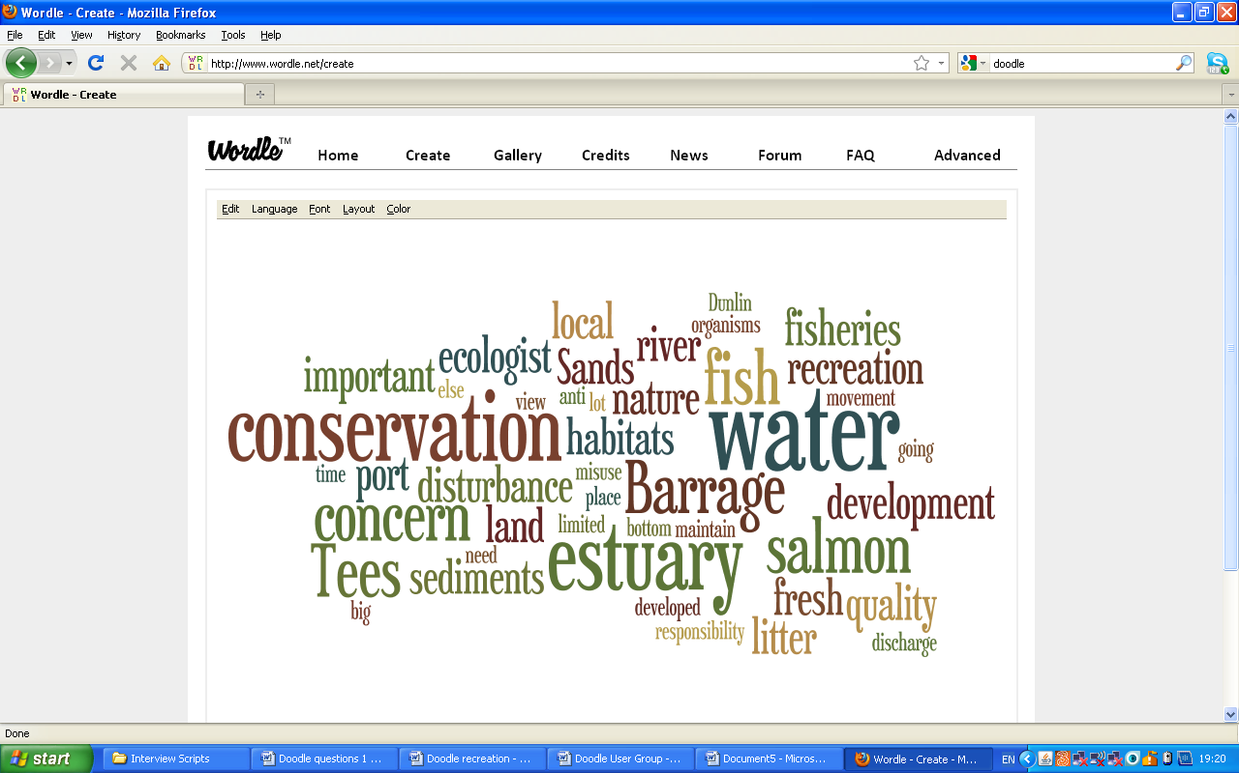

Figure 334: Key concerns of stakeholders at the Teesmouth and Cleveland EMS

*Communication between various management group members*

Following the recommendations of Prell et al (2009) communications between the management group members were analysed by creating a network of linked individuals. This was based on how frequently the members interacted with each other and what they discussed. This allowed for the central players to be highlighted who would play the main role in forming new management options, as well as sharing this information. As shows INCA and Natural England were the main partners discussed by management group members in terms of communication. INCA are seen as the main partner in fostering ties between industry and conservation. Natural England was also highlighted as taking a leading role due to their remit focussing on conservation.

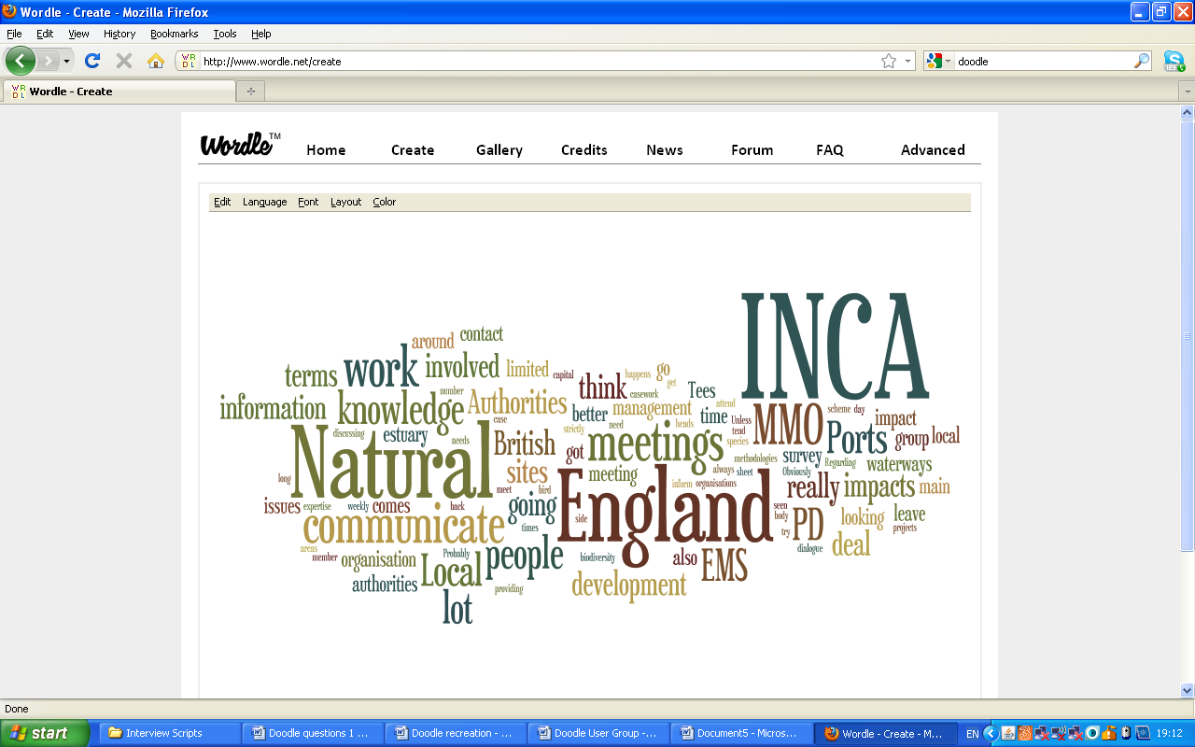

Figure 34: A summary of responses to communication questions

Communication between the stakeholders for discussing EMS issues is very limited. Nearly all members only interact every six months at the management group meeting facilitated by INCA, and chaired by PD Ports. However, within this network there are clusters of stakeholders which interact more frequently linked through their organisations concerns and remits ().

The Environment Agency is the main facilitator between those groups concerned with the waters of the EMS (Northumbrian Water, and the MMO). It also has ongoing discussions with Natural England for casework and British Waterways regarding the Tees Barrage. However, Northumbrian Water, the MMO and NESFC rarely have any communication with other stakeholders about specific EMS issues, other than at the management group meetings.

The two local authorities have ongoing discussions with both INCA and Natural England, covering a variety of aspects of the EMS including planning and casework.

PD Ports, Tees and Hartlepool Port Users, British Waterways and Durham Heritage Coast have limited communications with fellow stakeholders. The Port and Tees and Hartlepool Port Users are primarily responsible for control of the estuarine waters and are already fulfilling their remits. Both British Waterways and Durham Heritage Coast have very small land holdings on the EMS.

Generally stakeholders communicated based on the organisation they belonged too. Bob Pailor (INCA) was regarded as a strong facilitator for organising the meetings and encouraging communication. Both Geoff Barber (INCA) and Mike Leakey (Natural England) were highly regarded for their knowledge of local area and local issues. As such they were primarily contacted because of this, regardless of their organisation.

The minimal contact between stakeholders may constrain the management group’s ability to tackle those issues which are not legally regulated such as recreational disturbance. This lack of communication was highlighted as a key concern by two organisations, both of which felt that the members needed to communicate more frequently and encourage wider participation in the management scheme.

The network chart highlights that the local authorities, Natural England, and to a lesser extent INCA, the RSPB and Durham Heritage Coast are the key stakeholders in managing recreational disturbance. Other stakeholder’s have a limited capacity for tackling recreational disturbance. This may change when the MMO and IFCA begin to take on more responsibility for conservation.

**Figure 35: Network of Communication between the Stakeholders**

Hartlepool Borough Council

PD Ports

Natural England

Redcar & Cleveland Borough Council

Mike Leakey - Natural England

INCA

Environment Agency

Geoff Barber - INCA

Northumbrian Water

RSPB

MMO

**Specific EMS Issues Discussed Only at the Management Meeting**

NIFCA

British Waterways

Durham Heritage Coast

|  |  |
| --- | --- |
| **Links Between the Stakeholders** | |
|  | Members of INCA |
|  | Conservation |
|  | Balance of Conservation & Recreation |
|  | Engagement |
|  | Water Quality |
|  | Industry |
|  | No Concerns |
|  | Ongoing communication regarding regulatory issues in the EMS |
|  | Only direct communication between the members at the management meeting |
|  | Individual’s Knowledge |

*The changes within the EMS over the last 10 years with a focus on recreation, conservation, heritage and industry*

Stakeholders were asked to rank recreation, conservation, heritage and industry in order of their perceived importance at the EMS (Figure 36). Analysis of the transcripts showed that conservation was highlighted as the most important of the four, followed by recreation, industry and then heritage. At present it is evident that these thoughts are not necessarily being translated into deliverable actions, hence the unfavourable condition status of the EMS. In particular local authority representatives expressed the difficulties in choosing conservation priorities over recreation and developments, a finding concluded by Hein et al (2006a). As local authorities they have a remit to serve the local people and their wishes, which generally favour recreation and economic development; however under European Law they must ultimately manage these areas for conservation, leading to mismatched, and ultimately difficult to action policies.

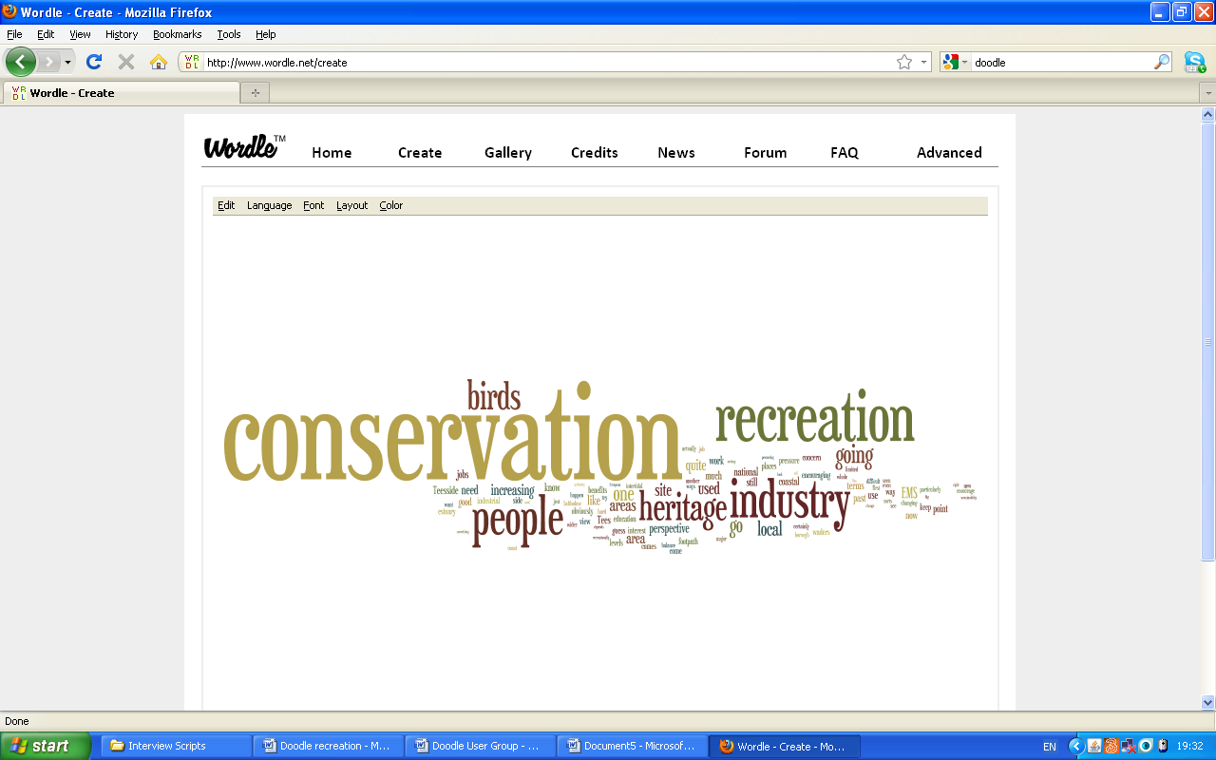

Figure 36: Stakeholder responses to ranking nature conservation, recreation, heritage and industry

*The potential management options identified by the relevant authorities*

The final questions were based around potential future management options for the EMS. Prior to the stakeholder questionnaire the management group had agreed that a voluntary code of conduct would be one of the leading management options for the control of recreational activities, and was preferable to harder management approaches. Stakeholders were emailed a draft code of conduct prior to the interview and were invited to provide comments. Table 17 outlines the general positive and negative responses from stakeholders. Overall, stakeholders welcomed the code of conduct as a positive step in future management. Many felt the educational context had been lacking in previous management options, and that the code of conduct linked with interpretation boards would be a key step in raising awareness. However, it was felt that attention should be paid to the target audience for the code of conduct. In particular, the code needs to be eye-catching and easily understood. Concern was also raised how to measure their effectiveness for reducing disturbance.

|  |  |  |
| --- | --- | --- |
| **Table 17: General comments on the code of conduct.** | | |
| **Aspect** | **Positive** | **Negative** |
| Management of Activities | * A big step forward for the management of the EMS | * How effective are the codes at changing people’s behaviour and how will we prove this change? |
| Educational Impact | * Interpretation boards with the code details will educate people about the EMS * Important to include site specific details | * You could achieve more by using the resources already available such as green events and school visits to raise awareness |
| Distributing the Codes | * Interpretation boards provide each site with a focus and are ideal at honey pot locations * Leaflets can be distributed at tourist information centres, public libraries, even local shops | * The code of conduct needs to be specific to the EMS, not the whole coastline * It is easy to target Redcar, Hartlepool and Seaton Carew but what about South Gare and North Sands? |

Stakeholders were also invited to discuss their own thoughts on future management. Overall, the stakeholders felt that future management should be centred around the general public as indicated by ‘people’ on Figure 37 and the creation of a ‘user group’. The stakeholders also felt this should be led by a project officer.

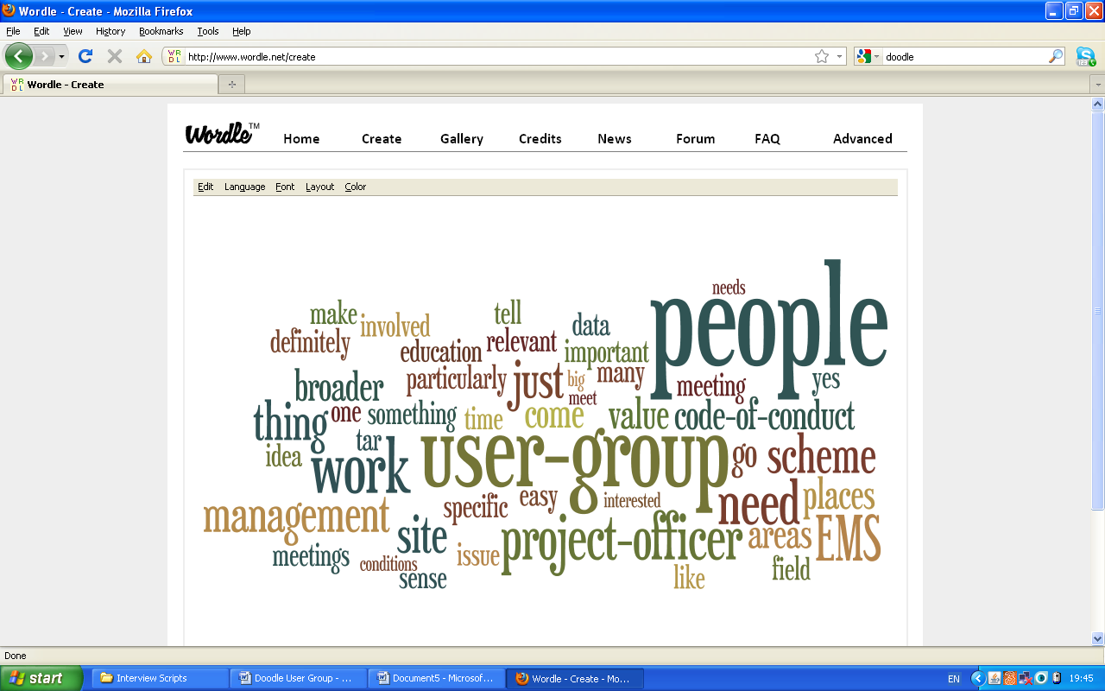

Figure 37: Stakeholder responses to future management options

Stakeholder views on future management of the EMS can be clearly divided into three key areas focussing on policy, physical site management and education (Figure 38).

Regarding future policy, it was felt that for the codes of conduct and local user group to be a success, they needed to be embedded in a new long term management plan for the EMS, specifically focussing on recreational disturbance. This would allow priorities to be identified and taken charge of by the authorities, who would drive the changes in a more active way than at present. In particular, expanding the group to take in council neighbourhood teams to promote the EMS, lead the way in education and the development of the user group.

There was some discussion of the role the IFCA will have to play in the management of the EMS, although it is too early draw to conclusions at present.

It was felt that the EMS should also be included in any future plans for the “North Tees Natural Network” as both share the common goal of encouraging the people of the Tees Valley to appreciate the wildlife on their doorstep.

Raising awareness of the conservation importance of the site was also seen as a vital step in future management. Alongside the user group it was felt that more needed to be made of awareness raising activities in the local area; the Teesmouth Field Centre already hosts visits to school children of up to 4000 per annum which would make it an ideal vehicle for conveying information about the EMS. It was felt that a website would highlight the conservation elements of the EMS alongside more contextual educational material.

In terms of physical site management, zoning of activities was suggested, in particular along the shorelines from Redcar to South Gare. A beach management plan exists for this area, having been developed by Redcar & Cleveland Borough Council as a planning obligation linked to the Coatham Enclosure redevelopment. However, the redevelopment has yet to take place, and the plan has not been implemented. The implementation of this plan is a vital step in reducing disturbance in this area of the EMS, otherwise disturbance here will continue to increase as the area begins to see the benefits from the regeneration.

**Figure 38: Future Management Options: Policy, Education & Site Management**

Voluntary wardening of sites organised through the user group

Zonal management of activities

More children’s activities

Expand the management group to include council neighbourhood teams

Positive PR for the area: improve the locals esteem for the site, connect people to the site- let’s make the area more attractive!

Include the EMS in the plans for the ‘North Tees Natural Network’

There needs to be a broader recognition of the EMS within planning documents. In particular looking to use Section 106 agreements more often

Prepare a five year management plan for establishing the code of conduct and user group:

- Set conditions

- Delegate tasks

- Formulate targets

Consider integrating EMS concerns into the IFCA management plan

User broader scales than the EMS- use the whole river as a focus for education and activities

Website detailing the codes of conduct alongside other contextual material

|  |  |
| --- | --- |
| **Management Options** | |
|  | Policy |
|  | Education |
|  | Physical site management |

Information on visitor numbers to each of the sites

## Discussion

# Towards an Ecosystem Approach for the management of the Teesmouth and Cleveland Coast

As discussed in Chapter 1 ecosystem based management involves recognising and addressing interactions among different spatial and temporal scales within ecological, economic and social systems using a participatory stakeholder process (Leslie & McLeod, 2007). This allows managers to bridge the gap between activities which were previously managed in isolation, which in turn aims to meet conservation and sector goals (Halpern et al, 2008). This thesis has centred on the initial development of the Ecosystem Approach for the EMS and has focussed on identifying, rather than valuing the ecosystem services provided by the EMS. The importance of the various ecosystem services has been identified for local users, as well as those who are responsible for managing the EMS.

In taking the Ecosystem Approach forward for management of the area there will be a need to consider the ecological, social and economic values provided by the EMS (De Groot et al, 2002). Ecologically, the value is determined by integrity, resistance and reliance. Social and cultural values also play a part in forming the valuation, with the natural world being a crucial source on non-material satisfaction. Finally there is economic valuation which addresses the problem that ecosystem services are public goods, and as such they have no specific market value. Brief reviews of the economic and ecological aspects of the Ecosystem Approach are provided, followed by a detailed discussion of the social approach and its role in policy.

*The Economic Value*

It is believed by economists (see Costanza et al, 1997; Balmford et al, 2002) that by placing a value on ecosystem services, they will no longer be undervalued and as such gives us an incentive to conserve them, rather than destroy them (Yung, 2004). It is argued by Beaumont, Austen & Townsend (2008) that monetary valuation formalises the valuation process by individuals and society that already takes place, and in doing so avoids less apparent ecosystem services, such as nutrient cycling being overlooked in policy.

The Millennium Ecosystem Assessment (MEA) and UK National Ecosystem Assessment (NEA) consider the “total economic value” of ecosystem services which is defined as the “total gain in wellbeing from a policy measured by the net sum of willingness to pay or willingness to accept, relating to the policy” (Garrod & Wills, 1999).

The total economic value is made up of use values and non-use values associated with the ecosystem services (Figure 39). For example at the Teesmouth and Cleveland EMS direct use is concerned with the actual use of the ecosystem, for example shellfish collection, and indirect use values are attributed to those services which we do not directly use, but which still deliver benefits for example coastal flood protection. The option value is related to future use of the service, for example one day someone may want one to walk in the sand dunes. Non-use values are associated with the benefits we derive from knowing the ecosystem service exists even though we gain no direct benefits from it. These include bequest values, for example knowing waterbirds will still be there for future generations to enjoy, altruistic values and existence values, for example knowing harbour seals are breeding in the estuary (Garrod & Wills, 1999).

Figure 39: The categorical breakdown of total economic value (Defra, 2007)

A wide variety of techniques are used to derive market and non-market values. Use values are derived using revealed preference methods, for example the replacement/restoration cost for damaged ecosystems, the travel cost method to determine how much people are willing to pay to travel to a site encompassing ecosystem services and hedonic pricing which uses market valuation for attributes of the ecosystem service. Non-use values are determined using stated preference methods, for example contingent valuation and choice experiments. These use surveys to elicit willingness to pay for a service or willingness to accept compensation for the degradation of the service (Garrod & Wills, 1999).

Whilst the method of economic valuation has been widely used, there are heavy criticisms of both the economic methodology and the choice of using economic valuation to measure the benefits in terms of ecosystem in the first place. Yung (2004) critically reviewed the economic valuation methods. He concluded that the replacement/restoration cost method results in poorer communities not being able to adequately express their preferences for the ecosystem as they do not have the money to restore it, even though they wish to. This is in line with the work of Wilson & Howarth (2002) who questioned the willingness to pay approach. By asking people to value goods individually the social equity of the whole community is undermined. This is opposite to the MEA view that the Ecosystem Approach will yield social equity improvements (Haines-Young & Potschin, 2007). It was also observed that the travel cost method failed to take into account sites which are placed further away from human settlements (Yung, 2004). It is expected that people are more likely to visit those places closest to them, which inflates the value derived for these sites. The stated preference techniques are considered the least reliable as the values are heavily affected by the survey design, resulting in a tendency for goods to be under or overvalued, dependant on whether the bid is actually collected (Yung, 2004). Pearce (2007) argued that surveyed willingness to pay values are much higher than the sums of money actually spent on biodiversity and other preservation projects and programs. This is a classic example of free riding due to the public good nature of the ecosystem service (Estrin et al, 2008).

There is also a moral debate surrounding the economic valuation of ecosystem services. In one sense the total value ecosystem goods and services to mankind and our economy is infinite. It can be argued that a value cannot be placed on such goods, and we should conserve them for their long term ecological benefits for our own morality (Costanza, 1997). In neoclassical economics, an entity only has an economic value if people are willing to pay for it. This is against the ethical and moral grounds which nearly every environmental issue encompasses. By valuating services economically, if one fails to be economically justified, policy makers will simply overlook it. Instead the value of ecosystem services needs to be incorporated in our own accounting systems (Edwards & Abivardi, 1998). There is also concern that people will not weight the future high enough resulting in an undervaluation of the service. To overcome this Costanza (1997) recommended that the discount rate applied to the valuation by policy makers should be lower than the rate used for private investment.

A key concern for ecologists regarding economic valuation is that some services can continue to be economically viable even with very low levels of species diversity, which discourages investment in conservation (Edwards & Abivardi, 1998). There is in line with standard macro-economic analysis. This theory would also led to the extinction of some of the rarest species, as the interest rate is greater than the natural rate of species increase, making it more economically viable to hunt the species to extinction and earn interest on the money in the bank (Costanza, 1997).

A significant problem for ecosystem valuation is the cost of researching specific primary data to calculate the value of the site. This has led to an increase in the use of “benefits transfer” where the economic value estimates of one site are transferred to another location (Plummer, 2009). However, it is very difficult to find studies of similar sites leading to a generalisation in site characteristics. This results in the values transferred having high levels of uncertainty. This is overlooked by many policy makers who are simply interested in the final number.

An ecological alternative benefit transfer is meta-analysis which combines the economic values of separate statistical valuation studies. It takes into account the differences in methodology, context and spatial location between the studies (Brouwer, 2000). Locatelli & Vignola (2009) applied this technique to managing watershed services in tropical forests. The main advantage of Meta-analysis was that the results produced were much clearer and easier to understand by policy makers. However, the pair concluded that in their study the small number of studies, coupled with sensitivity analysis made it difficult to reach any firm conclusions.

*The Ecological Value*

Whilst there are strong arguments against economic valuation techniques, most predominantly from the ecologist’s perspective, it would be ignorant to neglect some of the problems associated with ecological and social approaches to valuation.

The main problem with the ecological valuation is integrating it into public policy. It has been widely recognised that the Ecosystem Approach has a great deal of uncertainty surrounding both policy making and ecosystem dynamics (for examples see Hartje et al., 2003 & Kates et al., 2001). Ecologists believe that for the valuation to inform policy making the whole ecosystem must be taken into account as one change or stress is can affect the whole system. However, as yet, there is not enough scientific knowledge to accurately conclude that species diversity is important for long term ecosystem stability (Edwards & Abivardi, 1998) which makes it difficult for policy makers to decide which of the world’s ecosystems need the most protection.

Clark (2001) recommended that ecologists need to choose policies which are insensitive to uncertainty and as such will yield more ecosystem services even if an unexpected change occurs. This is in line with the work of Srivastava & Vellend (2005). They recognised the need to clearly state the target level of ecosystem functioning in ecosystem policy planning. They found that many policies implied that high productivity is desired, but it was not stated. For the marine and coastal environment it is accepted that at present our scientific knowledge is limited and for most ecosystems services the importance of biodiversity can only be quantified for a limited number of habitats and species (Hooper et al, 2005).

# The Social Approach and Policy Implications

From the site user questionnaires undertaken in Chapters 3 and 4, it is clear that on a local scale, recreation is considered the most important ecosystem service at the EMS. Communities depend on the coastal ecosystem to aid coastal development, tourism, recreation and fishing (Leslie & McLeod, 2007). In line with the Ecosystem Approach there have been calls for greater community participation in natural resource management by international and national agencies (Hikey & Mohan, 2004). The Ecosystem Approach lends itself to community based participatory management as meaningful engagement with stakeholders helps to create management initiatives which are credible, enforceable and realistic (Leslie & McLeod, 2007). Indeed literature goes as far as stating that local engagement can make all the difference between a successful and failed management effort (see Brown et al, 2002; Christie, 2004). Also economic incentives alone are unlikely to transform local cultural, ethical and behavioural traits towards environmental stewardship (Turner & Daily, 2008).

However, community based management increases difficulties for regional environmental agencies due to the myriad of stakeholder perspectives (Brett et al; de Groot et al, 2010). This problem has already been highlighted in this chapter where relevant authorities charged with the management of the European Marine Site cite three different management priorities between them; conservation, recreation and economic development. This follows the concerns of Hein et al (2006) who highlighted that decentralization of protected area management leads to a sub-optimal provision of nature conservation benefits. Ultimately local authorities have a mandate to deliver actions which local people prioritise. The EMS is bounded by four local authorities; Redcar & Cleveland Borough Council (RCBC), Stockton Borough Council, Middlesbrough Council and Hartlepool Borough Council (HBC) all of which have a regulatory role at the EMS. RCBC and HBC are considered the two most prominent local authorities on the EMS management group due to the nature of the land under their planning jurisdictions. As identified in Chapter 2, recreation is the most important ecosystem service at the EMS and Chapter 3 confirmed that people do utilise this service. Discussions with local authority representatives in Chapter 5 revealed that ultimately they must manage the EMS for the local people and this means placing a greater priority on recreation initiatives. To overcome this there is a need to broaden the understanding of the European Marine Site and SPA; this could potentially be achieved by framing future management actions in line with national and local policy, thus furthering potential funding options and enhancing the resources dedicated to managing the EMS.

Briefly considering national policy first, under Section 40 (1) of the Natural Environment and Rural Communities Act 2006 it is stated that *‘every public authority must, in exercising its functions, have regard, so far as is consistent with the proper exercise of those functions, to the purpose of conserving biodiversity.’* This places a statutory duty on the local authorities to manage the EMS for nature conservation.

The Local Development Frameworks (LDF) for both councils outline the need to protect the natural environment and promote sustainable recreational activities at the EMS (RCBC: CS4, CS5 and CS24; HBC: CS 22, CS25 and CS29). The code of conduct will act as the first step in encouraging the sustainable use of the EMS by raising awareness amongst the local population of the importance of the site and instigating behavioural change.

When studying the RCBC policies in more detail it is clear that the community involvement would fulfil several policy goals. The RCBC Countryside Strategy 2009-2014 details the need for community action “*working with all sectors of the local community to help them appreciate and ‘take ownership’ of their countryside”* and awareness and understanding “*building upon present initiatives; maintaining a positive image of the Council’s countryside landholdings; recognising the value of the countryside as an educational and recreational resource”*; commitments which the both the user group and code of conduct would help to achieve.

These aims are again discussed in RCBC Sustainable Environment Strategy 2011 – 2016 under Natural Environment Priority 3 & 6; promote environmental education, awareness and healthy outdoor exercise; community groups actively involved in enhancing their local green space. Priority 6 also states the council should support others in the management of wildlife sites.

The priority for RCBC is the completion and implementation of the Coatham Beach Management Plan. The initial production of the plan was attached to a planning obligation which has since halted. However there is still a clear imperative for the council to take the initiative forward, not least because of its Countryside Strategy 2009-2014 and Sustainable Environment Strategy 2011-2016. It is expected that the management plan would consider the zoning of some recreational activities to protect the most sensitive areas of the coastline.

The HBC Local Environmental Sustainability Strategy again discusses a need for community involvement under Theme 2: Environmental Education and Promotion and Theme 8 Biodiversity; to promote the understanding of, and participation in environmental issues, both within the council and in the community. This theme is also repeated in the Community Strategy & Neighbourhood Renewal Strategy 2008-2020 in the policy sections for Health, Environment, Culture & Leisure and Strengthening the Communities; work in partnership with the people of Hartlepool to promote and ensure the best possible health and wellbeing.

By considering the EMS in the broader policy contexts, it is clear that it has the potential to be a great asset to the local people acting as a focus for community engagement, wildlife education and an ideal green space for recreation.

The linking of the EMS priorities into local policy has the potential to be further developed by economic valuation of the ecosystems services. At present economic value is a currency universally understood by policy makers and politicians, and could in time be a requirement of local authorities (Beaumont et al, 2008). The tool is already being developed at the national level as part of the Marine and Coastal Access Act 2010 and The European Marine Strategy. There is also need to prioritise conservation activities economically to ensure that scarce funds and resources are being used efficiently and effectively (Wilson et al, 2009).

# Future Management of the Teesmouth and Cleveland EMS

At present shifting the management of the Teesmouth and Cleveland EMS towards an Ecosystem Approach appears to be fraught with difficulties. The approach advocates a shift towards community based decisions. This could potentially be undertaken by local authorities through engaging with stakeholders to develop new ways of managing recreational activities. Ultimately however this would have negligible benefits on the conservation status of the European Marine Site which is protected under European Law. The Habitats Directive, Birds Directive, European Marine Strategy Framework Directive and the UK Marine and Coastal Act all place conservation at the heart of the policy (Holt et al, 2011). This overlooks the local socio-ecological context of the ecosystem, meaning local people fail to see the benefits of the legislation and thus directly conflicting with the Ecosystem Approach which places human wellbeing at the centre (Turner & Daily, 2008; Holt et al, 2011).

Considering the Ecosystem Approach itself, there are clear scientific challenges for economists, ecologists and social scientists to overcome in terms of the provision of ecosystem services and how humans value them which is a key part of the framework before policy institutions at the national and local scale can fully incorporate this new way of thinking into their deliverable policies (Daily & Matson, 2008; Waston & Wright).

For the Ecosystem Approach to be truly adopted by the authorities responsible for managing the EMS the approach should be included in the conservation assessment criteria, for example the Natural England site condition assessments. This inclusion would allow the development of wider merits to be considered for each site and by placing on emphasis on safeguarding the site for human wellbeing it improves the societal relevance of an EMS (Knight et al, 2006; Egoha et al, 2007). The mapping of ecosystem services, as undertaken in Chapter 2 is seen as one of the most explicit methods of including ecosystem services in conservation assessments (Kremen & Ostfeld, 2005). The mapping of ecosystem services also allows for their inclusion into land use planning (de Groot et al, 2010) and can potentially help avoid highly productive, multi-functional landscape being converted for a single use. Already this approach has been adopted for a small area of the Teesmouth and Cleveland EMS when planning the managed re-alignment of Greathem Creek (as discussed in Chapter 2). There is a need to develop this mapping and thought to a regional level to realise the full suite of ecosystem services the Tees Valley has to offer.

# Take Home Messages for the Teesmouth and Cleveland European Marine Site Management Group

It is acknowledged at present that a complete shift in management towards an Ecosystem Approach would present a great deal of difficulty for the EMS management group due to gaps in knowledge and wide ranging policy drivers at the national and regional scales. It is however recommended that some aspects of the Ecosystem Approach are employed as part of a precautionary strategy to the management of recreational activities. Halpern et al (2008) present a range of precautionary options for the management of habitats to meet local and national policy goals. Global scale threats to the area, such as climate change will need to be addressed at the national and international scale (Halpern et al, 2008). On a regional and local scale recommendations are centred on spatial and temporal management tools including voluntary codes of practice, zoning and permits which can be developed with local stakeholders as part of participatory management. Tallis et al (2010) also concludes that local stakeholder engagement is one of the best ways to start implementing the Ecosystem Approach due to the low costs and relative ease for gathering the data required to begin debating management options. The social learning that takes place as part of the data gathering, either through surveys or focus groups with site various user groups is seen as an integral part of the Ecosystem Approach and fosters the development of locally accepted management decisions (Folke et al, 2005).

These options were presented to the EMS management group in April 2011 and adopted in September 2011 with appointment of an EMS Project Officer (Figure 40 and Table 18). To date focus groups have taken place with three key user groups; wildlife enthusiast and naturalists; kite – surfers, windsurfers and boat users; and recreational sea anglers and bait diggers. The groups have all agreed to help write and promote a voluntary code of conduct for the Teesmouth and Cleveland Coast as part of ongoing participatory based management for the EMS. These focus groups were not part of this research project; however the focus group script and code of conduct are included in the appendix for the reader’s interest.

Locally based monitoring schemes are also recommended to reinforce community based management (Danilesen, Burgess & Balmford, 2005). In Chapter 3 it was recommended that further monitoring of waterbird disturbance due to recreational activities should be undertaken to develop a long term data set. There is the potential that local groups, for example bird club members could be trained to undertake this monitoring. This not only overcomes the high costs associated with employing scientists to undertake the monitoring, but also provides users a rare opportunity to collaborate with authorities to monitor, and ultimately help manage the natural resources at the EMS (Danilesen, Burgess & Balmford, 2005).

Figure 40: An Overview of Management Recommendations

Three year vision for managing recreational activities at the EMS

Consensus from management group on management proposals

Present codes to Teesmouth Bird Club

Recreational officer appointed to drive the codes of conduct forward and user group

Interpretation boards designed

Local authority neighbourhood managers informed of codes of conduct and user group

Implementation of the Coatham Beach Management Plan by RCBC

Local resident’s workshops in Redcar and Hartlepool to discuss ideas for the code of conduct

Meeting agenda established

Dog control order comes into action on North Sands

Date for first user group meeting- local press release, posters in shops

Beach activity days to raise awareness of the EMS

First newsletter written for the management group and user group

First user meeting- comments on the code of conduct and secure groups backing

Interpretation boards at the site

|  |  |
| --- | --- |
| **Management Action** | **Key** |
| Primary Action |  |
| Secondary Action |  |
| Ongoing Action |  |
| Milestone Action |  |

Final code of conduct written and signed off

Development of ongoing monitoring strategy for recreational disturbance

Subsequent user group meetings: appoint “guardians of the EMS” to promote the codes and the area

First annual disturbance report produced

EMS website goes live with final code of conduct and user group details

|  |  |
| --- | --- |
| **Table 18: Management measures to minimise disturbance at the Teesmouth and Cleveland Coast EMS** | |
| 1. Consensus from the management group regarding the code of conduct and user group | |
| 1. A consensus is required from the management group giving their full support to the code of conduct and local user group. | Very High Priority |
| 1. It is recommended that a three year vision for the management of recreational activities is produced detailing:  * The writing and promotion the code of conduct. * The development of the user group. * The chair of the user group. * The focus and targets of the user group * The communication between the user group and the management group. * The completion and implementation of the Coatham Beach Management plan and the dog control order on North Sands. | High Priority |
| 1. A member of the management group needs to be appointed to further the code of conduct and user group (referred to as the recreational officer for the remainder of the recommendations). Many of other EMS’s have a project officer (full or part time) who is responsible for local user group and managing recreational activities. | High Priority |
| 1. Completion of the code of conduct and user group | |
| 1. Meeting with the Teesmouth Bird Club on 4 April 2011 as the start of the final stakeholder participation. | Low Priority |
| 1. Prior to the user group meeting it has been suggested that a workshop is run with local residents to discuss their thoughts on the code of conduct and local user group:  * These discussions would be more in depth than the initial visitor’s survey. * The workshop would need publishing to ensure a high level of attendance. * A brief discussion of the focus group is included in Appendix 5. | Medium Priority |
| 1. Establish an agenda for the user group meetings:  * The primary focus of the first meeting will be the drafting of the code of conduct and finalising it with the group members. * For subsequent meetings it is recommended that a speaker from a local group or trust is invited to give an educational and entertaining talk to the members (it does not have to be specific to the EMS) which gives the meeting a focus. * The members would then be invited to discuss any current issues affecting them of their recreational activity at the EMS, as well as any future changes that are currently being proposed for the EMS by the management group. * It is recommended the user group meets quarterly during the initial development and the group and the codes. Once the group is established this could decrease to two or three meetings a year depending on the issues at the site. * It is recommended that the recreational officer from the management group attends the user meetings and to act as an impartial link. | High Priority |
| 1. First user group meeting established:  * Following the workshop discussion about the user group and code of conduct the first local user meeting can take place. * This will need to be publicised in the local area using: * Posters in shops along the seafront and places of local interest. * Local press release. * It is essential that ALL members of the local community are invited to attend. | High Priority |
| 1. The final code of conduct:  * Once the user group has agreed to the code of conduct it can be published. * Leaflets should be sent out to members of the user group to forward to their club members. * Leaflets should also be made available in public information centres and local shops. * The management group needs to take on an active role in publicising the code. * It is also recommended that the code of conduct is promoted as ‘a coastal code’ to increase its appeal with the target audience. * The draft code of conduct for the user group can be found in Appendix 3. | High Priority |
| 1. Interpretation boards:  * To raise awareness amongst both tourists and local residents it is recommended that interpretation boards are placed at the entrances to each of the public access areas of the site (see Appendix 4 for details). * The interpretation boards should outline the key points from the code of conduct as well as additional local information. * One recent example of interpretation boards is the ‘Storyboard Trail’ at Flamborough Head EMS. Nine interpretation boards can be found at the site using different themes including seabirds, marine wildlife, geology, the lighthouse, and fishing. | Medium - |
| 1. Improving communication | |
| 1. Quarterly newsletter for management group and user group:  * Communication between the members of the management group needs to improve so that people are aware of what one another are achieving in terms of the EMS. * It is recommended that a quarterly newsletter is emailed between the members giving a brief outline of any major issues or changes that have happened over the past quarter. | Medium Priority |
| 1. Contact the relevant Head of Neighborhood and Neighborhood Managers:  * It is recommended that the council neighborhood mangers are contacted to give their thoughts on the code of conduct. * They should also be involved in the establishment of the local user group. | High Priority |
| 1. Improve communications with the MMO and North Eastern IFCA:  * The MMO and IFCA have responsibility in their remits to manage the EMS. At present the MMO and IFCA have very little involvement in the EMS. * They have legal powers to question and enforce change in the area, such as bait digging. More can be used of this power. | Medium - Low Priority |
| 1. Development of an EMS website:  * 18 of the EMSs have a website with varying degrees of information. * The most successful websites are those which included the links to the codes of conduct, details of the user group members and meeting agendas, as well as providing links to further contextual material. * The website could be linked to other local interest websites such as RSPB Saltholme, Tees Valley Wildlife Trust and in future the North Tees Natural Network. * There could also be a link to report disturbance issues at the site; this is currently being trialed by the Humber EMS. | Medium - Low Priority |
| 4. Other long term aims | |
| 1. The user group needs a long term aim:  * There needs to be ongoing monitoring of recreational activities at the EMS in order to establish whether the code of conduct and the user group are having a positive impact on reducing disturbance. * The user group needs a long term aim; people enjoy practical ‘hands on tasks’ and it is important that the user group does not become another ‘talking shop’. * When used effectively the user groups can provide volunteers for data collection, forming part of the long term monitoring of recreational activities at the site. * It is recommended that members of the user group, in particular members of the Teesmouth Bird Club are invited to take part in forming a long term monitoring strategy of recreational disturbance at the site. * It is proposed that monthly counts would take place following a similar methodology to the bird survey used in this report. * These data could then be compiled and sent out as a potential dissertation project to universities annually (the student would not need paying for this as it is a small project which would form part of their overall degree and it good experience for them). * This would allow robust baseline data to be collected and allow complete understanding of the effects of recreational activities. * In particular it would allow changes to be identified following the Redcar Development. * A guide to the long term monitoring strategy is included in Appendix 7. | High Priority |
| 1. Integration of the EMS into the wider environmental network:  * The EMS should not be managed as a standalone feature. * The code of conduct and user group aim to market the EMS for local people and increase their appreciation and awareness of the site. * This marketing could be furthered by integrating it into wider Tees Valley conservation initiatives. For example the code of conduct and user group could be promoted by the Teesmouth Field Centre, the NNR, RSPB Saltholme and Tees Valley Wildlife Trust. * It is recommended that some areas of the EMS, are included in the ‘North Tees Natural Network’. The focus of the Network is to improve awareness and encourage people to visit the Tees Valley – similar aims to the EMS. By integrating the two recreational activities the public may be more likely to take on board both ideas, | Medium - Low Priority |
| Hard management options | |
| 1. Implementation of the Coatham Beach Management Plan:  * This report has established that recreational activities on Coatham Sands are disturbing the coastal birds. * Whilst it is hoped the code of conduct will help minimise disturbance it is essential that Coatham Beach Management Plan is completed and acted upon, in particular the zoning of some activities. | High Priority |
| 1. Securing the dog control order at North Sands:  * If HBC implement the dog control order at North Sands this would be a successful step in reducing disturbance from dog walking. * It is expected this will come into force from September 2011. | High Priority |

# Conclusions

Overall this research has demonstrated a significant mismatch between international, national and local policy for the management of Special Protected Areas, a finding repeated throughout literature (for examples see Agardy, undated). It is clear new ways of managing these sites must develop to bridge the gaps in policy and create linkages throughout the system.

This research has shown that one potential management option for the Teesmouth and Cleveland Coast EMS is the development of an Ecosystem Approach. The ecosystem service approach is a useful tool for exploring the impact humans are having on ecosystems, in particular the state of these services as to whether they are increasing or decreasing in their benefits, as researched by the MEA. At present the adoption of the total economic valuation technique to ascertain a market value for the services at the EMS is questionable. This is in part due to the methodological flaws in the set valuation techniques, as well as a lack of specific economic knowledge needed to undertake valuation exercises within the EMS management group. It is also clear that ecological methods alone will have little use in policy making due to the nature of uncertainty, and failure to take into account human needs, which are at the centre of local authority policy. As concluded by Defra (2007) the Ecosystem Approach is a multi-disciplinary area, relying on the knowledge of the ecologists to deliver the science behind the subject and the economic valuation to strengthen the case for conservation in the political arena.

This thinking is shown best in stakeholder and group debate with people most affected by the change in the ecosystem service. Knowledge about ecosystem services also needs to be clearly communicated, and made easily accessible to policy makers, additional stakeholders and members of the public (Hein et al, 2006b).

It is clear that the key area for the development of the Ecosystem Approach and valuation framework will centred on stakeholder engagement and group deliberation. This is based on political theory that a public decision should be induced by a public debate, rather than from individually measured preferences (de Groot, et al., 2002). There is also a pressing need for the approach to be more efficiently designed to allow those who manage EMSs on the local scale to understand and be comfortable with the ecosystem service concept (Watson-Wright, undated).

As concluded by de Groot et al (2010) it is clear that the Ecosystem Approach has changed the way policy considers nature conservation, and offers an opportunity to overcome the perceived trade off conservation and development. However, the announcement that Defra[1] will be reviewing the Habitats and Wild Bird Directives (the basis of the conservation status for the Teesmouth and Cleveland Coast), in particular obligations which affect planning proposals, demonstrates that higher level policy makers still view conservation as second to our economy, rather than inclusive of one another.

### Appendix 1: Waterbird Survey and Visitor Survey Forms

Bird Disturbance Survey Form

|  |  |  |  |  |  |
| --- | --- | --- | --- | --- | --- |
| Location |  | Start Time |  | High Tide |  |
| Date |  | End Time |  | Low Tide |  |
| Weather | | |  | | |

|  |  |  |  |  |  |  |  |
| --- | --- | --- | --- | --- | --- | --- | --- |
| Bird Species | Count | | | Activity | Count | | |
| Start | Middle | End | Start | Middle | End |
| Cormorant |  |  |  | Walking |  |  |  |
| Curlew |  |  |  | Dog Walking |  |  |  |
| Dunlin |  |  |  | Bird Watching |  |  |  |
| Knot |  |  |  | Sea Angling |  |  |  |
| Little Tern |  |  |  | Bait Digging |  |  |  |
| Oystercatcher |  |  |  | Horse Riding |  |  |  |
| Purple Sandpiper |  |  |  | Sand Yachting |  |  |  |
| Redshank |  |  |  | Windsurfing |  |  |  |
| Ringed Plover |  |  |  | Diving |  |  |  |
| Sanderling |  |  |  | Off-Road Vehicles |  |  |  |
| Turnstone |  |  |  |  | | | | |  |

|  |  |  |  |
| --- | --- | --- | --- |
| Disturbance Code | | Bird Activity Code | |
| 1= | less than 50 m moved | F= | Feeding |
| 2= | greater than 50 m moved | R= | Roosting |
| 3= | left site |  | |

|  |  |  |  |
| --- | --- | --- | --- |
| **Recreational Activity** | **Bird Disturbed Y/N?** | **Disturbance Level** | **Species & Numbers Affected** |
|  |  |  |  |
|  |  |  |  |
|  |  |  |  |
|  |  |  |  |

## 

## Visitor Survey Form

1. **Using the following list, please rank the top three activities you carry out at this site.**

**(1 being the most often and 3 being the least often).**

|  |  |  |  |  |  |  |  |  |  |  |  |
| --- | --- | --- | --- | --- | --- | --- | --- | --- | --- | --- | --- |
|  | Bait digging / bait collection | | |  | Horse riding | | |  | Sea angling | | |
|  |  |  |  |  |  |  |  |  |  |  |  |
|  | Bird watching | | |  | Off road driving | | |  | Walking | | |
|  |  |  |  |  |  |  |  |  |  |  |  |
|  | Diving | | |  | Sand yachting / kite flying | | |  | Windsurfing / | | |
|  |  |  |  |  |  |  |  |  | kite surfing |  |  |
|  | Dog walking | |  |  |  |  |  |  |  |  |  |

1. **What is it about this particular site that makes you visit it? Please rank the top three features.**

**(1 being the most important and 3 being the least important).**

|  |  |  |  |  |  |  |  |  |  |
| --- | --- | --- | --- | --- | --- | --- | --- | --- | --- |
|  | Bridle paths | | |  | Ease of access | | |  | The natural environment and  what it provides |
|  |  |  |  |  |  |  |  |  |
|  | Convenient/ close to home | | |  | Ease of parking | | |  | Tranquillity |
|  |  |  |  |  |  |  |  |  |  |  |  |  |
|  | Feels safe | | |  | Good for children | | |  | Views |  |  |  |

1. **How often do you visit the site?**

|  |  |  |  |  |  |  |  |  |  |  |  |  |
| --- | --- | --- | --- | --- | --- | --- | --- | --- | --- | --- | --- | --- |
|  | Daily | | |  | Couple of times a month | | |  | Other |  |  |  |
|  |  |  |  |  |  |  |  |  |  |  |  |  |
|  | Couple of times a week | | |  | Monthly | | |  |  |  |  |  |
|  |  |  |  |  |  |  |  |  |  |  |  |  |
|  | Weekly | | |  | Less often | | |  |  |  |  |  |

1. **Please indicate how strongly you agree or disagree with the following statements.**
2. **Visiting the coastline makes me happy.**

|  |  |  |  |  |  |  |
| --- | --- | --- | --- | --- | --- | --- |
|  | Strongly agree |  | Agree |  | Neither agree or disagree | |
|  |  | | | | | |
|  | Disagree |  | Strongly Disagree |  | No comment |  |

1. **It is important to me that my children can visit this site in the future.**

|  |  |  |  |  |  |  |
| --- | --- | --- | --- | --- | --- | --- |
|  | Strongly agree |  | Agree |  | Neither agree or disagree | |
|  |  | | | | | |
|  | Disagree |  | Strongly Disagree |  | No comment |  |

1. **The needs of people should be a priority in managing the coastline.**

|  |  |  |  |  |  |  |
| --- | --- | --- | --- | --- | --- | --- |
|  | Strongly agree |  | Agree |  | Neither agree or disagree | |
|  |  | | | | | |
|  | Disagree |  | Strongly Disagree |  | No comment |  |

1. **Nature conservation has little relevance to my life.**

|  |  |  |  |  |  |  |
| --- | --- | --- | --- | --- | --- | --- |
|  | Strongly agree |  | Agree |  | Neither agree or disagree | |
|  | | | | | | |
|  | Disagree |  | Strongly Disagree |  | No comment |  |

1. **Some areas of the coastline should be regulated to protect it for the future.**

|  |  |  |  |  |  |  |
| --- | --- | --- | --- | --- | --- | --- |
|  | Strongly agree |  | Agree |  | Neither agree or disagree | |
|  | | | | | | |
|  | Disagree |  | Strongly Disagree |  | No comment |  |

1. **The Teesmouth and Cleveland Coastline contains important habitats which need to be preserved.**

|  |  |  |  |  |  |  |
| --- | --- | --- | --- | --- | --- | --- |
|  | Strongly agree |  | Agree |  | Neither agree or disagree | |
|  | | | | | | |
|  | Disagree |  | Strongly Disagree |  | No comment |  |

1. **Do any of the other recreational activities happening at this site bother you and how much?**

**(Please tick all that apply).**

|  |  |  |  |  |  |  |  |  |  |  |  |  |
| --- | --- | --- | --- | --- | --- | --- | --- | --- | --- | --- | --- | --- |
| Activity | No negative effects | | | Negative effects but I would stay in the same area. | | | Negative effects and I would move to another area of the site. | | | Negative effects and I would consider not returning to the site. | | |
|  |  |  |  |  |  |  |  |  |  |  |  |  |
| Bait digging/ bait collection |  |  |  |  |  |  |  |  |  |  |  |  |
|  |  |  |  |  |  |  |  |  |  |  |  |
| Bird watching |  |  |  |  |  |  |  |  |  |  |  |  |
|  |  |  |  |  |  |  |  |  |  |  |  |  |
| Diving |  |  |  |  |  |  |  |  |  |  |  |  |
|  |  |  |  |  |  |  |  |  |  |  |  |  |
| Dog walking |  |  |  |  |  |  |  |  |  |  |  |  |
|  |  |  |  |  |  |  |  |  |  |  |  |  |
| Horse Riding |  |  |  |  |  |  |  |  |  |  |  |  |
| Off road motorbikes |  |  |  |  |  |  |  |  |  |  |  |  |
|  |  |  |  |  |  |  |  |  |  |  |  |
| Sand yachting/ kite flying |  |  |  |  |  |  |  |  |  |  |  |  |
|  |  |  |  |  |  |  |  |  |  |  |  |
|  |  |  |  |  |  |  |  |  |  |  |  |
| Sea angling |  |  |  |  |  |  |  |  |  |  |  |  |
|  |  |  |  |  |  |  |  |  |  |  |  |  |
| Walking |  |  |  |  |  |  |  |  |  |  |  |  |
| Windsurfing / kite surfing |  |  |  |  |  |  |  |  |  |  |  |  |
|  |  |  |  |  |  |  |  |  |  |  |  |
|  |  |  |  |  |  |  |  |  |  |  |  |

1. **Do you think the site could be improved in any way? Please give details.**
2. **How strongly do you agree or disagree with the following statement.**

**“My main recreational activity has no effect on coastal birds using this site”**

|  |  |  |  |  |  |  |
| --- | --- | --- | --- | --- | --- | --- |
|  | Strongly agree |  | Agree |  | Neither agree or disagree | |
|  | | | | | | |
|  | Disagree |  | Strongly Disagree |  | No comment |  |

1. **A potential code of conduct is being proposed outlining best practice for all users of the site. How do you think this should be communicated to the users of the site? (Please tick all that apply)**

|  |  |  |  |  |  |  |  |  |  |
| --- | --- | --- | --- | --- | --- | --- | --- | --- | --- |
|  | Leaflet available from local shops | | | |  | Leaflet available from your activities club | | | |
|  |  |  |  |  |  |
|  | Local magazine | | | |  | Website | | | |
|  |  |  |  |  |  |  |  |  |  |
|  | Local newspaper | | | |  | Other |  |  |  |

1. **Does your main recreational activity already have its own code of conduct?**

|  |  |  |  |  |  |  |  |
| --- | --- | --- | --- | --- | --- | --- | --- |
|  | Yes | Please give details | |  |  |  |  |
|  |  |  |  |  |  |  |  |
|  | No |  |  |  |  |  |  |
|  |  |  |  |  |  |  |  |
|  | Unsure |  |  |  |  |  |  |

1. **If you already have a code of conduct for your main recreational activity do you follow it?**

|  |  |  |  |  |  |
| --- | --- | --- | --- | --- | --- |
|  | Yes |  | No |  | Sometimes |

1. **Do you believe you would follow a code of conduct for your recreational activity at this site?**

|  |  |  |  |  |  |
| --- | --- | --- | --- | --- | --- |
|  | Yes |  | No |  | Sometimes |

1. **A) Do you believe other users would follow a code of conduct for their recreational activity?**

|  |  |  |  |  |  |
| --- | --- | --- | --- | --- | --- |
|  | Yes |  | No |  | Sometimes |

**12. B) Are there any particular groups you feel are less likely to follow a code of conduct? Please give details.**

1. **Please give details of your group.**

|  |  |  |
| --- | --- | --- |
|  | Number of males | |
|  |  |  |
|  | Number of females | |

1. **How many people in your group are in each age category?**

|  |  |  |  |  |  |  |  |  |  |
| --- | --- | --- | --- | --- | --- | --- | --- | --- | --- |
|  | 17 and under | | |  | 25 - 29 | | |  | 60 - 64 |
|  |  |  |  |  |  |  |  |  |  |
|  | 18 - 19 | | |  | 30 - 44 | | |  | 65 and over |
|  |  |  |  |  |  |  |  |  |  |
|  | 20 - 24 | | |  | 45 - 59 | | |  |  |

1. **To help understand where visitors have come from it is very useful to know your postcode. Please note it will not be used to contact you, each postcode applies to about 20 houses and does not identify you individually.**
2. **Do you think this site a ... (Please tick all that apply)**

|  |  |  |  |  |  |  |  |
| --- | --- | --- | --- | --- | --- | --- | --- |
|  | European Marine Site |  | Ramsar Site |  | Special Protection Area | | |
|  |  | | | | | | |
|  | Heritage Coast |  | Site of Special Scientific Interest |  | I don’t know | | |
|  |  | | | | | | |
|  | Local Nature Reserve |  | Special Area for Conservation |  | Other |  |

1. **Are you a member of any of the following? (Please tick all that apply)**

|  |  |  |  |  |  |  |  |  |  |  |  |  |  |  |
| --- | --- | --- | --- | --- | --- | --- | --- | --- | --- | --- | --- | --- | --- | --- |
|  | British Kite Flying Association |  | North East Kite Surfers |  | UK Windsurfing  Association | | | | | | | | | |
|  |  |  |  |
|  | British Kite Surfing Association |  | Redcar Divers |  | University of Teesside Riding Club | | | |  | | | | | |
|  |  |  |  |  | | | |  |  |
|  | Cleveland Divers |  | Redcar Fishermans Huts Association |  | University of Teesside Sub Aqua Club | | | |  | | | | | |
|  |  |  |  |  | | | |  |  |
|  | Crimdon Pony World |  | Tees and Hartlepool Yacht Club |  | Whitby Sea Anglers | | | | | | | | | |
|  |  |  |  |  | | | | | |  |  | |  |
|  | Hartlepool Divers Club |  | Teesside BSAC |  | Other |  |  |  | |  | | | |  |
|  |  |  |  |  |  | | | | | |  |  | |  |
|  | North East Kite Fliers |  | Teesmouth Bird Club |  |  | | | | | |  |  | |  |

**Thank you for your time**

### Appendix 2: The Stakeholder Survey

1. What is the nature of your involvement with the Teesmouth and Cleveland EMS?
2. Roughly how long have you held this job? (years)
3. What is your organisations interest in the area? Why?
4. Does your organisation directly use the area for any purpose?
5. What issues are of concern to your organisation for this area?
6. If you have any concerns do you voice them? If so in what form? And who to? If not why not?
7. Do you feel your views are listened to and taken account of by others in the management group? Why?
8. Do you communicate with anyone from [list all other relevant authorities] regarding the management of the EMS? Please list up to five names.
9. How often do you communicate with these people?
10. What do you believe the site is most important for, please rank the following criteria.

* Recreation
* Nature Conservation
* Heritage
* Industry

1. To whom do these matter and why?
2. Are these degrading, being improved or maintained?
3. What changes, if any, have there been to the natural environment over roughly the last 10 years? Does your organisation consider the changes mentioned to be good or bad? Why?
4. What changes, if any, would your organisation like to see to the natural environment?
5. It has been suggested that an additional user group committee is formed alongside the existing management group involving members of the local community. Which local groups would you like to see involved in this? Will your organisation support this?
6. Prior to this you were emailed the proposed code of conduct. Do you agree with the proposed code of conduct for the site?
7. Are there any changes your organisation would wish to make?
8. Will your organisation support the code of conduct?

### Appendix 3: The Voluntary Code of Conduct

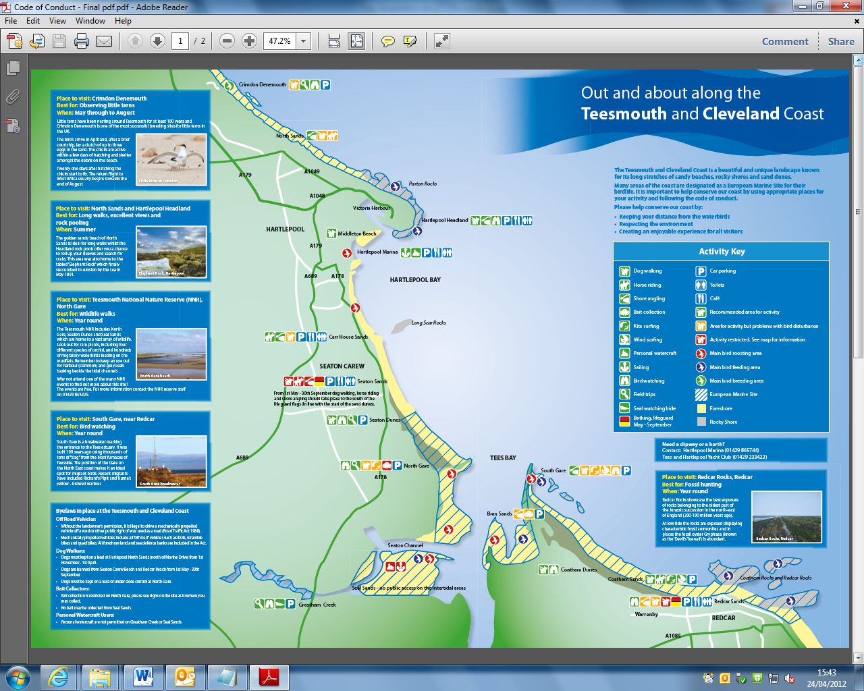

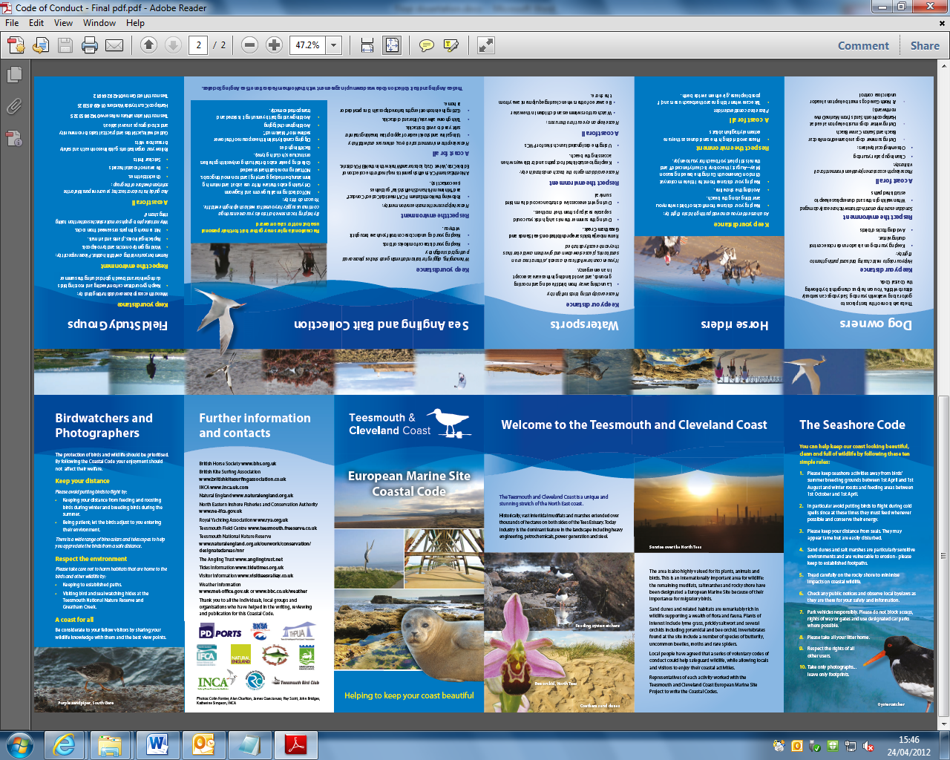

### Appendix 4: Potential Sites for the Interpretation Boards

# Key Points for Interpretation Boards

Interpretation boards are used at many conservation sites to convey show users the access routes, outline the importance of the site and to identify important site features.

When placed at strategic entrance points they immediately draw the visitor’s attention and it is hoped that the visitor would heed the information presented to them on the board.

The results from the visitor survey for the Teesmouth and Cleveland Coast European Marine Site (EMS) found that visitors would like to see more interpretation boards across the whole EMS and these would act as an effective way to communicate the code of conduct.

The interpretation boards would be most effective if they followed a standard theme (for example a storyboard theme as used as the Flamborough EMS) which was then adapted to include information specific to that site such as:

* Little terns at North Sands.
* Detailed information from the code of conduct for at sites where specific activities are known to be causing disturbance, such as bait digging at South Gare or wind/kite surfing at North Gare.
* A map of the site would be useful showing the entrance/exit points, as well as individual conservation features.
* Only a brief outline of the codes of conduct should be included on the interpretation boards such as the ‘Seashore Code Top 10’.
* It is recommended that the interpretation boards for the sites are produced following the RNLI Guide to Signage (URL: <http://www.rnli.org.uk/what_we_do/sea_and_beach_safety/beachsafety/beach_management/signage>).

# North Sands

There are two main entrance points to North Sands, the cemetery at Hartlepool Headland or further north at Crimdon. It is recommended a board is placed at both of these entrances, in particular at Crimdon where the little tern colony is found.

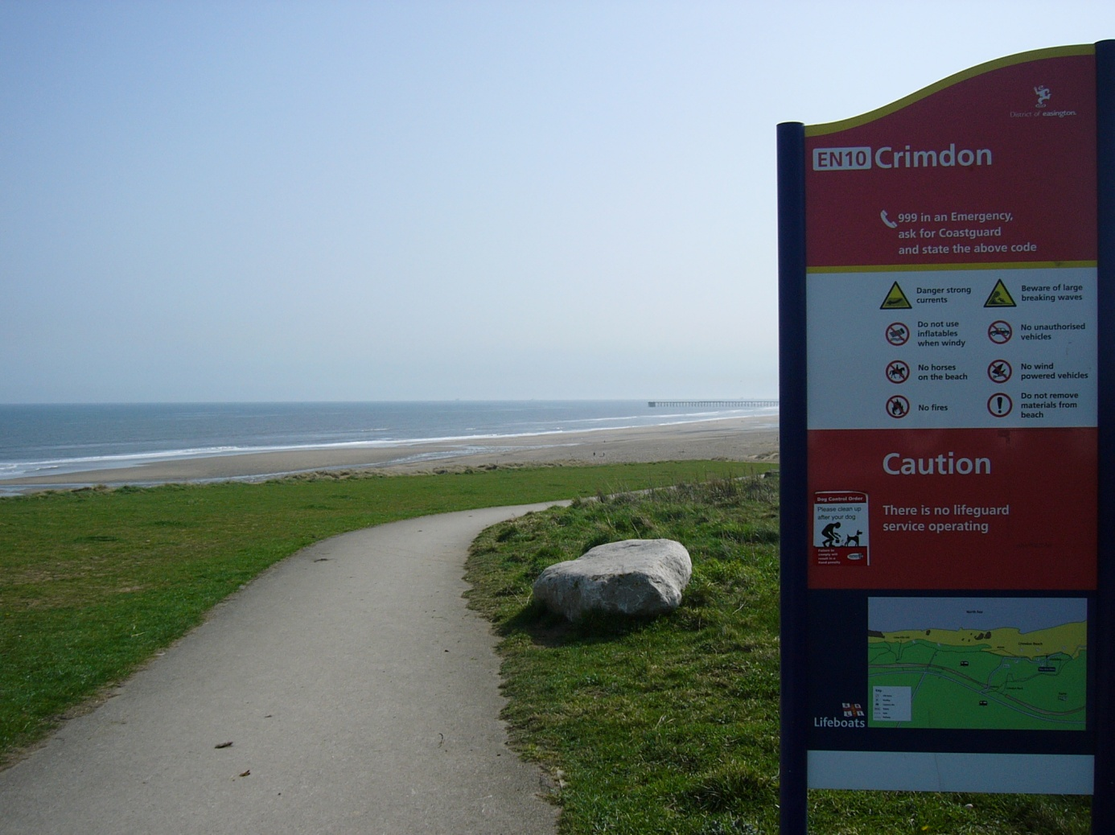

An example of an RNLI interpretation board at the Crimdon entrance to North Sands.

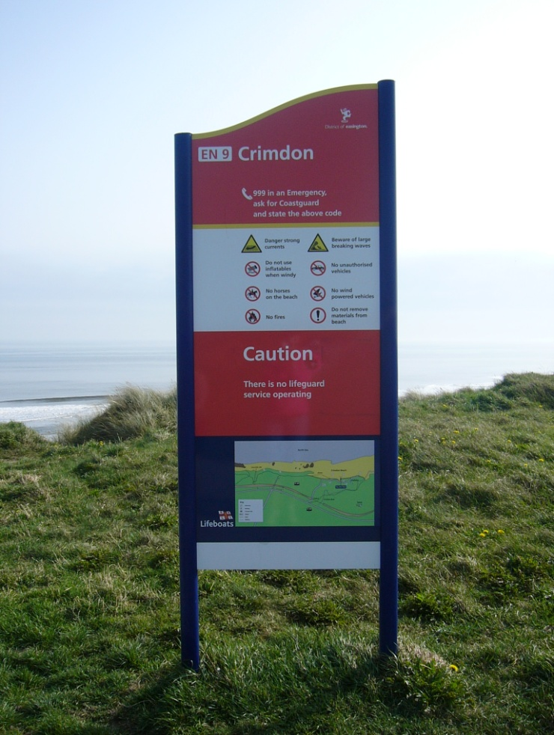

A further example of an RNLI interpretation board at the Crimdon entrance to North Sands.

# Hartlepool Headland

The need for an interpretation board as Hartlepool Headland is minimal compared to the other sites as disturbance here is limited. The site is visited most frequently by locals, rather than tourists so it is more likely they will learn of the code of conduct through other promotional material.

# North Gare

There are already two interpretation boards for North Gare at The National Nature Reserve (NNR), as well as an interpretation board outlining the Seaton Dunes & Common at Seaton Carew. There would be little need for a further interpretation board at the entrance to the NNR. However a further board at Seaton Carew may be useful to ensure there is a single theme running through the sites.

It should also be pointed out that some of the information boards at the NNR are not readily accessible to the public. Information on the Byelaws in force on the NNR is only found on the back of the boards in difficult to reach.

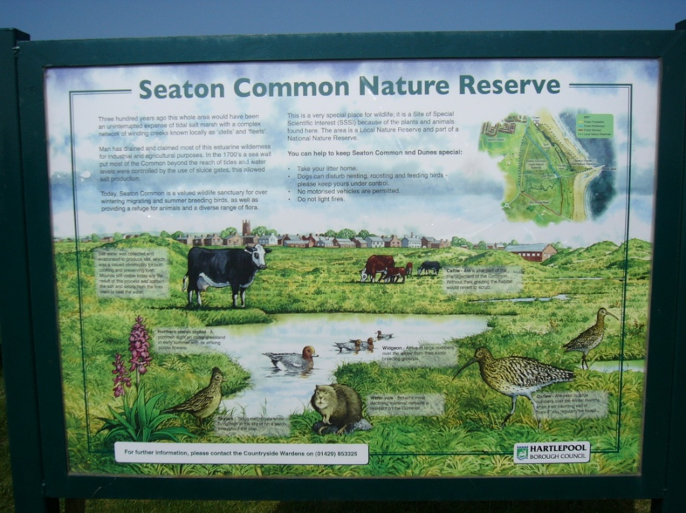

Interpretation board at the entrance to the NNR

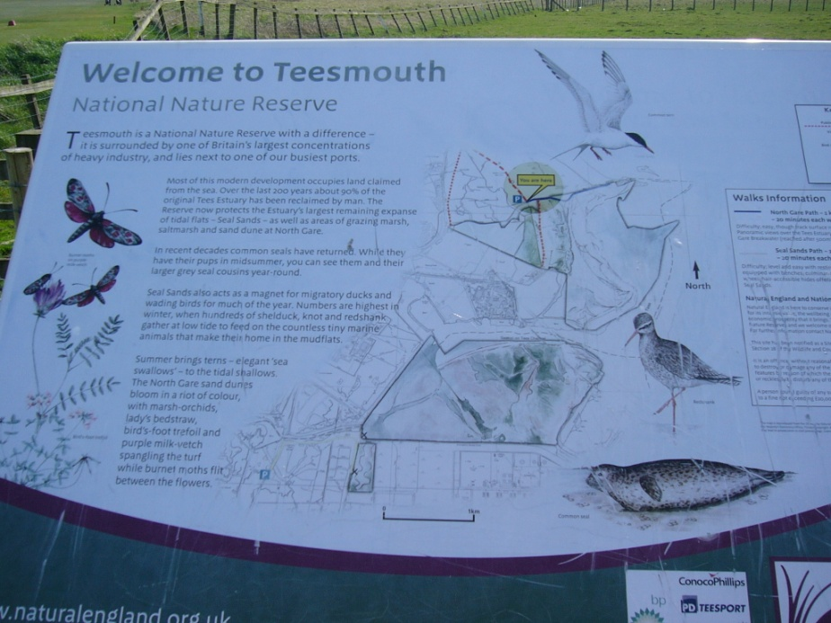

Interpretation board at the entrance to the NNR

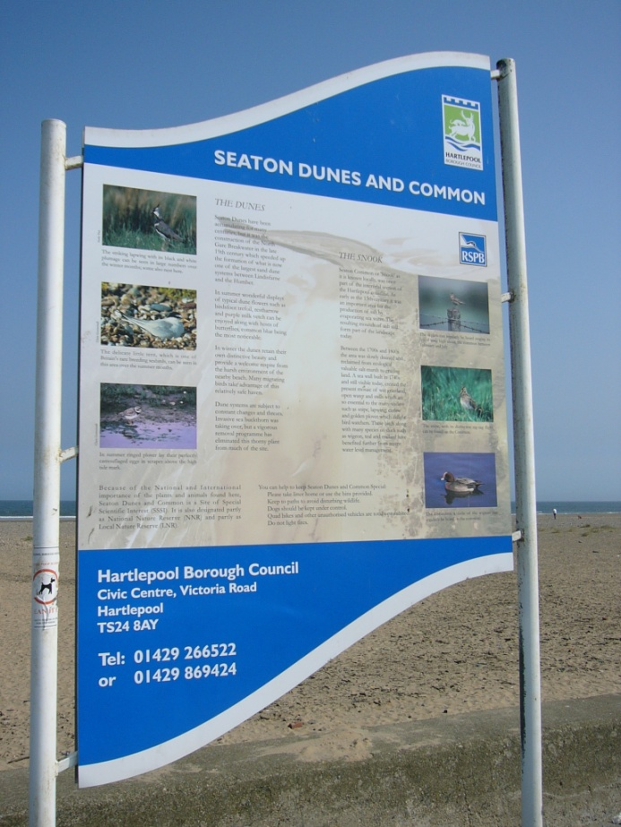

Interpretation board at Seaton Carew

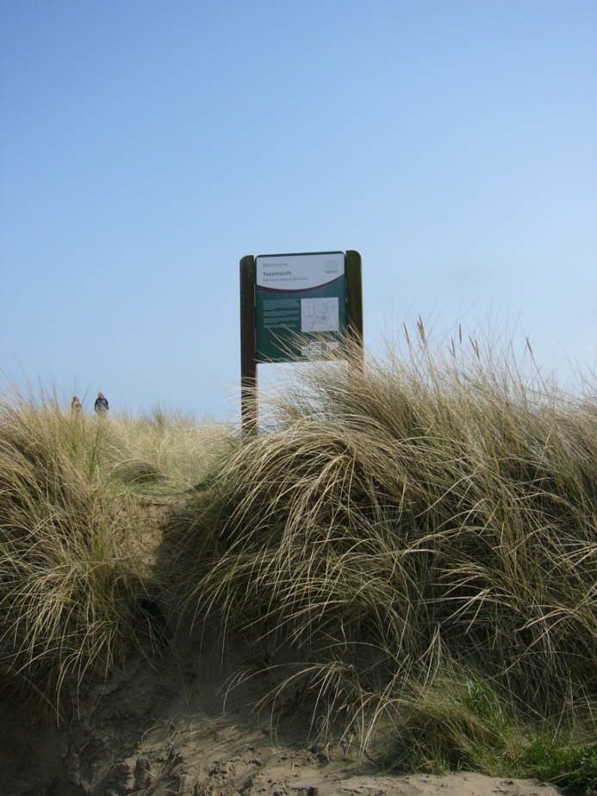

A less accessible interpretation board at the NNR

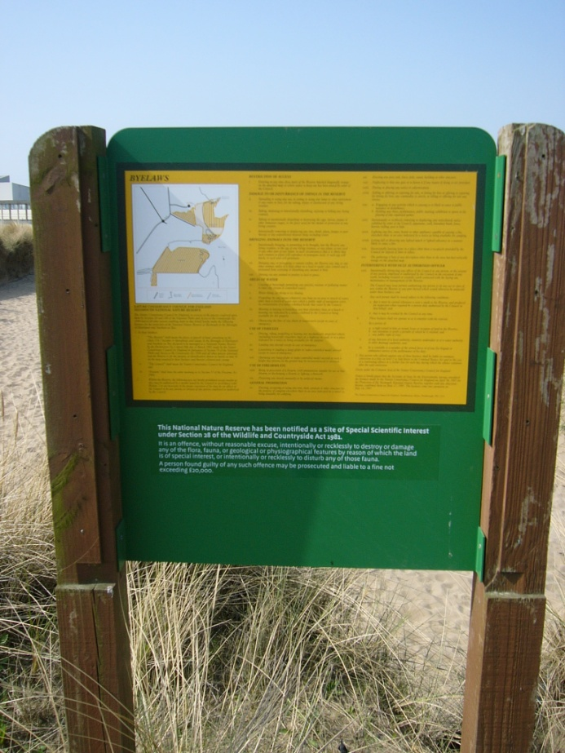

A less accessible interpretation board at the NNR

# South Gare

At present there are no interpretation boards at South Gare. South Gare is visited by a wide range of people for a variety of reasons. The area is a particularly important migratory stop off for birds- a point which could be highlighted on an interpretation board for this site.

The board would be most effective if placed where people park their cars and near to the picnic benches.

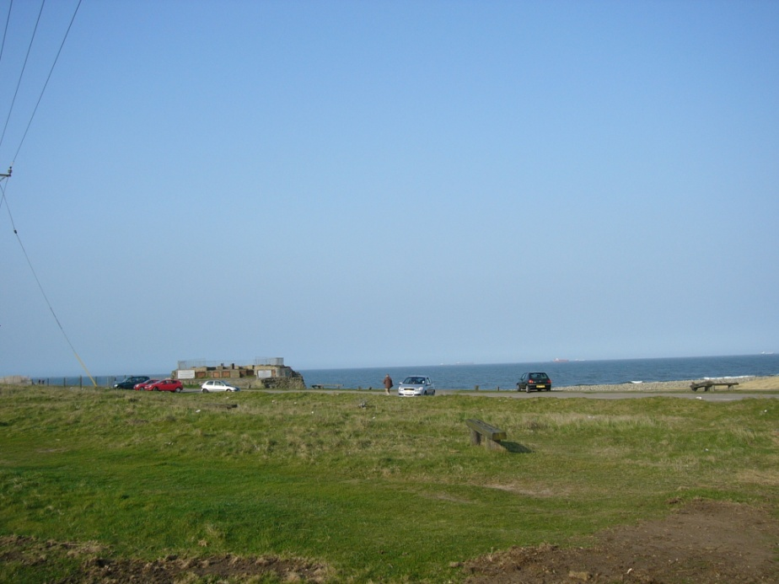

The car park at South Gare

# Coatham Sands and Redcar Seafront

At present there are no interpretation boards at Coatham Sands or along the promenade at Redcar detailing that the area is important for conservation. It is recommended that a board could be placed at the Majuba Road car park adjacent to Coatham Sands and a further board along the promenade. It is recommended that these are put in place following the redevelopment of the seafront and the implementation of the Coatham Beach Management Plan.

### Appendix 5: The Focus Group Agenda

Once the management group have reached a consensus regarding the recommendations, it is recommended that a focus group takes place with the local residents of Hartlepool and Redcar to gauge their responses to the proposed management options.

The visitor questionnaire was the first step in stakeholder engagement with site users. The next logical step is the planning and running of a focus group for local residents. A focus group with local residents would allow the management group to assess how people feel or think about the recommendations in greater detail than the visitor survey questionnaire. A brief introductory guide to focus groups is provided here in the Appendix following the recommendations of Krueger & Casey (2000).

|  |
| --- |
| **Proposed aims for the local user focus group** |
| 1. What is the problem that the study needs to address?   *How best to manage recreational disturbance at the Teesmouth and Cleveland Coast EMS.* |
| 1. What led up to the decision to do this study?   *Recreational disturbance is having a negative impact on the waterbirds at the site.* |
| 1. What is the purpose of this study?   *Is a code of conduct the best management approach for managing this problem?* |
| 1. What kind of information do you want?  * Why people visit the EMS? * Do they think there are any problems at the EMS? * Which management options would they like to see at the EMS:   + A code of conduct.   + A voluntary user group.   + Awareness raising activities and events for the EMS.   + Zoning of certain recreational activities. |
| 1. What types of information are of particular importance?   *The user’s thoughts on the code of conduct and local user group.* |
| 1. Who wants the information?   *Natural England and local authorities.* |

The group should not be used to educate people about the EMS, nor as a starter meeting for the local user group. The aim of the focus group is to establish the local user’s opinions and invite discussion on all the proposed recommendations to aid the final management choices for the site. .

|  |  |
| --- | --- |
| **Example focus group questions** | |
| Opening | 1. Name and how long you have lived in the area |
| Introductory | 1. How often do you visit the coast and what activities do you like doing there? |
| Transition | 1. Are there any activities which bother you when you visit the coastline? |
| Transition | 1. Did you know that the area is important for conservation?   *Bring in the conservation importance of the site* |
| Key questions | 1. There are many ways of managing the area what do you think of:   A) A code of conduct for site users?  B) A user group?  C) Raising awareness of the coastline through activity days at the beach visiting schools, talking to people in the local community?  D) Restricting activities on certain stretches of the coastline? |
| Key Questions | 1. If you had to choose one of these to take place which would you choose and why? |
| Ending questions | 1. If there was one thing you could change at the coastline what would it be? |
| Ending questions | 1. Is there anything we have missed? |

It is recommended that each focus group has no more than twelve participants which should encourage all people to interact with one another. It is recommended three groups would be held totally 30 - 36 respondents.

To encourage people to attend the focus group an advert for participants would need to be placed in local newspapers and broadcast on local radio, this also gives the management group and opportunity to promote the EMS. It is also suggested that people are offered an incentive to attend the focus group, for example a £5 shopping voucher. Refreshments would also need to be offered.

## Focus Group Timetable & Script

**Start 19.00**

**19.00 – 19.15**

**Introductions**

1. Welcome and Housekeeping (Bob) (5 minutes).
2. Introduction of the project, scene setting and why are we doing this. Explain the main purpose of the focus group, re-iterate the points in the briefing note, and explain how the group will operate (10 minutes).

*“As you most of you will know the Teesmouth and Cleveland Coastline is an internationally important area for the conservation of waterbirds. The areas of North Sands at Hartlepool, North Gare, Bran Sands, South Gare and Redcar Rocks are of national and international importance (see maps on table) something that many people who live in and visit Tees Valley still do not realise.*

*Until recently the major negative impact on birds was the impact of industry which has seen the loss of over 90% of the intertidal mudflats and sandbanks in the period since 1850. As land reclamation has ceased and industry has started to behave responsibly and repair the damage it caused during the 20th century the dominant negative impact on birds is now recreational activities which are causing disturbance resulting in the birds taking flight and squandering precious energy, rather than foraging for food or resting. This is especially a problem during the winter months when wintering and migratory birds need to maximise their feeding time because of restricted daylight and poor weather.”*

*“There are many local initiatives encouraging increased access by people to visit and make use of our local environmental assets. It is therefore crucial that both existing and new recreational users behave responsibly hence this initiative to educate users on how to access and behave responsibly when visiting our precious and beautiful coastline”*

*“Tonight is the first of 2 focus group looking to bring together local groups of similar interests to look at how they use the coastal area, which areas are the most important for different activities and to look at potential new ways of managing the coastline for recreation and conservation. The second focus group is later this week with water based groups including kite surfers, wind surfers and jet skiers. I am also talking to local horse users and sea angling groups.”*

*“What we are doing here is not unique. Many other coastlines have produced management plans for recreational activities and there is evidence of some success. It is hoped that eventually we will create a user group who will meet alongside the formal management group for the area to keep users informed of developments in the management of the coastline, but more on that later”.*

**19.15 – 19.30**

Further introductory questions: which activities do you undertake at the coastline and how often?

1. Ask each member to introduce themselves, and the group they belong to (5 minutes).
2. Ask the members to split into groups of six around the tables.
3. “On the table you will see you each have a pack of maps of the coastline. Over the next few minutes in pairs, or individually could you please mark on which areas of the coastline you prefer to visit” (5 minutes).
4. “Please could you now mark on how you access these areas? For example, if you bird watch at South Gare do you stand on the access road or prefer to stand on the shoreline” (5 minutes).
5. “Please could you mark down how often you visit the areas” (5 minutes).

**19.30 – 19.50**

**Transition: Recreational activities discussion**

*“As a table please could you discuss if there are any recreational activities which affect your enjoyment of the coast. Please could you write these down on the sticky pads provided and also write down which areas of the coast you experience these problems” (10 minutes).*

*“Please could one member of your table briefly share with the groups which problems you discussed (10 minutes).*

**19:50 – 20.00**

**Transition: Conservation Context**

Present the need to manage for the site for conservation, as well as improving the experience for those visiting the site.

*“As discussed at the start of the meeting certain stretches of the coastline are internationally important for waterbirds. From ongoing monitoring these areas can be sub divided into zones which are of high importance to the birds at different stages of the tidal cycle (see maps on table). We would like to develop with yourselves, a management plan which would see these areas safeguarded from disturbance, whilst allowing your recreational activity to still take place.”*

**20:00 – 20.45**

**Key Questions: Discussion of Management Options**

Present the management options available for the site.

1. *“Other coastlines have adopted a variety of management measures for the problems we have been discussing today, both for managing disturbance and conflicting recreational activities. At present we would like to create voluntary management for the area, rather than enforcement measures. The two main voluntary measures used by other coastlines are a voluntary code of conduct for all coastal users or voluntary zoning of activities, or a combination of the two.” (5 minutes)*
2. *“On the table are copies of codes of conduct for other coastlines. As a group could you look through the codes of conduct and discuss the positives of them and write your main thoughts on the sticky pads (5 minutes)*
3. *“Could you now discuss the negatives for five minutes and write your main thoughts on the sticky pads? (5 minutes)*
4. *“This is the draft wording for the Teesmouth & Cleveland Code of Conduct if we decided this was the right management measure for this area. As individuals could you read through it for 10 minutes and note any comments on the paper”. (10 minutes)*
5. *“On the table there is a potential plan for the zoning of activities based on the disturbance work to date, and previous management plans prepared by local authorities. As a table please could you discuss your objections to the plans.” (5 minutes)*
6. *“As a table could you discuss and write down how you would change the plan” (5 minutes).*
7. *“As a table could you discuss which voluntary measures you would prefer to take place? Please could one member of your table briefly discuss your thoughts? (15 minutes)*

**Communication Questionnaire**

*“The final part of tonight centres on how best to communicate the new management of the area in the future if we choose to take this work forward. It is essential that the general public at the coastline and wider Tees Valley are aware of the new plans; otherwise our initiatives that we have proposed tonight will fail. In your packs you will find a brief questionnaire regarding communicating the code of conduct and / voluntary zoning. Please will you spend 5 minutes completing this now before the final summary of the evening”.*

**Statement of Future Action**

*“Thank you very much for your time this evening. Over the coming two week I will work through the information you have provided me with this evening. I will then send a short summary of this evening to your groups, alongside the findings from the other focus groups for you to share with your other members.*

*I will also be discussing the findings with the EMS management group in January where we will decide which course of management is best taking into account our discussions this evening. A draft document will then be produced and sent out to you for further comments. You will also be invited to a second open meeting with all coastal users late January or early February where the plans will be discussed further. This will then result in a final draft being produced and hopefully circulated to you all by mid-March6: for final comments. It is hoped the management measure will then be launched spring next year”.*

*“Before we say good night do you have any further questions?”*

*“Thank you all for your time”*

### Appendix 6: Proposed Bird Monitoring Strategy

## Responses of Waterbirds to Human Activities

For the Teesmouth and Cleveland Coast EMS we need to understand the current level of recreational disturbance in a greater depth than that which was provided by the University of York report. The methodology outlined here follows the work of Footprint Ecology who is currently undertaking disturbance monitoring on the Humber Estuary, Exe Estuary and along the Solent.

In order to understand the response of birds to human activity ornithological fieldwork is necessary and should involve recording:

* Which activities occur.
* The behavioural response of the birds and the relevant distances. It is important to record which activities result in no response from the birds and important to record the distance at which birds stop feeding, become vigilant, take flight etc.
* Ideally for each disturbance event the time the birds spend in flight and the distance flushed should also be recorded.

## Methodology

# Survey Sites:

Following discussions with Mike Leakey (NE), Ian Bond (HBC) and Martin Kerby (RSPB) three high tide sites were chosen and five low tide survey sites.

* High Tide: North Gare entrance, Seaton Snook and South Gare to Coatham Sands
* Low Tide: Hartlepool North Sands, North Gare entrance, Seaton Snook, South Gare to Coatham Sands, Bran Sands and Redcar Rocks.

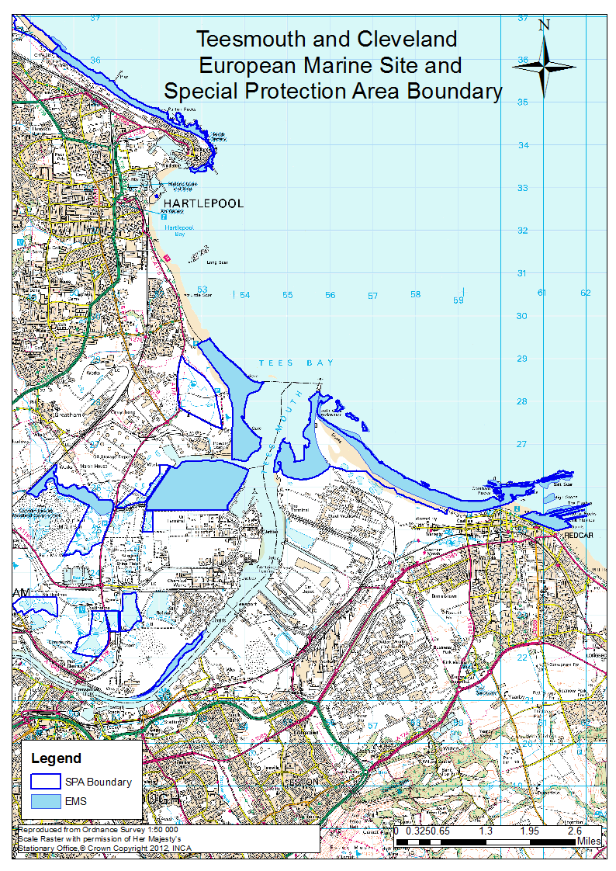

The Teesmouth and Cleveland Coast SPA

# Survey Timetable

Each site will be visited throughout the winter (October – March). Footprint Ecology suggests four visits per month, but due to time constraints each site will be visited twice per month. As North Gare, Seaton Snook and South Gare & Coatham Sands will be surveyed at low and high tide these sites will be visited four times per month.

Each survey will last two hours. The high tide surveys should start two hours before high tide to partly capture rising tide usage. For all sites except Redcar Rocks low tide surveys should take two hours and can take place within a four hour window around the low tide time. The low tide survey at Redcar Rocks should commence two hours after the low tide point.

It is important to note that the surveys are a snapshot which only quantify disturbance at certain stages of the tidal cycle.

Visits will need to be stratified to ensure temporal coverage, for example some surveys will need to take place on a weekend and early in the morning.

Each count will involve the following elements:

* Two waterbird counts (one at the beginning of the survey, one at the end of the survey) recording the number of birds at different distance bands from the surveyor.
* Locations of the waterbirds at the start and end of the survey should be detailed on the site map.
* An initial map of all recreational activities and an end map of recreational activities
* A diary of all potential disturbance events observed during the following 1 hour and 45 minutes.
* A record of the response of selected bird species to each of the potential disturbance events recorded in the ‘diary’.
* Additional information.

# Bird count

* At the start of each survey all the birds present within the pre-defined study area should be counted. For each survey location the area should be mapped as the sites will vary in size.
* For all species the count is total number of birds within the study area. This count will be divided into distance bands running perpendicular from the surveyor’s location. Key clusters of the birds should be recorded on the map.
* An aerial map will be produced for each site detailing the distance bands for ease of counts.
* The count and map of birds should be repeated at the end of each visit. Significant arrivals and departures of waterbirds during the survey period should also be noted.

**Initial map of all recreational activity**

* Following the bird count, all people and recreational activities should be mapped.
* The map acts as ‘snapshot’ recording all people and activities visible at a single point in time. It also provides an overview of how people use the site and how far out into the intertidal activities take place.
* The map zone extends beyond the bird recording area and will be highlighted on the distance band mapped.
* People will be mapped as a single point with a label (Letters which can be cross referenced with the disturbance diary i.e. DWL for dog walker, dog on lead).
* Some activities may need to be clustered with a circle, for example kite surfers moving quickly across a discrete area.
* This should take no more than five minutes as it aims to give a broad overview and it is accepted that the locations of people / activities will be approximate.

**Survey form (diary)**

* All potential disturbance events during the following 1 hour and 45 minutes should then be recorded on the survey form.
* This form will record all new recreational activities and all activities originally mapped.
* All recreational activities should be recorded and their location (corresponding to the recreational activity maps). For each activity the group size should be recorded, duration and for example the number of dogs.
* Recreational activities (events) are categorised as angling (A), bait digging (BD), bird watching (BW), diving (DV), dog walking (DW), horse riding (HR) , kite-surfing (KS), vehicles (V), walking (W), windsurfing (WS), and other.

**Disturbance**

* The survey form should document for each activity, which birds were present and ensure that events where no birds were present are recorded can be separated from events where birds were present and not disturbed.
* The disturbance data will record the number of birds within 200m of the potential source of disturbance and the behaviour.
* Behaviour can be categorised as feeding (F) or roosting / preening / loafing (R).
* The response of the birds should be recorded as:
* Birds raise head then continue feeding / roosting
* Birds move in foot from disturbance and then continue feeding / roosting (the distance moved should be recorded).
* Birds stop feeding / roosting and show high alertness / agitation.
* The bird takes flight. Flight disturbance should be categorised as Birds move less than 50 m (1), Birds move over 50m (2) and Birds leave the study site (3).
* For each activity/event where disturbance occurs the maximum distance from the birds to the event needs to be recorded, as the straight line distance from the source of disturbance to the birds. If there is no response from the birds then the minimum distance from each bird species present to the activity should be recorded.

If the birds are in a tight flock or an individual then this distance is relatively easy to measure. If the birds are scattered over a wide area and all are disturbed, then the distance will be the approximate range within which the birds were feeding (i.e. 20m – 50m). In all cases distances will be estimated to the nearest 10m.

### Appendix 7: Data Included on the CD

Raw data tables for the bird disturbance study and visitor survey are included on the CD. SPSS tables and outputs are also included.

The report ‘A Study into Recreational Disturbance at the Teesmouth and Cleveland Coast European Marine Site ‘ as submitted to Natural England and the Teesmouth and Cleveland European Marine Site Management Group is also included.

### List of References

AGARDY, T. (2005) Global marine conservation policy versus site-level implementation: the mismatch of scale and its implications. *Marine Ecology Progress Series.* 300: 242-248.

ARMITAGE, D.R., PLUMMER, R., BERKES, F., ARTHUR, R.I., CHARLES, A.T., DAVIDSON-HUNT, I.J., DIDUCK, A.P., DOUBLEDAY, N.C., JOHNSON, D., MARSCHKE, M., MCCONNEY, P., PINKERTON, E.W., & WOLLENBERG, E.K. (2009) Adaptive co-management for social-ecological complexity. *Frontiers in Ecology and the Environment.* 7 (2); 95-102.

BALMFORD, A. & COWLING, R.M. (2006) Fusion or Failure? The future of conservation biology. *Conservation Biology.* 20; 692-695.

BALMFORD, A., [Bruner](http://www.sciencemag.org/search?author1=Aaron+Bruner&sortspec=date&submit=Submit), A., COOPER, P., [Costanza](http://www.sciencemag.org/search?author1=Robert+Costanza&sortspec=date&submit=Submit), R., FARBER, S., GREEN, R.E., JENKINS, M., JEFFERISS, P., JESSAMY, V., MADDEN, J., MUNRO, K., MYERS, N., NAEEM, S., PAAVOLA, J., RAYMENT, M., ROSENDO, S., ROUGHGARDEN, J., TRUMPER, K. &TUNRER, R.K. (2002) Economic Reasons for Conserving Wild Nature. *Science.* 297; 950-953.

BANKS, P.B. & BRYANT, J.V. (2007) Four-legged friend or foe? Dog walking displaces native birds from natural areas. *Biology Letters.* 3 (6); 611-613.

BATTEN, L.A. (1977) Bird Population Changes for the Years 1975 – 1976. *Bird Study.* 24 (3); 159-164.

BEATTY,C., FOTHERGILL, F., GORE, T. & WILSON, I. (2010) The Seaside Tourist Industry in England and Wales- Employment, Economic Output, Location and Trends. [Online] Available at: http://collateral.newsflashconnect.co.uk/RemoteStorage/East%20Riding/Releases/12582/SHU%20FINALTourismReport.pdf. Accessed: 22/8/2011.

BEAUMONT, N.J., AUSTEN, M.C., MANGI, S.C. & TOWNSEND, M. (2008) Economic valuation for the conservation of marine biodiversity. *Marine Pollution Bulletin*. 56; 386–396.

[BECKER](http://socialecologicalsystems.referata.com/w/index.php?title=Dustin_Becker&action=edit&redlink=1), D. & OSTROM, E. (1995)Human Ecology and Resource Sustainability: The Importance of Institutional Diversity. [*Annual Review of Ecology and Systematics*](http://socialecologicalsystems.referata.com/wiki/Special:FormEdit/Reference/Annual_Review_of_Ecology_and_Systematics)*.* 26; 113-133.

BERKES, F., & FOLKE, C. (1998) *Linking Social and Ecological Systems: Management Practices and Social Mechanisms for Building Resilience.* Cambridge University Press, New York.

BERKES, F. (2009) Evolution of co-management: Role of knowledge generation, bridging organizations and social learning. *Journal of Environmental Management.* 90(5); 1692-1702.

BILDSTEIN, K.L., BANCOFT, G.T., DUGAN, P.J., GORDON, D.H., ERWIN, R.M., PAYNE, L.X. & SENNER’O, S.E. (1991) Approaches to the Conservation of Coastal Wetlands in the Western-Hemisphere. *Wilson Bulletin.* 103(2); 218-254.

BIRCHENOUGH, A.C. & EVANS, S.M. (2003) Bran Sands Bait Collection Project Phase 2. *English Nature Report NZ52.RC.5.*

BOND, I. (2011) *Seaton Sands Bird Study.* [spreadsheet data] (Personal communication, April 2011).

BOOTH, J. E., GASTON, K.J. & ARMSWORTH, P.R. (2010) Who benefits from recreational use of protected areas? *Ecology and Society.* 15(3):;19.

BORJA, A., [BRICKER SB](http://www.ncbi.nlm.nih.gov/pubmed?term=%22Bricker%20SB%22%5BAuthor%5D), [DAUER DM](http://www.ncbi.nlm.nih.gov/pubmed?term=%22Dauer%20DM%22%5BAuthor%5D), [DEMETRIADES NT](http://www.ncbi.nlm.nih.gov/pubmed?term=%22Demetriades%20NT%22%5BAuthor%5D), [FERREIRA JG](http://www.ncbi.nlm.nih.gov/pubmed?term=%22Ferreira%20JG%22%5BAuthor%5D), [FORBES AT](http://www.ncbi.nlm.nih.gov/pubmed?term=%22Forbes%20AT%22%5BAuthor%5D), [HUTCHINGS P](http://www.ncbi.nlm.nih.gov/pubmed?term=%22Hutchings%20P%22%5BAuthor%5D), [JIA X](http://www.ncbi.nlm.nih.gov/pubmed?term=%22Jia%20X%22%5BAuthor%5D), [KENCHINGTON R](http://www.ncbi.nlm.nih.gov/pubmed?term=%22Kenchington%20R%22%5BAuthor%5D), [CARLOS MARQUES J](http://www.ncbi.nlm.nih.gov/pubmed?term=%22Carlos%20Marques%20J%22%5BAuthor%5D), AND [ZHU C](http://www.ncbi.nlm.nih.gov/pubmed?term=%22Zhu%20C%22%5BAuthor%5D). (2008) Overview of integrative tools and methods in assessing ecological integrity in estuarine and coastal systems worldwide. *Marine Pollution Bulletin.*  56; 1519–1537.

BRANDER, L.M, & FLORAX, R.J.G.M. & VERMAAT, J.E. (2006) The empirics of wetland valuation: A comprehensive summary and a meta-analysis of the literature. *Environmental & Resource Economics* . 33(2); 223-250.

BRETT, A.B., GRANDGIRARD, A. & WARD, J.R. (2010) Quantifying and Exploring Strategic Regional Priorities for Managing Natural Capital and Ecosystem Services Given Multiple Stakeholder Perspectives. *Ecosystems*. 13; 539–555.

BROUWER, R. (2000) *Environmental value transfer: state of the art and future prospects*. *Ecological Economics.* 32 (1); 137-152.

BROWN, K., TOMPKINS, E.L. & ADGER, W.N. (2002) *Making waves: integrating coastal conservation and development*. London, UK: Earthscan Publications Ltd.

BURGER, J. (1981) The Effect of Human Activities on Birds at a Coastal Bay. *Biological Conservation.* 21; 231-241.

BURGER, J., SANCHEZA, J., ROUSHC, D. & GOCHFELD, M. (2000) Risk perception, land use, and the Idaho National Engineering and Environmental Laboratory: Attitudes of the Shoshone-Bannock and other American Indians. *Environmental Resources. .* 83; 298–310.

BURGER, J. MYERS, O., BORING, C.S., DIXON,C., JEITNER, J.C, LEONARD, LORD, C., McMAHON, M., RAMOS, R., SHUKLA, S., & GOCHFELD, M. (2003). Perceptual Indicators of Environmental Health, Future Land Use and Stewardship. *Environmental Monitoring and Assessment.* 89**;** 285–303.

BURTON, N.K.H. (2007) Landscape approaches to studying the effects of disturbance on waterbirds. *International Journal of Avian Science.* 149.1; 95-101.

BURTON, N.K.H., REHFISCH, M.M. & CLARK, N.G. (2002) Impacts of Disturbance from Construction Work on the Densities and Feeding Behaviour of Waterbirds Using the Intertidal Mudflats of Cardiff Bay, UK. *Environmental Management*, 30 (6), 865–871.

CAYFORD, J. T. (1993) Wader disturbance: a theoretical overview. *Wader Study Group Bulletin.* 68; 3-5.

CBD (1992) Convention on Biological Diversity. [Online] URL: http://www.cbd.int/ Accessed: 3/8/2011.

CBD (1995). The Jakarta Mandate on Marine and Coastal Biological Diversity; Decisions of the Second Meeting of the Conference of the Parties to the Convention on Biological Diversity. Jakarta, Indonesia, 6-17 November 1995. UNEP.

CBD (1998). Malawi Principles for the Ecosystem Approach. Fourth Conference of the Parties of the CBD. UNEP/CBD/COP/4/Inf.9). January 1998.

CHANTOIS, P. & STEAD, S. (2007) Interviewing people about the cost on the coast: Appraising the wider adoption of ICZM in North East England. *Marine Policy.* 31; 517-526.

CHIESURA, A. & de GROOT, R. (2003) Critical natural capital: a socio-cultural perspective. *Ecological Economics.* 44 (2-3); 219-231.

CHRISTIE, P. (2004). MPAs as biological successes and social failures in Southeast Asia. In: Shipley JB (Ed). *Aquatic protected areas as fisheries management tools: design, use, and evaluation of these fully protected areas.* Bethesda, MD: American Fisheries Society.

CLARK, J., CARPENTER, S.R., BARBER, M., COLLINS, S., DOBSON, A., FOLEY, J.A., LODGE, D.,M., PASCUAL, M., PIELKE, R., PIZER, R., PRINGLE, C., WALTER, R., ROSE, K.A., SALA, O., SCHLESINGER, W.H., WALL, D.H., & WEAR, D. (2001). Ecological Forecasts: An Emerging Imperative. *Science.* Vol. 293; pp.657-660.

COOMBES, E.G. & JONES, A.P. (2010). Assessing the impact of climate change on visitor behaviour and habitat use at the coast: A UK case study. Global Environmental Change- Human and Policy Dimensions. 20 (2); 303-313

COOPER, C. et al. (1998). In SHEPHERD, eds. Tourism: Principles and Practices. Second edition. Essex: Addison Wesley Longman.

CORNELIUS, C., NAVARRETE, S.C & MARQUET, P.A. (2001) Effects of Human Activity on the Structure of Coastal Marine Bird Assemblages in Central Chile. *Conservation Biology*. 15(5); 1396-1404.

COSTANZA, R., D’ARGE, R., DE GROOT, R., FARBERK, S., GRASSO, M., HANNON, B., LIMBURG, K., NAEEM, I.S., O’NEILL, R.V., PARUELO, J., RASKIN, R.G., SUTTONKK, P. VAN DEN BELT, M. (1997). [THE VALUE OF THE WORLD'S ECOSYSTEM SERVICES AND NATURAL CAPITAL](http://apps.isiknowledge.com/full_record.do?product=WOS&search_mode=GeneralSearch&qid=1&SID=U2of7@obI@7MLLGI8Gp&page=1&doc=1&cacheurlFromRightClick=no). *NATURE.* 387 (6630); 253-260.

COX, M., JOHNSTONE, R. & ROBINSON, J. (2005) Effects of Coastal Recreation on Social Aspects of Human Well-being. *Proceedings of the Coastal Zone Asia Pacific Conference 156.*

COYLE, M.D. & WIGGINS, S.M. (2010) European Marine Site Risk Review. *Natural England Research Reports, Number 038*.

CROOKS, S. & TURNER, R.K. (1999) Integrated coastal management: Sustaining estuarine natural resources. *Advances in Ecological Research.*  29; 241-289.

CRUICKSHANKS, K. LILEY, D., FEARNLEY, H., STILLMAN, R., HARVELL, P., HOSKIN, R. & UNDERHILL-DAY, J. (2010) Desk Based Study on Recreational Disturbance to birds on the Humber Estuary. Footprint Ecology / Humber Management Scheme.

CUMMINGS, R.G. & TAYLOR, L.O. (1999) Unbiased value estimates for environmental goods: A cheap talk design for the contingent valuation method. *The American Economic Review*, 89, 649–665.

DAILY, G. E. (1997). Nature's Services – Societal Dependence on Natural Ecosystems. Island Press, Washington.

DAILY, G. E. (2000). Management objectives for protection of ecosystem services. *Environmental Science Policy*. 3; 333–339.

DAILY, G.C. & MATSON, P.A. (2008) Ecosystem services: From theory to implementation. PNAS. 105 (28); 9455–9456.

DANILESEN, F. BURGESS, N.D. & BALMFORD, A. (2005) Monitoring matters: examining the potential of locally-based approaches. *Biodiversity and Conservation.*  14:2507–2542.

DAVIDSON, N.C. & ROTHWELL, P.I. (1993) Human disturbance to waterfowl on estuaries: conservation and coastal management implications of current knowledge. *Wader Study Group Bulletin.* 68; 97-105.

DE GROOT, R., WILSON, M.A, & ROUMANS, R.A. (2002). A typology for the classification, description and valuation of ecosystem functions, goods and services. *Ecological Economics*. 41(3); 393-408.

DE GROOT, R.S. ALKEMADE, J.R.M.; BRAAT, L.; HEIN, L.G.; WILLEMEN, L.L.J.M.L. (2010) Challenges in integrating the concept of ecosystem services and values in landscape planning, management and decision making. *Ecological Complexity.* 7; 260–272.

DEFRA. (undated) Magic Map. [Online] http://magic.defra.gov.uk/. Accessed: 15/9/2010.

DEFRA. (2004). Managing coastal activities: a guide for local authorities. [Online] URL: [http://archive.defra.gov.uk/rural/documents/countryside/coastal-guidance.pdf. Accessed 12/9/2011](http://archive.defra.gov.uk/rural/documents/countryside/coastal-guidance.pdf.%20Accessed%2012/9/2011).

DEFRA. (2006) Implementation of (2002/413/EC) Recommendation of the European Parliament and of the Council, of 3 May 2002, concerning the Implementation of Integrated Coastal Zone Management in Europe. [Online] [http://archive.defra.gov.uk/environment/marine/documents/protected/iczm/ukreport-march06.pdf Accessed 1/12/2011](http://archive.defra.gov.uk/environment/marine/documents/protected/iczm/ukreport-march06.pdf%20Accessed%201/12/2011).

DEFRA. (2007) An Introductory Guide to Valuing Ecosystem Services. [Online] URL: http://ec.europa.eu/environment/nature/biodiversity/economics/pdf/valuing_ecosystems.pdf. Accessed: 15/11/09.

DEFRA. (2010a) What nature can do for you. A practical introduction to making the most of natural services, assets and resources in policy and decision making. [Online] URL: <http://archive.defra.gov.uk/environment/policy/natural-environ/documents/nature-do-for-you.pdf> Accessed: 1/12/2012.

DEFRA. (2010b) Delivering a healthy natural environment. An update to “Securing a healthy natural environment: An action plan for embedding an ecosystems approach. [Online] URL: <http://archive.defra.gov.uk/environment/policy/natural-environ/documents/healthy-nat-environ.PDF> Accessed 1/12/2012.

DONOGHUE. D.M., ZONG, Y., DUNFORD, R. & WATT, P. (undated) An investigation of the sediment budget, the fate of contaminants, and dating sediment contamination in the Teesmouth and Cleveland Coast SPA. [Online] URL: http://www.geography.dur.ac.uk/EA_Tees/EA_Final_WP1_Report.pdf [Accessed April 2011].

DOWLING, R. K. (1993) Tourist and Resident Perceptions of the Environment: Tourism Relationship in the Gascoyne Region, Western Australia. *GeoJournal.* 29(3);243–251.

DUGAN, P.J., EVANS, P.R., GOODYER, L.R. & DAVIDSON, N.C. (1981) Winter fat reserves in shorebirds: disturbance of regulated levels by severe weather conditions. *International Journal of Avian Science.* 123 (3); 359-363.

DURELL, S., MCGRORTY, S., WEST, A.D., CLARKE, R.T., GOSS-CUSTARD, J.T, STILLMAN, R.A. (2005) A strategy for baseline monitoring of estuary Special Protection Areas. *Biological Conservation.* 121(2); 289-301.

Edwards, P. & Abivardi, C. (1998). The value of biodiversity: where ecology and economy blend. B*iological Conservation.* Vol. 83(3); pp. 239-246.

EGOHA, B., ROUGET, M., REYERS, B., KNIGHT, A.T., COWLING, R.M. & VAN JAARSVELD, A.S. (2007) Integrating ecosystem services into conservation assessments: A review. *Ecological Economics*. 63; 714 – 721.

ELLIOTT, A. BURDONA, D., HEMINGWAYA, K.L., & APITZ, S. (2007) Estuarine, coastal and marine ecosystem restoration: Confusing management and science. A revision of concepts. *Estuarine, Coastal and Shelf Science.* 74;349-366.

ENVIRONMENT AGENCY. (undated) Greatham North FAS Scoping Consultation Document. [Online] URL: http://www.marinemanagement.org.uk/licensing/public_register/eia/documents/screening_scoping/greatham_north.pdf. Accessed 12/9/2011.

ESTRIN, S., LAIDLER, D. & DIETRICH, M. (2008) *Microeconomics.* Pearson Education Limited. Sussex.

EU COMMISSION. (1992). EU Journal, No. C289/16.

EVANS, P.R. (1976). Energy balance and optimal foraging strategies in shorebirds: some implications for their distributions and movements in the non-breeding season. [Online] URL: http://ardeajournal.natuurinfo.nl/ardeapdf/a64-117-139.pdf. Accessed: 15/8/2011.

FARRELL, B. H. & RUNYUN, D. (1991) Ecology and tourism. *Annals of Tourism.*  18; 26–40.

FIELD, S.A., O’CONNOR, P.J., TYRE, A.J & POSSINGHAM, H.P. (2007). Making monitoring meaningful. *Aust. Ecol.* 32: 485–491.

FINNEY, S.K., PEARCE-HIGGINS, J.W & YALDEN, D.W. (2005) The effect of recreational disturbance on an upland breeding bird, the golden plover *Pluvialis apricaria. Biological Conservation.* 121 (1) 53 -63.

FITZPATRICK, S. & BOUCHEZ, B . (1998) Effects of recreational disturbance on the foraging behaviour of waders on a rocky beach. *Bird Study.* 45; 157–171.

FLATHER, C.H. & CORDELL, H.K. (1995) Outdoor Recreation: Historical and Anticipated Trends. In: KNIGHTS, R.L. & GUTZWILLER, K.J., eds. Wildlife and Recreationists: Coexistence Through Management and Research and Research, pp.3-16. Washington DC: Island Press.

FLOYD, J. & FOWLER. (1988) Survey research methods revised edition. Newbury Park, CA: SAGE Publishing.

FOLKE, C., HAHN, T., OLSSON, P. & NORBERG, J (2005). Adaptive governance of social-ecological systems**.** *Annual Review of Environment and Resources.* 30; 441-473.

FRANSSON, N. & GÄRLING, T. (1999) Environmental concern: conceptual definitions, measurement methods, and research findings. *Journal of Environmental Psychology.* 19 (4); 369-382.

FULLER, R. A., IRVINE, N.K., DEVINE-WRIGHT, P., WARREN, P.H. & GASTON, K.J. (2007). Psychological benefits of Greenspace increase with biodiversity. *Biology Letters.*  3; 390-394.

GARROD, B. & FENNELL, D.A. (2004) An Analysis of Whale watching Codes of Conduct. Annals of Tourism Research. 31 (2); 334–352.

GARROD, B., WILSON, J. & BRUCE, D. (2001) Planning for Marine Ecotourism in the EU Atlantic Area: Good Practice Guide. Bristol: University of West England.

[GARROD](http://www.sciencedirect.com/science?_ob=ArticleURL&_udi=B6V5X-4CC7V6J-D&_user=126317&_rdoc=1&_fmt=&_orig=search&_sort=d&_docanchor=&view=c&_searchStrId=1115429163&_rerunOrigin=google&_acct=C000010338&_version=1&_urlVersion=0&_userid=126317&md5=d6738ccaf44f1209390750aa488460c0#bbib46), G. & WILLIS, K.G. (1999) *Economic Valuation of the Environment*. Edward Elgar Publishing Ltd. Cheltenham.

GILL, J.A. (2007) Approaches to Measuring the Effects of Human Disturbance on Birds. The *International Journal of Avian Science*; 149 (1), 9-14.

GILL, J.A., NORRIS, K. & SUTHERLAND, W.J. (2001) Why behavioral responses may not reflect the population consequences of human disturbance. *Biological Conservation.* 97; 265–268.

GILL, J.A., SUTHERLAND, W.J. & NORRIS, K. (1998) The consequences of human disturbance for estuarine birds. *RSPB Conservation Revue.*

GJERDALEN, G. AND WILLIAMS, P. W. (2000) An evaluation of the utility of a whale watching code of conduct. *Tourism Recreation Research*. 25 (2), 27-37.

GLASSER, B. Social science responses to new challenges for the coast. In Schernewski, G., Dolch, T. Geographic der Meere und Kusten. Coastline Reports; 2(1); 201-211.

GLOKWA, L. et al. (1004) *A Guide to the Convention on Biological Diversity.* IUCN Gland and Cambridge.

GRIMM, V. & RAILSBACK, S.F. (2005) *Individual-based Modeling and Ecology.* Princeton University Press.

HAINES-YOUNG R AND POTSCHIN, M (2007). *England’s Terrestrial Ecosystem Services and the Rationale for an Ecosystem Approach.* Full Technical Report to Defra, Project CodeNR0107

HAINES-YOUNG, R. & POTSCHIN, M. (2007) The Ecosystem Concept and the Identification of Ecosystem Goods and Services in the English Policy Context. Review Paper to Defra, Project Code NR0107, 21pp.

HAINES-YOUNG, R. & POTSCHIN, M. (2010): The links between biodiversity, ecosystem services and human well-being. In: RAFFAELLI, D.G & FRID C.L.J. (eds.): Ecosystem Ecology: A New Synthesis. Cambridge University Press, British Ecological Society, pp. 110-139.

HALPERN, B.S. MCLEOD, K.L. ANDREW, B., ROSENBERG, A. & CROWDER, L.B. (2008) Managing for cumulative impacts in ecosystem-based management through ocean zoning. *Ocean & Coastal Management.*  51; 203-211.

HARTJE, V., KLAPHAKE, A. & SCHLIEP, R. (2003). *The international debate on the Ecosystem Approach: Critical Review, international actors, obstacles and challenges*. [Online] URL: <http://www.bfn.de/fileadmin/MDB/documents/skript80.pdf>. [Accessed 30/11/09].

HARTLEPOOL BOROUGH COUNCIL. (2010) Hartlepool Local Development Framework. Core Strategy Preferred Options Report. [Online] URL: http://www.hartlepool.gov.uk/downloads/file/6657/core_strategy_preferred_options-november_2010 [Accessed March 2011].

HEIN, L., KOPPEN, K.V., DE GROOT, R.S. & VAN IERLAND, E. (2006). Spatial scales, stakeholders and the valuation of ecosystem services. *Ecological Economics*. 57 (2), 209–228.

HENDEE, J., STANKEY, G. & LUCAS, R. (1990) Wilderness management. Second Edition. Golden Company, North American Press.

HICKEY, S. & MOHAN, G. (2004) Towards participation as transformation, in HICKEY, S. AND MOHAN, G. (eds) *Participation: from tyranny to transformation*? Zed Books, London.

HILL, D., HOCKIN, D., PRICE, D., TUCKER, G., MORRIS, R. & TREWEEK, J. (1997). Bird Disturbance: Improving the Quality and Utility of Disturbance. *Journal of Applied Ecology*. 34 (2); 275-288.

HILLERY, M., NANCARROW, B., GRIFFIN, G. & SYME, G. (2001) Tourist perception of environmental impact. *Annals of Tourism Research.* 28 (4); 853–867.

HOCKIN, D., M. OUNSTED, M. GORMAN, D. HILL, V. KELLER. & M.A. BARKER (1992). Examination of the effects of disturbance on birds with reference to the role of environmental impact assessments. *Journal of Environmental Management*. 36; 253-286.

HOLDNAK, A. (1993). *Visions leisure business.* 12; 11.

HOLT, A., GODBOLD, J.A., WHITE, P., SLATER, A.M., PEREIRA, E.G. & SOLAN, M. (2011). Mismatches between legislative frameworks and benefits restrict the implementation of the Ecosystem Approach in coastal environments. *Marine Ecology Progress Series* 434: 213–228.

HOOPER, D., F. S. CHAPIN, J. J. EWEL, A. HECTOR, P. INCHAUSTI, S. LAVOREL, J. H. LAWTON, D. M. LODGE, M. LOREAU, S. NAEEM, B. SCHMID, H. SETÄLÄ, A. J. SYMSTAD, J. VANDERMEER, & D. A. WARDLE (2005) Effects of biodiversity on ecosystem functioning: a consensus of current knowledge. *Ecological Monographs.* Vol. 75(1); pp. 3-35.

HOPKINS, C.C.E. (2005) The concept of Ecosystem Health & Association with the Ecosystem Approach to Management and Related Initiatives. ICES BSRP/HELCOM/UNEP Regional Sea Workshop on Baltic Sea Ecosystem Health Indicators. 30 March – 1 April 2005. Sopot, Poland.

HUNGERFORD, H. R. & VOLK, T. L. (1990). Changing learner behavior through environmental education. *Journal of Environmental Education*. 21(3); 8-21.

INCA (2009) Teesmouth and Cleveland Coast European Marine Site. [Online] URL: http://www.inca.uk.com/reports/ [Accessed September 2010].

JACOBS (2005) An Economic Assessment of the Costs and Benefits of Natura 2000 Sites in Scotland.[Online] URL: <http://www.scotland.gov.uk/Resource/Doc/47251/0014580.pdf>. [Accessed March 2012].

JACKSON, S.F. & KERSHAW, M. & GASTON, K.J. (2004) The performance of procedures for selecting conservation areas: waterbirds in the UK. *Biological Conservation.* 118 (2); 261-270.

JNCC. (2001) Teesmouth and Cleveland Coast [Online] URL: http://www.jncc.gov.uk/default.aspx?page=1993 [Accessed September 2010].

JNCC. (2007) UK Protected Sites. [Online] URL: http://jncc.defra.gov.uk/page-4 Accessed 17/8/2011.

JNCC. (undated) Management of the UK’s European Marine Sites. [Online] URL: http://www.jncc.gov.uk/page-4215 [Accessed January 2011].

JONES, K.E. & PARAMOR, O. 2009 Inter-disciplinarity in Ecosystems Research: Developing Social Robustness in Environmental Science. In: FRID, C.L.J. & RAFFAELLI, D.J. eds. *Ecosystem Ecology: A new synthesis.* Cambridge University Press.

KAPLAN, R., & KAPLAN, S. (1989). The experience of nature: A psychological perspective. New York: Cambridge University Press.

KAPLAN, S. (1995). The restorative benefits of nature: Toward an integrative framework. *Journal of Environmental Psychology.* 15; 169-182.

KATES, R.W., et al (2001) Sustainability Science. *Science.* Vol.292; pp. 641-642.

KEEN, M., BROWN, V. & DYBALL, B. (2005) Social learning in environ mental management. London, UK: Earthscan.

KENNISH, M.J. (2002) Environmental threats and environmental future of estuaries. *Environmental Conservation.* 29(1); 78-107.

KIRBY, J.S., CLEE, C. & SEAGER, V. 1993. Impacts and extent of recreational disturbance to wader roosts on the Dee estuary: some preliminary results. *Wader Study Group Bulletin.* 68; 53–58.

KLINE, J.D., SWALLOW, S.K. (1998) The demand for local access to coastal recreation in southern New England. *Coastal Management.* 26; 177-190.

KNIGHT, A.T. (2006) Failing but learning: writing the wrongs after Redford and Taber. *Conservation Biology.* 20**;** 1312–1314.

KOOIMAN, J. (2003) *Governing as Governance.* SAGE Publications, London.

KREMEN, C. & OSTFELD, R.S. (2005). A call to ecologists: measuring, analyzing, and managing ecosystem services. *Frontiers in Ecology and the Environment.* 3; 540-548.

KREMEN, C. (2005) Managing Ecosystem Services- What do we need to know about their ecology? *Ecology Letters.* 8; 468-479.

KRUGER, R.A. & CASEY, M.A. 2000. Focus Groups: A Practical Guide for Research. California: Sage Publications.

KUO, I.L. 2002. The Effectiveness of Environmental Interpretation at Resource Sensitive Tourism Destinations. International Journal of Tourism Research, 4, 87-101.

LAFFERTY, K.D. 2001. Birds at a Southern California beach: seasonality, habitat use and disturbance by human activity. Biodiversity and Conservation, 10, 1949-1962.

LEAKEY, M. 2011. Teesmouth National Nature Reserve. [email] (Personal communication, April 2011).

LESLIE, H. M. & MCLEOD, K.L. (2007) Confronting the Challenges of Implementing Marine Ecosystem-Based Management. *Frontiers in Ecology and the Environment*. 5 (10); 540-548.

LILEY, D. (2007). Access to the Countryside and Bird Conservation: Priorities for Research. Natural England Research Report 028. Footprint Ecology / Natural England.

LOCATELLI, B & VIGNOLA, R. (2009) Managing watershed services of tropical forests and plantations: Can meta-analyses help? *Forest and Ecology Management.* 258 (9);1864-1870.

LOTZE, H.K, LENIHAN, H.S., BOURQUE, B.J., BRADBURY, R.H., COOKE, R.G., KAY, M.C., KIDWELL, S.M., KIRBY, M.X., PETERSON, C.H. & JACKSON, J.C. (2006) Depletion, degradation, and recovery potential of estuaries and coastal seas. *Science.* 312(5781); 1806-1809.

LYNN, N.A. & BROWN, R.D. (2003) Effects of recreational use of impacts on hiking experiences in natural areas. Landscape and Urban Planning . 64; 77–87.

MACE, B.L., BELL, P.A. & LOOMIS, R.J. (2004). Visibility and Natural Quiet in National Parks and Wilderness Areas : Psychological Considerations. *Environment and Behaviour.* 36; 5.

MAGNUS, V. J., MARTINEZ, P. & PEDAUYE, R. (1997). Analysis of environmental concepts and attitudes among biology degree students. *Journal of Environmental Education*. 29 (1); 28-33.

MANN, J.A. (2009).The state of the natural environment of the Tees Valley - A summary of environmental changes from 1995. INCA.

MARYNOWSKI & JACOBSON (1999) Ecosystem Management Education for Public Lands. *Wildlife Society Bulletin.*  27(1); 134-145.

MCCOOL, S. F. (1995) Linking tourism, the environment, and concepts of sustainability: Setting the stage. MCCOOL, S.F. & WATSON, A.E. (eds.), Linking tourism, the environment, and sustainability. USDA Forest Service General Technical Report INT-GTR-323.

MCGOWEN, C.P. & SIMONS, T.R. (2006). Effects of human recreation on the incubation behaviour of American Oystercatchers. *Wilson Journal Of Ornithology.* 118 (4); 485-493.

MCKLUSKY, D.S & ELLIOTT, M. (2004) *The Estuarine Ecosystem: Ecology, Threats and Management.* Oxford University Press, Oxford.

MICHENER, W.K., BLOOD, E.R., BILDSTEIN, K.L., BRINSON, M. & GARDNER, L.R. (2007) Climate change, hurricanes and tropical storms, and rising sea level in coastal wetlands. *Ecological Applications.* 7(3); 770-801.

MILLENNIUM ECOSYSTEM ASSESSMENT (2005). *Millennium Ecosystem Assessment.* Island Press, Washington.

MMO. (2011) Marine Planning. [Online] URL: [http://www.marinemanagement.org.uk/marineplanning/documents/summary.pdf Accessed 25/9/2011](http://www.marinemanagement.org.uk/marineplanning/documents/summary.pdf%20Accessed%2025/9/2011).

MORRIS, J.T., SUNDARESHWAR, P.V., NIETCH, C.T., KJERFVE, B.N. & CAHOON, D.R. (2002) Responses of Coastal Wetlands to Rising Sea Level. *Ecology.* 83(10); 2869-2877.

MUCKAN, L. (2010) The English Indices of Deprivation 2010. [Online] URL: http://www.communities.gov.uk/documents/statistics/pdf/1871208.pdf. Accessed 15/8/2011/

MUSHOVE, P. & VOGEL, C. (2005) Heads or tails? Stakeholder analysis as a tool for conservation area management. *Global Environmental Change.* 15; 184-198.

NATIONAL ECOSYSTEM ASSESSMENT. (NEA) 2011. The UK National Ecosystem Assessment: Synthesis of the Key Findings. UNEP-WCMC, Cambridge.

NATURAL ENGLAND (a). 2011. SSSI Glossary. [Online]

URL: http://www.sssi.naturalengland.org.uk/special/sssi/glossary.cfm#vam [Accessed March 2011].

NATURAL ENGLAND (b). 2011. Nature on the Map. [Online]

URL: http://www.natureonthemap.org.uk/identify.aspx [Accessed March 2011].

NATURAL ENVIRONMENT AND RURAL COMMUNTIES ACT 2006. (c.16. s.40 (1)), London: HMSO.

NAVADO, J.G. & MASERO, J.A. (2007) Measuring potential negative effects of traditional harvesting practices on waterbirds: a case study with migrating curlews. *Animal Conservation.* 10 (1); 88-94.

NEUMAN, W.L. (2003) Social Research Methods: Quantitative and Qualitative Methods. Person.

NICHOLLS, R, J. (2004) Global Environmental Change-Human And Policy Dimensions. 14(1); 69-86.

NOMIS. undated. Labour Market Profile: Redcar and Cleveland. [Online] URL: [www.nomisweb.co.uk](http://www.nomisweb.co.uk). Accessed 12/9/2011.

OLSSON, P., FOLKE, C. & BERKES, F. (2004) Adaptive Co- management for Building Resilience in Social–Ecological Systems. *Environmental Management.*  34 (1); 75–90

PEARCE, D.W. (2007). Do we really care about biodiversity? *Environmental Resource Economics.*  37; 313–333.

PERGAMS, O.R.W. & ZARADIC, P.A. (2006) Is love of nature in the US becoming a love of electronic media? *Journal of Environmental Management.* 80; 387-393.

PETROSILLO, I., Zurlini, G., Corlianò, M.E., Zaccarelli, M.N. & Dadamo, M. (2007) Tourist perception of recreational environment and management in marine protected areas. *Landscape and Urban Planning.* 79; 29-37.

PIERSKALLA, C.D., LEE, M.E., STEIN, T.V., ANDERSON, D.H. & NICKERSON, R., (2004) Understanding Relationships Among Recreation Opportunities: A Meta-Analysis of Nine Studies. *Leisure Sciences.* 26 (2); 163-180.

PLUMMER, M. (2009) Assessing benefit transfer for the valuation of ecosystem services. *Frontiers in Ecology and the Environment.* 7 (1); 38-45.

POOLEY, J.A. & O’CONNER, M. (2000) Environmental Education and Attitudes : Emotions and Beliefs are What is Needed. *Environment and Behaviour.*  32; 711.

POTSCHIN, M. HAINES-YOUNG, R., SOMPER, C. & TANTRAM, D. (2008). The Parratt Catchment: A Case Study to Develop Tools and Methodologies to Deliver and Ecosystems Approach. Catchment Futures. Full Technical Report to Defra, Project Code NR0111.

PRELL, C., HUBACEKB, K. & REED, M. (2009). Stakeholder Analysis and Social Network Analysis in Natural Resource Management. Society & Natural Resources, 22 (6), 501- 518.

PRETTY, J. J. PEACOCKA, R. HINEA, M. SELLENSA, N. SOUTHB & M. GRIFFINA. (2007). Green exercise in the UK Countryside: Effects on Health and Psychological wellbeing, and Implications for Policy and Planning. *Journal of Environmental Planning and* *Management .* 50(2); 211-231.

PURDY, K. (1987) A guide to managing human activity on National Wildlife Refuges.

RAFFAELLI, D. & FRID, CJ (2009). Ecosystem Ecology, a New Synthesis.  Cambridge University Press.

RAVENSCROFT, N,. PARKER, B., VON., R. & WRIGHT. M (2007) Disturbance to waterbirds wintering in the Stour- Orwell estuaries SPA. Report to the Suffolk Coast & Heaths Unit from Wildside Ecology.

RAVNBORG, H. M. & WESTERMANN, O. (2002). Understanding interdependencies: stakeholder identification and negotiation for collective natural resource management. Agricultural Systems, 73 (1), 41-56.

RAWLINS, A. (2008). The Socio-Economic Aspects of Peatland Management: An Ecosystems Approach. PhD.

RCBC. (2010). Redcar and Cleveland Regeneration Masterplan. [Online] Available at: http://www.redcar-cleveland.gov.uk/regeneration-rcbc.nsf/4288A7C042686DAF802577B50035E9E0/$File/Redcar-Area-Spatial-Framework.pdfAccessed : 22/8/2011.

REDCAR & CLEVELAND BOROUGH COUNCI. (2011a). Redcar Seafront Improvements. [Online] URL:

http://www.redcar-cleveland.gov.uk/main.nsf/Web+Full+List/D1479E79FA54C2E9802575E500393CF4?OpenDocument. Accessed 5/3/2011.

REDCLIFT, M. & WOODGATE, G. (1997) *The international handbook of environmental sociology.* Edward Elgar Publishing, Cheltenham.

REDFORD, K.H. & A. TABER. (2000) Writing the wrongs: developing a safe-fail culture in conservation. *Conservation Biology.* 14**;** 1567–1568.

ROBINSON, J.A. & POLLITT, M.S. 2002. Sources and extent of human disturbance to waterbirds in the UK: an analysis of Wetland Bird Survey data, 1995/96 to 1998/99. Bird Study, 49 (3), 205-211.

SCHAEFER, H. M., NAEF-DAENZER, B., LEISLER, B., SCHMIDT., V., KARL MU¨ LLER, J. & SCHULZE-HAGEN, K. (2000) Spatial behaviour in the Aquatic Warbler (Acrocephalus paludicola) during mating and breeding. *Journal of Ornithology.*  141; 418-424.

SCHEFFER, M., BROCK, B. & WESTLEY, F. (2000). Socioeconomic mechanisms preventing optimum use of ecosystem services: An interdisciplinary theoretical analysis. *Ecosystems* 3:451–471.

SCHIEL, D.R. & TAYLOR. S.I. (1999) Effects of trampling on a rocky intertidal algal assemblage in southern New Zealand. *Journal of Experimental Marine Biology and Ecology*. 235:213-235.

SCHLACHER , T.A., RICHARDSON, D. & MCLEAN, I. (2008). Impacts of off-road vehicles (ORVs) on macrobenthic assemblages on sandy beaches. 41(6); 878-892.

SCHROEDER, H.W. (1991) Preference and meaning of arboretum landscapes: combining quantitative and qualitative data. *Journal of Environmental Psychology.* 11; 231-248.

SELLMAN, P. (2003). Community participation in the planning and management of cultural landscapes *Journal of Environmental Planning and Management.* 47 (3); 365-392.

SHIPMAN*,* B. *&* STOJANOVIC, T. A. (2007). Facts, Fictions and Failures of Integrated Coastal Zone Management in Europe. *Coastal Management.*  35 (2-3); 375-398.

SMIT, C.J. & VISSER, G.J.M. (1993). Effects of disturbance on shorebirds: a summary of existing knowledge from the Dutch Wadden Sea and Delta area. *Wader Study Group Bull*. 68, 6–19.

SMITH, H.J. (2003). The shape we’re in. *Science.* 302; 1681.

SRIVASTAVA, D. & VELLEND, M. (2005) Biodiversity-ecosystem function research: Is It Relevant to Conservation? *Annual review of ecology evolution and systematics***.**36**;** 267-294**.**

STILLAM, R.A. J. D. GOSS-CUSTARD, A. D. WEST, S. E. A. LE V. DIT DURELL, S. MCGRORTY, R. W. G. CALDOW, K. J. NORRIS, I. G. JOHNSTONE, B. J. ENS, J. VAN DER MEER & P. TRIPLET (2005) Predicting shorebird mortality and population size under different regimes of shellfishery management. *Journal of Applied Ecology.* 38(4); 857-868.

STILLAM, R.A., WEST, A.D., GOSS-CUSTARD, J.D., MCGRORTY, S., FROST, N.J., MORRISEY, D.J., KENNY, A.J. & DREWITT, A.L. (2007) Predicting site quality for shorebird communities : a case study on the Humber estuary, UK. *Marine Ecology Progress Series* 305: 203–217.

STOECKL. N., GREINER, R., AND MAYOCCHI, C. (2006) The different socio-economic impacts of different visitor segments: An empirical investigation of tourism in North West Queensland. *Tourism Management*. 27(1): 97 - 112.

STOKSTAD (2005). Taking the pulse out of the Earth’s life support systems. *Science.* Vol 308; ppl.41-43.

TALLIS, H.T., RICKETTS, T., NELSON, E, ENNAANAY, D.,. WOLNY, S, OLWERO, N VIGERSTOL, K.,PENNINGTON, D., MENDOZA, G.,.AUKEMA, J., FOSTER, J., FORREST, J., CAMERON, D, LONSDORF, E.,KENNEDY, C. (2010). InVEST 1.004 beta User’s Guide. The Natural Capital Project, Stanford.

TUASSIK, J. & MITCHELL, J. (Eds) (1996) Partnership in Coastal Zone Management. Cardigan, UK: Samara Publishing Limited.

TAYLOR, A.R. & KNIGHT, R.L. (2003) Wildlife responses to recreation and associated visitor perceptions. *Ecological Applications.* 13: 951-963.

TEEB (2010) The Economics of Ecosystems and Biodiversity: Mainstreaming the Economics of Nature: A synthesisof the approach, conclusions and recommendations of TEEB.

TEES VALLEY UNLIMITED. (2011). Economic Statistics for Boroughs in the Tees Valley. [Online] URL:

<http://www.teesvalleyunlimited.gov.uk/information-forecasting/documents/economic_profile/economic%20profile%20february%202011.pdf>. Accessed 5/8/2011.

TINER, R.W. (1984). Wetlands or the United States: Current Status and Recent Trends. U.S. Department of the Interior, Fish and Wildlife Service, Washington, DC, 59 pp.

TURNER, R.K. & DAILY, G.C (2008) The Ecosystem Services Framework and Natural Capital Conservation. *Environmental Resource Economics.* 39; 25–35.

TZOULAS, K., KORPELA, K, VENN, S, YLI-PELKONEN, V, KAZMIERCZAK, A, NIEMELA, J & JAMES, P (2007)Promoting ecosystem and human health in urban areas using Green infrastructure: a literature review. *Landscape and Urban Planning.* 81: 167–178.

UK National Ecosystem Assessment. (2011). *UK National Ecosystem Assessment.* [Online] URL: <http://uknea.unep-wcmc.org/>.

ULRICH, R.S. SIMONS, R.F., LOSITO, B.D., FIORITO, E., MILES, M.A. & ZELSON, M. (1991) Stress recovery during exposure to natural and urban environments. *Journal of Environmental Psychology.*  1;201-230.

WAKEFIELD, J. (2010). Undermining the Integrated Maritime Policy . *Marine Pollution Bulletin*.  60(3); 323-333.

WARD, D. & ANDREWS, J. (1993). Waterfowl and recreational disturbance on inland waters. British Wildlife, 4, 221-229.

WATSON-WRIGHT, W.M. (undated) Policy and science: different roles in the pursuit of solutions to common problems. MEPS 300:291-296

WATSON, J.J. & KERLEY, G.I.H. & MCLACHEN, A. (1996)Human activity and potential impacts on dune breeding birds in the Alexandria Coastal Dunefield. *Landscape and Urban Planning.* 34 (3-4); 315-322.

WELFORD, R. & YTTERHUS, B. (2004) Sustainable development and tourism destination management: A case study of the Lillehammer region, Norway. International Journal of Sustainable Development, 11 (4), 410 - 422.

WHITE, P.C.L., Godbold, J.L., Solan, M., Wiegand, J., & Holt, A.R. (2010) Ecosystem services and policy: a review of coastal wetland ecosystem services and an efficiency-based framework for implementing the Ecosystem Approach. In: HESTER, E. & HARRISON, R.M. (Eds). Issues in Environmental Science and Technology. 30; 29-51.

WILSON, K.A., CARWADINE, J. & POSSINGHAM, H.P. (2009) Setting Conservation Priorities. *The Year in Ecology and Conservation Biology, 2009*: Ann. N.Y. Acad. Sci. 1162: 237–264.

WILSON, M.A., HOWARTH, R.B. (2002): Discourse-based valuation of ecosystem services: establishing fair outcomes through group deliberation. *Ecological Economics.* Vol. 41; pp.431-443.

WORLD RESOURCES INSTITUTE (undated). Ecosystems and Human Well-being: Wetlands and Water: Wetlands and Water: Ecosystems and Human Well-being. In: Cutler, J. (Eds) *Encyclopaedia of Earth.* Cleveland. Washington, D.C.: Environmental Information Coalition, National Council for Science and the Environment.

WYNBERG, R.P. & BRANCH, G.M. (1994) Disturbance associated with bait-collection for sandprawns (Callianasa kraussi) and mudprawns (Upogebia africana): long-term effects on the biota of intertidal sandflats. *Journal of Marine Resources.*  52; 523–558.

YORIO, P., BORBOROGLU, G., POTTI, J. & MORENO, J. (2001) Breeding biology of Magellanic penguins *Spheniscus magellanicus* at Golfo San Jorge, Patagonia, Argentina. *Marine Ornithology* 29:75–79.

YOUNG, J., WATT, A., NOWICKI, P., DIDIER, A., CLITHEROW, J., HENLE, K., JOHNSON, R., LACZKO, E., MCCRACKEN, D., MATOUCH, S., NIEMELA, J. & RICHARDS, C. (2005) Towards sustainable land use: identifying and managing the conflicts between human activities and biodiversity conservation in Europe. *Biodiversity and Conservation.* 14 (7); 1641-1661.

YUNG, C. (2004).An ecological perspective on the valuation of ecosystem services. *Biological Conservation.* 120; 549–565.

ZEDLER, J.B. & KERCHER, S. 2005. Wetland Resources: Status, Trends, Ecosystem Services, and Restorability. *Annual Review of Environment and Resources.* 30; 39-74.

1. The announcement was made by the Chancellor on 29 November 2011 in his Autumn Statement. For full details of the review see URL: <http://www.defra.gov.uk/rural/protected/habitats-wildbirds-review/>