Dispensing Dispensationalism:
A Critical Analysis of the
1917 Scofield Reference Bible

Hilary Margaret Perry
Volume 1

Thesis Submitted for the Degree of
Doctor of Philosophy

Sheffield Institute of
Interdisciplinary Biblical Studies:
Department of History

July 2018

©2018
Hilary Margaret Perry
ALL RIGHTS RESERVED

Acknowledgements
I would like to thank the Department of Biblical Studies at the University of Sheffield, and latterly Sheffield Institute of Interdisciplinary Biblical Studies, for excellent teaching during my time as an undergraduate and continuing support while studying as a postgraduate. I especially thank my supervisor, Mark Finney, for working with me for many years on Dispensing Dispensationalism. Mark’s encouragement has been invaluable. Thank you to the friends who have accompanied me on my postgraduate journey, especially Philippe Guillaume, Iona Hine, Alan Saxby and Marlene Wilkinson. Thank you to the many people who have listened to my papers at conferences and asked pertinent questions.
I am also grateful to many biblical scholars who have assisted me, especially Larry Crutchfield, Charles Dyer, Arnold Fruchtenbaum, Edward Hindson, Todd Mangum and Diarmaid MacCulloch. Thanks also to Mark Cannon, who has helped me many times with my questions about Bibleworks, and to Donald Kraus at OUP in New York, who told me that the 1917 Scofield Reference Bible was still the best-selling Bible at OUP for evangelical Protestant customers, thus reassuring me that my research was relevant.
Finally, thank you to my family for their encouragement and especially to my husband Richard, for his unstinting support in looking after me while I worked and for his meticulous proof-reading.
Page intentionally left blank

CONTENTS
VOLUME 1
Abstract |  |  |  |  |  |  |  |  |  |  |  |  |  |  | 1
List of Abbreviations |  |  |  |  |  |  |  |  |  |  |  |  |  |  | 3
PREFACE:  What is Dispensationalism?  Definitions and Origins |  |  |  |  |  |  |  |  |  |  |  |  |  |  | 5
 | Definitions of Dispensationalism |  |  |  |  |  |  |  |  |  |  |  |  |  | 5
 |  |  |  | 1 Dictionary Definitions |  |  |  |  |  |  |  |  |  |  | 6
 |  |  |  | 2 Scholarly Definitions |  |  |  |  |  |  |  |  |  |  | 8
 |  |  |  |  |  | a) A Theological System |  |  |  |  |  |  |  |  | 8
 |  |  |  |  |  | b) A Method of Biblical Interpretation |  |  |  |  |  |  |  |  | 8
 |  |  |  |  |  | c) A Concept of Divine Purpose for the World |  |  |  |  |  |  |  |  | 9
 |  |  |  |  |  | d) An Eschatological System |  |  |  |  |  |  |  |  | 9
 |  |  |  | 3 Conclusion |  |  |  |  |  |  |  |  |  |  | 10
 | Origins of Dispensationalism |  |  |  |  |  |  |  |  |  |  |  |  |  | 11
 |  |  |  | Conclusion |  |  |  |  |  |  |  |  |  |  | 14
 |  | Endnotes, Preface |  |  |  |  |  |  |  |  |  |  |  |  | 15
INTRODUCTION  The Scofield Reference Bible 1917 |  |  |  |  |  |  |  |  |  |  |  |  |  |  | 19
 |  | 1 Research Questions |  |  |  |  |  |  |  |  |  |  |  |  | 19
 |  | 2 Methodology |  |  |  |  |  |  |  |  |  |  |  |  | 20
 |  |  | Six Elements of Dispensationalism |  |  |  |  |  |  |  |  |  |  |  | 20
 |  |  | Introduction to the Content of the Scofield Reference Bible, 1917 |  |  |  |  |  |  |  |  |  |  |  | 21
 |  |  |  |  | a) Comparison of Content of SRB with that of Other Reference Bibles |  |  |  |  |  |  |  |  |  | 21
 |  |  |  |  | b) Uneven Distribution of Notes between Books in SRB |  |  |  |  |  |  |  |  |  | 26
 |  |  |  |  |  |  | Methodology for Counting Words in SRB Notes |  |  |  |  |  |  |  | 26
 |  |  |  |  | c) Uneven Distribution of Notes within Books in SRB |  |  |  |  |  |  |  |  |  | 33
 |  |  |  |  | d) Themes in Notes in SRB |  |  |  |  |  |  |  |  |  | 33
 |  |  |  |  | e) Themes in Subheads in SRB |  |  |  |  |  |  |  |  |  | 57
 |  | Endnotes, Introduction |  |  |  |  |  |  |  |  |  |  |  |  | 66

CHAPTER 1  Dispensational Hermeneutics |  |  |  |  |  |  |  |  | 71
 | What is Hermeneutics? |  |  |  |  |  |  |  | 71
 | The Biblical Basis for Dispensational Hermeneutics |  |  |  |  |  |  |  | 72
1.1 | Consistent Literal Interpretation |  |  |  |  |  |  |  | 73
 | 1.1.1 |  | Elements in the Practice of Literal Interpretation |  |  |  |  |  | 74
 |  |  |  |  | a) Words |  |  |  | 75
 |  |  |  |  |  | Poythress’ Cumulative Analysis |  |  | 76
 |  |  |  |  | b) Grammar |  |  |  | 77
 |  |  |  |  | c) Genre |  |  |  | 77
 | 1.1.2 |  | Context |  |  |  |  |  | 79
 |  |  |  |  | Grammatical-Historical and Literary-Theological Interpretation |  |  |  | 80
 | 1.1.3 |  | Progressive Dispensationalism: Complementary Hermeneutics: A Challenge to “Normative Dispensationalism” |  |  |  |  |  | 81
 | 1.1.4 |  | Figurative Language |  |  |  |  |  | 83
1.2 | The Interpretation of Prophecy |  |  |  |  |  |  |  | 85
 | 1.2.1 |  | Symbolism in Prophecy |  |  |  |  |  | 87
 | 1.2.2 |  | Numerical Symbolism |  |  |  |  |  | 87
 | 1.2.3 |  | “Foreshortening” in Prophecy |  |  |  |  |  | 89
1.3 | Typology |  |  |  |  |  |  |  | 89
 | 1.3.1 |  | Types and Prophecy |  |  |  |  |  | 91
 | 1.3.2 |  | Types, Symbols and Allegories |  |  |  |  |  | 91
1.4 | Conclusion |  |  |  |  |  |  |  | 92
 | Endnotes, Chapter 1 |  |  |  |  |  |  |  | 93
CHAPTER 2  Scofield’s Hermeneutics, with Elements of Dispensationalism:  Element 1: Commitment to a Literal Biblical Hermeneutic |  |  |  |  |  |  |  |  | 99
2.1 |  | Biblical Literality, Inspiration and Historicity |  |  |  |  |  |  | 99
 |  | 2.1.1 |  | Solutions to Perceived Discrepancies or Contradictions in the Biblical Text |  |  |  |  | 104
 |  |  |  |  | a) Numerical Discrepancies |  |  |  | 105
 |  |  |  |  | b) Saul |  |  |  | 106
 |  |  |  |  | c) Purchase of Areas of Land |  |  |  | 108
 |  |  |  |  | d) New Testament Examples |  |  |  | 109
 |  | 2.1.2 |  | Harmonisation |  |  |  |  | 112
2.2 |  | Scofield’s Interpretation of Prophecy |  |  |  |  |  |  | 118
 |  | 2.2.1 |  | ‘Near’ and ‘Far’ Prophecy |  |  |  |  | 119
 |  | 2.2.2 |  | Fulfilled Prophecy |  |  |  |  | 120
 |  | 2.2.3 |  | Partially Fulfilled Prophecy |  |  |  |  | 122
 |  | 2.2.4 |  | As Yet Unfulfilled Prophecy |  |  |  |  | 123
2.3 |  | Typology |  |  |  |  |  |  | 123
 |  | 2.3.1 |  | Typological Assertions and Non-Typological Representations |  |  |  |  | 124
 |  |  |  |  | a) Christ and the Cross |  |  |  | 125
 |  |  |  |  |  | i) Typological Assertions Concerning Christ and the Cross |  |  | 125
 |  |  |  |  |  |  | Genesis |  | 125
 |  |  |  |  |  |  | Exodus |  | 128
 |  |  |  |  |  |  | Leviticus |  | 131
 |  |  |  |  |  |  | Numbers |  | 135
 |  |  |  |  |  |  | The ‘Historical Books’ |  | 136
 |  |  |  |  |  |  | The Prophets |  | 137
 |  |  |  |  |  |  | The New Testament |  | 138
 |  |  |  |  |  | ii) Non-Typological Assertions Concerning Christ and the Cross |  |  | 140
 |  |  |  |  | b) Typological Assertions – God the Father and the Holy Spirit |  |  |  | 143
 |  |  |  |  | c) The Church and Believers |  |  |  | 144
 |  |  |  |  |  | i) Typological and Non-Typological Assertions - The Church |  |  | 144
 |  |  |  |  |  | ii) Typological and Non-Typological Assertions - Believers |  |  | 146
 |  |  |  |  |  |  | Typological Assertions |  | 146
 |  |  |  |  |  |  | Non-Typological Assertions |  | 147
 |  |  |  |  | d) Typological and Non-Typological References - Israel |  |  |  | 148
 |  |  |  |  | e) Further Types |  |  |  | 150
2.4 |  | The Bible Readings Method |  |  |  |  |  |  | 152
2.5 |  | Conclusion |  |  |  |  |  |  | 153
 |  | Endnotes, Chapter 2 |  |  |  |  |  |  | 154
CHAPTER 3  Elements of Dispensationalism: Element 2:  Commitment to Evangelical Doctrine |  |  |  |  |  |  |  |  | 169
3.1 |  | Conversionism and Activism |  |  |  |  |  |  | 170
3.2 |  | Biblicism |  |  |  |  |  |  | 171
3.3 |  | Crucicentrism |  |  |  |  |  |  | 177
3.4 |  | Christocentrism |  |  |  |  |  |  | 178
3.5 |  | Conclusion |  |  |  |  |  |  | 179
 |  | Endnotes, Chapter 3 |  |  |  |  |  |  | 179
CHAPTER 4  Elements of Dispensationalism: Element 3:  Dualism –  The Eternal Distinction Between Israel and the Church in the Divine Plan |  |  |  |  |  |  |  |  | 183
4.1 |  | Dualism in the Scofield Reference Bible |  |  |  |  |  |  | 187
4.2 |  | Conclusion |  |  |  |  |  |  | 193
 |  | Endnotes, Chapter 4 |  |  |  |  |  |  | 194
CHAPTER 5  Elements of Dispensationalism: Element 4:  Dispensations, Together with Covenants |  |  |  |  |  |  |  |  | 197
5.1 |  | Introduction to Dispensations and Covenants |  |  |  |  |  |  | 197
 |  | 5.1.1 |  |  | Dispensations |  |  |  | 197
 |  | 5.1.2 |  |  | Covenants |  |  |  | 200
5.2 |  | Dispensations and Covenants in the Scofield Reference Bible |  |  |  |  |  |  | 203
 |  | 5.2.1 |  |  | Dispensations |  |  |  | 203
 |  | 5.2.2 |  |  | Covenants |  |  |  | 205
5.3 |  | Distribution and Content of Dispensations |  |  |  |  |  |  | 209
5.4 |  | The First Five Dispensations and First Five Covenants |  |  |  |  |  |  | 212
 |  | 5.4.1 |  | The First Dispensation and First Covenant |  |  |  |  | 212
 |  | 5.4.2 |  | The Second Dispensation and Second Covenant |  |  |  |  | 212
 |  | 5.4.3 |  | The Third Dispensation and Third Covenant |  |  |  |  | 213
 |  | 5.4.4 |  | The Fourth Dispensation and Fourth Covenant |  |  |  |  | 215
 |  | 5.4.5 |  | The Fifth Dispensation and Fifth Covenant |  |  |  |  | 217
5.5 |  | The Sixth, Seventh and Eighth Covenants |  |  |  |  |  |  | 218
 |  | 5.5.1 |  | The Sixth Covenant |  |  |  |  | 218
 |  | 5.5.2 |  | The Seventh Covenant |  |  |  |  | 224
 |  | 5.5.3 |  | The Eighth Covenant |  |  |  |  | 225
5.6 |  | The Sixth and Seventh Dispensations |  |  |  |  |  |  | 226
 |  | 5.6.1 |  | The Sixth Dispensation |  |  |  |  | 226
 |  | 5.6.2 |  | The Seventh Dispensation |  |  |  |  | 230
5.7 |  | Conclusion |  |  |  |  |  |  | 231
 |  | Endnotes, Chapter 5 |  |  |  |  |  |  | 232

CHAPTER 6  Elements of Dispensationalism: Element 5:  Expectation of Christ’s Imminent Return in the Pretribulation Rapture |  |  |  |  |  |  |  |  |  | 241
6.1 |  | The Pretribulational Removal of the True Church in the Scofield Reference Bible |  |  |  |  |  |  |  | 246
 |  | 6.1.1 | Translation |  |  |  |  |  |  | 250
 |  | 6.1.2 | Rapture |  |  |  |  |  |  | 250
 |  | 6.1.3 | Other Expressions |  |  |  |  |  |  | 252
6.2 |  | Conclusion |  |  |  |  |  |  |  | 254
 |  | Endnotes, Chapter 6 |  |  |  |  |  |  |  | 254
CHAPTER 7  Elements of Dispensationalism: Element 6:  Emphasis on Apocalyptic and Millennial Expectations |  |  |  |  |  |  |  |  |  | 259
7.1 |  | Apocalyptic Expectation |  |  |  |  |  |  |  | 259
 |  | 7.1.1 | Historicism and Futurism |  |  |  |  |  |  | 259
 |  | 7.1.2 | Daniel’s Seventy Weeks, the Times of the Gentiles and the Great Tribulation |  |  |  |  |  |  | 262
 |  |  |  |  | 7.1.2.1 | Daniel’s Seventy Weeks |  |  |  | 262
 |  |  |  |  |  |  | Alternative Interpretations of the Seventy Weeks |  |  | 265
 |  |  |  |  | 7.1.2.2 | The Times of the Gentiles |  |  |  | 266
 |  |  |  |  | 7.1.2.3 | The Great Tribulation |  |  |  | 270
 |  |  |  |  |  |  | The Importance of Intertestamental Links in Scofield’s Interpretation |  |  | 275
 |  |  |  |  |  |  | Scofield’s Intertestamental Equation of Eschatological Characters |  |  | 278
 |  |  |  |  |  |  | Scofield’s Intertestamental Equation of Eschatological Events |  |  | 280
 |  |  |  |  |  |  | The Importance of the Beast in Scofield’s Interpretation of the Tribulation |  |  | 282
 |  |  |  |  |  |  | The Dispensational Status of the Tribulation |  |  | 284
 |  | 7.1.3 | The Second Coming of Christ |  |  |  |  |  |  | 285
 |  | 7.1.4 | Armageddon |  |  |  |  |  |  | 289
7.2 |  | Millennial Expectations |  |  |  |  |  |  |  | 290
 |  | 7.2.1 |  | Scofield’s Old and New Testament Kingdom Summaries |  |  |  |  |  | 292
 |  | 7.2.2 |  | The Davidic Nature of the Kingdom |  |  |  |  |  | 293
 |  | 7.2.3 |  | The Messianic Nature of the Kingdom |  |  |  |  |  | 298
 |  | 7.2.4 |  | The Kingdom of Heaven and the Kingdom of God |  |  |  |  |  | 300
 |  |  |  |  | The Mystery Form of the Kingdom of Heaven in This Age |  |  |  |  | 303
 |  |  |  |  | The Kingdom in Some Revised and Progressive Dispensationalist Writings |  |  |  |  | 305
7.3 |  | Conclusion |  |  |  |  |  |  |  | 307
 |  | Endnotes, Chapter 7 |  |  |  |  |  |  |  | 309
CHAPTER 8  Analysis of the Content of SRB Commentary: Scofield’s Use of the Text  Part 1: The Old Testament |  |  |  |  |  |  |  |  |  | 327
8.1 |  | The Pentateuch |  |  |  |  |  |  |  | 328
 |  | 8.1.1 |  | Genesis |  |  |  |  |  | 328
 |  | 8.1.2 |  | Exodus |  |  |  |  |  | 330
 |  | 8.1.3 |  | Leviticus |  |  |  |  |  | 332
 |  | 8.1.4 |  | Numbers |  |  |  |  |  | 333
 |  | 8.1.5 |  | Deuteronomy |  |  |  |  |  | 335
 |  | 8.1.6 |  | Conclusion: Notes on the Pentateuch |  |  |  |  |  | 336
8.2 |  | The ‘Historical Books’ |  |  |  |  |  |  |  | 336
 |  | 8.2.1 |  | Conclusion: Notes on the ‘Historical Books’ |  |  |  |  |  | 341
8.3 |  | The ‘Poetical Books’ |  |  |  |  |  |  |  | 342
 |  | 8.3.1 |  | Psalms |  |  |  |  |  | 342
 |  | 8.3.2 |  | Conclusion: Notes on the ‘Poetical Books’ |  |  |  |  |  | 345
8.4 |  | The ‘Prophetical Books’ |  |  |  |  |  |  |  | 345
 |  | 8.4.1 |  | Isaiah |  |  |  |  |  | 347
 |  | 8.4.2 |  | Jeremiah |  |  |  |  |  | 351
 |  |  |  |  | Lamentations |  |  |  |  | 355
 |  | 8.4.3 |  | Ezekiel |  |  |  |  |  | 355
 |  | 8.4.4 |  | Daniel |  |  |  |  |  | 358
 |  | 8.4.5 |  | Hosea |  |  |  |  |  | 361
 |  | 8.4.6 |  | Joel |  |  |  |  |  | 361
 |  | 8.4.7 |  | Amos |  |  |  |  |  | 364
 |  | 8.4.8 |  | Obadiah |  |  |  |  |  | 364
 |  | 8.4.9 |  | Jonah |  |  |  |  |  | 365
 |  | 8.4.10 |  | Micah |  |  |  |  |  | 365
 |  | 8.4.11 |  | Nahum |  |  |  |  |  | 366
 |  | 8.4.12 |  | Habakkuk |  |  |  |  |  | 366
 |  | 8.4.13 |  | Zephaniah |  |  |  |  |  | 367
 |  | 8.4.14 |  | Haggai |  |  |  |  |  | 367
 |  | 8.4.15 |  | Zechariah |  |  |  |  |  | 368
 |  | 8.4.16 |  | Malachi |  |  |  |  |  | 373
 |  | 8.4.17 |  | Conclusion: Notes on the ‘Prophetical Books’ |  |  |  |  |  | 374
8.5 |  | Conclusion: Scofield’s Use of the Old Testament |  |  |  |  |  |  |  | 375
 |  | Endnotes, Chapter 8, Part 1 |  |  |  |  |  |  |  | 375
CHAPTER 8  Analysis of the Content of SRB Commentary: Scofield’s Use of the Text  Part 2: The New Testament |  |  |  |  |  |  |  |  |  | 387
8.6 |  | The Gospels and Acts |  |  |  |  |  |  |  | 387
 |  | 8.6.1 |  | Matthew |  |  |  |  |  | 388
 |  | 8.6.2 |  | Mark |  |  |  |  |  | 397
 |  | 8.6.3 |  | Luke |  |  |  |  |  | 398
 |  | 8.6.4 |  | John |  |  |  |  |  | 401
 |  | 8.6.5 |  | Acts |  |  |  |  |  | 407
 |  | 8.6.6 |  | Conclusion: the Gospels and Acts |  |  |  |  |  | 411
8.7 |  | The Epistles of Paul |  |  |  |  |  |  |  | 411
 |  | 8.7.1 |  | Romans |  |  |  |  |  | 412
 |  | 8.7.2 |  | 1 Corinthians |  |  |  |  |  | 415
 |  | 8.7.3 |  | 2 Corinthians |  |  |  |  |  | 418
 |  | 8.7.4 |  | Galatians |  |  |  |  |  | 420
 |  | 8.7.5 |  | Ephesians |  |  |  |  |  | 422
 |  | 8.7.6 |  | Philippians |  |  |  |  |  | 424
 |  | 8.7.7 |  | Colossians |  |  |  |  |  | 425
 |  | 8.7.8 |  | 1 Thessalonians |  |  |  |  |  | 425
 |  | 8.7.9 |  | 2 Thessalonians |  |  |  |  |  | 426
 |  | 8.7.10 |  | 1 Timothy |  |  |  |  |  | 426
 |  | 8.7.11 |  | 2 Timothy |  |  |  |  |  | 428
 |  | 8.7.12 |  | Titus |  |  |  |  |  | 429
 |  | 8.7.13 |  | Philemon |  |  |  |  |  | 429
 |  | 8.7.14 |  | Conclusion: The Pauline Epistles |  |  |  |  |  | 430
8.8 |  | The ‘Jewish-Christian’ Epistles |  |  |  |  |  |  |  | 430
 |  | 8.8.1 |  | Hebrews |  |  |  |  |  | 431
 |  | 8.8.2 |  | James |  |  |  |  |  | 435
 |  | 8.8.3 |  | 1 Peter |  |  |  |  |  | 436
 |  | 8.8.4 |  | 2 Peter |  |  |  |  |  | 437
 |  | 8.8.5 |  | 1 John |  |  |  |  |  | 438
 |  | 8.8.6 |  | 2 John |  |  |  |  |  | 438
 |  | 8.8.7 |  | 3 John |  |  |  |  |  | 438
 |  | 8.8.8 |  | Jude |  |  |  |  |  | 440
 |  | 8.8.9 |  | Conclusion: the ‘Jewish-Christian’ Epistles |  |  |  |  |  | 442
8.9 |  | Revelation |  |  |  |  |  |  |  | 442
 |  | 8.9.1 |  | Conclusion: Notes on Revelation |  |  |  |  |  | 447
8.10 |  | Conclusion: Scofield’s Use of the New Testament |  |  |  |  |  |  |  | 448
 |  | Endnotes, Chapter 8, Part 2 |  |  |  |  |  |  |  | 448
CONCLUSION |  |  |  |  |  |  |  |  |  | 467
 | Research Questions |  |  |  |  |  |  |  |  | 467
 | Summary |  |  |  |  |  |  |  |  | 472
 | Contribution to Research |  |  |  |  |  |  |  |  | 472
 |  | Endnotes, Conclusion |  |  |  |  |  |  |  | 472

VOLUME 2
CASE STUDIES:  Some Scholarly Interpretations of Key Texts Used by Scofield Concerning The Kingdom |  |  |  |  |  |  |  | 475
 | 1 Zechariah 12 |  |  |  |  |  |  | 475
 |  | 1 The Structure and Authorship of Deutero-Zechariah |  |  |  |  |  | 475
 |  | 2 The Historical Context of Deutero-Zechariah |  |  |  |  |  | 476
 |  | 3 The Genre of Deutero-Zechariah |  |  |  |  |  | 477
 |  | 4 Scholarly Exegesis of Zechariah 12 |  |  |  |  |  | 478
 |  |  | A Commentary on Zechariah 12:2-4, 6-7, 9 and 11-14 |  |  |  |  | 478
 |  |  |  | Zechariah 12:2 |  |  |  | 478
 |  |  |  | Zechariah 12:3 |  |  |  | 479
 |  |  |  | Zechariah 12:4 |  |  |  | 479
 |  |  |  | Zechariah 12:6 |  |  |  | 479
 |  |  |  | Zechariah 12:7, 9 and 11 |  |  |  | 479
 |  |  |  | Zechariah 12:12-14 |  |  |  | 480
 |  |  | B Commentary on Problematic Verses |  |  |  |  | 480
 |  |  |  | Zechariah 12:1 |  |  |  | 480
 |  |  |  | Zechariah 12:5 |  |  |  | 480
 |  |  |  | Zechariah 12:10 |  |  |  | 481
 |  |  | C Commentaries on Zechariah 12:8 |  |  |  |  | 482
 |  | 5 The Role of the House of David and Possible Messianic References: Points Emerging from Scholarly Exegesis of Zechariah 12 |  |  |  |  |  | 484
 |  |  | A The Relationship between Jerusalem and Judah |  |  |  |  | 484
 |  |  | B The Need for Repentance and Cleansing |  |  |  |  | 486
 |  |  | C The Messianic Pretensions |  |  |  |  | 486
 |  | 6 Conclusion Concerning Scofield’s Note on Zechariah 12:8 |  |  |  |  |  | 487
 | Endnotes: Case Study1: Zechariah 12:8 |  |  |  |  |  |  | 487
 | 2 Matthew |  |  |  |  |  |  | 493
 |  | John the Baptist and the Kingdom in Matthew |  |  |  |  |  | 493
 |  | The Kingdom of Heaven and the Kingdom of God in Matthew |  |  |  |  |  | 493
 |  | The Kingdom in SRB Notes on Parables in Matthew |  |  |  |  |  | 496
 |  | The Transfiguration in Matthew |  |  |  |  |  | 497
 |  | Conclusion Concerning the Kingdom in SRB notes on Matthew |  |  |  |  |  | 498
 | Endnotes: Case Study 2: Matthew |  |  |  |  |  |  | 499
 | 3 1 Corinthians 15:24 |  |  |  |  |  |  | 503
 |  | Conclusion Concerning Scofield’s Note on 1 Corinthians 15:24 |  |  |  |  |  | 507
 | Endnotes: Case Study 3: 1 Corinthians 15:24 |  |  |  |  |  |  | 508
TABLES |  |  |  |  |  |  |  | 511
 | ‘Near’ and ‘Far’ Prophecy |  |  |  |  |  |  | 511
 | As Yet Unfulfilled Prophecy |  |  |  |  |  |  | 515
TABLES ON WHICH THE GRAPHS IN CHAPTER 8 ARE BASED |  |  |  |  |  |  |  | 539
BIBLIOGRAPHY |  |  |  |  |  |  |  | 561
 | Works Cited |  |  |  |  |  |  | 561
 | Relevant Works Not Cited |  |  |  |  |  |  | 575
 |  |  | Postmillennialism and Amillennialism |  |  |  |  | 577
 |  |  | The Two Covenant Theory |  |  |  |  | 577
 | Reference Books |  |  |  |  |  |  | 579
 |  |  | Bibles |  |  |  |  | 579
 |  |  | Electronic Resources |  |  |  |  | 579
 |  |  | Bible Commentaries |  |  |  |  | 580
 |  |  | Dictionaries |  |  |  |  | 580

Tables, Graphs and Diagrams
INTRODUCTION:
 | A Comparison of the Content of Five Study Bibles |  |  |  | 22
 | Pages Without Footnotes in SRB – Old Testament |  |  |  | 24
 | Pages Without Footnotes in SRB – New Testament and Entire SRB |  |  |  | 25
 | Numbers of Words in Sample Sections of SRB Notes |  |  |  | 27
 | Numbers of Words in Biblical Books in KJV Compared with Estimated Numbers of Words in Commensurate SRB Notes |  |  |  | 28
 | Figure 1 (Graph): Percentage of the Number of Words in KJV in Each Book of the Old Testament Compared with Percentage of Estimated Number of Words in SRB Notes on Each Book of the Old Testament |  |  |  | 30
 | Figure 2 (Graph): Percentage of the Number of Words in KJV in Each Book of the New Testament Compared with Percentage of Estimated Number of Words in SRB Notes on Each Book of the New Testament |  |  |  | 31
 | Key to Colours in Tables Showing Notes and Subheads |  |  |  | 33
 | Main Themes in SRB Notes |  |  |  | 34
 | Main Themes in SRB Subheads |  |  |  | 60
CHAPTER 1:
 | Poythress’ Cumulative Analysis |  |  |  | 76
CHAPTER 2:
 | Periods in ‘the History of Israel’ from the Introduction to the Historical Books |  |  |  | 102
 | ‘Historical’ Ordering |  |  |  | 103
 | Numerical Discrepancies in the Biblical Text |  |  |  | 105
 | Discrepancies Concerning Saul |  |  |  | 106
 | Discrepancies Concerning Purchases of Areas of Land |  |  |  | 108
 | Perceived Discrepancies: New Testament Examples |  |  |  | 109
 | The Last Supper: Alleged Order of Events |  |  |  | 113
 | ‘Crucifixion Day’: Alleged Order of Events |  |  |  | 114
 | The Crucifixion: Alleged Order of Events |  |  |  | 115
 | ‘Resurrection Morning’: Alleged Order of Events |  |  |  | 116
 | Jesus’ Post-Resurrection Appearances: Alleged Order of Events |  |  |  | 117
 | Important Passages from Jeremiah, Ezekiel and Daniel Not Annotated in SRB |  |  |  | 119
 | Occurrences of Typological Language in SRB |  |  |  | 124
 | Occurrences of Other Comparative but Non-Typological Language in SRB |  |  |  | 124
 | Typological Assertions Concerning Christ and the Cross |  |  |  | 125
 |  |  | Genesis |  | 125
 |  |  | Exodus |  | 128
 |  |  | Leviticus |  | 132
 |  |  | Numbers |  | 135
 |  |  | The ‘Historical’ Books |  | 136
 |  |  | The Prophets |  | 137
 |  |  | The New Testament |  | 138
 | Non-Typological Comparisons Concerning Christ and the Cross |  |  |  | 141
 | Typological Assertions – God the Father and the Holy Spirit |  |  |  | 143
 | Typological and Non-Typological Comparisons – The Church |  |  |  | 144
 | Typological Assertions – Believers |  |  |  | 146
 | Non-Typological Assertions - Believers |  |  |  | 147
 | Typological and Non-Typological References – Israel |  |  |  | 148
CHAPTER 3:
 | Comparison: The Niagara Creed, 1878, the Doctrinal Statement of Dallas Theological Seminary and the Cairn University Statement of Faith |  |  |  | 172
 | Names of God, SRB Notes on Genesis |  |  |  | 175
CHAPTER 5
 | Dispensations in SRB |  |  |  | 204
 | Covenants in SRB |  |  |  | 205
 | Distribution of Dispensations: SRB Compared to the 1967 and 2003 Editions |  |  |  | 211
 | Occurrences of ‘tv,l,P’ in the Masoretic Text compared with the Septuagint and with translations in the Complete Jewish Bible, NRSV, NIV, KJV, Geneva Bible, Luther 1545 German Bible, Modern German Revidierte Elberfelder and Bible en Français Courant |  |  |  | 220
CHAPTER 6
 | Pretribulational References in SRB and the 1967 and 2003 Editions |  |  |  | 248
 | Composition of Pretribulational Removal References in Each Edition |  |  |  | 249
 | Translation |  |  |  | 250
 | Rapture |  |  |  | 251
 | Occurrences of Other Expressions |  |  |  | 252
CHAPTER 7
 | The Seven Churches of Revelation 2 – 3 |  |  |  | 261
 | Texts from the Old Testament Linked in SRB with Texts from Revelation |  |  |  | 275
 | Links from Revelation to Old Testament Passages |  |  |  | 277
 | Other Apocalyptic Links between the Testaments |  |  |  | 277
 | Equivalences made in SRB between Different Figures Within and Between Biblical Books |  |  |  | 278
 | Eschatological Personages, Events and Institutions |  |  |  | 280
 | Old Testament References to the Davidic Nature of the Kingdom |  |  |  | 295
 | New Testament References to the Davidic Nature of the Kingdom |  |  |  | 296
 | Old Testament References to the Messianic Nature of the Kingdom |  |  |  | 299
 | New Testament References to the Messianic Nature of the Kingdom |  |  |  | 300
 | Differences Between the Kingdom of God and Kingdom of Heaven |  |  |  | 302
CHAPTER 8, PART 1
 | Key to Colours in Headings in Tables |  |  |  | 327
 | Graph: Genesis |  |  |  | 328
 | Main Themes in SRB notes on Genesis |  |  |  | 329
 | Graph: Exodus |  |  |  | 330
 | Main Themes in SRB notes on Exodus |  |  |  | 331
 | Graph: Leviticus |  |  |  | 332
 | Main Themes in SRB notes on Leviticus |  |  |  | 332
 | Graph: Numbers |  |  |  | 334
 | Main Themes in SRB notes on Numbers |  |  |  | 334
 | Graph: Deuteronomy |  |  |  | 335
 | Introductions to the Historical Books |  |  |  | 337
 | Main Themes in SRB notes on the Historical Books |  |  |  | 339
 | Chapters in Historical Books With and Without Notes |  |  |  | 340
 | Subheads in Historical Books |  |  |  | 341
 | Graph: Psalms |  |  |  | 343
 | Main Themes in SRB notes on Psalms |  |  |  | 344
 | Graph: Isaiah |  |  |  | 347
 | Main Themes in SRB notes on Isaiah |  |  |  | 348
 | Graph: Jeremiah |  |  |  | 351
 | Main Themes in SRB notes on Jeremiah |  |  |  | 352
 | Graph: Ezekiel |  |  |  | 355
 | Main Themes in SRB notes on Ezekiel |  |  |  | 356
 | Graph: Daniel |  |  |  | 358
 | Main Themes in SRB notes on Daniel |  |  |  | 359
 | Graphs: Hosea, Joel, Amos, Jonah, Nahum, Zephaniah and Haggai |  |  |  | 362
 | Graphs: Micah, Habakkuk and Malachi |  |  |  | 363
 | Graph: Zechariah |  |  |  | 368
 | Main Themes in SRB notes on Zechariah |  |  |  | 369
CHAPTER 8, PART 2
 | Themes in SRB Introduction to the Four Gospels |  |  |  | 387
 | Graphs: Matthew and Mark |  |  |  | 389
 | Main Themes in SRB notes on Matthew |  |  |  | 390
 | Graph: Luke |  |  |  | 398
 | Main Themes in SRB notes on Luke |  |  |  | 399
 | Graph: John |  |  |  | 402
 | Main Themes in SRB notes on John |  |  |  | 402
 | Graph: Acts |  |  |  | 407
 | Main Themes in SRB notes on Acts |  |  |  | 408
 | Graph: Romans |  |  |  | 412
 | Main Themes in SRB notes on Romans |  |  |  | 413
 | Graph: 1 Corinthians |  |  |  | 416
 | Main Themes in SRB notes on 1 Corinthians |  |  |  | 416
 | Graphs: 2 Corinthians, Galatians, Ephesians and Philippians |  |  |  | 419
 | Main Themes in SRB notes on Galatians |  |  |  | 420
 | Main Themes in SRB notes on Ephesians |  |  |  | 423
 | Graphs: Colossians, 1 and 2 Thessalonians, and 1 and 2 Timothy |  |  |  | 427
 | Graphs: Titus and Philemon |  |  |  | 429
 | Graph: Hebrews |  |  |  | 431
 | Main Themes in SRB notes on Hebrews |  |  |  | 432
 | Main Themes in SRB notes on 1 Peter |  |  |  | 436
 | Main Themes in SRB notes on 2 Peter |  |  |  | 437
 | Main Themes in SRB notes on 1 John |  |  |  | 438
 | Graphs: James, 1 and 2 Peter, and 1 and 2 John |  |  |  | 439
 | Graph: Jude |  |  |  | 440
 | Graph: Revelation |  |  |  | 443
 | Main Themes in SRB notes on Revelation |  |  |  | 444
TABLES IN VOLUME 2
 | ‘Near’ and ‘Far’ Prophecy Tables |  |  |  | 511
 | As Yet Unfulfilled Prophecy Tables |  |  |  | 515
 | Tables on which the Graphs in Chapter 8 are Based |  |  |  | 539

ABSTRACT
Dispensing Dispensationalism explores the hermeneutic of Cyrus Ingerson Scofield as found in the second edition of the Scofield Reference Bible, published in 1917. It seeks to prove that this is no ordinary reference Bible but is a volume which employs the annotation of selected texts to promote a classical dispensationalist interpretation. It also aims to contextualise Scofield in succession to John Nelson Darby and as predecessor to later dispensationalists such as Lewis Sperry Chafer, Charles Ryrie, Craig Blaising, Darrell Bock and Robert Saucy. The works of these and other authors are considered alongside the Scofield Reference Bible and case studies giving scholarly analyses of three important sections of the annotation are included at the end of the thesis. Tables and graphs are provided throughout the thesis for illustration and clarification.
Dispensing Dispensationalism analyses the Scofield Reference Bible in relation to a general dispensational hermeneutic and to six elements which are essential to dispensationalism: its commitment to a literal interpretation of the biblical text and to evangelical doctrine, its employment of a dualistic interpretation of the text which sees Israel and the Church as eternally separate entities, its use of the concepts of dispensations and covenants, its expectation of the imminent pretribulational rapture of the true Church, and its focus on apocalyptic and millennial expectations. This study reveals that the Scofield Reference Bible fulfils each of these criteria and continues to propagate a form of dispensationalism which was extant at the turn of the twentieth century. This may be termed ‘classical dispensationalism’. Since the Scofield Reference Bible is still a best-selling Bible today, it acts as a time-capsule, promoting older ideas at a time when dispensationalism in its progressive form has developed and changed.

Page intentionally left blank
LIST OF ABBREVIATIONS
SRB The Scofield Reference Bible: the Holy Bible, containing the Old and New
Testaments, edited by Rev. C. I. Scofield, D.D. (Revised edition, London: Oxford University Press, 1917).
1967 Holy Bible, Concordance, New Scofield Reference Edition, ed. C. I. Scofield, Editorial Committee of the new edition: E. Schuyler English, chairman (New York, Oxford University Press, 1967).
2003 The Scofield Study Bible III, King James Version, ed. C. I. Scofield, Editorial Committee of the new edition: E. Schuyler English, chairman, contributing ed., 2003 edition, Doris W. Rikkers (New York, Oxford University Press, 2003).
English Bible Versions
KJV King James Version
ESV English Standard Version
HCSB Holman Christian Standard Bible
NAB New American Bible (2011)
NASV New American Standard Version
NEB New English Bible
NIV New International Version
NKJV New King James Version
RSV Revised Standard Version
NRSV New Revised Standard Version

LXX The Septuagint

Page intentionally left blank

PREFACE
What is Dispensationalism?
Definitions and Origins
Cyrus Ingerson Scofield, author of the Scofield Reference Bible, (SRB) has been described as being like a salesman who promoted the ideas of John Nelson Darby, ‘the primary inventor’ of dispensationalism. This description of Scofield begs several questions: what is dispensationalism, did it originate with Darby, and which of Darby’s ideas did Scofield “sell”? Subsidiary questions are those of change in the dispensationalist system since Scofield and of its current status, especially in view of continuing high sales of SRB, second edition, 1917, which is more than one hundred years old.
Definitions of Dispensationalism
Dispensationalism is notoriously difficult to define. Larry Crutchfield states:
One of the chief problems in dispensationalism is that of definition. While there is no lack of definitions, there is lack of agreement upon those proposed. We suspect that the primary reason for this is the desire to formulate a simple, succinct definition for a complex theological system that refuses to be so reduced.
Matthew Stamper agrees that ‘dispensationalism tends to be a difficult theology to pin down’; it is hard to ‘identify exactly what it is’ or to define ‘what would qualify a person as a Dispensationalist’. Charles Ryrie states that ‘there is no more primary problem in the whole matter of dispensationalism than that of definition … not simply arriving at a single sentence definition of the word, but rather a complete definition and description of the concept’.
One of the particular difficulties in establishing a satisfactory definition for ‘dispensationalism’ is that it is not, as Michael Williams suggests, ‘an essentially monolithic system of theology’. On the contrary, Mark Sweetnam observes that ‘Dispensationalism is very far from being a monolithic system of belief’. He states that, in order to arrive at a definition of dispensationalism which ‘accurately identifies the key determinants of the Dispensational identity’, it is necessary to find a definition which is ‘sufficiently flexible to encompass a wide range of instantiations of Dispensational theology, with their varying stresses and emphases’. Craig Blaising calls for ‘a new approach to defining dispensationalism, … noting the emphases, values, and beliefs that together as a pattern form an abiding identity in the dispensational tradition’. Glenn Kreider describes dispensationalism as ‘a diverse and developing tradition’. Blaising emphasises that it is ‘a living tradition … which may reformulate previous views or … may in fact adopt new features … and even bring them into the central pattern by which it defines itself’. He also states that ‘diversity exists today on a number of matters of interpretation’. However, he also allows that ‘there are some broad features which unite these diverse elements into a common tradition’ and, as Clarence Bass states, ‘the line of continuity from Darby to the present can be traced unbroken’, at least until 1960 when Bass produced his book, Backgrounds to Dispensationalism.
In this preface, I shall establish the definition for dispensationalism which I intend to apply throughout my study by examining dictionary and scholarly definitions and by identifying the broad features which occur in all formulations of dispensationalism, hoping to arrive at Ryrie’s ‘complete definition and description of the concept’. I shall also discuss views upon the origins of dispensationalism as a composite system; the previous occurrence of individual constituents will not be sufficient as attestation for the whole system. In my study, I shall examine especially Darby’s contribution to dispensational beliefs and any connections between Darby and Scofield.
1 Dictionary Definitions
John Feinberg remarks that much confusion has been caused by the past tendency of dispensationalists to define dispensationalism by ‘defining a dispensation’. Defining a ‘system of thought’ like dispensationalism is quite different from defining a word like ‘dispensation’. The latter ‘involves giving an analysis of the ways in which the word is used in various contexts’, whereas ‘defining a concept involves delineating the fundamental qualities that make it what it is’. Most dictionaries seem to follow the tendency criticised by Feinberg, rarely listing the word, ‘dispensationalism’, but many defining its cognate, ‘dispensation’, which has several different meanings. The basic meaning given for ‘dispensation’ is secular: ‘the act of dispensing, distributing, dealing out, or supplying, ‘something administered or dispensed’, ‘a system or plan of administering or dispensing’ ‘an administration (of justice, etc.)’, ‘distribution, as the dispensation of royal favours’ and ‘management; stewardship; an act or action as manager or steward’. None of these definitions has a specifically religious connotation but such definitions are used by scholars like Lewis Sperry Chafer when tracing the origins of dispensationalist terminology.
Definitions of a dispensation with a more religious content are ‘a political, religious, or social system prevailing at a particular time’ and ‘(in Christian theology) a divinely ordained system prevailing at a particular period of history’. Chambers’ definition: ‘religious or political system specific to a community or period’ also contains religious and temporal elements. The temporal aspect is important in the definition of a dispensation given by some writers.
Further definitions speak of ‘the ordering of life and events by God’, ‘a divine decree affecting an individual or group’ and ‘a religious system or code of prescriptions for life and conduct regarded as of divine origin’. This definition includes an element of ordinance, which is absent in ‘regulation or ordering of events by God, Providence or nature’, ‘act of divine providence’ and ‘particular distribution of blessing or affliction dispensed by God to a person, family, community, or nation, in the course of his dealing with his creatures; that which is dispensed or dealt out by God’. Nevertheless, all imply divine intervention in human life.
A fourth group of definitions of ‘dispensation’ concerns exemption from a rule, obligation, usual requirement, law or regulation. Two of the dictionaries relate this directly to the Roman Catholic Church.
The Century Dictionary, which is quoted by Chafer, gives the most detailed definition of the word, ‘dispensation’ in the sense generally understood in relation to dispensationalism, though it should be noted that is only the third definition of five given and it is preceded by the words, ‘in theology’:

(a) The method or scheme by which God has at different times developed his purpose, and revealed himself to man; or the body of privileges bestowed, and duties and responsibilities enjoined, in connection with that scheme or method of revelation: as the Old or Jewish dispensation; the New Gospel dispensation.

(b) A period marked by a particular development of the divine purpose and revelation: as the patriarchal dispensation (lasting from Adam to Moses); the Mosaic dispensation (from Moses to Christ); the Christian dispensation.

Having quoted this in full, Chafer notes that ‘the Century Dictionary Online also quotes one pertinent sentence from Bibliotheca Sacra: "The limits of certain dispensational periods were revealed in Scripture"’.
The Oxford Dictionary Online defines ‘dispensationalism’ itself as ‘belief in a system of historical progression, as revealed in the Bible, consisting of a series of stages in God's self-revelation and plan of salvation’. This definition bears a closer affinity to progressive dispensationalist tenets than to classical dispensationalist tenets. Blaising describes the ‘major distinctive’ of Progressive Dispensationalism as being ‘its conception of the progressive accomplishment and revelation of a holistic and unified redemption … revealed in a succession of dispensations which vary in how they stress the aspects of redemption, but all [pointing] to a final culmination in which all aspects are redeemed together’. Conversely, Norman Kraus states that traditional dispensationalism employed ‘a concept of historically independent dispensations’, which were ‘progressive only in the sense that each new one presupposed knowledge of those which have preceded it’, there being ‘progression but no progress in the historical sense’.
All these dictionary definitions of ‘dispensation’ or ‘dispensationalism’ are insufficient, however. Scholarly definitions must also be considered.

2 Scholarly Definitions
Despite academic interest in dispensationalism, it is, according to Kreider, ‘not an academic tradition’ but ‘a grass-roots and populist movement’. This is currently exemplified by books like the Left Behind Series and Hal Lindsey’s Late Great Planet Earth and Planet Earth 2000. There are, however, many academic books and articles on the subject. There appear to be four scholarly definitions.
a) A Theological System
Charles Ryrie, Larry Crutchfield, Johan Tangelder, Vern Poythress, Paul Wilkinson, Ronald Henzel, Norman Kraus and Robert Saucy have all described dispensationalism as ‘a system of theology’. Ryrie states, ‘Dispensationalists recognize that as a system of theology it is recent in origin.’ Crutchfield and Tangelder both refer to dispensationalism as ‘a complex theological system’, Tangelder adding that it has ‘numerous shades of interpretation’. Poythress describes ‘classic dispensationalism’ as ‘a whole system of theology’ and ‘a complex spectrum of beliefs’. Wilkinson states that ‘John Nelson Darby’s eschatology laid the foundations for a system of theology known as dispensationalism.’ Henzel concurs: ‘Darby bequeathed to his followers an impressive theological system …’ Kraus states, ‘The unique method of interpretation and the theological system which was developed … within the … the Bible and prophetic conference movements has come to be known as dispensationalism.’ He further calls dispensationalism ‘a philosophy of history, an attempt to interpret history according to a theological norm’. Saucy states, ‘Over the past several decades the system of theological interpretation commonly known as dispensationalism has undergone considerable development and refinement.’
Kreider, however, claims that ‘dispensationalism is not a theological system … in the same way that Calvinism, Lutheranism, Arminianism and other theological traditions are systematic’. Blaising and Darrell Bock, who, like Kreider, are progressive dispensationalists, view dispensationalism as ‘a tradition within American Evangelicalism, sharing common features of evangelical orthodoxy’. They recognise that, although the dispensationalist tradition began in Darbyite dispensationalism and Plymouth Brethrenism outside the United States, ‘much of its tradition has taken shape as a North American theology’. George Marsden lists dispensational premillennialism as one of four ‘important emphases’ which ‘came to characterise fundamentalism’ by the end of the 1870s. Sweetnam regards dispensationalism as ‘a subset of Evangelicalism, sharing its roots, values and most characteristic features’. For him, it is thus ‘important to make Evangelicalism fundamental to our definition of Dispensationalism’.
b) A Method of Biblical Interpretation
Dispensationalism is also sometimes defined as a method of biblical interpretation, particularly of prophetic material. Weber describes it as ‘a particular approach to interpreting the Bible which first appeared in Great Britain in the 1830s’. Ryrie calls it ‘a system of interpretation’. Karleen states that ‘for some, dispensationalism is foolishness. But for others, it is a tremendous help in understanding the Bible.’ It is ‘really an approach to the Bible rather than a system of theology’. Working on the basis of the tenets of historic and orthodox faith, it ‘attempts to allow the Bible to open itself to the readers’. Williams terms it ‘a hermeneutical methodology’ but Kreider emphasises that dispensationalism is not ‘a hermeneutical approach which is imposed upon the Scriptures’ but ‘a way of reading the Bible that can be supported by the Bible itself’. Kraus states that ‘dispensationalists claim … to be Biblicists’ and ‘are confident that their teaching are evident even on the surface of the Scripture’. According to Blaising, dispensationalism has been known as ‘a Bible exposition movement’ since its early days in the Brethren movement, through its exposition in the Scofield Reference Bible, and its promulgation by Bible conferences and Bible institutes, colleges and seminaries, and currently in churches and parachurch movements. Kreider asserts that dispensationalism is ‘a biblical theology’, which is ‘rooted in the teaching of the Scriptures and claims to be a way of reading the Scripture that is taught therein’.
c) A Concept of the Divine Purpose for the World
Dispensationalism also includes a concept regarding God’s purpose for the world. Williams refers to it as ‘a philosophy of history, a way of understanding how God relates to and manifests his will in human affairs’. Weber calls it ‘an intricate system that tried to explain the stages in God’s redemptive plan for the universe’. Blaising states that dispensationalism ‘refers to a distinctive way in which God manages or arranges the relationship of human beings to Himself’. Dispensationalists hold that dispensations are ‘revealed in Scripture, in biblical history and in prophecy’. Wilkinson states that Darby understood God’s dealings with humankind in ‘clearly defined time periods’ known as ‘dispensations or economies’. Kraus describes dispensations as periods of time which can be clearly distinguished from other periods by the different methods which God uses with humankind. These are ‘stages in God’s developing plan of the ages’. Kraus also notes that Chafer, the first to have written a Systematic Theology in which ‘dispensational distinctions have been employed as a unique structural and interpretative principle’, assumed that ‘his dispensational framework [was] identical with the Biblical structure and that the message of the Bible, therefore, [could not] be properly understood unless … viewed dispensationally’.
d) An Eschatological System
Several authors refer to dispensationalism in terms of its eschatological aspects. Weber gives one definition of dispensationalism as ‘one version of Christian eschatology, the study of last things’ and William Watson places it under the heading, ‘Schools of Eschatology’. Ryrie claims that dispensationalism’s ‘primary distinctions have to do with eschatology’. However, he also states that ‘dispensational premillennialism not only includes a description of the future, but also involves the meaning and significance of the whole Bible’. This is echoed by Crutchfield, who asserts that dispensationalism is ‘intimately involved in the study of eschatology’, but that this does not merely concern Revelation 20; it concerns interpretation of the whole Bible.
Kreider states that ‘dispensationalism is not primarily an eschatological position’. He allows that dispensationalism is ‘rooted in premillennial eschatology’ but states that, since some premillennialists are not dispensational, it is inaccurate to equate the two systems. Furthermore, ‘there is much more to dispensationalism than a view on the end times’. Although Blaising states that ‘the dispensations do not simply follow or replace one another but actually progress forward to a future eschatological goal’, he and Bock note that one of the features of Progressive Dispensationalism is ‘a proclivity for testing and altering traditional forms of theology for a more accurate conformity with Scripture (primarily in areas of dispensations and eschatology)’. It is notable again in this context that Kreider, Blaising and Bock are all dispensationalists, but from the progressive tradition.
3 Conclusion
Dispensationalism contains characteristics of all four elements named above but it does not consist solely of any one of them. In one sense it is a system of theology, though Kreider is justified in his opinion that it is not a theological system in the same sense as Calvinism, Lutheranism or Arianism and, since it is interdenominational, not a cult or sect. Ernest Sandeen states that Darby believed that the Church could not be identified with any denominational and bureaucratic structures and must be a purely spiritual fellowship. Having found it necessary, like the Plymouth Brethren, to disassociate himself from the established church, Darby did not appreciate that the disestablished American church had not shared that experience. The tenth tenet of the 1878 “Niagara Creed”, product of the Prophecy and Bible Conferences, as quoted by Walter Unger and by Sandeen, states that adherents believed that the Church, ‘as members one of another’ was ‘responsible to keep the unity of the Spirit in the bond of peace, rising above all sectarian prejudices and denominational bigotry’. Kraus notes that the leaders of the prophecy and Bible conferences of the 1870s – 1890s were generally unwilling to break away from their denominations and ‘tried to adapt Darby’s dispensationalism - which had antidenominationalism as a point of departure – to a nondenominational or interdenominational philosophy’. Nevertheless, dispensationalism does have its own set of tenets, some of which are not shared by all evangelicals. These could be said to constitute a distinct system of theology because dispensationalism combines beliefs which are shared by many evangelical Christians with its own particular tenets to create something unique.
It is also true that biblical interpretation is at the heart of dispensationalism as it is central to all systems of Christian belief. Ryrie gives the hermeneutic of literal interpretation of the Bible as the second ‘sine qua non’ of dispensationalism, making ‘literal’ synonymous with ‘normal’ or ‘plain’. This is discussed in Chapter 1.
Eschatology clearly plays a major role in dispensationalism. Literal interpretation supports the concept of the eternal separation of Israel and the Church, which is at the heart of dispensationalism and its view of the future. This includes the premillennial return of Christ in two stages: the secret rapture of the Church, followed by the great tribulation, the visible second coming of Christ and the establishment of the millennial kingdom.
In summary, dispensationalism, as defined by various scholars, embraces a mixture of the four components discussed above but it is much more than any single one of them. Probably ‘system of theology’ best covers all these characteristics but any definition of dispensationalism is unsatisfactory without reference to its constituent elements, which are part of the definition. The treatment of these will be discussed in the Introduction.
I now examine theories concerning the origins of dispensationalism.
Origins of Dispensationalism
Scholars differ as to whether dispensationalism originated with Darby. Again the argument depends upon the definition of dispensationalism which is adopted. Daniel Fuller suggests that confusion is caused because the term, ‘dispensationalism’ is used in two ways; he asserts that ‘Darby did largely formulate the system of dispensationalism that is based on the complete distinction between Israel and the Church. But he did not originate the “system” of dispensationalism that has to do simply with dividing redemptive history into several periods.’ As stated above, John Feinberg remarks upon the confusion caused by defining dispensationalism purely in terms of dispensations. Henzel asserts that ‘a shell game is being played with the word “dispensation”: sometimes it’s made to function as Dispensationalism’s essence, other times it isn’t’. For instance, Arnold Ehlert ‘included authors from centuries prior to Darby who clearly didn’t hold to any of the essentials of Dispensationalism as listed by Ryrie’. Henzel consequently finds Ryrie’s reference to Ehlert’s work as “excellent” rather puzzling. John Gerstner comments that ‘unfortunately, Ehlert views anyone who used the term dispensation as a dispensationalist’; this renders his work ‘almost worthless as a prior bibliography of Dispensationalism’. As Poythress states, ‘virtually all ages of the church and all branches of the church have believed that there are distinctive dispensations in God’s government of the world. The recognition of distinction between epochs is by no means unique to D-theologians’. David MacLeod declares that
A dispensationalist’, “classic”, “essentialist” or “progressive”, holds certain core views that set him apart from other theologians (viz., premillennialism, the futurity of Daniel’s 70th week, the abrogation of the Law at the Cross, the distinction between Israel and the church, and the future salvation of ethnic Israel). This package of distinctives originated with Darby, and dispensationalists must concede this point to their opponents.
Ehlert himself speaks of ‘modern dispensationalism’, stating that there are two possible inferences from this: ‘either … the doctrine of dispensationalism as such is modern, or … the particular type of dispensationalism styled “modern”: is quite different from ancient dispensationalism’. The latter option would imply that ‘ancient dispensationalism’ did exist; several scholars hold to this view. However, Ehlert comments that ‘so-called “modern dispensationalism” is usually dated from … Darby … and the Plymouth Brethren of England, or from … Scofield …, who popularized the doctrine in his preaching, teaching and Bible notes’.
In their effort to prove the antiquity of the dispensational concept, some writers even attribute cognisance of the system of dispensations to a maxim from Augustine of Hippo (354-430 CE), whom Crutchfield dubs ‘the father of millennialism’. In his introduction to the 1909 edition of his Reference Bible, repeated in SRB, point x, Scofield writes, ‘The Dispensations are distinguished, exhibiting the majestic progressive order of the divine dealings of God with humanity, “the increasing purpose” which runs through and links together the ages from the beginning of the life of man to the end in eternity. Augustine said, “Distinguish the ages and the Scriptures harmonize.’ Scofield thus enlists Augustine for the cause of an early incidence of the more modern concept of dispensations. Scofield’s quotation is a translation of the Latin, ’distribuite tempora, et concordat scriptura’. Harry Ironside preceded Scofield by attributing ‘Distinguish the ages and the Scriptures are plain’ to Augustine in ‘The Mysteries of God’, which was published three years earlier than the original Scofield Bible but Scofield was certainly followed by Chafer, Warren Wiersbe and a modern website called ‘Faithful Generations’. None identifies the source of this passage but each glibly quotes it. Stamper cites Wiersbe’s use of the quotation without comment.
The passage comes from Augustine’s Sermon on Matthew 18:15, and does not concern dispensational ages. It is part of a homily on how to treat those who sin against you. In context it reads,
‘Therefore those sins are to be reproved before all, which are committed before all; they are to be reproved with more secresy, [sic] which are committed more secretly. Distinguish times, and Scripture is in harmony with itself.’ ‘ergo ipsa corripienda sunt coram omnibus, quae peccantur coram omnibus: ipsa corripienda sunt secretius, quae peccantur secretius. distribuite tempora, et concordat scriptura.’
Henzel states that ‘Augustine was trying to reconcile Christ’s directive that reproofs should be private with the Septuagint rendering of Proverbs 10:10b, which reads “he that reproveth openly, maketh peace”’. The Latin words, ‘distribuite tempora, et concordat scriptura’ would be better translated ‘distinguish times and Scripture is in harmony with itself’. The solution to the problem of apparently conflicting texts was ‘distinguishing times’, that is, ‘observing the occasion to ascertain which Scripture was most suited to the circumstance’. Bernard Ramm does not remark upon this context but states that ‘if we are aware of the progressive character of revelation we shall not make Scripture conflict’. He asserts that ‘the dispensational interpretation … is only possible by taking tempora as if it meant saeculae’. Tempora means ‘times’ rather than ‘ages’.
To be fair, Ehlert, dismissing the passage above as having been used in an ‘unfortunate’ way, states that ‘Augustine does … have some significant statements that could probably have been used more advantageously’. Ehlert, Crutchfield, Ryrie and Watson all quote Augustine’s letter to Marcellinus as an indication that Augustine used the term, ‘dispensations’. Augustine certainly uses the word, ‘dispensation’ several times in the passage quoted below:
The divine institution of sacrifice was suitable in the former dispensation, but is not suitable now. For the change suitable to the present age has been enjoined by God, … who is, … the unchangeable Governor, … ordering all events in His providence until the beauty of the completed course of time, the component parts of which are the dispensations adapted to each successive age ….
However, it is questionable whether Augustine understood ‘dispensation’ in the same way as modern dispensationalists. No-one would dispute that ancient theologians were aware of changes in divine dealings, which they call ‘dispensations’ or ‘ages’ but they do not seem to employ the full modern system.
Several other scholars attribute the origin of dispensationalism unequivocally to Darby. Bass states that ‘as a system of thought, dispensationalism can be traced to the theology and practice of John Nelson Darby’. He admits that the word ‘dispensation’ appears in the Bible and that it was used in theology before C19 but argues that ‘both its use and meaning … have become significantly different since that time’. Henzel calls dispensationalism ‘John Nelson Darby’s Dispensationalism’; he states that this was a ‘new system of biblical hermeneutics with a distinct Heilsgeschichte and its own unique ecclesiology and eschatology’. Blaising notes that acknowledging a distinction between different dispensations in Scripture, for example the dispensations of Israel and of the church today, ‘has been quite common in the history of biblical interpretation’ but that ‘dispensationalists … had some distinctive views which differed from [those of] most other interpreters of Scripture’.
Crutchfield refutes claims like that made by Bass that ‘no dispensational writer has ever been able to offer … a single point of continuity between what is today known as dispensationalism and the historic premillennial view’, while emphasising that he is ‘not suggesting that in the church’s early history her leaders were dispensationalists in the modern sense of the word’. He holds that four ‘elementary elements of dispensationalism’ appear in early patristic writings. These are the year-day tradition, and belief in ‘God’s dispensational arrangements with mankind throughout salvation history’, Christ’s premillennial return and Christ’s imminent return. Among other early church fathers, Crutchfield attributes dispensational language to Justin Martyr in his Dialogue with Trypho. Chafer asserts that there is ‘abundant evidence … from the works of the early fathers, even going back to the Didache, which … establishes the fact that Chiliasm, with those dispensational divisions which belong to it, was the orthodox faith of the early church’. However, Crutchfield states that dispensationalists like Ryrie and Ehlert ‘rightly maintain that “features” or rudimentary concepts of dispensational theology were held by the fathers of the early church and later by certain individuals after the Reformation’, even though they also ‘readily acknowledge that modern, systematized dispensationalism must be traced to Darby’. Ryrie himself states that ‘neither Darby nor the Plymouth Brethren originated the concepts of the system [dispensationalism], and even if they had that would not make them wrong if they can be shown to be Biblical’.
Conclusion
My definition of dispensationalism is that it is a theological system which has changed over time since its inception in the teaching and writings of John Nelson Darby during the nineteenth century. Despite changes, dispensationalism contains certain characteristic elements by which it may be identified and has its own characteristic hermeneutic to which I turn in Chapter 1. Dispensationalism is committed to evangelical doctrine; it employs a literal biblical hermeneutic; it puts forward a system of dispensations by which God has governed and governs the world; it maintains an eternal distinction between Israel and the Church in the divine plan; it expects Christ’s imminent return in the pretribulation rapture and it emphasises an apocalyptic and millennial expectation. Although characteristics such as dispensations and expectation of the restoration of the Jews to their own land did exist before Darby, it was only in Darby that all the characteristics of dispensationalism came together and so Darby will be regarded for the purposes of this study as the founder of dispensationalism.
However, dispensationalism has gone through various phases since the time of Darby. Blaising identifies three stages in its development: classical, revised and progressive. He states that ‘the interpretative notes of the Scofield Reference Bible might be considered a key representative of classical dispensationalism, although there are various points at which different dispensationalists of that period would differ with it. The designation dispensationalism was first applied to the interpretations offered in the Scofield Reference Bible. And it has functioned as a reference point for the future development of the tradition.’ I would go further than this and claim that SRB 1917 still promotes the classical tradition through its continuing popularity with readers.
Blaising states that “revised” dispensationalism developed ‘between the late 1950s and the late 1970s, although it also applies to some publications in the 1990s as well’. He claims that the term, ‘revised’ comes from the 1967 revision of SRB, whose views are ‘much more compatible to writers of this second period’. Blaising lists John Walvoord and Ryrie amongst exponents of ‘revised dispensationalism. The 1967 edition, together with a 2003 edition of SRB, also based on KJV, will sometimes be mentioned in this study, though space will not permit detailed analyses of the content of these editions.
Blaising, along with scholars like Bock and Saucy, subscribes to the third, progressive, stage of dispensationalism. He states that this form ‘offers a number of modifications to classical and revised dispensationalism which brings dispensationalism closer to contemporary evangelical biblical interpretation’.
Examples from earlier classical dispensationalism, and revised and progressive versions of dispensationalism will be discussed in this study as appropriate.

INTRODUCTION
The Scofield Reference Bible, 1917
Dispensing Dispensationalism explores the hermeneutic of Cyrus Ingerson Scofield as displayed in the Scofield Reference Bible, 1917. Donald Kraus, Executive Editor of Bibles at Oxford University Press, USA, stated in 2013 that ‘the 1917 Scofield edition [of the Scofield Reference Bible] currently accounts for more than half of all OUP’s Bible sales to evangelical Protestant customers. It is still the best-selling Bible at OUP for those readers.’ Mark Sweetnam states that the 1917 edition has been ‘the most influential edition of this influential Bible’. ‘Scofield and his notes have shaped the doctrinal basis of large swathes of evangelicalism.’
The first edition of the Scofield Reference Bible, edited by Scofield, was published by Oxford University Press in 1909 but copies of this edition are now virtually unobtainable. The second edition, (SRB) published by OUP in 1917, is almost identical. There are three small differences between the 1909 and 1917 editions. Firstly, the 1917 edition incorporates dating attributed to Ussher; secondly, it includes an introductory section entitled ‘A Panoramic View of the Bible’; thirdly, it uses Arabic, rather than Roman, numerals in its chapter references.
SRB is a standard King James Version but contains extensive footnotes, cross-references, chapter-headings, sub-headings and introductions to each biblical book and group of books. It also contains an index of its ‘introduction, analyses, notes, definitions, summaries and subject references’, an ‘Indexed Atlas to the Holy Bible’ and twelve coloured maps. In this study I refer to the 1917 edition as ‘SRB’ and identify the 1909 edition and other, later editions individually when they are quoted.
1 Research Questions
My hypothesis is that the Scofield Reference Bible 1917 propagates a classical form of dispensationalism. Scofield’s hermeneutic and use of Scripture form the essential backdrop to my consideration of three issues.
My first objective is to demonstrate that the SRB 1917 is no ordinary reference Bible but ‘dispenses dispensationalism’ to a modern readership. As indicated in the Preface, I define dispensationalism as a theological system, essentially formulated by John Nelson Darby.
Secondly, I seek to establish that the dispensationalism propagated by SRB represents a view which is characteristic of what Craig Blaising terms ‘classical dispensationalism’. It thus creates a time-capsule which enables an earlier version of dispensationalism to continue to flourish amidst a system which has moved on, at least in academic circles.
Thirdly, I seek to determine whether Scofield was a typical dispensationalist by comparing the hermeneutic displayed in SRB with that in the works of his contemporaries, predecessor Darby, and successors such as Lewis Sperry Chafer, Charles Ryrie and Blaising.
2 Methodology
Dispensing Dispensationalism consists of eight chapters. It opens with a broad discussion of dispensational hermeneutics, which constitutes a consistent literal interpretation of the biblical text but allows for the use of figurative language, including symbolism and typology. This is followed in Chapter 2 by an exploration of Scofield’s hermeneutics as related to the dispensational hermeneutics discussed in Chapter 1. Scofield’s attitudes to biblical literality, inspiration and historicity, his concern about perceived discrepancies in the biblical text, his attempts to harmonise the gospels, his interpretations of prophetic content and his typological assertions are discussed.
Six elements of Dispensationalism
I regard dispensationalism as containing six essential elements, all of which are present in SRB. These six elements reflect the five ‘stresses’ which Sweetnam advances in his paper, ‘Defining Dispensationalism’. The first element I discuss is a commitment to a literal biblical hermeneutic; this subject is covered in Chapter 2.
In Chapter 3, I turn to the second essential element, commitment to evangelical doctrine. I treat this under the headings, ‘Conversionism and Activism’, ‘Biblicism’, ‘Crucicentrism’ and ‘Christocentrism’. The first four of these principles are based upon a study by David Bebbington and form what Bebbington calls ‘a quadrilateral of priorities’. The fifth element, ‘Christocentrism’ comes from in an article by David Hilborn.
I term the third element of dispensationalism ‘dualism’. I contend that the dispenationalist system is founded upon this apprehension that Israel and the Church, as God’s earthly and heavenly peoples, are eternally separate entities. This concept is grounded in a literal interpretation of the biblical text. My discussion of dualism in Chapter 4 answers to the second part of Sweetnam’s third stress.
In Chapter 5, I examine the fourth element of dispensationalism, Scofield’s exposition of dispensations themselves as reflecting a concept of the means of divine interaction with humankind, and I relate this to his presentation of biblical covenants. This answers to the first part of Sweetnam’s third stress.
In the next two chapters, I turn to eschatological issues; Chapter 6 concerns the fifth element of dispensationalism, the concept of the imminent pretribulational rapture of the Church and Chapter 7 explores apocalyptic interpretations and the expectation of the establishment of the millennial kingdom on earth at Christ’s return, which is the sixth element. In discussing each of the six elements of dispensationalism, I seek to demonstrate how the perceptions expressed in SRB fit into an historical continuum which begins with Darby, moves through the works of Ryrie and Chafer, and ends with the progressive form of dispensationalism expounded by Blaising, Bock and Saucy. Comparisons are made between Scofield’s exposition of dispensationalist theology in SRB and that of traditional and progressive dispensationalists, in an attempt to place Scofield in his context, coming after Darby but relatively early now in dispensational history. I explore whether Scofield was a typical dispensationalist for his time and whether, as I believe, his Bible is an anachronism amidst a dispensationalism which has moved on.
In Chapter 8, I explore the content of SRB book by book in order to formulate conclusions about Scofield’s general use of Scripture, considering introductions, annotation and omissions. For convenience and accessibility this material has been divided into Old and New Testament sections and a key-point format has generally been employed. This chapter includes some topics which have not been addressed under the headings of the six elements and it provides further evidence of the uneven annotation of SRB. It contains graphs which indicate the distribution of notes on individual chapters and tables showing the themes covered in each book. The books are divided into sections according to the divisions provided by Scofield and each section ends with my conclusion about Scofield’s annotation of the texts concerned.
Chapter 8 is followed by three case studies; these encapsulate discussions of scholarly interpretations of passages which are prominent in SRB: Zechariah 12:8 (Summary of the Kingdom, Old Testament); verses in Matthew concerning the kingdom and 1 Cor. 15:24 (Summary of the Kingdom, New Testament).
Introduction to the Content of the Scofield Reference Bible, 1917
a) Comparison of Content of SRB with that of Other Reference Bibles
I begin with a comparison between the content of the Scofield Reference Bible and other reference Bibles, examining its coverage of the biblical text. SRB was not the first Bible in the English language to be annotated - that honour probably goes to the Geneva Bible of 1560 - but SRB was the first reference Bible after Geneva to contain commentary in the same volume as the biblical text. The table below compares the annotative scheme of SRB with those of the Geneva Bible, of the Ryrie Study Bible (1976/1978) and of two other study Bibles which were published after SRB - the NIV Study Bible of 1987/1993 and The Cambridge Annotated Study Bible: New Revised Standard Version of 1989.
Continued overleaf
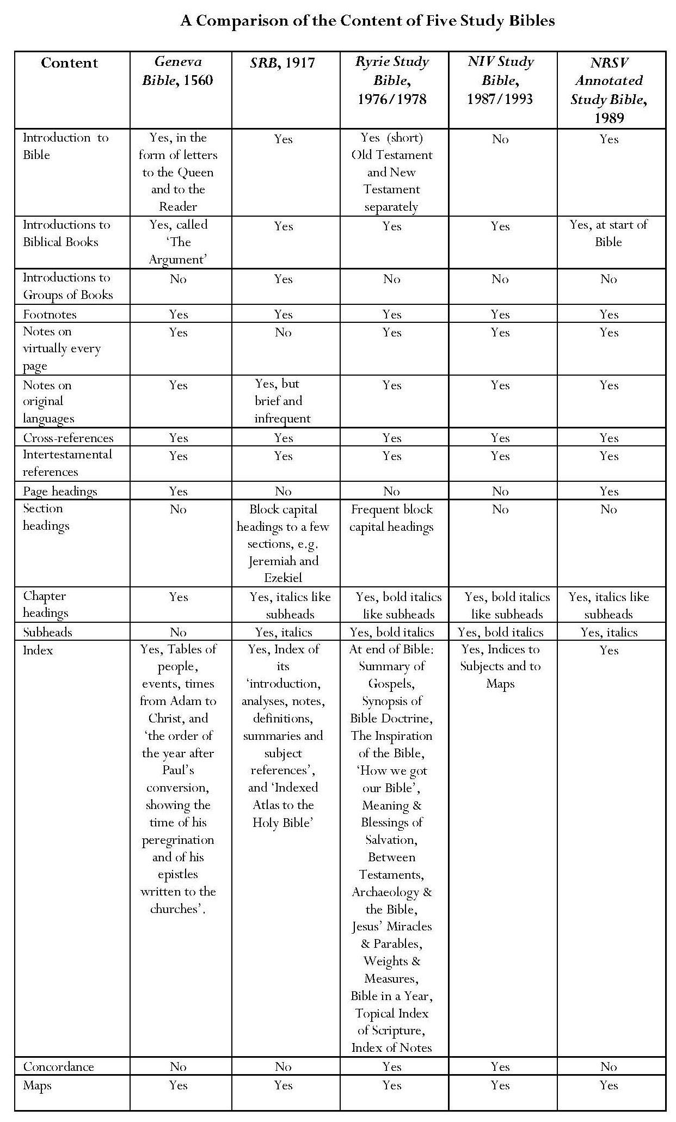
Comparing SRB with the Geneva Bible, the biggest innovations are SRB’s addition of introductions to groups of books, such as the Pentateuch and the Gospels, a feature which is not repeated in the later reference Bibles, and especially its insertion of subheads, an innovation which is maintained by the later study Bibles. Scofield’s introduction of block capital headings in Jeremiah and Ezekiel is replicated by Ryrie throughout his study Bible in a complex series of divisions and sub-divisions but this system is not adopted by the later study Bibles. All the study Bibles include references to the original languages, though SRB’s references are not extensive, and all contain cross-references, including intertestamental references. All include indices and maps but only the Ryrie Study Bible and NIV include a concordance.
What is most striking when comparing all five Bibles is that all versions except SRB contain notes on almost every page, whereas Scofield’s footnotes are sporadic, despite his claim in his introduction to SRB that ‘by a new system of connected topical references, all the greater truths of divine revelation are traced through the entire Bible’; ‘helps have been provided, available for reference on the very page where help is needed’ and ‘obscure and difficult passages, alleged discrepancies or contradictions, and every important type or symbol are elucidated by new references or made the subject of an explanatory footnote’. Scofield also asserts that he provides ‘analytic summaries of the whole teaching of Scripture’ on a subject to avoid proof-texting but annotation in the Scofield Bible is extremely uneven, both between biblical books and between chapters within them. Examination of SRB reveals large swathes of biblical text entirely without footnotes; in my copy, 797 pages out of 1336, approximately 60%, bear no footnotes. Approximately 67% of Old Testament pages and 41% of New Testament pages have no footnotes. It is scarcely credible that Scofield should have regarded such a large percentage of pages as without difficulty or need of explanation, especially when editors of earlier and later annotated Bibles took the opposite view. To be fair to Scofield, some material is included in the introductions to each book and group of books, and he does sometimes include brief notes as well as cross-references in his centre columns, which do not form part of this study.
Tables showing the numbers and percentages of pages without SRB footnotes appear below.

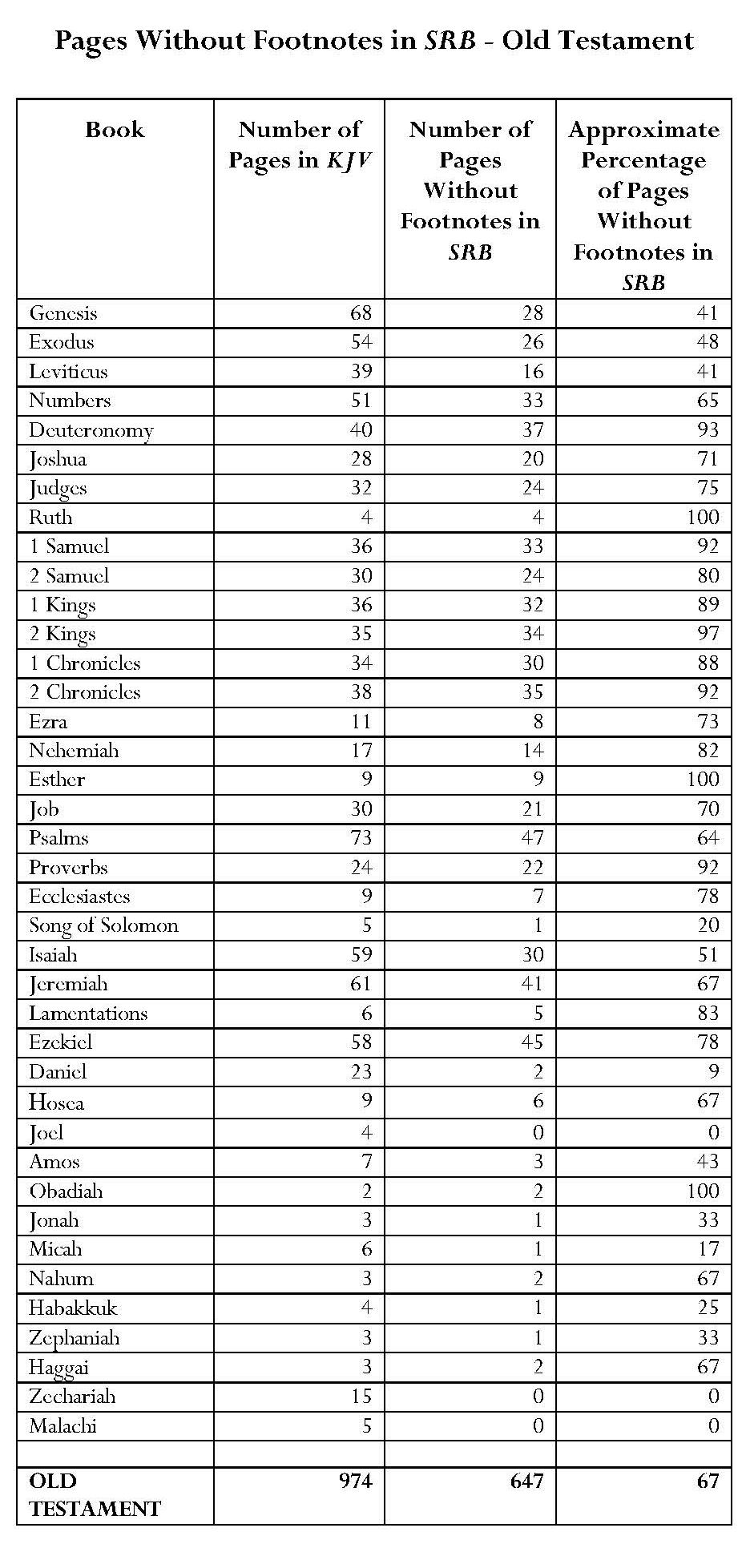
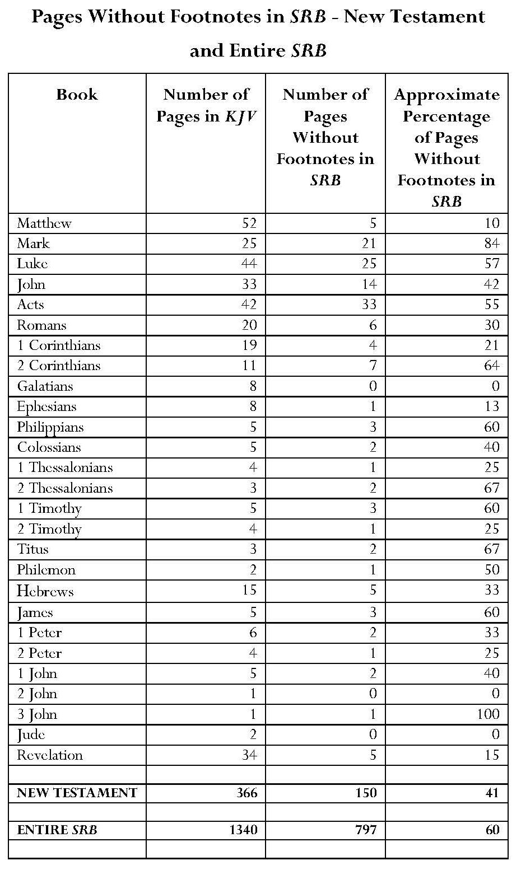

However, merely counting numbers of pages without annotation is a crude method of illuminating the uneven annotation of SRB compared with the more effective method which I have devised and which is outlined below. Using this method, I analyse the distribution of commentary between and within biblical books. Tables, graphs and analysis showing the uneven distribution of annotation between biblical books appear below the section on methodology.
b) Uneven Distribution of Notes between Books in SRB
Methodology for Counting Words in SRB Notes
The tables and the graphs in Figures 1 and 2 below indicate the percentage of the total KJV text represented by each biblical book compared with the percentage of SRB footnotes devoted to each book. All figures and derived percentages with regard to the word count of the KJV text were obtained from Bibleworks7; however, since no parallel electronic version of SRB was obtainable, a clear methodology was devised to provide a robust estimate of the word count of the SRB footnotes.
1 Three sections of Scofield’s notes were sampled. Each section contained the notes pertaining to three biblical chapters where notes are extensive, covering Old Testament and New Testament text.
The chapter sections were Genesis 1 – 3; Matthew 12 – 14 and Revelation 20 – 22.
2 The number of words in each sampled section was counted.
Since definitions of what counts as a word may vary, it was necessary to establish my own definition of a word for my word count. Following common digital convention, words were defined as being separated by a space, with hyphenated words counted as one. The same conventions are used by the Bibleworks7 software and by Microsoft Word.
Biblical references were treated systematically, applying the same blank space rule, that is, counting chapter and verse(s) separated by a colon as one word, and the book title as one word, unless preceded by a number (e.g. Luke_21:20 = 2 words [one space]; 1_John_3:17 = 3 words [2 spaces]).
3 The number of lines in each sampled section was counted.
A line was defined as filling more than 50% of the width of the page; any lines filling less than 50% of the page width were discounted.
4 The number of words in each section (from Step 2) was divided by the number of lines in that section (from Step 3), rounding to two decimal places.

Numbers of Words in Sample Sections of SRB Notes
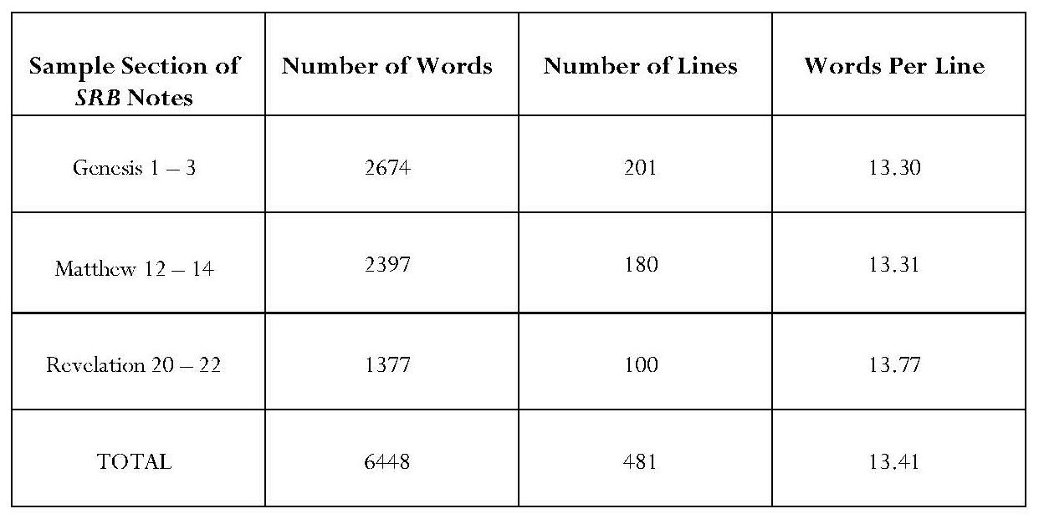
This gave an overall average of 13.41 words per line. This was rounded down to achieve a standardised and conservative estimate of 13 words per line.
5 This estimate of 13 words per line was then applied as follows to every Scofield note in every biblical book.
A The number of lines in the notes for each book and each chapter were counted, applying the same 50% rule as in Step 3 above.
B The number of lines was multiplied by 13 to give an estimated number of words in notes on each book and also on each chapter.
6 The results for each book appear in the table below. This table shows the number of words in each book in KJV, together with the percentage of KJV content represented by each book, compared with the estimated number of words in SRB notes for each book and the percentage of SRB notes devoted to each book. These results, rounded to two decimal places, are rounded to one decimal place to form the basis for the graphs below. N.B., where percentages fall below 0.1 in the table, they are counted as 0.1 in order to register in the graphs.
7 Because the graphs indicate both the size of each biblical book within KJV and the volume of SRB notes for each book, they provide a visual illustration of Scofield’s uneven treatment of biblical books. This important comparison is not illustrated by graphs such as that provided by Todd Mangum, which merely shows the number of lines in SRB notes devoted to each biblical book, or by Stephen Sizer’s count of pages in SRB which lack notes.

Table and Graphs Based Upon Statistics Obtained by Methodology Above
Green on the table and graphs represents KJV text; red on the table and graphs represents SRB annotation.
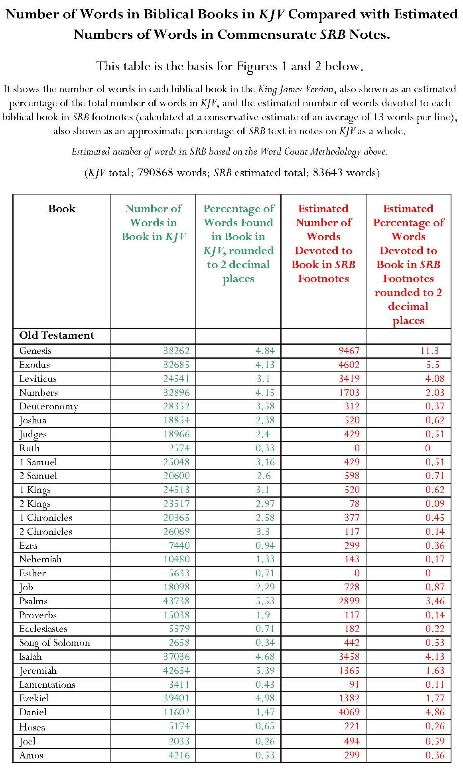
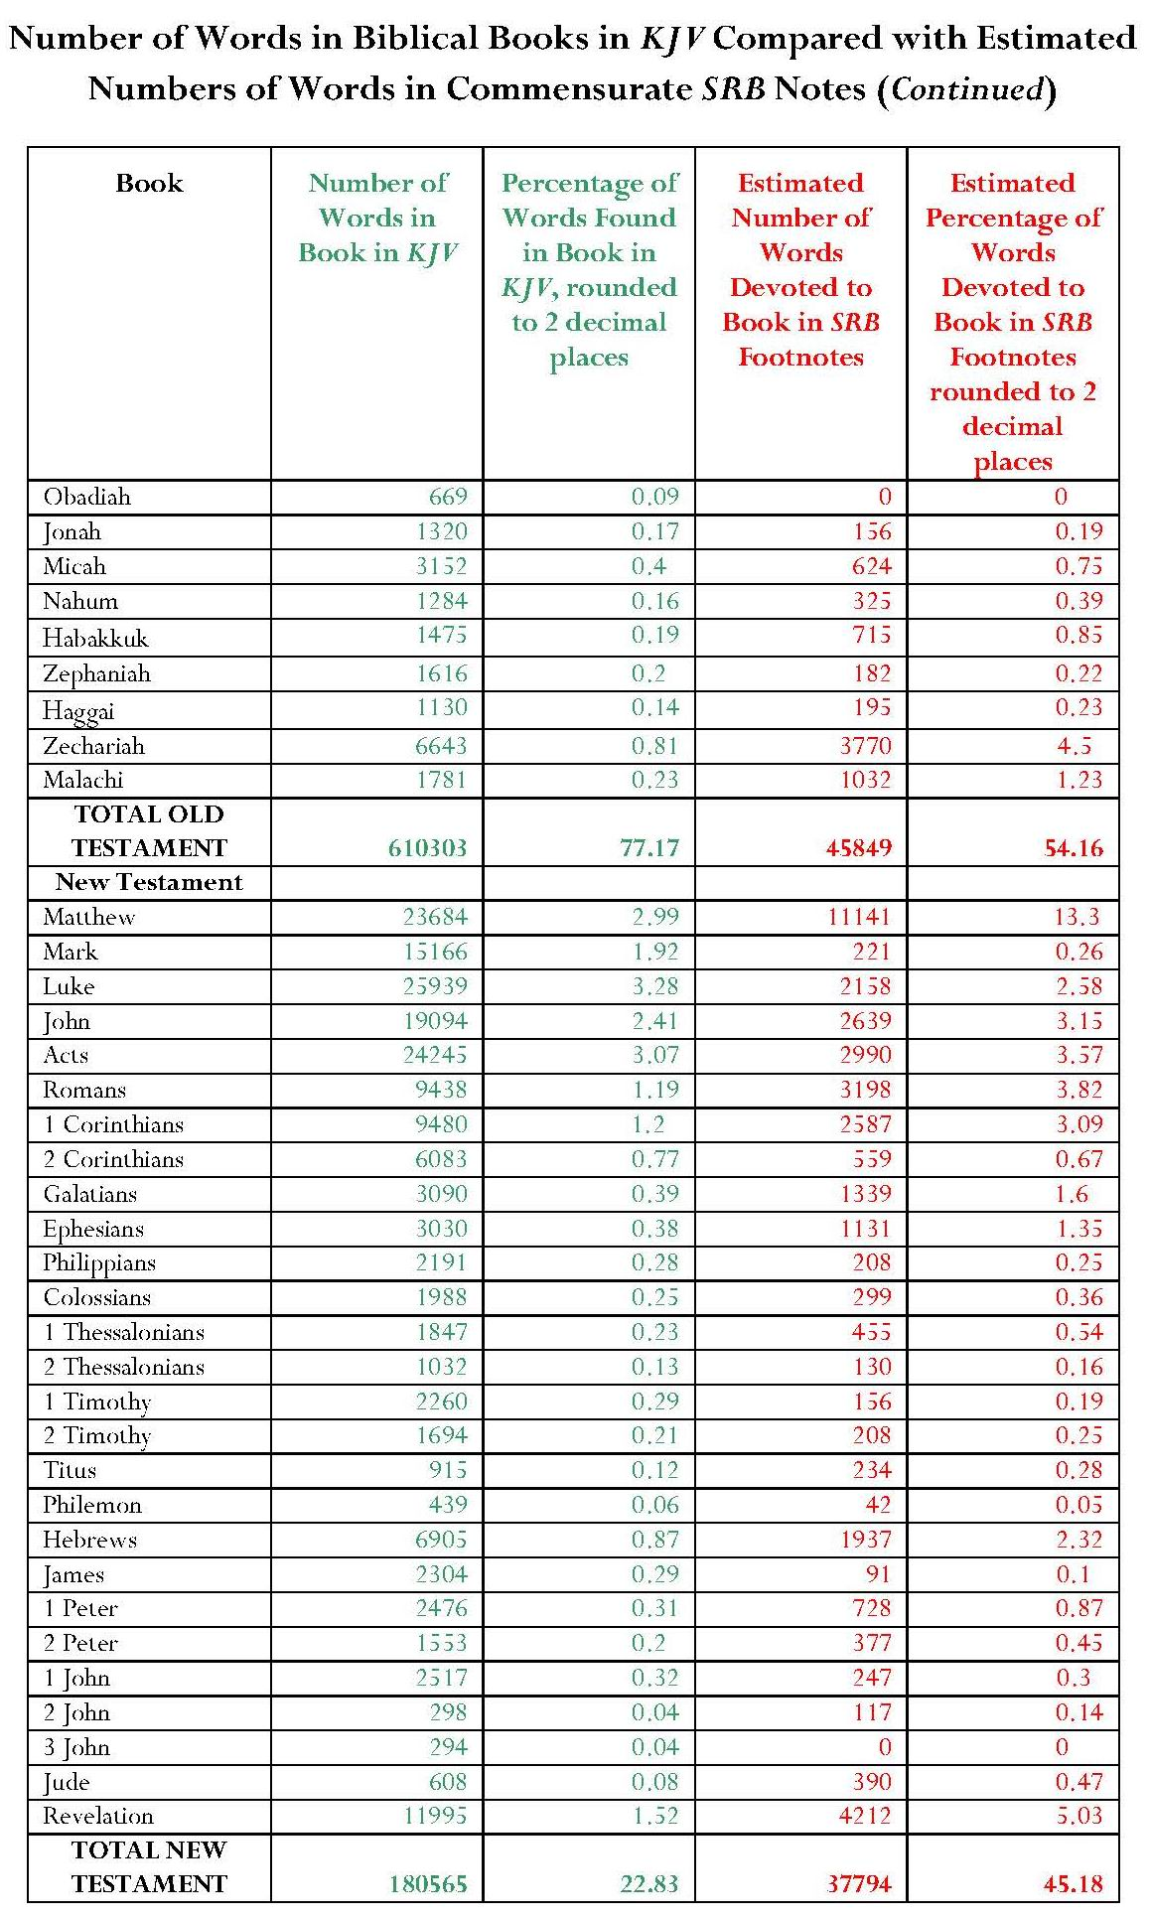
Figure 1
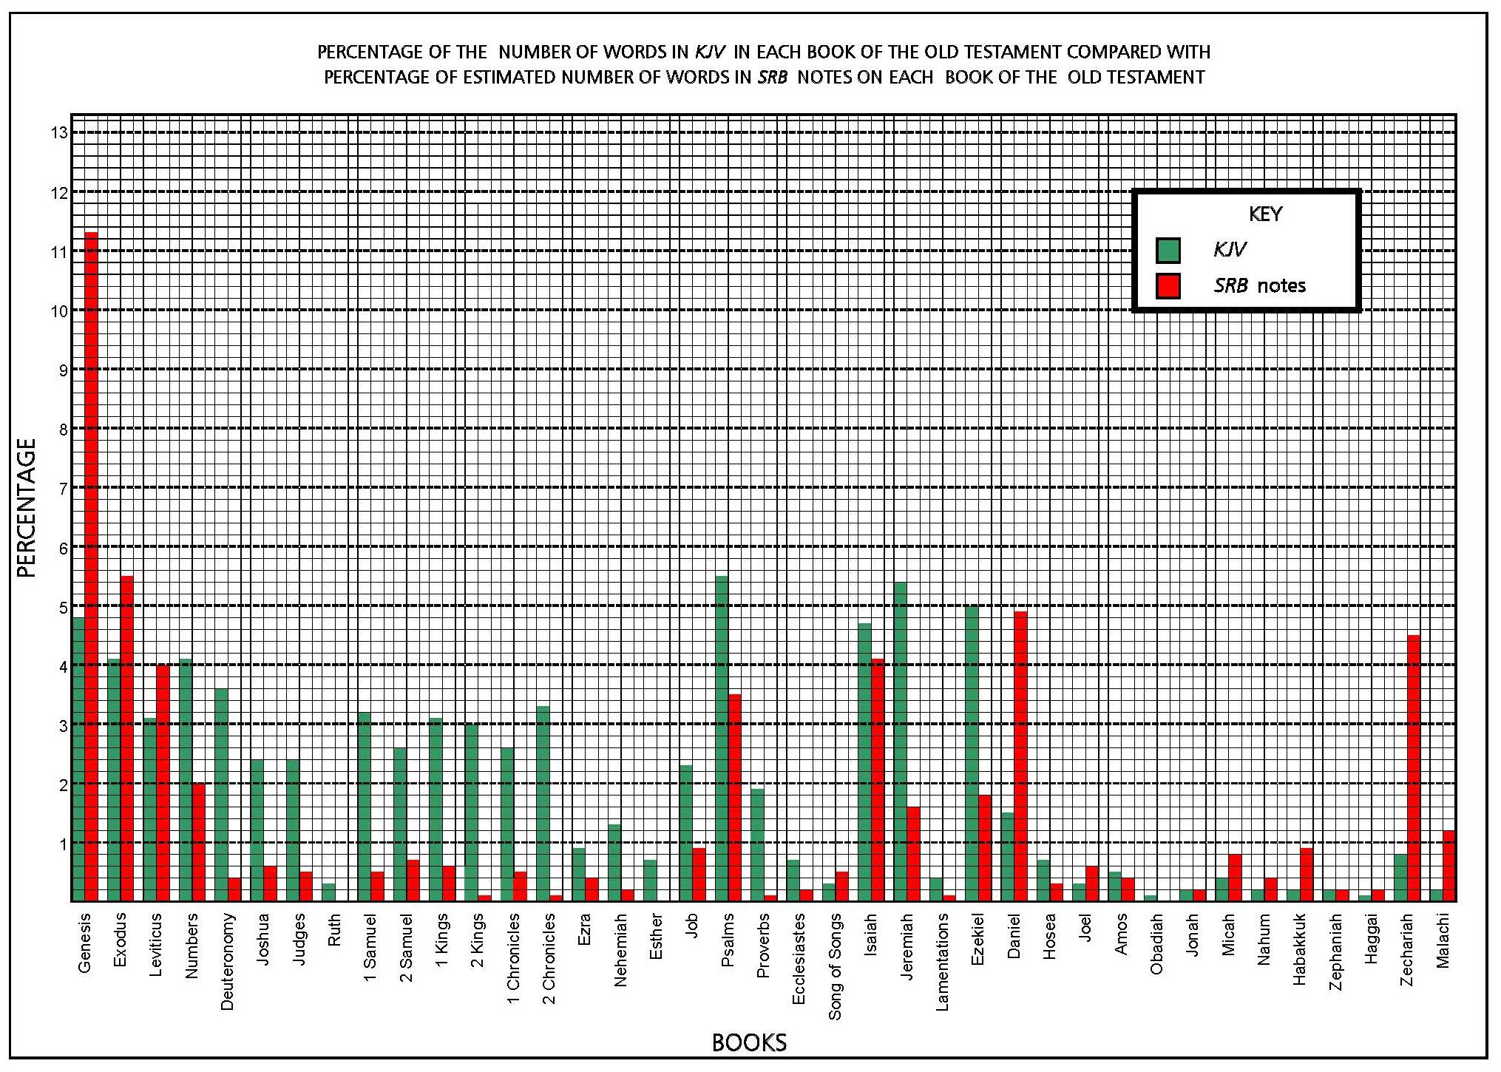
Figure 2

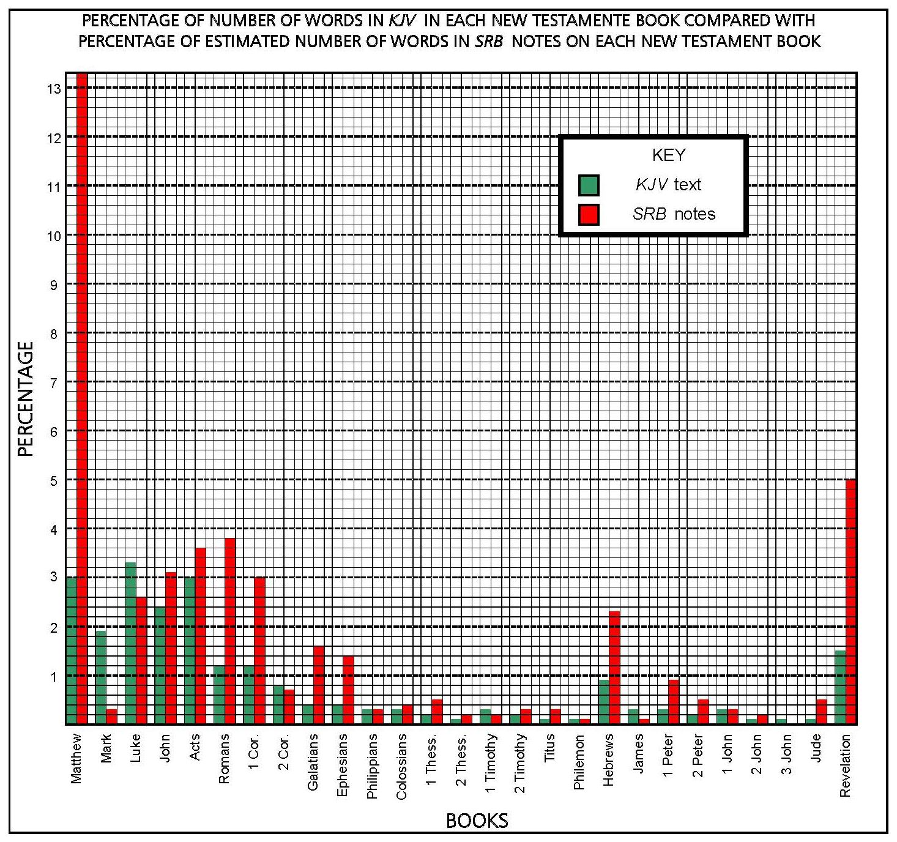

My analysis indicates that Scofield does not attach the same importance to all biblical books. In the Old Testament, the percentages of SRB notes devoted to Genesis, Daniel, Habakkuk, Zechariah and Malachi far exceed the percentages of words in KJV in each of these books; percentages of notes on eight other books marginally exceed the percentages of KJV text. Conversely, the ‘historical books’ in SRB notes contain far smaller percentages of material than the KJV text. The majority of the Psalms and other ‘poetic books’, and many of the remaining prophets, particularly Jeremiah and Ezekiel, are also neglected in SRB notes in comparison with their volume in KJV. The notes on four books have a slightly lower percentage than that of KJV text. Ruth, Esther and Obadiah bear no notes.
In the New Testament, Scofield’s major interests are Matthew, which takes pride of place by a wide margin, followed by Revelation. Matthew is the book to which Scofield devotes proportionally the most attention in the whole Bible; 13.3% of SRB notes are taken up by commentary on Matthew, compared with 3% of KJV text taken by this book. Of the other New Testament books, the estimated volume of Scofield’s notes exceeds by 1% that of KJV text only on Romans, 1 Corinthians, Galatians, Ephesians and Hebrews. In ten other books, it exceeds that of the KJV text by less than 1%. The percentages of notes on Philippians, Philemon and 1 John are slightly lower than the percentage of KJV text for these books. Excluding Matthew, the gospels, together with 2 Corinthians, 1 Timothy and James, receive lower percentages of SRB notes than the corresponding percentages of KJV text. Apart from the single-page 3 John, which has no note, Mark’s Gospel receives the lowest percentage of SRB notes compared with its percentage in KJV. It is extraordinary that this foundational gospel should rate proportionally so low in Scofield’s estimation. Scofield comments on only five verses in the entire book.
The percentage of SRB notes for thirteen books in the entire Bible exceeds by 1% — 10.3% that represented by these books in the KJV text. For seventeen books the estimated percentage of notes is slightly higher than that in the KJV text. For five books, the estimated percentage of notes is almost equal to that in the KJV text. To the remaining books, thirty-one out of the sixty-six in KJV, Scofield apportions a percentage of notes lower than the percentage of words accorded each book in the text. It seems Scofield attaches less importance to these thirty-one books.
It is also noteworthy that, while Scofield claims in Prophecy Made Plain that ‘it is peculiarly the prophetic part of Scripture which brings us into intimacy with God’, the estimated percentage of his annotation on three out of four of the major prophets does not reach equality with the percentage of KJV text. The notes on Isaiah come nearest to parity in volume with the KJV text but those on Jeremiah and Ezekiel show far lower percentages. Conversely, the percentages of SRB notes on Daniel and on Zechariah far exceed the percentages of KJV text. Scofield’s notes on the major and minor prophets do account for an estimated 22% of his total text, while the prophetic books account for 19% of the KJV text, but it can hardly be true, as Scofield claims, that ‘the general reader’, to whom these books were formerly closed by ‘fanciful and allegorical schemes of interpretation’, is now given ‘ready access … to the amazing literary riches of the Prophetical Books’. More than half the chapters in the prophetic books, 132 chapters out of 245, receive no annotation.
c) Uneven Distribution of Notes within Books in SRB
The same methodology as that described above was applied to the chapters in each biblical book. The results demonstrate that the distribution of SRB notes within books is also uneven and, in many cases Scofield selects for comment only a few verses or even a single verse within a chapter. Results appear in Chapter 8.
d) Themes in Notes in SRB
The tables below provide a summary of themes to be found in SRB footnotes. The categories selected for separate treatment reflect subject matter which occurs prominently in my thesis. Headings are given distinctive colours according to theme; these are repeated in Chapter 8 for the headings of tables showing material found in individual books. This provides unity of references and facilitates accessibility to information.
Key to Colours in Headings in Tables Showing Notes and Subheads
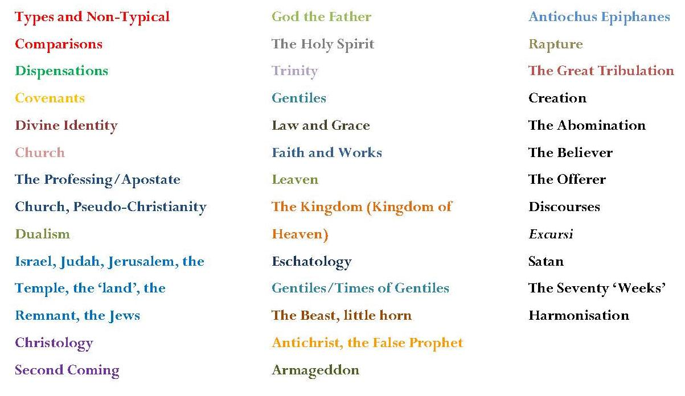

Main Themes in SRB Notes
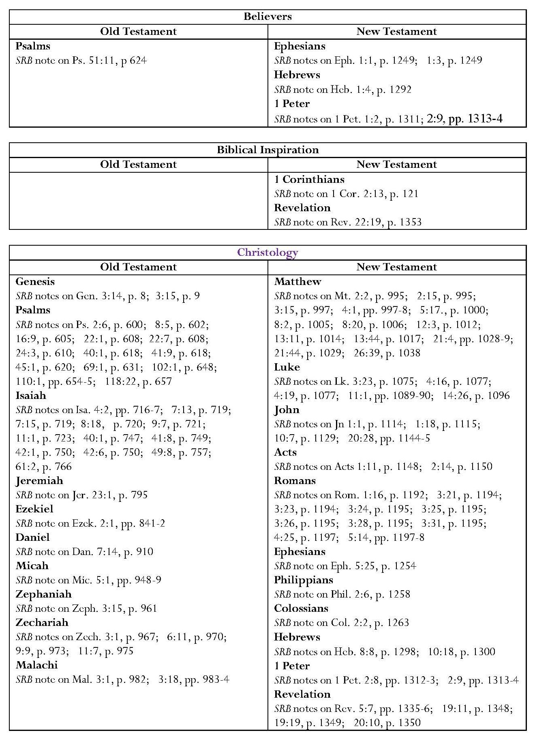

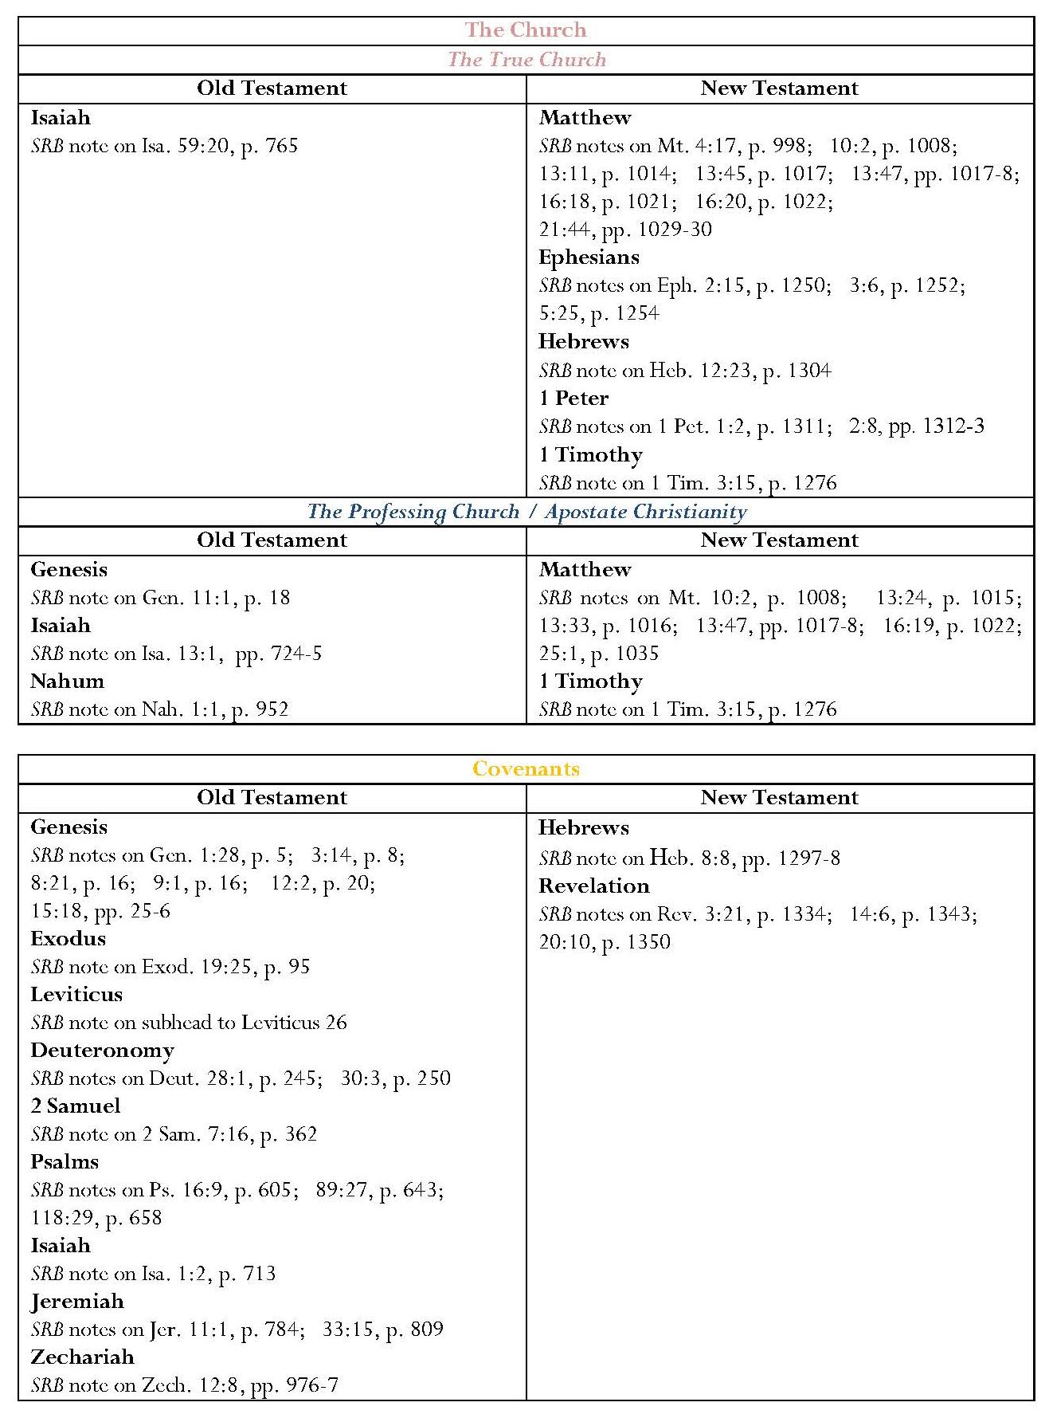
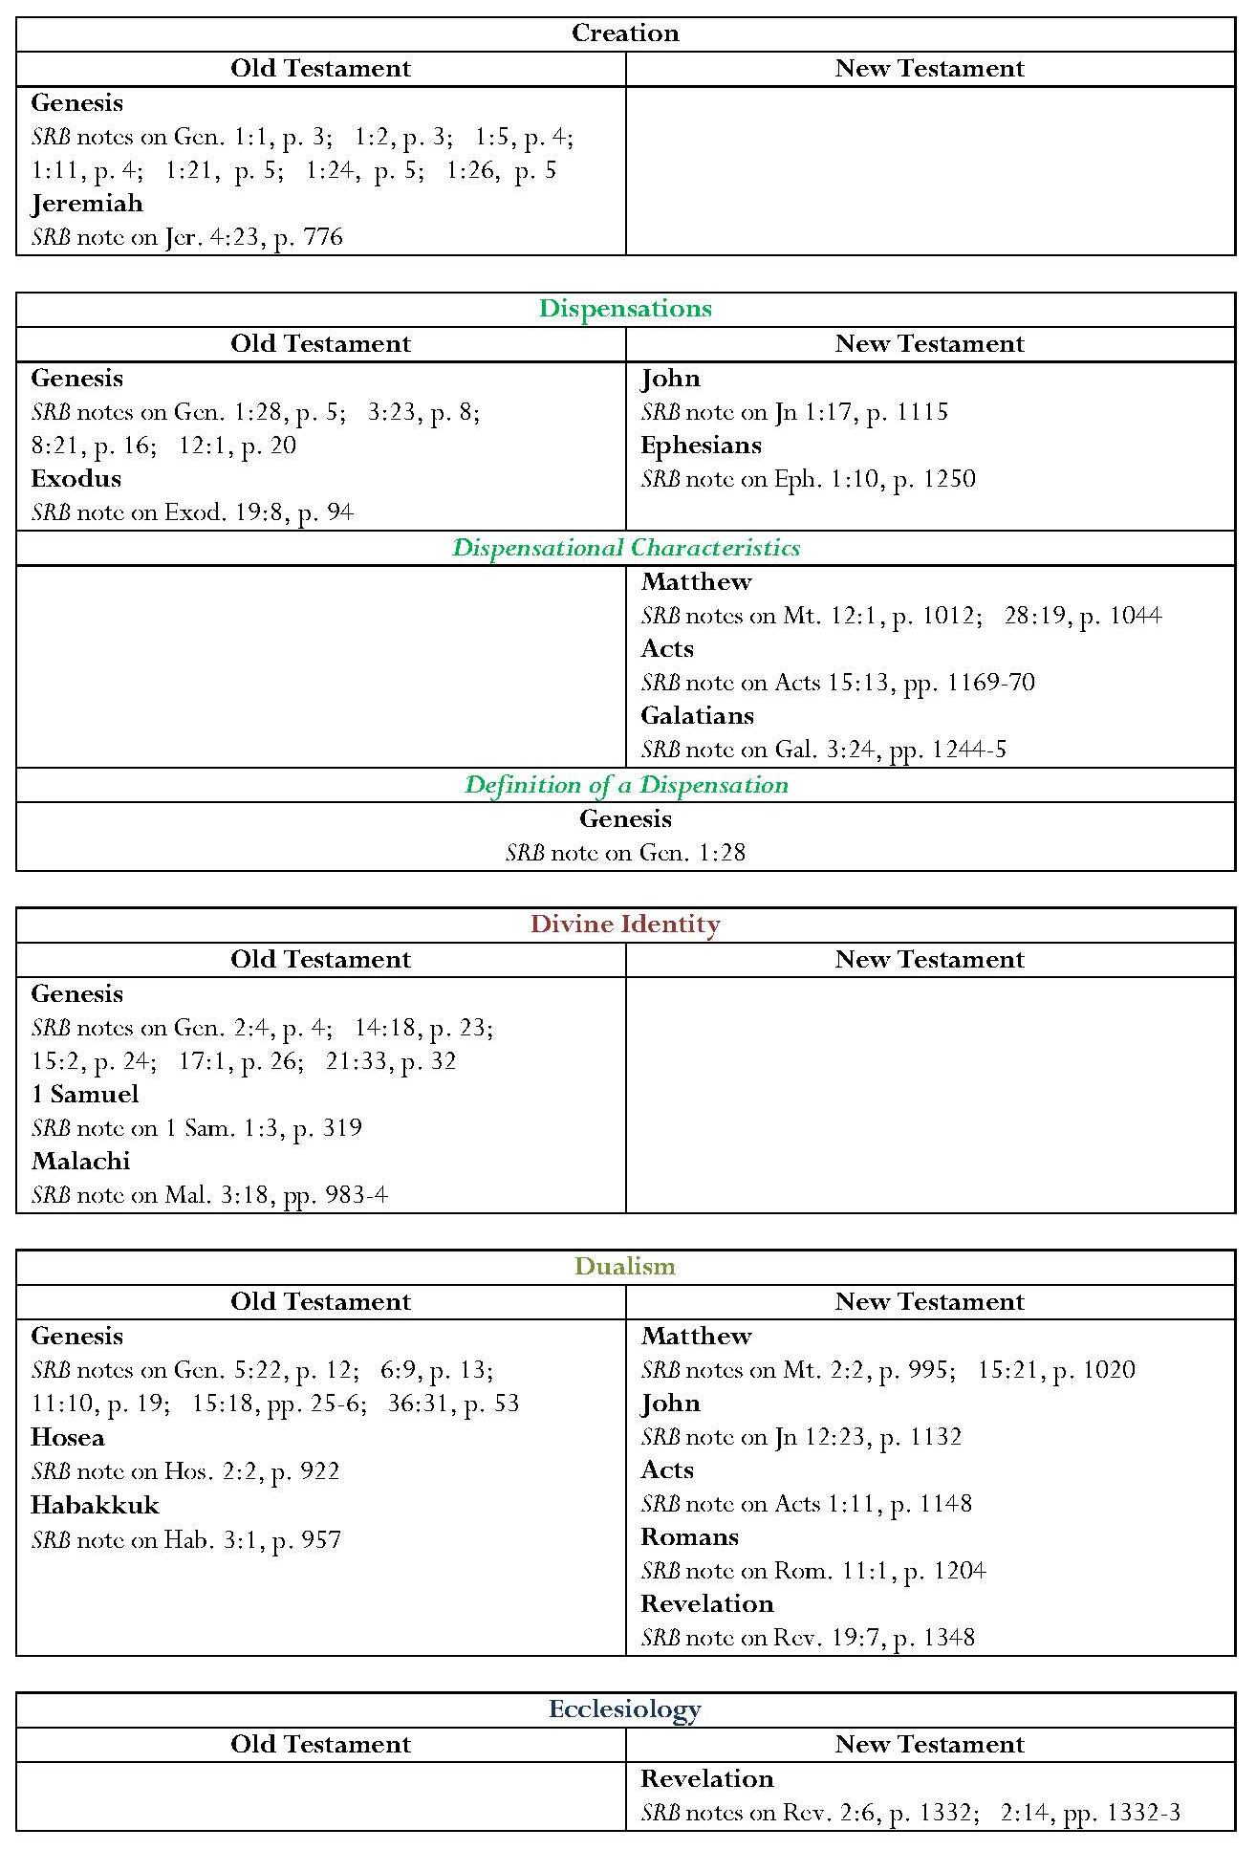

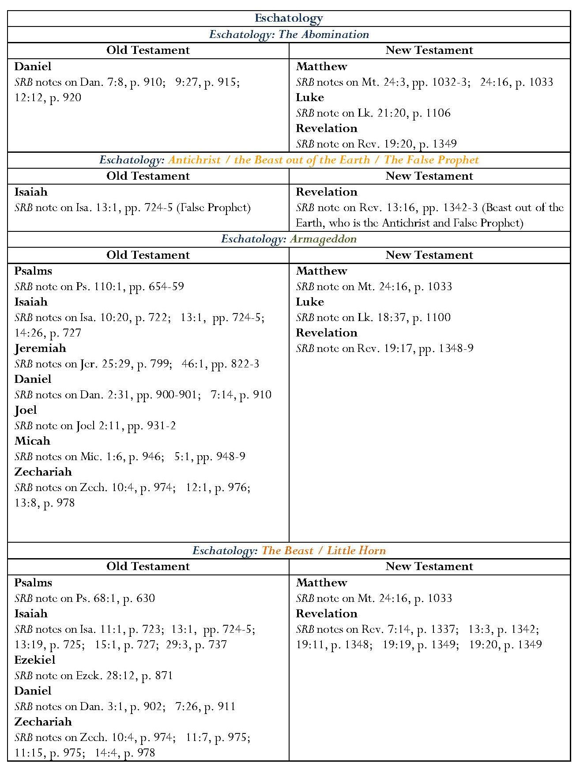

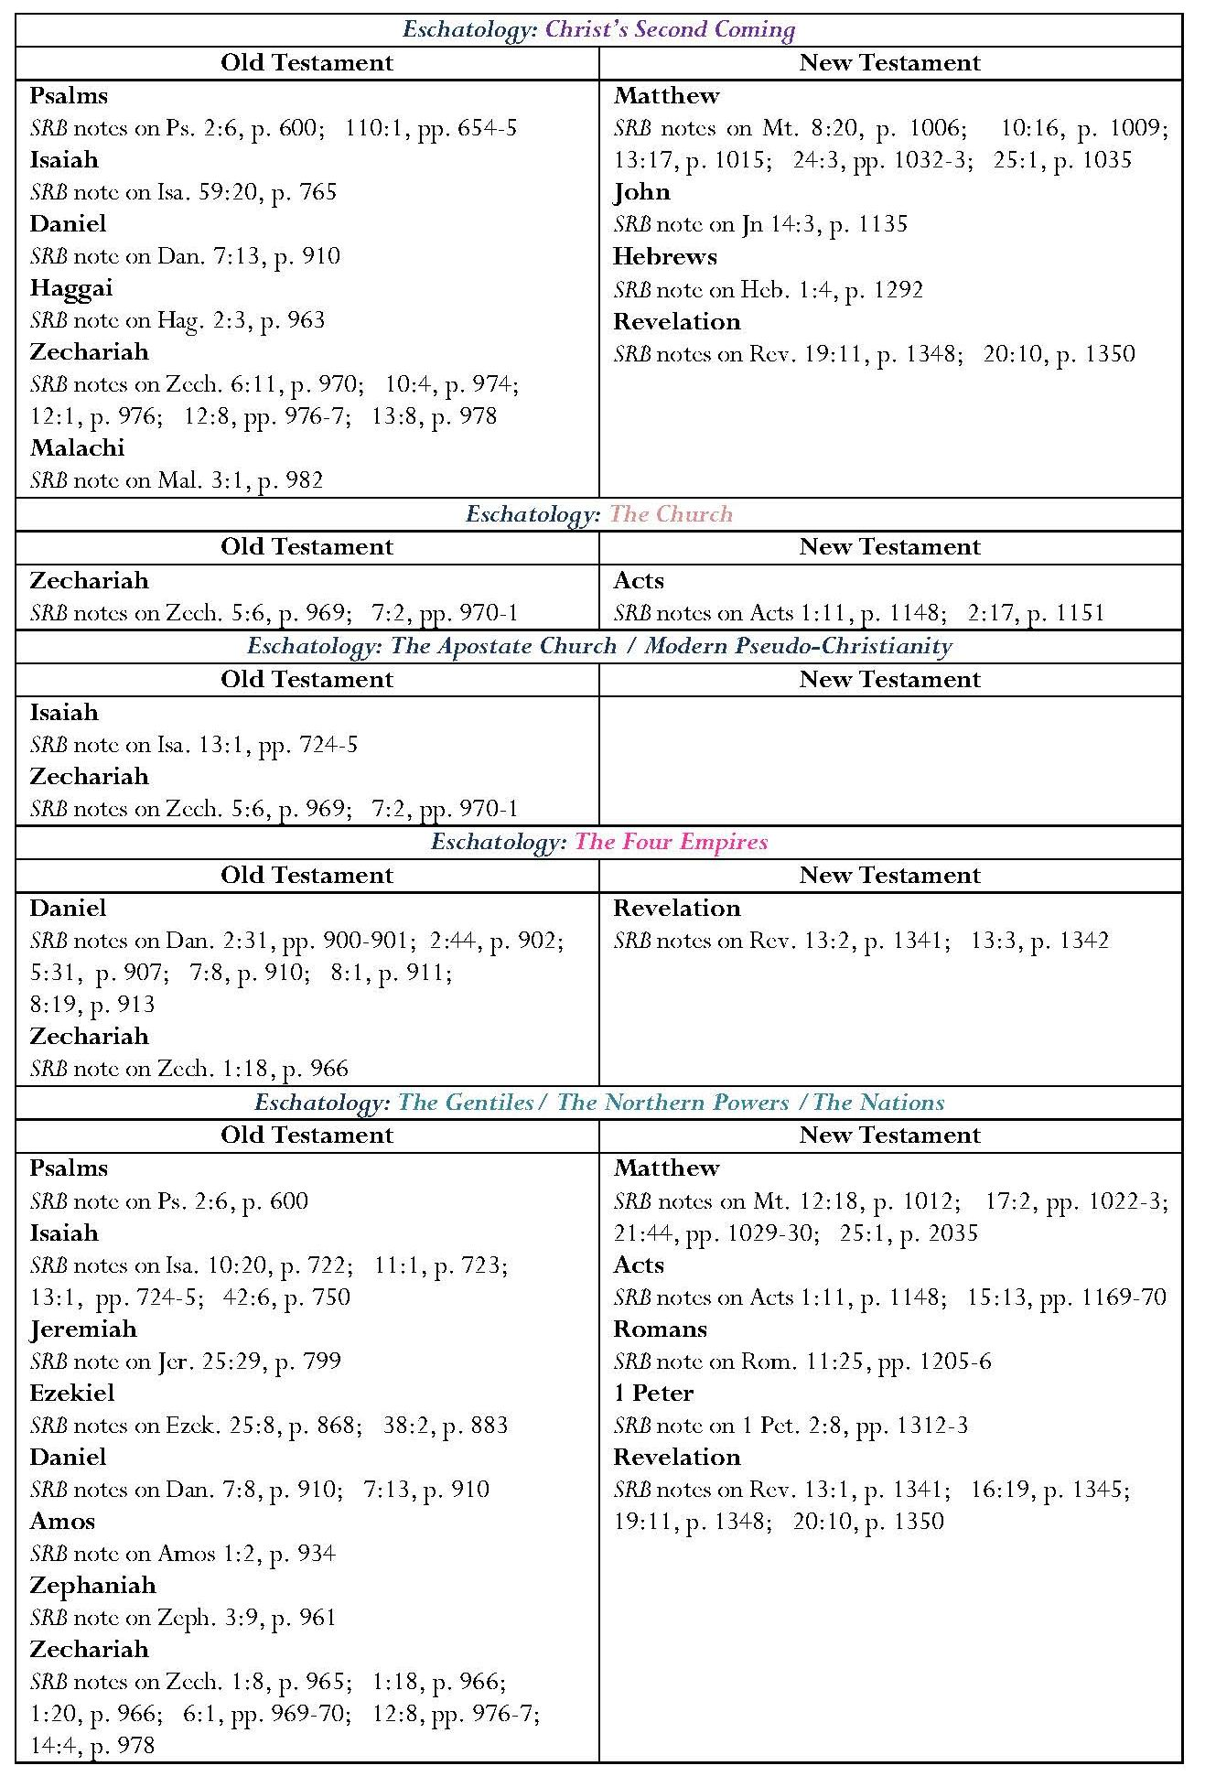

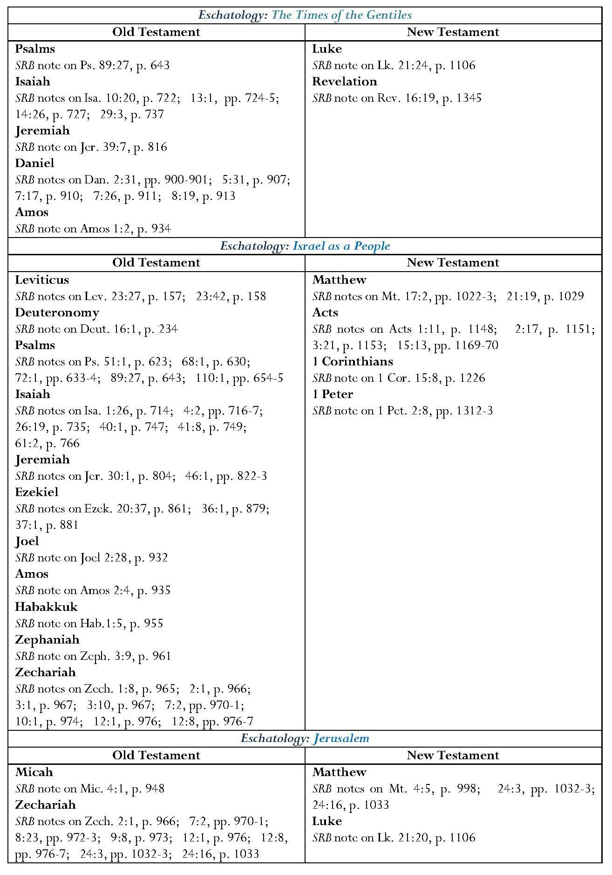

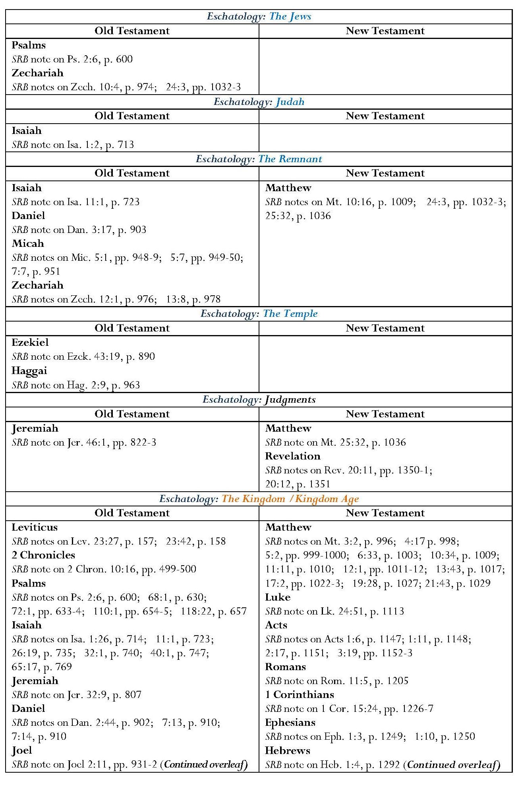

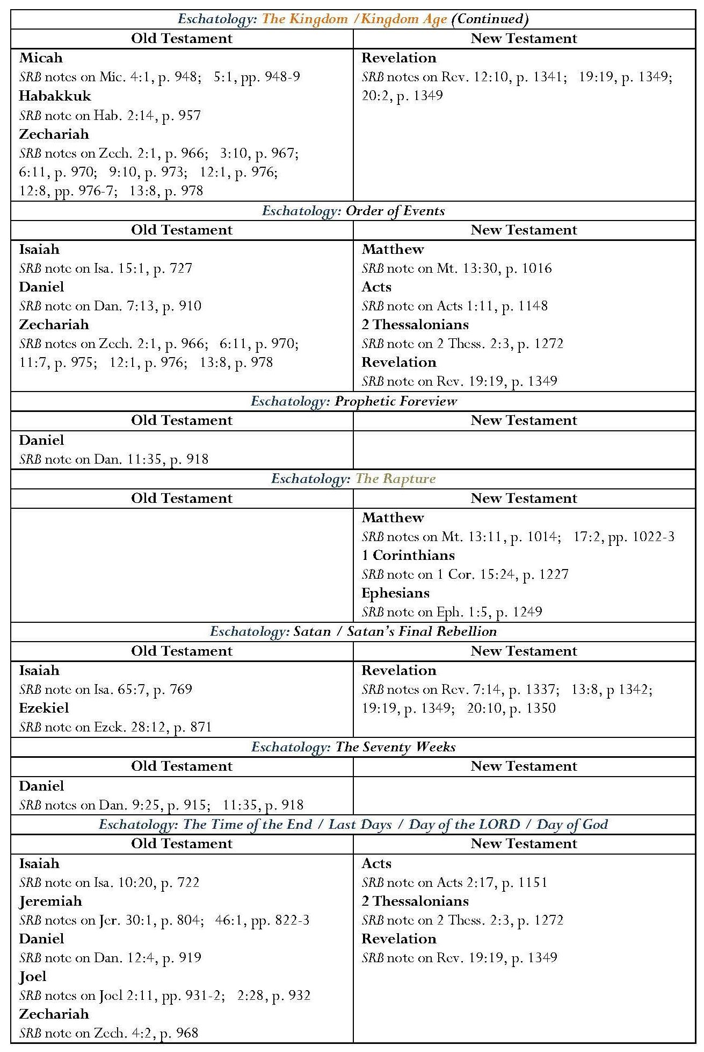

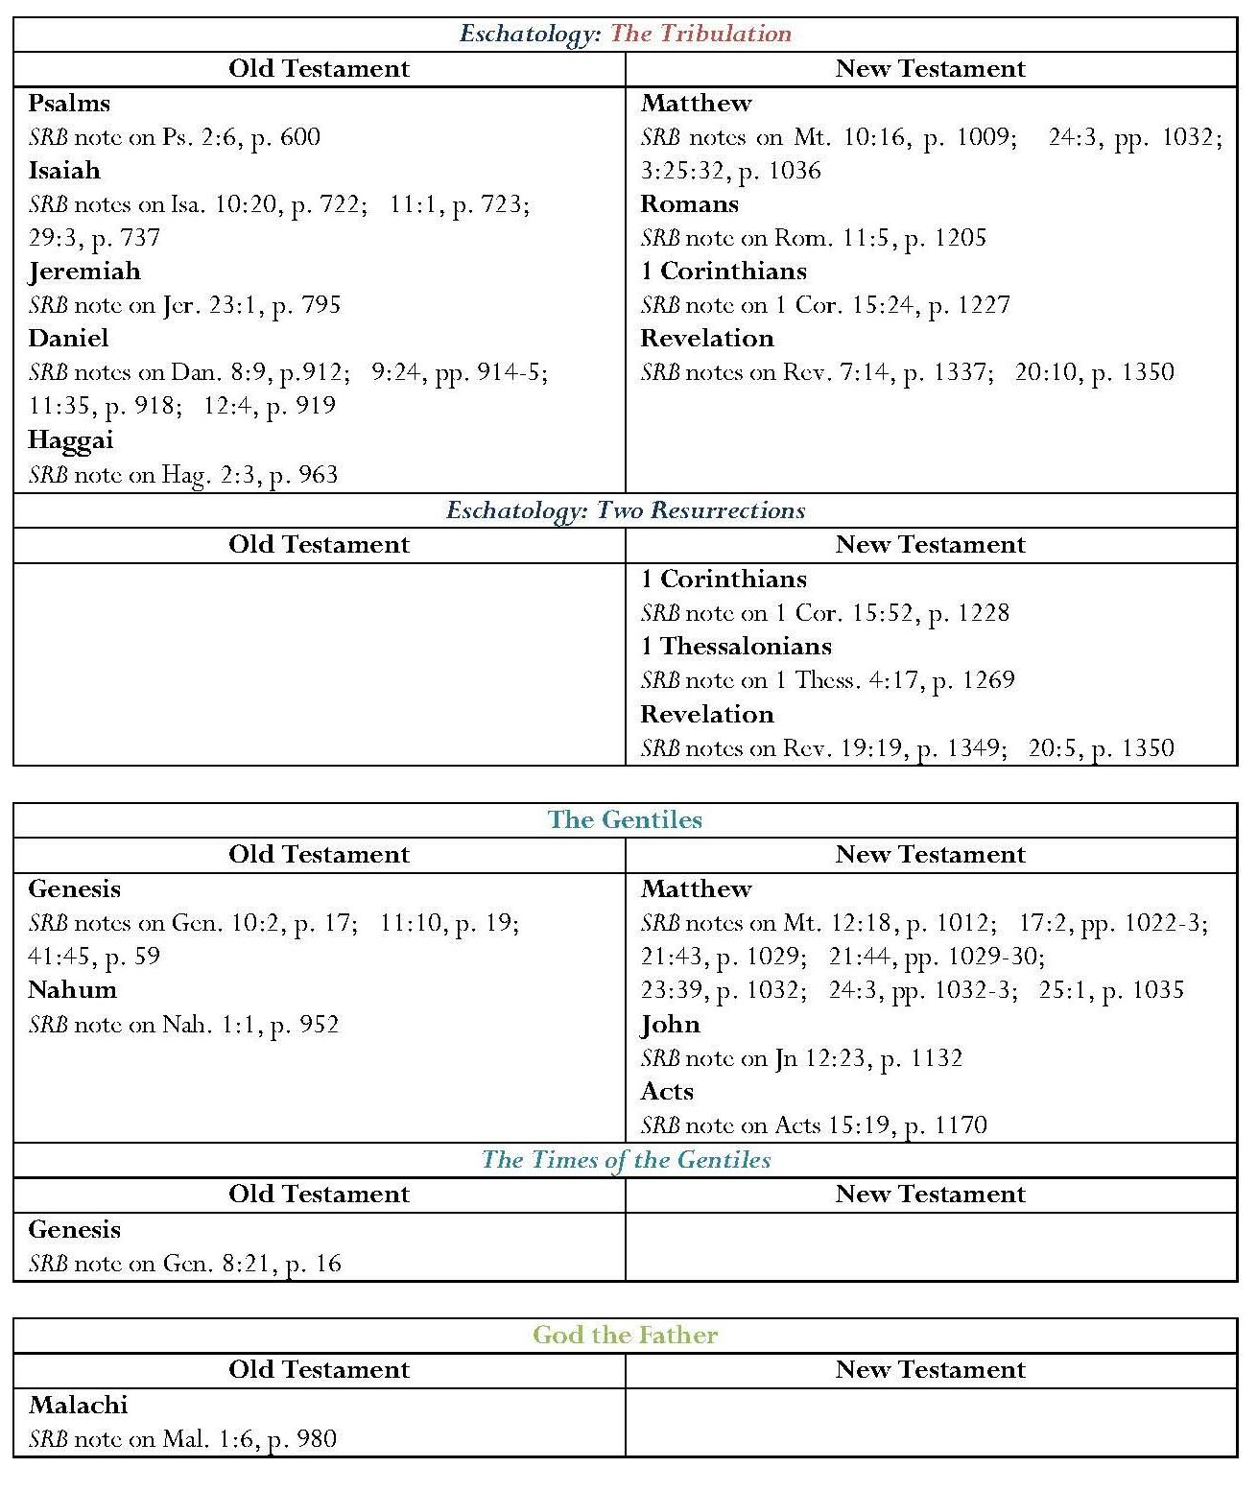

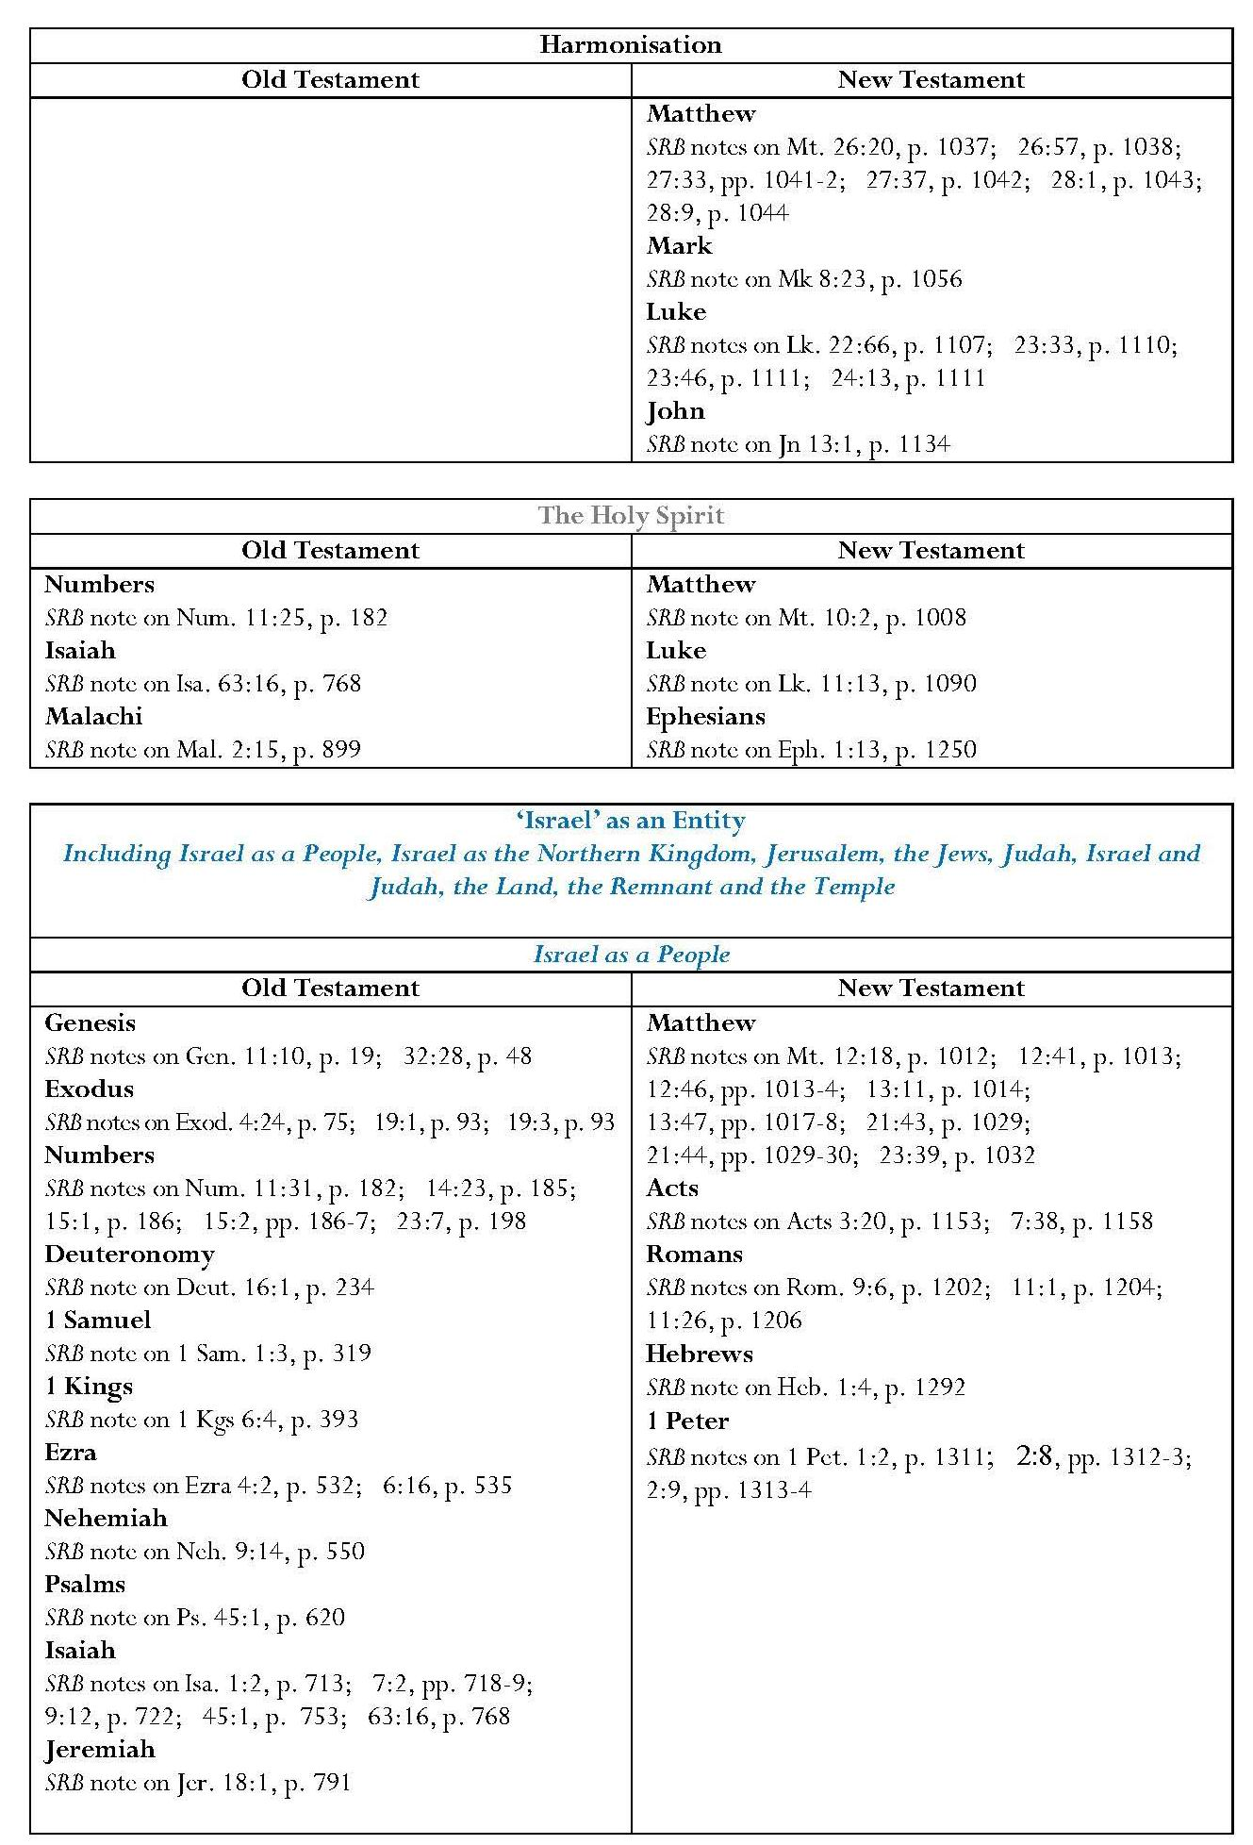
Continued overleaf

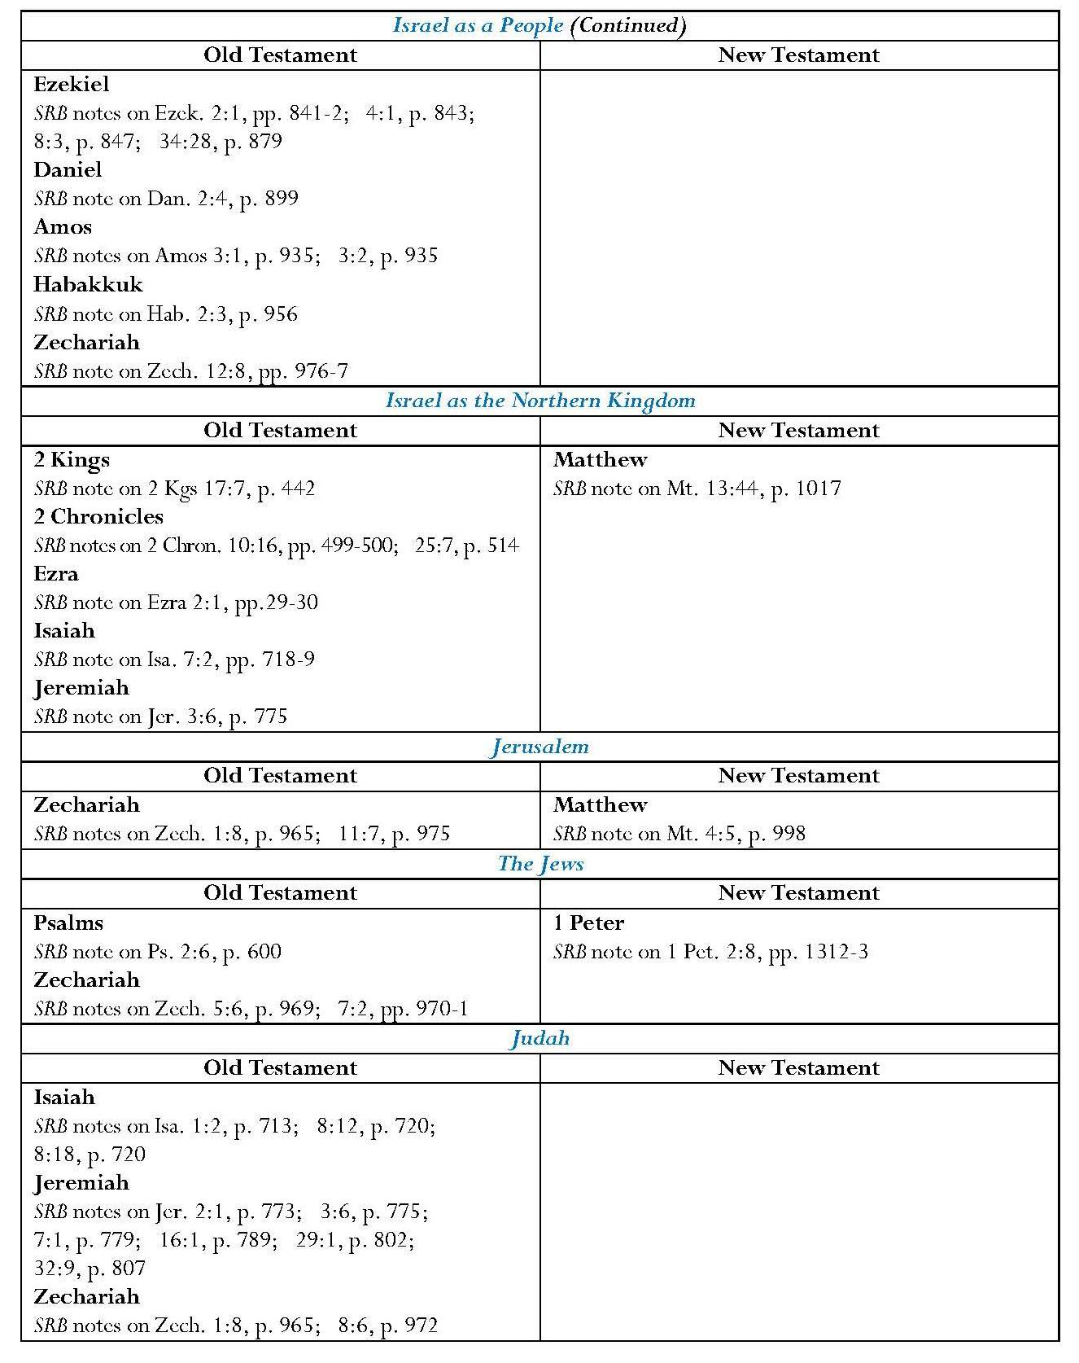

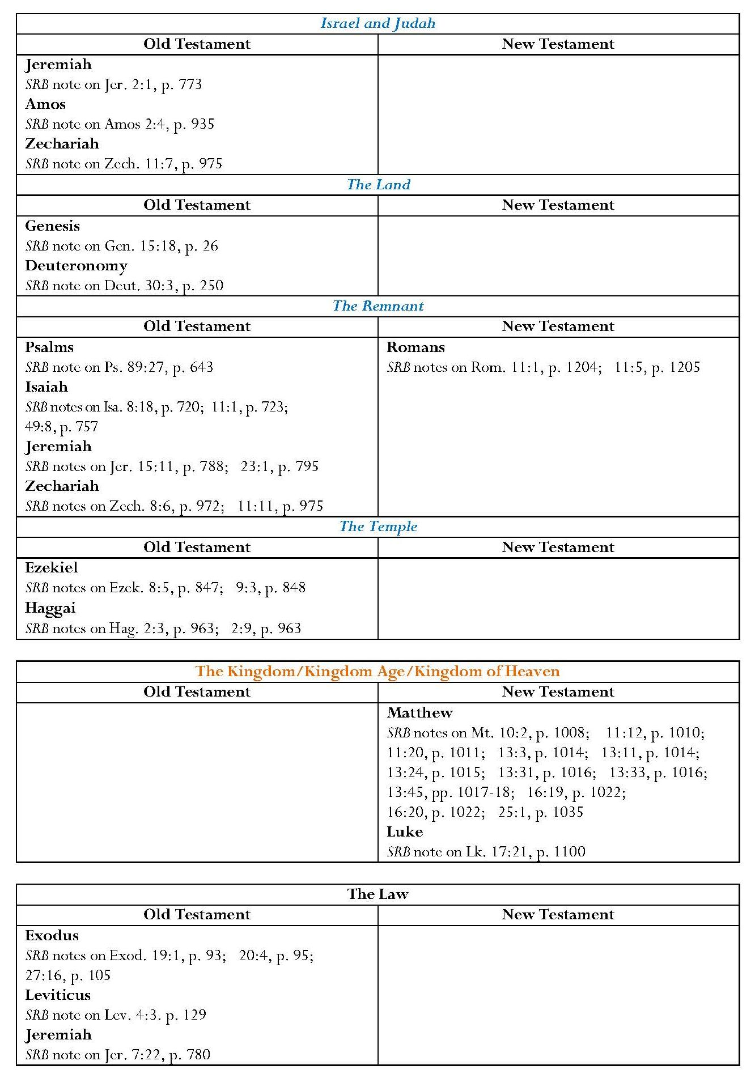

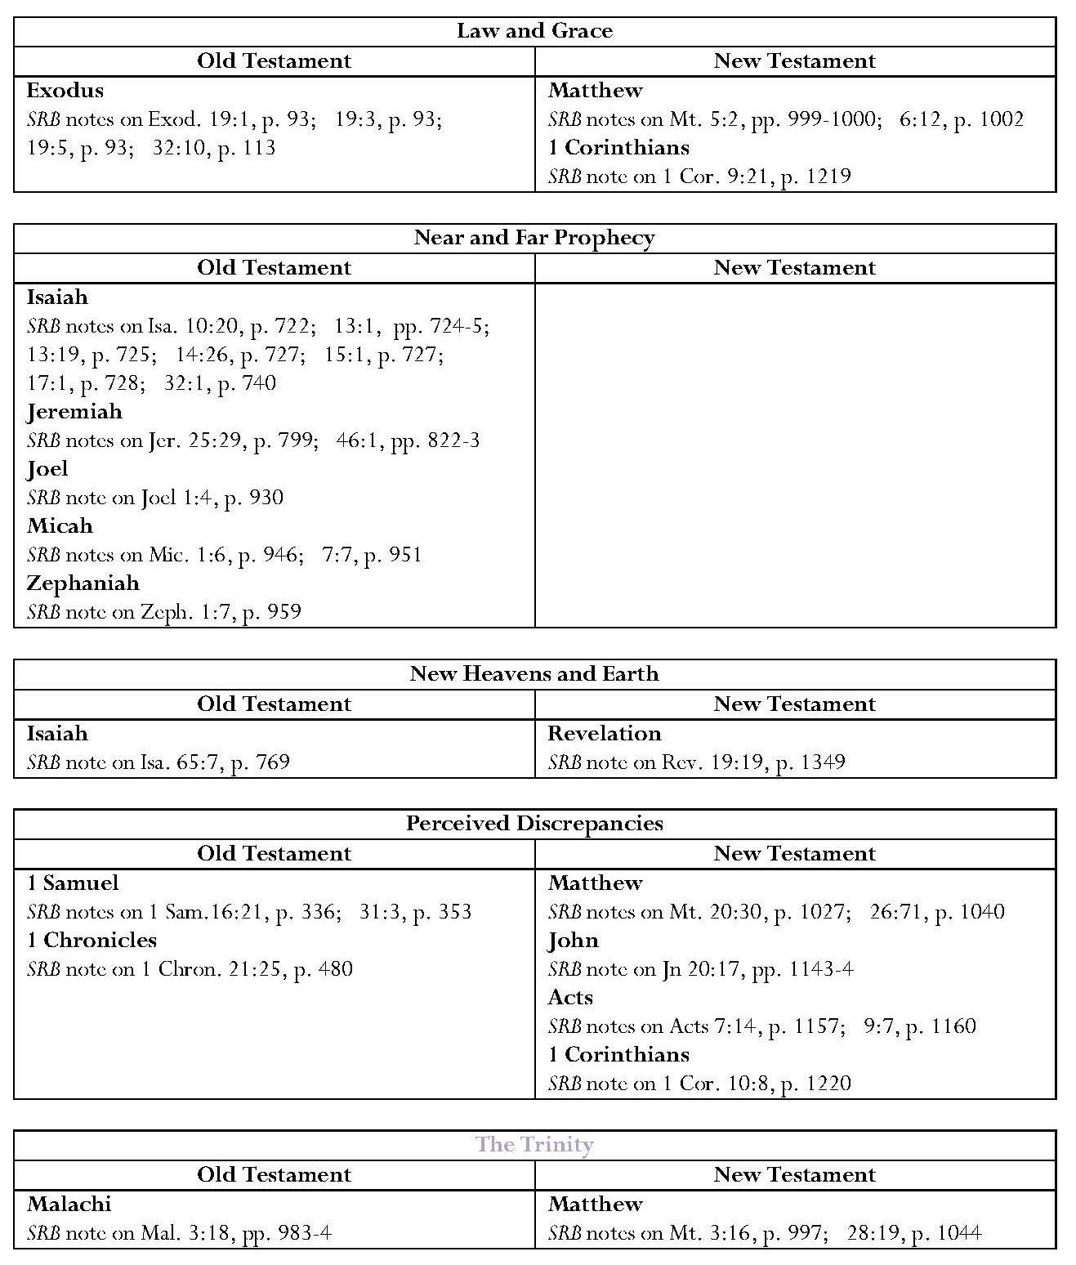

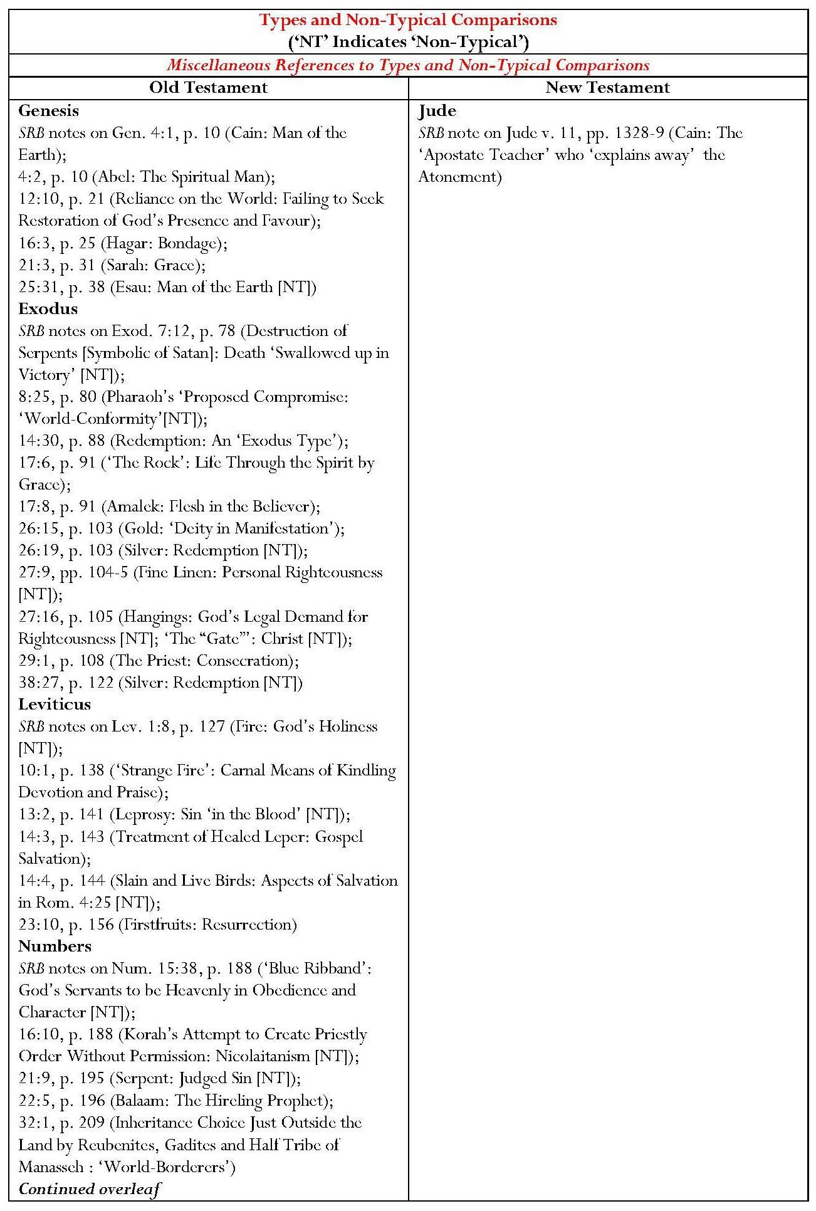

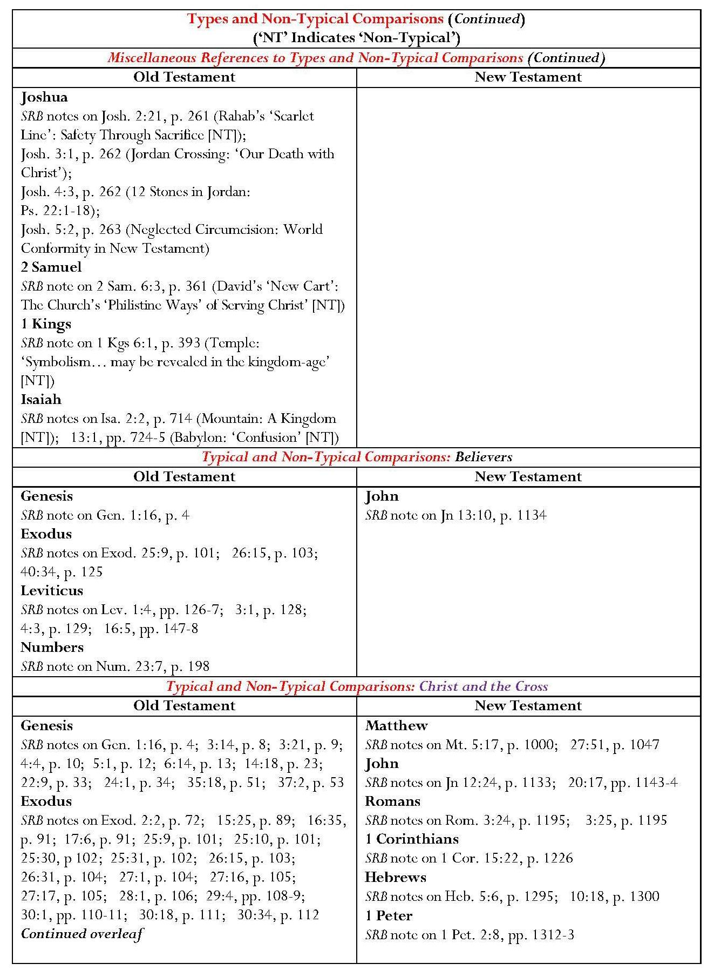

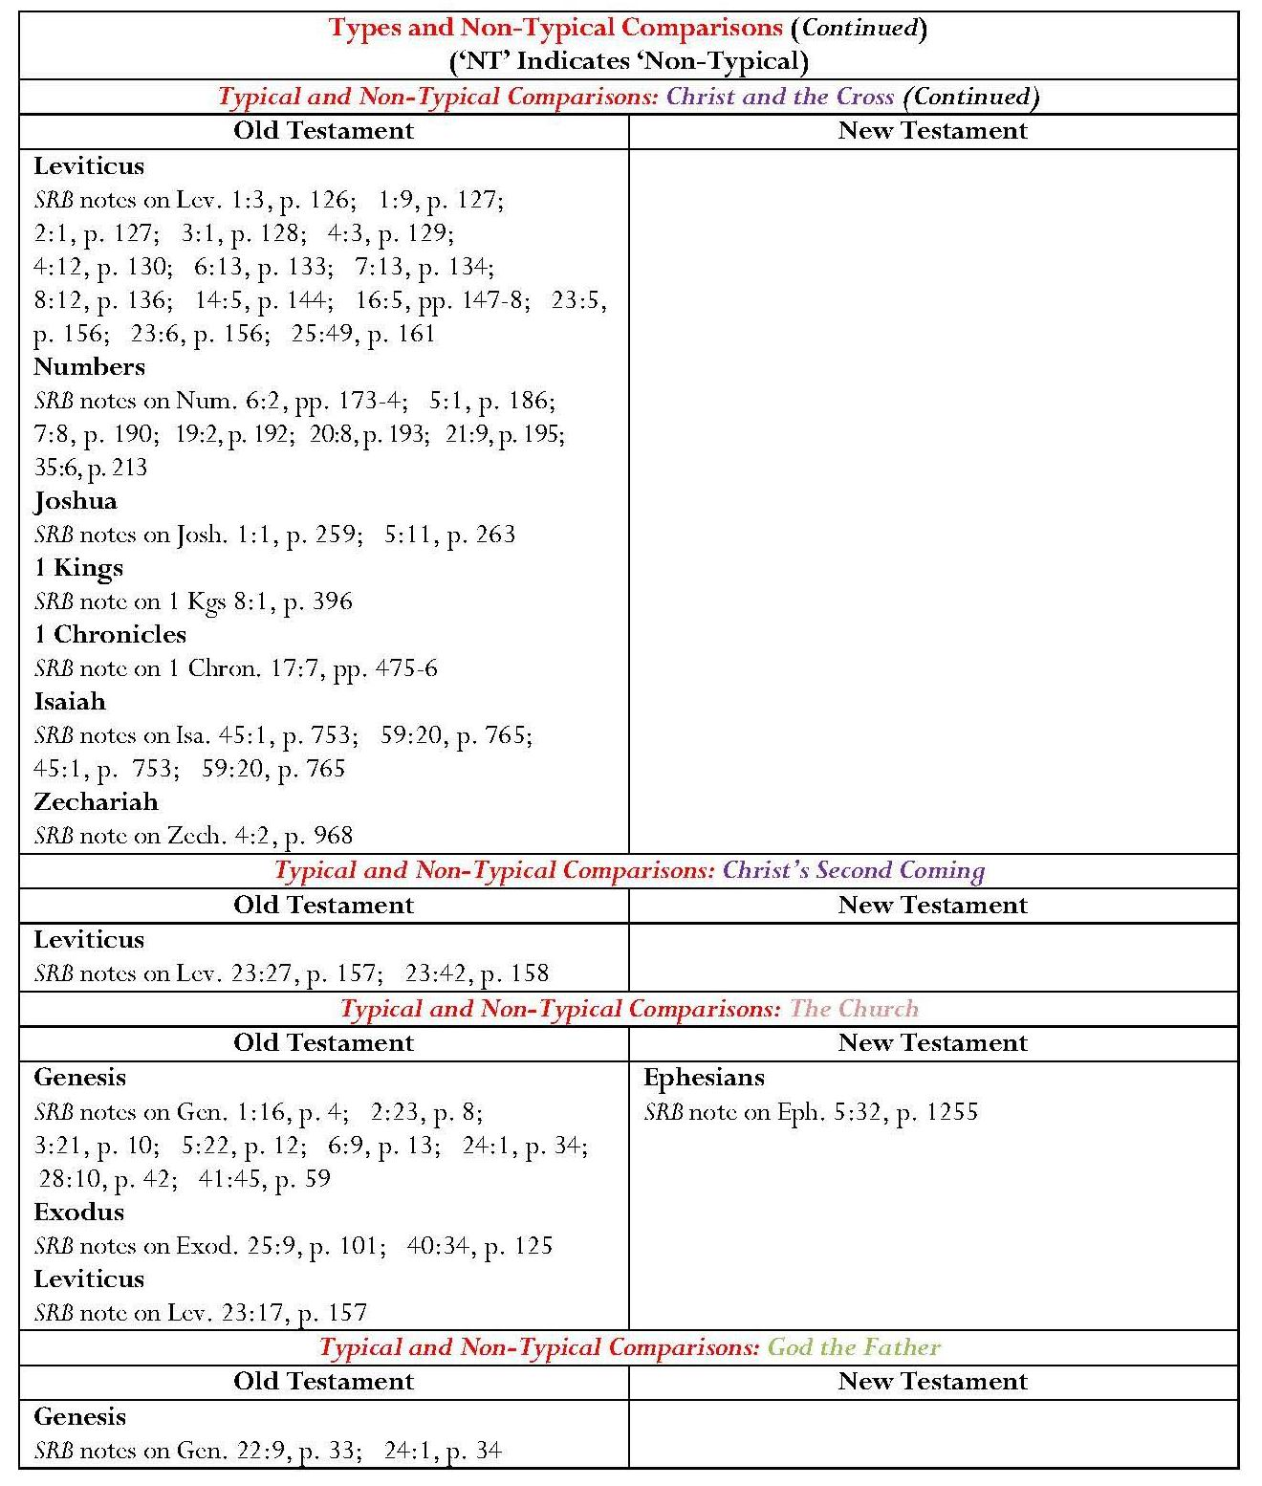

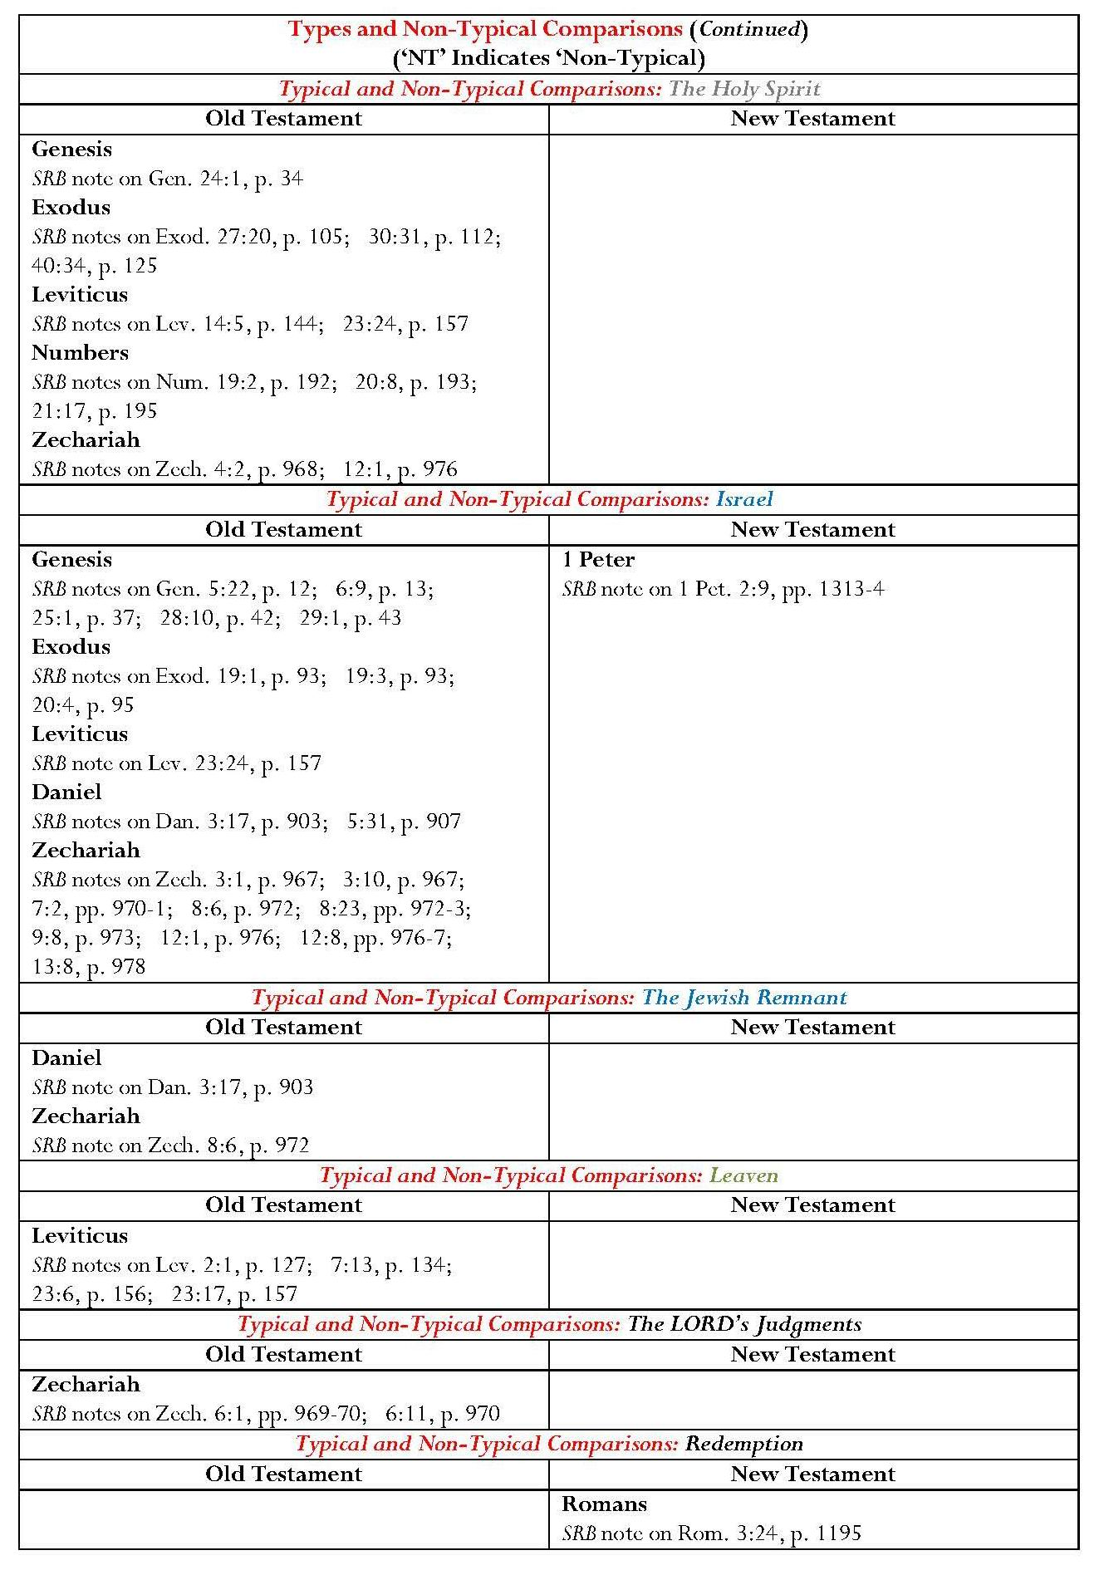

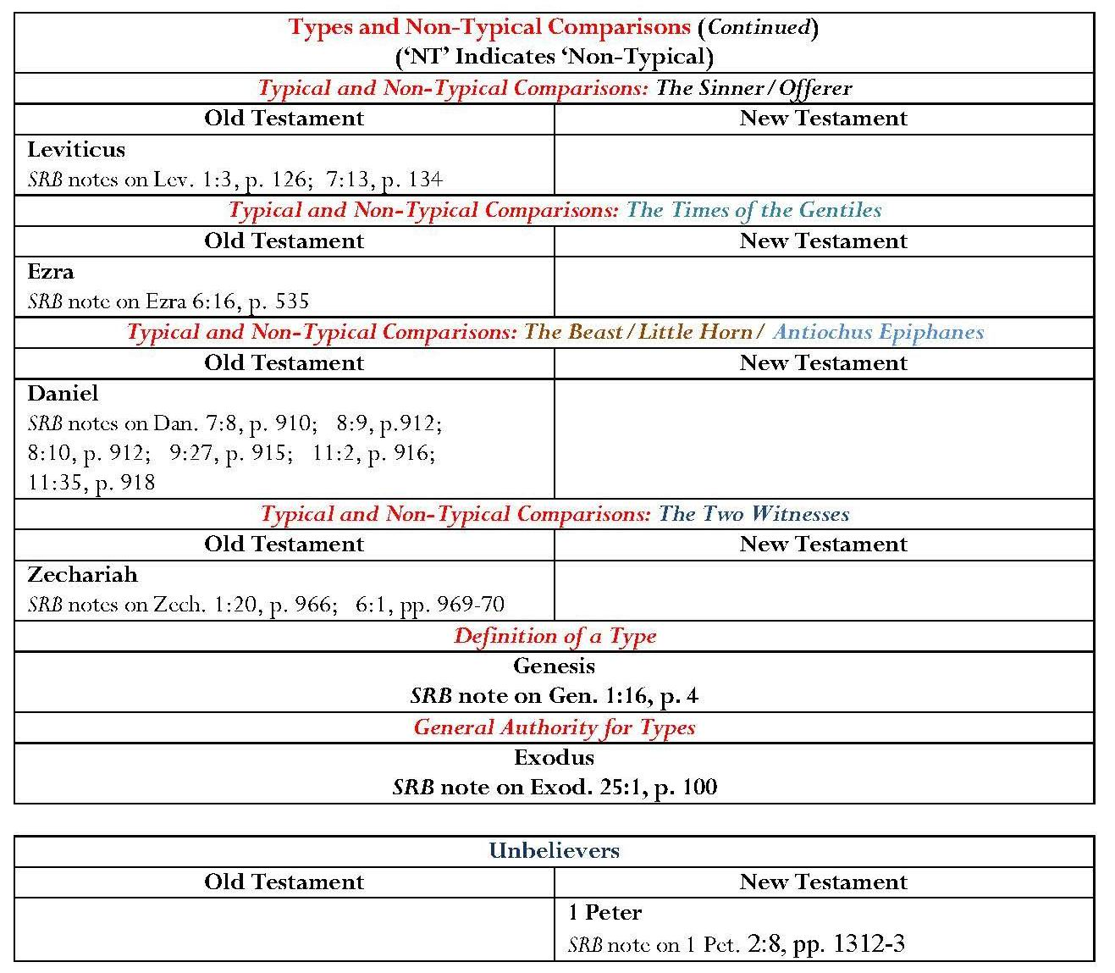

Highlighting below indicates annotation reflecting Christian doctrine.
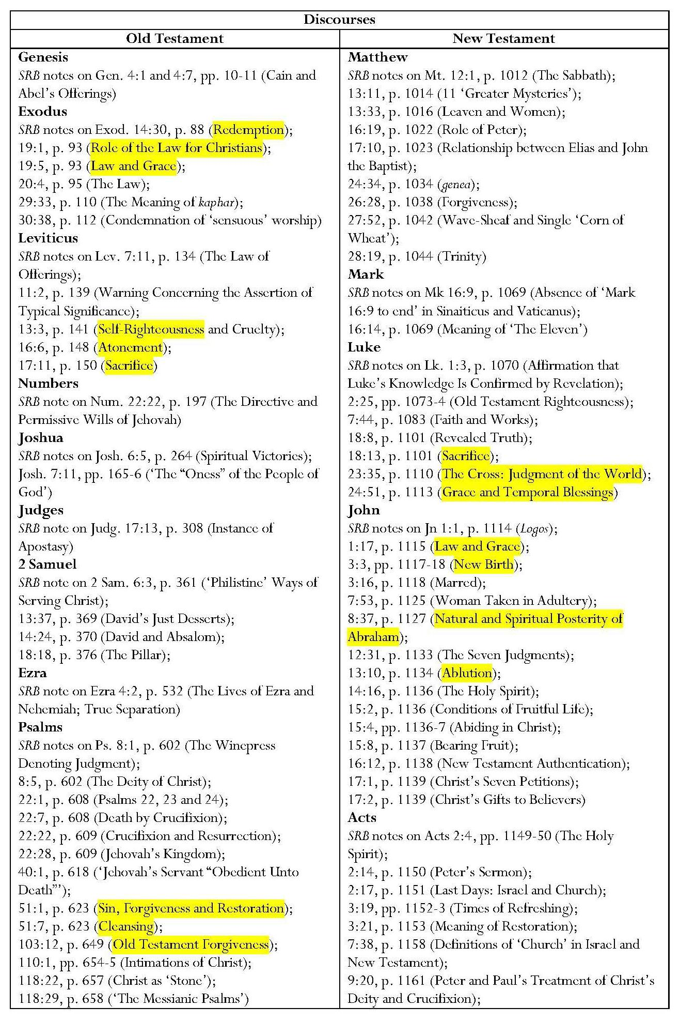

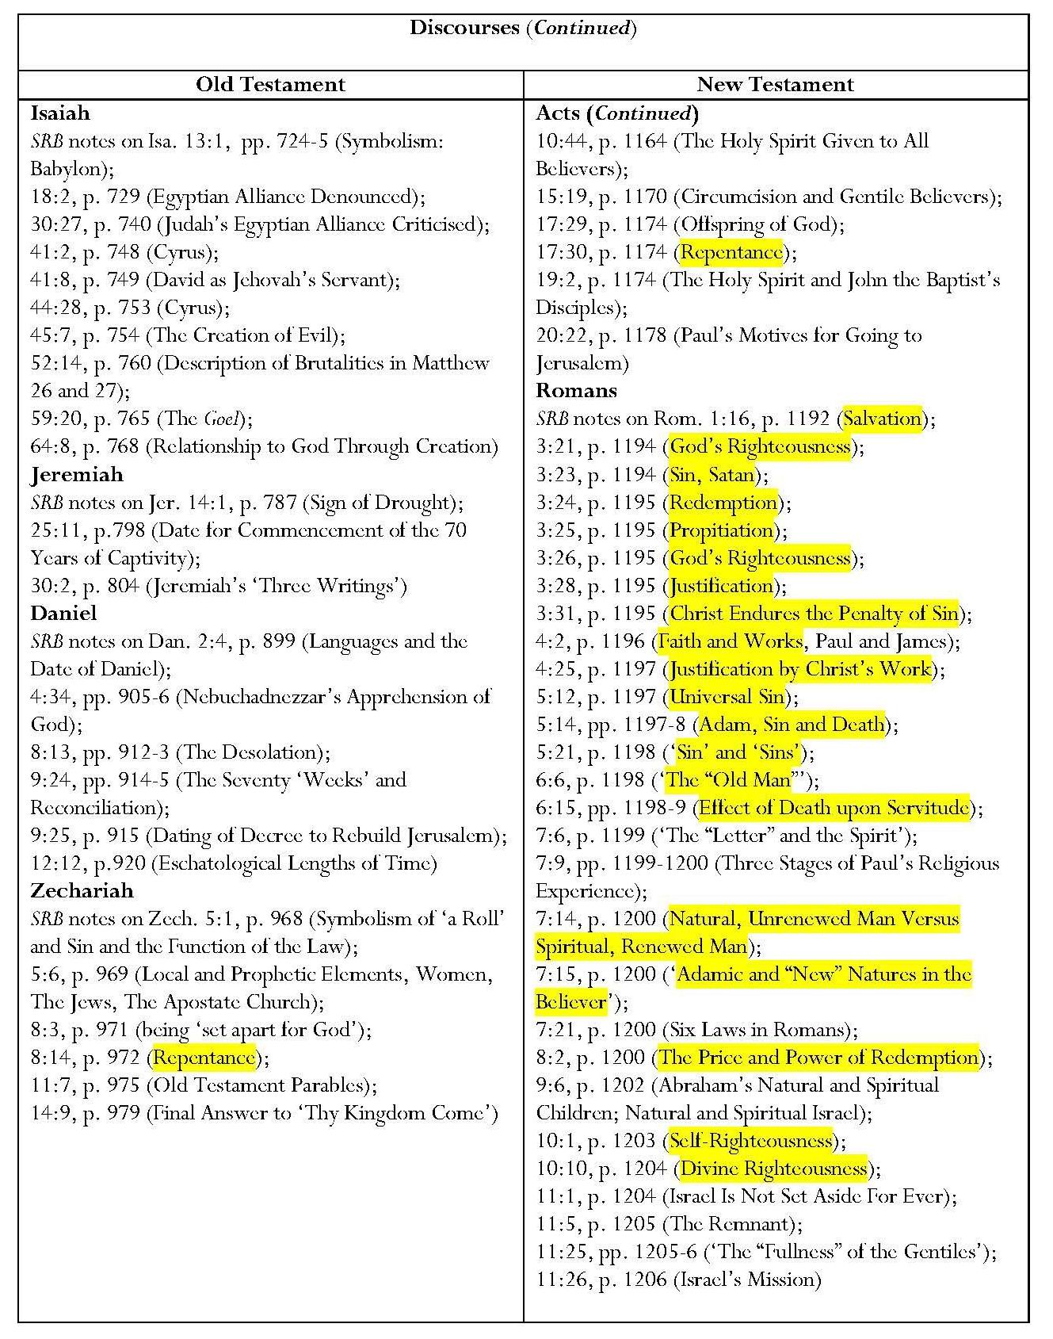

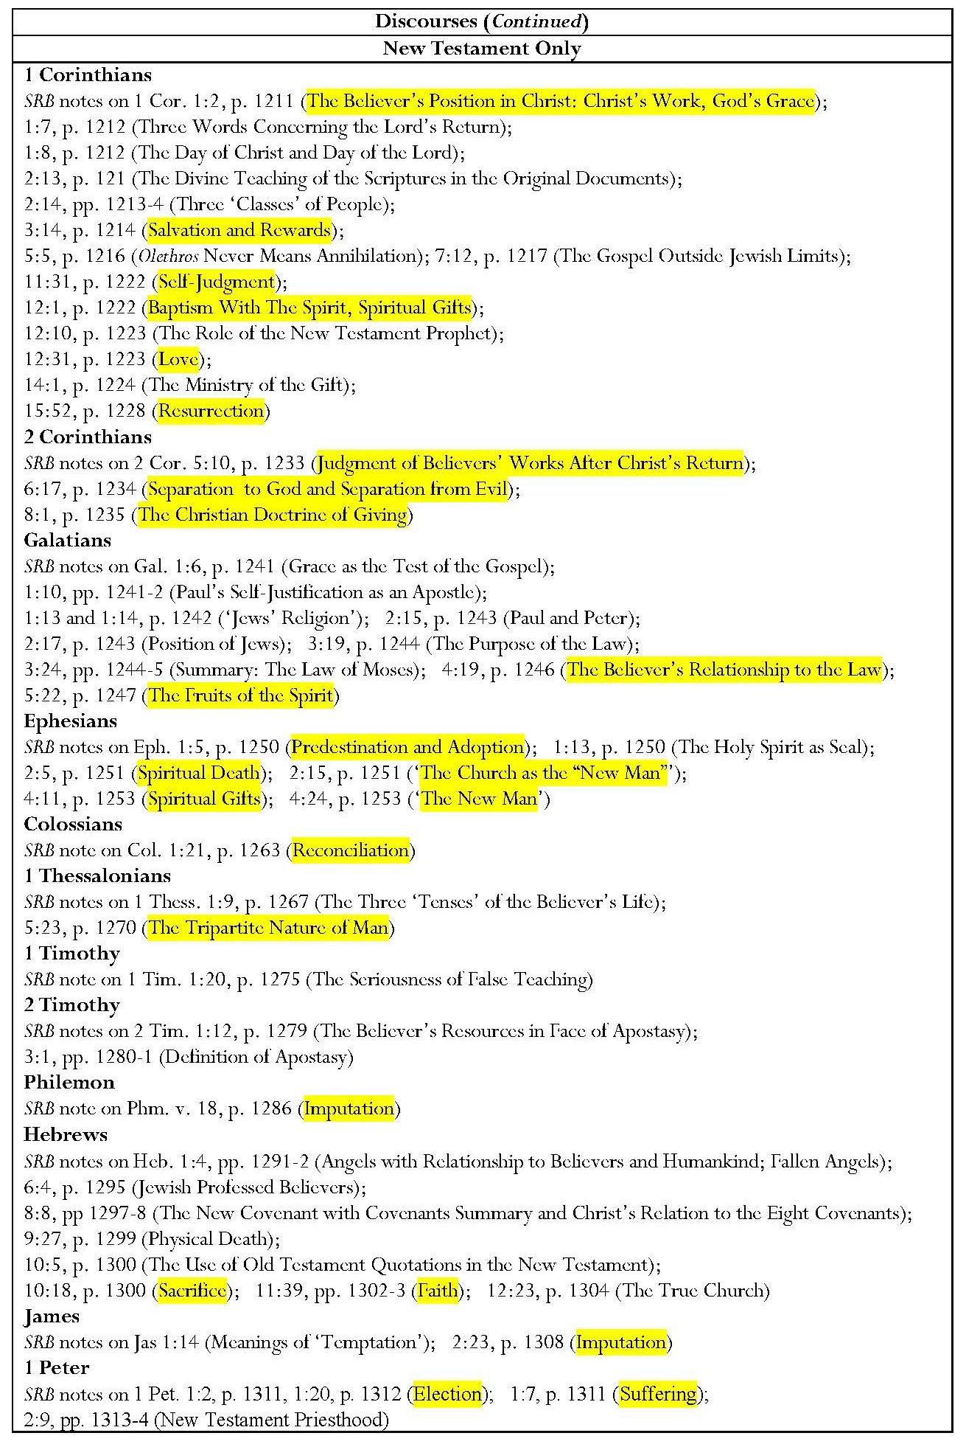

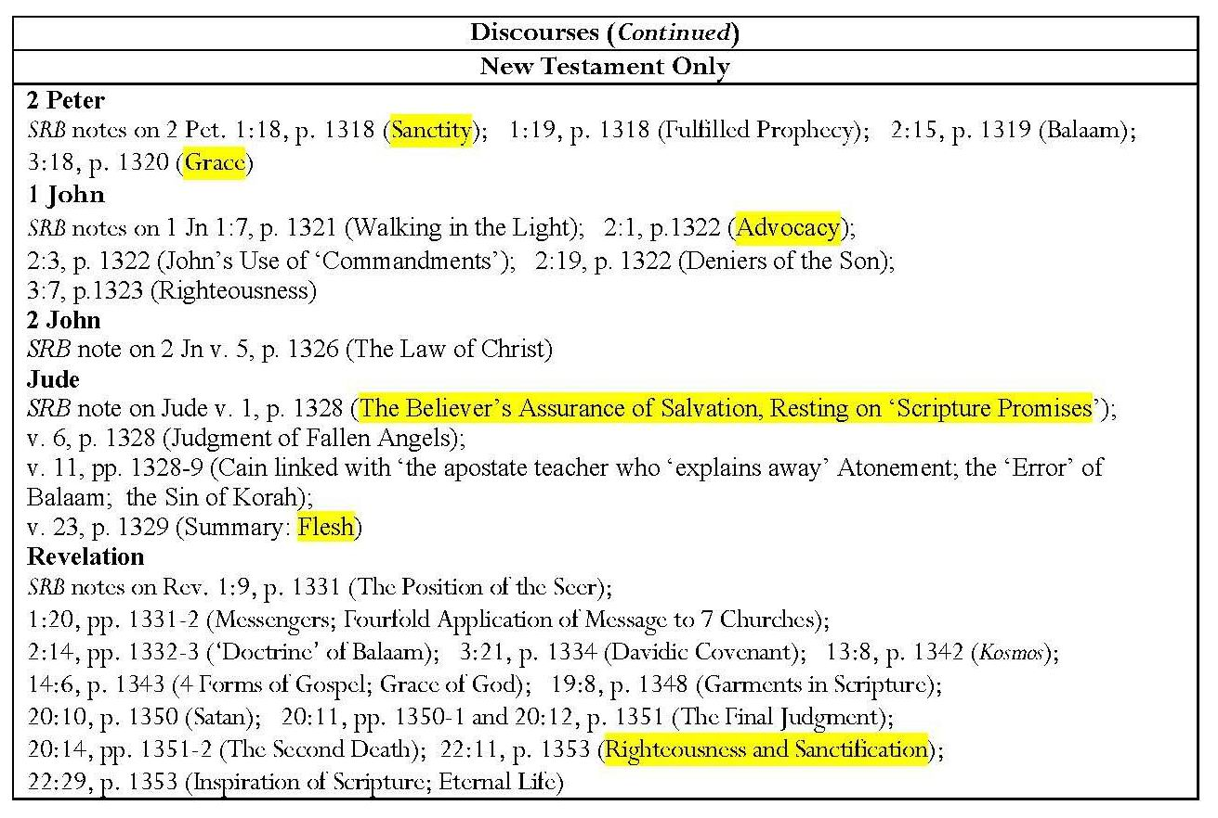

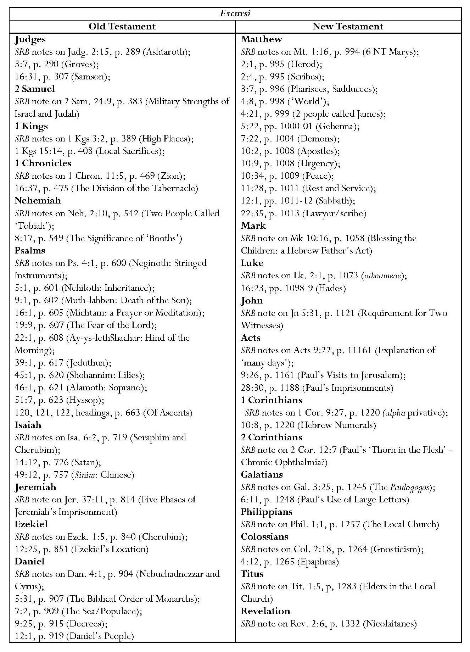
It is noticeable that eschatological and typological statements in the notes are found predominantly in Old Testament commentary, whereas Christological statements occur almost equally in Old and New Testament annotation. Subjects covered under the headings, ‘Discourses’ and ‘Excursi’ indicate that, in addition to dispensational material, Scofield includes themes which might well appear in other reference Bibles. I define ‘discourse’ as indicating a note which provides hortative material, rather than simply proffering information about a subject; this I term an excursus. A far greater number of discourses is found in New Testament commentary than in Old Testament annotation but numbers of excursi are roughly equal between the Testaments. Some of the discourses constitute direct explanations of the text but others explain Christian doctrine. These passages occur mainly in New Testament annotation, particularly in commentary on the epistles and especially Romans. The subjects of these discourses are highlighted in the Table of Discourses. The juxtaposition of uniquely dispensationalist and other types of commentary disguises differences between dispensationalist and other forms of evangelical theology.
In some cases it seems reasonable that particular annotation should be attached to one or other of the Testaments. For example, the majority of references to dispensations and covenants appear in Old Testament commentary; five of seven dispensations are asserted within Old Testament text and six of eight covenants. References to ‘Israel’ as an entity, whether denoting the concepts of Israel as a people, in historical and eschatological senses, or as the northern kingdom, and references regarding the Jews, Judah, the land, the remnant and the temple, would seem naturally to pertain to the Old Testament, as would references to the law. Also to be expected is that most references to creation are found in annotation of Genesis and those to ‘near and far’ prophecy in commentary on the Old Testament prophetic books. It seems consistent that notes on believers and unbelievers, the true Church, ecclesiology and the rapture should be found in New Testament commentary. However, other eschatological subjects such as Armageddon, the beast, the last days, and the tribulation are treated more frequently in Old Testament notes.
In other instances, there is an unexpected dominance of Old Testament references, for instance in notes on divine identity, and in eschatological references to the apostate Church, to the Gentiles and to the ‘Times of the Gentiles’. Most typological assertions are found in Old Testament commentary and very few of these assertions are fulfilled in New Testament notes. It is significant that comments concerning Christology, the Holy Spirit and Trinity, dualism and the Kingdom occur almost equally in notes on both Testaments. The reason for this is that Scofield regards the two Testaments as being parts of a single revelation which points to Christ, as he states in his note on Mal. 3:18.
e) Themes in Subheads in the Scofield Reference Bible
Subheads also play a significant role in conveying Scofield’s theology. Many of these subheads may be placed into the same categories outlined above for SRB notes as shown in the tables below. The same colours are used for the headings as in the tables of notes above and the tables in Chapter 8.
SRB subheads fall into several categories; some merely act as titles for the text that follows. This form of subhead is particularly prevalent in the ‘historical books’, which also lack annotation. Such subheads fragment the text but do not propagate a particular view. Where the subheads do not match the SRB notes, they often play an additional and significant role in promoting Scofield’s interpretations and views. Other subheads reinforce the notes.
Some subheads divide the text into numbered lists, some of which are complex, for example those in Exodus and Romans. This corroborates Marsden’s statement that ‘the disposition to divide and classify everything is one of the most striking and characteristic traits of dispensationalism’. The texts of Isaiah, Jeremiah and Ezekiel are physically divided into parts by horizontal lines which traverse the page and contain major headings in bold-print capitals. Other books are also divided into parts, but less obviously so, since the part numbers are included in the normal, italicised subheads. In Romans, almost every subhead belongs to a numbering system. These subheads present a virtual rewriting of Paul’s arguments, but they also contain elements of Scofield’s own interpretation, included as if part of the biblical text.
The subheads pertaining to Exodus and Romans also include references to ‘parentheses’; even the Passover and Romans 9 — 11 are regarded as ‘parenthetical’. This might imply that, for Scofield, such passages somehow interfere with the main flow of the text. This does not honour the importance of the Passover for Judaism or indeed for Christianity. With regard to Romans, as Craig Hill remarks, such a labelling might be seen to remove Romans 9 — 11 from ‘where it properly belongs, at the centre (or, rhetorically, at the climax) of Paul’s argument’. Such a separation of Romans 9 — 11 from the rest of the letter would also reflect Scofield’s insistence on a separate destiny for the Jews. This separation has already been emphasised in subheads in Leviticus referring to ‘God’s earthly people’.
Some subheads also contain typological references which go beyond the statement of type; they cross between the Testaments anachronistically, imposing New Testament figures and concepts upon Old Testament text. These subheads also sometimes promote doctrinal matter. Scofield appears to contravene his own claim in a letter to Gaebelein that ‘the types will be conservatively treated upon the principle of affirming nothing to be a type which is not elsewhere affirmed to be such’.
Other subheads make non-typological intertestamental claims. The reference to the cross in the subhead to Zech. 13:1 is particularly significant; it begs the question as to how the ‘remnant’ could be turned to a cross which had no significance until several centuries later. The subhead to Gen. 4:6, asserting an exhortation to Cain to bring a sin-offering, is anachronistic; sin-offerings are part of the law of Moses and are not mentioned in Cain’s context. According to Scofield’s acceptance of biblical chronology, such offerings were not even in existence at that time. In such subheads, matters which are purely interpretative are presented as if they actually appeared in the text. The interpretation of elements of Israelite rituals purely in terms of Christian models denigrates their contextual meaning.
Some subheads contain aphorisms which are not congruent with the text. For example, Scofield’s interpretation of 2 Cor. 9:6 appears to negate the thrust of Paul’s argument, which is that believers should give because God has given.
Dispensations, covenants and eschatological assertions are also enshrined in subheads. Many concern the king and his two advents, the kingdom, which is described several times as Messianic or Davidic, and the kingdom-age. Others concern the future for Israel and end-time events, such as the tribulation and Armageddon. Particularly significant are the statement of an interval between the rejection of the king and his return and the two subheads which claim that the king made a public offer of himself as king. The link made between Jn 14:1 and 1 Thess. 4:14-18 in two subheads is important because it implies that Jesus’ ‘coming for his own’ will be at the pretribulational removal of the true Church.
A series of subheads gives the names of the four world-empires which some, including Scofield, hold to be represented in Daniel 2 and 7. Subheads to Dan. 7:4 and 7:6 refer specifically to the ‘world-empire of Nebuchadnezzar’ and ‘Greece under Alexander’. The names of the kingdoms are not given in Daniel 2 or Daniel 7, while the names Media, Persia and Grecia appear in Dan. 8:20-21, applied to a different vision. The name ‘Rome’ does not appear in the Old Testament. The kingdom of heaven is listed as the last of these in the subhead to Dan. 2:44. The names of the kingdoms are given as if they occur in the text and represent fact. Similarly Antiochus Epiphanes is named in the subhead to Dan. 11:21.

Main Themes in SRB Subheads
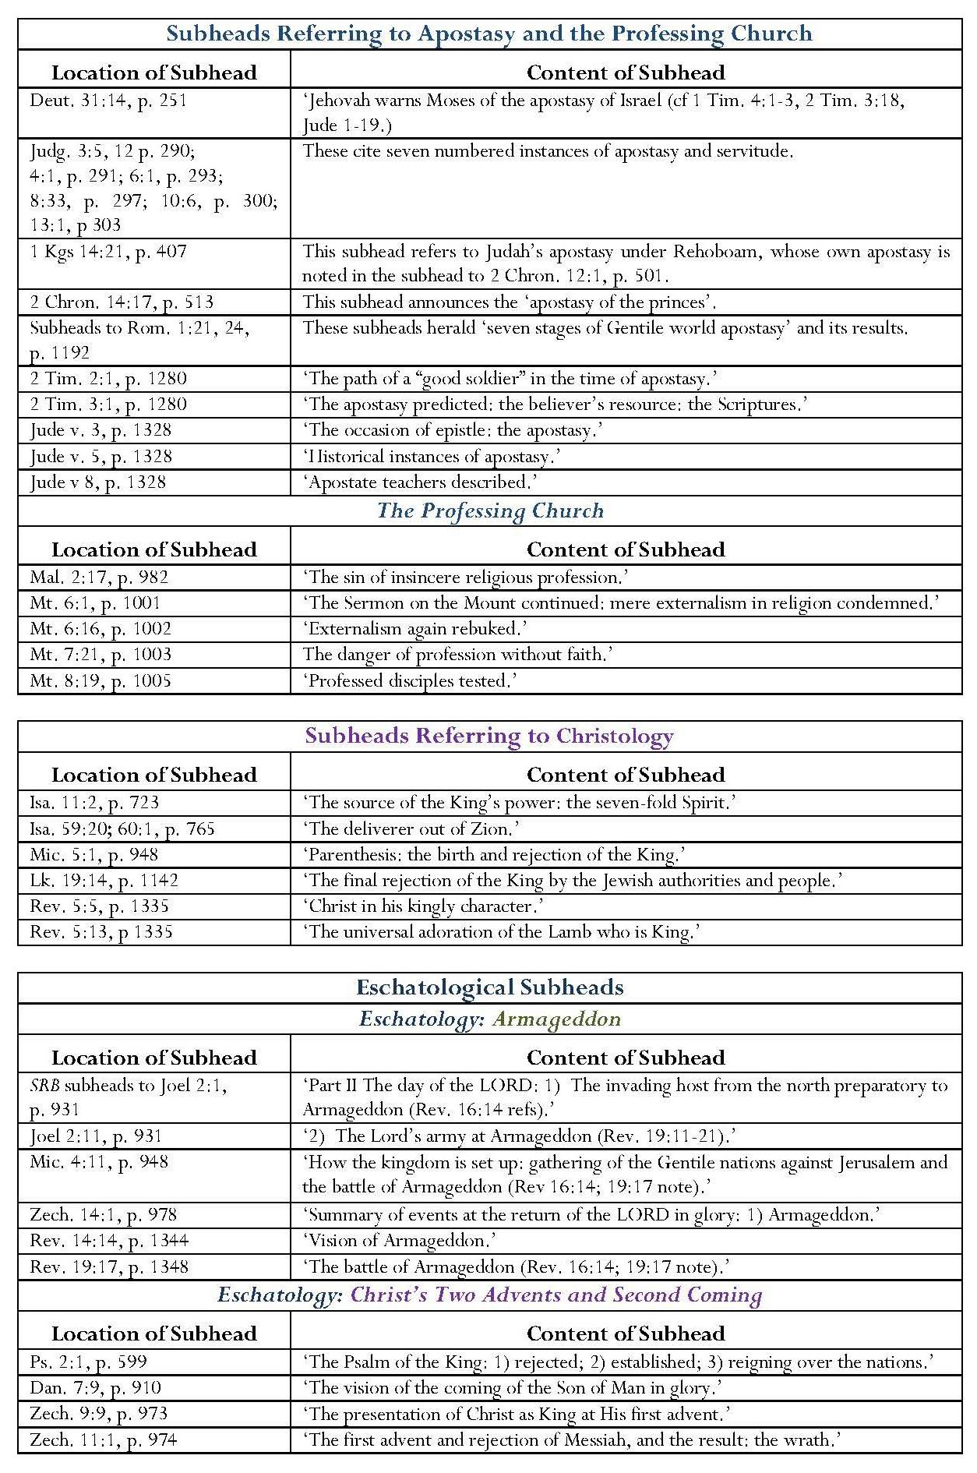

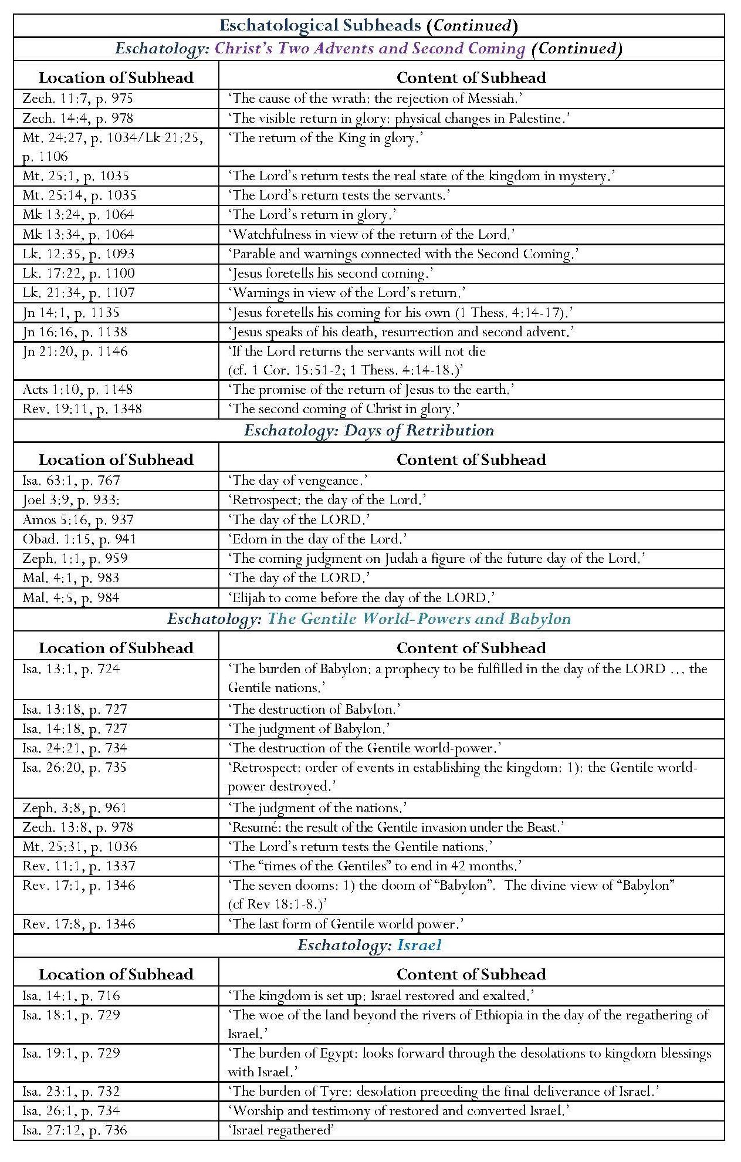
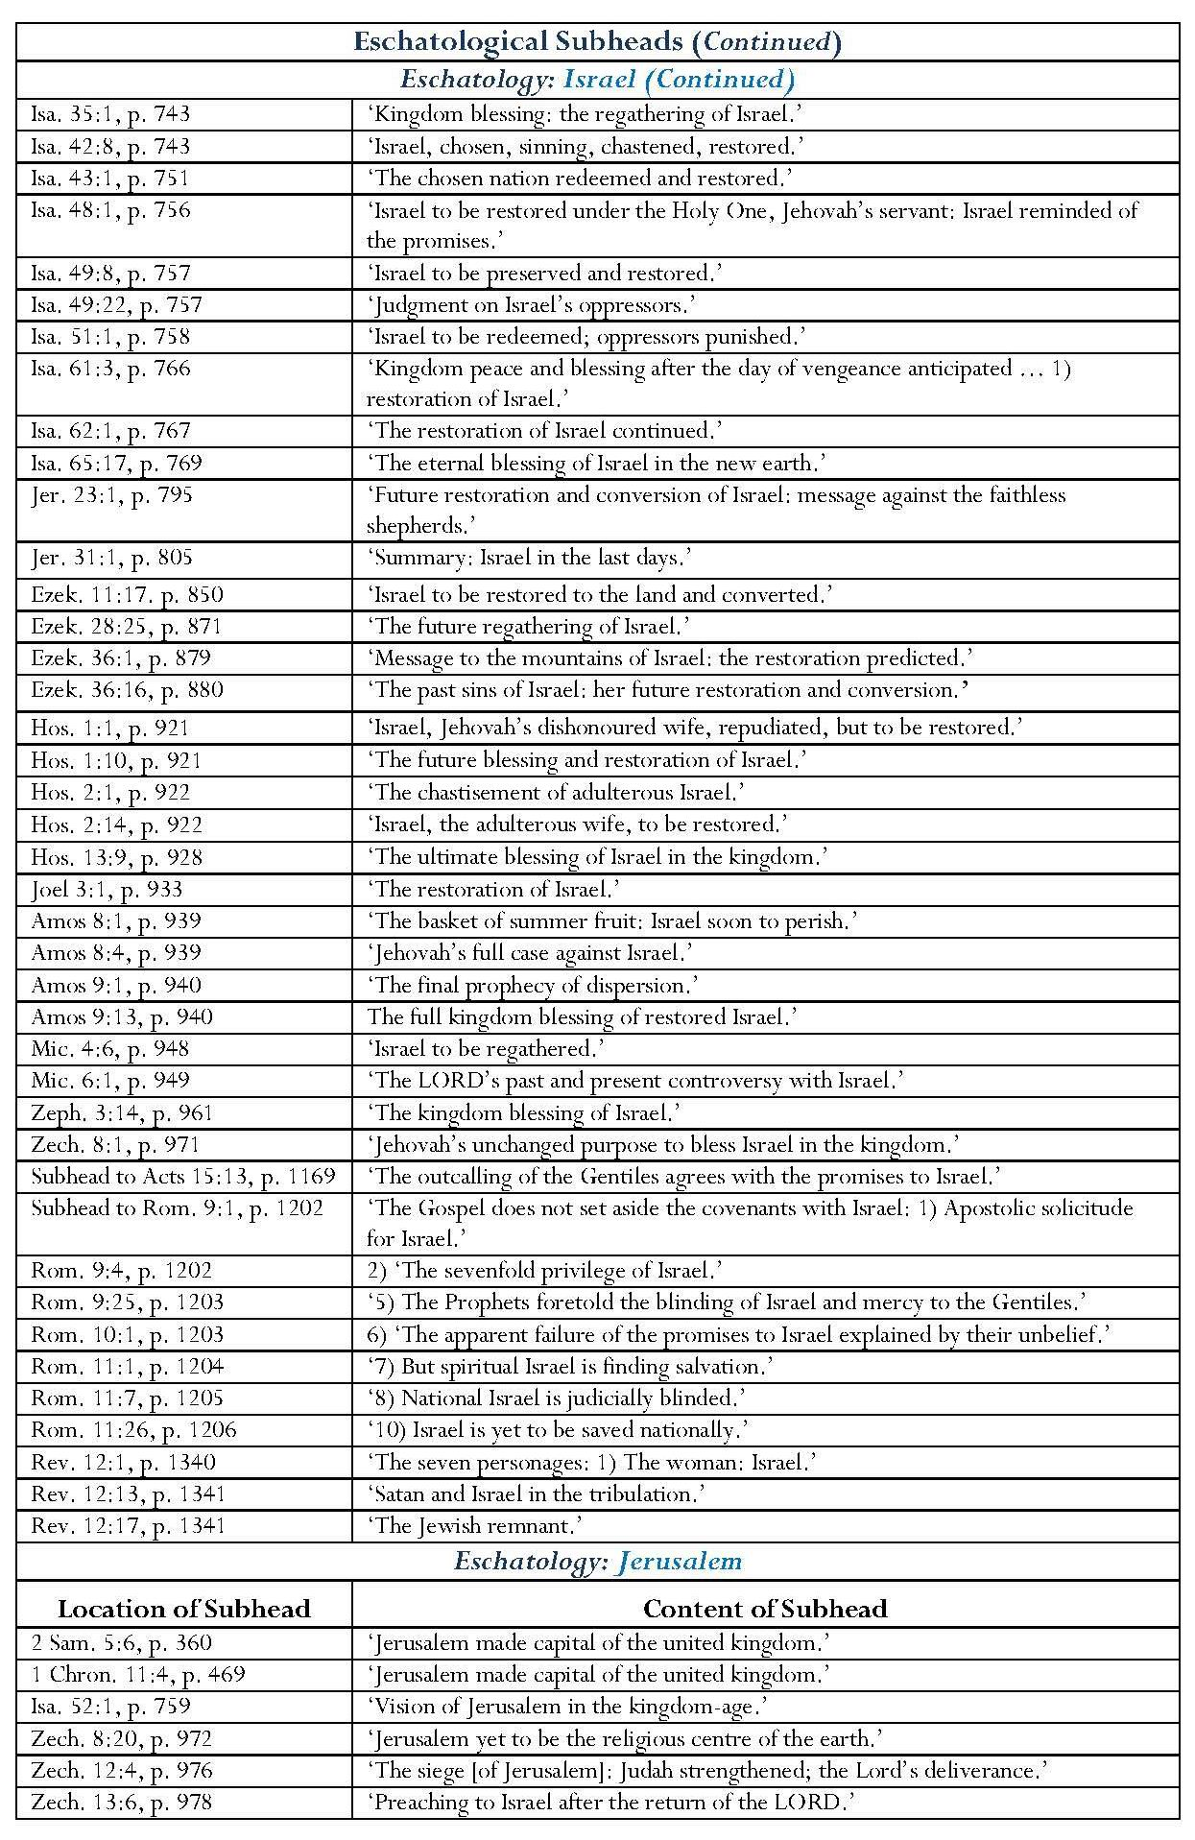

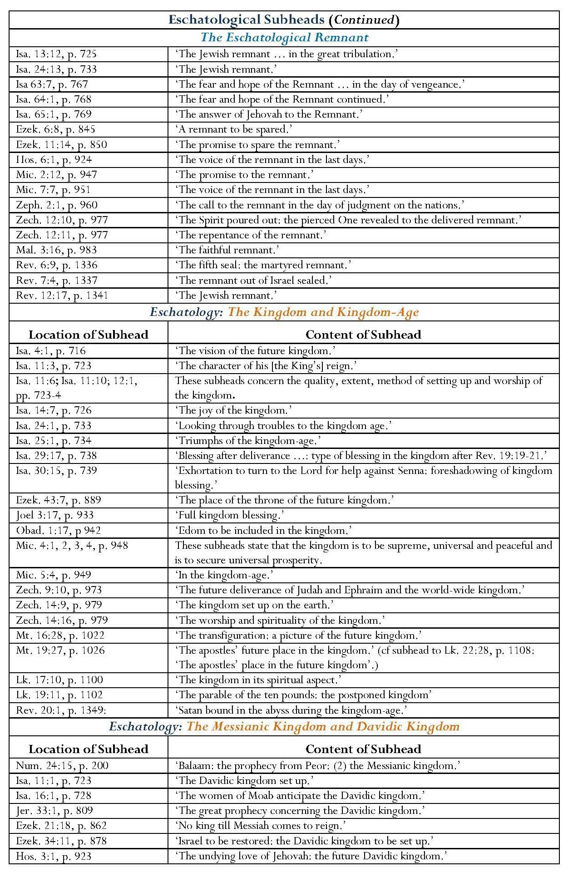

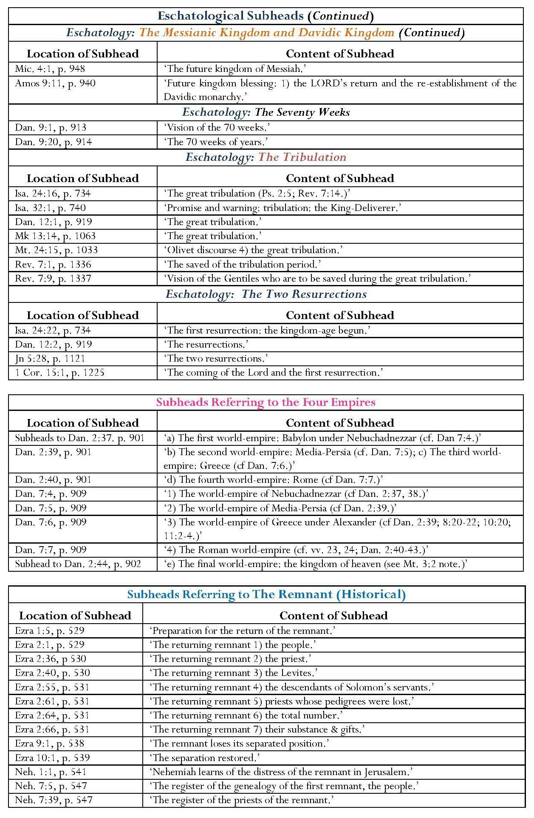

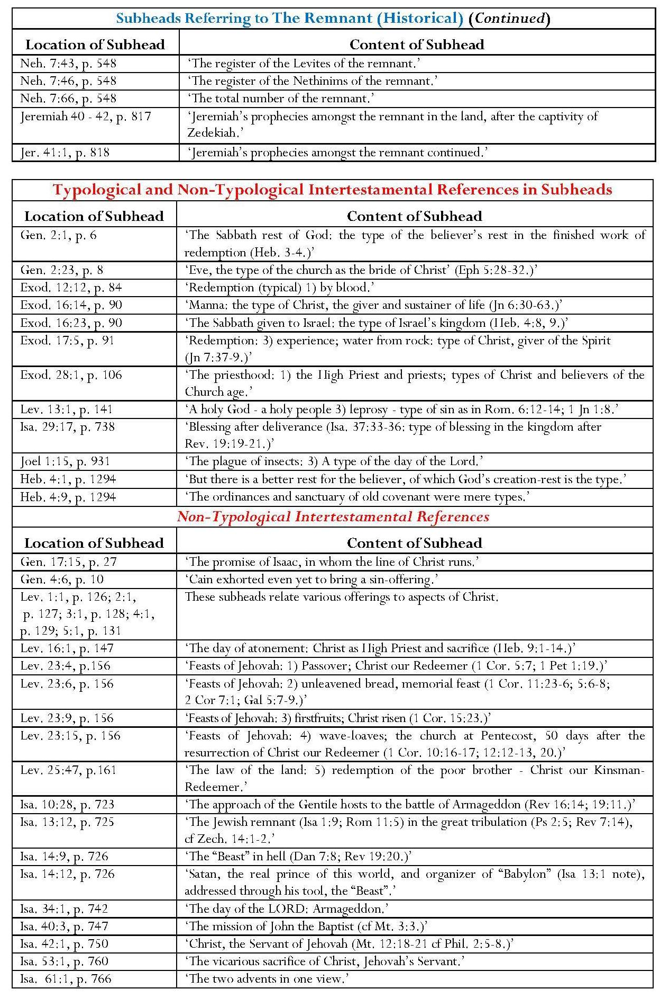

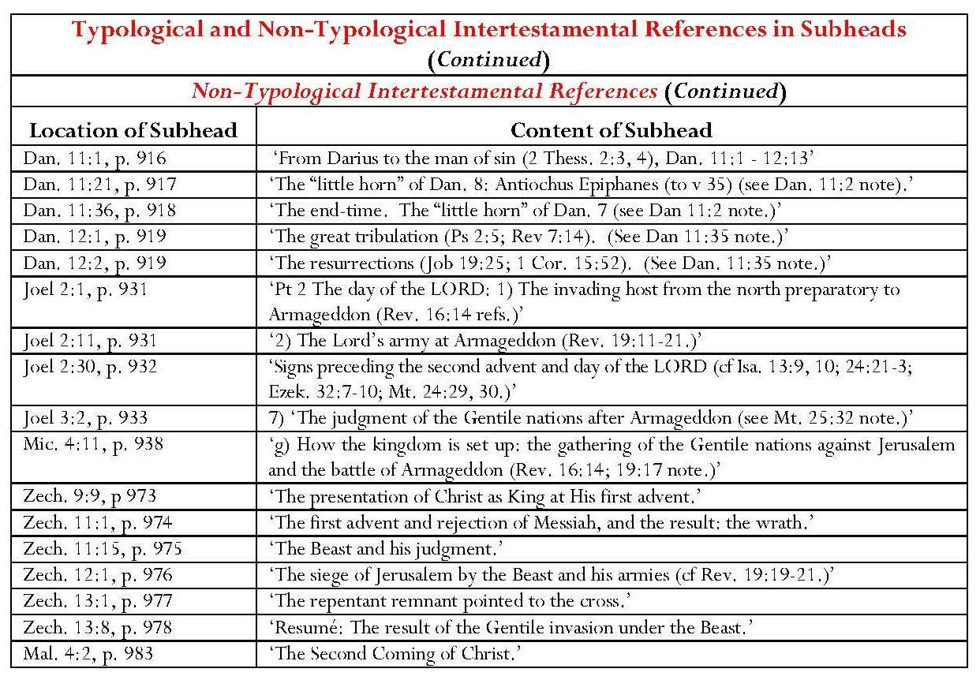

Page intentionally left blank

CHAPTER 1
Dispensational Hermeneutics
What is Hermeneutics?
The word ‘hermeneutics’ comes from the Greek ἑρμηνεύω, meaning ‘to explain’ or ‘to interpret’. Nathan Holsteen indicates that the three terms, hermeneutics, interpretation and exegesis are often linked. He does not explore the connection between hermeneutics and exegesis but suggests that ‘the simplest approach is … to say that hermeneutics is interpretation’. However, he also states that ‘hermeneutics is not identical to interpretation’; even in ‘the most simplified approaches, hermeneutics is the theory that stands behind the activity of interpretation’. Anthony Thiselton states that there is ‘a crucial difference between interpretation and hermeneutics. Interpretation is actually doing interpretation. Hermeneutics is the theory of how we ought to be interpreting.’
Regarding the connection between hermeneutics and exegesis, Bernard Ramm aptly compares hermeneutics to the rule-book for a game and exegesis to the game governed by it. He states, ‘The rules are not the game, and the game is meaningless without the rules. Hermeneutics proper is not exegesis but exegesis is applied hermeneutics.’ Ramm defines hermeneutics as ‘the science of the correct interpretation of the Bible’. It is both a science and an art, a science because it ‘can determine certain principles for discovering the meaning of a document’, these principles being ‘not a mere list of rules but [bearing] organic connection to each other’, and ‘an art … because principles or rules can never be applied mechanically but involve the skill … of the interpreter’. Moreover, ‘learning the rules of hermeneutics does not make a student a good interpreter’; an interpreter must have ‘the same Spirit who inspired the Bible as the sine qua non for interpreting the Bible’.
In his interview, Thiselton solely uses the term, ‘hermeneutics’ and does not employ the term, ‘hermeneutic’ as such. Holsteen, however, distinguishes between hermeneutic, which he defines as ‘a specific approach to the interpretation of texts’, and ‘hermeneutics’, which he calls ‘the study of various ways of approaching the interpretation of texts’. He does not explain this differentiation. In this study, I generally maintain the use of the term, ‘hermeneutics’, as employed by Thiselton, though construing it as ‘a specific approach to the interpretation of texts’. Such a rendering reflects Holsteen’s definition of hermeneutic but this delineation is more relevant to the study of the case of dispensationalism.
Ramm advances two reasons for the need for hermeneutics – firstly it provides a means by which God’s Word may be understood and secondly it ‘[bridges] the gap between our minds and the minds of the Biblical writers’. This task is not easy when ‘the interpreter is separated culturally, historically, and geographically from the writer he seeks to interpret’. Charles Ryrie calls hermeneutics ‘the science that furnishes the principles of interpretation’. These principles are basic and should ‘be established before attempting to interpret the Word so that the results are not only correct interpretations but a right system of theology’. As mentioned in the introductory chapter, biblical interpretation is an essential component of dispensationalism.
The Biblical Basis for Dispensational Hermeneutics
Ramm avers that ‘the divine inspiration of the Bible is the foundation of historic Protestant hermeneutics and exegesis’. This view became particularly pertinent to conservative American evangelicalism, including burgeoning dispensationalism, in the years following the Civil War, owing to rapid social change, the rise of evolutionary theory and liberalism, and the development of higher criticism of the Bible. According to Timothy Weber, doubts were sown even in evangelical minds and many ‘tried to redefine the traditional evangelical faith in terms compatible with modern thought’. Conservative evangelicals, including dispensationalists, made common cause against liberalism. The establishment in 1875 of the Believers’ Meeting for Bible Study (later the Niagara Bible Conference), is one example this co-operation. Premillennialists were prominent at Niagara from the start and became dominant in leadership roles; they also participated in framing the 1878 statement of faith, which included the affirmation of ‘the inspiration and authority of the Bible’. Premillennialists promulgated biblical inerrancy. As Kraus remarks, ‘the Bible, being the Word of God, was a priori perfect from start to finish in every sentence, word, and syllable according to the highest standards of human reason. To suggest that there might be one flaw … would have been equal to suggesting that it was not the Word of God.’ Clarence Bass asserts that ‘one great impetus’ to the growth of dispensationalism ‘has been an insistence that the Bible must be taken literally as the Word of God and its meaning must not be “spiritualized”’. For many even now, ‘a non-literal interpretation is synonymous with liberalizing tendencies which are equated with denying the validity of the Word’.
This belief in the inerrancy of the Scriptures led to a basic assumption that they contained a single system of truth and that no interpretation of a specific passage should contradict ‘the total teaching of Scripture’. This is sometimes known as ‘the analogy of faith’ or ‘analogy of Scripture’. Paul Lee Tan calls this the foundational principle that ‘Scripture interprets Scripture’; it is ‘a basic presupposition in Scriptural interpretation’. Bock describes this as the principle that ‘clear texts should interpret obscure texts’. He acknowledges that it can be difficult to apply this since ‘clarity is often seen through the eye of the beholder’. However, even Oswald Allis, who opposes dispensationalism, states that ‘the trustworthiness, perspicuity and plenary inspiration of Scripture cannot be maintained aside from the belief that the Bible is a thoroughly self-consistent whole’ and quotes the Westminster Confession, ‘The infallible rule of interpretation of Scripture is the Scripture itself.’ On the basis of the conviction by dispensationalists that ‘the words of Scripture can be trusted’, Paul Lee Tan calls their literal approach to interpretation ‘a true and honest method’.
1.1 Consistent Literal Interpretation
As mentioned above, literal interpretation is Ryrie’s ‘second aspect of the sine qua non of dispensationalism’. Ryrie states that ‘consistently literal or plain interpretation is indicative of a dispensational approach to the interpretation of the Scriptures’. A literal interpretation is one which ‘gives to every word the same meaning it would have in normal usage, whether employed in writing, speaking or thinking’. However, it is not sufficient simply to state that literal interpretation gives every word a normal or plain meaning. Perceptions of normality or plainness are subjective; it cannot be assumed that everyone will think of the same concept when hearing or reading a word. Perceptions are also influenced by context, time and location. For example, the word ‘silly’ meant ‘rustic, plain or homely’ in the seventeenth century, as used by John Milton in the ‘Ode on the Morning of Christ’s Nativity’, with reference to the shepherds, rather than ‘foolish’. Similarly ‘egregious’ originally meant something distinguished or eminent, coming from the Latin egregius, meaning ‘outstanding, surpassing, distinguished’, rather than ‘extraordinary in some bad way’. A biblical instance of change in the meaning of a word occurs in Zech. 1:20-21. Referring to the image of the four carpenters, Scofield states that the word, ‘charash’, translated as ‘carpenter’ means to ‘fray’ or ‘carve away’ and concludes that the passage refers to the ‘diminishing’ or ‘enfeebling’ of the Gentile world-powers. The modern implication of ‘fray’ is ‘to wear off by rubbing’ or ‘to unravel’, but in C17, it meant ‘to terrify’, as several translations render it. In C19, Darby translated the word as ‘affright’. Words may also lose some meanings over time while retaining others. For example, the verb ‘suffer’ in the seventeenth century English of KJV had two different meanings and was a translation of two different Greek verbs, ἀφίημι and πάσχω. The first meaning of the verb, famously enshrined in Jesus’ instruction to ‘suffer the little children to come unto me’, is no longer current and is translated in modern versions as ‘let’, whereas the second verb, conveying the sense of undergoing pain or distress, is still extant and translated as ‘suffer’ in modern versions, for example, ‘it is written that Christ must suffer’.
Ramm states that ‘the word “literal” in the theory of hermeneutics… takes as the primary range of designation [ie the association of certain words with such things as nouns, verbs, adjectives, etc.] the customary, the usual, the socially-acknowledged designations. Thus the literal meaning of a word is its designation in the common stock of the language.’ ‘Spiritual, mystical, allegorical or metaphorical usages of language reflect layers of meaning built on top of the literal meanings of a language.’ Literature is usually interpreted by the literal method and ‘the non-literal is always a secondary meaning’ dependent upon the literal. Parables, types, allegories, symbols, figures of speech, fables and myths all belong to the non-literal category. Furthermore, ‘literal interpretation … is … the effective, meaningful, and necessary control for the protection of the right interpretation of Scripture’. Tan avers that literalists ‘believe that the words of Scripture are adequate in conveying all that God wants man to know’. All applications of scripture must be based on literal interpretation.
Ryrie asserts that it is in the consistent application of literal interpretation that dispensationalism differs from nondispensational evangelicalism. He declares that ‘classic dispensationalism is a result of consistent application of the basic hermeneutical principle of literal, normal, or plain interpretation. No other system of theology can claim this.’ Ryrie avers that ‘most conservatives’ would agree that language is given by God to communicate with humankind and thus God would ‘expect people to understand it in its literal, normal, and plain sense’. They would also agree that the Old Testament prophecies about Christ’s first advent were literally fulfilled, thus establishing the reasonableness of the literal method. Thirdly, they would agree that there would be no restraint on ‘the variety of interpretations … if there were no objective standard’, that is, literal interpretation. Ryrie argues that the difference between ‘the dispensationalist’s use of this hermeneutical principle and the nondispensationalist’s’ is that ‘the dispensationalist claims to use the normal principle of interpretation consistently in all his study of the Bible’. He asserts that, although ‘the nondispensationalist is a literalist in much of his interpretation of the Scriptures’, he allegorises or spiritualises in the case of prophecy.
Charles Feinberg avers that it is only by consistent literal interpretation that ‘the entire Word of God [can] be brought into harmony’. Holsteen agrees that ‘the unifying factor in dispensationalism is indeed a systematic commitment to literal interpretation. Tan states that a consistent literal interpreter ‘consistently acknowledges and accepts the customary uses of Bible language’. Consistent literal interpretation also applies to figurative language as long as it is based on ‘the literal sense which the figure and symbol are intended to convey. Consistent literality also allow for the interpretation of types – whenever types are properly identified.’
1.1.1 Elements in the Practice of Literal Interpretation
Ramm suggests that three elements are involved in ‘the actual way in which literal interpretation is practiced’ – words, grammar and genre. Ryrie does actually agree with this precept, which modifies his assertion concerning literal interpretation which was quoted above. Ryrie allows that ‘most agree’ that the meaning of words must be ascertained through study of ‘etymology, use, history and resultant meaning’; that grammar, or interrelationship of words must be analysed, and that ‘context, immediate and remote, must be considered’.
a) Words
Ramm describes words as ‘the units of thought in most of our thinking and writing … the bricks of our conceptual formulation’. A word may be studied etymologically (studying its root[s]), comparatively (comparing Greek or Hebrew uses of the word in Scripture), culturally (understanding that a biblical word may not be understood in the same way as when it was written) or in terms of cognates (for example, Arabic and Aramaic). Tan emphasises the need for lexicography or the study of individual words, encompassing etymology, rare words, synonyms and shades of meaning, and including hapax legomenae. He also notes the need to try to establish words’ contemporary meaning. Feinberg points out that a word, even used within a close biblical context, may have different meanings. He gives the use of the word, ‘law’ in Rom. 2:14, and 20-23 as an example; he asserts that the first three uses in Rom. 2:14 concern the Mosaic law, whereas the fourth refers to ‘natural or inherent’ law. The use of ‘law’ in the latter verses refers ‘specifically to the Ten Commandments of the Mosaic system’. Feinberg adds that ‘it would be most unwise, then, to demand that a word should always mean the same wherever found’. This is pertinent in light of the dispensationalist claim, that ‘“Israel” always means “Israel” or “the nation state Israel”’ for example by Thomas Ice, ‘Israel always and only refers to national Israel’ and Scofield, ‘Jerusalem is always Jerusalem, Israel always Israel, Zion always Zion.’ Williams refers to this concept as ‘the principle of terminological absolutism’, in which ‘Israel and the Church are static terms’, Israel always indicating ‘the earthly progeny of Abraham, that is to say, the Jewish race’. The concept is refuted by Carly Crouch’s comment on Micah 3:
The biblical “Israel” is an elusive and multivalent entity. Depending on context … it may serve as an alternative name for the patriarch Jacob (in Genesis); as a collective name for the pre-settlement tribes (in Exodus to Judges); as the name of an ambitious political state ruled by David and Solomon (1 and 2 Samuel, and 1 Kings); as shorthand for the northern kingdom (1 and 2 Kings); or as the name of an idealized cultural or ethnic group, with variable political connotations depending on time and context.
The modern state of Israel might well fall within the last definition suggested by Crouch. In the light of this possibility, the dispensationalist assertion that ‘Israel’ always means ‘Israel’ may have serious political consequences. Christian Zionists like John Hagee strongly associate biblical and modern uses of the name:
At the conclusion of Ezekiel 37, the nation of Israel had been physically reborn. Today they have a flag; they have a constitution; they have a Prime Minister and a Knesset. They have a police force, a powerful military might, and the world’s best intelligence agencies. They have Jerusalem, the City of God. They have a nation. They have everything but spiritual life. Like the dry bones of Ezekiel 37, Israel awaits the spiritual awakening of the breath of God and the coming of Messiah.
This is a further illustration of the fundamental need for consideration of context when interpreting the biblical text.
Poythress analyses in detail the importance of setting single words within their contexts. Starting with the word, ‘battle’ and gradually adding the words surrounding it, he illustrates the differences made by its verbal context in Isa. 27:2-4. I have illustrated this in the table below, adding italics to each additional word or phrase.
Poythress' Cumulative Analysis
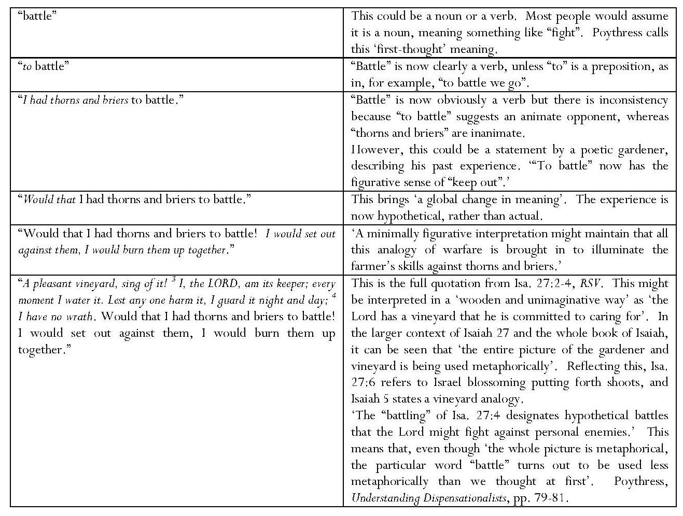
Poythress suggests that, within the total context of Isaiah, there is an allusion in Isa. 27:2-4 to Eden, which is used ‘to evoke the comprehensive peace that Israel will experience in the future’. He concludes that it is possible to say that ‘the literal meaning of a word is the meaning that native speakers are most likely to think of when they are asked about the word in isolation’, the ‘first-thought’ meaning. It would, however, be ‘artificial or even absurd’ to give each individual word its first-thought meaning. However, even if the surrounding words are included, it is still possible to produce what Poythress calls a ‘flat interpretation’, which is ‘literal if possible’ while ignoring ‘the possibility of poetic overtones, irony, wordplay, or the possibly figurative or allusive character of whole sections’; the interpretation might then be ‘a prediction that the Lord will construct … a perfect vineyard’. A third method of interpretation is ‘grammatical-historical’, that is, a method where the reader ‘reads passages as organic wholes and tries to understand … each passage … against the background of the original human author and original situation’. This method is discussed below.
b) Grammar
Ramm introduces his second element of literal interpretation by stating, ‘If words are the units of a language then the sentence is the unit of thought.’ Languages are constructed in different ways; they may be analytic, where word order matters, or agglutinative/synthetic where meaning is derived ‘partially from word-order but more by word-endings or case-endings’. This would appear to refute as too simplistic Ryrie’s claim that ‘the literal meaning of words is the normal approach to their understanding in all languages’. Ramm also asserts that ‘a knowledge of syntax is essential’; the structure of the sentence must be considered, ‘even if working only in translation’. Idiom, figures of speech and specialised terms of rhetoric should also be taken into account. Whether a text appears in the Old or New Testament is influential, as is the biblical book in which it appears. Its context is also affected by the preceding and following books.
Feinberg, Tan and Bock, all dispensationalists, agree with many of Ramm’s stipulations. Feinberg states that ‘there is no more basic rule than that ‘the meaning of a passage must be determined by a study of the words and the relationship sustained in the sentence’. The construction and form of the sentence and the idioms of the language must be considered. Tan stresses the importance of the positions of words and clauses in sentences, together with the ‘significance of conjunctions, adverbs and prepositions’, and the use of tense, voice and mood of verbs and cases of nouns. Bock emphasises the study interrelationship of terms within sentences and paragraphs in a passage and of its historical setting and genre. He suggests that it is best ‘to take the meaning most appropriate to the context’ and warns against ‘reading too much into a term’, remembering ‘the provisional character to all interpretation’, no matter how careful the interpreter. As seen below, Bock, as a progressive dispensationalist, has a more fluid approach to biblical interpretation, which is criticised by some more conservative dispensationalists.
c) Genre
Ramm’s third element in the practice of literal interpretation is awareness of the genre of a passage. This might well be included in the category of context. Ramm states that genres include figures of speech, especially metaphors, similes and hyperboles, together with ‘larger forms’ such as ‘parables, allegories, fables, myths and riddles’. He avers that each biblical book belongs to a broad literary genre – historical, dramatic epic, apocalyptic or poetry. Genre ‘sets the mood or stance from which all the rest of the book is seen.’ Ramm remarks that ‘disagreements about literary genre and … degrees of literalism’ within ‘mainline Reformation scholarship – Anglican, Reformed, Lutheran’ must not be ignored but the tradition ‘is not in principle forced to a grinding literalism in its Biblical interpretation’. ‘It recognizes that no book can be intelligently … interpreted without first noting its literary genre.’
Ramm cites Song of Songs as a particular example of ‘divergent opinions’, dubbing it ‘the most controversial book in the Scriptures’. Some see it as an allegory ‘representing some sort of relationship between God and man; others ‘take it literally as a theological justification and interpretation of human sexuality’. It is interesting that Scofield, as a dispensationalist, gives two interpretations, both of which are in fact allegorical. Song of Songs is ‘primarily the expression of pure marital love as ordained of God in creation … The secondary and larger interpretation is of Christ, the Son and His heavenly bride, the Church.’
Bock describes six biblical genres. The theological narrative, found in the historical books from Genesis to Esther and from Matthew to Acts, discusses events involving God’s interaction with humanity and often focuses on human hopes regarding divine promises. ‘A theological narrative is more than a collection of past events and facts. It is the story of people’s lives expressed in terms of hope and disappointment.’ Miracle accounts, parables and discourse material form subgenres. Bock regards ‘the poetical books and some portions of the prophets’ as ‘theological song … a story from the heart’, with which ‘all God’s people could … identify’. It is interesting that Bock includes parts of the prophets amongst poetic material though he does not give any detail. Regarding wisdom literature, Bock states that texts like Proverbs, Ecclesiastes and James consist of ‘short sayings of generalized approaches to life … They are often not designed to be understood as true in every particular moment since some proverbs are internally in tension, [for instance] Proverbs 26:4-5.’ These two verses contradict each other. Another genre is ‘epistolary literature’, which provides explanations or teaching discourse. Here Bock deems it important ‘to stay within the usage of the given human author … before considering how other authors use a term’, for example the use of ‘righteousness’ in Paul’s letters and in Matthew.
Bock’s interpretation of the prophets and of apocalyptic literature is significantly different from what might be termed ‘normative’ dispensationalism. Tan owns that ‘the message of the prophet may be either forth-telling or foretelling. But when the prophet is said to prophesy, foretelling rather than forthtelling is meant. Prophecy must technically be thought of in terms of the prognosticative, not the didactic.’ This is very similar to Scofield’s interpretation of prophecy. However, for Bock, ‘the Old Testament prophets and prophetic sections of other books are not primarily prediction though there is some. Rather they are story of confrontation and fresh perspective … designed to subvert spiritual complacency and declare accountability to God, while affirming the presence, promise, and judgment of God.’ This includes the reminder that ‘God is in control, that judgment will come to the unrighteous, and that God holds all accountable for how they live and treat others. In this genre, rebuke and exhortation dominate.’ This interpretation of prophecy is a far cry from that of, for example, Chafer, Ryrie and Feinberg, who concentrate on the predictive elements of prophecy and its fulfilment, as does Scofield. Conversely, Tan does admit that ‘it is necessary to determine whether a passage is predictive or if it deals with moral, ethical, or theological truth’.
Bock states that apocalyptic literature concerns ‘the basic conflict between God and the world’ but also offers comfort because it indicates that ‘one day God will restore righteousness and order to the earth’. He regards the apocalyptic genre in Daniel, Revelation and ‘portions of Zechariah, Isaiah [and] Jesus’ eschatological discourses’ as ‘heavily symbolic’. However, ‘there is a reality present in the imagery, even though that imagery may seem strange’. The interpretation of apocalyptic imagery is the subject of much debate. Literal interpretation may be set up in opposition to ‘figurative quality’ but there is disagreement even as to what ‘literal interpretation’ means in this context. ‘Imagery can legitimately represent reality in various degrees of detail and by various means’; Bock poses the rhetorical question as to whether it is ‘more literal’ to focus on how images might look to us and explain what the writer meant in different images (such as changing images of locusts in Rev. 9:3 into a modern nuclear conflagration) or to focus on how things appeared to the prophet and took written form in the text. Some apocalyptic imagery ‘seems to operate at a basic general level without filling in all the details’ and implies ‘a representative approach’. Conversely, other apocalyptic images have a ‘specific, even Israelite feel’, for example the 144,000. Some promises have not yet been realised and look forward to fulfilment. Some details indicate realities in the writer’s world; these may be related to Old Testament images by being given explicit details in their new context. The blend of symbolic and descriptive imagery and the use of ‘fresh referents’ in some contexts makes Revelation hard to interpret, ‘though it clearly refers ultimately to future reality’. Bock’s fluid and questioning attitude towards the apocalyptic in relation to prophecy is a contrast to the more rigid approach of traditional dispensationalism as will be seen below.
1.1.2 Context
Context is extremely important in interpreting a biblical passage. Poythress comments unfavourably on Ryrie’s use of ‘normal’ or ‘plain’ as synonyms for ‘literal’. He asserts that ‘our sense of normality’ depends upon ‘our sense of context, including a whole world view’. Moreover, twentieth century readers, when asked for a “plain” meaning, tend to give the meaning of a sentence or paragraph in their own twentieth century context, according to their own tacit knowledge. ‘The grammatical-historical meaning is not … plain to us because we have to work hard to try to reconstruct and appreciate the differences between then and now.’ Poythress asserts that ‘plain interpretation reads everything as if it were written directly to oneself in one’s own time and culture’, whereas ‘grammatical-historical interpretation reads everything as if it were written in the time and culture of the original author’. Dispensationalist writers agree that consideration of context is vital to interpretation. Feinberg remarks that a word is often ‘modified or limited by the connection in which it appears’, necessitating a study of context. Feinberg summarises this by saying that ‘any text taken from its context is but a pretext’. The broad context of the text within the whole biblical book must also be explored. Bock urges that historical, grammatical, literary and theological contexts be considered.
Grammatical-Historical Interpretation and Literary-Theological Interpretation
In his original volume, Dispensationalism Today, (1965) Ryrie stated that his second sine qua non was ‘the matter of plain hermeneutics’. This is modified in Dispensationalism, (2007); the second sine qua non becomes ‘the matter of historical-grammatical hermeneutics’. This change is significant because it possibly reflects Ryrie’s awareness of criticism of the classical dispensational standpoint by non-dispensationalists and even by progressive dispensationalists.
Ramm’s statement above regarding the need for bridging the gap between ancient and modern minds actually advocates historical-grammatical interpretation. This method emphasises the need to place both the original writing of a text and the reader of it into their respective contexts. For example, William Tolar states,
No element of interpretation is more important to an accurate understanding of the Bible than is the grammatical-historical method. It is the sine qua non for a valid understanding of God’s Word. Without an honest, careful, intelligent use of grammatical and historical knowledge, this is little or no hope for a correct interpretation of documents written in foreign languages within several different historical contexts.
Poythress remarks that ‘grammatical-historical interpretation deals with what a passage says against the background of its original time and culture, bearing in mind the purposes of the human author’. However, Ryrie seems simply to be coining the phrase, making ‘grammatical-historical’ synonymous with ‘normal’; literal interpretation may be called ‘grammatical-historical’ or ‘normal’ ‘since the literal meaning of words is the normal approach to their understanding in all languages’. However, if Ryrie’s approach was truly grammatical-historical, it would take into account the questions of who determines ‘normal usage’, the changes in meaning of words over time and in different contexts and cultures, the influence of translation and, above all, the impossibility of achieving an objective interpretation.
Tan claims the title ‘grammatical-historical interpretation’ as being synonymous with ‘literal interpretation’. He argues that ‘to interpret is to explain the original sense of a speaker or writer’; interpreting any text literally, including the biblical text, means explaining this original sense ‘according to the normal, customary, and proper usages of its words and language’. To achieve this, ‘it is necessary to consider the accepted rules of grammar and rhetoric, as well as the factual history and cultural data of Bible times’. Tan concludes from this that ‘the literal method of interpretation is also called the Grammatico-Historical Method’. He also holds that ‘literal interpreters believe that Scriptural revelation is given to be understood by men’, meaning that ‘one must assume that the speaker or writer is using words normally and without multiple meanings’. Tan’s analysis raises several questions. Firstly it must be remembered that a word in the original language may be translated in different ways, for example the Hebrew אֶרֶץ may be translated as ‘earth’ or ‘land’ thus it cannot be assumed that a single meaning was intended by the original author. Secondly, how does Tan define ‘Bible times’? If a Mosaic date is accepted for the Pentateuch, a period more than three thousand years separates the writing of the earliest and latest biblical books. It cannot be assumed that the entire Bible is governed by the same ‘normal, customary, and proper usages of its words and language’ especially in translation. Tan in fact answers these questions later in his book, noting the vast time-span of composition and the need to allow for different customs, habits, linguistic expressions and scenes. He also avers that Scripture contains many ‘doctrinal teachings and spiritual truths which are ageless’. A third question regarding his original statement is to ask how can ‘the original sense’ of the biblical text be determined, when thousands of years separate its human writers from its readers? Fourthly, the assumption that words in the Bible were not intended to bear multiple meanings eliminates the use of puns and plays on words which are abundant, for instance in Hebrew poetry and biblical names.
Ramm states that ‘the historical and grammatical principle is inseparable from the literal principle. The interpreter must attend to grammar; to the times, circumstances, and conditions of the writer of the Biblical book; and to the context of the passage.’ Thiselton regards the biblical context as extremely important and also stresses the seriousness of ‘situatedness or how a person approaches things’; this ‘makes an enormous difference to how they understand’. This mirrors Bock’s emphasis upon the role of readers’ presuppositions and preunderstandings in the grammatical-historical method. Bock defines a presupposition as ‘an element in one’s thinking’ which is non-negotiable except ‘under extreme duress’; conversely, ‘preunderstandings are beliefs or perceptions that are fluid in that they are open to adjustment, refinement, or development by further interaction and reflection’. Bock describes the combination of ‘our limitations of knowledge and understanding’ and ‘grid for understanding’ as ‘a prism through which we interpret reality and through which we read texts’. He emphasises ‘the mediation of authorship’, that is ‘the communication of the divine will through human authors’, and ‘the mediation of the message’, that is observing that the speaker of the message is not always the same person as the author of the text. Texts may also have several human authors, for example ‘the sons of Korah’ to whom several Psalms are attributed. God’s activity in history is also mediated through human authors.
Bock adds the need for ‘literary-theological’ interpretation to that for grammatical-historical. He states that interpreters should be sensitive to four levels of context – historical, grammatical, literary and theological. Interaction between these contexts results in different ways to read text and how to relate different passages to each other. Bock’s comments about the literary and theological categories are found above under ‘Genre’.
1.1.3 Progressive Dispensationalism: Complementary Hermeneutics: A Challenge to “Normative Dispensationalism”
Bock’s contribution to the argument, outlined above, is indicative of changes in perceptions of literal interpretation, particularly amongst progressive dispensationalists. Bock states that ‘a biblical text can be read at a variety of levels’ or ‘two complementary ways’, looking at the event itself and/or reading it in light of following events. The reading is ‘not at the expense of the original reading but is a complementary one’. Bock avers that ‘the concept of a multilayered reading should not be surprising’ since ‘this is done constantly in reading Christological or kingdom truths in the Old Testament. Subsequent revelation can always expand upon previous revelation.’ Later texts ‘add detail to the concept without replacing concepts already presented, unless a cancellation is explicitly noted’. Themes develop as revelation progresses. Bock states that this may be called ‘a complementary hermeneutic, an approach that functions naturally as a result of the progress of revelation within a historical-grammatical-literary reading of the text’. Blaising states that ‘the actual practice of historical-grammatical exegesis by dispensational scholars … is proving [the] fixed-interpretation view of dispensationalism inadequate. … hermeneutical developments are inevitable, including distinctions of various levels of hermeneutical certainty and the exploration and testing of multiple hermeneutical options.’
Ryrie and Ice are critical of this progressive dispensationalist approach, including its complementary hermeneutics. Each expresses the view that developments in progressive dispensationalism are diluting commitment to consistent literalism. Ice states that progressive dispensationalism ‘denies that consistent literal interpretation is a defining essential’, emphasising Blaising’s comment about the inadequacy of ‘consistently literal exegesis … to describe the essential distinctive of dispensationalism’. As can be seen in the previous paragraph, Ice is not quoting Blaising entirely accurately since Blaising refers to the ‘fixed-interpretation view of dispensationalism, rather than to ‘consistently literal exegesis’, but Ice accuses both Blaising and Bock of ‘not even [attempting] to delineate essentials’ in Dispensationalism, Israel and the Church. Ice asserts that ‘instead of recognizing clear essentials Blaising appears to think one can only say that there are patterns characteristic of the phases of the dispensational tradition’. Ice’s concern is that, ‘if there are no essential guidelines, [like those provided in Ryrie’s three sine qua non items] or proposed guidelines are vague and fluid’, how is one to determine who is a dispensationalist? ‘It seems that with the pattern approach one simply observes the different forms dispensationalism has taken in the past, while at the same time allowing for virtually any new “developments,” resulting in no meaningful definition.’
Although Ryrie’s revised book, Dispensationalism, contains much repetition of his analysis in Dispensationalism Today, some of its value lies in its inclusion of Ryrie’s critique of progressive dispensationalism. Ryrie includes three ‘different viewpoints’ under separate headings – ‘The Dispensational Position’, ‘The Nondispensational Position’ and ‘The Progressive Dispensational Position’. These titles effectively set up progressive dispensationalism in opposition to what Ryrie terms ‘normative dispensationalism’. Ryrie avers that ‘progressive dispensationalists are distancing themselves from the consistent literal hermeneutics of normative dispensationalism by introducing “complementary hermeneutics”’. He asserts that, in their intimation concerning the application of ‘the hermeneutic that we share’ in Dispensationalism, Israel and the Church, Blaising and Bock allude to ‘sharing … between covenantalists and progressives, not progressives and normative dispensationalists, further demonstrating the distance progressives wish to have between themselves and classic dispensationalists’.
According to Ryrie, the term, ‘complementary hermeneutics’ has been introduced by progressive dispensationalists to provide a hermeneutical basis for ‘certain interpretations … (e.g., Christ is now on the throne of David in heaven, and the somewhat indistinctiveness of Israel and the church)’. Ryrie quotes Blaising and Bock’s claim that the New Testament introduces ‘change and advance’, not merely repeating Old Testament revelation, but ‘making complementary additions’ which do not ‘jettison old promises’. He asserts that the first part this statement ‘opens the door for their already/not yet view of the Davidic kingdom’ but that the latter part ‘[keeps] them from becoming amillennialists’. Ryrie has already quoted Bruce Waltke’s response to Dispensationalism, Israel and the Church as alleging that ‘this already/not yet model …, entailing a less than one-for-one correspondence between Old Testament covenants and prophecies and the partial fulfillment in the church, shakes the very foundations of [normative] dispensational hermeneutics, which includes a consistent literalistic interpretation of the Old Testament, another sine qua non of the system’.
Ryrie also quotes Blaising as contending that ‘literary interpretation has developed so that some things which earlier interpreters thought they “clearly” saw in Scripture are not “clearly seen today at all”’. For Blaising, this raises ‘a question both about the meaning of “literal” interpretation and the claim that its consistent practice is the essence of dispensationalism’. Blaising argues that the term, literal, ‘is often used to mean the system and tradition of revised dispensationalism but traditional interpretation must always be tested by ongoing historical-literary interpretation as that interpretation develops in its understanding, methods, and procedures’, if ‘one remains committed to Scripture as the primary authority in theology’. For Blaising, then, interpretation must be allowed to progress in the light of developments in knowledge; this might be said to lie at the heart of progressive dispensationalism.
For Ryrie, however, other questions are raised concerning progressive dispensationalists. He asks whether ‘the umbrella of literalism’ is ‘large enough to cover their expanded historical-grammatical hermeneutic’, and whether it is actually progress to see things in Scripture less clearly. Indeed, he questions whether progressive dispensationalists may ‘proclaim honestly their continuity with the dispensationalist tradition’ in light of their ‘modification or redefinition of literalism’. Finally, Ryrie expresses what appears to amount to a fear for the future of other characteristic dispensational teachings in ‘the ongoing work of the progressives’ if ‘the literal hermeneutic of normative dispensationalism is not adequate to interpret all of Scripture, especially the prophetic and apocalyptic parts’.
1.1.4 Figurative Language
Ryrie’s claim that ‘literal’ means ‘normal’ or ‘plain’ does not preclude the use of figures of speech; Ryrie includes these in ‘plain interpretation’; he states, ‘Symbols, figures of speech, and types are all interpreted plainly in this method, and they are in no way contrary to literal interpretation.’ ‘Figures often make the meaning plainer, but it is the literal, normal or plain meaning that they convey to the reader.’
Tan agrees that ‘a figure is a legitimate grammatical device intended to convey more clearly an original, literal idea. It is a literary concept made more graphic.’ He states that the Bible contains both figurative and non-figurative language. The meaning intended behind figurative language often appears in the text or context and it is common for the Bible to offer its own interpretations of figures. Figurative language includes similes, metaphors, metonymy, synecdoche, personification, apostrophe, hyperbole, irony, allegory, parable (extended simile) and fable. According to Tan, ‘the only case of an Old Testament event seen by the New Testament as an allegory’ is found in Galatians 4, where ‘Paul assumes the literal existence of Hagar, Sarah, Mount Sinai, Jerusalem, etc.’ and ‘cites them as allegories only for the purpose of illustration’; Paul uses the term, ‘allegory’ in Gal. 4:24. Tan agrees that ‘the presence of figures does not militate against literal interpretation’, which ‘accepts that which is normal and customary in language’; this includes the figurative. However, interpreters must make sure that they do not mistake actual items for figurative, especially regarding prophecy. Tan suggests that the literal and the figurative may be distinguished by studying whether ‘a word or act, taken in the literal sense, fails to harmonize with either the flow of thought in the text of context, or with the analogy of Scripture’; if it does so, ‘it is to be understood as figurative. Otherwise, it is nonfigurative.’ John Lange states that
The Literalist (so called) is not one who denies that figurative language, that symbols, are used in prophecy, nor does he deny that great spiritual truths are set forth therein; his position is, simply, that the prophecies are to be normally interpreted (i.e., according to the received laws of language) as any other utterances are interpreted – that which is manifestly figurative being so regarded.
The major problem with Lange’s statement is the question of how manifest figurativeness is to be determined; similarly the application of Tan’s suggestion is also open to subjectivity. This dilemma is explored in Bock’s comments on Revelation. Opinions vary.
Clinton Lockhart defines literal language as ‘that which should be interpreted word for word in its primitive or most fundamental current sense’ but figurative language as ‘a deflection or departure from the literal’. He emphasises that figurative language is frequently used in most literature and interpreters must distinguish between this and literal language since ‘its meaning is different from that of literal speech’. Lockhart admits that this can be difficult to achieve and attempts to set out some ground rules for identifying figurative language. From discussion of Jesus’ statement, ‘I am the vine’, Lockhart draws the principle, ‘If the literal meaning of any word or expression makes good sense in its connections, it is literal; but if the literal meaning does not make good sense, it is figurative.’ This solution naturally brings its own problems because the perception of ‘good sense’ is subjective; it may make good sense to some readers to read events described in Revelation as a literal forecast of the future, but for others, these occurrences can only be understood in terms of apocalyptic imagery. Lockhart’s examples of ‘fox’ as applied metaphorically to Herod and literally to Christ’s homelessness does not really address the issue. Lockhart’s second rule is that an interpreter should seek other biblical instances of an expression for comparison. This is also flawed as the example of the fox indicates; expressions may be literal in one context and figurative in another.
1.2 The Interpretation of Prophecy
As stated above, dispensationalists like Ryrie hold that it is the consistency of their literal interpretation which separates them from their non-dispensationalist, evangelical counterparts; it is generally the interpretation of prophecy upon which the two systems differ. Feinberg advances several reasons why prophecy should be interpreted literally. He argues that prophecies which have already been fulfilled should act as a ‘pattern’ for those as yet unfulfilled. Since all the prophecies concerning Messiah’s suffering at his first advent were literally fulfilled, ‘there is no reason to believe that the predictions of a glorified and reigning Messiah’ will be fulfilled in any other manner. Tan makes a similar point. ‘The manner of past prophetic fulfillment indicates the manner of future prophetic fulfillment.’
Blaising classifies dispensationalism as ‘a futuristic premillennialism’; this is to be distinguished from ‘historicist premillennialism’. Weber states that ‘most millennialists … divide into two major camps’: historicists believe that ‘Revelation presents a prophetic overview of the entire sweep of church history’, whereas futurists hold that ‘the prophecies in Revelation refer to events that will occur at the very end of the present age, just before Christ’s return’. Blaising suggests that the very reception of dispensationalism in late nineteenth-century American Christianity was ‘due in no small part to its distinction from the date-setting tendencies of historicist premillennialism’. Date-setting, like that promulgated by the Millerites, had attracted disrepute. Weber compares futurist premillennialists with amillennialists, postmillennialists, preterists and historicist premillennialists, and states,
Futurist premillennialists have been most interested in developing elaborate end-time scenarios that contain … ‘a crescendo of natural disasters, an increase in persecution of and apostasy among God’s people, the rise of the Antichrist and the accompanying great tribulation, wars and rumors of wars that culminate in the battle of Armageddon, and the dramatic return of Jesus to defeat Satan and establish his millennial kingdom.
However, Blaising criticises sensational apocalypticism, such as that propagated by Hal Lindsey, as ‘compromising the futurism that has always been central to dispensational eschatology’; he emphasises that ‘such extremes should not be taken as the defining types of the tradition to which they are related’.
Feinberg argues that God intended prophecy to be as comprehensible as any other part of scripture; Tan endorses this, adding that language was originated by God. Feinberg also indicates that figures of speech must be interpreted in context. He asserts that God often emphasises the literal fulfilment of predictions; especially in Matthew. Similarly, Tan states that ‘instances of actual fulfilment are usually introduced in the New Testament by the formula ἵνα πληρωθῇ (that it might be fulfilled); however Poythress comments, rather unfairly, that Tan thus limits the interpreter almost entirely to Matthew because only Matthew ‘uses the word “fulfil” regularly in citing the Old Testament’. Tan does own that ‘we find different formulas used by different writers to introduce … the same passage’. Feinberg also argues that literal interpretation does justice to Old Testament revelation, and does not regard later revelation as superior, as he accuses ‘spiritualizers’ of doing. Furthermore, he states that premillennialists do not ‘require every single passage to be interpreted literally without exception’; each kind of language, symbolic, figurative, typical or literal, must be interpreted by its own laws.
Ramm states that careful attention must be paid to the particular language used in any prophetic passage. He avers that there is no definitive method for interpreting prophecy, partly because the language is ambiguous. Prophetic language is visionary because it paints the future in verbal pictures and it also occurs in a wide variety of contexts throughout the Bible from Genesis to Revelation. Ramm warns that interpreters must not assume they know the meaning of a term simply because it is familiar; terms may be used in different ways from the way in which modern people use it, for example ‘Arabia’. Terms may be used literally in one context and figuratively in another. For example, the lions in Daniel 6 are literal lions, whereas the Lion of the tribe of Judah is figurative. The description of the devil as a lion demonstrates that different figurative meanings may be attached to the same word. Ramm states that context and flow of argument must be considered, together with the determination of the passage’s predictive or didactic nature and the prophecy’s conditional or unconditional, fulfilled or unfulfilled character. If a prophecy is considered to have been fulfilled, the texts indicating that fulfilment must be studied; also the possibility of multiple fulfilments must be examined. Christ must be kept central to all prophetic interpretation.
Ramm claims that the apocalypse is one kind of prophetic interpretation, apocalyptic language being prophetic, historical and symbolic. Interpretation can be difficult and Ramm asserts that ‘in the interpretation of apocalyptic imagery a complete literalistic method is impossible. Those who claim to be complete literalists with reference to Revelation cannot consistently follow their program out.’ Ramm suggests that the issue is not between spiritualisation and literalism but ‘between lesser and greater degrees of spiritualization’. If strict literalism were applied here a woman would be literally sitting on seven hills and Christ would have a literal sword in his mouth. However, Tan disputes this as an incorrect assumption. Ramm asserts that ‘to be realistic in interpretation really means that the symbols of Revelation pertain to real, visible occurrences here on earth in contrast to some sort of gradual or historical fulfillment of the symbols in a thinner form’. It is important to try to ascertain what meaning the symbol had in the writer’s culture and whether meaning is revealed in the passage. The Old Testament and inter-biblical apocalyptic literature should be searched for clues to Revelation symbols. It should also be ascertained whether fulfilment has already happened.
1.2.1 Symbolism in Prophecy
Tan classes two kinds of prophecy as ‘so unique that they demand special consideration … symbolical and typical prophecies. Ramm states that many symbols are used in the Hebrew Scriptures; he attributes this to a human tendency to ‘represent the abstract by the concrete and pictorial’ and also to the mode of Semitic and Oriental thinking. Thus a symbol consists of the concept and the image which represents it; it is sometimes difficult to discover the concepts represented when cultures have disappeared and the only remnant is the limited range of their literature. Ramm suggests it is best to interpret symbols by Scripture if possible and, if not, to investigate their context within the biblical book and other uses of the same expressions. Studies of archaeology and Semitic culture may be helpful. Ramm warns that some symbols may have double meanings, such as the lion symbol mentioned above, and that some objects or persons may be represented by several different symbols, particularly those representing Christ. Ramm states that ‘in general, care and good taste should govern one’s interpretation of uninterpreted symbols. An uncritical association of cross references in determining the meaning of symbols may be more harmful than helpful.’
Tan states that a symbol has representative meaning, being a ‘graphic delineation of an actual event, truth, or object’. Symbolic words describe objects seen in prophetic visions, such as ‘trees, figures, candlesticks, beasts, horses and riders, and people … their meanings will be found in other than that which the literal objects connote’. Symbolic actions comprise prophetic acts which ‘convey specific messages to [the prophet’s] contemporaries’. Tan states that literalists admit that symbols exist in prophecy but that symbolic language is the exception rather than the rule. Conversely, Ryrie states that ‘although much of prophecy is given in plain terms, much of it is in figurative language, and this constitutes a problem of interpretation’. In general, however, ‘the use of figurative language does not compromise or nullify the literal sense of the thing to which is it applied’. This points to a difference of opinion even between dispensationalist writers.
Tan states that interpreters should accept as symbols ‘those which are so designated in context’, like the statue and beasts in Daniel 2 and 7 and the woman in the ephah, and also ‘elements which are truly impossible in the realm of reality’, noting that ‘eschatological times are real times’. Tan gives the examples of the woman clad with the sun, the beast with seven heads and ten horns, and Ezekiel being lifted to Jerusalem by his hair. It is difficult to see why these examples should be regarded differently from others which are accepted as literal, for example lions eating straw, there being a pearl large enough to become a gate for the New Jerusalem or the existence of an army of 200 million.
1.2.2 Numerical Symbolism
Ramm states that there is ‘a basic symbolism of numbers in the Bible’, especially in Daniel and Revelation, but warns that ‘apart from a few basic agreements on some of the numbers, fancy characterizes most studies on the subject’. Tan states that ‘prophetic numbers are to be accepted as actual and literal’. He cites the army of 200 million in Revelation as not being ‘preposterous’, as some might claim on the grounds that the world population at the time of John was less than that figure and that such an army has never existed. Tan merely comments, ‘It is … safe to accept the size of this eschatological army, even though its number may be phenomenal.’ He also notes that actual numbers may have symbolic significance, for example the number 7, as in Joshua’s seven priests blowing seven trumpets for seven days at Jericho, and the seven churches, seals, trumpet woes and bowls of Revelation. Feinberg argues that ‘prophetic numbers are symbolic just because and only because they are literal’. Referring to Revelation 1, he states that there are literally seven lampstands ‘and the symbolic significance is derivable from the literalness of the number’. On this basis, Feinberg includes the literal and symbolic meaning of the thousand years. He also cites previous literal fulfilment of prophetic numbers, such as the seventy years of the Babylonian exile.
Lockhart states that ‘it is reasonable to expect prophetic writers … to use numbers both literally and figuratively’. For instance, the four hundred years of exile predicted in Gen. 15:13 are literal, as was Isaiah’s prediction concerning the destruction of Ephraim within sixty-five years. Lockhart points to the frequent non-literal interpretation of Dan. 9:2, which he refutes, linking the seventy years predicted “for the accomplishment of the desolation of Jerusalem” with ‘the length of the Babylonian exile’; Lockhart asserts that ‘Daniel interpreted the number literally, for he began immediately to prepare for the return. It would be most extravagant to understand that the Exile was to continue three hundred and sixty times seventy years; and it is an historical fact that the Exile lasted, in round numbers, the period that Jeremiah had prophesied in literal terms.’ Lockhart offers no proof for his statement about Daniel’s preparations and Dan. 9:3-19 contains an account of Daniel’s fasting and prayer. If what Lockhart says about Daniel’s preparations were true, it would shed an interesting light on dispensational interpretations concerning Daniel’s seventy weeks and the postponed kingdom. Lockhart also asserts that the ‘year-day theory’ by which the time, times and half a time, the 1260 days, the 2300 days, the 1290 and 1335 days, and the 42 months are often interpreted, ‘rests on very unsubstantial proof’, which he delineates as coming from Num. 14:33-4 and Ezek. 4:5-6, where days represent years. Lockhart argues that there is no indication that either of these passages sets out a general rule for prophetic interpretation.

1.2.3 “Foreshortening” in Prophecy
Ramm states that ‘the prophets were not systematic in their presentation of sequences’. Predicted events might lie in the immediate or distant future and events predicted for different times might be amalgamated, as was the case with Messianic suffering and glory; ‘only in the … New Testament are these two pictures properly related in terms of two advents of the Messiah’. Tan calls this ‘the perspective of prophecy’, which means that ‘two or more future events, widely separated in time, may been seen by the prophet in a single profile side by side’. He likens this to a view where ranges of mountains appear close together and the intervening valleys are obscured, or to an earthly observer’s view of the constellations. Feinberg cites the example of Rachel grieving for her children, which initially applied to the Babylonian captivity, but subsequently to Herod’s slaughter of the innocents. Tan states that tenses may be future, present or past because the prophets ‘[stand] above all conceptions of time’, and some parts of prophecies may have ‘reverse time sequences’ meaning that events may occur in a different order from that prophesied.
1.3 Typology
The word, ‘type’ is a translation of the Greek ‘τύπος’, one of whose meanings is ‘pattern’. Types play an important role in the study of the relationship between the Old and New Testaments. Typology is an approach to biblical content which regards certain Old Testament people, events or objects as patterns for commensurate elements in the New Testament; these are known as ‘antitypes’. David Baker suggests that ‘a type is a biblical event, person or institution which serves as an example or pattern for other events, persons or institutions; typology is the study of types and historical and theological correspondences between them’. Donald Campbell defines a type as ‘an Old Testament institution, event, person, object, or ceremony which has reality and purpose in Biblical history, but which also by divine design foreshadows something yet to be revealed’. However, Baker emphasises that ‘it is only in retrospect that an event, person or institution may be seen as typical’; a typological meaning would not have been apparent at the time of writing.
Both dispensationalists and non-dispensationalists employ typological methods but John Feinberg states that these groups ‘differ in their understanding of typology and its implications for the relation of the Testaments’. Non-dispensational systems emphasise that ‘the type is shadow and the antitype is reality’, thus implying that the type is superseded by its antitype, which ‘cancels the meaning of the type in its own context’. However, Scofield avers that in God’s view the Old Testament sacrifices were ‘the shadows (Heb. 10:1) of which Christ was the reality’, thus placing himself alongside non-dispensationalists in Feinberg’s reckoning. Campbell states that ‘by their very nature types are only signs and shadows, consequently details should not generally be pressed for typical meaning’. Feinberg states, ‘Dispensationalists do not think types necessarily are shadows, and they demand that both type and antitype be given their due meanings in their own contexts while maintaining a typological relation to one another.’
The typological approach might be seen as undermining commitment to literal interpretation but Tan refutes any antithesis between literal interpretation and typological; typological interpretation is ‘the unfolding of the literal basis of the type not the allegorization of that which is typified. Typological interpretation is the literal interpretation of types.’ However, a type is never the equal of its antitype, for instance, ‘the Old Testament sacrificial lamb typifies – but does not equal – Christ’. Ryrie states, ‘It is one thing to say that Israel typifies the Church, as premillennialists rightly do; it is quite another thing to say that Israel is the Church, as amillennialists wrongly teach.’ Baker states that ‘the biblical text has only one meaning, its literal meaning … to be found by means of grammatical-historical study’. He avers that biblical writers make typological significance clear in the text and, if interpreters see such significance which was ‘not perceived by the original author, it must be consistent with the literal meaning’. It can thus be seen that the dispensationalist writers regard the use of typology as entirely compatible with literal interpretation.
This leads to the question of which Old Testament material may be legitimately regarded as a type. At one extreme, exemplified by Bishop Marsh, ‘a type is a type only if the New Testament so designates it to be such’. Ramm remarks that ‘many Protestant exegetes, if not adhering to the very letter of Marsh’s principle, certainly follow it very closely. Scofield’s strictures concerning typology, which are similar to those of Marsh, are discussed in Chapter 2. At the other extreme is what Campbell describes as ‘a fanciful typology that knows no bounds and admits of no regulation’. Milton Terry regards Marsh’s analysis as ‘altogether too restrictive for an adequate exposition of the Old Testament types’. Interpreters should ‘look to the Scriptures themselves for narrow general principles and guidance, but not with the expectation that every type, designed to prefigure Gospel truths, must be formally announced as such’.
Tan concludes that it is permissible to regard something as a type when ‘Scripture expressly states it’, ‘an interchange of name exists’ or there is ‘evident and manifest analogy’. Types must be based on explicit or implicit scriptural teachings and no imagination must be employed. Tan urges that good sense should prevail, so that the interpreter will ‘refrain from poking into every nook and corner of the tabernacle or every facet of the patriarchs’ lives in search of types’. Interpretation must be based on clear analogy.
Ramm suggests rules for interpreting typological elements. He urges that a typology should be derived from ‘an empirical investigation of the Scriptures’ in order to avoid ‘extravagances’. The interpreter should examine the way in which the New Testament writer treats the subject, noting that ‘the New Testament deals with the great facts of Christ and redemption; with the great moral and spiritual truths of Christian experience when it touches on typology. It does not deal with minutiae, and with incidentals.’ This should be reflected in typological interpretation. Most typical material is drawn from ‘the Tabernacle with its priesthood and offerings, and the Wilderness Wanderings’. These ‘wholes … have typical parts’ but typology is not restricted to these elements. Ramm warns that ‘much about the Tabernacle has no typical significance and this ought to be clearly apprehended. Not all the actions of the priests, nor all the elements of the sacrifices have precise New Testament counterparts. This last point will be significant below when Scofield’s typological assertions are considered. Ramm also states that interpreters should not ‘prove doctrine from types unless there is clear New Testament authority’ and should ‘be humble in spirit’ to avoid the risk of obscuring God’s word.
1.3.1 Types and Prophecy
There is some disagreement amongst scholars as to whether typology is a form of prophecy. Ramm links typology with prophecy, asserting that typology constitutes a valid method of interpretation through its role in prophecy; prophecy may be verbal or typological, and establishes ‘a nexus between the two Testaments’. Prophecy may be ‘typically predictive’. ‘It is this profound similarity of the two Testaments which makes predictive prophecy and typology a possibility.’ However, Tan asserts that, while prophecy and types are both predictive, ‘a type prefigures coming reality; a prophecy verbally delineates the future’. Nevertheless, he also avers that a large proportion of Messianic prophecies come in typical form. In the many cases where actual fulfilments are indicated, as in predictions concerning Messiah’s birth, ministry, death and resurrection, ‘the New Testament writers always approach Old Testament prophecy literally’. Baker states definitively that ‘typology is not prophecy … typology is retrospective whereas prophecy is prospective.’ ‘[The] recognition of prophetic fulfilment is retrospective but this is concerned with the fulfilment of words in the Old Testament whereas typology discerns a relationship between the events, persons and institutions recorded in the Bible.’
1.3.2 Types, Symbols and Allegories
Baker states that typology is not symbolism or an allegory. ‘Symbolic interpretation involves understanding objects as expressions of a general truth but typical interpretation is concerned to see relationships between historical facts.’ ‘Allegory is not so much concerned in facts as in their assembly, from which it draws out useful and hidden doctrine.’ ‘Allegory can find “spiritual” significance in unimportant details or words.’
On the surface, symbols and types are similar in that, as Terry states, they ‘resemble each other in being sensible representations of moral and religious truth, and may be defined, in general, as figures of thought in which material objects are made to convey vivid spiritual conceptions to the mind’. However, a symbol represents ‘a thing either past present or future’ and a type is ‘essentially a prefiguring of something future from itself’. Thus ‘a type is a figure or adumbration of that which is to come. It is a person, institution, office, action, or event, by means of which some truth of the Gospel was divinely foreshadowed under the Old Testament dispensations’. It is something ‘real’. Conversely, a symbol ‘has in itself no essential reference to time’. Campbell disagrees, stating that symbols may ‘point to the past, present, or future’ but that types always focus on the future and have ‘an obvious predictive message’. Williams regards as symbol as having ‘a purely abstract correspondence’ whereas ‘typology deals with the principle of historical fulfilment by way of the repetition of situations and relationships’. ‘In the progressive narrative of Scripture earlier events, persons, and places in the drama of redemption become patterns by which later events and persons are to be interpreted.’ This echoes the progressive dispensationalist concept expressed by Blaising: ‘… typology in historical-literary hermeneutics refers to patterns of resemblance between persons and events in earlier history to persons and events in later history.’
Types must also be distinguished from allegories. Ramm states that, in allegorical interpretations, ‘something foreign, peculiar, or hidden is introduced into the meaning … giving it a proposed deeper or real meaning’; typological interpretation is ‘the interpretation of the Old Testament, where something in the Old shadows, prefigures, adumbrates something in the New.’ Campbell asserts that ‘a type is based upon a recognition of the literal meaning of a given text of Scripture’; that literal meaning foreshadows someone or something yet to come, whereas ‘the allegory minimizes and often destroys the literal and historical…’ Ramm claims that dispensationalists are keen to maintain the distinction between allegory and type because they criticise amillennialism for its incorrect use of allegory, while wishing to ‘retain the typological method as valid’.
1.4 Conclusion
Having established the meaning of hermeneutics in general as ‘a specific approach to the interpretation of texts’, my study of dispensational hermeneutics in particular has revealed that consistent literal interpretation of the biblical text is the defining dispensational hermeneutic, that figurative language and typology are compatible with this and that literal interpretation may also be applied to prophecy. This conclusion is borne out by the writing of several authors studied in this chapter. Ryrie, Tan and Charles Feinberg represent a more traditional form of dispensationalism, and Blaising and Bock are progressive dispensationalists. Ramm presents a traditional Protestant, though not dispensational, view. All these writers except Blaising and Bock, and including Ramm, hold to literal interpretation. It is the progressive dispensationalist, Bock, who steps radically outside a traditional literal interpretation, especially with regard to prophecy and apocalyptic literature and is criticised for his ‘complementary hermeneutics’ by Ryrie and Ice. Blaising, too, expresses reservations about what he terms ‘the fixed-interpretation view of dispensationalism’. This would furnish proof that literal interpretation has traditionally been the main dispensational hermeneutic, which is being challenged by its progressive counterpart.
As I will prove in considering the Scofield Reference Bible, 1917, this publication, which was still OUP’s best-selling Bible in 2013, continues to promote traditional dispensationalist views despite advances in dispensational hermeneutics, admittedly mainly in the academic field. It is to Scofield’s hermeneutics that I now turn.

Page intentionally left blank

CHAPTER 2
Scofield’s Hermeneutics
with
Elements of Dispensationalism: Element 1:
Commitment to a Literal Biblical Hermeneutic
Chapter 1 contained a discussion of general Dispensational Hermeneutics, encompassing dispensationalists’ commitment to biblical inerrancy, literal interpretation of the biblical text, and their use of typology within this setting; this chapter seeks to reveal the extent to which Scofield conforms to these tenets in his Reference Bible. It also covers Scofield’s commitment to a literal biblical hermeneutic, which is the first element of dispensationalism, as outlined in the Introduction.
2.1 Biblical Literality, Inspiration and Historicity
Like the Niagara premillennialists, Ramm, Tan and other writers, Scofield holds the inspiration of Scripture in high regard. He states that the Bible is one book; bearing witness to one God, one continuous story of humanity in relation to God and one redemption. It makes radical predictions concerning the future and records their fulfilment at ‘the appointed time’. It unfolds truth progressively. Scofield regards the varied authorship over time as ‘the unanswerable proof of the divine inspiration of the Bible’. He also avers that the Bible testifies to its own inspiration. Like Ramm, Bock, Tan and even Allis, Scofield asserts ‘the testimony of the Bible to itself’. He states that the writers, if they mention it, affirm that they speak by divine authority and that ‘the words, and not the ideas merely, are inspired’. Like his dispensationalist counterparts, Scofield does not appear to allow for redaction and translation in these statements. He stresses Christ’s own attitude towards the Old Testament and his specific ascription of the Pentateuch to Moses. He also asserts that the historicity of Jonah was confirmed by Christ; Jonah’s ‘preservation in the great fish’ was ‘a “sign” or type of our Lord’s own entombment and resurrection’. Scofield claims that ‘both are miraculous and both are equally credible’. Anyone who doubts the veracity of the story argues with Christ himself. This is ‘a miracle … what might be expected of divine love, interposing for good in a physically and morally disordered universe’.
Scofield states that ‘in promising subsequent revelations after the predicted advent of the Spirit (Jn 16:12-15), our Lord prepared the way for the New Testament’. He does not state to what form, version or canonical content of the New Testament Christ allegedly ascribes this recommendation. Finally, Scofield states that the New Testament writers invariably treat the Old Testament as authoritative and inspired, and asserts that the scriptural writers ‘affirm … that the words of their writings are divinely taught’, at least in ‘the original documents’, though ‘some of our English translations’ have ‘a remarkable degree of reliability, so that no essential truth of Scripture is ever under any question’. Strangely, Scofield does not comment upon 2 Tim. 3:16, which would have supported his view of the inspiration of all Scripture.
In the light of these claims, it is interesting to observe how Scofield deals with Ecclesiastes. In his introduction to this book, he abandons his insistence on the inspiration of all scripture, that is, the ‘words, and not the ideas merely’. He states that ‘inspiration sets down accurately what passes, but the conclusions and reasoning are, after all, man’s’. He asserts that ‘the “conclusion” … is legal, the best that man apart from redemption can do, and does not anticipate the Gospel’. He owns that ‘no-one would quote Ecc. 9:2 as a divine revelation’. In his note on Ecc. 9:10, Scofield dismisses the pessimistic reference to ‘the grave’ as ‘no more a divine revelation concerning the state of the dead that any other conclusion of “the Preacher” … is such a revelation’. It is interesting that Scofield here compares these human reasonings with ‘the words of Satan’; both are ‘set down by inspiration’. Scofield concludes that Scripture affirms directly that ‘life and consciousness continue between death and resurrection’.
Dismissing superficial similarities to the biblical accounts which are to be found in Babylonian and Assyrian records, as ‘grotesque’, ‘incongruous’ and ‘mythological’, an ‘often absurd and childish tradition’, Scofield regards the Bible as a ‘revelation of the true history … and in an order which, rightly understood, is absolutely scientific’.
Scofield’s addition, in the 1917 edition, of dates such as a date of 4004 B.C. on the first page of Genesis, supports his belief in the historical accuracy of the biblical text. The inclusion of these dates is one of the items which differentiates the 1917 edition from that of 1909. The dates probably come from “Ussher” whom Scofield quotes in some of his introductions to biblical books; these are mainly the earlier Old Testament books but also include Matthew. According to G. Y. Craig and E. J. Jones, James Ussher (1581-1656), Archbishop of Armagh, ‘established the first day of creation as Sunday 23 October 4004 B.C’. Craig and Jones state that Ussher’s ‘treatise on chronology … was incorporated into an authorized version of the Bible printed in 1701, and thus came to be regarded with almost as much unquestioning reverence as the Bible itself’.
Remarks in SRB introductions to what Scofield calls the ‘historical books’ well illustrate his acceptance of the Bible as accurate history; Here he is in agreement with, for example, Ramm, and Campbell who refer to ‘biblical history’; R. B. Girdlestone who refers to ‘Old Testament history’; and Terry who refers to ‘the history of the Israelites’. Scofield treats the Bible in exactly the same way as later history, as if it were one single fabric, asserting that ‘the entire Old Testament is filled with historical material’ and that archaeology endorses this claim. Ramm, too, avers that ‘the archaeological researches have shown that much more is sober history in the Old Testament than was previously believed’. Like Scofield, Ramm offers no evidence for this remark. Both Scofield’s and Ramm’s claims are simplistic. Scholarly works, filling entire books, admittedly written long after SRB and after Ramm, provide detailed analyses of archaeological findings and offer different views on the role of archaeology in providing concrete evidence for the historical veracity of the biblical text. For example, Israel Finkelstein and Neil Asher Silberman state that ‘the finds [of recent discoveries of archaeology] have revolutionized the study of early Israel and have cast serious doubt on the historical basis of such famous biblical stories as the wanderings of the patriarchs, the Exodus from Egypt and conquest of Canaan, and the glorious empire of David and Solomon’. They further suggest that ‘archaeology has helped us to reconstruct the history behind the Bible …’; this helps partially to meet the need for the establishment of context.
Scofield states that the ‘historical books’ present ‘the story of the rise and fall of the Commonwealth of Israel …’. He lists seven periods in ‘the history of Israel’, as shown in the table below. In his intertestamental section, ‘From Malachi to Matthew’, he mingles facts of ancient history with references to Daniel and Matthew. References to historical figures like Antiochus Epiphanes, Alexander the Great, and the Babylonian, Persian and Macedonian Empires add to the impression of historicity in Scofield’s commentary. Scofield states that ‘the inspired history’ of the time between the return from exile and 70 CE appears in Ezra, Nehemiah, Haggai, Zechariah and Malachi and he includes New Testament ‘historical and biographical material’ in this. Christ’s Davidic identity is stressed in the SRB ‘Introduction to the Historical Books’: ‘Christ, the promised King of the Davidic Covenant, and the Seed of the Adamic and Abrahamic Covenants, appeared, was rejected as king, was crucified, rose again from the dead, and ascended to heaven.’. Surprisingly, Scofield does not mention the foundational role of Abraham in the establishment of Israel, concentrating on the ascription of the book of Job to this time.
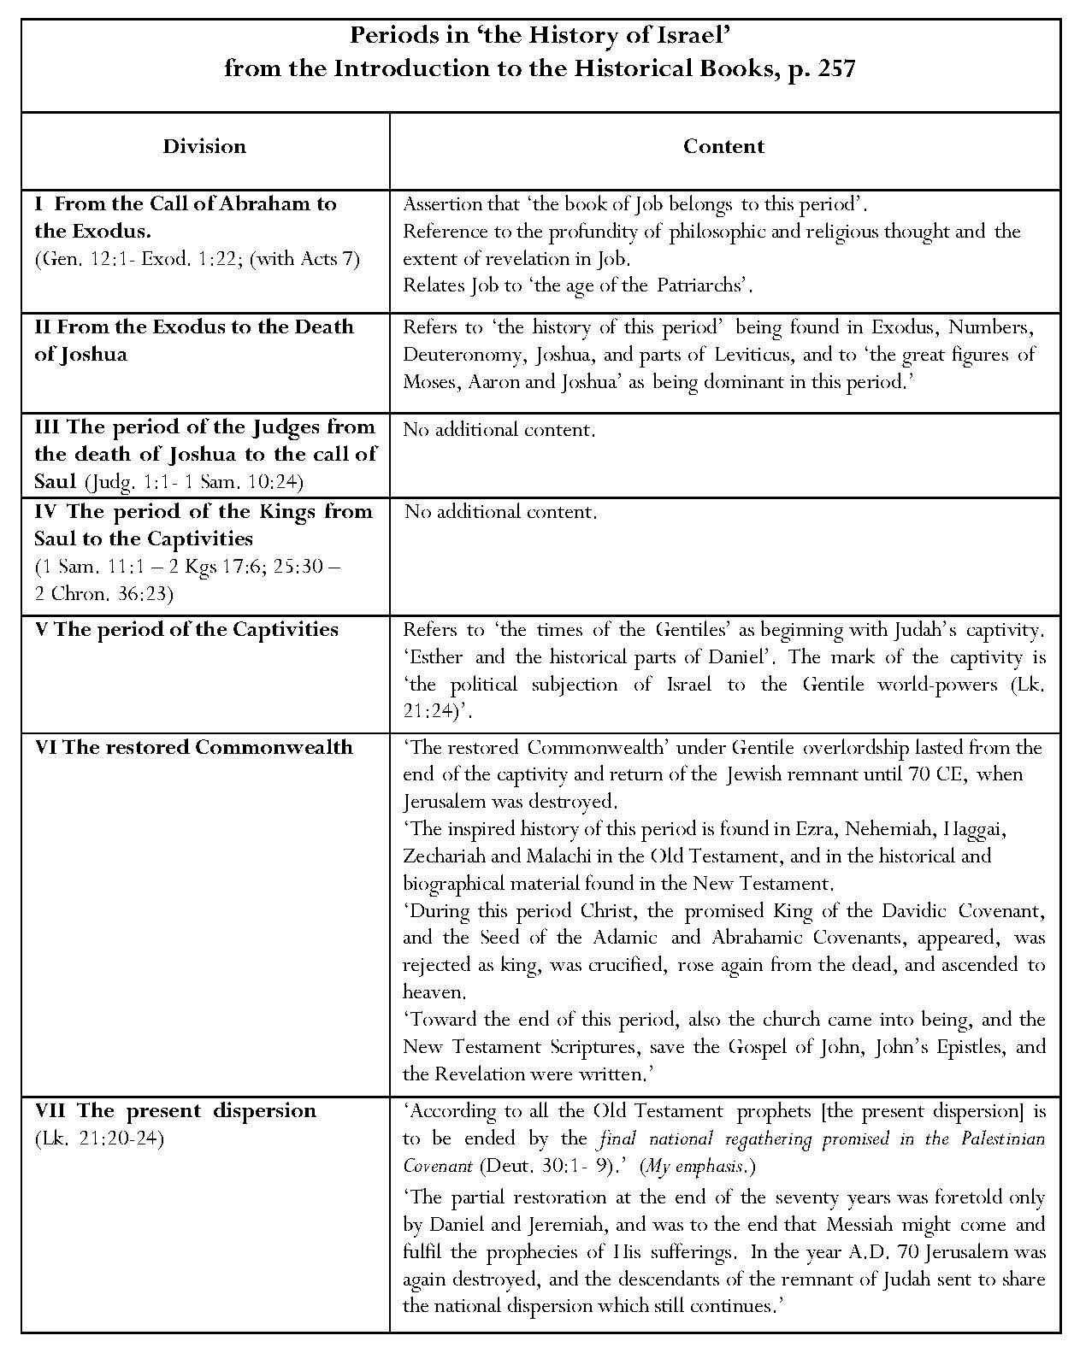

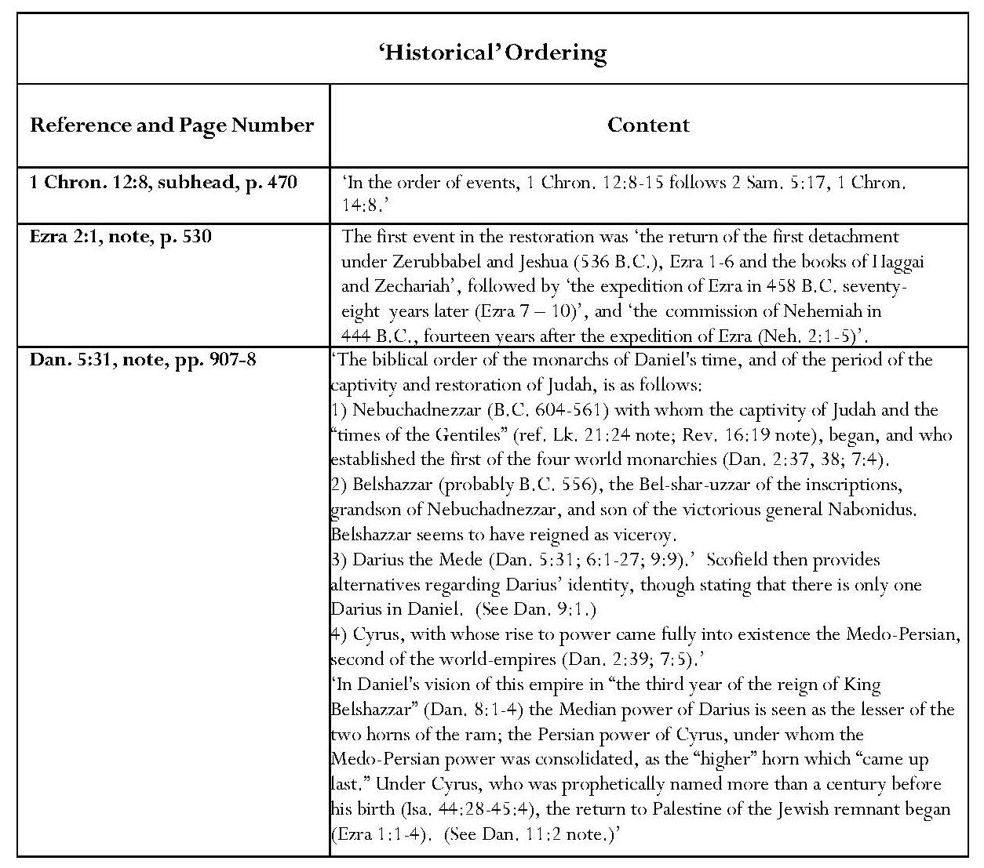
Another characteristic of Scofield’s interpretation is his enthusiasm for setting ‘biblical history’ in order. In his note on Ezra 2:1, Scofield provides definite dates for events as if these were axiomatic. However, Daniel Smith-Christopher indicates difficulties with dating the events described, some of which stem from uncertainties as to whether Artaxerxes I or II is intended. If Nehemiah served under Artaxerxes I, as is generally recognised, the seventh year of Artaxerxes’ reign would be 458 BCE, the date traditionally ascribed to Ezra; this date would be ‘before the date of Nehemiah’s opening memoirs, which would be 446 BCE’. However, if the king was Artaxerxes II, this suggests that ‘Ezra arrived in Jerusalem years after Nehemiah, in 398 BCE’. Smith-Christopher states that ‘more recent trends have accepted that Nehemiah’s actions make more sense following the precedent of Ezra’s legal reforms’.
In his note on Dan. 5:31, Scofield lists the ‘biblical order of the monarchs of Daniel’s time and of the period of the captivity and restoration of Judah’. This note contains a mixture of historically viable dates and figures, and tenets from Scofield’s eschatological interpretations of the Book of Daniel.
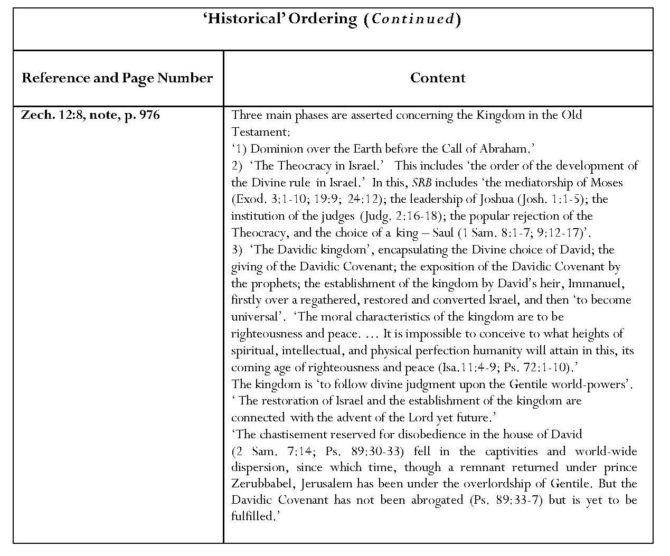
The note on Zech. 12:8 encapsulates Scofield’s concept of the ‘history’ of Israel and is another good example of his conflation of ‘historical’ and eschatological material. Putative past combines with predictive future in the section on the Davidic kingdom. The most notable characteristic is its movement from references to the Davidic kingdom past to visions for the Davidic kingdom in the future. The implication is continuity. This is a single kingdom. One significant point is Scofield’s reference to Jerusalem’s still being ‘under the overlordship of the Gentiles’, as it was at the time when SRB was written.
One result of Scofield’s acceptance of the principle of biblical inspiration is his attempt to eliminate any notion of discrepancies or contradictions in the biblical text, as outlined in his 1909 Introduction to SRB, and also to harmonise the gospels.
2.1.1 Solutions to Perceived Discrepancies or Contradictions in the Biblical Text
Scofield is often at pains to justify and obviate perceived inconsistencies in the biblical text. This is important if he is to defend his statement concerning the inspiration of both ideas and words. Often accounts appear irreconcilable and the discrepancies seem insoluble. Sometimes Scofield’s solution is to harmonise texts.

a) Numerical Discrepancies in the Biblical Text
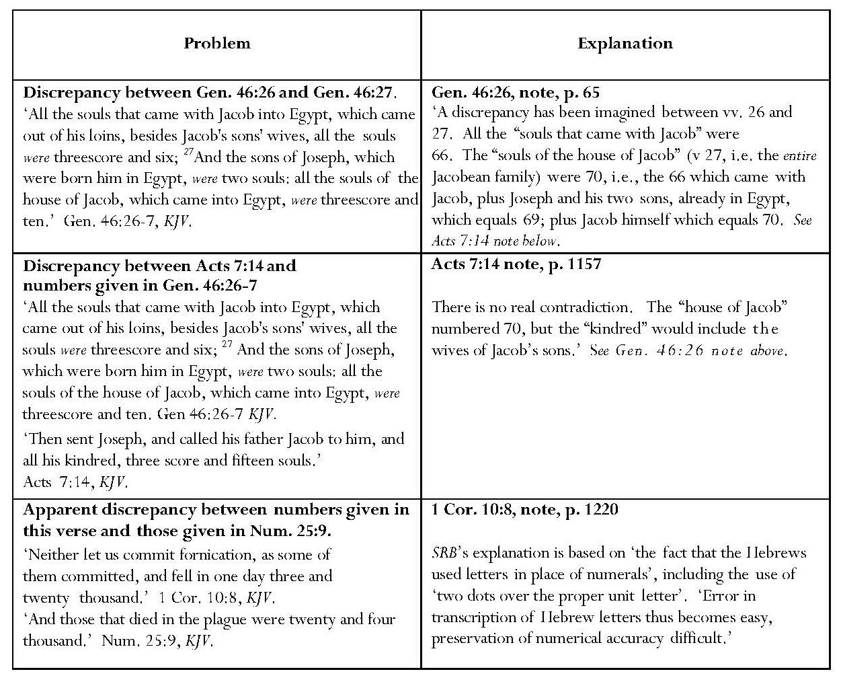
The above notes on Genesis, Acts and 1 Corinthians all concern numerical discrepancies about which Scofield is concerned. A total of seventy people are recorded in Gen. 46:27 as going to Egypt to join Joseph whereas Stephen refers to seventy-five people in his speech in Acts 7:14. Scofield identifies the additional five people as ‘wives of Jacob’s sons’; there is no justification for this conjecture and Scofield does not explain how he knows that only five of the twelve sons were married, assuming that, unlike Jacob, they were monogamous. It seems odd that this insignificant detail is the only matter in Stephen’s entire speech on which Scofield chooses to comment, apart from a brief reference to Israel in the wilderness as ‘the church’. In his note on 1 Cor. 10:8, Scofield ignores the content of the passage, which concerns not committing fornication, and instead analyses an ‘imagined [numerical] discrepancy’ of one thousand. He is forced to admit some inaccuracy in received texts, however.

b) Discrepancies Concerning Saul
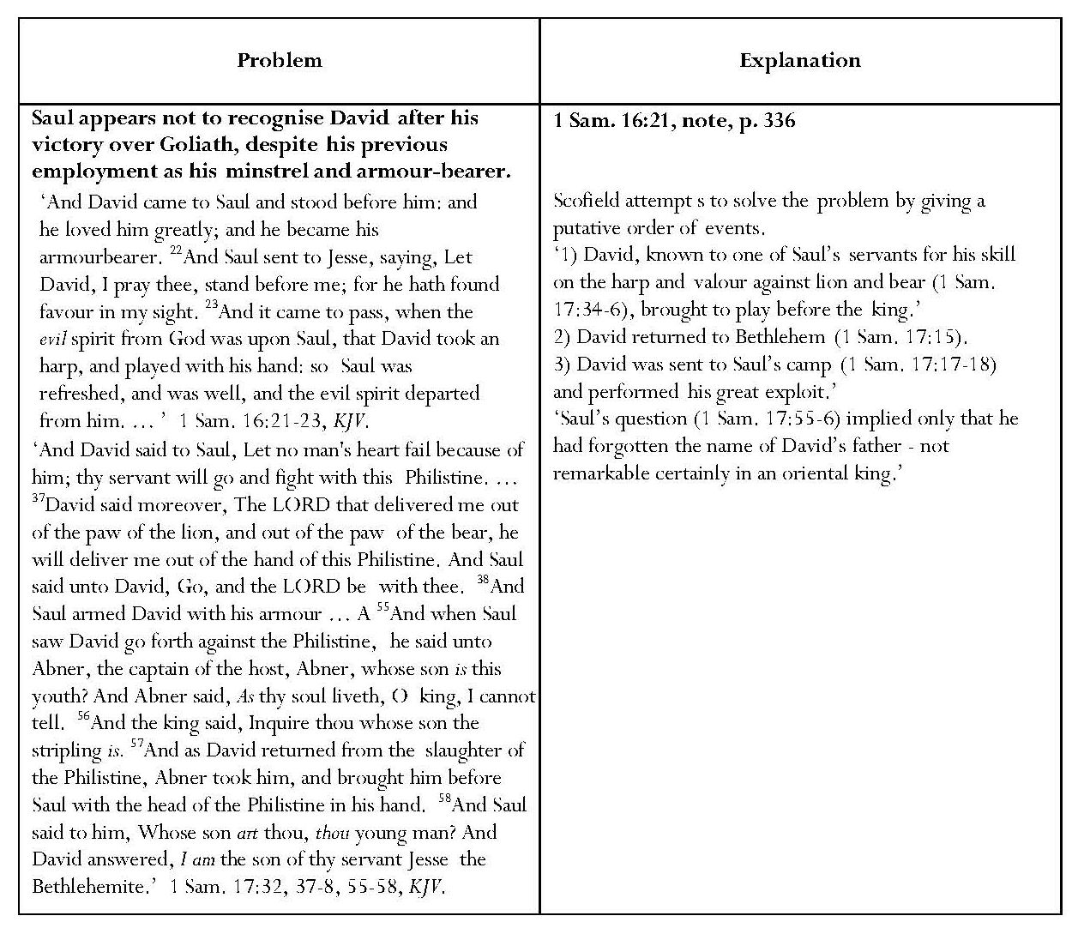
In 1 Samuel, Saul appears to have an aberration about David’s identity when he does not seem to recognise someone who has played the harp for him and to whom he has given his own armour. Scofield’s attempt to dissipate the apparent discrepancies in 1 Samuel 16 and 17 ignores 1 Sam. 16:22, where Saul requests David’s presence from Jesse, and does not allow for conflicting traditions or redaction of the text. Because he believes that the received biblical text must be true in every detail, Scofield turns the identity question upon David’s father rather than David himself.
Continued overleaf
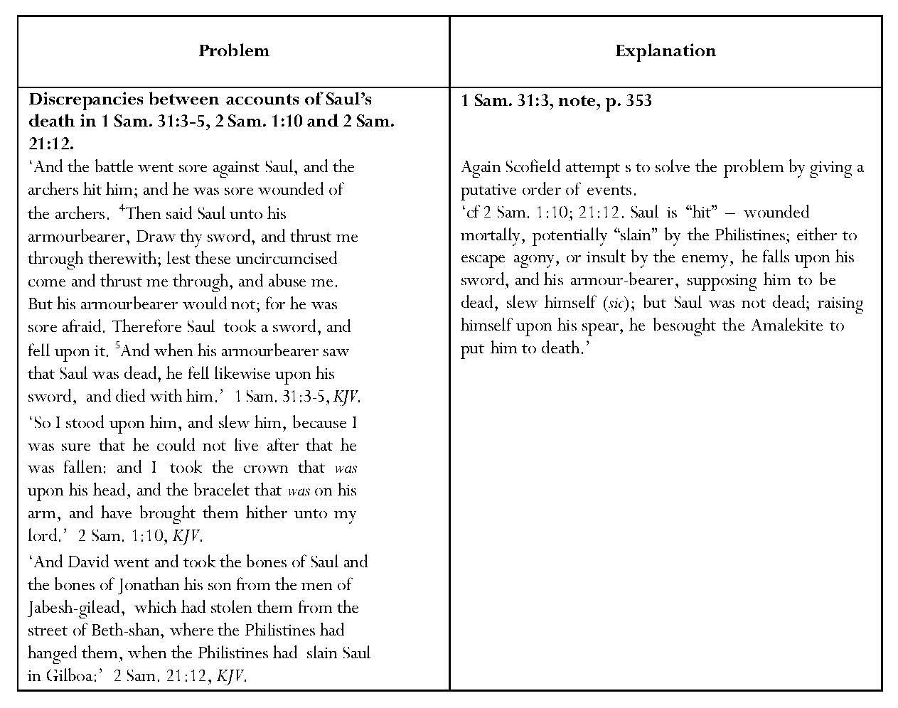
There are different accounts of Saul’s death in 1 Sam. 31:3-5 and 2 Sam. 21:12; in the former, Saul commits suicide, whereas in the latter Saul is killed by an Amalekite. Scofield utilises an order to encompass both versions of Saul’s death. By asserting this “order”, which is very creative since it incorporates a fake death which is not mentioned in either text, Scofield makes a very neat analysis of the two texts, telling his story as if it were axiomatic and constituted the only possible interpretation. Scofield does not appear to notice the similar discrepancy between the accounts of the death of Judas in Mt. 27:5 and Acts 1:16-20.

c) Discrepancies Concerning Purchases of Areas of Land
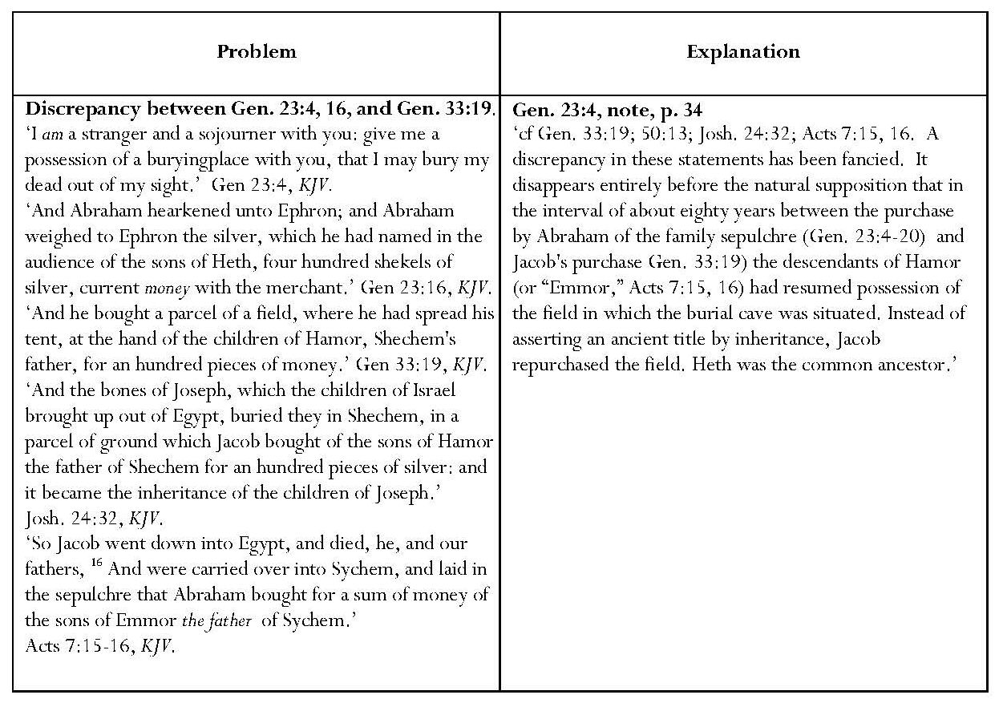
Two of the apparent discrepancies to which Scofield draws attention concern the purchase of areas of land. In a note on Gen. 23:4, Scofield rationalises the apparent double purchase of what he believes to be the same piece of land for a burying place by Abraham and for an altar by Jacob. The text does not imply that it is necessarily the same piece of land but Scofield states that it is ‘a natural supposition’ that, during the eighty-year interval between the two purchases, ‘the descendants of Hamor … had resumed possession of the land’ and that, ‘instead of asserting the ancient title by inheritance, Jacob repurchased the field’. This supposition that Jacob was purchasing the identical piece of land as the one Abraham had purchased for Sarah’s tomb and that Hamor’s descendants had repossessed that land is conjectural. There is no reason why Hamor’s descendants should not have possessed two pieces of land; moreover, the expression for ‘piece of land’ in Gen. 23:15 is ‘אֶרֶץ’ whereas that in Gen. 33:19 is חֶלְקַ֣ת הַשָּׂדֶ֗ה (a portion of land).
Continued overleaf
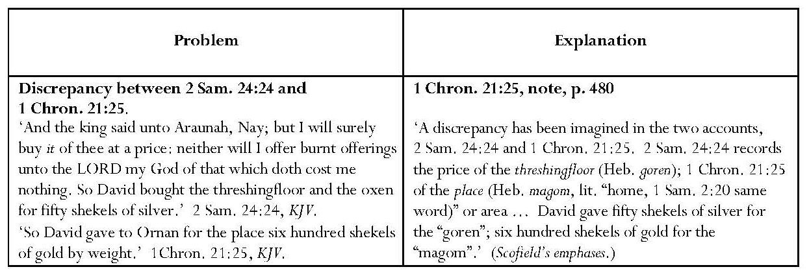
Scofield correctly avers that David’s purchases, a threshing-floor (!r,GO) in 2 Sam. 24:24 and a ‘place’ (~Aqm') in 1 Chron. 21:25 were different objects and the price differential between them is thus acceptable. However, in contrasting !r,G (goren) with ~Aqm', (maqom) he incorrectly transliterates the Hebrew of the latter as ‘magom’, and asserts that it means ‘home’. It is true that ~Aqm' also appears in 1 Sam. 2:20, as Scofield asserts, and that several versions translate this as ‘home’ in this verse, but The Geneva Bible and Young’s Literal Translation have the word, ‘place’.
d) Perceived Discrepancies: New Testament Examples
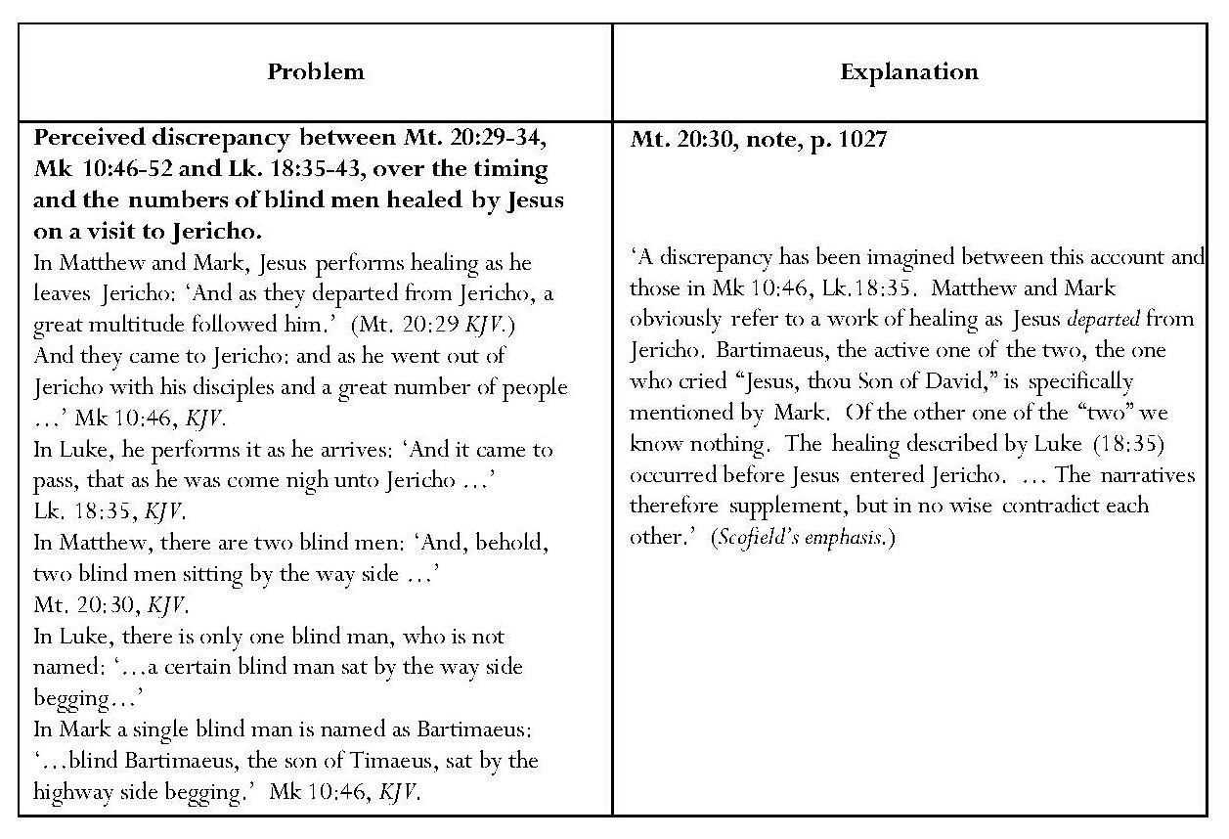
In his note on Mt. 20:20, Scofield notes a perceived discrepancy between this, Mk 10:46 and Lk. 18:35, over the timing and the numbers of blind men healed by Jesus on a visit to Jericho. A synopsis, showing the differences, has been included in the above table. In Matthew and Mark, Jesus performs healing as he leaves Jericho; in Luke, he performs it as he arrives. In Matthew there are two blind men, who are not named; in Mark and Luke, there is only one, also unnamed. In Mark, the single blind man is named as Bartimaeus. Scofield attempts to solve these discrepancies by stating that ‘the active one of the two [in Matthew], the one who cried out’, is Bartimaeus, specifically named by Mark. This cannot be justified by the text of Matthew but Scofield asserts that the texts supplement each other and do not contradict. His explanation involves speculations which cannot be justified within any of the texts.
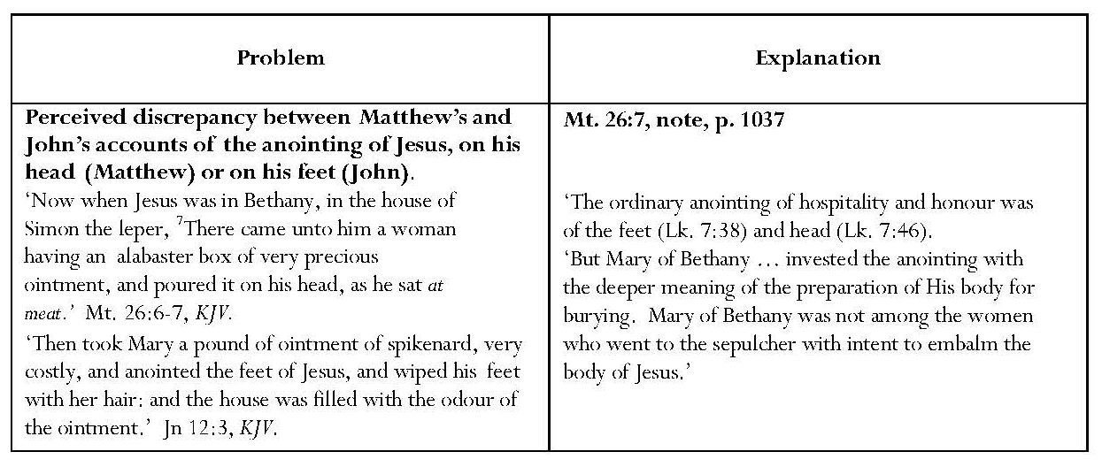
In his note on Mt. 26:7, Scofield attempts to ‘explain’ an apparent discrepancy between Mt. 28:9 and Jn 20:17. Apart from the fact that Mary is not named in Mt. 26:6-7, despite Scofield’s subhead to Mt. 26:6, ‘Jesus anointed by Mary of Bethany’, it cannot be assumed that ‘the woman’ in this passage is she, it stretches credence to accept Scofield’s explanation that anointing feet with pure nard, worth a year’s wages (Jn 12:5), constituted ordinary hospitality. Furthermore, all three evangelists, Matthew, John and Luke, to whom Scofield refers establish different locations for the anointing(s). Matthew and John both place them at Bethany but Matthew names the house of Simon the leper, whereas John implies that the location is the house of Lazarus, Martha and Mary. Luke names the house of a Pharisee called Simon, without giving a location, and the anointing of the head, quoted by Scofield, is with oil, not with nard (Lk. 7:46).
Continued overleaf
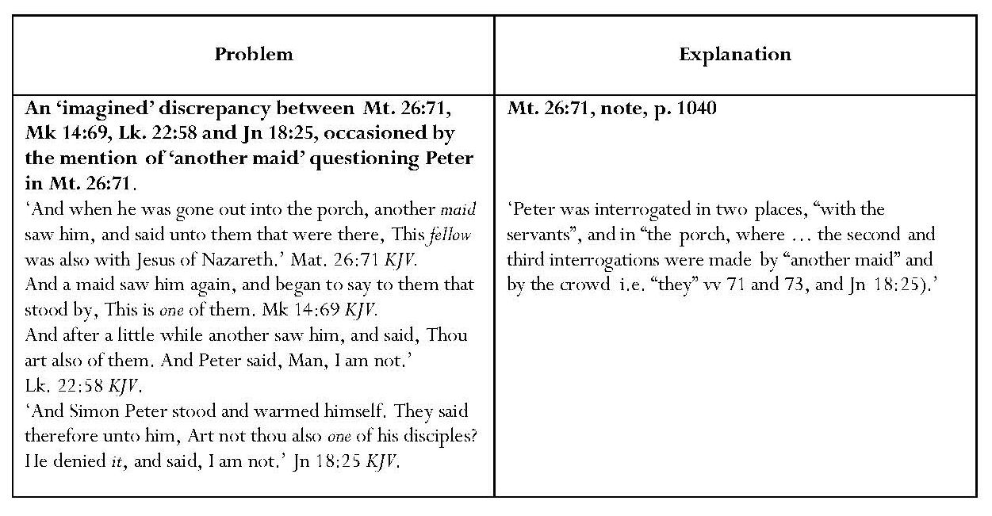
Scofield also tries to explain an ‘imagined discrepancy’ when ‘another maid saw Peter in the porch’. His explanation that ‘Peter was interrogated in two places’ does not really seem convincing. Matthew speaks of two girls and the crowd; Mark, one girl twice and the crowd, Luke, two girls and a man, John, a ‘damsel’, an unnamed ‘they’ and a relative of the man whose ear was cut off. Scofield does not address these true discrepancies, which are surely the result of oral transmission and no cause for concern.
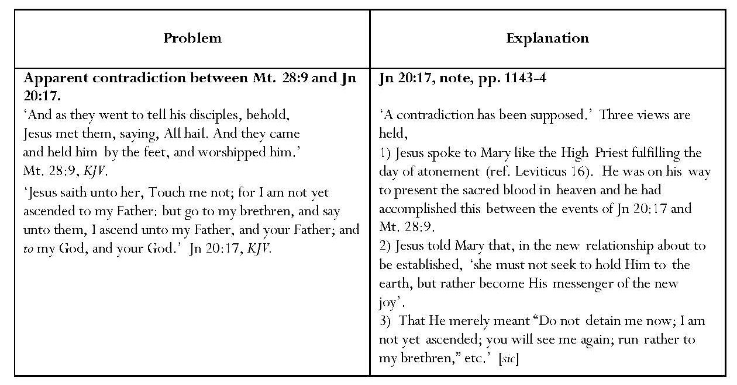
The same is true of Scofield’s attempt to ‘explain’ the apparent contradiction he says has been supposed between Mt. 28:9 and Jn 20:17. Presumably this is the discrepancy between the disciples’ touching Jesus feet in Matthew and Mary’s being forbidden to touch Jesus in John. Scofield suggests three explanations, none of which is justified from either text, though his second and third options seem far more plausible than the first.
2.1.2 Harmonisation
The occurrence of harmonisation in the SRB notes is another indication of Scofield’s desire to prove the inerrancy of the biblical text. However, harmonisation also militates against strict literal interpretation because disparate, even if related, passages are juxtaposed within Scofield’s notes. Most of Scofield’s harmonisations occur in his notes on the gospels, especially Matthew. By synchronisation, he tries to eliminate differences between the accounts, sometimes going to excessive lengths. Orders of events in Mark, Luke and John are mainly seen in relation to Matthew.
Because John puts Jesus’ cleansing of the temple at the beginning of his ministry, Scofield dubs this ‘the first purification’, the operation described in Matthew and Luke as ‘the second purification’, indicating that he believes Christ took this action both at the beginning and at the end of his earthly ministry. Richard Burridge states that ‘since it is unlikely that Jesus could have done [his action in the temple] twice, we must assume that John places it here at the start for theological rather than chronological reasons’. Burridge also acknowledges that it makes good historical sense, as in the synoptic gospels, for Christ’s ‘clean-out’ of the temple to have occurred at the end of his ministry, precipitating the events of Holy Week which culminated in his arrest and death. He relates Christ’s action to the prophecy of Mal. 3:1-4 that the Lord’s messenger would suddenly come to the temple like a refiner’s fire. However, Craig Blomberg, while allowing that a double cleansing is ‘seldom taken seriously today except in a few conservative circles’, advances six factors which could support this view. Firstly, details of the cleansing in all versions differ; secondly Jesus may have felt so strongly about ‘temple corruption’ that he did take action twice, especially if the execrable situation had resumed in the meantime; thirdly, Jesus’ initial action may have been regarded by some Jews as ‘an overtly Messianic act’, but the repetition probably ‘sealed his fate’; fourthly, Jesus’ accusers, in their inconsistent statements (Mk 14:58-9) when they alleged that Jesus had threatened to destroy the temple and rebuild it in three days, may have been referring to the earlier cleansing rather than to a later action which they would have remembered better; fifthly, Jesus’ language is increasingly severe in the action described as taking place at the end of his ministry in comparison to that used in John; and finally the reference to the rebuilding of the temple which had begun 46 years earlier (Jn 2:20) would place the cleansing at 27 or 28 CE. Providing that the dates are accurate, this final last reason, concerning the possible dating of 27 or 28 CE advanced for the Jews’ reference to Herod’s temple renewal, is the most convincing since this would place the temple cleansing at least two years before the putative date of the crucifixion, but the other reasons proposed are debatable. Two performances of Jesus’ action are, as Blomberg claims, possible, but, as Burridge avers, unlikely. The details of the cleansing, including Jesus’ language, could have varied for reasons other than that two different events were being described. The witnesses’ lack of consensus about Jesus’ statement about rebuilding of the temple in three days might also have been caused by factors other than poor memory of a more distant event.
Scofield provides timetables or ‘orderings’ in notes on Matthew’s gospel for all the significant events during Holy Week and extending up to Christ’s post-resurrection appearance to John on Patmos.
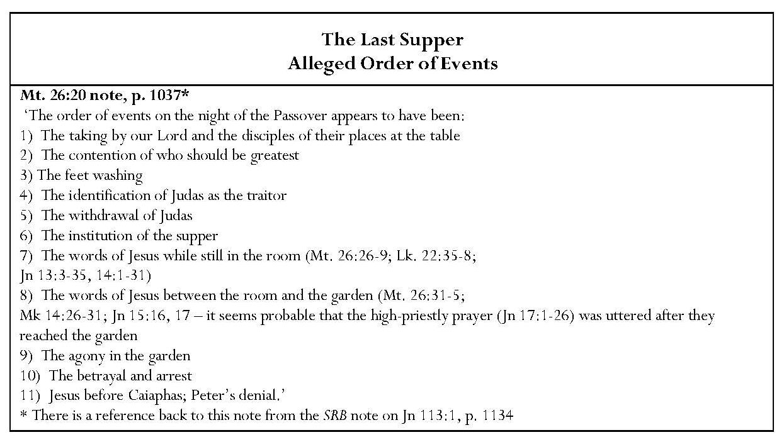
Not all gospel accounts fit with the order for events at the Last Supper based on Matthew. For example, in Luke, Jesus ordains Communion (Lk. 22:17-20) before betrayal is mentioned (Lk. 22:21) and in John, Judas partakes of the ‘sop’ (KJV) before he leaves. Judas’ departure is not recorded in the other gospels. In Luke, the strife over greatness occurs after Jesus’ establishment of Communion and statement about betrayal (Lk. 22:24). In this note, Scofield does not offer textual references for the elements he asserts. Moreover, he ignores the one glaring discrepancy between John and the synoptic gospels, where John gives a different date for the meal. The three synoptic gospels state that the Last Supper took place on ‘the first day of unleavened bread’ but John’s gospel makes it clear that the Jews had not yet eaten the Passover meal when Jesus was taken before Pilate. Besides its being recorded in Jn 13:1 that preparations took place ‘just before the Passover feast’, Jn 18:28 records the reluctance of ‘the Jews’ to enter Pilate’s palace because they wanted to be able to eat the Passover and did not wish to be contaminated. Moreover, Jn 19:14 states that Jesus was crucified on the ‘preparation of the Passover’. As with the cleansing of the temple, by attempting to synchronise all four gospels, Scofield misses the theological significance of John’s dating of the crucifixion, which places it at the time of the slaughter of the Passover lambs.
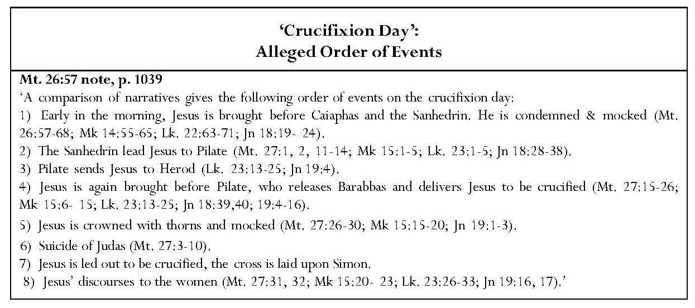
Scofield’s next schedule of events outlines occurrences after Jesus’ arrest. This is based on a ‘comparison of narratives’. In this note, Scofield does include all the references for his comments except those to Simon of Cyrene in Matthew, Mark and Luke. It is very apparent that not all the events occur in every gospel, for instance Pilate sends Jesus to Herod only in Luke and John. It is only in Matthew, Mark and John that Jesus is crowned with thorns, and only in Matthew that Judas commits suicide. It is noteworthy that, in a lengthy list of events, including two references to Pilate, Scofield fails to mention Jesus’ statement that his kingdom ‘is not of this world’ (Jn. 18:36). This is crucial to John’s account of Jesus’ conversation with Pilate and it militates against Scofield’s notion of an earthly kingdom.
Probably the most extreme example of harmonisation is Scofield’s attempt to synchronise the four accounts of the inscription on Jesus’ cross, declaring without explanation and without justification that ‘no one of the Evangelists quotes the entire inscription’. Here Scofield tries to piece together Mt. 27:37, Mk 15:26; Lk. 23:38 and Jn 19:19, to form ‘the entire inscription’ on Jesus’ cross: “this is [Matthew; Luke] Jesus [Matthew, John] of Nazareth [John], the King of the Jews” [all.]’ No allowance is made for individual expression and intention by the evangelists or for centuries of scribal copying the text. Scofield’s analysis also abrogates the principle of literal interpretation.
Continued overleaf
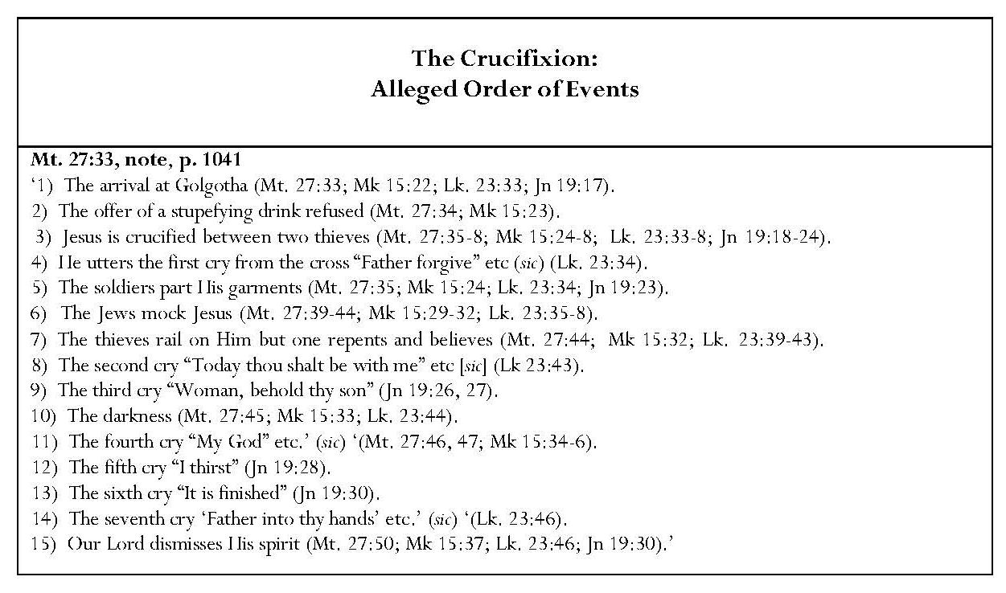
Scofield’s attempt to harmonise the gospel accounts of the crucifixion and produce an ‘order of events’ causes him to invalidate the text. In order to accommodate the difference between Luke’s account concerning the statements by the two thieves and those of the other synoptic gospels, Scofield is forced to say that ‘the thieves rail on Him, but one repents and believes’. Matthew and Mark state that both thieves insulted Jesus, whereas in Luke one insults Jesus while the other rebukes him for his attitude; Luke says nothing about the second thief uttering insults and then repenting. Similarly, in incorporating John’s ‘It is finished’, with Luke’s ‘Father, into your hands I commend my spirit’, Scofield reduces the impact of the dramatic final statement of John’s Jesus. These things also stem from a desire to prove that Scripture cannot conflict with itself.
Continued overleaf
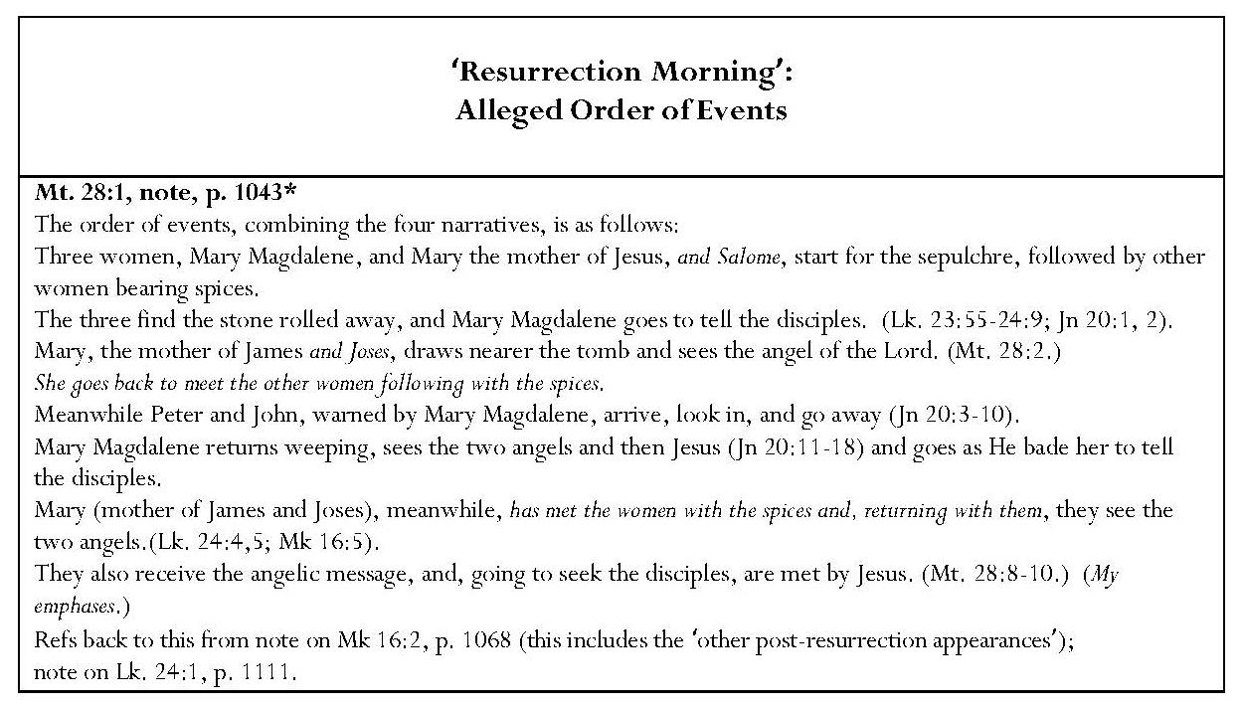
In his note on Mt. 28:1, attempting to homogenise the Gospel resurrection accounts, Scofield invents a group of ‘women bearing spices’, who follow those mentioned in the Gospels. To Matthew’s story of the visits of women to Jesus’ tomb, he adds the name of Salome to those of Mary Magdalene and the ‘other Mary’, whom Scofield identifies as ‘the mother of James and Joses’. The identification of this woman as mother of Joses as well as James does not appear in the resurrection accounts of any of the Gospels. Scofield is assuming that this is the same woman who watched the crucifixion from a distance (Mt. 27:56; Mk 15:40) and saw where Jesus was laid (Mk 15:47); the inclusion of ‘Joses’ is inaccurate. The name of Salome appears in Mk 16:1, as does the identification of Mary as ‘the mother of James’ in Mk 16:1 and Lk. 24:10, but these names do not appear in Matthew; Luke adds the name of Joanna and states that she, Mary Magdalene, Mary the mother of James and other women that were with them, not following them, were ‘telling these things to the apostles’. Scofield ignores Joanna, describing only three women as setting out for the sepulchre. He has them being followed by ‘other women bearing spices’. The only ‘following’ is by the women who ‘came with Jesus from Galilee’, following Joseph of Arimathea to the sepulchre after the crucifixion. The ‘they’ in Lk. 24:1 logically refers back to these women and these are the ones bearing spices; they are not said to be following anyone and are accompanied by ‘certain others’. The implication in Lk. 24:10 is that these women included Mary Magdalene, Joanna, and Mary the mother of James. Scofield’s ‘other women following and bearing spices’ do not appear in any of the Gospels, despite which he has ‘Mary, the mother of James and Joses’ going from the sepulchre and meeting these spice-bearing women. By this, it may be that Scofield hopes to account for the mention of one angel in Mark and Matthew, and two in Luke and John, the two visits of Mary the mother of James, who witnessed these phenomena, being divided by the meeting with these women of doubtful existence. Full harmonisation of these accounts would be very difficult, if not impossible, yet Scofield seems to feel compelled to try to reconcile them in the interests of biblical literality.
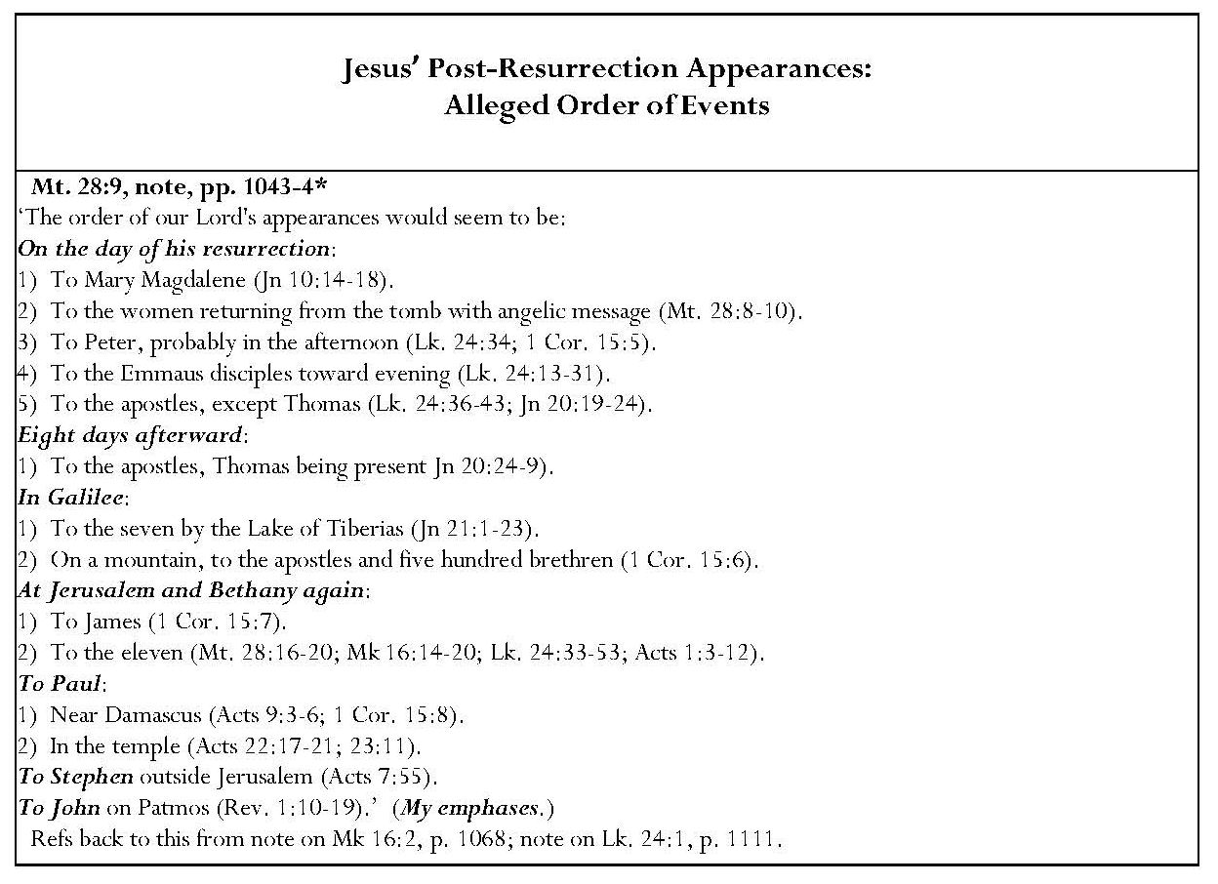
Scofield’s ‘ordering’ concerning Christ’s post-resurrection appearances is of a different kind from the putative ‘orderings’ advanced above because the cross-references move outside the limits of the four gospels and their interrelationships as seen by Scofield. Scofield does not differentiate between the kinds of Jesus’ resurrection appearances before and after his ascension. He treats his pre-ascension, physical appearances in the same way as his post-ascension, visionary appearances to Paul, Stephen and John. It is very interesting that Scofield supports this with references to four sequential verses, 1 Cor. 15:5-8; here Paul puts his vision of Jesus, while an unworthy persecutor of the believers, on a par with Peter/Cephas, the twelve, five hundred brothers, James and all the apostles. Paul clearly regards his visionary experience as equal to theirs and this may justify the inclusion of post-ascension appearances in Scofield’s list. However, Scofield also includes an unwarranted statement concerning the timing of Jesus’ resurrection appearance to Peter, conjecturing that Jesus’ appearance to Peter on the day of his resurrection was ‘probably in the afternoon’.
From all these examples, it is clear that Scofield believed that every word in the Bible must be taken literally and that no passage could conflict in any way with another. He felt the need to defend biblical integrity against any such accusations. In this, Scofield echoed earlier dispensationalists like the Niagara premillennialists, who had to withstand the challenges of higher criticism and evolutionary theory. His treatment of Scripture is also reflected in the views of later dispensationalists like Chafer, who held ‘the Scriptures of the Old and New Testaments to be the only infallible rule of faith and practice’, and Charles Feinberg, who held that the inerrancy and infallibility of the Scriptures ‘in the original languages’ is guaranteed by the inspiration of the Holy Spirit. As a progressive dispensationalist, Bock is prepared to make more allowance for the mediation of authorship, by which he means ‘the communication of the divine will through human authors’. Blaising refers to the development of ‘a more critical awareness of how bias (or preunderstanding) conditions our intuitions, or impressions of certainty, and clarity of interpretation’, and to ‘syntactical, rhetorical, and literary study’ as being formative factors in ‘the rise of progressive dispensationalism’. Blaising also states that ‘the interpretative notes of the Scofield Reference Bible might be considered a key representative of classical dispensationalism, although there are various points at which different dispensationalists of that period would differ from it’. Blaising defines ‘classical dispensationalism’ as ‘the views of British and American dispensationalists from the writings of John Nelson Darby … to the … Systematic Theology of Lewis Sperry Chafer …’. This statement well illustrates my contention that SRB continues to perpetuate views from a previous era. As stated in the Preface, Blaising also avers that the modifications which progressive dispensationalism has made to both classical dispensationalism and the revised form espoused by dispensationalists like Ryrie, Walvoord and [Dwight] Pentecost have brought dispensationalism ‘closer to contemporary evangelical biblical interpretation’.
2.2 Scofield’s Interpretation of Prophecy
References to prophecy pervade Scofield’s commentary. Just as Paul judged the gift of prophecy to be the most desirable Spiritual gift, so it represents the most important gift for Scofield. He avers that the keys to the meanings of prophecy are the doctrines of the two advents of Messiah, the remnant, the day of the LORD and the kingdom. The ‘pivotal’ passages for prophecy are Deuteronomy 28 — 30; Psalm 2 and Daniel 2 and 7. Scofield asserts that ‘the Palestinian Covenant … is the mould of predictive prophecy in its larger sense’ and gives a sequence of events expected during it. Echoing Darby, he emphasises that ‘the Church, corporately, is not in Old Testament prophecy’. He makes a similar observation in his note on Mal. 3:1.
Scofield states that ‘the prophet in any dispensation is God’s messenger to His people, to establish truth and to call them back to truth’; Christ’s ministry differed from that of the Old Testament prophets only in his ‘dignity of person’. However, he concentrates on the futuristic aspects of Old Testament prophecy and tends to ignore ‘the great treasure of ethical truth’, which is one of the important roles of prophecy: to admonish, to warn and to proclaim God’s requirements of humankind, as promulgated later by Bock. Interestingly, Scofield states in his note on 1 Cor. 12:10, that, in the New Testament, prophets are usually forth-tellers, speaking for ‘edification, exhortation and comfort’, rather than foretellers. Scofield also often disregards the different contexts and messages of the prophetic books, ignoring the important narrative elements in Jeremiah and Daniel. These even include material concerning the exile, which is essential to his theology. The table below shows some important passages in Jeremiah, Ezekiel and Daniel, which are not annotated in SRB. As shown in chapter 8, Scofield is very selective in his choice of passages for commentary.
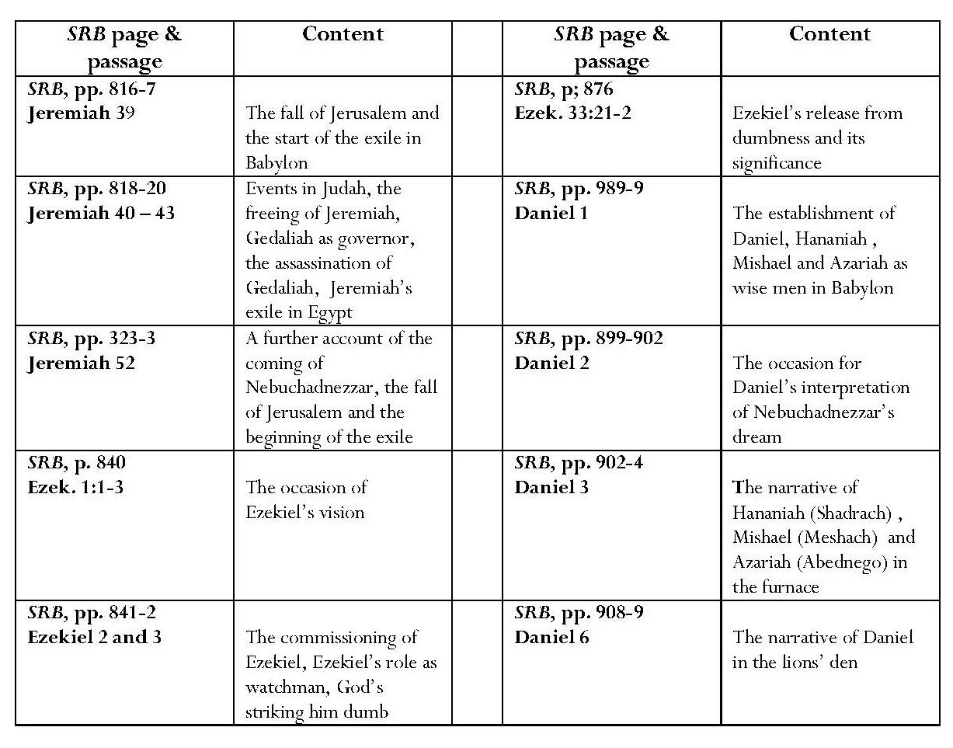
2.2.1 ‘Near’ and ‘Far’ Prophecy
This parallels what Charles Feinberg calls ‘foreshortening’ in prophecy. Scofield states that the quotation in Mt. 2:15 from Hos. 11:1 illustrates that ‘prophetic utterances often have a latent and deeper meaning than first appears’. On several occasions, he labels his interpretations of prophecy as ‘near’ and ‘far’. Tables showing Scofield’s ‘near and far’ interpretations of prophecy appear at the end of the thesis.
Scofield usually espouses characteristic dispensational futuristic premillennialism. He generally believes that distant prophecy applies to his own future and avers that prophetic messages have a dual character: ‘local and for the prophet’s time’ and ‘predictive of the divine purpose in the future’; the prediction frequently originates in the local situation. Scofield describes this as ‘an intermingling of the near and the far’. For example, predictions of a local restoration from Babylonian captivity must be differentiated from predictions of a future restoration from ‘the present world-wide dispersion’. However, Scofield sometimes tends towards an historicist view, notably in his topical allusions concerning the deterioration of the Roman Empire and his analysis of the ‘spiritual history’ represented by the seven churches of Revelation 1 — 3.
Scofield associates prophecies concerning immediate danger to Israel with the threat of end-times invasion. He links the Assyrian invasion and judgment upon Assyria with the final gathering of the Gentile nations against Jerusalem and the judgment upon all Gentile world-power. Scofield also sees in Isa. 29:3 a near reference to the Egyptian alliance and a far reference to ‘the stone’, pointing to the end-time and covenant between the Beast and the nations.
Furthermore, Scofield interprets Nebuchadnezzar’s invasion and the destruction of Babylon as having ‘near’ and ‘far’ prophetic meanings. Although Scofield asserts a ‘far’ interpretation of Babylon in Isaiah 13, he denies any connection with physical Babylon. He links the Babylonian invasion of Egypt with the judgment of nations after Armageddon, and draws a parallel between Jewish behaviour in Babylon at Zechariah’s time with the apostasy of the church in Babylon of Revelation. He sees ‘near’ and ‘far’ aspects in Zephaniah’s prophecy of the fall of Jerusalem, naming Nebuchadnezzar. He also refers to Alexander the Great in the context of prophecy of ‘the future last days’.
The concept of multiple fulfilments of prophecy is fluid, offering opportunities for diverse interpretations of future fulfilment. Paul Boyer speaks of the persistence and adaptability of the prophetic belief system, describing how ‘outmoded themes are quietly abandoned’ and new themes subtly introduced and altered, while remaining within the general rubric of ‘biblical inerrancy’. This adaptability is particularly fruitful when applied to prophecy concerning Israel. For example, the prophecies of the exiled Ezekiel, while relating to the return of Judah from the Babylonian exile of the sixth and fifth centuries BCE, can be made to apply equally to ‘the end-times’ of the current age, allowing references to Israel’s ‘third dispersion’ and subsequent restoration at Christ’s return. This has, of course, been particularly pertinent since 1948 and 1967. However, Boyer legitimately asks: ‘If the prophecies can be applied with equal validity to any historical situation, what becomes of their status as a divinely inspired foretelling of specific events?’
2.2.2 Fulfilled Prophecy
For Scofield, fulfilled prophecy constitutes proof of the inspiration of Scripture. He asserts that ‘predictions of future events were uttered so long before the events transpired that no merely human sagacity or foresight could have anticipated them, and these predictions are so detailed, minute and specific, as to exclude the possibility that they were mere fortunate guesses’. These claims of fulfilment are based on the assumptions that the prophecies antedated their “fulfilment” and that his interpretations of them and their fulfilments are correct. In many cases Scofield’s interpretations mirror and promote his premillennial, dispensational views.
Scofield claims that hundreds of prophecies concerning Israel, Canaan, Babylon, Assyria and Egypt, and concerning particular people, have been fulfilled, but does not identify these. He cites 2 Kgs 14:25 as recording the fulfilment of a prophecy by Jonah. He assumes that the ‘Jonah, son of Amittai of Gath-helper’, mentioned in this verse, is the same as the main character in the book of Jonah, though nothing of this is mentioned in Jonah itself. Scofield does not say in what way the prophecy in 2 Kgs 14:25 might be considered to have been fulfilled.
Scofield also claims fulfilment concerning the ‘four world-empires’ of Daniel. His note on Dan. 2:31 asserts that Nebuchadnezzar’s dream, as interpreted by Daniel, ‘gives the course and end of “the times of the Gentiles”’, the four metals in the image representing four empires which, while ‘not necessarily possessing the inhabited earth’, were ‘able to do so’. According to Scofield, these were fulfilled in ‘Babylon, Media-Persia, Greece (under Alexander), and Rome’. The names of these empires also appear in the SRB subheads to Dan. 2:37, 39 and 40 and are virtually identically repeated in the subheads to Dan. 7:4, 5, 6 and 7. In this context, Scofield also refers to ‘the final world-empire: the kingdom of heaven’, which is yet to be fulfilled, thus according this future kingdom a terrestrial status on a par with that of the physical kingdoms which have already held sway in the past.
Media, Persia, Greece and Rome are not mentioned in Daniel 2 or 7. Media, Persia and Grecia are named in Daniel 8, but with reference to a two-horned ram (the kings of Media and Persia, Dan. 8:20, KJV) and to a shaggy goat (the king of Grecia, Dan. 8:21, KJV). These appeared in Daniel’s vision in Daniel 8, which is separate from Nebuchadnezzar’s dream in Daniel 2, and Daniel’s ‘dream and visions’ in Daniel 7. Scofield unjustifiably applies these names to Daniel 2 and 7, adding that of Rome. Presumably the assumption that the Median kingdom stood second to Babylon, came from the reference in Dan. 5:31 to Darius the Mede’s taking over the kingdom.
J. M. Alonso-Núñez and Joseph Ward Swain claim that the theory of successive world-empires antedated the book of Daniel. According to Alonso-Núñez, a lost work by Aemilius Sura, named De annis populi Romani, a fragment of which is preserved in Velleius Paterculus’ Historiae Romanae 1, 6, 6, contains the statement that the Assyrians were first of all races to hold power, then the Medes, after them the Persians, and then the Macedonians. Alonso-Núñez dates De annis populi Romani as between 190/89 and 168 BCE and states that ‘in the fragment of Aemilius Sura we find formulated for the first time in Roman historiography the theory of the succession of world empires and it is also the first evidence that we have for Rome as one of the series’. However, ‘the first Greek source to enunciate a succession of world powers was Herodotus 1, 95 and 1, 130, when he speaks of the successive taking over of the world rule by Assyrians, Medians and Persians’. Swain avers that the Book of Daniel ‘reached its present form between 168 and 165 B.C.’ and that ‘the essential idea of the prophecies – an eternal fifth empire to follow the impending destruction of the fourth – was widely current in the Seleucid empire long before the composition of the Book of Daniel’. He also asserts that the introduction of the theory of four empires and a fifth into Christian historiography was mainly the work of Jerome, when translating Eusebius’ Chronicle into Latin, listing Assyrians, Persians, Greeks and Romans.
In his note on Dan. 2:41, Scofield also claims that that the division of the ‘Eastern and Western Empires’ and further divisions, marked deterioration in strength in the fourth kingdom; ‘the admixture of the iron of the Roman imperium … with the clay of the popular will’ had ‘precisely … come to pass in the constitutional monarchies which, the Republic of France and the despotism of Turkey, cover the sphere of ancient Roman rule’. He thus asserts that his interpretation of Dan. 2:41 is vindicated by the fulfilment which he claims.
2.2.3 Partially Fulfilled Prophecy
The vast majority of Scofield’s interpretations relate to prophecies which he considers ‘partially fulfilled’ or ‘unfulfilled’. Scofield asserts ‘partial fulfilment’ in relation to prophecies concerning the first advent of Christ. He states that the Old Testament prophets visualised Messiah’s suffering and glory in one, unbroken line. He avers that the Old Testament prophets were ‘perplexed’ by the seeming antithesis inherent in this but provides no evidence for this claim. The solution to this perplexity is two advents, one to suffering and the other to glory. According to Scofield, the New Testament shows that Christ’s suffering and glorification are ‘separated by the present church-age’ and anticipate ‘the Lord’s return … when the Davidic Covenant of blessing through power will be fulfilled’. The Old Testament prophets ‘describe an advent in two forms which could not be contemporaneous’.
Scofield claims Gen. 3:15 as ‘the beginning of a chain of references, which include promises and prophecies concerning Christ which are fulfilled at his first advent’. ‘For the line of unfulfilled promises, see Christ, second advent.’ Having described the distress of the tribulation and the glorious future kingdom-age, Scofield states that these and other parallel prophecies indicate that these events did not occur during Christ’s first advent. He reiterates this point in his note on Zeph. 3:15.
Another example of ‘partial fulfilment’ is Scofield’s complex construction concerning ‘the seventy weeks’. The prophecy is only ‘fulfilled’ up to the sixty-ninth week, the seventieth having already been awaited for two thousand years. However, Scofield warns that ‘prophetic time is invariably so near as to give full warning, so indeterminate as to give no satisfaction to mere curiosity’. Scofield’s interpretation supports the concept of ‘the postponed kingdom’, to which he refers in his subhead to Lk. 19:11 as the meaning of ‘the parable of the ten pounds’. Bass explains that postponement grows from the concept of the kingdom as ‘a literal restoration of the national kingdom’, ‘the covenanted kingdom with the Davidic throne’, which had not yet appeared and thus ‘must have been postponed’.
Scofield also asserts that ‘the prophecies upon the Gentile powers’ in Ezek. 25:8 ‘have doubtless had partial fulfilments’ of which their ‘history and present condition … bear witness but the mention of the day of Jehovah makes it evident that a fulfilment in the final sense is still future’. He also avers that Malachi’s prophecy concerning the coming of Elias is only partially fulfilled in the ministry of John the Baptist. The prophecy is yet to be fulfilled in Elijah.
2.2.4 As Yet Unfulfilled Prophecy
The prophecies which Scofield classifies as ‘unfulfilled’ are mostly given eschatological interpretations. Prominent themes are Israel, the Times of the Gentiles, Gentile world power, the Beast and Armageddon, Christ’s return, the kingdom, and the new heavens and earth. These passages are often used as springboards into the New Testament, especially the book of Revelation. Tables of notes regarding prophecy as yet unfulfilled appear at the end of the thesis.
2.3 Typology
Sweetnam states that ‘it is almost impossible to be a dispensationalist and not believe in the literal interpretation of Scripture; nevertheless, ‘dispensationalists from Darby forward have been particularly fond of a species of nonliteral interpretation generally known as typology’. As stated in 1.1.4, Ryrie avers that ‘… types … are in no way contrary to literal interpretation’. However, Tan and Baker both include typology within literal interpretation.
Scofield defines a type as ‘a divinely purposed illustration of some truth’. It may be a person, event, thing’ institution or ceremonial. Anti-types are usually found in the New Testament.’ In Scofield’s view, ‘the Gospels are woven of Old Testament quotation, allusion and type.’ Notably, Scofield uses similar words to those of Bishop Marsh in his Bible Correspondence Course, Old Testament, and in SRB. ‘It cannot be positively affirmed that anything is a type which is not somewhere in Scripture treated as such.’ ‘Nothing is to be asserted as a type without explicit New Testament authority; all types not so authenticated must be recognized as having the authority of analogy, or spiritual congruity, merely.’ However, Scofield fails to conform to his own rubric in many of his typological assertions. Conformity to his own rules may depend upon his definition of ‘explicit New Testament authority’ but many of the links made fall into the category of connections rather than biblically verified types. It sometimes appears that a New Testament situation is taken and Old Testament parallels found for it. Bock calls this ‘reading the New Testament back into the Old Testament’.
Albertus Pieters is critical of Scofield’s use of types. He states that Scofield’s definition of a ‘type’ and his ‘principle of interpretation to be employed in speaking of types’ are excellent but, ‘if the author had acted according to his own principles, he would, so far as typology is concerned, have written a very different book. This warning, tucked away on p. 100, is honored more in the breach than in the observance. Constantly he is dogmatically asserting this or that to be a type for which the New Testament offers no sort of explicit authority.’
Todd Mangum states that traditional typology has seen Old Testament figures, including events, as ‘spiritual, even mystical foreshadowings of New Testament persons and realities, especially concerning Christ’. He holds that Scofield’s typology reflects this traditional typology but ‘is distinctive … in that it not only advocates a deeper meaning, it suggests an actual dual meaning’, earthly for Israel, heavenly for the Church. Mangum avers that Scofield’s typology is rooted in his basic division between Israel and the Church. This is true, though the method employed by Scofield also has the effect of unifying the Testaments.
The two tables below indicate occurrences of typological and comparative, but non-typological language in SRB.
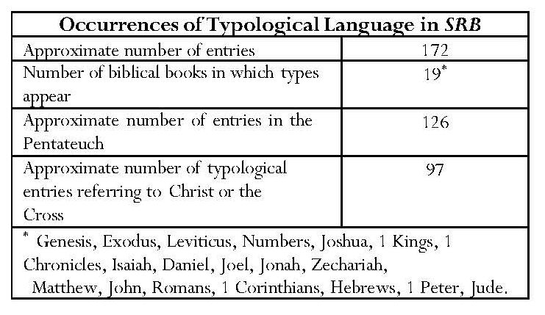

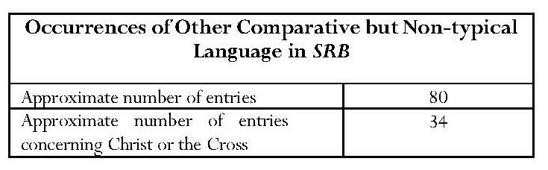
The large number of entries from the Pentateuch, especially Genesis, Exodus and Leviticus, verifies Scofield’s claim that ‘types occur most frequently in the Pentateuch’. The numbers of typological entries generally decline in the biblical books after the Pentateuch, whereas the numbers of non-typological comparisons increase. In some cases the distinction between typical and non-typical comparisons is not clear and in some cases it is difficult to determine whether or not typological significance is intended, especially when the vocabulary in a single note employs mixed terminology.
2.3.1 Typological Assertions and Non-Typological Representations
In some cases Scofield supports his claims of typological significance with valid New Testament references, following his own stated rules and those of Marsh. In other cases Scofield asserts typological significance in what might be considered ‘evident and manifest analogy’ as suggested by Tan, but some of his claims come near to what Campbell describes as ‘fanciful’. The tables below indicate typological assertions and other representations.
a) Christ and the Cross
i) Typological Assertions Concerning Christ and the Cross
The greatest number of types and other representations refers to Christ as anti-type.
Genesis
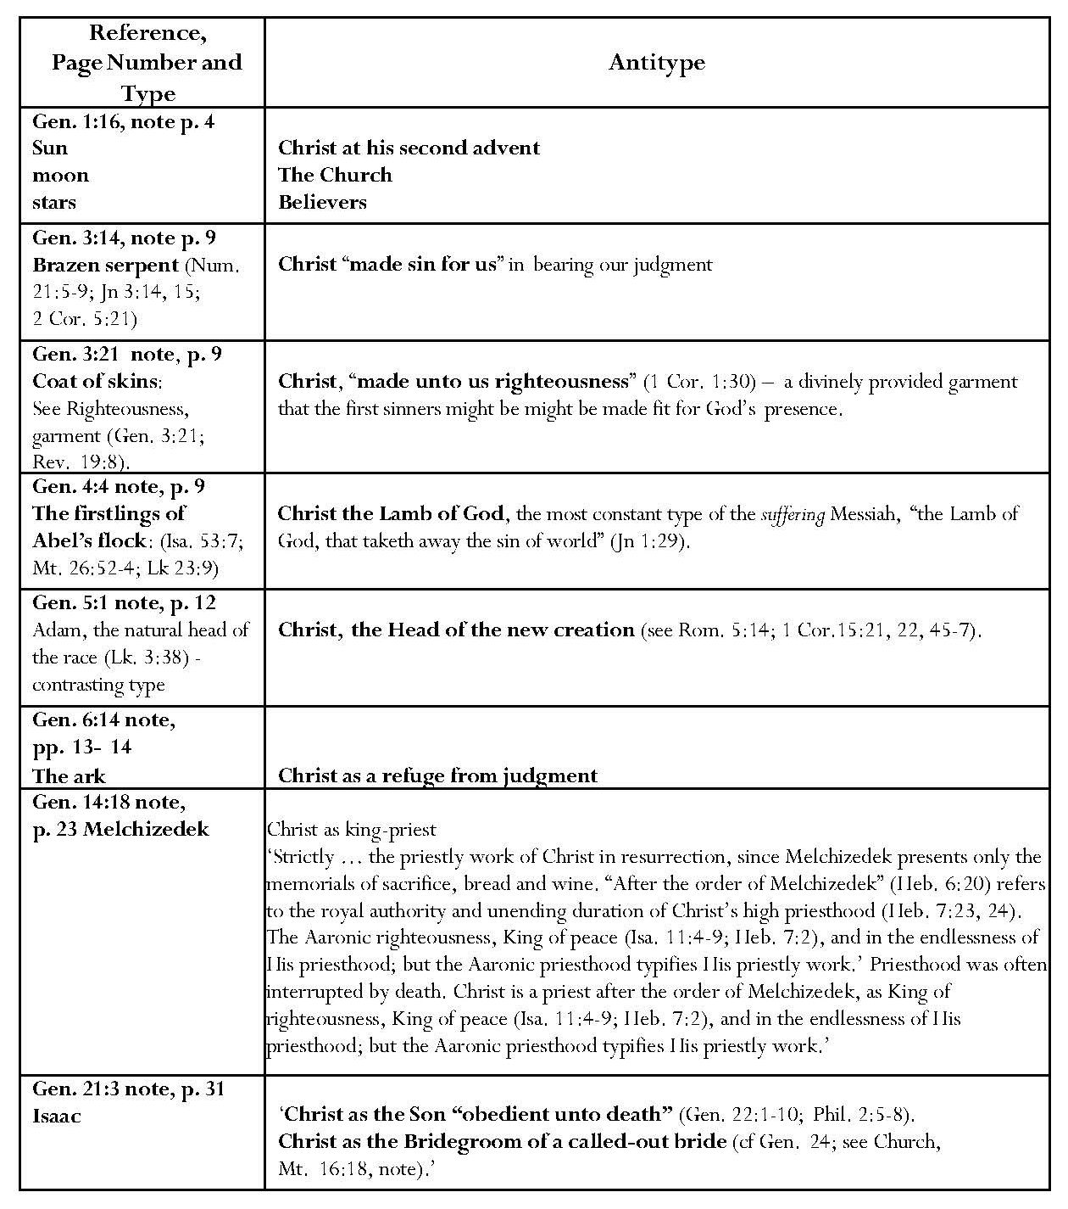 Continued overleaf
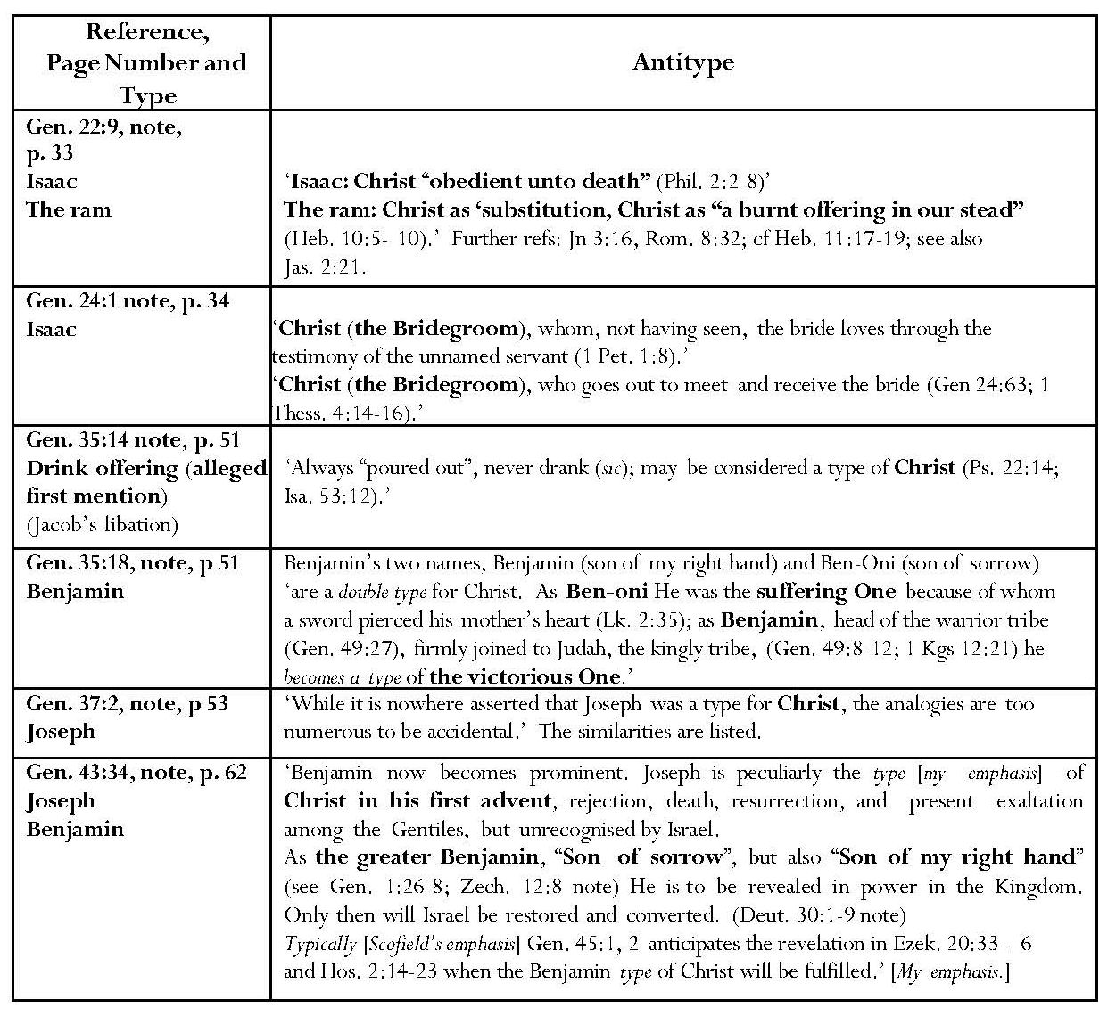
Scofield lists several types in his commentary on Genesis which are justifiable under his own rubric of New Testament authorisation and would probably have been allowed by Marsh. Scofield identifies Christ indirectly with the serpent in Genesis 3 by stating that the cursing of the serpent implies ‘the deepest mystery of the atonement’ since ‘Christ, “made sin for us” is typified by the brazen serpent’ of Num. 21:5-9. Brass ‘speaks of judgment’. Scofield’s reference to Jn 3:14-16 justifies this interpretation. Scofield identifies Adam, ‘the natural head of the race’ as a contrasting type of Christ as head of the new creation. His references to Rom. 5:14 and 1 Corinthians 15 seem to justify this. The quotation of Heb. 6:20 appears to justify typological assertions with regard to Melchizedek, contrasted with Aaron. However, the assertion that the Aaronic priesthood is typical of Christ’s priestly work appears to be contradicted by Heb. 7:11. Scofield typifies Melchizedek, the High Priest, Aaron and temple practices as representing aspects of Christ’s identity and priestly work. Some links made between Exodus, Leviticus and Hebrews appear legitimate because Hebrews reflects Old Testament sacrificial concepts, but that between the washing and anointing of the High Priest and Christ’s baptism seems tenuous.
However, many more of the types Scofield asserts for Genesis are not supported by New Testament authority. In his note on Gen. 1:16, Scofield typifies the ‘greater light’ as Christ at his second advent, the sun of righteousness; he also compares the Church to the moon and individual believers to the stars but does not give them typical significance. Scofield offers no evidence for this view, which appears extravagant. Scofield states that the skins God provided to cover Adam and Eve’s nakedness are ‘a type of Christ, made unto us righteousness’ but his reference to Rev. 19:8 does not make the link required to justify a typological claim under the terms he has laid down. It seems an exaggeration to claim the fine linen of Rev. 19:8 as an antitype of the skins of Genesis 3.
Scofield’s statement that the firstlings of Abel’s flock typify Christ as Lamb of God is not supported by his reference to Jn 1:29; the connection he makes between the blood sacrifices of Abel’s flock and of Christ as Lamb of God is justifiable but not in terms of the typicality he claims.
Scofield’s note on Gen. 6:14 describes the ark as ‘a type of Christ as the refuge of His people from judgment’, and states that ‘in strictness of application this applies to the preservation through the “great tribulation”’. However, there is no directly verified connection between Gen. 6:14 and the texts to which Scofield refers – Mt. 24:21, 22 and Heb. 11:7. Indeed, the latter refers to Noah, rather than to the ark.
Scofield’s claim that Melchizedek is a type of Christ as King-Priest can be justified by his reference to Heb. 7:23-24 but there is no justification for his assertion that the Aaronic priesthood ‘typifies [Christ’s] priestly work’. Hebrews 7:11 specifically states that the priest to come was not according to the order of Aaron; Hebrews 7:14 further states that ‘our Lord was descended from Judah, and in connection with that tribe Moses said nothing about priests’.
The assertion that Isaac typifies ‘the Son “obedient unto death”’ is not justified by the two New Testament references given; it would be more accurate to say that Christ’s sacrifice might remind Christians of the Aqedah. Scofield sees the whole of Genesis 24 as ‘highly typical’. Isaac as Rebekah’s bridegroom is also said to typify Christ as ‘the Bridegroom of the called-out bride’, on the grounds that Rebekah loves him through the servant’s testimony alone and that Isaac goes out to meet her. The biblical text contains nothing about these tenuous connections. In fact the latter claim contradicts an assertion made earlier in the note that Abraham’s servant, (typifying the Holy Spirit), ‘[brings] the bride to meet with the Bridegroom’.
Scofield asserts Benjamin’s being a type three times in his note on Gen. 35:18, the loose connection with Christ’s suffering being that ‘a sword pierced his mother’s heart’. Regarding Joseph, Scofield states that he is ‘peculiarly the type of Christ in His first advent, rejection, death, resurrection and present exaltation among the Gentiles, but unrecognized by Israel. This declaration of typicality might seem to contradict Scofield’s earlier statement that ‘it is nowhere asserted that Joseph was a type for Christ, [but] the analogies are too numerous to be accidental’.
Exodus
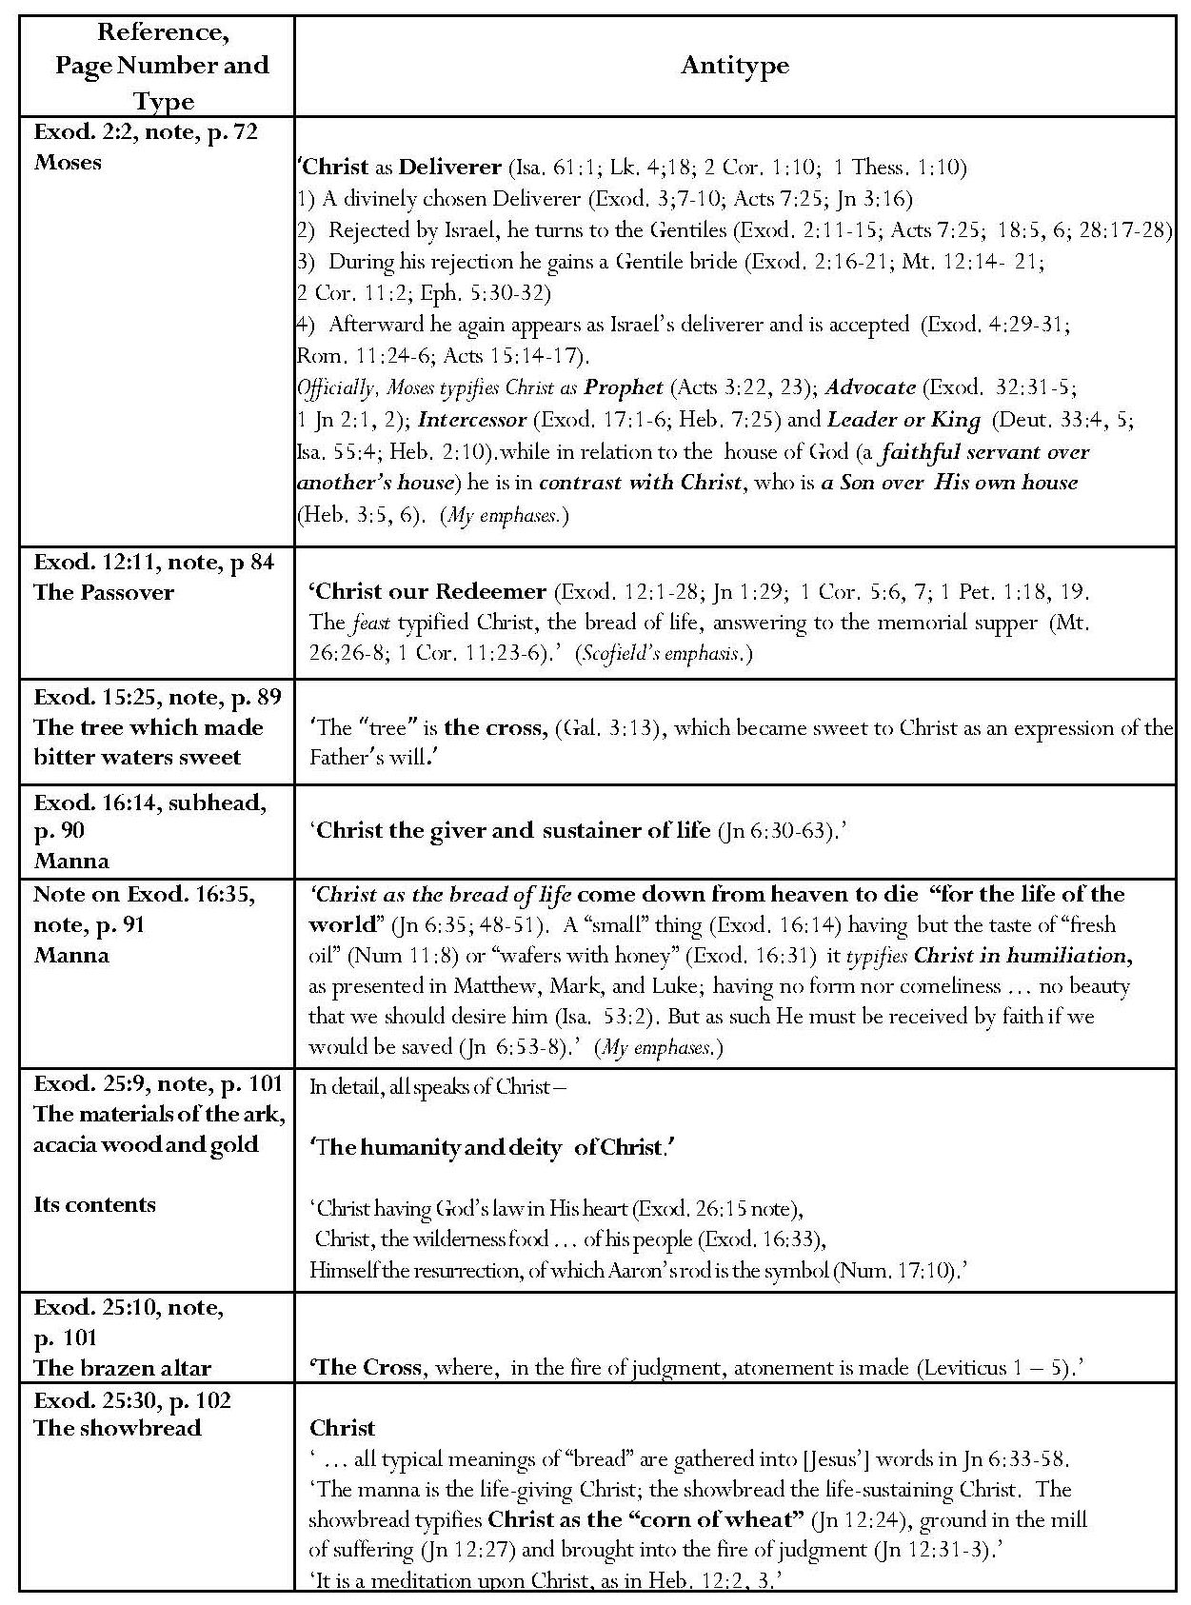
Continued overleaf
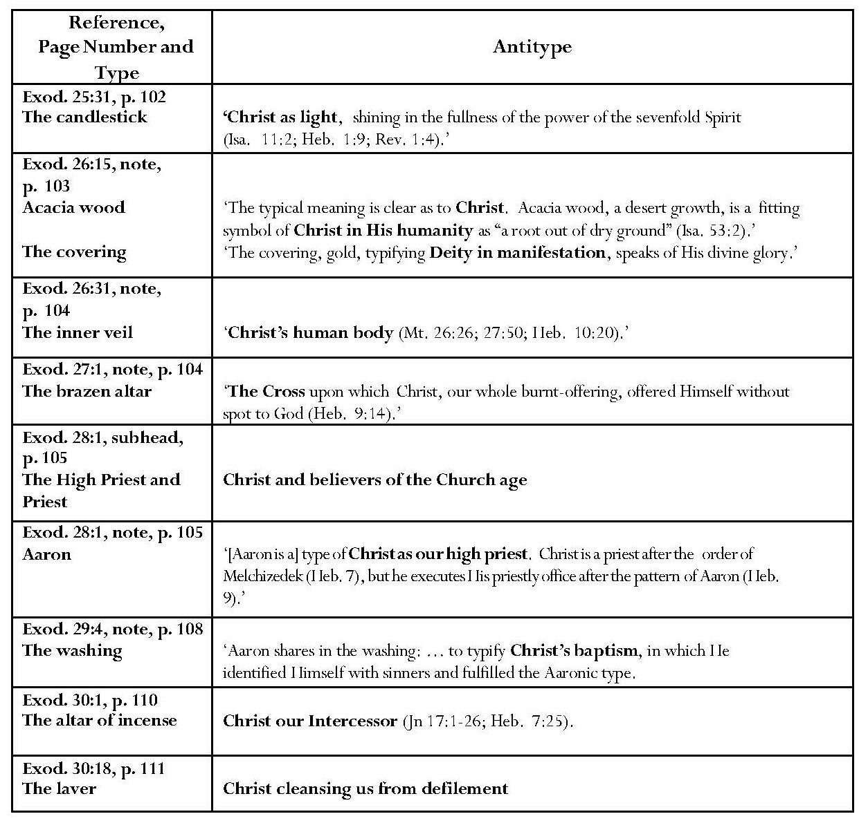
In commentary on Exod. 2:2, Scofield identifies Moses as a type of Christ as divinely chosen Deliverer, Prophet, Advocate, Intercessor and Leader or King. Two of Scofield’s assertions of typical significance here are partly justified. Acts 3:22-3 links Christ with Moses as ‘a Prophet … like unto me’ and there is, therefore, a legitimate association between the two, but this does not necessarily imply that Moses is a type of Christ. The reference, unquoted by Scofield, is Deut. 18:15. The quotation of Heb. 3:5-6 in Scofield’s note on Exod. 2:2 is apt and justifies the illustration of an important difference between Christ and Moses, Christ being a Son and Moses only a servant. Again, however, it does not necessarily imply typicality.
Some of the other references Scofield makes in his note on Exod. 2:2 present possible parallels and associations but not types under his own rubric. Regarding Moses’ typical status as divinely chosen deliverer, Scofield suggests several parallels between his life and that of Christ: both ‘turn to the Gentiles’ when ‘rejected by Israel’, and gain a bride during the time of rejection; afterwards Moses again appears as Israel’s deliverer and is accepted. Jesus quotes Isa. 61:1 in Lk. 4:18-19, but no connection is made with Moses. 2 Corinthians 1:10 and 1 Thess. 1:10 speak of deliverance by Christ but again Moses is not mentioned. Moses does appear to act as an advocate for the people in Exod. 32:31-5 and Jesus is actually described as an advocate in 1 Jn 2:1-2, but no biblical connection is made. Exodus 17:1-6 describes Moses as interceding for the people and Heb. 7:25 describes Christ as being an intercessor, but there is no biblical connection.
Regarding the assertion that Moses typified Christ as a Leader, or even a King, the verse quoted by Scofield, Deut. 33:5, is an ambiguous verse; the context is Moses’ dying address to Israel, when he is talking about what the LORD has done, and it is not clear whether ‘king’ is meant to apply to Moses or to the LORD. Indeed some translations insert the words, ‘the LORD’, ‘le Seigneur’ or ‘der Herr’. Isaiah 55:4 may be referring to Christ as a leader, but does not mention Moses; Heb. 2:10 concerns Christ as captain and also does not mention Moses.
Commentary on Exodus and Leviticus also claims Passover as typical of Christ; in the note on Exod. 12:11, Scofield’s reference to 1 Cor. 5:7 supports this. Scofield also holds, with less justification, that manna is typical of Christ in humiliation. This claim is repeated in his note on Josh. 5:11. Scofield also asserts that manna is a type of Christ as the giver and sustainer of life, and the water from the rock a type of Christ the giver of the Spirit. Scofield’s reference to Jn 6:30-63 includes the passage where Christ contrasts the manna of Moses with himself as ‘the bread of life’. This is an example of a ‘contrasting type’. With regard to the water, Jn 7:37-9 describes Jesus as inviting the thirsty to come to him and drink. No connection is made with Exod. 17:5. Scofield refers to Jn 6:33-58 in his note on Exod. 25:30 asserting the typicality of the showbread as the life-sustaining Christ, also typified as the ‘corn of wheat’ of Jn 12:24. These two assertions are unsupported, probably representing associations in Scofield’s own mind, as is the allusion to ‘the tree’ as the cross in the note on Exod. 15:25, demonstrated by his reference to Gal. 3:13.
Many of Scofield’s typological interpretations of Exodus 25 onwards, Leviticus and Numbers concern the parts and personnel of the tabernacle and its sacrifices. Scofield claims that ‘the general authority’ for types in Exodus is to be found in 1 Cor. 10:1-11 and for the tabernacle in Heb. 9:1-24, but he omits to quote appropriate specific New Testament verses to justify this assertion. Ironically, he states that ‘to force upon every word of [dietary] legislation a typical meaning is to strain 1 Cor. 10:1-11 and Heb. 9:23, 24 beyond all reasonable interpretation.’ The context is the comment that divine dietary regulations ‘must be regarded as primarily sanitary’, God being concerned with social as well as religious life. However, Scofield typifies many other points of legislation in Exodus and Leviticus, and further asserts that he is assured that everything in the tabernacle is typical, and so the details must also be regarded as typical. Here Scofield’s interpretation conflicts with what Ramm and Campbell later say about not forcing typological links from detail. Ramm urges restraint when discussing the tabernacle. ‘Much about the Tabernacle has no typical significance and this ought to be clearly apprehended.’ Too great a fascination with minutiae ‘is already out of step with the spirit of New Testament typology’. Campbell states, ‘By their very nature types are only signs and shadows, consequently details should generally not be pressed for typical meaning.’ In many cases Scofield’s claims of typological significance appear subjective even when New Testament texts are offered in justification. One might suspect that Scofield was ‘poking into every nook and corner of the tabernacle … in search of types’, in the words of Tan’s later criticism of excessive typological interpretation.
Scofield states that the materials of the ark typify Christ’s humanity and deity and its contents typify Christ ‘as having God’s law in His heart’, as ‘the wilderness food … of His people’ and as ‘Himself the resurrection’. The earthen vessel typifies Christ’s humanity. Scofield assigns typical Christological meaning to the showbread, candlestick, acacia wood boards and gold. Strangely, Scofield does not quote the obvious parallel texts, Jn 8:12 and 9:5, in relation to the candlestick; his references concentrate on ‘the seven-fold Spirit’. None of the references given refers to light. Scofield’s claim that the inner veil is a type of Christ’s human body is justified by Hebrews 10:20, which refers to the curtain as Christ’s body. Oddly, Scofield does not comment on Heb. 10:20, but refers to this type in his note on 1 Pet. 2:9, which does not refer to the curtain. Scofield also asserts as types the brazen altar, which he relates to the cross as a place of judgment and atonement, the altar of incense as a type of Christ as intercessor, and the laver as a type of Christ cleansing sinners.
Leviticus
The SRB note on Lev. 1:3 gives four types and two comparisons for Christ, each concerning animals used for sacrifice. Notably the dove and pigeon are not awarded typical significance. Again this kind of comparison would come under Ramm’s later disapproval. Ramm states specifically that ‘not all actions of the priests, nor all the elements of the sacrifices have precise New Testament counterparts’. There is no apparent reason for Scofield’s omission of the dove and pigeon as types and it is tempting to conclude that ‘type’ is sometimes merely used synonymously with other symbolic expressions, as will be demonstrated in the non-typological links discussed below. While the biblical verses referenced for each category present an impressive collection of related quotations, perhaps reflecting the Bible Readings method which is described in 2.4, they cannot be said to achieve ‘explicit New Testament authority’ for like-to-like correspondence. Christ’s perfection is also said to be typified by the perfection of the sacrifices, the sweet-savour offerings to typify Christ’s perfections and devotion to his Father’s will and the non-sweet savour offerings his bearing the sinner’s demerit. The claims of typological significance for the peace offering are also illustrated with related, but not strictly typological New Testament texts.

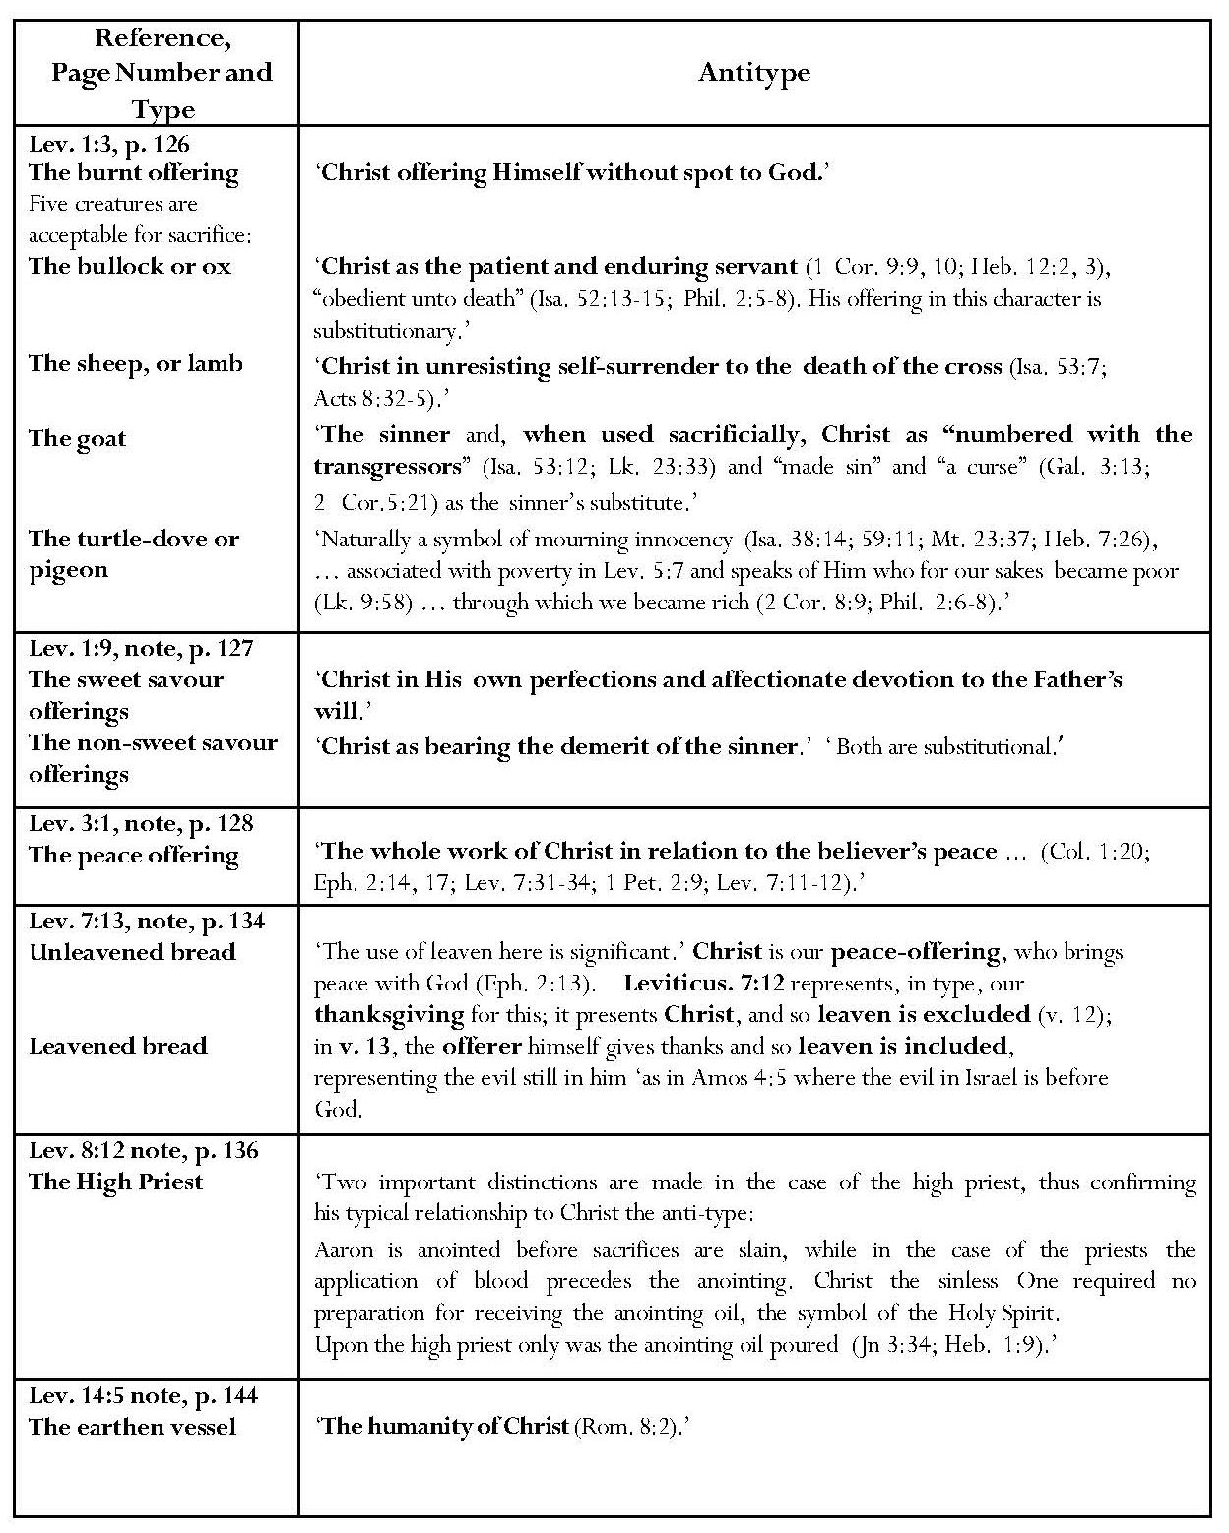
Continued overleaf

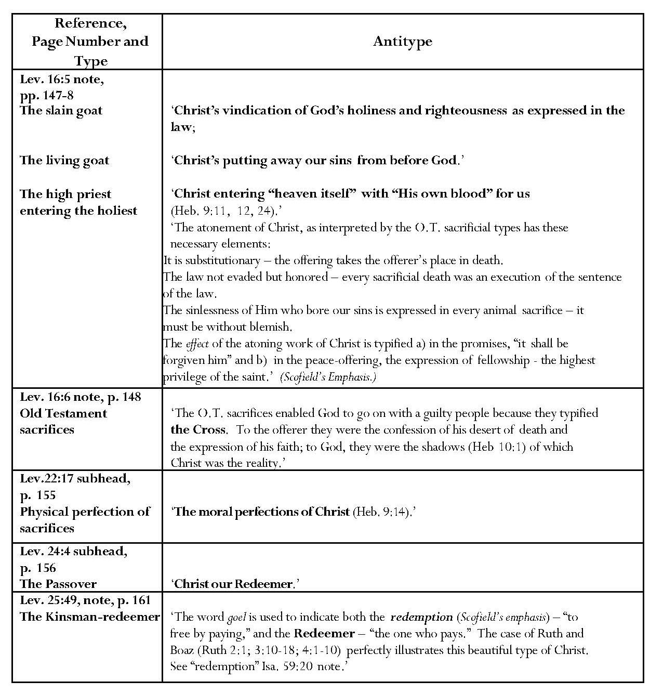
The note on Lev. 7:13 refers to the typological significance of the use of leaven in the peace-offering, distinguishing between Lev. 7:12, where “he” [the priest] is to offer with the sacrifice of thanksgiving unleavened wafers and cakes in the peace-offering, and Lev. 7:13, where, additionally, “he” is to offer leavened bread with the sacrifice of his thanksgiving of his peace-offerings’. From these verses, Scofield infers that verse 12 refers to Christ as ‘our peace-offering’ thus leaven is excluded, whereas ‘in verse 13 it is the offerer who gives thanks for his participation in the peace, and so leaven fitly signifies, that though having peace with God through the work of another, there is still evil in him’. Scofield does not state the basis for this inference and offers no justification for his interpretation of Amos 4:5 as an illustration of leaven representing evil in Israel.
The context of Amos 4:5 is the berating of wealthy women who oppress the poor; the NRSV commentary states that they are ‘ironically … invited to proceed with the presentation of their vain, idolatrous offerings in the corrupted sanctuaries where once the Lord was honoured’. The NIV commentary states that Amos was either rebuking the Israelites for ‘wilful transgression of the law (against the burning of leavened bread in sacrifices) or ‘he speaks of burning in a general way for offering inappropriate gifts to the Lord’. The commentary adds: ‘They loved the forms and rituals of religion but did not love what God loves – goodness, mercy, kindness, justice.’ Philip Hyatt states that Amos ironically invites them to come to Bethel and Gilgal to transgress, and to bring a thank offering of leavened bread as they loved to do. Hyatt refers to Amos’ caustic irony’ in summoning the people to come to Bethel, or to Gilgal, only to transgress against their God’. This reflected upon their total attitude to God, doing as they pleased and showing their own importance. It is noticeable that none of these commentaries designates leaven itself as evil. Scofield’s other references pertain to Gen. 19:3, which refers to Lot’s baking unleavened bread for his unexpected visitors, and to Exod. 12:8, 15-20, 34, 39, which all refer to the unleavened bread eaten by the Israelites on their exodus from Egypt. Exodus 12:39 gives the specific reason for this: ‘because they were thrust out of Egypt and could not tarry’. The case of Lot surely also points to hasty preparation. These illustrations may well indicate another instance of employment by Scofield of the ‘Bible Readings method’. However, this interpretation of leaven in the note on Lev. 7:13 forms the basis for an important concept which Scofield carries into his interpretation of the parable of the leaven in Matthew 13.
‘The case of Ruth and Boaz’ is also discussed in terms of its significance as a ‘beautiful type of Christ’ in ‘kinsman-redeemer’ relationship. The claim for a goel or kinsman-redeemer typology for Christ is repeated in the note on Isa. 59:20.. Discussing the anointing involved in the assertion of the typical relationship between Aaron and Christ in the role of high priest, Scofield cites Jn 3:34 and Heb. 1:9; each of these texts contains the word ‘anointing’, but neither appears adequately to demonstrate a real typological link.
Continued overleaf

Numbers
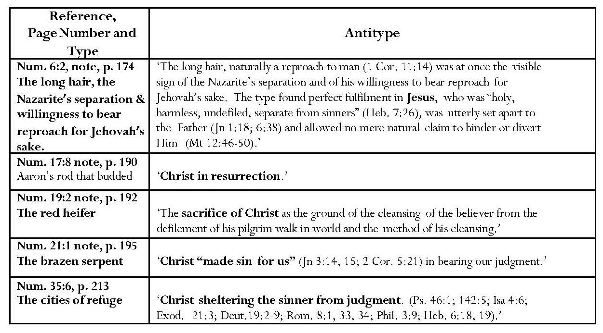
In notes on Numbers, Scofield claims five representations of Christ and the Cross, some of which display tenuous links and do not provide New Testament justification. Interestingly, Scofield justifies his assertion of the Nazarite as a type of Christ by a reference to 1 Cor. 11:14, assuming that the mores of the first century CE concerning male hair were in force in 1490 BCE, the date he ascribes to this section of Numbers. No New Testament references are given for the assertion concerning Aaron’s budding rod as typifying Christ’s resurrection but the link to Heb. 9:12:13 concerning the red heifer provides a connection with Christ which may come near to fulfilling the conditions for typicality. The quotation of Jn 3:14, 15 justifies the assertion that the brass serpent typifies Christ bearing our judgment. In his note on Num. 35:6, Scofield states that the cities of refuge typify Christ sheltering the sinner from judgment. Again the references given suggest correspondence but not actual typological significance.
Continued overleaf

The ‘Historical Books’
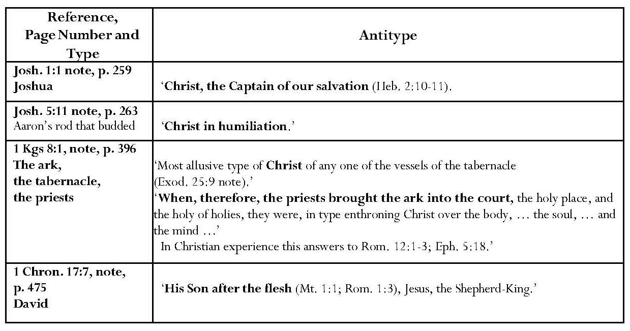
Beyond commentary on the Pentateuch, Scofield’s typological references decline. His assertion that Joshua is a type of Christ is not justified by the reference to Heb. 2:10, 11. Scofield states from Hebrews that Christ is ‘the captain of our salvation’ but Hebrews does not relate this to Joshua, son of Nun. Commenting upon Solomon’s bringing the ark of the covenant into the temple Scofield states that the ark was ‘the most allusive type of Christ’ among the tabernacle vessels and that, in bringing it into the holy of holies, the priests were typically enthroning Christ. The two New Testament references given by Scofield do not justify these claims. Scofield also identifies David as ‘a type of his Son after the flesh’; again the points of comparison are more allusive than typical.
Continued overleaf

The Prophets
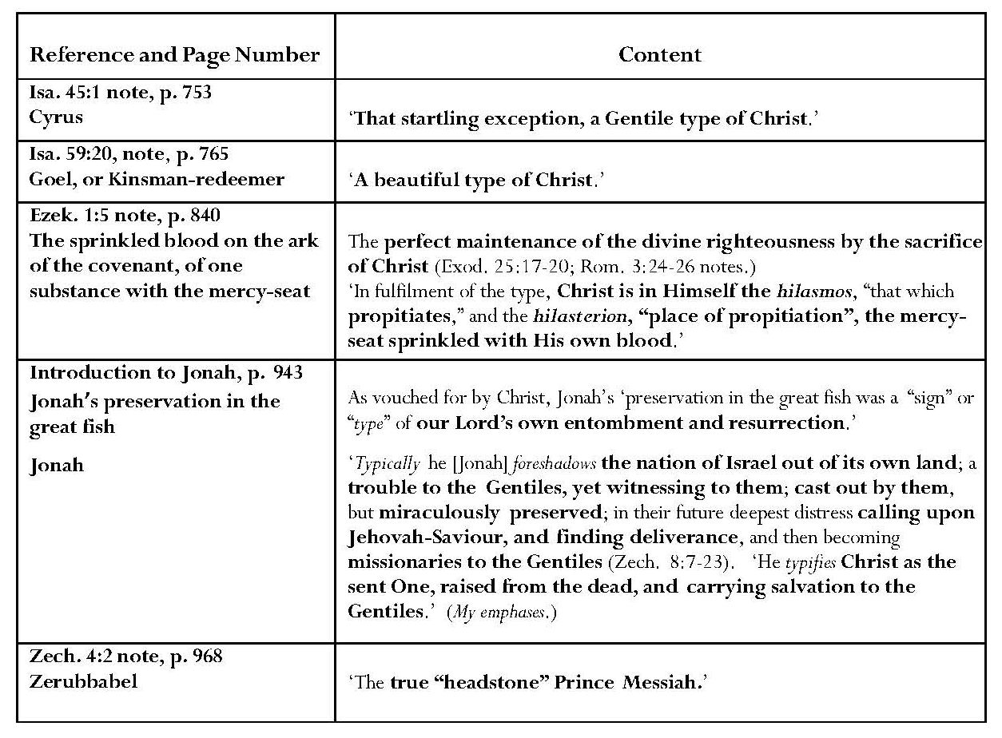
Scofield makes few typological references in commentary on the Prophets. In commentary on Isaiah, he states that ‘the goel’ typifies Christ. He also identifies Cyrus as ‘a Gentile type of Christ’ since Cyrus and Christ were both ‘irresistible conquerors of Israel’s enemies’, ‘restorers of the holy city’ and ‘those through whom God’s name is glorified as the one true God’. In Isa. 44:28, Cyrus is named as ‘my Shepherd’, a Messianic title. Reflections may easily be seen in the referenced verses but not types. Scofield makes typological claims relating to Ezekiel. Jonah and Zechariah. He states that the sprinkled blood of the ark of the covenant typically ‘spake of the perfect maintenance of the divine righteousness by the sacrifice of Christ’ and asserts that Jonah typifies Christ as the risen one, bringing salvation to the Gentiles. He also states that Zerubbabel is a type of ‘the true “headstone”, Prince Messiah’.
Continued overleaf
The New Testament
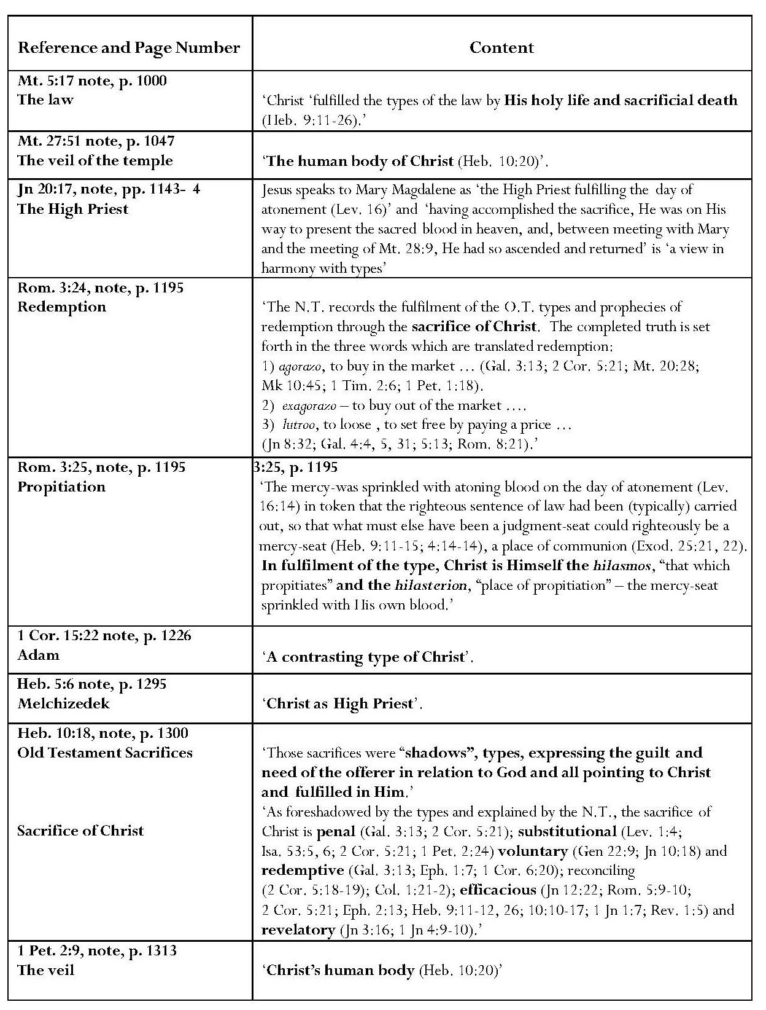
References to Hebrews 9 and Heb. 10:20 in Scofield’s notes on Mt. 5:17 and 27:51 justify typological assertions; Hebrews 9 provides a detailed discussion on the relationship between Christ’s role and that of the high priest, but the reference back to Leviticus 16 in the note on Jn 20:17 regarding Mary Magdalene’s encounter with the risen Jesus as typical of ‘the High Priest fulfilling the day of atonement, is non-specific and conjectural. As discussed above, Exod. 26:31 and Mt. 27:51 do bear a typological relationship.
In his note on Rom. 3:24, Scofield states that Christ’s fulfilment of Old Testament types is demonstrated in three Greek words. With avgora,zw, Scofield focuses on redemption achieved by Christ; he gives no references for evxagora,zw. Scofield’s references to freedom and liberty well illustrate lutro,w. However, Scofield does not demonstrate which Old Testament types are being fulfilled in these three words.
Scofield amplifies Paul’s statement in 1 Cor. 15:22, ‘as in Adam all die, even so in Christ shall all be made alive’, to make Adam a contrasting type of Christ. He states that Adam was a contrasting type of Christ in that Adam derived life from God whereas Christ gave life to others; Adam was from the earth, Christ from heaven; and Adam was head of a fleshly creation in which “all die”, whereas, in Christ, all will be made alive; ‘the Adamic creation is “flesh”; the new creation “spirit”’. These references provide legitimate cross references within the New Testament but are illustrations rather than proof of type.
In his note on Heb. 5:6, Scofield comments upon the suitability of Melchizedek as a type of Christ as High Priest in terms of being a king-priest; king of Salem, (peace); with ‘no (recorded) “beginning of days”’ or ‘“end of life”’ and not made a high priest by human appointment. In this Scofield says little more than the writer of Hebrews said in chapter 7, which Scofield does not annotate. It is in Scofield’s references for the clause concerning Melchizedek’s lack of ‘“beginning of days” or “end of life”’ that there is room for argument. The verses which Scofield quotes in his note, Jn 1:1, Rom. 6:9 and Heb. 7:23-5, all refer to Christ’s existence in the beginning, and to his resurrection and living for ever. It surely cannot be that Scofield is suggesting that a mere man, even without a recorded beginning or end, could compare with the eternal Son of God. It may be that this represents a further instance of Scofield’s use of the ‘Bible Readings’ technique and that he has assembled texts reflecting solely Christ’s nature but this is not made clear. Some comment on the meaning of this comparison would have been helpful.
In discussing Melchizedek, Richard Bauckham focuses on Hebrews 7 and the link it makes to Ps. 110:4. Bauckham regards Ps. 110:4 as being ‘obscure’ and expounded through the only other passage in the Hebrew Bible in which the name Melchizedek appears. As king and priest in both passages, Melchizedek ‘well serves the christological purpose of Hebrews, which is to develop the high priestly profile of Jesus alongside and in connection with his messianic lordship’. Bauckham states that ‘what the author of Hebrews says of Melchizedek in 7:3 is precisely what he said of Christ in applying the words of Ps 102 to him in chap. 1’ – ‘the full eternity of the only true God’. Any comment Scofield might have made on the crucial quotation from Ps. 102:25-7 in Heb. 1:10-12 is lost in his excursus on angels, which again may be a product of the Bible Readings method.
Jerome Neyrey points out that Melchizedek is described in terms of “negative theology” as apator, ametor, agenealogetos, a Greek ‘alpha privative’ format which is usually used in Greek theology to describe a god. However, he emphasises that ‘the point is not to exalt Melchizedek for his own sake, but to promote Jesus: “resembling the Son of God” (7:3)’. It represents ‘the author's clear and nuanced acclamation of Jesus as a true deity’. Bauckham adds that it is important to stress ‘the ‘Jewishness of this author’s use of Hellenistic philosophical language … When adopted into the context of the Jewish understanding of God, such hellenistic god-language …it becomes monotheistic language. … Terms which for non-Jewish writers defined a true deity for Jewish writers define the one and only true deity.’
Scofield makes a further typological Christological assertion in his note on Heb. 10:18. The sacrifices offered by priests under the law were ‘shadows, types’ ‘pointing to Christ and fulfilled in Him’; ‘As foreshadowed by the types and explained by the New Testament’, Christ’s sacrifice is ‘penal, substitutional, voluntary, redemptive, reconciling, efficacious and revelatory.’ While the references Scofield provides give an impressive coverage of the themes he lists, very few of them illustrate typological significance and there are very limited Old Testament references. The cross reference between Isa. 53:5-6 and 1 Pet. 2:24 is legitimate, though not typological. The reference to the Aqedah (Gen. 22:9) is debatable; it was Abraham who was willing voluntarily to sacrifice his son, Isaac, whereas it is the Son, Christ, who voluntarily sacrifices his own life in Jn 10:18, though the link between the Aqedah and Christ is a commonly held Christian tenet.
ii) Non-Typological Assertions Concerning Christ and the Cross
Scofield often uses other comparative words such as ‘symbolise’, ‘speak of’, ‘seen as’, ‘adumbrate’, ‘is’ or even a colon, which seem in some instances to act as synonyms for ‘typify’. These other expressions and representations relate Old and New Testament concepts in much the same way as the instances where Scofield’s use of ‘type’ seems unsupported by New Testament evidence.
Most of the non-typological Christological comparisons come from Leviticus and concern elements in tabernacle sacrifice. There is a single instance of non-typological comparison in Scofield’s note on Exod. 30:34, where he differentiates between incense and frankincense and between their meanings in relation to Christ, as Christ’s perfections and God’s view of Christ’s ‘ineffable’ nature. No references are given to explain this.
Continued overleaf

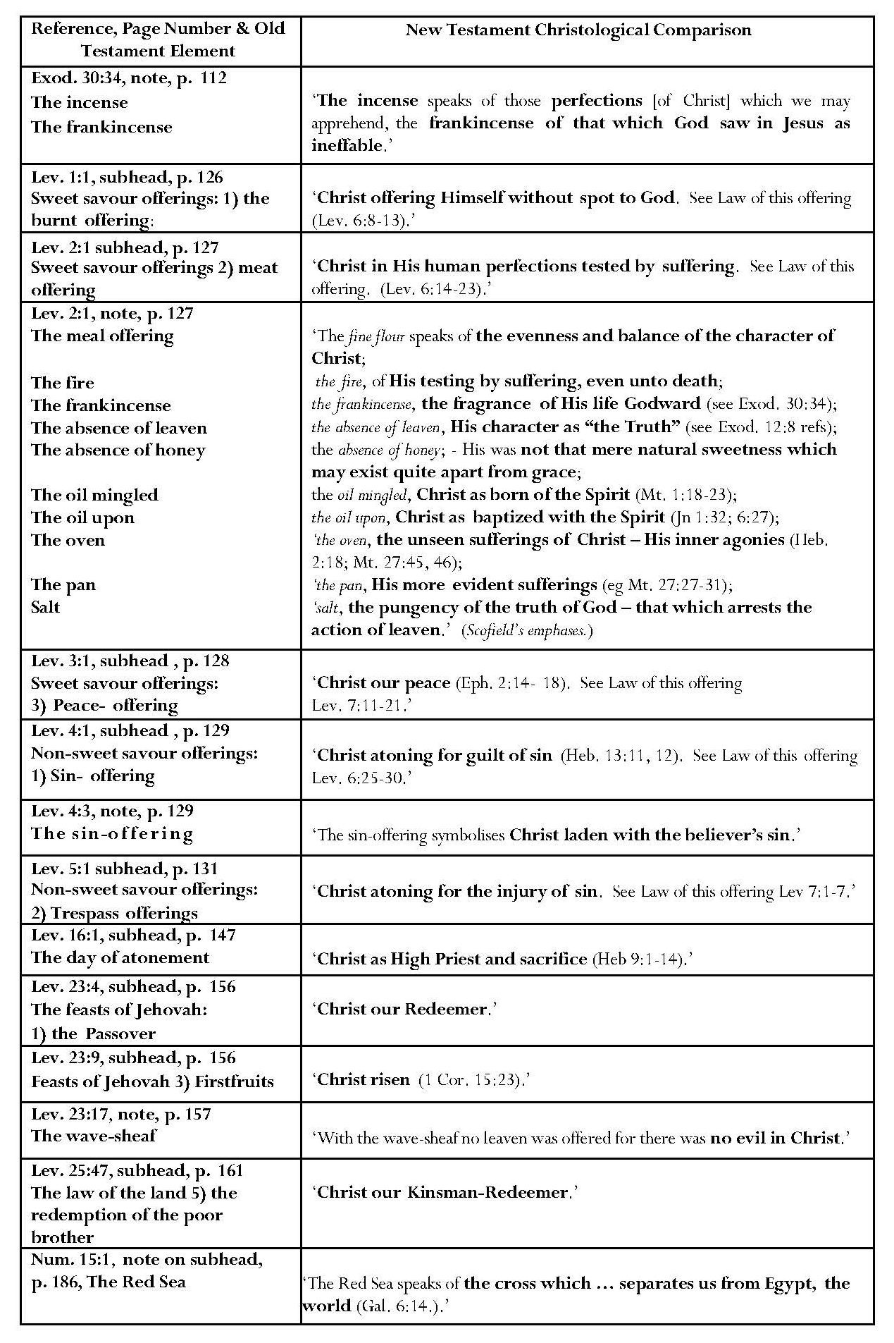 Continued overleaf

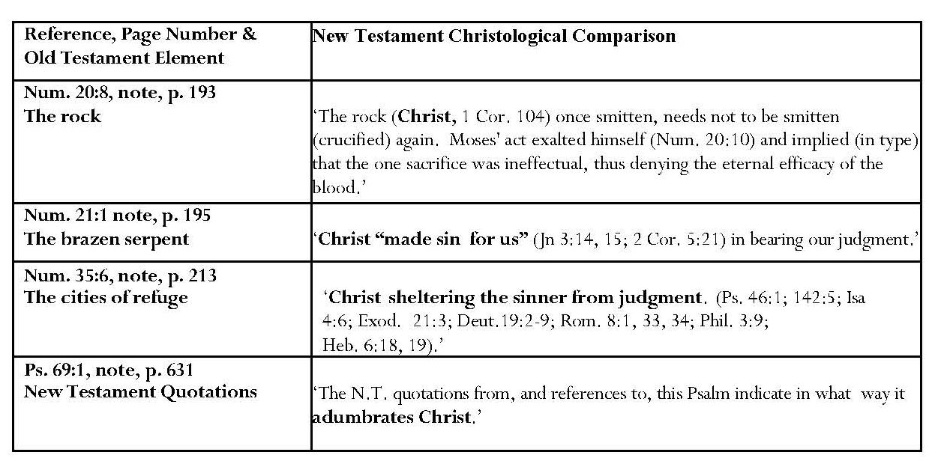
Scofield’s interpolated subheads to the first five chapters of Leviticus make direct references to Christ without suggesting any alternative interpretation such as Israelite sacrificial law, despite the references given to verses which prescribe the methods for the various sacrifices. The references are to Christ as a spotless offering to God, Christ’s human perfections tested by suffering, Christ as ‘our peace’, and Christ atoning for the guilt of sin and for the injury of sin. A particularly detailed note on Lev. 2:1 gives Christological parallels for a range of sacrificial elements. A further group of parallels refers to what Scofield calls ‘the feasts of Jehovah’ and is given Christological interpretations of ‘Christ our Redeemer’, ‘Memorial feast’ and ‘Christ risen’. The note on Lev. 23:17 asserts that no leaven was offered with the wave-sheaf ‘for there was no evil in Christ’. This view is unsubstantiated. None of the elements is supported by the references given and several unjustified inferences are made concerning the character and thoughts of Christ. Some of the connections appear fanciful. The implication is that these interpretations are axiomatic even though they depend upon associations made by Scofield independently.
The allusion to Heb. 9:1-14 in the subhead to Lev. 16:1 justifies the assertion that the day of atonement represents ‘Christ as High Priest and sacrifice’ but the allusion to Christ risen as the firstfruits in the subhead to Lev. 23:9 would have been better applied to Lev. 23:16, where firstfruits are first mentioned. The claim that the Red Sea represents the cross as separating ‘us from Egypt, the world’ is not borne out by the reference to Gal. 6:14, where neither Egypt nor Red Sea is mentioned.
Continued overleaf

b) Typological Assertions - God the Father and the Holy Spirit
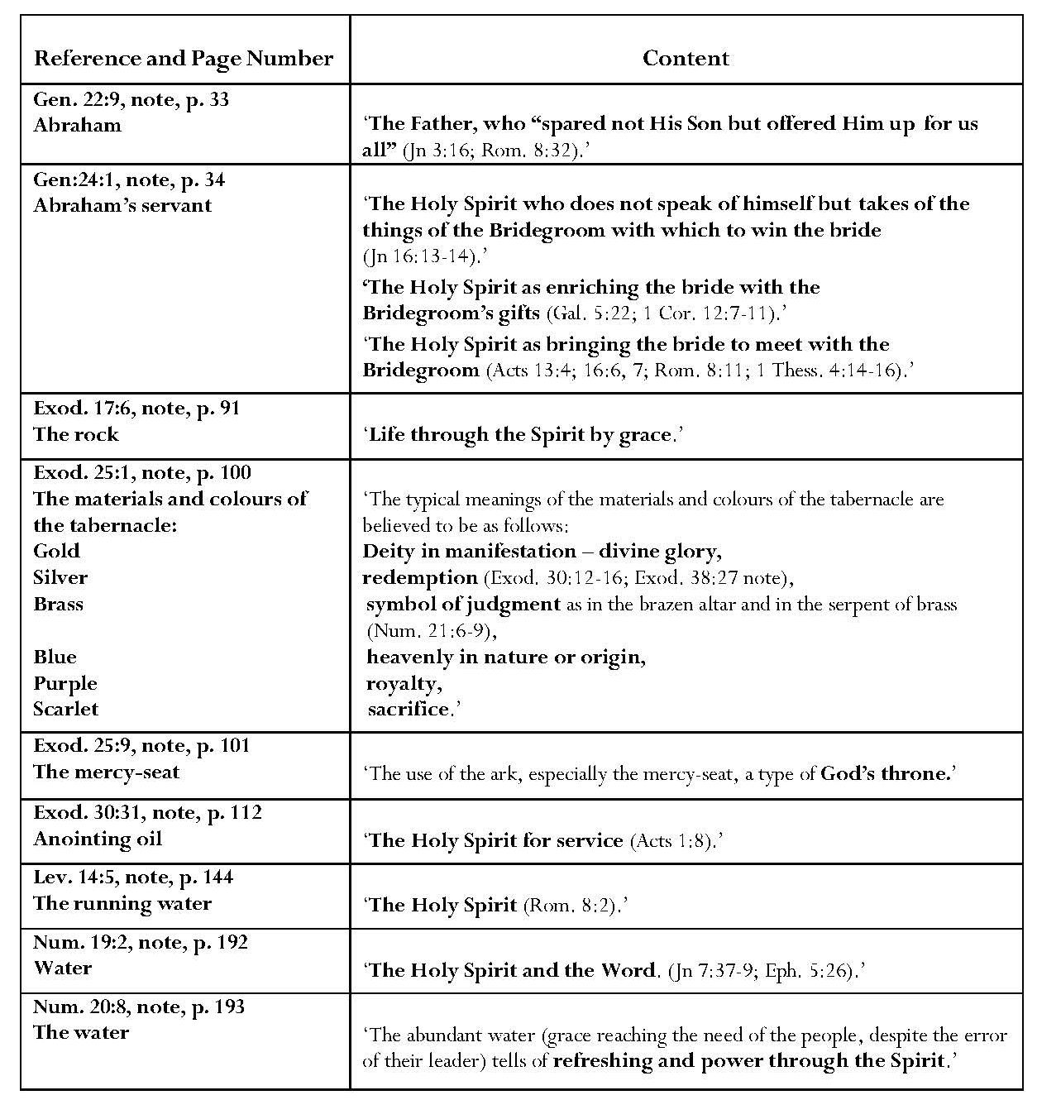
John 3:16 and Rom. 8:32, referenced from the note on Gen. 22:9, encourage comparison with the Aqedah, but these verses do not mention Abraham, Isaac or the ram and do not meet Scofield’s own criteria for types. The qualities allotted to Abraham’s servant as typifying the Holy Spirit appear to result from backward projection from the referenced texts. The Holy Spirit is not mentioned in 1 Thess. 4:14-16, the last of the passages to which Scofield refers. Again the references appear to show the influence of ‘Bible Readings’. Additionally, the typing of the Holy Spirit as a mere servant is not true to the Trinitarian role of the Spirit. The New Testament references in notes on Exod. 30:31 and Lev. 14:5 quoted to justify the typifying of water and oil as the Holy Spirit, again fail to satisfy Scofield’s criteria but the typing of water as the Holy Spirit in the note on Num. 19:2 is borne out by the reference to Jn 7:37-9. Gold and other asserted colour types, including ‘deity in manifestation’, are not true types according to the warnings given by Scofield in this very note, but would be better described as representatives.
c) The Church and Believers
i) Typological and Non-Typological Assertions — The Church
Following his assertion that the sun is a type of Christ, Scofield claims that the Church is the moon. He refers to Eve as typifying the Church in his subhead to Gen. 2:23 and notes on Gen. 2:23 and Eph. 5:32; his cross-referenced verses mention bride and bridegroom but, as Sizer indicates, none mentions Eve. 2 Corinthians 11:3 does mention Eve, but only in the context of a warning that Paul fears the Church might be deceived like her. This does not indicate that Eve is a type of the Church unless, as Sizer alleges, Scofield is paving the way for his thesis that the church-age is bound to culminate in ‘apostasy and failure’. I doubt that Scofield’s motive was as deep as this. The comparison appears to be more like a romantic notion on a par with Scofield’s remarks about the male and female characters in Song of Songs.
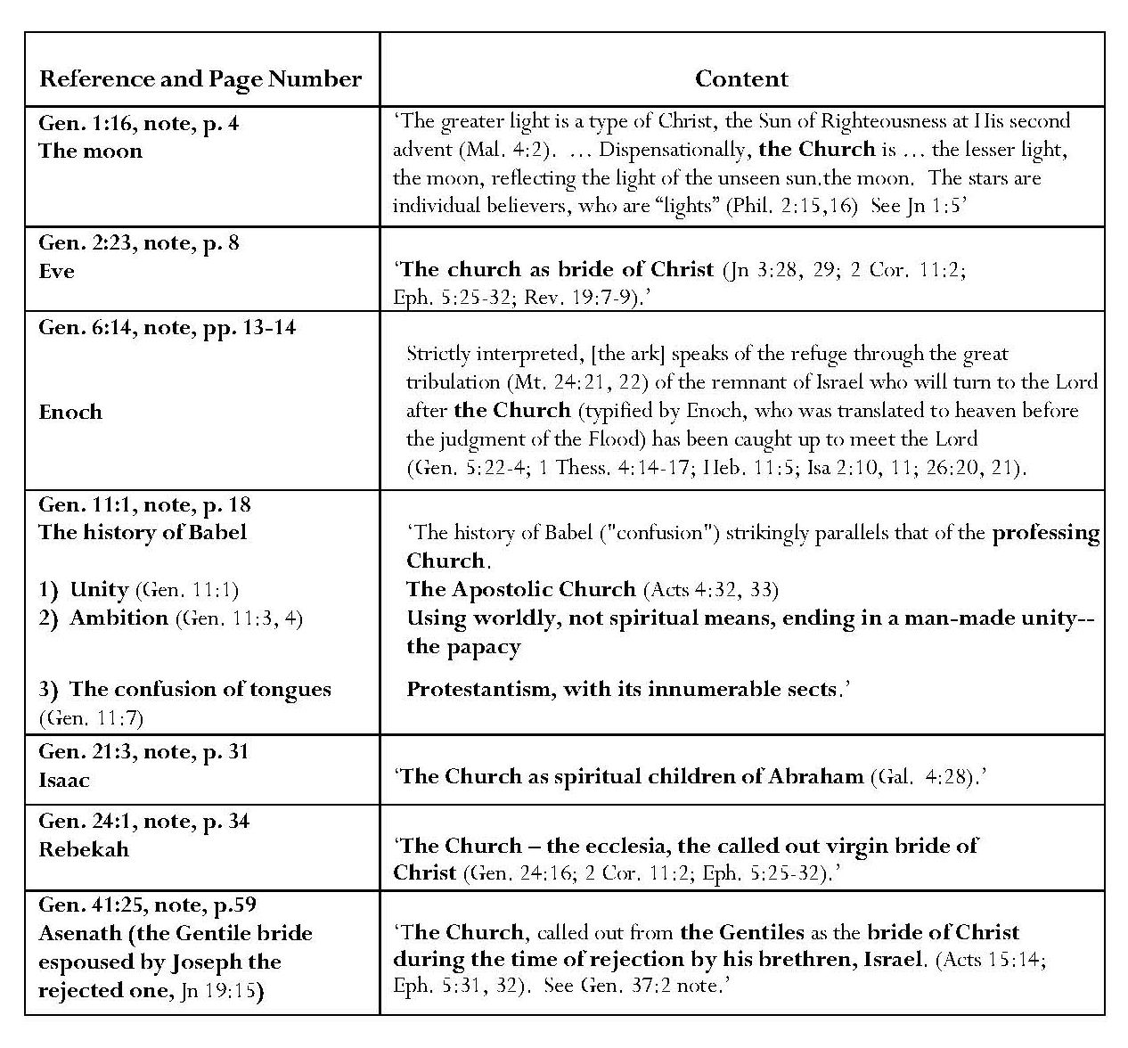
Continued overleaf

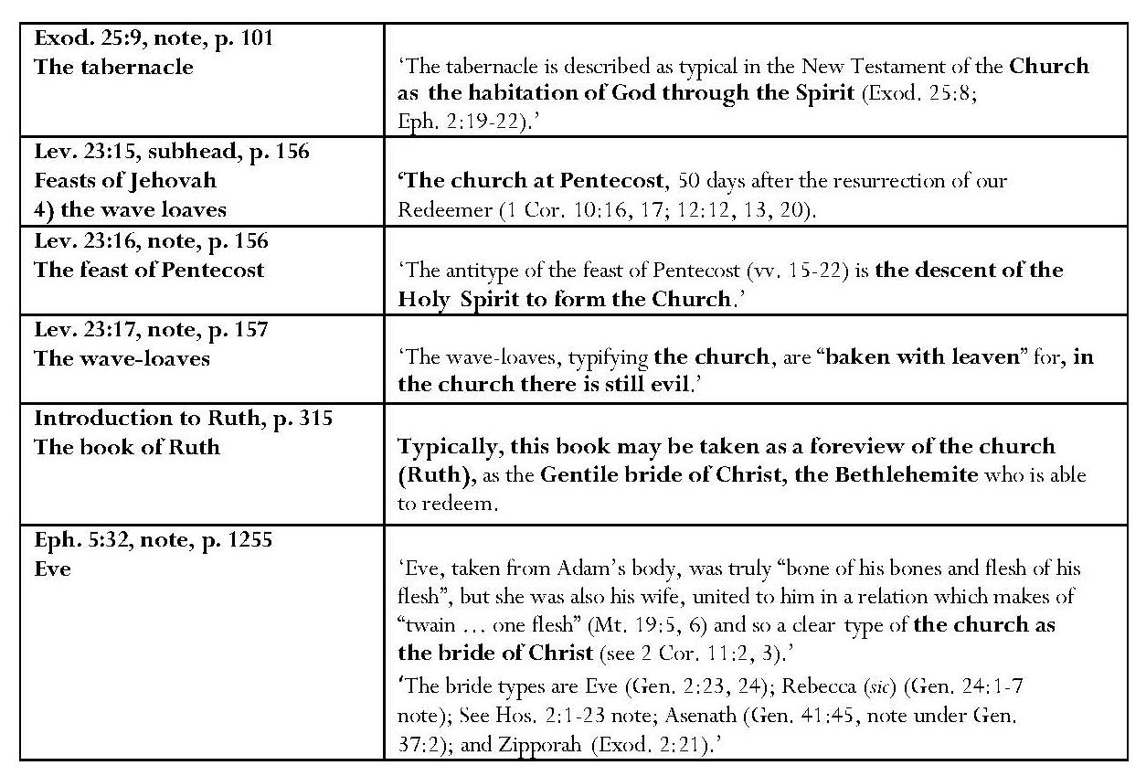

Scofield also avers that Enoch is a type of the Church raptured to heaven. He holds ‘the history of Babel’ to parallel that of the professing church, equating Pre-Babel unity with the apostolic church and Babel with the professing church. This comparison is interesting because in it Scofield criticises both the Roman Catholic and the Protestant churches as being part of the ‘professing church’.
Scofield’s identification of Isaac as ‘typical … of the Church as spiritual children of Abraham’ is justifiable in relation to Gal. 4:28, to which he refers but his claim that Rebekah is typical of ‘the Church – the ecclesia, the called out virgin bride of Christ’ is not supported by the texts he quotes. Scofield also sees Joseph’s wife, Asenath as ‘a type of the Church called out from the Gentiles as Christ’s bride during his rejection by Israel’, despite his avowal that Joseph is ‘nowhere declared as a type of Christ’. He views the tabernacle as being ‘described as typical in the New Testament of the Church as the habitation of God through the Spirit’. The whole book of Ruth is held to be typically a foreview of the Church, redeemed by Christ. An association is made in Ephesians 2 between the church, or believers, and the temple but this is not typological. Scofield asserts that the descent of the Holy Spirit to form the Church is the antitype to the feast of Pentecost but does not explain its significance in the Jewish calendar as Shavu’ot, a commemoration of the giving of Torah, which might represent a real parallel. He also states that the wave-loaves, baked with leaven, typify the Church which still contains evil. No justification is given for this.

ii) Typological and Non-Typological Assertions – Believers
Typological Assertions
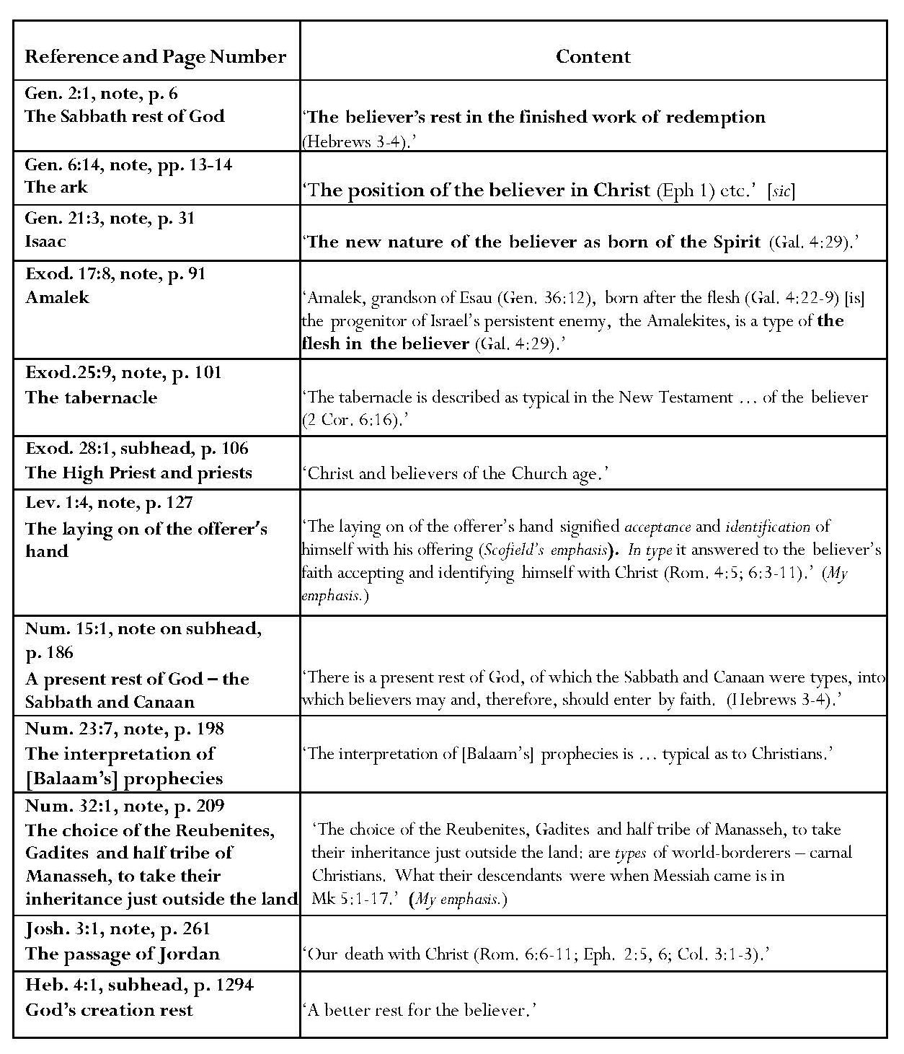
Regarding believers, the references to Gal. 4:29 and 2 Cor. 6:16 justify the typological classifications of Isaac and the tabernacle/temple. The reference to ‘Heb. 3 — 4’ is too broad to identify a specific typological claim but Heb. 4:1-11 concerns God’s rest and the need for believers to enter into it. Scofield’s reference to ‘Eph. 1 etc.’, justifying his typing of God’s Sabbath rest as that of redeemed believers, is even less specific than that to ‘Heb. 3 — 4’; he also makes typological statements concerning rest and the ark in relation to believers in commentary on Gen. 2:1 and Heb. 4:1.
Amalek is ‘a type of the flesh in the believer’ but the passage quoted in justification, Gal. 4:22-9 actually concerns Hagar and Ishmael, not Esau. Scofield states that the Exodus priesthood typifies believers. Scofield also states that ‘the interpretation of [Balaam’s] prophecies is literal as to Israel, typical as to Christians’ but does not give New Testament justification. Scofield sees the tribes who chose an inheritance just outside the land as typical of ‘world-borderers’; he includes a reference to Mk 5:1-17, which concerns Christ’s healing of the Gaderene man. The reference to Gen. 11:1 seems inappropriate because it concerns Abraham’s entering Canaan rather than remaining on its borders. Scofield regards ‘the passage of Jordan’ as a type of ‘our death with Christ’. The crossing of Jordan is not mentioned in any of the referenced verses, however.
Non-Typological Assertions
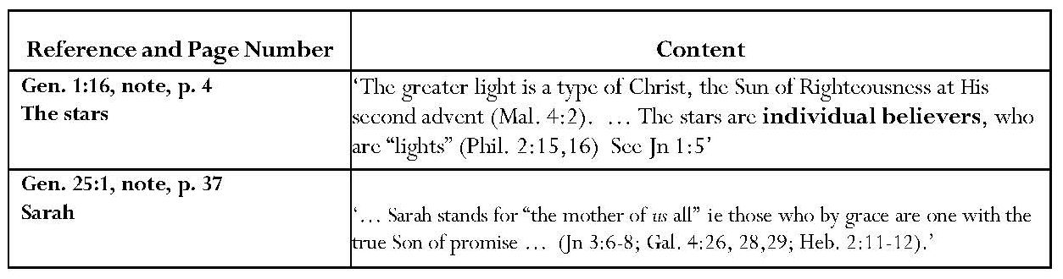
Non-typologically, Scofield compares believers to stars; possibly this claim is related to his later assertions concerning Abraham’s spiritual descendants to ‘the stars of the sky’. He sees Sarah as mother of those who believe in ‘the true Son of promise’. The comparison of believers to stars and reference to Sarah with regard to the New Testament passages referenced are unjustified. As with the moon and the Church, the comparison between stars and believers appears romanticised. John 3:6-8 concerns Christ’s explication of the Spirit to Nicodemus. Also, while Galatians 4:22 mentions ‘the freewoman’, Sarah is not named in Galatians and it is Jerusalem which is declared to be ‘our mother’ in Gal. 4:26. Sarah is not mentioned in Hebrews 2 but appears in Hebrews 11 as an example of faith.
Continued overleaf

d) Typological and Non-Typological References - Israel
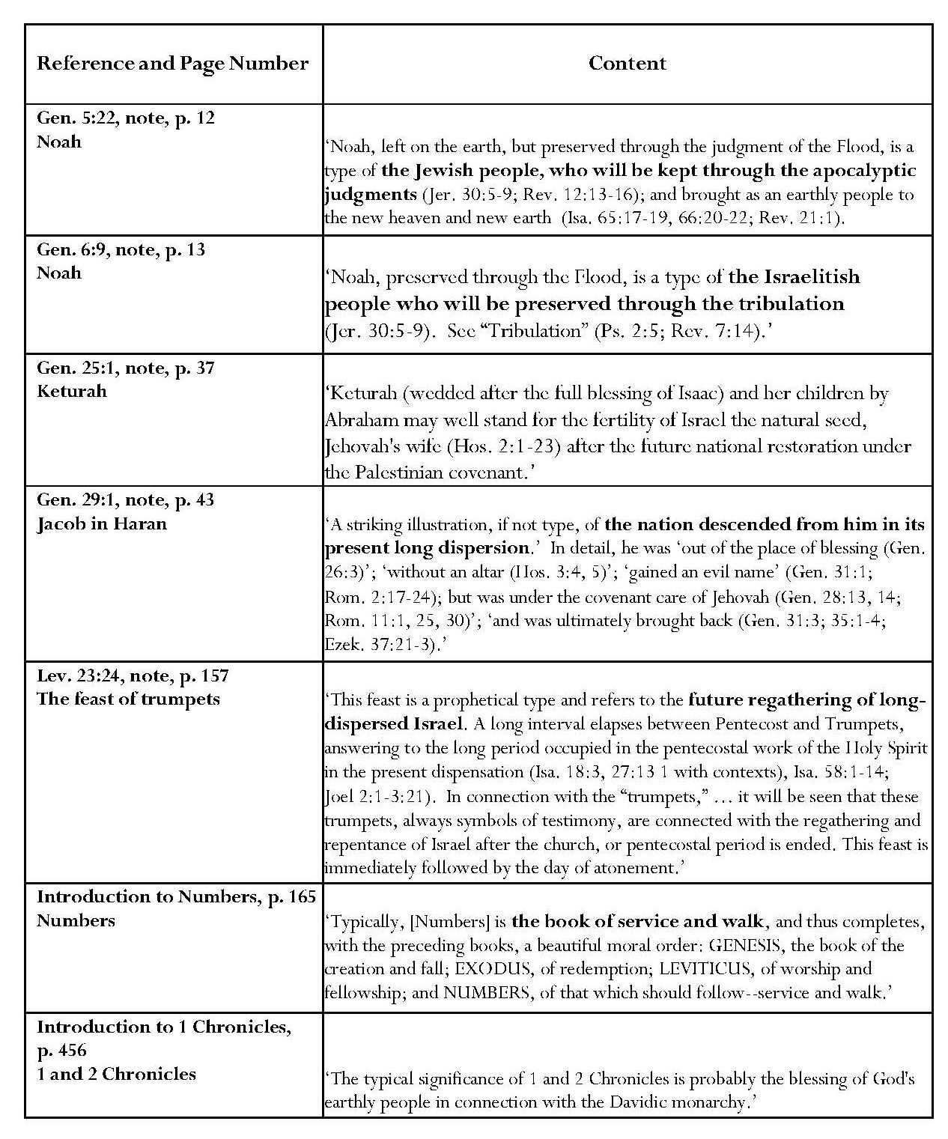
Continued overleaf

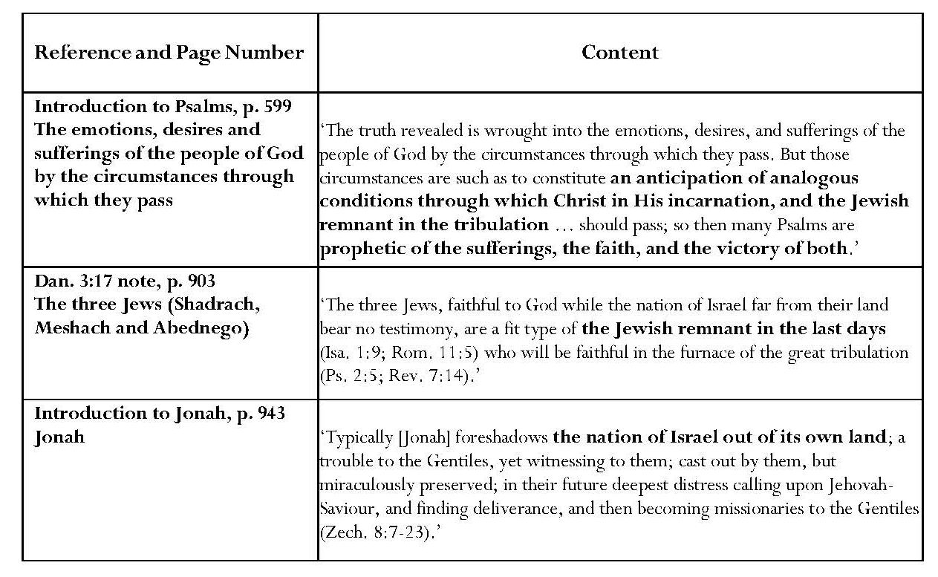
A virtual complete “history” of Israel occurs in the Israel-typical references in Scofield’s commentary. Scofield asserts that, unlike Sarah, Keturah may well represent ‘the fertility of Israel, the natural seed, Jehovah’s wife … after national restoration under the Palestinian covenant’. Jacob in Haran typifies currently dispersed Israel. Like Israel, Jacob was ‘out of the place of blessing; without an altar; he gained an evil name but was under Jehovah’s covenant care and was ultimately brought back’. Jonah also ‘foreshadows the nation of Israel out of its own land’. Noah, sustained on earth throughout the judgment of the flood, typifies ‘the Jewish people, who will be kept through the apocalyptic judgments … and brought as an earthly people to the new heaven and new earth’. Noah also typifies ‘the Israelitish people who will be preserved through the tribulation’.
The bitter waters in Exodus ‘stand for the educatory trials of God’s people’. According to Scofield, Numbers typically encapsulates the service and walk of the redeemed people, and also indicates that typically, wilderness circumstances occasioned Israel’s failure. Scofield states that 1 and 2 Chronicles probably typify the blessing of God’s earthly people through the Davidic monarchy. He also notes that ‘the Sabbath given to Israel’ is ‘a type of Israel’s kingdom’; there is no mention of any kingdom in Heb. 4:8-9, given as a reference. Scofield states that ‘blessing after deliverance … [is a] type of the blessing in the kingdom after Rev. 19:19-21’.
The circumstances described in the Psalms anticipate ‘the analogous conditions through which … the Jewish remnant in the tribulation should pass’ as well as Christ’s sufferings and ultimate victory. Shadrach Meshach and Abednego typify the Jewish remnant to be faithful in the great tribulation. The feast of Trumpets is ‘a prophetical type which refers to the future regathering of long-dispersed Israel’. ‘The Sabbath given to Israel’ is ‘a type of Israel’s kingdom’. ‘Blessing after deliverance … [is a] type of the blessing in the kingdom after Rev. 19:19-21’.
e) Further Types
Scofield identifies the whole Pentateuch as ‘in type, an epitome of the divine revelation’. He regards Cain and Abel as types. Cain is a type for ‘the mere man of the earth. His religion is destitute of any adequate sense of sin, or need of atonement.’ He typifies ‘the religious natural man, who believes in a God and in a “religion”, but after his own will, and who rejects redemption by blood’. From this, Scofield opines in his note on Jude 11 that apostate teachers explain away the atonement. David Horrell states that Cain was regarded in Jewish tradition not just as a murderer, but also as someone who denied God’s justice and future judgment, with the result that he was a type for ungodliness and false teaching. His judgment was a divine curse. Scofield holds that Abel is the type for the spiritual man; atoning blood was shed in the sacrifice he offered. This was simultaneously his confession of sin and expression of faith in the interposition of a substitute. No justification is given for either statement and neither atonement nor blood is mentioned in Jude.
Blue, as used in the tabernacle, typifies a heavenly nature or origin. The tabernacle is ‘explained in the New Testament’ as typifying ‘a figure of things in the heavens’. Speaking spiritually, ‘Joshua is the Ephesians of the Old Testament – the “heavenly” of Ephesians is to the Christian what Canaan was to the Israelite – a place of conflict, and therefore not a type of heaven, but also a place of victory and blessing through divine power.’ John 12 — 17 are held to be ‘a progression according to the order of approach to God in tabernacle types’, the brazen altar typifying the cross in chapter 12. According to Scofield, John 12, in which Jesus speaks of his death, ‘answers to the brazen altar of burnt offering, type of the cross’; in John 13, ‘the laver is next reached’; in John 14 — 16, the High Priest approaches and enters the holy place with His associate priests; in Jn 17:1, the High Priest enters the holy of holies and intercedes, not for the salvation, but for the keeping and blessing of those saved by his death. ‘Typically the order of approach to God’s presence is the brazen altar of sacrifice, then the laver of cleansing.’ Scofield sees this as typifying Christ’s washing the disciples’ feet. Fine linen usually typifies personal righteousness and the priest is a type for consecration. God constituted ‘the typical priesthood’, the Aaronic priesthood, the tribe of Levi, to minister as priests to Israel after Israel violated the law. However, ‘the ordinances and sanctuary of the old covenant were mere types’.
Other typical assertions concern sin and leprosy. ‘Strange fire’ is said to typify ‘any use of carnal means to kindle the fire of devotion and praise’. Leprosy is ‘a type of sin’, its anti-types, as applied to God’s people, being ‘“sin”, demanding self-judgment and “sins”, demanding confession and cleansing’. The instructions for priestly treatment of lepers are ‘a type for Gospel Salvation’. However, Scofield criticises the self-righteousness and cruelty of applying regulations about leprosy to discipline in the local church.
Several points of commentary refer to types of redemption and salvation. The exodus from ‘Egyptian bondage’ sets forth, in type, all redemption’. The slain and blood-dipped birds are ‘a type for the two aspects of salvation in Rom. 4:25’; here Scofield probably indicates Christ’s crucifixion for our sin and resurrection for our justification. Silver typifies redemption. ‘The kinsman-redeemer’ indicates redemption and the Redeemer.
Some asserted types and representations are eschatological. Brass is a symbol of judgment and speaks of divine judgment, the serpent being the symbol of judged sin. The plague of insects in Joel is a type for the day of the Lord. The little horn, the king of fierce countenance of Dan. 8:23, is typified by ‘that other king of fierce countenance, Antiochus Epiphanes’; Antiochus significantly typifies the Beast, ‘the terrible “little horn” of the last days’; ‘the “Beast out of the sea”’. The destruction of physical Babylon typifies the greater destruction yet to come upon the mystical Babylons. Scofield holds Genesis to speak typically of ‘the new creation, where all was chaos and ruin.
Scofield’s interpretation of the relationship alleged between John the Baptist and Elijah is interesting. Here Scofield applies his principle of ‘near and far horizons’ in prophecy, stating that the prophecy of Mal. 4:5-6, fulfilled in John the Baptist, must be kept distinct from ‘that yet to be fulfilled in Elijah’. The implication is that Elijah is still to return, perhaps heralding the kingdom, which Scofield has asserted will not arrive until the second coming. From Mt. 17:11 and 12, however, it would appear that Jesus completely identifies the coming of John the Baptist with the coming of Elijah predicted in Malachi. Scofield may be attempting to explain Jesus’ statement about John by stating that ‘John the Baptist had come already and with a ministry so completely in the spirit and power of Elijah’s future ministry (Lk. 1:17) that in an adumbrative and typical sense it could be said “Elias is come already”’.
SRB also includes types for law and grace, where Hagar is said to typify the Law and Sarah, grace. The feast of firstfruits is typical of resurrection first of Christ and then of ‘those who are His at His coming’. Psalm 69:25 is held to typify Judas as a member of his generation, which shared his guilt.
In conclusion, reflecting upon Scofield’s use of types, it seems that Scofield very rarely keeps to the rule he laid down for himself in his note on Exod. 25:1, where types must necessarily be justified by explicit New Testament references. The majority of Scofield’s alleged ‘types’ only bear ‘the authority of analogy, or spiritual congruity’, or are even the fruit of Scofield’s own imagination. Campbell states that continued employment of ‘unrestrained typology’ has meant that ‘the entire subject has been brought into disrepute’. It seems to me that unjustified comparisons between the Church and the moon and Eve, between the stars and believers, and between some of the tabernacle elements and Christ fall into this category. I believe that some of Scofield’s loose typological associations well reflect the prominent premillennialist method known as ‘Bible Readings’, which ‘featured in the Bible conference movement’.
2.4 The Bible Readings Method
Using the Bible Readings method, a preacher would select a number of verses which he saw as pertaining to a certain subject and use these in his address. Weber cites James Brookes, who was Scofield’s sole tutor, as urging preachers to ‘select some word, as faith, repentance, love, hope, justification, sanctification, and with the aid of a good Concordance, mark down before the time of the meeting the references to the subject under discussion’. Blaising calls this ‘a practice of stringing texts together dealing with a common word, phrase or theme’. He also dubs it ‘a kind of concordance organization of biblical passages under doctrinal headings, keying in on thematic terms and phrases’ and specifies Brookes’ journal, Truth, as an example of this.
Brookes himself provides a good example of the technique in his 1877 book, Bible Reading on the Second Coming of Christ According to the Scriptures. Each of the twelve chapters consists of a brief introduction, which sets forth the point being made; this is followed by a series of biblical texts. Brookes introduces chapter 1 by stating that the second coming is mentioned 318 times in the 260 chapters of the New Testament. Fifty-six texts are then listed as examples. Occasionally a short interpolation by the author interrupts the sequence. William Blackstone uses a similar technique in Jesus is Coming, providing more comment but including extensive biblical quotations in his footnotes, and Scofield employs a comparable method in Rightly Dividing the Word of Truth. However, here the biblical quotations are interspersed with more text, to which they act as illustrations. As has already been indicated and will be shown below, many of the associations made by Scofield in SRB may fall into the category of ‘Bible Readings’. Blaising states that, among contemporary dispensationalists, ‘Scofieldian views were thought to be inductive summaries of Scripture, often presented in typical Bible reading format’. Scofield was an active participant in the Bible conference movement. He is listed amongst the speakers at the Niagara conferences. When these conferences ceased, he was instrumental in initiating the Northfield and Sea Cliff conferences, based on the principle of the great need at the start of the new century to keep the testimony alive, ‘especially to bear witness to “that blessed hope”’. It was at the first Sea Cliff conference in 1901 that Scofield confided to Arno Gaebelein his dream of producing ‘a Reference Bible’.
Weber notes that ‘conservatives who wanted their beliefs based on the Bible alone were naturally impressed when passage was piled on passage’ according to the ‘Bible Readings’ method. In his introduction to Bible Reading on the Second Coming According to the Scriptures, George Needham commends Brookes for ‘collating the scriptures bearing on [the church’s] true hope and kindred subjects’. He avers that ‘little that is human is introduced save the expository paragraphs heading each chapter, with explanatory remarks interwoven throughout …’. However, Weber points out that ‘[Needham’s] appraisal obviously ignored the important role of the Bible reader in selecting which passages were read or the limit of “proof texting” to arrive at theological conclusions’. Blaising states that ‘these texts were then read one after the other, sometimes without much regard for context. Implications were then drawn from the exercise.’ Ramm’s caveat with regard to ‘an uncritical association of cross references’ was mentioned in 1.2.1. Bock emphasises the need for caution; interpreters should check ‘genre and thematic, literary categories before integrating [a passage] with the message of other texts given in other settings’. He warns, ‘If we’re not careful, we can read a text in a way that dilutes another text’s message.’
2.5 Conclusion
Scofield belongs within the evangelical Niagara tradition of the affirmation of the Bible as the inspired Word of God and its insistence that instruction was to be based on Scripture alone. He also displays evidence of the use of the characteristic Bible Readings method. Scofield claims in his introduction to his original Reference Bible of 1909 and its 1917 successor that his notes are the result of the past fifty years of Bible study; Blaising avers that this ‘meant Niagara as well as other conferences spawned by it and various publications associated with it’. This is feasible in view of Scofield’s intimate association with Niagara and other similar conferences. As Blaising also points out, however, ‘numerous presentations on the same topics’ were allowable at such conferences and ‘the Scofield Bible gave only one’. ‘While a typical Niagara perspective can be seen in Scofield’s notes, the singleness of the latter’s presentation masks differences of nuance and reservation in the former.’ It is interesting that Blaising suggests that Scofield would have called his system ‘premillennialism’ rather than ‘dispensationalism’, if he had chosen a name for it. On the surface, Scofield appears to adhere to literal interpretation but some of his typological assertions take him outside the use of figurative language which would be acceptable, for example, to later writers like Ryrie, Tan and Campbell.
Scofield is typical of classic dispensationalism in his views on the inerrancy and historicity of the biblical text and expresses this belief in very particular ways, being especially keen to obviate any sense that the Bible may contain even the smallest discrepancy. This is shown in his meticulous refutation of any numerical and narrative discrepancies which he considers may be perceptible. His attempts to harmonise the gospel accounts sometimes go to lengths which cause him to abandon strict literal interpretation.
Sweetnam pertinently states that, although ‘literal interpretation of prophecy’ was Scofield’s ‘preferred means of understanding Divine revelation’, in SRB ‘he does not engage in any explicit discussion of the importance of literal interpretation – rather it seems a given’. In his treatment of prophecy Scofield certainly adheres to dispensationalist principles of literal interpretation; as he says in his Bible Correspondence Course, ‘[in prophecies] we reach the ground of absolute literalness. Figures are often found in the prophecies, but the figure invariably has a literal fulfilment.’ In this, Scofield partly agrees with and partly differs from Darby. In ‘Thoughts on Isaiah the Prophet’, Darby might seem to endorse a consistently literal interpretation of prophecy: ‘To understand prophecy one must understand what God says as He says it, just believing simply the things as they are said.’ Such a statement could well have been made by Scofield; furthermore Scofield’s statement about the literal fulfilment of figures endorses Darby’s statement that ‘whatever figures the Spirit of God may use in depicting the ways of God or those of the enemy, the subject of the prophecy is never a figure’. However, Darby also owned that it was impossible to ‘make an exact rule to distinguish between figure and letter’ and he actually referred to the importance of authorial intent, as he writes in ‘Inspiration and Interpretation’: ‘If I am reading or hearing a statement, I do not in any way look to the effect on the hearers. This may be a casual help, but no more. … If I seek the meaning, I must seek, not the effect on others, but the intention of the speaker or writer.’ Here modern dispensational writers like Bock seem to be in tune with the final part of this quotation from Darby, though they are more aware of the importance of reader response and interpretation than he was. However, Scofield does not seem to have inherited Darby’s awareness of authorial intent.
An examination of Scofield’s hermeneutics shows him to be within the line of classic dispensationalist hermeneutic but adding to it his own interpretative gloss. As stated above, SRB stands as a monument to an earlier version of dispensationalism than is now current among some adherents. However, as Blaising states, there is ‘diversity within the tradition’, and ‘today under the label of dispensationalism one can find representatives of various stages of the tradition’s history’. Some dispensationalists might be classified as ‘Scofieldian’ in their adherence to SRB interpretations, and another group reflect the ‘definitional approach’ of Ryrie with its sine qua non elements, but ‘many dispensationalists … are reexamining their terminology, seeking dispensational structures that are more accurate biblically’. ‘Their work … brings a different perspective to traditional themes while maintaining continuity with earlier dispensationalism.’
My study now moves to a consideration of how SRB fulfils the remaining five elements of dispensationalism outlined in the Introduction, firstly, Scofield’s commitment to evangelical doctrine.

CHAPTER 3
Elements of Dispensationalism: Element 2:
Commitment to Evangelical Doctrine
Blaising states that dispensationalism has become ‘one of the most common expressions of evangelical Christianity’. The evangelical theologian, David Hilborn identifies three Reformation ‘solae’ which define the theological foundations of evangelicalism: sola scriptura (the belief that divine truth was revealed through God’s Word in the Old and New Testaments and that the Bible must ‘take precedence over reason, tradition, ecclesiastical authority and individual experience’); sola gratia (the belief that salvation is by God’s grace alone and on divine initiative); and sola fide (the belief that, although salvation is a divine gift, human beings must respond and be included in ‘the outworking’ of the divine purpose); hence salvation is by grace through faith. These principles are perceptible within dispensationalism.
Kreider makes an important distinction when he distances dispensationalism from identification as a ‘system of theology’. This term might imply a departure from orthodox Christian belief. Kreider emphasises that ‘dispensationalists do not have distinctive views of the Godhead, salvation, Christology or the gospel [and] …affirm the doctrines of evangelical Christian orthodoxy’. ‘Dispensationalism is not heterodox or heretical … specifically, dispensationalism does not teach multiple ways of salvation’ but, ‘like all Christians, dispensationalists believe that salvation is by grace alone, through faith alone, in Christ alone.’ Kreider’s denial of belief in multiple ways of salvation is pertinent since unfortunate and misleading statements were made in the past, for instance by Scofield and by Bass, which led to the understandable accusation that dispensationalists believed in two different ways of salvation.
David Bebbington experienced a similar problem in defining evangelicalism to that which scholars like Crutchfield, Stamper and Ryrie encountered in defining dispensationalism; like dispensationalism, evangelicalism has ‘found expression in a variety of institutional forms’, has ‘changed greatly over time’, and also has ‘common features’ which have lasted over time. Bebbington identifies four common features in evangelicalism as Conversionism, Activism, Biblicism and Crucicentrism. As stated in the Introduction, he calls these ‘a quadrilateral of priorities’. Again as stated in the Introduction, to these four characteristics, Hilborn adds ‘Christocentricism’, which he defines as God’s eternal Word becoming ‘human in the historical man Jesus of Nazareth, who definitively reveals God to humanity’. Blaising and Bock also refer to ‘Christocentricity’ with reference to dispensationalism. In this chapter, I examine ways in which the views of some dispensationalists, including Scofield, reflect these evangelical elements.

3.1 Conversionism and Activism
Conversionism and activism are so closely related that they will be treated here as a single subject. Bebbington states that conversionism entails the need for lives to be changed and preachers to urge their congregations to repent of their sins and turn to Christ in faith. He defines activism as related to this in that those converted often desire to convert others. Significantly, for those animated by this desire, learning could be regarded as ‘a dispensable luxury’ and, at the beginning of the nineteenth century ministers were trained only in preaching, not in theology or Greek. Even though Bebbington’s book concerns Britain, this may have significance for Scofield’s situation because it appears that he never received formal training except that from James Brookes. Kraus states that ‘most of the men who shaped the dispensational system in America were not trained theologians. They ‘distrusted theologians … and gloried in their own simplicity and Biblicism’. Marsden remarks upon the longstanding evangelical belief that sharing ‘the eternal implications of salvation in Christ’ is ‘the kindest thing one can do for one’s neighbour’. This belief is implicit in, for instance, clause 5 of the Niagara Creed, which states:
We believe that, owing to this universal depravity and death in sin, no one can enter the kingdom of God unless born again, and that no degree of reformation, … no attainment in morality, … no humanitarian and philanthropic schemes and societies, … no baptism or ordinance, … can help the sinner to take even one step toward heaven, but a new nature imparted from above … is absolutely essential to salvation.
Wilkinson tells how, even before his conversion, Darby, as a curate in the Church of Ireland, ‘labored tirelessly in the Wicklow mountains, ministering to the needs of Christ’s flock while preaching the Gospel to the Roman Catholic peasants’. In 1827, Darby wrote in ‘Considerations Addressed to the Archbishop of Dublin’ that ‘Roman Catholics were becoming Protestants at the rate of 600 to 800 a week’. After his conversion, Darby visited the United States and Canada seven times between 1862 and 1877, living there for nearly seven years, preaching and teaching laymen and ministers from the American denominations.
Weber describes the numbers of conversions to premillennialism, though not specifically dispensationalism, which took place throughout the churches in the last two decades of the nineteenth century. He refers to a sermon by Dwight Moody, in which the world was pictured as a wrecked vessel in which Moody alone had a life-boat and a divine instruction to save all he could. According to Weber, Scofield also pertinently used this image when addressing a memorial service in Belfast for Titanic victims. Weber additionally asserts that premillennialist speakers used the imminence and unpredictability of the second coming to put pressure on the unconverted.
Unlike postmillennialists, however, premillennialists held that God did not intend to save the world before Christ’s second coming and that the church must not imagine itself ‘commissioned to win the world for Christ’. The church’s work was ‘evangelization, by which premillennialists meant the dispensing of the gospel to non-Christian people’. Even though conversions might occur, the response would fall far short of that envisaged by postmillennialism. A. T Pierson, who was, according to Sandeen, ‘a prominent evangelical clergyman … and a vigorous missionary advocate’, and also one of the ‘consulting editors’ for SRB, stated: ‘We are responsible, not for conversion, but for contact. “Go ye into all the world and preach the gospel to every creature.” There our commission begins and ends. With results we have nothing to do, and are incapable of tracing or guaging [sic] them.’
As witness the many missions organised by premillennialists like Hudson Taylor and dispensationalists like Scofield, such strictures did not mean that evangelicals relinquished missionary work. Weber describes Taylor’s interdenominational and evangelical China Inland Mission as ‘the biggest and in some ways the best faith mission’. By 1895, the mission comprised 641 missionaries and 462 Chinese helpers, the main aim being ‘the dissemination of the gospel into unevangelized fields’ rather than to win the largest number of converts immediately. Charles Trumbull relates how Scofield set up the ‘greatly blessed Central American Mission’, based in his home in Dallas, on 14 November 1890. The mission was interdenominational and evangelistic, its aim being the evangelisation of the world, rather than its civilisation. In thirty years, ninety-two churches were established. Sandeen emphasises the role of the Student Volunteer Movement in this type of evangelism.
Apart from foreign missions, the message of dispensationalism was disseminated by the establishment of many colleges and seminaries and also through the Prophecy and Bible Conference Movement, of which Niagara was ‘the earliest, most representative, [and] most influential’. The Moody Bible Institute was founded as the Chicago Evangelization Society following ‘a meeting … to discuss city evangelization’ in January 1886. Moody was Scofield’s friend and associate in the Conference Movement; Scofield also served as pastor of Moody’s church. In 1914, Scofield was part of a group which established the Philadelphia School of the Bible, which is now Cairn University. An article in Cairn Magazine Online suggests Scofield’s motive, stating: ‘Scofield said there were seminaries for ordained pastors, but the work of Christ needed trained laymen and women.’ Dallas Theological Seminary was founded in 1924 by Chafer, who was Scofield’s disciple and successor at the First Congregational Church, Dallas. John Walvoord states that ‘The Moody Bible Institute alone has trained ten per cent of the foreign missionaries serving today. Dispensationalists actually are most aggressive in evangelical witness.’ The latter statement is made in response to Bass’ rhetorical question which suggests that dispensationalism has ‘contributed largely to the default of the church’s mission, and made it a detached, withdrawn, inclusively introverted group, waiting to be raptured away from this evil world’.
3.2 Biblicism
Bebbington defines Biblicism as ‘devotion to the Bible’; this derives from the belief that the Bible contains ‘all spiritual truth’. Darby clearly views the Bible as indispensable, describing it as
a Book which is the harmonious whole of all God's thoughts, of all His ways with regard to man, and of His determinate purpose as to the Christ, and as to man in Him; wherein also is set forth the revelation of what God is, of man's responsibility, and of what God Himself has done for man, as well as of the new relationships with God into which man enters through Christ …
Darby also states: ‘I say that man has nothing to do in the things of God without the Bible — that he has not to act without the Bible any more than without the Holy Ghost.’
Blaising notes that, at Niagara, the Bible was affirmed as the inspired Word of God, upon which all instruction was to be based. In the ‘Call for the Conference’, the organizing committee states that ‘when … some vital doctrine of God’s Word has fallen into neglect or suffers contradiction or reproach, it becomes the serious duty of those who hold it, not only strongly and constantly to re-affirm it, but to seek … to bring back the Lord’s people to its apprehension and acceptance’. E. P. Goodwin refers to his assumption of ‘the absolute, infallible authority of “this book” as the word of God’.
The dispensationalist perception of the divine inspiration of the Bible has clearly persisted. As shown in the table below, the first clause of the Niagara Creed of 1878 and Article One of the doctrinal statement of Dallas Theological Seminary, one of the foremost modern propagators of dispensationalism, are virtually identical: The Cairn University Statement of Faith contains a shorter version.
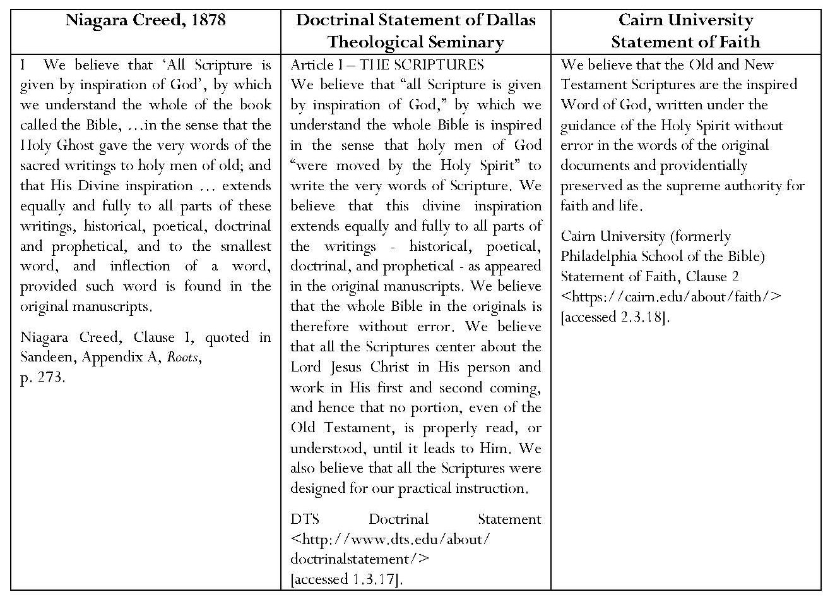
Chafer moreover, states that, ‘believing the Scriptures of the Old and New Testaments to be the only infallible rule of faith and practice, no appeal is to be made to the creeds, confessions, or doctrinal standards which men have formed’. Chafer’s prohibition includes specifically the Westminster Confession, of which virtually the whole first chapter (nine sections) concerns the necessity for the use of canonical Scripture because it is the Word of God, which should be believed and obeyed. This echoes the sola Scriptura language of the Reformation.
Scofield’s statements support evangelical claims about the divine inspiration of Scripture and the necessity for a literal interpretation of it. His belief in the inspiration and authority of the Bible was discussed in Chapter 2. His note on 1 Cor. 2:13 summarises his Biblicism. He asserts that scriptural writers affirm that ‘the words of their writings are divinely taught’ through the Spirit who ‘infallibly guides in the choice of words from the writer’s own vocabulary’; ‘this implies neither mechanical dictation nor the effacement of the writer’s personality’. Scofield states that this necessarily refers to ‘the original documents’ but, as stated in Chapter 2, he expresses great confidence in the competence of English translators. Finally, only the spiritual among believers may discern ‘their full spiritual content’.
Scofield sets the scene in SRB for his literal interpretation of the biblical text by including Bishop Ussher’s dates. He thus places creation at 4004 B.C. He makes three assertions to prove that there is no conflict between the Genesis account of creation and geological and biological facts. In defence of biblical accuracy, Scofield firstly states that ‘the first creative act [the heavens and earth] refers to the dateless past, and gives scope to all the geologic ages’. Scofield holds that only three creative acts of God are recorded in Genesis 1 – the heavens and earth (v. 1), animal life (v. 21) and human life (vv. 26, 27). Secondly, he declares that the earth bears the marks of ‘a cataclysmic change as the result of a divine judgment’. Thirdly, only animal life perished in this catastrophe and traces of this are to be found in fossilised remains. ‘Relegate fossils to the primitive creation, and no conflict of science with the Genesis cosmogony remains.’ This follows the ‘gap theory’, as described by Jack Sofield. This theory was first advanced in the early 19th century in an attempt to reconcile the geological ages and existence of fossils with the creation account of Genesis 1. According to the theory, a gap, an indefinite interval of time, often taken to be millions of years and to encompass the geological ages, intervened between Gen. 1:1 and Gen. 1:2. Those who advocate this theory also hold that, during this interval, God pronounced a cataclysmic judgment upon the earth as a result of Lucifer’s fall, thus Gen. 1:2 onwards contains a description of the divine re-creation of the earth from a chaotic state, rather than initial divine creation. Scofield avers that plants survived in seed form; this might imply that he had never seen any fossilised plants. Scofield also asserts categorically that ‘man was created, not evolved’ and describes how humankind differs from animals.
Scofield’s assertions must be placed within the context of his life and experience. Weber remarks that, in the five or six decades following the Civil War, ‘American evangelism was thrown into chaos by immense and unprecedented social and intellectual crises’ through the rise of the city, an influx of immigrants and rapid industrialisation, and challenged by ‘new revolutionary ways of thinking. The rise of the theory of evolution called into question traditional ways of looking at the universe and the nature of man.’ Charles Darwin’s On the Origin of Species by Means of Natural Selection was published in 1859, shortly before the outbreak of the Civil War, in which Scofield fought on the Confederate side. Additionally, ‘biblical higher criticism, comparative religion, and the new social sciences caused many evangelicals to doubt the traditional views of biblical inspiration and authority and the finality of the Christian faith’. One reaction to these challenges was the inauguration of Believers’ Meetings for Bible Study, which became the Bible Conference movement; as already stated, Scofield played a key role in this.
Scofield’s detailed analyses of divine names in six notes in Genesis, his note on 1 Sam. 1:3, and a table within his note on Mal. 3:18, probably also stem from his desire to take a stand against contemporary threats to Christian belief. In all these notes, he is especially concerned to emphasise the holiness of God, his eternal nature and his redemptive relationship with humankind and particularly regarding Israel. The notes in Genesis concerning names of God are analysed in the table below.
In his note on 1 Sam. 1:3, Scofield describes ‘Jehovah Sabaoth’ as ‘Jehovah (LORD) of Hosts’. ‘It is the name … of Jehovah in manifestation of power’, ‘the distinctive name of Deity for Israel’s help and comfort in time of division and failure’.
The first part of Scofield’s note on Mal. 3:18 comprises a table in which analyses the names of God in English and in Hebrew as found in Gen. 1:1 (El, Elah, or Elohim); 2:4 (Jehovah); 15:2 (Adon or Adonai); 17:1 (El Shaddai); 14:18 (El Elyon); 21:33 (El Olam); 2:4 (now quoted as Jehovah Elohim), 15:2 (now quoted as Adonai Jehovah) and 1 Sam. 1:3 (Jehovah Sabaoth). It is significant that Scofield gives the English translation first and regards the Hebrew as an ‘equivalent’. This table constitutes a summary of interpretations which Scofield has already given but also forms the basis for his construction concerning the Trinity. Scofield counts ‘Jehovah’ (hw"ïhy) and ‘Jehovah Elohim’ (~yhiÞl{a/ hw"ïhy), and ‘Adonai’ (yn"Üdoa) and ‘Adonai Jehovah’ (hwIhy/ yn"Üdoa]) as separate names in the repeated references, Gen. 2:4 and 15:2, respectively, thus producing nine names in total. The nine names are divided by Scofield according to three ‘classes’: ‘Primary’, ‘Compound (with El = God)’ and ‘Compound (with Jehovah = LORD)’. From this classification, Scofield expostulates that ‘the Trinity is suggested by the three times repeated groups of threes. This is not an arbitrary arrangement, but inheres in the O.T. itself.’ Since this three-fold classification has been constructed by Scofield, and also includes two double entries, this hypothesis is unconvincing. Scofield states that the plural name, Elohim, as the ‘Supreme Being’ of the Old Testament, the creator and source of life, is ‘a unity in plurality’. He asserts that ‘this plurality is really a Trinity’ as intimated in ‘the three primary names of Deity’ and in the ‘three-fold ascription of the Seraphim’ in Isa. 6:3. He sees the ‘interrelation of Deity’ as being between Father and Son and the Spirit ‘distinctly recognised in His personality’ and ascription of ‘all the divine attributes’. He also sees the Old Testament revelation of God as being in harmony, not in contrast, with the New Testament revelation of God in Christ.
It is probably significant that Scofield’s last major note on the Old Testament concerns divine identity, as did the earliest note on Genesis. Essentially, Scofield begins and ends his Old Testament commentary with statements concerning his concept of God.
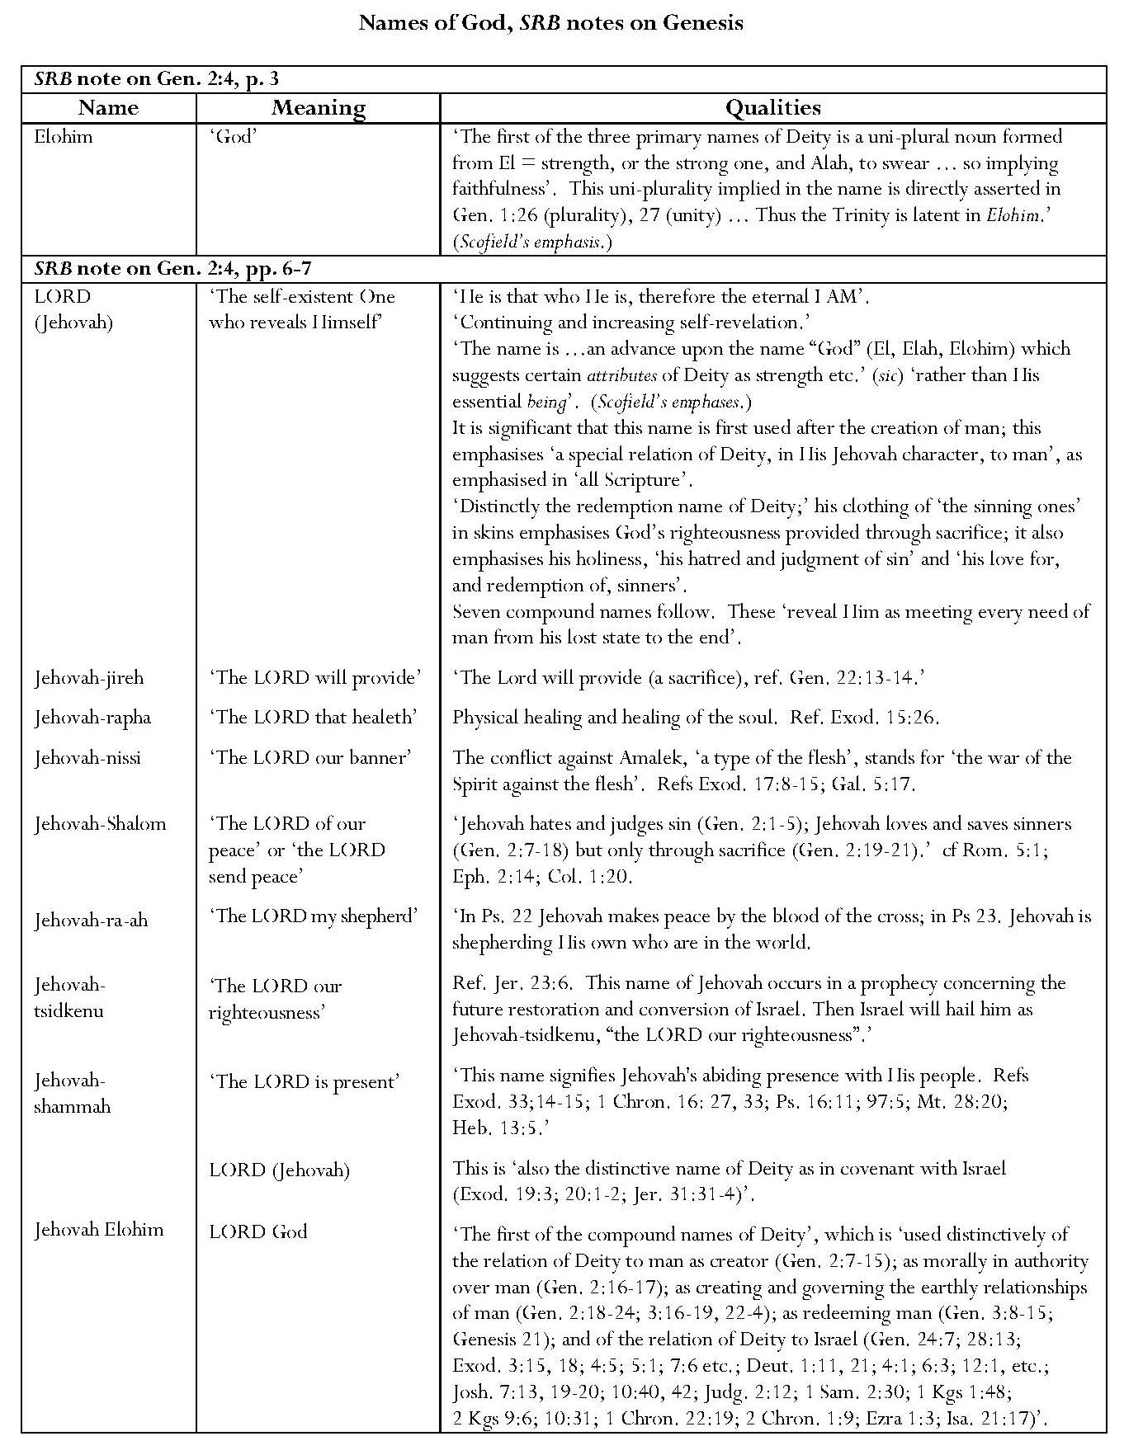 Continued overleaf
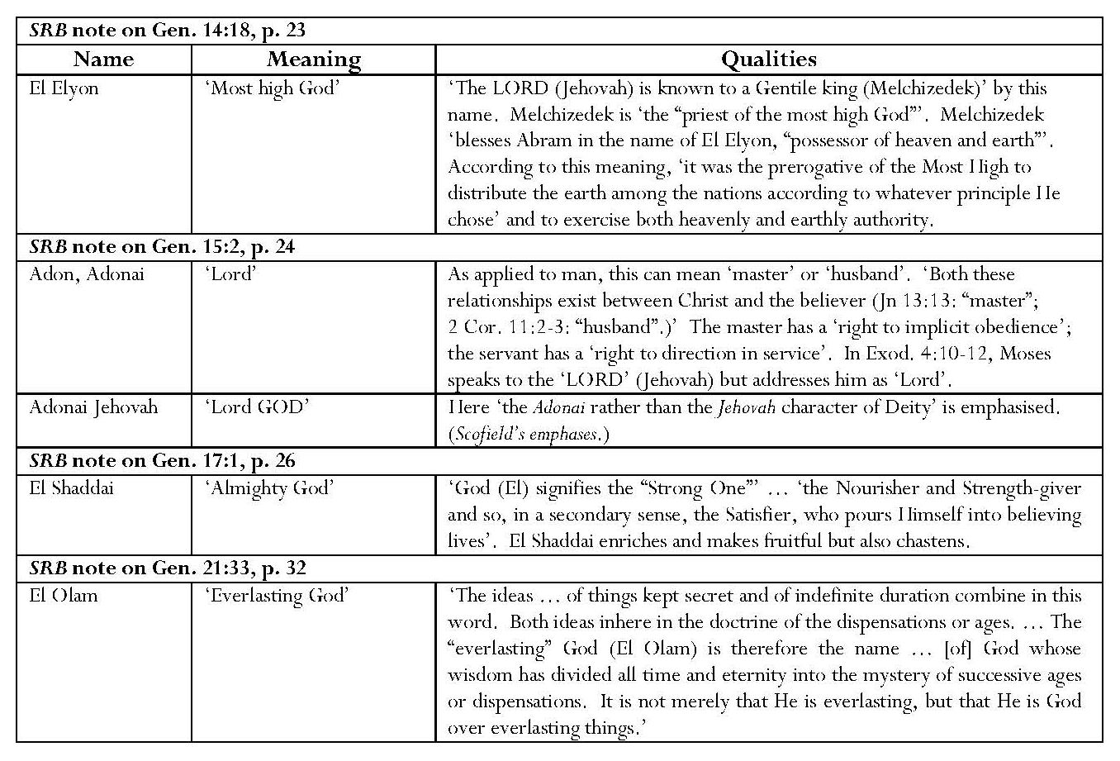
Scofield also asserts a literal interpretation regarding the languages and date of writing of Daniel. He considers, but dismisses, the notion that the book was written ‘after the conquest of Palestine by Alexander (B. C. 332)’. Arguing on the basis of the use of Aramaic ‘the ancient language of Syria and substantially identical with Chaldaic, the language of ancient Babylonia’, from Dan. 2:4 to Dan. 7:28, Scofield claims that this ‘has … seemed with some modern exceptions [unspecified], to the Hebrew and Christian scholarship of the ages an unanswerable proof of the Danielic authorship of the book’. Scofield supports this view with two arguments which are cited by John Collins as two of several theories advanced as solutions to the ‘conspicuous problem’ of the existence of two languages in the book of Daniel. Firstly, Scofield states that ‘the Aramaic section is precisely that part of Daniel which most concerned the peoples amongst whom he lived, and to whom a prophecy written in Hebrew would have been unintelligible’; Collins puts forward as one possible solution the idea that ‘the entire book was composed in Hebrew. An Aramaic version was issued almost simultaneously, for the benefit of those who could not read Hebrew.’ Collins states that this view was popular at the end of C19; this would fit well with Scofield’s context. Secondly, Scofield states, ‘The language returns to Hebrew in the predictive portions which have to do with the future of Israel.’ Collins states that the view that ‘the Aramaic chapters are concerned with gentile, especially Babylonian, history, whereas the Hebrew chapters focus more narrowly on Israel and the final judgment’ is ‘not very convincing’. Having discussed the various linguistic conclusions of several scholars and the significance of the discovery of various manuscripts, Collins concludes that ‘the Aramaic of Daniel appears to be later than that of the Samaria papyri (fourth century), while it does not yet attest many of the developments found in the Dead Sea Scrolls. The balance of probability, then, favours a date in the early Hellenistic period for the Aramaic portions of Daniel, although a precise dating on linguistic grounds is not possible.’
3.3 Crucicentrism
For Bebbington, crucicentrism indicates evangelical perception of ‘the doctrine of the cross’ as ‘the focus of the gospel’. Dispensationalist theology generally appears to endorse this. Darby states that ‘whatever shews the connection of the sacrifice of the cross with the entire development of God’s ways with man confirms the faith of the saint …’. In his letter to Professor Tholuck, he calls the cross ‘the divine basis of salvation’. Outlining seven ‘fundamental facts about grace’, Chafer states that ‘Christ … has by His Cross forever disposed of the condemnation of sin [and] … by the Cross created an entirely new relation between GOD and man’. He also says that those who preach the Gospel should ‘give the cross its true place of vital importance as given to it in the Word of God’ and that ‘the new revelation of the grace of God … is made possible only by the cross …’. However, he also states that Christ’s second coming is ‘the outstanding theme of prophecy’ in both Testaments. Roy Aldrich affirms that ‘God never saved any person or group of persons on any other ground than that righteous freedom to do so which the Cross of Christ secured’.
Scofield endorses the importance of the cross, for example in his many typological assertions concerning it and in numerous discourses on salvation, especially in New Testament annotation and particularly the epistles. However, as described in 7.1.3, his notes include many more positive comments about Christ’s second coming than about his first; commentary on Christ’s second advent predominates. As described in 4.1, Scofield puts ‘the gospel of the kingdom’ first and ‘the gospel of the grace of God’ only second in his thesis concerning ‘four forms of gospel’ in his note on Rev. 14:6. The implication is that he regards this gospel as more important, especially since he asserts that it preceded and will succeed the current gospel of grace.
It seems that the paramount importance of the cross is also sometimes overlooked by other dispensationalist writers. The fact that Thomas Ice mentions the cross only once in his ‘Short History of Dispensationalism’, and that in terms of a ‘punctuation’, may be indicative of his priorities. Ice states, ‘This linear progress of history began in innocence, continued with man’s fall, was punctuated by the cross of Christ, and moves toward the second coming and the millennium.’ This implies that the cross represents but a small intrusion into the general flow of history. Tangelder may be partially justified in his claim that ‘The rapture is the vital doctrine of dispensationalism. The centre of interest is not the end of the world, nor the cross, but the rapture, which is believed to be very near.’ He adds that the rapture is anticipated not only as ‘a means of the true church to meet her Christ, but also for the founding of an earthly Jewish kingdom’. He admonishes, ‘The hope of the world is not the restoration of Judaism but the proclamation of the liberating gospel of the cross and resurrection, the physical, visible return of Jesus Christ, and the new heaven and earth of eternal righteousness and justice.’
3.4 Christocentrism
Darby states of believers that ‘[Christ’s] person is the object of their faith, His life the example which they have to follow in their conduct.’ He also avers that ‘the great object of the Bible is the conflict between Christ, the last Adam, and Satan’. Ramm stipulates that Christ be kept central to all prophetic interpretation and Tan asserts that ‘Christ is the central figure and focus of all history and prophecy’. Initially Scofield seems to adhere to these principles in his ‘Panoramic View of the Bible’. In a section entitled ‘The Bible is one book’ he states that ‘from beginning to end the Bible testifies to one redemption [and] from beginning to end the Bible has one great theme – the person and work of the Christ’. Explaining that the Bible is also ‘a book of books’, he states: ‘The Old Testament is the preparation for Christ; in the Gospels he is manifested to the world; in the Acts he is preached and his Gospel is propagated in the world; in the Epistles his Gospel is explained; and in the Revelation all the purposes of God in and through Christ are consummated.’ It is ‘Christ, the Son of God, Son of man, Son of Abraham and Son of David’, who ‘binds the many books [of the Bible] into one Book’.
However, Scofield also accentuates differences within Christ’s roles with different groups of people. As ‘Seed of the woman he is the ultimate destroyer of Satan and his works’; as ‘Seed of Abraham he is the world blesser’; as Seed of David he is Israel’s King’; as ‘“Desire of all Nations”; exalted to the right hand of God he is “head over all to the Church, which is his body”; while to Israel and the nations the promise of his return forms the one and only rational expectation that humanity will yet fulfil itself. Meanwhile the church looks momentarily for the fulfilment of his special promise: “I will come again and receive you unto myself” (Jn 14:1-3).’
From Scofield’s own viewpoint, his overview of the Bible is Christocentric. He asserts that ‘the Bible is a progressive unfolding of truth’. Yet even this seemingly homogeneous account actually encapsulates the dualism, the eternal separation between Israel and the Church, which is foundational to Scofield’s theology. It indicates a different notion of Christocentricity from that expressed, for example, by Blaising and Bock.
By implication, Blaising and Bock deny that Scofield’s approach is Christocentric. They state that ‘the dispensationalism of [their] book [Dispensationalism, Israel and the Church] distinguishes itself from the immediately preceding dispensationalism and Scofieldism by the fact that instead of being anthropologically centred on two peoples it is Christologically centred’. The inference is that a Christological focus is not compatible with dualism. Blaising and Bock continue:
The movement from the past to the present and then to future dispensations is not due to a plan for two different kinds of people but rather is due to the history of Christ’s fulfilling the plan of holistic redemption in progressive phases (dispensations). The previous dispensation anticipated and then witnessed him. After his ascension to the Father’s right hand, Christ inaugurated the present dispensation of his earnest, the gift of the Holy Spirit. The future dispensation is the dispensation of his return and consummative rule.
3.5 Conclusion
It is possible to see some dispensationalists as fulfilling each of Bebbington’s categories for evangelicalism but it is apparent that the cross is not a priority for all and a preoccupation with Christ’s second coming may overshadow it, as in the cases of Scofield and Ice. Scofield reflects the evangelical qualities of conversionism, activism and Biblicism but his prioritising of the gospel of the kingdom over the gospel of the grace of God seems to indicate that he regards the kingdom as more important than the cross. Scofield’s approach to the Bible is overtly Christocentric but his definition of this term is not the same as that of later, progressive dispensationalists like Blaising and Bock. Scofield’s form of Christology is integral to his underlying concept of dualism between Israel and the Church. Nevertheless, apart from his apparent neglect of crucicentrism, Scofield may justly be included within the field of mainstream evangelicalism.

Page intentionally left blank

CHAPTER 4
Elements of Dispensationalism: Element 3:
Dualism – The Eternal Distinction Between Israel and the Church
in the Divine Plan
My contention is that dualism, the eternal distinction between Israel and the Church in the divine plan, is central to dispensationalist theology and is, in fact, its most important tenet, supported by the literal interpretation of Scripture, which has already been discussed in Chapters 1 and 2. In the first part of this chapter, I shall demonstrate the emphasis placed upon this concept in writings by Darby, Chafer, Ryrie, Blaising and Bock, and in the second part I shall examine in greater detail the evidence to be found in SRB.
Several scholars hold that the eternal dichotomy between Israel and the Church is the pivotal tenet of dispensationalism. Williams states that the ‘absolute distinction between Israel and the church of Christ’ is the ‘one central, controlling idea [which] informed, conditioned, and directed the theology of C. I. Scofield and Lewis Sperry Chafer’. ‘The difference between [Israel and the Church] is ‘metaphysical, a difference of nature.’ This is ‘the one indispensable tenet of classical dispensationalist theology, for it is the central tenet from which classical dispensationalism sprang and the one tenet that makes proponents of the system dispensationalists’. For Ryrie, the distinction between Israel and the Church is ‘the essence of dispensationalism’ and the first sine qua non of dispensationalism. Ryrie even claims that ‘a man who fails to distinguish Israel and the Church will inevitably not hold to dispensational distinctions; and one who does, will’. John Feinberg, however, argues that many non-dispensationalists also distinguish between the Church and Israel. Williams continues, ‘… the two never mix or touch, and one cannot be confused with the other. They are always qualitatively distinct peoples.’ Sweetnam states that ‘one of the most important features of the dispensationalism that developed from Darby and that would be embodied in Scofield’s notes is the recognition of a distinction between Israel and the church’. ‘The perception of Israel and the Church as distinct peoples of God is … organic to Dispensationalism’.
The consistent distinction between Israel and the Church is one outcome of the dispensationalist practice of literal interpretation. Ryrie states that it ‘grows out of the dispensationalist’s consistent employment of normal or plain interpretation’. The dichotomy leads to the concept of different destinies for the two peoples, earthly for Israel and heavenly for the Church, a concept thoroughly explored by Henzel in his study of Darby’s thought. According to Henzel, Darby’s ‘heavenly/earthly dualism became the most dominant aspect of his thought’ after his conversion, when he felt that he was ‘united to Christ in heaven’ (Letter to Professor Tholuck). Henzel holds that the dichotomy as posited by Darby is even deeper than that between Israel and the Church as such. He argues that ‘something far more essential’ underlies both Darby’s ‘literalistic starting point and his Church/Israel dichotomy … his all-pervasive heavenly versus earthly dualism’.
The concept of the Israel/Church dichotomy leads to belief in the parenthetical nature of the Church. Darby calls the Church ‘a heavenly timeless gap in the world’s history’. The dispensation of law was suspended at the crucifixion and the Church, unanticipated by the Old Testament prophets, was instituted; this was a development reflected in the posited interval between the sixty-ninth and seventieth of Daniel’s prophesied ‘weeks’. Sandeen states that ‘God had broken the continuity of history [and] stopped the prophetic clock …when the church is raptured out of this world, the clock will start again and God will return to … dealing with the earthly problems of Israel’. The great tribulation is to follow the rapture, mainly affecting Israel, and, after the second coming of Christ, the Millennial Kingdom is to be established on earth, centred on Jerusalem. As Williams says, according to the dispensationalist view, ‘God is not done with his earthly people, Israel.’ God’s plan ‘to bring in the long expected political millennium of the Old Testament prophets’ through Christ was suspended when Israel rejected him but ‘the present … “church age” is but a stop-gap … until the second advent and establishment of the kingdom of heaven’.
The concept of God’s pursuing different plans for Israel and for the Church, and of the terrestrial or heavenly identities of God’s people, can be found in writings by Darby, who preceded Scofield, and Chafer, who succeeded him. Both state that Old Testament prophecy does not concern the Church. Darby writes:
The church, properly speaking, is not the subject of prophecy. As to Old Testament prophecy, the New declares … that it was a mystery hidden in all ages, and now revealed to the apostles and prophets by the Spirit. The church belongs to heaven, is the body of Christ seated there, and while He is so seated. Prophecy relates to earth.
Like Darby, Scofield holds that ‘the church, corporately, is not in O.T. prophecy’. Scofield avers that the prophets did not know that the Church would be called out after the rejection of the Messiah. The Church does not appear in Isaiah, which contains much about the Messiah. ‘Still less was the Church-age in [Malachi’s] vision.’ Scofield states, however, that the prophets foretold the blinding of Israel and offer of mercy to the Gentiles; the distinctive work of the Church-age is ‘the taking out from among the Gentiles of a people for His name’. ‘The kingdom of God is taken from Israel nationally and given to the Gentiles.’ However, Scofield’s subhead to Rom. 11:13 highlights a warning to the Gentiles that Israel’s blindness is only temporary.
On the other hand, Darby states that millennial prophecy concerns both the Church and Israel [the Jews]:
There are two great subjects which occupy the sphere of millennial prophecy and testimony: the church and its glory in Christ; and the Jews and their glory as a redeemed nation in Christ: the heavenly people and the earthly people; the habitation and scene of the glory of the one being the heavens; of the other, the earth. Christ shall display His glory in the one according to that which is celestial; in the other, according to that which is terrestrial — Himself the Son, the image and glory of God, the centre and sun of them both. … Though the church and Israel be, in connection with Christ, the centres respectively of the heavenly and the earthly glory, mutually enhancing the blessing and joy of each other, yet each has its respective sphere, all things in the heavens being subordinate and the scene of the glory — angels, principalities, and powers in the one; the nations of the earth in the other.
Scofield claims that Christ intimated that New Testament revelation would include ‘new prophecies’ and also that the messages to the seven churches in Revelation have a ‘prophetical aspect’ in their foretelling phases in the Church’s spiritual history. Scofield states that the New Testament prophet was ‘an inspired preacher, through whom, until the New Testament was written, new revelations suited to the new dispensation were given’. Scofield bases his assertion that Revelation is prophecy on his rendering of the heavenly voices’ announcement.
Darby also holds that divine government has different objectives for Christians and for Jews:
With the Christian, it is to prepare him for heaven; with the Jews, on the contrary, it is to display God's righteousness on the earth: I speak of them as a body or people. Christ and the church suffer for righteousness, and reign. The Jews, as a people, suffer for sin, and the result of their history will be, “Verily, there is a reward for the righteous; verily, there is a God that judgeth the earth.”
Darby further states that ‘the subject of prophecy divides itself into two parts: the hope of the Church and those of the Jews’ [sic]. ‘That Israel’s earthly hopes and glory will be accomplished when the church’s heavenly hopes are, and that thus there will be harmony, is true. All things in heaven and earth will be gathered together in one in Christ. But they will never be blended.’ Bass asserts that Darby’s summary ‘here reflects again that there is a different hope for the church and for Israel’. The hope of the Church is its share in Christ’s heavenly and earthly glory, whereas that of Israel is a kingdom on earth with Christ seated on the throne of David. This re-asserts the notion of the existence of earthly and heavenly peoples. Scofield’s development of this concept is considered below in the second part of this chapter.
Chafer, whom Williams describes as Scofield’s ‘protégé’, restates Scofield’s position very strongly in two publications. ‘The dispensationalist believes that throughout the ages God is pursuing two distinct purposes: one related to the earth with earthly people and earthly objectives involved, which is Judaism; while the other is related to heaven with heavenly people and heavenly objectives involved, which is Christianity.’ ‘Israel is set apart as an elect nation’ but the Church, as a corporate whole, is also an elect people’. ‘This nation … will yet be the dominant, glorified people of the earth in the coming kingdom.’ Even though ‘divine favour is offered to the Gentiles, it does not consist in offering them a share in the national blessings of Israel, nor [sic] does it provide a way whereby the Jew may realize the specific features of his national covenants’. ‘To the nation, Christ is Messiah, Emmanuel and King; to the Church, He is Head, Bridegroom and Lord.’ However, ‘at the end of this age, Israel must pass through the great tribulation, … specifically characterized as “the time of Jacob’s trouble” … and, before entering her kingdom, she must come before her King in judgment’. By contrast, ‘the Christian’s hope is the prospect of the imminent coming of Christ to take away His Church from the earth’. ‘Each individual in that company [the Church] being born again enters the kingdom of God … all their promises, their possessions, and their positions are heavenly. By so much this heavenly people are distinguished from all other people of the earth.’
Despite the Israel/Church dichotomy still being central to dispensationalist belief, there have been some changes in interpretation. Some writers, including Blaising and Williams, regard the above passages by Darby, Scofield and Chafer as the ‘classical dispensationalist’ view. According to Blaising, dispensationalists in the 1950s and 60s, (‘revised dispensationalists’), were ‘uncomfortable with the notion of eternally separate heavenly and earthly destinies’ and ‘believed that, after the Millennium, all the redeemed would be together for eternity’, whether ‘all in heaven’ or ‘all on the new earth’. It is for this reason that ‘the distinguishing terminology of heavenly and earthly peoples is scarcely found in their writings’. Ryrie differentiates between ‘believing Israelites of the Mosaic age who died in faith’, who ‘have a heavenly destiny’ and ‘Jews … living on earth in earthly bodies’ at the start of the millennium or born during it, for whom the earthly promises will be fulfilled. Blaising asserts that the term, dualism, was now used in a more organisational sense, to indicate ‘two groups of people, represented by Israel and the church’ with ‘different dispensational prerogatives and responsibilities’ but each receiving the same eternal life. That is, ‘there will be an eternal distinction between Israel and the church, not in metaphysically distinctive kinds of salvation, but in name – the church is always the church, Israel is always Israel’.
Blaising states that progressive dispensationalists agree with their predecessors that ‘there is a place for Israel and for other nations in the eternal plan of God’ but claim that ‘the church is a vital part of this very same plan of redemption’. The church does not represent ‘a secondary redemption plan’; ‘the church today is a revelation of spiritual blessings which all the redeemed will share in spite of their ethnic and national differences’. This represents a ‘holistic and unified view of eternal salvation’. As already stated in Chapter 3, together with Bock, Blaising asserts that progressive dispensationalism is centred on Christ instead of being anthropologically centred on two peoples.’
Saucy sees ‘both Israel and the church as belonging to the one people of God and serving one historical purpose’.
Israel and the church are no longer viewed as representing two different purposes and plans of God, as some earlier dispensationalists taught; they are now seen as sharing in the same messianic kingdom of salvation history. These changes have obviously brought more confluence between dispensationalism and non-dispensationalism at many points.
Contrary to traditional dispensationalism, it does not entail separate programs for the church and Israel that are somehow ultimately unified only in display of God’s glory or in eternity. The present age is not a historical parenthesis unrelated to the history that precedes and follows it; rather it is an integrated phase in the development of the mediatorial kingdom. It is the beginning of the fulfillment of the eschatological promises. Thus the church today has its place and function in the same mediatorial messianic kingdom program that Israel was called to serve.
However, Blaising makes it clear that ‘God will save humankind in its ethnic and national plurality … but with the same salvation given to all without distinction’. It is particularly significant in this context that SRB, which portrays a much older version of dispensationalism, continues to be OUP’s best-selling Bible among American Protestant evangelicals.
4.1 Dualism in the Scofield Reference Bible
The eternal dichotomy between Israel and the Church, God’s earthly and heavenly people, is Scofield’s most important foundational theme. It underpins his whole eschatology and engenders his tenet that, because God’s promises to Israel were earthly, so must they be fulfilled on earth in the establishment of an earthly kingdom in the land promised to Abraham and his descendants. God’s covenants with Israel have never been rescinded and must be fulfilled; the Abrahamic, Palestinian and Davidic Covenants are especially important for the future of Israel. The Gospel does not negate the covenant promises to Israel. Contrary to Roman Catholic theology, inherited by some Protestant thought, the Church is not the true Israel and the Old Testament preview of the kingdom is not fulfilled in it; the ‘house of Jacob’ cannot be assumed to be ‘the Church composed of Jew and Gentile’. Nor are the promises to Israel fulfilled in a spiritual sense in the Church, but are to be fulfilled by the dead and risen Christ, seated on his throne. Israel’s moral decline led to the captivities and to current dispersion but, in the seventh dispensation, Israel is to be restored to the land, as promised to Abraham; at that time it will receive exaltation and blessing in the earthly millennial kingdom.
In Rightly Dividing the Word of Truth, Scofield identifies the Israelites as ‘having a very distinct place in the dealings and counsels of God’, recipients of ‘specific promises not given to any other nation’. He also states that it seems that ‘all the communications of Jehovah to Israel as a nation relate to the Earth’. The Church is ‘another distinct body’, with ‘a peculiar relation to God’ and ‘specific promises’ from God. Comparing ‘what is said in Scripture concerning Israel and the Church … in origin, calling, promise, worship, principles of conduct, and future destiny – all is contrast’. In SRB, there are references to the dichotomy between Israel and the Church throughout Scofield’s commentary.
From Genesis 5 onwards, Scofield posits the existence of two separate peoples of God; the note on Gen. 5:22 makes an important initial contribution to Scofield’s concept of the separation of ‘the Jewish people’ from ‘those saints who are to be translated before the apocalyptic judgments, that is, the Church’. This is the first time that Scofield refers to ‘the Jewish people’ as ‘an earthly people to be brought to the new heaven and earth’. Although Scofield does not here mention the eternity dichotomy which he posits between God’s earthly and heavenly peoples, Israel and the Church, the seed is sown for the development of this concept, which is further implied in Scofield’s note on Gen. 15:18.
Noah is ‘a type of the Jewish people’ who will be ‘brought as an earthly people to the new heaven and new earth’, and a type of ‘the Israelitish people who will be preserved through the tribulation’. The note on Gen. 11:10, concerning the descendants of Shem, also supports Scofield’s tenet concerning the separation of Jew from Gentile. Genesis 11 and 12 ‘mark an important turning point in the divine dealing’; Scofield claims that, up to this point, ‘the history has concerned the whole Adamic race’, with ‘neither Jew nor Gentile’. He describes this as ‘a vast stream’. However, ‘in the call of Abraham and the creation of the nation of Israel’, God drew off ‘a slender rill, through which He may at last purify the great river itself’. Here Scofield refers in a single sentence to ‘the call of Abram and the creation of the nation of Israel’, stating that ‘from Genesis 12 to Mt. 12:45, the Scriptures have primarily in view Israel … though again and again the universality of the ultimate divine intent breaks into view’. Scofield does not explain why any change in the situation occurs at that point in Matthew or why the other gospels are not given similar weight. This note also establishes Scofield’s assertion of the divine calling of Israel to witness to the one God, to receive divine revelation and ‘to produce the Messiah’, even though Israel was, at this time, an anachronistic term, as was the term, ‘Jew’. Scofield ignores the fact that that the name, ‘Israel’ does not occur until Gen. 32:28.
Scofield reinforces the idea of division between peoples in two subheads: ‘The Abrahamic Covenant: the land given; natural posterity promised’ and ‘The Abrahamic Covenant confirmed: a spiritual seed promised’. Regarding God’s promise that he will make of Abram a great nation, Scofield asserts that Abram’s natural posterity is ‘the dust of the earth’, that is, ‘the Hebrew people’, whereas the phrase, ‘in a spiritual posterity – look now toward heaven … so shall thy seed be,’ indicates ‘all men of faith, Jew and Gentile’. Scofield’s distinction between earthly and heavenly descendants of Abraham is presumably based on his idiosyncratic interpretation of God’s promise to Abram/Abraham and to Jacob in Gen. 13:16 and 28:14, where the progeny is described ‘as the dust of the earth’; in 15:5, and 26:4 where the progeny is described ‘as the stars’; and in 22:17, where both sand and stars are mentioned. In each of these verses a comparison with either dust or stars is made but in none of them is there any intimation of different kinds of descendants or mention of any spiritual dimension. In Deut. 1:10, Moses states, ‘The LORD your God hath multiplied you, and, behold, ye are this day as the stars of heaven for multitude.’ Moses here addresses the Israelites on the border of Canaan and cannot possibly be imagined to be addressing ‘men of faith, Jew and Gentile’. The same objection applies to several other texts; none of these bears comment from Scofield. 1 Chronicles 27:23 plainly states that it was Israel whom God had promised to increase like stars. It seems that, to serve his thesis, Scofield is importing Paul’s arguments in Romans 9 and Galatians 3, where Abraham’s physical and spiritual descendants are distinguished, but not in terms of dust, sand or stars. It is significant that two later versions of the Scofield Reference Bible, published in 1967 and 2003, do not repeat SRB’s analogies.
There is a further dualistic reference in Genesis where Scofield states that the listing of the kings of Edom before those of Israel is an indication that ‘first things are “natural,” man’s best, and always fail; second things are “spiritual,” God’s things, and succeed.’ Analogies are drawn between ‘Adam and Christ; Cain and Abel; Cain’s posterity and Seth’s posterity; Saul and David. Israel and the true Church’.
Three subheads to Leviticus all read, ‘The relationships and walk of God’s earthly people’; and God’s earthly people are to be blessed in connection with the Davidic monarchy. Scofield makes a stark distinction between the ‘earthly’ and ‘heavenly’ peoples in his introduction to the Psalms; Israel’s cry for justice in the imprecatory Psalms is appropriate in ‘the earthly people of God and based upon a distinct promise in the Abrahamic Covenant’ (unspecified) but unsuitable for the Church as ‘a heavenly people who have taken their place with a rejected and crucified Christ’. Scofield here draws an unjustifiable distinction between the human natures of Jews and believers and fails to explain how, if such a dichotomy exists, the imprecatory Psalms remain within the Christian canon. Scofield claims that Moses prayed for an earthly people whose dangers and blessings were earthly, whereas Paul prayed for a heavenly people whose dangers and blessings were spiritual; he also differentiates between the ‘last days’ for Israel and the Church. The “last days” as related to Israel are the days of Israel’s exaltation and blessing … synonymous with the kingdom age’ whereas ‘the “last days” as related to the church began with the advent of Christ but have special reference to the time of declension and apostasy at the end of this age’. Scofield also discusses this in his note on Joel 2:28.
Scofield states that Israel is Jehovah’s restored and forgiven earthly wife, whereas the Church is ‘the Lamb’s heavenly bride’. This assertion is repeated in the note on Rev. 19:7, where Scofield avers that ‘the ‘‘Lamb’s wife’’ here is the ‘‘bride’’, the Church, identified with the ‘‘heavenly Jerusalem’’ and to be distinguished from Israel, the adulterous and repudiated ‘‘wife’’ of Jehovah, yet to be restored who is identified with the earth’. Todd Mangum states that Scofield’s assertions reveal his hermeneutical approach; ‘the dichotomy between two peoples of God forms a theological template through which Scripture is read … This dichotomy takes precedence even when the result is different persons of the Godhead taking on two different ‘‘wives’’, one earthly and one heavenly’. It ‘indicates the level at which [his] theological presuppositions are exerting influence.’ Sizer argues that this concept is ‘in plain contradiction to passages such as John 10:16 and Romans 11:24, neither of which, interestingly, warrants any comment by Scofield’. These concern respectively one flock and one olive tree.
Scofield also asserts a difference in the presentation of Christ even within the Gospels as opposed to the epistles. The Gospels show the Messiah in humiliation, accompanied by his Jewish disciples, whereas the epistles show the Church as Christ’s glorious body, associated with him in heaven. This distinction illustrates Scofield’s notion that the dispensation of grace does not begin until the crucifixion. In his Introduction to the Epistles of Paul, Scofield states, ‘All Scripture, up to the Gospel accounts of the crucifixion, looks forward to the cross, and has primarily in view Israel, and the blessing of the earth through the Messianic kingdom.’
Although ‘king’ is a ‘divine title’, Christ is King of the Jews, not King of the Church, of which he is Lord and Head. Israel in the wilderness was ‘a true “church”’ but it is never called a church in the land, and ‘it was in striking contrast to the New Testament ekklesia’. The only common feature is that ‘both were “called out” by the same God’. Scofield also interprets the parables of the treasure and the pearl in Matthew 13 as differentiating between Israel and the Church. The metaphor of the treasure is made to apply to the lost tribes of Israel and Israel’s restoration, and that of the pearl to the true Church. Scofield avers that the treasure, bought by Christ’s blood, is ‘Israel, especially Ephraim … the lost tribes hidden in “the field,” the world’; this treasure is ‘beloved for the fathers’ sakes, and yet to be restored and saved’. He also asserts that Christ, having given himself for the pearl, is now preparing it for presentation to himself; the pearl represents the true children of the kingdom, the Church. In fact, the kingdom of heaven is likened to a merchant seeking a perfect pearl rather than to the pearl itself. Scofield claims that Christ sees ‘the true children of the true kingdom’ within ‘the sphere of Christian profession during this age’, seeing ‘in the great field, the world … the redeemed of all ages, but especially His hidden Israel, yet to be restored and blessed’. Scofield differentiates between the present and future forms of the kingdom; the future form is to see Israel restored but it is ‘in this form of the kingdom, so unlike that which is to be’, that ‘He sees the Church, His body and bride’.
In his note on Rom. 11:26, Scofield states that Israel, named after Abraham’s grandson, was chosen for a fourfold mission: to witness to God’s unity, to indicate the blessedness of serving the one true God, to preserve and transmit the Scriptures and ‘to produce, as to His humanity, the Messiah’. Notably, Scofield does not include any obligation on Israel to believe in the Messiah and it could be argued that, if the list is definitive, Israel’s tasks are already accomplished, even if imperfectly. However, Scofield states, ‘That the Christian now inherits the distinctive Jewish promises is not taught in Scripture. The Christian is of the heavenly seed of Abraham and partakes of the spiritual blessings of the Abrahamic Covenant but Israel as a nation always has its own place, and is yet to have its greatest exaltation as the earthly people of God.’ It would appear that the first coming of Jesus, the Messiah, has made no difference.
The note on Hab. 2:3 is particularly significant. Here Scofield states that ‘the opening of life to faith alone’, makes possible both the salvation of Gentiles during Israel’s dispersion and the existence of a believing remnant in Israel; nevertheless, in the dispersion, ‘in covenanted mercy the individual Jew may resort to the simple faith of Abraham and be saved’. This seems to imply the existence of two covenants conferring salvation and to obviate the need for Christ as redeemer. If a Jew can be saved through ‘the simple faith of Abraham’ then the necessity for Christ’s incarnation and the whole Christian theology of the cross are eliminated for Jews. Scofield states that a remnant of Jews will be regathered and converted, but they remain God’s earthly people, whereas believers are the heavenly seed of Abraham.
These categorical assertions contradict the statement in Romans 1 that the gospel of Christ ‘is the power of God unto everyone that believeth, to the Jew first and also to the Greek’ and numerous other Pauline statements to the same effect, all of which are ignored by Scofield. These statements would surely tend to the view that Israel was meant to believe, a view supported by Paul’s statement that Christ is the te,loj of the law. This would apply whether ‘te,loj’ is translated as ‘termination’ or as ‘goal’. If the New Covenant is the climax, it is difficult to see how a Christian can justify the belief that the old covenant is meant to continue unchanged.
Scofield’s assertion of four forms of gospel in response to the phrase, ‘everlasting gospel’, also supports his theory concerning the separation between Israel and the Church. The categories are ‘the Gospel of the kingdom’, ‘the Gospel of the grace of God’, ‘the everlasting Gospel’ and ‘Paul’s Gospel’; there is also ‘another Gospel’, which is perverted. This differentiation seems eccentric because many Christians would see the first four forms as aspects of the single gospel declared in Mark 1:1.
The ‘Gospel of the kingdom’, as defined by Scofield, includes ‘the good news that God purposes to set up on earth, in fulfilment of the Davidic Covenant … a kingdom, political, spiritual, Israelitish, universal, over which God’s Son, David’s heir, shall be King, and which shall be, for one thousand years, the manifestation of the righteousness of God in human affairs’. The ‘Gospel of the grace of God’ is ‘the good news that Jesus Christ, the rejected King, has died on the cross for the sins of the world, that He was raised from the dead for our justification, and that by Him all that believe are justified from all things’.
It is significant that Scofield places the Gospel of the kingdom first in his list, and the Gospel of God’s grace only second, an odd priority for a Christian. It is the eschatological concepts of the second coming of Christ and his establishment of the kingdom which predominate in Scofield’s commentary. Scofield asserts that two ‘preachings’ of the Gospel of the kingdom are mentioned: one past; which began with the ministry of John the Baptist, was continued by Jesus and his disciples, and ended with ‘the Jewish rejection of the King’ and one future, which will occur during the great tribulation, immediately preceding the King’s coming in glory. Allis remarks that
the most startling thing about these two “forms” of the Gospel … is their mutual exclusiveness. The one speaks of the Davidic King, the other of the crucified and risen Saviour. The Gospel of the grace of God – in a word, the Cross – belongs to the Church age; the Gospel of the kingdom was preached before the Church was founded and is to be preached after the Church is “raptured”. But it is a different Gospel. It is the Gospel of the Crown, not the Cross. … “Grace” and “the Kingdom” belong to two distinct dispensations which are set definitely in contrast, and each has a gospel of its own. … Salvation clearly will be on a quite different basis in the Kingdom age from what it is today in the Church age. … What we are now concerned to point out is the grievous error of separating in this arbitrary way between the precious offices of Christ, as Prophet, Priest, and King, all of which belong in a most real and viral sense to every age.
Scofield’s idea of the separation of forms of gospel also reflects his notion, expressed in What the Prophets Say, that the Church, under the gospel of grace, is ‘a parenthesis in the prophetic order’; thus the Church is seen as an interruption separating two important parts of the earthly kingdom. The very stress upon Christ as ‘rejected King’ in Scofield’s definition of the ‘Gospel of grace’ implies that Christ’s death and resurrection would have been unnecessary had the Jews somehow accepted him as their earthly monarch. Scofield states in his note on Mt. 4:17, ‘When Christ first appeared to the Jewish people the next thing should have been the setting up of the Davidic kingdom.’ Charles Weston names this concept of an earthly kingdom ‘the error of the Pharisees’, the perception that ‘Christ should appear as a mighty warrior conquering the world for Israel and setting up … a kingdom on earth’. Weston states that ‘Scofield falsely assumed that the Davidic Covenant prophesied an earthly enthronement of Christ upon the throne of David with Jews ruling over all’. The concept expressed by Scofield also militates against Christ’s own declaration that his kingdom is ‘not of this world’. Scofield offers no explanation for this declaration by Christ because he makes no comment on John 18.
Scofield asserts categorically that the everlasting Gospel ‘is neither the Gospel of the kingdom, nor of grace’ but is ‘to be preached to the earth-dwellers at the very end of the great tribulation and immediately preceding the judgment of the nations’. This statement goes beyond Scofield’s original suggestion that there are four ‘forms’ of gospel by definitively distinguishing between gospels. Furthermore, Scofield asserts that though the ‘burden’ of ‘the everlasting gospel’ ‘is judgment, not salvation, it is good news to Israel and to those who, during the tribulation, have been saved’; he thus again implies that there is a separate gospel for Jews.
The fourth form of gospel is Paul’s gospel, which is ‘the Gospel of the grace of God in its fullest development, but includes the revelation of the result of that Gospel in the outcalling of the church, her relationships, position, privileges and responsibilities’. It seems unlikely that Paul would preach any gospel but that of the grace of God; he roundly condemns the preaching of ‘a different gospel’ and declares that the gospel he preached was not something invented by man but came by direct revelation from Jesus Christ. Paul gives a fair summation of ‘his’ gospel in 1 Cor. 15:1-5; it solely concerns the work of Christ.
4.2 Conclusion
In this chapter I have demonstrated the varying emphasis placed upon the Israel/Church dichotomy by writers from the classical, revisionist and progressive schools of dispensationalist thought, by other scholars, and by Scofield in SRB, and proved that this is an extremely important concept in classical dispensationalism. I regard belief in this dichotomy as its most distinctive characteristic. Several other concepts contribute to this perception and I shall consider these in subsequent chapters. One of the most important tenets of dispensational belief is the theory which gives its name to the entire system: the dispensations. These are discussed in Chapter 5, with particular focus upon the fifth, sixth and seventh dispensations, which are the two Jewish ages of law and the millennial kingdom, divided by the parenthetical church-age. The covenants, especially the Abrahamic and Davidic, are also considered in this chapter. The pretribulational rapture of the true Church and separate millennial destinies might be described as the ultimate expression of dualism; these are explored in Chapters 6 and 7. Chapter 7 focuses on ‘the emphasis on apocalyptic and millennial expectation’ and includes the great tribulation, the coming of Antichrist, Christ’s visible second coming, the battle of Armageddon, and the establishment of the postponed millennial kingdom. All the events described in Chapter 7 are held to take place after the ultimate separation of Church and Israel has taken place at the pretribulational rapture.

Chapter 5
Elements of Dispensationalism: Element 4:
Dispensations, Together with Covenants
5.1 Introduction to Dispensations and Covenants
5.1.1 Dispensations
Dispensationalism gets its name from the concept of God’s differentiated past, present and future administration of the world, or ‘dispensations’. Blaising states that ‘understanding … dispensations, these different relationships God has had and will have with humanity, is crucial for comprehending the teaching and message of the Bible’ and also to understanding how the whole of Scripture relates to Christian faith and practice’. It must be said, however, that Blaising divides God’s dealings with humanity only into three dispensations: the old or past dispensation, to which ‘practically all of the Old Testament’ refers, the present dispensation, to which much of the New Testament refers, and the future dispensation, which features in both Old and New Testament prophecy. This is not the interpretation favoured by Scofield and several predecessors. Blaising also avers that all of the God’s ‘present relationship to the world’ is ‘described as a dispensation’ and ‘the Bible compares and contrasts this present relationship with past and future dispensations’, showing that ‘God’s relationship with human beings consists of a history of successive dispensations’.
In SRB, the characteristics of a dispensation comprise a particular kind of divine administration of humankind, a specific divine test, which humankind inevitably fails, and judgment, followed by the institution of a new dispensation. Chafer states that ‘each dispensation … begins with man divinely placed in a new position of privilege and responsibility and closes with the failure of man resulting in righteous judgments from God’. Crutchfield avers that the primary characteristics of each dispensation are ‘a distinct administration’, (that is, ‘a unique governing relationship between God and the world’); a distinct responsibility’ (that is, ‘a new responsibility on humankind resulting from the new governmental relationship’) and ‘a distinct revelation’ (which implements ‘the new governmental relationship with its resultant responsibility’). Secondary characteristics are ‘the test’, ‘the failure’ and ‘the judgment’. Ryrie endorses Crutchfield’s analysis of the primary and secondary characteristics of dispensations.
Some writers argue that ‘dispensation’ is a completely administrative term but others include a temporal element. Scofield famously wrote, ‘A dispensation is a period of time during which man is tested in respect of obedience to some specific revelation of the will of God.’ Chafer states that ‘as to time, the Bible may be apportioned into well-defined periods’. God’s character is constant in every age but ‘there are varying instructions and responsibilities which are, as to their application, limited to a given period’. Paul Wilkinson claims that Darby understood ‘God’s dealings with mankind in terms of clearly defined time periods which he termed “dispensations” or “economies”’. Conversely, Ryrie asserts that an ‘age’ is different from a ‘dispensation’; he states that ‘a dispensation is primarily a stewardship arrangement and not a period of time (though obviously the arrangement will exist during a period of time)’. Arnold Ehlert states that, ‘if time is divided into periods without respect to God’s redemptive program, those divisions would be ages but not dispensations’. However, while admitting that ‘Scofield’s definition might better have been cast in different terms emphasizing the time element less’, Crutchfield avers that Ephesians 1:10 and 3:29 connect the ideas of administration and ages and that the two concepts cannot be completely separated. Nonetheless, Kraus states that the two concepts combine separate ideas which are based on two Greek words. The first of these is αἰών, usually translated as ‘age’ or ‘world’; in dispensational use the ages are seen as historical periods. The second word is οἰκονομία, meaning a plan, arrangement, stewardship or dispensation. Thus ‘dispensations … are periods of time which can be clearly discerned and marked off from other periods by the changing methods which God employs in dealing with mankind. They are stages in God’s developing plan of the ages.’ Kraus notes, however, that this is not the biblical meaning of οἰκονομία, and that the words, αἰών and οἰκονομία, are never ‘confused in the usage of the New Testament’.
Chafer states that the word, ‘dispensation’ is of Latin origin, equivalent to ‘the Greek “οἰκονομία”, meaning, in this specific usage, “stewardship” or “economy” as to special features of divine government in the various ages’. The reference to ‘the dispensation of the fullness of times’ in Ephesians 1:10 is the only instance in KJV where ‘dispensation’ might be seen as being used in this sense. ‘Dispensation’ is purely a New Testament word in KJV, although ‘οἰκονομία’ also occurs twice in Isaiah 22, LXX, as well as nine times in the New Testament. In Isa. 22:19 and 21, οἰκονομία is translated ‘station’ and ‘government’ respectively in KJV; these examples and the other two uses of the word, ‘dispensation’ in the New Testament, (1 Cor. 9:17 and Col. 1:25 KJV), have the sense of ‘dispensing’, ‘dealing out’ or administering; these are all translations of ‘οἰκονομία’. Three of the verses where ‘οἰκονομία’ appears in the New Testament are Lk. 16:2, 3 and 4, where they refer to the stewardship of the dishonest steward. Strangely, KJV translates ‘ἢ οἰκονομίαν θεου’ as ‘godly edifying’ in its remaining occurrence, 1 Tim. 1:4. NAS has ‘administration of God’; NIV has ‘God’s work’ and NRSV has ‘divine training’.
Henzel states that ‘many have tended to define Dispensationalism according to its most obvious characteristic – what Ryrie referred to when he wrote, “It is the marking off these stages in the revelation of the purpose of God that is the basis for the dispensational approach to the interpretation of the Scriptures,”’. However, scholars like Sandeen, Poythress, Ryrie and John Feinberg argue that the recognition of the existence of dispensations is not the most important concept in the system. Sandeen states that the dispensational scheme was not of paramount importance in Darby’s thought and was quite common among his contemporaries. Poythress observes that ‘mere belief in dispensations does not distinguish dispensationalism from many other views’. Feinberg concurs, stating that it is basic error to imagine that ‘the word “dispensation” and talk of differing administrative orders only appears in dispensationalist thinking. Since both dispensationalists and nondispensationalists use the term and concept of a dispensation, that alone is not distinctive to Dispensationalism’. Ryrie avers that ‘a man can believe in dispensations, and even see them in relation to progressive revelation, without being a dispensationalist’, and he does not list dispensations in his sine qua non of dispensationalism. However, Henzel justly accuses Ryrie of contributing to the misapprehension that belief in dispensations is the guiding principle of dispensationalism by devoting twenty-one pages in Dispensationalism Today to ‘the definition of the word, “dispensation” as the starting point for defining Dispensationalism’, and only four pages to his concept of its true essence – the three elements comprising his sine qua non of dispensationalism – the eternal separation of Israel and the Church, the hermeneutic of consistent literal interpretation and God’s underlying purpose to propagate his glory.
Dispensations are mentioned in Darby’s writings, for example in ‘The Apostasy of the Successive Dispensations’:
… the dispensations themselves all declare some leading principle or interference of God, some condition in which He has placed man, principles which in themselves are everlastingly sanctioned of God, but in the course of those dispensations placed responsibly in the hands of man …in every instance, there was total and immediate failure as regarded man …
Scofield echoes Darby, stating categorically, in Rightly Dividing the Word of Truth, that ‘the Scriptures divide time … into seven unequal periods, usually called “Dispensations” (Ephesians 3:2), although these periods are also called ages (Ephesians 2:7) and days, as in “day of the Lord”’. These periods are indicated by changes in God’s dealing with humankind ‘in respect of … sin, and of man’s responsibility’. Each period is marked by divine testing of humankind, culminating in human failure and divine judgment.
On the matter of numbers and names of dispensations, Crutchfield states that the number is not essential — it may vary between four and eight but seven is the most common number; he also allows that names for the disparate dispensations have sometimes differed. Feinberg holds that ‘the number of dispensations is not at the heart of the system’. Ryrie attributes differences in number ‘not … to a defect in the dispensational scheme but rather … to a lack of the detailed revelation concerning the earliest periods of Biblical history’. ‘On the basis of the definition of a dispensation as a distinguishable economy in the outworking of God’s purpose, it is not difficult to deduce how many dispensations are revealed in Scripture’. Ryrie concludes that ‘it seems hard not to arrive at seven’; the seven which he gives are similar to those of Scofield. Ryrie’s categories are Innocency, Conscience, Civil Government, Patriarchal Rule, Mosaic Law, Grace and Millennium; Scofield’s are shown below. Aldrich argues that agreement on the number and nature of dispensations from Adam to Moses is ‘not so important’ but that ‘it is vitally important’ to understand ‘the difference between law and grace, Moses and Christ’.
Comparing ‘revised dispensationalists’ with ‘classical dispensationalists’ like Scofield and Chafer, Blaising states that the former, (generally active between the late 1950s and late 1970s), usually maintained Scofield’s dispensations but ‘distinguished between God’s purposes in the dispensations prior to Grace (the dispensations prior to the church) and His purpose in the Kingdom dispensation (the Millennium)’. Progressive Dispensationalists see dispensations ‘not simply as different arrangements between God and humankind, but as successive arrangements in the progressive revelation and accomplishment of redemption’. Different dispensations emphasise different aspects of the plan but all ‘point to a future culmination in which God will both politically administer Israel and Gentile nations and indwell all of them equally (without ethnic distinctions) by the Holy Spirit’.
5.1.2 Covenants
Blaising states that the word ‘covenant’ is ‘used in the Bible to refer to a variety of formal or legal agreements’. He also states that ‘the notions of dispensation and of covenant are definitely interrelated’ in the field of divine/human relationships’.
In ‘Covenant and Covenants in the Bible’, Robert Bradshaw explores similarities between the biblical covenants and other covenants in the Ancient Near East. He states that there are basically two types of covenant: the parity agreement between equals, and the suzerainty or vassal treaty between a Lord and his vassal. Late Bronze Age Hittite treaties usually contained a selection of six possible elements – a ‘title/preamble’ and ‘historical prologue’ which established the identities of the parties involved and recalled the history of their relationship, often emphasising obligation on the basis of past benefits. Stipulations were made about the consequences of disobedience and included the vassal’s loyalty to the suzerain and obligation to ‘appear before the suzerain annually (usually with tribute)’. Treaties were often placed in the temple at the heart of the society of a vassal state and the gods of both parties were called upon ‘to witness and enforce the treaty’.
Blaising identifies all of these elements in Mosaic Covenant, and in fact in the literary structures of Exodus and Deuteronomy. He regards these structures as ‘a typical Suzerain-vassal treaty’, which includes the identity of the King; the historical relationship between the King and people; stipulations and laws of the King; blessings and curses; witnesses; a ceremonial meal and filing of the Treaty. He notes the blessings of this Suzerain-vassal treaty are ‘conditioned on the fulfilment of the stipulations’ and that curses may well take place if laws are transgressed.
Blaising’s account of the biblical covenants begins with the Noahic Covenant, which he accurately identifies as being the subject of the first appearance in the Bible of the word, ‘covenant’. ‘It is used to formalize divine promises of blessing’ after the judgments of Genesis 3 and of the flood, which ‘call into question the plan of creation’. Blaising also gives a synopsis of the progression of four of the biblical covenants: the Abrahamic, Mosaic, Davidic and New. He regards the Abrahamic Covenant as foundational – ‘the story of the Bible, from Abraham on, is the story of God’s relationship with human beings as set forth in this covenant and developed from it as its features are expanded and detailed in subsequent revelation’. The Mosaic Covenant inaugurated ‘a new dispensation for blessing’, in which Israel, as descendants of the patriarchs as a nation, were ‘challenged … to trust in God alone and obey His commandments’. It was during the Mosaic Dispensation that ‘a covenant was made with David to bless him and his son(s) with rulership over Israel and the rest of the nations, an intimate and blessed relationship with God, and the mediation … of blessing to Israel and to all peoples and nations’. Following the ensuing history of Israel’s apostasy and exile ‘the prophets looked to a new dispensation in which a new covenant would replace the Mosaic covenant and bring the Abrahamic grant into everlasting fulfillment’, ‘exemplified in the life of a Davidic king’ through whom blessing would come to Israel and the nations, ‘all … who trust in God through this king’.
Tan also regards these four covenants as the most important. He states that ‘throughout the Old Testament Scriptures, God makes several important covenants with His people. He covenants with Abraham, the nation of Israel, David and with future Israel.’ Tan also states that ‘literal prophetic interpreters … affirm that all Bible covenants (except the Mosaic) are unconditional and absolute, being dependent solely on God for their fulfillment’. He takes the Abrahamic Covenant as an example of this. It is noticeable that neither Tan nor Blaising mentions a ‘Palestinian Covenant’, upon which Scofield places much emphasis, or the Edenic and Adamic Covenants, which Scofield posits in commentary on Genesis 1 — 3.
In his consideration of the development of dispensational thought, Blaising states that classical dispensationalists regard the Abrahamic Covenant as the foundational scriptural covenant , which applied primarily to ‘God’s earthly purpose for earthly peoples’ but which ‘could also be interpreted spiritually … to reveal the heavenly purpose and heavenly people’. The Mosaic, Palestinian and Davidic Covenants also ‘dealt with God’s earthly purpose, not with the heavenly/spiritual purpose’. Even the new covenant (prophesied in Isaiah, Jeremiah and Ezekiel) was interpreted primarily or solely as an earthly covenant. For example, Darby states, ‘We get the blessings of [the new covenant] spiritually, as I have said; but formally the new covenant, as the old to which it refers as new, is made with Israel, and with no one else.’ Chafer states that the New Covenant ‘does not directly apply to [the believer]’.
Blaising avers that, with revised dispensationalists, too, ‘the Abrahamic, Mosaic, Palestinian and Davidic Covenants were seen as earthly, political and national’, although they also believed that the church was the ‘spiritual seed of Abraham’ and that the Abrahamic Covenant was spiritually fulfilled in the church. He states that progressive dispensationalists have a more unified view of the biblical covenants than exponents of earlier versions of dispensationalism. This is different from Scofield’s view which links the covenants more strongly with the dispensations and apparently sees less continuity between them. Blaising states that progressive dispensationalists still see the Abrahamic Covenant as foundational and the blessings of the later covenants as explicating the promises of blessing to Abraham. The new covenant is ‘the form in which the Abrahamic Covenant has been inaugurated in this dispensation and will be fully fulfilled in the future’ at Christ’s return. Today’s spiritual blessings were ‘predicted by the new covenant’.
Bradshaw’s paper contains several references which are important in view of Scofield’s treatment of covenants. Significantly, in view of the blessing and curse clauses in the Abrahamic Covenant, Bradshaw states that ‘obedience to the terms of the covenant brought corresponding blessings and disobedience cursings similar to those described in Deuteronomy 28’. Also significantly, he states that ‘the most common method of ratifying a treaty involved the cutting up of an animal. The unspoken implication was that if the covenant was broken, then the offender would become like the animal.’ Bradshaw notes that the fact that ‘Abraham was sent into a deep sleep and so the Lord passed through [the separated bodies] alone … is generally seen as indicating that he was solely obligated to fulfil the covenant promises’. However, Bradshaw also emphasises that ‘other passages in Genesis make it clear that Abraham still had a part to play in the covenantal relationship’.
Bradshaw notes that the Mosaic Covenant ‘follows very closely the contemporary Hittie suzerainty treaties’ in ‘Israel’s obligation to Yahweh is derived from His gracious acts on their behalf … He has delivered them from the hand of Pharaoh and has now given this opportunity to serve Him, which they accept’. Notably, this covenant ‘adds no further promise to those given to Abraham’ and is ratified by ‘the blood of the covenant’. Violation of the covenant by the people’s worship of the golden calf resulted in punishment by plague but, although ‘from that point onwards [the LORD’s] presence would be manifested to Moses alone’, because of His abundant ‘hesed’, God would fulfil His promise to the patriarchs.
Bradshaw sees the Davidic Covenant as ‘the renewal of the promises made to Abraham to a specific family’. It encompassed ‘several developments in Hebrew theology’: David’s city on Mount Zion ‘became the focus of soteriological and eschatological interest, rather than the whole of the Promised Land’ and the idea of ‘an ideal Davidite’, the Messiah, emerges; even though he would be chastised for sin, ‘the promise would be fulfilled’. The concept of a ‘new covenant’, as mentioned in Jer. 31:31, contains all the elements of the preceding Noahic, Abrahamic, Mosaic and Davidic Covenants and is ‘“new” in the sense that it fulfilled and achieved the purposes of those that preceded it’.
5.2 Dispensations and Covenants in the Scofield Reference Bible
Dispensations and covenants lie at the heart of Scofield’s theology and eschatology.
5.2.1 Dispensations
As stated above, Scofield defines a dispensation as ‘a period of time during which man is tested in respect of obedience to some specific revelation of the will of God’. He also states that the ideas of hiddenness and indefinite duration in the name, El Olam ‘inhere in the doctrine of dispensations or ages’; these are ‘among the mysteries of God’. Scofield argues that olam is ‘used in Scripture of secret or hidden things’ and also of ‘an indefinite time or age, ‘olam’ being ‘the Hebrew synonym for the Greek aion, an age or dispensation’. ‘El Olam is thus that name of Deity in virtue of which He is the God whose wisdom has divided all time and eternity into the mystery of successive ages or dispensations.’
Scofield states that the dispensations reveal the progressive order of God’s dealings with humanity. In his note on Gen. 1:28, he lists the seven dispensations which he sees in Scripture. He repeats the list every time a new dispensation is introduced, thus the point is reinforced. The table below indicates the first reference to each dispensation.
Continued overleaf
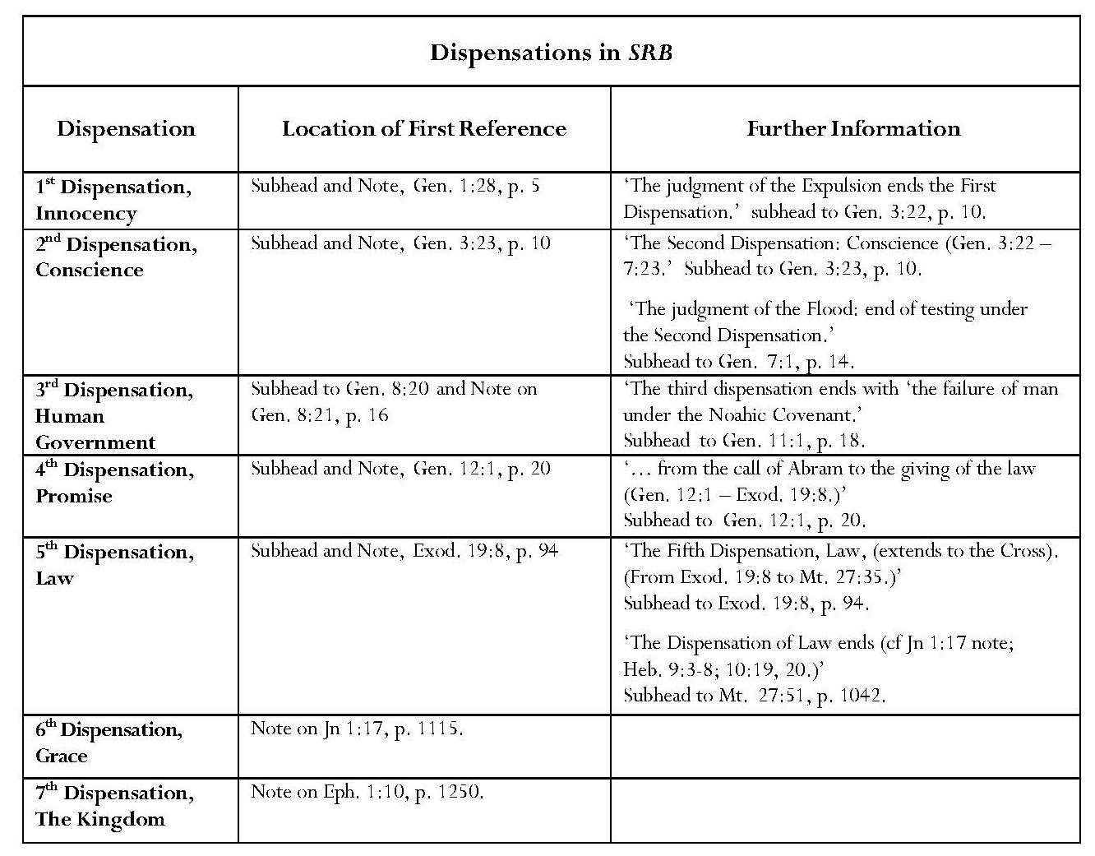
The first four dispensations are found in Genesis, the most important of these being the Dispensation of Promise, which corresponds with the Abrahamic Covenant. The fifth dispensation, Law, was instituted at Sinai and regarded by Scofield as lasting until ‘the Cross’. It is for this reason that Scofield sees Christ’s entire earthly ministry as belonging to the dispensation of law; hence the Sermon on the Mount is ‘pure law’, with only a ‘moral application to the Christian’ and even the Lord’s Prayer is ‘legal ground’ in contrast to grace. The sixth, current dispensation, of grace or of the church, was thus inaugurated at the crucifixion. This represents a hiatus or ‘parenthesis’ between the dispensations of law and the seventh and final dispensation, the kingdom, when the restoration of Israel under its Davidic ruler is to occur. This concept is foundational for Scofield’s eschatology.
Continued overleaf

5.2.2 Covenants
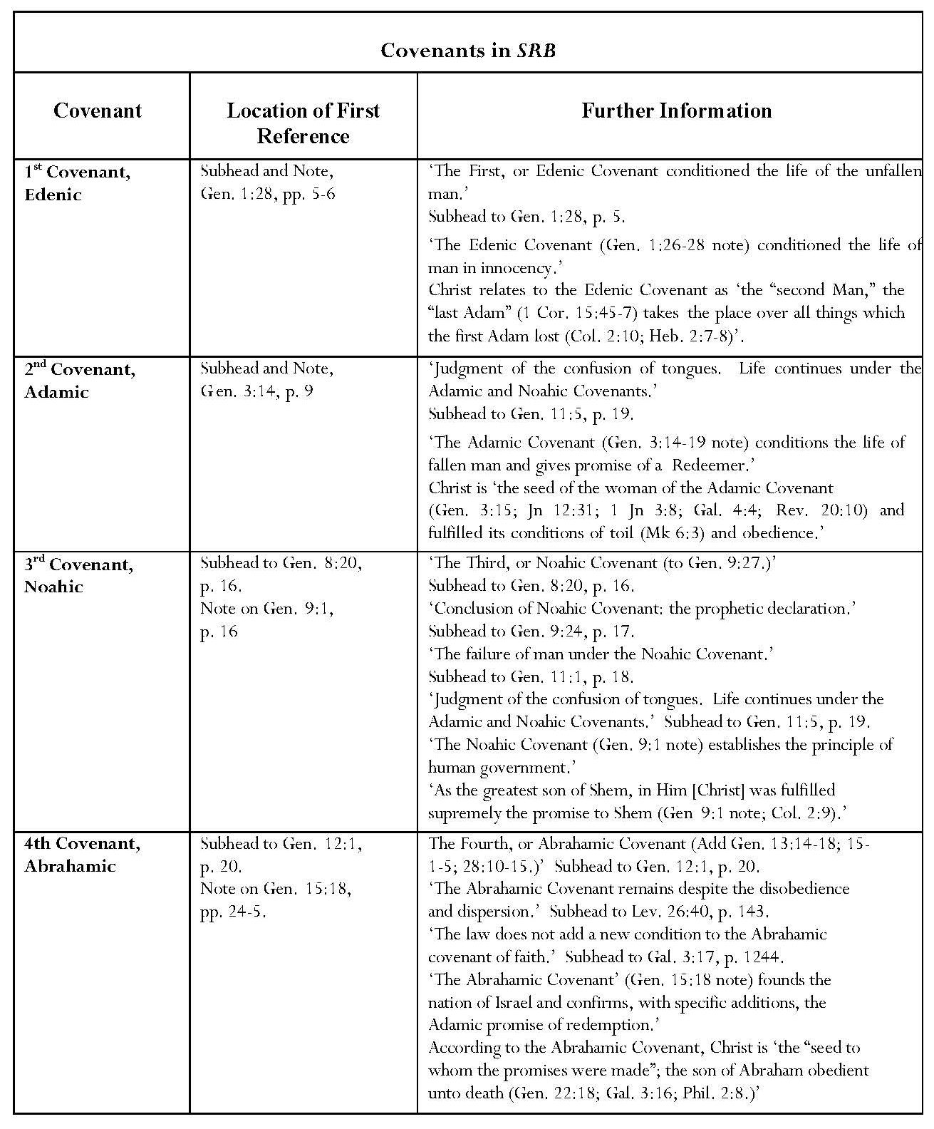
Continued overleaf
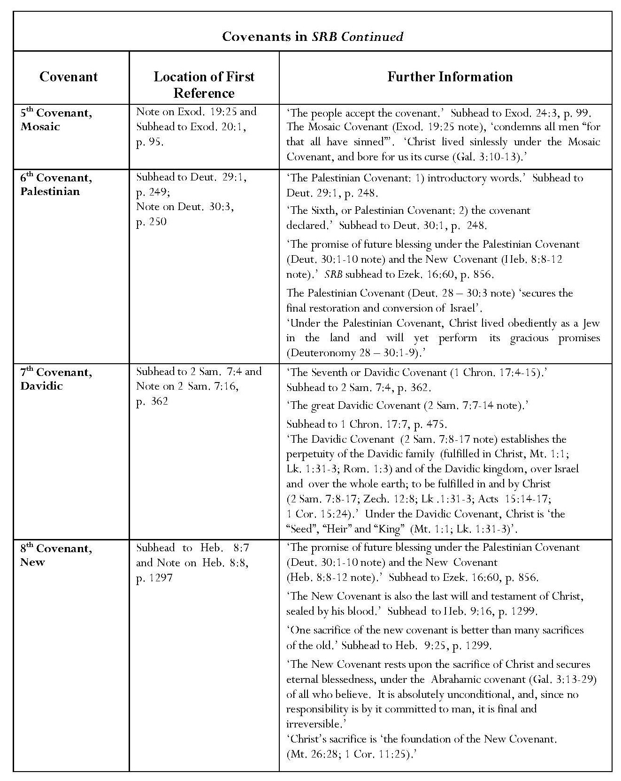
Eight covenants form a basis complementary to the dispensations for Scofield’s theology and eschatology. Scofield also refers to all eight each time one is introduced. He states that four of ‘the eight great covenants which condition human life and divine redemption’ are found in Genesis: ‘the Edenic, Adamic, Noahic and Abrahamic Covenants’. The remaining four are related to them ‘chiefly as adding detail or development’: ‘the Mosaic, Palestinian, Davidic and New Covenants’. As can be seen in the tables above, many of Scofield’s designated covenants and dispensations are referenced in subheads.
Scofield does not appear to make any definitive declaration regarding the nature of covenants in SRB parallel to his definition of a dispensation in the note on Gen. 1:28; this is rectified in the later editions of the Reference Bible, which include the statement that ‘a covenant is a sovereign pronouncement of God by which He establishes a relationship of responsibility. … The covenants are normally unconditional in the sense that God obligates Himself in grace, by the unrestricted declaration, “I will”, to accomplish certain announced purposes, despite any failure on the part of the person or people with whom He covenants.’ Charles Weston disagrees with the idea that a divine promise can be unconditional, arguing that ‘God’s promises are conditioned by his person and sovereignty … IF a so called unconditional promise COULD be made it would nullify God’s sovereignty – an absolute impossibility.’ Weston gives two examples where human behaviour affected God’s subsequent action, quoting 1 Sam. 2:30 and Jer. 18:7-10. He asserts that ‘any claim of this or that promise being unconditional is false. God says, “IF thou wilt … then will I.” There is always an IF.’ Weston avers that Jer. 18:7-10 ‘totally eliminates all so called unconditional promises and prophecies to Israel or to any other nation’.
In the absence of any formal definition of ‘covenant’ in SRB, one can turn to Scofield’s earlier Bible Correspondence Course, Old Testament, for a more cogent view of his attitude to covenants though even here Scofield does not provide a definition. He here asserts that ‘the Covenants of God disclose His whole purpose earthward’ and that ‘all Scripture crystallizes about and is the development of, these Covenants’; furthermore, ‘all the covenants meet in Christ’. These statements suggest that Scofield regards the covenants as ultimately more important than the dispensations. He distinguishes between ‘declarative, or unconditional’ covenants and ‘mutual, or conditional’ covenants. ‘Declarative or unconditional’ covenants are characterised by ‘I will’, the example provided being God’s declaration to Noah in Gen. 9:11. Such declarations may be categorised as divine promises rather than as covenants in the strict sense of the word since a covenant, by definition, must include two parties. It is true, however, that the word, בְּרִית (translated ‘covenant’) is used in the Hebrew Bible without differentiation between instances where no requirement is made of humankind where conditions have to be met by humankind; and is also used for transactions between human parties.
Scofield states in his Old Testament Correspondence Course that ‘mutual or conditional’ covenants are exemplified by Exod. 19:5. What is interesting here is that Scofield claims that ‘of the … seven greater Covenants, the Mosaic Covenant is conditional, the others are unconditional’ whereas, in SRB, both the Mosaic and the Palestinian Covenants are said to be conditional. In an oblique reference to the Mosaic Covenant in his note on Exod. 19:25, Scofield states that ‘the Christian is not under the conditional Mosaic Covenant of works, the law, but under the unconditional New Covenant of grace’; in his introduction to Deuteronomy he states categorically that ‘it was under the conditional Palestinian Covenant that Israel entered the land under Joshua’. Furthermore, violation of that covenant resulted in the disruption of the nation and then expulsion from the land; ‘but the same covenant unconditionally promises a national restoration of Israel which is yet to be fulfilled’. The discrepancy between the Correspondence Course and SRB presents an odd feature in Scofield’s writing, since the Correspondence Course was apparently published only two years before the original edition of the Reference Bible.
It should be noted that Scofield does not include the Edenic Covenant amongst his ‘seven greater covenants’ in the Correspondence Course and gives no explanation for this. It is also noteworthy that the fifth covenant listed, the ‘Deuteronomic’, is called the ‘Palestinian’ in SRB. The title, ‘Deuteronomic’ is actually more justifiable than ‘Palestinian’ because an unnamed covenant is mentioned in Deut. 29:1 as additional to ‘the covenant which [the LORD] had made with them at Horeb’ but, as discussed below, the term, ‘Palestinian’ is anachronistic. Darby does not appear to refer to this covenant and Chafer describes it as ‘the Covenant with Israel concerning Their Land (Deut. 20:1-10)’.
The Edenic and Adamic Covenants are not mentioned in the KJV text; the situations in which they occur cannot strictly be called covenants because there is no two-sided agreement in either, as defined by Bradshaw. Each comprises a divine statement, which probably accords with Scofield’s category of ‘declarative, or unconditional’ covenants. Neither the Dispensation of Grace nor the New Covenant receives a subhead proclaiming its arrival as do the earlier dispensations and covenants, but nor does the kingdom-age. Instead, Scofield refers indirectly to the Dispensation of Grace in terms of the end of the age of law and confines mention of the kingdom-age to the subhead concerning Satan’s binding. As can be seen in all the subheads in the table above, biblical references to covenants are mixed indiscriminately with references to Scofield’s own constructions, making it difficult for readers to distinguish between the two.
Covenants are actually mentioned in the biblical text of KJV with regard to Noah, for example in Gen. 6:18 and Genesis 9; and with regard to Abraham, for example in Gen. 15:18 and Genesis 17 (including the covenant to be extended to Isaac (Gen. 17:19, 21). God’s promise is extended to Jacob in Gen. 28:13-15, though the word ‘covenant’ is not used. The Mosaic Covenant is mentioned, for example in Exod. 19:5, 34:27-8 and Deut. 5:2-3; a separate covenant is mentioned ‘beside the one he made with them at Horeb’ in Deut. 29:1 but is not named. 2 Samuel 7 does not contain the word, covenant but 2 Sam. 23:5 and 2 Chron. 7:18 and 21:7 refer to the covenant with David, though obliquely. There are three references to the New Covenant in Hebrews – 8:8, 8:13 and 12:24.
Three covenants feature most prominently in Scofield’s notes concerning Israel’s status and future – the Abrahamic, the so-called Palestinian and the Davidic, along with the Mosaic, which is associated with the law. The New Covenant is discussed in commentary on Hebrews. Two notes, both on Heb. 8:8, appear self-contradictory. In the first of these, SRB states that ‘the New Covenant secures … the perpetuity, future conversion and blessing of Israel’ whereas, in the second note, it states that ‘the Palestinian Covenant … secures the final restoration and conversion of Israel’. These statements would seem to be mutually exclusive.
The ‘specific revelation of the will of God’ often seems to be couched in terms of the corresponding covenant and the ‘testing’ under a dispensation is often one of the covenantal elements – failure is sometimes under the covenant, not the dispensation. Keith Mathison states that ‘dispensationalists have failed to offer a coherent description of the way in which the dispensations and covenants work together to structure history’. This results in tension because these two methods of structuring biblical history are often contradictory. Sweetnam, however, holds that such harmonisation is not necessarily impossible even if Scofield’s attempt was not entirely successful.
Scofield avers that the Abrahamic and so-called ‘Palestinian’ Covenants still hold for ‘God’s earthly people’ and that the seventh dispensation, the kingdom, will secure the restoration of Israel under its Davidic ruler.
5.3 Distribution and Content of Dispensations
Blaising provides two useful tables in his chapter on ‘Dispensations on Biblical Theology’, which give details of ten dispensational schemes proposed between C17 and C19 and a further six schemes ‘in the dispensational tradition’. The notable feature with all these schemes is the differences between them in number and in terminology employed. The earliest scheme which Blaising notes is that of Hugo Grotius, who makes three simple divisions – Promise, Law and Gospel. The schemes of later writers basically grow more complex, except for that of Patrick Fairbairn (1805-74), who also makes three divisions – Patriarchal, Mosaic and Christian. However, most of the later schemes include a dispensation to come after the Gospel era, variously termed ‘glory’, ‘New Dispensation’, ‘Renovation (millennium)’, ‘Prophetic Gospel (millennium)’, and ‘Millennium and Eternal State’.
The first of the schemes ‘in the dispensational tradition’ noted by Blaising is that of Darby; this includes ‘the Paradisiacal State’, ‘Conscience’, ‘Noah’, ‘Abraham’, ‘Israel (divided into Law, Priest and Kings)’, ‘Gentiles’, ‘Spirit/Christian Church’ and ‘Millennium’. A footnote directs the reader to commentary on this by Crutchfield. Crutchfield notes that, although Darby ‘discusses the dispensations in a categorical way in a few places, the content of those categories is not always the same and his treatment of the dispensations is not in an altogether systematic fashion’. Darby sometimes designates the present dispensation ‘Spirit’, but at other times ‘Christian’ or ‘Gentile’. Crutchfield also states that Darby fluctuates between including and excluding the millennial kingdom as a dispensation. Crutchfield argues that Darby did not count the Paradisiacal State as a dispensation; there had at that time been no ‘administrative arrangement between God and humankind’, hence ‘there could be no dispensation under Adam’. Similarly, the period between the fall and the flood was ‘a place of human history during which the race was left completely to itself without any direct interference of God or established center of God’s dealings with it’, rather than a dispensation.
For Darby, dispensations start with Noah: ‘With Noah we begin the course of dispensations, or of the manifestations of the ways of God for the final bringing out the full glory of Christ.’ In the same document, referring to Abraham, Darby refers to ‘the next important principle brought out [which] is calling and election’, though he does not here call this a dispensation. Darby continues, ‘The next important step in the ways of God, the formation and deliverance of a people from the power of their enemies by judgments and an outstretched arm, by which they were set apart as a people of dilection (sic) to God on the earth.’ This is an intimation of the Mosaic dispensation, though again it is not named in this document. In another document, Darby asks, ‘Is it not true that God has substituted the Christian dispensation for the Jewish economy, or the dispensation of the law?’ In an oblique manner, Darby thus identifies the current dispensation. Equally obscurely, in a third document, Darby intimates on the basis of Eph. 1:9 that since God would ‘“gather together in one all things in Christ… in heaven … and on earth”’, and since ‘this is in no way applicable to the present dispensation … in which Satan is the prince and god of this world – in which he sows tares among the wheat’, this
cannot mean the church in the present dispensation, or in any dispensation for the church, as applied to believers, in no dispensation comprehends all things in heaven and on earth; and that which comprehends and gathers all into one (all things in heaven and on earth) is manifestly not the church; for the church, even here, is gathered out of the earth, and does not gather all things on the earth into itself, and as a dispensation of the assembled saints in heaven, it has none of the things of the earth in it at all.
The implication is that another dispensation is to follow.
Compared with Darby’s scheme, Scofield’s in SRB is set out very simply. The note introducing each dispensation is attached to a scriptural verse but, in view of the different historic schemes shown in Blaising’s table, it is not surprising that the placing of these attachments can appear arbitrary, for example when compared with the 1967 and 2003 editions of the Scofield Bible, where the same dispensations are identified but attached to different verses, as shown in the table below. This indicates that Scofield’s placing of the dispensations is interpretative.
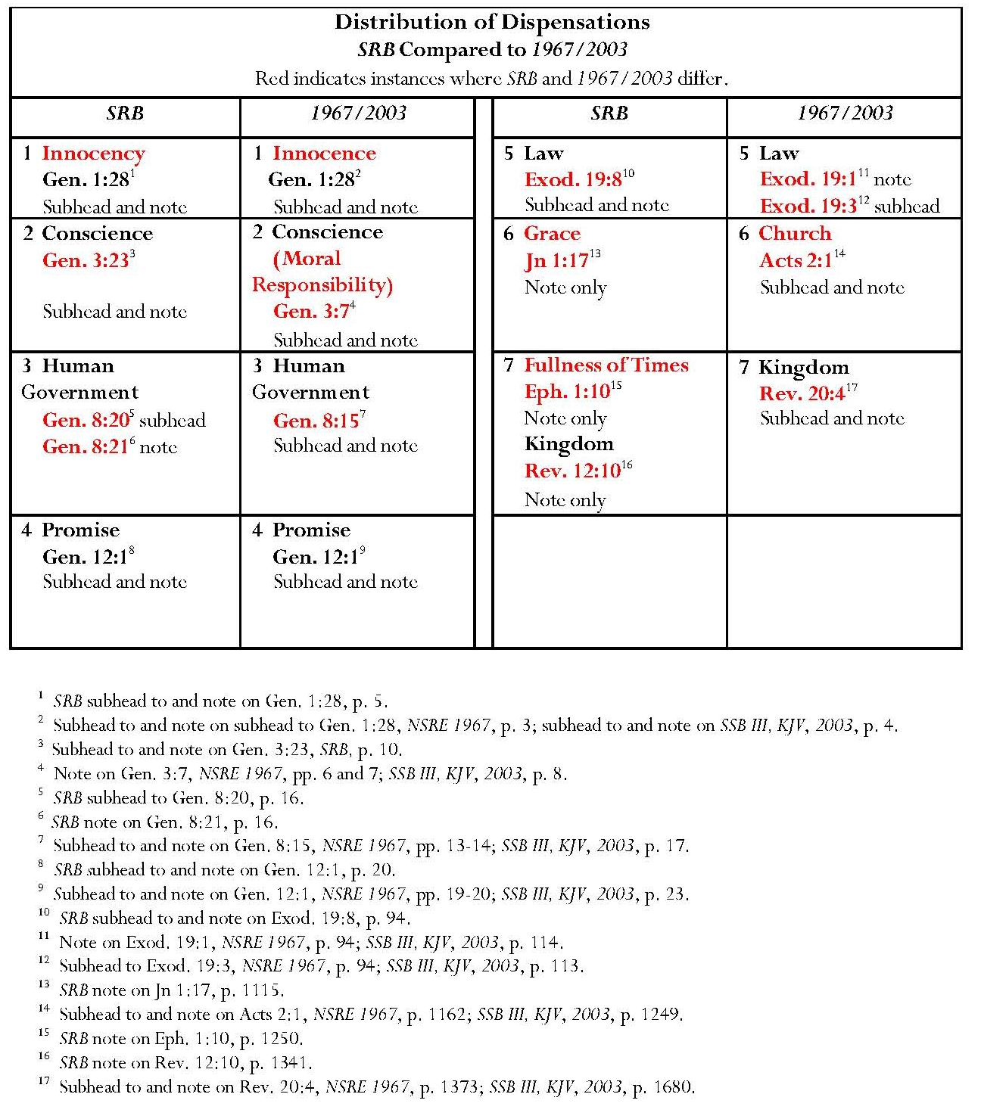

5.4 The First Five Dispensations and First Five Covenants
Since the first five dispensations correspond to the first five covenants commentary on both will be treated together. After the first five, dispensations and covenants diverge; the fifth Dispensation of Law continues until Christ’s crucifixion and is succeeded by the sixth and seventh dispensations, but the sixth covenant, the so-called Palestinian Covenant, occurs at Israel’s entry to Canaan. The seventh covenant is the Davidic Covenant, and the eighth, the New Covenant, established by Christ’s sacrifice.
5.4.1 The First Dispensation and First Covenant
The first dispensation (Innocency) and first covenant (Edenic) both open at Gen. 1:28. Though Scofield here gives Gen. 3:13 as the final verse in the First Dispensation, he inserts a subhead above Gen. 3:22, marking this verse as the end of the First Dispensation. (‘The judgment of the Expulsion ends the First Dispensation.’) Scofield introduces the Second Dispensation (Conscience) with the subhead to Gen. 3:23 (see below). In SRB, the test of innocent man in his perfect environment during the first dispensation was ‘simple’ but ‘the woman fell through pride; the man, deliberately’. The dispensation ended in ‘the judgment of the Expulsion’. The first covenant, the Edenic Covenant, ‘conditioned the life of the unfallen man’, who was created in innocency’; it involved six responsibilities for humankind and a warning of the consequence of disobedience. Humankind’s responsibilities were ‘to replenish the earth with a new order, man, to subdue the earth to human uses, to have dominion over the animal creation, to eat herbs and fruits, to till and keep the garden, to abstain from eating from the tree of the knowledge of good and evil’, the penalty for disobedience being death. According to the summary of covenants in the note on Heb. 8:8, Christ relates to this Covenant as ‘the “second man”, the “last Adam” (1 Cor. 15:45-7)’ who ‘takes the place over all the things which the first Adam lost’.
5.4.2 The Second Dispensation and Second Covenant
The second dispensation, conscience, marks ‘the awakening of conscience through disobedience and personal knowledge and experience of good … and evil’. This classification is difficult to accept because it is questionable whether Adam, devoid of conscience, would have known that his actions necessitated his hiding from God. Scofield states that, during the second dispensation and under the Adamic Covenant, humankind was constrained to do good, abstain from evil, and ‘to approach God through sacrifice’. Scofield does not explain the origin of his assertion of such constraints. Testing in this dispensation ended in the judgment of the flood.
The second covenant, the Adamic Covenant promises ‘the ultimate destruction of Satan through the “Seed of the woman”’. It ‘conditions the life of fallen man’. These conditions ‘must remain till, in the kingdom age, “creation shall be delivered from the bondage of corruption into the glorious liberty of the sons of God” (Rom 8:21)’. SRB lists seven elements in this covenant. These rehearse Scofield’s concept of sin and redemption by Christ, following a definite line of descent. Firstly, through being cursed, the serpent ‘becomes God’s illustration in nature of the effects of sin’. Atonement is intimated: Christ is made sin for us in bearing our judgment, and is ‘typified by the brazen serpent’. Scofield asserts that ‘brass speaks of judgment’ and cites the brazen altar and laver. Although Scofield takes the KJV translation of ‘tv,xon>’ as ‘brass’ at face value, brass, an alloy of copper and tin, was not invented until the first millennium BCE. Scofield is not alone in this interpretation of the significance of brass: for example, bible.org comments on the angel with the censer, Rev. 8:2-6: ‘The live coals on this altar originally came from the altar of brass, the altar of sacrifice or of judgment with the brass symbolizing judgment.’ Good News Articles states: ‘The brazen serpent, hung on a pole, forms a CROSS – brass always symbolizing judgment upon sin.’ The revelation of the inaccuracy of the KJV translation, which is replaced by ‘bronze’ in many new translations such as NRSV, NIV and NKJV, must have implications for such commentaries. In fact, the symbolism of judgment attributed by Scofield and others to brass is transferred to ‘bronze’, for example, in notes on Exod. 25:1; 27:17 and Num. 21:9 in the 1967 and 2003 editions.
The second element in the Adamic Covenant is ‘the first promise of a redeemer. Here begins “the highway of the seed,” Abel, Seth, Noah, Shem, Abraham, Isaac, Jacob, Judah, David, Immanuel-Christ.’ According to the summary of covenants in the note on Heb. 8:8, Christ is ‘the seed of the woman of the Adamic Covenant’ and fulfilled its conditions of toil and obedience. The third element in this covenant is the change in the woman’s state: ‘multiplied conception’, ‘motherhood linked with sorrow’ and ‘the headship of the man’, as a consequence of the necessity for headship which results from the disorder caused by sin. The remaining four elements concern the cursing of the earth, the ‘inevitable sorrow of life’ and physical death.
5.4.3 The Third Dispensation and Third Covenant
SRB conflates the third dispensation and the third covenant, the Noahic Covenant. The third dispensation, Human Government, was instituted after the flood, but ‘the declaration of the Noahic Covenant submits humanity to a new test’, instituting distinctively ‘the government of man by man’. It is noticeable that testing is held to be under the Noahic Covenant, rather than the third dispensation. Under this covenant, the whole human race, Jew and Gentile, is responsible for governing the world for God, but has failed.
The SRB note on Gen. 8:21 looks far ahead of the contemporary situation. Scofield states that Israel’s failure under the Palestinian Covenant led to the ‘judgment of the Captivities, when the “times of the Gentiles” began, and world government passed exclusively into Gentile hands’. Scofield returns to the immediate context by stating that the ‘racial testing’ was ended by the ‘judgment of the confusion of tongues’ but then moves again to the future: ‘Jewish testing’ will end by the ‘judgment of the Captivities’; Gentile testing ‘will end in the smiting of the Image and the judgment of the nations’. The language used reflects much later annotation, especially that on Daniel, Matthew, Luke and Revelation. It is an indication of the way in which Scofield sees the whole Bible as a single entity; eschatological material is inserted even into commentary on the earliest portions of the Bible.
It is noticeable that Scofield here uses the anachronistic words, ‘Jew’ and ‘Gentile’, even though, on his own reckoning, the categories do not exist until Gen. 11:10, when the call of Abraham ‘creates the nation of Israel’ – another anachronism. It is also doubtful whether the term ‘Jew’, is appropriate when applied to Genesis. The noun, yDiWhy>, (VIoudai/oj, LXX) does not appear in the Pentateuch. It occurs twice in plural form in 2 Kings (2 Kgs 16:6 and 2 Kgs 25:25), and once in the feminine form, hY"dIhuY>h, in 1 Chron. 4:18, but most occurrences are found in Jeremiah, Nehemiah and, especially, Esther, with the Aramaic form, yd;Why, appearing in Ezra and Daniel.
Scofield lists seven elements to be found in the Noahic Covenant; humankind’s relationship to the earth under the Adamic Covenant is confirmed, as is ‘the order of nature’. Human government is instituted; Scofield states that ‘the highest function of human government is the judicial taking of life. All other governmental powers are implied in that’. The fourth element of the Noahic Covenant is terrestrial security from further judgment by flooding. The final three elements are held to be ‘prophetic declarations’ concerning Noah’s three sons and their descendants. ‘An inferior and servile posterity’ is to descend from Ham, progeny with ‘a peculiar relation to Jehovah’ are to descend from Shem, and ‘the “enlarged races”’, are to descend from Japheth. Scofield avers that ‘government, science and art, broadly speaking, are and have been Japhetic’ and concludes that ‘his is the indisputable record of the exact fulfilment of these declarations’. Scofield further says of Shem’s descendants that ‘all divine revelation is through Semitic men, and Christ, after the flesh, descends from Shem’. According to the summary of covenants, in Scofield’s note on Heb. 8:8, ‘as the greatest son of Shem, in [Christ] was fulfilled supremely the promise to Shem’.
It is important to note that Scofield claims that these declarations concerning Noah’s sons are enshrined in a divine covenant. However, the declarations on which his note on Gen. 9:1 is based are not related to any covenant and are found in Gen. 9:25-7, where they form Noah’s response to Ham’s discovery of his nakedness in his drunken stupor.
‘And Noah awoke from his wine and knew what his younger son had done to him, ²⁵And he said, Cursed be Canaan; a servant of servants shall he be unto his brethren. ²⁶And he said, Blessed be the LORD God of Shem; and Canaan shall be his servant. ²⁷God shall enlarge Japheth, and he shall dwell in the tents of Shem; and Canaan shall be his servant.’ Gen. 9:24-7, KJV.
Significantly, in the text, Noah’s curse is upon Canaan, one of Ham’s descendants, not upon Ham. Genesis 9:1-2 actually describes God’s blessing on Noah and his sons.
‘And God blessed Noah and his sons, and said unto them, Be fruitful and multiply, and replenish the earth.’ Gen. 9:1-2, KJV.
As with the blessings and curses promised to Abram in Gen. 12:3, there is no indication that Noah’s remarks were intended for any except their immediate recipients. Also, since Scofield has designated all divine revelation as coming from Semitic men, Noah’s statements cannot be held to be divinely inspired; as Shem’s father, Noah, was patently not Semitic.
The third dispensation ends with ‘the failure of man under the Noahic Covenant’. Scofield states that judgment falls in ‘the confusion of tongues’; ‘life continues under the Adamic and Noahic Covenants’. A strange implication, found in the note on Gen. 11:10, is that Israel is now excluded from the human race since Scofield declares that ‘the human race, henceforth called Gentile in distinction from Israel, goes on under the Adamic and Noahic covenants’.
5.4.4 The Fourth Dispensation and Fourth Covenant
Scofield closely relates the fourth dispensation (Promise) to the fourth (Abrahamic) covenant; both are covered in the subhead to Gen. 12:1: ‘The Fourth Dispensation: Promise: from the call of Abraham to the giving of the Law. The Fourth, or Abrahamic Covenant.’ In the note on Gen. 12:1, Scofield describes the fourth dispensation almost totally in terms of the fourth covenant. Abraham and his descendants ‘became distinctively the heirs of promise’ through the ‘great change’ brought about by the Abrahamic Covenant. Nevertheless, Scofield asserts that the dispensation (mode of testing) must be distinguished from the covenant; ‘the latter is everlasting because unconditional’. The dispensation, which was ‘exclusively Israelitish’, ‘ended when Israel rashly accepted the law’ at Sinai, where ‘they exchanged grace for law’. Israel’s voluntary acceptance of the law is emphasised in the note on Exod. 19:3. Jehovah reminded the Israelites that they had previously been ‘objects of grace’; ‘the law was not a means of life but was the means by which Israel became a ‘“peculiar treasure” and a “kingdom of priests”’; ‘the law was not imposed until it was proposed and voluntarily accepted’. In his introduction to Matthew, Scofield describes Christ as being ‘connected’ with the Abrahamic Covenant of Promise but in the summary of covenants in the note on Heb. 8:8, Christ is ‘the “Seed to whom the promises were made”; the son of Abraham obedient unto death’.
Scofield calls the Abrahamic Covenant one of ‘the most important of Old Testament covenants’ together with the Davidic Covenant. He states that the Abrahamic Covenant ‘founds the nation of Israel and confirms, with specific additions, the Adamic promise of redemption’. This is inaccurate and misleading because the name, ‘Israel’ does not occur in the Old Testament until Abraham’s grandson, Jacob’s wrestling opponent names him ‘Israel’. The name is then applied to Jacob’s descendants and the people group of Israel. It is only with the establishment of the united monarchy under Saul, David and Solomon in 1 & 2 Samuel and 1 Kings that the idea of an area under administration really begins to emerge in the biblical text. The first incidence occurs in 1 Sam. 24:20, where Saul says to David, ‘I know that you will surely be king and that the kingdom of Israel will be established in your hands.’ Even here, the phrase is ‘laer"f.yI tk,l,m.m’, (kingdom of Israel), not ‘nation’.
The note on Exod. 19:1 quotes Galatians 3 as explaining the relation of the law to the Abrahamic Covenant. The Law cannot annul the covenant; it was added to convict of sin; it led to Christ and was ‘a preparatory discipline until the Seed came’. ‘The Law did not abrogate the Abrahamic Covenant’ or ‘add a new condition to it’. It remains ‘despite disobedience and dispersion’. ‘The descendants of Abraham had but to abide in their own land to inherit every blessing. In Egypt they lost their blessings, but not their covenant’.
In saying that the Abrahamic Covenant was unconditional, Scofield disregards conditional clauses, for example in Gen. 17:4-10, the ‘as for me’ (Gen. 17:4) and ‘as for you’ (Gen. 17:9) clauses, reflecting the Hebrew, ynIa] and hT'a. Abraham is to direct his children and household to keep the way of the Lord by ‘doing righteousness and justice so that the Lord would bring about for Abraham what he had promised him’. Gen. 18:19 NRSV, (my emphasis). KJV gives a similar rendering: ‘For I know him, that he will command his children and his household after him, and they shall keep the way of the LORD, to do justice and judgment; that the LORD may bring upon Abraham that which he hath spoken of him.’ Gen. 18:19, KJV. As Gary Burge remarks, ‘… the land is not a possession that may be enjoyed without reference to God. Possessing this land is contingent on Israel’s ongoing faithfulness to God and obedience to his law.’
In his note on Gen. 15:18, Scofield distinguishes seven ‘distinct parts’ which comprise the Abrahamic Covenant. The promise to make a great nation of Abraham is ‘fulfilled in a three-fold way’: though natural posterity, ie the Hebrew people, through spiritual posterity, ie ‘all men of faith, Jew and Gentile’, and significantly, through Ishmael. The promise to bless Abraham has been fulfilled temporally and spiritually. Of the clause ‘and make thy name great’, Scofield only says ‘Abraham’s is one of the universal names’; he does not comment on the promise that Abraham will be a blessing and, of ‘I will bless them that bless thee’, he only states that ‘in fulfilment this is closely related to the next clause’; this is ‘and curse him that curses thee’. The clause concerning the blessing of all the families of earth is ‘the great evangelic promise fulfilled in Abraham’s Seed, Christ’; this confirms ‘the promise of the Adamic Covenant’ concerning the woman’s seed.
Scofield asserts that the blessing and cursing clauses of the Abrahamic Covenant have been fulfilled; regarding Gen. 12:3, he claims that the curses have been ‘wonderfully fulfilled in the history of the dispersion. It has invariably fared ill with the people who have persecuted the Jew –well with those who have protected him. The future will still more remarkably prove this principle.’ Here there is a misreading of the second person singular object of God’s promise in Gen. 12:3 — ^yk,êr>b"åm and ^ßl.L,q;m, as being all Abraham’s physical descendants for ever, (but limited to descent through Isaac), coupled with a dangerous conflation of biblical text and historical events. Sizer states that ‘there is no indication in the text that this warning of cursing was ever intended to extend beyond Abraham. The promise, when referring to Abraham's descendants speaks of God's blessing them, not other nations blessing the Jews.’ Sizer also notes that Scofield does not comment on Gal. 3:16, 28-29, where Paul describes Christ as ‘the seed of Abraham’, and states that the promise of blessing to the Gentiles depends upon faith in Christ, not upon their treatment of the Jews. Moreover, according to Jeremiah, it is those who trust in the Lord who are blessed whereas those who trust in idols are cursed.
Scofield asserts that ‘it is important to see that the nation has never as yet taken the land under the Abrahamic Covenant, nor has it ever possessed the whole land’. Sizer disagrees; Scofield’s assertion is contradicted by Josh. 11:23 and 21:43, 45, and by Neh. 9:22-3. These verses are significant because arguments as to whether the Abrahamic Covenant has yet been fulfilled depend upon them; Scofield does not comment on them. Burge disagrees with the very notion of Israel’s possession of the land. ‘In a profound sense, Israel never “owns” the land of promise. God owns the land. Israel here is viewed as a tenant in this land, an alien, a renter. … God will determine the tenure of its occupants.’
5.4.5 The Fifth Dispensation and Fifth Covenant
The fifth dispensation, Law, ‘extends from Sinai to Calvary — from the Exodus to the Cross’. Israel’s history has constituted ‘one long record of the violation of the law’. The testing of the nation by the law ended at the Captivities but the dispensation itself ended at the Cross. It thus appears that there was no testing under the Dispensation of Law for more than 700 years of its course.
Many SRB notes relate the Dispensation of Law to the corresponding Mosaic Covenant and to the succeeding Dispensation of Grace. All three concepts are inseparably intertwined. For example, in the note on Exod. 19:5, Scofield states that ‘the “if” of Exod. 19:5 is the essence of law as a method of divine dealing, and the fundamental reason why “‘the law made nothing perfect”’, whereas ‘the Abrahamic and New Covenants minister salvation and assurance because they impose but one condition, faith’.
As stated above, the duration of the Dispensation of Law to the Cross indicates that Scofield regards Jesus’ incarnation, life and ministry as belonging to this dispensation. In his note on Gal. 3:24, Scofield repeats that ‘law, as a method of divine dealing with man, characterized the Dispensation of Law from the giving of the law to the death of Jesus Christ’. In his note on Mt. 6:12, he states, ‘Under law forgiveness is conditioned upon a like spirit in us; under grace we are forgiven for Christ’s sake and exhorted to forgive because we have been forgiven.’ Scofield’s reference here to Mt. 18:32 does not support his argument because that, too, as an avowedly Jewish parable concerning the unforgiving servant, also urges those who have been forgiven to forgive. In his note on Lk. 11:1, Scofield reiterates that, ‘dispensationally’, ‘the so-called Lord’s Prayer’ is based upon ‘legal, not church ground’. He asserts that the Lord’s prayer ‘is not a prayer in the name of Christ and it makes human forgiveness, as under the law it must, the condition of divine forgiveness; an order which grace exactly reverses’. However, he recognises that, in the Lord’s prayer, Jesus gives a model for all prayer, which is to be grounded in relationship with God.
Scofield states that the Mosaic Covenant contained three interdependent elements – the Commandments, expressing God’s righteous will; the judgments, governing Israel’s social life; and the ordinances governing Israel’s religious life. Together these constituted ‘“the law”, as that phrase is generically used in the New Testament’. The Commandments and ordinances formed one religious system and the Commandments were ‘a ministry of condemnation and of death.’ The ordinances instituted the High Priest as the people’s representative, offering sacrifices for their sins ‘in anticipation of the Cross’. Christians are not subject to ‘the conditional Mosaic Covenant of Works’ ‘Christ lived sinlessly under the Mosaic Covenant, and bore for us its curse.’
5.5 The Sixth, Seventh and Eighth Covenants
5.5.1 The Sixth Covenant
Although Scofield repeatedly lists Deut. 30:3 as his reference for the so-called Palestinian Covenant, he introduces the concept much earlier, in his note on Gen. 25:1, where he refers to Keturah as possibly representing ‘the fertility of I Jer. 25:29, p. 799; Israel, the natural seed, Jehovah’s wife after the future national restoration under the Palestinian Covenant’. A note on Deut. 28:1 states that ‘Chapters 28 — 29 are, properly, an integral part of the Palestinian Covenant’ and a subhead to Deut. 29:1 introduces it. This sixth covenant ‘gives the conditions under which Israel entered the land of promise’, which was ‘under Joshua’. Scofield states that it is the covenant under which ‘Christ lived obediently as a Jew in the land’ and it will ‘yet perform its gracious promises’, including ‘the final restoration and conversion of Israel’. This makes a connection with the second coming of Christ and the establishment of the millennial kingdom. In his note on Lev. 23:27, Scofield states that Israel’s sorrow and repentance here ‘look forward prophetically to [her] repentance after her regathering under the Palestinian Covenant’. The name, ‘Palestinian Covenant’, is repeated in the note on the chapter-heading of Leviticus 26, which states that ‘this chapter should be read in conjunction with Deuteronomy 28 — 30, ‘the Palestinian Covenant’. SRB also mentions regathering under the Palestinian Covenant in its introduction to the historical books.
The introduction to Deuteronomy and commentary on Deuteronomy 30 describe the terms of the conditional Palestinian Covenant. Disobedience would result in dispersion, but repentance would lead to restoration to the land, national conversion and prosperity, along with the judgment of Israel’s oppressors. This covenant ‘unconditionally promises a national restoration of Israel which is yet to be fulfilled’. Scofield states that the Palestinian Covenant is in seven parts, beginning with dispersal and ending with national prosperity: ‘dispersion for disobedience’, Israel’s future repentance in dispersion, the Lord’s return, restoration to the land, national conversion, the judgment of Israel’s oppressors, and national prosperity. Warnings in Jeremiah 11 are attributed to violations of the Palestinian Covenant and drought, already partly fulfilled in the reign of Ahab, is said to be one of the signs predicted in it. Scofield avers that the ten tribes have never been restored to Palestine after the Assyrian captivity and refers to the note on the Palestinian Covenant. However, they will eventually be restored to Palestine along with Judah to form one nation again. Scofield also states that the Palestinian Jews were dispersed in AD 70. However, the Palestinian Covenant’s promise of future restoration and exaltation for Israel is renewed by Jehovah in Isa. 1:2. The use of the adjective, ‘Palestinian’ is unusual, even though the area was known as Syria-Palaestina in 70 CE. The future blessing of Israel depends upon the Palestinian and Davidic Covenants. The expulsion of Israel from the land ‘does not set aside’ these Covenants.
No covenant is mentioned in Deuteronomy 30. Deuteronomy 29:1 does mention a covenant in addition to the one made at Horeb, but this is not named, and Deut. 29:19-28 delineate threatened consequences of disobedience. Scofield ignores these threats and elaborates on the promises of restoration in Deuteronomy 30, making a brief reference to dispersion for disobedience and minimising the conditions upon which any restoration can be based. The NRSV note refers to the covenant mentioned in Deut. 29:1 as ‘the Renewal of the Covenant in Moab’. This is ‘said to be what was given at Moab, and in addition to the law as it was given at Horeb. It actually represents an expansion of the legal tradition after the exile to account for the sufferings and despair of that experience.’
Continued overleaf
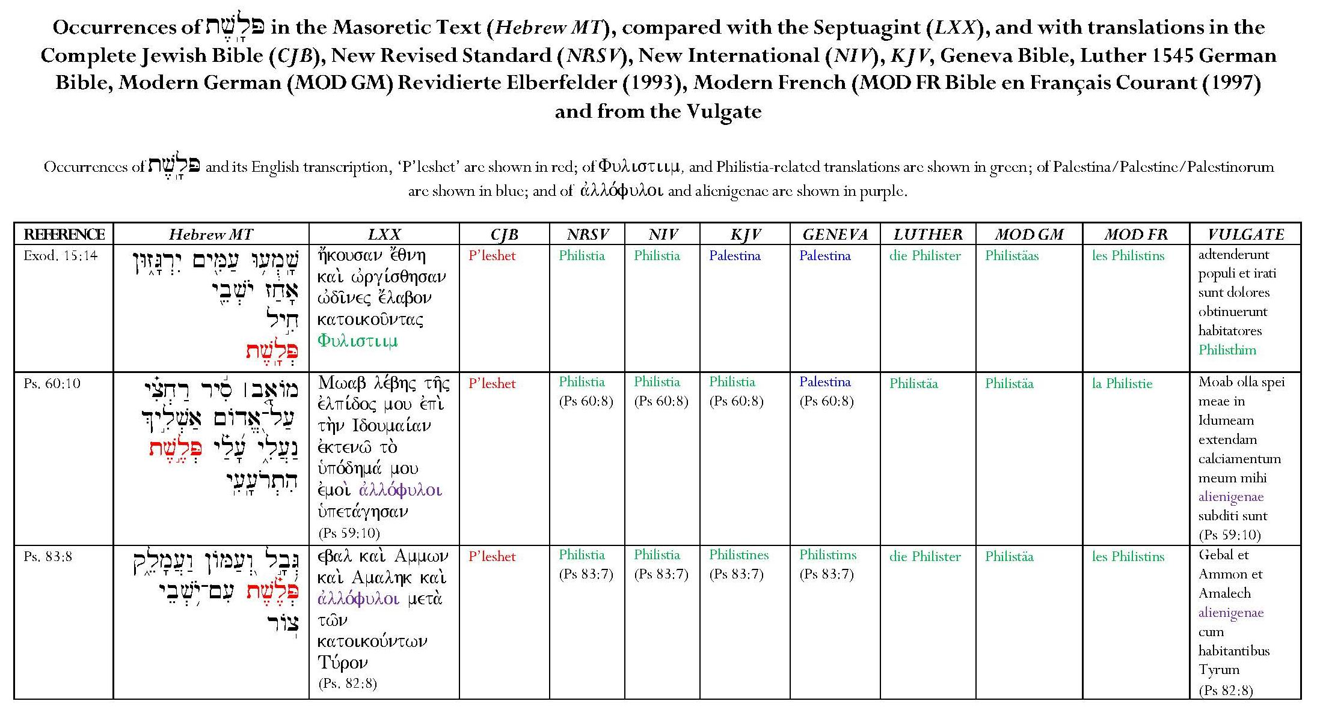
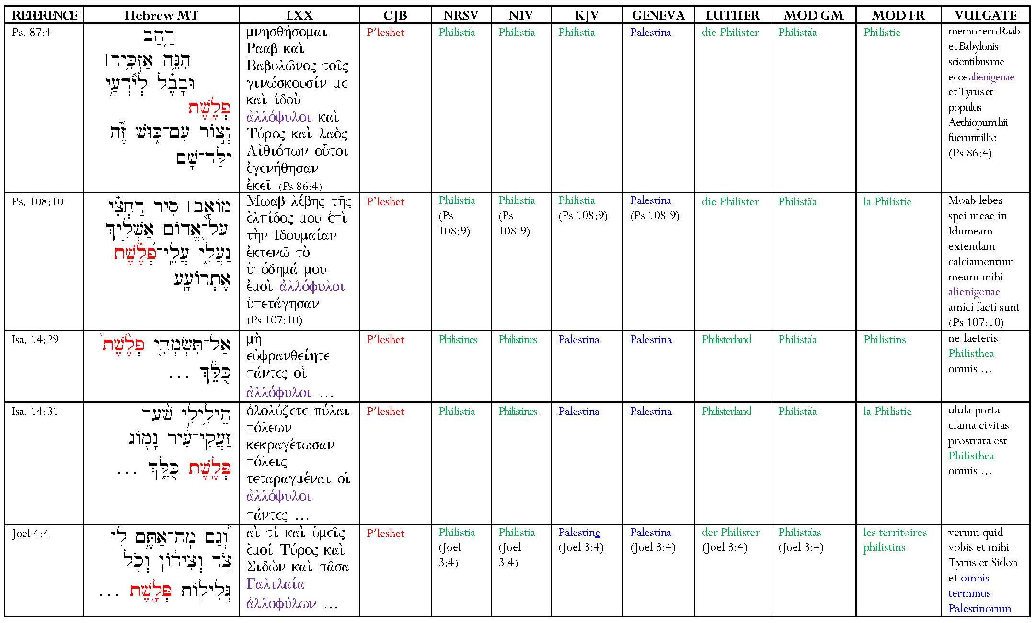
The term, ‘Palestinian’, is misleading. No place-name is mentioned in Deuteronomy 30; all references are to ‘the land’. The adjective, ‘Palestinian’, does not appear in KJV, which Scofield annotated, or in English translations like NRSV, NIV, and others, whereas ‘Philistine’ is common. tv,l,P. in varied forms occurs in the Masoretic text. The table below shows the eight incidences of it as a place-name in verses of the Hebrew Bible, with the LXX and Vulgate equivalents, and five English, one French and two German translations of the name.
In these eight verses, tv,l,P is rendered in LXX as Fulistiim once, as avllo,fuloi six times and as Galilai,a avllofu,lwn.. once. The Vulgate follows the same pattern, with Philisthim for Fulistiim in Exod. 15:14 and alienigenae for avllo,fuloi in the Psalms, but substitutes Philisthea for avllo,fuloi in the two verses from Isaiah 14 and omnis terminus Palestinorum for Galilai,a avllofu,lwn.. in Joel 4:4 (3:4). tv,l,P is consistently rendered as P’leshet in the Complete Jewish Bible (1998) though it appears as Philistia in the Jewish Publication Society (1917) edition.
The English versions studied consistently translate tv,l,P as ‘Philistia’ or sometimes ‘Philistines’, where a vocative is required, except in KJV and the Geneva Bible. Luther’s Bible and the modern German and French Bibles all use variants of Philister/Philistäa/Philisterland or les Philistines/la Philistie/les territories philistins. Apart from the Vulgate’s Palestinorum, in its rendering of Joel 4:4 (3:4), KJV and the Geneva Bible seem to be the only versions which translate tv,l, as ‘Palestina/Palestine’ in any of the eight verses. The Geneva Bible uses ‘Palestina’ consistently except for its use of ‘Philistims’ in Ps. 83:7. KJV is much less consistent, using ‘Palestina’ in certain verses and ‘Palestine’ in its translation of Joel 4:4, but in its translations of the Psalms, it uses ‘Philistia’ or ‘Philistines’. One might conjecture that the use of ‘Palestine’ in Joel 3:4 echoes the Vulgate’s omnis terminus Palestinorum.
Under these circumstances, it seems odd that Scofield chose the term, ‘Palestinian’ when annotating Deut. 30:3. None of the instances of tv,l,P is found in Deuteronomy and on very few occasions is the word translated into English as ‘Palestina’. It is true that Scofield used KJV, which contains three occurrences of ‘Palestina’ and one of ‘Palestine,’ but KJV also contains three references to Philistia, translating the same Hebrew word, tv,l,P, and thirty-three to the noun Philistine (yTiêv.liP.h). There are also approximately 280 references to Philistines in KJV, matching the Hebrew ~yTiÞv.liP, and no references to ‘Palestinians’ or a ‘Palestinian Covenant’.
Scofield uses the term, ‘Palestine’ in commentary on several passages where other names would be more accurate; for him the name seems to be a comprehensive term. SRB speaks of Palestine in commentary on Joshua, 2 Kings, Isaiah, Daniel, Joel, Amos and Zechariah. In some of these cases, the term ‘Canaan’, and in others, ‘Yehud’, would be more appropriate. David Jacobson states that the first clear, recorded, use of the name, Palestine, referring to ‘the entire area between Phoenicia and Egypt’, was by Herodotus in C5 BCE.
It is possible that Scofield anachronistically used the adjectival form of the name ‘Palestine’, by which the area was known in his own day. However, it is interesting to compare dates and places relevant to the planning and production of SRB with dates of the Zionist Congresses which began in 1897. According to Gaebelein, Scofield first spoke to him of ‘a plan of producing a Reference Bible’, ‘with references and copious footnotes’, during the first Sea Cliff Bible Conference of July 1901, and spoke of it again at the fourth conference in 1904. 1904 was the same year in which Scofield and his second wife, Hettie, visited London and, according to Scofield’s biographer, Trumbull, also visited Montreux in Switzerland before returning to America. Joseph Canfield suggests that Scofield may have made an earlier visit to London. Late in 1906, Scofield visited Oxford and then Switzerland again.
Theodor Herzl had published Der Judenstaat, in 1896 and the First Zionist Congress took place in Basle, Switzerland in 1897, with Herzl as chair. Two of the Congress’s major achievements were the foundation of the World Zionist Organisation and the formulation of the Basle programme, which stated that ‘Zionism seeks for the Jewish people a publicly recognized legally secured homeland in Palestine’. The second and third congresses were held in Basle in 1898 and 1899 and the fourth in London in 1900. The fifth, sixth and seventh congresses took place in Basle in 1901, 1903 and 1905 respectively. While it cannot be proved that these events had any influence on Scofield, it is interesting that he was in Switzerland, albeit in Montreux and Lausanne, not Basle, in 1904 and 1906, around the time that the sixth and seventh congresses were taking place, and could have been in London at the time of the fourth congress, or shortly after it. It could also be significant that he was working on the Reference Bible around that time. It is possible that this is one reason for the use of ‘Palestinian’ in notes on a Bible which does not contain the word.
Scofield states that the Palestinian Covenant ‘secures the final restoration and conversion of Israel’ and the seventh, Davidic Covenant ‘establishes the perpetuity of the Davidic family (fulfilled in Christ) … and of the Davidic kingdom, over Israel and over the whole earth, to be fulfilled in and by Christ’. Both these statements reflect and reinforce Scofield’s own interpretations of the texts in Deuteronomy and 2 Samuel.
5.5.2 The Seventh Covenant
Scofield states that the Davidic Covenant is set out in 2 Sam. 7:8-17. The theocratic kingdom will be restored under it. Scofield states that the Davidic Covenant is the source of ‘all kingdom truth’.
Many items of commentary concern the Davidic Covenant, which awaits fulfilment. It bestows ‘blessing through power’ and will be fulfilled at the Lord’s coming as the Abrahamic Covenant of blessing through suffering was fulfilled at his first advent. Disobedience in the Davidic family will lead to chastisement but not to abrogation of the covenant. This chastisement occurred first in the division of the kingdom under Rehoboam and finally in the Captivities. The sole king of the Davidic family since then was crowned with thorns. However, according to the SRB Introduction to 1 Chronicles, blessing will come to God’s earthly people through the Davidic monarchy. God’s future incarnation in Christ is ‘distinctly predicted in the promises connected with … the Davidic Covenant’; this covenant, ‘confirmed to David by the oath of Jehovah, renewed to Mary by the angel Gabriel’, is immutable and ‘the Lord God will yet give to that thorn-crowned One “the throne of his father David”’.
Psalm 89:27 simultaneously confirms and expounds the Davidic Covenant and ‘looks beyond David and Solomon’ to Immanuel. Even though the covenant arises from Jehovah’s lovingkindness, it still depends upon his oath and he is glorified in connection with it. Israel’s national regathering, conversion and establishment in peace and power, ‘invariably’ connected by the prophets to the fulfilment of the Davidic Covenant, is to take place ‘under the Davidic Covenant’. The statement in Acts 15:13 concerning rebuilding David’s tabernacle indicates ‘the re-establishment of the Davidic rule over Israel’. David’s family and kingdom are perpetuated. ‘The “throne of David”’ represents historical reality.
Scofield asserts that, under the Davidic Covenant, Christ is ‘the Seed, Heir and King’. He fulfils the Davidic Covenant as King, and his kingly office is defined in it. Scofield avers that, in Matthew, Christ appears most prominently as the covenanted king, David’s righteous Branch. Scofield holds that Matthew deals first with Christ as King and only turns to ‘the earlier covenant and … the sacrificial death of the Son of Abraham’ in chapters 26 — 8.
5.5.3 The Eighth Covenant
Scofield asserts that ‘the New Covenant is the eighth, thus speaking of resurrection and of eternal completeness’. This assertion is unexpected because the usual number of perfection is seven, a number which recurs frequently in Revelation and reflects several Old Testament concepts, as noted by Josephine Massyngberde Ford. Ford states that ‘the number [seven] is chosen intentionally [in Rev. 1:4] because it designates completeness, perfection, totality. In Judaism its sacredness was enhanced because the Sabbath was the seventh day, the sabbatical year was the seventh year, and the seventh sabbatical was the Jubilee … in the temple were seven altars, seven lamps etc.’
Scofield states that obedience to the divine will is intrinsic to this final covenant of grace. The New Covenant ‘rests upon the sacrifice of Christ and secures eternal blessedness, under the Abrahamic Covenant … of all who believe. It is absolutely unconditional, and … it is final and irreversible’. Christ’s single sacrifice under the new covenant ‘is better than the many sacrifices of the old’. This covenant is Christ’s ‘last will and testament sealed by His blood’.
Scofield states that the New Covenant is ‘better’ than the Mosaic Covenant, and that Hebrews contrasts ‘the good things of Judaism and the better things of Christ’. This superiority is efficacious, not moral and this covenant is established on ‘better’ promises which are unconditional. The subheads to Heb. 8:6 and 8:7 read respectively, ‘Because Christ mediates a better covenant’ and ‘The new covenant better than the old.’
SRB is ambiguous concerning the conversion of Israel; in its two notes on Heb. 8:8, it attributes this to both the Palestinian and New Covenants. In the first of these notes, Scofield states that ‘the New Covenant secures … the perpetuity, future conversion and blessing of Israel’ whereas, in the second note, he states that ‘the Palestinian Covenant … secures the final restoration and conversion of Israel’. These statements seem to be mutually exclusive. Despite Scofield’s claim concerning the New Covenant in the first note, this does not abrogate the Palestinian and Davidic Covenants ‘for the earth shall be filled … etc. and Jehovah will again be in His temple’. This statement appears to advocate the physical return of the Jews to what Scofield is calling ‘Palestine’ and the rebuilding of a physical temple. This belies Christ’s statement that the temple to be raised would be his body.
It is notable how much less material is included concerning the New Covenant than concerning the earlier covenants, especially the Abrahamic and Palestinian Covenants. Even the lengthy note on Heb. 8:8, which is the main commentary on the New Covenant, is partly taken up with a summary of all the covenants and Christ’s relationship to them.
5.6 The Sixth and Seventh Dispensations
5.6.1 The Sixth Dispensation
Scofield asserts that the entire sixth dispensation, or Church Age, lies between Daniel’s sixty-ninth and seventieth weeks, representing a hiatus between the Dispensation of Law and the Dispensation of the Kingdom. This age separates the suffering of the Messiah from his glory, something unforeseen by the Old Testament prophets, but revealed in the New Testament. New revelations relevant to the new dispensation were made through the preaching of New Testament prophets.
Scofield introduces the sixth dispensation, Grace, in his note on Jn 1:17. It is odd that Scofield attaches his main exposition of the sixth dispensation to this verse in John 1, when its first statement asserts that ‘as a dispensation, grace begins with the death and resurrection of Christ’. It would seem more logical to apply it to, for example, a verse in John 20, or one of the resurrection texts in the other gospels. The placing of the note here also seems to contradict Scofield’s assertion that Christ’s life belongs to the Dispensation of Law, for example in his note on Mt. 6:12, concerning the Lord’s Prayer as legal ground. The ‘Dispensation of the Grace of God’ has already been mentioned in connection with Christ’s death and resurrection in the note on Mt. 28:19, though SRB indicates Jn 1:17 as representing this dispensation in each list of dispensations, starting with the note on Gen. 1:28.
The heading to the note on Jn 1:17 is ‘Grace, Summary’; the note concerns mainly the contrast between law and grace. Scofield states that ‘grace is “the kindness and love of God our Saviour toward man …, not by works of righteousness which we have done”’. Grace is always contrasted with law, ‘under which God demands righteousness from man, as, under grace, He gives righteousness to man’. Law is ‘connected with Moses and works’ whereas grace is connected with ‘Christ and faith’. ‘Law blesses the good; grace saves the bad’ and ‘law demands that blessings be earned; grace is a free gift’. Grace has ‘a twofold manifestation in salvation, and in the walk and service of the saved’.
Scofield’s summary of Grace contains two anomalies. Firstly, Scofield contradicts himself. Having stated that the Dispensation of Grace begins with the Christ’s death and resurrection, and having averred that testing under grace is ‘acceptance or rejection of Christ with good works as a fruit of salvation’, he then asserts that ‘the immediate result of this testing was the rejection of Christ by the Jews, and His crucifixion by Jew and Gentile’. He thus implies that testing under grace actually occurred during the Dispensation of Law and preceded the onset of the Dispensation of Grace. The Jews failed in not accepting Christ, which was allegedly their obligation under a dispensation which did not exist at that time.
Secondly, the note on Jn 1:17 contains the ambiguous statement that ‘the point of testing is no longer legal obedience as the condition of salvation’. This clearly implies that salvation was achieved through works during the Dispensation of Law even though Scofield asserts elsewhere that salvation comes ‘through a crucified and risen Lord’ and is available to ‘all who believe’. Kraus refers to Scofield’s ambiguity on this matter; he asks two pertinent questions: ‘Does man’s salvation in any way depend upon his response to the dispensational tests? Is the nature of the response demanded in each dispensation the same?’ He suggests that Scofield would reply in the affirmative to both these questions, at least in some sense, but that, concerning the second question ‘[his] dispensational distinctions, if they mean anything at all, seem to belie [his] answer’. Consequently ‘one must conclude’ from statements in the notes on Jn 1:17 and Mt. 6:12, and in ‘others which sharply contrast the two dispensations and thereby make the same implicit contrast’, that ‘God does employ a different approach to salvation in each dispensation’. Quoting the SRB note on Jn 1:17, Bass states that ‘the presupposition of the difference between law and grace, between Israel and the church, between the different relations of God to men in the different dispensations, when carried to its logical conclusion will inevitably result in a multiple form of salvation – that men are not saved in the same way in all ages’. This implication has been vehemently denied by later dispensationalists, including the editors of the 1967 and 2003 editions of SRB. Both of these state categorically that ‘grace is the basis for salvation in all dispensations, and is under all circumstances the only way of salvation from sin’. Walvoord, reviewing Bass’ book, accuses him of perpetrating ‘the oft-repeated libel that dispensationalism teaches two ways of salvation’. Ryrie suggests that the charge that dispensationalism promotes two ways of salvation is one of the supposed teachings which opponents to dispensationalism ridicule and use to condemn the entire system. Chafer states that ‘The law was never given as a means of salvation or justification’.
Scofield’s main contention with regard to the Dispensation of Grace is the contrast between it and the preceding Dispensation of Law. He states that the sixth dispensation, which runs concurrently with the mystery form of the kingdom, endows believers with spiritual blessings; this is in contrast to the ‘Jewish dispensation’, whose blessings were the temporal reward of an obedient people, and the kingdom-age, during which ‘spiritual and temporal blessings unite’. Under this dispensation, ‘the Mosaic system, if still persisted in, becomes a mere “Jews’ religion”’.
Scofield generally holds that the concepts of law and grace must be kept completely separate, though he does allow the intrusion of law into the Dispensation of Grace as a behavioural guide for believers. Referring to Gal. 1:6, Scofield defines ‘another gospel’ as being a message which excludes grace, or mingles it with law as a means to justification or sanctification, or denies the fact or guilt of sin. In his note on Gal. 3:24, he states that ‘the attempt of the legalistic teachers to mingle law with grace as the divine method for this dispensation brought out the true relation of law to the Christian’ and then gives a definition of the role of the law in the Dispensation of Grace. In this Scofield rehearses many arguments made in the Pauline and Deutero-Pauline letters and in Hebrews, to which he gives many references. This places Scofield within evangelical Christian tradition on this matter. Law, itself ‘holy, just, good and spiritual’, is in contrast to grace because under grace ‘God bestows the righteousness which, under law, he demanded’. Because the whole world is guilty before the law, ‘the law is therefore of necessity a ministry of condemnation, death and the divine curse’. Christ took on the law’s curse and redeemed the believer from that and its dominion. Sinners are not justified by the law or believers sanctified by it. Believers are under grace, not law, and, ‘under the new covenant of grace the principle of obedience to the divine will is inwrought; the believer is under the “new law of Christ”; indwelt by the Spirit ‘the righteousness of the law is fulfilled in him’. ‘The commandments’ are thus for Christians ‘an instruction in righteousness’.
Mangum’s assertion that one of Scofield’s tenets was that ‘law and grace are mutually exclusive principles that characterize different dispensations and are in mutual diametric contrast’ is somewhat belied by the final clause in the note above. This shows some congruence with the opposite, covenant-theological view given by Mangum: ‘The Law as given by God (not perverted as by the Pharisees and hypocrites), is a gracious guide for living righteously for the person in the right relationship to God, such that even the present-day believer is provided through the Mosaic law clear principles for living in a way that pleases God.’ and that modern believers ‘gain principles from it for righteous living’.
Scofield regards Acts 15 as the most important New Testament passage for dispensational theory, giving God’s purpose for this age and the start of the next age. The elements are ‘the taking out from the Gentiles of a people for His name’; the final regathering of Israel; and the rebuilding of the tabernacle of David (i.e. the re-establishment of Davidic rule over Israel) so that ‘the residue’ of Israelites, and all the Gentiles might seek God. The distinctive feature of the present age is Christ’s salvation of the Gentiles. ‘The prophets connect Christ with the Gentiles in a threefold way’, firstly he is the Light of their salvation, secondly he will be their ruler as ‘the “Root of Jesse”’ ‘in the kingdom-age to follow this’, and thirdly ‘believing Gentiles, in the present age, together with believing Jews, constitute “the Church which is His body”’. ‘The “fullness of the Gentiles”’ marks the completion of God’s purposes for this age; the return of the Redeemer to Zion follows the completion of the Gentile Church. This concentration on the Gentile Church reinforces Scofield’s consistent concept of the eternal separation between Church and Israel, even as it contradicts his statement that the New Testament Church is ‘one body, composed of Jew and Gentile’, and that ‘the divine purpose [is] to make of Jew and Gentile a wholly new thing “the church”’. There seems to be no place for Jewish believers in Scofield’s account of the sixth dispensation.
The presence of the Holy Spirit is another distinction of the sixth dispensation. Peter’s encounter with Cornelius indicates that the Holy Spirit was given immediately to all those of faith in Christ; this is ‘the permanent fact for the entire church-age’. The ‘normal order’ is the giving of the Holy Spirit through faith in Christ. The interval between Pentecost and the feast of trumpets in Leviticus is said to parallel the Holy Spirit’s long Pentecostal period of work in ‘the present dispensation’. No believer of this dispensation needs to pray that the Holy Spirit should not be removed from him.
However, in commentary on some of the parables, Scofield also concentrates on the apostate nature of Christendom in this age, where world-wide conversion should not be anticipated. Scofield states that the Judaeo-Christian writers, unlike Paul, who describes the saved body of believers, see the Church as ‘a professing body in which, during this age, the wheat and tares are mingled’. Scofield asserts that ‘the predicted end of the testing of man under grace is the apostasy of the professing church’ and ‘apocalyptic judgments’. While believers are saved, the unbelieving world and apostate church are judged. For Scofield, the plague of insects in Joel represents ‘the end-time of the present age’. The prophecy of Jer. 25:29 concerns, not merely Nebuchadnezzar’s invasion, but also the end of the age, the Day of the LORD and Armageddon, and the account of the siege of Jerusalem in Lk. 21:20-24 refers to Titus’ siege of 70 CE, adumbrating the end-time siege of Rev. 19:11-21.
Scofield’s prediction of humankind’s failure under the Dispensation of Grace implies that Christ’s incarnation and universal offer of grace introduce a dispensation no different from preceding dispensations. Mathison states that ‘the description of dispensations as periods during which man fails the tests given to him by God is faulty’. It ‘does not do justice to the promises of God given to Christ and the church during the present age’.

5.6.2 The Seventh Dispensation
The final dispensation is the ‘last of the ordered ages’ that of the fullness of times or ‘kingdom-age’ and it ‘gathers into itself, under Christ, all past “times”’. It is listed fourth in an order of events in the day of Jehovah, where it is called ‘the thousand years, i.e. the kingdom-age’. The reference to ‘the Dispensation of the Fullness of Times’ in Eph. 1:10 is the only instance in KJV where ‘dispensation’ is used in Scofield’s sense. The other three uses of the word, ‘dispensation’ are in 1 Cor. 9:17, Eph. 3:2 and Col 1:25, where the sense has far more to do with work to be done. This dispensation is ‘synonymous’ with both the ‘last days’ in relation to Israel and also with ‘the days of Israel’s exaltation and blessing’. It is ‘identical with the kingdom covenanted to David’. SRB speaks of ‘the reign of David’s righteous branch in the kingdom-age’. Subheads to Isaiah 25 to Ezekiel 40 and to Micah proclaim the kingdom-age. SRB links the kingdom-age with the first resurrection in its subheads to Isa. 24:22 and Rev. 20:4, and ‘the coming of the Lord’ with ‘the first resurrection’ in its subhead to subhead to 1 Cor. 15:1. As stated in 4.1, the note on Rev. 14:6 describes the divine plan to fulfil the Davidic Covenant by establishing the millennial kingdom on earth under his Son, who is ‘David’s heir’, a kingdom which is to be ‘political, spiritual, Israelitish [and] universal’.
Scofield makes several references to the temple and Jerusalem in connection with the kingdom-age. The symbolism of the temple ‘may be revealed in the kingdom-age’. The subhead to Isa. 52:1 reads, ‘Vision of Jerusalem in the kingdom-age’. ‘The word, “Zion” is often used of the whole city of Jerusalem considered as the city of God … especially in passages referring to the future kingdom-age’. Jeremiah’s vision includes ‘the kingdom-age’. Ezekiel uses the measuring line as ‘a symbol of the preparation for rebuilding the city and temple in the kingdom-age’. Scofield states that ‘the kingdom-age temple is one of the themes of Haggai’ and Joshua and Zerubbabel ‘point to Christ as Priest-King in the kingdom-age’.
The kingdom-age begins with Christ’s return to earth, continues during his thousand-year earth-rule, and ends when he has delivered the kingdom to the Father. During this dispensation, Israel’s blindness and chastisement will end, and the kingdom, which, owing to Jewish rejection, did not ‘come with observation’ in the present age, ‘ultimately will come with outward show’.
Gentiles still participate in the kingdom-age. The Times of the Gentiles end in ‘the smiting of the image and the setting up of the kingdom of the heavens’. Christ will rule the Gentiles in the kingdom-age and ‘kings and priests of the church age are to be associated with the “Son of Man” … in His reign over the earth’ but the Gentiles will stage one last revolt at its close.
Scofield promises many utopian features for the kingdom-age. In contrast to the conflict which Christ warned his proclamation of truth would induce, there will be ‘universal prevalency of peace in the earth under the kingdom’, Sabbath observance and combined spiritual and temporal blessings. Oppression and misrule end in Christ’s kingdom; toil ends with rest and reward, suffering ends in glory, creation’s captivity ends in deliverance, Israel’s blindness and chastisement end in restoration and conversion, and divine forbearance ends in judgment. The kingdom-age will not be subject to angels but to Christ. During it, Satan will be bound in the abyss but will be released and will rebel at the end of the thousand years. He will be defeated and cast into the lake of fire.
5.7 Conclusion
While some scholars, even including some dispensationalists like Ryrie and John Feinberg, would argue that dispensations are not the most important element in the dispensational system, the concept of dispensations lies behind all of Scofield’s theology and offers vital support to his tenet concerning the eternal separation of Israel and the Church. Scofield’s assertion of seven dispensations is in line with the systems put forward by his predecessors, notably Darby, and his scheme is easy to identify because of the attachment of dispensations to particular biblical verses. Inevitably the greatest concentration on dispensational material occurs in commentary on Genesis and Exodus, where five of the seven originate.
As stated in 3.2, Scofield regards the biblical identities of God as very important. His reference to the name, El Olam as the God who has divided time and eternity into the mystery of successive ages or dispensations, is an indication of the importance he attaches to the whole concept of dispensations, as being divinely instituted and even almost part of God’s identity. Scofield shares a similar idea to one which Darby expresses in his commentary on Genesis 23, ‘He was Jehovah olam for a future day yet hidden, save in promise …Gen. 23:33, 34, is a sort of taking into possession of the land or earth, and the name of God refers to that; He is Jehovah, the El Olam, the God of Might for ever, for the yet hidden future’, but which Darby does not link to dispensations. The idea of periods of time in divine administration of the world is influential in Scofield’s thinking and, in this, later dispensationalists like Chafer follow him.
One of the most conspicuous elements in Scofield’s treatment of dispensations is the contrast between the Dispensations of Law and of Grace. These are generally regarded as entirely separate and not to be mingled, even if the provisions of the law are considered relevant for Christian behaviour. Scofield is very clear that salvation is by faith alone. Even though he makes an ambiguous reference to ‘legal obedience as the condition of salvation’ in his note on Jn 1:17, it is obvious from the main tenor of his notes that he does not mean to imply that there are two methods of salvation. This strict dichotomy between law and grace leads him to claim that the Israelites exchanged grace for law with their acceptance of the Mosaic Covenant and to assert that Christ’s life and ministry belonged to the Dispensation of Law, and included a legalistic Lord’s Prayer. Nevertheless, Scofield does own that Jehovah’s grace still persists during the Dispensation of Law. For example, the SRB Introduction to Judges notes that ‘two facts stand out, the utter failure of Israel and the persistent grace of Jehovah’. However, grace is not prominent in Scofield’s eschatological material, where the emphasis is on vengeance.
Scofield often synchronises dispensations and covenants roughly contemporary with them, but the relationship between them in SRB is sometimes ambiguous. Scofield is clear that the Dispensation of Promise as a mode of testing must be distinguished from the Abrahamic Covenant, which he regards as unconditional. However, he does not make a parallel statement concerning the other covenants which he considers to be conditional. In fact, the so-called ‘Palestinian Covenant’ is instituted during the pre-existing Dispensation of Law, which already contains the conditional Mosaic Covenant. Scofield’s preoccupation with the Palestinian Covenant marks him off from other dispensationalists, who do not concentrate on this as a separate covenant or even name it in the same way.

CHAPTER 6
Elements of Dispensationalism: Element 5:
Expectation of Christ’s Imminent Return
in the Pretribulational Rapture
Thanks to what Blaising calls ‘the sensational tendencies of popular apocalypticism’, ‘the most well-known feature of dispensational theology is the much-debated rapture doctrine’, as Thomas Ice remarks. Ice also states that ‘dispensationalism has become a victim of its own recent popularity, especially concerning the issue of the Rapture’; as a result of ‘the writings of Hal Lindsey and other prophecy popularizers, most Christians are familiar with at least one doctrine usually associated with and unique to dispensationalism – the pre-tribulation Rapture of the church’. Gary North somewhat sarcastically dubs these writers ‘dispensensationalists’ and even includes Walvoord and Charles Dyer among their number. Blaising adds Ryrie to this company, dubbing him and Walvoord ‘more respected theologians’ who have ‘ventured in this direction’. Crutchfield states that the rapture and the view of the Church as parenthetical are not at the heart of dispensationalism. Poythress describes the rapture as ‘a product of the other [dispensational] distinctives’, though an important one. In terms of the foundational belief in the eternal separation between Israel and the Church, it is probably strictly true that the rapture occupies a subordinate place, but the Israel/Church dichotomy, the parenthetic Church/postponement of the kingdom, and the rapture are intrinsically linked. The Israel/Church distinction envisages two separate divine plans, which God does not operate concurrently. When this tenet is combined with belief in the postponement of the Jewish kingdom, it leads to the concept of the rapture. Because the parenthetical Church occupies a ‘prophetic time warp’, during which the prophetic clock has stopped, it cannot remain on earth as a heavenly people when Daniel’s seventieth week begins and prophetic time resumes in the ‘time of Jacob’s trouble’ or ‘great tribulation’. Weber states that ‘God [has] to remove the church before proceeding with the final plans for Israel.’ Poythress suggests that the destinies of Israel and the Church are in danger of mixing if the Church is not removed. The rapture is thus seen to be of the utmost importance in dispensationalist eschatology.
According to Weber, premillennialists before Darby’s time held that the rapture would happen after the tribulation, when Christ returned. Supporting this view, George Eldon Ladd asserts that the accompanying shout, trumpet and voice of the archangel of 1 Thess. 4:16-17, often interpreted by pretribulationalists as evidence for a separate and secret rapture, make secrecy unlikely, and that Christ’s parousia in 2 Thess. 2:8 ‘will occur not only to Rapture the Church and to raise the righteous dead, but also to destroy the Man of Lawlessness, the Antichrist’. For Ladd, the natural conclusion is that ‘the Rapture of the living saints, the resurrection of those who have died, and the judgment upon the Antichrist will all take place at the same time, namely, at the paraousia of Jesus at the end of Tribulation’. Bass asserts that ‘premillennialists have always believed that Christ would return personally, literally and visibly to establish the millennial reign but only with the advent of dispensationalism has the pre-tribulation concept emerged’. Ladd confirms that ‘the hope of the Church throughout the early centuries was the second coming of Christ, not a pretribulation rapture’. ‘The early Church lived in expectation of Christ’s return.’
Weber states that, contrary to earlier interpretations, ‘Darby understood the rapture and the second coming as two separate events’, with the tribulation occurring after the rapture and before the second coming. It was ‘the pretribulation rapture [which] made Darby’s version of futurist premillennialism unique’. Referring to the nineteenth century Powerscourt Conferences, in which Darby participated, Harry Ironside states, ‘It was in these meetings that the precious truth of the rapture of the Church was brought to light; that is, the coming of the Lord in the air to take away His church before the great tribulation should begin on earth.’ Walvoord refers to ‘the pretribulational position’, in which the Church does not suffer the tribulation, as being ‘espoused by Darby and the Plymouth Brethren and popularized by the famous Scofield Reference Bible’. Sandeen agrees that it was Darby who introduced the idea of the secret rapture of the Church. Alexander Reese refers to ‘a new school … within the fold of premillennialism … founded by J. N. Darby. Its teaching includes the second coming of Christ’s happening in two distinct stages, the first concerning only the Church, and taking place at the beginning of, or prior to, the last … Week of Daniel’.
It is arguable that the rapture doctrine arises from dispensationalism’s ecclesiology rather than its eschatology. Williams asserts that ‘it is not an eschatological issue … nor does it arise from an exegetical determination. It is rather, a conclusion drawn from dispensational ecclesiology.’ Walvoord states that dispensationalist doctrine sees ‘the church as a body distinct from Israel and saints in general’. Since ‘pretribulationism depends upon a particular definition of the church’, the term, church, in this case must apply only to ‘saints of this present dispensation’ for ‘then the possibility of the translation of the church before the Tribulation is possible and even probable’. Referring to 1 Cor. 15:51-2, Walvoord avers that ‘never in Scripture are the Old Testament saints or the saints of the future tribulation promised translation’, which is ‘a truth not revealed … in the Old Testament’.
Darby’s rapture doctrine indeed arises from his ecclesiology. As discussed in 1.3.5, Darby’s conversion aroused in him a deep consciousness of his immediate place with Christ in heaven. This concept extended to all true believers, whose place was thus in heaven.
Darby wrote:
It then became clear to me that the church of God, as He considers it, was composed only of those who were so united to Christ, whereas Christendom, as seen externally, was really the world, and could not be considered as “the church,” save as regards the responsibility attaching to the position which it professed to occupy — a very important thing in its place. At the same time, I saw that the Christian, having his place in Christ in heaven, has nothing to wait for save the coming of the Saviour, in order to be set, in fact, in the glory which is already his portion in Christ.
This text seems to imply that Darby regarded Christ’s coming as having significance for believers since they had nothing to wait for except that coming, but he appears to contradict himself by also saying:
The church's joining Christ has nothing to do with Christ's appearing or coming to earth. Her place is elsewhere. She sits in Him already in heavenly places. She has to be brought there as to bodily presence. Christ could not remain with His disciples here, and tells them, “I go to prepare a place for you; and if I go and prepare a place for you, I will come again and receive you to myself; that where I am there ye may be also.” The thing she has to expect for herself, then, is not, though sure of that also, Christ's appearing, but her being taken up where He is.
Henzel provides a possible solution to this seeming contradiction by stating that, ‘in a very real sense, and in the way that ultimately mattered most to Darby, Christians already had been raptured into glory spiritually, and were now simply waiting for the physical sequel to that event’.
One of the most important features of the rapture is its imminent nature, which is usually defined as ‘any-moment’. This reflects the biblical notion that Christ may return at any time, expressed, for example, in his admonition to be watchful in Mt. 24:42, and the parable of the ten bridesmaids in Matthew 25. Unlike the postmillennialist view, which limits the possibility of Christ’s return to the time when the Church has Christianised the whole world, the view that Christ’s return is imminent means that it could take place at any time and must happen before the millennium. Blaising states that ‘dispensationalists interpreted apocalyptic chronologies in Daniel and Revelation to mean that Christ will return to the earth to rule the nations after a Tribulation of seven years’ though ‘some dispensationalists have used Tribulation to refer to the second half of Daniel’s seven year period, or a period of three and one half years’. Since the Israel/Church dichotomy has led to the belief that the Church will be taken from the earth before the start of the tribulation, a seven (or three-and-a-half) year interval (Daniel’s seventieth week) must exist between Christ’s coming for the Church in the clouds at the rapture and his return to earth after the tribulation. The imminence of the rapture thus implies that it is both premillennial and pretribulational. Sweetnam states, ‘The imminence of the rapture’ also prevents ‘the sort of historicism and date setting that had, by the turn of the nineteenth century, given premillennialism a bad name.’
Sandeen maintains that ‘there were in effect “two second comings” in Darby’s eschatology’, the first being a secret rapture of the Church, which could occur at any moment, and the second being ‘a public second advent as described in Matthew 24’. This means that, for Darby, the rapture is essentially different from Christ’s return at the end of the tribulation and that the rapture may occur at any time. Darby writes:
As to the time of this rapture, no one, of course, knows it. But the difference, in this respect, between it and the appearing is very marked, in what is most important. At the appearing comes the judgment of this world: hence it connects itself with, and closes, its history; and before it that history must have run on to its revealed result, revealed events must have occurred, and the objects of judgment must have appeared on the scene and accomplished what is predicted of them. The church is associated with Christ already gone, is not of the world as He was not, is risen with Him, has its life hid with Him in God. There is no earthly event between it and heaven. It must have been gathered, and Christ rise up from the Father's throne to receive it: that is all. It is this conviction that the church is properly heavenly, in its calling and relationship with Christ, forming no part of the course of events of the earth, which makes its rapture so simple and clear; and on the other hand, it shews how the denial of its rapture brings down the church to an earthly position, and destroys its whole spiritual character and position. Our calling is on high. Events are on earth. Prophecy does not relate to heaven. The Christian's hope is not a prophetic subject at all. It is the promise that Christ will come and receive him to Himself that where He is the Christian may be also.
Although the question be already answered in principle, it may be well to put it formally here, When is the Christian to expect the Lord? I answer, Always.
A further implication here is that Darby regards the rapture as so important that the Church would lose its heavenly status, were it not for it; denial of it brings the Church to ‘an earthly position’.
Scofield also writes of the imminence of the rapture. In his Bible Correspondence Course, New Testament, echoed virtually verbatim in his note on Mt. 4:17 in SRB, he interprets the phrase, ‘at hand’, as meaning that ‘no known or predicted event must intervene’. He asserts that believers ‘down the ages’ have constantly expected ‘our Lord’s coming into the air for us. … His coming is absolutely signless, timeless, unrevealed.’ Harris Rall asserts that ‘“imminent” with premillennialists means simply “next on the docket,” whether near or remote’.
Chafer, too, asserts the contrast between the rapture and the second coming in glory. He states that ‘distinction is made between two future events. … Christ is seen descending into the air and there receiving to Himself the saints who are caught up from the earth to meet Him … He is seen descending to the earth … with His glorified saints as His bride attending, to sit upon the throne of David which is also “the throne of His glory”. Though these two events differ in every particular, they are often confused …’
As ‘revised dispensationalists’, Ryrie and Walvoord both affirm the importance of the rapture. Ryrie maintains that, stemming from the Israel/Church dichotomy, ‘pretribulationism has become a part of dispensational eschatology’. Originally this was because early writers emphasised the imminence of Christ’s return, but ‘more recently it has been connected with the dispensational conception of the distinctiveness of the Church. As stated above, Walvoord bases his case for the pretribulational rapture upon 1 Cor. 15:51-2; to this he adds 1 Thess. 4:13-18. C. H. Mackintosh justifies his belief in the rapture by referring to Revelation 4 and 5 as showing the Church ‘in the very innermost circle of heavenly glory ere a single seal is opened, a single trumpet sounded, a single vial poured out’. In fact, Mackintosh regards this interpretation as essential to understanding ‘the book of the Apocalypse’.
It is disappointing that Blaising does not include the rapture amongst the topics he covers in his three-fold analysis of dispensational elements in his chapter, ‘Extent and Varieties’ in Progressive Dispensationalism. This is usually a valuable source for comparisons between classical, revised and progressive views of dispensational tenets. The rapture appears only three times in the index of Progressive Dispensationalism; the first of these references simply states that, ‘like most premillennialists, dispensationalists interpret biblical prophecy to teach that Christ will return during a time of trouble called the Tribulation. However, unlike most premillennialists, most dispensationalists have advocated the doctrine of the pretribulational Rapture – the doctrine that Christ will come for the church prior to the Tribulation.’ The second reference makes a passing reference to the rapture in the introduction to a section entitled ‘Prophecy and Current Events’, which mainly concerns the tribulation. Blaising discusses the disparity of views as to whether or not the tribulation is ‘presently transpiring’; he states that ‘the doctrine of a pretribulational Rapture allowed dispensationalists to keep the Tribulation entirely in the future and thus eliminate the embarrassment of repeated failure in the attempt to relate current events to prophecy’. In other words, the rapture is here being used simply as an argument for futurism rather than historicism. The third reference in the index is to the footnote to a passage entitled ‘The Kingdom of God in the New Testament’, which is not listed in the index; this concerns the theme of deliverance in the Day of the Lord in 1 Thessalonians 5. Blaising suggests that, ‘in the context, this deliverance would seem to be the blessing of resurrection and translation into immortality which Christ will grant His own at His coming, an event which is called the Rapture. This deliverance, or rapture, would appear to coincide with the inception or coming of the Day of the Lord, since that is the focus in 1 Thess. 5:2-4.’ The accompanying footnote mentions the rapture merely to say that dispensationalists believe that ‘the Rapture will take place before the Tribulation’. It appears that these passages represent the only interest Blaising has in the rapture, bearing out Sweetnam’s remark that ‘the eschatological implications of the Progressive programme remain somewhat unclear … because underdetermined’.
Saucy’s Case for Progressive Dispensationalism has only two entries for ‘rapture’. The first is the one quoted by Sweetnam:
While most dispensationalists probably hold to a pretribulation rapture of the church as being in certain respects more harmonious with dispensationalism in general, many would not desire to make this a determining touchstone of dispensationalism today. For these the broad dispensational interpretation of biblical history does not ultimately stand or fall on the time of the rapture.
Saucy clearly regards the rapture as something relatively unimportant. His other reference is to the rapture only as a feature delimiting ‘the “church age,” … as a parenthesis of time interrupting the messianic kingdom program’.
One can only conclude that the rapture doctrine is not as important to progressive dispensationalists as it was to their earlier counterparts. As Sweetnam remarks, ‘Progressive Dispensationalism has an organic susceptibility to eschatological positions other than the pre-tribulational premillennialism that has been a feature of broader Dispensationalism’.
However, Lindsey, Hagee, Arnold Fruchtenbaum, Edward Hindson and Tim LaHaye, as relatively modern dispensationalist writers, do not appear to subscribe to the progressive dispensationalist view on the pretribulational rapture. All endorse its importance as a tenet of dispensationalism. Lindsey states, ‘The word “rapture” means to snatch away or take out. But whether we call this event “the Rapture” or the “translation” makes no difference – the important thing is that it will happen.’ Hagee avers, ‘In 1 Thessalonians 4:13-18, the apostle Paul describes the rapture when the church is caught up to meet the Lord in the air.’ Fruchtenbaum affirms, ‘The Rapture is both imminent and pre-tribulational.’ Hindson states, ‘The Church will be raptured to heaven.’ Tim LaHaye and his co-author, Jerry Jenkins, have written a series of novels on the theme, ‘Left Behind’, which was the title of the first volume. This is based on a detailed fictitious account of the pretribulation rapture and its aftermath. Weber states that ‘the Left Behind series … has become the most effective disseminator of dispensationalist ideas ever’. The content of all volumes is discussed in detail in Dan Cohn-Sherbok’s The Politics of Apocalypse: The History and Influence of Christian Zionism. It is interesting that the phrase, ‘left behind’, is used of the apostate Church by the later editions of the Scofield Bible in their note on Acts 2:1. Lindsey, Fruchtenbaum, Hindson and LaHaye, along with Ryrie, among others, were listed as members of the Pre-Trib Research Center in 2010. LaHaye’s co-author, Jenkins, did not appear on the list.
Postmillennialists like Mathison, amillennialists like David Currie and William Cox, and even post-tribulational premillennialists like George Ladd, see 1 Thess. 4:13-18 as describing Christ’s fully visible and fully audible second coming.
6.1 The Pretribulational Removal of the True Church in the Scofield Reference Bible
As discussed in Chapter 4, the eternal separation between Israel and the Church is one of the most important tenets of dispensational theory; I believe that, despite the opinions recorded above by progressive dispensationalists, the ultimate expression of this is the assertion of the removal of the true Church in advance of the tribulation. This is certainly true of Scofield. The key text for this belief is 1 Thess. 4:13-17. Despite references in 1 Thess. 4:16 to the audible Lord’s shout, archangel’s voice and sound of the trumpet, Scofield sees 1 Thess. 4:13-17 as describing a rapture which is secret and invisible, in which Christ will not actually set foot on earth but come in the air to snatch the true Church to heaven before the tribulation. Christ’s visible, terrestrial second coming will occur at the end of the tribulation. Strangely, Scofield does not include a detailed note on 1 Thess. 4:13-17; references to the pretribulational removal of the true Church are made in commentary on other verses. Scofield does comment upon verse 17, saying ‘not church saints only, but all bodies of the saved, of whatever dispensation, are included in the first resurrection, as here described, but it is peculiarly the “blessed hope” of the Church.’ Scofield supports this contention by reversing the order of the text of Mt. 13:30, stating that the wheat will be gathered into the barn before the tares are burned. Matthew 13:30 states, ‘Let both grow together until the harvest: and in the time of harvest I will say to the reapers, Gather ye together first the tares, and bind them in bundles to burn them: but gather the wheat into my barn.’ Scofield’s note states, ‘At the end of this age (v. 40) the tares are set apart for burning, but first the wheat is gathered into the barn.’ The first reference Scofield gives, Jn 14:3, merely states, ‘And if I go and prepare a place for you I will come again, and receive you unto myself; that where I am, there ye may be also.’ The second reference is to 1 Thess. 4:14-17.
The terminology regarding the removal of the true Church encapsulates several different terms: ‘translation’, ‘rapture’, ‘being caught up’, ‘meeting Christ in the air’, ‘Christ’s coming for his Church or for his saints’, and ‘the blessed hope of the Church’ or ‘the hope of the believer’. ‘Outcalling’ may also be used eschatologically though this term is ambiguous. Some of the commentary employs several of these terms, especially the notes on Acts 1:11 and 2:1 and the Introduction to Paul’s Epistles. The commentary is not always relevant to the text to which it is attached. The references are shown in the chart below. Particularly in view of the discussion of ‘prophecy popularizers’ at the beginning of this chapter, it is significant that 1967 and especially 2003 contain more references to the pretribulation removal of the Church than SRB and use the term ‘rapture’ more frequently than does SRB, which only employs it in the note on Rev. 19:19. However, this increased incidence does not reflect the views of the progressive dispensationalists also discussed earlier. It is for these reasons that the following part of the current chapter includes comparative references to these later editions. These are a good indication of how the concept has developed since Scofield’s time even though it was an important element in his eschatology.
Pretribulational References in SRB and the 1967 and 2003 editions

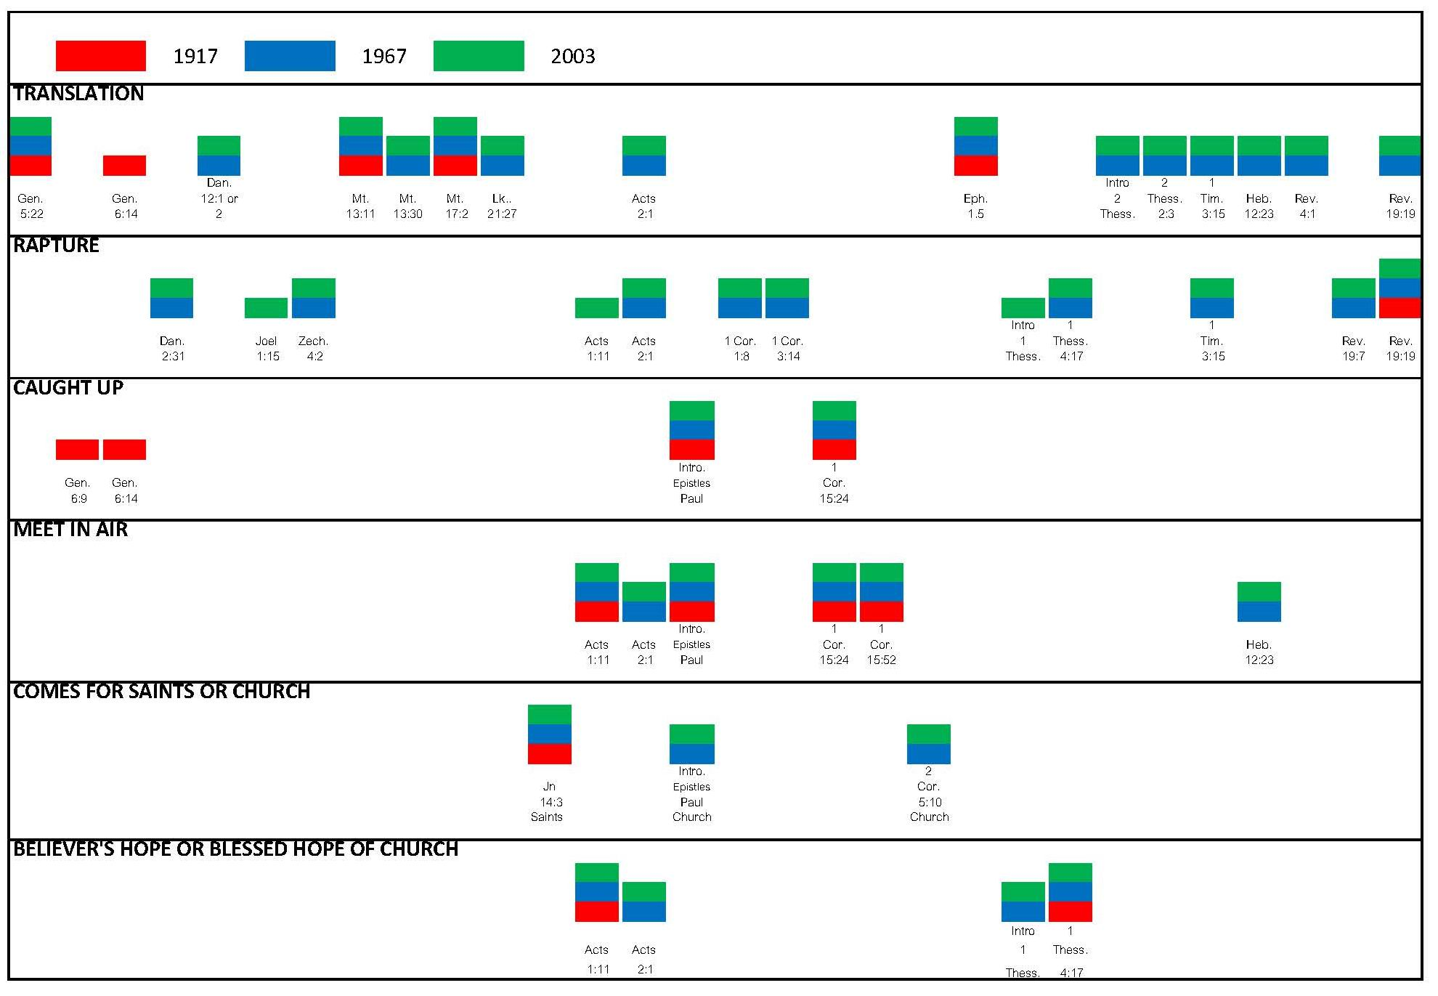

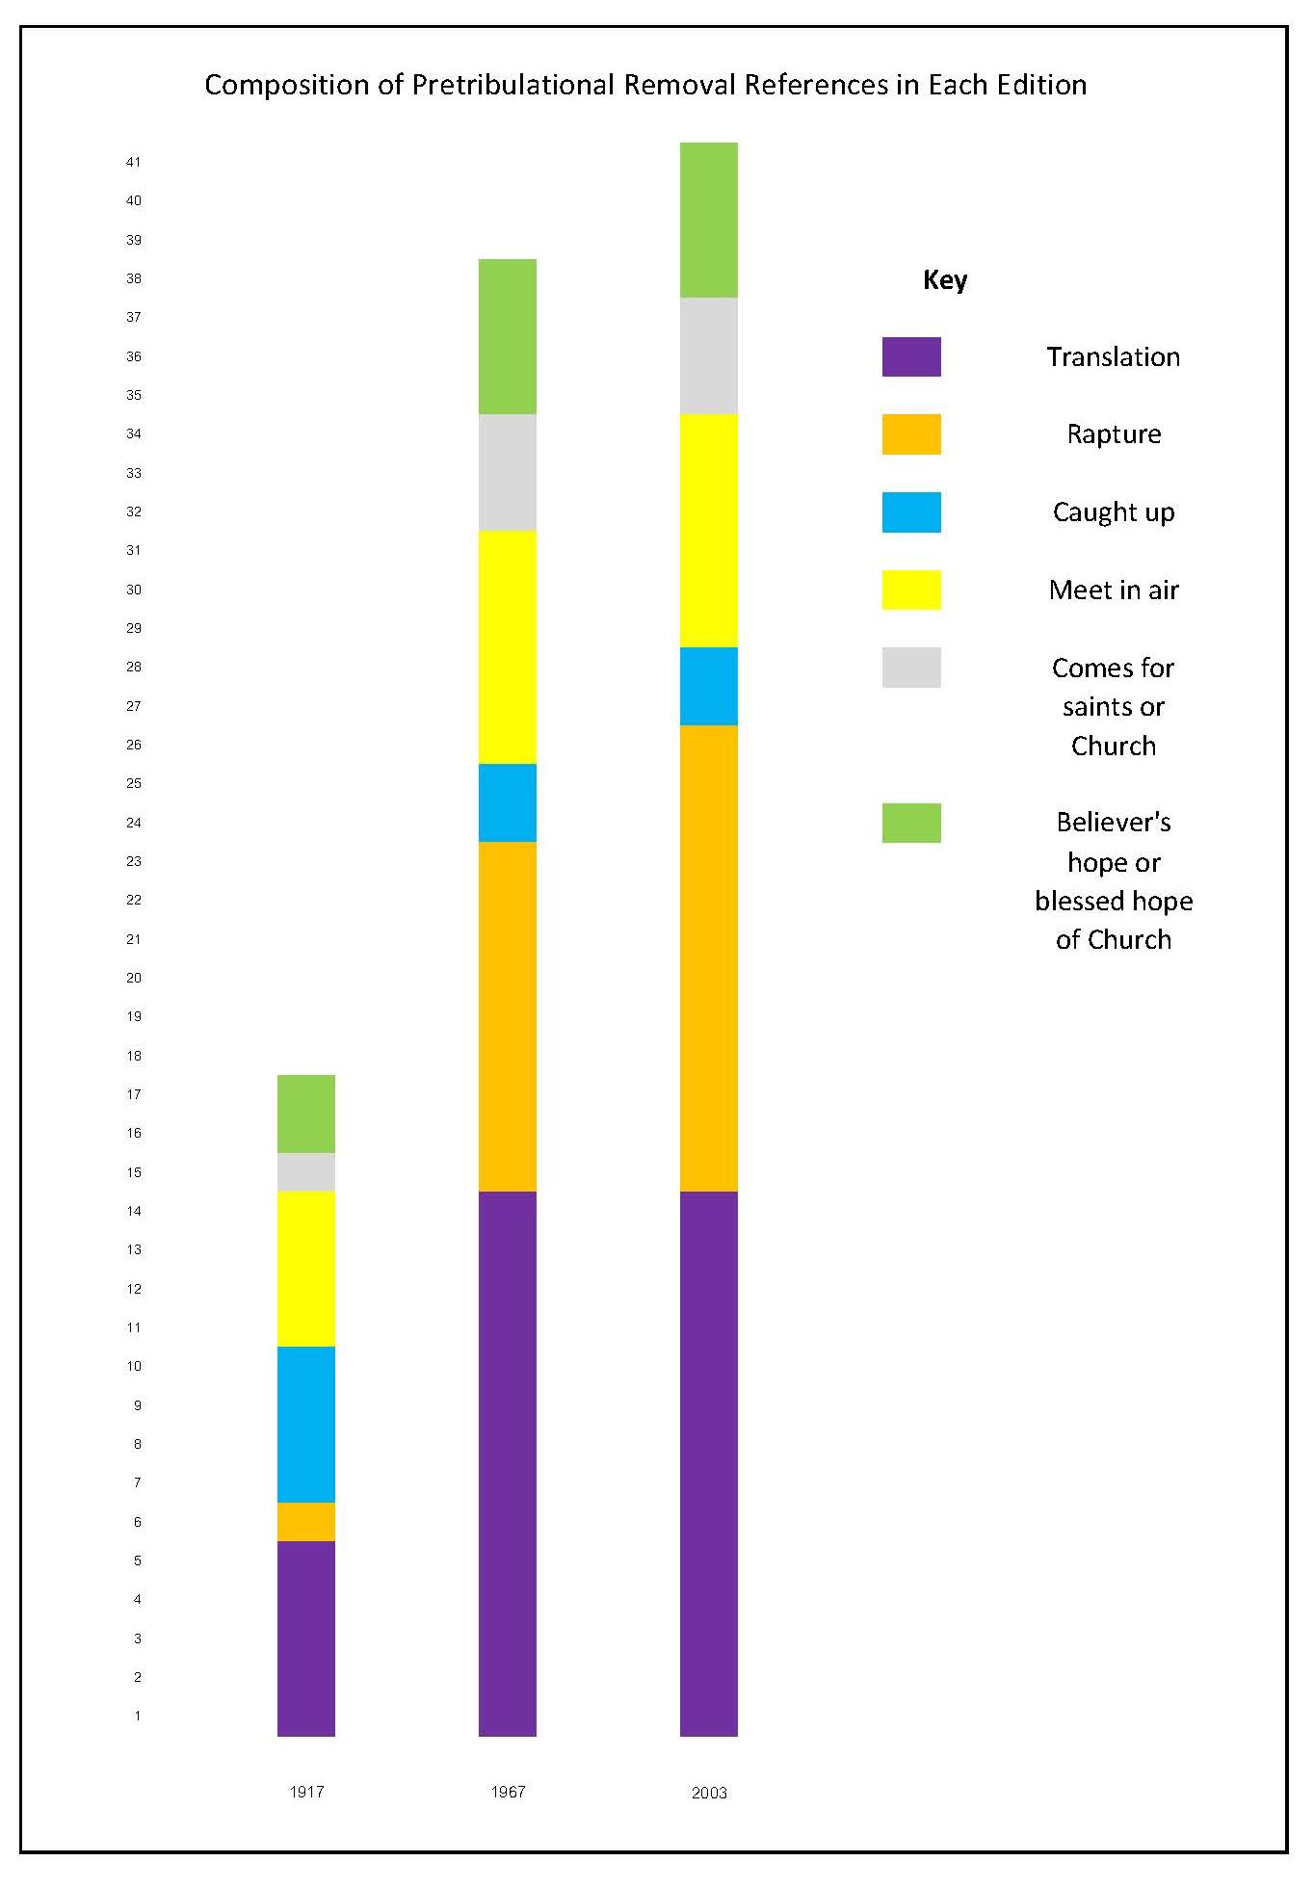
SRB has 17 references to the pretribulation removal of the church, 1967: 38, and 2003: 41, as seen in the graph above. The three references in 2003 which do not appear in 1967 all use the term ‘rapture’. I believe that there is a strong possibility that the editors of the later editions have been influenced by popular interest in the Rapture.

6.1.1 Translation
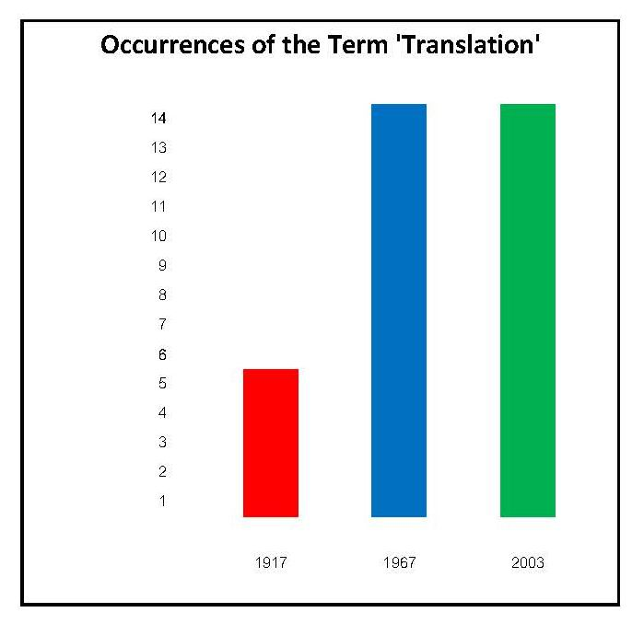
SRB’s most common term for the pretribulation removal of the church is ‘translation’, which appears five times in Scofield’s notes. Two of the occurrences concern Enoch. Enoch is ‘a type of those saints who are to be translated before the apocalyptic judgments’. Scofield also states that the church is ‘typified by Enoch’, who was ‘translated to heaven before the judgment of the Flood’. Elijah, too, is regarded as ‘representative’ of ‘the redeemed who have entered the kingdom through translation’. Fourthly, Scofield refers to ‘the mystery of the translation of the living saints at the end of this age’ as ‘one of the eleven “greater mysteries of Scripture”’. This indicates how important the translation of the Church is to Scofield. Finally, Scofield states that ‘the full manifestation of the believer’s sonship awaits the resurrection, change and translation of the saints, which is the redemption of the body’.
Translation is also the most common term used by the 1967 and 2003 editions. They share SRB’s references in their notes on Gen. 5:22, Mt. 17:2 and Eph. 1:5 and add ten further references to translation. These ten references to translation which do not appear in SRB, together with the four which repeat its notes, indicate that 1967/2003 attach more importance to translation than does the earlier volume.
6.1.2 Rapture
The noun, ‘rapture’ comes from the Vulgate translation of the verb, ‘a`rpaghso,meqa’, in 1 Thess. 4:17, ‘deinde nos qui vivimus … simul rapiemur’, meaning ‘then we who are living shall be caught up with them’. Both the Greek and the Latin have the sense of being snatched away or carried off. The context is 1 Thess. 4:13-18, concerning the Thessalonians’ anxiety about believers who have died before Christ’s second coming and Paul’s reassurance.
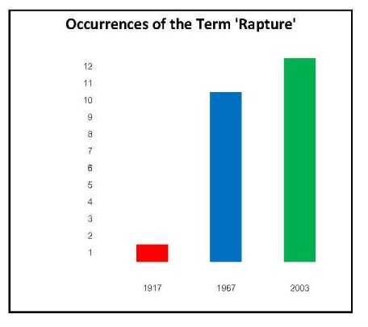
Scofield only uses the term, ‘rapture’ in his note on Rev. 19:19, where he refers to ‘the rapture of the true church’ as the fifth of the seven signs preceding the Day of the LORD. Scofield’s infrequent use of the term ‘rapture’ is more surprising than the extensive use of it by the later editions of the Scofield Bible. The term must have been current at Scofield’s time because his contemporary, Blackstone, uses it copiously in his book, Jesus is Coming. and even has a chapter entitled ‘Rapture and Revelation’. The date of original publication of Jesus is Coming appears to be uncertain. My copy states on its back cover that it was originally published in 1878; however, in the text of my copy, p. 212, Blackstone refers to ‘the time of writing, 1908’. Internet Archive has a facsimile of a copy published by Fleming H. Revell dated 1898, whereas Wholesome Words refers to ‘3rd Rev. 1908’. The Library of Congress holds several copies of Jesus is Coming’; it seems that the earliest edition was published in 1898.
It does not seem that Scofield has any antipathy towards the expression, ‘rapture’, however. He uses the word ten times in his New Testament Bible Correspondence Course in commentary on Revelation. The references are more contextualised than the brief mention in the note on Rev. 1919 in SRB. ‘The rapture of the church is seen but for one moment in [Rev.] 4:1.’ It is in this verse that John hears the voice bidding him ‘Come up hither’. Scofield later refers to this in more detail; it is this which is ‘indeed and most preciously, the indication of the rapture … From that moment the view-point of the seer changes. John still sees things on earth, but looks down upon them from the heights of glory.’ In his SRB note on Rev. 4:1, Scofield remarks that the call, ‘“come up hither” clearly seems to indicate the fulfilment of 1 Thess. 4:14-17. The word “church” does not again occur in the Revelation till all is fulfilled.’ This conclusion does not seem relevant to the text to which the note refers and also appears to be an unjustified argument from silence. Furthermore, the words, ‘come up hither’ are not addressed to believers, but only to John, who immediately ‘was in the spirit’.
Scofield also uses the rapture in his Correspondence Course to mark division between eras: ‘These churches were chosen … because … their then actual condition prefigured seven great phases of church history, from the close of the apostolic period to the rapture of true believers, and the apostasy of the professing church.’ It is also used in anticipation of a future event. ‘The morning star – light to the watchful before the full rising of the Sun of righteousness; the rapture before the glorious appearing.’ Scofield states that ‘Section III’ of Revelation, ‘The Things Which Shall Be’, Rev. 4:1 – Rev. 22:21, begins with the rapture. This section ‘falls into seven parts and three parentheses’, the first of which covers ‘Scenes in Heaven After the Rapture’ in Revelation 4 -— 5. Scofield later reiterates that Rev. 4:1 ‘indicates the Rapture’.
Rightly Dividing the Word of Truth also contains a reference to the rapture by Scofield. Here it is incidental to his analysis of the differences between law and grace; ‘But “the law” most frequently mentioned in Scripture was given by Moses, and from Sinai to Calvary dominates, characterizes, the time, just as grace dominates or gives its peculiar character to the dispensation which begins at Calvary and has its predicted termination in the rapture of the Church. … Scripture, never, in any dispensation, mingles those two principles.’ The implication is that grace ends at the rapture; this might comport with the idea that ‘that which restrains the mystery of lawlessness … can be no other than the Holy Spirit in the church, to be “taken out of the way”’.
1967/2003 state that ‘the translation of the true Church … is often called the rapture’. They include a further eight references to the rapture which do not appear in SRB, and 2003 an additional three. The third of these, the 2003 note on Acts 1:11 is significant and is discussed in 7.1.3.
6.1.3 Other Expressions
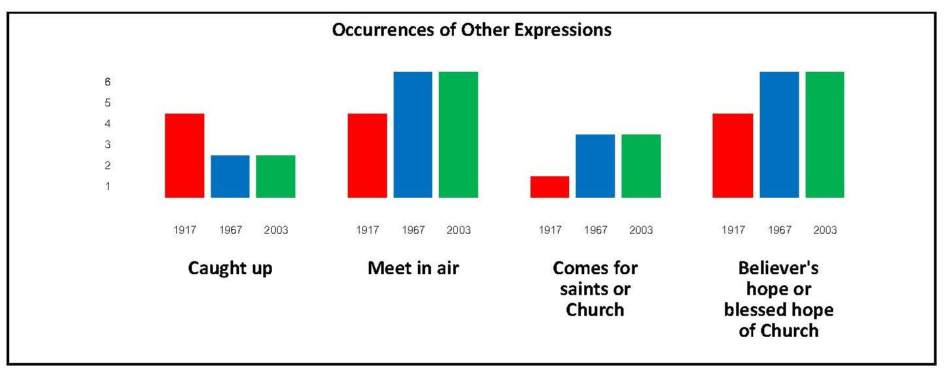
There is less marked difference between the three versions in the use of other expressions describing the pretribulational removal of the Church.
Scofield uses the phrase, ‘caught up’ more often than the later versions, especially in notes on Genesis. Enoch is ‘the type of those to be caught up before the great tribulation’. Scofield relates Enoch’s removal before the judgment of the flood to the survival of ‘the remnant of Israel who will turn to the Lord… after the Church is caught up to meet the Lord’. 1967/2003 share his other two uses of this phrase, though they adapt their notes slightly. It is through Paul that we know that ‘the living saints shall be “changed” and caught up to meet the Lord in the air at His return’. ‘The mysteries of the kingdom will be brought to an end by the “harvest” at the return of the King in glory, the church having previously been caught up to meet Him in the air.’
In the note on Acts 1:11, Christ is said to descend ‘into the air to raise the sleeping and change the living saints’. 1967/2003 add that the first element of Christ’s return is ‘to the air before the tribulation’. The second stage is ‘to the earth, after the tribulation’. All versions actually appear to entertain the possibility of a third advent by stating that the first resurrection will occur ‘at the second coming of Christ, … the saints of the OT and church ages meeting Him in the air’. These words in both notes seem to imply that Scofield and the editors of the later versions regard the ‘translation’ of the saints as the second advent, with Christ’s return in glory as a separate event, which could only be a third advent. This implication is confirmed in Scofield’s note on Jn 14:3; here Scofield states that ‘this promise of a second advent of Christ is to be distinguished from His return in glory to the earth … here He comes for His saints; there He comes to judge the nations’. However, in their note on Jn 14:3, 1967/2003 refer to the Lord’s promise of ‘His personal return for His own people’ as an ‘aspect of Christ’s return’, which is ‘to be distinguished from His coming to the earth to establish His kingdom’, thus diluting the force of the implication.
Scofield also refers to Christ’s return to the air in Rightly Dividing. He asserts that ‘the works of believers are to be judged “in the air”.’ This is more specific than his note on 2 Cor. 5:10, where, echoed by 1967/2003, he states that ‘this judgment occurs at the return of Christ’. 1967/2003 make two additional references to Christ’s descent into the air. The true Church is ‘to meet her Lord in the air’ and the Church is to be translated ‘at the return of the Lord in the air’.
All versions refer to Christ’s coming for ‘His saints’ or ‘His own people’. 1967/2003 add that ‘the fact that Christ is coming for His Church’ was introduced in Jn 14:3 but revealed more fully through Paul. They also state that the judgment of the believer’s works ‘occurs at the return of Christ for His Church’.
All versions regard Christ’s return to the air as the believer’s hope or ‘the Blessed Hope of the Church’, ‘a constant expectation and hope’; however, 1967/2003 omit some of SRB’s references to verses which warn believers to be constantly prepared. All versions refer to ‘the believer’s hope’ in their subhead to 1 Thess. 4:1. They all refer to ‘the blessed hope of the Church’ in their note on 1 Thess. 4:17, but with different emphases. SRB declares that the first resurrection is ‘peculiarly the “blessed hope” of the Church’, whereas 1967/2003 regard 1 Thess. 4:17 as the ‘central passage on the blessed hope of the Church’. 1967/2003 add intimations that the translation of the true Church is ‘ever held before believers as an imminent and happy hope’, and insert a title concerning ‘the Believer’s Hope’ in their introduction to 1 Thessalonians.
The term ‘outcalling’ is used once eschatologically in all versions; in the note on Isa. 59:20; the Lord’s return to Zion follows ‘the outcalling of the Church’. The context is a comment upon the relative ‘fixing’ of ‘the time when the Redeemer shall come to Zion’ by Rom. 11:23-9, as following the completion of the Church (‘Gentile’ Church in SRB). The expression appears to have different meanings according to its time-frame, however. Confusingly, it is used elsewhere of the establishment of the Church, for example in SRB’s note on Rev. 14:6, where ‘Paul’s gospel’ is said to ‘include the revelation of the result of that Gospel in the outcalling of the church, her relationships, position, privileges, and responsibility’, and in all versions’ notes on Mt. 4:17. Here the rejection of the Davidic kingdom and Christ, its king, which were fore-known to God, resulted in ‘the long period of the mystery-form of the kingdom, the world-wide preaching of the cross, and the outcalling of the Church’. The ‘outcalling of the Gentiles’ seems to reflect the establishment of the Church in the subhead to and note on Acts 15:13, and note on Rom. 11:25. SRB’s note on Dan. 9:24 is ambiguous. Scofield asserts that the ‘second event’ in Dan. 9:26 is the destruction of the city and sanctuary in 70 CE; after this a period follows which is ‘not fixed’ but has already lasted almost two millennia. He then states that, ‘during this period should be accomplished the mysteries of the kingdom of Heaven … and the outcalling of the Church’. Scofield probably means to indicate here the establishment of the Church, but this took place before 70 CE as his own commentary on Acts 2 asserts.
6.2 Conclusion
While Scofield certainly regards the concept of the pretribulational rapture of the Church marking the end of the present church-age as important, he does not devote as much annotation to it in SRB as he does to other important tenets of dispensationalism such as the eternal separation of Israel and the Church, and the existence of different dispensations in divine-human relationships. Although he refers to the rapture in various other works, he prefers to use other terms in SRB, especially ‘translation’. Nevertheless, he does subscribe to this aspect of dispensational belief. The later versions of the Scofield Bible include many more references to the removal of the true Church, especially using the term, ‘rapture’. However, Scofield subscribes to a two-stage second coming of Christ like that advanced by Darby, as shown in 7.1.3.

CHAPTER 7
Elements of Dispensationalism: Element 6:
Emphasis on Apocalyptic and Millennial Expectation
7.1 Apocalyptic Expectation
Blaising and Bock identify dispensationalism as ‘a futurist premillennialism’; this is a tradition which has ‘strongly maintained the imminent return of Christ and a national and political future for Israel in the divine plan for history’. Watson calls dispensationalism ‘the most common school of futurist premillennialism’. According to this view, certain aspects of prophecy remain unfulfilled and will only be implemented at the eschaton. As described in 1.2, Weber lists futurist characteristics as anticipating an escalation of natural disasters, persecution and apostasy, which will culminate in the rise of Antichrist, the ‘great tribulation’ and the return of Christ to defeat Satan at the battle of Armageddon and establish his millennial kingdom on earth. After a short rebellion led by Satan on his release from a thousand-year imprisonment during the millennium, judgments will occur and the eternal state be instituted. Together with the pretribulational rapture of the true church, which was discussed in Chapter 6, these elements constitute the core of dispensationalist belief concerning apocalyptic and millennial expectation. This chapter will examine dispensationalist expectations concerning the second coming of Christ and the establishment of Christ’s millennial kingdom. However, the chapter opens with a discussion of Scofield’s place in dispensationalism’s futuristic tradition and of the tribulation presaged in the dispensationalist interpretation of Daniel’s Seventy Weeks, since the tribulation chronologically precedes the second coming.
7.1.1 Historicism and Futurism
Premillennialists may be divided into two subgroups, historicists and futurists, as identified by Weber, who states that these are based on differences in ‘fundamental approach to prophetic texts’. Historicists regard the prophetic Scriptures, especially Daniel and Revelation, as giving ‘the entire history of the church in symbolic form’. They thus see prophetic fulfilments in the past and present of the church; these fulfilments show the divine plan in action. Conversely, as stated by Sandeen, futurists hold that ‘none of the events predicted in Revelation (following the first three introductory chapters) [have] yet occurred and that they [will] not occur until the end of this dispensation’. Because futurists deny that prophecies apply to the church age, they are able to avoid the ‘dangerous and often embarrassing’ date-setting, promoted by groups such as the Millerites.
Sandeen describes how, mainly prior to the 1840s, historicists held that ‘events in the Apocalypse were being fulfilled in European history’. Historicists thus ‘tied themselves to a prophetic timetable derived from the events predicted in the Bible, especially Revelation’. This encouraged a tendency to try to set dates for future events, which took an extreme form amongst the followers of William Miller. Weber states that such date-setting brought premillennialism into disrepute when predicted events, such as Christ’s arrival on 22 October, 1844, did not materialise. According to Blaising, this was one reason for the acceptance of the futuristic version of premillennialism in late C19. However, ‘popular religious apocalypticism’ created a blurring between futurism and historicism in late C20 with some dispensationalists coming ‘perilously close to the same mistake’ of date-setting as that made by the Millerites. Sweetnam states that ‘the resort’ of authors like Edgar Whisnant and Hal Lindsey to ‘a historicist reading of Scripture in the service of their date-setting sensationalism contravenes a crucial element of classical Dispensationalism’.
As a futurist, Darby emphasised that all prophecy in Revelation from chapter 4 onwards pertained to the future. He refuted Newton’s claim that Revelation referred to ‘“the period during which Christ is hidden with God”’ and that ‘these things are spoken of as His present relation to and … exercise of power upon the nations, hidden in the throne’. Darby averred that ‘the Revelation treats of no part of the present dispensation which is yet fulfilled, though the things spoken of be distinctively characteristic of it; and that which thus distinctively characterises it is altogether future’. Darby also held that ‘the greater part of the prophecies, and, in a certain sense, … all the prophecies, will have their accomplishment at the expiration of the dispensation in which we are’.
In his introduction to and notes on Revelation, Scofield shows futuristic belief, but tempered with historicism concerning the seven churches of Revelation 1 — 3, as shown in the table below.
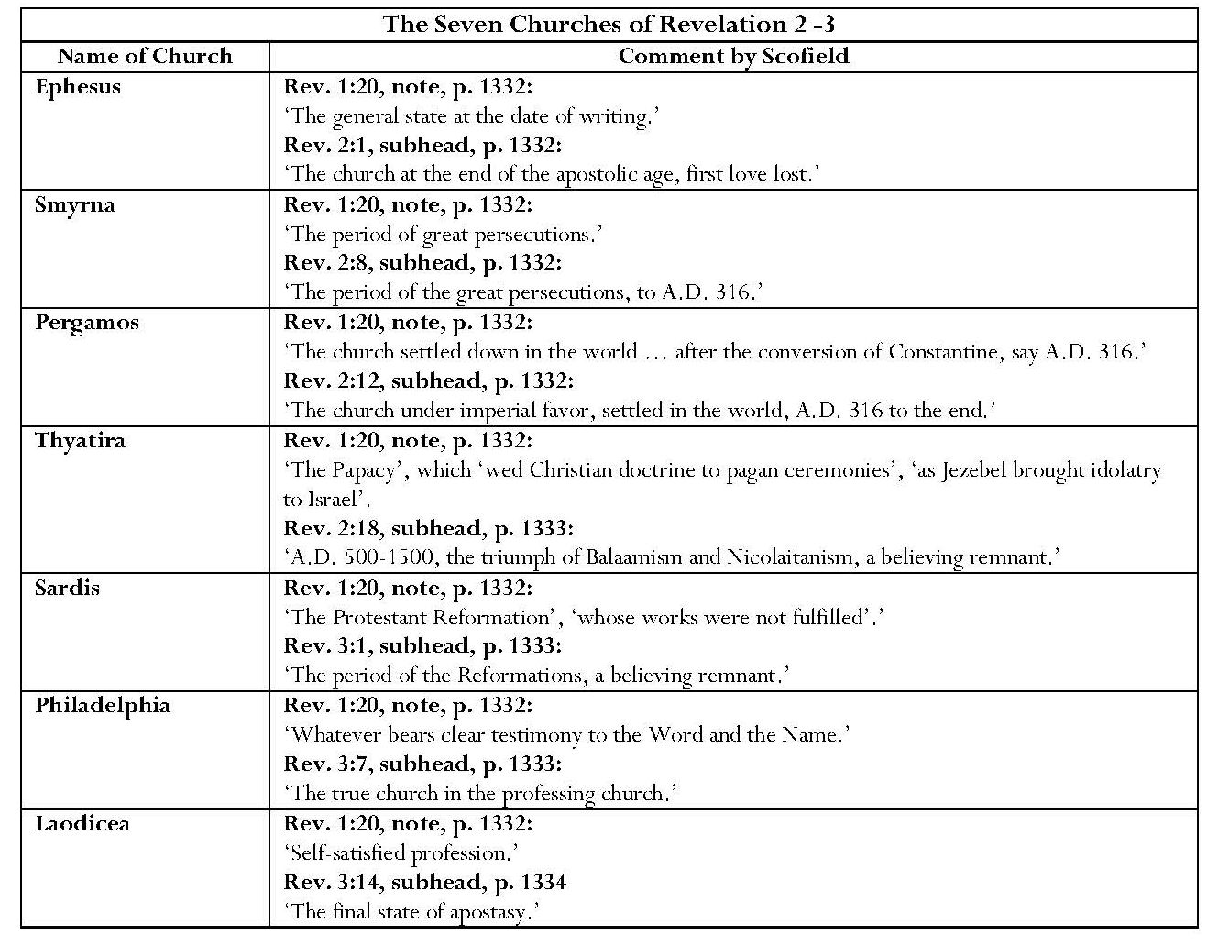
Scofield asserts that ‘from [Rev.] 2:1 to 3:22 [John] is on the earth, looking forward through the church-age’. He elaborates upon this in his note on Rev. 1:20, in which he describes the messages to the seven churches as disclosing ‘an exact foreview of the spiritual history of the church, and in this precise order’, as shown in the table. He then interprets the message to each church as corresponding to a particular phase in church history, sometimes giving dates. This is a form of historicism because it identifies prophecy with historical fulfilment. On the other hand, Scofield is also futuristic. He states that Rev. 4:1 – 22:21 concern ‘things future, “things which shall be hereafter,” lit. “after these,” i.e. after the church period ends’.
The end of the church period (2 – 3) is left indeterminate. It will end by the fulfilment of 1 Thess. 4:14-17. Chapters 4 — 19. are believed to synchronize with Daniel's Seventieth Week (ref. Dan. 9:24 note). The great tribulation begins at the middle of the “week” and continues three and a half years (Rev. 11:3 — 19:21). The tribulation is brought to an end by the appearing of the Lord and the battle of Armageddon (Mt. 24:29, 30; Rev. 19:11-21). The kingdom follows (Rev. 20:4, 5); after this the “little season” (Rev. 20:7-15), and then eternity.
Arguing from the evidence of faithful fulfilment of prophecy concerning Christ’s first advent, Chafer avers that it is reasonable and honouring to God to believe that prophecy as yet unfulfilled will also be fulfilled in the future. ‘Christ is to return to earth as He went.’
Ryrie, too, asserts that the apocalyptic events remain for the future. He states that, if the Old Testament prophecies concerning ‘the promises of the future made to Abraham and David are to be literally fulfilled, then there must be a future period, the millennium, in which they can be fulfilled, for the Church is not now fulfilling them in any literal sense’.
As a progressive dispensationalist, Saucy takes the view that, whereas the fundamental teaching of traditional dispensationalism is that no part of the Old Testament kingdom predictions are being fulfilled in any way during this age,
‘a mediating position … provides a better understanding of Scripture. This view seeks to maintain a natural understanding of the prophetic Scriptures that appear to assign a significant role to the nation Israel in the future, in accordance with a dispensational system. But it also sees the program of God as unified within history … and it denies a radical discontinuity between the present church age and the messianic kingdom promises. … This pervasive mediatorial kingdom program, ultimately fulfilled through the reign of Christ, is the theme of Scripture and the unifying principle of all aspects of God’s work in history.
7.1.2 Daniel’s Seventy Weeks, the Times of the Gentiles and the Great Tribulation
7.1.2.1 Daniel’s Seventy Weeks
The interpretation of the ‘seventy weeks determined upon thy people and upon thy holy city, to finish the transgression, and to make an end of sins, and to make reconciliation for iniquity and to bring in righteousness, and to seal up the vision and prophecy, and to anoint the most Holy’, is crucial to dispensational eschatological theory. These seventy weeks feature prominently in Scofield’s annotation of Daniel 9 and form an important part of his eschatology, supporting his theories of the parenthetical nature of the Church and Israel’s postponed kingdom. Marsden states that ‘the key to understanding the whole dispensational system is a very ingenious and complex interpretation of a prophecy in Daniel 9 concerning “seventy weeks”’. Dispensationalists interpret this prophecy as only partially fulfilled, with realisation of the final week of the seventy still lying in the future and corresponding to the great tribulation, which is to precede the second coming of Christ and his establishment of the millennial kingdom. Consequently, alternative interpretations, which see the final week as having been fulfilled in the first century CE or earlier, present a significant challenge. Cox, an amillennialist, states that someone who regards all seventy weeks as ‘a matter of fulfilled prophecy will have an altogether different approach to the New Testament, and to eschatology in general, than will the person who looks for the seventieth week to be fulfilled out in the future’. He contends that ‘Daniel 9 compared with other inspired scriptures, makes plain the conclusion that Daniel prophesied concerning events that took place in connection with the first advent of our Lord, and therefore are matters of history. … Since all seventy of those weeks were fulfilled by our Lord all prophecy concerning Israel as a nation has already been fulfilled.’ Cox’s interpretation, along with those of Mathison, who is a postmillennialist, and Joseph Fitzmyer, is discussed below.
The dispensationalist interpretation of Daniel 9 did not begin with Scofield. Similar perceptions are expressed, for example, in writings by Darby, James Brookes and C. H. Mackintosh. Ironside states that ‘the idea of the cancelled seventieth week of Daniel, beginning after the rapture of the church was suggested by Sir Edward Denny and Mr. Darby’ at ‘the Powerscourt meetings’. Darby himself states:
We are properly nowhere, save in the extraordinary suspension of prophetic testimony, or period, which comes in between the sixty-ninth and seventieth week of Daniel, or at the end of that age which was running on when Christ was here, the close of which was suspended by His crucifixion; His return to establish it then, according to Acts 3, being precluded by the rejection of the testimony of the Holy Ghost, which followed — finally declared at Stephen's death.
He further identifies the gap between the sixty-ninth and seventieth weeks as crucial to comprehension of divine-human relationships, stating that ‘This lapse of time, this parenthesis in the ways of God, is brought in, in the most distinct way, at the end of Daniel 9; and I refer to it because we should never understand God's dealings with mankind, unless we get hold of this.’
Brookes argues that Daniel’s seventy weeks commenced in the twentieth year of Artaxerxes, 454 years before Christ’s birth. Allowing for Christ’s birth occurring four years earlier than ‘the time assigned in our common chronology’, the crucifixion, or time when ‘shall Messiah be cut off’ occurred in 29 A.D. This was ‘483 years, or sixty-nine heptads from the command to restore and build Jerusalem’. Brookes claims that, according to the ‘correct translation’ given in the marginal notes in ‘our English Bible’, ‘the prophecy reaches to the close of the present dispensation, and indicates the overwhelming calamities … which are coming upon the Jews just before the second advent’. He argues that the sentence, ‘the people of the prince that shall come shall destroy the city and the sanctuary’ indicates that ‘a certain people shall destroy the city, and they shall be the people of a prince that is afterwards to come, or in other words, the Romans will destroy the city, and the prince afterwards to come will be the head of the Roman empire’. This means that there is a break of undetermined length between ‘the desolation of the city by the people and the coming of the prince’. The coming prince will ‘confirm a covenant with many for one week, or the seventieth heptad’. Brookes identifies the prince with the little horn of Daniel 7.
Mackintosh states that it is ‘impossible to read Dan. 9:24’ without seeing that Gabriel was commissioned to inform Daniel that 490 years were to elapse after the decree to rebuild Jerusalem and that ‘then Israel would be brought into blessing’. Answering the possible objection that these 490 years must have long ago expired, Mackintosh argues that, had this been so, ‘Israel would be now in their own land, under the blessed reign of their own beloved Messiah’. However, since Messiah was cut off instead of being received, God ‘[suspended] for a time His dispensational dealings with Israel’. ‘There is a great gap’, or ‘a parenthesis, a long unnoticed interval’. The 490 years are not yet complete – 483 have passed but seven remain. The full 490 years will not be accomplished ‘until the church has … gone to be with her Lord in her bright heavenly home’, which is ‘the place the heavenly saints shall occupy during the last of Daniel’s seventy weeks’, as shown in Revelation 4 and 5. Revelation 6 – 18 indicate ‘the various actings of God in government, preparing Israel and the earth for the bringing in of the First-begotten in the world’.
It is of paramount importance in Scofield’s interpretation of the seventy weeks that the seventieth week still lies in the future and it is on this that his ecclesiology and eschatology depend. Commenting on Dan. 9:24-27, Scofield identifies the seventy ‘“weeks”’ as ‘seventy weeks of seven years’. Following the divisions laid out in Dan. 9:25-7, Scofield includes the mathematically dubious statement that ‘the seventy weeks are divided into seven = 49 years; sixty-two = 434 years; one = 7 years (vv. 25-7)’. Like Brookes, Scofield pinpoints the decree to rebuild Jerusalem to the twentieth year of Artaxerxes, between 454 and 444 BCE, thus establishing an approximate date for the sequence of the 7, 49 and 434 years, a total of 483 years from the date of the decree to the coming of Messiah.
Scofield states that ‘verse 26 is an indeterminate period’ and ‘the date of the crucifixion is not fixed. It is only said to be “after” the threescore and two weeks’. He claims that the crucifixion is the ‘first event in verse 26’ and that the second event is the destruction of Jerusalem, ‘fulfilled in 70 A.D’. ‘Then, “unto the end” [is] a period not fixed, but which has already lasted nearly 2000 years.’ Daniel and the other Old Testament prophets were not informed that ‘during this period should be accomplished the mysteries of the kingdom of Heaven and the outcalling of the Church’. Like Darby, Scofield asserts that the whole ‘Church-age’ constitutes a hiatus between the sixty-ninth and seventieth weeks, the time of its termination and the start of the seventieth week being ‘nowhere revealed’. However, as discussed in Chapter 6, this time is fixed by the pretribulational removal of the true church, which may occur at any time. Daniel’s final week constitutes the great tribulation, which will be discussed below.
In stating that ‘the “he” of verse 27 is the “prince that shall come” of verse 26, whose people (Rome) destroyed the temple, A.D. 70’, Scofield reaffirms Brookes’ claim that the Romans destroyed Jerusalem and that the head of the Roman empire will be the prince to come. This illustrates Scofield’s theory concerning the revival of the Roman Empire which he advanced in his notes on Daniel 2 regarding the Gentile empires. It is also significant that he identifies the prince of verse 26 with a future Roman leader rather than the Messiah. Cox emphasises that ‘the historic view of the church always has been that [the ‘he’ in Dan. 9:27] refers back to the anointed one (the Messiah) of verse 26’, whereas the dispensationalist view ‘insists that verse 27 takes up a completely new subject by beginning to predict the antichrist, who is to appear before the second coming of Christ’. Cox avers that ‘there is absolutely no scriptural justification for saying that Daniel speaks in one breath of the first coming and crucifixion of Christ, then in the next breath jumps to the subject of the second coming’. This forms another part of Cox’s evidence for his assertion that the seventy weeks were completed in C1 CE.
It seems that Daniel’s seventy weeks do not play such a prominent role in writings by later dispensationalists even though it appears that, as late as 1982, in Millennialism, The Two Major Views, Charles Feinberg does still makes several references to the sixty-nine and seventy weeks. However, this book, under the title, Premillennialism or Amillennialism? was first published in 1936. Chafer does not focus on the seventy weeks in his Major Bible Themes; he only mentions them briefly with reference to the dispensation of law. He does not mention them in Dispensationalism. Ryrie, too, only mentions the seventy weeks with regard to the dispensation of law. Saucy’s only direct reference to Daniel 9 concerns the literality of Jerusalem as it appears in Revelation. Bock makes a single, short reference to ‘the seventy weeks of Daniel 9:24-7’ as describing Jerusalem and the temple and, although Blaising includes a section entitled ‘The Eschatological Kingdom in Daniel’ in his chapter on ‘the Kingdom of God in the Old Testament’, he does not refer specifically to the seventy weeks in this.
Alternative Interpretations of the Seventy Weeks
Cox asserts that there is no hint of any gap between ‘the fulfillment of the sixty-ninth and seventieth weeks of Daniel’s prophecy’, thus the first sixty-nine weeks would extend to the beginning of Christ’s ministry and ‘period three’ (the final seven years) ‘began with the beginning of that ministry and consequently was fulfilled long ago’. Daniel’s seventieth week constitutes ‘history rather than eschatology’. According to what Cox calls ‘the historic Christian view’ after the sixty-nine weeks and thus, during the seventieth, Messiah would come and be ‘”cut off” for others’ sin’. As a result of this, Titus, the ‘prince’ mentioned in Dan. 9:26, would come with his people, the Roman soldiers, and destroy Jerusalem and its temple in 70 CE as already determined by Israel’s sin. During this week, as described in Dan. 9:27, Messiah would ‘confirm a covenant with “as many as receive him”’ but, in the middle of the week, when Christ’s ministry was cut off by the crucifixion after 3½ years, God would cause the temple to be made desolate in punishment for Israel’s sin against its Messiah and thus sacrifices would be curtailed.
Mathison, a postmillennialist, agrees that the Church has traditionally interpreted Dan. 9:24-7 as prophesying Christ’s first advent and the destruction of Jerusalem by Roman armies. He argues that the purpose of the division of the 490 years into periods of 49, 434 and 7 years was to inform Daniel of the length of time involved with reference to his discernment of Jeremiah’s prophecy in Dan. 9:2. This would not be feasible if there was an indefinite gap between the sixty-ninth and seventieth weeks, especially when the gap is ‘already over four times longer than the entire seventy-week period itself’. Both Cox and Mathison regard the six divine purposes listed in Dan. 9:24 having been fulfilled by Christ at his first advent, and, like Cox, but unlike Scofield, Mathison identifies the ‘he’ of Dan. 9:27 as the Messiah of Verse 26 because ‘Messiah’ is the subject of the sentence in Verse 26 and is ‘the focus of the entire passage’ and because ‘the “end” in verse 26 is the “end of destruction”, not “his” end’.
Mathison also argues that Christ fulfilled or confirmed ‘the stipulations of the old covenant and [his] covenantal work was directed toward the many (faithful Jews) for almost exactly seven years or one week’. According to Mathison, the three-and-a-half years of Christ’s ministry focused primarily on the Jews and the approximately three-and-a-half years of his apostles’ ministry also ‘focused almost exclusively on the Jews’. While this argument is sustainable with regard to Christ and the two verses quoted from Matthew; it is not justified in the case of the references to Acts and Romans, where Jerusalem and the Jews are only listed first in the order of evangelism and no time scale is given. Mathison gives no evidence for his assumption that this period lasted ‘approximately three and one-half years’. This appears to be a specious argument designed to explain the two three-and-a-half-year periods.
Fitzmyer does not associate the anointed one who is ‘cut down’ with Christ but states that this was probably Onias III, a high priest who was assassinated in 171 BCE. Fitzmyer affirms that the ‘Anointed One’ of Dan. 9:25, dygIn" x:yvim', may indicate a king or priest but regards the interpretation of this figure as a ‘kingly Messiah’ as best for its second century context. He argues that the anointed one of Dan. 9:26 cannot be that of Dan. 9:25 because he appears ‘“after sixty-two weeks”’. Like Mathison, Fitzmyer emphasises the allusion in Dan. 9:2 to Jeremiah’s prophecy of the seventy years of Babylonian captivity. He regards the numbers involved in the ‘seventy weeks of years’ as only indicating ‘the passage of a long time from Cyrus’ edict of 538 BCE until Antiochus Epiphanes’ persecution. Antiochus ruled from 175-164 BCE. Antiochus, who ruled from 175-164 BCE, is the destructive prince, ‘whose “people come to destroy the city and the sanctuary”’.
7.1.2.2 The Times of the Gentiles
The notion of ‘the times of the Gentiles’ forms a background to the concept of the great tribulation, which is their ultimate expression. Darby describes the start, duration and ending of the times of the Gentiles in various writings. He states, ‘The shekinah of glory was in the temple; but from the time that Jerusalem was taken by Nebuchadnezzar it entirely ceased. Then began the times of the Gentiles, and God gave the kingdom to Nebuchadnezzar.’ He also states:
From the time of the destruction of Jerusalem, and of the throne of David, the government of the world was in the hands of the Gentiles; and the times of the Gentiles commenced (see Dan. 2: 37, 38) under a responsibility, the effects of which are described in the book of Daniel, the Apocalypse, and Zechariah, and which are characterised in Daniel 4. The four great empires which, by their pride and in God's providence, successively seized on the supreme power, and consequently brought themselves under this responsibility and failed, are well known. All the time of their dominion, Israel has been Lo-ammi, “not my people.” …
We have said enough to shew the separation of rule and the calling of God, in the destruction of Jerusalem, and the giving of government or power into the hands of the Gentiles. With them it still exists, and shall exist, until the destruction of the last of the four empires: with this destruction the times of the Gentiles end.
When Nebuchadnezzar takes Jerusalem, the people become Lo-ammi. Israel is rejected. God no more owns His people. He watches over them still for final restoration to their land, but "the times of the Gentiles" begin. … All the history whilst Israel is not owned belongs to the times of the Gentiles.
The subject of the four empires here mentioned by Darby was discussed in 2.2.2. Chafer uses similar vocabulary to Darby. He asserts that ‘“the times of the Gentiles”, which began in the last dispersion six hundred years before Christ, are characterized by a succession of world empires, continue their course throughout the present dispensation and are ended by the coming of Christ’. Christ fulfils ‘Daniel’s prophecy of the “smiting stone”’.
Scofield defines the times of the Gentiles as a period marked by Gentile ‘overlordship’ of Jerusalem, and ‘the political subjection of Israel to the Gentile world-powers’. He asserts that the plague of insects of Joel 1 is ‘a picture’ of the times of the Gentiles, which have run ‘from the time of King Nebuchadnezzar to this day’. Nebuchadnezzar was ‘the first of the Gentile world-kings in whom the times of the Gentiles began’, who established the first of the four world-monarchies’. Scofield states that Daniel, whom he dubs ‘the prophet of the “times of the Gentiles”’, interprets Nebuchadnezzar’s dream in Daniel 2 as providing information on the way in which the ‘times of the Gentiles’, that is ‘Gentile world-empire’ will proceed and end. Nebuchadnezzar, ‘in his monarchy vision’ ‘saw the imposing outward power and splendour of the “times of the Gentiles”, while Daniel saw the true character of Gentile world-government as rapacious and warlike, established and maintained by force’.
Scofield states that the times of the Gentiles will continue until ‘the destruction of the Gentile world-power by the “stone cut without hands”’ in ‘a sudden and irremediable blow’ at the Lord’s coming, and the establishment of the kingdom of heaven. God will not establish his kingdom until the smiting has occurred. It is notable how similar comments about the smiting of the Gentile world-power occur in SRB notes on Matthew, 1 Peter, and Revelation. To Scofield, these are clearly all part of the same scenario. This smiting did not occur at Christ’s first advent and, ‘since the crucifixion, the Roman empire has followed the course marked out in the vision but Gentile world-domination continues and the crushing blow is still suspended’. The final fulfilment of the prophecies concerning the Gentile powers is still future, even though there has been partial fulfilment.
The times of the Gentiles are also defined as ‘the Gentile world-empires’, a term which Scofield sometimes uses synonymously with ‘the Gentile world-power’, ‘the Gentile world-system’ and ‘Gentile world-domination’. Scofield has imported the concept of ‘world-empire’ into Daniel. The word used in Dan. 2:37, 39 and 40 is Wkl.m;, or basilei,a, (LXX), both meaning ‘kingdom’. It is significant that, even though Scofield refers to the kingdom of heaven as ‘the final world-empire’, he renders the same Hebrew and Greek words in the accompanying note as ‘kingdom’, and applies this translation to his interpretation of the ‘kingdom of heaven’ in Mt. 3:2. He does not refer there to a ‘world-empire’ of heaven.
The word ‘empire’ appears only once in KJV and that not in Daniel, but in Esther, in a verse upon which Scofield does not comment. However, the concept of empire is very important to Scofield. His interpretation of the four metals and four beasts as four empires which existed historically and his erroneous claim that the fourth beast of Dan. 7:7 is declared to be ‘“the fourth kingdom”, i.e. the Roman empire, the “iron” kingdom’, might appear to validate his futuristic interpretation concerning the ‘ten kingdoms, covering the regions formerly ruled by Rome’. Scofield avers that these ten kingdoms take the form in which the ‘fourth or Roman Empire will exist when the whole fabric of Gentile world-domination is smitten by the “stone cut out without hands” = [sic] Christ’. However, the text of Dan. 2:44-5 indicates that the future kingdom is the smiting-stone, not an individual, whom Scofield identifies as Christ. Moreover, the fourth kingdom, like the others in the image and beast visions, is not named; furthermore, the term ‘Roman’ does not appear in the Old Testament and nor does the adjective, ‘Macedonian’ which Scofield uses in his note on Dan. 8:1. Scofield also amalgamates the theoretical expressions, ‘empire’ and ‘great Gentile world-monarchies’, with references to the historical Roman Empire in the note on Ezra 6:14, which states that ‘Messiah …was crucified by soldiers of the fourth Gentile world-empire (Rome)’, that on Dan. 2:41, which refers to the division into the Eastern and Western empires, and that on Lk. 2:1, which translates oikoumene as ‘the sphere of Roman rule at its greatest extent’. Scofield refers in his note on Dan. 2:41 to ‘the fickle and impressionable nature of the Roman imperium and gives the purely contemporary examples of France and Turkey as covering ‘the sphere of ancient Roman rule’. This allusion takes him outside the futuristic interpretation generally held by dispensationalists and usually by Scofield himself. Scofield uses historical figures and facts, such as the Roman Empire, Antiochus Epiphanes and Alexander the Great, not named in the biblical text, to lend credence to his theory concerning the future for the area covered by the Roman Empire’s ‘ten kingdoms’. These references are misleading but are important in supporting Scofield’s theory that the Roman empire is to be revived under Antichrist, who fulfils the role of the ‘prince’ of Dan. 9:26.
Commentaries by Louis Hartmann and Alexander DiLella, John Collins, André Lacocque, John Goldingay and Norman Porteous make no reference in their commentary on Daniel 2 and 4 to the times of the Gentiles. All concentrate on the statue, especially its non-biblical antecedents; all except Lacocque comment on the symbolism of the four metals. Lacocque emphasises the symbolism of the holy mountain. Commenting on the beginning of Daniel 4, Hartmann and DiLella, and Lacocque emphasise the motif of the world tree, common to many ancient forms of literature; Collins notes parallels with neo-Babylonian royal inscriptions and Goldingay and Porteous comment upon Nebuchadnezzar’s recognition of divine spirit within Daniel. Goldingay specifically states that there is no emphasis on Nebuchadnezzar’s Gentile identity. Porteous emphasises the epistolary format of the dream narrative in Daniel 4.
The phrase, ‘the times of the Gentiles’, is only found in Lk. 21:24 and is pronounced by Christ. Scofield asserts, without offering any evidence, that Lk. 21:20-24 refers expressly to ‘a destruction of Jerusalem which was fulfilled by Titus in A.D. 70’ whereas the parallel passage in Mt. 24:16 refers to ‘a future crisis in Jerusalem after the manifestation of the “abomination”’. Scofield claims that ‘in the former case [Luke] Jerusalem was destroyed; in the latter [Matthew] it will be delivered by divine interposition’.
François Bovon, Fitzmyer, Michael Goulder, Robert Tannehill and David Tiede relate Lk. 21:23-4 to the putative composition of Luke during or after the Roman siege and sacking of Jerusalem and the temple in 70 CE. None of these scholars intimates that the prophesied destruction is still future and all relate the fulfilment of the times of the Gentiles to the ending of the Roman occupation, though some also find an eschatological meaning in this. Bovon claims that ‘the Lukan text strictly maintains the historical character of the fate of Jerusalem’; it is ‘a description as seen from recent history’, closely reflecting the fall of Jerusalem to Nebuchadnezzar and Josephus’ account of the Roman/Jewish war. Fitzmyer states that Luke has ‘obviously been influenced by historical events associated with the destruction of Jerusalem in 70 A.D.’. Goulder asserts that, at the time of Luke’s writing, Jerusalem was being trampled under the Roman heel’; he associates this with Dan. 8:13. According to Tannehill, Luke’s audience knew that Jerusalem had already been destroyed; Tannehill suggests, however, that the relationship between this and Christ’s return was not clear and might imply that the parousia could be expected at any time. Tiede suggests that Luke has recast Mark to interpret the present times and to demonstrate the fulfilment of Scripture in ‘the harsh realities of the Roman conquest’. He relates Lk. 21:23-4 to Josephus, to the siege of Samaria in 2 Kgs 6:24-31 and to the judgment of the great day of the LORD in Zeph. 1:15.
Concerning the fulfilment of the times of the Gentiles, Bovon states that the trampling (patoume,nh) of Jerusalem encapsulates the length of the Roman occupation. This desolation will be limited and will end with the fulfilment of the times of the Gentiles; however, Luke’s ‘prophetic haziness’ here reflects ‘both the end of Roman power and the massive conversion of the Gentiles’. For Fitzmyer, this fulfilment can only mean the time after 70 CE when Rome again dominated Judaea and Jerusalem after the Jews’ unsuccessful revolt, but ‘even the time of the pagans will give way to the coming of the Son of Man’. Goulder sees one possible meaning of the fulfilment as being a limitation on Roman oppression since the trampling of Jerusalem also occurs in Dan. 8:13, immediately followed, in Dan. 8:14, by ‘a time limit of days’, and because Mk 13:20 also refers to a divine limit upon tribulation. Tiede avers that the limitation means that Gentile superiority will not last for ever and that God has not finished with Israel. In all these interpretations it can be seen that the prophecies of Daniel are regarded as having already been fulfilled rather than awaiting future fulfilment.
7.1.2.3 The Great Tribulation
Blaising states that ‘like most premillennialists, dispensationalists interpret biblical prophecy to teach that Christ will return during a time of trouble traditionally called “the Tribulation.” However, unlike most premillenialists, most dispensationalists have advocated the doctrine of the pretribulation Rapture – the doctrine that Christ will come for the church prior to the Tribulation … then taking the church with Him to heaven prior to His millennial return in which He will visibly rule the nations on earth.’
Darby quotes four passages which ‘effectively prove that there will be a time of tribulation such as never was since there was a nation’. Jeremiah 30:7 indicates the people affected: it is ‘the time of Jacob’s trouble’. Daniel 12:1 confirms that ‘the tribulation is the tribulation of Daniel’s people’; this leads directly to Mt. 24:15, where ‘the Lord himself [declares] that He speaks of this same time and same event, using the terms of Daniel, and referring to him by name as well as to the statements of the passage’. ‘All is local and Jewish – has no application to hopes which rest on going to meet Christ in the air.’ Mark 13:19 ‘relates evidently to the same event and almost exactly in the same terms’. Darby states that Rev. 3:10 and 7:14 also indicate that ‘the unequalled tribulation is for Jacob, and that, when the time of temptation is spoken of in addressing the church, it is to declare that the faithful shall be kept out of it’.
Chafer agrees that this is ‘the time of Jacob’s trouble’, which ‘comes to that nation as the consummation of their sufferings at the hand of Jehovah for their sins’. ‘At that time, the persecution of Israel will no longer be a passing event in the affairs of the world; the Gentile peoples will have been divided over the national interests of Israel and unprecedented violence will be Israel’s portion.’
Blaising states that progressive dispensationalists believe that a future tribulation will provide the setting for Christ’s return but would question ‘the claim of any Bible interpreter to have identified specific current events as that future tribulational fulfilment of the historically repetitive Day of the Lord descriptions or the mysterious vision of biblical apocalyptic. … It takes prophetic authority or the actual appearance of Jesus Christ Himself to identify any particular pattern of trouble and conflict in the world as the Tribulation.’
Scofield makes at least eleven references to ‘the tribulation’ or ‘the great tribulation’ in his comments upon the Old Testament, often linking disparate verses to Matthew and Revelation. The word, ‘tribulation’ only occurs three times in the Old Testament, KJV: Deut. 4:30; Judg. 10:14; 1 Sam. 26:24. Scofield’s first reference to the tribulation occurs in the note on Ps. 2:6 and five subheads within prophetic books mention it. Scofield states that ‘Jewish tribulational suffering in Palestine is described in Isaiah 10.’ He avers that the remnant turns to the Lord in the great tribulation, and the ‘far view’ of Sennacherib’s invasion is the Gentile invasion ‘at the end of the great tribulation’. He asserts that the tribulation will be unprecedented and will be ‘such as was not from the beginning of the world, nor ever shall be’. He claims that the words, ‘I will shake all nations’, in Hag. 2:3 refer to the great tribulation.
In New Testament annotation, Scofield states that ‘the sign of the abomination …introduces the great tribulation …, which runs its awful course of three and a half years, culminating in the battle of Rev. 19:19-21, note, [sic] at which time Christ becomes the smiting Stone of Dan. 2:34’. He gives a seven-point calendar of events during the tribulation and urges study of Daniel 2, 7 and 9, and of Revelation 13 to ‘make the interpretation clear’. Scofield misses the biblical reference to the tribulation in Mt. 24:21. In his note on Mt. 25:32, he refers to the Jewish Remnant’s preaching to the nations during the tribulation. In his note on Lk. 21:20, he states that Titus’ siege of Jerusalem adumbrates ‘the final siege at the end of this age, in which the “great tribulation” culminates’. He also refers to ‘the final tribulation siege’.
Tribulation as an eschatological event is a term which Scofield imports into the Old Testament from the New. In each of the three occurrences of the word ‘tribulation’ in the Old Testament, KJV, it refers to present suffering, though in the first of these, Deut. 4:30-31, the phrase, ‘even in the latter days’ could be interpreted as having eschatological connotations. However, the context is the warning given about the consequences of future idolatry in the land (Deut. 4:25-28) when the Israelites are about to enter it. Such behaviour will result in exile and subsequent repentance; this is intimated in NRSV, which translates the verb צרר in Deut. 4:30 as ‘in time to come’, removing any eschatological implication. The Hebrew cognate, צָרָה, translated as ‘tribulation’ in Judg. 10:14 and 1 Sam. 26:24, KJV, appears seventy-one times in the Hebrew Bible; in only two cases could it have a definite eschatological tendency, Daniel 12:1 and Zephaniah 1:15.
Daniel 12:1:
KJV renders this as ‘a time of trouble such as never was since there was a nation’
Zephaniah 1:15:
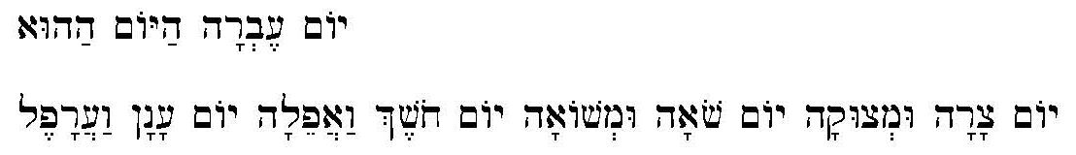
KJV renders this as ‘That day is a day of wrath, a day of trouble and distress, a day of wasteness and desolation, a day of darkness and gloominess, a day of clouds and thick darkness’. Scofield does not comment at length on either of these passages, though his subhead to Dan. 12:1 could cover the instance of hr"êc' in Dan. 12:1 and his references to the tribulation in his notes on Dan. 12:4 and 12 also probably reflect it. The Hebrew hr"êc' does not appear in a further eleven verses of the Hebrew Bible in which the term, ‘tribulation’ is applied. The rest of the uses of hr"êc in the Hebrew Bible appear to refer to human suffering, and complaints about distress and thanks for God’s help in alleviating it.
The Greek qli/yij occurs forty-five times in the New Testament. Again the occurrences mainly pertain to human suffering; qli/yij is used in an eschatological sense in only five verses. Scofield’s subheads to Mt. 24:15 and Mk 13:14 are congruent with the occurrences of qli/yij in Mt. 24:9, 21, 29 and Mk 13:19, 24.
The word ‘tribulation’ occurs nineteen times in the New Testament, KJV. It rarely has the connotation of an eschatological period of time. In most cases, ‘tribulation’ is merely a synonym for ‘affliction’. Even the writer of Revelation suffers tribulation. Most references to tribulation concern warnings about persecution for holding the faith, or explanations and exhortations concerning present suffering. Even in Revelation, most of the references to tribulation are not eschatological. The single exception, where KJV refers to what might be termed ‘the tribulation’ in an apparently eschatological sense, but without the definite article, is Rev. 7:14. Significantly, the Greek phrase, oi` evrco,menoi evk th/j qli,yewj th/j mega,lhj, includes the definite article, which Scofield uses, though KJV, like several other early translations, does not. This is the only instance in the whole Bible where the entire phrase, h`` qli/yij h`` mega,lh, occurs. Darby’s translation and Young’s Literal Translation, both roughly contemporary with Scofield, include the definite article, as do most modern English translations, though not all use the word, ‘tribulation’. Notably, Darby also includes the definite article before ‘tribulation’ in Rom. 5:3 and Rev. 1:9, as does the Greek text.
The word ‘tribulation’ in the New Testament KJV also largely lacks the definite article attributed to it by Scofield. The only New Testament verse in KJV in which the definite article precedes ‘tribulation’ is Mt. 24:29, which Scofield surprisingly ignores, along with Mt. 24:21 and Mk 13:24. These three verses, which give graphic descriptions of cosmic phenomena to follow the tribulation, might be said to describe eschatological tribulation, yet Scofield chooses not to exploit the opportunity to expand upon them. Scofield’s subhead to Mt. 24:15 proclaims ‘Olivet discourse: the great tribulation’ and then, unusually, refers to Mk 13:14-23. Scofield makes no comment upon ‘the little apocalypse’ of Mark 13, though SRB’s subhead to Mk 13:14 includes references to the tribulation.
The dispensationalist interpretation of Daniel’s seventy weeks of years is closely associated with its concept of the great tribulation but there is a difference of opinion as to whether the tribulation occupies the whole of the remaining seven years of Daniel’s seventieth week or only the final three-and-a half years. Darby asserts clearly that only the second three-and-a-half years of Daniel’s seventieth week constitute the tribulation, defined as ‘the time of Jacob’s trouble’.
Seventy weeks are determined on Daniel's people and his holy city, to complete the blessing and close their eventful history — the display of divine government in the earth. After seven and sixty-two weeks Messiah is cut off and has nothing. There are seven and sixty-two till Messiah the Prince. His cutting off is indefinite; only it is after the sixty-two weeks Then the prince that comes establishes a covenant with the many (that is, the mass of the people). Messiah's relationship, on the contrary, had been with the residue, though presented to all the people. Then, in the dividing of the week, he causes the sacrifice and oblation to cease; and then, because of the protection of abominations (idols), there is a desolator. …
No persecutions are here spoken of in the first half-week, nor indeed is any first half-week spoken of. The prince confirms the covenant one week, and the half-weeks are marked by his change of conduct in the middle of the week. In Daniel 7 we have, without any note of period, the general characteristic of the beast — that he wears out the heavenly saints, and in general makes war with the saints till the Ancient of days comes. But the times and laws (not the saints) are delivered into his hand for half a week, i.e., for a time, times, and half a time. In Matthew 24 there is general testimony, such as there was in Christ's time - only it reaches the Gentiles - till the last half-week, which begins the abomination of desolations. This exclusive allusion to the last half-week in Matthew 24 had often struck me. In Revelation 13 the beast is given power to act forty and two months. He blasphemes God and them that dwell in heaven; and he makes war with the saints (not “those that dwell in heaven”, compare chapter 12: 12), and overcomes them. One would surely, at first sight, suppose that power to act forty-two months hardly meant that he does so eighty-four.
Scofield argues that Daniel’s seventieth week can only last seven years. Confusingly, he avers in a single note that Dan. 9:27 ‘deals with the last week’ and also that it ‘deals with the last three and a half years of the seven, which are identical with the great tribulation; “time of trouble” and “hour of temptation”’. Several other notes confirm that Scofield holds that the great tribulation occupies only the second half of Daniel’s seventieth week:
The “he” of Dan. 9:27 … is the same with the “little horn” of chapter 7. He will covenant with the Jews to restore their temple sacrifices for one week (seven years), but in the middle of that time he will break the covenant and fulfil Dan. 12:11; 2 Thess. 2:3, 4.
Scofield’s notes on Dan. 11:35 and Rev. 7:14 also link the final three-and-a-half years with the great tribulation, a period begun by the Beast’s breaking of his covenant with the Jews. In his note on Dan. 12:4, Scofield designates ‘the duration of the “time of the end”’ as being ‘three and one half years, coinciding with the last half of the seventieth week of Daniel’. This is corroborated by his statement that ‘the great tribulation begins at the middle of the “week” and continues three and a half years’.
Blackstone provides a basic summary of the doctrine of the tribulation and appears not to differentiate between the two halves. He states that the term, tribulation, comprises ‘the whole period of earthly history, between the Rapture and the Revelation, or between the church and the millennial kingdom. … It no doubt embraces that last one of Daniel’s seventy weeks for the reason that then God begins to deal with Israel again after He has taken the church away.’ In it there will be ‘a period of unequalled trial, sorrow and calamity, spiritual darkness and open wickedness’, but the true Church will escape it through the pretribulational rapture. ‘Meanwhile a third part of Israel will be brought through it.’ Antichrist will be revealed at this time and ‘some, especially from the remnant of Israel will accept Christ, and become his witnesses, and be killed by Antichrist’; such people are known as ‘the tribulation saints’, who will be raised at the end of the tribulation. Walvoord states that the tribulation will concern ‘the nation Israel, the pagan Gentile world and the saints or elect who will live in that time of trouble’; he emphasises the exclusion of believers in the current age. Weber describes Antichrist’s emergence after the rapture, bringing a deceptive message of world peace and making a covenant with Israel, but later suspending all religious practices, declaring himself as God and instituting a reign of terror against any who oppose him. After the convergence of forces upon Armageddon in northern Israel, Christ will return with his raptured saints to defeat Antichrist and throw him and his followers into the lake of fire. This marks the end of Daniel’s seventieth week and the time when Christ will set up his millennial kingdom on earth.
Scofield follows the pattern for tribulation events set out above. He describes the events of the last week, the time of the end, starting with ‘the violation by the “prince that shall come” (ie “little horn” [of Daniel 7], “man of sin”, “Beast”) of his covenant with the Jews for the restoration of the temple and sacrifice … and the presentation of himself as God’, and ending with ‘his destruction by the appearing of the LORD in glory’. The covenant with the Jews was to have lasted seven years but halfway through that time the Beast would break the covenant and fulfil Dan. 12:11; 2 Thess. 2:3, 4. Scofield asserts that ‘The New Testament, especially Revelation, adds many details.’
Scofield describes the great tribulation as ‘the period of unexampled trouble predicted in passages cited under that head from Ps. 2:5 to Rev. 7:14 and described in Revelation 11 – 18. To some extent it involves the whole earth, but is distinctively “the time of Jacob’s trouble”’, centred on Jerusalem and the Holy Land, and involving ‘the people of God who will have returned to Palestine in unbelief.’ The elements include the Beast’s cruel reign and blasphemous elevation of himself as God in the temple, Satan’s ascription of his own power to the Beast, unprecedented demonic activity and ‘the terrible “bowl” judgments of Revelation 16’. However, it will also be ‘a period of salvation’ and it will be followed immediately by Christ’s glorious return ‘and the events associated with it’. Scofield asserts in his note on Rom. 11:5 that ‘a remnant out of all Israel will turn to Jesus as Messiah’ during the great tribulation, ‘and will become His witnesses after the removal of the church’.
The Importance of Intertestamental Links in Scofield’s Interpretation
It is significant that much of Scofield’s eschatological interpretation depends upon his synchronisation of apocalyptic events, particularly within and between the books of Daniel, Zechariah and Revelation, and especially regarding the beast of Revelation. The links made probably indicate a foundation in the Bible Readings method. The tables below show definitive links made by Scofield between Old and New Testament texts.
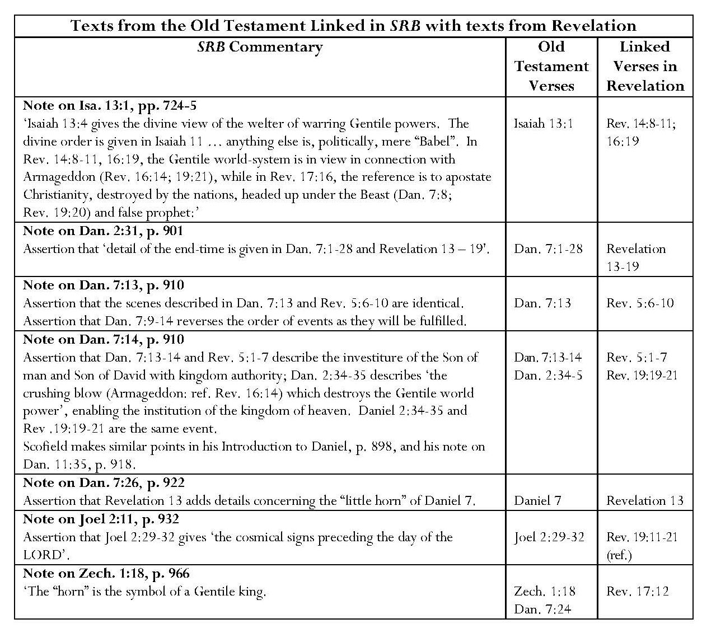
Continued overleaf

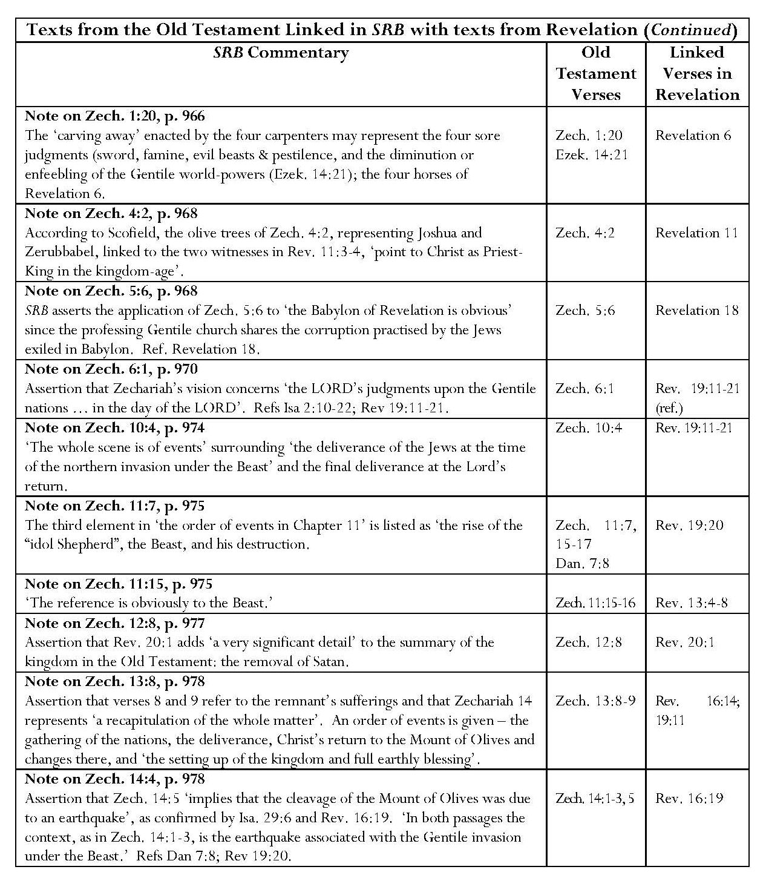

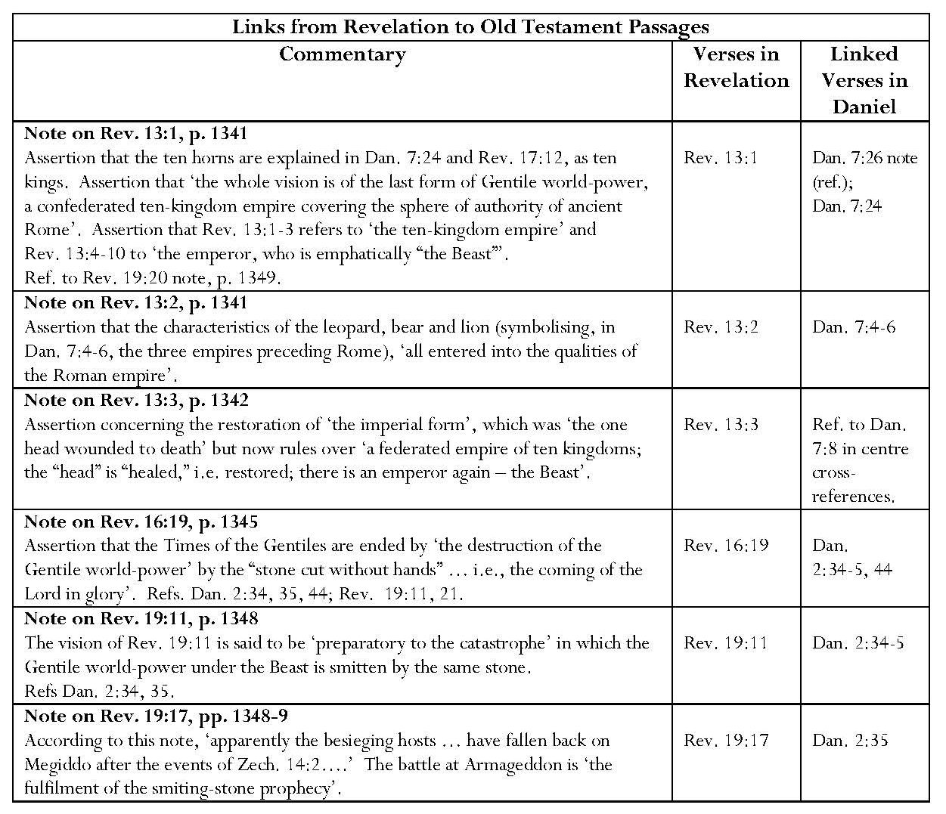
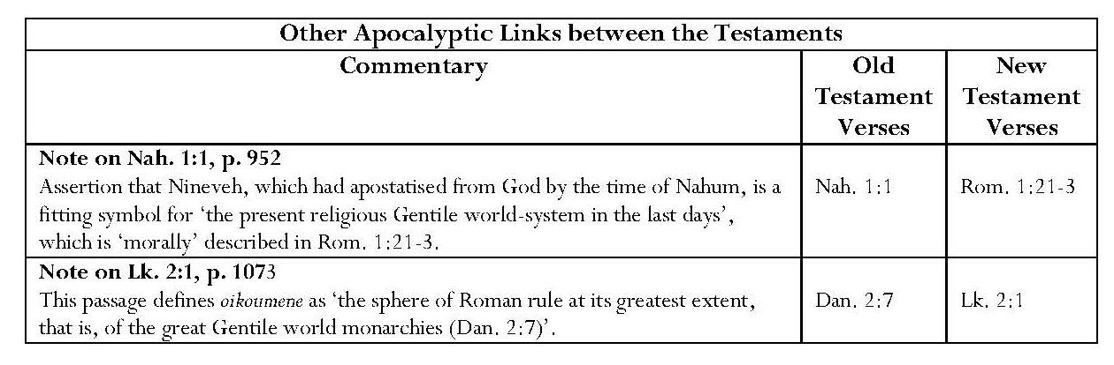
As shown in the tables above, Scofield makes very strong connections between biblical books written hundreds of years apart. The most blatant example of homogenisation is the occasion when, having imported the ‘Battle of Armageddon’ from Revelation (Rev. 16:16) as the ‘crushing blow’ of Dan. 7:14, Scofield asserts that ‘Dan. 2:34, 35 and Rev. 19:19-21 are the same event’. He also describes these passages as ‘identical’. Blaising warns against ‘the assumption’ that ‘the reemployment of literary descriptions in latter prophecy and apocalyptic … gives one concrete historical scenario in partially codified form’. He states that it is necessary to allow for ‘the way literary descriptions are taken up into a recurring pattern of prophecy and fulfillment within biblical history itself’. Other SRB notes make close comparisons between verses in Daniel, Zechariah and Revelation and concern end-time events and the day of the LORD. Several links reflect upon events relating to the Gentile world system and especially leadership by the beast, sometimes accompanied by the false prophet. Armageddon (ref. Rev. 16:14) appears in Old Testament notes on Isa. 13:1 and Dan. 7:14; in the latter note it is ‘the crushing blow’ of Dan. 2:34-5 but, according to the note on Rev. 19:17, it is ‘the fulfilment of the smiting-stone prophecy’. There are references to the kingdom or kingdom-age in notes on Daniel and Zechariah, making links to Revelation. The revival of the Roman empire is prominent in notes on Revelation 13 as the fulfilment of prophecies in Daniel 7. Two notes make comparisons between Old Testament verses and the apostate church and ‘present religious Gentile world-system of the last days’ … morally described in Rom. 1:21-3’.
Scofield’s Intertestamental Equation of Eschatological Characters
Scofield also asserts the equivalence of some Old and New Testament characters, especially the little horn of Daniel 7 and the beast of Revelation, but also involving other figures, as shown in the table below.
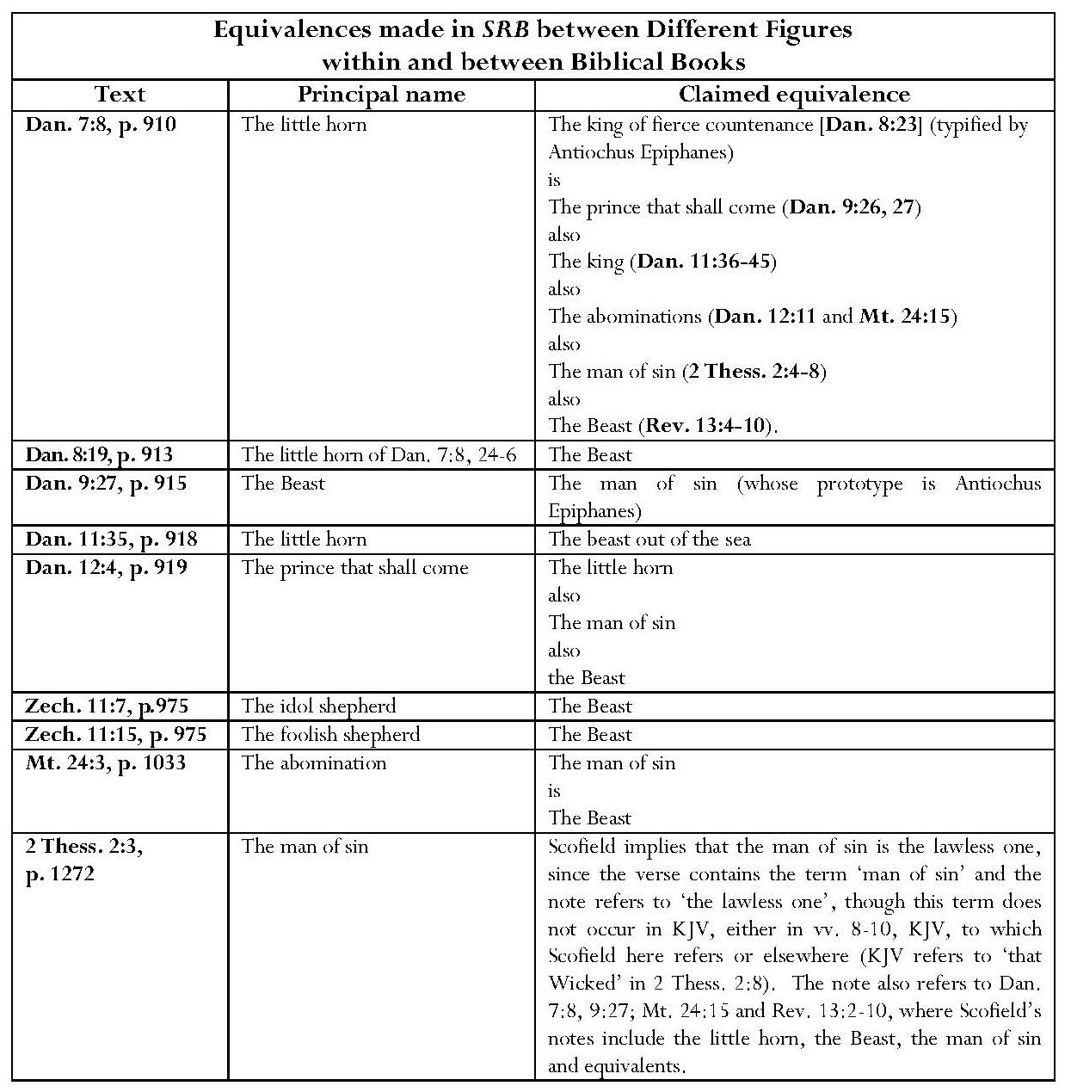
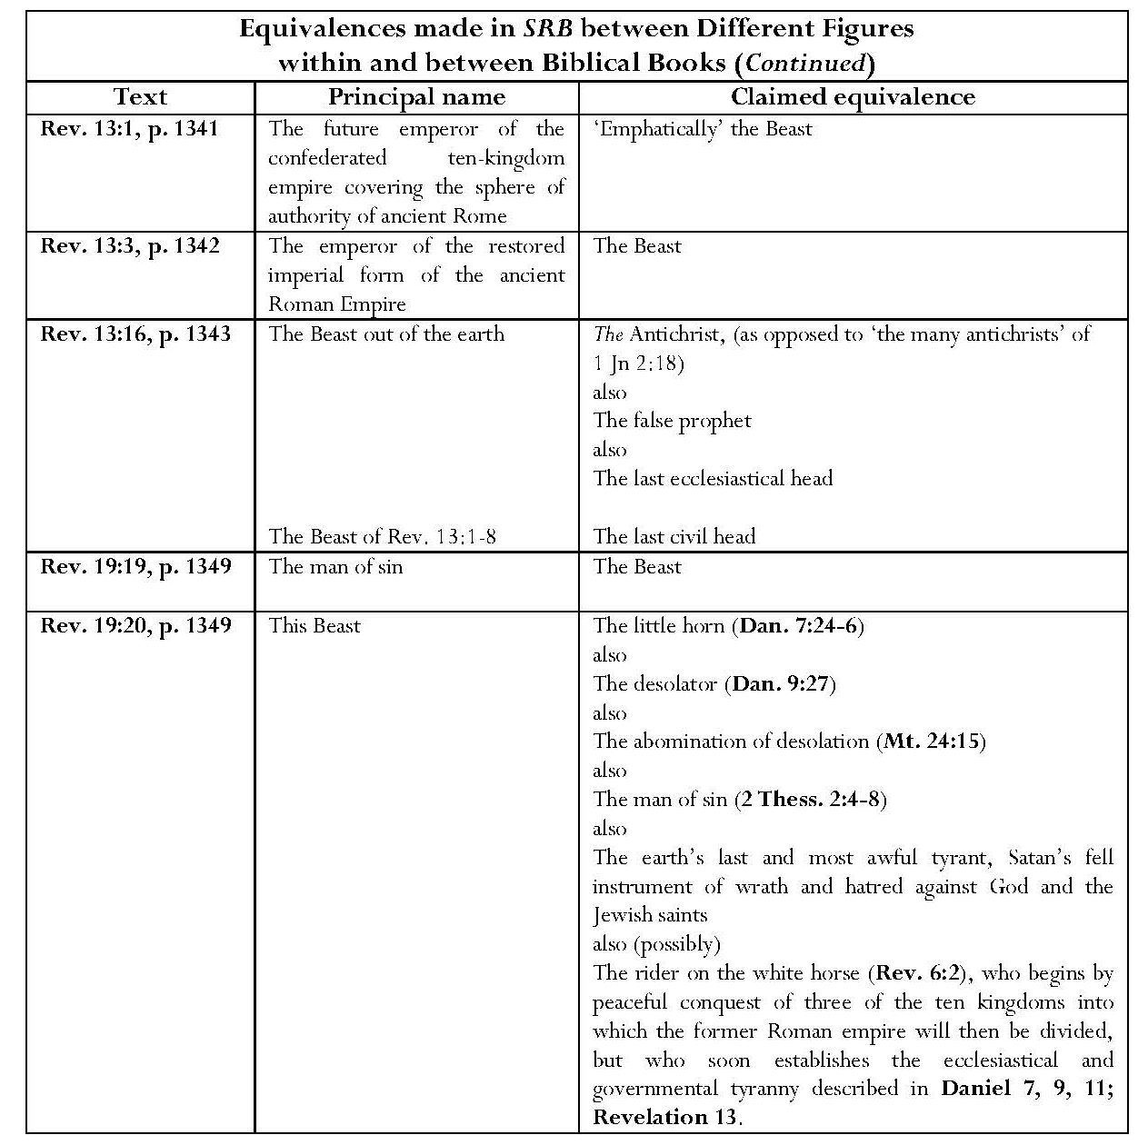
Scofield seems to relish lists of titles and equations between personalities, possibly reflecting once again his use of the Bible Readings method. The most important identification is the assimilation of the little horn of Daniel 7 and the beast of revelation, both directly and indirectly. In Scofield’s note on Dan. 7:8, the little horn is definitively associated with the king of fierce countenance and also connected with the historical, but non-biblical, figure of Antiochus Epiphanes; the king of fierce countenance is related to ‘the prince that shall come’, the ‘king’, ‘the “abominations”’, ‘the “man of sin”’, and ‘the “Beast”’. Thus, through this sequence of titles in a single note, the little horn is equated with all these figures, as is the beast. The beast is also associated directly with the man of sin, the idol shepherd and foolish shepherd, the abomination (of desolation), ‘the future emperor’ of the restored Roman empire and ‘last civil head’, the little horn, the desolator and, possibly, the rider on the white horse of Rev. 6:2. Through the equation made between the little horn and the beast from the sea in the note on Dan. 11:35, the Beast is identified by Scofield as the beast from the sea. Unlike Blackstone and Weber, Scofield identifies Antichrist with the beast from the earth and false prophet, rather than with the beast from the sea.
Scofield’s Intertestamental Equation of Eschatological Events
Further annotation from both Testaments describes other end-time personalities and institutions, and various events which are to occur during the tribulation period as shown in the table below.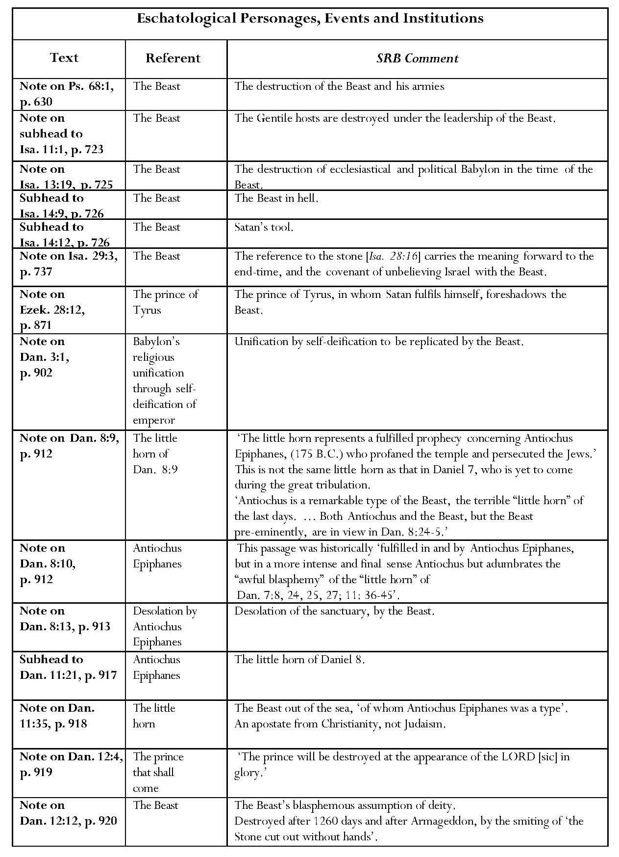
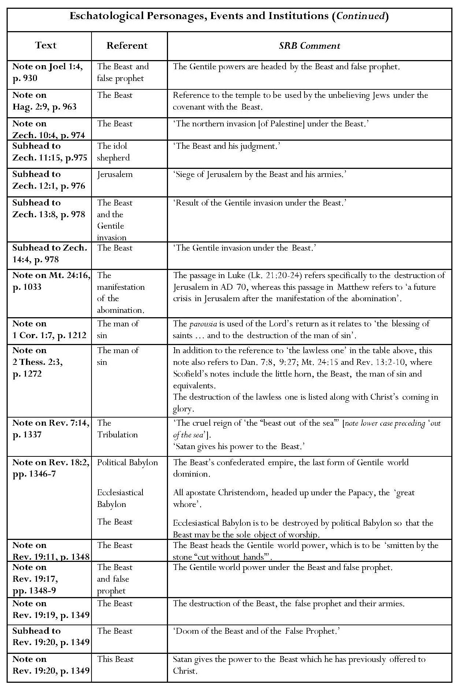

The Importance of the Beast in Scofield’s Interpretation of the Tribulation
Scofield states in his ‘Introduction to the Prophetical Books’ that the study of the beast and Armageddon aids understanding of the end-times. An analysis of the annotation in the table above illustrates several aspects of the role of the beast and his activities during the tribulation period. These include assertions about the arising of the beast during the tribulation; his role and activities, especially the blasphemous introduction of the abomination into the temple, and the invasion of Palestine; and his destruction and ultimate fate.
Many of the references to the beast occur in Old Testament commentary. Even Psalm 68 is said to refer to the beast; according to SRB, Ps. 68:21-3 refer to ‘the destruction of the Beast and his armies’. SRB also refers to the beast as Satan’s tool in its subhead to Isa. 14:12 In SRB, the phrase, ‘Gentile hosts headed up in the Beast’ is almost like a refrain. This reflects the way in which the whole Bible is regarded as a unity since events in the future tribulation are held to be found even in some of the oldest books.
The beast is strongly identified with Satan; it is Satan’s ‘tool’, his ‘fell instrument of wrath and hatred against God and the Jewish saints’ to whom ‘Satan gives his power’ … ‘the power which he offered to Christ’. These remarks by Scofield put the beast in a very powerful position, something which is probably reflected in his use of the capital letter for ‘Beast’. Furthermore, ‘Satan fulfils himself in and through the earthly king of Tyre, who foreshadows the Beast’. Scofield attributes the whole kosmos, or present world-system, to satanic influence; it is ‘the “order or arrangement” under which Satan has organised the world of unbelieving mankind upon his cosmic principles of force, greed, selfishness, ambition and pleasure’. ‘This world-system is imposing and powerful with armies and fleets; is often outwardly religious, scientific, cultured, and elegant; but, seething with national and commercial rivalries and ambitions, is upheld in any real crisis only by armed force, and is dominated by Satanic principles.’ Satan is ‘the real though unseen ruler of the successive world-powers, Tyre, Babylon, Medo-Persia, Greece, Rome etc’ [sic] and prince of the present world-system, which is his work and ‘the bribe which he offered to Christ’.
Important associations are made between the little horn, the historical figure of Antiochus Epiphanes and the beast, sometimes through the beast’s aliases, the little horn himself and the ‘man of sin’. Scofield emphasises the difference between the little horns of Daniel 7 and 8. ‘The little horn [in Daniel 8] is prophetically fulfilled in Antiochus Epiphanes, BC 175, who profaned the temple and terribly persecuted the Jews’, whereas ‘the “little horn” of Daniel 7 … is yet to come, and … will dominate the earth during the great tribulation’. However, ‘Antiochus is a remarkable type of the Beast, the terrible “little horn of the last days”’ and a type of ‘the Beast out of the sea of Rev. 13:4-10’. Daniel 8:24-25 go beyond Antiochus and evidently refer to the “little horn” of Daniel 7.’ The actions of both little horns ‘blend’ in Dan. 8:10-14.
Scofield argues that the little horns of Daniel 7 and 8 must be different because the former arises amidst the ten horns into which the fourth kingdom (Rome) is to be divided, whereas the latter arises from one of the four kingdoms into which the third (Grecian) empire was divided. This is true, but Scofield offers no evidence for his identification of either horn with the historical figure of Antiochus or the beast of Revelation and none for the attributions of the fourth and third kingdoms respectively to Rome and Greece. Further commentary attempts to put Antiochus in a biblical setting. The ‘appointed end’ of Dan. 8:19 is, on one level, said to be ‘the end of the third, or Grecian, empire of Alexander out of one of the divisions of which the little horn of verse 9 (Antiochus) arose’.
Further notes focus on the desecration of the sanctuary by the historical character, Antiochus Epiphanes. Scofield states that the first of seven desolations in Daniel is that of the sanctuary, fulfilled by Antiochus Epiphanes and the reference to ‘the abomination’ is to his sacrifice of a sow upon the altar. Antiochus’ blasphemy adumbrates that of the little horn. Here the little horn is projected into the future, rather than being a reflection of the past. Other notes look directly to the future and the beast. Scofield states that ‘the reference to the stone in Isa. 28:16 carries the meaning forward to the end-time, and the covenant of unbelieving Israel with the Beast’. In his note on Hag. 2:9, Scofield refers to the temple ‘which will be used by unbelieving Jews under their covenant with the Beast’. The SRB note on Dan. 3:1 refers to the Beast’s self-deification, which repeats ‘the great king of Babylon’s attempt to unify the religions of his empire’ by this means. In his note on Rev. 18:2, Scofield claims that ‘the Beast’s confederated empire’ is ‘the last form of Gentile world dominion’ and that ‘ecclesiastical Babylon [apostate Christendom] is to be destroyed by political Babylon [the Beast’s confederated Empire] so that the Beast may be the sole object of worship’.
Several meanings are allotted to the abominations. They are equated with the little horn himself and with ‘the blasphemous assumption of deity by the Beast’. Scofield asserts that ‘the abomination in the holy place’ is the first of the ‘details’ described in Mt. 24:15-28. The sign of the abomination is the man of sin, who is the Beast, Scofield refers to a foreshadowing of ‘the final siege at the end of this age, in which the great tribulation culminates’; the sign in Luke is Jerusalem’s being surrounded by armies, whereas that in Mt. 24:15 and Mk 13:14 is ‘the abomination in the holy place’. He states that the passage in Matthew describes ‘a future crisis in Jerusalem after the manifestation of “the abomination”’. In his note on Rev. 19:20, Scofield refers to the beast as ‘“the little horn” … “the desolator” … “the abomination of desolation” … and “the man of sin”.
A number of notes refer to the beast’s role in the Gentile invasion of Palestine from the north, which culminates in the Battle of Armageddon. The beast is the leader of the armies, which lay siege to Jerusalem. According to the note on Rev. 19:17, the beast is accompanied by the false prophet in besieging ‘the Jewish remnant’.
As stated above, Scofield equates Antichrist with the false prophet and beast out of the earth. In the note on a verse where neither the false prophet nor Antichrist is mentioned, Rev. 13:16, Scofield expounds 1 Jn 2:18, stating that ‘the Antichrist’ is the Beast out of the earth and the False Prophet, the last ecclesiastical head as the Beast is the last civil head. He offers no evidence for these assertions. Regarding the former, Scofield refers to Rev. 13:11-17; this is the only passage in Revelation where ‘the beast coming up out of the earth’ and his activities are mentioned. Rev. 16:13, Rev. 19:20 and Rev. 20:10, which Scofield gives as references concerning the latter, are three of the four verses in which the false prophet is actually mentioned. Gordon Fee identifies the false prophet with ‘the cult of the emperor’. The false prophet is mentioned only four times in KJV, all in the New Testament, one reference being to Elymas the sorcerer and the others occurring in Revelation. In none of these verses is the false prophet said to collaborate militarily with the Beast; according to Richard Bauckham, the false prophet ‘makes the world worship the beast, which is tantamount to worshipping the dragon’, and ‘performs signs’. It also has ‘power to give breath to the image of the first beast, so that the image could speak’ and shares the same fate as the beast, the lake of fire and brimstone. Nevertheless, Scofield often associates the false prophet with the Beast in the Gentile campaign against Palestine, coming from the north and besieging the Jewish remnant; here Scofield gives ‘False Prophet’ capitals as if attributing a title.
Nowhere in the biblical text is the false prophet or the beast from the earth equated with Antichrist, who only appears in 1 Jn 1 and 2. There is no intimation that Antichrist has any military role. The characteristic of Antichrist is that he denies that Jesus is the Christ who has come in the flesh; he also denies the Father. Scofield’s claim that the beast from the earth is synonymous with the false prophet is more legitimate and corroborated by Fee and Bauckham. Fee states that ‘the second beast … is referred to as a false prophet’; Bauckham refers to the second beast being called the false prophet in Rev. 16:13 and Rev. 19:20. John Sweet avers that the beast from the sea can ‘appropriately be called Antichrist’, since it represents, not merely opposition to Christ, but ‘the claim to be Christ, as Satan claims to be God’.
All the connections made by Scofield support the conception of Scripture as all being one and they ignore contexts of time, place and intention. Very importantly, Cox refutes the idea that ‘Daniel is a “key” to the interpretation of the book of Revelation’. Without this concept, ‘“these books” would then need to be treated as two separate volumes, each dealing with a different period of history’.
The Dispensational Status of the Tribulation
There is some disagreement over whether the tribulation forms part of a dispensation or not, although Scofield does not appear to consider this question. Williams states that classical dispensationalists regarded it as ‘a return to and continuation of the dispensation of law’; during the tribulation, it will be as if the Church had never existed or had any part in or effect on world history. Chafer, too, identifies the resumption of the law age with Daniel’s seventieth week; he argues that the course of the dispensation of the law ‘was interrupted by the death of Christ and the thrusting in of the hitherto unannounced age of the church. Thus the church age, while complete in itself, is parenthetical within the age of the law.’ The tribulation ‘bears no relation to the features of this church age’ and has no ‘characteristics of a dispensation in itself’. The ‘continuity’ of the law dispensation which began at Sinai, is ‘incomplete apart from the events which belong to the Great Tribulation’. It forms the ‘logical consummation of the dispensation of the law and contains judgments upon it’.
Ryrie advances three suggestions concerning the dispensational status of the tribulation. Firstly he disputes the claim made by Williams and Chafer concerning the continuation of the dispensation of law, arguing that no other dispensation is revived after its ending and that the Mosaic law ended at Christ’s first advent; it would thus be ‘more natural’ to speak of the tribulation period as ‘a distinct dispensation with similarities to the Mosaic economy’. A second alternative would be to regard the tribulation as the seventh dispensation out of eight, since it is a time of wrath, not grace, since it distinctly deals again with Israel, since the true Church is no longer on earth, and since the gospel to be preached is the gospel of the kingdom. Ryrie argues that grace is not precluded by wrath, since this ‘will also be a time of much salvation’, and that even a distinction between ‘the gospel of the grace of God and the gospel of the kingdom’ does not prohibit the inclusion of ‘the message of the cross’ within the latter gospel. A third possibility, which Ryrie regards as ‘more natural’ and with which Stamper concurs, would be ‘to consider the Tribulation as the time when [God] is bringing to a conclusion the economy of Grace with judgments on men who have rejected Him, rather than to consider it a separate dispensation’. Just as Noah was not subject to the judgment of the flood, so ‘the Church is not subject to the judgments … But in both cases the dispensation does not end until the judgments are completed.’ Later, Ryrie states categorically that ‘the Tribulation period itself is not a separate dispensation but is the judgment on those living persons who are Christ rejectors at the end of this present dispensation’.
7.1.3 The Second Coming of Christ
The coming of Christ to the air to accomplish the translation of the church is sometimes known as ‘Christ’s coming for his saints’. This is differentiated from ‘Christ’s coming with his saints’, which denotes Christ’s return to the earth to establish the millennial kingdom. Darby and Chafer both regard these as two separate events. Darby states: ‘The Lord comes with His saints, when He comes to execute judgment on the earth; but He comes for His saints previously.’ In his second ‘Lecture on the Second Coming’, he also refers to two events.
That Christ's power over death may be fully shewn, He takes to Himself mortal men, whether alive or dead: if alive, He changes them into glory without dying; if they are dead, He raises them. This is the first thing He does. He raises the dead first, and then the living are changed; and they go to meet the Lord in the air.
And if you turn to Colossians 3 you will see that when Christ appears, we shall appear in this glory along with Himself and be like Him. He will have already come and taken us up to Himself; and then He comes manifesting Himself to the world, and we appear with Him.
If He appears, we appear. If He appears in glory, we must appear in glory with Him. We are heirs of God, and joint-heirs with Christ.
He comes with these ten thousands or myriads of His saints.
However, in three other documents, Darby concentrates upon the earlier event, that is ‘Christ’s coming for his saints’, calling this ‘the second coming of Christ’:
We shall find, too, that the teaching of Scripture as to Christ's second coming casts wonderful light on the value of His first coming. For His second coming, as it concerns the saints, is to complete as regards their bodies (so bringing them into the full result of salvation) that work of life-giving power Christ has already wrought in their souls, founded on the complete title in righteousness which He has effected for them on the cross. He comes to receive them to Himself, that where He is there they may be also.
After Christ has fulfilled all that was necessary, the church, until the second coming of its Saviour, is taken from out of all nations, and united to Him.
The character of the Lord's second coming; seen not by the world but by those who look for Him; the time of their deliverance.
The SRB note on Acts 1:11 presents Scofield’s view of Christ’s two advents. Scofield asserts that ‘the O.T. foreview of the coming Messiah is in two aspects – that of rejection and suffering … and that of earthly glory and power’. Concerning the ‘N.T. teachings concerning the return of Jesus Christ’, Scofield states, ‘That return is an event, not a process, and is personal and corporeal.’ 1967 repeats the 1917 note exactly. However, as noted in 6.1.2, while repeating the rest of the SRB note verbatim, 2003 adds a very important clause after ‘personal and corporeal’. The note reads: ‘The return of Christ will be personal and corporeal, in two stages: to the air before the Tribulation – usually called the Rapture; then He will return to the earth after the Tribulation.’ This probably reflects greater interest in the rapture in later C20 and also puts more emphasis on the concepts of pre- and post-tribulation. Ice uses a similar expression in his 1997 article, ‘Morgan Edwards: A Pre-Darby Rapturist’: ‘The last few years have witnessed the discovery of voices from the Church’s past testifying to a two-stage return of Christ.’ However, the term ‘two-stage return of Christ’, contradicts remarks made by Chafer in Major Bible Themes. Chafer distinguishes ‘between two future events … Christ coming for His saints … and … Christ coming with His saints’; he even devotes a whole chapter to each of these events. Having established that the former event must precede the latter, Chafer states,
The long predicted second coming of Christ to this earth will be completely fulfilled when he comes with His saints, and, therefore, the coming of Christ for His own sustains no relation to it whatsoever. The two events are not two phases or aspects of one divine undertaking. … His coming for His saints is the next event in the order of the fulfillment of prophecy’, which should be awaited by ‘the child of God’.
This division between the two future events begs the question of an appropriate nomenclature for the event where Christ comes for his saints. As mentioned in 6.1.3, Scofield does sometimes open the possibility of a third coming since he refers in his note on 1 Cor. 15:52 to the ‘meeting in the air’ as the second coming of Christ, and in his note on Jn 14:3, where he asserts that the ‘promise of a second advent of Christ is to be distinguished from His return in glory to the earth’. However, in this chapter ‘the second coming of Christ’ will be treated as constituting Christ’s return to earth to establish the millennial kingdom.
Scofield emphasises that the Old Testament prophets, while not anticipating any interval between Christ’s two advents, distinguished between them as, for example, presenting Christ as ‘weak, despised, rejected and slain’ at his first advent and as a ‘mighty conqueror’ in the second. Scofield claims that Isaiah sees ‘the two advents in one view’ and that this is corroborated when Jesus quotes Isa. 61:1-2 in Lk. 4:16-20. He avers that it is significant that Jesus stopped partway through Isa. 61:2 when reading the text at Nazareth because the text up to “proclaim the acceptable year of the Lord” ‘is connected with the first advent’; he links the first advent with ‘the dispensation of grace’. ‘“The day of vengeance of our God” belongs to the second advent … and judgment’; it was not fulfilled in the first advent and will therefore occur at the second. Here Scofield builds upon the phrase, “and the day of vengeance of our God” which does, as he asserts, come after the comma in Isa. 1:2, KJV, but which is followed within that verse by the words, ‘to comfort all that mourn’ and by further words about comfort and rebuilding in the succeeding verses. The impression given is that the omitted ‘vengeance’ phrase is equal in weight to the words actually quoted by Jesus in Luke 4 both before and after it. Scofield asserts that Malachi, like other Old Testament prophets, saw ‘both advents of the Messiah blended in one horizon’, but did not conceive of the interval between them, occasioned by ‘the rejection of the King’, or envisage ‘the Church-age’. He states that ‘my messenger’ was fulfilled in John the Baptist, but ‘“the Lord whom ye seek” etc. is nowhere quoted in the New Testament’; Scofield avers that ‘the reason for this is obvious’: this awaits fulfilment. This assertion depends upon the argument of lack of New Testament quotation which could equally be applied to many other Old Testament verses.
Chafer states, ‘The Second Coming occupies a larger part of the text of the Scriptures than any other doctrine, and it is the outstanding theme of prophecy in both the Old and New Testaments.’ This is reflected in Scofield’s treatment of the two advents. Significantly, he makes many more references to the second advent than to the first. Of approximately eleven comments which mention the first advent, six emphasise events which did not happen during it. He uses these examples to indicate that these events will transpire at the future second coming. The SRB subhead to Mal. 4:2 proclaims ‘the mission of John the Baptist and the coming of the Lord’. As already mentioned, Scofield regards Jesus’ omission of Isa. 61:2b as indicating that that Isa. 61:1 and 2a belong to the first advent and dispensation of grace, whereas Isa. 61:2b belongs to the second advent. The subhead to Joel 2:30 proclaims ‘signs preceding the second advent and day of the LORD’ and the note on Heb. 1:4 states that the angels will accompany Christ at his second coming. Four subheads mention Jesus as foretelling his second coming, ‘coming for His own’, second advent and return. Even Zech. 13:8 is said to portray Christ’s return to the Mount of Olives. Scofield states that Mt. 24:4-33 answers questions about ‘the sign of thy coming and the end of the age’. He also avers that the ‘messenger of the covenant’ in Mal. 3:1 is ‘Christ in both His advents, but with special reference to events which are to follow after His return’. This seems a strange statement from a Christian, as it appears to undervalue Christ’s incarnation, death and resurrection.
Although Israel is to be regathered nationally, to be converted and to experience peace and power under the Davidic Covenant, it will be subject to judgment at Christ’s return. Scofield states that the ‘vexation’ was initially fulfilled in 70 CE and the ‘final dispersion of the Jews’, and ‘more completely [fulfilled] in the tribulation … which immediately precedes the return of the King’. Significantly, Israel’s regathering and repentance constitute preparation for Messiah’s return. Zechariah’s fifth vision typifies ‘the preparation of Israel for receiving Jehovah’s BRANCH’. Christ’s ‘“Immanuel” character’ as ‘Jehovah’s “Branch”’ will be manifested to ‘a restored and converted Israel’ after his glorious and divine return. The conversion and restoration of the High Priest’s ancient people will happen on his return. He will be ‘ruler over Israel’. Scofield claims that the future restoration of Israel is connected to the Lord’s advent and the deliverance of ‘the Jewish remnant’ ‘is wholly effected by the LORD’s return’. However, the use of the term ‘Son of man’ implies that Christ’s mission, death and resurrection, and second coming ‘transcended in scope and result all merely Jewish limitations’.
Christ’s return is to be glorious and visible, occasioning the earthly power and glory which were prophesied in the Old Testament. Many comments emphasise the glory of the return. Three comments mention its visibility: the subhead to Zech. 14:4: ‘The visible return in glory’; the note on Mt. 24:3: ‘The glorious appearing of the Lord, visible to all nations’; and the note on 1 Cor. 1:7, ‘Apokalupsis emphasises the visibility of the return; … it always implies visibility’. This stress on visibility emphases the contrast Scofield makes between this second coming and the secret rapture of the church.
The second coming is also associated with testing, judgment, vengeance and the day of the Lord. Subheads include watchfulness, warnings and exhortation. However, its initial action is the defeat of the beast, or Antichrist, at Armageddon. As Chafer says, ‘Fulfilling Daniel’s prophecy of the “smiting stone”, He [Christ] comes in “the fierceness of the wrath of almighty God”, conquering the God-defying nations of the earth in the battle of Armageddon.’

7.1.4 Armageddon
Scofield states that the first event of the day of the LORD will be ‘the invasion of Palestine from the north by the Gentile world-powers headed up under the Beast and false prophet’ and the second event will be ‘the Lord’s army and the destruction of the invaders’. Psalm 110 foresees judgment on the Gentile powers in advance of the kingdom’s arrival. Isaiah 10:20 anticipates ‘the final destruction of all Gentile world-power at the return of the Lord’, ‘the final crash of the world-system at the end of the age’. Scofield holds that Russia will play a significant role in both the northern invasion of Palestine before Armageddon and the final rebellion at the end of the Millennium. He asserts that ‘all agree’ that the primary reference in Ezekiel 38 is to the northern (European) powers, headed up by Russia: ‘the reference to Meshech and Tubal (Moscow and Tobolsk) is a clear mark of identification’. Scofield continues:
Russia and the northern powers have been the latest persecutors of dispersed Israel and it is congruous both with divine justice and with the covenants (eg Gen. 15:18 note; Deut. 30:3 note) that destruction should fall at that the climax of the last mad attempt to exterminate the remnant of Israel in Jerusalem. The whole prophecy belongs to the yet future “day of Jehovah” (Isa. 2:10-22; Rev. 19:11-21) and to the battle of Armageddon (Rev. 16:14; 19:19 note) but includes also the final revolt of the nations at the close of the kingdom-age (Rev. 20:7-9).
Scofield states that the battle of Armageddon is to occur at ‘the coming of the Lord in glory’, when the hosts have abandoned their siege of Jerusalem and ‘fallen back on Megiddo’, ‘at the very end of this age’, in ‘the last days’, ‘the day of the LORD’. He refers to this siege in his subhead to Zech. 12:1 and to the Lord’s deliverance from it in his subhead to Zech. 12:4. In his note on Mic. 1:6, he asserts that the Assyrian invasion ‘became a prophecy of a greater invasion in the last days … and of the Lord’s deliverance at Armageddon’. He states that ‘Armageddon … is the appointed place for the beginning of the great battle in which the Lord, at His coming in glory, will deliver the Jewish remnant besieged by the Gentile world-power under the Beast and False Prophet.’
Darby does not attach as much importance as Scofield to the exact site of Armageddon; he states:
That Antichrist will rise up against the Lord in a manner analogous to Pharaoh, I do not doubt; nor that Pharaoh is in many respects a type of Antichrist: but this is all. I do not attach very great importance to the idea that they are gathered at Armageddon, and that the battle is elsewhere. They are gathered to the battle, and they are gathered there; and the allusion, I have little doubt, is to Deborah's song; Judges 5: 19, 20. Armageddon is a mystic name, an allusion …
The name ‘Armageddon’ occurs only once in KJV, yet Scofield introduces this name thirty-three times into commentary on eleven biblical books. ‘Armageddon’ is referenced in twenty-five notes and eight subheads, twenty-six of these references appearing in Old Testament commentary. Scofield includes a further two references to Armageddon in his introductions to biblical books. The concept of Armageddon clearly plays a very important role as one of the focuses of Scofield’s eschatology. Armageddon forms the climax of the great tribulation, representing both the triumph of the returning Christ and the nemesis of the Times of the Gentiles. There is great emphasis on the Gentile nature of the opposition to Christ which culminates at Armageddon. ‘Gentile world-domination will be broken by Christ.’ The Gentile nations gather against Jerusalem, and take part in the battle of Armageddon. Gentile hosts approach Armageddon and the ‘Gentile world-system’ is in view in connection with it in Rev. 14:8-11, 16:19. The subhead to Mic. 4:11 proclaims ‘the gathering of the Gentile nations and the battle of Armageddon’. ‘Gentile world-dominion ends after the battle of Armageddon.’
Scofield asserts that the Beast and False Prophet are the leaders in the battle. They are ‘leaders of the nations’, of ‘the invading Gentile world-power’ or ‘world-powers’, and of ‘the northern invasion of Palestine’. As noted above, the false prophet is mentioned in only four biblical verses, none of which coincides with Scofield’s references. He is never stated to be the beast’s military accomplice, even though one of the verses in which he does appear occurs three verses before the sole reference to Armageddon. In Rev. 16:13, the false prophet is said to have an unclean spirit like a frog coming from his mouth. Joseph Mangina notes that the dragon, the beast and the false prophet here ‘explicitly appear as a kind of demonic anti-Trinity’ and that the striking feature is ‘the threefold repetition of the word “mouth”, underscoring John’s view of the uncanny, almost magical quality of speech itself’. In the verse actually describing the arraignment for battle, only the beast, the kings of the earth and their armies are mentioned and in the following verse, when the false prophet is mentioned in relation to the beast, he is described only as having ‘wrought miracles before him’.
It is at Armageddon that the beast meets his demise: the subhead to Rev.19:20 refers to the ‘Doom of the Beast and of the False Prophet’. In his guise as ‘the prince that shall come’, the beast will be destroyed at Christ’s coming; the note on Dan. 12:12 states that the beast will be destroyed after the Battle of Armageddon. ‘The crushing blow (Armageddon) … destroys Gentile world-power, thus clearing the way for the actual setting up of the kingdom of heaven.’ In his introduction to Revelation, Scofield relates the great tribulation, the Lord’s appearance and Armageddon, to the coming of the kingdom which follows them.
7.2 Millennial Expectations
The essence of dispensational premillennialist belief is that Christ will return to the earth before the millennium to initiate the millennial kingdom, which constitutes the seventh and final dispensation. Ryrie states that ‘the doctrine of the millennial kingdom is for the dispensationalist an integral part of his entire scheme and interpretation of many Biblical passages. … We may say that a millennial kingdom fully integrated into the whole theological system is a feature of dispensational premillennialism.’ It should be noted that the terms ‘millennium’ and ‘millennial kingdom’ do not appear in KJV. References to an eschatological thousand years appear in Rev. 20:2-7, where they concern the thousand-year binding of Satan and the thousand-year reign with Christ of those who ‘had not worshipped the beast, neither his image, neither had received his mark upon their foreheads not in their hands … they lived and reigned with Christ a thousand years’.
Scofield asserts that Christ’s thousand-year kingdom represents the manifestation of God’s righteousness on earth. The King will establish his thousand year rule over the whole earth on his glorious return. Scofield lists ‘the thousand years, i.e. the kingdom-age’, fourth in an ‘order of events’ occurring on the Day of Jehovah. Satan’s final rebellion at the end of the millennial period, and his judgment, and that of fallen angels, occurs after his thousand-year binding, preceding the final judgment and the defeat of death. Scofield claims that David described the future millennial kingdom in his last words. This assertion may be intended to suggest that David himself endorsed this concept, but Scofield offers no justification for this.
Scofield presents Christ’s transfiguration as containing ‘in miniature all the elements of the future kingdom in manifestation’: the glorified Lord; Moses, glorified, representing ‘the redeemed who have passed through death into the kingdom’; Elijah, glorified, ‘the redeemed who have entered by translation’; Peter, James and John, who are not glorified, temporarily, ‘Israel in the flesh in the future kingdom’; and the multitude below ‘the nations to be brought into the kingdom after its establishment over Israel’. Scofield asserts that one way in which Jesus Christ, the theme of Revelation, is presented, is in his relationship to the kingdom in his offices of High Priest, Bridegroom and King-Judge.
Scofield only refers twice to the Millennial Kingdom. The two references encapsulate claims that David foresaw the millennial kingdom and that some of the Jewish remnant will survive the tribulation and enter the millennial kingdom. Scofield does refer to the millennium in his note on Mt. 13:43, and to the millennial temple in his note on Ezek. 9:3. In his note on Ezek. 1:5, he suggests that, though the passage is ‘highly figurative’, ‘the effect was the revelation to [Ezekiel] of the glory of the Lord’. He emphasises that it is to Ezekiel as a priest that the vision of this glory was given, both its departure from the temple and also its ‘returning to the millennial temple to abide’. The descriptions of the measurements and regulations for the temple in Ezekiel 40 – 43 are very detailed, however, and Ezekiel is specifically told in Ezek. 43:11 to write down all these details so that the people, having repented, may ‘be faithful to its design and follow all its regulations’. This suggests a physical temple to be rebuilt according to instructions, not a millennial temple.
Because Scofield has tied the return of the Lord’s glory to a millennial temple, he has to account for the detailed instructions in Ezek. 43:18-27 about the reinstitution of sacrifices, hence his note on Ezek. 43:19. Commenting on the instruction to make a sin-offering of a young bullock, Scofield states that ‘doubtless these offerings will be a memorial, looking back to the cross, as the offerings under the old covenant were anticipatory, looking forward to the cross’. He also remarks that in neither case can animal sacrifices put away sin. It is questionable why an animal sacrifice should represent a memorial of the cross, since Christ instituted the Lord’s Supper as such a memorial and the sacrifice of a bullock would, in any case, be an imperfect offering in comparison with Christ’s perfect one. It also stretches the imagination to suggest that Ezekiel’s instruction should be any more than what it says from the viewpoint of its sixth century BCE context. The interpretation of the sacrifice of a bullock as a memorial also contravenes the dispensationalist principle of literal reading. Lutzweiler raises an additional objection: if the future temple were to host animal sacrifices, it would also have to have a veil, since all elements of the sacrificial system ‘stand or fall together’. If the veil were reinstated, this would negate the permanent fissure of the veil at the crucifixion, signifying denial of ‘the finality of the gospel’.
The later editions of the Scofield Bible use the adjective, ‘millennial’, far more frequently than SRB. They also refer more often to ‘the millennium’, which SRB names only in its note on Mt. 13:43. In some cases the addition of the adjective, ‘millennial’ lends specificity to SRB’s annotation, which may merely refer to ‘the kingdom’ and in other cases it is not reflected in SRB annotation. In the SRB note on Dan. 2:44, the reference is to ‘the kingdom of the heavens’, which the later versions change to ‘millennial kingdom’. SRB does not refer to the millennial reign, blessing, conditions, age, saints or period. The later versions include the phrase ‘millennial form of the kingdom of heaven’, which is interesting in view of the three-form kingdom of heaven which Blaising ascribes to Scofield.
Although he does not use the term, ‘millennial’ very frequently, Scofield holds that the doctrine of the kingdom is essential to understanding the meaning of prophecy. References to ‘the kingdom’ and ‘the kingdom-age’ occur as early as notes on Genesis, though the kingdom is not mentioned in these verses, and references to the kingdom occur throughout the SRB commentary, but the main expositions appear in commentary on Zech. 12:8 and 1 Cor. 15:24; the material in the two summaries is complementary, particularly in relation to the Davidic aspect.
7.2.1 Scofield’s Old and New Testament Kingdom Summaries
Scofield posits three stages in his Old Testament Summary. The first stage was earthly dominion ‘before the call of Abraham’, prediluvian and postdiluvian. The second stage, starting with the call of Abraham, ‘the Theocracy in Israel’, included the creation of ‘a distinctive people through whom the great purposes of God toward the human race might be worked out’ and that these purposes included ‘the establishment of a universal kingdom’. Scofield avers that the order of the development of divine rule was Moses’ mediatorship, Joshua’s leadership, the institution of the judges and the popular rejection of theocracy and choice of Saul as king. The third stage, ‘the Davidic kingdom’, included ‘the divine choice of David, ‘the giving of the Davidic Covenant’ and ‘the exposition of the Davidic Covenant by the prophets’.
The prophetic exposition is given under seven headings. Firstly, it will be Davidic; here Scofield makes links and Christological assertions, which are echoed in the note on 1 Cor. 15:24, which states that ‘the King was born in Bethlehem of a virgin’. The note on Zech. 12:8 states that the kingdom is ‘to be established under an heir of David, who is to be born of a virgin, thus truly man, but also “Immanuel”, “Mighty God, Everlasting Father, Prince of Peace”’. According to the note on 1 Cor. 15:24, The first element of ‘kingdom truth’ developed in the New Testament is that ‘the promise of the kingdom to David and his seed and described in the prophets enters the New Testament unchanged’.
Secondly, the kingdom will be ‘heavenly in origin, principle and authority but set up on earth, with Jerusalem as its capital’. Thirdly, it will initially be established over Israel but will become universal. Fourthly, its ‘moral characteristics’ will be righteousness and peace. Scofield here asserts that Rev. 20:1-5 ‘adds a very significant detail: the removal of Satan’. Fifthly, the kingdom will be established by power, not persuasion, and will follow divine judgment on the Gentile world-powers. Sixthly, its establishment, and Israel’s restoration, are ‘connected with the advent of the Lord, yet future’. Finally, despite chastisement for disobedience by David’s house, involving continuing Gentile overlordship of Jerusalem, ‘the Davidic Covenant has not been abrogated, but is yet to be fulfilled’, as reiterated in commentary on 1 Cor. 15:24, where Scofield asserts that ‘the King will restore the Davidic monarchy in His own person, regather dispersed Israel, establish His power over all the earth and reign a thousand years’.
In his Summary of the Kingdom, New Testament, Scofield states that the kingdom constitutes the seventh dispensation. It was ‘announced as “at hand” by John the Baptist, by the King, and by the Twelve’, but ‘was rejected by the Jews’. In anticipation of his rejection and crucifixion, Jesus ‘revealed the mysteries of the kingdom of heaven’ to be fulfilled between his rejection and glorious return. At Christ’s coming, the kingdom will be established under ‘David’s divine Son’, in order to restore divine authority on earth, ‘a revolted province of the great kingdom of God’. The Son will then ‘deliver up the kingdom of heaven to “God even the Father”, that “God” (ie. the triune God …) “may be all in all”’. The kingdom does not become the kingdom of the Father until Christ has delivered it up. Scofield states that ‘the great end and objective of the rule of Adonai (Lord) is the restoration of the kingdom to Jehovah (LORD)’.
7.2.2 The Davidic Nature of the Kingdom
Dispensationalists hold that the terrestrial kingdom to be instituted by Christ at his second coming will constitute the physical Davidic kingdom which was postponed during the unanticipated Church-age because of Israel’s rejection of Christ’s offer to establish it at his first coming. This terrestrial kingdom is to be based upon Jerusalem.
Charles Feinberg offers an enlightening account of the earthly and Davidic nature of the millennial kingdom. He states of the Sermon on the Mount that ‘the King is still offering the covenanted kingdom to those to whom it was promised. Now He promulgates the laws for the carrying on of that kingdom.’ ‘In failing to receive that King, that particular generation of Israelites lost the kingdom He was about to establish.’ Echoing Scofield, Feinberg asserts that ‘Christ never once corrected the Jews for their belief in an earthly kingdom’. He states that the kingdom is the one covenanted to David and that Matthew makes it clear from the start of his Gospel that Christ is ‘that descendant of the house and dynasty of David, … connected by the Word … with all the prophecies relating to the future Messianic kingdom’. ‘In a real sense the kingdom yet future will be the Davidic kingdom ruled over by the son of David.’ Bass asserts that ‘the dispensationalist millennium is decidedly Jewish in character’, focusing on ‘regathered Israel’. ‘The entire consummation of God’s plan for Israel is epitomized in the restored kingdom …’
Many elements in Scofield’s commentary relate to the Davidic nature of the kingdom; the third section of his ‘Kingdom in O.T. Summary’ in his note on Zech. 12:8 is devoted to it. The tables below show Old and New Testament references in SRB which relate the Davidic kingdom to the kingdom Christ is to establish at his second coming.
Continued overleaf
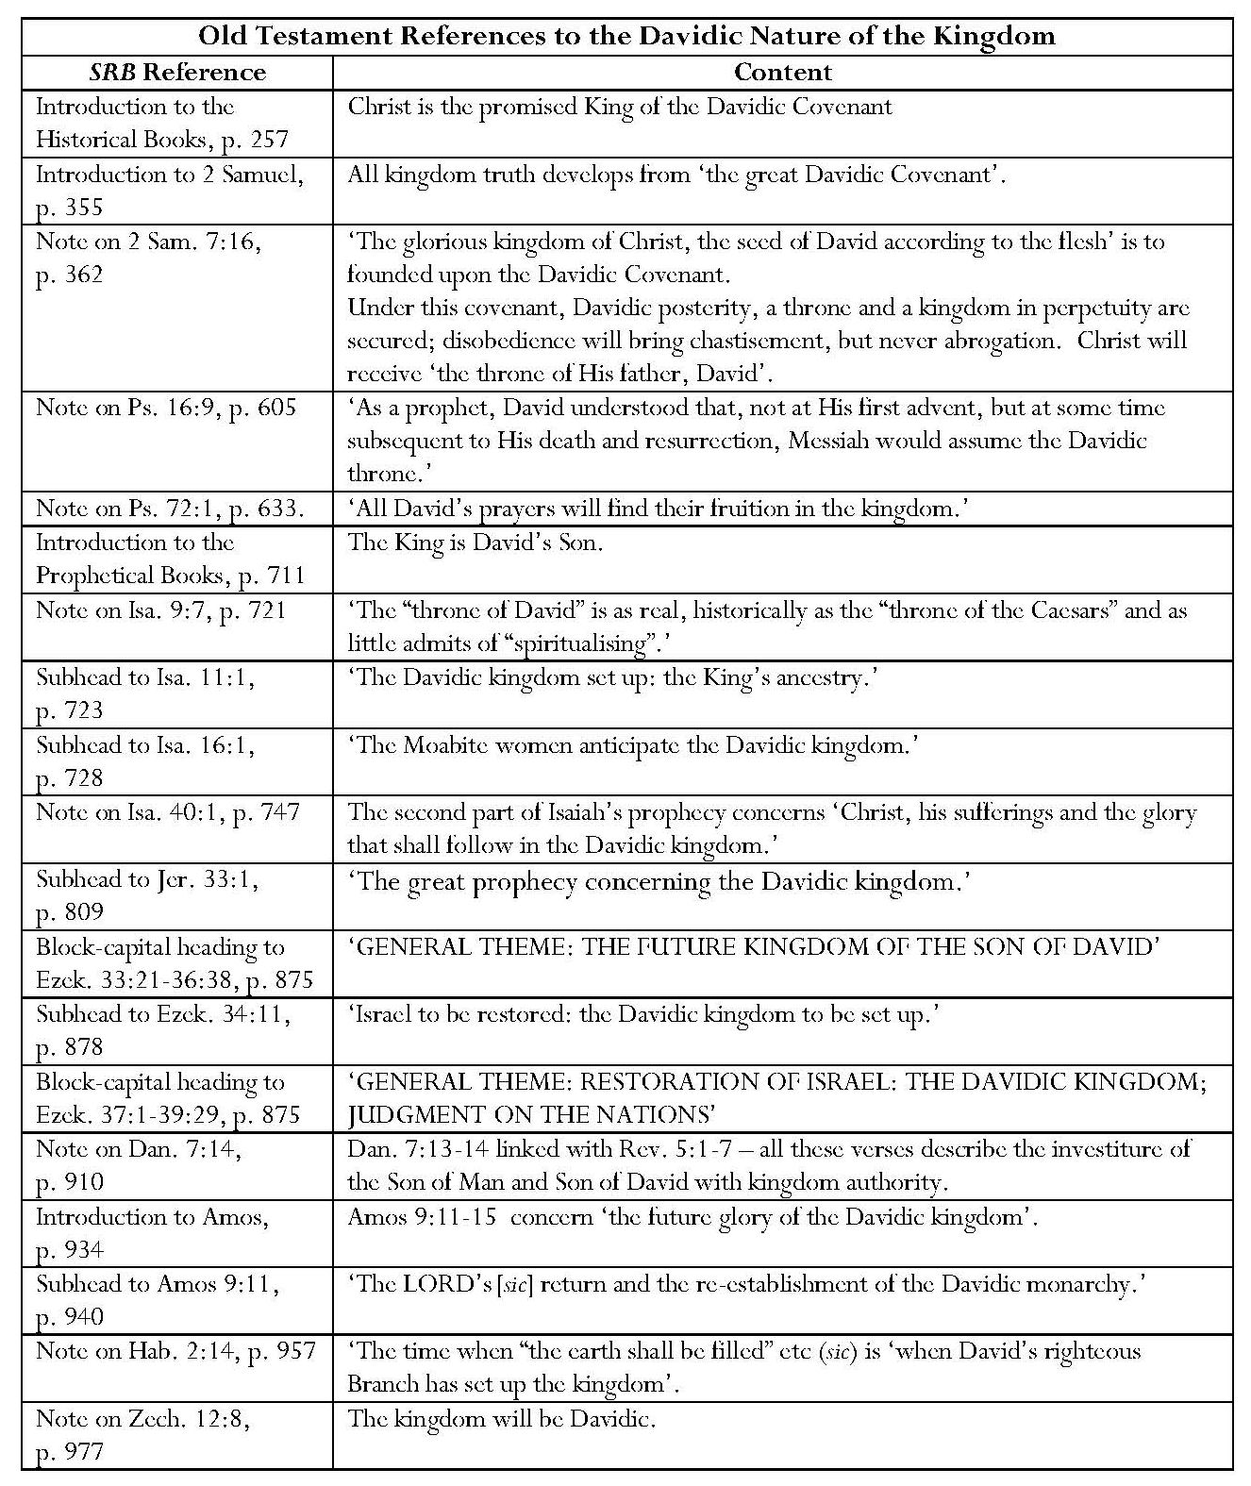
Scofield states in his Bible Correspondence Course that Christ is ‘the “seed,” heir and coming King under the Davidic covenant’; the Davidic Covenant, as described by Scofield in his SRB note on 2 Sam. 7:16, forms the basis for Scofield’s claims concerning the Davidic nature of the kingdom to be established at Christ’s return. It is for this reason that Scofield emphasises Christ’s ancestry, for example in his subhead to Isa. 11:1. Scofield makes several references to the Davidic kingdom in his annotation of Isaiah. The word, ‘Davidic’ never occurs in KJV and Isa. 55:3, concerning divine mercy, is the only reference to David in Isaiah after Isa. 40:1. The word, ‘kingdom’ occurs only five times in Isaiah, and is related to David solely in Isa. 9:7, thus the same criticism applies to Scofield’s subheads to Isa. 11:1, and 16:1.
Scofield makes several more links between prophetical material and the Davidic kingdom. Despite the SRB subhead to Jer. 33:1, there is no reference in Jeremiah 33 to a kingdom, though some verses do refer to God’s covenant with David. SRB makes three references to the Davidic Kingdom in a subhead and block-capital headings to Ezekiel. Ezekiel 34 does not contain the word, ‘kingdom’; Ezek. 34:23-4 refer to David, but in a shepherd capacity, and as ‘a prince among them’ under God. The context of the earlier occurrences of the word, ‘kingdom’ in Ezekiel 17 does not suggest triumphant restoration. These refer to Judah’s abasement as a kingdom through the Babylonian exile and a fruitless attempt at an Egyptian alliance. These verses are not annotated. Ezekiel 37:24-5 provides some justification for Scofield’s second major heading; these verses state that God will re-establish Israel in her own land under David, her king. However, the existence of these two verses, while giving a more optimistic message, does not really justify two conspicuous headings with which Scofield divides the text of Ezekiel. Scofield links Daniel 7:13-14 to Rev. 5:1-7 with the assertion that all these verses describe the investiture of the Son of Man and Son of David with kingdom authority; ‘root of David’ occurs in Rev. 5:5, but the name, ‘David’, does not occur in Daniel.
The appropriateness of Scofield’s references to the Davidic monarchy in commentary on Amos is also debatable. Amos 9:11 actually concerns the raising of David’s fallen tabernacle and the only kingdom mentioned in Amos is the ‘sinful kingdom’ of Amos 9:8; the threat of its destruction does not seem congruent with Scofield’s jubilant declaration. Scofield also states in his note on Hab. 2:14 that ‘the time when “the earth shall be filled” etc.’ is ‘when David’s righteous Branch has set up the kingdom’. Habakkuk does not mention David, kingdom or Branch.
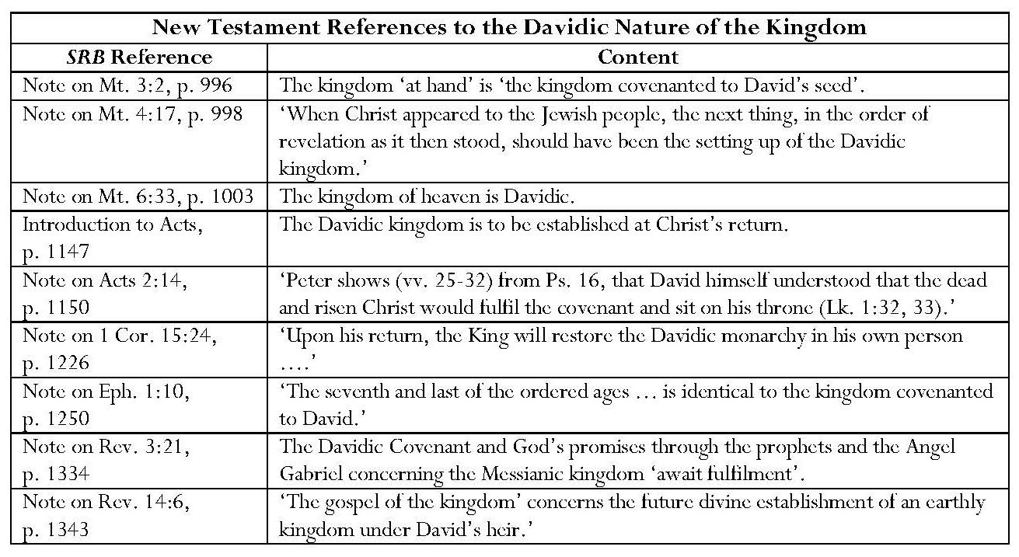
There are very few references to David in the New Testament verses to which Scofield attaches the term ‘Davidic kingdom’. Matthew 3:2 states that the kingdom of heaven is at hand. It makes no reference to this being ‘the kingdom covenanted to David’s seed’ or to David himself, as Scofield asserts. Matthew 4:17 simply refers to ‘the kingdom of heaven’, yet, referring to this, Scofield makes claims regarding ‘the Davidic kingdom’. Scofield’s note on Mt. 6:33 also refers to the kingdom of heaven as ‘Davidic’.
Scofield attempts to explain the apparent failure of materialisation of the promised Davidic kingdom by stating that it was to be established at Christ’s return, but this explanation is not supported by the verses he quotes. Acts 2:25-31 contains Peter’s declaration of what God has already done in Christ, as foretold by David. There is no mention of Christ’s return. Acts 15:14-16 concerns the restoration of David’s tabernacle, or tent (skhnh,), which has the sense of a holy place or, more generally, a dwelling.
Acts contains ten references to David, and eight to the kingdom. Seven of the latter refer to the kingdom of God, which is outside Scofield’s usual definition of ‘the kingdom’. The eighth concerns the restoration of the kingdom to Israel, in which the disciples’ question is firmly dismissed by Jesus. Four of the references to David concern his prophecy. Other references concern God’s choice of David as king, the gift to Christ of the mercies of David, and David’s mortality. Acts 7:45-6 refer to David’s desire to build a tabernacle for God, though verses 48-9 state that God does not dwell in temples made with hands, verses upon which Scofield does not comment. Acts 15:16-17 refer to God’s promise to restore ‘the tabernacle of David’. Strangely, Scofield ignores Acts 2:30, which refers to Christ’s sitting on David’s throne, and transfers comment on this to his note on Acts 2:14, which does not.
Scofield states that the arrival of the covenanted kingdom marks the consummation of events in Revelation. The word, ‘covenant’, does not appear in Revelation. Scofield asserts that Rev. 3:21, along with several other passages, ‘is conclusive that Christ is not now seated upon His own throne. The Davidic Covenant and God’s promises through the prophets and the Angel Gabriel concerning the Messianic kingdom await fulfilment.’ Scofield avers that the ‘gospel of the kingdom’, concerns the future divine establishment of an earthly kingdom under David’s heir. David is mentioned three times in Revelation and in none of these verses is his name related to a kingdom, though Christ’s links to David, including his identity as David’s offspring are stated. The word ‘kingdom’ appears five times; in no instance does it pertain to an earthly kingdom of Christ. The first instance is ambiguous; the second pertains to the kingdom of God; the third pertains to the Beast’s kingdom; and the fourth and fifth pertain to the kingdom offered to the Beast by the ten kings. There are, of course, many references to ‘the throne’, but the Davidic kingdom is nowhere mentioned in the text of Revelation.
Chafer calls the covenanted Davidic kingdom ‘the most extensive and important feature of the eschatology of Judaism’. He asserts that the Davidic Covenant ‘does bind Jehovah with an oath to the perpetuity of the Davidic house, the Davidic throne, and the Davidic kingdom’. Ryrie states that Christ offered the Davidic kingdom rather than ‘the general rule of God over the earth or His spiritual reign in individual lives’, even though dispensationalists ‘affirm the continuing presence of the universal kingdom and the spiritual rule of God in individual hearts today’. However, Saucy states that, although the Davidic promise ‘provides the central features for the kingdom in the Old Testament, especially in the aspect of the predicted messianic king … the kingdom theme of the Bible encompasses more than these explicit promises to David. The establishment of the kingdom of God on earth is … the ultimate goal of biblical history’.
7.2.3 The Messianic Nature of the Kingdom
Scofield belongs within a succession of writers who refer to the millennial kingdom as Messianic. Darby makes at least one reference to the ‘Messianic economy’: ‘Christ's government, then, or his headship over creation, is the grand characteristic feature which marks the dispensation of the fullness of times or, it may be termed, the Messianic economy.’ Chafer refers to ‘Christ’s Messianic kingdom on the earth’. Ryrie refers several times to the Messianic kingdom in Dispensationalism Today. Saucy refers to ‘the messianic kingdom’, ‘the messianic reign of Christ’, ‘messianic kingdom promises’, and ‘the mediatorial messianic kingdom’. Blaising, too refers to ‘the mediatorial messianic kingdom’, and Blaising and Bock to ‘the messianic reign of Christ’.
Scofield makes several references to the Messianic nature of the kingdom in Old and New Testament commentary.
Continued overleaf
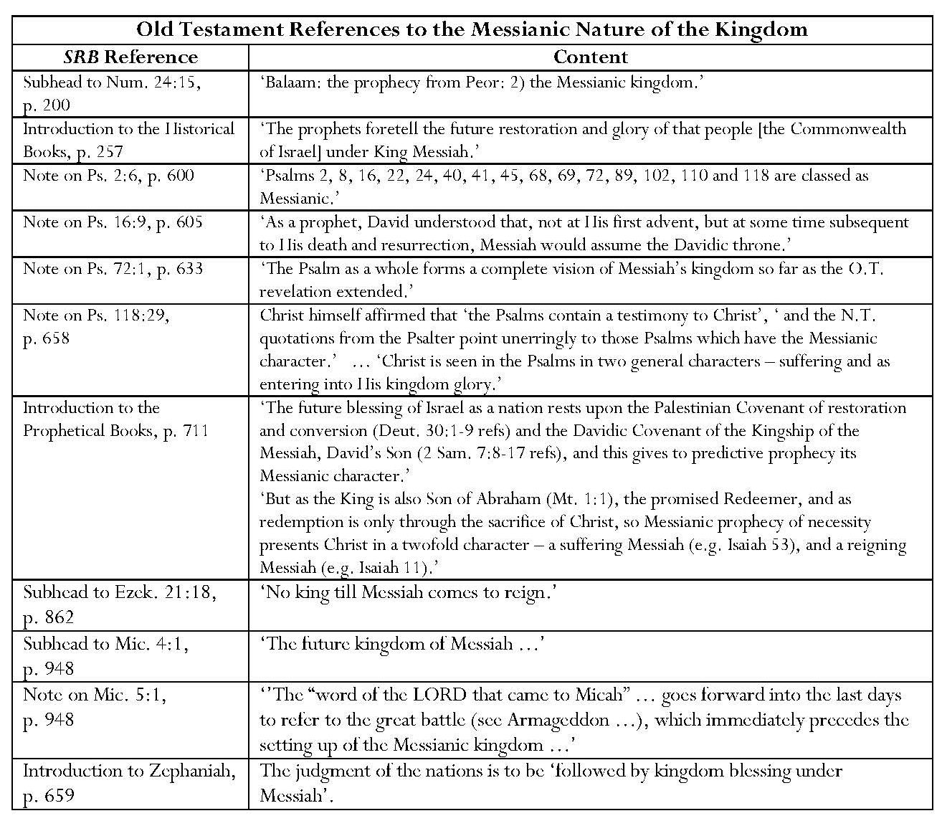
Contrary to Scofield’s claim that Balaam prophesied ‘the Messianic kingdom’, Fitzmyer comments that Balaam’s vision refers to a future Israelite victory over Moab and Edom and that ‘there is neither mention nor hint of a Messiah in this text’. Fitzmyer identifies some of the Psalms which Scofield calls ‘Messianic’ as ‘royal psalms’.
In no verse to which Scofield attributes Messianic significance, does the word x;yvim, appear in the Hebrew Bible, though the SRB Introduction to Daniel may indirectly refer to Dan. 9:25-26, which contains the only two uses of the word ‘Messiah’ in KJV. There are also only two references to ‘Messias’ in KJV. The word ‘Messianic’ does not occur in KJV. There are thirty-seven verses in the Hebrew Bible where x;yvim' is used as an adjective. References may be to anointed priests, Saul, David, Cyrus, ‘our life-breath’ and God’s people.
Fitzmyer states that ‘one cannot foist a later Christian meaning on a passage that was supposed to have a distinctive religious sense in guiding the Jewish people of old’. ‘The idea of x;yvim as an awaited or future anointed agent of God in the end time developed only gradually in Old Testament times’; ‘“Messiah” as such is a relatively late development’. Fitzmyer attributes this to the second quarter of C2 BCE.
Fitzmyer classifies most occurrences of x;yvim as pertaining to reigning kings, priests and prophets or patriarchs. He emphasises the importance of distinguishing between pre-exilic monarchic times and the post-exilic era when Judah became a province and hope for restoration grew. ‘Out of such a hope … developed the expectation of a Messiah in the narrow sense.’
Fitzmyer regards the book of Daniel as belonging to ‘the period in the history of Judaism when belief in the coming David develops into that of a national Messiah, whom God will raise up as a descendant of David, an earthly scion, a future eschatological realization of the ideal of kingship’. Dan. 9:25 contains ‘the first occurrence in the Old Testament … of x;yvim … as an Anointed One, even though in the context it might refer to one who is or has been already on the scene’. Thus ‘Messiah’ in the narrow sense emerges in the second quarter of C2 BCE. Even if this ‘Anointed One’ cannot be specifically identified, this shows that ‘messianism was not merely a visionary foreshadowing of what New Testament writers would predicate of Jesus of Nazareth’.
Scofield employs ‘Messiah’ or ‘Messianic’ regarding the kingdom at least seven times in New Testament commentary as shown in the table below.
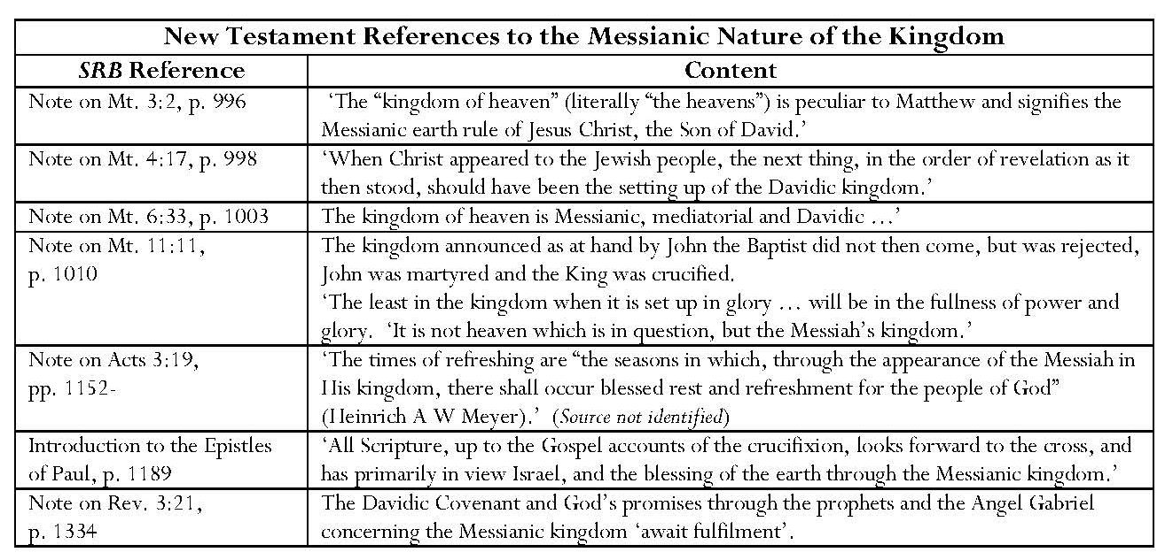
Fitzmyer does not comment on any of the verses to which Scofield applies Messianic connotations. Ironically, Scofield again fails to comment on the two verses where ‘Messias’ appears. Fitzmyer draws attention to these on the very first page of his commentary.
7.2.4 The Kingdom of Heaven and the Kingdom of God
One of the features crucial to classical dispensationalism is its distinction between the kingdom of heaven and the kingdom of God and the identification of the millennial kingdom with the kingdom of heaven in a future form. Blaising states that the most well-known version of this is that advanced by Scofield; ‘Scofield taught that the kingdom of heaven had three forms … “at hand” in Jesus’ preaching … now present in mystery form … and [to] be fulfilled in the Millennium.’ This will be discussed below.
Darby refers to the kingdoms of heaven and of God in several documents and it is possible to see a relationship between his view and the view later developed and expressed much more definitively by Scofield. Like Scofield, Darby sees the kingdom of heaven as being established on earth at Christ’s return but his interpretations of the current nature and roles of the kingdoms of heaven and of God is different from Scofield’s. In his ‘Dispensation of the Kingdom of Heaven’, Darby writes:
“The kingdom of God” is a distinct expression from “the kingdom of heaven,” although in many respects so identified, that the same things could be affirmed about it. … But at the same time they were of very distinct import; for it was a matter of faith to know that the “kingdom of God was come amongst them.” (See … Luke 11: 20; Luke 17:21.) … The kingdom of God was necessarily there when the Son of God was there — in a word, when God was there. The kingdom of heaven, as the development of God's purpose, could not be there while He was there; it resulted from the Lord's going away into heaven.
The kingdom of God is the exercise or exhibition of the ruling power of God under any circumstances in the wisdom of God. The kingdom of heaven is the kingdom of God in its heavenly character. …
… The kingdom of God, therefore, was amongst the Jews when He, the Son of God, Jesus, was there — and they ought to have known it — and the kingdom of heaven was at hand. By the earthliness of men, however, instead of gathering the Gentiles to the Jews, the Messiah being recognised, it was known only (as in God's counsels and wisdom meant to be) by the rejection of Him, and the exaltation … of the Son of man, who was the Lord from heaven, and Son of man in heaven. The kingdom of heaven (His kingdom was not of this world) was set up, continuing, as regards the Church, till the time when the saints, in the Father's kingdom, raised with Jesus at His second coming, shall know the blessedness of the rule of the Son of God and man, in the whole scene which once rejected Him, now brought under His sway and theirs (still, in that sense, the kingdom of heaven to those below), when they witness the blessedness of heavenly rule, while dwelling "kings and priests unto God" in the quiet and secure fullness of the Father's house-sons with Him.
Like Darby in his ‘Brief Remarks on the Work of Rev. David Brown’, Scofield notes that Matthew alone refers to ‘the kingdom of heaven’; he also points out that Matthew uses the term, ‘kingdom of God’, in Mt. 21:31 and 43. He asserts five points of difference between the kingdoms of God and heaven.
Continued overleaf
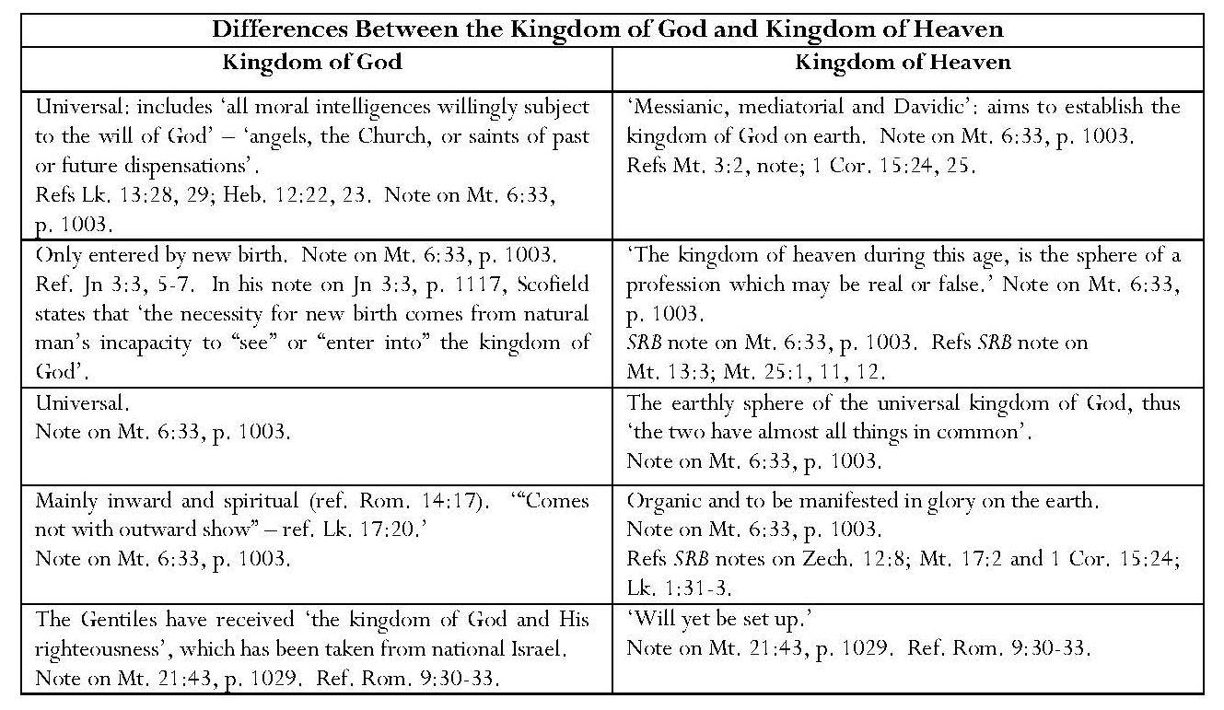
Scofield asserts that it is because ‘the two [kingdoms] have almost all things in common’ that Matthew uses ‘kingdom of heaven’ in many cases where Mark and Luke use ‘kingdom of God’. Scofield also avers that the earth is ‘a revolted province of the great kingdom of God’. He states that the two kingdoms merge when Christ, ‘having “put all enemies under His feet”, “shall have delivered up the kingdom to God, even the Father”’.
Commenting on Jesus’ statement about the withdrawal of the kingdom of God in Mt. 21:31, Scofield states that ‘kingdom of God’ is a ‘larger word’; ‘the kingdom of God and His righteousness is taken from Israel nationally and given to the Gentiles’. Attempting to explain Jesus’ enigmatic statement in Lk. 17:21 that ‘the kingdom of God is within you’, Scofield states that a ‘Christ-rejecting Pharisee’ could not be said to have ‘the spiritual content’ of the kingdom of God within him, thus Jesus’ answer ‘has a dispensational meaning’. The Jews had rejected the covenanted Davidic kingdom in its outward form, thus it would not be observable during this present age, but exist only inwardly; it would ultimately ‘come, with outward show’; David is not mentioned in the text. Moreover, Scofield’s interpretation implies that Christ desired the Pharisees to accept an outward kingdom rather than stating that they were looking in the wrong place. This strongly suggests a notion that the Jews’ acceptance of a material kingdom ‘offered’ by Christ would have obviated the need for his suffering, death and resurrection. This impression is confirmed in two subheads: ‘The King’s public offer of Himself as King’ and ‘The official presentation of Jesus as King’, and also in the note on Mt. 21:4, where Scofield states that this was ‘the King’s final and official offer of Himself according to Zech. 9:9’. Scofield states that the Jews were ‘never rebuked for expecting a visible and powerful kingdom’ even though they should have expected from the prophets that ‘only the poor in spirit and the meek could share in it’. He thus seems to imply that the kingdom of God is only a substitute for the kingdom of heaven, which has been postponed from the fifth to the seventh dispensation. Furthermore, the kingdom named in Luke is the ‘kingdom of God’, not the ‘kingdom of heaven’, a phrase peculiar to Matthew, yet Scofield uses ‘kingdom of heaven’ at the end of his note on Lk. 17:21. This could be another example of Scofield’s homogenisation of the gospels, or simply confusion.
The note on Acts 1:6 reveals ambiguity in Scofield’s conception of the kingdoms of heaven and of God. Scofield unjustifiably asserts that Christ had, for forty days, been ‘instructing the apostles “of the things pertaining to the kingdom of God”’; the verses he references in his note on Acts 1:6 actually describe Christ’s opening the scriptures concerning himself to Cleopas and his companion on the way to Emmaus. None of these verses mentions the kingdom of God. However, the use of the term ‘kingdom of God’ in commentary on the disciples’ question concerning the timing of the restoration of ‘the kingdom’ to Israel, implies that Scofield assumes that this is the kingdom of God; this is not stated in Acts 1:6. This conflicts with Scofield’s earlier statements, where he identifies Christ’s Messianic earth-rule as ‘the kingdom of heaven’ and avers that the kingdom of God is mainly spiritual but the kingdom of heaven ‘is to be manifested in glory on the earth’. It also conflicts with SRB’s unambiguous statement that it is the kingdom of heaven which is to be established on earth as the restored Davidic monarchy.
The Mystery Form of the Kingdom of Heaven in This Age
Unlike Darby, who confines the kingdom of heaven during this age to heaven, Scofield avers a role for the kingdom of heaven on earth in this age; it is a ‘mystery form’. He avers that ‘a mystery in Scripture is a previously hidden truth, now divinely revealed’; Scofield states that ‘a supernatural element remains’ in this. The first of the greater mysteries is ‘the kingdom of heaven.’ In God’s as yet undisclosed knowledge ‘lay the rejection of the kingdom (and King), the long period of the mystery-form of the kingdom’. The Church represents ‘the revelation of the mystery hid in God’ and is also contemporary with the mysteries of the kingdom.
The notion of mystery-form is particularly advanced in Scofield’s commentary on Matthew, especially Matthew 13, which contains a series of subheads attributing ‘mystery’ to the parables. Scofield claims that the parables in this chapter are ‘called by Jesus “the mysteries of the kingdom of heaven”’. These seven mysteries occur between Christ’s advents to suffering and to glory, and are to be fulfilled during this age. ‘The great growth of the mustard seed prefigures the rapid but unsubstantial growth of the mystery form of the kingdom from an insignificant beginning to a great place in the earth’. ‘The Lord’s return tests the real state of the kingdom in mystery.’
These claims of mystery are not accurate; the word, musth,rion, occurs only three times in the Gospels, in Christ’s response to questions from the disciples, explaining that he uses parables because only his disciples are given to know the secret or secrets of the kingdom of heaven or of God. He does not call the parables themselves mysteries. The seven ‘mysteries’ listed by Scofield are, in fact, a metaphor for God and six metaphors for the kingdom, each introduced by ‘~Wmoiw,qh h` basilei,a tw/n ouvranw/n’ or ‘o`moi,a evsti.n h` basilei,a tw/n ouvranw/n’. Christ does not refer to a ‘mystery-form’ of the kingdom but to the kingdom itself.
According to Scofield’s note on Dan. 9:24, the mysteries of the kingdom of heaven and the ‘outcalling’ of the Church are to occur during the period between the crucifixion and destruction of Jerusalem, and ‘the end’. Only the continuation of wars and desolation were revealed to Daniel but the New Testament ‘reveals … that during this period should be accomplished certain mysteries of the kingdom of heaven’. Scofield states that the Church is another mystery revealed through Paul, being fulfilled contemporaneously with the kingdom in the present age. The mysteries will end at the ‘harvest’ after the Church has been caught up to meet Christ in the air.
However, the kingdom of heaven in the present age, in addition to being in ‘mystery-form’, is also ‘the sphere of a profession which may be real or false’. Scofield holds that the parables of the kingdom of heaven after those of Matthew 13 encapsulate this. He states that the parables of the wheat and tares, and good and bad fish, are indicative of Christian profession or ‘Christendom’. The parable of the wheat and tares is ‘a description of what professes to be the kingdom’. SRB includes the parable of the bridesmaids in this category. Scofield claims that leaven also represents the corruption of true doctrine by false. He asserts that the keys of the kingdom of heaven given to Peter are ‘viewed as’ pertaining to ‘the sphere of Christian profession’, as is Peter’s use of them in Acts. He states that it is a mistake to think that the world will be converted during this age, when the kingdom is inward only.
It is significant that Darby specifically gives the title, ‘the Dispensation of the Kingdom of Heaven’, to his document concerning the future age which was quoted above. The implication in this passage is that Darby believed that the kingdom of heaven, which is ‘the kingdom of God in its heavenly character’, is confined to heaven as during the current dispensation and has no role on earth. For Darby, the kingdom of heaven has never been present on earth and will not appear until it is brought by Christ at his second coming. Conversely, for Scofield, the kingdom of heaven in the current age is in mystery form or is ‘the sphere of profession’ but will come to fruition in the future age as the millennial kingdom.
Chafer’s view of the two kingdoms reflects Scofield’s. Chafer, too, associates the ‘final form’ of the kingdom of heaven with the millennial kingdom and endorses Scofield’s concept of ‘mysteries’. He even says specifically that the kingdom of heaven is ‘limited to the earth’:
The phrase “The kingdom of heaven” refers to any rule God may exercise at any time in the earth. Being limited to the earth, it is to be distinguished from the kingdom of God, which embraces not only the sphere of the kingdom of heaven, but all that is in Heaven, and the whole universe. While the long predicted millennial reign of Christ in the earth is the final form of the kingdom of heaven and that which was foreseen by all the prophets and announced by Christ in His early ministry, the present dispensation, being that form of divine rule in the earth in which God is ruling to the extent that He is realizing the accomplishment of those things which are termed “mysteries,” is rightly called “the mysteries of the kingdom of heaven” (Matt. 13:11).
The Kingdom in Some Revised and Progressive Dispensationalist Writings
Writings by some revised dispensationalists reveal some developments in the concept of the relationship between the two kingdoms. Ryrie admits that earlier dispensationalists ‘undoubtedly emphasized the millennial kingdom and its relation to the fulfillment of Israel’s promises almost to the point of neglecting other aspects of the doctrine. The emphasis on the millennial kingdom has had a tendency to place in the background the eternal kingdom of God.’ The emphasis on the relationship between the millennial kingdom and the nation Israel has possibly led to stress upon its material and terrestrial aspects. Ryrie also owns that ‘dispensationalists have sometimes pinned the label “kingdom of Heaven” to the earthly, millennial kingdom and the label “kingdom of God” to the eternal, spiritual kingdom’. However, Ryrie asserts that this division ‘is not at all determinative’. The real issue is ‘the present form of the kingdom’. Ryrie avers that, ‘if the future form [of the kingdom] is the Davidic kingdom on earth’, rather than the Church, ‘then dispensational premillennialism is the only answer’ and, if Jesus preached and offered the Davidic kingdom … it was obviously postponed’. ‘When a dispensationalist says that the kingdom is postponed, he is speaking of the Davidic kingdom, but he also affirms the continuing present of the universal kingdom and the spiritual rule of God in individual hearts today.’ While using the same vocabulary as Scofield and Chafer, Ryrie presents a more unified concept of the kingdoms.
Revised dispensationalist, Alva McClain speaks of universal and mediatorial kingdoms, rather than the kingdom of God and kingdom of heaven. He states that ‘This universal kingdom is something which has always existed.’ ‘This kingdom is universal in the most complete sense of that term. Nothing lies outside its reach and scope. It includes all things in space and time, in earth, in heaven and in hell.’ McClain avers that the operative words regarding the prayer for the coming of the kingdom in the Lord’s Prayer are ‘as it is in heaven’. He argues that ‘in the universal and providential sense, the kingdom of God has already come and the will of God is being done on earth’. The significant difference between earth and heaven is the existence of sin and rebellion on earth. It is this which designates the purpose of ‘the mediatorial kingdom’, which indicates God’s rule through ‘a divinely chosen representative who not only speaks and acts for God but also represents the people before God’ and is always human. Starting with Moses, the mediatorial kingdom was ‘imperfectly realized in Old Testament history’, was foretold in Old Testament prophecy, was announced by Christ, and exists in a ‘peculiar form’ in ‘the present Christian church era’. McClain recognises that ‘the body of true believers constitutes the royal family, the ruling aristocracy of the kingdom. It would not be improper, therefore, to speak of the kingdom as now existing on earth, but only in the restricted sense that today God is engaged in selecting and preparing a people who are to be the spiritual nucleus of the established kingdom.’ The mediatorial kingdom will take a ‘visible and established form in the millennial age’. Finally it will be merged and completely identified with ‘the eternal and universal kingdom of God’.
Walvoord, also a revised dispensationalist, states, ‘The “kingdom of God” is apparently the sphere of genuine faith in God and the sphere of genuine rule. It is never used in the Scriptures to include unbelievers, whether in Matthew or other New Testament books.’ Conversely, ‘the “kingdom of heaven” seems to be concerned with the outward display of God’s government and appearance rather than reality’.
As a progressive dispensationalist, Saucy states that he prefers ‘the concept of “the kingdom” as that which best encompasses the full meaning of God’s work in the history of Scripture’. ‘As the theme of biblical history, the kingdom is that program through which God effects his lordship on the earth in a comprehensive salvation within history.’ Blaising states that progressive dispensationalists ‘make no substantive distinction between the terms kingdom of heaven and kingdom of God’, but see ‘one promised eschatological kingdom which has both spiritual and political dimensions’. With Bock, he states that progressive relationships exist both between past and present dispensations and present and future dispensations. The first transition was occasioned by ‘the Christ event’, which allowed Gentiles to be ‘included with equal standing alongside the remnant of Israel’ and to be recipients of blessings which fulfilled promises made to Israel and the Gentiles during ‘the dispensation of the Mosaic covenant’. This represents continuity through progress. Moreover, ‘… progressive dispensationalism does not see the church as a parenthesis, unrelated to what came before and to what comes after’. Blaising and Bock also state that ‘the New Testament teaches a strong continuity between the present church dispensation and the future dispensation when all things in heaven and on earth will be united in Christ’; a new covenant covers both, both have ‘aspects of the Messianic reign of Christ’ and both appear in the New Testament as fulfilling the Davidic Covenant. They stress that ‘the new dispensationalism sees greater continuity between the Millennium and the eternal kingdom than in some forms of essentialist dispensationalism’. Blaising states that progressive dispensationalists emphasise the eternal kingdom for understanding all previous forms of the kingdom including the Millennium. The universal and eternal kingdom of God is the goal of history. In an article written in 2010, Blaising even refers to premillennialism itself as
‘… the belief that the future kingdom that comes with Jesus will undergo a two-stage fulfillment: first a millennial phase, a one-thousand year reign of Christ and his saints from the time of his coming to the time of the final judgment, and secondly, the final, eternal kingdom of God, extending from the time of the final judgment throughout all eternity, set within the conditions of God’s new creation.
This statement is far removed from Scofield’s distinction between the millennial kingdom and the new heaven and earth.
Blaising and Bock, and Saucy all stress the holistic nature of redemption. Blaising and Bock state that ‘the transition from the Millennium to the new earth is the completion of the redemption (not annihilation) of the whole created order’. They state that salvation touches individual souls but also includes all humanity in its ‘corporate and social dimensions’. Saucy states that ‘God’s kingdom, which today may be said to be over the earth, will one day be established on the earth’. This is the meaning of the prayer, ‘your kingdom come, your will be done on earth as in heaven’. ‘God’s kingly rule will be brought to earth through the mediation of the kingdom of the Messiah,’ when all creation will be redeemed from the effects of sin.
Blaising and Bock stress that Christ is ‘the fulfillment, agent and director of dispensational change’; this form of dispensationalism is always centred on Christ rather than on the concept of two separate peoples. Blaising states that progressive dispensationalists see Christ’s current relationship with the Church as ‘a form of the eschatological kingdom which affirms and guarantees the future revelation of the kingdom in all its fullness’. Blaising and Bock emphasise that the new form of dispensationalism ‘rejects the notion of two peoples in the sense of two different humanities with parallel destinies’. In the previous dispensation, Gentiles were excluded from divine blessings on Israel, and in the present dispensation ‘the divine blessings of the Spirit’ are afforded to ‘Jews and Gentiles equally while national blessings are in abeyance’. Blaising and Bock state that ‘the progressive relationship of both of these dispensations to the future dispensation of kingdom fulfillment suggests that the equality of Jew and Gentile in the regenerating, renewing, Christ-uniting ministry of the Holy Spirit will both be carried forward and enhanced (glorification), for this is a blessing of the one new covenant that unites both dispensations.’ Such a concept ‘continues even while redemption is expressed on a national, political scale with all nations at peace, oriented to Zion, the new Jerusalem from which the Son of David, the Christ of Israel and the nations, rules’. Neither Israel nor the nations are ‘replacement peoples’ or ‘dual-track peoples’; they are ‘different redemptive dimensions of the same humanity’. However, Saucy cautions that the biblical prophecies still indicate ‘the restoration of the nation of Israel to the promised land and a central position for that nation in the final period of the mediatorial kingdom’. ‘The term, Israel is not finally applied to all God’s people irrespective of nationality.’ It still indicates ‘a particular national people’.
Scofield also includes eschatological commentary on physical death, the ‘two resurrections’, eschatological judgments, and the new heavens and earth. These lie outside the scope of this chapter and this study.
7.3 Conclusion
Despite some leanings towards an historicist approach, evidenced, for example, in his assertions concerning the seven churches of Revelation 1 — 3, and his contemporary references to Russia and France, Scofield generally advances futuristic interpretations typical of dispensational apprehension as exemplified by Darby, Chafer, Ryrie and Saucy. Following his predecessors, Darby, Brookes and Mackintosh, Scofield interprets Daniel’s seventy weeks as being predictive of the eschatological future, especially regarding the times of the Gentiles. As noted above, the concept of the seventy weeks seems to play a less pronounced part for later dispensationalists than for Scofield. It seems, again, that SRB is perpetuating an emphasis which is no longer current.
Scofield follows Darby in his concept of the times of the Gentiles as beginning with Nebuchadnezzar and continuing until Christ’s second coming; this view is not supported by several C20 scholars, who also tend to see this time as having been fulfilled in the Roman sack of Jerusalem in 70 CE. Chafer, however, agrees with Scofield’s interpretation, both in Major Bible Themes and in Dispensationalism. Ryrie, Blaising and Saucy are more interested in the integration of the Gentiles, along with Jews, into the Church. This appears to be another example of SRB’s continuing to advance concepts which have become less important to progressive dispensationalists.
Like Darby before him and Chafer after him, Scofield stresses that the tribulation, in which the times of the Gentiles culminate, constitutes ‘the time of Jacob’s trouble’. This supports the idea of the pretribulation rapture of the Church, which asserts that the Church will not suffer the tribulation. Where Ryrie mentions the tribulation in Dispensationalism Today, he generally concentrates on a debate between various scholars about its length; its existence is assumed. Saucy does not refer to the tribulation in The Case for Progressive Dispensationalism and Blaising’s main references to it in Progressive Dispensationalism consist of warnings against historicist tendencies to attempt to identify contemporary signs of its appearance. It seems that Scofield’s successors generally accept the existence of the coming tribulation without feeling the need to justify their expectation. The same appears to be true of Armageddon, which is not mentioned by Blaising, Bock or Saucy. Even Chafer only makes one reference to it in Major Bible Themes and none in Dispensationalism.
It is probably in the perceived nature of the millennial kingdom that progressive dispensationalism has moved furthest from the classical dispensational view expressed by SRB. Whereas Darby and Scofield see this kingdom as a totally separate entity from all that goes before it and comes after it, progressive dispensationalists like Blaising and Saucy see it as much more integrated, both with the preceding dispensation of the Church and with the succeeding eternal kingdom. Scofield sees the millennial kingdom as the fulfilment of the kingdom of heaven, set between the distinct boundaries of the pretribulational rapture of the Church and the release of Satan at the end of the thousand years, together with the last revolt which is to occur in advance of the advent of the new heaven and earth. Chafer endorses this concept but later dispensationalists, including Ryrie and McClain, present a more integrated view of the kingdoms of heaven and of God. Progressive dispensationalists see a steady progression between the present dispensation, the millennial kingdom to come and the eternal kingdom which will eventually succeed it. With the concepts of apocalyptic and millennial expectation, as with other dispensational concepts such as the rigid dualism between Israel and the Church, SRB continues to propagate an older form of dispensational belief.

CHAPTER 8
Analysis of the Content of SRB Commentary:
Scofield’s Use of the Text
Part 1: The Old Testament
This chapter provides an analysis, mainly presented in single-spaced, key-point format, tables and graphs, of the content of SRB annotation of individual biblical books. Comments on the key-points are mainly indicated by indented text. The information furnishes evidence concerning Scofield’s use of the biblical text and in particular the relationship which he posits between Old and New Testaments. The statistics concerning the content of individual chapters are derived from the methodology described in the Introduction but, because it would have been impracticable to produce graphs showing the numbers of words in every KJV chapter and estimated numbers in the corresponding SRB notes, the tables and graphs indicate the number of words in SRB notes for every 100 words in the KJV text. All graphs are based on the tables in Volume 2. Certain books are not covered in graphical form because there is so little annotation on them. The uneven distribution of notes both between and within biblical books indicates that Scofield selects particular passages to which to attach his theological comments and, unlike other reference Bibles, does not seek to illuminate all biblical books and chapters.
All book content tables share the same colour scheme as that employed in the Introduction.
Key to Colours in Headings in Tables

8.1 The Pentateuch
Introduction: Key Points
Assertion that ‘the five books ascribed to Moses’ represent ‘an order which is undeniably the order of the experience of the people of God in all ages’.
Assertion that the Pentateuch provides an introduction to the whole Bible, typologically summing up divine revelation.
8.1.1 Genesis
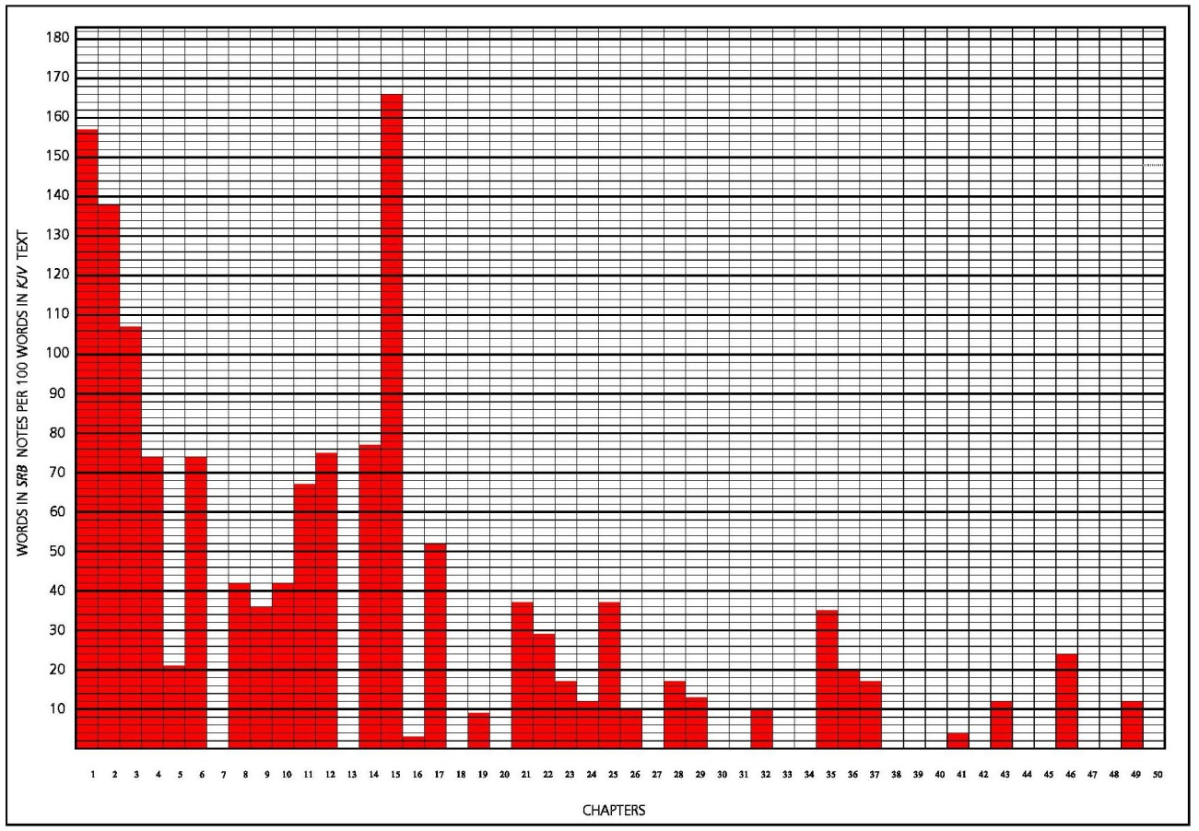
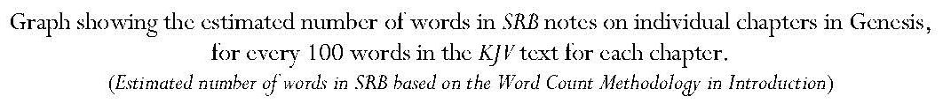
Introduction: Key Points:
Represents beginnings and typifies new birth and new creation.
The start of ‘progressive self-revelation of God which culminates in Christ.
Contains three primary and five most important compound names of Deity.
Contains ‘essence’ of problem of sin and divine solution.
Contains four covenants.
Fundamental to comprehension of the New Testament.
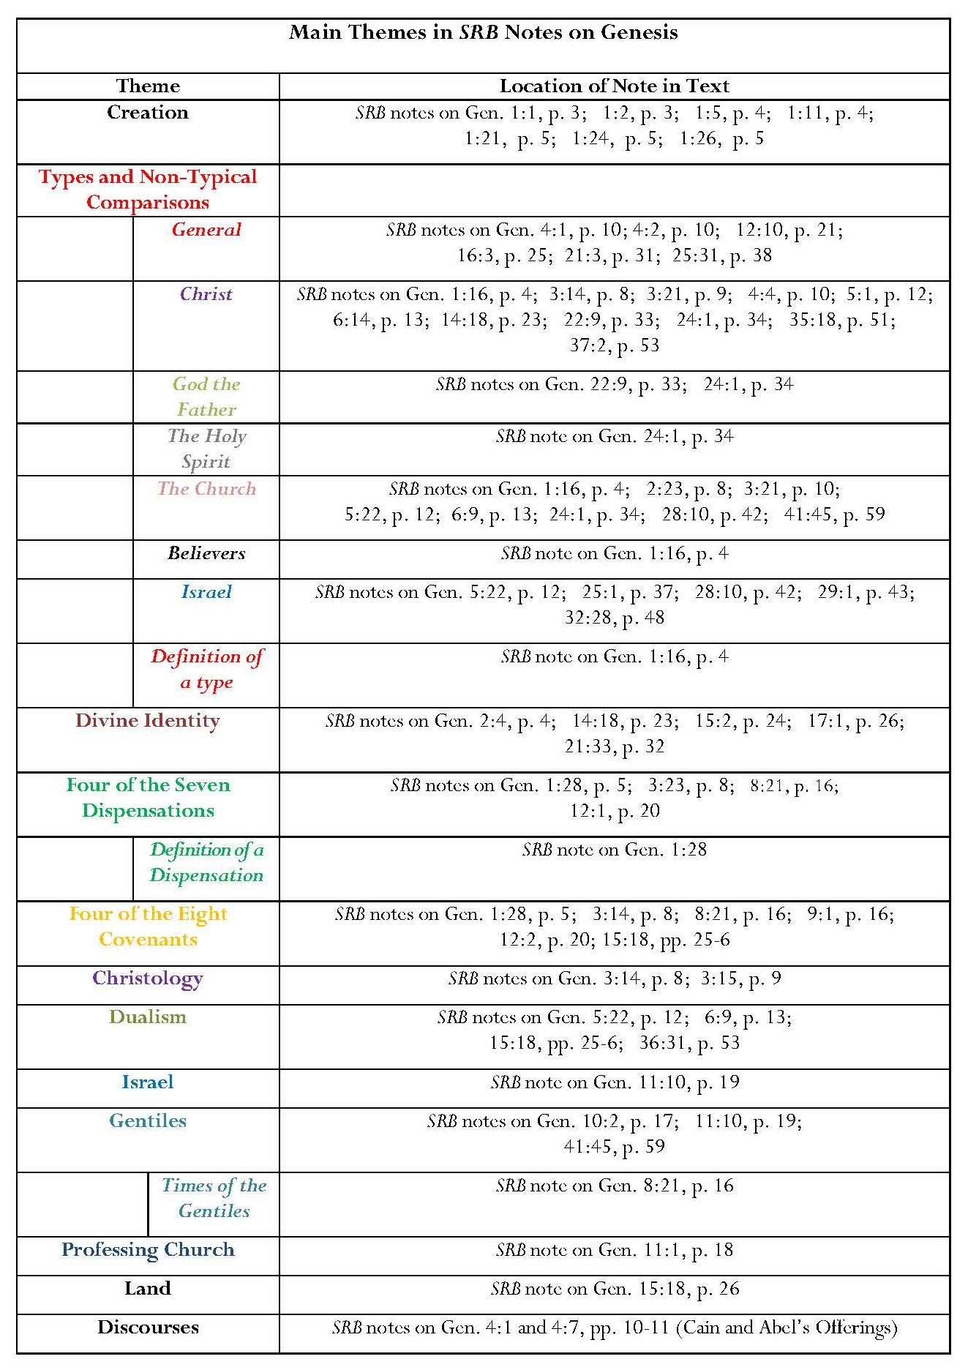
Annotation: Key Points:
Introduction of themes which are important throughout SRB, especially the prevailing presence of God in Scripture, types, dispensations, covenants, and dualism between Israel and the Church.
Emphasis on divine names and creation.
Typological references are important in the way in which Scofield relates the Old Testament to the New – many occur in Genesis, especially representing Christ.
Definition of types.
Definition of a dispensation.
Omissions
Narrative elements mainly missing.
Surprisingly, Scofield does not annotate one of the repetitions of the Abrahamic Covenant in Genesis 13.
8.1.2 Exodus
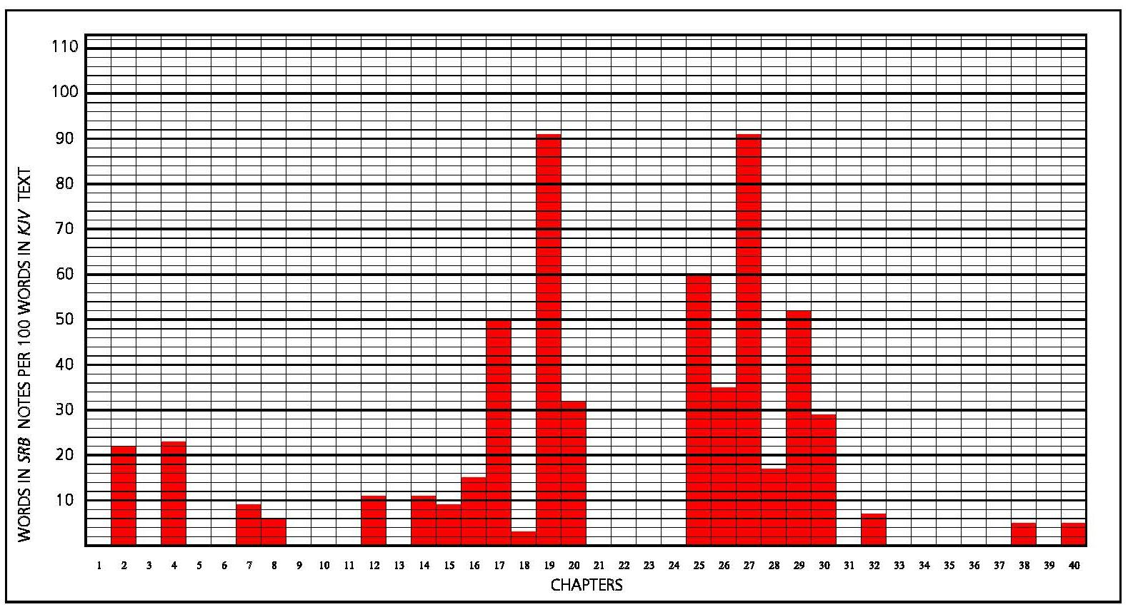
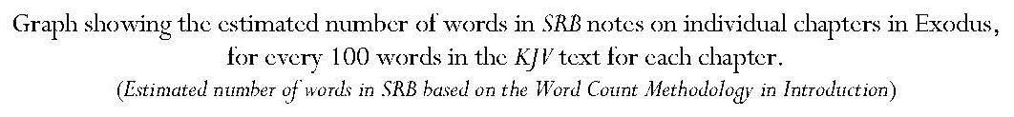
Introduction: Key Points
Deliverance from Egypt ‘sets forth in type all redemption’; forms a type for ‘the conditions upon which all relationships with God exist’.
The ‘Israelitish’ people, previously connected to God only through the Abrahamic Covenant, were brought ‘nationally’ to God through redemption.
Israelites put under Mosaic Covenant; ‘God taught Israel His just demands’; conviction of Israel for sin and the provision of priesthood and sacrifices (typical of Christ) ‘gave a guilty people a way of forgiveness, cleansing, restoration to fellowship, and worship’.
Galatians cited to explain relationship of the law to the Abrahamic Covenant.

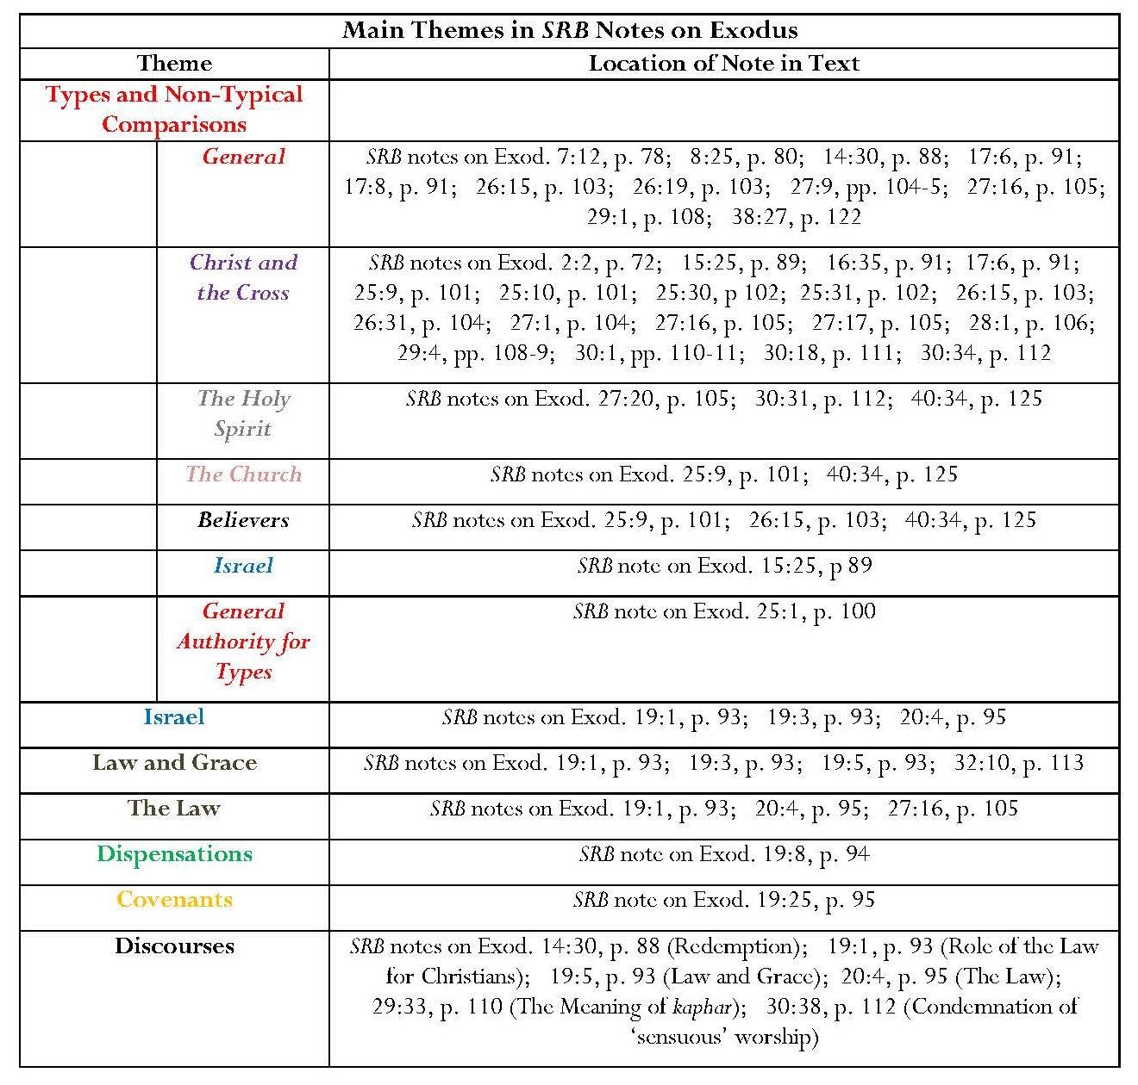
Annotation: Key Points:
Many typological and non-typological representations, especially Christological.
Focus on the tabernacle and New Testament connections.
‘General authority for types’.
Importance of relational history of Jehovah and Israel, with interpretations regarding Christian application.
Fifth dispensation and fifth covenant introduced.
Doctrinal discourses introduced.
Omissions
Narrative elements, including the birth and calling of Moses, the account of the burning bush, and Moses’ interaction with Pharaoh.
Comment: Even where mentioned, narrative elements are not treated according to their context but used for typological reference to the New Testament, especially Christ; for example, the Passover is treated only as a type for Christ.
However, a complex series of subheads clarifies this interaction.
8.1.3 Leviticus
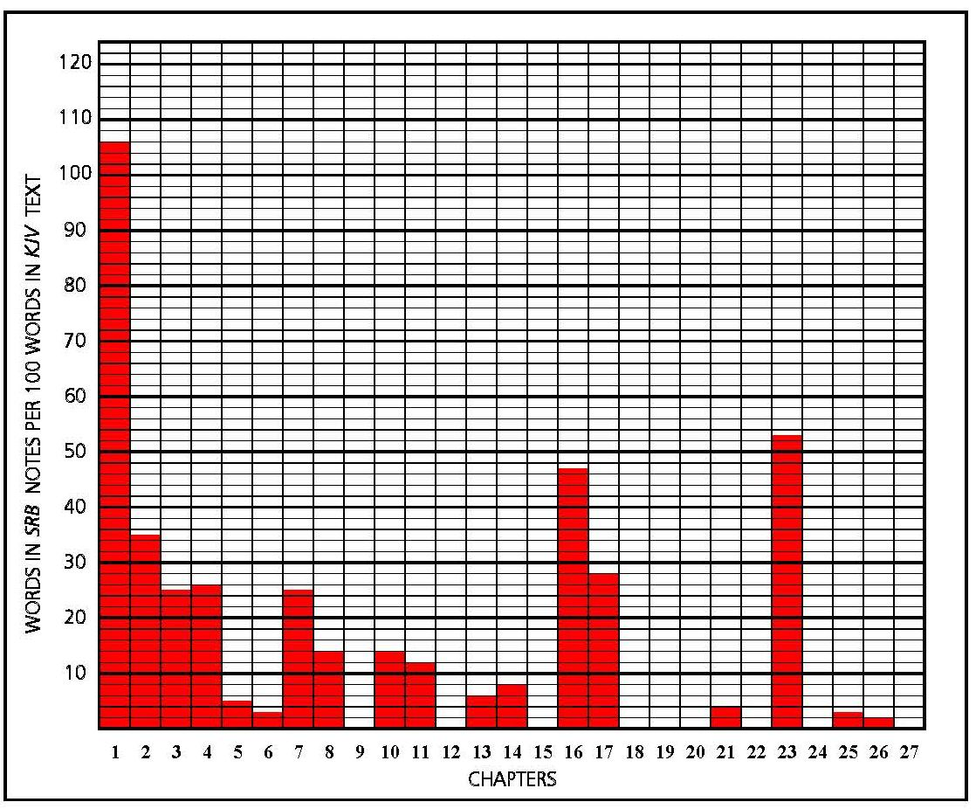
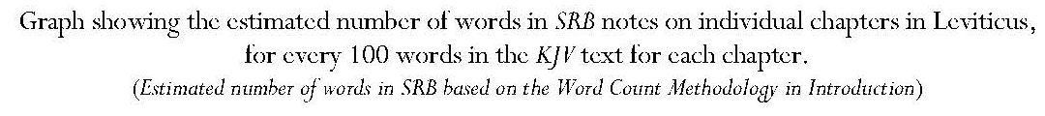
Introduction: Key Points
Leviticus gives the details of ‘the walk, worship and service’ of the redeemed people described in Exodus.
Parallel drawn with relationship between epistles and Gospels.
Key word: ‘holiness’, as God lives in his tabernacle amongst his people.
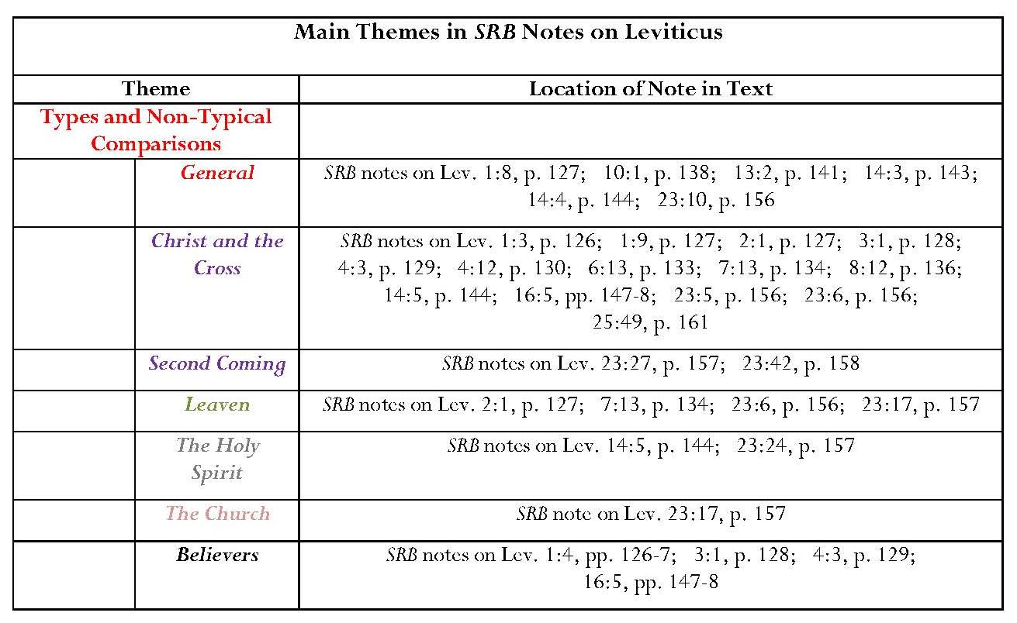
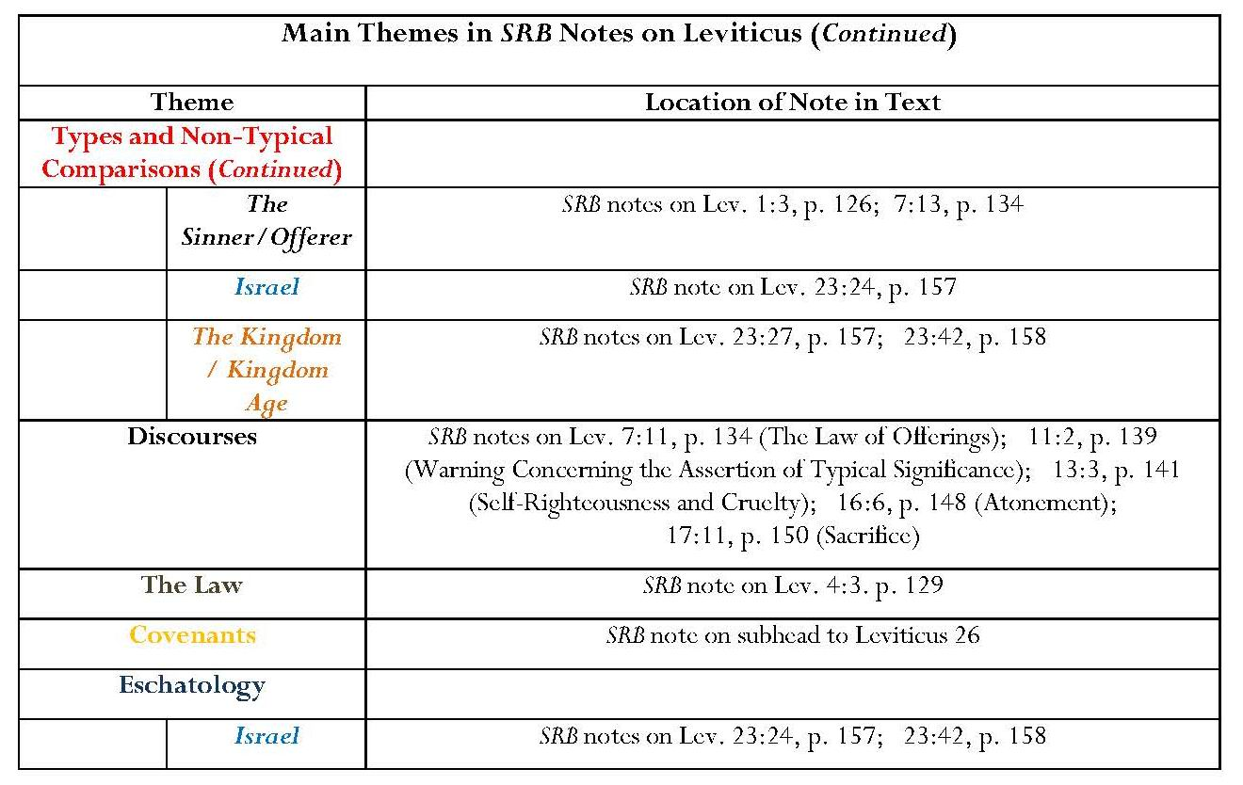
Annotation: Key Points:
Mainly concerns types – many references are in subheads.
Levitical offerings ‘covered’ Israel’s sins ‘until, and in anticipation of the Cross, but did not “take away” those sins’.
Important eschatological references to Israel:
Israel’s sorrow and repentance, stressed in Leviticus 23, ‘looks forward to the repentance of Israel after her regathering under the Palestinian Covenant preparatory to the second advent of Messiah and the establishment of the kingdom’.
The feast of Tabernacles, ‘like the Lord’s supper for the church’, is ‘both memorial and prophetic – memorial as to redemption out of Egypt; prophetic as to the kingdom-rest of Israel after her regathering and restoration …’.
Comment: These statements are important because they illustrate Scofield’s commitment to the dispensationalist tenet concerning the restoration of Israel in a future terrestrial and Messianic kingdom. Scofield’s injunction in his note on the subhead to Leviticus 26 that the chapter be ‘read in connection with Deuteronomy 28 — 30, the Palestinian Covenant’, is another illustration of this commitment.
The discourses concerning ‘the “law of the offerings”’, the nature of atonement and the efficacy of sacrifice, both in the Old Testament and as substitutional in the case of Christ indicate a greater awareness of Old Testament context than Scofield often displays with regard to his assertions of type, though even he admits that ‘typical meaning’ can be ‘strained’.
8.1.4 Numbers
Introduction: Key Points:
‘Historically, Numbers takes up the story where Exodus left it’ and is ‘typically … the book of service and walk’, in which ‘nothing was left to self-will’.
Completes ‘a beautiful moral order’ along with Genesis, Exodus and Leviticus.
Second typical lesson: ‘tested by wilderness circumstances, Israel utterly failed’.
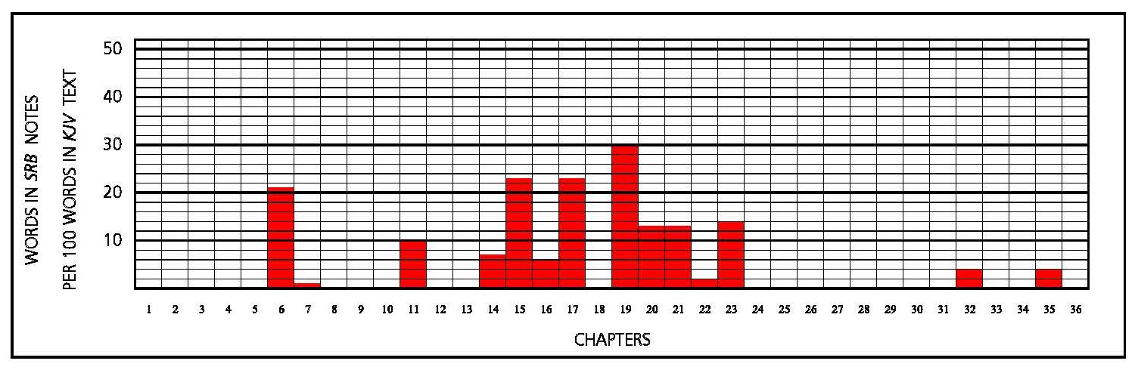
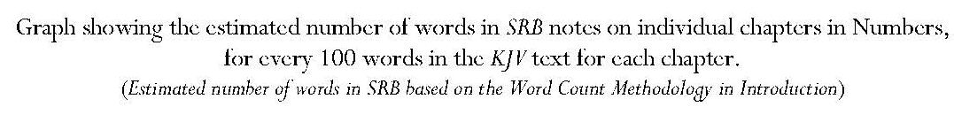
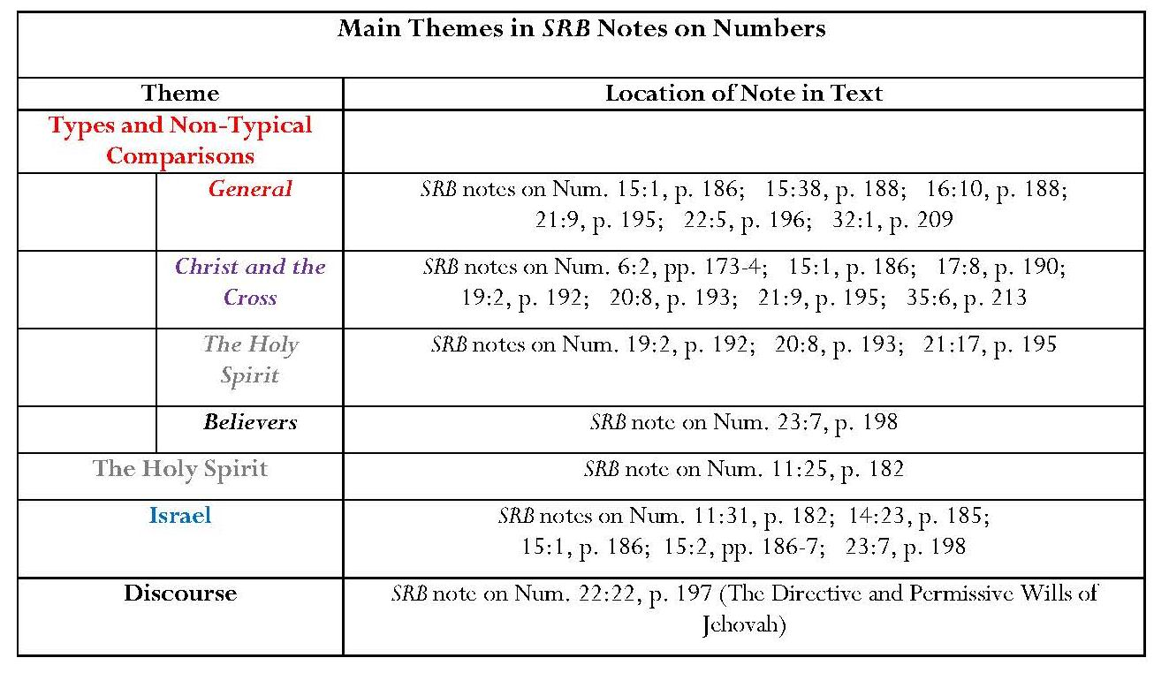
Annotation: Key Points
Israel’s wilderness experience as ‘discipline’ distinguished from ‘wandering’ as punishment for disbelief and disobedience.
God’s care for his disobedient people.
Water mentioned three times as a type of the Holy Spirit, bestowing refreshment and power.
Difference between God’s directive and permissive wills: ‘God’s permissive will never extends to things morally wrong’ and ‘the highest blessing is ever found in obedience to His directive will’. Jehovah’s directive will was ‘made known to Balaam’ in Num. 22:12 but his permissive will is shown in Num. 22:20, where Balaam knows ‘the true mind of the Lord’ but chooses ‘the path of self-will and self-advantage’.

Omission
Endowment of seventy elders with part of the Spirit given to Moses in Num. 11:25.
8.1.5 Deuteronomy
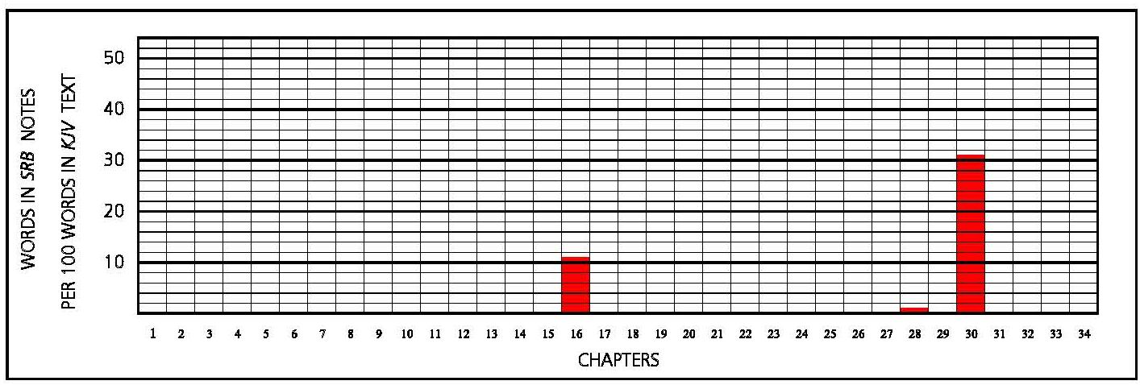
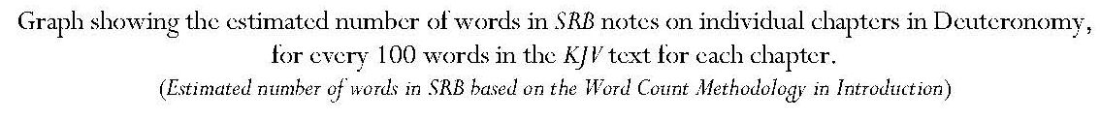
Introduction: Key Points
Presented as ‘Moses’ parting counsels delivered to Israel in view of their impending entrance upon their covenanted possession’.
Repeats Decalogue to new generation; instructions about Israel’s conduct in the land.
Contains ‘the Palestinian Covenant, under which Israel entered under Joshua’.
Unlike the Abrahamic Covenant, the Palestinian Covenant was conditional and violation resulted in expulsion, ‘but the same covenant unconditionally promises a national restoration of Israel which is yet to be fulfilled’ — condition of restoration is that the people return to the Lord their God.
Comment: Because Scofield insists, despite the ‘as for me/as for you’ clauses in Gen. 17:4, 9, that the Abrahamic covenant is unconditional, it is important to his thesis that the expulsion was caused by the violation of the conditions of the so-called ‘Palestinian Covenant’, yet even this covenant did not contain an unconditional promise of restoration as Scofield asserts.
Contains ‘great closing prophecies summarizing the history of Israel to the second coming of Christ, and … the Palestinian Covenant, 28:1 – 30:20’.
Annotation: Key Points
Only three verses annotated in Deuteronomy.
All notes concern Israel, especially the significance of the so-called ‘Palestinian Covenant’:
Restoration of Israel as shown in Passover, Tabernacles and Weeks.
Detailed description of Palestinian Covenant.
Claim that Palestinian Covenant gives ‘the conditions under which Israel entered the land of promise. It is important to see that the nation has never as yet taken the land under the unconditional Abrahamic Covenant, nor has it ever possessed the whole land.’
Comment: A very important claim which is discussed in 5.4.4.
8.1.6 Conclusion: Notes on the Pentateuch
Scofield’s notes on the Pentateuch are foundational to his commentary on the Bible as a whole. He himself calls the Pentateuch ‘a true and logical introduction to the entire Bible; and, in type, an epitome of the divine revelation’. The most striking aspect is the sheer number of typological comparisons between Old and New Testaments. This is intrinsic to Scofield’s whole use of the Bible. The Old Testament is often seen in these chapters and, indeed, elsewhere in Scofield’s commentary, as a source for the New Testament. Its own context is frequently overshadowed by concentration on how it may be applied to perceived New Testament antitypes, many of which are not directly supported by New Testament texts and seem rather to owe their existence to Scofield’s own interpretations. Corresponding antitypes are mainly asserted in notes on Matthew and a few in notes on John, 1 Corinthians, Ephesians and Hebrews.
Paradoxically, however, there is also a concentration in the notes on the Pentateuch on the future restoration of national Israel and its place in the eschatological kingdom to be established on earth at the return of the Messiah. This is related to the other significant themes of the notes on the Pentateuch: God’s nature and plans for the world, dispensations and covenants. The note on Gen. 3:15 introduces the subject of prophecy, which is an underlying motif of all Scofield’s commentary. All these matters receive attention in the notes on the rest of the Bible.
8.2 The ‘Historical Books’
Since there are few footnotes, much commentary on the historical books is conveyed through the ‘Introduction to the Historical Books’ and the introductory material for each individual book.
Continued overleaf
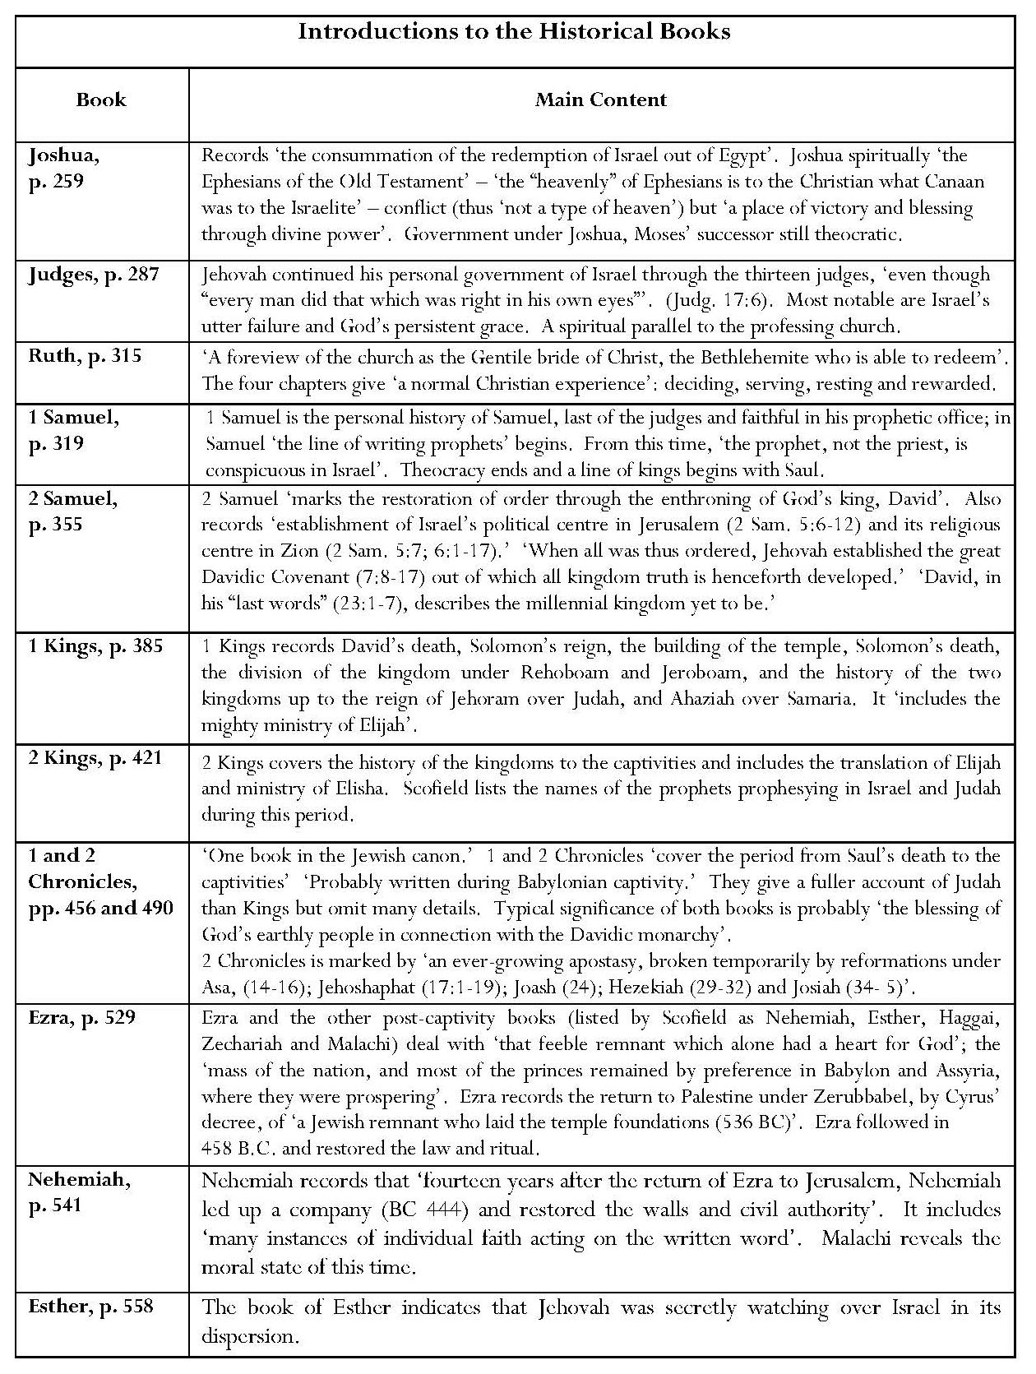
Introductions: Key Points
Assertion that the accuracy of these books has recently been ‘completely confirmed’ by archaeological finds.
Scofield’s conviction concerning the historical veracity of the narrative is emphasised by the inclusion of Ussher’s estimation of the length of time covered by each book, in addition to Ussher’s dates.
The Introduction to the Historical Books refers to ‘the rise and fall of the Commonwealth of Israel’ and outlines seven periods in its history.
Past and future treated as part of one continuum.
The periods outlined here have some resonance with the periods given in Scofield’s Old Testament Summary of the Kingdom, though this describes only three periods.
The focus is Israel’s history and future.
A few references to New Testament concepts such as the parallels asserted between Canaan for Israel and ‘the heavenly’ for Christians, and between the events in Judges and the professing church, and Ruth as a possible type for the Church.
Important references to the Davidic kingdom:
Significance of the reference to ‘the blessing of God’s earthly people in connection with the Davidic monarchy’, echoing the term, ‘earthly people’ in Genesis notes; this is an intimation of Scofield’s belief that Israel is to be eschatologically restored as a nation under David’s heir, Messiah, at his second coming.
Only after ‘the establishment of Israel’s political centre in Jerusalem … and her religious centre in Zion’, was [it] possible to establish ‘the great Davidic Covenant … out of which all kingdom truth is henceforth developed’
‘David, in his “last words” … describes the millennial kingdom yet to be.’
Continued overleaf
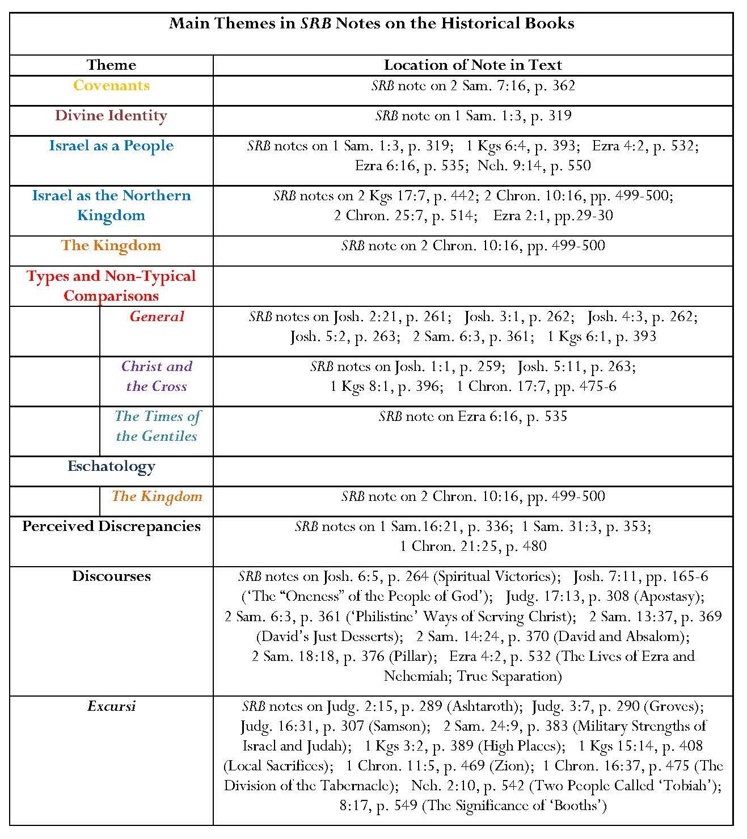
Continued overleaf

Annotation: Key Points
Chapters in Historical Books With and Without Notes
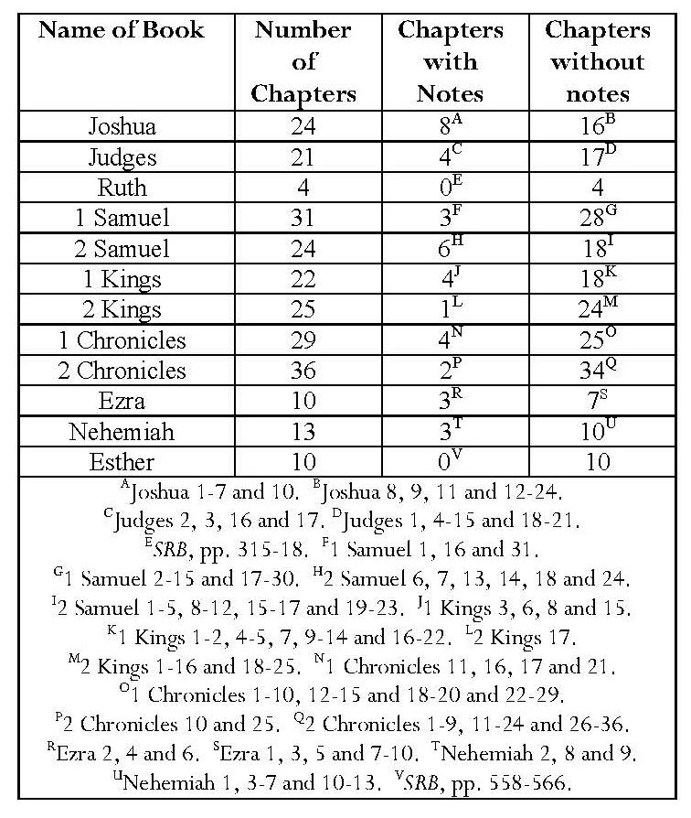
Most chapters bear no notes. Usually only single verses within chapters are annotated.
Otherwise, maximum number of verses annotated is two.
Only thirty-nine verses in the twelve ‘historical’ books are annotated.
Davidic Covenant and Davidic Kingdom
Davidic Covenant: foundation for claims concerning Christ and establishment of eschatological Davidic kingdom, ‘upon which the glorious kingdom of Christ “of the seed of David according to the flesh” is to be founded’.
Zion, ‘the southwest eminence in Jerusalem, called in Scripture the city of David’ is ‘associated with the Davidic royalty both historically and prophetically’.
Israel’s Spiritual Declenison
References to idolatry, spiritual declension and apostasy
Assertion that ‘in many ways, Solomon’s temple manifests the spiritual deterioration of the people and Jehovah’s condescension to it in grace’.
Israel’s Future
The division of the kingdom represents a very important stage in the history of the nation: Judah and Israel must be reunited in the future kingdom.
Ten northern tribes never restored to Palestine after Assyrian captivity; individuals returned, but ‘national restoration is yet to be fulfilled’.
The ten tribes still ‘preserved distinct from other peoples’; God knows them but they do not know him.
Comment: It is significant that Scofield regards the dispersion as continuing in his own day.
Only two notes on exiles’ return from Babylon
Worship of Jehovah resumed ‘but the theocracy was not restored’ and ‘the remnant lived in the land by Gentile sufferance, though doubtless by the providential care of Jehovah, till Messiah came’, after which ‘Rome destroyed the city and temple.’
Analogies
Several comparisons with apostate church and unfaithful individuals.
Israelites’ neglect of circumcision, ‘the “sign” of the Abrahamic Covenant’ analogous with ‘world-conformity’ in the New Testament.
Illustration of ‘oneness of the people of God’: as Achan’s sin and divine punishment represent Israel’s sin, so ‘the whole cause of Christ’ is ‘injured by the sin, neglect, or unspirituality of one believer’.
David’s employment of a ‘cart’ for the transportation of the ark following ‘a Philistine expedient’ likened to ‘the church … full of Philistine ways of doing service to Christ’.
Subheads
Subheads are also important elements of commentary on the ‘historical books’; most describe content.
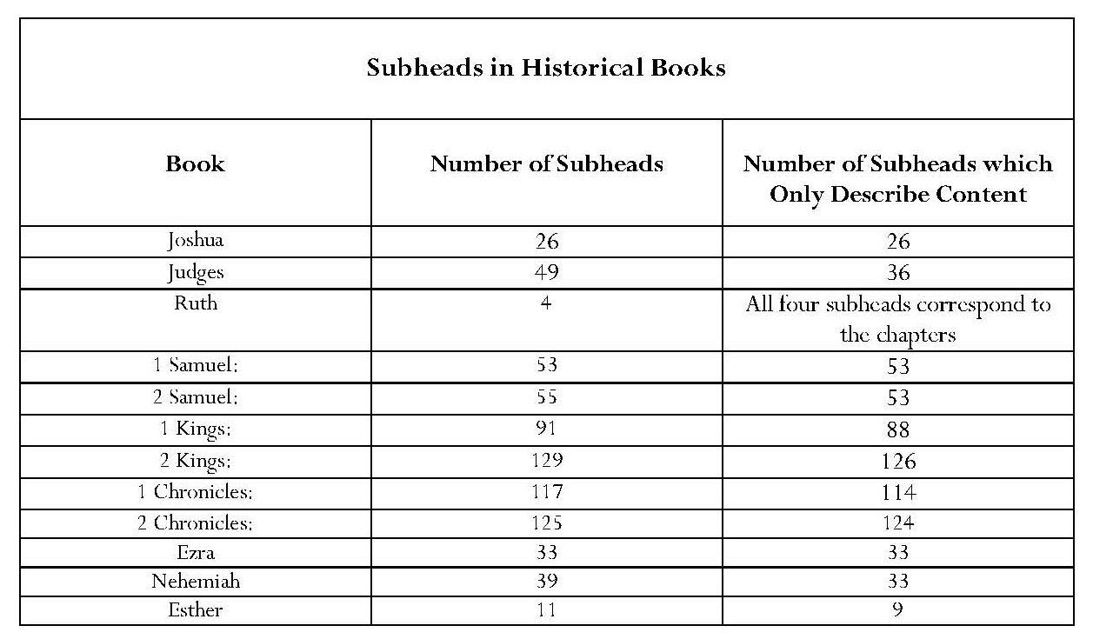
8.2.1 Conclusion: Notes on the ‘Historical Books’
Scofield’s notes on the historical books serve to demonstrate his commitment to the historicity of the biblical text. The main subject is the history of the theocracy in Israel, including her decline, exile and restoration, both from the Babylonian exile and in the kingdom age. There is a strong emphasis upon the importance of the Davidic Covenant for Israel’s future and upon the nature of Israel as ‘God’s earthly people’. Some typological assertions make comparisons with New Testament concepts. However, the main focus of Scofield’s commentary on these twelve books is Israel, her history and future.
8.3 The ‘Poetical Books’
The only significant annotation is of Psalms.
Introduction to ‘Poetical Books’: Key Points
Poetical books, especially Psalms, present human experiences of God’s people, ‘wrought in them by the Spirit, interpreted to us by the Spirit, and written by holy men of God as they were moved by the Spirit’.
These books ‘supply examples of literary expression unmatched in uninspired literature’.
Annotation: Key Points (Job, Proverbs, Ecclesiastes, Song of Solomon)
Assertion that ‘Job is probably the oldest of the Bible books’ and that ‘Job was a veritable personage … the events are historical’.
Proverbs is a ‘collection of sententious sayings [of] divine wisdom applied to the earthly conditions of the people of God’ – only two verses annotated.
For comments on Ecclesiastes see 2.1.
Song of Solomon:
The only ‘poetical’ book where the approximate percentage of words in SRB notes exceeds the percentage of words in the corresponding KJV text.
In this annotation, many examples of Scofield’s poetic imagination — treatment of text makes no allowance for what may have been original meaning.
According to Scofield, this book is ‘mysterious and incomprehensible’ to the ‘unspiritual mind’.
Posits two interpretations:
1 Book describes ‘expression of pure marital love as ordained of God in creation and the vindication of that love against both asceticism and lust – the two profanations of the holiness of marriage’.
Comment: This is an interesting statement in view of Scofield’s treatment of his own first marriage.
2 More important interpretation is ‘of Christ, the Son and His heavenly bride, the Church’.
8.3.1 Psalms
Introduction: Key Points
Psalms are ‘revelations of truth in human experience … revealed in the emotions, desires and sufferings of the people of God’
Some situations described link experiences of the incarnate Christ and of Jewish remnant in tribulation, thus many Psalms prophesy ‘the sufferings, faith and victory of both’.
Assertion that Psalm 22, ‘the “holy of holies” of the Bible, reveals all that was in the mind of Christ when He uttered the desolate cry “My God, My God, why has Thou forsaken Me?”’
Comment: This claim is unsustainable cf notes on Pss 102:1 and 118:29.
Continued overleaf

Assertion that Psalm 2 presents ‘Jehovah’s Anointed as rejected and crucified … but afterward set as King in Zion’.
Comment: The first part of this statement cannot be substantiated since the Psalm concerns the rebellion of the nations rather than suffering, and does not mention crucifixion.
Moreover, assuming that the Psalm was written by David and that David lived around 1000 BCE, crucifixion was not a method of execution at the time of the composition of the Psalm.
Promises in the Psalms mainly Jewish, but ‘spiritually true in Christian experience also’.
Unsuitability of ‘the imprecatory psalms’ for God’s heavenly people.
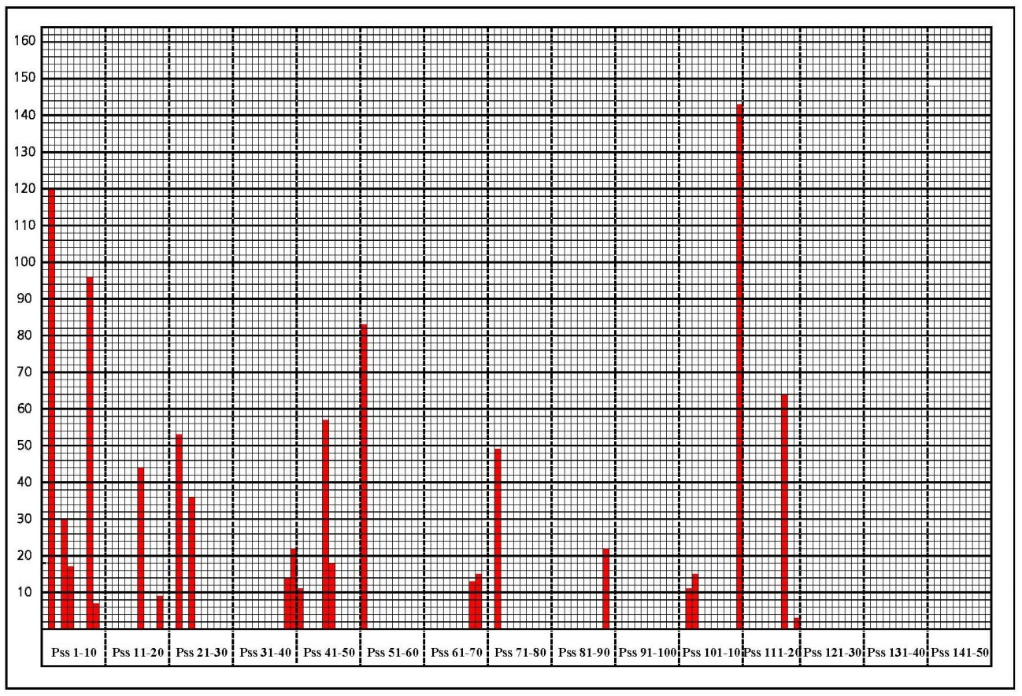
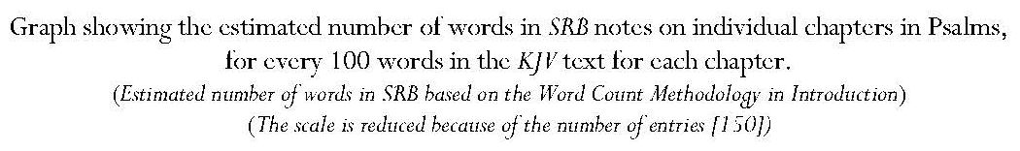

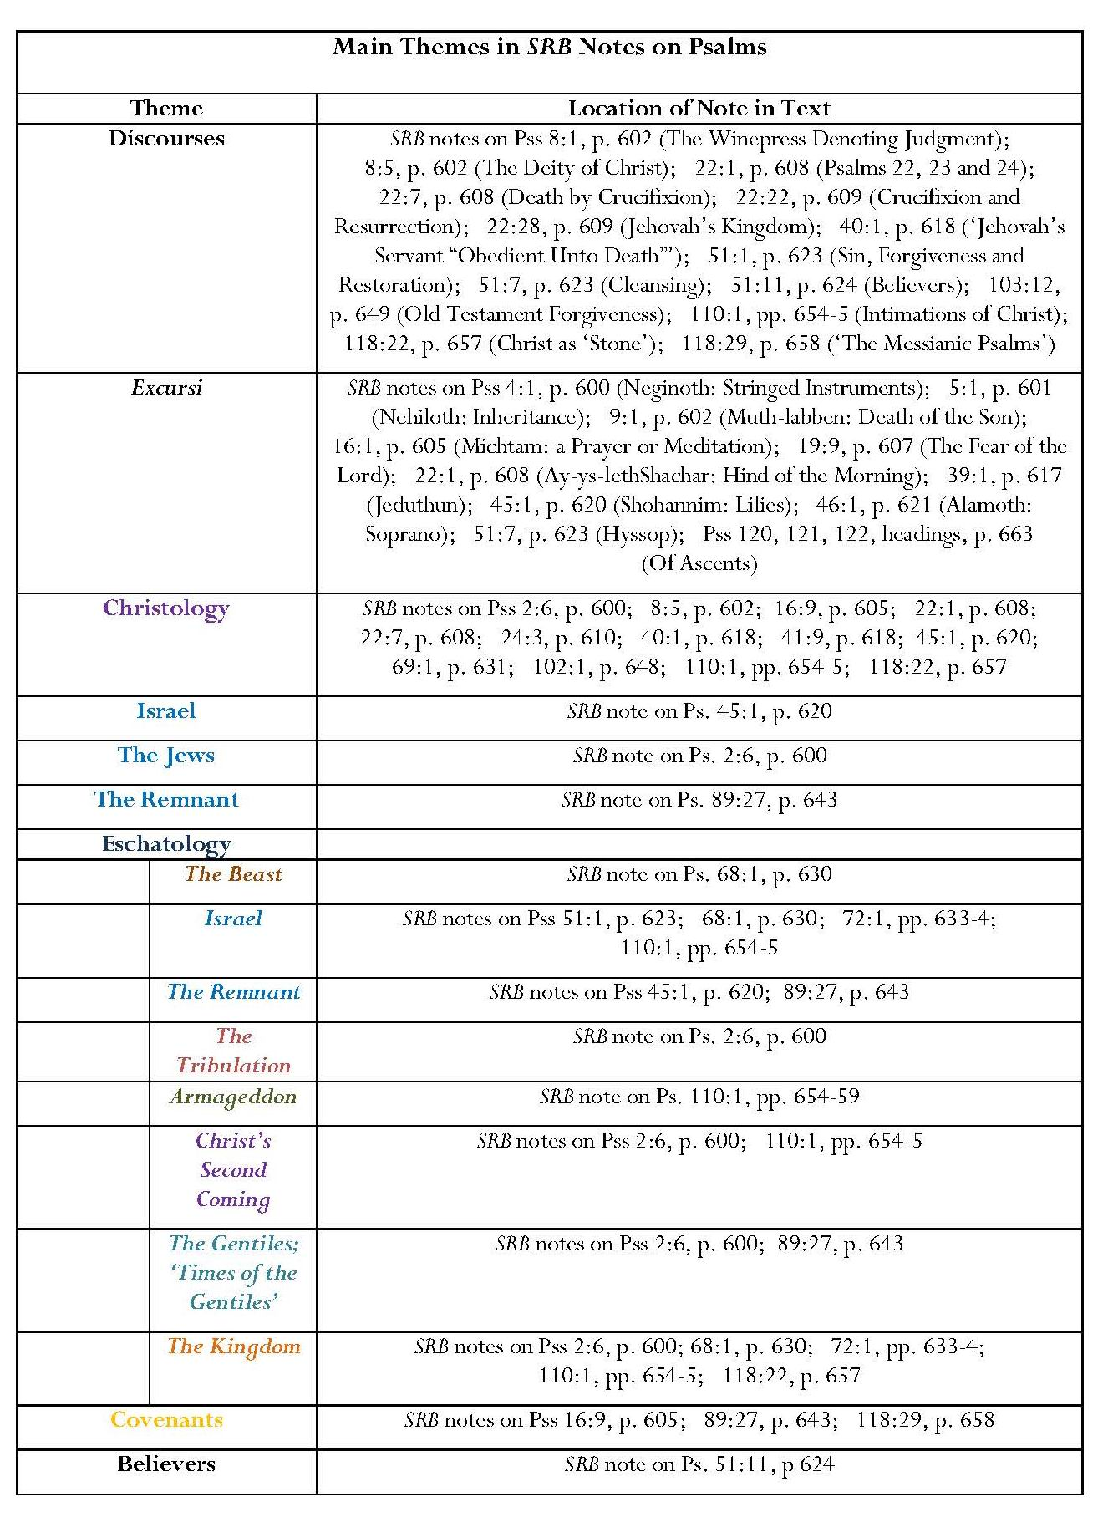
Annotation: Key Points
Only 24 psalms out of 150 annotated.
Several notes only give excursi on single words in Psalm headings or add comment on one other verse.
Concentration on ‘Messianic psalms’ and Psalm 51.
Highest proportion of notes compared to the text in note on Psalm 110; assertion that its importance is attested by prominence in the New Testament.
Eschatological themes prominent: Messianic kingdom, including Christ’s dominion over ‘redeemed creation’ and over the whole earth, and to his exaltation in the kingdom; also fulfilment of Davidic Covenant, Israel’s future, and Christ’s second coming, including his future glory.
Stress on the Jewish nature of the kingdom:
Christ will appear as ‘the Deliverer out of Zion’ and Gentile powers will be judged before the establishment of the kingdom.
The kingdom will be preceded by the tribulation, which fulfils ‘the vexation’ of Ps. 2:5.
‘Dispensationally’, repentance ‘will be the pathway of returning Israel’, though it is also the ‘mould of the experience of a sinning saint’.
Israel will be regathered and the Beast and his armies destroyed.
‘Imprecatory’ verses of Ps. 69:22-8 relate to Israel’s present judicial blindness
Fulfilment of Davidic Covenant anticipated but warnings of chastening in response to disobedience; this began with the captivities and continues with Israel’s subjection to Gentile rule.
Identification of Psalms with Christ’s suffering during his first advent
Antagonism against Jehovah’s anointed in Ps. 2:1-3 is fulfilled in the crucifixion,
Assertion that Ps. 69:21 also refers to the crucifixion
Assertion that Psalm 22 is ‘a graphic picture of death by crucifixion’
Claim that elements in Ps. 22: 1-2, 6-8 and 12-18, were directly fulfilled in Matthew 27.
Comment
Scofield is correct in saying that crucifixion was not a Jewish method of execution but his assertion that this proves irresistible inspiration does not follow from this observation. Scofield’s claim in several notes that the Messianic Psalms give Christ’s inner thoughts cannot be justified and must result from surmise.
8.3.2 Conclusion: Notes on the ‘Poetical Books’
It is only in his notes on Psalms that Scofield includes any material which is significant in supporting some of his main themes: the eschatological kingdom, Christ’s fulfilment of the Davidic Covenant and his first and second advents, and Israel’s eschatological future. The notes on Job, Proverbs and Ecclesiastes are insubstantial. Those on Song of Songs do not add anything to support Scofield’s concepts but reinforce the impression that Scofield sees the Old Testament mainly as a source for the New, rather than as an entity with its own contextual interpretative possibilities.
8.4 The ‘Prophetical Books’
Of the major prophets, it is only Daniel which receives coverage greatly in excess of its volume in the biblical text. Notes on Isaiah approach parity in volume with the text but those on Jeremiah and Ezekiel fall well below this. Conversely, the volume of notes on Zechariah is well in excess of the volume of this text in KJV. In the group of books known as the minor prophets, SRB provides significant amounts of commentary compared to volume of KJV text only on Zechariah and Malachi. The proportion of commentary on Joel, Micah and Habakkuk also exceeds that of KJV text, however. There is very little commentary on several books, and none on Obadiah.
Introduction
It is significant that this introduction occupies more than a page of small print in SRB; this indicates the importance Scofield attaches to prophecy but it is noteworthy that in neither his general introduction to the prophetic books nor his introductions to individual books, does Scofield mention prophecy’s exhortative aspect. It is also noticeable that, in what purports to be an introduction to ‘the Prophetical Books’, Scofield expounds upon several biblical books outside the major and minor prophets, where he finds material to support some of his important Christological, ecclesiological and eschatological concepts and his theses concerning Israel. He asserts that the prophets were ‘primarily revivalists and patriots’, speaking on God’s behalf ‘to the heart and conscience of the nation’. He emphasises that prophetic messages have ‘a twofold character: first for the prophet’s own time; secondly, that which was predictive of the divine purpose in the future’. In later notes, Scofield calls these aspects ‘near’ and ‘far’.
Introduction: Key Points:
1 Sin, Failure and ‘Glorious Future’ of the Covenant People
a) ‘Predictive prophecy’ concerns fulfilment of Palestinian and Davidic Covenants and also involves the Abrahamic Covenant. This gives it ‘its Messianic character’.
b) Israel’s ‘restoration and blessing as a nation’ depends upon ‘Palestinian Covenant of restoration and conversion’ and ‘the Davidic Covenant of the Kingship of the Messiah, David’s Son’.
c) ‘The Palestinian Covenant is the mould of predictive prophecy in its larger sense — national disobedience, world-wide dispersion, repentance, the return of the Lord, the regathering of Israel and the establishment of the kingdom, the conversion and blessing of Israel, and the judgment of Israel’s oppressors.’
d) The predictions of Israel’s ‘restoration from the Babylonians captivity’ must be distinguished from those of ‘restoration from the present world-wide dispersion’. Context for this distinction is ‘always clear’.
2 Gentiles and the Church
a) Most prophecy is ‘not occupied with Gentile history’; exceptions are Daniel, which ‘has a distinctive character’, and Obadiah, Jonah and Nahum.
b) ‘The Church, corporately, is not in the vision of the O.T. prophet.’
c) The Gentiles have a role in Israel’s chastisement.
d) The Gentiles will share in the grace to be extended to Israel.
3 Christology
a) Christ’s two advents have different characteristics: — first advent is ‘to redemption through suffering’; second advent ‘to the kingdom in glory when the promises to Israel will be fulfilled’.
b) Though the prophets described these different characteristics, they did not anticipate that, between the advents to suffering and to glory, ‘there would be accomplished certain “mysteries of the kingdom”’ and that ‘the New Testament Church would be called out’.
Comment
It is noticeable that the focus in this introduction is upon Israel and the idea that the Church is parenthetical is cultivated in the statement that the Old Testament prophets did not discern its existence.
8.4.1 Isaiah
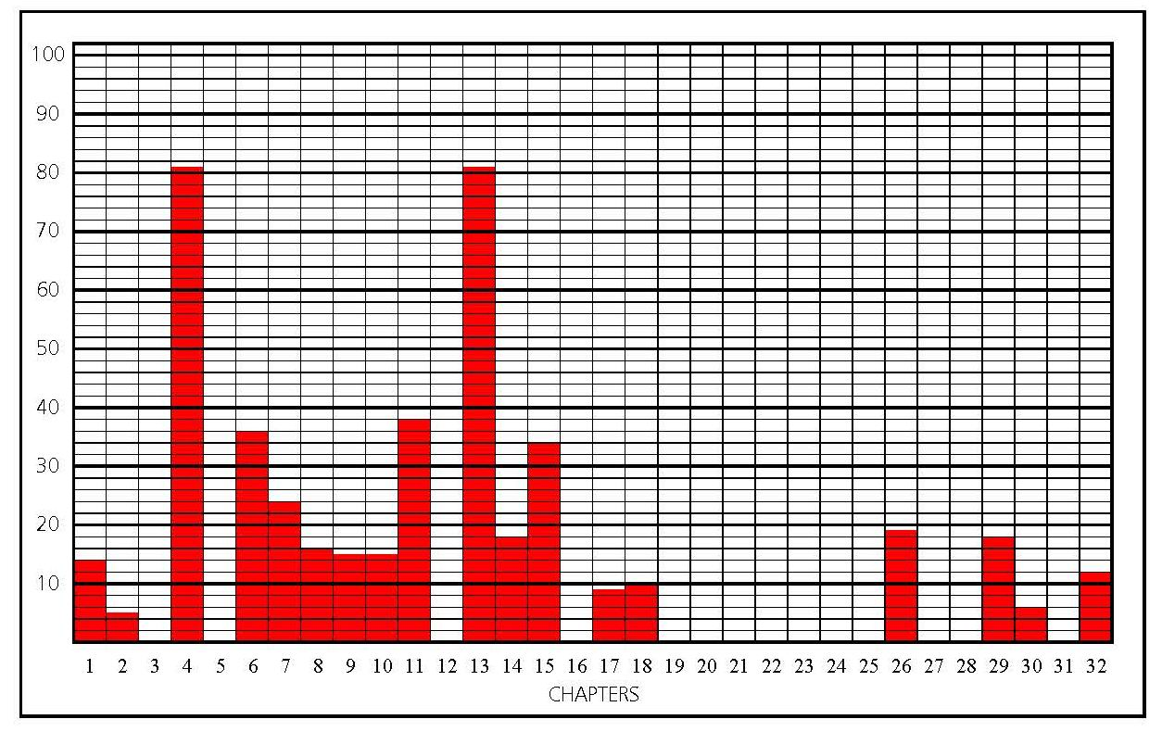
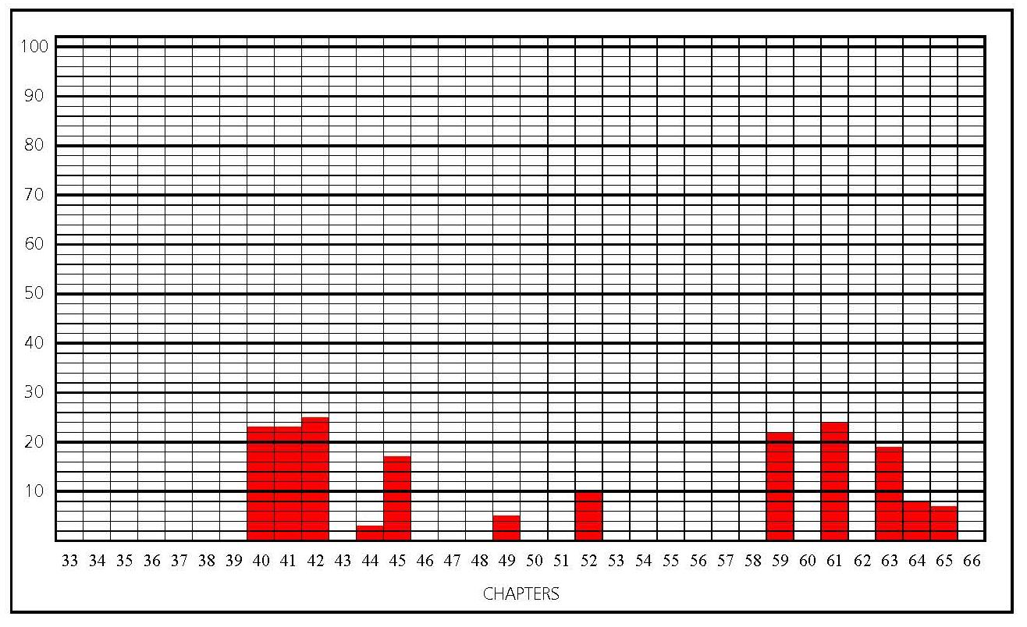
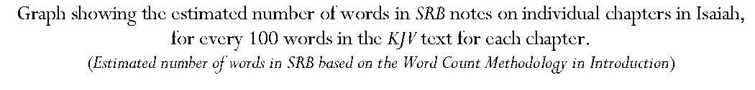
Introduction: Key Points
‘Chief of the writing prophets’ and ‘distinctively the prophet of redemption.’
‘The New Testament Church does not appear but Messiah in His Person and sufferings, and the blessing of the Gentiles through Him, in full vision’
Testifies to own time but also gives predictive messages on ‘seven great themes’.
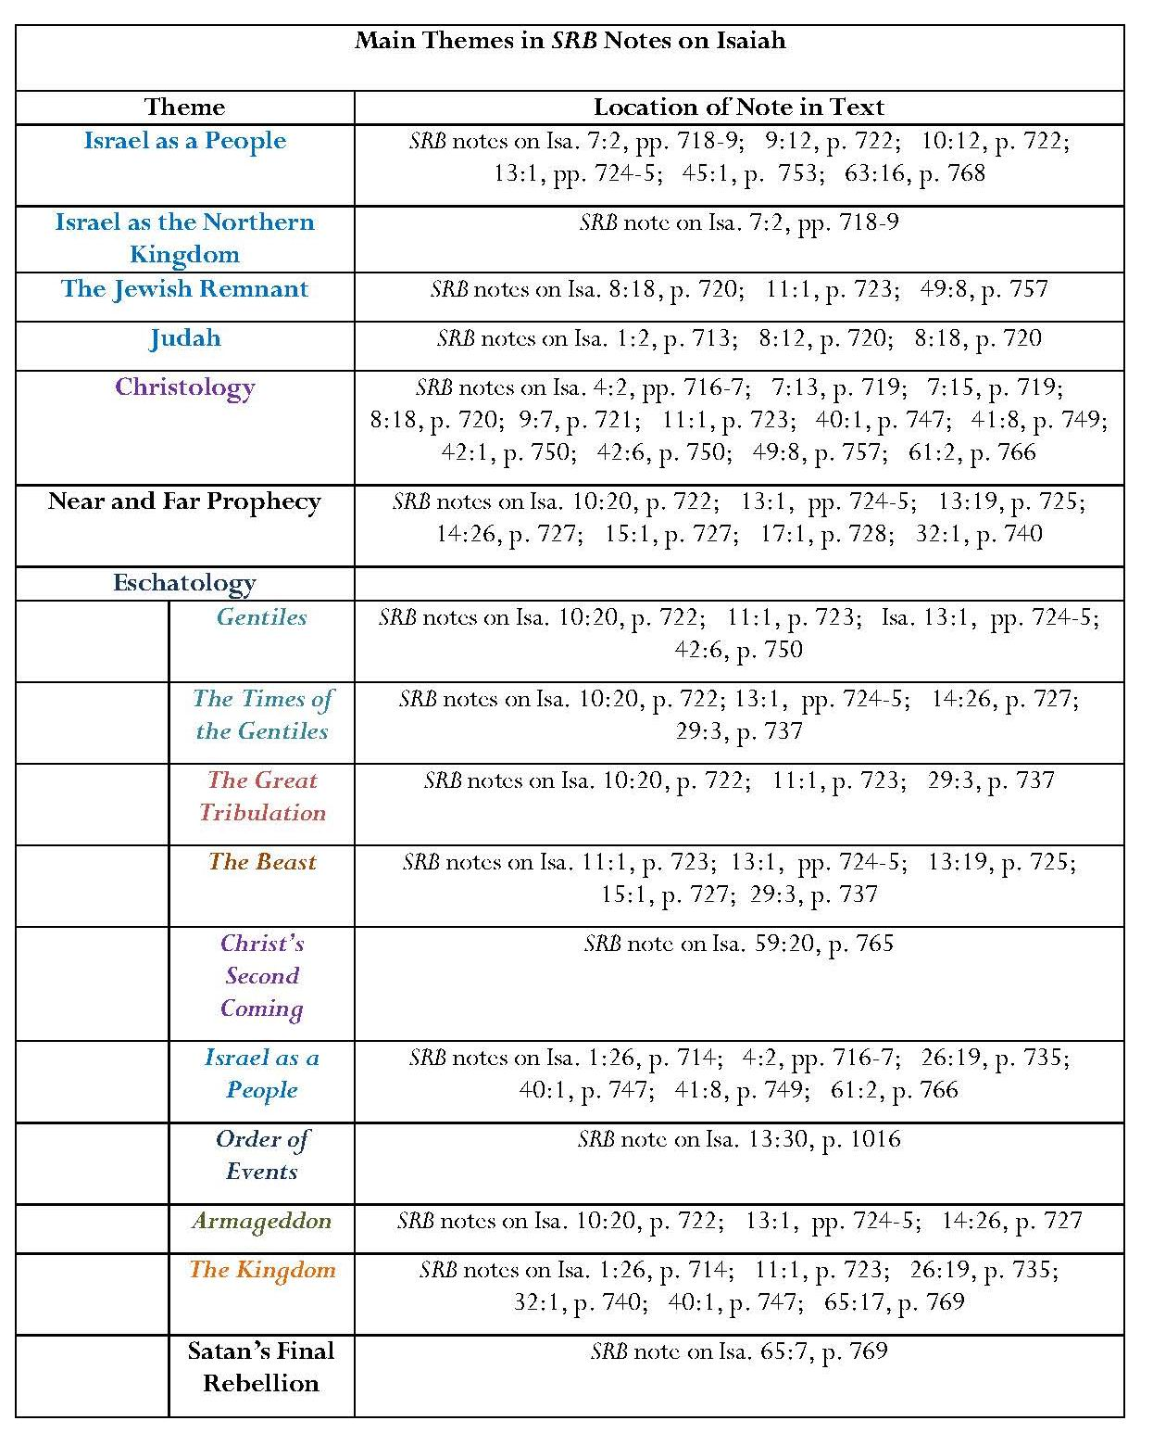

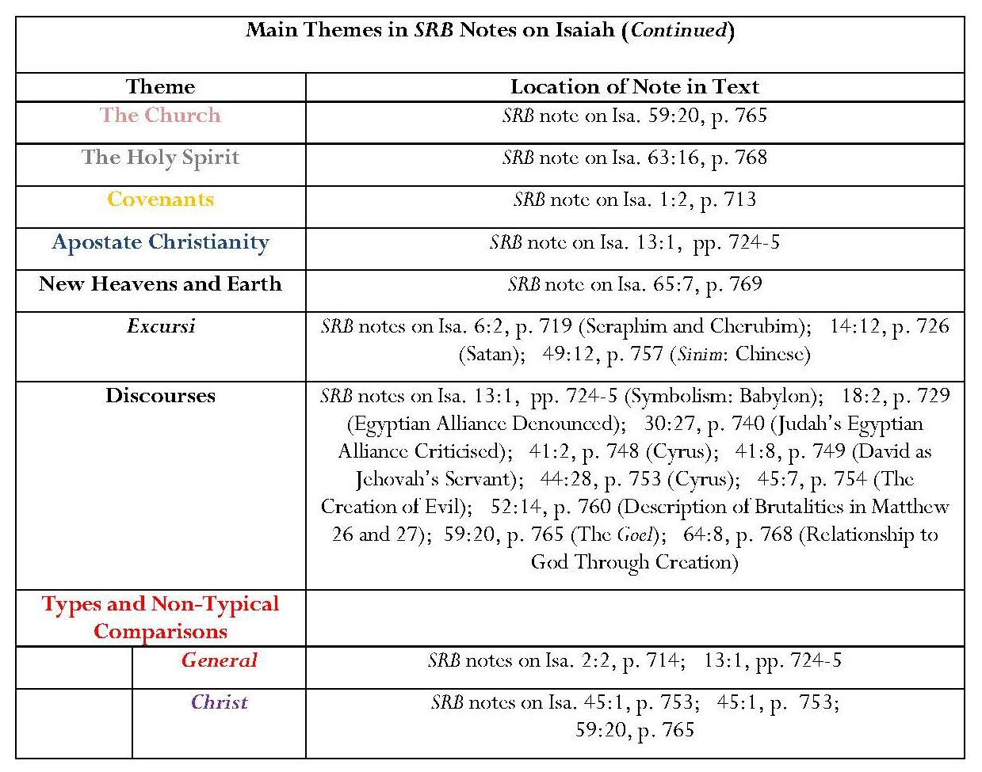
Annotation: Key Points
Only 36 chapters out of 66 annotated
Israel
Emphasis on punishment of Judah and Israel for neglect of God’s requirements but also their restoration in the future kingdom, with reference to the Palestinian Covenant.
Particular interest in the fate of the ten tribes of the northern kingdom, Israel; the concept of the reunion of Judah and Israel is important in Scofield’s eschatological vision.
Many references to Israel’s future and the eschatological future in general: Israel’s exaltation in the kingdom after the tribulation and defeat of the beast at Armageddon.
Emphasis on Davidic nature of kingdom
Isaiah 11 is ‘a prophetic picture of the future kingdom … announced by John the Baptist as “at hand”. It was then rejected, but will be set up when David’s Son returns in glory.’
The use of name ‘David’ is significant; subhead to Isaiah 11 is ‘The Davidic kingdom set up’.
‘The “throne of David” is as definite, historically, as “throne of the Caesars”.’
‘Near’ and ‘far’ prophecy emphasised
The imminent Assyrian invasion under Sennacherib as ‘the near event’ and ‘the day of the Lord’ as ‘the far event’.
Important link made between Isaiah and Revelation: Babylon in Isaiah is symbolic in relation to times of Gentiles; in Revelation symbolical-political and symbolical-religious Babylon are under beast’s tyranny and the latter is destroyed by the former

Christology
‘The branch’ as a four-fold name of Christ
No comment on Isa. 7:14; but remarks upon the butter and honey of Isa. 7:15 as ‘indicating the plainness and simplicity of the life in which the young Immanuel should be brought up’.
Assertion that Isa. 40:1-2 is ‘key-note’ of the second part of Isaiah’s prophecy: ‘Jesus Christ in His sufferings and the glory that shall follow in the Davidic kingdom’.
No direct comment on Isaiah 53; very brief note within Isaiah 52 with assertion that literal translation of this verse should be a description of someone ‘not human’ and anachronistic assertion that this is ‘the effect of the brutalities described in Mt. 26:67-8; 27:27-30’. May reflect Scofield’s apparent greater interest in the second advent of Christ than in the first cf observation that, in Lk. 4:16-21, Jesus quoted only the first part of Isa. 61:2, with the implication that ‘the first advent … opened the day of grace, “the acceptable day of the LORD” but does not fulfil the day of vengeance’ which will occur at Messiah’s return.
Assertion of contrast: Christ’s first advent as ‘weak, despised, rejected, slain’ (already fulfilled) and second advent as mighty conqueror, taking vengeance on the nations and restoring Israel (unfulfilled)
Comment
Scofield displays a confusing mixture of uses of the name ‘Israel’ in some of his annotation of Isaiah. It seems from the references he gives in his note on Isa. 10:12 that he has extended his definition of ‘Israel’ to include Judah because some of these references antedate the division of the kingdom. Joel 3:1-8 definitely refers to Judah but Isa. 14:1-2 refers to Jacob, while Mic. 5:7-9 refers to the remnant of Jacob. Matthew 25:31-40 does not refer to Israel, Judah or Jacob. This illustrates the point made in 1.1.1, that the term, ‘Israel’ does not always mean ‘Israel’ in the same sense. Scofield himself virtually acknowledges this when he states that ‘both names [Jacob and Israel] are applied to the nation descended from Jacob. He gives the example of Isa. 9:8. ‘The “word” was sent to all the people, “Jacob,” but it “lighted upon Israel,” i.e. was comprehended by the spiritual part of the people.’ Scofield’s meaning for ‘Israel’ seems to have shifted again in his note on Isa. 13:1, where he avers that ‘the divine order’ constitutes ‘Israel in her own land, the centre of the divine government of the world and channel of divine blessing’, with ‘the Gentiles blessed in association’ with her. Such a description surely cannot be confined to the ‘Israel’ of the northern kingdom.
Omissions
Several references to the restoration of Israel and especially to Jerusalem occur within the thirty-six chapters of Isaiah not annotated by Scofield. Many of these involve Israel’s eventual peace. It is surprising that Scofield does not take the opportunity to comment upon the fulfilment of prophecy which occurs in the narrative of the invasion of Sennacherib.
It is possibly not surprising that Scofield does not reflect upon Isa. 48:19, which has echoes of Gen. 22:17 and 32:12 but contains conditionality. Even though Scofield does not annotate these verses in Genesis either, they form part of God’s promises to Abraham, which Scofield regards as fundamental. Scofield emphasises that the Abrahamic Covenant was ‘wholly gracious and unconditional’, whereas the suggestion in Isa. 48:19 is that the promise concerning descendants was conditional upon Israel’s obedience.
The most notable omissions of chapters in Isaiah are those which pertain to what Robert Jewett and John Shelton Lawrence term ‘the healthier strands of faith and ethics that lie at the heart of every great religion’. In these chapters, Israel is often accused of its failure to act in justice and righteousness. Scofield ignores these chapters and their prophetic message with regard to ethical behaviour in every age.
8.4.2 Jeremiah
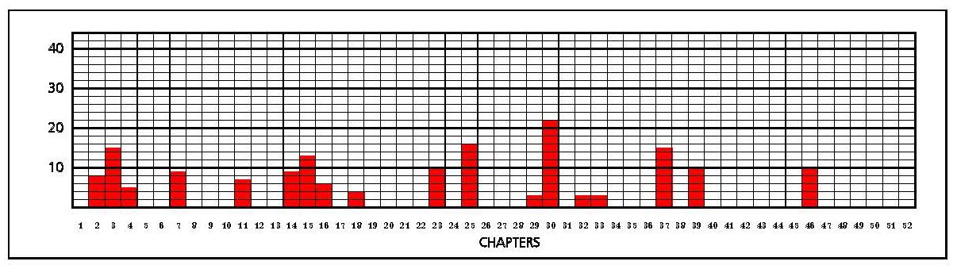
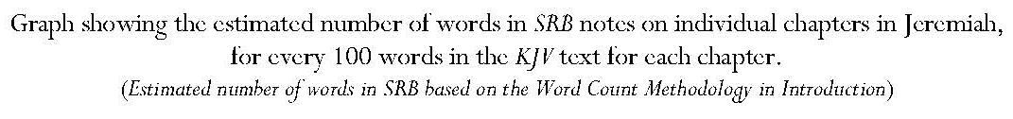
Introduction: Key Points
Biographical details for Jeremiah, placing the start of his ministry in ‘the thirteenth year of Josiah, about sixty years after Isaiah’s death’.
Jeremiah prophesied before and during Judah’s exile in Babylon.
Jeremiah ‘connects the pre-exile prophets with Ezekiel and Daniel, prophets of the exile’.
Jeremiah’s vision includes Babylonian captivity, return after 70 years, world-wide dispersion, final regathering, the kingdom-age, the day of judgment upon the Gentile powers and the Remnant.

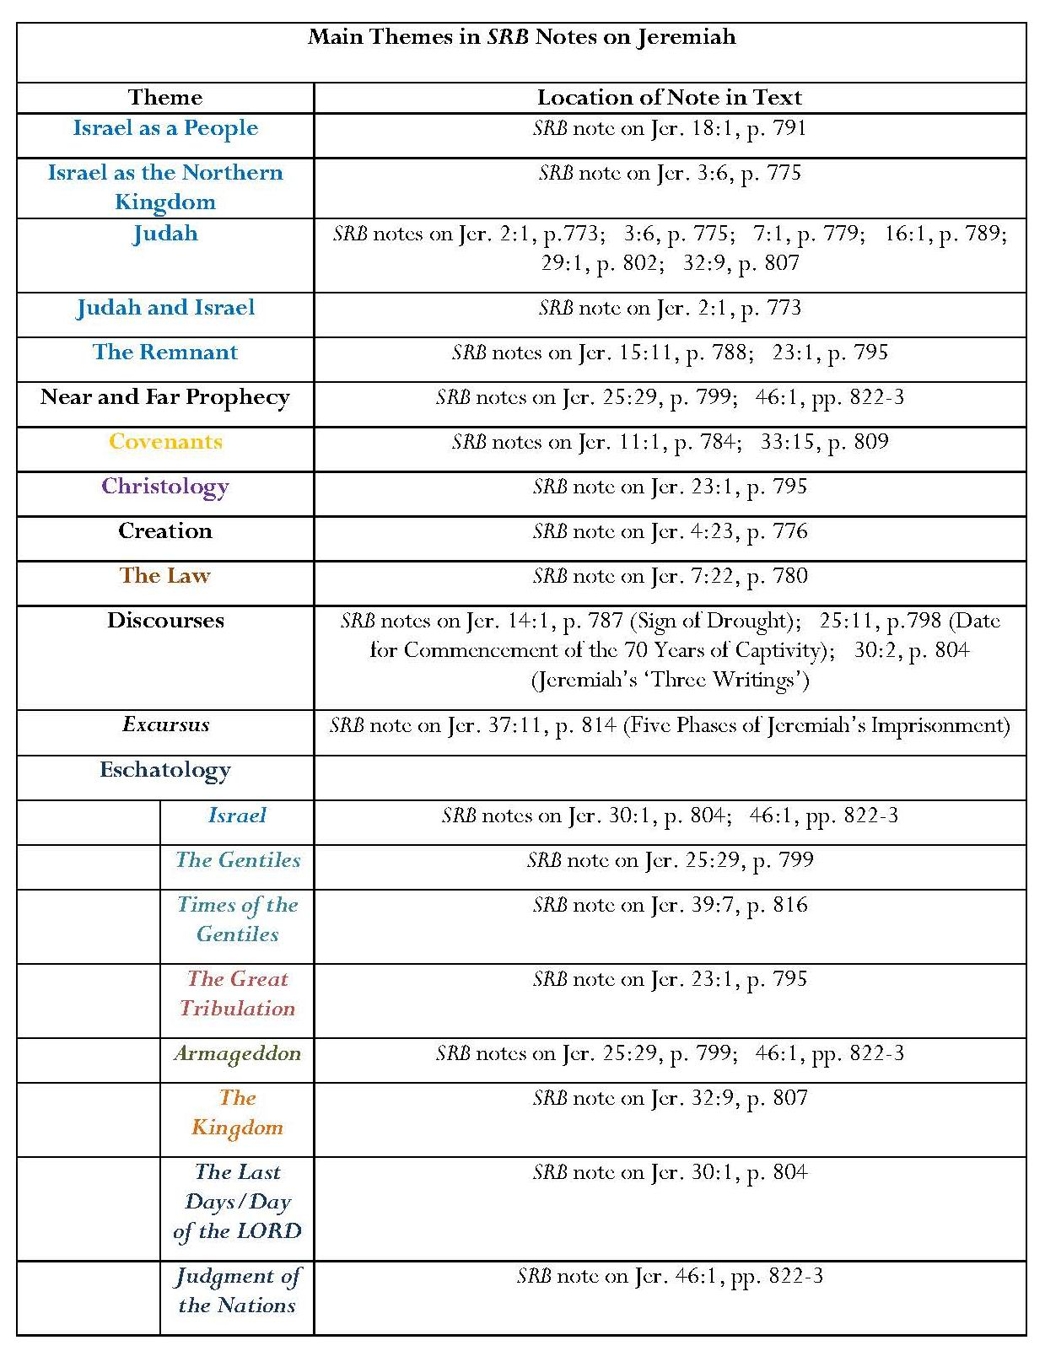
Annotation: Key Points:
34 of 52 chapters not annotated
Assertion that ‘without form and void’ ‘describes the condition of the earth as a result of judgment … which overthrew the primal order of Gen. 1:1’.
Assertion that the transportation of Zedekiah to Babylon is the beginning of the ‘Times of the Gentiles’; Jerusalem under Gentile overlordship ‘from the time of Nebuchadnezzar to this day’.
Detailed analysis of stages of Jeremiah’s imprisonment.
Israel and Judah
‘Rebuke, warnings and exhortation’ to Judah, including ‘religious Judah’.
Violations of the Palestinian Covenant led to the Assyrian and Babylonian captivities; Judah should have taken warning from the northern kingdom’s chastisement.
After warnings, Jeremiah’s message promises ultimate national restoration and blessing.
Future restoration not be confused with ‘the return of a feeble remnant of Judah under Ezra, Nehemiah and Zerubbabel at the end of the 70 years’, and that even this remnant, whom Jeremiah represents, must be distinguished from the ‘unbelieving mass’.
‘Jehovah will again make [the whole of Israel] again another vessel’: ‘key to prophetic strain’. Jeremiah’s purchase of the field is quoted as proof of the prophet’s confidence in this.
However, Israel’s future restoration and conversion to be preceded by tribulational chastisement.
Assertion that prophecies concerning Israel, not fulfilled at Christ’s first advent, remain unfulfilled.
Assertion that Jeremiah 30 — 36 summarise prophecy concerning Israel as a nation, especially the last days, day of the LORD and succeeding kingdom-age.
‘Near’ and ‘Far’ Prophecy
Two direct references:
1 ‘Near event’: the Babylonian invasion; ‘far event’: predictions of the Day of the LORD and battle of Armageddon.
2 ‘Near event’: the Babylonian invasion; ‘far event’: the judgment of the nations and Israel’s deliverance in the last days.
Comment
Jeremiah contains further illustrations of the incidence of different uses of the word, ‘Israel’. The addressees are the people of Judah; the northern kingdom of Israel is clearly sometimes named by Jeremiah as a separate entity, for example, in Jer. 3:6-8, which refer to Israel’s backsliding activities and to ‘her treacherous sister’ Judah’s not taking warning but also playing the harlot. Scofield notes that ‘the second message to backsliding Judah’ contains ‘reproach that the example of Jehovah’s chastening of the northern kingdom had produced no effect upon Judah’ and ‘warning of like chastisement impending over Judah’. However, both Jeremiah and Scofield also use the term, ‘Israel’, as denoting a single entity; for example, Jer. 2:3-4 refers to Israel as being ‘holiness unto the LORD’, brought out by him from Egypt ‘into a plentiful country’. Similarly, Scofield refers to ‘the general character of the first message from Jehovah to Judah by Jeremiah … [which] reminds Israel of the days of blessing and deliverance; reproaches them with forsaking Him’; and ‘accuses them of choosing other, and impotent, gods’. Scofield is clearly aware of the discrepancy in meaning because he expands his comment upon Jer. 3:6 by stating that ‘“Israel” and “Ephraim” [are] names by which the northern kingdom (the ten tribes) is usually called in the prophets. When by “Israel” the whole nation is meant, it will appear from the context.’

Omissions
Though Scofield gives a detailed analysis of the stages of Jeremiah’s imprisonment, and provides some biographical details in his introduction, he offers no other reflection on the context for Jeremiah’s prophecies and the narrative of the prophet’s life. He comments that the writings in chapters 30 — 36 cannot be arranged in a definite sequential order and the prophecies contained in them are ‘interspersed with much historical matter concerning Jeremiah and his time’. This implies that he does not attribute importance to matters which do not directly concern what he regards as end-time prophecy. He does not consider the full content of the biblical text or examine ways in which Jeremiah’s life might be exemplary to Christians, notably Jeremiah’s obedience to God’s commands and his perseverance in face of rejection and threats.
Scofield also neglects to annotate several chapters which refer to the coming of a power from the north. This is surprising in view his emphasis on such a power in his note on Ezek. 38:2. The context in Jeremiah is clearly the imminent Babylonian invasion. Scofield ignores other important narrative elements, despite the fact that these may represent the fulfilment of part of Jeremiah’s prophecy, for example Zedekiah’s appointment by Nebuchadnezzar, the course of events in Jerusalem under Babylonian attack and siege, the assassination of the governor, Gedaliah, and the subsequent flight of the ‘remnant of Judah’ to Egypt, Zedekiah’s rebellion, the final attack on Jerusalem and destruction of the Temple and even the exile of Judah itself.
Other passages in Jeremiah not annotated by Scofield concern the sin of Israel, specifically idolatry, and the threats of God’s chastisement. Some of the later chapters not annotated by Scofield also contain a detailed exposition of God’s judgment and threats of chastisement issued against Judah’s neighbours, though Scofield includes these in his general statement about ‘near’ and ‘far’ prophecy in his note on Jer. 46:1.
Some of God’s direst threats to Judah are omitted from Scofield’s annotation. In Jeremiah 21, disaster is predicted for any who attempt to stay in Jerusalem because the LORD is fighting against Judah and turning its own weapons against it. It will suffer plague from the LORD, who is determined to do it harm, not good. The most serious is the threat that Judah will lose the inheritance God gave it. This threat calls into question the idea that God’s promises concerning the land were unconditional and thus could never be rescinded. However, Scofield also misses some of the most explicit statements about the restoration of Israel, for instance those in Jer. 31:35-40.
Jeremiah includes strictures concerning behaviour expected of God’s people but again Scofield ignores these. Jerusalem is condemned for neglecting to help the fatherless. The royal house is warned that it must rescue the oppressed from robbers’ hands. Jeremiah 22 emphasises righteous conduct, especially by kings. The kings of Judah are to do what is right and just, to treat aliens, the fatherless and widows fairly and not to shed innocent blood. If they obey, they will enter the palace; if they do not, the palace will be ruined. Kings who exalt themselves through unrighteousness, injustice and exploitation are condemned. Josiah is commended for defending the cause of the poor and needy: that is what it means to know the Lord. In contrast his son, Jehoiakim, is accused of dishonest gain, of shedding innocent blood and of oppression and extortion. He will be ignominiously dragged from Jerusalem and be childless; none of his descendants will rule in Jerusalem. It seems again that this aspect of prophecy is not important to Scofield; for him, the prophetic mainly pertains to the last days and he is not concerned with past and present ethics.
Lamentations
Scofield remarks that ‘the Lamentations of Jeremiah’ have ‘touching significance’ as ‘the disclosure of the love and sorrow of Jeremiah for the very people whom He (sic) is chastening’. Apart from this, Scofield comments upon the inadequacy of translation to express the literary form of this book, which is ‘an acrostic dirge, the lines arranged in couplets or triplets, each of which begins with a letter of the Hebrew alphabet’.
8.4.3 Ezekiel
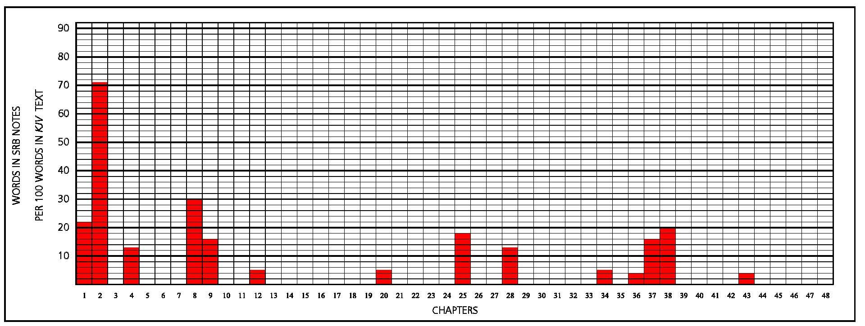
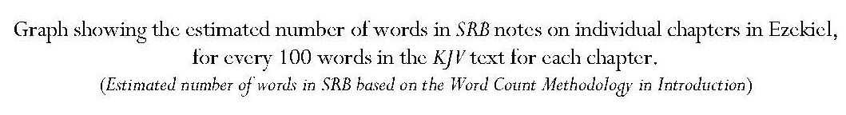
Introduction: Key Points:
Ezekiel is a prophet out of the land, like Daniel and John in Revelation, whose prophecy ‘follows the method of symbol and vision’
Voice to ‘the whole house of Israel’
Ministry: ‘keep before the generation born in exile the national sins which had brought Israel low’ and sustain exiles’ faith by ‘predictions of national restoration, of the execution of justice upon their oppressors and of national glory under the Davidic monarchy’
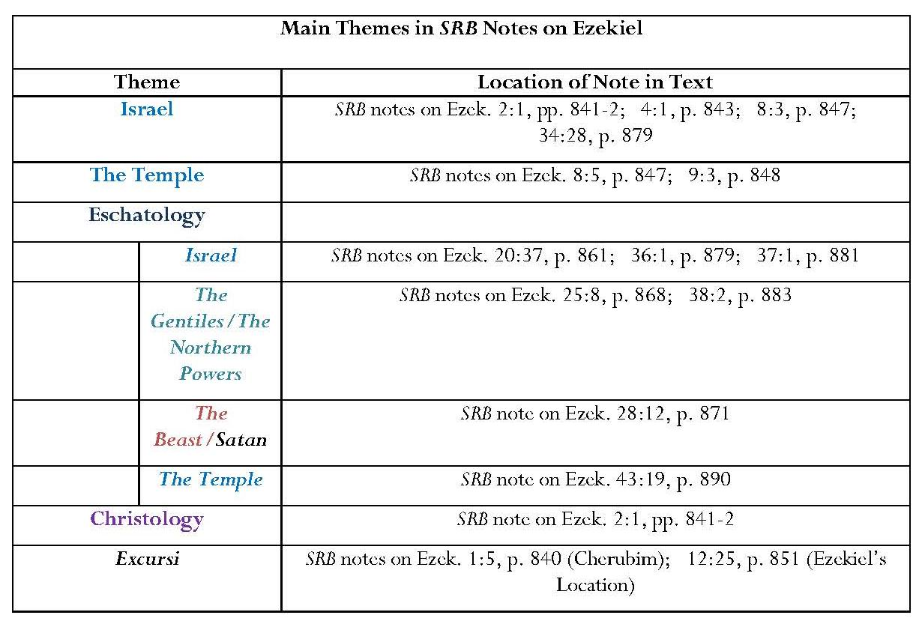
Annotation: Key Points
Only 14 of 48 chapters annotated.
Israel
Stress on sinfulness, and justice of exile but also future restoration.
Jehovah’s addressing Ezekiel 91 times as ‘“Son of man”’, reminds Israel that ‘they are but a small part of the race for whom [Jehovah] also cares’; nevertheless, he will not forsake his people in their captivity.
Visions of the profanation of the temple and of Israel’s wickedness were given so that Ezekiel ‘might justify to the new generation born in Assyria and Babylon during the captivity, the righteousness of God in the present national chastening’ which had resulted from Israel’s actions.
Restoration is still future since the remnant who returned from the captivity and their descendants were displaced from the land in 70 CE and remain in dispersion.
Assertion that Ezekiel receives a vision of millennial temple.
Eschatology
Prophecies about Gentile powers may have been partially fulfilled but the reference to the day of Jehovah in Jer. 30:3 indicates that ‘fulfilment in the final sense is still future’ and these countries are again to be the ‘battle-ground of the nations’.
Assertion that the prophecy of Ezekiel 38 refers to ‘the yet future day of Jehovah and to the battle of Armageddon’, and also includes the nations’ revolt at the end of the kingdom-age.
‘Primary reference’ in Ezek. 38:2 is to ‘northern (European) powers, headed up by Russia’; these powers ‘have been the latest persecutors of dispersed Israel’.
Russia clearly identified by references to Mesech (Moscow) and Tubal (Tobolsk).
‘Language [of Ezek. 28:12] goes beyond the king of Tyre to Satan, inspirer and unseen ruler of all such pomp and pride;’ moreover, this vision shows ‘an earthly king who arrogates to himself divine honours’, thus ‘the prince of Tyrus’ foreshadows the beast.
‘Beautiful order’ in Ezek. 36:1 and following prophecies: restoration of the land and people, judgment on Israel’s enemies and establishment of the worship of Jehovah.
The valley of dry bones represents Jehovah’s revelation of how the restoration of the nation is to be accomplished. The bones represent ‘the whole house of Israel who shall then be living’. The people will be brought out, brought in, converted and filled with the Spirit.
Israel and Judah will be reunited.
The Gentiles will also know Jehovah, as is indicated by ‘full Gentile conversion’ described in Acts 15:16-17.
Christology
Assertion that ‘Son of man’, as used by Jesus of himself, is ‘His racial name as the representative Man …’. ‘The same thought, implying transcendence of mere Judaism, is involved in phrase when applied to Ezekiel.’ Applied to both Ezekiel and Christ, the expression indicates what each is to God: a son of man ‘chosen, endued with the Spirit and sent of God’. Additionally Christ is ‘the representative man – the head of regenerate humanity’.
Omissions
Apart from the short note on Ezek. 43:19, Scofield makes no comment on the content of Ezekiel 40 – 46. These chapters all concern instructions for temple design and regulations for worship and sacrifice. Narrative features, such as the call of Ezekiel, his appointment as a watchman for Israel, and the imposition upon him of dumbness and its reversal are omitted, as are historical details such as the recording of the date of the start of the siege of Jerusalem and the news of its fall. The important question of responsibility for sin, related to Ezekiel’s appointment as watchman, is also omitted.
Apart from the comment about the tile, which obliquely refers to Ezekiel’s dumbness and the symbolic actions which occurred during it, Scofield does not mention the symbolism which is prevalent in Ezekiel, especially that which physically affects the prophet. He also neglects to annotate many of the chapters which describe Israel’s sin, especially her idolatry, and her chastisement. Scofield does not comment upon Ezekiel’s questioning as to whether the inhabitants of Israel should possess the land in view of their sin and idolatry or Ezekiel’s condemnation of sins against the poor and needy, and instructions on how aliens should be treated. Some intimations of restoration are also missed, including those verses in which God’s new covenant is described. Ezekiel’s lengthy diatribes against other entities are summarised in the brief SRB note on Ezek. 25:8. Finally, the last two chapters of Ezekiel, which describe land allocations to the tribes of Israel, are not annotated.
Continued overleaf

8.4.4 Daniel
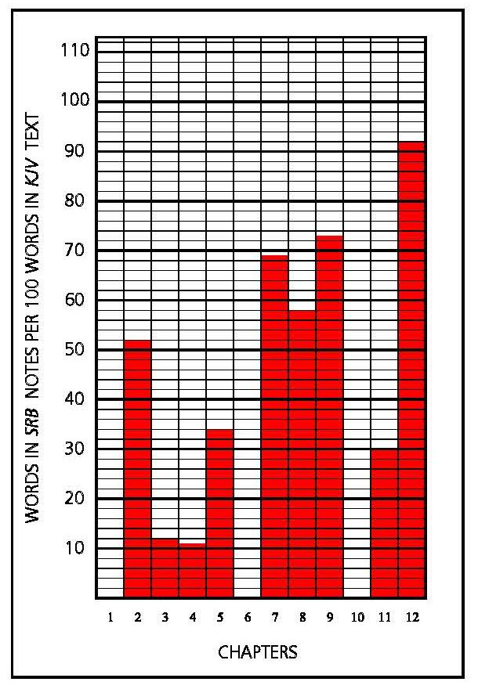
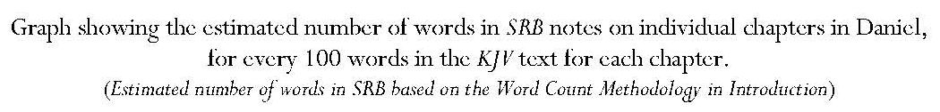

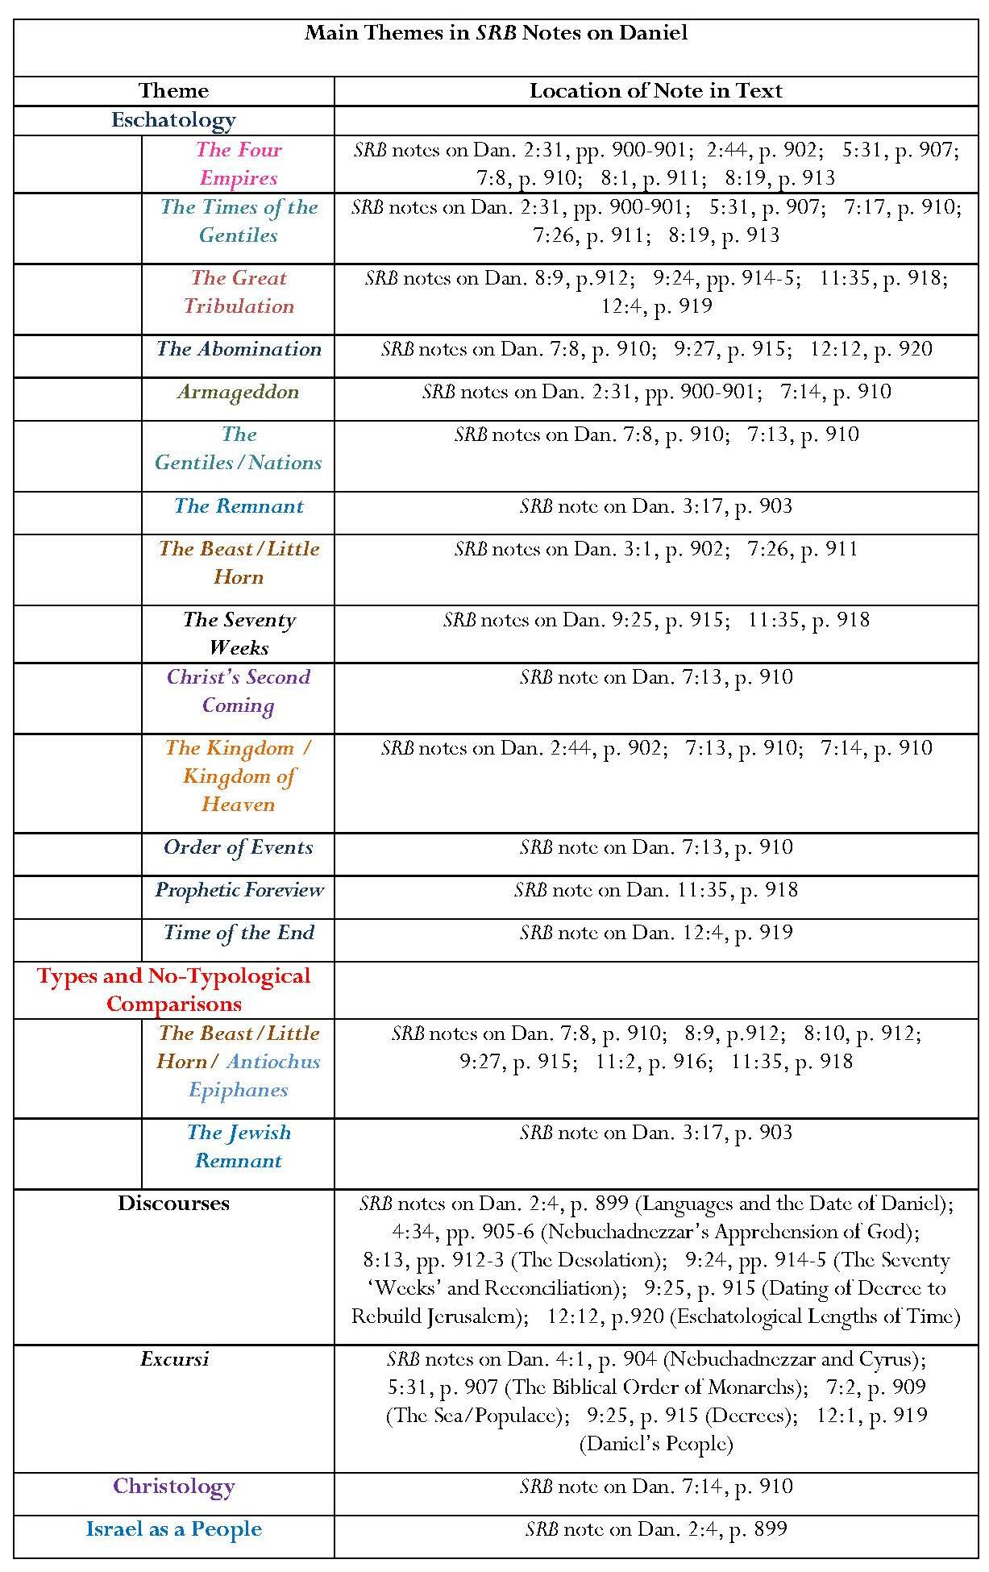
Introduction: Key Points:
Daniel is ‘the indispensable introduction to New Testament prophecy’.
New Testament prophetic themes: the apostasy of the Church, the manifestation of the man of sin, the great tribulation, the Lord’s return, the resurrections and judgment are all shared by Daniel except the apostasy of the Church.
Daniel is ‘distinctively the prophet of the “times of the Gentiles”’.
Daniel’s ‘vision sweeps the whole course of Gentile world-rule to its end in catastrophe, and to the setting up of the Messianic kingdom’.
Annotation: Key Points
Marked contrast between Scofield’s treatment of Daniel and of Isaiah, Jeremiah and Ezekiel. Only three of Daniel’s twelve chapters are not annotated; nine bear detailed notes; notes on five chapters exceed 50 words per 100 in the KJV text, one of these reaching 73 words per 100 and another 92 words. Apparent that Scofield attaches importance to Daniel.
Daniel is one of the chief sources in SRB for evidence of Scofield’s eschatology.
Eschatology
‘Times of the Gentiles’, especially as encapsulated in the concept of ‘the four world-empires’.
Future kingdom of heaven.
Detailed explanation of the meaning of the ‘seventy weeks of years’ in Daniel 9;
The great tribulation and Jewish remnant.
The ‘time of the end’, including the blasphemous assumption of deity by the Beast.
Typological comparisons, particularly between the ‘horns’ of Daniel 7 and 8, the historical figure of Antiochus Epiphanes, and the beast of Revelation.
Extensive links between Daniel and Revelation.
Typology
Comparisons between Shadrach, Meshach and Abednego and the Jewish remnant.
Comparisons between the two horns of Daniel 7 and 8 and the Revelation beast and Antiochus Epiphanes.
Comments
Scofield’s excursus on reconciliation is interesting in that it criticises KJV for ‘improper’ translation in Dan. 9:24 and other Old Testament verses, arguing that ‘reconciliation is a N.T. doctrine’; in the Old Testament ‘atonement is invariably the meaning’. In this context the verb concerned, כפר, does mean ‘cover’ or ‘atone’.
In his note on Dan. 5:31, Scofield lists ‘the biblical order of the monarchs of Daniel’s time, and of the period of the captivity and restoration of Judah. The note contains information about a mixture of real and mythical figures, combined with some of Scofield’s interpretations of visions. It starts with seemingly factual information, even including dates, and a discussion of the identity of Darius the Mede, but reverts, under the subject of Cyrus, to an interpretation of the horns of the ram in Dan. 8:6. Scofield sees Darius’ ‘Median power’ as the lesser of the two horns of the ram and the ‘Persian power’ of Cyrus as the “higher horn” which came up last in Dan. 8 1-4.
Omissions
Characteristically, Scofield omits all narrative or historical elements in Daniel, except those he lists in his note on Dan. 5:31. Chapter 1 is not annotated even though it establishes the identities of Daniel and his three compatriots, Hananiah, Mishael and Azariah, and their situation. It tells of their faithful witness to God and the way in which they impressed Nebuchadnezzar with their wisdom. The narrative part of Daniel 2 and the stories of the fiery furnace, and Daniel in the lions’ den and Belshazzar’s feast are not covered either. Daniel 2:1-18 tell of Nebuchadnezzar’s disquiet, the failure of his astrologers, sorcerers and Chaldeans to ascertain his dream, the threat to the lives of Daniel and his friends, their prayers for wisdom and the divine inspiration granted to Daniel. If Scofield were concerned to instruct Christians, he would surely have included such examples of faith and endurance. It is significant that Scofield concentrates on ‘the visions of the second half [of Daniel]’, which Philip Davies regards as ‘more intriguing to scholars’ rather than ‘the stories of the first half [which] have more appeal to laypeople’.
8.4.5 Hosea
Introduction and Annotation: Key Points
Dualism
Israel described as ‘Jehovah’s adulterous wife, repudiated, but ultimately to be purified and restored’.
Israel’s sin ‘takes its character from the exalted relationship to which she has been brought’.
Contrasts Israel as Jehovah’s disowned wife, yet to be restored, with the Church as Christ’s virgin bride.
Israel
‘My people’ in the Old Testament refers ‘exclusively’ to ‘Israel the nation’.
‘Israel’ in Hosea means the ten tribes of the northern kingdom as opposed to Judah.
8.4.6 Joel
Introduction: Key Points
Plagues of insects, sent as divine punishment, ‘give the occasion for the unveiling of the two aspects of the coming “day of the Lord”: judgment on the Gentiles and blessing for Israel’.

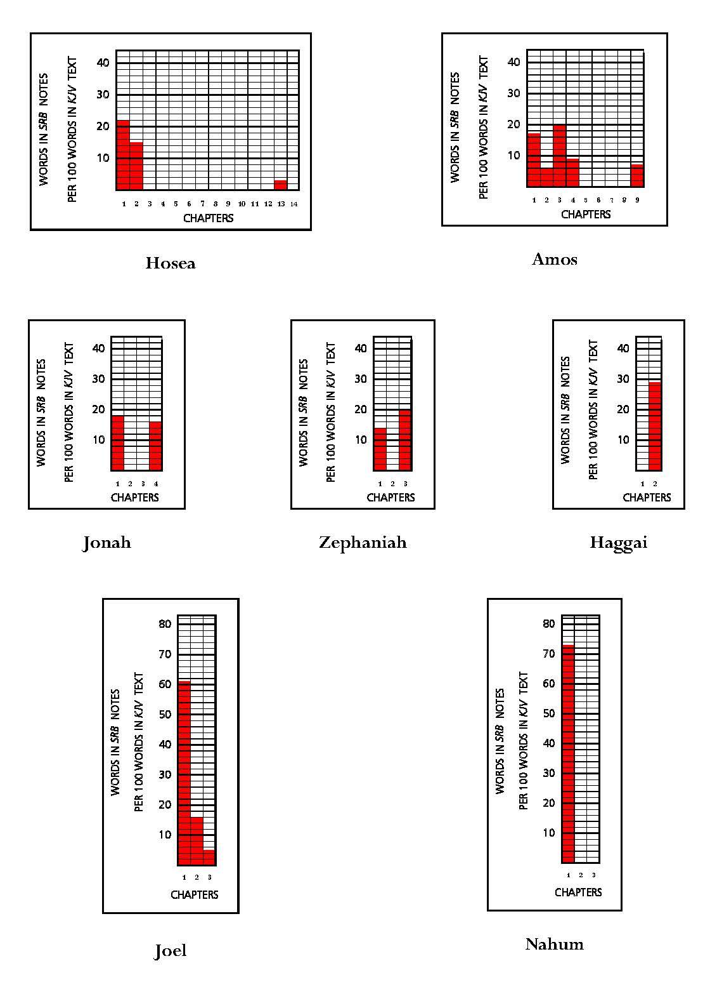
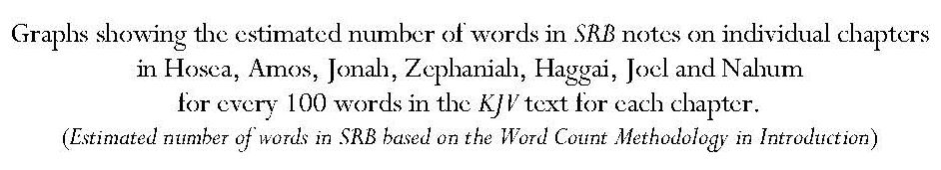
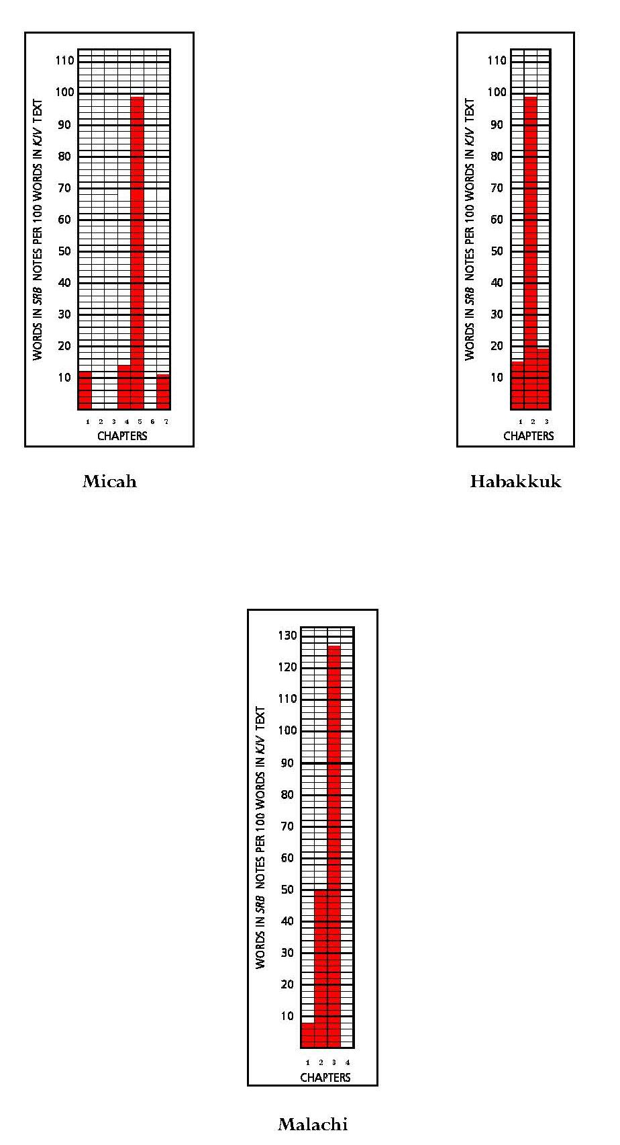
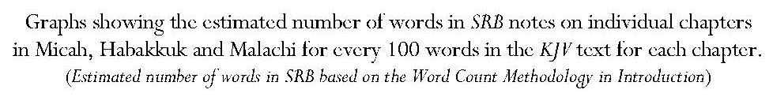

Annotation, Joel: Key Points:
Assertion that Joel comes at the start of written prophecy but ‘gives the fullest view of the consummation of all written prophecy’.
Claim that the plague of insects is an instance of near and far prophecy, ‘where a local circumstance is shown to be of spiritual significance and is made the occasion of a far-reaching prophecy’. ‘The whole picture’ is of the end-time …the ‘times of the Gentiles’, the day of the LORD, the regathering of Israel and ‘kingdom blessing.’
Sees ‘order of events’, which begins with the future invasion of Palestine from the north by the Gentile hordes, headed by the Beast and false prophet, includes the battle of Armageddon, and ends with full blessing in the kingdom set up by Christ on his return.
Note on Joel 2:11 also focuses on Armageddon, kingdom blessing and ‘cosmical signs preceding the day of the Lord’ and adds references to the promise of deliverance in response to repentance and to kingdom blessings.
‘Afterward’ in Joel 2:28 means ‘during the “last days”’; this is partly fulfilled in this age and partly awaits ‘greater fulfilment’ in the ‘last days’ for Israel’.
Notes on Joel conflate material from Joel and New Testament texts, especially Revelation.
8.4.7 Amos
Introduction: Key Points:
Amos’ warning to the northern kingdom is ‘highly improbable’, but the kingdom was destroyed within fifty years.
Amos’ vision included ‘the whole house of Jacob’, however, and his predictions included the future glory for the Davidic kingdom.
Annotation: Key Points:
Israel
The LORD’s roaring linked to the destruction of the Gentile powers, already achieved with regard to Syria, but with a wider future application.
Some references to judgments on Judah and Israel.
Intimation of the inevitability of schism occasioned by the creation of an altar at Bethel after ‘the establishment of Jehovah’s worship at Jerusalem’.
Judgment on Judah occurred in the seventy years’ captivity; that on the northern kingdom in continuing world-wide dispersion.
Prophecy concerning the ‘house of Jacob’ in Amos 3:13, applies to a wider entity than the northern kingdom, though judgment was first executed there.
Israel’s privileged position entailed responsibility and consequent divine indictment.
8.4.8 Obadiah
Introduction: Key Point:
If Obadiah prophesied during the reign of Joash, then he was ‘chronologically the first of the writing prophets, and the first to use the formula, “the day of the Lord”’.

8.4.9 Jonah
Introduction: Key Points:
Typology:
Assertion that ‘typically [Jonah] foreshadows the nation of Israel out of its own land; a trouble to the Gentiles, yet witnessing to them; cast out by them, but miraculously preserved; in their future deepest distress calling upon Jehovah-Saviour, and finding deliverance, and then becoming missionaries to the Gentiles’.
Assertion that Jonah typifies ‘Christ as the sent One, raised from the dead, and carrying salvation to the Gentiles’.
Annotation: Key Points
Only two verses annotated.
Literality of Jonah’s ingestion by the great fish.
Homily on Jonah as an example of a servant.
8.4.10 Micah
Introduction: Key Points
Contemporary of Isaiah
Prophet in Judah, though prophecy mainly concerns Samaria.
Contains three prophetic strains, each beginning with ‘hear’.
Annotation: Key Points
Eschatology
Near and far prophecy: Assyrian invasion in Micah linked with Armageddon.
Micah 4:1-8 describes the future kingdom and ‘goes forward into the last days to refer to the great battle’ and then back to ‘the birth and rejection of the King, Messiah-Christ’.
‘The believing remnant’ to be brought out ‘in the last days’ from ‘the still dispersed and unbelieving nation’.
Establishment of the future kingdom with Jerusalem as its capital.
Though ‘Mic. 7:7-20 is, primarily, the confession and intercession of the prophet, who identifies himself with Israel’, it ‘voices also the heart exercise of the remnant in the last days’.
Assertion that this is the nature of prophecy, intermingling near and far.
Omissions
Scofield ignores much of the material in Joel and Micah condemning the behaviour of Judah, which is engendering God’s punishment, and sets most of the prophecies in an eschatological context.

8.4.11 Nahum
Introduction: Key Points:
Sole theme is the destruction of Nineveh, which, according to Didorus Siculus, occurred as predicted nearly a century later.
‘The prophecy is one continuous strain which does not yield to analysis’
Moral theme is ‘the holiness of Jehovah which must deal with sin in judgment’.
Annotation: Key Points
Only the first two verses in Nahum are annotated.
Nineveh is ‘representative of apostate religious Gentiledom, as Babylon represents the confusion into which the Gentile political world-system has fallen’. Nahum gives ‘an unrelieved warning of judgment’.
God can bring justice only through the cross.
8.4.12 Habakkuk
Introduction: Key Points
Only Habakkuk amongst the prophets was ‘more concerned that the holiness of Jehovah should be vindicated than that Israel should escape chastisement’.
‘Raises and answers question of God’s consistency with Himself in view of permitted evil’.
In answer to Habakkuk’s view that God’s holiness would forbid his continued relationship with evil Israel, Jehovah announced a Chaldean invasion and world-wide dispersion, but also introduced great promises.
Annotation: Key Points
Habakkuk 1:5 ‘anticipates [Israel’s] dispersion “among the nations”’ but during dispersion God will work an incredible work; Acts 13:37-41 interprets this as a prediction of Christ’s redemptive work.
Differentiation between prayers of Moses and Paul as being for earthly and heavenly people respectively.
Summary of content of Hab. 2:5-13, 15-19, as ‘Jehovah’s moral judgment on the evils practised by dispersed Israel’.
Assertions that ‘in covenanted mercy the individual Jew may resort to the simple faith of Abraham and be saved’ and that ‘this does not set aside the Palestinian … and Davidic … Covenants’.
Comments
Scofield fails to engage deeply with the content of Hab. 2:5-13, 15-19; Habakkuk opens with the prophet’s lament to God against injustice, wrong, destruction, violence and conflict. The law is paralysed and justice never prevails, but is perverted. It is for this reason that the Lord is raising up the Babylonians.
Scofield’s ambiguous assertions in his note on Hab. 2:3, both of which may imply the existence of two means of salvation, are discussed in 4.1.
8.4.13 Zephaniah
Introduction: Key Points:
Zephaniah prophesied during a time of revival, when captivity was nevertheless impending and inevitable through Israel’s moral lassitude.
Zephaniah 3:8-20 includes the prediction of the judgment of the nations, followed by kingdom blessing under the Messiah.
Annotation: Key Points
‘Near and far’ prophecy: Nebuchadnezzar’s invasion and ‘the day of the LORD’.
Assertion that ‘the conversion of “the peoples” is stated out of the usual prophetic order, in which the blessing of Israel and the setting up of the kingdom precedes the conversion of the Gentiles’; there is no doubt, however that the conversion of the Gentiles’ will occur after ‘the smiting of the nations’.
Context means Zephaniah 3:15 cannot refer to Christ’s first coming.
8.4.14 Haggai
Introduction: Key Points
Along with Zechariah and Malachi, Haggai’s task was ‘to hearten, rebuke and instruct the feeble and divided remnant’.
Theme of Haggai: the unfinished temple and the mission of the prophet to encourage the builders. Assertion that three temples are in view in Hag. 2:1-9: Solomon’s temple, the restoration temple and the kingdom-age temple.
Annotation: Key Points
Assertion that Haggai calls those who remembered Solomon’s temple to witness to the new generation how greatly its magnificence exceeded that of the present one.
Assertion that the prophecy in vv. 7-9 ‘can only refer to the future kingdom temple described by Ezekiel’.
Comment: No justification is given for this assertion.
Claim that ‘I will shake all nations’, in v. 7 refers to the great tribulation, which is followed by the coming of Christ in glory as ‘the desire of all nations’.
In some ways ‘all the temples (Solomon’s, Ezra’s, Herod’s and “that which will be used by the unbelieving Jews under covenant with the Beast” and Ezekiel’s future kingdom temple’) are all treated as one “house” — the “house of the LORD, since they all profess to be that’. Claim that this is why ‘Christ purified the temple of His day, erected though it was by an Idumean usurper to please the Jews’.

8.4.15 Zechariah
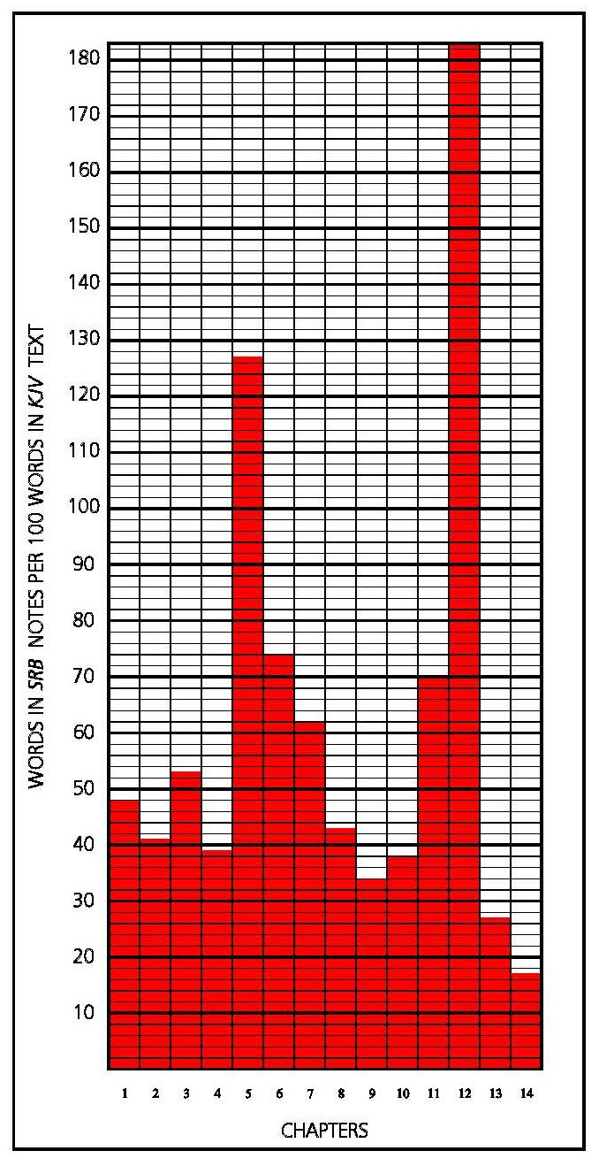
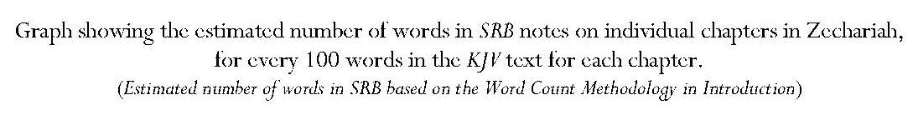
Introduction: Key Points
Assertion that Zechariah contains prophecy of both advents of Christ.
Assertion that it gives ‘the mind of God concerning the Gentile world-powers surrounding the last restored remnant’. God has given them their authority and will hold them to account according to their treatment of Israel. the reference is to the statement that ‘he that toucheth [Zion] toucheth the apple of his eye’.
Annotation: Key Points:
Volume of annotation on all chapters of Zechariah never falls below 17 words for every 100 words in the KJV text.
Zechariah 12 bears a greater volume of annotation than any other chapter in the Bible.
Notes on Zech. 12:1 and 12:8 provide 183 words for every 100 words in the KJV text.
Continued overleaf
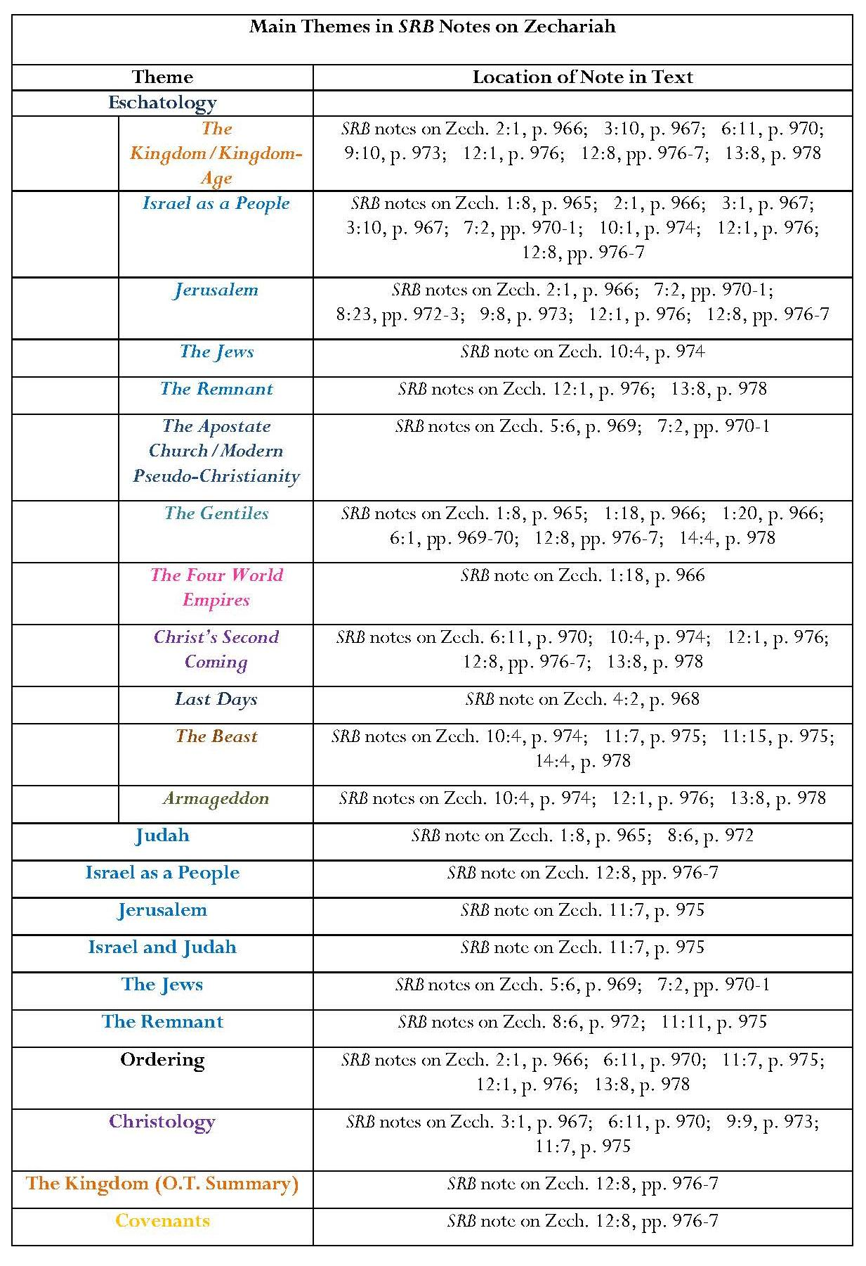
Continued overleaf

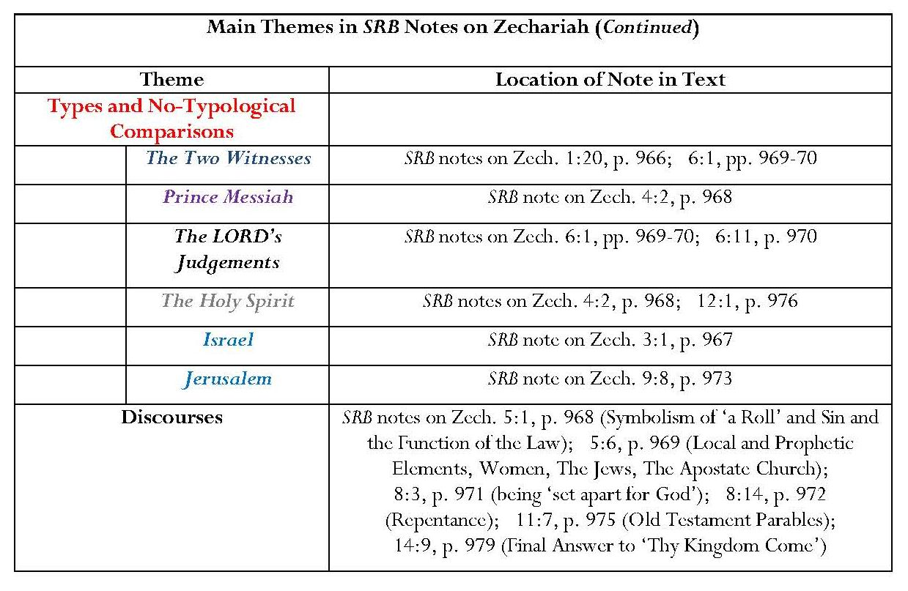
Annotation: Key Points (Continued)
The high volume of wordage in annotation of Zechariah 12 is mainly achieved by the dense annotation of Zech. 12:8; this contains Scofield’s ‘Kingdom in O.T., Summary’.
Emphasis on full earthly blessing in the kingdom and on the future kingdom as a time of fulfilment for Israel.
Zechariah 12:8 is also the verse to which Scofield refers most often in his other notes on the entire Bible.
Zechariah 9:9 ‘introduces the King’; verses 10 and the verses following look forward to the end-time and the kingdom’.
Notes on Zech. 5:1 and 6, especially the latter, also exceed the number of words in the corresponding KJV text.
Assertion that, though much in Zechariah is symbolic, ‘these difficult passages are readily interpreted in the light of the whole body of related prophecy’ and that ‘the great Messianic passages are, upon comparison with the other prophecies of the kingdom, perfectly clear’.
Comment: As with preceding prophecies, Scofield’s interpretation of Zechariah is his own and not necessarily shared by others, who analyse the text more thoroughly; a case-study of Zechariah 12 utilising works by several modern biblical scholars appears at the end of the thesis.
Intertestamental Connections
Homogenisation of disparate texts.
Majority of linked references are between Zechariah and Revelation but also links between Zechariah and other Old Testament texts.
Comment: Four intertestamental references include ‘the Beast’, which is not mentioned in Zechariah. Scofield even states that the reference to the Beast in Zech. 11:14 ‘is obvious; no other personage in prophecy … meets the description’. (The referent is ‘the foolish shepherd’.) The association may not be so obvious to others.
Eschatology
The term, ‘times of the Gentiles’, so prominent in the notes on Daniel, is not used here, though the note on Zech. 1:18 asserts that the four horns mentioned in this verse are ‘the four-world empires’ of Daniel 2 and 7, the horn being ‘symbolic of a Gentile king’.
The presence of beast and connection with Armageddon seem to be assumed in the notes on Zech. 10:4 and 14:4, though they are less prominent than in Daniel.
Further references to Armageddon are found in the notes on Zech. 12:1 and 13:8.
Most ‘orderings’ in the annotation of Zechariah are eschatological and include references to the gathering of the nations, the siege of Jerusalem, Christ’s return, and the ensuing battle, Israel’s deliverance and restoration, divine judgment upon the nations, the judgments of ‘the day of the LORD’ and the kingdom and its blessing.
Israel, Judah and Jerusalem, the Jews
The note on Zech. 12:8 contains a ‘summary of the kingdom in the Old Testament’.
Zechariah’s situation is described in the note on Zech. 1:8 — Judah dispersed and Jerusalem under Gentile domination, a position which still prevails.
Rare reference to prophetic criticism: the people’s fasting was ‘mere religious form’ and ‘they are told why their 70 years’ prayer has not been answered’.
The scene showing two staves belongs to the first advent; that is, ‘Beauty’ (i.e. ‘graciousness’, ‘God’s attitude to His people Israel, in sending His son’); and ‘Bands’ (i.e. union’, ‘signifying [God’s] purpose to reunite Judah and Ephraim’). ‘Christ came with grace … at his first advent to offer union … and was sold for 30 pieces of silver (Zech. 11:12, 13).’ Thus graciousness was ‘cut in sunder, signifying that Judah was abandoned to the destruction foretold in vv. 1-6 and fulfilled in A.D. 70’; ‘Bands’ was thus broken and the purpose to reunite Judah and Israel temporarily abandoned.
Judah suffered the prophesied destruction in 70 A.D.
Judah and Israel remain divided.
Israel, Jerusalem and the temple are to be restored, following ‘godly sorrow’ and the ‘cleansing fountains’ ‘to be opened effectually to Israel’.
There will be ‘a mighty effusion of the Spirit upon restored Israel’.
The measuring-line in Zech. 2:1 is symbolic of the preparation for rebuilding the city and temple in the kingdom-age; ‘in no sense has this prophecy been fulfilled’.
The Jews’ previous ‘refusal to abandon self-righteousness for God’s righteousness’ had prevented their acknowledgment of the presence of God’s “Branch” at Christ’s first advent but the vision in Zech. 3:1 is a type of Israel’s future preparation for receiving him as Priest-King.
Israel will achieve security when the kingdom appears.
Jerusalem is to become ‘the centre of the world’s worship’ and its religious centre.
God’s purpose to bless Israel in the kingdom is unchanged.

The Gentiles
References mainly concern the end of Gentile domination and the judgment of the Gentile nations.
Dualism
The ‘poor of the flock’ are identified as believing Jews from Christ’s first advent ‘and since’. The term does not signify Gentiles or the Gentile church but only believers from Israel during this age.
Christology
References to Christ’s first advent in notes on Zech. 3:1, 9:9 and 11:7.
Assertion that ‘except in Zechariah 9:9, the present age is not seen in Zechariah’.
Comment: This assertion contradicts Scofield’s association of the two staves of Zech. 11:7-14 with graciousness and betrayal during Christ’s first advent. Scofield’s statement about Zech. 9:9 may reflect his belief that Christ’s ministry up to his death took place within the dispensation of law and that the church age only began at the crucifixion. This in itself would be contradictory because Scofield’s association of Zech. 9:9 with Christ’s entry into Jerusalem would place that event within the ‘present age’ and destroy his argument.
Assertion that ‘the scene’ involving ‘Beauty’ and ‘Bands’ in Zechariah 11 ‘belongs to the first advent’; as stated above, the imagery is strongly associated with Christ’s betrayal.
Joshua and Zerubbabel in Zechariah 4 ‘point to Christ as Priest-King in the kingdom-age’, in the ‘last days’ of the present age and on His own throne’.
Christ’s ‘manifestation in glory’, his second advent, follows ‘earth-judgments’ symbolised by the chariots and horses in Zechariah 6.
The scene in Zechariah 10 represents the final deliverance of Israel at Christ’s return.
The general theme in Zechariah 12 — 14 is ‘return of the Lord and establishment of kingdom’.
The note on Zech. 13:8, describes Christ’s ‘return to the Mount of Olives and physical change of the scene in [Zech. 13:] 9-21’.
Assertion that none of the events of Zechariah 14 concerning the Mount of Olives occurred at Christ’s first coming.
Types and other Non-Typological Comparisons
The carpenters in Zech. 1:20 ‘may stand for Jehovah’s “four sore judgments” … the four horses of Revelation 6’.
Oil symbolises the Holy Spirit.
The ‘fast day’ in memory of the destruction of Jerusalem is ‘extra-Biblical, formal and futile’, ‘like much in modern pseudo-Christianity’.
The four chariots and horses are likely to represent the four angels of Revelation 7 and 9.
Typological references to the two witnesses, Prince Messiah and ‘the Babylon phase of the apostate church’ were discussed in Chapter 2.
Comments
In his note on Zech. 8:14, Scofield is correct in saying that ‘nacham’ can mean ‘to be “eased” or “comforted”’. This is a correct translation when the Hebrew verb is in the piel or pual, but the form in Zech. 8:14 is the niphal and here it does mean ‘to be sorry’, ie ‘repent’ as given in translations such as KJV.
Scofield refers to ‘the remnant’ in notes on five verses in Zechariah but the word has basically two different meanings. In his notes on Zech. 8:6 and 12:8, Scofield refers to ‘the remnant of Judah who returned from Babylon’, under Zerubbabel. In the notes on Zech. 11:11, 12:1 and 13:8, he refers to ‘the poor of the flock’, Jews who had not waited for Christ’s manifestation in glory, but believed in him at his first advent ‘and since’. After their suffering in the time preceding the great battle, Christ is to be revealed to them personally. It is not made clear why Scofield uses the same terminology for two different groups but it can be seen that these are Jews who remained faithful in the two situations of suffering, the Babylonian exile being seen as paralleled by the great tribulation.
8.4.16 Malachi
Introduction: Key Points
Themes: God’s love for Israel, rebuke of the sins of priests and people, and the day of the LORD.
Malachi gives God’s moral judgment on the remnant, restored under Ezra and Nehemiah, whose worship had become ‘formal and insincere’
Malachi, too, ‘sees both advents and predicts two forerunners’. Distinction made between ‘the messenger’ and ‘Elijah’.
Annotation: Key Points
Notes open with the comment that the Jews are calling God ‘Father’ but failing to obey him.
Brief references to Israel and the Church.
No references to types, the Gentiles or Gentile powers, the kingdom, near and far prophecy, dualism or eschatology except the comment on the second advent in the note on Mal. 3:1.
Brief references to creation and to the Davidic Covenant.
Christ’s Two Advents
Malachi 3:1 is split into the phrase “my messenger”, quoted of John the Baptist in Mt. 11:10, Mk 1:2 and Lk. 7:27 (which, by implication, means the first advent), and the two phrases, ‘“the Lord whom ye seek” and “the messenger of the covenant”’, which are assigned to the second coming.
‘Malachi 3:2-5 speaks of judgment, not of grace’.
The Old Testament prophets, including Malachi, were unable to separate Messiah’s two advents, even though they prophesied both his suffering and his glory.
Old Testament Theology
Annotation of Malachi includes Scofield’s doctrine of the Holy Spirit and a significant expansion of his interpretations of the divine identity which were found in Genesis and 1 Samuel.
a) The Doctrine of the Holy Spirit
Scofield’s analysis of the Spirit’s qualities, characteristics and work surely reflects the ‘Bible Readings method’.
An observation is made that, in the Old Testament, the Spirit comes as he wills upon people and even ‘a dumb beast’, in contrast with his indwelling of all believers, which was made possible only by the death and resurrection of Christ and which is a New Testament blessing.
Brief reference to Israel’s future reception of the Spirit and its expectation both of the coming of Messiah and ‘such an effusion of the Spirit as the prophets described’.
b) Divine Identity, Trinity and Incarnation
A short section of the note on Mal. 3:18 is devoted to the incarnation, ‘intimated in the theophanies’ of Genesis and predicted in the promises connected with redemption and the Davidic Covenant.
Omissions
As with other prophets, Scofield largely ignores the moral imperatives of Malachi. Malachi 3:1, which Scofield interprets solely as concerning the first and second advents of Christ, is followed by a warning that few will be able to stand at the Lord’s coming (vv. 2-3) for he will ‘be a swift witness against … those that oppress the hireling in his wages, the widow, and the fatherless, and that turn aside the stranger from his right’.
8.4.17 Conclusion: Notes on the ‘Prophetical Books’
After Genesis and Exodus, Scofield devotes the greatest proportion of his Old Testament notes to Daniel and Zechariah. This is a strong indication of the importance he attaches to these books and thus their annotation provides a key to Scofield’s interests. Literality is assumed, eschatological material predominates and significant links are made between both books and Revelation.
Scofield’s interpretation of the ‘seventy weeks’ of Daniel is foundational to his concept of the postponed kingdom, which is one of the essential elements in dualism. The promises to Israel in the Abrahamic and Davidic Covenants cannot be broken and have yet to be fulfilled; since Israel rejected its Messiah at his first coming, the ‘prophetic clock’ has stopped and will not start again until the parenthetic church has been removed at the rapture. It is then that Israel’s great tribulation under the beast can take place, culminating in Christ’s return, his defeat of the beast at the battle of Armageddon and his establishment of the millennial kingdom. Further important annotation on Daniel covers ‘the times of the Gentiles’, encapsulated by the concept of the four empires, the power of the fourth of which only ends at Armageddon. The notes on Joel also reflect upon ‘the times of the Gentiles’, Armageddon and ‘the day of the Lord’.
Scofield’s eschatology as displayed in his notes on Zechariah has a greater focus on Israel and its two periods of dispersal – the physical exile in Babylon and the continuing diaspora – and also its future restoration. The note on Zech. 12:8, which provides Scofield’s analysis of the kingdom in the Old Testament, is the key element in the commentary on Zechariah since it offers Scofield’s interpretation of the Old Testament as literal Israelite history and his tenets concerning its millennial future. The kingdom is also an important element in the notes on Isaiah and Micah.
Scofield’s notes on Isaiah, Jeremiah and Ezekiel similarly focus on Israel’s chastisement and future restoration, those on Ezekiel concentrating upon the future for the temple. The temple also features in notes on Haggai. Notes on Isaiah, Joel, Zephaniah and, especially, Jeremiah contain material concerning near and far prophecy and its ultimate eschatological fulfilment. Of the other prophets, only the SRB notes on Hosea and Jonah contain no obvious eschatological material. Israel is also given detailed treatment in notes on Amos and Habakkuk.
Commentary on Christ’s first and second comings is found in notes on Isaiah, Ezekiel, Nahum and Zechariah and on Israel/Church dualism in notes on Hosea, Habakkuk and Zechariah. However there are few typological references; these are found only in notes on Daniel, Jonah and Zechariah.
In his notes on all the prophets, Scofield ignores many chapters and verses involving prophetic denunciation. The prophets reflect in unfavourable terms upon their contemporary situations and pronounce God’s anger at oppression and injustice. Scofield has very little to say about this important aspect of Old Testament prophecy, which can be seen as directly relevant to modern morality.
8.5 Conclusion: Scofield’s Use of the Old Testament
Probably Scofield’s most comprehensive statement of his interpretation of the function of the Old Testament is found at the very end of his Old Testament commentary in his note on Mal. 3:18. ‘The revelation of Deity in the N.T. so illuminates that of the O.T. that the latter is seen to be, from Genesis to Malachi, the foreshadowing of the coming incarnation of God in Jesus the Christ. In promise, covenant, type, and prophecy the O.T. points forward to Him.’ It is true that Scofield sees the Old Testament mainly in terms of the New, as witness the number of typological and Christological interpretations in SRB and the number of intertestamental links he makes between texts, especially in Daniel, Zechariah and Revelation. Paradoxically, however, he also sees in it an entirely separate function and future for Israel in the eschatological kingdom in which all the ages culminate. The original promises to Israel, especially couched in the Abrahamic and Davidic Covenants, have not been abrogated or superseded.

Page intentionally left blank

CHAPTER 8
Analysis of the Content of SRB Commentary:
Scofield’s Use of the Text
Part 2: The New Testament
8.6 The Gospels and Acts
There is a marked contrast between the amounts of annotation on each of the four Gospels. Matthew is the most heavily annotated book in the whole Bible compared with its volume in KJV, whereas only five verses in Mark are annotated. The contrast in annotation is illustrated in the graphs below. All graphs are based on the tables in Volume 2. Luke and John are more thoroughly annotated than Mark but some chapters have few notes and others none at all. The annotation on Acts is also sporadic, only twelve of the twenty-eight chapters bearing any notes and five of these twelve having minimal annotation.
Introduction, the Four Gospels: Key Points:
Several principles important to Scofield’s interpretation of the New Testament emerge in this introduction.
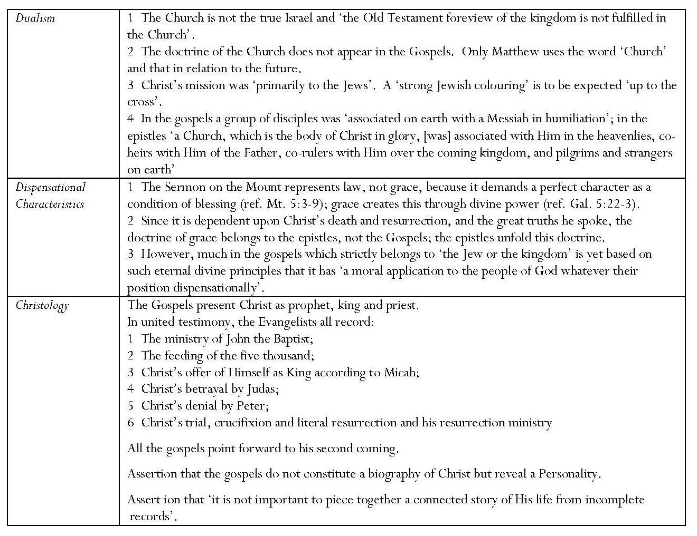
Scofield gives no reference in Micah to support his statement that all the Evangelists record Christ’s offer of Himself as King according to Micah’ and he does not quote any New Testament text which could be attributed to Christ himself as making this offer. Charles Weston states that ‘nowhere does Jesus ever suggest … that he is waiting for popular or national approval to establish his kingdom or to be an earthly king’. As Weston points out, in Jn 6:15, Jesus departed when people were about forcibly to make him king. Contradicting his assertion that ‘it is not important to piece together a connected story of [Christ’s] life from incomplete records, in his notes, Scofield makes many attempts to make a connected story as he tries to harmonise the Gospel accounts, and produce ‘orders of events’.
8.6.1 Matthew
Introduction: Key Points
Date and Authorship
Confident identification of author and date of each Gospel.
An unidentified ‘all’ agree that the author here is ‘Matthew, also called Levi, a Jew of Galilee, who had taken service under the Roman oppressor’ and that ‘no convincing reason has been given for discrediting the traditional date of 37 AD’.
Comment: W. D. Davies & Dale Allison cite no date asserted by any scholar before 40 CE and indicate that some think Matthew was written after 100 CE.
Matthew is ‘peculiarly the Gospel for Israel, and, as flowing from the death of Christ, a Gospel for the whole world’.
Christological Assertions:
Matthew connects Jesus with ‘two of the most important of Old Testament Covenants: the Davidic Covenant of kingship and the Abrahamic Covenant of promise’.
Matthew writes first of the King, the Son of David, and then of the Son of Abraham who, as typified by Isaac, was obedient unto death.
Following his accounts of Jesus’ genealogy and birth in the City of David, Matthew records the ministries of Jesus’ forerunner and of Jesus, and Jesus’ rejection by Israel and his predictions of his glorious second coming. ‘Only then does Matthew turn to the earlier covenant, and record the sacrificial death of the Son of Abraham. This determines the purpose and structure of Matthew.’
Comment: This seems improbable because the order is purely chronological and repeated in the other Gospels. Also the term, ‘Son of Abraham’ is only applied to Christ in the genealogy and is not given any prominence in the account of the crucifixion.
Continued overleaf

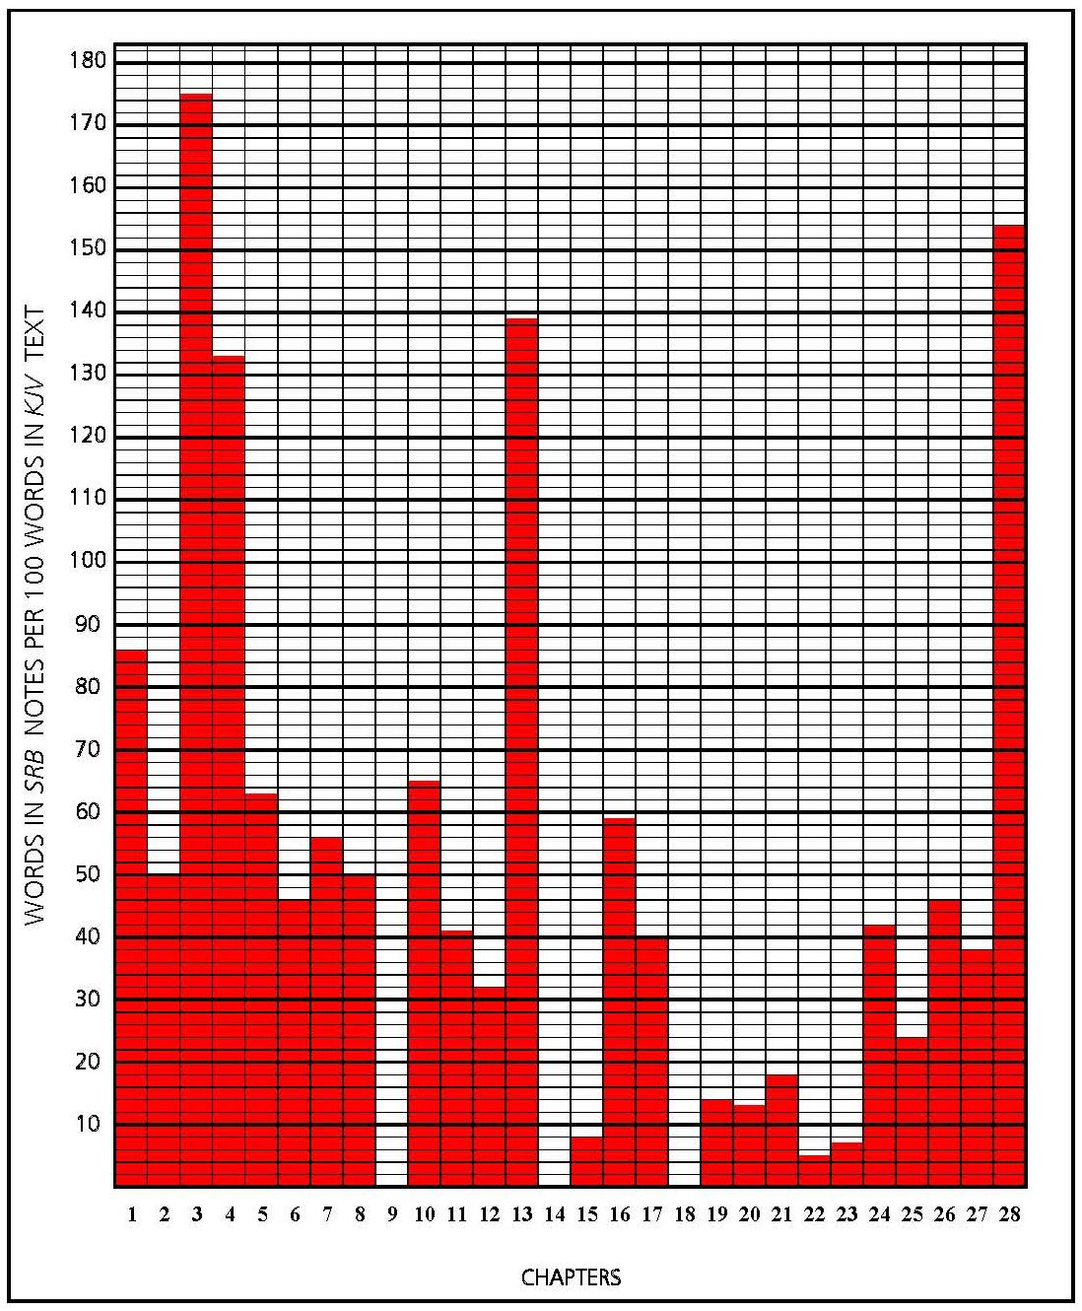
MATTHEW
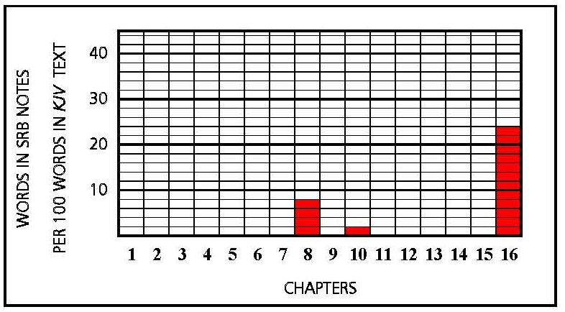
MARK
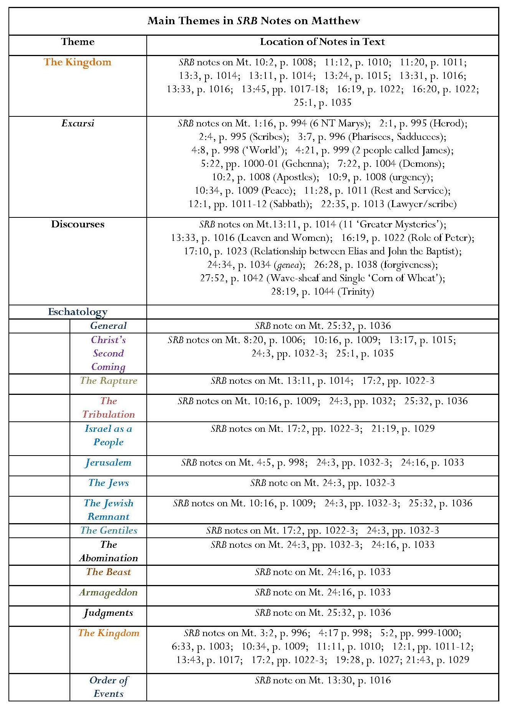
Continued overleaf

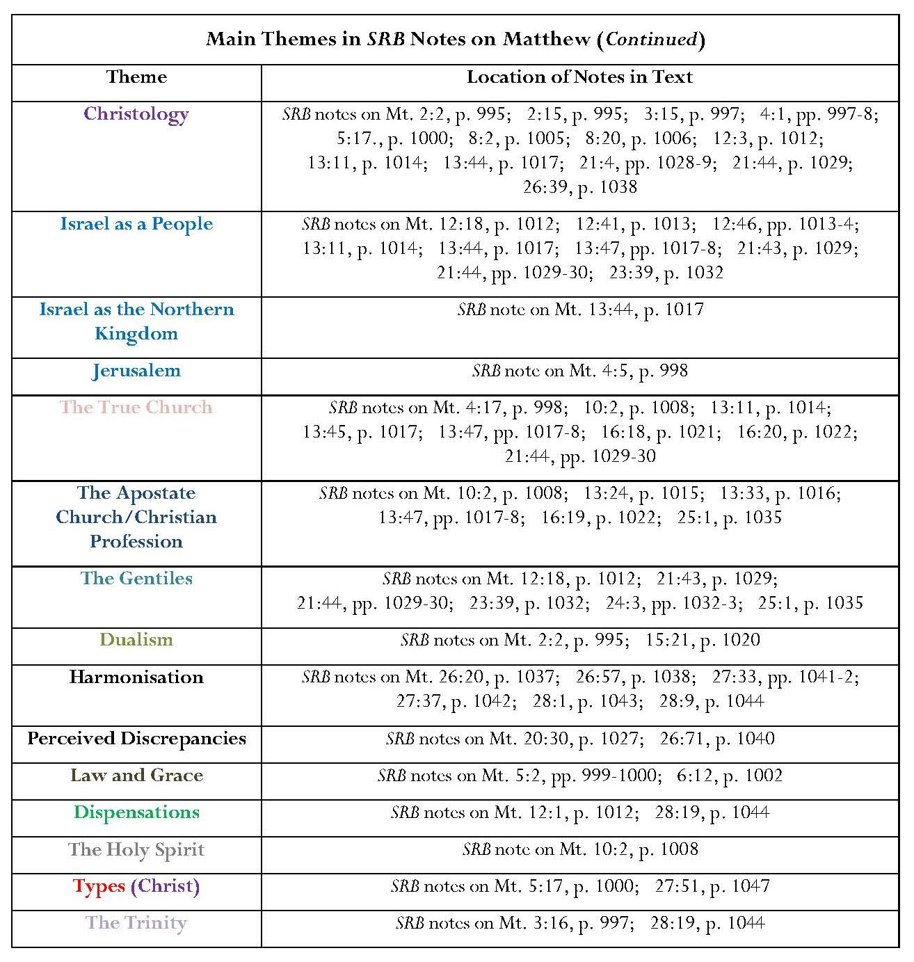
Annotation: Key Points
The Kingdom
Most prominent theme in SRB notes on Matthew, especially notes on chapters 3, 4 and 13.
Emphasis on Davidic, Messianic and terrestrial nature, and its connection with the kingdom referenced in Daniel 2 and 7, which is to be set up by God after ‘the destruction by “the stone cut without hands” of ‘the Gentile world-system’.
Three aspects: the kingdom of heaven: as ‘at hand’, in its present ‘mystery-form’ and in its ‘prophetic aspect’. These three forms constitute an important element in Scofield’s concept of the kingdom of heaven.
‘At hand’ in relation to the kingdom is never a positive affirmation of an immediate appearance but ‘only that no known or predicted event must intervene’.
Comment: Weston dismisses Scofield’s view as ‘pompous nonsense’, asserting that ‘‘‘at hand” means something within your reach. So the Scripture uses it continually’.
Claim that the establishment of the Davidic kingdom should have followed upon Christ’s appearance.
Discussing the Sermon on the Mount, Christ’s earthly ministry during his first advent was strongly identified with the dispensation of law, making application of it to Christians a minimal second function.
Claim that ‘the Jews … were never rebuked for expecting a powerful and visible kingdom, but the words of the prophets should have prepared them to expect also that only the poor in spirit and the meek could share in it’ reinforces idea that Christ was at that time offering such a kingdom.
Rejection of this kingdom emphasised.
Seminal elements of differentiation between the kingdom of heaven and the kingdom of God outlined — five ways in which the two kingdoms differ; emphasises that the kingdom of heaven is purely terrestrial and is, in this age, the arena of a mixture of true and false profession, whereas the kingdom of God is universal.
Comment: Davies and Alison state that ‘most scholars assume that “kingdom of heaven” is the equivalent of “kingdom of God”’.
Notes on Mt. 3:2, 10:2, 13:24, 16:19 and 25:1 also refer to the merely professing nature of ‘Christendom’.
Comment: These remarks weight Scofield’s interpretation in favour of a negative assessment of the current age.
The kingdom of heaven is yet to be established but the kingdom of God is ‘taken from Israel nationally and given to the Gentiles’.
The kingdom is not the Church.
When the kingdom comes, it ‘will be administered over Israel through the apostles, according to ancient theocratic judgeship’, thus fulfilling the promise of Isa. 1:26;
Jewish nature of the kingdom-age again emphasised in the assertion that the Sabbath will again be observed during it.
The Kingdom in Annotation of Matthew 13
Mingling of good and bad, true and false doctrine within the current kingdom of heaven.
Also references to the kingdom of heaven merely as ‘the sphere of profession’.
Many interpretations of the parables concerning the kingdom of heaven – the parables of the sower, the wheat and tares, the mustard seed, the treasure, the pearl and the net.
Inclusion of many negative aspects concerning the parable of the leaven, contrasting it with the parable of the mustard seed, which is given a fairly positive treatment as developing from ‘an insignificant beginning … to a great place in the earth’, even though the refuge of the mustard tree is considered insecure.
Comment: For Scofield, leaven always represents corruption; there is no room for reinterpretation even by Jesus, who does not differentiate between the two parables. Scofield’s discourse on leaven leads into a statement of his disapproval of women participating in religious practice. The scholars and commentaries quoted in my case study of Matthew disagree with Scofield.
The Kingdom and the Transfiguration
Important analysis of the transfiguration in terms of the kingdom.

Christology
Assertions concerning Christ’s titles: ‘Christ or “Messiah”’ is our Lord’s ‘official name’ whereas “Jesus” is His ‘human name’. ‘“Son of man” is His racial name’; ‘“Son of David” is His distinctively Jewish name’ and ‘“Son of God” is His divine name’.
Assertion that ‘the name or title “Christ” connects Him with the entire O.T. foreview … of a coming Prophet, Priest and King’.
Emphasis on ‘the intelligent use of the word of God’ and ‘”rightly dividing the word of truth” (2 Tim. 2:15)’ in the comment on temptations of Christ.
Christ’s relationship to the law emphasised. Detailed analysis given.
Reference to the veil of the temple as a type of Christ’s human body.
Comment: This is one of the rare examples of a justified typological assertion under Scofield’s own rubric.
Christ’s Relationship to Jews and Gentiles
Assertion that Christ is King only of the Jews, not of the Church; supported by the statement that the reference to David in Mt. 12:3 implies that Christ was rejected as King rather than Saviour.
Assertion that Christ ignored the Canaanite (Syrophoenician) woman’s request when addressed as ‘son of David’, to which a Gentile had ‘no claim upon Him’, but immediately responded on being addressed as ‘Lord’.
Claim that Israel, especially Ephraim, interpreted as the treasure concealed in the field bought by Christ with his own blood in the parable of Mt. 13:44, whereas the true church is the pearl in Mt. 13:45.
Israel, the Church and the Gentiles
Differences between Israel and the Church emphasised.
Emphasis on Israel’s rejection of Christ as King and his turning to the Gentiles.
Israel’s fate is clearly bound up with that of the Gentiles; Israel will not be blessed by ‘the Deliverer’s’ coming from Zion until the Gentile world-power has ‘run its course’ and ‘the elect number of Gentiles’ been brought in.
Israel’s blindness in the current age is one of the ‘greater mysteries’.
Other mysteries are the Church as ‘one body composed of Jew and Gentile’ and as ‘the bride of Christ’.
Assertion of different relationships for ‘Christ as “the Stone”’ to Israel, the Church and the Gentiles; the rejected stone identified with Israel and the cornerstone with the Church, but ‘the smiting stone of destruction’ is linked with the demise of the Gentile world-powers.
Comment: Scofield’s note identifies the stone in Mt. 21:44 with the stone cut without hands which breaks the image in Dan. 2:34-5, but the stone to which Christ refers in Mt. 21:44 is contextually linked to the stone in Mt. 21:42, where the reference is to Ps. 118:22.
Eschatology
SRB note on Mt. 24:3 contains a virtual summary of Scofield’s eschatological concepts in an outline largely based upon associations with Daniel, including ‘the end of the age’, ie Daniel’s seventieth week, the Jewish remnant, the abomination and the great tribulation. Assertion that ‘a careful study of Daniel 2, 7 and 9, and Revelation 13, will make the interpretation clear’.
Comment: Much of the material in the note on Mt. 24:3 mirrors that in the text of Matthew 24 but there are subtle additions to Christ’s recorded speech. Scofield defines ‘these things’ in Mt. 24:6 as specifically concerning ‘the destruction of the temple and city’. He introduces ‘a double interpretation’ of Mt. 24:4-14, which differentiates between conditions in this age and their application to the end of the age. The KJV text includes no time-scale but provides a continuous sequence of events. It does not mention Daniel’s seventieth week. Scofield defines ‘the abomination of desolation, spoken of by Daniel the prophet’ as ‘“the man of sin” or “Beast”’; this identification is not made in the KJV text. Scofield also asserts the length of the great tribulation and its culmination in ‘the battle of Rev. 19:19-21’; he identifies Christ with the Smiting Stone of Daniel 2:34; and he links the coming of the son of man with ‘the smiting of the ‘Gentile world-power’. These are all features which do not appear in Matthew 24, KJV.
Occurrence of one of several assertions that the Old Testament prophets were not aware of the occurrence of any interval between Christ’s first and second comings.
Assertion that ‘the ‘mysteries of the kingdom of heaven’ are to occur during this interval.
Christ’s Second Coming
Claim that ‘when [Christ’s] messengers are cast out by the Jews, His thought leaps forward to the time when the Son of man shall come, not then to Israel only but to the race’.
Claim that Mt. 10:23 concerns ‘the preaching of the remnant in tribulation and immediately preceding the Lord’s return in glory’.
Claim identifying ‘my brethren’ in the judgment of the nations as Jewish remnant.
Comment: The two claims concerning the remnant in Mt. 10:23 and Matthew 25 are not justified within the text of Matthew and contain pure interpretation on Scofield’s part. In context, Christ’s words in Mt. 10:23 are addressed to the disciples then being sent out and do not contain any eschatological element. The ‘brethren’ in at the judgment in Matthew 25 simply represent Christ as he is treated well or badly by ‘the nations’; no single group is named here.
Harmonisation and Rebuttal of Perceived Discrepancies
Much volume in annotation of Matthew 26 — 28 is created by Scofield’s attempts to harmonise the Gospel accounts, to provide ‘orders of events’ and to refute perceived discrepancies.
This synchronisation is labelled ‘combining the four narratives’.
Comment: Some of the events from different Gospels cannot be reconciled without manipulation. The method of ‘combining the four narratives’ is insupportable and it forces Scofield to make adaptations in order to maintain his literal interpretation.
Dispensational Material and Law/Grace Contrasts
Christ’s ministry is placed firmly within dispensation of law rather than grace: according to the ‘law of the kingdom’ (presumably the law of the ‘mystery-form’ of the kingdom, though the use of the word here is ambiguous), ‘no-one may hope for forgiveness who has not first forgiven’; the condition of divine forgiveness is our own exercise of forgiveness.
Implication that the Lord’s Prayer is not intended for Christians, especially in relation to forgiveness.
Jesus’ death and resurrection occasioned the beginning of the dispensation of grace.
Comment: This reflects the very particular dispensationalist view that the age of grace began only at Christ’s death, which Scofield presents as if it were axiomatic but the opening words of Mark’s Gospel make this questionable.

Excursi
Some excursi are simply informative and are similar to notes which might be found in conventional reference Bibles; others, which contain long lists of Bible verses, probably reflect Scofield’s use of the Bible Readings method. However, some of the information is not accurate, for example in the note on the scribes.
Scofield makes some anachronistic remarks in his excursus on scribes. He accuses the scribes of Jesus’ time of adding to scripture with ‘Halachoth’, ‘Mishna’, ‘Gemara’ (forming, together with the Mishna, the ‘Talmud’), ‘Midrashim’, ‘Hagada’ and ‘mystical interpretations’ including ‘the Kabbala’. However, Joseph Telushkin states that the Mishna is the result of a decision by Rabbi Judah the Prince around 200 CE ‘to record in writing the Oral Law’, a writing which had been resisted for centuries by ‘Judaism’s leading rabbis’, and that the Mishna is arranged topically. This topical arrangement does not sound unlike Scofield’s own system of ‘connected topical lines of reference’ which ‘end in analytical summaries of the whole teaching of Scripture on that subject’, as described in the SRB introduction, and probably reflecting the ‘Bible Readings method’. The Babylonian Talmud is even later than this; it consists of the Mishna, together with rabbinical discussions on it (the Gemara), and it was formulated ‘more than a century’ after the Palestinian Talmud of about 400 CE.
Kabbalah is the traditional and most commonly used term for the esoteric teachings of Judaism and for Jewish mysticism, especially the forms which it assumed in the Middle Ages from the 12th century onward. In its wider sense it signifies all the successive esoteric movements in Judaism that evolved from the end of the period of the Second Temple and became active factors in the history of Israel.
Scofield could thus be correct in implying that kabbalistic belief was extant at the time of Christ but he offers no evidence for his statement that scribes contemporary with Jesus were writing Kabbalah and this assertion is, therefore, unjustified.
Discourses
Scofield lists eleven ‘greater mysteries’ in his discourse in his note on Mt. 13:11. The list is selective. Since Scofield differentiates between the kingdoms of heaven and of God, it is strange that he does not refer to ‘the mysteries of the kingdom of God’ in Mk. 4:11 and Lk. 8:10. The word musth,rion does not appear in Mt. 13:33, where Scofield presumably uses ‘mystery of iniquity’ to reflect his own interpretation of leaven as symbolising evil; the mystery of iniquity is actually mentioned in his other reference, 2 Thess. 2:7. The word musth,rion does not occur at all in 1 Thessalonians, where Scofield uses it to support his theory of translation, nor is translation mentioned in his other reference, 1 Cor. 15:51-2. The word musth,rion does not appear in Galatians, though Gal. 2:20 might be summarised as describing Christ living in Christians. Scofield also omits some important references to ‘mysteries’, for example, he does not refer to other important, named mysteries such as God’s hidden wisdom ‘ordained before the world unto our glory’, God’s will, of the gospel, of the faith, of the seven lamps, of God or specifically of Christ.
Scofield’s note on Mt. 16:19 appears keen to limit the importance of Peter’s role and is congruent with other notes which are critical of the Papacy. Scofield emphasises that Christ does not promise to build his church upon Peter, but upon himself.
In his discourse on genea, Scofield claims that all lexicons give ‘the primary definition’ of ‘race, kind, family, stock, breed’ and uses this as evidence that ‘the nation’ or ‘family of Israel’ will be preserved until ‘the world-wide preaching of the kingdom, the great tribulation, the return of the Lord in visible glory and the regathering of the elect’. Scofield’s definitions of genea. are included by some lexicons (for example, ‘race and clan’ are included amongst other translations in the Friberg Greek Lexicon definition [5291], ‘clan, race, kind’ in the Gingrich Greek Lexicon [1327] and ‘race, stock, family’ in the Thayer Greek Lexicon [1124]) but not all lexicons, as Scofield claims. The UBS Greek Dictionary gives ‘generation, contemporaries, period, age (of time), posterity or, perhaps, origin’ [1267] and the Louw-Nida Lexicon gives ‘people living at the same time and belonging to the same reproductive age-class – those of the same time, those of the same generation’ [11.4]. By defining genea. in the way he does, Scofield abandons the KJV translation and refutes several other translations which render it ‘generation’, for example, NRSV, NIV and even the Darby translation. Scofield’s definition also supports the concept of duality.
Omissions
Only Matthew 9, 14 and 18 are not annotated within Matthew’s Gospel. Chapters 9 and 14 mainly contain accounts of Jesus’ miracles, exhortations about forgiveness and declarations about the people’s need. These matters do not seem to be of concern to Scofield. It is, perhaps, not surprising that Scofield does not comment on Mt. 18:1-10, which gives a picture of the kingdom of heaven incompatible with Scofield’s concept of it as a political kingdom since it can only be entered by those who become like little children. The chapter also contains further intimations of Christ’s purpose ‘to save that which was lost’ and of his Father’s will that not one of these should perish. Even though Scofield does not provide any notes on Matthew 18, he includes subheads to Mt. 18:15-19, ‘discipline in the future church’, and 18:20 ‘the simplest form of a local church’, and labels Mt. 18:21-35 ‘the law of forgiveness’; however, he does not comment on the parable about forgiveness. It appears that Scofield’s main interest when annotating parables is to support his own eschatological interests.
Continued overleaf

8.6.2 Mark
Introduction: Key Points
Mark, also called John, was the ‘son of one of the New Testament Marys and nephew of Barnabas … an associate of the apostles, … mentioned in the writings of Paul and Luke’.
Date: ‘variously placed between AD 57 and 63’.
Comment: This indicates that Scofield regards Matthew (37 AD) as earlier than Mark.
Mark is ‘the Gospel of Jehovah’s Servant the Branch’ and as such contains no genealogy, ‘for who gives the genealogy of a servant?’ But this servant was also ‘“the mighty God”, as Mark distinctly declares’.
It is a Gospel of deeds, not of words.
Annotation: Key Points
In stark contrast with annotation of Matthew; only five verses (in three chapters) in Mark are annotated and those very sparsely.
Another instance of Scofield’s homogenisation of the Gospels. Scofield takes a figurative saying of Jesus from one Gospel and applies it literally to a physical situation in another.
Comment: Scofield notes that Jesus took the blind man out of Bethsaida before healing him and states that ‘having abandoned Bethsaida to judgment He would neither heal in that village nor permit any further testimony there’. This is also an extrapolation because the text of Matthew merely says that ‘if the mighty works, which were done in you, [Chorazin and Bethsaida] had been done in Tyre and Sidon, they would have repented long ago in sackcloth and ashes. ²²But I say unto you, It shall be more tolerable for Tyre and Sidon at the day of judgment, than for you.’ It says nothing about the performance of further miracles.
Assertion that the blessing of children was a Father’s act in Hebrew custom.
Note on Mk 16:2, concerning the resurrection and Jesus’ appearances, merely refers to the ‘order’ averred in the homogenisation of the Gospels in notes on Mt. 28:1 and 9.
Remark that ‘the passage Mk 16:9 to the end is not found in the two most ancient manuscripts, the Sinaitic and Vatican, and others have it with partial omissions and variations’.
Comment: This remark demonstrates a scholarly rigor rare in Scofield.
Remark that ‘the Eleven’ may not necessarily imply an actual number of eleven people present, but be a collective term equivalent to “The Sanhedrin” or “The Commons”.
Comment: Gordon Fee may concur with Scofield’s final comment concerning ‘the Eleven’. Commenting on Mark 3:14, Fee suggests that ‘the use of the term “the Twelve” is a clear indication that in the early going this was a title given to the special group of twelve whom Jesus called to “be with him”. Thus this is their collective designation; it does not imply that all twelve were on hand, since the evidence indicates otherwise.’
Scofield’s five small and insignificant remarks seem a pitiful commentary upon what the common consensus among Gospel scholars, according to Richard Burridge, regards as the earliest Gospel. Because so much of Mark is ignored, it is a lengthy operation to note all the omissions. Scofield is patently not interested in Jesus’ life, works and preaching as expressed by Mark. Possibly too great a concentration on these aspects would interfere with Scofield’s contention that the age of grace only began at the crucifixion. Perhaps the most notable omission is that of any comment on Mark 1:1, ‘the beginning of the gospel of Jesus Christ, the Son of God’.
8.6.3 Luke
Introduction: Key Points
Assertion that Luke was ‘of Jewish ancestry, but his correct Greek marks him as a Jew of the Dispersion’, traditionally of Antioch, and that his Gospel was written between 63 and 68 AD.
Assertion that the theme of Luke is ‘the Gospel of the human-divine One, as John is of the divine-human One’.
Key phrase is ‘Son of Man’; assertion that Luke selects elements which emphasise Jesus’ humanity, for example, a genealogy traced to Adam, and detailed accounts of Jesus’ mother, infancy and boyhood, but Luke is also ‘careful to guard the Deity and Kingship of Jesus Christ’.
Assertion that emphasis is on seeking and saving the lost.
Assertion that that Luke is ‘the Gospel of the man whose name is the BRANCH”’.
Assertion of seven divisions in Luke, the sixth being ‘the final offer of the Son of man as King to Israel: His rejection and sacrifice’.
Comment: This statement echoes several statements already made in the note on
Mt. 21:4.
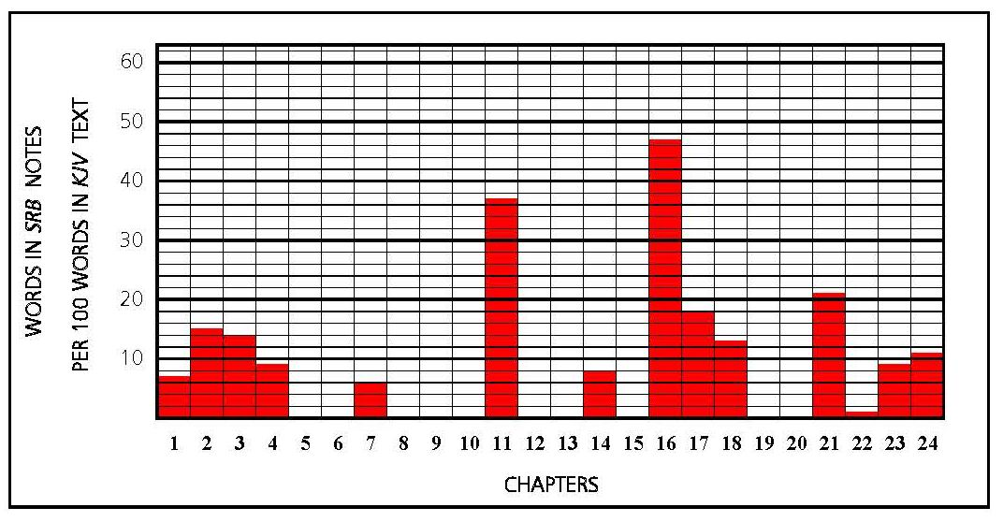
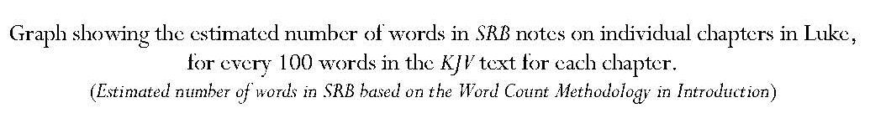

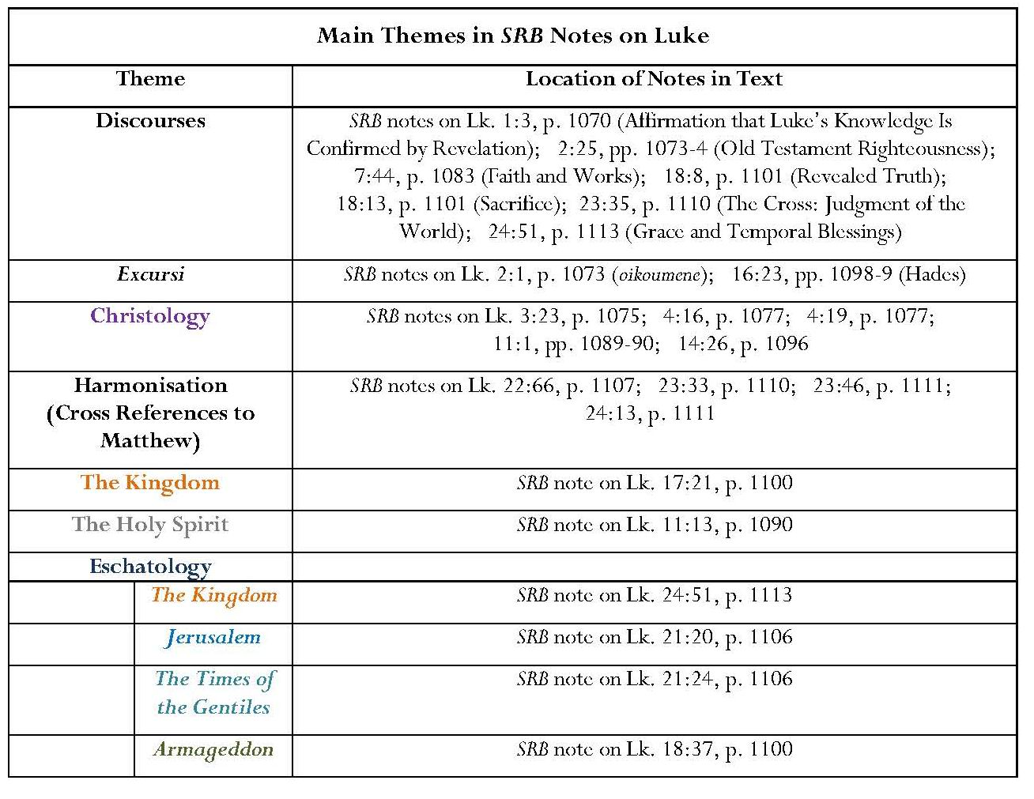
Annotation: Key Points
Ten chapters out of twenty-four not annotated.
Reiterates view that the Lord’s Prayer belongs to the dispensation of law, even though some positive remarks are included concerning its role as a model for all prayer.
Note on Lk. 16:23 focuses upon Scofield’s interpretation of Jesus’ words concerning Lazarus and the rich man. Used as an excursus on Hades and a springboard to an exposition of views about resurrection and judgment.
Comment: Scofield omits recognition of Jesus’ words in Luke 16 as an injunction for moral behaviour in this world. The label ‘Talmudic’, which he applies to the designations, ‘paradise’ and ‘Abraham’s bosom’, is anachronistic. Scofield’s comment here about being absent from the body, at home with the Lord, is a slight misquotation of 2 Cor. 5:8 KJV, which uses ‘present’ instead of ‘at home’.
Christology
Assertion that Luke’s genealogy of Christ represents Mary’s genealogy whereas Matthew’s is that of Joseph; conclusion that either line of descent proves his Davidic ancestry.
Comment: By concentrating on the apparent discrepancy between the genealogies advanced by Luke and Matthew, Scofield misses a salient point which is suggested by Eric Franklin. Franklin points out that, unlike Matthew’s genealogy, which ‘is obviously meant to point to a climax in Jesus’, Luke’s genealogy goes backwards from Jesus, via David and Abraham, to Adam; ‘Jesus is effecting something for David – the restoration of the people of Israel; for Abraham – the fulfilment of God’s promise to him of a wider salvation; and for Adam — the restoration of universal sonship which was lost at the Fall. Luke here pictures Jesus as the Second Adam, the restorer of the human race …’ These observations relate to Scofield’s own emphasis upon Christ as the second Adam in his notes on Mt. 4:1 and Heb. 8:8.
Assertion that Christ’s stopping at “the acceptable year of the Lord” in his quotation of Isa. 61:1-2 in Lk. 4:19 indicates that this relates to his first advent and the dispensation of grace; the omitted phrase, ‘“the day of vengeance of our God” belongs to the second advent … and judgment’.
Assertion that ‘Mary alone of the disciples understood Christ’s repeated declaration concerning His own death and resurrection’.
Comment: Scofield neglects to mention Mary’s sister Martha’s proclamation of Jesus as ‘Christ, the Son of God, which should come into the world’.
The Holy Spirit
Criticism of disciples for failing to ask for the Spirit in response to the promise that the heavenly Father would give the Holy Spirit to those who asked.
Assertion that ‘it was a new and staggering thing to a Jew that, in advance of the fulfilment of Joel 2:28, 29, all might receive the Spirit’.
Eschatology
Reference to Armageddon.
Assertion that ‘the Times of the Gentiles’ began with Nebuchadnezzar, ‘since which time Jerusalem has been under Gentile overlordship’.
Comment: Luke 21:24 is the only place where Scofield’s frequent references to ‘the Times of the Gentiles’ is actually corroborated by the biblical text.
Near and Far’ Prophecy: the Two Sieges of Jerusalem
Assertion that Matthew 24 and Mark 13 concern ‘the final siege at the end of this age’ prior to deliverance by ‘the Lord’s appearing’, whereas Luke 21 refers to the more immediate siege of Titus in AD 70, when Lk. 21:24 was ‘literally fulfilled’.
The Kingdom in Annotation of Luke
Oddly, in his note on Lk. 17:21, Scofield seems to abandon the differentiation between the kingdoms of heaven and of God, which appears so often in his notes on Matthew. Here, Scofield is forced to refer to ‘the kingdom of God’ because that is Luke’s phrase, but he here applies ‘kingdom of God’ to the kingdom rejected by the Jews; this is in contrast the SRB notes on Mt. 11:11 and 11:20, where it is the kingdom of heaven which is rejected.
Omissions
Many details of Luke’s account of Jesus’ life, including the announcement and account of his birth.
The annunciation and the birth of John the Baptist.
Jesus’ entry into Jerusalem, his lament over it and his cleansing of the temple.
Jesus’ miracles and much of his teaching.
Many parables, including those concerning Israel.
Jesus’ calling of disciples and naming of apostles.
Jesus’ conflict with the Pharisees and Sadducees.

Comment: Omissions
All these elements help to establish Jesus’ identity in Luke’s eyes and relate to Jesus’ self-pronouncement in Lk. 4:18-19.
Significantly Lk. 8:21 does not fall within the chapters annotated by Scofield; here Jesus declares that those who hear and practise God’s word constitute his family. Jesus’ statement conflicts with Scofield’s identification of Jesus’ ‘brethren’ as the Jewish remnant in his note on Mt. 25:32. Important omissions in the note on Luke 22 include comment on the role of Judas, and also any proper reference to the new covenant in Jesus’ blood, which is essential to the concept of atonement. Content concerning Jesus’ prediction of Peter’s denial, his agony at Gethsemane, his arrest and the fulfilment of his prediction concerning Peter and his trial before the priests and elders is also omitted. In the notes on chapter 23 many particulars and nuances of Luke’s account of the crucifixion escape comment. Many of these matters are merely covered by cross-references to notes on Matthew. These are all important matters and it is strange that they do not draw any comment from Scofield.
8.6.4 John
Introduction: Key Points
Assertion that the theme of John is given in the prologue and in ‘the last verse of the Gospel proper’: ‘the incarnation of the eternal Word, and Son of God, Himself God, in Jesus the Christ’.
Assertion that the object is ‘to reveal God in terms of a human life’ so that those who believe in Jesus as ‘Christ the Son of God’ may have eternal life.
The key words are ‘believed’ and ‘life’.
Assertion that the writer is the apostle John; though ‘this has been questioned on critical grounds, but on the same grounds and with equal scholarship, the early date and Johanean authorship have been maintained’.
Asserted date: ‘85-90 A.D., probably the latter’.
Comment: The dates given for each of the Gospels indicate that Scofield holds that the four Gospels appear in the New Testament in chronological order of writing.

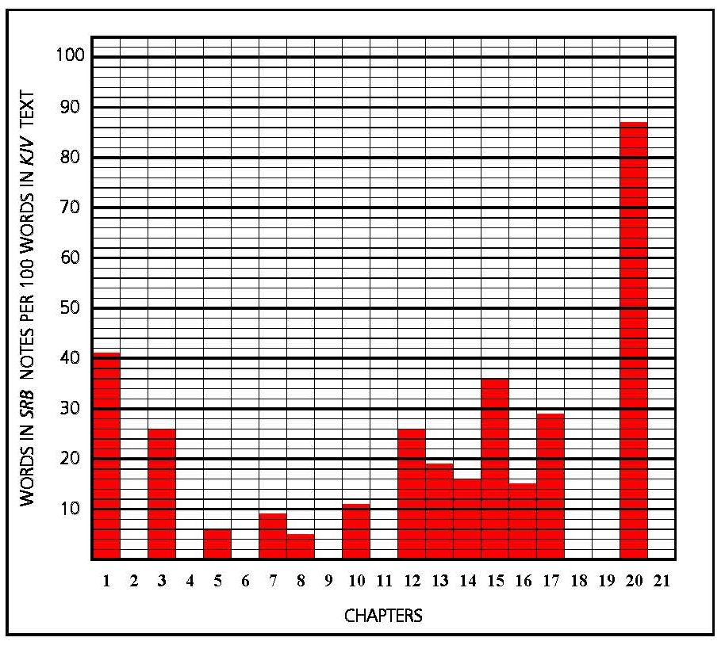
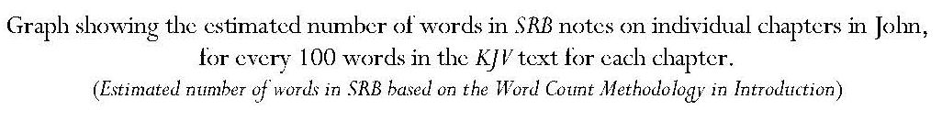
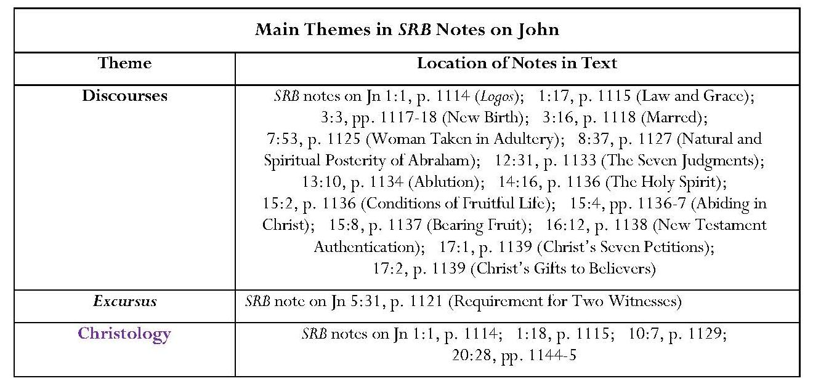
Continued overleaf
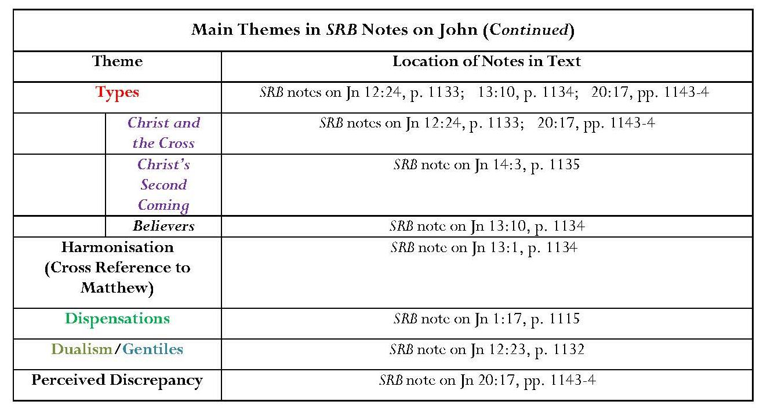
Annotation: Key Points
Eight chapters out of twenty-one are not annotated and some chapters are very briefly annotated, with isolated verses afforded commentary.
John 1:17 is chosen as the vehicle for the onset of the sixth dispensation, the Dispensation of Grace.
Discourses: Comment
The most striking feature of Scofield’s annotation of John is the number of discourses on a variety of subjects. Many of these have an exhortative character and contain a wealth of references, again suggesting the influence of the Bible Readings method. There are notably fewer items which advance characteristically dispensationalist tenets and more which place Scofield more demonstrably within mainstream evangelical tradition.
The first lengthy discourse is on differences between law and grace, a subject which has already been addressed in the note on Exod. 19:5. This is a very important note because, not only does it define grace as a concept of undeserved divine love, but it also demonstrates the case for the differences between the dispensations of law and of grace, establishing that the latter dispensation only begins with Christ’s death and resurrection. It also makes one statement which has been the subject of controversy. This is the implication that ‘legal obedience’ was ‘the condition of salvation’ in the age of law. However, other statements from Scofield refute this implication. The notion that Christ was crucified ‘by Jew and Gentile’ is also controversial.

Christology: Comment
Commentary in the intensely annotated John 20 contains three suggestions as to why Jesus might have instructed Mary Magdalene not to touch him after his resurrection, and a discourse on the deity of Christ occasioned by Thomas’ exclamation, ‘My Lord and my God’. Having quoted several theophanies as evidence that Old Testament texts intimate ‘the appearance of God in human form’, Scofield makes several unjustified references to the Messiah. While he correctly identifies New Testament quotations of these Old Testament verses, none of them actually includes the term, ‘Messiah’, which occurs in KJV only in Dan. 9:25-6. Scofield applies the expression anachronistically to a range of biblical texts; the late development of this concept as a future anointed divine agent and national figure was discussed in 7.1.2.1 and 7.2.3.
Scofield makes a valid point concerning the lack of ‘he’ as a predicate in Christ’s ‘I am’ sayings in Greek The Greek phrase, ‘ἐγώ εἰμι αὐτὸς’ is very rare, occurring only twice in LXX and once in the New Testament. The references in Isaiah and Luke are significant. In Isa. 52:6, LXX, Isaiah prophesies a time when God’s people will know his name: ‘therefore they shall know in that day that I am he that doth speak …’; this occurs in the context of passages often identified with the coming of Christ as God’s servant. In Lk. 24:39, the words ‘ἐγώ εἰμι αὐτὸς’, translated as ‘it is I myself’, are used by Christ to reassure his disciples when he appears to them after his resurrection. The phrase, ‘ἐγώ εἰμι’, without ‘αὐτὸς’, is far more common and occurs in all Christ’s ‘I am’ sayings in John, and several further significant passages such as Jn 8:58.
Typology: Comment
In a corollary of notes on Exodus and Leviticus, which assert typicality for the tabernacle and its contents, Scofield aligns John 12, 13 and 14-16 with ‘the order of approach to God in tabernacle types’ but offers no formal justification for this. These connections fall more into the category of imaginative interpretation than into the strict typological conditions which Scofield previously instituted.
Dualism Comment
Scofield asserts in his note on Jn 12:23 that ‘Christ does not receive these Gentiles’, referring to some Greek worshippers whom Philip and Andrew mentioned to Jesus as wishing to see him. Scofield here argues from silence; John does not state whether or not Jesus ‘received’ the Greeks. However, Scofield uses his unjustified interpretation to argue that a fleshly Christ, as King of the Jews, could not be a ‘proper object of faith to the Gentiles’, and that, ‘for the Gentiles, the seed must fall into the ground, but as the seed of Abraham, not David’. This is another demonstration of Scofield’s deep-seated dualistic belief.

Harmonisation and Perceived Discrepancy: Comment
As mentioned in 2.1.2, Scofield regards Christ’s cleansing of the temple as recorded in Jn 2:13-17 as ‘the first purification’ at ‘the first passover’. It is congruent, therefore, that he refers to ‘the last passover’ in his note on Jn 13:1, referring to his previous note on Mt. 26:20 and making this an item of harmonisation. Strangely, Scofield does not comment on the event he terms the ‘first purification of the temple’ but he sees the event described in Mt. 21:12-13 and Lk. 19:45-6 as ‘Jesus’ second purification of the temple’. This seems to be the result of literal interpretation and absence of any attempt to analyse why John might have placed the purification at the beginning of Jesus’ ministry instead of at the end. Scofield also fails to offer any reason as to why Jesus might have had to perform this task twice. His constant attempts to harmonise the Gospels also lead to his difficulty over the seeming discrepancy between Jn 20:17 and Mt. 28:9 and his somewhat tenuous explanations in the note on the former verse.
Eschatology: Comment
Scofield selects the single word ‘perish’ in Jn 3:16 and comments that this never means ‘the cessation of existence or consciousness. It is the condition of every non-believer’. The notion that existence never ceases is echoed in the note on Rev. 20:14, where Scofield states that ‘the second death is not annihilation’. ‘Perish’ seems an odd word to emphasise in Jn 3:16, which is usually quoted as evidence of God’s enormous and saving love for his world.
The note on Jn 14:3 is one of the places in which Scofield implies that there is more than one ‘second coming’ since ‘this promise of a second advent of Christ is to be distinguished from His return in glory to the earth’.
Omissions
Important events and activities in Jesus’ life:
John the Baptist’s self-identification and identification of Jesus as the ‘Lamb of God’.
John’s account of Jesus’ baptism.
The calling of Andrew, Simon (named Cephas by Jesus), Philip, and especially Nathanael, who identifies Jesus as ‘Son of God’ and ‘King of Israel’.
Comment: This omission is strange because the identification of Jesus as ‘King of Israel’ is extremely important to Scofield.
Records of Christ’s miracles and sayings.
Comment: There is no focus on the light and darkness theme in John and, apart from the brief reference to the Greek verb meaning I AM not being followed by ‘he’, there is no mention of Jesus’ ‘I am’ sayings, which are so characteristic of John’s Gospel. Jesus’ statements that ‘He that believeth on me hath everlasting life’ and ‘ye shall know the truth, and the truth shall make you free’ also go unremarked, as does his reassurance that the disciples might have peace even though they experience tribulation in the world because he has ‘overcome the world’. The notes also neglect to mention Jesus’ declaration of purpose, that he has come to do his Father’s will, which is that everyone who looks to the Son and believes in him will have eternal life and Jesus will raise him up at the last day.
Christ’s encounter with the Samaritan woman, with its implications for worship at Jerusalem and in Samaria.
Jesus’ self-declaration as Christ and his declaration concerning the readiness of the harvest.
Peter’s acknowledgement of Jesus as ‘the Holy One of God’.
Christ’s disputes with the Pharisees and Sadducees, for example disputes over healing on the Sabbath and implying that God was his Father and questioning by the Pharisees following Jesus’ healing of the blind man in John 9.
Martha’s confession of Jesus as ‘Christ the Son of God’ and Jesus’ anointing by Mary of Bethany, even though Scofield has commented on this in his note on Mt. 11:13.
Jesus’ entry to Jerusalem.
Comment: It is noteworthy that Scofield comments upon Jesus’ entry into Jerusalem only in his note on Mt. 21:4, and ignores the parallel passages in Mark, Luke and John, as if nothing further were to be learned from them. One particularly interesting omission is comment on Jn 12:16, which states that the disciples realised the significance of Jesus’ entry to Jerusalem ‘when Jesus was glorified’. This refutes Scofield’s claim that Jesus is yet to be glorified. In his note on Mt. 13:17, Scofield states that Jesus’ parables reveal his revelation that ‘a period of time is to intervene between His sufferings and His glory’.
The plots by the Sanhedrin.
Judas’ betrayal
Jesus’ warning of Peter’s denial
Jesus’ promise of the Spirit
Jesus’ arrest in Gethsemane, denial by Peter, and trials before the High Priest and Pilate.
The crucifixion, especially in relation to fulfilment of scripture.
Jesus’ burial.
The reinstatement of Peter.
Omissions: General Comment
Much material in John which is foundational to the Christian faith is ignored and some of the omitted material is very important to the New Covenant. Scofield does not comment on Jesus’ statement that, once destroyed, he will raise up the temple in three days or on the evangelist’s remark that ‘he spake of the temple of his body’. Discussion of these clauses might undermine the concept of the rebuilding of a physical temple.
Another serious omission is any note on the discussion following the feeding of five thousand people, during which Jesus declares that he is the bread of life, who has come down from heaven, and that, unlike those who ate manna in the wilderness and died, those who feed on his flesh will live for ever. This statement would seem to belie any intimation that the old covenant is to continue or be restored and fulfils Scofield’s rubric for a type. There is also no comment on Jesus ‘new commandment’ to ‘love one another’, by which ‘all men will know that you are my disciples’. Again believers’ behaviour appears to be unimportant to Scofield.
8.6.5 Acts
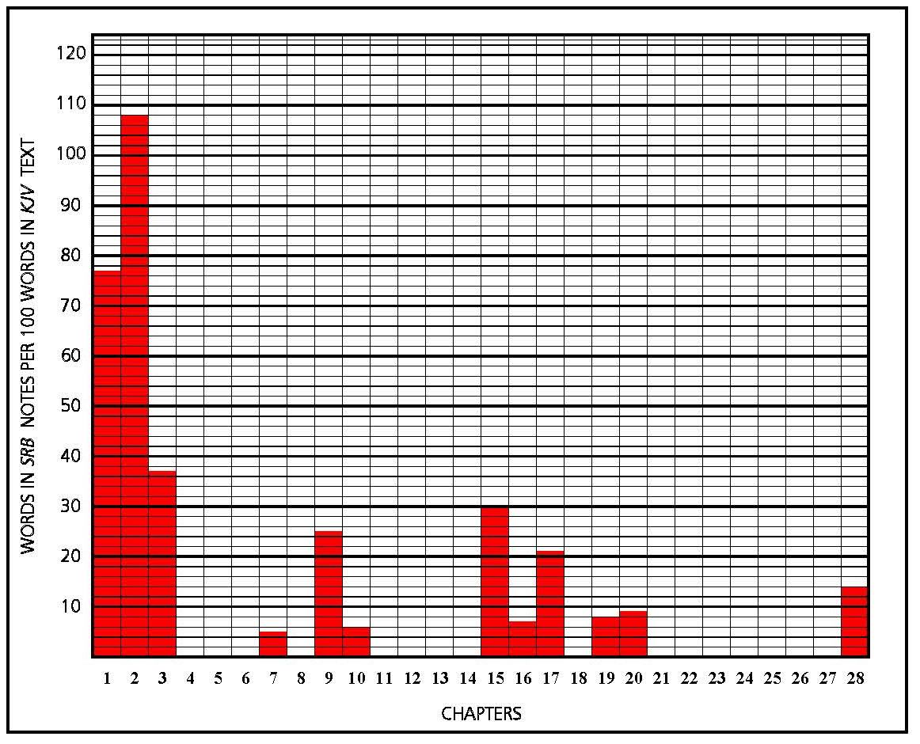
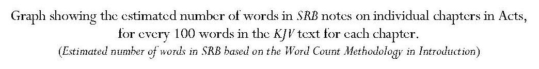
Introduction: Key Points
Author is Luke; Acts continues from Luke’s Gospel.
Suggestion that ‘as Acts concludes with Paul’s earliest ministry in Rome, AD 65, Acts appears to have been written at or near that time’.
Acts records Jesus’ ‘ascension and promised return’; the Holy Spirit’s descent at Pentecost; ‘Peter’s use of the keys, opening the kingdom (considered as the sphere of profession, as in Mt. 13) to the Jews at Pentecost and to the Gentiles at the house of Cornelius; and the beginning of the Christian church and the conversion and ministry of Paul’.
The ‘great fact of Acts’ is the ‘presence of the Holy Spirit exalting and revealing the Son’.
Assertion that Acts 11, 12 and 15 are ‘transitional, establishing finally the distinction, doctrinally, between law and grace’ and that ‘Galatians should be read in this connection’.

Assertions concerning Peter and Paul:
Peter is prominent in Acts 1:1 — 9:43; the centre is Jerusalem and the ministry is to the Jews, who, though ‘in covenant relations with Jehovah’, had sinned ‘in rejecting Jesus as the Christ’ and needed to repent.
Paul is prominent in Acts 10:1 — 28:31. A new centre was established in Antioch; ministry was mainly to the Gentiles, who had merely to believe in Jesus to be saved.
Comment: In fact Peter is prominent in Acts 10, 11 and 12; Paul does not become prominent, apart from his conversion, until Acts 13.
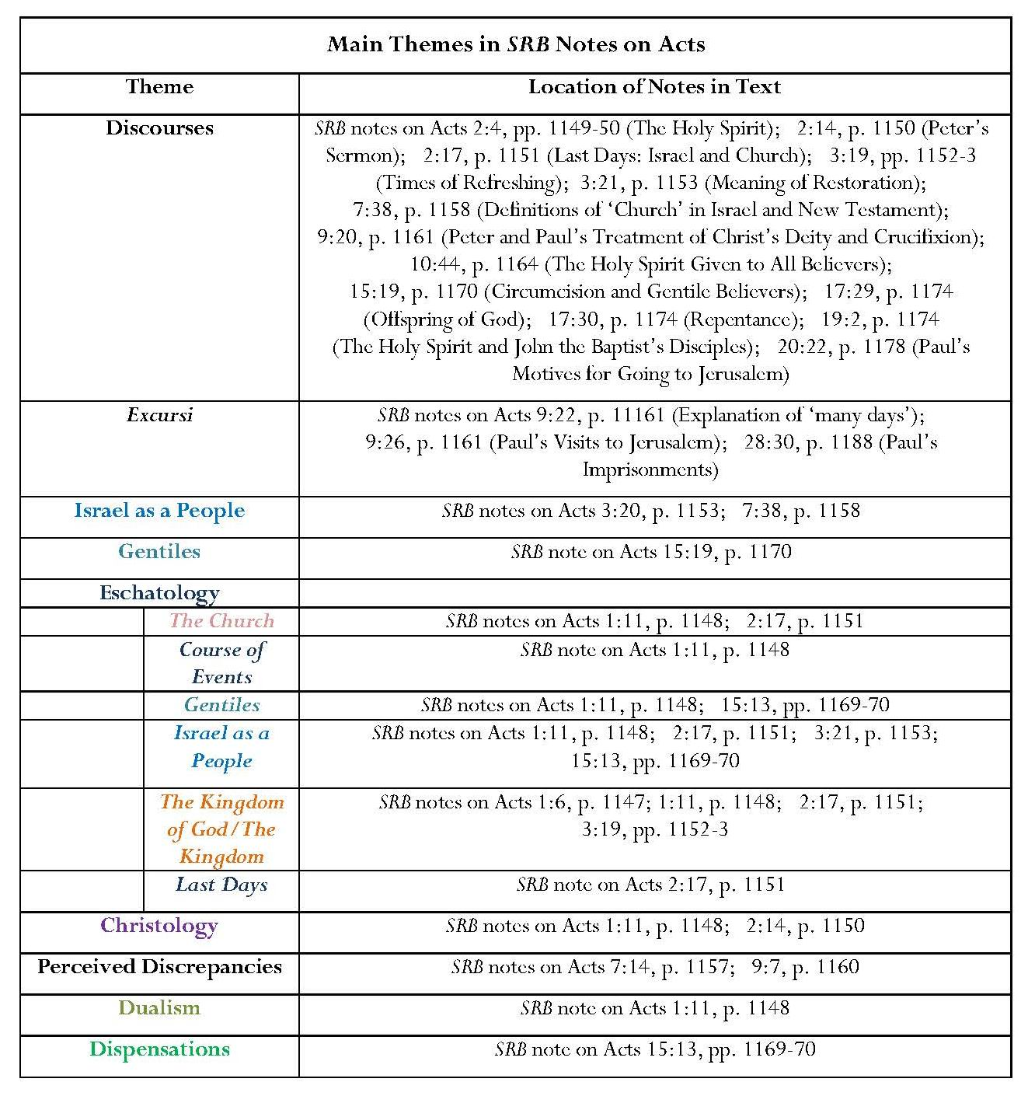
Annotation: Key Points
Sixteen of the twenty-eight chapters are not annotated.
Only chapters 1 and 2 bear notes of any significant length. Many important references in notes on Acts 1:11 and 2:4.
References in Acts 1:6 note are to ‘the kingdom of God’ and then to ‘the kingdom’.
SRB Note on Acts 1:11: Christology, the Kingdom, Eschatology, Dualism
This note is entitled ‘Two Advents Summary’.
Emphasis on lack of perception of two advents in Old Testament prophecy concerning the Messiah.
Stress on the announcement and rejection of the kingdom at Christ’s first advent as in the notes on Matthew.
Comment: It is interesting that, in this note, Scofield refers to ‘the kingdom’, as he did in the second phrase of his note on Acts 1:6 rather than ‘the kingdom of God’, as he did in the first phrase in that verse. As noted above, Scofield sometimes uses the terms, ‘kingdom of God’ and ‘kingdom’ interchangeably.
Assertion that Christ ‘uttered predictions concerning the course of events between His departure and return’.
Assertion that Christ’s promised return ‘becomes a prominent theme in the Acts, Epistles, and Revelation’.
The future predicted for the Church again focuses upon the ‘descent of the Lord into the air’, whereas that for Israel is fulfilment of prophecies concerning national regathering, conversion and implementation of the Davidic Covenant.
A third element is added: the separate future for the Gentile nations, in which the Gentiles are predicted to have the capacity for conversion and a share in kingdom blessings.
The Holy Spirit
Discourse on ‘the Holy Spirit, N. T. Summary’, which Scofield indicates as the corollary to his note on Mal. 2:15.
Comment: As might be expected, the note on Acts 2:4 provides more detail than that on Mal. 2:15 about the activities of the Holy Spirit; it also includes new material concerning sins against the Spirit and symbols of the Spirit.
Malachi, O.T. Summary, ‘the indwelling of every believer by the abiding Spirit’ and prediction of the future effusion of the Spirit on Israel and ‘all flesh’, is reflected in Acts N.T. Summary. This includes the progressive impartation of the Spirit by the laying on of hands when the Gospel was preached to Jews only after Pentecost, but given to all believers when ‘the door of the kingdom’ was opened to Gentiles by Peter and ‘the Holy Spirit, without delay, or other condition than faith, was given to those who believed’.
This is corroborated in the notes on Acts 10:44 and 15:13.
Israel and the Kingdom
A distinction is made between the ‘last days’ for Israel and for the Church; this emphasises again the dichotomy between the futures for the two bodies; any supersession is also denied.
‘National repentance’ by Israel is to lead to ‘national deliverance’ and restoration.
The kingdom age is synonymous with its exaltation and blessing.
Israel is to be regathered under Davidic rule.
Israel and the Kingdom: General Comment:
In his notes on Acts, Scofield makes three uncomfortable and probably inaccurate claims about the Jews, and Peter and Paul’s statements concerning them. In his note on Acts 2:14, concerning ‘Peter’s sermon’, he states that the Jews ‘had rejected [Christ’s] Messianic claims, and crucified Him’. No direct reference is given here but, in his note on Acts 9:20, he references Acts 2:25-30 as evidence that ‘Peter’s charge was that the Jews had crucified the Son of David’. The verse in question is probably Acts 2:23, which reads in KJV, ‘Him [Jesus of Nazareth] being delivered by the determinate counsel and foreknowledge of God, ye had taken, and by wicked hands have crucified and slain’. However, the phrase translated ‘by wicked hands’ in KJV is ‘διὰ χειρῶν ἀνόμων’, ‘ἀνόμων’ meaning ‘lawless’ or ‘without the law’; this implies the agency of non-Jews. In the note on Acts 9:20, Scofield also states that ‘Paul … charges them [unspecified] with crucifying “the Lord of glory”’. Scofield here refers to 1 Cor. 2:8, where the subject is not the Jews but ‘the princes of this world’, (οὐδεὶς τῶν ἀρχόντων τοῦ αἰῶνος); also ‘τοῦ αἰῶνος’ signifies ‘age’, rather than ‘world’.
Dispensations
The coming of the Holy Spirit upon all who hear Peter’s message is regarded as ‘one of the pivotal points of scripture’; the bestowal of the Holy Spirit upon all with ‘simple faith in Jesus Christ’ is ‘the normal order for this age’.
Peter’s account of the coming of the Holy Spirit upon the Gentiles is viewed as ‘dispensationally the most important passage in the New Testament’; it reveals ‘the divine purpose for this age, and for the beginning of the next’.
Comment: Scofield makes no comment on the narrative of the actual incident in
Acts 10.
Omissions
The narrative which underpins the book of Acts goes without comment; however Scofield splits the text with many subheads which indicate content.
Most biographical material concerning Paul, including any direct comment on Paul’s appearance at the stoning of Stephen, his conversion and his accounts of it; his escape from Damascus and journey to Jerusalem and Tarsus and of his missionary journeys, and the final record of his preaching in Rome.
Comment: Much of this narrative falls within chapters not annotated by Scofield.
Narratives concerning Peter.
The witness of Stephen, apart from a brief central column note on Acts 7:54.
Philip’s activities in Samaria and his meeting with the Ethiopian eunuch.
Passages concerning the life of the Church, such as the accounts of the fate of Judas and choice of Matthias to replace him, the record of the fellowship, common ownership and worship of the believers, the appointment of deacons and the collection at Antioch for the Judean believers.
Miracles performed by the apostles.
Omissions: General Comment:
Again, patterns of Christian behaviour are not emphasised. Scofield appears uninterested in the growth of the Church. Strangely, he misses many opportunities to comment upon Old Testament quotations by various speakers, including a reference to David in Acts 2:25. The omissions include a specific statement that all the prophets from Samuel onwards have foretold these days.

8.6.6 Conclusion: Notes on the Gospels and Acts
As already noted, Matthew’s Gospel bears the greatest volume of SRB annotation of any biblical book; SRB’s concentration on the kingdom and eschatological material in annotation of Matthew also acts as a bridge between Old and New Testament eschatological themes. Scofield’s most important theme in his notes on Matthew is the kingdom of heaven, which is one of his most significant eschatological concepts and appears in his notes on many parts of the Bible. Since the term is unique to Matthew, it is natural that Scofield should concentrate upon it here. The concept of different roles and futures for Israel and the Church is also an important theme, as is Scofield’s eschatology. Scofield’s attempts to harmonise the Gospels are also based on Matthew with the result that notes on parallel passages in the other synoptic Gospels often merely refer to Matthew. Mark’s Gospel is almost entirely neglected. Scofield shows little interest in Jesus’ life-story and miracles in any of the Gospels. He also ignores much of Christ’s teaching. Where he deals with parables, he concentrates on those where it is possible to elicit an eschatological meaning, ignoring those, for example in Luke, which deal with moral behaviour. In his notes on John, Scofield ignores Jesus’s statements about his own significance and purpose, and his ‘I am’ sayings. Scofield’s main concerns in his notes on Acts are the work of the Holy Spirit and the restoration of the kingdom to Israel; he does not emphasise the narrative elements and shows little interest in Paul’s life and that of the early church.
8.7 The Epistles of Paul
Scofield counts the Deutero-Pauline letters as Pauline, listing seven Gentile churches of Rome, Corinth, Galatia, Ephesus, Philippi, Colosse and Thessalonica, and also the Pastoral Epistles, 1 and 2 Timothy and Titus. He places them in ‘what is believed to be ‘the chronological order’ and states that ‘Hebrews has a distinctive place, nor can the order of that book amongst the writings of Paul be definitely fixed’. However, he actually includes Hebrews amongst the ‘Jewish-Christian Epistles’, which follow those of Paul.
Introduction: Key Points
Several dispensational tenets are developed: the beginning of the dispensation of grace at the crucifixion, dualism and the rapture.
Assertions:
‘All Scripture, up to the Gospel accounts of the crucifixion, looks forward to the cross, and has primarily in view Israel, and the blessing of the earth through the Messianic kingdom.’
Comment: This contradicts the rather odd statement in the note on Gen. 11:10, which states that ‘from Genesis 12 to Mt. 12:45, the Scriptures have primarily in view Israel’.
‘Hid in God’ there was ‘an unrevealed fact — the interval between Christ’s death and resurrection, and his return’, and ‘an unrevealed purpose – the outcalling of the ecclesia.’
Paul’s epistles develop the doctrine of the church, which is an organism, not an organisation, ‘heavenly in calling, promise and destiny’;
Through Paul, we learn that ‘living saints shall be “changed” and caught up to meet the Lord at His return’.
While in Arabia, Paul developed ‘the doctrinal explanation of salvation by grace through faith, wholly apart from the Law’ through revelation by the Holy Spirit.
Paul was commissioned to unfold ‘the doctrines of grace which were latent’ in Christ’s teachings.
‘Paul originates nothing but unfolds everything, concerning the nature and purpose of the law; the ground and means of the believer’s justification and glory; the meanings of the death and resurrection of Christ, and the position, conduct, expectation and service of the Christian.’
8.7.1 Romans
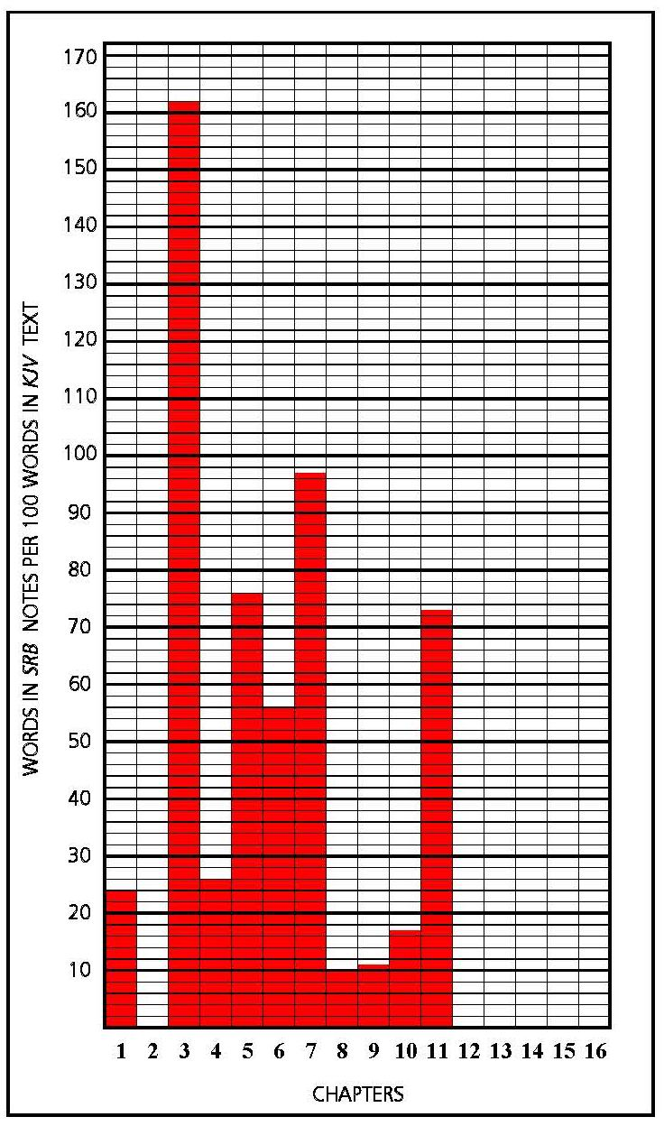
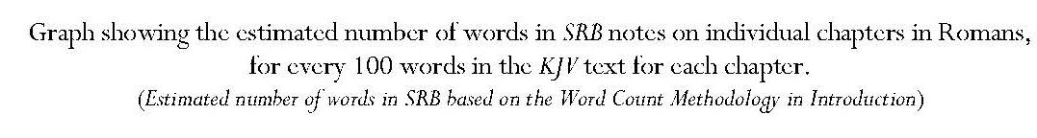
Introduction: Key Points
Assertion that the theme of Romans is ‘the Gospel of God’ for Jew and Gentile.
Since ‘the whole world is found guilty before God’ the remedy is redemption ‘upon the alone condition of faith’.
Romans not only provides a full exposition of ‘the doctrine of grace in relation to salvation’ but also here reconciles the promises to Israel with the promises concerning the Gentiles. The former will be fulfilled when the church is complete and the Deliverer comes from Zion.
Romans 9 — 11 form the fifth of seven parts allotted to Romans: ‘Parenthesis: the Gospel does not abolish the covenant promises to Israel.’
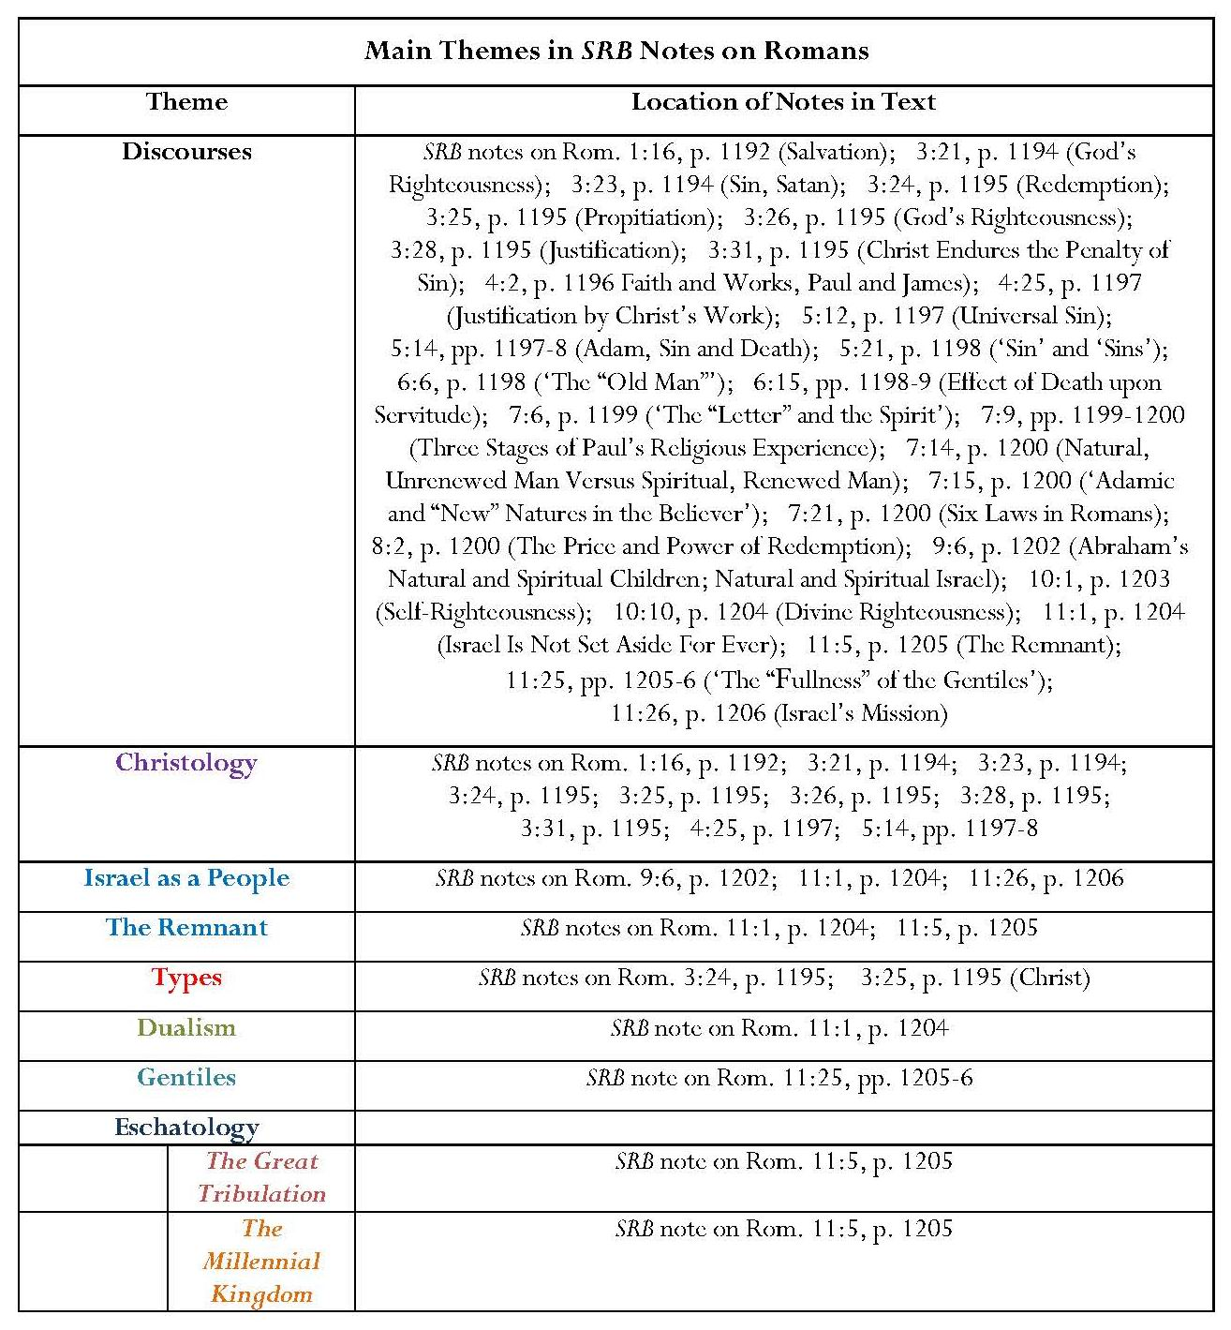

Annotation: Key Points
Significant annotation of four chapters in Romans, especially chapter 3 (many discourses)
Chapters 2 and 12 – 16 are not annotated.
Comment: The lack of annotation of chapters 12 – 16 is noteworthy because these chapters largely concern Christian behaviour, a subject in which Scofield has already shown a marked lack of interest. In all these chapters, the emphasis is upon the Church and mutual support in witness. Scofield discusses many theories and doctrines but rarely considers their application to Christian life.
Christian Doctrine
A significant proportion of notes comprises expositions of Christian doctrine concerning such matters as salvation, divine righteousness, sin, redemption, propitiation and justification. Most of these, up to commentary on Romans 8, are Christological and reflect upon Christ’s work and its effects upon believers.
Comment: Craig Hill states that these chapters were often regarded by the Protestant Reformers as ‘a kind of personal salvation manual, a road-map for guilty, lost souls in search of a forgiving, gracious God’. Scofield’s commentary focuses on these chapters, especially chapters 3, 5 and 7, and the material is largely consistent with the interpretation Hill describes.
Israel
Romans 9 — 11 are described as ‘three remarkable chapters’ in which ‘the great promises to Israel are reconciled with the promises concerning the Gentiles, and the fulfilment of the former shown to await the completion of the church and the coming of the Deliverer out of Zion’.
Strangely these chapters are labelled as ‘parenthetic’, implying that they interrupt Paul’s thesis; however Scofield does not include any comment upon how Paul’s argument may continue in chapters 12 — 16.
Comment: Hill asserts that Romans 9 – 11 is ‘at the centre (or, rhetorically, at the climax) of Paul’s argument. The concern of Romans is not so much to explain justification by faith in Christ as to explain how such a soteriological system upholds God’s righteousness, especially … towards non-Christian Israel.’
Notes on Romans 9 and 10 are insubstantial: chapter 9: commentary only on verse 6, expanding upon Paul’s statement that ‘they are not all Israel, which are of Israel’; two verses annotated in Romans 10 whose subject is righteousness.
The focus in the SRB notes on Romans 11 is on the continuing existence of Israel as the earthly people of God, especially exemplified as the spiritual remnant within national Israel in its eschatological future. This involves the necessity for the dualistic corollary: the Christian as ‘the heavenly seed of Abraham’, partaking of ‘the spiritual blessings of the Abrahamic Covenant’ but not inheriting any ‘distinctive Jewish promises’.
Comment: Hill states that one of the consequences of Protestant concentration on Romans 1 – 8 was ‘the orphaning of the remainder of the epistle, especially chs. 9 — 11, whose interest in the fate of Israel was scarcely an ongoing or pivotal Christian concern’. but Scofield’s notes on Romans 11 distance him from the implication in Hill’s statement concerning lack of interest in Israel. Scofield’s interest in Israel is palpable.
Eschatology
Only brief eschatological references in the SRB notes on Romans, concerning Israel’s suffering in the great tribulation and its eventual participation in the Millennial Kingdom, its regathering, restoration to the land, and ‘greatest exaltation and glory’.

Omissions
Statements in Romans that there is no difference between Jews and Gentiles as far as their deeds and their consequences are concerned.
Statements in at least six verses in Romans emphasising that calling comes to Jew and Gentile alike and that for both, salvation comes about through faith, as stated in at least six verses in Romans.
Comment: Although Scofield provides notes on almost every verse in Romans 3 from 21 onwards, he neglects to comment on Rom. 3:29-30 which indicate parity between Jew and Gentile. A particular omission is any discussion of the faith of Abraham in relation to Jews and Gentiles, and to the law. One possible conclusion is that Scofield ignores any passages which might suggest that the distinction between Israel and the Church is not intended to be perpetual. Scofield does not comment upon Paul’s prayer that his Jewish brethren might be saved. Romans 10:4 states, ‘Te,loj ga.r no,mou cristo.j eivj dikaiosu,nhn panti. tw/| pisteu,ontiÅ’ If Christ is the te,loj of the law, whether that be taken to mean ‘termination’ or ‘goal’, then the old distinctions must surely be abandoned.
Omission of comment upon some matters which might occasion debate or require elucidation, such as obedience to secular authorities in chapter 13, the discussion of the role of the law in chapter 5 and the subject of election in chapter 9.
Comment: It is impossible to believe that Scofield has really provided explanatory notes for every ‘obscure or difficult’ passage, as he stated in his introduction to SRB.
8.7.2 1 Corinthians
Introduction: Key Points
Author: Paul; date: ‘A.D 59 at the close of Paul’s three years’ residence in Ephesus’.
Letter contains nine subjects.
Claims:
Theme encompasses several subjects ‘under the general theme of Christian conduct’. ‘Even the tremendous revelation of the truth concerning resurrection is made to bear upon that theme.’
Letter ‘occasioned by a letter of inquiry from Corinth concerning marriage and the use of meats offered to idols’ and refers to Paul’s concern about divisions in the church and ‘a case of incest which had not been judged’. Letter ‘came from the Spirit through the apostle’s grief, solicitude and holy indignation’.
Continued overleaf
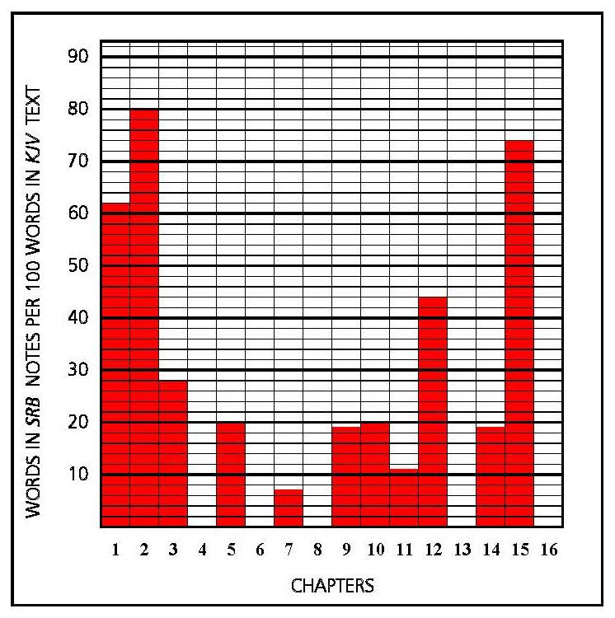
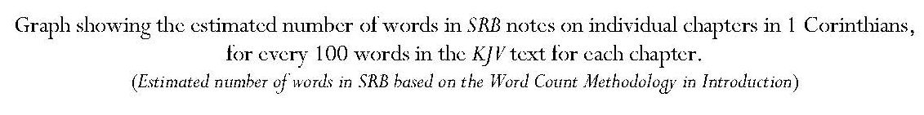
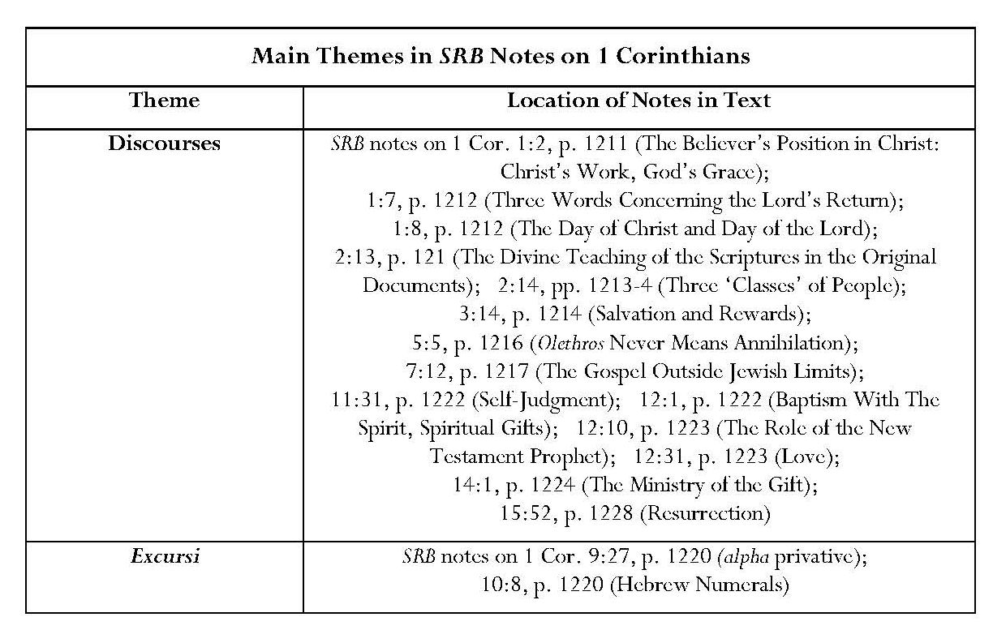
Continued overleaf

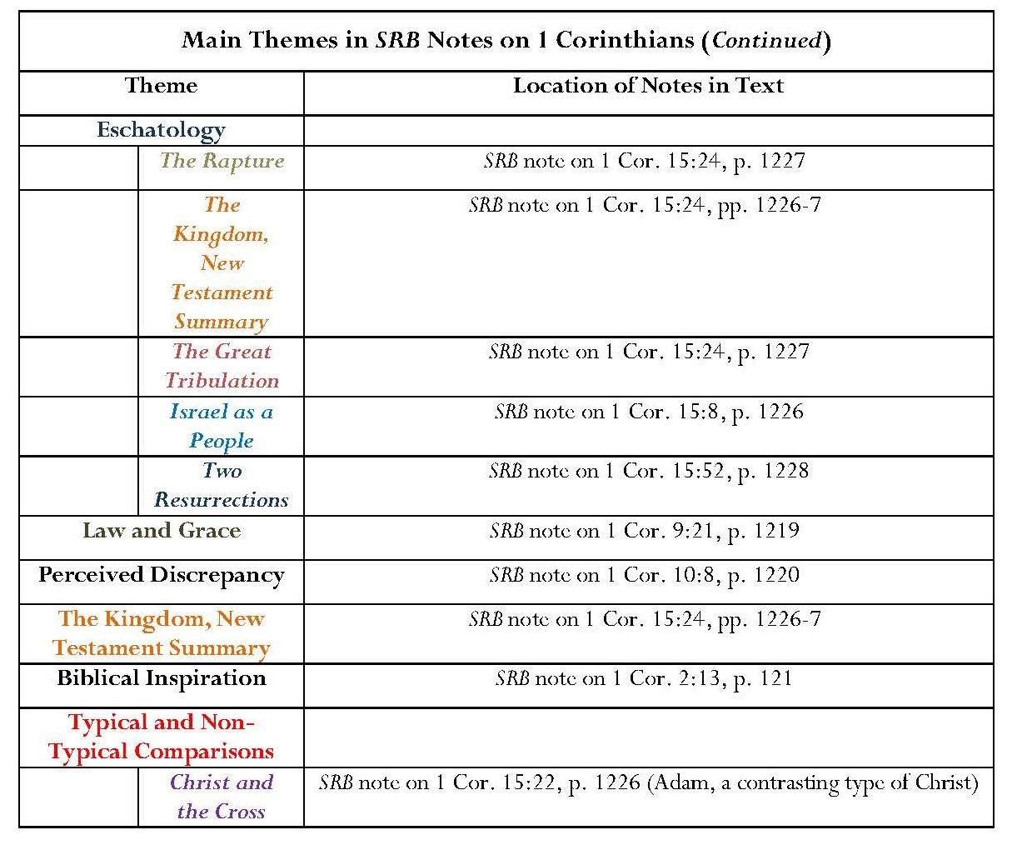
Annotation: Key Points
Important assertion concerning the inspiration of Scripture.
Most notes comprise discourses on Christian doctrine.
Some translations of Greek words.
An unusual grammatical excursus on the alpha privative.
Excursus on imagined discrepancy between Num. 25:9 and 1 Cor. 10:8.
Comment: This ‘imagined discrepancy’ concerns numbers of deaths (23,000 in Num. 25:9 and 24,000 in 1 Cor. 10:8). Admittedly it may be true, as Scofield claims, that deaths ‘in a day’ are not the same as deaths ‘in the plague’, but concentration on this tiny phrase avoids any discussion of Paul’s subject, which is fornication. It is also interesting that, in his discussion of the statistics involved in the two verses Scofield casts doubt upon the accuracy of the biblical text where numbers are concerned by arguing that error in ‘the transcription of Hebrew numbers’ is easy and ‘the preservation of numerical accuracy difficult’.
The Kingdom
The New Testament Summary of the Kingdom is one of two substantial notes on 1 Corinthians 15.

Eschatology
Summary on resurrection.
This includes the dispensationalist ideas of a pretribulational rapture of believers and a second resurrection concerning ‘the wicked dead’; it also refers to the great tribulation.
Types
The note on 1 Cor. 15:22 focuses on Paul’s comparison in verse 45 between Adam as the first man and Christ as the last Adam; it rehearses many of Paul’s clauses in the chapter and incorporates ideas from other biblical books to demonstrate that Adam is a contrasting type of Christ.
Omissions
Some of Scofield’s omissions in his notes on 1 Corinthians are surprising. He does not comment on Paul’s analogous use of the word, ‘leaven,’ which could have supported his argument in his notes on Matthew.
Many of the omitted chapters, and omitted verses in chapters which are covered, contain advice on aspects of behaviour in the church at Corinth. In view of Scofield’s separation from his first wife and the divorce case which she brought against him for desertion, it is noteworthy that he does not dwell upon the strictures on sexual immorality in 1 Cor. 10:8, or in 1 Cor. 5:13, where Paul orders the Corinthians to ‘put away that wicked person’. Scofield shows little interest in what he calls ‘this instance of gross sin’ in 1 Corinthians 5; instead, he concentrates on the divisions amongst Corinthians. He also suggests in his note on 1 Cor. 7:12 that the words of Jesus concerning divorce in Mt. 5:31-2 and 19:5-9 ‘were an instruction, primarily, to Israel’.
8.7.3 2 Corinthians
Introduction: Key Points
Author: Paul; date ‘A.D. 60, probably from Philippi’.
Assertion that ‘it is evident that the really dangerous sect in Corinth was that which said “And I of Christ” (1 Cor. 1:12)’.
Assertion that these believers ‘rejected the new revelation through Paul of the doctrines (sic) of grace, grounding themselves, probably, on the kingdom teaching of our Lord as “a minister of the circumcision”, seemingly oblivious that a new dispensation had been introduced by Christ’s death’.
Comment: This statement is surprising. It implies that Christ taught circumcision, of which there is no evidence; that is, that Christ taught law and that it was Paul who introduced the whole concept of grace. However, Christ told Nicodemus that no-one could enter the kingdom of God unless he had been born again of water and the Spirit. Weston calls Scofield’s statement ‘an outrageous heresy’.
Assertion that it was this which made a defence of Paul’s apostolic authority necessary.
Continued overleaf
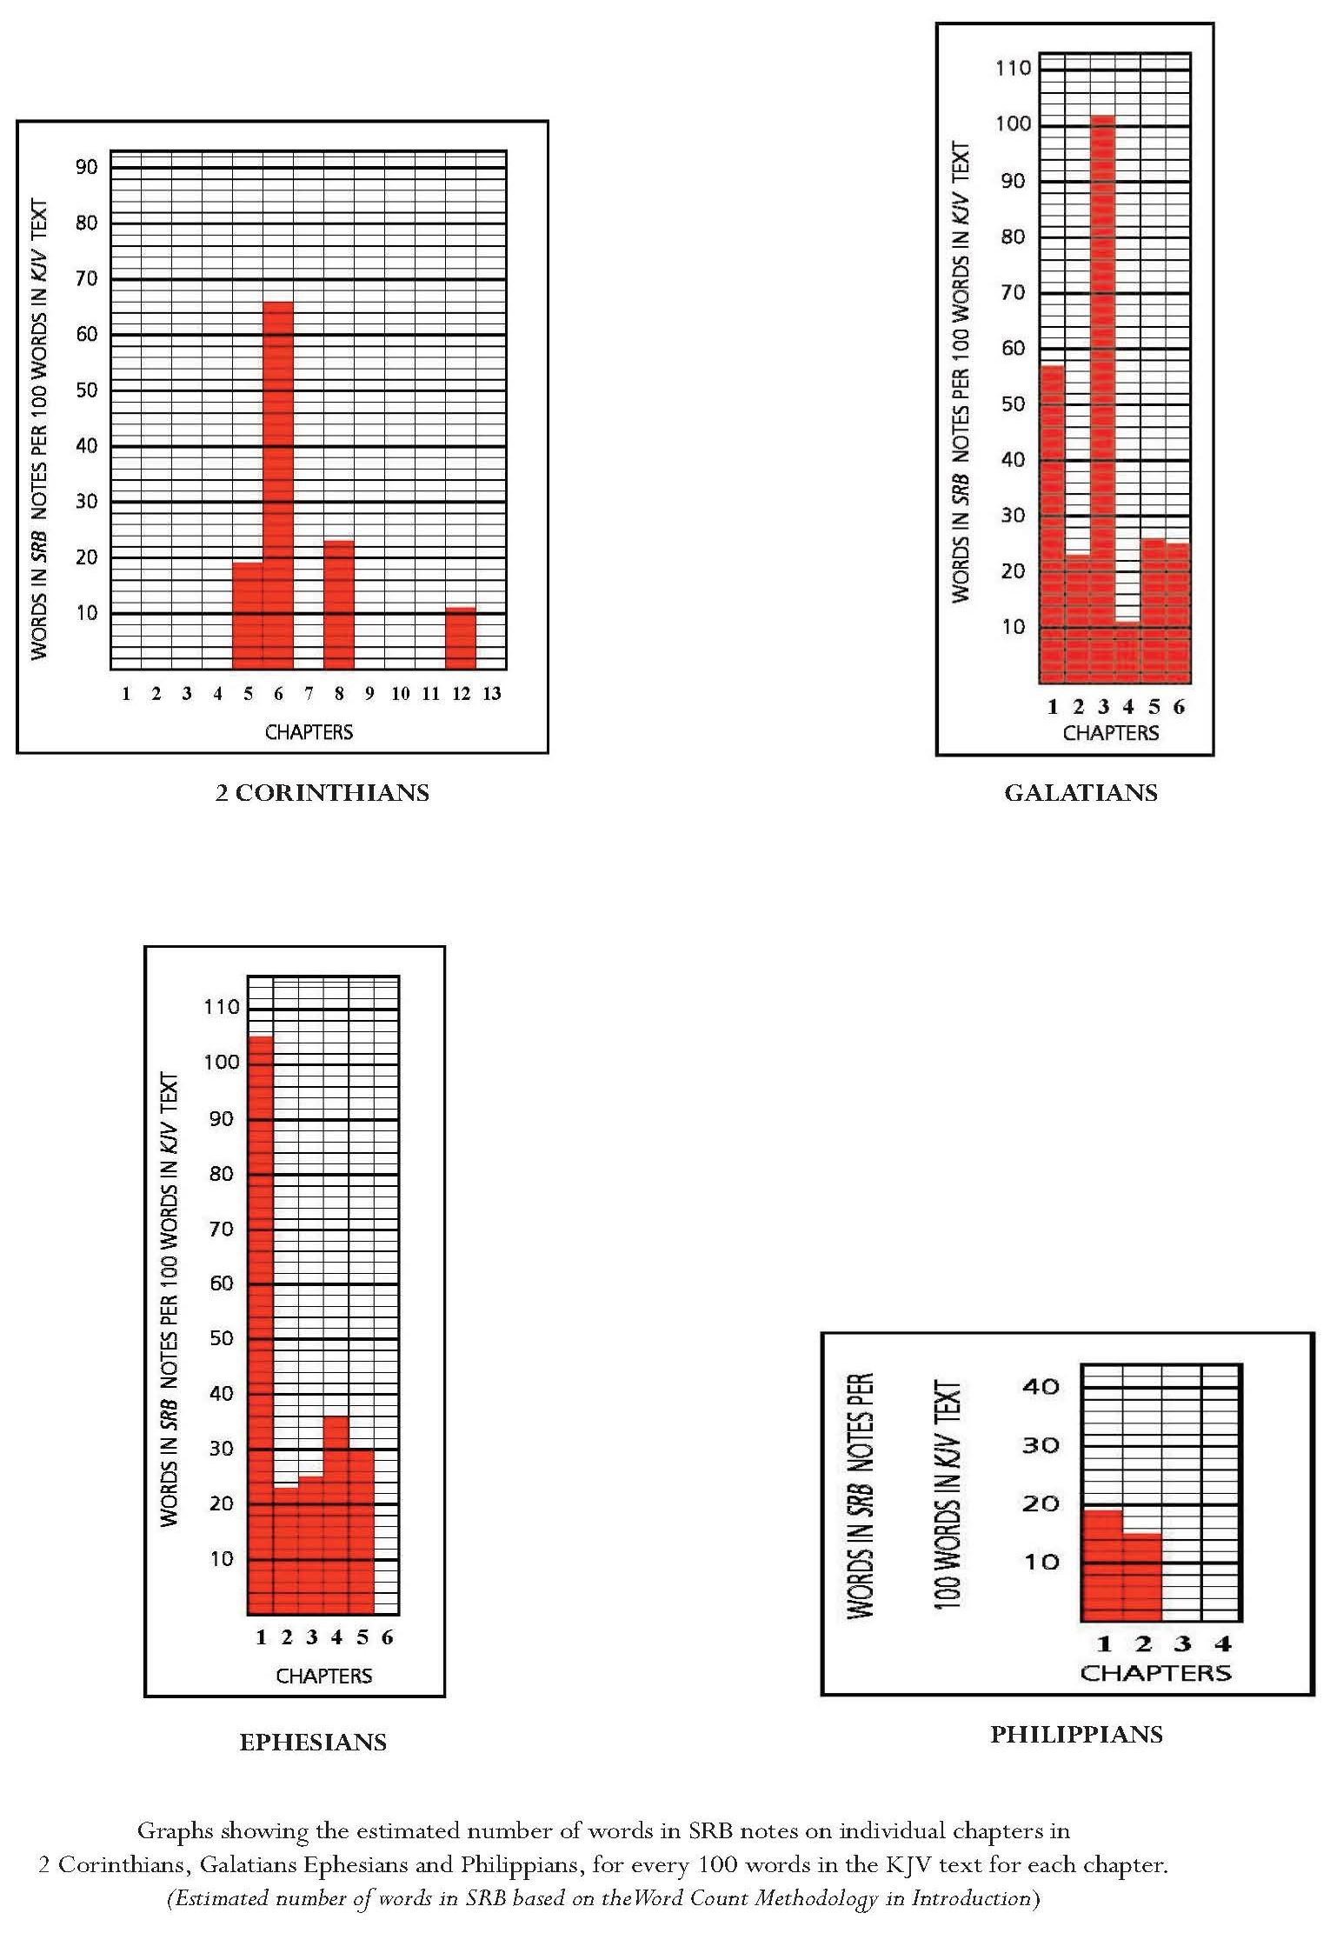

Annotation, 2 Corinthians: Key Points
Only four verses annotated.
Discourses on the judgment of believers’ works following Christ’s return, the twofold nature of separation in Scripture – separation to God and separation from evil, and ‘the Christian doctrine of giving’.
An excursus speculates about the nature of Paul’s ‘thorn in the flesh’ as being ‘chronic ophthalmia, inducing bodily weakness and repulsive appearance’.
Comment: Scofield justly owns that this cannot be positively known and states that ‘the reserve of Scripture is as sure a mark of inspiration as its revelations’. Paul’s thorn is not described so that ‘his consolations may avail for any to whom any thorn is given’.
Omissions
There is no mention of the intensely personal tone of Paul’s letter or of his reliance upon Christ in his weakness. There is no comment on the encouragement Paul offers to the Corinthians.
8.7.4 Galatians
Introduction: Key Points
Author: Paul; date: ‘probably A.D 60’.
Theme: vindication of the Gospel of the grace of God against any mixture with conditions of law.
Paul had learned that the Galatians had ‘become the prey of the legalizers, the Judaizing missionaries from Palestine’.
Two forms of Galatian error refuted: the teaching that obedience to the law, mixed with faith, is the basis of sinners’ justification, and that the justified believer is perfected through law-keeping.
Paul demonstrates that justification is through the Abrahamic Covenant and that ‘the law, which was 430 years after the confirmation of the covenant, and the true purpose of which was condemnation, not justification, cannot disannul a salvation which rests on earlier covenant’.
‘Paul’s Gospel’ is ‘a revelation’.
Comment: This assertion repeats the implication that ‘Paul’s Gospel’ is independent from the Gospel of Christ.
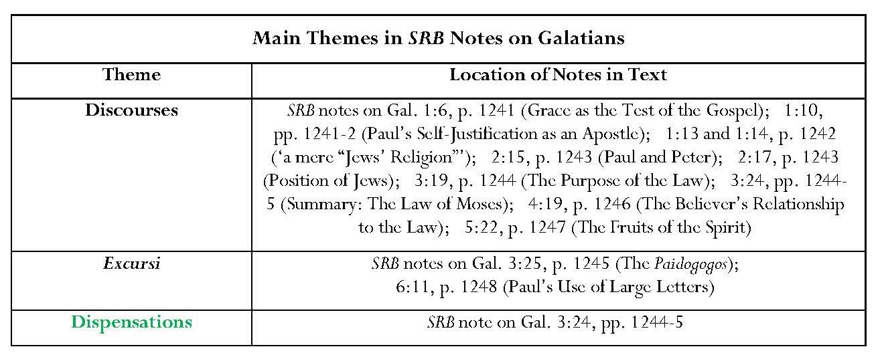

Annotation: Key Points
Unusually, Scofield annotates every chapter in Galatians but, chapters 4, 5 and 6, with only single notes.
Almost every note consists of a discourse which often repeats ideas in the text, with many references from both Testaments.
Comment: These references again suggest the employment of the Bible Readings method.
Doctrinal Discourses
Notes on Galatians 3 encapsulate discourses on the law and sin, the Mosaic law and Christian doctrine of the law, and the law in relation to faith.
General Comment on Discourse on the Law and Sin
Scofield’s interpretation of Gal. 3:19a displays an odd reversal of cause and effect. The text states that the law was added because of transgression, which implies that transgression came first, yet Scofield asserts that the law was added ‘to give to sin the character of transgression’, the implication being that sin came before transgression, as suggested by his reference to Rom. 5:13. Furthermore, Scofield here defines ‘transgression’ as ‘personal guilt’, whereas, in his note on Rom. 3:23, he defines it as ‘overstepping the law’, which is actually closer to the meaning of para,basij. Scofield does not address some difficult interpretative issues in Galatians 3. He does not try to explain the obscure statements in Gal. 3:19c and 20: ‘and it [the law] was ordained by angels in the hand of a mediator. Now a mediator is not a mediator of one, but God is one’. Terrance Callan regards the latter verse as ‘one of the most obscure verses in …. Paul’, and other modern scholars, such as Richard Longenecker Sam Williams and Ben Witherington III, all debate these verses thoroughly.
Scofield asserts that the inseparability of commandments and judgments in the Mosaic law means that ‘when an Israelite sinned, he was held “blameless” if he brought the required offering’; he thus admits, in effect, that Judaism was not a mere religion of works and that forgiveness was possible. This would seem to contradict his earlier statement, with reference to KJV’s translation of Ioudai?smo,j as ‘Jews’ religion’.
Dispensations
Galatians 3:24 is linked with dispensational theory by the assertion that legalistic endeavours ‘to mingle law with grace’ in the current dispensation of grace constituted an attempt to return to the previous dispensation of law.
Omissions
It is very noticeable that Scofield’s notes on Galatians lack the context which Paul is so careful to give, for example in chapter 2, where he sets out the occasion for his dispute with Peter over eating with Gentile Christians in Antioch. Scofield merely comments that Paul is proving that ‘Peter and he were in perfect accord doctrinally’. Galatians is essentially relational; Paul has preached the Gospel to the Galatians and feels a personal tie to them. Some of Paul’s admonishments are intensely personal, for example Gal. 4:12-16, where Paul admits his situation of weakness and illness and then asks, surely displaying his hurt and love for the Galatians, what has happened to their joy that he has become their enemy for speaking the truth. In Gal. 4:19-20, he even compares his concern for them with the pangs of childbirth. This relationship and context are entirely missed by Scofield, who concentrates on doctrine. Paul is distressed that the Galatians appear to be receptive to other influences, which are poisoning their view of him, hence his effort to establish his credentials. The closest Scofield gets to Paul is a dry, itemised rehearsal of Paul’s own points about the course of his life since his conversion and a speculative excursus on the reason for Paul’s writing with his own hand, and using large letters.
Paul frequently refers to matters of believers’ behaviour, which, as is often the case, Scofield ignores. Scofield also fails to comment, as in his notes on Romans, on the parity of Jewish and Gentile believers. Again, as with Romans, he fails to emphasise the faith of Abraham and the identity of his seed as primarily Christ, but also believers. He does not examine the Sarah-Hagar analogy, which has interesting implications for the roles of the Church and Israel. Paul even compares believers with Isaac as children of promise.
8.7.5 Ephesians
Introduction: Key Points
Author: Paul; ‘written from Rome in A.D.64’.
Ephesians again linked to Joshua.
Claims:
Ephesians ‘contains the highest church truth, but nothing about church order’.
Comment: This runs counter to assertions by scholars like James Dunn, who outlines four elements in ‘the message of Ephesians’. The first two of these concern human experience of God through life ‘in Christ’ and of the Holy Spirit and grace, and God’s purpose of ‘retrieving humanity from its state of death, and the bringing of all things into unity in Christ’. Scofield does fulfil both these elements to some extent. However, Dunn’s third and fourth propositions concerning the content of Ephesians are that ‘conduct and relationship modelled on those of Christ are also part of the restoration of creation to its original purpose’ and that ‘Christian households should have Christ as model and resource and thus provide a test bed for society in re-creation’. Scofield has thus omitted important elements as stated below.
The Church in this epistle is ‘the true Church’, not the local church.
The epistle concerns the believer’s exalted position through grace, the truth about the body of Christ and ‘a walk in accordance with that position’.
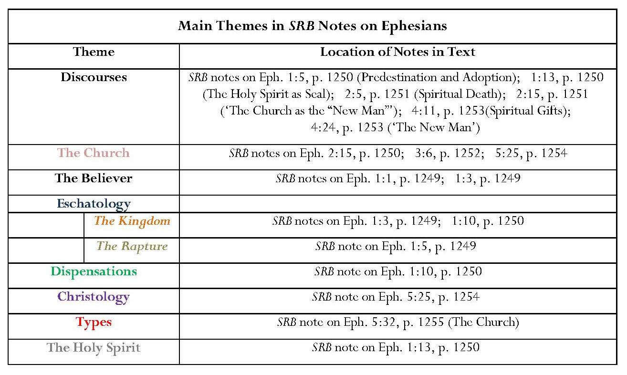
Annotation: Key Points
Annotation of all chapters except chapter 6.
The Church and the Believer
Several discourses concerning the Church, the believer and the way in which the believer is connected to God through Christ as his body and bride.
Several references to the concept of ‘the new man’ in Christ.
Comment: Scofield touches upon the Jewish/Gentile composition of the Church, but does not comment upon all verses concerning this important theme in Ephesians. For example, he ignores the context of Eph. 2:15, which is another powerful exposition of the parity of Jew and Gentile and their reconciliation in Christ as part of the restoration of humanity, and merely makes an assertion about the Church, which is not mentioned in the text.
The Final Dispensation: The Kingdom
Reference to the kingdom as ‘the last of the ordered ages’ in the note on Eph. 1:10. This is here designated ‘the dispensation of the fullness of times’, as in KJV, and considered to be ‘identical with the kingdom covenanted to David’.
The Translation of the Saints
As in his note on 1 Cor. 15:52, Scofield refers to ‘the redemption of the body’ but there is an added reference here to translation.
Christology
Summary of Scofield’s view of Christ’s work for the Church.
Comment: This also contains an inference of dualism in its reference to the Church as ‘one pearl of great price’. This reflects Scofield’s interpretation of Mt. 13:46, in contrast to Israel, which was ‘the treasure’.

Types
Assertion that Eve is a ‘clear type of the church as the bride of Christ’.
Comment: Scofield utilises the quotation of Gen. 2:24 in Eph. 5:32 to make this assertion. However, Eve is not mentioned by the writer of Ephesians and, while the passage makes a connection with Genesis 2, it does not meet the conditions for typicality which Scofield stipulates in his note on Exod. 25:1.
Omissions
Scofield’s concentration on ‘bride-types’ in his note on Eph. 5:32, means that he ignores the context in which this verse is found. Ephesians 5:1-21 largely consists of admonitions concerning believers’ behaviour. The human analogy of the love of a husband for a wife, used by the writer of Ephesians for Christ and the Church, is preceded by practical instructions about the marriage relationship. Similar instructions are given about the relationships between parents and children, and masters and servants. Scofield does not offer any notes on these. Similarly, in his annotation of Ephesians 4, Scofield does not comment on injunctions concerning the life of believers and the need for unity which will build up the Church. These omissions reflect Scofield’s denial in his Introduction to Ephesians that the epistle contains material concerning the functioning of the local church.
Other significant omissions are consideration of the writer’s prayers for the recipients in Eph. 1:15-23 and 3:14-21, and any references to the important subject of spiritual warfare in Eph. 5:1-20 and especially Eph. 6:10-18. Scofield calls Eph. 3:14-21 ‘parenthetic’ and does not annotate Ephesians 6. However, some of this material is referenced in subheads.
8.7.6 Philippians
Introduction: Key Points
Author: Paul; date: uncertain.
Theme: Christian experience and ‘soundness of doctrine is assumed’.
There is nothing to be set right in this ‘normal New Testament assembly’ with its ‘saints in Christ Jesus with the bishops (elders) and deacons’.
‘Right Christian experience … is the outworking, whatever one’s circumstances … of the life, nature and mind of Christ, living in us.’
Annotation: Key Points
Only two notes.
Excursus on the ‘local church’.
Definition of ‘form’ (Christ’s being ‘in the form’ of God’) as ‘the external appearance’.
No comment upon Paul’s appeal for unity amongst the Philippians or upon his injunctions on behaviour.

8.7.7 Colossians
Introduction: Key Points
Author: Paul; date: probably contemporary with Ephesians and Philemon.
Theme: excellent state of Colossian church but marred by two forms of error: ‘legality in its Alexandrian form of asceticism’ and ‘false mysticism’.
‘Because of these ever-present perils, Colossians was written, not for that day only, but for the warning of the church in all days.’
Annotation: Key Points
Discourse on reconciliation, defined as ‘the effect of the death of Christ upon the believing sinner which, through divine power, works in him a “thorough change” toward God from enmity and aversion to love and trust …God is propitiated, the sinner reconciled’.
Definition of ‘the “mystery of God”’ as ‘Christ, as incarnating the fulness of the Godhead, and all the divine wisdom and knowledge for the redemption and reconciliation of man’.
Excursus on Gnosticism: the Gnostics were ‘the errorists against whom Paul warns the Colossians …’, who had ‘pretended “knowledge”’.
Excursus on Epaphras as ‘a touching illustration of priestly service’.
8.7.8 1 Thessalonians
Introduction: Key Points
Author: Paul; date A.D. 54, written from Corinth.
Themes: reinforcement of truths already learned by young converts, exhortation of those converts to holiness and comforting them ‘concerning those who had fallen asleep’.
‘The second coming of Christ is prominent throughout.’
The epistle shows ‘the richness in doctrine of the primitive evangelism’.
Claim that, over about a month, ‘the apostle had taught all the great doctrines of the Christian faith’.
Annotation: Key Points
Single notes on three verses.
Assertion of ‘the tripartite nature of man’ as consisting of a ‘trinity’ of body, soul and spirit, each of which enables human beings to relate to God through a special quality. ‘Because man is “spirit” he is capable of God-consciousness, and of communication with God; because he is “soul” he has self- consciousness; because he is “body” he has, through his senses, world consciousness.’
Assertion of the three stages or ‘tenses’ of a believer’s life, starting with conversion, continuing with service and finally experiencing ‘the “patience of hope”’, which is ‘to “wait for his Son from heaven”.
Comment: This note is almost a paraphrase of 1 Thess. 1:9-10.
Identifies 1 Thess. 4:14-17 with Christ’s second advent and refers to ‘the first resurrection’.
Comment: It is interesting that Scofield identifies 1 Thess. 4:14-17 with Christ’s ‘second advent’ in his note on 1 Thess. 4:17. This raises the question, discussed in 7.1.3, as to whether Scofield here implies a third advent. Strangely, considering the emphasis which Scofield puts upon 1 Thess. 4:13-17 in support of his thesis concerning the pretribulational rapture of the true church, his note on 1 Thess. 4:17 is the shortest note on 1 Thessalonians and merely comments upon the inclusion of ‘the bodies of the saved, from whatever dispensation’ in ‘the first resurrection’, which is, however, ‘peculiarly the hope of the Church’. This echoes Scofield’s note on 1 Cor. 15:52.
8.7.9 2 Thessalonians
Introduction: Key Points
Author: Paul, written soon after 1 Thessalonians.
Assertion that 2 Thessalonians was written ‘to instruct the Thessalonians about the day of Christ “and our gathering together unto Him” and the relation of the “day of Christ” to the “day of the LORD”’.
Assertion that 1 Thessalonians primarily concerns ‘the day of Christ’, whereas 2 Thessalonians mainly concerns ‘the day of the LORD’.
Argument that ‘A.V.’ contains a mistranslation in 2 Thess. 2:2; ‘“the day of Christ is at hand” should be “the day of the LORD is now present”’.
Comment: ‘h` h`me,ra tou/ kuri,ou’ and ‘h` h`me,ra tou/ cristou’ both occur in different versions of the Greek.
Conjecture that ‘the Thessalonian converts were “shaken in mind” and “troubled,” supposing, perhaps on the authority of a forged letter as from Paul, that the persecutions from which they were suffering were those of the “great and terrible day of the LORD,” from which they had been taught to expect deliverance by “the day of Christ, and our gathering together unto him”’.
Annotation: Key Points
Single verse annotated: ‘the order of events’ for ‘that day’, which includes the apostasy of the professing church, the removal of restraint, identified as the Holy Spirit, ‘the manifestation of the lawless one’ and Christ’s coming, which destroys him.
8.7.10 1 Timothy
Introduction: Key Points
Author: Paul; date: subject to interpretation of Paul’s imprisonment(s).
Assertion that existence of increased numbers of churches necessitated ‘a clear revelation for church guidance’ concerning church order, faith and discipline.
‘Well had it been with the churches if they had neither added to nor taken from the divine order.’
Continued overleaf

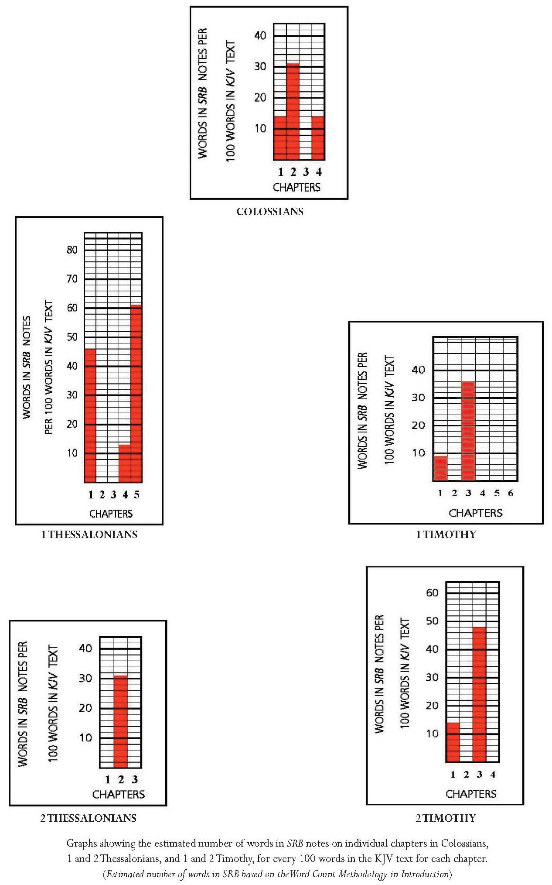
Annotation, 1 Timothy: Key Points
Notes on only two verses.
The ‘delivery to Satan’ of Hymenaeus and Alexander linked with ‘the seriousness of false teaching, and particularly as related to resurrection’. Further links made to 2 Tim. 2:17-18, asserting that ‘Paul calls it blasphemy to teach that “the resurrection is past already”’.
Comment: Presumably this link is made because someone named Hymenaeus is mentioned in 2 Tim. 2:17, but there Hymenaeus is linked with Philetus in misapprehension concerning the resurrection. As Clare Drury remarks, ‘It is impossible to say whether both refer to the same man.’ Drury further states that ‘we cannot be sure whether [Hymenaeus and Philetus] were known to the community at the time of writing, if they were well-known historical figures, or if they are fictitious characters introduced to make the situation more vivid and realistic’.
Assertion concerning the true and professing churches and their ‘predicted futures’. The true Church has existed within the historical Church, which is the ‘visible body of professed believers’, whose ‘predicted future is apostasy, but that of the true Church, glory’.
8.7.11 2 Timothy
Introduction: Key Points
Author: Paul, ‘shortly before his martyrdom’.
Assertion on the grounds of 2 Tim. 4:6-8 that the epistle ‘contains the last words of the great apostle which inspiration has preserved’.
Theme: ‘the personal walk and testimony of a true servant of Christ in a day of apostasy and declension’: assertion that this is ‘proof that already apostasy had set in in its first form, legalism’.
Annotation: Key Points
List of ‘the believers’ resources’ in face of apostasy.
Definition of apostasy as ‘falling away: the acts of professed Christians who deliberately reject revealed truth’ concerning Christ’s deity and redemption through his sacrifice.
Assertion that apostasy differs from error, which may result from ignorance or heresy, ‘both of which may consist with true faith’; apostates ‘depart from the faith, but not from the outward profession of Christianity’.
Assertion that ‘apostasy in the church, as in Israel … is irremediable and awaits judgment’.
Continued overleaf
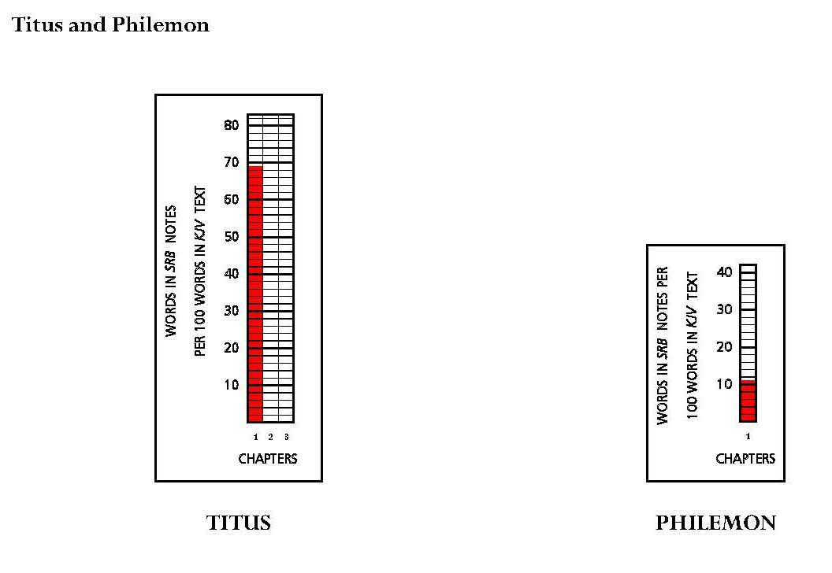
8.7.12 Titus
Introduction: Key Points
Author: Paul; date: contemporary with 1 Timothy.
Theme: order in churches, especially in local churches.
Assertion of application to ‘churches grown careless as to the truth of God’ and ‘churches careless as to the order of God’s house’.
Annotation: Key Points
Two notes on Titus 1 provide an excursus on elders in local churches.
8.7.13 Philemon
Introduction: Key Point
Summary of the occasion of the letter, and assertion that it offers ‘priceless value as teaching in practical righteousness; Christian brotherhood; Christian courtesy and the law of love’.
Annotation: Key Point
References vv. 17-18 as an example of imputation.
8.7.14 Conclusion: Notes on the Pauline Epistles
The most striking feature of Scofield’s annotation of the Pauline and Deutero-Pauline epistles is the number of discourses on doctrinal matters. This is quite different from most of the annotation of the Old Testament and of Acts and of the Gospels, apart from Matthew and John. The notes on Romans, in particular, appear to reflect the Bible Readings method as Scofield explicates various soteriological terms. These notes form homilies which bear more similarity to those in other Reference Bibles. The annotation of 1 Corinthians, Galatians and Ephesians contains more doctrinal material which is related to the text. After Ephesians, there is very little annotation of the Pauline epistles.
There are correspondingly fewer eschatological references, though the translation of the church and the great tribulation are mentioned in some notes, such as those on Rom. 11:5; 1 Cor. 15:52 and Eph. 1:5. The note on 1 Cor. 15:24 contains an important summary of the kingdom in the New Testament and there are further brief references to the kingdom in a few notes on Romans and Ephesians. The note on Eph. 1:10 is important for its exposition of the final dispensation.
There are only two typological references: Adam as a type for Christ and the ‘bride-types’.
8.8 The ‘Jewish-Christian’ Epistles
Introduction: Key Points
Epistles listed as Hebrews, James, 1 and 2 Peter, and Jude.
Comment: 1, 2 and 3 John are not listed here, but do not fall under a new heading and so must be assumed to belong to Scofield’s group of ‘Jewish-Christian epistles’.
Assertion that the Jewish-Christian epistles present the same Christ, salvation and morality as the Pauline epistles but ‘the Jewish-Christian writings deal with the elementary and foundational things of the Gospel, whereas Paul was given revelations concerning the church, her place in the counsels of God, and the calling and hope of the believer as vitally united to Christ in the one body’.
Assertion that Paul is addressing ‘the body of true believers, who are therefore assuredly saved’, whereas ‘the Judaeo-Christian writers view the church as a professing body in which, during this age, the wheat and tares are mingled’. There are thus many warnings ‘calculated to arouse and alarm the mere professor’.
Comment: Scofield repeats the sentence concerning ‘the mere professor’ almost verbatim in his introduction to Hebrews. He mitigates this harsh view in both introductions and in his note on Heb. 6:4 by stating that the people addressed were not hypocritical but had not gone the full distance in their faith journey, and were being urged to continue.
Assertion that 1 and 2 Peter are ‘less Jewish and more truly catholic than the other Jewish-Christian writings’.
Continued overleaf

8.8.1 Hebrews
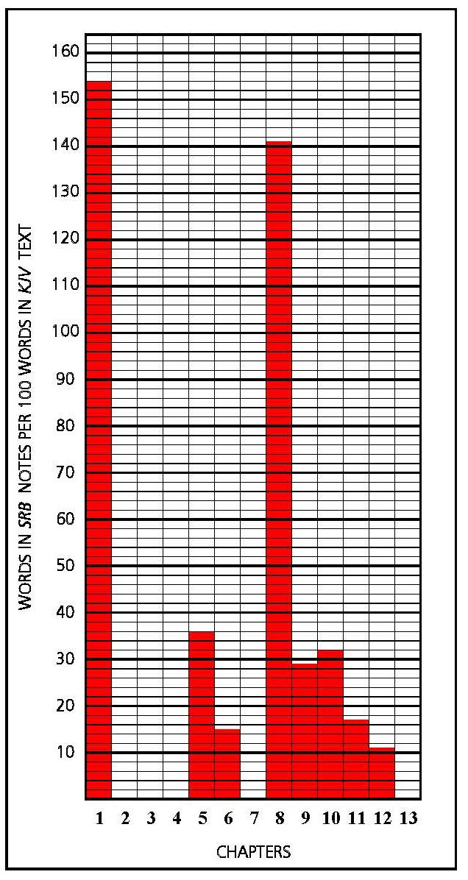
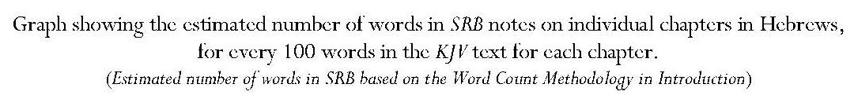
It would initially seem that Hebrews is of particular importance to Scofield, because two of its chapters bear annotation of a volume far higher than that of the KJV text of these chapters. In fact, however, the annotation of single verses in each of these chapters accounts for these figures. Other chapters include much lower proportions of notes and five chapters are not annotated. Five notes also refer to single verses within their chapters and the sixth refers to only two verses. Thus Scofield annotates only nine verses in the whole of Hebrews. Many notes consist of discourses which often depend upon the use of single words as springboards.
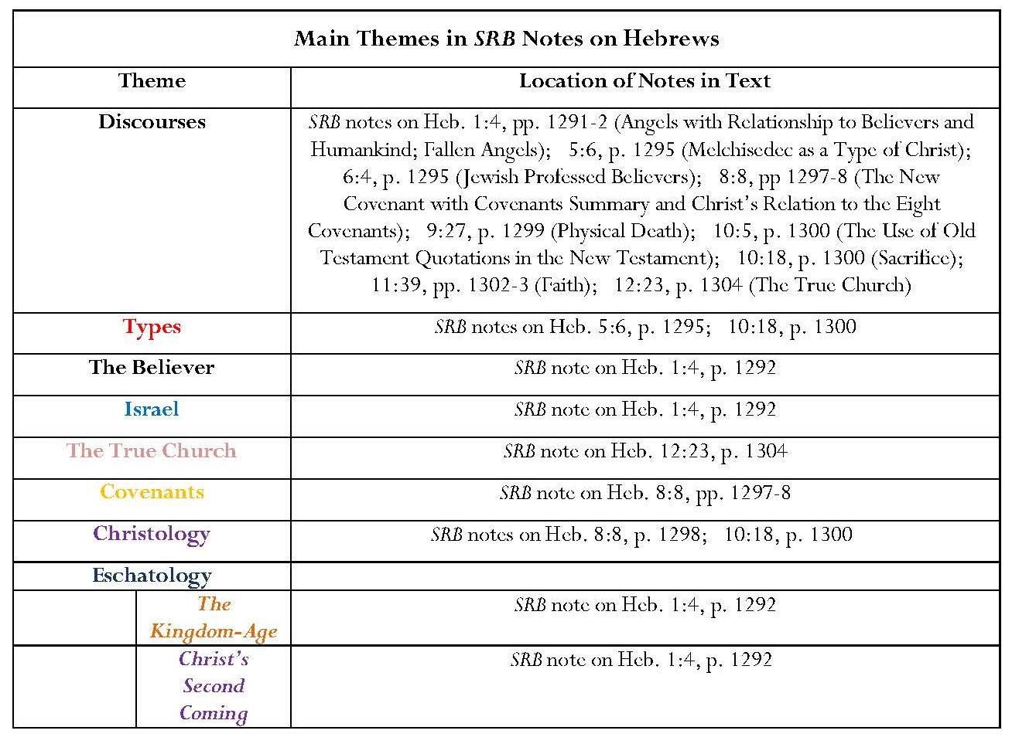
Introduction: Key Points
Assertion that this book is anonymous but nevertheless includes claims that ‘2 Pet. 3:15 seems conclusive that Paul was the writer’ and that another unidentified “all” ‘agree that, whether by Paul or another, the point of view is Pauline’. ‘We undoubtedly have here the method of Paul’s synagogue addresses.’
Comment: None of these statements is substantiated.
Assertion that ‘no book of Scripture more fully authenticates itself as inspired’.
Comment: This implies that degrees of inspiration are comparative; this effectively casts doubt upon the authenticity of other books, something which Scofield surely does not intend.
Assertion that the purpose of Hebrews is to assure Jewish Christians that Judaism had ended through Christ’s fulfilment of the law and to warn against the dangers of their lapsing into Judaism or never reaching full faith in Christ.
Assertion that ‘it is clear from the Acts that even the strongest believers in Palestine were held to a strange mingling of Judaism and Christianity … and that snare would be especially apt to entangle professed Christians amongst the Jews of the dispersion’.
Comment: No justification is given for this statement. If Scofield believes this was so, it is odd that he devotes so little of his annotation to the relation of Christ to sacrifice and the high priestly function which features so prominently in the text of Hebrews, even though these passages do not come into the sections of Hebrews to which Scofield attaches the term, ‘parenthetical’, a term which seems unfortunate in the context. These passages mainly concern Christian belief and behaviour. Unsurprisingly, Scofield ignores most of the ‘parenthetical’ sections and annotates just one verse within them, Hebrews 6:4.

Annotation: Key Points
Angels
Concentration on angels in lengthy discourse.
Comment: This verse and, indeed, the whole chapter, concern Christ and his superiority to angels.
Assertion that, in the Old Testament, ‘the expression, “the angel of the LORD” usually implies the presence of God in angelic form’.
Comment: It is true that the word, ‘angel’, does sometimes appear to be synonymous with God, for example in Gen. 16:10 and Judg. 2:1, where words which are put in the mouth of the angel of the LORD seem to be the words of God himself, but in many other cases an ‘angel’ is definitely a separate being, for example in Num. 22:22-3, where God sends an angel to stand in the way of Balaam’s donkey.
Assertion of instances where ‘the word angel is used of men’.
Comment: Lk. 7:24 refers to messengers from John the Baptist, and Jas. 2:25 to messengers received by Rahab. It is possible that some confusion has arisen through the fact that the same Greek word, a;ggeloj can mean ‘angel’ or ‘messenger’. a;ggeloj is translated as ‘messenger’ in KJV in both these cases. The other instances cited by Scofield in which he claims angels are men, refer to the angels of the seven churches in Revelation. Ford states that ‘scholars find it difficult to define exactly what is meant by the angels of the communities’. She cites three main suggestions: ‘angel guardians, bishops and heavenly counterparts of the respective kingdoms’. Only one of these possibilities refers to human beings and Ford states that ‘in Revelation the term “angel” is used only of superterrestrial beings, and … nowhere in the NT is it used of bishops’. She states that the term in this context is best related to the concept of ‘the angels of the various kingdoms’ in Daniel, where they are ‘a kind of heavenly counterpart of the respective kingdoms’.
Assertion that ‘the word [angel] is always used in the masculine gender, though sex in a human sense is never ascribed to angels’.
Comment: It is not clear what Scofield means by this statement. He may mean that pronouns referring to angels are usually masculine but then this is not surprising since %a'l.m and a;ggeloj are masculine nouns in Hebrew and Greek respectively.
Assertions: Very numerous and of inconceivable power.
Place is around God’s throne.
Relation to believers as ‘ministering spirits’, mainly with regard to physical well-being.
Care begins in infancy and is life-long. Angels’ observation should influence believers’ conduct.
Receive ‘departing saints’.
Man is made ‘“a little lower than the angels”, and in incarnation Christ took ‘for a little (time) this lower place that He might lift the believer into His own sphere above the angels’.
Eschatology
Assertion that angels are to accompany Christ at his second coming and will prepare the judgment of the nations.
The kingdom-age is not to be subject to angels but to Christ and ‘those for whom He was made a little lower than the angels’.
‘An archangel, Michael, is mentioned as having a particular relation to Israel and to the resurrections. The only other angel whose name is revealed, Gabriel, was employed in the most distinguished services.’
Covenants: Comment
Scofield’s note on Heb. 8:8 focuses on the New Covenant and its superiority to the Mosaic Covenant; however, Scofield does not provide notes on Heb. 8:7 and 8:13, which are both relevant to the relationship between the old and new covenants. Hebrews 8:7 mentions only two covenants, the first and the second. It states that, had the first been faultless, there would have been no need of the second. Despite drawing contrasts between only these two covenants, old and new, Scofield again summarises the eight covenants he sees in the Old and New Testaments. Hebrews 8:13 states that ‘that which decayeth and waxeth old is ready to vanish away’. This surely implies the demise of the ‘old covenant’, yet Scofield asserts in his comment on the so-called ‘Palestinian Covenant’ that ‘Christ will yet perform its gracious promises’. It is not clear how Scofield’s seven preceding covenants relate to the ‘first covenant’ of Heb. 8:7, but the implication in Scofield’s comment on Heb. 8:8 is that for him the Palestinian Covenant still holds sway because he expects Christ to perform it even though Scofield himself states that the New Covenant is ‘final and irreversible’.
Types: Comment
Scofield’s two typological assertions in commentary on Hebrews are discussed in 2.3.1. He does not cross-reference Heb. 10:20 with Mt. 27:51, as he does in his note on the latter verse.
Omissions
In concentrating on covenants in his note on Heb. 8:8, Scofield fails to comment on text in Hebrews 8 concerning Christ’s role as high priest ‘on the right hand of the Majesty in the heavens’ in a tabernacle and sanctuary pitched by the Lord’, and his superiority to earthly high priests who serve ‘unto the example and shadow of heavenly things’. The subject of Christ’s priesthood has already been raised in Hebrews 2 and his Melchizedek priesthood, not of the order of Aaron, has already been introduced in Hebrews 5. While Scofield confines himself to an explanation as to why Melchizedek is an appropriate type of Christ, Hebrews 5 also describes the empathy of the ordinary high priest for sinners, whose sin he shares, an empathy also present in Christ through his temptation and suffering, though not through experience of sin. Hebrews 2 is another chapter not annotated by Scofield. Here it is stated that Christ was made like his brothers in every way so that he might make atonement for the sins of the people. Also, because he suffered when he was tempted, he can help those being tempted.
Hebrews 9 and 10 contain further important material concerning Christ’s role as high priest, which is omitted by Scofield. This is surprising because, for example in his notes on Leviticus and Numbers, he lists several types for Christ which reference verses in Hebrews. It seems inconsistent that Scofield does not comment Heb. 10:4, to which he refers in his note on Ezek. 43:19 but perhaps dwelling too much upon verses which state the obsolescence of the old tabernacle, high priestly function and sacrifices would be detrimental to the promotion of the concept of the reinstitution of sacrifices as a memorial of the cross in the ‘millennial temple’.
Commenting on the approximate quotation of part of Ps. 40:6 in Heb. 10:5, Scofield is constrained, probably in the interests of defending the infallibility of scripture, to justify the slight variation. Scofield allows that ‘the rule, applicable to all modifications of form of quotations in the New Testament from Old Testament writings, is that the divine Author of both Testaments is perfectly free in using an earlier statement, to recast the mere literary form of it. The variant form will be found invariably to give the deeper meaning of the earlier statement.’ The inefficacy of repeated animal sacrifice is not emphasised in Scofield’s discourse on sacrifice in his note on Heb. 10:18. Instead he offers a short history of Old Testament sacrifices, emphasising their typical status in relation to Christ, and then provides a list of doctrinal terms and references concerning Christ’s sacrifice. He does not engage with the main issue.
Again Scofield neglects to comment upon exhortations to the Hebrews in Hebrews 12 and 13. Importantly, the writer reminds his audience that they have not come to a physical mountain but to Mount Zion, the city of the living God, the heavenly Jerusalem, and to Jesus, the mediator of the new covenant. They are receiving ‘a kingdom which cannot be moved’. They do not have an enduring city but look for the city to come. As often, the essentials of Christian living appear to be unimportant to Scofield.
8.8.2 James
Introduction Key Points
Author: James ‘the Just’; presumably very early date.
Theme: ‘“the twelve tribes scattered abroad”’, to be understood, not as Jews, but as ‘Christian Jews of the Dispersion’.
Assertion that James, who seems not to have left Jerusalem, would have felt ‘a particular pastoral responsibility for these scattered sheep’.
Comment: Scofield does not justify this remark.
Assertions that James is ‘the first Epistle to Christians’, and that it is ‘elementary in the extreme’. Further assertions: ‘To suppose that Jas. 2:14-26 is a polemic against Paul’s doctrine of justification is absurd. Neither Galatians nor Romans was yet written.’ James ‘does not exalt works as against faith, but faith as producing works’.
Annotation: Key Points
Two notes: definitions of ‘temptation’ as both ‘solicitation to evil’ and ‘testing under trial’, and of imputation as God’s act of imputing Christ’s righteousness to the believer.
8.8.3 1 Peter
Introduction: Key Points
Author: the Apostle Peter; date: probably 60 A.D.
Claim that ‘while Peter undoubtedly has scattered Jewish believers in mind, his Epistles comprehend Gentile believers also’. It includes all Christian foundational truths and specially emphasises the atonement. Its distinctive feature is its emphasis on victory over suffering.
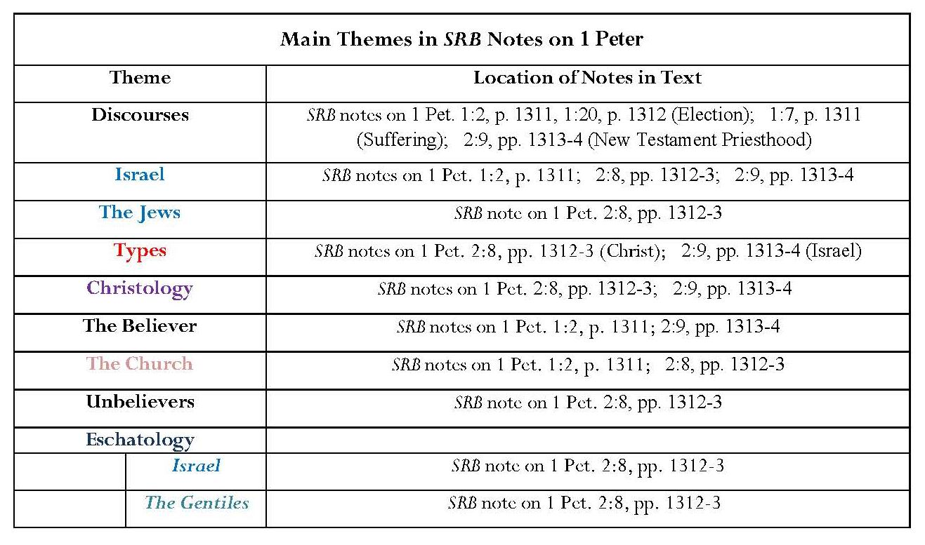
Annotation: Key Points
Annotation of only five verses within first two chapters of 1 Peter.
Election
Assertion that this is a sovereign action of divine grace, according to divine foreknowledge or predestination, and may be corporate or individual. Election is certain for every believer on the basis of belief alone.
Suffering
Assertion that believers’ salvation is assured even in the light of suffering, which reflects Christ’s suffering, and in the light of coming glory like that of Christ. Suffering is disciplinary and Christ is glorified by it.
Christology and Eschatology, the Church, Israel and the Gentiles: Comment
Building upon the images of ‘stone of stumbling’ and ‘rock of offence’ in his note on 1 Pet. 2:8, Scofield draws eschatological conclusions concerning the futures of the Church, Israel and the Gentiles. However, 1 Pet. 2:8 mentions no races, religious groups or comings of Christ. This verse merely refers to those who are ‘disobedient’; in the two preceding verses, those to whom the ‘chief corner stone’ is precious, are those who believe. Scofield also introduces a strange dichotomy between ‘the Jews’ at Christ’s first coming and ‘Israel’ at his second coming; this difference is particularly emphasised. The note is similar to his note on Mt. 21:44, where it is Israel to which Christ is the stumbling stone and rock of offence. Furthermore, Scofield ignores the context of 1 Pet. 2:8, which is that the believers addressed are to be like ‘living stones’.
Omissions
While Scofield provides great detail on the chosen status of believers, their priestly function and role in glorifying Christ through their suffering, he ignores the effects these things should have on their lives according to 1 Peter. The epistle points out their glorious position through Christ’s precious blood and how this should result in holiness and living in love from the heart. There are many practical instructions. The believers are now the people of God, another important point not noted by Scofield.
Several sections of 1 Peter would benefit from the ‘helps’ Scofield promises in his introduction to SRB. Scofield neglects to comment upon issues of submission of wives to husbands, of slaves to masters and of all to those in authority. Two verses not annotated include material about preaching to the dead. Scofield also fails to comment on the writer’s use of the rescue of Noah and his family from the flood as a symbol of baptism and his observations that ‘the end is near’ and that ‘judgment must begin at the house of God’. Finally, it is surprising that Scofield has nothing to say about the reference to ‘the church that is at Babylon’.
8.8.4 2 Peter
Introduction: Key Points
Author: the Apostle Peter; date: probably 66 A.D.
Assertion that writer is aware of impending martyrdom and responds with joy but foresees the history of the professing church ending in apostasy.
‘Paul [in 2 Timothy] finds that apostasy [i.e. the apostasy … in which the history of the professing church will end] in its last stage when the so-called laity have become infected’, whereas Peter sees the origin of apostasy as being false teachers, who deny the truth of redemption.

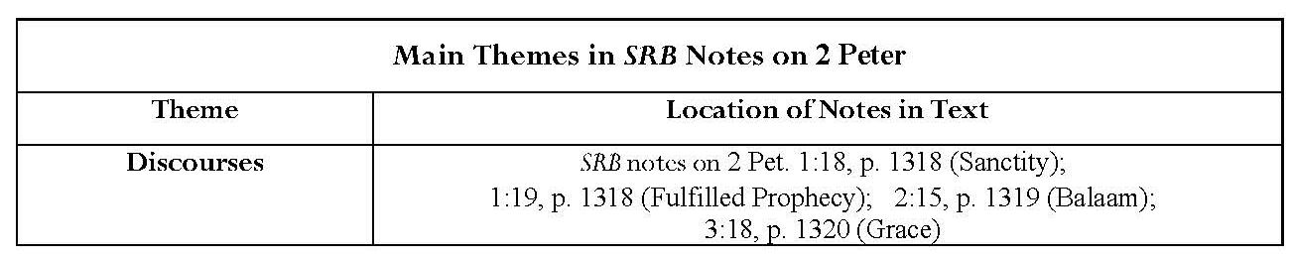

Annotation, 2 Peter: Key Points
Fulfilled Prophecy
Important exposition concerning fulfilled prophecy as proof of inspiration.
Grace
Discourse on grace contains a plethora of cross-references and may be a good example of the Bible Readings Method.
8.8.5 1 John
Introduction Key Points
Author: the Apostle John; date: probably 90 A.D.
Theme: is ‘a family letter from the Father to His “little children” who are in the world’. ‘The sin of a believer is treated as a child’s offence against his Father and is dealt with as a family matter.’
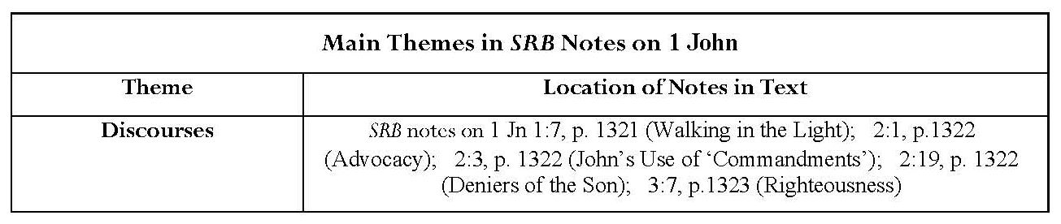
8.8.6 2 John
Introduction: Key Points
Author: the Apostle John; date: probably 90 A.D.
Assertion that 2 John ‘gives the essentials of the personal walk of the believer when “many deceivers are entered into the world”’.
Anachronistic assertion that ‘the Bible, as the only authority for doctrine and life is the believer’s resource in a time of declension and apostasy’.
Annotation, 2 John
Exposition of the law of Christ. Christ’s law is love whereas Moses’ external law demands love. Christ’s law thus replaces ‘the external law by fulfilling it. It is the “law written in the heart under the New Covenant”.’
8.8.7 3 John
Introduction: Key Points
Author: the Apostle John; date: probably 90 A.D.
Assertion of intimations of incipient clerical and priestly church domination and consequent loss of original church order. Claim that this indicates the responsibility of individual believers in the local church amidst apostasy.
Scofield does not annotate 3 John.

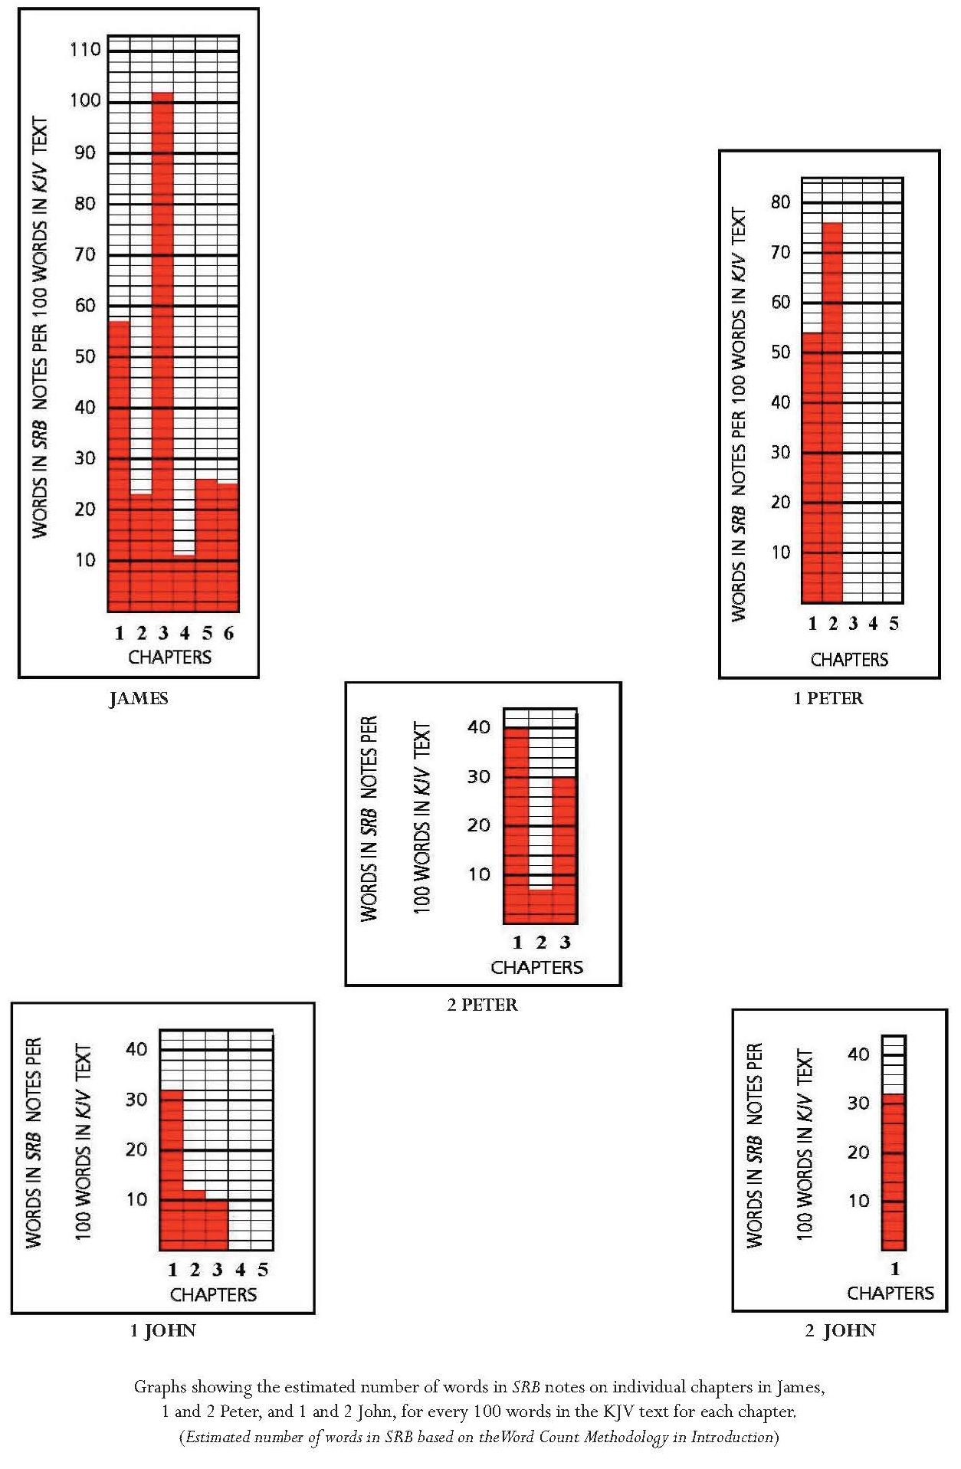
8.8.8 Jude
Introduction: Key Points
Author: Jude, brother of James; date: probably 66 A.D.
Assertion that it is the Holy Spirit rather than Jude himself who speaks.
Theme: is ‘contending for the faith’.
Apostasy of the professing church, its cause and course predicted; shown as having already become established.

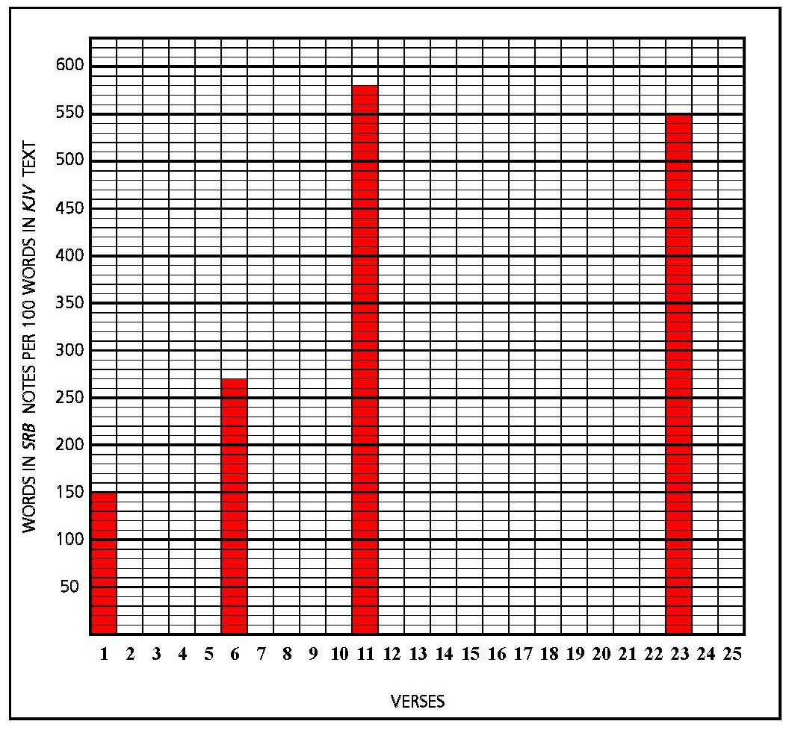
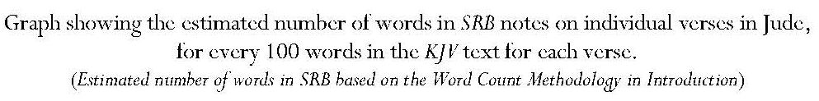
Annotation: Key Points
It has to be admitted that, because Jude only consists of twenty-five verses, anything Scofield writes will represent a high number of words in relation to the KJV text of the book, but, taken verse by verse, the notes on all four verses upon which Scofield comments reach exceptionally high numbers.
Instead of commenting upon the whole subject of this short letter, Scofield again builds excursi on odd words. He uses the word ‘preserved’ in verse 1 to make an assertion about Scripture which is irrelevant to the context. Scofield states that ‘assurance is the believer’s conviction that, through the work of Christ alone, received by faith, he is in possession of a salvation in which he will be eternally kept’. This assurance ‘rests only upon the Scripture promises to him who believes’.
Comment: Horrell states that the date of Jude is widely disputed but argues for a date between 75 and 90 CE; Scripture, in the sense intended by Scofield, would not have been available to the recipients of the letter.
In his note on Jude v. 6, Scofield reverts to the subject of angels. Scofield asserts that the ‘great day’ mentioned in the verse is the ‘day of the Lord’ and, since the final judgment on Satan occurs after the thousand years and before the final judgment, it is ‘congruous to conclude that the other fallen angels are judged with him’.
The lengthy note on Jude v. 11 concentrates on the three characters mentioned in the verse: Cain, Balaam and Core (Korah).
Comment: Horrell notes the dependence of the author of Jude, not only on the scriptures where these names are mentioned, but also on ‘the interpretations of these scriptures in post-scriptural Jewish tradition’.
Assertion that ‘the “error” of Balaam was that, reasoning from natural morality, and seeing the evil in Israel, he supposed a righteous God must curse them’.
Comment: This does not accord with the account of Balaam in Numbers 22 – 24, where Balaam consistently refuses to curse Israel and insists on saying nothing but the words the LORD provides. Furthermore, even if Scofield were correct in his assessment of Balaam’s error, it is difficult to see how the apostate teachers for whom the writer of Jude is using Balaam as a symbol, could be accused of this. Horrell suggests another instance of the influence of tradition upon the writer, asserting that, despite the biblical account in Numbers, Balaam in later Jewish tradition was held to be someone who ‘greedily accepted Balak’s rewards and led Israel into immorality’.. Both these charges seem far more likely to be levelled at the apostate teachers than does the error Scofield suggests.
Accusation that Balaam was ‘blind to the higher morality of the Cross, through which God maintains and enforces the authority and awful sanctions of His law, so that He can be just and the justifier of a believing sinner’.
Comment: The charge is anachronistic because the time of Balaam occurred several millennia before the cross and the Christian doctrine found in the New Testament.
Assertion that Korah’s sin was the denial of Moses as God’s chosen spokesman and ‘intrusion into the priest’s office’.
Comment: Horrell states that Korah was one of the leaders in a rebellion against Moses and Aaron who, in Jewish tradition, became a heretic who denied the law. Horrell also notes that the verse speaks as if the apostate teachers had already suffered the fate of Korah, and been swallowed up into the earth. He suggests that this is what the writer was convinced would happen to them.
Omissions
Again some difficult material receives no annotation, and some challenging theology passes without comment, for example, verse 9, ‘Yet Michael the archangel, when contending with the devil he disputed about the body of Moses, durst not bring against him a railing accusation, but said, The Lord rebuke thee.’ Some word of explanation would be helpful. Scofield also does not explain the allusion to Enoch or identify the quotation from 1 Enoch in Jude v 14. He neglects the whole thrust of the letter; Horrell states that Jude is ‘dominated by sustained polemic against heretical opponents’. This is borne out by verses 4 and 10-19, where the writer inveighs in acerbic tones against those who are corrupting the faith of the recipients of the letter. Scofield misses the fact that the purpose of the letter is to ‘exhort you that ye should earnestly contend for the faith which was once delivered unto the saints’. Concern for the recipients balances to some extent the stringent denunciations of the opponents and there is a certain amount of exhortation to Christian behaviour, which Scofield also ignores.
Scofield does not attempt to explain the meaning of the final phrase in Jude v. 23, which Horrell describes, along with the preceding verse, as ‘one of the most corrupt passages in New Testament literature’. Horrell notes the ‘rather large number of textual variations and uncertainties’ in Jude. Instead of addressing the difficulty of this verse, Scofield takes the single word, ‘flesh’, and expands upon it. He states that ‘“flesh” in the ethical sense’ signifies the natural, unregenerate man, self-centred and liable to sinfulness and rebellion against God, whereas the regenerate man is not in the sphere of flesh but in that of the Spirit. However, the flesh is still in him and he may choose to walk after the flesh and be ‘a carnal Christian’ or after the Spirit and be ‘a spiritual Christian’. Believers who walk in the Spirit will consistently experience victory over the flesh.
8.8.9 Conclusion: Notes on the ‘Jewish-Christian’ Epistles
Like the notes on the Pauline and Deutero-Pauline epistles, those on the Jewish-Christian epistles contain doctrinal discourses. The note on Heb. 10:18 on sacrifice makes some points similar to those in the notes on Romans, and includes many cross-references and a reference to types. It also includes elements of Scofield’s Christology, as do those on Heb. 5:6 concerning Melchisedec as a type of Christ and 1 Pet. 2:8 concerning Christ as the stone of stumbling and rock of offence. Some of the discourses come close to being excursi, especially the note on angels. This note also includes references to Christ’s second advent and the kingdom-age but, again as with the Pauline epistles, there is little eschatological material in these notes. The triple note on covenants in Hebrews 8 forms the climax of Scofield’s annotation concerning this subject and is the object of cross-references from notes on all the other covenants. As already stated, many significant elements in these epistles are not covered by Scofield.
8.9 Revelation
Introduction: Key Points
Author: the Apostle John; date: 96 A.D.
Theme: Jesus Christ, as the one who was and is and is to come, in relationship to the churches, the tribulation and the kingdom, and in His offices as High Priest, Bridegroom and King-Judge. However, ‘all events move to one consummation – the bringing in of the covenanted kingdom’.
Assertion that Revelation is ‘a prophecy’; ‘the key phrase is the prophetic declaration of the “great voices in heaven”, lit. “The world kingdom of our Lord and of his Christ has come”’.
John is commanded to write of things past, present and future.

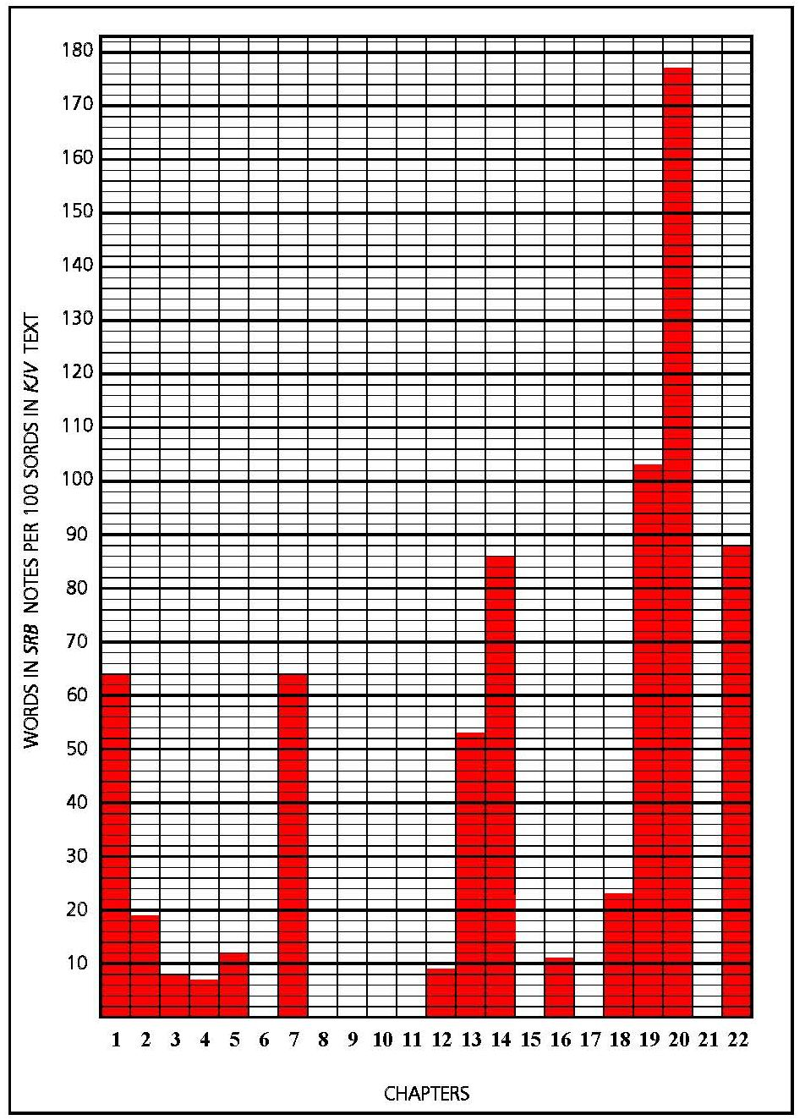
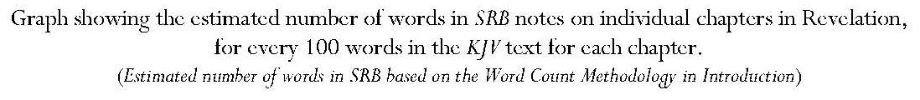
Introduction: Key Points
Author: the Apostle John; date: 96 A.D.
Theme: Jesus Christ, as the one who was and is and is to come, in relationship to the churches, the tribulation and the kingdom, and in His offices as High Priest, Bridegroom and King-Judge. However, ‘all events move to one consummation – the bringing in of the covenanted kingdom’.
Assertion that Revelation is ‘a prophecy’; ‘the key phrase is the prophetic declaration of the “great voices in heaven”, lit. “The world kingdom of our Lord and of his Christ has come”’.
Comment: This unusual translation supports Scofield’s own interpretation of the kingdom. The Greek of Rev. 11:15 reads, ‘evge,neto h` basilei,a tou/ ko,smou tou/ kuri,ou h`mw/n kai. tou/ cristou/ auvtou/’. Most English translations make a contrast between the ‘kingdom of the world’ and that of ‘our Lord and his Christ’ by including a second use of the word, ‘kingdom’ (in italics in KJV), which is not in the Greek, where ‘h` basilei,a’ occurs only once. The Geneva Bible has a different interpretation: ‘The kingdomes of this worlde are our Lordes, and his Christes’. It is possible that Scofield has derived his translation from that of Darby, which reads, ‘The kingdom of the world of our Lord and of his Christ is come’.
John is commanded to write of things past, present and future.
Assertion that the phrase ‘meta. tau/ta’ in Rev. 4:1 means ‘after the church period ends’.
Comment: This is not justified since no church period is mentioned in the text and, in any case, the phrase is in the plural and would be better translated ‘after these things’, as indeed Darby translates it.
Assertion that this future period falls into ‘six sevens’, making seven sevens if the ‘church division’ is included.
Assertion of five ‘parenthetical’ passages, which ‘do not advance the prophetic narrative’. They look backward and forward to ‘sum up results accomplished and speak of results yet to come as if they had already come’. The indeterminate end of the church period will come at the fulfilment of 1 Thess. 4:14-17.
Assertion that ‘[Revelation] chapters 4 — 19 are believed to synchronize with Daniel’s seventieth week’.
Comment: Scofield does not state by whom this is believed.
Assertion that the great tribulation begins in the middle of the ‘week’ and lasts three and a half years. It ends at the appearance of the Lord and the battle of Armageddon. The kingdom follows, succeeded by ‘the “little season” and then eternity’.
Assertion that ‘doubtless much which is designedly obscure to us will be clear to those for whom it was written as the time approaches’.
Comment: The implication is that Revelation was written only for the future and has no bearing on events contemporary with its writing.
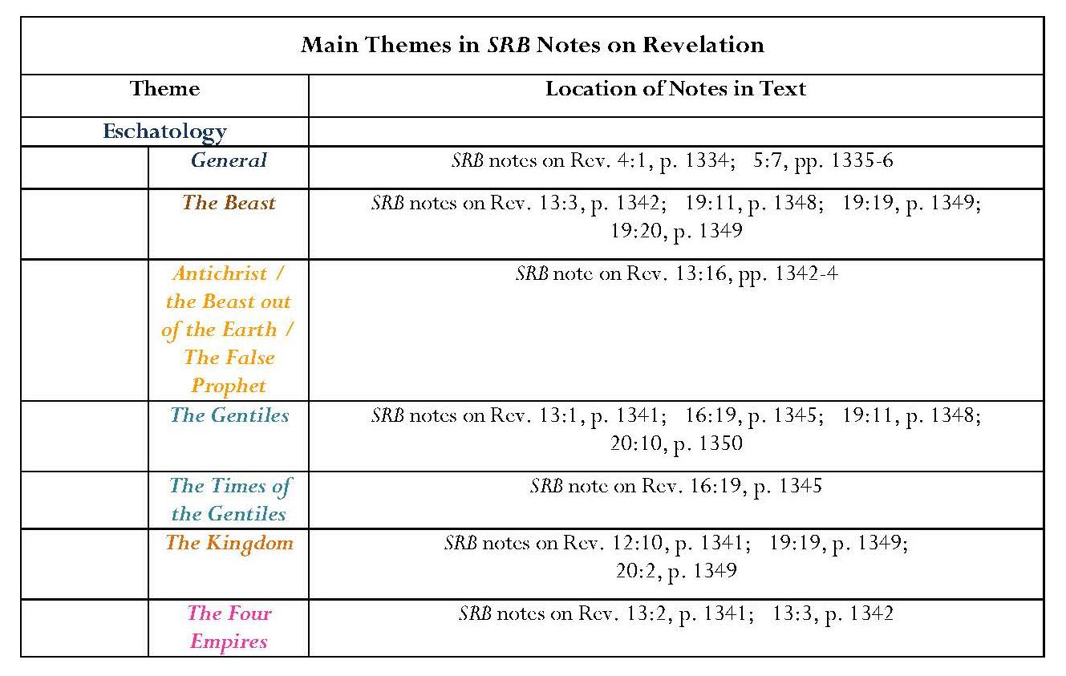
Continued overleaf

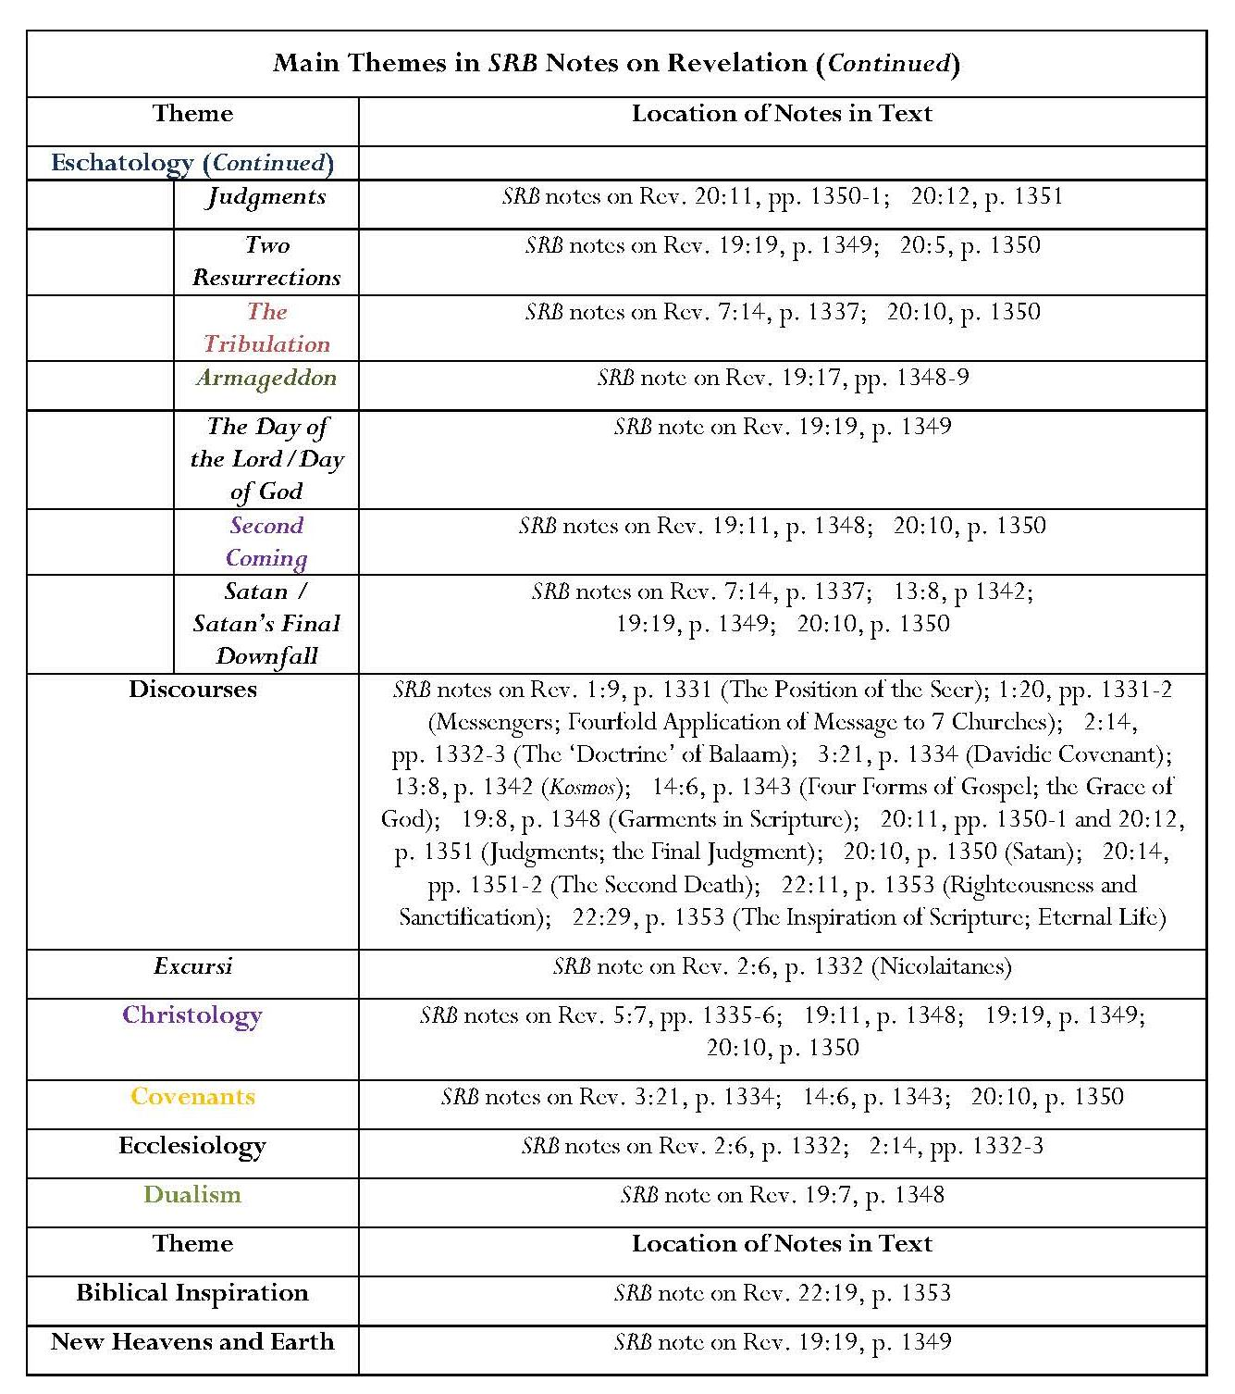
Annotation, Revelation
After Zechariah 12, Revelation 20 bears the next highest volume of annotation compared with the corresponding KJV text.
The large volume of notes on Revelation 20 is achieved by notes on six verses.
Eschatology
Many notes on Revelation represent the summation of the eschatological ideas which have been outlined earlier and discussed in earlier chapters.
Several notes form the corollary to notes on Daniel and Zechariah.
Scofield’s futuristic interpretation of Revelation was discussed in 7.1.1 and his notes concerning the great tribulation, Antichrist and the two Babylons in 7.1.2.3.
The final reference to ‘the Times of the Gentiles’ occurs in the note on Rev. 16:19, linking with several earlier references.
The excursus on Satan contains several eschatological assertions concerning the great tribulation and Christ’s return.
Biblical text amplified in a series of eschatological discourses placing strong emphasis on the thousand years mentioned in Rev. 20:2-7.
Note on Rev. 19:17 provides the climax of many references to Armageddon.
Comment: The name, Armageddon appears only in Rev. 16:16.
Note on Rev. 19:19 is important for the exposition of Scofield’s view on ‘the Day of Jehovah’,
Note on Rev. 19:20 gives a summary concerning the beast, which it links with Dan. 7:24-6.
Dualism
The first section of the discourse on the four forms of Gospel in the note on Rev. 14:6 reflects Scofield’s dualistic concept; the first Gospel mentioned is that of ‘the kingdom’, which is ‘Israelitish’ and terrestrial, the fulfilment of the Davidic Covenant.
In the note on Rev. 19:7, Scofield contrasts the Church, bride of the Lamb, with Israel, Jehovah’s ‘adulterous and repudiated wife’, yet to be restored. He also asserts that ‘a forgiven and restored wife could not be called a virgin … or a bride’.
Comment: It is the ‘wife’ (gunh) of the Lamb, not the ‘bride’ (nu,mfh) who has prepared herself in the verse on which he is commenting, and ‘wife’ (gunh) occurs as a synonym for ‘bride’ (nu,mfh) in Rev. 21:9, Revelation 21 being one of the chapters upon which Scofield does not comment.
Biblical Inspiration
The note on Rev. 22:19 contains a very important statement about biblical inspiration.
Ecclesiology
The excursus on the Nicolaitanes reveals Scofield’s disagreement with the establishment of a priestly order.
The note on Rev. 2:14 indicates his view of an apostate church which has become united with the world.
Omissions
Scofield does not include any context for John’s remarks about the seven churches in Revelation 1 — 3; he does not analyse what these chapters may say about the condition of these churches or consider the implications for the behaviour of individuals and churches. He uses these chapters to propagate his own ecclesiology and eschatology. He theorises about the seven ‘angels’ of the churches and categorises the messages to the seven churches, describing these as ‘an exact foreview … and in this precise order’. Scofield’s argument that the messages to the seven churches must contain a foreview because it would be ‘incredible’ if they did not, is untenable.
Scofield advances many of his doctrinal beliefs in his notes on Revelation, but, as with his notes on other books throughout the Bible, he omits many important issues which would fall into the category of ‘obscure and difficult passages’. Strangely, examination of some of these might have reinforced his promotion of his eschatology. Scofield fails to draw the parallel between John’s vision of Jesus and that of Daniel and omits Jesus’ command to write, which would have supported his contention concerning the inspiration of scripture. Very oddly, there are no notes on the opening of the seven seals, the sounding of the seven trumpets or the outpouring of the seven plagues. There is no comment on the detailed description of Babylon, its symbolism and its fate. There is no annotation of the description of the souls of witnesses beneath the altar, of the fate of the two witnesses or of earthquakes and their effects, the falling of stars, and lightning and thunder. Scofield does not comment on the incident involving the woman, child and dragon or on the war between the dragon and Michael. The relationship between the dragon and the beast from the sea is not emphasised, nor are the effects of the power of the two beasts on human beings. There is no comment upon the description of the angel with the sickle or of the grapes trampled in the winepress, from which blood flows ‘even unto the horses’ bridles by the space of a thousand and six hundred furlongs’. Very oddly, Scofield does not pick up the name of Armageddon in the sole place where it is actually mentioned.
Other omissions result in the absence of alternative themes of Revelation, such as the repeated worship of the company of heaven and the vision of the new heaven and new earth. In particular, there is no comment upon the temple in heaven which John is told to measure and in which the ark of the covenant is seen, or of the coming of the new Jerusalem from heaven, and especially the lack of need for a temple in it, God and the Lamb being its temple. It is strange, too, that Scofield gives no explanation as to the meaning of the white stone, the significance of the number of the Beast, the identity of the 144,000 or the relevance of Jesus’ repeated statement that he is coming soon, a declaration of definite importance to Scofield’s thesis.
8.9.1 Conclusion: Notes on Revelation
As might be anticipated, Scofield’s notes on Revelation largely revert to eschatological material, though there are also some doctrinal discourses. It is in the notes on Revelation that many of Scofield’s eschatological themes reach their climax, for example, in his notes on the great tribulation, the beast, Christ’s return and Armageddon. However, some themes which might be considered essential to Scofield’s eschatology are not given significant treatment in his notes on Revelation. For example, the millennial kingdom receives only four brief references. This is probably because the kingdom has been fully dealt with in earlier annotation, particularly in the links made from Daniel and Zechariah, and also the expositions of the kingdom in the notes on Zech. 12:8, Matthew, 1 Cor. 15:24 and Eph. 1:10. It is noticeable that many more links are made to Revelation from Old Testament books than are made from it. This illustrates Scofield’s contention that scenes in Daniel are ‘the same as’ or ‘identical to’ scenes in Revelation. Similarly, the Times of the Gentiles, which meet their nemesis in Revelation, have been given extensive treatment in earlier annotation. These matters present further evidence of the way Scofield regards the Old and New Testaments as intrinsically linked and mainly sees the former in terms of the latter.
The reference in the notes on Revelation to two covenants is significant. The allusion to the Davidic Covenant in the note on Rev. 3:21 is used to indicate that Christ is not yet seated on his own throne and that this covenant and its promises are yet to be fulfilled; that on 14:6 asserts that this covenant is to be fulfilled in the future kingdom. The reference to the Adamic Covenant, almost hidden amidst Scofield’s excursus on Satan, takes his annotation full circle to his assertion concerning this second covenant in his note on Gen. 3:14 and his first intimation concerning the promise of a Redeemer.
8.10 Conclusion: Scofield’s Use of the New Testament
As discussed above, Scofield’s annotation of the New Testament books can be roughly divided into the mainly eschatological and the mainly homilectic and doctrinal. The notes on Matthew include many eschatological subjects, especially concerning the kingdom, Christ’s second coming, the translation of the saints, the great tribulation, the beast and Armageddon, even though they also include many excursi and notes concerning Christology, types and other subjects. Matthew is also largely used as the basis for harmonisation with the other Gospels. The annotation of Revelation, too, contains much eschatological material, but this is almost entirely lacking in the notes on the epistles, both Pauline and Jewish-Christian. The notes here mainly concern doctrinal issues. The annotation of Matthew and Revelation might be seen as continuing from that on Old Testament books whereas that on the epistles departs from it into largely Christian areas of doctrine. It is these notes which are more akin to classical evangelical interpretations.

CONCLUSION
Research Questions
Dispensing Dispensationalism set out to establish whether SRB 1917 has an enduring place in the development and continued propagation of dispensationalism. The study had three objectives: to prove that SRB indeed dispenses dispensationalism, to establish that the form taken by that dispensationalism is classical even within its modern setting and to set Scofield himself within his context, exploring his typicality or atypicality as a dispensationalist.
My approach to the first objective was to assess the extent to which SRB fulfilled six characteristics of dispensationalism, developed from Mark Sweetnam’s paper, ‘Defining Dispensationalism’: commitment to a literal biblical hermeneutic, commitment to evangelical doctrine, dualism between Israel and the Church, the concept of dispensations and its relationship to covenants, the apprehension of the imminent pretribulational rapture of the true Church, and apocalyptic and millennial expectations. I examined each of these elements in a separate chapter and, by comparing SRB with the works of such authors as Darby, Chafer, Ryrie, Blaising, Bock and Saucy, I was able to answer my second research objective. I established that SRB continues to advance the form of dispensationalism which Blaising terms ‘classical’, even though the system has changed in the hundred years since SRB was published. My third objective was also achieved through these comparisons between SRB and other works.
It was important first, however, to establish a definition of the term ‘dispensationalism’ and to examine its origins. These considerations were discussed in the Preface and it was concluded that dispensationalism is a theological system which also contains the characteristics of a method of biblical interpretation, a concept of divine purpose for the world and an eschatological scheme. The nineteenth century preacher, John Nelson Darby laid the foundations for modern dispensationalism.
Secondly, it was necessary to establish the nature and content of SRB as a reference Bible; this was considered in the Introduction. The Introduction also provided a guide to the contribution of footnotes and subheads to the content of SRB.
Thirdly, it was essential to set the parameters of the general dispensationalist hermeneutic within which Scofield’s own hermeneutic was to be viewed. These parameters were explored in Chapter 1. Dispensationalism shares with more general evangelicalism a belief in the divine inspiration of Scripture and its most basic element is a consistent literal interpretation of the biblical text. Dispensationalism differs from nondispensational evangelicalism in that its consistent application of the literal hermeneutic includes prophecy. This form of interpretation also encapsulates figurative, symbolic and typological language. The use of typology is prominent in dispensational interpretation.
Chapter 2 had a two-fold function; firstly it considered the extent to which Scofield’s hermeneutic in SRB resembles the general dispensational hermeneutic established in Chapter 1; secondly it discussed the first of the six dispensational characteristics against which SRB was measured in the thesis as a whole. I found that SRB puts forward the typical dispensationalist concept of the Bible as the inspired word of God; this is particularly perceptible in annotation which challenges apparent biblical discrepancies and in attempts to harmonise the Gospel accounts. SRB endorses a commitment to biblical literalism even though it does not mention this per se. In its harmonisations, SRB steps outside a strictly literal interpretation. Nevertheless, Scofield’s interpretation of prophecy is typically dispensational; Scofield sees the fulfilment of prophecy as evidence of the inspiration of Scripture and partial or non-fulfilment as a sign that such prophecies will be fulfilled in the future.
It is in his use of typology that Scofield moves furthest from the general dispensational hermeneutic described in Chapter 1. He cites many instances of Old Testament typological association with the New Testament which are not justifiable under the terms advocated by such scholars as Ryrie, Tan and Campbell or indeed, under his own terms. These typological assertions appear particularly in annotation of Genesis, Exodus and Leviticus. As suggested in 2.4, some of these associations may stem from Scofield’s apparent employment of the Bible Readings method, which I believe to be an important feature in his hermeneutic. It is interesting that Scofield seems to follow a non-dispensationalist model in his typology; this sees types as shadows of which antitypes represent the reality, as opposed to a more normal dispensationalist view which regards both type and antitype as having significance in their respective contexts.
As shown in Chapter 3, Scofield like other dispensationalists, meets the Reformation criteria sola scriptura, sola gratia and sola fide, and engages in Conversionism and Activism in the form of evangelisation, in Biblicism in Crucicentrism, and in Christocentrism. With regard to Crucicentrism, dispensationalists like Darby and Chafer, and Scofield in some instances, endorse the importance and indeed, centrality of the cross in the Gospel. However, Scofield, and later, Ice, sometimes treat the cross as of lesser importance than Christ’s second coming. This possibly indicates that Scofield sometimes projects a view of Christ’s two advents which does not conform to the opinions of his immediate predecessor Darby and successor Chafer, and in fact anticipates an attitude held by some later dispensationalists. Like, for example, Darby and Tan, Scofield sees Christ as being the person central to the whole Bible but this Christocentricity is tempered by his insistence upon separate futures for Israel and the Church, in which Christ plays very different roles. Progressive dispensationalists, Blaising and Bock contrast Christological centring with an anthropological centring upon two separate peoples.
Eternal dualism between Israel and the Church arises from consistent literal interpretation of the biblical text and is foundational to classical and revised dispensationalism, as discussed in Chapter 4. The concept of God’s earthly and heavenly peoples was expounded by Darby, reiterated by Chafer and named as the first of Ryrie’s sine qua nons of dispensationalism, but it is not endorsed in the same form by progressive dispensationalists like Blaising and Saucy, who view Israel and the Church as constantly separate entities who nevertheless receive the same eternal life. I argued in 4.1 that an enduring dualism between Israel and the Church is fundamental to Scofield’s theology and eschatology; it forms the bases for his interpretation of God’s purposes for the world, expressed in the concept of dispensations, and for his belief that the divine promises to Israel from Genesis onwards are yet to be fulfilled. This apprehension of future fulfilment supports the notion that Christ’s terrestrial kingdom is to be set up over Israel at his second coming; it also engenders the concept of the parenthetical Church. I demonstrated in 4.1 that dualism even encompasses the existence of different ‘Gospels’, the first of which, significantly, is ‘the Gospel of the kingdom’, rather than ‘the Gospel of the grace of God’, which only comes second in Scofield’s discussion.
As shown in Chapter 5, the concept of dualism also appears in Scofield’s treatment of the dispensations. The strongest emphasis in SRB annotation regarding dispensations is on the contrast between the Dispensations of Law, Grace and the Kingdom. The Dispensations of Law and the Kingdom are presented as Jewish ages and that of Grace as parenthetical, constituting an interruption imposed as a consequence of Jewish refusal of the physical kingdom offered by Christ at his first advent. This kingdom, ‘political, spiritual, Israelitish [and] universal’, is to be instituted as the seventh dispensation at Christ’s return after the rapture of the true Church and will be based in Jerusalem.
Scofield’s system involving seven dispensations echoes earlier schemes like that of Darby and is developed throughout his annotation, particularly in relation to Genesis and Exodus, where the existence of five out of the seven dispensations is asserted. Some later dispensationalists like Ryrie continue with a seven-dispensation scheme but progressives like Blaising speak only of past, present and future dispensations and emphasise the successive nature of dispensations in progressive revelation.
The fifth characteristic of dispensationalism is belief in the imminent pretribulational removal of the true Church in advance of the great tribulation, as discussed in Chapter 6. This may be regarded as the ultimate stage in dualism. While the heavenly people, the Church, escape the terrestrial suffering preceding Christ’s second coming, the earthly people, Israel, are left to endure the depredations of the beast in the great tribulation. Scofield only uses the term ‘rapture’ once in his annotation of SRB and prefers terms like ‘caught up’, ‘meeting in the air’, Christ’s ‘coming for his Church’ and especially ‘translation’. Significantly, the 1967 and 2003 editions of the Scofield Bible contain many more references to the removal of the Church, and specifically to the rapture, than does SRB; I argued that this may indicate the later influence of populist eschatological literature especially in the twenty-first century. However, the concept of a pretribulational rapture is also found in Darby’s writings, though largely for ecclesiological rather than eschatological reasons. Chafer, Ryrie and Walvoord also endorse its importance but progressive dispensationalists, Blaising and Saucy do not appear to assign such significance to it.
As indicated in Chapter 7, SRB fulfils the sixth element of dispensationalism, eschatological and millennial expectation. The premillennialism expressed in it is mainly futurist in line with Darby, Chafer and Ryrie, though it does contain some historicist elements. I noted here that Saucy, as a progressive dispensationalist, sees greater continuity between the present and future ages.
Scofield’s interpretation of Daniel 9 concerning the seventy weeks of years is very important to his eschatology since he holds that the whole church age exists in the hiatus between the 69th and 70th weeks. This intercalation is to be ended at the rapture, when the 70th week will commence and the great tribulation will ensue for Israel. Darby, too, advanced this interpretation of the seventy weeks, as did Brookes and Mackintosh, but the concept is not so prominent in progressive dispensational works. Another important feature is that SRB makes extensive use of intertestamental references, especially between Daniel and Zechariah on the one hand and Revelation on the other.
Scofield adopts Darby’s interpretation concerning the times of the Gentiles; this is taken up by Chafer but Ryrie, Blaising and Saucy do not devote as much attention to this subject. The great tribulation and Armageddon are also subjects which appear to be of greater interest to the earlier dispensationalists including Scofield though even Chafer does not discuss the latter deeply.
Both Chafer and Scofield place more emphasis on Christ’s second coming than his first. Darby, Scofield and Chafer all differentiate between the comings of Christ for his saints and with his saints. There is some ambiguity in SRB as to whether the coming of Christ to the air ‘for his saints’ constitutes the second coming; Scofield seems to imply in his notes on Jn 14:3 and 1 Cor. 15:52 that this is indeed the second coming and that Christ’s return to establish the kingdom is, therefore, a third advent. .
Scofield follows Darby in seeing the millennial kingdom as a totally separate entity from the preceding church-age and succeeding eternal kingdom but progressive dispensationalists like Blaising and Saucy visualise much more integration between these ages. It is significant that, with regard to Daniel’s Seventy Weeks, the great tribulation, Armageddon and the nature of the millennial kingdom, SRB continues to propagate classical dispensationalism. This is happening at a time when progressive dispensationalism takes a different view but when popular eschatology is proliferating.
In Chapter 8, I analysed the content of SRB book-by-book and revealed its extensive use of introductions to individual biblical books and to groups of books. The commentary on the Pentateuch is foundational to Scofield’s biblical annotation and establishes him as an evangelical believer in the divine inspiration of the Bible. The commentary on Genesis, Exodus and Leviticus is particularly rich in typological assertions, which reveal Scofield’s interpretation of the whole Bible as relating to Christ. Four dispensations and four covenants are outlined in annotation of the Pentateuch and Scofield’s interpretations of prophecy and dualistic attitudes are introduced.
The paucity of annotation of the historical books is compensated by extensive introductions to each book and a large number of subheads. The commentary on these books also contains various discourses and excursi in a format which becomes more prevalent in New Testament notes. The Davidic Covenant is introduced in the note on 2 Sam. 7:16. Scofield’s treatment of the historical books provides evidence of his commitment to biblical historicity.
Of the ‘poetical books’, only Psalms bears any significant annotation. This includes material concerning the eschatological kingdom, Christ’s relationship to the Davidic Covenant and the future for Israel. Amongst the prophets, Daniel and Zechariah receive a disproportionate amount of attention in SRB. Many intertestamental references are made. Important subjects are Daniel’s Seventy Weeks, the Times of the Gentiles and the Old Testament Kingdom Summary in the note on Zech. 12:8. Much of the annotation of the prophetic books concentrates on Israel’s chastisement and future restoration, including the erection of the millennial temple. Prophetic hortatory material is conspicuously lacking in the SRB notes.
Old Testament commentary in SRB generally looks forward to the New Testament in its typological and Christological interpretations but it also emphasises the unfulfilled promises made to Israel under the Abrahamic and Davidic Covenants. Much material concerns the future for God’s ‘earthly people’.
New Testament commentary in SRB includes an increased number of discourses and excursi, especially concerning Christian doctrine; these occur most often in the annotation of John and of the Pauline and Jewish-Christian epistles. I argued that employment of the Bible Readings method is evident here. There is much eschatological material in the commentary on Matthew and Revelation which is akin to Old Testament commentary.
Matthew takes the lion’s share of annotation of the Gospels and indeed of commentary on the Bible as a whole. The other Gospels are often related to Matthew in the interests of harmonisation and many chapters in them and in Acts are not annotated. Much annotation of Matthew relates to the kingdom, especially in its relationship to the kingdom of heaven, which Scofield regards as a separate entity from the kingdom of God. Mark is almost totally neglected; even the ‘little apocalypse’ of Mark 13 receives no comment. Intimation of the start of the sixth dispensation, the Dispensation of Grace, is attached to John 1:17.
Discourses on Christian doctrine are prevalent in the notes on the Pauline and Deutero-Pauline epistles, especially Romans, 1 Corinthians and Ephesians. This is a notable change from Old Testament commentary. Unsurprisingly, annotation of Romans 11 concentrates on the eschatological future for Israel as the earthly people of God. Commentary on these epistles contains less eschatological material but the subject of the note on 1 Cor. 15:24 is Scofield’s New Testament summary of the kingdom. The seventh dispensation, the Kingdom, is introduced in the note on Eph. 1:10.
The notes on the Jewish-Christian epistles also contain doctrinal discourses, notably the long discourse on angels in annotation of Hebrews 1. The triple note on Heb. 8:8 represents the climax of Scofield’s commentary on covenants.
The annotation of Revelation is inevitably mainly eschatological, though it does also contain some doctrinal material. The great tribulation, the beast, Christ’s return and Armageddon receive heavy annotation but, strangely, the subjects of the kingdom and times of the Gentiles are not emphasised. This may be because Scofield considered these subjects as already covered, particularly in annotation of Daniel 9, Zech. 12:8, Matthew, 1 Cor. 15:24 and Eph. 1:10. This illustrates again that Old and New Testaments are considered as one in SRB.
Summary:
My research questions have been answered in the affirmative: I have shown that SRB does dispense dispensationalism and that its dispensationalism is classical in nature even though Scofield makes his own adaptations. Observation of the graphs in the Introduction and Chapter 8 indicates that SRB is very sporadic in its coverage of the biblical text, which Scofield uses to propagate dispensationalist interpretations but also evangelical Christian doctrine, particularly in New Testament commentary. I have also shown that Scofield belonged to a succession of dispensational writers from Darby until the present day.
Contribution to Research
From my research, it appears that no detailed analysis of the content of SRB, especially vis-à-vis its dispensational elements, has ever been undertaken before. Previous studies have concentrated upon dispensationalism itself, often making reference to SRB, upon premillennialism, prophecy and American culture, and upon Scofield’s life-story. In addition, works by Mangum and Sweetnam, Pieters, Sizer and Charles and Emma Weston focus more deeply upon SRB itself. However, although such studies have been very useful in providing background sources for my examination of SRB, none has analysed the way in which SRB has supplied and continues to supply a written source for the propagation of one version of the dispensationalist system. My study should, therefore, provide a useful basis for further studies, which might take into account the notes in the central columns of SRB and examine more deeply the doctrinal material included in discourses in SRB. Further study could also explore the influence which SRB continues to exert a century after its publication.

Dispensing Dispensationalism:
A Critical Analysis of the
1917 Scofield Reference Bible

Hilary Margaret Perry
Volume 2

Thesis Submitted for the Degree of
Doctor of Philosophy

Sheffield Institute of
Interdisciplinary Biblical Studies:
Department of History

July 2018

©2018
Hilary Margaret Perry
ALL RIGHTS RESERVED

CASE STUDIES:
Some Scholarly Interpretations of Key Texts Used by Scofield Concerning The Kingdom
1 Zechariah 12
Scofield’s note on Zechariah 12:8 contains his summary of ‘the kingdom in the Old Testament’ and attracts more cross-references from other notes than any other in SRB. Scofield chooses an isolated verse as a peg on which to hang eschatological concepts which go far beyond its content. In so doing, he neglects many aspects covered by modern scholarship.
David Petersen states that the last nine or ten chapters of the Old Testament, Zechariah 9 – 14 and Malachi, ‘constitute arguably the most difficult texts for the interpreter of the Old Testament’. There are no identifiable historical events or specific authors and ‘the literature itself is, quite simply, difficult to understand’. Modern scholars are interested in the structure and authorship of Zechariah, and its historical context. Of particular interest in Zechariah 12 is the relationship between Judah and Jerusalem and the status and role of the house of David. Unlike Scofield, scholars offer exegeses of every verse in Zechariah and wrestle with particular problems, such as the meaning of Zech. 12:10.
1 The Structure and Authorship of Deutero-Zechariah
Zechariah 12:8 does not exist in a vacuum but is situated within Zechariah 9 – 14, recognised by many scholars as a separate entity from Zechariah 1 – 8 and known as Second- or Deutero-Zechariah. Eibert Tigchelaar remarks that virtually the sole thing upon which most scholars agree is that ‘Zech. 9 – 14 should not be attributed to the prophet Zechariah of Zech. 1 – 8’. Differences between Deutero- and Proto-Zechariah in style and theological concerns suggest ‘different dates of origin’. Paul Redditt advances further reasons for this belief. Rex Mason notes similar themes in Proto- and Deutero-Zechariah, but states that differences between the two sections suggest that Zechariah 9 - 14 came from ‘different and later hands than Zechariah’, and concludes that ‘if so, they stand farther downstream in the history of the group which maintained and developed the tradition’.
Most scholars see the putative producers of Deutero-Zechariah as a dissident group, disappointed with both the priestly group in charge at the Temple and with the ruling Jerusalem élite, with whom they were in ‘habitual conflict’. The redactors were also deeply suspicious of contemporary prophets and regarded them, together with the priests and royal family, as corrupt. Redditt sees them as probably ‘rural Judaeans’. The group established their identity through their sect theology and regarded themselves as ‘the true Israel’, appealing to earlier prophets to prove their own legitimacy. They also proclaimed that the word of God was still relevant, despite suffering and apparent non-fulfilment of earlier prophecy. This encouraged visions of a new age, achievable only when the corrupt elements, including the Davidides, repented and were cleansed. Jerusalem was not to be regarded as superior to Judah. There was also an element of a belief that God was the only king necessary.
Tigchelaar suggests that editing and reduction may have been performed by several authors and editors, following a long process of oral transmission, with older material referenced or re-used and new additions made. Zech. 12:1 – 13:6 was originally a separate section, consisting of comments on older prophecies, and only later incorporated into Deutero-Zechariah. Redditt suggests that Zechariah 9 - 11 arose independently of Zechariah 12 – 14. He regards Deutero-Zechariah as composed of six collections of materials.
Carol and Eric Meyers see Deutero-Zechariah as probably ‘the collected sayings of one or more individuals’, possibly members of a circle of prophets, who especially revered the words of Zechariah ben-Berechiah ben-Iddo. Their expansion of Zechariah may have been due to awareness that traditional prophecy had ended and that earlier works needed to be collected for posterity.
2 The Historical Context of Deutero-Zechariah
There is no real agreement on the date of the origin of Deutero-Zechariah; proposed dates range from C8 BCE to C2 BCE. Mason states, ‘It is notoriously difficult to “date” these chapters by supposed historical allusions.’ Tigchelaar regards such supposed allusions as too ambiguous to date Deutero-Zechariah to the end of C4 BCE. or C3 BCE., and believes that ‘it is virtually impossible to decide whether these chapters stem from the Persian or Hellenistic period’. However, he suggests that they were composed ‘somewhere in the Persian period’.
Redditt argues that Zech. 9:13 and 10:10-11, which are often used to prove dating to around the time of Alexander the Great’s invasion of the Mediterranean coast, show little evidence of allusion to Alexander and his generals and offer ‘too flimsy a basis for dating Zechariah 9 – 14 during the Greek period’. He states that ‘the book contains much material from the first half of the Persian period, though it may have reached its final form some time after the career of Nehemiah’.
Meyers and Meyers believe that association of Deutero-Zechariah with Alexander’s time or with the Hellenistic era is unwarranted. They suggest that, even though Deutero-Zechariah contains no historical and socio-political information like Proto-Zechariah, a reconstruction of world events between 515 BCE and Nehemiah’s mission in 445 BCE justifies a date for Deutero-Zechariah towards the end of this period. The social setting for ‘the language of power’, especially ‘the military, or divine warrior, imagery of chapters 9, 10, 12 and 14’ also suggests a mid-fifth century date. Petersen holds that Deutero-Zechariah (and Malachi) were probably composed in fifth century Judah ‘on a critical flank of the Persian Empire, namely, its boundary with Egypt’.
Meyers and Meyers note a decline in the mood of hope in Haggai and Proto-Zechariah ‘immediately preceding the completion of the rebuilding of the Temple’. Governors appointed by Persia were initially linked with the Davidic dynasty, like Zerubbabel, but the family apparently disappeared from public life around the turn of the sixth – fifth centuries; this is evidence of a general decline in Yehudite internal affairs which is reflected in books like Deutero-Zechariah, Malachi, Ezra and Nehemiah.
Domestic conditions in the first half of Persian administration in Yehud also induced pessimism. Settlement evidence indicates that there was a scant population and that the demographic situation in Jerusalem, ‘the focus of Second Zechariah’s eschatology’, was even worse. The inland hill country of Yehud, with its agricultural economy, may have been particularly adversely affected by Persian domination and taxation and been unable to produce enough surplus goods to trade.
Redditt sees in parts of Ezra and Nehemiah, a small, struggling community, possibly threatened with internal disintegration. He notes economic advantage-taking by the wealthy and emphasises societal divisions. He claims that Deutero-Zechariah is most interested in these factional issues. Petersen emphasises Persian ethnic collectivisation policy, which placed different groups adjacent to each other, with the possibility of intermarriage and ‘a threat to the integrity of Yahweh’s people’.
Externally, the start of the Greek-Persian wars in the early fifth century, including Persian defeats in 490 and 480 BCE, the probable independence of the Babylonian satrapy by 481, and Egyptian revolts between 460 and 450, aided by the Athenian navy, occasioned stricter control by the Persian authorities in territories like Yehud, which bordered conflict areas. Archaeological evidence suggests that the series of fortresses in the region were constructed about 450 BCE. These fortresses required material support from the local populace.
3 The Genre of Deutero-Zechariah
Meyers and Meyers suggest that Deutero-Zechariah’s ‘more lachrymose view of reality’ and ‘heightened eschatological thrust’ reflect conditions in daily Yehudite life. With earlier hopes of national restoration dashed by social and political reality, the inhabitants naturally turned to ‘the eschatological realm’. ‘Only by supernatural and transhistorical means, through divine intervention, could a restoration be envisaged’. Meyers and Meyers note the sevenfold use of the eschatological phrase ‘aWhøh; ~AY“B’ in Zech. 12:2-11 as does Mason.
Scofield merely states in his introduction to Zechariah that Zechariah 9 – 14 concerns ‘Messiah in rejection and afterwards in power’ but Mason notes different emphases in chapters 9 – 11, where traditional eschatological hopes are affirmed, and 12 – 14, where the hopes of the Zion tradition are rekindled. Increased suffering is predicted in advance of Yahweh’s institution of the new age, offering an explanation of current suffering and lack of prophetic fulfilment. The leadership is held responsible for the delay. The main concern of Zechariah 12 – 14 is ‘the last days’ of ‘the final cosmic struggle’ in which the nations attack Jerusalem but are defeated by divine intervention. However, ‘there is no suggestion … that a kind of timetable of the last events is being drawn up here. All must be largely events contemporary with each other.’
Petersen posits that Zechariah 9 – 14, especially 12 – 14, is best understood as prophetic literature because of similarities to other prophetic material. Mason suggests that the theme of Zech. 12:1 – 13:6 and 14:1-21 is future hope, but ‘here more in terms of “apocalyptic”’. However, these chapters are not ‘apocalyptic’ in the full sense. Tigchelaar sees ‘the historical days of Yahweh’ as being, in Zechariah 14, ‘a blueprint for the near-future day of Yahweh’. Eschatology and apocalyptic are not synonymous, but for Tigchelaar, Deutero-Zechariah represents ‘a forerunner to the apocalyptic mode’, warranting the label, ‘protoapocalyptic’.
4 Scholarly Exegesis of Zechariah 12
Scholars see difficulties of interpretation in several verses of Zechariah 12, including verses 1, 5 and 8, and verse 10, which Mason terms ‘the crux interpretatum of Zechariah studies’. Despite claiming to ‘provide helps on every page where help is needed’ and to ‘make obscure and difficult passages … the subject of an explanatory footnote’, Scofield fails to engage adequately with any of these passages.
A Commentary on Zechariah 12:2-4, 6-7, 9 and 11-14
Zechariah 12:2
Different translations of @s; produce different interpretations of Zech. 12:2. Petersen suggests that ‘the imagery in Zech. 12:2-3 reflects a postexilic understanding of the Zion tradition’. He possibly uses the LXX translation of l[;r:² (reeling) as saleuo,mena, (shaking), to see Jerusalem as a ‘shaking foundation’ which will cause the enemy siege-works to collapse. The New English Bible renders @s as ‘sill’ or ‘threshold’. Mason calls this ‘an ingenious translation’ but Tigchelaar states that @s should not be translated as ‘threshold’; the more common translation, ‘bowl’ (of reeling) is identical with ‘cup of wrath’, which is often concerned with divine judgment. This does not necessarily imply God’s judgement on the nations but, together with the stone and panicking horses, illustrates ‘belief in the unassailability of Zion’. Mason suggests the concept of the nations’ attacking Jerusalem and being repulsed by God may reflect an ancient ritual drama of enthronement, adopted by the prophets as representative of God’s future deliverance of Jerusalem.
Several scholars, using the frequent translation of @s as ‘cup’, note the reversal of the usual pattern where Judah or Jerusalem is forced to drink the cup of Yahweh’s wrath: now the nations must imbibe. Edgar Conrad holds that a double meaning of l[;r:²-@s; as both ‘cup of reeling’ and ‘shaking threshold or door-frame’, is appropriate in the context of the judgment of nations.
Zechariah 12:3
Mason asserts that the stone upon which the attackers ‘gash themselves’, ‘evidently’ reflects ‘a pagan rite of mourning’; this was forbidden to the priests in Lev. 21:5. Meyers and Meyers interpret the image of ‘the burdensome stone’ as the prophet’s wish to make a link with Temple-vision material in Proto-Zechariah. Jerusalem, a precious, though jagged, stone, will cause severe wounds.
Zechariah 12:4
Yahweh is directly involved in military action, though he also empowers his people to ‘deliver the mortal blows’. ‘Israel’s holy war traditions’ are represented. Several scholars draw parallels to the Pentateuchal curses of madness, blindness and confusion of mind, threatened in response to potential Israelite disobedience, and now extended ‘to all the nations who disobey [Yahweh] by attacking Jerusalem’. Deutero-Zechariah converts these curses into ‘a completely different genre’, indicating the way in which it ‘participates in the ongoing exegetical tradition in ancient Israel’. Again, malediction originally directed against Israel is turned upon her attackers.
Zechariah 12:6
Fire is used in the Old Testament as symbolic of judgment and of God’s presence; the victory is God’s: it is he who empowers the men of Judah. Mason states that this is ‘not because of some guaranteed “inviolability” of Jerusalem’. Meyers and Meyers aver that ‘fire’ and ‘consume’, when linked with Yahweh, imply divine judgment and ‘punishment against targets in the human realm’. Individual dynasties are usually targeted, but here the target is ‘all the people around’, which sounds ‘a note of global destruction … as befits the eschatological thrust of this chapter’.
Zechariah 12:7, 9 and 11
Meyers and Meyers state that, whereas the nations were previously gathering against Israel, here they are in motion, coming against Jerusalem, which they regard as symbolic of all Israel. This makes ‘Yahweh’s destructive acts imminent indeed’.
Mason states that Hadad was the Syrian equivalent to Baal, whose death and descent to the underworld were ritually lamented annually. The implication may be that the people returning to Yahweh will regard their former worship as near idolatry.

Zechariah 12:12-14
Meyers and Meyers state that it is difficult to determine which aspect of bureaucratic power is represented by David, Nathan, Levi and the Shimeites and whether the power structure represented by two royal and two priestly lineages ‘is meant to recapture preexilic realities or instead to depict a future that takes present circumstances into account’. For Petersen, the lineages ‘symbolize political and religious power’ in relation to the lament but the four names are balanced by the women, whose inclusion indicates universality; all the families will be involved. However, the reference to women may reflect gender specific behaviour. Mason avers that the response of families suggests the totality of penitence and mourning in which the royal house of David shares.
B Commentary on Problematic Verses
Zechariah 12:1
The use of the name, ‘Israel’ is anomalous. It may reflect the idea that ‘those [in Judah and Jerusalem] who experience the deliverance of Yahweh’s final victory and his work of cleansing and renewal will be the true Israel, heirs to all the promises relating to Israel from patriarchal times onwards …’. Alternatively, ‘Israel’ here is a generic, rather than a political term. Thirdly, ‘Israel’ may be used inclusively for all the people of Yahweh.
Zechariah 12:5
There is debate over whether hd"ÞWhy> ypeîLua should be translated as clans or chieftains of Judah. Redditt notes that NRSV amends ‘chiefs’ to read ‘clans’. Conversely, Petersen argues that ypeîLua should be translated as ‘leaders’ because the language comes from a much earlier situation where the term usually referred to leaders of a territorial state, especially Edom. Military leaders would have been summoned to set up defences. Petersen’s interpretation agrees with LXX, which gives cili,arcoi Iouda.
Meyers and Meyers’ interpretation of hd"ÞWhy> ypeîLua is bound up with their interpretation of the whole phrase, ‘~Øil;êv'Wry ybeäv.yO ‘yli hc'îm.a;’. They question whether hc'îm.a is a noun meaning ‘strength’ or a verb meaning ‘to be strong’. They prefer the former and thus render the whole phrase as ‘the leaders of Jerusalem are my strength’. They quote ‘the medieval commentator Rashi’ and two modern scholars as taking this view, but not subscribing to the translation of ~Øil;êv'Wry> ybeäv.y as ‘leaders of Jerusalem’.
Meyers and Meyers state that the clans of Judah represent ‘the fighting forces, drawn from all the populace, under the leadership … of Jerusalem’. They are ‘confident because they recognize that Yahweh has empowered their commanders’.
Meyers and Meyers’ translation of ybeäv.yO, as ‘leaders’ or ‘commanders’ appears unusual as all English translations studied give ‘inhabitants’ and several French and German translations give ‘les habitants’ and ‘die Bewohner’ or ‘die Bürger’ respectively. LXX, too, reads ‘tou.j katoikou/ntaj Ierousalhm’. Meyers and Meyers’ justification for their translation requires some manipulation of participles and their argument that the word is masculine plural does not advance the matter since ‘inhabitants’ is also masculine plural. Meyers and Meyers cite Norman Gottwald as accepting the word’s ‘technical use’ as ‘rulers’ for ‘a small but significant number of passages in the Hebrew Bible’. However, Gottwald does not include Zech. 12:5. Nevertheless, much of Meyers and Meyers’ later commentary depends on this translation. Meyers and Meyers aver that the term applied to pre-exile monarchic rule but ‘not to exilic and postexilic periods, when kingship and its associated governance structures ceased to exist’. Thus they assert that ‘the use of “leaders of Jerusalem” and “house of David” in this context involves language of a past political organization being projected upon the eschatological future’.
Zechariah 12:10
The penitence engendered by Yahweh’s outpouring of the spirit of grace and supplication is directed towards ‘one whom they have pierced’. Mason sees this as an important crux. Who is meant and what action do the people mourn? The preceding first person speech of Yahweh: yl;Þae WjyBiîhiw>, they shall look to me, ‘Wrq"+D"-rv,a taeä’, the one whom they have pierced, implies that Yahweh is the pierced one. Some translators respond by giving, ‘they shall look to him whom they have pierced’, as in Jn 19:37. Secondly, the first person yl;Þae is abruptly followed by the third person wyl'ª[' Wdåp.s'w>eä, they shall mourn for him. Thirdly, the Hebrew construction is awkward: yl;Þa is immediately followed by ta, the accusative case indicator, followed by the relative rv,a.
Mason states that repentance and weeping over the pierced one result from the outpouring of the spirit of grace; they are not caused by grief for sin. It is thus necessary to be ‘careful here in assigning a vicarious role to the death of this one in the manner of the king in the earlier Jerusalem cult, or the Suffering Servant of Isa. 53’. Also, since return to Yahweh is emphasised, ‘look to me’ seems appropriate. The pierced one could be a reference to the prophet or his circle. When the people repent, they realise that in rejecting them, they have rejected God and ‘they will look to God and mourn for the one they have treated wrongfully’. The first to third person change could intimate an association so strong between Yahweh and the prophet that Yahweh could be regarded as pierced through his representative.
Redditt holds that it is impossible to identify the pierced one but asserts that it may be said that ‘the author of 12:10 held the population of Jerusalem responsible for a past deed, perhaps an execution’. Petersen argues that the reference to lamentation as for an only son may involve child sacrifice rather than murder. He suggests that some of this material stems from ‘the normative Zion tradition and a promissory note that Yahweh will act beneficently towards those in Jerusalem after they have made supplication and, possibly, engaged in human sacrifice as a way of averting attack’.
Meyers and Meyers assert that both the house of David and the leaders of Jerusalem are ‘implicated in the stabbing’, thus both mourn. They look to God and show remorse about the stabbed one. Meyers and Meyers propose that ‘true prophecy is under attack in this verse’. The author identifies strongly with the preexilic prophets and the suffering endured in conflict with those in power. The use of preexilic terminology for those guilty of the stabbing may be ‘a retrospective reflection of the historical struggle between prophecy and the ruling establishment …’. The author may well have been involved in an ongoing struggle between true and false prophets.
Considering the obvious struggle of modern scholars with this verse and the varied attempted explanations, it is strange that Scofield totally ignores it. Surely this of all verses is a candidate for one of his ‘helps’. However, Scofield may simply be assuming that this is a reference to Christ at his first coming, a matter which is of less interest to him than Christ’s second coming.
C Commentaries on Zechariah 12:8
Most of the commentary on this verse concerns its comparisons of the weakest Jerusalemites to David and the house of David to God and his angel. Because Scofield barely relates his note to the text, he misses some extraordinary claims which really need explanation, especially the avouchment that the house of David will be like God.
According to Meyers and Meyers, Zech. 12:8 is linked with the inviolability of Zion and the Davidide tradition; God’s special relationship with the house of David has not been abandoned but it has been tempered by the prominence of Judah and of the need for repentance by the house of David along with other groups. Nevertheless, Meyers and Meyers note an assumption that Davidic rule will be part of the eschatological scheme. They suggest that the concept of a Davidic monarchy, supported by an unquestioning acceptance of God’s promise of eternal Davidic rule, was so intrinsic to Israelite belief that any idea of real change in a restored dynasty might appear critical of the sacred notion of kingship in political organisation. However, it seems that the powers of the preexilic royal bureaucracy were reduced. The people [Judah] were to be rescued first and were no less important than the bureaucracy. Again, Meyers and Meyers rely here on their translation of ybeäv.y as ‘leaders’ or, in this case, ‘bureaucracy’. Mason argues that the house of David would not have been mentioned if a process of democratisation had taken place.
Mason suggests that the word, ‘lv'îk.NIh;’ (feeble) is possibly used in Zech. 12:8 to emphasise that Yahweh does not merely offer military strength but also requires the repentance of his people, who must rely on him alone. Petersen, however, sees a promise of protection to all Jerusalemites, especially the weak.
Meyers and Meyers remark that the image of ‘the weak ones’ seems strange when applied to leaders but that it is part of the striking comparisons in v. 8. ‘If God is defending even an ineffectual member of the Jerusalemite leadership, then that person will be as strong as if he were the premier king of Israel, the paradigmatic dynastic figure and the symbol of future royal rule.’ Holding to this rare translation of bveäAy actually weakens Meyers and Meyers’ argument, however; the contrast would be more extreme if mere inhabitants were to become like David. However, Meyers and Meyers assert that it is the enfeebled bureaucrats who will become like David, suggesting that this comparison and that of David to God possibly indicate that ‘the historical opposition to Yahweh’s prophets will be utterly reversed in the future age of Davidic restoration’.
Mason states that the promise of ordinary inhabitants’ being like David ‘recalls the special place [the David tradition] assigned to David and his relationship to Yahweh by virtue of divine choice’. However, the whole community will be renewed. ‘All its members will know the relationship with God once thought to be the special prerogative of the “sacral” king.’
The likening of the house of David to God causes the greatest problems for exegetes. Some scholars, and some translations, try to soften the implications of this. LXX gives ‘w`j oi=koj qeou/’ (like a house of God). Presumably following LXX; the Geneva Bible and Luther’s 1545 German Bible give ‘house of God/Gottes Haus’ and the Jewish Publication Society gives ‘a godlike being’. Petersen uses a translation which compares the house of David to ‘a deity’. For Redditt, the house of David becomes ‘god-like, indeed a view of a divine warrior’.
Meyers and Meyers call the house of David’s being like God ‘a stunningly bold idea’. They, and Mason, cite Exodus to prove a precedent for comparing a human being to God. Moses is declared ‘like God to Aaron’. Mason adds that Moses’ special relationship with Yahweh permits Aaron to speak God’s mind and purpose; the roles of both Moses and Aaron were necessary in bringing about deliverance. He suggests that this may indicate that the restoration of the house of David to a right relationship with God will be part of God’s renewal of the whole community, where the house of David will still have its role but ‘is no longer the sole mediator of [God’s] life’. He even implies that ‘being like God’ indicates that the restored leadership plays ‘a vital part’ in the cleansing. Meyers and Meyers suggest that there is also a possible intimation that the leaders of Yehud/Judah must support the house of David, but conclude that even in this verse there is evidence of ‘the postexilic tendency to idealize and exaggerate the Davidides’.
Petersen relates David’s deified position to ‘a theologically elevated’ view of the king in ancient Israel, exemplified by David, as the adopted son of the deity. 2 Samuel 14:17 refers to the king as ‘messenger of God’, which ‘can be a circumlocution for the deity’. The author of Zech. 12:8 suggests that the inhabitants of Jerusalem, possibly symbolised by David/the house of David, ‘will achieve the sort of divine status associated with the king in Israelite royal ideology’.
Mason states that many believe ‘the phrase like the angel of the LORD is a later attempt to soften [the comparison of the house of David to God]’. This could, perhaps, be borne out by what appears to be an anti-climax from the high point of the series leading from ordinary people, to the house of David to God himself. However, Mason also states that ‘the king had always been thought in a special way to be the mediator of God’s blessings to his people’. At the end of time, these Davidic rulers would be so close to God that they would exactly act, speak and rule in accordance with his will. Meyers and Meyers emphasise the common Old Testament idea of a divine being acting as a messenger but having some of the characteristics of God. ‘Because of the extraordinary hope and praise attached to the house of David, it would not be surprising to find such an emphasis here on the special place of the Davidic line.’
Tigchelaar remarks that some scholars’ espousal of the ‘polemic theory’ of the existence of pro-and anti-Jerusalemite strands in the text, Zech. 12:8, which favours Jerusalem and the house of David, need not be incompatible with Zech. 12:7, which favours Judah. He wryly remarks that ‘In that case Zech. 12:8 might ironically mean: Yahweh shields Jerusalem, but what happens … all those dunces will think they’re like David, and those Davidic good-for-nothings that they’re supermen!’
5 The Role of the House of David and Possible Messianic References: Points Emerging from Scholarly Exegesis of Zechariah 12
Scofield idealises the Davidic Covenant and the house of David but scholarly commentaries on Zechariah 12 posit criticisms of the Davidic house and its future. Firstly, some scholars have detected rivalry between Jerusalem and the house of David on the one hand and, on the other, the people of Judah. Secondly, the house of David needs repentance and cleansing. Thirdly, few of the scholars find any real messianic references.
A The Relationship between Jerusalem and Judah
Zechariah 12:2b is problematic because it does not clarify whether Judah is for or against Jerusalem. Petersen believes this question is insoluble. Mason suggests that;;
could mean that Judah will be caught up in the siege of Jerusalem or that it will take part in it, but favours the former interpretation because Judah is encouraged by Jerusalem’s strength in Zech. 12:5. He asserts that ‘there is little to suggest … open hostility between Judah and Jerusalem’; it was the men of Judah who first supported David. He also suggests that Zech. 12:2b may be a later addition. Tigchelaar, however, believes it belongs to material assembled by the original author-compiler. Meyers and Meyers agree that Judah will be besieged as well as Jerusalem. Conrad sees Judah as a rampart and fiery wall around Jerusalem.
Zechariah 12:7 is sometimes given in evidence of a possible enmity between the house of David/Jerusalem and Judah. Mason avers that this verse states that God will deliver Judah first in order to keep the house of David and Jerusalemites from ‘getting too “uppity”’. Nevertheless, there is no great enmity; Zech. 12:7 reinforces the idea that victory is God’s alone and that any glory for the house of David will consist of transformation of heart and spirit as well as victory. Victory itself ‘could not be taken as a “right” of the community under the terms of a Davidic covenant or the special claims of Jerusalem on God’s protection’. This would seem to challenge Scofield’s contentions concerning the Davidic Covenant.
Meyers and Meyers state that Zech. 12:7-11 are concerned with internal affairs: Jerusalem, its leadership, and the house of David. However, the notion of ‘tents of Judah’ ‘may be a way of highlighting Judah’s role against that of the house of David’. The people themselves will be first to be rescued by Yahweh because they are just as important as the traditional royal bureaucracy. This represents a radical change in the status of the latter, but with ‘the strong sense of continuity with the past’, in Deutero-Zechariah’s ‘vision of the restored house of David’. The Davidides have a new role. However, Meyers and Meyers question whether the fate of the actual descendants of the last king of Judah is ‘connected to this perspective depicting a somewhat diminished place for the Davidides vis-à-vis the rest of the people’.
Redditt holds that verses 6-7 show that Jerusalem was not superior to Judah, but verses 8-9 indicate that ‘Jerusalem was above all the nations’. He asserts that the author of vv. 6-7 (and v. 4b) probably sympathised with the Judeans rather than with the Jerusalemite élite.
Petersen asserts that Yahweh acts through non-royal, non-Jerusalemite leaders to diminish any possibly Jerusalemite arrogance concerning association with ‘the regional capital and the old dynastic line’. Zechariah 12:7 presupposes that Judah and Jerusalem are distinct as ‘geographical realities and religious constructions’, but Petersen questions the extent to which 12:7 refers to the role of Davidides in C5 B.C.E. Judah. It is inappropriate to assume Davidides are referenced here, especially since, as in 12:10 and 13:1, ‘house of David’ is twinned with ‘inhabitants of Jerusalem’. However, there is some evidence for ‘identifiable members of David’s lineage in the postexilic period’, even though the phrase, ‘house of David’ does not occur often in postexilic literature. Nevertheless ‘it is inappropriate to think that the “house of David” signifies members of the Davidic lineage or aspirations for a renaissance of kingship associated with them’.
B The Need for Repentance and Cleansing
Zechariah 12 – 14 contains much eschatological material concerning God’s protection, rescue and exaltation of Jerusalem and the Davidic house, but it also includes material which criticises Jerusalem and its inhabitants and emphasises their need of repentance and cleansing.
Meyers and Meyers aver that the future will not be a mere restoration of conditions in Israel’s past. Israel will ultimately be fully restored, all exiles will return and the nations will recognise Yahweh’s sovereignty, the centre of the new order being Jerusalem and the Temple. The roles of Judah and Jerusalem are ‘central to the restorative process’, but there must be ‘a radical change in the attitudes of the people in the future’. The future status of Yahweh’s people vis-à-vis the surrounding nations depends upon divine action but also upon absolute obedience to Yahweh’s word, ‘hence Yahweh will bring about the necessary changes’. Mourning for past deeds will ‘characterise restored royal rule in the future age’.
Mason and Redditt also emphasise that Yahweh’s outward deliverance must be accompanied by inward cleansing, renewal and repentance. Mason avers that the Davidic line is not mentioned in Zechariah 9 – 14 in a ‘messianic’ or ‘triumphalist’ way. The house of David needs to participate in repentance and mourning.
Redditt states that Jerusalem, which is more important than its leaders, who need cleansing, ‘must be purged before it can take its significant place as the center for all nations to worship God’. The historical David is of little interest to the author of Deutero-Zechariah, who focuses on his contemporary Davidides and hope for a future David. ‘… that hope has been seriously compromised by the conduct of the house of David. The redactor’s hope is contingent on the repentance of the Davidides, and the position is even advanced that God could rule directly without a Davidide.’
C Messianic Pretensions
None of the scholars studied sees any real messianic reference in Zechariah 12 – 14. Redditt notes the revision of hopes for the future, including messianic expectations found in Haggai, Proto-Zechariah and even Zechariah 9 – 10. The group of writers is nonmessianic. Meyers and Meyers find unacceptable the implication, which they find in traditional Jewish commentary on Zech. 12:10, that ‘the stabbed one becomes a martyred messianic figure’. Tigchelaar avers that interpretations of the individual in 12:10 as ‘a leading, perhaps royal, even messianic figure, are built on shaky grounds’. Comparisons with Isa. 53:5 and Zech. 13:7 are unconvincing.
Mason states that the messianism of Zech. 9:9 is strongly modified in Zechariah 12 – 14. Traditional ‘Messianic’ hope is absent. ‘This hardly fits a lively expectation of a Messiah whose miraculous intervention makes him the agent of salvation for the community as a whole.’ ‘A Messiah who needs to join in the general repentance is not quite the figure of traditional Messianic hope.’ Zechariah 12:8 does not suggest a strongly messianic view of the Davidic line. The fact that the whole community will share in the once exclusively royal relationship with God is, to some extent, a ‘democratizing’ of the messianic role. Dismissing the messianic references some have found in Zech. 12:10, Mason points out that mourning over the treatment of the pierced one is the work of God; it is the result of their repentance, not its cause. ‘This does not suggest that the thought of a vicarious value in the death or sufferings of the “pierced one” was prominent. It hardly suggests for him the role of a “Suffering Servant”, still less a messianic one.’
6 Conclusion Concerning Scofield’s Note on Zechariah 12:8
The scholars studied present a much larger and more detailed picture than Scofield’s limited and tangential commentary allows. Again, Scofield ignores important context and, as with his commentary on other passages, he makes unwarranted links with the New Testament and offers little reference to the actual text. Yahweh, the divine warrior of Zechariah 9 – 14, is transformed into the Christ of Revelation. Moreover, the full-blown apocalyptic genre of Revelation is imposed upon writing probably composed more than five hundred years earlier, whose genre can only be deemed ‘protoapocalyptic’. By contrast, modern scholars examine the full context of Zech. 12:8, both within Deutero-Zechariah and within its probable historical setting.

CASE STUDIES:
Some Scholarly Interpretations of Key Texts Used by Scofield Concerning The Kingdom
2 Matthew
The Gospel of Matthew is one of the biblical books to which Scofield has added the highest proportion of notes. Many of these concern the kingdom, both in its mystery-form in this age and in its eschatological form, as indicated in the table in 8.6.1. This case study places some of these notes concerning the kingdom alongside scholarly interpretations.
John the Baptist and the Kingdom in Matthew
Unlike Scofield, who expounds upon the narrowly selected phrases, ‘kingdom of heaven’ from Mt. 3:2 and ‘at hand’ from Mt. 4:17, other commentaries have a contextual approach. W. D. Davies and Dale C. Allison, Margaret Pamment and the NRSV, NIV and Zondervan notes all place Mt. 3:2 within its setting in John the Baptist’s ministry. All except the NIV note stress the importance of John’s call to repentance, ‘repentance’ being the subject of the first clause in Mt. 3:2, a subject ignored by Scofield.
Davies and Allison, the NRSV note and Pamment emphasise John’s link with Elijah, and Davies and Allison note his role as the messenger sent to prepare God’s people for the coming of their Messiah. It appears strange that Scofield, who often emphasises a type and antitype relationship between the Testaments, misses the opportunity to use the links inherent here and to comment upon Matthew’s near quotation of Isa. 40:3. He also fails to register, as do Davies and Allison, and the NRSV and NIV notes, that Jesus’ words in Mt. 4:17 are identical to those of John the Baptist in Mt. 3:2, linking Jesus’ ministry with John’s and thence with the prophetic utterances applied to John.
Davies and Allison point out eight similarities between John the Baptist and Jesus. They, together with Pamment and Zondervan, also note that Matthew alone of the evangelists has John the Baptist proclaiming the kingdom of heaven. According to Davies and Allison, Mt. 11:11-15 ‘places John the Baptist in the days of the kingdom of heaven’, thus he and Jesus ‘belong to the same stage of salvation history’ and ‘proclaim the same kingdom and call upon Israel with the same words’.
The Kingdom of Heaven and the Kingdom of God in Matthew
Scofield draws a distinction between the kingdom of heaven, an expression unique to Matthew, and the kingdom of God, a term used only four, or possibly five, times in Matthew. He holds the kingdom of heaven to be the future, earthly, post-parousia kingdom of Jesus, covenanted to him as the Son of David, though he also regards it as being at hand and fulfilled in mystery-form in the present age. In fact, none of the Gospels refers to Jesus as ‘Son of David’ in the context of the kingdom of heaven or kingdom of God, and, apart from the NIV note, the commentaries studied do not connect the name ‘Son of David’ with Jesus in this context.
In his note on Mt. 6:33, Scofield outlines five ways in which ‘the kingdom of God is to be distinguished from the kingdom of heaven’. The distinction is very important to him: the kingdom of heaven is ‘Messianic, mediatorial and Davidic’ and, during this age, is ‘the sphere of a profession which may be real or false’; it is ‘organic and to be manifested in glory on the earth’. Furthermore, ‘the kingdom of heaven has three aspects in Matthew: ‘at hand’, in its present ‘mystery-form’ and in its ‘prophetic aspect’. Conversely, the kingdom of God is universal but may only be entered by new birth; it is ‘mainly inward and spiritual’.
Davies and Allison appear to use the terms ‘kingdom of heaven’ and ‘kingdom of God’ interchangeably. In their note on Mt. 4:17, they compare Mt. 3:2 with Mt. 10:7, both of which refer to h` basilei,a tw/n ouvranw/n, but they write their commentary in terms of ‘the kingdom of God’, as if the two terms were synonymous. They claim that ‘most scholars assume that “kingdom of heaven” is the equivalent of “kingdom of God”, “heaven” being used as a periphrasis for God, perhaps under rabbinic influence’. The NIV note concurs, stating that the use of ‘kingdom of heaven’ reflects ‘Jewish reverential reluctance to use the name of God’. Davies and Allison conclude that the two phrases merely demonstrate a ‘stylistic variation’, which also occurs in the apocryphal Gospel of Thomas; both terms ‘denote God’s rule, present and coming’. Davies and Allison note that Matthew also uses the phrases, ‘kingdom of my Father’, ‘kingdom of the Son of Man’ and simply ‘the kingdom’. Matthew ‘thinks in terms of a complex of prophesied events, some of which have taken place, … some of which are taking place … and some which will take place in the near future’.
Zondervan emphasises that the predominant meaning of ‘kingdom’ in both testaments is ‘reign’. ‘The biblical goal is the manifest exercise of God’s sovereignty, his “reign” on earth and among humans.’ Zondervan suggests that parallels among the synoptic gospels imply that ‘“kingdom of God” and “kingdom of heaven” denote the same thing’. It states that, according to Matthew, ‘the kingdom came with Jesus and his preaching and miracles, it came with his death and resurrection, and it will come at the end of the age’.
Among the commentaries studied, Pamment’s is the only one which posits a complete separation between the kingdom of heaven and the kingdom of God. Pamment asserts an even more extreme separation than does Scofield. She argues that h` basilei,a tw/n ouvranw/n is pictured as an imminent but entirely future reality, unlike the five occurrences of h` basilei,a tou/ qeou/, which represent a present kingdom. She argues that, in the Beatitudes, the present tenses of Mt. 5:3 and 10 ‘do not indicate the presence of the kingdom but indicate that when it is present it belongs by right to oi` ptwcoi and oi dediwgmenoi, i.e. they are futuristic presents’. ‘A reversal between the present situation and that of the future is envisaged.’ ‘The “kingdom of heaven” is a place other than the world as it is known.’ Discussing the futuristic implication of the words ‘evlqe,tw h` basilei,a sou’, Pamment asserts that, while these words might seem to suggest that the kingdom of God is a future reality like the kingdom of heaven, the difference is made clear by the second half of Mt. 6:10, ‘enhqh,tw to. qe,lhma, sou( w`j evn ouvranw/| kai. evpi. gh/j’. From this, she concludes that ‘the kingdom becomes a reality upon earth whenever and wherever the will of God is performed’.
The Kingdom in SRB Notes on Parables in Matthew
As stated above, Scofield uses his note on Mt. 6:33 to differentiate between the kingdoms of heaven and of God. Differentiation is also made in the note on Mt. 13:33 through Scofield’s interpretations of the parables of the wheat and tares, net and yeast. The commentaries studied contextualise Mt. 6:33 as following Jesus’ exhortations to his disciples not to be anxious but to rely on God’s foreknowledge and provision of all needs. The pursuit of the kingdom is of paramount importance. As Davies and Allison state, ‘this verse succinctly wraps up the major theme of 6:25-34. Those who seek first the kingdom and righteousness, who serve God and not mammon, will find their legitimate needs met: they shall be satisfied.’
In his notes on Matthew 13, Scofield includes notes on verses 3, 17, 24, 30, 31, 33, 43-5 and 47, some of which contain parables to which he refers in his note on Mt. 6:33. Like Zondervan, Davies and Allison emphasise that the parable of the sower, which Scofield labels as ‘foundational to the mysteries of the kingdom of heaven’, actually concerns the four types of soil at the start of a ‘chapter whose leading theme is the kingdom of heaven and its reception in the world’. The context is the rejection experienced by Jesus and his disciples. Davies and Allison suggest that the parable indicates that ‘the course of salvation history is not predetermined’; God does not force his people to respond to his love. They suggest that the main theme may be the contrast between the present and future of the kingdom. If the start of the kingdom appears unpromising, its end will be glorious and the harvest will be plentiful. The NRSV note also emphasises the contrast between the mixed conditions under which the seed is sown and the ‘astonishingly rich results’.
In making his note on Mt. 13:11 a vehicle for a detailed exposition of his theories on mysteries, Scofield ignores the context, which is Jesus’ explanation of the parable of the sower and the disciples’ question about his motive in using parables. As Davies and Allison state, Jesus speaks of ‘the differences between those who have been given the secrets of the kingdom of heaven and those who have not’. Davies and Allison assert that, according to the consensus of modern scholarship, the content of mystery mentioned in Mt. 13:11 is the presence of the kingdom in Jesus and his ministry, which is only recognised by a minority. The emphasis is not upon those who are deprived through lack of understanding but upon God’s gracious gift to those who do understand, since humanity is normally ignorant of God’s eschatological secrets. Human sin and moral failure are to blame. Furthermore, it was the disciples’ mission after Easter to share the proclamation they had received.
Zondervan states that the ‘mysteries of the kingdom’ are ‘divine plans or decrees, often passed on in veiled language, known only to the elect and usually relating to the events of the end time’. It avers that Jesus is here revealing that the kingdom of God, ‘especially as foreseen in Daniel’, has entered the world and is secretly working among human beings.
All the commentaries studied see the parable of the leaven in Mt. 13:33 as a direct parallel to the parable of the mustard seed in Mt. 31-2, even though Pamment differs from the other commentaries in her interpretation of the two parables. Davies and Allison claim a common theme for the two parables, based upon similarities between the two introductions (vv. 31, 33) and between the two stories, each of which concerns an organic process in which someone hides something which becomes great. Both parables indicate that the kingdom begins in a small, secretive way and grows to be great. Davies and Allison do acknowledge, however, that the two parables ‘probably did not belong together from the first and that they could have been spoken on very different occasions and hence for different ends’. It may be significant that all three synoptics mention the parable of the mustard seed but only Matthew and Luke quote the parable of the leaven as sequential to it; Mark, regarded by many scholars as the earliest Gospel, does not mention the parable of the leaven at all. Zondervan agrees that the parable of the leaven indicates that ‘the kingdom produces ultimate consequences out of all proportion to its insignificant beginnings’. Like Scofield, the NIV note explains that yeast in the Bible usually symbolises evil or uncleanness but states that ‘here … it is a symbol of growth’. This growth may be that of the kingdom of heaven in the life of an individual or that of the kingdom itself by the work of the Holy Spirit. The NRSV note states that this parable ‘points to the hidden but effective power of the gospel’.
Pamment denies that the parable of the mustard seed indicates that the kingdom of heaven has a present as well as a future reality, holding that the planting of the seed represents only the imminence of the kingdom and that the contrast within the parable is that between the ‘meagre response to the preaching depicted in the Gospel and a larger response in future’. Pamment’s interpretation of the parable of the leaven supports this view. She argues that the operative word is evne,kruyen – the reality of the kingdom is hidden from most people just as the leaven is hidden in the meal.
For Scofield, however, the parable of the leaven has only negative connotations. He expressly repudiates interpretations which regard the parables of the mustard seed and of the leaven as parallel. Leaven invariably symbolises evil in the New Testament as well as in the Old, and ‘a woman in the bad ethical sense always symbolises something out of place religiously’. Interestingly, Davies and Allison point out that the woman in verse 33 ‘is no more symbolic than “the man” in verse 31’. For Scofield, the parable constitutes a warning against the pervasive corrupt teaching which would be mingled with true doctrine by the apostate church, symbolised by the leaven of the Sadducees, Pharisees and Herodians.
Apart from Pamment, the commentaries studied, unlike Scofield, do not see any real differentiation between the terms ‘kingdom of heaven’ and ‘kingdom of God’. Unlike Scofield, all the commentaries are concerned for context and the elements of exhortation and behavioural guidance which are included in the parables. Scofield ignores any possible contemporary meaning or application.
The Transfiguration in Matthew
For Scofield, the Transfiguration has important eschatological connotations. He states that it ‘contains in miniature all the elements of the future kingdom in manifestation’ and is symbolic of Jesus in glory and of the different futures of Israel, the raptured Church, and the nations. While the other commentaries studied broadly agree with Scofield’s interpretation concerning Jesus, none shares his interpretation of the significance of the Transfiguration or the other figures involved in it vis-à-vis the kingdom and the future.
The NRSV note relates the Transfiguration to the ‘transforming experiences of Moses and Elijah’, because through it Jesus, like them, receives heavenly confirmation of his role in God’s purpose for his people. The NIV note asserts that the Transfiguration was ‘the revelation of the glory of the Son of God … hidden now but to be fully revealed when he returns’ and also a confirmation of the difficult teaching the disciples had received at Caesarea Philippi and an encouragement to them after that difficult teaching. Moses appeared as the representative of the old covenant and promise of salvation, soon to be fulfilled in Jesus’ death; Elijah appeared as the appointed restorer of all things. In his desire to erect three tabernacles, Peter may have wanted to erect new tents of meeting or may have been thinking of the Feast of Tabernacles but in any case wished to expedite the promised glory. This was not appropriate because Jesus had still to complete his work on earth.
Like Zondervan and Davies and Allison, the NIV note links the words spoken by the voice from the cloud with those spoken at Jesus’ baptism. Davies and Allison add that the words concerning God’s pleasure in his Son originate in Isa. 42:1, where they refer to the suffering servant. Zondervan states that the words ‘listen to him’, an allusion to Deut. 18:15, which are here added to the baptism saying, confirm that Jesus is the ‘Prophet like Moses’, not merely another prophet of Moses’ stature, but ‘the eschatological Prophet patterned on Moses as a type’, so far outstripping Moses that people must listen to him.
Zondervan suggests that the words, ‘transfigured “before them”’ indicate that the Transfiguration occurred largely for the sakes of the disciples who witnessed it. They were ‘privileged to glimpse something of his [Jesus’] preincarnate glory’ and ‘anticipate his coming exultation’. Since the Feast of Tabernacles looks back to the tabernacle in the wilderness and also has eschatological overtones, Peter may have been recognising the dawn of the Messianic Age. Davies and Allison suggest that, since the Transfiguration account immediately follows a parousia prediction and since early Christians believed it was their destiny to share in Jesus’ resurrection glory, this account may have been intended to ‘portray the eschatological glory of both the Messiah and his followers. The narrative provides a glimpse of what eschatological resurrection will mean.’ The parousia has been foretold; now resurrection hope is verified for believers.
Davies and Allison hold that the major epiphany theme in Matthew would seem to be Jesus’ status as a new Moses and that Exodus 24 and 35 are important influences. They note that whereas Mark lists Elijah first in the appearances, Matthew puts him second to Moses. They regard this as significant because no priority is given to Elijah, who is associated with John the Baptist. They list similarities between the Transfiguration and Moses’ Sinai experience: the high mountain, the cloud, the voice from the cloud, fearful witnesses, and event taking place after six days and the mention of a select group of three people. At the same time, the fact that Jesus takes Moses’ place and supersedes him is emphasised in Matthew by the words, ‘my beloved Son’ and by the use of the emphatic pronoun, ‘auvto.n’ in Mt. 17:8, where Elijah and Moses disappear, leaving Jesus himself, ‘alone’. ‘The eschatological prophet, the one like Moses and Elijah, has appeared and the light of the resurrection and parousia has already shone forth. Israel’s primal history is being recapitulated by her Messiah, God’s Son, the eschatological embodiment of true Israel.’
Davies and Allison and the NIV and Zondervan commentaries take seriously the contemporary implications of the narration concerning the two Old Testament figures. They are concerned to see the significance of the Transfiguration within its first century setting but also as it reflected the past in Old Testament texts. Scofield makes these figures mere hastily-drawn ciphers serving his own theology. As within his notes on earlier verses in Matthew, he fails to comment upon important links with other parts of the Bible, for instance the links between the Transfiguration and Baptism voices and links with the Old Testament, especially Exodus, Deuteronomy, 1 Kings and Isaiah.
Conclusion Concerning the Kingdom in SRB notes on Matthew
As with his notes on Zech. 12:8 and 1 Cor. 15:24, Scofield displays a limited view of Matthew which is confined to the promotion of his view of the kingdom of heaven. He largely ignores the context and actual content of the passages in Matthew 3 and 4. He neglects to place Mt. 3:2 within the ministry of John the Baptist and to link Jesus’ injunction to repentance in Mt. 4:17 with John’s identical injunction in Mt. 3:2. Unusually, he also misses some important intertestamental links between John and Elijah and, in his interpretation of the transfiguration, between Moses, Elijah and Jesus. Scofield is unusual in his insistence that the kingdoms of heaven and of God are separate entities and in his conviction that leaven represents evil even in one of Jesus’ parables. This interpretation of leaven stems from Scofield’s belief that the kingdom of heaven in its present ‘mystery form’ contains both good and evil. Scofield shows a particularly limited view in his interpretation of the transfiguration; he confines this to a futuristic representation of elements in the eschatological kingdom and misses important links between Jesus and the past and between God’s declarations concerning his Son in Mt. 3:17 and 17:5. In annotation of all these passages, the other commentaries display a much more comprehensive view.

Page intentionally left blank

CASE STUDIES:
Some Scholarly Interpretations of Key Texts Used by Scofield Concerning The Kingdom
3 1 Corinthians 15:24
Scofield annotates only four verses in 1 Corinthians 15: verses 8, 22, 24 and 52. His note on 1 Cor. 15:24 concentrates on the single word, ‘kingdom’. Scofield is not concerned with attempting to explicate Paul’s meaning or with contextualising the verse, but only with propounding his own interpretation of this isolated word. According to Scofield, the kingdom is Davidic. It is ‘at hand’ but was rejected by the Jews. It is currently being fulfilled as a mystery simultaneously with the Church. Its mystery stage will end at the return of the king of glory, the Church having previously been caught up to meet him in the air. It will last for a thousand years throughout the earth with Israel regathered. It will constitute the re-establishment of divine authority on earth and it will be delivered up to the Father by the Son so that the triune God may be all in all. It constitutes the seventh and final dispensation.
Commentaries on 1 Corinthians by Archibald Robertson and Alfred Plummer, Gordon Fee, Antony Thiselton, Joseph Plevnik and Wilber Wallis were studied. Of these, only Wallis suggests that 1 Corinthians 15:20-28 allows for the possibility of a millennial kingdom. Only he and Plevnik give any significant consideration to this and Plevnik comes to the opposite conclusion to Wallis. None of the commentaries associates the kingdom with David or Israel, and none posits an earthly character for it. None mentions any association with a dispensation.
Like Plevnik, Robertson and Plummer; Fee and Thiselton place 1 Cor. 15:24 within its context in the chapter and in the letter as a whole, and analyse it and the surrounding verses comprehensively. They agree with Plevnik that the subject of 1 Corinthians 15 is resurrection.
Both Fee and Thiselton see the main subject of 1 Corinthians 15 as being Paul’s attempt to disabuse some Corinthian believers of their doubts that their own bodily resurrection would follow consequentially upon that of Christ. Both focus on Paul’s argument to this effect in 1 Cor. 15:20-28. Fee notes that Paul ‘expected it [the letter] to be read in context of his argument with them [the Corinthians], not as a piece of abstract theology’. He summarises, ‘Given that you believed in the resurrection of Christ (vv. 1-2, 11), how is it that some of you are denying the future bodily resurrection of believers?’ Thiselton states that Nuni. de. at the beginning of 1 Cor. 15:20, has the sense of introducing a real situation after the statement of a false one and may hence be translated as ‘in reality, however …’. Verses 20-28 reveal the divine purposive order: verses 20-25 give assurance that the resurrection of believers will follow that of Christ but also ‘prepare the way for vv. 26-8, which is about God and God’s purposes, as is this whole chapter’.
Fee states that, for Paul, Christ’s resurrection was the key to everything and the ultimate eschatological event. Through Christ’s death and resurrection and by sending the Spirit, God had inaugurated the events of the End, which must of divine necessity be consummated, so the resurrection of believers was guaranteed. God’s ‘two irreversibles’ are set out in 1 Corinthians 15: the resurrection of all believers (vv. 20-22) and the destruction of death itself (vv. 23-28). Plevnik holds that these two events will occur simultaneously.
Taking a contextual approach, Plevnik states that 1 Cor. 15:20-22 affirms that Christ’s resurrection has a universal effect, while vv. 23-28 show the sequence in the implementation of the resurrection: Christ the firstfruits, then, at his coming, those who belong to him. Both Thiselton and Fee emphasise the importance of the concept of firstfruits as prior to and as the guarantee of the full harvest. Thiselton states that the adverb e;peita, (then or thereupon, v. 23), indicates a firmly marked sequence, and notes the tenses used: because Christ, the firstfruits, has been raised (perfect), the full harvest of believers will be raised (future).
Wallis seeks to establish that there is room in 1 Cor. 15:20-28 for an intermediate Messianic kingdom. He argues that e;peita (v. 23), followed by ei=ta (v. 24), implies an interval between the parousia of Christ and to. te,loj and that the two clauses governed by o[tan (v. 24) imply a sequence of two events. He supports this view by noting the parallelism between this sequence and that in 1 Cor. 15:28, by emphasising ‘goal’ as one meaning of te,loj, (which would permit seeing Paul’s focus as being on a goal beyond the parousia to be reached after the judgment and the destruction of Christ’s enemies), and by stating that ‘a reign is essential to the destruction of Christ’s enemies’ which ‘must follow the Parousia’.
While acknowledging the sequence formed by avparch., e;peita and ei=ta (vv. 23-4), Plevnik states that ‘…ei=ta does not indicate a later event or another phase between the resurrection [of the faithful] and the completion, but, rather, the beginning of the completion (te,loj)…’. He asserts that ‘only context can decide whether to. te,loj comes after or at the same time as the resurrection of the dead’. Robertson and Plummer make a similar point, stating that o[tan in 1 Cor. 15:24 can introduce something ‘subsequent’ or something ‘immediately consequent’, thus o[tan indicates an indefinite time and has the sense of ‘whenever’. Fee and Thiselton concur, the latter drawing attention to the subjunctive mood.
Wallis finds in Paul’s ‘construction’ a sequence of events beginning with the parousia, followed by the subjugation of Christ’s enemies and then by to. te,loj. He argues that ‘to. te,loj cannot be simultaneous with the parousia; it must stand between the parousia and the judgment’. At least part of Christ’s rule, which is to be handed over to the Father, must extend beyond the parousia. Thus there is room within 1 Cor. 15:20-28 for an intermediate kingdom.
Thiselton asserts that, in 1 Cor. 15:20-28 and elsewhere in Paul, the eschatological resurrection of believers happens at the parousia. Plevnik concurs. He argues that, since this resurrection occurs at the parousia, and since it signifies Christ’s conquest of the final enemy, death, which is the ‘last act required of the reign of Christ’ and indicates completion, which can only occur after death is conquered, then ‘… the interpretation that would posit a period of time between the resurrection of the faithful and completion is not supported by the context of 1 Corinthians 15’. ‘The parousia and the completion coincide’ and ‘there is no need to posit here successive apocalyptic periods’. Fee agrees, holding that it is presumptuous to see an intermediate stage between the resurrection of believers and Christ’s handing over the kingdom to God the Father. He states that Paul does not often employ kingdom language but, when he does, the referent is usually the consummation of the kingdom at Christ’s coming.
Wallis also suggests that parallels may be drawn within Paul’s writings, including 1 Corinthians 15:20-28, with the ‘millennial kingdom of Rev. 20:4-6’ which ‘should be seen as one brief era but a necessary one for the destruction of the enemies of God’. Plevnik dismisses the notion of aligning 1 Cor. 15:23-8 with Rev. 20:2-4. He states that there is ‘no hard evidence that Paul spoke of a millennial reign of Christ after the resurrection of the faithful’ and argues that the concept of an intermediate millennial kingdom would place the climax not at the resurrection of the dead, which is the theme of 1 Corinthians 15, but on a subsequent action by Christ against death.
Again arguing contextually, Plevnik points out that, unlike the writer of Revelation, Paul was not dealing with persecution and perseverance amidst suffering and does not offer faithful witnesses a privileged status. Paul was delineating what had to happen before completion could occur. The sequence posited by some scholars, in which to. te,loj comes after the resurrection, ‘imports an apocalyptic millennium in order to explain the continuing struggle between Christ and the powers after the general resurrection’. Wallis comes into this category. This critique of the method of combining contextually incompatible texts actually also offers implicit criticism of Scofield’s mode of interpretation.
Fee criticises a loose use of language which renders ‘apocalyptic’ and ‘eschatological’ almost synonymous. He points out that anything in 1 Cor. 15:23-4 which ‘might be considered apocalyptic in this passage is purely conceptual. … This is Pauline eschatology, undoubtedly influenced by his Jewish heritage, but it lacks the essential “stuff” of apocalyptic.’
According to Plevnik, Christ’s kingdom, which ‘began at the resurrection and exaltation of Christ’, is in progress; Christ is already at work, subjugating the hostile powers. ‘Christ’s subjugation of the hostile powers and raising of the dead are part of Paul’s understanding of the lordship of the risen Christ.’ Fee, too, holds that Christ’s rule is currently in effect, having begun, by implication, with his resurrection and ascension. Thiselton concurs, pointing out that the verb, katargei/tai (v. 26) is in the present tense, which may denote ‘the process of annihilation [of death] already set in motion by Christ’s (past) death and resurrection’. ‘The “stingless” death experienced by Christians already represents a partial annihilation of death in its fullest, most terrifying absolute sense.’ Fee’s note on 1 Cor. 4:20 states that, for Paul, ‘the kingdom was “now” as well as “not yet”’. According to Thiselton, the messianic intermediate reign, which is currently in progress, must last until two future conditions are fulfilled: Christ hands over the rule to God, who is also the Father, and has annihilated every rule, authority and power. Fee suggests that these two conditions should probably be taken in reverse order.
Fee states that Christ will destroy death through the resurrection of believers, with the result that all his enemies will then be subject to him, so that he may be made subject to God, the one who subjected all things to him. He suggests that the distinction between God and Christ is actually irrelevant; ‘the language of the subordination of the Son is functional, referring to his “work” of redemption, not ontological, referring to his being as such’. Thiselton states that ‘God remains the source and goal; Christ remains the means through which the goal which God purposes comes to be brought about’; the purposes of God and Christ remain one. When death is defeated, God will become all in all. Fee states that ‘this is the whole point of 1 Cor. 15:23-8’. He points out that this is crucial to Paul’s argument and not a digression or an ‘apocalyptic chronology of resurrection’. Paul’s theological point concerns God’s sovereign purposes for the universe as well as the resurrection of individuals.
Both Fee and Thiselton link the statement ‘so that God becomes all in all’ (i[na h=| o` qeo.j Îta.Ð pa,nta evn pa/sin) with Paul’s earlier phrase, ‘when he hands over the rule to the One who is God and Father’ (o[tan paradidw/| th.n basilei,an tw/| qew/| kai. patri,). Fee holds that 1 Cor. 15:28 ties together all that precedes it and also offers a further explanation of the dual clauses in verse 24. Thiselton regards it as forming a frame with v. 24 and as the climax of vv. 23-8, where Paul reveals ‘the ultimate purpose of the salvific and eschatological “ordered” process’.
Scofield does discuss resurrection in his note on 1 Cor. 15:52, but he does not attempt to illuminate Paul’s reasoning concerning its logicality and inevitability. Instead he avers that there are ‘two resurrections yet future, which are inclusive of all that are in the graves’: the resurrection ‘unto life’ and the resurrection ‘unto judgment’, separated by 1000 years. It is significant that Scofield is unable to support his assertion concerning either of these resurrections by a quotation from 1 Corinthians itself and relies instead on quotations from 2 Thessalonians and Revelation. According to Scofield, the resurrection ‘unto life’ will be in two parts; the saints of the Old Testament and church ages will ‘meet him in the air’ and the martyrs of the tribulation will be raised at the end of the tribulation period. The future resurrection ‘unto judgment’ will occur at the end of the thousand years, when the wicked dead will be raised, judged for their works and cast into the lake of fire.
Interestingly, in their comment on 1 Cor. 15:22, Robertson and Plummer state specifically that ‘nothing is said about the saints being “caught up in the clouds to meet the Lord in the air” … either here or in later Epistles’. They suggest that Paul may have recognised that such language was symbolic and might mislead. Since Robertson-Plummer was published only two years after SRB, one is led to wonder whether this commentary intended to refute Scofield’s assertions in SRB or at least to counter views which were common at the time.
Wallis supports the notion of the resurrection of a third ta,gma (order) associating it with the destruction of the last enemy, death’. Plevnik opposes it, stating that ‘only those who totally neglect the connection between v. 26 and vv. 25 and 27 maintain that there is a third order’. Fee, too, argues against the suggestion that Paul has in mind a third resurrection in 1 Corinthians 15. It is ‘pure presumption to read a third resurrection here’, though that is not to say that Paul did not believe in the resurrection of the unjust, it was simply not his concern in this context.
Conclusion Concerning Scofield’s Note on 1 Corinthians 15:24
In his note on 1 Cor. 15:24, Scofield again ignores context. In offering a note on verse 24, it is not sufficient to take that verse alone, let alone to ignore the second half of the verse and to concentrate on a single word. All the other commentaries studied place discussion of verse 24 within a grouping of verses including, at minimum, verses 20-28. Fee and Thiselton both emphasise the essential links between o[tan paradidw/| th.n basilei,an tw/| qew/| kai. patri, (v. 24) and the reason for this, i[na h=| o` qeo.j Îta.Ð pa,nta evn pa/sin (v. 28). They, together with Plevnik and Robertson-Plummer, have already discussed what has been, and will be, involved Christ’s work in bringing about God’s future status as ‘all in all’, not least the resurrection of the dead, which results from Christ’s conquest of all powers and authorities, including the last enemy, death.
Scofield again merely propagates material to build his own theological argument at the expense of any deep consideration of the biblical text on which he comments. He reads into the text ideas which cannot be found within it and consequently has to resort to quotations from other biblical books, which have contexts and purposes very different from those of the text under discussion. This is another instance of Scofield’s homogenisation of the biblical text and another indication that he is not really interested in helping others to understand it. In commenting on only four of the fifty-eight verses of 1 Corinthians 15, Scofield fails to illuminate adequately a chapter which is complex and doctrinally extremely important. He cannot justly claim, as he does in his introduction, that ‘obscure and difficult passages, alleged discrepancies or contradictions, and every important type or symbol are elucidated by new references or made the subject of an explanatory footnote’.
It might be argued that Scofield is providing Bible notes and not producing a detailed exegesis like Fee, Thiselton, Robertson-Plummer and Plevnik, but, even compared with annotation in other reference Bibles, Scofield’s is inadequate. The reference versions of both NRSV and NIV include notes on all verses of 1 Corinthians 15, even though they, especially NRSV, group some verses together. Both emphasise resurrection as the theme running throughout 1 Corinthians 15. In both, the notes on 1 Cor. 15:12-19 emphasise the context of the Corinthians’ doubts about their own resurrection and the essential nature of this resurrection. The NRSV note on vv. 20-28 covers the concept of Christ’s resurrection being ‘the initial event in a series of God’s actions which will culminate in the final triumph of his purpose for the whole of the creation’, in which the subjection of everything to God includes that of Christ as God’s Son.
The NIV notes give more detail about Christ’s resurrection as the firstfruits (v. 20), the relationship between Christ and Adam (vv. 21-2), the resurrection of believers (v. 23), the second coming of Christ and ‘all the events accompanying it’, including ‘his handing over the kingdom to the Father following his destroying all dominion, authority and power of the persons and forces who oppose him’ (v. 24), Christ’s reign (v. 25), the destruction of death (v. 26) and the subjection of Christ (v. 28). The existence of alternative views is acknowledged in the note on v. 25 and, in the note on v. 28 there is discussion on the meaning of the Son’s subjection. Interestingly, the NIV note on v. 26 places the destruction of death ‘at the end of the second coming events after Christ conquers his enemies … at the great white throne judgment’ and refers to Rev. 19:11-21; 20:5-14. Like Scofield, this note draws on unrelated texts to make a statement not warranted by the content of the passage in hand.
Scofield’s notes on 1 Cor. 15:24 and 1 Cor. 15:52 ignore Paul’s whole argument in the chapter, his great treatise on the resurrection of Christ and consequent resurrection of believers, and the place of these in the fulfilment of the ultimate purposes of God. Scofield’s treatment of these two verses appears crude compared to the majestic sweep of the whole chapter and indeed of the whole letter. His limited approach obviates much which could be gained from a fuller and more open reading.
TABLES
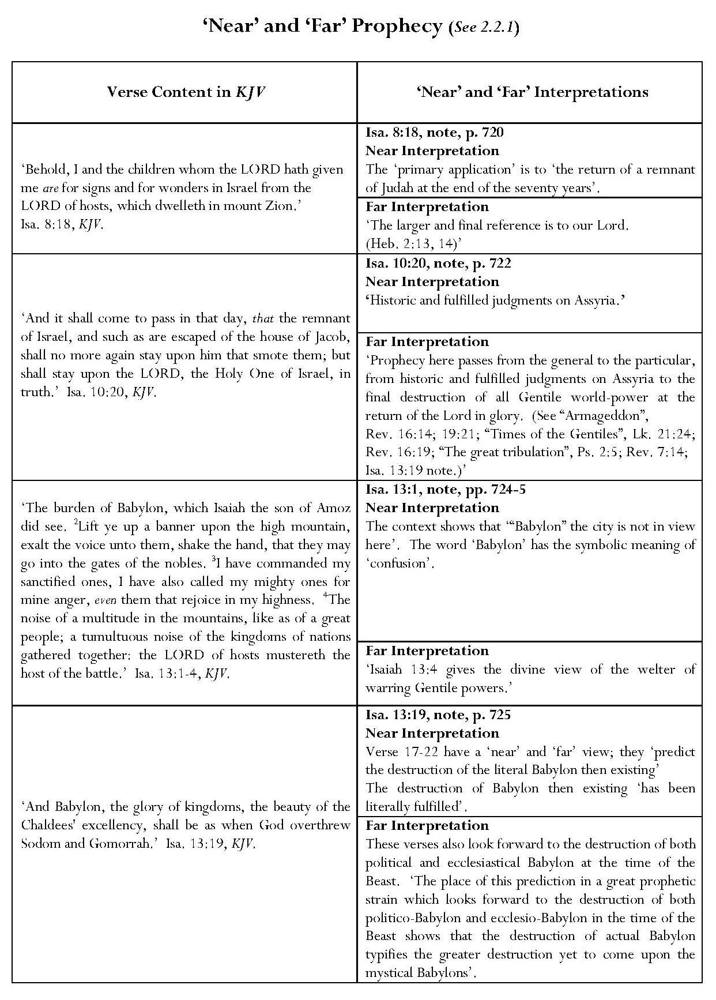

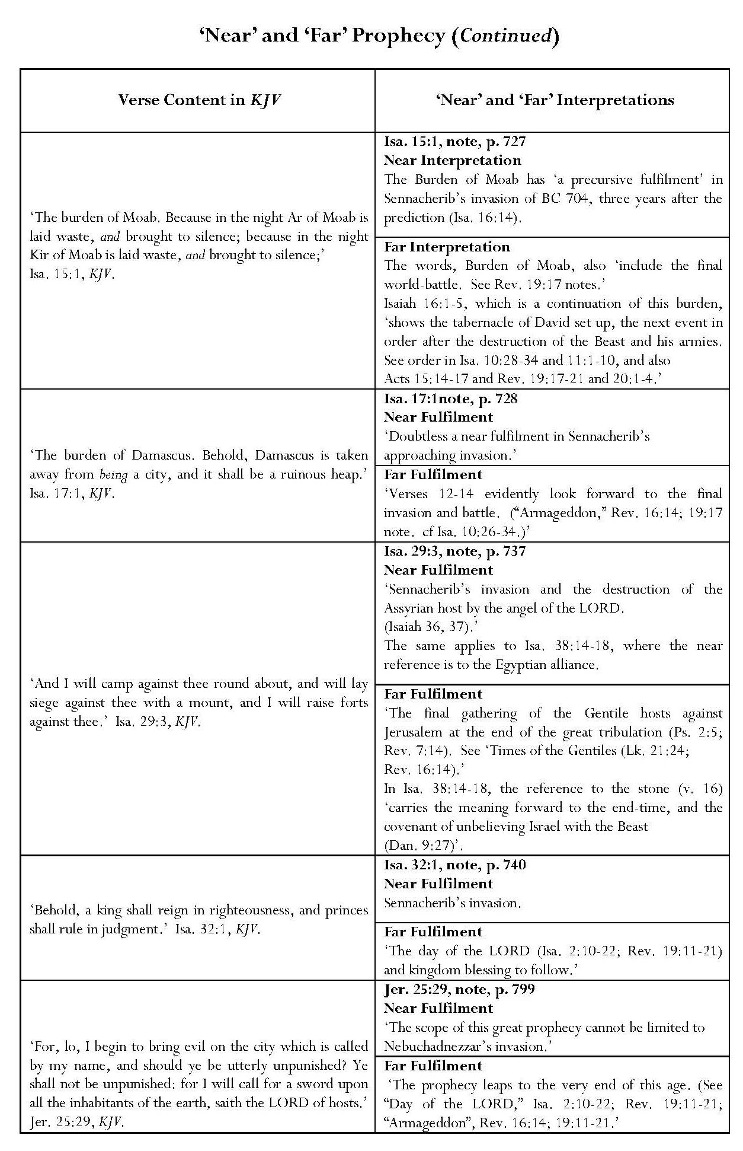

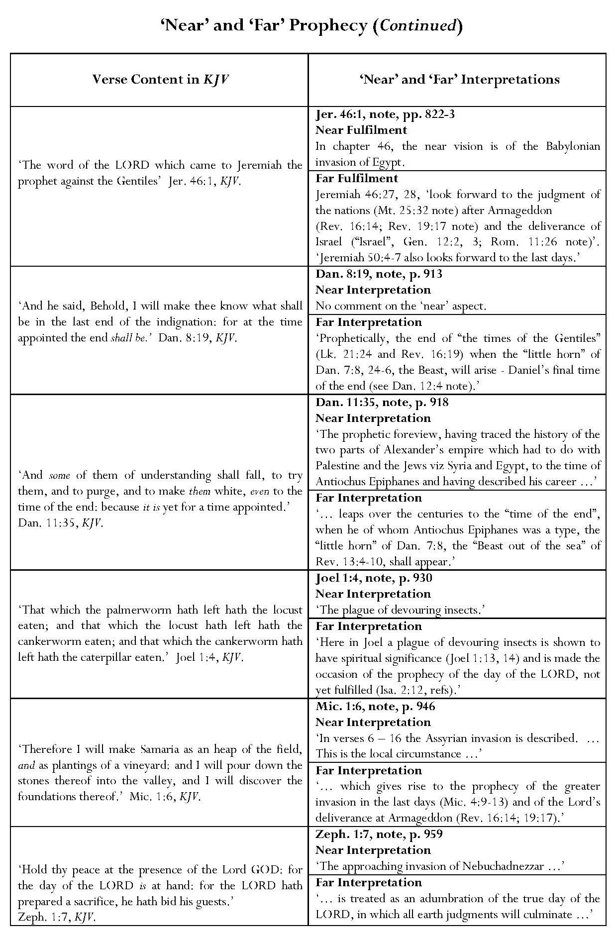

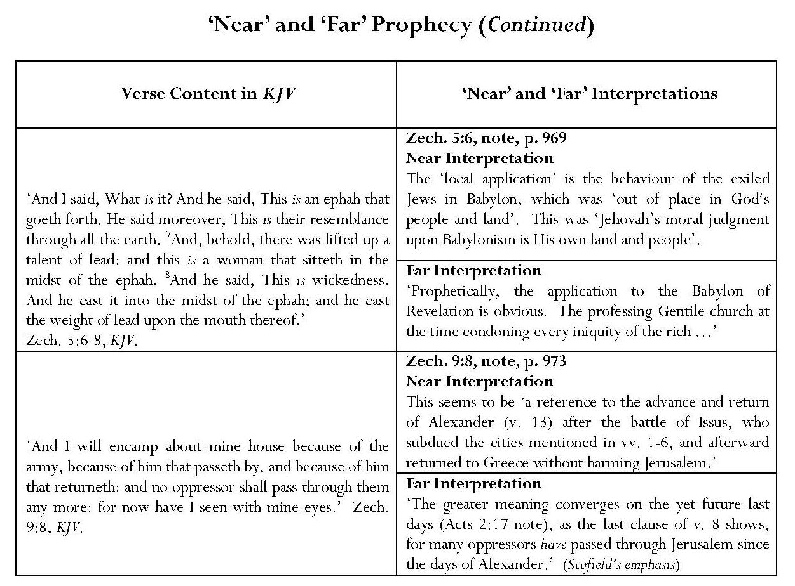

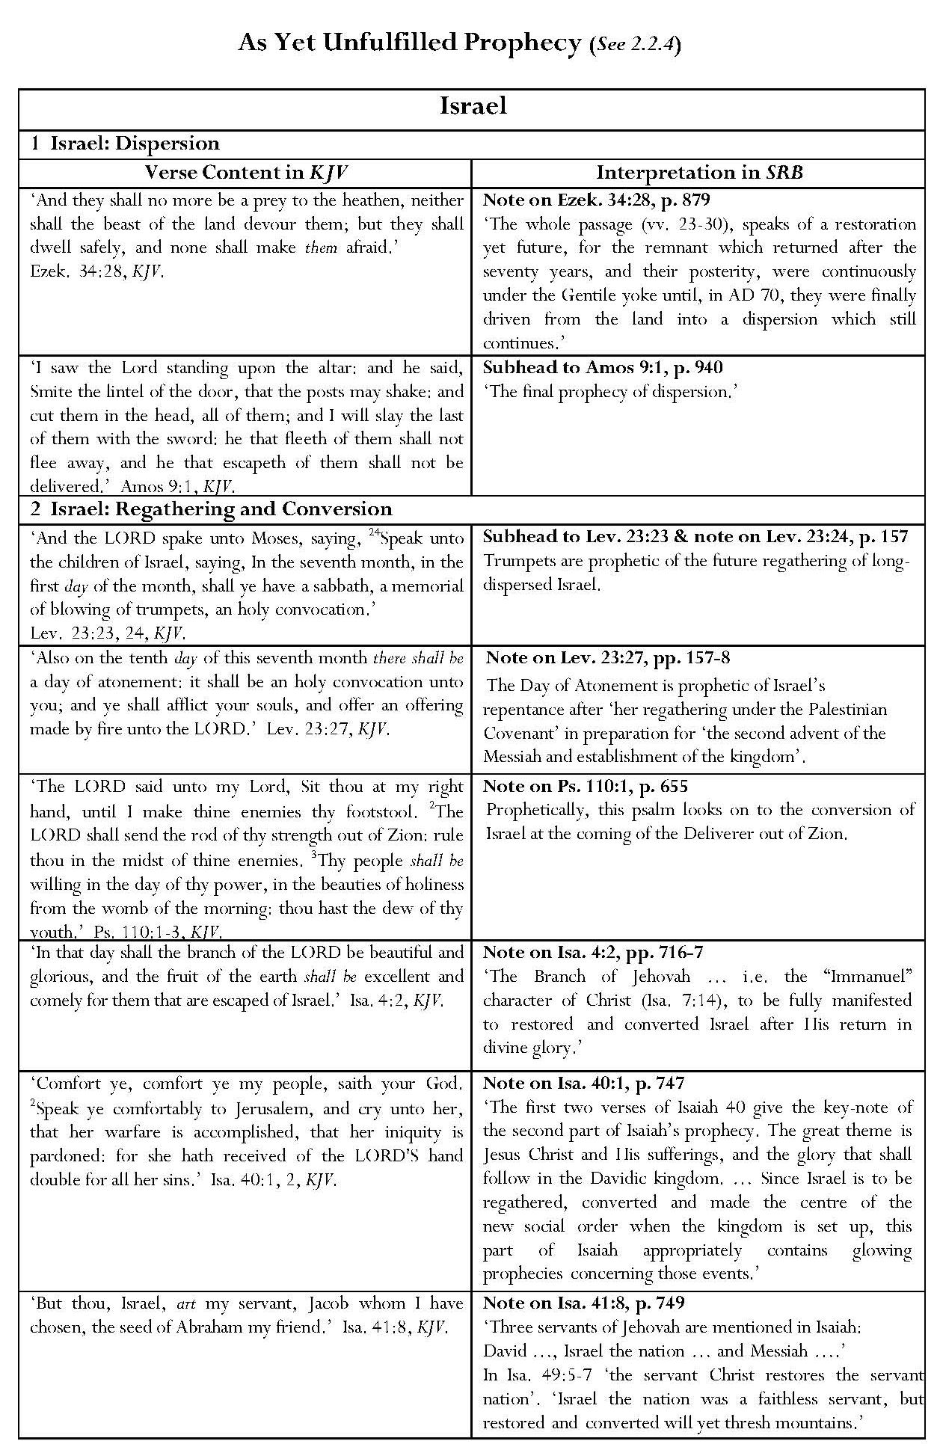
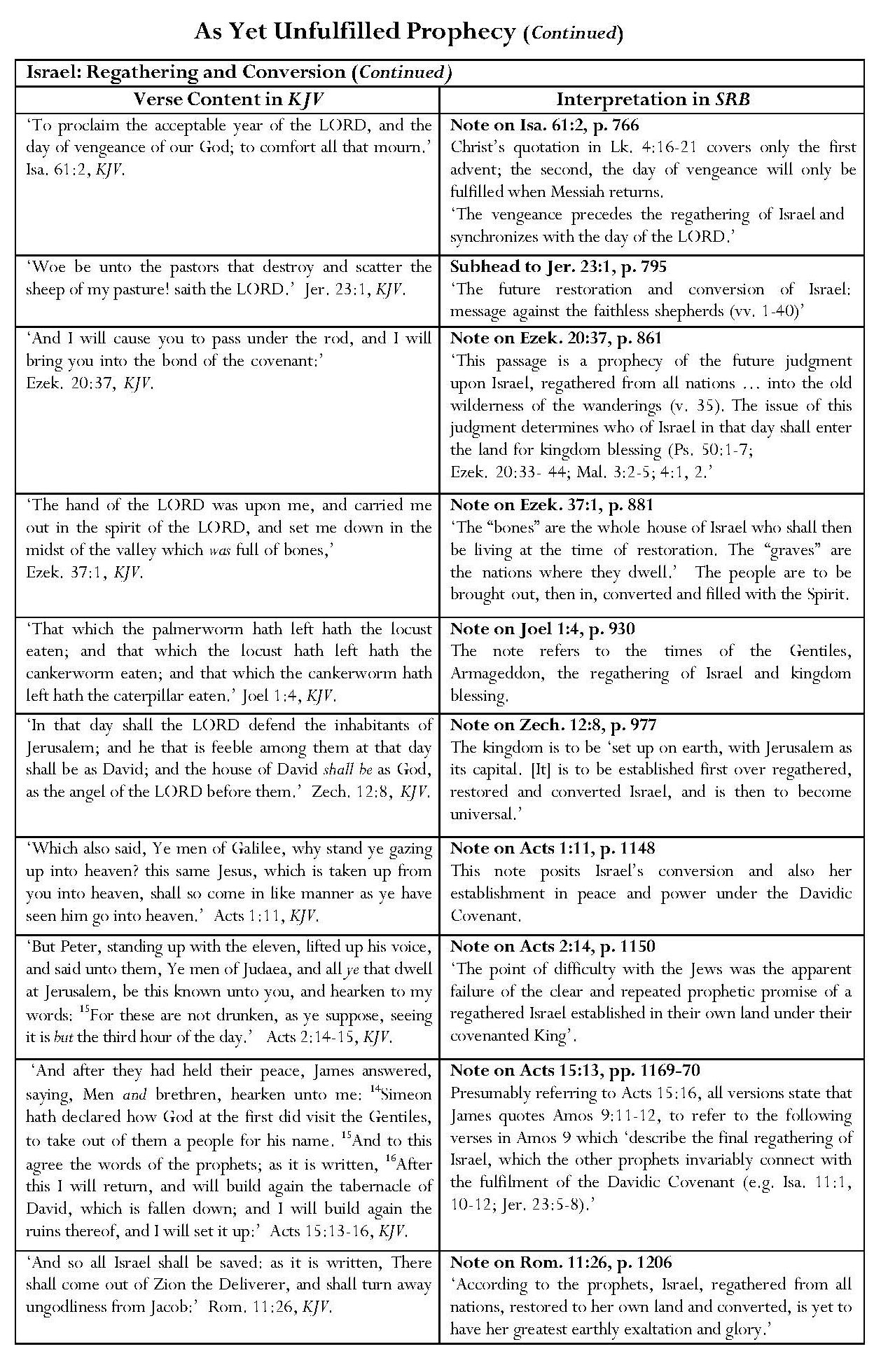

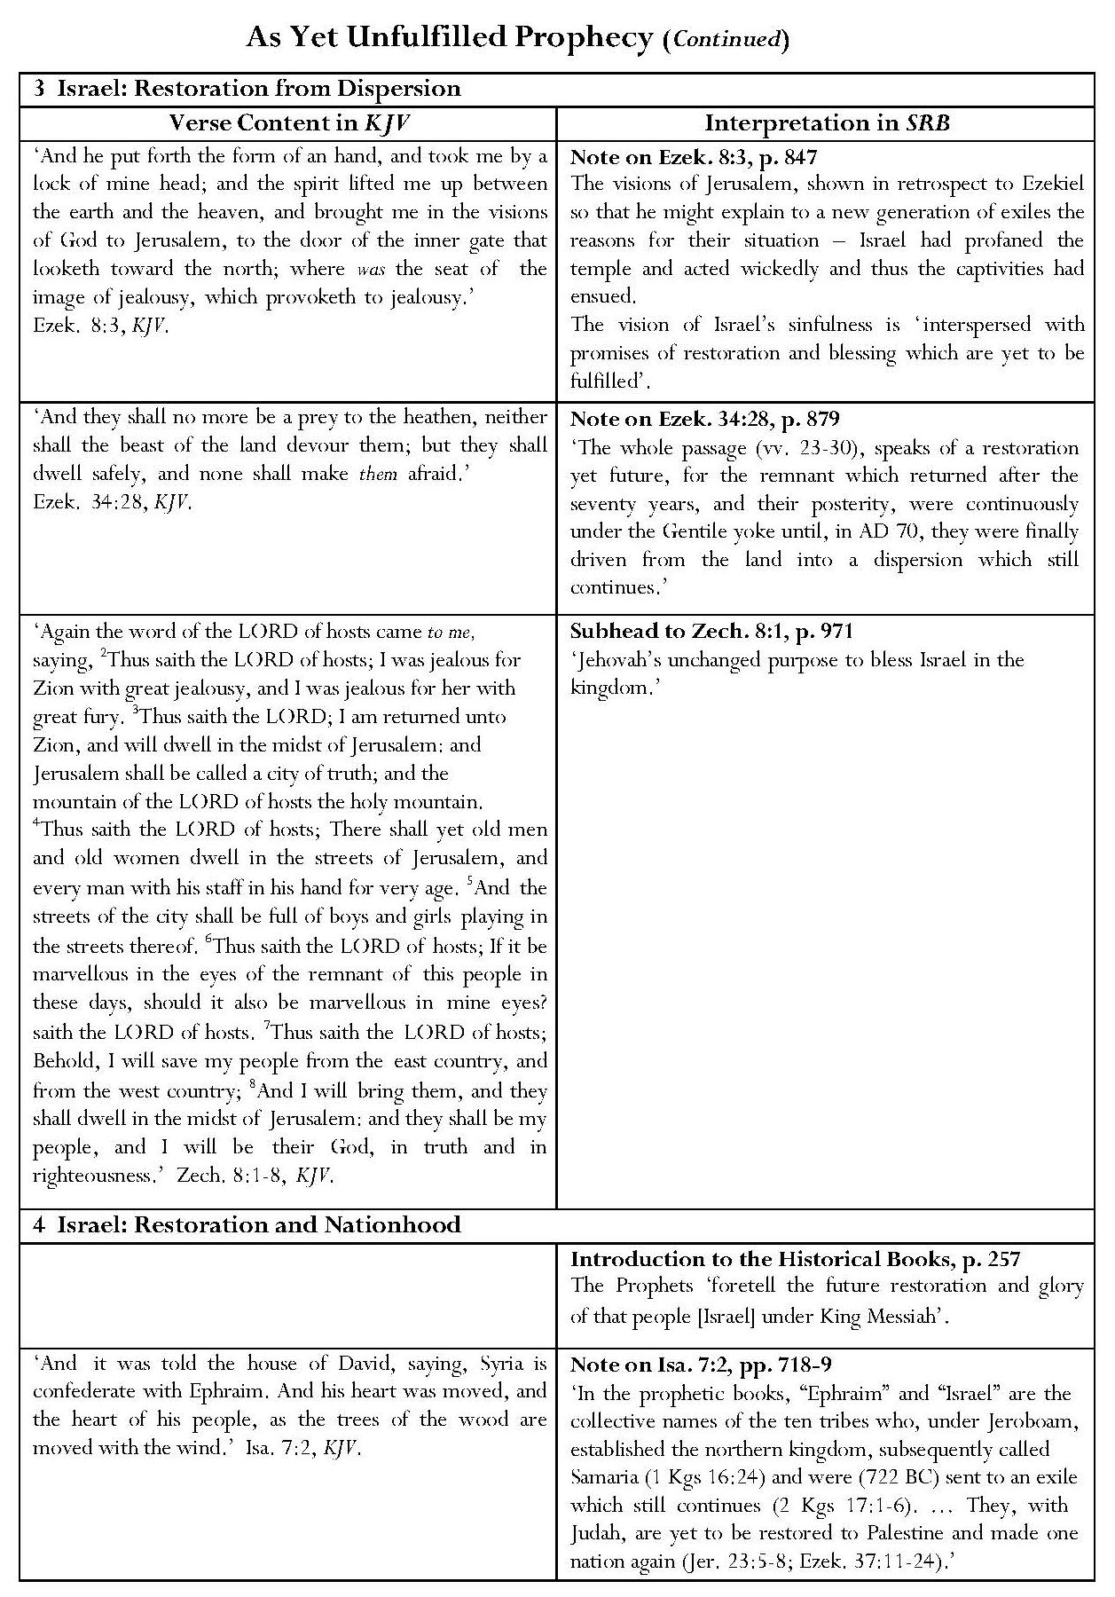

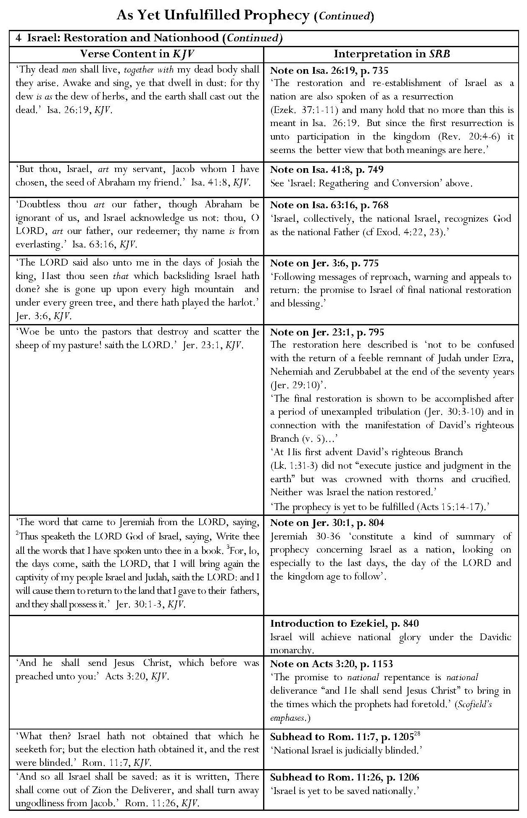

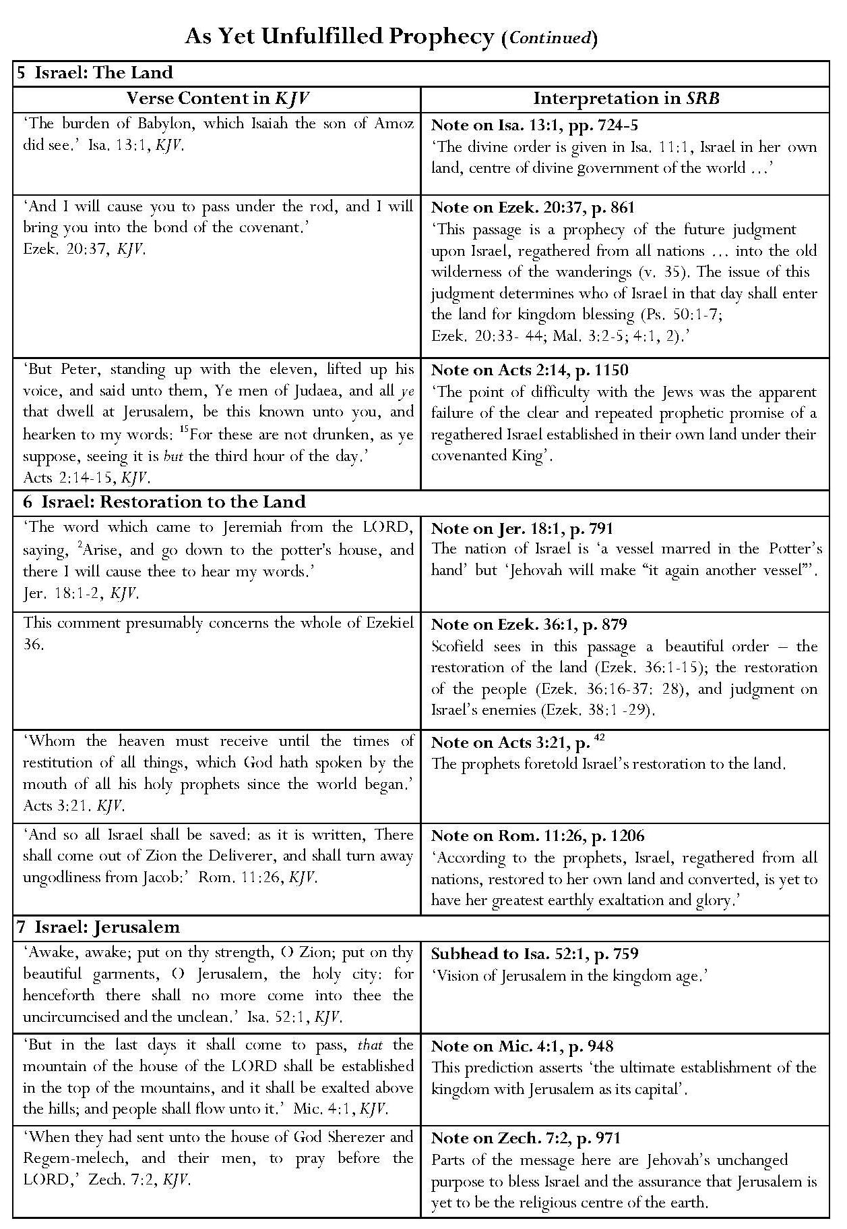

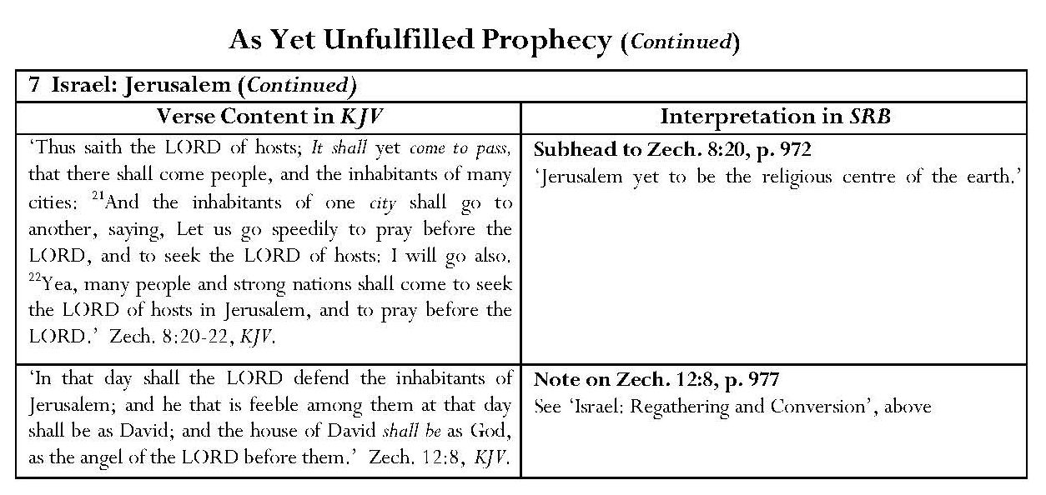
Continued overleaf

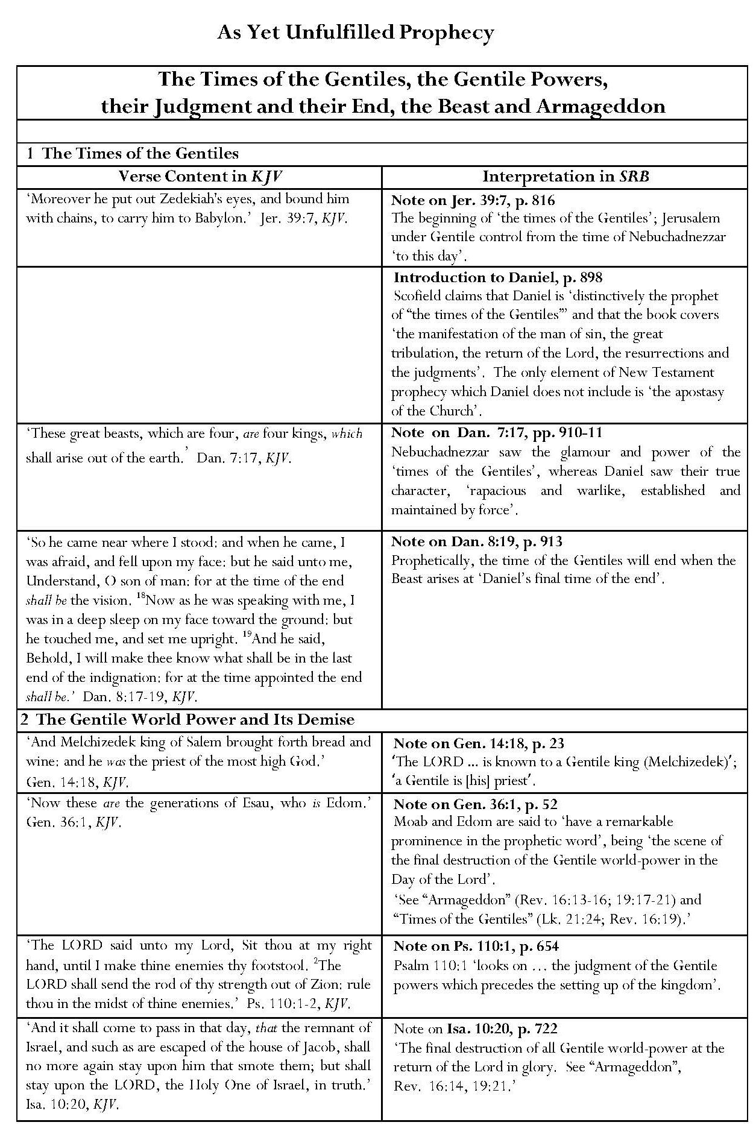

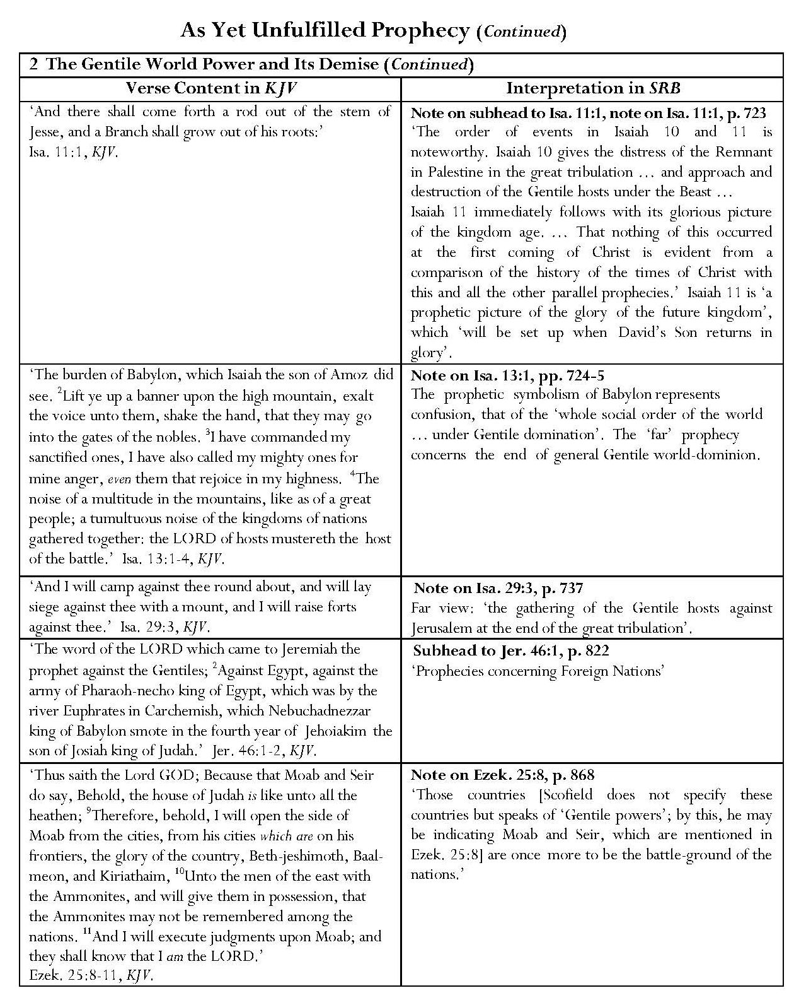

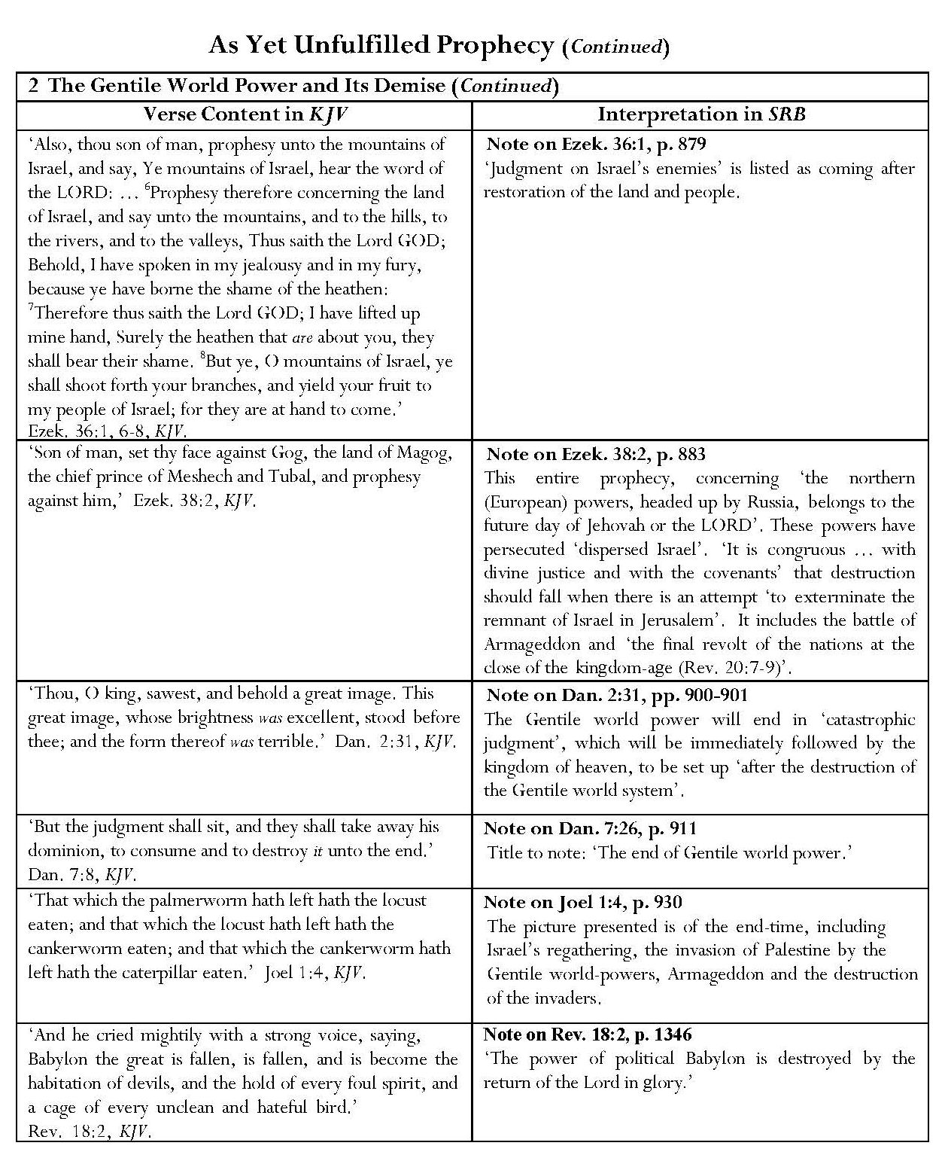

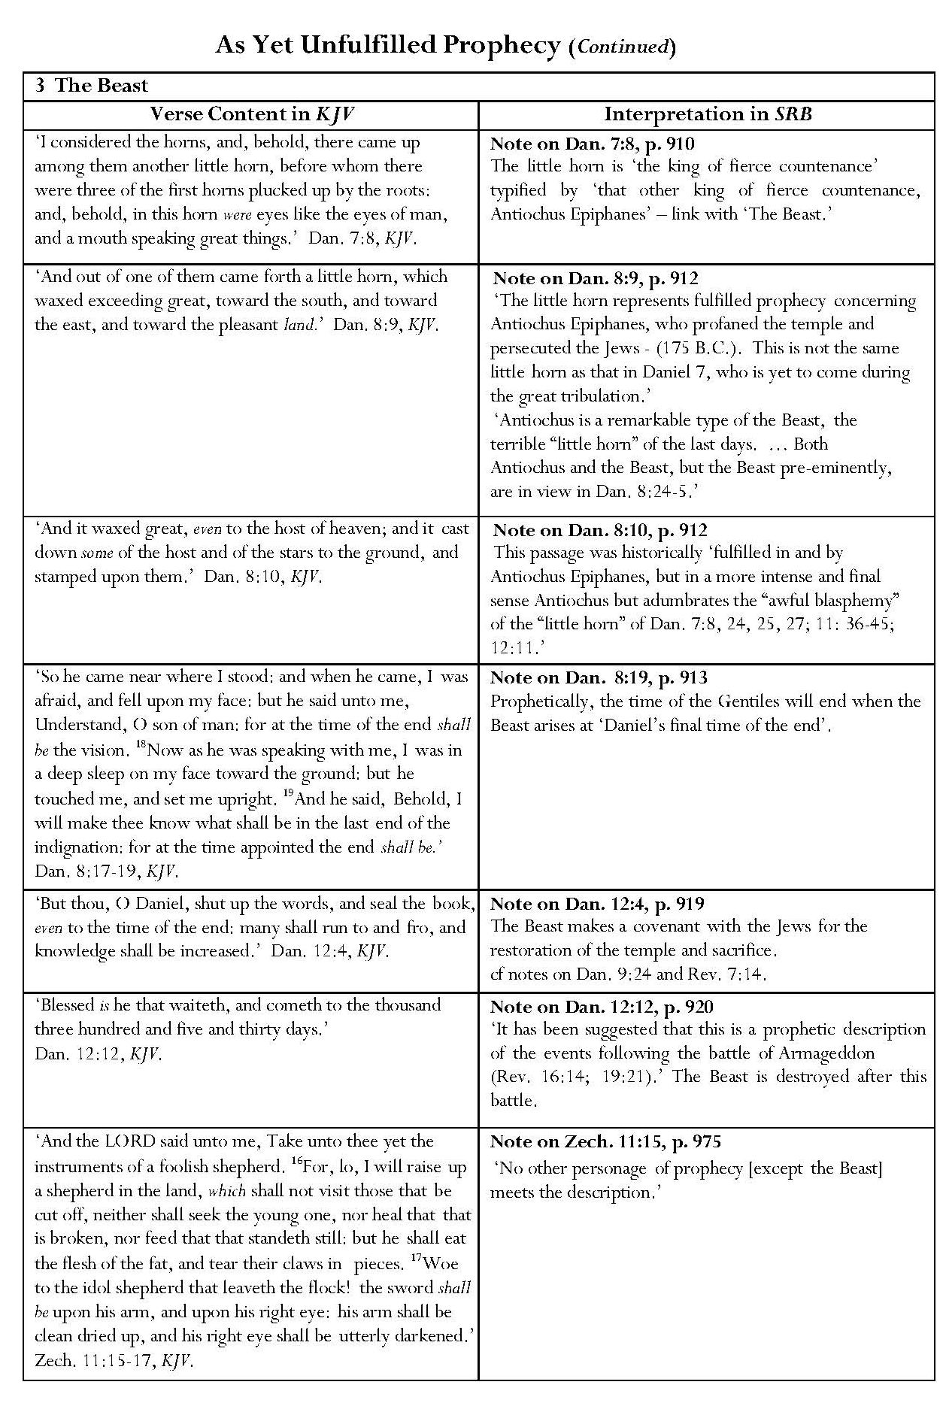

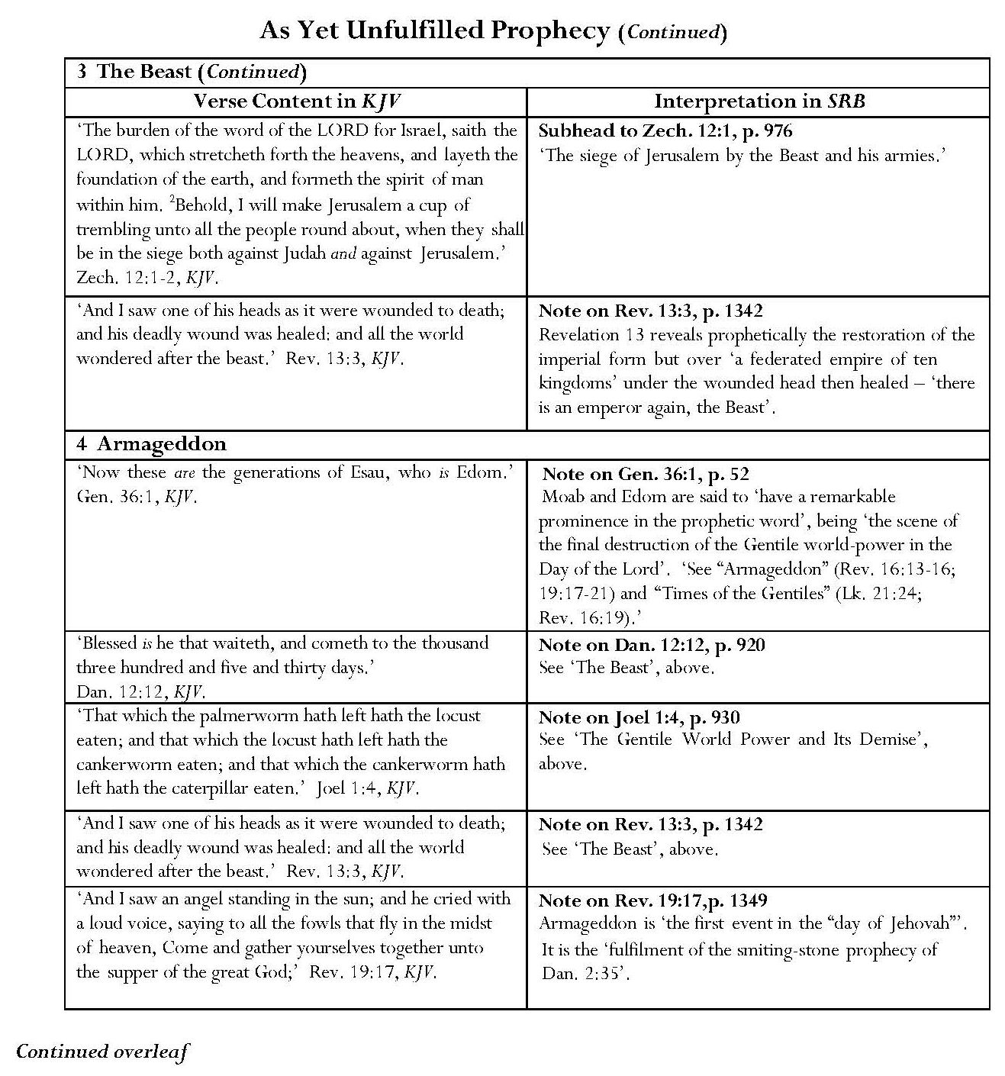

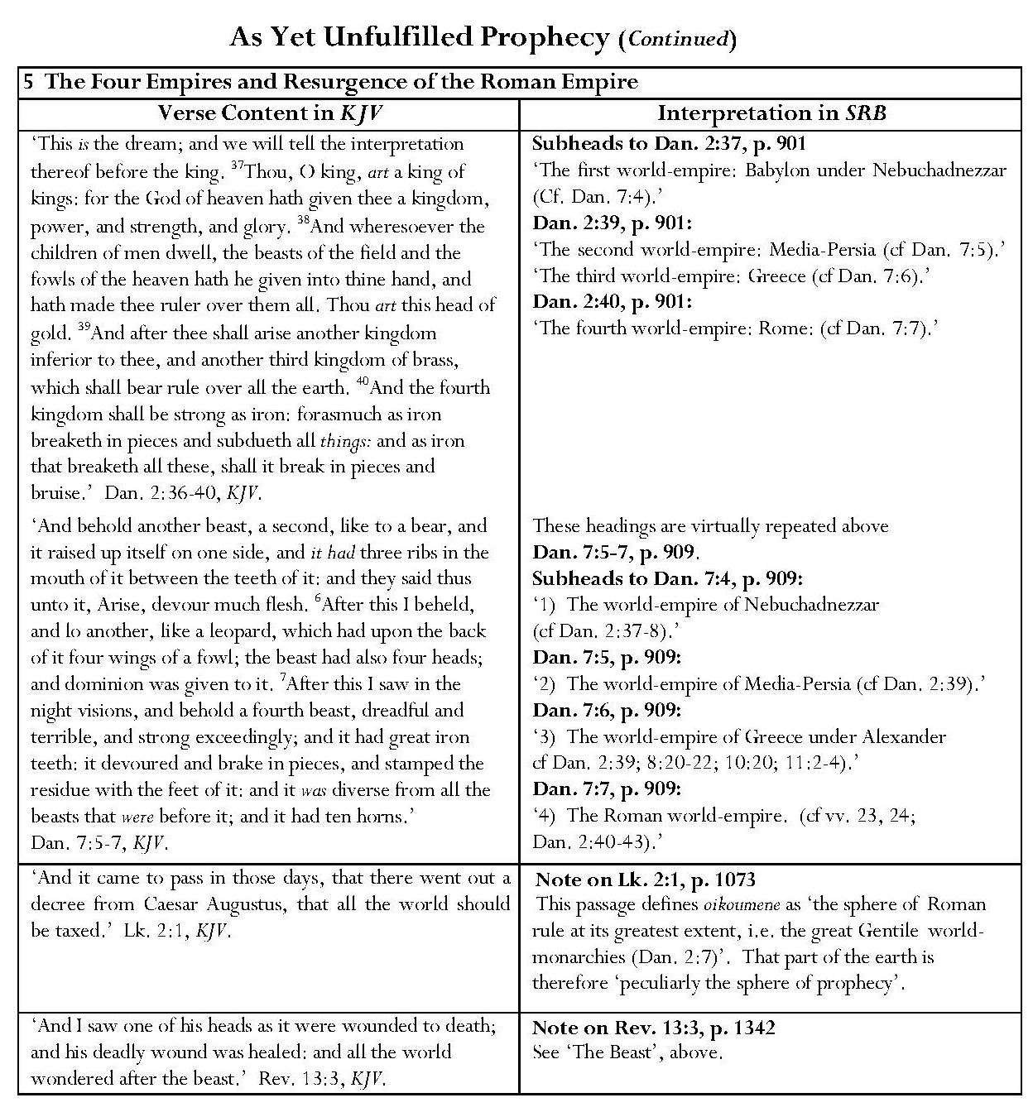

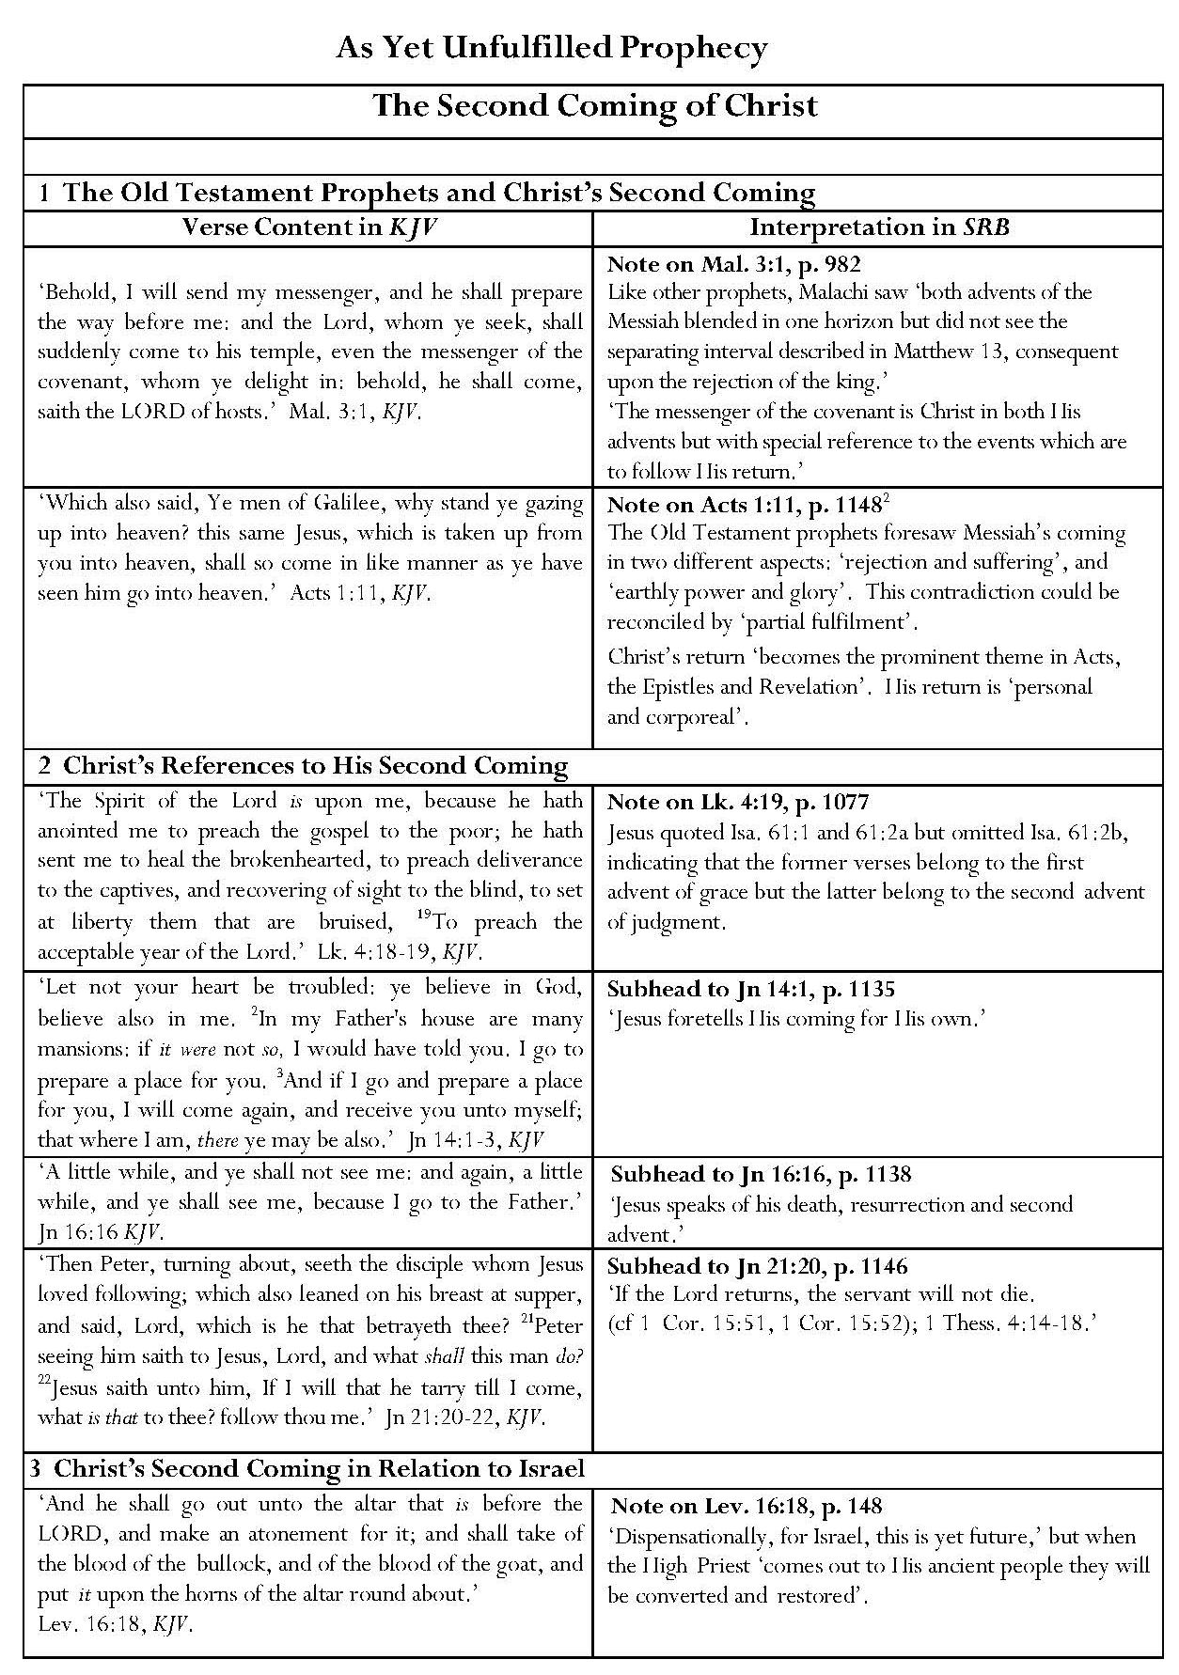

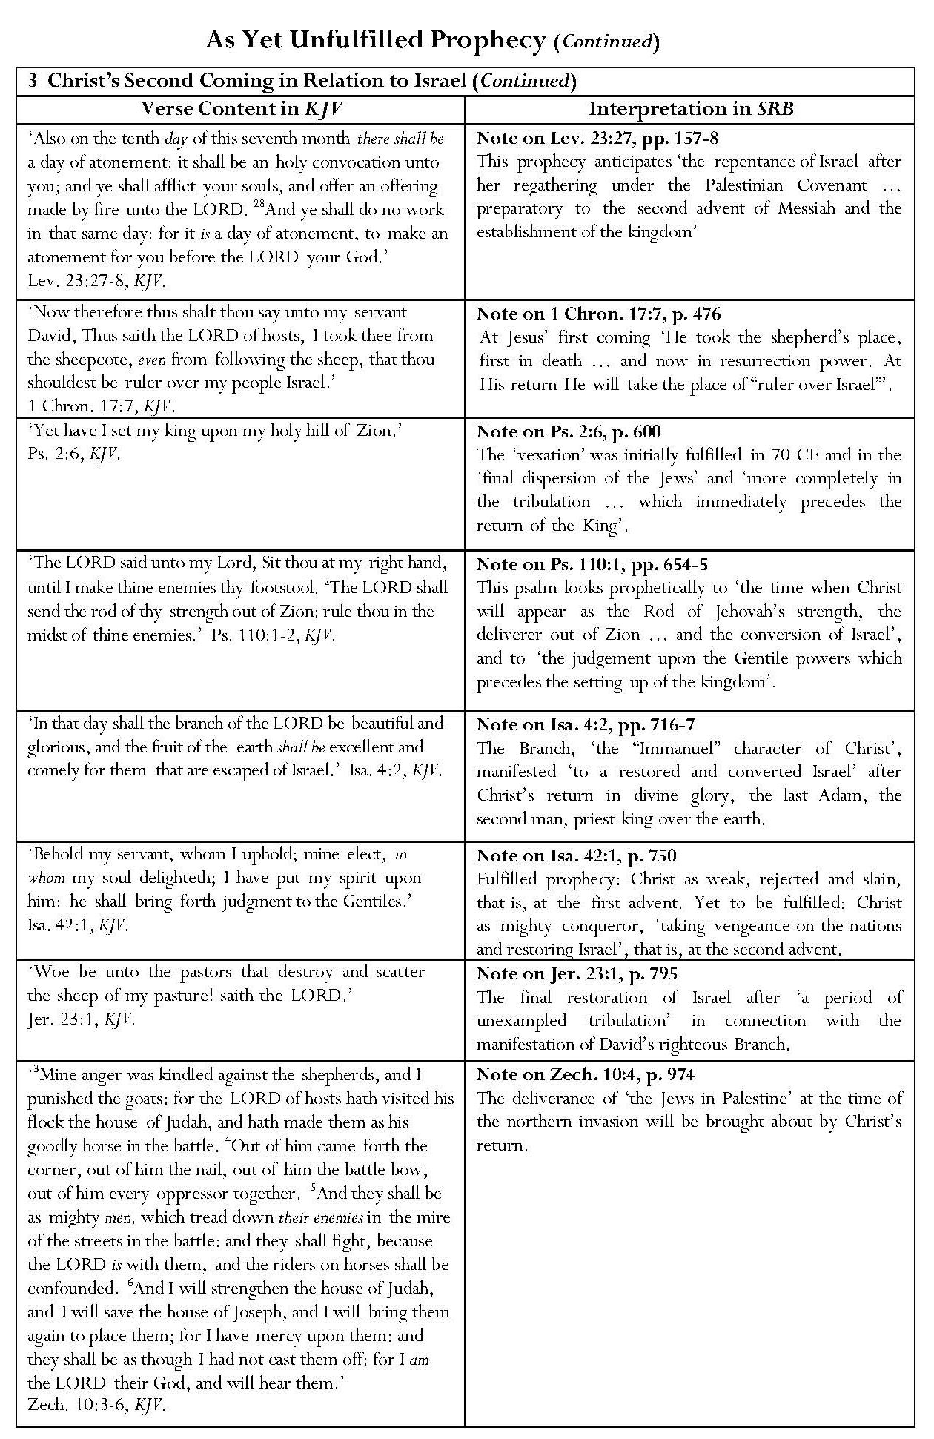

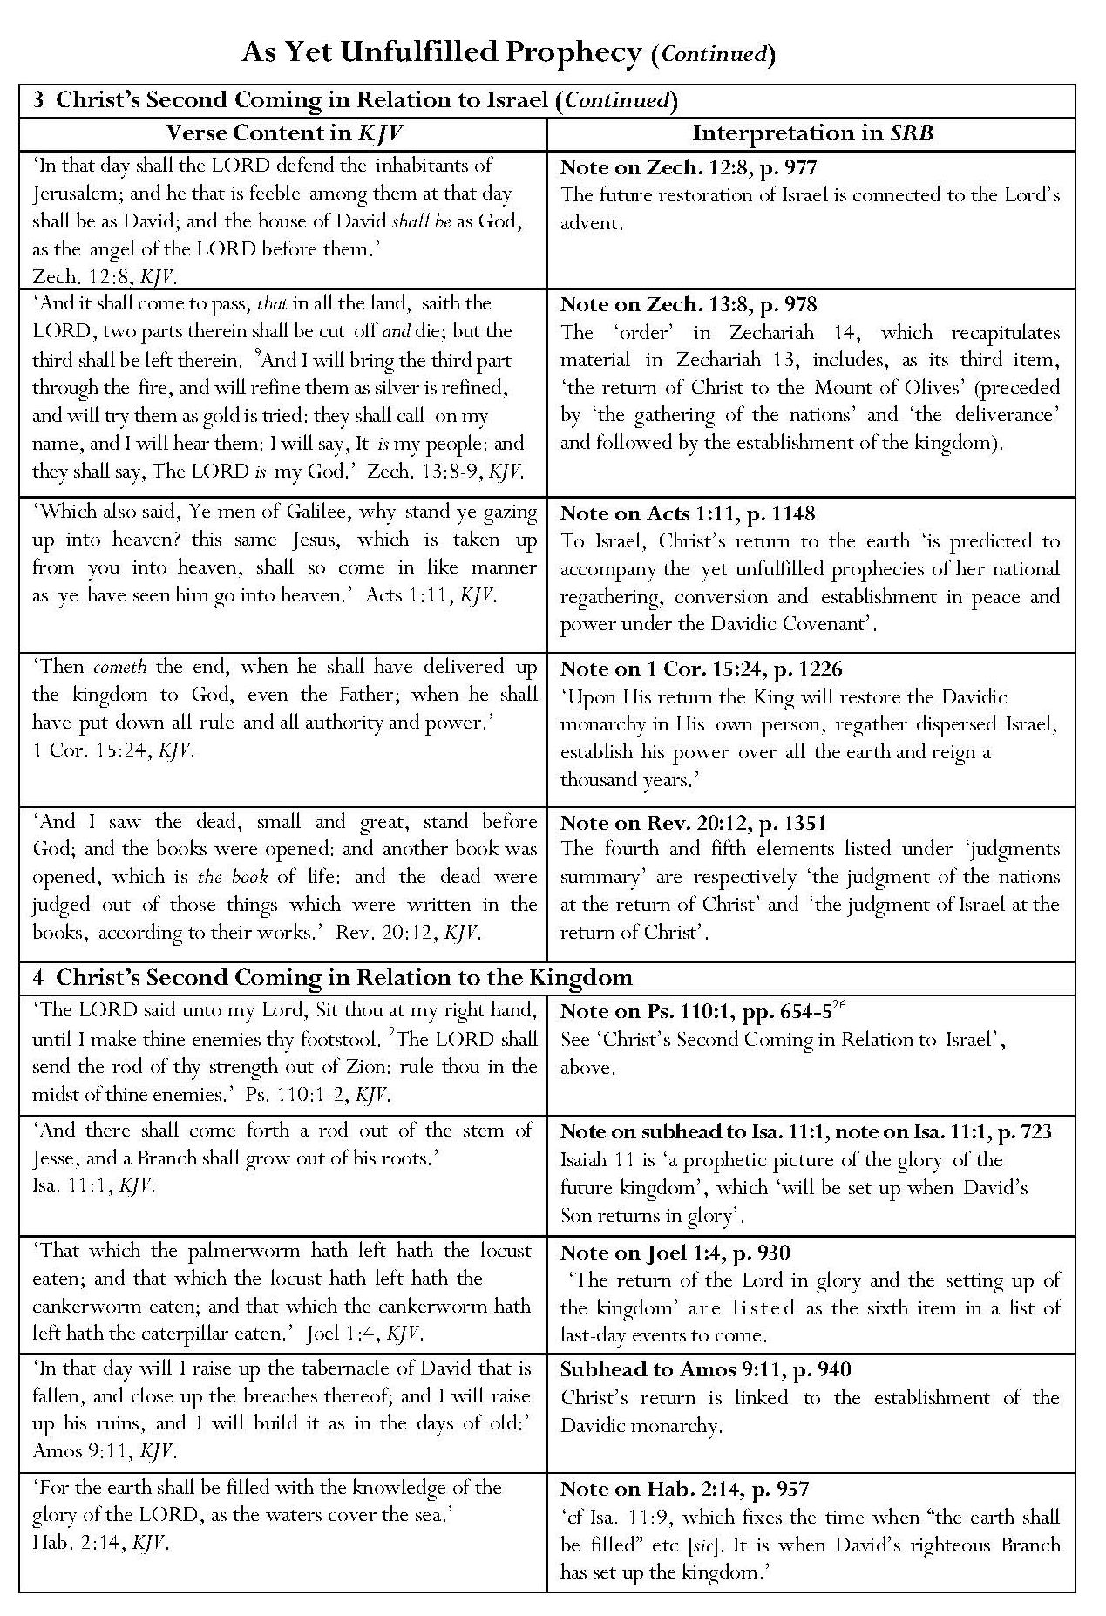

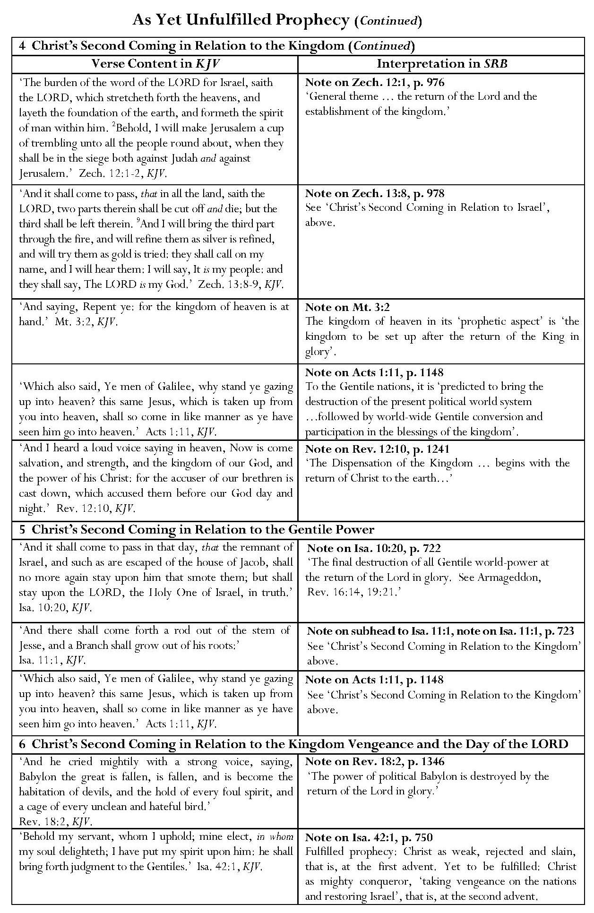

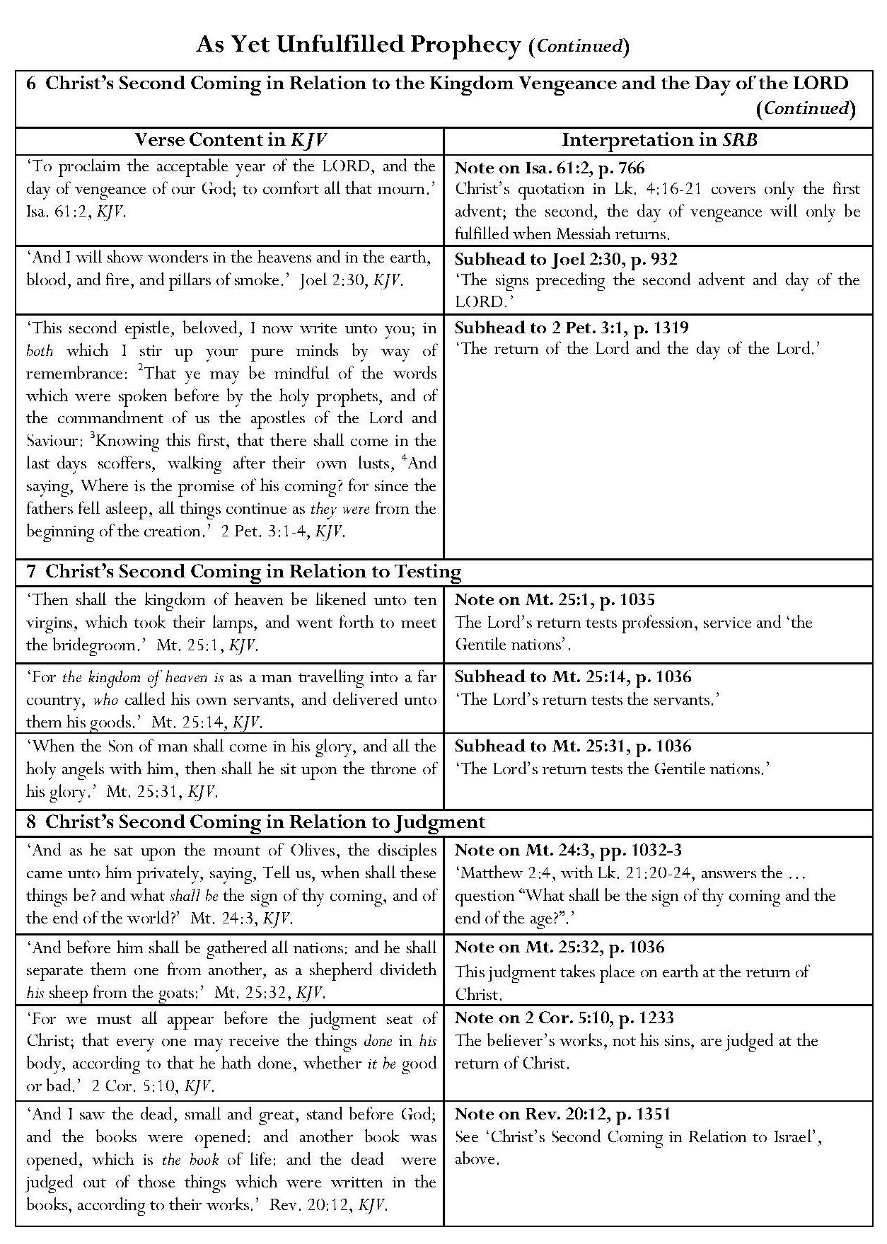

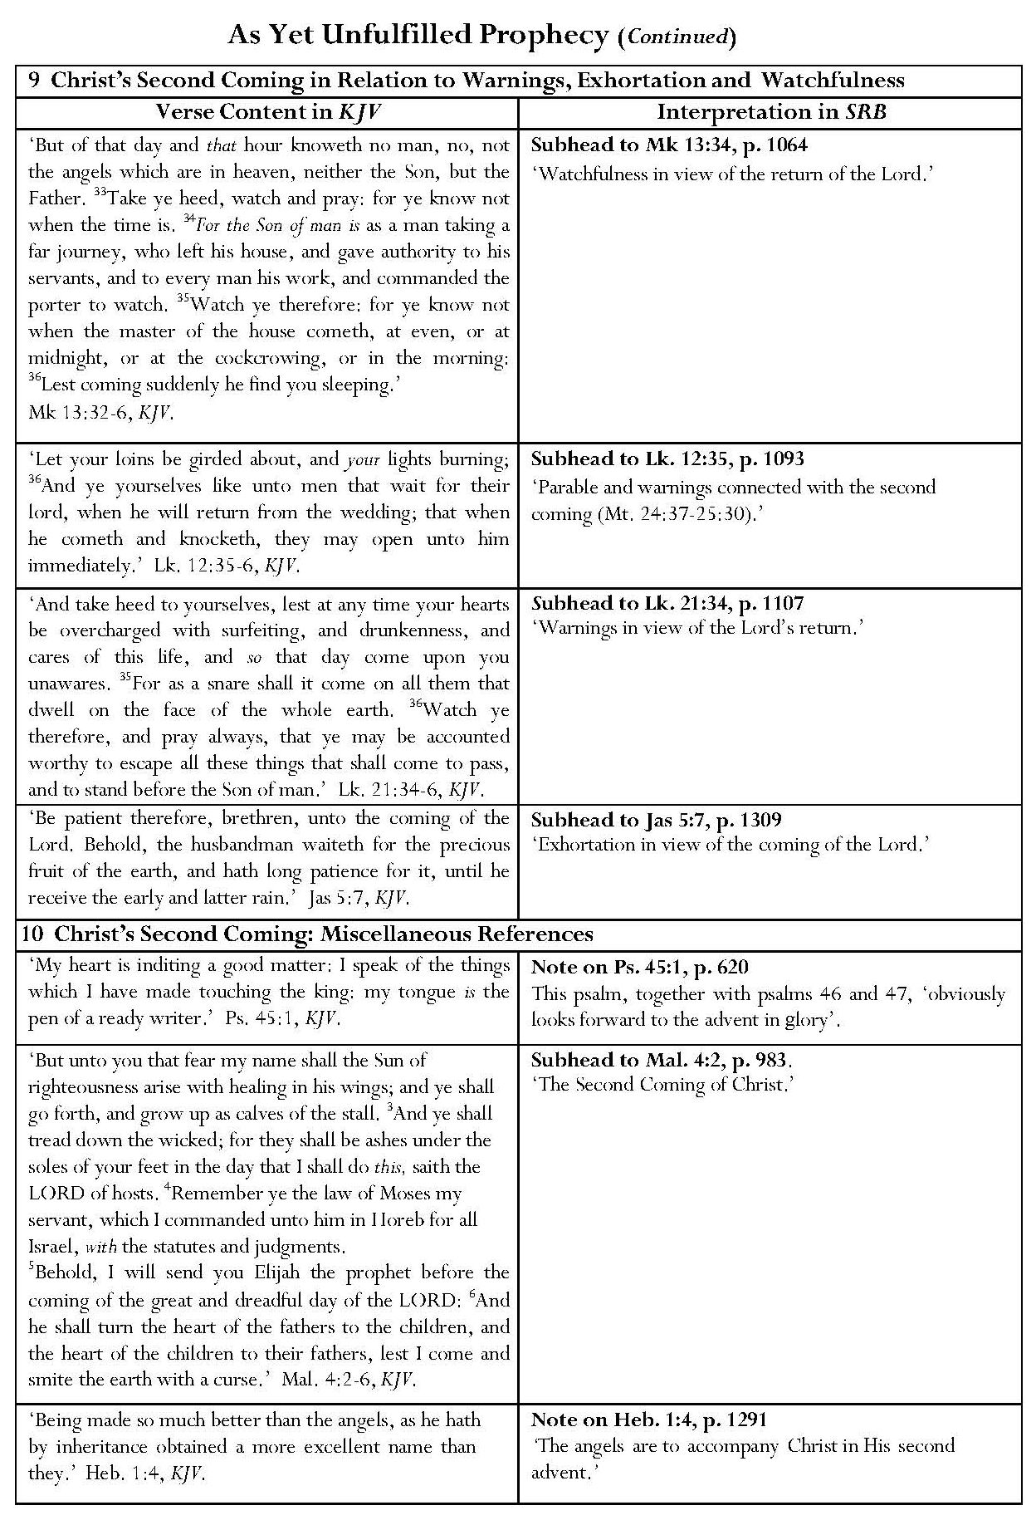

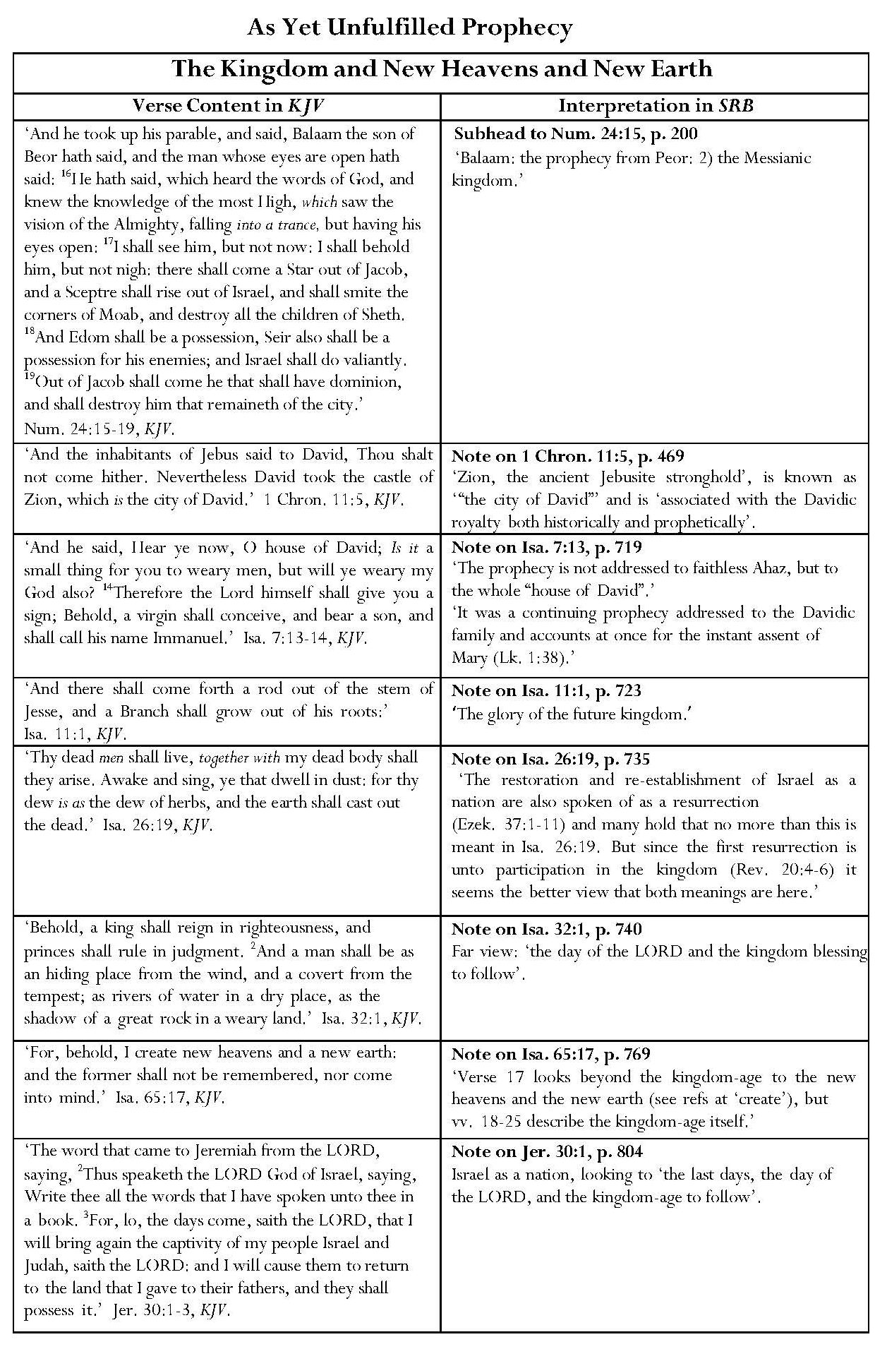

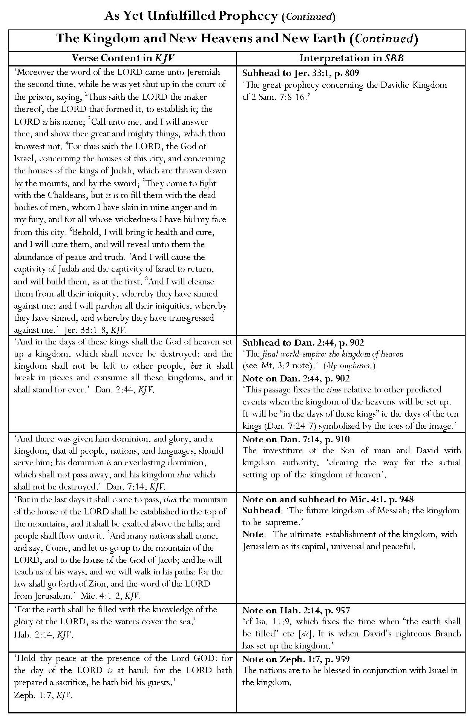

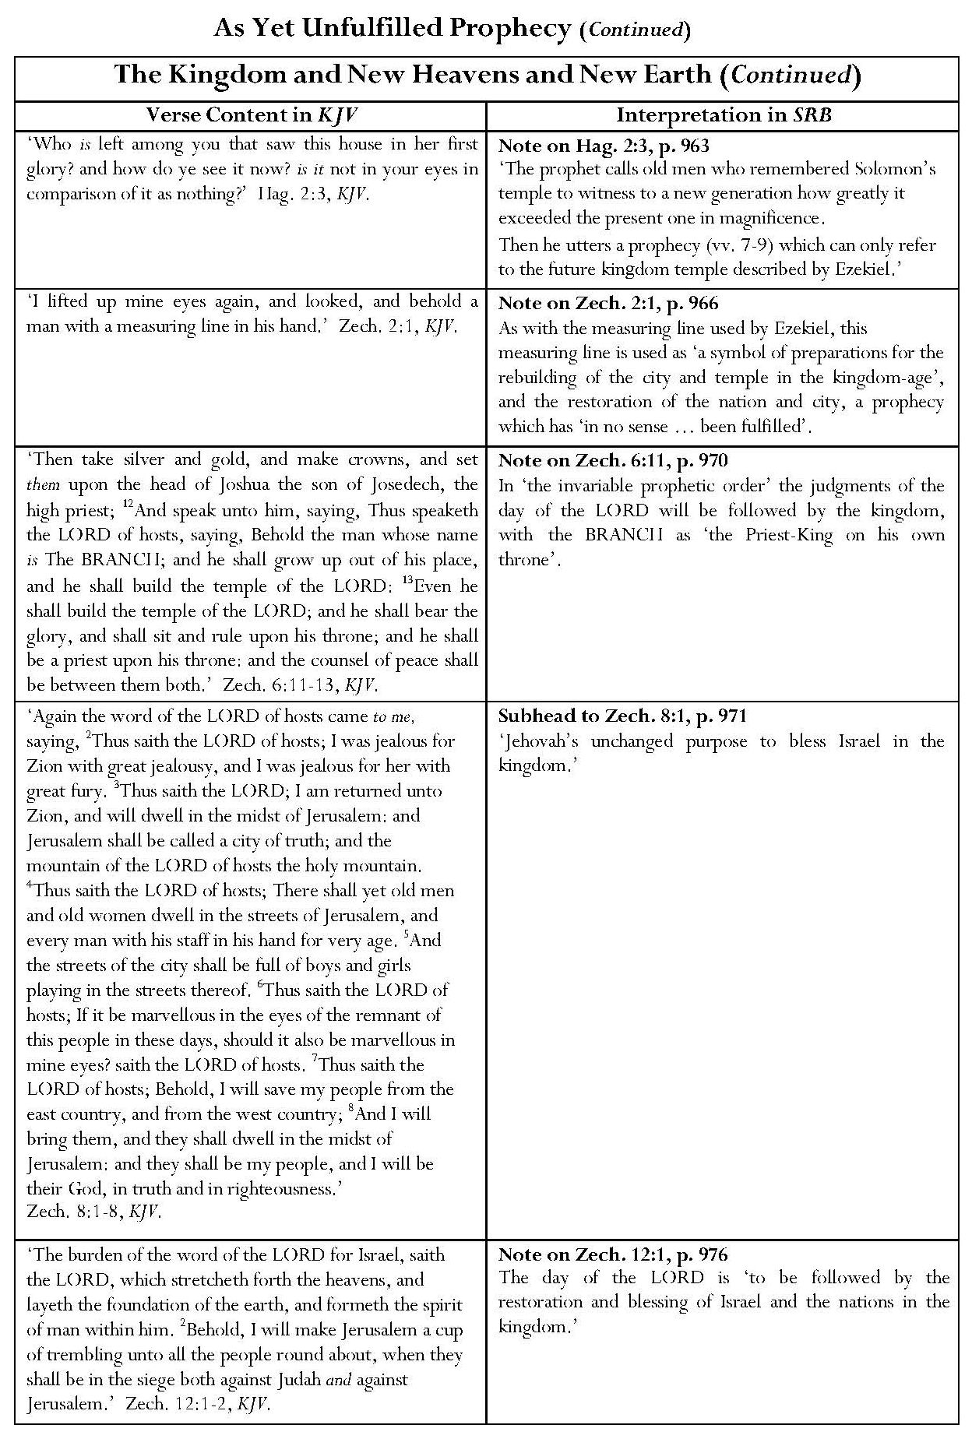

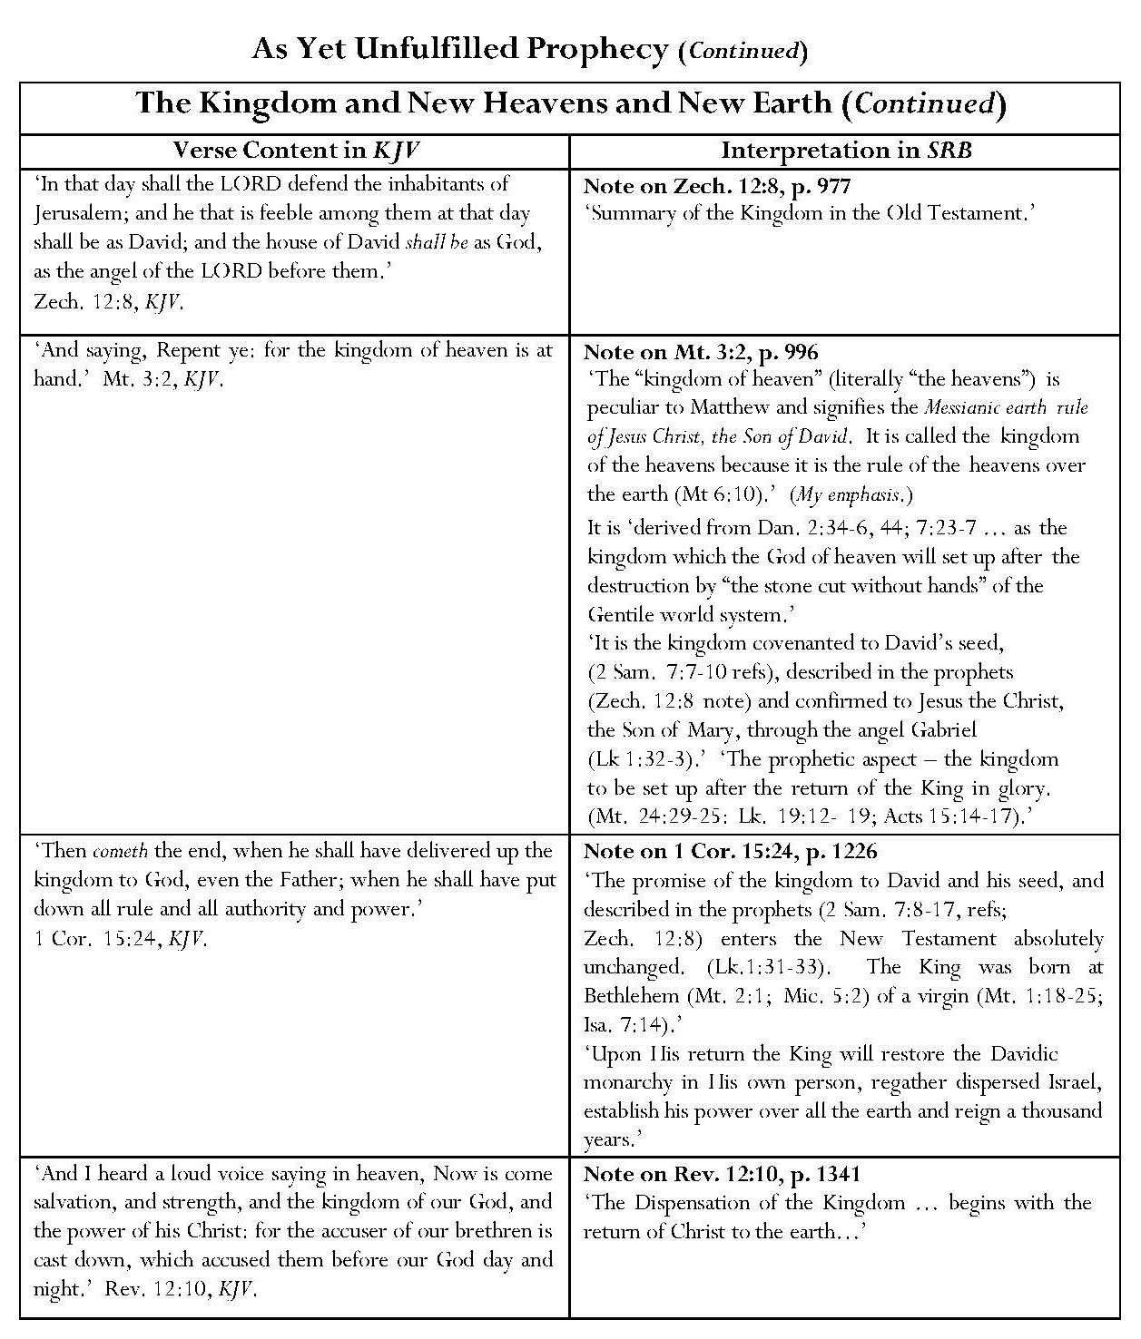

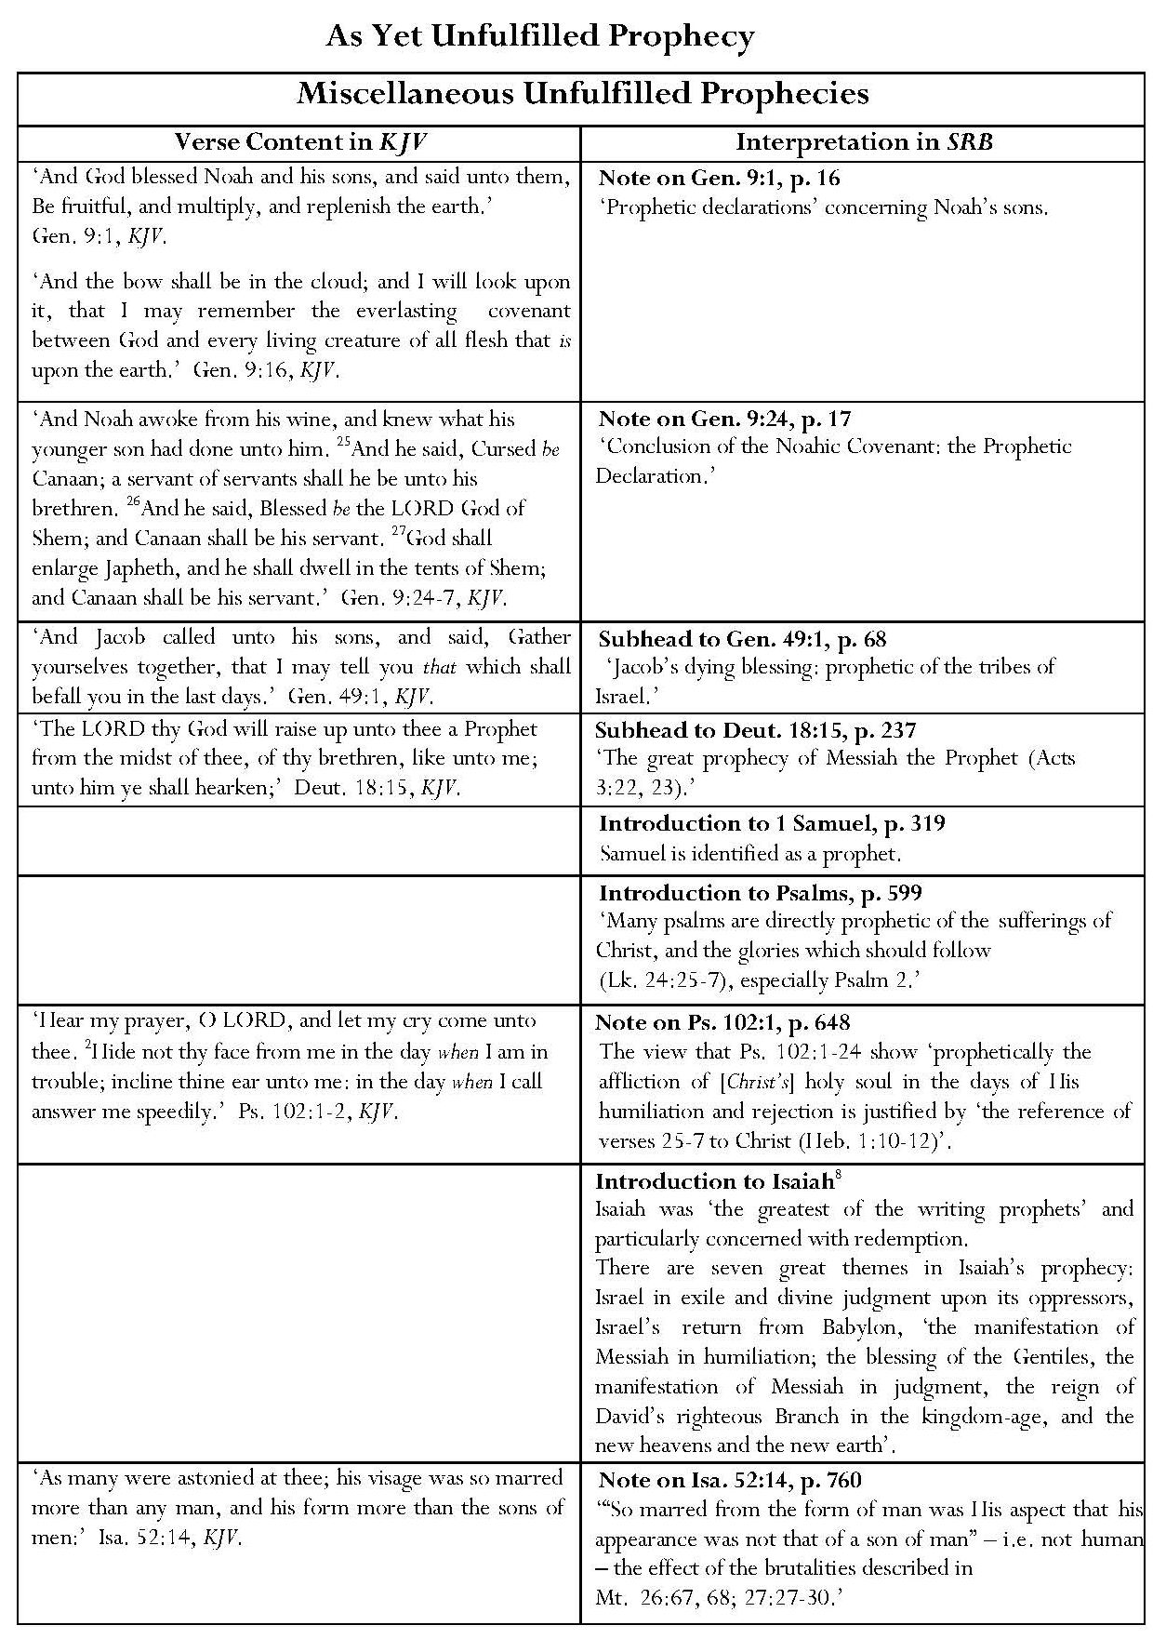

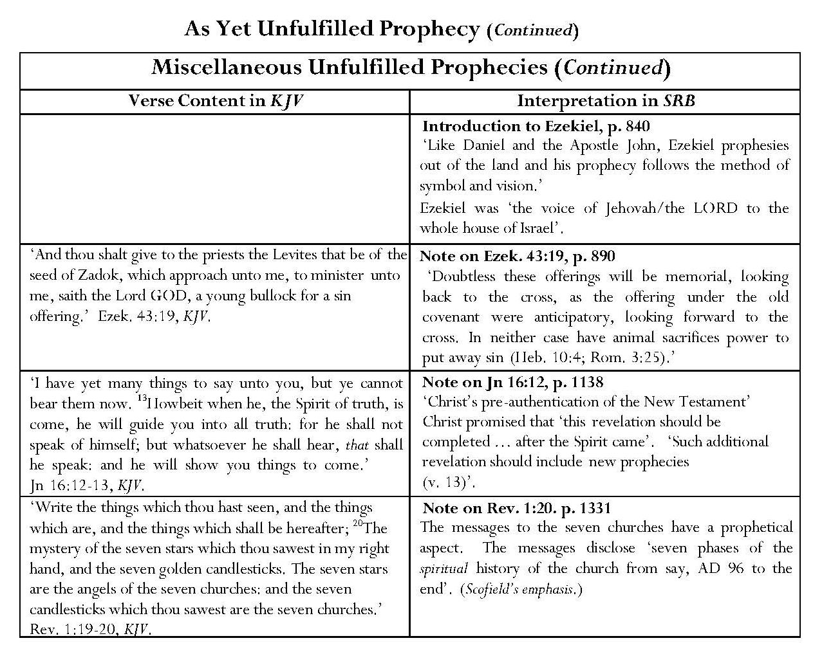

TABLES ON WHICH THE GRAPHS IN CHAPTER 8 ARE BASED
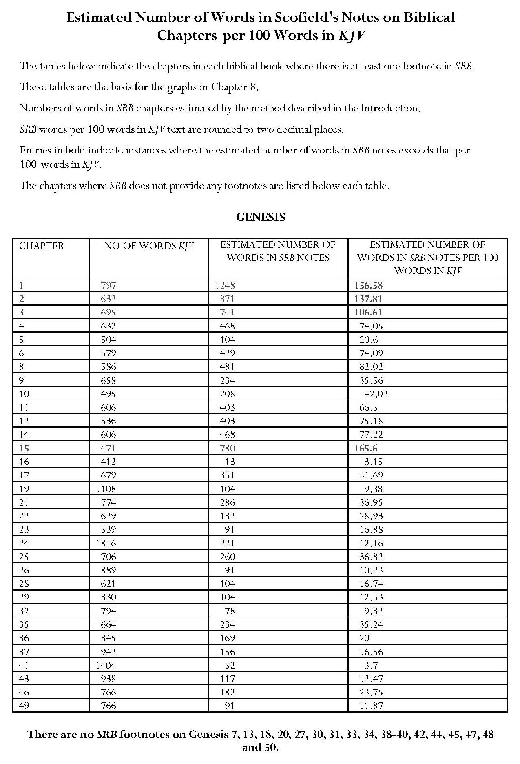

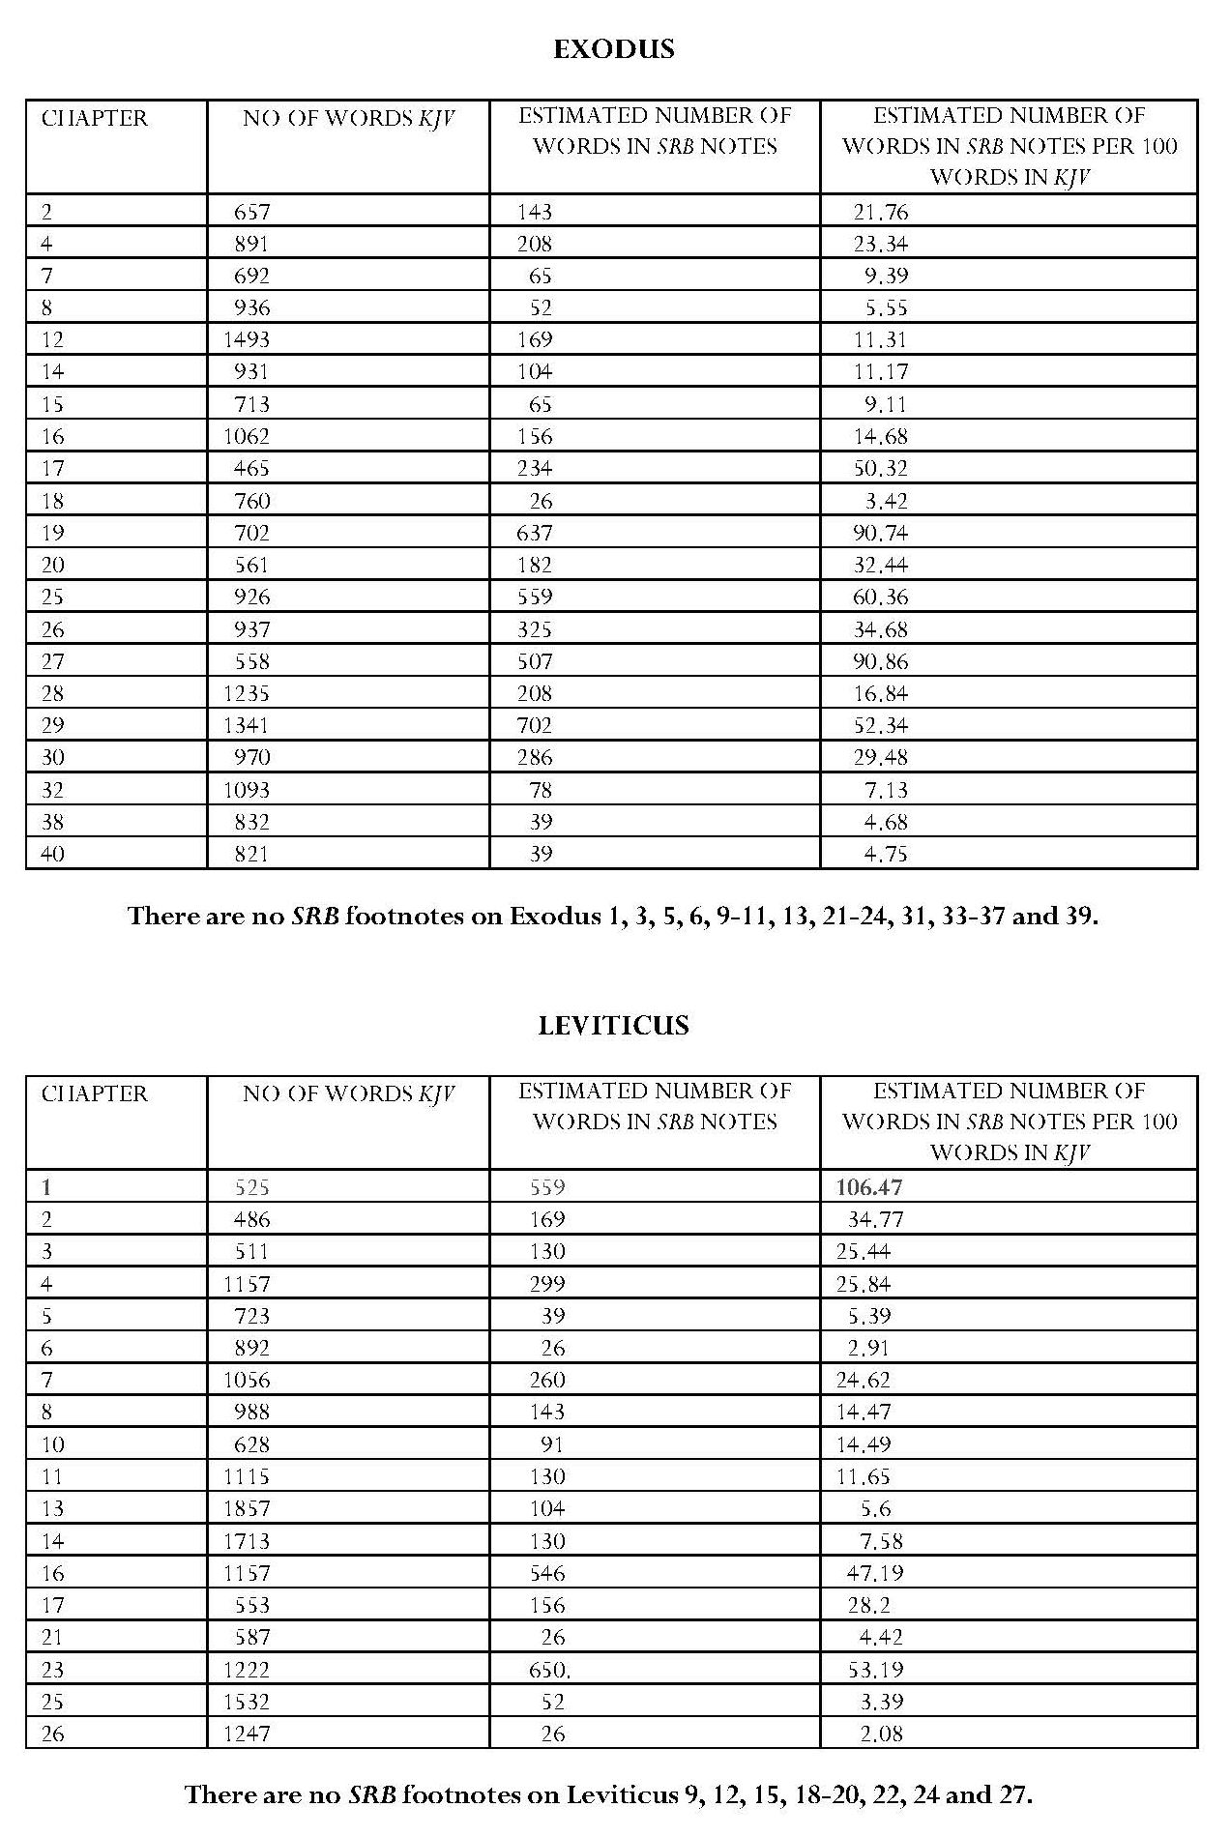

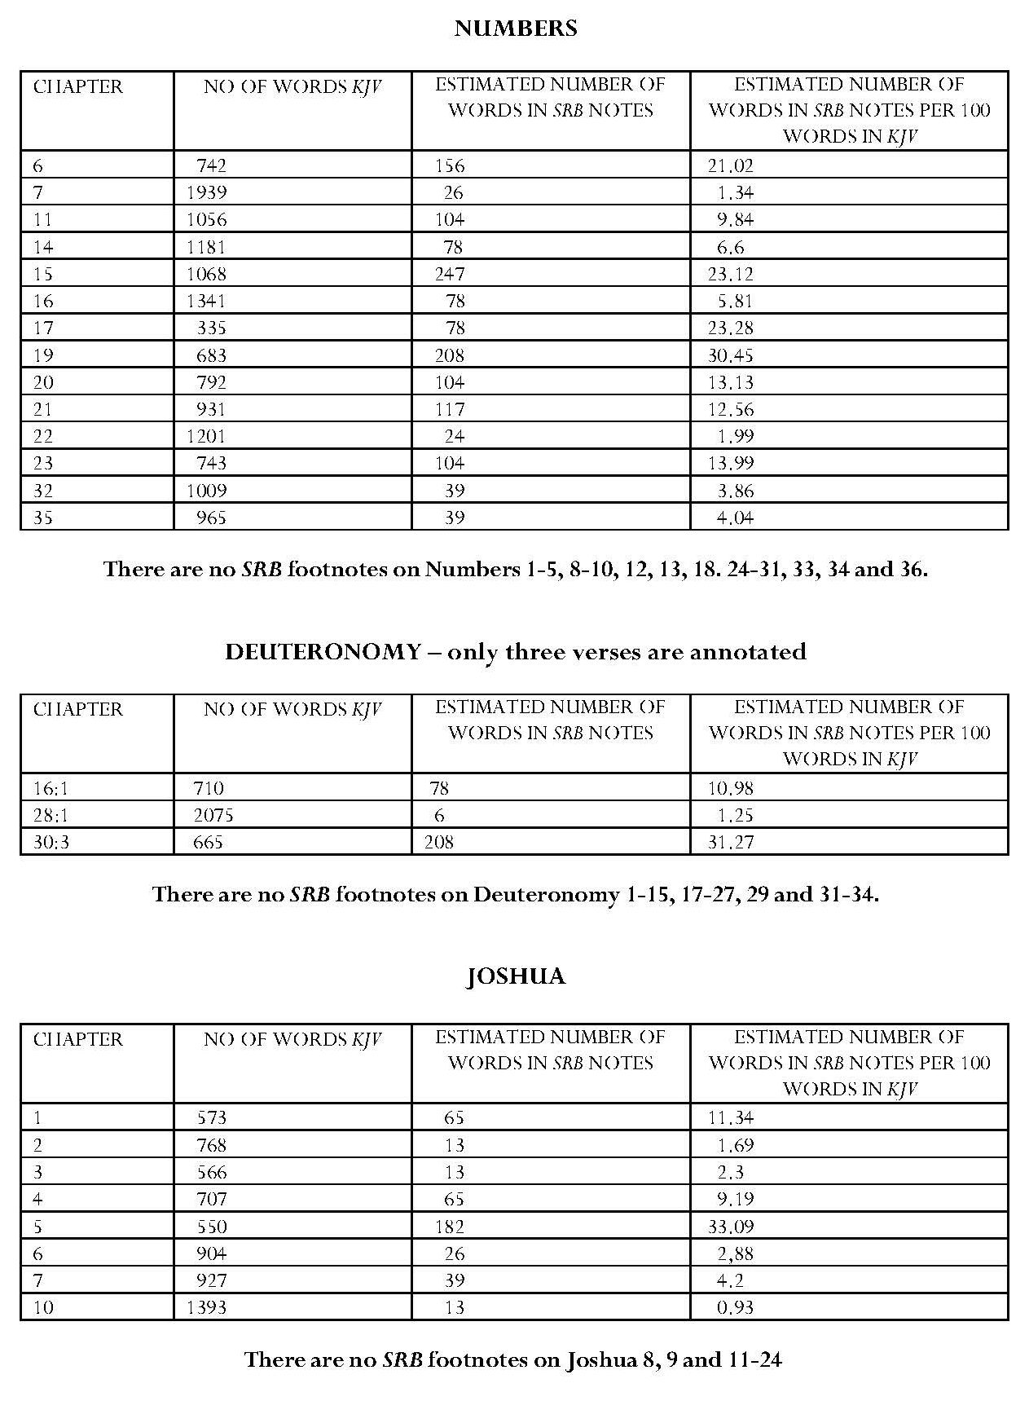

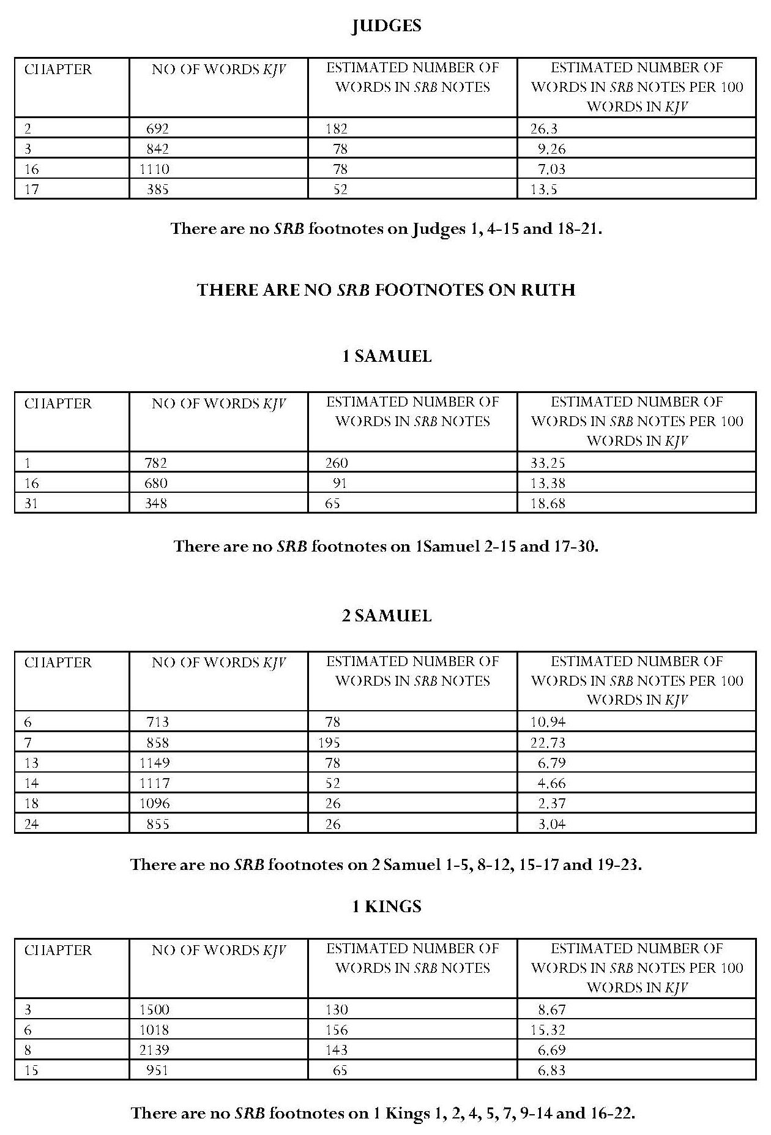

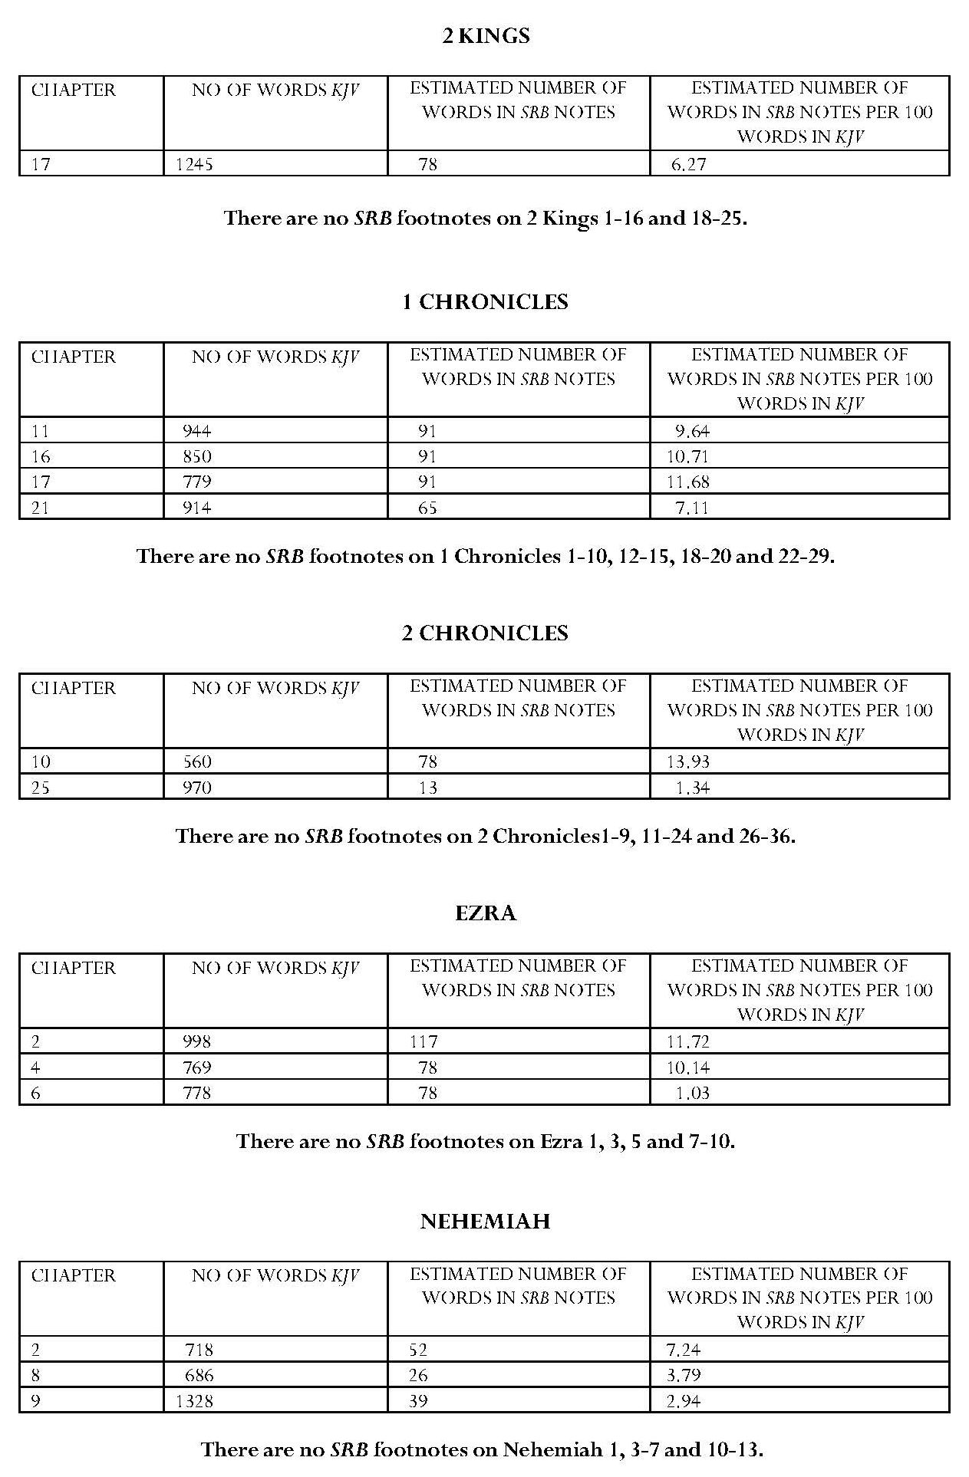

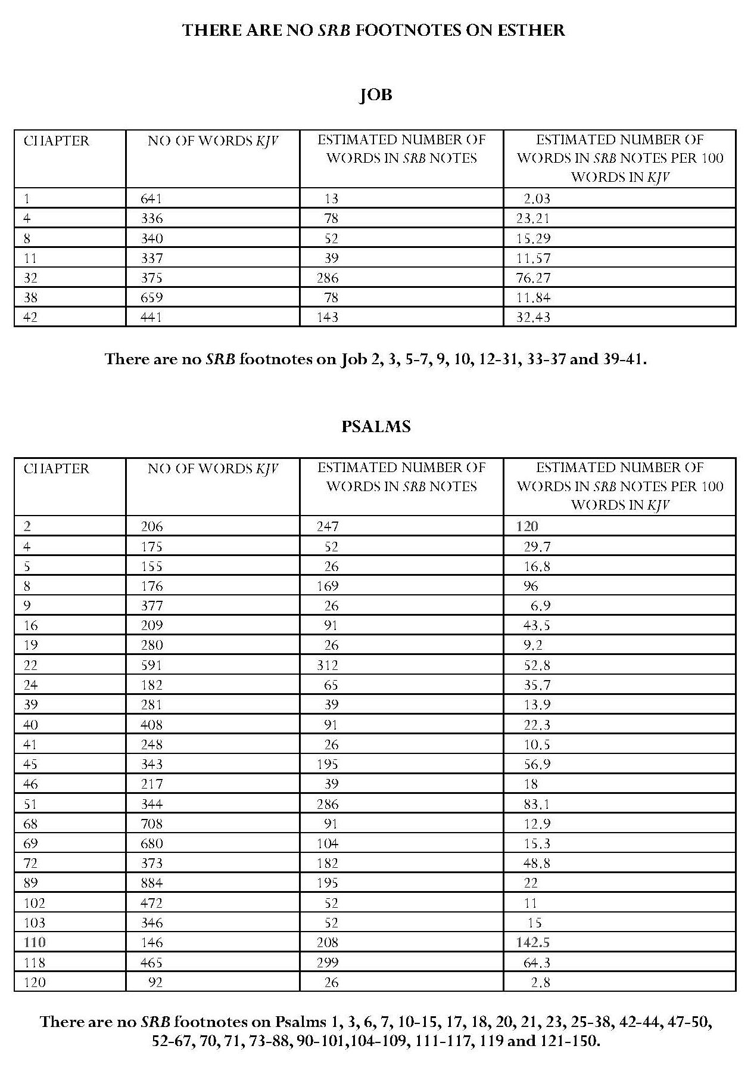

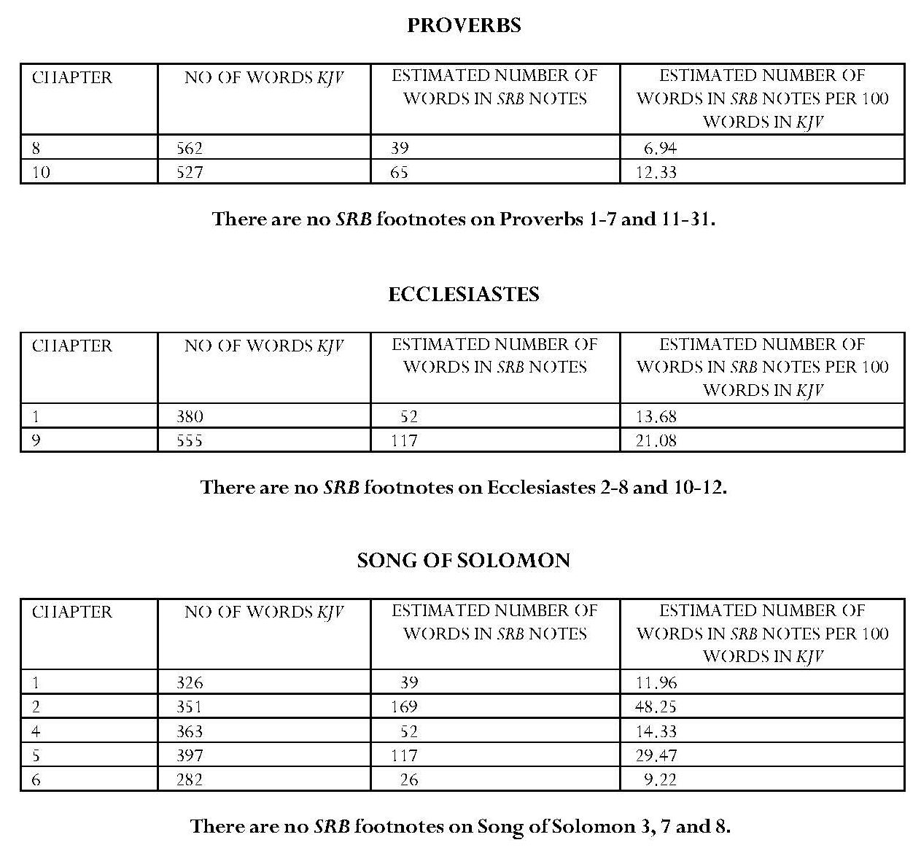
Continued overleaf

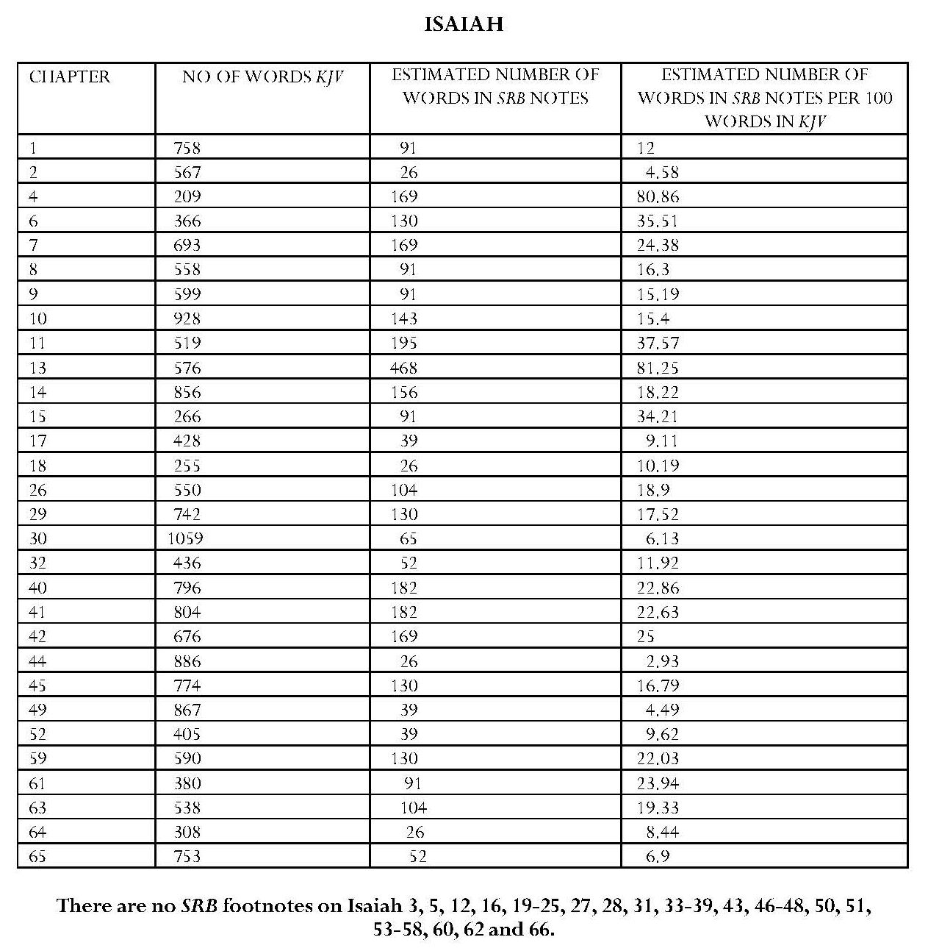

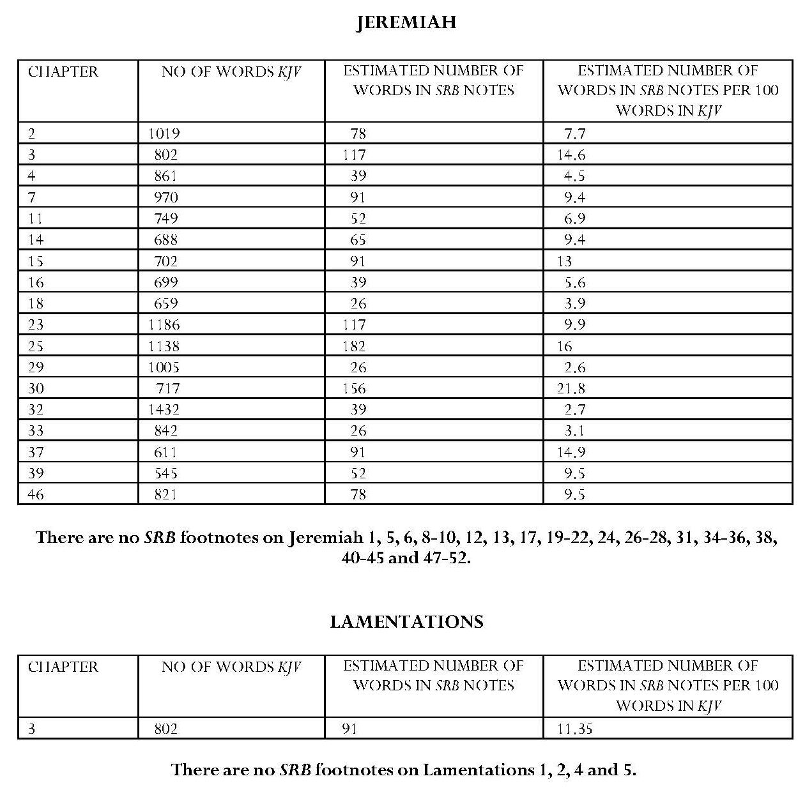

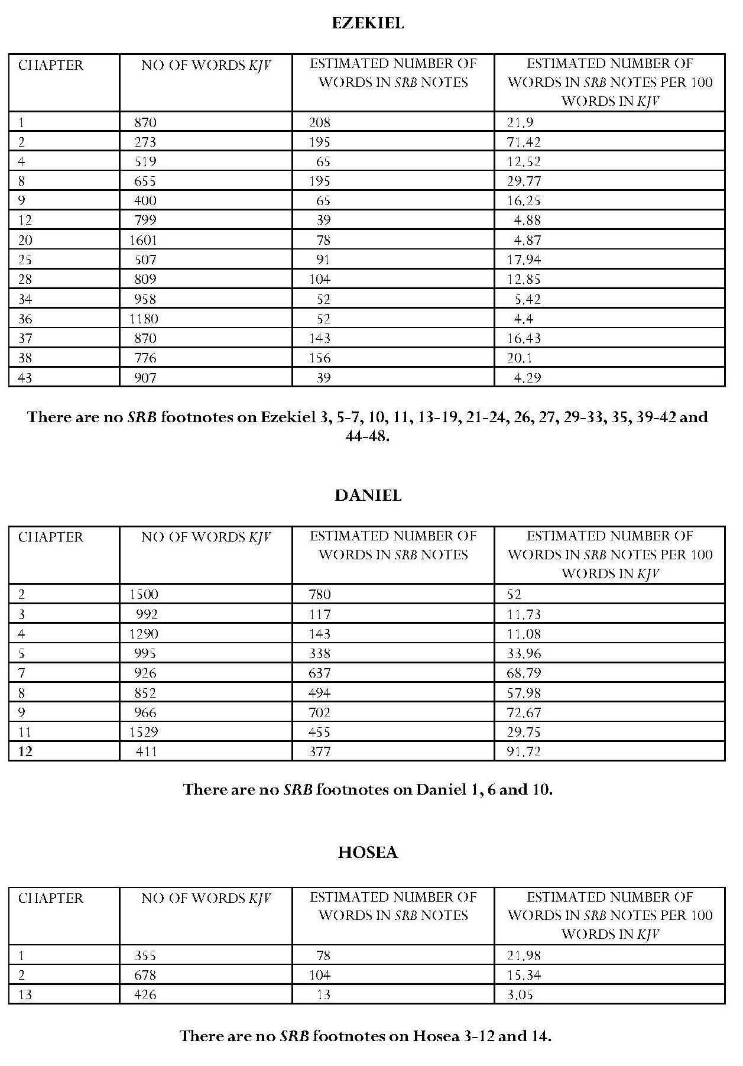

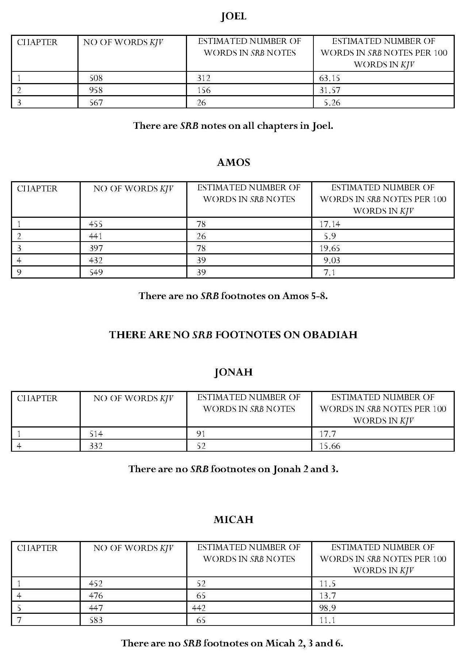

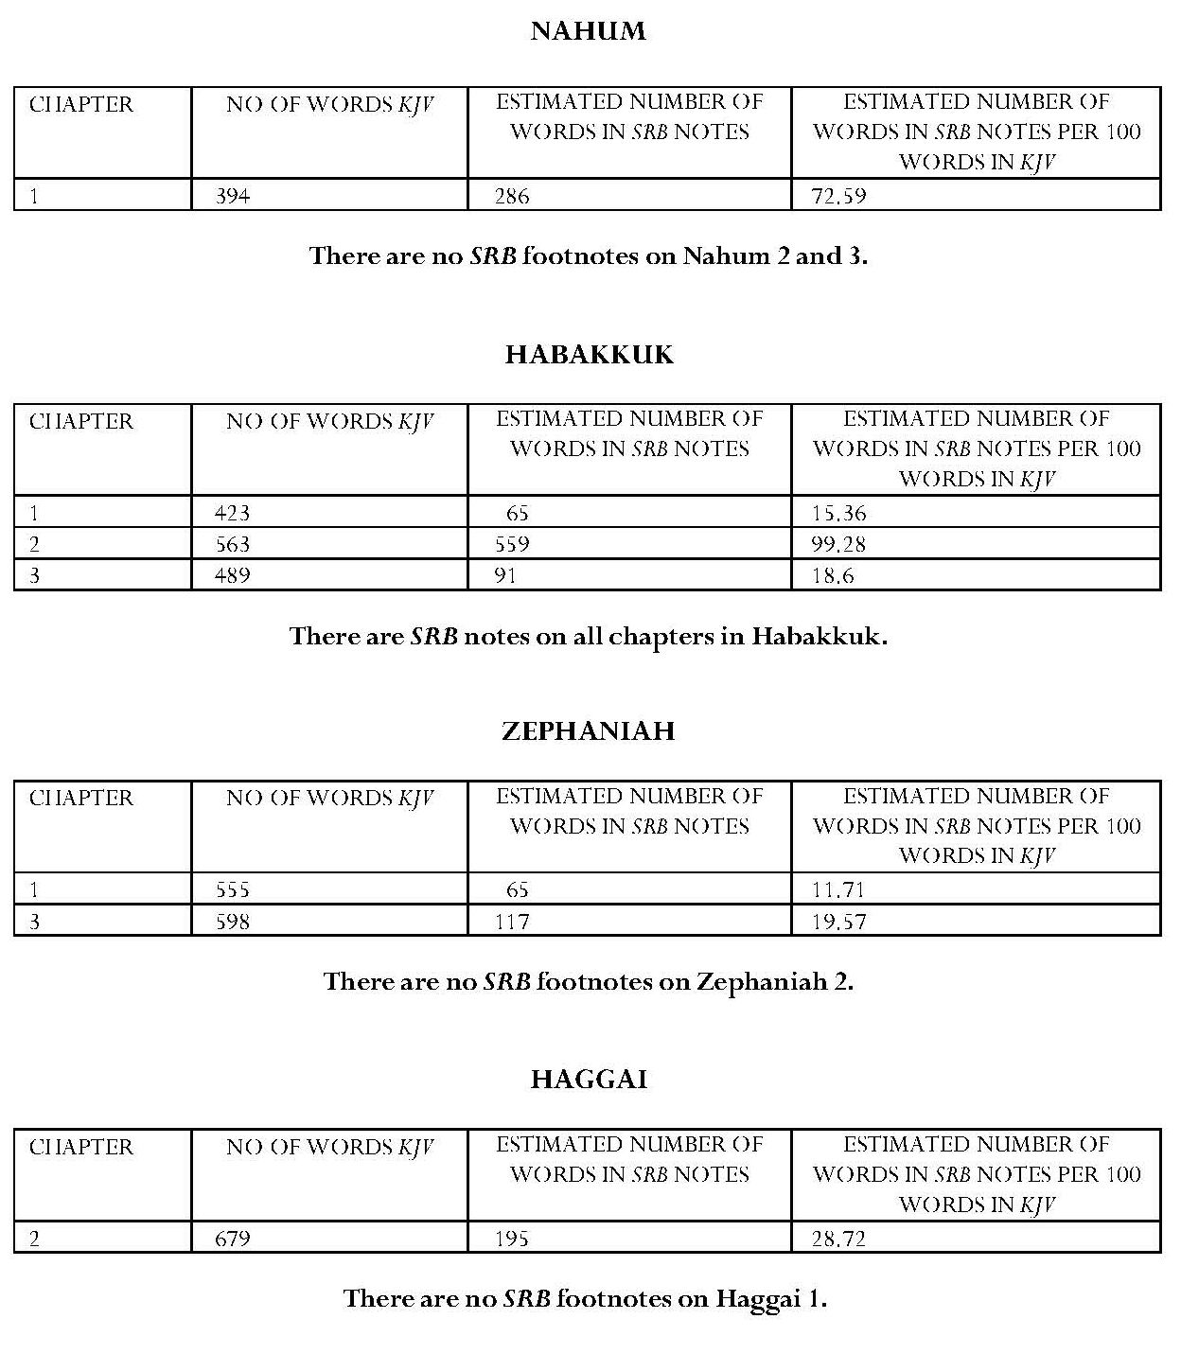

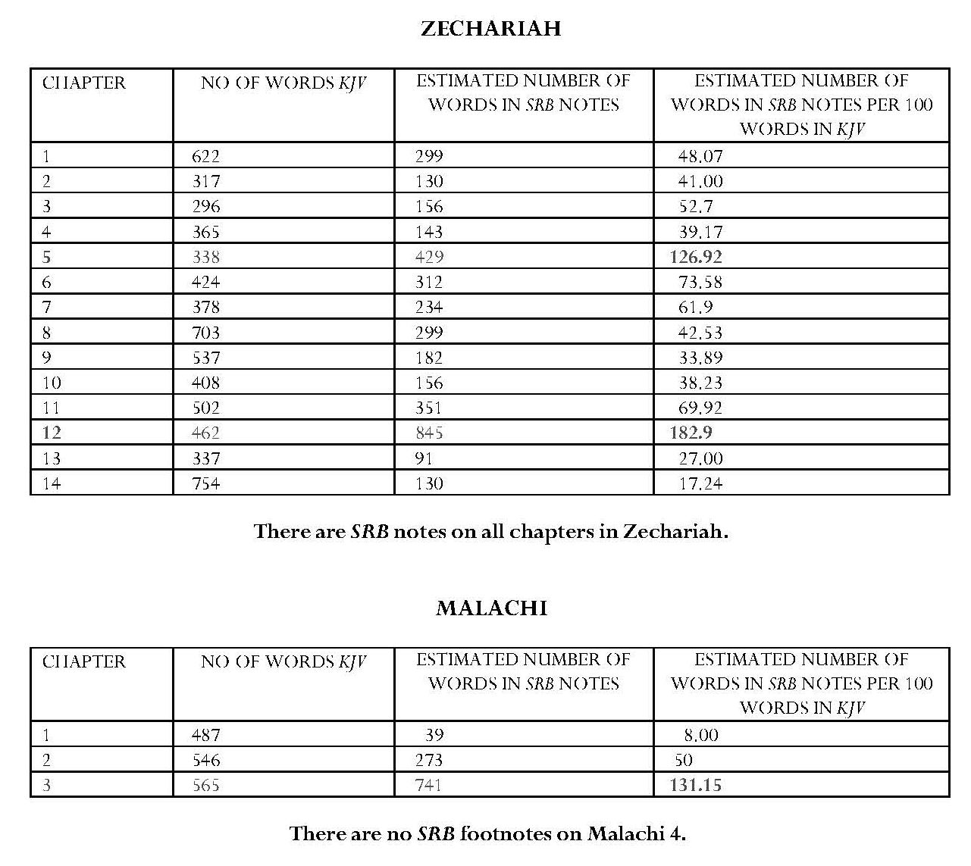

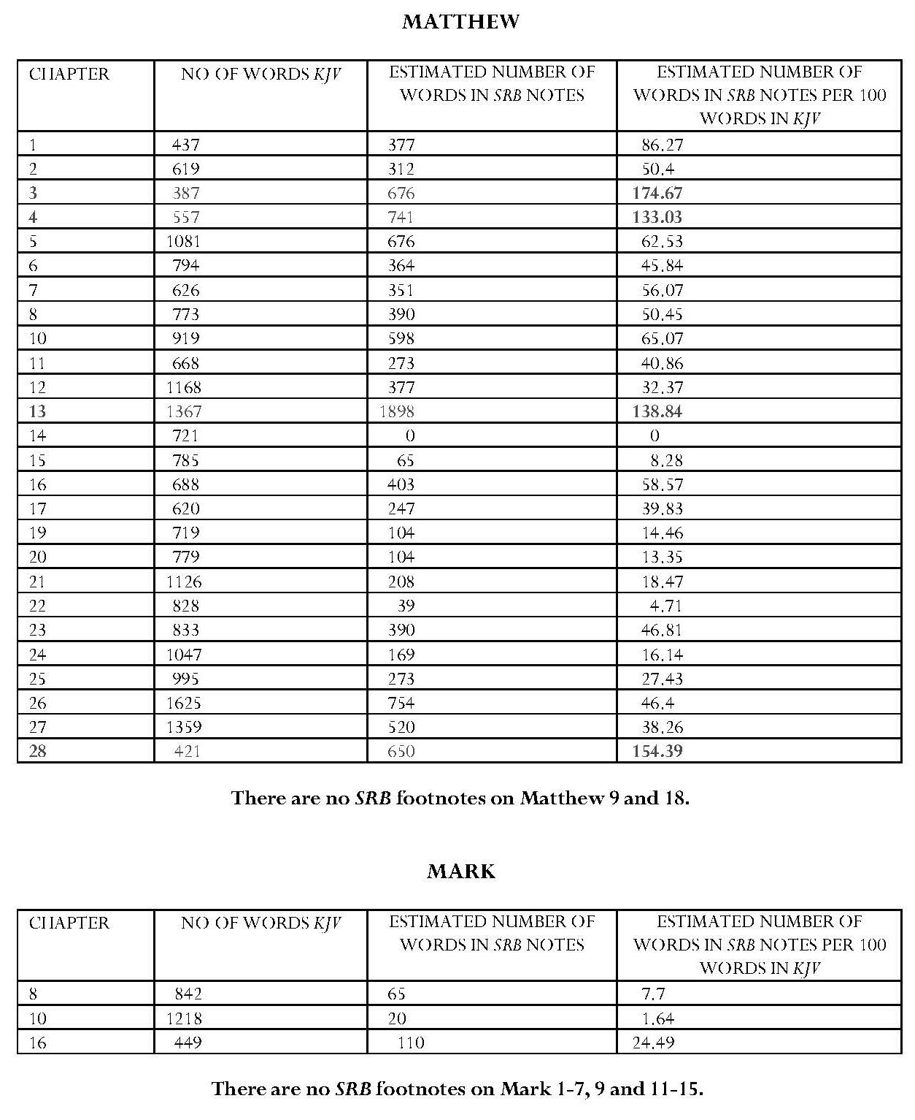

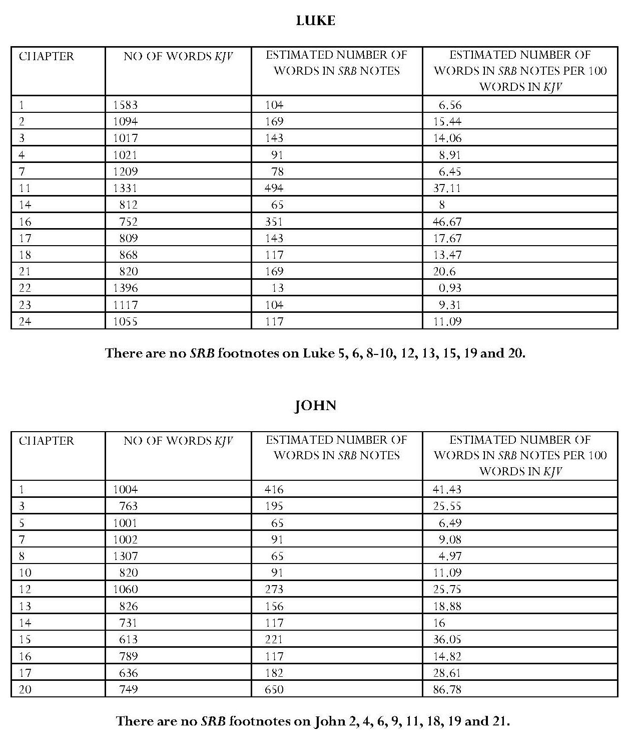

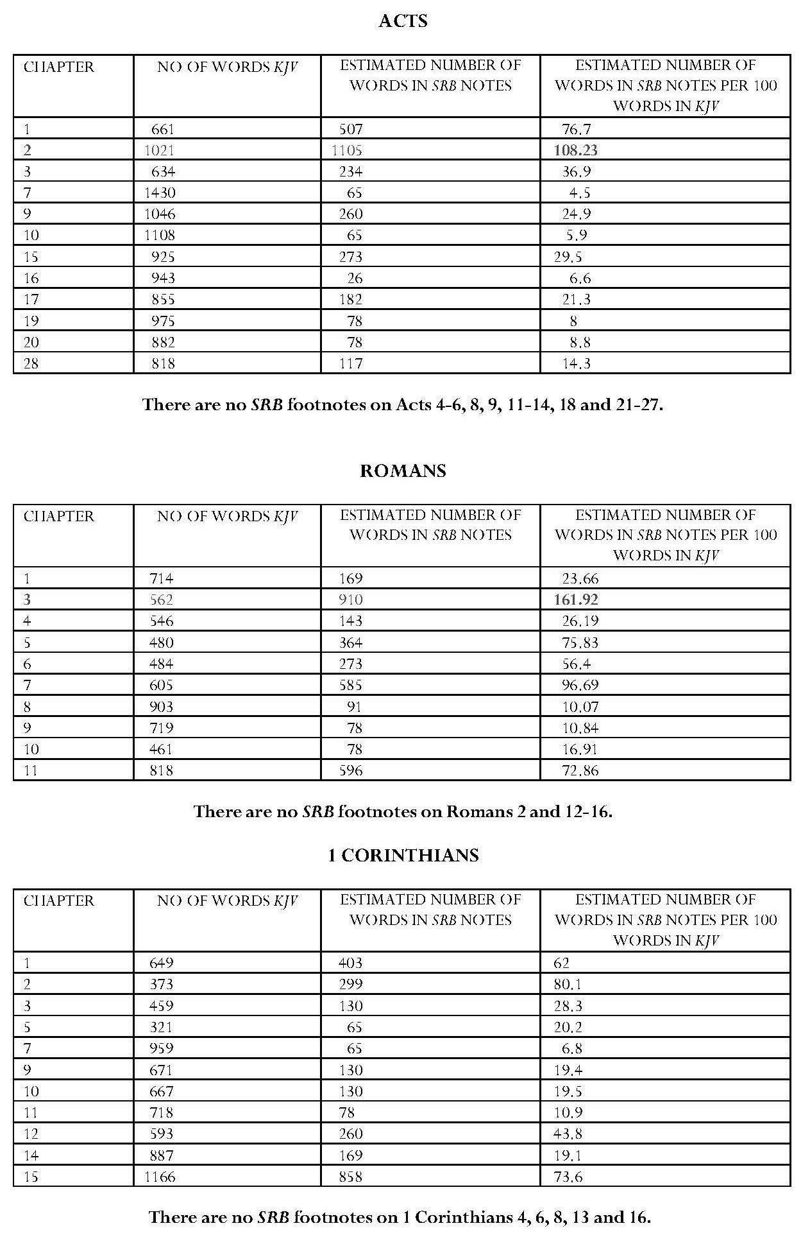

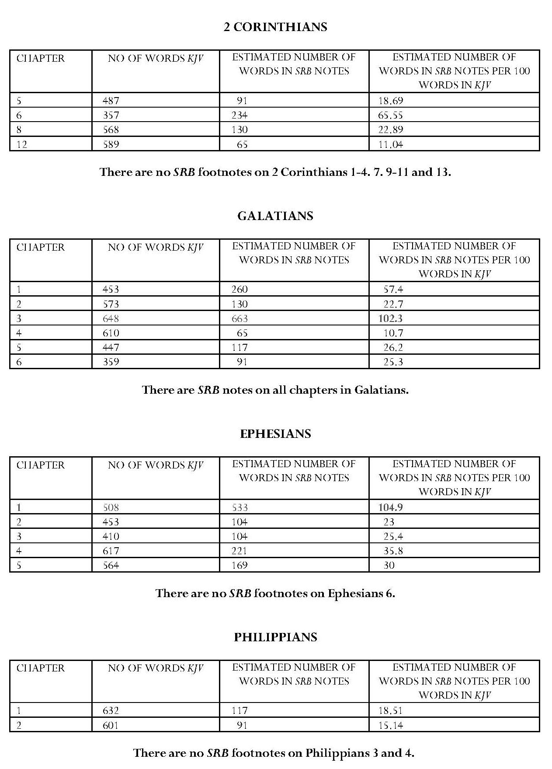

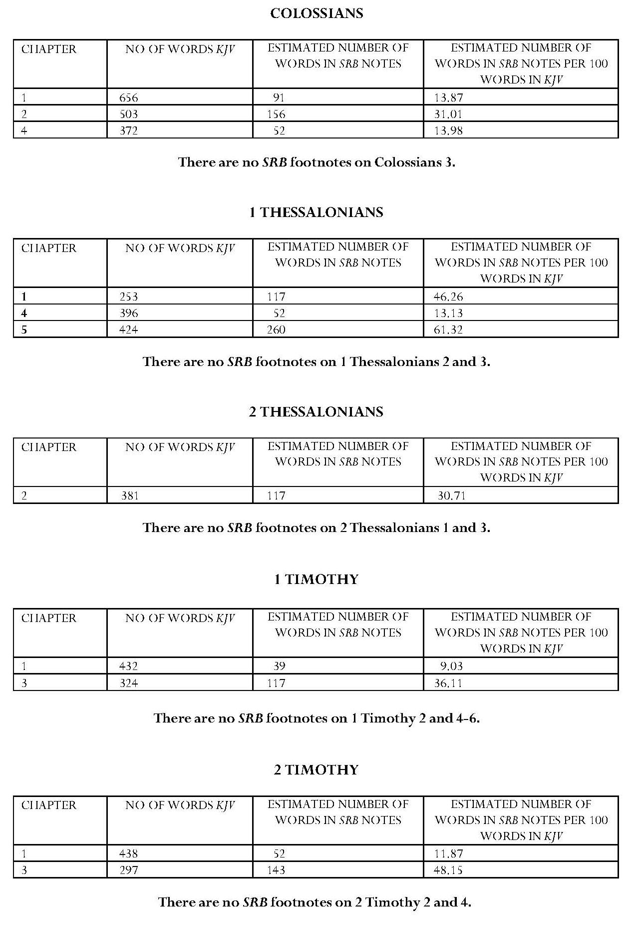

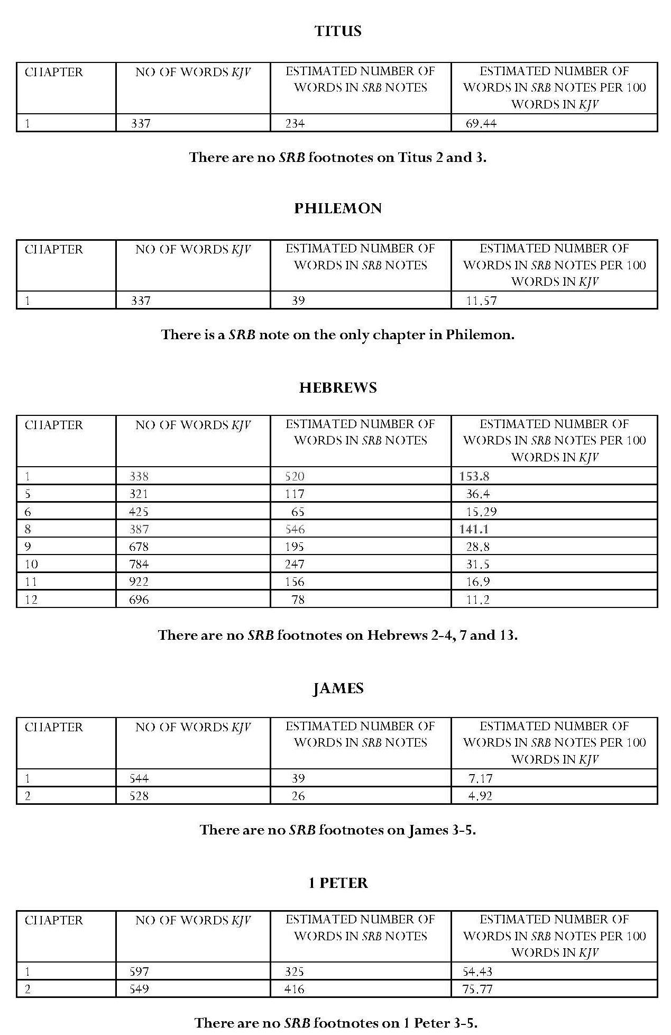

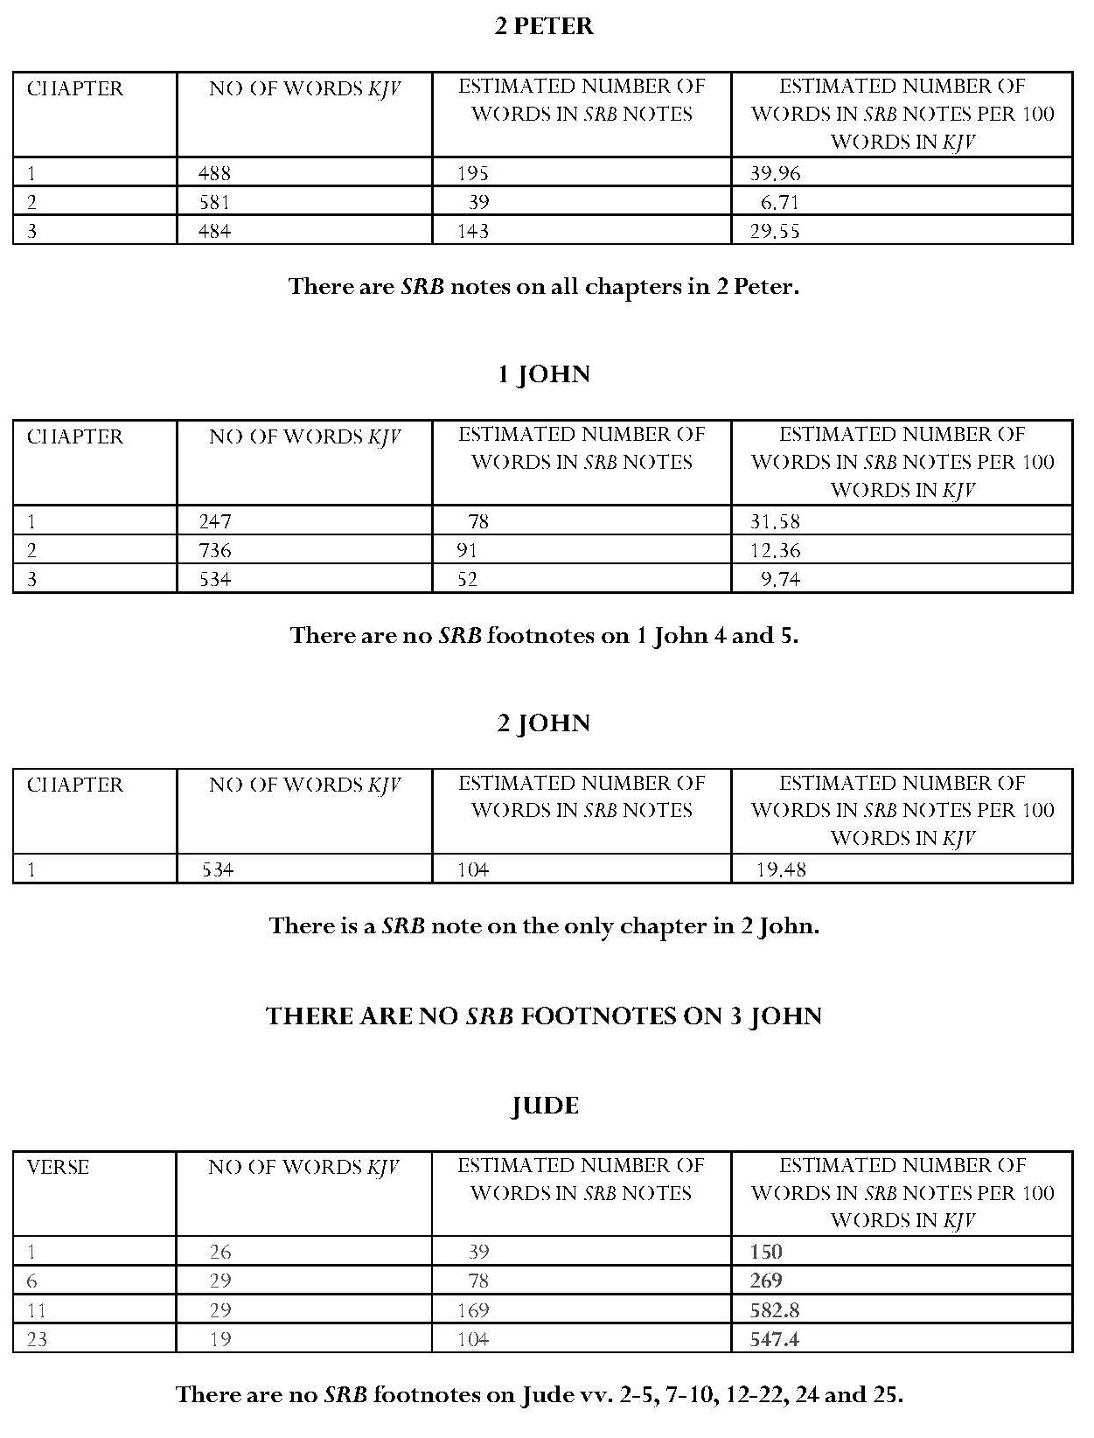

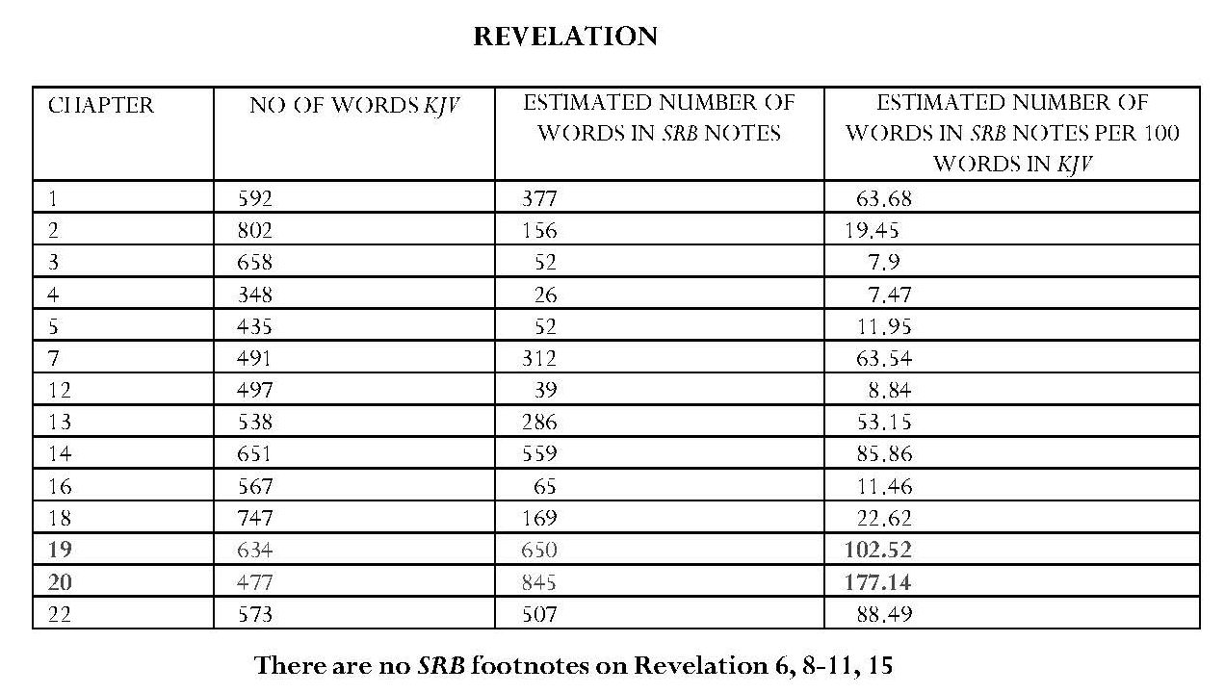

Page intentionally left blank

BIBLIOGRAPHY
Works Cited
Aldrich, Roy L., ‘An Apologetic for Dispensationalism’, Bibliotheca Sacra, Vol. 112:445 (Jan. 1955),
pp. 46-54.
Allis, Oswald, T., ‘Modern Dispensationalism and the Doctrine of the Unity of Scripture’, Evangelical Quarterly, Vol. VIII, No. 1, January 1936, reprinted by Reformed Literature.com <http://www.reformedliterature.com/allis-modern-dispensationalism-and-unity-of-scripture.php > [accessed 23.4.17].
Alonso-Núñez, J. M., ‘Aemilius Sura’, Latomus, T.48, Fasc. 1 (Janvier-Mars 1989).
St Augustine,‘Letter to Marcellinus’, Letter 138 (412 AD), New Advent <http://www.newadvent.org/fathers/1102138.htm> [accessed 29.6.17].
— ‘Sermon 32’, Nicene and Post-Nicene Fathers (ed. Philip Schaff, trans. R. G. MacMullen, First Series, Vol. 6 (Buffalo, NY: Christian Literature Publishing Co., 1888; revised and ed. for New Advent, Kevin Knight) <http://www.newadvent.org/fathers/160332.htm> [accessed 4.5.17]. (Sermon 82, Benedictine edition).
— ‘Augustini Sermo LXXXII’, The Latin Library <http://www.thelatinlibrary.com/augustine/serm82.shtml> [accessed 4.5.17].
Baker, David L., ‘Typology and the Christian Use of the Old Testament’, Scottish Journal of Theology,
Vol. 29, Issue 2, April, 1976.
<https://www-cambridge-org.sheffield.idm.oclc.org/core/services/aop-cambridge-core/content/view/3FC16F2E8EAD51FB5863151BC33C5541/S0036930600042563a.pdf/
typology_and_the_christian_use_of_the_old_testament.pdf> [accessed 19.9.17].
Bass, Clarence B., Backgrounds to Dispensationalism: Its Historical Genesis and Ecclesiastical Implications (Grand Rapids: Wm. B. Eerdmans Publishing Co., Baker Book House, 1960).
Bauckham, Richard, ‘The Divinity of Jesus Christ in the Epistle to the Hebrews’ in Richard Bauckham, Daniel R. Driver, Trevor A. Hart & Nathan MacDonald(eds) The Epistle to the Hebrews and Christian Theology (Grand Rapids: William B. Eerdmans Publishing Company, 2009).
— The Theology of the Book of Revelation (Cambridge: Cambridge University Press, 1993).
Bebbington, David, Evangelicalism in Modern Britain: A History from the 1730s to the 1980s (London: Unwin Hyman/Routledge, 1989; paperback edition, Baker Book House, 1992).
Bible.org, ‘The First Four Trumpet-Judgments (Rev. 8:1-13)’
<http://www.goodnewsarticles.com/Dec03-1.htm> [accessed 24.7.11].
Bingham, D. Jeffrey and Glenn R. Kreider (gen. eds), Dispensationalism and the History of Redemption: A Developing and Diverse Tradition (Chicago: Moody Publishers, 2015).
Blackstone, William E., Jesus is Coming: God’s Hope for a Restless World (Grand Rapids: Kregel Publications, 1989; original publication: New York: F.H. Revell, 1908).
Internet Archive, ‘Jesus is Coming’ <https://archive.org/details/JesusIsComing-raptureByWilliamW.e.b.Blackstone> [accessed 16.5.14].
Library of Congress, W. E. Blackstone, Jesus is Coming, <https://catalog.loc.gov/vwebv/holdingsInfo?searchId=5535&recCount=25&recPointer=6
&bibId=6266385 > [accessed 16.5.14 ].
Wholesome Words, ‘Jesus is Coming’ <http://www.wholesomewords.org/etexts/blkstone/coming0.html> [accessed 16.5.14].

Blaising, Craig A., ‘Developing Dispensationalism Part 2: Development of Dispensationalism by Contemporary Dispensationalists’, Bibliotheca Sacra, Vol. 145:579 (July 1988).
— ‘The Kingdom That Comes With Jesus: Premillennialism And The Harmony Of Scripture’, Southern Baptist Journal of Theology, SBTJ 14:1 (Spring 2010).
Blaising, Craig A., and Darrell L. Bock (eds), Dispensationalism, Israel and the Church: The Search for Definition (Grand Rapids, Michigan: Zondervan Publishing House, 1992).
Blaising, Craig A., and Darrell L. Bock Progressive Dispensationalism (Grand Rapids, Michigan: Bridgepoint Books, 1993, paperback, 2000).
Blomberg, Craig, The Historical Reliability of the Gospels (Leicester: Inter-Varsity Press, 1987).
Bock, Darrell L., ‘The Son of David and the Saints’ Task: The Hermeneutics of Initial Fulfillment’, Bibliotheca Sacra, Vol. 150:600 (Oct. 1993).
Bovon, François, Luke 3: A Commentary on the Gospel of Luke 19:28-24:53 (William Foxwell Albright and David Noel Freedman [gen. eds], ed. Helmut Koester, trans. James Crouch, Semeia, Vol. 28A; Garden City, New York: Doubleday & Company, Inc., 1985).
Boyer, Paul, When Time Shall Be No More: Prophecy Belief in Modern American Culture (Cambridge, Mass., Belknap Press of Harvard University Press, 1992).
Bradshaw, Robert I., ‘Covenant and Covenants in the Bible’ <https://biblicalstudies.org.uk/article_covenant.html > [accessed 28.3.17].
Brookes, James H., Bible Reading on the Second Coming of Christ According to the Scriptures (Springfield, Illinois: Edwin A. Wilson, 1877).
— Maranatha: or The Lord Cometh (1889) <https://archive.org/stream/J.H.BrookesMaranathaOrTheLordCometh1889/1889_brookes_maranatha_lordCometh_djvu.txt> [accessed 22.2.17].
— The Truth, V (1879).
Burge, Gary M., Jesus and the Land: The New Testament Challenge to ‘Holy Land’ Theology (Grand Rapids: SPCK, Baker Academic, 2010).
Burridge, Richard A., Four Gospels, One Jesus? A Symbolic Reading (2nd Edition, London: Society for Promoting Christian Knowledge, 2005).
— John (3rd Edition, The People’s Bible Commentary: A Devotional Commentary for Study and Preaching, Abingdon: The Bible Reading Fellowship, 2010).
Cairn Magazine Online, June 2013.
<http://magazine.cairn.edu/2013/06/new-every-morning/> [accessed 2.3.18].
Callan, Terrance, ‘Pauline Midrash: The Exegetical Background of Gal. 3:19b’
Journal of Biblical Literature 99/4 (1980) <http://uk.jstor.org/journals/00219231.html>
[accessed 5.1.08].
Campbell, Donald K., ‘The Interpretation of Types’, Bibliotheca Sacra, CXII, No 447, July 1955.
Canfield, Joseph M., The Incredible Scofield and His Book (Vallecito, California: Ross House Books, 1988).
Chafer, Lewis Sperry, Dispensationalism, Second Reprint of article, Bibliotheca Sacra, Vol. 93, no. 372, Oct.-Dec. 1936 (Fort Worth, Texas: Exegetica Publishing, 1951).
— Grace: An Exposition of God’s Marvelous Gift <http://www.baptistbiblebelievers.com/BookList/GracebyLewisSperryChafer1922.aspx > [accessed 1.1.17].
— The Kingdom in History and Prophecy <http://scofield.me/uploads/Kingdom_in_History.pdf> [accessed 11.2.11].
Chafer, Lewis Sperry, Major Bible themes, representing forty-nine vital doctrines of the Scriptures, abbreviated and simplified (Grand Rapids: Dunham Publishing Company, 1965; copyright Dallas Theological Seminary, 1926 & 1953).
Cohn-Sherbok, Dan, The Politics of Apocalypse: The History and Influence of Christian Zionism
(Oxford: Oneworld Publications, Ltd., 2006).
Collins, John J., ‘Apocalypses and Apocalypticism, IV: Early Jewish Apocalypticism’, in David Noel Freedman (ed. in chief), Anchor Bible Dictionary, Vol. I (London: Doubleday, 1992).
— Daniel: A Commentary on the Book of Daniel (Minneapolis: Fortress Press, 1993).
Conrad, Edgar W., Zechariah (Sheffield: Sheffield Academic Press, 1999).
Cox, William E., Amillennialism Today (Phillipsburg, New Jersey: Presbyterian and Reformed Publishing Co., 1966).
— Biblical Studies in Final Things (Phillipsburg, New Jersey: Presbyterian and Reformed Publishing Co., 1966).
Craig, G. Y. and E. J. Jones, A Geological Miscellany (Princeton: Princeton University Press, 1982) <http://www.lhup.edu/~dsimanek/ussher.htm> [accessed 19.3.11].
Crouch, Carly, ‘Wicked Rulers and Prophets: Micah 3’ in Guidelines, Vol. 33, Part 1, January-April 2017 (ed. Lisa Cherrett, Abingdon: Bible Reading Fellowship, 2017).
Crutchfield, Larry V., ‘John Nelson Darby: Defender of the Faith’, According to Prophecy Ministries, Pre-Trib Study Group <http://www.according2prophecy.org/darby.html> [accessed 17.2.10].
— ‘The Early Church Fathers and the Foundations of Dispensationalism, Part 1 – Setting the Stage: The Participants and Theological Principles in the Debate’, Conservative Theological Journal 02:4,
Mar. 1998.
— ‘The Early Church Fathers and the Foundations of Dispensationalism, Part 4 – Dispensational Concepts in the Apologists: Justin Martyr’, Conservative Theological Journal 2.7, December. 1998.
— The Origins of Dispensationalism: The Darby Factor (Lanham: University Press of America, 1992).
— ‘The Rudiments of Dispensationalism in the Ante-Nicene Period’ Part 1, ‘Israel and the Church in the Ante-Nicene Fathers’, Bibliotheca Sacra, Vol. 144:575, July/September 1987, p. 254 <https://www.galaxie.com/article/bsac144-575-02> [accessed 29.3.17].
— ‘The Rudiments of Dispensationalism in the Ante-Nicene Period’ Part 2, ‘Ages and Dispensations in the Ante-Nicene Fathers’, Bibliotheca Sacra, Vol. 144:576, October 1987 <https://www.galaxie.com/article/bsac144-576-02> [accessed 29.3.17].
Currie, David B., Rapture: The End-Times Error That Leaves the Bible Behind (Manchester, New Hampshire: Sophia Institute Press, 2003).
Dallas Theological Seminary, History <https://www.dts.edu/about/> [accessed 2.3.18].
Darby, John Nelson, ‘The Apostasy of Successive Dispensations’, Collected Works, Vol. 1, Ecclesiastical 1, <http://www.stempublishing.com/authors/darby/ECCLESIA/01009E.html>
[accessed 22.1.10].
— ‘Are There Two Half Weeks in the Apocalypse?’, Collected Writings, Vol. 11, Prophetic 4 <http://www.stempublishing.com/authors/darby/PROPHET/11008E.html> [accessed 2.8.09].
— ‘Brief Remarks on the Work of Rev. David Brown, D. D., entitled “Christ’s Second Coming, is it Premillennial?”’ Collected Writings, Vol. 11, Prophetic No. 4 <http://www.stempublishing.com/authors/darby/PROPHET/11018E.html> [accessed 2.8.09 ].
Continued overleaf
Darby, John Nelson, ‘Connection of the cross with the entire development of God’s ways with man’ in Collected Works of J. N. Darby, Vol. 22, Doctrinal No. 6 <http://www.stempublishing.com/authors/darby/DOCTRINE/22006E.html> [accessed 2.8.09].
— ‘Considerations addressed to the Archbishop of Dublin and the Clergy who signed the petition to the House of Commons for Protection’, Collected Writings, Vol. 1, Ecclesiastical 1 <http://www.stempublishing.com/authors/darby/ECCLESIA/01001E.html> [accessed 24/7/09].
— The Dispensation of the Fulness of Times’, Collected Writings, Vol. 13, Critical No. 1,
<http://www.stempublishing.com/authors/darby/CRITICAL/13011E.html>
[accessed 2.8.09].
— ‘The Dispensation of the Kingdom of Heaven, Matthew 13’, Collected Writings, Vol. 2, Prophetic 1 <http://www.stempublishing.com/authors/darby/PROPHET/02004E.html >
[accessed 2.8.09].
— ‘Divine Mercy in the Church and Toward Israel’, Collected Writings, Vol. 2, Prophetic No. 1 <http://www.stempublishing.com/authors/darby/PROPHET/02008E.html>
[accessed 24.7.09].
— ‘Elements of Prophecy, in connection with the Church, the Jews, and the Gentiles’,
Collected Writings, Vol. 11, Prophetic, No. 4, p. 45 <http://www.stempublishing.com/authors/darby/PROPHET/11003E.html> [accessed 2.8.09].
— ‘Evidence from Scripture of the passing away of the present dispensation’, Collected Writings, Vol. 2, Prophetic No. 1 <http://www.stempublishing.com/authors/darby/PROPHET/02007E.html> [accessed 13.5.17].
— ‘An Examination of Statements in Newton’s Apocalyptic Thoughts’, Collected Writings, Vol. 8, Prophetic 3, Part 4 <stempublishing.com/authors/darby/PROPHET/08001E04.html>
[accessed 2.8.09].
— ‘A glance at various ecclesiastical principles and examination of the foundations on which the institutions of the church on earth are sought to be based. In reply to various writings’, Collected Works of J. N. Darby, Vol. 4, Ecclesiastical No 2, p 1. <http://www.stempublishing.com/authors/darby/ECCLESIA/04001F_A.html>
[accessed 31.7.09].
— ‘The Gospel and the Church According to Scripture’ Collected Writings, Vol. 29, Doctrinal No. 8,
p 366 <http://www.stempublishing.com/authors/darby/DOCTRINE/29014E.html >
[accessed 2.8.09 ].
— ‘The Hopes of the Church of God’, Part 1, Collected Writings, Vol. 2, Prophetic No. 1 <http://www.stempublishing.com/authors/darby/PROPHET/02011E.html> [accessed 7.8.09].
— ‘The Hopes of the Church of God’, Lectures at Geneva, Lecture 11, Collected Writings,
Prophetic Vol. 2 <http://www.stempublishing.com/authors/darby/PROPHET/02021E.html>
[accessed 9.11.17].
— ‘Inspiration and Interpretation, 4th Dialogue on Essays and Reviews’ in Collected Works of
J. N. Darby, Vol. 9, Apologetic No. 2, p. 256 <http://www.stempublishing.com/authors/darby/APOLOGY/09004E_A.html>
[accessed 12.5.17].
— ‘An Introduction to the Bible’, Collected Works of J. N. Darby, Vol. 34, Miscellaneous No 3
<http://www.stempublishing.com/authors/darby/MISCELLA/34001F.html>
[accessed 11.5.17].
— ‘Introduction to the Prophets’ in Synopsis of the Books of the Bible, Vol. 2, Ezra to Malachi, p. 209 <http://bibletruthpublishers.com/introduction-to-the-prophets/john-nelson-darby-jnd/darby-synopsis-2-ezra-to-malachi/la72894> [accessed 12.5.17]. Continued overleaf
Darby, John Nelson, ‘Isaiah’ in ‘The Prophets’ in Synopsis of the Books of the Bible <http://www.stempublishing.com/authors/darby/synopsis/isaiah/isaiah.htm>
[accessed 11.10.17].
— ‘Lectures on the Second Coming of Christ, Lecture 1, 1 Thessalonians 1’, Collected Writings, Vol. 11, Prophetic 4 <http://www.stempublishing.com/authors/darby/PROPHET/11012E.html> [accessed 7.8.09].
— ‘Lectures on the Second Coming of Christ, Lecture 3, Revelation 12’, Collected Writings, Vol. 11, Prophetic 4 <http://www.stempublishing.com/authors/darby/PROPHET/11014E.html> [accessed 7.8.09].
— ‘Lectures on the Second Coming of Christ, Lecture 5, Matthew 13’, Collected Writings, Vol. 11, Prophetic 4 <http://www.stempublishing.com/authors/darby/PROPHET/11016E.html> [accessed 7.8.09].
— ‘Letter to Major Lancey’, The Letters, Vol. 1 <http://www.stempublishing.com/authors/darby/letters/51066E.html> [accessed 13.5.17].
— ‘Letter to Professor Friedrich Tholuck, Letters, Vol. 3 <http://www.stempublishing.com/authors/darby/letters/53226E.html> [accessed 5.5.17].
— ‘Meditations on the Acts of the Apostles’, Collected Writings, Vol. 25, Expository <http://www.stempublishing.com/authors/darby/EXPOSIT/25028_34E.html>
[accessed 11.5.17].
— ‘Notes on the Apocalypse gleaned at lectures in Geneva, 1842’, Collected Writings, Vol. 5, Prophetic 2 <http://www.stempublishing.com/authors/darby/PROPHET/05001_7F.html#a1> [accessed 7.8.09].
— ‘Notes on the Gospel of Luke, Luke 3’ Collected Writings, Vol. 25, Expository No 4 <http://www.stempublishing.com/authors/darby/EXPOSIT/25003_7E.html#a3>
[accessed 15.5.17].
— ‘Observations on a tract, entitled “Plymouthism in view of the Word of God”’, Collected Writings, Vol. 4, Ecclesiastical No. 2, p. 272 <http://www.stempublishing.com/authors/darby/ECCLESIA/04006F.html>
[accessed 4.10.10].
— ‘On the Gospel of Luke’, Collected Writings, Vol. 25, Expository <http://www.stempublishing.com/authors/darby/EXPOSIT/25026E.html> [accessed 15.5.17].
— ‘The Principles displayed in the Ways of God, compared with His Ultimate Dealings’,
Collected Writings, Vol. 5, Prophetic No. 2, p. 384 <http://www.stempublishing.com/authors/darby/PROPHET/05043E.html>
[accessed 19.2.10].
— ‘The Purpose of God’, Collected Writings, Vol. 2, Prophetic 1 <http://www.stempublishing.com/authors/darby/PROPHET/02010E.html> [accessed 2.8.09].
— Synopsis: Epistle to the Hebrews, Chapter 9 <http://www.stempublishing.com/authors/darby/synopsis/hebrews/hebrews9.html >
[accessed 18.7.17].
— ‘The Rapture of the Saints and the Character of the Jewish Remnant’, Collected Works, Vol. 11, Prophetic No. 4 <http://www.stempublishing.com/authors/darby/PROPHET/11007E.html> [accessed 9.7.17].
— ‘Thoughts on Isaiah the Prophet’, in Collected Works of J. N. Darby, Vol. 30, Expository No. 2 <http://www.stempublishing.com/authors/darby/EXPOSIT/30027E.html > [accessed 12.5.17].
— ‘What Saints will be in the Great Tribulation’, Collected Writings, Vol. 11, Prophetic No. 4
<http://www.stempublishing.com/authors/darby/PROPHET/11006E.html> [accessed 2.8.09].
Davies, P. R., Daniel (Sheffield: JSOT Press, 1985).
Davies, W. D., and Dale C. Allison, Jr., A critical and Exegetical Commentary on the Gospel According to Saint Matthew, Vol. 1, Introduction and Commentary on Matthew 1 - 7 (Edinburgh: T. & T. Clark Limited, 1988).
— A critical and Exegetical Commentary on the Gospel According to Saint Matthew, Vol. 2, Commentary on Matthew 8 - 18 (Edinburgh: T. & T. Clark Limited, 1991).
Dean, David Lance, Christian Zionism and the Scofield Reference Bible: A Critical Evaluation of Dispensational Theory (Self-published through Xlibris.com, May 2015; purchased through Amazon.com).
Drury, Clare, ‘The Pastoral Epistles’ in John Barton and John Muddiman (eds.) The Oxford Bible Commentary (Oxford: Oxford University Press, 2001).
Dunn, J. D. G., ‘Ephesians’ in John Barton and John Muddiman (eds.) The Oxford Bible Commentary (Oxford: Oxford University Press, 2001).
Ehlert, Arnold D., ‘A Bibliography of Dispensationalism: Part 6’, Bibliotheca Sacra, 102:406 (Apr. 1945).
Encyclopaedia Britannica, ‘Brass’
<http://www.britannica.com/EBchecked/topic/88760/calamine-brass> [accessed 24.7.11].
— ‘Crucifixion’ <http://www.britannica.com/EBchecked/topic/144583/crucifixion>
[accessed 12.7.11].
Encyclopaedia Judaica: © 2008 The Gale Group, Jewish Virtual Library, ‘Kabbalah’
<http://www.jewishvirtuallibrary.org/jsource/judaica/ejud_0002_0011_0_10514.html> [accessed 5.5.11].
Fee, Gordon D., Revelation: A New Covenant Commentary (New Covenant Commentary Series,
Michael F. Bird and Craig Keener, [eds]; Eugene, Oregon: Cascade Books, 2011).
— The First Epistle to the Corinthians (Grand Rapids: Wm. B. Eerdmans Publishing Co., 1987).
Feinberg, Charles L., Millennialism: The Two Major Views: The Premillennial and Amillennial Systems of Biblical Interpretation Analyzed and Compared (Third and Enlarged Edition, Winona Lake, Indiana: BMH Books, 1985, 2006, 2008, 2012). [Original Title: Premillennialism or Amillennialism (Chicago: Moody Bible Institute of Chicago, 1936, 1954, 1961, 1980).]
Feinberg, John S., ‘Systems of Discontinuity’ in John S. Feinberg (ed.) Continuity and Discontinuity: Perspectives on the Relationship Between the Old and New Testaments: Essays in Honor of S. Lewis Johnson, Jr. (Crossway: Wheaton, Illinois, 1988) Google Books <https://books.google.co.uk/books?id=l6HXCgAAQBAJ&printsec=frontcover&source=gbs_ge_summary_r&cad=0#v=onepage&q&f=false> [accessed 3.7.17].
Finkelstein, Israel and Neil Asher Silberman, The Bible Unearthed: Archaeology’s New Vision of Ancient Israel and the Origin of Its Sacred Texts (New York: Touchstone, 2002).
Fitzmyer, Joseph A., S.J., The Gospel According to Luke (X-XXV) (The Anchor Bible, Vol. 28A,
William Foxwell Albright and David Noel Freedman [gen. eds]; Garden City, New York: Doubleday & Company, Inc., 1985).
— The One Who Is To Come (Grand Rapids: William B. Eerdmans Publishing Company, 2007).
Ford, J. Massyngberde (The Anchor Bible, Revelation: Introduction, Translation and Commentary (William Foxwell Albright and David Noel Freedman, eds., Vol. 38; New York: Doubleday & Company, Inc., 1985).
Franklin, Eric, ‘Luke’ in John Barton and John Muddiman (eds.) The Oxford Bible Commentary
(Oxford: Oxford University Press, 2001).
Fruchtenbaum, Arnold G., The Footsteps of the Messiah: A Study of the Sequence of Prophetic Events (Tustin: Ariel Press, 1982, 3rd printing 1990).

Fuller, Daniel P., Gospel and Law: contrast or continuum? : The hermeneutics of dispensationalism and covenant theology (Grand Rapids: Eerdmans, 1980).
— ‘Progressive Dispensationalism and the Law/Gospel Contrast: A Case Study in Biblical Theology’, in Scott J. Hafemann (ed.) Biblical Theology: Retrospect and Prospect (Downers Grove: InterVarsity Press, 2002).
Gaebelein, A. C., C. I. Scofield: The History of the Scofield Reference Bible, The Brethren Writers Hall of Fame <http://www.newble.co.uk/writers/Scofield/refbibhist.html> [accessed 15.3.11].
Girdlestone, R. B., The Grammar of Prophecy: A Systematic Guide to Bible Prophecy
(Grand Rapids, Michigan: Kregel Publications, 1955).
Goldingay, John E., Daniel (Word Biblical Commentary, Vol. 30, Gen. Eds David A. Hubbard and Glenn W. Barker, Old Testament Editor, John D. W. Watts, Dallas: Word Books, 1989).
Goodwin, E. P., ‘The Return of the Lord, Personal and Literal’, Prophetic Studies of the International Prophetic Conference, Chicago, November, 1886 (Chicago: F. H. Revell, 1886).
Gottwald, Norman K., The Tribes of Yahweh: A Sociology of Religion of Liberated Israel 1250-1050 B.C.E.
(First British edition; London: SCM Press Ltd., 1980).
Goulder, Michael D., Luke A New Paradigm II (David Hill, [Executive Editor, Supplement Series], David E. Orton [Publishing Editor], Journal for the Study of the New Testament Supplement Series, 20, Sheffield: JSOT Press, 1989).
Hagee, John, Jerusalem Countdown (Revised and Updated): A Prelude to War, (Lake Mary: Frontline, 2006, 2007).
Hartmann, Louis F. and Alexander A. DiLella, The Book of Daniel (The Anchor Bible 23, William Foxwell Albright and David Noel Freeman, [gen. eds]; New York: Doubleday & Company, Inc., 1978).
Henzel, Ronald M., Darby, Dualism & Decline of Dispensationalism: Reassessing the Nineteenth Century
Roots of a Twentieth Century Prophetic Movement for the Twenty-first Century (Tucson, Arizona: Fenestra Books, 2003).
Herzl, Theodore, The Jewish State (1896) (trans. Sylvie D'Avigdor, 1946) <http://www.jewishvirtuallibrary.org/jsource/Zionism/herzl2.html> [accessed 24.6.11].
Hill, Craig C., ‘God’s Righteousness Evident in the Treatment of Israel (9:1- 11:36) in ‘Romans’, The Oxford Bible Commentary, John Barton and John Muddiman (eds.), (Oxford: Oxford University Press, 2001).
Hilborn, David, ‘Evangelicalism: A Brief Definition’, Evangelical Alliance <http://www.eauk.org/connect/about-us/upload/Evangelicalism-a-brief-definition.pdf> [accessed 13/6/17].
Hindson, Edward, The Book of Revelation: Unlocking the Future (Twenty-First Century Biblical Commentary Series, Mal Couch and Ed Hindson, [gen. eds]; Chattanooga, Tennessee: AMG Publishers, 2002).
Holsteen, Nathan D., ‘The Hermeneutic of Dispensationalism’ in D. Jeffrey Bingham and Glenn R. Kreider (gen. eds), Dispensationalism and the History of Redemption: A Developing and Diverse Tradition (Chicago: Moody Publishers, 2015).
Horrell, David, The Epistles of Peter and Jude (Peterborough: Epworth Press, 1998).
Hyatt, J. Philip, ‘Amos’ in Matthew Black (General Editor and New Testament Editor) and H. H. Rowley, (Old Testament Editor), Peake’s Commentary on the Bible (Wokingham: Van Nostrand Reinhold (UK) Co. Ltd, 1962).

Ice, Thomas, ‘A Short History of Dispensationalism’, Pre-Trib Research Center
<http://www.pre-trib.org/data/pdf/Ice-AShortHistoryOfDispen.pdf> [accessed 1.6.17].
— ‘Dispensationalism, Date-Setting, and Distortion’, Chafer Theological Seminary <http://www.chafer.edu/date-setting-distortion> [accessed 1.6.17].
— ‘Dispensational Hermeneutics’, Pre-trib Research Center
<http://www.pre-trib.org/data/pdf/Ice-DispensationalHermene.pdf> [accessed 16.6.17].
— ‘Morgan Edwards: A Pre-Darby Rapturist’, Conservative Theological Journal CTJ01:1
(Apr. 1997), p. 4. <https://www.galaxie.com/article/ctj01-1-02> [accessed 12.6.17].
Ironside, Harry Allen, A Historical Sketch of the Brethren Movement (Revised Edition, January 1985, Neptune, New Jersey: Loizeaux Brothers, Second Printing January 1988, Earlier Edition, Zondervan, 1942).
— The Mysteries of God, Bartimaeus Alliance of the Blind, Inc.
<http://bartimaeus.us/pub_dom/the-mysteries-of-god.html> [accessed 25.5.17].
Jacobson, David M., ‘Palestine and Israel’, Bulletin of the American Schools of Oriental Research No. 313,
(Feb. 1999), pp. 65-74 <http://www.jstor.org/discover/10.2307/1357617?uid=3738032&uid=2&uid=4&sid=21104237038797> [accessed 1.7.14].
Jewett, Robert and John Shelton Lawrence, Captain America and the Crusade Against Evil: The Dilemma of Zealous Nationalism (Grand Rapids: William B. Eerdmans Publishing Company, 2003).
Karleen, Paul S. The Handbook to Bible Study, With a Guide to the Scofield Study System
(New York: Oxford University Press, 1987).
Kellogg, Revd S. H., ‘Premillennialism: Its Relations to Doctrine and Practice’, Bibliotheca Sacra 45:178, April 1888.
Kraus, C. Norman, Dispensationalism in America: Its Rise and Development
(Richmond, Virginia: John Knox Press, 1958).
Kraus, Donald, the Executive Editor of Bibles at Oxford University Press USA, personal email communications, 25.6.13 and 25.9.13.
Kreider, Glenn R., ‘What is Dispensationalism’ in D. Jeffrey Bingham and Glenn R. Kreider (gen. eds) Dispensationalism and the History of Redemption: A Developing and Diverse Tradition (Chicago: Moody Publishers, 2015).
Lacocque, André, The Book of Daniel (trans. David Pellauer, English edition revised by the author, London: SPCK, 1979).
Ladd, George Eldon, The Blessed Hope: A Biblical Study of the Second Advent and Rapture (Grand Rapids:
Wm. B. Eerdmans Publishing Co., 1956).
LaHaye, Tim and Jerry B. Jenkins, Left Behind (Wheaton, Illinois: Tyndale House, 1999).
Lange, John Peter, A Commentary on the Holy Scriptures: Critical, Doctrinal and Homiletical, with Special Reference to Ministers and Students: The Revelation of St John the Divine (trans. Philip Schaff, New York: Scribner, Armstrong & Co., 1874).
Lindsey, Hal, Planet Earth 2000 A.D.: Will Mankind Survive?
(Palos Verdes: Western Front, Ltd., 1994, 1996).
— The Late Great Planet Earth (London: Lakeland, 1970).
Lockhart, Clinton, Principles of Interpretation: as Recognized Generally by Biblical Scholars, treated as a Science, derived inductively from an Exegesis of Many Passages of Scripture (Delight, Arkansas: Gospel Light Publishing Company, Revised Edition, 1915).
Loetscher, Lefferts A., Foreword to C. Norman Kraus, Dispensationalism in America: Its Rise and Development (Richmond, Virginia: John Knox Press, 1958).
Longenecker, Richard N., Galatians (Nashville: Abingdon Press, 1997).
Lutzweiler, David, The Praise of Folly: The Enigmatic Life and Theology of C. I. Scofield (Nashville, Tennessee: Lamplighter Educational Services, 2009).
McClain, Alva J., ‘The Greatness of the Kingdom’, Bibliotheca Sacra, 112:445 (Jan. 1955); 112:446
(Apr. 1955); 112:447 (July 1955); 112:448 (Oct. 1955).
Mackintosh, C. H., Papers on the Lord’s Coming, Stem Publishing <http://www.stempublishing.com/authors/mackintosh/Bk3/LORDSCMN.html>
[accessed 23.2.17].
Mangina, Joseph L., Revelation (SCM Theological Commentary on the Bible; R. R. Reno et al. [eds], London: SCM Press, 2010).
Mangum, R. Todd and Mark S. Sweetnam, The Scofield Bible: Its History and Impact on the Evangelical Church (Colorado Springs: Paternoster, 2009).
Marsden, George M., Fundamentalism and American Culture (Second Edition, Oxford: Oxford University Press, 2006).
Marsh, Herbert, Lectures on the Criticism and Interpretation of the Bible, with Two Preliminary Lectures on Theological Study and Theological Arrangement; to which are added Two Lectures on the History of Biblical Interpretation (London: J.G.F.& J. Rivington, 1842) <https://archive.org/details/lecturesonthebib00marsuoft> [accessed 18.9.17].
Mason, Rex, The Books of Haggai, Zechariah and Malachi: Commentary by Rex Mason, Lecturer in Hebrew and Old Testament Studies, Regent’s Park College, Oxford (Cambridge: Cambridge University Press, 1977).
— ‘Why is Second Zechariah so Full of Quotations?’ in Christopher Tuckett (ed.) The Book of Zechariah and its Influence (Aldershot: Ashgate Publishing Limited, 2003).
— ‘Zechariah 12.1-13.6’ in Mark J. Boda and Michael H. Floyd (eds) Bringing out the Treasure: Inner Biblical Allusion in Zechariah 9-14 (JSOT supp. series; 370; London: Sheffield Academic Press, 2003).
Mathison, Keith A., Postmillennialism: An Eschatology of Hope (Phillipsburg, New Jersey: P&R Publishing Company, 1999).
Mendelsson, David, ‘From the First Zionist Congress (1897) to the Twelfth (1921)’ <http://www.jewishvirtuallibrary.org/jsource/Zionism/firstcong.html> [accessed 24.6.11].
Meyers, Carol L. and Eric M. Meyers, Haggai, Zechariah 1-8: A New Translation with Introduction and Commentary (The Anchor Bible 25B, William Foxwell Albright and David Noel Freeman, [gen. eds]; New York: Doubleday & Company, Inc., 1987).
— Zechariah 9-14: A New Translation with Introduction and Commentary (The Anchor Yale Bible 25C, William Foxwell Albright and David Noel Freeman, [gen. eds]; New Haven: Yale University Press, 1993).
Milton, John, ‘Ode on the Morning of Christ’s Nativity’, in Ernest Rhys (ed.) The Golden Treasury of Longer Poems (London: E. P. Dutton & Co., 1921).
Moody Bible Institute, History
<https://www.moody.edu/about/our-bold-legacy/history-of-moody-bible-institute/>
[accessed 2.3.18].
Morris, Leon, Apocalyptic (2nd edition, 1973; London: Inter-Varsity Press, 1973) <http://www.biblicalstudies.org.uk/pdf/apocalyptic_morris.pdf> [accessed 16.12.10].
Needham, George C., Introduction to Brookes, Bible Reading on the Second Coming of Christ According to the Scriptures (Springfield, Illinois: Edwin A. Wilson, 1877).
Neyrey, Jerome H., ‘“Without Beginning of Days or End of Life” (Hebrews 7:3): Topos for a True Deity’, Catholic Biblical Association, Catholic Biblical Quarterly, Vol. 53, No. 3 (July, 1991), pp. 439-455 <http://www.jstor.org/stable/43718283> [accessed 29.9.17].
North, Gary, ‘Publisher’s Preface’ to Dwight Wilson, Armageddon Now: The Premillenarian Response to Russia and Israel Since 1917 (Tyler, Texas: Institute for Christian Economics, 1991).
Pamment, Margaret, ‘The Kingdom of Heaven According to the First Gospel’, New Testament Studies 27, issue 2, 1981 <http://journals.cambridge.org.eresources.shef.ac.uk/action/displayFulltext?type=1&pdftype=1&fid=3392572&jid=NTS&volumeId=27&issueId=&aid=3392564> [accessed 1.12.10].
Perry, Hilary, ‘God’s Earthly People: C. I. Scofield and the Blessing of Israel’ in Michael J. Sandford (volume editor) The Bible, Zionism and Palestine: The Bible’s Role in Conflict and Liberation in Israel-Palestine (Sean Durbin, Deane Galbraith, James E. Harding, Will Sweetman [series editors], Bible in Effect, Vol. 1; Dunedin, New Zealand: Relegere Academic Press, 2016).
Petersen, David L., Zechariah 9-14 and Malachi: a Commentary (Old Testament Library, London: SCM Press, 1995).
Pierson, A. T., ‘Premillennial Motives to Evangelism’, Prophetic Studies of the International Prophetic Conference, Chicago, November, 1886 (Chicago: F. H. Revell, 1886).
Pieters, Albertus, ‘A Candid Examination of the Scofield Bible’ – Lecture before the Ministerial Association of the Christian Reformed Church, at Calvin College, Grand Rapids, Michigan,
1 June 1938
< http://www.archive.org/stream/candidexaminatio00piet#page/n1/mode/2up >
[accessed 26.6.16].
Plevnik, Joseph, Paul and the Parousia: An Exegetical and Theological Investigation (Peabody, Massachusetts: Hendrickson Publishers, Inc., 1997).
Porteous, Norman, Daniel: A Commentary (London: SCM Press, Ltd., second revised edition, 1979).
Poythress, Vern A., Understanding Dispensationalists (Phillipsburg, New Jersey: Presbyterian & Reformed Publishing, 2nd Edition with Postscript, 1994).
Prophetic Studies of the International Prophetic Conference (Chicago: F. H. Revell, 1886).
Rall, Harris Franklin, ‘Premillennialism. III. Where Premillennialism Leads’, University of Chicago Press Journals, The Biblical World, Vol. 53, No. 6 (Nov. 1919) <http://www.jstor.org/stable/3135904> [accessed 16.12.16].
Ramm, Bernard, Protestant Biblical Interpretation: A Textbook of Hermeneutics (Grand Rapids, Michigan: Baker Books, 3rd Revised Edition, 1970, Third Printing, October, 2001).
Redditt, Paul L., Haggai, Zechariah, Malachi (The New Century Bible Commentary; London: Marshall Pickering, 1995).
— ‘Israel’s Shepherds: Hope and Pessimism in Zechariah 9-14’, Catholic Biblical Quarterly 51 [1989], pp 631 – 642
<http://content.ebscohost.com/pdf19_22/pdf/ddd/rfh/n0008-912/atla0000819763.pdf?T=P&P=AN&K=ATLA0000819763&S=R&D=a6h&EbscoContent=dGJyMNHX8kSeprc4yOvsOLCmr0qeprNSsqq4SrSWxWXS&ContentCustomer=dGJyMPGssEyzqrFKubnAac7JuXvg5%2B6L> [accessed 9.6.12].
— ‘Themes in Haggai-Zechariah-Malachi’, Interpretation (2007, 61: 184). pp.: 184-9
<http://int.sagepub.com/content/61/2/184> [accessed 10.5.12].
Reese, Alexander, The Approaching Advent of Christ (original publication, Marshall, Morgan and Scott, 1937) <https://theologue.files.wordpress.com/2014/07/theapproachingadventofchrist-alexanderreese.pdf> [accessed 8.7.17].
Reform Judaism, ‘The Talmud’, reformjudaism.org. <http://www.reformjudaism.org/talmud#sthash.mPmsNVtr.dpuf> [accessed 14.5.16].
Robertson, Archibald and Alfred Plummer, A Critical and Exegetical Commentary of the First Epistle of St. Paul to the Corinthians (Edinburgh: T. & T. Clark, 1911).
Robinson, Revd S. V., ‘Believers’ Meeting for Bible Study Report, stenographically reported by
Revd S. V. Robinson’ (Toronto: Toronto Willard Tract Depository, 1888) <https://archive.org/details/cihm_05879> [accessed 12.9.17].
Ryrie, Charles C., Dispensationalism Today (Chicago: Moody Press, 1965).
— Dispensationalism: Revised and Expanded (Chicago: Moody Press, 1995, 2007).
— Ryrie Study Bible (Chicago: Moody Bible Institute of Chicago, 1976, 1978).
— The Basis of Premillennial Faith (Neptune, New Jersey: Loizeaux Brothers, Inc., 1953) <http://bartimaeus.us/pub_dom/premille.html> [accessed 18.9.17].
Sandeen, Ernest R., The Roots of Fundamentalism: British and American Millenarianism 1800-1930 (Chicago and London: The University of Chicago Press, 1970).
Sarver, Mark, ‘Dispensationalism: Part III – The Development and Spread of Dispensationalism in America’, Grace Online Library <http://www.graceonlinelibrary.org/eschatology/dispensationalism/dispensationalism-part-iii-the-development-and-spread-of-dispensationalism-in-america-by-mark-sarver/> [accessed 11.5.15].
Saucy, Robert L., The Case for Progressive Dispensationalism: The Interface Between Dispensational
& Non-Dispensational Theology (Grand Rapids, Michigan: Zondervan Publishing House, 1993).
Scofield, Cyrus Ingersoll (sic), Rightly Dividing the Word of Truth: Being 10 Studies of the More Important Divisions of Scripture (Windber, Pennsylvania: Classic Reprint Press, 2007, original printing 1885).
Scofield, Cyrus Ingerson, The Scofield Reference Bible: the Holy Bible, containing the Old and New Testaments, edited by Rev. C. I. Scofield, D.D. (Revised edition, London: Oxford University Press, 1917).
— Holy Bible, Concordance, New Scofield Reference Edition, ed. C. I. Scofield, Editorial Committee of the new edition: E. Schuyler English, chairman (New York, Oxford University Press, 1967).
— The Scofield Study Bible III, King James Version, ed. C. I. Scofield, Editorial Committee of the new edition: E. Schuyler English, chairman, contributing ed., 2003 edition, Doris W. Rikkers (New York, Oxford University Press, 2003).
— Prophecy Made Plain: “Addresses on Prophecy” (Glasgow: Pickering and Inglis, Printers and Publishers, no date given).
— The Scofield Bible Correspondence Course, Vol. 1, Old Testament (Chicago: Moody Bible Institute Correspondence Department, Fifteenth Edition, copyright by C. I. Scofield, 1907).
— The Scofield Bible Correspondence Course, Vol. 2, New Testament (Chicago: Moody Bible Institute Correspondence Department, 1907, 20th edition, 1934).
— Things Old and New: Old and New Testament Studies (ed. Arno C. Gaebelein, New York: Publication Office “Our Hope”, 1920).
Seitz, Christopher R., Prophecy and Hermeneutics: Toward a New Introduction to the Prophets
(Grand Rapids: Baker Academic, 2007).
Sizer, Stephen, Christian Zionism: Road-map to Armageddon? (Leicester: Inter-Varsity Press, 2004).
Sizer, Stephen, The Denigration of the Church Within the Purposes of God’, in Cyrus Ingerson Scofield (1843-1921) The Author of the Scofield Reference Bible
<http://www.cc-vw.org/articles/scofield1.html> [accessed 7.7.11].
— ‘The Elevation of National Israel to a Superior Role over the Church’, in Cyrus Ingerson Scofield (1843-1921) The Author of the Scofield Reference Bible
<http://www.cc-vw.org/articles/scofield1.html> [accessed 7.7.11].
— ‘The Significance of the Scofield Reference Bible’, in Cyrus Ingerson Scofield (1843-1921) The Author of the Scofield Reference Bible
<http://www.cc-vw.org/articles/scofield1.html> [accessed 7.7.11].
Smith-Christopher, Daniel L., ‘Ezra-Nehemiah’, in John Barton and John Muddiman (eds.) The Oxford Bible Commentary (Oxford: Oxford University Press, 2001).
Sofield, Jack C., ‘The Gap Theory of Genesis Chapter 1’, Bible.org
<https://bible.org/article/gap-theory-genesis-chapter-one> accessed 10.12.13.
Stamper, Matthew, Covenantal Dispensationalism: An Examination of the Similarities and Differences Between Covenant Theology and Dispensationalism (Bloomington, Indiana: West Bow Press, 2010).
Sweet, John, Revelation (SCM Pelican Commentaries, D. E. Nineham [ed.], London: SCM Press Ltd., 1979).
Sweetnam, Mark S., ‘Defining Dispensationalism: A Cultural Studies Perspective’,
Journal of Religious History, Vol. 24, No. 2, June 2010.
Swain, Joseph Ward, ‘The Theory of the Four Monarchies: Opposition History under the Roman Empire’, Classical Philology, Vol. XXXV, January 1940, Number 1, pp. 1-21.
Tan, Paul Lee, The Interpretation of Prophecy (Winona Lake, Indiana: BMH Books, 1974?) (Date from Library of Congress – my copy contains no details of publication.)
Tangelder, Johan D., ‘Reformed Reflections: Darby and Scofield’, Reformed Reflections, March 1975 <http://www.reformedreflections.ca/articles/th-dispensationalism-d-s.html> [accessed 23.4.17].
— ‘Reformed Reflections: Modern Dispensationalism: What Does It Teach?’, Reformed Reflections, April 1975
<http://www.reformedreflections.ca/articles/th-modern-dispensationalism.html>
[accessed 23.4.17].
Tannehill, Robert C., Luke (Abingdon New Testament Commentaries: Luke; Nashville: Abingdon Press, 1996).
Telushkin, Joseph, Jewish Literacy: The Most Important Things to Know About the Jewish Religion, Its People and Its History, (New York: William Morrow and Co., 1991), quoted by permission of the author in ‘Judaism: The Oral Law: Talmud and Mishnah’, Jewish Virtual Library <http://www.jewishvirtuallibrary.org/jsource/Judaism/talmud_&_mishna.html >
[accessed 3.5.11].
Terry, Milton S., Biblical Hermeneutics: A Treatise on the Interpretation of the Old and New Testaments
(New York: Eaton & Mains, 1890).
The Good News, <http://www.goodnewsarticles.com/Dec03-1.htm> [accessed 24.7.11].
Thiselton, Anthony C., The First Epistle to the Corinthians (Carlisle: Paternoster Press, 2000).
— ‘Why Study Hermeneutics with Professor Anthony C. Thiselton’, an interview with Thomas O’Loughlin, University of Nottingham, 13 September, 2011 <https://www.youtube.com/watch?v=J1UY7_KA8L0> [accessed 4.9.17].
Tiede, David L., Luke (Augsburg Commentary on the New Testament; Minneapolis, Minnesota: Augsburg Publishing House, 1988).
Tigchelaar, Eibert J. C., Prophets of Old and the Day of the End: Zechariah, the Book of Watchers and Apocalyptic (Leiden: E. J. Brill, 1996).
Tolar, William B., ‘The Gramatical-Historical Method’ in Bruce Corley, Steve Lemke & Grant Lovejoy (eds), Biblical Hermeneutics: A Comprehensive Introduction to Interpreting Scripture (Nashville: Broadman & Holman, 2002).
Trumbull, Charles Gallaudet, The Life Story of C.I. Scofield (New York: Oxford University Press, 1920; digitized by WholesomeWords.org) <http://www.wholesomewords.org/biography/bscofield.pdf> [accessed 15.3.11].
Unger, Walter, ‘“Earnestly Contending for the Faith”: The Role of the Niagara Bible Conference in the Emergence of American Fundamentalism, 1875- 1900’. National Library of Canada <http://summit.sfu.ca, b12743276.pdf> [accessed 8.6.17].
Wallis, Wilber B., ‘The Problem of an Intermediate Kingdom in 1 Corinthians 15:20-28’ in the Journal of the Evangelical Theological Society, 18, 1975, pp 229 – 242
<http://www.etsjets.org/files/JETD-PDFs/18/18-4-pp229-242_JETS.pdf> [accessed 6.10.10].
Walvoord, John F., The Millennial Kingdom (Grand Rapids: Zondervan, Academie Books, 1959).
— The Rapture Question (Revised and Enlarged Edition, Grand Rapids: Academie Books, 1979; First Edition, Findlay, Ohio, Dunham Publishing Company, 1957).
— ‘Book Review of Bass, Origins of Dispensationalism’, Bibliotheca Sacra, 118:469 (Jan. 1961).
— Millennial Series: Part 12: ‘The Abrahamic Covenant and Premillennialism’, Bibliotheca Sacra, Vol. 108:432 (Oct. 1951).
Watson, William C., Dispensationalism Before Darby (Silverton, Oregon: Lampion Press, LLC, 2015).
Weber, Timothy P., Living in the Shadow of the Second Coming: American Premillennialism 1875 – 1925 (New York: Oxford University Press, 1979).
— On the Road to Armageddon: How Evangelicals Became Israel’s Best Friend (Grand Rapids: Baker Academic, 2005, paperback).
West, Nathaniel (ed), Premillennial Essays of the Prophetic Conference (Chicago: F. H. Revell, 1879).
Weston, Charles Gilbert, ‘Scofield’s Basic Errors’ in ‘Analyzing Scofield’ <http://www.gospeltruth.net/scofield.htm> [accessed 20.1.11].
http://www.regal-network.com/dispensationalism/files/pdfs/Analyzing%20Scofield.pdf
[accessed 20.1.11].
The Westminster Confession of Faith (1646) <http://www.reformed.org/documents/index.html?mainframe=http://www.reformed.org/documents/westminster_conf_of_faith.html > [accessed 24.9.11].
Wilkinson, Paul Richard, For Zion’s Sake: Christian Zionism and the Role of John Nelson Darby
(Milton Keynes: Paternoster, 2007).
— ‘For Zion’s Sake: Darby and Christian Zionism’, Pre-Trib Research Center
<http://www.pre-trib.org/articles/view/for-zions-sake-darby-and-christian-zionism>
[accessed 15.4.10].
Williams, Michael, This World is Not My Home: The Origins and Development of Dispensationalism (Fearn,
Ross-shire, Scotland: Christian Focus Publications, 2003).
Williams, Sam K., Galatians (Nashville: Abingdon Press, 1997).
Witherington, Ben III, Grace in Galatia: A Commentary on St. Paul’s Letter to the Galatians (Grand Rapids: William B. Eerdmans Publishing Company, 1998).
Continued overleaf

Page intentionally left blank

Relevant Works Not Cited
Balmer, Randall, Mine Eyes Have Seen the Glory: A Journey into the Evangelical Subculture in America (New York: Oxford University Press, 1989, 1993).
Barclay, John, ‘The Resurrection of Christ and the Resurrection Body, (1 Cor. 15:1-58)’ in John Barton and John Muddiman (eds) The Oxford Bible Commentary (Oxford: Oxford University Press, 2001).
Brenner, A., The Song of Songs (Sheffield: JSOT Press, 1989, 2001).
Cairn University, ‘Our History’ <http://cairn.edu/about/history.cfm> [accessed 6.9.13].
Chafer, Lewis Sperry,‘Soteriology’, Bibliotheca Sacra, Vol. 102:405 (Jan. 1945).
Christianity Today, ‘John Walvoord Dead at 92’
<http://www.christianitytoday.com/ct/2002/decemberweb-only/12-23-14.0.html>
[accessed 11.3.15].
Cox, William E., ‘C. I. Scofield’, Grace Online Library <http://www.graceonlinelibrary.org/eschatology/dispensationalism/c-i-scofield-by-william-e-cox/> [accessed 27.4.14].
Darby, John Nelson, ‘Lectures on the Second Coming of Christ, Lecture 2, Ephesians 1’, Collected Writings, Vol. 11, Prophetic 4 http://www.stempublishing.com/authors/darby/PROPHET/11013E.html>
[accessed 7.8.09].
Davies, Philip R., In Search of ‘Ancient Israel’ (JSOT supp. series; 148; Sheffield: JSOT Press, 1992).
Demy, Timothy, ‘James Hall Brookes’
<http://www.pre-trib.org/articles/view/james-hall-brookes> [accessed 15.4.10].
— ‘Arno C. Gaebelein’ <http://www.pre-trib.org/articles/view/arno-c-gaebelein> [accessed 24.7.13].
Exum, J. Cheryl, Song of Songs (Louisville, Kentucky: Westminster John Knox Press, 2005).
Fruchtenbaum, Arnold G., ‘The Dispensations’, Come and See: Messianic Bible Studies, Ariel Ministries <http://www.arielm.org/dcs/pdf/mbs041m.pdf> [accessed 17.5.12].
Goss, Glenn R., ‘The Scofield Bible and C. I. Scofield’, Ray of Hope Church of Our Lord Jesus Christ <http://www.rayofhopechurch.com/scofield.htm> [accessed 20.1.13].
Horrell, David, An Introduction to the Study of Paul (London: Continuum, 2000).
Hvalvik, Reidar, ‘A “Sonderweg” for Israel: A Critical Examination of a Current Interpretation of
Romans 11:25-27’, Journal for the Study of the New Testament 38, (1990), pp. 87-107.
Ice, Thomas, Foreword in Paul Richard Wilkinson, For Zion’s Sake: Christian Zionism and the Role of John Nelson Darby (Milton Keynes: Paternoster, 2007).
Josephus, Flavius, Antiquities of the Jews, Book 1, ‘Chapter 6. How Every Nation Was Denominated From Their First Inhabitants’ Section 1. Gutenberg.org, (trans. William Whiston) <http://www.gutenberg.org/files/2848/2848-h/2848-h.htm#link2HCH0006 > [accessed 16/3/15].
Judaism 101, ‘Shavu’ot’ <http://www.jewfaq.org/holidayc.htm> [accessed 29.9.17].
Kinzer, Mark S., Israel’s Messiah and the People of God: A Vision for Messianic Jewish Covenant Fidelity (Jennifer M. Rosner, [ed.], Eugene, Oregon: Cascade Books, 2011).
van der Kooij, Arie, ‘The Septuagint of Zechariah as Witness to an Early Interpretation of the Book’ in Christopher Tuckett (ed.) The Book of Zechariah and its Influence (Aldershot: Ashgate Publishing Limited, 2003).
Ladd, George Eldon, The Gospel of the Kingdom: Scriptural Studies in the Kingdom of God
(Grand Rapids: Wm. B. Eerdmans Publishing Company; Copyright, The Patenoster Press, 1959).
Larsen, David, ‘John Nelson Darby: Pioneer of Dispensational Premillennialism’
<http://www.pre-trib.org/articles/view/john-nelson-darby-pioneer-of-dispensational-premillennialism> [accessed 15.4.10].
Longenecker, Bruce W., ‘Defining the Faithful Character of the Covenant Community: Galatians 2:15-21 and Beyond: A Response to Jan Lambrecht’ in James D. G. Dunn (ed.) Paul and the Mosaic Law (Cambridge, U.K.: William B. Eerdmans Publishing Company, 1996, 2001).
Mangum, R. Todd, ‘High Hopes for 21st-Century Dispensationalism: A Response to “Hope and Dispensationalism: An Historical Overview and Assessment” (by Gary L. Nebeker)’, presented to the Dispensational Study Group of the Evangelical Theological Society, Nashville, Tennessee,
16 November 2000 <http://www.biblical.edu/images/stories/academics/progressive%20dispensationalism%20and%20pre-trib%20rapture.ets.pdf> [accessed 7.10.11].
Miller, J. Maxwell and John H. Hayes, A History of Ancient Israel and Judah (London: SCM Press Ltd, 1986).
Morris, Henry M., Answers in Genesis.org, ‘The Gap Theory – An Idea with Holes’ <http://www.answersingenesis.org/articles/cm/v10/n1/gap-theory> [accessed 10.12.13].
Motyer, Steve, Israel in the Plan of God: Light on Today’s Debate (Leicester: Inter-Varsity Press, 1989).
Pettingill, William L. God’s Prophecies for Plain People (Wheaton, Illinois: Van Kampen Press, 1923), reproduced on Baptist Bible Believer’s Website <http://www.baptistbiblebelievers.com/Books/GODsPropheciesforPlainPeople/tabid/165/Default.aspx> [accessed 24.7.13].
Pyper, Hugh S., ‘Reading in the Dark: Zechariah, Daniel and the Difficulty of Scripture’, JSOT 29.4 (2005) <http://www.swetswise.com.eresources.shef.ac.uk/FullTextProxy/swproxy?url=http%3A%2F%2Fjot.sagepub.com%2Fcgi%2Freprint%2F29%2F4%2F485.pdf%3Fxdata%3D143167002135&ts=1340368866854&cs=3966514938&userName=8080034.ipdirect&emCondId=12173&articleID=25621201&yevoID=1595369&titleID=110448&referer=2&remoteAddr=143.167.2.135&hostType=PRO&swsSessionId=J+tZ7wtxyE3M73tpApr2HQ__.pasc1> [accessed 9.2.11].
Riddlebarger, Kim, ‘A Present or Future Millennium?’, Grace Online Library
<http://www.graceonlinelibrary.org/eschatology/amillennialsm/a-present-or-future-millennium-by-kim-riddlebarger-2/> [accessed 27.4.14].
Saucy, Robert L., ‘The Church as the Mystery of God’, Dispensationalism, Israel and Church: The Search for Definition (Grand Rapids, Michigan: Zondervan Publishing House, 1992).
Scofield, Cyrus Ingerson, The Old Scofield Study Bible (New York: Oxford University Press, 1996).
— What do the Prophets Say? (Philadelphia: The Sunday School Times Company, 1918)
<http://archive.org/details/whatdoprophetssa00scof>[accessed 1.5.12].
Sim, David C., Apocalyptic Eschatology in the Gospel of Matthew (Cambridge: Cambridge University Press, 1996).
Sizer, Stephen, Zion’s Christian Soldiers? The Bible, Israel and the Church (Nottingham: Inter-Varsity Press, 2007).
Stendahl, Krister, ‘The Apostle Paul and the Introspective Conscience of the West’, in Krister Stendahl, Paul Among Jews and Gentiles (London: Fortress Press, 1976).
Stowers, Stanley K., A Rereading of Romans: Justice, Jews, & Gentiles (New Haven: Yale University Press, 1994).

Sweetnam, Mark, The Dispensations: God’s Plan for the Ages (Lisburn: Scripture Teaching Library, 2013).
— To the Day of Eternity: Future Events in Biblical Prophecy (Cookstown: Scripture Teaching Library, 2014).
Thatcher, Adrian, The Savage Text, The Use and Abuse of the Bible (Chichester: Wiley-Blackwell, 2008).
Thompson, Leonard L., The Book of Revelation: Apocalypse and Empire (Oxford: Oxford University Press, 1990).
Towner, W. Sibley, Daniel (Interpretation: A Bible Commentary for Teaching and Preaching, James Luther Mays (ed.) and Patrick D. Miller, Jr., Old Testament ed., Atlanta: John Knox Press, 1984).
Walvoord.com, John F. Walvoord <http://www.walvoord.com/about-dr-john-walvoord> [accessed 18.7.13].
Westerholm, Stephen, Understanding Paul: The Early Christian Worldview of the Letter to the Romans
(2nd edition; Grand Rapids: Baker Academic, 1997, 2004).
Weston, Charles Gilbert, ‘Cyrus I. Schofield (sic) in the Role of a Congregational Minister’ <http://www.gospeltruth.net/scofield.htm> [accessed 20.1.11].
— ‘Scofield Notes Answered’ in ‘Analyzing Scofield’ <http://www.gospeltruth.net/scofield.htm> [accessed 20.1.11].
Weston, Emma Moore, ‘Origin of Scofield Heresies’ in ‘Analyzing Scofield’ <http://www.gospeltruth.net/scofield.htm> [accessed 20.1.11].
— ‘The Terrible Error of the Scofield Bible’
<http://www.fgcp.org/book/export/html/214> [accessed 17.5.12].
Wilson, Dwight, Armageddon Now: The Premillenarian Response to Russia and Israel Since 1917 (Tyler, Texas: Institute for Christian Economics, 1991).
Witherington, Ben III, The Problem with Evangelical Theology: Testing the Exegetical Foundations of Calvinism, Dispensationalism, and Wesleyanism (Waco: Baylor University Press, 2005).
Wright, N. T., The Climax of the Covenant: Christ and the Law in Pauline Theology
(Minneapolis: Fortress Press, 1993).
Postmillennialism and Amillennialism
Boettner, Loraine, ‘Postmillennialism: An Introduction by Loraine Boettner’, Grace Online Library <http://www.graceonlinelibrary.org/eschatology/postmillennialism/postmillennialism-introduction-by-loraine-boettner/> [accessed 27.4.14].
Engelsma, David J. ‘Amillennialism: An Introduction’, Grace Online Library <http://www.graceonlinelibrary.org/eschatology/amillennialsm/reformed-amillennialism-an-introduction-by-prof-david-j-engelsma/> [accessed 27.4.14].
The Two Covenant Theory
Gudel, Joseph P., ‘The Two Covenant Challenge: “To the Jew First”: A Biblical Analysis of the “Two Covenant” Theory of Atonement’, Christian Research Journal 20, (1998), pp. 36-42 <http://www.applesofhiseye.org/FAQs/TotheJewFirstTheTwoCovenantTheoryExposed/>
[accessed 18.2.09].
Holwerda, David E., Jesus and Israel: One Covenant or Two?
(Grand Rapids: Wm. B. Eerdmans Publishing Co., 1995).
Rosenzweig, Franz, The Star of Redemption (trans. William W. Hallo; Stern der Erlösung, 2nd edition, 1930; London: Routledge & Kegan Paul, 1971).

Sigal, Phillip, ‘Aspects of Dual Covenant Theology: Salvation’, Horizons in Biblical Theology Vol. 3, No. 1 (1981) <http://www.ingentaconnect.com.eresources.shef.ac.uk/content/brill/hbl/1981/00000003/00000001/art00008 > [accessed 16.2.09].
Worthen, Jeremy, ‘Beginning without End: Christianity in Franz Rosenzweig’s “Star of Redemption”’,
Journal of Ecumenical Studies (Summer-Fall 2002)
<http://findarticles.com/p/articles/mi_hb3236/is_3-4_39/ai_n28974687> [accessed 10.3.09].
Continued overleaf

Reference Books
Bibles
Aland, Barbara, et al. (eds.) The Greek New Testament (Nördlingen: Deutsche Bibelgesellschaft, First Edition, 1966, 4th Revised Edition, 1983, 8th printing, 2004).
Alt, A., O. Eißfeldt, P. Kahle, R. Kittel (eds), Biblia Hebraica Stuttgartensia (Editio Funditus Renovata; Editio quinta emendate opera A. Schenker; Stuttgart: Deutsche Bibelgesellschaft, 1997).
Barker, Kenneth L., (gen. ed.), The NIV Study Bible, New International Version with Study Notes and References, Concordance and Maps (London: Hodder & Stoughton, 7th impression, 1993).
Clark Kee, Howard, (ed.), The Cambridge Annotated Study Bible: New Revised Standard Version (Cambridge: Cambridge University Press, 1989).
The Geneva Bible: A Facsimile of the 1560 Edition (Hendrickson Publishers, Inc.: Peabody, Massachusetts, 2007; original facsimile edition published by University of Wisconsin Press, 1969).
Hebrew New Testament (London: The Trinitarian Bible Society, 1998).
The New English Bible with the Apocrypha (Oxford: Oxford University Press, Cambridge University Press, 1970).
New English Translation, NET Bible® copyright ©1996-2006 by Biblical Studies Press, L.L.C. <http://www.biblegateway.com/versions/New-English-Translation-NET-Bible/> [accessed 25.6.14].
The Holy Bible, New International Version (London: Hodder & Stoughton, 1990).
The New Jerusalem Bible, Study Edition (London: Darton, Longman & Todd, 1994).

Electronic Resources
BibleWorks LLC, BibleWorks7 (Norfolk, Virginia: BibleWorks, 2006):
American Standard Version
Bible in Basic English
Common English Bible
Complete Jewish Bible
Darby Bible
Douai-Rheims American Version
English Revised Version
English Standard Version
Geneva Bible
Jewish Publication Society OT
King James Version
The New American Bible
New English Translation
New International Version (UK)
New International Version (US)
New International Reader’s Version
New Jerusalem Bible
New King James Bible
New Living Translation
New Revised Standard Version
Revised Standard Version
Rotherham Bible
Tyndale’s NT
Young’s Literal Translation

The Vulgate
Luther 1545 German Bible, Revidierte Elberfelder [1993])
Bible en Français courant (1997)

Zondervan, The NIV Study Bible Complete Library Bible Reference Software (Grand Rapids: Zondervan Interactive, 1998).

Bible Commentaries
Barton, John and John Muddiman (eds), The Oxford Bible Commentary, (Oxford: Oxford University Press, 2001).
Black, Matthew (gen. editor and New Testament editor), Peake’s Commentary on the Bible (Wokingham: Van Nostrand Reinhold (UK) Co. Ltd, 1962).
Rowley, H. H., (Old Testament Editor), Peake’s Commentary on the Bible (Wokingham: Van Nostrand Reinhold (UK) Co. Ltd, 1962).
Wiersbe, Warren W., The Wiersbe Bible Commentary: The Complete New Testament <https://asucru.files.wordpress.com/2008/01/wiersbe-commentary-new-testament.pdf> [accessed 30.6.17].

Dictionaries
Brown, Francis, with the cooperation of S. R. Driver and Charles A. Briggs, The Brown-Driver-Briggs Hebrew and English Lexicon with an Appendix containing the Biblical Aramaic (Peabody, Massachusetts: Hendrickson Publishers, Inc., 9th printing, 2005).
Century Dictionary Online <http://www.global-language.com/century/> [accessed 26.5.17].
Brookes, Ian (editor in chief), The Chambers Dictionary, 11th Edition
(Edinburgh: Chambers Harrap Publishers Ltd., 2008).
The Chambers Dictionary 12th Edition, (London, Chambers Harrap Publishers Ltd., 2011).
Collins English Dictionary, 21st Century Edition, 5th edition, 2000, reprinted 2002
(Glasgow, HarperCollins Publishers).
Kessler, Edward and Neil Wenborn (eds.) A Dictionary of Jewish-Christian Relations (Cambridge: Cambridge University Press, 2008 [paperback]).
Oxford Dictionary Online <https://en.oxforddictionaries.com/> [accessed 26.5.17].

In June 2013, Donald Kraus, OUP New York Bible Editor, stated, ‘The 1917 Scofield edition currently accounts for more than half of all OUP's Bible sales to evangelical Protestant customers. It is still the best-selling Bible at OUP for those readers.’ Personal Email Communication from Donald Kraus, the Executive Editor of Bibles at Oxford University Press USA, 25.6.13.
The 2003 edition is one of six editions of the Scofield Bible, produced by OUP between 2002 and 2006; these are based on the New King James Version, NKJV (2002), the King James Version, KJV (2003), the New International Version, NIV (2004), the New American Standard Version, NASV (2005), the English Standard Version, ESV (2006), and HCSB (Holman Christian Standard Bible) (2006). OUP also produced a version based on NIV in 1984.
Cyrus Ingerson Scofield, The Scofield Reference Bible: the Holy Bible, containing the Old and New Testaments, edited by Rev. C. I. Scofield, D.D. (Revised edition, London: Oxford University Press, 1917). Originally published by OUP in 1909, as ‘The Holy Bible, containing the Old and New Testaments’.
The Scofield Reference Bible: the Holy Bible, containing the Old and New Testaments, edited by Rev. C. I. Scofield, D.D. (London: Oxford University Press, revised edition, 1917).
BibleWorks LLC, BibleWorks7 (Norfolk, Virginia: BibleWorks, 2006).
After searching Bibleworks for biblical verses in KJV containing hyphenated words, I found that hyphens occur in only 13 verses in KJV – Gen. 33:20, Exod. 18:19, Deut. 32:51, 1 Sam. 19:4, Ps. 40:5, Rom. 8:17, 2 Cor. 1:12, 2 Cor. 13:3, Eph. 1:19, Eph. 3:2, 1 Thess. 1:8 and 2 Pet. 3:9. Having compared the number of words in each of these verses with the word-counts given by Bibleworks, I confirmed that Bibleworks treats the hyphenated words in all these verses as single words. My analysis corroborated information received on 29.3.16 in an email communication from Mark Cannon, BibleWorks Customer Support <http://www.bibleworks.com/>.
For example, in the SRB subhead to Rom. 11:7 (‘What then? Israel hath not obtained that which he seeketh for; but the election hath obtained it, and the rest were blinded’, KJV) Scofield inserts the word ‘national’, (‘National Israel is judicially blinded’), and in the subhead to Rom. 11:26 (‘And so all Israel shall be saved: as it is written, There shall come out of Zion the Deliverer, and shall turn away ungodliness from Jacob:’ KJV), he inserts the word, ‘nationally’ (‘Israel is yet to be saved nationally’). (My emphases).
Note on Zech. 13:1, p. 977. ‘The repentant remnant pointed to the cross.’
ἑρμηνεύω occurs three times in the New Testament; in Jn 1:42, it is translated as ‘interpreted’ or ‘translated’ with reference to Christ’s giving Simon the name Cephas, which ‘being interpreted/translated’ means ‘the rock’. In Jn 9:7, it is applied to the pool of Siloam, ‘which means “sent” and in Heb. 7:2, it refers to Melchizedek, which ‘means “king of righteousness”’.
Defined by Oxford Online Dictionary as ‘Critical explanation or interpretation of a text, especially of scripture’. <https://en.oxforddictionaries.com/definition/exegesis> [accessed 4.9.17].
Definition given as ‘archaic’ in Dictionary.com <www.dictionary.com/browse/silly?s+t> [accessed 8.9.17].
‘Perhaps their loves, or else their sheep Was all that did their silly thoughts so busy keep’. John Milton, ‘Ode on the Morning of Christ’s Nativity’, in Ernest Rhys (ed.) The Golden Treasury of Longer Poems (London: E. P. Dutton & Co., 1921), p. 91.
Definition given as ‘archaic’ in Dictionary.com <www.dictionary.com/browse/egregious?s+t> [accessed 8.9.17].
Definition from Collins Latin Gem Dictionary (G. F. Mainf, [ed.], London: Collins, 1957), p. 114.
‘When Gentiles, who do not possess the law, do instinctively what the law requires, these, though not having the law, are a law to themselves.’ Rom. 2:14, NRSV. (My emphases.)
‘and if you are sure that you are a guide to the blind, a light to those who are in darkness, ²⁰ a corrector of the foolish, a teacher of children, having in the law the embodiment of knowledge and truth,.’ Rom. 2:19-20, NRSV. ‘You that boast in the law, do you dishonor God by breaking the law?’ Rom. 2:23, NRSV. (My emphases.)
Lk. 13:32. ‘Go tell that fox [Herod]...’
Lk. 9:58. ‘The foxes have holes … the Son of Man has nowhere …’
‘And your children shall be shepherds in the wilderness for forty years, and shall suffer for your faithlessness, until the last of your dead bodies lies in the wilderness. ³⁴ According to the number of the days in which you spied out the land, forty days, for every day a year, you shall bear your iniquity, forty years, and you shall know my displeasure."’ Num. 14:33-4, NRSV.
‘For I assign to you a number of days, three hundred ninety days, equal to the number of the years of their punishment; and so you shall bear the punishment of the house of Israel. ⁶ When you have completed these, you shall lie down a second time, but on your right side, and bear the punishment of the house of Judah; forty days I assign you, one day for each year.’ Ezek. 4:5-6, NRSV.
‘All scripture is given by inspiration of God, and is profitable for doctrine, for reproof, for correction, for instruction in righteousness:’ 2 Tim. 3:16, KJV.
Ref. Ecc. 12:13: ‘Let us hear the conclusion of the whole matter: Fear God and keep his commandments: for this is the whole duty of man.’ Ecc. 12:13 KJV.
‘All things come alike to all: there is one event to the righteous, and to the wicked; to the good and to the clean, and to the unclean; to him that sacrificeth, and to him that sacrificeth not: as is the good, so is the sinner; and he that sweareth, as he that feareth an oath.’ Ecc. 9:2, KJV.
There are three small differences between the 1909 and 1917 editions, as indicated in the Introduction.
As mentioned in 8.7.2, Scofield does not appear keen to discuss fornication or adultery.
The Hebrew word, hM'g:m, seems only to occur in construct form in Hab. 1:9, where it has the meaning, ‘the totality of’.
Four or possibly, five women’s names are mentioned in connection with the resurrection: Mary Magdalene appears in all the gospels (Mt. 28:1; Mk 16:1; Lk.. 23:10; Jn 10:1, 11); ‘the other Mary’ (Mt. 28:1), whom Scofield seems to identify as ‘the mother of James and Joses’, appears in Matthew; ‘Mary, the mother of James’ appears in Mark and Luke (Mk 16:1; Lk. 24:10); Salome appears in Mark (Mk 16:1) and Joanna appears in Luke (Lk. 23:10).
‘katakolouqe,w’. This verb only occurs in 1 Esdras 7:1, Judith 11:6, 1 Macc. 6:23, Jer. 17:16, Dan. 9:10, Lk. 23:55 and Acts 16:17.
SRB, p. iii.
‘When he arose, he took the young child and his mother by night, and departed into Egypt: ¹5And was there until the death of Herod: that it might be fulfilled which was spoken of the Lord by the prophet, saying, Out of Egypt have I called my son.’ Mt. 2:14-15, KJV.
‘When Israel was a child, then I loved him, and called my son out of Egypt.’ Hos. 11:1, KJV.
‘οὐ κατὰ τὴν τάξιν Ἀαρὼν λέγεσθαι’ Heb. 7:11.
‘The LORD thy God will raise up unto thee a Prophet from the midst of thee, of thy brethren, like unto me; unto him ye shall hearken;’ Deut. 18:15, KJV.
‘And he was king in Jeshurun, when the heads of the people and the tribes of Israel were gathered together.’ Deut. 33:5, KJV.
‘Christ our passover is sacrificed for us.’ 1 Cor. 5:7, KJV.
Ref. Rev. 19:19-21. These verses describe the defeat and destruction of the beast and false prophet.
Without father, mother or genealogy.
This section contains material from the author’s paper, ‘God’s Earthly People: C. I. Scofield and the Blessing of Israel’ in Michael J. Sandford (volume editor) The Bible, Zionism and Palestine: The Bible’s Role in Conflict and Liberation in Israel-Palestine (Sean Durbin, Deane Galbraith, James E. Harding, Will Sweetman [series editors], Bible in Effect, Vol. 1; Dunedin, New Zealand: Relegere Academic Press, 2016).
‘Then goeth he, and taketh with himself seven other spirits more wicked than himself, and they enter in and dwell there: and the last state of that man is worse than the first. Even so shall it be also unto this wicked generation.’ Mt. 12:45, KJV.
‘And he said, Thy name shall be called no more Jacob, but Israel: for as a prince hast thou power with God and with men, and hast prevailed.’ Gen. 32:28, KJV.
‘And I will make thy seed as the dust of the earth: so that if a man can number the dust of the earth, then shall thy seed also be numbered.’ Gen. 13:16, KJV.
‘And thy seed shall be as the dust of the earth, and thou shalt spread abroad to the west, and to the east, and to the north, and to the south: and in thee and in thy seed shall all the families of the earth be blessed.’ Gen. 28:14, KJV.
‘And he brought him forth abroad, and said, Look now toward heaven, and tell the stars, if thou be able to number them: and he said unto him, So shall thy seed be.’ Gen. 15:5, KJV.
‘And I will make thy seed to multiply as the stars of heaven, and will give unto thy seed all these countries; and in thy seed shall all the nations of the earth be blessed.’ Gen. 26:4, KJV.
‘That in blessing I will bless thee, and in multiplying I will multiply thy seed as the stars of the heaven, and as the sand which is upon the sea shore; and thy seed shall possess the gate of his enemies.’ Gen. 22:17, KJV.
‘Remember Abraham, Isaac, and Israel, thy servants, to whom thou swarest by thine own self, and saidst unto them, I will multiply your seed as the stars of heaven, and all this land that I have spoken of will I give unto your seed, and they shall inherit it for ever.’ Exod. 32:12, KJV. ‘Thy fathers went down into Egypt with threescore and ten persons; and now the LORD thy God hath made thee as the stars of heaven for multitude.’ Deut. 10:22, KJV. ‘And ye shall be left few in number, whereas ye were as the stars of heaven for multitude; because thou wouldest not obey the voice of the LORD thy God.’ Deut. 28:62, KJV. ‘Their children also multipliedst thou as the stars of heaven, and broughtest them into the land, concerning which thou hadst promised to their fathers, that they should go in to possess it.’ Neh. 9:23, KJV.
‘But David took not the number of them from twenty years old and under: because the LORD had said he would increase Israel like to the stars of the heavens.’ 1 Chron. 27:23, KJV.
‘And other sheep I have, which are not of this fold: them also I must bring, and they shall hear my voice; and there shall be one fold, and one shepherd.’ Jn 10:16, KJV. ‘For if thou wert cut out of the olive tree which is wild by nature, and wert grafted contrary to nature into a good olive tree: how much more shall these, which be the natural branches, be grafted into their own olive tree?’ Rom. 11:24, KJV.
Rom. 10:4.
‘The beginning of the gospel of Jesus Christ, the Son of God;’ Mk 1:1, KJV.
‘εἰς οἰκονομίαν τοῦ πληρώματος τῶν καιρῶν, ἀνακεφαλαιώσασθαι τὰ πάντα ἐν τῷ χριστῷ, τὰ ἐπὶ τοῖς οὐρανοῖς καὶ τὰ ἐπὶ τῆς γῆς·ἐν αὐτῷ,’ (Eph 1:10) ‘That in the dispensation of the fulness of times he might gather together in one all things in Christ, both which are in heaven, and which are on earth; even in him:’ Eph 1:10 KJV.
καὶ ἀφαιρεθήσῃ ἐκ τῆς οἰκονομίας σου καὶ ἐκ τῆς στάσεώς σου’ Isa. 22:19 LXX. ‘And I will drive thee from thy station, and from thy state shall he pull thee down.’ Isa. 22:19 KJV. ‘καὶ ἐνδύσω αὐτὸν τὴν στολήν σου καὶ τὸν στέφανόν σου δώσω αὐτῷ καὶ τὸ κράτος καὶ τὴν οἰκονομίαν σου δώσω εἰς τὰς χεῖρας αὐτοῦ καὶ ἔσται ὡς πατὴρ τοῖς ἐνοικοῦσιν ἐν Ιερουσαλημ καὶ τοῖς ἐνοικοῦσιν ἐν Ιουδα’ Isa 22:21, LXX. ‘And I will clothe him with thy robe, and strengthen him with thy girdle, and I will commit thy government into his hand: and he shall be a father to the inhabitants of Jerusalem, and to the house of Judah.’ Isa 22:19 KJV.
‘Εἰ γὰρ ἑκὼν τοῦτο πράσσω, μισθὸν ἔχω· εἰ δὲ ἄκων, οἰκονομίαν πεπίστευμαι.’ (1Cor. 9:17) ‘For if I do this thing willingly, I have a reward: but if against my will, a dispensation of the gospel is committed unto me.’ 1Cor. 9:17 KJV. Note that the KJV translators have added ‘of the gospel’; other translations omit this. The Geneva Bible does not have it (For if I do it willingly, I haue a reward, but if I do it against my will, notwithstanding the dispensation is committed vnto me. [1Cor. 9:17, Geneva Version] and nor do New American Standard Version (For if I do this voluntarily, I have a reward; but if against my will, I have a stewardship entrusted to me. [1 Cor. 9:17 NAS]) and New Revised Standard Version (For if I do this of my own will, I have a reward; but if not of my own will, I am entrusted with a commission. [1Cor. 9:17 NRSV]). ‘ἧς ἐγενόμην ἐγὼ διάκονος, κατὰ τὴν οἰκονομίαν τοῦ θεοῦ τὴν δοθεῖσάν μοι εἰς ὑμᾶς, πληρῶσαι τὸν λόγον τοῦ θεοῦ,’ (Col 1:25) Whereof I am made a minister, according to the dispensation of God which is given to me for you, to fulfil the word of God; (Col. 1:25 KJV). (All my emphases.)
‘Καὶ φωνήσας αὐτὸν εἶπεν αὐτῷ, Τί τοῦτο ἀκούω περὶ σοῦ; Ἀπόδος τὸν λόγον τῆς οἰκονομίας σου·οὐ γὰρ δυνήσῃ ἔτι οἰκονομεῖν. ³ Εἶπεν δὲ ἐν ἑαυτῷ ὁ οἰκονόμος, Τί ποιήσω, ὅτι ὁ κύριός μου ἀφαιρεῖται τὴν οἰκονομίαν ἀπ᾽ ἐμοῦ; Σκάπτειν οὐκ ἰσχύω, ἐπαιτεῖν αἰσχύνομαι. ⁴ Ἔγνων τί ποιήσω, ἵνα, ὅταν μετασταθῶ τῆς οἰκονομίας, δέξωνταί με εἰς τοὺς οἴκους αὐτῶν. ’ (Lk. 16:2-4). ‘οἰκονομεῖν’ in verse 2 is the cognate of ‘οἰκονομία’, meaning ‘to steward’ or ‘to serve’. ‘And he called him, and said unto him, How is it that I hear this of thee? give an account of thy stewardship; for thou mayest be no longer steward. ³ Then the steward said within himself, What shall I do? for my lord taketh away from me the stewardship: I cannot dig; to beg I am ashamed. ⁴ I am resolved what to do, that, when I am put out of the stewardship, they may receive me into their houses.’ (Lk. 16:2 KJV) (All my emphases.)
‘Wherefore the LORD God of Israel saith, I said indeed that thy house, and the house of thy father, should walk before me for ever: but now the LORD saith, Be it far from me; for them that honour me I will honour, and they that despise me shall be lightly esteemed.’ 1 Sam. 2:30, KJV.
‘At what instant I shall speak concerning a nation, and concerning a kingdom, to pluck up, and to pull down, and to destroy it; 8 If that nation, against whom I have pronounced, turn from their evil, I will repent of the evil that I thought to do unto them. 9 And at what instant I shall speak concerning a nation, and concerning a kingdom, to build and to plant it; 10 If it do evil in my sight, that it obey not my voice, then I will repent of the good, wherewith I said I would benefit them.’
‘And I will establish my covenant with you; neither shall all flesh be cut off any more by the waters of a flood; neither shall there any more be a flood to destroy the earth.’ Gen. 9:11, KJV.
‘Now, therefore, if ye will obey my voice indeed, and keep my covenant, then ye shall be a peculiar treasure unto me above all people: for all the earth is mine.’ Exod. 19:5, KJV.
The Library of Congress record gives the date of publication of the Correspondence Course, Vol. 1, as 1907. <https://www.loc.gov/search/?q=C+I+Scofield+Bible+Correspondence+Course+&all=true> [accessed 13.11.17]. The original Scofield Bible was published in 1909.
For example, failure under the Noahic Covenant: subhead to Gen. 11:1, p. 18; failure under the Palestinian Covenant; note on Gen. 8:21, p. 16. See 5.4.3 below.
Innocency, Conscience, Human Government, Promise and Law.
Edenic, Adamic, Noahic, Abrahamic and Mosaic.
SRB note on Gen. 15:18, p. 25. Refs Deut. 30:7; Isa. 14:1,2; Joel 3:1-8; Mic. 5:7-9; Hag. 2:22; Zech. 14:1-3; Mt. 25:40, 45. cf SRB Introduction to Zechariah, p. 965, which states that ‘[God] has given [the Gentile world-powers surrounding the restored remnant] their authority (Dan. 2:37-40) and will hold them to account; the test, as always, being their treatment of Israel’.
‘And I will bless them that bless thee, and curse him that curseth thee: and in thee shall all families of the earth be blessed.’ Gen. 12:3 KJV.
‘So Joshua took the whole land, according to all that the LORD said unto Moses’ (Josh. 11:23, KJV).
‘And the LORD gave unto Israel all the land which he sware to give unto their fathers; and they possessed it, and dwelt therein. … ⁴⁵ There failed not ought of any good thing which the LORD had spoken unto the house of Israel; all came to pass.’ (Josh. 21:43, 45, KJV).
‘Moreover thou gavest them kingdoms and nations, and didst divide them into corners: so they possessed the land of Sihon, and the land of the king of Heshbon, and the land of Og king of Bashan. ²³Their children also multipliedst thou as the stars of heaven, and broughtest them into the land, concerning which thou hadst promised to their fathers, that they should go in to possess it.’ (Neh. 9:22-3, KJV).
Ref. Lev. 25:23. ‘The land shall not be sold for ever: for the land is mine; for ye are strangers and sojourners with me.’ Lev. 25:23, KJV.
The term ‘Palestinian’ did not occur in any of more than 20 English translations which were searched in Bibleworks 9: American Standard Version; Bible in Basic English; Common English Bible; Complete Jewish Bible; Darby Bible; Douai-Rheims American Version; English Revised Version; English Standard Version; Geneva Bible; Jewish Publication Society OT; King James Version; The New American Bible; New English Translation; New International Version (UK); New International Version (US); New International Reader’s Version; New Jerusalem Bible; New King James Bible; New Living Translation; New Revised Standard Version; Revised Standard Version; Rotherham Bible; Tyndale’s NT and Young’s Literal Translation.
Exod. 15:14; Ps. 60:10 (Ps 59:10 LXX and Vulgate; Ps. 60:8 NRSV, NIV, KJV, Geneva Bible); Ps. 83:8 (Ps. 82:8 LXX and Vulgate; Ps. 83:7 NRSV, NIV, KJV, Geneva Bible); Ps. 87:4 (Ps 86:4 LXX and Vulgate); Ps. 108:10 (Ps. 107:10 LXX and Vulgate; Ps 108:9 NRSV, NIV, KJV, Geneva Bible); Isa. 14:29; Isa. 14:31; Joel 4:4 (Joel 3:4 NRSV, NIV, KJV, Geneva Bible, Luther 1545 German Bible, Revidierte Elberfelder [1993]). Masoretic Text, LXX, NRSV, NIV, KJV, Geneva Bible, Luther 1545 German Bible, Revidierte Elberfelder (1993); Bible en Français courant (1997).
Exod. 15:14 LXX. Fulistiim is found eighteen further times in Genesis, Exodus, Joshua and Judges.
‘Alien’ or ‘foreign’.
Pss 59:10; 82:8; 86:4; 107:10 LXX (NB these verses correspond to Pss 60:10, 83:8, 87:4 and 108:10 in MT); Isa. 14:29, 31.
Pss. 59:10; 82:8; 86:4; 107:10. (Again, these verses correspond to Pss 60:10, 83:8, 87:4 and 108:10 in MT.)
In Geneva, KJV, NRSV and NIV, Luther 1545 German Bible, Revidierte Elberfelder (1993).
NRSV and NIV both have ‘Do not rejoice, O you Philistines …’ in Isa. 14:29; NIV has ‘Melt away, all you Philistines!’ in Isa. 14:31, whereas NRSV has ‘…melt in fear, O Philistia, …’.
The Vulgate also uses ‘Palestinos’ in 1 Chron. 10:1; Amos 9:7; Jer. 47:1 and 4 and Ezek. 25:16; ‘Palestinorum’ in Gen. 21:33; Gen. 26:1 and 8; Exod. 23:31 and Amos 6:2; and ‘Palestini’ in Gen. 26:14 and Ezek. 25:15.
KJV uses ‘Palestina’ for tv,l,P in its translations of Exod. 15:14 and Isa. 14:29 and 31.
Geneva and KJV.
Exod. 15:14 (The people shall hear, and be afraid: sorrow shall take hold on the inhabitants of Palestina); Isa. 14:29 (Rejoice not thou, whole Palestina, because the rod of him that smote thee is broken: for out of the serpent's root shall come forth a cockatrice, and his fruit shall be a fiery flying serpent); Isa 14:31 (Howl, O gate; cry, O city; thou, whole Palestina, art dissolved: for there shall come from the north a smoke, and none shall be alone in his appointed times).
‘Yea, and what have ye to do with me, O Tyre, and Zidon, and all the coasts of Palestine? will ye render me a recompense? and if ye recompense me, swiftly and speedily will I return your recompense upon your own head;’ Joel 3:4, KJV.
‘Moab is my washpot; over Edom will I cast out my shoe: Philistia, triumph thou because of me’, Ps. 60:8, KJV; ‘I will make mention of Rahab and Babylon to them that know me: behold Philistia, and Tyre, with Ethiopia; this man was born there’, Ps. 87:4, KJV; ‘Moab is my washpot; over Edom will I cast out my shoe; over Philistia will I triumph’, Ps. 108:9, KJV.
Twenty-seven of these refer to Goliath in 1 Samuel 17 and one to the killing of another Philistine, Ishbi-Benob, by Abishai, son of Zeruiah, in 2 Samuel 21:17.
Theodore Herzl, ‘The Jewish Question: The Plan’ and ‘The Jewish Question: Palestine or Argentine?’ in The Jewish State (1896) (trans. Sylvie D’Avigdor, 1946) <http://www.jewishvirtuallibrary.org/jsource/Zionism/herzl2b.html> [accessed 24.6.11]. Herzl wrote in a section entitled, ‘The Plan’: Let the sovereignty be granted us over a portion of the globe large enough to satisfy the rightful requirements of a nation; the rest we shall manage for ourselves.’ and in a section entitled ‘Palestine or Argentine?’: ‘Palestine is our ever-memorable historic home. The very name of Palestine would attract our people with a force of marvelous potency. If His Majesty the Sultan were to give us Palestine, we could in return undertake to regulate the whole finances of Turkey. We should there form a portion of a rampart of Europe against Asia, an outpost of civilization as opposed to barbarism. We should as a neutral State remain in contact with all Europe, which would have to guarantee our existence. The sanctuaries of Christendom would be safeguarded by assigning to them an extra-territorial status such as is well-known to the law of nations. We should form a guard of honor about these sanctuaries, answering for the fulfillment of this duty with our existence. This guard of honor would be the great symbol of the solution of the Jewish question after eighteen centuries of Jewish suffering.
‘But I would not have you to be ignorant, brethren, concerning them which are asleep, that ye sorrow not, even as others which have no hope. ¹⁴ For if we believe that Jesus died and rose again, even so them also which sleep in Jesus will God bring with him. ¹⁵ For this we say unto you by the word of the Lord, that we which are alive and remain unto the coming of the Lord shall not prevent them which are asleep. ¹⁶ For the Lord himself shall descend from heaven with a shout, with the voice of the archangel, and with the trump of God: and the dead in Christ shall rise first: ¹⁷ Then we which are alive and remain shall be caught up together with them in the clouds, to meet the Lord in the air: and so shall we ever be with the Lord.’ 1Thess. 4:13-17, KJV
‘e;peita h`mei/j oi` zw/ntej oi` perileipo,menoi a[ma su.n auvtoi/j a`rpaghso,meqa evn nefe,laij eivj avpa,nthsin tou/ kuri,ou eivj ave,ra’ 1 Thess. 4:17.
‘deinde nos qui vivimus qui relinquimur simul rapiemur cum illis in nubibus obviam Domino in aera’ 1 Thess. 4:17, Vulgate.
‘Seventy weeks are determined upon thy people and upon thy holy city, to finish the transgression, and to make an end of sins, and to make reconciliation for iniquity, and to bring in everlasting righteousness, and to seal up the vision and prophecy, and to anoint the most Holy. ²⁵Know therefore and understand, that from the going forth of the commandment to restore and to build Jerusalem unto the Messiah the Prince shall be seven weeks, and threescore and two weeks: the street shall be built again, and the wall, even in troublous times. ²⁶And after threescore and two weeks shall Messiah be cut off, but not for himself: and the people of the prince that shall come shall destroy the city and the sanctuary; and the end thereof shall be with a flood, and unto the end of the war desolations are determined. ²⁷And he shall confirm the covenant with many for one week: and in the midst of the week he shall cause the sacrifice and the oblation to cease, and for the overspreading of abominations he shall make it desolate, even until the consummation, and that determined shall be poured upon the desolate.’ Dan. 9:24-7, KJV.
‘And they shall fall by the edge of the sword, and shall be led away captive into all nations: and Jerusalem shall be trodden down of the Gentiles, until the times of the Gentiles be fulfilled.’ Lk. 21:24, KJV.
‘And he gathered them together into a place called in the Hebrew tongue Armageddon.’ Rev. 16:16, KJV.
SRB note on Zech. 12:8, pp. 976-7 ‘The Kingdom in OT Summary’. ‘In that day shall the LORD defend the inhabitants of Jerusalem; and he that is feeble among them at that day shall be as David; and the house of David shall be as God, as the angel of the LORD before them.’ Zechariah 12:8, KJV. See Case Study 1.
SRB note on 1 Cor. 15:24, pp. 1226-7. ‘Kingdom (N.T.) Summary’. ‘Then cometh the end, when he shall have delivered up the kingdom to God, even the Father; when he shall have put down all rule and all authority and power.’ 1 Cor. 15:24, KJV. See Case Study 3.
‘O that thou hadst hearkened to my commandments! then had thy peace been as a river, and thy righteousness as the waves of the sea: ¹⁹Thy seed also had been as the sand, and the offspring of thy bowels like the gravel thereof; his name should not have been cut off nor destroyed from before me.’ Isa. 48:18-19 KJV.
‘That in blessing I will bless thee, and in multiplying I will multiply thy seed as the stars of the heaven, and as the sand which is upon the sea shore; and thy seed shall possess the gate of his enemies;’, Gen. 22:17, KJV. ‘And thou saidst, I will surely do thee good, and make thy seed as the sand of the sea, which cannot be numbered for multitude.’ Gen. 32:12, KJV.
‘In that day shall the LORD defend the inhabitants of Jerusalem; and he that is feeble among them at that day shall be as David; and the house of David shall be as God, as the angel of the LORD before them.’ Zech. 12:8, KJV. .
‘The beginning of the gospel of Jesus Christ, the Son of God.’ Mk 1:1, KJV.
A graph showing the number of words in SRB notes on Mark per 100 words in the KJV text appears above and indicates the significant contrast with notes on Matthew.
‘The Spirit of the Lord is upon me, because he hath anointed me to preach the gospel to the poor; he hath sent me to heal the brokenhearted, to preach deliverance to the captives, and recovering of sight to the blind, to set at liberty them that are bruised, ¹⁹To preach the acceptable year of the Lord.’ Lk. 4:18-19, KJV. See above, 7.1.3 and 8.4.1.
‘Then goeth he, and taketh with himself seven other spirits more wicked than himself, and they enter in and dwell there: and the last state of that man is worse than the first. Even so shall it be also unto this wicked generation.’ Mt. 12:45, KJV.
Originally published by Our Hope Publications, 1943 – information from Abe Books <http://www.abebooks.co.uk/servlet/SearchResults?an=Gaebelein&sts=t&tn=History+of+the+Scofield+Reference+Bible> [accessed 11.7.15].
After a phone conversation with the grandson of one of the original publishers, I was able to ascertain that this book must have been published after 1893 when Pickering and Inglis was formed but I am unable to give a more accurate date. This is unfortunate because it would be interesting to know whether this volume preceded or antedated the publication of SRB in 1909. The earliest date I have been able to find online is 1910; this pertains to an electronic edition by Logos Bible Software, <https://www.logos.com/product/37978/prophecy-made-plain> [accessed 5.4.16].
David Lutzweiler, The Praise of Folly: The Enigmatic Life and Theology of C. I. Scofield (Nashville, Tennessee: Lamplighter Educational Services, 2009), pp. 3, 9.
Larry V. Crutchfield, The Origins of Dispensationalism: The Darby Factor (Lanham: University Press of America, 1992), p. 24.
Matthew Stamper, Covenantal Dispensationalism: An Examination of the Similarities and Differences Between Covenant Theology and Dispensationalism (Bloomington, Indiana: West Bow Press, 2010), p 68.
Charles C. Ryrie, Dispensationalism Today (Chicago: Moody Press, 1965), p. 22.
Michael Williams, This World is Not My Home: The Origins and Development of Dispensationalism (Fearn, Ross-shire, Scotland: Christian Focus Publications, 2003), p. 11.
Mark S.Sweetnam, ‘Defining Dispensationalism: A Cultural Studies Perspective’, Journal of Religious History, Vol. 24, No. 2, June 2010, p. 193.
Sweetnam, ‘Defining Dispensationalism, p. 197.
Craig A. Blaising, ‘Dispensationalism: The Search for Definition’ in Craig A. Blaising and Darrell L. Bock (eds) Dispensationalism, Israel and the Church: The Search for Definition (Grand Rapids, Michigan: Zondervan Publishing House, 1992), p. 30.
Glenn R. Kreider, ‘What is Dispensationalism?’ in D. Jeffrey Bingham and Glenn R. Kreider (gen. eds) Dispensationalism and the History of Redemption: A Developing and Diverse Tradition (Chicago: Moody Publishers, 2015), p. 18.
Blaising, ‘Dispensationalism: Search for Definition’, Dispensationalism, Israel & Church, p. 30.
Blaising, ‘The Extent and Varieties of Dispensationalism’ in Craig A. Blaising and Darrell L. Bock, Progressive Dispensationalism (Grand Rapids, Michigan: Bridgepoint Books, 1993, paperback, 2000), p. 13.
Blaising, ‘Extent and Varieties of Dispensationalism’, Progressive Dispensationalism, p. 13.
Clarence B. Bass, Backgrounds to Dispensationalism: Its Historical Genesis and Ecclesiastical Implications (Grand Rapids: Wm. B. Eerdmans Publishing Co., Baker Book House, 1960), p 17.
Ryrie, Dispensationalism Today, p. 22.
John S. Feinberg, ‘Systems of Discontinuity’ in John S. Feinberg (ed.) Continuity and Discontinuity: Perspectives on the Relationship Between the Old and New Testaments: Essays in Honor of S. Lewis Johnson, Jr. (Crossway: Wheaton, Illinois, 1988) Google Books <https://books.google.co.uk/books?id=l6HXCgAAQBAJ&printsec=frontcover&source=gbs_ge_summary_r&cad=0#v=onepage&q&f=false > [accessed 3.7.17].
This is true of Collins English Dictionary, 21st Century Edition, 5th edition, 2000, reprinted 2002 (Glasgow, HarperCollins Publishers); The Chambers Dictionary 12th Edition, (London, Chambers Harrap Publishers Ltd., 2011) and the Century Dictionary Online, <http://www.global-language.com/century/> [accessed 26.5.17]. Collins Dictionary and Oxford Dictionary Online. <https://en.oxforddictionaries.com/definition/dispensation> [accessed 26/5/17].
Collins and Chambers Dictionaries; Century Dictionary Online.
Collins Dictionary and Oxford Dictionary Online. <https://en.oxforddictionaries.com/definition/dispensation> [accessed 26/5/17].
Chambers Dictionary and Century Dictionary Online.
Oxford Dictionary Online.
Collins Dictionary.
Chambers Dictionary.
Century Dictionary Online.
Lewis Sperry Chafer, Dispensationalism, Second Reprint of article, Bibliotheca Sacra, Vol. 93, no. 372, Oct.-Dec. 1936 (Fort Worth, Texas: Exegetica Publishing, 1951), p.11. See below, Origins of Dispensationalism.
Oxford Dictionary Online.
See 5.1.1.
Collins Dictionary.
Chambers Dictionary.
Oxford Dictionary Online.
Century Dictionary Online.
Collins and Chambers Dictionaries; Oxford Dictionary Online. Century Dictionary Online refers to this as ‘a relaxation’.
Collins English Dictionary; Chambers Dictionary; Oxford Dictionary Online.
Collins English Dictionary.
Oxford Dictionary Online.
Century Dictionary Online.
Collins English Dictionary: ‘Chiefly Roman Catholic Church – a) permission to dispense with an obligation of church law, b) a document authorizing such permission; Chambers Dictionary: Licence or permission to neglect a rule, especially of church law in Roman Catholic Church. Oxford Dictionary Online gives ‘permission to be exempted from the laws or observances of the Church; Century Dictionary Online has ‘a license granted (as by the pope or a bishop) relieving or exempting a person in certain circumstances for the action, obligations, or penalties of some law or regulation.
Chafer, Dispensationalism, p.12.
Century Dictionary Online.
Chafer, Dispensationalism, p 12, quoting ‘Bibliotheca Sacra XLV, p. 237’. This Century Dictionary entry is actually included under ‘dispensational’. I have identified this quotation as coming from an article by Revd S. H. Kellogg, entitled ‘Premillennialism: Its Relations to Doctrine and Practice’, which is found in Bibliotheca Sacra 45:178, April 1888, pp. 237-8.
<https://en.oxforddictionaries.com/definition/dispensationalism> [accessed 26.5.17].
Blaising ‘Extent and Varieties’, Progressive Dispensationalism, p. 56.
C. Norman Kraus, Dispensationalism in America: Its Rise and Development (Richmond, Virginia: John Knox Press, 1958), p. 43.
Kreider, ‘What is Dispensationalism?’, Dispensationalism & History of Redemption, p. 19.
For example, Tim LaHaye and Jerry B. Jenkins, Left Behind (Wheaton, Illinois: Tyndale House, 1999).
Hal Lindsey, The Late Great Planet Earth (London: Lakeland, 1970).
Hal Lindsey, Planet Earth 2000 A.D.: Will Mankind Survive? (Palos Verdes: Western Front, Ltd., 1994, 1996).
For example (in order of date of publication): C. Norman Kraus, Dispensationalism in America: Its Rise and Development (Richmond, Virginia: John Knox Press, 1958); Charles C. Ryrie, Dispensationalism Today (Chicago: Moody Press, 1965); Johan D.Tangelder, ‘Reformed Reflections: Darby and Scofield’, Reformed Reflections, March 1975 <http://www.reformedreflections.ca/articles/th-dispensationalism-d-s.html> [accessed 23.4.17]; Timothy P. Weber, Living in the Shadow of the Second Coming: American Premillennialism 1875 – 1925 (New York: Oxford University Press, 1979); Paul S. Karleen, The Handbook to Bible Study, With a Guide to the Scofield Study System (New York: Oxford University Press, 1987); Craig A. Blaising and Darrell L. Bock (eds) ‘Dispensationalism, Israel and the Church: The Search for Definition (Grand Rapids, Michigan: Zondervan Publishing House, 1992); Larry V. Crutchfield, The Origins of Dispensationalism: The Darby Factor (Lanham: University Press of America, 1992); Craig A. Blaising and Darrell L. Bock, Progressive Dispensationalism (Grand Rapids, Michigan: Bridgepoint Books, 1993, paperback, 2000); Robert L.Saucy, The Case for Progressive Dispensationalism: The Interface Between Dispensational & Non-Dispensational Theology (Grand Rapids, Michigan: Zondervan Publishing House, 1993); Vern A. Poythress, Understanding Dispensationalists (Phillipsburg, New Jersey: Presbyterian & Reformed Publishing, 2nd Edition with Postscript, 1994); Ronald M. Henzel, Darby, Dualism & Decline of Dispensationalism: Reassessing the Nineteenth Century Roots of a Twentieth Century Prophetic Movement for the Twenty-first Century (Tucson, Arizona: Fenestra Books, 2003); Timothy P. Weber, On the Road to Armageddon: How Evangelicals Became Israel’s Best Friend (Grand Rapids: Baker Academic, 2005, paperback); Charles C. Ryrie, Dispensationalism: Revised and Expanded (Chicago: Moody Press, 1995, 2007); Paul Richard Wilkinson, For Zion’s Sake: Christian Zionism and the Role of John Nelson Darby (Milton Keynes: Paternoster, 2007); Matthew Stamper, Covenantal Dispensationalism: An Examination of the Similarities and Differences Between Covenant Theology and Dispensationalism (Bloomington, Indiana: West Bow Press, 2010).
Ryrie, Dispensationalism, p. 71. [Ryrie’s emphasis.]
Crutchfield, Origins, p. 24. (See full quotation at 1.1 above); Tangelder, ‘Darby and Scofield’.
Poythress, Understanding Dispensationalists, p. 52.
Poythress, Understanding Dispensationalists, p. 10.
Wilkinson, For Zion’s Sake, p. 98.
Henzel, Darby, Dualism & Decline of Dispensationalism, p. 150.
Kraus, Dispensationalism in America, p. 15. [Kraus’ emphasis.]
Kraus, Dispensationalism in America, p. 43.
Saucy, Case for Progressive Dispensationalism, p. 8.
Kreider, ‘What is Dispensationalism?’, Dispensationalism & History of Redemption, p. 17.
Blaising and Bock (eds) Dispensationalism, Israel and the Church, p. 379.
George M. Marsden, Fundamentalism and American Culture (Second Edition, Oxford: Oxford University Press, 2006), p. 6.
Sweetnam, ‘Defining Dispensationalism, p. 199.
Weber, Armageddon, p. 19.
Ryrie, Dispensationalism Today, p. 157.
Karleen, Handbook to Bible Study, p. 24.
Williams, Not My Home, p. 7.
Kreider, ‘What is Dispensationalism?’, Dispensationalism & History of Redemption, p. 18.
Kraus, Dispensationalism in America, p. 57.
Blaising, ‘Extent & Varieties’, Progressive Dispensationalism, p. 13.
Kreider, ‘What is Dispensationalism?’, Dispensationalism & History of Redemption, p. 20.
Williams, Not My Home, p. 7.
Weber, Armageddon, p. 20.
Blaising, ‘Extent & Varieties’, Progressive Dispensationalism, pp. 11 and 14.
Wilkinson, For Zion’s Sake, p. 98.
Kraus, Dispensationalism in America, p. 43.
Kraus, Dispensationalism in America, p. 57.
Weber, Armageddon, p. 9.
William C. Watson, Dispensationalism Before Darby (Silverton, Oregon: Lampion Press, LLC, 2015), p. 3.
Ryrie, Dispensationalism Today, p. 77.
Ryrie, Dispensationalism Today, p. 157.
Crutchfield, Origins, p. 33.
Kreider, ‘What is Dispensationalism?’, Dispensationalism & History of Redemption, p. 19.
Blaising, ‘Extent & Varieties’, Progressive Dispensationalism, p. 17.
Blaising and Bock (eds) Dispensationalism, Israel & Church, p. 380.
Kreider, ‘What is Dispensationalism?’, Dispensationalism & History of Redemption, p. 18.
Ernest R. Sandeen, The Roots of Fundamentalism: British and American Millenarianism 1800-1930 (Chicago and London: The University of Chicago Press, 1970), pp. 62, 79.
See Chapter 1, The Biblical Basis for Dispensational Hermeneutics.
The Niagara Creed, 1878, cited by Walter Unger, ‘“Earnestly Contending for the Faith”: The Role of the Niagara Bible Conference in the Emergence of American Fundamentalism, 1875-1900’, Appendix A, The Niagara Creed, p. 322. National Library of Canada <http://summit.sfu.ca, b12743276.pdf> [accessed 8.6.17], and by Sandeen, Roots, p. 275.
Kraus, Dispensationalism in America, pp. 55-6. [Kraus’ emphases.]
Ryrie, Dispensationalism Today, p. 45.
Some dispensationalists would disagree with the term ‘two-stage’ return, for example, Chafer, Major Bible Themes, representing forty-nine vital doctrines of the Scriptures, abbreviated and simplified (Grand Rapids: Dunham Publishing Company, 1965; copyright Dallas Theological Seminary, 1926 & 1953), pp. 57-8. See 7.1.3.
Daniel P. Fuller, Gospel and Law: contrast or continuum? : The hermeneutics of dispensationalism and covenant theology (Grand Rapids: Eerdmans, 1980), p. 10.
John Feinberg, ‘Systems of Discontinuity’.
Ref. Arnold D. Ehlert, ‘A Bibliography of Dispensationalism’, Bibliotheca Sacra, 101:401 (Jan. 1944) – 103:401 (Jan. 1946).
Henzel, Darby, Dualism & Decline of Dispensationalism, pp. 25-6.
John H. Gerstner, Wrongly Dividing the Word of Truth: A Critique of Dispensationalism (Brentwood, Tennessee: Wolgemuth & Hyatt Publications, Inc., 1991), p. 8.
Poythress, Understanding Dispensationalists, pp. 9 – 10.
David J. MacLeod, ‘Walter Scott, A Link in Dispensationalism between Darby and Scofield?’, Bibiotheca Sacra, 153:610 (Apr. 96), p. 158
Arnold D. Ehlert, ‘A Bibliography of Dispensationalism: Part 1’, Bibliotheca Sacra, 101:401 (Jan. 1944), p. 95.
Ehlert, ‘Bibliography’, p. 95.
Crutchfield, Origins, p. 28.
Scofield, ‘Introduction’, 1909 edition of the Scofield Reference Bible, repeated in the 1917 Edition, p. iii. (My emphasis.)
Harry Allen Ironside, The Mysteries of God, Bartimaeus Alliance of the Blind, Inc. <http://bartimaeus.us/pub_dom/the-mysteries-of-god.html> [accessed 25.5.17], Chapter IV.
Chafer, Dispensationalism, p. 14.
Warren W. Wiersbe, The Wiersbe Bible Commentary: The Complete New Testament <https://asucru.files.wordpress.com/2008/01/wiersbe-commentary-new-testament.pdf> [accessed 30.6.17], p. 599.
‘Here’s the Difference: Differing Ages’, Faithful Generations <http://www.faithfulgenerations.com/index.php/church-doctrine/basic-doctrine/heres-the-difference> [accessed 30.6.17].
Stamper, Covenantal Dispensationalism, p. 68.
Augustine, ‘Sermon 32’, Nicene and Post-Nicene Fathers (ed. Philip Schaff, trans. R. G. MacMullen, First Series, Vol. 6 (Buffalo, NY: Christian Literature Publishing Co., 1888; revised and ed. for New Advent, Kevin Knight) <http://www.newadvent.org/fathers/160332.htm> [accessed 4.5.17]. (Sermon 82, Benedictine edition).
Henzel, Darby, Dualism & Decline of Dispensationalism, p. 28 and footnote 52.
Bernard Ramm, Protestant Biblical Interpretation: A Textbook of Hermeneutics (Grand Rapids, Michigan: Baker Books, 3rd Revised Edition, 1970, Third Printing, October, 2001), p. 37.
Ehlert, ‘Bibliography of Dispensationalism’, Part 3, Bibliotheca Sacra 101:403 (July 1944), p. 323.
Ehlert, ‘Bibliography’, Part 3, pp. 323-4.
Crutchfield, Origins, p. 28.
Ryrie, Dispensationalism, p. 73.
Watson, Dispensationalism Before Darby, p. 7.
Augustine, ‘Letter to Marcellinus’, Letter 138 (412 AD), New Advent <http://www.newadvent.org/fathers/1102138.htm> [accessed 29.6.17].
Bass, Backgrounds, p. 7. (His emphasis.)
Bass, Backgrounds, p. 17.
Henzel, Darby, Dualism & Decline of Dispensationalism, pp. 2 and 1.
Blaising, ‘Extent and Varieties’, Progressive Dispensationalism, p. 11.
Bass, Backgrounds, p. 14.
Crutchfield, ‘The Rudiments of Dispensationalism in the Ante-Nicene Period’ Part 1, ‘Israel and the Church in the Ante-Nicene Fathers’, Bibliotheca Sacra, Vol. 144:575, July 1987, p. 255.
Larry V. Crutchfield, ‘The Early Church Fathers and the Foundations of Dispensationalism, Part 4 – Dispensational Concepts in the Apologists: Justin Martyr’, Conservative Theological Journal 2.7, December. 1998, p. 376.
Chafer, Dispensationalism, pp. 14-15.
Crutchfield, ‘The Early Church Fathers and the Foundations of Dispensationalism’, Part I – Setting the Stage: The Participants and Theological Principles in the Debate’, Conservative Theological Journal 02:4, March 1998, p. 20.
Ryrie, Dispensationalism Today, p. 74.
Blaising, ‘The Extent and Varieties of Dispensationalism’ in Craig A. Blaising and Darrell L. Bock, Progressive Dispensationalism (Grand Rapids, Michigan: Bridgepoint Books, 1993, paperback, 2000), p. 22.
Holy Bible, Concordance, New Scofield Reference Edition, ed. C. I. Scofield, Editorial Committee of the new edition: E. Schuyler English, chairman (New York, Oxford University Press, 1967).
Blaising, ‘Extent and Varieties of Dispensationalism’, Progressive Dispensationalism, p. 22.
The Scofield Study Bible III, King James Version, ed. C. I. Scofield, Editorial Committee of the new edition: E. Schuyler English, chairman, contributing ed., 2003 edition, Doris W. Rikkers (New York, Oxford University Press, 2003).
Personal email communication from Donald Kraus, the Executive Editor of Bibles at Oxford University Press, USA, 25.6.13.
Sweetnam, ‘The Scofield Reference Bible and Evangelical Thought: One Hundred Years and Counting,’ in R. Todd Mangum and Mark S. Sweetnam, The Scofield Bible: Its History and Impact on the Evangelical Church (Colorado Springs: Paternoster, 2009), p. 202.
Sweetnam, ‘One Hundred Years and Counting’ in Mangum and Sweetnam, History and Impact, p. 199.
This information was received in personal email correspondence on 5 February, 2016, from R. Todd Mangum, Academic Dean and Professor of Theology, Biblical Theological Seminary, Hatfield, PA.
Blaising, ‘Extent and Varieties’, Progressive Dispensationalism, p. 22.
Mark S.Sweetnam, ‘Defining Dispensationalism: A Cultural Studies Perspective’, Journal of Religious History, Vol. 24, No. 2, June 2010, p. 198. 1. A commitment to Evangelical doctrine. 2. A commitment to a literal Biblical hermeneutic. 3. A recognition in manifestation of Divine dealing with mankind, which insists on the uniqueness and importance of both Israel and the Church in the Divine plan. 4. An expectation of the imminent return of Christ in the Rapture. 5. An emphasis on apocalyptic and millennial expectation.
David Bebbington, Evangelicalism in Modern Britain: A History from the 1730s to the 1980s (London: Unwin Hyman/Routledge, 1989; paperback edition, Baker Book House, 1992), pp. 1 - 3. See Chapter 3.
David Hilborn, ‘Evangelicalism: a brief definition’, Evangelical Alliance, UK <http://www.eauk.org/connect/about-us/upload/Evangelicalism-a-brief-definition.pdf> [accessed 13.6.17], p. 1.
‘… the uniqueness and importance of both Israel and the Church in the Divine plan.’ Sweetnam, ‘Defining Dispensationalism’, p. 198.
‘A recognition in manifestation of Divine dealing with mankind …’. Sweetnam, ‘Defining Dispensationalism’, p. 198.
The Pentateuch, ‘Historical Books’, ‘Poetical Books, ‘Prophetical Books’, Gospels and Acts, Pauline Epistles, ‘Jewish-Christian’ Epistles and Revelation.
The Geneva Bible: A Facsimile of the 1560 Edition (Hendrickson Publishers, Inc.: Peabody, Massachusetts, 2007; original facsimile edition published by University of Wisconsin Press, 1969).
Charles C. Ryrie, Ryrie Study Bible (Chicago: Moody Bible Institute of Chicago, 1976, 1978).
Kenneth L. Barker, (gen. ed.), The NIV Study Bible, New International Version with Study Notes and References, Concordance and Maps (London: Hodder & Stoughton, 7th impression, 1993).
Howard Clark Kee, (ed.), The Cambridge Annotated Study Bible: New Revised Standard Version (Cambridge: Cambridge University Press, 1989).
SRB, p. iii, point 1.
SRB, p. iii, point 3.
SRB, p. iii, point IV. See 2.3.
See Chapter 2.
Old Testament.
New Testament.
An electronic version of SRB is available at https://www.biblestudytools.com/commentaries/scofield-reference-notes/, but the notes reproduced here are not always accurate. They also include the shorter notes which appear in the central columns of SRB; these do not form part of the current study. These notes, therefore, could not be used in the calculation of numbers of words in the footnotes of SRB.
This happens with Obadiah, Philemon, 2 John, 3 John and Jude in KJV, and with 2 Kings and Philemon in SRB.
Todd Mangum, ‘The Theology of the Scofield Reference Bible’ in R. Todd Mangum and Mark S. Sweetnam, The Scofield Bible: Its History and Impact on the Evangelical Church (Colorado Springs: Paternoster, 2009), p. 117. Mangum does not attempt to estimate the number of words in the SRB notes.
Stephen Sizer, The Significance of the Scofield Reference Bible’, in Cyrus Ingerson Scofield (1843-1921) The Author of the Scofield Reference Bible <http://www.cc-vw.org/articles/scofield1.html> [accessed 7.7.11].
SRB notes on Genesis, plus 6.5%; Malachi, plus 4.5%; Zechariah, plus 3.7%; Habakkuk, plus 3.5%; Daniel, plus 3.4%, compared to KJV text.
SRB notes on Micah, plus 2%; Joel, plus 1.5%; Exodus, plus 1.4%; Leviticus, plus 1%; Nahum, plus 1%; Haggai, plus 0.5%; Jonah, plus 0.02%; Zephaniah, plus 0.02%, compared to KJV text.
SRB notes on 2 Chronicles, minus 3.2%; 2 Kings, minus 2.9%; 1 Samuel, minus 2.7%; 1 Kings, minus 2.5%; Joshua, minus 2.1%; 1 Chronicles, minus 2.1%; Judges, minus 1.9%; 2 Samuel, minus 1.9%; Nehemiah, minus 1.1%; Esther, minus 0.71%; Ruth, minus 0.5%; Ezra, minus 0.5%, compared to KJV text.
SRB notes on Psalms, minus 2% compared to KJV text. Only twenty-four Psalms are annotated
SRB notes on Proverbs, minus 1.8%; Job, minus 1.4%; Ecclesiastes, minus 0.5%; Song of Songs, minus 0.2%, compared to KJV text.
SRB notes on Jeremiah, minus 3.8%; Ezekiel, minus 3.2%, compared to KJV text.
SRB notes on Isaiah, minus 0.6%; Hosea, minus 0.4%; Lamentations, minus 0.3%; Amos, minus 0.1%, compared to KJV text.
The proportion of SRB notes on Matthew exceeds by 10.3% the proportion of KJV text taken up by Matthew.
The proportion of SRB notes on Revelation exceeds by 3.5% the proportion of KJV text taken up by Revelation.
SRB notes on Romans, plus 2.6%; 1 Corinthians, plus 1.9%; Hebrews, plus 1.4%; Galatians, plus 1.2%; Ephesians, plus 1%, compared to KJV text.
SRB notes on 1 Peter, plus 0.6%; Jude, plus 0.4%; 2 Peter, plus 0.3%; 1 Thessalonians, plus 0.3%; Colossians, plus 0.1%; 2 Thessalonians, plus 0.1%; 2 Timothy, plus 0.1%; Titus, plus 0.1%; 2 John, plus 0.1%, compared to KJV text.
SRB notes on Philippians, minus 0.03%; 1 John, minus 0.02%; Philemon, minus 0.01%, compared to KJV text.
SRB notes on Mark, minus 1.6%; Luke minus 0.7%; John, minus 0.7%, compared to KJV text.
SRB notes on James, minus 0.2%; 2 Corinthians, minus 0.1%; 1 Timothy, minus 0.1%, compared to KJV text.
According to my estimation, SRB notes on Mark represent only 0.26% of Scofield’s notes, whereas Mark occupies 1.92% of KJV. Other books, like Philippians, 2 Thessalonians, 1 Timothy, 2 Timothy, Philemon, James and 2 John, receive lower percentages of notes than does Mark, but these books are all much shorter. This illustrates the value of comparing the percentages of words for both biblical books and Scofield notes.
Matthew, plus 10.3%; Genesis, plus 6.5%; Zechariah, plus 3.7%; Revelation, plus 3.5%; Daniel, plus 3.4%; Romans, plus 2.6%; 1 Corinthians, plus 1.9%; Exodus and Hebrews, plus 1.4%; Galatians, plus 1.2%; Leviticus, Malachi and Ephesians, plus 1%.
Habakkuk and John, plus 0.7%; 1 Peter, plus 0.6%; Acts, plus 0.5%; Micah and Jude, plus 0.4%; Joel, 1 Thessalonians and 2 Peter, plus 0.3%; Song of Songs, Nahum and Titus, plus 0.2% and Haggai, Colossians, 2 Thessalonians, 2 Timothy and 2 John, plus 0.1%.
Jonah, Zephaniah, Philippians, Philemon and 1 John.
2 Corinthians and 1 Timothy, minus 0.1%; Amos and James, minus 0.2%; Lamentations, minus 0.3%; Hosea, minus 0.4%; Ecclesiastes, minus 0.5%; Ezra and Isaiah, minus 0.6%; Luke, minus 0.7%; Numbers, minus 1.1%; Nehemiah, minus 1.2%; Job, minus 1.4%; Mark, minus 1.7%; Joshua and Proverbs, minus 1.8%; Judges and 2 Samuel, minus 1.9%; Psalms, minus 2%; 1 Chronicles, minus 2.1%; 1 Kings, minus 2.5%; 1 Samuel, minus 2.7%; 2 Kings, minus 2.9%; Deuteronomy, 2 Chronicles and Ezekiel, minus 3.2%; Jeremiah, minus 3.76%. Ruth, Esther, Obadiah and 3 John are not annotated.
C I Scofield, Prophecy Made Plain: “Addresses on Prophecy” (Glasgow: Pickering and Inglis, Printers and Publishers, no date given), p. 12. (After a conversation with the grandson of one of the original publishers, I was able to ascertain that this book must have been published after 1893 when Pickering and Inglis was formed, but I am unable to give a more accurate date. This is unfortunate because it would be interesting to know whether this volume preceded or antedated the publication of the first edition of SRB in 1909.)
An estimated 4.1% of the SRB notes, as against 4.7% KJV text.
An estimated 1.3% of the SRB notes on Jeremiah, as against 5.2% KJV text; and an estimated 1.8% of the SRB notes on Ezekiel, as against 5% KJV text.
An estimated 4.9% of the SRB notes on Daniel, as against 1.5% KJV text; and an estimated 4.5% of the SRB notes on Zechariah, as against 0.8% KJV text.
SRB p. iii. Scofield himself admits here that prophecy constitutes nearly one quarter of the Bible.
See 2.2.1.
See 8.5.
See 8.2.
Marsden, Fundamentalism and American Culture, p. 59.
Isaiah (2 parts: Chapters 1 — 39, p. 713, and 40 — 66, p. 747); Jeremiah (5 parts: Chapters 1 — 29, p. 772; 30 — 36, p. 804; 37 — 39, p. 813; 40 — 42, p. 817; 43 — 44, p. 820 and 45 – 52, p. 822); Ezekiel (7 parts: Ezekiel 1 — 3:9; 3:10-21; 3:22 — 7:27; 8 — 33:20; 33:21 — 36:38; 37:1 — 39:29 and 40:1 — 48:35. Psalms is divided into ‘books’ in the same way: Book I: Pss 1 – 41, p. 599; Book II: 42 — 72, p. 619; Book III: 73 — 89, p. 634; Book IV: 90 — 106, p 644; Book V: 107 — 150, p. 652.
Italicised ‘parts’ subheads are included in Job, Proverbs, Ecclesiastes, Song of Solomon, Daniel, Hosea, Joel, Amos, Obadiah, Micah, Habakkuk, Zephaniah, Haggai, Zechariah, Malachi, 1 Corinthians, 2 Corinthians, Galatians, Ephesians, Philippians, Colossians, 1 Thessalonians, 2 Thessalonians, 1 Timothy, 2 Timothy, Titus, Hebrews, James, 1 Peter, 2 Peter, 1 John, Revelation and even Philemon, 2 John, 3 John and Jude which are single-chaptered.
Subheads to Exod. 12:1, ‘The contest with Pharaoh: Parenthesis — the Passover’, and Rom. 9:1, ‘Part V. Parenthetic (Rom. 9 — 11)’. Other uses of ‘parenthetic’ in subheads include Gen. 9:20; Gen. 31:11; Exod. 13:1; Exod. 32:1; Jer. 19:14; Mic. 5:1; Mic. 5:3; Mal. 3:1; Eph. 3:13; Heb. 2:1; 3:1; 5:11; 10:26; 12:3-17; 1 Jn 4:1; Rev. 7:1; 10:1 - 11:14; 14:1; 16:13-16 and 19:1.
Craig C. Hill, ‘God’s Righteousness Evident in the Treatment of Israel (9:1 —11:36)’ in ‘Romans’, The Oxford Bible Commentary, John Barton and John Muddiman (eds.), (Oxford: Oxford University Press, 2001), p. 1099.
Subheads to Lev. 18:1, Lev.19:1 and Lev. 20:1, pp. 150-2: ‘The relationships and walk of God’s earthly people’ repeated for each chapter.
Gaebelein, ‘History of the Scofield Reference Bible’, chapter 5.
Non-typological intertestamental comparisons occur especially in Genesis, Leviticus, Daniel, Joel, Micah, Zechariah and Malachi.
Subhead to Gen. 4:6, p. 10. ‘Cain exhorted even yet to bring a sin-offering’.
Subhead to 2 Cor. 9:6, p. 1236. ‘The encouragement: God loves a cheerful giver; if we give, he will give.’
Subheads to Gen. 1:28, p. 5 (First Dispensation and First Covenant); 3:14, p. 9 (Second, or Adamic Covenant); 3:23, p. 10 (Second Dispensation: Conscience); 8:20, p. 16 (Third Dispensation: Human Government; Third, or Noahic Covenant); 12:1, p. 20 (Fourth Dispensation: Promise; Fourth, or Abrahamic Covenant); 15:1, p. 23 (Abrahamic Covenant confirmed; spiritual seed promised); 26:1, p. 38 (Abrahamic Covenant confirmed to Isaac); 28:1, p. 42 (Jacob at Bethel: the Abrahamic Covenant confirmed to him); Exod. 19:8, p. 94 (Fifth Dispensation, Law [extends to the Cross]; 20:1, p. 95 (Fifth, or Mosaic covenant); Deut. 29:1, p 248 (Palestinian Covenant); 30:1, p. 249 (Sixth, or Palestinian Covenant: … the covenant declared); 2 Sam. 7:4, p. 362 (Seventh, or Davidic Covenant); Heb. 8:7, p. 1297 (The new covenant better than the old).
For example, in Isaiah, Jeremiah, Ezekiel, Hosea, Joel, Amos, Micah, Zephaniah, Zechariah, Acts, Romans and Revelation.
Subhead to Mic. 5:3, p. 949. ‘The interval between the rejection and return of the King’.
Subheads to Mt. 21:1, p. 1027: ‘The King’s public offer of himself as King’, and Mk 11:1, p. 1060: ‘The official presentation of Jesus as King’
Subheads to Jn 14:1, p. 1135, ‘Jesus foretells his coming for his own (1 Thess. 4:14-17)’ and Jn 21:20, p. 1146, ‘If the Lord returns the servants will not die (cf. 1 Cor. 15:51-2; 1 Thess. 4:14-18.)’
See Chapter 6.
Subhead to Dan. 11:21, p. 917. ‘The “little horn” of Dan. 8: [sic] Antiochus Epiphanes (to v. 35). (See Dan. 11:2 note.)’. See 2.1; 7.1.2.1; 7.1.2.2; 8.4.4.
Nathan D. Holsteen, ‘The Hermeneutic of Dispensationalism’ in D. Jeffrey Bingham and Glenn R. Kreider (gen. eds), Dispensationalism and the History of Redemption: A Developing and Diverse Tradition (Chicago: Moody Publishers, 2015), p. 102. (Holsteen’s emphasis.)
Anthony C. Thiselton, ‘Why Study Hermeneutics with Professor Anthony C. Thiselton’, an interview with Thomas O’Loughlin, Department of Theology and Religious Studies, University of Nottingham, 13 September, 2011. <https://www.youtube.com/watch?v=J1UY7_KA8L0> [accessed 4.9.17].
Bernard Ramm, Protestant Biblical Interpretation: A Textbook of Hermeneutics (Grand Rapids, Michigan: Baker Books, 3rd Revised Edition, 1970, Third Printing, October, 2001), p. 11.
Ramm, Protestant Biblical Interpretation, p. 12.
Thiselton, ‘Why Study Hermeneutics’.
Holsteen, ‘Hermeneutic of Dispensationalism’, Dispensationalism and the History of Redemption, p. 103.
Ramm, Protestant Biblical Interpretation, p. 4.
Ryrie, Dispensationalism Today, p. 86.
Ramm, Protestant Biblical Interpretation, p. 93.
Weber, Living in the Shadow of the Second Coming, pp. 24-5.
Weber, Shadow, pp. 26-7. See Chapter 4, table with quotation of Clause 1 of the Report of Believers’ Meeting for Bible Study, stenographically reported by Revd S. V. Robinson (Toronto: Toronto Willard Tract Depository, 1888), p. 13. <https://archive.org/details/cihm_05879> [accessed 12.9.17].
Weber, Shadow, p. 36.
Kraus, Dispensationalism in America, p. 66.
Bass, Backgrounds to Dispensationalism, p. 21.
Ramm, Protestant Biblical Interpretation, p. 107.
Darrell L. Bock, ‘Interpreting the Bible – How Texts Speak to Us’ in Progressive Dispensationalism (Grand Rapids, Michigan: Bridgepoint Books, 1993, paperback, 2000), p. 73. (See Grammatical-Historical Interpretation and Literary-Theological Interpretation below.)
Paul Lee Tan, The Interpretation of Prophecy (Winona Lake, Indiana: BMH Books, 1974?), pp. 109-110. (Date from Library of Congress – my copy contains no details of publication.)
Bock, How Texts Speak to Us’, Progressive Dispensationalism, p. 73.
Oswald, T. Allis, ‘Modern Dispensationalism and the Doctrine of the Unity of Scripture’, Evangelical Quarterly, Vol. VIII, No. 1, January 1936, reprinted by Reformed Literature.com, p. 1 <http://www.reformedliterature.com/allis-modern-dispensationalism-and-unity-of-scripture.php > [accessed 23.4.17].
The Westminster Confession of Faith (1646) <http://www.reformed.org/documents/index.html?mainframe=http://www.reformed.org/documents/ westminster_conf_of_faith.html > [accessed 24.9.11], ‘IX. The infallible rule of interpretation of Scripture, is the Scripture itself; and therefore, when there is a question about the true and full sense of any scripture (which is not manifold, but one), it may be searched and known by other places that speak more clearly.’
Tan, Interpretation of Prophecy, p. 76.
Ryrie, Dispensationalism Today, p. 45; Dispensationalism: Revised and Expanded, p. 47.
Ryrie, Dispensationalism Today, p. 46; Dispensationalism, p. 47.
Ryrie, Dispensationalism Today, p. 86; Dispensationalism, p. 91.
Chambers Dictionary, 2008.
For example, English Standard Version, New American Standard Version, NET Bible, NIV, NJB, NRSV.
‘ἄφετε τὰ παιδία ἔρχεσθαι πρός με’, Mk 10:14.
‘Οὕτως γέγραπται, καὶ οὕτως ἔδει παθεῖν τὸν χριστόν’ Lk.24:46.
Ramm, Protestant Biblical Interpretation, p. 120.
Ramm, Protestant Biblical Interpretation, p. 121.
Ramm, Protestant Biblical Interpretation, pp. 123-4.
Ramm, Protestant Biblical Interpretation, p. 125.
Tan, Interpretation of Prophecy, pp. 33.34.
Ryrie, Dispensationalism, p. 97.
Ryrie, Dispensationalism Today, pp. 87-88; Dispensationalism, pp. 91-2.
Ryrie, Dispensationalism Today, pp. 88-9; Dispensationalism, pp. 92-3. (Ryrie’s emphases.)
Ryrie, Dispensationalism Today, p. 89; Dispensationalism, p. 93. The interpretation of prophecy is discussed below. See 1.2.
Charles L. Feinberg, Millennialism: The Two Major Views: The Premillennial and Amillennial Systems of Biblical Interpretation Analyzed and Compared (Third and Enlarged Edition, Winona Lake, Indiana: BMH Books, 1985, 2006, 2008, 2012), p. 48. [Original Title: Premillennialism or Amillennialism (Chicago: Moody Bible Institute of Chicago, 1936, 1954, 1961, 1980).]
Holsteen, ‘Hermeneutic of Dispensationalism’, Dispensationalism and the History of Redemption, p. 113.
Tan, Interpretation of Prophecy, p. 264. (Tan’s emphasis.)
See 1.1.4 below.
See 1.3 below.
Tan, Interpretation of Prophecy, p. 264.
Ramm, Protestant Biblical Interpretation, pp. 128-148.
Ryrie, Dispensationalism Today, p. 86; Dispensationalism, p. 91. In literal interpretation, every word is given ‘the same meaning it would have in normal usage, whether employed in writing, speaking or thinking’.
Ryrie, Dispensationalism, p. 93.
Ramm, Protestant Biblical Interpretation, pp. 128-135.
Tan, Interpretation of Prophecy, pp. 97-98.
Feinberg, Millennialism, p. 38.
Thomas Ice, ‘Dispensational Hermeneutics’, Pre-trib Research Center <http://www.pre-trib.org/data/pdf/Ice-DispensationalHermene.pdf> [accessed 16.6.17].
Cyrus I. Scofield, The Scofield Bible Correspondence Course, Vol. 1, Old Testament (Chicago: Moody Bible Institute Correspondence Department, Fifteenth Edition, copyright by C. I. Scofield, 1907), p. 46.
Williams, This World is Not My Home, p. 90.
Carly Crouch, ‘Wicked Rulers and Prophets: Micah 3’ in Guidelines, Vol. 33, Part 1, January-April 2017 (ed. Lisa Cherrett, Abingdon: Bible Reading Fellowship, 2017), p. 98.
John Hagee, Jerusalem Countdown (Revised and Updated): A Prelude to War, (Lake Mary: Frontline, 2006, 2007), p. 131.
Poythress, Understanding Dispensationalists, pp. 79-82.
Poythress, Understanding Dispensationalists, pp. 82-4.
See Grammatical-Historical Interpretation and Literary-Theological Interpretation below (1.1.2).
Ramm, Protestant Biblical Interpretation, p. 136.
Ryrie, Dispensationalism, p. 91.
Ramm, Protestant Biblical Interpretation, pp. 138-9.
Feinberg, Millennialism, p. 38.
Tan, Interpretation of Prophecy, p. 97.
Bock, ‘How Texts Speak to Us’ Progressive Dispensationalism, p. 82. See Grammatical-Historical Interpretation and Literary-Theological Interpretation below (1.1.2).
See 1.1.3 below.
Ramm, Protestant Biblical Interpretation, p. 143.
Ramm, Protestant Biblical Interpretation, p. 144.
Ramm, Protestant Biblical Interpretation, pp. 146-7.
Ramm here includes ‘(Israel and the Lord, Christ and the Church, Christ and the believer, God and the believer, etc)’.
Ramm, Protestant Biblical Interpretation, p. 145.
SRB, Introduction to the Song of Solomon, p. 705.
Bock, ‘How Texts Speak to Us’, Progressive Dispensationalism, pp. 86-7.
Bock, ‘How Texts Speak to Us’, Progressive Dispensationalism, pp. 87-8.
Bock, ‘How Texts Speak to Us’, Progressive Dispensationalism, p. 88.
‘Do not answer fools according to their folly, or you will be a fool yourself. ⁵ Answer fools according to their folly, or they will be wise in their own eyes.’ Prov. 26:4-5.
Bock, ‘How Texts Speak to Us’, Progressive Dispensationalism, pp. 89-90.
Tan, Interpretation of Prophecy, p. 76.
See 2.2. and 2.2.1.
Bock, ‘How Texts Speak to Us’, Progressive Dispensationalism, pp. 88-9.
Chafer, Dispensationalism, pp. 26-35.
Ryrie, Dispensationalism, pp. 91-3.
Feinberg, Millennialism, pp. 39-41, 46-8.
See 2.2. and 2.2.1.
Tan, Interpretation of Prophecy, p. 250.
Bock, ‘How Texts Speak to Us’, Progressive Dispensationalism, p. 90.
Bock, ‘How Texts Speak to Us’, Progressive Dispensationalism, pp. 91-2.
Revelation 7.
Bock, ‘How Texts Speak to Us’, Progressive Dispensationalism, pp. 92-3.
Bock, ‘How Texts Speak to Us’, Progressive Dispensationalism, p. 93.
Refs Ryrie, Dispensationalism Today, p. 46; Ryrie, Dispensationalism: Revised and Expanded, p. 91. See 1.1.
Poythress, Understanding Dispensationalists, pp. 79, 85.
Feinberg, Millennialism, p. 38.
Bock, ‘How Texts Speak to Us’, Progressive Dispensationalism, p. 96. (See Grammatical-Historical Interpretation and Literary-Theological Interpretation below.)
Ryrie, Dispensationalism Today, p. 45.
Ryrie, Dispensationalism, p. 47.
See Introductory chapter, What is Hermeneutics?
William B., Tolar, ‘The Grammatical-Historical Method’ in Bruce Corley, Steve Lemke & Grant Lovejoy (eds), Biblical Hermeneutics: A Comprehensive Introduction to Interpreting Scripture (Nashville: Broadman & Holman, 2002), p. 21.
Poythress, Understanding Dispensationalists, p. 97.
Tan, Interpretation of Prophecy, pp. 29-30.
Tan, Interpretation of Prophecy, pp. 102-4.
Ramm, Protestant Biblical Interpretation, p. 55. (Ramm’s emphases.)
Bock, ‘Interpreting the Bible – How We Read Texts’, in Progressive Dispensationalism (Grand Rapids, Michigan: Bridgepoint Books, 1993, paperback, 2000), pp. 59-60.
Bock, ‘Interpreting the Bible – How We Read Texts’, Progressive Dispensationalism, p. 62.
Bock, ‘How Texts Speak to Us’, Progressive Dispensationalism, pp. 86-96.
Bock, ‘The Son of David and the Saints’ Task: The Hermeneutics of Initial Fulfillment’, Bibliotheca Sacra, Vol. 150:600 (Oct. 1993), pp. 446-7.
Blaising, ‘Developing Dispensationalism Part 2: Development of Dispensationalism by Contemporary Dispensationalists’, Bibliotheca Sacra, Vol. 145:579 (July 1988), pp. 257-8.
Ice, ‘Dispensational Hermeneutics’.
Ryrie, Dispensationalism: Revised and Expanded.
Ryrie, Dispensationalism Today.
Ryrie, Dispensationalism, pp. 91-7.
Ryrie, Dispensationalism, pp. 97-100.
Ryrie, Dispensationalism, pp. 100-102.
Reference: Blaising and Bock, Dispensationalism, Israel and the Church, p. 392.
Ryrie, Dispensationalism, pp. 100-101.
Reference: Blaising and Bock, Dispensationalism, Israel and the Church, pp. 392-3.
Ryrie, Dispensationalism, p. 102.
Ryrie, Dispensationalism, p. 101. Reference: Blaising and Bock, Dispensationalism, Israel and the Church, p. 348. ‘[normative]’ added by Ryrie.
Blaising, ‘The Extent and Varieties of Dispensationalism, Progressive Dispensationalism, p. 36.
Ryrie, Dispensationalism, p. 101.
Ryrie, Dispensationalism, p. 91.
Tan, Interpretation of Prophecy, p. 137.
Tan, Interpretation of Prophecy, p. 31.
Tan, Interpretation of Prophecy, pp. 143-4.
Tan, Interpretation of Prophecy, pp. 140-141.
Tan, Interpretation of Prophecy, p. 141 and footnote.
Tan, Interpretation of Prophecy, p. 31.
Tan, Interpretation of Prophecy, p. 138.
John Peter Lange, A Commentary on the Holy Scriptures: Critical, Doctrinal and Homiletical, with Special Reference to Ministers and Students: The Revelation of St John the Divine (trans. Philip Schaff, New York: Scribner, Armstrong & Co., 1874), footnote, p. 98. (Lange’s emphases.)
See ‘Genre’ section above.
Clinton Lockhart, Principles of Interpretation: as recognized generally by biblical scholars, treated as a science, derived inductively from an exegesis of many passages of scripture (Delight, Arkansas: Gospel Light Publishing Company, Revised Edition, 1915), p. 49.
Jn 15:1.
Lockhart, Principles of Interpretation, p 50.
Feinberg, Millennialism, p. 41.
Tan, Interpretation of Prophecy, p. 62.
Blaising, ‘Dispensationalism: Search for Definition’, Dispensationalism, Israel and the Church, p. 13.
Weber, On the Road to Armageddon, p. 10. See Chapter 7.
Blaising, ‘Dispensationalism: Search for Definition’, Dispensationalism, Israel and the Church, p. 13.
Weber, Armageddon, p. 10.
Blaising, ‘Dispensationalism: Search for Definition’, Dispensationalism, Israel and the Church, pp. 14-15, footnote 3.
Feinberg, Millennialism, p. 46.
Tan, Interpretation of Prophecy, p. 59.
Feinberg, Millennialism, p. 47.
Tan, Interpretation of Prophecy, p. 194.
Poythress, Understanding Dispensationalists, p. 54.
Tan, Interpretation of Prophecy, p. 194.
Feinberg, Millennialism, p. 47.
Ramm, Protestant Bible Interpretation, pp. 245-7.
Rev. 5:5.
1 Pet. 5:8.
Ramm, Protestant Bible Interpretation, pp. 247-51.
Ramm, Protestant Bible Interpretation, pp. 251-3.
Ramm, Protestant Bible Interpretation, pp. 267-8.
Ramm, Protestant Bible Interpretation, p. 268.
Ramm, Protestant Bible Interpretation, pp. 268-9. Ref. Rev. 17:9.
Ramm, Protestant Bible Interpretation, pp. 268-9. Ref. Rev. 1:16.
Tan, Interpretation of Prophecy, pp. 263-4.
Ramm, Protestant Bible Interpretation, p. 269.
Tan, Interpretation of Prophecy, p. 152.
Ramm, Protestant Bible Interpretation, pp. 233-4. There is a reflection with regard to this warning in 2.4 below.
Tan, Interpretation of Prophecy, pp. 152-3.
Ryrie, The Basis of Premillennial Faith (Neptune, New Jersey: Loizeaux Brothers, Inc., 1953), pp. 42-3. <http://bartimaeus.us/pub_dom/premille.html> [accessed 18.9.17].
Zechariah 5.
Tan, Interpretation of Prophecy, pp. 155-6.
Rev. 12:1.
Rev. 17:3.
Ezek. 8:3.
Tan, Interpretation of Prophecy, pp. 158, 159, 166.
Isa. 11:7.
Rev. 21:21.
Rev. 9:16.
Ramm, Protestant Bible Interpretation, p. 235.
Tan, Interpretation of Prophecy, pp. 165-6.
Rev. 20:2-7.
Feinberg, Millennialism, pp. 42-3.
Isa. 7:8.
See 7.1.2.1.
Dan. 7:25, 12:7; Rev. 12:14.
Rev. 11:3, 12:6.
Dan. 8:14.
Dan. 12:11, 12.
Rev. 11:2, 13:5.
Lockhart, Principles of Interpretation, pp. 211, 214-5.
Ramm, Protestant Bible Interpretation, p. 249.
Tan, Interpretation of Prophecy, pp. 91-2.
Jer. 31:15; Mt. 2:18.
Feinberg, Millennialism, p. 40.
Tan, Interpretation of Prophecy, p. 92.
David L. Baker, ‘Typology and the Christian Use of the Old Testament’, Scottish Journal of Theology, Vol. 29, Issue 2, April, 1976, p. 153. <https://www-cambridge-org.sheffield.idm.oclc.org/core/services/aop-cambridge-core/content/view/3FC16F2E8EAD51FB5863151BC33C5541/S0036930600042563a.pdf/typology_and_the_christian_use_of_the_old_testament.pdf> [accessed 19.9.17]. Baker, ‘Typology and Christian Use of Old Testament’, p. 153.
Donald K. Campbell, ‘The Interpretation of Types’, Bibliotheca Sacra, CXII, No 447, July 1955, p. 250.
Baker, ‘Typology and the Christian Use of the Old Testament’, p. 152.
John S. Feinberg, ‘Systems of Discontinuity’ in John S. Feinberg (ed.) Continuity and Discontinuity.
SRB note on Lev. 16:6, p. 148. See Leviticus table in 2.3.1, a), i).
Campbell, ‘Interpretation of Types’, p. 254.
Feinberg, ‘Systems of Discontinuity’.
Tan, Interpretation of Prophecy, pp. 168-9.
Ryrie, Basis of Premillennial Faith, p. 43.
Baker, ‘Typology and the Christian Use of the Old Testament’, p. 149.
This is a paraphrase, quoted, for example, by Ramm (Protestant Biblical Interpretation, p. 219), Campbell (‘Interpretation of Types’, p. 252) and Tan (Interpretation of Prophecy, p. 170), of a three page passage in Lectures on the Criticism and Interpretation of the Bible by Bishop Herbert Marsh (1757-1839). Marsh stated that to qualify as a type, something more than resemblance is required; ‘it must have been designed [in its original situation] as something preparatory to the latter [situation]’. Both type and antitype must have been preordained. Only people or objects from the Old Testament ‘expressly declared by Christ or by His apostles, to have been designed as pre-figurations of persons or things relating to the New Testament, so recorded in the former, are types of the persons or things, with which they are compared in the latter’. ‘…where no such pre-figuration has been declared by divine authority, … we neither have, nor can have, the slightest foundation.’ ‘Even when comparisons are instituted in the New Testament … we must be careful to distinguish the examples where a comparison is instituted merely for the sake of illustration, from the examples, where such a connexion is declared, as exists in the relation of a type to its antitype.’ Herbert Marsh, Lectures on the Criticism and Interpretation of the Bible, with Two Preliminary Lectures on Theological Study and Theological Arrangement; to which are added Two Lectures on the History of Biblical Interpretation (London: J.G.F.& J. Rivington, 1842), pp. 371-3 <https://archive.org/details/lecturesonthebib00marsuoft> [accessed 18.9.17].
Ramm, Protestant Bible Interpretation, p. 219.
See 2.3.
Campbell, ‘Interpretation of Types’, p. 249.
Milton S. Terry, Biblical Hermeneutics: A Treatise on the Interpretation of the Old and New Testaments (New York: Eaton & Mains, 1890), p. 255.
Tan, Interpretation of Prophecy, p. 171.
Ramm, Protestant Bible Interpretation, p. 221.
Ramm, Protestant Bible Interpretation, pp. 229-30.
See 2.3.
Ramm, Protestant Bible Interpretation, p. 231.
Ramm, Protestant Bible Interpretation, p. 249.
Tan, Interpretation of Prophecy, p. 168.
Tan, Interpretation of Prophecy, p. 168.
Baker, ‘Typology and the Christian Use of the Old Testament’, p. 149. (Baker’s emphases.)
Baker, ‘Typology and the Christian Use of the Old Testament’, pp. 149-50.
Terry, Biblical Hermeneutics, p. 244.
Terry, Biblical Hermeneutics, p. 246.
Campbell, ‘The Interpretation of Types’, p. 250.
Williams, This World is Not My Home, p. 218.
Blaising, ‘Extent and Varieties of Dispensationalism’, Progressive Dispensationalism, p. 52.
Ramm, Protestant Bible Interpretation, p. 223.
Campbell, ‘The Interpretation of Types’, pp. 250-251.
Ramm, Protestant Bible Interpretation, p. 222.
Revd S. V. Robinson, ‘Report of Believers’ Meeting for Bible Study, stenographically reported by Revd S. V. Robinson’ (Toronto: Toronto Willard Tract Depository, 1888), p. 13. <https://archive.org/details/cihm_05879> [accessed 12.9.17].
Ramm, Protestant Biblical Interpretation, p. 93.
Tan, Interpretation of Prophecy, p. 76.
‘A Panoramic View of the Bible’, SRB, pp. v -vi. See 3.4.
‘A Panoramic View of the Bible’, SRB, p. v.
‘Panoramic View’, SRB, p. v.
‘Panoramic View’, SRB, p. v.
Ramm, Protestant Biblical Interpretation, p. 107.
Bock, ‘How Texts Speak to Us’ Progressive Dispensationalism, p. 73.
Tan, Interpretation of Prophecy, pp. 109-110.
Allis, ‘Modern Dispensationalism & Doctrine of Unity of Scripture’, p. 1.
SRB note on Rev. 22:19, p. 1353. Ref. 1 Cor. 2:7-15.
SRB note on Rev. 22:19, p. 1353.
Mt. 12:39-41.
Ref. Mt. 12: 39-40.
SRB note on Jn 1:17, p. 944. Ref. Rom. 8:19-23.
SRB note on 1 Cor. 2:13, p. 1213. See 8.7.2.
SRB note on Rev. 22:19, p. 1353.
SRB Introduction to Ecclesiastes, p. 696.
SRB Introduction to Ecclesiastes, p. 696.
SRB note on Ecc. 9:10, p.702.
SRB note on Ecc. 9:10, p. 702.
SRB, p. 3.
References to Ussher’s estimations of durations of books appear in Scofield Introductions to Genesis, Exodus, Number, Isaiah, Jeremiah, Ezekiel, Daniel, Hosea, Micah and Matthew. The SRB Introductions to Deuteronomy, Mark, Luke, John and Acts contain estimations of durations but without any ascriptions.
G. Y. Craig and E. J Jones, A Geological Miscellany (Princeton: Princeton University Press, 1982) <http://www.lhup.edu/~dsimanek/ussher.htm> [accessed 19.3.11].
It is noteworthy that Ussher’s dates do not appear in all editions of KJV, but their inclusion may have been more common in Scofield’s time.
Craig and Jones, A Geological Miscellany.
Joshua – Esther.
Ramm, Protestant Biblical Interpretation, p. 154.
Campbell, ‘Interpretation of Types’, p. 250.
R. B. Girdlestone, The Grammar of Prophecy: A Systematic Guide to Bible Prophecy (Grand Rapids, Michigan: Kregel Publications, 1955), p.29.
Terry, Biblical Hermeneutics, p. 18.
SRB Introduction to the Historical Books, p. 257.
See 8.2.
Ramm, Protestant Biblical Interpretation, p. 94.
Israel Finkelstein and Neil Asher Silberman, The Bible Unearthed: Archaeology’s New Vision of Ancient Israel and the Origin of Its Sacred Texts (New York: Touchstone, 2002), p. 3.
See 1.1.2.
SRB Introduction to the Historical Books, p. 257.
‘From Malachi to Matthew’, SRB pp. 985-6.
Notes on Daniel 7 – 9 and Daniel 11.
SRB commentary on Dan. 2:31, p. 901; Dan. 8:9, p. 912; Dan. 11:35, p. 918; Zech. 9:8, p. 973.
SRB notes on Dan. 2:31, p. 900; Dan. 2:41, p. 901; Dan. 8:9, p. 912; Dan. 8:22; Rev. 13:2, p. 1341.
SRB Introduction to the Historical Books, p. 257.
SRB Introduction to the Historical Books, p. 257.
SRB note on Ezra 2:1, p. 530.
Ref. Ezra 7:7.
Daniel L. Smith-Christopher, ‘Ezra-Nehemiah’, in John Barton and John Muddiman (eds.) The Oxford Bible Commentary (Oxford: Oxford University Press, 2001), pp. 307-308.
SRB note on Dan. 5:31, pp. 907-8. The kings listed are Nebuchadnezzar (B.C. 604-561); Belshazzar (probably B.C. 556); Darius the Mede; and Cyrus. See 8.4.4.
See 7.1.2.2.
SRB Introduction, item 3, p. iii.
SRB note on Rev. 22:19, p. 1353. Ref. 1 Cor. 2:7-15 See 2.1 above.
See 2.1.2 below.
SRB note on Acts 7:14, p. 1157.
SRB note on Acts 7:38, p. 1158; central column note on Acts 7:54, p. 1158.
SRB note on 1 Cor. 2:8, p. 1160.
SRB note on 1 Cor. 10:8, p. 1220.
SRB note on 1 Sam. 16:21.
Accounts in 1 Sam. 31:3 and 2 Sam. 1:10.
See table above.
SRB note on Gen. 23:4, p. 34.
SRB note on 1 Chron. 21:25, p. 480.
Matthew 20:29-30; Mk 10:46.
Luke 18:35.
SRB note on Mt. 20:30, p. 1027.
Lk. 7: 38 and 46.
Mt. 26:6; Jn 12:1.
Mt. 26:6.
Jn 12:1.
Lk. 7:36.
Matthew 26:71.
See table.
Matthew 26:69-75.
Mark 14:66-72.
Luke 22:54-62.
John 18:17, 25-7.
SRB subhead to Jn 2:13, p. 1116. See 8.6.4.
SRB subheads to Mt. 21:12, p. 1028; Lk. 19:45, p. 1103. See 8.6.4.
Richard Burridge, John (3rd Edition, The People’s Bible Commentary: A Devotional Commentary for Study and Preaching, Abingdon: The Bible Reading Fellowship, 2010), pp. 50-51.
Craig Blomberg, The Historical Reliability of the Gospels (Leicester: Inter-Varsity Press, 1987), pp. 171-72.
Mt. 16:17; Mk 14:12; Lk. 22:7.
SRB note on Mt. 26:57, p. 1039.
See 7.2.2.
SRB note on Mt. 27:37, p. 1042.
SRB note on Mt. 27:37, p. 1042.
SRB note on Mt. 27:33, p. 1041.
Mk. 27:44; Mk 15:32.
Lk. 23:39-43.
SRB note on Mt. 28:1, p. 1043.
SRB note on Mt. 28:1, p. 1043.
Lk. 24:10.
My emphases. Lk. 24:10.
Lk. 23:55.
Lk. 24:1, KJV.
‘And the women also, which came with him from Galilee, followed after, and beheld the sepulchre, and how his body was laid. ⁵⁶And they returned, and prepared spices and ointments: and rested the sabbath day according to the commandment. ^{24:1}Now upon the first day of the week, very early in the morning, they came unto the sepulchre, bringing the spices which they had prepared, and certain others with them.’ Lk. 23:55 – 24:1, KJV.
SRB note on Mt. 28:1, p. 1043. Texts used are Mt. 28:2, 8-10; Mk 16:5; Lk. 23:55 – 24:9; Jn 20:1-19.
SRB note on Mt. 28:9, pp. 1043-4.
Jn 20:14-18; Mt. 28:8-10; Lk. 24:34; 1 Cor. 15:5; Lk. 24:13-31; Lk 24:36-43; Jn 20:19-24; Jn 21:1-23; 1 Cor. 15:6; 1 Cor. 15:7; Mt. 28:16-20; Mk 16:14-20; Lk. 24:33-53; Acts 1:3-12.
Acts 9:3-6, 22:17-21, 23:11; 1 Cor. 15:8.
Acts 7:55.
Rev. 1:10-19.
Chafer, Dispensationalism, p. 18.
Feinberg, Millennialism, p. 37.
Bock, ‘How We Read Texts’, Progressive Dispensationalism, p. 62.
Blaising, ‘Extent & Varieties of Dispensationalism’, Progressive Dispensationalism, p. 52.
Blaising, ‘Extent & Varieties of Dispensationalism’, Progressive Dispensationalism, p. 22.
Blaising, ‘Extent & Varieties of Dispensationalism’, Progressive Dispensationalism, p. 22.
Significant references are especially found in the SRB notes on: Genesis: Gen. 3:15, p. 9; 9:1, p. 16; 14:18, p. 23; 36:1. p. 51; Isaiah: Isa. 7:13, p. 719; 10:20, p. 722; 11:1, p. 723; 13:1, p. 724; 29:3, p. 737; 40:1, p. 747; Ezekiel: SRB Introduction to Ezekiel, p. 840; SRB, notes on Ezek. 20:37, p. 861; 25:8, p. 868; 36:1, p. 879; 38:1, p. 883; 38:2, p. 883; 39:1, p. 884; Daniel: SRB Introduction to Daniel, p. 898, and notes and subheads on Dan. 5:31, p. 908 (see 8.4.4); Dan. 7:26, p. 911; Dan. 8:9, 10, p. 912; Dan. 8:19, p. 913; Dan. 9:24, 25, p. 915; Dan. 11:35, p. 918; Dan. 12:4, p. 919; Dan. 12:12, p. 920; Zechariah: SRB Introduction to Zechariah, p. 965; SRB notes on Zech. 2:1, p. 966; 4:2, p. 468; 5:6, p. 968; 6:11, p. 970; 11:15, p. 975; 12:1, p. 976; 12:8, p. 976; Malachi: SRB note on Mal. 3:1, p. 982; SRB Introduction to the Four Gospels, p. 989; Matthew: SRB notes on Mt. 2:15, p. 995; 3:2, p. 996; 13:17, p. 1015; 13:44, p. 1017; 17:10, p. 1023; Acts: SRB notes on Acts 1:11, p. 1148; 2:14, p. 1150; 3:20, 21, p. 1153; 15:13, pp. 1169-70; Revelation: SRB Introduction to Revelation, p. 1330; and SRB notes on Rev. 1:20, p. 1331; (SRB lists seven aspects of prophecy); 3:21, p. 1334; 13:3, p. 1342; 18:2, pp. 1346-7; 19:17, pp. 1348-9.
SRB note on 1 Cor. 14:1, p. 1224.
SRB Introduction to the Prophetical Books, p. 712.
SRB Introduction to the Prophetical Books, p. 711.
SRB Introduction to the Prophetical Books, p. 711.
SRB note on Zech. 11:11, p. 975.
SRB note on Mal. 3:1, p. 982.
SRB Introduction to the Four Gospels, p 989.
Examples neglected include passages like Isa. 3:13-15; 16:5; 57:2; Isaiah 22, 24, 25, 28, 33, 56, 58; Jer. 17:4; 24:4-7; 29:16-19; 35:13-16; Jeremiah 5, 6, 8, 9, 13, 21, 22; Ezek. 5:11; Ezekiel 22; Amos 2:6-8; 5:10-15, 24; 6:4-7; 8:4-6; Mic. 1:2; 6:8; Micah 2, 3, 7; Hab. 1:2-3; Mal. 3:1.
Bock, ‘How Texts Speak to Us’, Progressive Dispensationalism, pp. 88-9. See 1.1.1, c) Genre.
SRB note on 1 Cor. 12:10, p. 1223.
Feinberg, Millennialism, p. 40. See 1.1.5, c) Foreshortening in Prophecy.
SRB note on Mt. 2:15, p. 995.
See 1.2.
SRB Introduction to the Prophetical Books, p. 711.
SRB note on Mic. 7:7, p. 951.
SRB Introduction to the Prophetical Books, p. 711.
SRB note on Dan. 2:41, p. 901. See 8.4.4.
SRB notes on Rev. 1:20, pp. 1331-2; 2:6, p. 1332; 2:14, pp. 1332-3; and subheads to Rev. 2:1, p. 1332; 2:8, p. 1332; 2:12, p. 1332; 2:18, p. 1333; 3:1, p. 1333; 3:7, p. 1333; 3:14, p. 1334.
SRB notes on Isa. 10:20, p. 722; Isa. 15:1, p. 727; Isa. 17:1p. 728; Isa. 29:3, p. 737; Isa. 32:1, p. 740; Mic. 1:6, p. 946.
SRB note on Isa. 29:3, p. 737.
SRB notes on Isa. 13:19, p. 725, and Jer. 25:29, p. 799.
SRB note on Isa. 13:1, pp. 724-5.
SRB note on Jer. 46:1, pp. 822-3.
SRB note on Zech. 5:6, p. 968.
SRB note on Zeph. 1:7, p. 959.
SRB note on Zech. 9:8, p. 973.
Paul Boyer, When Time Shall Be No More: Prophecy Belief in Modern American Culture (Cambridge, Mass., Belknap Press of Harvard University Press, 1992), p. xi.
SRB note on Gen. 15:18, p. 25.
Boyer, Time No More, p. 77.
SRB note on 2 Pet. 1:19, p. 1318.
SRB note on 2 Pet. 1:19, p. 1318.
‘He restored the coast of Israel from the entering of Hamath unto the sea of the plain, according to the word of the LORD God of Israel, which he spake by the hand of his servant Jonah, the son of Amittai, the prophet, which was of Gath-hepher.’ 2 Kgs 14:25, KJV.
SRB Introduction to Jonah, p. 943.
SRB note on Dan. 2:31, pp. 900-901. cf SRB note on Zech. 1:18, p. 966: ‘The vision is of the four world empires (Dan. 2:36-44; 7:3-7) which have scattered Judah, Israel, and Jerusalem (Zech. 1:19).’
cf Introduction.
SRB subhead to Dan, 2:37, p. 901: (a) The first world-empire: Babylon.
SRB subhead to Dan, 2:39, p. 901: (b) The second world-empire: Media-Persia; (c) The third world-empire: Greece.
SRB subhead to Dan, 2:40, p. 901: (d) The fourth world-empire: Rome.
SRB subhead to Dan. 7:4, p. 909, ‘The world-empire of Nebuchadnezzar’.
SRB subhead to Dan. 7:5, p. 909, ‘The world-empire of Media-Persia’.
SRB subhead to Dan. 7:6, p. 909, ‘The world-empire of Greece under Alexander’.
SRB subhead to Dan. 7:7, p. 909, ‘The Roman world-empire’.
SRB subhead to and note on Dan. 2:44, p. 902.
J. M. Alonso-Núñez, ‘Aemilius Sura’, Latomus, T.48, Fasc. 1 (Janvier-Mars 1989), pp. 110-113. Joseph Ward Swain ‘The Theory of the Four Monarchies: Opposition History under the Roman Empire’, Classical Philology, Vol. XXXV, January 1940, Number 1, pp. 1, 10, 19.
A fifth century BCE historian.
Alonso-Núñez, ‘Aemilius Sura’, Latomus, (Janvier-Mars 1989), pp. 110-113.
Swain ‘Theory of Four Monarchies, pp. 1, 10, 19.
SRB note on Dan. 2:41, p. 901.
SRB Introduction to the Four Gospels, p. 989, and SRB notes on Mt. 13:17, p. 1015, see 8.6.4; Acts 1:11, p. 1148, see 8.3.1, Psalm 118.
SRB Introduction to the Four Gospels, p. 989 and SRB note on Acts 1:11, p. 1148.
For example, the SRB Introduction to Zechariah, p. 965, and SRB notes on Mal. 3:1, p. 982; Acts 1:11, p. 11488. See 8.3.1, Psalm 118.
SRB Introduction to the Four Gospels, p. 990.
SRB Introduction to the Prophetical Books, p. 711.
SRB note on Gen. 3:15, p. 9.
Ref. Isaiah 10.
Ref. Isaiah 11.
SRB note on subhead to Isa. 11:1, p. 723. See 8.4.1.
SRB note on Zeph. 3:15, p. 961.
SRB notes on Dan. 9:24, 25, pp. 914-5. See interpretations of the “weeks” in 7.1.2.1.
SRB note on Dan. 9:25, p. 915.
SRB subhead to Lk. 19:11, p. 1102.
Bass, Backgrounds, p. 32.
Ref. Ezek. 30:3.
SRB note on Ezek. 25:8, p. 868. See 7.1.2.2.
SRB note on Mt. 17:10, p. 1023.
See 7.1.2.3 for examples. In its note on its subhead to Isa. 11:1, p. 723, SRB avers that ‘precisely the same order [of events] is found in Revelation 19 and 20’ as is found in Isaiah 10 and 11.
Sweetnam, ‘The Impact of the Scofield Reference Bible on British Premillennialism’ in Mangum and Sweetnam, History and Impact, pp. 159-60.
Ryrie, Dispensationalism, p. 91.
See 1.1.4. Tan, Interpretation of Prophecy, pp. 31, 137, 138, 140-41 and 143-4.
Baker, ‘Typology and the Christian Use of the Old Testament’, p. 149.
SRB note on Gen. 1:16, p. 4.
Ref. Rom. 5:14.
Ref. 1 Cor. 10:11.
Ref. Heb. 10:20.
Ref. Heb. 9:11.
Ref. 1 Cor. 5:7.
SRB note on Gen. 1:16, p. 4.
SRB Introduction to the Four Gospels, p. 989.
See 1.3.
Scofield, The Scofield Bible Correspondence Course, Old Testament, p. 45.
SRB note on Exod. 25:1, p. 100. (Scofield’s emphases.)
Bock, ‘How Texts Speak to Us’, Progressive Dispensationalism, p. 97.
Albertus Pieters, ‘A Candid Examination of the Scofield Bible’– Lecture before the Ministerial Association of the Christian Reformed Church, at Calvin College, Grand Rapids, Michigan, 1 June 1938, pp. 12-13. < http://www.archive.org/stream/candidexaminatio00piet#page/n1/mode/2up > [accessed 26.6.16].
R. Todd Mangum, ‘The Theology of The Scofield Reference Bible’ in R. Todd Mangum and Mark S. Sweetnam, The Scofield Bible: Its History and Impact on the Evangelical Church (Colorado Springs: Paternoster, 2009), p. 108. cf 4.1.
SRB note on Gen. 1:16, p. 4.
See 1.3; 2.3.
Tan, Interpretation of Prophecy, p. 171.
Campbell, ‘The Interpretation of Types’, p. 249.
SRB note on Gen. 3:14, p. 9. See 5.4.2.
‘And as Moses lifted up the serpent in the wilderness, even so must the Son of man be lifted up: ¹⁵That whosoever believeth in him should not perish, but have eternal life.’ Jn 2:14, 15, KJV.
SRB note on Gen. 5:1, p. 12.
‘Nevertheless death reigned from Adam to Moses, even over them that had not sinned after the similitude of Adam's transgression, who is the figure of him that was to come.’ Rom. 5:14, KJV.
‘For since by man came death, by man came also the resurrection of the dead. ²²For as in Adam all die, even so in Christ shall all be made alive.’ 1 Cor. 15:21, 22, KJV; ‘And so it is written, The first man Adam was made a living soul; the last Adam was made a quickening spirit. ⁴⁶Howbeit that was not first which is spiritual, but that which is natural; and afterward that which is spiritual. ⁴⁷The first man is of the earth, earthy: the second man is the Lord from heaven.’ 1 Cor. 15:45-6, KJV.
‘Whither the forerunner is for us entered, even Jesus, made an high priest for ever after the order of Melchisedec.’ Heb. 6:20, KJV.
SRB note on Gen. 14:18, p. 23. cf notes on Exod. 28:1, p. 106, and Heb. 5:6, p. 1295. See 8.8.1.
SRB note on Gen. 14:18, p. 23.
‘If therefore perfection were by the Levitical priesthood, (for under it the people received the law,) what further need was there that another priest should rise after the order of Melchisedec, and not be called after the order of Aaron?’ Heb. 7:11, KJV.
SRB note on Exod. 28:1, p. 106. Refs Hebrews 7 and 9.
SRB note on Lev. 16:5, p. 147. Refs Heb. 9:11, 12, 24. ‘But Christ being come an high priest of good things to come, by a greater and more perfect tabernacle, not made with hands, that is to say, not of this building; ¹²Neither by the blood of goats and calves, but by his own blood he entered in once into the holy place, having obtained eternal redemption for us.’ Heb. 9:11, 12, KJV. ‘For Christ is not entered into the holy places made with hands, which are the figures of the true; but into heaven itself, now to appear in the presence of God for us:’ Heb. 9:24, KJV.
SRB note on Exod. 29:4, p. 108. Refs Exod. 29:4, 7; Mt. 3:14-16. ‘And Aaron and his sons thou shalt bring unto the door of the tabernacle of the congregation, and shalt wash them with water. … ⁷Then shalt thou take the anointing oil, and pour it upon his head, and anoint him.’ Exod. 29:4, 7, KJV. ‘But John forbad him, saying, I have need to be baptized of thee, and comest thou to me? ¹⁵And Jesus answering said unto him, Suffer it to be so now: for thus it becometh us to fulfil all righteousness. Then he suffered him. ¹⁶And Jesus, when he was baptized, went up straightway out of the water: and, lo, the heavens were opened unto him, and he saw the Spirit of God descending like a dove, and lighting upon him:’ Mt. 3:14-16, KJV.
Ref. Mal 4:2.
SRB note on Gen. 1:16, p. 4. See below – Non-Typical representations.
SRB note on Gen. 3:21, p. 9. Ref. Rev. 19:8. See 8.8.1.
‘And to her was granted that she should be arrayed in fine linen, clean and white: for the fine linen is the righteousness of saints.’ Rev. 19:8, KJV.
SRB note on Gen. 3:21, p. 9. Ref. Rev. 19:8. See 8.8.1..
SRB note on Gen. 4:4, p. 10.
John 1:29: ‘The next day John seeth Jesus coming unto him, and saith, Behold the Lamb of God, which taketh away the sin of the world.’ Jn 1:29, KJV.
SRB note on Gen. 4:4, p. 10.
SRB note on Gen. 6:14, pp. 13-14. Ref. Heb. 11:7. See 6.1.1 and 6.1.3.
SRB note on Gen. 14:18, p. 23.
Heb. 7:14, NRSV.
SRB notes on Gen. 21:3, p. 31, and Gen. 22:9, p. 33. Refs in both notes, Phil. 2:2-8; Heb. 10:5-10. Philippians 2:5-8 refers to Christ’s incarnation, and Heb. 10:5-10 to the inefficacy of animal sacrifice. Two further references to Heb. 11:17-19 and Jas 2:21-3 concern Abraham’s faith rather than any self-sacrifice on the part of Isaac.
SRB note on Gen. 24:1, p. 34.
SRB note on Gen. 21:3, p. 31. Scofield capitalises ‘Bridegroom’ in each case, implying that the bridegroom is Christ.
SRB note on Gen. 24:1, p. 34. The reference for this is 1 Pet. 1:8: ‘Whom having not seen, ye love; in whom, though now ye see him not, yet believing, ye rejoice with joy unspeakable and full of glory:’ 1 Pet. 1:8, KJV.
SRB note on Gen. 24:1, p. 34. The reference given here is to 1 Thess. 4:14-16: ‘For if we believe that Jesus died and rose again, even so them also which sleep in Jesus will God bring with him. ¹⁵For this we say unto you by the word of the Lord, that we which are alive and remain unto the coming of the Lord shall not prevent them which are asleep. ¹⁶For the Lord himself shall descend from heaven with a shout, with the voice of the archangel, and with the trump of God: and the dead in Christ shall rise first:’ 1 Thess. 4:14-16, KJV.
SRB note on Gen. 24:1, p. 34. cf Gen. 24:66-7: ‘And the servant told Isaac all things that he had done. ⁶⁷And Isaac brought her into his mother Sarah's tent, and took Rebekah, and she became his wife; and he loved her: and Isaac was comforted after his mother's death.’ Gen. 24:66-7, KJV.
SRB note on Gen. 35:18, p. 51.
Ref. Lk. 2:35: ‘Yea, a sword shall pierce through thy own soul also, that the thoughts of many hearts may be revealed.’ Lk. 2:35, KJV. This is a clause in Simeon’s prophecy to Mary.
SRB note on Gen. 43:34, p. 62.
SRB note on Gen. 37:2, p. 53. Scofield states that ‘each [Joseph and Christ] became a blessing among the Gentiles and gained a Gentile bride’.
SRB note on Exod. 2:2, p. 72. Refs Isa. 61:1; Lk. 4:18; 2 Cor. 1:10; 1 Thess. 1:10.
SRB note on Exod. 2:2, p. 72. Ref. Acts 3:22, 23.
SRB, note on Exod. 2:2, p. 72. Ref. Exod. 32:31-5; 1 Jn 2:1, 2.
SRB note on Exod. 2:2, p. 72. Refs Exod. 17:1-6, Heb. 7:25.
SRB note on Exod. 2:2, p. 72. Refs Deut. 33:4, 5, Isa. 55:4, Heb. 2:10.
‘For Moses truly said unto the fathers, A prophet shall the Lord your God raise up unto you of your brethren, like unto me; him shall ye hear in all things whatsoever he shall say unto you. ²³And it shall come to pass, that every soul, which will not hear that prophet, shall be destroyed from among the people.’ Acts 3:22-3 KJV.
SRB note on Exod. 2:2, p. 72. Ref. Heb. 3:5, 6. ‘And Moses verily was faithful in all his house, as a servant, for a testimony of those things which were to be spoken after; ⁶But Christ as a son over his own house; whose house are we, if we hold fast the confidence and the rejoicing of the hope firm unto the end.’ Heb. 3:5-6, KJV.
Refs Exod. 2:11-15, Acts 7:25, Acts 18:5, 6, 28:17-28.
Refs Exod. 2:16-21, Mt. 12:14-21, 2 Cor. 11:2, Eph. 5:30-32.
Refs Exod. 4:29-31; Rom. 11:24-6; Acts 15:14-17.
For example, English Standard Version, 2007; New English Translation; RSV, 1952.
For example, Bible en Français Courant, 1997.
For example, Revidierte Lutherbibel, 1984.
SRB notes on Exod. 12:11, p. 84, and Lev. 23:5, p. 156. Refs in Exod, 12:11 note: Exod 12:1-28, Jn 1:29, 1 Cor. 5:6, 7, 1 Pet. 1:18, 19. Exodus 12 gives the instructions for the institution of the Passover. In 1 Jn 1:29. John the Baptist describes Jesus as ‘the Lamb of God’; 1 Cor. 5:7 describes Christ as ‘our Passover’; and 1 Pet. 1:18-19 describes redemption as being by Christ’s blood, ‘as of a lamb without blemish’. The Passover feast is also declared to be ‘a type of Christ, the bread of life, answering to the memorial supper’. SRB subhead to Lev. 23:5, p. 156. Ref. 1 Cor. 5:7.
SRB note on Exod. 16:35, p. 91.
SRB note on Josh. 5:11, p. 263.
SRB subhead to Exod. 16:14, p. 90. Ref. Jn 6:30-63.
SRB subhead Exod. 17:5, p. 91. Ref. Jn 7:37-9.
‘Our fathers did eat manna in the desert; as it is written, He gave them bread from heaven to eat. ³²Then Jesus said unto them, Verily, verily, I say unto you, Moses gave you not that bread from heaven; but my Father giveth you the true bread from heaven. ³³For the bread of God is he which cometh down from heaven, and giveth life unto the world.’ Jn 6:32-3, KJV.
SRB note on Exod. 25:30, p. 102.
SRB note on Exod. 25:30, p. 102.
SRB note on Exod. 15:25, p. 89.
SRB notes on Exod. 25:9, p. 100; Exod. 25:10, p. 101; Exod. 25:30, p. 102; Exod. 25:31, p. 102; Exod. 26:15, p. 103; 26:31, p. 104; Exod. 27:1, p. 104; Exod. 30:1, p. 110; Exod. 30:18, p. 111.
SRB note on Exod. 25:1, p. 100.
SRB note on Lev. 11:2, p. 139.
SRB note on Exod. 25:1, p. 100.
Ramm, Protestant Biblical Interpretation, p. 230.
Campbell, ‘Interpretation of Types’, p. 254.
Tan, Interpretation of Prophecy, p. 171.
SRB note on Exod. 25:9, p. 100.
SRB note on Lev. 14:5, p. 144.
SRB note on Exod. 25:30, p. 102.
SRB note on Exod. 25:31, p. 102.
SRB note on Exod. 26:15, p. 103.
SRB note on Exod. 25:31, p. 102. The candlestick is a type of Christ as light, shining in the ‘power of the seven-fold Spirit’s power’. (Refs Isa. 11:2; Heb. 1:9; Rev. 1:4.) ‘And the spirit of the LORD shall rest upon him, the spirit of wisdom and understanding, the spirit of counsel and might, the spirit of knowledge and of the fear of the LORD;’ Isa. 11:2, KJV; ‘Thou hast loved righteousness, and hated iniquity; therefore God, even thy God, hath anointed thee with the oil of gladness above thy fellows.’ Heb. 1:9, KJV; ‘John to the seven churches which are in Asia: Grace be unto you, and peace, from him which is, and which was, and which is to come; and from the seven Spirits which are before his throne;’ Rev. 1:4, KJV.
Refs Isa. 11:2; Heb. 1:9; Rev. 1:4.
SRB note on Exod. 26:31, p. 104. This remark is repeated in the note on Mt. 27:51, p. 1047. See below.
‘By a new and living way, which he hath consecrated for us, through the veil, that is to say, his flesh;’ Heb. 10:20, KJV.
SRB note on 1 Pet. 2:9, pp. 1313-4.
SRB notes on Exod. 25:10, p. 101 and Exod. 27:1, p. 104.
SRB note on Exod. 30:1, p. 110. (Refs Jn 17:1-26; Heb. 7:25).
SRB note on Exod. 30:18, p. 111. (Refs Jn 13:2-10; Eph. 5:25-7.)
See table above.
Ramm, Protestant Biblical Interpretation, p. 230.
SRB note on Lev. 1:3, p. 126. The burnt offering is a type of Christ, atoning and substitutional. The bullock or ox typified Christ as the patient and enduring servant. (Refs 1 Cor. 9:9, 10; Heb. 12:2, 3; Isa. 52:13-15; Phil. 2:5-8): ‘For it is written in the law of Moses, Thou shalt not muzzle the mouth of the ox that treadeth out the corn. Doth God take care for oxen? ¹⁰Or saith he it altogether for our sakes? For our sakes, no doubt, this is written: that he that plougheth should plough in hope; and that he that thresheth in hope should be partaker of his hope.’ 1 Cor. 9:9, 10, KJV; ‘Looking unto Jesus the author and finisher of our faith; who for the joy that was set before him endured the cross, despising the shame, and is set down at the right hand of the throne of God. ³For consider him that endured such contradiction of sinners against himself, lest ye be wearied and faint in your minds.’ Heb. 12:2, 3, KJV; ‘Behold, my servant shall deal prudently, he shall be exalted and extolled, and be very high. ¹⁴As many were astonied at thee; his visage was so marred more than any man, and his form more than the sons of men: ¹⁵So shall he sprinkle many nations; the kings shall shut their mouths at him: for that which had not been told them shall they see; and that which they had not heard shall they consider.’ Isa. 52:13-15, KJV; ‘Let this mind be in you, which was also in Christ Jesus: ⁶Who, being in the form of God, thought it not robbery to be equal with God: ⁷But made himself of no reputation, and took upon him the form of a servant, and was made in the likeness of men: ⁸And being found in fashion as a man, he humbled himself, and became obedient unto death, even the death of the cross.’ Phil. 2:5-8, KJV. The sheep typified his unresisting surrender to death on the cross (refs Isa. 53:7; Acts 8:32-5): ‘He was oppressed, and he was afflicted, yet he opened not his mouth: he is brought as a lamb to the slaughter, and as a sheep before her shearers is dumb, so he openeth not his mouth.’ Isa. 53:7, KJV; ‘The place of the scripture which he read was this, He was led as a sheep to the slaughter; and like a lamb dumb before his shearer, so opened he not his mouth: ³³In his humiliation his judgment was taken away: and who shall declare his generation? for his life is taken from the earth. ³⁴And the eunuch answered Philip, and said, I pray thee, of whom speaketh the prophet this? of himself, or of some other man? ³⁵Then Philip opened his mouth, and began at the same scripture, and preached unto him Jesus.’ Acts 8:32-5, KJV. The goat typified Christ’s role as the sinner’s substitute (refs Isa. 53:12; Lk. 23:33; Gal. 3:13; 2 Cor. 5:21): ‘Therefore will I divide him a portion with the great, and he shall divide the spoil with the strong; because he hath poured out his soul unto death: and he was numbered with the transgressors; and he bare the sin of many, and made intercession for the transgressors.’ Isa. 53:12, KJV; ‘And when they were come to the place, which is called Calvary, there they crucified him, and the malefactors, one on the right hand, and the other on the left.’ Lk. 12:33, KJV; ‘Christ hath redeemed us from the curse of the law, being made a curse for us: for it is written, Cursed is every one that hangeth on a tree:’ Gal. 3:13, KJV; ‘For he hath made him to be sin for us, who knew no sin; that we might be made the righteousness of God in him.’ 2 Cor. 5:21, KJV. All these animals are held to be types but the turtle-dove or pigeon only ‘speaks of’ his poverty (refs Isa. 38:14; 59:11; Mt. 23:37; Heb. 7:26; Lev. 5:7; Lk. 9:58; 2 Cor. 8:9; Phil. 2:6-8). ‘Like a crane or a swallow, so did I chatter: I did mourn as a dove: mine eyes fail with looking upward: O LORD, I am oppressed; undertake for me.’ Isa. 38:14, KJV; ‘We roar all like bears, and mourn sore like doves: we look for judgment, but there is none; for salvation, but it is far off from us.’ Isa. 59:11, KJV; ‘O Jerusalem, Jerusalem, thou that killest the prophets, and stonest them which are sent unto thee, how often would I have gathered thy children together, even as a hen gathereth her chickens under her wings, and ye would not!’ Mt. 23:37, KJV; ‘And if he be not able to bring a lamb, then he shall bring for his trespass, which he hath committed, two turtledoves, or two young pigeons, unto the LORD; one for a sin offering, and the other for a burnt offering.’ Lev. 5:7, KJV; ‘And Jesus said unto him, Foxes have holes, and birds of the air have nests; but the Son of man hath not where to lay his head.’ Lk. 9:58, KJV; ‘For ye know the grace of our Lord Jesus Christ, that, though he was rich, yet for your sakes he became poor, that ye through his poverty might be rich.’ 2 Cor. 8:9, KJV; ‘Who, being in the form of God, thought it not robbery to be equal with God: ⁷But made himself of no reputation, and took upon him the form of a servant, and was made in the likeness of men: ⁸And being found in fashion as a man, he humbled himself, and became obedient unto death, even the death of the cross.’ Phil. 2:6-8, KJV
SRB subhead to Lev. 22:17, p. 155. Ref. Heb. 9:14, ‘How much more shall the blood of Christ, who through the eternal Spirit offered himself without spot to God, purge your conscience from dead works to serve the living God?’ Heb. 9:14, KJV. SRB note on Lev. 1:9, p. 127.
SRB note on Lev. 1:9, p. 127. See 8.1.3.
SRB note on Lev. 3:1, p. 128. (Refs Col. 1:20; Eph. 2:14, 17; Lev. 7:31-34; 1 Pet. 2:9; Lev. 7:11, 12): ‘And, having made peace through the blood of his cross, by him to reconcile all things unto himself; by him, I say, whether they be things in earth, or things in heaven.’ Col. 1:20, KJV; ‘For he is our peace, who hath made both one, and hath broken down the middle wall of partition between us;’ Eph. 2:14, KJV; ‘And the priest shall burn the fat upon the altar: but the breast shall be Aaron's and his sons'. ³²And the right shoulder shall ye give unto the priest for an heave offering of the sacrifices of your peace offerings. ³³He among the sons of Aaron, that offereth the blood of the peace offerings, and the fat, shall have the right shoulder for his part. ³⁴For the wave breast and the heave shoulder have I taken of the children of Israel from off the sacrifices of their peace offerings, and have given them unto Aaron the priest and unto his sons by a statute for ever from among the children of Israel.’ Lev. 7:31-4, KJV; ‘But ye are a chosen generation, a royal priesthood, an holy nation, a peculiar people; that ye should show forth the praises of him who hath called you out of darkness into his marvellous light:’ 1 Pet. 2:9, KJV; ‘And this is the law of the sacrifice of peace offerings, which he shall offer unto the LORD. ¹²If he offer it for a thanksgiving, then he shall offer with the sacrifice of thanksgiving unleavened cakes mingled with oil, and unleavened wafers anointed with oil, and cakes mingled with oil, of fine flour, fried.’ Lev. 7:11, 12, KJV. Note on Lev. 7:13, p. 134; ref. Eph. 2:13: ‘But now in Christ Jesus ye who sometimes were far off are made nigh by the blood of Christ. ¹⁴For he is our peace, who hath made both one, and hath broken down the middle wall of partition between us; ¹⁵Having abolished in his flesh the enmity, even the law of commandments contained in ordinances; for to make in himself of twain one new man, so making peace; ¹⁶And that he might reconcile both unto God in one body by the cross, having slain the enmity thereby: ¹⁷And came and preached peace to you which were afar off, and to them that were nigh. ¹⁸For through him we both have access by one Spirit unto the Father.’ Eph. 2:13-18, KJV.
Lev. 7:8.
‘And this is the law of the sacrifice of peace offerings, which he shall offer unto the LORD. ¹² If he offer it for a thanksgiving, then he shall offer with the sacrifice of thanksgiving unleavened cakes mingled with oil, and unleavened wafers anointed with oil, and cakes mingled with oil, of fine flour, fried.’ Lev 7:11-12, KJV.
‘Besides the cakes, he shall offer for his offering leavened bread with the sacrifice of thanksgiving of his peace offerings.’ Lev 7:11, KJV.
‘And offer a sacrifice of thanksgiving with leaven, and proclaim and publish the free offerings: for this liketh you, O ye children of Israel, saith the Lord GOD.’ Amos 4:5, KJV.
Kee, (ed.), The Cambridge Annotated Study Bible: New Revised Standard Version, p. 781.
Barker, (gen. ed.), The NIV Study Bible, New International Version, p. 1330.
J. Philip Hyatt, ‘Amos’ in Matthew Black (General Editor and New Testament Editor) and H. H. Rowley, (Old Testament Editor), Peake’s Commentary on the Bible (Wokingham: Van Nostrand Reinhold (UK) Co. Ltd, 1962), p. 620.
See 2.4 below.
See 8.6.1. SRB note on Mt. 6:33, p. 1003 and SRB note on Mt. 13:33, p. 1016.
SRB note on Lev. 25:49, p. 161.
SRB note on Isa. 59:20, p. 765.
SRB note on Lev. 8:12, p. 136. Refs Jn 3:34; Heb. 1:9. ‘For he whom God hath sent speaketh the words of God: for God giveth not the Spirit by measure unto him.’ Jn 3:34, KJV. ‘Thou hast loved righteousness, and hated iniquity; therefore God, even thy God, hath anointed thee with the oil of gladness above thy fellows.’ Heb. 1:9, KJV.
SRB note on Num. 6:2, p. 174.
SRB note on Num. 17:8, p. 190.
SRB note on Num. 19:2, p. 192. Refs regarding the blood-sprinkling: ‘Neither by the blood of goats and calves, but by his own blood he entered in once into the holy place, having obtained eternal redemption for us. ¹³For if the blood of bulls and of goats, and the ashes of an heifer sprinkling the unclean, sanctifieth to the purifying of the flesh: ¹⁴How much more shall the blood of Christ, who through the eternal Spirit offered himself without spot to God, purge your conscience from dead works to serve the living God?’ Heb. 9:12-14, KJV; ‘By the which will we are sanctified through the offering of the body of Jesus Christ once for all. ¹¹And every priest standeth daily ministering and offering oftentimes the same sacrifices, which can never take away sins: ¹²But this man, after he had offered one sacrifice for sins for ever, sat down on the right hand of God;’ Heb. 10:10-12, KJV.
SRB note on Num. 35:6, p. 213. References: Exod. 21:3 — this is probably a misprint for Exod. 21:13: ‘And if a man lie not in wait, but God deliver him into his hand; then I will appoint thee a place whither he shall flee.’ Exod. 21:13, KJV. Exod. 21:3 reads, ‘If he came in by himself, he shall go out by himself: if he were married, then his wife shall go out with him.’ Deut. 19:2-9, this passage merely gives details about the establishment of the cities of refuge. Ps. 46:1, ‘God is our refuge and strength, a very present help in trouble.’ Ps. 46:1, KJV. Ps. 142:5, ‘I cried unto thee, O LORD: I said, Thou art my refuge and my portion in the land of the living.’ Ps. 142:5, KJV. Isa. 4:6, ‘And there shall be a tabernacle for a shadow in the daytime from the heat, and for a place of refuge, and for a covert from storm and from rain.’ Isa. 4:6, KJV. Rom. 8:1, ‘There is therefore now no condemnation to them which are in Christ Jesus, who walk not after the flesh, but after the Spirit.’ Rom. 8:1, KJV. Rom. 8:33-4, ‘Who shall lay any thing to the charge of God's elect? It is God that justifieth. ³⁴Who is he that condemneth? It is Christ that died, yea rather, that is risen again, who is even at the right hand of God, who also maketh intercession for us.’ Rom. 8:33-4, KJV. Phil. 3:9, ‘And be found in him, not having mine own righteousness, which is of the law, but that which is through the faith of Christ, the righteousness which is of God by faith:’ Phil. 3:9, KJV. Heb. 6:18-19, ‘That by two immutable things, in which it was impossible for God to lie, we might have a strong consolation, who have fled for refuge to lay hold upon the hope set before us: ¹⁹Which hope we have as an anchor of the soul, both sure and steadfast, and which entereth into that within the veil;’ Heb. 6:18, 19, KJV.
SRB note on Josh. 1:1, p. 259. Ref. Heb. 2:10, 11.
SRB note on 1 Kgs 8:1, p. 396. See note on Exod. 25:9 in 2.3.1, a) i) ‘Exodus’ above; and c) i) ‘The Church’, c) ii) Believers, and e) Further Types (tabernacle), below.
Refs: Rom. 12:1-3: ‘I beseech you therefore, brethren, by the mercies of God, that ye present your bodies a living sacrifice, holy, acceptable unto God, which is your reasonable service. ²And be not conformed to this world: but be ye transformed by the renewing of your mind, that ye may prove what is that good, and acceptable, and perfect, will of God. ³For I say, through the grace given unto me, to every man that is among you, not to think of himself more highly than he ought to think; but to think soberly, according as God hath dealt to every man the measure of faith.’ Rom. 12:1-3 KJV; ‘And be not drunk with wine, wherein is excess; but be filled with the Spirit; ¹⁹Speaking to yourselves in psalms and hymns and spiritual songs, singing and making melody in your heart to the Lord;’ Eph. 5:18-19 KJV. Ref. Rev. 19:19-21. These verses describe the defeat and destruction of the beast and false prophet.
SRB note on 1 Chron. 17:7, p. 475.
SRB note on Isa. 59:20, p. 765.
Refs Isa. 44:28 and Zech. 14:1-11.
Refs Isa. 45:6: and 1 Cor. 15:28.
SRB note on Isa. 45:1, p. 753.
SRB note on Ezek. 1:5. p. 840.
SRB Introduction to Jonah, p. 943.
SRB note on Zech. 4:2, p. 968. Scofield refers to the two witnesses of Revelation 11. See 5.6.2; 8.4.15.
SRB notes on Mt. 5:17, p. 1000, and Mt. 27:51, p. 1047. cf note on Exod. 26:31, see above. The references are to Heb. 9:11-26 and to Heb. 10:20.
SRB note on Jn 20:17, pp. 1143-4. See 8.6.4.
SRB note on Rom. 3:24, p. 1195. Words which are ‘translated redemption’: avgora,zw, evxagora,zw and lutro,w avgora,zw – refs: Gal. 3:13 (‘Christ hath redeemed us from the curse of the law, being made a curse for us: for it is written, Cursed is every one that hangeth on a tree’, Gal. 3:13, KJV); 2 Cor. 5:21 (‘For he hath made him to be sin for us, who knew no sin; that we might be made the righteousness of God in him’, 2 Cor. 5:21, KJV); Mt. 20:28 (‘Even as the Son of man came not to be ministered unto, but to minister, and to give his life a ransom for many’ Mt. 20:28, KJV); Mk 10:45 (‘For even the Son of man came not to be ministered unto, but to minister, and to give his life a ransom for many.’ Mk 10:45, KJV; 1 Tim. 2:6 (‘Who gave himself a ransom for all, to be testified in due time.’ 1 Tim. 2:6, KJV); 1 Pet. 1:18 (‘Forasmuch as ye know that ye were not redeemed with corruptible things, as silver and gold, from your vain conversation received by tradition from your fathers;’ 1 Pet. 1:18, KJV). evxagora,zw: no refs. lutro,w – refs: Jn 8:32 (‘And ye shall know the truth, and the truth shall make you free.’ Jn 8:32, KJV); Gal. 4:4, 5, 31 (‘But when the fullness of the time was come, God sent forth his Son, made of a woman, made under the law, ⁵To redeem them that were under the law, that we might receive the adoption of sons. … ³¹ So then, brethren, we are not children of the bondwoman, but of the free.’ Gal. 4:4, 5, 31, KJV); Gal. 5:13 (‘For, brethren, ye have been called unto liberty; only use not liberty for an occasion to the flesh, but by love serve one another.’ Gal. 5:13, KJV); Rom. 8:21 ‘Because the creature itself also shall be delivered from the bondage of corruption into the glorious liberty of the children of God.’ Rom. 8:21, KJV.
Refs Gen. 2:7; Jn 1:4, 5:21, 10:10, 12:24; 1 Cor. 15:45; 1 Jn 5:12
SRB note on 1 Cor. 15:22, p. 1226.
See 2.3.1. a) i) above (Genesis).
Refs Gen. 14:18 with Zech. 6:12, 13.
Ref. Isa. 11:5-9.
Ref. cf Jn 1:1.
Refs cf Rom. 6:9; Heb. 7:23-5.
SRB note on Heb. 5:6, p. 1295. Ref. Ps. 110:4.
Hebrews 7:1-4.
Hebrews 7:17, 21.
Genesis 14:17-20.
Richard Bauckham, ‘The Divinity of Jesus Christ in the Epistle to the Hebrews’ in Richard Bauckham, Daniel R. Driver, Trevor A. Hart & Nathan MacDonald(eds) The Epistle to the Hebrews and Christian Theology (Grand Rapids: William B. Eerdmans Publishing Company, 2009), p. 27.
Bauckham, ‘Divinity of Jesus Christ in Hebrews’, p. 31.
SRB note on Heb. 1:4, pp. 1291-2. See 2.4 below.
Jerome H.Neyrey, ‘“Without Beginning of Days or End of Life” (Hebrews 7:3): Topos for a True Deity’, Catholic Biblical Association, Catholic Biblical Quarterly, Vol. 53, No. 3 (July, 1991), pp. 440, 448 <http://www.jstor.org/stable/43718283> [accessed 29.9.17].
Bauckham, ‘Divinity of Jesus Christ in Hebrews’, pp. 29, 31.
SRB note on Heb. 10:18, p. 1300. See 8.8.1.
Refs Gal. 3:13; 2 Cor. 5:21.
Refs Lev. 1:4; Isa. 53:5, 6; 2 Cor. 5:21; 1 Pet. 2:24.
Refs Gen. 22:9 (Aqedah); Jn 10:18.
Refs Gal. 3:13; Eph. 1:7; 1 Cor. 6:20.
Refs 2 Cor. 5:18-19; Col. 1:21-2.
Refs Jn 12:32, 33 (lifted up); Rom. 5:9-10; 2 Cor. 5:21; Eph. 2:13; Heb. 9:11-12, 26; 10:10-17; 1 Jn 1:7; Rev. 1:5.
Refs Jn 3:16; 1 Jn 4:9-10.
SRB note on Exod. 30:34, p. 112.
SRB subheads to Lev. 1:1, p. 126. See Introduction, Subheads Tables. Ref. ‘See Law of this offering Lev. 6:8-13’. SRB subhead to Lev. 2:1, p. 127. See Introduction, Subheads Tables. Ref. ‘See Law of this offering Lev. 6:14-23’. SRB subhead to Lev. 3:1, p. 128. See Introduction, Subheads Tables. Ref. ‘See Law of this offering Lev. 7:11-21’. SRB subhead to Lev. 4:1, p. 129. See Introduction, Subheads Tables. Ref. ‘See Law of this offering Lev. 6:25-30’. SRB subhead to Lev. 5:1, p. 131. See Introduction, Subheads Tables. Ref. See Law of this offering, Lev. 7:1-7.
SRB subhead to Lev. 1:1, p. 126.
SRB subhead to Lev. 2:1, p. 127.
SRB subhead to Lev. 2:1, p. 128.
SRB subhead to Lev. 4:1, p. 129.
SRB subhead to Lev. 5:1, p. 131.
SRB note on Lev. 2:1, p. 127.
SRB subheads to Lev. 23:4, 6 and 9, p. 156.
SRB note on Lev. 23:17, p. 157.
For example, the SRB notes on Exod. 30:34, p. 112 and Lev. 2:1, p. 127. See Exodus and Leviticus Tables above.
SRB subhead to Lev. 16:1, p. 147.
‘And the feast of harvest, the firstfruits of thy labours, which thou hast sown in the field: and the feast of ingathering, which is in the end of the year, when thou hast gathered in thy labours out of the field.’ Lev. 23:16, KJV. ‘But every man in his own order: Christ the firstfruits; afterward they that are Christ's at his coming.’ 1 Cor. 15:23, KJV.
SRB note on subhead to Num. 15:1, p. 186.
‘But God forbid that I should glory, save in the cross of our Lord Jesus Christ, by whom the world is crucified unto me, and I unto the world.’ Gal. 6:14, KJV.
‘For God so loved the world, that he gave his only begotten Son, that whosoever believeth in him should not perish, but have everlasting life.’ Jn 3:16, KJV; ‘He that spared not his own Son, but delivered him up for us all, how shall he not with him also freely give us all things?’ Rom. 8:32, KJV.
SRB note on Gen. 22:9, pp. 33-4.
SRB note on Gen:24:1, p. 34. (Refs Jn 16:13-14; Gal. 5:22; 1 Cor. 12:7-11; Acts 13:4; 16:6, 7; Rom. 8:11; 1 Thess. 4:14-16.) ‘Howbeit when he, the Spirit of truth, is come, he will guide you into all truth: for he shall not speak of himself; but whatsoever he shall hear, that shall he speak: and he will show you things to come. ¹⁴He shall glorify me: for he shall receive of mine, and shall show it unto you.’ Jn 16:13-14, KJV. ‘But the fruit of the Spirit is love, joy, peace, longsuffering, gentleness, goodness, faith,’ Gal. 5:22, KJV; ‘But the manifestation of the Spirit is given to every man to profit withal. ⁸For to one is given by the Spirit the word of wisdom; to another the word of knowledge by the same Spirit; ⁹To another faith by the same Spirit; to another the gifts of healing by the same Spirit; ¹⁰To another the working of miracles; to another prophecy; to another discerning of spirits; to another divers kinds of tongues; to another the interpretation of tongues: ¹¹But all these worketh that one and the selfsame Spirit, dividing to every man severally as he will.’ 1 Cor. 12:7-11, KJV. ‘So they, being sent forth by the Holy Ghost, departed unto Seleucia; and from thence they sailed to Cyprus.’ Acts 13:4, KJV; ‘Now when they had gone throughout Phrygia and the region of Galatia, and were forbidden of the Holy Ghost to preach the word in Asia, ⁷After they were come to Mysia, they assayed to go into Bithynia: but the Spirit suffered them not.’ Acts 16:6-7, KJV; ‘But if the Spirit of him that raised up Jesus from the dead dwell in you, he that raised up Christ from the dead shall also quicken your mortal bodies by his Spirit that dwelleth in you.’ Rom. 8:11, KJV; ‘For if we believe that Jesus died and rose again, even so them also which sleep in Jesus will God bring with him. ¹⁵For this we say unto you by the word of the Lord, that we which are alive and remain unto the coming of the Lord shall not prevent them which are asleep. ¹⁶For the Lord himself shall descend from heaven with a shout, with the voice of the archangel, and with the trump of God: and the dead in Christ shall rise first:’ 1 Thess. 4:14-16, KJV.
See 2.4 below.
SRB notes on Exod. 30:31, p. 112, and Lev. 14:5, p. 144.
SRB note on Num. 19:2, p. 192. Refs Jn 7:37-9; Eph. 5:26. ‘In the last day, that great day of the feast, Jesus stood and cried, saying, If any man thirst, let him come unto me, and drink. ³⁸He that believeth on me, as the scripture hath said, out of his belly shall flow rivers of living water. ³⁹(But this spake he of the Spirit, which they that believe on him should receive: for the Holy Ghost was not yet given; because that Jesus was not yet glorified.)’ Jn 7:37-9, KJV; ‘That he might sanctify and cleanse it with the washing of water by the word,’ Eph. 5:26, KJV.
SRB note on Exod. 25:1, p. 100. See 5.4.2 for comments on the use of ‘brass’ as a symbol of judgment.
SRB note on Exod. 25:1, p. 100. See 2.3 above.
SRB note on Gen. 1:16, p. 4.
SRB subhead to Gen. 2:23 and SRB notes on Gen. 2:23, p. 8; Eph. 5:32, p. 1255. In the note on Eph. 5:32, Scofield asserts that the reference in Eph. 5:30, 31 to Gen. 2:23 and 24 ‘excludes the interpretation that the reference to the church is merely as the body of Christ’ but to ‘bone of his bone and flesh of his flesh’ as Eve was of Adam.
Jn 3:28, Jn 3:29; 2 Cor. 11:2; Eph. 5:25-32; Rev. 19:7, 8.
Stephen Sizer, ‘The Denigration of the Church within the Purposes of God’ in ‘Cyrus Ingerson Scofield – The Author of the Scofield Reference Bible’, chapter 7, revised 1998 <http://www.theologue.org/CIScofield-SSizer.htm> [accessed 24.6.11].
Sizer, ‘The Denigration of the Church within the Purposes of God’.
Most of the notes and subheads in Scofield’s annotation of Song of Solomon stress the inferiority of the ‘bride’ to the ‘Bridegroom’; the use of the capital letter for ‘Bridegroom’ is also significant as an indication of his identity as Christ in Scofield’s eyes. The bride is ‘unperfected’ and the Bridegroom ‘tender’; Scofield states that ‘it is comforting to see that all these tender thoughts of Christ are for His Bride in her unperfected state’. (SRB note on Song 1:1, p. 705.) Her ‘similes’ are poor compared to His: a ‘lily among thorns’, compared to ‘the apple tree among the trees of the wood’. (SRB note on Song. 2:2, p. 706.) The bride, though ‘in herself most faulty; in Him “blameless and harmless”, the very character of the dove. In her rocky hiding-place, she is ‘hidden … in the wounds of Christ’. (SRB note on Song. 2:14, p. 706.) In the note on Song 5:2, Scofield brings his interpretation completely into the New Testament: the bride is not in a state of sin but is in ‘neglect of service’, ‘preoccupied with the graces which she has in Christ through the Spirit’. ‘So soon as the bride witnesses to the Bridegroom’s own personal loveliness, a desire is awakened in the daughters of Jerusalem to seek Him.’ (SRB note on Song 6:1, p. 708.)
SRB note on Gen. 6:14, p. 13. See 6.1.1 and 6.1.3.
SRB note on Gen. 11:1, p. 18.
SRB note on Gen. 11:1, p. 18. ‘The history of Babel (“confusion”) strikingly parallels that of the professing Church: Ambition (Gen. 11:4), using worldly, not spiritual, means (Gen. 11:3), ending in a manmade unity – the papacy; the confusion of tongues (Gen. 11:7) – Protestantism with its innumerable sects.’ cf SRB note on Rev. 1:20, p. 1332. ‘Thyatira is the Papacy, developed out of the Pergamos state: Balaamism (worldliness) and Nicolaitanism (priestly assumption) having conquered. As Jezebel brought idolatry into Israel, so Romanism weds Christian doctrine to pagan ceremonies. Sardis is the Protestant Reformation, whose works were not “fulfilled”.’ See 2.2.1 above; 7.1.1; 8.9 and endnote 100.
SRB note on Gen. 21:3, p. 31.
SRB note on Gen. 24:1, p. 34. Refs 2 Cor. 11:2; Eph. 5:25-32.
SRB note on Gen. 41:45, p. 59.
SRB note on Gen. 41:45, p. 59.
SRB note on Exod. 25:9, p. 101. Ref.s Exod. 25:8; Eph. 2:19-22. ‘And let them make me a sanctuary; that I may dwell among them.’ Exod. 25:8, KJV. ‘Now therefore ye are no more strangers and foreigners, but fellow citizens with the saints, and of the household of God; ²⁰And are built upon the foundation of the apostles and prophets, Jesus Christ himself being the chief corner stone; ²¹In whom all the building fitly framed together groweth unto an holy temple in the Lord: ²²In whom ye also are builded together for an habitation of God through the Spirit.’ Eph. 2:19-22, KJV.
SRB Introduction to Ruth, p. 315.
SRB note on Lev. 23:16, p. 156.
Judaism 101, ‘Shavu’ot’ <http://www.jewfaq.org/holidayc.htm> [accessed 29.9.17].
SRB note on Lev. 23:17, p. 157.
SRB notes on Gen. 2:23, p. 31, and Exod. 25:9, p. 101.
SRB note on subhead to Num. 15:1, p. 186.
SRB note on subhead to Num. 15:1, p. 186. .
SRB subhead to Gen. 2:1, p. 6; SRB notes on Gen. 6:14, pp. 13-14; Heb. 4:1, p. 1294.
SRB note on Exod. 17:8, p. 91.
‘For it is written, that Abraham had two sons, the one by a bondmaid, the other by a freewoman. ²³But he who was of the bondwoman was born after the flesh; but he of the freewoman was by promise. ²⁴Which things are an allegory: for these are the two covenants; the one from the mount Sinai, which gendereth to bondage, which is Agar. ²⁵For this Agar is mount Sinai in Arabia, and answereth to Jerusalem which now is, and is in bondage with her children. ²⁶But Jerusalem which is above is free, which is the mother of us all. ²⁷For it is written, Rejoice, thou barren that bearest not; break forth and cry, thou that travailest not: for the desolate hath many more children than she which hath an husband. ²⁸Now we, brethren, as Isaac was, are the children of promise. ²⁹But as then he that was born after the flesh persecuted him that was born after the Spirit, even so it is now.’ Gal. 4:22-9, KJV.
SRB subhead to Exod. 28:1, p. 106.
SRB note on Num. 23:7, p. 198.
SRB note on Num. 32:1, p. 209.
SRB note on Josh. 3:1, p. 261. Refs Rom. 6:6-11; Eph. 2:5, 6; Col. 3:1-3.
‘Knowing this, that our old man is crucified with him, that the body of sin might be destroyed, that henceforth we should not serve sin. ⁷For he that is dead is freed from sin. ⁸Now if we be dead with Christ, we believe that we shall also live with him: ⁹Knowing that Christ being raised from the dead dieth no more; death hath no more dominion over him. ¹⁰For in that he died, he died unto sin once: but in that he liveth, he liveth unto God. ¹¹Likewise reckon ye also yourselves to be dead indeed unto sin, but alive unto God through Jesus Christ our Lord.’ Rom. 6:6-11, KJV; ‘Even when we were dead in sins, hath quickened us together with Christ, (by grace ye are saved;) ⁶And hath raised us up together, and made us sit together in heavenly places in Christ Jesus:.’ Eph. 2:5-6, KJV; ‘If ye then be risen with Christ, seek those things which are above, where Christ sitteth on the right hand of God. ²Set your affection on things above, not on things on the earth. ³For ye are dead, and your life is hid with Christ in God.’ Col. 3:1-3, KJV.
SRB note on Gen. 1:16, p. 4.
SRB note on Gen. 15:18, p. 24. See 4.1.
SRB note on Gen. 25.1, p. 37.
Heb. 11:11.
‘Sarah stands for “the mother of us all”.’
SRB note on Gen. 25:1, p. 37. (Refs Hos. 2:1-23 and Deut. 30:1-9 note.)
SRB note on Gen. 29:1, p. 43.
SRB Introduction to Jonah, p. 943. See 8.4.9.
SRB note on Gen. 5:22, p. 12. See 4.1; 6.1.1; 8.2.
SRB note on Gen. 6:9, p. 13. See 4.1; 6.1.3.
SRB note on Exod. 15:25, p. 89.
SRB Introduction to Numbers, p. 165. See 8.1.4.
SRB Introduction to 1 Chronicles, p. 456.
SRB subhead to Exod. 16:23, p. 90. Ref Heb. 4:8-9. ‘For if Jesus had given them rest, then would he not afterward have spoken of another day. ⁹There remaineth therefore a rest to the people of God.’ Heb. 4:8-9, KJV.
SRB Introduction to the Psalms, p. 599.
SRB note on Dan. 3:17, p. 903. See 8.4.4.
SRB note on Lev. 23:24, p. 157. See 5.6.1.
SRB subhead to Exod. 16:23,.
SRB subhead to Isa. 29:17, p. 738.
SRB Introduction to the Pentateuch, p. 2.
SRB note on Gen. 4:1, p. 10.
SRB note on Jude, v. 11, pp. 1328-9. See 8.8.8.
SRB note on Jude, v. 11, pp. 1328-9. See 8.8.8.
David Horrell, The Epistles of Peter and Jude (Peterborough: Epworth Press, 1998), p. 123.
SRB note on Gen. 4:2, p. 10. Ref.Heb. 11:4.
SRB note on Exod. 25:1, p. 100.
SRB note on Exod. 25:9, p. 101.
SRB Introduction to Joshua, p. 259. Refs Josh. 21:43-5; Eph. 1:3.
SRB note on Jn 12:24, p. 1133.
Ref. Exod. 30:17-31.
SRB note on Jn 13:10, p. 1134.
SRB note on Exod. 27:9, p. 104.
SRB note on Exod. 29:1, p. 108.
SRB note on 1 Pet. 2:9, pp. 1313-4. Refs Expd. 19:6 and Exod. 28:1.
SRB subhead to Heb. 9:1, p. 1298.
SRB note on Lev. 10:1, p. 138.
SRB subhead to Lev. 13:1, p. 141. See Introduction, Subheads Table, ‘Typological and Non-Typological Intertestamental References in Subheads’.
SRB note on Lev. 13:2, p. 141. Ref. 1 Cor. 11:31.
SRB note on Lev. 13:2, p. 141. Ref. 1 Jn 1:9.
SRB note on Lev. 14:3, p. 143.
SRB note on Lev. 13:3, p. 141.
SRB Introduction to Exodus, p. 71.
SRB note on Lev. 14:4, p. 144.
SRB notes on Exod. 25:1, p. 100, and Exod. 26:19, p. 103.
SRB note on Lev. 25:49, p. 161.
SRB note on Exod. 25:1, p. 100.
SRB note on Num. 21:9, p. 195.
SRB note on Joel 1:15, p. 931.
SRB note on Dan. 7:8, p. 910. Ref. Dan. 8:23-5.
SRB note on Dan. 8:9, p. 912.
SRB note on Dan. 11:35, p. 918. Ref. Rev. 13:4-10. See 7.1.2.3.
SRB note on Isa. 13:19, p. 725.
SRB Introduction to Genesis, p. 3.
SRB note on Mt. 17:10, p. 1023.
SRB note on Gen. 16:3, p. 25.
SRB note on Gen. 21:3, p. 31.
SRB note on Lev. 23:10, p. 156.
SRB note on Ps. 69:1, p. 631.
SRB note on Exod. 25:1, p. 100.
SRB, note on Exod. 25:1, p. 100. (Scofield’s emphases.)
Campbell, ‘Interpretation of Types’, p. 249.
Weber, Armageddon, p. 37.
James, H. Brookes, The Truth, V (1879), p. 314, cited in Weber, Shadow, p. 37.
Blaising, ‘Extent and Varieties of Dispensationalism’, Progressive Dispensationalism, p. 28.
Blaising, ‘Dispensationalism, Search for Definition’, Dispensationalism, Israel & Church, p. 18.
Brookes, Bible Reading on the Second Coming of Christ According to the Scriptures (Springfield, Illinois: Edwin A. Wilson, 1877).
William E. Blackstone, Jesus is Coming: God’s Hope for a Restless World (Grand Rapids: Kregel Publications, 1989; original publication: New York: F.H. Revell, 1908).
Scofield, Cyrus Ingersoll (sic), Rightly Dividing the Word of Truth: Being 10 Studies of the More Important Divisions of Scripture (Windber, Pennsylvania: Classic Reprint Press, 2007, original printing 1885).
Blaising, ‘Dispensationalism, Search for Definition’, Dispensationalism, Israel & Church, p. 22.
1883-97. Other speakers included Brookes; W. H. Moorehead; and W. J. Erdman and Arthur T. Pierson who also became ‘Consulting Editors’ for SRB. A. C. Gaebelein, C. I. Scofield: The History of the Scofield Reference Bible, Chapter 3. The Brethren Writers Hall of Fame <http://www.newble.co.uk/writers/Scofield/refbibhist.html> [accessed 15.3.11]. This was originally published by Our Hope Publications, 1943 – information from Abe Books <http://www.abebooks.co.uk/servlet/SearchResults?an=Gaebelein&sts=t&tn=History+of+the+Scofield+ Reference+Bible> [accessed 11.7.15].
Gaebelein, History, Chapter 4.
Weber, Shadow, p. 38.
George C. Needham, Introduction to Brookes, Bible Reading on the Second Coming of Christ According to the Scriptures (Springfield, Illinois: Edwin A. Wilson, 1877)., p. viii.
Weber, Armageddon, p. 37.
Blaising, ‘Extent and Varieties of Dispensationalism’, Progressive Dispensationalism, p. 28.
Ramm, Protestant Bible Interpretation, pp. 233-4.
Bock, ‘How Texts Speak to Us’, Progressive Dispensationalism, p. 96.
Blaising, ‘Dispensationalism, Search for Definition’, Dispensationalism, Israel & Church, p. 21.
Blaising, ‘Dispensationalism, Search for Definition’, Dispensationalism, Israel & Church, p. 21.
Sweetnam, ‘Defining Dispensationalism, p. 201.
Scofield, Bible Correspondence Course, Vol. 1, Old Testament, p. 46. (Scofield’s emphasis.)
J. N. Darby, ‘Thoughts on Isaiah the Prophet’ in Collected Works of J. N. Darby, Vol. 30, Expository No. 2, p. 178. <http://www.stempublishing.com/authors/darby/EXPOSIT/30027E.html > [accessed 12.5.17].
Darby, ‘Introduction to the Prophets’ in Synopsis of the Books of the Bible, Vol. 2, Ezra to Malachi, p. 209 <http://bibletruthpublishers.com/introduction-to-the-prophets/john-nelson-darby-jnd/darby-synopsis-2-ezra-to-malachi/la72894> [accessed 12.5.17].
Darby, ‘Isaiah’ in ‘The Prophets’ in Synopsis of the Books of the Bible <http://www.stempublishing.com/authors/darby/synopsis/isaiah/isaiah.htm> [accessed 11.10.17].
Darby, ‘Inspiration and Interpretation, 4th Dialogue on Essays and Reviews’ in Collected Works of J. N. Darby, Vol. 9, Apologetic No. 2, p. 256. <http://www.stempublishing.com/authors/darby/APOLOGY/09004E_A.html> [accessed 12.5.17].
Blaising, ‘Dispensationalism, Search for Definition’, Dispensationalism, Israel & Church, p. 15.
Blaising, ‘Extent and Varieties’, Progressive Dispensationalism, p. 13.
David Hilborn, Head of Theology, Evangelical Alliance, UK.
David Hilborn, ‘Evangelicalism: a brief definition’, Evangelical Alliance, UK <http://www.eauk.org/connect/about-us/upload/Evangelicalism-a-brief-definition.pdf> [accessed 13.6.17], p. 1.
See Preface, Scholarly Definitions, a) A Theological System.
Kreider, ‘What is Dispensationalism?’ Dispensationalism & History of Redemption, p. 17.
See 5.6.1.
See Preface.
David Bebbington, Evangelicalism in Modern Britain: A History from the 1730s to the 1980s (London: Unwin Hyman/Routledge, 1989; paperback edition, Baker Book House, 1992), pp. 1-2.
Bebbington, Evangelicalism in Modern Britain, p. 3.
Hilborn, ‘Evangelicalism’, p. 2.
Blaising and Bock, ‘Dispensationalism, Israel and the Church: Assessment and Dialogue’ in Dispensationalism, Israel & Church, pp. 382-3. See 3.4 below.
Bebbington, Evangelicalism in Modern Britain pp. 3, 4.
Bebbington, Evangelicalism in Modern Britain p. 10.
Bebbington, Evangelicalism in Modern Britain, p. 12.
Charles Gallaudet Trumbull, The Life Story of C.I. Scofield (New York: Oxford University Press, 1920; digitized by WholesomeWords.org), pp. 35-7, 44, 52. <http://www.wholesomewords.org/biography/bscofield.pdf> [accessed 15.3.11].
Kraus, Dispensationalism in America, p. 59.
Marsden, Fundamentalism and American Culture, p. 252.
Niagara Creed, Clause V, quoted in Sandeen, Appendix A, Roots, p. 274.
Paul Wilkinson, ‘For Zion’s Sake: Darby and Christian Zionism’, Pre-Trib Research Center <http://www.pre-trib.org/articles/view/for-zions-sake-darby-and-christian-zionism> [accessed 15.4.10].
J. N. Darby, ‘Considerations addressed to the Archbishop of Dublin and the Clergy who signed the petition to the House of Commons for Protection’, Collected Writings, Vol. 1, Ecclesiastical 1, para. 1 <http://www.stempublishing.com/authors/darby/ECCLESIA/01001E.html> [accessed 24.7.09].
Sandeen, Roots, p. 71.
Weber, Shadow, p. 53, quoting D. L. Moody, New Sermons, p. 535.
Weber, Shadow, p. 71.
Weber, Shadow, p. 54.
Weber, Shadow, p. 70.
A. T. Pierson, ‘Premillennial Motives to Evangelism’, Prophetic Studies of the International Prophetic Conference, Chicago, November, 1886, p. 38.
Weber, Shadow, pp. 74-6.
Trumbull, Life Story of C.I. Scofield, p. 73.
Sandeen, Roots, p. 172.
Sandeen, Roots, p. 132. See Chapter 1, The Biblical Basis for Dispensational Hermeneutics, and 2.3.
History of Moody Bible Institute <https://www.moody.edu/about/our-bold-legacy/history-of-moody-bible-institute/> [accessed 2.3.18].
The Philadelphia School of the Bible later amalgamated with the Bible Institute of Pennsylvania and became the Philadelphia College of the Bible. Later known as Philadelphia Biblical University, it is now Cairn University.
Cairn Magazine Online, June 2013. <http://magazine.cairn.edu/2013/06/new-every-morning/> [accessed 2.3.18].
See below.
Thomas Ice, ‘A Short History of Dispensationalism’, Pre-Trib Research Center <http://www.pre-trib.org/data/pdf/Ice-AShortHistoryOfDispen.pdf> [accessed 1.6.17].
History of Dallas Theological Seminary <https://www.dts.edu/about/> [accessed 2.3.18].
John F. Walvoord, Book Review, Bass, Origins of Dispensationalism, Bibliotheca Sacra, 118:469 (Jan. 1961), p. 68.
Bass, Backgrounds, p. 149.
Bebbington, Evangelicalism in Modern Britain p. 12.
Darby, ‘An Introduction to the Bible’, Collected Works of J. N. Darby, Vol. 34, Miscellaneous No 3, p. 23 <http://www.stempublishing.com/authors/darby/MISCELLA/34001F.html> [accessed 11.5.17].
Darby, ‘A glance at various ecclesiastical principles and examination of the foundations on which the institutions of the church on earth are sought to be based. In reply to various writings’, Collected Works of J. N. Darby, Vol. 4, Ecclesiastical No 2, p 1. <http://www.stempublishing.com/authors/darby/ECCLESIA/04001F_A.html> [accessed 31.7.09].
Blaising, ‘Dispensationalism: Search for Definition’, Dispensationalism, Israel & Church, p. 17.
Nathaniel West, (ed) Premillennial Essays of the Prophetic Conference (Chicago: F. H. Revell, 1879), p. 11.
E. P. Goodwin, ‘The Return of the Lord, Personal and Literal’, Prophetic Studies of the International Prophetic Conference, Chicago, November, 1886, p. 7.
Chafer, Dispensationalism, p. 18.
The Westminster Confession of Faith (1646) <http://www.reformed.org/documents/index.html?mainframe=http://www.reformed.org/documents/ westminster_conf_of_faith.html > [accessed 24.9.11].
SRB note on 1 Cor. 2:13, p.1213. (Scofield’s emphasis.)
See Introduction and 2.1.
SRB, p. 3.
SRB notes on Gen. 1:2 and 3, p. 3, and 1:11, p. 4.
SRB note on Gen. 1:2, p. 3. (Scofield’s emphasis.)
SRB note on Gen. 1:3, p. 3, refs Jer. 4:23-6; Isa. 24:1, 45:18. In the note on Jer. 4:23, p. 776, Scofield states that ‘“without form and void” describes the condition of the earth as the result of judgment which overthrew the primal order of Gen.1:1’.
SRB note on Gen. 1:11, p. 4.
Jack C. Sofield, Bible. org, ‘Definition’ and ‘History and Purpose’ in ‘The Gap Theory of Genesis Chapter 1’ <https://bible.org/article/gap-theory-genesis-chapter-one> [accessed 10.12.13].
SRB note on Gen. 1:26, p. 5. (Scofield’s emphasis.)
Weber, Shadow, pp. 24-5.
Weber, Shadow, p. 25.
SRB notes on Gen. 1:1, p. 3; 2:4, pp. 6-7; 14:18, p. 23; 15:2, p. 24; 17:1, p. 26 and 21:33, p. 32.
SRB note on 1 Sam. 1:3, p. 319.
SRB note on Mal. 3:18, pp. 983-4.
SRB note on 1 Sam. 1:3, p. 319.
Refs Gen. 1:26; 3:22; Ps. 110:1; Isa. 6:8.
Refs Ps. 2:7; Heb. 1:5.
SRB note on Mal. 3:18, pp. 983-4.
SRB note on Mal. 3:18, pp. 983-4.
SRB note on Gen. 1:1, p. 3. Also SRB notes on Gen. 2:4, p. 4; 14:18, p. 23; 15:2, p. 24; 17:1, p. 26; 21:33, p. 32.
SRB note on Dan. 2:4, p. 899.
John J. Collins, Daniel: A Commentary on the Book of Daniel (Minneapolis: Fortress Press, 1993), p. 12.
Collins, Daniel, p. 12.
SRB note on Dan. 2:4, p. 899.
Collins, Daniel, p. 12.
Collins, Daniel, pp. 13-15.
Collins, Daniel, pp. 15-17.
Collins, Daniel, p. 15.
Collins, Daniel, p. 17.
Bebbington, Evangelicalism in Modern Britain, pp. 5-17.
Darby, ‘Connection of the cross with the entire development of God’s ways with man’, Collected Works of J. N. Darby, Vol. 22, Doctrinal No. 6, p. 365. <http://www.stempublishing.com/authors/darby/DOCTRINE/22006E.html> [accessed 2.8.09].
Darby, ‘Letter to Professor Friedrich Tholuck’, Letters, Vol. 3, p. 297. <http://www.stempublishing.com/authors/darby/letters/53226E.html> [accessed 5.5.17].
Chafer, Grace: An Exposition of God’s Marvelous Gift <http://www.baptistbiblebelievers.com/BookList/GracebyLewisSperryChafer1922.aspx > [accessed 1.1.17], chapter 1, points 1 and 6.
Chafer, The Kingdom in History and Prophecy <http://scofield.me/uploads/Kingdom_in_History.pdf> [accessed 11.2.11].
Chafer, Major Bible Themes, p. 63. See 7.1.3.
Roy L. Aldrich, ‘An Apologetic for Dispensationalism’, Bibliotheca Sacra, Vol. 112:445 (Jan. 1955). <https://www.galaxie.com/article/bsac112-445-05> [accessed 6.6.17].
See 2.3.1, a) i) and ii).
See Introduction, Discourses Table. Doctrinal discourses are highlighted.
SRB note on Rev. 14:6, p. 1343. See 4.1.
Thomas Ice, ‘A Short History of Dispensataionalism’. (My emphasis.)
Johan D. Tangelder, ‘Reformed Reflections: Modern Dispensationalism: What Does It Teach?’, Reformed Reflections, April 1975 <http://www.reformedreflections.ca/articles/th-modern-dispensationalism.html> [accessed 23.4.17], ‘What it teaches’, No. 3.
Tangelder, ‘Modern Dispensationalism’, ‘An Evaluation’, No. 3.
Darby, ‘Letter to Professor Friedrich Tholuck’, Letters, Vol. 3 (no page numberavailable). <http://www.stempublishing.com/authors/darby/letters/53226E.html> [accessed 5.5.17].
Darby, ‘The Hopes of the Church of God’, Lectures at Geneva, Lecture 11, Collected Writings, Prophetic Vol. 2, p. 372 <http://www.stempublishing.com/authors/darby/PROPHET/02021E.html> [accessed 9.11.17].
Ramm, Protestant Biblical Interpretation, pp. 267-8. See 1.2, The Interpretation of Prophecy.
Tan, Interpretation of Prophecy, p. 104.
‘A Panoramic View of the Bible’, SRB, pp. v-vi.
‘A Panoramic View of The Bible’, SRB, p. v. (Scofield’s emphases.)
‘Panoramic View’ SRB, p. vi.
‘Panoramic View’, SRB, p. vi. Ref. Gen. 3:15.
‘Panoramic View’, SRB, p. vi. Ref. Jn 14:1-3.
See Chapter 4.
Blaising and Bock, ‘Dispensationalism, Israel and the Church: Assessment and Dialogue’ in Dispensationalism, Israel & Church, p. 383.
Williams, Not My Home, pp. 8-9
Ryrie, Dispensationalism Today, p. 47.
Ryrie, Dispensationalism Today, pp. 44-5.
Ryrie, Dispensationalism Today, p. 45.
Feinberg, ‘System of Discontinuity’, ‘Multiple Senses of Terms Like “Jew,” “Seed of Abraham”’.
Williams, Not My Home, p. 9.
Sweetnam, ‘British and Irish Roots of The Scofield Reference Bible’ in ‘Theological Roots of The Scofield Reference Bible’, in Mangum and Sweetnam, History and Impact, p. 69.
Sweetnam, ‘Defining Dispensationalism’, p. 203.
Ryrie, Dispensationalism Today, p. 47.
Henzel, Darby, Dualism, & Decline of Dispensationalism, pp. 76, 74. ref. Darby, Letters, Stem Publishing <http://www.stempublishing.com/authors/darby/letters/53226E.html> [accessed 5.5.17].
Henzel, Darby, Dualism, & Decline of Dispensationalism, p. 68.
Darby, ‘Brief Remarks on the Work of Rev. David Brown, D. D., entitled “Christ’s Second Coming, is it Premillennial?”’ Collected Writings, Vol. 11, Prophetic No. 4, p 344. <http://www.stempublishing.com/authors/darby/PROPHET/11018E.html> [accessed 2.8.09 ].
Ref. Daniel 9. See 7.1.2.1.
Sandeen, Roots, p. 67.
Williams, Not My Home, p. 16.
J. N. Darby, ‘Elements of Prophecy, in connection with the Church, the Jews, and the Gentiles’, Collected Writings, Vol. 11, Prophetic, No. 4, p. 45 <http://www.stempublishing.com/authors/darby/PROPHET/11003E.html> [accessed 2.8.09].
SRB note on Zech. 11:11, p. 975.
SRB Introduction to the Prophetical Books, p. 711.
SRB Introduction to Isaiah, p. 713.
SRB note on Mal. 3:1, p. 982.
SRB note on Rom. 9:25, p. 1203.
SRB note on Acts 15:13, p. 1169.
SRB note on Mt. 21:43, p. 1029. Reference to Rom. 9:30-33.
SRB subhead to Rom. 11:13, p. 1205.
Darby ‘Divine Mercy in the Church and Toward Israel’, Collected Writings, Vol. 2, Prophetic No. 1, pp. 122-3 <http://www.stempublishing.com/authors/darby/PROPHET/02008E.html> [accessed 24.7.09].
SRB note on Jn 16:12, p. 1138.
SRB note on Rev. 1:20, p. 1331.
SRB note on 1 Cor. 14:1, p. 1224. See 2.2; 5.6.1; 8.7.2 (table).
SRB Introduction to Revelation, p. 1330. ‘The world kingdom of our Lord and of his Christ has come’. See 8.9.
Darby, ‘Elements of Prophecy’.
Darby, ‘The Hopes of the Church of God’, Part 1, Collected Writings, Vol. 2, Prophetic No. 1, pp. 279-80 <http://www.stempublishing.com/authors/darby/PROPHET/02011E.html> [accessed 7.8.09].
Darby, ‘An Examination of Statements in Newton’s Apocalyptic Thoughts’, Collected Writings, Vol. 8, Prophetic 3, Part 4, p. 107 <stempublishing.com/authors/darby/PROPHET/08001E04.html> [accessed 2.8.09].
Bass, Backgrounds, p. 132.
Williams, Not My Home, p. 23.
Chafer, Dispensationalism, p. 103.
Chafer, Dispensationalism, p. 27.
Chafer, Dispensationalism, p. 75.
Chafer, Major Bible Themes, p. 206. Ref. Isa. 62:1-12.
Chafer, Dispensationalism, pp. 32-3.
Chafer, Dispensationalism, p. 33.
Chafer, Dispensationalism, p. 57.
Ref. Jn 3:5.
Ref. 2 Cor. 5:17, 18.
Chafer, Major Bible Themes, p. 207.
Blaising, ‘Extent and Varieties’, Progressive Dispensationalism, pp. 22, 23; Williams, Not My Home, pp. 9, 12, 16, 35.
Blaising, ‘Dispensationalism: Search for Definition’, Dispensationalism, Israel & Church, p. 25.
Ryrie, Dispensationalism Today, pp. 146-7.
Blaising, ‘Extent and Varieties’, Progressive Dispensationalism, p. 32.
Blaising, ‘Extent and Varieties’, Progressive Dispensationalism, p. 49.
Blaising and Bock, ‘Dispensationalism, Israel and the Church: Assessment and Dialogue’, Dispensationalism, Israel & Church, pp. 382-3. See quotation in 3.4.
Saucy, Case for Progressive Dispensationalism, p. 187.
Saucy, Case for Progressive Dispensationalism, p. 187.
Saucy, Case for Progressive Dispensationalism, p. 28.
Blaising, ‘Extent and Varieties’, Progressive Dispensationalism, p. 47. (My emphases.)
SRB Introduction to Romans, p. 1191 and subhead to Rom. 9:1, p. 1202. See 8.7.1.
SRB Introduction to the Four Gospels, p. 989. Ref. Lk. 1:33.
SRB note on Acts 2:14, p. 1150. See 7.2.2.
Scofield, Rightly Dividing the Word of Truth, pp. 13-15. (Scofield’s emphases.)
SRB notes on Gen. 5:22, p. 12; 15:18, p. 24; Hos. 2:2, p. 922; Hab. 3:1, p. 957; Mt. 2:2, p. 995; 16:18, p. 1021; Acts 2:17, p. 1151; 7:38, p. 1158; Rom. 11:1, p. 1204 and Rev. 19:7, p. 1348; subheads to Lev. 18:1, 19:1, 20:1, pp. 150, 151, 152; Acts 2:1, p. 1149; 10:1, p. 1162; Heb. 12:18, p. 1303; and Introductions to 1 Chronicles, p. 456; the Psalms, p. 599 and the Four Gospels, pp. 989-90.
SRB note on Gen. 5:22, p. 12. See 2.3.1, d).
See below.
SRB note on Gen. 5:22, p. 12. See 2.3.1, d).
SRB note on Gen. 6:9, p. 13. See 2.3.1, d).
SRB note on Gen. 11:10, p. 19.
SRB note on Gen. 11:10, p. 19. See 5.4.3.
These are extrapolations from Rom. 3:1, which Scofield acknowledges in his references, and Rom. 9:4-5, which he does not. These remarks are repeated almost verbatim in the SRB note on Rom. 11:26, p. 1206. See below.
SRB subhead to Gen. 13:14. p. 22. Ref. Gen. 13: 16.
SRB subhead to Gen. 15:1, p. 23. Ref. Gen. 15: 5.
References Gen. 13:16; Jn 8:37.
References Jn 8:39; Rom. 4:16, 17; Gal. 3:6, 7.
SRB note on Gen. 15:18, p. 24.
Holy Bible, Concordance, New Scofield Reference Edition, ed. C. I. Scofield, Editorial Committee of the new edition: E. Schuyler English, chairman (New York, Oxford University Press, 1967), note on Gen. 12:2, p. 19.
The Scofield Study Bible III, King James Version, ed. C. I. Scofield, Editorial Committee of the new edition: E. Schuyler English, chairman, contributing ed., 2003 edition, Doris W. Rikkers (New York, Oxford University Press, 2003), note on Gen. 12:2, p. 24.
SRB note on Gen. 36:31, p 53.
SRB subheads to Lev. 18:1, Lev. 19:1 and Lev. 20:1, pp. 150-2.
SRB Introduction to 1 Chronicles, p. 456.
SRB Introduction to the Psalms, p. 599. See 4.4.
SRB note on Hab. 3:1, p. 957.
Ref. Heb. 1:2.
SRB note on Acts 2:17, p. 62-3. Refs Ref. Heb. 1:2, 2 Tim. 3:1, 4:4. See 5.6.1; 5.6.2.
Scofield also discusses this in his note on Joel 2:28, p. 932. See 8.4.6; 8.5.3.
SRB note on Hos. 2:2, p. 922. Refs Jn 3:29; Rev. 19:6-8; Hos. 2:23; Rev. 19:7.
Ref. Rev. 21:9.
Refs Rev. 21:9; Heb. 12:22, 23.
Refs. Isa. 54:1-10; Hos. 2:1-17.
SRB note on Rev. 19:7, p. 1348. Ref. Hos. 2:23.
Mangum, ‘The Theology of The Scofield Reference Bible’ in ‘Theological Roots of The Scofield Reference Bible’, in Mangum and Sweetnam, History and Impact, pp. 111 and 112. cf 2.3.
Sizer, ‘Elevation of National Israel’ <http://www.theologue.org/CIScofield-SSizer.htm> [accessed 24.6.11].
SRB Introduction to the Four Gospels, p. 990.
See SRB note on Exod. 19:8, p. 94. See 5.4.4; 5.4.5. cf SRB subhead to Exod. 19:8.
SRB Introduction to the Epistles of Paul, p. 1189.
Ref. Ps. 110:16.
SRB note on Mt. 2:2, p. 995.
SRB note on Mt. 16:18, p. 1021.
SRB note on Acts 7:38, p. 1158. See 2.1.1, a).
SRB note on Mt. 16:18, p. 1021.
SRB note on Mt. 13:44, p. 1017.
SRB note on Mt. 13:45, p. 1017. cf Chafer, Major Bible Themes, p. 213. Chafer makes the same distinction.
SRB note on Mt. 13:47, p. 1017.
SRB note on Rom. 11:26, p. 1206. This statement is almost identical to that in the SRB note on Gen. 11:10, p. 19. ‘Israel was called to be a witness to the unity of God in the midst of universal idolatry (Deut. 6:4; Isa. 43:10-12); to illustrate blessedness of serving true God (Deut. 33:26-29); to receive and preserve the divine revelations (Rom. 3:1, 2; Deut. 4:5-8); and to produce the Messiah (Gen. 3:15; 21:12; 28:10, 14; 49:10; 2 Sam. 7:16-17; Isa. 4:3, 4; Mt. 1:1).’
Refs Gen. 15:5-6; Gal. 3:29.
Ref. SRB note on Gen. 15:8.
SRB note on Rom. 11:1, p. 1204.
Refs Rom 1:17; Gal 3:11-14; Heb. 10:38.
SRB note on Hab. 2:3, p. 956. See 5.6.1; 8.4.12.
SRB note on Rom. 11:1, p. 1204.
For example, Rom 2:9-10; Rom 3:29; Rom. 9:24; Rom. 10:12; Rom. 11:11-13; 1 Cor. 1:24; 1 Cor. 12:13; Gal. 3:28.
SRB note on Rev. 14:6, p. 1343. See 3.3; 8.9.
Rev. 14:6.
SRB note on Rev. 14:6, p. 1343.
SRB note on Rev. 14:6, p. 1343. See 5.6.1; 5.6.2; 7.2; 7.2.2.
SRB note on Rev. 14:6, p. 1343. See 3.3; 7.2; 7.2.2.
SRB note on Rev. 14:6, p. 1343. See 3.3; 7.2.2.
SRB note on Rev. 14:6, p. 1343. cf 3.3, Crucicentrism.
Allis, ‘Modern Dispensationalism and the Doctrine of the Unity of Scripture’, Sections IV-V.
C. I Scofield, What do the Prophets Say? (Philadelphia: The Sunday School Times Company, 1918), p. 79 <http://archive.org/details/whatdoprophetssa00scof>[accessed 1.5.12].
SRB note on Mt. 4:17, p. 998. See Chapter 6; 6.1.3; 7.2.1; 8.6.1.
Charles Weston, ‘Scofield’s Basic Errors’ in ‘Analyzing Scofield’, p. 24 <http://www.gospeltruth.net/scofield.htm> [accessed 20.1.11].
Jn 18:36.
Rev. 14:6.
SRB note on Rev. 14:6, p. 1343.
SRB note on Rev. 14:6, p. 1343. (My emphasis.) See 3.3.
SRB note on Rev. 14:6, p. 1343.
Gal. 1:6-9.
Gal. 1:11-12.
Sweetnam, ‘Defining Dispensationalism’, pp. 210 - 212.
Blaising, ‘Extent & Varieties’, Progressive Dispensationalism, pp. 14-15.
Blaising, ‘Extent & Varieties’, Progressive Dispensationalism, p. 15.
See 5.3 below.
Blaising, ‘Dispensations in Biblical Theology’, Progressive Dispensationalism, p. 127.
SRB note on subhead to Gen. 1:28, p. 6; note on Gen. 3:23. p. 10; subhead to Gen. 7:1, p. 14; subhead to Gen. 8:20 and note on Gen. 8:21, p. 16; subhead to and note on Gen. 12:1, p. 20; subhead to and note on Exod. 19:8, p. 94; note on Jn 1:17, p. 1115; note on Eph. 1:10, p. 1250.
Chafer, Major Bible Themes, pp. 96-7.
Crutchfield, Origins, p. 26.
Crutchfield, Origins, pp. 27-8.
Ryrie, Dispensationalism Today, pp. 37-9.
SRB note on Gen. 1:28, p. 5.
Chafer, Major Bible Themes, pp. 96, 97.
Paul Richard Wilkinson, For Zion’s Sake: Christian Zionism and the Role of John Nelson Darby (Milton Keynes: Paternoster, 2007), p 98.
Ryrie, Dispensationalism Today, p. 29.
Arnold D. Ehlert, ‘A Bibliography of Dispensationalism: Part 6’, Bibliotheca Sacra, 102:406 (Apr. 1945), p. 219.
Crutchfield, Origins, p. 25.
Kraus, Dispensationalism in America, p. 43.
Henzel, Darby, Dualism & Decline of Dispensationalism, p. 11. Quoting Ryrie, Dispensationalism Today, p. 34.
Sandeen, Origins, p. 68.
Poythress, Understanding Dispensationalists, p. 21.
Feinberg, ‘Systems of Discontinuity’.
Ryrie, Dispensationalism Today, p. 44.
Ryrie, Dispensationalism Today, p. 44.
Henzel, Darby, Dualism & Decline of Dispensationalism, p. 12. Ryrie, Dispensationalism Today, pp. 43-7.
Darby, ‘The Apostasy of Successive Dispensations’, Collected Works, Vol. 1, Ecclesiastical 1, pp. 124-5 <http://www.stempublishing.com/authors/darby/ECCLESIA/01009E.html> [accessed 22.1.10].
Scofield, Rightly Dividing the Word of Truth, p. 19.
Crutchfield, Origins, p. 33.
Feinberg, ‘Systems of Discontinuity’, ‘Essentials of Dispensationism’.
Ryrie, Dispensationalism Today, p. 50.
Ryrie, Dispensationalism, pp. 54, 62.
Aldrich, ‘An Apologetic for Dispensationalism’, Bibliotheca Sacra, Vol. 112:445 (Jan. 1955), p. 52.
Blaising, ‘Extent and Varieties’, Progressive Dispensationalism, p. 33.
Blaising, ‘Extent and Varieties’, Progressive Dispensationalism, p. 48. (Blaising’s emphases.)
Blaising, ‘The Structure of the Biblical Covenants’, Progressive Dispensationalism, p. 128.
Robert I. Bradshaw, ‘Covenant and Covenants in the Bible’ <https://biblicalstudies.org.uk/article_covenant.html > [accessed 28.3.17].
Bradshaw, ‘Covenant and Covenants in the Bible’.
Refs Exod. 20:2; Deut. 1:1-6.
Refs Exod. 20:2; Deut. 1:6 – 4:49.
Refs Exodus 20 – 31; Deuteronomy 5 – 26.
Refs Leviticus 26; Deuteronomy 27 – 30.
Refs Deut. 4:26; 30:19; 31:28.
Ref. Exod. 24:9-11.
Refs Exod. 25:16; 40:21; Deut. 31:25-6.
Blaising, ‘The Structure of the Biblical Covenants, Progressive Dispensationalism, p. 143.
Ref. Gen.6:18.
Blaising, ‘The Structure of the Biblical Covenants, Progressive Dispensationalism, pp. 128-9.
Blaising, ‘The Structure of the Biblical Covenants, Progressive Dispensationalism, pp. 172-3.
Ref. Gen. 12:1-3.
Ref. Exod. 19:5-8.
Ref. 2 Sam. 7:12-16.
Ref. Jer. 31:31-4.
Tan, Interpretation of Prophecy, pp. 190-191.
Blaising, ‘Extent and Varieties’, Progressive Dispensationalism, p. 28.
Darby, ‘The Gospel and the Church According to Scripture’ Collected Writings, Vol. 29, Doctrinal No. 8, p 366 <http://www.stempublishing.com/authors/darby/DOCTRINE/29014E.html > [accessed 2.8.09 ].
Chafer, Major Bible Themes, p. 109.
Blaising, ‘Extent and Varieties’, Progressive Dispensationalism, p. 53.
Blaising, ‘Extent and Varieties’, Progressive Dispensationalism, p. 53.
Ref. Gen. 12:3. See below, 6.2.4.
Gen. 15:12.
Gen. 15:17.
Bradshaw, ‘Covenant and Covenants in the Bible’, section 3.2.1, refs Gen, 17:1-4 [these verses concern the ‘as for me, as for you clauses – see 5.4.4]; 18:19 [this verse includes the LORD’s command that Abraham and his family keep the way of the LORD ‘that the LORD may bring upon Abraham that which he hath spoken of him’]; 22:2, 16-18 [these verses concern the Aqedah]; 26:4-5 [these verses contain the affirmation that God will multiply Abraham’s seed and bring blessing to all nations because Abraham obeyed].
Hesed means ‘loving-kindness’.
Bradshaw, ‘Covenant and Covenants in the Bible’.
SRB note on Gen. 1:28, p. 5. (Scofield’s emphasis.)
Refs Lev. 5:2; 2 Kgs 4:27, Ps. 10:1.
Refs Lev. 25:32; Josh. 24:2.
SRB note on Gen. 21:33, p. 32. See 3.2, Names of God Table.
SRB 1909 Introduction, shown in 1917 revised edition, p. iii.
SRB note on subhead to Gen. 1:28, p.5; SRB notes on Gen. 3:23, p. 10; Gen. 8:21, p.16 ; Gen. 12:1, p. 20; Exod. 19:8, p.94; Jn 1:17, p. 1115; Eph. 1:10, p. 1250.
See 5.4.4 above.
SRB note on Mt. 5:2, p. 1000.
Ref. Eph. 4:32.
See Chapter 8, part 1, especially 8.4.4, and 4.1.
SRB Introduction to Genesis, p. 3.
SRB note on Gen. 1:28, p. 5. See above.
Note on Gen. 2:16, NRSE 1967, p. 5; SSB III, KJV, 2003, p. 6.
Charles Gilbert Weston, ‘Scofield Notes Answered’ in ‘Analyzing Scofield’ <http://www.gospeltruth.net/scofield.htm> [accessed 20.1.11].
C. R. Scofield, The Scofield Bible Correspondence Course, Vol. 1, Old Testament (Chicago: Moody Bible Institute Correspondence Department, Fifteenth Edition, copyright by C. I. Scofield, 1907), p. 47.
Scofield, Bible Correspondence Course, Old Testament, p. 50.
Scofield, Bible Correspondence Course, Old Testament, p. 47.
See Bradshaw in Covenants, above.
For example, Gen. 6:18; 9:9, 11, 2, 15, 16, 17, 18.
For example, Exod. 19:5.
For example, Exod. 23:32.
Adamic, Noahic, Abrahamic. Mosaic, Deuteronomic, Davidic and New Covenants, Bible Correspondence Course, Old Testament, pp. 47-50.
Scofield, Bible Correspondence Course, Old Testament, p. 47.
SRB note on Exod. 19:25, p. 95. (My emphasis.)
SRB Introduction to Deuteronomy, p. 216.
Deut. 29:1, KJV.
See 5.5.1 below.
Chafer, Major Bible Themes, p. 107.
Bradshaw, ‘Covenant and Covenants in the Bible’.
See above.
SRB subhead to Rev. 20:1, p. 1349.
See 5.4.4.
See 5.5.1.
See 5.5.2.
See 5.4.5.
SRB subhead to Heb. 9:25, p. 1299, and two notes on Heb. 8:8, pp. 1297-8. See 5.5.3. A summary of the eight covenants is given in the second note on Heb. 8:8. See 8.8.1.
Refs Jer. 31:31-40; “Kingdom O.T.” and 2 Sam. 7:8-17.
Ref. Deuteronomy 28 – 30:3 note.
SRB notes on Heb. 8:8, p. 1297. See 5.5.1 and 5.5.3.
Keith A. Mathison, Postmillennialism: An Eschatology of Hope (Phillipsburg, New Jersey: P&R Publishing Company, 1999), p. 13.
Sweetnam, ‘The Impact of the Scofield Reference Bible on British Premillennialism,’ in Mangum and Sweetnam, History and Impact, p. 166.
SRB Introduction to Romans, p. 1191and subhead to Rom. 9:1, p. 1202.
Blaising, ‘Dispensations in Biblical Theology’, Progressive Dispensationalism, pp. 118-19.
Grotius: 1583-1645.
Fairbairn: 1805-74.
Johannes Cocceius, 1603-69.
Francis Turretin, 1623-87.
Peter Poiret, 1646-1719.
John Fletcher, 1729-85.
John Cumming, 1810-81.
Blaising, ‘Dispensations in Biblical Theology’, Progressive Dispensationalism, pp. 118-19.
Crutchfield, Origins, p. 67.
Crutchfield, Origins, p. 68.
Crutchfield, Origins, pp. 72-3.
Darby, ‘The Principles displayed in the Ways of God, compared with His Ultimate Dealings’, Collected Writings, Vol. 5, Prophetic No. 2, p. 384 <http://www.stempublishing.com/authors/darby/PROPHET/05043E.html> [accessed 19.2.10].
Darby, ‘The Principles displayed in the Ways of God’, p. 384.
Darby, ‘The Principles displayed in the Ways of God’, p. 385.
Darby, ‘Observations on a tract, entitled “Plymouthism in view of the Word of God’, Collected Writings, Vol. 4, Ecclesiastical No. 2, p. 272 <http://www.stempublishing.com/authors/darby/ECCLESIA/04006F.html> [accessed 4.10.10].
Darby, ‘Evidence from Scripture of the passing away of the present dispensation’, Collected Writings, Vol. 2, Prophetic No. 1 <http://www.stempublishing.com/authors/darby/PROPHET/02007E.html> [accessed 13.5.17].
Blaising, ‘Dispensations in Biblical Theology’, Progressive Dispensationalism, pp. 118-19.
The sixth dispensation, the Dispensation of Grace, SRB note on Jn 1:17, p. 1115, ‘begins with the death and resurrection of Christ’. Scofield does not give a biblical reference for this.
SRB note on Deut. 30:3, p. 250.
2 Samuel 7:8-17.
Hebrews 8:8.
SRB subhead to Gen. 1:28, p. 5. ‘The Dispensation of Innocency, (Gen 1:28 – 3:13).’
SRB subhead to Gen. 1:28.
SRB note on Gen. 1:28, p. 5.
This may suggest a misprint in the subhead to Gen. 1:28.
SRB note on Gen. 1:28, p. 5.
SRB subhead to Gen. 3:22.
SRB note on Gen. 1:28, pp. 5-6. Humankind’s responsibilities: ‘to replenish the earth with a new order, man, to subdue the earth to human uses, to have dominion over the animal creation, to eat herbs and fruits, to till and keep the garden, to abstain from eating from the tree of the knowledge of good and evil’, the penalty for disobedience being death.
SRB note on Gen. 1:28, pp. 5-6.
SRB note on Heb. 8:8, p. 1298.
SRB note on Gen. 3:23, p. 10.
SRB note on Gen. 3:23, p. 10.
SRB subhead to Gen. 7:1, p.14.
SRB note on Rev. 20:10, p. 1350. See 8.9.
SRB subhead to and note on Gen. 3:14, p. 9.
SRB note on Gen. 3:14, p. 9.
Refs Num. 21:5-9; Jn 3:14, 15; 2 Cor. 5:21.
SRB note on Gen. 3:14, p. 9.
Encylopaedia Britannica, ‘Brass’ <http://www.britannica.com/EBchecked/topic/88760/calamine-brass> [accessed 24.7.11].
Bible.org <http://bible.org/seriespage/first-four-trumpet-judgments-rev-81-13> [accessed 24.7.11].
The Good News <http://www.goodnewsarticles.com/Dec03-1.htm> [accessed 24.7.11].
Note on Exod. 25:1, NSRE 1967, p. 101; SSB III, KJV, 2003, p. 122.
Note on Num. 21:19, NSRE 1967, p. 196; SSB III, KJV, 2003, p. 234.
Ref. Gen. 6:8-10.
Ref. Gen. 9:26, 27.
Ref. Gen. 12:1-4.
Ref. Gen. 17:19-21.
Ref. Gen. 28:10-14.
Ref. Gen. 49:10.
Ref. 2 Sam. 7:5-17.
SRB note on Gen. 3:14, p. 9. Refs Isa. 7:9-14, Mt. 1:1, 20-23, 1 Jn 3:8, 12:31.
Refs Gen. 3:15; Jn 12:31; 1 Jn 3:8; Gal. 4:4; Rev. 20:10
Ref. Mk 6:3.
SRB note on Heb. 8:8, p. 1298.
SRB note on Gen. 3:14, p. 9. Refs Gen. 1:26-7, 1 Tim. 2:11-14, Eph. 5:22-5, 1 Cor. 11:7-9.
Genesis 8:20-9:11.
Genesis 8:20-9:11.
SRB note on Gen. 8:21, p. 16.
SRB note on Gen. 8:21, p. 16.
Ref. Deuteronomy 28 – 30:1-10.
Refs Lk. 21: 24; Rev. 16:14.
Refs Dan. 2:26-45; Lk 21:24; Acts 15:14-17.
Ref. Daniel 2.
Ref. Mt. 25:31-46
SRB note on Gen. 11:10, p. 19.
Francis Brown, with the cooperation of S. R. Driver and Charles A. Briggs, The Brown-Driver-Briggs Hebrew and English Lexicon with an Appendix containing the Biblical Aramaic (Peabody, Massachusetts: Hendrickson Publishers, Inc., 9th printing, 2005), p. 397.
SRB note on Gen. 9:1, p. 16.
Ref. Gen. 8:21.
Ref. Gen. 8:22.
Ref. Gen. 9:1-6.
SRB note on Gen. 8:21, p. 16. (My emphasis.)
SRB note on Gen. 9:1, p. 16. Refs Gen. 8:21, 9:11.
Ref. Gen. 9:24-5.
Ref. Gen. 9:26-7.
Ref. Gen. 9:27.
SRB note on Gen. 9:1, p. 16.
SRB note on Heb. 8:8, p. 1298. Refs Gen 9:1 note; Col. 2:9.
SRB note on Gen. 9:1, p. 16.
SRB note on Gen. 9:1, p. 16.
SRB subhead to Gen. 11:1, SRB p. 18.
SRB subhead to Gen. 11:5, p. 19.
SRB note on Gen. 11:10, p. 19.
Refs Gen. 12:1 – Exod. 19:8.
SRB subhead to Gen. 12:1, p. 20. ‘Add Gen. 13:114-18;15:1-21; 17:4-8; 22:15-24; 26:1-5; 28:10-15.’
SRB note on Gen. 12:1, p. 20. (Scofield’s emphasis.)
SRB note on Gen. 12:1, p. 20.
SRB note on Exod. 19:3, p. 93. (Scofield’s emphases.) cf SRB subhead to Exod. 24:3, p. 99: ‘The people accept the covenant …’
SRB Introduction to Matthew, p. 993.
SRB note on Heb. 8:8, p. 1298. Refs Gen. 22:18; Gal. 3:16; Phil. 2:8.
SRB Introduction to Matthew, p. 993.
SRB note on Heb. 8:8, p. 1297.
Gen. 32:28.
SRB note on Exod. 19:1, p. 93. cf Introduction to Exodus, p. 71.
SRB note on Gen. 12:1, p. 20. cf SRB Introduction to Galatians, p. 1241. Ref. Gal. 3:15-18.
SRB subhead to Gal. 3:17, p. 1244.
SRB subhead to Lev. 26:40, p. 163.
SRB note on Gen. 12:1, p. 20. (Scofield’s emphases.)
SRB note on Gen. 12:1, p. 20.
Gary M. Burge, Jesus and the Land: The New Testament Challenge to ‘Holy Land’ Theology (Grand Rapids: SPCK, Baker Academic, 2010), pp.4-5. This paragraph contains material from the author’s paper, ‘God’s Earthly People, p. 43.
SRB note on Gen. 15:18, pp. 24-5.
See 4.1.
Refs Gen. 13:14-15, 17; 15:18; 24:34-5.
Refs Gen. 15:6; Jn 8:56.
Refs Gal. 3:16; Jn 8:56-8.
SRB note on Gen. 15:18, p. 25. Ref. Gen. 3:15.
Genesis 12:3.
Stephen Sizer, ‘The Elevation of National Israel to a Superior Role over the Church’ in ‘Cyrus Ingerson Scofield – The Author of the Scofield Reference Bible’, chapter 8, revised 1998 <http://www.theologue.org/CIScofield-SSizer.htm> [accessed 24.6.11].
Jeremiah 17:5-8.
This paragraph contains material from the author’s paper, ‘God’s Earthly People’, pp. 44-5.
SRB note on Deut. 30:3, p. 250.
Stephen Sizer, Christian Zionism: Road-map to Armageddon? (Leicester: Inter-Varsity Press, 2004), p. 155.
Burge, Jesus and the Land, pp. 4-5.
SRB note on Exod. 19:8, p. 94. cf SRB note on Gal. 3:24, p. 1244.
Refs Rom. 8:3; Heb. 7:18, 19.
SRB note on Exod. 19:5, p. 93. cf Gen. 15:18; Heb. 8:8-12.
SRB note on Gal. 3:24, p. 1244.
SRB note on Mt. 6:12, p. 1002. Refs Mt. 18:32 and SRB note on Mt. 26:28.
cf Jn 14:13, 14; 16:24.
SRB note on Lk. 11:1, pp. 1089-90. cf Eph. 4:32.
SRB note on Lk. 11:1, pp. 1089-90.
Ref. Exod. 20:1-26.
Ref. Exod. 21:1 – 24:11.
Ref. Exod. 24:12 – 31:18.
SRB note on Exod. 19:25, p. 95. Refs Exod. 20:1-26; 21:1-24:11; 24:12-31:18; Rom. 3:21-7; 6:14, 15; Gal. 2:16; 3:10-14, 16-18, 24-6; 4:21-31; Heb. 10:11-17.
Ref. 2 Cor. 3:7-9.
Refs Heb. 5:1-3; 9:6-9; Rom. 3:25, 26. cf Lev. 16:6; Heb. 8:8.
SRB note on Exod. 19:25, p. 95.
SRB note on Heb. 8:8, p. 1298. Ref. Gal. 3:10-13.
‘Palestinian Covenant’ appears each time Scofield rehearses his list of covenants in the notes on Gen. 1:28, p. 6; Gen. 3:14, p. 9; Gen. 9:1, p. 16; Gen. 15:18, p. 25; Exod. 19:25, p. 95; Deut. 30:3, p. 250; 1 Sam. 7:16, p. 362; Heb. 8:8, pp. 1297-8.
Ref. Hos. 2:1-23.
SRB note on Gen. 25:1, p. 37.
SRB note on Deut. 28:1, p.245.
SRB subhead to Deut. 29:1, p. 248.
SRB note on Deut. 30:3, p. 250.
SRB Introduction to Deuteronomy, p. 216.
SRB note on Heb. 8:8, p. 1298.
SRB note on Lev. 23:27, p. 157. (My emphasis.)
SRB note on chapter-heading to Leviticus 26, p. 161.
SRB Introduction to the Historical Books, p. 257.
SRB note on Deut. 30:3, p. 250.
SRB Introduction to Deuteronomy, p. 216. cf SRB notes on 2 Kgs 17:7, p. 442, and Heb. 8:8, p. 1297.
Refs Deut. 28:63-8; Gen. 15:18, note.
Ref. verse 2.
Refs Amos 9:9-14; Acts 15:14-17.
Refs verse 5; Isa. 11:11, 11:12; Jer. 23:3-8; Ezek. 37:21-5.
Refs verse 6; Rom. 11:26, 27; Hos. 2:14-16.
Refs verse 7, Isa. 14:1, 2; Joel 3:1-8; Mt. 25:31-46.
SRB note on Deut. 30:3, p. 250. Refs verse 9; Amos 9:11-14.
SRB note on Jer. 11:1, p. 784.
SRB note on Jer. 14:1, p. 787.
SRB note on 2 Kgs 17:7, p. 442. (My emphasis.)
SRB note on Isa. 7:2, p. 719.
SRB note on subhead to Isa. 11:1, p. 723. (Again my emphasis.)
SRB note on Isa. 1:2, p. 713. cf SRB subhead to Ezek. 16:60, p. 856. (‘The promise of future blessing under the Palestinian Covenant (Deut. 30:1-10 note) and the New Covenant (Heb. 8:8-12 note.’)
SRB Introduction to the Prophetical Books, p. 711.
SRB note on Hab. 2:3, p. 956.
NRSV note on Deut. 29:1.
Deuteronomy 30:5, 9, 16, 18, 20.
Masoretic Text, LXX, NRSV, NIV, KJV, Geneva Bible, Luther 1545 German Bible, Revidierte Elberfelder (1993); Bible en Français courant (1997).
Joel 4:4 LXX.
Exod. 15:14.
Bibleworks.
Bibleworks.
SRB note on Josh. 10:42, p. 271. ‘And all these kings and their land did Joshua take at one time; because the LORD God of Israel fought for Israel.’ Josh. 10:42, KJV. SRB states that Josh. 10:42 refers to ‘different parts of Palestine and different kings’.
SRB note on 2 Kgs 17:7, p. 442; subhead to 2 Kgs 25:22, p. 454.
SRB note on Isa. 7:2, p. 719; subhead to Isa. 11:1, p. 723.
SRB Introduction to Daniel, p. 899; note on Dan. 5:31, p. 908; note on Dan. 11:35, p. 918.
SRB note on Joel 1:4, p. 930.
SRB Introduction to Amos, p. 934.
SRB subhead to Zech. 9:1, p. 973; subhead to Zech. 14:4, p. 978; note on Zech. 10:1, p. 974; note on Zech. 10:4, p. 974.
The area’s name as a Babylonian province.
David M. Jacobson, ‘Palestine and Israel’, Bulletin of the American Schools of Oriental Research No. 313, (Feb. 1999), pp. 65-74. <http://www.jstor.org/discover/10.2307/1357617?uid=3738032&uid=2&uid=4&sid=21104237038797> [accessed 1.7.14].
Gaebelein, History of the Scofield Reference Bible’, Chapter 4. Gaebelein was one of the consulting editors on the 1909 and 1917 editions of SRB. The 1909 edition is online at http://rarebooks.dts.edu/viewbook.aspx?bookid=1385 [accessed 11.1.12].
Gaebelein, History of the Scofield Reference Bible, Chapter 5.
Trumbull, Life Story, pp. 88, 90, 94. According to Gaebelein in The History of the Scofield Reference Bible, Chapter 5, Scofield’s first visit to Montreux was in 1906, but ‘The History of the Scofield Reference Bible’ was first published in Moody Monthly magazine, in the early months of 1943, much later than Trumbull’s biography of Scofield. Canfield, in Incredible Scofield, pp. 190-1, disputes Gaebelein’s dating.
Joseph Canfield, The Incredible Scofield and His Book (Vallecito, California: Ross House Books, 1988), pp. 115, 120. Canfield cites notes from a sermon preached by Scofield at Chicago in August 1903 in which he mentioned that he ‘often’ went ‘to that part of the city in which is situated the building called the “Horse Guards”’.
Trumbull, Life Story, p. 101. Trumbull states that Scofield visited the library at Lausanne, begun by Calvin. Here Canfield corrects Trumbull’s account to read ‘Geneva’, Incredible Scofield, p. 196. This seems more likely.
David Mendelsson, ‘From the First Zionist Congress (1897) to the Twelfth (1921) <http://www.jewishvirtuallibrary.org/jsource/Zionism/firstcong.html> [accessed 24.6.11].
Mendelsson, ‘From the First Zionist Congress’ <http://www.jewishvirtuallibrary.org/jsource/Zionism/firstcong.html> [accessed 24.6.11]. This congress was held in London ‘in order to affect public opinion in that country in sympathy with the Zionist idea’ amidst growing concern about the fate of Rumanian Jews.
Mendelsson, ‘From the First Zionist Congress’ <http://www.jewishvirtuallibrary.org/jsource/Zionism/firstcong.html> [accessed 24.6.11]. The Jewish National Fund was established at the fifth congress.
This paragraph contains material from the author’s paper, ‘God’s Earthly People: C. I. Scofield and the Blessing of Israel’, pp. 33-4.
SRB note on Heb. 8:8, p. 1297. See Covenants and Dispensations in SRB, Covenants, above for a discussion of a contradiction between the roles Scofield asserts for the New and Palestinian Covenants in his two notes on this verse.
cf SRB note on 2 Sam. 7:8-17, p. 362.
SRB note on Heb. 8:8, pp. 1297-8.
SRB note on 2 Sam. 7:16.
SRB Introduction to 2 Samuel, p. 355. See also subheads to 2 Sam. 7:4, p. 362; 1 Chron. 17:7, p. 475.
SRB note on Zech. 12:8, p. 976. This is the seventh dispensation, see 5.6.2. cf subhead to Jer. 33:1, p. 809, and note on Jer. 33:15, p. 809.
SRB Introduction to 2 Samuel, p. 355. cf subhead to Jer. 33:1 and note on Jer. 33:15, p. 809.
SRB notes on Zech. 12:8, p. 977; Rev. 3:21, p. 1334. The Davidic Covenant and divine promises concerning the Messianic kingdom are still unfulfilled.
SRB Introduction to the Four Gospels, p. 990.
Ref. 2 Kgs 25:1-7.
SRB note on 2 Sam. 7:16, p. 362.
SRB Introduction to 1 Chronicles, p. 456. cf note on Zech. 12:8, p. 977. See 4.1.
SRB note on Mal. 3:18, pp. 983-4.
Ref. Ps. 89:30-37. SRB note on Heb. 8:8, p. 1298.
SRB note on 2 Sam. 7:16, p. 362. Refs Lk. 1:31-33; Acts 2:29-32; 15:14-17. See 7.2.2.
SRB note on Ps. 89:27, p. 643.
SRB note on Acts 1:11, p. 1148.
SRB note on Acts 15:13, p. 1170.
SRB note on Acts 1:11, p. 1148.
SRB note on Acts 15:13, p. 1170.
SRB note on Heb. 8:8, p. 1297.
SRB note on Isa. 9:7, p. 721. Ref. Lk. 1:32, 33.
SRB note on Heb. 8:8, p. 1298.
SRB note on Ps. 118:2, p. 658.
SRB Introduction to the Four Gospels, p. 989.
SRB Introduction to Matthew, p. 993. Refs. Gen. 22:1-18; Heb. 11:17-19.
SRB note on Heb. 8:8, p. 1297.
J. Massyngberde Ford, The Anchor Bible, Revelation: Introduction, Translation and Commentary (William Foxwell Albright and David Noel Freedman, eds., Vol. 38; New York: Doubleday & Company, Inc., 1975), p. 376.
SRB note on Gal. 3:24, p. 1245.
SRB note on Heb. 8:8, p. 1298.
SRB subhead to Heb. 9:25, p. 1299.
SRB subhead to Heb. 9:16, p. 1299.
SRB Introduction to Hebrews, p. 1291.
Refs Heb. 7:19; Rom. 8:3, 4.
SRB note on Heb. 8:8, p. 1297.
SRB subhead to Heb. 8:7, p. 1297.
Refs Jer. 31:31-40; “Kingdom O.T” and 2 Sam. 7:8-17.
Ref. Deuteronomy 28 – 30 note.
SRB notes on Heb. 8:8, p. 1297. (My emphases.)
[sic]. Ref. verse 14.
SRB note on Hab. 2:3, p. 956. Ref. verse 20. cf Rom. 11:25-7.
Ref. John 2:21. Scofield does not annotate this verse.
SRB note on Heb. 8:8, pp. 1297-8.
SRB note on Dan. 9:24, p. 914. See 7.1.2.1.
SRB Introduction to the Four Gospels, p. 990.
SRB note on 1 Cor. 14:1, p. 1224.
SRB note on Jn 1:17, p. 1115.
SRB note on Mt. 6:12, p. 1002. See above.
SRB note on Mt. 28:19, p. 1044.
SRB note on Gen. 1:28, p. 5.
Ref. Tit. 3:4, 5.
Refs Exod. 19:5; Eph. 2:1-9.
SRB note on Jn 1:17, p. 1115. Refs Deut. 29:1-6; Eph. 2:8; Rom. 4:4, 5.
Ref. Rom. 3:24 refs.
SRB note on Jn 1:17, p. 1115. Ref. Rom. 6:15 refs.
cf SRB note on Mt. 28:19, p. 1044.
SRB note on Jn 1:17, p. 1115. Refs Jn 1:12, 13; 3:36; 15:22, 25; Mt. 21:37; 22:42; Heb. 1:2; 1 Jn 5:10-12.
SRB note on Jn 1:17, p. 1115. Ref. Acts 4:27.
SRB note on Jn 1:17, p. 1115. cf SRB note on Hab. 2:3, p. 956 in 4.1, Dualism in the Scofield Reference Bible’.
SRB note on Mt. 10:2, p. 1008.
SRB note Mt. 28:19, p. 1044.
Kraus, Dispensationalism in America, p. 118.
Bass, Backgrounds, p. 34.
Note on Rev. 14:6, NSRE 1967, p. 1366; SSB III, KJV, 2003, p. 1672. cf 1967 and 2003 notes on Gen. 1:28, NSRE 1967, p. 3; SSB III, KJV, 2003, p. 4; Gen. 15:6, NSRE 1967, p. 24; SSB III, KJV, 2003, p. 29.
Walvoord, Book Review of Bass, Origins of Dispensationalism; Bibliotheca Sacra, 118:469 (Jan. 1961), p. 70.
Ryrie, Dispensationalism Today, p. 13.
Chafer, Grace: An Exposition of God’s Marvelous Gift, p. 113 <http://www.baptistbiblebelievers.com/BookList/GracebyLewisSperryChafer1922.aspx > [accessed 1.1.17].
SRB note on 1 Cor. 15:24, p. 1226. See 7.2.1; 7.2.4.
SRB note on Lk. 24:51, p. 1113.
SRB note on Gal. 1:13, p. 1242. See 8.7.4.
For example, in his note on Exod. 32:10, p. 113, where he refers to a ‘striking contrast between law and grace’ as exemplified by Israel and Moses, and Christ and believers respectively.
SRB note on Gal. 3:24, p. 1244.
SRB note on Gal. 1:6, p. 1241.
SRB note on Gal. 3:24, p. 1244.
Ref. Rom. 7:12-14.
Refs Exod. 19:5; Jn 1:17.
Refs Rom. 3:19; 2 cor. 3:7-9; Gal. 3:10.
Refs Gal. 3:13; 4:5-7.
Refs Gal. 2:16; 3:2-3, 11-12.
Refs Rom. 6:14; 7:4; Gal. 2:19; 4:4-7; 1 Tim. 1:8-9.
Ref. Heb. 10:6.
Refs 1 Cor. 9:21; Gal. 6:2; 2 Jn 1:5.
Refs Rom. 8:2-4; Gal. 5:16-18.
SRB note on Gal. 3:24, p. 1244. Refs 2 Tim. 3:16; Rom. 13:8-10; Eph. 6:1-3; 1 Cor. 8-9.
Mangum, ‘Impact of the Scofield Reference Bible on American Evangelicalism’, in Mangum and Sweetnam, History and Impact, pp. 182-3.
SRB note on Acts 15:13, p. 1169.
SRB note on Isa. 42:6, p. 750. Ref. Eph. 1:23.
SRB note on Rom. 11:25, pp. 1205-6.
SRB note on Isa. 59:20, p. 765. Refs. Rom. 11:23-9; Acts 15:14-17.
SRB note on Mt. 13:11, p. 1014. cf SRB notes on Hab. 2:3, p. 956, and Eph. 3:6, p. 1252; and subheads to Rom. 15:4, p. 1208, and Eph. 2:14, p. 1251.
SRB note on Eph. 3:6, p. 1252.
Acts 10.
SRB note on Acts 2:4, p. 1149. This statement is repeated in the SRB note on Acts 10:44, p. 1164.
SRB note on Acts 10:44, p. 1164. See 8.6.5. cf SRB note on Acts 2:4, pp. 1149-50.
SRB note on Lev. 23:24, p. 157.
SRB note on Ps. 51:11, p. 624.
SRB notes on Mt. 13:3, p. 1014; 13:47, pp. 1017-8. See 7.2.4.
SRB note on Mt. 13:47, pp. 1017-8. See 7.2.4,The Mystery Form of the Kingdom of Heaven in This Age. cf SRB note on Mt. 24:3, pp. 1032-3.
SRB Introduction to the Judaeo-Christian Epistles, p. 1289.
SRB note on Jn 1:17, p. 1115. Ref. 2 Tim 3:1-8 note (p. 1280).
SRB note on Mt. 28:19, p. 1044. cf “last days”, note on Acts 2:17, p. 1151.
SRB note on Joel 1:4, p. 930. See 8.4.6.
SRB note on Jer. 25:29, p. 799.
SRB note on Lk. 21:20, p. 1106. Refs Mt. 24:15 and Mk 13:14-26. See 8.6.3, 7.1.2.2; 7.1.2.3.
SRB note on Mt. 28:19, p. 1044.
Mathison, Postmillennialism, p. 13.
Refs 2 Sam. 7:8-17; Zech 12:8 summary. See 7.2.1.
SRB note on Eph. 1:10, p. 1250.
SRB note on 1 Cor. 15:24, p. 1226.
SRB note on Eph. 1:10, p. 1250.
SRB note on Rev. 19:19, p. 1349. Ref. Rev. 20:4-6.
SRB note on Acts 2:17, p. 1151.
SRB note on Eph. 1:10, p. 1250. Refs 2 Sam. 7:8-17; Zech. 12:8, Summary; Lk. 1:31-3; 1 Cor. 15:24, Summary.
SRB Introduction to Isaiah, p. 713.
SRB subhead to Isaiah 25, p. 734: ‘Triumphs of the kingdom-age’.
SRB heading to Ezekiel 40:1 – 48:35, p. 885, ‘General theme: Israel in the Land during the Kingdom-Age’.
SRB subhead to Mic. 5:4, p. 949, ‘In the kingdom age’.
SRB subhead to Isa. 24:22, p. 734. ‘The first resurrection: the kingdom-age begun.’
SRB subhead to Rev. 20:4, p. 1349. ‘The first resurrection (1 Cor. 15:52 note) and the kingdom-age.’
SRB subhead to 1 Cor. 15:1, p. 1225.
SRB note on Rev. 14:6, p. 1343. See 4.1 for a quotation of this note.
SRB note on 1 Kgs 6:1, p. 393.
SRB subhead to Isa. 52:1, p. 759.
SRB note on 1 Chron. 11:5, p. 469.
SRB Introduction to Jeremiah, p. 772.
SRB note on Zech. 2:1, p. 966. See 8.4.15.
SRB Introduction to Haggai, p. 962. Ref. Hag. 2:1-9.
SRB note on Zech. 4:2, p. 968. Ref. Zech. 6:12, 13.
SRB note on Rev. 20:10, p. 1350. cf note on 1 Cor. 15:24, p. 1226.
SRB note on Eph. 1:10, p. 1250. Refs Rom. 11:15-7; Ezek. 39:25-9.
SRB note on Lk. 17:21, p. 1100. (Scofield’s emphasis.) See 7.2.4.
SRB note on Eph. 1:10, p. 1250. Refs Dan. 2:34-5; Rev. 19:15-21.
SRB note on Isa. 42:6, p. 750.
SRB note on Rev. 5:7, pp. 1335-6. See 8.8.1; 8.9.
SRB note on Ezek. 38:2, p. 883. See 7.1.4; 8.4.3.
SRB note on Mt. 10:34, p. 1009
SRB note on Mt. 12:1, p. 1011. Ref. Isa. 66:23. See 8.6.1.
SRB note on Lk. 24:51, p. 1113.
SRB note on Eph. 1:10, p. 1250.
SRB note on Heb. 1:4, p. 1292.
SRB subhead to Rev. 20:1, p. 1349.
SRB note on Isa. 65:17, p. 769, cf SRB subhead to Rev. 20:1, p. 1349.
SRB note on Rev. 20:10, p. 1350.
SRB notes on Gen. 2:4, p. 4; 14:18, p. 23; 15:2, p. 24; 17:1, p. 26; 21:33, p. 32; Mal. 3:18, pp. 983-4.
Darby, Synopsis of the Books of the Bible: Genesis, Part 3, p. 33 <http://www.stempublishing.com/authors/darby/NOTESCOM/41004E_C.htm> [accessed 13.5.17].
SRB note on Gen. 12:1, p. 20.
SRB notes on Exod. 19:8, p. 94; Mt. 5:2, p. 1000, 6:12, p.1002; Lk. 11:1, pp. 1089-90; Gal. 3:24, p. 1244.
SRB Introduction to Judges, p. 287.
For example, SRB note on Isa. 61:2, p. 766.
Blaising, ‘Extent and Varieties’, Progressive Dispensationalism, p. 19.
Thomas Ice, ‘A Short History of Dispensationalism’, Pre-Trib Research Center <http://www.pre-trib.org/data/pdf/Ice-AShortHistoryOfDispen.pdf> [accessed 1.6.17].
Thomas Ice, ‘Dispensationalism, Date-Setting, and Distortion’, ‘Fruit and Root’, Chafer Theological Seminary <http://www.chafer.edu/date-setting-distortion> [accessed 1.6.17].
Gary North, ‘Publisher’s Preface’ to Dwight Wilson, Armageddon Now: The Premillenarian Response to Russia and Israel Since 1917 (Tyler, Texas: Institute for Christian Economics, 1991), p. xxii. References : John Walvoord, Armageddon, Oil and Terror; and Charles Dyer, The Rise of Babylon: Sign of the End Time.
Reference: Ryrie, The Living End, 1976.
Blaising, ‘Extent & Varieties’, Progressive Dispensationalism, p. 20.
Crutchfield, Origins, p. 28.
Poythress, Understanding Dispensationalists, p. 22.
Weber, Armageddon, p. 23.
Poythress, Understanding Dispensationalists, p. 22.
Weber, Armageddon, p. 24.
‘For the Lord himself, with a cry of command, with the archangel's call and with the sound of God's trumpet, will descend from heaven, and the dead in Christ will rise first. ¹⁷ Then we who are alive, who are left, will be caught up in the clouds together with them to meet the Lord in the air; and so we will be with the Lord forever.’ 1 Thess. 4:16-17, NRSV.
‘And then the lawless one will be revealed, whom the Lord Jesus will destroy with the breath of his mouth, annihilating him by the manifestation of his coming.’ 2 Thess. 2:8, NRSV.
George Eldon Ladd, The Blessed Hope: A Biblical Study of the Second Advent and Rapture (Grand Rapids: Wm. B. Eerdmans Publishing Co., 1956), p. 63.
Bass, Backgrounds, p 38.
Ladd, Blessed Hope, pp. 19, 20.
Weber, Armageddon, p. 24.
H. A. Ironside, A Historical Sketch of the Brethren Movement (Revised Edition, January 1985, Neptune, New Jersey: Loizeaux Brothers, Second Printing January 1988, Earlier Edition, Zondervan, 1942), p. 23.
John F. Walvoord, The Rapture Question (Revised and Enlarged Edition, Grand Rapids: Academie Books, 1979; First Edition, Findlay, Ohio, Dunham Publishing Company, 1957), p. 19.
Sandeen, Roots, p. 38.
Alexander Reese, The Approaching Advent of Christ, pp. 8, 9 (original publication, Marshall, Morgan and Scott, 1937) <https://theologue.files.wordpress.com/2014/07/theapproachingadventofchrist-alexanderreese.pdf> [accessed 8.7.17].
Williams, Not My Home, p. 110.
Walvoord, Rapture Question, pp. 21-2. (My emphases.)
‘Listen, I will tell you a mystery! We will not all die, but we will all be changed, ⁵² in a moment, in the twinkling of an eye, at the last trumpet. For the trumpet will sound, and the dead will be raised imperishable, and we will be changed.’ 1 Cor. 15:51-2, NRSV.
John F. Walvoord, The Millennial Kingdom (Grand Rapids: Zondervan, Academie Books, 1959), p. 242.
Darby, ‘Letter to Tholuck’, p. 297. (My emphasis.)
Darby, ‘The Rapture of the Saints and the Character of the Jewish Remnant’, Collected Works, Vol. 11, Prophetic No. 4, p. 153. (My emphasis.)
Henzel, Darby, Dualism & Decline of Dispensationalism, p. 81.
Blaising, ‘Extent and Varieties’, Progressive Dispensationalism, p. 20 and footnote 5, p. 304. (Blaising’s emphasis.)
Ryrie, Dispensationalism Today, p. 159.
Sweetnam, ‘Defining Dispensationalism’, p. 209.
Sandeen, Roots, p. 63.
Sweetnam, ‘ Defining Dispensationalism’, p. 207.
Darby, ‘The Rapture of the Saints’, pp. 155-6. (My emphases.)
Scofield, Bible Correspondence Course, Vol. 2, New Testament, Lesson 42, ‘The Gospels and Acts, Matthew’, p. 179; SRB note on Mt. 4:17, p. 998.
Scofield, Things Old and New: Old and New Testament Studies (ed. Arno C. Gaebelein, New York: Publication Office “Our Hope”, 1920), p. 299.
Harris Franklin Rall, ‘Premillennialism. III. Where Premillennialism Leads’, University of Chicago Press Journals, The Biblical World, Vol. 53, No. 6 (Nov. 1919) <http://www.jstor.org/stable/3135904> [accessed 16.12.16], p. 623.
Refs 1 Cor. 15:22, 23, 51, 52.
Refs Rev. 19:7, 8, 14; Jude 1:14.
Ref. Lk. 1:32.
Ref. Mt. 25:3.
Chafer, Major Bible Themes, pp. 56-60.
Ryrie, Dispensationalism Today, pp. 159-60.
Walvoord, Millennial Kingdom, pp. 241-2.
C. H.Mackintosh, “The Coming” and “The Day”, Papers on the Lord’s Coming, Stem Publishing <http://www.stempublishing.com/authors/mackintosh/Bk3/LORDSCMN.html> [accessed 23.2.17].
Blaising, ‘Extent and Varieties’, Progressive Dispensationalism, p. 19.
Blaising, ‘Extent and Varieties’, Progressive Dispensationalism, pp. 292-3. (Blaising’s emphasis.)
Ref. 1Thess. 4:13-18.
Blaising, ‘Theological and Ministerial Issues’, Progressive Dispensationalism, pp. 292-3.
Blaising, ‘Theological and Ministerial Issues’, Progressive Dispensationalism, footnote 15, p. 317.
Sweetnam, ‘Defining Dispensationalism’, p. 209.
Saucy, Case for Progressive Dispensationalism, pp. 8-9.
Sweetnam, ‘Defining Dispensationalism’, p. 210.
Lindsey, Late Great Planet Earth, p. 126.
Hagee, Jerusalem Countdown, p. 152.
Arnold G. Fruchtenbaum, The Footsteps of the Messiah: A Study of the Sequence of Prophetic Events (Tustin: Ariel Press, 1982, 3rd printing 1990), p. 82.
Edward Hindson, The Book of Revelation: Unlocking the Future (Twenty-First Century Biblical Commentary Series, Mal Couch and Ed Hindson, [gen. eds]; Chattanooga, Tennessee: AMG Publishers, 2002), p. 12.
Tim LaHaye and Jerry B. Jenkins, Left Behind (Wheaton, Illinois: Tyndale House, 1999).
Weber, Armageddon, p. 15.
Dan Cohn-Sherbok, The Politics of Apocalypse: The History and Influence of Christian Zionism (Oxford: Oneworld Publications, Ltd., 2006), pp. 154-7.
Note on Acts 2:1, NSRE 1967, p. 1162; SSB III, KJV, 2003, p. 1429. See 6.1.1 and endnote 84 below.
Pre-TribResearchCenter <http://www.pre-trib.org> [accessed 26.5.10].
Mathison, Postmillennialism.
David B. Currie, Rapture: The End-Times Error That Leaves the Bible Behind (Manchester, New Hampshire: Sophia Institute Press, 2003).
William E.Cox, Amillennialism Today (Phillipsburg, New Jersey: Presbyterian and Reformed Publishing Co., 1966).
Ladd, Blessed Hope.
Ref. 1 Cor. 15:52 note.
SRB note on 1 Thess. 4:17, p. 1269.
SRB note on Mt. 13:30, p. 1016. Refs. Jn 14:3; 1 Thess. 4:14-17. (My emphasis.)
Mt. 13:30 KJV.
SRB note on Mt. 13:30, p. 1016. Refs. Jn 14:3; 1 Thess. 4:14-17. (My emphasis.)
Jn 14:3, KJV.
See 6.1.3 below.
Ice, ‘Dispensationalism, Date-Setting and Distortion’.
SRB note on Rev. 19:19, p. 1349.
For example, Hal Lindsey, The Late Great Planet Earth (London: Lakeland, 1970), and Tim LaHaye and Jerry B. Jenkins, Left Behind (Wheaton, Illinois: Tyndale House, 1999).
SRB note on Gen. 5:22, p. 12.
Note on Gen. 6:14, SRB, p. 13; NSRE 1967, p. 11; SSB III, KJV, 2003, p. 14.
SRB note on Mt. 17:2, p. 1023.
SRB note on Mt. 13:11, p. 1014. The other mysteries are the mysteries of the kingdom of heaven, of Israel’s blindness during ‘this age’, of the New Testament Church as ‘one body composed of Jew and Gentile’, and as ‘the bride of Christ’, of the ‘inliving Christ’, of ‘Christ as the incarnate fullness of the Godhead’, of the ‘processes by which godlikeness is restored to man’, of iniquity, of the seven stars and of Babylon.
SRB note on Eph. 1:5, p. 1250.
Note on Gen. 5:22, NSRE 1967, p. 10; SSB III, KJV, 2003, p. 13.
Note on Mt. 17:2, NSRE 1967, p. 1022; SSB III, KJV, 2003, p. 1267.
Note on Eph. 1:5, NSRE 1967, p. 1272; SSB III, KJV, 2003, p. 1556.
Note on Dan. 12:2, NRSE, p. 918; SSB III, p. 1138. The ‘resurrection’ of Old Testament believers will occur after the tribulation, and thus does not involve the Church, which will be translated before the tribulation. Cont. overleaf Notes on Lk. 21:27, NSRE 1967, p. 1114; SSB III, KJV, 2003, p. 1373, and note on Jn 14:3, NSRE 1967, p. 1146; SSB III, KJV, 2003, pp. 1410-11. 1967/2003 distinguish between Christ’s return ‘in which He comes to the earth’ from ‘His return to translate the Church’. Note on Acts 2:1, NSRE 1967, p. 1162; SSB III, KJV, 2003, p. 1429. 1967/2003 list ‘the translation of the true Church’ as one of the chief events prophesied for the end of the Church Age, when the apostate church will be ‘left behind on earth’. Introduction to 2 Thessalonians, NSRE 1967, p. 1294; SSB III, KJV, 2003, p. 1581. 1967/2003 aver that the emphasis in 1 Thessalonians is ‘the translation of the Church’. Note on 2 Thess. 2:3, NSRE 1967, p. 1294; SSB III, KJV, 2003, p. 1581. See 6.1.2 below. 1967/2003 assert that the removal of ‘that which restrains the mystery of lawlessness’ in 2 Thessalonians 2 will take place when the man of sin is revealed, that is, ‘when the Church is translated’. Note on 1 Tim. 3:15, NSRE 1967, p. 1299; SSB III, KJV, 2003, p. 1588. Whereas SRB states that the predicted future of the true church is glory, 1967/2003 hold that it is ‘translation and glory’. (My emphasis.) Note on Heb. 12:23, NSRE 1967, p. 1324; SSB III, KJV, 2003, p. 1619. 1967/2003 state that the Church ‘will be translated to heaven at the return of the Lord in the air’. Note on Rev. 4:1, NRSE, p. 1334; SSB III, p. 1661. 1967/2003 aver that the invitation to John to ‘come up hither’ may be interpreted as ‘a symbolic representation of the translation of the Church before the tribulation’ since ‘the word “church” does not appear again in Revelation until 22:16’. Note on Rev. 19:19, NSRE 1967, p. 1372; SSB III, KJV, 2003, p. 1679. 1967/2003 state that ‘the Day of the LORD’ will commence with ‘the translation of the Church’.
SRB note on Rev. 19:19, p. 1349.
Blackstone, Jesus is Coming.
Internet Archive <https://archive.org/details/JesusIsComing-raptureByWilliamW.e.b.Blackstone> [accessed 16.5.14].
Wholesome Words refers to ‘3rd Rev. 1908’ <http://www.wholesomewords.org/etexts/blkstone/coming0.html> [accessed 16.5.14].
Library of Congress, W. E. Blackstone, ‘Jesus is Coming’ <https://catalog.loc.gov/vwebv/holdingsInfo?searchId=5535&recCount=25&recPointer=6&bibId=6266385 > [accessed 16.5.14 ].
Scofield Bible Correspondence Course, Vol. 2, New Testament, p. 332.
Scofield Bible Correspondence Course, Vol. 2, New Testament, p. 339. This is a similar point to the one made by 1967/2003 concerning translation.
SRB note on Rev. 4:1, p. 1334.
‘After this I looked, and, behold, a door was opened in heaven; and the first voice which I heard … said : Come up hither, and I will shew thee things which must be hereafter.’ Rev. 4:1-2, KJV.
Rev. 4:1-3.
Scofield Bible Correspondence Course, Vol. 2, New Testament, p. 333.
Scofield Bible Correspondence Course, Vol. 2, New Testament, p. 337.
Scofield Bible Correspondence Course, Vol. 2, New Testament, p. 337.
Scofield Bible Correspondence Course, Vol. 2, New Testament, p. 341.
Scofield Bible Correspondence Course, Vol. 2, New Testament, p. 342.
Scofield, Rightly Dividing the Word of Truth, pp. 49-50.
Ref. 2 Thess. 2:6-7.
SRB note on 2 Thess. 2:3, p. 1272.
Note on Acts 2:1, NSRE 1967, p. 1162; SSB III, KJV, 2003, p. 1429. Ref. note on 1 Thess. 4:17.
Note on Rev. 19:19, NSRE 1967, p. 1372; SSB III, KJV, 2003, p. 1679. 1967/2003 state that the rapture is the first item in the ‘order of events’ for the Day of the LORD. Note on Dan. 2:31, NSRE 1967, p. 899; SSB III, KJV, 2003, p. 1115. Note on Zech. 4:2, NSRE 1967, p. 966; SSB III, KJV, 2003, p. 1206. God will still maintain a witness in the world even though the Church ‘will be removed at the rapture’. Note on Acts 2:1, NSRE 1967, p. 1162; SSB III, KJV, 2003, p. 1429. Note on 1 Cor. 1:8, NSRE 1967, p. 1233; SSB III, KJV, 2003, p. 1511. 1967/2003 state that the ‘Day of Christ’ (ref. 1 Cor. 1:8), is the ‘period of blessing for the Church’ which begins with the rapture. They claim that all six New Testament references to the day of Christ or of the Lord Jesus, (refs 1 Cor. 5:5; 2 Cor. 1:14; Phil. 1:6, 10, 2:16; 2 Thess. 2:2), relate to ‘the reward and blessing of the Church at the rapture’. SRB merely states that the ‘Day of Christ’ refers to the blessing of the saints at Christ’s coming; SRB note on 1 Cor. 1:8, p. 1212. Note on 1 Cor. 3:14, SRB, p. 1214; NSRE 1967, p. 1235; SSB III, KJV, 2003, p. 1515: SRB states that rewards are to be given at the Lord’s coming whereas 1967/2003 state that they will be given at the rapture. Note on 1 Thess. 4:17, NSRE 1967, p. 1292; SSB III, KJV, 2003, p. 1579. 1967/2003 state that 1 Thess. 4:13-18 sets forth ‘the return of Christ, the rapture of the Church and the reunion of all believers’. Note on 1 Tim. 3:15, NSRE 1967, p. 1299; SSB III, KJV, 2003, p. 1588. The future for ‘the unsaved element of the visible church left on earth at the rapture is apostasy and divine judgment’. Note on Rev. 19:7, NSRE 1967, p. 1371; SSB III, KJV, 2003, p. 1678. 1967/2003 state that the marriage of the Lamb is in three stages, the second of which is ‘the coming of the Bridegroom for His bride at the rapture of the Church’.
SSB III, KJV, 2003, note on Joel 1:15, p. 1154. Refs 1 Cor. 15:50-58; 1 Thess. 4:13-18. ‘The Day of the LORD’ will be inaugurated by the rapture of the Church. SSB III, KJV, 2003, note on Acts 1:11, SSB III, KJV, 2003, p. 1428. Refs Acts 1:11; Mt. 23:39, 24:30, 25:31; Rev. 19:11-16. Editor’s emphases. 2003 postulates a two-stage return of Christ: ‘to the air before the Tribulation’ - ‘usually called the Rapture’ (Refs 1 Thess. 4:14-17; Phil. 3:20-21; Rev. 3:10), followed by his return to the earth after the Tribulation’. SSB III, KJV, 2003, Introduction to 1 Thessalonians, p. 1576. 2003 also includes a heading, ‘The Revelation of the Rapture’ in its introduction to 1 Thessalonians.
SRB note on Gen. 6:9, p. 13.
SRB note on Gen. 6:14, p. 13.
SRB Introduction to the Epistles of Paul, p. 1189. 1967, p. 1209, and 2003, p. 1483, adapt SRB’s statement to read: ‘[Paul] teaches that … believers living at His return will be “changed” and caught up to meet the Lord in the air.’
Refs Mt. 13:39-43, 49-50.
Note on 1 Cor. 15:24, SRB, p. 1226; NSRE 1967, p. 1248; SSB III, KJV, 2003, p. 1529. Ref. 1 Thess. 4:14-17. See 7.2.4, The Mystery Form of the Kingdom in This Age.
Note on Acts 1:11, SRB, p. 1148; NSRE 1967, p. 1161; SSB III, KJV, 2003, p. 1428. 1967/2003 substitute ‘the believers who have died’ for ‘the sleeping’.
Note on 1 Cor. 15:52, SRB, p. 1228; NSRE 1967, p. 1250; SSB III, KJV, 2003, p. 1531.
Ref. 1 Thess. 4:14-17.
e.g. Mt. 24:29, 30.
SRB note on Jn 14:3, p. 1135. 1967/2003 refer to the Lord’s promise of ‘His personal return for His own people (ref. 1 Thess. 4:13-18)’ as an ‘aspect of Christ’s return’, which is ‘to be distinguished from His coming to the earth to establish His kingdom’.
Ref. 1 Thess. 4:13-18.
Scofield, Rightly Dividing the Word of Truth, p. 43.
Note on 2 Cor. 5:10, SRB, p. 1233; NSRE 1967, p. 1255; SSB III, KJV, 2003, p. 1537.
Note on Acts 2:1, NSRE 1967, p. 1162; SSB III, KJV, 2003, p. 1429. .
Note on Heb. 12:23, NSRE 1967, p. 1324; SSB III, KJV, 2003, p. 1619. Ref. 1 Thess. 4:13-17.
SRB note on Jn 14:3, p. 1135.
Note on Jn 14:3, NSRE 1967, p. 1146; SSB III, KJV, 2003, p. 1410.
Introduction to the Epistles of Paul, NSRE 1967, p. 1209; SSB III, KJV, 2003, p. 1483.
Note on 2 Cor. 5:10, NSRE 1967, p. 1255; SSB III, KJV, 2003, p. 1537.
Note on Acts 1:11, SRB, p. 1148; NSRE 1967, p. 1161; SSB III, KJV, 2003, p. 1428. SRB gives references to Mt. 24:36, 44, 48-51; 25:13, which 1967/2003 omit. ‘But of that day and hour knoweth no man, no, not the angels of heaven, but my Father only.’ Mt. 24:36, KJV. ‘Therefore be ye also ready: for in such an hour as ye think not the Son of man cometh.’ Mt. 24:44, KJV. ‘But and if that evil servant shall say in his heart, My lord delayeth his coming; ⁴⁹And shall begin to smite his fellowservants, and to eat and drink with the drunken; ⁵⁰The lord of that servant shall come in a day when he looketh not for him, and in an hour that he is not aware of, ⁵¹And shall cut him asunder, and appoint him his portion with the hypocrites: there shall be weeping and gnashing of teeth.’ Mt. 24:48-51, KJV. ‘Watch therefore, for ye know neither the day nor the hour wherein the Son of man cometh.’ Mt. 25:13, KJV. The other verses, to which all versions refer, are 1 Cor. 15:51-2; Phil. 3:20; 1 Thess. 1:10; 4:14-17; 1 Tim. 6:14; Tit. 2:13 and Rev. 22:20.
Subhead to 1 Thess. 4:1, SRB, p. 1269; NSRE 1967, p. 1192; SSB III, KJV, 2003, p. 1578.
Note on 1 Thess. 4:17, SRB, p. 1269; NSRE 1967, p. 1292; SSB III, KJV, 2003, p. 1579.
Note on Acts 2:1, NSRE 1967, p. 1162; SSB III, KJV, 2003, p. 1429.
Introduction to 1 Thessalonians, NSRE 1967, p. 1290; SSB III, KJV, 2003, p. 1576.
Note on Isa. 59:20, SRB, p. 765; NSRE 1967, p. 763; SSB III, KJV, 2003, p. 950.
SRB note on Rev. 14:6.
Note on Mt. 4:17, SRB, p. 998; NSRE 1967, p. 996; SSB III, KJV, 2003, p. 1240.
Subhead to Acts 15:13, SRB, p. 1169; NSRE 1967, p. 1185; SSB III, KJV, 2003, p. 1455. ‘The outcalling of the Gentiles agrees with the promises to Israel.’ Note on Acts 15:13, SRB, pp. 1169-70; NSRE 1967, p. 1186; SSB III, KJV, 2003, p. 1456.
Note on Rom. 11:25, SRB, p. 1206; NSRE 1967, p. 1226; SSB III, KJV, 2003, p. 1503. ‘The “fullness of the Gentiles” is the completion of the purpose of God in this age, viz. the outcalling from among the Gentiles of a people for Christ’s name…’
See 7.1.2.1.
SRB note on Acts 2:4, p. 1150 and subhead to Acts 2:42, p. 1152.
Blaising and Bock, ‘Assessment and Dialogue’, Dispensationalism, Israel & Church, p. 379. See 1.2.
Watson, Dispensationalism Before Darby, p. 3.
Weber, Armageddon, p. 10.
Weber, Shadow, p. 9.
Weber, Shadow, pp. 9-10.
Sandeen, Roots, pp. 36-7.
Weber, Shadow, p. 16.
Sandeen, Roots, pp. 36-7.
Sandeen, Roots, p. 59.
Weber, Shadow, p. 15.
Blaising, ‘Search for Definition’, Dispensationalism, Israel & Church, p. 13.
Blaising, ‘Extent and Varieties’, Progressive Dispensationalism, p. 20.
Sweetnam, ‘Defining Dispensationalism’, p. 209.
Darby, ‘An Examination of Statements in Newton’s Apocalyptic Thoughts’. (My emphases.)
Darby, ‘The Hopes of the Church of God’, Part 1, Collected Writings, Vol. 2, Prophetic No. 1, pp. 279-80 <http://www.stempublishing.com/authors/darby/PROPHET/02011E.html> [accessed 7.8.09].
SRB note on Rev. 1:9, p. 1331.
SRB note on Rev. 1:20, p. 1331.
SRB Introduction to Revelation, p. 1330.
SRB Introduction to Revelation, p. 1330.
Chafer, Major Bible Themes, p. 56.
Ryrie, Dispensationalism Today, p. 158.
Refs Walvoord, The Millennial Kingdom, p. 227; Ryrie, Dispensationalism Today, pp. 158-9.
Saucy, Case for Progressive Dispensationalism, p. 27.
Dan. 9:24, KJV.
Marsden, Fundamentalism and American Culture, p. 52.
William E.Cox, Biblical Studies in Final Things (Phillipsburg, New Jersey: Presbyterian and Reformed Publishing Co., 1966), p. 17.
Cox, Biblical Studies in Final Things, pp. 24-5. (Cox’s emphases.)
Ironside, Historical Sketch of the Brethren Movement, p. 32.
Darby, ‘Letter to Major Lancey’, The Letters, Vol. 1, p. 131 <http://www.stempublishing.com/authors/darby/letters/51066E.html> [accessed 13.5.17].
Darby, ‘Lectures on the Second Coming of Christ, Lecture 3, Revelation 12’, Collected Writings, Vol. 11, Prophetic 4, p. 243 <http://www.stempublishing.com/authors/darby/PROPHET/11014E.html> [accessed 7.8.09]..
According to Brookes, the ‘seventy weeks’ mean ‘seventy heptads’, a heptad indicating something divided into seven parts.
Presumably this refers to the marginal notes provided by the 1611 translators of KJV.
James H. Brookes, Maranatha: or The Lord Cometh (1889), pp. 424-9 <https://archive.org/stream/J.H.BrookesMaranathaOrTheLordCometh1889/1889_brookes_maranatha_ lordCometh_djvu.txt> [accessed 22.2.17].
C. H. Mackintosh, ‘Concluding Remarks’, Papers on the Lord’s Coming, Stem Publishing <http://www.stempublishing.com/authors/mackintosh/Bk3/LORDSCMN.html> [accessed 23.2.17].
[Dan. 9:24].
SRB note on Dan. 9:24, p. 914. See 8.4.4.
SRB note on Dan. 9:25, p. 915. Ref. Neh. 2:1-8.
SRB note on Dan. 9:25, p. 915.
Scofield here echoes almost verbatim a statement made by Darby in his publication, ‘Are There Two Half Weeks in the Apocalypse?’, see below.
[Dan. 9:26a].
[Dan. 9:26b], in SRB note on Dan. 9:24, p. 914.
Ref. Mt. 13:1-50.
SRB note on Dan. 9:24, p. 914. Refs Mt. 16:18; Rom. 11:25.
SRB note on Dan. 9:24, p. 914.
See 7.1.2.2 below.
Cox, Biblical Studies in Final Things, p. 22.
Feinberg, Millennialism, pp. 149-50, 159-60, 164, 175, 183, 280, 292.
Feinberg, Premillennialism or Amillennialism? Moody Bible Institute of Chicago.
Chafer, Major Bible Themes, p. 100, footnote 1.
Ryrie, Dispensationalism Today, pp. 55-6.
Saucy, Case for Dispensationalism, p. 295.
Bock, How Texts Speak to Us’, Progressive Dispensationalism, p. 93.
Blaising, The Eschatological Kingdom in Daniel in The Kingdom of God in the Old Testament’, Progressive Dispensationalism, pp. 224-5.
Cox, Biblical Studies in Final Things, p. 18.
Cox, Biblical Studies in Final Things, p. 20.
cf Jn 1:12.
Cox, Biblical Studies in Final Things, pp. 20, 22.
Mathison, Postmillennialism, p. 220.
Mathison, Postmillennialism, pp. 220-21.
These six objectives are: ‘to finish the transgression, to make an end of sins, to make reconciliation for iniquity, to bring everlasting righteousness, to seal up the vision and prophecy, and to anoint the most Holy’. Ref. Dan. 9:24, KJV.
Cox, Biblical Studies in Final Things, p. 19; Mathison, Postmillennialism, pp. 220-21.
Mathison, Postmillennialism, pp. 221-2.
Refs, Mt. 10:5; 15:24.
Mathison, Postmillennialism, p. 222. Refs Acts 1:8; 2:14; Rom. 1:16; 2:10.
Dan. 9:26.
Joseph A. Fitzmyer, S.J., The One Who Is To Come (Grand Rapids: William B. Eerdmans Publishing Company, 2007).One To Come, p. 61. Ref. 2 Macc. 4:30-38.
Fitzmyer, One to Come, p. 63.
Fitzmyer, One to Come, p. 60. Refs Jer. 25:11-12; 29:10.
Fitzmyer, One to Come, pp. 61-2. Refs Dan. 9:26; 1 Macc. 1:54.
Darby, ‘Notes on the Apocalypse gleaned at lectures in Geneva, 1842’, Collected Writings, Vol. 5, Prophetic 2, p. 13 <http://www.stempublishing.com/authors/darby/PROPHET/05001_7F.html#a1> [accessed 7.8.09].
Darby, ‘Divine Mercy in the Church and Towards Israel’, Collected Writings, Vol. 2, Prophetic 1, pp. 150, 153-4 <http://www.stempublishing.com/authors/darby/PROPHET/02008E.html> [accessed 24.7.09].
Darby, ‘Thoughts on Isaiah the Prophet’, Collected Writings, Expository Vol. 30, p. 195 <http://www.stempublishing.com/authors/darby/PROPHET/02008E.html> [accessed 12.5.17].
Ref. Lk. 21:24.
Refs Dan. 2:37-45; 7:1-14.
Chafer, Major Bible Themes, p. 279.
SRB Introduction to the Historical Books, p. 257. Ref. Lk. 21:24. cf notes on Rev. 16:19, p. 1345 (refs. Dan. 2:34, 35, 44; Lk. 21:24); Jer. 39:7, p. 816; Zech. 1:8, p. 965 and Zech. 12:8, p. 977. The note on Ps. 89:27, p. 643, speaks of ‘that subordination of Israel to the Gentiles which still continues’.
SRB note on Joel 1:4, p. 930. See 8.4.6.
SRB note on Jer. 39:7, p. 816. cf note on Gen. 8:21, p. 16 – ‘The times of the Gentiles began at the judgment of the Captivities’. This view is corroborated in the Introduction to the Historical Books, p. 257.
SRB note on Dan. 4:1, p. 904.
SRB note on Dan. 5:31, p. 907. See 8.4.4.
SRB Introduction to Daniel, p. 898. Ref. Lk. 21:24. See 8.4.4.
SRB note on Dan. 2:31, p. 900. See 2.2.1.
Ref. Daniel 2.
Refs Lk. 21:24; Rev. 16:19.
SRB note on Dan. 7:17, pp. 910-11.
SRB note on Dan. 2:31, p. 901. cf note on Dan. 7:17, p. 911.
SRB note on Rev. 16:19, p. 1234. ‘And the great city was divided into three parts, and the cities of the nations fell: and great Babylon came in remembrance before God, to give unto her the cup of the wine of the fierceness of his wrath.’ Rev. 16:19, KJV.
SRB note on Eph. 1:10, p. 1250. The times of the Gentiles are to ‘end in the smiting of the image (refs Dan. 2:34-5, Rev. 19:15-21) by the “stone cut without hands” and the setting up of the kingdom of the heavens’.
SRB note on Dan. 2:31, p. 901. cf notes on Dan. 7:14, p. 910; Dan. 7:26, p. 911 and Dan. 12:12, p. 920.
SRB notes on Mt. 3:2, p. 996; Mt. 21:44, p. 1030; Mt. 24:3, p. 1033.
SRB note on 1 Pet. 2:8, p. 1313.
SRB notes on Rev. 16:19, p. 1345; Rev. 19:11, p. 1348; Rev. 19:19, p. 1349.
SRB note on Dan. 2:31, p. 901.
SRB note on Ezek. 25:8, p. 868. See 2.2.3.
SRB note on Dan. 2:31, pp. 900-901. Ref. Rev. 13:14, 15.
Subhead to Dan. 2:44, p. 902. Ref. Mt. 3:2.
SRB subhead to and note on Dan. 2:44, p. 902.
SRB note on Mt. 3:2, p. 996.
‘And when the king's decree which he shall make shall be published throughout all his empire, (for it is great,) all the wives shall give to their husbands honour, both to great and small.’ Esther 1:20 KJV.
Daniel 2.
Daniel 7.
SRB note on Dan. 7:26, p. 911. Ref. Daniel 2.
SRB note on Dan. 7:26, p. 911. Refs Dan. 2:44, 45; 7:9. cf note on Rev. 13:3, p. 1342.
‘And in the days of these kings shall the God of heaven set up a kingdom, which shall never be destroyed: and the kingdom shall not be left to other people, but it shall break in pieces and consume all these kingdoms, and it shall stand for ever. ⁴⁵ Forasmuch as thou sawest that the stone was cut out of the mountain without hands, and that it brake in pieces the iron, the brass, the clay, the silver, and the gold; the great God hath made known to the king what shall come to pass hereafter: and the dream is certain, and the interpretation thereof sure.’ Dan. 2:44-5, KJV. My emphasis.
SRB note on Dan. 7:26, p. 911.
SRB note on Dan. 8:1, p. 911.
SRB note on Ezra 6:14, p. 535. Refs Dan. 2:40; 7:7.
SRB note on Dan. 2:41, p. 901. See 2.2.2.
SRB note on Lk. 2:1, p. 1073.
SRB note on Dan. 2:41, p. 901.
See 2.2.1 and 2.2.2.
SRB notes on Dan. 7:26, p. 911; 8:9, p. 912; 8:10, p. 912; 8:13, pp. 912-13; 8:19, p. 913; 9:27, p. 915; 11:2, p. 916; 11:35, p. 918.
SRB notes on Dan. 2:31, p. 901; 8:19, p. 913; 11:2, p. 916; 11:35, p. 918.
SRB notes on Dan. 7:26, p. 911; Rev. 13:3, p. 1342. SRB notes on Dan. 8:9, p. 912; Dan. 8:10, p. 912; Dan. 11:2, p. 916; Dan. 11:35, p. 918.
Louis F.Hartmann and Alexander A. DiLella, The Book of Daniel (The Anchor Bible 23, William Foxwell Albright and David Noel Freeman, [gen. eds]; New York: Doubleday & Company, Inc., 1978), pp. 145-6, 175-6.
John J. Collins, Daniel: A Commentary on the Book of Daniel (Minneapolis: Fortress Press, 1993), pp. 162-5, 166-70, 222.
André Lacocque, The Book of Daniel (trans. David Pellauer, English edition revised by the Author, London: SPCK, 1979), pp. 48-9; 73-4.
John E.Goldingay, Daniel (Word Biblical Commentary, Vol. 30, Gen. Eds David A. Hubbard and Glenn W. Barker, Old Testament Editor, John D. W. Watts, Dallas: Word Books, 1989), pp. 49-51, 87.
Norman Porteous, Daniel: A Commentary (London: SCM Press, Ltd., second revised edition, 1979), pp. 44-5, 66-7.
Hartmann and DiLella, Book of Daniel, pp. 145-6; Collins, Daniel, pp. 162-5; Goldingay, Daniel, pp. 49-51; Porteous, Daniel, pp. 44-5.
Lacocque, Book of Daniel, p. 49.
Hartmann and DiLella, Book of Daniel, pp. 175-6.
Lacocque, Book of Daniel, pp. 73-4.
Lacocque, Book of Daniel, p. 73. Refs Ezekiel 17 and 31, and Zech. 11:2.
Collins, Daniel, p. 222.
Goldingay, Daniel, p. 87.
Porteous, Daniel, p. 67.
Goldingay, Daniel, p. 87.
Porteous, Daniel, pp. 66-7.
SRB note on Mt. 24:16, p. 1033. Refs to ‘the Beast’, Dan. 7:8; Rev. 19:20 and to ‘Armageddon’, Rev. 16:14; 19:17. See 8.6.1.
Refs 2 Kings 25 and 2 Chronicles 36.
François Bovon, Luke 3: A Commentary on the Gospel of Luke 19:28 — 24:53 (William Foxwell Albright and David Noel Freedman [gen. eds], ed. Helmut Koester, trans. James Crouch, Semeia, Vol. 28A; Garden City, New York: Doubleday & Company, Inc., 1985), p. 104.
Joseph A. Fitzmyer, S.J., The Gospel According to Luke (X — XXV) (The Anchor Bible, Vol. 28A, William Foxwell Albright and David Noel Freedman [gen. eds]; Garden City, New York: Doubleday & Company, Inc., 1985), p. 1343.
Michael D. Goulder, Luke A New Paradigm II (David Hill, [Executive Editor, Supplement Series], David E. Orton [Publishing Editor], Journal for the Study of the New Testament Supplement Series, 20, Sheffield: JSOT Press, 1989), p. 711.
Robert C. Tannehill, Luke (Abingdon New Testament Commentaries: Luke; Nashville: Abingdon Press, 1996), p. 305.
David L. Tiede, Luke (Augsburg Commentary on the New Testament; Minneapolis, Minnesota: Augsburg Publishing House, 1988), p. 363.
Lk. 21:24.
Bovon, Luke 3, p. 116.
Fitzmyer, Luke, p. 1347.
Goulder, New Paradigm II, p. 712.
Tiede, Luke, p. 363.
Blaising, ‘Extent and Varieties of Dispensationalism’, Progressive Dispensationalism, p. 19.
Darby, ‘What Saints will be in the Great Tribulation’, Collected Writings, Vol. 11, Prophetic No. 4, p. 110 <http://www.stempublishing.com/authors/darby/PROPHET/11006E.html> [accessed 2.8.09].
Chafer, Major Bible Themes, p. 271.
Chafer, Major Bible Themes, pp. 290-91.
Blaising, ‘Theological and Minsterial Issues’, Progressive Dispensationalism, p. 294. (Blaising’s emphasis.)
SRB note on Ps. 2:6, p. 600. ‘The vexation’ will be fulfilled in the tribulation immediately preceding the King’s return. See 8.3.1.
SRB subheads to Isa. 13:12, p. 725, ‘The Jewish remnant [Isa. 1:9] in the great tribulation; Isa. 24:16, p. 734, ‘The great tribulation’; Isa. 32:1, p. 740, ‘Promise and warning: tribulation: the King-Deliverer’; Dan. 12:1, p. 919, ‘The great tribulation’; Dan. 11:35, ‘From this time begins the great tribulation’.
SRB note on subhead to Isa. 11:1, p. 723. Refs Ps. 2:5; Rev. 7:14. Also subhead to Isa. 13:12, p. 725, ‘The Jewish remnant [Isa. 1:9] in the great tribulation [Ps. 2:5; Rev. 7:14; cf Zech. 14:1-2]).
SRB note on Mic. 5:7, p. 949.
SRB note on Isa. 29:3, p. 737.
SRB note on subhead to Jer. 23:1, p. 795.
SRB note on Dan. 12:4, p. 919. Ref. Mt. 24:21.
SRB note on Hag. 2:3, p. 963.
SRB note on Mt. 24:3, p. 1033.
SRB note on Mt. 24:3, p. 1033.
SRB note on Mt. 25:32, p. 1036.
SRB note on Lk. 21:20, p. 1106.
cf the importation of New Testament concepts from Romans 9 and Galatians 3 in Scofield’s assertions concerning ‘sand and stars’ in the Abrahamic Covenant. See 4.1.
‘When thou art in tribulation, and all these things are come upon thee, even in the latter days, if thou turn to the LORD thy God, and shalt be obedient unto his voice; ³¹(For the LORD thy God is a merciful God;) he will not forsake thee.’ Deut. 4:30-31 KJV. ‘Go and cry unto the gods which ye have chosen; let them deliver you in the time of your tribulation.’ Judg. 10:14, KJV. ‘And, behold, as thy life was much set by this day in mine eyes, so let my life be much set by in the eyes of the LORD, and let him deliver me out of all tribulation.’ 1 Sam. 26:24, KJV.
‘In your distress, when all these things have happened to you in time to come, you will return to the LORD your God and heed him.’ Deut. 4:30, NRSV.
SRB subhead to Dan. 12:1, p. 919.
SRB note on Dan. 12:4, p. 919.
SRB note on Dan. 12:4, p. 920.
hr"êc does not appear in Ps. 2:5, 6; Isa.11:1, Isa. 13:12; Isa. 24:16; Isa. 29:3; Isaiah 32; Jeremiah 23; Dan. 8:9; 11:35; Mic. 5:7; or Hag. 2:3.
For example, Mt. 13:21; 24:9; Mk 4:17; Jn 16:33; Acts 7:10, 11; 11:19; 14:22; 20:23; Rom. 2:9; 5:3; 8:35; 12:12; 1 Cor. 7:28; 2 Cor. 1:4, 8; 2:4; 4:17; 6:4; 7:4; 8:2, 13; Eph. 3:13; Phil. 1:17; 4:14; Col. 1:24; 1 Thess. 1:6; 3:3, 7; 2 Thess. 1:4, 6; Heb. 10:33; Jas 1:27; Rev. 1:9; 2:9, 10, 22.
Mt. 24:21, 29; Mk 13:19, 24; Rev. 7:14.
SRB subhead to Mt. 24:15, p. 1033.
SRB subhead to Mk 13:14.
‘Yet hath he not root in himself, but dureth for a while: for when tribulation or persecution ariseth because of the word, by and by he is offended.’ Mt. 13:21, KJV. ‘These things I have spoken unto you, that in me ye might have peace. In the world ye shall have tribulation: but be of good cheer; I have overcome the world.’ Jn 16:33, KJV. ‘Confirming the souls of the disciples, and exhorting them to continue in the faith, and that we must through much tribulation enter into the kingdom of God.’ Acts 14:22, KJV. ‘Tribulation and anguish, upon every soul of man that doeth evil, of the Jew first, and also of the Gentile;’ Rom. 2:9, KJV. ‘And not only so, but we glory in tribulations also: knowing that tribulation worketh patience.’ Rom. 5:3, KJV. ‘Who shall separate us from the love of Christ? shall tribulation, or distress, or persecution, or famine, or nakedness, or peril, or sword?’ Rom. 8:35, KJV. ‘Rejoicing in hope; patient in tribulation; continuing instant in prayer.’ Rom. 12:12, KJV. ‘Who comforteth us in all our tribulation, that we may be able to comfort them which are in any trouble, by the comfort wherewith we ourselves are comforted of God.’ 2 Cor. 1:4, KJV. ‘Great is my boldness of speech toward you, great is my glorying of you: I am filled with comfort, I am exceeding joyful in all our tribulation.’ 2 Cor. 7:4, KJV. ‘For verily, when we were with you, we told you before that we should suffer tribulation; even as it came to pass, and ye know.’ 1 Thess. 3:4, KJV. ‘Seeing it is a righteous thing with God to recompense tribulation to them that trouble you.’ 2 Thess. 1:6, KJV. ‘I John, who also am your brother, and companion in tribulation, and in the kingdom and patience of Jesus Christ, was in the isle that is called Patmos, for the word of God, and for the testimony of Jesus Christ.’ Rev. 1:9, KJV. ‘I know thy works, and tribulation, and poverty, (but thou art rich) and I know the blasphemy of them which say they are Jews, and are not, but are the synagogue of Satan.’ Rev. 2:9, KJV. ‘Fear none of those things which thou shalt suffer: behold, the devil shall cast some of you into prison, that ye may be tried; and ye shall have tribulation ten days: be thou faithful unto death, and I will give thee a crown of life.’ Rev. 2:10, KJV. ‘Behold, I will cast her into a bed, and them that commit adultery with her into great tribulation, except they repent of their deeds.’ Rev. 2:22, KJV. ‘And I said unto him, Sir, thou knowest. And he said to me, These are they which came out of great tribulation, and have washed their robes, and made them white in the blood of the Lamb.’ Rev. 7:14, KJV.
‘I John, who also am your brother, and companion in tribulation, and in the kingdom and patience of Jesus Christ, was in the isle that is called Patmos, for the word of God, and for the testimony of Jesus Christ.’ Rev. 1:9, KJV.
Mt. 13:21; Jn 16:33; Acts 14:22; 1 Thess. 3:4.
Rom. 2:9; 5:3; 8:35; 12:12; 2 Cor. 1:4; 2 Cor. 7:4; 2 Thess. 1:6.
Rev. 1:9; 2:9, 10, 22.
(My emphasis.)
‘… And he said to me, “These are they which came out of great tribulation, and have washed their robes, and made them white in the blood of the Lamb.’ Rev. 7:14, KJV.
Tyndale’s New Testament (1534): ‘these are they which cam oute of gret tribulacion’, Luther’s translation (1545): ‘Diese sind's, die kommen sind aus großer Trübsal’, the Geneva Bible (1599): ‘These are they, which came out of great tribulation’, and the Revised Lutheran Bible (1912): ‘Diese sind's, die gekommen sind aus großer Trübsal’.
The definite article also appears in the Greek text of three other verses where it does not appear in KJV: Rom. 5:3, Rom. 12:12 and Rev. 1:9.
Darby’s translation (1884/1890): ‘These are they who come out of the great tribulation’; Young’s Literal Translation (1862.1898): ‘These are those who are coming out of the great tribulation.’
For example, New International Version (1984); New KJV (1982); English Standard Version (2001) and the New American Standard Version (1995).
NRSV (1989): ‘the great ordeal’; New Jerusalem Bible (1985): ‘the great trial’; the Complete Jewish Bible (1998) ‘the Great Persecution’.
‘Οὐ μόνον δέ, ἀλλὰ καὶ καυχώμεθα ἐν ταῖς θλίψεσιν, εἰδότες ὅτι ἡ θλίψις ὑπομονὴν κατεργάζεται, ’ Rom. 5:3. ‘And not only that, but we also boast in tribulations, knowing that tribulation works endurance;’ Rom. 5:3, Darby’s translation. ‘Ἐγὼ Ἰωάννης, ὁ ἀδελφὸς ὑμῶν καὶ κοινωνὸς ἐν τῇ θλίψει καὶ βασιλείᾳ καὶ ὑπομονῇ ἐν χριστῷ Ἰησοῦ, ἐγενόμην ἐν τῇ νήσῳ τῇ καλουμένῃ Πάτμῳ, διὰ τὸν λόγον τοῦ θεοῦ καὶ διὰ τὴν μαρτυρίαν Ἰησοῦ χριστοῦ.’ Rev. 1:9. ‘I John, your brother and fellow-partaker in the tribulation and kingdom and patience, in Jesus, was in the island called Patmos, for the word of God, and for the testimony of Jesus.’ Rev 1:9, Darby’s translation.
‘Immediately after the tribulation of those days shall the sun be darkened, and the moon shall not give her light, and the stars shall fall from heaven, and the powers of the heavens shall be shaken.’ Mt. 24:29, KJV. (Euvqe,wj de. meta. th.n qli/yin tw/n h`merw/n evkei,nwn)
‘For then shall be great tribulation, such as was not since the beginning of the world to this time, no, nor ever shall be.’ Mt 24:21, KJV.
‘But in those days, after that tribulation, the sun shall be darkened, and the moon shall not give her light,’ Mk 13:24, KJV.
(My emphasis.)
SRB subhead to Mt. 24:15, p. 1033.
SRB subhead to Mk 13:14, p. 1063: ‘The great tribulation’. Refs Mt. 24:15, Ps. 2:5; Rev. 7:14.
Darby, ‘Examination of Statements in Newton’s Apocalyptic Thoughts’, p. 98.
Darby, ‘Are There Two Half Weeks in the Apocalypse?’, Collected Writings, Vol. 11, Prophetic 4, p. 168 <http://www.stempublishing.com/authors/darby/PROPHET/11008E.html> [accessed 2.8.09].
[Dan. 9:26c, 27].
SRB note on Dan. 9:24, p. 914.
SRB note on Dan. 9:24, p. 914.
Refs. Mt. 24:15-28; Dan. 7:25; 12:7; Rev. 13:5.
Ref. Dan. 12:1.
Continuation of SRB note on Dan. 9:24, p. 915. Ref. Rev. 3:10.
SRB note on Dan. 9:24, p. 915.
SRB notes on Dan. 11:35, p. 918; Rev. 7:14, p. 1337. Refs Dan. 9:24 and Rev. 11:2.
SRB notes on Dan. 8:9, p. 912; Rev. 7:14, p. 1337. Ref. Rev. 13:1.
SRB note on Rev. 7:14, p. 1337. Refs Dan. 9:27; Mt. 24:15; 2 Thess. 2:4.
SRB note on Dan. 12:4, p. 919. cf note on Mt. 24:3, p. 1033.
SRB Introduction to Revelation, p. 1330. Ref. Rev. 11:3 – 19:21.
Blackstone, Jesus is Coming, pp. 99-100.
Walvoord, Rapture Question, p. 41.
Weber, Shadow, pp. 22-3.
SRB note on Dan. 12:4, p. 919. Refs. Dan. 9:27; 11:36-8; Mt. 24:15; 2 Thess. 2:4; Rev. 13:4-6.
SRB note on Dan. 12:4, p. 919. Further refs. 2 Thess. 2:8; Rev. 19:19, 20.
SRB note on Dan. 9:24, p. 915.
SRB note on Dan. 12:4, p. 919.
SRB note on Rev. 7:14, p. 1337.
Ref. Rev. 3:10.
SRB note on Rev. 7:14, p. 1337. Ref. Mt. 24:29-30.
SRB note on Rom.11:5, p. 1205. Ref. Rev. 7:3-8.
See 2.4.
SRB note on Dan. 7:14, p. 910.
SRB note on Dan. 7:13, p. 910. See 7.1.4 below.
Sic.
Blaising, ‘Theological and Ministerial Issues’, Progressive Dispensationalism, p. 294.
SRB notes on Dan. 2:31, p. 901; Joel 2:11, p. 932; Zech. 6:1, p. 970; Rev. 16:19, p. 1345.
SRB notes on Isa. 13:1, pp. 724-5; Zech. 10:4, p. 974; Zech. 11:15, p. 975; Zech. 14:4, p. 978; Lk. 21:1, p. 1073; Rev. 13:1, p. 1341; Rev. 13:3, p. 1342; Rev. 19:11, p. 1348; Rev. 19:17, pp. 1348-9.
SRB notes on Isa. 13:1, p. 725; Dan. 7:14, p. 910.
SRB note on Dan. 7:14, p. 910.
SRB note on Rev. 19:17, p. 1349.
SRB notes on Dan. 7:14, p. 910; Zech. 12:8, p. 977; Zech. 13:8, p. 978.
SRB notes on Rev. 13:1, p. 1341; Rev. 13:2, p. 1341; 13:3, p. 1342.
SRB notes on Nah. 1:1, p. 952; Lk. 2:1, p. 1073.
See 2.4.
Dan. 8:23.
SRB note on Dan. 7:8, p. 910.
Dan. 9:26, 27.
Ref. Dan. 11:36-45.
Ref. Dan. 12:11 and Mt. 24:15.
Ref. 2 Thess. 2:4-8.
SRB note on Dan. 7:8, p. 910. Ref. Rev. 13:4-10.
SRB notes on Dan. 9:27 p. 915; Dan. 12:4, p. 919; Rev. 19:20, p. 1349.
SRB note on Zech. 11:7, p. 975.
SRB note on Zech. 11:15, p. 975.
SRB note on Mt. 24:3, p. 1033.
SRB note on Rev. 19:20, p. 1349.
SRB note on Rev. 13:3, p. 1342.
SRB note on Rev. 13:16, p. 1343.
SRB note on Rev. 19:20, p. 1349.
SRB note on Rev. 19:20, p. 1349.
SRB note on Dan. 11:35, p. 918.
SRB note on Rev. 13:16, p. 1343. See table below.
Refs Dan. 7:8; Rev 19:20.7.
Refs Rev. 16:14; 19:17 note.
SRB Introduction to the Prophetical Books, p. 712.
SRB note on Ps. 68:1, p. 630. See 8.3.1.
SRB subhead to Isa. 14:12, p. 726.
SRB notes on subhead to Isa. 11:1, p. 723; Joel 1:4, p. 930 (where the false prophet is also included in the leadership); Zech. 10:4, p. 974; Rev. 19:17, p. 930.
SRB subhead to Isa. 14:12, p. 726.
SRB note on Rev. 19:20, p. 1349.
SRB note on Rev. 7:14, p. 1337.
SRB note on Rev. 19:20, p. 1349.
SRB note on Ezek. 28:12, p. 871.
SRB note on Rev. 13:8, p. 1342. Refs Mt 4:8, 9; Jn 12:31; 14:30; 18:36; Eph. 2:2; 6:12; 1 Jn 2:15-17.
SRB note on Isa. 14:12, p. 726. (cf Ezek. 28:12-14).
SRB note on Rev. 20:10, p. 1350. See 8.9.
SRB notes on Dan. 8:9, 10, p. 912; Dan. 9:27, p. 915; 11:2, p. 916; 11:35, p. 918.
SRB note on Dan. 8:9, p. 912.
SRB note on Dan. 8:9, p. 912.
SRB note on Dan. 11:35, p. 918.
SRB notes on Dan. 8:9, p. 912; Dan. 7:26, p. 911.
SRB note on Dan. 8:10, p. 912.
SRB note on Dan. 8:9, p. 912.
‘And he said, Behold I will make thee know what shall be in the last end of the indignation: for at the time appointed the end shall be.’ Dan. 8:19, KJV.
SRB note on Dan. 8:19, p. 913.
SRB note on Dan. 8:13, p. 912.
Ref. Dan. 11:31.
SRB notes on Dan. 9:27, p. 915; Dan. 11:2, p. 916.
SRB note on Dan. 8:10, p. 912.
SRB note on Isa. 29: 3, p. 737.
SRB note on Hag. 2:9, p. 963. Refs Dan. 9:27; Mt. 24:15; 2 Thess. 2:3, 4.
SRB note on Dan. 3:1, p. 902.
SRB note on Rev. 18:2, p. 1346.
SRB note on Dan. 7:8, p. 910.
SRB note on Dan. 12:12, p. 920.
SRB note on Mt. 24:3, p. 1033.
SRB note on Mt. 24:3, p. 1033.
SRB note on Lk. 21:20, p. 1106. Ref. 2 Thess. 2:4. See 8.6.1; 8.6.3.
SRB note on Mt. 24:16, p. 1033. See 8.6.1.
SRB note on Rev. 19:20, p. 1349.
SRB notes on Joel 1:4, p. 930; Zech. 10:4, p. 974; Zech. 12:1, p. 976; subheads to Zech. 13:8, p. 978; Zech. 14:4, p. 978.
SRB notes on Rev. 19:17 and Rev. 19:19, p. 1349.
Ref. Rev. 13:11-17, Scofield’s emphasis.
Refs Rev. 16:13, Rev. 19:20 and Rev. 20:10. See Eschatological Personages, Events and Institutions Table above.
SRB note on Rev. 13:16, pp. 1342-3. See 8.9.
Gordon D.Fee, Revelation: A New Covenant Commentary (New Covenant Commentary Series, Michael F. Bird and Craig Keener, [eds]; Eugene, Oregon: Cascade Books, 2011), p. 222.
Acts 13:6.
‘And I saw three unclean spirits like frogs come out of the mouth of the dragon, and out of the mouth of the beast, and out of the mouth of the false prophet.’ Rev. 16:13, KJV. ‘And the beast was taken, and with him the false prophet that wrought miracles before him, with which he deceived them that had received the mark of the beast, and them that worshipped his image. These both were cast alive into a lake of fire burning with brimstone.’ Rev. 19:20, KJV. ‘And the devil that deceived them was cast into the lake of fire and brimstone, where the beast and the false prophet are, and shall be tormented day and night for ever and ever.’ Rev. 20:10, KJV.
For Rev. 19:20, ‘kai. evpia,sqh to. qhri,on kai. metV auvtou/ o` yeudoprofh,thj o` poih,saj ta. shmei/a evnw,pion auvtou/( evn oi-j evpla,nhsen tou.j labo,ntaj to. ca,ragma tou/ qhri,ou kai. tou.j proskunou/ntaj th/| eivko,ni auvtou/\ zw/ntej evblh,qhsan oi` du,o eivj th.n li,mnhn tou/ puro.j th/j kaiome,nhj evn qei,w|’, the majority of English translations give ‘in the presence of’ or ‘before’ for the phrase, ‘evnw,pion auvtou/’ (CJB, ESV, NAS, NKJV, Tyndale, Young’s Literal, Darby, Geneva, KJV), as do two French translations (Bible en français courant – ‘en sa presence’; Nouvelle Edition Geneve – ‘ devant elle’), four German translations (Revidierte Elberfelder, Luther 1545 German Bible, Luther Bible 1912 – ‘vor ihm’; Revidierte Lutherbibel – vor seinen Augen) and the Vulgate (coram ipso). However, some English translations do give ‘on behalf of’ (NET, NIV, NJB) and the French Bible Jerusalem gives ‘au service de’. Whether these are justifiable translations or not, Scofield did not have access to them and his assertions concerning military co-operation between the False Prophet and the Beast are certainly not justified by any reading of the KJV translation.
Richard Bauckham, The Theology of the Book of Revelation (Cambridge: Cambridge University Press, 1993), p. 115. References are to Rev. 13:12-13.
Fee, Revelation, p. 186. The reference is to Rev. 13:15.
Rev. 19:20; 20:10, cf the doom of the Beast and False Prophet, SRB subhead to Rev. 19:20, p. 1349, and note on Rev. 19:19.
SRB notes on Isa. 13:1, pp. 724-5; Joel 1:4, p. 9330.
SRB note on Rev. 19:17, p. 1348.
‘Little children, it is the last time: and as ye have heard that antichrist shall come, even now are there many antichrists; whereby we know that it is the last time’ 1 Jn 2:18, KJV; ‘Who is a liar but he that denieth that Jesus is the Christ? He is antichrist, that denieth the Father and the Son’, 1 Jn 2:22, KJV; ‘And every spirit that confesseth not that Jesus Christ is come in the flesh is not of God: and this is that spirit of antichrist, whereof ye have heard that it should come; and even now already is it in the world’, 1 Jn 4:3, KJV; ‘For many deceivers are entered into the world, who confess not that Jesus Christ is come in the flesh. This is a deceiver and an antichrist’, 2 Jn 1:7, KJV.
Fee, Revelation, p. 187.
Bauckham, Theology of Revelation, p. 38.
John Sweet, Revelation (SCM Pelican Commentaries, D. E. Nineham [ed.], London: SCM Press Ltd., 1979), p. 9.
These were discussed in Chapter 1. See especially 1.1.2 and the section on Grammatical-Historical Interpretation and Literary-Theological Interpretation.
Cox, Biblical Studies in Final Things, pp. 17-18.
Williams, Not My Home, p. 112.
Chafer, Major Bible themes, pp. 100-101, footnote 1.
Ref. Rom 10:4.
Ref. Mt. 24:14.
Ref. Revelation 7.
Stamper, Covenantal Dispensationalism, pp. 102-3.
Ryrie, Dispensationalism Today, pp. 54-7.
Ryrie, Dispensationalism Today, p. 63.
See 6.1.1; 6.1.3.
Darby, ‘On the Gospel of Luke’, Collected Writings, Vol. 25, Expository, p. 207 <http://www.stempublishing.com/authors/darby/EXPOSIT/25026E.html> [accessed 15.5.17].
Darby, ‘Lectures on the Second Coming, Lecture 1, 1 Thessalonians 1’, Collected Writings, Vol. 11, Prophetic 4, p. 236 <http://www.stempublishing.com/authors/darby/PROPHET/11013E.html> [accessed 24.7.09].
Darby, ‘Lectures on the Second Coming, Lecture 1’.
Darby, ‘The Hopes of the Church of God’, Lectures at Geneva, Lecture 11, Collected Writings, Prophetic Vol. 2, p. 374 <http://www.stempublishing.com/authors/darby/PROPHET/02021E.html> [accessed 9.11.17].
Synopsis: Epistle to the Hebrews, Chapter 9 <http://www.stempublishing.com/authors/darby/synopsis/hebrews/hebrews9.html > [accessed 18.7.17].
SRB note on Acts 1:11, p. 1148.
NSRE 1967 note on Acts 1:11, p. 1161.
Refs 1 Thess. 4:14-17; Phil. 3:20-21; Rev. 3:10.
Note on Acts 1:11, SSB III, KJV, 2003, p. 1428. Refs Acts 1:11; Mt. 23:39, 24:30, 25:31; Rev. 19:11-16. Editor’s emphases.
Thomas Ice, ‘Morgan Edwards: A Pre-Darby Rapturist’, Conservative Theological Journal CTJ01:1 (Apr. 1997), p. 4 <https://www.galaxie.com/article/ctj01-1-02> [accessed 12.6.17].
Chafer, Major Bible Themes, p. 57.
Chafer, Major Bible Themes, ‘Chapter XI, God the Son: His Coming For His Saints’, pp. 56-61; ‘Chapter XII, God the Son: His Coming With His Saints’, pp. 62-6. (Chafer’s emphases.)
Chafer, Major Bible Themes, pp. 57-8. (Chafer’s emphases.)
SRB note on 1 Cor. 15:52, p. 1228.
SRB note on Jn 14:3, p. 1135.
SRB note on Isa. 42:1, p. 750. See 8.4.1.
SRB subhead to Isa. 61:1, p. 766.
SRB notes on Lk. 4:19, p. 1077 (refs Gen. 3:15; Acts 1:11 note), and Isa. 61:2, p. 766.
SRB note on Mal. 3:1, p. 982. See 8.4.16.
First clause in Mal. 3:1.
Second clause in Mal. 3:1.
[sic]
Scofield’s emphasis.
SRB note on Mal. 3:1, p. 982.
Chafer, Major Bible Themes, p. 63.
SRB note on the subhead to Isa. 11:1, p. 723. The remnant’s ‘tribulation distress’ (refs Isaiah 10; Dan. 7:8, Rev. 19:20; Ps. 2:5; Rev. 7:14) and the glorious kingdom-age (refs. Isaiah 11; refs Revelation 19 and 20) did not occur at the first advent and Israel was not gathered but dispersed. See 2.2.3; 2.2.4. SRB note on subhead to Jer. 23:1, p. 795. Rather than bringing justice and judgment on earth, Christ was crucified; Israel the nation was not restored and the Jewish people did not say, ‘The Lord, our righteousness’. See 8.4.2. SRB note on Dan. 2:31, p. 901. The ‘Gentile monarchy-system’ was not destroyed at the first advent; instead Christ ‘was put to death by an officer of the fourth empire, then at the zenith of its power’. SRB note on Dan. 2:44, p. 902. The ‘present national world-system’, required for the establishment of the kingdom of the heavens, was not present during the first advent. SRB note on Zeph. 3:15, p. 961. Israel’s rejoicing in Zephaniah 3 ‘cannot refer to anything which occurred at the first coming of Christ’. SRB note on Zech. 14:4, p. 978. None of the events associated with the cleavage of the Mount of Olives occurred at the first advent either, ‘closely associated though [Christ] then was with the Mount of Olives’.
SRB subhead to Mal. 4:2, p. 983.
SRB note on Lk. 4:19, p. 1077. Refs Gen. 3:15; Acts 1:11 note. cf note on Isa. 61:2, p. 766. See above.
SRB subhead to Joel 2:30, p. 932.
SRB note on Heb. 1:4, p. 1292.
SRB subhead to Lk. 17:22, p. 1100. SRB subheads to Lk. 17:22, p. 1100, ‘Jesus foretells his second coming’; Jn 14:1, p. 1135, ‘Jesus foretells His coming for His own’; Jn 16:16, p. 1138, ‘Jesus speaks of his death, resurrection and second advent’; Jn 21:20, p. 1146, ‘If the Lord returns, the servant will not die (cf 1 Cor. 15:51, 1 Cor. 15:52); 1 Thess. 4:14-18.’
SRB subhead to Jn 14:1, p. 1135.
SRB subhead to Jn 16:16, p. 1138.
SRB subhead to Jn 21:20, p. 1146.
SRB note on Zech. 13:8, p. 978. See 8.4.15.
SRB note on Mt. 24:3, pp. 1032-3.
SRB note on Mal. 3:1, p. 982. See 8.4.16.
SRB notes on Acts 1:11, p. 1148. Refs Acts 15:14-17; Zech. 14:1-9; 2 Sam. 7:8-17; Zech. 13:8, p. 978; 1 Cor. 15:24, p. 1226.
SRB note on Rev. 20:12, p. 1351.
SRB note on Ps. 2:6, p. 600. Ref. Mt. 24:30. See 7.1.2.3 above.
SRB note on Lev. 23:27, pp. 157-8. See 5.5.1; 8.1.3.
SRB note on Zech. 3:1, p. 967.
SRB note on Isa. 4:2, p. 716. Ref. Mt. 25:31.
SRB note on Lev. 16:18, p. 148.
SRB note on 1 Chron. 17:7, p. 476.
SRB note on Zech. 12:8, p. 977. Refs Dan. 30:3-5; Ps 2:1-9; Zech 14:4.
SRB note on Rev. 19:17. p. 1349.
SRB note on Zech. 10:4, p. 974. [Sic]
SRB note on Mt. 8:20, p. 1006.
SRB note on Isa. 4:2, p. 716. cf note on Acts 1:11, p. 1148.
SRB notes on Isa. 4:2, p. 716; Isa. 10:20, p. 722; Isa. 11:1, p. 723; Dan. 12:4, p. 919; Joel 1:4, p. 930; Hab. 2:3, p. 956; Hab. 2:14, p. 957; Hag. 2:3, p. 963; Zech. 2:1, p. 966; Zech. 3:1, p. 967; Zech. 6:11, p. 970; Mt. 10:16, p. 1009; Mt. 13:17, p. 1015; 1 Cor. 15:24, p. 1226; 2 Thess. 2:3, p. 1272; Rev. 7:14, p. 1337; Rev. 16:19, p. 1345; Rev. 19:17, p. 1349; subheads to Zech. 14:1, p. 978; Mt. 24:27, p. 10; Mk 13:24, p. 1064; Lk. 21:25, p. 1106; Rev. 19:11, p. 1348.
SRB subhead to Zech. 14:4, p. 978.
SRB note on Mt. 24:3, p 1033.
SRB note on 1 Cor. 1:7, p. 1212.
SRB note on Mt. 25:1, p. 1035. The Lord’s return has three aspects: a testing profession, a testing service and a testing of ‘the Gentile nations’. See 8.6.1. SRB note on Mt. 25:1, p. 1035. See 8.6.1. SRB subhead to Mt. 25:14, p. 1036. ‘The Lord’s return tests the servants.’ SRB subhead to Mt. 25:31, p. 1036. ‘The Lord’s return tests the Gentile nations.’
SRB note on Mt. 25:32, p. 1036. This judgment takes place on earth at the return of Christ and involves ‘the living nations’. SRB note on 2 Cor. 5:10, p. 1233. The believer’s works, not his sins, are judged at the return of Christ.
SRB note on Isa. 61:2, p. 766.
SRB subhead to 2 Pet. 3:1, p. 1319. ‘The return of the Lord and the day of the Lord.’
SRB subhead to Mk 13:34, p. 1064.
SRB subhead to Lk. 12:35, p. 1093. ‘Parable and warnings connected with the second coming – ref. Mt. 24:37-25:30.’ SRB subhead to Lk. 21:34, p. 1107. ‘Warnings in view of the Lord’s return.’
SRB subhead to Jas 5:7, p. 1309. ‘Exhortation in view of the coming of the Lord.’
Ref. Dan. 2:36-45.
Ref. Rev. 19:15.
Chafer, Major Bible Themes, p. 279. Refs Rev. 19:17-21; 17:8-18.
SRB note on Joel 1:4, p. 930. cf note on Rev. 19:17, p. 1349.
SRB note on Ps. 110:1, p. 655. Refs vv. 5-6; Joel 3:9-17; Zech. 14:1-4; Rev. 19:11-21.
SRB note on Isa. 10:20, p. 722. The notion is reinforced by the subheads to Isa. 24:21, p. 734 and Isa. 26:20, p. 735.
SRB note on Isa. 14:26, p. 727.
Identities unidentified.
SRB note on Ezek. 38:2, p. 883.
SRB note on Ezek. 38:2, p. 883.
SRB subhead to Zech. 14:1, p. 978.
SRB note on Rev. 19:17, p. 1349.
SRB note on Jer. 25:29, p. 799.
SRB note on Mic. 1:6, p. 946. See 8.4.10.
SRB subhead to Isa. 34:1, p. 742. ‘The day of the LORD: Armageddon.’ SRB subhead to Joel 2:1, p. 931. ‘The Day of the LORD: The invading host from the north preparatory to Armageddon.’ SRB subhead to Joel 2:11, p. 231. ‘The Day of the LORD: The Lord’s army at Armageddon.’ SRB note on Rev. 19:17, p. 1349. ‘The battle is the first event in the “Day of Jehovah”.’
SRB subhead to Zech. 12:1, p. 976.
SRB subhead to Zech. 12:4, p. 976.
SRB note on Mic. 1:6, p. 946.
SRB note on Rev. 19:17, pp. 1348-9. See 8.9.
Darby, ‘An Examination of the statements made in the “Thoughts on the Apocalypse,” by B. W. Newton; and an enquiry how far they accord with Scripture’, Collected Writings, Prophetic 3, Vol. 8, p. 212. <stempublishing.com/authors/darby/PROPHET/08001E04.html> [accessed 12.5.17].
SRB notes on Ps. 68:1, p. 630; Isa. 10:20, p. 722; Isa. 13:1, pp. 724-5; Isa. 14:26, p. 727; Isa. 17:1, p. 728; Jer. 25:29, p. 799; Jer. 46:1. pp. 822-3; Ezek. 25:8, p. 868; Ezek. 38:2, p. 883; Dan. 2:31, p. 901; Dan. 7:14, p. 910; Dan. 12:12, p. 920 Joel 1:4, p. 930; Joel 2:11, p. 931 (see 8.4.6); Joel 3:9, p. 933; Mic. 1:6, p. 946 (see 8.4.10); Mic. 5:1, pp. 948-9; Zech. 10:4, p. 974; (see 8.4.15); Zech. 12:1, p. 976; Zech. 13:8, p. 978; Mt. 21:44, p. 1030; Mt. 24:16, p. 1033; Lk. 17:37, p. 1100; Rev. 18:2, pp. 1346-7; Rev. 19:17, p. 1348.
SRB subheads to Isa. 10:28, p. 723; Isa. 34:1, p. 742; Joel 2:1, p. 931; Joel 2:11, p. 931; Mic. 4:11, p. 948; Zech. 14:1, p. 978; Rev. 14:14, p. 1344; Rev. 19:17, p. 1348.
SRB Introductions to the Prophetical Books, p. 712, and to Revelation, p. 1330.
SRB notes on Isa. 13:1, p. 725; Dan. 7:14, p. 910; Dan. 12:12, p. 920; Zech. 13:8, p. 978; Mt. 21:44, p. 1030; Rev. 19:17, pp. 1348-9; subheads to Isa. 10:28, p. 723. Mic. 4:11, p. 948.
SRB note on Mt. 21:44, p. 1030. ‘Ref. see “Armageddon”.’
SRB note on Zech. 13:8, p. 978.
SRB subhead to Mic. 4:11, p. 948.
SRB subhead to Isa. 10:28, p. 723.
SRB note on Isa. 13:1, p. 725.
SRB subhead to Mic. 4:11, p. 948. Refs. Rev. 16:14; 19:17 note.
SRB note on Dan. 12:12, p. 920.
SRB notes on Isa. 13:1, pp. 724-5; Joel 1:4, p. 930; Zech. 10:4, p. 974; Mt. 24:16, p. 1033; Rev. 19:17, p. 1349.
SRB note on Isa. 13:1, pp. 724-5.
SRB note on Rev, 19:17, p. 1349.
SRB note Joel 1:4, p. 930. Refs Rev. 16:14; 19:11-21.
SRB note on Zech. 10:4, p. 974.
Acts 13:6; Rev. 16:13; Rev. 19:20 and Rev. 20:10.
Rev. 16:13.
Rev. 16:16.
Joseph L. Mangina, Revelation (SCM Theological Commentary on the Bible; R. R. Reno et al. [eds], London: SCM Press, 2010), p. 188.
Rev. 19:19.
Rev. 19:20.
SRB subhead to Rev. 19:20, p. 1349.
SRB note on Dan. 12:4, p. 919.
SRB note on Dan. 12:12, p. 920.
Rev. 16:14 refs.
SRB note on Dan. 7:14, p. 910.
SRB Introduction to Revelation, p. 1330.
See 5.6.2.
Ryrie, Dispensationalism Today, pp. 160-161.
SRB note on Rev. 14:6, p. 1343. Ref. Mt. 3:2 note (p. 996). See 4.1.
SRB note on 1 Cor. 15:24, p. 1226.
cf SRB note on Rev. 12:10, p. 1341.
SRB note on Rev. 19:19, p. 1349. Ref. Rev. 20:4-6. See 5.6.2.
SRB note on Isa. 65:17, p. 769.
SRB note on Jude 6, p. 1328.
SRB note on Mt. 13:43, p. 1017. Refs 1 Cor. 15:54, 55 and Rev. 20:14.
SRB Introduction to 2 Samuel, p. 355.
SRB note on Mt. 17:2, pp. 1022-3. cf subhead to Mt. 16:28, p. 1022. ‘The transfiguration: a picture of the future kingdom (Mk 9:2-13; Lk. 9:28-36).’ See Case Study, Matthew.
SRB Introduction to Revelation, p. 1330. Ref. 20:1 – 22:21.
SRB Introduction to Revelation, p. 1330. Refs Rev. 1:1, 4; 1:9 — 3:22; 8:3-6; 19:7-9; 20:1-15.
SRB Introduction to 2 Samuel, p. 355.
SRB note on Rom. 11:5, p. 1205.
SRB note on Mt. 13:43, p. 1017.
SRB note on Ezek. 9:3, p. 848.
SRB note on Ezek. 1:5, p. 840.
SRB note on Ezek. 9:3, p. 848.
SRB note on Ezek. 9:3, p. 848.
SRB note on Ezek. 43:19, p. 890.
Lk. 22:19-20, 1 Cor. 11:24-5.
‘For it is not possible that the blood of bulls and of goats should take away sins.’ Heb. 10:4, KJV. ‘Then said he, Lo, I come to do thy will, O God. He taketh away the first, that he may establish the second. ¹⁰By the which will we are sanctified through the offering of the body of Jesus Christ once for all.’ Heb. 10:10, KJV.
‘… dispensationalism claims to employ principles of literal, plain, or normal, interpretation consistently.’ Ryrie, Dispensationalism Today (Chicago: Moody Press, 1965), p. 20.
Lutzweiler, Praise of Folly, pp. 44-5.
Millennial kingdom: Notes on Dan. 2:44, NSRE 1967, p. 900; SSB III, KJV, 2003, p. 1116; Mt. 3:2, NSRE 1967, p. 994; SSB III, KJV, 2003, p. 1237; Mt. 6:33, NSRE 1967, p. 1002; SSB III, KJV, 2003, p. 1245; Mt. 13:30, NSRE 1967, p. 1015; SSB III, KJV, 2003, p. 1260; Acts 2:1, NSRE 1967, p. 1162; SSB III, KJV, 2003, p. 1429; 2 Thess. 2:3, NSRE 1967, p. 1295; SSB III, KJV, 2003, p. 1582; Rev. 19:19, NSRE 1967, p. 1372; SSB III, KJV, 2003, p. 1679. Introduction to Revelation, NSRE 1967, p. 1351; SSB III, KJV, 2003, p. 1654. Millennial reign: Introduction to Isaiah, NSRE 1967, p. 713; SSB III, KJV, 2003, p. 885; note on Rev. 19:19, NSRE 1967, p. 1372; SSB III, KJV, 2003, p. 1679. Millennial blessing: Note on Acts 3:20, NSRE 1967, p. 1166; note on Acts 3:19, SSB III, KJV, 2003, p. 1434. Millennial conditions: Subhead to Isa. 65:18, NSRE 1967, p. 768; SSB III, KJV, 2003, p. 955. Millennial age: Introduction to Ezekiel, NSRE 1967, p. 838; SSB III, KJV, 2003, p. 1041; notes on Ezek. 47:13, NSRE 1967, p. 893; SSB III, KJV, 2003, p. 1107; Zech. 8:23, NSRE 1967, p. 971; SSB III, KJV, 2003, p. 1210; Mal. 1:11, NSRE 1967, p. 979; SSB III, KJV, 2003, p. 1221. Millennial saints: Note on 1 Cor. 1:8, NSRE 1967, p. 1233; SSB III, KJV, 2003, p. 1511. Millennial period: Introduction to Ezekiel, NSRE 1967, p. 838; SSB III, KJV, 2003, p. 1041. Millennial Temple: Introduction to Ezekiel, NSRE 1967, p. 838; SSB III, KJV, 2003, p. 1041; notes on Ezek. 9:3, NSRE 1967, p. 846; SSB III, KJV, 2003, p. 1051 (shared by SRB); Ezek. 40:5, NSRE 1967, p. 884; SSB III, KJV, 2003, p. 1096; Ezek. 43:19, NSRE 1967, p. 888; SSB III, KJV, 2003, p. 1101; heading above Ezekiel 40, NSRE 1967, p. 883; SSB III, KJV, 2003, p. 1095; subhead to Ezek. 40:5, NSRE 1967, p. 883; SSB III, KJV, 2003, p. 1095.
Introductions to the Historical Books, NSRE 1967, p. 258; SSB III, KJV, 2003, p. 309 and to Zechariah, NSRE 1967, p. 964; SSB III, KJV, 2003, p. 1202; notes on Ezek. 40:5, NSRE 1967, p. 884; SSB III, KJV, 2003, p. 1096; Mt. 10:34, NSRE 1967, p. 1008; SSB III, KJV, 2003, p. 1253; Mt. 13:43, (shared by SRB, p. 1017), NSRE 1967, p. 1016; SSB III, KJV, 2003, p. 1261; Mt. 21:43, NSRE 1967, p. 1029; SSB III, KJV, 2003, p. 1275; Mt. 25:32, NSRE 1967, p. 1036; SSB III, KJV, 2003, p. 1284; 2 Pet. 3:10, NSRE 1967, p. 1341; SSB III, KJV, 2003, p. 1639; Rev. 19:7, NSRE 1967, p. 1371; SSB III, KJV, 2003, p. 1678; Rev. 20:2, NSRE 1967, p. 1373; SSB III, KJV, 2003, p. 1680; subhead to Rev. 19:1, NSRE 1967, p. 1371; SSB III, KJV, 2003, p. 1677.
Note on Mt. 13:43, SRB p. 1017; NSRE 1967, p. 1016; SSB III, KJV, 2003, p. 1261.
Note on Dan. 2:44, SRB p. 902; NSRE 1967, p. 900; SSB III, KJV, 2003, p. 1116.
Blaising, ‘Extent and Varieties’, Progressive Dispensationalism, pp. 30-31. The first of the three forms was in Christ’s teaching but Israel rejected the kingdom and thus ‘the kingdom of heaven is now present in mystery form’; ‘the kingdom of heaven will be fulfilled in the Millenium’.
SRB Introduction to the Prophetical Books, p. 711. Refs Gen. 1:26-8; Zech. 12:8 note; Lk. 1:31-33; 1 Cor. 15:28 note [presumably 1 Cor. 15:24 – there is no note on 1 Cor. 15:28].
SRB notes on Gen. 3:14, p. 9; Gen. 34:43, p. 62.
‘The Davidic Kingdom’ is listed third in the Old Testament Summary in the SRB note on Zech. 12:8, pp. 976-7, and first in the New Testament Summary in the note on 1 Cor. 15:24, p. 226, which also gives as its sixth point the assertion that ‘the King will … restore the Davidic monarchy in His own person’.
See Zechariah Table, 8.4.15, and 1 Corinthians Table, 8.7.2. See also Case Studies 1 and 2.
Refs Exod. 3:1-10, 19:9, 24:12.
Ref. Josh. 1:1-5.
Ref. Jud. 2:16-18.
Refs 1 Sam. 8:1-7; 9:12-17.
Ref. 1 Sam. 16:1-13.
Refs 2 Sam. 7:8-16; Ps. 89:3-4, 20-21, 28-37.
SRB note on Zech. 12:8, pp. 976-7. Refs Isa. 1:25-6; Zech. 12:6-8.
SRB note on Zech. 12:8, pp. 976-7.
SRB note on Zech. 12:8, pp. 976-7. Refs. Isa. 7:13-14, 9:6-7; 11:1; Jer. 23:5; Ezek. 34:23; 37:24; Hos. 3:4-5.
SRB note on 1 Cor. 15:24, p. 1226.
Refs Mt. 2:1; Mic. 5:2.
Refs Mt. 1:18-25; Isa. 7:14.
SRB note on Zech. 12:8, pp. 976-7.
SRB note on 1 Cor. 15:24, p. 1226. Refs 2 Sam. 7:8-17; Zech. 12:8.
SRB note on 1 Cor. 15:24, p. 1226. Ref. Lk. 1:31-33.
SRB note on Zech. 12:8, p. 977. Refs Isa. 2:2-4; 4:3, 5; 24:23; 33:20; 62:1-7; Jer. 23:5; 31:38-40; Joel 3:1, 16-17; Mic. 4:1, p. 948; Zech. 7:2, p. 971.
SRB note on Zech. 12:8, p. 977. Refs Ps. 2:6-8; 22; 24; Isa. 1:2-3; 11:1, 10-13; 60:12; Jer. 23:5-8; 30:7-11; Ezek. 20:33-40; 37:21-5; Zech. 9:10; 14:16-19. cf note on Ps. 72:1, p. 634.
SRB note on Zech. 12:8, pp. 976. Refs Ps. 2:9; Isa. 26:9, 6-9; 26:9; 65:20; Zech. 14:16-21; Ps. 72:1-10; Isa. 11:4-9.
SRB note on Zech. 12:8, pp. 977. Refs Isa. 11:4-9; Ps. 72:1-10.
SRB note on Zech. 12:8, p. 977. Refs Ps. 2:4-9; Isa. 9:7; Dan. 2:35; 44-5; 7:26-7; Zech. 14:1-19; Zech. 6:11 note.
SRB note on Zech. 12:8, p. 977. Refs Dan. 30:3-5; Ps 2:1-9; Zech. 14:4.
SRB note on Zech. 12:8, p. 977. Chastisement fell in ‘the captivities and worldwide dispersion’. Refs 2 Sam. 7:14; Ps 89:30-33.
SRB note on Zech. 12:8, p. 976. Refs Ps. 89:33-7; Acts 15:14-17.
SRB note on 1 Cor. 15:24, p. 1227. Refs Mt. 24:27-30; Lk. 1:31-3; Acts 15:14-17; Rev. 20:1-10.
SRB note on 1 Cor. 15:24, p. 1226. Refs Mt. 4:17 note; Mt. 11:20 note; Mt. 21:42-3.
SRB note on 1 Cor. 15:24, p. 1226. Refs Mt. 13:11 note; 13:1-50. cf SRB Introduction to the Prophetical Books, p. 711. Also cf SRB note on Mt. 3:2, p. 996. Refs Mt. 24:29-25:46; Lk. 19:12-19; Acts 15:14-17.
SRB note on 1 Cor. 15:24, p. 1227. Ref. Mt. 6:33 note.
SRB note on 1 Cor. 15:24, p. 1227. Refs 1 Cor. 15:24-5; Mt. 3:2; 1 Cor. 15:28.
SRB note on Mt. 13:43, p. 1017. Refs 1 Cor. 15:24-28; Rev. 20:2. See 8.6.1.
SRB note on Ps. 22:28, p. 609.
Refs SRB notes on Mic. 4:1, p. 948; Zech. 7:2, p. 971; Zech. 12:8, p. 977.
Feinberg, Millennialism, p. 132.
Feinberg, Millennialism, p. 135.
SRB note on Mt. 5:2, p. 1000.
Feinberg, Millennialism, p. 133.
Feinberg, Millennialism, pp. 129-30.
Feinberg, Millennialism, p. 140.
Bass, Backgrounds, p. 43.
SRB note on Zech. 12:8, p. 977. See Case Study Zechariah 12.
Scofield, Bible Correspondence Course, Old Testament, p. 50. See 5.5.2.
SRB note on 2 Sam. 7:16, p. 362.
SRB subhead to Isa. 11:1, p. 723.
SRB notes on Isa. 9:7, p. 721; Isa. 40:1, p. 747; subheads to Isa. 11:1, p. 723; Isa. 16:1, p. 728.
‘Incline your ear, and come unto me: hear, and your soul shall live; and I will make an everlasting covenant with you, even the sure mercies of David.’ Isa. 55:3, KJV.
Isaiah 9:7; 17:3; 19:2; 34:12; 60:12.
SRB subhead to Isa.11:1, p. 723.
SRB subhead to Isa. 16:1, p. 728.
SRB subhead to Jer. 33:1, p. 809.
Jeremiah 33:15, 17, 21, 22, 26.
SRB subhead to Ezek. 34:11, p. 878; block-capital heading to Ezek. 33:21 – 36:38, p. 875; block-capital heading to Ezekiel 37:1 – 39:29, p. 881.
‘And I will set up one shepherd over them, and he shall feed them, even my servant David; he shall feed them, and he shall be their shepherd. ²⁴ And I the LORD will be their God, and my servant David a prince among them; I the LORD have spoken it.’ Ezek. 34:23-4, KJV.
Ezek. 17:14, within Ezek. 17:11-21. ‘That the kingdom might be base, that it might not lift itself up, but that by keeping of his covenant it might stand. ¹⁵ But he rebelled against him in sending his ambassadors into Egypt, that they might give him horses and much people. Shall he prosper? shall he escape that doeth such things? or shall he break the covenant, and be delivered?’ Ezek. 17:14-15, KJV.
‘And David my servant shall be king over them; and they all shall have one shepherd: they shall also walk in my judgments, and observe my statutes, and do them. ²⁵ And they shall dwell in the land that I have given unto Jacob my servant, wherein your fathers have dwelt; and they shall dwell therein, even they, and their children, and their children's children for ever: and my servant David shall be their prince for ever.’ Ezek. 37:24-5.
SRB note on Dan. 7:14, p. 910.
‘And one of the elders saith unto me, Weep not: behold, the Lion of the tribe of Judah, the Root of David, hath prevailed to open the book, and to loose the seven seals thereof’, Rev. 5:5, KJV.
SRB Introduction to Amos, p. 934; subhead to Amos 9:11, p. 940.
‘Behold, the eyes of the Lord GOD are upon the sinful kingdom, and I will destroy it from off the face of the earth; saving that I will not utterly destroy the house of Jacob, saith the LORD.’ Amos 9:8, KJV.
Sic.
SRB note on Hab. 2:14, p. 957.
SRB note on Mt. 3:2, p. 996.
SRB note on Mt. 4:17, p. 998.
SRB note on Mt. 6:33, p. 1003.
SRB Introduction to Acts, p. 1147. Refs Acts 2:25-31; 15:14-16.
Acts 1:16; 2:25, 29, 34; 4:25; 7:45; 13:22, 34, 36; 15:16.
Acts 1:3, 6; 8:12; 14:22; 19:8; 20:25; 28:23, 31.
Acts 1:6.
‘Men and brethren, this scripture must needs have been fulfilled, which the Holy Ghost by the mouth of David spake before concerning Judas, which was guide to them that took Jesus’, Acts 1:16 KJV. ‘For David speaketh concerning him, I foresaw the Lord always before my face, for he is on my right hand, that I should not be moved’, Acts 2:25, KJV. ‘For David is not ascended into the heavens: but he saith himself, The LORD said unto my Lord, Sit thou on my right hand, ³⁵Until I make thy foes thy footstool’, Acts 2:34-5, KJV; ‘Who by the mouth of thy servant David hast said, Why did the heathen rage, and the people imagine vain things?’ Acts 4:25, KJV.
‘And when he had removed him, he raised up unto them David to be their king; to whom also he gave testimony, and said, I have found David the son of Jesse, a man after mine own heart, which shall fulfil all my will.’ Acts 13:22, KJV.
‘And as concerning that he raised him up from the dead, now no more to return to corruption, he said on this wise, I will give you the sure mercies of David’, Acts 13:34, KJV.
‘Men and brethren, let me freely speak unto you of the patriarch David, that he is both dead and buried, and his sepulchre is with us unto this day’, Acts 2:29, KJV. ‘For David, after he had served his own generation by the will of God, fell on sleep, and was laid unto his fathers, and saw corruption’, Acts 13:36, KJV.
‘Howbeit the most High dwelleth not in temples made with hands; as saith the prophet, ⁴⁹Heaven is my throne, and earth is my footstool: what house will ye build me? saith the Lord: or what is the place of my rest?’ Acts 7:48-9, KJV.
‘After this I will return, and will build again the tabernacle of David, which is fallen down; and I will build again the ruins thereof, and I will set it up: ¹⁷That the residue of men might seek after the Lord, and all the Gentiles, upon whom my name is called, saith the Lord, who doeth all these things’, Acts 15:16-17, KJV.
‘Therefore being a prophet, and knowing that God had sworn with an oath to him, that of the fruit of his loins, according to the flesh, he would raise up Christ to sit on his throne’, Acts 2:30, KJV.
SRB note on Acts 2:14, p. 1150.
SRB Introduction to Revelation, p. 1330. No references are given for this statement.
‘I am set down with my Father in his throne’, Rev. 3:21, KJV.
SRB note on Rev. 3:21, p. 1334. Scofield lists Lk. 1:32, 33; Mt. 19:28; Acts 2:30, 34, 35; 15:14-16.
SRB note on Rev. 3:21, p. 1334:
SRB note on Rev. 14:6, p. 1343.
‘And to the angel of the church in Philadelphia write; These things saith he that is holy, he that is true, he that hath the key of David, he that openeth, and no man shutteth; and shutteth, and no man openeth’, Rev. 3:7, KJV; ‘And one of the elders saith unto me, Weep not: behold, the Lion of the tribe of Judah, the Root of David, hath prevailed to open the book, and to loose the seven seals thereof’, Rev. 5:5, KJV. ‘I Jesus have sent mine angel to testify unto you these things in the churches. I am the root and the offspring of David, and the bright and morning star’, Rev. 22:16, KJV.
‘I John, who also am your brother, and companion in tribulation, and in the kingdom and patience of Jesus Christ, was in the isle that is called Patmos, for the word of God, and for the testimony of Jesus Christ’, Rev. 1:9, KJV.
‘And I heard a loud voice saying in heaven, Now is come salvation, and strength, and the kingdom of our God, and the power of his Christ: for the accuser of our brethren is cast down, which accused them before our God day and night’, Rev. 12:10, KJV.
‘And the fifth angel poured out his vial upon the seat of the beast; and his kingdom was full of darkness; and they gnawed their tongues for pain’, Rev. 16:10, KJV.
‘And the ten horns which thou sawest are ten kings, which have received no kingdom as yet; but receive power as kings one hour with the beast’, Rev. 17:12, KJV; ‘For God hath put in their hearts to fulfil his will, and to agree, and give their kingdom unto the beast, until the words of God shall be fulfilled’, Rev. 17:17, KJV.
Chafer, Dispensationalism, p. 64.
Ref. Acts 2:30.
Chafer, Dispensationalism, p. 80.
Ryrie, Dispensationalism Today, p. 173.
Saucy, Case for Progressive Dispensationalism, p. 81.
Darby, ‘The Dispensation of the Fulness of Times’, Collected Writings, Vol. 13, Critical No. 1, p. 156 <http://www.stempublishing.com/authors/darby/CRITICAL/13011E.html> [accessed 2.8.09].
Chafer, Dispensationalism, p. 25.
Ryrie, Dispensationalism Today, for example, pp. 107. 108, 165.
Saucy, Case for Progressive Dispensationalism, p. 9.
Saucy, Case for Progressive Dispensationalism, p. 22.
Saucy, Case for Progressive Dispensationalism, pp.26, 27, 29.
Saucy, Case for Progressive Dispensationalism, p. 28.
Blaising, ‘Extent and Varieties, Progressive Dispensationalism, p. 40.
Blaising and Bock, ‘Assessment and Dialogue’, Dispensationalism, Israel & Church, p. 383.
SRB note on Num. 24:15, p. 200.
Fitzmyer, One To Come, p. 31.
SRB note on Ps. 2:6, p. 600. The psalms listed are Pss 2, 8, 16, 22, 24, 40, 41, 45, 68, 69, 72, 89, 102, 110 and 118.
Fitzmyer, One To Come, p. 19. Psalms 2, 45, 72, 89, and 110.
SRB Introduction to Daniel, p. 898.
‘Know therefore and understand, that from the going forth of the commandment to restore and to build Jerusalem unto the Messiah the Prince shall be seven weeks, and threescore and two weeks: the street shall be built again, and the wall, even in troublous times. ²⁶And after threescore and two weeks shall Messiah be cut off, but not for himself: and the people of the prince that shall come shall destroy the city and the sanctuary; and the end thereof shall be with a flood, and unto the end of the war desolations are determined.’ Dan. 9:25, 26, KJV.
From ‘Messi,aj’ in Jn 1:41 and 4:25.
Lev. 4:3, 4:5, 4:16, 6:15; 1 Sam. 2:10, 2:35, 12:3, 12:5, 16:6, 24:7, 24:11, 26:9, 26:11, 26:16, 26:23; 2 Sam. 1:14, 1:16, 19:22, 22:51, 23:1; 1 Chron. 16:22; 2 Chron. 6:42; Ps. 2:2, 18:51, 20:7, 28:8, 84:10, 89:39, 89:52, 105:15, 132:10, 132:17; Isa. 4:5; Lam. 4:20; Dan. 9:25, 9:26; Hab. 3:13.
Fitzmyer, One To Come, p. viii.
Fitzmyer, One To Come, p. 8.
Fitzmyer, One To Come, p. 62.
Fitzmyer, One To Come, pp. 10, 11.
1 Sam. 2:10, 35; 16:6; Ps. 2:2; 20:7; 84:10; possibly 28:8 (‘a king in a generic sense or an unnamed king of the Davidic dynasty’); 1 Sam. 24:7 [two entries], 11; 26:9, 11, 16, 23; 2 Sam. 1:14, 16, cf 1 Sam. 12:3, 5 (Saul); 2 Sam. 19:22; 22:51; 23:1; Ps. 18:51; 89:39, 52; 132:10, 17 (‘David [as a historical king] – in some of the last mentioned instances x;yvim is also extended to descendants of David on his throne, or to a ‘Davidic king’.) 1 Chron. 6:42 (Solomon [with David?]); Lam. 4:20 (Zedekiah); Isa. 45:1 (Cyrus); Hab. 3:13 (The people of Israel or their unnamed king.)
Lev. 4:3, 5, 16; 6:15, where the term is used as an adjective, not as a title.
1 Chron. 16:22; Ps. 105:15.
Fitzmyer, One To Come, p. 12. By ‘”Messiah” in the narrow sense’, Fitzmyer indicates God’s future, end-time agent. Fitzmyer, One To Come, p. 9.
Fitzmyer, One To Come, p. 56. Fitzmyer regards Daniel’s final redaction as circa 165 BCE, when Antiochus Epiphanes was attempting to Hellenise Judaea and desecrated the temple.
Fitzmyer, One To Come, p. 57. Fitzmyer, One To Come, p. 62, also makes the point that this ‘piece of apocalyptic writing … has no mention of the Davidic dynasty’ but notes that this does not mean the author had no hope for the restoration of the monarchy; the author was pre-occupied with attempted Hellenisation by Antiochus Epiphanes and his desecration of the temple.
Fitzmyer, One To Come, p. 62.
Fitzmyer, One To Come, p. 64.
Jn 1:41 and 4:25.
Fitzmyer, One To Come, p. 1.
See Case Study, Matthew.
Blaising, ‘Extent and Varieties, Progressive Dispensationalism, p. 30.
Blaising, ‘Extent and Varieties, Progressive Dispensationalism, pp. 30-31. (Blaising’s emphasis.)
For example, Darby ‘The Dispensation of the Kingdom of Heaven, Matthew 13’, Collected Writings, Vol. 2, Prophetic 1 <http://www.stempublishing.com/authors/darby/PROPHET/02004E.html > [accessed 2.8.09]; Brief Remarks on the Work of Rev. David Brown, D. D, p 360; ‘Lectures on the Second Coming of Christ, Lecture 5, Matthew 13’, Collected Writings, Vol. 11, Prophetic 4, p. 281 <http://www.stempublishing.com/authors/darby/PROPHET/11016E.html> [accessed 7.8.09]; ‘Notes on the Gospel of Luke, Luke 3’ Collected Writings, Vol. 25, Expository No 4 <http://www.stempublishing.com/authors/darby/EXPOSIT/25003_7E.html#a3> [accessed 15.5.17]; ‘The Purpose of God’, Collected Writings, Vol. 2, Prophetic 1 <http://www.stempublishing.com/authors/darby/PROPHET/02010E.html> [accessed 2.8.09]; ‘Meditations on the Acts of the Apostles’, Collected Writings, Vol. 25, Expository <http://www.stempublishing.com/authors/darby/EXPOSIT/25028_34E.html> [accessed 11.5.17].
Darby ‘The Dispensation of the Kingdom of Heaven, Matthew 13’. [Darby’s emphasis. Paragraphs inserted to enable easier reading.]
Darby ‘Brief Remarks on the Work of Rev. David Brown, D. D, p 360. <http://www.stempublishing.com/authors/darby/PROPHET/11018E.html> [accessed 2.8.09 ].
SRB note on Mt. 6:33, p. 1003. Ref. note on Mt. 3:2, p. 996. SRB note on Mt. 21:43, p. 1029.
SRB note on Mt. 6:33, p. 1003.
SRB note on 1 Cor. 15:24, p. 1226.
SRB note on Mt. 6:33, p. 1003. Ref. 1 Cor. 15:24.
‘Therefore say I unto you, The kingdom of God shall be taken from you, and given to a nation bringing forth the fruits thereof.’ Mt. 21:43, KJV. This is one of only two occurrences of ‘kingdom of God’ in Matthew.
SRB note on Mt. 21:43, p. 1029. Ref. Rom. 9:30-33.
‘Neither shall they say, Lo here! or, lo there! for, behold, the kingdom of God is within you.’ Lk. 17:21, KJV.
SRB note on Lk. 17:21, p. 1100.
SRB subhead to Mt. 21:1, p. 1027.
SRB subhead Mk 11:1, p. 1060.
SRB note on Mt. 21:4, p. 1028.
SRB note on Mt. 5:2, p. 1000.
SRB note on Lk. 17:21, p. 1100.
Lk. 24:27, 32, 44, 45.
SRB note on Acts 1:6, p. 1147.
SRB note on Mt. 3:2, p. 996.
SRB note on Mt. 6:33, p. 1003.
SRB note on 1 Cor. 15:24, p. 1227.
See 5.6.1.
SRB note on Mt. 13:11, p. 1014.
SRB note on Mt. 13:11, p. 1014.
SRB note on Mt. 4:17, p. 998.
SRB note on Mt. 10:2, p. 1008.
SRB note on Mt. 13:45, p. 1017.
Matthew 13 is headed, ‘The mysteries of the kingdom of heaven, 1) the sower’ (subhead to Mt. 13:1, p. 1014). This is followed by subheads to Mt. 13:24, p. 1015, (‘Second mystery, the tares among the wheat’); Mt. 13:31, p. 1016, (‘Third mystery, the grain of mustard seed’); Mt. 13:33, p. 1016, (‘Fourth mystery: the leaven’); Mt. 13:36, p. 1017, (‘The second mystery explained’); Mt. 13:44, p. 1017, (‘Fifth mystery, the hid treasure’); Mt. 13:45, p. 1017, (‘Sixth mystery: the pearl’); Mt. 13:47, p. 1017, (‘Seventh mystery, the drag-net’). See 8.6.1. SRB note on Mt. 13:31, p. 1016. Refs Acts 1:15; 2:41.
SRB note on Mt. 13:3, p. 1014.
SRB notes on Mt. 13:17, p. 1015; 1 Cor. 15:24, p. 1226, and Introduction to the Prophetical Books, p. 711.
SRB note on Mt. 3:2, p. 996.
SRB note on Mt. 13:31, p. 1016. Refs Acts 1:15; 2:41.
SRB subhead to Mt. 25:1, p. 1035.
Or ‘musth,ria’, mysteries.
Matthew 13:11 – ‘~O de. avpokriqei.j ei=pen auvtoi/j o[ti ~Umi/n de,dotai gnw/nai ta. musth,ria th/j basilei,aj tw/n ouvranw/n( evkei,noij de. ouv de,dotai’; ‘He answered and said unto them, Because it is given unto you to know the mysteries of the kingdom of heaven, but to them it is not given.’ Mt. 13:11, KJV. Mark 4:11 – ‘Kai. e;legen auvtoi/j( ~Umi/n de,dotai gnw/nai to. musth,rion th/j basilei,aj tou/ qeou/\ evkei,noij de. toi/j e;xw( evn parabolai/j ta. pa,nta gi,netai’; ‘And he said unto them, Unto you it is given to know the mystery of the kingdom of God: but unto them that are without, all these things are done in parables:’, Mk 4:11, KJV. Luke 8:10 – ‘~O de. ei=pen( ~Umi/n de,dotai gnw/nai ta. musth,ria th/j basilei,aj tou/ qeou/\ toi/j de. loipoi/j evn parabolai/j( i[na ble,pontej mh. ble,pwsin( kai. avkou,ontej mh. suniw/sinÅ’ ‘And he said, Unto you it is given to know the mysteries of the kingdom of God: but to others in parables; that seeing they might not see, and hearing they might not understand.’ Lk. 8:10 KJV. In LXX, ‘musth,rion/musth,ria’ appears only in Daniel 2, regarding Nebuchadnezzar’s dream, and in some of the apocryphal books, mainly Ben Sirach and Wisdom.
The sower.
‘The kingdom of the heavens is like …’, Mt. 13: 24, referring to the man who sowed good seed and whose crop was spoiled by the enemy who planted seeds for weeds, i.e. ‘the parable of the wheat and tares’.
‘The kingdom of the heavens is like …’, Mt. 13:31, concerning the mustard seed; Mt. 13:33, concerning the leaven; Mt. 13:44, concerning the treasure in the field; Mt. 13:45, concerning the merchant and the pearl; Mt. 13:47, concerning the net.
70 C.E.
SRB note on Dan. 9:24, p. 914.
SRB note on 1 Cor. 15:24, p. 1226.
SRB note on Mt. 6:33, p. 1003. Ref. Mt. 13:3.
SRB note on Mt. 3:2, p. 996.
SRB note on Mt. 13:3, p. 1014. See 5.6.1.
SRB note on Mt. 13:24, p. 1015.
SRB note on Mt. 25:1, p. 1035.
SRB note on Mt. 13:33, p. 1016. See 8.6.1. See also 8.1.3.
SRB note on Mt. 10:2, p. 1008. See 8.6.1.
SRB Introduction to Acts, p. 1147.
SRB note on Mt. 13:47, p. 1017. See 5.6.1.
SRB notes on Mt. 6:33, p. 1003 and Lk. 17:21, p. 1100, referring to ‘outward show’as something which will ultimately occur in the kingdom of heaven yet to come. See 5.6.2.
Chafer, Major Bible Themes, pp. 275-6.
Ryrie, Dispensationalism Today, pp. 168-172.
Alva J. McClain, ‘The Greatness of the Kingdom’, Bibliotheca Sacra, 112:445 (Jan. 1955), pp. 14, 15.
McClain, ‘Greatness of Kingdom’, Bib. Sac. 112:445, pp. 16-18.
McClain, ‘Greatness of Kingdom’, Bib. Sac. 112:445, pp. 18, 20.
McClain, ‘Greatness of Kingdom’, Bib. Sac. 112:448, (Oct. 1955), pp. 307-8.
McClain, ‘Greatness of Kingdom’, Bib. Sac. 112:445, pp. 16-18.
Walvoord, Millennial Kingdom, p. 171.
Saucy, Case for Progressive Dispensationalism, p. 27.
Saucy, Case for Progressive Dispensationalism, pp. 27-8.
Blaising, ‘Extent and Varieties’, Progressive Dispensationalism, p. 54.
Blaising and Bock, ‘Dispensationalism, Israel and the Church: Assessment and Dialogue’, Dispensationalism, Israel and Church, p. 381.
Blaising and Bock, ‘Dispensationalism, Israel and the Church: Assessment and Dialogue’, Dispensationalism, Israel and Church, p. 382.
Blaising and Bock, ‘Dispensationalism, Israel and the Church: Assessment and Dialogue’, Dispensationalism, Israel and Church, p. 381.
Blaising and Bock, ‘Dispensationalism, Israel and the Church: Assessment and Dialogue’, Dispensationalism, Israel and Church, p. 383.
Blaising, ‘Extent and Varieties’, Progressive Dispensationalism, p. 54.
Blaising and Bock, ‘Dispensationalism, Israel and the Church: Assessment and Dialogue’, Dispensationalism, Israel and Church, p. 390.
Craig Blaising, ‘The Kingdom That Comes With Jesus: Premillennialism And The Harmony Of Scripture,’ Southern Baptist Journal of Theology, SBTJ 14:1 (Spring 2010), pp. 4-5.
Blaising and Bock, ‘Dispensationalism, Israel and the Church: Assessment and Dialogue’, Dispensationalism, Israel and Church, p. 383.
Blaising and Bock, ‘Dispensationalism, Israel and the Church: Assessment and Dialogue’, Dispensationalism, Israel and Church, p. 382.
Saucy, Case for Progressive Dispensationalism, p. 28. (Saucy’s emphases.)
Blaising and Bock, ‘Dispensationalism, Israel and the Church: Assessment and Dialogue’, Dispensationalism, Israel and Church, p. 382-3.
Blaising, ‘Extent and Varieties’, Progressive Dispensationalism, p. 54.
Blaising and Bock, ‘Dispensationalism, Israel and the Church: Assessment and Dialogue’, Dispensationalism, Israel and Church, p. 383.
Blaising and Bock, ‘Dispensationalism, Israel and the Church: Assessment and Dialogue’, Dispensationalism, Israel and Church, pp. 383-4.
Blaising and Bock, ‘Dispensationalism, Israel and the Church: Assessment and Dialogue’, Dispensationalism, Israel and Church, p. 384.
Saucy, Case for Progressive Dispensationalism, pp. 28-9. (Saucy’s emphasis.)
Chafer, Major Bible Themes, pp. 267, 279.
Chafer, Dispensationalism, pp. 24-5.
Ryrie, Dispensationalism Today, pp. 56, 133-4, 138, 142-3, 146.
Blaising, ‘Extent and Varieties’, Progressive Dispensationalism, pp. 16, 48-50; ‘Dispensations in Biblical Theology’, Progressive Dispensationalism, p. 158; ‘The Structure of Biblical Covenants’, Progressive Dispensationalism, p. 158; ‘The Fulfilment of the Biblical Covenants Through Jesus Christ’, Progressive Dispensationalism, pp. 190-91, 193; ‘The Kingdom of God in the Old Testament’, Progressive Dispensationalism, pp. 222-5; ‘The Kingdom of God in the New Testament, Progressive Dispensationalism, pp. 256, 279.
Saucy, ‘The Church as the Mystery of God’, Dispensationalism, Israel and Church, pp. 147, 149; Case for Progressive Dispensationalism, pp. 123-4, 155-62, 163.
Blaising, ‘Extent and Varieties’, Progressive Dispensationalism, pp. 19-20; ‘Theological and Ministerial Issues’, Progressive Dispensationalism, p. 294.
Chafer, Major Bible Themes, p. 279.
SRB Introduction to the Pentateuch, p. 2.
See 8.1.6 below.
SRB Introduction to Genesis, p. 3.
See Chapters 2 and 3.
See 2.3.
See Chapter 5.
See Chapter 4.
SRB note on Gen. 1:1, p. 3.
Scofield’s typology was discussed in Chapter 2.
SRB note on subhead to Gen. 1:28, p. 5. A detailed discussion of dispensations and covenants appeared in Chapter 5.
There are no notes on chapters 7 (the narrative concerning Noah);13 (Abram’s return from Egypt); 18 (Abraham, Sarah and the three visitors, including the prediction of the birth of Isaac); 20 (Abraham’s second prevarication about Sarah); 27 (Jacob’s theft of Esau’s blessing); 30 (the mothers of Jacob’s sons); 31 (Jacob’s flight); 33 (Jacob’s meeting with Esau); 34 (the rape of Dinah); 38 (Judah and his daughter-in-law); 39 (Joseph and Potiphar’s wife); 40 (Joseph’s dream interpretations); 42 and 44 (Joseph’s brothers in Egypt); 45 (Joseph revealing his identity); 47 (Jacob in Egypt); 48 (Jacob, Ephraim and Manasseh); 50 (Burial of Jacob).
SRB Introduction to Exodus, p. 71.
This is also explored in the SRB note on Exod. 14:30, p. 88.
See 2.3.
SRB note on Exod. 25:1, p. 100. See 2.3.
For example, SRB notes on Exod. 14:30, p. 88 (redemption); 19:1, p. 93 (application of the law to Christians); 19:5, p. 93 (the difference between law and grace).
Exodus 1, 3, 5, 6, 9-11.
SRB note on Exod. 12:11, p. 84.
SRB Introduction to Leviticus, p. 126.
See Introduction, e) Themes in Subheads in the Scofield Reference Bible.
Ref. Heb. 10:4.
SRB note on Lev. 16:6, p. 148.
Ref. Deut. 20:1-10.
SRB note on Lev. 23:27, pp. 157-8.
Ref. Lev. 23:43.
SRB note on Lev. 23:43, p. 158.
See Chapter 7.
SRB note on Lev. 7:11, p. 134.
SRB note on Lev. 16:6, p. 148.
SRB note on Lev. 17:11, p. 150.
SRB note on Lev. 11:2, p. 139.
SRB Introduction to Numbers, p. 165.
Ref. 1 Corinthians 12 as New Testament parallel.
SRB notes on Num. 14:23, p. 185 and 15:1, p. 186.
SRB notes on Num. 11:25, p. 182; 11:31, p. 182; 23:7, p. 198.
SRB notes on Num. 19:2, p. 192, 20:8, p. 193 and 21:17, p. 195.
SRB note on Num. 20:8, p. 193.
SRB note on Gen. 46:3, p. 65. Here Scofield states that God’s directive will was that ‘the covenant family’ should be in Canaan (Gen. 26:1-5, 46:3) but it is ‘a touching instance of the permissive will of God’ to allow Jacob to follow his sons to Egypt, even though they were ‘out of His best’. Other examples cited are ‘Israel’s choice of a king (1 Sam. 8:7-9)’, the ‘turning back from Kadesh (Deut. 1:19-22)’, the sending of the spies, and ‘the case of Balaam’.
SRB note on Num. 22:22, p. 196. cf SRB note on Jude v. 11, p. 1329.
Scofield only includes this in his summary of the Old Testament doctrine of the Holy Spirit in his note on Mal. 2:15, p. 899, where he states that the Spirit ‘[enables] men to receive and utter divine revelations’ and generally to be empowered.
SRB Introduction to Deuteronomy, p. 216.
Ref. Deuteronomy 28 — 30:9.
Refs Gen. 13:15; 15:7.
SRB introduction to Deuteronomy, p. 216.
Deut. 30:2.
See 5.5.1.
Ref. Deut. 28:1 — 30:20
SRB note on Deut. 16:6, p. 234.
SRB note on Deut. 30:3, p. 250.
SRB notes on Deut. 28:1, p. 245; 30:3, p. 250. See 5.4.4.
SRB Introduction to the Pentateuch, p 2.
SRB Introduction to Matthew, p. 993; SRB notes on Mt. 5:17, p. 1000; Mt. 12:1, pp. 1011-2; Mt. 13:33, p. 1016 and Mt. 27:52, p. 1042.
SRB notes on Jn 12:24, p. 1133; Jn 13:10, p. 1134 and Jn 20:17, pp. 1143-4.
SRB note on 1 Cor. 15:22, p. 1226.
SRB note on Eph. 5:32, p. 1255.
SRB notes on Heb. 5:6, p. 1295 and 10:18, p. 1300.
SRB Introduction to the Historical Books, p. 257.
SRB Introductions to Joshua, p. 259, Ussher: 26 years; Judges, p. 287, Ussher: 305 years; Ruth, p. 315, Ussher: 10 years; 1 Samuel, p. 319, Ussher: 115 years; 2 Samuel, p. 355, Ussher: 38 years; 1 Kings, p. 385, Ussher: 118 years; 2 Kings, p. 421, Ussher: 308 years; 1 Chronicles, p. 456, Ussher: 41 years; 2 Chronicles, p. 490, Ussher: 427 years; Ezra, p. 529, Ussher: 80 years; Nehemiah, p. 541, Ussher: 11 years; Esther, p. 558, Ussher: 12 years.
See 2.1, and table.
SRB note on Zech. 12:8, pp. 976-7. See Case-Study, Zechariah 12 below.
SRB Introduction to 1 Chronicles, p. 456.
See 8.1.1 above. SRB notes on Gen. 5:22, p. 12 and 15:18, p. 25.
For example, SRB note on 1 Chron. 17:7, pp. 475-6.
2 Sam. 7:8-17.
SRB Introduction to 2 Samuel, p. 355.
2 Sam. 23:1-7
SRB Introduction to 2 Samuel, p. 355.
See table in 8.2, (Historical Books ), Annotation: Key Points above: Josh. 1:1, 2:21, 3:1, 4:3, 6:5, 7:11, 10:42. Judg. 3:7, 16:31, 17:13. 1 Sam. 1:3, 16:21, 31:3. 2 Sam. 6:3, 13:37, 14:24, 18:18, 24:9. 1 Kgs 3:2, 8:1, 15:14. 2 Kgs 17:7. 1 Chron. 11:5, 16:37, 21:25. 2 Chron. 10:16. Ezra 2:1, 4:2, 6:14. Neh. 2:10, 8:18, 9:14.
Josh. 5:2 and Josh. 5:11. Judg. 2:13, p. 289, and Judg. 2:18, p. 289. 2 Sam. 7:15, and 2 Sam. 7:16. 1 Kgs 6:1, 4.
SRB note on 2 Sam. 7:16, p. 362. See 5.5.2.
SRB note on 1 Chron. 11:5, p. 469.
SRB notes on Judg. 2:15, p. 289; 3:7, p. 290; 1 Kgs 3:2, p. 389; Judg. 17:13, p. 308, and 1 Kgs 15:14, p. 408.
SRB note on 1 Kgs 6:4, p. 393.
SRB note on 2 Chron. 10:16, pp. 499-500. cf note on Ezra 2:1, pp. 529-30.
SRB note on 2 Kgs 17:7, p. 442. (Scofield’s emphasis.) See 5.5.1; 8.2 8.4.1 above.
SRB note on Ezra 2:1, pp. 529-30.
SRB notes on Ezra 4:2, p. 532; Ezra 6:16, p. 535.
SRB note on Ezra 6:16, p. 535.
SRB notes on Josh. 1:1, p. 259; 2:21, p. 261; 3:1, p. 261; 4:3, p. 262; 5:2, p. 263; 5:11, p. 263; 1 Kgs 8:1, p. 396; SRB Introduction to 1 Chronicles, p. 456, and note on 1 Chron. 17:7, pp. 475-6. See 2.3.1.
Reinstated in Josh. 5:2.
SRB note on Josh. 5:2, p. 263.
SRB note on Josh. 7:11, pp. 265-6.
Ref. 1 Sam. 6:7, 8.
SRB note on 2 Sam. 6:3, p. 361.
See Introduction, e) Themes in Subheads in the Scofield Reference Bible.
SRB Introduction to the Poetical Books, p. 567.
SRB Introduction to Job, p. 569. 7 divisions. Scofield asserts that the period covered is ‘within one year’.
SRB Introduction to Proverbs, p. 672.
SRB notes on Prov. 8:22, p. 677 (refs Prov. 8:22-26; Jn 1:1-3; Col. 1:17); Prov. 10:1, p. 678.
0.25%.
0.15%.
SRB Introduction to the Song of Solomon, p. 705.
Mangum states that ‘Scofield’s family life is probably the one area in which he deserves some negative assessment’. ‘At some point during this period in the mid-1870s, Leontine [Scofield’s wife] and Cyrus separated; the girls [his two daughters, Abigail and Marie Helene] stayed with Leontine, who filed for legal separation in 1877.’ (Mangum, ‘Cyrus Ingerson Scofield’, in Mangum and Sweetnam, History and Impact, pp. 50; 25-6.) Lutzweiler states that Scofield’s failure to care for his family after the divorce meant that ‘he did not meet the biblical standards for becoming a pastor’. Lutzweiler, Praise of Folly, p.95.
SRB Introduction to Song of Solomon, p. 705.
SRB Introduction to the Psalms, p. 599.
SRB note on Ps. 102:1, p. 648: ‘The reference of verses 25-7 to Christ (Heb. 1:10-12) assures us that in the preceding verses of Ps. 102, we have, prophetically, the exercises of His holy soul in the days of His humiliation and rejection.’ SRB note on Ps. 118:29, p. 658: ‘The Messianic Psalms give the inner thoughts, the exercises of soul of Christ in His earthly experiences (see e.g. Ps. 16:8-11; Ps. 22:1-21; Ps. 40:1-17).’
Ref. Ps. 2:1-3.
SRB Introduction to the Psalms, p. 599.
Crucifixion was ‘an important method of capital punishment, particularly among the Persians, Seleucids, Carthaginians, and Romans from about the 6th century BCE to the 4th century CE.’ Encyclopaedia Britannica <http://www.britannica.com/EBchecked/topic/144583/crucifixion> [accessed 12.7.11].
SRB Introduction to the Psalms, p. 599. See 4.1.
Pss 2, 4, 5, 8, 9, 16, 19, 39, 40, 41, 45, 46, 51, 68, 69, 72, 88, 102, 103, 110, 118 and 120.
SRB notes on Pss 4, 5, 9, 46 and 120, pp. 600-602, 617, 621 and 662. See the excursi table at the end of the Introduction.
SRB notes on Pss 8, 16 and 45, pp. 602, 605 and 620.
Pss 2, 8, 16, 22, 24, 40, 41, 45, 68, 69, 72, 89, 102, 110, 118.
SRB note on Ps. 110, pp. 654-5.
SRB note on Ps. 2:6, p. 600. Unusually, Scofield annotates every verse of this psalm, though all the references are listed in the note on v. 6.
SRB note on Ps. 8:5, p. 602.
SRB notes on Ps. 24:3, p. 610; 45:1, p. 620; 72:1, pp. 633-4.
SRB note on Ps. 118:22, p. 657.
SRB note on Ps. 110:1, pp. 654-5.
SRB note on Ps. 2:6, p. 600.
SRB note on Ps. 51:1, p. 623.
SRB note on Ps. 68:1, p. 630.
SRB note on Ps. 69:1, p. 631. See 4.1.
SRB notes on Pss 16:9, p. 605; 89:27, p. 643; 118:29, p. 658.
SRB note on Ps. 89:27, p. 643.
SRB note on Ps. 2:6, p. 600.
SRB note on Ps. 69:1, p. 631.
SRB note on Ps. 22:7, p. 608.
See above.
SRB notes on Ps. 69:1, p. 631 (ref. Mt. 26:36-45); Ps. 102:1, p. 648; SRB note on heading to Ps. 120, p. 663.
See Figure 1 above.
Hosea, Amos, Jonah, Zephaniah and Haggai.
SRB Introduction to the Prophetical Books, pp. 711-2.
Gen. 1:26-8; 3:15; Deut 28, 29 & 30, especially 30:1-9; Deut. 30:3; 2 Sam. 7:8-17 note; Psalm 2; Lk 1:31-33; Acts 1:9-11; 1 Cor; 15:28 note [sic. probably 1 Cor. 15:24]; Rev. 16:14; 19:11-21.
SRB Introduction to the Prophetical Books, p. 711.
For example, in SRB notes on Isa. 13:19, p. 725; 29:3, p. 737; 32:1, p. 740; Jer. 46:1, pp. 822-3.
Ref. Deuteronomy. 12:1 – 30:9.
SRB Introduction to Isaiah, p. 713.
Scofield asserts that ‘nowhere else in the Scriptures written under the law have we so clear a view of grace’.
SRB Introduction to Isaiah, p. 713. These include ‘the reign of David’s righteous Branch in the kingdom-age’. The other themes are: Israel in exile and divine judgment upon Israel’s oppressors; the return from Babylon; the manifestation of Messiah in humiliation; the blessing of the Gentiles; the manifestation of Messiah in judgment and the new heavens and new earth.
For example, SRB notes on Isa. 1:2, p. 713; 9:12, p. 721; 10:12, p. 722.
SRB note on Isa. 7:2, pp. 718-9. Ref. Mt. 13:44, where Scofield’s note interprets the ten tribes as the treasure ‘hidden in the world’.
SRB notes on Isa. 9:7, p. 721; 11:1, p. 723; 40:1, p. 747.
SRB note on Isa. 9:7, p. 721.
SRB notes on Isa. 10:20, p. 722; 14:26, p. 727; 15:1, p. 727; 17:1, p. 728; 29:3, p. 737; 32:1, p. 740.
SRB notes on Isa. 13:1, pp. 724-5; 13:19, p. 725. See 7.1.2.3.
SRB note on Isa. 4:2, pp. 716-7.
Isaiah 7:14 is generally regarded as prophesying the incarnation of Christ.
SRB note on Isa. 7:15, 719.
SRB note on Isa. 40:1, p. 747.
Refs within Isa. 4:2, 40:1 and 41:8.
SRB note on Isa. 52:14, p. 760.
SRB note on Isa. 61:2, p. 766. See 8.6.3.
SRB note on Isa. 42:1, p. 750.
Refs Gen. 15:13-14; Deut. 30:5-7; Isa. 14:1-2; Joel 3:1-8; Mic. 5:7-9; Mt. 25:31-40.
Gen. 15:13-14; Deut. 30:5-7.
1.1.1, a) “Words”.
SRB note on Gen. 32:28, SRB, p. 48. [Scofield’s emphases.]
In Isaiah 11.
SRB note on Isa. 13:1, pp. 724-5.
Isaiah 43 concerns God’s redemption of Israel and his presence with her as his servant, even though she has not called on him. Isaiah 62 states that Jerusalem will no longer be called forsaken and desolate (v. 4), but called ‘Sought out’ and her people the redeemed of the LORD (v. 12). Isa. 27:12-13 describes the regathering of Israel and the worship of the outcasts from Egypt worshipping the LORD in the holy mount at Jerusalem.
Isaiah 19 concerns the oracle against Egypt, which ends with Assyria and Egypt worshipping the Lord together, with Israel as the third. Isaiah 31 contains the message that Israel should not trust in the Egyptians or in horses, which will perish, but should trust in God, who will fight on Mount Zion to defend Jerusalem. This message is repeated in Isaiah 50, 51, 54, 55 and 60. Isaiah 32 and 35 paint portraits of the idyllic situation to pertain under restoration. Isa. 66:12 promises peace and the glory of the Gentiles to Jerusalem.
Isaiah 36 – 39. According to Scofield’s notes on Isa. 15:1, p. 727, and 17:1, p. 728, this invasion was foretold in the ‘burdens’ of Moab and Damascus.
SRB note on Gen. 12:1, p. 20. See 5..2.2.
Robert Jewett and John Shelton Lawrence, Captain America and the Crusade Against Evil: The Dilemma of Zealous Nationalism (Grand Rapids: William B. Eerdmans Publishing Company, 2003), p. xvi.
Isa. 3:13-15 state that God will judge Israel for despoiling the poor and grinding their faces. The emphasis in the Song of the Vineyard in Isaiah 5 is on the mistreatment of the poor. Israel has gone into exile for its lack of regard for God’s ways. Those who act justly will flourish. Isa. 16:5 describes how a man from the house of David will seek justice in judgment and will hasten righteousness. In Isaiah 22, the oracle of the Valley of Vision bemoans the lack of concern of those who continue to feast in Jerusalem and ignore God’s warnings about their behaviour. Isaiah 24 contains the warning that the Lord will ruin the earth and scatter its inhabitants because they have not kept his covenant. After this, the Lord will reign in Zion. Scofield attaches a subhead to Isa. 24:1: ‘looking through troubles to the kingdom-age (v. 23)’. In Isaiah 25, God is praised as a refuge for the poor and needy. In Isaiah 28, God promises to make justice the measuring line and righteousness the plumb line and warns Judah to cease mocking him lest it be swept away. Isaiah 33 lists the qualities of those able to survive the fire (v. 14): those who walk righteously, speak uprightly, reject extortion and bribes, do not plot murder and do not dwell on evil. In Isaiah 56, God condemns Israel’s watchmen and exhorts Israel to maintain justice and to do rightly because the Lord’s salvation is close. According to Isa. 57:2, NIV, those who walk uprightly enter into peace and find rest as they lie in death. In Isaiah 58, Israel is accused of hypocrisy in its fasting; its job is to undo heavy burdens, let the oppressed go free and care for the poor, hungry and naked (vv. 6-7). The glory of the Lord will be its reward (v. 8).
SRB Introduction to Jeremiah, p. 772.
Jer. 4:23, KJV.
SRB note on Jer. 4:23, p. 776. Refs Jer. 4:14-6 and Isa. 24:1. cf SRB note on Gen. 1:2, p. 3.
SRB note on Jer. 39:7, p. 816. See 7.1.2.2.
SRB note on Jer. 37:11, p. 814. The note also covers Jer. 38:1-6, 38:13-28 and 40:1-4.
SRB notes on Jer. 7:22, p. 780; 16:1, p. 789.
SRB note on Jer. 7:1, p. 779.
SRB notes on Jer. 11:1, p. 784; 14:1, p. 784. See 5.5.1.
SRB note on Jer. 3:6, p. 775.
SRB note on subhead to Jer. 23:1, p. 795.
SRB note on Jer. 15:22, p. 788.
SRB note on Jer. 18:1, p. 791.
SRB note on Jer. 32:9, p. 807.
SRB note on subhead to Jer. 23:1, p. 795.
SRB note on Jer. 30:1, p. 804.
SRB note on Jer. 25:29, p. 799.
SRB note on Jer. 46:1, pp. 822-3.
See 1.1.1, a) words: quotation by Carly Crouch, ‘Wicked Rulers and Prophets: Micah 3’, Guidelines, p. 98.
SRB subhead to Jer. 3:16, p. 775.
SRB note on Jer. 3:6, p. 775.
Jer. 2:3, KJV.
Jer. 2:6, KJV.
Jer. 2:7, KJV.
SRB note on Jer. 2:1, p. 773.
SRB note on Jer. 3:6, p. 775.
SRB note on Jer. 37:11, p. 814. The note also covers Jer. 38:1-6, 13-28, and 40:1-4.
See above.
These aspects include Jeremiah’s call and commissioning (Jer. 1:4-10, 19), his heartfelt concern for the people of Judah (Jer. 9:1, 2), his rejection and fears (Jer. 17:14-18), his maltreatment (Jer. 20:2-3), his imprisonment under threat of death in consequence of his obedience to God (Jer. 26:7-11), his second imprisonment in a cistern (Jer. 38:1-6), his rescue (Jer. 38:7-13) and his liberation by a Babylonian commander (Jer. 39:11-18; 40:6).
SRB note on Jer. 30:1, p. 804.
Jer. 1:13-15; 6:1, 22; 10:22; 13:20.
SRB note on Ezek. 38:2, p. 883. See 2.2.2.4 Ezekiel, footnote 117; 7.4.3; 8.4.1. Scofield’s emphasis is on the coming of a northern European power, headed by Russia. He identifies Gog as the prince, Magog as his land, and Meshech and Tubal as Moscow and Tobolsk.
Jer. 37:1.
Jer. 39:1-18.
Jer. 41:1-9.
Jeremiah 42, 43.
Jer. 52:3.
Jer. 52:13.
In Jeremiah 5, God declares that he would pardon Jerusalem if anyone dealing honestly and seeking justice could be found there (v. 1). Because of the people’s sin and idolatry, he will send ‘a nation from afar … a mighty nation … an ancient nation’ upon them (v. 15). The prophets and priests are as bad as the people (v. 31). Jeremiah 6:20 states that God finds the people’s burnt offerings unacceptable. Jeremiah 8 accuses Jerusalem of idolatry (v. 2) and constant backsliding (v. 5); God will take everything from them (v. 13). In Jeremiah 9, God declares he will punish Jerusalem for forsaking his law (v. 11) and will scatter the people until none are left (v. 16). He will punish those who are circumcised merely in the flesh and not in the heart (vv. 25-6). In Jeremiah 13, the symbol of the linen belt (vv. 1-3) is used to emphasise how God will spoil Judah and Jerusalem (vv. 8-12). As punishment for their sin, Judah will be sent into exile (v. 19). If Jerusalem will not repent, it will be destroyed because of its idolatry (Jer. 22:3-9). In Jer. 35:13-16, Israel’s faithlessness is contrasted with the faithfulness of the Recabites. Those who accept God’s punishment and are exiled in Babylon are ‘good figs’, who will be restored (Jer. 24:4-7), but those who remain in Jerusalem like Zedekiah are ‘bad figs’ who will be destroyed (Jer. 24:8-10, 29:16-19). The exiles are commanded to settle down in Babylon until 70 years are over (Jer. 29:4-7, 10).
SRB note on Jer. 46:1, p. 822.
Jer. 21:3-10.
‘And thou, even thyself, shalt discontinue from thine heritage that I gave thee; and I will cause thee to serve thine enemies in the land which thou knowest not: for ye have kindled a fire in mine anger, which shall burn for ever.’ Jer. 17:4, KJV.
SRB note on Gen. 12:1, p. 20. See above and 5.4.4.
‘Thus saith the LORD, which giveth the sun for a light by day, and the ordinances of the moon and of the stars for a light by night, which divideth the sea when the waves thereof roar; The LORD of hosts is his name: ³⁶If those ordinances depart from before me, saith the LORD, then the seed of Israel also shall cease from being a nation before me for ever. ³⁷Thus saith the LORD; If heaven above can be measured, and the foundations of the earth searched out beneath, I will also cast off all the seed of Israel for all that they have done, saith the LORD. ³⁸Behold, the days come, saith the LORD, that the city shall be built to the LORD from the tower of Hananeel unto the gate of the corner. ³⁹And the measuring line shall yet go forth over against it upon the hill Gareb, and shall compass about to Goath. ⁴⁰And the whole valley of the dead bodies, and of the ashes, and all the fields unto the brook of Kidron, unto the corner of the horse gate toward the east, shall be holy unto the LORD; it shall not be plucked up, nor thrown down any more for ever.’ Jer. 31:35-40, KJV.
Jer. 5:28.
Jer. 21:11-12.
Jer. 22:3.
Jer. 22:4-5.
Jer. 22:13.
Ref. Jer. 22:17.
Jer. 22:16, 17, 19, 30.
SRB Introduction to Lamentations, p. 834.
SRB note on heading to Lamentations 3, p. 836.
SRB Introduction to Ezekiel, p. 840.
SRB note on Ezek. 8:3, p. 847.
SRB note on Ezek. 2:1, pp. 841-2.
SRB notes on Ezek. 8:3, p. 847; 8:5, p. 847, refs Ezek. 8:10-11, 14, 16.
SRB note on Ezek. 34:28, p. 879.
See 7.2.
SRB note on Ezek. 25:8, p. 868.
Refs Isa. 2:10-22; Rev. 19:11-21.
Ref. Rev. 16:14.
Ref. Rev. 20:7-9.
SRB note on Ezek. 38:2, p. 883.
SRB note on Ezek. 28:12, p. 871.
Ezek. 36:1-15.
Ezek. 36:16 - 37:28.
Ezek. 38:1-39.
Ezekiel 37.
Refs Ezek. 37:12-14, 19-27.
Ref. Ezek. 37:12.
Ref. Ezek. 37:13.
Ref. Ezek. 37:14.
Ref. Ezek. 37:19-21. Represented by the two sticks in verses 19-21.
SRB note on Ezek. 38:1, p. 881.
Ref. 1 Cor. 15:45-7.
SRB note on Ezek. 2:1, pp. 841-2.
SRB note on Ezek. 43:19, p. 890.
Ezek. 1:4, 7, 17. Ezekiel’s appointment as watchman is obliquely repeated in Ezek. 33:2.
Ezek. 3:26, 33:22.
Ezek. 24:1.
Ezek. 33:21.
Ezek. 18:3, 21-24; 33:2-10.
Jeremiah 4:1.
SRB note on Ezek. 4:1, p. 843.
For example, the symbolism of the iron pan, representing the siege of Jerusalem (Ezek. 4:2); Ezekiel’s being forced to lie on one side and then the other to symbolise in turn the iniquity of Israel and Judah (Ezek. 4:4-8); the use of Ezekiel’s food and cooking method to symbolise the defilement of Israel amongst the Gentiles (Ezek. 4:9-17); the use of sections of Ezekiel’s hair to symbolise the fates for third parts of Jerusalem (Ezek. 5:1-4, 12) and the use of the death of Ezekiel’s wife and the Lord’s command that the prophet should show no signs of mourning to symbolise the Lord’s profanation of his sanctuary and the prohibition on Israel’s mourning (Ezek. 24:16-24).
Ezekiel 6 — 7; 10 — 11; 13 — 19; 21 — 31.
Ezek. 5:11.
Ezek. 22:29; 45:9-10; 47:23.
Ezek. 11:17-20; 16:60-63; 17:22.
Tyre: Ezekiel 28; Egypt: Ezekiel 29 — 32; Assyria, Elam, Meshech, Tubal, and Sidon: Ezekiel 32; Edom: Ezekiel 32, 33; Seir: Ezekiel 33; and Gog: Ezekiel 39.
SRB note on Ezek. 25:8, p. 868. See 7.1.2.2.
Ezekiel 47 and Ezekiel 48.
SRB Introduction to Daniel, p. 898.
Notes on two chapters in Isaiah reach 81 words per 100 words in the KJV text and two reach more than 40 words, but the majority consist of fewer than 30 words per 100; many have fewer than 20 words per 100 and some fewer than 10 words. Notes on Jeremiah exceed 20 words per 100 words in the KJV text only in chapter 30. Notes on Ezekiel all fall below 30 words per 100 in the KJV text, except Ezekiel 2, which has 71 words per 100 in the KJV text.
Daniel 1, 6 and 10.
SRB notes on Dan. 2:31, p. 900; 4:1, p. 904; 7:17, pp. 910-11; 7:26, p. 911; 8:19, p. 913. See 7.1.2.2.
SRB notes on Dan.2:31, pp. 900-901; 2:41, p. 901; 2:44, p. 902; 4:1, p. 904; 5:31, p. 907 (short reference); 7:26, p. 911; 8:1, p. 911; 8:19, p. 913; 11:2, p. 916. See 2.2.2.
SRB notes on Dan. 2:31, p. 901; 2:44, p. 902; 7:13, p. 910; 7:14, p. 910; 9:24, pp. 914-5. See 7.1.2.2.
SRB notes on Dan. 9:24, 25, pp. 914-5. See 7.1.2.1.
SRB notes on Dan. 3:17, p. 903; 8:9, p. 912; 9:24, p. 915; 11:35, p. 918; 12:4, p. 919; 12:12, p. 920. See 7.1.2.3.
SRB notes on Dan. 3:17, p. 903; 5:31, p. 908.
SRB note on Dan. 12:4, pp. 919-20.
SRB notes on Dan. 3:17, p. 903; 7:8, p. 901; 8:9, p. 912; 8:10, p. 912; 9:27, p. 915; 11:35, p. 918.
See 7.1.2.3.
See 2.3.1, d).
See 2.3.1, e).
1 Sam. 29:4; 2 Chron. 29:24; Lev. 6:30, 8:15, 16:20; Ezek. 45:15, 17, 20.
SRB note on Dan. 9:24, p. 915. Final refs: Rom. 5:10 and SRB note on Col. 1:21.
SRB note on Dan. 5:31, pp. 907-8.
SRB note on Dan. 5:31, p. 907.
Daniel 3.
Daniel 6.
Daniel 5.
P. R. Davies, Daniel (Sheffield: JSOT Press, 1985), p. 12.
SRB Introduction to Hosea, p. 921.
SRB Introduction to Hosea, p. 921.
SRB note on Hos. 2:2, p. 922. See 4.1.
SRB note on Hos. 1:9, p. 921.
SRB note on Hos. 1:10, p. 921.
Isa. 2:12 refs.
SRB Introduction to Joel, p. 930.
SRB note on Joel 1:4, p. 930.
SRB note on Joel 1:4, p. 930.
SRB note on Joel 1:4, p. 930.
SRB note on Joel 2:11, pp. 931-2.
SRB note on Joel 2:28, p. 932.
See 7.1.2.3.
SRB Introduction to Amos, p. 934.
SRB note on Amos 1:2, p. 934.
SRB notes on Amos 2:4; 3:1, 3:2, p. 935; 9:1, p. 940.
SRB note on Amos 4:4, p. 936.
SRB note on Amos 2:4, p. 935.
SRB note on Amos 3:1, p. 935.
SRB note on Amos 3:2, p. 935.
SRB Introduction to Obadiah, p. 941.
SRB Introduction to Jonah, p. 943.
Ref. Zech. 8:7-23. See 2.3.1, d).
See 2.3.1, a) i).
SRB note on Jon. 1:17, p. 944.
SRB note on Jon. 4:8, p. 945.
SRB Introduction to Micah, p. 946.
The three strains are found in Mic. 1:1 — 2:13; 3:1 — 5:15 and 6:1 — 7:20.
SRB note on Mic. 1:6, p. 946.
See ‘Armageddon’, Rev. 16:14; SRB note on Rev. 19:7, p. 1348.
SRB note on Mic. 5:1, pp. 948-9.
SRB note on Mic. 5:1, pp. 948-9.
SRB note on Mic. 4:1, p. 948.
SRB note on Mic. 7:7, p. 951.
SRB note on Mic. 7:7, p. 951. See 2.2.1.
In Mic. 1:2 God is to be a witness against the people of Samaria and Jerusalem, and to come down upon the earth because of their sin; Scofield merely comments that the Assyrian invasion is described in vv. 6-16, a ‘local circumstance which gives rise to the prophecy of the greater invasion in the last days … and of the Lord’s deliverance at Armageddon …’. Micah 2, not annotated by Scofield, opens with the phrase, ‘woe to them that devise iniquity … they practise it, because it is in the power of their hand’. Verse 2 expands: ‘And they covet fields, and take them by violence; and houses and take them away: so they oppress a man and his house, even a man and his heritage.’ In verses 8-9 the people are accused of rising up ‘as an enemy’, stealing the garments of passersby and making women homeless. In Micah 3, also not annotated, Jacob’s leaders are asked whether they know nothing of justice. The chapter describes the exploitation of the people (Mic. 3:1-3); moreover, the prophets are leading them astray (Mic. 3:5). Micah 6:8, also not annotated, states unequivocally that God has shown man what is good and that what God requires is ‘to do justly, and to love mercy, and to walk humbly with … God’. Micah 7 paints a bleak picture of the godly and righteous being swept from the land and no-one remaining to do good; all lie in wait to carry out murder or are corrupt and susceptible to bribery. As stated above, Scofield merely emphasises near and distant prophecy in the chapter (SRB note on Mic. 7:7-20, p. 951).
SRB Introduction to Nahum, p. 952.
SRB note on Nah. 1:1, p. 952. Scofield’s emphases. See 7.1.2.3.
SRB note on Nah. 1:2, p. 952.
SRB Introduction to Habakkuk, p. 955.
Hab. 1:6; 1:5.
SRB Introduction to Habakkuk, p. 955. Refs Hab. 1:5; 2:3, 4; 14, 20.
SRB note on Hab.1:5, p. 955.
SRB note on Hab. 3:1, p. 957. See 4.1.
SRB note on Hab. 2:3, p. 956.
SRB note on Hab. 2:3, p. 956.
Hab. 1:1-3.
Hab. 1:4.
Hab. 1: 6-11.
SRB note on Hab. 2:3, p. 956.
SRB Introduction to Zephaniah, p. 959.
Ref. 2 Kings 22, during the reign of Josiah.
SRB Introduction to Zephaniah, p. 959.
SRB note on Zeph. 1:7, p. 959.
Refs: SRB notes on Zech. 12:1; 12:8.
SRB note on Zeph. 3:9, p. 961.
SRB note on Zeph. 3:15, p. 961.
SRB Introduction to Haggai, p. 962.
SRB note on Hag. 2:3, p. 963.
SRB note on Hag. 2:3, p. 963.
SRB note on Hag. 2:3, p. 963.
Refs Dan. 9:27; Mt. 24:15; 2 Thess. 2:3-4.
Ref. Ezekiel 40 — 47.
SRB note on Hag. 2:9, p. 963. Ref. Mt. 21:12-13.
SRB Introduction to Zechariah, p. 965. cf Gen. 15:18; Zech. 2:8.
cf Zech. 9:9 with Mt. 21:1-11 and Zech. 14:3, 4.
Ref. Dan. 2:37-40.
SRB Introduction to Zechariah, p. 965. cf Gen. 15:18; Zech. 2:8.
Zech. 2:8.
SRB notes on Zech. 12:1, p. 976 and Zech. 12:8, pp. 976-7.
See 7.2.1 and Case Study on Zechariah 12.
SRB notes on Zech. 2:1, p. 966; 13:8, p. 978.
SRB note on Zech. 3:10, p. 967.
References to the SRB note on Zech. 12:8 come from 24 other verses and there are 4 subhead references to it: Gen. 43:34; 1 Kgs 6:1; 2 Chron. 10:16; Ps. 16:9; Ps. 68:1; Ps. 110:1; Isa 24 chapter; Ezek. 8:3; Jer. 33:15; Mic. 5:1; Zeph. 3:9; Zech. 1:8; Zech. 2:1; Mt 1:16; Mt. 3:2; Mt. 6:33; Mt. 13:17; Mt. 19:28; Lk. 17:21; Acts 2:14; Acts 3:21; Rom. 11:1; Rom. 11:26; 1 Cor. 15:24; Eph. 1:10; Isa. 14:1 (subhead); Isa. 19:1 (subhead); Isa. 24:21 (subhead); Joel 3:17 (subhead).
SRB note on Zech. 9:10, p. 973.
SRB note on Zech. 5:6, p. 969.
SRB Introduction to Zechariah, p. 965.
See tables in 7.1.2.3.
SRB note on Zech. 11:15, p. 975. See 7.1.2.3.
SRB note on Zech. 1:18, p. 966.
SRB note on Zech. 10:4, p. 974.
SRB note on Zech. 14:4, p. 978.
SRB note on Zech. 12:1, p. 976.
SRB note on Zech. 13:8, p. 978. See 7.1.4.
cf ‘orderings’ in Matthew. See 2.1.2.
SRB note on Zech. 13:8, p. 978.
SRB note on Zech. 12:1, p. 976.
SRB note on Zech. 2:1, p. 966; 13:8, p. 978.
SRB note on Zech. 12:1, p. 976.
SRB notes on Zech. 13:8, p. 978; 2:1, p. 966.
SRB note on Zech. 2:1, p. 966, cf note on Zech. 11:7, p. 975.
SRB note on Zech. 6:11, p. 970.
SRB notes on Zech. 2:1, p. 966; 6:11, p. 970; 13:8, p. 978.
See 7.2.1.
SRB notes on Zech. 1:8, p. 965; 9:8, p. 973.
SRB note on Zech. 7:2, p. 971.
Zechariah 11:7-14.
Ref. Zech. 11:10.
Ref. Zech. 11:7.
SRB note on Zech. 11:7, p. 975.
SRB note on Zech. 11:7, p. 975. Ref. Zech. 11:1-6.
SRB notes on Zech. 2:1, p. 966; 10:1, p. 974.
Ref. Zech. 13:1.
SRB note on Zech. 12:1, p. 976. (Scofield’s emphasis.)
SRB notes on Zech. 10:1, p. 974; 12:1, p. 976.
SRB note on Zech. 2:1, p. 966.
SRB note on Zech. 3:1, p. 967.
SRB note on Zech. 3:10, p. 967.
SRB note on Zech. 8:23, p. 972.
SRB note on Zech. 7:2, p. 971. See 7.2.1; 7.2.2.
SRB note on Zech. 1:8, p. 965.
SRB notes on Zech. 6:1, p. 970; 12:8, p. 977.
Zech. 11:11.
SRB note on Zech. 11:11, p. 975.
SRB note on Zech. 3:1, p. 967, 9:9, p. 973, 11:7, p. 975.
SRB note on Zech. 9:10, p. 973.
SRB note on Zech. 11:7, p. 975. The breaking of the “bands” is held to signify ‘the abandonment, for the time, of the purpose to reunite Judah and Israel’. See above, Israel, Judah and Jerusalem, the Jews.
SRB note on Jn 1:17, p. 1115. Scofield states that ‘as a dispensation, grace begins with the death and resurrection of Christ’. See 5.6.1.
SRB note on Zech. 11:7, p. 975.
SRB note on Zech. 4:2, p. 968. Refs Revelation 11; Zech. 6:12, 13.
SRB note on Zech. 6:11, p. 970.
SRB note on Zech. 6:11, p. 970.
SRB note on Zech. 10:4, p. 974.
SRB note on Zech. 12:1, p. 976.
SRB note on Zech. 13:8, p. 978.
SRB note on Zech. 14:4, p. 978. See 7.1.3.
SRB note on Zech. 1:20, p. 966.
SRB note on Zech. 4:2, p. 968.
SRB note on Zech. 7:2, p. 971.
SRB note on Zech. 6:1, pp. 969-70.
SRB note on Zech. 4:2, p. 968. See 8.3.1., a) i).
SRB note on Zech. 5:6, p. 969. See 2.2.1.
SRB note on Zech. 8:14, p. 972.
Zechariah 8:6 and 8:12 are the only occurrences of the word, ‘remnant’ in Zechariah, KJV.
SRB note on Zech. 8:6, p. 972,
SRB note on Zech. 12:8, p. 977.
SRB note on Zech. 11:11, p. 975.
SRB note on Zech. 13:8, p. 976. Refs Zech. 13:8, 9. (Scofield’s emphasis.)
SRB note on Zech. 12:1, p. 976.
SRB Introduction to Malachi, p. 980. Refs Mal. 4:5, 6.
Ref. Mal. 3:1; Mal. 4:5; Mal. 4:6.
Mal. 3:1.
SRB Introduction to Malachi, p. 980. Refs Mal. 4:5 and 6.
SRB note on Mal. 1:6, p. 980.
SRB note on Mal. 2:15, p. 982.
SRB note on Mal. 3:1, p. 982.
SRB note on Mal. 3:1, p. 982.
SRB note on Mal. 2:15, p. 981.
SRB note on Mal. 3:1, p. 982.
SRB note on Mal. 3:1, p. 982.
SRB note on Mal. 3:1, p. 982. See 2.2; 2.2.3; Chapter 4.
SRB note on Mal. 2:15, pp. 981-2.
SRB note on Mal. 3:18, pp. 983-4.
SRB note on Mal. 3:18, pp. 983-4, ref. SRB note on 1 Sam. 1:3, p. 319.
See 2.4. This method involves the presentation of multiple texts on a single theme.
See 3.2.
SRB note on Mal. 3:18, p. 983.
See 7.1.3.
SRB note on Mal. 3:18, p. 983.
Mk 8:23; 10:16; 16:2, 9, 14.
SRB Introduction to ‘The Four Gospels’, pp. 989-91.
SRB Introduction to ‘The Four Gospels’, p. 991.
Charles Gilbert Weston, ‘Scofield’s Basic Errors’ in ‘Analyzing Scofield’, p. 23 <http://www.gospeltruth.net/scofield.htm> [accessed 20.1.11].
See 2.1.2.
SRB Introduction to Matthew, p. 993.
W. D. Davies & Dale C. Allison Jr., A critical and Exegetical Commentary on the Gospel According to Saint Matthew, Vol. 1, Introduction and Commentary on Matthew 1 — 7 (Edinburgh: T. & T. Clark Limited, 1988), pp. 127-8.
SRB Introduction to Matthew, p. 993.
Refs 2 Sam. 7:8-16; Gen. 15:8.
Refs Gen. 22:1-18; Heb. 11:17-19.
SRB Introduction to Matthew, p. 993.
Matthew 1:1.
SRB note on Mt. 3:2, p. 996.
See 7.2.1; 7.2.4.
See 7.2.4.
SRB note on Mt. 4:17, p. 998.
Charles Gilbert Weston, ‘Scofield’s Basic Errors’ in ‘Analyzing Scofield; Scofield’s Notes Answered’ <http://www.gospeltruth.net/scofield.htm> [accessed 20.1.11].
SRB note on Mt. 4:17, p. 998. See 4.1.
SRB note on Mt. 5:2, pp. 999-1000. See 5.1.1; 5.4; 7.2.4.
SRB note on Mt. 5:2, pp. 999-1000. See 7.2.2.
SRB notes on Mt. 11:11, p. 1010; 11:20, p. 1011; 11:28, p. 1011. cf SRB note on Mt. 21:4, pp. 1028-9.
SRB note on Mt. 6:33, p. 1003. See 7.2.4.
Davies and Allison, Matthew, Vol. 1, p.390. See Case Study: Matthew.
SRB notes on Mt. 3:2, p. 996; 10:2, p. 1008; 13:24, p. 1015; 16:19, p. 1022; 25:1, p. 1035. See 7.2.4, The Mystery Form of the Kingdom of Heaven in This Age.
SRB note on Mt. 21:43, p. 1029. See 7.2.4.
SRB note on Mt. 13:45, p. 1017.
Ref. Judg. 2:18.
SRB note on Mt. 19:28, p. 1026.
SRB note on Mt. 12:1, p. 1012.
SRB notes on Mt. 13:3, p. 1014; 13:33, p. 1016; 13:47, pp. 1017-8. See 5.6.1, 7.2.4; The Mystery Form of the Kingdom in This Age.
SRB notes on Mt. 13:3, p. 1014; 13:47, pp. 1017-8.
SRB note on Mt. 13:3, p. 1014.
SRB note on Mt. 13:24, p. 1015; 13:30, p. 1016.
SRB notes on Mt. 13:31; 13:33, p. 1016.
SRB notes on Mt. 13:44; 13:45, p. 1017.
SRB note on Mt. 13:45, p. 1017.
SRB note on Mt. 13:47, pp. 1017-8.
SRB note on Mt. 13:31, p. 1016.
See 2.3.1, a), i); Case Study, Matthew.
SRB note on Mt. 13:33, p. 1016.
See Case Study, Matthew.
SRB note on Mt. 17:2, pp. 1022-3. See 7.2 and Case Study, Matthew.
SRB note on Mt. 1:16, p. 994. Refs Lk. 1:31; 2:21.
SRB note on Mt. 8:20, p. 1006.
SRB note on Mt. 1:16, p. 994. Ref. SRB note on Zech. 12:8, pp. 976-7.
SRB note on Mt. 1:16, p. 994. Ref. Deut. 18:15-19.
SRB note on Mt. 1:16, p. 994. Ref. Ps. 100:4.
SRB note on Mt. 1:16, p. 994. Ref. 2 Sam. 7:7-10.
SRB note on Mt. 4:1, pp. 997-8.
SRB note on Mt. 5:17, p. 1000. Christ was ‘made under the law’; he ‘lived in perfect obedience to it’; ‘he was a minister of the law to the Jews, clearing it from rabbinical sophistries’ but ‘confirming the promises made to the fathers under the Mosaic Covenant’; ‘He fulfilled the types of the law by His holy life and sacrificial death’; He bore, vicariously, the curse of the law so that the Abrahamic Covenant might avail to all who believe’; ‘by His redemption’ he made believers sons rather than ‘servants under the law’; ‘He mediated by His blood the New Covenant in which all believers stand so establishing the “law of Christ” (Gal. 6:2 refs)’, in which ‘higher exaltation [is] made possible by the indwelling Spirit’.
SRB note on Mt. 27:51, p. 1047.
SRB note on Mt. 2:2, p. 995. See 4.1.
SRB note on Mt. 12:3, p. 1012.
SRB note on Mt. 15:21, p. 1020.
SRB note on Mt. 13:44, p. 1017. cf SRB note on Mt. 13:47, p. 1018. See 4.1.
SRB note on Mt. 13:45, p. 1017. cf SRB note on Mt. 13:47, p. 1018. See 4.1.
SRB notes on Mt. 12:18, p. 1012; 12:41, p. 1013; 12:46, pp. 1013-4.
SRB note on Mt. 23:39, p. 1032.
SRB note on Mt. 13:11, p. 1014.
SRB note on Mt. 13:11, p. 1014.
Ref. Dan. 2:34.
SRB note on Mt. 21:44, pp. 1029-30.
SRB note on Mt. 24:3, pp. 1032-3.
cf SRB note on Mt. 24:34, p. 1034.
Refs 2 Thess. 2:3-8; Dan. 9:27; 12:11; Rev. 13:4-7.
SRB note on Mt. 24:3, pp. 1032-3.
SRB note on Mt. 13:17, p. 1015; This concept is mentioned several times in SRB. cf SRB notes on Mal. 3:1, p. 982; Acts 1:11, p. 1148; SRB Introduction to the Four Gospels, p. 990. See 2.2.3; 7.1.3.
SRB note on Mt. 3:2, p. 996; cf SRB note on Dan. 9:24, p. 914. See 7.2.1.
SRB note on Mt. 8:20, p. 1006. Refs Mt. 10:5, 6 and 23.
SRB note on Mt. 10:16, p. 1009. cf SRB notes on Mt. 24:3, pp. 1032-3; Mt. 25:32, p. 1036. See 7.1.2.3.
SRB note on Mt. 25:32, p. 1036. See 7.1.2.3.
Mt. 25:31-45, KJV.
Mt. 26:20 (order of events on night of Passover); 26:57 (order of events on ‘Crucifixion Day’), 27:33 (order of events at the crucifixion); 27:37 (assertion that ‘no one of the Evangelists quotes the entire inscription [on Jesus’ cross]; and 28:1 (order of events: resurrection) 28:9 (‘order of our Lord’s appearances’). See 2.1.2.
SRB note on Mt. 28:1, p. 1043.
For example, SRB note on Mt. 28:1, p. 1043. This concerns the visit of the women to Jesus’ tomb. See 2.1.1; 2.1.2.
SRB note on Mt. 5:2, p. 1000.
SRB note on Mt. 6:12, p. 1002. See 5.4.5.
SRB notes on Mt. 5:2, p. 1000; 6:12, p. 1002. See 5.2.1, 5.4.5; 5.7.
SRB note on Mt. 28:19, p. 1044. Ref. Eph. 3:2. Matthew 28:19 refers to the commission of the disciples and Eph. 3:2 refers to the grace of God, but neither verse mentions Christ’s crucifixion and resurrection.
See 5.6.1.
For my definitions of ‘excursus’ and ‘discourse’, see Introduction, d) Themes in Notes in the Scofield Reference Bible.
For example, discourses on the six Marys of the New Testament, SRB note on Mt. 1:16, p. 994; Herod the Great, SRB note on Mt. 2:1, p. 995; the scribes, SRB note on Mt. 2:4, p. 995; Pharisees and Sadducees, SRB note on Mt. 3:7, p. 996; the “world”, SRB note on Mt. 4:8, p. 998; ‘two people called James’, SRB note on Mt. 4:21, p. 999; Gehenna, SRB note on Mt. 5:22, pp. 1000-1001; “perfect”, SRB note on Mt. 5:48, p. 1001; demons, SRB note on Mt. 7:22, p. 1004; apostles, SRB note on Mt. 10:2, p. 1008; peace, SRB note on Mt. 10:34, p. 1009; the Sabbath, SRB note on Mt. 12:1, pp. 1011-12; lawyers and scribes, SRB note on Mt. 22:35, p. 1031; the meaning of ‘dismissed His spirit’, SRB note on Mt. 27:50, p. 1042.
See 2.4. For example the note on Mt. 7:22 on demons and that on Mt. 8:2 on ‘the use of “Lord”’.
SRB note on Mt. 2:4, p. 995.
Joseph,Telushkin, Jewish Literacy: The Most Important Things to Know About the Jewish Religion, Its People and Its History, (New York: William Morrow and Co., 1991), quoted by permission of the author in ‘Judaism: The Oral Law: Talmud and Mishnah’, Jewish Virtual Library <http://www.jewishvirtuallibrary.org/jsource/Judaism/talmud_&_mishna.html > [accessed 3.5.11].
SRB, p. iii.
See 2.4.
Telushkin. Jewish Literacy <http://www.jewishvirtuallibrary.org/jsource/Judaism/talmud_and_mishna.html> [accessed 3.5.11]. Although the document ‘Talmud/Mishna/Gemara’ is no longer available online, I have a copy of it on my computer. Its contents are corroborated by an entry at reformjudaism.org. ‘The Talmud’ <http://www.reformjudaism.org/talmud#sthash.mPmsNVtr.dpuf> [accessed 14.5.16].
Source: Encyclopaedia Judaica. © 2008 The Gale Group. All Rights Reserved. <http://www.jewishvirtuallibrary.org/jsource/judaica/ejud_0002_0011_0_10514.html> [accessed 5.5.11].
For my definitions of ‘excursus’ and ‘discourse’, see Introduction, d) Themes in Notes in the Scofield Reference Bible.
1) The mystery of the kingdom of heaven (Mt 13:3-50); 2) The mystery of Israel’s blindness during this age (Rom. 11:25); 3) The mystery of the translation of living saints at end of this age (1 Cor. 15:51, 52; 1 Thess. 4:14-17); 4) The mystery of the New Testament church as one body composed of Jew and Gentile (Eph. 3:1-11; Rom. 16:25; Eph 6:19; Col. 4:3); 5) The mystery of the church as the bride of Christ (Eph. 5:28-32); 6) The mystery of the inliving Christ (Gal. 2:20; Col. 1:26-7); 7) ‘The “mystery of God even Christ”’ i.e. Christ as the incarnate fullness of the Godhead embodied, in whom all the divine wisdom for man subsists (Col. 2:2, 9; 1 Cor. 2:7); 8) The mystery of the processes by which godlikeness is restored to man (1 Tim. 3:16); 9) The mystery of iniquity (2 Thess. 2:7; Mt. 13:33); 10) The mystery of the seven stars (Rev. 1:20); 11) The mystery of Babylon (Rev. 17:5, 7).
See Case Study, Matthew.
cf SRB notes on Lev. 2:1, p. 127; 7:13, p. 134; 23:6, p. 156; 23:17, p. 157.
See 6.1.1.
1 Cor. 2:7.
Eph. 1:9.
Eph. 6:19.
1 Tim. 3:9.
Rev. 1:20.
Rev. 10:7.
Eph. 3:4.
cf SRB notes on Mt. 10:2, p. 1008; Mt. 16:18, p. 1021.
cf SRB note on Gen. 11:1, p. 18, where Scofield refers to the Papacy as the culminating feature of ‘ambition (Gen 11:4), using worldly, not spiritual, means (Gen 11:3), ending in a manmade unity – the papacy’; SRB note on Rev. 1:20, p. 1332, where ‘Thyatira is the Papacy’ and ‘as Jezebel brought idolatry into Israel, so Romanism weds Christian doctrine to pagan ceremonies’; SRB note on Rev. 18:2, p. 1346, where ‘apostate Christendom’ is ‘headed up under the Papacy’. ‘Confusion of tongues (Gen 11:7) — Protestantism, with its innumerable sects See Isa 13:1 note.’
SRB note on Mt. 16:18, p. 1021.
SRB note on Mt. 23:34, p. 1034.
Mt. 9:1-8, the healing of the man sick of palsy, whose sins are forgiven. Mt. 9:10-13, Jesus answers the Pharisees by emphasising to them the need of the sick for a physician and his calling to bring sinners to repentance, quoting from Hos. 6:6, another verse upon which Scofield does not comment. Mt. 9:16-17, Jesus again emphasises the need for a new approach. Mt. 9:18-26, the healing of the woman with the issue of blood and of Jairus’ daughter. Mt. 9:27-31, the healing of two blind men. Mt. 9:32-33, the expulsion of a demon from a dumb man. Mt. 9:35-8, Jesus’ compassion, healing of many, preaching of the gospel and injunction to the disciples to pray for harvesters to reap the plentiful harvest. Mt. 14:1-13, the narration of the death of John the Baptist at the hands of Herod. Mt. 14:15-21, the feeding of the five thousand. Mt. 14:22-33, Jesus’ walking on the water. Mt. 14:35-6, the coming of multitudes for healing, and their faith.
SRB note on Rev. 14:6, p. 1343.
Mt. 18:3.
Mt. 18:11.
Mt. 18:14.
SRB Introduction to Mark, p. 1045.
Ref. Zech. 3:8, as opposed to Matthew’s ‘Gospel of the “Branch … unto David” (Jer. 33:15)’.
Ref. Mk 1:1.
SRB notes on Mk 8:23, p. 1056: an estimated 8 words per 100 words in the KJV text of Mark 8; Mk 10:16, p. 1058: an estimated 4 words per 100 words in the KJV text of Mark 10; Mk 16:2, 9 and 14, pp. 1068-9: an estimated 29 words per 100 words in the KJV text of Mark 16.
SRB note on Mk 8:23, p. 1056.
Ref. Mt. 11:21-3.
Mt. 11:21-22 KJV.
SRB note on Mk 10:16, p. 1058.
SRB note on Mk 16:2, p. 1068.
SRB note on Mt. 28:1, p. 1043. See above.
SRB note on Mk 16:14, p. 1069.
Gordon D.Fee, The First Epistle to the Corinthians (Grand Rapids: Wm. B. Eerdmans Publishing Co., 1987), p. 729.
Richard A. Burridge, Four Gospels, One Jesus? A Symbolic Reading (2nd Edition, London: Society for Promoting Christian Knowledge, 2005), p. 12.
Significant omissions are: the proclamation of the beginning of the Gospel about Jesus Christ, the Son of God; the role of John the Baptist; Jesus’ baptism and temptation; the calling of the first disciples, and Jesus’ exorcisms, healings and preaching (Mark 1); further healings; the calling of Levi; parables and clashes with the Pharisees (Mark 2); further healings and the choosing of the twelve (Mark 3); the parable of the sower and other parables (Mark 4); the healing of the man of Gadara and of the woman with the issue of blood and raising of Jairus’ daughter (Mark 5); Jesus’ reception at Nazareth; the sending out of the twelve; Herod’s murder of John the Baptist; the feeding of 5000 people; Jesus’ walking on the sea and performing further miracles (Mark 6); Jesus’ rebuke of the Pharisees and his healing of the Syro-Phoenician woman’s daughter and a deaf and dumb man (Mark 7); the feeding of 4000 people and Jesus’ warning against the leaven of the Pharisees (an explanation possibly ignored by Scofield since it does not accord with his interpretation of Mt. 13:33, p. 1016) and Peter’s confession of faith (Mark 8); the transfiguration; the disciples’ failure and Jesus’ foretelling of his death and resurrection (Mark 9); Jesus’ statements concerning divorce and warnings against riches (Mark 10); Jesus’ entry to Jerusalem; the parable of barren fig-tree and the purification of the temple (Mark 11); the parable of the vineyard; the question of tribute and interactions with the Sadducees and Pharisees (Mark 12); the Olivet discourse; it seems very odd that Scofield should not comment upon verses very pertinent to his eschatological arguments (Mark 13); Mary’s anointing of Jesus; the last supper; Gethsemane; Jesus’ trial before Caiaphas and Peter’s denial (Mark 14); Jesus’ trial before Pilate and the crucifixion (Mark 15); the resurrection (Mark 16).
ui`ou/ tou/ qeou (Son of God) does not appear in all manuscripts, for example Codex Sinaiticus, but ‘Son of God’ does appear in KJV, which is the subject of Scofield’s annotation.
SRB Introduction to Luke, p. 1070.
Ref. Lk. 1:32-5.
Ref. Zech. 6:12
SRB Introduction to Luke, p. 1070.
SRB note on Mt. 21:4, pp. 1028-9.
Luke 5, 6, 8, 9, 10, 12, 13, 15, 19 and 20.
SRB note on Lk. 11:1, pp. 1089-90. cf SRB notes on Mt. 5:2, p. 1000, and 6:12, p. 1002 (see above). See 5.4.5.
SRB note on Lk. 16:23, pp. 1098-9. Ref. note on Gehenna, SRB note on Mt. 5:22, p. 1000.
SRB note on Lk. 16:24, pp. 1098-9.
SRB note on Lk. 16:24, pp. 1098-9. See 8.6.1 (Matthew) Excursi above.
SRB note on Lk. 3:23, p. 1075.
Mt. 1:17.
Ref. Gen. 12:3.
Eric Franklin, ‘Luke’ in John Barton and John Muddiman (eds.) The Oxford Bible Commentary (Oxford: Oxford University Press, 2001), p. 931.
SRB note on Mt. 4:1, pp. 997-8.
SRB note on Heb. 8:8, SRB, p. 1298. See 5.4.1.
SRB note on Lk. 4:19, p. 1077. cf SRB note on Isa. 61:2, p. 766. See 7.1.3; 8.4.1.
SRB note on Lk. 11:13, p. 1090.
Ref. Jn 11:27.
SRB note on Lk. 11:13, p. 1090.
SRB note on Lk. 11:13, p. 1090.
SRB note on Lk. 18:37, p. 1100.
SRB note on Lk. 21:24, p. 1106. See 7.1.2.2.
SRB note on Lk. 21:24, p. 1106.
SRB note on Lk. 21:20, p. 1106. (Corollary to SRB notes on Mt. 24:16 and 34, pp. 1033 and 1034.)
For example, SRB notes on Mt. 3:2, p. 996; 4:17, p. 998; 5:2, pp. 999-1000; 6:33, p. 1003; 10:2, p. 1008; 11:11, p. 1010; 11;20, p. 1011; 13:3, p. 1014; 13:11, p. 1014; 13:24, p. 1015; 13:31, p. 1016; 13:47, pp. 1017-8; 16:19, p. 1022; 16:20, p. 1022.
SRB note on Lk. 17:21, p. 1100.
SRB notes on Mt. 11:11, p. 1010 and 11:20, p. 1011.
Luke 2.
Luke 1.
Luke 19.
For example, the healings of the man at Gadara and of the woman with the issue of blood, the raising of Jairus’ daughter and Jesus’ calming of the sea (Luke 5); the feeding of 5000 people (Luke 6).
For example: the ‘Sermon on the Plain’: loving without expecting a reward; not judging others and obeying Jesus (Luke 6); the lessons in humility and cost of commitment (Luke 9); the injunction to build up treasure in heaven (Luke 12). Also the parables of the old and new wine/cloth (Luke 5); the sower (Luke 8); the good Samaritan (Luke 10); the lost sheep, coin (in which a woman is portrayed in a favourable light) and son (Luke 15); the labourers (Luke 19); the tenants (Luke 20).
The calling of Andrew, Simon, James, John and Levi (Luke 5); the naming of the apostles (Luke 6); the sending out of the disciples (Luke 9); the sending out of the seventy-two (Luke 10).
The calling of Andrew, Simon, James, John and Levi (Luke 5); the naming of the apostles (Luke 6); the sending out of the disciples (Luke 9); the sending out of the seventy-two (Luke 10).
Lk 8:21.
SRB note on Mt. 25:32, p. 1036. See 7.1.3 and endnote 368.
SRB notes on Lk. 22:66, p. 1107; 23:33, p. 1110; 24:1, p. 1111; 24:13, p. 1113.
SRB Introduction to John, p. 1114.
Ref. Jn 1:1-14.
Ref. Jn 20:31.
Ref. Jn 21:24.
John 2, 4, 6, 9, 11, 18, 19 and 21 are not annotated at all. In the remaining chapters, only Jn 1:1, 17, 18; 3:3, 16; 5:31; 7:53; 8:37; 10:7; 12:23, 24, 31; 13:1; 14:3, 16; 15:2, 4, 8 15; 16:12; 17:1, 2; 20:17, 21 are annotated.
See 5.6.1.
See 2.4.
For example, SRB notes on Jn 3:3, pp. 1117-8 (new birth); 8:37, p. 1125 (Abraham’s progeny); 12:31, p. 1133 (the seven judgments); 13:10, p. 1134 (cleansing by Christ); 15:2, p. 1136 (three conditions for living afruitful life); 15:4, pp. 1136-7 (abiding in Christ); 15:8, p. 1137 (‘three degrees in fruit-bearing’); 16:12, p. 1138 (Christ’s authentication of the New Testament); 17:1 and 2, p. 1139 (Christ’s petitions concerning, and gifts to, believers).
SRB note on Exod. 19:5, p. 93.
For example, SRB notes on Mt. 10:2, p. 1008 and 28:19, p. 1044. See 5.4.5 (SRB note on Gal. 3:24); 5.6.1.
SRB note on Jn 1:17, p. 1115. cf SRB notes on Acts 2:14, p. 1150 and 9:20, p. 1161, discussed below.
87 words for every 100 words in the corresponding KJV text.
SRB note on Jn 20:17, pp. 1143-4.
SRB note on Jn 20:28, pp. 1144-5.
For example, SRB notes on Num. 24:15, p. 200; Ps. 16:9, p. 605; Ps. 2:6, p. 600; Ps. 118:29, p. 658; Ps. 72:1, p. 633; Mic. 5:1, p. 949; SRB subheads to Ezek. 21:18, p. 862; Mic. 4:1, p. 948; SRB Introductions to the Historical Books, p. 257; the Prophetical Books, pp. 711-12; Daniel, p. 898; Zephaniah, p. 959.
SRB note on Jn 20:28, pp. 1144-5. Point 2a.
1 Sam. 9:19; Isa. 52:6.
Lk. 24:39.
See 8.4.1.
Jn 6:35, 41, 48, 51; 8:12; 10:7, 9; 10:11, 14; 11:25; 14:6; 15:1, 5.
SRB notes on Jn 12:24, p. 1133; Jn 13:10, p. 1134.
SRB note on Exod. 25:1, p. 100.
SRB note on Jn 12:23, p. 1132.
cf SRB note on Mt. 15:21, p. 1020 above.
SRB subhead to Jn 2:13, p. 1116.
See 2.1.2 and 8.6.1.
SRB note on Jn 20:17, pp. 1143-4. See 2.1.1 d).
SRB note on Jn 3:16, p. 1118.
SRB note on Rev. 20:14, pp. 1351-2.
Strangely, Scofield stresses a more positive side to Jn 3:16 in his note on Exod. 17:6, p. 91. There Scofield connects Jn 3:16 with abundant life; he states that ‘“not perish” speaks of atoning blood; “but have” speaks of life bestowed’.
SRB note on Jn 14:3, p. 1135. See 7.1.3. “
Jn 1:20-23.
Jn 1:23, 29; 3:22-36.
Jn 1:32-4.
Jn 1:40-42.
Jn 1:43.
Jn 1:49.
Jesus’ first miracle at Cana (Jn 2:1-11); the distant healing of the nobleman’s son (Jn 4:46-54); the healing of the crippled man at Bethesda (Jn 5:2-15); the feeding of 5000 people (Jn 6:5-14); Jesus’ walking on the sea (Jn 6:15-21); the healing of the blind man and Jesus’ resulting comments about the blindness of the Pharisees (Jn 9:1-41) and the raising of Lazarus (Jn 11:1-46).
Jn 6:47 KJV.
Jn 8:32 KJV.
Jn 16:33.
Jn 6:38-40.
Jn 4:6-30.
Jn 4:26.
Jn 4:35.
Jn 6:69.
Jn 5:16-18.
Jn 9:40-41.
Jn 11:27.
Jn 12:1-7.
SRB note on Mt. 11:13, p. 1090.
Jn 12:12-19.
SRB note on Mt. 21:4, pp.1028-9.
SRB note on Mt. 13:17, p. 1015.
Jn 11:47-53; 12:9-11.
Jn 13:13:21, 26, 27, 30.
Jn 13:38.
Jn 16:7.
John 18.
John 19.
John 21.
Jn 2:19 KJV.
Jn 2:21 KJV.
See, for example, 3.4.3, Ezekiel, The Temple.
‘Your fathers did eat manna in the wilderness, and are dead. ⁵⁰This is the bread which cometh down from heaven, that a man may eat thereof, and not die. ⁵¹I am the living bread which came down from heaven: if any man eat of this bread, he shall live for ever: and the bread that I will give is my flesh, which I will give for the life of the world.’ Jn 6:49-51, KJV.
SRB note on Exod. 25:1, p. 100.
‘A new commandment I give unto you, That ye love one another; as I have loved you, that ye also love one another. By this shall all men know that ye are my disciples, if ye have love one to another.’ Jn 13:23-5 KJV.
SRB introduction to Acts, p. 1147.
Acts 10 concerns Peter’s encounter with Cornelius, Acts 11 concerns Peter’s account of the encounter and Acts 12 concerns Peter’s imprisonment by Herod and his miraculous escape.
Acts 9.
SRB introduction to Acts, p. 1147.
Acts 4-6, 8-9, 11-14, 18 and 21-27.
SRB note on Acts 1:11, p. 1148.
See 8.6.1 above: SRB Introduction to Matthew, p. 993; SRB notes on Mt. 11:11, p. 1010; 12:3, 18, p. 1012; 12:41, 46, pp. 1013-4; 21:4, pp. 1028-9; cf SRB Introduction to Luke, p. 1070.
SRB note on Acts 1:6, p.1148.
See 8.6.3, The Kingdom in Luke: SRB note on Lk. 17:21, p. 1100.
See 7.1.3.
No biblical evidence is given for this statement.
cf ‘Panoramic View’, SRB, p. vi.
SRB note on Acts 2:4, pp. 1149; ref. note on Mal. 2:15, p. 899. See 8.4.16 Old Testament Theology, a).
See 5.6.1.
SRB note on Acts 2:4, p. 1149.
SRB notes on Acts 10:44, p. 1164; 15:13, pp. 1169-70.
SRB note on Acts 2:17, p. 1151.
SRB note on Acts 2:14, p. 1150.
SRB notes on Acts 3:20, 21, p. 1153
SRB notes on Acts 2:17, p. 1151; 3:19, pp. 1152-3.
SRB note on Acts 15:13, pp. 169-70.
SRB note on Acts 2:14, p. 1150.
SRB note on Acts 9:20, p. 1161.
SRB note on Acts 9:20, p. 1161.
1 Cor. 2:8, KJV.
SRB note on Acts 10:44, p. 1164.
SRB note on Acts 15:13, pp. 1169-70.
Refs Acts 7:58, 8:1.
Refs Acts 9, 22, 26.
Ref. Acts 9.
Refs Acts 11, 13 and 14-28.
Ref. Acts 28:30-31.
Acts 4, 5, 8, 9, 10, 11, 12.
Central column note on Acts 7:54, p. 1158. ‘They had brought false witnesses against Stephen; he bears true witness against them, quoting the testimony of writers they owned to be inspired. He speaks of the persistent rejection of God and His servants by the nation till at last it is brought home to themselves, and arouses the maddened enmity of their hearts. It was the final trial of the nation.’ See 2.2.1 a).
Acts 8.
Acts 1.
Acts 2:42-7, 4:32-6, 5:1-11.
Acts 6:1-7.
Acts 11:27-30.
For example, Acts 3:1-10, 5:12-16, 8:4-8, 9:32-5, 36-43, 14:8-10, 16:18, 19:11-12, 20:10.
For example, Acts 2:41, 5:14, 6:7, 12:24, 14:1, 16:14-15.
Acts 3:24.
1 and 2 Thessalonians; 1 and 2 Corinthians; Galatians; Romans; Philemon; Colossians; Ephesians; Philippians; 1 Timothy; 2 Timothy; Titus.
SRB Introduction to the Epistles of Paul, p. 1189.
See 4.1.
SRB note on Gen. 11:10, p. 19. See 4.1; 5.4.3.
See 4.1.
SRB Introduction to the Epistles of Paul, p. 1189. Scofield’s emphases.
SRB Introduction to Romans, p. 1191. Ref. Rom. 9:1 — 11:36.
SRB Introduction to Romans, p. 1191. Refs Rom. 1:1; 2:11; 3:29.
Ref. Rom. 3:19.
SRB Introduction to Romans, p. 1191. Ref. Rom. 9:1 — 11:36.
Romans 5, 6, 7 and 11.
Romans 12 contains injunctions not to be conformed to the world but to live the new life in love, especially loving enemies. Romans 13 speaks of submission to governing authorities and the injunction to love, love being the fulfilment of the law. Romans 14 contains injunctions concerning honouring other believers even if their opinions on non-essential matters are not the same as your own and injunctions concerning not judging others or putting stumbling blocks in their way. Romans 15 incorporates admonitions about living for others not oneself and accepting others as Christ accepted you. Romans 16 includes requests for greetings to be given to church members in Rome and greetings from Paul’s associates.
Craig C. Hill, ‘God’s Righteousness Evident in the Treatment of Israel (9:1 — 11:36) in ‘Romans’, The Oxford Bible Commentary, John Barton and John Muddiman (eds.), (Oxford: Oxford University Press, 2001), p. 1099.
Hill, ‘God’s Righteousness Evident in the Treatment of Israel’, ‘Romans’, Oxford Bible Commentary, p. 1099.
SRB Introduction to Romans, p. 1191. Ref. Rom. 11:25-7.
SRB heading to Romans 9, p. 1202. cf SRB Introduction to Romans, p. 1191.
Hill, ‘God’s Righteousness Evident in the Treatment of Israel’, ‘Romans’, Oxford Bible Commentary, p. 1099.
SRB note on Rom. 9:6, p. 1202.
SRB note on Rom. 10:3, p. 1203.
SRB notes on Rom. 11:1, p. 1204; 11:5, p. 1205; 11:26, p. 1206.
Hill, ‘God’s Righteousness Evident in the Treatment of Israel’, ‘Romans’, Oxford Bible Commentary, p. 1099.
SRB note on Rom. 11:5, p. 1205.
SRB note on Rom. 11:26, p. 1206.
‘Who will render to every man according to his deeds …tribulation and anguish upon every soul of man that doeth evil, of the Jew first, and also of the Gentile, But glory, honour, and peace to every man that worketh good, to the Jew first, but also to the Gentile.’ Rom. 2:6, 9-10 KJV. ‘What then? are we better than they? No, in no wise: for we have before proved both Jews and Gentiles, that they are under sin.’ Rom. 3:9, KJV. ‘The gospel of Christ … is the power of God unto salvation to every one that believeth; to the Jew first, and also to the Greek.’ Rom 1:16, KJV. ‘Seeing it is one God, which shall justify the circumcision by faith, and uncircumcision through faith.’ Rom. 3:30, KJV. ‘Even us, whom he hath called, not of the Jews only, but also of the Gentiles. Rom 9:24, KJV. ‘For there is no difference between the Jew and the Greek: for the same Lord over all is rich unto all that call upon him.’ Rom 10:12, KJV.
Romans 4.
Rom. 10:1.
SRB introduction, p. iii.
SRB Introduction to 1 Corinthians, p. 1211.
Nine subjects to be found in 1 Corinthians: the believer’s standing in grace (1:1-9); the contrast between this and their present factious state (1:10 — 4:21); Paul’s rebuke of immorality and exhortation to discipline (5:1-6, 8); the sanctity of the body, and Christian marriage (6:9 — 7:40); meats, and limitations on Christian liberty (8:1 — 11:1); Christian order and the Lord’s Supper (11:2-34); spiritual gifts in relation to the body, the church and Christian ministry (12:1 — 14:40); resurrection of the dead (15:1-58); special directions and greetings (16:1-24).
Ref. 1 Cor. 15:58.
SRB note on 1 Cor. 2:13, p. 1213. See 3.2.
SRB notes on 1 Cor. 1:7, p. 1212; 2:14. pp. 1213-4; 5:5, p. 1216.
SRB notes on 1 Cor. 9:27, p. 1220.
SRB note on 1 Cor. 10:8, p. 1220.
See 2.1.1. a) Numerical Discrepancies.
See below: Omissions.
SRB note on 1 Cor. 10:8, p. 1220.
SRB note on 1 Cor. 15:24, pp. 1226-7.
See 7.2.1 and Case Study, 1 Cor. 15:24.
SRB note on 1 Cor. 15:52, p. 1228.
See 7.1.2.3 and Case Study, 1 Cor. 15:24.
SRB note on 1 Cor. 15:22, p. 1226. See 2.3.1, a) i).
1 Cor. 5:8.
SRB notes on Mt. 6:33, p. 1003 and Mt. 13:33, p. 1016. See 2.3.1, a) i); 8.6.1 above and Case Study, Matthew. cf SRB notes on Lev. 2:1, p. 127; 7:13, p. 134; 23:6, p. 156; 23:17, p. 157.
1 Corinthians 4: criticisms of the Corinthians’ arrogance. 1 Corinthians 6: criticism of the believers’ taking each other to court; criticisms of sexual immorality. 1 Corinthians 8: advice about food sacrificed to idols. 1 Corinthians 13: love and the behaviour it should generate. 1 Corinthians 16: greetings to the Church. 1 Cor. 1:10-13: appeal for unity in the Church, injunctions to believers not to rely on their own wisdom but God’s and to emulate Christ (1 Cor. 18-31). 1 Cor. 2:7, 16: God’s secret wisdom; the possession of the mind of Christ through the Spirit. 1 Cor. 3:16-17: the sacred position of believers as being God’s temple. The omission of comment on this statement is, perhaps, significant, because the idea refutes the necessity for the building of a physical replacement temple. 1 Cor. 3:18-23 the foolishness of God, not boasting in one’s own wisdom. 1 Cor. 5:1-5, 9-11: injunctions to ostracise sexually immoral people. 1 Corinthians 7: injunctions concerning marriage and divorce (1 Cor. 7:8-16), especially in the case of unbelieving spouses; injunctions concerning maintaining one’s status even after conversion. 1 Cor. 10:1-11: injunctions against idolatry of the kind practised by the Israelites in the desert; all things may be permissible but not all are helpful (1 Cor. 10:14-23); do not cause others to stumble (1 Cor. 10:24-31). 1 Cor. 11:3-16: injunctions concerning woman’s head coverings in church; criticisms of bad practice in worship, especially concerning the Lord’s Supper. 1 Cor. 14:12: an injunction to try to excel in gifts which build up the Church; order in worship (1 Cor. 14:20-33); injunction for women to remain silent in church (1 Cor. 14:34-5). 15:1-7: injunction to hold to the Gospel as received. 16:1-2 injunction to make a collection for God’s people; greetings and commendations to build up the Church (1 Cor. 16:10-24).
Mangum, ‘Cyrus Ingerson Scofield: A Controversial Life’, in History and Impact, pp. 25-6. cf Lutzweiler, Praise of Folly, p. 98. cf. 8.3, footnote 93, for a further comment from Mangum.
Canfield, Incredible Scofield, p. 88. cf Lutzweiler, Praise of Folly, pp. 96-113.
SRB note on 1 Cor. 10:8, p. 1220. See 8.7.2 above.
See 1 Cor. 5:1-5, 10-13; 6:9.
1 Cor. 5:13. cf 1 Cor. 6:9.
SRB subhead to and note on 1 Cor. 5:2, p. 1215.
SRB note on 1 Cor. 7:12, p. 1217.
SRB Introduction to 2 Corinthians, p.1230.
Ref. Rom. 15:8.
Jn 3:5.
Weston, ‘Scofield’s Basic Errors’, p. 32.
SRB note on 2 Cor. 5:10, p. 1233. See 7.1.3.
SRB note on 2 Cor. 6:17, p. 1234.
SRB note on 2 Cor. 8:1, p. 1235,
Refs Gal. 4:15; 1 Cor. 2:3-4; 2 Cor. 10:10.
SRB note on 2 Cor. 12:7, p. 1239. cf similar note on Gal. 6:11, p. 1248.
2 Cor. 11:30; 12:9.
SRB Introduction to Galatians, p. 1241.
Ref. Gen. 15:18.
SRB Introduction to Galatians, p. 1241. Ref. Gal. 1:10-2:14.
SRB Introduction to Galatians, p. 1241. See 4.1.
See 2.4.
SRB note on Gal. 3:19, p. 1244.
SRB note on Gal. 3:24, pp. 1244-5. See 5.4.5.
SRB note on Gal. 3:25, p. 1245.
Discourse on the Law and Sin.
SRB note on Gal. 3:19, p. 1244.
SRB note on Rom. 3:23, p. 1194.
SRB note on Gal. 3:19, p. 1244.
Gal. 3:19c, 20, KJV.
Terrance Callan, ‘Pauline Midrash: The Exegetical Background of Gal. 3:19b’ Journal of Biblical Literature 99/4 (1980) <http://uk.jstor.org/journals/00219231.html> [accessed 5.1.08].
Richard N. Longenecker, Galatians (World Biblical Commentary Volume 41; Dallas: Word Books, Publisher, 1990).
Sam K. Williams, Galatians (Nashville: Abingdon Press, 1997).
Ben Witherington III, Grace in Galatia: A Commentary on St. Paul’s Letter to the Galatians (Grand Rapids: William B. Eerdmans Publishing Company, 1998).
SRB note on Gal. 3:24, p. 1244.
Gal. 1:13 and 14.
SRB notes on Gal. 1:13, 14, p. 1242.
SRB note on Gal. 3:24, p. 1244.
SRB note on Gal. 2:15, p. 1243.
Gal. 1:6-9; 3:1-5, 26; 4:8-10, 17-18; 5:1-4, 7-8;
Galatians 1 and 2.
SRB note on Gal. 1:10, pp. 1241-2.
SRB note on Gal. 6:11, p. 1248. From Paul’s reference to his illness in Gal. 4:14, he also infers without evidence that Paul was nearly blind.
In Gal. 5:6 , Paul states that the important thing is expressing faith through love. In 5:13, he states that believers should serve one another in love. In 5:14, he states that the whole law is encapsulated in the single command to love one’s neighbour as oneself. In Gal. 6:1 he urges the Galatians to restore sinners gently, always being aware of their own actions, in 6:3 to carry each other’s burdens and in 6:7 never to weary of doing good.
Scofield comes closest to a comment on Christian behaviour in his note on Gal. 5:22, p. 1247, where he rehearses the list of the fruits of the spirit, dividing those reflecting an inward state (love, joy, peace) from those to be exercised towards man (longsuffering, gentleness, goodness) and those to be exercised towards God (faith, meekness, temperance). Scofield avers that these nine graces present ‘a moral portrait of Christ’, possible to the believer through his union with Christ.
‘There is neither Jew nor Greek, there is neither bond nor free, there is neither male nor female, for ye are all one in Christ Jesus.’ Gal. 3:28, KJV.
Galatians 3:6-9, 14, 16-18, 29.
Galatians 4:22-31.
Galatians 4:28.
SRB Introduction to Ephesians, p. 1249.
SRB Introduction to Ephesians, p. 1249. ‘The “heavenlies”[ answer] in the Christian position to Canaan in Israel’s experience.’ cf SRB introduction to Joshua, p. 259. See 8.2.
J. D. G.Dunn, ‘Ephesians’ in John Barton and John Muddiman (eds.) The Oxford Bible Commentary (Oxford: Oxford University Press, 2001), p.1167.
See Omissions.
SRB notes on Eph. 2:15, p. 1251; 4:24, p. 1253.
Eph. 2:11-18.
SRB note on Eph. 2:15, p. 1251.
SRB note on Eph. 1:10, p. 1250. See 5.6.2.
SRB note on Eph. 1:5, p. 1250. See 6.1.1.
SRB note on Eph. 5:25, p. 1254. Ref. Mt. 13:46. See 3.5.1 Christology.
SRB note on Eph. 5:25, p. 1254. Ref. Mt. 13:46. See 8.6.1 above.
SRB note on Eph. 5:32, p. 1255.
SRB note on Eph. 5:32, p. 1255.
SRB note on Exod. 25:1, p. 100. See 2.3.1 c) i).
Eph. 5:25.
Eph. 5:22-5.
Eph. 6:1-4.
Eph. 6:5-9.
Eph. 4:1-3, 17-32.
Eph. 4:4-6.
Eph. 4:12-13.
SRB subheads to Eph. 1:15; 3:13; 5:1, 18-19; ;6:10, 12, 18.
SRB Introduction to Philippians, p. 1257.
SRB note on Phil. 1:1, p. 1257.
SRB note on Phil. 2:6, p. 1258.
SRB Introduction to Colossians, p. 1262.
SRB Introduction to Colossians, p. 1262.
SRB note on Col. 1:21, p. 1263.
SRB note on Col. 2:2, p. 1263.
SRB note on Col. 2:18, p. 1264.
SRB note on Col. 4:12, p. 1265. Ref. SRB note on 1 Pet. 2:9.
SRB Introduction to 1 Thessalonians, p. 1267.
SRB Introduction to 1 Thessalonians, p. 1267. Doctrines include election (ref. 1 Thess. 1:4); the Holy Spirit (refs 1 Thess. 1:5, 6; 4:8; 5:19); assurance (ref. 1 Thess. 1:5); the Trinity (refs 1 Thess. 1:1, 5, 6); conversion (ref. 1 Thess. 1:9); Christ’s second advent (refs 1 Thess. 1:10; 2:19; 3:13; 4:14-17; 5:23); walk (refs 1 Thess. 2:12; 4:12:12; 4:1); sanctification (refs 1 Thess. 4:3; 5:23); the day of Jehovah (ref. 1 Thess. 5:1-3); resurrection (ref. 1 Thess. 4:14-18) and the tripartite nature of man (ref. 1 Thess.5:23).
Refs Job 32:8; Ps. 18:28; Prov. 20:27.
Refs Ps. 13:2; 42:5-6, 11.
SRB note on 1 Thess. 5:23, p. 1270.
SRB note on 1 Thess. 1:9, p. 1267.
SRB note on 1 Thess. 4:17, p. 1269.
For example SRB notes on Jn 14:3, p. 1135, 1 Cor. 15:52, p. 1228 and Rev. 19:19, p. 1349, which contains Scofield’s only reference to the rapture as such. See 6.1.2.
SRB note on 1 Thess. 4:17, p. 1269.
SRB note on 1 Cor. 15:52, p. 1228. ‘The first resurrection, that “unto life”, will occur at the second coming of Christ (1 Cor. 15:23), the saints of the O.T. and church ages meeting Him in the air (1 Thess. 4:16-17), while the martyrs of the tribulation, who also have part in the first resurrection (Rev. 20:4) are raised at the end of the great tribulation.’
SRB Introduction to 2 Thessalonians, p. 1267.
1 Thess. 4:14-17.
Ref. SRB note on 1 Cor. 1:8.
SRB refs from Isa. 2:12.
‘Day of the Lord’ and ‘day of Christ’.
w`j o[ti evne,sthken h` h`me,ra tou/ kuri,ou or w`j o[ti evne,sthken h` h`me,ra tou/ cristou. The Byzantine text has h` h`me,ra tou/ cristou.
Ref. 2 Thess. 2:1.
SRB note on 2 Thess. 2:3, p. 1272.
SRB Introduction to 1 Timothy, p. 1274.
1 Tim. 1:20 and 3:15.
Clare Drury, ‘The Pastoral Epistles’ in John Barton and John Muddiman (eds.) The Oxford Bible Commentary (Oxford: Oxford University Press, 2001), p. 1223.
Drury, ‘Pastoral Epistles’, p. 1229.
SRB note on 1 Tim. 3:15, p. 1276.
SRB Introduction to 2 Timothy, p. 1279.
SRB note on 2 Tim. 1:12, p. 1279: ‘faith (ref. 2 Tim. 1:5); the Spirit (ref. 2 Tim. 1:6-7); the word of God (refs 2 Tim. 1:13; 3:1-17; 4:3-4); the grace of Christ (ref. 2 Tim. 2:1); separation from vessels unto dishonour (refs 2 Tim. 2:4, 20-21); the Lord’s sure reward (ref. 2 Tim. 4:7-8); and the Lord’s faithfulness and power (refs 2 Tim. 2:13, 19)’.
SRB note on 2 Tim. 3:1, pp. 1280-81.
SRB note on 2 Tim. 3:1, pp. 1280-81.
SRB note on 2 Tim. 3:1, pp. 1280-81.
SRB Introduction to Titus, p. 1283.
SRB Introduction to Titus, p. 1283. Refs. 1 Tim. 3:1-7; Tit. 1:6-9.
SRB notes on Tit. 1:5, p. 1283.
SRB Introduction to Philemon, p. 1286.
SRB note on Philemon v. 18, p. 1286.
SRB notes on salvation, (Rom. 1:6, p. 1192); divine righteousness (Rom. 3:21, p. 1194; 3:26, p. 1195) imputed human righteousness given by God (Rom. 10:10, p. 1204); sin (Rom. 3:23, p. 1194; 5:12, p. 1197 [sin]; 5:14 [Adam, sin and death]; 5:21, p.1198 [sin and sins]); redemption (Rom. 3:24, p. 1195; 8:2, p. 1200 [price and power of redemption]); propitiation (Rom. 3:25, p. 1195); justification (Rom. 3:28, p. 1195; 4:25, p. 1197); the ‘old man’ (Rom. 6:6, p. 1198; 7:14, p. 2100 [natural versus spiritual natures]; 7:15, p. 1200 [Adamic and new, divine natures]); law, sin and death versus Christ and life (Rom. 6:15, pp. 1198-9); letter and Spirit (Rom.7:9, pp. 1199-1200); the six laws in Romans (Rom. 7:21, p. 1200); self-righteousness (Rom.10:1, p. 1203).
For example, SRB notes on the believer’s position (1 Cor. 1:1, p. 1211); salvation and rewards (1 Cor. 3:14, p. 1214); self-judgment (1 Cor. 11:31, p. 1222); spiritual gifts (1 Cor. 12:1, p. 1222; Eph. 4:11, p. 1253); love (1 Cor. 12:31, p. 1223); resurrection (1 Cor. 15:52, p. 1228; the purpose of the law (Gal. 3:19, p. 1244); the believer’s relationship to the law (Gal. 4:19, p. 1246); the fruits of the Spirit (Gal. 5:22, p. 1247); the believer (Eph. 1:1, p. 1249); predestination, and adoption (Eph. 1:5, p. 1250); spiritual death (Eph. 2:15, p. 1251); the meaning of Christ’s being ‘in the form of God’ (Phil. 2:6, p. 1258); reconciliation (Col. 1:21, p. 1:21, p. 1263); the fullness of the Godhead (Col. 2:2, p. 1263); the tripartite nature of man (1 Thess. 5:23, p. 1270) Philemon as an example of imputation (Phm v. 18). See 2.4.
SRB note on Rom. 11:5, p. 1205,
SRB note on 1 Cor. 15:52, p. 1228.
SRB note on Eph. 1:5, p. 1250.
SRB note on Rom. 11:5, p. 1205.
SRB notes on Eph. 1:3, p. 1249; Eph. 1:10, p. 1250.
SRB note on Eph. 1:10, p. 1250.
SRB note on 1 Cor. 15:22, p. 1226.
SRB note on Eph. 2:15, p. 1251.
SRB Introduction to the Jewish-Christian Epistles, p. 1289.
SRB Introduction to the Jewish-Christian Epistles, p. 1283. Refs to ‘characteristic contrasts between Heb. 6:4-6 and Rom. 8:29-30; 2 Pet. 1:10 and Phil. 1:6’. cf Matthew 13 — 23; Acts 2 - 9.
SRB Introduction to the Jewish-Christian Epistles, p. 1289. Ref. Mt. 13:24-30.
SRB Introduction to Hebrews, p. 1291. ‘The whole sphere of Christian profession is before the writer; hence exhortations necessary to warn and alarm a mere professor.’
SRB Introductions to the Jewish-Christian Epistles, p. 1289 and to Hebrews, p.1291.
SRB note on Heb. 6:4, p. 1295.
SRB notes on Heb. 1:4, p. 1291-2 and 8:8, pp. 1297-8.
Hebrews 5, 6, 9, 10, 11 and 12.
Hebrews 2, 3, 4, 7 and 13.
Heb. 5:6; 6:4; 9:27; 11:39 and 12:23.
Heb. 10:5 and 18.
SRB Introduction to Hebrews, p. 1291.
SRB Introduction to Hebrews, p. 1291, cf Heb. 13:23.
cf SRB note on Rev. 22:19, p. 1353, where Scofield asserts ‘the testimony of the Bible to itself’.
SRB Introduction to Hebrews, p. 1291. Ref. Acts 21:18-24).
SRB Introduction to Hebrews, p. 1291. Scofield claims that five ‘parenthetic exhortations’ in Hebrews are to be found in Heb. 2:1-4; 3:1-4;16; 5:11 — 6:12; 10:26-39; 12:3-17, within the 6 divisions into which he divides Hebrews: the great salvation (1:1 — 2:18); the rest of God (3:1 — 4:16); our great High Priest (5:1 — 8:6) the new covenant and the heavenly sanctuary (8:7 – 10:39); the superiority of the faith-way (11:1-40); and the worship and walk of the believer-priest (12:1 — 13:25). The ‘parenthetic’ sections are indicated in subheads interpolated within the text of Hebrews. Once these sections are isolated, the remaining passages are: chapter 1; 2:5-18; 5:1-10; 6:13-20; chapters 7, 8 9; 10:1-25; chapter 11; 12:1-2; 18-29; chapter 13.
SRB note on Heb. 1:4, pp. 1291-2.
Refs Lk. 7:24; Jas 2:25.
Refs Dan. 10:13, 20, 21; 11:1; 12:1.
J. Massyngberde Ford, The Anchor Bible, Revelation, p. 386.
SRB note on Heb. 1:4, p. 1292.
Refs Mt. 26:53; Heb. 12:22; Rev. 5:11; Ps. 68:17.
Ref. 2 Kgs 19:35.
Refs Rev. 5:11; 7:11.
Refs 1 Kgs 19:5; Ps. 34:7; 91:11; Dan. 6:22; Mt. 2:13, 19; 4:11; Lk. 22:43; Acts 5:19; 12:7-10. (Scofield’s emphasis.)
Refs Heb. 1:14; Mt. 18:10; Ps. 91:11.
Ref. Lk. 16:22.
Refs Ps. 8:4, 5; Heb. 2:6, 9.
Ref. Heb. 2:9, 10.
SRB note on Heb. 1:4, pp. 1291-2.
Ref. Mt. 25:31.
See Mt. 13:30, 39, 41, 42; SRB note on Mt. 25:32.
Ref. Heb. 2:5.
Refs Dan. 10:13, 21; 12:1, 2; Jude 9; 1 Thess. 4:16.
Refs Dan. 8:16; 9:21; Lk.1:19, 26.
SRB note on Heb. 8:8, pp. 1297-8.
SRB note on Heb. 8:8, pp. 1297-8. Scofield lists the Edenic Covenant, Gen. 1:28 (SRB note p. 5) and 2:8 (SRB subhead p. 7); the Adamic Covenant, Gen. 3:15 [actually subhead to Gen. 3:14, SRB p. 9]; the Noahic Covenant, Gen. 9:1 (SRB p. 16); the Abrahamic Covenant, Gen. 15:18 (SRB pp. 24-5); the Mosaic Covenant, Exod 19:25 (SRB p. 95); the Palestinian Covenant, Deut. 30:3 (SRB p. 250, see 5.5.1); the Davidic Covenant, 2 Sam. 7:16 (SRB p. 362); the New Covenant, Heb. 8:8 (SRB pp. 1297-8).
SRB note on Heb. 8:8, p. 1298. See 5.3.3.
SRB notes on Heb. 5:6, p. 1295 and 10:18, p. 1300.
See 2.3.1, a) i).
cf SRB note on Mt. 27:51, p. 1042
Heb. 8:1-2.
Heb. 8:5.
Heb. 2:17.
Heb. 5:6.
SRB note on Heb. 5:6, p. 1295.
Heb. 4:15, also not annotated by Scofield.
Heb. 5:3, 7-9.
Heb. 2:11.
Heb. 2:17.
Heb. 2:18.
According to Hebrews 9, the Holy Spirit was showing that the way into the most holy place was not disclosed as long as the first tabernacle was still standing, (Heb. 9:8.) This signified that gifts and sacrifices were not able to cleanse the worshipper’s conscience but were a temporary measure until the new order came, (Heb. 9:9-10.) The worship regulations, contents and ceremonies of the first tabernacle are described in Heb. 9:1-7. When Christ came, he made a greater and more perfect tabernacle, which is not part of this creation, and entered it, not by animal blood but by his own, thus obtaining eternal redemption. (Heb. 9:10-11.) This is an act which has been performed once for all and does not have to be repeated like the annual acts of the earthly high priest. (Heb. 9:24-6.) Hebrews 10 continues the theme. The old sacrifices had to be repeated because the blood of bulls and goats could never take away sins (Heb. 10:1-4, 11). Through his obedient performance of God’s will, Christ sets aside the first [unspecified item but the implication is ‘the will of God’] in order to establish the second by which believers are made holy (vv 9-10). When sins are forgiven, there is no more sacrifice (v 18).
For example: the SRB note on Lev. 1:3, pp. 126-7, makes links with Heb. 9:11-14; 10:5-7; 12:2-3; 7:26. The SRB note on Lev. 2:1, p. 128, makes links with Heb. 2:18. The SRB note on Lev. 4:12, p. 130, makes links with Heb. 13:10-13; 13:15. The SRB note on Lev. 8:12, p. 136, makes links with Heb. 1:9. The SRB note on Lev. 16:5, pp. 147-8, makes links with Heb. 1:3; 4:14-16; 7:26, 27; 9:11, 12, 26; 10:19-22. The SRB note on Lev. 16:6, p. 148, makes links with Heb. 10:1, 4. The SRB note on Lev. 16:18, p. 148, makes links with Heb. 10:19-22. The SRB note on Lev. 17:11, p. 150, makes links with Heb. 10:4. The SRB note on Lev. 23:17, p. 157, makes links with Heb. 12:22, 23. The SRB note on Num. 6:2, p. 174, makes links with Heb. 7:26. The SRB note on Num. 19:2, p. 192, makes links with Heb. 9:12-14; 10:10-12.
‘For it is not possible that the blood of bulls and of goats should take away sins.’ Heb. 10:4, KJV
SRB note on Ezek. 43:19, p. 890.
SRB note on Ezek. 43:19, p. 890. See 7.2.
‘Sacrifice and offering thou didst not desire; mine ears hast thou opened: burnt-offering and sin-offering hast thou not required,’ Ps. 40:6 KJV; ‘Wherefore when he cometh into the world, he saith, Sacrifice and offering thou wouldest not, but a body thou prepared me,’ Heb. 10:5 KJV.
SRB note on Heb. 10:5, p. 1300.
SRB note on Heb. 10:18, p. 1300.
The Hebrews are urged to keep their eyes fixed on Jesus and not to worry if they are disciplined (Heb. 12:1-3, 5-11). They are given injunctions about life and a warning against following bad examples (Heb. 13:14-17). They receive practical exhortations about loving, hospitality, prison-visiting, marriage, money and possessions. (Heb. 13:1-5). They are to praise God constantly, do good and share, obey their leaders and pray for the authors of the letter (Heb. 13:15-19).
Heb. 12:22-23.
Heb. 12:24.
Heb. 12:28.
Heb. 13:14.
SRB Introduction to James, p. 1306.
SRB Introduction to James, p. 1306.
SRB note on Jas 1:14, p. 1307.
SRB note on Jas 2:23, p. 1308.
SRB Introduction to 1 Peter, p. 1311.
Ref. 1 Pet. 2:10.
SRB Introduction to 1 Peter, p. 1311.
SRB notes on 1 Pet. 1:2, p. 1311; 1:7, p. 1311; 1:20, p. 1312; 2:8, pp. 1312-3; 2:9, pp. 1313-4.
SRB notes on 1 Pet. 1:2, p. 1311; 1:20, p. 1312.
SRB note on 1 Pet.1:7, p. 1311.
SRB note on 1 Pet. 2:8, pp. 1312-3.
1 Pet. 2:6.
1 Pet. 2:7.
SRB note on Mt. 21:44, pp. 1029-30.
1 Pet. 2:4.
1 Pet. 1:3-9.
1 Pet. 1:17-19.
1 Pet. 1:15-16.
1 Pet. 1:21-5.
There is to be no malice, deceit, hypocrisy, envy or slander (1 Pet. 2:1). The believers are to live amongst the pagans so that they will glorify God (1 Pet. 2:11-12). All are to live in harmony with each other, not repaying evil for evil or fearing but doing right (1 Pet. 3:1-14), living to do God’s will and not emulating the pagans (1 Pet. 4:1-5, 8-9). Believers are to use the gifts God has given them (1 Pet. 4:10-11). Specific instructions are issued to elders (1 Pet. 1-3) and to young men (1 Pet. 5:5). All are to humble themselves and trust God (1 Pet. 5:6-7), to exercise self-control and to resist the devil (1 Pet. 5:8-9). Believers must always be ready to give an answer gently to anyone asking for their reason for hope, an important point of witness, ref. 1 Pet. 3:15-6. Believers are not to misuse their freedom, ref. 1 Pet. 2:16.
Introduction to SRB, p. iii.
1 Pet. 3:1-6.
1 Pet. 2:18.
1 Pet. 2:13-17.
1 Pet. 3:19 and 4:6.
1 Pet. 3:21.
1 Pet. 4:7.
1 Pet. 4:17.
‘The church that is at Babylon, elected together with you, saluteth you; and so doth Marcus my son.’ 1 Pet. 5:13, KJV.
SRB Introduction to 2 Peter, p. 1317. Ref. SRB note on Rev. 2:6, p. 1332.
SRB Introduction to 2 Peter, p. 1317. Refs 2 Tim. 3:1-5; 2 Tim. 4:3, 2 Tim. 4:4.
SRB Introduction to 2 Peter, p. 1317. Refs 2 Pet. 2:1-3, 15-19.
SRB Introduction to 2 Peter, p. 1317. Ref. 2 Pet. 2:1.
SRB note on 2 Pet. 1:19, p. 1318. See 2.2.2.
SRB note on 2 Pet. 3:18, p. 1320. See 2.4.
SRB Introduction to 1 John, p. 1321.
SRB Introduction to 2 John, p. 1326.
SRB note on 2 John, v. 5, p. 1326.
SRB Introduction to 3 John, p. 1327.
SRB Introduction to Jude, p. 1328.
SRB Introduction to Jude, p. 1328. Ref. Lk. 18:8.
SRB Introduction to Jude, p. 1328.
Jude v. 1: 150 words for every 100 words in the KJV text for the verse; Jude v. 6: 270 words; Jude v. 11: 580 words; and Jude v. 23: 550 words. In total, the SRB notes on Jude contain 64 words for every 100 words in the KJV text.
SRB note on Jude v. 1, p. 1328.
Horrell, Epistles of Peter and Jude, pp. 105-7
SRB note on Jude v. 6. Scofield has already covered this subject thoroughly in his note on Heb. 1:4, p. 1291. See above.
SRB note on Jude v. 6, p. 1328. Scofield’s note also directs his readers to the ‘other judgments’ listed in his note on Rev. 20:12, p. 1351.
SRB note on Jude v. 11, pp. 1328-29. See 2.3.1, e) for Scofield’s analysis of Cain as a type.
SRB note on Jude v. 11, pp. 1328-29.
Horrell, Epistles of Peter and Jude, p. 123.
SRB note on Jude v. 11, p. 1329. (Scofield’s emphasis.) cf SRB notes on Num. 22:5, p. 196 and Num. 22:22, p. 197.
Horrell, Epistles of Peter and Jude, p. 123.
Numbers 16.
SRB note on Jude v. 11, p. 1329.
Horrell, Epistles of Peter and Jude, p. 124.
Horrell, Epistles of Peter and Jude, p. 103.
Jude v. 3.
Jude vv. 2, 20-21, 24.
Jude vv. 20-24.
‘And others save with fear, pulling them out of the fire; hating even the garment spotted by the flesh.’ Jude v. 23, KJV.
Horrell, Epistles of Peter and Jude, p. 124.
SRB note on Jude v. 23, p. 1329.
For example, SRB notes on physical death (Heb. 9:27, p. 1299); sacrifice (Heb. 10:18, p. 1300); faith (Heb. 11:39, pp. 1302-3); temptation (Jas 1:14, p. 1307); the imputation of Christ’s righteousness to the believer (Jas 2:23, p. 1308); election (1 Pet. 1:2, p. 1311); suffering (1 Pet. 1:7, p. 1311); grace (2 Pet. 3:18, p. 1320); walking in the light (1 Jn 1:7, p. 1321); advocacy (1 Jn 2:1, p. 1322); righteousness (1 Jn 3:7, p. 1323); angels (Heb. 1:4, pp. 1291-2; Jewish professed believers (Heb. 6:4, p. 1295).
SRB note on Heb. 10:18, p. 1300.
SRB note on 1 Pet. 2:8, pp. 1312-3.
SRB note on Heb. 1:4, pp. 1291-2.
SRB Introduction to Revelation, p. 1330. Ref. Rev. 11:15.
SRB Introduction to Revelation, p. 1330. Ref. Rev. 1:4.
Ref Rev. 1:9-3:22.
Ref. Rev. 4:1 - 19:21.
Ref. Rev. 20:1 - 22:21.
Ref. Rev. 8: 3-6.
Ref. Rev. 19:7-9.
Ref. Rev. 20:1-15.
SRB Introduction to Revelation, p. 1330. Ref. Rev. 1:3.
Ref. Rev. 11:15.
SRB Introduction to Revelation, p. 1330. Ref. Rev. 11:15.
SRB Introduction to Revelation, p. 1330. ‘“The things which thou hast seen”, the Patmos vision (1:1-20)’.
SRB Introduction to Revelation, p. 1330. ‘“The things which are” i.e. things then existing – obviously the churches’. After the destruction of the Temple and Jewish dispersal, ‘the testimony of God had been committed to the churches (1 Tim. 3:15)’. Seven messages are given to seven ‘representative churches’ (2:1 — 3:22). Scofield emphasises that the Church is not mentioned in chapters 5 — 18.
‘“The things which shall be hereafter”, lit. “after these” (4:1 — 22:21).’
SRB Introduction to Revelation, p. 1330. Ref. Rev. 11:15.
SRB Introduction to Revelation, p. 1330. Ref. Rev. 1:4.
Ref Rev. 1:9 — 3:22.
Ref. Rev. 4:1 — 19:21.
Ref. Rev. 20:1 — 22:21.
Ref. Rev. 8: 3-6.
Ref. Rev. 19:7-9.
Ref. Rev. 20:1-15.
SRB Introduction to Revelation, p. 1330. Ref. Rev. 1:3.
Ref. Rev. 11:15.
SRB Introduction to Revelation, p. 1330. Ref. Rev. 11:15.
‘The kingdoms of this world are become the kingdoms of our Lord, and of his Christ’ Rev. 11:15 KJV. It is uncertain why the singular ‘h` basilei,a’ is pluralised in KJV and other translations.
SRB Introduction to Revelation, p. 1330. ‘“The things which thou hast seen”, the Patmos vision (1:1-20)’.
SRB Introduction to Revelation, p. 1330. ‘“The things which are” i.e. things then existing – obviously the churches’. After the destruction of the Temple and Jewish dispersal, ‘the testimony of God had been committed to the churches (1 Tim. 3:15)’. Seven messages are given to seven ‘representative churches’ (2:1 — 2:22). Scofield emphasises that the Church is not mentioned in chapters 5 - 18.
‘“The things which shall be hereafter”, lit. “after these” (4:1 — 22:21).’
SRB Introduction to Revelation, p. 1330: 7 seals (4:1 — 8:1), 7 trumpets (8:2 — 11:19), 7 personages (12:1 — 14:20), 7 vials (bowls) (15:1 — 16:21, 7 dooms (17:1 — 20:15) and 7 new things (21:1 — 22:21).
SRB Introduction to Revelation, p. 1330: the Jewish remnant and tribulation saints (7:1-17); the angel, little book and two witnesses (10:1 — 11:14); the Lamb, the Remnant and the everlasting Gospel (14:1-13); the gathering of the kings at Armageddon (16:13-16) and the four alleluias in heaven (19:1-6).
SRB Introduction to Revelation, p. 1330. Ref. SRB note on Dan. 9:24, pp. 914-15.
SRB Introduction to Revelation, p. 1330. Ref. Rev. 11:3-19:21.
SRB Introduction to Revelation, p. 1330. Refs Mt. 24:29, 30; Rev. 19:11-21.
SRB Introduction to Revelation, p. 1330. Ref. Rev. 20:4, 5.
SRB Introduction to Revelation, p. 1330.
Other heavily annotated chapters are 19, 22 and 14. Revelation 1, 2, 3, 4, 5, 7, 12, 13 and 16 are less thoroughly annotated and Revelation 6, 8, 9, 10, 11, 15, 17 and 21 are not annotated at all.
SRB notes on Rev. 20:2, 5, 10, 11, 12 and 14.
For example, SRB notes on Isa. 10:20, p. 722; 11:1, p. 723; 15:1, p. 727; 17:1, p. 728; 29:3, p. 737; Ezek. 20:37, p. 861; 25:8, p. 868; 28:12, p. 871; 36:1, p. 879; 37:1, p. 881; 38:2, p. 883; Dan. 2:31, pp. 900-901; 2:41, p. 901; 2:44. p. 902; 3:1, p. 902; 4:1, p. 904; 5:31, p. 907; 7:8, p. 910; 7:13, p. 910; 7:14, p. 910; 7:17, pp. 910-11; 7:26, p. 911; 8:1, p. 911; 8:9, p. 912; 8:10, p. 912; 8:13, pp. 912-3; 8:19, p. 913; 9:24, pp. 914-5; 9:25, p. 915; 9:27, p. 915; 11:35, p. 918; 12:4, p. 919; 12:12, p. 920; Zech. 1:8, p. 865; 1:18, p. 966; 1:20, p. 966; 2:1, p. 966; 3:1, p. 967; 3:10, p. 967; 4:2, p. 968; 6:1, pp. 969-70; 6:11, p. 970; 8:23, pp. 972-3; 9:8, p. 973; 9:10, p. 973; 10:4, p. 974; 11:7, p. 975; 11:15, p. 975; 12:1, p. 976; 12:8, pp. 976-7; 14:4, p. 978; Mt. 13:11, p. 1014; 13:30, p. 1016; 24:3, pp. 1032-3; 25:32, p. 1036; Lk. 21:20, p. 1106; Acts 1:11, p. 1148; 2:17, p. 1151; 2:17, p. 1151; 15: 13, pp. 1169-70; Rom. 11:26, p. 1206; 1 Cor. 15:8; 15:52, p. 1228; 1 Pet. 2:8, pp. 1312-3.
SRB notes on Rev. 5:7, pp. 1335-6 (Dan. 7:13-14, p. 710); Rev. 7:14, p. 1337 (Dan. 9:24-7, pp. 914-5); Rev. 13:1, p. 1341 (ref. Dan. 7:24 – not annotated; note on Dan. 7:26, p. 911); Rev. 13:2, p. 1341 (ref. Dan. 7:4-6 – not annotated); Rev. 16:19, p. 1345 (ref. Dan. 2:34-5 – [these are not annotated but the SRB notes on Dan. 2:31, pp. 900-901 and Dan. 2:41, p. 901 are relevant], note on Dan. 2:44, p. 902); Rev. 19:11 (ref. Dan. 2:34-5 – not annotated); Rev. 19:17, pp. 1348-9 (ref. Dan. 2:5 – not annotated); Rev. 19:20, p. 1249 (ref. Dan. 7:24 – not annotated; note on Dan. 7:26, p. 911; ref. Dan. 9:27 – not annotated; ref. Daniel 7, 9, 11); Rev. 19:17, pp. 1348-9 (Zech. 12:1-9. p. 976; ref. Zech. 14:2 – not annotated); Rev. 19:19 (ref. Zech. 14:1-9 – not annotated). The intertestamental connections made by Scofield were discussed in 7.1.2.3; 8.4.4 and 8.4.15.
SRB note on Rev. 4:1, p. 1334.
SRB note on Rev. 7:14, p. 1337.
SRB note on Rev. 13:16, pp. 1342-3.
SRB note on Rev. 18:2. pp. 1346-7.
For example, SRB note on Gen. 8:21, p. 16; SRB Introduction to the Historical Books, p. 257; SRB notes on Isa. 10:20, p. 722; 13:1, pp. 724-5; 14:26, p. 727; 29:3, p. 737; Jer. 39:7, p. 816; Dan. 2:31, pp. 900-901; 4:1, p. 904; 5:31, p. 907; 7:17, pp. 910-11; 8:19, p. 913; Joel 1:4, p. 930; Lk. 21:24, p. 1106; Eph. 1:10, p. 1250. See 7.1.2.2.
SRB note on Rev. 20:10, p. 1350.
SRB notes on Rev. 20:5, p. 1350 (two resurrections); 20:11, 12, pp. 1350-1 (judgments); 20:14, pp. 1351-2 (the second death); 12:10, p. 1341 (one thousand years of Christ’s earth-rule); 14:6, p. 1343 (a kingdom over which ‘the King’ will reign for ‘one thousand years’); 20:2, p. 1349 (one thousand year duration of the kingdom of heaven in its mediatorial form); 20:5, p. 1350 (one thousand year binding of Satan); 20:5, p. 1350 (thousand year separation between the two resurrections).
See 7.1.4; 8.4; 8.4.1; 8.4.2; 8.4.3; 8.4.6; 8.4.10; 8.4.15; 8.4.17.
SRB note on Rev. 19:19, p. 1349. See 7.1.2.3; 7.1.4.
SRB note on Rev. 19:20, p. 1349.
SRB note on Rev. 14:6, p. 1343.
SRB note on Rev. 19:7, p. 1348.
SRB note on Rev. 22:19, p. 1353.
See 2.1.
SRB note on Rev. 2:6, p. 1332.
SRB note on Rev. 2:14, pp. 1332-3.
SRB note on Rev. 1:20, p. 1331.
SRB note on Rev. 1:20, pp. 1331-2.
See Introduction, a).
Rev. 1:7, 12-16.
Dan. 7:13.
Rev. 1:19-20.
Revelation 6 and 8.
Revelation 8, 9, 10 and 11.
Rev. 15:1, 5-8; 16:1-14, 17.
Rev. 14:8; 16: 19; 17:1-18.
Rev. 6:9-11.
Rev. 11:3-12.
Rev. 6:12-17; 11:17; 16:17-19.
Revelation 12.
Rev. 13:1-2, 7-8.
Rev. 13:6-8, 11-18; 14:9-12.
Rev. 14:14-20.
Rev. 16:16.
For example, Rev. 4:2-11; 5:8-14; 7:9-13; 8:3-5; 11:15-18; 14:2-5, 7; 15:2-4.
Rev. 21:1, 3.
Rev. 11:1-2, 19.
Rev. 21:2, 9-21, 23-7; 22:1-5, 14-15.
Rev. 21:22.
Rev. 2:17.
Rev. 13:18.
Rev. 7:1-8; 14:1.
Rev. 3:11; 22:7, 12, 20.
For example, SRB notes on the kosmos (Rev. 13:8, p. 1342); the ‘four forms of gospel’ (Rev. 14;6, p. 1343); garments in Scripture (Rev. 19:8, p. 1348); two resurrections (Rev. 20:5, p. 1350); judgments (Rev. 20:11, 20:12, pp. 1350-1); the second death (Rev. 20:14, pp. 1351-2); righteousness and sanctification (Rev. 22;11, p. 1353); and the inspiration of Scripture and eternal life (Rev. 22:19, p. 1353).
SRB notes on Rev. 7:14, p. 1337; 20:10, p. 1350.
SRB notes on Rev. 19:11, p. 1348; 19:19, p. 1349; 19:20, p. 1349.
SRB notes on Rev. 12:10, p. 1341; 18:2, pp. 1346-7; 19:11, p. 1348; 19:19, p. 1349; 20:10, p. 1350.
SRB notes on Rev. 18:2, pp. 1346-7; 19:17, pp. 1348-9.
SRB notes on Rev. 12:10, p. 1341; 14:6, p. 1343; 19:19, p. 1349; 20:2, p. 1349.
SRB note on Zech. 12:8, pp. 976-7.
SRB notes on Mt. 3:2, p. 996; 4:17, p. 998; 5:2, pp. 999-1000; 6:33, p. 1003; 10:2, p. 1008; 10:34, p. 1009; 11:11, p. 1010; 11:12, p. 1010; 11:20, p. 1011; 12:1, pp. 1011-2; Matthew 13, pp. 1014-18; Mt. 16:19, p. 1022; 16:20, p. 1022; 17:2, pp. 1022-3; 19:18, p. 1026;21:43, p. 1029; 25:1, p. 1035; 25:32, p. 1036.
SRB note on 1 Cor. 15:24, pp. 1226-7.
SRB note on Eph. 1:10, p. 1250 (Dispensation of the Fullness of Times).
See 7.1.2.3.
See, for example, SRB notes on Dan. 7:13 and 7:14, p. 910.
SRB note on Rev. 16:19, p. 1345.
For example, SRB notes on Isa. 10:20, p. 722; 13:1, pp. 724-5; Jer. 39:7, p. 816; Dan. 2:31, pp. 900-901; 4:1, p. 904; 5:31, p. 907; 7:17, pp. 910-11; 7:26, p. 911; 8:19, p. 913; Lk. 21:24, p. 1106; Eph. 1:10, p. 1250.
SRB note on Rev. 3:21, p. 1334.
SRB note on Rev. 14:6, p. 1343.
SRB note on Rev. 20:10, p. 1350.
SRB note on Gen. 3:14, p. 9.
See Annotation: Key Points above.
SRB notes on Mt. 8:20, p. 1006; 10:16, p. 1009; 13:17, p. 1015; 24:3, pp. 1032-3; 25:1, p. 1035.
SRB note on Mt. 13:11, p. 1014.
SRB note on Mt. 24:3, pp. 1032; 25:32, p. 1036.
SRB note on Mt. 24:16, p. 1033.
SRB note on Mt. 24:16, p. 1033.
SRB notes on Mt. 1:16, p. 994; 2:1, p. 995; 2:4, p. 995; 3:7, p. 996; 4:8, p. 998; 4:21, p. 999; 5:22, pp. 1000-01; 7:22, p. 1004; 10:2, p. 1008; 10:34, p. 1009; 11:28, p. 1011; 12:1, pp. 1011-12.
SRB notes on Mt. 2:2, p. 995; 2:15, p. 995; 3:15, p. 997; 4:1, pp. 997-8; :17., p. 1000; 8:2, p. 1005; 8:20, p. 1006; 12:3, p. 1012; 13:11, p. 1014; 13:44, p. 1017; 21:4, pp. 1028-9; 21:44, p. 1029; 26:39, p. 1038.
SRB notes on Mt. 5:17, p. 1000; 27:51, p. 1047.
Sweetnam, ‘Defining Dispensationalism: A Cultural Studies Perspective’, Journal of Religious History, Vol. 24, No. 2, June 2010.
Commitment to a literal, biblical hermeneutic, Chapter 2; commitment to evangelical doctrine, Chapter 3; dualism between Israel and the Church, Chapter 4; the concept of dispensations and its relationship to covenants, Chapter 5; the apprehension of the imminent pretribulational rapture of the true Church, Chapter 6 and apocalyptic and millennial expectations, Chapter 7.
Blaising, ‘Extent and Varieties’, Progressive Dispensationalism, p. 22.
Ryrie, Dispensationalism, p. 97.
See SRB note on Exod. 25:1, p. 100.
See 2.4.
John S. Feinberg, ‘Systems of Discontinuity’. cf SRB note on Lev. 16:6, p. 148.
See Chapter 2.
Bebbington’s ‘quadrilateral of priorities’: Bebbington, Evangelicalism in Modern Britain, pp. 1-2.
Hilborn, ‘Evangelicalism’, p. 2.
For example, SRB typological notes in the tables in 2.3.1, a) i) and ii).
For example, SRB note on Rev. 14:6, p. 1343. See 4.1.
Blaising and Bock, ‘Dispensationalism, Israel and the Church: Assessment and Dialogue’ in Dispensationalism, Israel & Church, p. 383.
Blaising, ‘Extent and Varieties’, Progressive Dispensationalism, p. 32.
Discussed in Chapter 5.
See 5.6; 7.2.2; 7.2.4; 8.6; 8.6.1; 8.6.3.
SRB notes on Mt. 11:11, p. 1010; 11:20, p. 1011; 11:28, p. 1011. cf SRB note on Mt. 21:4, pp. 1028-9.
SRB note on Rev. 14:6, p.1343. See 5.6.2.
Blaising, ‘Extent & Varieties’, Progressive Dispensationalism, p. 15.
Blaising, ‘Extent & Varieties’, Progressive Dispensationalism, p. 48.
SRB note on Rev. 19:19, p. 1349.
SRB notes on Jn 14:3, p. 1135; 1 Cor. 15:52, p. 1228.
SRB note on 2 Sam. 7:16, p. 362.
SRB note on Jn 1:17, p. 1115.
SRB note on Eph. 1:10, p. 1250.
SRB note on Heb. 1:4, pp. 1291-2.
For example, Aldrich, ‘An Apologetic for Dispensationalism’; Allis, ‘Modern Dispensationalism and the Doctrine of the Unity of Scripture’; Bass, Backgrounds to Dispensationalism; Bingham, D. Jeffrey and Glenn R. Kreider, Dispensationalism and the History of Redemption; Blaising, ‘Developing Dispensationalism Part 2: Development of Dispensationalism by Contemporary Dispensationalists’; Blaising and Bock, Dispensationalism, Israel and the Church: The Search for Definition; Progressive Dispensationalism; Crutchfield, ‘John Nelson Darby: Defender of the Faith’; ‘The Early Church Fathers and the Foundations of Dispensationalism, Part 1 – Setting the Stage: The Participants and Theological Principles in the Debate’; The Origins of Dispensationalism: The Darby Factor; ‘The Rudiments of Dispensationalism in the Ante-Nicene Period’ Part 1, ‘Israel and the Church in the Ante-Nicene Fathers’; ‘The Rudiments of Dispensationalism in the Ante-Nicene Period’ Part 2, ‘Ages and Dispensations in the Ante-Nicene Fathers’; Fuller, Gospel and Law: contrast or continuum?: The hermeneutics of dispensationalism and covenant theology; ‘Progressive Dispensationalism and the Law/Gospel Contrast: A Case Study in Biblical Theology’; Gerstner, Wrongly Dividing the Word of Truth: a Critique of Dispensationalism; Henzel, Darby, Dualism and Decline of Dispensationalism; Holsteen, ‘The Hermeneutic of Dispensationalism’; Ice, ‘A Short History of Dispensationalism’; ‘Dispensationalism, Date-Setting, and Distortion’; ‘Dispensational Hermeneutics’; Kraus, Dispensationalism in America: Its Rise and Development; Kreider, ‘What is Dispensationalism?’; Mangum, ‘High Hopes for 21st-Century Dispensationalism’; Poythress, Understanding Dispensationalists; Sarver, ‘Dispensationalism: Part III – The Development and Spread of Dispensationalism in America’; Saucy, The Case for Progressive Dispensationalism; ‘The Church as the Mystery of God’; Stamper Covenantal Dispensationalism; Sweetnam, ‘Defining Dispensationalism: A Cultural Studies Perspective’; The Dispensations: God’s Plan for the Ages; Tangelder, ‘Reformed Reflections: Modern Dispensationalism: What Does It Teach?’; Watson, Dispensationalism Before Darby; Williams, This World is Not My Home: The Origins and Development of Dispensationalism. Some of these works refer to SRB.
For example, Balmer, Mine Eyes Have Seen the Glory: A Journey into the Evangelical Subculture in America; Boyer, When Time Shall Be No More; Ladd, The Blessed Hope: A Biblical Study of the Second Advent and Rapture; Mackintosh, Papers on the Lord’s Coming; George Marsden Fundamentalism and American Culture; Rall, ‘Premillennialism. III. Where Premillennialism Leads’; Sandeen, The Roots of Fundamentalism; Seitz, Prophecy and Hermeneutics: Toward a New Introduction to the Prophets; Sweetnam, To the Day of Eternity: Future Events in Biblical Prophecy; Tan, The Interpretation of Prophecy; West, Premillennial Essays of the Prophetic Conference.
For example, Canfield, The Incredible Scofield and His Book; Lutzweiler, The Praise of Folly; Mangum, ‘Cyrus Ingerson Scofield: A Controversial Life’; Trumbull, The Life Story of C.I. Scofield.
Mangum and Sweetnam, History and Impact.
Pieters, ‘A Candid Examination of the Scofield Bible’.
Sizer, ‘The Denigration of the Church within the Purposes of God’; ‘The Elevation of National Israel to a Superior Role over the Church’, both in ‘Cyrus Ingerson Scofield – The Author of the Scofield Reference Bible’.
Charles Weston, ‘Scofield Notes Answered’ and ‘Scofield’s Basic Errors’ in ‘Analyzing Scofield’; Emma Moore Weston, ‘Origin of Scofield Heresies’ in ‘Analyzing Scofield’.
There is a further work which claims to analyse dispensational theory in terms of SRB and Christian Zionism, David Lance Dean, Christian Zionism and the Scofield Reference Bible: A Critical Evaluation of Dispensational Theory (Self-published through Xlibris.com, May 2015; purchased through Amazon.com). This book comments only on the 1967 edition of the Scofield Reference Bible and several of its chapters appear to have little direct relevance to the Scofield Bible. Dean strongly advances the Zionist New World Order conspiracy theory (Chapter 8: ‘Mystery Babylon’; Chapter 10: ‘The Israel Deception’; Chapter 11 ‘Talmudic Judaism’; Chapter 12: ‘A “Greater Israel”’). He makes unsubstantiated claims about the Zionist identity and intentions of OUP as publishers of the Scofield Bible (pp. 84 and 161). He labels ‘the true content of Judaism as a Christ-hating, Luciferian-inspired religion’ (p. 161) and questions the extent of the Holocaust, referring to ‘the alleged murder of six million Jews’ and Jewish exaggeration and use of the Holocaust for its own ends (p. 136). Very few proper references are given and there is no bibliography. I do not, therefore, regard it as a worthy commentary on the Scofield Reference Bible.
See 8.4.15, Annotation: Key Points.
David L. Petersen, Zechariah 9-14 and Malachi: a Commentary (Old Testament Library, London: SCM Press, 1995), p. 1. Petersen states that most Christian English Bible Translations follow the LXX enumeration of ten chapters.
For example, Carol L. Meyers and Eric M. Meyers, Zechariah 9-14: A New Translation with Introduction and Commentary (The Anchor Yale Bible 25C, William Foxwell Albright and David Noel Freeman, [gen. eds]; New Haven: Yale University Press, 1993), p. 15; Paul L. Redditt, ‘Themes in Haggai-Zechariah-Malachi’, Interpretation (2007 61: 184), footnote 7, p. 185 <http://int.sagepub.com.eresources.shef.ac.uk/content/61/2/184.full.pdf+html> [accessed 10.5.12]; - Haggai, Zechariah, Malachi (The New Century Bible Commentary; London: Marshall Pickering, 1995), p. 93; - ‘Israel’s Shepherds: Hope and Pessimism in Zechariah 9-14’, Catholic Biblical Quarterly 51 [1989], p. 636 <http://content.ebscohost.com/pdf19_22/pdf/ddd/rfh/n0008-7912/atla0000819763.pdf?T=P&P=AN&K=ATLA0000819763&S=R&D=a6h&EbscoContent=dGJyMNHX8kSeprc4yOvsOLCmr0qeprNSsqq4SrSWxWXS&ContentCustomer=dGJyMPGssEyzqrFKubnAac7JuXvg5%2B6L> [accessed 9.6.12], p. 632. Rex Mason, The Books of Haggai, Zechariah and Malachi: Commentary by Rex Mason, Lecturer in Hebrew and Old Testament Studies, Regent’s Park College, Oxford (Cambridge: Cambridge University Press, 1977), p. 76; Petersen, Zechariah 9-14 and Malachi, p. 3; Eibert J. C. Tigchelaar, Prophets of Old and the Day of the End: Zechariah, the Book of Watchers and Apocalyptic (Leiden: E. J. Brill, 1996), p. 89.
As will be discussed below, these scholars believe that Zechariah 9 – 14 has different authorship from Zechariah 1 – 8.
Tigchelaar, Prophets of Old, p. 89.
Redditt, ‘Themes in Haggai-Zechariah-Malachi’, p. 185. Zechariah 9 – 14 contains no visions or exhortations, but consists of a brief narrative and ten prophetic messages. Concern for the Davidide Zerubbabel is replaced by a demand for the cleansing of the royal family (12:10-12). Also, Footnote 7: Mention of a siege of Jerusalem implies a walled city, which necessitates a date after 445 B.C.E. when the walls were completed. Also, Paul L. Redditt, Haggai, Zechariah, Malachi, (The New Century Bible Commentary; London: Marshall Pickering, 1995), p. 93. Zechariah 9 – 14 assumes the existence of the Second Temple (Zech. 9:8; 11:13; 14:16-21).
Rex Mason, ‘Zechariah 12.1-13.6’ in Mark J. Boda and Michael H. Floyd (eds) Bringing out the Treasure: Inner Biblical Allusion in Zechariah 9-14 (JSOT supp. series; 370; London: Sheffield Academic Press, 2003), p. 143. Mason uses the term, ‘Proto-Zechariah’.
Rex Mason, Books of Haggai, Zechariah and Malachi, p. 76.
Redditt, Haggai, Zechariah, Malachi, p. 145. Also Rex Mason, ‘Why is Second Zechariah so Full of Quotations?’ in Christopher Tuckett (ed.) The Book of Zechariah and its Influence (Aldershot: Ashgate Publishing Limited, 2003), p. 27.
Meyers and Meyers, Zechariah 9 – 14, p. 339.
Redditt, Haggai, Zechariah, Malachi, p. 104.
Redditt, ‘Themes in Haggai-Zechariah-Malachi’, p. 190.
Redditt, Haggai, Zechariah, Malachi, p. 103.
Mason, ‘Why is Second Zechariah so Full of Quotations?’ pp. 25, 27.
Redditt, Haggai, Zechariah, Malachi, p. 104.
Redditt, Haggai, Zechariah, Malachi, p. 145.
Redditt, ‘Themes in Haggai-Zechariah-Malachi’, p. 190.
Tigchelaar, Prophets of Old, pp. 90-91.
Tigchelaar, Prophets of Old, p. 116.
Redditt, ‘Israel’s Shepherds’, p. 632. The sections are: 1) Zech. 9:1-10; 2) Zech. 9:11-10:1 and 10:3b-12; 3) Zech. 10:2-3a; 11:1-17; 13:7-9; 4) Zech. 12:1-4a, 5, 8-9; 5) Zech. 12:6-7; 12:10-12 and 13:1-6; 6) Zech. 14:1-13, 14b-21.
Ref. Zech. 1:1.
Meyers and Meyers, Zechariah 9-14, pp. 27-8.
Tigchelaar, Prophets of Old, p. 89.
Mason, ‘Why is Second Zechariah so Full of Quotations?’, p. 26.
Tigchelaar, Prophets of Old, pp. 89, 133.
332 BCE.
Redditt, Haggai, Malachi, Zechariah, pp. 97, 99-100.
Meyers and Meyers, Zechariah 9 – 14, p. 26. Refs Hag. 1:1 and Zech. 7:1. Proto-Zechariah can be dated to 518-520 B.C.E. Meyers and Meyers hold that ‘the composite work’ was ready in time for the dedication of the Second Temple in 515 B.C.E.
Meyers and Meyers, Zechariah 9 – 14, p. 27.
Petersen, Zechariah 9 – 14 and Malachi, p. 22.
Meyers and Meyers, Zechariah 9 – 14, p. 16.
Meyers and Meyers, Zechariah 9 – 14, p. 18.
Meyers and Meyers, Zechariah 9 – 14, p. 24.
Meyers and Meyers, Zechariah 9 – 14, p. 25.
Ezra 7, 8 and 11; Nehemiah 1 – 7 and 11.
Redditt, Haggai, Zechariah, Malachi, p. 100.
Ref. Neh. 5:12.
Redditt, Haggai, Zechariah, Malachi, p. 101. Redditt notes divisions between those who had experienced exile and those who had not, especially over land ownership and public office; between Jerusalemites and Judahites and between North and South.
Redditt, Haggai, Zechariah, Malachi, p. 101.
Petersen, Zechariah 9-14 and Malachi, p. 20.
Battle of Marathon, 490 BCE; Battle of Salamis, 480 BCE.
Meyers and Meyers, Zechariah 9 – 14, pp. 18-21.
Petersen, Zechariah 9-14 and Malachi, p. 19.
Meyers and Meyers, Zechariah 9 – 14, p. 23.
Meyers and Meyers, Zechariah 9 – 14, p. 27.
Meyers and Meyers, Zechariah 9 – 14, p. 349.
Mason, ‘Zechariah 12:1 – 13:6’, p. 135.
SRB Introduction to Zechariah, p. 965.
Mason, ‘Why is Second Zechariah so Full of Quotations?’, pp. 26-7.
Mason, ‘Zechariah 12.1-13.6’, pp. 131, 135.
Mason, ‘Zechariah 12.1-13.6’, p. 153.
Petersen, Zechariah 9-14 and Malachi, p. 24, 25. Similarities listed are in form, rhetoric, terminology and intermediation.
Mason, Books of Haggai, Zechariah and Malachi, pp. 76-77. ‘In apocalyptic God’s future action is seen as intervention from outside this world’s history, renewing it completely in one decisive final catastrophe, since history is seen in more and more pessimistic terms.’
Tigchelaar, Prophets of Old, p. 248.
Leon Morris, Apocalyptic (2nd edition, 1973; London: Inter-Varsity Press, 1973), p. 18 <http://www.biblicalstudies.org.uk/pdf/apocalyptic_morris.pdf> [accessed 16.12.10].
Tigchelaar, Prophets of Old, p. 13. Tigchelaar references Isaiah 24 – 27, Deutero-Isaiah, Trito-Isaiah, Ezekiel 38 – 39 and Joel as also protoapocalyptic.
Mason, ‘Zechariah 12.1-13.6’, p. 160. Meyers and Meyers concur, identifying this as ‘surely one of the major interpretative cruxes in Second Zechariah, if not in all of prophecy’. Meyers and Meyers, Zechariah 9 – 14, p. 337.
SRB pp. iii-iv. Scofield fails to comment on Zech. 12:5 or 12:10.
‘See, I am about to make Jerusalem a cup of reeling for all the surrounding peoples; it will be against Judah also in the siege against Jerusalem.’ Zech. 2:2, NRSV; ‘Behold, I will make Jerusalem a cup of trembling unto all the people round about, when they shall be in the siege both against Judah and against Jerusalem.’ Zech. 2:2, KJV.
Petersen, Zechariah 9-14 and Malachi, p. 113.
Petersen, Zechariah 9-14 and Malachi, p. 111.
‘I am making the steep approaches to Jerusalem slippery for all the nations pressing round her.’ Zech. 12:2, NEB.
Zech. 12:3.
Zech. 12:4.
Tigchelaar, Prophets of Old, p. 121.
Mason, Books of Haggai, Zechariah and Malachi, p. 115.
Meyers and Meyers, Zechariah 9 – 14, p. 314, 315, 352; Redditt, Haggai, Zechariah, Malachi, p. 129; Mason, ‘Zechariah 12.1-13.6’, p. 144.
Edgar W. Conrad, Zechariah, p. 180.
‘On that day I will make Jerusalem a heavy stone for all the peoples; all who lift it shall grievously hurt themselves. And all the nations of the earth shall come together against it.’ Zech. 12:3, NRSV; ‘And in that day will I make Jerusalem a burdensome stone for all people: all that burden themselves with it shall be cut in pieces, though all the people of the earth be gathered together against it.’ Zech. 12:3, KJV.
Rather than ‘try to carry’, as in many English translations.
Mason, Haggai, Zechariah, Malachi, p. 116.
‘On that day, says the LORD, I will strike every horse with panic, and its rider with madness. But on the house of Judah I will keep a watchful eye, when I strike every horse of the peoples with blindness.’ Zech. 12:4, NRSV; ‘In that day, saith the LORD, I will smite every horse with astonishment, and his rider with madness: and I will open mine eyes upon the house of Judah, and will smite every horse of the people with blindness.’ Zech. 12:4, KJV.
Meyers and Meyers, Zechariah 9 – 14, p. 319.
Petersen, Zechariah 9-14 and Malachi, p. 114.
Petersen, Zechariah 9-14 and Malachi, p. 114; Mason, Books of Haggai, Zechariah and Malachi, p. 116; Meyers and Meyers, Zechariah 9 – 14, p. 319.
Deuteronomy 28:28.
Mason, Books of Haggai, Zechariah and Malachi, p. 116.
Meyers and Meyers, Zechariah 9 – 14, p. 319.
‘On that day I will make the clans of Judah like a blazing pot on a pile of wood, like a flaming torch among sheaves; and they shall devour to the right and to the left all the surrounding peoples, while Jerusalem shall again be inhabited in its place, in Jerusalem.’ Zech. 12:6, NRSV; ‘In that day will I make the governors of Judah like an hearth of fire among the wood, and like a torch of fire in a sheaf; and they shall devour all the people round about, on the right hand and on the left: and Jerusalem shall be inhabited again in her own place, even in Jerusalem.’ Zech. 12:6, KJV.
Mason, Books of Haggai, Zechariah and Malachi, p. 116.
Or ‘devour’, NRSV.
‘To right and left’, NIV; NRSV.
Meyers and Meyers, Zechariah 9 – 14, p. 325.
‘And the LORD will give victory to the tents of Judah first, that the glory of the house of David and the glory of the inhabitants of Jerusalem may not be exalted over that of Judah.’, Zech. 12:7 NRSV; ‘The LORD also shall save the tents of Judah first, that the glory of the house of David and the glory of the inhabitants of Jerusalem do not magnify themselves against Judah.’ Zech. 12:7, KJV. This will be dealt with under the heading of ‘David’ below.
‘And on that day I will seek to destroy all the nations that come against Jerusalem.’ Zech. 12:9, NRSV. ‘And it shall come to pass in that day, that I will seek to destroy all the nations that come against Jerusalem.’ Zech. 12:9, KJV.
‘On that day the mourning in Jerusalem will be as great as the mourning for Hadad-rimmon in the plain of Megiddo.’ Zech. 12:11, NRSV. ‘In that day shall there be a great mourning in Jerusalem, as the mourning of Hadadrimmon in the valley of Megiddon.’ Zech. 12:11, KJV.
Zech. 12:3. This actually reads ‘Jerusalem’.
Meyers and Meyers, Zechariah 9 – 14, p. 333.
Zechariah 12:11.
Mason, The Books of Haggai, Zechariah and Malachi, pp. 119-20.
‘The land shall mourn, each family by itself; the family of the house of David by itself, and their wives by themselves; the family of the house of Nathan by itself, and their wives by themselves; ¹³ the family of the house of Levi by itself, and their wives by themselves; the family of the Shimeites by itself, and their wives by themselves; ¹⁴ and all the families that are left, each by itself, and their wives by themselves.’ Zech.12:12-14 NRSV; ‘And the land shall mourn, every family apart; the family of the house of David apart, and their wives apart; the family of the house of Nathan apart, and their wives apart; ¹³The family of the house of Levi apart, and their wives apart; the family of Shimei apart, and their wives apart; ¹⁴All the families that remain, every family apart, and their wives apart.’ Zech. 12:12-14, KJV.
Meyers and Meyers, Zechariah 9 – 14, p. 329.
Petersen, Zechariah 9-14 and Malachi, pp. 122-3.
Mason, Books of Haggai, Zechariah and Malachi, p. 120.
‘An Oracle. The word of the LORD concerning Israel: Thus says the LORD, who stretched out the heavens and founded the earth and formed the human spirit within:’ Zech. 12:1, NRSV. ‘The burden of the word of the LORD for Israel, saith the LORD, which stretcheth forth the heavens, and layeth the foundation of the earth, and formeth the spirit of man within him.’ Zech. 12:1, KJV.
See 1.1.1, a); 8.4.2.
Mason, ‘Zechariah 12.1-13.6’, p. 133.
Redditt, Haggai, Zechariah, Malachi, p. 129.
Meyers and Meyers, Zechariah 9 – 14, pp. 309-10.
‘Then the clans of Judah shall say to themselves, “The inhabitants of Jerusalem have strength through the LORD of hosts, their God.”’ Zech. 12:5, NRSV. ‘And the governors of Judah shall say in their heart, The inhabitants of Jerusalem shall be my strength in the LORD of hosts their God.’ Zech. 12:5, KJV.
Redditt, Haggai, Zechariah, Malachi, p. 130. NIV makes a similar translation in Zech. 9:7 where the context seems to require it.
Petersen, Zechariah 9 – 14 and Malachi, pp. 114-5.
Hence a hapax legomenon.
Meyers and Meyers name these scholars as Mitchell (1912; p 328) and Driver (1938: 403).
ybeäv.yO is a qal participle masculine plural construct from the verb, bvy, ‘to inhabit’.
American Standard Version, 1901; English Revised Version, 1895; English Standard Version, (2001); the Geneva Bible, 1599; Complete Jewish Bible, 1998; Darby Bible, 1884/1890; Jewish Publication Society, 1917; KJV, 1611; New American Standard Version, 1977; NIV; New Jerusalem Bible; New KJV, 1982; New Living Translation; NRSV, 1989; Young’s Literal Translation, 1862/1898.
French Bible en français courant, 1997; French version Darby, 1895; French Bible Jerusalem; Revidierte Elberfelder, 1993; Luther 1545 German Bible; Luther Bibel (1912) with codes; Revidierte Lutherbibel, 1984.
Meyers and Meyers, Zechariah 9 – 14, p. 323.
Norman K. Gottwald, The Tribes of Yahweh: A Sociology of Religion of Liberated Israel 1250-1050 B.C.E. (First British edition; London: SCM Press Ltd., 1980), pp. 512-30. Gottwald does say (p 512) that there is ‘a strong case to be made for a more specialized political structural meaning of the text in some contexts’. He cites Amos 1:5, 8; Lam. 4:12; (development of bvy as ‘a throne-sitter’); Zech. 9:5-6; Isa. 9:8-10; 10:13-14a; 20:3-6; 23:2-3; Jer. 12:4; Jeremiah 26; Ezek. 11:14-15; Micah 6:12 and various texts from Genesis, Joshua and Judges but does not mention Zech. 12:5.
Meyers and Meyers, Zechariah 9 – 14, pp. 323-4.
‘And I will pour out a spirit of compassion and supplication on the house of David and the inhabitants of Jerusalem, so that, when they look on the one whom they have pierced, they shall mourn for him, as one mourns for an only child, and weep bitterly over him, as one weeps over a firstborn.’ Zech. 12:10, NRSV. ‘And I will pour upon the house of David, and upon the inhabitants of Jerusalem, the spirit of grace and of supplications: and they shall look upon me whom they have pierced, and they shall mourn for him, as one mourneth for his only son, and shall be in bitterness for him, as one that is in bitterness for his firstborn.’ Zech. 12:10, KJV.
Zechariah 12:10a.
(My emphasis.)
For example, English Standard Version and NRSV.
(My emphasis.)
Mason, ‘Zechariah 12.1-13.6’, p. 160.
Mason, ‘Zechariah 12.1-13.6’, pp. 163-4.
Mason, Books of Haggai, Zechariah and Malachi, p. 119.
Mason, ‘Zechariah 12.1-13.6’, p. 165.
Redditt, Haggai, Zechariah, Malachi, p. 133.
Petersen, Zechariah 9 – 14 and Malachi, p. 121.
Meyers and Meyers, Zechariah 9 – 14, p. 334. This may possibly be reflected in verses 12-14.
Meyers and Meyers, Zechariah 9 – 14, p. 337.
Meyers and Meyers, Zechariah 9 – 14, pp. 339-40.
‘hw"hy> !gEÜy" aWhªh; ~AYæB; lv'îk.NIh; hy"ùh'w> ~Øil;êv'Wry> bveäAy ‘d[;B. ‘dywID" tybeÛW dywI+d"K. aWhßh; ~AYðB; ~h,²B' ~h,(ynEp.li hw"ßhy> %a:ïl.m;K. ~yhiêl{aKe( ‘On that day the LORD will shield the inhabitants of Jerusalem so that the feeblest among them on that day shall be like David, and the house of David shall be like God, like the angel of the LORD, at their head.’ Zech. 12:8 NRSV. ‘On that day the LORD will shield those who live in Jerusalem, so that the feeblest among them will be like David, and the house of David will be like God, like the Angel of the LORD going before them.’ Zech. 12:8, KJV.
Zech. 12:7.
Meyers and Meyers, Zechariah 9 – 14, p. 330. Ref. Zech. 12:10-14.
Meyers and Meyers, Zechariah 9 – 14, p. 331.
Ref. 2 Sam. 7:8-16.
Meyers and Meyers, Zechariah 9 – 14, p. 357.
Zech. 12:7.
Meyers and Meyers, Zechariah 9 – 14, p. 358.
Mason, ‘Zechariah 12.1-13.6’, pp. 155-6.
Mason, ‘Zechariah 12.1-13.6’, p. 155.
Petersen, Zechariah 9 – 14 and Malachi, p. 118.
Meyers and Meyers, Zechariah 9 – 14, pp. 330-31.
Meyers and Meyers, Zechariah 9 – 14, pp. 331.
Mason, ‘Zechariah 12.1-13.6’, p. 155. Ref. 2 Sam. 7:8ff; 23:2ff.
Petersen, Zechariah 9 – 14 and Malachi, pp. 105-6.
Redditt, ‘Israel’s Shepherds’, p. 638.
Meyers and Meyers, Zechariah 9 – 14, pp. 331.
Meyers and Meyers, Zechariah 9 – 14, pp. 332.
Mason, ‘Zechariah 12.1-13.6’, p. 156.
Exodus 4:16.
Mason, ‘Zechariah 12.1-13.6’, p. 156.
Mason, ‘Zechariah 12.1-13.6’, p. 143.
Meyers and Meyers, Zechariah 9 – 14, p. 332.
Ref. Psalm 2:7.
Petersen, Zechariah 9 – 14 and Malachi, p. 119.
Mason, Books of Haggai, Zechariah and Malachi, p. 117. (Mason’s emphasis.)
Mason, Books of Haggai, Zechariah and Malachi, p. 117.
Meyers and Meyers, Zechariah 9 – 14, p. 332.
Tigchelaar, Prophets of Old, p. 123.
For example, SRB note on Zech. 12:8, pp. 976-7.
Tigchelaar, Prophets of Old, p. 123.
‘...it will be against Judah also in the siege against Jerusalem.’ Zech. 2:2, NRSV. ‘… when they shall be in the siege both against Judah and against Jerusalem.’ Zech. 2:2, KJV.
Petersen, Zechariah 9 – 14 and Malachi, p. 112.
Mason, ‘Zechariah 12.1-13.6’, p. 148.
Mason, Haggai, Zechariah, Malachi, p. 116.
Tigchelaar, Prophets of Old, p. 121.
Meyers and Meyers, Zechariah 9 – 14, p. 316.
Conrad, Zechariah, p. 180, 182.
‘And the LORD will give victory to the tents of Judah first, that the glory of the house of David and the glory of the inhabitants of Jerusalem may not be exalted over that of Judah.’ Zech. 12:7 NRSV. ‘The LORD also shall save the tents of Judah first, that the glory of the house of David and the glory of the inhabitants of Jerusalem do not magnify themselves against Judah.’ Zech. 12:7, KJV.
Mason, ‘Why is Second Zechariah so Full of Quotations?’, p. 25.
Mason, ‘Zechariah 12.1-13.6’, p. 150.
Mason, The Books of Haggai, Zechariah and Malachi, pp. 115-6.
SRB note on Zech. 12:8, pp. 976-7.
Meyers and Meyers, Zechariah 9 – 14, pp. 327-8.
Meyers and Meyers, Zechariah 9 – 14, p. 329.
Meyers and Meyers, Zechariah 9 – 14, pp. 358-9.
Redditt, Haggai, Zechariah, Malachi, p. 131.
Petersen, Zechariah 9 – 14 and Malachi, p. 116.
Petersen, Zechariah 9 – 14 and Malachi, p. 118.
Petersen, Zechariah 9 – 14 and Malachi, pp. 116-7.
Petersen, Zechariah 9 – 14 and Malachi, p. 118.
Meyers and Meyers, Zechariah 9 – 14, p. 356.
Zechariah 14:16-19.
Meyers and Meyers, Zechariah 9 – 14, p. 29.
Meyers and Meyers, Zechariah 9 – 14, p. 310.
Meyers and Meyers, Zechariah 9 – 14, p. 350.
Meyers and Meyers, Zechariah 9 – 14, p. 350.
Meyers and Meyers, Zechariah 9 – 14, p. 346.
Mason, Books of Haggai, Zechariah and Malachi, p. 113; Redditt, Haggai, Zechariah, Malachi, p. 100. Ref. Zechariah 12: 10 – 13:6.
Mason, ‘Why is Second Zechariah so Full of Quotations?’, p. 25.
Ref. Zechariah 12:10-13:1.
Ref. Zech. 13:8-9, 14:2, 5.
Redditt, ‘Israel’s Shepherds’, p. 642. Ref. Zech.14:16-19.
‘And the LORD will become king over all the earth; on that day the LORD will be one and his name one.’ Zech. 14:9, NRSV; Redditt, ‘Israel’s Shepherds’, p. 641.
Redditt, ‘Themes in Haggai-Zechariah-Malachi’, p. 190.
Redditt, ‘Israel’s Shepherds’, p. 632.
Meyers and Meyers, Zechariah 9 – 14, p. 336.
Tigchelaar, Prophets of Old, p. 126.
Mason, ‘Zechariah 12.1-13.6’, p. 157.
Mason Books of Haggai, Zechariah and Malachi, p. 117. Ref. Isa. 55:3-5.
Mason, Books of Haggai, Zechariah and Malachi, p. 119.
SRB, p. 996.
SRB, p. 998.
W. D. Davies and Dale C. Allison, Jr., A critical and Exegetical Commentary on the Gospel According to Saint Matthew, Vol.1, Introduction and Commentary on Matthew 1 - 7 (Edinburgh: T. & T. Clark Limited, 1988); W. D. Davies and Dale C. Allison, Jr., A critical and Exegetical Commentary on the Gospel According to Saint Matthew, Vol. 2, Commentary on Matthew 8 - 18 (Edinburgh: T. & T. Clark Limited, 1991); Howard Clark Kee, The Cambridge Annotated Study Bible: New Revised Standard Version (Cambridge: Cambridge University Press, 1989); The NIV Study Bible, New International Version with Study Notes and References, Concordance and Maps (London: Hodder & Stoughton, 7th impression, 1993); Zondervan, The NIV Study Bible Complete Library Bible Reference Software (Grand Rapids: Zondervan Interactive, 1998); Margaret Pamment, ‘The Kingdom of Heaven According to the First Gospel’, New Testament Studies 27, issue 2, 1981 <http://journals.cambridge.org.eresources.shef.ac.uk/action/displayFulltext?type=1&pdftype= 1&fid=3392572&jid=NTS&volumeId=27&issueId=&aid=3392564> [accessed 1.12.10].
Davies and Allison, Matthew, Vol. 1, pp.286-7.
Pamment, ‘Kingdom of Heaven’, p. 211.
NRSV Commentary, N.T., p. 2.
NIV Commentary, p. 1414.
Zondervan, note on Mt. 3:2.
Davies and Allison, Matthew, Vol. 1, p.289.
NRSV Commentary, N.T., p. 2.
Pamment, ‘Kingdom of Heaven’, p. 212.
Mal. 4:5-6.
Mt. 3:3.
Davies and Allison, Matthew, Vol. 1, p.388.
NRSV Commentary, N.T., p. 3.
NIV Commentary, p. 1418.
Davies and Allison, Matthew, Vol. 1, p.289.
Davies and Allison, Matthew, Vol. 1, p.289; Pamment, ‘Kingdom of Heaven’, p. 211; Zondervan note on Mt.3:2.
Davies and Allison, Matthew, Vol. 1, pp.289-90.
SRB note on Mt. 3:2, p. 996.
Mt. 12:28; 19:24; 21:31; 21:43. Matthew 6:33 contains a contested incidence of ‘h` basilei,a tou/ qeou/’.
SRB notes on Mt. 3:2, p. 996 and Mt. 6:33, p. 1003.
See table in 7.2.4.
SRB note on Mt. 6:33, p. 1003.
See 7.2.1; 7.2.4.
SRB note on Mt. 3:2, p. 996.
SRB note on Mt. 6:33, p. 1003.
Davies and Allison, Matthew, Vol. 1, p.389.
Davies and Allison, Matthew, Vol. 1, p.390. See 8.6.1.
NIV Commentary, p. 1414.
Davies and Allison, Matthew, Vol. 1, p.391, 392.
Davies and Allison, Matthew, Vol. 1, p.391.
Davies and Allison, Matthew, Vol. 1, p.390.
Zondervan note on Mt. 3:2.
Zondervan note on Mt. 3:2.
Zondervan note on Mt. 3:2.
Pamment, ‘Kingdom of Heaven’, p. 211. (Pamment appears to include the doubtful incidence of ‘tou/ qeou’ in Mt. 6:33.)
Pamment, ‘Kingdom of Heaven’, p. 213.
Pamment, ‘Kingdom of Heaven’, p. 214.
Mt. 6:10.
Pamment, ‘Kingdom of Heaven’, p. 229.
SRB note on Mt. 6:33, p. 1003.
Mt. 13:24-30, 33, 47-50. SRB, p. 1003.
‘But seek first his kingdom and his righteousness, and all these things will be given to you as well.’ Mt. 6:33, NIV.
Davies and Allison, Matthew, Vol. 1, pp.625, 658-61; NRSV note, N.T. p. 6; Zondervan note on Mt. 6:33, Pamment, ‘Kingdom of Heaven’, p. 215.
Davies and Allison, Matthew, Vol. 1, p. 659.
Zondervan note on Mt. 3:3-7b.
Mt. 13:1-9.
SRB note on Mt. 13:3, p. 1014.
Davies and Allison, Matthew, Vol. 2, p. 374; Pamment, ‘Kingdom of Heaven’, p. 218.
NRSV Commentary, N.T. p. 13.
SRB. p. 1014.
Mt. 13:10.
Davies and Allison, Matthew, Vol. 2, p. 387.
Parallel Mk 4:11.
Davies and Allison, Matthew, Vol. 2, p. 389.
Davies and Allison, Matthew, Vol. 2, p. 389.
Zondervan note on Mt. 13:11-12.
Davies and Allison, Matthew, Vol. 2, p. 423.
Davies and Allison, Matthew, Vol. 2, p. 422.
Burridge, Four Gospels, One Jesus, p. 12. See 8.6.2.
Zondervan note on Mt. 13:33.
NIV note on Mt. 13:33, p. 1431.
NRSV note on Mt. 13:33, N.T. p. 1431.
Note on Mt. 13:33, SRB, p. 1016. (Scofield’s emphasis.)
Davies and Allison, Matthew, Vol. 2, p. 423.
SRB note on Mt. 13:33, p. 1016.
Mt. 17:1-13.
SRB note on Mt. 17:2, pp. 1022-3.
Exod. 34:29-35; 2 Kgs 2:1-12.
NRSV note on Mt. 17:1-13, N.T. p. 18.
Mt. 16:13-20.
NIV note on Mt. 17:1-9, p. 1436. Compare Mk. 9:2-7 and Lk. 9:28-35.
Mal. 4:5-6; Mk. 9:11-13. NIV note on Mt. 17:3, p. 1437.
NIV note on Mt. 17:4.
Zondervan note on Mt. 17:5.
Davies and Allison, Matthew, Vol. 2, note on Mt. 17:5, p. 702.
Mt. 17:5.
Mt. 3:17.
Davies and Allison, Matthew, Vol. 2, note on Mt. 17:5, p. 686.
Mt. 3:17; 17:5.
Zondervan notes on Mt. 17:2, 4, 5.
Jn 1:14; Phil. 2:6-7.
2 Pet. 1:16-18; Rev 1:16.
Lev. 23:42-3.
Zondervan Notes on Mt. 17:2 and Mt. 17:4.
Mt. 16:28.
Davies and Allison, Matthew, Vol. 2, p. 688.
Mt. 16:27, 28.
Davies and Allison, Matthew, Vol. 2, p. 705.
Davies and Allison, Matthew, Vol. 2, p. 685.
Mk 9:4.
Davies and Allison, Matthew, Vol. 2, p. 685.
Exod. 24:12, 15-18; 34:3; Mk 9:2.
Exod. 24:15-18; 34:5; Mk 9:7.
Exod. 24:16; Mk 9:7.
Exod. 34:30; Mk 9:6.
Exod. 24:16; Mk 9:2.
Exod. 24:1; Mk 9:2.
Davies and Allison, Matthew, Vol. 2, pp. 686-7.
Mt. 17:5.
Davies and Allison, Matthew, Vol. 2, p. 705.
Archibald Robertson and Alfred Plummer, A Critical and Exegetical Commentary of the First Epistle of St. Paul to the Corinthians (Edinburgh: T. & T. Clark, 1911). Gordon D.Fee, The First Epistle to the Corinthians (Grand Rapids: Wm. B. Eerdmans Publishing Co., 1987); Anthony C. Thiselton, The First Epistle to the Corinthians (Carlisle: Paternoster Press, 2000); Joseph Plevnik, Paul and the Parousia: An Exegetical and Theological Investigation (Peabody, Massachusetts: Hendrickson Publishers, Inc., 1997), pp. 122-44; Wilber B. Wallis, ‘The Problem of an Intermediate Kingdom in 1 Corinthians 15:20-28’ in the Journal of the Evangelical Theological Society, 18, 1975, pp 229 – 242 <http://www.etsjets.org/files/JETD-PDFs/18/18-4-pp229-242_JETS.pdf> [accessed 6.10.10].
Robertson and Plummer, First Epistle of St. Paul to Corinthians.
Fee, First Epistle to Corinthians.
Thiselton, First Epistle to Corinthians.
Plevnik, Paul and Parousia, p. 122; Robertson and Plummer, First Epistle of St. Paul to Corinthians, p. 328; Fee, First Epistle to Corinthians, p. 713; Thiselton, First Epistle to Corinthians, p. 1169.
Fee, First Epistle to Corinthians, pp. 713–7, 745-63; Thiselton, First Epistle to Corinthians, pp. 1169-78, 1222-40.
Fee, First Epistle to Corinthians, p. 750.
Fee, First Epistle to Corinthians, p. 713.
Thiselton, First Epistle to Corinthians, p. 1223.
Thiselton, First Epistle to Corinthians, p. 1224.
Fee, First Epistle to Corinthians, p. 747.
Fee, First Epistle to Corinthians, p. 717.
Fee, First Epistle to Corinthians, p. 746.
Fee, First Epistle to Corinthians, p. 738.
Plevnik, Paul and Parousia, p. 126.
Plevnik, Paul and Parousia, p. 123.
Fee, First Epistle to Corinthians, p. 749; Thiselton, First Epistle to Corinthians, p. 1229.
‘Ekastoj de. evn tw/| ivdi,w| ta,gmati\ avparch. cristo,j( e;peita oi` tou/ cristou/ evn th/| parousi,a| auvtou/Å ²⁴ Ei=ta to. te,loj( o[tan paradw/| th.n basilei,an tw/| qew/| kai. patri,( o[tan katargh,sh| pa/san avrch.n kai. pa/san evxousi,an kai. du,naminÅ’ ‘But each one in proper order: Christ the firstfruits; then, at his coming, those who belong to Christ; ²⁴ then comes the end, when he hands over the kingdom to his God and Father, when he has destroyed every sovereignty and every authority and power.’ 1 Cor. 15:23-4, NAB. (My emphases.)
‘Then comes the end, when He delivers up the kingdom to the God and Father, when He has abolished all rule and all authority and power.’ 1 Cor. 15:24, NASB. (My emphases.)
Wallis, ‘Problem of Intermediate Kingdom’, pp. 230-31.
‘And when all things are subjected to Him, then the Son Himself also will be subjected to the One who subjected all things to Him, that God may be all in all.’ 1 Cor. 15:28, NASB. (My emphasis.) Wallis, ‘Problem of Intermediate Kingdom’, p. 231.
Wallis, ‘Problem of Intermediate Kingdom’, p. 231.
Wallis, ‘Problem of Intermediate Kingdom’, pp. 231-2.
Plevnik, Paul and Parousia, p. 125.
Plevnik, Paul and Parousia, p. 127.
Robertson and Plummer, First Epistle of St. Paul to Corinthians, p. 354.
Fee, First Epistle to Corinthians, p. 752; Thiselton, First Epistle to Corinthians, p. 1230.
Wallis, ‘Problem of Intermediate Kingdom’, p. 231.
Wallis, ‘Problem of Intermediate Kingdom’, p. 231.
Wallis, ‘Problem of Intermediate Kingdom’, pp. 231-2.
1 Cor. 15:24.
Thiselton, First Epistle to Corinthians, p. 1229.
1 Cor. 15:23.
1 Cor. 15:26; Plevnik, Paul and Parousia, p. 126.
Plevnik, Paul and Parousia, p. 127.
Plevnik, Paul and Parousia, p. 125.
Plevnik, Paul and Parousia, p. 129.
Plevnik, Paul and Parousia, p. 129.
Fee, First Epistle to Corinthians, p. 753.
Fee, First Epistle to Corinthians, p. 754, 192.
Also 1 Cor. 15:50, 1 Thessalonians 4, 2 Thess. 2:8, 1 Cor. 4:8, 6:2, 3.
Wallis, ‘Problem of Intermediate Kingdom’, p. 237.
Plevnik, Paul and Parousia, p. 129.
Plevnik, Paul and Parousia, p. 129.
Plevnik, Paul and Parousia, p. 142.
Plevnik, Paul and Parousia, p. 142.
Fee, First Epistle to Corinthians. pp. 752-3, note 30.
Plevnik, Paul and Parousia, p. 128.
Plevnik, Paul and Parousia, p. 128.
Fee, First Epistle to Corinthians, p. 754.
Thiselton, First Epistle to Corinthians, p. 1234. (All Thiselton’s emphases.)
Fee, First Epistle to Corinthians, p. 192.
1 Cor. 15:24; Thiselton, First Epistle to Corinthians, p. 1231.
Fee, First Epistle to Corinthians, p. 752.
1 Cor. 15:28; Fee, First Epistle to Corinthians, p. 755.
Fee, First Epistle to Corinthians, p. 755.
Fee, First Epistle to Corinthians, p. 760.
Thiselton, First Epistle to Corinthians, p. 1236.
Thiselton, First Epistle to Corinthians, p. 1237.
Fee, First Epistle to Corinthians, p. 747.
Fee, First Epistle to Corinthians, p. 747.
1 Cor. 15:28.
1 Cor. 15:24.
Fee, First Epistle to Corinthians, p. 759.
Thiselton, First Epistle to Corinthians, p. 1236.
SRB note on 1 Cor. 15:52, p. 1228.
1 Thess. 4:16-17.
Rev.20:4.
SRB note on 1 Cor. 15:52, p. 1228.
Robertson and Plummer, First Epistle of St. Paul to Corinthians, p. 353, footnote.
Robertson and Plummer, First Epistle of St. Paul to Corinthians, p. 353, footnote.
For example, William E. Blackstone, Jesus is Coming: God’s Hope for a Restless World (Grand Rapids: Kregel Publications, 1989; 3rd revised edition, New York: F.H. Revell, 1908), pp. 77, 101-2.
1 Cor. 15:52, Wallis, ‘Problem of Intermediate Kingdom’, p. 235.
Plevnik, Paul and Parousia, p. 142.
Fee, First Epistle to Corinthians, p. 753.
Fee, First Epistle to Corinthians, p. 759; Thiselton, First Epistle to Corinthians, p. 1236.
SRB, 1909 introduction in 1917 edition, p. iii.
NRSV Commentary, N.T. pp. 167-8; NIV Commentary, pp. 1721-4.
NIV notes on 1 Cor. 15:21-26, p. 1722.

