The Picturesque, The Sublime, The Beautiful: Visual Artistry in the Works of Charlotte Smith (1749-1806)

Valerie Grace Derbyshire

A thesis submitted in fulfilment of the requirements for the degree of
Doctor of Philosophy

The University of Sheffield
Faculty of Arts and Humanities
School of English

Submission Date: September 2018

Abstract

This thesis considers the relationships between Charlotte Smith (1749-1806) and a number of visual artists of the eighteenth century with whom she had connections. By exploring these associations with artists such as George Smith of Chichester (c. 1714-1776), George Romney (1734-1802), James Northcote (1746-1831), John Raphael Smith (1751-1812) and Emma Smith (1783-1853), the thesis demonstrates how the artwork of these individual artists influenced the literary works of Charlotte Smith. It further indicates how the literary works of Charlotte Smith exercised a mutual influence on the corpora of these artists. This study reveals information which was not heretofore known in connection with these artists, including a mistaken attribution of a sketch which accompanied the second volume of Smith’s Elegiac Sonnets (1797) and a print held by the British Museum which was previously shrouded in mystery. The artworks also enhance the information scholars already hold in respect of Smith’s biography.

The main purpose of the thesis, however is to analyse the tropes and motifs of these artists and the popular aesthetics of the period as they employed them and undertake parallel readings between the visual artistry and examples from Smith’s poetry, novels and educational works for children. The thesis deliberates on how Smith utilises these aesthetics as narrative devices, making use of the tropes of the picturesque, the sublime, the beautiful and a national artwork in the form of the iconography of heraldic charges, in order to enhance meaning in her literary oeuvre. By accessing these aesthetics and employing them thus, Smith makes use of them as a vehicle for social critique making commentary on political, gender, moral and class concerns, in addition to using the artwork in order to enhance the perceived authenticity of her own artistry.

Acknowledgements

First and foremost, I wish to acknowledge the support of my amazing supervisor, Professor Jacqueline M. Labbe, without whom I would never have managed to negotiate this process

I wish also to acknowledge with gratitude the financial support of White Rose Open College for Arts and Humanities who have funded me as an Arts and Humanities Research Council Competition Student. WRoCAH financed this research through scholarship and the award of numerous other research grants which have enabled me to conduct archival research, undertake further training and present my findings at academic conferences. Many of the findings presented in this thesis would simply not have happened without the resources generously input by WRoCAH. I would also like to acknowledge with gratitude the British Association of Romantic Studies (BARS) for their generous award to me of the Stephen Copley Research Award, which enabled me to make further discoveries in connection with the artist James Northcote and his relationship with Charlotte Smith and other key figures of British Romanticism.

I wish to thank Professor Angela H. Wright and Dr. Anna Barton and others from the School of English at the University of Sheffield who have provided support in the doctoral development process and helped me gain the experience I will need to progress my career in the future. I also wish to thank Dr. Paul Whickman and his colleagues at the University of Derby for their support throughout a placement there and their never failing good advice.

Finally, and last but definitely not least, I wish to thank my husband, Martin Derbyshire, and my children, Michael and Luke, for being ever supportive of my return to study. Thanks to this process, Michael and Luke are now probably the only teenagers in the world who know more about Charlotte Smith than most undergraduate and some postgraduate students. I would like to also thank my Mum and Dad, Les and Carole Harwood, also for their never failing support and willingness to listen and my sister, Clare ‘Pompey’ Harwood, without whose good advice I would never have made it through. She has been the voice of reason through it all.

List of Illustrations | Page
Figure 1: Charlotte Turner, A Watercolour Painting of blue bells, pink and blue anemones, among other flowers, date unknown (but must be pre-1765), included in Florence May Anna Hilbish, Charlotte Smith, Poet and Novelist (1749-1806) (Philadelphia: The Mitre Press, 1941). | 22
Figure 2: The Strangers’ Burial Ground, Lower Clifton Hill, Clifton in Bristol. | 27
Figure 3: The corner of the burial ground where Smith’s daughter Anna Augusta’s grave lies. | 27
Figure 4: Anna Augusta’s grave. | 28
Figure 5: Detail from the inscription on Anna Augusta’s grave. | 29
Figure 6: Inscription with Photoshop enhancement in order to determine the inscription. | 29
Figure 7: Jacob Sturm, Galanthus nivalis, Figure 49 from Deutschlands Flora in Abbildungen by Johann Georg Sturm, 1796. | 32
Figure 8: Anonymous Chinese Artist, Butterfly, praying mantis and aphid on a composite, featured as Plate 21 in Mildred Archer, Natural History Drawings in the India Office Library (London: Her Majesty’s Stationery Office, 1962). | 35
Figure 9: Attributed to George Smith of Chichester, Portrait of a boy (Charles, Third Duke of Richmond), date unknown, oil on canvas. | 44
Figure 10: Thomas Burke, after Henry Fuseli (published by John Raphael Smith), The Nightmare, 1783, stipple on paper. | 50
Figure 11: Front Cover of Three Gothic Novels: The Castle of Otranto, Vathek & Frankenstein, ed. by Peter Fairclough (Harmondsworth: Penguin Books Limited, 1968). | 51
Figure 12: George Romney, Charlotte Smith, 1792, pastel on paper. | 60
Figure 13: George Smith, George and John Smith, c. 1760, oil on canvas. | 61
Figure 14: George Smith’s Premium Painting of 1760, engraved by William Woollett and published by J. Boydell in 1762 as compared with Thomas Hearne’s The Unimproved Picturesque Landscape, an illustration from Richard Payne Knight’s The Landscape: a didactic poem in three books. | 66
Figure 15: George Smith, Ideal Classical Landscape, c. 1770, oil on canvas. | 69
Figure 16: George Smith, Langdale Pikes, undated, oil on re-lined canvas. | 70
Figure 17: George Smith: A Landscape with Views of a Ruined Castle and a distant Town seen over Water, 1776, oil on canvas. | 71
Figure 18: George Smith, Rocky Shore with a Ship Foundering, undated, oil on canvas. | 73
Figure 19: George Smith, Landscape with a Castle on a Hill, undated, oil on canvas. | 78
Figure 20: George Smith, Evening Landscape, undated, oil on canvas. | 79
Figure 21: Paul Sandby, The South Gate of Cardiff Castle in Glamorganshire, 1777, aquatint on paper. | 80
Figure 22: Paul Sandby, Manerbawr Castle in Pembrokeshire, 1777, aquatint on paper. | 81
Figure 23: Richard Wilson, Pembroke Town and Castle, c. 1773, oil on canvas. | 82
Figure 24: William Gilpin, Goodrich Castle, 1782, aquatint on paper. | 83
Figure 25: Paul Sandby, detail from Carew Castle with Reflections, 1777, aquatint on paper. | 85
Figure 26: Paul Sandby, detail from The West Gate at Cardiff, 1777, aquatint on paper. | 85
Figure 27: George and John Smith, The Shepherd, Evening, undated, oil on canvas. | 87
Figure 28: George Smith, Winter Scene, undated, oil on canvas. | 93
Figure 29: George Smith, A Winter Landscape, undated, oil on canvas. | 93
Figure 30: View of Chichester Cathedral (Duke of Richmond and Groom in the Foreground), undated, oil on canvas. | 99
Figure 31: George Smith, Landscape with a Camp Fire, undated, oil on canvas. | 111
Figure 32: After Richard Corbould, Plate to accompany ‘Ode to the Poppy’ by Henrietta Boyle O’Neill, published in the second volume of the Elegiac Sonnets, James Neagle, 1796, line engraving on paper. As noted by Jacqueline M. Labbe, Charlotte Smith: Romanticism, Poetry and the Culture of Gender (Manchester & New York: Manchester University Press, 2003), p. 41. | 134
Figure 33: George Smith, A Monk by a Church in a Wood (The Hermitage, Goodwood), c. 1734-1776, oil on canvas. | 135
Figure 34: George Romney, Self-portrait (unfinished), undated, oil on canvas. | 138
Figure 35: George Romney, Self-Portrait (unfinished), 1794, oil on canvas. | 139
Figure 36: James Neagle after Thomas Stothard, Illustration to accompany Sonnet XII: ‘On Some rude fragment of the rocky shore,’ 1797, engraving. | 144
Figure 37: George Romney, Page from The Kendal Sketchbook 1763-71, undated, pencil sketch. | 146
Figure 38: George Romney, John Flaxman Modelling the Bust of William Hayley, 1795, oil on canvas | 155
Figure 39: George Romney, The Egremont Family, 1795-1796, oil on canvas. | 165
Figure 40: George Romney, Lady Elizabeth Stanley (1753-1797), Countess of Derby, 1776-1778, oil on canvas. | 171
Figure 41: Handwritten note quoting Anon., ‘Mrs. Smith’s Ethelinde, a Novel,’ A Monthly Review, or Literary Journal (June 1790), included in the frontispiece to the ECCO edition of Charlotte Smith, Ethelinde, or the Recluse of the Lake (1789). | 177
Figure 42: Handwritten note written on page 298 of volume IV of the ECCO version of Smith’s Ethelinde, or the Recluse of the Lake (1789): ‘Two fools, and one of them Criminal even.’ | 177
Figure 43: George Romney, Anne Albemarle, formerly Keppel, Countess of Albemarle, and Son, 1779, oil on canvas. | 179
Figure 44: George Romney, King Lear in the Tempest Tearing off His Robes, undated, oil on canvas. | 187
Figure 45: George Romney, Mademoiselle Pamela, undated, oil on canvas. | 192
Figure 46: George Romney, Emma as Circe, 1782, oil on canvas. | 194
Figure 47: George Romney, Emma as a Bacchante, undated, oil on canvas. | 195
Figure 48: George Romney, Emma as a Bacchante, 1785, oil on canvas. | 196
Figure 49: George Romney, Owen Putland Meyrick (1752-1825), c. 1789-92, oil on canvas. | 213
Figure 50: George Romney, Mrs. Clara Meyrick (1754-5-1826), c. 1789-92, oil on canvas. | 214
Figure 51: Aaron Hill, Moral Rock Garden, plan reproduced by Stephen Bending, Green Retreats: Women, Gardens and Eighteenth-Century Culture (Cambridge: Cambridge University Press, 2013) | 216
Figure 52: James Northcote, Self-portrait, c.1784, oil on canvas. | 228
Figure 53: James Northcote, Lieutenant George Dyer, 1780, oil on canvas. | 231
Figure 54: James Northcote, William Henry West Betty, the ‘Young Roscius,’ as Norval in John Home’s Douglas, 1804, oil on canvas. | 232
Figure 55: After James Northcote, William Henry West Betty (1791-1874), the ‘Young Roscius,’ Juvenile Actor, engraved by James Heath, 1808, line engraving on paper. | 240
Figure 56: Detail from After James Northcote, close up of facial features, William Henry West Betty (1791-1874), the ‘Young Roscius,’ Juvenile Actor, engraved by James Heath, 1808, line engraving on paper. | 241
Figure 57: Detail from After James Northcote showing jewelled footwear, William Henry West Betty (1791-1874), the ‘Young Roscius.’ Juvenile Actor, engraved by James Heath, 1808, line engraving on paper. | 242
Figure 58: Detail from After James Northcote showing jewelled clothing and frilled collar, William Henry West Betty (1791-1874), the ‘Young Roscius,’ Juvenile Actor, engraved by James Heath, 1808, line engraving on paper. | 243
Figure 59: After James Northcote, In the Tower of London, Dighton and Forrest carry the murdered princes down stairs in their bedclothes, another man reaching up to receive them at left at the foot, only his hands seen; unknown engraver, mezzotint on paper, c. 1790s, British Museum holding 2010.7081.5483. | 244
Figure 60: After James Northcote, Portrait of Miss Clarke as Una, Print made by William Say, c. 1783-1834, mezzotint engraving on paper. | 246
Figure 61: After James Northcote, The Loss of the Halsewell East Indiaman, James Gillray, 1787, line engraving, etching and stipple on paper. | 275
Figure 62: James Northcote, Captain Sir Thomas Hyde (1746-1821) holding a Plan of Fort Landguard and seen in the distance, c. 1783-1821, oil on canvas. | 276
Figure 63: James Northcote, ‘End plate accompanying the fable “The Nightingale”’ in One Hundred Fables, Original and Selected (London: Geo. Lawford, 1829), p. 174. | 286
Figure 64: James Northcote, ‘Illustration accompanying the fable “The Trooper”’ in One Hundred Fables, Original and Selected (London: Geo. Lawford, 1829), p. 114. | 289
Figure 65: James Northcote, ‘End plate accompanying the fable “The Trooper”’ in One Hundred Fables, Original and Selected (London: Geo. Lawford, 1829), illustrating the consequences of the Trooper’s death upon his family, p. 115. | 290
Figure 66: After James Northcote, The Modest Girl and the Fellow Wanton Servant, plate I from James Northcote, Diligence and Dissipation: Or, The Progress of a Modest Girl and a Wanton, Exemplified in Ten Different Stages of Their Lives, Being an Attempt to Exhibit the Natural Consequences which attend on Good and on Bad Conduct (London: H. L. Galahin, 1796), engraved by Thomas Gaugin and Thomas Hellyer, 1796, etching on paper. | 294
Figure 67: After James Northcote, The Good Girl Married to her Master, the Wanton Laid in her Grave, Plate X from James Northcote, Diligence and Dissipation: Or, The Progress of a Modest Girl and a Wanton, Exemplified in Ten Different Stages of Their Lives, Being an Attempt to Exhibit the Natural Consequences which attend on Good and on Bad Conduct (London: H. L. Galahin, 1796), engraved by Thomas Gaugin and Thomas Hellyer, 1796, etching on paper. | 296
Figure 68: John Raphael Smith (1751-1812), Self-Portrait, 1807, pastel on paper. | 312
Figure 69: Ann Probyn (apprentice of John Raphael Smith), Female Study: Portrait of Emma Smith (1783-1853), 1801, mezzotint engraving. | 313
Figure 70: John Raphael Smith, Spectators at a Print Shop in St. Paul’s Churchyard, 1774, mezzotint on paper with hand-colouring. | 316
Figure 71: John Raphael Smith, George O’Brien Wyndham, 3rd Earl of Egremont, c. 1785, pastel on paper. | 319
Figure 72: John Raphael Smith, Duchess of Richmond, née Lady Mary Bruce, c. 1785, pastel on paper. | 319
Figure 73: John Raphael Smith (after Romney), Serena, 1782, mezzotint with hand-colouring. | 322
Figure 74: George Romney, Serena, 1782, oil on canvas. | 323
Figure 75: John Keyse Sherwin after Thomas Rowlandson, The Smithfield Sharpers, or The Countrymen Defrauded, 1787, hand-coloured etching engraving on paper. | 325
Figure 76: John Raphael Smith, Self-Portrait, c. 1774-75, pencil, black and red chalk on grey prepared paper and detail from Figure 80 showing the character in Rowlandson’s print who has clearly been modelled upon J. R. Smith. | 326
Figure 77: Detail from James Northcote, Self-Portrait, undated, oil on canvas with detail from Figure 80 showing the character in Rowlandson’s print who has clearly been modelled upon Northcote. | 326
Figure 78: Emma Smith, The Gypsy, c. 1798-1828, mezzotint engraving on paper. | 329
Figure 79: John Raphael Smith, Mrs. Henry Hare Townsend (née Charlotte Lake), c. 1768-1831, mother of Reverend Chauncy Hare Townshend, playing a harp, 1805, pastel on paper. | 333
Figure 80: Joseph Raphael Smith, Reverend Chauncy Hare Townshend (né Townsend) (1798-1868), 1805, pastel on paper. | 334
Figure 81: John Raphael Smith, Mrs. John Crook Elrington, née Charlotte Townsend (1800-1824), Sister of Rev. Chauncy Hare Townshend, 1805, pastel on paper. | 334
Figure 82: Emma Smith, Miss Raper of York, Exhibit No. 789 at the Royal Academy of Arts, 1804, pastel on paper. | 336
Figure 83: John Raphael Smith, The Soldier’s Farewell on the Eve of a Battle, 1802, Stipple printed on brown ink with hand colouring. | 339
Figure 84: John Raphael Smith, A Visit to the Grandfather, 1785, mezzotint on paper. | 342
Figure 85: John Raphael Smith, A Lecture on Gadding, 1787, stipple on paper. | 343
Figure 86: John Raphael Smith, All Sorts, c. 1775-76, mezzotint on paper. | 346
Figure 87: John Raphael Smith, Like Mistress, Like Maid, 1781, mezzotint engraving on paper. | 349
Figure 88: John Raphael Smith, A Widow – Une Veuve, 1791, stipple on paper. | 355
Figure 89: John Raphael Smith, What you will – ce qui vous plaira, 1791, stipple on paper. | 356
Figure 90: John Raphael Smith (after George Morland), Domestic Happiness: Laetitia with her Parents, 1789, stipple on paper. | 374
Figure 91: John Raphael Smith (after George Morland), The Elopement, 1789, stipple on paper. | 375
Figure 92: John Raphael Smith (after George Morland), The Virtuous Parent: Laetitia endeavours in vain by presents to reconcile her parents, 1789, stipple on paper. | 376
Figure 93: John Raphael Smith (after George Morland), Dressing for the Masquerade: Laetitia flies from reflection to public entertainments, 1789, stipple on paper. | 377
Figure 94: John Raphael Smith (after George Morland), The Tavern Door: Laetitia deserted by her Seducer is thrown on the Town, 1789, stipple on paper. | 378
Figure 95: John Raphael Smith (after George Morland), The Fair Penitent: Laetitia in penitence finds relief and protection from her Parents, 1789, stipple on paper. | 379
Figure 96: John Raphael Smith, Children Bird-Nesting, 1774, mezzotint engraving. | 383
Figure 97: Emma Smith, Rosalie, 1801, mezzotint on paper. | 385

Figure 98: Richard Corbould, Classical Italianate Landscape with a Bridge, 1788, oil on canvas. | 386
Figure 99: The garter arms of the thirteenth Earl of Oxford, John de Vere. | 398
Figure 100: Coat of Arms for John de Vere, thirteenth Earl of Oxford. | 399
Figure 101: Coat of arms on a seal of Humphrey de Bohun, fourth Earl of Hereford. | 400
Figure 102: Plate 14 from Hugh Clark’s An Introduction to Heraldry (London: Henry Washbourne & Company, 1854). | 402
Figure 103: samples of mythological creatures which may be used as charges. | 403
Figure 104: Samples of ‘Lion rampant gardant’. | 406
Figure 105: Sample of a ‘griffin’ in heraldic art. | 409
Figure 106: Sample of a griffin, counter sailant, sable, langued gules. | 410
Figure 107: Figures 428, 429 and 430 from A Complete Guide to Heraldry by Arthur Charles Fox-Davies (London: Graham Johnston, 1909), p. 226, showing samples of the wyvern in heraldic art. | 413
Figure 108: ‘Gutty’, or tear drops which might be added by families to stain an escutcheon. | 419
Figure 109: Wife’s arms impaled with husband’s. | 426
Figure 110: A scutcheon of pretence. | 426
Figure 111: Arms of John Churchill, First Duke of Marlborough (1650-1722. | 431
Figure 112: End Plate from James Northcote’s Fables (James Northcote, One Hundred Fables, Original and Selected (London: Geo. Lawford, 1829) | 513

Contents
Page

Volume One  Abstract | 1
Acknowledgements | 3
List of Illustrations | 5-13
‘Passionate Delineation’: Introducing Art, Introducing Artists. | 17-56
Relationship Chart: Smith’s connections in Romanticism. | 57
Chapter One: A Tale of Two Smiths: In Pursuit of the Picturesque in Emmeline, or The Orphan of the Castle (1788) by Charlotte Smith | 59-135
Chapter Two: ‘The Horror of the Abyss’: The Feminine Sublime in Ethelinde (1789) and The Young Philosopher (1798) | 137-226
Chapter Three: The Darker Side of Desire: The Beautiful Heroes of James Northcote and Charlotte Smith | 227-309
Chapter Four: A Bevy of Beauties, An Anthology of Prostitutes, A Consternation of Mothers: The Print Collections of John Raphael Smith, Emma Smith and Charlotte Smith | 311-392
Chapter Five: Every Picture Tells a Story? Heraldic Art in Celestina (1791). | 393-439
Bibliography | 440-513

‘Passionate Delineation’:
Introducing Art, Introducing Artists

This thesis commenced life as a study into the places and spaces explored by Charlotte Smith (1749-1806) throughout her literary corpus. As a writer, Smith takes her readers on a global journey. Despite the fact that many critics view her as a ‘regional writer’ and indeed, as Carroll L. Fry argues, much of her poetical work is situated in an area which ‘extend[s] approximately twenty miles inland from Eastbourne or Brighton on the east to Southampton on the west,’ Smith travelled through her poetical and prose works across continents. Within her poetry, her translations, her novels, her educational works for children, her one play, and her journalistic account of the shipwrecks of the Catharine, Venus and Piedmont Transports, Smith visits a range of locations and settings, many of these long before they were familiar to her readers. From the South Downs to the Hebrides, from Lapland to Pembrokeshire in Wales, from the American wilderness to the Lake District, without ever leaving Southern England for any substantial amount of time within her life, Smith’s writing is a global affair. The thesis question was to consider the nature of these locations as they had been constructed through literature. For it became clear from the very outset that although Smith was intimately familiar with the Sussex South Downs, she could only really know the Sicilian landscape of Montalbert, for example, from reading books or viewing paintings.

Indeed, extensive reading of Smith’s texts revealed that there are some places in Smith’s writings that do not appear as real locations. Rather these diverse global settings had one thing in common: their picturesque and scenic nature. Further research into Smith’s biography and the connections she formed in her life revealed that amongst her friendships and acquaintances there were numbered many visual artists. Commencing in her childhood when Smith took drawing lessons with an early proponent of the picturesque, George Smith of Chichester (c. 1714-1776), Smith formed friendships with and admired the works of many other artists. Whilst researching these connections, it became apparent that some of the locations had been accessed not just from descriptions found in books that Smith must have encountered, but from paintings as well. As will be outlined in chapter one, it was whilst considering some of the picturesque landscape paintings of George Smith of Chichester that it became clear that Emmeline’s Pembrokeshire from Smith’s first novel, Emmeline, or the Orphan of the Castle (1788), had been lifted from a picture frame.

This discovery led to the much more interesting research question than just a consideration of places: what else had Smith encountered through the medium of visual artistry? Considering the relationships and oeuvres of a number of eighteenth-century practising artists who were known to Smith, alongside the popular theories of visual artistry and aesthetics of the day, it became possible to see how Smith was capitalising not just on her relationships with these artists. Rather she was also using the tropes of these theories within her literary works as narrative devices and thus rendering her own literary pieces into artworks in their own right. Smith was using the aesthetics popular during this period in a weighty and interpretive manner in order to imbue her texts with additional meaning. Therefore this thesis does not seek just to argue a case for influence or cross-influence within Smith’s particular artistic circle. Whilst it does reflect upon mutual inspirations, and consideration of these has been provoked by some interesting discoveries surrounding the works of the individual artists, the thesis also analyses the aesthetics of the period as a mode of interpretation as well as a means of representation within Smith’s works. This, in turn, demonstrates the imperative of Romantic aesthetics and the importance of these in the period to writers like Smith. Something, it is clear, was taking place in this period whereby the aesthetics of the time were so significant within society that Smith had confidence enough to inflect her writing with traits from aesthetics and be certain that any reader of discernment would detect these tropes and interpret them appropriately within her texts.

It might be pertinent at this stage to outline an example of how I have applied the aesthetics of the period to Smith’s texts in order to enhance my own interpretations of them. Smith, it was well-known, was an enthusiast of botanical artistry. The Annual Register in 1806 observed:

Mrs. Smith was well versed in the captivating science of Botany; and had she been at ease in her circumstances, and in a situation favourable to such pursuits, she would doubtless have produced many useful works, as well as beautiful effusions, on those pleasing objects in the vegetable world which afford pure delight to the eye and elegant contemplation to the mind.

Figure 1 shows a painting reproduced from one of the earliest studies which takes Smith as its subject: Florence Hilbish’s dissertation which was published by The Mitre Press in 1941, Charlotte Smith, Poet and Novelist (1749-1806). This, Hilbish claims, is ‘an extant watercolour painting done in [Smith’s] girlhood,’ and that was later furnished for her research paper by ‘Mrs. H. A. Cranwell of Charleston, S. C., from the scrap book of Charlotte Smith’s granddaughter, Charlotte Pierpoint Cranwell, of Deerholts Hall, Suffolk, England.’ Sadly, this painting has now disappeared. Hilbish records in her thesis that ‘[t]he original painting is now in the possession of the writer.’ Without knowledge of Hilbish’s family or access to her personal possessions, it becomes impossible to prove the provenance of this painting. Deerholts Hall in Suffolk has proven similarly elusive. Judith Stanton identifies this as ‘Deerbolts Hall, Suffolk,’ the location where Nicholas Hankey Smith (Smith’s sixth child) retired to after the failure of his career as a civil servant. He is reported to have died there ‘on 15th December 1837.’ This does exist on the Historical England register for ‘its special architectural or historic interest,’ but very little other information is available.

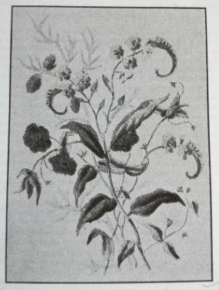
Figure 1: Charlotte Turner, A Watercolour Painting of blue bells, pink and blue anemones, among other flowers, date unknown (but must be pre-1765), included in Florence May Anna Hilbish, Charlotte Smith, Poet and Novelist (1749-1806) (Philadelphia: The Mitre Press, 1941), p. 16.

However, that Smith did have an interest in the science of botany and the art of botanical illustration is indisputable from the evidence available, and it is entirely possible that the painting in Figure 1 was completed by Smith in her girlhood. In a letter to Mary Hays dated 1800, Smith observes, ‘[i]f I could not at times have been a little amused with the study of botany, which by sending out into the fields & hedges I could indulge here, I should have hardly sustain’d my fatigued spirits at all.’ The science of botany and the art of botanical illustration go together. Writing in 1794 to her publishers, Thomas Cadell Jr. and William Davies, she proposed inserting into Rural Walks (1795) ‘some easy lessons on botany; but on setting about it, I found it could not be done without engravings.’ In a letter to botanist Dr. James Edward Smith (1759-1828), Smith writes ‘I have not forgotten (being still compelled to write, that my family may live) your hint of introducing botany into a novel.’ In 1797 Smith was still trying to make this project into a reality. In a further letter to Cadell & Davies she attempts to sell the idea to them once again, arguing that ‘Dr. James Edward Smith would correct it for me,’ and,

Mrs Dorset, whose skill in botanical drawings is greater than that of almost any person I know, has a plan of our doing together a set of drawings, one to illustrate each of Linneas’s orders – to be etched with a page of Letter press to each & the characters done with precision for the use of botanical students & those who cultivate this branch of drawing.

Smith’s Conversations Introducing Poetry: chiefly on the subjects of natural history. For the use of children and young persons (1804) published by Joseph Johnson is perhaps the closest Smith came to realising her dream of a botanical work. This work, as Smith explains in her preface, was ‘originally written for the use of a child of five years old, who, on her arrival in England, could speak no English, but who was a lover of birds, flowers and insects.’ This child was Luzena, the daughter of Smith’s sixth child, Nicholas Smith, and an Indian or Persian woman. As Judith Phillips Stanton observes, ‘Nicholas had sent the child to her from East India.’ Conversations was commended ‘to mothers and teachers, as a welcome help in inspiring children with the love of nature,’ and as the introduction to the work states, demonstrates Smith’s artistry as ‘a close observer of nature; her descriptions are interesting and her style elegant.’ Further, the introduction to this work explicitly draws a connection between the accuracy required for scientific illustration and Smith’s own precision in recording the natural world: ‘[i]t has often been remarked that few writers have given more truthful and lifelike pictures of the creatures whose habits and ways she has studied, and even the lightest touch in her descriptions is correct.’

The attention to detail necessary in the construction of these works is a point of interest in the consideration of Smith’s literary art in parallel with the art of botanical illustration. Elaine Hodges argues that ‘[s]cientific illustrations should be beautiful, and the best qualify as art.’ Hodges continues ‘but accuracy comes first. A beautiful but inaccurate drawing is useless to science.’ Mildred Archer, in her study of Natural History Drawings in the India Office Library from the long nineteenth century, outlines how artists rendered natural history subjects with ‘great sensitivity’:

By patiently applying layer upon layer of brilliant body colour and burnishing between each layer, a firm egg-shell-like surface was built up. The finest of brushes was then used and in this way a delicate yet wiry line was drawn across the surface. By this means, the artists could reproduce the lustre of a feather, the roughness of an animal’s coat, the velvet texture of a petal, or the touch and leathery surface of a leaf with a delicacy and precision which almost justifies the phrase of [Ananda K.] Coomaraswamy, ‘passionate delineation.’

By considering Smith’s sonnets alongside the tropes and motifs of botanical illustration, it becomes possible to analyse how Smith captures both the beauty and the precision of this genre of artistry using this ‘passionate delineation’ in the evocative imagery of her sonnets. By using the ‘finest of brushes’ and ‘patiently applying layer upon layer’ of poetical imagery, Smith, too, ‘reproduce[s] the lustre of a feather, the roughness of an animal’s coat, the velvet texture of a petal.’ In order to show this, I would like to consider the series of sonnets which centre around the death of Smith’s favourite daughter, Anna Augusta (1774-1795). Anna Augusta was Smith’s eighth child, born in Hampshire in 1774. She died in 1795 after being married to the French Catholic émigré Alexandre Marc Constant de Foville for just under two years. Her death was caused by complications resulting from consumption which were exacerbated by the difficult birth of her son. Her health was precarious throughout her pregnancy, but after the loss of her son who died just three days after being born, Smith began to seriously worry about the potential that her daughter too might die. Writing just after the birth of her grandson, Smith writes:

being 70 hours in the greatest peril & in most excruciating tortures, [she] was deliver’d on thursday night of a very fine boy, but it was so much bruised & injurd that it lingered till this morning & then died in my arms – [...] She is so weak that we keep from her the death of the infant. What the effect will be when she must know it, I tremble to think of. Perhaps I shall lose her too.

Smith’s worst fears were realised when her daughter began to decline and was ordered to Bristol Hot Wells to recuperate. Smith made desperate attempts to raise money for her medical treatment, but to no avail. Her daughter died on 23 April 1795 at Bristol, and was buried in the Strangers’ Burial Ground in Clifton Hot Wells (Figures 2, 3, 4, 5, and 6).
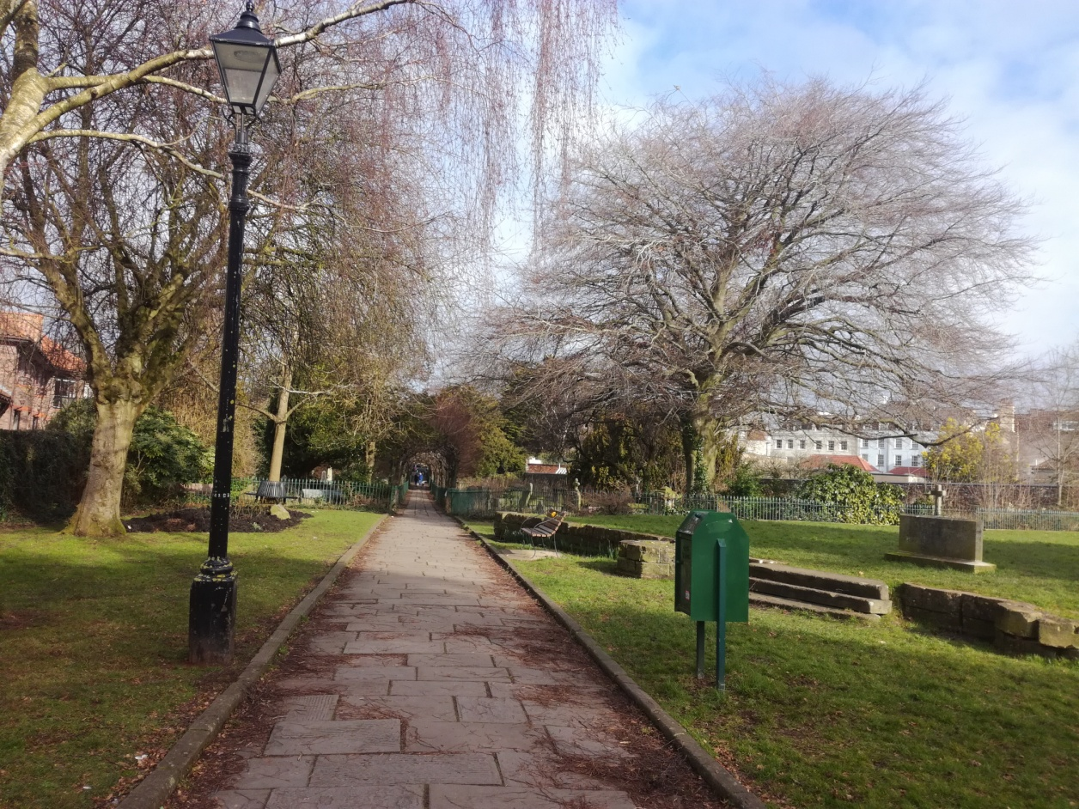
Figure 2: The Strangers’ Burial Ground, Lower Clifton Hill, Clifton in Bristol.

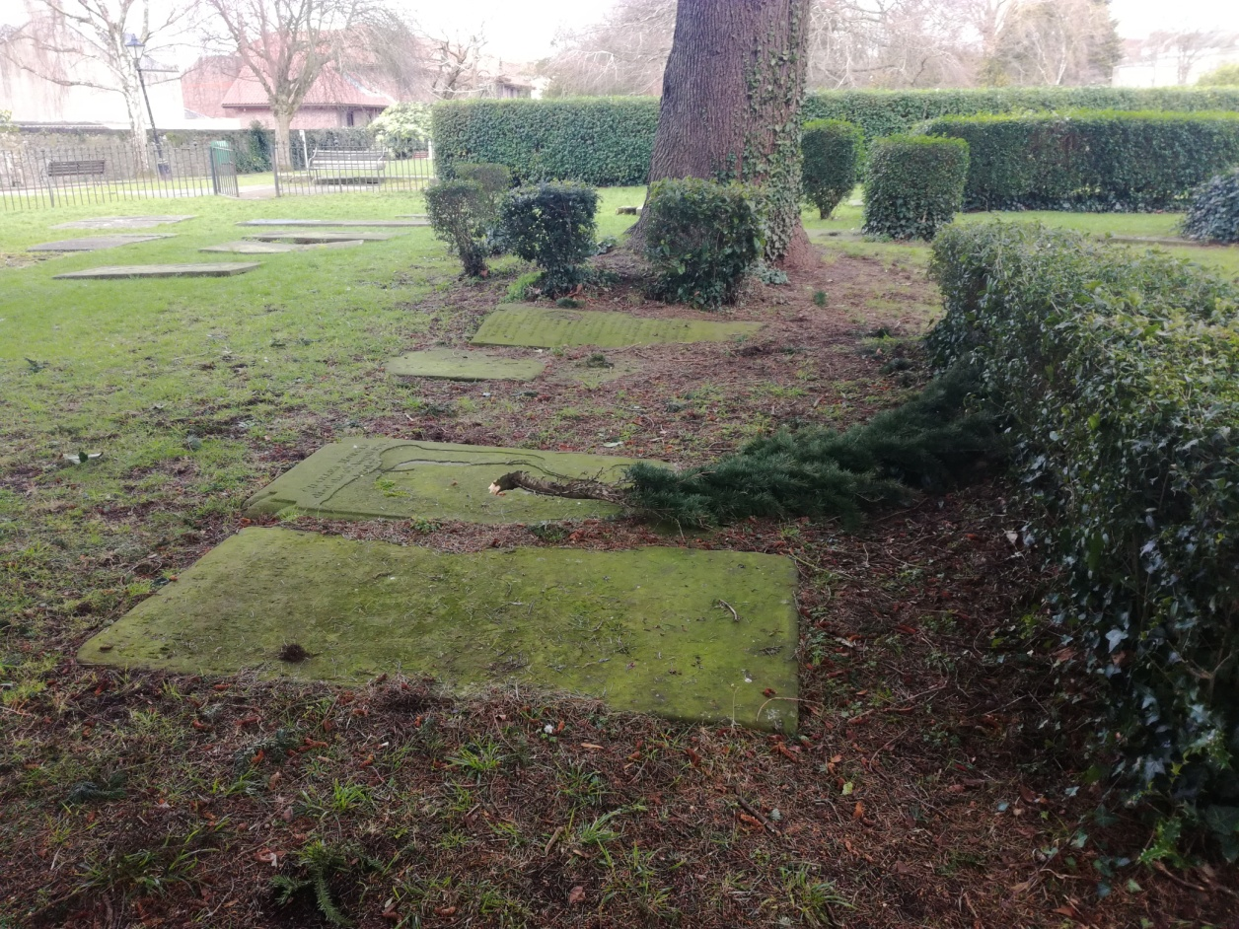
Figure 3: The corner of the burial ground where Smith’s daughter Anna Augusta’s grave lies. This is a disused graveyard and the poor condition of the gravestones can be seen. Epitaphs have generally been washed away by over 200 years of exposure to weather.

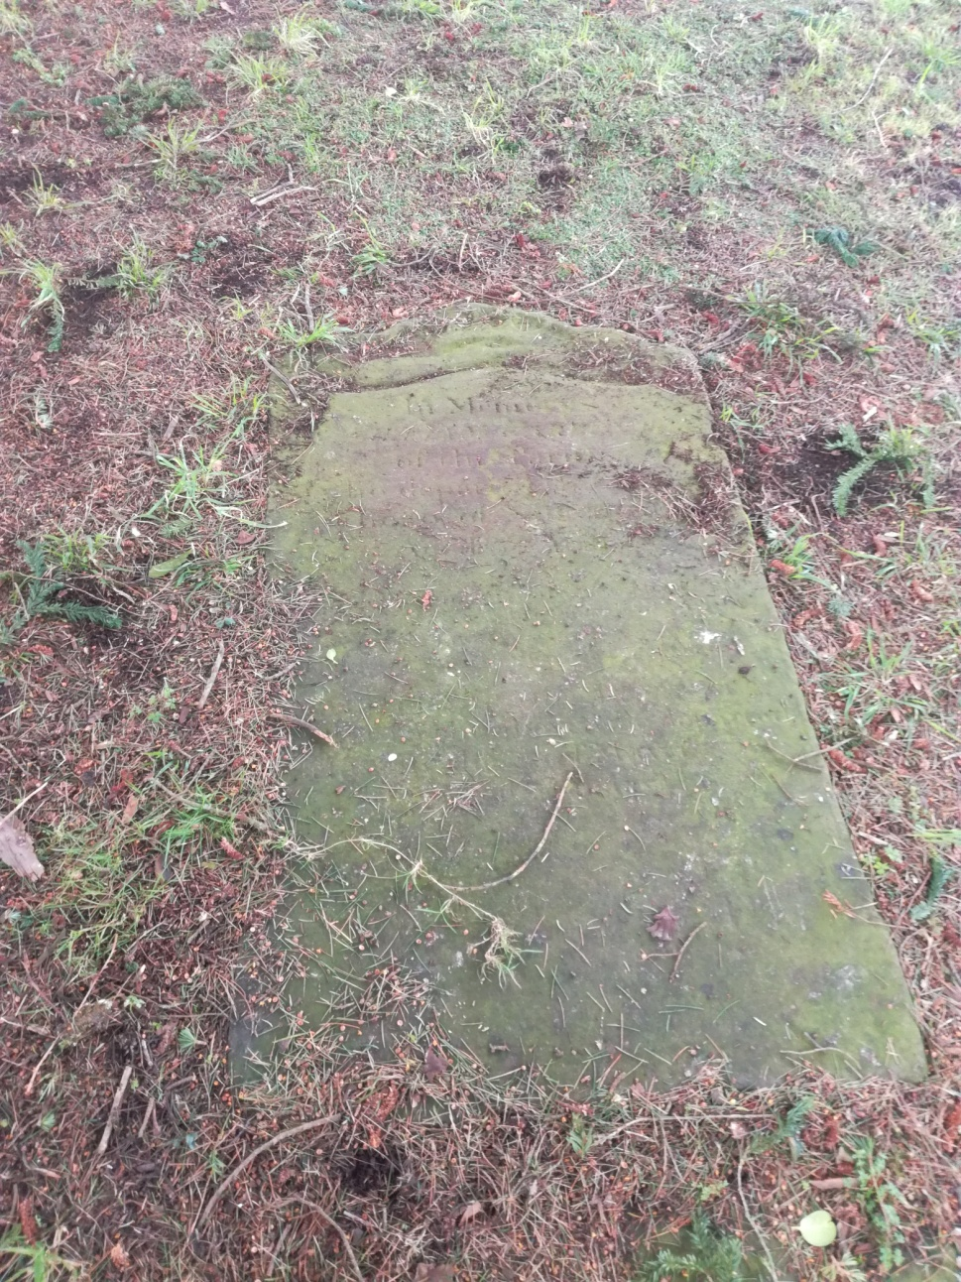
Figure 4: The evidence suggests that this is Anna Augusta’s grave, although from the general deterioration of the grave marker, it is difficult to be certain. Judith Stanton, when describing her visit to the grave writes, ‘The map, which now made sense, led to Augusta’s grave, a flat granite marker under the drooping limbs of an ancient yew. Kneeling beside it, I gently wiped the short dry spiky needles off its inscription and copied it down, feeling, in its syntax and cadences, the protest, the prostrate grief of the mother whose prose by then I knew so well. Smith had penned not only her daughter’s obituary but also the inscription on her grave. (Judith Phillips Stanton, ‘Recovering Charlotte Smith’s Letters: A History, with Lessons’ in Charlotte Smith in British Romanticism, ed. by Jacqueline Labbe (London: Pickering & Chatto, 2008), pp. 159-173 (p. 167)). This flat marker was beneath the only yew in the churchyard, although the inscription, as can be seen, is very difficult to read.

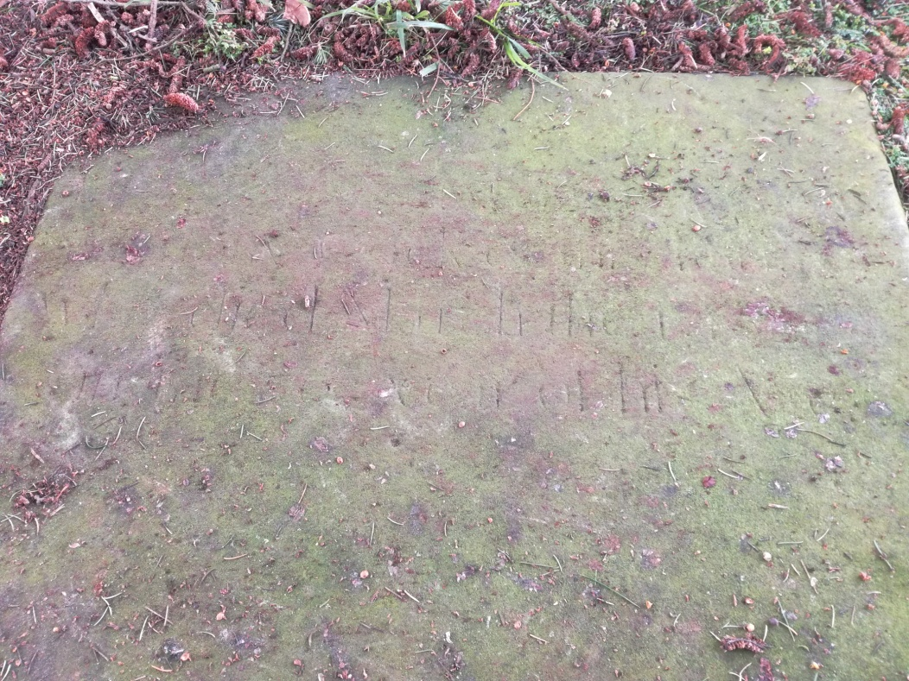
Figures 5 (above): Anna Augusta’s Grave, and Figure 6 (below) with Photoshop enhancements to attempt to determine the inscription. Although it is hard to read the inscription, and a certain element of guesswork has gone into this, it becomes possible to determine, as Stanton asserts, ‘in its syntax and cadences,’ the prose of Charlotte Smith. At the grave site, the words ‘Anna’ could just be made out, along with the word ‘daughter,’ indicating that Smith highlights their relationship on Anna’s tomb.

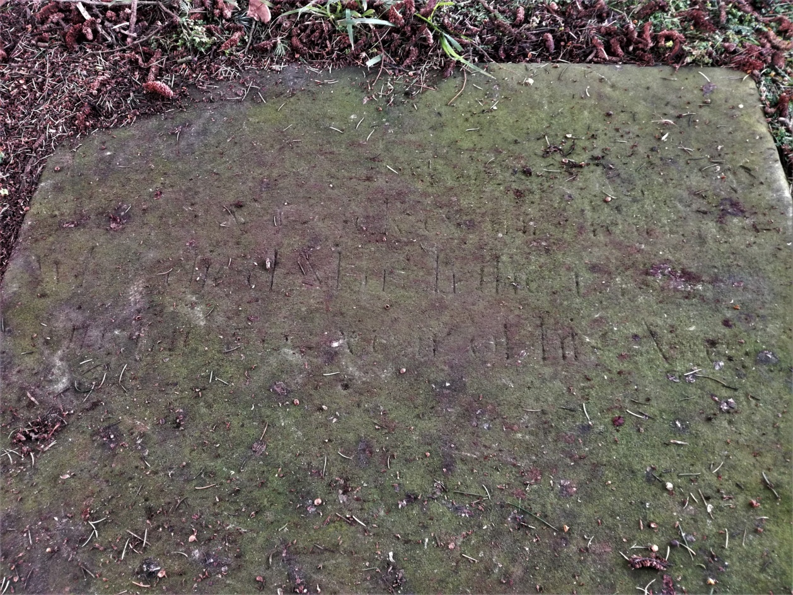
From this point on, mentions of Anna Augusta’s death in Smith’s personal letters are few. Instead, from here on Smith begins to express her grief through her sonnets. She does this in a very particular way, which accesses many of the tropes of botanical artistry. It is as if she is attempting to reconstruct the body of her dead daughter and somehow assuage her own grief through this artistic medium. ‘I can in groups these mimic flowers compose,’ she claims, in sonnet XLI, before using the scientifically accurate detail in her drawings of plants to reconstruct and memorialise the human anatomy of the body of her lost daughter. To exemplify this, it’s worth considering the following sonnet:

Sonnet LXXVIII, ‘Snowdrops’

Wan Heralds of the Sun and Summer gale!
That seem just fallen from infant Zephyrs’ wing;
Not now, as once, with heart revived I hail
Your modest buds, that for the brow of Spring
Form the first simple garland. - Now no more
Escaping for a moment all my cares,
Shall I, with pensive, silent step, explore,
The woods yet leafless; where to chilling airs
Your green and pencill’d blossoms, trembling, wave.
Ah! Ye soft, transcient children of the ground,
More fair was she on whose untimely grave
Flow my unceasing tears! Their varied round
The Seasons go; while I through all repine:
For fixt regret, and hopeless grief are mine

The scientific accuracy of Smith’s delineation in her sketched plants seems important to the poet in this sonnet. She underpins her poetry with the correct scientific names of the plants in question. The snowdrop, for instance, is noted as ‘Gallanthus nivalis,’ within Smith’s footnotes. It seems, as Judith Pascoe observes, unusual for a poet, to resort to ‘the cumbersome Latin terminology Smith so often employs. That she insists on using scientific detail suggests that the poems represent acts of intellectual as well as artistic assertion.

This ‘intellectual as well as artistic assertion’ adopts the same conventions as those used in scientific or botanical illustration. Here, as Hodges argues, ‘accuracy comes first.’ Further, Smith accesses other tropes used in botanical illustration. Sonnet LXXVIII commences by lightly sketching the shape of the diminutive flowers: ‘[y]our green and pencil’d blossoms, trembling, wave.’ It may seem odd to describe the flower of the snowdrop as ‘green’ and yet the individual snowy petals of these flowers are quite often streaked with delicate green lines. These are often so subtle that they could indeed have been ‘pencil’d’ on so finely that what would be required would be that other tool of scientific analysis, the microscope, to view the effect properly (Figure 7).

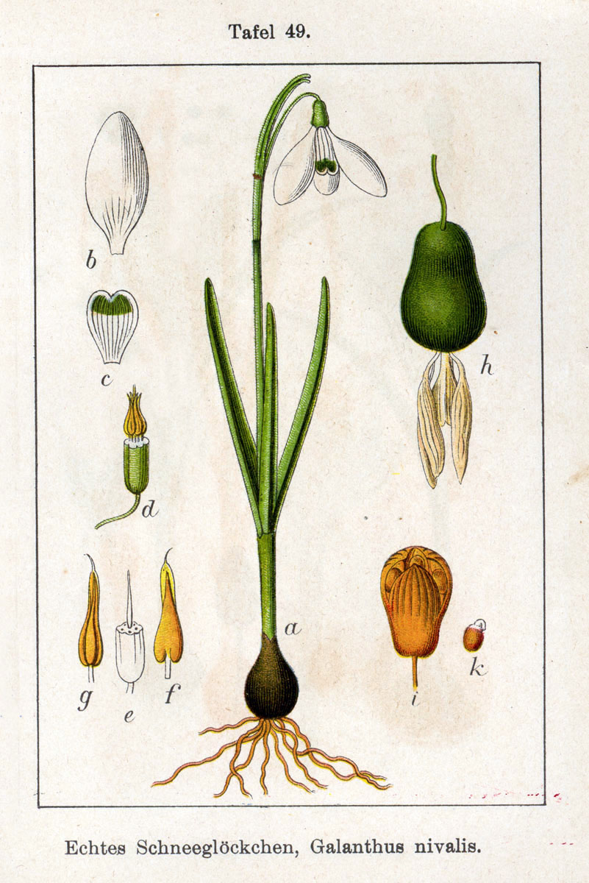
Figure 7: Jacob Sturm, Galanthus nivalis, Figure 49 from Deutschlands Flora in Abbildungen by Johann Georg Sturm, 1796.

Smith here demonstrates her intellectual knowledge and first hand close observation of the species. As Pascoe has termed it, hers is ‘a poetics of the botanically exact.’ The reference to the ‘pencil’d’ line, then, simultaneously calls to mind the detail of the real flower, and the pencil in the artist’s hand which might also be doing the recording. This is a pencil which could be used as an artist’s sketching tool, as in ‘the mimic pencil [that] tries to blend/The glowing dyes that dress the flowery race,’ like the ‘Painted Flowers,’ that the poet wishes to send to ‘The Honourable Mrs. O’Neill,’ in Sonnet XXXVIII. Alternatively, it also calls to mind the ‘pencil sickening Fancy throws away.’ This is the pencil the poet uses to record ‘thy flowers, fair Poesy!’ in the sonnet directly preceding the sonnet addressed to Mrs. O’Neill, sonnet XXXVII, i.e. the pencil used to write the poetry itself. The three realms of scientific analysis, the art of botanical illustration and the art of poetry – are thus combined. There is a conflation between the artist’s pencil and the recording pen held in the writer’s hand.

From the self-conscious manner in which the artist/poet draws attention to the pencil in her recording/illustrating hand, the poetic voice, then, ensures that the reader is aware that her recording of the specimen is made accurate by first hand

observation in the field:

Now no more
Escaping for a moment all my cares,
Shall I, with pensive, silent step, explore
The woods yet leafless; where to chilling airs
Your green and pencill’d blossoms, trembling, wave.

These specimens have been viewed in person by the poetic ‘I’ of this sonnet. She has ‘explore[d]’ their properties and witnessed them in the natural environment. The ‘chilling airs’ and ‘trembling’ manner in which they ‘wave’ in the harsh winter wind, is all recorded. These are field notes reporting on the specimen in its native surroundings, recording both seasonal details (‘woods yet leafless,’ i.e. Winter) and meteorological information (‘chilling airs’). One of the key functions of the scientific illustrator, Hodges asserts, is ‘to record [...] habitats.’ This is often demonstrated by botanical illustrators in the manner in which artists will make composite pictures, including both the plant itself, and insects which may prey on the plant, and other, larger insects, which may prey on these parasites of the plant. Figure 8, for example, is by an anonymous Chinese artist, which forms part of the collection of botanical works held by the India Office Library and provides a sample of this form of composite illustration.

Figure 8: Anonymous Chinese Artist, Butterfly, praying mantis and aphid on a composite, featured as Plate 21 in Mildred Archer, Natural History Drawings in the India Office Library (London: Her Majesty’s Stationery Office, 1962). This image can be viewed in this book, or in the non-redacted copy of this PhD thesis, held by the University of Sheffield Library.

Smith has similarly formed a composite picture for the viewer of her work. The reader gets to witness the snowdrop in its natural environment.

However, in addition to all of these details, Smith is also revealing something else in her field notes. Whilst it is true that she has, in the past, viewed the Gallanthus nivalis in its native state, this particular botanical illustration is being reconstructed from memory: ‘Now no more/[...]Shall I with pensive silent step explore.’ The real purpose and subject of the sonnet comes sharply into focus with the closing apostrophe of the poem:

Ah! ye soft, transcient children of the ground
More fair was she on whose untimely grave
Flow my unceasing tears! Their varied round
The Seasons go; while I through all repine;
For fixt regret, and hopeless grief are mine.

For readers of the Elegiac Sonnets and Smith’s prefaces to these, it becomes apparent that the real reason for recording the snowdrops is, in fact, to record her own grief as a mother at losing ‘[t]he loveliest, the most beloved of my daughters,’ Anna Augusta, which Smith has already notified the reader of in the Preface to her work. The scientific specimen morphs into a female portrait. The Gallanthus nivalis merges with the idea of ‘soft, transcient children’ encapsulating both the concept of the brief pre-Spring spell in which the snowdrops will flower, whilst simultaneously revealing that real children’s lives can be ‘transcient’ as well, being taken in death far too soon. The lost daughter becomes as much a ‘child [...] of the ground’ as the snowdrops, being, literally interred in the ‘untimely grave’ in the body of the earth. The body of the daughter is recalled through the snowdrops being subject to the same decay as ‘[t]he Seasons go.’ However, unlike the snowdrops, for Anna Augusta, there is no possibility of return in the next seasonal cycle.

The lines inscribing the botanical illustration of the snowdrops becomes a memorial to the lost daughter. Indeed, the lines inscribing many of these botanical specimens are rooted in and concerned with memory, just as the drawings illustrating ‘Linnaes’s orders’ would serve as an aide memoire ‘for the use of botanical students & those who cultivate this branch of drawing.’ Sonnet XLI: ‘Reflections on some drawings of plants’ considers the art of botanical illustration before transcending plant physiology to reconstruct the human anatomy of Smith’s lost children (both Anna Augusta and Anna’s baby son – Smith’s grandson – who died shortly after birth. It also memorialises Smith’s own body as the mother of this lost child.
I can in groups these mimic flowers compose,
These bells and golden eyes, embathed in dew;
Catch the soft blush that warms the early Rose,
Or the pale Iris cloud with veins of blue;
Copy the scallop’d leaves, and downy stems,
And bid the pencil’s varied shades arrest
Spring’s humid buds, and Summer’s musky gems:
But, save the portrait on my bleeding breast,
I have no semblance of that form adored,
That form, expressive of a soul divine,
So early blighted; and while life is mine,
With fond regret, and ceaseless grief deplored –
That grief, my angel! with too faithful art
Enshrines thy image in thy Mother’s heart.

As Jacqueline M. Labbe argues:

At the moment she establishes herself as skilled maker of flowers, Smith leaves behind her flower painting; those very drawings over which she exerted such steady control evoke the memory of a daughter whose death she "with fond regret, and ceaseless grief deplore[s]" (12). Here, the permanent representations of nature only emphasize the evanescence of human life, while the ease with which she captured nature's hues in her drawings underscores her sorrow that, "save the portrait on my bleeding breast,/ I have no semblance of that form adored" (8-9). Yet, as we see by the poem's end, she is not entirely without her child's "semblance." Indeed, almost sanctifying the art by which the image is engraved, Smith offers her own body, first the maternal breast that "bleeds" from its loss, and then her "Mother's heart" as the canvas on which the portrait is reproduced.

Here, as Labbe demonstrates, the body of the grieving mother is presented within the sonnet as vividly rendered alongside the ‘drawings of plants.’ Here also can be found the body of the lost daughter. Judith Hawley concurs with this view, noting that ‘[i]n [Smith’s] botanical drawings she can capture in art a nature which might have some reference to herself and her daughter.’ Elizabeth Dolan also makes a similar point as Hawley: ‘Smith draws her daughter into her botanical sketch.’ Thus, ‘[t]hese bells and golden eyes, embathed in dew’ evocative of blue bells, and the golden eyes of daisies in the first light of morning, become the blue eyes fringed with golden lashes of Smith’s fair daughter, glittering with unshed tears. The ‘soft blush that warms the early Rose’ evokes the roses in Anna Augusta’s cheeks. This could also be, as Kathleen Béres Rogers argues, ‘the pale pink hue of a human baby.’ Indeed, the botanical illustration, as Smith composes it, reconstructs the body of the grieving mother, the pregnant body of Anna Augusta as she was just prior to her death (about to bring forth her own human baby), and the baby the mother Smith would remember her daughter being, in addition to the dead baby (Anna Augusta’s child and Smith’s grandson). Capturing Anna Augusta’s last moments alive, this sonnet recalls her as Smith would probably remember her forever.

These anatomical details such as ‘the pale Iris cloud[ed] with veins of blue’ refocuses the reader’s gaze to consider the many human bodies concealed within the body of the sonnet. The reader switches from analysing plants, to considering female forms, for example the ‘bleeding breast’ and ‘Mother’s Heart’ of the grieving mother highlighted by Labbe. The ‘veins of blue’ evoke the image of the blue veins which become startlingly visible across an expectant mother’s breasts, caused by increased blood flow during pregnancy. The ‘downy stems’ is an image redolent of the downy skin of a newborn child. The poetic speaker of the sonnet, ‘bid[s] the pencil’s varied shades arrest/Spring’s humid buds, and Summer’s musky gems.’ Anna Augusta’s pregnancy has come to the fruition associated with ‘Spring,’ with new life bursting forth in the ‘humid’ heat of new seasonal warmth. As Anna Augusta’s son was born in the summer preceding her death, early in the following year, he could be the ‘musky gem’ of Summer that Smith’s daughter has produced, and which will ultimately accelerate Anna Augusta’s demise in the following Spring. There is nothing the narrator of the poem can do to ‘arrest’ that now. All that remains of Smith’s lost children is the ‘portrait on [her] bleeding breast.’ The motherhood in this sonnet has only brought forth death, thus the breast passes blood, not mother’s milk. This is a portrait constructed through the medium of botanical illustration. The physiology of plants is examined by the artist in microscopic detail, before being transplanted into human form. This is the only way the grieving poet can memorialise her daughter and provide for herself the portrait which she otherwise lacks. This illustration is then engraved into her heart by grief: ‘That grief, my angel! with too faithful art/Enshrines thy image in thy Mother’s heart.’

The sonnet becomes more than a ‘Reflection on some drawings of plants’ but instead a reflection and memorial to the lost daughter constructed in verse. It is a portrait that remembers and reconstructs ‘with [the] too faithful art’ of scientific accuracy. The act of remembering becomes re-membering, as Smith uses the microscopic detail in her recording of plant physiology to reconstruct the body of her dead daughter by utilising imagery which is redolent of human anatomy. The microscopic detail employed then, in turn, frees Smith to recreate her daughter again, if only in memory, and transcend the final barrier of death itself. Cynthia Sundberg Wall, in The Prose of Things, describes how Robert Hooke’s 1665 poem, ‘The Flea’ uses microscopic detail of both the flea’s anatomy and the manner in which it moves in order to ‘free him to fold, stretch, and spring his joints to move his hair auricular film to and fro.’ The ‘verbal visualization’ is then ‘matched with narration to try and create an experiential description of something not just seen but imaginatively inhabited.’ The same microscopic detail of Anna Augusta’s physiology of her recently pregnant body is being presented by Smith in Sonnet XLI. By the act of reflecting on – and inserting into her sonnet – ‘That form, expressive of a soul divine,’ Smith breathes life back into ‘[t]hese bells and golden eyes, embathed in dew,’ rendering a pair of blue eyes vividly gazing tearfully out at the reader at that life ‘[s]o early blighted.’ The minuteness of the description necessary for the botanical illustration recorded in this sonnet creates, in Wall’s words ‘another plane of experiential space.’ As Wall observes:

The flea and the louse may drape themselves, as magnificent still lives across a creamy page, but, in the text, they scuttle and scud and lurk and intrude and trample and spring, generating a visualized, inhabited space in the reader’s mind – or less happily, memory.

The daughter is irrevocably lost, and yet across the ‘creamy page,’ she, like the flea, lives again. Within the confines of the poem, she can be discerned blushing softly, like the ‘early Rose,’ the ‘veins of blue,’ pulse with blood flow once more, the eyes shine forth ‘expressive of a soul divine.’

In discussing Smith’s posthumously published epic poem Beachy Head (1806), Pascoe suggests that:

The sheer material abundance of Beachy Head’s close-up tableaux suggests that the most circumscribed outdoor space – for example, the narrow loop of a lady’s daily promenade – can serve as easily to expand as to constrict. By insistently focusing on the minute within even the grandest expanse, Smith suggests the escapist possibilities of the particular. Within the carefully delineated realm of the cottage garden, locus of female work and duty, Smith employs the extreme close-up of the botanist’s gaze, creating an explosion of dazzling specificity, so that the limitations of a female vantage point become forces of liberation.

Smith uses this focus on the minutiae of detail inherent within the botanical illustration to resurrect her dead children: both the lost favourite daughter and Smith’s new and tragically short-lived grandson who ‘then died in [her] arms.’ In this manner, this sonnet, ostensibly mimicking a composition of flowers, offers the ultimate escapist possibility, that of altering the past and reincarnating the dead.
This is just one example of how Smith adopts the particular tropes and motifs of specific art styles – in this case botanical illustration – and incorporates these into her literary works in order to enhance meaning. This thesis examines a number of specific aesthetics and styles of artistry across five chapters to demonstrate this, in order to extract that further literary meaning from her work, and also to illustrate Smith’s own artistry within her literary endeavour. In most cases, the stylistics analysed will belong to artists with whom Smith had a known relationship and where evidence exists that she was familiar with their corpora.

With this in view, the first chapter explores the connection between Charlotte Smith and one of the earliest artists she would have been exposed to. This was George Smith of Chichester, a landscape painter who worked under the patronage of the second Duke of Richmond (1701-50) (Figure 9). Despite the fact that this patronage was continued by his son, Charles, the third Duke (1735-1806), George Smith only ever ‘earned his living “very precariously” as a portrait painter, and lived an itinerant life searching for commissions.’ During this ‘itinerant life,’ he came into contact with the Turner family of Bignor Park, probably through his relationship with the Duke of Richmond at nearby Goodwood. Charlotte Smith’s family commissioned George Smith to act as her drawing master. Circa 1756-57, when Charlotte Smith was just 7-8 years old, George Smith inculcated in Charlotte Smith his own particular interpretation of the English picturesque with lessons in artistry.

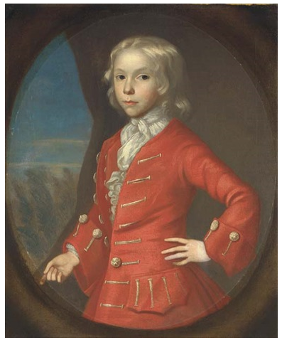
Figure 9: Attributed to George Smith of Chichester, Portrait of a boy (Charles, Third Duke of Richmond), date unknown, oil on canvas. Portrait in private ownership. This image can be viewed in the non-redacted version of this thesis held by the University of Sheffield Library.

Despite the brevity of their relationship and the youthful age of Charlotte Smith during the period in which these lessons took place, George Smith’s work, as will be seen, had a profound effect on Charlotte Smith’s literary landscapes. Indeed, I am not the first researcher to notice the connection between the picturesque, romanticised landscapes which form some of the settings for Charlotte Smith’s novels, and George Smith’s painterly oeuvre. Christopher Hussey also marks the correlations between ‘Charlotte Smith, a pupil of George Smith of Chichester,’ and Charlotte Smith’s landscapes described ‘with gusto in the manners of […] the prints and paintings’ of George Smith. These ‘prints and paintings obviously supplied the want of first-hand impressions,’ according to Hussey, and indeed, as I observe during the first chapter, Charlotte Smith is, in some instances, describing the landscapes of actual places that we know she did not visit during her lifetime. She also, however, uses locations which could not possibly exist. They are landscapes of the imagination to a certain extent, and it is their visionary nature which permits Charlotte Smith to imbue them with additional significance and use them to convey critical commentary on the nature of eighteenth-century society. Charlotte Smith’s picturesque landscapes chart links between the aesthetic ideal of the picturesque and political, gender, moral and class concerns. Exploring the connections between Charlotte Smith’s first novel, Emmeline, or, the Orphan of the Castle (1788), and the oeuvre of her drawing master, George Smith, it becomes possible to see how Charlotte Smith uses the picturesque as a narrative device to demonstrate the instability of her characters, and by extension, her society. Further, Smith uses the artificial zeitgeist of the picturesque to accentuate the realism of her romantic novel.

Whilst the aesthetic of the picturesque was incredibly popular during the period, chapter two will consider a different very popular Romantic aesthetic: that of the sublime as defined by Edmund Burke. This is analysed particularly in conjunction with the corpus of another of Charlotte Smith’s artistic acquaintances, George Romney (1734-1802). Smith’s friendship with Romney is much better understood by modern readers and scholars than her relationship with George Smith of Chichester. From the letters of William Cowper and Romney himself, we know that Smith spent time at William Hayley’s house, Eartham in Surrey, in 1792. Romney describes his visit to Eartham with Smith thus:

I was near a month at Mr. Hayley’s, where I met Mr. Cowper and Mrs Smith; and yet, in spite of such good company, and bathing, my health continues very poorly. – Mr. Cowper is a most excellent man; he has translated Milton’s Latin Poems, and I suppose very well. Hayley is writing the life of Milton, so you may imagine we were deep in that poet; every thing belonging to him was collected together and some part of his works read every day. Mrs Smith is writing another Novel, which, as far as it is advanced, is, I think, very good. She began it while I was there, and finished one volume. She wrote a chapter every day, which was read at night, without requiring any correcting. I think her a woman of astonishing powers.

Indeed, Smith clearly felt Romney was a man of equally ‘astonishing powers.’ Not only did he complete the only portrait of herself of which she ever approved (Figure 12), but his influence as an artist pervades her literary oeuvre. Chapter two charts the relationship between the two artists and demonstrates how Romney’s use of the Burkean sublime in his primarily female portraiture infiltrates Smith’s portrayals of ‘sublime women.’ Focussing on the eponymous heroine Ethelinde, in addition to Laura along with her daughter Medora in The Young Philosopher (1798), this chapter will demonstrate how these women adopt and adapt the Burkean sublime for their own purposes. Further, it will demonstrate how Smith is utilising precisely the same painterly techniques as Romney in order to convey concepts surrounding the sublime. By reading their artistry in tandem, it will become clear how their mutual use of the sublime is employed by both artists as a tool for social critique. The chapter will further demonstrate how the sublime of Romney and Smith, as an aesthetic that transgresses boundaries, enables their literary and visual artistry to stray beyond the borders of the eighteenth century into the realm of the postmodern.

Continuing along the same vein, chapter three explores the relationship between Smith and another eighteenth-century portraitist, James Northcote (1746-1831). This time the chapter considers the artists’ mutual adaptation of the aesthetic trope of ‘the Beautiful’ in their portrayal of male heroes. Within this chapter, ‘the beautiful’ as defined by both Edmund Burke and Immanuel Kant has been considered as both of these theorists contribute to our understanding of the eighteenth-century aesthetic, and traits from both theorists’ interpretations are clearly visible in the heroes created by Northcote and Smith. James Northcote has traditionally been viewed as a marginal figure within the art world of British Romanticism but research has revealed that he was in fact central to the circles of a number of key Romantic figures. Exploration in a variety of archival holdings has shown that not only did he have an intimate friendship with William Godwin, even leaving Godwin £100 in his will, but that he also corresponded with Elizabeth Inchbald, in addition to taking tea with Smith, along with Samuel Taylor Coleridge and Godwin. He was one of the last people to see John Opie alive, and his wife, novelist Amelia Opie, took comfort from Northcote’s visit to her dying husband’s bedside, detailing Northcote’s kindness and sensitivity. Further, the connection between his own visual artistry and the literary world was clearly very important to Northcote. Within his Letter Book held by the Bodleian Libraries, he keeps a detailed list of every work of fiction which makes reference to or details his work. These include:

Northcote’s pictures perused in the following: Rosalind de Tracy, a novel by Elizabeth Sophia Tomlins. The Triumphs of Constancy, A Novel in a series of letters Mammon in London, or the Spy of the day. John Thelwall also wrote about him in The Champion May 27 1821.

Within The Papers of James Northcote, R.A. presented to Sir William Knighton on his death, there was also the inclusion of many extracts from the publications of the day which praised his work. It would perhaps have given him pleasure to understand how similar his own portraits of heroes which played with the aesthetic of the beautiful within his primarily male portraiture are to Smith’s heroes within novels like The Old Manor House (1793) and Montalbert (1795). Chapter three thus explores the connections between the heroes of Northcote and Smith and how both artists utilise painterly tropes such as sublime contrasts to illuminate the ‘beautiful’ characteristics of male portraits. It will demonstrate how Smith’s heroes, like Orlando, Warwick, Desmond and Montalbert, are ‘beautiful’ in nature rather than leaning towards the Burkean masculine sublime. This in turn raises interesting questions concerning the ‘beautiful’ as a gendered construct which both Smith and Northcote interrogate. Further, the chapter also queries the Burkean notion that sexual desire is something that can only be experienced by men for women and is thus denied as a valid emotion to be experienced by women for men. Smith’s works refute this.

Following on from this consideration of the ‘beautiful heroes’ of both Northcote and Smith, chapter four returns to artists named ‘Smith’ again, and considers the relationship and mutual influences which occur between the visual artworks of pioneering printmaker and engraver John Raphael Smith (1751-1812), his daughter, the precociously talented artist Emma Smith (1783-1853), and Charlotte Smith. John Raphael Smith was a ‘superb mezzotint engraver and print publisher, producing over 300 prints and employing the young Thomas Girten and J. M. W. Turner.’ He also completed portraits in pastel. J. R. Smith, like Northcote, is a relatively understudied figure of British Romanticism, and yet his print works and engravings had a profound effect on shaping Romanticism as it is portrayed today. J. R. Smith’s print of Fuseli’s iconic image of Romanticism, The Nightmare, was exhibited at the Royal Academy in 1782, and has become an enduring image of Romanticism. It only became so popular because J. R. Smith sold approximately 2,000 prints of it, making it widely and cheaply available for the public, and guaranteeing its enduring fame. With its themes drawing on folklore, science and classical art, Fuseli’s original, and subsequently J. R. Smith’s print, creates a sexually-charged image which has come to embody certain aspects of Romanticism, especially pertaining to the Gothic. A variant of the image was, for example, used as the front cover to the Penguin English Library edition of Three Gothic Novels: Walpole, The Castle of Otranto; Beckford, Vathek and Mary Shelley, Frankenstein, issued in 1968, 1970, 1972, 1973, 1974, 1975, 1976 and 1978 (Figures 10 and 11).

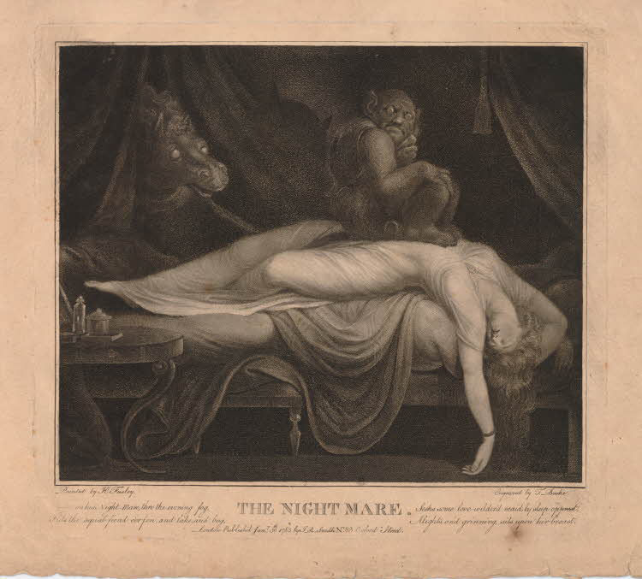
Figure 10: Thomas Burke, after Henry Fuseli (published by John Raphael Smith), The Nightmare, 1783, stipple on paper.

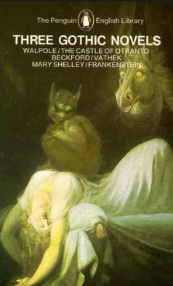
Figure 11: Front Cover of Three Gothic Novels: The Castle of Otranto, Vathek & Frankenstein, ed. by Peter Fairclough (Harmondsworth: Penguin Books Limited, 1968). This image can be viewed on the front cover of this book, or in the non-redacted version of this PhD thesis, held by the University of Sheffield Library.

J. R. Smith’s daughter, Emma Smith, was an artistic prodigy. From 1799, when E. Smith was just sixteen years old, she was exhibiting pieces at the Royal Academy. She was reviewed by the Monthly Magazine, after two of her engravings, copied from originals by Maria Cosway, were published by Rudolph Ackermann in 1801:

These prints are engraved by a young artist of very uncommon abilities, who is only seventeen years of age. She is the daughter of Mr. Smith, an engraver; she draws the figures with great taste and accuracy; paints in miniature and oil; plays the pianoforte and harp; and speaks and writes the French language in perfection. As an artist, the shadows are broad, forcible and well understood, and the manner of the painter well preserved.

J. R. Smith and E. Smith had connections with a number of key Romanticism figures, including William Godwin, William Blake, George Romney, James Northcote and, of course, Charlotte Smith. Through his other daughter Eliza Aders, who formed a literary salon, J. R. Smith also had connections with William Wordsworth, Samuel T. Coleridge and Charles Lamb. What becomes clear from analysis of his life and works is that J. R. Smith was a key figure in the art world of British Romanticism, in spite of the fact that he is little remembered today. Reading his visual artistry alongside Charlotte Smith’s works provides new insight into both Charlotte Smith’s biographical history and gives new information concerning prints which were previously shrouded in mystery, such as the British Museum held print of E. Smith’s ‘Rosalie’ (1801) which is discussed in this chapter.

It is from analysis of J. R. and E. Smith’s oeuvre that it became apparent just how central a figure Charlotte Smith was in British Romanticism. When I was studying as an undergraduate during the 1990s, the common misperception was that Charlotte Smith was a marginal figure. Despite the groundbreaking work in 1988 of Stuart Curran in his essay ‘The “I” Altered’ which exposed the fact ‘that by the 1790s in Great Britain there were many more women than men novelists’ and that ‘[i]n the arena of poetry, which in the modern world we have privileged as no other in this age, the place of women was likewise, at least for a time, predominant,’ to some extent this misconception is still extant today. Many critics still perceive Charlotte Smith as just one woman writer working in ‘profound isolation’ labouring against her financial misfortunes by solitary endeavour with her pen. As Curran argues, ‘the distortions of our received history are most glaring’ in this area. Studying the circle of artists and literary figures to which J. R. Smith and E. Smith belonged, it is plain that Charlotte Smith was part of an enormous network of key figures of British Romanticism. This is illustrated in the relationship chart included on page 57. Further, considering the visual and literary works of all of these artists named Smith alongside each other, it becomes clear that the cross currents of influence between them can be determined from readings of Charlotte Smith’s works and analysis of J. R. Smith’s and E. Smith’s engravings and prints. Within this chapter, I focus on the educational works of Charlotte Smith to draw out the parallels between these artists and examine how the combination of tropes taken from the popular aesthetic theories of the picturesque, the sublime and the beautiful were employed by J. R. Smith within his engravings and prints. This conflation of aesthetic concepts is then discussed in terms of how a print collection can present a ‘portrait gallery’ of women and what these collections reveal about the social positioning of women during the late eighteenth century.

Moving on from the aesthetics used in the print and engraving collection, chapter five is the only chapter which does not consider the works of a specific artist and his or her connections with the works of Charlotte Smith. Rather, the subject of analysis here is a national artistry in the form of heraldic art and how this records history and is employed in Smith’s novel Celestina (1791). Celestina is a novel that seems deeply concerned with heraldic art and accesses the tropes of this aesthetic repeatedly. However, Smith does this in order to apparently undermine how reliable these escutcheons are as purveyors of historical ‘truth.’ Truth, authenticity, the very nature of fiction itself and the stories which are being told, both within society, and by Smith, all come into play here. The chapter analyses the stories that society’s first families are telling themselves, and society, about themselves and how Smith deconstructs these in order to interrogate the nature of ‘truth’ and the stories that are being told. It is through her close examination of these heraldic tropes and motifs that Smith exposes the flawed nature of these stories, but also demonstrates her own artistry as a creator of literature and weaver of stories. Indeed, Smith’s adoption of these diverse aesthetic tools that she demonstrably applies within her novels, her educational works for children and her poetry, and that form the subject of this thesis, provides insight not just into her actual relationships and friendships with the many visual artists. Her extensive knowledge and employment of visual artistry within her own literary works lays bare the level of artistry which has gone into the creation of these texts. Fuson Wang describes readerly expectations of her early novels of sensibility as ‘another romantic potboiler.’ However, within all of her writings there is a layer of artistry that close reading reveals, and that exhibits her literary work as true art.

This thesis contributes to a new understanding of Smith’s literary work as art via the original methodology employed in comparatively reading Smith’s literary works alongside the visual artistry of the period. My research sheds new light on the importance of Smith’s relationships with artists such as George Smith of Chichester, Romney, Northcote, John Raphael Smith, and his daughter, Emma Smith, in addition to providing new insight into their artworks. The links and allegiances uncovered within this thesis between Smith and her fellow artists provides an innovative understanding of a new kind of Romantic companionability. The implicit conversations Smith holds with these artists creates a Romantic community interested in how to use art to represent both life and art. By realigning my thinking from my original starting point of place and shifting instead to consider space as a visualized and textual artefact of something that otherwise risks being unrepresented, I have opened a new space for the study of Smith and her works.

The texts analysed within the thesis have been selected on the basis of how clearly the individual artistic and aesthetic devices shine through. However, for instance, whilst the focus has solely been on Celestina in the discussion of heraldic art, Ethelinde and The Young Philosopher have formed the focus of the analysis of the sublime, and the picturesque has only been discussed in the context of Emmeline, all of these tropes and devices appear in other works by Smith. Warwick, Orlando, Desmond and Montalbert are not the only heroes in Smith’s works, for example, who are arguably ‘beautiful.’ But, no thesis can be so broad that it encompasses a writer like Smith’s complete works, and therefore by necessity some works have been excluded. There is no discussion, for example, of Smith’s play, What is She? A Comedy in Five Acts (1799) or her late educational work The History of England from the Earliest Records to the Peace of Amiens in a Series of Letters to a Young Lady at School (1806). Some novels have not been discussed including The Banished Man (1795), Marchmont (1796), and her series of interlinked novellas, The Letters of a Solitary Wanderer (1800). This decision was made not because these works are without merit or do not contain similar evidence of Smith’s use of the tropes of visual artistry within them. It was rather simply because there was not space.

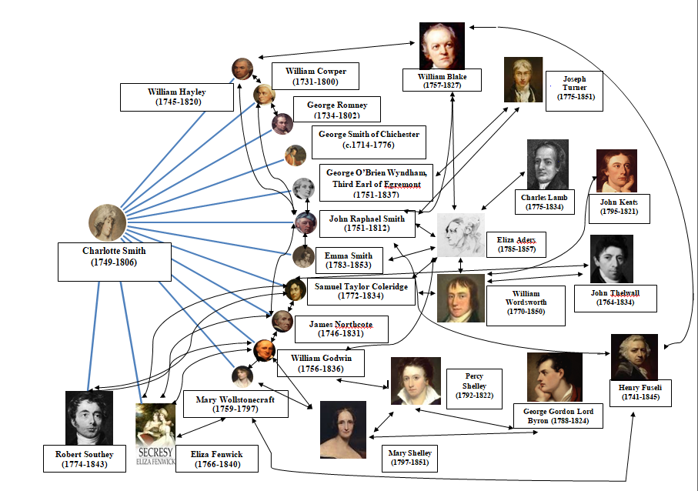

Chapter One
A Tale of Two Smiths: In Pursuit of the Picturesque in Emmeline, or the Orphan of the Castle (1788)

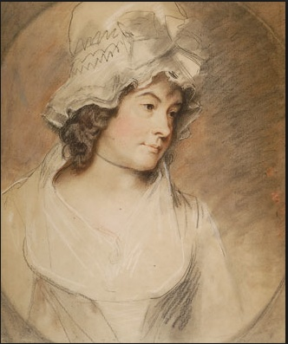
Figure 12: George Romney, Charlotte Smith, 1792,
pastel on paper.

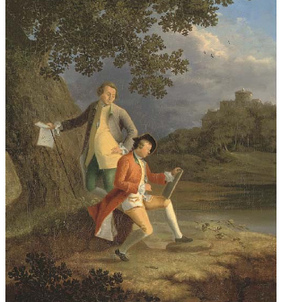
Figure 13: George Smith, George and John
Smith, c. 1760, oil on canvas. Painting in private ownership. This image can be viewed in the non-redacted version of this PhD-thesis, held by the University of Sheffield Library.

This chapter commences with two artists named Smith. In the foreground, and the subject of this thesis, is Charlotte Smith (1749-1806). In the background and supplying much of the scenery is George Smith of Chichester (c. 1714-1776), an English landscape painter from whom Charlotte Smith took drawing lessons as a child between the years of 1756-1757. This chapter will explore the links between the two artists and will demonstrate how Charlotte Smith’s landscapes within her first novel, Emmeline, or the Orphan of the Castle (1788), utilise George Smith’s picturesque landscapes as a suitably romantic setting for her heroine.

The relationship of the two Smiths, that of drawing master and child pupil, is one that was previously known about, although little critical attention has been paid to it. This chapter will explore the relationship between the two artists further and illustrate the significance of George Smith of Chichester’s picturesque vision when it is applied to the textual artistry of Charlotte Smith’s first novel. It will show how Charlotte Smith uses George Smith’s interpretation of the picturesque within her work and how this, in turn, adds an additional interpretative layer to her novel. This is a strand of investigative research that has never been fully exposed before and permits an original reading of Charlotte Smith’s first novel that has not heretofore been considered. Paying attention to the picturesque elements of this sentimental novel, for example, reveals it to be more politically engaged than previously considered.

The connection between the picturesque and the political is much-explored territory. Many scholars and theorists have charted links between the aesthetic ideal of the picturesque and the political, gender issues, and moral and class concerns. Stephen Daniels’s analysis of ‘The Political Iconography of Woodland,’ for example, highlights Anna Seward’s outrage at Richard Payne Knight’s ‘Jacobinism of taste’ in his picturesque poem, The Landscape: a didactic poem in three books addressed to Uvedale Price, Esq. (1794). Knight’s readers, Daniels argues, ‘saw the spectre of the guillotine’ in his verse. Elizabeth Bohls ‘frame[s] a meditation on gender, knowledge and power’ by an in-depth analysis of ‘the language of landscape aesthetics.’ Challenging the ‘founding assumptions’ associated with the rhetoric of aesthetics, Bohls disputes ‘the autonomy of the aesthetic domain from moral, political, or utilitarian concerns and activities.’ Her study of a variety of women writers of the period locates the ‘ingenious means’ these women access in order ‘to disrupt and reconceive’ notions surrounding the picturesque. Vivien Jones’s analysis of the ‘sexual/textual politics’ in The Old Manor House (1793), amongst other texts, explores theories of the picturesque alongside ‘anxieties about private property and national identity’ which, Jones argues, ‘are articulated in terms of voyeurism and sexual possession.’ The picturesque, Jones observes, contains ‘instabilities of class and gender’ personified via the relationship between Orlando and Monimia, and, more specifically, the discourse of ‘improvement’ which takes place within this novel. I follow in the footsteps of these and many other scholars who discuss the connection between the rhetoric of picturesque landscape painting and the political realm. Exploring the connections between Charlotte Smith’s first novel and the oeuvre of her drawing master, George Smith, demonstrates the significance of the picturesque in the landscape settings of Emmeline. Smith uses the picturesque as a narrative device to demonstrate the instability of the characters, and by extension society. Further, Smith uses the artificial zeitgeist of the picturesque to accentuate the realism of her romantic novel.

George Smith, commonly known as ‘George Smith of Chichester,’ was one of three brothers, all of whom were artists. Joseph Holden Potts in his Essay on Landscape Painting of 1782 lists Smith in the ‘second class’ of [English] landscape painters. George Smith is virtually unknown today, although during his lifetime he was termed ‘the English Claude’ who painted with ‘[a]n eye for picturesque scenes, whether cottages or Claudian glades.’ He is described by Christopher Hussey, in his detailed study of the picturesque movement, as ‘a rich painter and, in his feeling for the spirit of nature, a finer artist’ than his brothers. Smith, with his scenic landscapes epitomising an ideal of the English countryside, was situated firmly within the almost ubiquitous zeitgeist of the picturesque movement in the period. This movement was popularised by the guidebooks of William Gilpin, the aesthetic theories of Uvedale Price and Richard Payne Knight, and the landscape garden designs of Lancelot ‘Capability’ Brown, William Kent and Humphrey Repton. There is even evidence to suggest that George Smith’s vision of the picturesque ‘created a climate receptive’ to these later theorists. Richard Payne Knight’s influential poem of the picturesque, The Landscape: a didactic poem in three books addressed to Uvedale Price, Esq used illustrations that were directly inspired by George Smith’s premium painting of 1760 (Figure 14). As Brian Stewart observes, in Thomas Hearne’s illustration for Payne Knight’s poem, ‘[t]he rise of the banks, the bend of the river, even the rock in the stream are all based on Smith’s popular painting.’ Hearne’s version, as is clear from a comparison of the individual landscapes in Figure 14, was even produced to scale. George Smith, then, is an early proponent of the picturesque movement, situated squarely at its forefront.

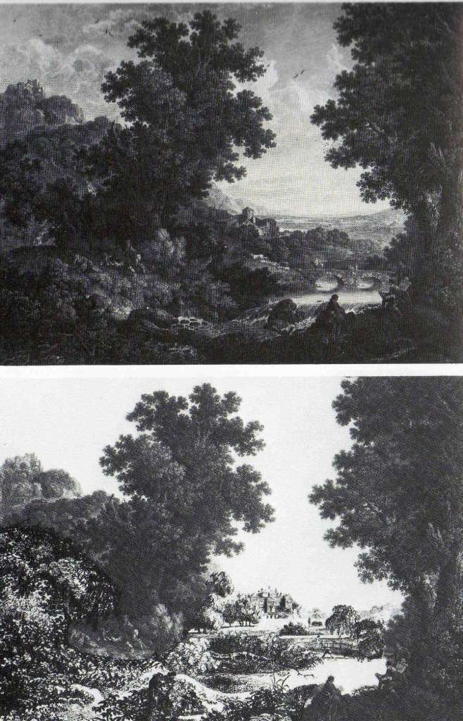
Figure 14: George Smith’s Premium Painting of 1760, engraved by William Wollett and published by J. Boydell in 1762 (top) as compared with Thomas Hearne’s The Unimproved Picturesque Landscape, an illustration from Richard Payne Knight’s The Landscape:A Didactic Poem in Three Books. This image can be seen in the non-redacted version of this PhD thesis held in the University of Sheffield Library.
The ‘nature’ exhibited by these picturesque artists, including Smith, Hearne, Gilpin, Price and Knight, however, did not, in reality, adhere to nature at all, as many theorists have argued. It was rather, as Ann Bermingham terms it, an ‘aestheticization of the English countryside.’ Everything about the picturesque was artificial. It was a method by which to order and construct nature. It instructed viewers of the landscape where to see: by directing them to specific ‘viewing stations.’ It told them how to see: through their Claude glasses, which, as John Brewer observes, were tools ‘for capturing and manipulating nature, for making a frameable possession of it.’ It told them what to see: a series of pictorial codes which had been carefully delineated for the picturesque tourist in William Gilpin’s popular guidebooks and a whole host of other publications of the period. If the correct views were not there to see, it told them what to imagine they could see in the landscape.

George Smith’s Claudean-style landscapes frequently employed any number of the pictorial codes of the picturesque, constructing an artificial view of nature. Claude, himself, had no connection with the English landscape. He was a French artist, born over a century before Smith. Claude spent most of his life in Italy, painting depictions of classical Italian landscapes, which in themselves were not faithful depictions. As Robin Jarvis observes, ‘Claude Lorrain [...] aimed not at a realistic art but at a kind of “ideal landscape,” which accentuated certain aspects of nature and gave it a unity and generalized perfection it did not possess in actuality.’ Derived from an artificial style, and adhering to rules of simulated beauty, nothing about George Smith’s ‘English’ landscapes bears any resemblance to the real. Figure 15 announces itself as an ‘ideal’ classical landscape. It also adopts the conventions of the English picturesque, emphasising what Gilpin would later enunciate as ‘two side-screens, which are the opposite [river] banks, and mark the perspective; and the front-screen, which points out the winding of the river.’ This is a landscape which could be anywhere or nowhere. His painting presents a fictionalised, romanticised, landscape: ‘ideal’ as the title tells the viewer.

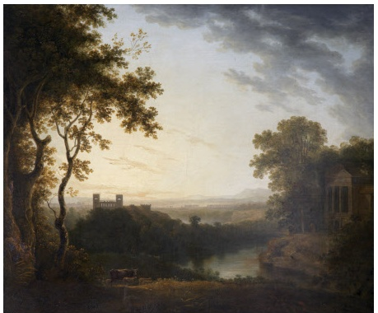
Figure 15: George Smith, Ideal Classical Landscape, c. 1770, oil on canvas.
Reproduced with the kind permission of ©National Trust Images (collection number CMS_PCF_987443)

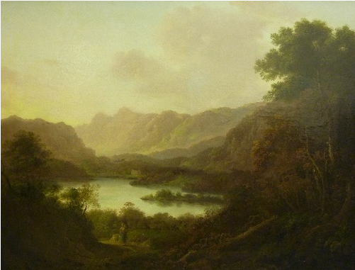
Figure 16: George Smith, Langdale Pikes, undated, oil on re-lined canvas. This painting is in private ownership. The image can be viewed in the non-redacted version of the PhD thesis, held by the University of Sheffield Library.

Even when the settings are situated in a specifically named geographical area, these landscapes still appear as idealised to the viewer. Figure 16 is George Smith’s depiction of the Langdale Pikes in Cumbria. The same conventions abound within the painting as within his Ideal Classical Landscape. There are the side-screens framing the view and the barren mountains in the distance louring over the body of water. What has been recorded here could be the Lake District, but it could equally be the Alps. The only reason the viewer knows for certain that it is the former is because the artist has fixed the identity of the location by fastening a title to it. Via the title of his painting, George Smith has instructed the viewer precisely where they are. However, within George Smith’s other landscapes, matters are not so clear. Whilst the artist has advised the viewer that they are in a landscape of romance and imagination in the title of his Ideal Classical Landscape, within other paintings, such as A Landscape with Views of a Ruined Castle and a distant Town seen over Water (Figure 17), he is not so explicit.

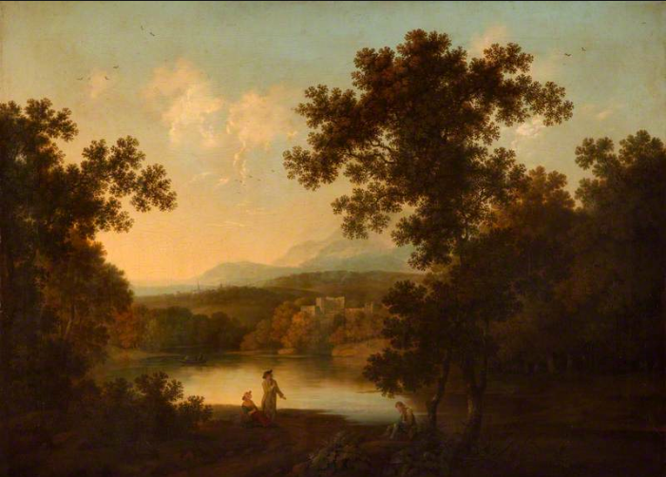
Figure 17: George Smith: A Landscape with Views of a Ruined Castle and a distant Town seen over Water, 1776, oil on canvas. Reproduced with the kind permission of ©National Trust Images (collection number CMS_PCF_1430467)

Figure 17 could show a real location where the artist has stood with his easel and sketched from nature. Alternatively it could equally be a location pulled from his imagination: it is simply impossible to tell. The hills in the distance in Figure 17 could be the Langdale Pikes again, viewed from a point slightly closer to the water. Alternatively, they could be nowhere at all and simply recording a scene drawn from the artist’s imagination. Charlotte Smith utilises similarly picturesque scenery to form the background to the action of her novels. Scott C. Campbell argues that Charlotte Smith’s novels ‘all take place in remote and practically timeless locales – clearly the landscapes of romance more than “real life.”’ Whilst this assertion is not strictly true, as Charlotte Smith employs real locations within her texts and captures authentic settings vibrantly, such as eighteenth-century London, there is, however, an undeniably picturesque and romanticised air to the landscapes she has her heroines traverse. Ethelinda’s Grasmere, for example, could have been modelled on the lake which George Smith positions before his Langdale Pikes. This scene includes a ‘white cottage, glittering on the unruffled bosom of the lake,’ which is just discernible in the centre of the painting (Figure 16). Walter Scott famously argued of Charlotte Smith’s works that she ‘preserves in her landscapes the truth and precision of a painter.’ Scott notes her ‘excellent sketches of description’ and remarks that ‘the sea-coast scenery of Dorset and Devon, with which she must have been familiar, is scarce painted with more accuracy of description than the tower upon a rugged headland on the coast of Caithness, which she could only become acquainted with by report.’

There are many places portrayed in her novels that Charlotte Smith did not visit and that she must have apprised herself of either through her extensive reading, or by viewing artwork like George Smith’s. Her scenes in the Highlands of Scotland referred to by Scott, for example, could quite easily have been inspired by George Smith’s Rocky Shore with a Ship Foundering (Figure 18). This landscape is distinctly reminiscent of the scene in Charlotte Smith’s Celestina (1791) where Mrs. Elphinstone and the eponymous heroine watch helplessly as Mr. Elphinstone’s ship founders on the rocky shore of their Scottish island and he is lost at sea.

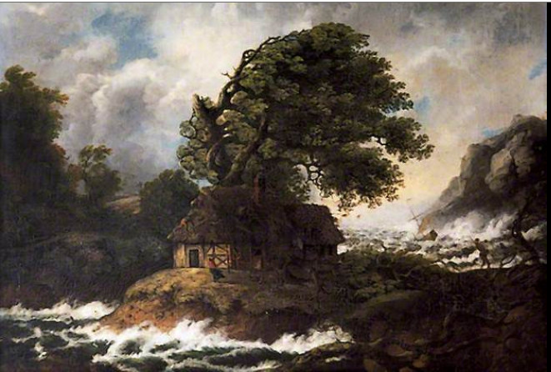
Figure 18: George Smith, Rocky Shore with a Ship Foundering, undated, oil on canvas. This image is held at The Council House, Chichester and can be viewed via this link: https://artuk.org/discover/artworks/rocky-shore-scene-with-a-ship-foundering-68539, or in the non-redacted copy of this PhD thesis, held by the University of Sheffield Library.

Similarly, a further example of how her landscapes have been derived from her extensive reading exists in her descriptions of the Sicilian landscape and the earthquake of 1783 in Montalbert (1795). The reader of these scenes can speculate alongside Walter Scott, that these were scenes ‘she could only become acquainted with by report.’ In fact a close reading of them reveals they have clearly been influenced by the writings of Sir William Hamilton, and his report of these events for the Royal Society. That Smith was acquainted with Hamilton’s work becomes apparent because Smith references this in a footnote in Montalbert, describing how mothers attempted to save their children during this natural disaster. Within the scene, Smith describes how during Rosalie’s terrifying ordeal in the earthquake, she saves her infant son by ‘clasping her boy to her breast.’ Smith then asserts the realistic nature of Rosalie’s actions in a footnote underpinning this stating that:

[w]hen the ruins came to be cleared away, says Sir William Hamilton, the bodies of the men who had perished were universally found in the attitude of resistance; the women in that of prayer, unless it was those who had children with them, in which case they were observed to have taken such postures as were likely to shelter and protect them.

Hamilton terms it thus:

the male dead were generally found under the ruins in the attitude of struggling against the danger; but that the female attitude was usually with hands clasped over their heads, as giving themselves up in despair, unless they had children near them, in which case they always were found clasping the children in their arms, or in some attitude which indicated their anxious care to protect them.’

Not only does Smith cite Hamilton’s work in her footnote as being one of her sources, but she also uses his descriptions of the scenery in describing the views which first meet her heroine, Rosalie’s eyes, as she traverses the countryside. To Rosalie, who has never left England before, the Sicilian landscape is exotically ‘rich and luxurious.’ It is precisely the same for Hamilton, who describes it as ‘the most beautiful and fertile country I ever beheld.’

These landscapes, inspired by descriptions from books and paintings, become literary constructs of actual locations, just as George Smith’s recreations of such scenes as the Langdale Pikes, become painterly constructions of actual sites. As such, they are removed from reality. They are landscapes of the imagination, as clearly reading a description of a place is very different to actually seeing and experiencing the place for oneself. Charlotte Smith may be able to prove the scientific reality of her places by supporting her work with footnotes resting on Hamilton’s precise observations, but she has not actually seen and experienced Sicily for herself. The Sicily she has seen, rather, is the Sicily as she pictured it inside her mind’s eye whilst reading Hamilton’s work. If, as observed earlier, George Smith’s landscapes embody all places and no place at all, Charlotte Smith’s landscapes are equally everywhere and nowhere: imaginary constructs. Many of the romantic scenes she charts within her novels are just that: scenes.

However, there is demonstrably other evidence that links the two artists aside from their known association whilst Charlotte Smith was a child, and their tendency to portray scenes drawn from the imagination. A close reading of Charlotte Smith’s novelistic landscapes reveals she is doing more than just emulating the picturesque style. Rather, she emulates George Smith’s picturesque style. In her first novel, Emmeline, or, the Orphan of the Castle, the heroine, Emmeline, is brought up in relative isolation within a partially ruined Pembrokeshire castle. It is a setting which is picturesque in the extreme, drawing on all of the conventions as prescribed by Gilpin et al. The castle, although habitable by Emmeline and the household staff, could only be described as a ruin (‘the greater part of it was gone to decay.’). It is situated ‘among copses that fringed the banks of the river,’ flanked on all sides by woodland, with a view towards the sea. In other words, it is framed by forest scenery, with a seascape forming a distant background, just like a painting of an appropriately picturesque ruined castle. The windows from the castle provide a further framing device for the picturesque scenery laid out before it. Prior to the death of her housekeeper/carer, Mrs. Carey, which marks the sea-change in Emmeline’s life, Emmeline has shared a room with this elderly lady, selected solely ‘on account of the beautiful prospect commanded between the hills’ visible from the window. From this outlook, Emmeline can view ‘a long narrow valley, fringed with copses, [...] a small but rapid river; which [...] rushed into the sea at a distance of a mile from the castle.’ The window in Emmeline’s chamber acts as her own Claude glass, framing the view into a picture of ideal nature.

As Emmeline makes her departure from her first home, the resonance between Charlotte Smith’s scene and George Smith’s paintings come into focus. Pushed out of the only home she has known, Emmeline looks back towards the ruined castle, to gaze nostalgically upon the scenes of her childhood:

The road lay along the side of what would in England be called a mountain; at it’s feet rolled the rapid stream that washed the castle walls, foaming over fragments of rock; and bounded by a wood of oak and pine; among which the ruins of the monastery, once an appendage to the castle, reared its broken arches; and marked by grey and mouldering walls, and mounds covered with slight vegetation, it was traced to it’s connection with the castle itself, still frowning in gothic magnificence and stretching over several acres of ground: the citadel, which was totally in ruins and covered with ivy, crowning the whole. Farther to the West, beyond a bold and rocky shore, appeared the sea; and to the East, a chain of mountains seemed to meet the clouds; while on the other side, a rich and beautiful vale, now variegated with the mellowed tints of the declining year, spread its enclosures, ’till it was lost among the blue and barren hills.

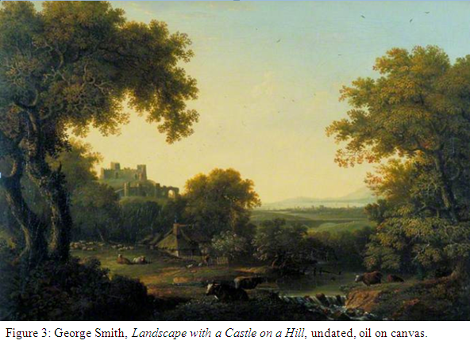
Figure 19: George Smith, Landscape with a Castle on a Hill, undated, oil on canvas. Reproduced with the kind permission of © UK Government Art Collection.

Emmeline’s scenery from her childhood closely matches George Smith’s picturesque vision in Landscape with a Castle on a Hill (Figure 19). In the foreground, clearly visible, is the ‘rapid stream [...] foaming over fragments of rock’ hurrying away from the castle walls, from the direction of which, it seemingly originates. In the centre of the landscape, there are the rustic signs of the village through which Emmeline’s chaise must pass. The diminutive form of a villager standing outside his cottage gate, dwarfed by the magnificence of the castle in the landscape, can just be perceived. He might be one of the villagers who have heard of Emmeline’s departure and ‘wait[...] to bid her farewell.’ In the distance is the sea, and a ‘chain of mountains,’ ‘a rich and beautiful vale,’ tinged with the autumnal colours of the ‘declining year,’ before the ‘blue and barren hills’ of the mountainous range. Most surprising of all, is the manner in which the two Smiths’ ruinous castles correspond with each other, right down to the ‘broken arches’ in George Smith’s painting, which appear remarkably like the ‘ruins of [a] monastery’ appended to the castle. George Smith utilises a similar ruined castle with the ‘broken arches’ of a monastery attached to it in his Evening Landscape (Figure 20), where again, the scene is framed by woodland and the castle clearly enjoys a view over water to a mountain range beyond.

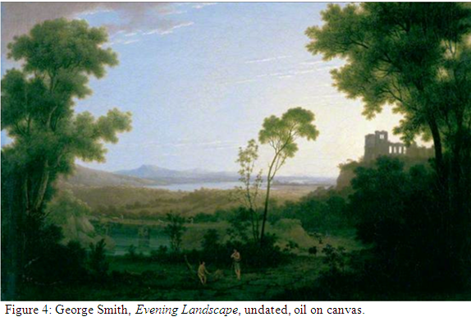
Figure 20: George Smith, Evening Landscape, undated, oil on canvas. This image is held by the Government Art Collection and can be viewed via this link: https://artuk.org/discover/artworks/evening-landscape-29288, or in the non-redacted version of this PhD thesis, held by the University of Sheffield Library.

When contrasted with works by other picturesque artists who also painted scenes in Wales in the period, George Smith’s landscapes stand out even more clearly as the inspiration of the Welsh scenes in Emmeline. Paul Sandby (1731-1809) was an English landscape painter in the picturesque style, who, along with his brother Thomas, in 1768, became one of the founding members of the Royal Academy. Sandby toured the same area where Emmeline commences her adventures and from this created Views in Aquatinta from Drawings Taken on the Spot in South-Wales Dedicated to the Honourable Charles Greville and Joseph Banks Esquire (1777). His sketches are full of picturesque details, including ruined castles, quaint peasants and broken down horses, in the style of Dr. Syntax’s ‘Grizzle.’ Figure 21, for example, featuring Cardiff Castle, includes charming details typical of the picturesque zeitgeist, such as the rustic figure of the woman just before the castle archway, pegging her washing out on the line.
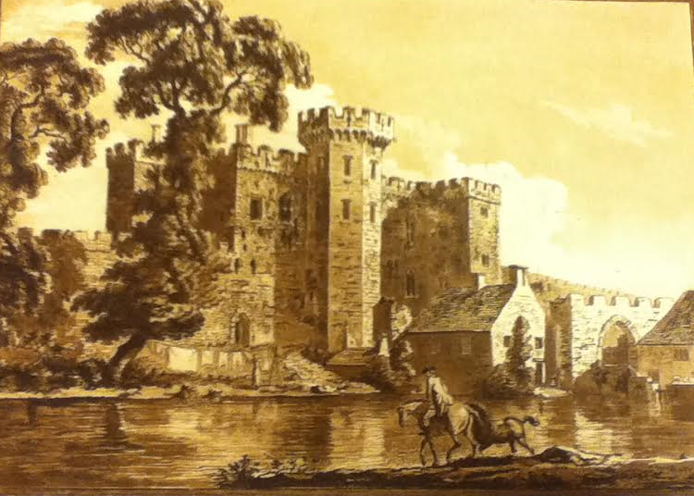
Figure 21: Paul Sandby, The South Gate of Cardiff Castle in Glamorganshire, 1777, aquatint on paper. This image can be viewed in the Maps Room of the British Library, or in the non-redacted version of this PhD thesis, held by the University of Sheffield Library.

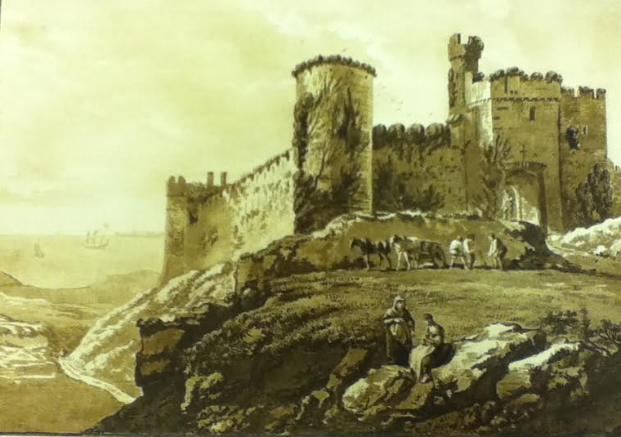
Figure 22: Paul Sandby, Manerbawr Castle in Pembrokeshire, 1777, aquatint on paper. This image can be viewed in the Maps Room of the British Library, or in the non-redacted version of this PhD thesis, held by the University of Sheffield Library.

Sandby’s painting of Manerbawr Castle in Pembrokeshire, a point very close geographically to Emmeline’s first home, features an elderly woman accompanied by a younger, just like Mrs. Carey and Emmeline herself, and a view over water. Yet it is clear that Sandby’s Welsh castles, are not those of the Smiths’ (either George or Charlotte’s). The castles are too complete. Despite being extremely picturesque, they are not ruined enough. Unlike George Smith’s castles, there are no remains of a ruined priory, and although covered in ivy, Sandby’s ‘citadel’ is not ‘totally in ruins.’

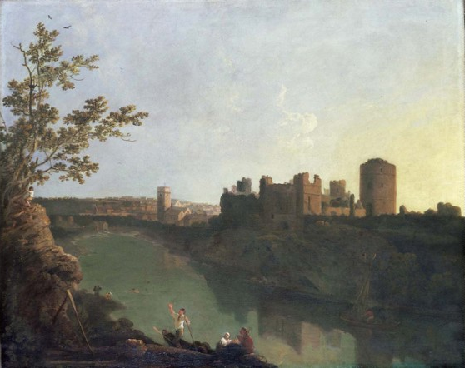
Figure 23: Richard Wilson, Pembroke Town and Castle, c. 1773, oil on canvas. This image is at the National Museum Cardiff and can be viewed via this link: https://www.artfund.org/supporting-museums/art-weve-helped-buy/artwork/809/pembroke-town-and-castle, or in the non-redacted version of this PhD thesis held by the University of Sheffield Library.

Circa 1773, picturesque artist Richard Wilson (1714-1782) was also in Pembrokeshire completing landscape paintings in the area. Wilson’s Pembroke, like Sandby’s, bears no resemblance to either of the Smiths’ picturesque visions of Pembrokeshire. Wilson’s more matter-of-fact and less romanticized recordings of Pembrokeshire portray realistic towns, not humble villages with the charming rustics who so idolise Emmeline. Like Sandby’s, Wilson’s castle is too complete to be Emmeline’s barely habitable ruin and while it enjoys a view over water, it is not a view of a ‘rapid stream that washed the castle walls, foaming over fragments of rock’ or ‘a bold and rocky shore.’ Rather, it is a river that glides serenely by.

Perhaps the most famous authority in all things picturesque, William Gilpin, also explored areas in Wales in his Observations on the River Wye, and Several Parts of South Wales & c. Relative Chiefly to Picturesque Beauty Made in the Summer of the Year 1770, (first published 1782). He includes many sketches within his text, including Goodrich Castle in Ross-on-Wye, close to the Welsh border (Figure 24).

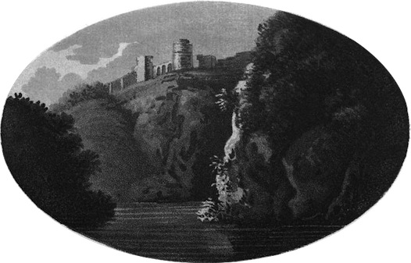
Figure 24: William Gilpin, Goodrich Castle, 1782, aquatint on paper. This image can be viewed via this link: https://www.rc.umd.edu/gallery/goodrich-castle, or in the non-redacted version of this PhD thesis, held by the University of Sheffield Library.

Goodrich Castle is described by Gilpin in similar terms to Charlotte Smith’s. ‘The bank on the right, is steep, and covered with wood.’ This is similar to Emmeline’s castle, which is ‘bounded by a wood of oak and pine.’ Beyond the wood, according to Gilpin, ‘a bold promontory shoots out.’ Again, this is reminiscent of Smith’s ‘bold and rocky shore. Yet, despite Gilpin’s assertion that he ‘should not scruple to call [this view] correctly picturesque,’ Gilpin’s castle is clearly not Emmeline’s. As in Sandby’s and Wilson’s paintings, in Gilpin’s sketch, the castle is too complete and the water is too serene.

Without direct evidence in her letters or prefaces to her novels, it is very difficult to assert authoritatively that Charlotte Smith specifically accesses George Smith’s vision of the picturesque. Yet the scenes that lay the foundation for Emmeline bear an uncanny resemblance to George Smith’s picturesque vision. Further, a comparison of the works of George Smith and his contemporaries reveals a clear demarcation of difference between what Dominic McIvor Lopes might term ‘the “air” of [the] pictures.’ Sandby’s are too bright and jolly somehow. In the sketches in Views in Aquatinta, he includes many half-concealed jokes such as a bull chasing the artist out of his tent, or a depiction of the enormous wagon which he requires to carry his sketch books into Wales (Figures 25 and 26). Wilson’s Pembroke is too realistic. It is not romantic enough for the picturesque setting in Emmeline. Gilpin comes the closest, but key details are missing from the vista, such as the ‘the rapid stream that washe[s] the castle walls.’ Gilpin’s scene is too serene. Only George Smith’s scenes seem fully to resonate with Charlotte Smith’s.
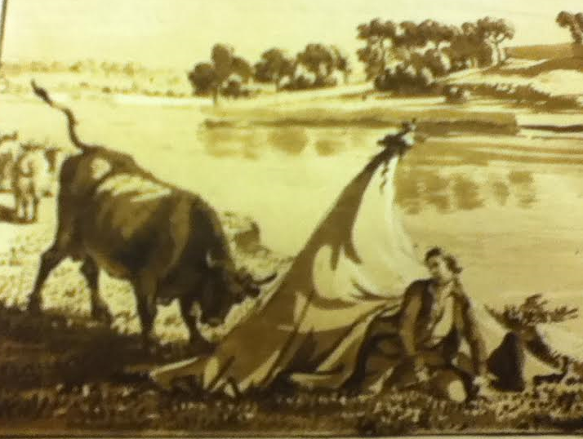
Figure 25: Paul Sandby, detail from Carew Castle with Reflections, 1777, aquatint on paper.

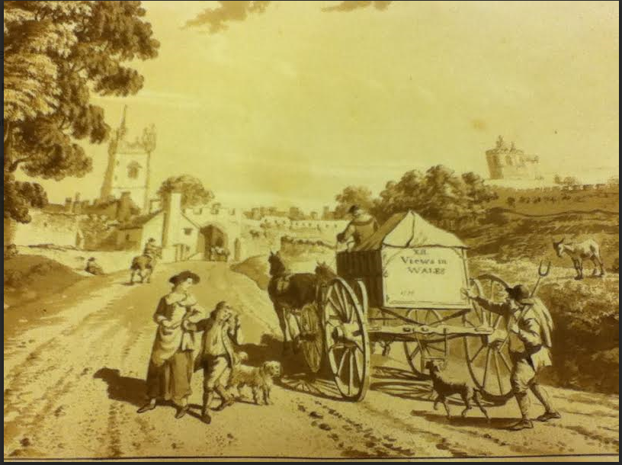
Figure 26: Paul Sandby, detail from The West Gate at Cardiff, 1777, aquatint on paper. The joke about how Sandby requires an enormous wagon to carry his ‘XII Views in Wales’ is an appropriate one, as Sandby’s book is an oversized one. Both of these images can be viewed in the Maps Room of the British Library, or in the non-redacted version of this PhD thesis, held by the University of Sheffield Library.

Lack of serenity is a key feature tying together the landscapes of George Smith and Charlotte Smith. Both of their landscapes may be idealised and romanticised, but within both depictions of their castles, there is an undertone of disorder and violence. This may seem strange when considering that the picturesque movement was so widely popular because it presented an image of England as England wished to see itself. Influenced greatly by the works of Claude Lorrain, the landscapes of the artists of the picturesque school presented, as Kenneth Clarke observes of Lorrain’s work, ‘Everything [...] in Keeping: there is never a false note.’ Yet, there is something subversive about both Smiths’ landscapes that lies concealed within their interpretation of the picturesque. While superficially George Smith’s landscapes convey an initial impression of harmony of both ‘the natural and social world,’ a closer look at his scenes reveals something different, something disturbing. Careful scrutiny of the painting that most closely matches Charlotte Smith’s castle scene in Emmeline, his Landscape with a Castle on a Hill (Figure 19), reveals that the apparent harmony of the scene is disrupted by its chaotic nature. In the foreground a group of cows are messily clumped around a broken down cottage, with shaded areas on its roof indicating a level of disrepair (i.e., holes in the roof). Trees and fences fall into the river. In the centre of the painting, just before the cottage door and barely visible to the viewer, is the tiny figure of a rustic standing at the cottage gate. Frowning down over the entire scene is the castle itself dominating the landscape. The castle asserts its supremacy over the scene via the title of George Smith’s painting, which explicitly directs the viewer to look at A Castle on a Hill. The viewer’s eye is also drawn to the castle as the most prominent feature in the landscape, whilst the peasant and his squalid surroundings are easily overlooked. Only minute attention to the painting reveals the peasant’s presence.

The tiny figures of these peasants in George Smith’s English picturesque landscapes are just so many human fragments, rendered as so much flotsam and jetsam for the eye to run over and the memory to discard. An additional painting from his body of work emphasises this point further. Figure 27 shows The Shepherd, Evening, which is credited to both George Smith and his brother, John (c. 1717-1764).
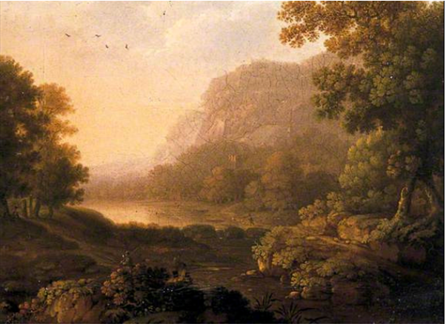
Figure 27: George and John Smith, The Shepherd, Evening, undated, oil on canvas. This image is held at The Pallant House Gallery in Chichester and can be viewed via this link: https://artuk.org/discover/artworks/the-shepherd-evening-70542, or in the non-redacted version of this PhD thesis, held by the University of Sheffield Library.

The subject of the painting is ironically barely visible within it. This is not just due to the aged, cracked nature of the work. The Shepherd of the title is just lost within the scene. It is not even clear which of the tiny rustic figures he is. There are three figures occupying this painting: one by the river, one seated in the foreground, his back to the viewer, and one tiny, ant-like figure on the far left of the painting, standing beside the tree. It is impossible to determine from these figures just who is the shepherd and the titular subject of the painting. They have been rendered by George Smith as too small and vaguely defined to determine which is the title subject. Further, he has done this, in my view, purposefully to emphasise the status of such figures within the landscape of his society. His treatment of the figures within his landscape offers a critique of societal structure, via which the artist implies that the peasantry are insignificant and easily dismissed scraps of humanity within the eyes of the ruling classes, just as Emmeline herself is in Charlotte Smith’s castle landscape. As the ‘natural daughter’ of Lord Montreville’s deceased elder brother, and abandoned along with the slowly decaying castle by her Uncle, Emmeline sits outside the social hierarchy of the rich family of which she is ostensibly a part. Marginalised by her wealthy relatives and society as a whole, Emmeline, like George Smith’s rustics, is one of those tiny and easily dismissed scraps of humanity within the landscape. This situation, for Emmeline, forms the stark reality of what it means to be part of the picturesque landscape as an impoverished person.

Both Smiths criticise the ruling classes’ neglect of the plight of the impoverished poor within their society. It is worth remembering that it was only the landed classes who had the power to vote and determine the outcome of issues which were crucial to the survival of the rural poor at this time. As George Rudé argues, the interests of the landed classes were ensured by their ‘voting Enclosure Acts, subsidies, and Corn Laws; promoting tolls and turnpikes, Militia Acts, and measures against smuggling; and upholding Poor Law and Acts of Settlement for the better policing and regulation of the poor.’ Such issues, as Rudé observes, ‘rarely divided the upper classes or the political parties, but they were of considerable concern to the “lower orders” or “labouring poor.”’ If the upper classes as represented by George Smith in his landscapes and Charlotte Smith in characters like Lord Montreville are not concerned with the impoverished peasants, then there is nobody left to represent their interests. This underscores an absence in the picturesque landscape demonstrative of scandalous injustice for an entire section of the population.

Whereas George Smith conveys a hint through his artwork of the disorder and immorality of a government that forgets and abandons its rural poor, Charlotte Smith elaborates her criticism in her written work. Of the ruling classes in Emmeline, she articulates how Lord Montreville, ‘[t]he present possessor of the castle [...] was not at all interested for the peasantry.’ Indeed, ‘among [them] he [is] a stranger’ and ‘in losing Emmeline, [they] seemed to lose the last of the race of their ancient benefactors.’ Once Emmeline has been driven from the castle, there is no one left to care for them, in their hardship. They will be overlooked, just like George Smith’s peasantry as he portrays them within his picturesque landscapes. Further, like George Smith’s scenes, the chaotic nature of the picturesque scenery spills over into the atmosphere of the novel. The prospect of violence hangs over Emmeline from the moment her supposed guardian, Lord Montreville and his companions arrive. She is insulted by the family’s valet-de-chambre, Millefleur. Montreville’s son, Delamere, with his obsessive desire for her, attempts to force his way into her private chambers. The threat of rape is tangible in the text, and Emmeline is only able to circumvent it and escape Delamere by playing her role as a picturesque heroine to the extreme. For Emmeline, Montreville represents her ‘government’: and he is failing her, just as he fails his own tenants, and just as the national system fails its rural poor. Ann Bermingham observes of the picturesque landscape, ‘although it neither reflects nor directly mirrors reality, the rustic landscape does not altogether dispense with it.’ In their interpretation of the pastoral landscape, both Smiths use the picturesque as a vehicle to convey important critical commentary about the nature of the nation as they viewed it.

This critical commentary is also conveyed via the literary corpus of both Smiths. Most painters, as Brewer observes, leave ‘to posterity [...] not texts but images, the visual equivalent of the literary archive. We see their vision but can only rarely hear their voice.’ However, George Smith left more than just paintings behind, and his literary work forms an additional link between the two artists, and provides a further vehicle for critique of society’s tendency to overlook impoverished country dwellers. George Smith’s Six Pastorals of 1770 predate Charlotte Smith’s earliest work, the first edition of the Elegiac Sonnets (1784) by fourteen years. They predate her most successful novel, The Old Manor House (1793), by twenty-three years, and her final posthumously published Natural History of Birds (1807) by thirty-seven years. Yet these works are connected by the geographical scenes they invoke, their detailed depictions of nature and the ideologies they express in their themes. Like Charlotte Smith, George Smith situates his pastorals within the landscape of the Sussex South Downs. In ‘Pastoral IV, Tom and Will,’ the river banks the shepherd boys ‘ever lov’d to roam’ surely belong to the same River Arun where Charlotte Smith will place the infant Otway in her Elegiac Sonnets XXVI and XXX, both titled ‘To the River Arun.’ In addition, both write with a real feeling for nature. The sentiment expressed by shepherd boy Will that a nesting bird should be left alone with its eggs is reiterated repeatedly in Charlotte Smith’s works for children. Both pepper their verses with informative local knowledge providing the reader with additional (and nearly identical) information on the topic of their poetic subjects.
In George Smith’s ‘Pastoral III: Winter, Colin and Phebe,’ the natural detail observed by the artist renders the scene more palpably alive to the reader:

Look upward, Phebe, and behold a train
Of snow-white swans, that seek the distant main.
Their fanning pinions please my listning fair,[sic]
And make soft music with the yielding air.’

George Smith uses an unlikely image with his swans in flight. Swans, perhaps, are more traditionally associated with gliding serenely along the surface of a lake or river. As George Smith observes, they are noisy in flight, their vast ‘pinions’ marking their discordant passage through the air. They are also more frequent flyers during winter, when certain breeds of swan migrate away from the bodies of water they have resided on during the spring and summer months and native British (mute) swans travel to clump together in large bodies of water which will not freeze. A flying swan, therefore, might be perceived to be a peculiarly apt indicator of winter. George Smith uses the image both in his poetry and his paintings (Figures 28 and 29).

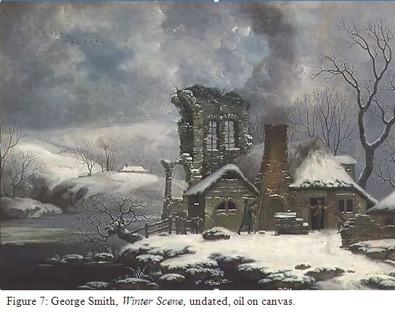
Figure 28: George Smith, Winter Scene, undated, oil on canvas. This image can be viewed in the non-redacted version of this PhD thesis, held by the University of Sheffield Library.

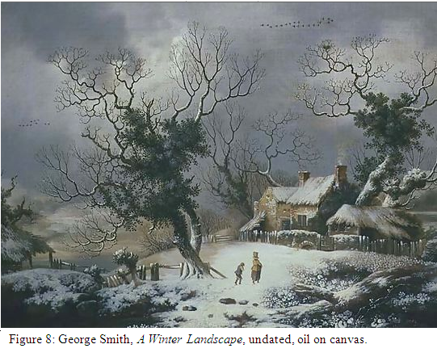
Figure 29: George Smith, A Winter Landscape, undated, oil on canvas. This image is held by The Pallant House Gallery, Chichester, and can be viewed via this link: https://artuk.org/discover/artworks/winter-landscape-70495, or in the non-redacted version of this PhD thesis, held by the University of Sheffield Library.

The cluster of birds, clearly flying in a migratory formation in each of the paintings, and within the poem too, emphasises the chill as they mark their passage through the leaden sky over the frozen landscape. They also illustrate the option to depart for more benevolent climes that is available to the migrating birds. This is a choice that is denied the rustic peasants and poor folk who have no alternative but to remain within the wintery scene. Travel, as many scholars have noted, and Charlotte Smith was well aware during her lifetime, was expensive and not easily achieved. George Smith’s ‘Winter: Colin and Phebe’, in his Pastorals, read alongside Figures 28 and 29, both suggest an empathy for the situation of the rural poor, just as he highlights how society overlooks them in the landscapes detailed earlier. Figure 28, Winter Scene, has the rustic living amongst ruins, desperately attempting to fix a smoking chimney whilst a woman frantically gesticulates at the door. She is perhaps protesting against the biting cold and their powerlessness to keep warm in such conditions. Figure 29, A Winter Landscape, features a pitiful child, hunched over against the freezing conditions, as he follows a woman through the deep snow. ‘Pastoral III: Winter’ commences with Phebe’s lament: ‘how painful is this piercing wind!/ [...] my fingers ach [sic] to that degree,/My gushing tears declare my misery.’ The poem runs through Colin’s various attempts to cheer Phebe, as they are forced to remain out of doors in the bitter conditions in order to tend their ‘kine,’ or cattle. Phebe assures Colin,

Without thee, Colin, here I could not stay,
Unless to perish ere the close of day.
But let the sharpest frost bind up the rills,
And make the fens as hard as rocky hills,
Nay, hang his icicles on ev’ry tree,
I would rejoice to tend the herd with thee.

Although love might go some way to keeping the rural poor warm, the poem ends on a distinctly negative note, as Phebe draws Colin’s attention to the pitiful lowing of the cattle as they attempt to ‘break the ice,’ ‘in vain attempt to drink.’ This is a landscape which is so cruelly unforgiving, that even the beasts of the field are unable to fulfil the materials necessary for survival. Both George Smith’s artwork and his poetry shine an illuminating light on the struggles of rural dwellers and their almost hopeless attempts to survive without the necessary resources. Charlotte Smith, too, revisits this theme throughout her works. Like Phebe and Colin, Monimia and Orlando will find that love is not enough, in the struggle to survive in The Old Manor House. In the same novel, the demobbed one-legged soldier will hop in penury after Orlando, abandoned to his fate by the Government he served, in his attempts to aid him. In Celestina, servant Jessy will be forced to leave her rural home for the ‘close and narrow’ streets of a London townhouse, until overwork and the environment causes a decline in her health. In Rural Walks, Mrs. Woodfield leads her young charges to encounter and be educated about the rural poor. If George Smith educated Charlotte Smith in how to see a view, he perhaps also influenced her in how to see from a certain point of view: the point of view of the poor.

George Smith himself was painfully aware of the struggle against poverty, just as Charlotte Smith was. For both artists, poverty was a lived reality. In 1759, he was part of the group of artists who helped to found The Free Society of Artists, an organisation whose raison d’être was ‘to promote the welfare of artists in this country by awarding premiums, often very opportune to the struggling recipients.’ The Society then changed its name in 1762 to ‘The Free Society of Artists, associated for the Relief of Distressed Brethren, their Widows, and Orphans,’ and donated all of their profits to this charitable cause. He also believed in the right of the general populace to have free access to the nation’s artwork. In 1760, he was involved in the organisation of the first exhibition of English art ever held. ‘The Society,’ as Alfred Beaver observes, ‘objected to any charge being made at the doors.’ This was a stance which wrought divisions in the Free Society and led to a belief among a certain contingent of the more aristocratic members ‘that the free admission brought crowds of “inferior” people for whom the exhibition was “not intended.”’ This division, in turn, led to the creation of the Royal Academy, whose excuse for charging an admission fee to their exhibitions was that it would keep out ‘the meaner sort.’ The conception of the Royal Academy subsequently led to the demise of the Free Society, as the Academy excluded ‘from membership all who were connected with any other society,’ effectively ensuring that any artist of any ambition never attempted to join the Free Society. George Smith, along with his brothers, Thomas and John, were among the Free Society’s principle supporters. George Smith clearly exercised a democratic belief that the nation’s artwork was for the nation, regardless of class, wealth or status. His knowledge that he was in a minority in this belief echoes within his landscapes. In George Smith’s picturesque scenes, as has been observed, the rural figures are diminutive. His minute figures are demonstrative of the state of George Smith’s society; a situation that was re-enacted in microcosm in the formation of the Royal Academy. In this society, only the powerful and the wealthy got to be seen close up: through the portraits they commissioned from artists such as Joshua Reynolds. A particularly good example of this in George Smith’s artwork exists in the form of his View of Chichester Cathedral (Duke of Richmond and Groom in the Foreground) (Figure 30). In this painting, the Duke of Richmond stands out clearly in his red finery, whereas the groom, despite occupying ‘the Foreground’ with the Duke, disappears into the dark green avenue of trees, camouflaged against them.

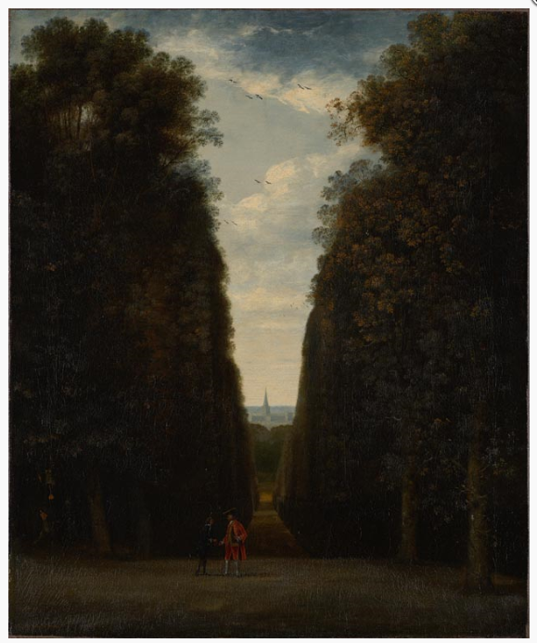
Figure 30: George Smith, View of Chichester Cathedral (Duke of Richmond and Groom in the Foreground), undated, oil on canvas. This image can be viewed in the non-redacted version of this PhD thesis, held by the University of Sheffield Library.

Charlotte Smith shared her painting instructor’s empathy for the impoverished within the nation. Within her novels, Smith caustically represents wealthy figures who fail to help the worthy heroes and heroines, through primarily selfish motives, whereas she paints as heroic laudable servants, like Celestina’s Jessy. It is similarly clear, from Charlotte Smith’s works, that she held a comparably firm belief in equality amongst humanity. This link in ideologies is just one further exemplification of how the two artists named Smith shared common beliefs and a common vision in their picturesque. That Charlotte Smith had strong connections with the artistic world, specific artists of the picturesque movement and demonstrated her knowledge and understanding of this visual culture is undeniable. These aesthetic theories enhance interpretation of her works. The landscape of Smith’s first novel, Emmeline, is firmly grounded in the picturesque. This is a world of tumbledown places, ruins and purposely ‘broken grounds’ where the unwary might stumble and fall. It is a world where the impoverished are barely noticed and their needs dismissed, their only role to look pleasing in the picturesque landscape. How the aesthetic of the picturesque is conveyed within Emmeline raises concerns surrounding societal issues such as property ownership, class and the positioning of women.

Property, for example and the question of who owns the ruin in the landscape that Emmeline (rightfully as it transpires) feels as her own is at the heart of the novel. As an apparently illegitimate, orphan female child, Emmeline has seemingly no rights whatsoever: ‘[s]he considered herself as a being belonging to nobody; as having no right to claim the protection of any one; no power to procure for herself the necessaries of life.’ This non-existence in terms of rights to property ownership, even apparently over her own person, is intrinsically linked to the theory of the picturesque landscape that Emmeline inhabits: if the picturesque is an artificial zeitgeist, portraying places that could be anywhere and nowhere, then women’s status in terms of ownership of the landscape is the same. As Kaley Kramer terms it, during the late eighteenth century, ‘women are never the “right owners.”’ Emmeline, by the end of the text, will be proven to be the ‘right owner,’ but the usurping Lord Montreville, forcing her from her home, commences the pattern in Emmeline’s adventures which will ensure she has no home where she can reasonably stake a claim. As the narrator reveals of Emmeline’s iterinant status, ‘unknown as she was to the principal inhabitants of the country, who were few, and their houses at a great distance, she could hardly hope to be received by any of them.’

From the point of view of Lord Montreville and his family Emmeline is an insignificant and easily ignored speck that forms part of the picturesque landscape, much like George Smith’s peasantry. This upper-class standpoint is reflected in the words of his spoiled ‘strange inconsiderate boy,’ Delamere, when he accepts his father’s gift of Emmeline’s castle to him. Accepting the present, Delamere remarks that an additional draw to ownership of this property is ‘especially as I suppose Miss Emmeline is to be included in the inventory.’ ‘Miss Emmeline,’ in his view, is literally part of his view, and offered up along with the other inconsequential peasants who tenant the surrounding countryside, and the furniture and fittings of the castle itself. On Lord Montreville’s removal of Emmeline, nowhere and anywhere is precisely where Emmeline has to call home, much as the zeitgeist of the picturesque itself embodies locations which are visionary in nature, and could literally be nowhere or anywhere. As Kramer argues: ‘“women” in general, belong nowhere, existing without a country, and outside of the law.’

Lord Montreville believes he has the right to give away Emmeline’s castle, although latter events within the novel which prove her legitimacy, demonstrate that he has no legal right to do so. The novel’s preoccupation with property read alongside property as George Smith portrays it, is a further link between the two artists. The landscape painting that most closely matches Emmeline’s, Landscape with a Castle on a Hill (Figure 19), serves as a reminder that all landscape is somebody’s property. In George Smith’s vision, the landscape seems to fall under the dominion of the castle on the hill. The castle authoritatively controls the panorama, with the items placed in the foreground of the painting barring access to the countryside beyond (the enormous tree on the left, the large cow seated beside it, and the rapid torrent foaming over the rocks to the right effectively prevent any entrance). As George Smith portrays it, this is a landscape of control: a separate realm where none may trespass. Those who find themselves in it (i.e. the peasant) are subject to that control, just as Emmeline is subject to the usurping government of Lord Montreville, even though there are several points in the text when both Emmeline and Montreville himself admit that Emmeline has no real reason to obey his commands. ‘Consider that,’ Montreville observes to his wife when she urges him to threaten Emmeline into accepting Rocheley as her husband, ‘if I am bound by no obligations to support this young person, I am also without any power over her.’

Charlotte Smith’s novel is littered with wealthy and powerful figures like Montreville who assert control over their surroundings when they have no real right to do so. Sir Richard Crofts, a prime example, is a man who has wormed his way up to power by ‘obtain[ing] the entire confidence of his patron [Lord Montreville].’ He is a man with ‘less understanding than cunning; less honesty than industry; and tho’ he knew how to talk warmly and plausibly of honour, justice, and integrity, he was generally contented only to talk of them, seldom so imprudent as to practice them.’ He, too, will attempt to force Emmeline into an unwanted marriage with Rocheley. The rest of the Montreville family, excluding Augusta, also personify the authoritarian control criticized in the Smiths’ version of the picturesque. Delamere is the most striking example of a character who appears to embody the zeitgeist of the picturesque movement. While Emmeline’s education is neglected, Delamere’s family are responsible for numerous and repeated failures in his education. He has been ‘[a]ccustomed from his infancy to the most boundless indulgences.’ ‘[H]e never formed a wish, the gratification of which he expected to be denied: and if such a disappointment happened, he gave way to an impetuosity of disposition that he had never been taught to restrain.’ He has been spoiled utterly. Despite possessing the same natural good qualities as Emmeline, (i.e. he is ‘generous, candid, [...] humane,’) all of these positive traits are ‘obscured’ by ‘the defects of his education.’ Taught to be selfish from an early age in expectation that he will one day inherit Lord Montreville’s position of governing over the landscape, when his father thwarts Delamere’s wish to marry Emmeline, this dooms Delamere to his almost inevitable early death. This is caused solely by his inability to control his temper, almost to the point of madness.

Delamere’s instability as a character at the very brink of madness illustrates how in tune with the picturesque he is. In a landscape epitomised by ruins, dashing streams and broken grounds, the man who is truly picturesque in nature can only ever be unstable. He is as precarious in nature as the ruins, as volatile and unpredictable as the broken grounds, and as wild and impetuous as the rapidly rushing streams. Delamere is even on many occasions in the novel mistaken for a lunatic. His rage and frenzy whenever he is denied in anything leading him to give way ‘to such unbounded passion’ and frenzy that he frequently resorts to tantrums and violence. When in such ‘temporary phrenzy,’ he ‘dashe[s] his head against the wainscot.’ On other occasions, he ‘strik[es] his forehead’ in ‘passion,’ becoming inarticulate with rage. By the time that Montreville realises his failings as a parent, it is too late to undo the damage that has been done: ‘[t]he impetuosity of his [Delamere’s] temper, which has never been restrained, it is now out of my power to check.’ Delamere has learned his selfishness and attempts to control the landscape around him from his father. Lord Montreville himself has two ruling passions: ‘avarice and ambition;’ passions which lead him to forget his duties to his ward Emmeline and attempt to force her, on two separate occasions, into marriages she does not want, just so that he can go back to ignoring her in his landscape. Represented as weak rather than positively evil, Montreville’s actions are determined by greed and self-interest. As a custodian both of all of his family members (including Emmeline) and the tenants on his lands, he is a failure, much like whoever rules the castle in George Smith’s scenes has failed, abandoning their tenants to live in squalor.

Equally, Lady Delamere ‘never had any command over her passions.’ Montreville’s eldest daughter, Frances’ ruling motivations are also ‘vanity and inordinate self-love.’ Selfishness, in other words, permeates the two Smiths’ landscapes as the ruling classes worry about themselves and forget those who are dependent on them. The portrait of Montreville’s family, appropriately enough, fits with a model utilised by Gilpin in one of his descriptions of the picturesque, in his Remarks on Forest Scenery. Gilpin, in a ‘moralizing strain’ describes a ‘large acacia.’ As he watches the tree from his window, he compares the branches of the tree with ‘families,’ ‘[t]he larger branches might hold out the first – the smaller branches, connected with them, the second.’ Gilpin metaphorically cautions these first families against unethical principles as only ‘decay,’ ‘malady’ and ‘pestilence’ can be the result. Failing in one’s custodianship and immoral behaviour, for
Gilpin, can only lead to disaster:

The blast increased; and every branch, that presented itself, bowed before it. A shower of leaves covered the ground. The cup of vengeance, said I, is poured out upon the people. Pestilence shakes the land. Nature sickens in the gale. They fall by multitudes. Whole families are cut off together.

Among the branches was one intirely [sic] withered. The leaves were shrivelled; yet clinging to it.

Lord Montreville’s family, are ‘intirely [sic] withered,’ with the ‘shrivelled’ ‘leaves’ of his wife, son and eldest daughter clinging around him. Montreville has failed in the education of his son and daughter. He has attempted to usurp control over the landscape, even when he has no moral or legal entitlement to do so. He will end by losing everything: his wife’s frenzied passions will ruin her health and destroy her. His son will meet an early and violent death befitting his unstable nature and all that remains of him will be ‘carried to be deposited with those of his mother.’ His daughter’s defects in her nature will lead her to disgrace and imprisonment by a lettre de cachet in a French convent, and a large part of Montreville’s fortune will be forfeited to Emmeline. He, himself, will ‘shut himself up in total darkness’ refusing anyone ‘to participate his sorrows.’ It is a fitting end for the Montreville family tree, the members of which have so embodied the signifiers of the picturesque landscape.

Perhaps the most interesting picturesque character in the book, is Emmeline herself. It has already been observed that to Lord Montreville and his family Emmeline is one of those easily overlooked unimportant figures that just happen to be situated within the picturesque landscape. As readers, however, our attention is fixed on her as she is the heroine, and the one whose adventures the reader must follow. Her role, both as the heroine of the tale, and as a member of the rural poor in the picturesque landscape, is to look pleasing in the picture, and this is something which she achieves easily. Our first glance of Emmeline reveals that:

[h]er figure was elegant and graceful; somewhat exceeding the middling height. Her eyes were blue; and her hair brown. Her features were not very regular; yet there was a sweetness in her countenance, when she smiled, more charming than the effect the most regular features could have given.

She is not beautiful in the ‘very regular’ sense. Rather she is, like the rustic in George Smith’s landscape paintings and ‘charming’ in appearance. This figure in the landscape is perfectly in keeping, just as the picturesque demands, and Emmeline works hard to ensure that she stays that way. For Emmeline, in the text, appears to be controlling her own portrait as a picturesque heroine, knowing that she can benefit from Lord Montreville, just so long as she continues to appear to be in keeping with the picturesque landscape as he comprehends it. Her adoption of the picturesque role also provides her with a methodology in which to evade Delamere and his threat to her person and autonomy, as noted earlier. John Berger argues in Ways of Seeing:

A woman must continually watch herself. She is almost continually accompanied by her own image of herself. [...] From earliest childhood she has been taught and persuaded to survey herself continually.

And so she comes to consider the surveyor and the surveyed within her as the two constituent yet always distinct elements of her identity as a woman.

She has to survey everything she is and everything she does because how she appears to others, and ultimately how she appears to men, is of crucial importance for what is normally thought of as the success of her life. [...] Men survey women before treating them. Consequently how a woman appears to a man can determine how she will be treated. To acquire some control over this process, women must contain it and interiorize it. That part of a woman’s self which is the surveyor treats the part which is the surveyed so as to demonstrate to others how her whole self would like to be treated. And this exemplary treatment of herself by herself constitutes her presence.

Emmeline, so much at the mercy of the men in her life (notably Lord Montreville, but also Delamere to a certain extent, particularly during her kidnap ordeal) is forced, as Berger argues, to continually survey herself and ensure that she is acting the correct part in order to achieve her own desires. Joe Morrissey has noted similar behaviour in Smith’s character of Ethelinde from Smith’s second novel. During this novel, Ethelinde is, as Morrissey observes, ‘at all times in control of her emotions.’ The hero, Montgomery ‘is soon overcome by his love for Ethelinde and urges their marriage.’ Ethelinde, however, rather employs ‘feeling strategies [which] are extremely successful’ and permit her to continue being ‘able to exploit the financial and social support of Sir Edward [Newenden] throughout the story until an expected inheritance allows her to prudently marry Montgomery.’ Emmeline is, by constantly surveying herself and ensuring the rectitude of the portrait she presents and how this fits within Montreville’s picturesque world, able to achieve the successful conclusion to her story which she desires, in the form of her marriage to Godolphin. To exemplify this one has only to consider the strategies Emmeline utilises in order to extricate herself from the marriages which Lord Montreville attempts to force upon her, without losing his favour and the little financial support he has pledged to her. In the case of the Steward Maloney, Emmeline’s first argument is to call on Montreville’s sense of pride and familial self-love, something which she probably realises had

already made a faint struggle in his Lordship’s breast on behalf of his deserted ward. He felt some pain in determining, that a creature boasting a portion of the Mowbray blood, should sink into the wife of a man of such inferior birth as Maloney.

Correctly and astutely judging the characteristics of her uncle, Emmeline’s first proclamation is to call herself ‘humbled! I am lost indeed!’ When this fails, however, and Montreville demands to know ‘[w]hy distress yourself in this manner?’ and accuses her of courting Delamere, Emmeline changes tack, ceases weeping and appealing to Montreville’s non-existent sense of pity, she ‘assume[s] more spirit than she had yet shewn’ in order to persuade Montreville to continue to support her with the sister of Mrs. Carey. Understanding that Montreville little cares where she is, as long as she is away from Delamere and he can go back to ignoring her presence in his picturesque landscape, Emmeline fully realises at this stage that this is the time to assert herself in order to gain what she wants.

Once the crisis is past, and she has gained what she wants, with Montreville agreeing to continue financially supporting her, Emmeline permits the most feminine side of her to resurface in ‘[t]he violent and artless sorrow of a beautiful young woman’ which at last ‘excite[s] the compassion of Lord Montreville.’ In other words, she succumbs to a feminine fit of weeping in order to get Lord Montreville to agree that ‘she should be supplied with an annual income equal to all her wants.’ Emmeline becomes her own artist, consciously painting herself as picturesque. The reader understands that this vision of the picturesque heroine is not entirely genuine, however, because there is a revelatory lapse in Emmeline’s self-constructed character which illustrates that she is not the meek young woman artlessly weeping after all. When Montreville demands of her, ‘what am I to say to poor Maloney?’ her answer is as assured and as full of self-love as if it was Lady Delamere speaking. ‘That you are astonished at his insolence in daring to lift his eyes to a person bearing the name of Mowbray; and shocked at his falsehood in presuming to assert that I ever encouraged his impertinent pretensions!’ Gone is the mild champion of ‘[t]he ignorant rustics,’ their administering compassionate angel at the mercy of the usurping Lord Montreville. In her place is the strong resolute woman who knows her own mind and is determined to get what she wants. This is not the pastoral innocent blending in within the picturesque scene around her. Rather, she appears more like the figures clumped around the tree on the left hand side within George Smith’s Landscape with a Camp Fire (Figure 31).

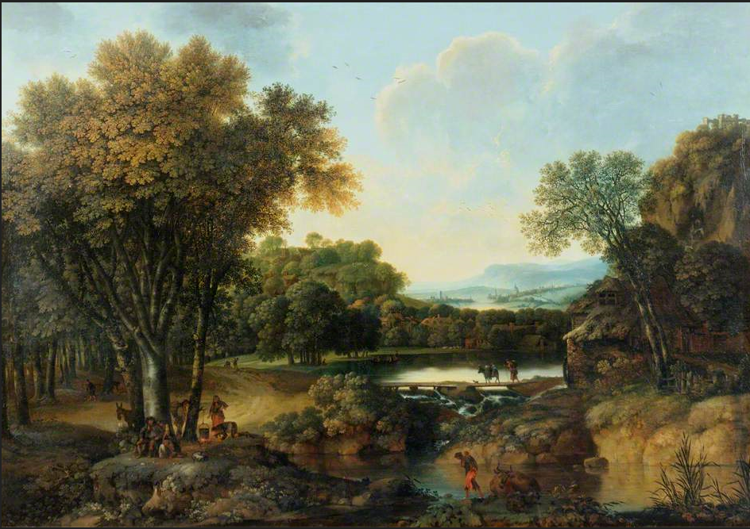
Figure 31: George Smith, Landscape with a Camp Fire, undated, oil on canvas. This image is held by the Government Art Collection and can be viewed via this link: https://artuk.org/discover/artworks/landscape-with-a-camp-fire-29286, or in the non-redacted version of this PhD thesis, held by the University of Sheffield Library.

Unlike George Smith’s other rustics, these ones gaze boldly back out at the viewer, contemplating them, just as they are examined. There is the man beneath the tree who sits with his hands on his knees and the woman in the orange skirt, with her hand on her hip, audaciously facing the viewer and holding their eye. These are unusual figures in the picturesque landscape because the viewer doesn’t expect the viewed to look back. It is almost a challenge to the onlooker to recognise their humanity. These are being portrayed by George Smith as real people with a sense of self-worth. This is precisely the same as Emmeline’s sense of self-value which she evinces with such spirit in the former scene with Lord Montreville, forcing him to acknowledge Emmeline’s individuality.

Emmeline’s portrayal of herself as the innocent, picturesque heroine, however, is a convincing stance for those who truly are picturesque, such as the Montreville family who surround her. There are numerous examples throughout the text of Emmeline’s playing the heroine in a picturesque manner, in order to extricate herself from a difficult situation. The convenient swooning fever which saves her virtue and simultaneously - fortuitously for her - effectively prevents her having to marry Delamere when he kidnaps her from the home of Mrs. Ashwood and attempts to force her into marriage with him, is just one. Emmeline’s attempts at ridding herself of Delamere for good are further examples. Within the section of the text where Delamere, influenced by the calumnious gossip of the Crofts, witnesses Emmeline with the illegitimate child he believes to be hers, Emmeline does nothing to disabuse him of this notion. Rather, while he waits in ‘expectation of hearing her speak’ and excuse herself, Emmeline, like the rustics in George Smith’s pictures, is silent and permits him to reach his own (erroneous) conclusions. Emmeline is later challenged on this point, when she refuses to listen to Delamere’s renewed proposals. Instead, she accuses him of unsteadiness in his attachment to her because

of his entanglement with Miss Otley. At this point, Lord Westhaven observes:

[h]is wavering then was, you well know, owing to some evil impressions he had received of you; which, tho’ he refuses to tell me the particulars, he assures me were conveyed and confirmed with so much art, that a more dispassionate and cooler lover would have believed them without enquiry.

The ‘art’ referred to here, is no less than Emmeline’s own. She has portrayed herself as the silent peasant in the picturesque landscape in her mute refusal to excuse herself in the hope that this will rid her of Delamere’s unwanted presence forever.

Lord Montreville’s attempts at coercing Emmeline into marriage with Rocheley is a further example of her stage-managing her appearance as a picturesque heroine to the men around her in order to get what she wants. During this scene, Emmeline just happens to produce the very sentimental item required, in the form of a portrait of her dead father, in order to diffuse the situation. However, during this episode, Emmeline suffers another lapse in her role as submissive heroine disappearing against the background of the picturesque landscape. This is a further occasion where Emmeline looks assertively back at those who would look on and dismiss her, just like George Smith’s bold peasants in Landscape with a Camp Fire (Figure 31). Upon this occasion, Emmeline resorts to threatening Lord Montreville

that she will not stay away from Delamere, unless he gives her what she wants:

To prevent his [Delamere’s] coming here was out of my power; but if I really aspired to the honour of which your Lordship thinks me ambitious, what has prevented me from engaging at once with Mr. Delamere? who has, I own to you, pressed me repeatedly to elope. My Lord, while I am treated with kindness and confidence, I can rely upon my own resolution to deserve it; but when your Lordship, on suspicion or misrepresentation, is induced to withdraw that kindness and confidence, - why should I make it a point of honour, where you no longer seem to expect it?

Lord Montreville is immediately forced to admit ‘[t]he truth of this answer,’ even though it ‘hurt and irritated’ him. For Lord Montreville ‘[p]ride and self-love seemed to resent that a weak little girl should pretend to a sense of rectitude, and a force of understanding greater than his own.’ Lord Montreville resents the fact that Emmeline, in this battle of wits, is the clear victor. This irritates him as he doesn’t expect his peasants to answer him back. It is as unexpected and surprising as the picturesque rustics looking back to meet the eyes of the viewer in George Smith’s Landscape with a Camp Fire (Figure 31). Emmeline’s self-possession and almost intimidating behaviour in this scene points to the genuinely steely nature of her character. It is hardly, it is clear, a portrait of a helpless, virtuous, picturesque heroine. However, in this instance, victory cannot, as Emmeline immediately realises, be achieved by winning the argument. Instead, Emmeline once more has to resort to the picturesque, using her feminine wiles with tears and becoming seemingly so (opportunely) ‘absorbed’ in these tears, that she is unable to ‘oppose’ Lord Montreville laying his hands on the very thing that will persuade him on her behalf: the portrait of his deceased brother. Once more, with the assistance of this external object, Emmeline is able to ‘be ingenuous with his Lordship, and get what she wants from him: safe passage to Mrs. Stafford’s and ‘an hundred guineas a year in quarterly payments.’

If Emmeline becomes adept at managing Lord Montreville, however, she faces a greater challenge in the management of her relationship with Godolphin. For, if Emmeline is not the traditional picturesque heroine, then Godolphin is not picturesque in nature at all. He differs greatly from the other men in the text in that he does not seem to play the same games and stratagems which Emmeline has been forced to resort to in order to manage the men who have previously exerted power over her. Instead, he is a different breed of man. Having ‘passed the greatest part of his life at sea,’ Godolphin has effectively been removed from the corrupting forces of the picturesque society which are rife within the diseased branches of Lord Montreville’s family. With ‘dark eyes full of intelligence and spirit; his hair, generally carefully dressed, [and] remarkably fine, and his person tall, light, and graceful, yet so commanding,’ Emmeline immediately recognises him as a bona fide member of those who bring ‘to the mind ideas of the race of heroes.’ He, as a hero, is not easy to overlook in the landscape at all. Rather, he stands out with his noble bearing. That Emmeline instantaneously recognises his worth, we are told in a typically Smithian veiled manner:

his voice was particularly grateful to the ear, and his address appeared to Emmeline to be a fortunate compound of the insinuating softness of Fitz-Edward and with the fire and vivacity of Delamere. Of this, however, she could inadequately judge, as he was now under such depression of spirits: and however pleasing he appeared, Emmeline, who conceived herself absolutely engaged to Delamere, thought of him only as the brother of Lady Adelina; yet insensibly she felt herself more than ever interested for the event of his hearing how little Fitz-Edward had deserved the warm friendship he had felt for him.

Smith opens their relationship by emphasising to the reader what Emmeline is not feeling and carefully drawing the reader’s attention significantly to this. Smith then subverts this by revealing that although Emmeline has not considered Godolphin as a preferable alternative to Delamere, it is only really by an effort of will that she is not doing so. The heroine is naturally drawn to the natural hero in the text, as is the case in every romantic novel, and no amount of denials and nay-saying will prevent this. The avid reader of any romantic novel will understand this, and, inevitably, it is not long before Emmeline’s heart admits ‘those dangerous partialities’ towards the hero. However, the reader knowing that Emmeline’s thoughts are occupied with ‘that esteem which [...] the softness of his manners, the elegance of his mind, and the generosity of his heart, could hardly fail of extorting from the most indifferent observer,’ and Emmeline being perceived by Godolphin as anything but an ‘indifferent observer,’ is another matter. Romantic conventions as fixed as any of the principles of the picturesque demand that the heroine cannot just easily give herself to the hero. In the landscape of romance, this is the case no matter how much both parties mutually wish to form a relationship together.

This romantic, picturesque landscape that Smith’s readers demand to see as the realm of their heroines, has romantic conventions it must adhere to, in addition to the pictorial codes outlined earlier in the chapter which readers similarly expected. These romantic rules dictate that there need to be obstacles to be overcome before the resolution can be achieved. In Emmeline’s case, she has to work hard to create these obstacles in order to continue in her role as the picturesque heroine, because in reality there is nothing whatsoever to prevent her marrying as she wishes. Earlier in the novel, Lady Delamere accuses Emmeline of ‘pretty finesse, learned from novels, to inveigle a silly boy to his undoing.’ At that point in the text, and concerning Delamere as it did, the accusation was unfair. However, Emmeline will now require everything she has ‘learned from novels’ in order to ensure that both Godolphin truly appreciates his prize, when he achieves it, and the reader’s sense of satisfaction at the romantic conclusion is maximised. Montreville, as noted earlier, has already indicated that he has no real power over the actions of Emmeline. This renders Emmeline’s repeated objections to Godolphin that she must consult her Uncle before acting in any way as regards to visits to Adelina at Godolphin’s home in East Cliff, or agreeing to marry him, nonsensical. Yet these are the only objections she has. As the reader races towards the end of the novel, these objections appear even more senseless, and begin to manifest themselves as merely prevarication on Emmeline’s part. It becomes increasingly clear within the text that the sole remaining obstacle is art on Emmeline’s behalf. This is a new courtship discourse for Emmeline: she is simply playing hard to get.

Emmeline, with her feminine wiles in this instance, is imbuing her own romance with a picturesque element. She is rendering it unstable and uncertain in order to ensure that Godolphin’s interest in her remains piqued. However, as outlined earlier, Godolphin is not a man who plays these games. He is not a picturesque character and suffers none of the instability of the picturesque. Rather, he prefers solid ground and plain speaking. When Emmeline somewhat irrationally refuses his attendance upon her to visit Adelina at East Cliff, therefore, he challenges
Emmeline, and calls her to account:

From the first moment I beheld you, my heart was your’s. I attempted, indeed, at the beginning of our acquaintance – ah! how vainly attempted! – to conquer a passion which I believed was rendered hopeless by your prior engagement. While I supposed you the promised wife of Lord Delamere, I concealed, as well as I was able, my sufferings, and never offended you with an hint of their severity. Had you married him, I think I could have carried them in silence to the grave. Those ties, however, Lord Delamere himself broke; and I then thought myself at liberty to solicit your favour [...] studiously as you have avoided giving me an opportunity of speaking to you, I have yet ventured to flatter myself that you beheld not with anger or scorn, my ardent, my fond attachment.

Godolphin speaks with a transparency and honesty which is entirely new to Emmeline in the picturesque society with which she has habitually mixed. Godolphin has recognised her art and seen through her ‘studious’ attempts to avoid him. When confronted with the truth, Emmeline is similarly faced with the knowledge that her behaviour has been ‘coldness [...] unkindness.’ In short, it is no way for the picturesque heroine to behave. Her reaction can only be ‘encreasing confusion’ and being deprived ‘of all power of answering.’ Unable to represent herself successfully as that picturesque heroine any longer, Emmeline is forced into a corner where there is only one possible outcome: acknowledging her love and marrying her hero. ‘I do indeed think very highly of you,’ she confesses, ‘I cannot, if I would, deny it.’

Of course, Emmeline has spent much of volumes III and IV denying it, but the fact that she can now put aside ‘all attempts to dissimulate’ and give way ‘to her natural frankness; and having once been induced to make such an acknowledgement of the state of her heart, she determined to have no longer any secrets concealed from him who was it’s master,’ speaks volumes about Emmeline’s return to her natural state of heroine-like virtue. Godolphin has effectively rescued her from the picturesque Montrevilles and brought her back to herself. As a heroine she has travelled a risky and convoluted journey amidst the many perils of society and has emerged out of the other side a better woman, who truly deserves her place as mistress in Godolphin’s home. Before she can reach her asylum with Godolphin, however, Emmeline must first successfully traverse a variety of treacherously picturesque landscapes. The textual landscape constructed by Charlotte Smith for her heroine and other characters is no less picturesque in essence than the picturesque landscape paintings of George Smith. For the aesthetics of the zeitgeist undermines even the structure of Charlotte Smith’s novel which exists, it seems, in fragments (much like the fragments of ruins which form part of George Smith’s landscapes).

The textual landscape of Emmeline is surprising in the number of scripts from which it is fabricated. Within the novel the action is advanced by letters, wills, lettres de cachet, challenges, bank notes, marriage certificates, writs, memoranda, sonnets, check books, anonymous letters, a signed promise, bogus newspaper reports and even the charade of a charade when Emmeline pretends to pass Fitz-Edward this article as she surreptitiously slips him a note. Even the unspoken language of innocence and blushes is employed by Emmeline, along with her rows of ‘spoiled netting’ which indicate the moment of crisis when Godolphin forces Emmeline to admit her true feelings for him, and which serve as a textual signifier in themselves. The entire plot, it seems, hangs on a box full of letters which Emmeline unwisely ignores at the beginning of the novel. Reading these documents at the point of their discovery would have circumvented many of the problems Emmeline later encounters as the picturesque insignificant orphan at the unmerciful hands of the Montrevilles. These fragments become the broken ground which form the foundation for Emmeline’s picturesque story. The novel as a whole seems almost like a text which has taken the picturesque truly to heart in that the entire structure of it is comprised of relics and little bits and pieces which clutter the landscape and come to embody the many stumbling blocks and trip hazards the picturesque landscape can hold for the unwary. This is similar to George Smith’s Landscape with a Castle on a Hill (Figure 19), which presents itself as a disordered panorama into which there are too many obstacles to provide any easy access and provides a further link between this particular painting from George Smith’s corpus and Charlotte Smith’s literary work. Each text which comprises Emmeline exemplifies the picturesque in that the individual pieces indicate a part of the story. Taken separately, the story is only partially visible, much like the traits of the picturesque itself.

Similarly, the limitations of the picturesque in connection with expression, how characters express themselves and which characters are able to do so effectively is emphasised within the text by Smith. Within the picturesque landscapes constructed by George Smith, as highlighted earlier, the figures within the landscape are often easily overlooked and ignored. They have no voice or presence in the paintings, as George Smith deliberately seems to represent them so as to be easily missed. The truly picturesque figure in the landscape, after all, as noted earlier, is silent and easy to overlook. Similarly, within Charlotte Smith’s novel there are frequently occasions when the characters populating her story are not permitted to speak for themselves. This applies most typically to women in the text. The steward Maloney’s implication to Lord Montreville in his proposal for Emmeline’s hand in marriage is one case in point, as Maloney ‘this communication he so contrived to word, that his Lordship had no doubt of Emmeline’s having allowed him to make it.’ When Emmeline attempts to explain in this case, she is accused of ‘artifice or coquetry’ and of ‘altering [her] mind.’ Her explanations are dismissed until, as noted earlier, she uses the language of the picturesque itself in a fit of weeping and appeals to his pity. Emmeline suffers a similar failure of expression in the paroxysms of terror she falls into when she realises that Delamere has tracked her down at the home of Mrs. Watkins and that Lord Montreville will most likely believe she has engineered this visit. Her inarticularity at this stage is indicative of her utter conviction that ‘Lord Montreville will believe I have corresponded with his son; he will withdraw all favour and confidence from me; and I shall be undone!’ The only remedy, as appropriately enough, the figure of Mrs. Stafford suggests, is to explain in writing. In a picturesque world where the figure in the landscape is not permitted to speak for herself, only those who are most able to articulate themselves with clarity in writing are rewarded with any success. Mrs. Stafford’s lucid rationalisation in written form ensures Emmeline is not penalised by Lord Montreville and ‘everybody must applaud [her] conduct in this affair.’ Indeed, Mrs. Stafford’s letter of explanation to Lord Montreville becomes yet another fragment in the text which forms part of this wholly picturesque novel and further advances the story.

Within this novel which so embodies the zeitgeist of the picturesque at its heart, it is the characters who are able to articulate themselves with the most lucidity that are the most successful, and this further provides a clue as to who is a genuinely picturesque character and who is not. Fitz-Edward, for example, the reader is advised, ‘who knew the power of his insidious eloquence’ is placed in a difficult situation when Lord Montreville discovers he has been aiding Delamere in his pursuit

of Emmeline. However, when Montreville calls on Fitz-Edward to explain himself:

The Colonel heard him with great serenity; and then began to justify himself, by assuring his Lordship that he had accompanied Delamere only in hopes of being able to detach him from his pursuit. [...] Though this was not all strictly true, Fitz-Edward possessed a sort of plausible and insinuating eloquence, which hardly ever failed of removing every impression, however strong, against him.

Despite the reprehensible and immoral actions Fitz-Edward undertakes within the novel, including being instrumental in Emmeline’s kidnap and his inappropriate affair with the married Lady Adelina, Smith (and the reader) somehow manages to forgive him and ensure he reaches a satisfactory conclusion at the end of the novel. His excuses are just too plausible and his eloquence too compelling. He, too, will eventually find his way to Emmeline’s asylum on the Isle of Wight and find salvation there, slotting perfectly into the harmonious landscape because he is not authentically picturesque in nature.

Conversely, unlike his friend Fitz-Edward, Delamere, with his inarticulate rage and frenzy as he is consumed by his passions, confirms his position as the most unstable and picturesque character within the text by his inability to express himself both orally and in writing. On the few occasions Delamere commits himself to paper, his letters read like the desperate ravings of a lunatic:

For two days I have forborne to see you, Emmeline, and have endeavoured to argue myself into a calmer state of mind; but it avails nothing; hopeless when with you, yet wretched without you, I see no end to my sufferings. I have been about the door all the evening; but find, by the carriages, that you are surrounded by fools and coxcombs. Ah! Emmeline! that time you owe only to me; those smiles to which only I have a right, are lavished on them; and I am left to darkness and despair.

It is a note which causes Emmeline to shudder, as it is ‘more incoherent than usual and seemed to be written with [the] trembling and uncertain hand’ of a madman. A later epistle from Delamere will read, with equal desperation, ‘I came hither to entreat only one quarter of an hour’s conversation, which you cruelly deny me! You determine then, Emmeline, to drive me to despair!’ To this Emmeline responds with her own business-like epistle, almost as if she is declining a job interview:

Sir,
Your request of an interview, I think myself obliged on every account to refuse. I am extremely sorry you determine to persevere in offering me proposals, to which, though they do me a very high and undeserved honour, I never ought to listen; and excuse me if I add, that I never will.

EMMELINE MOWBRAY

The result of her coherent self-expression in her positive rejection of his advances, results in yet more insanity on Delamere’s part. It ‘seemed to affect him with a temporary phrenzy. He stamped about the room, dashed his head against the wainscot,’ leading Mrs. Watkins to reach the quite natural conclusion that ‘’tis the young Lord. He is gone mad, to be sure.’ Emmeline’s coherence also confirms the suspicion in the reader’s mind that she is not an authentically picturesque character. She is just using the trope of the picturesque to her own advantage as and when it suits her. Just as the reader suspects from her sagacious actions which preserve her from the Montreville family outlined earlier, Emmeline acts and speaks with coherence and good sense. She is a stable character, unlike the truly picturesque Montrevilles. Emmeline uses the picturesque: Delamere is picturesque. Further, the more articulate Emmeline becomes, the more able to argue with clarity, the less Delamere is able to communicate with her rationally. They are speaking and writing different languages. Emmeline sees reason and communicates logically, whereas Delamere can only use the rhetoric of the make believe world of the picturesque and the unreal and unstable nature of this permeates his every action. The end result is Delamere’s rash communications in his impetuous challenge to Bellozane. It is this which will cost him his life.

Whilst the unstable picturesque characters like Delamere can only meet a bad end, it is those who are the most pragmatic and least picturesque characters who force the action forward within the novel. For example, Mrs. Stafford, who perceiving that Godolphin ‘had received an impression from the mental and personal perfections of Emmeline,’ and foreseeing the way the story will go, decides to interfere and shape Emmeline’s story herself. She does this by ensuring that Godolphin is fully apprised of Emmeline’s tale, including ‘Delamere’s long and violent passion for Emmeline,’ and the engagement she is bound to fulfil at that stage in the text. In some ways, it could be perceived that Mrs. Stafford is the controlling element in the story, both here, and at other points in the story. It is only after Mrs. Stafford has given her permission and approval of the developing relationship between Godolphin and Emmeline, that Emmeline feels free to acknowledge her feelings for him. The novel needs this straightforward unpicturesque force within it to move events along. Without it, the reader would be trapped: compelled to stumble around the broken grounds of picturesque fantasy. There is something uncanny about this, as Mrs. Stafford seems to act as an almost-author in the text, relating stories and providing written accounts as necessary, in order to advance the heroine’s story. Some critics have argued that Mrs. Stafford is an autobiographical figure, and indeed, there would be something of conscious artistry in Mrs. Stafford doubling as Mrs. Smith within the novel. Both seem to be exerting authorial control over the novel – Mrs. Smith literally so, and Mrs. Stafford in a manner which equally advances and shapes the plot.

Whereas viewing Charlotte Smith’s art alongside George Smith’s artwork augments our understanding of Emmeline’s landscapes, the fragmentary and picturesque structure of the novel enhances what the reader suspects. This is not just a novel, but rather it becomes a piece of art constructed out of many texts. It is artwork which is formed on the picturesque model, with fragments and partially visible characters, comprising the whole. Both artists named Smith are drawing on a similar interpretation of the zeitgeist of the picturesque in order to present a larger picture of what is going on in society during this period. There are several conclusions that can be drawn from this comparative reading of both George Smith’s picturesque artwork in tandem with Charlotte Smith’s first novel, Emmeline. It is a novel which is picturesque in multiple ways, from the characters in the text, right down to the very structure of it. For many of Smith’s readers, it is likely that, like Walter Scott and the anonymous reviewers of The Critical Review and The Monthly Review, the picturesque scenes and the artistry within Smith’s novel were simply accepted for what they seemed to be. They were ‘drawn with great beauty.’ They were ‘elegant and correct.’ George Smith’s evocation of the picturesque as he sees it, however, with its implications of social injustice within the British landscape, resonates with the scenes which Charlotte Smith has constructed for her heroine, and adds an additional layer of interpretation to her novel.

At its most basic level, first and foremost, the picturesque movement presents an image of England as England wished to see itself. In times of uncertainty, such as during the latter years of the eighteenth century, when revolutionary fervour was at its height in France, and the repressive government of William Pitt was in power, being able to imagine that everything was ‘in keeping’ in the British countryside must have been a comforting factor for the populace to cling onto. These images of the soothing pastoral landscape of the picturesque model had infiltrated society’s psyche at that time. As Simon Schama argues, this was precisely ‘the time when Britain became needy for consolatory images of its rustic delights.’ That the people of Britain would wish to imagine that all was well and peaceful in the English countryside is further enforced by the fact that during this particular period in history, things were very far from well and peaceful there. It was a time when the rural poor had no political rights in determining the very issues (for example, Enclosure Acts, Corn Laws, Militia Acts and Poor Laws) which most directly affected them. Indeed, as Rudé observes, they ‘had no other means of redress of grievance than resort to the traditional riot.’ As early as 1775, public opinion had become so alarmed about the frequency of riots by rural inhabitants that one correspondent sent the following epistle to the Gentleman’s Magazine:

If the Legislature don’t speedily use some method effectually to suppress the present spirit of rioting, which is become general among the lower sort of people ... there will be no protection from the plundering mob... The Mob must be conquered!

Riots would continue, however, throughout the latter years of the eighteenth century. Rudé documents that there were ‘nine food riots in 1772-3, seven in 1783, eight in 1792-3, fifteen in 1795, and a dozen or more in 1800.’ A cursory glance at George Smith’s artwork will, on the surface of it, reveal landscapes which are undeniably serene in appearance and attractive to look at. This is the landscape the public wishes to see. There are no rioting peasants present there.

Similarly, Charlotte Smith also constructed ideal landscapes with her pen. A brief reading of her early novels will reveal that these are romantic novels, and in the landscape of romance the reader can be fairly confident that integrity will win the day and the virtuous hero/heroines will achieve their just desserts. Like readers of many contemporary romantic novels, for Smith’s readers, the satisfaction of surveying her scenes had much to do with the pleasures of bricolage. As Rosalind Brunt argues of the world of romantic novels, ‘[p]recisely because the story elements are familiar we are assured of entering a customary world. We “know where we are.”’ The sure and certain knowledge that here, at least, everything was going to work out just fine kept readers reading, deriving gratification from the picturesque scenery and the certainty of a happy ending in an uncertain world. Both Smiths are giving the paying public what they want, at least on the surface of the matter.

Although Charlotte Smith’s early novels are primarily concerned with romantic relationships, they are also concerned with depicting a recognisable reality. A romance has to be believable in order for readers to invest their time and energy in the adventures of the heroes and heroines. Paradoxically, Smith’s reliance on the artificial zeitgeist of the picturesque adds to the realism of her fictions. As Nancy Miller argues:

In a true story, as in ‘true confessions,’ the avowal would be believable because in life, unlike art, anything can happen; hence the constraints of likeliness do not apply. In a made-up story, however, the confession offends because it violates our readerly expectations about fiction. In other words, art should not imitate life but reinscribe received ideas about the representation of life in art.

Smith’s composition of those early novels coincided precisely with the picturesque movement. Hussey observes: ‘[t]he picturesque view of nature was then the new, the only, way of deriving aesthetic satisfaction from the landscape.’ The cultured readership Smith was aiming for would have expected to see the heroine traverse an aesthetically pleasing landscape. As Brewer argues, ‘eighteenth century observers relied on poems and paintings’ in order to interpret the landscape surrounding them. That Smith understands this, and awards the same sensibilities to her heroines, we know, as she has Ethelinde take out ‘with her that volume of the works of Gray, in which he, with the clearest simplicity, describes this small lake,’ when she walks out to look at the ‘small lake’ in question: Grasmere. Ethelinde, like her readers, is unable to view the actual landscape without referring to Gray’s picturesque travel journal, in order to ensure that her responses to the genuine view are correct. The picturesque view of nature, as noted earlier, had become almost ubiquitous during latter eighteenth-century society. It was the only correct way to view nature at that period in time. The realism within Smith’s early novels, it could therefore be argued, was made more realistic by virtue of its reliance on art to portray it. The artistry and artificiality of the scenes within the story, made the story more recognisably real to readers, as it fitted precisely with their view of how the landscape should (correctly) look.

So on the surface of the matter, both Smiths’ artwork gives the reading and viewing public precisely what they want from their books and pictures. Yet, as Morrissey has observed, there is ‘a more general propensity in Smith to build multiple possible interpretations into her work. Chris Jones notes that “Smith was well aware of a [politically] divided readership and perpetually played on ambiguities of response.”’ It is reasonable to assume that Smith provided the opportunity for her readers to see the political and social landscape of her novels exactly as they wished to see them, in order to appeal to the maximum number of readers. If, however, her readers were inclined to look beneath the picturesque patina which was thickly daubed over her text, then there was more to be found than just rocks and ruins and trees.

As in George Smith’s landscapes, the ingredients which comprise both artists’ picturesque scenes have a hint of violence and disorder to them. This subtle undertone highlights the flaws of those who govern the British landscape, their neglect of the lower classes and the impoverished, and their failure in custodianship. In the picturesque landscape, as has been highlighted, it is all too easy to overlook the peasants. For Charlotte Smith, the injustice of what is hidden behind the pretty appearance of the picturesque British landscape contaminates the view and is expressed through the scenes, the characters and the very structure of her romantic novel. With this in view, her ‘romance’ becomes so much more than just a love story. It becomes the literature of protest and a demand for justice. As Stanton argues of Charlotte Smith’s work, ‘she could imagine and create a more rational, sympathetic, and equitable world than the one she lived in.’ In using her text to highlight the flawed nature of British society through the zeitgeist of the picturesque, this is precisely what she lays out before the reader.

The moral in the novel laid out before the reader is partially screened by these picturesque principles. As Susan Manning observes of the works of Burns and Wordsworth, ‘art teaches by pleasing, the beautiful gives pleasure. It becomes “safe” as the sugar coating on the bitter moral pill.’ By wrapping her strong female authorial characters and her heroines who don’t quite behave as they should in the ‘sugar coating’ of the picturesque, Smith displaces the subversive message of her text. By concealing her social views within the conscious artistry of her fiction, she protects herself and her work. Smith will use a similar feint in her most popular novel, The Old Manor House, when she displaces the revolutionary action to a period earlier in history in order to provide herself with the freedom to express support for the revolution which was going on in France at the time. Indeed, the picturesque, for Charlotte Smith, and more specifically George Smith’s picturesque, is a useful device in her novel. It looks pretty, and yet it conceals a multitude of sins.

Charlotte Smith’s Emmeline would not be the last time that she was inspired by the artworks of her erstwhile drawing master George Smith. Figure 32 shows the engraving which accompanied ‘Ode to the Poppy,’ written by Charlotte Smith’s friend, Henrietta Boyle O’Neill (1758-93). This first appeared in Desmond (1792) and was included in Volume II of the Elegiac Sonnets. The background to the female figure in the engraving, completed by James Neagle from an original by Richard Corbould, bears a striking resemblance to George Smith’s A Monk by a Church in a Wood (The Hermitage, Goodwood) (Figure 33), which is held at Petworth. The windows of the church are the same shape. The cowled figure of a monk appears in each illustration and is essentially the same figure in outline. This painting is unusually gothic in theme for George Smith and is something of an oddity in his corpus. It is the only example of this type of painting amongst his known artworks that he ever did. It being held at Petworth, the home of the third Earl of Egremont, renders it likely that Charlotte Smith would have seen this uncharacteristic example of her former drawing master’s work, due to her frequent visits on business relating to her father-in-law’s will with the Earl. Further, given the active involvement Charlotte Smith participated in during the commissioning of the expensive engraved images, it also seems likely that she was instrumental in the design of this plate. In chapter two, I will analyse the influence of another artist on the work of Charlotte Smith, that of George Romney, who also completed a sketch for the second volume of the Elegiac Sonnets.

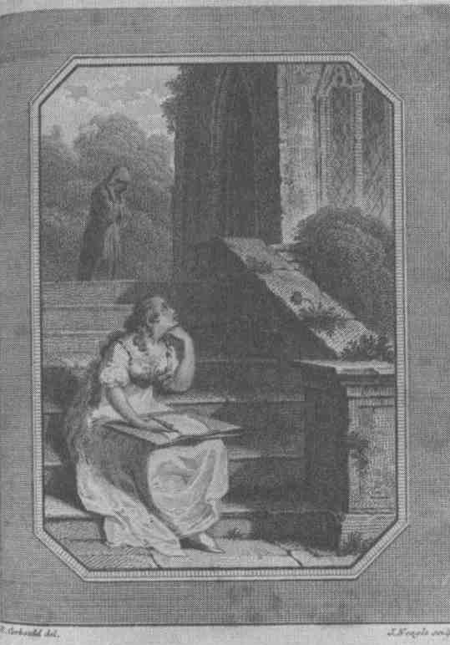
Figure 32: After Richard Corbould, Plate to accompany ‘Ode to the Poppy’ by Henrietta Boyle O’Neill, published in the second volume of the Elegiac Sonnets, James Neagle, 1796, line engraving on paper. As noted by Jacqueline M. Labbe, Charlotte Smith: Romanticism, Poetry and the Culture of Gender (Manchester & New York: Manchester University Press, 2003), p. 41. This image can be viewed in this book or in the non-redacted version of this PhD thesis, held by the University of Sheffield Library.

Top of Form
Figure 33: George Smith, A Monk by a Church in a Wood (The Hermitage, Goodwood), c. 1734-1776, oil on canvas. This image is held by the National Trust at Petworth House and can be viewed via this link: https://www.artuk.org/discover/artworks/a-monk-by-a-church-in-a-wood-the-hermitage-goodwood-219612 , or in the non-redacted version of this PhD thesis held at the University of Sheffield Library
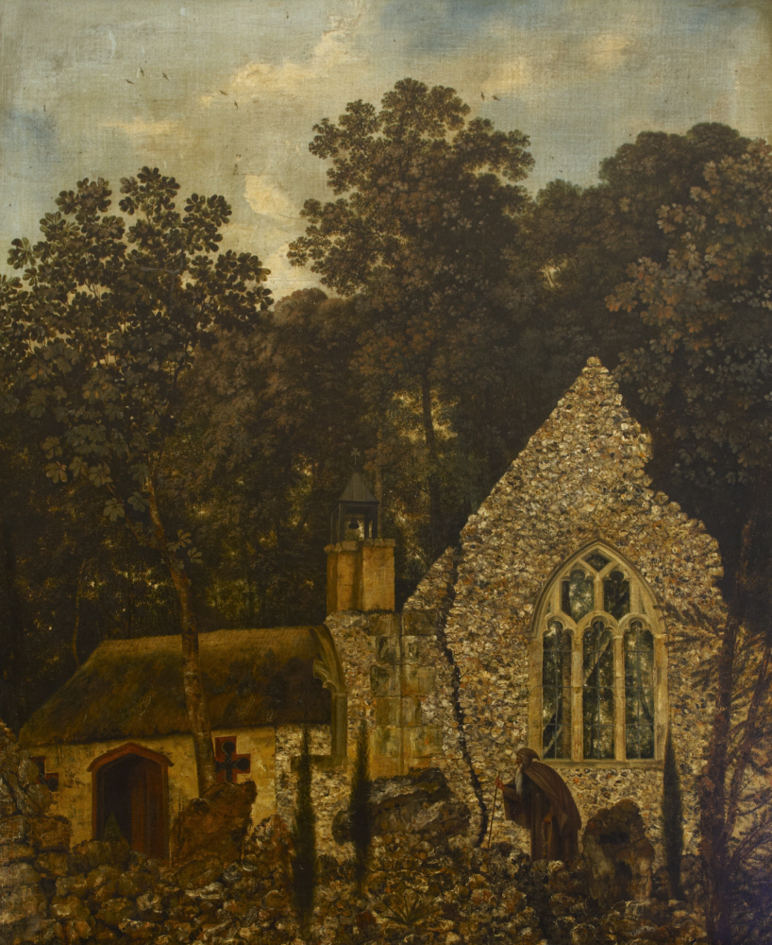

Chapter Two
‘The Horror of the Abyss’: The Feminine Sublime in Ethelinde (1789) and The Young Philosopher (1798)

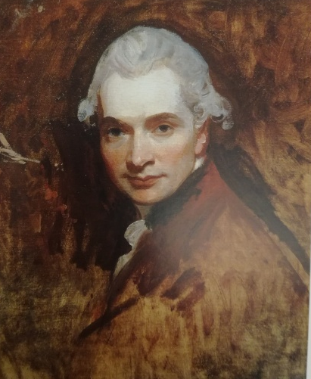
Figure 34: George Romney, Self-portrait (unfinished), undated, oil on canvas, location of picture now lost.

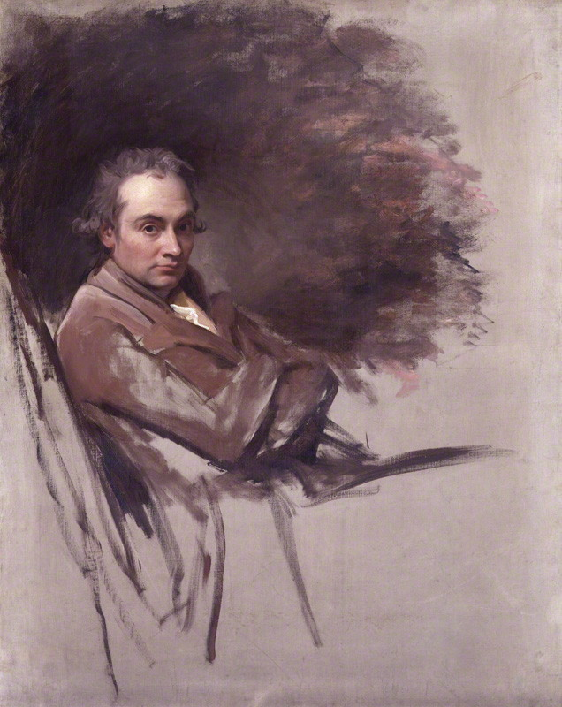
Figure 35: George Romney, Self-Portrait (unfinished), 1784, oil on canvas. This image is held by the National Portrait Gallery and can be viewed via this link: https://www.npg.org.uk/collections/search/portrait/mw05424/George-Romney, or in the non-redacted version of this PhD thesis, held by the University of Sheffield Library.

At this cruel period, Corisande gave an instance of that firmness which wholly different from masculine fierceness, is the highest attribute of the female mind.

This chapter explores the works of Charlotte Smith alongside the artistry of portraitist George Romney (1734-1802) with particular regard to the sublime tropes Romney habitually worked into his oeuvre. It will compare Romney’s primarily female portraiture with the women Smith portrays in her novels, and analyse how the tropes of the sublime aesthetic, made so popular during the late eighteenth century by Irish writer Edmund Burke, are manifested within these female portraits. It will reconsider what has popularly been conceived as masculine gendered aesthetic tropes and reconfigure these to deliberate how both artists create ‘sublime women’ via their artworks.

The personal acquaintance between Romney and Smith is much more well-documented than Smith’s relationship with George Smith. The two artists spent time together at William Hayley’s house, Eartham, in 1792, along with William Cowper. During this time, Smith worked on her most famous novel, The Old Manor House (1793), and Romney took her portrait in pastels (Figure 12). The relationship, however, did not endure. The portrait itself became a bone of contention for Smith. Held at Eartham by Hayley, despite Smith’s best efforts, she was never able to gain access to it in order to have copies taken for the frontispiece of the second volume of the Elegiac Sonnets (1797). Complaining to Joseph Cooper Walker in a letter of May 1796, she records:

Mr Hayleys repeated refusal to let me have copied the only picture that I ever had made of me once when I was writing at Eartham. It is extremely like, & I wish’d for two copies of it, one for an Engraving & another for my Son’.

Smith made repeated attempts to gain access to her own image, but each time, Hayley would ‘on no account let it go out of his possession.’ That the portrait had more than just business value for Smith is made clear by the fact that she also wanted to gift a copy to her son. Although her relationship with Hayley had reached the point of terminal breakdown by this stage, there is some indication that her acquaintance with Romney continued, albeit on a precarious footing. Within an unpublished letter, Smith reports Romney’s willingness to provide another portrait for both her family, and the second volume of her sonnet:

Romney proposes doing one for my family this winter on purpose for the Engravers but that will be too late for Mr. Cadell’s purposes. – I want to ask leave to have this engraved as I cannot hope that another will be so very like, but I find it so despicable to the person in whose possession it is [Hayley], that I can press it no further. My propos’d addition, therefore, of a little ode to the Painter must of course be omitted also.

Smith clearly wished to repay Romney in some measure for the only likeness she ever had taken of her which she approved. However, the sole currency Smith had free access to, given her permanently impoverished state, was her poetry. The ‘propos’d addition’ to which Smith refers, was a short ode to Romney which she wished to include within the second volume of the sonnets.

Smith reported to her publishers Cadell & Davies that she would submit this poem as soon as she was able. In a letter dated 28 April 1797, she advises them that:

[i]t is an address to Mr Romney on the sketch he made of a likeness, but to tell you the truth, he is so odd & capricious a Man that I do not know whether I can print it without his consent for which I have written to Mr Hayley with the preface & hope you will have them both in a day or two.

Smith never did gain the necessary permissions from her estranged friend Hayley or the ‘odd & capricious’ Romney, and for Smith the loss of the painting meant the loss of the poem as well. In the end, the poem never made it into the second volume of the sonnets. The poem was lost for over a century before being found by a curator of the Abbot Hall Art Gallery in Kendal, a gallery with strong Romney links.

There is, however, some evidence to suggest that Romney did complete a sketch for the second volume of Smith’s Elegiac Sonnets. This is something that Smith scholars had not formerly been aware of, and also has implications surrounding the discovery of a previously unattributed Romney sketch. David A. Cross in his biography of Romney’s life, records how, during the early days of their friendship, Hayley had promised Smith, on Romney’s behalf, ‘a drawing of “a pensive pathetic muse on a rock” as an illustration for her verse.’ Cross notes how ‘the drawing was eventually provided and was engraved by Stothard who does not acknowledge its origin.’ The resultant image is shown in Figure 36.
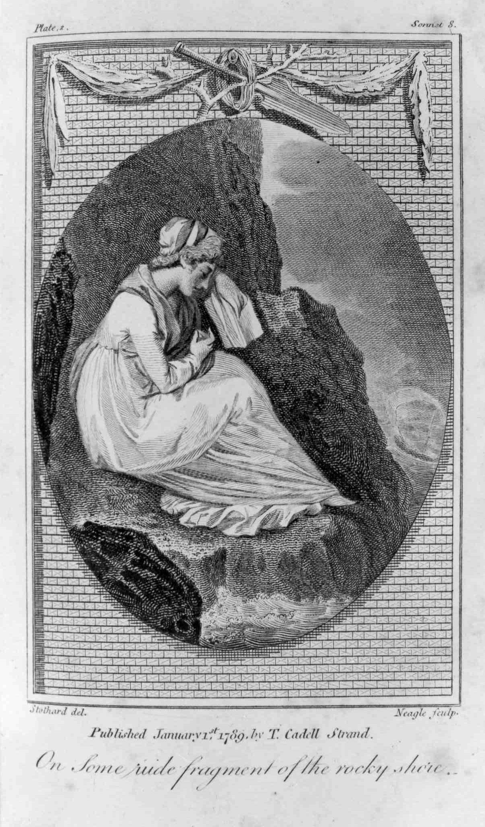

Figure 36: James Neagle after Thomas Stothard, Illustration to accompany Sonnet XII: ‘On Some rude fragment of the rocky shore,’ 1797, engraving.

Figure 36 accompanies Smith’s ‘Sonnet XII: “On some rude fragment of the rocky shore,”’ which has the names Thomas Stothard as the delineator and James Neagle as the engraver inscribed upon it. Leading Romney scholar, Alex Kidson, did not, unlike Cross, recognise the design as being related to any painting or drawing by Romney, but acknowledged that ‘it is obviously Romneyish in conception and Stothard’s name is known to have been used on early prints after Romney.’ The shape of the woman, the folds of her dress and the shading techniques used within this illustration, all correspond with Romney’s artistic techniques. One might compare her features with the women featured in the Romney sketchbooks held by the Romney Society/British Library (Figure 37).

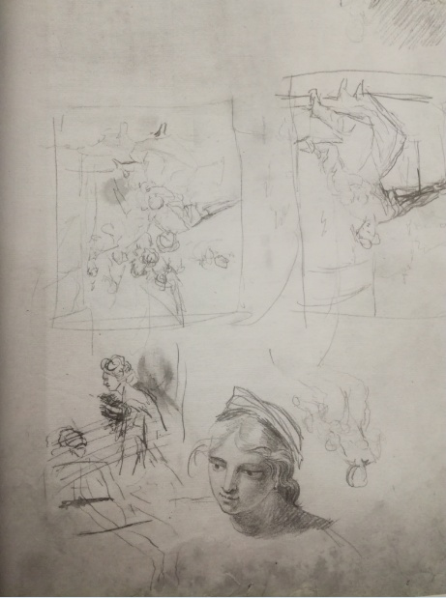
Figure 37: George Romney, Page from The Kendal Sketchbook 1763-71, undated, pencil sketch. This image can be viewed in this book, or in the non-redacted version of this PhD thesis, held by the University of Sheffield Library.

Similarly, it has been noted by Romney scholars that very few sketchbooks from Romney remain, as on his death, the books were dismantled and the pages sold individually. In this way, his sketches have been scattered to the four winds. With this evidence in view, it is entirely possible – likely even – that the sketch which accompanies Smith’s sonnet is an unattributed Romney sketch. This demonstrates, in some measure, the influence that each of the artists had on each other. Romney was inspired by Smith’s literature, and, in turn, Smith applauded Romney’s portraiture of women. Romney’s corpus proved sufficiently inspirational to Smith for her to want to include his works within the plates to accompany her poetry, just as the works of George Smith inspired her. Chapter one provides details of just how important the engravings accompanying the poetry were to Smith and her attempts at exerting artistic control over these and influencing their content. With this in view, it becomes increasingly apparent just how imperative the visual artistry is to Smith’s poetic art.

Smith’s loss of control over her own portrait completed by Romney, however, is indicative of the status of women in Romanticism, and provides a clue as to why the aesthetic of the sublime, as exemplified by Romney in his female portraiture, becomes so important in Smith’s own female characterisations. This is an aesthetic which is essentially concerned with the loss of control, whilst simultaneously being secure in the knowledge that one is ultimately safe. Its distinguishing features are of darkness and obscurity, and the breaking of boundaries. It is concerned with immeasurable distances – huge heights and vast gulfs – and has a tendency to spill over the edges and refuse to be constrained. Romney’s paintings arguably share the same traits. Consider, for example, the two samples of unfinished self-portraits which open this chapter (Figures 34 and 35). Here, the self the artist has attempted to record fades out at the edges, into an unknown territory of indeterminate, sketchy lines. There are no fixed boundaries surrounding these images. The edges merely disappear gradually into darkness and obscurity. These are unfinished portraits and perhaps purposely so. When one considers the nature of the inner being, it becomes an impossible task to conclude one’s self. The nature of the individual is something which is permeable, ever-changing and developing, and can never truly be resolved into one final entity, except, perhaps, when confronted by that most sublime moment of all: death. Romney encapsulates all of the sense of the evanescence of human life and being in his unfinished portraits. Surrounded by dark sweeps of paint representing obscurity, Romney’s self- portraits could arguably be referencing the tremendous shadows which futurity casts upon the nature of human existence by using the tropes of the sublime. As Christopher Kilgore argues, for theorists on the sublime such as Burke, ‘the sublime represented the human mind’s encounter with and recoil from events that evoke the suprapersonal forces, from the quasi-mystical to the literally religious.’ There can be no encounter for the human mind more jarring than the confrontation of one’s own mortality and Romney demonstrates this in the sublime tropes he employes on his canvas. Surrounded by dark sweeps of paint, the artist’s eyes gaze vividly out from his face which provides a singular point of light colouring in the picture and highlights the murkiness of the background by comparison. This is the ‘quick transition from light to darkness’ which ‘has yet a greater effect’ in the production ‘of sublime ideas.’ Here, within these unfinished portraits, Burke utilises the tropes of the sublime to great effect, in order to convey the nature of the human self and its very transitoriness.

Similarly, Smith also accesses the tropes of the sublime aesthetic in order to portray her female characters within her two novels Ethelinde, or the Recluse of the Lake (1789) and The Young Philosopher (1798). In the case of Laura Glenmorris, there is an unmistakeable tendency for Laura to contrive to lose herself and spill over the edges, from reason into a staged madness. She seemingly loses her own image of herself, just as Romney’s own self-portrait (Figure 34) ended up lost, and Smith lost control over her own image. In this manner, Laura crosses a further border of the sublime, to confront a Kristevan abject as the boundaries between what is natural and supernatural, what is real and unreal, life and death itself, dissolve. She uses the tropes of the sublime to present herself in a weird and uncanny landscape which forms the perfect background for her to demonstrate Smith’s feminine sublime. The eponymous heroine, Ethelinde, however, seemingly appreciating the ease in which a woman can lose control over her own destiny, exerts a masculine firmness in exercising control over herself and manipulating those around her, to ensure that she is ultimately directing their decisions. Laura’s daughter, Medora, exhibits a similar masculine determination in assuming agency over her own self. The sublime, which has, since Burke, been associated with the masculine, comes to characterise their behaviour. It is a firmness, Smith seems to be saying, that is necessary for women, in order to have any measure of control over their own lives: ‘the highest attribute of the female mind.’

Smith, in her novels, utilises the sublime in a variety of ways, as does Romney in his female portraiture. However, it might be useful at this stage, to set out which definition of the tropes of ‘the sublime’ are being employed in the analysis of these two novels. There are numerous definitions under this heading, all of which could be considered. Judy Lochhead notes that the ‘first significant use of the term sublime traces back to a Greek treatise on rhetorical technique commonly attributed to Longinus.’ This was resurrected during the eighteenth century and, as Lochhead continues, ‘the concept of the sublime became central to the birth not only of aesthetics as the province of artistic experience but also […] of the modern human subject.’ From Longinus onwards, the sublime has been appropriated by any number of philosophies to be put to any number of uses. In his 1757 essay, A Philosophical Enquiry into the Origin of our Ideas of the Sublime and Beautiful, Edmund Burke attempted a definitive explication of the aesthetic (the Burkean sublime). Within this text, he valorises the sublime as the superior aesthetic to ‘the beautiful,’ attributing all that is powerful and masculine to the sublime, whereas ‘the beautiful’ is engendered feminine, consisting of ‘weakness,’ ‘imperfection’ ‘lisp[ing]’ and ‘totter[ing].’ Similarly, Immanuel Kant’s ‘sublime’, as Lochhead observes, ‘inscribes gender into the very nature of knowledge […] the understanding of women is beautiful, that of men is deep.’ Kant’s mathematical sublime becomes concerned with the immeasurable and the infinite. A similar comprehension of the aesthetic is applied by Derrida who considers the unbounded nature of the sublime, which can, according to Derridean theory, only make sense when juxtaposed against the bounded. Derridean sublimity ‘claims that the unboundedness of the sublime is an effect of “consciousness itself,”’ making the leap from the purely visual to consider sublimity as a state of being.

From Derrida onwards, the uncontrolled and uncontrollable theory of the sublime begins to exceed even its own self. As Robert R. Clewis argues:

with such liberal use of the concept and so many kinds of sublimity popping up – the technological sublime, feminist sublime, ecological sublime, literary sublime, postmodern sublime, American sublime, romantic sublime, the cultural and political sublimes – one is tempted to conclude that the concept itself has become too massive, hence diffuse and uninformative.

The ‘postmodern sublime’ that Clewis refers to then ultimately comes, as David B. Johnson argues, to rest ‘on a principle of “thinking’s getting carried away … as if fascinated by its own excessiveness.”’ Jane Forsey concurs, highlighting the ‘problem’ of the sublime, in that ‘theorizing about the sublime rests on a mistake.’ Forsey argues that ‘the generally accepted notion [of] the sublime experience ‘professes to “see” beyond human powers of knowledge and description.’ The problem being that such a statement is impossible. The sublime is a human construct, created by human beings, so it is impossible that it is able to surpass the boundaries of human comprehension itself. How does one say the unsayable, or describe the indescribable? With her forays into the unbounded language of madness via her heroines, Smith manages to negotiate this predicament.

Barbara Claire Freeman and Patricia Yaeger have also theorised on ‘The Feminine Sublime,’ which underscores a crisis of identity for the eighteenth-century heroine. As Freeman argues:

The feminine sublime is not a discursive strategy, technique, or literary style the female writer invents, but rather a crisis in relation to language and representation that a certain subject undergoes. As such it is the site both of the women’s affective experiences and their encounters with the gendered mechanisms of power from the mid-eighteenth century (when the theory of the sublime first came to prominence) to the present, for it responds specifically to the diverse cultural configurations of women’s oppression, passion and resistance.

However, as will be seen, Smith, instead of considering a ‘Feminine Sublime,’ Smith effectively re-sexes the sublime to assert that the sublime is not a gendered construct. Women as embodied by her heroines are sublime. They are as sublime as any male. In most cases, they possess more attributes of the sublime than the masculine characters in the texts. In order to simplify the concept of ‘the sublime’ as it is applied to the texts in this chapter, it is the Burkean hypothesis of the sublime which has principally been relied on. This is primarily because this would be the aesthetic theory as Smith and Romney would most likely understand it. Smith engages with Burkean philosophies and politics on numerous occasions throughout her texts, including directly confronting and arguing against his theories, in such novels as Desmond (1792). However, as will become clear, both Smith’s and Romney’s female portraits expand outside themselves, and slip over the edges, and beyond the frame of the painting, into what could be perceived as a postmodern understanding of the aesthetic. This in Smith’s case, is Smith’s way of raising that ‘crisis in relation to language and representation’ of the eighteenth-century woman, and so, in itself, transforms into a female sublime.

By considering Romney’s sublime women alongside Smith’s, it will become possible to deliberate how these eighteenth-century women expand beyond themselves and the boundaries imposed on them by traditional portraiture. A portrait is only a thing – a mere commodity – but simultaneously it has a meaning beyond itself. Smith’s reaction to the loss of her own portrait demonstrates this clearly. Further consideration of the Romney self-portraits underlines this point. Figure 35 is the unfinished 1784 self-portrait which is held by the National Portrait Gallery. This painting formed the first exhibit at the exhibition entitled George Romney 1734-1802: British Art’s Forgotten Genius, held at the Liverpool Walker Art Gallery in 2002. Heather McPherson describes the painting as ‘arresting’:

his luminous head dramatically set off against the sketchy dark background. But it is the directness and nakedness of his gaze and the astonishing economy of means that make the work so quintessentially modern. This arresting yet elusive image, painted for his friend and patron William Hayley, captures the essence of Romney – artist, dreamer and rebel. As Hayley remarked, it reveals ‘that pensive vivacity, and profusion of ideas, which a spectator might discover in his countenance, whenever he sat absorbed in studious meditation.

The painting, therefore, is revealed as being much more than just a self-portrait of the middle-aged artist. It is, in its striking likeness to both author and subject of the work, a gift of himself – incorporating the very nature of his self – to his patron, Hayley. Hayley, as he does with Smith’s image, now owns Romney to some extent. This anxiety about the nature of this type of exchange of gifts is discussed in detail by Reggie Allen in his analysis of ‘The Sonnets of William Hayley and Gift Exchange,’ in which Allen highlights Hayley’s tendency to ‘maintain the cohesion of his [artistic] group with a constant donation of verse, hardly ever letting a work of art go without penning a sonnet of praise, and never receiving praise without sending a sonnet of gratitude.’ Romney participates in this gift economy by the gifting of the image of his own self, replete with so many of his essential characteristics, to Hayley. A further example of his work, however, highlights the anxieties surrounding these economic transactions. Figure 38 shows Romney’s John Flaxman Modelling the Bust of William Hayley (1795).

Figure 38: George Romney, John Flaxman Modelling the Bust of William Hayley, 1795, oil on canvas.

As Allen argues, ‘[t]his portrait beautifully exemplifes the circularity of artistic gift exchange: A painter portrays a sculptor portraying a poet.’ Romney also chooses to place a further image of himself in the painting (just visible in the top left corner, probably recording the scene), thereby imbuing the gift with additional value as he places himself in Hayley’s possession as subject/object once more. This, as Allen observes, reveals ‘an anxiety about incomplete exchanges.’ When has the patronised artist ever given enough of themselves/their artwork, in order to justify the patronage/inclusion in the artistic circle? Further, what happens when the circularity of the gift economy breaks down? How does exclusion from the gift economy of the artistic circle affect the artist? These must have been questions which Smith knew all too well how to answer. Hayley’s repeated refusal to grant her access to her own portrait determined her as an outsider in this artistic circle. It was not just an exclusion from a friendship – it was a banishment to the abyss of the non-artistic community. It was tantamount to a declaration that she did not belong within these circles. Such a denunciation by an established literary figure, who had previously patronised her work and acted as her literary mentor and friend, must have hurt.

The self-portraits and images given as gifts hold an intrinsic meaning much beyond surface appearances. It becomes clear that a picture is never just a picture: it always holds more significance than that. That Smith was well aware of this even before the rift in her friendship with Hayley and her exclusion from the Eartham artistic circle is apparent from the significance Smith invests in the portraiture featured within her novels. A key moment in Ethelinde concerns the image of the heroine herself and who controls ownership of a miniature painting which has been taken of her aged around fifteen. Her declared lover, Montgomery requests that Ethelinde give him the picture to take with him as he sets off for the colonies in order to make his fortune. This, in turn, will ensure that he is able to return with sufficient money to enable him to marry Ethelinde. However, Ethelinde, it transpires, has already given the miniature painting to somebody else: her ostensible guardian, Sir Edward:

A faint blush arose on the cheek of Ethelinde; and faultering she said – ‘Indeed, Montgomery, I would give you the picture with pleasure – but I have not got it.’
‘Who has it then?’ said he eagerly. ‘Have you given it to Chesterville?’
‘No,’ replied Ethelinde, who by this question had an opportunity of concealing the truth, had she been capable of artifice, ‘but Sir Edward, who is fond of Meyer’s miniatures, and thought that not only very like but extremely well painted, begged me to give it him.’

By this stage in the text, the reader, as well as Ethelinde, is well aware of Sir Edward Newenden’s true romantic feelings for his ward. Ethelinde, for nearly the entirety of the novel, will seek to deny that Sir Edward entertains these feelings for her. It is the only way in which she can retain her relationship with the married Sir Edward within the bounds of propriety. She needs to do this in order to preserve Sir Edward’s financial support of her. Acknowledging the true nature of Sir Edward’s feelings for her would ensure that she would be forced to renounce her relationship with him entirely, and the impoverished Ethelinde simply cannot afford to do this.
Ethelinde is caught in a double-bind. Following her heart and marrying Montgomery will lead to financial ruin. However, openly acknowledging Sir Edward’s feelings for her will also lead to financial ruin in the loss of his support of her. Instead, Ethelinde has to balance the competing desires of the two men so as to seem available to both of them and not forfeit the interest of either. In order to do this, Ethelinde perpetrates an elaborate deception which partakes of the tropes of the Burkean sublime in her effective use of obscurity in clouding Montgomery’s view as to whether he is the owner of the original portrait he so desires. The miniature portrait marks the moment of crisis in the text in Ethelinde’s precarious balancing of these relationships, but it also becomes the very item that can save Ethelinde, via her use of a sublime obscurity in presenting the facts, as will be seen.

Montgomery, despite the narrator’s deliberate attempt at misleading the reader by assuring them that Ethelinde is incapable ‘of artifice,’ immediately detects the true reason that Sir Edward wishes to own the image of Ethelinde: ‘And Sir Edward then,’ cried Montgomery, ‘has it? Sir Edward wears it?’ Montgomery’s instantaneous, almost hysterically anguished conclusion that Sir Edward wears the miniature against his skin confirms the reader’s view that Montgomery fully realises Sir Edward’s true feelings for Ethelinde, and comprehends that he is at risk of losing Ethelinde to this rival. The miniature is so much more than just a painting. It is an intimate gift of the image of one’s self, intended to be worn by an acknowledged lover, which, due to its size, permits that lover to then carry their beloved around with them. It is, as Marcia Pointon has shown, an intimate item, that will be worn close to the skin. Ethelinde, seeking to appease Montgomery, however, immediately denies the romantic connotations that are apparent in her gift of the miniature to Sir Edward. She instead seeks to debase it to just a thing which ‘he has merely put […] into a little cabinet where he keeps many others.’ Of course, Montgomery straightaway sees through this ruse on Ethelinde’s part, by challenging her to ‘[a]sk it of him again. It cannot be of the value to him that it is to me. How could you so cruelly part with it?’ To this Ethelinde responds with ‘[h]ow could I refuse it to Sir Edward to whom I owe so many obligations?’ The true value of the gift is being highlighted by the narrator in this exchange. Ethelinde has ‘cruelly’ given away something which has much more value than a mere picture. She has, in effect, promised herself to Sir Edward in the gifting of her image to him. That Montgomery understands the value of this item on the sexual marketplace in which Ethelinde is manoeuvring is emphasised by the jealous outburst which follows:

‘Obligations!’ exclaimed Montgomery, rising and walking to the other end of the room – ‘Obligations! Yes I know their extent but too well! ’Tis these obligations which distract me! A divorce, which I am well informed he intends to sue for, will give you an opportunity of acquitting yourself: and Montgomery, in Indostan, will be recollected only to wonder how you could ever give him hope!’

Montgomery’s romantic jealousy is further accentuated, as Joe Morrissey argues, in Smith’s ‘literary allusion to Othello.’ ‘[B]ut the picture, the picture, like the handkerchief of Othello, was still not to be got over.’ As this scene in Othello specifically ‘relates to an instance of romantic jealousy,’ it raises in the reader’s mind the idea that Montgomery is intensely jealous of Sir Edward. The only way that Ethelinde manages to manoeuvre out of this situation, without losing the heart of Montgomery entirely, is by promising to demand the picture back from Sir Edward and give it to Montgomery himself.

This, however, leaves Ethelinde with a problem, as she immediately acknowledges to herself as soon as she has managed to calm Montgomery down:

How to ask Sir Edward for a picture which she had given him, and on which she knew he set so high a value, she knew not; yet to disappoint Montgomery after the solemn promise she had given him, was yet more impossible: after much deliberation she determined to ask Sir Edward for it the next morning, that she might leave it in town to be copied. She foresaw that this might introduce a conversation relative to Montgomery, which she wished to avoid; but as no alternative remained, and she could not for a moment support the thoughts of disappointing him or raising anew his uneasiness on the subject of Sir Edward, she fixed on this plan; and as she knew he had never seen the picture above twice, and that she could have it very exactly copied, she believed he would not distinguish it from the original; and should by this means gratify Montgomery without appearing capricious and ungrateful to Sir Edward Newenden.

There are several points of importance within Ethelinde’s internal wrangling with herself over the picture which further highlight how this miniature is not just a mere thing, but instead has a deeper meaning invested within it, and it has apparently been used as a pledge of sexual promise on Ethelinde’s part. Ethelinde fully realises this, even if she will not openly admit it to either the reader or the characters surrounding her. First of all, there is her frank acknowledgement to herself that Sir Edward sets ‘so high a value’ on the image itself. This is not just a thing which has been placed within a cabinet where he keeps many other things of like nature, as Ethelinde has previously asserted to Montgomery. This item is, Ethelinde understands, of personal value and romantic significance to Sir Edward.

Secondly, there is Ethelinde’s tacit admission to the reader that she is setting out to deceive Montgomery and to cloud his view with obscurity. Within their earlier exchange, Ethelinde promises that she will ask Sir Edward for the original of the painting to be restored to her, so that this original can then be passed to Montgomery. However, here Ethelinde admits that she is only going to ask to borrow the painting back so that she can have it copied in town. She will then aim to deceive Montgomery by passing off the copy as an original, and return the original to Sir Edward. She believes that she will get away with this, because ‘as she knew he [Montgomery] had never seen the picture above twice, and that she could have it very exactly copied, she believed he would not distinguish it from the original.’ This dishonesty on the part of the heroine is highlighted further by the narrator, as Morrissey observes, ‘just over a hundred pages later,’ when Montgomery gives an account of his travels on his return to England:

‘[A]nd at night, or whenever my watch was over, I kissed the two dear pictures I had preserved of my mother and my Ethelinde: their beloved images soothed my short slumbers, and I awoke indeed to new toils, but to toil lightened by the hope of soon embracing the beloved originals.’

As Morrissey argues:

Montgomery’s comfort in his picture is founded on a lie, and the reader is reminded of the fact by Montgomery’s reference to the ‘originals,’ which acquires a double meaning for the reader if they remember that Montgomery’s picture is a copy of a copy, and that Sir Edward holds the first copy.

The fact that Montgomery habitually regards the portrait ‘at night’ also reminds the reader of Etheldine’s deception and that he is in the literal dark as well as the figurative in his belief that the portrait is an original. The scene itself participates in the tropes of the sublime as it refocuses the reader’s gaze on the obscurity Ethelinde has purposefully woven around the portrait. As Burke argues, ‘light now appearing, and now leaving us, and so off and on, is even more terrible than total darkness.’ Montgomery is not totally unaware of the nature of Sir Edward’s feelings for Ethelinde and yet despite the initial concerns he has exhibited over Sir Edward’s possession of the portrait, he still has sufficient faith in Ethelinde to believe that he now possesses the original of it. Montgomery’s knowledge is a partial mix of light and shade which compounds Ethelinde’s deception further and is perhaps ‘more terrible than total darkness’ if Montgomery were to learn the truth of Ethelinde’s actions on this point. However, in reality, Ethelinde has had no choice. She still needs to retain the interests of both suitors, thus the requirement for deceit in this matter becomes imperative.

The third point this exchange highlights is the very depth of the obscurity which Ethelinde aims to create in this matter for both of her suitors. This is drawn to the reader’s attention via subtleties. As Morrissey observes, the point when Ethelinde has actually given the miniature to Sir Edward is not recorded in the text. This is something which has taken place off-stage, without the reader’s knowledge, until Montgomery exposes the fact that the miniature is no longer in Ethelinde’s possession. This, in itself, hints at a private relationship which is occurring between Ethelinde and Sir Edward, the nature of which the reader is not privy to. Ethelinde admits the questionable propriety of this private relationship in the difficulties she recognises in requesting the picture back from Sir Edward. The very request, she concedes, will make her appear ‘capricious’ or fickle in Sir Edward’s eyes. Yet there is no reason that this would be so - unless, of course, Ethelinde herself has hinted at the possibility of their relationship developing into a romantic one, underscored by the gift of the miniature to Sir Edward. Sir Edward himself raises this during the problematic interview Ethelinde endures with him when she requests the loan of the miniature in order to get it copied. ‘I will fetch the picture, Ethelinde; perhaps you may chuse to give Mr. Montgomery that rather than a copy. If so, I am sure my wish to keep it ought to yield to his and your’s.’ The picture is as good as a pledge in Sir Edward’s eyes. However, Ethelinde, who cannot bear to see either of her suitors unhappy, because this will deprive her of the advantages of both of their friendships, insists that a copy will do for Montgomery, thus appeasing Sir Edward. She cannot, after all, deceive Sir Edward with a copy, as his knowledge of the original painting is too intimate by this stage. The fact that Ethelinde knows that she cannot deceive Sir Edward by borrowing the original and then replacing it with a copy, in itself, implies that she also knows that he has studied the miniature extensively. One does not do this with an object that is merely intended to be stored in ‘a little cabinet [with] many others.’ Ethelinde, it is clear, is fully aware of the significance of the miniature portrait she has gifted to Sir Edward.

The very nature of a portrait, and the fact that it can be authentically copied, however, enables Ethelinde to retain the good will of both of her suitors, and provides her with a convenient escape route via art. This applies to both the artistry recording herself (i.e. the miniature portrait) and her own artfulness in controlling her own image and the obscurity she disseminates around this. Like Emmeline, as argued in chapter one, who uses the tropes of the picturesque to portray herself to her greatest advantage, Ethelinde, similarly uses the tropes of the sublime to manipulate how she appears to those around her. Ethelinde becomes sublime in her characteristics by assuming the traditional masculine patriarchal role in directing her own future. Ethelinde, it is clear from the text, cannot rely on either her weak-willed father or her ostensible guardian, Sir Edward – too easily swayed by his illegitimate passion for her – to do this for her. She must become sublime herself so as to regain control of the situation. In order to do this, she makes effective use of the tropes of the sublime. Ethelinde seeks to manipulate her destiny via the control of her own image, and she does this by utilising obscurity. By successfully manoeuvring the original and the copy around her love triangle of Montgomery and Sir Edward, Ethelinde distributes an uneven possession of the knowledge of who owns which. By shrouding this point in obscurity, she uses the sublime to effectively first regain the original from Sir Edward, without losing his goodwill or interest. She then has it copied for Montgomery, who then believes he has received the original, freeing Ethelinde to return the original to Sir Edward who, as noted earlier, Ethelinde realises, has a too intimate knowledge of the original to be fooled by a copy. However, both men believe they now own the original of Ethelinde. By controlling access to this knowledge, and perpetuating obscurity around the provenance of the true original and copy, Ethelinde twists the tropes of the sublime to reconcile the situation to her own satisfaction.

Romney was also no stranger to the politics of the power of ownership of the original artwork. Accessing them after completion came with their own specific challenges. Figure 39 shows a commission from Romney’s patron, the Earl of Egremont.
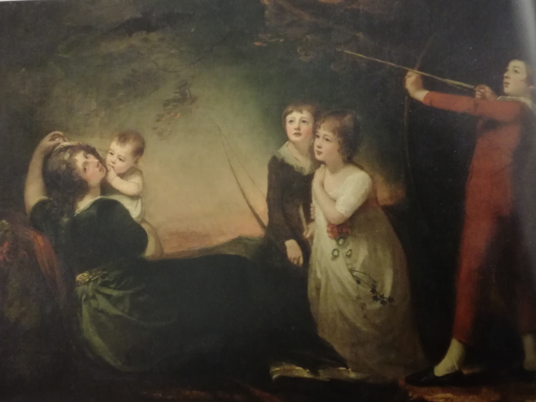
Figure 39: George Romney, The Egremont Family, 1795-1796, oil on canvas. This image can be viewed in the non-redacted version of this PhD thesis, held by the University of Sheffield Library.

The commission was arranged by William Hayley, and depicts Elizabeth Iliff (far left), Egremont’s mistress who finally married the Earl in1801 after bearing him six children, before divorcing him two years later. Amongst the children in the picture are featured the three eldest sons, Henry, Francis and George. The youngest child, the daughter featured in the picture, is Charlotte. Sittings for the picture took place in Hayley’s riding house, and as Kidson notes, Hayley worked hard to promote the picture as a triumph, no doubt because in the gift economy of patrons/artists, this would promote his own interests with the Earl. On 4 October 1795, he wrote to his son, Thomas Alphonso in London, reporting that ‘his fair friend of Petworth spoke yesterday in the most pleasing terms of the family picture, with a lively solicitude for its being happily finished, and in such a manner as to suit the convenience and gratify the feelings of the artist in every respect.’

These effusions Kidson describes as ‘self-serving gloss’ and, indeed, the picture, like Smith’s portrait, became a bone of contention between artist and patron. As Pointon observes ‘[t]he fortunes of the painter could become inextricably bound up with the fortunes of the portrait he had painted.’ This one, depicting the Earl of Egremont’s irregular family life, was much in demand by the art market and Romney wished to have an engraving made of it and sell the copies. The more copies he sold, the more valuable the painting would be perceived to be, and the more in demand Romney would be as an artist. However, Egremont refused permission to have any engraving taken of the painting, just as Hayley did with Smith’s own portrait. As is demonstrated by Smith’s Ethelinde, whoever owns the original of the painting has the most power. For Ethelinde, at this stage in the novel, it is Sir Edward who triumphs over Montgomery. Sir Edward, after all, is the only man who can offer Ethelinde financial security at this point in the novel. Montgomery’s future is too precarious.

Throughout the novel, Ethelinde has many other suitors beyond Montgomery and Sir Edward, including Danesforte and Davenant. Their desires surrounding their concepts of her – the images they carry within their own minds of her – are similarly copies from the original Ethelinde. The standard of the copies, whether they be ‘very exactly copied,’ as Montgomery’s version is, or a complete miscomprehension of her true nature shaping her into a poor shadow of her true semblance, all contribute to the value of the original, just as Romney knew as he attempted to traverse the difficult art market. As Pointon argues, ‘[m]odern-day criteria of originality and individuality need to be set aside in this discussion, for portraiture was the one genre in which copies increased rather than diminished the standing of the original.’ Although Montgomery would not be pleased to learn of Ethelinde’s sleight of hand in foisting the copy of the original painting off on him, the fact that multiple men desire her and seek to own her image in some way, increases the original Ethelinde’s value substantially. The control over the portrayal of her own self catapults her into the realm of masculine sublimity, asserting dominance in this social realm. Nearly every man in the novel who meets with her, seeks to impress her. However, none of the men in Ethelinde’s life are, in reality, worthy of her. Sir Edward is a would-be adulterer. Danesforte and Davenant are fops of the worst order. Her brother is too volatile to be relied on. Her father is dead. Montgomery himself is weak, vacillating in nature, and missing for most of the text. Therefore, the only real choice Ethelinde has is to follow her heart. Her heart, it becomes clear, is prejudiced in Montgomery’s favour, despite his many failings.

The partiality Ethelinde feels for Montgomery is demonstrated via her reaction to his portrait. As Pointon observes, ‘[p]ortraiture is the elaboration of absence. From its earliest manifestations, the portrait has stood for an absent human being.’ This has already been demonstrated in Montgomery’s sentimental conjuring of ‘the beloved originals’ of his mother and Ethelinde from their portraits, during his long absence. From Ethelinde’s heartfelt response to the absent Montgomery’s portrait, the reader also learns that it is here that her preference truly lies:

hung in the parlour, and over his mother’s chair was a picture of him painted in France when he was a boy. On these memorials Ethelinde had gazed during the long winter; now she looked at them with renewed sensations of hope and delight. Montgomery was well; his love was undiminished.

Her heart lies with Montgomery, but it is not quite so simple as arguing that this is because she is in love with him. Rather, the complicated emotions she experiences are revealed in a close reading of her reaction to the portrait of the boyish Montgomery, and these too demonstrate her feminine sublime. The fact that the image portrays him as a boy suggests a significance in terms of power relationships. Ethelinde would be able to assert superiority as an adult woman over a boy. Indeed, Ethelinde has already managed to stamp her more powerful nature on the grown Montgomery: ‘his love was undiminished.’ Via her machinations, she has managed to retain his love for her, in spite of ‘the little crack in her character’ which her involvement with Sir Edward Newenden has earned her.

Montgomery is sufficiently deceived by her outward appearance of heroine of sensibility and her various artifices to convince him of this, to continue experiencing that undiminished love for her. Ethelinde, as a powerful woman, wishes to have a husband who can be easily ruled. As Diane Long Hoeveler argues of the position of the eighteenth-century heroine, ‘if there is a system of “traffic in women,” then sell yourself to the best (read: most controllable) bidder.’ That this is not Sir Edward Newenden, Ethelinde – and the reader – is all too aware. She has, after all, been unable to fool him by giving him a copy of the miniature painting. Montgomery however, is all too easily duped into believing he possesses the original. For a woman of such sublime nature as Ethelinde, her best match is with the easily directed Montgomery.

It would be difficult for Smith to create an eponymous heroine who is less than deserving of the appellation of ‘heroine’ to her readers. She must be seen to be worthy by her readers, on the surface of the matter at least. In creating this complicated portrait of Ethelinde, Smith manages to balance the selfish desires of the heroine and the less than societally acceptable masculine control she asserts over her own destiny, with the requirement to appear as the traditional submissive, beautiful heroine who marries the first hero she has expressed an interest in. However, for the reader who delves beneath the surface, Ethelinde similarly has excellent reasons for behaving as she does. She is taking control of her own destiny and forging the best future for herself she is able to, in the face of a patriarchal society which fails her as a woman. Indeed, Smith’s use of the tropes of portraiture, such as those practised by Romney in the women he depicts, contributes to the reader’s acceptance and respect for the heroine. Romney, who, as Kidson argues, ‘found greater inspiration in women sitters than men,’ uses the same tropes of the sublime to depict interesting women as Smith is doing in her portrayal of Ethelinde.

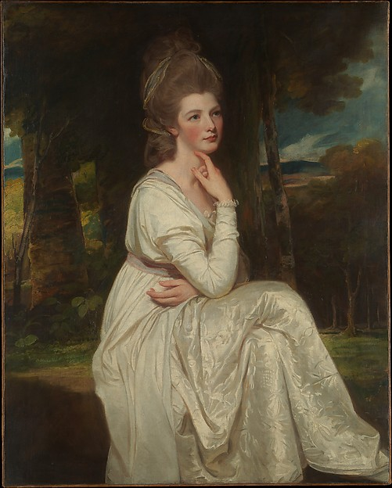
Figure 40: George Romney, Lady Elizabeth Stanley (1753-1797), Countess of Derby, 1776-1778, oil on canvas.

Figure 40 shows Romney’s portrait of Lady Elizabeth Stanley (1753-1797), Countess of Derby. Lady Elizabeth Stanley was a less than respectable woman. Her mother was an impoverished Irish actress, one of the famous ‘Gunning Sisters,’ who had married her way into a fortune. She would later have an affair with the Duke of Dorset which would lead to the breakdown of her marriage. She also had family links with the scandalous author Elizabeth Gunning, later Plunkett (1769-1823) who was forced to survive by her pen after her involvement in an attempted fraud of the Marquess of Blandford involving forged letters. However, Romney manages to brush over her salacious past via the tropes he uses in her portrait, and Smith utilises the same devices within her portrayal of Ethelinde. Within Romney’s portrait, the Countess of Derby is a vision in pure and virginal white. The choice of gown colour is significant, as Angela Rosenthal argues, as ‘whiteness [acts] as an erasure of corporeality, a chromatic void and a cancelling out of bodily existence.’ The woman’s white body and potential for sexual desires is overwritten by her white dress. She is rendered unsexual and safe by this. The whiteness is made almost luminous by the darkness and obscurity which are features of the landscape in which the woman is seated. Romney uses the tropes of the sublime to emphasise what he wishes to superficially convey about the nature of this woman.

However, like Smith’s Ethelinde, there is more to Romney’s portrayal of this woman than mere surface appearances initially imply. Clearly visible beneath the folds of her gown, is the bodily outline of the woman herself. The whiteness of her gown might go some way towards erasing her bodily existence, but she remains vividly corporeal just beneath the surface. Her knees, and legs, in particular are emphasised by the folds Romney paints surrounding her shape. The woman’s unambiguous blush, too, becomes an indicator of her natural womanhood and inner sexuality. The blood flow clearly visible, again, just beneath the surface of the whiteness of her skin, indicates an inner emotional life.

Whilst the accentuated whiteness of the woman might highlight a significant outer marker of virtue, ‘represented’ as Rosenthal argues ‘in aesthetic discourses by means of an emphasis on the transparency and paleness of female skin,’ the blush perceptible on her cheeks marks off her ‘darker, uncivil, erotic drive.’ The Countess of Derby in Romney’s portrayal is both safe and unsafe, simultaneously exuding innocence, and oozing with sexual allure. She is the embodiment of the sublime in that she is many things impossibly at once. The Countess of Derby’s skin appears transparent in Romney’s painting. With her delicate creamy complexion, like marble, her skin appears translucent with the blood of her violent blush blooming beneath her cheeks. The soft pastel tone of the ribbon at her waist, the colour of pale pink roses, further highlights the blush and suggests the animated presence of her inadvertent expression of emotions. Her virtuous whiteness cannot, ultimately, conceal her animal sexuality.

Smith uses the same external signifiers in her complex portrayal of Ethelinde. Opening the scene with Montgomery’s demand for the miniature painting, Ethelinde’s first response is to blush: ‘A faint blush arose on the cheek of Ethelinde.’ It is a moment revelatory of uintentional emotion, which faintly reveals Ethelinde’s guilt, at the sexual betrayal of her established lover. For, as the reader knows, she has already given the miniature portrait to Sir Edward. The blush, it seems, in the iconography of both Smith and Romney, is firmly linked to sexual allure. This is emphasised by the narrator at the point when Montgomery has rescued Ethelinde from the thunderstorm at Grasmere and she returns to the company of the Abbey. The image of Ethelinde, disordered by the storm, marks the point when Sir Edward falls in love with her:

Thus Ethelinde, the object of so much anxiety, now appeared before him in a blaze of beauty which turned his Lordship’s curiosity into admiration. Her complexion, which was frequently too pale, was raised to a deep blush. Her fear had given way to pleasure at the kindness and attention of Sir Edward, and her whole countenance was animated by good humour; while the disorder of her hat, and her dark auburne hair, set off her face to more advantage than could have been done by the exactest arrangement or most studied ornament.

As with Romney’s portrait of the Countess of Derby, Ethelinde’s skin has been rendered as transparent (‘too pale’) ensuring that the markers of her sexuality (her ‘deep blush’) are all too easily legible on her body. Again, as in the Romney portrait, Smith uses the sublime trope of background obscurity to illuminate Ethelinde’s whiteness in the room. The room she enters in the Abbey is dark and gothic in nature, lit by firelight, against the gloom of the external storm. The very frame surrounding her translucent features – her hair – is a fashionably Rousseauesque (or Romneyesque) ‘dark auburne’, thus throwing her paleness into further relief for those who look on her. Shown to her best advantage, and appearing at her most virtuous – superficially anyway – those who look on her could easily misread her as ‘pure.’ Her skin, however, in the midst of all this whiteness is rendered transparent and the emotions within are all too decipherable via that ‘deep blush.’ The level of sexual arousal in this scene with Sir Edward Newenden in that ‘deep blush’ might be compared with the ‘faint blush’ Ethelinde betrays in the company of Montgomery. From this portrayal, it becomes all too apparent that Ethelinde’s emotions towards Sir Edward are intensely sexual in nature, whereas, she considers Montgomery more as his own portrait depicts him: as a boy.

Indeed, this moment could be interpreted as the very instant of Ethelinde’s sexual awakening. Prior to this her skin has been ‘frequently too pale.’ Now, in the face of Sir Edward’s ‘admiration’, she is ‘raised to a deep blush’of sexual awareness. Ethelinde’s exuding of awakened sexuality again points to her sublime nature. For Burke, sexual desire is something that can only be experienced by men for women. In discussing the nature of passion and love, Burke asserts, ‘it contains a mixture of lust: its object is the beauty of women.’ This is clearly designed to encompass men’s feelings but does nothing to address the passions of women. Indeed, as argued earlier, the Burkean sublime is very much a gendered concept attributing all that is powerful and masculine to the sublime, whereas ‘the beautiful’ is engendered feminine, consisting of ‘weakness’, ‘imperfection’ ‘lisp[ing]’ and ‘totter[ing].’ However, there is nothing of weakness in Ethelinde’s strong sexual feelings at this point in the novel. She is experiencing a new and powerful emotion that Burke would classify as sublime in nature according to his own criteria.

On the surface of the matter, however, at least, both the Countess of Derby in her portrait, and Ethelinde are rendered in a socially acceptable way, with the sexual body concealed by artistic trickery. Within Ethelinde, the narrator commits a sleight of hand in directing the reader towards this interpretation of the heroine’s character. However, the more astute reader paying close attention to the text, will realise that Ethelinde is far from innocent and is operating on a sublime level to her own agenda. This becomes apparent from the handwritten comments which are included in the scanned edition of the 1789 text available on Eighteenth Century Collections Online which records a contemporaneous reader’s responses to Ethelinde’s character and the men who surround her. Figure 41 shows a comment taken from the frontispiece to the text which quotes the anonymous review from A Monthly Review, or Literary Journal of 1790 in describing Ethelinde as ‘a very Phoenix – like Richardson’s Grandison far too excellent – far above the standard of Nature.’ Figure 42 details the same reader’s reaction towards Ethelinde’s suitors. This reader has discerned Ethelinde’s female sublime in operating ‘above the standard of Nature,’ whilst simultaneously being surrounded by ‘two fools and one of them criminal even.’

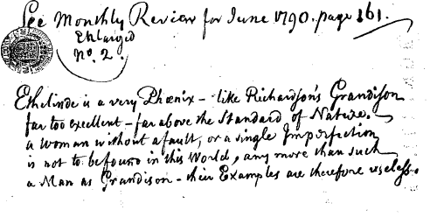
Figure 41: Handwritten note quoting Anon., ‘Mrs. Smith’s Ethelinde, a Novel’, A Monthly Review, or Literary Journal (June 1790), 2, 161-166, (161), indicating the reader’s response to Ethelinde’s sublime character.
Figure 42: Handwritten note written on page 298 of volume IV of the ECCO version of Smith’s Ethelinde, or the Recluse of the Lake (1789): ‘Two fools, and one of them Criminal even.’
The tropes of the sublime used in the background to Smith’s portrait of Ethelinde, show her to her best advantage, as Sir Edward’s immediate admiration of her indicates. Further, Ethelinde, as Lady Newenden (Sir Edward’s rightful wife) instantly distinguishes, belongs in this sublime landscape. When Sir Edward directs his wife’s attention to the surrounding scenery during their journey into the Lakes, Lady Newenden immediately rejects his attentions and refers him instead to Ethelinde, who she describes revealingly as ‘a young lady of sublime taste.’ Indeed, the manner in which she behaves, and the mode in which she controls her own destiny, indicates that she is more than of just ‘sublime taste.’ Rather she exhibits traits traditionally associated with the masculine, which makes her a sublime woman. ‘[T]he sublime,’ as Burke put it, ‘that in all things abhors mediocrity.’ There is nothing remotely mediocre about Ethelinde with her firmness of character and terrifying single-mindedness.

This strength of character is fortunate in Smith’s heroine, because it is clear from the very outset of the novel, that she will require all of this strength in order to survive her forthcoming adventures. In the true manner of the art of the portraitist, dark clouds gather on the horizon indicating a future failure of fortunes. This type of imagery can be viewed in Romney’s work, in examples such as his 1779 portrait of Anne Albemarle, formerly Keppel, Countess of Albemarle and Son (Figure 43).

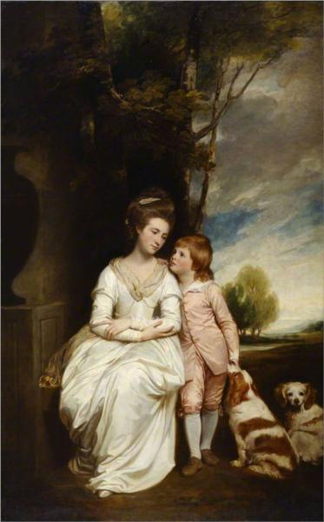
Figure 43: George Romney, Anne Albemarle, formerly Keppel, Countess of Albemarle, and Son, 1779, oil on canvas. This image can be viewed in the non-redacted version of this PhD thesis, held by the University of Sheffield Library.

Once again, in this portrait, the virtuous woman’s purity is highlighted by her white gown. As with many other Romney portraits, the image has a depth of meaning beyond mere surface value, and the family history is alluded to within it. As Kidson observes,

[t]he countess, emerging from a penumbrous space alongside a large urn, is grieving decorously for her husband. She is being consoled by her son Charles (accompanied by a pair of King Charles spaniels, a pun on both his name and the family’s direct descent from King Charles II). Behind him a bright horizon expresses the family’s optimistic future.

Romney would habitually use this technique in his portraits to demonstrate the bright future prospects of the sitter.

Smith utilises a similar effect, by having dark clouds gather on Ethelinde’s horizon from the very outset, to indicate that her future path will be far from smooth. Here, Smith’s sublime imagery comes into its own with the Burkean ‘vast cataracts [in which Ethelinde nearly drowns], raging storms [and] thunder,’ all of which Ethelinde must face. Smith deliberately evokes these painterly effects when she describes Ethelinde’s first encounter with Montgomery: ‘dark clouds, gathering on the tops of the hills, and a ruffling wind arising, made her apprehend a storm.’ Even as she accepts Montgomery’s assistance in conveying her home, her future troubles are foretold by the ‘tremendous burst of thunder [which] made the rocks tremble to their base; and Ethelinde started, and almost fell, from the suddenness and violence of the shock.’ This is truly Burkean ‘terror’ of which ‘no passion so effectually robs the mind of all its powers of acting and reasoning as fear.’ That we are in the terrain of an authentic Burkean sublime, we know, because although Ethelinde feels fear, it is of a superficial nature. She is entirely immune from actual danger. What Ethelinde is feeling is the ‘delight’ of knowing her own ‘immunity’ from real peril. She is, after all, quite safe with Montgomery, whilst these terrifying scenes enact around them.

That Smith is perhaps consciously invoking painterly effects in her presentation of the tropes of the sublime to the reader’s mind is underscored by Ethelinde’s oneiric sublime visions on the evening immediately subsequent to her confrontation with Montgomery over the miniature painting. By calling the concept of a painting to the forefront of the reader’s mind, the reader is fully prepared to recognise the motifs of Ethelinde’s dream as artistic devices. Within her dreams, after ‘[t]he various agitations she had gone through during the day,’ Ethelinde witnesses

the image of Montgomery, in distress and in despair, attempting amidst rocks, precipices, storms, and darkness, to reach her […] now, that in the midst of a tempestuous sea she beheld him struggling for life, and holding out his hands towards her, and towards his mother, who had neither of them the power to save him.

The fact that Ethelinde does, in fact, have the power to save him, is clearly elucidated during the closing chapters of the text, when Montgomery re-emerges from the scene of actual shipwreck he has suffered. When Montgomery overhears Ethelinde’s declaration of love for him, even though she believes him to be dead, he admits that ‘he had lost every thing’ but with the open acknowledgement of Ethelinde’s love for him, he is able to ‘come shipwrecked and a beggar, to [his] country; but [...] richer than fortune could have made’ him.

These dark tropes of the sublime imagery throw Ethelinde’s position of female sublime strength into sharp relief for the reader. However, they also serve a further purpose. Cian Duffy, in The Landscapes of the Sublime, 1700-1830, argues that some imagery pertaining to the sublime, for example, volcanic eruption, has been used ‘to figure political violence.’ It has also

come increasingly to be used during the late eighteenth century and Romantic period, almost to the point of cliché, to provide a potent pre-Freudian vocabulary for figuring a range of existential and psychosexual topoi, for exploring concepts of repression, creativity and mental illness, and for representing the dynamics of the public mind and the individual consciousness.

The violent tropes of the sublime in Ethelinde’s surrounding scenery is not just a landscape of actuality, but a landscape of the psyche. The raging storms, the rocks, the precipices and the ‘tempestuous sea,’ are all indicative of Ethelinde’s state of mind as she attempts to balance the two relationships necessary to her, those she has with Montgomery and Sir Edward. Nowhere is this more apparent than during one of the most sublime scenes of the novel, where Ethelinde is struck by lightning through the window frame, whilst on a visit to ‘the paternal seat of her ancestors,’ Abersley. For it is at this stage in the text, that Ethelinde realises that she and her brother must become embroiled in a fight to save the family inheritance from Lady Arabella. It is a moment of crisis in the text when the family stand to lose everything. Just prior to the visit, the narrator reveals Lady Arabella’s and her mother’s, Lady Hawkhurst’s plan, to seduce Mr Harcourt into marriage with Arabella:

‘…I had no idea how great a fortune. I figured to myself that he was an old man; why he is yet in the middle of life.’
[…]
And pray, my Lord, what do you judge his fortune really to be?’
‘The estate in this country is a good four thousand five hundred a year after all deductions. He has made, I understand, a very advantageous purchase in Staffordshire of upwards of three. He has a very great estate in Jamaica, and I have been credibly informed not less than sixty thousand pounds in the funds.’
‘And will your nephew, will Chesterville, be possess’t of all this?’
‘I suppose so; yes certainly, unless he marries again.’
A silence of some minutes ensued. ‘Unless he marries again,’ repeated Lady Hawkhurst to herself; ‘and why should he not? What a match for Lady Belle or Lady Helen.’

Lord Hawkhurst immediately recognises the danger that Ethelinde will pose to this plan: ‘I bid you beware of Mrs. Montgomery, of Chesterville and his little hawk-eyed wife, and above all of my demure, but very pretty, and, as I suspect, very sly, niece Ethelinde.’ Despite the narrator’s portrayal of Ethelinde as virtuous and as a model of sensibility who would ostensibly never stoop to interest herself in mere pecuniary gain, Lord Hawkhurst is, of course, correct to be concerned about Ethelinde’s interference in the plan and his assessment of her character. Hawkhurst is presented by the narrator as flawed, but, he is still a man of the world, and as such, is no fool. He understands how the world operates. Even in spite of the fact that at the time of the visit, Ethelinde is caught up in her anxiety about the newspaper report of the wreck of the ship on which Montgomery’s name was included in the passenger list, she does not fail to discern Lady Hawkhurst’s plan (‘A confused notion of their real motive occurred to Ethelinde.’)

The danger, both Ethelinde and the reader realises, is particularly acute, because Lady Arabella is using the same devious methods to entrap Mr Harcourt, as is employed to portray Ethelinde as virtuous in the reader’s mind. ‘Her person was fine, and her manners very insinuating,’ the reader is told. In a novel where surface appearance is everything, Lady Arabella finds it easy to make ‘progress in the heart of Harcourt.’ He has, after all, in an earlier episode mistaking Ethelinde for his own daughter, shown how foolishly susceptible he can be to the ‘loveliness of [a] form.’ Adopting Ethelinde’s surface patina of sensibility, Lady Arabella even forsakes her habitual rouge wearing (‘Lady Belle wore no rouge; she had taken quite a grave and retired turn.’) It is the same ‘grave and retired turn’ that initially attracts Ethelinde to Harcourt’s notice. He is immediately drawn to ‘the soft yet deep melancholy which appeared to possess you [Ethelinde], and that look which seemed to promise the tenderest pity for the misery of others.’ The cessation of rouge wearing is significant. Lady Arabella renders her skin as white and unflawed by blushes as possible, portraying herself into being perceived as a safe, unsexual being, much like the white-gowned women of Romney’s portraits create an initial impression of unthreatening non-sexuality. Arabella divests herself of her sexuality as easily as removing her make-up. However, as Ethelinde immediately discerns, Arabella’s ‘new grave and retired turn’ of character is as superficial as the make-up itself. ‘Ethelinde […] knew that her cousin had, to carry her point, been acting a part altogether unlike her own character, which was spirited, arrogant, volatile and dissipated.’

The realisation that both Montgomery is probably lost and her family’s fortunes may be in jeopardy as well because of Lady Arabella’s machinations, creates a crisis in the text of sublime proportions, and one which is entirely indicative of Ethelinde’s tumultuous state of mind as she grapples with it. It is the most gothic moment of the novel, in which the portrait of her deceased father comes to represent the traditional spectre of the gothic text, in an almost supernatural warning from beyond the grave. Embroiled in a scene of mental breakdown, her dead father appears to step forth from his own portrait. This landscape of mental disaster is particularly apocalyptic in Smith’s description. Set against a backdrop of a sky of ‘fiery deep red clouds,’ in a moment of pathetic fallacy, the weather turns and ‘a flash of lighting’ strikes Ethelinde down, leaving her ‘almost senseless.’ Ethelinde is almost overcome by the sublime at this point. It is the Burkean epitome of subliminal imagery which nearly engulfs her – the ‘quick transition from light to darkness’ of the lightning flash, which is indicative of her sudden knowledge that both Montgomery might be lost to her, as well as Harcourt’s estate. The weather becomes indicative of the landscape of Ethelinde’s mind. Ethelinde creates this sublime environment herself, conjuring it from her own mental turmoil, joining with it and coming to embody it. Ethelinde, the narrator advises, is ‘almost [struck] senseless.’ Yet, she is not entirely so. She is, ultimately, still in control.

The device employed by Smith here is similarly adopted by Romney also to convey the impression of mental crisis in his artworks. Figure 44 shows Romney’s King Lear in the Tempest Tearing off his Robes, depicting Lear’s madness as he strips off his clothing to become more like the naked beggarly fool, Poor Tom. Within this painting, Romney uses the sublime to render the turmoil of Lear’s psychic landscape in the viewer’s mind, just as Smith utilises the same painterly effects of pathetic fallacy to elucidate clearly Ethelinde’s mental anguish at this point in the text.

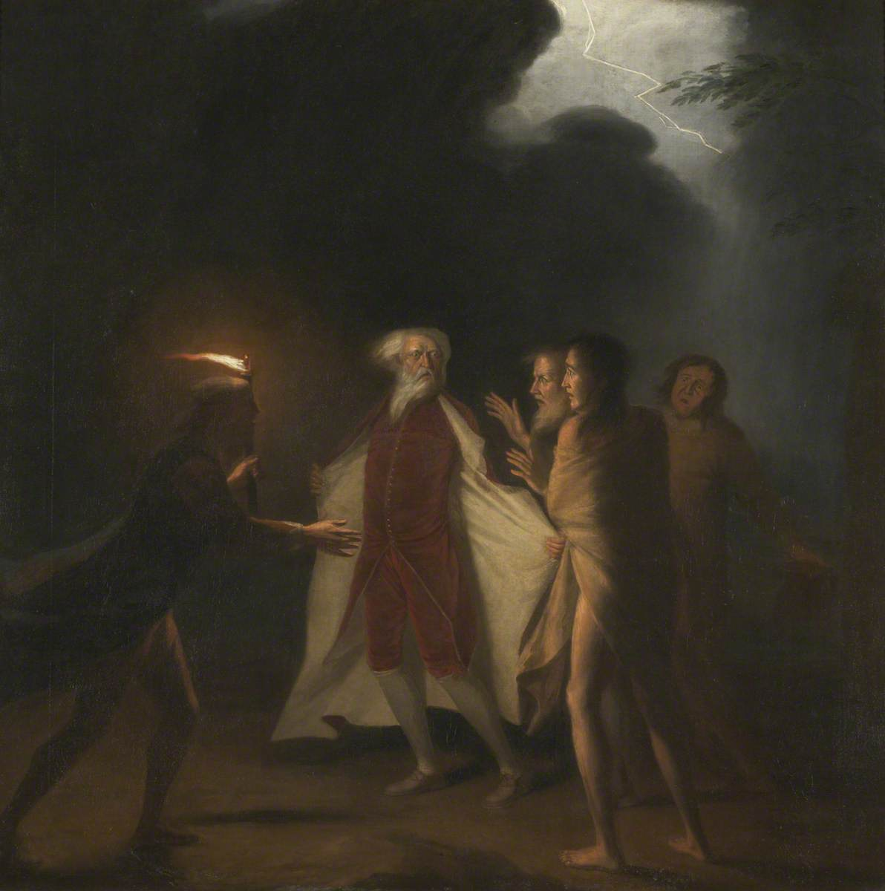
Figure 44: George Romney, King Lear in the Tempest Tearing off His Robes, undated, oil on canvas. This image is held at Kendal Town Hall and can be viewed via this link: https://artuk.org/discover/artworks/king-lear-in-the-tempest-tearing-off-his-robes-143156, and in the non-redacted version of this PhD thesis, held at the University of Sheffield Library.

As with the Romney painting, where the bolt of lightning strikes down from the frame of the image, Ethelinde herself is struck from somewhere beyond the frame of the window she stands beside. It is a trope of the sublime demonstrative that this is a moment of supreme significance within the text, one which cannot be contained by the traditional boundary of a picture frame. Rather, it defies nature and escapes its own confines to demonstrate, in the true manner of the sublime, that it cannot be restrained. It marks the moment of realisation that it will require all of Ethelinde’s cunning, fortitude and feminine sublimity to overcome Lady Arabella’s machinations and retain Harcourt’s inheritance within her own family, and yet achieve this, without admitting her real motivations to Harcourt himself. Ethelinde’s sublime nature must embody the problem of the sublime as Forsey views it. She must simultaneously be something, whilst concurrently not being something.

In order to achieve this, Ethelinde has a cautious part to play here. She cannot sully her own reputation for purity by admitting to the knowledge of Lady Arabella’s true nature and motivations. Similarly, she is unable to even acknowledge the significance of Harcourt’s wealth to her family, because to do so will tarnish her reputation as a virtuous woman to whom money is of no account or interest. However, at the same time, she cannot permit the marriage to go ahead, as it will substantially injure her family’s fortunes. Balancing these dichotomies she must find some way to reveal to Mr. Harcourt Lady Arabella’s genuine motivations. Once again, Ethelinde cannot rely on the patriarchal figures in her life to solve her problems for her. Chesterville merely resorts to futile ‘rage and agitation’ when the plan is revealed to him. It is left to Ethelinde to find a resolution and ‘point out to him to prevent the means to what he feared.’

The text itself fails to make explicit what these ‘means’ actually are. Perhaps, indeed, Smith herself could not defile her own character by admitting knowledge of how such devious manipulation could be achieved. Instead, the reader is left to infer Ethelinde’s methods themselves in conjecture which occurs beyond the text. This expansion beyond the boundaries of the frame of the painting or the language of the text is a trope which is also entirely sublime in nature. Hélène Ibata argues how Burke’s definition of the sublime ‘is often considered to herald the breaking apart of the sister arts, poetry and painting,’ claiming ‘that the literalness of painting prevented it from conveying the sublime.’ As Ibata observes

After having conceded that obscurity in painting could approach a similar form of indistinctness and emotional confusion, he [Burke] then added that painting’s inferiority was mostly due to its inability to convey infinity, because of its perceptible boundaries.

However, a text has a boundary as well. It is necessarily contained within itself, just like the frame of a painting. Yet Smith breaks her own boundaries via clever narrative devices inferring action is taking place elsewhere, which the reader is unaware of. An example of this has already been seen in the episode with Ethelinde’s miniature portrait. Further, the fact that Ethelinde does not reveal her methods – that they are cloaked in obscurity – is an additional technique by which she demonstrates her own sublime nature. By relying on the sublime trope of obscurity to confuse the issue, Ethelinde, with a frightening determination, manipulates the lives and actions of those around her.

The afterlife of the text, as Claire Knowles observes, demonstrates that Ethelinde also had a presence beyond her history as Smith recorded it within the novel. She, in effect, escapes from solely existing within the pages of a mere novel. Knowles imparts to us that about a month after Ethelinde’s publication, an anonymous poem appeared in The Morning Post under the pen name of ‘Ethelinde’:

Pity the plainings of a mournfull Sonnetteer,
Whose mournful muse so woefully can weep;
Her drooping hopes with kind subscriptions cheer,
So shall she remain the friend of SLEEP.
Th’oblivious charm more potently to aid,
His drowsy jingle HAYLEY shall combine;
And pompous periods from the LITCHFIELD Maid,
Complete an off’ring for SOMNUS’ shrine.
The torpid strain benumbing ev’ry sense,
All opiates shall transcend at Warwick-lane,
And our narcotic numbers sleep dispense,
When Poppy and Mandragora are vain:
E’en GOUT itself shall slumber o’er the lay,
And softly sink in leaden ease away.

These ‘Stanzas’ were satirically directed against Smith and it is likely Ethelinde’s name was used by the anonymous author, in order to specifically invoke the figure of Smith as the author in the reader’s mind. The sonnet, Knowles asserts, ‘hints at Smith’s complicity in the construction of her authorial image.’ Indeed, it could almost be read as an exposure of the performativity of the roles both Smith and Ethelinde play. Ethelinde steadfastly playing the role of heroine of sensibility whilst effectively manipulating all those around her in order to ensure she gets her own way and Smith herself unfailingly adopting the same role. She does this in order to assert the authenticity of her sufferings and invoke the public’s compassion so that they will continue to buy her work. Further, the New London Magazine dissected Ethelinde for their own purposes, appropriating ‘The Affecting HISTORY OF CAROLINE MONTGOMERY: [From ETHELINDE; or the Recluse of the Lake, a beautiful Novel, by Mrs. CHARLOTTE SMITH],’ and using Montgomery’s mother’s narrative as a short standalone story, within their January 1790 edition.

This expansion beyond the frame of the text within Ethelinde is just one trope of the sublime which will resurface in her later novel from 1798, The Young Philosopher. Here, Smith uses alternative methodologies of narrative in order to expand her text beyond the conventional frame in her portrayal of this novel’s sublime women: Laura Glenmorris, and her daughter Medora. Like Ethelinde, The Young Philosopher is a text which refuses to be confined by the traditional boundaries of the book. Similarly, Romney also expands his artwork beyond the traditional limits of the rectangular frame in order to refute Burke’s assertion that the painted media is incapable of achieving the truly sublime. Rather, he experiments with the margins of his work to ‘convey infinity,’ evading the portrait’s ‘perceptible boundaries.’ As Ibata argues, ‘[p]icture frames are usually a convenient mechanism to isolate the work of art from its surroundings, to provide closure or protection to it, and to allow the viewer to contemplate a coherent and autonomous representational space.’ However, Romney collapses this argument via his artworks, and the more interesting or ‘sublime’ the subject he is portraying, the more he utilises these artistic techniques. This can be viewed in Figure 44, depicting King Lear’s lightning strike which comes from outside the window. As noted earlier in Smith’s Ethelinde, the heroine herself is struck from somewhere beyond the frame of the window she stands beside at the moment of sublime crisis. Within these artworks the sublime cannot be contained by traditional devices such as a picture frame. The sublime will, by its very nature, always breach boundaries and spill over the edges. Figure 45 shows Mademoiselle Pamela.

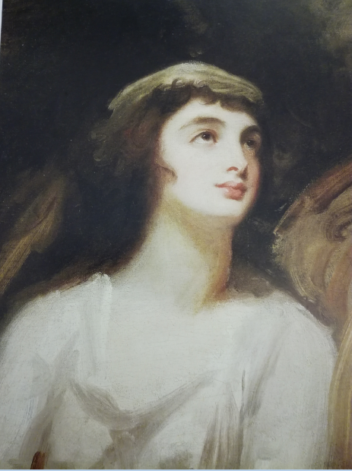
Figure 45: George Romney, Mademoiselle Pamela, undated, oil on canvas. This image can be viewed in the non-redacted version of this PhD thesis, held by the University of Sheffield Library.

Here, at the margins of the canvas, the background dissolves into hastily scrubbed clouds. The woman’s dark hair melts into the obscure background. Her – again white – gown, is of the same hasty execution as the background wash as if she is dissolving into her setting. The woman herself was, as Kidson observes, ‘[a]lmost certainly the illegitimate daughter of Mme de Genlis.’ Romney’s finishing of the painting presents her as a sublime subject is entirely in keeping with her mother’s nature of a woman who has expanded beyond the boundaries that constrained traditional eighteenth-century women and demonstrated her sublime disposition via her renunciation of the conventional. Romney’s most interesting portraits, however, are those of the most sublime subject of all to his own eyes: Emma Hamilton. Acting as Romney’s muse, Hamilton is portrayed in a variety of characterisations and settings by Romney, always sublime in nature. Figures 46, 47, and 48, are demonstrative of this.
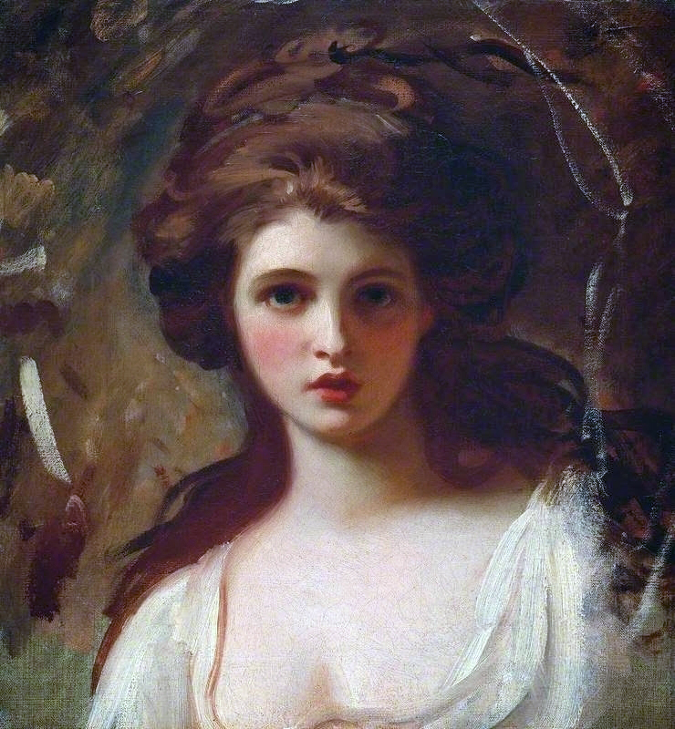
Figure 46: George Romney, Emma as Circe, 1782, oil on canvas. This image is held at The Tate and can be viewed at the following link: https://www.tate.org.uk/art/artworks/romney-emma-hart-as-circe-n05591, or in the non-redacted version of this PhD thesis, held at the University of Sheffield Library.

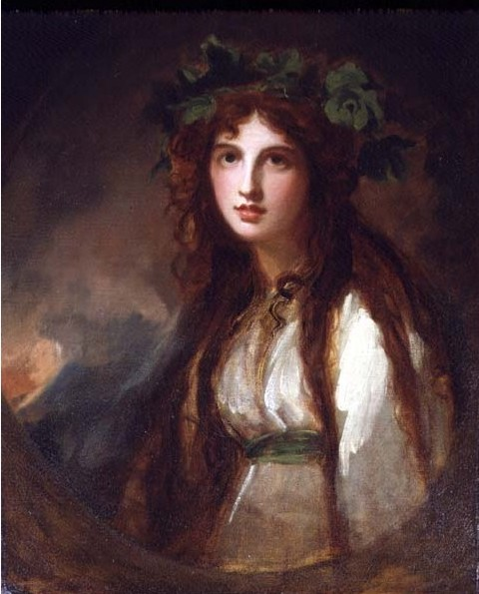
Figure 47: George Romney, Emma as a Bacchante, undated, oil on canvas. This image can be viewed in the non-redacted version of this PhD thesis, held at the University of Sheffield Library.

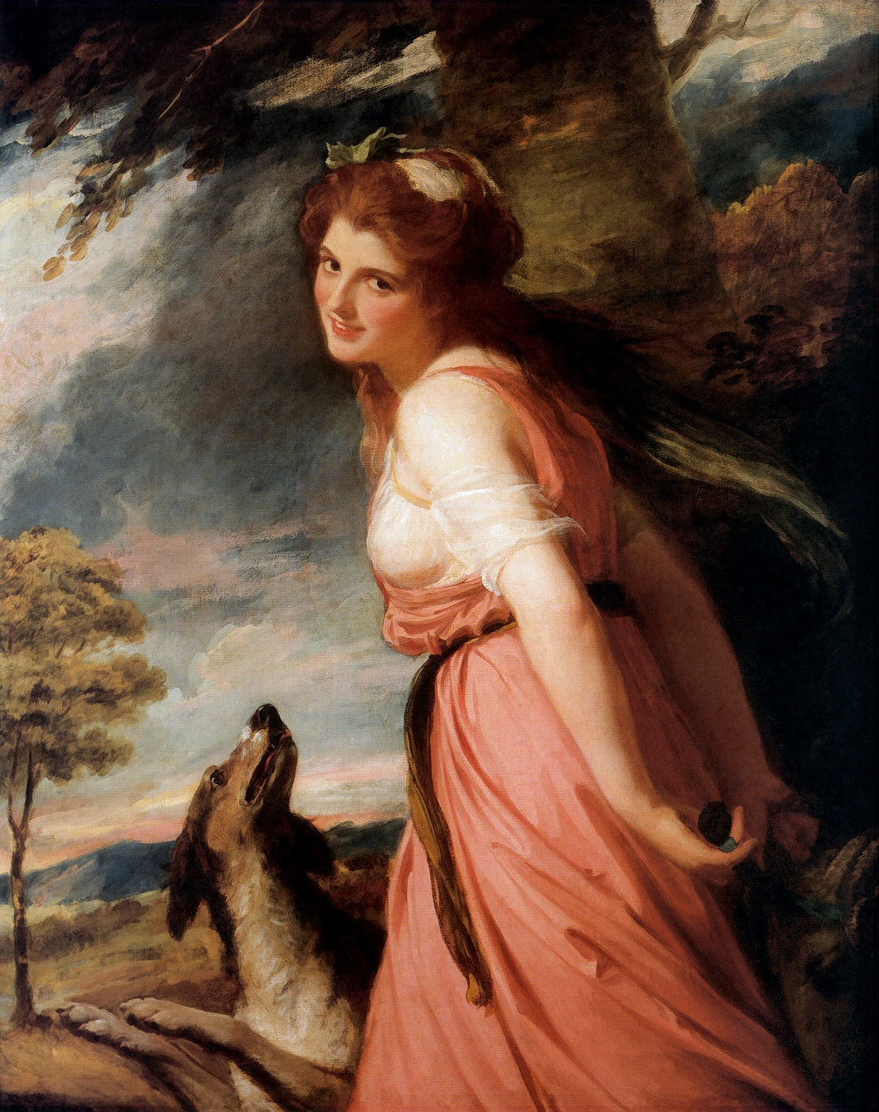
Figure 48: George Romney, Emma as a Bacchante, 1785, oil on canvas.

As with Figure 45, once more the chaotic, obscure washes of the background consciously invoke the Burkean sublime. The boundaries of visual representation are further pushed backwards by the artist in Figure 47, with dark stormy clouds in the background and the muddy brown circular sweep of paint which sits beneath the subject. This is a painting which cannot possibly be contained in the traditional rectangular frame due to the artist’s manipulation of the conventional shape of the portrait. Figure 48 employs the same sublime motifs at the edges of canvas in the dark clouds gathering to the right hand edge. The artistic tropes of sublime artist Salvator Rosa are accessed in the branches of the tree suspended over Emma. Here, the smiling Emma is depicted against a landscape which is almost wilderness in form. From somewhere just beyond the outskirts of the painting, a ferocious wind blows, directing the uppermost branches of the tree off to the left. Conversely, however, and entirely against nature, Emma’s hair is also blown, in the opposite direction. Even more strangely, on the left hand side of the painting is a further tree, entirely still, and eerily not disturbed by any wind at all. This is a nature which, as W. Gaunt argued of Rosa’s sublime works, is ‘corrupt and hostile,’ depicting ‘the suffering and defiance not […] of the body, but the soul.’ It is an anti-nature, an uncanny landscape: the familiar elements of which exist within the painting, and yet is simultaneously impossible in any natural setting. Romney’s darkness doesn’t struggle against the light, it subsumes it, or whirls around it, as in Figures 46 and 47, creating a preternatural sublime which is almost anguished.

This, as Ibata argues of Turner’s work, is an example of a Romantic-era artist who is denying the existence of ‘pictorial limitations’ and ‘consciously explor[ing] the physical edges of visual representation, in order to transform them into places of unlimitedness.’ Romney’s sublime spills over the edges of his paintings. It cannot be contained. Smith’s sublime achieves the same effect in her portrayal of Laura Glenmorris, utilising precisely the same techniques. The settings this character is placed in access all of the tropes of the Burkean sublime. Her surface appearance is sublime. Most significantly of all, she cannot be contained within her own self. Laura consistently transgresses the limits between self and other, reason and madness, even losing her own identity and leaching over the boundaries between existence and incorporeality, being mistaken for spirits or hovering somewhere between the margins of life and death. Yet, like Ethelinde, Laura is simultaneously always in control of the sublime nature which surrounds her. Like Ethelinde, she comes to embody the female sublime. Laura is not just mad – there is reason underlying her madness. She is, in other words, mad for a reason. Laura twists the sublime landscape and arranges herself within it to ensure that she always presents the portrait of herself as she wishes to be perceived. This, again, is similar to Emmeline’s manipulation of the aesthetic of the picturesque, in order to present herself to best possible advantage. Laura, like Ethelinde, uses the sublime setting as the aesthetic of choice against which to best portray herself. As the anonymous sonneteer noted of both Ethelinde and Smith’s projection of a desired image, there is a performativity to Laura’s languishing within the sublime setting. She is stage-managing her own appearance to others.

Laura’s own description of her appearance as a young woman immediately calls to mind Romney’s portrayal of Emma Hamilton in her various guises. Describing her beauty as first attracting the eyes of Glenmorris, at the juncture in the text when she believes her husband dead, Laura elucidates for Delmont the reason she ‘captivates the Laird’:

At this distance of time I may be allowed, with little imputation of egotism or vanity, to speak of myself as I then was – A very fair skin, with dark eyes, and eye brows a shade darker than the profusion of light brown hair, too luxuriant to dress, which flowed round my face, would have rendered very indifferent features shewy and attractive at the age I then was.

Indeed, Laura could be describing Emma as she appears in the Romney portraits, particularly considering her ‘very fair skin’ and ‘profusion of light brown hair, too luxuriant to dress.’

The similarities are further compounded by the sublime scenes in which the narrator asks the reader to look at her heroine’s mother. Removed by her own deviant hard and uncaring mother to a remote location which subsists on the boundary between land and sea, Laura is transplanted into an unnatural, almost impossible, uncanny setting, which seems to sit somewhere between all of the elements. Like Romney’s nature, this is a nature which can never exist. As with the Burkean sublime, this landscape is one which the reader is only ever permitted to view in ‘an uncertain light.’ This is comparable with the ‘latest light’ of the moon which the frantic Glenmorris and Laura view with dismay as it sinks into the sea, further obscuring the deadly shifting sands they must traverse in order to effect their initial escape. From the sands, Laura is transplanted to the semi-ruin of Glenmorris’s castle, again bordered by the endlessly shifting boundary of the sea. From there, she will inhabit a further castle, from which she will make another moonlit escape, this time from the Kilbrodies. There will also be a short sojourn when she subsists in a heathland hovel, a hole in a crag and a cave amongst ‘mountainous cliffs [...] of this wild coast,’ again bordered by the endless expanse of the sublime ocean. As Burke observes, ‘the ocean is an object of no small terror [and] Indeed, terror is in all cases whatsoever, […] the ruling principle of the sublime.’

That Smith purposely asks her reader to view the heroine’s mother against these sublime backgrounds indicates immediately the aesthetic she is reliant on in furthering her tale. Each setting is indicative of Laura’s conjuring of the pathetic fallacy so that the setting she is situated in, always becomes her most. The frames of her portraits, like Romney’s frames, are diffuse and variable in nature. Laura Glenmorris cannot be confined within the traditional rectangular shaped frame of a portrait, surrounded by the fluidity of the sea as she ever is. Further, like Romney, Smith describes an unnatural, uncanny setting for Medora’s mother; one which cannot exist within any known nature. The family seat, Sandthwaite Castle, is ‘the most gloomy and comfortless abode.’ A sublime ‘edifice’ where the ‘walls, which were in no part […] less than seven feet thick’ exists in a space somewhere between all of the elements. On the evening of her escape, Laura, taking a walk on the terrace of the house, elucidates this clearly:

I forebore therefore to lengthen my walk beyond the end of a terras, which was carried on before the house, at the distance of four or five hundred paces, rather as a guard against the sea, which in high tides overflowed the place, that if grass would have grown in it might have been with more justice called a lawn, than as affording any ornament. On reaching its termination towards a sort of salt marsh, I stopped a moment to observe some sea birds, whose white wings catching the moon beams, seemed like transcient meteors floating from the sea, which was now covering the sand, where at low water they sought their food. Every thing was so still that I could hear the whispering of their wings.

This is a meeting of all of the elements. It is an impossible place where land dissolves into the sea, as Laura will learn to her peril as she attempts to cross the shifting sands with Glenmorris. The sea rises up in the form of the white sea birds to mingle in the air. The air itself transcends its own boundaries, rising up too high to meet the blackness of space and the fire of the ‘transcient meteors’ which stem from there.

This is also a landscape in which nothing healthy can survive. Despite Lady Mary’s best attempts to improve it, ‘trees absolutely refuse [...] to grow.’ This unnatural setting can only ever breed aberrant and deviant behaviour. Laura herself, confined in this location, transcends the boundaries of the ‘normal’ human being, beginning to exist as outside of nature. ‘I had,’ Laura tells Delmont, ‘never had a mother, for she who bore me seemed to have thrown me off in my infancy as an impediment to her ambition.’ This woman, borne of no woman, spills over the edges, losing shape and form, like Romney’s Mademoiselle Pamela (Figure 45), dissolving into her setting, almost losing herself in the sands, before being mistaken for a spirit herself by the Scottish fishermen, whose ‘gestures and countenance[s]’ express ‘wonder and doubt’ as they learn that Laura, ‘was a living being, and not a kelpie’ as they had initially supposed.

At one of the points of her greatest despair, Laura makes the decision to dissolve the boundary between life and death once and for all, in a passive suicide attempt, as she waits for the sublimity of the ocean to subsume her. She describes her situation thus:

There was at this period what are called neap tides, the sea had receded much farther than in its accustomed reflux, and, I knew, would be still lower in the evening – to that time I determined to wait; for had I now traversed the sands towards the rocks, I might have been seen from the cliffs – retiring therefore into the deepest of the caverns, I awaited there the return of night, and took my last leave of the sun. I found such a place of temporary rest as had served me the preceding night, and sat down, faint and sick, for I had now fasted above twenty four hours, and I doubted whether, when the present day was passed, I should have strength to execute my purpose. The wind, which was low during the night, and had blown from the west, had now changed to the east, and while by driving the sea towards this coast it was likely to accelerate the fate I sought, it rendered my present shelter more cold and dreary. I wrapped myself up in my cloak, and bound my handkerchief over my hat, then reclining on a fragment of the rock, a sort of stupor, the effect of inanition, crept upon me – I ceased to feel so acutely the terrors of my condition – I almost ceased to be conscious of my own miserable being; and I hoped that my life was ebbing slowly away without any act of my own to hasten its close.

Elizabeth Kraft’s explanation of ‘neap tides’ reads as follows:

Tides that attain a minimal rise and fall, observable at or near the first and last quarters of the moon. Smith seems to mistake the term somewhat, because she emphasizes the unusual ‘reflux’ of the ocean rather than the minimal difference between high and low tides, which the term denotes.

However, there remains a question as to whether Smith has actually made a mistake or not in this instance. She is, after all, like Romney, recording settings which are weirdly uncanny and do not exist within the natural world. With these sublime settings which expand beyond the boundary of the traditional frame of the painting, Smith calls everything the reader thinks they know and understand about nature and society into question. The natural relationship that should exist between mothers is instead over-written by eighteenth-century societal ambition. Women instead of nurturers, become meddling gossips, and actively work to harm each other. This, to the reader, begins to manifest itself as unnatural and deviant as a wind that blows in two directions at once, whilst simultaneously not blowing at all, and a neap tide that doesn’t behave as it ought to. Smith uses the Burkean definition of the sublime to render an acute critique on the unnatural nature of her society.

Further, by pushing the boundaries of her own text, and openly weaving an intertextuality within her novel with the novels of other artists, Smith exceeds the boundaries or framing of her novel and collapses them. Smith’s opening preface to
the novel refers to Mary Wollstonecraft’s Maria, or The Wrongs of Woman (1798):

the incident of the confinement in a mad house of one of my characters was designed before I saw the fragment […] by a Writer whose talents I greatly honoured, and whose untimely death I deeply regret; from her I should not blush to borrow, and if I had done so I would have acknowledged it.

At this point, the reader now has Wollstonecraft’s Maria, and the incidents within this novel, which detail those ‘Wrongs of Woman’ firmly in their mind. Doubt is cast on the ingenuity of the statement, via the fact that Smith includes characters and incidents within her own novel which are distinctly redolent of Wollstonecraft’s oeuvre and that of her husband, William Godwin. In addition to the episode of Laura’s captivity in the mad house, Medora’s kidnapper and persecutor is named ‘Darnell’; Maria features ‘Darnford.’ Further, the episode where Delmont resides temporarily with one of Sir Harry Richmond’s servants, and her account of her fate at his hands, is distinctly evocative of the tyranny exercised over Emily Melville by Mr. Tyrell in Godwin’s Things as They Are; or, The Adventures of Caleb Williams (1794). Delmont is acquainted with the fact

that she was a servant in Sir Harry Richmond’s house, to whom unhappily he took a fancy. A conquest over a poor country girl of seventeen was not difficult; […] Sir Harry then insisted on the poor girl’s marrying one of his huntsmen, who being a man of a fierce and brutal disposition, continually reproached, and not unfrequently beat her during the five miserable years she lived with him. He then luckily broke his neck.

The situation is distinctly comparable to Mr. Tyrell’s attempts at forcing the uncouth and violent Grimes upon Emily, as retribution for her idolization of Falkland. Smith’s intertextuality is completed via Delmont’s thoughts ‘as he walked towards the great house – “these are indeed among the wrongs of woman.”’ This is a thought which is deliberately highlighted via Smith’s enclosure of it in double quotation marks and appears as a calculated reference on Smith’s part to the title of Wollstonecraft’s text.

By intentionally making this reference, and invoking the concepts surrounding the works of Wollstonecraft and Godwin and expanding beyond the frame of her own literary text, Smith places the sufferings of her own heroines (both Medora and her mother) distinctly within the same arena of social critique as the worlds of Caleb and Maria. Indeed, their torments, especially in the case of Laura Glenmorris, are precisely the same and have exactly the same origin: an unjust society. It is a society, as both Maria and Laura discover, where a woman can be confined without reasonable cause and without any prospect of release, on the whim of a tyrannical relative. Laura’s fate also corresponds with Caleb’s afflictions, in a subtler manner. As with Godwin’s Caleb Williams, where, as Michael Verderame argues, ‘the chief villain […] manages to make Caleb police and torment himself,’ in Smith’s text, it is the chief villains of Mrs Crewkherne et al who manage to make Laura Glenmorris ‘police and torment’ herself. It is the vile gossip of these women which leaves her too afraid to seek the help of Armitage in her time of need. As a direct consequence of this, she is rendered sufficiently defenceless and alone that Lady Mary can abuse her maternal power and have her confined in the mad house.

Through these intertextualities, Smith’s Young Philosopher expands through its own textual frame into the arena of alternative literary texts. By uniting herself and her artistry with the works of Wollstonecraft and Godwin, Smith participates in a similar economy of gift exchange as the type elucidated earlier in respect of Hayley and Romney. She demonstrates her alliance with these important literary figures and her belonging within this literary circle. This is an artistic community to which she does belong. Further, these deliberate references to these famous texts create a literary echo within her own novel, giving it a resonance beyond its own pages and providing access to alternative interpretations for her readers. It is, as Kraft observes in her introduction to The Young Philosopher, ‘a significant claim to kinship with Wollstonecraft and the position she had staked out philosophically in her Vindication of the Rights of Woman and demonstrated in The Wrongs of Woman.’

This, as Wollstonecraft and Godwin demonstrate within their texts, is a society in which women must be sublime in order to survive. As Caleb Williams is advised:
Make the best story you can for yourself; true, if truth as I hope, will serve your purpose; but, if not, the most plausible and ingenious you can invent. That is what self-defence requires from every man where, as it always happens to a man upon his trial, he has the whole world against him, and has his own battle to fight against the world.

Laura, like Caleb, has the whole world against her, and has to construct the best story she can for herself, in order to gain the empathy of Delmont. Laura’s story in itself becomes emblematic of her use of the sublime in presenting herself and is a further trope of the sublime inherent within the novel. The narrative is confused and twisting, told in fragments, breaking through the framing of traditional novelistic narration. These fragments, again, are reminiscent of the fragments Smith uses in her picturesque construction of Emmeline. Again, the form of the aesthetic itself is being used as a narrative device within the novel. The fragmentary nature of Laura’s story and how it is related to the audience mimics the Burkean sublime’s tendency to digress traditional boundaries, as in the Romney paintings referenced earlier, that cannot be contained by the conventional rectangle of the picture frame.

This effect can be perceived in the following example: the entirety of Volume II consists of the heroine’s (Medora’s) mother’s adventures which have been ‘told to Delmont in fragments at various times.’ The reader, however, will learn of them as if they were ‘related […] in a single narrative.’ Yet this promise to the reader breaks down as Laura gets further into her own story. Imparting the episode where Glenmorris returns after his kidnap by the pirates, Laura is forced to relate a story within a story, as she tells Delmont the story of how she (Laura) told Glenmorris the story of what has happened to her in his absence. This is a story the reader is already familiar with, because Delmont has already relayed it as if it was ‘comprised in a single narrative.’ In return for this, the reader is also advised of Glenmorris’s story. This is conveyed via Laura to Delmont, who conveys it to the reader.

These stories within stories within stories expose the frailty of the ‘story’ that forms the structure of the novel. It becomes clear that it is something which has been consciously shaped by the different narrators in order to ‘[m]ake the best story [they] can’ for themselves in a difficult world. Smith exposes this by also making available to her reader alternative points of view. When explaining his love affair with Medora to his man-of-the-world brother, Major Adolphus Delmont,

[t]he Major listened with a sort of half sneer on his countenance; and when Delmont concluded what he had to say, observed that there were two ways of representing every thing; ‘and it must be owned,’ said he, ‘that our delectable aunt has made a most terrible and terrific history of this, while your’s is just fitted for the amiable young heroine of a romance.’

A similar exposure of the workings of the story occurs, again in a further episode featuring Adolphus, when he explains his chance encounter with Medora in her flight from Darnell. When Medora mistakes Adolphus for Delmont, Adolphus makes ‘violent love to her’ answering Medora ‘like a preux chevalier,’ and outlines his licentious conduct in the language of high romance. Delmont responds in kind, as this is the language he habitually uses: ‘You did not dare to insult her? […] Medora! my Medora!’ However, Adolphus immediately destabilizes the romance with his flippant response: ‘How should I know she was your Medora? She seemed to me to be everybody’s Medora.’ This unnatural style of narration in the text which is seemingly purposefully highlighted by Smith is a further example of the text expanding beyond its own boundaries and its refusal to be contained within any kind of textual frame. The stories become diffuse and overlap. They become almost unknowable as the frank admission that stories rely on the point of view of the storyteller is elucidated clearly within the text, as is demonstrated by the exchanges between hero Delmont and anti-hero Adolphus.

Just as the stories elude the boundary of the textual frame, the roles the heroines of the text adopt similarly surpass any kind of restriction. Laura is the heroine’s mother and not the heroine of the novel. Yet, her role within the text is conversely also the role of the heroine. She is central to the entirety of Volume II of the novel. Further, the actual heroine, Medora, is missing for a large space of the novel, her story also emerging within fragments later and mediated by Delmont himself. When her story does emerge, it immediately strikes the reader as a doubling of Laura’s story. The castles she has been held in and the manner in which she makes her escape bears too many similarities to Laura’s exploits, to be coincidental on the part of Smith. Here, rather than the sins of the father being inherited by the son, it is the sufferings of the mother at the hands of an unjust society which are revisited upon the daughter, Medora. Medora does not feature in Volume II whatsoever, as she is not part of Laura’s story at that point in time. Similarly, Medora is absent from Volume III, her presence being replaced by the dead silence of her omission in the volume, being taken up instead with the anguish of her mother as Laura futilely searches for Medora, losing her own self in the process. This is a novel which features too many abysses for the heroines to express horror of: sublime voids in which a heroine can all too easily disappear into for the space of a volume or two.

In addition to Medora’s absence from a large part of the novel, Delmont, despite being Medora’s acknowledged lover, does not address his love letters to Medora herself. Rather, he sends them to her mother, with Laura becoming the stand in for Medora. Thus, for an extensive portion of the novel, Laura acts as both heroine’s mother and adopts the role of heroine herself. Loraine Fletcher argues that Laura is unique ‘among other distressed mothers in the 1790s novel [in] that she does not fit the contemporary medical establishment’s framework for female hysteria; rather, Fletcher concludes, Laura’s distress ‘can only be explained by [the] societal abuse of women’ by men. This most certainly seems to be the case, but Laura is also unique in the multiplicity of roles she adopts. She is not just a heroine, she is a mother as well, and because of this, Smith implies, a heroine in her own right. With these clever narrative devices and portraits of these women within this text, Smith demonstrates to her readers the complexity of women. Even those just dismissed as mothers, or aging supporting characters, are sublime in nature, expanding beyond the traditional confines of the roles they have been assigned within Smith’s romance and demonstrating that at any age, a woman can be a sublime heroine.

Laura, by choosing to sojourn into unreason and use the sublime to represent herself, caused by the unnatural characters’ in the text refusal to aid her in her search for her daughter, addresses the ‘problem’ of the sublime as Forsey elucidates it. Forsey, as observed earlier, highlights the ‘problem’ of the sublime as follows: ‘theorizing about the sublime rests on a mistake,’ the mistake being that if ‘the generally accepted notion [of] the sublime experience ‘professes to “see” beyond human powers of knowledge and description,’ then how is the sublime even possible? How can it surpass the boundaries of human comprehension itself? The language of madness, however, doesn’t adhere to any rules or regulations. It can literally say anything and still make sense; the sense being that the speaker is mad, and the reader does not expect coherence. Laura, by choosing to immerse herself in her madness, embraces the sublime. Within Derrida’s theory of the sublime, it is observed that the ‘main difference between the sublime and the beautiful is that “the presence of a limit is what gives form to the beautiful” while “[t]he sublime is to be found in an “object without form.”’ In losing her reason, and her very sense of self, Laura becomes that ‘object without form,’ with no sense of boundedness within herself. She comes to represent the unrepresentable, which, as Vijay Mishra argues is the essence of ‘that which is sublime.’

The dissolution of her own boundaries and the expansion of these female characters to embody the essence of the sublime and become something more than themselves, is, in itself, Smith’s response to the patriarchal landscapes of power which surround these women and seemingly relentlessly persecute them. Romney too was fully aware of the nature of patriarchal society and the place women occupied within this. With his double portraits of men and their wives, Romney seems to intentionally site these figures within a landscape of patriarchal power, where men are perfectly comfortable within their own estate settings, but their wives feature merely as an extension of them and become almost like another possession, part of the estate’s fixtures and fittings. Figures 49 and 50 show Romney’s matching portraits of Owen Putland Meyrick and his wife, Mrs. Clara Meyrick.
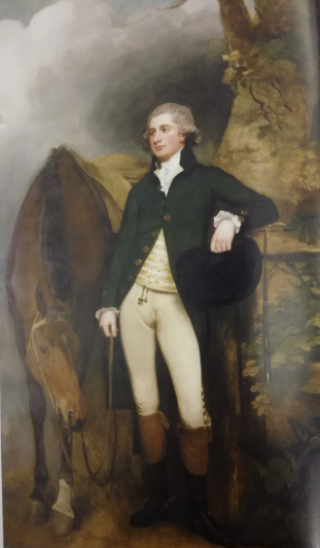
Figure 49: George Romney, Owen Putland Meyrick (1752-1825), c. 1789-92, oil on canvas. This image can be viewed in the non-redacted version of this PhD thesis, held at the University of Sheffield Library.
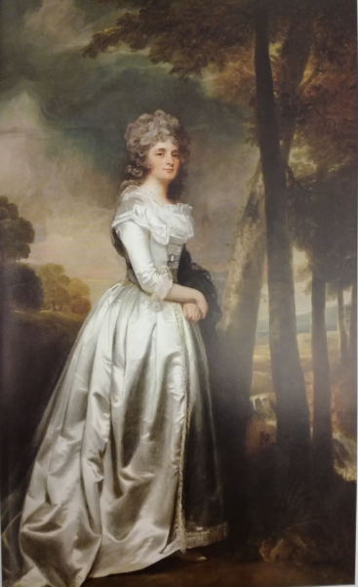
Figure 50: George Romney, Mrs. Clara Meyrick (1754-5-1826), c. 1789-92, oil on canvas. This image can be viewed in the non-redacted version of this PhD thesis, held at the University of Sheffield Library.

Once again. the sublime aesthetic is being accessed by Romney in the darkly swirling clouds which form the background setting to this pair of portraits of man and wife. The portraits are intended to sit side by side and show the continuation of the same background setting, presumably part of Meyrick’s estate, as a deliberate ploy on Romney’s behalf. Note, however, how the horse stands beside the man, whereas the wife stands alone, and seems in some way to merely constitute an extension of the man himself, or one of his further possessions. The woman holds a black piece of material over her arm, which is perhaps indicative of the early decease of two of their children within the marriage. Their daughter Lucy Meyrick (born 1801) did not survive infancy and their son Owen Garth Meyrick died at six years’ old. The man gets to hold his horse; the woman gets to hold the dead children. Like Laura and Medora, the sublime techniques of Romney’s portraiture demonstrate how Mrs. Meyrick articulates an absence: the sublime void of death.

Smith also uses the tropes of the sublime in her portraits, but this time manages to have her heroines, Laura and Medora, embody the landscapes of traditional patriarchal power. Laura, with her formlessness in taking refuge in her madness, as argued earlier, means, that in a truly sublime way, she has no boundaries to be confined within. Her unreason allows her to flow freely. Indeed, wherever Laura is imprisoned, she escapes, including the strict confinement of the mad house. Laura, with her sublime boundlessness, cannot be contained by any patriarchal structure. She literally leaks out at the edges, it is impossible to hold on to her. The same applies to Medora. Despite being confined in numerous castles, country house estates and inns, Medora manages to evade her captors in the end. The escape of these heroines is a reinterpretation of these eighteenth-century landscapes of power. Perhaps most interesting is Medora’s escape from Sir Harry Richmond’s ‘pleasure gardens’ – the grounds of his licentiousness which are entirely dedicated to his own sexual pleasure. The garden, as Stephen Bending observes, can be read allegorically. This becomes clear from the plans of such eighteenth-century gardens as Aaron Hill’s ‘Moral Rock Garden’ (Figure 51).

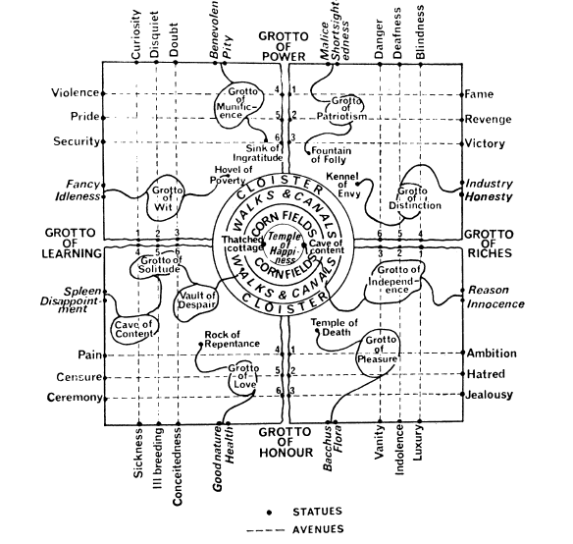
Figure 51: Aaron Hill, Moral Rock Garden, plan reproduced by Stephen Bending, Green Retreats: Women, Gardens and Eighteenth-Century Culture (Cambridge: Cambridge University Press, 2013). This image can be viewed in this book or in the non-redacted version of this PhD thesis, held at the University of Sheffield Library.

As can be seen from Hill’s plan for his garden, he had a clear agenda, as to how it should be read and interpreted. However, like many landscapes of the sublime, artificial gardens like this one and Sir Harry’s, are not natural environments. The sublime tropes are present in the bowers carved from natural rock, the recreations of Roman temples and rushing streams and waterfalls, but these are all man-made and thus not of nature. As Joshua Reynolds observes in his Discourses on this point:

Gardening, as far as Gardening is an Art, or entitled to that appellation, is a deviation from nature; for if the true taste consists, as many hold, in banishing every appearance of Art, or any traces of the footsteps of man, it would then no longer be a Garden.

As Bending notes, ‘[g]ardens are necessarily man-made and impose a set of constraints and conventions [...] they are to be recognized not as nature but as being about nature.’ Sir Harry Richmond’s ‘nature’ is licentious, and an abuse of patriarchal power over the young women who have the misfortune to fall into his hands and the artificial landscape he has created reflects this. That this is a site of unnatural abuse of power becomes clear from the iconography Sir Harry’s garden employs:

There is places all lined with marble and china, that his honour calls chalets, or challots, or some such name, and he’ve carried a stream of water through them from the lower cascade; and there’s rooms fitted up very grand indeed, with satin and silk and chinchi’s for curtins and settees, and such like, and sweet smelling flowers in pots, and oranges and gereenums – fine large looking-glasses, shells, china, and a heap of beautiful things that there’s no telling; and there is besides an ice-house to make vittels into ice, and a cold bath, and an hot bath, with water that is let into a place with a copper to heat it. The cold bath is the most beautifullest thing; all lined with moss and shells, and clear streams of water, that comes as ‘twere out of a rock where there’s a white image of a lady, that they say is a roman catholic goddess, brought from the pope of Rome.

Like Laura’s Sandthwaite Castle, Medora must here negotiate a landscape where the nature is completely unnatural. Streams run where they shouldn’t. Exotic fruits and flowers bloom in a place where they do not naturally belong. Hot water runs with cold. Plants from the land mingle with animals from the sea. Water comes out of a rock. Mythological imagery is mixed up with religious iconography. The true meaning of the allegory is immediately recognised by Delmont who ‘[a]t any other time [...] would hardly have forborne a smile at this description of luxuries collected by a determined voluptuary.’ The landscape, as Delmont’s reaction towards it reveals, is not demonstrative of a true sublime. It becomes instead simply ridiculous and laughable. Hence it can patently never be sublime. This masculine created domain lacks the true sublime power of the female sublime settings against which Laura Glenmorris has positioned herself to her best advantage: those of the ocean, the dark obscurity created by the shadows in gothically ruinous castles, the landscapes that refuse to behave in a natural manner and sites of genuine horror and death, such as the graveyard in which Laura is forced to inter the remains of her first infant son. This, perhaps, is the reason that Medora is able to escape it so easily – it is simply a false sublime landscape.

However, whilst Delmont from his masculine point of view can confidently smile at Sir Harry’s wickedness, the true tragedy these excesses represent in the form of his abuses are highlighted in a slightly different manner by Miss Cardonnel, his daughter, ‘“you cannot refuse to walk with us round the home grounds, which are,” added she, sighing, “what are called worth seeing.”’ Miss Cardonnel seems to appreciate that this unnatural nature her father has created is both laughable and simultaneously indicative of a terrible truth. It is something unnatural – an abomination within nature – which marks the illegitimacy of patriarchy itself. Medora only manages to elude Sir Harry’s ‘pleasure gardens’ with Miss Cardonnel’s help. Medora, a heroine with as much masculine firmness and agency about her as Ethelinde, relies on a sisterhood of other women to effect her escape. She does not require her hero to save her. It is worth remembering that at this juncture in the text, Medora has vanished into one of those sublime voids from the point of view of the other characters and is missing. This particular fragment of the story is only revealed later when Medora has achieved her own escape. However, as a sublime heroine herself, and with the help of other sublime females, she is able to negotiate her own way out of Sir Harry’s clutches and effectively rescue herself.

This is perhaps fortunate as the hero in this case, Delmont, is not available to effect any kind of rescue for Medora. Indeed, he is somewhat useless as a ‘hero.’ Worse, as Kraft observes:

[b]oth Laura and Medora exhibit extraordinary strength and courage during their trials, yet each is confronted at the moment of rescue not by praise for her strength but by unfounded suspicions born of sexual jealousy.
Delmont not only fails to rescue Medora, but then goes on to accuse her of unfaithfulness, after she has rescued herself. When Delmont finds her in the arms of her father, he levels similar accusations of infidelity at her, just as Glenmorris rewards Laura’s courage with accusations of adultery. Patriarchal landscapes of power put all women at risk, Smith seems to be saying, depriving them of autonomy and freedom. Indeed, these scenes in themselves directly confront and dispute Burke’s interpretations surrounding the aesthetic of the sublime. Burke, as Neale Wood notes, determines that it is the father figure within a family who is sublime: ‘[i]n the family the father is the figure of authority who commands the respect and admiration of his children.’ However, the father/protector figures in Smith’s text are all either dissolute and untrustworthy (Sir Harry) or absent when their assistance and protection is most required (Glenmorris/Armitage/Delmont). In short, patriarchal authority cannot be relied on. It is, in itself, like Sir Harry’s ‘pleasure grounds,’ unnatural and corrupt.

Whilst Medora can easily evade Sir Harry’s mock sublime of his corrupt pleasure gardens, her mother Laura spends her time subsisting in that most sublime place of all, at the ‘margin of the sea,’ seemingly strategically placing herself here so that all her sublime nature can be viewed to best effect. It is here, at the close of the novel, that she will be recovered from the abyss of the void by Armitage, although he determines that her mind has been too much shaken and finds her ‘wandering about an absolute maniac.’ Dispossessed and suffering too much from parental abuses and societal tyranny, the only language left that Laura chooses to access is that of insanity.

Laura’s portrayal of madness points to a further consideration of the sublime in this text. The dissolution of Laura beyond the boundaries of her own body, and when she is at her most sublime, is when she is at her most womanly. This is at the point in the novel when she is pregnant with her first child. Whereas the pregnancy with Medora takes place off-stage, and so this does not have to be confronted or considered by the reader, the reader lives through the anguished months of Laura’s first pregnancy, held captive in the castle of Kilbrodie. Lochhead observes, ‘Julia Kristeva links the sublime to abjection. [...] Like Derrida, Kristeva claims a paradoxical status for the sublime as an “impossible bounding.”’ For Laura, this ‘impossible bounding’ takes place as the borders between her body and the foetal body, her life and the life of her unborn child, dissolves into one. ‘The abject,’ Kristeva argues, ‘is a breaking down of a world that has erased its own boundaries.’ With the shared body, and the shared consumption of nutrients through it, Laura’s pregnancy is the epitome of Kristeva’s abjection.

Held captive in the Kilbrodie castle, and powerless in her condition to escape, Laura’s pregnancy and the potential future life with her child, comes to represent the maternal condition for many women, from the eighteenth century, right up to the present time. It is representative of a loss of agency and autonomy. A woman cannot just consider herself any more. Suddenly there are two beings to think about, one entirely reliant upon the other for protection and support. For Laura, stranded alone without her husband, it becomes a struggle between life and death, and a space where she must confront both. ‘Death,’ as Mishra argues, is the ultimate ‘abyss of the sublime.’

The narrowness of the divide between life and death is emphasised in the gothic ambience of the text at this point. Although Laura acquaints the reader with the fact that she is not prone to superstition, she is surrounded by those who do give credence to ‘[t]he shrieks of spirits, portending future evil, [which] were nightly heard, either from the sea or among the rocks.’ Once more the sublime landscape twists to become a reflection of Laura’s inner sublime. She feels the ‘horrible kind of pleasure’ which Burke associates with the delightful horror that the sublime can cause. The unnatural external country of ‘chaotic and misshapen masses of rock,’ ‘mountainous and barren’ where only ‘reluctant vegetation’ grows, becomes indicative of the fruit Laura is destined to bring forth from her womb. This fruit is monstrous in the most sublime manner: a new life destined to embody death.

Caught between a heaven and hell, reality and nightmarish unreality, between the accusations of her own undutifulness and the promise of spiritual punishment, where ‘portentous sounds were heard in the air; and at other [times] the corpse candle was seen to go from my chamber to the burial ground of the abbey,’ boundaries between worlds and representations of reality dissolve. These dreadful premonitions prove veracious as her baby does indeed die, and she will carry his lifeless form from her chamber to ‘the most obscure part of the ruined abbey,’ just as the corpse candle predicted she would. The dissolution of her pregnancy and the body of her prematurely born baby, ‘the little lifeless object of so many months fond solicitude’ is, again, nothing less than a violation of Laura’s human rights, as Smith makes clear.

This landscape of sublime terror and unnatural forms comes to be representative of the lived reality of society for unprotected mothers. Terrified into a premature labour because the laird will not inherit Glenmorris’s property if she bears a healthy heir, the ‘fragments of the ruins’ which Laura uses to cover the body of her dead baby, are also emblematic of the ruins of human decency. Within these, the fragments which have originated from Laura’s body are slotted into the sublime puzzle. Women, Smith seems to be asserting, may have no rights in her contemporaneous society, but seeking to harm the female body for reasons of pecuniary gain and profit strikes an ideological blow against society itself. By confronting the most abject horror of all in the form of the corpse of her baby, the breakdown of the world ‘eras[ing] its own boundaries’ is complete. Here the female body comes to represent women in society as a whole. Laura is not just one woman, but all women whose fragments are scattered over society as testimonials to the sacrifice they have made at the grave of human decency. The violence inflicted against her body comes to represent the injustice all these women must face.

Smith’s Laura, with her staged retreat into an apparent incoherence of insanity, as a result of her sufferings through all of these horrors, becomes a visual representation of the crisis of identity for women during the eighteenth century. Wollstonecraft in her novels and factual works of protest railed against her society as being unfair for women. Smith, however, refuses to do this. With her heroines, she rather holds up a model of female impossibility and dramatises how unfeasible it is for women to live in her contemporaneous patriarchal society. This is a world that doesn’t allow women to survive. They must act a part – as Ethelinde and Laura both do, as well as Emmeline – in order to successfully negotiate it. The manner in which Smith portrays her sublime women becomes peculiarly modern, or even post-modern in nature, refusing to accept traditional boundaries and spreading beyond their own margins. Romney also demonstrates this with his works, which are described by art critics as ‘quintessentially modern.’

This portrayal of these sublime women and who dominates the image of the self becomes a key question in texts like Ethelinde. Ethelinde herself manages to control her own image, thus adding value to it by ensuring copies can be made, and, by default, adding value to herself because of this. Ethelinde’s firmness in manipulating her own image demonstrates her masculine sublimity and the sublime control she exerts over every area of her own life. Ethelinde controls the stage-effects of the construct of the sublime in order to assert her dominance and fight her way in this masculine world. By accessing the tropes of the sublime, such as obscurity, she confuses the men around her into submitting to her will, ensuring she gains the best possible outcome for herself. The artistic tropes which record Ethelinde’s female sublime – tropes which appear in Romney’s artworks - such as the blush record the rich inner life of these complex portraits of women. They are also revelatory of the depths beneath the surface, such as the sexual desire which Ethelinde exhibits, even whilst the disingenuous narratorial voice denies even the possibility of the existence of this within the heroine. Further, the sublime tropes of the landscape the heroines place themselves within demonstrate the sublime workings of their mental topographies, creating sublime settings to surround them. This can be exemplified by Ethelinde in her moment of crisis when the lightning strikes her from beyond the window frame, and Laura who strategically places herself within scenery which most becomes her. In this manner, she can exhibit her reasonable unreason to all who regard her.

The sublime nature of both Smith’s and Romney’s women, as has been argued, is elucidated by their refusal to be contained within the traditional boundaries of either picture frame or text. Smith and Romney adapt the Burkean definition of the sublime to render a vision of unnatural nature which in itself acts as an acute critique on the unnatural nature of contemporaneous society. This is a society in which women must act out the sublime in order to survive. Their sublime natures – either demonstrated through masculine firmness, or by refusal to be contained by traditional boundaries and siting themselves in unreason – enable women to negotiate these unjust landscapes of patriarchal power. Smith herself would appreciate this. A single mother with daughters to protect would have a particular comprehension of ‘the horror of the abyss into which [they could] unconsciously plunge.’ In Smith’s – and Romney’s – interpretations, the sublime is not a male-gendered construct. It is one which is available for all and rewards the woman who makes best use of it. In chapter three, consideration will be given to what Burke argues is the opposite of the sublime: the beautiful.

Chapter Three
The Darker Side of Desire: The Beautiful Heroes of James Northcote and Charlotte Smith

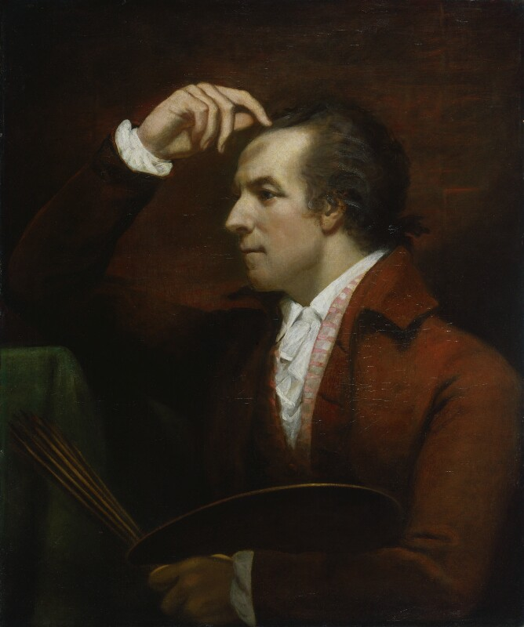
Figure 52: James Northcote (1746-1831), Self-portrait, c.1784, oil on canvas. This image can be viewed at the following link: https://commons.wikimedia.org/wiki/File:James_Northcote_by_James_Northcote.jpg, and in the non-redacted version of this PhD thesis, held at the University of Sheffield Library.

His face was indeed so uncommonly handsome, that had not his complexion been heightened by his manner of life, and by being exposed continually to the air, it would have had the blooming lustre of feminine beauty.

Mr. S. could only just endure Lord Byron’s company. This seemed to me odd; for though he might be neither orator nor philosopher, yet any thing he might say or only stammer out in broken sentences, must be interesting: a glance, a gesture would be full of meaning; […] Besides, he was very handsome, and it was some satisfaction to look at a head at once so beautiful and expressive!

Speaking of George Gordon Lord Byron in conversation with William Hazlitt, portrait painter James Northcote expresses open admiration for the beauty of his subject. Indeed, Northcote, as an artist, had the same appreciation for the beauty of the male form as Charlotte Smith’s narrator in the description of the hero of her second novel, Ethelinde (1789) in the first quotation above. Northcote portrayed far more men than women, habitually endowing his subjects with a physical beauty which arguably not all of them could possibly possess (Figures 53 and 54 show examples from Northcote’s corpus). Smith, as Stuart Curran observes, was ‘[u]nique among novelists of her age [in describing] her male protagonists with an eye to their physical attractions.’ Curran draws attention to the fact that Smith was ‘[w]ell aware that continental and American morality is more relaxed than that of Great Britain’ and thus ‘moves every one of her novels except the dark, claustrophobic Marchmont to one or the other of those alternate cultural dispensations.’ This looser morality in the sexual mores of these international locations permits Smith to make the potentially subversive acknowledgement of the existence of sexual desire in women. Smith’s women, as has been seen in the earlier discussion of Ethelinde’s sexual awakening in the face of Sir Edward’s admiration of her, as indicated by her complexion being ‘raised to a deep blush’ are, it is clear, passionately sexual beings. This argument will be developed further as the nature of female sexual desire for male physical beauty in Smith’s Montalbert (1795) will be discussed later in this chapter, in an analysis of the transformative nature of strong emotion whilst dealing with the beautiful. This argument will engage with Edmund Burke’s A Philosophical Inquiry into the Origin of Our Ideas of the Sublime and Beautiful with an Introductory Discourse Concerning Taste, and demonstrate how Smith’s heroines refute Burke’s assertion that, as Ethelinde has already shown, sexual desire can only be experienced by men.

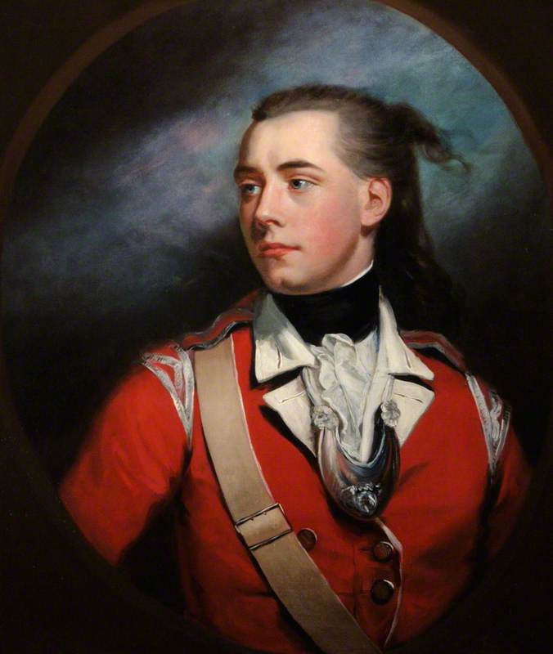
Figure 53: James Northcote, Lieutenant George Dyer, 1780, oil on canvas. This image can be viewed at the National Museum of the Royal Navy, or in the non-redacted version of this PhD thesis, held at the University of Sheffield Library.

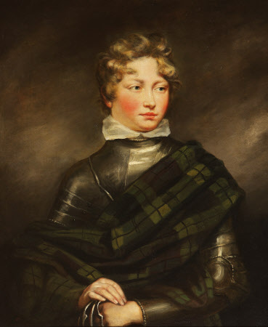
Figure 54: James Northcote, William Henry West Betty, the ‘Young Roscius’, as Norval in John Home’s Douglas, 1804, oil on canvas. This image can be viewed at National Trust property Attingham Park, Shropshire, or in the non-redacted version of this PhD thesis, held by the University of Sheffield Library.

The primary theme of this chapter, however, is to consider the more abstract concept of ‘the beautiful.’ Both Smith and Northcote adapt the tropes and devices of aesthetic theories relative to ‘the beautiful.’ Accessing the system of aesthetics as created by key eighteenth-century figures such as Burke and Immanuel Kant, this chapter will analyse the tropes traditionally associated with ‘the beautiful’ and elucidate how both Smith’s and Northcote’s adaptation of these devices extends ‘the beautiful’ from the masculine, into the feminine sphere. By considering the male portraits of Northcote and Smith in tandem, the chapter will hypothesise how both engage with this abstract concept in order to reveal that it is an unstable signifier within gender identity. Much as the previous chapter demonstrates how Smith’s heroines such as Ethelinde or The Young Philosopher’s Laura Glenmorris err towards the sublime in nature, this chapter will similarly establish how Smith’s male heroes are rather beautiful in nature, according to the theoretical framework of the aesthetic. The chapter will then consider what this means in terms of gender relationships within Smith’s literary oeuvre, and how as the novels progress in chronology, Smith’s view of masculine beauty becomes increasingly to mean something corrupt: a trap to ensnare women like Montalbert’s Rosalie. As masculine beauty comes to represent something rotten in nature, feminine beauty becomes increasingly useless for holders of it, like Rosalie.

Within Burkean aesthetics, the masculine belongs to the sublime, whereas the beautiful is the dominion of the feminine. As John G. Pipkin observes, ‘women are theoretically denied access to the discourse of the sublime because they inhabit the antithetical realm of the beautiful.’ With this line of reasoning in view, men should therefore theoretically be denied access to the discourse of the beautiful, because they inhabit the antithetical realm of the sublime. However, the male portraits of both Smith and Northcote access tropes of the aesthetic theory in a manner which critiques the certainty of these gendered positions and questions the assumptions concerning masculinity and femininity within the aesthetic. That the corpus of both artists share certain traits and similarities is, perhaps, not surprising. The artists belonged to the same circle. Northcote had connections with both George Romney and an established friendship and business relationship with John Raphael Smith. He was also part of Charlotte Smith’s circle of friends. He was included within an invitation to take tea at her home which was addressed to William Godwin dated 27 February 1800: ‘Will you dine with me some day next week if I can assemble Mr & Mrs Fenwick, Mr Northcote, Mr Coleridge, & one or two friends – who would not spoil the party.’ The party took place on 4th March 1800, when Godwin noted in his diary ‘tea C Smith’s w. Coleridge, Northcote, Fenwicks & Duncans.’

Northcote, in his portraits of male heroes, is an artist of contrasts. Within Figures 53 and 54, the subjects of both portraits are situated against a backdrop which is arguably sublime in nature, in both the Burkean and Kantian definitions of the aesthetic. The backgrounds are obscure in nature, with the subjects set against dark, swirling night-time clouds. As with George Romney’s portraits of Emma Hamilton, the boundaries of visual representation are exceeded with the backgrounds dissolving beyond the frame of the portraits. Within Figure 53, the background spills beyond the boundaries of the traditional rectangular frame, with an oval being placed over the top to contain it artificially. This again, as Ibata argues of Turner’s work, is an example of a Romantic-era artist who is denying the existence of ‘pictorial limitations’ and ‘consciously explor[ing] the physical edges of visual representation, in order to transform them into places of unlimitedness.’ Like Romney’s sublime, Northcote’s sublime backgrounds spill over the edges of his paintings and can only be contained through artificial measures (the oval superimposed over the top of Lieutenant George Dyer’s portrait acts as a control). Additionally, within this portrait, Northcote employs a typical device of the Burkean sublime via the inclusion of what appears to be a flash of lightning or a sudden shaft of moonlight providing illumination behind his sitter. As Burke argues:

[w]ith regard to light, to make it a cause capable of producing the sublime, it must be attended with some circumstances, besides its bare faculty of showing other objects […] lightning is certainly productive of grandeur, which it owes chiefly to the extreme velocity of its motion. A quick transition from light to darkness, or from darkness to light, has yet a greater effect.

The background settings are clearly night-time settings. As Kant observes, ‘[t]he night is sublime’ in nature.

Yet despite the background, the subjects of both portraits are rather beautiful in nature according to the definitions of the aesthetic as outlined by both Burke and Kant. Both are arguably beautiful to look at in appearance, but male handsomeness is not particularly pertinent here. Rather, it is how the subjects appear against the sublime background, and how this correlates with theories of ‘the beautiful,’ being effectively highlighted by the contrasts offered to the viewer. ‘Beautiful objects [are] small.’ In both portraits, the subjects have narrow shoulders and slender arms which appear smaller against the dark washed expanse of the background. This is particularly surprising in Figure 54, the portrait of William Henry West Betty, the ‘Young Roscius’ as Norval, who wears a suit of armour, which the viewer would reasonably expect to be broad across the shoulders. In the portrait however, it does not appear so. Especially noteworthy are Betty’s hands, which are very petite and almost womanly. Comparison might be made between Romney’s sublime settings and subjects, for example, Emma as Circe (1782), detailed in Figure 46 of chapter two, where both subject and backdrop are sublime in nature. Emma’s hair, eyes, face, figure and gown are not diminished by the apparently unlimited background she is situated against. Rather they are rendered as large. The entire painting is sublime according to the definitions of the aesthetic. Romney has deliberately set out to do this and create a piece of art which accesses the sublime as the primary artistic device. Northcote’s use of the sublime, however, is different. He is presenting a deliberate contrast so that both the sublime and the beautiful can be included within one frame. This permits the viewer to easily differentiate between sublime surroundings and beautiful subject.

Despite the fact that both men in Northcote’s portraits are wearing military-style costumes (literally a costume in Betty’s – the actor’s - case), the appearance of either subject is not rugged or particularly masculine in nature. Indeed, both subjects have remarkably fine, smooth skin. As Burke observes, ‘[t]he next property constantly observable in such objects is smoothness: a quality so essential to beauty, that I do not now recollect anything beautiful that is not smooth.’ Burke particularly makes reference to the ‘smooth skins’ of ‘fine women.’ Yet, here, the subjects are male. In order for an object to be beautiful, according to Burke, ‘gradual variation’ is required. In this respect, Burke makes reference to William Hogarth’s ‘Line of Beauty’ referring to the serpentine line as in the case of hair:

the flowing curl; and the many waving and contrasted turns of naturally intermingling locks ravish the eye with the pleasure of the pursuit, especially when they are put in motion by a gentle breeze. The poet knows it, as well as the painter, and has described the wanton ringlets waving in the wind.’

Both portraits employ this ‘gradual variation’ with the flowing curls of both subjects clearly in evidence. What seems particularly interesting is the feminised form of both subjects. As Burke argues:

[o]bserve that part of a beautiful woman where she is perhaps the most beautiful, about the neck and breasts; the smoothness; the softness, the easy and insensible swell; the variety of the surface, which is never for the smallest space the same; the deceitful maze through which the unsteady eye slides giddily, without knowing where to fix or whither it is carried.

In Figure 53, ‘the deceitful maze’ consists of the ruffles of the subject’s feminine shirt and jewellery which is shaped almost as if it intentionally points downwards to a womanly bosom. Within Figure 54, again, a delicate collar points downwards to the narrow bosom, which is swathed in material forming a ‘deceitful maze’ of its own. After focusing upon the female form, Burke cites ‘delicacy’ as essential to the beautiful: ‘[a]n appearance of delicacy, and even of fragility, is almost essential to it.’ Both men appear delicate in their portraits, especially as they are highlighted against obscure backgrounds. Their creamy skin is suffused with blushes and the smallness of their form and, as noted before, the shape of Betty’s hands, appear particularly delicate in nature.

The two portraits can equally be classified as ‘beautiful’ within the Kantian definition of the aesthetic. Kant, too, refers to smallness. Further, he argues, ‘the beautiful can be decorated and ornamented,’ just as each of the figures within the paintings wear jewellery, are adorned with frills, and, in the case of Figure 53, wears satin ribbon epaulets. ‘The mien of the human being who finds himself in the full feeling of the sublime is serious, sometimes even rigid and astonished.’ In neither of the pictures is this the case. Rather, there is a fluidity concerning the poses of the portrait subjects: that ‘gradual variation’ of form, discussed by Burke in such detail. ‘By contrast,’ Kant continues, ‘the lively sentiment of the beautiful announces itself through shining cheerfulness in the eyes, through traces of a smile, and often through audible mirth.’ Neither of the two portraits are particularly stern or forbidding in aspect. The rosy facial features of Betty, in particular, seem characterised by ‘lively sentiment,’ with rounded baby fat cheeks and cherubic lips which seem on the cusp of a smile. This is revealed further in a mezzotint engraving by James Heath after Northcote of the same subject, where Betty is shown standing beneath a large bust, emphasising his smallness of stature, lively expressive eyes and lips on the brink of a smile (Figures 55 and 56). Again, the subject is adorned with frills and jewelled clothes shoes, ‘decorated and ornamented’ (Figures 57 and 58). The vastness of his setting, once again, emphasises his beautiful nature by contrast. As Burke notes, ‘[g]reatness of dimension is a powerful cause of the sublime.’ The gigantic steps, the enormous bust and Corinthian pillars (‘a perpendicular has most force in forming the sublime’): the ‘extreme of dimension’ all contribute to the viewer’s perception of Betty’s smallness and delicacy.

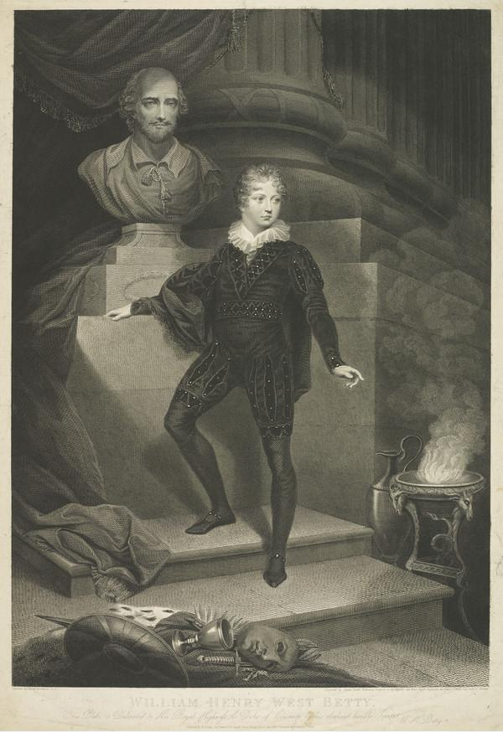
Figure 55: After James Northcote, William Henry West Betty (1791-1874), the ‘Young Roscius,’ Juvenile Actor, engraved by James Heath, 1808, line engraving on paper. This image can be viewed in the non-redacted version of this PhD thesis, held by the University of Sheffield Library.
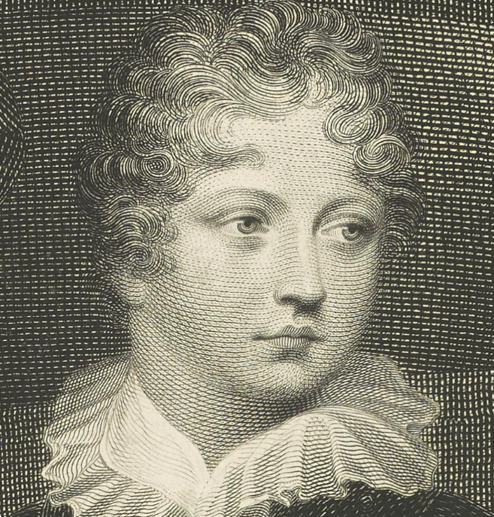
Figure 56: Detail from After James Northcote, close up of facial features, William Henry West Betty (1791-1874), the ‘Young Roscius,’ Juvenile Actor, engraved by James Heath, 1808, line engraving on paper. This image can be viewed in the non-redacted version of this PhD thesis, held by the University of Sheffield Library.

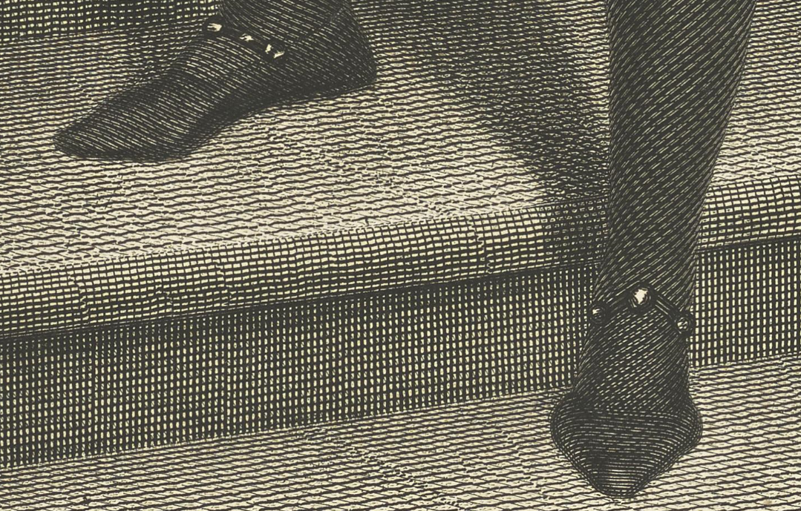
Figure 57: Detail from After James Northcote showing jewelled footwear, William Henry West Betty (1791-1874), the ‘Young Roscius,’ Juvenile Actor, engraved by James Heath, 1808, line engraving on paper. This image can be viewed in the non-redacted version of this PhD thesis, held by the University of Sheffield Library.

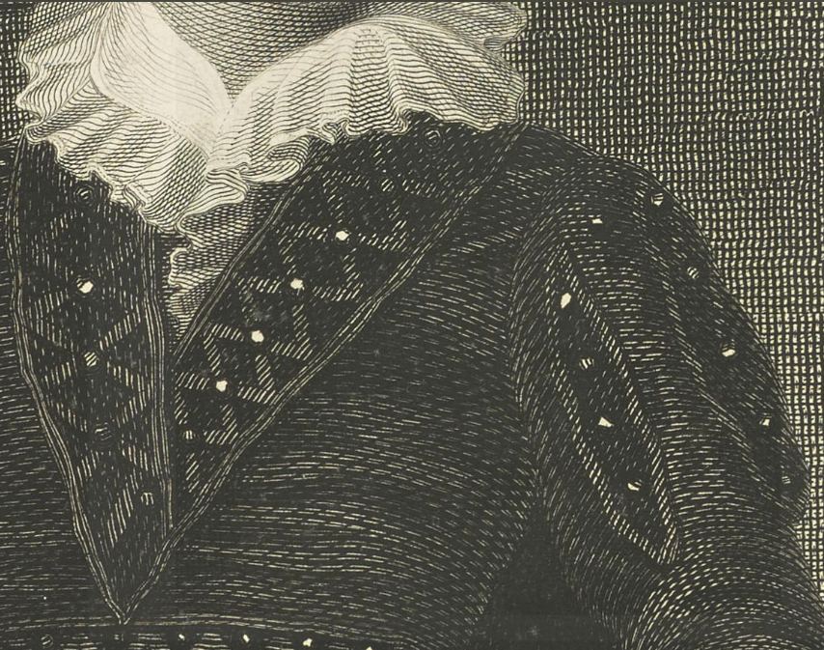
Figure 58: Detail from After James Northcote showing jewelled clothing and frilled collar, William Henry West Betty (1791-1874), the ‘Young Roscius,’ Juvenile Actor, engraved by James Heath, 1808, line engraving on paper. This image can be viewed in the non-redacted version of this PhD thesis, held by the University of Sheffield Library.

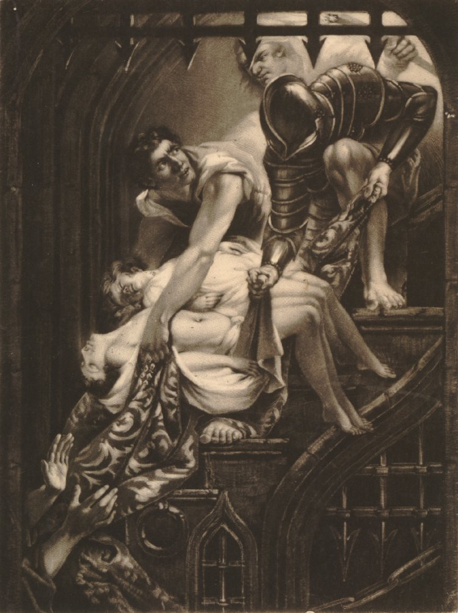
Figure 59: After James Northcote, In the Tower of London, Dighton and Forrest carry the murdered princes down stairs in their bedclothes, another man reaching up to receive them at left at the foot, only his hands seen; unknown engraver, mezzotint on paper, c. 1790s, British Museum holding 2010.7081.5483. This image can be viewed in the non-redacted version of this PhD thesis, held at the University of Sheffield Library.

These contrasts are habitually employed by Northcote in order to highlight an intentional disparity between the sublime and the beautiful in his subjects. Within his historical and literary pieces completed for John Boydell’s Shakespeare Gallery, of which Northcote was a primary contributor, he uses a rigidity of form, intentional obscurity, vast settings and marked dissimilarities between the rugged facial features of his villains and the smooth limbs of their victims to imbue his pieces with a sublime tincture and emphasise the beautiful. Figure 59 is a prime example, with the helpless murdered children being conveyed in a soft drape, by rugged villains in a setting of iron spikes and harsh outlines. The viewer needs only contrast the line of the children’s delicate feet with the enormous square foot of the soldier on the step in order to make an effective comparison, although there are numerous opportunities for such contrasts to be made within this print. The uppermost child’s head drooping to the side as if sweetly sleeping and swathed in blonde curls, in comparison with black curls, murderous mien and the obvious musculature of the villain who manhandles the children up the stairs is just one.

These contrasts forcing the viewer to overtly distinguish between the sublime and the beautiful in Northcote’s paintings were also employed in his more workaday portraiture in order to construct flattering portraits of his sitters. Figure 60 shows Northcote’s portrait of Miss Clarke as Una, where the features of a plain woman are enhanced by comparison with the rugged fierceness of the lion, the loose flowing lines of her gowned figure made beautiful in contrast with the backdrop of stony cave entrance. Her natural place as belonging within the aesthetic of the beautiful is yet more clearly elucidated by the jewelled girdle which lies on the ground beside her. Such character portraits were often commissioned by fathers of daughters, anxious to interest future suitors and ensure the best match possible for their offspring. With this reasoning in view, it becomes clear why Northcote wished to emphasise ‘the beautiful’ in his subject.

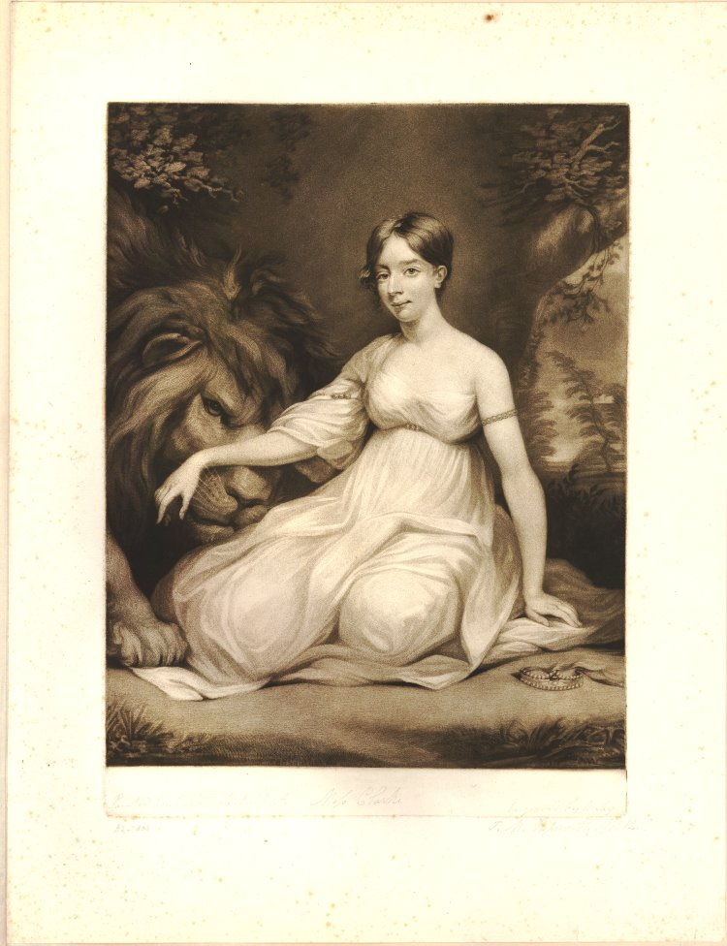
Figure 60: After James Northcote, Portrait of Miss Clarke as Una, Print made by William Say, c. 1783-1834, mezzotint engraving on paper. This image can be viewed in the non-redacted version of this PhD thesis, held at the University of Sheffield Library.

Smith, too, highlights the ‘beautiful’ nature of her heroes and demonstrates that they belong within the sphere of this aesthetic, using the same artistic techniques as Northcote, via the effective use of contrasts. One of her most handsome heroes is Captain Warwick, featured as a supporting character in The Old Manor House (1793) and as the eponymous hero of the sequel to this novel, The Wanderings of Warwick (1794). He has, Warwick tells his listening audience, ‘a tolerable figure, and some degree of favour with the women.’ Indeed, Isabella has eloped with him for his personal attractions, relinquishing the vast fortune of General Tracy in Warwick’s favour, in their earlier adventures detailed in The Old Manor House. However, once again, his indisputable physical attractiveness is not the most important point here. Rather, it is how his personality as the ‘hero’ of this novel ensures he corresponds with ‘the beautiful.’ His ‘disposition [is] lively and sanguine in the extreme.’ As Kant observes, ‘[t]he person of a sanguine frame of mind has a dominant feeling for the beautiful.’ Further, in the following description of the mind prepossessed by beautiful characteristics, Kant could be describing Warwick’s personality:

Variety is beautiful and he loves change. He seeks joy in himself and around himself, amuses others, and is good company. […] He is often dissolute and wicked, more from complaisance than inclination. He is liberal and generous, but a poor payer of his debts, since he has much sentiment for goodness but little for justice. Nobody has as good an opinion of his own heart as he does.

Despite claiming to have learned his lesson from the ‘many follies’ he commits with their ‘fatal consequences’ whilst engaging in ‘deep play’ during his residence in Dublin, in reality it is clear that Warwick has learned nothing from his misfortunes. As the action opens, the very first note of caution the narrative voice interjects is that, even now, he suffers when ‘[h]is gay and volatile spirits hav[e] […] no object in pursuit’ and that this was ‘continually likely to lead him into dissipation, for which in fact he had no other relish than as it broke the monotony of domestic life.’

Smith further highlights Warwick’s ‘beautiful’ aspects by introducing a character into the action with truly sublime characteristics within the Kantian definition to provide that painterly contrast: Don Julian (later Villanova). Like Northcote’s beautiful subjects set against sublime backgrounds, Smith juxtaposes the beautiful Warwick with the sublime Julian. Julian has ‘feelings [which] tend toward the melancholic’ which gives him, according to Kantian theory, ‘above all a feeling for the sublime.’ Further, his brooding taciturnity places him within that ‘thoughtful’ masculine ‘sublime’ that Kant outlines as one of the principal character traits of the sublime individual. By comparison with Don Julian, Warwick is rendered even more beautiful in nature than ever. Indeed this fact is not lost on Isabella. In contrast, Julian appears much the greater masculine hero and exponentially more dependable than her husband. Julian has the ‘melancholy and interesting countenance’ of the Kantian sublime. With ‘his black eyes, so expressive of hopeless love; his deep sighs, and his silent adoration; and his misfortunes,’ he is rendered ‘more interesting’ to Isabella. Warwick himself acknowledges that he has ‘a heart that Isabella seemed alone worthy of sharing.’ This inspires jealousy, for the first time, in Warwick. In spite of the language barrier which exists between them, and the fact that she has no prior knowledge of ‘any language but her own,’ Isabella seems to understand ‘his Portuguese mingled with scraps of something that he thought was English’ much better than Warwick is able to. Julian is ‘not handsome’ nor does he ‘have the same powers of pleasing as the English officers,’ and yet, Warwick instinctively recognises Julian as a threat to his marriage.

The perceived threat is real, as can be determined from Warwick’s narration of their tale. As Don Julian takes his leave from them on the first occasion, Warwick discloses that his departure ‘drew more tears from Isabella than I ever saw her shed before.’ On Julian’s return Isabella ‘shew[s] more satisfaction than I [Warwick] had observed her to express for many weeks, at this unexpected renewal of our acquaintance with the young Portuguese.’ When inappropriately propositioned by Sir Randolph Aldborough, it is to Julian that Isabella turns for help and protection – not her husband. She similarly chooses Julian to confide her suspicions to concerning the nature of the relationship between her husband and Mrs. Effingham. The differing reactions of the two male leads underscores the disparity between their sublime and beautiful natures further, and how correct Isabella is in her assessment of
Julian’s ultimate worthiness:

That she should make Don Julian the confident of her suspicion, renewed all my [Warwick’s] rage, and I expressed myself in terms of reproach so bitter and violent, that had Don Julian been as hot-headed as I was, an immediate recourse must have been had to arms; but the conscious rectitude of his mind, together with his regard for me, gave him a degree of coolness very unusual among the Portuguese.
Despite his anger, Warwick cannot help but admire the ‘conscious rectitude’ and correct behaviour of the character who is being represented as the true hero of the text. And Isabella has good reasons not to place her faith in her beautiful and beautiful-natured husband. When he does find out the danger she has been in from Sir Randolph Aldborough, instead of moving to protect her, Warwick levels accusations at her, descending into hysteria as he does so:

I remonstrated warmly with her on her concealing from me the insulting conduct of Sir Randolph Aldborough, which I would not have endured an hour – no, not a moment. –
‘Alas, Warwick,’ replied she, ‘it was that impatience, that violence, which compelled me to silence: - I dared not hazard.’

Of course, Smith is presenting a novel which must be acceptable to the paying public. In order to – like Warwick in the novel – make a living as a writer, she cannot possibly have the heroine abandon her husband. It would be a totally unacceptable conclusion to a romantic novel and far too controversial an ending for eighteenth-century society’s sensibilities. With this in view, she disposes of the melancholy Julian via suicide, in a conclusion for him which is entirely fitting with his sublime nature. As Kant argues, the ‘melancholic […] has above all a feeling for the sublime.’ ‘He is […] not seldom weary of himself as well as of the world.’ Smith, however, opens her text with a hint at the regret that Isabella feels in selecting Warwick for a husband in the first place:

‘Let them begin [the story of their adventures], then,’ said Isabella, ‘from our sailing from Portsmouth – for to take up the story sooner would perhaps occasion to me some reflection’ – ‘Not of repentance, I hope?’ interrupted Warwick. ‘No,’ answered Isabella blushing, ‘not of repentance – but of something like regret at the unjustifiable and rash step I took in quitting my father’s house – and’ – She hesitated; and Orlando, who perfectly understood her sensations on this subject, said – ‘No, Warwick, we will begin, if you please, in the middle of the Atlantic Ocean –’

Orlando may understand her sensations at this point, but the reader is purposely left in the dark. It is only as events unfold that the implication becomes clear that Isabella might lament her marriage to Warwick. Indeed, the seeds for Isabella’s discontent in the choice of her marriage partner were sown in the prequel to the story of Warwick’s wanderings: The Old Manor House. Here, when Isabella first requests her mother’s approval of a potential match with Warwick, her mother sounds a subtle note of caution in the text, ‘“You would consent then, my dear mamma,” replied Isabella, “to my having Captain Warwick?” “Alas!” answered her mother mournfully, “Captain Warwick, my dear girl, heir to the fortune of General Tracy, will never, I fear, ask my consent.”’ As Mrs. Somerive correctly predicts, Warwick is not the type of man to ‘ask […] consent’ of a girl’s parents in the societally-acceptable manner. Rather, he defies convention, convincing Isabella to elope with him and spiriting her away from her protectors. It is a poor start to a marriage, and entirely in keeping with Warwick’s beautiful nature, which, as Kant observes, if the ‘moral feeling is beautiful, [it is] yet without principles.’ Warwick repeatedly acts without principle or moral virtue within both this text and The Old Manor House, where the narrator explicitly lays out his ruling characteristics:

Indulged from his [Warwick’s] infancy, by his uncle, in every thing that did not interfere with his own pleasures, and having no parents to restrain him, Warwick never dreamed of checking himself in whatever gratified his passions or flattered his imagination.

As the narrative of Wanderings unfolds, despite their apparent commitment to each other at the point of narration, there are, it is clear, cracks within the relationship of Warwick and Isabella. There seems to exist between them, it is true, affection. However, as Kant argues, ‘[a] certain tenderheartedness […] is beautiful and lovable, […] [b]ut this kindly passion is nevertheless weak and is always blind.’ In some measure, the romance outlined in this novel acts almost as a cautionary tale by Smith, warning her young female readers to guard against hasty decisions in the selection of a marriage partner, and not to be blinded by female desire for male physical attractiveness, but rather to consider the worthiness and moral character of the partner in question. Marriage, after all, as Smith knew to her detriment, lasts a lifetime and the selection of a weak partner can destroy a woman’s fortunes. Smith was a woman who knew what it meant to be married to a morally bankrupt partner. The darker side of desire lies in the consequences of succumbing to it, from a woman’s point of view.

This lesson concerning that darker side of desire is similarly learned by Smith’s heroine Monimia in the novel which directly precedes The Wanderings of Warwick, The Old Manor House. Orlando too, like Warwick, is both physically beautiful (‘a remarkably handsome boy’), and beautiful in nature as well. Like Warwick, he is only really concerned with his own pleasures, convincing Monimia to accept his visits to her in private, against her better judgement, because of his heedless desire for her. This is an obvious violation of respectability, and something which The Critical Review drew attention to, highlighting these scenes as ‘repugnant to decorum and virtue.’ He acts with that ‘certain tenderheartedness [which] indicates a kindly participation in the fate of other people,’ but, as Kant, goes onto observe, ‘the action cannot arise from any virtuous resolution’ and is ultimately just caused by ‘blind enchantment.’ Indeed, his actions do not ‘arise from any virtuous resolution,’ but rather a selfish longing to spend time with the woman he desires. Like all who are beautiful in nature, Orlando has a ‘love of honour,’ which Kant describes as mere ‘foolish delusion.’ ‘In cases of insults he falls back upon duels,’ Kant argues, depicting precisely Orlando’s actions when Sir John Belgrave angers him. Weak and vacillating, Mr. Stockton accuses Orlando of being a ‘milk-sop, and living always in the lap of the old lady at the Hall.’ General Tracy observes that ‘[i]t is a thousand pities [...] that such a gloriously spirited young fellow should waste his life in seclusion, waiting on the caprices of an old woman.’ Orlando is repeatedly advised that he ‘ought not to waste his life nailed to the gouty chair of a peevish old woman, who ten to one dies and bilks him [of his expected inheritance] at last.’ In spite of his self-proclaimed sense of honour, Orlando is essentially awaiting the death of Mrs Rayland so that he can inherit her fortune. In this, there is ‘the complete absence of real merits’ described by Kant in his portrayal of the beautiful in nature. This is something which the narrator of the tale acknowledges on Orlando’s behalf as he comes to realise ‘that he was despised; and that there was meanness in his attending on Mrs. Rayland like a legacy hunter – of all characters the most despicable.’

Realising his failings in his relationship with Mrs. Rayland, Orlando dreams of transforming Monimia into a cultivated young woman, worthy of being his wife: ‘What delight to be her [Monimia’s] preceptor, and, in despite of the malignity of fortune, to render her mind as lovely as her form!’ The implicit inference for the reader is that when Orlando first meets her, in his own view, Monimia is not worthy of marriage to him. As a lower class woman, she is not of a high enough caste to be worthy of him. His desire to add to her accomplishments is linked in the mind of the reader with the task of that of training the young horse which Mrs. Rayland gifts to him, and which he undertakes ‘to break […] and to give it among other accomplishments, that of leaping.’ It is whilst he is searching for a leaping-bar that he discovers the secret entrance into Monimia’s turret which provides access for him to ‘educate’ and ‘improve’ her. Here, Smith makes explicit the connection between the status of women in this society as femme couvert, mere possessions of their fathers and husbands. It is a correlation Smith forged within her own life, comparing herself to a ‘Southdown sheep’ sold to her unworthy husband.

As a lower-class woman, Monimia is as much at Orlando’s mercy as his young horse. As Betty Joseph argues in her study of the interaction of the castes in the East India Company, ‘where all sexual intercourse between upper-caste women and lower-caste men is forbidden, the woman’s yes will always mean no – thus her consent or nonconsent becomes irrelevant.’ Similarly, in spite of the fact that Monimia’s ‘natural rectitude of understanding […] at once told her these clandestine meetings would be wrong,’ as a lower-class woman protesting against an upper-class man, Monimia is not in the position to refuse Orlando’s private visits to her. Her ‘no’ will always be heard and interpreted as ‘yes’ by the upper-class male. Orlando’s ‘honour’ as a gentleman entirely belongs to the sphere of the beautiful as outlined by Kant. As Kant argues:

As long as he is only vain, i.e. seeks honour and strives to be pleasing to the eye, then he can still be tolerated, but when he is conceited […] then he is that which he would least gladly be taken for, namely a fool.’

Orlando believes he acts in Monimia’s best interests, but his folly hurts Monimia from the very outset. From compromising her reputation to forcing her to live in poverty alongside him; his actions permit Smith to demonstrate indubitably the necessary caution required by a woman in the selection of a marriage partner. Miranda Burgess summarises this nicely in her description of Orlando’s attempts to
‘improve’ Monimia:

His first act on falling in love with her is to throw a ball through the window of Rayland Hall, where she sits sewing with Lennard and Rayland. Caught concealing the ball, Monimia is beaten and reduced to a sentimental tableau of tears: ‘on the lovely neck of [Lennard’s] victim … the marks of her fingers were to be traced many days afterwards’ (p. 18). Yet far from avoiding Monimia in order to prevent further punishment, Orlando invades her rooms. When she flees ‘in terror,’ he uses his ‘superior strength and agility’ to prevent her, trapping her as Lennard does: ‘setting his back against the door, he insisted upon knowing the cause of her tears before he suffered her to stir’.

As the hero of the tale, Orlando should correctly be protecting his love interest. However, consistently, he is ineffectual in this role, creating more problems for his heroine than solutions. Indeed, he without fail hurts her. He exposes her to the domestic violence of her aunt. He also injures her health by keeping her up late into the night with his education and improvement of her. He forces her to wait for him ‘so long past [her] hour of going to bed, that [she is] half frozen’ with fatigue and cold. It is frequently ‘day-break’ before Orlando leaves her, and despite ‘insist[ing] on her promising to endeavour to sleep,’ he little appreciates that she has duties and cannot just sleep during the day as if she were a member of the leisured classes. Monimia has to work for her living. His nightly instruction of her in reality worsens her situation, as a conversation with her aunt elucidating Monimia’s exhausted state makes clear:

‘I hope, dear aunt, there is no harm in my trying to improve myself, if I do not therefore neglect what you order me to do?’
‘Improve yourself! – Yes, truly, a pretty improvement – Your chalky face and padded eyes are mighty improvements: and I’d be glad to know what good your reading does you, but to give you a hankering after what you’ve no right to expect? An improved lady will be above helping me, I suppose, very soon.’

The recognition of the damaging nature of Orlando’s beautiful nature and behaviour towards his heroine not only permits Smith to critique the gender politics of the eighteenth century and the destructive qualities of social mores such as ‘honour’ and caste systems. It also permits her to highlight very effectively the flaws within the assumptions concerning the gendered characteristics of ‘the sublime’ and ‘the beautiful.’ Kant describes the understanding of women thus, ‘[t]he fair sex has just as much understanding as the male, only it is a beautiful understanding, while ours should be a deeper understanding, which is an expression that means the same thing as sublime.’ Smith, however, transmutes this and places it on its head. In Smith’s novel, it is Orlando who fails to understand deeply, whereas Monimia fully appreciates her position. She, like Betty Richards, is ‘a very friendless orphan, a poor girl’ who ‘knows very well that all [their] meetings will one day or other be discovered’ and will ‘entirely ruin’ both herself and Betty. Orlando has only a superficial grasp of affairs, that ‘beautiful understanding’ which does not consider matters in any depth. It takes him until the very end of the novel to learn that his failure to think deeply and possess that ‘deeper understanding’ which Kant marks out as ‘the designation of the noble sex,’ hurts the person he claims to love the most:

He [Orlando] now remembered that he used to think, were he once blessed with Monimia, every other circumstance of life would be to him indifferent; yet she was now his – she was now more beloved, as his wife, than she had ever been as his mistress; and the sweetness of her temper, the excellence of her heart, the clearness of her understanding, and her tender attachment to him, rendered her infinitely dearer to him than that beauty which had first attracted his early love. But far from being rendered indifferent to every other circumstance, he felt that much of his present concern arose from the impossibility he found of sheltering his adored creature from the evils of indigence; and that the romantic theory, of sacrificing every consideration to love, produced, in the practice, only the painful consciousness of having injured its object.

Indeed, Monimia is forced to exercise her ‘deeper understanding’ of the nature of things as they are in order to control Orlando and ensure her own safety and well-being. Once again, like Northcote’s contrasts between the sublime and the beautiful offered within the same painting, a contrast in the tableau is being offered to the reader as they are invited to compare Orlando’s beautiful understanding which is only superficial in nature with Monimia’s more acute and deeper judgement. At the point in the text where Monimia is first exhibited as the victim of her aunt’s domestic violence, Orlando’s sense of honour rises up and he threatens a rash action, the consequences of which he fails to perceive:

Gasping for breath, trembling and inarticulately she [Monimia] tried to relate the effects of his [Orlando’s] indiscretion, and that therefore her aunt had threatened and struck her. Orlando, whose temper was naturally warm, and whose generous spirit revolted from every kind of injustice, felt at once his indignation excited by this act of oppression, and his anger that Mrs. Lennard should arraign him for a childish frolic, and thence take occasion so unworthily to treat an innocent girl; and being too rash to reflect on consequences, he declared that he would go instantly into the parlour, confess to Mrs. Rayland what he had done, and appeal against the tyranny and cruelty of her woman.

Monimia, like the narratorial voice, immediately recognises the corollaries of Orlando’s impetuousness:

‘Indeed, dear Orlando,’ cried she, ‘you would not be heard against my aunt. Mrs. Rayland, if she forgave you, would never forgive me; but I should be immediately turned out of the house with disgrace; and I have no friend, no relation in the world but my aunt, and must beg my bread.’

Monimia, after pointing out the likely detrimental outcome of Orlando’s threatened action, is obliged to utilise all of her deeper understanding and superior reasoning powers to prevent his exposure of her. Recognising fully ‘the terrors and distress such a step’ on Orlando’s part ‘would inevitably plunge her into,’ she has recourse to feminine wiles to convince him not to act rashly:

But it is not so much that,” added she, while sobs broke her utterance, “it is not so much that I care for – I am so unfortunate that it does not signify what becomes of me: I can work in the fields, or can go through any hardship; but Mrs. Rayland will be very angry with you, and will not suffer you to come to the Hall again, and I shall – never – never see you any more!” this speech, unguarded and simple as it was, had more effect on Orlando than the most studied eloquence.

Monimia uses this affected simplicity within her speech in order to manipulate Orlando, because it’s all she can do to control him. It is a conscious debasement of herself and appeal to his own perceived superiority as a ‘gentleman.’ It also makes clear to Orlando that his threatened action will result in the very outcomes he fears the most – that of not being able to ‘come to the Hall again,’ and continue his courtship of both Monimia and Mrs. Rayland’s fortune. Within Kant’s handwritten ‘Remarks in the Observations on the Feeling of the Beautiful and the Sublime,’ Kant notes how ‘Women are strong because they are weak. […] Since she is weak, she is clever.’ By this, Kant means that women are forced to demonstrate strength through their courage since they are naturally weaker than men. His argument in the Observations, as Susan Shell notes, is to unite ‘a feminine embodiment of wisdom to complement and complete his own moral and intellectual striving.’ However, Monimia’s cleverness here is fuelled by her own strength of understanding, which is deeper and more noble, hence sublime, in character, than the beautiful disposition of Orlando’s intellect. Smith demonstrates here the ingenuity of women; a shrewdness necessitated by the failure of men to think deeply or understand completely the impossible position their so-called ‘honour’ places women in.

Kant himself changed his view on the nature of women as time passed. Shell notes how his ‘handwritten “Remarks,” set down in his own copy of the Observations in the years immediately following its publication, mark the rapid souring of Kant’s view.’ ‘Women’s cleverness,’ for Kant, Shell observes, ‘is now a trap, and dogmatic metaphysics is like the wig and greasepaint that beguiles the eager groom until his rude awakening after the wedding.’ Monimia’s cleverness equally entraps Orlando into behaving how she needs him to behave. It is a trick, in order to flatter Orlando’s ego so he will do what she wants him to do. However, it is a necessary deception. Here, Smith highlights the flawed nature of the ‘beautiful hero,’ and how women are forced to adopt such ruses for reasons of self-protection. If Orlando had not failed to understand the consequences of his actions in the first place, Monimia would not have been compelled to trick him. For both Burke and Kant, as Judy Lochhead argues, the sublime is ‘a superior aesthetic category by virtue of a power that registers in prerational experience. […] Beauty, on the other hand, is an inferior aesthetic category associated with “weakness and imperfection.”’ ‘For Burke,’ Lochhead continues, ‘women are guided by nature to embody the attributes of beauty in order, presumably to appeal to men’s desire.’ Kant also inscribes gender into the aesthetic. For Kant, whilst ‘a woman’s virtue is beautiful, […] a man’s is noble; a woman’s actions are guided by an avoidance of the ugly; and while “there are good moral qualities that are amiable and beautiful … they can not properly be included within the virtuous disposition.”’ As Lochhead observes, ‘[i]n a single stroke Kant both degrades the feminine and the beautiful and elevates the masculine and sublime as superior both aesthetically and morally.’ However, by situating her leading men within the aesthetic of ‘the beautiful’ rather than the sublime, Smith interrogates this assumption, as it becomes clear that Orlando’s and Warwick’s behaviour is morally imprudent at the very best interpretation of it. In contrast, Monimia’s circumspection and ability to manipulate Orlando demonstrates both that she has a proper understanding of the situation, exhibiting her own deep knowledge of the people in whose power she is, and also how she is forced to resort to trickery in order to constrain Orlando’s beautiful-natured folly. Like her literary ancestor Ethelinde, Monimia becomes sublime in her ability to take control and direct the actions of those around her, assuming a necessary strength in order to survive. Monimia then also becomes the sublime foil to Orlando’s beauty and the contrast in the picture to demonstrate just how beautiful he is.

If Orlando’s and Warwick’s morality is questionable, then as Smith’s heroes progress their beauty becomes increasingly corrupt in nature and more harmful to the women around them. With her eponymous hero Desmond (1792), Smith creates a beautiful hero who, in both the Kantian and Burkean definition of the aesthetic, is characterised by a feminised passivity and inability to act. Like Orlando, he has grandiose ideas concerning his own honour and a recourse to duels and challenges ends in him being ‘engaged in an affair of honour’ which results in him ‘being terribly wounded by a pistol shot in the right arm.’ Considering the Burkean rather than the Kantian definition of ‘the beautiful,’ Desmond still remains firmly within this sphere. His virtues are not ‘of the sublime kind, [which] produce terror rather than love; such as fortitude, justice, wisdom and the like,’ but are rather characterised by ‘amiable qualities […] [t]hose which engage our hearts, […] easiness of temper, compassion, kindness, and liberality.’ There are numerous occasions within the text when Desmond demonstrates these latter qualities, for example, the willingness with which he dispenses Verney’s debts in order to assist Geraldine, or the moment when he assists the ‘thin, pale figure’ of the French ‘widow in great distress,’ whilst his fellow countrymen ignore her pleas for aid. It is his ‘amiable qualities’ which ‘engage[s]’ the ‘hearts’ of the women around him. This success with women leads Montfleuri to almost enviously question, ‘Desmond, do tell me how you manage to bewitch the women in this manner?’

However, as becomes clear as the text progresses and unlike the characteristics of the sublime, there is very little of ‘justice [and] wisdom’ in Desmond’s behaviour. Immorally in love with a woman who is already wedded to another, the conduct of this beautiful hero revolves around his ‘indulgences’ of a corrupt passion for a married woman. He permits an immoral infatuation for the married Geraldine to possess him utterly, refusing, despite the advice of his mentor Bethel, to make any attempts at conquering it. Rather, Desmond openly confesses he is in the grip of ‘a passion which I still take every opportunity of cherishing,’ in spite of the harm that he fully realises this illegitimate obsession can do to Geraldine’s reputation. Desmond appears almost as a reversal of Sir Edward Newenden, with his immoral passion for Ethelinde discussed in chapter two. Sir Edward, however, despite being desperately attracted to Ethelinde, makes several attempts to surmount his passion, initially by not daring to ‘acknowledge the affection he could not conquer’ for Ethelinde. Although the death of his wife and the surmised death of Montgomery places Sir Edward at liberty to make proposals to Ethelinde, he immediately redacts these when it transpires that Montgomery is alive. At this point in the novel, Sir Edward renounces his claim with the following promise which is sacrificial to his own happiness:

[y]ou will continue, I know, to honor me with that sisterly affection that has hitherto been at once a pleasure and a torment to me. I will endeavour henceforth to learn the art of making it only the former; and I beg of you and your dear Montgomery to forgive, to pity, and if possible, to forget my weakness.

Desmond, however, unlike Sir Edward, entertains no notions of sacrificing his own happiness at the expense of Geraldine’s peace of mind or reputation. He becomes the embodiment of the beautiful person, who Burke describes as, ‘those persons who creep into the hearts of most people, who are chosen as the companions of their softer hours, and their reliefs from care and anxiety,’ and who ‘are never persons of shining qualities or strong virtues.’ By exposing the flawed nature of her hero who sits squarely within the aesthetics of the beautiful with his character and behaviour, Smith disputes that the beautiful belongs solely to women. If as Jill Heydt-Stevenson observes, ‘the masculine sublime is characterized by “immense force and labor”’ then Desmond, portrayed as weak and passive has no place whatsoever. His behaviour is feeble and characterised by passivity and inaction, linking him to the ‘idea of weakness and imperfection’ which Burke attributes to ‘beauty, […] where it is highest, in the female sex.’ ‘They [women] learn to lisp, to totter in their walk, to counterfeit weakness, and even sickness.’ Indeed, it is during a period of sickness, suffering the effects of the pistol shot, when Desmond inertly impregnates Josephine. He does this whilst simultaneously eschewing any responsibility for his activities whatsoever, and apparently achieving this without any action on his part. Josephine, it is made clear, has seduced him and played the leading role throughout this episode (‘declaring […] it was her own unguarded folly, and not to any art or deception on his [Desmond’s] part, that the blame was owing.)’ Desmond’s role in this does not even extend to confessing the sin himself. As Scott C. Campbell observes, ‘Desmond’s actual whereabouts and the birth of his French child – a letter that declares “I will confide to you the truth” (p. 410) – is actually written by Desmond’s friend, Montfleuri’.

Failings such as these demonstrate that despite his ostensible position as the male hero of the text, Desmond is apparently seized by an inability to act, which Burke might argue corresponds with feminine behaviour, at surprising junctures in the novel. For example, during the episode when Verney has apparently sold his wife’s sexual favours to the Duc de Romagnecourt, Desmond goes through the motions of seeming to protect Geraldine, but in reality, does nothing whatsoever to help her, and even exacerbates her situation. Despite his suspicions regarding Romagnecourt’s ‘behaviour’ and ‘conversation,’ he excuses himself thus: ‘what right had I to interfere?’ His inaction also belongs to the Kantian definition of the beautiful in that he is ‘guided by an avoidance of the ugly.’ Desmond fails to intrude on the scene, because the immorality of Romagnecourt’s purchase of Geraldine from her husband is too vile to even contemplate. Desmond even goes so far as to provide the ‘veteran debauché’ with ‘the directions he requested me to procure for him; [and] to trust the first reception of such a proposal to the sense and prudence of Geraldine,’ rather than become actively involved in helping Geraldine. In other words, he leaves her to cope alone with Romagnecourt’s importunities. His is a position of tottering ‘weakness.’

Further, Desmond then aggravates Geraldine’s situation by a vacillating and half-hearted attempt at seeming to help her: ‘“You are,” said I, “quite unprotected here: you have not even a man-servant, who might shut your doors against impertinent intrusion.”’ After terrifying Geraldine with these reflections, he then leaves her to manage singlehandedly with the inevitable ‘impertinent intrusion’ of Romagnecourt. During the time Geraldine is left alone to defend herself and her children as best she can, Desmond merely watches from the window in a re-enactment of Monimia’s later position in her Rapunzel-like watching from the top of her turret: ‘I have seen from my windows the carriage of Romagnecourt go to her house. Impatiently I awaited its return, which was not for an hour and a half – and now I go to enquire the result.’ Smith even draws the reader’s attention to the fairy tale-like qualities of Desmond’s inert watching from the window, by having him make reference to traditional tropes and devices of fable: ‘I leave you to comment on the strange story I have related, and to blame, for so I doubt not but you will (since chivalry is no more) this romantic knight-errantry.’ Within his own mind, Desmond may be the ‘romantic knight’ but his ‘errantry,’ as the word implies, is delinquent and wayward – turned on its head and inverted. Indeed, he fails to be the ‘romantic knight’ at all, and instead is rather playing the part of the watching heroine, than the romantic hero. When Desmond does finally go to Geraldine, it is merely to ‘enquire the result.’ Here, he appears more feminised and woman-like than ever. He seeks the gossip of what has occurred and when he does learn this, he descends into ‘momentary phrenzy […] forgetting that to avoid encreasing her discomfort was the object nearest [his] heart.’ He becomes hysterical, in other words, a term which originates from the Greek word for uterus, and is indelibly associated with the feminine. It is left to Geraldine to ‘dread […] Mr. Desmond’s interference, which seemed hourly probable.’

The reader never does learn fully ‘the result’ of Romagnecourt’s visit; i.e. precisely what passes during that hour and a half whilst Desmond watches passively from his window. And in the true manner of gossip, as Patricia Meyer Spacks argues, it is ‘[n]ot what we hear but what we don’t hear [that] fills us with alarm.’ What we don’t hear, as a narratorial footnote apprises the reader, is Geraldine’s ‘account of the second and third visits of the Duc de Romagnecourt*,’ with the asterisked information advising in a footnote that these facts are contained ‘[i]n a letter which does not appear’ in the text. It seems as if these events are too horrible to be even elucidated within the novel. These accounts are sufficient to convince Geraldine’s sister, Miss Waverley, that ‘he [Romagnecourt] was not easily to be repulsed.’ Romagnecourt’s insolence becomes literally unspeakable, existing only outside the text, and falling within that alarming remit of what the reader can conjecture only.

Desmond’s position as a gossiping figure enacted in the scenes recounted above (again, a role reserved for women in traditional parlance), and perpetuator of gossip, is a role he adopts from his very opening letters, but as Spacks observes of the nature of gossip, it requires close attention to discern this. Smith has created a novel which ‘insist[s] on the need to pay attention.’ Here, like Orlando, Desmond hurts the very person he claims to love most of all: Geraldine. This becomes clear from his opening letter to Bethel, in which he initially, in a Sir Edward-like manner, apparently agrees with Bethel’s ‘arguments’ from an earlier epistle, with regard to ‘the dangerous indulgence of contemplating the perfections of an object that can never be mine.’ Having announced his illegal passion, he then spells out for the reader the identity of the woman he desires and the fact that she is married: ‘[h]er husband – I hate the name – Verney,’ later giving her first name too, just in case there is any doubt in the mind of the reader as to the woman’s identity, ‘the lovely Geraldine.’ This would all be fine with no harm done if the reader could assume that the letter will only fall under the eyes of the addressee, Bethel. Unfortunately, however, this supposition is undermined by the fact that what this text exposes more than anything is that letters are neither private nor safe. They are bandied around like currency and read by the people who are not the addressees. For example, Geraldine’s mother’s letter to her, expostulating with her for ‘receiv[ing] visits from Mr Desmond,’ is read by her sister, Fanny, passed to Bethel, before finally making its way to Desmond himself.

Desmond, as the ‘hero’ seemingly has little comprehension of the damage he does to Geraldine of ‘reports’ of his attachment ‘gaining ground,’ as they incontrovertibly do, via epistolary means, and by word of mouth. Following her into her ‘cheap retirement,’ unbeknownst to Geraldine herself, he little reckons that he will be detected in his pursuit of her. However, once again, he is wrong. In a moment redolent of the fairy tale of the ‘Sleeping Beauty,’ and again playing on the passive nature of the male lead, Desmond is discovered by Geraldine herself, in the figure of ‘a gentleman who appeared to be sleeping’ in the ‘singular and beautiful’ woods which surround her cottage. He then ingratiates himself with her family, rendering her son ‘George, […] astonishingly fond of him,’ justifying to himself all the while that he will never be detected by society at large. He defends himself to Bethel thus:

The breath of scandal has never yet injured the spotless character of Geraldine. You, who know, that my love for her has a just claim to be called true love, because it seeks only her good – You, my friend, before you condemn me, will ask yourself whether I am likely to commit any indiscretion that will really injure her fame? - You will not, after having so reflected, blame me for what has passed since I have been here. – I could not act otherwise – And after all, who is to report my being here at all?

Inevitably, Smith immediately undermines these professions of the benign nature of ‘true love,’ by having his indiscretions detected by fashionable Bath society a mere four pages later: ‘her mother was extremely displeased with her journey, and had heard, by some means or other, that Mr. Desmond had been some time concealed in the neighbourhood of her residence at Bridge-foot.’

With the parts he plays within the text, it is clear that although Desmond aspires to play the chivalric hero, he in actuality is portrayed as almost any other female figure who people these types of romances. The watching heroine imprisoned behind the glass of her window, the Sleeping Beauty in the woods, the gossiping crone: Desmond is demonstrated to have played all these parts in some measure. It is however, not only metaphorical costumes which he dons. Once he finally realises that he has been detected, he sets out to deceive both Geraldine and Bethel on a grander scale by the adoption of actual costumes and disguises, as he trails her around Europe. Unfortunately, both Bethel (and the reader) are already shrewdly aware that he may do this. Smith alerts the reader to the possibility of future deceptions on Desmond’s part of this nature by raising the likelihood in a letter from Bethel:

Are you quite candid with me, Desmond? – And are you really going, you know not when, you know not whither? – Is it quite like my friend, even under the influence of this unhappy passion, to be so very unsettled in his plans? - It is, however, more unlike him to be disingenuous! – More unlike him to take a step the most injurious that can be devised, to Geraldine! – I mean going to France in pursuit of her. – You surely cannot be so indiscreet, nay, I will call it so cruel, as to meditate this. – You tell me, that if I write by the return of the post, you shall, on second thoughts, probably receive my letter at Sedgewood. – I write, therefore; and I conjure you, if you read it in England, let nothing induce you to cross the Channel, till you are assured that Geraldine is with her husband, and till there is no longer any danger of those reports gaining ground, which, (I cannot conjecture how), have certainly got into circulation here of your attachment to her.

Therefore, when Geraldine just happens to notice the figure of a monk haunting her steps during her residence at Meudon, it becomes immediately obvious that the figure ‘more restlessly wretched than the rest,’ whose beauty ‘is particularly affecting’ is Desmond himself. Desmond’s play-acting the figure of the impoverished monk, dispossessed by the Revolution in France, demonstrates the soundness of the Burkean theory, that ‘‘[b]eauty in distress is much the most affecting beauty.’ Desmond later admits that he was ‘compelled to take a disguise’ in order to remain near Geraldine, because he ‘languished for the pleasure of gazing, unperceived, on that lovely countenance.’ Here Smith highlights how performing within the boundaries of the beautiful aesthetic is flawed by Desmond’s unheroic actions which ultimately harm the women around him. When Geraldine is forced to move on from Meudon, Desmond drops all pretence at his disguise as a Capuchin monk, terrifying her maid in the process so much that ‘she fell into a sort of fit.’ Bethel fully exposes the dire consequences of Desmond’s costume-wearing and actions which are ‘beautiful’ in nature, such as the secret advances of money, in a frank exposure of the consequences of his deeds:

How make your uncle Danby believe, that you should, on a system of affection, merely platonic, have advanced this money? (of which it is wonderful that he should be informed) on a system merely platonic, go and live perdu in Hertforshire? on a system merely platonic, be now concealed in France, in the neighbourhood of Geraldine – for such I am afraid is the fact. – Dear Desmond! behold the consequences of your indiscretion! – See what cruel (and, as I am convinced) what unjust reflections you have been the means of throwing on the woman you love – consider all the consequences that may follow.

Many critics read a conventionally romantic happy ending into Smith’s Desmond, in spite of his repeated ‘cruel’ and ‘unjust’ actions towards the woman he asserts he loves. Nicola Watson, for example, states that ‘although Desmond fathers an illegitimate child on Josephine, he eventually marries Geraldine.’ Campbell similarly argues that the novel has ‘a conventional ending – Geraldine’s obstacles to a second marriage are removed with Verney’s death.’ In actual fact, however, the novel does not conclude with Desmond’s marriage to Geraldine. The action of the novel closes before any marriage takes place. The reader assumes that this will be the eventual outcome because the dying Verney expresses his final wish that Desmond ‘would be the guardian of his children, jointly with her; and […] that if she ever took a second husband, it might be his friend Desmond.’ It is advisable for the reader to recollect, however, that Verney has proved himself to be a less than reliable character throughout the entirety of the text, and Geraldine is awarded no say in the matter whatsoever. Indeed, Desmond’s behaviour towards Geraldine prompts the inevitable question, why should Geraldine want to marry Desmond? He has proven himself as unreliable, and has betrayed her with another woman whilst simultaneously proclaiming ‘true love’ for her. The nature and fallacy of the ‘true love’ of the beautiful hero is fully exposed within this text.

Indeed, this is a romantic novel which is topsy-turvy in nature and all mixed up. The baby precedes the marriage, the proposed marriage features a different heroine to the mother of the baby, and the novel ends with no wedding at all anyway. Just as Smith has taken the traditionally feminine aesthetic of the beautiful and turned it on its head, awarding these characteristics to the males in her novels instead, here, the tropes of the traditional romance are equally subverted. The novel actually concludes with another hysterical outburst from Desmond:

Oh! lend me, dear Bethel, some of your calm reason to check my impatience; and soothe, with your usual friendship, the agitated heart – which, whatever else may disturb it, will ever be faithfully grateful to you, while it beats in the bosom of your LIONEL DESMOND.

Perhaps the ending to this romantic novel is not so conventional after all. Perhaps, with this final frenzied outburst exclaiming against his own impatience to possess Geraldine, an alternative option is being alluded to. Just prior to this, Desmond confesses that he believes he frightens Geraldine ‘by my restless and vehement temper,’ much as Smith’s first hero, Delamere, terrified his heroine, Emmeline. Perhaps the best outcome for Geraldine will be in an Emmeline-like evasion of marriage to Desmond – for Geraldine’s sake, the reader can only hope so.

One of the primary attractions Desmond finds in Geraldine is that ‘beauty in distress’ which ‘is much the most affecting beauty,’ according to Burkean theory. Describing her at a key moment in distress as she fears for the health of her infant child, Desmond depicts her as ‘less dazzling’ but ‘a thousand times more interesting than in the most luxuriant bloom of early beauty.’ He even dreams of her nursing her dead baby. Just as Desmond’s beauty is demonstrated as more corrupt and harmful to the heroine than Sir Edward’s or Orlando’s, Geraldine’s feminine beauty in this novel is shown to be more useless to her than Emmeline’s or Ethelinde’s. Whilst Desmond’s beauty becomes harmful, Geraldine’s is left with nothing but distress for herself and her infant children. This downward spiral of a corrupt masculine beauty and a useless feminine one will continue through Smith’s novels, with her later ones exhibiting masculine beautiful heroes who are fully corrupted in nature, like Montalbert, who abuses Rosalie to such an extent that at the end of the novel she is left entirely weakened, and forced to alter her very nature in order to merely survive her relationship with him.

For Desmond, Geraldine’s distress seems as one of her key attractions, and he, too, presents an affecting portrait of the beautiful at key moments of his own distress. Northcote, too, accessed this theory of ‘beauty in distress’ in order to emphasise the beautiful nature of his subjects. As with Smith’s Desmond or Orlando, his beautiful subjects in distress are male, rather than female. Similarly, like Smith, what is interesting in these portrayals is the underlying critical commentary these ‘beautiful heroes’ make on the nature of eighteenth-century society. One of Northcote’s early successes included The Loss of the Halsewell East Indiaman (Figure 61), which he described as ‘the grandest and most original thing I ever did.’ Here, the gradual lines of the figures lost at sea are swallowed up by the sublimity of the ocean itself. As Burke observes, ‘the ocean is an object of no small terror [and] Indeed, terror is in all cases whatsoever, […] the ruling principle of the sublime.’ This is an artwork of contrasts once again, where the figures presented in a tangle of flowing lines, smooth limbs and waving hair, which are entirely beautiful in nature, are highlighted by their disparity with the sublime setting of the raging sea. Both men and women are presented as lost at sea here, but it is curiously difficult to distinguish who is male and who is female. Instead, all appear with the same characteristics of ‘beauty in distress.’ It is not possible to argue that Northcote’s men are sublime whilst his women are beautiful. They are all simply beautiful.

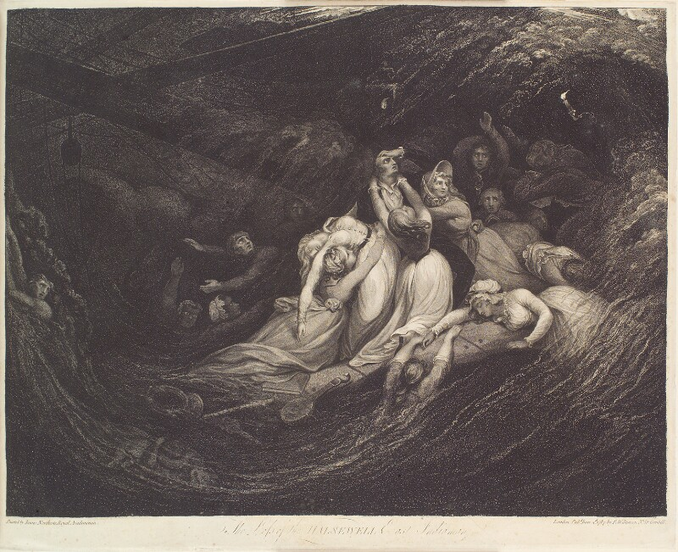
Figure 61: After James Northcote, The Loss of the Halsewell East Indiaman, James Gillray, 1787, line engraving, etching and stipple on paper. This image can be viewed at the British Museum or in the non-redacted version of this PhD thesis, held at the University of Sheffield Library.

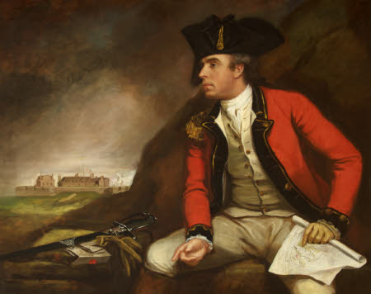
Figure 62: James Northcote, Captain Sir Thomas Hyde (1746-1821) holding a Plan of Fort Landguard and seen in the distance, c. 1783-1821, oil on canvas. This image can be viewed in the non-redacted version of this PhD thesis, held at the University of Sheffield Library.

Northcote’s depictions of military heroes, portrayals which the viewer might expect to partake of the masculine sublime most of all, are also interesting. Figure 62 depicts Captain Sir Thomas Hyde (1746-1821). His uniform is the outfit of a military hero, yet there is a curious lack of power and agency present within this portrait. Once again, the background is sublime in nature, consisting of dark, swirling clouds. However, this only serves to emphasise the subject’s smallness, positioned before the enormous dark rock which forms the background. Again, there is a smoothness to his skin and a delicacy to his hands. His pointing fingers indicate his orders. Beneath his left hand he points at the plan of Fort Landguard. In the distance, his right hand points at the actual Fort. His sword lies discarded at his side. The viewer’s eye is drawn not to the man who is the ostensible subject of the portrait, but to the Fort in the distance which he indicates, and where his duty lies. This is a man – as is the fate of all military men – merely following orders. By accessing the aesthetic of the beautiful, Northcote deliberately feminises his subject, indicating the powerlessness of the British army officer.

In Smith’s depiction of Orlando in The Old Manor House, the powerlessness of the beautiful hero at the hands of a corrupt Government in eighteenth-century society is thrown into sharp relief, via the portrayal of Orlando as embodying ‘beauty in distress.’ During Volume II, vacillating in inactivity in a Desmond-like manner, and unsure of how to spend his time whilst he waits for Mrs Rayland to die so that he can inherit her fortune, Orlando accepts the position of a commission with the British Army. There is very little that is noble about this enterprise, and it encapsulates more than any of Orlando’s other actions the ‘foolish delusion’ of the beautiful hero’s clinging to traditional concepts surrounding masculinity and honour. Initially, the commission is only accepted because of General Tracy’s assurances that ‘as from the present state of the war, there is not the least likelihood of your being sent abroad.’ However, towards the end of Volume III, Orlando is ordered into action in America. Orlando’s brother, the cynical Philip Somerive, has perhaps the most realistic perception of Orlando’s romantic visions surrounding his new career:

‘Well, my boy! I’m glad to see thee: though devilishly thou art bit, my little hero, to find that all that old Tabby’s fine promises end in sending thee to carry a rag upon a pole and get shot through the gizzard by the Yankies.’

Indeed Orlando’s deployment abroad marks the point in the text when Smith subverts the romance of the heroic ideal of Orlando’s career as a soldier. As Joseph F. Bartolomeo argues, Orlando’s ‘service as a soldier [...] in fact consists of a series of misadventures in which he is the victim of forces and individuals beyond his control.’ Travelling to New York in a vessel which is desperately over-crowded and under-provisioned, disease quickly breaks out. Disabled by sickness, he arises ‘as it were from the grave’ only to be immediately thrust weakened into battle. Inevitably he is captured, held prisoner by Native Americans, almost destroyed by a violent blow to the head which deprives him of his senses and he fears, fractures his skull. He is then forced to walk barefoot and bleeding through scenes of horror before being eventually freed in Quebec. There, however, he is captured by the French while attempting to return to New York, freed in France, before being returned to England by smugglers, who nevertheless first rob him of all his possessions. They even attempt to steal his sword. Orlando, already unmanned by his experiences, suffers yet one further emasculating blow in the loss of this item when he inadvertently drops it in the sea. It is, as Bartolomeo adds, a ‘devastating final comment on the disparity between Orlando’s grandiose ambitions and his

hapless experiences’:

...his sword ... his high and romantic spirit might have been unwilling to surrender to those rapacious wretches; but, fortunately perhaps both for them and for himself, this his only weapon had slipt from under his arm as he was violently staggered by a sudden tossing of the boat, and, to the vexation of his guides, who meant to make it their prize, it fell overboard and was irrecoverably lost.

Wearing ill-matching clothes, dirtied and disabled, with a ‘shock head’ of hair (in the style of Iroquois who have held him captive), the hero feebly attempts to return to the two women whom he believes anxiously await him. During his journey, he will fall off a cliff, lose his way, be mistaken for a drunken itinerant and will ultimately discover that neither of the women are awaiting his return. Mrs. Rayland is dead; and Monimia has been spirited away. Orlando’s hapless experiences of military life reference the conflicted nature of the apparent hero/soldier in both art and reality. Depicted as unerringly noble in art and rhetoric, the reality of the matter was that soldiers were expected to be little more than machines. As staff officer Colonel Alexander Hamilton records, ‘Let officers be men of sense and sentiment, and the nearer the soldiers approach to machines the better.’ The apparent ludicrousness of the adventures which the ‘hero’ suffers through permits the narrative to expose in excruciating detail, the fallacy between the perception of the military hero and the reality. It is a reality in which, as V. G. Kiernan argues of the military man, ‘manly feeling and absurdity jostle together.’

Like Northcote’s Captain Sir Thomas Hyde, Orlando is subject to orders and under the ultimate control of a higher governmental power from the very beginning. That this government is corrupt, the reader is fully apprised, by the cuttingly sarcastic commentary provided by the narratorial voice, which concludes in an
impassioned plea for the government to exhibit humanity towards its subjects:

The provisions on board were universally bad; and the sickness of the soldiers was as much owing to that cause as to the heat of the climate. Musty oatmeal, half-dried pease, and meat half spoiled before it had been salted down, would in any situation have occasioned diseases; and when to such defective food, their being so closely stowed and so long on board was added, those diseases increased rapidly, and generally ended fatally. But it was all for glory. And that the ministry should, in thus purchasing glory, put a little more than was requisite into the pockets of contractors, and destroy as many men by sickness as by the sword, made but little difference in an object so infinitely important; especially when it was known (which, however, Orlando did not know) that messieurs the contractors were for the most part members of parliament, who under other names enjoyed the profits of a war, which, disregarding the voices of the people in general, or even of their own constituents, they voted for pursuing. Merciful God! can it be thy will that mankind should thus tear each other to pieces with more ferocity than the beasts of the wilderness? Can it be thy dispensation that kings are entrusted with power only to deform thy works – and in learning politics to forget humanity?

As Derek T. Leuenberger argues, ‘Orlando’s captivity [with the Iriquois] stands not as a contrary to his ‘British Liberty’ but merely as a new iteration of his life in bondage: Orlando’s captivity is, in essence, an extension of his passage from master to master.’ Indeed, the comparison between the conduct of the British government and the barbarity of the ‘Bloody Captain’ of the Iriquois, who in the service of the English takes and carries with him ‘eleven scalps, some of them evidently those of women and children’ is explicitly drawn. In order to quiet ‘his doubts’ on this matter, Orlando recurs ‘to history.’ In doing this, however, he is equally only able to come up with names such as ‘bloody Queen Mary’ and other ‘crowned murderers of antiquity.’ These are names which are too similar in nature (‘Bloody Captain’/’bloody Queen Mary’) for Orlando to overlook, and equally sanguinary in disposition. As Leuenberger continues:

[f]rom Smith’s perspective, Orlando’s is a feminizing experience rife with war’s (and marriage’s) transactional and dislocative properties: he is taken from one family (the British) into the custody of a new family (the Iriquois), enduring separation from his originary home and the vulnerability of absolute dependence.

Orlando’s is a ‘beauty in distress’ which permits him to live the experience of the femme couvert in eighteenth-century society. With his military service of masculine ‘heroics,’ Orlando conversely undergoes the emotions of dependency experienced by many eighteenth-century females. As Elaine Showalter argues of classic romantic novels like Jane Eyre (1847) where Rochester is maimed before he is ultimately accepted by the heroine:

Men, these novels are saying, must learn how it feels to be helpless and to be forced unwillingly into dependency. Only then can they understand that women need love but hate to be weak. If he is to be redeemed and rediscover his humanity, the “woman’s man” must find out how it feels to be a woman.
Orlando’s utter loss of control in the uncontrollable situation of combat permits him to experience how ‘it feels to be a woman.’ As Harvie Ferguson argues, ‘[i]n combat, identity is lost; surrendered to impenetrable processes which can be ascribed a meaning only at the cost of denying their real/unreal character.’ Combat ‘destroy[s] the ego,’ rendering war into a dreamlike, uncanny experience. Orlando’s experiences on the battlefield become just this, ‘an episode of unreality […] an inexperience,’ rather than an actual lived reality which he can rationalise in any meaningful manner. On his return, the military hero is more feminised than ever. Subject to easy tears at the first hint of a ruinous sympathy received from a stranger (‘These few words, spoken in a pleasing female voice, had an immediate effect in softening the heart of Orlando, petrified by affliction. He burst into tears.’) Within Orlando, there is a disbelief that events have actually taken place and that it is not all ‘only a hideous dream.’ At the end, Orlando is left subject to fits of neurasthenia-like symptoms. Orlando, clearly a victim of post-traumatic stress disorder, or shell-shock, becomes the portrait of ‘beauty in distress’:

All the horrors of which he had been a witness in America now returned to his recollection; and the madness and folly of mankind, which occasioned those horrors, struck him more forcibly now than when his spirits were heated by having been a party to them.

Simon Parkes convincingly argues how Smith’s The Old Manor House contains three ghost stories. Two of these consist in legends and cases of mistaken identity, but ‘the third and most distinctive haunting [is] […] the return of the soldier Orlando. The soldier who went away [but] never truly comes back.’ As Parkes argues, Smith’s ‘lead character is made strange and spectral – an uncanny absent presence – undermining the notion of war as a glorious endeavour.’ Smith, with her depiction of the beautiful but ultimately powerless hero in her portrayal of Orlando before he even sets foot on the battlefield, undermines ‘the notion of war as a glorious endeavour,’ and ideas surrounding the perceived nobility of military imagery, from the very outset. However, his return as a mere shade of himself applies the finishing touches to the portrait of the hero immersed within the feminine realm of the beautiful. At the close of the novel, as Anne Mellor observes, Orlando is able to relinquish the ‘irredeemably brutal, corrupt, and self-destructive […] political state’ and be ‘entirely absorbed into a feminized domesticity’ as he lives out his life at Rayland Hall surrounded by his loving family, ‘within a […] household now run by his beloved Monimia.’ Smith, as Jay Dixon contends of the romantic novels of Harlequin Mills & Boon published post-First World War, uses ‘this new perception of masculinity [...] to argue for the feminist demand for equality between the sexes in sexual and marital relationships.’ The resulting community at the close of the novel is one of apparent prosperity and equality. The heroine, Monimia, has acted to save the hero, not only in rendering him happy, but in other useful ways such as her contribution to the ‘slender stock on which depended their subsistence,’ which enables them to survive financially. The final paragraph paints a portrait of the transformation of Rayland Hall from desiccated, decaying antiquity in the landscape to a community in which a number of beneficiaries feel ‘the sunshine of their prosperity.’

Smith, as part of her depiction of that ‘prosperity’, turns the tables
on Orlando’s status as the hero by transforming him into a worthier hero for Monimia. If Orlando’s identity is lost through the effects of combat and the nightmarish qualities of his military experiences, he becomes a blank slate on to which females (Monimia, the reader, Smith herself) can project their desires. Mary Ann Doane observes that ‘when a woman looks, the verb “looks” is generally intransitive (she looks beautiful).’ She becomes, as Ann Bermingham argues, ‘the unconscious object of the gaze’ and thus, ‘her true role is not that of artist but that of art object.’ Bermingham exemplifies this by elucidating the relationship of Emma Hart and Sir William Hamilton: that of ‘aestheticized accomplished woman to the aestheticizing gentleman connoisseur. Hart was the blank screen on which masculine desire could project itself.’ This was equally true of Emma Hamilton’s (nee Hart’s) relationship with George Romney, discussed in chapter two, with her functioning as his muse of sublime womanhood, enabling him to make of her anything he wished. Orlando, via the loss of his self on the battlefield, too becomes a blank slate, this time on which female desire can project itself. By focussing on the aesthetic of the beautiful in association with him, Smith transforms Orlando into the art object, rather than any of her female characters. He becomes the handsome hero who is the ideal husband, transformed by the trauma of his experiences. He is altered into a man who is content to reside in perfect equality with his heroine, without being tempted to stray away from home again.

Yet, Orlando’s transformation is perhaps more significant than just giving female readers the hero all women want. Given Smith’s own personal experiences of how the after-effects of the battlefield will be felt far from the battlefield itself, The Old Manor House can be read as a memorial to those lost young men who failed to return. Or, the ones, like Orlando, who return, but not quite as themselves. It is revealing, perhaps, that that final sunshine-filled paragraph of The Old Manor House terminates with the figure of the disabled soldier:

In the number of those who felt the sunshine of their prosperity, and prayed for its continuance, no individual was more sincere in his joy, or more fervent in repeated expressions of it, than the useful old military mendicant, whose singular services Orlando rewarded by making him the tenant for life of a neat and comfortable lodge in his park-

This figure seemingly casts a long shadow over the scene, as Northcote equally appreciates (Figure 63).

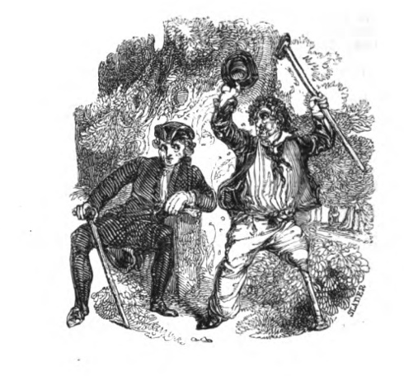
Figure 63: James Northcote, ‘End plate accompanying the fable “The Nightingale”’ in One Hundred Fables, Original and Selected (London: Geo. Lawford, 1829), p. 174. This image can be viewed in this book, or in the non-redacted version of this PhD thesis, held at the University of Sheffield Library.

Here, in the endplate to Northcote’s fable ‘The Nightingale’ in which a caged nightingale rails against her fate as a captive of a seemingly all-powerful human supremacy, Northcote, like Smith, demonstrates the repercussions of state policy and war. The well-dressed, clearly upper-class gentleman is confronted by the reproving figure of the disabled, discharged soldier. The gentleman turns his back and shoulder towards the injured man in an attempt to block him out, but his eyes are still turned in the invalid’s direction, as if he cannot help but look. He is unable to entirely ignore him. The gentleman’s cane sits at precisely the same angle as the soldier’s wooden leg and crutch, echoing it, and indicating a relationship between all three items. Society should not, the moral inculcated within this sketch makes clear, turn its back on such ex-soldiers. The men who are lost in what Richard Price terms ‘offensive […] always unlawful’ wars, are the very men who would have potentially become the husbands of the women reading Smith’s novels, or who were their brothers, or fathers, or fiancés. These fallen heroes attain a different type of beauty, becoming a mere beautiful memory, memorialised by Smith’s prose and a testament to ‘the folly as well as the iniquity of wars’ presided over by a seemingly uncaring governmental power who do not feel the consequences of their actions. They become the ‘beautiful young men’ of a lost generation of soldiers who never return from the battlefield.

This, in itself, brings us back to the artefact of the portrait itself, as the portrait left behind would be all that remained for those grieving widows, sisters and daughters. As Jonathan Richardson observes in his Theory of Painting:

And thus we see the persons and faces of famous men, the originals of which are out of our reach, as being gone down with the stream of time, or in distant places: and thus we see our relations and friends, whether living or dead, as they have been in all the stages of life. In picture we never die, never decay or grow older.

The picture preserves the memory and substitutes for the originals of all of those men who never returned from the battlefield. By presenting their military heroes in a very specific manner, inflected and infused with the aesthetic of the beautiful, both Northcote and Smith evoke the concept that this is a path redolent of powerlessness rather than masculine agency. It is a path leading to the ultimate loss of the masculine self. Although Smith adapts her message to inculcate it with an inherently feminist one, the end perception of war can only ever be a negative one. As Anna Laetitia Barbauld writes in Eighteen Hundred and Eleven (1812), ‘War’s least horror is the ensanguined field.’ Rather, it is the shattered fathers, brothers and sons who fail to return from the battlefield and the consequences of this on ordinary family life. War is something that never just happens far away. The repercussions always come home. Both Northcote and Smith appreciate these horrors (Smith firsthand in the loss and maiming of her own sons through military endeavour). Figures 64 and 65 outlines Northcote’s comprehension of the devastation of war on the state of the domestic nation. The first illustration, featured at the opening of Northcote’s fable of ‘The Trooper’ shows the Trooper’s fate on the battlefield. The closing endplate to this story shows the Trooper’s weeping relatives in a drawing room, far away from the field of battle, and yet suffering its consequences nevertheless.

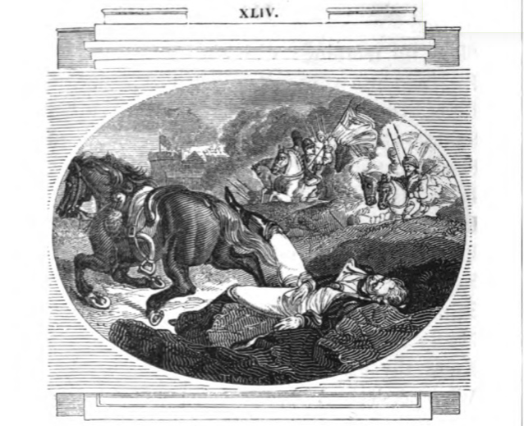
Figure 64: James Northcote, ‘Illustration accompanying the fable “The Trooper”’ in One Hundred Fables, Original and Selected (London: Geo. Lawford, 1829), p. 114. This image can be viewed in this book, or in the non-redacted version of this PhD thesis, held at the University of Sheffield Library.

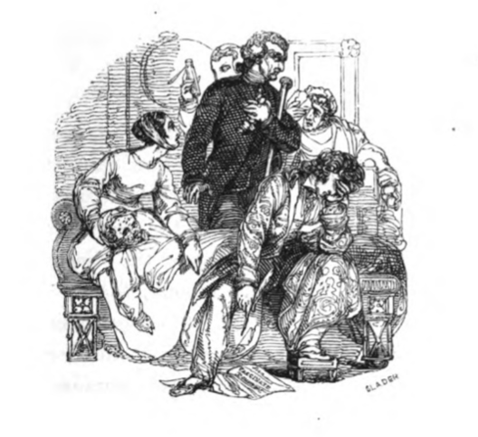
Figure 65: James Northcote, ‘End plate accompanying the fable “The Trooper”’ in One Hundred Fables, Original and Selected (London: Geo. Lawford, 1829), illustrating the consequences of the Trooper’s death upon his family, p. 115. This image can be viewed in this book, or in the non-redacted version of this PhD thesis, held at the University of Sheffield Library.

With her exhibition of Orlando as ‘beauty in distress,’ Smith further brings to light the fact that men and women often want very different things from portrayals of romantic relationships. As Bartolomeo terms it, there exists a ‘subversion of romance’ in this romantic novel. Jane Miller argues in Women Writing About Men, ‘men’s heroes “who would put achievement before love” are not women’s heroes, “who would be … prepared to love her and to hear her first.”’ Smith – like Northcote – is making the point that the military hero who appears so dashing in his uniform is not the hero a woman actually wants or needs. Smith emphasises the fallacy of General Tracy’s belief that women ‘of all ages and descriptions, will not like a handsome young fellow the less for having a cockade in his hat.’ Rather, she draws her reader’s attention to the inevitable consequences of war, as Northcote does in his fable ‘The Trooper,’ with figures such as Mrs. Fleming:

War had deprived her [Mrs Fleming] of her first support [her husband]; yet him on whom she next relied [her son] she was compelled to part with for the same dreadful trade, because her pension, as a lieutenant’s widow, which was almost her sole dependence, was very insufficient for the support of her four other children.

The feminist message which is revealed in Smith’s text is that society must readdress its behaviour, because government wars and their treatment of soldiers are failing one half of the population. Similarly, male perceptions surrounding what is ‘noble’ and ‘heroic’ will only destroy happiness. Monimia herself spells out for Orlando that him becoming a soldier is not what she requires from her romantic hero at an early stage in their relationship: ‘“And yet,” said Monimia shuddering, “and yet Orlando you sometimes talk of being a soldier.” “Ah! my sweet friend,” replied Orlando, “I have no choice, but must be what they would have me.”’ However, Orlando is flawed in his reasoning here. He does have a choice – he has already been offered the option to go into business with his rich uncle Woodford, which he turns down with alacrity on the slightest of excuses, because it doesn’t fit with his idea of what is noble for a gentleman to do (a yet further example of the ‘foolish delusion’ of his beautiful nature). Clinging to this ‘foolish delusion’ of honour cannot make Monimia happy. Neither, as will be proven, will it render Orlando happy either.

The gap between the ‘foolish delusion’ of honour and happiness is highlighted within the Kantian understanding of the sublime and the beautiful. Here, as Shell argues, there is ‘a difference between happiness and virtue, on the one hand, and beauty and sublimity, on the other - between, in other words a moral gap that should be closed and a natural gap that cannot be so.’ The first writer who brought the terms ‘Sublime’ and ‘Beautiful’ together was Anthony Ashley Cooper, the third Earl of Shaftesbury, in Characteristicks of Men, Manners, Opinions, Times. The treatise, as Paddy Bullard observes, ‘makes it […] clear […] that Shaftesbury does not distinguish between the capitalized pairings of words ‘SUBLIME and BEAUTIFUL, ‘DECORUM and SUBLIME of actions,’ and ‘HONESTUM and PULCHRUM.’ Within Shaftesbury’s definitions of the aesthetics, morality and virtue (‘the morally beautiful […] the moral, the honourable’) are ineluctably mingled. Paddy Bullard argues that part of Burke’s raison d’être was to demonstrate the inaccuracy of this and the incompatibility of the two terms ‘sublime’

and ‘beautiful.’ Bullard observes how:

[i]n the preface to the 1757 first edition, he [Burke] locates the origin of his project in his perception that ideas of the sublime and of the beautiful ‘were frequently confounded; and that both indiscriminately applied to things greatly differing, and sometimes to natures directly opposite.’ Later he contends that ideas of the sublime and of the beautiful ‘stand on foundations so different, that it is hard, I had almost said impossible, to think of reconciling them in the same subject.’

Like Kant’s understanding of the terms, Burke’s definition of ‘the sublime’ and ‘the beautiful’ have very disparate moral implications:

From what has been said in the foregoing section, we may easily see how far the application of beauty to virtue may be made with propriety. The general application of this quality to virtue, has a strong tendency to confound our ideas of things; and it has given rise to an infinite deal of whimsical theory; as the affixing the name of beauty to proportion, congruity, and perfection, as well as to qualities of things yet more remote from our natural ideas of it, and from one another, has tended to confound our ideas of beauty, and left us no standard or rule to judge by, that was not even more uncertain and fallacious than our own fancies. This loose and inaccurate manner of speaking has therefore misled us both in the theory of taste and of morals; and induced us to remove the science of our duties from their proper basis, (our reason, our relations, and our necessities,) to rest it upon foundations altogether visionary and unsubstantial.

This disparity between the moral virtuousness of the sublime in nature and the lack thereof within the beautiful is a trope which Northcote follows within his work. Within his series of moral plates, Diligence and Dissipation (1796), Northcote outlines the fate of two servant girls. One is virtuous and modest, whilst the other is dubbed a ‘Wanton’ (Figure 66).
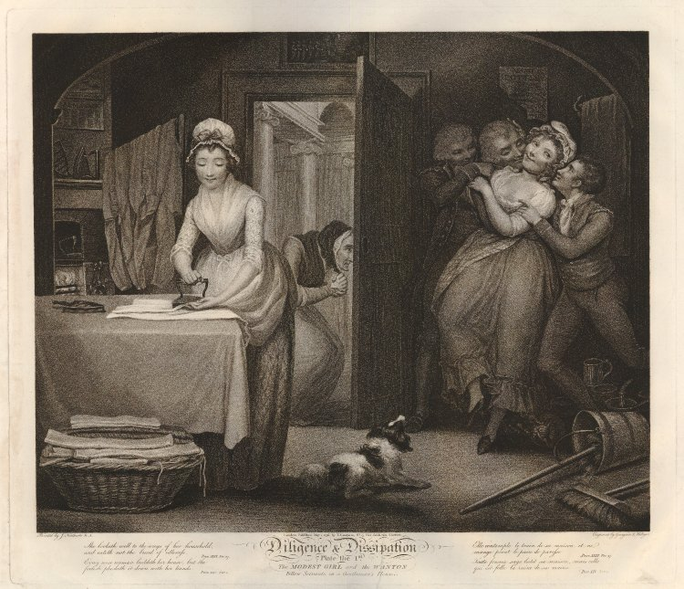
Figure 66: After James Northcote, The Modest Girl and the Fellow Wanton Servant, plate I from James Northcote, Diligence and Dissipation: Or, The Progress of a Modest Girl and a Wanton, Exemplified in Ten Different Stages of Their Lives, Being an Attempt to Exhibit the Natural Consequences which attend on Good and on Bad Conduct (London: H. L. Galahin, 1796), engraved by Thomas Gaugin and Thomas Hellyer, 1796, etching on paper. This image can be viewed in this book, or in the non-redacted version of this PhD thesis, held at the University of Sheffield Library.

It is interesting how much Northcote’s ‘Wanton’ resembles the actor William Henry West Betty, in their mutual portrayals by the same artist (Figures 55 and 56). Indeed, within the collection of plates, the wanton is named ‘Betty’ as well. The Wanton’s facial features and the curls on her hairline all precisely match with Betty’s, linking the artist with that wanton, female beauty expounded by Hogarthian theories of beauty (‘[a] lock of hair falling thus cross the temples, and by that means breaking the regularity of the oval, has an effect too alluring to be strictly decent.’) The same tropes of ‘the beautiful’ are adopted: the gradual lines of the woman’s figure, the ‘shining cheerfulness in the eyes’ of the wanton, and the curls of her escaping hair. Conversely, the ‘sublime’ nature of the virtuous woman’s moral stance is illustrated within the final plate in the collection (Figure 67). Here, the virtuous woman is the most visible part of the illustration, shining in her purity, and appearing large to the viewer’s gaze. The dimensions of her wedding gown makes her appear much the largest object in the picture. Conversely ‘the beautiful’ wanton is now consigned to her grave and, like all Burkean beautiful things, becomes small and barely visible. She is now concealed in a darkly shaded coffin, which is almost too small to distinguish accurately in the background of the print.

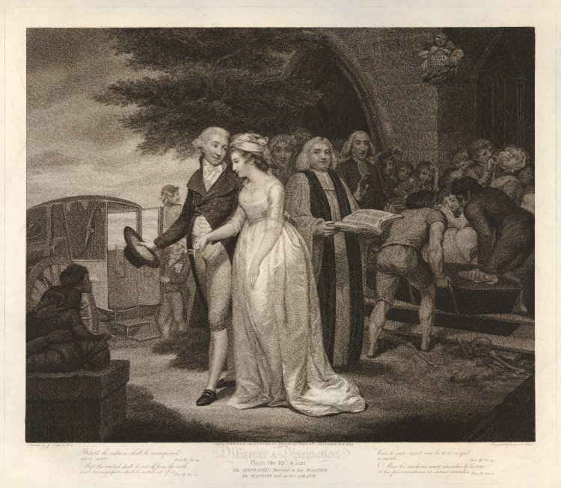
Figure 67: After James Northcote, The Good Girl Married to her Master, the Wanton Laid in her Grave, Plate X from James Northcote, Diligence and Dissipation: Or, The Progress of a Modest Girl and a Wanton, Exemplified in Ten Different Stages of Their Lives, Being an Attempt to Exhibit the Natural Consequences which attend on Good and on Bad Conduct (London: H. L. Galahin, 1796), engraved by Thomas Gaugin and Thomas Hellyer, 1796, etching on paper. This image can be viewed in this book, or in the non-redacted version of this PhD thesis, held at the University of Sheffield Library.

Similarly, the moral qualities of ‘the sublime’ and ‘the beautiful’ in character is a trope which Smith also works with in her novel Montalbert (1795). Here, in this later novel, the reader is presented with a portrait of masculine beauty at its most corrupt, whilst the feminine beauty available in the person of the heroine Rosalie, is entirely useless to her. Within this novel, both hero and heroine possess qualities of ‘the beautiful.’ Rosalie has a ‘peculiar mildness of […] disposition.’ ‘[N]either sullen nor melancholy,’ once she returns to the home of the Lessingtons, Rosalie’s thoughts are nevertheless occupied with ‘how happy she had been’ in her former home with Mrs. Vyvian. Her passions, in effect, ‘turn on reliefs, gratifications, and indulgences’ of her former home. These are sensations, as Burke outlines, which ‘are therefore more lovely [than the sublime], though inferior in dignity.’ The reader sees Rosalie most often at the beginning of the text ‘[a]mong colours, such as are soft or cheerful,’ such as the ‘green’ of her South Downs home. She, like Desmond, is ‘amiable,’ one of those characters

who creep into the hearts of most people, who are chosen as the companions of their softer hours, and their reliefs from care or society. […] It is the soft, green of the soul on which we rest our eyes, that are fatigued with beholding more glaring objects.

‘The soft, green’ of Rosalie’s ‘soul’ is illustrated as being thus via the ‘soft, green’ of the rolling hills of the South Downs of her surroundings, which are entirely suited to her nature.

Once again, like Northcote, Smith uses contrasts to ensure that the reader views Rosalie in her true beautiful light. It can be no coincidence that Rosalie’s reading material of choice is ‘the history’ in Mrs. Lessington’s library. Smith’s direct reference to ‘an old History of Rome’ reminds the reader of Burke’s assertion that the sublime nature can be traced ‘in reading the characters of Caesar and Cato.’ Rosalie’s failure to find that any of these texts ‘contributed to enlarge her philanthropy, or furnish her with rules for the conduct of her life’ further underscores her beautiful nature. Unlike Burke, she sees nothing sublime in these histories and finds nothing ‘to admire’ or ‘reverence.’ She fails to understand the sublime, indicating her affiliation with ‘the beautiful.’ Rosalie is a miscellany of beautiful characteristics and ‘positive qualities,’ ‘excit[ing] in us the passion of love, or some corresponding affection.’ Nearly every male Rosalie encounters in the text is smitten by her and inspired by passion or love. At her inaugural appearances in public, the narrator acknowledges ‘[t]he admiration Rosalie had so universally excited.’

However, it is only when Rosalie meets the equally beautiful in nature Montalbert, that one of these males invokes a corresponding passion within her and in a very brief period, what commences as ‘an infant passion’ takes ‘entire possession of her mind.’ Amongst others, Montalbert’s ‘beautiful’ nature is signified by his ‘vivacity,’ and his ‘warm and lively’ nature. These are the qualities which both Burke and Kant have outlined as belonging to the sphere of ‘the beautiful’ as highlighted earlier, and which Smith awards to her other male heroes previously discussed, such as Warwick and Orlando. Montalbert’s beautiful nature is further signified by his delicacy. During an early conversation, Montalbert complains of sickness, revealing to Rosalie that he is ‘not very well.’ This apparent infirmity connects him with that ‘idea of weakness and imperfection’ which Burke attributes to the beautiful. Perhaps most revelatory, however, in connection with Montalbert, is his national identity as an Italian. In the Kantian definition of the term, ‘the Italians and the French are […] those who most distinguish themselves in the feeling of the beautiful.’ ‘The beautiful itself is either enchanting and touching, or laughing and charming,’ Kant continues. There can be little doubt in the reader’s mind that Montalbert has both enchanted and charmed Rosalie:

She ran over in her mind every look, every sentence of Montalbert, and sincerity and tenderness seemed to dwell upon his tongue. What but real affection could induce him to speak, to act as he had done? and what could be so fortunate as her inspiring such a man with a passion such as he professed to feel for her. A consciousness of attractions, which till very lately she never suspected that she possessed, gave her a momentary pleasure;

Montalbert has charmed Rosalie into that ‘infant passion’ via his flattery of her and awakening of a sense of her own desirability as a woman. That the narrator is obliquely cautioning the reader not to take Montalbert’s charms at face value however, is implied with that revelatory ‘seemed’ in relation to the ‘tenderness’ that dwells ‘upon his tongue.’ The inaccuracy of Rosalie’s assumptions concerning Montalbert’s character are illuminated through a work of portraiture. As Rosalie cradles the miniature portrait Montalbert has presented her with, this portrait is proven to be an unstable signifier of character and morality as Rosalie particularly takes note of ‘[t]he candour and integrity of the countenance’ within it. ‘Never, (sighed she), can the heart that belongs to these features be otherwise than generous, tender and sincere.’ Of course, the succeeding action within the novel will prove Rosalie disastrously wrong. As noted earlier, as Kant observes, if the ‘moral feeling is beautiful, [it is] yet without principles,’ and Montalbert is entirely ‘without principles,’ and presents Smith’s most corrupt depiction of masculine beauty from her oeuvre. Persuading Rosalie to meet with him illicitly, ‘against […] that internal sense of prudence, (which like the voice of conscience, could not be entirely stifled), and the fear of offending her mother,’ Rosalie is seduced utterly by his mad passion for her. However, Montalbert’s true moral state has been revealed yet earlier in the text, via his lack of ‘fear of offending her mother.’ When Mrs. Lessington insists that Rosalie leave the dance early, Montalbert’s malevolence is revealed in his ‘smiling half maliciously’ on her mother leaving him momentarily alone with Rosalie, so that he can press his suit. Throughout the text, Montalbert will inflict a variety of unkind actions and judgements on Rosalie, the culmination of which will ultimately destroy her health and happiness.

All of Rosalie’s subsequent sufferings, of which there are much and many, result from her terrible decision to secretly marry Montalbert in the first place. Throughout the course of the text, Montalbert will abandon Rosalie as he attempts to appease his dictatorial mother, during which time she is forced to reside with her infant son alone, and suffers through the Sicilian earthquake of 1783. This renders her homeless. She is then kidnapped and held prisoner on the orders of Montalbert’s mother. Escaping with the help of the English Walsingham, Rosalie is then subject to accusations of infidelity by the volatile Montalbert. This leads Montalbert to recruit two cruel individuals represented with almost criminal physiognomies (‘[t]he man, who had a countenance which seemed made on purpose to execute such commissions’) to force Rosalie into relinquishing her son to him. The separation from her child is by far the worst affliction for Rosalie, and it is this which tips her over the edge into insanity. Calling ‘incessantly for her child’ and ‘implor[ing] her husband to pity her,’ ‘her senses [are] totally deranged.’

By the conclusion of the text, Rosalie will have ‘suffered every possible calamity’ before seeing ‘her husband returned, her child restored.’ However, the ability to experience happiness is gone from her forever. Rosalie, by the conclusion of the story is a mere shell of a woman, all emotion wrung out from her, by the actions of her volatile husband with his poisonously beautiful and immoral nature. The best happy ending the narrator can come up with is couched in such terms of: ‘Montalbert enjoyed [...] more happiness than usually falls to the lot of humanity’ whilst Rosalie passed her life in studying how to contribute to his felicity.’ Rosalie’s elopement has ultimately led to a life sentence of appeasement of a capricious and unworthy husband, in other words, living in constant fear of his explosive temper and wild ways.

Rosalie has paid a high price for her ‘infant passion.’ Indeed, the implication seems to be that the price of female desire and succumbing to this, is expensive. Eleanor Ty argues that in Emmeline, Smith ‘asserts the presence and validity of female desire’ via ‘Adelina’s love for a man who is not her husband.’ Ty draws attention to ‘traditional thinkers [who] believed that a wife should have no desires of her own,’ as espoused by conduct books. Rosalie, too, in eloping with Montalbert in a manner which is indicative of the immorality of the beautiful, sacrifices herself to this passion. The fact that Rosalie is willing to do this puts into contention the point made by Burke that sexual desire is something which can only be experienced by men for women, ‘[t]he first is, the society of sex. The passion belonging to this is called love, and it contains a mixture of lust: its object is the beauty of women.’ However, in Montalbert, Rosalie’s downfall is entirely attributable to her desire for the eponymous ‘hero.’ During her early relationship with him, she entirely succumbs to that ‘desire or lust; which is an energy of the mind, that hurries us on to the possession of certain objects.’ As the narratorial

voice advises the reader:

To be continually in presence of a beloved object, to see or suppose that his attachment every moment becomes stronger, to listen to arguments to which the heart yields but too ready an asset, was a situation of all others the most dangerous for a young woman who had not seen her nineteenth year. Montalbert, besides the advantages of a very handsome person, had the most insinuating manners and the most interesting address: he was naturally eloquent – love rendered his eloquence doubly formidable.

Montalbert is not only physically desirable to Rosalie, but he also flatters her with his ‘insinuating manners.’ The note of caution concerning the future price Rosalie will pay for her desire is veiled by the narrator in the text: ‘to see or suppose that his attachment every moment becomes stronger.’ Montalbert’s love is not real - it only really exists within Rosalie’s romantic imagination. This state of affairs is proven by his later reprehensible treatment of her. However, the narrator also cautions the reader not to judge Rosalie too harshly in her behaviour, in a moment of narratorial interruption. Female desire, for a handsome man, the implication
is, is quite natural:

Let no fastidious critic, on the characters of a novel, declaim against the heroine of this, as being too forward or too imprudent. […] There are other errors, which, in an imaginary heroine, we may at once blame and pity, without finding the interest we take in her story weakened. This is the sentiment that Rosalie may excite; who being tenderly attached to a man, not only amiable in his person, but of the most insinuating manners, believing his declarations of love, and persuaded that her friends could not disapprove of the step he so earnestly urged her to take; fearing, on the other hand, to lose him; that he would be convinced he was indifferent to her, would return to Italy, and make an effort to forget her; found her objections giving way before so many motives, and at length, though with trembling reluctance, agreed to the expedient Montalbert proposed – of their being married by the priest whom he had engaged for that purpose. Rosalie neither knew the danger this man incurred, nor that her marriage would not be binding.

Barbara Claire Freeman argues that Burke’s treatment of the sublime and the beautiful ‘conceals that the domains of the beautiful exerts its own peculiar form of tyranny.’ This tyranny becomes apparent not only in the manner in which Montalbert with his beautiful nature tricks Rosalie into an imaginary and illegal marriage, but in the tyranny of Rosalie’s own sexual desires. Afraid to lose her beautiful hero, the darker side of Rosalie’s desire is the ultimate price she will pay for it. The loss of her virtue and her status as an honourable woman is not the highest price she will pay. Rather, Rosalie’s desires lead her to lose her home, her freedom, her child, and, ultimately, her very self as Montalbert’s cruelty causes her decent into madness. Once again, the reader is back in the domain of receiving marital guidance from Smith and her narrator. Like Isabella in The Wanderings of Warwick before her, Rosalie can only regret her choice of marriage partner, once the romance is over and the reality of her relationship with her volatile and immoral beautiful husband becomes clear.

In Rosalie’s instance, however, this regret comes too late. Nancy K. Miller observes of the ‘Plots and Plausibilities in Women’s Fiction’ whilst discussing La Princesse de Clèves, ‘[t]he princess refuses to marry the duke […] not because she does not want to live happily ever after, but because she does. And by choosing not to act on that desire but to preserve it […] as fantasy’ she manages to achieve her aim of living ‘happily ever after.’ Rosalie, however, has already acted on her desire for Montalbert, and as a result of this, does not achieve her fairy tale ending. Rather, as noted earlier, it leads to the very opposite: a mere existence and the relinquishment of all happiness in attempting to live peaceably with an unruly partner. In order to retain her happiness, she too should have relinquished her desire for Montalbert.

Rosalie is altered completely by her experiences from the ‘beautiful’ heroine she once was. Whilst Montalbert continues as a ‘beautiful’ hero throughout the text, never improving or learning anything from his adventures, Rosalie is educated through her misfortunes, becoming sublime in nature and improving on just belonging to the sphere of ‘the beautiful.’ The first clue to this is the transformation of her settings which alter sharply from the soft, rolling green hills of the South Downs to the sublime territory of the Sicilian landscape. When the earthquake takes place during Montalbert’s absence, the transformative nature of Rosalie’s succumbing to her sexual desire for Montalbert and her growth as a woman, becomes clear. The reader is projected back amongst that landscape of ‘subterranean volcanic processes which figure a moment of crisis,’ just as Ethelinde’s lightening strike marks her own catastrophe. Rosalie’s sexual desire for Montalbert, and the outcome of this, is figured by Smith in a literal upheaval of the landscape during the earthquake and subsequent tsunami which, as Hamilton observed, caused ‘the greatest mortality.’ The landscape becomes sublimely apocalyptic. Like the Prince of Messina, as described by Sir William Hamilton’s paper to the Royal Society, Rosalie takes shelter on the shore of the bay, and like the real inhabitants of Messina, during the night,

the same shock which had raised and agitated the sea so violently, and done so much damage […] acted with still greater violence there, for that the wave (which was represented to have been boiling hot, and that many people had been scalded by its rising to a great height went furiously three miles inland and swept off in its return 2473 of the inhabitants.

From here, in addition to Montalbert’s abandonment of her in order to appease his tyrannical mother, Rosalie will be forcibly removed and imprisoned, and commence on her journey to the ultimate loss of her identity. All of these events follow on from Montalbert’s corruptly beautiful nature and failure to be a good husband because his character fits so entirely with the aesthetic of the beautiful. Sexual desire has transformed Rosalie’s landscape in a very literal way within this novel. She has been taken away from the beauty of the South Downs landscape, which formerly provided a suitable setting for the ‘beautiful’ nature of her nineteen-year-old self, and placed instead into a background of sublime imagery befitting a mature, sexually aware woman. Rosalie’s final transformation from ‘beautiful’ to ‘sublime’ heroine, however, comes at a high price: through insanity and near death. As Thomas Hardy observes in Far From the Madding Crowd (1874), of the ruined maid Fanny Robin (like Rosalie, a woman who has succumbed to her sexual desire for Sergeant Troy), Fanny ultimately manages to transform herself from weakly ill to sublimely powerful via ‘the one feat alone – that of dying- by which a mean condition could be resolved into a grand one.’ Similarly, Rosalie’s derangement and near death, the utter dissolution of herself, transforms her into a sublime object. She becomes one who is able to wield power over her unruly husband through his destruction of her, ‘[w]hen he finds that he has destroyed me, it is he, poor man, who will want consolation – who will be an object of pity.’ Rosalie, unlike Fanny Robin, does elude the abyss of death, yet the experience has altered her from weak, infatuated romantic teenager, the victim of numerous forces, including her own husband, her mother-in-law and gossiping neighbours, to a woman who pities those lesser than her. For Rosalie, the near-death experience is sufficient to transform that ‘mean condition’ of a dishonoured woman ‘into a grand one’ who partakes not of ‘the beautiful,’ but rather of the sublime. Rosalie is effectively forced to renounce her femininely beautiful nature, as it has done her no good whatsoever. Indeed, it has nearly destroyed her, and the only way in which she has survived is to alter her very essence from the beautiful to the sublime.

With Smith’s depiction of the suffering Rosalie, she differs from Northcote’s depiction of the dead wanton (Figure 67) in awarding agency to her nearly dead heroine, whereas Northcote merely emphasises the beautiful nature of the deceased woman by diminishing her yet further in her coffin. However, both Rosalie’s and the dead woman’s experiences present the transformative nature of sexual desire for women. Indeed, both artists refute the concept presented by Burke that sexual desire can only be experienced by men. In both illustration and text, however, the end result is a negative one. It truly does represent the darker side of desire for women. In Smith’s works, as has been argued, the ‘beautiful’ is charted through a downward spiral of increasing corruption in the male heroes who exhibit the characteristics of the aesthetic as argued by Kant and Burke. Whereas Orlando and Warwick are purely beautiful, not really harming their heroines too much, and Sir Edward is able to exert self-control over his own desires, Desmond’s casual disregard of Geraldine’s well-being in his passionate obsession with her marks the commencement in the trend for Smith’s heroes to be harmfully beautiful in their nature. By the time of the publication of Montalbert in 1795, Smith’s disillusionment with masculine beauty is complete, as he is presented as fully corrupted. This is something, as Smith shows with Rosalie, that can only ever impact negatively on the existence and family lives of women in eighteenth-century society.

The works of Smith and Northcote illustrate how both artists engage with the aesthetic of ‘the beautiful’ in strikingly similar ways, presenting male heroes who are essentially beautiful in nature, in accordance with the theories as expounded by both Burke and Kant. Both Northcote and Smith employ contrasts to differentiate between sublime settings and throw into relief the beauty of their subjects. Smith even goes so far as to contrast male characters who are beautiful alongside male characters who are sublime in the same novel, perhaps outlining these choices as a cautionary tale to her young female readers to choose wisely in the selection of a marriage partner. Smith demonstrates how the traits of the beautiful hero, such as Montalbert’s flawed characteristics, can only ever ultimately hurt women. Here Smith undermines the masculine assumption by both Kant and Burke that the male is the superior sex. In her novels, it is generally her male heroes who fail to think effectively, whilst it is the women who exhibit that Kantian ‘deeper understanding.’ Smith makes clear that this female shrewdness is rendered necessary by the stupidity and rash, reckless behaviour of her beautiful heroes. She also queries the validity of the assertion that Burke and Kant make that the sublime is always masculine, by creating heroes like Desmond who are characterised by a feminine passivity and inability to act. Whilst acknowledging that ‘beauty in distress […] is much the most affecting beauty,’ Northcote and Smith employ this Burkean device to make critical commentary on the nature of eighteenth-century society and how military men (who should arguably appear as sublime and powerful subjects) are rather femininely powerless and at the mercy of a corrupt government and whatever orders this government wishes to issue. Orlando’s ‘beauty in distress’ from his post-battlefield experiences, for example, permit him to live the life of the eighteenth-century femme couvert. This new perception of battle-traumatised masculinity argues for the feminist ideal of gender equality. The following chapter will consider the portraits of women in greater detail as they appear in Smith’s contemporaneous society, and the nature of the aesthetic tropes employed by printmakers and engravers in order to characterise women’s social position within society and what can be learned by considering the pictorial signifiers concerning women contained within these collections of prints.

Chapter Four
A Bevy of Beauties, An Anthology of Prostitutes, A Consternation of Mothers: The Print Collections of John Raphael Smith, Emma Smith and Charlotte Smith

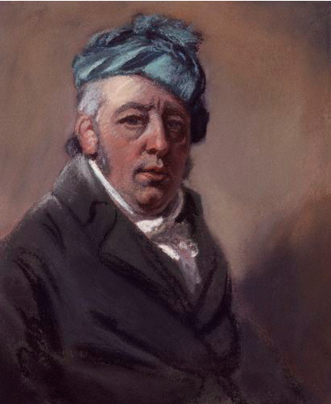
Figure 68: John Raphael Smith (1751-1812), Self-Portrait, 1807, pastel on paper. This image can be viewed in the non-redacted version of this PhD thesis, held at the University of Sheffield Library.

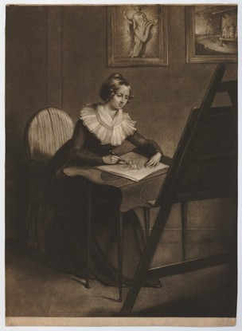
Figure 69: Ann Probyn (apprentice of John Raphael Smith), Female Study: Portrait of Emma Smith (1783-1853), 1801, mezzotint engraving. This image can be viewed in the non-redacted version of this PhD thesis, held at the University of Sheffield Library.

This chapter explores the connection between the literary works of Charlotte Smith with the work of pioneering printmaker and engraver John Raphael Smith (1751-1812) and the brief artistic career of his daughter, Emma Smith (1783-1853). J. R. Smith was a ‘superb mezzotint engraver and print publisher, producing over 300 prints and employing the young Thomas Girten and J. M. W. Turner.’ He also completed portraits in pastel. J. R. Smith made a living through his print shop which specialised in reproducing art works exhibited by the Royal Academy. As Ellen G. D’Oench observes:

[t]he public’s demand for reproductions after celebrated painters increased dramatically with the establishment of exhibiting societies in the 1760s and the founding of annual exhibitions at the Royal Academy in 1769. British artists, formerly relegated to the fringes of the art market, were now acquiring public followings and international reputations. Mezzotints reproducing their work found a ready market.

The Morning Chronicle in 1792 commented that William Hogarth ‘used to assert, that whoever lived fifty years after him would see Print Shops as common as porter houses; [and] every street gives proof that he was not only a painter but a prophet.’ In spite of the fact that Reynolds et al of the Royal Academy wished to exclude ‘the meaner sort,’ of people by charging for admission to the exhibitions, this very class of people were gaining unprecedented access to contemporary art works, cheaply available to purchase from print shops such as those run by J. R. Smith at Exeter Court in London or John Boydell’s Cheapside premises. These art works were released by engravers and printers simultaneously as they were exhibited, or as D’Oench observes of J. R. Smith’s works, sometimes even before the exhibit at the Royal Academy commenced. It was part of J. R. Smith’s ‘joke’ at the expense of the Royal Academy, who refused to grant engravers full membership, despite the fact that many engravers, including Smith, were completing original works of art and not just copies from the Academy exhibitions. Artworks were available before the paying members gained entrance into the Academy to view them, and were looked at by all and sundry, free of charge, in the print shop window (Figure 70).
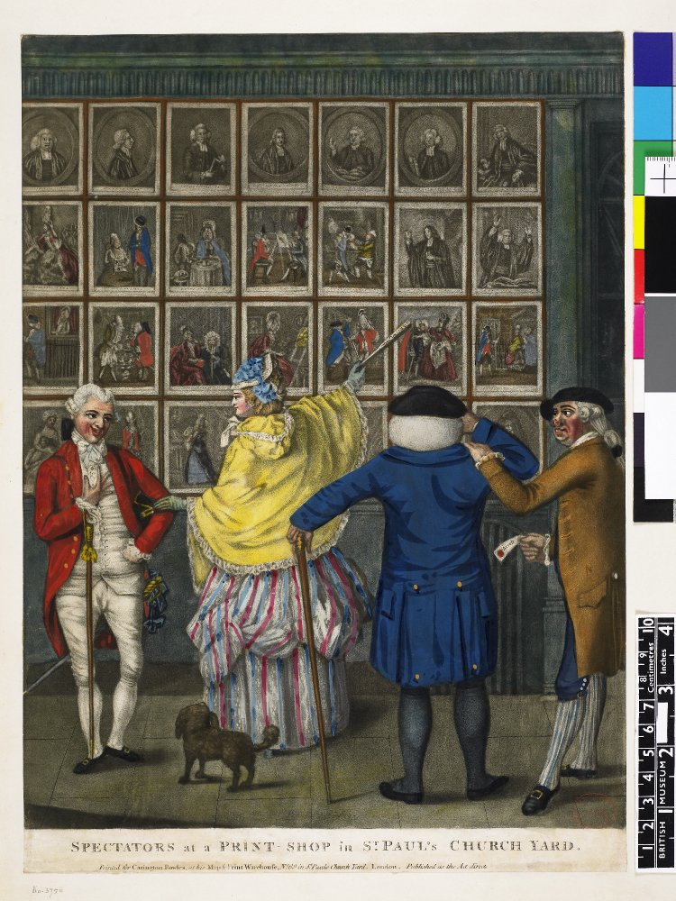
Figure 70: John Raphael Smith, Spectators at a Print Shop in St. Paul’s Churchyard, 1774, mezzotint on paper with hand-colouring. This image can be viewed in the non-redacted version of this PhD thesis, held at the University of Sheffield Library.

As an engraver, printmaker and print shop owner, J. R. Smith took the tropes of original artworks from a diverse range of contemporaneous artists and played with the aesthetics within these to produce his own interpretations of their original works. Like Charlotte Smith, George Smith of Chichester, George Romney and James Northcote, as discussed in the earlier chapters, J. R. Smith too was accessing popular aesthetic tropes taken from the picturesque, the sublime and the beautiful, and presenting these within his engravings and prints. This chapter will examine these systems of aesthetics as employed by both C. Smith and J. R. Smith, and analyse how both artists use these to make statements about their society. J. R. Smith employs a collection of traits from these systems of aesthetics as a kind of cultural shorthand to convey a clear commentary (either mocking or moral) to his audience. That J. R. Smith was confident enough that the message would emerge with clarity for his viewers via these tropes demonstrates how immersed Romantic era society was in these aesthetic theories. As has already been seen, C. Smith also often adopts these theories of visual artistry in order to depict her landscapes and portray her characters. If a purveyor of popular prints appealing to a mass audience was using a compilation of traits from the picturesque, the sublime and the beautiful in order to create his own message concerning society, it seems clear that the characteristics of these theories were understood throughout society.

Just as the works of J. R. Smith employ a compilation of the aesethetic tropes in order to convey a clear commentary about the nature of the world he lived within, like C. Smith, J. R. Smith was an artist who was deeply interested in the position of women in his society, and his corpus presents, to some extent, a portrait gallery of all categories and conditions of women. This chapter explores the nature of collections in both the compilation of aesthetic theories that are being employed by the artists, and how these merge together to create a collection of the portrait of womanhood in society during the time. The chapter will explore J. R. Smith’s typical tropes and motifs in his engraved prints of a variety of women across the social classes and demonstrate how C. Smith’s own interest in feminine endeavour and struggle within her society, led her to create a collection of her own within her educational works for children. The acquaintance between J. R. Smith, his daughter Emma, and Charlotte Smith is one that has not been fully explored by any scholars researching C. Smith’s works. Yet, there are clear cross-currents which existed between these artists and demonstrate that if C. Smith was influenced by the work of J. R. Smith and E. Smith, then they were equally inspired and influenced by her wide body of literary works.

It might be helpful at this stage to clarify the relationship between the three artists. C. Smith was an acquaintance of J. R. Smith and his daughter, Emma. J. R. Smith was one of the pioneers of the eighteenth-century engraving and printmaking industry and belonged firmly within the same circle of artists as C. Smith. Like C. Smith, he had friendships with William Godwin and James Northcote, as well as business relationships with George Romney and George O’Brien Wyndham, the third Earl of Egremont. J. R. Smith’s early prints were published by C. Smith’s first publisher, James Dodsley. Ellen G. D’Oench records that Dodsley published J. R. Smith’s engraving of The Bard (1775). Similarly, J. R. Smith also worked for both George O’Brien Wyndham, the third Earl of Egremont (Figure 71) and much of his portraiture ended up at Goodwood, the family seat of the Duke of Richmond, and patron to Charlotte Smith’s erstwhile drawing master, George Smith of Chichester. This is a location which is close geographically to C. Smith’s home on the Sussex downs, as well as having connections with C. Smith’s former drawing master, the works of whom, as discussed in chapter one, arguably influenced her own literary landscapes. J. R. Smith also completed a portrait of the Duchess of Richmond (Figure 72).

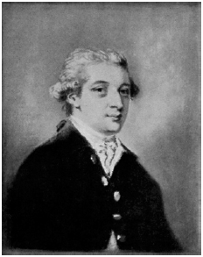  Figure 71: John Raphael Smith, George O’Brien Wyndham, 3rd Earl of Egremont, c. 1785, pastel on paper. | Figure 72: John Raphael Smith, Duchess of Richmond, née Lady Mary Bruce, c. 1785, pastel on paper.

These images can be viewed in the non-redacted version of this PhD thesis, held at the University of Sheffield Library.

One of J. R. Smith’s major works was an extremely popular print of George Romney’s famous painting of a girl reading, Serena (1782). However, J. R. Smith altered Romney’s original painting in his print (Figure 73), which demonstrates in some measure how J. R. Smith embellishes Romney’s use of the sublime in order to emphasise the aesthetic tropes and satirise the figure of the young woman obsessed with reading novels. Within the print, the aesthetics of the sublime is emphasised with the light from the candle providing a sharp point of illumination against an obscure dark background which is contained only artificially by the archway placed above the female reader. The woman’s whiteness in her gown (her shape visible beneath this in a very Romneyesque manner) is another site of illumination within the print. Her figure is almost incandescent, glowing whitely, against the murky wash of the background. Again, this is a very Romneyesque trait. However, within J. R. Smith’s rendering of it, the girl is subtly different from Romney’s original painting (Figure 74). Although she still reads Fanny Burney’s Evelina, as in Romney’s original, J. R. Smith includes four lines of verse from William Hayley’s Triumphs of Temper (1778), in which Hayley’s heroine, Serena, stays up all night to finish reading Evelina, thus using an intertextual reference to subtly alter the portrait so that it becomes a rendering of Hayley’s heroine, rather than a precise copy of Romney’s portrait. J. R. Smith emphasises the comedic elements of a girl staying up all night feverishly reading by also subtly changing the position of his heroine. In his rendering of Serena, she is perched on the very edge of her seat, unlike in Romney’s original where Serena relaxes against sumptuous red velvet cushions. The tropes of the sublime are emphasised and embellished by J. R. Smith in order to demonstrate just how eager the white body of the girl is in her febrile reading. She is literally on the edge of her seat as she progresses through the novel’s plot. The extent of the girl’s agitation in reading her novel is made apparent by J. R. Smith’s exaggeration of Romney’s tropes of the sublime. He has amplified these tropes in order to ensure his viewers get the joke in his portrayal of the risible young girl all too easily influenced by her reading of romantic novels. C. Smith would make a similar point with caricatures of such figures within her own novels, i.e. the character of the foolish Miss Clarinthia in Ethelinde, who is ‘extremely well read’ and whose ‘great delight is in novels.’ This recognisable derisory character from eighteenth-century culture ensured that J. R. Smith’s print became extremely popular, being ‘copied in several variants.’ The print itself must have been known by both Romney and Hayley, both of whom, as this thesis has already explored, had known close personal connections with C. Smith.

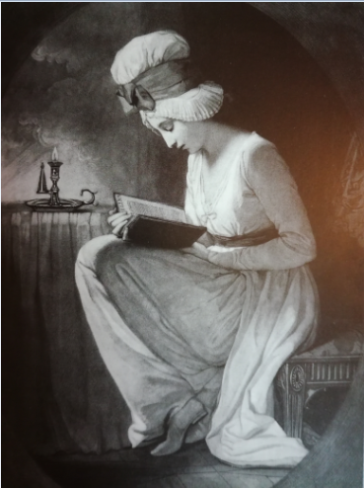
Figure 73: John Raphael Smith (after Romney), Serena, 1782, mezzotint with hand-colouring. This image can be viewed in the non-redacted version of this PhD thesis, held at the University of Sheffield Library.
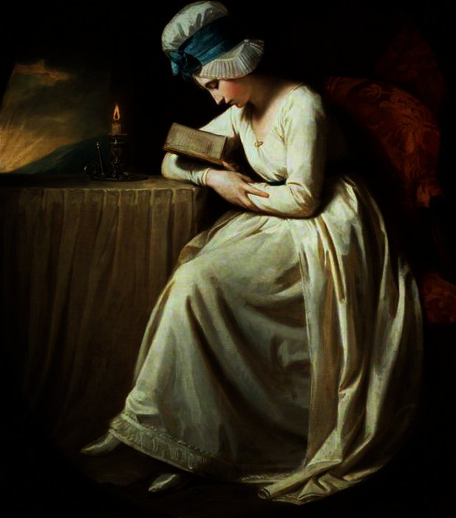
Figure 74: George Romney, Serena, 1782, oil on canvas. This image can be viewed in the non-redacted version of this PhD thesis, held at the University of Sheffield Library.
Charlotte Smith’s friend, William Godwin reported dining with J. R. Smith and his daughters Emma and Eliza in a diary entry of 21st January 1803, and again on 20th January 1805. J. R. Smith also reproduced some of James Northcote’s portraits, and is also portrayed alongside a figure who resembles Northcote in Thomas Rowlandson’s satirical print, The Smithfield Sharpers (Figure 75). Within this humorous piece, Rowlandson, ‘a central figure among Smith’s circle of friends,’ portrays himself and Smith fleecing a youth at cards. J. R. Smith is situated second from the left in the drawing. Rowlandson sits beside the hapless youth, squinting in a calculated manner, whereas the figure whom resembles Northcote is seated behind the youth, overlooking proceedings with a wily eye. The inclusion of the Northcote figure in this sketch indicates that he knew J. R. Smith well, both on a business and a personal/social level. Indeed, in a letter from James Northcote to his brother Samuel, held by the Royal Academy of Art, Northcote describes Smith as ‘one of my most intimate acquaintances.’

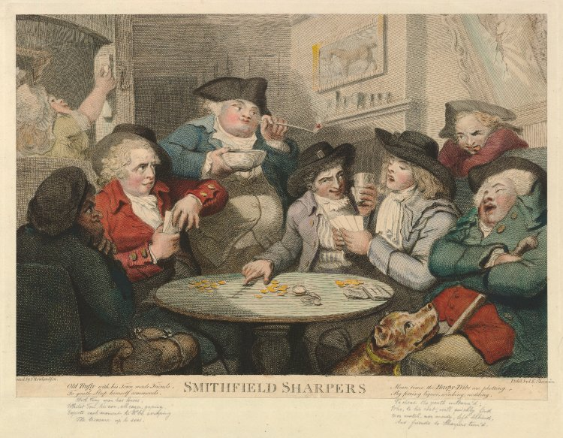
Figure 75: John Keyse Sherwin after Thomas Rowlandson, The Smithfield Sharpers, or The Countrymen Defrauded, 1787, hand-coloured etching engraving on paper. This image can be viewed in the non-redacted version of this PhD thesis, held at the University of Sheffield Library

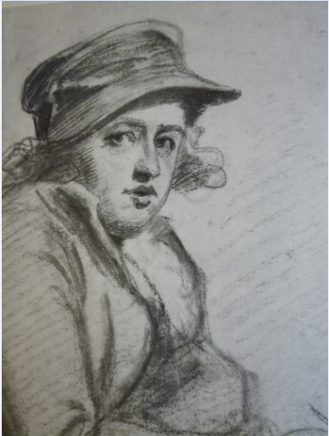  Figure 76: On the left is John Raphael Smith, Self-Portrait, c. 1774-75, pencil, black and red chalk on grey prepared paper. On the right is a detail from Figure 75 showing the character in Rowlandson’s print who has clearly been modelled upon J. R. Smith. These images can be viewed in the non-redacted version of this PhD thesis, held at the University of Sheffield Library | 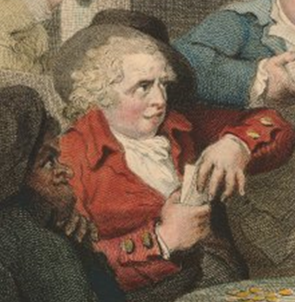

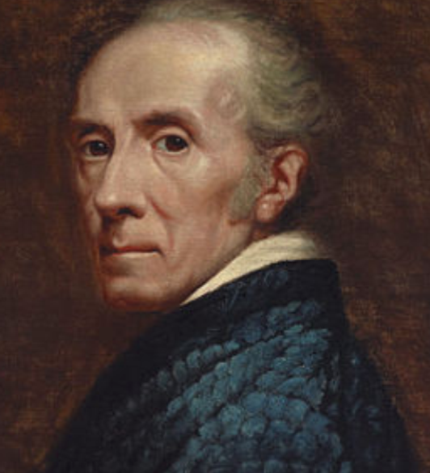  Figure 77: On the left is a detail from James Northcote, Self-Portrait, undated, oil on canvas. On the right is a detail from Figure 75 showing the character in Rowlandson’s print who has clearly been modelled upon Northcote. These images can be viewed in the non-redacted version of this PhD thesis, held at the University of Sheffield Library | 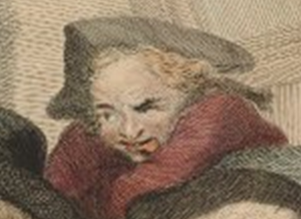

J. R. Smith’s daughter, Emma Smith’s career began early and was very brief, being cut short by youthful motherhood and marriage. Prior to her marriage, her father encouraged her to work alongside him as an engraver. E. Smith was an artistic prodigy, exhibiting works at the Royal Academy from a very young age and C. Smith, on viewing her work, was clearly impressed with it. Writing to Cadell & Davies in 1805 on the subject of her ‘Poem of considerable length [...] on a local subject,’ Beachy Head, Smith raises the question of whether her final poem will be accompanied by illustrations. If they ‘are intended,’ she recommends the work of E. Smith. As an artist, Smith reports, she creates works which are ‘almost too masterly for so young an Artist.’ Very few of E. Smith’s works remain, but the ones which are extant clearly demonstrate both her mastery of her art and her interest in similar themes as her father’s oeuvre. Like J. R. Smith, E. Smith also portrays the lives of all categories and conditions of women in her society, exaggerating the tropes of the sublime and the beautiful, in order to ensure that her audience gets the message inherent within her works. Figure 78, for example, is E. Smith’s The Gypsy. The historic view of the gypsy has probably altered little in several centuries. The anonymous author of ‘Of Gypsies, and the Laws Respecting them’ (1787), for example, in The Town and Country Magazine, or Universal Repository of Knowledge, Instruction and Entertainment, outlines how since the sixteenth-century, these ‘outlandish people, [...] used great and crafty means to deceive the people’ and how society ‘regards them only under the denomination of rogues and vagabonds.’ Stigmatized as thieves and dirty rabble, society’s view is less than empathetic towards the gypsy peoples.

This popular comprehension surrounding the figure of the gypsy renders E. Smith’s interpretation of the gypsy woman somewhat surprising. Respectably dressed in every point, there is little to distinguish E. Smith’s gypsy from any other woman in society, excluding perhaps the haunted anguish in her eyes, the lines beneath her eyes marking her exhaustion, and the woman’s pinched features, illustrative perhaps of the onset of starvation. What is being emphasised here is not the accepted view of a gypsy woman, as a thief and representative of the socially unacceptable, but rather the common humanity shared by all people. Further, as a woman, E. Smith seems to be expressing empathy for another woman in difficulty. The woman’s face and the setting sun in the background are the only points of light in this dark painting which again adopts the tropes of the sublime. The dying light of the sun in the background seems to point to the possibility that this woman is dying as well, in the same manner that Romney’s backgrounds quite often indicated family history, as argued of Romney’s technique in respect of Figure 43 in chapter two. Her features are sharp and the woman herself is almost skeletal in her slenderness. The artist has raised questions about what the viewer might know – or think they know – about a gypsy woman’s life with her engraving. This woman looks worn and has lived a life of struggle. Like C. Smith’s Rosalie, this woman seems to have endured suffering to the point where it has rendered her entirely fitting with her sublime surroundings. Emma Smith has neither presented a romanticised view of the gypsy, as other artists may have done, nor vilified her. She has instead presented existing aesthetics surrounding sublime portraiture to demonstrate a case for common humanity and inspire empathy for women’s suffering in society.

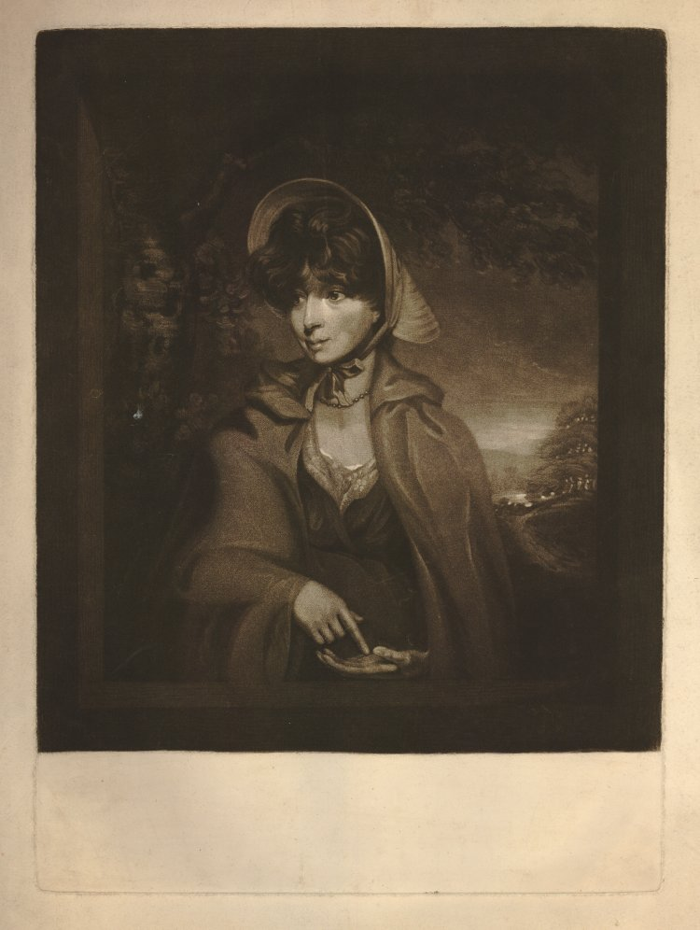
Figure 78: Emma Smith, The Gypsy, c. 1798-1828, mezzotint engraving on paper. This image can be viewed in the non-redacted version of this PhD thesis, held at the University of Sheffield Library

E. Smith’s sympathetic portrayal of an impoverished woman fitted entirely with her father’s somewhat unusual interest in recording female experience in society, and most of his original work focuses on female narrative pieces. Within these, as D’Oench observes, ‘women enact a gamut of roles from literature and the stage, or in imagined episodes from contemporary London life.’ D’Oench continues, ‘Smith’s narratives, rather than serving as critiques of errant women, offered parodic or ironic commentary on the hypocrisies embedded in society’s expectations of female behaviour.’ This, of course, was a position C. Smith arguably adopted with her portrayals of virtuous ‘fallen’ women that I will discuss later in this chapter. J. R. Smith gave women opportunities to become apprentices with him and learn his trade as a mezzotint and stipple engraver, and recorded their experiences in society from a unique viewpoint. Further, by enhancing existing aesthetic tropes surrounding female portraiture, he recorded women as individuals, declaring, as D’Oench also observes, ‘an ironic stance towards custodians of public morality for whom female sexuality was a threat to the social fabric.’ These are views which seem in concordance with C. Smith’s, and the beliefs she expresses within all of her writings over various genres.

However, the relationship between C. Smith and J. R. and E. Smith was not just one of proximity or a concurrence of viewpoints. They did not just belong to the same circle, and evidence exists that they were acquainted on a personal level too. Neil Jeffares notes that C. Smith dined with J. R. Smith and Emma twice in 1805, at Busbridge Hall in Surrey, the home of Henry Hare Townsend (later Townshend). During this time J. R. Smith was employed by the family, ‘taking the portraits [...] in Crayons.’ C. Smith, as noted earlier, was impressed with the two artists’ work, and this is unsurprising. The resultant portraits by J. R. Smith of the Townsend family (Figures 79, 80 and 81) are beautifully rendered, charming depictions of an ideal family. Mrs Henry Hare Townsend demonstrates her accomplishments, being portrayed beside her harp (Figure 79). Her son, Chauncy Hare Townsend (later the Reverend Chauncy Hare Townshend), is seated outside in the family’s picturesque parklands, indicating his status as the educated son of a gentleman by the signifying book held in his right hand (Figure 80). Her daughter, Charlotte Townsend, just five years old at the time of the portrait, is shown seated in a fine interior, playing with her dolls (Figure 81). This demonstrates her mother’s Rousseauesque sensibilities. As Donelle R. Ruwe observes, ‘Jean-Jacques Rousseau’s influential book on child education, Emile, recommends that girls play with dolls in order to develop their sense of taste in clothing.’ Considering that Charlotte Smith herself had a penchant for Rousseau’s work, demonstrable in the number of times she quotes him in her own texts, this meeting of minds is perhaps one reason she found the company convivial. Just as C. Smith enjoyed the Townsends’ company, it is also unsurprising that she found John Raphael and his daughter Emma, interesting. The contemporary biographers of J. R Smith describe his ‘extraordinary gregarious personality.’ Edward Brayley, commenting on the ‘hasty portraits’ of J. R. Smith’s later career, wrote ‘that Smith “possesses the address to please all those who are fond of a song and a story, with which he is always ready.”’ He was a ‘raconteur and bon-vivant,’ a man with a charming and attractive personality, equipped to entertain a woman of sharp intellects like C. Smith.

J. R. Smith’s artistry is also unusual in terms of eighteenth-century art child portraiture, as they portray children being children. They are not forced into formal poses, like miniature adults. Rather, they are permitted to play with their books and their dolls, as part of a nurturing system of childhood education, of which C. Smith could only approve. There is an immediacy in the pictures, as if the artist has surprised the children in the act of play, or reading, rather than asking them to pose for him.

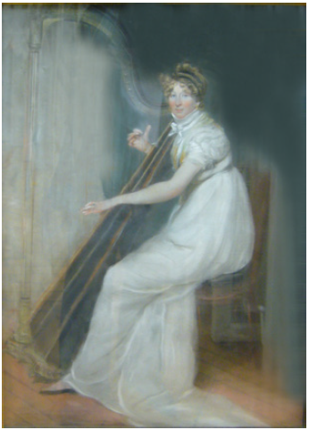
Figure 79: John Raphael Smith, Mrs. Henry Hare Townsend (née Charlotte Lake), c. 1768-1831, mother of Reverend Chauncy Hare Townshend, playing a harp, 1805, pastel on paper. This image can be viewed in the non-redacted version of this PhD thesis, held at the University of Sheffield Library.

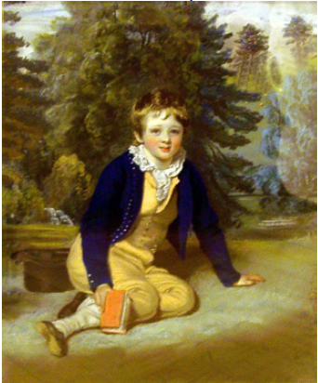
Figure 80: Joseph Raphael Smith, Reverend Chauncy Hare Townshend (né Townsend) (1798-1868), 1805, pastel on paper. This image can be viewed in the non-redacted version of this PhD thesis, held at the University of Sheffield Library

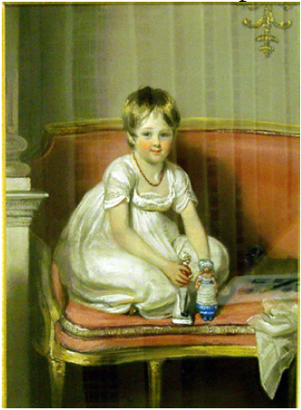
Figure 81: John Raphael Smith, Mrs. John Crook Elrington, née Charlotte Townsend (1800-1824), Sister of Rev. Chauncy Hare Townshend, 1805, pastel on paper. This image can be viewed in the non-redacted version of this PhD thesis, held at the University of Sheffield Library
J. R. Smith’s portraits of the Townsend children are a moment captured in their childhood. J. R. Smith became adept at capturing moments within his oeuvre and holding these up to scrutiny so that the viewer can either perceive what is flawed within this social structure, or, as in the case of the Townsend children’s portraits, simply focus on that single moment. His daughter Emma, extremely precocious in the demonstration of her artistic talent, also became adept at capturing these moments. Figure 82, for example, is a miniature pastel of Miss Raper of York. This was one of two paintings E. Smith exhibited at the Royal Academy in 1804. Here the artistic style is the same as her father’s. Miss Raper sports a childish short haircut, similar to Charlotte Townsend’s (Figure 81). Her gown is simplistic and emblematic of her youthfulness, dissolving into the background of the blue and white clouds of a sky which appears Spring-like in nature (pastel blue mingled with white being representative of this), and again indicating that Romneyesque trope of setting indicating the situation of the sitter. This is a young woman in the Spring-time of her youth.

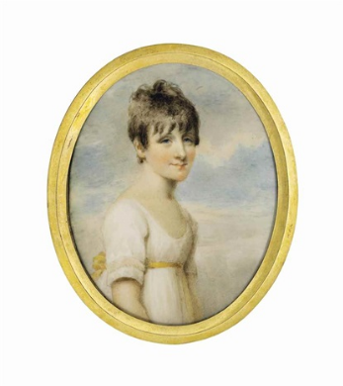
Figure 82: Emma Smith, Miss Raper of York, Exhibit No. 789 at the Royal Academy of Arts, 1804, pastel on paper. This image can be viewed in the non-redacted version of this PhD thesis, held at the University of Sheffield Library

J. R. Smith’s works are comprised of portraits mainly in crayons, female narrative subjects like ‘The Soldier’s Farewell on the Eve of a Battle’ (Figure 83), or educational series in which a number of prints unfurl a story and make some kind of commentary on society, as in the Laetitia series (Figures 90-95) which I will discuss later in this chapter. J. R. Smith’s ‘The Soldier’s Farewell’, for example, captures the moment when war comes home and directly and negatively impinges on ordinary people. The print illustrates the tragedy of separating loved ones and breaking up family units, for the reason of waging war. The violence awaiting the despairing soldier is emphasised in the print by the blood-red coat he wears, and the ribbons of the same shade around the woman’s large-brimmed hat that she holds across her lap. The woman hangs her head in despair, contemplating the streams of blood-coloured fabric in sorrow at her projected loss of her beloved and the violence which is likely to be inflicted on him (blood soon, potentially, to run out of his body?). That she anticipates this, we know, as she is wearing mourning colours in the black ribbon circling the bonnet she actually wears on her head. The powerlessness of the soldier to prevent the woman’s grief is indicated in the Northcote-style manner in which the beautiful hero is presented. He is stooped over in a flowing line indicative of the tropes of the beautiful, which again, J. R. Smith has emphasised within his print to demonstrate the melancholy atmosphere of the scene, and the sense of defeat already permeating the scene. The soldier appears almost pleading before his lover. The feminised beauty of the soldier is further enhanced by the violently red blush on his cheek and the flowing curl of his hair. The elegiac effect on the viewer is enhanced by the words engraved beneath the plate: ‘Soon shall we be torn asunder.’ The very language itself is couched in terms of unnecessary violence.

Like Joseph Mallord William Turner, J. R. Smith wished to ensure that viewers of his artwork were receiving the correct message as they viewed, by adding lines beneath them, in order to fix the viewer’s line of sight on what they should be seeing, within his prints. He placed these lines as a safeguard to ensure the reader gained the correct message, just in case the tropes taken from the popular aesthetics of the time and exaggerated within his prints were not enhancement enough. In this case, all of the futility and tragedy of war is spelled out. Again, it is clear there exists a concordance of views between J. R. Smith and C. Smith, who occupied an anti-war stance, as all of her writings testify. The horror and futility of war is a point which is emphasised in Smith’s most famous novel, The Old Manor House (1793), as noted in the previous chapter. Within this novel, as Simon Parkes argues: ‘In order to emphasise her discomfort regarding public and artistic responses to war, Smith consistently demonstrates how war leads not only to a rupture in personal identity but also the disruption of private spaces and relationships.’ J. R. Smith’s interpretation and portrayal of war entirely matches with C. Smith’s in The Old Manor House, as it does with his acquaintance James Northcote, who conveys a similar message in the sketches accompanying his Fables, also discussed in the previous chapter. The battle may not yet have begun for the soldier, but the effects of it are already being felt nevertheless.
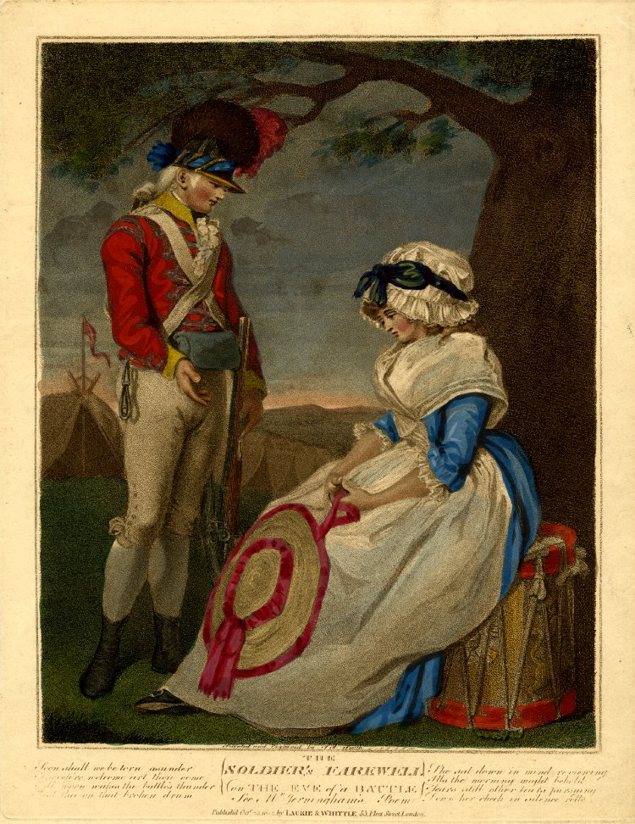
Figure 83: John Raphael Smith, The Soldier’s Farewell on the Eve of a Battle, 1802, Stipple printed on brown ink with hand colouring. This image can be viewed in the non-redacted version of this PhD thesis, held at the University of Sheffield Library.

All of the life of the individual seems enclosed within the narrow confines of the Smiths’ portraits. They seek, as Susan Stewart argues ‘to “realize” a certain formulation of the world.’ These paintings mark ‘the interior space and time’ of the subject. Both artists present

the inanimate-made-animate as symptomatic of all narrative’s desire to invent a realizable world, a world which ‘works.’ In this sense, every narrative is a miniature and every book a microcosm, for such forms always seek to finalize, bring closure to, a totality or model.

They become microcosms of life, much as Charlotte Smith’s books can be read as microcosms of individual female experience. C. Smith’s educational works for children ‘unite[s] the interest of the novel with the instruction of the school book,’ yet the portraiture she constructs of the many women in these texts becomes like a portrait gallery, displaying every type and condition of womanhood within her world. E. Smith’s portraits, viewed alongside her father’s, J. R. Smith’s engravings and prints, equally record the world for women – or, a certain reading of it, anyway. Within their depictions, the tropes of the aesthetics employed by portraitists such as Romney and Northcote are, as argued earlier, adapted and embellished to ensure that the print viewer understands what the artist wishes them to discern about conditions in this society. Sometimes, however, as in the Serena print (Figure 73), the indicators are conflated in order to confuse what the viewer knows, or thinks they already understand about these women. In a society where outward appearance is key and every situation can be read by their display, it takes careful scrutiny of the aesthetics in order to determine the real situation surrounding women in this society. The prints of J. R. Smith require as much careful reading as the novels of C. Smith. Figures 84 and 85, for example, confuse the indicators of social status in a woman. A Visit to a Grandfather (1785) (Figure 84) shows a tender image of a woman taking her children to visit their elderly grandfather. The print speaks of filial devotion and familial love.

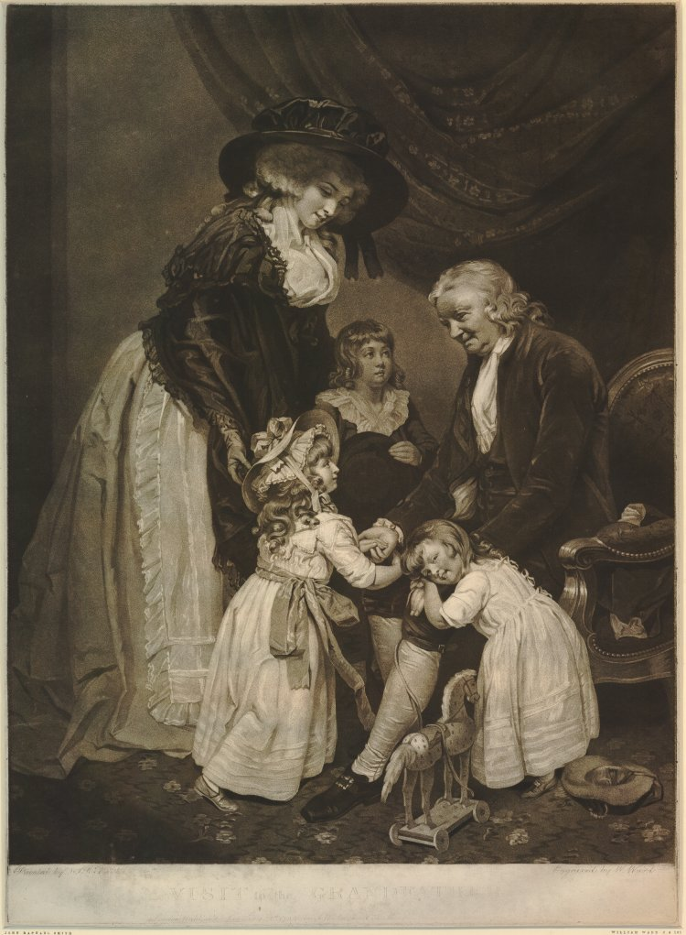
Figure 84: John Raphael Smith, A Visit to the Grandfather, 1785, mezzotint on paper. This image can be viewed in the non-redacted version of this PhD thesis, held at the University of Sheffield Library.

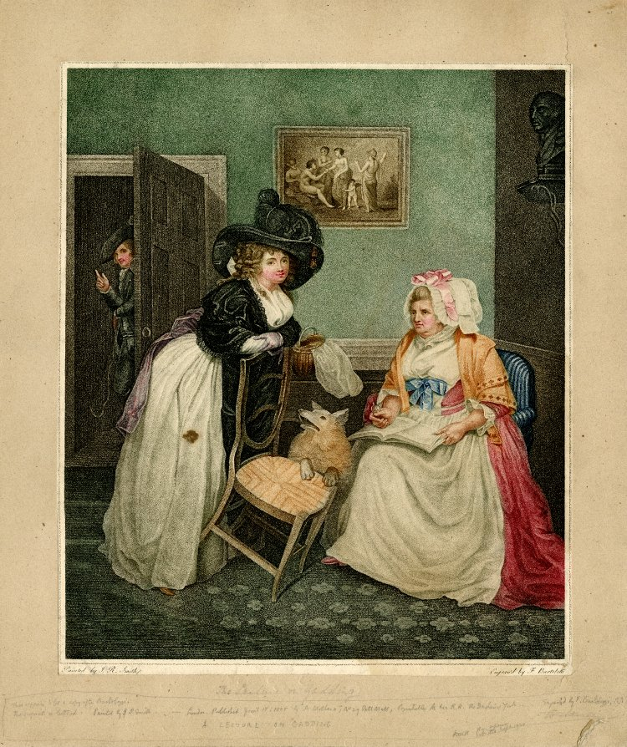
Figure 85: John Raphael Smith, A Lecture on Gadding, 1787, stipple on paper. This image can be viewed in the non-redacted version of this PhD thesis, held at the University of Sheffield Library.
It is worth considering J. R. Smith’s satirical A Lecture on Gadding of 1787 (Figure 85) alongside the Visit. The subject matters are very different. Within A Lecture, a young woman is reprimanded for her giddy conduct by a matriarchal figure. The girl in the picture, however, gazes nonchalantly out towards the viewer whilst the lecture takes place. She is apparently unheeding to the words of advice, and, indeed, her gallant is just discernible through the open door, waiting for the lecture to finish and the woman to join him. What is striking about the two images considered side by side, however, is their similarity. Both women wear fine clothes and elaborate hats. Both women bend at the waist towards a parent. The tropes of the aesthetics of both the beautiful and the sublime have been employed in the pictures. The women both have flowing lines in their figures and curling hair. The beautiful grouping of angelic beribboned children is mimicked in A Lecture by the print on the wall. The patriarchal figure of the grandfather in Visit is echoed in the stern aspect of the bust in the top right corner of A Lecture. However, within Visit, the grandfather does not appear as the typical Burkean sublime patriarch, but rather a cheerful, rosy-cheeked man, who leans rather towards the beautiful than the sublime, just as Northcote’s and C. Smith’s heroes do. The individual tropes of each of these distinct systems of aesthetics as discussed in detail in chapters two and three, are conflated and confused, and demonstrated by J. R. Smith for the nonsense they are. Just as C. Smith has undermined Burke’s and Kant’s gendering of the aesthetics, J. R. Smith exposes them as meaningless interpretatively. These two women are engaged in very different modes of behaviour, yet J. R. Smith seems to be implying that they are indistinguishable from each other by the outside viewer, whatever their conduct may be. The tropes of the sublime and the beautiful are present in both pictures. They are being portrayed as essentially the same, yet the subject matter, modes of behaviour and whether this can be read as ‘proper’ or otherwise, are very different.

J. R. Smith was interested in cataloguing all sorts and conditions of women, highlighting their differences, and, more subversively, their similarities. This becomes apparent from his engraving entitled All Sorts (Figure 86). Here, the haughty demeanour of the upper-class woman in her finery (far right) is met by the equally proud stare of the lower-class woman, whose clothes are in rags, immediately adjacent to her. The fine clothing of the woman in the foreground is mirrored in the bonnet of the woman behind her. It is impossible to tell who is maid and who is mistress here between the two figures on the left hand side of the picture. The indicators of social status are deliberately conflated by J. R. Smith. What is really interesting about this print is J. R. Smith’s background of picturesque scenery. Here, J. R. Smith has accessed and exaggerated a further popular aesthetic of the time, and employed it in a similar manner to his artistic ancestor, George Smith of Chichester. As discussed in chapter one, G. Smith used the background of the picturesque to make critical commentary on society of the time. Here, J. R. Smith uses the ubiquitously popular aesthetic in almost a mocking way to demonstrate the true nature of eighteenth-century society as it sits within the popularly picturesque background. There is nothing remotely pretty about it. It is rather just a background for a confused mass of teeming humanity of all aspects and conditions. The tropes of the ‘collection’ in terms of a collection of portraits participates in a bewildering conflation of all three aesthetics discussed so far, and creates an aesthetic of its own, comprised as it is of a collective of all the aesthetics on offer.

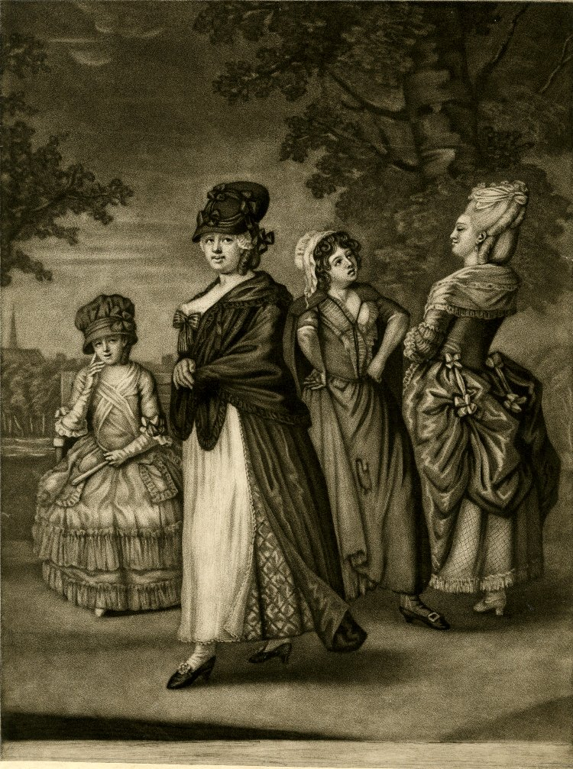
Figure 86: John Raphael Smith, All Sorts, c. 1775-76, mezzotint on paper. This image can be viewed in the non-redacted version of this PhD thesis, held at the University of Sheffield Library.

J. R. Smith, like C. Smith, was interested in characterising and cataloguing all types and conditions of women, and in order to do this he accesses this collective of aesthetics for display in his portrait gallery. C. Smith, as has already been seen, also accesses a variety of traits and tropes of the various popular aesthetics of the day in order to create her own characters. This can be further exemplified when considering the portrait gallery collecting together all manner and modes of females with which she peoples her educational works. From the opening paragraph of C. Smith’s initial foray into educational works, Rural Walks, the portrait gallery of the many types and conditions of womanhood opens. The reader is introduced to Mrs. Woodfield, a woman who, like many of Smith’s older heroines, bears some resemblance to Smith herself. She has been, like Smith, ‘[b]orn in prosperity, and educated in all those accomplishments which are cultivated to adorn society.’ However, again, like Smith, Mrs. Woodfield, despite ‘having passed five and thirty years of her life in the splendours and enjoyments of affluence,’ still remains very much at the mercy of her husband, even after his death. When Mr. Woodfield dies suddenly and seemingly in disgrace (‘occasioned by disquiet and mortification,’) Mrs. Woodfield is helpless to prevent the ‘sudden reverse’ in her fortunes. Surrendering her affluence, she is ‘reduced to the necessity of retiring from the world,’ taking her daughters with her.

From this opening premise, the reader is permitted entrance into C. Smith’s own portrait gallery of women. The reader meets the initially proud and haughty Caroline Cecil, who is related to nobility through her dissipated mother. Caroline’s mother comes to embody Mary Wollstonecraft’s perceptions concerning the hypocrisy of society’s ideals about the ‘honourable woman’:

if the honour of a woman, as it is absurdly called, be safe, she may neglect every social duty: nay, ruin her family by gaming and extravagance, yet still present a shameless front – for truly she is an honourable woman.

Caroline’s mother and Wollstonecraft’s ‘honourable woman’ is echoed in another J. R. Smith work, Like Mistress, Like Maid (Figure 87). In this mezzotint engraving, the maid out shopping for the day meets her mistress on her way home from the previous evening’s entertainment. The mistress is almost catatonic with exhaustion, her pallid features unable to focus on the accusing gaze of the maid. The figure of the maid is pert and energetic, particularly in comparison with the listless figure of her mistress. The fact that they meet outside a purveyor of liquor (as detailed on the sign above the mistress’s hat) is an external indicator employed by the artist to hint at the still intoxicated state of the mistress. Once again, J. R. Smith confuses the social indicators of class. Both maid and mistress are dressed the same, and even resemble each other in facial features. One is allegedly better than the other in societal terms of class, but J. R. Smith casts doubt on this by his portrayal of the dissipated mistress heading home to bed, whilst the sober maid commences her work fresh and alert for the day.
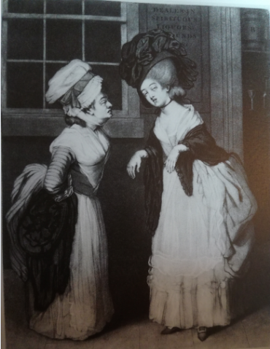
Figure 87: John Raphael Smith, Like Mistress, Like Maid, 1781, mezzotint engraving on paper. This image can be viewed in the non-redacted version of this PhD thesis, held at the University of Sheffield Library.

Caroline’s mother is just such a woman as J. R. Smith’s mistress and on her death, her daughter is left ‘in a situation so friendless and desolate’ that there is no-one but her aunt left to protect her, having dissipated away all her fortune. From Caroline, the reader proceeds to ‘the miserable mansion of a parcel of beggars.’ Here, the cottage woman who ‘with a stifled anguish in her countenance,’ desperately tries to keep her sick husband and five infant children alive. With each new narrative episode, another portrait of female helplessness in the face of an apparently indifferent society is presented for view. The aged, the sick, the helpless, the young and naïve, the easily exploited. ‘What a melancholy sight’ it is for the reader. A ‘spectacle [...] indeed humiliating and painful,’ as Mrs. Woodfield describes the grandmother of ‘The Strawberry Girls,’ described as ‘[s]o very old and so very poor.’ The woman through her great age and poverty has ‘almost lost the traces of humanity.’ This is what the reader is being asked to survey in C. Smith’s portrait gallery of women: an area where things have become so bad for women, that some of them are no longer even recognisable as human.

As with J. R. Smith’s Like Mistress, Like Maid, the reader is invited to make a silent appraisal of the true value of these women when compared side by side. Who is justly an honourable woman? C. Smith prompts her reader. Is it Caroline, with her ‘air of haughty superiority, mingled with something of concealed disdain’ for her Aunt and her family, before Mrs. Woodfield’s re-education of her? Is it Caroline’s mother, the ‘dissipated woman, related to nobility.’ Is it Mrs. Wadford, another elderly lady who spends her time gambling on games of whist? Or, rather, is it the grandmother of the Strawberry Girls, ‘who has nobody to help her for all her children are dead, and what is yet more distressing, she has three of her grandchildren, whom the parish have sent to her to take care of, when she had more occasion to have some person hired to take care of her.’ C. Smith invites readers to consider the true virtue of all of these women by placing them side by side in a portrait gallery and inviting these comparisons to be made.

In addition to the invitation to evaluate the honourable qualities of these women, C. Smith also, like J. R. Smith, highlights the fact that women across all classes have more in common than they do to differentiate between them. Whether they are portrayed as powerful or weak, exhibiting the tropes of the sublime or the beautiful, all of the female characters, C. Smith makes clear, are nothing more than the playthings of fate. Mrs. Woodfield has fallen from affluence through apparently no fault of her own. Tied to a presumably feckless husband, the loss of his fortune and his subsequent death in disgraceful and mortifying circumstances, have had a material impact. Caroline Cecil may initially exhibit character flaws acquired through the deficiency of her education, but her ‘friendless and desolate’ situation has in no way been brought about by herself. It has been inflicted on her by suffering the misfortune of the death of her mother. Similarly, the suffering cottage woman cannot be held accountable for the sickness of her husband or his inability to work. The strawberry girls’ grandmother cannot help being so old.

Indeed, this woman, Mrs. Woodfield observes, ‘was the daughter of a rich farmer, and was, as I have heard other women of the neighbourhood relate, a great beauty in her time and a celebrated horsewoman.’ This is a fate, it is implied, that can happen to any woman. Indeed, C. Smith’s own history links her personal story ‘of a life so peculiarly and invariably marked by adversity,’ as her sister, Catherine Ann Dorset terms it, with former happier times, and how the friends of her youth from her Romantic literary family would recollect her as being. During a visit to Brighton towards the end of her life, C. Smith recorded in a letter to Sarah Rose:

I did not think that any thing could induce me to revisit this place again whither from my earliest recollection I used to come for pleasure & change of scene & where I have been often with ‘Chariots & with horses & horsemen & footmen,’ Where I have been a gay dancer at Balls, & a lighthearted Equestrian on the Hills.

Erstwhile friends, such as William Hayley, would recall the time when C. Smith was a still beautiful woman, who could ‘continue to look sleek & smug’ and not just ‘by candlelight.’ Similarly, they would recollect the time when she could afford to keep a horse for herself and ride across the Downs at her leisure. Here, C. Smith connects her own fate with the grandmother of ‘The Strawberry Girls,’ ‘[s]o very old and so very poor’ - a woman who has almost lost all appearances of humanity in the eyes of unfeeling civilised society (as embodied by Caroline Cecil who shudders at the sight of her).

The women presented within the frames of these individual portraits are, C. Smith seems to be implying – or have the potential to be – all and any women. One moment they are ‘a great beauty’ proudly riding their fine horses across land which belongs to their fathers. The next they are aged old hags, barely recognisable as human, eking out a precarious subsistence and with grandchildren dependent on them. The space within the picture frame presents a fiction – as does the space within the story – but it is a fiction which has the frightening potential to become a terrifying reality to any and all women who view it. It details fictional places, and yet it has, as with the picturesque detailed in chapter one and as J. R. Smith references in his All Sorts (Figure 86) via his adoption of a picturesque background setting to demonstrate the reality of the diverse nature of society, the potential to exist everywhere and in actual places. Smith is, as Elizabeth Dolan argues, showing the reader ‘a collection of verbal portraits.’ She is also holding up a mirror for the female reader to see herself as she might yet become.

What is truly frightening about C. Smith’s portraits, as J. R. Smith has already hinted in his range of female narrative pieces, is that there is very little distinction between the mighty and the fallen, the rich and the poor. These are conditions and states that could belong to any woman at any point in their lives, and, as both J. R. Smith and C. Smith show within their portraits, what is striking about the women, is that if considered side by side, they are virtually indistinguishable from each other. Class, affluence and age barriers are too easily transgressed as the boundaries between them can be confused (as in J. R. Smith’s prints), or, as in the case of C. Smith’s women, dissipated away. Consider, for example, Figures 88 and 89, in J. R. Smith’s stages of womanhood series.
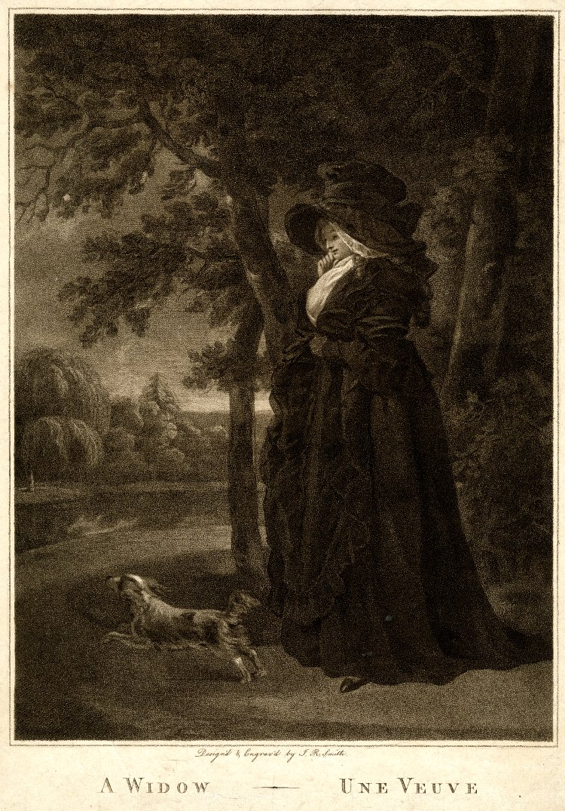
Figure 88: John Raphael Smith, A Widow – Une Veuve, 1791, stipple on paper. This image can be viewed in the non-redacted version of this PhD thesis, held at the University of Sheffield Library.

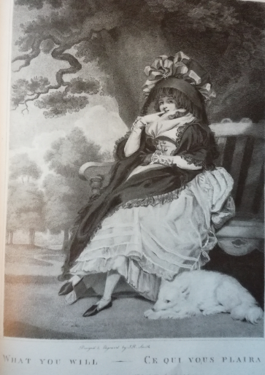
Figure 89: John Raphael Smith, What you will – ce qui vous plaira, 1791, stipple on paper. This image can be viewed in the non-redacted version of this PhD thesis, held at the University of Sheffield Library.

The distance between the ostensibly respectable widow in Figure 88 and the slightly more ambiguous character featured in What you will – ce qui vous plaira (Figure 89) is hardly perceivable. Both women point to their lips in a manner which, any experienced viewer of J. R. Smith’s prints would recognise as serving as an indicator to the women’s sexual allure and availability. Both women wear the same style of dress. They both wear oversized hats and elegant gowns. The only difference between them is that the widow wears black with a white fichus menteurs at the chest, and the other wears white with a black shawl draped around her. Indeed, the women serve as almost mirror images of each other, with one woman appearing as a photographic negative-style reflection of the other. Both women have small dogs with them. Again, this was a frequent motif featured in engravings to indicate the sexual availability of a woman. Thus, so-called women of honour demonstrate their ambiguity. That this is the situation everywhere is again perhaps indicated by J. R. Smith’s use of the picturesque background in both prints, indicating the ubiquitous nature of this fact about the position of womanhood in society (being, after all, as the picturesque at this time as, as argued in chapter one, the only correct way to view nature at this period in time).

The positioning of women is equally ambiguous in C. Smith’s works where Caroline Cecil’s own mother, a woman related to nobility, neglects to provide for her daughter, whereas much reviled impoverished old women become pillars of responsibility. This is demonstrated in the case of the Grandmother of the Strawberry girls who undertakes their care, even though she can ill-afford to, and, as Elizabeth observes in an imagined conversation with Mrs. Wadford, she has reached an age when she should really have someone taking care of her. What is additionally horrifying is the realisation that no amount of planning or forethought seems to be able to save these women from the tricks fate wishes to play on them. In the episode of ‘Fanny Bennison,’ Fanny and her ailing brother have received all the benefits of an enlightened education by their caring father. However, when he dies, there is seemingly nothing and no-one who can prevent a future of ‘friendless obscurity.’ As Mrs. Woodfield argues, ostensibly to herself, but within convenient earshot of the reader:

‘And this,’ said she to herself, ‘this is the end of all the solicitude which the father of those poor young people gave to their education! So sink in friendless obscurity all the hopes they had been taught to cherish of future competence! Alas! how many people are there who perish unlamented and unknown, for whom the fond heart of paternal tenderness has throbbed with the most flattering expectations!’

‘[H]ow many people’: the implication being that these are people like Smith’s readers themselves. The first lesson in Smith’s educational text is ‘judge not, lest ye be judged,’ since all of the women whose portraits Smith has verbally painted are seemingly only ever a couple of missteps away from disaster. The potential is always there – as J. R. Smith demonstrates with his Widow and What you will – for women to slip between the boundaries of class and respectability, to become photographic negative versions of each other.

Indeed, Mrs. Woodfield seems keen to emphasise to the newly impoverished Caroline Cecil that there is only one way in which women can prevent themselves featuring in a future portrait gallery of a collective of misfortune. There is only one way to ‘amend that fortune’: ‘it must be done by shewing that you possess the virtues of sensibility, gratitude and humility,’ or at least appearing to do so. In other words, Caroline’s education at the hands of Mrs. Woodfield will fit her out entirely to become the willing, uncomplaining and gracious wife of a wealthy man. When the very type of man Mrs. Woodfield has been searching for arrives on the scene, the reader understands and recognises immediately that Caroline is destined to belong to him (for, on marriage, she will, it is clear, become a mere portable possession of the man, the femme couvert that is the destiny of all married women in Smith’s society):

At length Halesworth spoke to me; said, that having a passion for the country, it was his intention to retire to the house formerly his uncle’s, and to reside there almost constantly; but as entire solitude was not his plan, he intended to marry, if he could find a young woman of merit and beauty who thought she could be contented to live in the way he proposed, and who had the sweetness of temper, and affection for him, which would be necessary to ensure their mutual happiness.

Yet this is not all. There is a further qualification required in the person specification for the role of Halesworth’s wife:

He added, that though his mother preferred living at Bath on account of her health, and some connexions she had there, he always intended to reserve for her and his sisters apartments in his house; and whoever he married, must assist him on every occasion to shew his mother the grateful remembrance he retained of the painful struggles she had made for him in his infancy and childhood.

Whomsoever fills the position (and it does read somewhat like a job vacancy) must be able to show ‘merit’ and ‘beauty,’ ‘sweetness of temper,’ ‘affection for him’ and be prepared to share her home with his mother and sisters. The important verb here is ‘shewing.’ Caroline Cecil must appear to possess these qualities. Whether she actually possesses them is another matter. Within the world of female portraiture, it is surface appearance that matters. Women – like Caroline Cecil’s mother and J. R. Smith’s Widow – will be superficially judged by their appearance of respectability and status of honour, despite the lived reality of their dissipation (although this is only implied in J. R. Smith’s Widow). These character traits which must be exhibited by Caroline become mere classifications of behaviour that she must show, much like the sublime is dark and obscure and the beautiful is characterised by flowing lines and soft curves. It is a list of behavioural traits that she must demonstrate, but which are, in actuality, much like the tropes of the sublime and the beautiful as demonstrated by both J. R. and C. Smith, nonsensical. The reality of the matter is that Caroline is not really like any of these things, but as long as she appears so in the eyes of her future husband, this does not really matter.

Considering how Caroline is being aestheticised to appear more appealing to her suitor, it is little wonder that this ‘Dialogue,’ ‘Dialogue VII’ in the sequel to Rural Walks, Rambles Farther, is titled ‘The Painters Gallery.’ Within this dialogue the reader learns just how much of a commodity Caroline is, just like a painting of a woman is a consumable to be owned. Within this episode, Caroline visits the portrait painter’s gallery to have her portrait painted for her father, with a further copy for her future husband. However, when Caroline’s portrait is admired by a group of strangers, Caroline becomes

intoxicated by the eulogiums she had heard; and the fine speeches of the painter did not fail to increase her internal satisfaction, which shewed itself in the attempts she made to appear still more amiable by varying her attitudes, and throwing various expressions into her countenance.

It is a ‘personal vanity’ that renders her aunt ‘somewhat alarmed’ and ‘rejoic[ing] that Mr. Halesworth happened not to be there,’ to witness these faults in his bride-to-be. Caroline has failed to understand just how much she is to become the personal possession of Halesworth when she becomes his wife. She cannot afford to exhibit these ‘original faults.’ If Halesworth sees them, he will replace her with any number of other women, with the qualities he does desire from the gallery at his disposal. The ‘original’ Caroline needs to become more like the portrait that is being painted: silent, beautiful, and uncomplaining. Mrs. Woodfield understands this, but equally understands that no other, better fate, awaits Caroline than making the match. There is, after all, as Mrs. Woodfield is well aware, no alternative manner in which Caroline can ‘amend that fortune’ which would await her as a single woman, with no income. It would be, at best, an acceptance of the ‘merely negative life,’ which apparently faces Smith’s eponymous heroine, Celestina, in her third novel, discussed in the next chapter. At worst, it would be to embrace the fate of the Strawberry Girls’ Grandmother: becoming steadily older and poorer alone. In order to circumvent this, Caroline must silently go wherever and undertake whatever duties, Mr. Halesworth requires of her.

In a strange and bizarre twist at the conclusion of C. Smith’s romance, Mr. Halesworth is delayed on his return journey to Caroline. When he does eventually send a letter explaining this long delay, it is not to his affianced that the explanation comes. Rather, much as Delmont addresses his epistles to Laura Glenmorris in The Young Philosopher, rather than his affianced, Medora, discussed during chapter two, Halesworth addresses his letter to Mrs. Woodfield. Mr. Halesworth, it seems, has acquired a baby whom he requires Caroline to take care of: ‘a beautiful infant girl.’ It is perhaps the moment that Caroline realises the truth about her engagement in respect of her personal worth to Mr. Halesworth. It is a moment redolent of Desmond’s foisting of his own illegitimate child with Josephine onto Geraldine. Her value from this point onwards is measurable in utility and silent acquiescence, rather than personal vanity (a silent portrait of a woman, rather than an actual, real life speaking, complaining woman). Caroline, unsure what to do, ‘(in tears),’ can only ask Mrs. Woodfield how she should act.

Mrs. Woodfield (entering Caroline’s room) Well, my love, you have read Mr. Halesworth’s letter: What shall we do to assist him?
Caroline (in tears) Dear aunt! you are a better judge of that than I am.

Caroline is forced to ask Mrs. Woodfield’s advice, because she is, indeed, ‘a better judge,’ than Caroline as to the best course of action. Halesworth has addressed his letter to Mrs. Woodfield, after all, solely for the purpose of getting the educator figure in the text to tell Caroline what she must properly do in this corrupt society. It is left to Mrs. Woodfield to open Caroline’s eyes as to who is really important in her future husband’s life: i.e. his mother:

You know that Mr. Halesworth’s mother is to pass the summer with you, and you are aware that one great object of his life is to render what remains of hers happy, in which, above all other things, he expects you to be his assistant.

Further, the child may have been found in mysterious and somewhat suspicious circumstances, but Mrs. Woodfield does allow that it provides a unique

opportunity in the continuation of Caroline’s, and her own daughters’, educations:

Among the ornamental parts of modern education, it seems to me that the most useful is wholly neglected. Girls who are destined by nature to bring up children, are left wholly ignorant how to manage them; they are therefore unable to see that their own are properly taken care of, or, if they do not themselves become mothers, to be useful as they may wish to be, in a thousand instances, to their friends, or to the infant poor. It is true that this cannot always be taught, but I shall be very glad to have Elizabeth and Henrietta know the cares that are necessary during the infancy of a human being; and how much attention is required to its food, to perfect cleanliness, and to exercise and rest; besides that in such an undertaking will teach them vigilance, patience, and tenderness.

Mrs. Woodfield’s explanation for seeing the positives in the adoption of the unknown child supports Dolan’s reading of the educational works, in that Smith is emphasising the arduous nature of another female role, motherhood: ‘[m]othering, in Smith’s children’s books, is something one learns to do well, but it is not natural or even easy.’ This view is confirmed in Smith’s The Young Philosopher, discussed during chapter two, where in spite of the fact that the baby expected by Laura Glenmorris in her first pregnancy is so anxiously awaited, and ‘the object of so many months of fond solicitude,’ when the baby is born early due to the traumas she has been exposed to, Laura simply lacks the knowledge and skill to keep the infant alive. Despite the infant subsisting for three days, indicating that he had survived his premature birth,

towards the close of the third, I [Laura] observed a visible change in my infant; but I knew that if I called for assistance his danger would only be accelerated. – Soon I found that the best assistance could not save him – he fell into convulsions, and died upon my bosom.’

Without the skills and experience necessary, Laura is helpless to save her child. Motherhood, the apparently natural role which proves all too difficult for the inexperienced, is not the only domestic science lesson being learned in these educational texts. Equally important is the ‘vigilance, patience, and tenderness’ required by Caroline in her new role as Halesworth’s wife, and Elizabeth and Henrietta, at that future time when they marry. These attributes, Mrs. Woodfield as the educator figure, seems to be stressing as the properties a wife will most be in need of. ‘[V]igilance’ to recognise when her husband strays into the next inevitable indiscretion; ‘patience’ to wait for him to come back again; ‘tenderness’ required to forgive him. In short, these three qualities are precisely the attributes Caroline will need to exhibit towards Mr. Halesworth if she is to make any kind of success of her marriage. Mr. Halesworth, it seems, is yet another of C. Smith’s beautiful heroes, like Desmond, behaving in a reprehensible manner: a corrupt version of the aesthetic of the beautiful which can only harm the women around these heroes, i.e. Geraldine and Caroline.

This new version of herself that Caroline must consent to, the seemingly meekly accepting woman featured within the portrait, who must relinquish all her natural spirit and become as silently uncomplaining as a portrait, is hardly flattering or appealing. Yet, as Mrs. Woodfield can clearly appreciate, there are few other viable options available for Caroline, at this stage in her life, except to make that ostensibly advantageous match. As C. Smith has demonstrated within the portrait gallery of unfortunate women paraded before Caroline’s view, silent acquiescence is better than the relentless struggle of other single women within this collection to survive. Women like Fanny Bennison or Flora MacCarryl, newly responsible for a family or orphans, eking out a living with the construction of artificial flowers and subject to sexual predation by men when petitioning for help. C. Smith has put together her gallery of textual portraits to illustrate the many, varied categories and conditions of womanhood. Almost all of these states are forced on these women by a society which privileges the male. Women are required to become puppets demonstrating their accomplishments (like Miss Griskin in Smith’s later educational work, Minor Morals). These women are not real women at all: they are woman as she appears in a portrait, demonstrating the tropes and characteristics of the popularly aesthetically pleasing, in order to survive. These women have had their very humanity stripped from them as they become part of the collection. The only alternative however is to be forced into a deprivation that they must somehow survive, as in the case of the Grandmother of the Strawberry Girls, or the ‘Witch of the Wold.’ This elderly woman’s appearance is ‘enough to have convicted her’ of witchcraft by those in power, ‘frowned with wrinkles, express[ing] a sort of wild melancholy.’ This ‘poor creature,’ as C. Smith terms her, is tortured to death before the fact that this was just a poor, old, helpless woman, whose only crime is to be hideous in appearance and act as a loyal servant, emerges.

Once again, as in J. R. Smith’s conversation pieces, appearance emerges as all-important for the women in these portraits. It is the yardstick by which society judges these women, as well as the one by which visual art is judged. An ugly painting, after all, will not sell. An ugly woman, equally, in C. Smith’s literary portraits, will not be able to expect any future support (as Caroline does via her marriage to Mr Halesworth), or even empathy from a harshly judgemental society. The appearance one makes - the ‘shew’ - is all important in securing a woman’s future. It can, as C. Smith’s literary portraits of her women illustrate, delineate the difference between financial security and poverty, between (as in the Witch of the Wold’s case) life and death.

Mrs Woodfield’s apparent complicity in negotiating Caroline’s future with Halesworth, in the very face of his all-too-apparent infidelity before they are even wed, seems problematic to contemporary readers. However, Mrs Woodfield’s acceptance of the facts of society – as ‘Things as they are’ as William Godwin terms it in his own contemporaneous critique of society - rather emphasises the reality which surrounds the fictional women she portrays, just as J. R. Smith uses subtle devices to illustrate the real grounding for his fictional pieces. This is that ‘formulation of the world’ in microcosm, contained within the confines of the portrait. Once more the mirror is being held up by the author/artist to show the reality inherent within their fictional works. Further, what could be perceived as a somewhat cynical observation on society, does not, however, indicate an outright concurrence that society’s view is the correct standpoint. Mrs Woodfield demonstrates on numerous occasions that although she is relating the facts of ‘Things as they are,’ that does not preclude her own empathy for the sufferings of those less fortunate than herself.

Perhaps the most sustained collection of portraits of the state of womanhood featured in C. Smith’s works comes in Minor Morals (1798). Again, the dialogues open with the main characters of ‘Sophia, Fanny, Mary and Louisa Harland,’ who have been ‘left to the care of their Aunt, Mrs. Belmour, their mother’s sister,’ along with their brothers, ‘Lionel and Julius’. The daughters of the family, it seems, are in a similar situation to the characters under the care of Mrs. Woodfield. From there, the portrait gallery is, once again, opened on a disparate range of portraits of the conflicting condition and state of woman in this society. There is ‘Miss Griskin,’ a woman too proud and boastful of her accomplishments. Next comes Eliza and Emma, the former ‘being the child of her grandmother’s ill-placed vanity’ and educated poorly, throwing herself away in marriage with Mr. Puffington, a rich fool, who soon squanders all his money. It falls to her sister Emma, who has been quite differently educated by a servant, to rescue her. Mrs. Beanfield was born rich, but soon becomes the victim of domestic violence at the hands of her feckless husband. She looks set to end her days in poverty, thanks to Mr. Beanfield’s dissipation, extravagances and ultimate desertion of his family, when he is thrown into prison.

However, like J. R. Smith’s female narrative pieces, none of C. Smith’s portraits of women quite measure up to what the viewer/reader might think they know about these women, if they were judged solely on appearances, demonstrating further how the tropes used in portraiture are nonsensical in terms of interpretation in comparison with the reality of society. This particular educational volume seems to emphasise less the commodification of women, as exhibited by Caroline Cecil, and focus more on teaching women how they can save themselves. As Dolan argues, ‘Smith’s mother-daughter portraits proclaim to the young women who read her books [that] […] they must educate themselves to survive.’ Eliza, although doomed by her poor education, manages to improve herself, with the help of her sister. She is not, C. Smith makes clear, beyond redemption, whatever the reader may initially think of Eliza’s character. Mrs. Beanfield commences her life without her husband in squalor, when with all her and her children’s clothes, sold or pawned ‘to buy liquor,’ her ‘goods had been seized and sold,’ and she has been ‘turned destitute into the street.’ The reader would be forgiven for believing that the only way for Mrs. Beanfield from this point, without the ‘protection’ of her husband, and with nine children to take care of, would be descend further into squalor. Instead, C. Smith confounds her readers’ expectations and when they are first introduced to the character, she is in a ‘neat cottage,’ with ‘its own humble enclosure, planted for a little kitchen-garden and orchard’ and ‘a quantity of bee-hives.’ Without her husband, Mrs. Beanfield has done very well for herself and her children. Indeed, she’s better off without him, as she no longer has to fear for her life or have the little property she has managed to accumulate be dissipated by a drunk. This seems to be the lesson for female readers contained within this particular didactic work: without the interference of that corruptly beautiful male ‘hero,’ women can – and do – shift for themselves.

J. R. Smith, with his series of illustrations entitled Laetitia (Figures 90-95), is similarly interested in confounding the expectations of viewers of his artwork. The Laetitia series, published in 1789, and printed by J. R. Smith after paintings by George Morland was extremely popular. It was reprinted in 1811 by R. Ackermann, with the ‘last four plates [...] reworked to provide Laetitia and her associates with new costumes and hairdresses to update them according to the fashions of the time, because the set had proved so persistingly popular.’ The set also, according to D’Oench, ‘survived into the third decade of the nineteenth century,’ and, as D’Oench argues, marked a departure in the traditional story of the fallen female and actually changed nineteenth-century attitudes towards prostitutes. Whereas previously, the ruined maid/prostitute would be perceived as being beyond any hope of redemption, in his narrative series, as D’Oench observes:

Smith departs from tradition by representing a prostitute as a modern-day Magdalen, forgiven for her sins by a compassionate father [and mother]. Her story transforms the prodigal son’s parable by associating it with a woman’s redemption and thus with an important reform movement of its time, for Laetitia has ties with a sisterhood that found refuge in London’s Magdalen Hospital. Her narrative, the visual embodiment of these prostitutes’ ‘real-life’ histories of penitence and salvation, expresses in pictures a text common to contemporary novels and tracts: the need for benevolent impulses on behalf of the prodigal daughter.

The series was thought to have been the brainchild of J. R. Smith, but, according to D’Oench, ‘to capitalise on the rising reputation of his friend, George Morland, Smith convinced Morland to execute six preliminary canvases containing the Laetitia narrative following his instructions.’ The series recalls C. Smith’s Adelina Trelawney in Emmeline, the Orphan of the Castle (1788), who, despite committing adultery with the artful FitzEdward and bearing an illegitimate son, lives to anticipate a happy ending with her seducer, thanks to the forgiveness of her compassionate brother, Godolphin. Adelina was just the first in a line of virtuous fallen women for C. Smith. For example, in Celestina (1791) Mrs. Elphinstone’s sister, Emily, ‘lost’ to the rake Beresford, reappears at the point in the text of Mrs. Elphinstone’s greatest need. Coldly dismissed by her wealthy brother who refuses to assist Mrs. Elphinstone with her dying baby boy, it is the ruined Emily who aids Mrs. Elphinstone. As Loraine Fletcher argues, Emily ‘is pictured almost as a saint.’ Her death scene is laid out in a manner that prefigures the deathbed scenes of virtuous characters in Dickens’s novels:

Emily sat in a great chair, supported by pillows. The extreme beauty that had been so fatal to its possessor, still remained, though its lustre was gone. Emaciated, and of a delicate fairness, her hands and her face had a transparency that gave an idea of an unembodied spirit, and her dress was such as favoured the deception. The blood might almost be seen to circulate in her veins, so plainly did they appear; and her eyes had the dazzling radiance of ethereal fire, to which the hectic heat of her glowing, though wasted countenance, still added. A few locks of her fine light hair had escaped from her head-dress; and played like broken rays from a receding planet, round a face, which only those who had hearts unhappily rigid, could behold, without feeling the sense of her errors suspended or overwhelmed by strong emotions of the tenderest pity.

Here, Emily’s ‘dazzling radiance of ethereal fire,’ ‘her glowing countenance’ and the ‘few locks of her fine light hair’ which ‘played like broken rays from a receding planet,’ delineate Emily’s demise in the terms of the death of an angel. She is become that ‘unembodied spirit,’ clad in angel robes (‘her dress was such as favoured the deception’) transformed into seraphic ethereality. She is a woman who ‘has virtues that might redeem the vices of half of her sex; not one in a thousand of whom possess a twentieth part of her worth.’ It is, as Fletcher argues, an event which ‘is a disaster on a cosmic scale,’ something which is hinted at by language of celestial infinitude. She is also, as can be easily discerned, being portrayed in terms that participate in the aesthetic of the sublime and is a further example from C. Smith’s catalogue of sublime women, discussed in detail in chapter two.

In these renderings of virtuous, fallen women, it perhaps indicates that J. R. Smith was influenced by C. Smith’s innovative conclusion for the suffering Adelina, and her almost canonisation of Emily. If this was indeed the case, and J. R. Smith was influenced by C. Smith’s novel, then, C. Smith, through the cross-currents which have been created between these artists within their Romantic circle, is also responsible for changing attitudes towards prostitutes and may have had a more lasting impact on the place of fallen women in society than has heretofore been understood. However, whether or not it is a case of direct influence, what these portraits of this type of woman demonstrates is how two artists approach sexual virtue in the same way. For both J. R. Smith and C. Smith, redemption is permissible for the fallen woman.

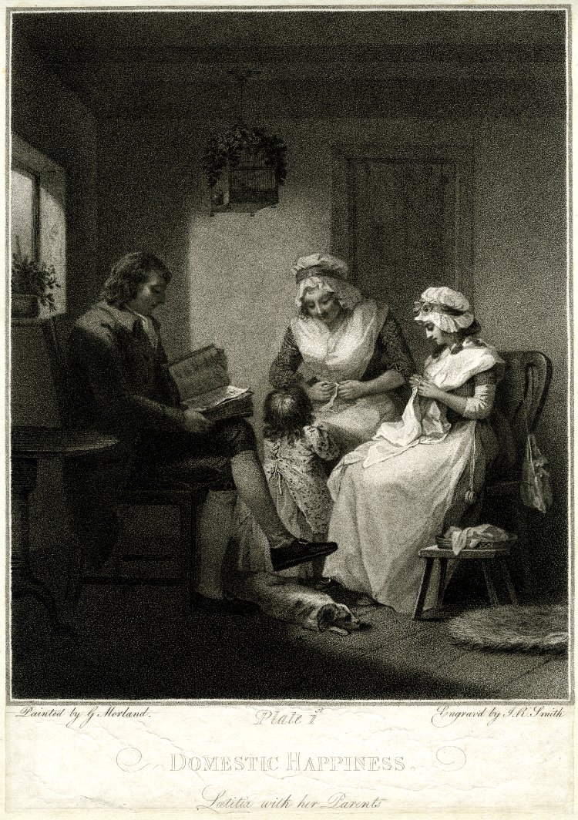
Figure 90: John Raphael Smith (after George Morland), Domestic Happiness: Laetitia with her Parents, 1789, stipple on paper. This image can be viewed in the non-redacted version of this PhD thesis, held at the University of Sheffield Library.

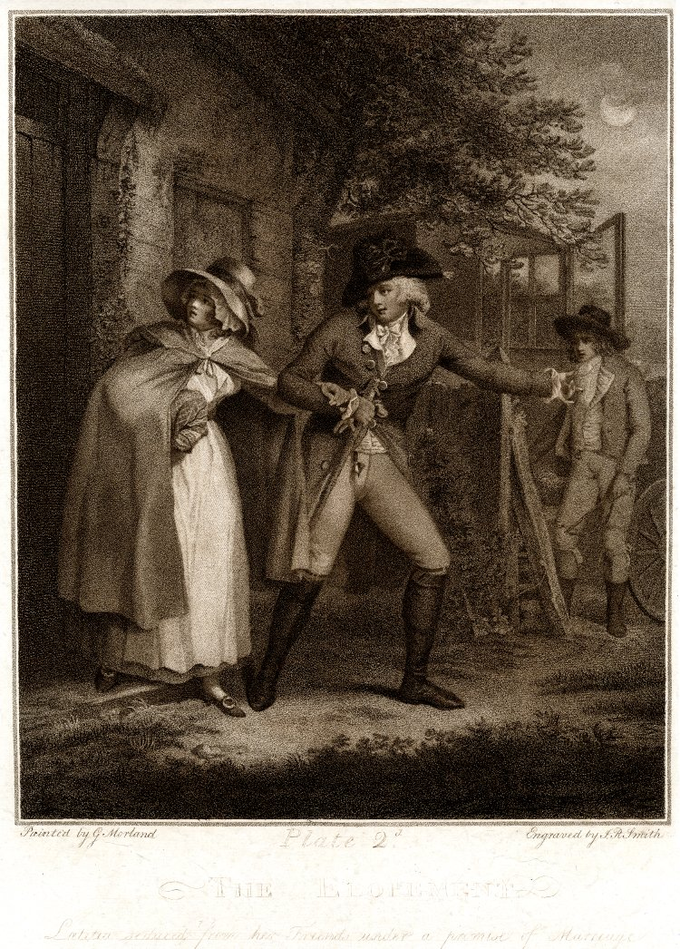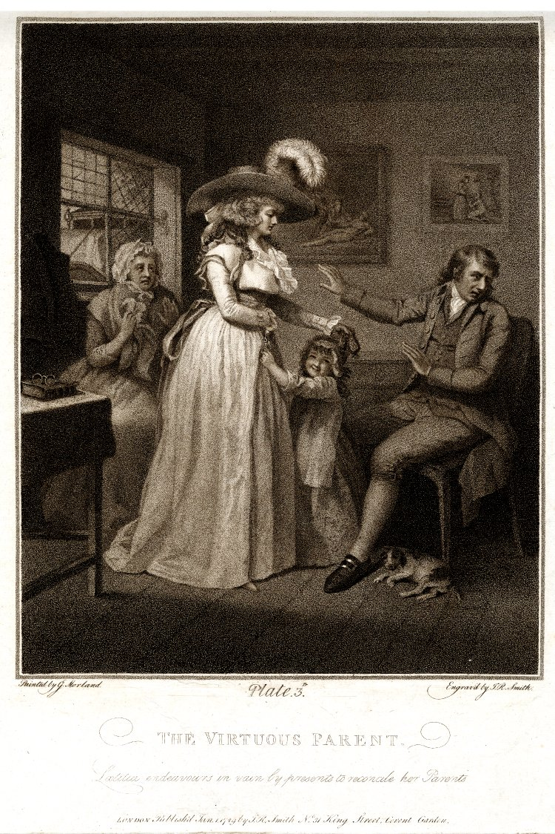
Figure 91: John Raphael Smith (after George Morland), The Elopement, 1789, stipple on paper. This image can be viewed in the non-redacted version of this PhD thesis, held at the University of Sheffield Library.
Figure 92: John Raphael Smith (after George Morland), The Virtuous Parent: Laetitia endeavours in vain by presents to reconcile her parents, 1789, stipple on paper. This image can be viewed in the non-redacted version of this PhD thesis, held at the University of Sheffield Library.
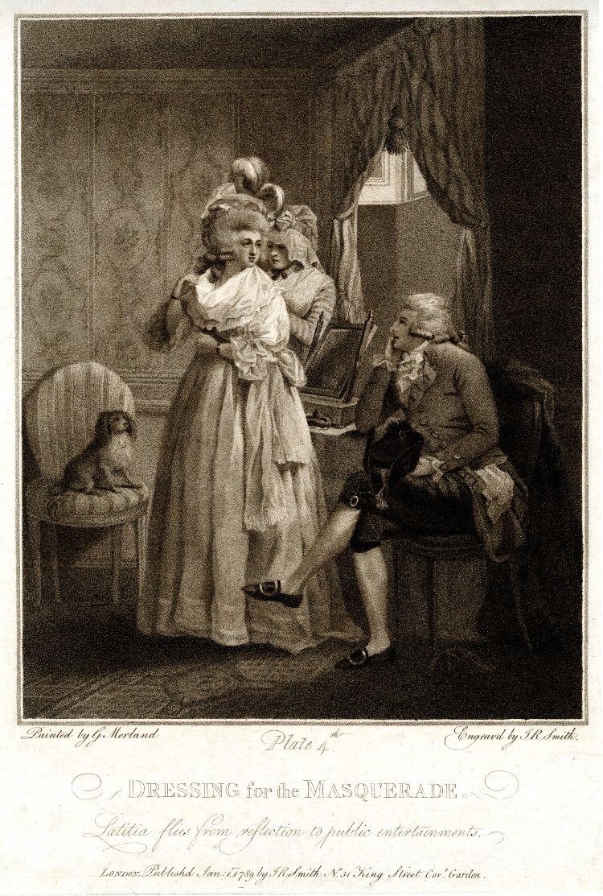
Figure 93: John Raphael Smith (after George Morland), Dressing for the Masquerade: Laetitia flies from reflection to public entertainments, 1789, stipple on paper. This image can be viewed in the non-redacted version of this PhD thesis, held at the University of Sheffield Library.
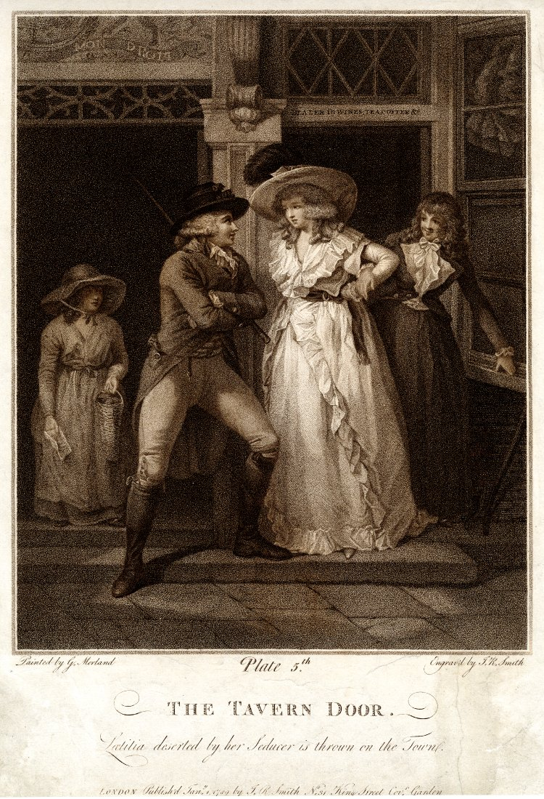
Figure 94: John Raphael Smith (after George Morland), The Tavern Door: Laetitia deserted by her Seducer is thrown on the Town, 1789, stipple on paper. This image can be viewed in the non-redacted version of this PhD thesis, held at the University of Sheffield Library.
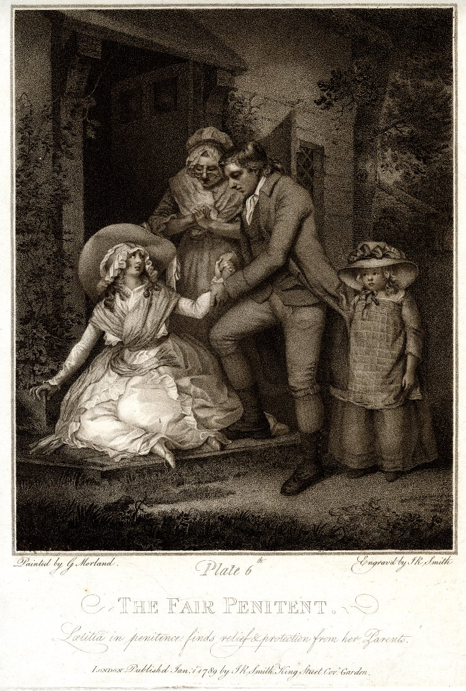
Figure 95: John Raphael Smith (after George Morland), The Fair Penitent: Laetitia in penitence finds relief and protection from her Parents, 1789, stipple on paper. This image can be viewed in the non-redacted version of this PhD thesis, held at the University of Sheffield Library.

The Laetitia series commences with the main character situated in Domestic Happiness (Figure 90). Appreciation of this ‘happiness,’ however, is clearly subjective. Whilst the patriarchal figure reads from his Bible and Laetitia’s mother listens, Laetitia’s discontent and sense of confinement is indicated by the bird in a cage suspended over her. There is a Sunday afternoon ambience to the room. The dog snoozes on the floor, father reads from the Bible, the bird is confined in its cage, as surely as Laetitia is trapped in the stultifying boredom of it all. The print series commences with depicting what women should do, but simultaneously manages to convey how far away this is from what they want to do. The distance between duty and desire is enforced further by plate four in the series (Figure 93) which shows Laetitia dressing for the masquerade, appearing in all of her finery, with her own dog alert, lively, and attentively watching her. There is ambiguity, however, surrounding Laetitia’s status in plate four of the print series. She turns her back towards her own reflection, fleeing a too close analysis of the woman she has become, much as Adelina finds herself ‘made compleatly miserable by the consciousness of guilt’ after Fitz-Edward’s seduction of her. She is unable to meet her lover’s eyes. Within the next plate (Figure 94), the woman Laetitia has become is made apparent by her loitering at the tavern door with a young man gazing admiringly at her. Whilst the man’s features are animated, Laetitia’s eyes are sad. Here, just as she leans against the threshold of the Tavern door, the viewer perceives her on the threshold of prostitution. It is the fate, as Fletcher observes of Smith’s Emily after Beresford’s seduction, ‘[e]xtramarital sexual experience in men carried little social stigma, while women were often rejected by their families and forced to turn to prostitution to survive.’ This is precisely where Laetitia is at this stage in the print series.

Like C. Smith’s Adelina, J. R. Smith’s Laetitia can only recognise her failings when she confronts them, and this is portrayed in the tragic raising of her eyes to meet those of her forgiving parents in J. R. Smith’s concluding plate, The Fair Penitent (Figure 95). Like Adelina, Laetitia has been returned home to be absolved and taken care of again by her forgiving family. Laetitia has survived her experiences, just as C. Smith’s Adelina survives, Eliza from Minor Morals survives, and becomes a better person, despite the flaws in her early education, and Mrs Beanfield survives (and flourishes) despite the loss of her husband. Expectations in all of these portraits, either visual or literary, are confounded, just as expectations surrounding the use of popular aesthetics are upset as well. Dishonour does not necessarily mean that a woman is a bad person. There is life beyond sex for most of these women. Even in Emily’s case, her death is presented as truly heroic, rendering her into another one of C. Smith’s sublime women, a little like Rosalie’s transformation from the ‘beautiful’ to the ‘sublime, as discussed in chapter three. The tropes of the aesthetic of the beautiful are clear throughout the series. Indeed, Laetitia is rather more participating in the tropes of the beautiful in the last print, as her hair is more obviously curling loosely around her and her gown and bonnet consist of a series of soft curving lines ballooning around her. Despite her recent hardship, her skin appears as delicate and smooth as ever, just like the ‘smooth skins’ of ‘fine women’ described by Burke in his elucidation of the beautiful. Again, the tropes of the picturesque are also in play. The outline of the trees in Figures 91 and 95 are distinctly picturesque in style, as is the quaint diamond pattern in the window in Figure 92. Once more, J. R. Smith presents a mixture of aesthetic tropes popular during the time to make a comment upon how society understands itself. He takes the ubiquitously picturesque and uses it to demonstrate that what is really ever present in society is its flawed nature in permitting women to be used by men and then cast aside to a future of prostitution. He also twists the trope of the beautiful to demonstrate that whatever society is telling itself about itself via this aesthetic, it is nonsensical, as any category or condition of womanhood can be presented as ‘beautiful’ in art, as demonstrated by Laetitia.

As has been shown in the discussion of the Laetitia series, C. Smith’s texts overlap and her portraits of women, interact with the portrait gallery of women as envisioned by J. R. Smith in his gallery. The circularity of the mutual influence between these two artists can be further reinforced by the examination of another print by J. R. Smith which seems to have a direct relation with an episode in C. Smith’s Rural Walks. Figure 96 shows J. R. Smith’s print Children Bird-Nesting.
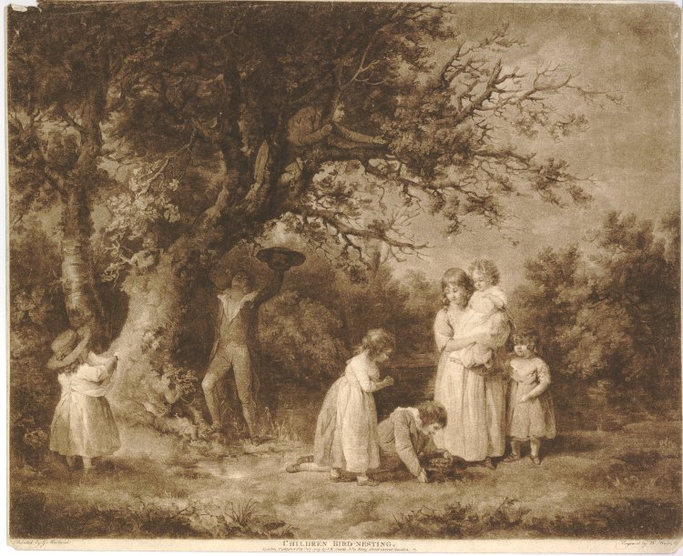
Figure 96: John Raphael Smith, Children Bird-Nesting, 1774, mezzotint engraving. This image can be viewed in the non-redacted version of this PhD thesis, held at the University of Sheffield Library.

It is an episode which has its literary echo in the moment when Mrs. Woodfield is exhorted by her two sons, Harry and Edward, to purchase a nightingale’s nest. The nest, complete with unfledged occupants, has been stolen by idle boys, ‘bird-nesting,’ much like the children depicted within the print. Within this episode in C. Smith’s text, Mrs. Woodfield criticises the boys who have taken the nest containing the suffering nightingale chicks, which are on the cusp of death even as they are presented for sale by the boys. ‘[T]o take them seems to be wanton cruelty [...] Poor, little, unfortunate creatures! see how they pant!’ J. R. Smith, in his earlier print, presents an image which is outwardly pleasing, containing the picturesque tree, the pastoral landscape, the charming children engaged in play. It is only a deeper analysis of the cruelty of what is actually taking place in the print which highlights the fact that the children are engaged in activities that are contrary to nature. It is a cruelty and corruption that is hidden behind the overtly charming picturesque façade of the print, and one, much as George Smith of Chichester implies, is inherent within the eighteenth-century landscape. Again, in J. R. Smith’s print, the children are beautiful with loosely curling hair and clothed in the softly curving lines of their gowns. However, again, J. R. Smith presents the reality behind these beautiful tropes in having the children participate in an activity that is intrinsically cruel.

If C. Smith was taking inspiration from J. R. Smith’s prints and J. R. Smith was inspired by C. Smith’s literature, then there is equally evidence to suggest that E. Smith was utilising C. Smith’s literary characters for inspiration in the creation of her artworks as well. Figure 97 details one of the few surviving prints known to have been executed by J. R. Smith’s daughter and which details Rosalie.
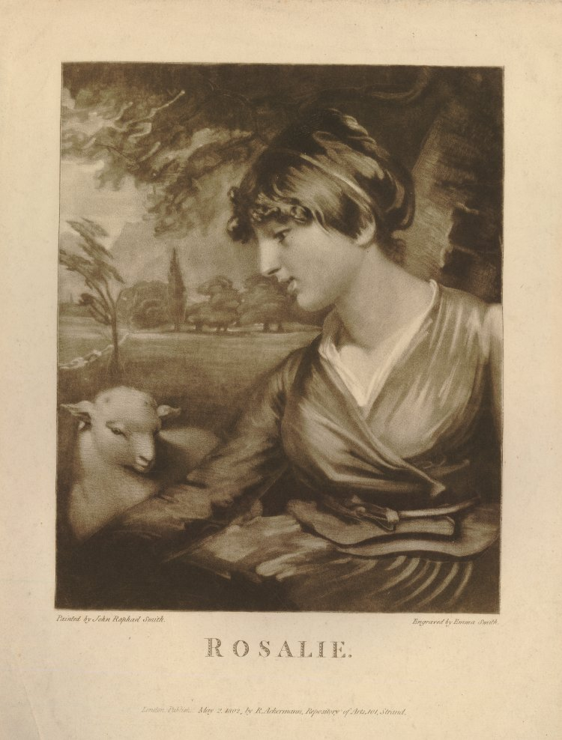
Figure 97: Emma Smith, Rosalie, 1801, mezzotint on paper. This image is in the holdings of the British Museum and can be viewed at the following link: https://www.britishmuseum.org/research/collection_online/collection_object_details/collection_image_gallery.aspx?assetId=1299444001&objectId=3449788&partId=1 It can also be viewed in the non-redacted version of this PhD thesis held by the University of Sheffield Library.

This can only be the ‘Rosalie’ from Smith’s 1795 novel, Montalbert. To Rosalie, in Smith’s novel, the Sicilian landscape is beautifully ‘rich and luxurious,’ a pastoral wonderland. The landscape in the background to E. Smith’s engraving is also Italianate in style, as is evidenced by looking at other artworks from the same period, which purport to record the Italian landscape (Figure 98, for an example of this). The trees have the same wispiness to them in both of the illustrations. Richard Corbould’s landscapes show the same mountainous terrain being framed by these feathery trees as features in E. Smith’s Rosalie.

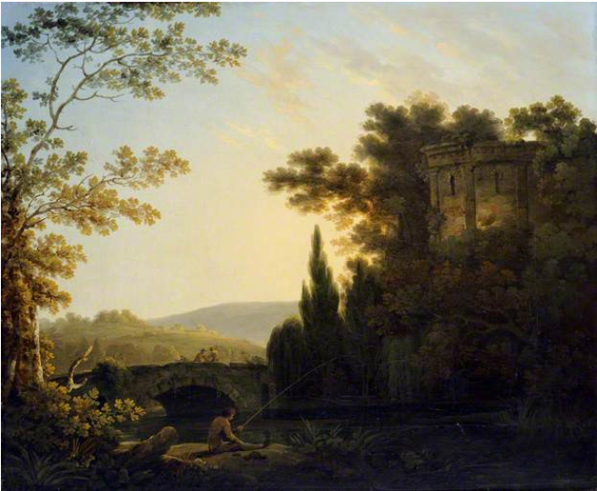
Figure 98: Richard Corbould, Classical Italianate Landscape with a Bridge, 1788, oil on canvas. This image can be viewed at English Heritage Property, Kenwood, and at the following link: https://artuk.org/discover/artworks/classical-italianate-landscape-with-a-bridge-191696. It can also be viewed in the non-redacted version of this PhD thesis, held by the University of Sheffield Library.

A database search of literary Rosalies reveals just one other textual Rosalie contemporaneous to this time. Accessing Eighteenth Century Collections Online (ECCO), this ‘Rosalie’ was featured in Addison’s Interesting Anecdotes, Memoirs, Allegories, Essays, and Poetical Fragments, Tending to Amuse the Fancy, and Inculcate Morality (1797). The Rosalie in the story contained within this anthology, the ‘Story of Rosalie,’ is a young woman who meets and falls in love with a young man named ‘Montalmant.’ Affected by ‘the most refined sensibility and delicate sentiment,’ Rosalie soon commences a love affair with the man. When Montalmant’s mother refuses permission for the match, Montalmant is forced by his mother to abandon Rosalie, leaving her with a baby son. Rosalie is imprisoned some time in a convent, but eventually saved by the return of Montalmant at the end of the story. If this sounds familiar at all, it is because this is basically the story of C. Smith’s Montalbert (1795) plagiarised and compressed into eight pages. C. Smith’s Montalbert was clearly popular enough to inspire other artists and writers such as the Addison detailed above to emulate it and include it within their own literary compilations. This, in itself, illustrates how E. Smith may have become familiar with the character of Rosalie, and been sufficiently inspired to create her own artwork from C. Smith’s creation.

E. Smith’s Rosalie is further directly connectable to C. Smith’s heroine via the iconography both artists utilise within their works. The presence of the lamb in the engraving becomes important when one considers the religious significance of the lamb. The lamb is meek and serves a sacrificial purpose within the Bible, much as C. Smith’s Rosalie’s meekness leads her to become the sacrifice of the doppelganger of Emmeline’s Delamere, the volatile and unstable Montalbert. Rosalie is easily persuaded to meet with him without her foster mother’s knowledge, despite the fact that ‘she was conscious that she ought not to go out with a view to meeting Montalbert.’ Rosalie’s romantic nature leads her ‘to listen to arguments to which the heart yields but too ready an assent’ to one with the ‘insinuating manners’ of Montalbert. The sacrificial nature of Rosalie has also been emphasised by C. Smith’s elucidation of her feelings about the nature of the marriage market to which she is exposed by Mrs. Lessington: ‘[d]ragged to a scene, where she considered herself exposed as an animal in a market to the remarks and purchase of the best bidder.’ Denied all agency and power of choice by her supposed mother, Rosalie becomes a mere beast to be sacrificed to the man who can apparently offer the best price.

Rosalie has already been successfully connected with Catholic iconography by C. Smith via the fact that ‘Rosalie’ itself is a Catholic name, immortalised to the (perhaps equally significantly) Sicilian-born St. Rosalia, who died in 1160, after spending her life immured in a cave, existing entirely hidden from the world. Her body was found during the seventeenth century with the words, ‘I, Rosalia, daughter of Sinibald, Lord of Roses and Quisquina, have taken the resolution to live in this cave for the love of my lord, Jesus Christ’ daubed on the walls. Further, C. Smith weaves Rosalie’s connection with Catholicism further, by having her real mother, Mrs. Vyvian, a devout practitioner in this religion. Mrs. Vyvian herself enacts St. Rosalia’s fate becoming a ‘solitary and isolated being’ within her family, in the practice of her faith, when Mr. Vyvian, contrary to his pre-marital promise, renounces the religion and insists that his children are brought up within the Church of England. Rosalie becomes the metaphorical sacrificial lamb within C. Smith’s novel, linking her character with the religious imagery employed within E. Smith’s print. The Book of Revelation includes many references to the image of the lamb, ‘slain but standing,’ which is, arguably, how Rosalie concludes her adventures. Montalbert’s removal of her son, accusations of infidelity, unreasonable behaviour and apparent abandonment of her, before their ultimate reconciliation, takes its toll on her ‘sickened soul’ and ‘enfeebled frame,’ as argued earlier in chapter three. Rosalie, when she emerges from the insanity which is the temporary result of Montalbert’s ill-treatment of her,

now saw her husband returned, her child restored, her father in safety and master of an ample fortune (circumstances which even in her most sanguine moments she never ventured to flatter herself with); yet with all these blessings united, Rosalie was not happy.

At the conclusion of the novel, Rosalie is an empty shell. She has been used and worn out by Montalbert. Not much of the original romantic heroine remains behind after this trial.

Originally titled Rosalie by C. Smith, she later altered the title of her seventh novel to Montalbert, perhaps indicating the effacement of Rosalie’s desires within her text. This is not a romantic novel about ‘Rosalie’ after all. It is a tale delineating Montalbert’s ultimate success and achievement of ‘more happiness than usually falls to the lot of humanity.’ Rosalie herself, as argued in the previous chapter, does not achieve this. She is left ‘not happy.’ Her desires are represented as seemingly unimportant in that closing denouement. Rather like the portrait gallery of women presented in C. Smith’s educational works, Montalbert is a novel which again presents the facts of society in an age where it is impossible for women to achieve their own desires. Women, after all, in this age, are the mere possessions of men and afforded little agency of their own. This is things as they are for women.

Considering the works of all of these artists named Smith demonstrates C. Smith’s influence on this circle of Romantic era artists, and creates new understandings surrounding the works of these lesser-known printmakers and engravers. The print titled ‘Rosalie’ by E. Smith has been held by the British Museum in their collection with no real understanding of the subject matter of the illustration. It is only by considering the works of E. Smith and C. Smith in tandem, that we can come to know that this is not just a ‘half-length woman sitting in a landscape, head in profile to the left, under tree, lamb to the left’ as the British Museum have catalogued it, without knowledge of C. Smith’s Montalbert. Conversely, considering the artworks of J. R. and E. Smith in tandem with the works of C. Smith and what we know of her biography, provides researchers with additional information, such as copies of the pastel portraits of the Townsends which were taken whilst C. Smith was present.

Considering the artworks alongside the literary corpus of C. Smith also demonstrates those mutual influences of the artists which has led them to utilise similar devices within the construction of their artworks, whether visual or literary. The portrait gallery of categories and conditions of a variety of women constructed by J. R. Smith and E. Smith in their visual works is being echoed and replicated by C. Smith in the ‘collection of verbal portraits’ of the state of womanhood within her society, and vice versa. All of their artworks, both literary and visual, record and catalogue society as it is for women, by presenting a collection of portraits. Analysis of these textual and visual portraits demonstrates how narrow is the divide which exists between fiction and reality, between affluent respectability and impoverished shame, and, as Dolan argues, ‘challeng[es] any sense that “the poor” exist in a social category from which her [C. Smith’s] readers are entirely protected.’

The boundaries between the many categories and conditions of women, all of the artists seem to be suggesting, are far too easily transgressed. It is too easy to slip between the cracks for a woman in this society. This, in the Smiths’ view, seems to apply to any and all women. In order to portray this collection of women, a collective of aesthetics is referred to and employed: the sublime, the beautiful and the picturesque. All of these popular aesthetics are conflated and confused by the artists and whilst outwardly being presented as a readily understandable shorthand for viewers of the scenes, they are simultaneously undermined and demonstrated to be patently nonsensical in interpretive terms. They cannot be relied upon to represent truth in any meaningful manner. A ‘beautiful’ woman can be either a respectable wife, a prostitute or, What You Will (Figure 89). A ‘beautiful’ child can be engaged in an act of ugly cruelty. Things as they are in this society are never so clear cut as to be simply sublime, beautiful or picturesque. Rather, they can be a mix of all three simultaneously which can mean anything in the collection of portraits as demonstrated by J. R., E., and C. Smith. The sublime, the beautiful and the picturesque can be repurposed to represent that collective of the varying categories and conditions of womanhood to show a bevy of beauties, an anthology of prostitutes or a consternation of mothers. The use of the picturesque is particularly interesting, as it presents a background setting, which as noted in chapter one, had become almost ubiquitous during the latter eighteenth-century society. As argued earlier, and as John Brewer observes, ‘eighteenth century observers relied on poems and paintings’ in order to interpret the landscape surrounding them. Within J. R., E., and C. Smith’s picturesque, however, the ubiquity of this zeitgeist is employed in order to show with clarity the corruption inherent within their contemporaneous society. If the picturesque is everywhere, as argued in chapter one, then this corruption is equally to be found everywhere within all walks of society and in the representation of all of these categories of women. Following on from this, the next chapter will discuss a national artwork and how an iconography which purports to record ‘truth’ in terms of recording history, once again fails to tell an accurate story about the nature of society as it realistically was during this period.

Chapter Five
Every Picture Tells a Story? Heraldic Art in Celestina (1791)

‘It is something like personages with whom we are presented in old romances, and who meet in forests and among rocks and recount their adventures; but do know, my dear Miss de Mornay, that I feel very much disposed to enact such a personage, and though it is but a painful subject, to relate to you my past life?’
‘And do you know, dear Madam,’ replied Celestina, ‘that no wandering lady in romance had ever more inclination to lose her own reflections in listening to the history of some friend who has by chance met her, lost in the thorny labyrinth of uneasy thoughts.’

In Smith’s third novel, Celestina (1791), Smith constructs a bridge between the past and her present. This is a conduit, between history and art conjuring interpretations surrounding artistic ‘truth’ and questioning the very nature of this. As in the conversation quoted above which takes place between Mrs. Elphinstone and the eponymous heroine, a vernacular of Romance is being evoked within the reader’s mind. This is further reinforced via the language of aesthetics which Smith presents within this novel, and the use she makes of this. This is a novel which is deeply concerned with heraldic art and how this records ‘history.’ This chapter will not consider Smith’s work in connection with any individual artist or their corpus, or in parallel with any specific system of aesthetics. Rather, it takes the iconography of heraldic art and considers this as a schema of national artistry. Heraldic art is a style of artistry that is used as a tool to convey information concerning national identity. Like J. R. Smith’s conflation of elements from the picturesque, the sublime and the beautiful as a readily comprehensible cultural shorthand, heraldry ostensibly provides the same interpretive qualities through its iconography. However, as with J. R. Smith’s use of the aesthetic theories, C. Smith’s use of heraldry demonstrates the impossibility of this system of art to convey truth in her society.

Heraldry is an artistic device in itself which is redolent of days of yore and tales of Romance, rather than representative of modernity. From Lord Castlenorth’s senile fixation on his family’s coat of arms, to Celestina’s lost family’s escutcheons, a number of heraldic shields are presented in the novel in order to shape the stories the characters tell themselves about themselves. Smith uses heraldry as a tool of fiction, within her own fiction, in order to preserve the fictions the characters reassure themselves with. She also uses it to question the very nature of fiction itself, and draw attention to her own artistry as a constructor of fiction. These artistic devices in the shape of family shields have historically been used to tell a family a story about their own identity. This chapter will analyse the stories that the characters are telling themselves within the novel and demonstrate how a real thing, in the form of a family artefact, can be used to accomplish something that isn’t real at all. Heraldic art has always been associated with family identity. However, there are glaring omissions in heraldry. There is, for example, a discernible lack of feminine presence recorded in these coats of arms. It is arguably even more masculine than the Burkean sublime, because within it there is barely any space for the female line whatsoever. Only a queen has the right to bear the use of a heraldic shield and mantling in her own right, according to the rules of heraldry, and only in specific circumstances can a woman’s life be recorded in these artistic renderings of history. This lack of space within the art form to represent women points to a loss of identity which Smith plays with in her novel to tell her own story to the reader about the nature and recording of women’s lives.

It may be useful at this stage to set out a definition of heraldic art, and provide a little background information about the grammar of heraldry. Heraldic art is a language which is partly based on fact, and yet simultaneously has a wildly imaginative stratum. As Hugh Clark argues ‘[c]oats of arms are […] marshalled on various accounts: viz. to show descent, marriage, alliance, adoption, or the gift of the sovereign.’ Families are bound together by conjoining the coat-armours of a man and a woman’s kin, illustrating descent from individual families. Charges (the separate illustrations which comprise the coats of arms) are added in to demonstrate where families hail from originally (place of origin), services rendered to the monarchy, and the personal qualities of their ancestors. For example, Figures 99 and 100 show the garter arms and the full coat of arms of John de Vere, thirteenth Earl of Oxford. The boar (or Verre, French being the traditional language of heraldry, since, as Hope observes, ‘French was the ‘vulgar tongue’ of the court when heraldry was invented’) is meant to denote his name. It is crossing an ermine area intended to indicate a ford, or X-ing a ford = ‘Oxford.’ This type of arms, including a hint to the bearer’s name, is termed by heraldic artists, a ‘Rebus,’ or word punning on a man’s name.

Figure 100 contains additional elements detailing the de Vere family history. This fuller escutcheon and supporting charges illustrates De Vere’s loyal service to the King at the Battle of Bosworth (the Boar rampant, i.e. standing up, in battle) and the harpy on the opposite side which is a charge indicative of support and loyalty. De Vere was the commander of King Henry VII’s army at the Battle of Bosworth. He later led Henry’s troops to victory at the Battle of Stoke. The crown over the whole indicates that he comes from both a noble family, but also that he has the royal blessing.

Figure 99: The garter arms of the thirteenth Earl of Oxford, John de Vere. Note the boar in the top right hand corner. The boar (or Verre is meant to denote his name). It is crossing an ermine area meant to denote a ford, or X-ing a ford = “Oxford.” This type of arms, including a hint to the bearer’s name, is termed a “Rebus,” or word punning upon a man’s name.

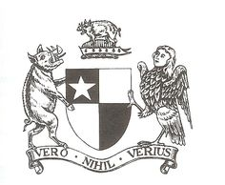
Figure 100: Coat of Arms for John de Vere, thirteenth Earl of Oxford. This example features the same charges as the garter arms. This one, however, illustrates De Vere’s service to the King at the Battle of Bosworth (the Boar rampant, i.e. standing up) and the harpy (right) which is indicative of support/loyalty to the king.

Other elements of a coat of arms might be inserted by the family themselves in order to indicate what they feel are their key qualities, in order to represent the story they wish to tell about themselves. For example, Humphrey de Bohun, the fourth Earl of Hereford, held a coat of arms on which ‘the Bohun swan’ rested atop (Figure 101).

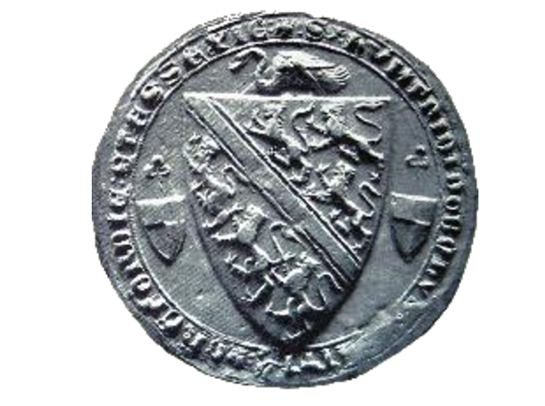
Figure 101: Coat of arms on a seal of Humphrey de Bohun, fourth Earl of Hereford. The ‘Bohun swan’ rests over the whole.

Iu A. Chistiakof notes that the white swan in heraldic art ‘is a symbol of rebirth, wisdom, courage and perfection.’ Humphrey de Bohun (1276-1322) was a member of an influential Welsh family who stood in opposition to King Edward II’s excesses of the time, Edward II’s potentially homosexual relationship with Piers Gaveston and the disproportionate influence Gaveston exercised over Royal policy and household funds. The white swan, therefore, is indicative of the de Bohun’s own perception of their family’s ‘wisdom, courage and perfection’ in standing against the King.
As will be perceived, this is the point where heraldic art strays into the realms of the fictive. Families are free to add charges as desired to their escutcheons and are limited only by the extent of their imagination, and the list of motifs and charges which can potentially be added, is endless. In the words of Arthur Charles Fox-Davies, ‘[t]here is scarcely an object under the sun which at some time or another has not been introduced in a coat of arms.’ Within his list of objects which might appear, he includes such items as ‘Noah’s ark, a safety-lamp, a 40-feet telescope, a radiometer, and a corrugated boiler flue. Consequently, it is hopeless to attempt anything in the nature of a list.’ Further, heraldic art is replete with mythological creatures (Figure 102). An object does not even need to exist – either in reality, or in any known mythology - in order to make an appearance. Fox-Davies observes, ‘[h]eraldry has assigned wings to almost every existing creature. The Pegasus or winged horse is not exclusively heraldic, but winged bulls and winged stags, for example, are occasionally met with.’

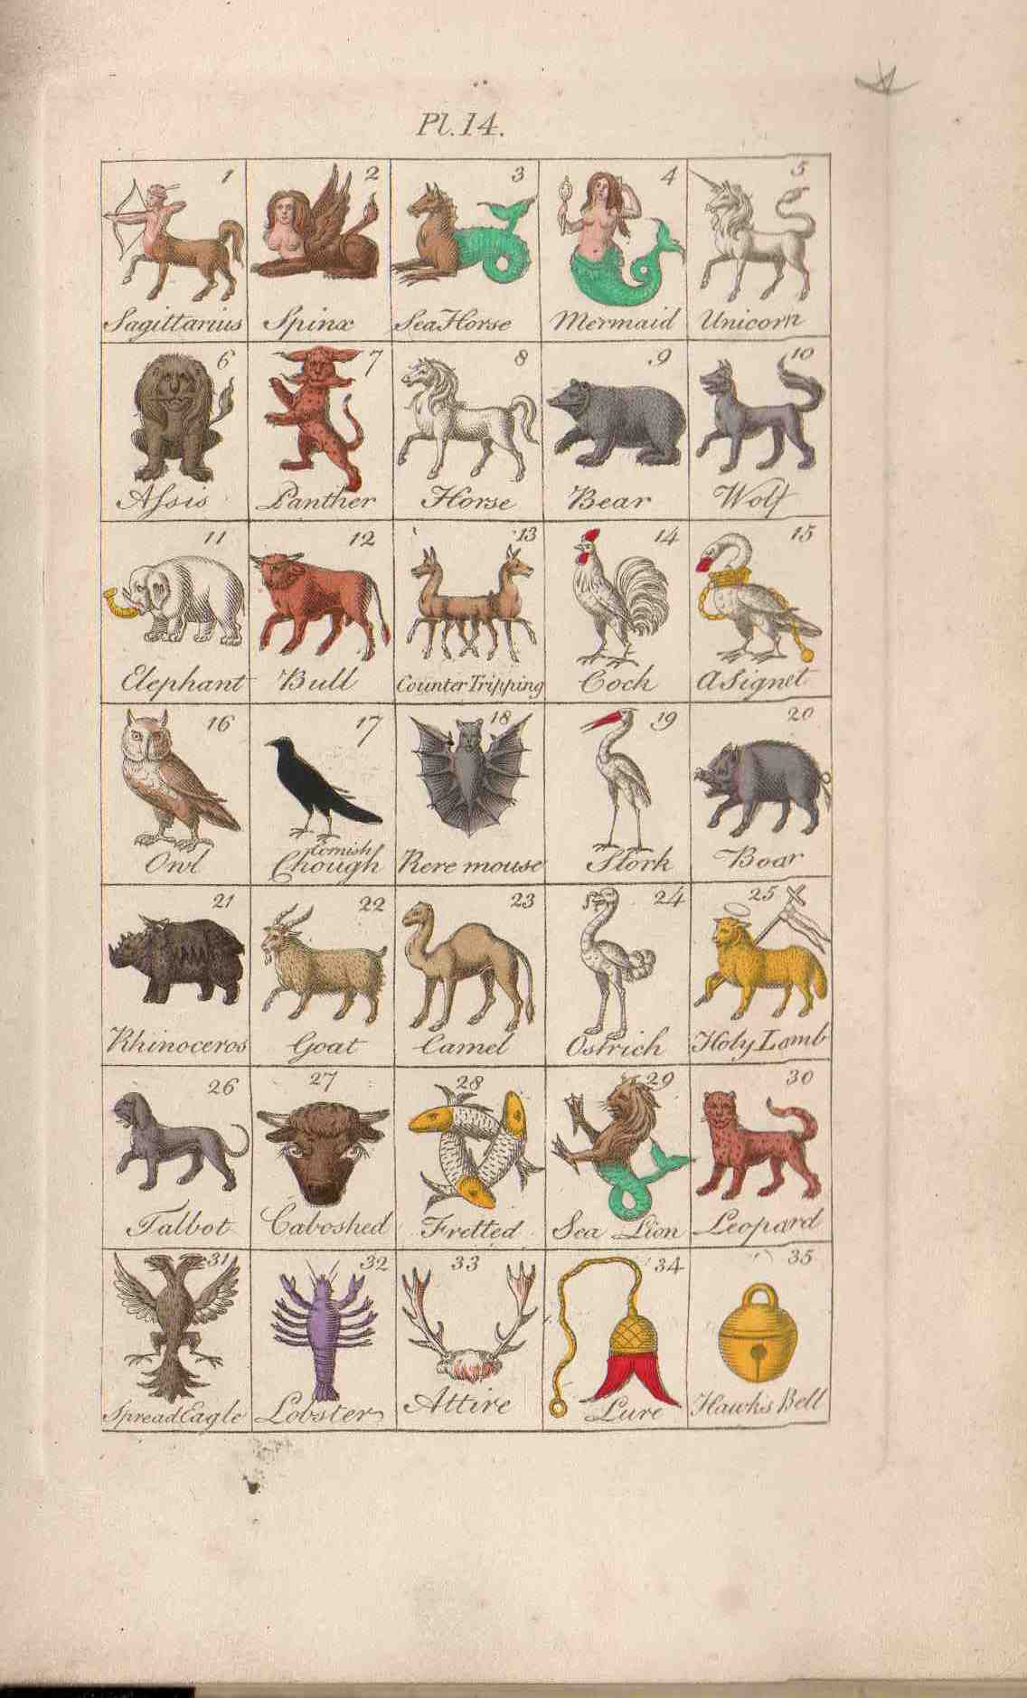
Figure 102: Plate 14 from Hugh Clark’s An Introduction to Heraldry (London: Henry Washbourne & Company, 1854). This is just one sample from a number of illuminated pages in this book describing the various charges which may be used on a coat of arms. Within this sample alongside ‘horse’ (No.8), ‘boar’ (No. 20) and ‘lobster’ (No. 32), there is also ‘sagittarius’, ‘sphinx’, ‘sea horse’, ‘mermaid’ and ‘unicorn (Nos. 1-5), in addition to ‘centaur tripping’ (13) and ‘sea lion’ (39 – not the traditional interpretation of ‘sea lion’ but rather a lion with the tail of a fish).

Other animals will have scales, fins, webbed feet, unicorn horns and fish tails added to them (Figure 103).

Figure 103: samples of mythological creatures which may be used as charges from the illustrations of Arthur Charles Fox-Davies, Heraldry Explained (Whitstable: David & Charles (Publishers) Limited, 1971), pp. 110-1. These images can be seen in this book, or in the non-redacted version of this PhD thesis, held at the University of Sheffield Library.

Similarly, the family motto appended to a coat of arms, is, once again, only restricted by the extent of the family’s imagination. Of the motto, Fox-Davies observes:

Without any attempt at veto, the College of Arms permits the selection of a motto at the fancy of the grantee, and recognises no ownership or prior claim in any particular motto or form of words. Unless a motto is selected by the grantee the patent is issued without one, but if one is selected this, if the grantee desires, will be painted and recorded with the arms and crest granted, but it is not hereditary and may be dropped or changed at pleasure.

To return to the example of the de Vere family (Figures 99 and 100), the motto they have adopted as representative of their story is ‘Vero Nihil Verius,’ or ‘Nothing Truer than Truth,’ in translation, which is somewhat ironic considering that the ‘truth’ being presented by these coats of arms, is as much a fiction as any romantic novel. The coat of arms reveals what the family wants to disclose about their own story. Whether it represents any actual ‘truth,’ however, is problematic. The ‘grammar’ of English heraldry, or what Clark terms ‘the science of Heraldry,’ is all too easily manipulated by those who wish to perpetuate a fiction about themselves. This is a form of artistry which can mean literally anything, have any qualities or interpretation imbued within it, any motto added to it, and, as Chistiakof argues, ‘begins to live a life of its own’ with ‘[p]eople in a society perceiv[ing] any heraldic symbol through the prism of their culture, [and] their cultural experience.’ It is a ‘science,’ or representation of ‘knowledge,’ for which there is no proof, a language of aesthetics with no clear dictionary and an art form which can convey multiple interpretations. Much like J. R. Smith’s conflation of the tropes of popular aesthetic theories of his contemporaneous society, the individual elements of heraldic art have meaning, but in reality they are nonsensical interpretively as they can be adapted to mean literally anything. Heraldic art is perfect, in other words, as an artistic device representative of storytelling and fiction.

C. Smith uses heraldic art as a tool of fiction within her own fiction, to expose the difference between what is real, and what is merely imagined to be real. To explore this, it is worth considering Lord Castlenorth’s obsession with his family heraldry more fully, and the story he is telling himself about his own family history.

‘He [Willoughby] has a great deal,’ said [Lord Castlenorth], ‘of the family countenance. He strikes me, indeed he always did from a boy, as resembling greatly the picture painted on board of William, son of Robert Fitz-Hayman, Seneschal to Henry II, who obtained the grants of the estate in Gloucestershire. His arms were azure, a lion rampant, gardant or, the original bearing of the family; you see it so in the great window of the hall at Castlenorth; the next is that of his wife, party per pale, two griffins counter sailant, sable, langued gules. This is my first quarter for the name of Bigot, a daughter of which house, this William, son of Robert, married.’ Lord Castlenorth was now got on his favourite topic, and in the numberless quarterings of his present bearing, he quite forgot the merits of his nephew, and was busied among wyverns and boars, pearls, saltiers, fesses and bend dexters, till they arrived at their own house.

First of all, Castlenorth invokes the image of ‘Robert Fitz-Hayman, Seneschal to Henry II,’ by comparing Willoughby’s appearance ‘as resembling greatly the picture painted on board of William,’ Robert Fitz-Hayman’s son, and provides details of the imagery associated with this branch of the family, in the form of the ‘lion rampant, gardant or.’ (Figure 104).

Figure 104: Samples of ‘Lion rampant gardant’. Illumination by Hugh Clark’s An Introduction to Heraldry (London: Henry Washbourne & Company, 1854), facing page 29 (left) and the coat of arms of Sir Gosenain d’Estrangort which is a Lion rampant gardant on an azure background.

The son of Henry I’s daughter Matilda, Henry II first became active in his attempts to usurp the English throne at the age of 14. After a military expedition to England in 1153, Henry made a peace treaty with the then king, Stephen, and inherited the English throne a year later. Henry was known to be a ruthless ruler, rooting himself in a desire to restore the empire of his grandfather, Henry I. He married Eleanor of Aquitaine, whose first marriage to Louis VII of France had been annulled. Later he came into conflict with Louis over the usurpation of lands, as Henry expanded his empire at Louis’ expense. He clashed with the Church, resulting in the bloody murder of Thomas à Beckett in Canterbury Cathedral. This is a particularly barbaric chapter in English history, and yet Lord Castlenorth seemingly exhibits immense pride in assimilating it into his family heraldry. This, potentially, may be due to the fact that the story behind the imagery reflects in some measure the story of Lord Castlenorth himself. By evoking the image of Henry II, Smith introduces the concept into her novel of a usurping, callous King, with no real right to rule. Not only has he illegitimately taken control of the English throne, but he also illegally commandeered French lands by asserting a tenuous right of ‘Empire’ and taken ownership of a French queen. Castlenorth is no less of a usurper in attempting to direct and control the actions of his nephew, Willoughby. He attempts to colonise Willoughby, again, via the use of a woman, his daughter, ‘growing every day fonder of the proposed marriage’ between his nephew and Miss Fitz-Hayman.

The story Lord Castlenorth tells himself about his royal heritage marks him as a traditionalist. His pride consists in his connection with the royal throne. Yet, this in itself is problematic. As Loraine Fletcher observes:

[h]e embodies what Smith most despises and hopes to see reformed in England. In his obsession with heraldry, that is, with the coat of arms that from early-medieval times recorded the land-grabbing and intermarriage of powerful families, he functions as the microcosm of an England imploding under the weight of dead tradition.

The very foundations of the family are tainted by its roots and hereditary links with the noble families of old, the very same noble families who run the very same society which Smith and her characters inhabit, struggling under the yoke of the mortmain (the dead hand) of tradition. In other words, Castlenorth’s fictional history is nothing to envy, despite his own evident pride in it. This is a pride, which, as the narrator

clearly elucidates for the reader, is misplaced when dealing with what is actually real:
As he [Castlenorth] advanced in life, he found himself of so little consequence for individual merit, that he was compelled to avail himself of the names of his ancestors, from whom only he derived any importance at all; and the ‘puny insect shivering at a breeze,’ swelled with conscious pride when he recited the names of heroes from whom he had so woefully degenerated.

Castlenorth’s family history, as represented by the heraldic imagery he espouses is, the narrator argues, a false story that he merely tells himself – and the world - for purposes of self-aggrandisement. Every picture tells a story – but it’s not necessarily a true one. Indeed, Smith’s utilisation of the grammar of heraldic art in the Castlenorth family itself raises doubts about the veracity of Castlenorth’s belief in the worthiness of his ancient ancestors, and that this, in turn, should automatically confer a hereditary importance upon himself from society. Analysis of the Castlenorth coat of arms as he describes it indicates rather a tale of degeneration hinted at by Smith in the race of this family. After outlining the original familial coat of arms of the ‘lion rampant, gardant or’ linked to royalty in the figure of Henry II, Castlenorth moves on to their descendants. ‘[T]he next is that of his wife, party per pale, two griffins counter sailant sable, langued gules.’ In heraldic art the griffin counter sailant sable, means a black griffin leaping (Figure 105).

Figure 105: Sample of a ‘griffin’ defined by Clark as ‘a chimerical creature [which] is half an eagle and half a lion, having large ears, but no wings, and rays of gold issuing from various parts of its body’ (Clark, An Introduction to Heraldry, p. 134). Within this sample, the rays of what would be gold are clearly visible. The griffin in this sample, however, is white (or ‘argent’ in heraldic terms) on a sable background, whereas the griffins (there would be a pair) in Lord Castlenorth’s arms, are described as sable themselves (Figure 106).

The reference to ‘langued gules’ refers to the fact that the black griffins both have red tongues (Figure 106).

Figure 106: Sample of a griffin, counter sailant, sable, langued gules, as per the description supplied by Castlenorth.

What is really interesting about this particular coat of arms as ascribed by Castlenorth to his ancient ancestors, is that it is nonsensical. Lord Castlenorth observes that this escutcheon belongs to the wife of ‘Robert Fitz-Hayman, Seneschal to Henry II.’ However, a griffin, according to Clark’s dictionary of terms, is always assigned to a male relative, and so it is impossible that the wife’s family should possess it. Further, the grammar of heraldry states that all beasts, excluding red ones, will be langued gules. ‘This rule,’ Clark argues, ‘is never to be deviated from,’ and so there is no need for a heraldic expert like Castlenorth to explicitly express this. It could be that Smith has made a mistake with her own heraldry. However, given Smith’s accuracy and expertise in artistic matters, and her close connections to practising artists outlined earlier in this thesis, this seems unlikely. Rather, it seems indicative of Smith making a comment about the quality of the Castlenorth family stock. Castlenorth is constructing a fiction about his own family history and how he ideally perceives this within his imagination, out of the obvious fiction of the devices which the narrator presents. Castlenorth misuses his own tools and thereby turns the ‘truth’ of his heraldry into an obvious fiction. Further, by using heraldry to speak this ‘truth,’ he demonstrates its invalidity. Smith’s narrator reveals this, but it is something that Castlenorth himself is blind to.

Lord Castlenorth’s next statement regarding his family history also supports this view: ‘[t]his is my first quarter for the name of Bigot.’ Given Smith’s fondness for attributing names to her characters which reflect their personal qualities, for example, Vampyre or Tygerface for the ruthless attorneys of Marchmont (1796), it seems likely that Lord Castlenorth’s true identity as a dogmatist is what is being alluded to. This discussion certainly sets Castlenorth off ‘on his favourite topic, and in the numberless quarterings of his present bearing, he quite forgot the merits of his nephew, and was busied among wyverns and boars, pearls, saltier, fesses and bend dexters, till they arrived at their own house.’ To Castlenorth, nothing has any importance beyond the imagery of his imagined nobility. The mention of ‘boars’ and ‘pearls’ also seems significant in this context. These heraldic devices recall the well-known Biblical phrase, ‘don’t cast your pearls before swine, with its meaning of don’t give items of quality to those who aren’t cultured enough to appreciate them. For what Smith really seems to be questioning here is the authenticity of the Castlenorth family heritage, and, in turn, how genuine their right to bear a coat of arms is. The reigning monarch has the right to confer the title of Baron onto any individual. As Clark tells us ‘the great rule of the institution was, that none should be admitted unless upon good proof that they were men of quality, state of living, and good reputation, worthy of it; and at the least descended of a grandfather by the father’s side, that bore arms, and had also a clear revenue in lands of at least 1000l per annum.’ On face value, from what the reader has been told of Lord Castlenorth and his estate, he falls into this category. However, the numbers of this title awarded was increased around the time of Charles II. Further, Clark argues ‘since the reign of George II, the number has been unlimited and the qualifications necessary for admission into this order has been frequently dispensed with.’ Castlenorth claims, as his initial description of his genealogy makes clear, that his familial history dates from an era preceding George II. However, incidences of counterfeit coats of arms are common in heraldic art, as all of the writers on this subject make clear. Fox-Davies, for example, asserts that the way to determine a spurious claim is by how early the claimant maintains his pedigree dates from:

In these days of absurd pedigree pretension and bogus pedigree claims (the bogus claimant always talks the loudest), there are not many who fully recognise the fact that nowadays a male pedigree back to the Conquest is a wild exception, and that male descent even as far back as Tudor times is now exceptional, even amongst those landed and titled families who are now generally regarded as of ancient date.

There is little doubt in the reader’s mind that Lord Castlenorth ‘talks the loudest’ on this matter. The potential exists, therefore, in this grammar of heraldry, that Castlenorth is what Smith might term a mere mushroom of a man, embodying, as Bethel terms it in her radical novel Desmond, ‘barons by recent purchase, and dignified mushroom nobility.’

The other elements in Castlenorth’s coat of arms expose his own story for the sham it is yet further. The griffin, for instance, is symbolic of valour and death-defying bravery in the grammar of heraldic art. The griffin would, according to the heraldic definition, ‘dare all dangers, and even death itself, rather than become captive.’
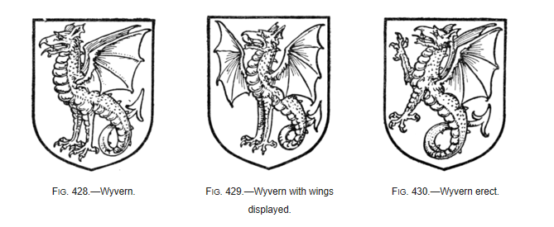
Figure 107: Figures 428, 429 and 430 from A Complete Guide to Heraldry by Arthur Charles Fox-Davies (London: Graham Johnston, 1909), p. 226, showing samples of the wyvern in heraldic art.

The wyvern, or the dragon with two rooster legs and a barbed serpent’s tail, is symbolic of valour and protection (Figure 107). The saltier – more commonly termed the saltire – is indicative of resolution within the lexicon of heraldry. Fesses, a broad horizontal band across the shield in the form of a military belt or girdle of honour, are representative of a readiness to serve the public. Similarly, a bend - one diagonal stripe - symbolises defence or protection. It is patently clear to the reader that the narrator does not consider Castlenorth as embodying any of these noble qualities. Indeed, the narrator unambiguously summarises his character thus:

This pride of ancestry was now the most distinguishing feature in a character where it appeared with the greatest prominence, from the faintness and insipidity of the other traits, for being no longer able to pursue the dissolute manner of life which he had adopted rather from fashion than inclination, he had now in other respects no character at all.

Castlenorth’s true character is a mere blank, consisting, in reality, of ‘no character at all.’ Whatever character he may have had when he was a young man has been dissipated away by following fashion. He has done this not, the narrator assures us ‘by inclination,’ but rather because he did not know what else to do. There is nothing noble or honourable in such a character.

Nor is there anything laudable in any other members of his family. Rather, Lady Castlenorth governs ‘her Lord with despotic sway (which indeed, saved him the trouble and probably the disgrace of governing himself).’ Each character in the Castlenorth family is entirely directed by self-interest. Castlenorth’s daughter, Miss Fitz-Hayman, lays claim to ‘eminent beauty,’ but in a satirical aside by the narrator the reader is advised that this is a mere ‘escutcheon of pretence,’ awarded to her by society because she is the ‘heiress to the illustrious house of Fitz-Hayman.’ That Smith employs the precise terminology of heraldic art here is again significant. The escutcheon of pretence has the following definition in the heraldic art dictionary of terms: ‘[w]hen the wife is an heiress impalement is not made use of, but the husband places the wife’s arms on a small escutcheon super-imposed on the centre of his own’ (Figure 110). ‘This is termed an escutcheon of pretence, because it signifies that the husband “pretends” to the representation of his wife’s family.’ Smith’s aside here makes reference both to the fact that Miss Fitz-Hayman is an heiress, and her ‘pretence’ of beauty of which ‘nature had very scantily allowed her,’ and does not, in reality, exist. It is also an oblique hint at events to come – Miss Fitz-Hayman’s intended husband, Willoughby, will ‘pretend’ to want to marry her for the sole reason that she is an heiress and marriage to her will resolve his financial entanglements. The terminology of heraldic art is utilised by Smith once again to demonstrate a fictional claim. Miss Fitz-Hayman is not beautiful and despite the fact that she is an heiress, Willoughby will not really want to marry her. Both aspirations towards beauty and matrimony are assimilated into that ‘escutcheon of pretence,’ in that they are a literal pretence. In the terms of her ‘real disposition of […] character,’ however, this was ‘inflated with ideas of its own consequence, and considering more than half the world as beings of another species, whose evils she could not feel for, because she was placed where it was impossible she could ever share them.’ In other words, Miss Fitz-Hayman is a callous, uncaring, plain young woman, who only ever exhibits self-interest.

Lord Castlenorth himself is also particularly selfish along with being weak and a hypochondriac in nature. His ‘real or imaginary complaints’ inspire dread in his own wife who refuses to nurse him. Rather, Lady Castlenorth delegates this task to the dependant living with them, Mrs. Calder, because ‘there was more trouble and disgust than honour to be obtained by a constant attention to it.’ Reference to the ‘trouble and disgust’ of Lord Castlenorth’s ‘real’ complaints raises questions in the reader’s mind concerning the true nature of the ‘it’ Lord Castlenorth suffers from, and which requires such ‘constant attention.’ It invokes imagery of bodily effluvia and discharges such as might result from that life of dissolution that he followed in his youth through fashion, but is now ‘no longer able to pursue,’ because of his own degeneration through age and illness. Castlenorth’s ‘wild career’ in his youth has been cut short through ‘declining health’ and ‘the irregularities of his life’ which have ‘impaired a habit naturally weak.’ Reference to the ‘wild career’ of his youth, links him to the sexually licentious Vavasour. The precise term is used by Emily in her description of her lover’s ‘wild career, where he is wasting his time, his fortune and his life.’ The implication is, as Fletcher observes in a footnote to the text, that Castlenorth’s repulsive bodily ailments have been brought about by his own disgusting habits, i.e. ‘debilitated by venereal disease and heavy drinking.’ Indeed, as Caroline’s fashionable mother in Rural Walks accentuates the hypocrisy of society’s ideals concerning how a woman of the first world behaves, discussed in the previous chapter, Castlenorth too is demonstrably a shameful specimen.

Linking Castlenorth to Vavasour via that reference to the similitude of their youthful wild careers further throws this ignominious behaviour into the light. Mr. Thorold delineates Vavasour’s precise nature thus:

He is called, and I believe is, a man of honour, in the common acceptation of the term; but I am afraid there is little real honour among those who are in any respect so very licentious as Vavasour is said to be in regard to your sex; the stile in which he lives among a certain description of women, is not only the means of degrading all in his opinion, but hardens the heart while it corrupts the morals: and with all Vavasour’s boasted honour, I dare say he is a man, who, if he happened to take a fancy to the mistress of his friend, would steal her affections and her person without hesitation, and suppose, that by an appeal to the sword or pistol to vindicate the wrong he had done, the action, however unprincipled, would derogate nothing from his honour.

The very ‘little real honour’ in these men of the first world who live their lives in the fashionable mode is denigrated here and explicitly laid bare for the infamous behaviour it is. Such a character is certainly not deserving of being represented by the valorous griffin, the noble wyvern or bend, or the unselfish fess. Indeed, the characteristics of each of these heraldic devices are the precise opposite of Castlenorth’s familial qualities. The obvious fictionality of the story which Castlenorth likes to imagine about himself and his family identity via the real meanings behind these heraldic tropes is exposed for the sham it is. These heraldic devices are just more fictional devices in the fiction of Lord Castlenorth’s construction concerning himself and his family story.

The concept that heraldic art can be manipulated in order to relate any story the teller wants and whether the story it presents should be believed or otherwise, is central to this novel, which is preoccupied with false histories. At the very heart of this is the lie which derails the heroine’s romance, threatening to undermine its essential nature as a love story. The hero and heroine cannot acceptably be in love if they are presented to each other as brother and sister, as the Castlenorth family and Willoughby’s own mother and sister connive to do. Here too, in this element of the story, Smith adopts the discourse of heraldic art to present another false story the family tells about itself, in order to manipulate what is perceived by onlookers as ‘truth.’ The lies of the various characters in preventing Willoughby’s match with Celestina with their story about the nearness of their relationship, and concealed truths in failing to pass on correspondence from Celestina to Willoughby, becomes a blot on the family escutcheon, which manifests itself in the confused and hastily written note which Willoughby sends to Celestina on the eve of their marriage. Smith uses the precise term to describe the note which ‘seem’d to have been written with a trembling hand; the lines […] crooked, and the letters hardly formed, and the paper blotted.’ The blots on the paper, which might be from either ink spilled in haste, or Willoughby’s tears, resemble the guttes de poix, or ‘drops of pitch’ and the guttes de lamente, or ‘drops of tears’ which might be added to the family coat of arms to stain an escutcheon (Figure 108). The guttes de poix (embodied by the blots of black ink) might be interpreted as a black stain on the escutcheon of family honour represented by the lies Willoughby’s family relay to him to in order to prevent his marriage to Celestina.

Figure 108: ‘Gutty’, or tear drops which might be added by families to stain an escutcheon. Illumination from Hugh Clark’s An Introduction to Heraldry (London: Henry Washbourne & Company, 1854), facing page 27. There are six types of ‘guttes’ which an escutcheon may be blotted with: (guttes d’or, or drops of gold, guttes d’eau, or drops of water (silver in colour), guttes d’olive, or drops of olive oil (green), guttes de lamente, or drops of tears (white), guttes de poix, or drops of pitch (black), or guttes de sang (or drops of blood).

By accessing the same terminology and making the association which interprets these heraldic figures into Willoughby’s letter, Smith exposes more fully the fact that much of what is being presented by the Castlenorths, as well as
Willoughby’s mother and sister, is a fiction. The narrator uses the same tools as Castlenorth accesses in his presentation of his family story to present a tale within a tale. The fact that this tale within the tale is a fictional one highlights the unreliability of heraldic art as a storyteller – about family history or, indeed, anything else. This national iconography is demonstratively flawed. Just as J. R. Smith has demonstrated that other systems of aesthetics so popular nationally at the time were also flawed, this form of artistry cannot be relied upon. By falsely asserting that Celestina is the natural born child of Mrs. Willoughby, and thus Willoughby’s sister, the fiction created also threatens to subvert the very nature of fiction itself. A love story cannot be a love story without a hero and heroine who are able to fall in love. The lies they perpetuate, therefore, threatens the very identity of not just the principal characters, but the genre of the story.

Further, within Celestina and its use of heraldic art and exposure of certain ‘facts’ about society’s first families as a lie, Smith also exposes her own fiction as a fiction, relentlessly playing with the motifs and tropes of fiction. The charges exhibited on Lord Castlenorth’s escutcheon subtly expose him as a fraud – a man who could not really exist within society with all the claims he makes about his ancestry. Yet, Smith goes further and exposes her characters as mere fabrications to the reader. It is as if she is playing with the tropes and devices of narrative fiction in the same way as she does with the motifs of heraldic art, in order to expose them as

fictitious. Consider the following description of the eponymous heroine:

[I]f she had any foible, (a perfect character it has been said must not be represented because it cannot exist) if she had any foible, it was carrying a little too far, though she carefully concealed it, that sort of pride which seemed born with her, and which, after all that has been said against it, is often, especially in a young and beautiful woman, a fortunate defect.

Celestina is a ‘character’. She’s not ‘a perfect character’ because ‘it has been said [that] must not be represented because it cannot exist’. Of course, as noted earlier, many devices in heraldic art can simultaneously not exist (Figure 102). What is fictional, what is being used to represent the fictional, what is real, and what is being used to represent the real in fiction, becomes muddled and confused in this text. Viktor Shklovsky argues that true art uses defamiliarisation to invest the literary text with strangeness and thereby enhance perception in the novel. This, as Shklovsky argues, is the essence of literariness, exposing artificiality and rendering the novel, comprised as it is, of elements of artistry, into a piece of art in its own right. As Shklovsky theorises:

[A]rt exists that one may recover the sensation of life; it exists to make one feel things, to make the stone stony. The purpose of art is to impart the sensation of things as they are perceived and not as they are known. The technique of art is to make objects “unfamiliar,” to make the forms difficult, to increase the difficulty and length of perception because the process of perception is an aesthetic end in itself and must be prolonged. Art is a way of experiencing the artfulness of the object; the object is not important.

With her emphasis on the fictions that the characters are telling themselves via artistry, alongside the fact that she exposes her own characters as mere characters, thus purposely removing them from the realm of the real world of the reader’s belief, Smith lays bare the fact of her own artistry. She is using artistic tropes to construct art – accessing the imagery of an aesthetic device (in this case, the aesthetics of heraldry) – to prove to her reader that what is being presented is a fiction about the nature of fiction. The stories told are proven to have no basis in reality. By deconstructing the devices of heraldic art in such detail, Smith simultaneously deconstructs ‘the sensation of things […] as they are known,’ and rather exposes them ‘as they are perceived.’ She shows the fallacy of the story presented by heraldic art. It is as if she lays claim to the fact that there are no truths in her world, only stories. At the same time, she also proves her own artistry in that her literary works like Celestina becomes a piece of art in its own right, via the tropes of art.

Within this novel, Smith demonstrates how heraldic art can be manipulated to tell any story the teller wants to tell. This proves to be true in the case of Lord Castlenorth and the fictions he perpetuates about his family, using the ‘evidence’ of his heraldic history. Yet, it is also true about the teller of the tale the reader holds in their hands. Smith, too, manipulates the charges and motifs to tell the tale she wants to tell, and appropriates these and adapts them to best suit her purpose. Within this reimagining of the mechanics of storytelling this approach yields up fresh possibilities for those who would be ordinarily be invisible within a traditional novel of sensibility to reappear and tell their own tales. Emily, for example, the seduced and fallen woman should, if Smith was playing by the conventional rules, disappear from the text and die. However, as noted in the previous chapter, Emily’s death scene is not written as one meeting a deserved fate. Rather, Emily at her death is reconstructed as saintly. During her life she exhibits traits which are, in reality, more noble than the behaviour of the Castlenorths or Mrs. Elphinstone’s wealthy brother. ‘Whatever may be my failings, or my errors,’ as Emily writes to Mrs. Elphinstone, ‘I trust that among them will never be reckoned want of love to my relations.’ The ‘truth’ about this genre of novel is that Emily as a ruined woman should have just been removed from the readers’ view. However, ‘truth,’ whether it be represented by a heraldic shield, or the acceptable conventions of fiction cannot be relied on in Smith’s work. By emphasising the fact that her characters are just that, characters, Smith demonstrates that she can do anything she likes within her own story, to tell the story she wishes to tell. Via this aestheticisation of her own story, she is able to highlight the flaws in the stories society tells itself about itself, and undermine the credence that should be placed in these stories as they should traditionally be. Rather she asserts her own right as an artist to invent a better story, one which tells the tale as it should to her mind correctly be.

If ‘truth’ as the onlooker perceives it is based on fiction, then the implication Smith leaves us with is that any understandings or beliefs that society derives about itself from these stories, is also intrinsically flawed. This is a society with something rotten at its core, with an outward appearance of nobility, but which, like Lord Castlenorth himself sheltering behind his apparently noble heritage as embodied by his shield, has degenerated into something putrid. This, therefore, becomes a society where the ruling classes take pride in their former family heritage, and yet fail to protect their immediate living family. This can be exemplified by the treatment of Mrs. Elphinstone by her eldest brother when her child is dying and her husband is ill. Appealing for help from her wealthy brother her family’s pleas are received ‘so coldly that I shall hardly repeat the visit.’ This is a society which places precedence on outward show, but ignores immediate family when ‘famine was likely to stare [them] in the face.’ It is one which is constructing a fiction about the nobility of its own nature, which, as Smith’s use of the heraldic shield makes clear, cannot ever accurately reflect the true nature of things as they are. These lies society is telling itself threaten its very survival, just as the false histories at the heart of the novel threaten the very genre of the novel. An over-reliance on false histories, as embodied by heraldic art, as being representative of some version of history has, in the novel, desperate implications concerning the survival of some of the characters. Mrs. Elphinstone’s son will die because her elder brother, newly married to a woman of fortune, can only offer ‘cruelty and scorn from those to whom the sick heart looks for pity and protection;’ he forgets any ‘tender recollection’ of his sister. His new grandeur enables him to adopt a new identity within society, and forget his old filial associations.

Of course, familial identity is the principal concern of heraldic art – what a family wants to tell the world about itself to the world in its escutcheon. Yet, heraldic art, as has been made clear, is not representative of all society. It is something which only belongs to the gentrified classes, leaving entire strata of society with no apparently discernible identity. This is emphasised by the narrator in the satirical description of ‘the only son of an Irish Baronet,’ Molyneux. A member of ‘the very first world,’ ‘[i]t is absolutely necessary [for him] to be in the House of Commons.’ Here, however, instead of representing the people of his ‘Cornish borough,’ he instead gives ‘a silent vote to the Minister for the time being’ and ‘neither cared nor enquired whether [his vote] would benefit or injure his country, about which he was perfectly indifferent.’ Those who don’t belong to that very first world are left not just voiceless and powerless by the true nature of the nobility who are supposed to represent their interests, but also identity-less and rendered invisible by these societal structures. Further, if heraldic art fails to represent the middling and lower classes of society, it is also a particularly masculine art form. There is very little space within heraldic art to represent female members of the family. Although women are visible within shields, their family histories tend to be subsumed by the imagery associated with the male branch of the family (Figures 109 and 110 detail examples of how a woman’s family arms are incorporated).

Figure 109: Wife’s arms impaled with husband’s. In this sample, the coat of arms of the Duchess of Cambridge is impaled with those of her husband, Prince William, Duke of Cambridge.

Figure 110: Alternatively, another way of marshalling arms by a man who has married an heiress is by superposing the lady’s arms in a smaller shield upon the middle of his own, as in this example from the coat of arms for the county of Cheshire. This is termed ‘a scutcheon of pretence’ (Fox-Davies, Heraldry Explained, p. 28) and is used by Smith in her description of Miss Fitz-Hayman highlighted earlier.

Within the novel, Celestina, from the very outset, is portrayed as lacking a concrete identity. Her birth, is ‘very uncertain, and [...] nothing was known of it but that it was disgraceful to her parents.’ Considered by all as ‘not very honourably born,’ ‘a foreigner,’ ‘an alien,’ and certainly belonging to the lower classes (‘[p]eople of fashion don’t part with their children to strangers,’) there are questions from the very beginning as to Celestina’s identity. Indeed, the emphasis from the narratorial voice and the portrayal of the various characters’ perceptions concerning her, highlights the fact that, like the space where women are not on heraldic shields, there is a blank where the identity of the heroine should be.

This blank is encompassed in the ‘merely negative life’ that Celestina is condemned to live. Her name is forgotten, or dismissed as illegal or irrelevant, ‘You took, I think, your Christian name from the order of Nuns among whom you were reared; and your surname – I mean the name they gave you – it has escaped me?’ Heraldic art leaves no space in which to record women’s histories or identities. Without Willoughby, who Celestina freely admits has stolen the very essence of her being (‘for my heart has been Willoughby’s ever since I knew I had one, and it will be his, till I remember it no longer’) and with no discernible identity recorded in any family history or heraldic art whatsoever, Celestina, like many of the women in the text, appears destined to live that ‘merely negative life’ of barely existing on the margins of society. It can be no coincidence that many of the women in this text are described by the narrator in terms of ‘negatives.’ Mrs. Thorold is ‘one of those who are best described by negatives.’ Mrs. Maculaurin, the wife of Dr. Maculaurin who treats Lord Castlenorth during his first illness, is similarly portrayed with ‘all her virtues [being] negative.’ Mrs. Elphinstone’s ‘mother-in-law was one of those common characters which are so difficult to describe unless it be by negatives.’ The term, in the descriptions of women in the novel, appears too frequently for it to be merely coincidental. The apparent absence of women in this heraldic record of history is not just the heroine’s alone – it is the story of the recording of all women’s lives.

However, as previously argued, within this novel, Smith is exposing heraldry as fictive and she is further reinventing how the story should be told. Castlenorth’s identifying himself as somehow honourable or noble because he can display a family escutcheon has been laid bare as nonsense. The reader is already apprised of the fact that it is possible to use the tropes and motifs of heraldic art for misrepresentation, or to make mistakes with it, as Castlenorth does when he misuses his own tools, discussed earlier. The men surrounding Celestina frequently make similar mistaken assumptions about her. Vavasour erroneously determines that she can be easily tricked into taking his statement that she should ‘know how little concealment and dissimulation are in my nature;’ a statement which is dissimulation in itself. He underestimates Celestina’s purity of nature by treating her with ‘improper familiarity’ in his crass attempts at seduction. Later on in the text, in a Burney-esque episode in Ranelagh Gardens, Celestina is mistaken by a group of unruly young men, for ‘a girl without character.’ Within the novel, Celestina’s lack of identity or heraldic background is held against her by those first families. Yet the reader is already fully aware that heraldry within this novel can only be viewed as an unreliable narratorial device. The reader already knows that these noble first families are not really all that noble in nature. So the story is a more complex one than just dismissing Celestina’s identity because she is not represented by a family heraldic shield. Rather, the fact that she does not appear in heraldic art, and that she is mistaken for ‘a girl without character’ strengthens her position via her relative invisibility. The reader can draw this conclusion from the aspersions Smith and her narrator have already cast on the reliability of the recording of ‘truth’ in these heraldic devices. After all, if heraldry does not represent truth, then absence from the escutcheon can only speak in favour of the heroine’s authenticity and her being truly noble in nature.

Smith, however, uses the heraldic aesthetic in order to tell a woman’s story. Indeed, this is a novel which is really only concerned with women’s stories: Celestina’s principally, but also Jessy’s, Emily’s, and Mrs. Elphinstone’s in a series of nested narratives. Even when the action ostensibly follows the hero, Willoughby, in his quest to locate Celestina’s true identity, the story departs from him, instead relating Jacquelina’s and Genevieve’s sufferings at the hands of their tyrannical (male) relations. Further, the women’s stories that are being told are of women who are far nobler in nature than the Castlenorths, the Vavasours, the Molyneuxs, or any of those families of the first world seem to be. This is true even in spite of the fact that Jessy is of the servant classes, Emily is a fallen woman, and Mrs. Elphinstone subsists on the brink of extreme poverty. By focusing on these women’s stories, Smith exposes the fallacy of ‘truth’ as it is recorded by masculine heraldic art, and creates an alternative mode of recording family history concentrating on the marginalised and the dispossessed.

These women do not have access to a family history being portrayed by heraldic art. In heraldic terms, they are invisible. However, further consideration of Castlenorth’s coat of arms demonstrates that the motifs he recounts as his own very much encompass Celestina’s character and in some ways summarise her history much more accurately than they do his own. Heraldic art is all about detailed interpretation, and a close reading of Castlenorth’s charges: the boar, the pearls, the griffin, the wyvern, the saltier, fesses and bends, demonstrate that all of these devices bear a part in Celestina’s character and the plot of her story. The pearl is perhaps the most obvious as symbolic of her innocence. However, the wyvern is the most interesting. Symbolic of valour and protection, it is particularly linked with supporters of the Duke of Marlborough (Figure 111).

Figure 111: Arms of John Churchill, First Duke of Marlborough (1650-1722), with wyverns standing erect either side.

It is noteworthy that the title of Duke of Marlborough is one of the few titles in the peerage that allows for female inheritance, and the only current dukedom to do so. It is perhaps one of the only coats of arms in existence (beyond those belonging to the queen) which allows space to tell a female story. It can be no accident that Smith selects this particular charge, with its unique association with the Marlborough Dukedom, for inclusion in the family escutcheon, in a novel preoccupied with telling women’s stories. The Marlborough family seat (Blenheim Palace, constructed in 1722) is situated in Oxfordshire: a location Smith resided in during the years 1796 and 1797 and clearly known to her. The family armourial motto for the Marlborough dukedom is ‘fiel pero desdichado’ which translates as ‘faithful, though unfortunate.’ The applicability of this motto to Celestina’s story, remaining faithful to Willoughby throughout her unfortunate adventures, cannot be merely coincidental. Via the adoption of this device, Smith hints to the reader that the chronicles which are truly authentic in nature are being presented not via the escutcheon, but through these unrecorded women’s stories. The symbolism of the wyvern as representative of valour and protection, alongside the other similar motifs which represent these qualities (the bend, for defence and protection, and the fess indicating a willingness to serve others) are entirely representative of the leading female in this story. Celestina proves herself time and again as unselfish, and as willing to protect others in her assistance of the unfortunate Jessy and the ruined Emily. Similarly, the motif of the boar becomes significant, as Celestina bravely sacrifices all she has ever known to take her first long coach journey alone. This imagery becomes doubly noteworthy when it is considered that the boar’s head is also representative of hospitality. Celestina performs both bravely and with hospitality during this journey.

Setting out on the long coach journey at an early hour, the protagonist acts like a heroine, with ‘an elevation of spirit’ and ‘the consciousness she was acting right’ as she ignores the ‘pain which she too sensibly felt in tearing herself from Willoughby’ without either bidding him goodbye or revealing her intentions to leave. Setting out ‘at five o’clock in a dreary winter morning,’ Celestina’s first action on her journey into her unknown future is to rescue Jessy from travelling dangerously and vulnerably alone. Assuming the characteristics of all of the motifs of Castlenorth’s shield, Celestina immediately notes that Jessy ‘is as young as I am, [...] and perhaps even more unfortunate. Why should I not take her with me, if she is, as I suppose, travelling the same road?’ Celestina provides both hospitality and protection for a woman even more unfortunate than herself, recognising her as a sister in her misfortunes. After all, as the narrator seems to imply, all women are ‘travelling the same road.’

The appropriation of the qualities of Castlenorth’s heraldic devices and the incorporation of these into the principal women’s stories demonstrates how Smith is manipulating these fictional devices yet further, in order to advance her own fiction. Whilst Celestina is simultaneously perceived as nothing and no-one to the Castlenorths, to her own mind and the readers she is of the utmost importance. Her character, the reader is told, ‘was an uncommon one’:

though she had always been told by Mrs. Willoughby that her birth was very uncertain, and that nothing was known of it but that it was disgraceful to her parents, since they had taken such pains to conceal it, she felt within herself a consciousness of hereditary worth, an innate pride, which would never suffer her to believe herself descended from mean or unworthy persons: her open and commanding countenance, where sat dignity mingled with sweetness; her nymph-like and graceful form, which might have rivalled the models of Grecian art; were advantages of which, though she was not vain of them, she could not be insensible.

Celestina somehow knows, despite a lack of any proof, that ‘she was not born to be dependent.’ The face she presents to the world – her own escutcheon – is ‘open and commanding,’ i.e., if appearances are to be believed, then Celestina belongs to the leading classes. In her assertions, of course, Celestina is proven to be correct, as it will ultimately transpire that she is the legitimate daughter of Ormond and Genevieve (the upper-class friend and sister respectively of the Count de Bellegarde) and the Count’s niece. As such, she has an interest in ‘the innumerable coats of arms that were blazoned on the windows, and on the banners that hung in faded majesty’ of her rightful family home. She does, it will ultimately transpire, have a coat of arms belonging to her own family after all. However, this escutcheon will not be revealed until the very final pages of the novel, because Celestina, unlike Lord Castlenorth, does not need heraldic art to tell her story for her. She embodies all of the qualities of the charges via her true nobility of nature. Celestina’s happy ending comes through her own true worth.

The discovery of her true identity as being linked to both Lady Horatia and as belonging to the family of the Count de Bellegarde will ensure she ends the novel ‘highly gratified’ in the ‘romantic and magnificent scenes [surrounding] the castle.’ It is here that Celestina’s – and the reader’s – journey will end, with one final foray into heraldic art. It is in Celestina’s grandfather’s castle that Willoughby will at long last learn the truth concerning his lover’s identity, in an ancient hall,

replete with heraldic shields:

They entered an immense hall; barbarously magnificent; it was roofed with beams of oak, and the sides covered with standards, and trophies of armour, the perishable parts of which were dropping to pieces. The narrow Gothic windows were filled, not with glass that admitted the light, but with glass painted with the achievements of the family; mingled with the heads of saints and martyrs, whose names were now, no where to be found, but in the archives of the neighbouring convent. But, in contemplating the innumerable coats of arms that were blazoned on the windows, and on the banners that hung in faded majesty, between them, Willoughby could not help recollecting what food they would afford for the favourite speculations of his uncle, and his thoughts dwelt a moment on the scene that might have passed in consequence of his absence, in the family of Castlenorth.

The Gothic scenes that Willoughby must pass through where the ‘achievements’ are set side by side with ancient armour ‘dropping to pieces,’ highlights yet further the nonsensicality of placing any kind of credence in this type of artwork as conveying historical truth. Accessing the tropes of the Gothic, and asserting the irrelevance of this artistry to modernity (information about these achievements are, after all, ‘no where to be found, but in the archives of the neighbouring convent,’) the narratorial voice implies that this mode of living is outdated, old-fashioned, archaic, and completely irrelevant to the reality of living in Celestina’s and Willoughby’s contemporaneous society. Theirs is a society, after all, where in France where Celestina’s ancestral home is situated, titles will shortly be abolished by the National Convention, and family names, and their ancient histories as recorded in heraldic art, will be rendered defunct. As Dale Townshend argues of John Thelwall’s treatment of the structure of British society, Thelwall highlights a society which ‘is, indeed, an old Gothic mansion, [and] it is one that is profoundly haunted.’ Smith’s treatment of Castlenorth’s clinging to tradition, alongside such characters as Mrs. Elphinstone’s wealthy brother’s clinging to form in order to deny his own closest relatives, demonstrates that this mode of society just does not work. It is rather a flawed and immoral society, hampered by tradition and refusing to evolve. Throughout the action of the novel, Celestina’s happy ending will be comprised of both a discovery of her true family name, alongside a forging of her own future with a sisterhood of friends – Jessy, Mrs. Elphinstone and Lady Horatia – whom she assimilates into her new family structure. This sisterhood of women are the people who have stood beside her, supported her, and helped her to survive Willoughby’s initial abandonment of her. Here, Smith demonstrates that Celestina’s modern approach to family is more healthful than a pointless clinging to archaic tradition in order to construct a fiction about family heritage.

This chapter has considered the extensive use Celestina makes of heraldic art, Smith’s exposure of these devices as unreliable as purveyors of ‘truth’ about the stories families tell themselves and society about themselves. Smith accesses these artistic tropes in order to aestheticise her own fiction and question the very nature and reliability of storytelling itself. Nearly every motif of storytelling and artistry within this text is possible to be exposed as fraudulent, including how much credence the readers should place in the characters peopling this text. They are, after all, held up for what they are – imaginary characters. Smith twists how a novel of sensibility should traditionally be and transforms it via the aesthetics she has employed into something deeper. Smith doesn’t ask her readers to suspend disbelief. Rather, she asks them to seek out the truth in her story. The truth being that not every family that hides behind the heraldic shield is noble in nature, and, indeed, this is an outdated, archaic view which damages the health of society. Instead, modernity demands that women be able to tell their own stories, including the stories of those such as Emily, who should conventionally have disappeared from the text. The national iconography of heraldic art does not permit them space to do this.

Yet, Celestina, like all of Smith’s novels, is a novel that is concerned with the telling of women’s stories. Even the novels where the titular character is male, such as Desmond (1792) and The Young Philosopher (1798), do not really follow the action of male heroes. In The Young Philosopher, as noted in chapter two, the philosopher of the title is not the main focus of much of the text. The story is rather told to Delmont – and the reader ‘in fragments at various times,’ narrated by the women who are relaying their experiences. In Desmond, the subject of the men’s letters in this epistolary novel are women. The women’s letters convey mostly information about themselves. These women, who are not properly represented in heraldic art, and are dismissed by men as girls ‘without character,’ come to symbolise all women and all women’s stories. In an unjust society, where a woman is the possession of her husband – a mere femme couvert - Smith exposes the fact that women are unable to tell their own stories within British Romantic society.

The findings from this chapter and this thesis overall demonstrate the primacy of the visual artistry of the eighteenth century in Smith’s works, and suggests the same of British Romanticism. The popular aesthetics of the period as embodied in Burke’s theories of the sublime and the beautiful, or theories of the picturesque which were so ubiquitous throughout the epoch, demonstrate that these theories were pervasively understood throughout society of the time and clearly exercised great influence in how society viewed itself. J. R. Smith’s conflation of traits from all three aesthetic theories in order to make ironic or moral commentary upon society as an easily comprehensible cultural shorthand exhibits this with clarity. Similarly, C. Smith’s reliance upon a national iconography of art in her use of heraldry in Celestina further displays the measure by which she expected her audience to understand the importance, and meaningfulness, of this form of iconography.

Smith’s novels almost invariably tell women’s stories. However, what are we as readers to make of novels like Celestina, a story which contains so many falsehoods? Similar questions are raised surrounding Smith’s use of the picturesque in Emmeline, where the aesthetic is used by the heroine to make herself outwardly seem more authentic to those around her. Smith’s use of aesthetics intriguingly demonstrates, the impossibility of relying upon art to tell the truth. Further, her technique suggests that no aesthetic, including an ostensible ‘science’ in the form of a national iconography of heraldry, can be a reliable form to convey ‘truth.’ Rather, Smith would concur with Tania Blanco’s argument in her recent exhibition piece: ‘Art is a lie that makes us see the truth.’ Smith and the many visual artists she surrounded herself with adapt the unstable tropes of the popular aesthetic theories of the day in order to interrogate and expose the true nature of their society. Smith’s aestheticisation of the fictive exhibits that, ultimately, the ‘truth’ that can be conveyed through art is unreal and impossible, much like the winged creatures of heraldry (Figure 102). The tropes of the popular theories of the day are nothing more than ‘art.’

Real society, Smith suggests, does not allow women to tell their own stories. Therefore, these stories have necessarily to be veiled in art, much as Emmeline’s story is concealed within the picturesque landscape and Celestina’s hidden on the escutcheon. In Smith’s works, it seems clear that fiction, fiction-making and fictiveness combine to create an art form in its own right, within which Smith represents the unrepresentable and contrives to tell those women’s stories. By immersing her own fictive art within the real eighteenth-century art world, and by pulling the world of art into her tropology, Smith challenges her readers to seek out the truth in her stories.

Bibliography

‘A.B’, Letters on the Character and Writings of Mr. Burke (Edinburgh: The Scots Chronicle, 1797)

Addison, Interesting Anecdotes, Memoirs, Allegories, Essays, and Poetical Fragments, Tending to Amuse the Fancy, and Inculcate Morality (London: Printed for the author, 1797)

Addison, Joseph, ‘from The Spectator 1712-14)’ in The Sublime: A Reader in British Eighteenth-Century Aesthetic Theory. ed. by Andrew Ashfield and Peter de Bolla (Cambridge: Cambridge University Press, 1996), pp. 62-69

Ahuja, Anjana, ‘Jane Austen, a £400 Painting and an Enduring Art Mystery’, The Financial Times, (24 April 2017), (https://www.ft.com/content/9f68d0a2-140a-11e7-b0c1-37e417ee6c76) [accessed: 14th September 2017]

Aiken, John, An Essay on the Application of Natural History to Poetry (Warrington: J. Johnson, 1777)

Aiken, J. & A. L., Miscellaneous Pieces in Prose (London: J. Johnson, 1773)

Alexander, David, Affecting Moments: Prints of English Literature made in the Age of Romantic Sensibility, 1775-1800 (York: University of York, 1993)

Allen, Reggie, ‘The Sonnets of William Hayley and Gift Exchange’, European Romantic Review, 13.4 (2002), 383-392(http://dx.doi.org/10.1080/10509580214662) [accessed: 30th March 2017)

Alliston, April, ‘Female Quixotism and the Novel: Character and Plausibility, Honesty and Fidelity’, The Eighteenth Century, 52.3-4 (Fall/Winter 2011), 249-269 (DOI: 10.1353/ecy.2011.0021) [accessed: 17th May 2016]

Alryyes, Ala, ‘War at a Distance: Court Martial Narratives in the Eighteenth Century’, Eighteenth-Century Studies, 41.4 (Summer 2008), 525-542 (http://www.jstor.org/stable/25161240) [accessed: 17th May 2016]

Anderson, John M., ‘“Beachy Head”: The Romantic Fragment Poem as Mosaic’, Huntington Library Quarterly, 63.4 (2000), 547-574(http://www.jstor.org/stable/3817616) [accessed: 19th September 2016]

Andrews, Kerri, ‘“Herself ... Fills the Foreground”: Negotiating Autobiography in the Elegiac Sonnets and The Emigrants’, in Charlotte Smith in British Romanticism, ed. by Jacqueline Labbe (London: Pickering & Chatto, 2008), pp. 13-27

Anon., ‘Book Review’, Monthly Review, or, Literary Journal, 26, (1798), 423-426

Anon., ‘Early English Landscapes: The Grant Collection at Stoke’, The Manchester Guardian, 16 February 1953, 2

Anon., ‘Elegy on the Death of Mr. G. Smith, Landscape Painter, of Chichester, September 7th, 1776’, London Magazine, Vol. XLV (1776), 665

Anon., ‘Collective Nouns – People’, www.collectivenouns.biz, (http://www.collectivenouns.biz/list-of-collective-nouns/collective-nouns-people/) [accessed: 9 May 2018]

Anon., ‘James Northcote, R.A.’, The New York Times, (2 July 1876), 3.

Anon., ‘Memoir of James Northcote, R.A.’, The Imperial Magazine, 8:96 (December 1826), 1072-1082

Anon., ‘Mrs Charlotte Smith’, The Lady’s Monthly Museum, or Polite Repository of Amusement and Instruction: being an assemblage of whatever can tend to please the fancy, interest the mind, or exalt the character of the British fair. By a Society of Ladies, 1798-1828, (July 1808), 30

Anon., ‘Mrs Robinson’, The Lady’s Monthly Museum, or Polite Repository of Amusement and Instruction: being an assemblage of whatever can tend to please the fancy, interest the mind, or exalt the character of the British fair. By a Society of Ladies, 1798-1828, (July 1808), 30

Anon., ‘Mrs. Smith’s Ethelinde, a Novel’, A Monthly Review, or Literary Journal (June 1790), 2, 161-166

Anon., ‘Of Gypsies, and the Laws Respecting Them’, The Town and Country Magazine, or Universal Repository of Knowledge, Instruction and Entertainment, (April 1787), 178-179.

Anon., ‘On the Literary Pretensions of Mrs. Bennett, Ann Radcliffe, and Charlotte Smith’, Universal Magazine (May 1809), 394

Anon., ‘Review of A Narrative of the Loss of the Catharine, Venus, and Piedmont Transports, and the Thomas, Golden Grove, and AEolus Merchant Ships, near Weymouth, on the 18th of November last. Drawn up from Information taken on the Spot, by Charlotte Smith; and published for the Benefit of an unfortunate Survivor from one of the Wrecks, and her Infant Child’, Monthly Review, or, Literary Journal, 20 (August 1796) 478-9

Anon., ‘Review of An Essay on the Picturesque, as compared with the Sublime and the Beautiful; and on the Use of Studying Pictures, for the Purpose of improving real Landscape’, Monthly Review, or, Literary Journal, ed. by G. Mars, 16 (March 1795), 315-317

Anon., ‘Review of Celestina in The Critical Review, No. 3, November 1791, pp. 318-23’ in Celestina by Charlotte Smith, ed. by Loraine Fletcher (Plymouth: Broadview Literary Editions, 2004), 545-548

Anon., ‘Review of Celestina in The European Magazine and London Review, No. 20, October 1791, pp. 278-79’ in Celestina by Charlotte Smith, ed. by Loraine Fletcher (Plymouth: Broadview Literary Editions, 2004), pp. 544-545

Anon., ‘Review of Emmeline, The Orphan of the Castle’, English Review, or, An Abstract of English and Foreign Literature, 1783-1795, 12 (July 1788), 26-27

Anon., ‘Review of Emmeline, or, The Orphan of the Castle’, The Critical Review, or, Annals of Literature, ed. by Tobias Smollett, 65 (June 1788), 530-532

Anon., “Review of Emmeline, or The Orphan of the Castle” in The General Magazine and Impartial Review, April 1788, p. 200

Anon., ‘Review of Emmeline, or, The Orphan of the Castle, The Monthly Review, September 1788’ in Charlotte Smith, Emmeline, ed. by Loraine Fletcher (Peterborough, Ontario: Broadview Literary Texts, 2003), pp. 480-481

Anon., ‘Review of Emmeline, or, The Orphan of the Castle’, The Town and Country Magazine, or, Universal Repository of Knowledge, Instruction and Entertainment, 20 (August 1788), 375-6

Anon., ‘Review of Ethelinde, or the Recluse of the Lake’, The Critical Review, (September 1791), 57

Anon., ‘Review of Ethelinde, or the Recluse of the Lake’, The General Magazine and Impartial Review, (March 1790), 114

Anon., ‘Review of Montalbert’, Monthly Review, or, Literary Journal, 1752-1825, 19 (January 1796), 87-88

Anon., ‘Review of Montalbert’,The Analytical Review: or, History of Literature, 22.1 (1795), 59-60

Anon., ‘Review of Montalbert’, The Critical Review, or, Annals of Literature, 20 (August 1797), 469

Anon., ‘Review of New Publications: Notices Illustrative of the Drawings and Sketches of Some of the Most Distinguished Masters in all the Principal Schools of Design. By the Late Henry Reveley, Esq.’, The Gentleman’s Magazine and Historical Chronicle, (August 1820), 139-141

Anon., Sketches from Nature, in High Preservation, by the Most Honourable Masters; Containing upwards of one hundred Portraits, or Characters of the Most Conspicuous Persons in the Kingdom (London: G. Kearsley, 1779)

Anon., ‘St Rosalia’, http://www.catholic.org/saints/saint.php?saint_id=157 [accessed: 6th February 2017]

Anon., The Cuckold’s Chronicle, Being Select Trials for Adultery, Incest, Imbecility, Ravishment & c. (London: H. Lemoin, 1793)

Anon., The Emigrant in London, A Drama, in Five Acts, by An Emigrant (London: J. Barker, Boosy & De Bosse, 1795)

Anon., The Laws Respecting Women, as they regard their Natural Rights, or their Connections and Conduct (London: J. Johnson, 1777)

Anon., ‘The Old Manor House’, The Mirror of Literature, Amusement, and Instruction, 25th August 1827, 142

Anon., The Spectre (London: Printed for John Stockdale, 1789)

Anon., ‘Timeline of the French Revolution’, EmersonKent.com, http://www.emersonkent.com/history/timelines/french_revolution_timeline_1789.htm [18th April 2016]

Archer, Mildred, Natural History Drawings in the India Office Library (London: Her Majesty’s Stationery Office, 1962)

Armstrong, Isobel, ‘The Gush of the Feminine: How Can We Read Women’s Poetry in the Romantic Period?’ in Romantic Women Writers: Voices and Countervoices, ed. by Paula R. Feldman and Theresa M. Kelley (Hanover, New England & London: University Press of New England, 1995), pp. 13-32

Armstrong, Nancy, Desire and Domestic Fiction: A Political History of the Novel (Oxford & New York: Oxford University Press, 1987)

Ashfield, Andrew and Peter de Bolla, The Sublime: A Reader in British Eighteenth-Century Aesthetic Theory (Cambridge: Cambridge University Press, 1996)

Astbury, Katherine, ‘Charlotte Smith’s The Banished Man in French Translation; or the Politics of Novel-Writing During the Revolution’ in Charlotte Smith in British Romanticism, ed. by Jacqueline Labbe (London: Pickering & Chatto, 2008), pp. 129-143

Astbury, Katherine, ‘The Trans-National Dimensions of the Émigré Novel during the French Revolution’, Eighteenth-Century Fiction, 23.4 (Spring 2011), 801-832 (https://muse-jhu-edu.eresources.shef.ac.uk/article/444346) [accessed: 22nd July 2016]

Bachelard, Gaston, The Poetics of Space (Boston: Beacon Press, 1994)

Baillie, John, ‘An Essay on the Sublime (1747)’ in The Sublime: A Reader in British Eighteenth-Century Aesthetic Theory. ed. by Andrew Ashfield and Peter de Bolla (Cambridge: Cambridge University Press, 1996), pp. 87-100

Bainbridge, Simon, ‘Politics and Poetry’ in The Cambridge Companion to British Literature of the French Revolution in the 1790s, ed. by Pamela Clemit, pp. 190-205 (http://dx.doi.org/10.1017/CCOL9780521516075.013) [accessed: 17th May 2016]

Ballaster, Ros, Seductive Forms: Women’s Amatory Fiction from 1684 to 1740 (Oxford: Clarendon Press, 1992)

Ballentyne, Andrew, ‘Geneaology of the Picturesque’, British Journal of Aesthetics, 32.4(October 1992), 320-329
(http://bjaesthetics.oxfordjournals.org.eresources.shef.ac.uk/content/32/4/320) [accessed 29th January 2016]

Barbour, Judith, ‘The Professor and the Orang-Outang: Mary Shelley as a Child Reader’ in Frankenstein’s Science: Experimentation and Discovery in Romantic Culture, 1780-1830, ed. by Christina Knellwolf and Jane Goodall (Aldershot, Hampshire: Ashgate, 2008), pp. 32-48

Baridon, Michel, ‘Historiography’ in The Cambridge History of Literary Criticism, ed. by H. B. Nisbet and Claude Rowson (Cambridge: Cambridge University Press, 1997), pp. 282-301 (http://dx.doi.org/10.1017/CHOL9780521300094.01) [accessed: 5th November 2016]

Baridon, Michel, ‘Science and Literary Criticism’ in The Cambridge History of Literary Criticism, ed. by H. B. Nisbet and Claude Rowson (Cambridge: Cambridge University Press, 1997), pp. 778-797 (http://dx.doi.org/10.1017/CHOL9780521300094.033) [accessed: 5th November 2016]

Barkhoff, Jürgen, ‘Romantic Science and Psychology’ in The Cambridge Companion to German Romanticism, ed. by Nicholas Saul (Cambridge: Cambridge University Press, 2010), pp. 209-226 (http://dx.doi.org/10.1017/CCOL9780521848916.013) [accessed: 18th October 2016]

Barkley, Danielle, ‘Crossing Borders: Geographic and Generic Expansiveness in Letitia Landon’s Romance and Reality’, European Romantic Review, 27.2 (2016), 175-188 (http://dx.doi.org/10.1080/10509585.2016.1140043) [accessed: 6th May 2016]

Barlow, Joel, Advice to the Privileged Orders in the Several States of Europe, resulting from Necessity and Propriety of a General Revolution in the Principle of Government, Part I (London: J. Johnson, 1792)

Barrell, John, ‘Radicalism, Visual Culture and Spectacle in the 1790s’, Romanticism on the Net,46 (May 2007) (http://www.erudit.org/revue/ron/2007/v/n46/016131ar.html) [accessed 17th December 2015]

Barrell, John, The Dark Side of the Landscape: The Rural Poor in English Painting 1730-1840 (Cambridge: Cambridge University Press, 1989)

Barrell, John, The Political Theory of Painting from Reynolds to Hazlitt: ‘The Body of the Public’ (New Haven & London: Yale University Press, 1986)

Bartolomeo, Joseph F., ‘Charlotte to Charles: The Old Manor House as a Source for Great Expectations’, Dickens Quarterly, 8.3 (September 1991), 112-119

Bartolomeo, Joseph F., ‘Subversion of Romance in The Old Manor House’, Studies in English Literature, 1500-1900, 33.3(Restoration and Eighteenth Century, Summer 1993) 645-657 (http://www.jstor.org/stable/451018) [accessed 9th May 2014]

Basker, James, ‘Criticism and the Rise of Periodical Literature’ in The Cambridge History of Literary Criticism, ed. by H. B. Nisbet and Claude Rowson (Cambridge: Cambridge University Press, 1997), pp. 316-332 (http://dx.doi.org/10.1017/CHOL9780521300094.013) [accessed: 5th November 2016]

Batchelor, Jennie, ‘Influence, Intertextuality and Agency: Eighteenth-Century Women’s Writing and the Politics of Remembering’, Women’s Writing, 20.1 (2013), 1-12 (http://dx.doi.org/10.1080/09699082.2013.754253) [accessed: 24th February 2017]

Batchelor, Jennie, Women’s Work: Labour, Gender, and Authorship 1750-1830 (Manchester & New York: Manchester University Press, 2010)

Batchelor, Rhonda, ‘The Rise and Fall of the Eighteenth Century’s Authentic Feminine Voice’, Eighteenth-Century Fiction, 6.4 (July 1994), 347-368 (https://muse.jhu.edu/article/409362/pdf) [accessed: 6th July 2016]

Battersby, Christine, ‘Terror, Terrorism and the Sublime: Rethinking the Sublime after 1789 and 2001’, Postcolonial Studies, 6.1 (2003), 67-89 (http://dx.doi.org/10.1080/13688790308118) [accessed: 9th December 2016]

Beaver, Alfred, ‘The Free Society of Artists’, The Portfolio: an Artistic Periodical, 17 (January 1886), 179-184

Beer, Gillian, The Romance (London: Metheun & Company Limited, 1970)

Behrendt, Stephen C., ‘Charlotte Smith, Women Poets and the Culture of Celebrity’ in Charlotte Smith in British Romanticism, ed. by Jacqueline Labbe (London: Pickering & Chatto, 2008), pp. 189-202

Behrendt, Stephen C., ‘“I am not what I am”: Staged Presence in Romantic Autobiography’ in Romantic Autobiography in England, ed. by Eugene Stelzig (Farnham, Surrey: Ashgate Publishing, 2009)

Behrendt, Stephen C., ‘Poetry’ in The Cambridge Companion to Women’s Writing in the Romantic Period, ed. by Devoney Looser (Cambridge: Cambridge University Press, 2015), pp. 1-15 (https://doi-org.sheffield.idm.oclc.org/10.1017/CCO9781139061315.003) [accessed: 25th September 2017]

Bending, Stephen, Green Retreats: Women, Gardens and Eighteenth-Century Culture (Cambridge: Cambridge University Press, 2013)

Bending, Stephen, ‘Re-Reading the Eighteenth-Century English Landscape Garden’, Huntington Library Quarterly, 55.3 (Summer 1992), 379-399 (http://www.jstor.org/stable/3817684) [accessed: 30th November 2016]

Benis, Toby Ruth, ‘“A Likely Story”: Charlotte Smith’s Revolutionary Narratives’, European Romantic Review, 14.3 (2003), 291-306 (http://dx.doi.org/10.1080/1050958032000099117) [19th January 2014]

Bennett, Mark, ‘Gothic Travels’ in Romantic Gothic: An Edinburgh Companion, ed. by Angela Wright and Dale Townshend (Edinburgh: Edinburgh University Press, 2016), pp. 224-245

Benson, Aldolph B., ‘Fourteen Unpublished Letters by Henry Crabb Robinson: A Chapter in his Appreciation of Goethe’, PMLA, 31.3 (1916), 395-420 (http://www.jstor.org/stable/457010) [accessed: 24th January 2017]

Benstock, Shari, ‘At the Margin of Discourse: Footnotes in the Fictional Text’, PMLA, 98.2 (1983), 204-225 ( http://www.jstor.org/stable/462046) [20th January 2016]

Bentley Jr., G. E., ‘Copyright Documents in the George Robinson Archive: William Godwin and Others 1713-1820’, Studies in Bibliography, 35 (1982), 67-110 (http://www.jstor.org/stable/40371753) [accessed: 11th September 2017]

Béres Rogers, Kathleen, ‘Permeability and its Uses: Affect and Audience in Charlotte Smith’s Elegiac Sonnets’, Women’s Writing, 16.1 (2009), 126-142 (http://dx.doi.org/10.1080/09699080902768323) [12thJanuary 2016]

Berger, John, About Looking (New York: Vintage Books, 1980)

Berger, John, Ways of Seeing (London: Penguin Books Limited, 2008)

Bermingham, Ann, Landscape and Ideology: The English Rustic Tradition 1740-1860 (Berkeley, Los Angeles & London: University of California Press, 1986)

Bermingham, Ann, ‘Technologies of Illusion: De Loutherbourg’s Eidophusikon in Eighteenth-Century London’, Art History, 39.2 (2016), 376-399 (http://onlinelibrary.wiley.com.eresources.shef.ac.uk/doi/10.1111/1467-8365.12243/epdf) [accessed: 16th June 2016]

Bermingham, Ann, ‘The Aesthetics of Ignorance: The Accomplished Woman in the Culture of Connoisseurship’, Oxford Art Journal, 16.2 (1993),3-20 (http://www.jstor.org/stable/1360509) [1st February 2016]

Bermingham, Ann, ‘The Simple Life: Cottages and Gainsborough’s Cottage Doors’ in Land, Nation and Culture, 1740-1840: Thinking the Republic of Taste, Ed. by Peter de Bolla, Nigel Leask and David Simpson (Houndsmills, Basingstoke: Palgrave Macmillan, 2005), pp. 37-62

Besterman, Theodore, The Publishing Firm of Cadell & Davies: Select Correspondence and Accounts 1793-1836 (London: Humphrey Milford, 1938)

Blanco, Tania, Lennon’s Letter to the Queen Instead of the £345M Letter from the Queen,’ 2018 Exhibition of postgraduate students, Royal Academy of Art, London.

Blank, Antje, ‘Introduction’, Women’s Writing, 16.1 (2009), 1-5 (http://dx.doi.org/10.1080/09699080902768232) [12th January 2016]

Blank, Antje, ‘Things as they Were: The Gothic of Real Life in Charlotte Smith’s The Emigrants and The Banished Man’, Women’s Writing, 16.1 (2009), 78-93 (http://dx.doi.org/10.1080/0969908092768281) [19th January 2014]

Blank, Antje & Todd, Janet, ‘Introduction’ in Desmond by Charlotte Smith, ed. by Antje Blank & Janet Todd (Ontario, Canada: Broadview Literary Texts, 2001), pp. 7-33

Bohls, Elizabeth, Women Travel Writers and the Language of Aesthetics (Cambridge: Cambridge University Press, 1995)

Bohrer, Martha, ‘Thinking Locally: Novelistic Worlds in Provincial Fiction’ in The Cambridge Companion to Fiction in the Romantic Period, ed. by Richard Maxwell and Kate Trumpener (Cambridge: Cambridge University Press, 2009), pp. 89-106 (http://dx.doi.org/10.1017/CCOL9780521862523) [5th January 2015]

Bowles, William Lisle, Sonnets, Written Chiefly on Picturesque Spots During a Tour (Bath: R. Crutwell, 1789)

Boyd, Diane E., ‘“Professing Drudge”: Charlotte Smiths Negotiation of a Mother-Writer Author Function’, South Atlantic Review, 66.1 (Winter 2001), 145-166 (http://www.jstor.org/stable/3202033) [accessed: 22nd September 2017]

Bradshaw, Penny, ‘Romantic Recluses and Humble Cottages: Charlotte Smith’s Ethelinde and the Literary Construction of Grasmere’, Women’s Writing (2017), 1-19 (http://dx.doi.org/10.1080/09699082.2017.1355516) [accessed: 11th September 2017]

Brannon, George, Brannon’s Picture of the Isle of Wight; or, The Expeditious Traveller’s Index (London: Dodo Press, 2009)

Brant, Clare, ‘Duelling by Sword and Pen: The Vauxhall Affray of 1773’, Prose Studies, 19.2 (1996), 160-172 (http://dx.doi.org/10.1080/01440359608586584) [29th January 2016]

Bray, Matthew, ‘Removing the Anglo-Saxon Yoke: The Francocentric Vision of Charlotte Smith’s Later Works’, The Wordsworth Circle, 24.3 (Summer 1993), 155-158 (http://www.jstor.org/stable/24042447) [accessed: 17th May 2016]

Brenneman, David A., ‘Self-Promotion and the Sublime: Fuseli’s Dido on the Funeral Pyre’, Huntington Library Quarterly, 62.1/2 (1999), 68-87 (http://www.jstor.org/stable/3817809) [accessed: 28th February 2017]

Brewer, John, ‘“Love and Madness”: Sentimental Narratives and the Spectacle of Suffering in Late-Eighteenth-Century Romance’ in Land, Nation and Culture, 1740-1840: Thinking the Republic of Taste, Ed. by Peter de Bolla, Nigel Leask and David Simpson (Houndsmills, Basingstoke: Palgrave Macmillan, 2005), pp. 131-147

Brewer, John, The Pleasures of the Imagination: English Culture in the Eighteenth Century (London: Harper Collins, 1997)

Brewer, William D., ‘The French Revolution as a Romance: Mary Robinson’s Hubert de Sevrac’, Papers on Language and Literature: A Journal for Scholars and Critics of Language and Literature, 42.2 (Spring 2006), 115-49

Briggs, Asa, ‘The English: How the Nation Sees Itself’ in Literature in the Modern World: Critical Essays and Documents, ed. by Dennis Walder (Oxford: Oxford University Press, in association with The Open University, 1990)

Brissenden, R. F., Virtue in Distress: Studies in the Novel of Sentiment from Richardson to Sade (London & Basingstoke: MacMillan Press, 1974)

Brittan, Owen, ‘Subjective Experience and Military Masculinity at the Beginning of the Long Eighteenth Century, 1688-1714’, Journal for Eighteenth-Century Studies, 40.2 (June 2017, 273-290

Broadley, A. M., ‘Introduction’ in The Journal of a British Chaplain in Paris During the Peace Negotiations of 1801-2 From the Unpublished MS of the Reverend Dawson Warren, M.A., unofficially attached to the Diplomatic Mission of Mr. Francis James Jackson, Ed. A. M. Broadley (London: Chapman and Hall Limited, 1913), pp. xiii-li

Brodey, Ingor Sigrun, ‘Adventures of a Female Werther: Jane Austen’s Revision of Sensibility’, Philosophy and Literature, 23.1 (April 1999), pp. 110-126 (https://muse-jhu-edu.eresources.shef.ac.uk/article/26968) [accessed: 19th January 2017]

Brontë, Charlotte, Jane Eyre (Harmondsworth: Penguin Books Limited, 1966)

Brooks, Colin, ‘England 1782-1832: The Historical Context’ in The Context of English Literature: The Romantics, ed. by Stephen Prickett (London: Methuen & Company Limited, 1981), pp. 15-76

Brooks, Stella, ‘The Sonnets of Charlotte Smith’, Critical Survey, 4,.1(Jane Austen and Romanticism, 1992), 9-21 (http://www.jstor.org/stable/41555618) [accessed 25th November 2015]

Brown, Deborah, ‘Revolutionary Imaginings in the 1790s: Charlotte Smith, Mary Robinson, Elizabeth Inchbald’, Women’s Writing, 19.3 (2012), 379-382 (http://www.dx.doi.org/10.1080/09699082.2012.666422) [accessed 19th January 2014]

Brown, G., A New Treatise of Flower Painting, or, Every Lady Her Own Drawing Master, with Directions how to mix the Various Tints, and Obtain a Complete Knowledge of Drawing Flowers with Taste, by Practice Alone (London: G. Riley, 1799)

Brown, John, A Description of the Lake at Keswick (and the Adjacent Country) Communicated in a Letter to a Friend by a Late Popular Writer (Kendal: J. Ashburner, 1770)

Brown, Marshall, ‘Poetry and the Novel’ in The Cambridge Companion to Fiction in the Romantic Period, ed. by Richard Maxwell and Kate Trumpener (Cambridge: Cambridge University Press, 2009), pp. 107-128 (http://dx.doi.org/10.1017/CCOL9780521862523) [accessed: 29th September 2017]

Brown, Marshall ‘Romanticism and Enlightenment’ in The Cambridge Companion to British Romanticism, ed. by Stuart Curran (Cambridge: Cambridge University Press, 1993), pp. 25-47

Brownstein, Rachel M., Becoming a Heroine: Reading about Women in Novels(New York & Chichester: Columbia University Press, 1994)

Brunt, Rosalind, ‘A Career in Love: The Romantic World of Barbara Cartland’ in Popular Fiction and Social Change, ed. by Christopher Pawling (London: Macmillan Press, 1984), pp. 127-156.

Bullard, Paddy, ‘The Meaning of the ‘Sublime and Beautiful’: Shaftesburian Contexts and Rhetorical Issues in Edmund Burke’s “Philosophical Enquiry”’, The Review of English Studies, 56.224 (April 2005), 169-191 (http://www.jstor.org/stable/3661416) [accessed: 9th December 2016]

Bunce, J. Thackray, ‘James Northcote RA’, Fortnightly Review, 19:114 (June 1876), 861-876

Burgess, Miranda J., ‘Charlotte Smith, The Old Manor House’ in A Companion to Romanticism, ed. by Duncan Wu (Oxford: Blackwell Publishers Limited, 1998), pp. 122-130

Burke, Edmund, ‘A Philosophical Inquiry into the Origin of Our Ideas of the Sublime and Beautiful with an Introductory Discourse Concerning Taste’ in The Works of Edmund Burke, Vol. 1 (London: A Public Domain Book, Kindle Edition, 2012)

Burke, Edmund, On Taste, On the Sublime and Beautiful, Reflections on the French Revolution, A Letter to a Noble Lord: With Introduction and Notes (New York: P. F. Collier and Son, 1909)

Burke, Edmund, ‘Reflections on the Revolution in France, and on the Proceedings in Certain Societies in London relative to that Event: In a Letter intended to have been sent to a Gentleman in Paris, 1790’ in The Works of Edmund Burke, Vol. 3 (London: A Public Domain Book, Kindle Edition, 2012)

Butler, Marilyn, ‘Culture’s medium: the Role of the Review’ in The Cambridge Companion to British Romanticism, ed. by Stuart Curran (Cambridge: Cambridge University Press, 1993), pp. 120-147

Butler, Marilyn, Jane Austen and the War of Ideas (Oxford: Clarendon Press, 1987)

Campbell, Jill, ‘Women Writers and the Woman’s Novel: The Trope of Maternal Transmission’ in The Cambridge Companion to Fiction in the Romantic Period, ed. by Richard Maxwell and Kate Trumpener (Cambridge: Cambridge University Press, 2009), pp. 159-176 (http://dx.doi.org/10.1017/CCOL9780521862523.010) [accessed 5th January 2015]

Campbell, Scott C., ‘“Disagreeable Misconstructions”: Epistolary Trouble in Charlotte Smith’s Desmond’ in Enlightening Romanticism, Romancing the Enlightenment: British Novels from 1750 to 1832, ed. by Miriam L. Wallace (Farnham Surrey: Ashgate, 2009), pp. 55-68

Cardinale, Phil, ‘Coleridge’s “Nightingale”: A Note on the Sublime’, Notes and Queries, 49.1 (2002), 35-36 (http://www.jstor.org.eresources.shef.ac.uk/openurl?sid=primo&volume=49&date=2002&spage=35&issn=00346551&issue=1) [accessed: 20th February 2017]

Carpenter, Kirsty, Refugees of the French Revolution: Émigrés in London, 1789-1802 (Houndsmills, Basingstoke: Macmillan Press Limited, 1999)

Carritt, E. F., ‘The Sublime’, Mind, 19.75 (July 1910), 356-372 (http://www.jstor.org/stable/2248112) [accessed: 9th December 2016]

Carson, Jamin, ‘The Sublime and Education’, The Journal of Aesthetic Education, 40.1 (Spring 2006), 79-93 (http://www.jstor.org.sheffield.idm.oclc.org/stable/4140219) [accessed: 21st March 2017]

Castle, Terry, ‘Women and Literary Criticism’ in The Cambridge History of Literary Criticism, ed. by H. B. Nisbet & Claude Rawson (Cambridge: Cambridge University Press, 2008, pp. 434-455 (http://dx.doi.org/10.1017/CHOL9780521300094.020) [accessed 18th January 2016]

Cavendish, Georgiana, ‘The Passage of the Mountain of Saint Gothard’, The European Magazine and London Review (December 1799), 405-408

Chard, Chloe, ‘Effeminacy, Pleasure and the Classical Body’ in Femininity and Masculinity in Eighteenth-Century Art and Culture, ed. by Gill Perry & Michael Rossington (Manchester & New York: Manchester University Press, 1994), pp. 142-161

Charlesworth, Michael, ‘Thomas Sandby Climbs the Hoober Stand: The Politics of Panoramic Drawing in Eighteenth-century Britain’, Art History, 19.2 (June 1996), 247-266 (http://web.a.ebscohost.com.eresources.shef.ac.uk/ehost/pdfviewer/pdfviewer?sid=70573943-acce-4a01-958c-cc176429a44d%40sessionmgr4003&vid=1&hid=4209) [accessed 11th January 2016]

Chistiakof, A. Iu, ‘Regional Heraldry and Identity’, Anthropology and Archaeology of Eurasia, 51.4 (2013), 52-62 (http://dx.doi.org/10.2753/AAE1061-1959510404) [accessed: 17th January 2017]

Clark, Hugh, An Introduction to Heraldry (London: Henry Washbourne & Company, 1854)

Clark, Kenneth, Landscape Into Art (London: John Murray, 1976)

Clark, Norma, ‘“The Cursed Barbauld Crew”: Women Writers and Writing for Children in the Late Eighteenth Century’ in Opening the Nursery Door, ed. by Mary Hilton, Morag Styles and Victor Watson (London & New York: Routledge, 1997)

Clarke, Cecil, ‘Montalbert’, Notes and Queries, S11-IX (14th March 1914), 209 (http://nq.oxfordjournals.org.eresources.shef.ac.uk/content/s11-IX/220/209-d) [accessed 9th December 2015]

Clayton, Daniel, ‘Georgian Geographies “from and for the margins”: “King George men” on the Northwest Coast of North America’ inGeorgian Geographies: Essays on Space, Place and Landscape in the Eighteenth-Century, ed. by Miles Ogborn & Charles W. J. Withers (Manchester & New York: Manchester University Press, 2004), pp. 24-51

Cleeve, Rowley, George Romney (London: George Bell & Sons, 1902)

Clemit, Pamela and Charlotte Smith, ‘Charlotte Smith to William and Mary Jane Godwin: Five Holograph Letters’, Keats-Shelley Journal, 55 (2006), 29-40

Clewis, Robert R., ‘What’s the Big Idea?: On Emily Brady’s Sublime’, The Journal of Aesthetic Education, 50.2 (Summer 2016), 104-118 (https://muse.jhu.edu/article/619245) [accessed: 9th December 2016]

Clucas, Tom, ‘Editing Milton during the French Revolution: Cowper and Hayley as ‘Brother Editor[s]’, The Review of English Studies, 65.272 (2014), 866-887 (https://academic-oup-com.sheffield.idm.oclc.org/res/article-lookup/doi/10.1093/res/hgu004) [accessed: 3rd April 2017]

Cobbett, William, Cottage Economy (London: Peter Davies Limited, 1926)

Cochrane, Tom, ‘The Emotional Experience of the Sublime’, Canadian Journal of Philosophy, 42.2 (June 2012), 125-148 (https://muse.jhu.edu/article/492969) [accessed: 9th December 2016]

Cohn, Jan, and Thomas H. Miles, ‘The Sublime: In Alchemy, Aesthetics and Psychoanalysis’, Modern Philology, 74.3 (February 1977), 289-304 (http://www.jstor.org/stable/437116) [accessed: 30th January 2017]

Coke, David E., Sybilla Jane Flower, M. J. H. Liversidge, Peter Mitchell, Bernard Price, and Brian Stewart, The Smith Brothers of Chichester (Chichester: The Friends of Pallant House, 1986)

Coleridge, Samuel Taylor Coleridge, Letters of Samuel Taylor Coleridge, ed. by Earl Leslie Griggs, Vol 1: 1785-1800 (Oxford: Clarendon Press, 1956)

Coleridge, Samuel Taylor, The Complete Poetical Works of Samuel Taylor Coleridge, Ed. by Ernest Hartley Coleridge (Oxford: The Clarendon Press, 1912)

Collier, Jane, The Art of Ingeniously Tormenting, with Proper Rules for The Exercise of that Pleasant Art, Humbly Addressed in the First Part to the Master, Husband & c. In the Second Part to the Wife, Friend, & c., With Some General Instructions for Plaguing all your Acquaintance (London: A. Millar, 1753)

Collier, Mary, The Woman’s Labour: An Epistle to Mr. Stephen Duck, in Answer to his Late Poem entitled ‘The Thresher’s Labour’ (London: J. Roberts, 1739)

Collins, William, ‘Poems of William Collins’ in Gray and Collins: Poetical Works, ed. by Roger Lonsdale (Oxford: Oxford University Press, 1977), pp. 107-194

Colvin, Sidney, ‘From Rigaud to Reynolds: Characteristics of French and English Painting in the Eighteenth-Century’, The Portfolio: an Artistic Periodical, 3 (January 1872), 82-87

Combe, William, Doctor Syntax’s Three Tours: In Search of the Picturesque, Consolation, and a Wife (London: Chatto&Windus, Publishers, 1895)

Condé, Mary, ‘Reading Romance, Reading Landscape: Empires of Fiction’ in Landscape and Empire, 1770-2000, ed. by Glenn Hooper (Aldershot and Hampshire: Ashgate Publishing Limited, 2005), pp. 127-140

Cook, Wayne, and William Godwin, ‘Two Letters of William Godwin’, Keats-Shelley Journal, 15 (Winter, 1966\), 9-13 (http://www.jstor.org/stable/30209847) [accessed: 17th January 2017]

Cooper, Anthony Ashley, third Earl of Shaftesbury, Characteristicks of Men, Manners, Opinions, Times (Cambridge: Cambridge University Press, 2012) (https://doi.org/10.1017/CBO9780511803284) [accessed: 22nd January 2018]

Cooper, Lane, ‘The “Forest Hermit” in Coleridge and Wordsworth’, Modern Language Notes, 24.2 (February 1909), pp. 33-36 (http://www.jstor.org/stable/2916638) [accessed: 13th September 2016]

Copeland, Edward, Women Writing About Money: Women’s Fiction in England, 1790-1820 (Cambridge: Cambridge University Press, 1995)

Costelloe, Timothy M., ‘Imagination and the Internal Sense: The Sublime in Shaftesbury, Reid, Addison and Reynolds’ in The Sublime: From Antiquity to Present, ed. by Timothy M. Costelloe (Cambridge: Cambridge University Press, 2012), pp. 50-63

Cowper, William, The Letters and Prose Writings of William Cowper, Vol. IV, 1792-1799, ed. by James King & Charles Ryskamp (Oxford: Oxford University Press, 1984)

Cowper, William, The Task and Other Poems, (London: A Public Domain Book, Kindle Edition, 2011)

Cozens, Alexander, Principles of Beauty Relative to the Human Head (London: James Bixwell, 1778)

Craciun, Adriana, ‘Citizens of the World: Emigrés, Romantic Cosmopolitanism, and Charlotte Smith’, Nineteenth-Century Contexts: An Interdisciplinary Journal, 29.2-3, (2007), 169-185 (http://dx.doi.org/10.1080/08905490701584676) [accessed 8th May 2014]

Craciun, Adriana, ‘“Empire without End”: Charlotte Smith at the Limits of Cosmopolitanism’, Women’s Writing, 16.1, (2009), 39-59 (http://dx.doi.org/10.1080/09699080902768265) [accessed: 6th May 2016]

Craciun, Adriana, ‘Romantic Satanism and the Rise of Nineteenth-Century Women’s Poetry’, Literary History, 34.4 (Autumn 2003), 699-721 (http://www.jstor.org/stable/20057809) [accessed: 25th November 2015]

Craciun, Adriana and Lokke, Kari E., Rebellious Hearts: British Women Writers and the French Revolution (New York; State University of New York Press, 2001)
Cramer, Charles A., ‘Alexander Cozens’s New Method: The Blot and General Nature’, The Art Bulletin, 79.1 (March 1997), 112-129 (http://www.jstor.org/stable/3046232) [accessed 1st June 2016]

Craven, Maxwell, Derbeians of Distinction (Derby: The Breedon Books Publishing Company,1998

Cresswell, Tim, ‘Race, Mobility and the Humanities’ in Envisioning Landscapes, Making Worlds: Geography and the Humanities, ed. by Stephen Daniels, Lydia De Lyser, J. Nicholas Entrikin and Douglas Richardson (London & New York: Routledge, 2011), pp. 74-83

Crisafulli, Lilla Maria, ‘Within or Without? Problems of Perspectives in Charlotte Smith, Anna Laetitia Barbauld and Dorothy Wordsworth’ in Romantic Women Poets: Genre and Gender, ed. by C. C. Barfoot, A. J. Hoenselaars & W. M. Verhoeven (Amsterdam and New York: DQR Studies in Literature, 2007), pp. 35-61

Crosby, Mark, ‘The Voice of Flattery versus Sober Truth: William Godwin, Thomas Erskine, and the 1792 Trial of Thomas Paine for Sedition’, The Review of English Studies, 62:253 (2010), 90-112 (http://www.jstor.org.sheffield.idm.oclc.org/stable/23016336), [accessed: 20th September 2017]

Cross, Ashley, ‘To “Buzz Lamenting Doings in the Air”: Romantic Flies, Insect Poets, and Authorial Sensibility’, European Romantic Review, 25.3 (2014), pp. 337-346 (http://dx.doi.org/10.1080/10509585.2014.899760) [accessed: 12th October 2016]

Cross, David A., A Striking Likeness: The Life of George Romney (Aldershot, Hampshire: Ashgate Publishing Limited, 2000)

Curran, Stuart, ‘Anna Seward and the Dynamics of Female Friendship’ in Romantic Women Poets: Genre and Gender, ed. by C. C. Barfoot, A. J. Hoenselaars & W. M. Verhoeven (Amsterdam and New York: DQR Studies in Literature, 2007), pp. 11-21

Curran, Stuart, ‘Charlotte Smith and British Romanticism’, South Central Review, 11.2 (Creating a Literary Series: The Brown University Women Writers Project and the Oxford University Press "Women Writers in English, 1350-1850 " Texts Summer, 1994), 66-78 (http://www.jstor.org/stable/3189989) [accessed 8th January 2016]

Curran, Stuart, ‘Charlotte Smith: Intertextualities’ in Charlotte Smith in British Romanticism, ed. by Jacqueline Labbe (London: Pickering & Chatto, 2008), pp. 175-188

Curran, Stuart, ‘Charlotte Smith, Mary Wollstonecraft, and the Romance of Real Life’ The History of British Women’s Writing 1750-1830, Volume 5, Ed. by Jacqueline M. Labbe (Houndsmills, Basingstoke: Palgrave Macmillan, 2010), pp. 194-206

Curran, Stuart, ‘General Introduction’ in The Works of Charlotte Smith, Volume 1: Manon L’Escaut: or, The Fatal Attachment (1786) and The Romance of Real Life (1787), ed. by Michael Gamer & Karla M. Taylor (London: Pickering & Chatto, 2005), pp.vii-xxvii

Curran, Stuart, ‘Introduction’ in The Poems of Charlotte Smith, ed. by Stuart Curran (Oxford: Oxford University Press, 1993), pp. xix-xxix

Curran, Stuart, Poetic Form and British Romanticism (Oxford & New York: Oxford University Press, 1986)

Curran, Stuart, ‘Robin Jackson: Restoring Women’s Literary Culture’, European Romantic Review, 24.3 (2013), 363-367 (http://dx.doi.org/10.1080/10509585.2013.785689) [accessed: 6th May 2016]

Curran, Stuart, ‘Romanticism Displaced and Placeless’, European Romantic Review, 20.5 (2009), 637-650 (http://dx.doi.org/10.1080/10509580903407761) [accessed: 6th May 2016]

Curran, Stuart, ‘Romantic Poetry: Why and Wherefore?’ in The Cambridge Companion to British Romanticism; ed. by Stuart Curran (Cambridge: Cambridge University Press, 1993)

Curran, Stuart, ‘Romantic Women Poets: Inscribing the Self’ in Women’s Poetry in the Enlightenment: The Making of a Canon, 1730-1820, ed. by Isobel Armstrong & Virginia Blain (Houndsmills, Basingstoke: Macmillan Press, 1999), pp.145-166

Curran, Stuart, ‘The I Altered’ in Romantic Poetry: Recent Revisionary Criticism; ed. by Karl Kroeber &Gene W. Ruoff (New Brunswick & New Jersey: Rutgers University Press, 1993), pp. 185-208.

Curran, Stuart, ‘The Records of Woman’s Romanticism’, Women’s Writing, 22.2 (2015), 263-269 (http://dx.doi.org/10.1080/09699082.2015.1011833) [accessed: 18th May 2016]

Curran, Stuart, ‘Women Readers, Women Writers’ in The Cambridge Companion to British Romanticism; ed. by Stuart Curran (Cambridge: Cambridge University Press, 1993

Cutterham, Tom, ‘“What ought to belong to merit only”: Debating Status and Heredity in the New American Republic’, Journal for Eighteenth-Century Studies, 40.2 (June 2017), 181-198

D. D. ‘James Northcote, Esq. R.A.’, The Lady’s Monthly Museum, or the Polite Repository of Amusement and Instruction, being an Assemblage of Whatever can Tend to Please the Fancy, Interest the Mind, or Exalt the Character of the British Fair, by a Society of Ladies, 24 (November 1826), 241-245

Dane, Gesa, ‘Women Writers and Romanticism’ in The Cambridge Companion to German Romanticism, ed. by Nicholas Saul (Cambridge: Cambridge University Press, 2010), pp. 133-146 (http://dx.doi.org/10.1017/CCOL9780521848916.008) [accessed: 20th February 2017]

Daniels, Stephen, ‘Great Balls of Fire: Envisioning the Brilliant Meteor of 1783’ in Envisioning Landscapes, Making Worlds: Geography and the Humanities, ed. by Stephen Daniels, Lydia De Lyser, J. Nicholas Entrikin and Douglas Richardson (London & New York: Routledge, 2011), pp. 155-169

Daniels, Stephen, ‘Reforming Landscape: Turner and Nottingham’ in Land, Nation and Culture, 1740-1840: Thinking the Republic of Taste, Ed. by Peter de Bolla, Nigel Leask and David Simpson (Houndsmills, Basingstoke: Palgrave Macmillan, 2005), pp. 12-36

Daniels, Stephen, ‘Re-Visioning Britain: Mapping and Landscape Painting, 1750-1820’ in Glorious Nature: British Landscape Painting 1750-1850 (London: A. Zwemmer Limited, 1993), pp. 61-72

Daniels, Stephen, ‘The Political Iconography of Woodland in later Georgian England’ in The Iconography of Landscape, ed. by Denis Cosgrove & Stephen Daniels (Cambridge: Cambridge University Press, 1997), pp. 43-82

Daniels, Stephen & Cosgrove, Denis, ‘Introduction: Iconography and Landscape’ in The Iconography of Landscape, ed. by Denis Cosgrove & Stephen Daniels (Cambridge: Cambridge University Press, 1997), pp. 1-10

Daniels, Stephen & Watkins, Charles, ‘Picturesque Landscaping & Estate Management: Uvedale Price at Foxley, 1770-1829’, Rural History, 2.2(October 1991), 141-169 (http://journals.cambridge.org/abstract_S0956793300002739) [accessed 29th January 2016]

D’arcy Wood, Gillen, The Shock of the Real: Romanticism and Visual Culture 1760-1860 (New York & Houndsmills, Basingstoke: Palgrave, 2001)

Darnton, Robert, The Great Cat Massacre And Other Episodes in French Cultural History (London & New York: Penguin Books, 1984)

Darwin, Erasmus, A Plan for the Conduct of Female Education, on Boarding Schools, Private Families, and Public Seminaries (Philadelphia: John Ormond, 1798)

Davis, Diana K., ‘Reading Landscapes and Telling Stories: Geography, the humanities and environmental history’ in Envisioning Landscapes, Making Worlds: Geography and the Humanities, ed. by Stephen Daniels, Lydia De Lyser, J. Nicholas Entrikin and Douglas Richardson (London & New York: Routledge, 2011), pp. 170-176

Davis, Lennard J., ‘Conversation and Dialogue’ in The Age of Johnson: A Scholarly Annual Volume 1, ed. by Paul J. Korshin, (New York: AMC Press Inc, 1987), pp 347-373

Davis Miller, Judith, ‘The Politics of Truth and Deception: Charlotte Smith and the French Revolution’ in Rebellious Hearts: British Women Writers and the French Revolution ed. by Adriana Craciun and Kari E. Lokke (New York; State University of New York Press, 2001), pp. 337-364

Dawson, P. M. S., ‘Poetry in an Age of Revolution’ in The Cambridge Companion to British Romanticism, ed. by Stuart Curran (Cambridge: Cambridge University Press, 1993), pp. 48-73

Deane, Nichola, ‘Reading Romantic Letters: Charlotte Smith at the Huntington’, Huntington Library Quarterly, 66.3 / 4 (Studies in the Cultural History of Letter Writing, 2003), 393-410 (http://www.jstor.org/stable/3818089) [accessed 11th December 2015]

De Bolla, Peter, The Discourse of the Sublime: Readings in History, Aesthetics and the Subject (Oxford: Basil Blackwell, 1989)

Debrett, John, The Peerage of the United Kingdom of Great Britain and Ireland (London: F. C. & J. Rivington, T. Egerton, W. Miller Clark & Sons, 1812)

‘Deerbolts Hall, Register No: 1033190c,’ Historic England Register (https://historicengland.o rg.uk/listing/the-list/list-entry/1033190) [accessed: 9th February 2018]

d’Enno, Douglas, Sussex Coast Through Time (Stroud, Gloucestershire: Amberley Publishing, 2012)

de Crèvecoeur, J. Hector St. John, Letters from an American Farmer and Sketches of Eighteenth-Century America, ed. by Albert E. Stone (Harmondsworth: Penguin Books Limited, 1981)

DeLucia, JoEllen, ‘Radcliffe, George Robinson and Eighteenth-Century Print Culture: Beyond the Circulating Library’, Women’s Writing, 22.3 (2015), 287-299 (http://dx.doi.org/10.1080/09699082.2015.1037981) [accessed: 5th December 2016]

Den Tandt, Christophe, ‘Invoking the Abyss: the Ideologies of the Postmodern Sublime’, Revue Belge de Philologie et Histoire, 73.3 (1995), 803-821 (http://www.persee.fr/doc/rbph_0035-0818_1995_num_73_3_4038) [accessed: 8th May 2016]

Derbyshire, Val, ‘“Reading Rooms”: Interpreting the English Country House in the Landscape of Literature’ (unpublished MA dissertation, University of Sheffield, 2015)

Derrida, Jacques, The Truth in Painting, Tr. by Geoff Bennington & Ian McLeod (Chicago & London: The University of Chicago Press, 1987)

de Staël, Germaine, ‘On Exile’ in Altogether Elsewhere: Writers on Exile, Ed. by Marc Robinson (London: Faber & Faber, 1994), pp. 106-109
De Villiers, J. H., and Slabbert, M., ‘Never Let Me Go: Science Fiction and Legal Reality’,Literator, 32.3 (December 2011), 85-103 (http://www.literator.org.za/index.php/literator/article/view/211) [accessed 11th August 2014]

Dickinson, H. T., ‘The Political Context’ in The Cambridge Companion to British Literature of the French Revolution in the 1790s, ed. by Pamela Clemit, pp. 1-15 (http://dx.doi.org/10.1017/CCOL9780521516075.001) [accessed: 17th May 2016]

Dixon, Jay, The Romance Fiction of Mills & Boon 1909-1990s (London & Philadelphia: UCL Books Limited, 1999)

Dixon Hunt, John, The Figure in the Landscape: Poetry, Painting, and Gardening during the Eighteenth-Century (Baltimore and London: The John Hopkins University Press, 1989)

Dixon Hunt, John, ‘Wondrous Deep and Dark: Turner and the Sublime’, The Georgia Review,30.1 (Spring 1976), 139-164 ( http://www.jstor.org/stable/41399578) [accessed 4th January 2016]

D’Oench, Ellen G., “Copper Into Gold”: Prints by John Raphael Smith 1751-1812 (New Haven & London: Yale University Press, 1999)

D’Oench, Ellen G., ‘Prints, Drawings, and a Turner in John Raphael Smith’s Will’, Print Quarterly, 17.4 (December 2000), pp. 381-383 (http://www.jstor.org/stable/41826195) [accessed: 13th September 2016]

D’Oench, Ellen G., ‘Prodigal Sons and Fair Penitents: Transformations in Eighteenth-Century Popular Prints’, Art History, 13 (September 1990), pp. 318-343

Dolan, Elizabeth A., ‘British Melancholia: Charlotte Smith’s Elegiac Sonnets, Medical Course and the Problem of Sensibility,’ Journal of European Studies, 33.3-4 (December 2003), 237-253 (http://jes.sagepub.com.eresources.shef.ac.uk/content/33/3-4/237) [accessed 18th December 2015]

Dolan, Elizabeth A., ‘British Romantic Melancholia: Charlotte Smith’s Elegiac Sonnets, Medical Discourse and the Problem of Sensibility’, Journal of European Studies, 33.3-4 (December 2003), 237-253 (http://jes.sagepub.com.eresources.shef.ac.uk/content/33/3-4/237) [accessed: 17th October 2016]

Dolan, Elizabeth A., ‘Collaborative Motherhood: Maternal Teachers and Dying Mothers in Charlotte Smith’s Children’s Books’, Women’s Writing, 16.1 (2009), 109-125 (http://dx.doi.org/10.1080/09699080902768307) [accessed 12th January 2016]

Dolan, Elizabeth A., Seeing Suffering in Women’s Literature of the Romantic Era (Aldershot, Hampshire: Ashgate Publishing Limited, 2008)
Dorset, Catherine Ann Turner, ‘Charlotte Smith from Walter Scott’s Lives of the Novelists (1821), in Scott’s Miscellaneous Prose Works, Vol. 4 (Edinburgh: Cadell, 1834) 20-42, 47-58’ in Celestina by Charlotte Smith, ed. by Loraine Fletcher (Plymouth: Broadview Literary Editions, 2004), pp. 574-599

Dow, Gillian, ‘Translation, Cross-Channel Exchanges and the Novel in the Long Eighteenth Century’, Literature Compass, 11.11 (November 2014), 691-702 (http://onlinelibrary.wiley.com.eresources.shef.ac.uk/doi/10.1111/lic3.12183/abstract) [accessed 2nd August 2008]

Doy, Gen, ‘Women and the Bourgeois Revolution of 1789: Artists, Mothers and Makers of Art History’ in Femininity and Masculinity in eighteenth-century art and culture, ed. by Gill Perry & Michael Rossington (Manchester & New York: Manchester University Press, 1994), pp. 184-203

Doyle, William, The French Revolution: A Very Short Introduction (Oxford & New York: Oxford University Press, 2001)

Duckling, Louise, ‘Sensibility and the Female Poetic Tradition, 1780-1860: The Legacy of Charlotte Smith’, Women’s Writing, 18.3 (2011), 441-443 (http://dx.doi.org/10.1080/09699082.2011.577305) [accessed: 25th November 2015]

Duckling, Louise, ‘“Tell My Name to Distant Ages”: The Literary Fate of Charlotte Smith’ in Charlotte Smith in British Romanticism, ed. by Jacqueline Labbe (London: Pickering & Chatto, 2008), pp. 203-217

Duffy, Cian, The Landscapes of the Sublime, 1700-1830: Classic Ground (Houndsmills, Basingstoke: Palgrave MacMillan, 2013)

Duro, Paul, ‘Observations on the Burkean Sublime’, Word and Image, 29.1 (2013), 40-58 (http://dx.doi.org/10.1080/02666286.2012.731797) [accessed: 28th February 2017]

Durrani, Osman, ‘Travel Writing: Germany’ in Encyclopaedia of the Romantic Era 1760-1850, ed. by Christopher John Murray (New York and London: Fitzroy Deerbaum, 2004), pp.1155-1156

Eaves, Morris, ‘The Sister Arts in British Romanticism’ in The Cambridge Companion to British Romanticism, ed. by Stuart Curran (Cambridge: Cambridge University Press, 1993), pp. 236-269

Edelman, Lee, ‘At Risk in the Sublime: The Politics of Gender and Theory’ in Gender and Theory: Dialogues on Feminist Criticism, ed. by Linda Kauffman, (Oxford: Basil Blackwell Limited, 1989), pp. 213-223

Edgeworth, Maria, Lazy Lawrence, Tarleton, False Key, Being the First Volume of The Parent’s Assistant or Stories for Children (London: J. Johnson, 1800)

Edgeworth, Maria, Old Poz, The Mimic, Mademoiselle Panache, Being the Fourth Volume of the Parent’s Assistant (London: J. Johnson, 1800)

Edgeworth, Maria, The Barring Out, Eton Montem, Being the Sixth Volume of The Parent’s Assistant or Stories for Children (London: J. Johnson, 1800)

Edgeworth, Maria, The Basket-Woman, The White Pigeon, The Orphans, Waste Not, Want Not, Forgive and Forget, Being the Fifth Volume of The Parent’s Assistant, or Stories for Children (London: J. Johnson, 1800)

Edgeworth, Maria, The Birthday Present, Simple Susan, Being the Second Volume of The Parent’s Assistant or Stories for Children (London: J. Johnson, 1800)

Edgeworth, Maria, The Bracelets, The Little Merchants, Being the Third Volume of The Parent’s Assistant, or Stories for Children (London: J. Johnson, 1800)

Eger, Elizabeth, ‘Paper Trails and Eloquent Objects: Bluestocking Friendship and Material Culture’, Parergon, 26.2(2009), 109-138 (https://muse-jhu-edu.eresources.shef.ac.uk/journals/parergon/v026/26.2.eger.html) [accessed 29th January 2016]

Ehrenpreis, Anne Henry, ‘Northanger Abbey: Jane Austen and Charlotte Smith’, Nineteenth-Century Fiction, 25.3 (December 1970), 343-348 (http://www.jstor.org/stable/2933438) [accessed: 30th November 2015]

Elliott, Paul A., The Derby Philosophers: Science and Culture in British Urban Society, 1700-1850 (Manchester & New York: Manchester University Press, 2009)

Elliott, Pat, ‘Charlotte Smith’s Feminism: A Study of Emmeline and Desmond’ in Living By the Pen: Early British Women Writers, ed. by Dale Spender, (New York & London: Teachers College Press, 1992), pp. 91-112

Ellis, Katherine, ‘Charlotte Smith’s Subversive Gothic’, Feminist Studies, 3.3/4 (Spring/Summer 1976), 51-55 (http://www.jstor.org/stable/31777230) [accessed 12th January 2016]

Elton, Oliver, A Survey of English Literature 1780-1830, Vol. 1 (London: Edward Arnold, 1920)

Eskine, Kendall J., Natalie A. Kacinik and Jesse J. Prinz, ‘Stirring Images: Fear, Not Happiness or Arousal, Makes Art More Sublime’, American Psychological Association, 12.5 (2012), 1071-1074 (DOI: 10.1037/a0027200) [accessed: 6th March 2017]

Fabricant, Carole, ‘The Literature of Domestic Tourism and the Public Consumption of Private Property’ in The New Eighteenth Century: Theory, Politics, English Literature, ed. by Felicity Nussbaum and Laura Brown (New York & London: Methuen, 1987), pp. 254-275

Fara, Patricia, ‘Educating Mary: Women and Scientific Literature in the Early Nineteenth Century’ in Frankenstein’s Science: Experimentation and Discovery in Romantic Culture, 1780-1830, ed. by Christina Knellwolf and Jane Goodall (Aldershot, Hampshire: Ashgate, 2008), pp. 17-32

Favret, Mary A., ‘Telling Tales about Genre: Poetry in the Romantic Novel’, Studies in the Novel, 26.3 (Fall, 1994), 281-300 (http://www.jstor.org/stable/20831880) [accessed: 30th November 2015]

Favret, Mary A., ‘The Public Spaces of Romantic War’, Studies in Romanticism, 33.4 (Winter 1994), 539-548 (http://www.jstor.org/stable/25601084) [accessed: 25th November 2016]

Favret, Mary A., ‘Spectatrice as Spectacle: Helen Maria Williams at Home in the Revolution’, Studies in Romanticism, 32.2 (Summer 1993), 273-295

Fawcett, Trevor, ‘Visual Facts and the Nineteenth-Century Art Lecture’, Art History, 6.4 (December 1983), 442-460

Feingold, Richard, Nature and Society: Later Eighteenth-Century Uses of the Pastoral and Georgic (Hassocks, Sussex: The Harvester Press, 1978)

Fenwick, Eliza, Secresy, Or, The Ruin on the Rock (Salt Lake City: Project Gutenberg e-book, 2013)

Fergus, Jan, Provincial Readers in Eighteenth-Century England (Oxford: Oxford Scholarship Online, 2010), (http://www.oxfordscholarship.com.eresources.shef.ac.uk/view/10.1093/acprof:oso/9780199297825.001.0001/acprof-9780199297825) [accessed: 8th November 2016]

Ferguson, Frances, ‘Reflections on Burke, Kant, and Solitude and the Sublime’, European Romantic Review, 23.3 (2012), 313-317 (http://dx.doi.org/10.1080/10509585.2012.674261) [accessed: 9th December 2016]

Ferguson, Harvie, ‘The Sublime and the Subliminal: Modern Identities and the Aesthetics of Combat’, Theory, Culture and Society, 21.3 (June 2004), 1-33 (http://journals.sagepub.com.eresources.shef.ac.uk/doi/abs/10.1177/0263276404043618) [accessed: 6th March 2017]

Ferguson, Moira, ‘Feminist Polemic: British Women’s Writing in English from the Late Renaissance to the French Revolution’, Women’s Studies International Forum, 9.5 (1986), 451-464 (http://www.sciencedirect.com.eresources.shef.ac.uk/science/article/pii/0277539586900385) [accessed: 23rd June 2016]

Ferris, Ina, ‘Introduction’ in The Works of Charlotte Smith, Volume 6: The Old Manor House, ed. by Ina Ferris (London: Pickering & Chatto, 2006), pp. vii-xxii

Ferris, Ina, ‘Writing on the Border: The National Tale, Female Writing and the Public Sphere’ in Romanticism, History, and the Possibilities of Genre, Ed. by Tilottama Rajan and Julia M. Wright (Cambridge: Cambridge University Press, 1998), pp. 86-105

Finley, Gerald, ‘Pigment into Light: Turner and Goethe’s Theory of Colours’, European Romantic Review, 2.1 (1991), 39-60 (http://dx.doi.org/10.1080/10509589108569944) [accessed 12th January 2016]

Fissell, Mary, and Roger Cooter, ‘Exploring Natural Knowledge: Science and the Popular’ in The Cambridge History of Science, Volume 4: Eighteenth Century Science, ed. by Roy Porter (Cambridge: Cambridge University Press, 2008), pp. 129-158 (http://dx.doi.org/10.1017/CHOL9780521572439.007) [accessed: 27th September 2016]

Fleet, Charles, Glimpses of our Ancestors in Sussex (Milton Keynes: Scholar’s Choice, 2008)

Fletcher, Loraine, Charlotte Smith: A Critical Biography (Houndsmills, Basingstoke: Palgrave, 2001)

Fletcher, Loraine, ‘Charlotte Smith’s Emblematic Castles’, Critical Survey, 4.1 (1992), 3-8, (http://www.jstor.org/stable/41555617) [accessed 10th December 2015]

Fletcher, Loraine, ‘Lorraine Fletcher replies to Patricia Meyer Spacks’, Eighteenth-Century Fiction, 12.1 (October 1999), 101-102 (DOI: 10.1353/ecf.1999.007) [accessed 19th January 2014]

Fletcher, Loraine, ‘Satire and Sensibility in the Novels of Charlotte Smith (1749-1806)’ (unpublished doctoral thesis, Birkbeck College, University of London, 1993)

Fookett, Daphne, A Dictionary of British Miniature Painters, Volume I (London: Faber & Faber Limited, 1972)

Ford, Brian J., ‘Scientific Illustration in the Eighteenth Century’ in The Cambridge History of Science, Volume 4: Eighteenth Century Science, ed. by Roy Porter (Cambridge: Cambridge University Press, 2008), pp. 561-583 (http://dx.doi.org/10.1017/CHOL9780521572439.025) [accessed: 27th September 2016]

Forsey, Jane, ‘Is a Theory of the Sublime Possible?’, The Journal of Aesthetics and Art Criticism, 65. 4 (Autumn 2007), 381-389 (http://www.jstor.org/stable/4622261) [accessed: 9th December 2016]

Foster, James R., ‘The Abbé Prevost and the English Novel’, PMLA, 42.2 (1927), 443-464 (http://www.jstor.org/stable/457517) [accessed 12th January 2016]

Foster, James R., ‘Charlotte Smith, Pre-Romantic Novelist’, PMLA, 43.2 (1928), 463-475 (http://www.jstor.org.eresources.shef.ac.uk/stable/pdf/457634.pdf) [accessed 16th December 2015]

Foucault, Michel, Discipline and Punish: The Birth of the Prison, Tr. by Alan Sheridan (London: Penguin Books, 1991)

Foucault, Michel, Madness & Civilization: A History of Insanity in the Age of Reason, Tr. by Richard Howard (New York: Random House Inc., 1988)

Fox-Davies, Arthur Charles, A Complete Guide to Heraldry (London: Graham Johnston, 1909)

Fox-Davies, Arthur Charles, Heraldry Explained (Whitstable: David & Charles (Publishers) Limited, 1971)

Franta, Andrew, ‘Godwin’s Handshake’, PMLA, 122.3 (May 2007), 696-710 (http://www.jstor.org/stable/25501738) [accessed: 17th January 2017]

Freeman, Barbara Claire, The Feminine Sublime: Gender and Excess in Women’s Fiction (Berkely, Los Angeles & London: University of California Press, 1995)

Frevert, Ute, Men of Honour: A Social and Cultural History of the Duel, Tr. by Anthony Williams (Cambridge: Polity Press, 1995)

Frohock, Richard, ‘Satire and Civil Governance in A General History of the Pyrates, (1724, 1726), The Eighteenth Century, 56.4 (Winter 2015), 467-483 (https://muse-jhu-edu.eresources.shef.ac.uk/article/609138) [accessed: 7th July 2016]

Fruchtman Jr. Jack, ‘Public Loathing, Private Thoughts: Historical Representation in Helen Maria Williams’s Letters from France’, Prose Studies, 18.3 (1995), 223-243 (http://dx.doi.org/10.1080/01440359508586567) [accessed: 18th May 2016]

Fullerton, Peter, ‘Patronage and Pedagogy: The British Institution in the Early Nineteenth Century’, Art History, 5.1 (March 1982), 58-72

Fry, Carrol L., Charlotte Smith, (New York: Twayne Publishers, 1996)

Frye, Northrop, ‘Towards Defining an Age of Sensibility’, ELH, 23.2 (June 1956), 144-152 (http://www.jstor.org/stable/2871949) [accessed: 25th November 2015]

Fulk, Mark K., ‘Mismanaging Mothers: Matriarchy and Romantic Education in Charlotte Smith’s The Young Philosopher’, Women’s Writing, 16.1 (2009), 94-108 (http://dx.doi.org/10.1080/09699080902768299) [accessed: 12th January 2016]

Fyfe, Aileen, ‘Reading Children’s Books in Late Eighteenth-Century Dissenting Families’, The Historical Journal, 43.2 (June 2000), 453-473 (http://www.jstor.org/stable/3021037) [accessed: 15th September 2016]

Gadamer, Hans-Georg, The Relevance of the Beautiful and Other Essays, ed. by Robert Bernasconi (Cambridge & New York: Cambridge University Press, 1987)

Gade, Daniel W., Curiosity, Inquiry and the Geographical Imagination (New York & Oxford: Peter Lang, 2011)

Gamer, Michael, ‘Introduction’ in The Works of Charlotte Smith, Volume 1: Manon L’Escaut: or, The Fatal Attachment (1786) and The Romance of Real Life (1787), ed. by Michael Gamer & Karla M. Taylor (London: Pickering & Chatto, 2005), pp. xxix-xxxvii

Garnai, Amy, ‘A Letter from Charlotte Smith to the Publisher George Robinson’, Eighteenth Century Fiction, 19.4 (Summer 2007), 391-40 (DOI: 10.1353/ecf.2007/0021) [accessed 19th January 2014]

Garnai, Amy, ‘An Exile on the Coast: Robert Merry’s Transatlantic Journey, 1796-1798’, Review of English Studies, 64.263 (February 2013), 87-104 (http://res.oxfordjournals.org.eresources.shef.ac.uk/content/64/263/87) [accessed: 22nd July 2016]

Garnai, Amy, ‘“One Victim from the Last Despair”: Mary Robinson’s Marie Antoinette’, Women’s Writing, 12.3 (2005), 381-398 (http://www.tandfonline.com.eresources.shef.ac.uk/doi/abs/10.1080/09699080500200270#.V44fJNIrK1s) [accessed: 19th July 2016]

Garnai, Amy, ‘The Alien Act and Negative Cosmopolitanism in The Letters of A Solitary Wanderer’ in Charlotte Smith in British Romanticism, ed. by Jacqueline Labbe (London: Pickering &Chatto, 2008), pp. 101-112

Garnai, Amy, ‘Writing Romanticism: Charlotte Smith and William Wordsworth, Review’, Women’s Writing, 20.4 (2013), 604-606 (http://dx.doi.org/10.1080/09699082.2012.738025) [accessed 19 January 2014]

Gascoigne, John, ‘Ideas of Nature: Natural Philosophy’ in The Cambridge History of Science, Volume 4: Eighteenth Century Science, by Roy Porter (Cambridge: Cambridge University Press, 2008), pp. 285-304 (http://dx.doi.org/10.1017/CHOL9780521572439.013) [accessed: 2nd November 2016]

Gasché, Rodolphe, ‘…And the Beautiful? Revisiting Edmund Burke’s “Double Aesthetics”’ in The Sublime: From Antiquity to Present, ed. by Timothy M. Costelloe (Cambridge: Cambridge University Press, 2012), pp. 24-36

Gaull, Marilyn, ‘Romantic Women Writing on Imprisonment and Prison Reform’, The Wordsworth Circle, 19.2 (Spring 1988), 99-103 (http://www.jstor.org/stable/24042862) [accessed: 18th May 2016]

Gaunt, W., Bandits in a Landscape: A Study of Romantic Painting from Caravaggio to Delacroix (London: The Studio Limited, 1937)

Gent, J. B., Chirologia: or the Naturall Language of the Hand. Composed of the Speaking Motions, and Discoursing Gestures thereof. Whereunto is added, Chironomia: Or, the Art of Manuall Rhetoricke. Consisting of the Naturall Expressions, digested by the Art in the Hand, as the Chiefest Instrument of Eloquence, by Historicall Manifesto’s (London: Henry Twyford, 1644)

George, Jacqueline, ‘Public Reading and Lyric Pleasure: Eighteenth Century Elocutionary Debates and Poetic Practices’, ELH, 76.2 (Summer 2009), 371-397 (http://www.jstor.org.eresources.shef.ac.uk/stable/27742940) [accessed: 3rd November 2016]

George, Sam, ‘Epistolary Exchange: the Familiar Letter and the Female Botanist’, Journal of Literature and Science, 4.1 (2011), pp. 12-29

Gilpin, William, A Dialogue Upon the Gardens of the Right Honourable Lord Viscount Cobham, at Stow in Buckinghamshire (London: B. Seeley, 1748)

Gilpin, William, An Essay upon Prints Containing Remarks upon the Principles of Picturesque Beauty, the Different Kinds of Prints, and the Characters of the Most Noted Masters, Illustrated by Criticisms Upon Particular Pieces; to which are Added, some Cautions which may be useful in Collecting Prints (London: J. Robson, 1768)

Gilpin, William, Observations on the River Wye, and Several Parts of South Wales & c. Relative Chiefly to Picturesque Beauty Made in the Summer of the Year 1770 (London: R. Blamire, 1789)

Gilpin, William, Remarks on Forest Scenery and Other Woodland Views (Relative Chiefly to Picturesque Beauty) Illustrated by the Scenes of New-Forest in Hampshire (London: R. Blamire, 1791)

Gilpin, William, Three Essays on Picturesque Beauty; on Picturesque Travel; and on Sketching Landscape, to Which is Added a Poem on Landscape Painting (London: R. Blamire, 1792)

Girten, Kristin M., ‘Charlotte Smith’s Tactile Poetics’, The Eighteenth-Century, 54.2 (summer 2013), 215-230 (DOI: 10.1353/ecy.2013.0020) [accessed 19th January 2014]

Girten, Kirsten M., ‘Mingling with Matter: Tactile Microscopy and the Philosophic Mind in Brobdingnag and Beyond’, The Eighteenth Century, 54.4 (Winter 2013), pp. 497-520 (https://muse-jhu-edu.eresources.shef.ac.uk/article/526330) [accessed: 28th September 2016]

Glasse, Hannah, The Art of Cookery Made Plain and Easy. To Which are Added One Hundred and Fifty New Receipts, A Copious Index and A Modern Bill of Fare for Each Month, in the Manner the Dishes are Placed Upon the Table. The Twentieth Edition (Edinburgh: James Donaldson, 1791)

Godwin, William, The Letters of William Godwin: Volume ii: 1798-1805, ed. by Pamela Clemit (Oxford & New York: Oxford University Press, 2014)

Godwin, William, Things as they are, or, the Adventures of Caleb Williams, ed. by David McCracken (Oxford & New York: Oxford University Press, 1982)

Goethe, Johann Wolfgang von, The Sorrows of Young Werther (London: Penguin Books Limited, 1989)

Goldsmith, Sarah, ‘Dogs, Servants, and Masculinities: Writing about Danger on the Grand Tour’, Journal for Eighteenth-Century Studies, 40.1 (March 2017), pp. 3-22

Gombrich, E. H., Art and Illusion: A Study in the Psychology of Pictorial Representation (Princeton & Oxford: Princeton University Press, 2000)

Gomille, Monika, ‘A Response to Sandra Jung, “Some Notes on the ‘Single Sentiment’ and Romanticism of Charlotte Smith’, Connotations: A Journal for Critical Debate, 9.3 (1999/2000), 285-88 (http://www.connotations.uni-tuebingen.de/volume009.htm) [accessed: 22nd July 2016]

Goodman, Kevis, ‘Conjectures on Beachy Head: Charlotte Smith’s Geological Poetics and the Ground of the Present’, ELH, 81.3 (Fall 2014), 983-1006 (https://muse-jhu-edu.eresources.shef.ac.uk/article/553641) [accessed: 1st November 2016]

Grande, James, ‘Nineteenth-Century London in William Godwin’s Diary’, Journal of Victorian Culture, 15.2 (2010), 201-211 (http://dx.doi.org/10.1080/13555502.2010.491655) [accessed: 17th January 2017]

Graves, Algernon, The Royal Academy of Arts; a Complete Dictionary of Contributors and their Work from its Foundation in 1769 to 1904, Volume VII (London: H. Graves & Company Limited, 1905) (https://archive.org/stream/royalacademyofar07grav#page/174/mode/2up) [accessed: 8th November 2016]

Gray, Sarah, A Dictionary of British Women Artists (Cambridge: The Lutterworth Press, 2009)

Gray, Thomas, Thomas Gray’s Journal of his Visit to the Lake District in October 1769, Ed. William Roberts (Liverpool: Liverpool University Press, 2001)

Gray, Thomas, ‘Poems of Thomas Gray’ in Gray and Collins: Poetical Works, ed. by Roger Lonsdale (Oxford: Oxford University Press, 1977), pp. 1-106

Greer, Germaine, ‘A Knight’s Tale’, The Guardian, 24th January 2004, ‘Books Section’ (https://www.theguardian.com/books/2004/jan/24/featuresreviews.guardianreview3) [accessed: 4th September 2016]

Gregory, John, A Father’s Legacy to his Daughters (London: W. Strahan; T. Cadell, J. Balfour, and W. Creech, 1774)

Griffin, Susan, Woman and Nature: The Roaring Inside Her (London: The Women’s Press, 1984)

Grove, Allen W., ‘Coming out of the Castle: Gothic, Sexuality and the Limits of Language’, Historical Reflections, 26.3 (Fall 2000), 429-446 (http://www.jstor.org/stable/41299186) [accessed: 30th November 2015]

Grylls, Rosalie Glynn, William Godwin and His World (London: Odhams Press Limited, 1953)

Guentner, Wendelin A., ‘British Aesthetic Discourse 1780-1830: The Sketch, the NonFinito, and the Imagination’, Art Journal, 52.2 (Romanticism, Summer 1993), 40-47 (http://www.jstor.org/stable/777237) [accessed 9th January 2016]

Guentner, Wendelin, ‘Travel Writing: France’ in Encyclopaedia of the Romantic Era 1760-1850 ed. byChristopher John Murray (New York and London: Fitzroy Deerbaum, 2004), pp. 1153-1155
Guest, Harriet, ‘Charlotte Smith, Mary Robinson and the First Year of the War with France’ in The History of British Women’s Writing, 1750-1830, Volume Five (Houndsmills, Basingstoke: Macmillan, 2010)

Guest, Harriet, ‘Suspicious Minds: Spies and Surveillance in Charlotte Smith’s Novels of the 1790s’ in Land, Nation and Culture, 1740-1840: Thinking the Republic of Taste, Ed. by Peter de Bolla, Nigel Leask and David Simpson (Houndsmills, Basingstoke: Palgrave Macmillan, 2005), pp. 169-187

Guyer, Paul, ‘Kant’s Distinction between the Beautiful and the Sublime’, The Review of Metaphysics, 35.4 (June 1982), 753-783 (http://www.jstor.org/stable/20127740) [accessed: 24th January 2017]

Gwynn, Stephen, Memorials of an Eighteenth Century Painter (James Northcote) (London: T. Fisher Unwin, 1898)

Habermas, Jurgen, The Structural Transformation of the Public Sphere: An Inquiry into a Category of Bourgeois Society, Tr. by Thomas Burger & Frederick Lawrence (Cambridge: Polity Press, 2011)

Haefner, Joel, ‘The Romantic Scene(s) of Writing’ in Re-Visioning Romanticism: British Women Writers, 1776-1837, ed. by Carol Shiner Wilson & Joel Haefner (Philadelphia: University of Pennsylvania Press, 1994), pp. 256-273

Hale, Terry, ‘Translation in Distress: Cultural Misappropriation and the Construction of the Gothic’ in European Gothic: A Spirited Exchange 1760-1960, ed. by Avril Horner (Manchester & New York: Manchester University Press, 2002), pp. 17-38
Halewood, Michael, ‘On Natural Social Commodities: The Form and Value of Things’, The British Journal of Sociology, 63.3 (2012), 430-450 (DOI: 10.1111/j.1468-4446.2012.01418.x) [accessed 22nd March 2017]

Hall, Daniel, ‘Fictionalizing History and Historicizing Fiction: Émigrés, Politics and Literature’, Nottingham French Studies, 45.1 (Spring 2006), 89-103 (http://www.euppublishing.com.eresources.shef.ac.uk/doi/abs/10.3366/nfs.2006.008) [accessed: 7th March 2017]

Hallett, Mark, ‘A Monument to Intimacy: Joshua Reynolds’s The Marlborough Family’, Art History, 31.5 (November 2008), 691-720 (http://onlinelibrary.wiley.com.sheffield.idm.oclc.org/doi/10.1111/j.1467-8365.2008.00637.x/full) [accessed: 22nd September 2017]

Hallett, Mark, ‘Reading the Walls: Pictorial Dialogue at the British Royal Academy’, American Society for Eighteenth-Century Studies (ASECS), 37.4 (Artistic Interactions, Summer 2004), 581-604, (http://www.jstor.org/stable/25098090) [accessed: 6th March 2017]

Hamilton, Paul, ‘Romantic Economies and the Sublimation of Money’, The Wordsworth Circle, 25.2 (Spring, 1994), 79-81 (http://www.jstor.org.sheffield.idm.oclc.org/stable/24043083) [accessed: 28th March 2017]

Hamilton, William, An Account of the Earthquakes in Calabria, Sicily & c. as Communicated to the Royal Society (Colchester: J. Fenno, 1783)

Hamilton, William, Contemplation: or, The Triumph of Love (Edinburgh: Hamilton & Balfour, 1747)

Hamyln, Robin, ‘An Early Sketchbook by J. M. W. Turner’, Record of the Art Museum, Princeton University,44.2 (1985), 2-23 (http://www.jstor.org/stable/3774619) [accessed 9th December 2015]

Hardy, Thomas, Far from the Madding Crowd (London: Penguin Popular Classics, 1994)

Harley, J. B., ‘Maps, Knowledge, and Power’ in The Iconography of Landscape, ed. by Denis Cosgrove & Stephen Daniels (Cambridge: Cambridge University Press, 1997), pp. 277-312

Harrold, Charles Frederick, ‘A Spectator of Life: Henry Crabb Robinson’, The Sewanee Review, 36.1 (January 1928), pp. 46-61 (http://www.jstor.org/stable/27534242) [accessed: 24th January 2017]

Hartley, David, ‘Observations on Man: His Frame, His Duty, and His Expectations’ in Lyrical Ballads and Related Writings by William Wordsworth and Samuel Taylor Coleridge, ed. by William Richey and Daniel Robinson (Boston & New York: Houghton Mifflin Company, 2002), pp. 129-132

Harvey, Karen, ‘Men Making Home: Masculinity and Domesticity in Eighteenth-Century Britain’, Gender and History, 21.3 (November 2009), 520-540

Harvey, Karen, ‘Spaces of Erotic Delight’in Georgian Geographies: Essays on Space, Place and Landscape in the Eighteenth-Century, ed. by Miles Ogborn & Charles W. J. Withers (Manchester & New York: Manchester University Press, 2004), pp. 131-150

Haslett, Moyra, ‘Bluestocking Feminism Revisited: The Satirical Figure of the Bluestocking’, Women’s Writing, 17.3 (2010), 432-451 (http://dx.doi.org/10.1080/09699082.2010.508927) [accessed: 17th January 2017]

Hasperg, Keith, ‘“Saved by the Historic Page”: Charlotte Smith’s Arun River Sonnets’, Studies in Romanticism, 53.1 (Spring 2013), 103-131

Hawes, Louis, ‘Constable’s Hadleigh Castle and British Romantic Ruin Painting’, The Art Bulletin, 65.3 (September 1983) 455-470 (http://www.jstor.org/stable/3050347) [accessed 1st February 2016]

Hawley, Judith, ‘Charlotte Smith’s Elegiac Sonnets: Losses and Gains’ in Women’s Poetry in the Enlightenment: The Making of a Canon, 1730-1820, ed. by Isobel Armstrong & Virginia Blain (Houndsmills, Basingstoke: Macmillan Press, 1999), pp.184-198

Hayfield, Debbie, ‘Aesthetics of the Sublime: The Romantic Artist in A. S. Byatt’s The Shadow of the Sun’, Romanticism: The Journal of Romantic Culture and Criticism, 15.1 (2009), pp. 75-84 (http://www.euppublishing.com.eresources.shef.ac.uk/doi/abs/10.3366/E1354991X09000531) [accessed: 19th January 2017]

Hayley, William, An Epistle to an Eminent Painter (London: J. Dodsley, 1779)

Hayley, William, The Life of George Romney (Chichester: W. Mason, 1809)

Hayward, Tim, Ecological Thought: An Introduction (Cambridge: Polity Press, 1994)

Haywood, Ian, Bloody Romanticism: Spectacular Violence and the Politics of Representation, 1776-1832 (Houndsmills, Basingstoke: Palgrave MacMillan, 2006)

Hazlitt, William, ‘Conversations of James Northcote, R.A.’ in The Complete Works of William Hazlitt in Twenty-One Volumes, Vol. 11, ed. by P. P. Howe (London & Toronto: J. M. Dent & Sons Limited, 1932), pp.185-320

Heckendorn Cook, Elizabeth, ‘Charlotte Smith and “The Swallow”: Migration and Romantic Authorship’,Huntington Library Quarterly, 72.1 (March 2009), 48-67 (http://www.jstor.org/stable/10.1525/hlq.2009.72.1.48) [accessed 19th January 2014]

Heller, Benjamin, ‘Leisure and the Use of Domestic Space in Georgian London’, The Historical Journal, 53.3 (September 2010), 623-645 (http://journals.cambridge.org/abstract_S0018246X10000221) [accessed: 4th January 2017]

Heltzel, Virgil B., ‘Chesterfield and the Anti-Laughter Tradition’, Modern Philology, 26.1 (1928), 73-90 (http://www.jstor.org/stable/433576) [accessed: 13th May 2016]

Hepworth, Barbara, A Pictorial Autobiography (London: The Tate Gallery,1985)

Hewitt, Rachel, ‘Mapping and Romanticism’, The Wordsworth Circle, 42.2 (Spring 2011), 157-165

Heydt-Stevenson, Jill, ‘Liberty, Connection and Tyranny: The Novels of Jane Austen and the Aesthetic Movement of the Picturesque’ in Lessons of Romanticism (Durham & London: Duke University Press, 1998), pp. 261-279

Heydt-Stevenson, Jillian, ‘Northanger Abbey, Desmond and History’, The Wordsworth Circle, 44.2/3 (Spring/Summer 2013), 140-148

Higinbotham, Sarah, ‘Things as They Are: William Godwin on Sympathy and Punishment’, Law, Culture and the Humanities, 11.1 (2015), 44-63 (http://journals.sagepub.com.sheffield.idm.oclc.org/doi/abs/10.1177/1743872110388374) [accessed: 24th March 2017]

Hilbish, Florence May Anna, Charlotte Smith, Poet and Novelist (1749-1806) (Philadelphia: The Mitre Press, 1941)

Hind, Arthur Magyer, John Raphael Smith and the Great Mezzotinters of the Time of Reynolds (New York: Frederick A. Stokes Company, 1911)

Hindle, Steve, ‘Representing Rural Society: Labor, Leisure and the Landscape in an Eighteenth-Century Conversation Piece’, Critical Inquiry, 41.3 (Spring 2015), 615-654 (http://www.jstor.org/stable/10.1086/680205) [accessed 25th November 2015]

Hipple, Walter John, The Beautiful, the Sublime and the Picturesque in Aesthetic Theory (Carbondale: Southern Illinois University Press, 1957)

Hodges, Elaine R. S., ‘Scientific Illustration: A Working Relationship Between the Scientist and the Artist’, Bioscience, 39.2 (February 1989), 104-111 (http://www.jstor.org/stable/1310910) [accessed: 17th October 2016]

Hogarth, William, The Analysis of Beauty Written with the View of Fixing the Fluctuating Ideas of Taste (London: J. Reeves, 1753)

Home, Henry, Lord Kames, ‘Elements of Criticism (1765)’ in The Sublime: A Reader in British Eighteenth-Century Aesthetic Theory. ed. by Andrew Ashfield and Peter de Bolla (Cambridge: Cambridge University Press, 1996), pp. 224-232

Hones, Sheila, ‘Literary Geography: The Novel as a Spatial Event’ in Envisioning Landscapes, Making Worlds: Geography and the Humanities, ed. by Stephen Daniels, Lydia De Lyser, J. Nicholas Entrikin and Douglas Richardson (London & New York: Routledge, 2011), pp. 247-255

Hope, W. H. St. John, A Grammar of English Heraldry (Cambridge: Cambridge University Press, 1953)

Hopkinson, Martin, ‘James Northcote’s “The Death of Prince Maximilian Leopold of Brunswick”’, The British Art Journal, 4.2 (Summer 2003), 29-36 (http://www.jstor.org/stable/41614457) [accessed: 30th January 2017]

Houghton, Sarah, ‘The Sublime Vision of John Clare’, Romanticism, 9.2 (2003), 176-195 (http://www.euppublishing.com.eresources.shef.ac.uk/doi/abs/10.3366/rom.2003.9.2.176) [accessed: 21st February 2017]

Hugo, Victor, ‘What Exile Is’ in in Altogether Elsewhere: Writers on Exile, Ed. by Marc Robinson (London: Faber & Faber, 1994), pp. 67-84

Hunt Jr., Bishop, ‘Wordsworth and Charlotte Smith’, TheWordworth Circle, 1.3 (Summer 1970), 85-103
(http://search.proquest.com.eresources.shef.ac.uk/docview/1300171026?accountid=13828) [accessed 9th December 2015]

Hunt, Leigh, One Hundred Romances of Real Life (London: Leopold Classic Library, 2016)

Hunt, Leigh, Works of Leigh Hunt, Volume II: Men, Women & Books (London: Smith,Elder& Co., 1876)

Hunt, Lynn, The Family Romance of the French Revolution (Berkeley, Los Angeles: University of California Press, 1992)

Hunter, J. Paul, ‘The Novel and Social/Cultural History’ in The Cambridge Companion to The Eighteenth Century Novel, ed. by John Richetti (Cambridge: Cambridge University Press, 1996), pp. 9-40

Hussey, Christopher, The Picturesque: Studies in a Point of View (London: Frank Cass & Company Limited, 1967)

Ibata, Hélène, ‘Beyond the “Narrow Limits of Painting”: Strategies for Visual Unlimitedness and the Burkean Challenge’, Word and Image, 31.1 (2015), 28-42 (http://dx.doi.org/10.1080/02666286.2015.1013277) [accessed: 24th January 2017]

Iliffe, Rob, ‘Science and Voyages of Discovery’ World’ in The Cambridge History of Science, Volume 4: Eighteenth Century Science, by Roy Porter (Cambridge: Cambridge University Press, 2008), pp. 618-646 (http://dx.doi.org/10.1017/CHOL9780521572439.027) [accessed: 12th October 2016]
Ingrassia, Catherine, ‘Writing in Wartime’ in The Cambridge Companion to Women’s Writing in the Romantic Period, ed. by Devoney Looser (Cambridge: Cambridge University Press, 2015), pp. 101-114 (https://doi-org.sheffield.idm.oclc.org/10.1017/CCO9781139061315.010) [accessed: 25th September 2017]

Ionescu, Christina, ‘The Visual Journey of Manon Lescaut: Emblematic Tendencies and Artistic Innovation’, Journal for Eighteenth-Century Studies, 39.4 (December 2016), pp. 559-577

Jackson, George, ‘George Jackson’s Journal From 1 Feb to 20 April 1802’ in The Journal of a British Chaplain in Paris During the Peace Negotiations of 1801-2 From the Unpublished MS of the Reverend Dawson Warren, M.A., unofficially attached to the Diplomatic Mission of Mr. Francis James Jackson, ed. by A. M. Broadley (London: Chapman and Hall Limited, 1913), pp. 221-251

Jacobsson, Bengt, ‘A Scandal of 1772 as Reportedin Pictures’ in Man and Picture: Papers from the First International Symposium for Ethnological Picture Research in Lund 1984 (Stockholm: Almqvist & Wiksell International, 1984), pp. 28-38

Jacobus, Mary, ‘“The Science of Herself”: Scenes of Female Enlightenment’ in Romanticism, History, and the Possibilities of Genre: Reforming Literature 1789-1837, ed. by Tilottama Rajan and Julia M. Wright (Cambridge: Cambridge University Press, 1998), pp. 240-267

Janowitz, Anne, ‘Adam Smith’s Campaign against the Sublime’,The Wordsworth Circle, 35.1 (Winter, 2004), 11-16

Jarvis, Robin, The Romantic Period: The Intellectual and Cultural Context of English Literature 1789-1830 (Harlow: Pearson Education Limited, 2004)

Johnson, Claudia L., Equivocal Beings: Politics, Gender, and Sentimentality in the 1790s Wollstonecraft, Radcliffe, Burney, Austen (Chicago & London: The University of Chicago Press, 1995)

Jeffares, Neil, ‘John Raphael Smith, Derby 1751-Doncaster 1812’ in Dictionary of Pastellists Before 1800 (Norwich: Unicorn Press, 2006)

Johns, Christopher M. S., ‘Portraiture and the Making of Cultural Identity: Pompeo Batoni’s The Honourable Colonel William Gordon (1765-66) in Italy and Northern Britain’, Art History, 7.3 (June 2004), 382-411

Johns-Putra, Adeline, ‘“Blending Science with Literature”: The Royal Institution, Eleanor Anne Porden and The Veils”, Nineteenth-Century Contexts, 33.1 (2011), 35-52 (http://dx.doi.org/10.1080/08905495.2011.543833) [accessed: 19th September 2016]

Johnson, Captain Charles, A General History of the Robberies and Murders of the Most Notorious Pyrates (London: Charles Pivington, 1724)
Johnson, David B., ‘The Postmodern Sublime’ in The Sublime: From Antiquity to Present, ed. by Timothy M. Costelloe (Cambridge: Cambridge University Press, 2012), pp. 118-131

Johnson, Nancy, ‘Fashioning the Legal Subject: Narratives from the London Treason Trials of 1794’, Eighteenth Century Fiction, 21.3 (Spring 2009), 413-443 (https://muse-jhu-edu.eresources.shef.ac.uk/article/261284) [accessed: 23rd June 2016]

Jones, Darryl, ‘“As If The Waters Had But Newly Retired From The Face Of The Earth”: The Flood in Victorian Fiction’, Literature and Theology, 26.4 (December 2012), 439-458 (DOI: 10.1093/litthe/frs051) [accessed 19th October 2014]

Jones, Henry, Vectis. The Isle of Wight. A Poem (London: W. Flexney, 1766)

Jones, Vivien ‘“The Coquetry of Nature”: Politics and the Picturesque in Women’s Fiction’ in The Politics of the Picturesque: Literature, Landscape and aesthetics since 1770, ed. Stephen Copley and Peter Garside (Cambridge: Cambridge University Press, 1994), pp. 120-45

Jordan, Penny, So Close and No Closer (Richmond, Surrey: Harlequin Mill & Boon Limited, 1989)

Joseph, Betty, Reading the East India Company, 1720-1840: Colonial Currencies of Gender (Chicago & London: University of Chicago Press, 2004)

Jung, Sandra, ‘Some Notes on the “Single Sentiment” and the Romanticism of Charlotte Smith”, Connotations: A Journal for Critical Debate, 9.3 (1999/2000), 269-284 (http://www.connotations.uni-tuebingen.de/volume009.htm) [accessed: 22nd July 2016]

Kames, Henry Home, Elements of Criticism (Basil: Printed & Sold by J.J.Tourneisen, 1775)

Kant, Immanuel, Observations on the Feeling of the Beautiful and the Sublime and Other Writings, ed. by Patrick Frierson & Paul Guyer (Cambridge: Cambridge University Press, 2011)

Kant, Immanuel, ‘What is Enlightenment? (1784) in The Enlightenment: A Sourcebook and Reader, ed. by Paul Hyland with Olga Gomez and Francesca Greensides (London & New York: Routledge, 2003) pp.54-58

Kantor, Jamison, ‘Justice, Dissent, and the Sublime’, Nineteenth-Century Contexts, 38.2 (2016), 166-169 (http://dx.doi.org/10.1080/08905495.2016.1136986) [accessed: 9th December 2016]

Kauffman, Angelica, & H. Bunbury, Esq., Angelica’s Ladies Library; or Parents and Guardians Present (London: J. Hamilton & Company, 1794

Kavanagh, Julia, English Women of Letters (Cambridge: Cambridge University Press, 2011) (https://doi-org.sheffield.idm.oclc.org/10.1017/CBO9780511751288) [accessed: 9th October 2017]

Keane, Angela, ‘Helen Maria Williams’s Letters from France: A National Romance’, Prose Studies, 15.3 (1992), 271-294 (http://dx.doi.org/10.1080/01440359208586475) [accessed: 18th May 2016]

Keane, Angela, Women Writers and the English Nation in the 1790s: Romantic Belongings (Cambridge: Cambridge University Press, 2000)

Keller, Susanne B., ‘Sections and Views: Visual Representation in Eighteenth-Century Earthquake Studies’, The British Journal for the History of Science, 31.2 (June 1998), 129-159 (http://www.jstor.org/stable/4027760) [accessed; 6th February 2017]

Kelley, Theresa M., Clandestine Marriage: Botany and Romantic Culture (Baltimore: The John Hopkins University Press, 2012)

Kelley, Theresa M., ‘J. M. W. Turner, Napoleonic Caricature, and Romantic Allegory’, ELH, 58.2 (Summer 1991, 351-382 (http://www.jstor.org/stable/2873372) [accessed: 13th September 2016]

Kelley, Theresa M., ‘Proteus and Romantic Allegory’, ELH, 49.3 (Autumn 1982), 623-652 (
http://www.jstor.org/stable/2872758) [accessed: 13th September 2016]

Kelley, Theresa M., ‘Restless Romantic Plants: Goethe meets Hegel’, European Romantic Review, 20.2 (2009), 187-195 (http://dx.doi.org/10.1080/10509580902840467) [accessed: 2nd November 2016]

Kelley, Theresa M., ‘Romantic Histories: Charlotte Smith and Beachy Head’, Nineteenth-Century Literature, 59.3 (December 2004), pp. 281-314 (http://www.jstor.org/stable/10.1525/ncl.2004.59.3.281) [accessed: 11th October 2016]

Kelley, Theresa M., ‘Romantic Nature Bites Back: Adorno and Romantic Natural History’, European Romantic Review, 15.2 (2004), pp. 193-203 (http://dx.doi.org/10.1080/10509580420001680697) [accessed: 13th September 2016]

Kelly, Gary, ‘Fiction and the Working Classes’ in The Cambridge Companion to Fiction in the Romantic Period, ed. by Richard Maxwell and Kate Trumpener (Cambridge: Cambridge University Press, 2009), pp. 207-234 (Cambridge: Cambridge University Press, 2009) (http://dx.doi.org/10.1017/CCOL9780521862523.013) [accessed 1st March 2015]

Kelly, Gary, ‘Romantic Fiction’ in The Cambridge Companion to British Romanticism, ed. by Stuart Curran (Cambridge: Cambridge University Press, 1993), pp. 196-215

Kelly, Gary, ‘Women Novelists and the French Revolution Debate: Novelizing the Revolution/Revolutionizing the Novel’, Eighteenth-Century Fiction, 6.4 (July 1994), 369-388 (DOI: 10.1353/ecf.1994.0010) [accessed: 17th May 2016]

Kennedy, Deborah, ‘Revolutionary Tales: Helen Maria Williams’s “Letters from France” and William Wordsworth’s “Vaudracour and Julia”’, The Wordsworth Circle, 21.3 (1990), 109-114 (http://www.jstor.org/stable/24044618) [accessed 18 May 2016]

Kennedy, Deborah, ‘Spectacle of the Guillotine: Helen Maria Williams and the Reign of Terror’, Philological Quarterly, 730.10 (Winter 1994), 95-113 (http://search.proquest.com.eresources.shef.ac.uk/docview/1290906333/9A0D606C3D1640ECPQ/25?accountid=13828) [accessed: 4th July 2016]

Kennedy, Deborah, ‘Thorns and Roses: The Sonnets of Charlotte Smith’,Women’s Writing, 2.1 (1995), 43-53 (http://dx.doi.org/10.1080/0969908950020103) [accessed 21st December 2015]

Kennedy, Sarah, ‘The Compleat Housewife, 1727’, Prairie Schooner, 80.1 (Spring 2006), 43-44 (http://www.jstor.org/stable/40638236) [accessed 3rd December 2015]

Kidson, Alex, George Romney: A Complete Catalogue of his Paintings Volumes I-III (New Haven & London: Yale University Press, 2015)

Kidson, Alex & Yvonne Romney Dixon, George Romney: The Kendal Sketchbook 1763-71 (Kendal: The Romney Society,2010/11)

Kiernan, V. G. The Duel in European History: Honour and the Reign of Aristocracy (Oxford: Oxford University Press, 1988)

Kilgore, Christopher D., ‘Unnatural Graphic Narration: The Panel and the Sublime’, Journal of Narrative Theory, 45.1 (Winter 2015), 18-45 (https://doi.org/10.1353/jnt.2015.0006) [accessed: 9th December 2016]

Kimball, W. H., ‘The Beautiful’, Journal of Speculative Philosophy, 17.1 (January 1883), 94-96 (http://www.jstor.org/stable/25667952) [accessed: 20th June 2017]

King, Nicola, Memory, Narrative, Identity: Remembering the Self (Edinburgh: Edinburgh University Press, 2000)
Kinkel, Sarah, ‘The King’s Pirates? Naval Enforcement of Imperial Authority1740-1776’, The William and Mary Quarterly, 71.1 (2014), 3-34 (http://www.jstor.org/stable/10.5309/willmaryquar.71.1.0003) [accessed: 4th July 2016]

Klancher, Jon, ‘Discriminations or Romantic Cosmopolitanisms in London’ in Romantic Metropolis: The Urban Scene of British Culture, 1780-1840, ed. by James Chandler and Kevin Gilmartin (Cambridge: Cambridge University Press, 2005), pp. 65-81

Klinkenborg, Verlyn, Timothy; or, Notes of an Abject Reptile (New York: Vintage Books, 2007)

Klonk, Charlotte, ‘Science, Art and the Representation of the Natural World’ in The Cambridge History of Science, Volume 4: Eighteenth Century Science, by Roy Porter (Cambridge: Cambridge University Press, 2008), pp. 584-617 (http://dx.doi.org/10.1017/CHOL9780521572439.026) [accessed: 27th September 2016)

Knellwolf, Christa, ‘Geographic Boundaries and Inner Space: Frankenstein, Scientific Explorations and the Quest for the Absolute’ in Frankenstein’s Science: Experimentation and Discovery in Romantic Culture, 1780-1830, ed. by Christina Knellwolf and Jane Goodall (Aldershot, Hampshire: Ashgate, 2008), pp. 49-67

Knoop, Christine A., ‘Over the Edge of the Mental Map: On the Narrative Functions of Wilderness in Abbé Prévost’s Manon Lescaut’, Romance Studies, 30.1 (2012), 36-47 (http://dx.doi.org/10.1179/174581512X13221535571812) [accessed: 17th May 2016]

Knowles, Claire, ‘Celebrity, Femininity and Masquerade: Reading Letitia Landon’s Romance and Reality’, European Romantic Review, 23.2 (2012), 247-263 (http://dx.doi.org/10.1080/10509585.2012.653283) [accessed: 6th May 2016]

Knowles, Claire, ‘Female Poetic Tradition in the Regency Period: Susan Evance and the Evolution of Sentimentality’, Keats-Shelley Journal, 55 (2006), 199-225 (http://www.jstor.org/stable/30210651) [accessed: 29th September 2017]

Knowles, Claire, ‘Hazarding the Press: Charlotte Smith, the Morning Post and the Perils of Literary Celebrity’, Romanticism: The Journal of Romantic Culture and Criticism, 20.1 (2014), 30-42 (DOI: 10.3366/rom.2014.0155) [accessed: 4th July 2016]

Kraft, Elizabeth, ‘Introduction’ in The Young Philosopher by Charlotte Smith, ed. by Elizabeth Kraft, (Lexington, Kentucky: The University Press of Kentucky, 1999), pp.ix-xxxii

Kramer, Kaley, ‘Women and Property in late Eighteenth-Century Fiction: Gendered Property and Generic Belonging in Charlotte Smith and Mary Wollstonecraft’,Literature Compass, 6.6 (November 2009), 1145-1158 (http://onlinelibrary.wiley.com.eresources.shef.ac.uk/doi/10.1111/j.1741-4113.2009.00658.x/abstract) [accessed 29th February 2016]

Kristeva, Julia, Powers of Horror: An Essay on Abjection, Tr. by Leon S. Roudiez (New York: Columbia University Press, 1982)
Kroeber, Karl, ‘Proto-Evolutionary Bards and Post-Ecological Critics’, Keats-Shelley Journal, 48 (1999), 157-172 (http://www.jstor.org/stable/30213026) [accessed: 13th September 2016]

Kujawinska-Courtney, K, ‘Derrida’s The Truth in Painting’, Explicator, 50.2 (Winter, 1992), 124-125 (http://search.proquest.com.eresources.shef.ac.uk/docview/1290244896?accountid=13828) [accessed: 19th February 2017]

Labbe, Jacqueline, ‘At the Intersection of Artifice and Reality’ in Romantic Localities, ed. by Christopher Bode and Jacqueline Labbe (London: Pickering &Chatto, 2010)

Labbe, Jacqueline M., ‘Charlotte Smith, Beachy Head’ in The Cambridge Companion to Romanticism, ed. by Duncan Wu (Cambridge: Cambridge University Press, 1998), pp.204-210

Labbe, Jacqueline M., Charlotte Smith: Romanticism, Poetry and the Culture of Gender (Manchester & New York: Manchester University Press, 2003)

Labbe, Jacqueline, ‘Communities: Mary Robinson, Charlotte Smith, Anna Letitia Barbauld, and Romanticism’,Literature Compass, 1.1 (January 2004), 1-12 (http://onlinelibrary.wiley.com.eresources.shef.ac.uk/doi/10.1111/j.1741-4113.2004.00093.x/epdf)[accessed 11th January 2016]

Labbe, Jacqueline M., ‘Every Poet Her Own Drawing Master: Charlotte Smith, Anna Seward and ut pictuura poesis’ in Early Romantics: Perspectives in British Poetry from Pope to Wordsworth, ed. by Thomas Woodman (Houndsmills, Basingstoke: MacMillan Press Limited, 1998), pp. 200-214

Labbe, Jacqueline, ‘Gentility in Distress: A New Letter by Charlotte Smith (1749-1806)’, The Wordsworth Circle, 35.2 (Spring 2004), 91-93

Labbe, Jacqueline, ‘Introduction’ in Charlotte Smith in British Romanticism, ed. by Jacqueline Labbe (London: Pickering &Chatto, 2008), pp. 1-11

Labbe, Jacqueline, ‘Introduction’ in The Old Manor House, Charlotte Smith, ed. by Jacqueline M. Labbe (Peterborough, Ontario: Broadview Literary Editions, 2005),pp. 9-29

Labbe, Jacqueline, ‘Metaphoricity and the Romance of Property in “The Old Manor House”’, NOVEL: A Forum on Fiction, 34.2 (The Romantic-Era Novel, Spring 2001), 216-231 (http://www.jstor.org/stable/1346216), [accessed 9th May 2014]

Labbe, Jacqueline, ‘Narrating Seduction: Charlotte Smith and Jane Austen’ in Charlotte Smith in British Romanticism, ed. by Jacqueline Labbe(London: Pickering &Chatto, 2008), pp. 113-128

Labbe, Jacqueline, ‘Pathological Sensibility’, Women’s Writing, 23.3 (2016), 354-365 (http://dx.doi.org/10.1080/09699082.2016.1159026) [accessed: 8th June 2016]

Labbe, Jacqueline M., ‘Re-membering: Memory, Posterity, and the Memorial Poem’ in Memory and Memorials, 1789-1914 (London & New York: Routledge, 2000)

Labbe, Jacqueline, ‘Revisiting the Egotistical Sublime: Smith, Wordsworth, and the Romantic Dramatic Monologue’ in Fellow Romantics: Male and Female British Writers, 1790-1835; ed. by Beth Lau (Farnham, Surrey: Ashgate, 2009),pp. 17-39

Labbe, Jacqueline, ‘Romantic Intertextuality: The Adaptive Weave’,The Wordsworth Circle,46.1(Winter 2015), 44-48

Labbe, Jacqueline, Romantic Visualities: Landscape, Gender & Romanticism (Houndsmills, Basingstoke: Palgrave, 1998)

Labbe, Jacqueline, ‘Selling One’s Sorrows: Charlotte Smith, Mary Robinson and the Marketing of Poetry’,The Wordsworth Circle, 25.2 (Spring 1994), 68-71

Labbe, Jacqueline M., ‘The Economics of Female Authorship’ in The Cambridge Companion to Women’s Writing in the Romantic Period, ed. by Devoney Looser (Cambridge: Cambridge University Press, 2015), pp. 158-168 (DOI: https://doi-org.sheffield.idm.oclc.org/10.1017/CCO9781139061315.014) [accessed: 22nd September 2017]

Labbe, Jacqueline, ‘The Hybrid Poems of Smith and Wordsworth: Questions and Disputes’, European Romantic Review, 20.2 (2009), 219-226 (http://dx.doi.org/10.1080/10509580902840491) [accessed: 27th May 2016]

Labbe, Jacqueline, ‘The Romance of Motherhood: Generation and the Literary Text,’ Romanticism on the Net, 26.2 (2002), 1-37
(https://retro.erudit.org/revue/ron/2002/v/n26/005698ar.html) [accessed: 30th April 2018]

Labbe, Jacqueline M., The Romantic Paradox: Love, Violence and the Uses of Romance, 1760-1830 (Houndsmills, Basingstoke: MacMillan Press Limited, 2000)

Labbe, Jacqueline M., ‘The Seductions of Form in the Poetry of Ann Batten Cristall and Charlotte Smith’ in Romanticism and Form, ed. by Alan Rawes (Basingstoke, Hampshire: Palgrave, 2007), pp. 154-170

Labbe, Jacqueline M., ‘“Transplanted into more congenial soil”: footnoting the Self in the poetry of Charlotte Smith’ in Marking the Text: The Presentation of Meaning on the Literary Page, ed. by Joe Bray, Miriam Handley, Anne C. Henry (Aldershot, Hampshire: Ashgate: 2000), pp. 71-86

Labbe, Jacqueline M., ‘What Happens at the Party: Jane Austen Converses with Charlotte Smith’, Persuasions: The Jane Austen Journal On-line, 30.2 (Spring 2010) (http://www.jasna.org/persuasions/on-line/vol30no2/labbe.html) [accessed: 4th July 2016]

Labbe, Jacqueline M., Writing Romanticism: Charlotte Smith and William Wordsworth, 1784-1807 (Houndsmills, Basingstoke: Palgrave Macmillan, 2015)

Lamb, Jonathan, ‘The Sublime’ in The Cambridge History of Literary Criticism, ed. by H. B. Nisbet& Claude Rawson (Cambridge: Cambridge University Press, 2008, pp. 394-416 (http://dx.doi.org/10.1017/CHOL9780521300094.018) [accessed 18th January 2016]

Landry, Donna, ‘Green Languages? Women Poets as Naturalists in 1653 and 1807’, Huntington Library Quarterly, 63.4 (2000), pp. 467-489 (http://www.jstor.org/stable/3817613) [accessed: 10th October 2016]

Landry, Donna, ‘Picturing Benevolence against the Commercial Cry, 1750-98: Or, Sarah Fielding and the Secret Causes of Romanticism’ in The History of British Women’s Writing 1750-1830, Volume 5, Ed. by Jacqueline M. Labbe (Houndsmills, Basingstoke: Palgrave Macmillan, 2010), pp. 150-171

Lau, Beth, ‘William Godwin and Cockney School Publishing Circles: Leigh Hunt, Charles Ollier, Taylor and Hessey and their Authors, Particularly John Keats’, Romanticism, 17.2 (2011), 186-194 (http://www.euppublishin.com.eresources.shef.ac.uk/doi/10.3366/rom.2011.0023) [accessed: 24th February 2017]

Le Brun, Charles, A Method To Learn to Design the Passions, Proposed in a Conference in their General and Particular Expression, Tr. by John Williams (London: J. Huggonson, 1734)

Ledbury, Mark, James Northcote, History Painting and the Fables (New Haven & London: Yale Center for British Art, 2014)

Ledoux, Ellen Malenas, ‘Defiant Damsels: Gothic Space and Female Agency in Emmeline, The Mysteries of Udolpho and Secresy’, Women’s Writing,18.3 (2011), 331-347 (http://dx.doi.org/10.1080/09699082.2010.508889) [accessed 21st December 2015]

Lee, Vernon, The Beautiful: An Introduction to Psychological Aesthetics (Cambridge: Cambridge University Press, 1913)

Lehmann, Gilly, ‘Politics in the Kitchen’,Eighteenth Century Life, 23.2 (1999), 71-83 (https://muse-jhu-edu.eresources.shef.ac.uk/journals/eighteenth-century_life/
v023/23.2lehmann.html) [accessed 7th January 2016]

Lentzsch, Franziska, Christoph Becker, Christian Klemm and Bernhard von Waldkirch, Fuseli: The Wild Swiss (Zurich: Scheidegger & Spiess, 2005)

Le Retour de Martin Guerre, dir. by Daniel Vigne (European International, 1982)

Leuenberger, Derek T., ‘“Their Only Protection and Support”: Protection and Dependency in Charlotte Smith’s The Old Manor House’, European Romantic Review, 28.2 (2017), 139-161 (http://dx.doi.org/10.1080/10509585.2017.1289928) [accessed: 13th July 2017]

Lévesque de Pouilly, Louis-Jean, Theory of Agreeable Sensations: in which the Laws Observed by Nature in the Distribution of Pleasure are investigated; and the Principles of Natural Theology and Moral Philosophy are Established, including likewise, Relative to the Same Subject, A Dissertation upon Harmony of Style (Basil: J. J. Tourneisen, 1754)

Levy, Michelle, ‘Women and Print Culture, 1750-1830’ in The History of British Women’s Writing 1750-1830, Volume 5, Ed. by Jacqueline M. Labbe (Houndsmills, Basingstoke: Palgrave Macmillan, 2010), pp. 29-46

Lewis, Janet, The Wife of Martin Guerre (Athens, Ohio: Swallow Press/Ohio University Press, 2013)

Lewis, Jayne Elizabeth: ‘“No Colour of Language”: Radcliffe’s Aesthetic Unbound’, Eighteenth-Century Studies, 39.3 (Spring 2006), 377-390 (http://www.jstor.org.sheffield.idm.oclc.org/stable/30053478) [accessed: 8th March 2017]

Lezard, Nicholas, ‘A Bargain of Poetry’, The Guardian, 29th May 1999 (https://www.theguardian.com/books/1999/may/29/johnkeats) [accessed: 27th January 2017]

Lindsay, Susan G., ‘Emblematic Aspects of Fuseli’s Artist in Despair’, The Art Bulletin, 68.3 (September 1986), 483-484 (http://www.jstor.org/stable/3050980) [accessed: 28th February 2017]

List, Julia, ‘Sometimes a Stamen is only a Stamen: Sexuality, Women and Darwin’s Loves of Plants’, Nineteenth-Century Contexts, 32.3 (2010), pp. 199-218 (http://dx.doi.org/10.1080/08905495.2010.511763) [accessed 6th May 2016]

Littlejohns, Richard, ‘German Romantic Painters’ in The Cambridge Companion to German Romanticism, ed. by Nicholas Saul (Cambridge: Cambridge University Press, 2010), pp. 227-242 (http://dx.doi.org/10.1017/CCOL9780521848916.014) [accessed: 20th February 2017]

Lochhead, Judy, ‘The Sublime, the Ineffable, and Other Dangerous Aesthetics’, Women and Music: A Journal of Gender and Culture, 12, (2008), 63-74 (http://muse.jhu.edu/article/252818) [accessed: 24th January 2017]

Lokke, Kari, ‘Charlotte Smith’s Desmond: The Historical Novel as Social Protest’,Women’s Writing, 16.1 (2009), 60-77 (http://dx.doi.org/10.1080/09699080902768273) [accessed 19th January 2014]

Lokke, Kari, ‘The Figure of the Hermit in Charlotte Smith’s Beachy Head’ in Charlotte Smith in British Romanticism, ed. by Jacqueline Labbe(London: Pickering &Chatto, 2008), pp. 45-56

Lokke, Kari E., ‘“The Mild Dominion of the Moon”: Charlotte Smith and the Politics of Transcendence’ in Rebellious Hearts: British Women Writers and the French Revolution ed. by Adriana Craciun and Kari E. Lokke (New York; State University of New York Press, 2001), pp. 85-107

London, April, Radical Utopias: History and the Novel in the 1790s, 16.4 (July 2004), 783-802 (https://muse-jhu-edu.eresources.shef.ac.uk/article/413836) [accessed: 22nd July 2016]

Long, Joanna C., ‘Diasporic Dwelling: The Poetics of Domestic Space’, Gender, Place and Culture, 20.3 (2013), 329-345 (http://dx.doi.org/10.1080/0966369X.2012.674932) [accessed: 9th January 2016]

Long Hoeveler, Diane, Gothic Feminism: The Professionalization of Gender from Charlotte Smith to the Brontës (Liverpool: Liverpool University Press, 1998)

Longinus, Dionysius, ‘On the Sublime’, Tr. by William Smith (1743) in The Sublime: A Reader in British Eighteenth-Century Aesthetic Theory. ed. by Andrew Ashfield and Peter de Bolla(Cambridge: Cambridge University Press, 1996), pp. 22-29

Looser, Devoney, ‘Age and Aging’ in The Cambridge Companion to Women’s Writing in the Romantic Period, ed. by Devoney Looser (Cambride: Cambridge University Press, 2015), pp. 169-182 (https://doi-org.sheffield.idm.oclc.org/10.1017/CCO9781139061315.015) [accessed: 23rd September 2017]

Loudon, Robert B., Kant’s Human Being: Essays on his Theory of Human Nature (Oxford: Oxford Scholarship Online, 2015) (DOI: 10.1093/acprof:osobl/9780199768714.001.0001) [accessed: 13th July 2017]

Louth, Charlie, ‘The Romantic Lyric’ in The Cambridge Companion to German Romanticism, ed. by Nicholas Saul (Cambridge: Cambridge University Press, 2010), pp. 67-84 (http://dx.doi.org/10.1017/CCOL9780521848916.004) [accessed: 20th September 2017]

Lucas, John, ‘Places and Dwellings: Wordsworth, Clare and the anti-picturesque’ in The Iconography of Landscape, ed. by Denis Cosgrove & Stephen Daniels (Cambridge: Cambridge University Press, 1997), pp. 83-97

Lynch, Lawrence W., ‘Sade and the Case of La Marquise de Ganges: Sources, Adaptations and Regressions’, Symposium: A Quarterly Journal in Modern Literatures, 41.3 (1987), 188-199 (http://search.proquest.com.eresources.shef.ac.uk/docview/1291664703?accountid=13828) [accessed: 8th September 2016]

Mace, Dean, ‘Parallels Between the Arts’in The Cambridge History of Literary Criticism, ed. by H. B. Nisbet& Claude Rawson (Cambridge: Cambridge University Press, 2008, pp. 730-741 (http://dx.doi.org/10.1017/CHOL9780521300094.030) [accessed 18th January 2016]

Mackenzie, Henry, Julia de Roubigné: A Tale, in a Series of Letters (London: W. Strahan & T. Cadell, 1777)

Macklin, Victoria Ursula, The Power of the Breast and Cane – How Literary Mother Figures Challenged Social Constructions of Femininity, 1787-1825 (unpublished doctoral thesis, University of Glasgow, 2013) (http://theses.gla.ac.uk/4221/) [accessed: 9th November 2016]

Magee, William H., ‘The Happy Marriage: The Influence of Charlotte Smith on Jane Austen’, Studies in the Novel, 7.1 (Spring 1975), 120-132 (http://www.jstor.org/stable/29531708) [accessed 9th May 2014]

Malone, Edmond, ‘Some Account of the Life and Writings of Joshua Reynolds’ in The Works of Sir Joshua Reynolds, Knight; Late President of the Royal Academy (London: T. Cadell, Jun., & W. Davies, 1798), pp. iii-cxxiv

Mandal, Anthony, ‘Fiction’ in The Cambridge Companion to Women’s Writing in the Romantic Period, ed. by Devoney Looser (Cambridge: Cambridge University Press, 2015), pp. 16-31 (https://doi-org.sheffield.idm.oclc.org/10.1017/CCO9781139061315.004) [accessed: 25th September 2017]

Manly, Susan, ‘William Godwin’s “School of Morality”’, The Wordsworth Circle, 43.3 (Summer 2012), 135-142 (http://www.jstor.org/stable/24043982) [accessed: 17th January 2017]

Manning, Susan, ‘Burns and Wordsworth: Art and “The Pleasure which there is in life itself”’ in Pleasure in the Eighteenth Century, ed. by Roy Porter and Marie Mulvey Roberts, (Houndsmills, Basingstoke: MacMillan Press, 1996), pp. 182-208

Markley, A. A., ‘Banished Men and the “New Order of Things”: The French Emigré and the Complexities of Revolutionary Politics in Charlotte Smith and Mary Robinson’, Women’s Writing, 19.4 (2012),387-403 (http://dx.doi.org/10.1080/09699082.2011.633744) [accessed 19th January 2014]

Markley, A. A., ‘Charlotte Smith, The Godwin Circle and the Proliferation of Speakers in The Young Philosopher’ in Charlotte Smith in British Romanticism, ed. by Jacqueline Labbe (London: Pickering & Chatto, 2008), pp. 87-99

Marshall, David, ‘Literature and the Other Arts’ in The Cambridge History of Literary Criticism, ed. by H. B. Nisbet & Claude Rawson (Cambridge: Cambridge University Press, 2008, pp. 681-718 (http://dx.doi.org/10.1017/CHOL9780521300094.030) [accessed 18th January 2016]

Marshall, David, ‘Taste and Aesthetics’ in The Cambridge History of Literary Criticism, ed. by H. B. Nisbet & Claude Rawson (Cambridge: Cambridge University Press, 2008, pp. 633-657 (http://dx.doi.org/10.1017/CHOL9780521300094.029) [accessed 18th January 2016]

Marshall, Henry Rutgers, The Beautiful (London: Macmillan and Company Limited, 1924)

Marshall, P. J. & Glyndwr Williams, The Great Map of Mankind: British Perceptions of the World in the Age of Enlightenment (London: J. M. Dent & Sons Limited, 1982)

Martin, Stephen Robert, A Critical Survey of her Works and Place in English Literary History, PhD Thesis, University of Sheffield, 1978

Mason, William Hayley, Goodwood, Its House Park and Grounds with a Catalogue Raissoné of the Pictures in the Gallery of His Grace the Duke of Richmond K.G., to which are added an Account of the Antient Encampment, Tumuli and British Village, on the Adjacent Downs; and a Detailed Record of Goodwood Races from their First Establishment (London: Smith, Elder & Company, Cornhill, 1839)

Massey, Doreen, Space, Place and Gender (Oxford: Polity Press, 1994)

Maxwell, Richard, ‘The Historiography of Fiction in the Romantic Period’ in The Cambridge Companion to Fiction in the Romantic Period, ed. by Richard Maxwell and Kate Trumpener (Cambridge: Cambridge University Press, 2009), pp. 7-22 (Cambridge: Cambridge University Press, 2009)(http://dx.doi.org/10.1017/CCOL9780521862523.002) [accessed 1stMarch 2015]

Maxwell, Richard and Trumpener, Katy, ‘Introduction’ in The Cambridge Companion to Fiction in the Romantic Period, ed. by Richard Maxwell and Kate Trumpener (Cambridge: Cambridge University Press, 2009), pp. 1-6 (Cambridge: Cambridge University Press, 2009)(http://dx.doi.org/10.1017/CCOL9780521862523.001) [accessed 1st March 2015]

Maunu, Leanne, ‘Home is Where the Heart is: National Identity and Expatriation in Charlotte Smith’s The Young Philosopher’ in European Romantic Review, 15.1 (2004), 51-71 (http://dx.doi.org/10.1080/1050958042000180692) [accessed: 17th May 2016]

May, Rebecca E., ‘“This Shattered Prison”: Bodily Dissolution, Wuthering Heights and Joseph Maclise’s Dissection Manuals’, Nineteenth-Century Contexts: An Interdisciplinary Journal, 33.5 (2011), 415-436 (DOI: 10.1080/08905495.2011.623841) [accessed 15 February 2014]

M. C., ‘Two Eighteenth Century English Landscape Painters’, Bulletin of the Art Institute of Chicago (1907-1951), 19.8 (November 1925), 91-94 (http://www.jstor.org/stable/4116144) [accessed 4th December 2015]

McCarthy, William, ‘Mother of All Discourses: Anna Barbauld’s Lessons for Children’, Princeton University Library Chronicle, 60.2 (Winter 1999), 196-219 (http://web.b.ebscohost.com.eresources.shef.ac.uk/ehost/detail/detail?vid=0&sid=0f06a555-7712-404a-b23f-7f64bc5a158b%40sessionmgr2&bdata=JnNpdGU9ZWhvc3QtbGl2ZQ%3d%3d#AN=74266629&db=31h) [accessed: 5th November 2016]

McDonald, Kevin P., Pirates, Merchants, Settlers & Slaves: Colonial America and The Indo-Atlantic World (Oakland, California: University of California Press, 2015)

McDowell, Linda, Gender, Identity and Place: Understanding Feminist Geographies (Oxford: Blackwell Publishers Limited, 1999)

McGavran Jr., James Holt, ‘Smuggling, Poaching and the Revulsion Against Kinship in The Old Manor House’, Women’s Writing, 16.1 (2009), 20-38 (http://dx.doi.org/10.1080/09699080902768257) [accessed 15th July 2016]

McGavran Jr., James Holt, ‘“The Children Sport Upon the Shore”: Romantic Vision in Two Twentieth-Century Picture Books’, Children’s Literature Association Quarterly, 11.4 (Winter 1986-1987), pp. 170-175(https://muse-jhu-edu.eresources.shef.ac.uk/article/248488) [accessed: 17th October 2016]

McGeogh, Jared, ‘Unlimited Questioning: The Literary Anarchism of William Godwin’, Studies in the Literary Imagination, 45.2 (2012), 1-27

McIvor Lopes, Dominic, Sight and Sensibility: Evaluating Pictures (Oxford: Clarendon Press, 2005)

McKenzie, Alan T., ‘The Countenance You Show Me: Reading the Passions in the Eighteenth-Century’, The Georgia Review, 32.4 (Winter 1978), 758-773 (
http://www.jstor.org/stable/41397825) [accessed, 21st February 2017]

McKeon, Michael, ‘Prose Fiction: Great Britain’ in The Cambridge History of Literary Criticism, ed. by H. B. Nisbet and Claude Rowson (Cambridge: Cambridge University Press, 1997), pp. 238-263 (http://dx.doi.org/10.1017/CHOL9780521300094.009) [accessed: 5th November 2016]

McKeon, Michael, The Secret History of Domesticity: Public, Private, and Division of Knowledge (Baltimore: The John Hopkins University Press, 2005)

McKillop, Alan Dugald, ‘Charlotte Smith’s Letters’, Huntington Library Quarterly, 15.3 (May 1952), 237-255 (http://www.jstor.org/stable/3816355) [accessed 9th December 2015]

McPherson, Heather, ‘Reconsidering Romney’, American Society for Eighteenth-Century Studies, 36.3 (Spring 2003), 411-422 (http://www.jstor.org/stable/30053388) [accessed: 30th March 2017]

Mee, Jon, ‘“The Use of Conversation”: William Godwin’s Conversable World and Romantic Sociability’, Studies in Romanticism, 50.4 (Winter 2011), 567-590 (http://www.jstor.org/stable/23209285) [accessed: 17th January 2017]

Mellor, Anne K., ‘Embodied Cosmopolitanism and the British Romantic Writer’,European Romantic Review, 17.3 (2006), 289-300 (http://dx.doi.org/10.1080/10509580600816710) [accessed 8th May 2014]

Mellor, Anne K., ‘Essays and Political Writing’ in The Cambridge Companion to Women’s Writing in the Romantic Period, ed. by Devoney Looser (Cambridge: Cambridge University Press, 2015), pp. 44-57 (https://doi-org.sheffield.idm.oclc.org/10.1017/CCO9781139061315.006) [accessed: 25th September 2017]

Mellor, Anne K., ‘Making an Exhibition of Herself: Mary “Perdita” Robinson and Nineteenth Century Scripts of Female Sexuality’, Nineteenth-Century Contexts: An Interdisciplinary Journal, 22.3 (2000), 271-304 (http://dx.doi.org/10.1080/08905490008583514) [accessed 8th May 2014]

Mellor, Anne K., Mothers of the Nation: Women’s Political Writing in England, 1780-1830 (Bloomington & Indianapolis: Indiana University Press, 2002)

Mellor, Anne K., ‘The Baffling Swallow: Gilbert White, Charlotte Smith, and the Limits of Natural History’, Nineteenth Century Contexts, 31.4 (2009), pp. 299-309 (http://dx.doi.org/10.1080/08905490903445478) [accessed: 13th September 2016]

Mergenthal, Sylvia, ‘Charlotte Smith and the Romantic Sonnet Revival’ in Feminist Contributions to the Literary Canon: Setting Standards of Taste, ed. by Susanne Fendler Women’s Studies, Volume 15 (Lampeter: The Edwin Mellin Press, 1997), pp. 65-79

Meyer, Arline, ‘Re-dressing Classical Statuary: The Eighteenth-Century “Hand in Waistcoat” Portrait’, The Art Bulletin, 77.1 (March 1995), 45-63 (http://www.jstor.org/stable/3046079) [accessed: 21st September 2017]

Meyer Spacks, Patricia, Gossip (New York: Alfred A. Knopf, 1985)

Miall, David S., ‘Foregrounding and the Sublime: Shelley in Chamonix’, Language and Literature: Journal of the Poetics and Linguistic Association, 16.2 (2007), 155-168 (http://journals.sagepub.com.sheffield.idm.oclc.org/doi/abs/10.1177/0963947007075982) [accessed: 10th March 2017]

Miller, Adam, ‘Ann Radcliffe’s Scientific Romance’, Eighteenth-Century Fiction, 28.3 (Spring 2016), pp. 527-545 (https://muse-jhu-edu.eresources.shef.ac.uk/article/613350) [accessed: 19th January 2017]

Miller, Nancy K., ‘Emphasis Added: Plots and Plausibilities in Women’s Fiction’, PMLA, 96.1 (January 1981), 36-48 (http://www.jstor.org/stable/462003) [accessed 10th December 2015]

Miller, Nancy K., The Heroine’s Text: Readings in the French and English Novel, 1722-1782 (New York: Columbia University Press, 1980)

Miller, Nancy K., ‘The Text’s Heroine: A Feminist Critic and her Fictions’, Diacritics, 12.2Text (Summer 1982), 48-53. (http://www.jstor.org/stable/464679) [accessed 21st December 2015]

Mishra, Vijay, The Gothic Sublime (New York: State University of New York Press, 1994)

Miskolcze, Robin, ‘Transatlantic Touchstone: The Shipwrecked Woman in British and Early American Literature’, Prose Studies, 22.3 (1999), 41-56 (http://dx.doi.org/10.1080/01440359908586684) [accessed 18th December 2015]

Montagna, Dennis, ‘Benjamin West’s The Death of General Wolfe: A Nationalist Narrative’, The American Art Journal, 13.2 (Spring 1981), 72-88 (http://www.jstor.org/stable/1594250) [accessed: 25th September 2017]

Moore, Charles, A Full Inquiry into the Subject of Suicide. To which are added (as being closely connected with the subject) Two Treatises on Duelling and Gaming (London: Printed for J. F. & C. Rivington et al, 1790)

Moore, John, ‘A View of the Commencement and Progress of Romance from The Works of Tobias Smollett. With Memoirs of His Life’ in Charlotte Smith, The Old Manor House, ed. by Jacqueline M. Labbe (Peterborough, Ontario & Plymouth: Broadview Literary Texts, 2002), pp. 544-546

Moretti, Franco, Atlas of the European Novel 1800-1900 (London & New York: Verso, 1998)

Morrissey, Joseph, ‘Gentry Women and Work & Leisure 1770-1820’ (unpublished doctoral thesis, University of Warwick, 2013)

Morrissey, Joseph, ‘Sensibility, Sincerity and Self-Interest in Charlotte Smith’s Ethelinde’ in Women’s Writing, (2017), 1-16 (http://dx.doi.org/10.1080/09699082.2017.1355513) [accessed: 11th September 2017]

Monkhouse, Cosmo, ‘The Early English Watercolour Painters’, The Portfolio: an Artistic Periodical, 19 (January 1888), 9-14

Moskal, Jeanne, ‘Ann Radcliffe’s Lake District’, The Wordsworth Circle, 31.1 (Winter 2000), 56-62

Moy, Olivia Loksing, ‘Radcliffe’s Poetic Legacy: Female Confinement in the “Gothic Sonnet”’, Women’s Writing, 22.3 (2015), 376-394 (http://dx.doi.org/10.1080/09699082.2015.1037988) [accessed: 6th May 2016]

Müllenbrock, Heinz-Joachim, ‘The English Landscape Garden: Literary Context and Recent Research’, The Yearbook of English Studies, 14 (Satire Special Number, Essays in Memory of Robert C. Elliott, 1914-1981, 1984), 291-299 (http://www.jstor.org/stable/3508317) [accessed 30th November 2015]

Mulvey, Laura, Visual and Other Pleasures (Houndsmills, Basingstoke: The Macmillan Press Limited, 1989)

Munro, Moira and Madigan, Ruth, ‘Negotiating Space in the Family Home’ in At Home: An Anthropology of Domestic Space, ed. by Irene Cieraad (New York: Syracuse University Press, 1999), pp. 107-117

Müllenbrock, Heinz-Joachim, ‘The English Landscape Garden: Literary Context and Recent Research’, The Yearbook of English Studies, 14 (Satire Special: Essays in Memory of Robert C. Elliott ( 1914-1981) 1984), 291-299 (http://www.jstor.org/stable/3508317) [accessed: 30th November 2015]

Murphy, Carmel, ‘Jacobin History: Charlotte Smith’s Old Manor House and the French Revolution Debate’, Romanticism, 20.3 (2014), 271-281 (DOI: 10.3366/rom.2014.0191) [accessed: 21st July 2016]

Murphy, Carmel, ‘Possibilities of Past and Future: Republican History in William Godwin’s Mandeville’, The Keats-Shelley Review, 28.2 (2014), 104-116 (http://dx.doi.org/10.1179/0952414214Z.00000000049) [accessed: 17th January 2017]

Murphy, Carmel, ‘“The Stormy Sea of Politics”: The French Revolution and Frances Burney’s The Wanderer”, Women’s Writing, 22.4 (2015), 485-504 (http://dx.doi.org/10.1080/09699082.2015.1026240) [accessed: 6th May 2016]

Myers, Ann, ‘Charlotte Smith’s Androgynous Sonnets’, European Romantic Review, 13.4(2002), 379-382 (http://dx.doi.org/10.1080/10509580214661) [accessed 7th January 2015]

Myers, Mary Ann, ‘Unsexing Petrarch: Charlotte Smith’s Lessons in the Sonnet as Social Medium’, Studies in Romanticism, 53.2 (Summer 2014), 239-263

Myers, Mitzi, ‘Impeccable Governesses, Rational Dames, and Moral Mothers: Mary Wollstonecraft and the Female Tradition in Georgian Children’s Books’, Children’s Literature, 14 (1986), pp. 31-59 (https://muse-jhu-edu.eresources.shef.ac.uk/article/246123) [accessed: 11th October 2016]

Myrone, Martin, ‘Fuseli and the Gothic Spectacle’, The Huntington Library Quarterly, 70.2 (2007), 289-310 (http://www.jstor.org.eresources.shef.ac.uk/stable/10.1525/hlq.2007.70.2.289) [accessed: 6th March 2017]

Nesvet, Rebecca, ‘A Note from Godwin to Ollier in the Year of Reform’, Keats-Shelley Journal, 63 (2014), 34-37 (https://muse-jhu-edu.eresources.shef.ac.uk/article/582453) [accessed: 24th February 2017]

Newlyn, Lucy, Reading, Writing & Romanticism: The Anxiety of Reception (Oxford: Oxford University Press, 2000)

Newlyn, Lucy, ‘Wordsworth Among the Glow-Worms’, Essays in Criticism, 61.3 (2011), 249-274 (http://eic.oxfordjournals.org.eresources.shef.ac.uk/content/61/3/249) [accessed: 17th October 2016]

Nicholson, Kathleen, ‘Naturalizing Time/Temporalizing Nature: Turner’s Transformation of Landscape Painting’in Glorious Nature: British Landscape Painting 1750-1850 (London: A. Zwemmer Limited, 1993), pp. 31-46

Nixon, Cheryl, ‘Legal and Familial Recordkeeping: Chancery Court Records and Charlotte Smith’s The Old Manor House’,Literature Compass, 2.1 (2005), 1-24 (http://onlinelibrary.wiley.com.eresources.shef.ac.uk/doi/10.1111/j.1741-4113.2005.00155.x/full) [accessed 25th June 2014]

Napton, Dani & Russo, Stephanie, ‘Place in Charlotte Smith’s The Banished Man and Walter Scott’s Woodstock’, SEL Studies in English Literature 1500-1900, 52.4 (Autumn 2012), 747-763 (DOI: 10.1353/sel.2012.0038) [accessed 18th January 2014]

Needler, Howard, ‘“She Walks In Beauty” and the Theory of the Sublime’, Byron Journal, 38.1 (2010), 19-28 (doi:10.3828/bj.2010.5) [accessed: 8th March 2017]

Nordius, Janina, ‘“A Kind of Living Death”: Gothicizing the Colonial Encounter in Charlotte Smith’s The Old Manor House’, English Studies, 86.1 (2005), 40-50 (http://www.dx.doi.org/10.1080/0013838042000339871) [accessed 9th May 2014]

North, Charles M., ‘Not Just Guidelines: Pirate Codes and the Emergence of Property Rights in The Invisible Hook’, The Review of Austrian Economics, 23.3 (2010), 307-313 (DOI 10.1007/s11138-010-0110-8) [Accessed 4th July 2016]

Northcote, James, Diligence and Dissipation: Or, The Progress of a Modest Girl and a Wanton, Exemplified in Ten Different Stages of Their Lives, Being an Attempt to Exhibit the Natural Consequences which attend on Good and on Bad Conduct (London: H. L. Galahin, 1796)

James Northcote, ‘Letter to Samuel Northcote dated 15 January 1776,’ Royal Academy of Art Library, London, Holding number NOR/15

Northcote, James, The Letter Book of James Northcote (Oxford: Bodleian Libraries, MS Eng Misc e 143).

Northcote, James, One Hundred Fables, Original and Selected (London: Geo. Lawford, 1829)

Northcote, James, The Papers of James Northcote, R.A., Collected and Presented by G. G. Williamson, (London: British Museum Additional MS 42524)

Northcote, James, The Papers of James Northcote, R.A., The Sir William Knighton Collection (London: British Museum Additional MS 47790-47792)
Northcote, James, The Life of Sir Joshua Reynolds, LI.D, FRS, FSA, etc, Late President of the Royal Academy, Comprising Original Anecdotes of Many Distinguished Persons, his Contemporaries, and a Brief Analysis of his Discourses (Cambridge: Cambridge University Press, 2014) (https://doi.org/10.1017/CBO9781107252462) [accessed: 4th October 2017]
Northcote, James, The Life of Titian: with Anecdotes of the Distinguished Persons of his Time (London: Henry Colburn and Richard Bentley, 1830)

Northcote, James, Amelia Opie and R. B. Haselden, ‘A Note on James Northcote and John Opie’, Huntington Library Quarterly, 3.4 (July 1940), 471-476 (http://www.jstor.org/stable/3815722) [accessed: 30th January 2017]

Oakleaf, David, ‘Passion and Language in Eighteenth-Century Literature: The Aesthetic Sublime in the Works of Eliza Haywood by Earla Wilputte’, Eighteenth-Century Fiction, 28.3 (Spring 2016), 608-610 (https://muse-jhu-edu.sheffield.idm.oclc.org/article/613365) [accessed: 22nd March 2017]

OED online, 3rd edn (Oxford: Oxford University Press, 2005)

O’Driscoll, Sally, ‘The Pirate’s Breasts: Criminal Women and the Meanings of the Body’, The Eighteenth Century, 53.3 (Fall 2012), 357-379 (http://www.jstor.org/stable/23365017) [accessed: 5th July 2016]

Ogborn, Miles & Withers, Charles W. J., ‘Introduction: Georgian Geographies?’ in Georgian Geographies: Essays on Space, Place and Landscape in the Eighteenth-Century, ed. by Miles Ogborn& Charles W. J. Withers (Manchester & New York: Manchester University Press, 2004), pp. 1-23

Opie, John, Lecture on Painting Delivered at the Royal Academy of Arts: with a Letter on the Proposal for a Public Memorial of The Naval Glory of Great Britain by the Late John Opie Esq., to which are Prefixed a Memoir by Mrs. Opie and Other Accounts of Mr. Opie’s Talents and Character (London: Longman, Hurst, Rees and Orme, 1809)

Oppé, A. P., ‘A Landscape in Oils by Alexander Cozens’, The Burlington Magazine, 96.610 (January 1954), 20-22 (http://www.jstor.org/stable/871269) [accessed 1st June 2016]

Ord, Melanie, ‘Travel Writing: Britain’ in Encyclopaedia of the Romantic Era 1760-1850 ed. by Christopher John Murray (New York and London: Fitzroy Deerbaum, 2004), pp. 1152-1153

Otto, Peter, ‘A Sublime Allegory: Blake, Blake Studies and the Sublime’, The Eighteenth-Century, 43.1 (Spring 2002), 61-84 (http://www.jstor.org/stable/41468202) [accessed: 9th December 2016]

Ottum, Lisa, ‘Placing Natures: Reading and Teaching British Romantic Landscapes’ (unpublished doctoral thesis, Indiana University, 2010)

Ottum, Lisa, ‘“Shallow” Estates and the “Deep” Wild: The Landscapes of Charlotte Smith’s Fiction’, Tulsa Studies in Women’s Literature, 34.2 (Fall 2015), 249-272

Otway, Thomas, The Orphan, or, The Unhappy Marriage. A Tragedy (Edinburgh: J. Robertson, 1774)

Özdemir, Erinç, ‘Charlotte Smith’s Poetry as Sentimental Discourse’, Studies in Romanticism, 50.3 (2011), 437-473 (http://www.jstor.org/stable/23209233) [accessed: 5th December 2016]

Paley, Morton D., ‘Coleridge and the Annuals’, Huntington Library Quarterly, 57.1 (Winter 1994), 1-24 (http://www.jstor.org/stable/3817643) [accessed: 17th January 2017]

Parisot, Eric, ‘Living to Labour, Labouring to Live: The Problem of Suicide in Charlotte Smith’s Elegiac Sonnets’, Literature Compass, 12.12 (December 2015), 660-666 (http://onlinelibrary.wiley.com.sheffield.idm.oclc.org/doi/10.1111/lic3.12286/full) [accessed: 21st March 2017]
Park, Suzie, ‘Compulsory Narration, Sentimental Interface: Going through the Motions of Emotion’, The Eighteenth-Century, 50.2-3 (Summer/Fall 2009), 165-183 (https://muse-jhu-edu.sheffield.idm.oclc.org/article/379696) [accessed: 20th September 2019]

Park, Thomas, Sonnets and Other Small Poems (London: Sael, 1797)

Parkes, Simon, ‘“More Dead than Alive”: The Return of Not-Orlando in Charlotte Smith’s The Old Manor House’, European Romantic Review, 22.6 (2011), 765-784 (http://dx.doi.org/10.1080/10509585.2011.616097) [accessed 19th January 2014]

Pascoe, Judith, ‘Female Botanists and the Poetry of Charlotte Smith’ in Re-Visioning Romanticism: British Women Writers, 1776-1837, ed. by Carol Shiner Wilson & Joel Haefner (Philadelphia: University of Pennsylvania Press, 1994), pp. 193-209

Pascoe, Judith, ‘Introduction’ in Works of Charlotte Smith, Volume 13: What Is She? Conversations, Birds, ed. by Judith Pascoe(London: Pickering & Chatto (Publishers) Limited, 2007, pp. vii-xix

Pascoe, Judith, Romantic Theatricality: Gender, Poetry and Spectatorship (Ithaca and London: Cornell University Press, 1997)

Pascoe, Judith, ‘The Hummingbird Cabinet’, The Wordsworth Circle, 35.1 (Winter, 2004), (http://www.jstor.org/stable/24046036) [accessed: 13th September 2016], pp.30-33

Pascoe, Judith, The Sarah Siddons Audio Files: Romanticism and the Lost Voice (Michigan: The University of Michigan Press, 2011)

Paulson, Ronald, Literary Landscape: Turner and Constable (New Haven & London: Yale University Press, 1982)

Perry, Gill, ‘“The British Sappho”: Borrowed Identities and the Representation of Women Artists in Late Eighteenth-Century British Art’, Oxford Art Journal, 18.1 (1995), 44-57 (http://www.jstor.org/stable/1360594) [accessed 1st February 2016]

Perry, Gill ‘Women in Disguise: Likeness, the Grand Style and the Conventions of ‘feminine’ Portraiture in the Work of Sir Joshua Reynolds’ in Femininity and Masculinity in eighteenth-century art and culture, ed. by Gill Perry & Michael Rossington (Manchester & New York: Manchester University Press, 1994), pp. 18-40

Eds. Perry, Gill & Rossington, Michael, Femininity and Masculinity in eighteenth-century art and culture (Manchester & New York: Manchester University Press, 1994)

Pevsner, Nikolaus, ‘The Architectural Setting of Jane Austen’s Novels’, Journal of the Warburg and Courtauld Institutes, 31 (1968), 404-422 (http://www.jstor.org/stable/750649) [accessed 8th June 2014]

Phillips, James, ‘The Case for a Convergence of the Beautiful and the Sublime: Kant, Aesthetic Form and the Temptations of Appearance’, Journal of the British Society for Phenomenonlogy, 43:2 (2012), 161-177 (http://dx.doi.org/10.1080/00071773.2012.11006765) [accessed: 24th January 2017]

Pinch, Adela, Strange Fits of Passion: Epistemologies of Emotion, Hume to Austen (Stanford: Stanford University Press, 1996)

Pipkin, John G., ‘The Material Sublime of Women Romantic Poets’, Studies in English Literature 1500-1900, 38.4 (Autumn 1998), 597-619 (http://www.jstor.org/stable/451089) [accessed 25th November 2015]

Pointon, Marcia, Hanging the Head: Portraiture and Social Formation in Eighteenth-Century England (New Haven & London: Yale University Press, 1993)

Pointon, Marcia, ‘Portrait Painting as a Business Enterprise in London in the 1780s’, Art History, 7.2 (June 1984), 187-205

Pointon, Marcia, ‘“Surrounded with Brilliants”: Miniature Portraits in Eighteenth-Century England’, The Art Bulletin, 83.1 (March 2001), 48-71 (http://www.jstor.org/stable/3177190) [accessed: 21st September 2017]

Pope, Ed, ‘Three Wives, Three Husbands Living’, Ed Pope History (http://edpopehistory.co.uk/content/3-wives-3-husbands-living) [accessed: 11th November 2016]

Porter, Charles A., ‘Voltaire, Diderot, Rousseau and the Encyclopédie’ in The Cambridge History of Literary Criticism, ed. by H. B. Nisbet and Claude Rawson (Cambridge: Cambridge University Press, 2008), pp. 489-521 (http://dx.doi.org/10.1017/CHOL9780521300094.023) [accessed: 20th September 2017]

Porter, Dahlia, ‘From Nosegay to Specimen Cabinet: Charlotte Smith and the Labour of Collecting’ in Charlotte Smith in British Romanticism, ed. by Jacqueline Labbe(London: Pickering & Chatto, 2008), pp. 29-44

Porter, Dahlia, ‘Maps, Lists, Views: How the Picturesque Wye transformed Topography’, Romanticism, 19.2 (2013), 163-178 (http://www.euppublishing.com.sheffield.idm.oclc.org/doi/abs/10.3366/rom.2013.0129) [accessed: 20th March 2017]

Potkay, Adam, ‘The British Romantic Sublime’ in The Sublime: From Antiquity to Present, ed. by Timothy M. Costelloe (Cambridge: Cambridge University Press, 2012), pp. 203-216

Potts, Joseph Holden, An Essay on Landscape Painting with Remarks General and Critical on the Different Schools and Masters, Ancient and Modern (London: J. Johnson, 1782)

Powell, Nicolas, The Drawings of Henry Fuseli (London: Faber & Faber, 1951)

Pratt, Kathryn, ‘Charlotte Smith’s Melancholia on the Page and Stage’, Studies in English Literature 1500-1900, 41.3 (Summer 2001), 563-581 (DOI: 10.1353/sel.2001.0031) [accessed 19th January 2014]

Pratt, Mary Louise, Imperial Eyes: Travel Writing and Transculturation (London & New York: Routledge, 1993)

Prévost, François, Manon Lescaut, Tr. by L. W. Tancock (Harmondsworth: Penguin Books Ltd, 1967)

Prévost, François, The History of the Chevalier Des Grieux, Tr. by Anon. (London: B. White, 1767)

Price, Fiona, ‘“A Great Deal of History”: Romantic Women Writers and Historical Fiction’, Women’s Writing, 19.3 (2012),259-272 (http://dx.doi.org/10.1080/09699082.2012.666413) [accessed 10th December 2015]

Price, Fiona, ‘National Identities and Regional Affiliations’ in The Cambridge Companion to Women’s Writing in the Romantic Period, ed. by Devoney Looser (Cambridge: Cambridge University Press, 2015), pp. 183-197 (https://doi-org.sheffield.idm.oclc.org/10.1017/CCO9781139061315.016) [accessed: 25th September 2017]

Price, Hugh, ‘Landscape through Painting’, Geography, 69.1 (January 1984), 3-18 (http://www.jstor.org/stable/40570767) [accessed 14th December 2015]

Price, Richard, A Discourse on our Love of our Country delivered on November 4, 1789, at the Meeting-House in the Old Jewry, to the Society for Commemorating the Revolution in Great Britain, with an Appendix Containing the Report of the Committee of the Society, an Account of the Population of France; and the Declaration of Rights by the National Assembly of France (London: T. Cadell, 1790)

Price, Uvedale, An Essay on the Picturesque as Compared with the Sublime and the Beautiful, and, on the Use of Studying Pictures for the Purpose of Improving Real Landscape (London: J. Robson, 1796)

Purser, J. W. R., Art and Truth (Glasgow: Jackson, Son & Company, 1937)

Quaintance, Richard, ‘Vistas of Persistent Promise: An England Evermore About to Be’ in Glorious Nature: British Landscape Painting 1750-1850 (London: A. Zwemmer Limited, 1993), pp. 47-60

Redfield, Marc ‘Romanticism, Bildung and the Literary Absolute’ in Lessons of Romanticism (Durham & London: Duke University Press, 1998), pp. 41-54

Redford, Bruce, The Converse of the Pen: Acts of Intimacy in the Eighteenth-Century Familiar Letter (Chicago & London: The University of Chicago Press, 1986)

Reiss, Hans, ‘The Rise of Aesthetics from Baumgarten to Humboldt’ in The Cambridge History of Literary Criticism, ed. by H. B. Nisbet& Claude Rawson (Cambridge: Cambridge University Press, 2008, pp. 658-680 (http://dx.doi.org/10.1017/CHOL9780521300094.029) [accessed 18th January 2016]

Rennhak, Katharina, ‘Tropes of Exile in the 1790s: English Women Writers and French Emigrants’,European Romantic Review, 17.5 (2006),575-591 (http://dx.doi.org/10.1080/10509580601071414 ) [accessed 8th May 2014]

Reynolds, Joshua, The Works of Sir Joshua Reynolds, Knight; Late President of the Royal Academy (London: T. Cadell, Jun., & W. Davies, 1798)

Richards, Cynthia D., ‘Romancing the Sublime: Why Mary Wollstonecraft Fell in Love with that Cad, Gilbert Imlay’, Tulsa Studies in Women’s Literature, 25.1 (Spring, 2006), 71-91 (
http://www.jstor.org/stable/20455262) [accessed: 9th December 2016]

Richardson, Jonathan, The Works of Mr. Jonathan Richardson, Consisting of (I) The Theory of Painting, (II) Essay on the Art of Criticism so far as it relates to Painting, (III) The Science of a Connoisseur, ed. by Mr. J. Richardson (London: T. Davies, 1773)

Richetti, John, ‘Introduction’ in The Cambridge Companion to The Eighteenth Century Novel, ed. by John Richetti (Cambridge: Cambridge University Press, 1996), pp. 1-8

Richey, William, ‘The Rhetoric of Sympathy in Smith and Wordsworth’, European Romantic Review, 13.4 (2002), 427-443 (http://dx.doi.org/10.1080/10509580214655) [accessed 11th December 2015]

Richey, William, and Daniel Robinson, ‘Political Backgrounds’ Expectations’ in Lyrical Ballads and Related Writings by William Wordsworth and Samuel Taylor Coleridge, ed. by William Richey and Daniel Robinson (Boston & New York: Houghton Mifflin Company, 2002), pp. 167-176

Ridgway, John L., Scientific Illustration (California: Stanford University Press, 1938)

Robb, Bonnie Arden, ‘Madame de Maintenon and the Literary Personality of Madame de Genlis: Creating Fictional, Historical and Narrative Virtue’, Eighteenth-Century Fiction, 7.4 (1995), 351-372 (https://doi.org/10.1353/ecf.1995.0003) [accessed: 19th July 2017]

Robbins, Sarah, ‘Lessons for Children and Teaching Mothers: Mrs Barbauld’s Primer for the Textual Construction of Middle-Class Domestic Pedagogy’, The Lion and the Unicorn, 17.2 (December 1993), pp. 135-151 (https://muse-jhu-edu.eresources.shef.ac.uk/article/243927) [accessed: 4th October 2016]

Roberts, Bethan, ‘Literary Past and Present in Charlotte Smith’s Elegiac Sonnets’, Studies in English Literature, 54.3 (Summer 2014), 649-674 (DOI: 10.1353/sel.2014.0032) [accessed 25th November 2015]

Robertson, John, The Enlightenment: A Very Short Introduction (Oxford & New York: Oxford University Press, 2015)

Robinson, Daniel, ‘Elegiac Sonnets:Charlotte Smith’s Formal Paradoxy’, Papers on Language and Literature: A Journal for Scholars and Critics of Language and Literature, 39.2 (Spring 2003), 185-220

Robinson, Daniel, ‘Reviving the Sonnet: Women Romantic Poets and the Sonnet Claim’, European Romantic Review, 6.1 (1995), 98-127 (http://dx.doi.org/10.1080/10509589508570002) [accessed 19th December 2015]

Robinson, Peter, ‘Jean-Jacques Roussea and History: Moral Truth at the Expense of Facticity’, Rethinking History, 12.3 (2008), 417-431 (http://dx.doi.org/10.1080/13642520802193288) [accessed: 30th November 2015]

Roethlisberger, Marcel, ‘A Panoramic View by Claude Lorrain’, Art Institute of Chicago Museum Studies, 11.2 (Spring 1985), 102-115 (http://www.jstor.org/stable/4108729) [accessed 4th January 2016]

Roethlisberger, Marcel, ‘Claude Lorrain Revisited’, Arbituset Historiae, 32.63 (2011), 101-118 (http://www.jstor.org/stable/41479740) [accessed 4th January 2016)]

Rogers, Katherine M., ‘Inhibitions on Eighteenth-Century Women Novelists: Elizabeth Inchbald and Charlotte Smith’,Eighteenth-Century Studies, 11.1 (Autumn 1977), 63-78 (http://www.jstor.org/stable/2738021) [accessed 5th January 2015]

Rogers, Katherine M., ‘Romantic Aspirations, Restricted Possibilities: The Novels of Charlotte Smith’ in Re-Visioning Romanticism: British Women Writers, 1776-1837, ed. by Carol Shiner Wilson & Joel Haefner (Philadelphia: University of Pennsylvania Press, 1994), pp. 72-88)

Roscoe, E. S., ‘Aliens in Great Britain’, Transactions of the Grotius Society, 16 (1930), 65-72 ( http://www.jstor.org/stable/742891) [accessed 17th May 2016]

Rose, Gillian, Feminism and Geography: The Limits of Geographical Knowledge (Cambridge: Polity Press, 1993)

Rosenthal, Angela, ‘Visceral Culture: Blushing and the Legibility of Whiteness in Eighteenth-Century British Portraiture’, Art History, 27.4 (September 2004), 563-592 (http://onlinelibrary.wiley.com.sheffield.idm.oclc.org/doi/10.1111/j.0141-6790.2004.00438.x/full) [accessed: 21st March 2017]

Rosenthal, Michael, British Landscape Painting (Swindon: Book Club Associates, 1982)

Rosenthal, Michael, ‘Landscape as High Art’ in Glorious Nature: British Landscape Painting 1750-1850 (London: A. Zwemmer Limited, 1993), pp. 13-30

Ross, Marlon B., ‘Reading Habits: Scenes of Romantic Miseducation’ in Lessons of Romanticism (Durham & London: Duke University Press, 1998), pp. 126-156

Rothstein, Eric, ‘“Ideal Presence” and the “Non Finito” in Eighteenth-Century Aesthetics’, Eighteenth-Century Studies, 9.3 (Spring 1976), 307-332 (http://www.jstor.org/stable/2737513) [accessed: 9th January 2016]

Rousseau, George S., ‘Science, Culture and the Imagination’ in in The Cambridge History of Science, Vol. 4, Eighteenth-Century Science, ed. by Roy Porter (Cambridge: Cambridge University Press, 2003), pp. 762-799 (http://dx.doi.org/10.1017/CHOL9780521572439.034) [accessed: 7th October 2016]

Rousseau, Jean-Jacques, The Reveries of the Solitary Walker, Tr. and Ed. by Charles E. Butterworth (New York: New York University Press, 1979)

Rowland, Ann Wierda, ‘Sentimental Fiction’ in The Cambridge Companion to Fiction in the Romantic Period, ed. by Richard Maxwell and Kate Trumpener (Cambridge: Cambridge University Press, 2009), pp. 191-206 (http://dx.doi.org/10.1017/CCOL9780521862523.012) [accessed 1st March 2016]

Rudé, George, The Crowd in History: A Study of Popular Disturbances in France and England, 1730-1848 (London: Serif, 1995)

Russell, Deborah, ‘Domestic Gothic: Genre and Nation in Charlotte Smith’s The Old Manor House’, Literature Compass, 10.10 (2013), 771-782 (DOI: http://10.1111/lic3.12096) [accessed 19th January 2014]

Russell, Nicholas, ‘Science and Scientists in Victorian and Edwardian Literary Novels: Insights into the Emergence of a New Profession’, Public Understanding of Science, 16.2 (2007), 205-222 (DOI: 10.1177/0963662506065875) [accessed: 21st November 2014]

Ruwe, Donelle R., ‘Benevolent Brothers and Supervising Mothers: Ideology in the Children’s Verses of Mary and Charles Lamb and Charlotte Smith’, Children’s Literature, 25 (1997), 987-115 (https://muse-jhu-edu.eresources.shef.ac.uk/article/246366) [accessed: 19th September 2016]

Saglia, Diego, ‘“This Village Wonder’: Charlotte Smith’s ‘What is She?’ and the Ideological Comedy of Curiosity’ in Charlotte Smith in British Romanticism, ed. by Jacqueline Labbe(London: Pickering &Chatto, 2008), pp. 145-158

Saint, Nigel, ‘Louis Marin, Poussin and the Sublime’, Art History, 34:5 (November 2011), 914-933, (10.1111/j.1467-8365.2011.00853.x) [accessed: 18th September 2017]

Sandby, Paul, A Collection of Landscapes Drawn by P. Sandby, Esq. R.A., and Engraved by Mr. Rooker and Mr. Watts with Descriptions (London: G. Kearsley, 1777)

Sandby, Paul, Views in Aquatinta from Drawings Taken on the Spot in South-Wales Dedicated to the Honourable Charles Greville and Joseph Banks Esquire (1777)

Sandby, William, Thomas and Paul Sandby, Royal Academicians: Some Account of their Lives and Works (London: Seeley & Company Limited, 1892)

Santayana, George, ‘The Philosophy of Travel’ in Altogether Elsewhere: Writers on Exile, Ed. by Marc Robinson (London: Faber & Faber, 1994), pp. 41-48

Sarafianos, Aris, ‘Pain, Labor and the Sublime: Medical Gymnastics and Burke’s Aesthetics’, Representations, 91.1 (Summer 2005), 58-83 (http://www.jstor.org/stable/10.1525/rep.2005.91.1.58) [accessed: 9th December 2016]

Sato, Hikari, ‘Blake, Hayley and India: On Designs to a Series of Ballads (1802)’ in The Reception of Blake in the Orient, ed. by Steve Clark and Masashi Suzuki (London & New York: Continuum Press, 2006), pp. 134-144

Scaramellini, Guglielmo, ‘The Picturesque and the Sublime in Nature and the Landscape: Writing and Iconography in the Romantic Voyaging in the Alps’, GeoJournal, 38.1 (January 1996), 49-57 (http://www.jstor.org/stable/41146703) [accessed 26th November 2015]

Scarth, Kate, ‘Elite Metropolitan Culture, Women, and Greater London in Charlotte Smith’s Emmeline and Celestina’, European Romantic Review, 25.5 (2014), 627-648 (http://dx.doi.org/10.1080/10509585.2014.938230) [accessed 10th December 2015]

Schama, Simon, Citizens: A Chronicle of the French Revolution (London: Penguin Books, 1989)
Schama, Simon, Landscape and Memory (London: Fontana Press, 1996)
Schama, Simon, Power of Art (London: BBC Books, 2006)

Scheibinger, Londa, ‘The Philosopher’s Beard: Women and Gender in Science’ in The Cambridge History of Science, Vol. 4, Eighteenth-Century Science, ed. by Roy Porter (Cambridge: Cambridge University Press, 2003), pp. 184-210 (http://dx.doi.org/10.1017/CHOL9780521572439.009) [accessed: 10th November 2016]

Schiffman, Robin L., ‘A Concert of Werthers’, Eighteenth-Century Studies, 43.2 (Winter 2010), 207-222 (http://www.jstor.org/stable/25642182) [accessed: 5th December 2016]

Schofield, Mary Anne, ‘“The Witchery of Fiction”: Charlotte Smith, Novelist’ in Living By the Pen: Early British Women Writers, ed. by Dale Spender, (New York & London: Teachers College Press, 1992), pp. 177-187

Schor, Esther, ‘Universal Romanticism’, European Romantic Review, 20.2 (2009), 271-287 (http://dx.doi.org/10.1080/10509580902840558) [accessed: 6th May 2016]

Schor, Naomi, Reading in Detail: Aesthetics and the Feminine (New York & London: Metheun, 1987)

Schreyac, Michael, ‘Barnett Newman’s “Sense of Space”: A Noncontextualist Account of its Perception and Meaning’, Common Knowledge, 19.2 (Spring 2013), 351-379 (https://muse-jhu-edu.eresources.shef.ac.uk/article/506782) [accessed: 7th March 2017]

Schwartz, Joan M., ‘Overlapping Ambiguities, Disciplinary Perspectives and Metaphors of Looking: Reflections on a Landscape Photograph’ in Envisioning Landscapes, Making Worlds: Geography and the Humanities, ed. by Stephen Daniels, DydiaDeLyser, J. Nicholas Entrikin and Douglas Richardson (London & New York: Routledge, 2011), pp. 227-236

Scott, Walter, ‘Romance from Miscellaneous Prose Works, 4’ in Charlotte Smith, The Old Manor House, ed. by Jacqueline M. Labbe (Peterborough, Ontario & Plymouth: Broadview Literary Texts, 2002), pp. 546-551

Scott, Walter, Waverley – Complete (London: A Public Domain Book, Kindle Edition, 2011)

Segal, Naomi, The Unintended Reader: Feminism and ManonLescaut (Cambridge: Cambridge University Press, 1986)

Seward, Anna, Lousia: A Poetical Novel in Four Epistles (Lichfield: J. Jackson & G. Robinson, 1784)

Sha, Richard, The Visual and Verbal Sketch in British Romanticism (Pennsylvania: University of Pennsylvania Press, 1998)

Shapira, Yael & Miranda M. Yaggi, ‘Notes on a Margin: British Women Writers and Acts of Annotation’, Partial Answers: Journal of Literature and History of Ideas, 8.2 (2010), 229-234 (https://muse-jhu-edu.eresources.shef.ac.uk/article/382599) [accessed: 15th June 2016]

Sharpe, Ada, ‘Orphan, Embroiderer, Insect, Queen: The “Elegant and Ingenious” Art of Being Ellena in Radcliffe’s The Italian (1796)’, European Romantic Review, 23.2 (2012), 123-140 (http://dx.doi.org/10.1080/10509585.2012.653272) [accessed: 6th May 2016]

Shell, Susan, ‘Kant as Propagator: Reflections on “Observations on the Feeling of the Beautiful and Sublime”, Eighteenth-Century Studies, 35.3, Aesthetics and the Disciplines (Spring 2002), 455-468 (http://www.jstor.org/stable/30054209) [accessed: 24th January 2017]

Shin, Un-chol, ‘A Journey from Place to Space in the Humanities’, The Journal of Aesthetic Education, 32.1 (Special Issue: Essays in Honor of Eugene F. Kaelin, Spring, 1998), 84-88, (http://www.jstor.org/stable/3333213) [accessed: 4th January 2016]

Shklovsky, Viktor, ‘Art as Technique’ in Russian Formalist Criticism: Four Essays, Tr. by Lee T. Lemon and Marion J. Reis (Lincoln & London: University of Nebraska Press, 1965), pp. 3-24

Showalter, Elaine, Sexual Anarchy: Gender and Culture at the Fin de Siècle, (London: Virago Press Limited, 1992)

Shteir, Ann, Cultivating Women, Cultivating Science: Flora’s Daughters and Botany in England, 1760-1860 (Baltimore & London: The John Hopkins University Press, 1996)

Silverman, Sue William, ‘Concerning Cardboard Ghosts, Rosaries, and the Thingness of Things’, Prairie Schooner, 81.1 (Spring 2007), 125-134 (http://www.jstor.org/stable/40638752) [accessed: 1st March 2017]

Sim, Stuart, The Eighteenth-Century Novel and Contemporary Social Issues (Edinburgh: Edinburgh University Press, 2008)

Simon, Jacob, ‘The Account Book of James Northcote’, The Volume of the Walpole Society, 58 (1995/96), 21-125 (http://www.jstor.org/stable/41829526) [accessed: 30th January 2017]

Simpson, David, ‘Romanticism, Criticism and Theory’ in The Cambridge Companion to British Romanticism, ed. by Stuart Curran (Cambridge: Cambridge University Press, 1993), pp. 1-24

Slinn, E. Warwick, ‘Poetry and Culture: Performativity and Critique’, New Literary History, 30.1, (Poetry & Poetics, Winter 1999), 57-74 (http://www.jstor.org/stable/20057522) [accessed: 12th January 2016]

Smith, Charlotte, A Narrative of the Loss of the Catharine, Venus, and Piedmont Transports, and the Thomas, Golden Grove, and Æolus Merchant Ships, Near Weymouth, on Wednesday the 18th of November Last. Drawn up from Information taken on the Spot (London: Sampson Low, 1796)

Smith, Charlotte, ‘A Narrative of the Loss of the Catharine’ in The Works of Charlotte Smith, Volume XII: Rural Walks, Rambles Farther, Minor Morals, A Narrative of the Loss of the Catharine, ed. by Elizabeth A. Dolan (London & New York: Routledge Taylor & Francis Group, 2016), pp. 309-330

Smith, Charlotte, ‘A Natural History of Birds Intended Chiefly for Young Persons’ in The Works of Charlotte Smith, Volume 13: What Is She? Conversations, Birds, ed. by Judith Pascoe (London: Pickering & Chatto (Publishers) Limited, 2007, pp. 239-358

Smith, Charlotte, Celestina, ed. by Loraine Fletcher (Plymouth: Broadview Literary Editions, 2004)

Smith, Charlotte, Conversations Introducing Poetry Chiefly on Subjects of Natural History for the Use of Children and Young Persons (Memphis, USA: General Books LLC, 2012)

Smith, Charlotte, Desmond, ed. by Antje Blank and Janet Todd (Ontario, Canada: Broadview Literary Texts, 2001)

Smith, Charlotte, The Works of Charlotte Smith, Volume 14: Elegiac Sonnets, Volumes I and II, The Emigrants, Beachy Head with Other Poems, Uncollected Poems, ed. by Jacqueline M. Labbe (London: Pickering Chatto, 2007)

Smith, Charlotte, Emmeline, or, The Orphan of the Castle (London: T. Cadell, 1788)

Smith, Charlotte, Emmeline, ed. by Loraine Fletcher (Peterborough, Ontario: Broadview Literary Editions, 2003)

Smith, Charlotte, Emmeline, ou, L’orpheline du Château. Traduit de L’Anglais (London & Paris: Letellier Libraire Quai Des Augustins & Desenne Libraire au Palais Royal, 1788)
Smith, Charlotte, Ethelinde, or, The Recluse of the Lake (London: T. Cadell, 1789)

Smith, Charlotte, ‘Manon L’Escaut: or, The Fatal Attachment’ in The Works of Charlotte Smith, Volume 1: Manon L’Escaut: or, The Fatal Attachment (1786) and The Romance of Real Life (1787), ed. by Michael Gamer & Karla M. Taylor (London: Pickering & Chatto (Publishers) Limited, 2005, pp. 5-123

Smith, Charlotte, Marchmont (London: Sampson Low, 1796)

Smith, Charlotte, Minor Morals Interspersed with Sketches of Natural History, Historical Anecdotes, and Original Stories (London: Sampson Low, 1799)

Smith, Charlotte, ‘Minor Morals’ in The Works of Charlotte Smith, Volume XII: Rural Walks, Rambles Farther, Minor Morals, A Narrative of the Loss of the Catharine, ed. by Elizabeth A. Dolan (London & New York: Routledge Taylor & Francis Group, 2016), pp. 209-308

Smith, Charlotte, Montalbert (London: E. Booker, 1795)

Smith, Charlotte, Rambles Farther: A Continuation of Rural Walks in Dialogues Intended for the Use of Young Persons(London: T. Cadell Jun. & W. Davies, 1796)

Smith, Charlotte, ‘Rambles Farther’ in The Works of Charlotte Smith, Volume XII: Rural Walks, Rambles Farther, Minor Morals, A Narrative of the Loss of the Catharine, ed. by Elizabeth A. Dolan (London & New York: Routledge Taylor & Francis Group, 2016), pp. 113-208

Smith, Charlotte, Rural Walks in Dialogues Intended for the Use of Young Persons (London: T. Cadell Jun. & W. Davies, 1795)

Smith, Charlotte, ‘Rural Walks’ in The Works of Charlotte Smith, Volume XII: Rural Walks, Rambles Farther, Minor Morals, A Narrative of the Loss of the Catharine, ed. by Elizabeth A. Dolan (London & New York: Routledge Taylor & Francis Group, 2016), pp. 1-112

Smith, Charlotte, ‘The Affecting History of Caroline Montgomery from Ethelinde, or The Recluse of the Lake, a Beautiful Novel by Mrs. Charlotte Smith’, New London Magazine, or, Gentleman’s Universal and complete monthly repository of Knowledge, Instruction, and Entertainment, (January 1790), 6, 12-16.

Smith, Charlotte, The Banished Man (London: T. Cadell, Jun. & W. Davies, 1795)

Smith, Charlotte, ‘The Banished Man’ in The Works of Charlotte Smith Volume 7: The Banished Man and The Wanderings of Warwick, ed. by M. O. Grenby (London & New York: Pickering & Chatto, 2007), pp. 105-480

Smith, Charlotte, The Collected Letters of Charlotte Smith, ed. by Judith Phillips Stanton (Bloomington & Indianapolis: Indiana University Press, 2003)

Smith, Charlotte, The History of England from the Earliest Records to the Peace of Amiens in a Series of Letters to a Young Lady at School (London: Richard Phillips, 1806)

Smith, Charlotte, The Letters of a Solitary Wanderer Containing Narratives of Various Description (London: Sampson Low, 1800)

Smith, Charlotte, The Letters of a Solitary Wanderer in The Works of Charlotte Smith, Volume 11: The Letters of a Solitary Wanderer, ed. by David Lorne Macdonald (London: Pickering & Chatto, 2007)

Smith, Charlotte, The Old Manor House, ed. by Anne Henry Ehrenpreis (London, New York & Toronto: Oxford University Press, 1969)

Smith, Charlotte, The Old Manor House, ed. Jacqueline M. Labbe (Plymouth: Broadview Literary Texts, 2005)

Smith, Charlotte, The Poems of Charlotte Smith, ed. by Stuart Curran (New York and Oxford: Oxford University Press, 1993)

Smith, Charlotte, The Republican’s Mistress (London: Shackell & Arrowsmith, 1821)

Smith, Charlotte, The Romance of Real Life (London: Thomas Cadell, 1787)

Smith, Charlotte, The Wanderings of Warwick (London: J. Bell, 1794)

Smith, Charlotte, The Young Philosopher, ed. by Elizabeth Kraft (Lexington, Kentucky: The University Press of Kentucky, 1999)

Smith, Charlotte, What is She? A Comedy in Five Acts (London: T N Longman and O. Rees, 1799)

Smith, George, ‘A Journey up Cross-Fell Mountain’, The Gentleman’s Magazine & Historical Chronicle, 17 (August 1747), 384-5

Smith, George, Six Pastorals. To Which are Added Two Pastoral Songs (London: J. Dodsley, 1770)

Smith Hart, Monica, ‘Charlotte Smith’s Exilic Persona’, Partial Answers: Journal of Literature and the History of Ideas, 8.2 (June 2010), 305-323 (DOI: 10.1353/pan.0.0183) [accessed 19th January 2014]

Smith, Maria Hockenhull, ‘The Children will be “Subject to the Infamy of Their Deluded and Unfortunate Mother”: Rhetoric of the Courtroom, A Gothic Fantasy and A Plain Letter to the Lord Chancellor’, Law and Literature, 18.3 (Fall 2006), 403-430 (http://www.jstor.org/stable/10.1525/lal.2006.18.3.403) [accessed: 13th September 2016]

Sodeman, Melissa, ‘Charlotte Smith’s Literary Exile’, ELH, 76.1 (Spring 2009), 131-152 (DOI: 10.1353/elh.0.0038) [accessed 19th January 2014]

Solkin, David H., Painting for Money: The Visual Arts and the Public Sphere in Eighteenth-Century England (New Haven & London: Yale University Press, 1992)

Solkin, David H., ‘The Battle of the Ciceros: Richard Wilson and the Politics of Landscape in the Age of John Wilkes’, Art History, 6.4 (December 1983), 403-422

Sommersby, dir. by Jon Amiel (Le Studio Canal+, Regency Enterprises & Alcor Films, 1993)

Spencer, Jane, ‘Women Writers and the Eighteenth-Century Novel’ in The Cambridge Companion to The Eighteenth Century Novel, ed. by John Richetti (Cambridge: Cambridge University Press, 1996), pp. 212-235

Spratley, Peter, ‘Annette, Caroline and Reclaiming Liberty: Wordsworth in Calais’, Romanticism, 16.3 (2010), 293-304 (http://www.euppublishing.com.sheffield.idm.oclc.org/doi/abs/10.3366/rom.2010.0104) [accessed: 28th March 2017]

Spring, David, ‘Aristocracy, Social Structure and Religion in the Early Victorian Period’, Victorian Studies, 6.3 (March 1963), 263-280 (http://www.jstor.org/stable/3825673) [accessed 8th June 2014]

Stabler, Jane, ‘“Know Me ByWhat I Paint”: Women Poets and the Aesthetics of the Sketch 1770-1830’in Romantic Women Poets: Genre and Gender, ed. by C. C. Barfoot, A. J. Hoenselaars & W. M. Verhoeven (Amsterdam and New York: DQR Studies in Literature, 2007), pp. 23-34

Stafford, William, ‘The Gender of the Place: Building and Landscape in Women-Authored Texts in England of the 1790s’, Transactions of the Royal Historical Society, 13 (December 2003), 305-318 (http://journals.cambridge.org/abstract_S0080440103000173) [accessed 30th November 2015]

Standring, Timothy, ‘WatercolorLandscape Sketching During the Popular Picturesque Era in Britain’ in Glorious Nature: British Landscape Painting 1750-1850 (London: A. Zwemmer Limited, 1993), pp. 73-84

Stanhope, Phillip, Fourth Earl of Chesterfield, Lord Chesterfield’s Letters, ed. by David Roberts (Oxford & New York: Oxford University Press, 2008)

Stanton, Judith, ‘Charlotte Smith and “Mr. Monstroso”: an Eighteenth Century Marriage in Life and Fiction’, Women’s Writing, 7.1 (2000), 7-22
(http://dx.doi.org/10.1080/09699080000200092)[accessed 25th June 2014]

Stanton, Judith & Harriet Guest, ‘“A Smart Strike on the Nerves”: Two Letters from Charlotte Smith to Thomas Cadell, with a Title Page’, Women’s Writing, 16.1 (2009), 6-19 (http://dx.doi.org/10.1080/09699080902768240) [accessed 12th January 2017]

Stanton, Judith Phillips, ‘“Charlotte Smith’s Literary Business”: Income, Patronage and Indigence’ in The Age of Johnson: A Scholarly Annual Volume 1, ed. by Paul J. Korshin, (New York: AMC Press Inc, 1987), pp 375-401

Stanton, Judith Phillips ‘Recovering Charlotte Smith’s Letters: A History, with Lessons’ in Charlotte Smith in British Romanticism, ed. by Jacqueline Labbe (London: Pickering & Chatto, 2008), pp. 159-173

Staves, Susan, A Literary History of Women’s Writing in Britain, 1660-1789 (Cambridge: Cambridge University Press, 2006)

St. Clair, William, ‘Publishing, Authorship and Reading’ in The Cambridge Companion to Fiction in the Romantic Period, ed. by Richard Maxwell and Kate Trumpener (Cambridge: Cambridge University Press, 2009), pp. 23-46 (http://dx.doi.org/10.1017/CCOL9780521862523.003) [accessed 5th January 2015]

St. Clair, William, The Reading Nation in the Romantic Period (Cambridge: Cambridge University Press, 2004)

Stewart, Larry, ‘Global Pillage: Science, Commerce and Empire’ in The Cambridge History of Science, Vol. 4, Eighteenth-Century Science, ed. by Roy Porter (Cambridge: Cambridge University Press, 2003), pp. 825-844 (http://dx.doi.org/10.1017/CHOL9780521572439.036) [accessed: 22nd June 2016]

Stewart, Mary Margaret, ‘Henry Fielding’s Letter to the Duke of Richmond’, Philological Quarterly, 50.1 (1st January 1971), 135-140

Stewart, Susan, On Longing: Narratives of the Miniature, the Gigantic, the Souvenir, the Collection (Durham & London: Duke University Press, 1993)

Stokes, Christopher, ‘Lorn Subjects: Haunting, Fracture and Ascesis in Charlotte Smith’s Elegiac Sonnets’, Women’s Writing, 16.1 (2009), 143-160 (http://dx.doi.org/10.1080/09699080902768331) [accessed 25th November 2015]

Stroud, Angus, Stuart England (London & New York: Routledge, 1999)

St. Pierre, Bernardin, Paul et Virginie, Translated by Helen Maria Williams (London: J. Oxlade, 1800)

Styles, Morag, ‘“Of the Spontaneous Kind?”: Women Writing Poetry for Children – From Jane Johnson to Christina Rosetti’ in Opening the Nursery Door, ed. by Mary Hilton, Morag Styles and Victor Watson (London & New York: Routledge, 1997)

Summers, Montague, The Gothic Quest: A History of the Gothic Novel (New York: Russell & Russell Inc, 1964)

Sundberg Wall, Cynthia, The Prose of Things: Transformations of Description in the Eighteenth Century (Chicago & London: University of Chicago Press, 2006)

Surry, Nigel, ‘James Northcote at Portsmouth’, The Burlington Magazine, 136.1093 (April 1994), 234-237 (http://www.jstor.org/stable/886087) [accessed: 30th January 2017]

Sussman, Charlotte, ‘The Art of Oblivion: Charlotte Smith and Helen of Troy’, Studies in Eighteenth-Century Culture, 27 (1998), 131-146 (https://muse-jhu-edu.eresources.shef.ac.uk/article/267199) [accessed: 15th September 2016]

Tarling, Barbara, ‘“The Slight Skirmishings of a Novel Writer”: Charlotte Smith and the American War of Independence’ in Charlotte Smith in British Romanticism, ed. by Jacqueline Labbe (London: Pickering & Chatto, 2008), pp. 71-86

Tayebi, Kandi, ‘Charlotte Smith and the Quest for the Romantic Prophetic Voice’, Women’s Writing, 11.3 (2004) 421-438 (http://www.tandfonline.com.eresources.shef.ac.uk/doi/abs/10.1080/09699080400200240) [accessed: 19th September 2016]

Tayebi, Kandi, ‘Undermining the Eighteenth-Century Pastoral: Rewriting the Poet’s Relationship to Nature in Charlotte Smith’s Poetry’, European Romantic Review, 15.1 (2004), 131-150 (http://dx.doi.org/10.1080/1050958042000180737) [accessed 10th December 2015]

Tegan, Mary Beth, ‘Mocking the Mothers of the Novel: Mary Wollstonecraft, Maternal Metaphor, and the Reproduction of Sympathy’, Studies in the Novel, 42-4 (Winter 2010), 357-376 (http://www.jstor.org/stable/41203483) [accessed: 6th May 2016]

Terry, Richard, ‘Sentimental Doubling in Charlotte Smith’s Elegiac Sonnets’. A Quarterly Journal of Short Articles, Notes and Reviews, 20.4 (2007), 50-58 (http://www.tandfonline.com.eresources.shef.ac.uk/doi/abs/10.3200/ANQQ.20.4.50-58#.VtRMbuTcvIU) [accessed 29th February 2016]

Thelwall, John, An Appeal to Popular Opinion Against Kidnapping and Murder, including a Narrative of the Late Atrocious Proceedings, at Yarmouth (Norwich: J. March, 1796)

Thelwall, John, Poems Written in Close Confinement in the Tower and Newgate, Under a Charge of High Treason (London: J. Ridgeway, D. Symonds & D. Eaton, 1795)

Thelwall, John, Selected Poetry and Poetics, ed. by Judith Thompson (Basingstoke: Palgrave Macmillan, 2015)

Thelwall, John, The Rights of Nature, against the Usurpations of Establishments. A Series of Letters to the People of Britain on the State of Public Affairs, and the Recent Effusions of the Right Honourable Edmund Burke (London: H. D. Symonds, 1796)

Thierfelder, Bill, ‘Smith’s Elegiac Sonnets’, The Explicator, 64.1 (2005), 28-30

Thrift, Nigel, ‘Intensities of Feeling: Towards a Spatial Politics of Affect’, Human Geography, 86.1 (2004), 57-78 (http://www.jstor.org/stable/3554460) [accessed 11th January 2016]

Tobin, Beth Fowkes, ‘The Moral and Political Economy of Property in Jane Austen’s Emma’, Eighteenth-Century Fiction, 2.3 (April 1990), 229-254 (https://muse-jhu-edu.sheffield.idm.oclc.org/article/414453/pdf) [accessed: 21st September 2017]

Todd, Janet, Sensibility: An Introduction (London & New York: Metheun, 1986)

Todd, Janet, The Sign of Angellica: Women, Writing and Fiction 1660-1800 (London: Virago Press, 1989)

Tomlinson, Janis A., ‘Landscape Into Allegory: J. M. W. Turner’s “Frosty Morning” and James Thomson’s “The Seasons”’, Studies in Romanticism, 29.2 (Summer 1990), 181-196 (http://www.jstor.org/stable/25600834) [accessed 4th January 2016]

Tompkins, J. M. S., The Popular Novel in England 1770-1800 (London: Methuen & Company Limited, 1969)

Townsend, Joseph, ‘A Dissertation on the Poor Laws’ Expectations’ in Lyrical Ballads and Related Writings by William Wordsworth and Samuel Taylor Coleridge, ed. by William Richey and Daniel Robinson (Boston & New York: Houghton Mifflin Company, 2002), pp. 176-178

Townsend, Richard P., ‘Atmospheric Watercolors by Turner’, USA Today, 126.2634 (March 1998), 35-41
(http://search.proquest.com.eresources.shef.ac.uk/docview/214609741?rfr_id=info%3Axri%2Fsid%3Aprimo) [accessed 18th December 2015]

Townshend, Dale, ‘Improvement and Repair: Architecture, Romance and the Politics of the Gothic, 1790-1817’, Literature Compass, 8.10 (October 2011), 712-738 (http://onlinelibrary.wiley.com.eresources.shef.ac.uk/doi/10.1111/j.1741-4113.2011.00815.x/abstract) [accessed 1st March 2016]

Trimmer, Sarah, Fabulous Histories: Designed for the Instruction of Children, respecting their Treatment of Animals (Dublin: William Porter, 1800)

Trott, Nicola, ‘The Picturesque, the Beautiful and the Sublime’ in The Cambridge Companion to Romanticism, ed. by Duncan Wu (Cambridge: Cambridge University Press, 1998), pp.72-87

Trumpener, Katie, ‘Tales for Child Readers’ in The Cambridge Companion to Fiction in the Romantic Period, ed. by Richard Maxwell and Katie Trumpener (Cambridge: Cambridge University Press, 2008), pp. 177-190 (http://dx.doi.org/10.1017/CCOL9780521862523.011) [accessed: 11th October 2016]

Tuan, Yi-Fu, Romantic Geography: In Search of the Sublime Landscape (Madison: The University of Wisconsin Press, 2013)

Tucker, Nicholas, ‘Fairy Tales and their Early Opponents: In Defence of Mrs. Trimmer’ in Opening the Nursery Door, ed. by Mary Hilton, Morag Styles and Victor Watson (London & New York: Routledge, 1997)

Turchi, Peter, Maps of the Imagination: The Writer as Cartographer (San Antonio, Texas: Trinity University Press, 2004)

Turner, Katherine ‘Women’s Travel Writing, 1750-1830’ in The History of British Women’s Writing, 1750-1830, Volume Five (Houndsmills, Basingstoke: Macmillan, 2010), pp. 47-60.

Turner, Nicholas, An Essay on Draining and Improving Peat Bogs; in which their Nature and Properties are Fully Considered (London: R. Baldwin & J. Bew, 1784)

Turner, Nicholas, A Proposal for Raising Timber and for Effectually Supporting the Poor in Great Britain, to which is added a Supplement Relating to a National Militia (London: Edward Owen, 1757)

Turner, Rufus P., Charlotte Smith 1749-1806 (Los Angeles: University of Southern California, 1966)

Ty, Eleanor, Unsex’d Revolutionaries: Five Women Novelists of the 1790s (Toronto: University of Toronto Press, 1993)

Umbach, Maiken, ‘Classicism, Enlightenment and the “Other”: Thoughts on Decoding Eighteenth-Century Visual Culture’, Art History, 25.3 (June 2002), 319-40 (http://onlinelibrary.wiley.com.eresources.shef.ac.uk/doi/10.1111/1467-8365.00324/epdf) [accessed 7th December 2015]

Van Sant, Ann Jessie, Eighteenth-century Sensibility and the Novel: The Senses in Social Context (Cambridge: Cambridge University Press, 1993)

Van Tromp, Harold, ‘Charlotte Smith, Sussex Poet’,The Sussex County Magazine, 1933 pp. 634-638

Verderame, Michael, ‘English Novelists Read the French Revolution’, The Eighteenth Century, 53.1, (2012), 129-133 (http://www.jstor.org/stable/41468169) [accessed: 17th May 2016]

Vickery, Amanda, Behind Closed Doors: At Home in Georgian England (New Haven & London: Yale University Press, 2009)

Vickery, Amanda, ‘Golden Age to Separate Spheres? A Review of the Categories and Chronology of Women’s History’, The Historical Journal, 36.2 (June 1993), 383-414 (http://www.jstor.org/stable/2639654) [accessed: 4th January 2016]

Vickery, Amanda, The Gentleman’s Daughter: Women’s Lives in Georgian England (New Haven & London: Yale University Press, 2003)

Wakefield, Priscilla, An Introduction to Botany, in a Series of Familiar Letters, with Illustrative Engravings (London: E. Newberry, 1796)

Wakefield, Priscilla, Reflections on the Present Condition of the Female Sex, with Suggestions for its Improvement (London: J. Johnson, 1798)

Wall, Cynthia, ‘A Geography of Georgian Narrative Space’ in Georgian Geographies: Essays on Space, Place and Landscape in the Eighteenth-Century, ed. by Miles Ogborn& Charles W. J. Withers (Manchester & New York: Manchester University Press, 2004), pp. 114-130

Wall, Wendy, ‘Literacy and the Domestic Arts’, Huntington Library Quarterly, 73.3 (September 2010), 383-412. (http://www.jstor.org/stable/10.1525/hlq.2010.73.3.383) [accessed 3rd December 2015]

Wallace, Anne D., ‘Picturesque Fossils, Sublime Geology? The Crisis of Authority in Charlotte Smith’s Beachy Head’, European Romantic Review, 13.1 (2002), pp. 77-93 (http://dx.doi.org/10.1080/10509580212764) [accessed: 13th September 2016]

Wallen, Martin, ‘Lord Egremont’s Dogs: The Cynosure of Turner’s Petworth Landscapes’ in ELH, 73.4 (Winter 2006), 855-883 (https://muse-jhu-edu.eresources.shef.ac.uk/journals/elh/v073/73.4wallen.html) [accessed 4th December 2015]

Walker, Gina Luria, Mary Hays (1759-1843) The Growth of a Woman’s Mind (Aldershot, Hampshire: Ashgate Publishing, 2006)

Walker, Gina Luria, ‘Women’s Voices’ in The Cambridge Companion to British Literature of the French Revolution in the 1790s, Ed. by Pamela Clemit (Cambridge: Cambridge University Press, 2011, pp. 145-159 (http://dx.doi.org/10.1017/CCOL9780521516075.010) [accessed: 15th July 2016]

Walpole, Horace, William Beckford and Mary Shelley, Three Gothic Novels: The Castle of Otranto, Vathek & Frankenstein, ed. by Peter Fairclough (Harmondsworth: Penguin Books Limited, 1968)

Wang, Fuson, ‘Cosmopolitanism and the Radical Politics of Exile in Charlotte Smith’s Desmond’, Eighteenth-Century Fiction, 25.1 (2012), 37-59. (DOI: 10.3138/ecf.25.1.37) [accessed 19th January 2014]

Ward, Ian, ‘The Abode of Moral Truth: William Godwin’s “Enquiry Concerning Political Justice”’, Archives for Philosophy of Law and Social Philosophy, 89.3 (2003), 349-371 (http://www.jstor.org/stable/23680629) [accessed: 17th January 2017]

Warren, Dawson, The Journal of a British Chaplain in Paris During the Peace Negotiations of 1801-2 From the Unpublished MS of the Revd. Dawson Warren, M.A., unofficially attached to the Diplomatic Mission of Mr. Francis James Jackson, A. M. Broadley (Ed.), (London: Chapman and Hall Limited,1913)

Warton, Thomas, Verses on Sir Joshua Reynolds’s Painted Window at New College, Oxford (London: J. Dodsley, 1783)

Watson, Nicola, Revolution and the Form of the British Novel 1790-1825 (Oxford: Clarendon Press, 1994)

Watt, James, ‘“The Blessings of Freedom”: Britain, America, and “the East” in the Fiction of Robert Bage’, Eighteenth Century Fiction, 22.1 (Fall 2009), 49-69 (https://muse-jhu-edu.eresources.shef.ac.uk/article/362318) [accessed: 22nd June 2016]

Weisman, Karen A., ‘Form and Loss in Charlotte Smith’s Elegiac Sonnets’,The Wordsworth Circle, 33.1 (Winter 2002), 23-27

West, Shearer, ‘Wilkes’s Squint: Synecdochic Physiognomy and Political Identity in Eighteenth-Century Print Culture’, Eighteenth-Century Studies, 33.1 (Fall 1999), 65-84 (http://www.jstor.org/stable/30053315) [accessed 29th January 2016]

Whalley, George, ‘Some Studies of Wordsworth and Coleridge’, Queen’s Quarterly, 81.2 (Summer 1974), pp. 265-277 (http://search.proquest.com.eresources.shef.ac.uk/docview/1296910040?rfr_id=info%3Axri%2Fsid%3Aprimo) [accessed: 24th January 2017]

Whelan, Timothy, ‘Henry Crabb Robinson and Godwinism’, The Wordsworth Circle, 33.2 (Spring 2002), 58-69 (http://www.jstor.org/stable/24044958) [accessed: 24th January 2017]

White, Daniel E., ‘Autobiography and Elegy: The Early Romantic Poetics of Thomas Gray and Charlotte Smith’ in Early Romantics: Perspectives in British Poetry from Pope to Wordsworth, ed. by Thomas Woodman (Houndsmills, Basingstoke: MacMillan Press Limited, 1998), pp. 57-69

White, Gilbert, The Illustrated Natural History of Selborne (London: Book Club Associates, 1981)

Whitehead, Angus, ‘An Allusion to “[...] All the Ghosts in the Red Sea” in Charlotte Smith’s The Old Manor House (1794)’, Notes and Queries, 55.1 (2008), 28-29 (DOI: 10.1093/notesj/gjm255) [accessed 9th May 2014]

Wilcox, Stewart C., ‘Hazlitt and Northcote’, ELH, 7.4 (Dec, 1940), 325-332 (http://www.jstor.org/stable/2871522) [accessed: 20th June 2017]

Wiley, Michael, ‘The Geography of Displacement and Replacement in Charlotte Smith’s The Emigrants’, European Romantic Review, 17.1 (2006), 55-68 (http://dx.doi.org/10.1080.10509580500520834) [accessed 19th January 2014]

Williams, Helen Maria, Julia, A Novel (London: T. Cadell, 1790)

Williams, Helen Maria, Letters Written in France, ed. by Neil Fraistat and Susan S. Lanser (Peterborough, Ontario: Broadview Literary Texts, 2001)

Williams, Iolo A., ‘Alexander Cozens at Sheffield’, The Burlington Magazine for Connoisseurs, 88.525 (December 1946), 308-309 (http://www.jstor.org/stable/869523) [accessed 1st June 2016]

Wleke, Albert O., Wordsworth and the Sublime (Berkeley, Los Angeles & London: University of California Press, 1973)

Wolcot, James, ‘Nine Letters to James Northcote’, Durham Special Collections, holding number ABL 590-598 (1774-1775)

Wolf (2nd), Edwin, ‘The Blake-Linnell Accounts in the Library of Yale University’, The Papers of the Bibliographical Society of America, 37.1 (First Quarter, 1943), pp. 1-22 (http://www.jstor.org/stable/24293443) [accessed: 17th January 2017]

Wolfreys, Julian, Victorian Hauntings: Spectrality, Gothic, the Uncanny and Literature (Houndsmills, Basingstoke: Palgrave, 2002)

Wolfson, Susan J., ‘Charlotte Smith: “to live only to write & write only to live”. The Collected Letters of Charlotte Smith by Judith Phillips Stanton: The Works of Charlotte Smith by Stuart Curran; Review’, Huntington Library Quarterly, 70.4 (December 2007), 633-659 (http://www.jstor.org/stable/10.1525/hlq.2007.70.4.633) [accessed 19th January 2014]

Wolfson, Susan J., ‘Charlotte Smith’s “Emigrants”: Forging Connections at the Borders of a Female Tradition’, Huntington Library Quarterly, 63.4 (2000), pp. 509-546 (http://www.jstor.org/stable/38176150 [accessed: 13th September 2016]

Wollstonecraft, Mary, ‘A Vindication of the Rights of Men’ in Mary Wollstonecraft: Works (West Lafayette, Indiana: The Perfect Library, 2013)

Wollstonecraft, Mary, Original Stories from Real Life; with Conversations Calculated to Regulate the Affections, and Form the Mind to Truth and Goodness (London: J. Johnson, 1800)

Wood, Neal, ‘The Aesthetic Dimension of Burke’s Political Thought’, Journal of British Studies, 4.1 (November 1964), 41-64 (http://www.jstor.org/stable/175121) [accessed: 21st February 2017]

Wright, Angela, ‘The Female Gothic’ in The Cambridge Companion to Women’s Writing in the Romantic Period, ed. by Devoney Looser (Cambride: Cambridge University Press, 2015), pp. 101-115 (DOI: https://doi-org.sheffield.idm.oclc.org/10.1017/CCO9781139061315.007) [accessed: 22nd September 2017]

Wright, Nicole M., ‘Tendering Judgement? Vying Prototypes of “Judicial Sensibility” in Later Eighteenth-Century British Narratives of Justice’, Eighteenth-Century Studies, 48.3 (Spring 2015), 329-352 (https://muse-jhu-edu.sheffield.idm.oclc.org/article/577419) [accessed: 27th March 2017]

Wyett, Jodi L., ‘Female Quixotism Refashioned: Northanger Abbey, the Engaged Reader, and the Woman Writer’, The Eighteenth-Century, 56.2 (Summer 2015), 261-276 (http://muse.jhu.edu/journals/ecy/summary/v056/56.2.wyett.html) [accessed 30th November 2015]

Wyndham, Henry Penruddocke., A Picture of the Isle of Wight Delineated Upon the Spot, in the Year 1793 (London: C Roworth/J. Egerton Military Library, 1794)

Yaeger, Patricia, ‘Towards a Female Sublime’ in Gender and Theory: Dialogues on Feminist Criticism, ed. by Linda Kauffman, (Oxford: Basil Blackwell Limited, 1989), pp. 191-212

Young, Arthur, The Example of France, A Warning to Britain (London: W. Richardson, 1793)

Young, Edward, Night Thoughts Among the Tombs in Blank Verse with a Poem on the Last Day (London: W. Heard, 1753)

Zemon Davis, Natalie, The Return of Martin Guerre (Cambridge, Massachusetts & London: Harvard University Press, 1983)

Zerilli, Linda M. G., ‘Text/Woman as Spectacle: Edmund Burke’s “French Revolution”’, The Eighteenth-Century, 33.1 (Spring 1992), 47-72 (http://www.jstor.org/stable/41467765) [accessed 20th January 2016]

Ziff, Jerrold, ‘“Backgrounds, Introduction of Architecture and Landscape”: A Lecture by J. M. W. Turner’, Journal of the Warburg and Courtauld Institutes, 26.1/2, (1963), 124-147 (http://www.jstor.org/stable/750572) [accessed 25th November 2015]

Zimmerman, Sarah, ‘Charlotte Smith’s Letters and the Practice of Self-Representation’, Princeton University Library Chronicle, 53.1(1991), 50-77

Zimmerman, Sarah, ‘Varieties of Privacy in Charlotte Smith’s Poetry’, European Romantic Review, 18.4 (2007), 483-502 (http://dx.doi.org/10.1080/10509580701646800) [accessed 19th January 2014]

Zuckert, Rachel, ‘The Associative Sublime: Gerard, Kames, Alison, and Stewart’ in The Sublime: From Antiquity to Present, ed. by Timothy M. Costelloe (Cambridge: Cambridge University Press, 2012), pp. 64-76

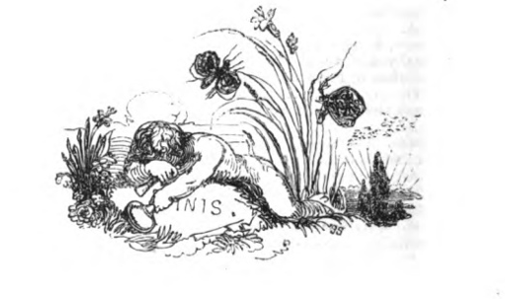
Figure 112: End Plate from James Northcote’s Fables (James Northcote, One Hundred Fables, Original and Selected (London: Geo. Lawford, 1829). This image can be viewed in this book, or in the non-redacted version of this PhD thesis, held by the University of Sheffield Library.

Mildred Archer, Natural History Drawings in the India Office Library (London: Her Majesty’s Stationery Office, 1962), p. 57.
Carrol L. Fry, Charlotte Smith (New York: Twayne Publishers, 1996), p. 19.
Charlotte Smith, A Narrative of the Loss of the Catharine, Venus, and Piedmont Transports, and the Thomas, Golden Grove, and Æolus Merchant Ships, Near Weymouth, on Wednesday the 18th of November Last. Drawn up from Information taken on the Spot (London: Sampson Low, 1796).
Charlotte Smith, Montalbert (London: E. Booker, 1795).
Cited in Rufus P. Turner, Charlotte Smith 1749-1806 (Los Angeles: University of Southern California, 1966), p. 88.
Florence May Anna Hilbish, Charlotte Smith, Poet and Novelist (1749-1806) (Philadelphia: The Mitre Press, 1941).
Hilbish, Charlotte Smith, Poet and Novelist (1749-1806), p. 15.
Hilbish, Charlotte Smith, Poet and Novelist (1749-1806), p. 16.
Judith Phillips Stanton, ‘Epilogue: “Nothing but the wind”’ in The Collected Letters of Charlotte Smith, ed. by Judith Phillips Stanton (Bloomington & Indianapolis: Indiana University Press, 2003), pp. 760-1 (p. 761).
Stanton, ‘Epilogue: “Nothing but the wind”’ in The Collected Letters, pp. 760-1 (p. 761).
‘Deerbolts Hall, Register No: 1033190c,’ Historic England Register (https://historicengland.o rg.uk/listing/the-list/list-entry/1033190).
Charlotte Smith, ‘Letter to Mary Hays dated 26 July 1800’ in The Collected Letters of Charlotte Smith (Bloomington & Indianapolis: Indiana University Press, 2003), pp. 349-352 (p. 349). Mary Hays would later be the author of the third volume of The History of England from the Earliest Records to the Peace of Amiens in a Series of Letters to a Young Lady at School (London: Richard Phillips, 1806). This volume was published under the name of Charlotte Smith but was actually written by Mary Hays. The tone of this final volume is discernibly different to Smith’s first two volumes, which she only completed grudgingly and under much protest. In a letter to Sarah Rose of 1805, Smith complains of Richard Phillips’s ‘threatening & very rude manner,’ and how ‘[h]e now expects me to bring down the history to the Peace of Amiens, tho’ at the very beginning of our engagement I declared that for many reasons I neither would or could go beyond the end of the reign of George the second. How I shall get out of this Mans power I do not know; I have now no literary or active friend to interpose for me.’ (Smith, ‘Letter to Sarah Rose dated 2 July 1805’ in The Collected Letters, pp. 689-694, p. 689 [sic]). The ‘literary or active friend’ in this instance became Mary Hays who completed the final volume on Smith’s behalf, although this was most likely because Smith died before she had completed her engagement with Phillips.
Smith, ‘Letter to Thomas Cadell Jr. and William Davies dated 2 October 1794’ in The Collected Letters, pp. 167-8 (p. 168).
Smith, ‘Letter to Dr. James Edward Smith dated 15 March 1798’ in The Collected Letters, pp. 314-5 (p. 314).
Smith, ‘Letter to Thomas Cadell Jr. & William Davies dated 1 August 1797’ in The Collected Letters, pp. 283-4 (p. 283). ‘Mrs. Dorset’ is Catherine Ann Dorset, Smith’s sister [sic].
Charlotte Smith, Conversations Introducing Poetry Chiefly on Subjects of Natural History for the Use of Children and Young Persons (Memphis, USA: General Books LLC, 2012), p. 1.
This point is unclear. Smith calls Luzena ‘my Indian Girl,’ in her letters, but as Stanton argues, He [Nicholas Smith] married or consorted with a native woman, a Georgian or Persian, in the late 1790s, and had two children by her, Luzena (ca. 1799-1885) and William Hankey (ca. 1800-22 June 1821). Another story has it that he stole his 12-year-old Indian bride and drove her to church in a carriage to be married. His fluency in Persian argues that she was Persian. (Smith, The Collected Letters, p.779).
Stanton, ‘Footnote to Letter to the Earl of Egremont dated 5 November 1802,’ in The Collected Letters, pp. 487-489 (p. 489).
Anon, ‘Introduction,’ in Conversations Introducing Poetry, p. 1.
Anon, ‘Introduction,’ in Conversations Introducing Poetry, p. 1.
Elaine R. S. Hodges, ‘Scientific Illustration: A Working Relationship Between the Scientist and the Artist’, Bioscience, 39.2 (February 1989), 104-111 (p. 104).
Hodges, ‘Scientific Illustration,’ (p. 104).
Archer, Natural History Drawings, p. 57.
Archer, Natural History Drawings, p. 57.
Smith, ‘Letter to James Upton Tripp dated 27 July 1794’ in The Collected Letters, pp. 140-2 (pp. 140-1) [sic].
Charlotte Smith, ‘Sonnet XCI: Reflections on some drawings of plants’ in The Poems of Charlotte Smith, ed. by Stuart Curran (New York and Oxford: Oxford University Press, 1993), pp. 77-78, (p. 77).
Charlotte Smith, ‘To the Snow-drop’ in The Poems of Charlotte Smith, p. 187, footnote, emphasis in original.
Judith Pascoe, ‘Female Botanists and the Poetry of Charlotte Smith’ in Re-Visioning Romanticism: British Women Writers, 1776-1837, ed. by Carol Shiner Wilson & Joel Haefner (Philadelphia: University of Pennsylvania Press, 1994), pp. 193-209 (p. 195).
Pascoe, ‘Female Botanists and the Poetry of Charlotte Smith,’ (p. 195).
Hodges, ‘Scientific Illustration’, (p. 104).
Smith, ‘Sonnet LXVIII: Snowdrops’ in The Poems of Charlotte Smith, p.67, L. 9.
Smith, ‘Sonnet LXVIII: Snowdrops’ in The Poems of Charlotte Smith, p.67, L. 9.
Cited by Ann Shteir, Cultivating Women, Cultivating Science: Flora’s Daughters and Botany in England , 1760-1860 (Baltimore & London: The John Hopkins University Press, 1996), p. 68.
Smith, ‘Sonnet LXVIII: Snowdrops’ in The Poems of Charlotte Smith, p.67, L. 9.
Smith, ‘Sonnet XXXVII: Sent to the Honourable Mrs. O’Neill, with painted flowers’ in The Poems of Charlotte Smith, p 37, LL. 9-10.
Smith, ‘Sonnet XXXVI’ in The Poems of Charlotte Smith, p 37, L. 11.
Smith, ‘Sonnet XXXVI’ in The Poems of Charlotte Smith, p 37, L. 7. The Oxford English Dictionary records the first usage of ‘pencil’ as an implement to write poetry in Lady Mary Wortley Montagu’s Turkish Letters. In her letter dated 1717, she describes ‘Walls almost cover'd with little distichs of Turkish verse writ with pencils.’ (OED online, 3rd edn (Oxford: Oxford University Press, 2005). Prior to that date, ‘pencil’ was applied to describe a paintbrush.
Smith, ‘Sonnet LXVIII: Snowdrops’ in The Poems of Charlotte Smith, p.67, LL. 5-9.
Smith, ‘Sonnet LXVIII: Snowdrops’ in The Poems of Charlotte Smith, p.67, L. 7.
Smith, ‘Sonnet LXVIII: Snowdrops’ in The Poems of Charlotte Smith, p.67, LL. 8-9.
Smith, ‘Sonnet LXVIII: Snowdrops’ in The Poems of Charlotte Smith, p.67, L. 8.
Hodges, ‘Scientific Illustration’, (p. 104).
Smith, ‘Sonnet LXVIII: Snowdrops’ in The Poems of Charlotte Smith, p.67, LL. 5-7.
Smith, ‘Sonnet LXVIII: Snowdrops’ in The Poems of Charlotte Smith, p.67, LL. 10-14.
Smith, ‘Preface to Volume II’ in The Poems of Charlotte Smith, pp. 6-12 (p. 7).
Smith, ‘Sonnet LXVIII: Snowdrops’ in The Poems of Charlotte Smith, p.67, L. 10.
Smith, ‘Sonnet LXVIII: Snowdrops’ in The Poems of Charlotte Smith, p.67, LL. 10-11.
Smith, ‘Sonnet LXVIII: Snowdrops’ in The Poems of Charlotte Smith, p.67, L. 13. There is a further layer of interpretive meaning to Smith’s Gallanthus nivalis, in that these flowers have habitually been associated with graveyards and death, frequently being planted in these areas. A common name for the snowdrop is ‘Death Flower’ and it was said of them during Victorian times that ‘they grow closer to the dead than the living’ and the drooping heads of the flowers resembled shrouds. However, in floristry terms, the snowdrop also has associations with hope and rebirth, being the first flower which emerges after Winter. It is a somewhat ambivalent flower in iconography.
Smith, ‘Letter to Thomas Cadell Jr. & William Davies dated 1 August 1797’ in The Collected Letters, pp. 283-4 (p. 283) [sic].
Smith, ‘Sonnet XCI: Reflections on some drawings of plants’ in The Poems of Charlotte Smith, pp. 77-78.
Smith, ‘Sonnet XCI: Reflections on some drawings of plants’ in The Poems of Charlotte Smith, pp. 77-78.
Jacqueline Labbe, ‘The Romance of Motherhood: Generation and the Literary Text,’ Romanticism on the Net, 26.2 (2002), 1-37 (13).
Smith, ‘Sonnet XCI: Reflections on some drawings of plants’ in The Poems of Charlotte Smith, pp. 77-78.
Judith Hawley,‘Charlotte Smith’s Elegiac Sonnets: Losses and Gains’ in Women’s Poetry in the Enlightenment: The Making of a Canon, 1730-1820, ed. by Isobel Armstrong & Virginia Blain (Houndsmills, Basingstoke: Macmillan Press, 1999), pp.184-198, (p. 187).
Elizabeth A. Dolan, Seeing Suffering in Women’s Literature of the Romantic Era (Aldershot, Hampshire: Ashgate Publishing Limited, 2008), p. 105.
Smith, ‘Sonnet XCI: Reflections on some drawings of plants’ in The Poems of Charlotte Smith, p. 77, L.2.
Smith, ‘Sonnet XCI: Reflections on some drawings of plants’ in The Poems of Charlotte Smith, p. 77, L.3.
Kathleen Béres Rogers, ‘Permeability and its Uses: Affect and Audience in Charlotte Smith’s Elegiac Sonnets’, Women’s Writing, 16.1 (2009), 126-142, p. 133.
Smith, ‘Sonnet XCI: Reflections on some drawings of plants’ in The Poems of Charlotte Smith, p. 77, L.4.
Smith, ‘Sonnet XCI: Reflections on some drawings of plants’ in The Poems of Charlotte Smith, p. 78, L. 6-7.
Anna Augusta’s son was born in the July preceding her death in the April of the following year. Thus both Spring and Summer acquire unfortunate connotations of death in Smith’s family.
Smith, ‘Sonnet XCI: Reflections on some drawings of plants’ in The Poems of Charlotte Smith, p. 78, LL. 13-14.
Smith, ‘Sonnet XCI: Reflections on some drawings of plants’ in The Poems of Charlotte Smith, p. 78, L. 13.
Cynthia Sundberg Wall, The Prose of Things: Transformations of Description in the Eighteenth Century (Chicago & London: University of Chicago Press, 2006), p. 74.
Sundberg Wall, The Prose of Things, p. 74.
Smith, ‘Sonnet XCI: Reflections on some drawings of plants’ in The Poems of Charlotte Smith, p. 78, LL. 2-11.
Sundberg Wall, The Prose of Things, p. 76.
Sundberg Wall, The Prose of Things, p. 74.
Smith, ‘Sonnet XCI: Reflections on some drawings of plants’ in The Poems of Charlotte Smith, p. 78, LL. 3-10.
Pascoe, ‘Female Botanists and the Poetry of Charlotte Smith’, p. 204-5.
Smith, ‘Letter to James Upton Tripp dated 27 July 1794’ in The Collected Letters, pp. 140-2 (p. 140) .
David E. Coke, ‘Introduction’ in The Smith Brothers of Chichester (Chichester: Pallant House Gallery, 1986), pp. 17-34 (p. 24).
Christopher Hussey, The Pictureque: Studies in a Point of View (London: Frank Cass & Company Limited, 1967), p. 231.
William Cowper refers to this in a letter to William Hayley dated 23 April 1793, in which he acknowledges receipt of a copy of The Old Manor House (1793), thus ‘I have received our old Eartham friends Orlando and Monimia, and shall have double pleasure in a farther acquaintance with them; pleasure not only for their own sakes, but because it was under your roof that I first knew them.’ (William Cowper, ‘Letter to William Hayley dated 23 April 1793’, in The Letters and Prose Writings of William Cowper, Vol. IV, 1792-1799, ed. by James King & Charles Ryskamp (Oxford: Oxford University Press, 1984), p. 324).
Detailed in Loraine Fletcher, Charlotte Smith: A Critical Biography (Houndsmills, Basingstoke: Palgrave, 2001), p. 162.
James Northcote, The Papers of James Northcote, R.A., Collected and Presented by G. G. Williamson, (London: British Museum Additional MS 42524). Letters from Elizabeth Inchbald are included in The Letter Book of James Northcote (Oxford: Bodleian Libraries, MS Eng Misc e 143), and include charming details such as Northcote arriving uninvited at Inchbald’s home in order to take Inchbald to ‘Mrs Wedells rout’ (Letter dated 28 May 1801). Unfortunately, as Northcote was not expected, Inchbald had already put her nightgown on for the night, but was then crippled by guilt at refusing to see Northcote, if only to ‘load [him] with reproaches.’
Amelia Opie, Lecture on Painting Delivered at the Royal Academy of Arts: with a Letter on the Proposal for a Public Memorial of The Naval Glory of Great Britain by the Late John Opie Esq., to which are Prefixed a Memoir by Mrs. Opie and Other Accounts of Mr. Opie’s Talents and Character (London: Longman, Hurst, Rees and Orme, 1809), p. 49.
Northcote, The Letter Book of James Northcote.
James Northcote, The Papers of James Northcote, R.A., The Sir William Knighton Collection (London: British Museum Additional MS 47790-47792).
Maxwell Craven, Derbeians of Distinction (Derby: The Breedon Books Publishing Company, 1998).
Cited in Ellen G. D’Oench, “Copper Into Gold”: Prints by John Raphael Smith 1751-1812 (New Haven & London: Yale University Press, 1999), p. 169.
Stuart Curran, ‘The I Altered’ in Romantic Poetry: Recent Revisionary Criticism; ed. by Karl Kroeber &Gene W. Ruoff (New Brunswick & New Jersey: Rutgers University Press, 1993), pp. 185-208 (p. 185).
Sarah Zimmerman,‘Varieties of Privacy in Charlotte Smith’s Poetry’, European Romantic Review, 18.4 (2007), 483-502 (p. 493). Loraine Fletcher also hints at this understanding of Smith’s constructed poetic persona in her introduction to the Broadview Literary edition of Smith’s third novel, Celestina (1791).
Fuson Wang, ‘Cosmopolitanism and the Radical Politics of Exile in Charlotte Smith’s Desmond,’ Eighteenth-Century Fiction, 25.1 (2012), 37-59 (41).
As noted by Stanton, The Collected Letters of Charlotte Smith, p. xxx.
Stephen Daniels, ‘The Political Iconography of Woodland in later Georgian England’ in The Iconography of Landscape, ed. by Denis Cosgrove & Stephen Daniels (Cambridge: Cambridge University Press, 1997), pp. 43-82 (p. 67).
Daniels, ‘The Political Iconography of Woodland in later Georgian England,’ p. 67.
Elizabeth Bohls, Women Travel Writers and the Language of Aesthetics (Cambridge: Cambridge University Press, 1995), p. 2.
Bohls, Women Travel Writers, p. 10.
Bohls, Women Travel Writers, p. 10.
Vivien Jones, “‘The Coquetry of Nature’: Politics and the Picturesque in Women’s Fiction” in The Politics of the Picturesque: Literature, Landscape and aesthetics since 1770, ed. Stephen Copley and Peter Garside (Cambridge: Cambridge University Press, 1994), 120-45 (135).
Jones, “The Coquetry of Nature,” 135.
Joseph Holden Potts, Essay on Landscape Painting with Remarks General and Critical on the Different Schools and Masters, Ancient and Modern (London: J. Johnson, 1782), p. 66.
Hussey, The Picturesque, p. 109.
Hussey, The Picturesque, p. 253.
I have not included much background detail surrounding the Picturesque movement within the chapter as this is fairly well-rehearsed territory. However, for more information concerning the pictorial codes of the Picturesque movement, see footnote 18.
David E. Coke, Sybilla Jane Flower, M. J. H. Liversidge, Peter Mitchell, Bernard Price, and Brian Stewart,The Smith Brothers of Chichester (Chichester: The Friends of Pallant House, 1986), p. 50.
George Smith won premiums on three separate occasions from the Society for the Arts. This achievement was celebrated in an elegy after his death: Thrice only, candidate for public fame, His matchless skill the laurels thrice obtain'd; His works the glory of the age became, And endless honour for their master gain'd. (Lines 20-24, Anon., ‘Elegy on the death of Mr G. Smith, Landscape Painter, of Chichester, September 7th 1776,’ London Magazine, XLV (1776), p. 665.
Coke et al, The Smith Brothers of Chichester, p. 51.
Ann Bermingham, Landscape and Ideology: The English Rustic Tradition 1740-1860 (Berkeley, Los Angeles & London: University of California Press, 1986), p. 83.
John Brewer, The Pleasures of the Imagination: English Culture in the Eighteenth Century (London: Harper Collins, 1997), pp. 635-6
For example, Joseph Holden Potts, in his Essay on Landscape Painting of 1782, lists the ‘particular characters of landscape,’ or the pictorial codes, which he considers will fit together to comprise the most picturesque view. The list is extensive, covering four pages, and including such items as: Forest. Wood or coppice with underwood. Heath or downs. Barren mountains. Mountains covered with hanging wood, shrubs & c. Park. Pleasure grounds, i.e. lawns with few trees. Flat, rich, and cultivated country. Broken grounds, with dells & c. Banks of a river. Lake or pool. Torrent or waterfall, with stones, & c. Views of villages or hamlets with spires, & c. Views of cities, villas, ruins, bridges, roads. (pp. 80-1). Joshua Reynolds, in his Discourses, advises artists to seek to follow the fashions of the times: ‘[w]ith respect to the pictures that you are to choose for your models, I could wish that you would take the world’s opinion rather than your own.’ (Joshua Reynolds, ‘Discourse I’, in The Works of Sir Joshua Reynolds, Knight; Late President of the Royal Academy (I), p. 38). By 1812, the picturesque movement had achieved such a height of popularity, that it had become a target for satirists: ‘I’ll prose it here, I’ll verse it there,/I’ll picturesque it everywhere’, exclaims William Combe’s hero, Dr. Syntax, as he sets out to make his fortune from the craze for the picturesque in Combe’s burlesque The Tour of Dr. Syntax (William Combe, Doctor Syntax’s Three Tours: In Search of the Picturesque, Consolation, and a Wife (London: Chatto & Windus, Publishers, 1895), p. 5).
Robin Jarvis, The Romantic Period: The Intellectual and Cultural Context of English Literature 1789-1830 (Harlow: Pearson Education Limited, 2004), p. 182
William Gilpin, Observations on the River Wye, and Several Parts of South Wales & c. Relative Chiefly to Picturesque Beauty Made in the Summer of the Year 1770 (London: R. Blamire, 1789), p. 18.
Scott C. Campbell, ‘“Disagreeable Misconstructions”: Epistolary Trouble in Charlotte Smith’s Desmond’ in Enlightening Romanticism, Romancing the Enlightenment: British Novels from 1750 to 1832, ed. by Miriam L. Wallace (Farnham, Surrey: Ashgate, 2009), pp. 55-68 (p. 58).
Kate Scarth, for example, in her essay ‘Elite Metropolitan Culture, Women, and Greater London in Charlotte Smith’s Emmeline and Celestina’, European Romantic Review, 25.5 (2014), 627-648, uses Smith’s evocation of London in these novels to demonstrate how London looked during the eighteenth century.
Charlotte Smith, Ethelinde, or, The Recluse of the Lake (London: T. Cadell, 1789) (I), p. 208.
Detailed in Sarah Zimmerman, ‘Charlotte Smith’s Letters and the Practice of Self-Representation’, Princeton University Library Chronicle, 53.1 (1991), 50-77 (p. 70).
Walter Scott, ‘Romance from Miscellaneous Prose Works, 4’ in Charlotte Smith, The Old Manor House, ed. by Jacqueline M. Labbe (Peterborough, Ontario & Plymouth: Broadview Literary Texts, 2002), pp. 546-551 (p. 531).
Scott, ‘Charlotte Smith’ in The Old Manor House, p. 531.
Smith, Montalbert, (II), p. 171.
Smith, Montalbert, (II), p.171.
William Hamilton, An Account of the Earthquakes in Calabria, Sicily & c. as Communicated to the Royal Society (Colchester: J. Fenno, 1783), pp. 11-12.
Smith, Montalbert, (II), p. 143.
Hamilton, An Account of the Earthquakes in Calabria, Sicily & c, p. 7.
Charlotte Smith, Emmeline, or, The Orphan of the Castle (London: T. Cadell, 1788) (I), p.1.
Smith, Emmeline, (I), p. 56.
Smith, Emmeline (I), p. 24.
Smith, Emmeline (I), p. 25.
Smith, Emmeline (I), pp. 90-1, [sic].
Smith, Emmeline (I), p. 90.
Smith, Emmeline (I), p. 89.
Smith, Emmeline (I), p. 91.
Smith, Emmeline (I), p. 91.
Smith, Emmeline (I), p. 91.
The name of the earless, tailless ageing warhorse in William Combe’s satirical Dr. Syntax’s Three Tours.
Smith, Emmeline (I), p. 91.
Smith, Emmeline (I), pp. 90-1.
Gilpin, Observations on the River Wye, p. 30.
Smith, Emmeline (I), p. 90.
Gilpin, Observations on the River Wye, p. 30.
Smith, Emmeline (I), p. 91.
Gilpin, Observations on the River Wye, p. 30, emphasis in original.
Dominic McIvor Lopes, Sight and Sensibility: Evaluating Pictures (Oxford: Clarendon Press, 2005), p. 49.
Smith, Emmeline (I), pp. 90.
Kenneth Clark, Landscape Into Art (London: John Murray, 1976), p. 128.
Daniels, ‘The Political Iconography of Woodland’, (p. 61).
The brothers frequently worked on landscape paintings together and enjoyed a close relationship. They shared a studio in Chichester from 1750 until the date of John Smith’s death in 1764. George only married after the death of his brother, leading the curators of the Pallant House exhibition to speculate that he only did so because he missed the company of his brother.
Smith, Emmeline (I), p. 2.
George Rudé, The Crowd in History: A Study of Popular Disturbances in France and England, 1730-1848 (London: Serif, 1995), p. 34.
Rudé, The Crowd in History, p. 34.
Smith, Emmeline (I), p. 89.
Smith, Emmeline (I), pp. 89-90.
For example, by taking recourse to fainting and illness when Delamere kidnaps her. This point will be expanded further later within this chapter.
Ann Bermingham, cited in Steve Hindle, ‘Representing Rural Society: Labor, Leisure and the Landscape in an Eighteenth-Century Conversation Piece’, Critical Inquiry, 41.3 (Spring 2015), p. 615.
Brewer, The Pleasures of the Imagination, p. 295
George Smith, Six Pastorals. To Which are Added Two Pastoral Songs (London: J. Dodsley, 1770), IV. L. 11.
George Smith provides information on the local Sussex bird, the wheat-ear, as follows: ‘The wheat-ear is a very delicious bird, about the size of a lark, found chiefly on the South-downs in Sussex, where they are taken in the following manner: They dig a hole in the ground a foot long and six inches broad, taking off the turf as a cover to it. In this hole they fix a noose made with horse-hair, and cover every part of the hole with the turf, except a small aperture near which the noose is placed. The birds, which are remarkably timorous, and frighted even at the appearance of the shadow of a cloud, run for shelter into the traps, where they are taken.’ (Smith, Six Pastorals, p. 28). Charlotte Smith provides the same information as follows: ‘Why you see, Emily, these square pieces of turf – stay, I can take one out - these square pieces of turf are cut, and the earth under them, six or seven inches deep; then the piece is laid across the hole, so, and makes a sort of cave; a wire or horse hair with a noose in it is fixed within, and the wheat-ears are so foolish as to be afraid of the least appearance of storm, or darkness, so that every shadow drives them into these holes, and they run their silly heads into the nooses and are caught.’ (Charlotte Smith, Conversations Introducing Poetry Chiefly on Subjects of Natural History for the Use of Children and Young Persons (Memphis, USA: General Books LLC, 2012), p. 31. It is hard to know whether there is a common source for their information, whether it stems from local knowledge or whether Charlotte Smith has used George Smith’s text as a source. Any of these are a possibility.
Smith, Six Pastorals, III. LL. 87-90.
Smith, Six Pastorals, III. L. 89.
As John Brewer observes: Touring was a minority, not a mass, recreation, an expensive hobby for those with ample leisure time and a purse to match. The two stages of the often-described boat tour down the Wye valley each cost one and a half guineas. Privately owned carriages and horses were expensive. Travel by coach, though swift by the standards of the day, was beyond the pocket of all but the prosperous: single fare from London to York, with a seat inside a mail coach (as opposed to hanging on for dear life up top) cost three guineas in the 1780s. Though coach prices fell temporarily during that decade, when many new operators set up rival services to the mail coaches (the cheapest London-to-York fare dropped to £1.15s), such bargains did not last. The overall standard cost for coaches was 3d. a mile, while the chaises hired out by innkeepers averaged 7d. This meant that a coach trip from London to the edge of the Highlands cost about £5, one to Wales about £2.5s.) Touring was socially exclusive, and the most distant spots were the most exclusive of all. (John Brewer, The Pleasures of the Imagination, pp. 638-639). Information derived from The Collected Letters of Charlotte Smith, edited by Judith Phillips Stanton, supports the fact that Smith was well aware of the costs of removal and travel. A letter to James Upton Tripp dated 16 May 1794, for example, bemoans the fact that she wished to go into Wales for a visit, but could not afford it because ‘of the intolerable expense of keeping house at Storrington,’ for her son Charles. (Collected Letters, p. 120). The letters, and her many appeals to her publishers and to Tripp himself for advances of money, also show that the one resource Smith lacked was the one which was essential for travel: a healthy financial position.
Smith, Six Pastorals, III. LL. 1-3.
Smith, Six Pastorals, III. L. 36.
Smith, Six Pastorals, III. LL. 37-42.
Smith, Six Pastorals, III. LL. 96-97.
Despite Monimia’s protestations that she ‘should be too happy to be allowed to beg with you [Orlando] round the world’ the reality of their indigent situation soon becomes clear: He now remembered that he used to think, were he once blessed with Monimia, every other circumstance of life would be to him indifferent; yet she was now his – she was now more beloved, as his wife, than she had ever been as his mistress; and the sweetness of her temper, the excellence of her heart, the clearness of her understanding, and her tender attachment to him, rendered her infinitely dearer to him than that beauty which had first attracted his early love. But far from being rendered indifferent to every other circumstance, he felt that much of his present concern arose from the impossibility he found of sheltering his adored creature from the evils of indigence; and that the romantic theory, of sacrificing every consideration to love, produced, in the practice, only the painful consciousness of having injured its object. Charlotte Smith, The Old Manor House, (Plymouth: Broadview Literary Texts, 2005), p. 123 & p. 508.
Charlotte Smith, Celestina, Ed. Loraine Fletcher (Plymouth: Broadview Literary Editions, 2004), p. 115.
Episodes such as ‘Dialogue I: The Sick Cottager’ and ‘Dialogue VII: The Strawberry Girls’ are just two examples of Mrs. Woodfield’s concern for her rural neighbours. Charlotte Smith, Rural Walks in Dialogues Intended for the Use of Young Persons (London: T. Cadell Jun. & W. Davies, 1795).
Alfred Beaver, ‘The Free Society of Artists’, The Portfolio: an Artistic Periodical, 17 (January 1886), 179-184 (p. 180).
George Romney was also a member of the society. Romney would later also have associations with Charlotte Smith and sketched her portrait in chalks during their mutual stay with William Hayley at Eartham House during the summer of 1792 (Figure 12). Charlotte Smith’s relationship with Romney and their mutual use of the aesthetic of the sublime is discussed in chapter two.
Beaver, ‘The Free Society of Artists,’ (p. 180).
Beaver, ‘The Free Society of Artists,’ (p. 181).
Beaver, ‘The Free Society of Artists,’ (p. 181).
Beaver, ‘The Free Society of Artists,’ (p. 183).
Holden Potts, Essay on Landscape Painting, pp. 80-81.
Smith, Emmeline (I), p. 14.
Kaley Kramer, ‘Women and Property in late Eighteenth-Century Fiction: Gendered Property and Generic Belonging in Charlotte Smith and Mary Wollstonecraft,’ Literature Compass, 6.6 (2009), 1145-1158, (pp.1145-1146).
Kramer, ‘Women and Property in late Eighteenth-Century Fiction,’ (p. 1146).
Smith, Emmeline (I), p. 15.
Smith, Emmeline (I), p. 67.
Smith, Emmeline (I), p. 46.
Smith, Emmeline (I), p. 46.
Kramer, ‘Women and Property in late Eighteenth-Century Fiction’, (pp.1145-1146).
Smith, Emmeline (II), p. 26.
Smith, Emmeline (I), p. 214.
Smith, Emmeline (I), p. 215.
Smith, Emmeline (I), p. 68.
Smith, Emmeline (I), pp. 68-9.
Smith, Emmeline (I), p. 69.
The most notable point in the text when Delamere is mistaken for a lunatic is when the servant observes to Emmeline that she has been interrupted by a man who ‘looked oddish as ‘twere about the eyes’ whilst she is hanging out her washing (Smith, Emmeline (III), p. 173). Delamere is later considered to be ‘a lunatic who might lay in wait to hurt her [Emmeline] on her way home, and would not suffer her to set out ‘till they had called a woodcutter from the forest to accompany her.’ (Smith, Emmeline (III), pp. 174-5). In their conjectures, that Delamere might hurt Emmeline, they are, the reader realises, not too far from the truth.
Smith, Emmeline (II), p. 94.
Smith, Emmeline (I), p. 158.
Smith, Emmeline (II), p. 95.
Smith, Emmeline (I), p. 152.
Smith, Emmeline (I), p. 51.
Smith, Emmeline (I), pp. 217-8.
Smith, Emmeline (IV), p. 277.
The one exception to this is Augusta, as noted earlier, whose sweet temperament, positions her beside Emmeline as an heroine of sensibility.
William Gilpin, Remarks on Forest Scenery and Other Woodland Views (Relative Chiefly to Picturesque Beauty) Illustrated by the Scenes of New-Forest in Hampshire (London: R. Blamire, 1791) (I), p. 103.
Gilpin, Remarks on Forest Scenery(I), p. 103.
Gilpin, Remarks on Forest Scenery (I), p. 104.
Gilpin, Remarks on Forest Scenery (I), p. 104.
Gilpin, Remarks on Forest Scenery (I), p. 104.
Smith, Emmeline (IV), p. 385.
Smith, Emmeline (IV), p. 385.
Smith, Emmeline (I), p. 11.
Smith, Emmeline (I), p. 11.
Smith, Emmeline (I), p. 11.
John Berger, Ways of Seeing (London: Penguin Books Limited, 2008), p. 46.
Joe Morrissey’s work has now been published in the following book: Joseph Morrissey, Women’s Domestic Activity in the Romantic-Period Novel, 1770-1820: Dangerous Occupations (Palgrave Macmillan, 2018). Unfortunately I have not yet managed to source a copy of this text, so my references refer to the argument in Morrissey’s PhD thesis and his recent article in Women’s Writing (referenced in footnote 117 below).
Joe Morrissey, ‘Sensibility, Sincerity and Self-Interest in Charlotte Smith’s Ethelinde,’ Women’s Writing, (2017), 1-16 (14).
Morrissey, ‘Sensibility, Sincerity and Self-Interest,’ p. 15.
Morrissey, ‘Sensibility, Sincerity and Self-Interest’, p. 18.
Smith, Emmeline (I), p. 50.
Smith, Emmeline (I), p. 60.
Smith, Emmeline (I), pp. 61-63, [sic].
Smith, Emmeline (I), p. 65.
Smith, Emmeline (I), p. 65.
Smith, Emmeline (I), p. 64.
Smith, Emmeline (I), p. 64.
Smith, Emmeline (I), p. 10.
Smith, Emmeline (III), p. 171.
Smith, Emmeline (IV), p. 128.
Smith, Emmeline (IV), p. 128.
Smith, Emmeline (II), p. 10; emphasis mine.
Smith, Emmeline (II), p. 10.
Smith, Emmeline (II), p. 11.
Smith, Emmeline (II), p. 14.
Smith, Emmeline (II), pp. 17-18. Emmeline’s success in manipulating the characters around her is underscored by the failures of some of Smith’s other female characters. In her 1795 novel Montalbert, which almost functions as an inverse reflection of the action of Emmeline, Smith, in the fate of Rosalie, shows what would have happened to Emmeline if she had not so successfully stage-managed those around her. Rosalie’s fate, when she fails to manage the volatile Montalbert and agrees to elope with him, is madness, near death, and an almost reluctant ‘happy’ ending which is couched in such terms as ‘Montalbert enjoyed [...] more happiness than usually falls to the lot of humanity’ whilst Rosalie passed her life in studying how to contribute to his felicity.’ Charlotte Smith, Montalbert (London: E. Booker, 1795), p. 324.
Smith, Emmeline (III), p. 116.
Smith, Emmeline (III), p. 116.
Smith, Emmeline (III), pp. 116-7.
Smith, Emmeline (III), p. 163.
Smith, Emmeline (III), p. 157.
Smith, Emmeline (II), p. 37.
Smith, Emmeline (II), p. 37.
Smith, Emmeline (IV), pp. 216-217, [sic].
Smith, Emmeline (IV), p.217.
Smith, Emmeline (IV), p. 218.
Smith, Emmeline (IV), p. 217.
Smith, Emmeline (IV), p. 234.
Smith, Emmeline (IV), p. 234, [sic].
Smith, Emmeline (IV), p. 218.
Smith, Emmeline (I), p. 50.
Smith, Emmeline (I), p. 61-62.
Smith, Emmeline (I), p. 121.
Mrs. Stafford is the most appropriate figure to explain with eloquence in writing as some critics have argued (for example Loraine Fletcher, in both her Critical Biography of the author and her introduction to the Broadview Literary edition of Emmeline) that Mrs. Stafford is an autobiographical figure, representing Smith herself. There are, arguably, some links between the character and the author, for example, Mrs. Stafford’s disastrous marriage to Trelawney; a man who appears not unlike what is known of Smith’s husband, Benjamin Smith.
Smith, Emmeline (I), pp. 148-9.
Smith, Emmeline (I), p. 125.
Smith, Emmeline (I), p. 165.
Smith, Emmeline (II), p. 62.
Smith, Emmeline (II), p. 63.
Smith, Emmeline (I), p. 156.
Smith, Emmeline (I), pp. 157-8.
Smith, Emmeline (I), pp. 158-159.
Smith, Emmeline (III), p. 145.
Smith, Emmeline (III), p. 149.
See footnote 153 for more on this argument.
Anon., ‘Review of Emmeline, or, The Orphan of the Castle’, The Critical Review, or, Annals of Literature, 65 (1788), 530-532; and Anon., ‘Review of Emmeline, or, The Orphan of the Castle, The Monthly Review, September 1788’ in Charlotte Smith, Emmeline, ed. Loraine Fletcher (Peterborough, Ontario: Broadview Literary Texts, 2003), pp. 480-481.
Anon., ‘Review of Emmeline, or, The Orphan of the Castle’, The Critical Review, or, Annals of Literature, (p. 531).
Anon., ‘Review of Emmeline, or, The Orphan of the Castle, The Monthly Review, September 1788’, (p. 481).
Clark, Landscape Into Art, p. 128.
Simon Schama, Power of Art (London: BBC Books, 2006), p. 247.
Rudé, The Crowd in History, p. 34.
Gentleman’s Magazine, XXVIII, 591, December 22nd 1757, cited in Rudé, The Crowd in History, pp. 36-7.
Rudé, The Crowd in History, p. 37.
Rosalind Brunt, ‘A Career in Love: The Romantic world of Barbara Cartland’ in Popular Fiction and Social Change, ed. by Christopher Pawling (London: Macmillan Press, 1984), pp. 127-156 (p. 146).
This certainly could not be said of Smith’s later novels, where the endings become more ambiguous, such as in Montalbert, where, as noted in an earlier footnote, the happy ending is couched in such terms as ‘Montalbert enjoyed [...] more happiness than usually falls to the lot of humanity’ whilst Rosalie ‘passed her life in studying how to contribute to his felicity.’ Charlotte Smith, Montalbert (London: E. Booker, 1795), p. 324. In other words, Rosalie’s elopement with her romantic hero leads to a life sentence of appeasement and flattery of a capricious and unworthy husband, living constantly in fear of his explosive temper and wild ways. Similarly, in Smith’s Volume I of The Letters of a Solitary Wanderer, the heroine, Edouarda, only achieves her happy ending because ‘she dismissed all lovers’ and lives out her life as a single woman enjoying her own fortune. Charlotte Smith, The Letters of a Solitary Wanderer, ed. by David Lorne Macdonald, The Works of Charlotte Smith, 14 vols, 11, (London: Pickering & Chatto Publishers Limited, 2007), p. 96. As the works progress, the landscape alters perceptibly from the realm of romance to the dominion of a disillusioned reality.
Nancy K. Miller, ‘Emphasis Added: Plots and Plausibilities in Women’s Fiction’, PMLA, 96.1, (January 1981), 36-48 (p. 36).
Hussey, The Picturesque, p. 2.
Brewer, The Pleasures of the Imagination, p. 619.
Smith, Ethelinde, p. 58
Cited in Morrissey, ‘Sensibility, Sincerity and Self-Interest’, p. 19
Stanton, The Collected Letters of Charlotte Smith, p. xxx.
Susan Manning, ‘Burns and Wordsworth: Art and “The Pleasure which there is in life itself”’ in Pleasure in the Eighteenth Century, ed. by Roy Porter and Marie Mulvey Roberts (Houndsmills, Basingstoke: MacMillan Press, 1996), pp. 182-208 (p. 182).
Manning, ‘Burns and Wordsworth’, (p. 182).
From May 1796 up until the publication of the second Volume of the Elegiac Sonnets in Summer 1797, there are frequent references to the engravings which would accompany Smith’s poetry. Her letters to her publishers reveal the intense pride Smith took in her poetry, and also demonstrates her artistic eye. She offers frequent advice and criticisms when the artists have failed to realise her vision. For example, Richard Corbould also completed the plate to accompany Sonnet XXXVI (‘Should the lone wanderer, fainting on his way’) in the second Volume of the Elegiac Sonnets. Smith originally condemned this illustration stating that Corbould had ‘faild in comprehending my idea’ and ‘[t]he fat girl he first produced was any thing but such an ideal Sylphish representation.’ This letter also criticises Corbould’s rendering of the Lunatic to accompany Sonnet LXX (‘On being cautioned against walking on an headland overlooking the sea, because it was frequented by a lunatic’), arguing that ‘instead of a Madman the figure is that of a fool with a black Wig on, & his mantle looks like a piece of a ploughed field flying in the Air.’ (Charlotte Smith, ‘Letter to William Davies dated 25th April 1797’ in The Collected Letters, pp. 266-269). Smith clearly adopted the view, like William Blake, that the artwork and the poetry were intrinsically inseparable and part of one cohesive whole.
Smith, ‘Letter to an Unnamed Recipient’ in The Collected Letters, p. 2.
Charlotte Smith, The Letters of a Solitary Wanderer in The Works of Charlotte Smith, Volume 11: The Letters of a Solitary Wanderer, ed. by David Lorne Macdonald (London: Pickering Chatto, 2007), p. 293.
The theory of the sublime was also developed in the late eighteenth century by German philosopher Immanuel Kant. The infinitude of Kant’s mathematical sublime is something which will be considered further in the context of Smith’s beautiful heroes in chapter three. This chapter is drawing primarily on Burkean theories of the sublime.
Smith, ‘Letter to Joseph Cooper Walker dated 29 May 1796’ in The Collected Letters, pp. 236-238 (p. 236), [sic].
Smith, ‘Letter to Thomas Cadell & William Davies dated July 1792,’ East Sussex Archive, The Keep, Brighton, Holding number: BH/P/17/5.
Smith, ‘Letter to Thomas Cadell & William Davies dated July 1792,’ East Sussex Archive, The Keep, Brighton, Holding number: BH/P/17/5.
This poem (‘Untitled’) was discovered by Hannah Neale, Curator at Abbot Hall Gallery, Kendal, as acknowledged in the note appended to the poem by Jaqueline M. Labbe in her edited collection of The Works of Charlotte Smith, Volume 14: Romney, whose tragic pencil knows to give To scenes long past, with force renew’d to live And in bless’d union with the Poet’s art To sooth the fancy and to charm the heart, Say shall thy faithful Pencil deign to trace At Friendship’s prayer this sorrow-faded Face, Yet when perhaps a few short months shall lay These weary temples on their kindred Clay. Many there are who then shall pensive stand And as they view the likeness bless the hand Which to their mourning memory shall restore The form maternal they behold no more When from remotest India’s burning strand My banish’d Sons shall seek their native land. Could the proud feelings that elate my breast By thy unrival’d Talents be expressed When, tho’ one-half the Globe may intervene, ‘Tho’ Mountains rise and Oceans roll between,’ The well-earned meed of Praise my Sons have gained, Unmarked by Folly and by Vice unstained, Told by no flatterers’ tongue – attains my ear Joy even to pain then prompts the unbidden tear And with a virtuous pride while I can say, ‘My Sons, tread firm in honours [sic] way.’ Then Matchless Artist – I would fain command The friendly aid of thy unerring hand To catch the exulting feelings as they rise And paint A Mother’s Triumph in her eyes. Source: The New York Times (Sunday, July 12, 1914), with thanks to Hannah Neale, Curator, Abbot Hall Art Gallery, Kendal, Cumbria, UK (Charlotte Smith, ‘Untitled: Romney, whose tragic pencil knows to give’ in The Works of Charlotte Smith, Volume 14: Elegiac Sonnets, Volumes I and II, The Emigrants, Beachy Head with Other Poems, Uncollected Poems, ed. by Jacqueline M. Labbe (London: Pickering Chatto, 2007), p. 216).
Smith, ‘Letter to Thomas Cadell & William Davies Jnr dated 28April 1797’ in The Collected Letters, pp. 269-270 (p. 270).
Smith, ‘Letter to Thomas Cadell & William Davies Jnr dated 28 April 1797’ in The Collected Letters, pp. 269-270 (p. 270).
See footnote 6.
David A. Cross, A Striking Likeness: The Life of George Romney (Aldershot, Hampshire: Ashgate Publishing Limited, 2000), p. 170.
Cross, A Striking Likeness, p. 170.
Personal email from Alex Kidson dated 26 April 2017.
See footnote 183 in chapter one.
Christopher D. Kilgore, ‘Unnatural Graphic Narration: The Panel and the Sublime’, Journal of Narrative Theory, 45.1 (Winter 2015), 18-45 (37).
Edmund Burke, On Taste, On the Sublime and Beautiful, Reflections on the French Revolution, A Letter to a Noble Lord: With Introduction and Notes (New York: P. F. Collier and Son, 1909), p. 70.
Smith, The Letters of a Solitary Wanderer in The Works of Charlotte Smith, Volume 11, p. 293.
Judy Lochhead, ‘The Sublime, the Ineffable, and Other Dangerous Aesthetics’, Women and Music: A Journal of Gender and Culture, 12, (2008), 63-74 (p. 64).
Lochhead, ‘The Sublime, the Ineffable, and Other Dangerous Aesthetics’, Women and Music, (p. 64).
Burke, On Taste, On the Sublime and Beautiful, p. 94.
Lochhead, ‘The Sublime, the Ineffable, and Other Dangerous Aesthetics’, Women and Music, (p. 66).
Lochhead, ‘The Sublime, the Ineffable, and Other Dangerous Aesthetics’, Women and Music, (p. 66).
Robert R. Clewis, ‘What’s the Big Idea?: On Emily Brady’s Sublime’, The Journal of Aesthetic Education, 50.2 (Summer 2016), 104-118 (105).
David B. Johnson, ‘The Postmodern Sublime’ in The Sublime: From Antiquity to Present, ed. by Timothy M. Costelloe (Cambridge: Cambridge University Press, 2012), pp. 118-131 (p. 120).
Jane Forsey, ‘Is a Theory of the Sublime Possible?’, The Journal of Aesthetics and Art Criticism, 65. 4 (Autumn 2007), 381-389 (381).
Forsey, ‘Is a Theory of the Sublime Possible?’, The Journal of Aesthetics and Art Criticism, (381).
Barbara Claire Freeman, The Feminine Sublime: Gender and Excess in Women’s Fiction (Berkely, Los Angeles & London: University of California Press, 1995) and PatriciaYaeger, ‘Towards a Female Sublime’ in Gender and Theory: Dialogues on Feminist Criticism, ed. by Linda Kauffman, (Oxford: Basil Blackwell Limited, 1989), pp. 191-212.
Freeman, ‘The Feminine Sublime: Gender and Excess in Women’s Fiction’ cited in Erinç Özdemir, ‘Charlotte Smith’s Poetry as Sentimental Discourse’, Studies in Romanticism, 50.3 (2011), 437-473 (462).
Who generally prove themselves to be rather ‘beautiful’ in nature in the Burkean definition of the term. This will be elaborated further in chapter three.
Freeman, ‘The Feminine Sublime: Gender and Excess in Women’s Fiction’ cited in Erinç Özdemir, ‘Charlotte Smith’s Poetry as Sentimental Discourse’, Studies in Romanticism, 50.3 (2011), 437-473 (462).
Heather McPherson, ‘Reconsidering Romney,’ American Society for Eighteenth-Century Studies, 36.3 (Spring 2003), 411-422 (413).
Reggie Allen, ‘The Sonnets of William Hayley and Gift Exchange’, European Romantic Review, 13.4 (2002), 383-392 (391).
Allen, ‘The Sonnets of William Hayley and Gift Exchange’, European Romantic Review, (391).
Allen, ‘The Sonnets of William Hayley and Gift Exchange’, European Romantic Review, (391).
Smith, Ethelinde, or, The Recluse of the Lake (II), pp. 115-6.
Smith, Ethelinde, or, The Recluse of the Lake (II), p. 116.
Marcia Pointon,‘“Surrounded with Brilliants”: Miniature Portraits in Eighteenth-Century England’, The Art Bulletin, 83.1 (March 2001), 48-71.
Smith, Ethelinde, or, The Recluse of the Lake (II), p. 116.
Smith, Ethelinde, or, The Recluse of the Lake (II), p. 116.
Smith, Ethelinde, or, The Recluse of the Lake (II), p. 116.
Smith, Ethelinde, or, The Recluse of the Lake (II), p. 116.
Smith, Ethelinde, or, The Recluse of the Lake (II), pp. 116-7
Joe Morrissey, ‘Gentry Women and Work & Leisure 1770-1820’ (unpublished doctoral thesis, University of Warwick, 2013), p. 238.
Smith, Ethelinde, or, The Recluse of the Lake (II), p. 118.
Morrissey, ‘Gentry Women and Work & Leisure 1770-1820’, p. 238.
Smith, Ethelinde, or, The Recluse of the Lake (II), pp. 130-1.
Smith, Ethelinde, or, The Recluse of the Lake (II), p. 130.
Smith, Ethelinde, or, The Recluse of the Lake (II), p. 130.
Morrissey, ‘Gentry Women and Work & Leisure 1770-1820’, p. 239.
Smith, Ethelinde, or, The Recluse of the Lake (V), p. 315.
Morrissey, ‘Gentry Women and Work & Leisure 1770-1820’, p. 239.
Burke, On Taste, On the Sublime and Beautiful, p. 70.
Burke, On Taste, On the Sublime and Beautiful, p. 70.
Smith, Ethelinde, or, The Recluse of the Lake (II), p. 131.
Smith, Ethelinde, or, The Recluse of the Lake (II), p. 144.
Smith, Ethelinde, or, The Recluse of the Lake (II), p. 116.
Cited in Alex Kidson, George Romney: A Complete Catalogue of his Paintings Volumes I-III (New Haven & London: Yale University Press, 2015), pp. 200-201.
Kidson, George Romney: A Complete Catalogue of his Paintings, p. 201.
Marcia Pointon, Hanging the Head: Portraiture and Social Formation in Eighteenth-Century England (New Haven & London: Yale University Press, 1993), p. 49.
Smith, Ethelinde, or, The Recluse of the Lake (II), pp. 130-1.
Pointon, Hanging the Head, p. 46.
Pointon, Hanging the Head, p. 205.
Smith, Ethelinde, or, The Recluse of the Lake (V), p. 315.
Smith, Ethelinde, or, The Recluse of the Lake (V), p. 181.
Smith, Ethelinde, or, The Recluse of the Lake (V), p. 181.
Smith, Ethelinde, or, The Recluse of the Lake (V), p. 44.
Diane Long Hoeveler, Gothic Feminism: The Professionalization of Gender from Charlotte Smith to the Brontës (Liverpool: Liverpool University Press, 1998), p. 36.
Kidson, George Romney: A Complete Catalogue of his Paintings, p. 16.
Angela Rosenthal, ‘Visceral Culture: Blushing and the Legibility of Whiteness in Eighteenth-Century British Portraiture’, Art History, 27.4 (September 2004), 563-592 (578).
Rosenthal, ‘Visceral Culture’, Art History, (572).
Smith, Ethelinde, or, The Recluse of the Lake (II), p. 115.
Smith, Ethelinde, or, The Recluse of the Lake (I), pp. 64-5.
Smith, Ethelinde, or, The Recluse of the Lake (I), p. 64.
Romney also favoured women with auburn hair as models for his historical or character portraits. See Figures 46, 47 and 48 for samples of his work using Emma Hamilton as his preferred model.
Smith, Ethelinde, or, The Recluse of the Lake (I), p. 64.
Smith, Ethelinde, or, The Recluse of the Lake (I), p 64.
Burke, On Taste, On the Sublime and Beautiful, pp. 46-7.
Burke, On Taste, On the Sublime and Beautiful, p. 94.
Anon., ‘Mrs. Smith’s Ethelinde, a Novel’, A Monthly Review, or Literary Journal (June 1790), 2, 161-166, (161).
Handwritten note on the ECCO version of Smith, Ethelinde, or, The Recluse of the Lake (IV), p. 298.
Smith, Ethelinde, or, The Recluse of the Lake (I), p. 31, emphasis in original.
Smith, Ethelinde, or, The Recluse of the Lake (I), p. 31, emphasis in original.
Burke, On Taste, On the Sublime and Beautiful, p. 71.
Kidson, George Romney: A Complete Catalogue of his Paintings, p. 39.
Burke, On Taste, On the Sublime and Beautiful, p. 72.
Smith, Ethelinde, or, The Recluse of the Lake (I), p. 59.
Smith, Ethelinde, or, The Recluse of the Lake (I), p. 61.
Burke, On Taste, the Sublime and Beautiful, p. 51, emphasis in original.
Burke, On Taste, the Sublime and Beautiful, p. 44.
Smith, Ethelinde, or, The Recluse of the Lake (IV), p. 131.
Smith, Ethelinde, or, The Recluse of the Lake (V), pp. 299-300.
Cian Duffy, The Landscapes of the Sublime, 1700-1830: Classic Ground (Houndsmills, Basingstoke: Palgrave MacMillan, 2013), pp. 71-2.
Duffy, The Landscapes of the Sublime, pp. 71-2.
Smith, Ethelinde, or, The Recluse of the Lake (IV), p. 131.
Smith, Ethelinde, or, The Recluse of the Lake (V), p. 207.
Smith, Ethelinde, or, The Recluse of the Lake (V), pp. 202-3.
Smith, Ethelinde, or, The Recluse of the Lake (V), p. 205, emphasis mine.
Smith, Ethelinde, or, The Recluse of the Lake (V), p. 234.
Smith, Ethelinde, or, The Recluse of the Lake (V), p. 241.
Smith, Ethelinde, or, The Recluse of the Lake (V), p. 241.
Smith, Ethelinde, or, The Recluse of the Lake (V), p. 136.
Smith, Ethelinde, or, The Recluse of the Lake (V), p. 240.
Smith, Ethelinde, or, The Recluse of the Lake (V), p. 136.
Smith, Ethelinde, or, The Recluse of the Lake (V), p. 136.
Smith, Ethelinde, or, The Recluse of the Lake (V), p. 240.
Smith, Ethelinde, or, The Recluse of the Lake (V), p. 245.
Smith, Ethelinde, or, The Recluse of the Lake (V), p. 209.
Burke, On Taste, the Sublime and Beautiful, p. 70.
Smith, Ethelinde, or, The Recluse of the Lake (V), p. 209.
Smith, Ethelinde, or, The Recluse of the Lake (V), p. 255.
Smith, Ethelinde, or, The Recluse of the Lake (V), p. 256.
Hélène Ibata, ‘Beyond the “Narrow Limits of Painting”: Strategies for Visual Unlimitedness and the Burkean Challenge,’ Word and Image, 31.1 (2015), 28-42 (28).
Ibata, ‘Beyond the “Narrow Limits of Painting,”’ (28).
Claire Knowles, ‘Hazarding the Press: Charlotte Smith, the Morning Post and the Perils of Literary Celebrity’, Romanticism: The Journal of Romantic Culture and Criticism, 20.1 (2014), 30-42 (30).
Cited in Knowles, ‘Hazarding the Press: Charlotte Smith, the Morning Post,’ 30-42 (30).
Cited in Knowles, ‘Hazarding the Press: Charlotte Smith, the Morning Post,’ 30-42 (30).
Charlotte Smith, ‘The Affecting History of Caroline Montgomer,’ New London Magazine, or, Gentleman’s Universal and Complete Monthly Repository of Knowledge, Instruction and Entertainment, 1790, (January 1790), 12-16, emphasis in original.
Ibata, ‘Beyond the “Narrow Limits of Painting,”’ (28).
Ibata, ‘Beyond the “Narrow Limits of Painting,”’ (30).
Kidson, George Romney: A Complete Catalogue of his Paintings, p. 76.
Stéphanie Félicité, the Comtesse de Genlis (1746-1830) was a brilliant harpist and is reported to have been vivaciously witty. She married the Comte de Genlis in 1758, but with an Ethelinde-like determination, refused to give up her education or to satisfy her taste for acquiring knowledge and teaching after her marriage. In 1781, after successfully inveigling herself into the French court, the Duke of Chartres took the bold step of appointing her ‘gouverneur of his sons.’ This led to the resignation of all the other tutors and much social scandal. She also penned several treatises on the subject of education. In 1782 she separated from her husband and bore at least one illegitimate child. The excessive morality of her educational works and her preoccupation with virtue, ‘earned her’ as Bonnie Arden Robb notes, ‘scant praise.’ Her contemporaries noted a ‘discrepancy between her moralizing writings and her worldly life.’ (Bonnie Arden Robb, ‘Madame de Maintenon and the Literary Personality of Madame de Genlis: Creating Fictional, Historical and Narrative Virtue’, Eighteenth-Century Fiction, 7.4 (1995), 351-372 (351). In many ways, Mme de Genlis is a real-life prototype for the feminine sublime nature demonstrated by Ethelinde.
W. Gaunt, Bandits in a Landscape: A Study of Romantic Painting from Caravaggio to Delacroix (London: The Studio Limited, 1937), p. 29.
Ibata, ‘Beyond the “Narrow Limits of Painting,”’ (29).
Charlotte Smith, The Young Philosopher, ed. by Elizabeth Kraft (Lexington: University of Kentucky Press, 1999), p. 118.
Smith, The Young Philosopher, p. 118.
Smith, The Young Philosopher, p. 118.
Burke, On Taste, the Sublime and Beautiful, p. 74.
Smith, The Young Philosopher, p. 102.
Smith, The Young Philosopher, p. 119.
Burke, On Taste, On the Sublime and Beautiful, p. 52.
Smith, The Young Philosopher, p. 92.
Smith, The Young Philosopher, p. 102.
Smith, The Young Philosopher, p. 96.
Smith, The Young Philosopher, p. 96.
Smith, The Young Philosopher, p. 92.
Smith, The Young Philosopher, p. 122.
Smith, The Young Philosopher, p. 123.
Smith, The Young Philosopher, p. 123.
Smith, The Young Philosopher, p. 370.
Smith, The Young Philosopher, p. 5.
Smith, The Young Philosopher, p. 290.
Smith, The Young Philosopher, p. 290.
Michael Verderame, ‘English Novelists Read the French Revolution’, The Eighteenth Century, 53.1, (2012), 129-133 (130). Again, there is an element of control in this as Laura is making a conscious decision to make herself tormentable by these women. She could, after all, just ignore or denounce them, as Armitage does. Although this would be a difficult position for an eighteenth-century woman to adopt with propriety, it is not an impossible one.
Elizabeth Kraft, ‘Introduction’ in Charlotte Smith, The Young Philosopher, pp. ix-xxxii, p. p. xxiii.
William Godwin, Things as they are, or, the Adventures of Caleb Williams, ed. by David McCracken (Oxford & New York: Oxford University Press, 1982), pp. 162-3.
Smith, The Young Philosopher, p. 83.
Smith, The Young Philosopher, p. 83.
Smith, The Young Philosopher, p. 83.
Godwin, Things as they are, or, the Adventures of Caleb Williams, p. 162.
Smith, The Young Philosopher, p. 165.
Smith, The Young Philosopher, p. 264.
Smith, The Young Philosopher, p. 264.
Smith, The Young Philosopher, p. 264.
Cited in Mark K. Fulk, ‘Mismanaging Mothers: Matriarchy and Romantic Education in Charlotte Smith’s The Young Philosopher’, Women’s Writing, 16.1 (2009), 94-108 (97-98).
Forsey, ‘Is a Theory of the Sublime Possible?’, 381-389 (381).
Lochhead, ‘The Sublime, the Ineffable, and Other Dangerous Aesthetics’, Women and Music, (p. 66).
Lochhead, ‘The Sublime, the Ineffable, and Other Dangerous Aesthetics’, Women and Music, (p. 66).
Vijay Mishra,The Gothic Sublime (New York: State University of New York Press, 1994), p. 19.
Joshua Reynolds, ‘Discourse XIII’ in The Works of Sir Joshua Reynolds, Knight; Late President of the Royal Academy (London: T. Cadell, Jun., & W. Davies, 1798), p. 89.
Stephen Bending, Green Retreats: Women, Gardens and Eighteenth-Century Culture (Cambridge: Cambridge University Press, 2013), p. 388.
Smith, The Young Philosopher, pp. 282-3, [sic].
Smith, The Young Philosopher, p. 283.
Smith, The Young Philosopher, p. 283.
Kraft, ‘Introduction’ in Smith, The Young Philosopher, p. xxv.
Neale Wood, ‘The Aesthetic Dimension of Burke’s Political Thought’, Journal of British Studies, 4.1 (November 1964), 41-64 (48).
Smith, The Young Philosopher, p. 119.
Smith, The Young Philosopher, p. 336.
Lochhead, ‘The Sublime, the Ineffable, and Other Dangerous Aesthetics’, Women and Music, (p. 67).
Lochhead, ‘The Sublime, the Ineffable, and Other Dangerous Aesthetics’, Women and Music, (p. 67).
Julia Kristeva, Powers of Horror: An Essay on Abjection, Tr. by Leon S. Roudiez (New York: Columbia University Press, 1982), p. 4.
Mishra, The Gothic Sublime, p. 19.
Smith, The Young Philosopher, p. 108.
Smith, The Young Philosopher, p. 108.
Smith, The Young Philosopher, p. 108.
Smith, The Young Philosopher, p. 112.
Smith, The Young Philosopher, p. 116.
Smith, The Young Philosopher, p. 116.
Smith, The Young Philosopher, p. 108.
Kristeva, Powers of Horror: An Essay on Abjection, p. 4.
McPherson, ‘Reconsidering Romney’ (413).
Smith, ‘Letter to an Unnamed Recipient’ in The Collected Letters, p. 2.
Smith, Ethelinde (I), p. 104.
James Northcote describing George Gordon Lord Byron, ‘Conversations with James Northcote’ in The Complete Works of William Hazlitt, Volume 11 ed. by P. P. Howe (London & Toronto: J. M. Dent and Sons Limited, 1932), pp. 185-320 (pp. 188-9).
Stuart Curran, ‘General Introduction’ in The Works of Charlotte Smith, Volume 1: Manon L’Escaut: or, The Fatal Attachment (1786) and The Romance of Real Life (1787), ed. by Michael Garner & Karla M. Taylor (London: Pickering & Chatto, 2005), pp. vii-xxvii (p. x).
Curran, ‘General Introduction’, p. x.
Smith, Ethelinde, or, The Recluse of the Lake (I), pp. 64-5.
John G. Pipkin, ‘The Material Sublime of Women Romantic Poets,’ Studies in English Literature 1500-1900, 38.4 (Autumn 1998), 597-619 (606).
As noted by Jacob Simon, ‘The Account Book of James Northcote’, The Volume of the Walpole Society, 58 (1995/96), 21-125.
A more detailed exploration of Smith’s relationship with John Raphael Smith and his talented daughter Emma is laid out in chapter four.
Cited in Pamela Clemit and Charlotte Smith, ‘Charlotte Smith to William and Mary Jane Godwin: Five Holograph Letters’, Keats-Shelley Journal, 55 (2006), 29-40 (39). ‘Mr & Mrs. Fenwick, refers to Eliza Fenwick (1766-1840), author of Secresy, or the Ruin of the Rock (1795), and her husband.
Cited in Pamela Clemit and Charlotte Smith, ‘Charlotte Smith to William and Mary Jane Godwin: Five Holograph Letters’, Keats-Shelley Journal, 55 (2006), 29-40 (39). (Clemit notes that ‘the Duncans have not been further identified.’ (p. 39).
Ibata, ‘Beyond the “Narrow Limits of Painting,”’ (29). This has been discussed earlier during the preceding chapter.
Burke, On Taste, On the Sublime and Beautiful, p. 70.
Immanuel Kant, Observations on the Feeling of the Beautiful and the Sublime and Other Writings, ed. by Patrick Frierson & Paul Guyer (Cambridge: Cambridge University Press, 2011), p. 16.
Burke, On Taste, On the Sublime and Beautiful, p. 96.
Burke, On Taste, On the Sublime and Beautiful, p. 97.
Burke, On Taste, On the Sublime and Beautiful, p. 97.
Burke, On Taste, On the Sublime and Beautiful, p. 98.
William Hogarth, The Analysis of Beauty Written with the View of Fixing the Fluctuating Ideas of Taste (London: J. Reeves, 1753), p. 28.
Burke, On Taste, On the Sublime and Beautiful, p. 98.
Burke, On Taste, On the Sublime and Beautiful, p. 98.
Burke, On Taste, On the Sublime and Beautiful, p. 98.
Burke, On Taste, On the Sublime and Beautiful, p. 98.
Burke, On Taste, On the Sublime and Beautiful, p. 99.
Kant, Observations on the Feeling of the Beautiful and the Sublime and Other Writings, p. 17.
Kant, Observations on the Feeling of the Beautiful and the Sublime and Other Writings, p. 16.
Burke, On Taste, On the Sublime and Beautiful, p. 98.
Kant, Observations on the Feeling of the Beautiful and the Sublime and Other Writings, p. 16.
Burke, On Taste, On the Sublime and Beautiful, p. 63.
Burke, On Taste, On the Sublime and Beautiful, p. 64.
As noted by Kidson in his discussion of Romney’s character portraits of certain women in George Romney: A Complete Catalogue of his Paintings.
Charlotte Smith, The Wanderings of Warwick (London: J. Bell, 1794), p. 9.
Smith, The Wanderings of Warwick, p. 2.
Kant, Observations on the Feeling of the Beautiful and the Sublime, p. 28.
Kant, Observations on the Feeling of the Beautiful and the Sublime, pp. 28-9.
Smith, The Wanderings of Warwick, p. 261.
Smith, The Wanderings of Warwick, p. 3.
Kant, Observations on the Feeling of the Beautiful and the Sublime, p. 27.
Kant, Observations on the Feeling of the Beautiful and the Sublime, p. 27.
Smith, The Wanderings of Warwick, p. 11.
Smith, The Wanderings of Warwick, p. 23.
Smith, The Wanderings of Warwick, p. 23.
Smith, The Wanderings of Warwick, p. 12.
Smith, The Wanderings of Warwick, p. 23.
Smith, The Wanderings of Warwick, p. 27.
Smith, The Wanderings of Warwick, p. 101.
Smith, The Wanderings of Warwick, pp. 111-12.
Smith, The Wanderings of Warwick, p. 112.
Smith, The Wanderings of Warwick, p. 153.
Even today, traditional romantic novels, such as Harlequin Mills & Boon romantic novels, refuse to publish any story where the hero or heroine abandon marital spouses to pursue new relationships, no matter how terribly the spouse (usually the male character) treats their partner. Most common within these collections featuring married couples encountering difficulties, are so-called ‘second chance romances’ where the marriage of the hero and heroine breaks down due to miscommunication, and the action of the novel covers their reconciliation, sometimes even remarrying post-divorce. There are no examples of married heroes or heroines finding new love outside of that first marital relationship unless the original spouse has died (as in the case of Penny Jordan’s So Close and No Closer (1989), for example, where the aptly named heroine, ‘Rue’ rues the day she marries her alcoholic wife-abuser husband Julian, who conveniently dies, freeing her to experience love again).
Kant, Observations on the Feeling of the Beautiful and the Sublime, p. 27.
Kant, Observations on the Feeling of the Beautiful and the Sublime, p. 28.
Smith, The Wanderings of Warwick, pp. 5-6.
Smith, The Old Manor House, p. 167, emphasis in original.
Smith, The Old Manor House, p. 167, emphasis in original.
Kant, Observations on the Feeling of the Beautiful and the Sublime, p. 35.
Smith, The Old Manor House, p. 309.
Kant, Observations on the Feeling of the Beautiful and the Sublime, pp. 22-3.
As both Smith knew from her own personal experience, and Isabella learns as well during the course of this novel. Smith describes her lengthy sufferings at the hands of her husband, Benjamin Smith, in a letter to the Earl of Egremont dated 8 September 1804: It is very sad to have lost all credit with your Lordship, and that by the Extraordinary intervention of Mr B S whose total disregard of truth and every other gentleman like quality is and has been notorious to every one who has known him & felt more severely by those who have sufferd from his meanness, dishonesty, and depravity – He is as Mr Rose said at Petworth house (on the information of those who knew him, & of whom Mr Rose had enquired) “a wretched miscreant”. Forty years, Sir, have nearly expired since I was made over an early & unconscious victim to this half Ideot, half Madman. (Smith, ‘Letter to the Earl of Egremont dated 8 September 1804’ in The Collected Letters, pp. 654-659 (p. 654) [sic]).
Smith, The Old Manor House, p. 39.
Anon., ‘Review of The Old Manor House, The Critical Review, 8 (May 1793): 44-54’ in The Old Manor House by Charlotte Smith, ed. Jacqueline M. Labbe (Plymouth: Broadview Literary Texts, 2005), pp. 525-530 (p. 528).
Kant, Observations on the Feeling of the Beautiful and the Sublime, pp. 22-3.
Kant, Observations on the Feeling of the Beautiful and the Sublime, p. 22.
Kant, Observations on the Feeling of the Beautiful and the Sublime, p. 34.
Kant, Observations on the Feeling of the Beautiful and the Sublime, p. 31.
Smith, The Old Manor House, p. 170.
Smith, The Old Manor House, p. 148.
Smith, The Old Manor House, p. 94.
Kant, Observations on the Feeling of the Beautiful and the Sublime, p. 31.
Smith, The Old Manor House, p. 162.
Smith, The Old Manor House, p. 61.
Smith, The Old Manor House, p. 62.
Smith, ‘Letter to the Earl of Egremont dated 4 February 1803’ in Collected Letters, pp. 521-526): ‘My Lord, I am a poor old Woman, but I beleive still equal to understanding affairs in which, thanks to my favourable stars, I have had the honor of being scribe, ever since my father & my Aunt (peace to their ashes!) thought it a prodigious stroke of domestic policy to sell me like a Southdown sheep to the West India shambles not far from Smithfield (& they would have done me a greater kindness if they had shot me at once).’[sic] (p. 522).
Betty Joseph, Reading the East India Company, 1720-1840: Colonial Currencies of Gender (Chicago & London: University of Chicago Press, 2004), p. 51.
Smith, The Old Manor House, p. 53.
Kant, Observations on the Feeling of the Beautiful and the Sublime, p. 31, emphasis in original.
Miranda J. Burgess, ‘Charlotte Smith, The Old Manor House’ in A Companion to Romanticism, ed. by Duncan Wu (Oxford: Blackwell Publishers Limited, 1998), pp. 122-130 (p. 127).
Smith, The Old Manor House, p. 71.
Smith, The Old Manor House, p. 140.
Smith, The Old Manor House, p. 197.
Kant, Observations on the Feeling of the Beautiful and the Sublime, p. 36, emphasis in original.
Smith, The Old Manor House, p. 74.
Kant, Observations on the Feeling of the Beautiful and the Sublime, p. 36.
Kant, Observations on the Feeling of the Beautiful and the Sublime, pp. 35-6.
Smith, The Old Manor House, p. 508.
Kant, Observations on the Feeling of the Beautiful and the Sublime, p. 36.
Smith, The Old Manor House, p. 52, emphasis mine.
Smith, The Old Manor House, p. 52.
Smith, The Old Manor House, p. 52.
Smith, The Old Manor House, pp. 52-3.
Smith, The Old Manor House, p. 53.
Kant, ‘Remarks in the Observations on the Feeling of the Beautiful and the Sublime’ in Observations on the Feeling of the Beautiful and the Sublime and Other Writings by Immanuel Kant, ed. by Patrick Frierson & Paul Guyer (Cambridge: Cambridge University Press, 2011)
Susan Shell, ‘Kant as Propagator: Reflections on “Observations on the Feeling of the Beautiful and Sublime,”’ Eighteenth-Century Studies, 35.3, Aesthetics and the Disciplines (Spring 2002), 455-468 (466).
Shell, ‘Kant as Propagator,’ Eighteenth-Century Studies, 35.2 (Spring 2002), p. 465.
Shell, ‘Kant as Propagator,’ Eighteenth-Century Studies, 35.2 (Spring 2002), p. 465.
Lochhead, ‘The Sublime, the Ineffable, and Other Dangerous Aesthetics’, (64).
Lochhead, ‘The Sublime, the Ineffable, and Other Dangerous Aesthetics’, (64).
Lochhead, ‘The Sublime, the Ineffable, and Other Dangerous Aesthetics’, (65).
Lochhead, ‘The Sublime, the Ineffable, and Other Dangerous Aesthetics’, (65).
Charlotte Smith, Desmond, ed. by Antje Blank and Janet Todd (Ontario, Canada: Broadview Literary Texts, 2001), p. 162.
It seems appropriate to do this, being as many critics have made an explicit link between Desmond and the works of Burke. As Antje Blank and Janet Todd argue, ‘Desmond is closely linked to Reflections in several ways: the epistolary discourse of the former mimics and parodies the structural concept that underlies the latter. It is surely no coincidence that the names of Edmund Burke and that of his addressee De Pont are echoed in the correspondents Erasmus Bethel and Desmond.’ (Antje Blank and Janet Todd, ‘Introduction’ in Desmond by Charlotte Smith (Ontario, Canada: Broadview Literary Texts, 2001), p. 22.
Burke, On Taste, On the Sublime and Beautiful, p. 94.
Smith, Desmond, p. 82.
Burke, On Taste, On the Sublime and Beautiful, p. 94.
Smith, Desmond, p. 134.
Burke, On Taste, On the Sublime and Beautiful, p. 94.
Burke, On Taste, On the Sublime and Beautiful, p. 94.
Smith, Desmond, p. 109.
Smith, Ethelinde (V), p. 275.
Smith, Ethelinde, (V), pp. 331-2, emphasis in original.
Burke, On Taste, On the Sublime and Beautiful, p. 94.
Jill Heydt-Stevenson, ‘Liberty, Connection and Tyranny: The Novels of Jane Austen and the Aesthetic Movement of the Picturesque’ in Lessons of Romanticism (Durham & London: Duke University Press, 1998), pp. 261-279 (p. 269).
Burke, On Taste, On the Sublime and Beautiful, p. 94.
Burke, On Taste, On the Sublime and Beautiful, p. 94.
Smith, Desmond, p. 411.
Campbell, ‘“Disagreeable Misconstructions”: Epistolary Trouble in Charlotte Smith’s Desmond,’ (p. 67).
Smith, Desmond, pp. 264-5.
Lochhead, ‘The Sublime, the Ineffable, and Other Dangerous Aesthetics,’(65).
Smith, Desmond, pp. 264-5.
Burke, On Taste, On the Sublime and Beautiful, p. 94.
Smith, Desmond, p. 273.
Smith, Desmond, p. 273.
Smith, Desmond, p. 273.
Smith, Desmond, p. 273.
Smith, Desmond, p. 273.
Smith, Desmond, p. 273.
Smith, Desmond, p. 273.
Smith, Desmond, p. 278.
Smith, Desmond, p. 283.
Smith, Desmond, p. 273.
Patricia Meyer Spacks, Gossip (New York: Alfred A. Knopf, 1985), p. 29.
Smith, Desmond, p. 283.
Smith, Desmond, p. 283.
Spacks, Gossip, p. 20.
Smith, Desmond, p. 48.
Smith, Desmond, p. 48.
Smith, Desmond, p. 291.
Smith, Desmond, p. 312.
Smith, Desmond, p. 201.
Smith, Desmond, pp. 244-5.
Smith, Desmond, p. 257.
Smith, Desmond, p. 282, emphasis in original.
Smith, Desmond, pp. 285-6.
Smith, Desmond, p. 312.
Smith, Desmond, p. 337.
Burke, On Taste, On the Sublime and Beautiful, p. 94
Smith, Desmond, p. 378
Smith, Desmond, p. 381.
Smith, Desmond, p. 349.
Smith, Desmond, p. 349.
Nicola Watson, Revolution and the Form of the British Novel 1790-1825 (Oxford: Clarendon Press, 1994), p. 38.
Campbell, ‘“Disagreeable Misconstructions”: Epistolary Trouble in Charlotte Smith’s Desmond’ (p. 66).
Smith, Desmond, pp. 407-8.
Smith, Desmond, p. 282, emphasis in original.
Smith, Desmond, p. 282, emphasis in original.
Smith, Desmond, p. 414.
Smith, Desmond, p. 413.
Burke, On Taste, On the Sublime and Beautiful, p. 94.
Smith, Desmond, p. 290.
Burke, On Taste, On the Sublime and Beautiful, p. 94.
Detailed in Stephen Gwynn, Memorials of an Eighteenth Century Painter (James Northcote) (London: T. Fisher Unwin, 1898), p. 21.
Burke, On Taste, On the Sublime and Beautiful, p. 52.
Burke, On Taste, On the Sublime and Beautiful, p. 94.
Burke, On Taste, On the Sublime and Beautiful, p. 94.
Kant, Observations on the Feeling of the Beautiful and the Sublime, p. 34.
Smith, The Old Manor House, p. 162.
Smith, The Old Manor House, p. 301.
Joseph F. Bartolomeo, ‘Subversion of Romance in The Old Manor House’, Studies in English Literature, 1500-1900, 33.3 (Restoration and Eighteenth Century, Summer 1993) 645-657 (652).
Smith, The Old Manor House, p. 358.
I have previously outlined Orlando’s series of misadventures in my MA dissertation in the following University of Sheffield thesis: Val Derbyshire, ‘“Reading Rooms”: Interpreting the English Country House in the Landscape of Literature’ (unpublished MA dissertation, University of Sheffield, 2015), pp. 27-28).
Bartolomeo, ‘Subversion of Romance in The Old Manor House,’ Studies in English Literature, (652).
Smith, The Old Manor House, p. 395.
Smith, The Old Manor House, p. 398.
Cited in Tom Cutterham, ‘“What ought to belong to merit only”: Debating Status and Heredity in the New American Republic,’ Journal for Eighteenth-Century Studies, 40.2 (June 2017, 181-198 (181-2).
V. G. Kiernan, The Duel in European History: Honour and the Reign of Aristocracy (Oxford: Oxford University Press, 1988), p. 174.
Smith, The Old Manor House, p. 354.
Derek T. Leuenberger, ‘“Their Only Protection and Support”: Protection and Dependency in Charlotte Smith’s The Old Manor House’, European Romantic Review, 28.2 (2017), 139-161 (152).
Smith, The Old Manor House, p. 365.
Smith, The Old Manor House, p. 353.
Smith, The Old Manor House, p. 353.
Leuenberger, ‘“Their Only Protection and Support”: Protection and Dependency in Charlotte Smith’s The Old Manor House’, European Romantic Review, 28.2 (2017), 139-161 (154).
Burke, On Taste, On the Sublime and Beautiful, p. 94.
Cited in Jay Dixon, The Romance Fiction of Mills & Boon 1909-1990s (London & Philadelphia: UCL Books Limited, 1999), p. 77.
Cited in Dixon, The Romance Fiction of Mills & Boon 1909-1990s, p. 77.
Harvie Ferguson, ‘The Sublime and the Subliminal: Modern Identities and the Aesthetics of Combat’, Theory, Culture and Society, 21.3 (June 2004), 1-33 (21).
Ferguson, ‘The Sublime and the Subliminal,’ (22).
Ferguson, ‘The Sublime and the Subliminal,’ (22).
Smith, The Old Manor House, p. 409.
Smith, The Old Manor House, p. 406.
Burke, On Taste, On the Sublime and Beautiful, p. 94.
Smith, The Old Manor House, pp. 457-8.
Simon Parkes, ‘“More Dead than Alive”: The Return of Not-Orlando in Charlotte Smith’s The Old Manor House’, European Romantic Review, 22.6 (2011), 765-784 (765).
Parkes, ‘“More Dead than Alive’, (765).
Parkes, ‘“More Dead than Alive’, (765).
Anne K. Mellor, Mothers of the Nation: Women’s Political Writing in England, 1780-1830 (Bloomington & Indianapolis: Indiana University Press, 2002), p. 105.
Dixon, The Romance Fiction of Mills & Boon 1909-1990s, p. 67.
Smith, The Old Manor House, p. 487.
Smith, The Old Manor House, p. 523.
Smith, The Old Manor House, p. 523.
Cited in Ann Bermingham, ‘The Aesthetics of Ignorance: The Accomplished Woman in the Culture of Connoisseurship’, Oxford Art Journal, 16.2 (1993), 3-20 (11).
Bermingham, ‘The Aesthetics of Ignorance’, (11).
Bermingham, ‘The Aesthetics of Ignorance’, (15).
Smith, The Old Manor House, p. 523.
Richard Price, A Discourse on our Love of our Country delivered on November 4, 1789, at the Meeting-House in the Old Jewry, to the Society for Commemorating the Revolution in Great Britain, with an Appendix Containing the Report of the Committee of the Society, an Account of the Population of France; and the Declaration of Rights by the National Assembly of France (London: T. Cadell, 1790), p. 29.
Price, A Discourse on our Love of our Country, p. 30.
Jonathan Richardson, The Works of Mr. Jonathan Richardson, Consisting of (I) The Theory of Painting, (II) Essay on the Art of Criticism so far as it relates to Painting, (III) The Science of a Connoisseur, ed. by Mr. J. Richardson (London: T. Davies, 1773), p. 4.
Cited in Catherine Ingrassia, ‘Writing in Wartime’ in The Cambridge Companion to Women’s Writing in the Romantic Period, ed. by Devoney Looser (Cambridge: Cambridge University Press, 2015), pp. 101-114 (p. 101).
Bartolomeo, ‘Subversion of Romance in The Old Manor House’, Studies in English Literature, (645-657).
Cited in Dixon, The Romance Fiction of Mills & Boon 1909-1990s, p. 65.
Smith, The Old Manor House, p. 160.
Smith, The Old Manor House, p. 480.
Smith, The Old Manor House, p. 80.
Kant, Observations on the Feeling of the Beautiful and the Sublime, p. 34.
Kant, Observations on the Feeling of the Beautiful and the Sublime, p. 34.
Kant, Observations on the Feeling of the Beautiful and the Sublime, p. 34.
Shell, ‘Kant as Propagator’, Eighteenth-Century Studies, 35.2 (Spring 2002), p. 466.
Anthony Ashley Cooper, third Earl of Shaftesbury, Characteristicks of Men, Manners, Opinions, Times (Cambridge: Cambridge University Press, 2012)
Paddy Bullard,‘The Meaning of the ‘Sublime and Beautiful’: Shaftesburian Contexts and Rhetorical Issues in Edmund Burke’s “Philosophical Enquiry”’, The Review of English Studies, 56.224 (April 2005), 169-191 (173), emphasis in original.
Bullard ‘The Meaning of the ‘Sublime and Beautiful’, The Review of English Studies, (173).
Bullard ‘The Meaning of the ‘Sublime and Beautiful’, The Review of English Studies, (170).
Burke, On Taste, On the Sublime and Beautiful, pp. 95-6. The ‘foregoing section’ is ‘How Far the Idea of Beauty May be Applied to the Qualities of the Mind” (pp. 94-5).
As observed by Mark Ledbury, who adds that part of ‘Betty’s folly is to desire to acquire a new name of higher status (“Eliza”)’. In this, she does not succeed, as her behaviour leads to an early grave. (Mark Ledbury, James Northcote, History Painting and the Fables (New Haven & London: Yale Center for British Art, 2014), p. 95).
Hogarth, The Analysis of Beauty, p. 35.
Kant, Observations on the Feeling of the Beautiful and the Sublime and Other Writings, p. 16.
Charlotte Smith, Montalbert (London: E. Booker, 1795) (I), p. 4.
Smith, Montalbert (I), p. 26.
Burke, On Taste, On the Sublime and Beautiful, p. 94.
Burke, On Taste, On the Sublime and Beautiful, p. 94.
Burke, On Taste, On the Sublime and Beautiful, p. 72.
Burke, On Taste, On the Sublime and Beautiful, pp. 94-5.
Smith, Montalbert (I), p. 18.
Smith, Montalbert (I), p. 18.
Burke, On Taste, On the Sublime and Beautiful, p. 95.
Smith, Montalbert (I), p. 18.
Burke, On Taste, On the Sublime and Beautiful, p. 95.
Burke, On Taste, On the Sublime and Beautiful, p. 96.
Smith, Montalbert (I), p. 102.
Smith, Montalbert (I), p. 116.
Smith, Montalbert (I), p. 110 and p. 105.
Smith, Montalbert (I), p. 67.
Burke, On Taste, On the Sublime and Beautiful, p. 94.
Kant, Observations on the Feeling of the Beautiful and the Sublime and Other Writings, p. 50, emphasis in original.
Kant, Observations on the Feeling of the Beautiful and the Sublime and Other Writings, p. 50.
Smith, Montalbert (I), p. 115.
Smith, Montalbert (I), p. 116.
Smith, Montalbert (I), p. 115.
Smith, Montalbert (I), p. 116.
Smith, Montalbert (I), p. 116.
Kant, Observations on the Feeling of the Beautiful and the Sublime, p. 35.
Smith, Montalbert (I),, p. 105.
Smith, Montalbert (I), p. 105.
Smith, Montalbert (I), p. 92.
The evocative descriptions of which, as noted in chapter one, are almost identical in detail to the descriptions given by Sir William Hamilton to the Royal Society, and later published in An Account of the Earthquakes in Calabria, Sicily & c. as Communicated to the Royal Society (Colchester: J. Fenno, 1783).
Smith, Montalbert (III), p. 200.
Smith, Montalbert, (III), p. 205.
Smith, Montalbert (III), p. 315.
Smith, Montalbert (III), p. 324. As noted in chapter one, Rosalie acts as an inverse reflection of Smith’s earlier heroines, such as Emmeline, who understands from the very outset that Delamere is much too volatile in temperament for her ever to be happy with him. Rosalie’s story is what would have happened to Emmeline, if she had given in and married Delamere.
Smith, Montalbert (I), p. 116.
Eleanor Ty, Unsex’d Revolutionaries: Five Women Novelists of the 1790s (Toronto: University of Toronto Press, 1993), p. 123.
Eleanor Ty, Unsex’d Revolutionaries, p. 123.
Burke, On Taste, On the Sublime and Beautiful, pp. 46-7.
Burke, On Taste, On the Sublime and Beautiful, p. 77.
Smith, Montalbert (I), pp. 162-3.
Smith, Montalbert (I), p. 163.
Smith, Montalbert (I), p. 162, emphasis mine.
Smith, Montalbert (I), pp. 176-7.
Freeman, The Feminine Sublime: Gender and Excess in Women’s Fiction, p. 61.
Nancy K. Miller, ‘Emphasis Added: Plots and Plausibilities in Women’s Fiction’, PMLA, 96.1 (January 1981), 36-48 (43).
Duffy, The Landscapes of the Sublime, 1700-1830, p. 71. The sublime moment of Ethelinde being struck by lightening is discussed in chapter two.
Hamilton, An Account of the Earthquakes in Calabria, Sicily & c., p.1.
Hamilton, An Account of the Earthquakes in Calabria, Sicily & c., pp. 2-3.
Thomas Hardy, Far from the Madding Crowd (London: Penguin Popular Classics, 1994), p. 278.
Smith, Montalbert (III), p. 241.
Smith, Montalbert (III), p. 242.
Hardy, Far from the Madding Crowd, p. 278.
Kant, Observations on the Feeling of the Beautiful and the Sublime, p. 34.
Kant, Observations on the Feeling of the Beautiful and the Sublime, p. 36, emphasis in original.
Burke, On Taste, On the Sublime and Beautiful, p. 94.
Burke, On Taste, On the Sublime and Beautiful, p. 94.
Collective nouns for women sourced from http://www.collectivenouns.biz/list-of-collective-nouns/collective-nouns-people/
Maxwell Craven, Derbeians of Distinction (Derby: The Breedon Books Publishing Company, 1998).
Ellen G. D’Oench, “Copper Into Gold”: Prints by John Raphael Smith 1751-1812 (New Haven & London: Yale University Press, 1999), p. ix.
Morning Chronicle, 15th March 1792, p. 3, cited in D’Oench, Copper Into Gold, p. ix, emphasis in original.
Beaver, ‘The Free Society of Artists’, The Portfolio: an Artistic Periodical, 17 (January 1886), 179-184 (p. 181). The history of the Royal Academy and the Free Society of Artists is elaborated fully in chapter one.
D’Oench, Copper Into Gold, p. 156.
D’Oench, Copper Into Gold, p. 18.
D’Oench, “Copper Into Gold,” p. 10.
Noted by Neil Jeffares, ‘John Raphael Smith, Derby 1751-Doncaster 1812’ in Dictionary of Pastellists. Jeffares, in his article lists several paintings which ended up at Goodwood. However, he also reports that most of this collection was lost in 1945. George Smith of Chichester’s influence on Charlotte Smith is explored in chapter one of this thesis.
As noted by D’Oench in Copper into Gold, pp. 59-60. The lines quoted from Hayley’s poem are as follows: Sweet Evelina’s fascinating power Had first beguil’d of sleep her midnight hour. Posesst by Sympathy’s enchanting sway, She reads, unconscious of the dawning day. J. R. Smith then advises the viewer of his print the source of the verse by stating: ‘See Canto 1st of the Triumphs of Temper by Mr. Hayley.’
Smith, Ethelinde (II), pp. 164-6.
D’Oench, Copper into Gold, p. 60.
Cited by Ed Pope, ‘Three Wives, Three Husbands Living’, Ed Pope History (http://edpopehistory.co.uk/content/3-wives-3-husbands-living). Mr Pope is a direct descendant of Eliza Aders, Emma Smith’s sister and John Raphael Smith’s daughter.
D’Oench, Copper into Gold, p. 100.
James Northcote, ‘Letter to Samuel Northcote dated 15 January 1776,’ Royal Academy of Art Library, London, Holding number NOR/15. James Northcote, ‘Letter to Samuel Northcote dated 15 January 1776,’ Royal Academy of Art Library, London, Holding number NOR/15.
Smith, ‘Letter to Thomas Cadell Junior and William Davies, dated 26 July 1805’ in The Collected Letters, p. 695, emphasis in original.
Smith, ‘Letter to Thomas Cadell Junior and William Davies, dated 26 July 1805’ in The Collected Letters, p. 695.
Smith, ‘Letter to Thomas Cadell Junior and William Davies, dated 26 July 1805’ in The Collected Letters, p. 695.
Anon., ‘Of Gypsies, and the Laws Respecting Them’, The Town and Country Magazine, or Universal Repository of Knowledge, Instruction and Entertainment, (April 1787), 178-179, p. 179.
D’Oench, Copper Into Gold, p. x.
D’Oench, Copper Into Gold, p. xiv.
Smith employed two female apprentices, Ann Probyn and Caroline Kirkley. See Figure 69 for an example of Probyn’s work.
D’Oench, Copper Into Gold, p. 39.
Noted by Jeffares, ‘John Raphael Smith, Derby 1751-Doncaster 1812,’ p. 1.
Smith, ‘Letter to Thomas Cadell Junior and William Davies, dated 26 July 1805’ in The Collected Letters, p. 695. Although scholars have known about these crayon portraits for some time, this is the first time, I believe, that these portraits have been shown as illustrations in a thesis on C. Smith, connecting the artwork with the known historical facts of C. Smith’s life.
Noted by Jeffares, ‘John Raphael Smith, Derby 1751-Doncaster 1812,’ p. 9.
Donelle R. Ruwe, ‘Benevolent Brothers and Supervising Mothers: Ideology in the Children’s Verses of Mary and Charles Lamb and Charlotte Smith’, Children’s Literature, 25 (1997), 987-115. Ruwe quotes Rousseau’s text thus: ‘"The doll is the girl's special plaything; this shows her instinctive bent towards her life's work. The art of pleasing finds its physical basis in personal adornment, and this physical side of the art is the only one which the child can cultivate [...] in due time she will be her own doll” (396),’ (p. 106). Sadly, Charlotte Townsend, or Mrs. John Crook Elrington, as she became, did not have much time to practise what Rousseau maintains she would learn from her dolls, dying very young at the age of just 24.
Amongst his contemporary biographers are Edward Brayley (1805), William Paulet Carey, a stipple engraver and art critic (1827) and Henry Angelo (1828-30). J. R. Smith also features as ‘promoter and drinking companion of George Morland’ in several earlier biographies concerning Morland, including ones by William Collins (1805), F. W. Blagdon (1806), and John Hassell (1806). As noted by D’Oench, Copper Into Gold, p. x.
Cited in D’Oench, Copper Into Gold, p. x.
D’Oench, Copper Into Gold, p. xi.
As is evidenced by the characters in Smith’s novels. Smith’s Emmeline, for example, is brought up in a nurturing, naturalistic environment providing her with an enlightened education, which the unruly, wilful Delamere lacks. Further, Smith’s own educational writings advocate the view that children can only benefit from a natural, maternally nurtured education. For example, Smith invites her readers to compare the upbringing and resulting characters of Eliza and Emma Walters in Minor Morals (1798). Eliza, the favourite of her grandmother, is given an artificial education and comes to no good as a result. Emma, however, abandoned by her grandmother to the care of a kindly housekeeper, develops into an admirable young woman.
The powerlessness of the military hero and the use of the beautiful aesthetic in order to portray this is discussed in detail in chapter three.
Indeed, being as J. M. W. Turner served an apprenticeship with J. R. Smith, it is likely that Turner learned this practice from Smith and was inspired to add pieces of poetry and sometimes quotations beneath his own depictions, in order to enhance the message of his art. Turner also had connections with Egremont at Petworth.
Parkes,‘“More Dead than Alive,’ (766-67).
Susan Stewart, On Longing: Narratives of the Miniature, the Gigantic, the Souvenir, the Collection (Durham & London: Duke University Press, 1993), p. 23.
Stewart, On Longing, p. 23.
Stewart, On Longing, p. 23.
Charlotte Smith, ‘Preface’ to Rural Walks in Dialogues Intended for the Use of Young Persons (London: T. Cadell Jun. & W. Davies, 1795), p. iv.
Charlotte Smith, ‘Rural Walks’ in The Works of Charlotte Smith, Volume XII: Rural Walks, Rambles Farther, Minor Morals, A Narrative of the Loss of the Catharine, ed. by Elizabeth A. Dolan (London & New York: Routledge Taylor & Francis Group, 2016), pp. 1-112, (p. 3).
Smith, ‘Rural Walks’ in The Works of Charlotte Smith, Volume XII, (p. 3).
Smith, ‘Rural Walks’ in The Works of Charlotte Smith, Volume XII, (p. 3).
Smith, ‘Rural Walks’ in The Works of Charlotte Smith, Volume XII, (p. 3).
Mary Wollstonecraft, quoted in Rosalie Glynn Grylls, William Godwin and His World (London: Odhams Press, 1953), p.130.
Wollstonecraft, quoted in Rosalie Glynn Grylls, William Godwin and His World, p.130.
Smith, ‘Rural Walks’ in The Works of Charlotte Smith, Volume XII, (p. 5).
Smith, ‘Rural Walks’ in The Works of Charlotte Smith, Volume XII, (p. 11).
Smith, ‘Rural Walks’ in The Works of Charlotte Smith, Volume XII, (p. 8).
Smith, ‘Rural Walks’ in The Works of Charlotte Smith, Volume XII, (p. 61).
Smith, ‘Rural Walks’ in The Works of Charlotte Smith, Volume XII, (p. 61).
Smith, ‘Rural Walks’ in The Works of Charlotte Smith, Volume XII, (p. 61).
Smith, ‘Rural Walks’ in The Works of Charlotte Smith, Volume XII, (p. 6).
Smith, ‘Rural Walks’ in The Works of Charlotte Smith, Volume XII, (p. 6).
Smith, ‘Rural Walks’ in The Works of Charlotte Smith, Volume XII, (p. 62).
Smith, ‘Rural Walks’ in The Works of Charlotte Smith, Volume XII, (p. 5).
Smith, ‘Rural Walks’ in The Works of Charlotte Smith, Volume XII, (p. 61).
Catherine Ann Dorset, ‘“Charlotte Smith” from Walter Scott’s Lives of the Novelists (1821) in Scott’s Miscellaneous Prose Works, Vol. 4 (Edinburgh: Cadell, 1834) 20-42, 47-58’ in Charlotte Smith, Celestina, ed. by Loraine Fletcher (Peterborough, Ontario: Broadview Literary Editions, 2004), pp. 574-599 (p. 599).
Smith, ‘Letter to Sarah Rose dated 10 September 1805’ in The Collected Letters, pp. 714-717 (p. 714) [Sic].
Smith, ‘Letter to an Unnamed Recipient dated 8 December 1791’ in The Collected Letters, pp. 39-42 (p. 40).
William Hayley recalls his first meeting with Charlotte Smith in a letter to his wife dated 28 September 1791: First let me say, did you hear yesterday, that a post-chaise was sent for to convey a lady, suddenly taken ill at Eartham, to her own home? So it was; and this sick lady was no less a personage than the elegant poetess at Bignor Park. About one o’clock, I was surprised by an exclamation from Nurse, ‘Lord, sir! there are three strange ladies in the garden.’ – ‘Find out who they are.’ My ambassadress, however, did not return, but bustled about the poor invalid; and when I descended to make further inquiries, I found the veteran Charlotte Colins, with Mrs. Smith and her daughter, in a piteous plight, in the parlour. Our tender sister of Parnassus had been seized with spasms in her stomach, which had obliged her to quit her horse, and creep, like a poor wounded bird, through the garden. I played the physician with some success; and by a seasonable medicine soon restored the sick Muse. The chaise had been ordered in their first alarm, and as it could not arrive till between four and five, I insisted on their taking a poetical dinner, to which they consented after many apologies. The fair invalid was sufficiently restored to survey all our walks, and the chaise arriving, they departed between five and six. Detailed in Loraine Fletcher, Charlotte Smith: A Critical Biography (Houndsmills, Basingstoke: Palgrave, 2001), pp. 68-9.
Smith, ‘Rural Walks’ in The Works of Charlotte Smith, Volume XII, (p. 61).
Smith, ‘Rural Walks’ in The Works of Charlotte Smith, Volume XII, (p. 61).
Elizabeth A. Dolan, Seeing Suffering in Women’s Literature of the Romantic Era (Aldershot, Hampshire: Ashgate Publishing Limited, 2008), p.15.
A dog was one of the many indicators used by both English engravers and French artists in particular to register sexual excitement. As D’Oench observes of J. R. Smith’s works which frequently employ this motif beside a disreputable female character, it is ‘a typical motif [...] to signal a female’s arousal’ (D’Oench, Copper Into Gold, p. 120).
Charlotte Smith, ‘Dialogue VIII: Fanny Bennison’ in Rural Walks in Dialogues Intended for the Use of Young Persons (London: T. Cadell Jun. & W. Davies, 1795) (II), (pp. 31-55).
Smith, ‘Rural Walks’ in The Works of Charlotte Smith, Volume XII, (p. 72).
Smith, ‘Rural Walks’ in The Works of Charlotte Smith, Volume XII, (pp. 72-3).
Smith, ‘Rural Walks’ in The Works of Charlotte Smith, Volume XII, (p. 72).
Matthew 7.1.
Smith, ‘Rural Walks’ in The Works of Charlotte Smith, Volume XII, (p. 10).
Charlotte Smith, ‘Rambles Farther’ in The Works of Charlotte Smith, Volume XII: Rural Walks, Rambles Farther, Minor Morals, A Narrative of the Loss of the Catharine, ed. by Elizabeth A. Dolan (London & New York: Routledge Taylor & Francis Group, 2016), pp. 113-208, (p. 168).
Smith, ‘Rambles Farther’ in The Works of Charlotte Smith, Volume XII, (pp. 168-9).
Smith, ‘Rambles Farther’ in The Works of Charlotte Smith, Volume XII, (p. 168).
Smith, ‘Rural Walks’ in The Works of Charlotte Smith, Volume XII, (p. 10).
Smith, ‘Rambles Farther’ in The Works of Charlotte Smith, Volume XII, (p. 171).
Smith, ‘Rambles Farther’ in The Works of Charlotte Smith, Volume XII, (p. 170).
Smith, ‘Rambles Farther’ in The Works of Charlotte Smith, Volume XII, (p. 170).
Smith, ‘Rambles Farther’ in The Works of Charlotte Smith, Volume XII, (p. 170).
Smith, ‘Rural Walks’ in The Works of Charlotte Smith, Volume XII, (p. 10).
Smith, Celestina, p. 129.
Smith, ‘Rambles Farther’ in The Works of Charlotte Smith, Volume XII, (p. 197).
Smith, ‘Rambles Farther’ in The Works of Charlotte Smith, Volume XII, (p. 200).
Smith, ‘Rambles Farther’ in The Works of Charlotte Smith, Volume XII, (p. 200).
Smith, ‘Rambles Farther’ in The Works of Charlotte Smith, Volume XII, (p. 200).
Smith, ‘Rambles Farther’ in The Works of Charlotte Smith, Volume XII, (p. 201).
Several critics have voiced their suspicions in respect of this infant which seemingly arrives from nowhere and the expectation that Caroline will then take care of it as her own. The misgiving surrounding this child is that it is the natural child of Halesworth himself, which seems a reasonable supposition, as it is unlikely that the child’s real family would give the child up so easily into the care of a stranger they have only just met. As Smith has Mrs. Thorold observe in her third novel, Celestina, ‘people of fashion don’t part with their children to strangers.’ (Smith, Celestina, p. 231).
Smith, ‘Rambles Farther’ in The Works of Charlotte Smith, Volume XII, (p. 201).
Elizabeth A. Dolan, ‘Collaborative Motherhood: Maternal Teachers and Dying Mothers in Charlotte Smith’s Children’s Books’, Women’s Writing, 16.1 (2009), 109-125, p. 122.
Smith, The Young Philosopher, p. 117.
Smith, The Young Philosopher, p. 116.
Smith, ‘Rambles Farther’ in The Works of Charlotte Smith, Volume XII, (p. 201).
Smith, ‘Rambles Farther’ in The Works of Charlotte Smith, Volume XII, (p. 201).
Smith, ‘Rambles Farther’ in The Works of Charlotte Smith, Volume XII, (p. 123). Mrs. Woodfield overhears this when Flora MacCarryl arrives at the residence of Mrs. Berkley to ask for assistance: ‘The Porter now, laughing aloud, called to Higgs, who coming up, I heard the other tell him there was a pretty girl waiting for him in the hall. His answer was not articulate, but when he spoke to the poor petitioner, I soon heard enough of his rude and brutal manner of treating her, to induce me to interfere.’ (Charlotte Smith, ‘Rambles Farther’ in The Works of Charlotte Smith, Volume XII, (p. 125)).
Smith, ‘Minor Morals’ in The Works of Charlotte Smith, Volume XII, (p. 216).
Charlotte Smith, ‘Dialogue VI: The Witch of the Wold’ in Minor Morals, Interspersed with Sketches of Natural History, Historical Anecdotes, and Original Stories (London: Sampson Low, 1799) (II), pp. 123-159.
Smith, ‘Minor Morals’ in The Works of Charlotte Smith, Volume XII, (p. 250).
Smith, ‘Minor Morals’ in The Works of Charlotte Smith, Volume XII, (p. 250).
Stewart, On Longing, p. 23.
Smith, ‘Minor Morals’ in The Works of Charlotte Smith, Volume XII, (p. 213).
Smith, ‘Minor Morals’ in The Works of Charlotte Smith, Volume XII, (p. 216).
Smith, ‘Minor Morals’ in The Works of Charlotte Smith, Volume XII, (p. 233).
Elizabeth A. Dolan ‘Introduction’ in ‘Minor Morals’ in The Works of Charlotte Smith, Volume XII: Rural Walks, Rambles Farther, Minor Morals, A Narrative of the Loss of the Catharine by Charlotte Smith, ed. by Elizabeth A. Dolan (London & New York: Routledge Taylor & Francis Group, 2016), pp. i-xxi (p. xviii).
Smith, ‘Minor Morals’ in The Works of Charlotte Smith, Volume XII, (p. 279).
Smith, ‘Minor Morals’ in The Works of Charlotte Smith, Volume XII, (p. 277).
Indeed, like Mrs. Woodfield, it could be argued that C. Smith’s character of Mrs. Beanfield features shades of autobiography on the part of the author.
George Morland was also linked with Romney, the artist who spent some time with Charlotte Smith at William Hayley’s house and took her portrait in crayons. Romney offered to take Morland into his house as an apprentice in 1784, when Morland was 21. Morland also lived in the same geographical area as Charlotte Smith, dying in Brighton, two years before C. Smith, in 1804.
Ellen G. D’Oench, ‘Prodigal Sons and Fair Penitents: Transformations in Eighteenth-Century Popular Prints’, Art History, 13 (September 1990), pp. 318-343, p. 319.
D’Oench, ‘Prodigal Sons and Fair Penitents, p. 319.
D’Oench, ‘Prodigal Sons and Fair Penitents’, p. 319.
D’Oench, ‘Prodigal Sons and Fair Penitents’, p. 333.
See chapter one of this thesis for more detailed discussion of this text.
Smith, Celestina, p. 202.
Loraine Fletcher, ‘Introduction’ in Celestina by Charlotte Smith, Ed. by Loraine Fletcher (Plymouth: Broadview Literary Editions, 2004), pp. 9-45 (p. 20).
Smith, Celestina, p. 523.
Smith, Celestina, p. 523.
Smith, Celestina, p. 523.
Smith, Celestina, p. 403.
Fletcher, ‘Introdution’ in Celestina, p. 20.
Charlotte Smith, Emmeline, ed. by Loraine Fletcher (Peterborough, Ontario: Broadview Literary Editions, 2003), p. 229.
Fletcher, ‘Introdution’ in Celestina, p. 20.
Burke, On Taste, On the Sublime and Beautiful, p. 97.
Charlotte Smith, Rural Walks in Dialogues Intended for the Use of Young Persons (London: T. Cadell Jun. & W. Davies, 1795), p. 88.
Smith, Montalbert, (II), p. 143.
Addison, Interesting Anecdotes, Memoirs, Allegories, Essays, and Poetical Fragments, Tending to Amuse the Fancy, and Inculcate Morality (London: Printed for the author, 1797).
Addison, ‘Story of Rosalie’ in Interesting Anecdotes, pp. 226-238.
Addison, ‘Story of Rosalie’ in Interesting Anecdotes, p. 227.
Smith, Montalbert (I), p. 104.
Smith, Montalbert (I), p. 163.
Smith, Montalbert (I), p. 81.
Anon., ‘St. Rosalia’, http://www.catholic.org/saints/saint.php?saint_id=157.
Smith, Montalbert (I), p. 13.
Revelations 5:6.
Smith, Montalbert (III), p. 262.
Smith, Montalbert (III), p. 315.
As noted in The Collected Letters, p. 93.
Smith, Montalbert (III), p. 315.
Smith, Montalbert (III), p. 315.
Museum number 1867,1214.324, Emma Smith, Rosalie, 1801, mezzotint engraving on paper.
Dolan, Seeing Suffering, p.15.
Dolan, Seeing Suffering, p. 189.
Brewer, The Pleasures of the Imagination, p. 619.
Smith, Celestina, p. 255.
Hugh Clark, An Introduction to Heraldry (London: Henry Washbourne & Company, 1854), p. 56.
W. H. St. John Hope, A Grammar of English Heraldry (Cambridge: Cambridge University Press, 1953), p. 13.
As noted by Hope, A Grammar of English Heraldry, p. 50.
Iu. A. Chistiakof, ‘Regional Heraldry and Identity’, Anthropology and Archaeology of Eurasia, 51.4 (2013), pp. 52-62 (p. 58).
Chistiakof, ‘Regional Heraldry and Identity’, (p. 58).
Arthur Charles Fox-Davies, Heraldry Explained (Whitstable: David & Charles (Publishers) Limited, 1971), pp. 114-5.
Fox-Davies, Heraldry Explained, pp. 115-6.
Fox-Davies, Heraldry Explained, p. 110.
Fox-Davies, Heraldry Explained, p. 48.
Clark, An Introduction to Heraldry, p. 6.
Chistiakof, ‘Regional Heraldry and Identity’, (pp. 52-3).
Smith, Celestina, pp. 92-3.
Smith, Celestina, p. 93.
Smith, Celestina, p. 93.
Loraine Fletcher, ‘Introduction’ in Celestina, p. 12.
Smith, Celestina, pp. 85-6.
Smith, Celestina, p. 93.
Smith, Celestina, p. 93.
Smith, Celestina, p. 93.
Smith, Celestina, p. 93.
Clark, An Introduction to Heraldry, p. 145.
Smith, Celestina, p. 93.
Smith, Celestina, p. 93.
Matthew 7:6.
Clark, An Introduction to Heraldry, p. 238.
Clark, An Introduction to Heraldry, p. 238.
Fox-Davies, Heraldry Explained, p. 58.
Fox-Davies, Heraldry Explained, p. 58.
Smith, Desmond, p. 61.
Clark, An Introduction to Heraldry, p. 145.
Smith, Celestina, p. 86.
Smith, Celestina, p. 86.
Smith, Celestina, p. 86.
Smith, Celestina, p. 87.
Smith, Celestina, p. 88.
Fox-Davies, Heraldry Explained, p. 71.
Fox-Davies, Heraldry Explained, p. 72.
Smith, Celestina, p. 88.
Smith, Celestina, p. 89.
Smith, Celestina, p. 87.
Smith, Celestina, p. 87.
Smith, Celestina, p. 87.
Smith, Celestina, p. 86.
Smith, Celestina, p. 84.
Smith, Celestina, p. 84.
Smith, Celestina, p. 523.
Fletcher, detailed in Celestina, p. 84.
Smith, Celestina, p. 126, [sic] emphasis mine.
Smith, Celestina, p, 153, emphasis mine.
Smith, Celestina, p. 105.
Smith, Celestina, p.105.
Viktor Shklovsky, ‘Art as Technique’ in Russian Formalist Criticism: Four Essays, Tr. by Lee T. Lemon and Marion J. Reis (Lincoln & London: University of Nebraska Press, 1965), pp. 3-24, (p. 12), emphasis in original.
Shklovsky, ‘Art as Technique’ in Russian Formalist Criticism: Four Essays, (p. 12), emphasis in original.
Smith, Celestina, p. 275.
Smith, Celestina, p. 268.
Smith, Celestina, p. 269.
Smith, Celestina, p. 270.
Smith, Celestina, p. 67.
Smith, Celestina, pp. 67-9.
Smith, Celestina, p. 69.
Smith, Celestina, p. 104.
Smith, Celestina, p. 231.
Smith, Celestina, p. 129.
Smith, Celestina, p. 90.
Smith, Celestina, p. 229.
Smith, Celestina, p. 129.
Smith, Celestina, p. 165.
Smith, Celestina, p. 85.
Smith, Celestina, p. 257.
Smith, Celestina, p. 217.
Smith, Celestina, p. 349.
Smith, Celestina, p. 430.
Smith, Celestina, p. 430.
As noted by Fox-Davies, A Complete Guide to Heraldry, p. 226.
John Debrett, The Peerage of the United Kingdom of Great Britain and Ireland (London: F. C. & J. Rivington, T. Egerton, W. Miller Clark & Sons, 1812), p. 322.
Smith, Celestina, p. 105.
Smith, Celestina, p. 105.
Smith, Celestina, p. 109, emphasis in original.
Smith, Celestina, p. 109.
Smith, Celestina, pp. 104-5.
Smith, Celestina, p. 105.
Smith, Celestina, p. 105.
Smith, Celestina, p. 488.
Smith, Celestina, p. 540.
Smith, Celestina, p. 488 [Sic].
Smith, Celestina, p. 488 [Sic].
Smith, Celestina, p. 488.
As Loraine Fletcher observes, [t]itles were abolished in France on 19 June 1790’. (Fletcher, Charlotte Smith: A Critical Biography, p. 140). The action of the novel takes place during 1789.
Dale Townshend, ‘Improvement and Repair: Architecture, Romance and the Politics of the Gothic, 1790-1817’, Literature Compass, 8.10 (October 2011), pp. 712-738, (p. 728).
Smith, The Young Philosopher, p. 83.
Smith, Celestina, p. 430.
Clark, An Introduction to Heraldry, p. 6.
Tania Blanco, Lennon’s Letter to the Queen Instead of the £345M Letter from the Queen,’ 2018 Exhibition of postgraduate students, Royal Academy of Art, London.

