Very long wave infrared photon detection using type-II strained layer superlattice structures composed of InAs and GaSb

Master of Philosophy thesis
mAX sANDERSON
REG NO. 150108964
University of Sheffield

Contents
0 Abstract 5
1 Chapter 1: Introduction 6
1.1 Introduction to IR 6
1.2 Applications 7
1.3 Alternative IR Detectors 10
1.3.1 Bolometers 10
1.3.2 Thermopile 10
1.3.3 Mercury Cadmium Telluride (MCT) 10
1.3.4 Blocked Impurity Band Detectors 11
1.3.5 InSb 12
1.3.6 Quantum Well Infrared Photodetector (QWIP) 12
1.3.7 Quantum Dot Infrared Photodetector (QDIP) 12
1.3.8 Challenges and Objectives of VLWIR detectors 13
1.4 Motivation 13
2 Chapter 2: Literature Review and Background Theory 14
2.1 Background Theory 14
2.1.1 T2SL Infrared Photodetectors 14
2.1.2 Quantum Confinement 14
2.1.3 Large Effective Mass 15
2.1.4 Band to Band Tunnelling 16
2.1.5 Strain 17
2.1.6 Lattice Matching 17
2.1.7 Type-II Band Alignments 18
2.1.8 Auger Recombination 19
2.1.9 Band Splitting and Auger Suppression 20
2.1.10 Shockley Reed hall (SRH) recombination 21
2.1.11 Surface Leakage Mechanisms 21
2.1.12 Rule 07 22
2.2 Literature Review 23
2.2.1 History 23
2.3 Design variations 24
2.3.1 W-Structure 24
2.3.2 M-Structure 25
2.3.3 nBn 25
2.3.4 State-of-the-Art VLWIR T2SLs 26
3 Chapter 3: Modelling and Experimental Techniques 28
3.1 Software modelling 28
3.1.1 NextNano3 (Nn3) 28
3.1.2 Bede Rads Mercury 28
3.2 Experimental Techniques 29
3.2.1 Current-Voltage 29
3.2.2 Responsivity and Detectivty 30
3.2.3 Spectral Response 32
3.2.4 X-ray diffraction 33
4 Chapter 4: Fabrication and Characterisation 34
4.1 Fabrication 34
4.1.1 Devices design 34
4.1.2 Device fabrication 35
4.2 36
4.3 Characterisation 36
4.3.1 Electrical Characterisation 36
4.4 Optical Characterisation 38
4.4.1 Spectral Response 38
4.4.2 Responsivity and Detectivty 40
4.4.3 XRD 41
5 Chapter 5: Simulation Verification 42
5.1 XRD simulation 42
5.1.1 ISCAS 42
5.1.2 43
5.1.3 InAs Substrate 43
5.2 Nn3 46
6 Chapter 6: Conclusions and Future Work 48
6.1 Appendix 48
7 Bibliography 51

Table of Figures
Figure 1 Table of the Infrared subands 5
Figure 2 Atmospheric absorption of light in the infrared spectrum 5
Figure 3 Blackbody spectral radiance for different source temperatures 6
Figure 4 A table showing different atomic molecules and their bond wavelengths 6
Figure 5 IR image taken of Jupiter by NASA's infrared red telescope facility (IRTF) (5) 7
Figure 6 An air pollution map of England obtained using IR data from a weather satellite 8
Figure 7 Structure of a standard BIB detector 10
Figure 8 Band gap diagram of a T2SL InAs/GaSb detector 12
Figure 9 Quantum confinement increases the energy difference between energy states. The smaller the confining space, the larger the energy difference 13
Figure 10 Comparison of the effective electron mass against cutoff wavelength for T2SLs and MCT (22) as the wavelength increases the electron effective mass of MCT decreases rapidly but stays constant for T2SLs. This leads to a reduction in tunnelling currents. 14
Figure 11 Energy-Band structures of an InAs-In_{0.5}Ga_{0.5}Sb superlattice, showing a steep profile of the electron band in the Growth direction, this steep potential increases the effective mass of the electron and reduces the likelihood of band to band tunnelling (23) 15
Figure 12 A demonstration of how strain is induced on two lattice mismatched semiconductor crystals. 15
Figure 13 Bandgap versus Lattice Constant for several popular Semiconductor compounds (26) 16
Figure 14 Different types of band gap configurations for heterojunctions 16
Figure 15 Bandgap versus layer thickness for an InAs-InGaSb superlattice with varying In-Ga concentrations. This demonstrates how the bandgap of superlattices can be easily tailored for a specific wavelength (27). 17
Figure 16 (a) Auger 1 recombination, where an electron-hole pair recombine and excite an electron higher into the conduction band, (b) Auger 7 recombination, where instead a hole is excited from the heavy hole band into the light hole band. 18
Figure 17 (Left) Bulk material, heavy hole and light hole bands are very close, therefore many final states exist for auger 7 recombination, (Right) The Pauli exclusion principle forces the hole states apart as more confinement and strain is entered into the system making it harder for the Auger process to take place. (29) 19
Figure 18 Defect states within T2SL imaged with an electron microscope, this shows how the wave function of the defect states extends across the structure increasing the probability of recombination (29). 19
Figure 19 Bandgap diagram showing ‘band bending’ at the surface due to a none zero surface potential creating a conducting surface channel bellow the bandgap, this channel allows an unwanted surface current to flow. 20
Figure 20 W-structure device (42) 22
Figure 21 M-Structure device (43) 23
Figure 22 nBn band-gap diagram 23
Figure 23 Structure of a State-of-the-art VLWIR T2SL (48) 24
Figure 24 Comparison of State-of-the-Art devices with respect to 'rule 07' 25
Figure 25 n = 1 (diffusion) and n = 2 (generation recombination) Forward IV 27
Figure 26 Responsivity setup 28
Figure 27 Detectivities of several commercial devices at room temperature (300K) 29
Figure 28 The mechanism behind the interferometer inside the FTIR 30
Figure 29 Layout of the Frequency response setup 30
Figure 30 Incoming X-Rays reflecting off of equally spaced atoms 31
Figure 31 Electric field profile for a PN and PiN diode 32
Figure 32 Device deign layout 33
Figure 33 Photo of a partially fabricated device with three different size devices, (A) 400 µm, (B) 200 µm and (C) 100 µm 33
Figure 34 Forward and reverse IVs for 400 µm devices 34
Figure 35 Current Density for Forward and Reverse IVs 400 µm devices 34
Figure 36 Current Density for 400 µm, 200 µm and 100 µm size devices 35
Figure 37 Different temperature IVs for 400 µm T2SL 35
Figure 38 0V Dark current Vs Temperature for three 400µm devices 36
Figure 39 Spectral Response Plots at Different Temperatures 37
Figure 40 Variation of Cut-off wavelength with respect to temperature for three 400µm devices 37
Figure 41 Change in Peak wavelength with temperature 38
Figure 42 Peak responsivity at different temperatures 38
Figure 43 Specific detectivty for different temperatures 39
Figure 44 XRD from the T2SL sample 39
Figure 45 Peaks plotted against angle to determine the superlattice period 40
Figure 46 Fitted XRD for T2SL Sample 41
Figure 47 Fitting parameters for the XRD analysis 41
Figure 48 No interface layer XRD for a 16µm cut-off device grown on GaSb 42
Figure 49 1nm InAs(0.15)Sb(0.85) interface layer XRD for a 16µm cut-off device 42
Figure 50 0.6nm InSb interface layer XRD for a 16µm cut-off device 42
Figure 51 No interface layer XRD for a 16µm cut-off device grown on InAs 43
Figure 52 0.3nm GaAs interface layer XRD for a 16µm cut-off device 43
Figure 53 1nm InAs(0.2)Sb(0.8) interface layer XRD for a 16µm cut-off device 44
Figure 54 1nm GaAs(0.4)Sb(0.6) interface layer XRD for a 16µm cut-off device 44
Figure 55 1nm In(0.68)Ga(0.32)As interface layer XRD for a 16µm cut-off device 44
Figure 56 T2SL bandgap simulation for a NxN well where N = X-axis, for devices grown on GaSb and InAs substrates 45
Figure 57 Nn3 simulation of Energy-band diagram for T2SL 45

Abstract
In this thesis a thorough literature review is taken of infrared type-II superlattice (T2SL) detectors, specifically in the long wave and very long wave bands of the infrared spectrum. Then a mid-wave infrared T2SL detector grown by MBE is fabricated and characterised. A dark current of 1x10⁻⁴A/cm² at 77K is achieved without any surface treatment or passivation. A responsivity of 0.45A/W and detectivity of 1.3x10¹⁰cmHz^{1/2}/W is measured at a peak wavelength of 3.7µm and a cut-off wavelength of 4.5µm, at 77K. Following this the device is then modelled using the Schrödinger-Poisson solver Nextnano 3 (Nn3), this is used to confirm the band-gap of the device. A band-gap of 0.353eV equivalent to a 3.5µm cut-off wavelength is simulated. Then the X-ray diffraction (XRD) graph is simulated and compared to experimental data to see the difference between the theoretical structure and that grown by molecular beam epitaxy (MBE). The XRD shows good agreement with the intended structure, with only a 1.5% discrepancy in lattice period. Then the XRD software is used to simulate a Very long-wave infrared (VLWIR) T2SL device grown on an InAs substrate, to lay the foundations for further research into a VLWIR avalanche photodiode (APD). Several strain balanced structures with various interface layers are reviewed.

Chapter 1: Introduction

Introduction to IR
All light is made up of photons. These are small quantised packets of electromagnetic energy. The energy of a given photon is directly related to the wavelength of that photon, this relationship is defined by the Planck-Einstein equation (1.1). Which relates the energy of a given photon (E) to Planck’s constant (h) multiplied by the speed of light in a vacuum (c) divided by the wavelength of that photon (λ).
$E= \frac{hc}{λ}$ $\left(1.1\right)$
Since a photon can theoretically have any energy from zero to approaching infinity, this creates a huge spectrum of wavelengths light is able to encompass. Visible light only occupies a tiny portion of this spectrum between 300nm (blue) and 700nm (red). Wavelengths higher than the red light cut-off point (around 700nm) but bellow 1mm, are considered infrared (IR) light and are invisible to the naked eye.
The infrared electromagnetic spectrum was first discovered by William Hershel in 1800 [1]. It incorporates wavelengths from the edge of the visible spectrum all the way out to the beginning of the radio wave band. The IR spectrum can be divided up into subsections as shown in Figure 1.
Name | Wavelength
Near | 0.7μm - 1μm
Short-wave | 1μm - 3μm
Mid-wave | 3μm - 5μm
Long-wave | 8μm - 14μm
Very Long-wave | 14μm-1mm
Figure 1 Table of the Infrared subands
Between the upper edge of the Mid-wave infrared (MWIR) band at 5µm and the lower edge of the Long-wave infrared (LWIR) band at 8µm, there is a break in continuity. This is due to the absorption of water in the atmosphere at these wavelengths, making working with these wavelengths in practise very difficult. Figure 2 shows the IR absorption of molecules found in the atmosphere.
Figure 2 Atmospheric absorption of light in the infrared spectrum
All atoms above 0K emit IR radiation proportional to their given temperature. An object at a given temperature will emit a spectrum of IR radiation. The relationship between the temperature of a given object and the IR radiation emitted is quantified by Planck’s law (1.2). This law assumes the object is a perfect emitter also known as a black body.
$L\left(λ,T_{BB}\right)= \frac{2πc^{2}h}{λ^{5}(e^{\left(\frac{hc}{λkT_{BB}}\right)}-1)} W/m^{3}$ (1.2)
This equation relates the wavelength (λ), with the black body temperature (T_{BB}), where (c) is the speed of light, (h) is planks constant and (L) is the spectral radiance of the black body. This relationship is illustrated in Figure 3. As the temperature increases the overall energy in the system is increased, thus the body emits shorter wavelengths of light and the total spectral radiance at all wavelengths increases.
Figure 3 Blackbody spectral radiance for different source temperatures
This project will focus on the Very Long Wave infrared (VLWIR) band of the Infrared spectrum. With practical fabrication and testing taking place on a MWIR sample to confirm theoretical models and prove the concept of T2SL detectors.

Applications
The VLWIR spectrum starts at 14µm, this is equivalent to a peak detection temperature of 207K or -66°C. Naturally such cold temperatures are rare on the surface of the earth and the applications of such a detector are limited. The key areas are astronomy, spectroscopy and military. One of the applications for such a detector would be in the detection of ballistic missiles in ‘midcourse’. Since the end of the Second World War the technological ability to fire missiles into orbit has been achieved by many world superpowers. In order to track missiles coming from space the detection of ‘cold objects’ is desirable [2] as an object coming from space will not be spotted by radar in time to mitigate the attack. Thus there is a need for high speed VLWIR detectors.
Aside from missile defence systems VLWIR detectors are also used extensively in spectroscopy. Since all atoms and atomic bonds vibrate in the infrared spectrum, they emit IR radiation. Many atomic bond pairs only emit IR radiation in the VLWIR region of the spectrum. The table below gives a comparison of chemical bonds and their given wavelengths [3].

Bond Pair | Wavelength
Disulphide | 20µm
Bending Vibrations* in C-H bonds in Alkyenes | 16.6µm
CH₂ Groups in Alkenes | 13.3µm
CO₂ | 14.1µm, 5µm
H₂O | 2.8µm, 6.5µm
Figure 4 A table showing different atomic molecules and their bond wavelengths
*bending vibrations simply refer to a vibration which takes place on a different axis to the conventional bond vibrations.
Without detectors for these wavebands with fast response speeds, these chemicals could not be detected by infrared spectroscopy. This would greatly impact the work of chemists and pharmaceutical companies when attempting to analyse samples.
Another key application for VLWIR detectors is in astronomy. All objects in space emit IR radiation, being able to detect these signals allows astronomers to study the behaviour of stars, planets, and nebular. The IR signals emitted by ‘galactic molecules’, (rare chemical compounds that only form in space) can be studied and give us a greater understanding of the universe. NASA’s SOFIA (Stratospheric Observatory, for Infrared Astronomy), contains a camera known as FORCAST (Faint Object infrared Camera for the SOFIA Telescope). The FORCAST camera uses a 256x256 array of Si:As blocked impurity band (BIB) detectors for the <25um region [4]. These detectors require cooling to 10K to operate effectively. To cool down to such a low temperature, bulky cooling equipment is required. One of the objectives of newer VLWIR detectors is to operate at higher temperatures, this would allow for more compact packaging and versatile uses.
Figure 5 IR image taken of Jupiter by NASA's infrared red telescope facility (IRTF) [5]
NASA also operates a spaceborne Telescope called Spitzer. This includes an IR array camera (3.6 to 8µm) and an IR Spectrograph (5 to 40µm). This Spectrograph is used for detecting water on distant planets and moons, making it an essential tool in space exploration applications. An 128x128 array consisting of short wave Si:As (5.3-14µm) and longer wave Si:Sb (14-40µm) BIB detectors are used [6]. The Spitzer telescope divides up incoming IR radiation into it constituent wavelengths using optical filters, this allows astronomers to study the individual chemical signatures being emitted by an object and this allows them to form a picture of the chemical environment of the target. Astronomers operating the Spitzer telescope have recently managed to find water on a planet orbiting another star thanks to IR detectors [7].
There are also a number of ground based observatories which utilise IR detection, these include the MIRSE telescope at the Mauna Kea Observatory in Hawaii. This operates a 2.2 to 25µm thermal infrared imaging camera. It is comprised of a 320x240 array of Si:As and operates at around 12K [8].
Aside from monitoring the chemical environments of objects out in space, these detectors can also be turned inward and used to detect the chemical makeup of our own atmosphere. This allows for a relatively new application in the field of remote pollution monitoring. Governments and scientists can pinpoint pollution hotspots in the atmosphere and use this to help combat global problems such as climate change and air pollution levels in cities [9].
Figure 6 An air pollution map of England obtained using IR data from a weather satellite

Alternative IR Detectors

Bolometers
A bolometer works by exposing a thin layer of material to the radiation source and isolating the wavelength of interest using optical filters. The material is connected to a thermal reservoir which is at a constant temperature. The material can be a metal or semiconductor. The incident radiation heats up the material creating a temperature differential between it and the reservoir. This temperature difference is measured using a resistive thermometer or by measuring the change in resistance of the absorbing material. The typical specific detectivity of a bolometer is in the region of 2x10⁸ cmHz^{1/2}/W [10], these detectors do not have a wavelength range as they can in theory operate at any wavelength capable of heating the material.
Amorphous Si is a popular material for bolometers as it can easily be combined with CMOS readout circuitry and its resistance varies greatly with temperature. The downside of a bolometer is the slow speed at which the temperature resets and allows for a second reading to take place. The speed of a bolometer is the thermal heat capacity divided by the thermal conductance. If you reduce the thermal heat capacity you increase the number of random temperature fluctuations which will give false readings, aka the noise. Increasing the thermal conductance will make the material harder to heat up above the threshold and thus reduce the sensitivity of the device.

Thermopile
Thermopiles are similar to bolometers in the fact that they are also classed as thermal detectors. This is to say that they require a material to be heated by incident radiation as opposed to a photon detector which absorbs an incident photon. A thermopile is composed of a stack of thermocouples connected in series. A thermocouple consists of two different conducting materials forming a junction. As IR radiation is incident on the thermocouple one side of this junction heats up whilst the other is kept cold by attaching it to a heat sink. This causes a voltage to form across the junction due to the Seebeck effect. The Seebeck effect states that whenever there is a temperature gradient across a material then a proportional voltage gradient will also form. This voltage can be measured to determine the temperature gradient that has been created. The typical detectivity of a thermopile is 1x10⁸Hz^{1/2}/W [10]. The disadvantages of Thermopiles are slow response times and low sensitivity just like bolometers.

Mercury Cadmium Telluride (MCT)

History
MCT material systems have dominated detection in the infrared spectrum since their conception in 1959 by Lawson et al [11]. Cadmium Telluride is a semiconductor meaning there is a definite energy band gap between the conduction and valence bands of around 1.5eV at room temperature, Mercury Telluride is a semimetal so there is a small overlap between the conduction and valence bands. Combining these two materials allows you to tune the band gap from 1.5eV down to 0eV depending on how much Mercury is added into the structure, this change in bandgap is sufficient enough to cover the entire IR spectrum. MCT also benefits from a high optical absorption coefficient, high electron mobility and a low thermal generation rate.
The first photodiode made from MCT was reported by Granger et al. [12], one of the first application of MCT photodiodes was in CO₂ laser radiation [13]. The basic photoconductor made from MCT consists of a CdZnTe substrate, with n-type HgCdTe grown on top coated with a Zinc Sulfide AR coating and an anodic oxide passivation. A variation of this design was developed in 1982 by Wilson et al. [14], this is known as a SPRITE detector, ‘Signal PRocessing In The Element’, this works by averaging a scanned spot by synchronising the drift velocity of the minority carriers and the scan speed of the imaging system, effectively integrating the signal and improving the signal to noise ratio. After this Photovoltaic MCT devices became more common place in the LWIR and MWIR regions for application in thermal imaging.

State of the art
The latest developments in MCT detector technology, also known as the fourth generation of MCT detectors has seen devices with high performance, high resolution, multi-colour band operation when cooled, medium to high performance when uncooled and low cost uncooled imagers. Due to the current limitations of MCT detectors described in the following section, state of the art devices are more focused on producing smaller devices to allow for larger focal plane arrays. Tennant et al. [15], reported a planar 5µm pitch detector with a quantum efficiency of 40% at a 11µm wavelength, a dark current density lower than ‘Rule 07’ (Ch.2) achieved by fully depleting the active layer thus reducing the free carriers in the semiconductor. The device used a double layer planar heterojunction structure [16] with an n-type absorption region, surrounded by wide-bandgap N-type MCT grown on a Cadmium Zinc Telluride (CdZnTe) substrate. This is connected to a Silicon multiplexer using indium ‘bumps’.

Limitations
The main constraining factor in the development of MCT based technologies over the 20th century was the difficulty in growing high quality material. This is mainly due to the high vapour pressure of mercury and the solidus – liquidus separation of the HgTe-CdTe systems leading to segregation between the binaries and poor overall crystal quality [17]. A lot of the growth problems commonly associated with MCT have been overcome but it is at the expense of the overall cost of producing the wafers. It should be noted that the vast majority of MCT devices are purchased by the military for whom cost is less of a limiting factor. MCT also has the problem of a smaller electron effective mass when compared to strained layer superlattices, resulting in higher leakage currents [18].
Another problem with this technology is that it is fundamentally limited in its performance by Auger recombination processes [19] preventing it from operating at higher temperatures and longer wavelengths. This is a problem for many narrow band gap semiconductor material systems.

Blocked Impurity Band Detectors
Blocked impurity band (BIB) photo detectors are capable of operating from 10µm up to 1000µm, the main applications for this style of IR detector are in astronomy as atmospheric interference at longer wavelengths makes using these detectors on earth impractical. The large majority of these devices are situated on satellites or high altitude observatories. An n-type BIB detector consists of an IR-active layer composed of heavily (but not degenerately) doped semiconductor [20]. The dopants form an impurity layer within the band gap of the semiconductor allowing for very small transition energies to be achieved. These devices are usually operated at around 10K, to help mitigate against thermally generated carriers. These devices also contain a region of intrinsic Si which is known as the blocking layer. There is no impurity band in the blocking layer thus it forms a depletion region between the active layer and the blocking layer, meaning that carrier transport cannot take place in the impurity band.
Figure 7 Structure of a standard BIB detector

InSb
InSb based photodiodes are a mature technology. InSb wafers have been grown to a high standard since the 1950s. In recent years 1024x1024 focal plane arrays have been developed allowing for the use in high resolution IR cameras [21]. A typical InSb device can achieve detectivities in the region of 1x10¹¹cmHz^{1/2}/W within the 3µm - 5µm wavelength range. Whilst these devices are very good at operating in this specific wavelength range they struggle to get out past the 6µm mark making them undesirable in the LWIR and VLWIR regions.

Quantum Well Infrared Photodetector (QWIP)
A QWIP consist of a thin strip of narrow band gap material surrounded by a larger band gap material, forming a quantum well. The advantage of the quantum well structure over bulk material detectors comes down to the quantum confinement effect which is explained in greater detail later on. These detectors are known for having fast response times and low power consumption making them ideal candidates for FPAs. The disadvantage comes at higher temperature operation (>70K), where intersubband transitions become a factor [21]. The intersubband lifetime for QWIPs is generally small (<100ps) which in turn means a low quantum efficiency. This results in detectivites in the region of 1x10⁹cmHz^{1/2}/W, above LWIR wavelengths at 77K. The low detectivites and the need to operate at below LWIR and at low temperatures makes these devices undesirable for longer wave applications.

Quantum Dot Infrared Photodetector (QDIP)
A QDIP is similar to a QWIP in the sense that it relies on the quantum confinement principle. A three dimensional hemisphere of narrow band gap semiconductor is encased inside a wider band gap material. This has the effect of trapping the carriers inside the hemisphere and confining them in three dimensions. This leads to low dark currents in the region of 1µA/cm². A variation on the design of the QDIP is the Dot-In-a-Well (DWELL) structure. This consists of a quantum dot inside a quantum well. The advantage of this structure is that it allows for greater control of the wavelength by introducing a larger confining potential to the carriers. QDIPs have been reported in the literature to have detectivities up to 1x10¹¹ cmHz^{1/2}/W for LWIR at 77K [22]. The two key disadvantages of QDIP and DWELL devices is the carrier tunnelling between adjacent quantum dots and the non-uniformity of dot growth in terms of shape, size and doping profile. Lack of control over the dot structure leads to lower absorption coefficients and a certain level of unpredictability when designing this style of device.

Challenges and Objectives of VLWIR detectors
The current challenge for state-of-the-art VLWIR detectors is to maintain a high detectivity whilst operating at longer wavelengths and high temperatures (>77K). The detectivity of a device is proportional to two key parameters; Resistance-area-product (R₀A) and Quantum efficiency (QE). These will be looked at in more detail in the following sections. A high R₀A is desirable as it reduces the dark current or the signal generated when no light is incident on the detector. QE is the number of electrons generated per incident photon on the device, it can be characterised as either internal or external QE. To date QEs of >60% have been reported in the literature and dark currents as low as 1mA/cm², in the VLWIR band, with cut-off wavelengths extending out to around 20µm.

Motivation
The motivation of this work is to lay the foundations for producing a Separate Absorption and Multiplication region Avalanche Photodiode (SAMAPD) T2SL grown on InAs. A SAMAPD works by absorbing photons in the absorption (active) region. These absorbed photons generate electron-hole pairs which are transported by an internal electric field to the multiplication region which has a higher electric field. These carriers then undergo avalanche breakdown dramatically increasing the number of free carriers resulting in a high current gain.
There are two challenges to overcome to achieve this device structure. Firstly the T2SL absorber region needs to be lattice matched to an InAs substrate. This involves choosing the correct interface layers between the InAs and GaSb superlattice layers. Secondly a transport region needs to be designed to move the carriers from the absorption region to the multiplication region. This is achieved by varying the superlattice layer thicknesses in this region to alter the band gap of the device.

Separate Absorption and Multiplication region Avalanche Photodiode (SAMAPD)
The SAMAPD is a variation of a standard Avalanche photodiode (APD), where the multiplication and absorption region are separated by a transport region. An APD is a photodiode which is reverse biased to just above its breakdown voltage. When a photon is absorbed electrons and holes set off a chain reaction, exciting other electron-hole pairs to produce more free carriers which in turn excite other particles. This is known as avalanche breakdown. The advantage of separating the absorption and multiplication regions is that it allows different electric fields and materials to be utilised in each region for optimised device performance.

Layout
Chapter 2 consists of the background theory behind the operation and advantages of T2SL IR photodetectors. Then a comprehensive literature review of T2SL is carried out starting with the theoretical conception and finishing with the latest devices in the literature to date.
Chapter 3 is an overview of the modelling techniques used in this work and the experimental techniques used to characterise IR devices. These modelling techniques include using the Schrödinger-Poisson solver Nextnano3 and the XRD modelling software Bede Rads Mercury. Once these models are established an explanation of experimental techniques is given, these include dark current measurements using the Current-Voltage (IV) setup, cut-off and peak wavelength analysis using the Fourier transform infrared spectrometer (FTIR); and the responsivity measurement taken using the blackbody heat source.
Chapter 4 is a guide to the fabrication and characterisation of a MWIR T2SL device, with focus on the step by step fabrication procedure going from bare wafer to a working device. Then the device is characterised on the setups described in chapter 3 and the data is analysed.
Chapter 5 compares the data obtained from chapter 4 with that of the theoretical data produced by the models in chapter 3, which allows conclusions to be drawn about the devices structure and verification of the models designed in Nn3 and XRD.
Chapter 6 contains a brief conclusion of the work conducted and a recommendation for how to continue this work in future.

Chapter 2: Literature Review and Background Theory

Background Theory

T2SL Infrared Photodetectors
A T2SL photodetector is a detector that makes use of a type-II band alignment between any two layered semiconductor materials. A type-II band alignment is where the highest valence band level is confined to one superlattice layer and the lowest conduction band is confined to the other, thus spatially separating the generated charge carriers. This has a large number of advantages over conventional detectors which will be explained in the coming sections. The two most popular materials being researched for use in T2SLs currently are InAs and GaSb. Figure 8 shows a typical bandgap diagram for an InAs/GaSb T2SL.
Figure 8 Band gap diagram of a T2SL InAs/GaSb detector
In Figure 8, the E1 band is the lowest electron energy level. HH1 is the heavy hole band, this is the highest hole energy level. Recombination/absorption takes place between these two bands. The energy difference between these two bands, Eg, is the band gap. LH1 is the light hole band, this is involved in Auger recombination which will be looked at in further detail later on.

Quantum Confinement
One advantage of the superlattice design is the ability to make use of the quantum confinement principle. Electrons can be modelled as both waves and particles, the wavelength of an electron is inversely proportional to its momentum. This wavelength is known as the de Broglie wavelength. When an electron is confined by potentials within the lattice to a space smaller than its de Broglie wavelength (as is the case in a superlattice), the number of available energy states is reduced. The Pauli exclusion principle states that no two electrons or holes within a confined system may occupy the same discrete energy level if they also have the same spin.
Since no more than two electrons of opposite spin can occupy any one energy level at any moment in time the conduction band is split into many sub-bands whose energy is shifted. A superlattice has the ability to confine electrons in one dimension (the growth direction of the crystal), but other structures such as quantum nanowires and quantum dots can confine electrons in two and three dimensions respectively. The quantum confinement also doesn’t allow the heavy hole band and the light hole band to occupy the same energy level like in a bulk semiconductor material, this causes the bands to split leading to improved electrical performance, this effect is described in greater detail in future sections. Figure 9 shows how as the confining space decreases the quantised energy levels become more separated. The green circles can be likened to the outer boundary of a quantum dot, as the diameter of the dot decreases below the deBroglie length the separation of the energy levels increases.
Figure 9 Quantum confinement increases the energy difference between energy states. The smaller the confining space, the larger the energy difference
In a T2SL the electrons are confined to the InAs layer and the holes are confined to the GaSb layer. The conduction band level lowers as the InAs layer widens, if the InAs level becomes too wide the electron will be able to tunnel into other InAs layers through the valence band of the GaSb well, creating a semi-metal.
The valence band energy level doesn’t vary much as the width increases above 1.5nm. But the thickness of the GaSb layer does effect the interactions between the InAs wells and thus the conduction band energy levels. If the electron wave-functions are not separated by a sufficiently large GaSb layer then the Pauli Exclusion principle comes into play forcing the lowest conduction band electron level even lower thus narrowing the band gap. Therefore to tune the structure to the desired wavelength it is necessary to take into account both the InAs and GaSb layer thicknesses, as they both effect the conduction band energy level.

Large Effective Mass
The effective mass of a material is linked to the bandgap, so that in general the higher the cut-off wavelength the smaller the effective mass, the relationship between effective mass and band gap is given bellow (2.1). This is true for mercury cadmium telluride (MCT), one of the main competitors to T2SLs.
$m^{*}=\left[\frac{1}{m_{e}}+\frac{E_{P}\left(E_{g}+\frac{2}{3∆}\right)}{E_{g}\left(E_{g}+∆\right)}\right]$ (2.1)
Where E_{g} is the bandgap, m_{e} is the mass of an electron, E_{P} is fixed at 19eV and Δ is 1eV for MCT. As band gaps move out into the LWIR and VLWIR spectral regions the effective mass of the electron becomes too small and high tunnelling currents become the dominant dark current mechanism. T2SLs on the other hand have a fixed electron effective mass for all cut-off wavelengths, this is due to the separation of the electron wave-functions as the effective mass is determined by the overlap of the electron wavefunctions in adjacent InAs wells [23]. This is shown in comparison to MCT in Figure 10.
Figure 10 Comparison of the effective electron mass against cutoff wavelength for T2SLs and MCT [23] as the wavelength increases the electron effective mass of MCT decreases rapidly but stays constant for T2SLs. This leads to a reduction in tunnelling currents.

Band to Band Tunnelling
Band to band tunnelling is a dark current mechanism which is prevalent in semiconductors operating with a high electric field or a small bandgap. When moving out into the LWIR and VLWIR regions the bandgap becomes sufficiently small for this to be a considerable dark current mechanism. It occurs when the electron wave function appears on the other side of a potential barrier and therefore there is a probability of finding that electron on the other side of the barrier. In the case of band to band tunnelling the potential barrier is the bandgap. Superlattices have a naturally larger electron effective mass than MCT based materials resulting in a lower quantum tunnelling current, the probability of which is given by (2.2). This larger effective mass is due to the large dispersion of the electron sub-band in the growth direction Figure 11.
$T_{t}=\frac{16E\left(U_{0}-E\right)}{{U_{0}}^{2}}\exp\left(-2\sqrt{\frac{2m^{*}\left(U_{0}-E\right)}{ℏ^{2}}} W\right)$ (2.2)
Where E is the electron energy, $U_{0}$ is the barrier height, $m^{*}$ is the effective electron mass and W is the barrier width.
Figure 11 Energy-Band structures of an InAs-In_{0.5}Ga_{0.5}Sb superlattice, showing a steep profile of the electron band in the Growth direction, this steep potential increases the effective mass of the electron and reduces the likelihood of band to band tunnelling [24]

Strain
When two different semiconductor materials are grown side by side with different lattice constants strain is induced in the structure as shown in Figure 12. If the layer thickness of the material grown onto the substrate material is above a certain critical thickness then dislocations will appear in the crystal structure which will negatively impact the electrical characteristics.
Figure 12 A demonstration of how strain is induced on two lattice mismatched semiconductor crystals.
An expression for calculating the critical thickness of zinc blende substrates derived by Blake and Mattews [25] is given in (2.3)
$h_{c}= \frac{a_{0}\left(1-\frac{v}{4}\right)[\ln\left(\frac{\sqrt{2}h_{c}}{a_{0}}\right)+1]}{\sqrt{2}π|f|(1+v)}$ (2.3.1)
$f=\frac{(a_{0}-a_{1})}{a_{1}}$ (2.3.2)
$v= \frac{C_{12}}{C_{11}+ C_{12}}$ (2.3.3)
Where v is Poisson’s ratio, C₁₁ and C₁₂ are the elastic constants, f is the layer strain, a₀ is the substrate lattice constant, a₁ is the layer lattice constant and h_{c} is the critical thickness. Although this method of calculation has been proven to be unreliable by experimental data [26] it serves a purpose as a rough guide when choosing the upper limit of layer thickness. If two superlattice layers are grown with alternating compressive and tensile strain then it is possible to strain balance the structure so that the forces cancel each other out, this in theory allows for an infinitely large layer to be grown on top of the substrate.

Lattice Matching
In order to mitigate the problems associated with strain mismatch, superlattice structures are designed with lattice matched semiconductors, the InAs, GaSb and AlSb binaries have similar lattice constants which all fall around the 6.1Å mark as shown in Figure 13 making them ideal materials for a superlattice structure. Minimising the lattice mismatch by working with this group of materials reduces the risk of strain induced dislocation and defects which lead to suboptimal device performance.
Figure 13 Bandgap versus Lattice Constant for several popular Semiconductor compounds [27]

Type-II Band Alignments
The challenge for very longwave infrared detection is to have a suitably small bandgap in order to detect the longer wavelength/lower energy particles of light. A type-II band alignment is when the lowest electron level is confined to one material in the heterojunction and the highest hole energy level is confined to the other. An extension of this is the ‘Broken gap’ type-II alignment where the highest hole level actually appears above the lowest electron level, shown in Figure 14.
Figure 14 Different types of band gap configurations for heterojunctions
When enough superlattice layers with a type-II alignment are grown together the continuity of the electron and hole wavefunctions leads to the formation of miniband states across the structure allowing for very small band gap transition energies. This theoretically enables for band gap tailoring in the 3µm to 32µm detection ranges. By varying the thickness of the InAs layer you can tune the electron energy level to the wavelength you so desire. Figure 15 [28] shows that for a InAs/InGaSb superlattice where both layers are equal in size, reducing the thickness leads to a large increase in band gap energy also increasing the Sb concentration in the InGaSb layer has the same effect.

Figure 15 Bandgap versus layer thickness for an InAs-InGaSb superlattice with varying In-Ga concentrations. This demonstrates how the bandgap of superlattices can be easily tailored for a specific wavelength [28].
This is a major advantage over other IR material systems. If for example you are working with a binary system (such as InSb), you are limited to a fixed band-gap. In order to change the band gap in such a system a ternary or quaternary compound is required which has the potential to jeopardise the growth quality and uniformity of the material.

Auger Recombination
Recombination processes between electron-hole pairs occur naturally in semiconductor materials, when an electron-hole pair recombine an electron is removed from the conduction band thus reducing the photocurrent. One objective of photodetector design is to increase the life time of photo generated carriers so that they contribute more towards the overall photocurrent of the device. This is achieved by reducing the probability of recombination processes taking place.
One of the major problems with small band gap semiconductors is Auger recombination. Auger recombination is when an electron-hole pair recombine and the excess energy is transferred to a third particle, either an electron or a hole. It is more prominent at higher temperatures due to the increased number of free carriers. There are many different types of Auger recombination but the two most prominent in MCT based technologies are Auger 1 in n-type material and Auger 7 for p-type material [29]. Auger 1 is when an electron–hole pair recombine and the energy is transferred to another electron, this electron then relaxes down the conduction band by releasing its energy to the crystal via phonons. Auger 7 recombination involves an electron hole pair and another hole in the heavy hole band being pushed down into the light hole band shown in Figure 16.
Figure 16 (a) Auger 1 recombination, where an electron-hole pair recombine and excite an electron higher into the conduction band, (b) Auger 7 recombination, where instead a hole is excited from the heavy hole band into the light hole band.
Supressing the Auger recombination increases the carrier lifetime (the amount of time after a carrier is generated before it gets recombined). This has the effect of reducing the Schockley Read hall generated current and the diffusion current, these are two dark current mechanism. Reducing these mechanism leads to a lower overall dark current. This can be seen (2.3) and (2.4) both current densities are inversely dependant on carrier lifetime and therefore increasing lifetime will decrease dark current.
$J_{SRH}=\frac{qn_{i}w}{2τ_{eff}}\left(\exp\left(\frac{qV}{2kT}\right)-1\right)$(2.3)
Where q is electron charge, $n_{i}$ is intrinsic carrier concentration, w is the depletion width, $τ_{eff}$ is the effective carrier lifetime, k is Boltzmanns constant and T is the Temperature.
$J_{diff}= J_{0}\left(\exp\left(\frac{qV}{kT}\right)-1\right)$(2.4.1)
$J_{0}=q(\frac{D_{p}n_{i}^{2}}{\sqrt{D_{p}τ_{p}}N_{D}}+ \frac{D_{n}n_{i}^{2}}{\sqrt{D_{n}τ_{n}}N_{A}})$ (2.4.2)
$D_{p}$ is the diffusion coefficient for holes, $τ_{p}$ is the hole lifetime, $N_{D}$ is the ionised donor concentration, $D_{n}$ is the diffusion coefficient for electrons, $τ_{n}$ is the electron lifetime, $N_{A}$ is the ionised acceptor concentration.

Band Splitting and Auger Suppression
One of the key advantages of type-II superlattice structures over MCT is that due to the compressive strain the light hole and heavy hole energy bands are split, see Figure 17. This reduces the number of final hole states which are required for Auger 7 recombination to take place thus increasing the Auger 7 lifetime [30]. Since Auger 7 recombination dominates the dark current mechanisms at room temperature and above for P-type narrow band gap detectors, reducing this is necessary to push detection out to longer wavelengths and higher operating temperatures. The band splitting is directly related to the amount of quantum confinement and strain within the system, essentially the more confining potential in the crystal the stronger the Pauli Exclusion Principle comes into play leading to a greater energy difference between the hole states.
Figure 17 (Left) Bulk material, heavy hole and light hole bands are very close, therefore many final states exist for auger 7 recombination, (Right) The Pauli exclusion principle forces the hole states apart as more confinement and strain is entered into the system making it harder for the Auger process to take place. [30]

Shockley Reed hall (SRH) recombination
When trying to reach detection in the VLWIR region with InAs/GaSb superlattices, a larger InAs layer is required to increase the electron-hole overlap and thus increase the optical absorption coefficient leading to a higher quantum efficiency. The larger InAs layer means more strain due to the lattice mismatch between InAs and GaSb this is compensated for by adding InSb layers at the interface, but there is also a lattice mismatch between InSb and InAs/GaSb which can lead to defect states within the crystal.
These defect states in the crystal create energy states within the bandgap of the superlattice, allowing for unwanted transitions to take place. Because the bandgap for IR detection is already very small, the transition energy between the conduction and valence bands and the defect states will be very small, so it wouldn’t take much to cause recombination via these levels due to thermal excitation which would contribute to increasing the dark current of the device. Defect state assisted recombination is known as Shockley Read Hall recombination. Figure 18 shows defect states in a T2SL taken with an electron microscope. To mitigate against SRH recombination care must be taken in designing and growing superlattices with minimal strain mismatch.
Figure 18 Defect states within T2SL imaged with an electron microscope, this shows how the wave function of the defect states extends across the structure increasing the probability of recombination [30].

Surface Leakage Mechanisms
There are several components which contribute to the surface leakage currents in T2SL, one of which comes from dangling bonds that terminate at the mesa side wall [31]. These bonds create surface states which allow for an unwanted current channel to flow. Surface currents are not easily quantifiable algebraically due to the random nature of the termination of bonds at the side wall. It is believed that some of these bonds oxidise during the etching process and when the device is brought into contact with air the Oxygen atoms terminate the dangling bonds forming Ga₂O₃, Sb₂O₃, In₂O₃ or As₂O₃ [32]. These oxides leave free Sb on the surface of the device lowering the resistance and allowing for surface currents to flow as demonstrated by equation 7.
$$2GaSb_{2}+3O_{2}↔Ga_{2}O_{3}+Sb_{2}O_{3}$$
$$2GaSb_{2}+{Sb}_{2}O_{3}↔Ga_{2}O_{3}+4Sb$$
The conduction channels that form on the surface can be described by the non-zero surface potential model where the conduction and valence bands are bent, creating leakage channels which run parallel to the surface.
Figure 19 Bandgap diagram showing ‘band bending’ at the surface due to a none zero surface potential creating a conducting surface channel bellow the bandgap, this channel allows an unwanted surface current to flow.
The oxides and contaminants that form on the surface also create defect energy states which can appear within the bandgap, contributing to band to band tunnelling.

Rule 07
“Rule 07” is a rule of thumb for estimating the dark current density for state of the art MCT devices fabricated using molecular beam epitaxy [33]. Tennant et. al. established this rule through trial and error, λ_{scale}, λ_{threshold} and Pwr are all quantities that had to be added to establish a good fit to the dark current densities of MBE grown MCT devices.
$J= J_{0}e^{C(1.24q/kλ_{e}T)}$ (2.5.1)
$λ_{e}= λ_{cutoff } for λ_{cutoff }≥ λ_{threshold }$ (2.5.2)
$=\frac{λ_{cutoff }}{[1-(\frac{λ_{scale }}{λ_{cutoff }}- \frac{λ_{scale }}{λ_{threshold }})^{Pwr}]} for λ_{cutoff }<λ_{threshold }$ (2.5.3)
Using state of the art devices a fit was used to determine the values: J₀ = 8367A/cm²; Pwr = 0.544; C = -1.162; λ_{scale} = 0.201µm; λ_{thereshold} = 4.635µm. The other values are as follows: q = 1.6 x 10⁻¹⁹ (electronic charge); k = 1.38 x 10⁻²³ (Boltzmann’s constant); T = operating temperature of device. This rule was developed off the understanding that devices above 4.6 µm cutoff wavelength are diffusion limited so the resistance area product of the devices is related to the dark current by the expression
$J_{d}=\frac{kT}{qR_{0}A}$ (2.6)
Where R₀ is the differential resistance and A is the device area. The rule stands true for state-of-the-art MCT devices. It is the challenge of new long wave infrared state of the art devices to achieve dark current density lower than rule 07. Tennant et. al. [33] attributes the limitations of MCT devices to the Auger-7 recombination process. Superlattice detectors can theoretically significantly reduce the Auger-7 lifetime.

Literature Review

History
Superlattice semiconductor structures were first theoretically proposed by Esaki and Tsu in 1970 [34]. They predicted that by periodically changing the alloy composition or impurity density the lattice potential would vary. If the period of this potential variation is less than that of the de Broglie wavelength of an electron (<10nm) then quantum confinement would create mini-band states throughout the lattice. The type-II variation of the periodic superlattice was theorised by Sai-Halasz et al. in 1977 [35] this is the first instance of a superlattice structure of two alternating alloys (InAs-GaSb) where the conduction band edge of one layer is below the valence band of the next, leading to the type-II alignment. In this structure the wave functions of the lowest electron level and the highest hole level are confined to different superlattice layers. This has the unique advantage of allowing the energy level of the electron and hole to be ‘tuned’ independently, allowing for a greater controllability over the bandgap of the structure. It wasn’t until advances were realised in molecular beam epitaxial growth that superlattice structures could be realised. The first InAs-GaSb type-II superlattices were created and characterised by Esaki et al. in 1981 [36], this demonstrated the maturity in MBE technology for allowing the growth of periodic superlattice structures.
The first superlattices theoretically calculated for use in IR detection were CdTe/HgTe superlattices proposed by McGill et al. [37]. In 1985 Chang et al. [38] theoretically analysed optical transitions in InAs/GaSb superlattices for an M x N structure (where M & N refer to the InAs and GaSb layer widths and are > 10 monolayers) they calculated that the oscillator strength of optical transitions was proportional to 1/MN. This is due to the electron and hole wavefunctions being spatially separated into different layers of the superlattice, meaning that optical transitions have to take place at the interfaces between superlattice layers. The result of which is that the vast majority of the superlattice is optically inactive. Long superlattice periods are required for smaller band gaps, but this has the trade-off of reducing the oscillator strength of optical transitions. To overcome this Smith et al. [28] (1987) proposed the strained layer superlattice, by adding strain into the structure they calculated that the increased confining potential would lead to an increase in the hole energy level and a decrease in the electron level. This allows the period of the superlattice to be greatly decreased, whilst keeping the bandgap the same, thus increasing optical oscillator strength.
The first strained layer superlattice detector grown on a GaSb substrate was produced by Johnson et al. [39] in 1996. Shortly after this in 1997 Mohseni et al. [40] demonstrated the growth of type-II superlattice detectors on GaAs substrates, but they experienced many difficulties with the growth due to the high lattice mismatch of 7% between the epitaxial layer and the substrate. In the late 90s GaSb substrates became more widely available commercially making them the obvious choice for future T2SLs, the low lattice mismatch allowed for defect free crystals, allowing for lower leakage currents and therefore longer wavelength detection. The first high performance photodiodes consisting of InAs/GaInSb superlattice layers were produced by Fuchs et al. [41] in 1997. Since then the focus has been on optimizing photodiode performance and fabricating the devices into focal plane arrays (FPAs), for use in IR cameras.
The first T2SL FPA was produced by Northwestern University in 2003, Cabanski et al. [42] produced the first high performance FPA in 2004. More complex design variations have been found to improve the performance by reducing the dark current mechanism these include the W-structure, M-structure and nBn detectors which will be looked at in more detail in the next section. In 2006 Vurgaftman et al. [43] suggested that the surface leakage of LWIR T2SLs could be reduced by introducing wide bandgap contact regions. This stops band bending at MESA side walls caused by defects and unwanted chemicals forming during the fabrication process. In 2008 Nguyen et al. [44] reported a T2SL device with a very high specific detectivity of 8.1x10¹¹ cm Hz^{1/2}/W at 8µm, an external quantum efficiency of 50% and a maximum operating temperature of 110K, comparable with state-of-the-art MCT devices.

Design variations
There are several variation of InAs/GaSb T2SL detectors in the literature. In this section a few of the more popular structures will be reviewed.

W-Structure
The W-structure T2SL photodetector was first proposed in 1995 by Meyer et al [45]. This structure has a GaAlSb layer inserted into the InAs layer of the T2SL. This has the effect of blocking the electron wavefunction overlap and increase the effective mass of the superlattice. This reduces the Auger lifetime of the structure.
Figure 20 W-structure device [45]
This structure is not without its problems. Since the structure contains two different ternary compounds very careful control over growth conditions is required. Also the GaAlSb/InAs interface contains no shared elements which means the shutter timings in the MBE growth must be consistent throughout the growth. Any variation in material quality could lead to sub-optimal performance.

M-Structure
The inverse of the W-structure superlattice is the M-structure. It is based on the same principles except this time the GaSb layer is separated by an AlSb layer. It was first theorised by Nguyen et al. [46]. The AlSb layer has a very wide band gap capable of blocking electrons in the conduction band and holes in the valence band simultaneously. This results in a reduced tunnelling probability because of the increase in effective mass over that of the standard InAs/GaSb type-II superlattice.
Figure 21 M-Structure device [46]
Since the structure consists only of binary layers it is less sensitive to variations in growth temperature so it is possible to grow high quality crystals based off of this structure. Also because of the shared Sb atom in AlSb and GaSb layers more clearly defined interface layers are achievable.

nBn
An nBn structure consists of a n-type material with an electron barrier layer followed by another n-type material. The first n-type layer acts as a contact layer for the structure, whilst the second n layer is where the light is absorbed. The barrier layer should have a significant conduction band offset to prevent the flow of majority charge carriers but also have minimal valence band offset so as to not disrupt the flow of minority carriers. This allows minority carriers to act as the primary current carrying particles. By preventing the flow of majority carrier particles Shockley Reed Hall (SRH) recombination is dramatically reduced, thus lowering the overall dark current of the device.
Figure 22 nBn band-gap diagram
Although this design was originally trialled on MCT and InSb devices, it has been found to be most promising when working with very small band gap semiconductors, such as T2SLs. In 2012 H.S. Kim et al. [47] reported an InAs/InAsSb with an InAs/AlGaAsSb type-II electron blocking layer LWIR T2SL device with a 13.2µm cut-off, 5x10⁻⁴A/cm² dark current and an experimentally measured specific detectivity of 1x10⁸ cm Hz^{1/2}/W at 12µm.

Complimentary Barrier Infrared Detector (CBIRD)
The CBIRD detector consists of an electron blocking layer and two hole blocking layers positioned either side of the absorption region. Photogenerated electrons drift/diffuse away from the electron barrier towards the top contact to be collected. The excess generated holes recombine with electrons from the bottom contact through dielectric relaxation. A. Soibel et. al. have achieved dark current densities as low as 1x10⁻⁶Acm⁻¹ [48] for FPA based on the CBIRD design.

State-of-the-Art VLWIR T2SLs
Since the turn of the century much progress has been made towards producing VLWIR T2SL devices with desirable optical and electrical characteristics. In 2001, H. Mohseni et al. [48], produced an InAs/GaSb T2SL with a peak detection wavelength of 16µm a quantum efficiency of 35% and a specific detectivty of 1.51x10¹⁰ cm Hz^{1/2}/W, at 12µm whilst operating at 80K. This result was attributed to the use of a GaSb substrate grown with a lattice mismatch less than 0.06%, and overall good surface morphology. This paper cemented the move from GaAs substrates to GaSb in order to achieve high quality crystal growth. In 2002 Y.Wei et al. [49] reported another InAs/GaSb T2SL with a cut-off wavelength of 18.8µm, a detectivty of 4.5x10¹⁰ cm Hz^{1/2}/W at 12µm and a peak responsivity of 4A/W whist operating at 80K. This result was also attributed to high growth quality, with a lattice mismatch of less than 0.0043%. This very low mismatch was achieved by growing an InSb interface between the InAs and GaSb layers, to help strain balance the structure. In 2008 Hoffman et al. [50] optimised the M-structure as mentioned in the previous section. They used the M-structure superlattice as a barrier between the intrinsic region and the N+ contact region of the device, they then optimised it by varying the doping in that region to get the ideal electric field profile to allow charge carrying electrons to pass from the absorption region, through the barrier to the N contact region. This allowed them to achieve a dark current density of 4.95 mA/cm² and a detectivity of 3.11x10¹⁰ cm Hz^{1/2}/W at 77K and 12µm, with a cut-off wavelength of 14.58µm. In 2016 Jiang et al. [51] produced a T2SL device with a quantum efficiency greater than 60% at 15µm with a 50% cut-off wavelength at 19µm. This was achieved by using an M-structure layer to reduce the dark current, a low growth temperature to reduce defects and a large absorption region (3µm) to maximise quantum efficiency. The device was passivated using SiO₂. This device structure is shown in Figure 23.
Figure 23 Structure of a State-of-the-art VLWIR T2SL [51]
A comparison of various state-of-the-art VLWIR detectors is shown in Figure 24 which compares the dark current versus the wavelength of the device at 77K and ‘Rule 07’. Certain QDIP and DWELL devices have achieved dark current densities lower than ‘Rule 07’ but this is at the expense of responsivity, ultimately resulting in low detectivites. These devices are detailed in the appendix.
Figure 24 Comparison of State-of-the-Art devices with respect to 'rule 07'

Chapter 3: Modelling and Experimental Techniques

Software modelling

NextNano3 (Nn3)
Nn3 is a three dimensional Schrödinger-Poisson solver which allows the user to input two and three dimensional shapes made out of a range of semiconductor materials. A Schrödinger- Poisson solver is necessary as the calculation requires many thousands of iterations to find the correct values for the conduction and valence band energies. The calculation starts with an initial electron density at a set position in the crystal, it uses this value to solve the Poisson equation. Equation (3.1) shows the Poisson equation for electrons.
$ε∇_{x}φ^{k+1}\left(x\right)= -ρ\left(x\right)= {-q}_{0}(-n^{k}\left(x\right)+ N_{d}\left(x\right))$ (3.1)
Where $φ(x)$ is the electrical potential, n(x) is the hole concentration, $N_{d}\left(x\right)$ is the concentration of donor dopants. The electrical potential links to the conduction band energy using equation (3.2).
${E_{c}}^{k+1}\left(x\right)=E_{c,0}{-q}_{0}φ^{k+1}\left(x\right)$ (3.2)
Once the conduction band energy is found it is used to help solve the Schrodinger equation seen in (3.3)
$\left[-\frac{{ħ }^{2}}{2m}{∇_{i}}^{2}+\frac{{E_{c}}^{k+1}\left(x\right)}{q_{0}}\right]{ψ_{i}}^{k+1}= {E_{n,i}}^{k+1}{ψ_{i}}^{k+1}$ (3.3)
Where ${E_{n,i}}^{k+1}$ is the energy of a quasi-state for an electron and ${ψ_{i}}^{k+1}$ is the wavefunction for that state. These values are used to then recalculate the electron density. If the electron density subtracted from the previously calculated electron density is within a given range then the iterations stop.
This is a highly simplified explanation of a Schrödinger-Poisson solver, Nn3 follows this general principle whilst being able to take into account strain, multiple electron and hole states and complex three dimensional geometries.
In this work Nn3 is used to calculate the band gap of a T2SL, this is then compared to experimental data.

Bede Rads Mercury
Bede Rads Mercury is X-ray diffraction (XRD) simulation software, in this work it is used for two functions. Firstly it is possible to input a semiconductor structure into the software and it will produce a simulated x-ray diffraction graph for that given structure. This is useful when attempting to design strain matched devices, where the substrate and subsequent layers are strain balanced. This feature allowed the design of strain balanced T2SLs grown on InAs substrates. The second feature is the inverse of the first, it is possible to take raw XRD data input it into the software and given set parameters the software will attempt to match a device structure to a given XRD. It does this by solving the Takagi-Taupin equations [52] which describe two-beam diffraction in a crystal.

Experimental Techniques

Current-Voltage
Current-Voltage (IV) measurements are the first characterisation method to test the quality of the device fabrication. This measurement is performed using the HP4140B or the Keithley 236/237. For VLWIR Type-IIs there is a need to cool the devices down to reduce the dark current so the ‘Janis’ cooling station or a cryostat cold finger, usually cooled to around 77K, is employed. For an ideal diode the current in the absence of light under a forward bias is given by 4.1.
$I_{F}= I_{0}[\exp\left(\frac{qV}{nk_{B}T}\right)-1]$ (4.1)
Where I₀ is the saturation current, q is the electron charge, V is the bias across the device, T is the temperature and n is the ideality factor which is between 1 and 2. The value of n determines whether or not the dark current is dominated by diffusion or generation recombination. If n is closer to 1 then it is diffusion, if its closer to 2 then generation recombination is the dominant mechanism. As generation recombination will be dominant in a device with poor material quality determination of n allows the growth quality to be assessed.
For a non-ideal diode a series resistance is introduced to the equation which causes some of the voltage to be lost. This is due to contamination on the surface, or poor quality contacts. The equation below accounts for this additional resistance.
$I_{F}= I_{0}[\exp\left(\frac{qV-IR_{s}}{nk_{B}T}\right)-1]$ (4.2)
R_{s} and n can be found by taking the measured IV and fitting it against an ideal one. This allows you to get a sense of how good the metal contacts are, how highly doped the semiconductor cladding layer is and whether or not the current is dominated by diffusion (n=1) or generation-recombination (n=2) this is shown in Figure 25.
Figure 25 n = 1 (diffusion) and n = 2 (generation recombination) Forward IV
The reverse bias IV measurement reveals the breakdown voltage of the device and the dark current. The dark current is made up of surface current and bulk current. Since the surface current takes place on the surface of the device it is possible to divide the IV through by the area and the perimeter to determine whether or not the dark current is limited by bulk or surface currents. The bulk dark current scales linearly with area, it is made up of the diffusion current, generation recombination current and the band to band tunnelling current.
$I_{D}=I_{DS} πr{+}I_{DB}πr^{2}{ }$ (4.3)
$J_{D}=\frac{I_{DS}}{r}{+}I_{DB}{ }$ (4.4)
Where $I_{D}$ is the total dark current, $I_{DS}$ is the surface component of the dark current, $I_{DB}$ is the bulk component and $r$is the radius of the device. By dividing through by the device area the only term still affected by the radius is the surface component. This mean if you plot IVs of different sized devices scaled for area onto the same graph, bulk leakage dominated devices will show little to no difference in the IVs, whereas surface limited will scale with radius.

Responsivity and Detectivty
The setup used to measure responsivity is made up of a cryostat containing the sample to be measured, this cryostat is held under vacuum and cooled by a helium compressor down to a set temperature controlled by a temperature controller. The light source illuminating the device is a black body heat source which is set to a fixed temperature by the black body controller. This signal is then chopped by an optical chopper set to a certain frequency by the chopper controller. The signal from the device is fed into a lock in amplifier (LIA) which also receives the frequency from the chopper. This then allows it to distinguish which signal came from the black body and which is just background noise. A diagram of the setup is shown in Figure 26.
Figure 26 Responsivity setup
The LIA works by taking the output from the device and the frequency from the optical chopper. It then isolates the portion of the device signal that correlates to the same frequency as that of the optical chopper. Since the background noise occurs across all frequencies but the signal noise occurs only at the frequency of the optical chopper, you can extract relatively small signals from noisy environments. This is essential when taking measurements on small band gap semiconductors.
Responsivity is a key figure of merit for VLWIR T2SL photodetectors. It is the relationship between the measured photocurrent and the incident power on the surface of the detector, it is defined algebraically by 4.5 and 4.6.
$R\left(λ\right)=\frac{ηq}{hc}=\frac{A}{W}$ (4.5)
$R_{p}= \frac{I_{p}}{\int_{λ_{1}}^{λ_{2}}{Ṙ(λ)P(λ)}}$ (4.6)
Where η is the QE, $R_{p}$ is the peak responsivity and I_{p} is the photocurrent, $Ṙ(λ)$ is the normalised responsivity and $P\left(λ\right)$ is the power incident on the device. The QE can be either external or internal. External QE is the number of charge carriers created per photon incident on the surface of the device, internal ignores photons that are reflected by the surface of the device. The incident power is dependant on the experimental set up. Equation (4.7) shows how the incident power is calculated.
$P\left(λ\right)=W\left(λ,T\right)\sin^{2}{(θ/2)AT_{f}(λ)F_{c}}$ (4.7)
$θ=2\tan^{-1}\left(\frac{p}{D}\right)$ (4.8)
Where$F_{c}$ is the modulation factor of the optical chopper (0-1), $W\left(λ,T\right)$ is the total power emitted by the blackbody heat source calculated in equation (1.2). $T_{f}(λ)$ is the transmission factor of the optical window to the cryostat chamber, p is the black body aperture radius and D is the distance from the black body to the device.
The theoretical maximum responsivity of a device is defined by the equation (4.9), this links the quantum efficiency η and peak wavelength$λ_{peak}$ with the maximum peak responsivity $R_{p}$ if there is no gain in the device. 1.24 is Planck’s constant multiplied by the speed of light divided by the charge of an electron converted into µm.
$R_{p}= \frac{ηλ_{peak}}{1.24}$ (4.9)
The detectivity of a device takes into account the peak responsivity and the noise of the photodetector, essentially giving a signal to noise ratio. It is defined algebraically by (4.10).
$D^{*}=\frac{R_{p}{\left(AΔf\right)}^{0.5}}{i_{n}}$ (4.10)
Where A is device area, i_{n} is the total noise and $Δf$ is the frequency range of interest (usually the peak detection wavelength). Ideally the noise would be measured but it can also be calculated using equations for shot and thermal noise. The graph in Figure 27 shows the detectivity verse wavelength for several different material systems
Figure 27 Detectivities of several commercial devices at room temperature (300K)

Spectral Response
The spectral response measurements were carried out using a Fourier Transform Infrared Spectrometer (FTIR). The FTIR works by shining a range of frequencies onto a sample and then measuring how much of the signal is absorbed. This range of frequencies is then altered slightly and another measurement is taken. The process is repeated multiple times allowing the software to establish which frequencies the device is responding to.
FTIRs work by shining a beam of light with a broad range of frequencies onto a mirror positioned at a 45° angle. The mirror is coated so that it only reflects half of the signal and allows the other half to pass through undisturbed Figure 28 shows a diagram of an interferometer. Both the reflected signal and the non-reflected signal are then reflected back towards the semi-transparent mirror by mirrors M1 and M2 in the diagram. The only difference being that one of the mirrors (in this case M1) is oscillating back and forth at a set frequency to create destructive interference and remove certain wavelengths from the signal. When the two signal recombine at point C you are left with the original signal minus the wavelength determined by the frequency of the oscillation of mirror M1.
Figure 28 The mechanism behind the interferometer inside the FTIR
FTIRs are advantageous over simple monochromatic measurements due to the nature of the high sample size of the measurement. The FTIR effectively monitors all frequencies over a period of time taking thousands of measurements thus increasing the signal-to-noise ratio. This is particularly useful when working with high noise detectors such as those in the LWIR and VLWIR bands.
As well as the FTIR the spectral response setup consists of a cold finger attached to a helium compressor capable of reaching temperatures below 40K. in addition to this the signal passes through a low noise preamplifier before being passed back to the FTIR to be processed. Figure 29 shows the layout of the setup.
Figure 29 Layout of the Frequency response setup

X-ray diffraction
X-ray diffraction (XRD) is an important method used to establish the quality of crystal growth. An XRD is obtained by directing x-rays at the crystal whilst the crystal is rotated about an axis through a set range of angles. The reflected x-rays are then collected and the intensity of the reflected beams at each angle is plotted. The x-ray beams are reflected at different rates depending on the lattice constants they come into contact with. This is defined by Braggs law given in (4.11).
$nλ=2dsinθ$ (4.11)
Where n is the wave number (usually = 1), $λ$ is the wavelength of light (within the X-ray band), d is the lattice constant and $θ$is the incident angle. As the X-rays come into contact with atoms in the crystal they are reflected, the reflected light interferes constructively with each other when the path length is equal to 2d.
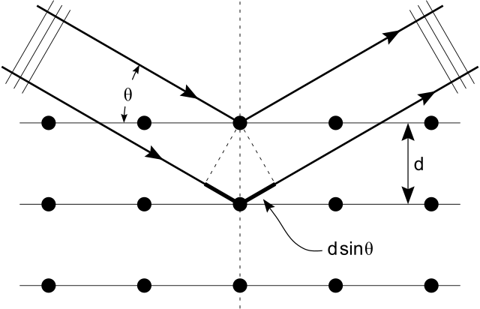
Figure 30 Incoming X-Rays reflecting off of equally spaced atoms
Keeping everything the same and altering the incident angle allows for different lattice constants to be detected. These lattice constants will appear as peaks in the angle versus intensity plot, it is therefore possible to establish the growth quality and uniformity. The XRD plot will also reveal any lattice mismatch between the substrate and the layers grown on it, giving a clear indication of any potential device design floors or major problems with the growth. It is also possible to extract the superlattice period from the XRD graph, superlattices cause multiple peaks in the intensity versus angle graph, by measuring the difference in angle between these peaks you can work out the lattice period. This is demonstrated later on in the results section. A lattice-substrate mismatch of less than 100 arc seconds is desirable. The XRD used in this work is a Bruker D8 X-ray diffraction system.

Chapter 4: Fabrication and Characterisation
In this chapter the results for the electrical and optical characterisation of the devices will be discussed as well as the device fabrication procedure. The device described during the fabrication section is the same device that is characterised in the subsequent section.

Fabrication

Devices design
The devices fabricated for this work are InAs/GaSb superlattices based on a PiN type architecture grown on a GaSb substrate. This comprises of a P doped region (P) attached to an intrinsically doped region (i) on top of an N doped region (N). The i region is the active region where the incoming photons are absorbed. Due to the applied bias and the doping in the other two regions a depletion region forms across the I layer, resulting in there being no free charge carriers. This type of structure is advantages over a standard PN junction for two reasons, firstly a PN junction only forms a depletion region at the junction of the two layers whereas in a PiN diode the depletion region can be as long as you are able to make the i region without compromising growth quality. Secondly the electric field profile in PiN diodes is uniform and controllable as is shown in Figure 31. This field draws charge carriers towards the contact regions, a PiN diode is also has a higher breakdown voltage than the PN equivalent.
Figure 31 Electric field profile for a PN and PiN diode
The devices in this work are known as Mesa Pin Diodes because of the tower like shape formed during the etching process. Since the GaSb substrate is naturally P-type the devices are grown with the N on top, i in the middle and the P below next to the substrate on which it is grown. On overall outline for the device structure is shown in Figure 32. The P layer consists of a 20nm InAs capping layer followed by 516nm of a 7MLx7ML InAs/GaSb superlattice, doped with 2x10¹⁸cm⁻³ Si. The intrinsic region is comprised of 1987nm of 7MLx7ML InAs/GaSb superlattice. Finally the N layer is a 7MLx7ML InAs/GaSb superlattice doped with 2x10¹⁸cm⁻³ of Be grown on top of a 500nm buffer layer which is also doped at the same concentration.
Figure 32 Device deign layout

Device fabrication
The wafer for this project was provided by the Chinese Academy Of Science. A full detailed fabrication procedure is provided in the appendix. The first part of the fabrication procedure which is repeated throughout is the threes stage clean. First stage involves dipping the sample into n-butyl acetate which has been brought to the boil and then allowed to cool. This removes any organic compounds from the surface. Following this the sample is placed in acetone to remove any polymers or non-organic compound which could have contaminated the surface. Finally the sample is rinsed in Isopropanol to remove the acetone. The devices are then fabricated using photolithography and a ‘wet’ chemical etch consisting of hydrogen peroxide, deionised water, citric acid and phosphoric acid 1:1:1:1 (H₃PO₄/H₂O₂/C₆H₈O₇/H₂O (deionised)). The contacts used are 20nm of titanium initially followed by 200nm of Gold. The titanium acts as a binding agent for the gold and semiconductor interface. These are deposited using an evaporator under high vacuum, the metal is heated into a vapour and then cools and solidifies on contact with the semiconductor. No attempt was made to add an antireflective coating or surface passivation. 400 µm, 200 µm and 100 µm devices diameters were fabricated as shown in Figure 33. Figure 33 shows a photo of the top contacts of a single cell of devices taken by a camera attached to a microscope.
Figure 33 Photo of a partially fabricated device with three different size devices, (A) 400 µm, (B) 200 µm and (C) 100 µm

Characterisation

Electrical Characterisation
IV’s were taken on the fabricated sample at 77K for a 400µm device diameter, Figure 34. The source measuring unit applies voltage to the device and measures the current. The device had a metal lid also cooled to 77K to prevent any radiation being incident on the device. The device was cooled using a helium compressor. The devices show good uniformity suggesting consistent device fabrication.
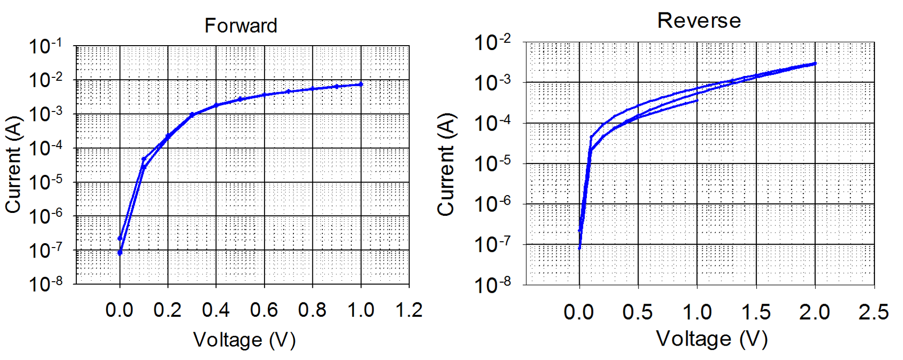
Figure 34 Forward and reverse IVs for 400 µm devices
Figure 35 shows the same IVs divided through by area to give the current density. We can see that the 0V dark current density is around 1x10⁻⁴A/cm², this is higher than state-of-the-art devices, but the uniformity shows consistent enough fabrication to continue characterisation with this device.
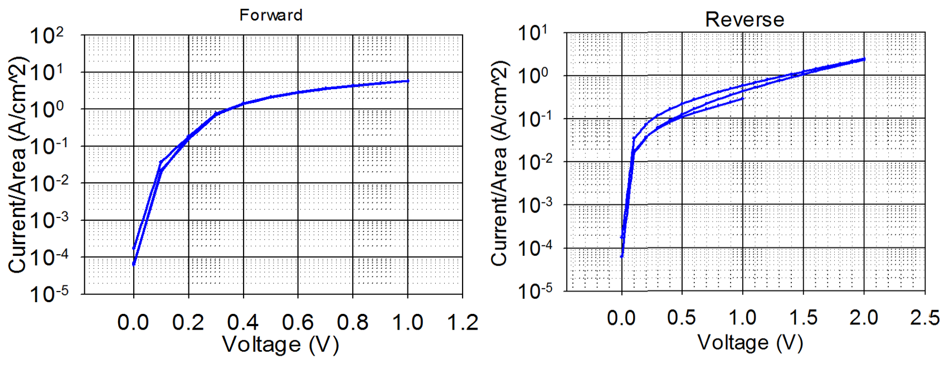
Figure 35 Current Density for Forward and Reverse IVs 400 µm devices
The current density for a 400µm, 200µm and 100µm size devices are compared in Figure 36. The IVs scale well with area showing that the dominant dark current mechanism is bulk. But there isn’t a perfect alignment so there is still some surface leakage component to the dark current mechanism, which is to be expected when working with T2SLs, which haven’t received any surface treatment or passivation. The spread is more prominent at higher voltages (>0.1V), suggesting higher surface leakage at higher voltages.
Figure 36 Current Density for 400 µm, 200 µm and 100 µm size devices
After establishing the devices work and the dark currents are within an acceptable range the next stage is to establish the temperature dependence of the dark current, for this a 400µm device was cooled from room temperature, 290K, down to 77K. The results in Figure 37 show a drop of around 4 orders of magnitude in the dark current. In general bulk dark current mechanism are more temperature dependant.
Figure 37 Different temperature IVs for 400 µm T2SL
A comparison of 0V dark current at different temperatures for three different 400µm devices is shown in Figure 38. The dark current density varies from 3 to 4 orders of magnitude with temperature.
Figure 38 0V Dark current Vs Temperature for three 400µm devices
The decrease in dark current with temperature is due to the increase in the Auger recombination lifetime and the SRH lifetime due to the trap states that occur during the growth of the semiconductor. There is also a surface leakage component to the dark current. These devices are unpassivated and have received no surface treatment, it has been shown in the literature that T2SLs can produce surface states due to the migration of free Sb atoms to the surface. As has already been mentioned these surface states create energy-bands within the band gap reducing the energy required to excite an electron from the valence band into the conduction band. As more thermal energy is introduced into the crystal more electrons are excited via these states and a higher dark current is seen. By reducing the temperature the number of thermally generated carriers is greatly reduced, these are the carriers that take part in Auger and SRH dark current processes. These are dominant dark current mechanism in T2SL devices.

Optical Characterisation

Spectral Response
The Spectral response was measured from room temperature down to 77K. Figure 39 shows the response for different temperatures. As the temperature increases the cut-off wavelengths are extended. These measurements were taken at 0V. The cut-off wavelength varies from around 4µm at 77K, up to around 4.9µm at 290K. There is an obvious signal disruption at around 4.2µm and again at 4.5µm, this is due to the absorption of CO₂ in the air. The interference seen between 2.5µm and 2.7µm is due to H₂O molecules in the air. These measurements were taken at 0V to minimise dark current.
Figure 39 Spectral Response Plots at Different Temperatures
The spectral response shows good sharp curves suggesting good superlattice uniformity and a type-2 transition has been achieved as the wavelength is longer than that of InAs or GaSb independently. InAs has a cut-off wavelength of 3.5µm and GaSb has a cut-off of 1.7µm. Change in cut-off wavelength for different temperatures is shown in Figure 40. The change in cut-off wavelength is due to the increase in temperature. As the temperature increases the atoms in the crystal gain vibrational energy. This increase in energy decreases the amount of energy requied to free an electron from the valence band and release it into the conduction band. Thus lowering the band gap. A lower band gap energy results in a longer wavelength response.
Figure 40 Variation of Cut-off wavelength with respect to temperature for three 400µm devices

Change in peak wavelength for different temperatures is shown in Figure 41, since the spectral response curves have broad peaks the noise on the measurement leads to a high level of uncertainty as to the actual peak detection. The peak detection appears to be in the region of 3.65µm to 3.7µm at 77K and between 4.2µm and 4µm at room temperature.
Figure 41 Change in Peak wavelength with temperature

Responsivity and Detectivty
The temperature dependence for peak responsivity and detectivty were measured using the setup described in the previous section. A blackbody heat source was heated to 1000˚C and used to generate the signal. This signal was chopped using an optical chopper operating at 800Hz. The device is stored in a cold finger held under vacuum with a Potassium bromide window with a transmission factor of 0.9. Figure 42 shows the change in peak responsivity with temperature. The peak responsivity ranges from 4.5A/W to 3.5A/W at room temperature, 290K, and 2.8A/W and 1.4A/W at 77K. The theoretical peak responsivity of a device with the same wavelength response at room temperature is 3.39A/W, so the responsivity achieved in this work is an order of magnitude below the theoretical value. These measurement s are taken at 0V to minimise dark current.
Figure 42 Peak responsivity at different temperatures
Peak detectivity for different temperatures is given in Figure 43, the best device shows a detectivty of 1.3x10¹⁰ cm Hz^{1/2}/W at 77K and 1x10⁹ cm Hz^{1/2}/W at room temperature. These values are an order of magnitude below that of the state-of-the-art devices operating at this wavelength. For example an InSb device with a 5µm cut-off wavelength would have a detectivity around 1x10¹¹cmHz^{1/2}/W, as can be seen in Figure 27. That being said InSb is a far more mature material system than T2SLs. If these devices were further processed to include surface passivation to reduce the surface leakage current and anti-reflection coating the detectivity could be further improved.
Figure 43 Specific detectivty for different temperatures

XRD
The sample was taken for XRD measurements in the III-V national centre in Sheffield. The results are shown in Figure 44. The XRD shows clearly defined peaks indicating good superlattice uniformity.
Figure 44 XRD from the T2SL sample
By plotting the peaks against the angle at which they occur at we can determine the superlattice period as shown in Figure 45.
Figure 45 Peaks plotted against angle to determine the superlattice period
The slope m can be used in equation (4.1) to calculate the lattice period L, using the wavelength of the X-ray beams used in XRD λ which in this case is 0.154nm.
$\frac{λ}{2m}=L$ (4.1)
This gives a period length of 4.07nm, the desired period length from the device design is 4.13nm. A discrepancy of 0.06nm or 1.5%. Given the complexity of the growth procedure this is an acceptable margin of error.

Chapter 5: Simulation Verification

XRD simulation

ISCAS
The XRD data from Figure 44 was analysed using the XRD analysis software Bede Rads Mercury. It was found that the structure was grown to include InSb and GaAs like interfaces between the InAs and GaSb layers. Figure 46 shows the finished fitting achieved by the software, the red line is the fit. Figure 47 shows the parameters defined by the fit, namely 1.956nm of GaSb, 1.811nm of InAs with a 0.277nm InSb layer when switching between InAs and GaSb and a 0.058nm GaAs layer when switching between the GaSb and InAs layers. The GaAs interface is too small to be intentional and is probably just a by-product of atom inter-diffusion but the InSb layer is most likely intentionally introduced to increase optical performance.
Arc Seconds
Figure 46 Fitted XRD for T2SL Sample
Figure 47 Fitting parameters for the XRD analysis

InAs Substrate
Growing a VLWIR T2SL on an InAs substrate would allow the production of a T2SL APD with an InAs multiplication region. Allowing for high gain detection of VLWIR photons, this could be calibrated for use in single photon detection in the VLWIR region. To lay the ground work for future projects the interface layers required to strain balance such a device have been calculated. In this section the different available types of interface are simulated and discussed.
Starting off with a known VLWIR T2SL device structure [48], comprised of 5.4nm of InAs and 4nm of GaSb and a 16µm cut-off wavelength grown on a GaSb substrate.
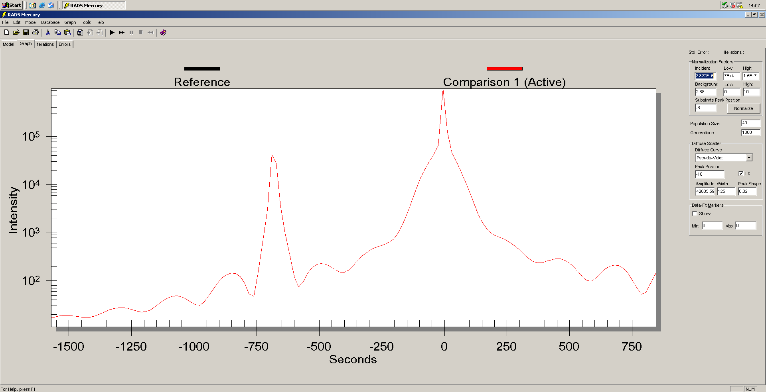
Arc Seconds
Figure 48 No interface layer XRD for a 16µm cut-off device grown on GaSb
Figure 48 shows two clearly defined peaks, the substrate peak on the right and the superlattice peak on the left, the angle difference shows the strain mismatch in the system. A strain balanced structure would show one single peak at the same angle. By introducing interface layers we can attempt to strain balance the structure.
Figure 49 shows the XRD with a 1nm InAs(0.15)Sb(0.85) interface layer introduced, since there is only one clear peak this structure is lattice matched.
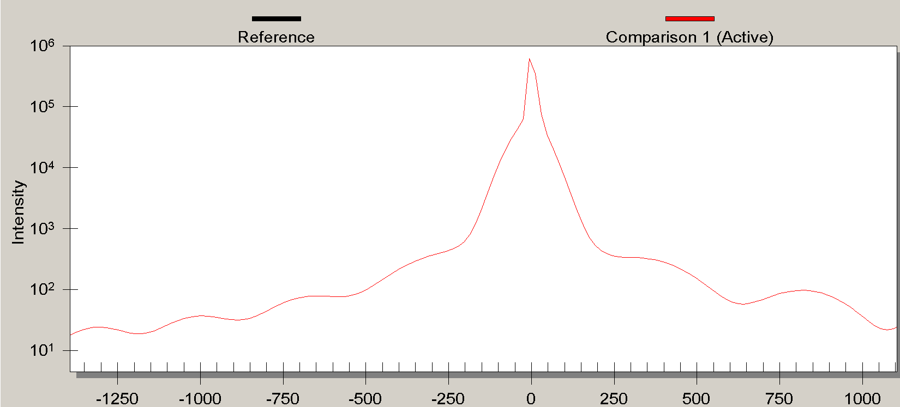
Arc Seconds
Figure 49 1nm InAs(0.15)Sb(0.85) interface layer XRD for a 16µm cut-off device
Figure 50 shows a 0.6nm InSb interface layer which is also lattice matched, the peak of interest is the central peak, the other peaks appear due to the periodicity of the superlattice structure.
Arc Seconds
Figure 50 0.6nm InSb interface layer XRD for a 16µm cut-off device
From this we can conclude that it is likely that the interface used in this work was either 0.6nm of pure InSb or 1nm of InAs(0.15)Sb(0.85). This makes sense since it has been shown that InSb like interfaces increase optical performance so it is likely that the growers aimed for this composition. Having established that the software can be used to produce logically consistent results the next step is to introduce a structure grown on an InAs substrate and attempt to lattice match it.
Now we take the same structure but grown on an InAs substrate instead of GaSb. Figure 51 shows the simulated XRD which has a clear strain mismatch.
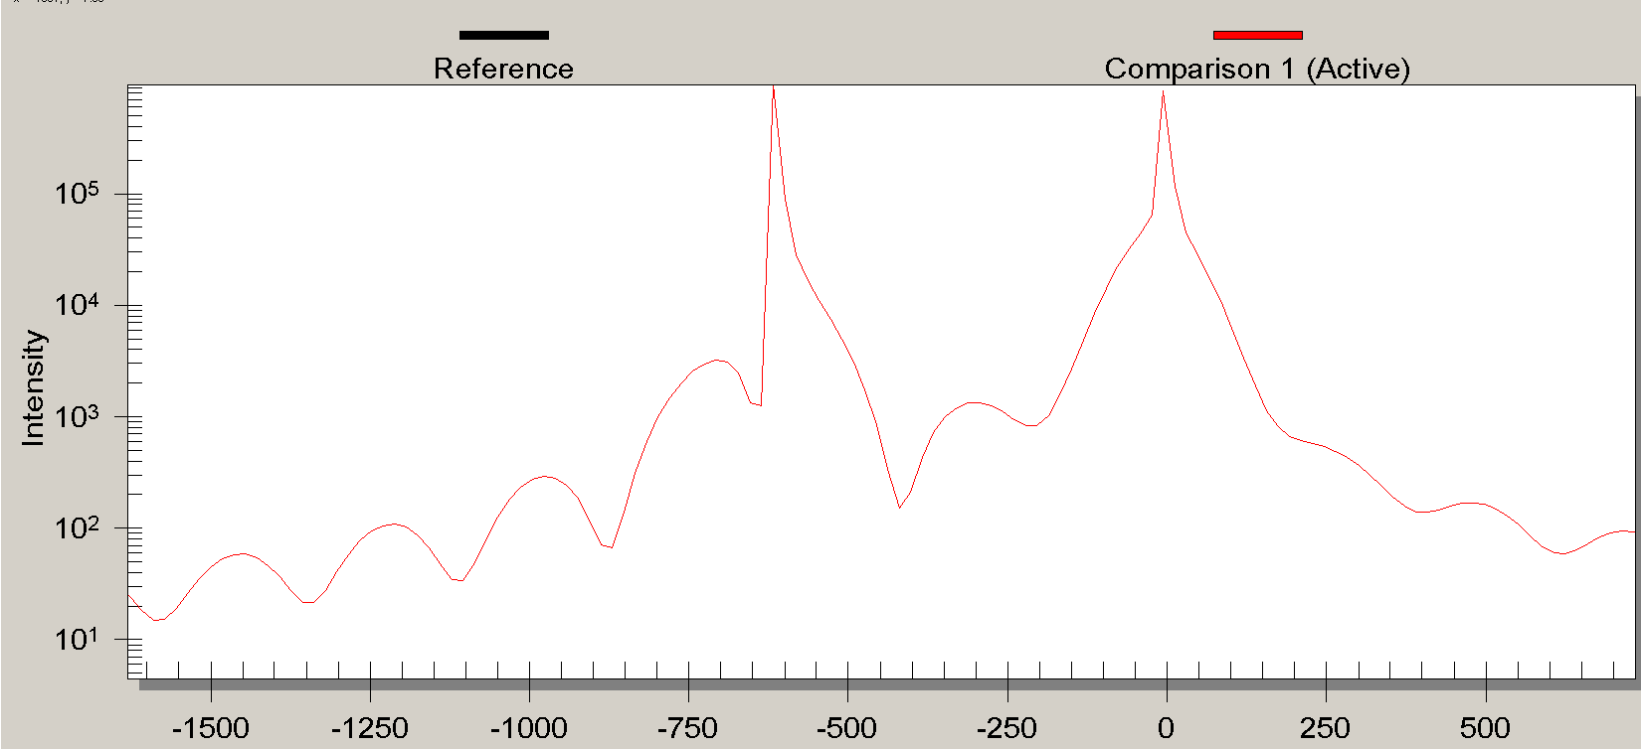
Arc Seconds
Figure 51 No interface layer XRD for a 16µm cut-off device grown on InAs
Introducing a 0.3nm GaAs interface layer leads to a strain match Figure 52. Since the lattice constant for GaAs is 0.565nm an interface this small is physically impossible and not a practical consideration for device design.
Arc Seconds
Arc Seconds
Figure 52 0.3nm GaAs interface layer XRD for a 16µm cut-off device
Figure 53 shows a 1nm InAs(0.2)Sb(0.80) interface layer will strain match the structure, (left) the substrate and superlattice peaks are overlapped showing strain balance, (right) the non-symmetrical nature of the full XRD is unexpected. It is unclear how this would affect the electrical and optical properties of the device.
Arc Seconds
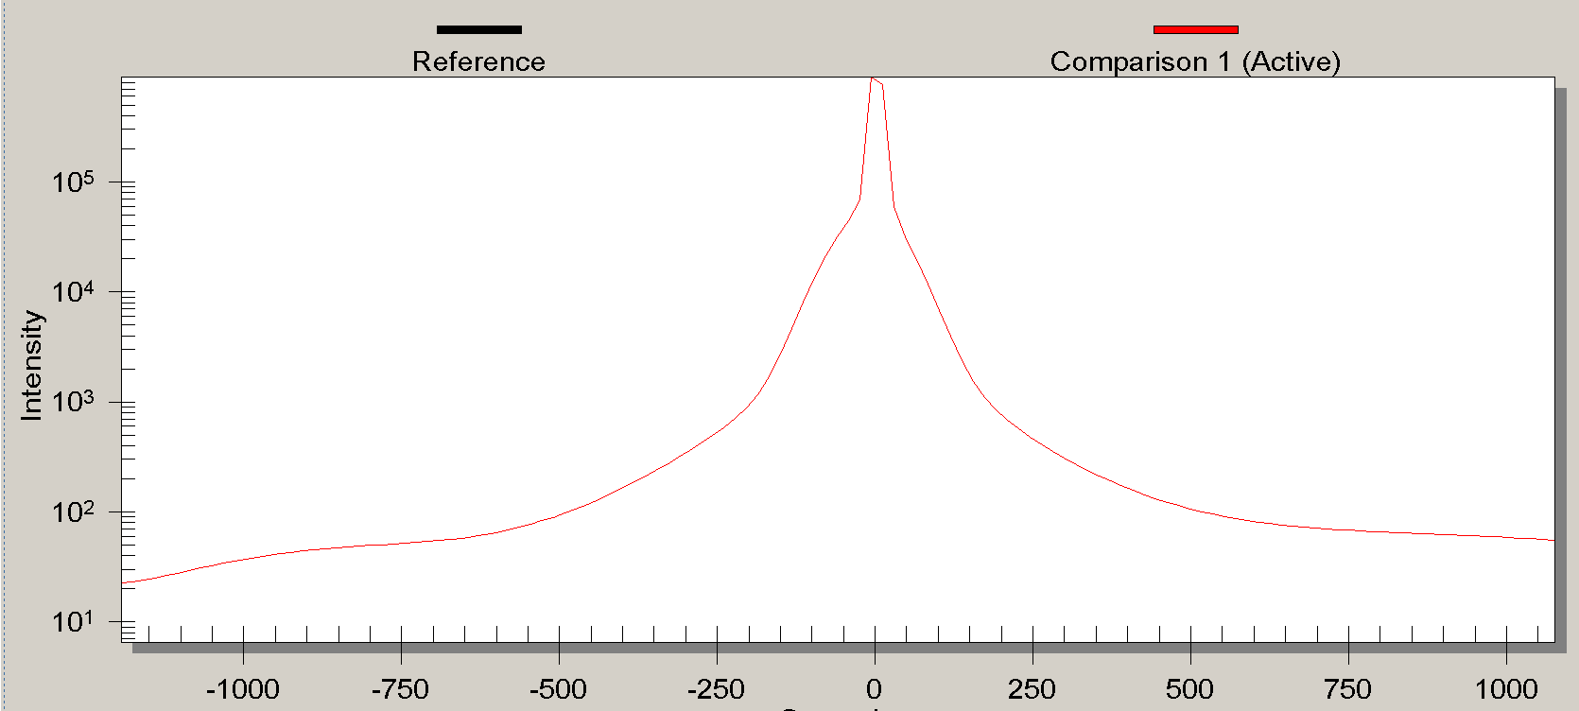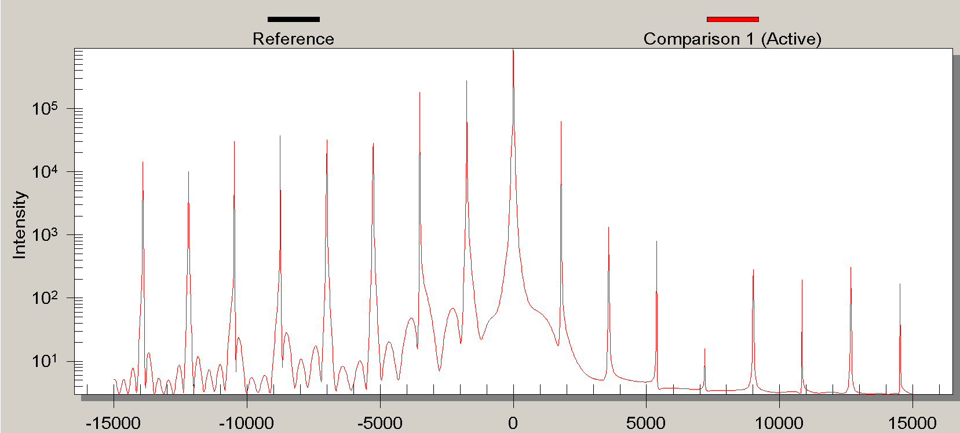
Arc Seconds
Arc Seconds
Figure 53 1nm InAs(0.2)Sb(0.8) interface layer XRD for a 16µm cut-off device
Figure 54 shows a 1nm GaAs(0.4)Sb(0.60) interface layer will also strain match the structure, (right) the full XRD shows a more symmetrical response than the previous simulation, making this a more viable option.
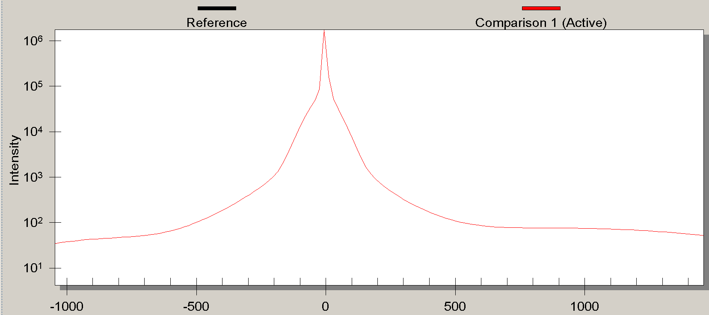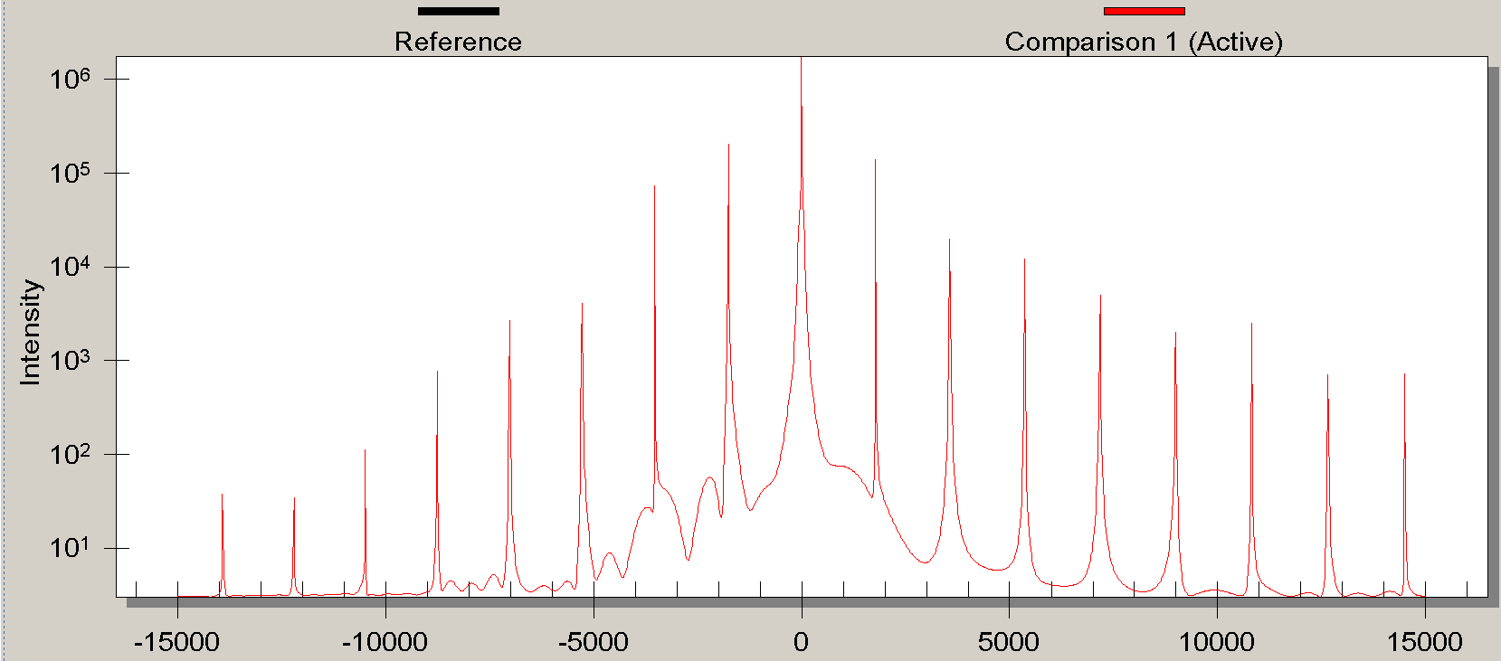
Arc Seconds
Arc Seconds
Figure 54 1nm GaAs(0.4)Sb(0.6) interface layer XRD for a 16µm cut-off device
Another viable interface is 1nm In(0.68)Ga(0.32)As, which will also lattice match the structure as shown in Figure 55.
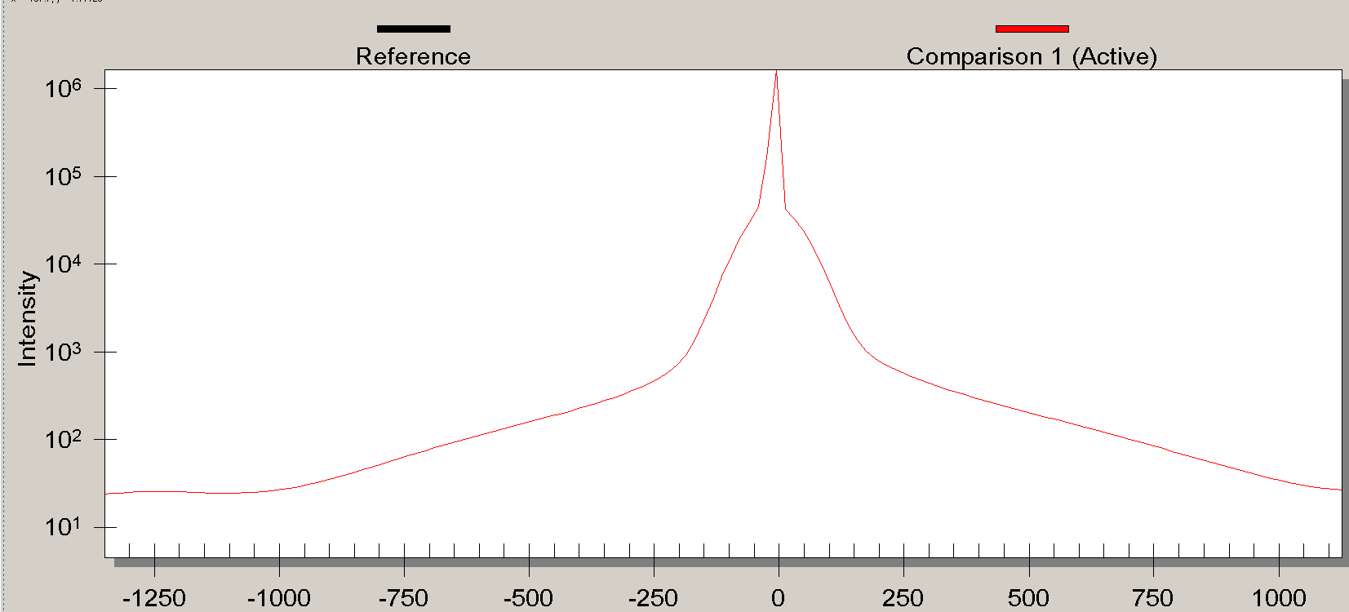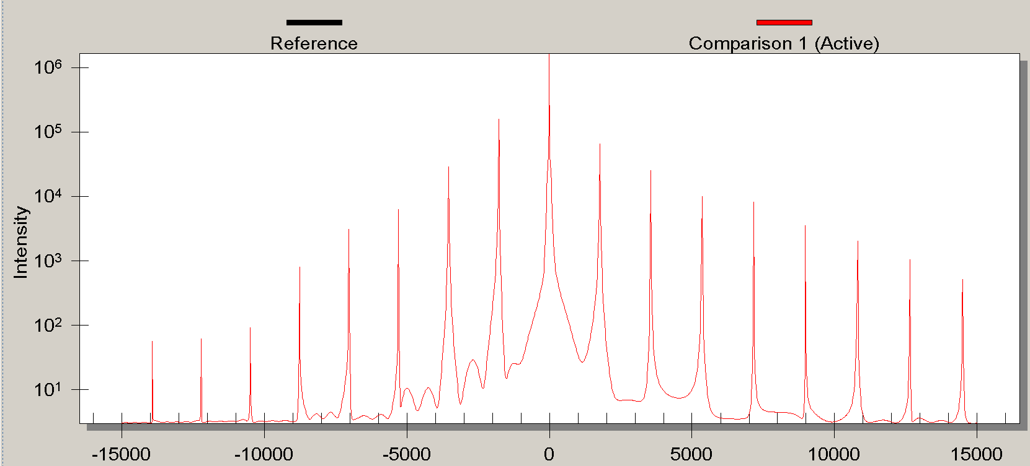
Arc Seconds
Arc Seconds
Figure 55 1nm In(0.68)Ga(0.32)As interface layer XRD for a 16µm cut-off device
All of these interface layers are based on the InAs-GaSb binaries, making them easier to grow. Introducing different elements to the system would just further increase the complexity of the growth procedure. Both the 1nm GaAs(0.4)Sb(0.6) interface and the 1nm In(0.68)Ga(0.32)As interface produce clearly defined superlattice peaks. The recommendation of this work would be to grow both interface layers and then optically characterise the device to determine which interface gave the most favourable characteristics.

Nn3
Bandgap for a NxN well showing devices grown on an InAs substrate would have a slightly different wavelength to those grown on GaSb. The InAs substrate T2SL has a higher cut-off wavelength than that of a GaSb substrate device for well lengths below 24ML. For values above 24ML the value is lower than that of a GaSb substrate device Figure 56. These are important consideration to take into account when designing an InAs substrate device. For very small well periods the conduction band starts off below the valence band in a Type-II broken gap alignment. As the confinement is reduced due to well width widening the conduction band and valence band energies cross over creating a semi-metal with a theoretically infinitely long wavelength. This is demonstrated by the peak graph at 24 monolayers for InAs and 26 monolayers for GaSb substrates.
Figure 56 T2SL bandgap simulation for a NxN well where N = X-axis, for devices grown on GaSb and InAs substrates
The MWIR T2SL which was characterised in chapter 4 was simulated using the Nn3 software. The simulation comprised of An InAs layer grown next to a GaSb layer with no interface. The simulation boarder parameters were set to ‘periodic’ so the InAs/GaSb layers were seen to been infinitely repeating by the computer. This simulation included a one dimensional strain model. Figure 57 shows the simulated Energy-Band diagram for this device, the E1-Hh1 transition energy 0.3533eV, giving a wavelength of 3.5µm. This is lower than the lowest measured experimental cut-off wavelength of 4µm at 77K. Notice the splitting of the heavy-hole and light-hole bands.
Hh1
Hh2
Lh1
E1
E2
Figure 57 Nn3 simulation of Energy-band diagram for T2SL
This simulation was repeated for different temperatures but no change in bandgap was detected, suggesting that perhaps the simulation doesn’t take into account the effect of temperature on band gap. The parameters for this simulation for GaSb and InAs are taken at 77K, so we can assume that this simulation is only valid at this temperature. A cut-off wavelength discrepancy of 0.5 µm is probably due in part to the slighty growth disgrapancy in the superlattice period length.

Chapter 6: Conclusions and Future Work
To conclude a thorough analysis of the current understanding of the physics behind T2SL devices has been taken as well as an in-depth literature review from a historical perspective. State-of-the-art devices have been analysed and compared to ‘Rule 07’. Then a MWIR T2SL sample was fabricated and characterised electrically and optically. The same sample was then analysed using XRD and simulated using various software packages. The Software showed good agreement with the experimental characterisation. Finally devices grown on InAs substrates were simulated to check the feasibility of creating an T2SL InAs/GaSb APD.
Someone wishing to continue this work should look into surface passivation and antireflection coatings to further optimise the detectivities of the device. Also a transport layer to move the carriers generated in the T2SL absorber region into an InAs multiplication region should be simulated, grown and tested for working towards building a T2SL InAs/GaSb APD. The two interface layers singled out by this work for growing VLWIR T2SL on InAs substrates should be grown and characterised to determine which produces the most desirable optical and electrical characteristics.

Appendix
State of the Art IR photodetectors
Year | Peak (µm) | Cut off at 77K(µm) | Peak Responsivity (A/W) | Peak Detectivty (cmHz^{1/2}/W) | Dark Current (A/cm²) | Reference
VLWIR
2016 | 15 | 18 | 8 | 3.33x10^10 | 0.1 | [51]
2016 | 11.8 | 14.4 | 0.65 |  | 0.005 | [53]
2008 | 12 | 14.58 |  | 3.11x10^10 | 0.00495 | [50]
2009 | 9.6 | 14 |  | 4.6x10^10 | 0.0033 | [54]
2002 | 12 | 18.8 | 4 | 4.5x10^10 | 2 | [49]
2001 | 12 | 16 | 3.5 | 1.51x10^10 | 0.02 | [48]
2016 | 12.1 | 14.4 | 0.54 | 2.94x10^9 | 0.001 | [55]
2016 | 10.55 | 19 | 0.93 | 1x10^10 | 0.3 | [56]
2014 | 12.8 | 14.6 | 4.8 | 1.4x10^10 | 0.7 | [57]
LWIR
2010 | 8.5 | 10.8 | 1.8 | 8.7x10^10 | 0.0012 | [58]
2010 | 3.5 | 8.5 |  |  | 0.00032 | [59]
2014 | 7.9 | 10 | 4.47 | 2.8x10^11 | 0.00044 | [60]
2012 | 12 | 13.2 | 0.24 | 1x10^8 | 0.0005 | [47]
2012 | 4 | 9 |  | 5x10^10 | 0.0027 | [61]
2015 | 10 | 11.5 | 2.8 |  | 0.34 | [62]
2011 | - | 9.9 | 1.5 |  | 0.00001 | [63]
2009 | 9 | 9.9 | 1.5 | 1.1x10^11 | 0.0000099 | [64]
2010 |  | 10.3 |  |  | 0.0000101 | [65]
2007 |  | 10.5 |  |  | 0.00001 | [46]
2008 | 8.5 | 10 |  |  | 0.0002 | [66]
2004 |  | 8 |  |  | 0.0001 | [67]
2005 | 5 | 6.64 |  | 1x10^12 | 0.0000008 | [68]
2007 | 9 | 11 | 3.9 | 2.2x10^11 | 0.001 | [69]
2009 | 9.6 | 14 |  | 4x10^10 | 0.0033 | [54]
2008 | 7 | 9.4 |  | 8.1x10^11 | 0.0001 | [44]
2009 | 7 | 9.4 |  |  | 0.00001 | [70]
2009 |  | 10.5 |  |  | 0.0001 | [71]
1996 | 6 | 8.8 |  | 2.2x10^10 | 0.01 | [39]
2006 | 9 | 10 | 1.8 | 4.4x10^10 | 0.002 | [72]
2007 |  | 7.5 |  |  | 0.002 | [73]
DWELL
2004 | 7.5 | 8 |  | 5.1x10^9 | 0.0000039 | [74]
2014 |  | 11 |  | 2x10^10 | 0.000001 | [75]
QDIP
2007 |  | 9.9 |  | 3.8x10^9 | 0.000059 | [76]
2011 |  | 10.2 | 2.16 | 1.01x10^11 | 0.00000136 | [22]
2013 | 7.5 | 11.5 | 0.14 | 1.25x1-^10 | 0.00000521 | [77]

Fabrication Run sheet for a T2SL device
Step | Description | Date | Notes
Cleave | Cleave a piece of sample from the wafer by scratching a line on the underside, flipping it over and applying pressure with a cotton bud. Inspect sample using microscope, use a large magnification.
Three solvent clean | Perform a three stage clean, start by running a cotton bud dipped in boiling n-butyl over the sample, then dip in acetone and boiling IPA. Dry with nitrogen gun.  Inspect the sample.
Bake | Bake for 1 min @ 100C
Spin | Spin photo resist (BPRS 200) at 4000 rpm
Bake | Bake for 1 min @ 100C
Expose | Use mask-aligner, with "Top Contact" mask layer.  Line the edge of the sample with the edge of the mask. Expose.
Develop | Develop for 1min, dip in deionised water
Inspect | Check under the microscope for over or under exposure. Under exposed - there is a colourful pattern of photo-resist across the mask design. Over Exposed - the whole sample is devoid of photo-resist. Make sure to inspect the exposure bars, use a large magnification when inspecting. Check the thickness and profile of the photoresist.
Asher | Asher the sample
Evaporate | Take sample to the Evap. Place the gold and titanium inside separate coils and boil in n-butyl to clean. Place coils in the Evap and position samples at the base. Pump Evap down to pressure. Once pressure is achieved apply current to the titanium and remove shutter when it starts to melt, keep applying current until 20nm has been deposited (see crystal monitor) trying to keep the rate at around 0.09. Repeat for gold but for 200nm trying to keep the rate around 0.14. Once complete bring Evap back to room pressure, remove coils and samples and clean the bell jar.
Lift-off | Take sample over to the lift off station and place in warm acetone, if the gold doesn’t come off agitate the sample or leave it in the acetone overnight. Spray with acetone bottle if still refusing to move.
Three solvent clean | Perform a three stage clean, dip sample in boiling n-butyl, then dip in acetone and boiling IPA. Dry with nitrogen gun.  Inspect the sample.
Bake | Bake for 1 min @ 100C
Spin | Spin photo resist (BPRS 200) at 4000 rpm
Bake | Bake for 1 min @ 100C
Expose | Use mask-aligner, with "deep mesa" mask layer,  making sure to align it properly with your top contacts, make sure the features are in the right orientation and are completely visible through the mask. Expose.
Develop | Develop for 1min, dip in deionised water
Inspect | Check under the microscope for over or under exposure. Under exposed - there is a colourful pattern of photo-resist across the mask design. Over Exposed - the whole sample is devoid of photo-resist. Make sure to inspect the exposure bars, use a large magnification when inspecting.
Detak | Use Detak to measure the height of your profile and photoresist. Calculate desired etch depth.
Etch | Place test sample in 1:1:1:1 (H₃PO₄/H₂O₂/C₆H₈O₇/H₂O (deionised)) and calculate the etch rate. Calculate etch time to reach desired depth. Then Etch your sample for the required etch time.
Detak | Check etch depth of sample. Repeat etch if necessary.
Three solvent clean | Perform a three stage clean, dip sample in boiling n-butyl, then dip in acetone and boiling IPA. Dry with nitrogen gun.  Inspect the sample.
Bake | Bake for 1 min @ 100C
Spin | Spin photo resist (BPRS 200) at 4000 rpm
Bake | Bake for 1 min @ 100C
Expose | Use mask-aligner, with "Grid Contact" mask layer.  Line the edge of the sample with the edge of the mask. Expose.
Develop | Develop for 1min, dip in deionised water
Inspect | Check under the microscope for over or under exposure. Under exposed - there is a colourful pattern of photo-resist across the mask design. Over Exposed - the whole sample is devoid of photo-resist. Make sure to inspect the exposure bars, use a large magnification when inspecting. Check the thickness and profile of the photoresist.
Asher | Asher the sample
Evaporate | Take sample to the Evap. Place the gold and titanium inside separate coils and boil in n-butyl to clean. Place coils in the Evap and position samples at the base. Pump Evap down to pressure. Once pressure is achieved apply current to the titanium and remove shutter when it starts to melt, keep applying current until 20nm has been deposited (see crystal monitor) trying to keep the rate at around 0.09. Repeat for gold but for 200nm trying to keep the rate around 0.14. Once complete bring Evap back to room pressure, remove coils and samples and clean the bell jar.
Lift-off | Take sample over to the lift off station and place in warm acetone, if the gold doesn’t come off agitate the sample or leave it in the acetone overnight. Spray with acetone bottle if still refusing to move.
Three solvent clean | Perform a three stage clean, dip sample in boiling n-butyl, then dip in acetone and boiling IPA. Dry with nitrogen gun.  Inspect the sample.
Inspect | Check Sample under the microscope

Nextnano 3 simulation can be made available on request.

Bibliography

[1] | A Rogalsk, "History of infrared detectors," vol. 20, no. 3, 2012.
[2] | M. Z. Tidrow and W. R. Dyer, "Defense Technical Information Center," , Washington, 2000.
[3] | William Reusch. Infrared Spectroscopy. [Online]. http://www2.chemistry.msu.edu/faculty/reusch/virttxtjml/spectrpy/InfraRed/infrared.htm#ir1
[4] | D.B. Reynolds and D.H. Seib, "Blocked impurity band hybrid infrared focal plane arrays for astronomy," vol. 36, no. 1, 1989.
[5] | (2015, July) NASA website. [Online]. https://www.nasa.gov/jpl/pia19640/jupiters-infrared-glow
[6] | NASA. Spitzer.Caltech.edu. [Online]. http://www.spitzer.caltech.edu/mission/32-Mission-Overview
[7] | NASA. spitzer.caltech.edu. [Online]. http://www.spitzer.caltech.edu/mission/394-he-Infrared-Spectrograph-IRS-
[8] | Harvard. cfa.harvard.edu. [Online]. https://www.cfa.harvard.edu/mirsi/mirsi_spec.html
[9] | P. Veefkind et al., "The Applicability of Remote Sensing in the Field of Air Pollution," Luxembourg, 1018-5593 , 2007.
[10] | Antoni Rogalski, Krzysztof Adamiec, and Jaroslaw Rutkowski, Narrow-Gap Semiconductor Photodiodes.: SPIE Press, 2000.
[11] | W. D. Lawson, S. Nielson, E. H. Putley, and A. S. Young, "Preparation and properties of HgTe and mixed crystals of HgTe-CdTe," J. Phys. Chem. Solids , vol. 9, pp. 325–329, 1959.
[12] | Verie C and Granger R, "Propriet´ es de junctions p-n d’alliages CdxHg(1−x)Te," C. R. Acad. Sci, vol. 261, pp. 3349-3352, 1965.
[13] | Verie G C and Sirieix M, "Gigahertz cutoff frequency capabilities of CdHgTe photovoltaic detectors at 10.6µm," IEEE J. Quant. Electron., vol. 8, pp. 180-184, 1972.
[14] | Elliott C T, Day D, and Wilson B J, "An integrating detector for serial scan thermal imaging," Infrared Phys., vol. 22, pp. 31-42, 1982.
[15] | W.E. TENNANT et al., "Small-Pitch HgCdTe Photodetectors," Journal of ELECTRONIC MATERIALS, vol. 43, no. 8, pp. 3041-3046, 2014.
[16] | Peter Capper and James Garland, Mercury Cadmium Telluride: Growth, Properties and Applications. Chichester: WILEY, 2011.
[17] | Safa Kasap and Peter Capper, Handbook of Electronic and Photonic Materials.: Springer, 2006.
[18] | A. Rogalski, "HgCdTe infrared detector material: history, status and outlook," Reports on Progress in Physics, vol. 68, no. 10, pp. 2267–2336, 2005.
[19] | Committee on Developments in Detector Technologies, Seeing Photons: Progress and Limits of Visible and Infrared Sensor Arrays. Washington: National Academies Press, 2010.
[20] | Michael D. Petroff and Maryn G Stapelbroek, "Blocked impurity band detectors ," Hardware US4568960 A, Feb 4, 1986.
[21] | Antoni Rogalski, "Infrared detectors: an overview," vol. 43, no. 3-5, 2002.
[22] | Subhananda Chakrabarti, Sourav Adhikary, Nilanjan Halder, Yigit Aytac2, and A. G. U. Perera, "High-performance, long-wave (∼10.2 μm) InGaAs/GaAs quantum dot infrared photodetector with quaternary In0.21Al0.21Ga0.58As capping," vol. 99, no. 18, 2011.
[23] | Manijeh Razeghi, Technology of Quantum Devices.: Springer, 2010.
[24] | David Z.Ting, AlexanderSoibel, and Sarath D.Gunapala, "Type-II superlattice hole effective masses," 2016.
[25] | J. W. Matthews and A. E. Blakeslee, "Defects in epitaxial multilayers. I. Misfit dislocations," J. Cryst. Growth, vol. 27, pp. 118-125, 1974.
[26] | R. People and J. C. Bean, "Calculation of critical layer thickness versus lattice mismatch for GexSi1-x/Si strained-layer heterostructures," Appl. Phys. Lett., vol. 47, pp. 322-324, 1985.
[27] | S. M. Sze, "Heterojunctions and Nanostructures," in Physics of Semiconductor Compounds. New Jersey: John Wiley & Sons, 2007, p. 57.
[28] | D. L. Smith and C. Mailhiot, "Proposal for strained type II superlattice infrared detectors," Journal of Applied Physics, vol. 62, no. 6, pp. 2545-2548, 1987.
[29] | Antonio Rogalski, Infrared Detectors, Second Edition. London: CRC Press, 2010.
[30] | M. E. Flatte and C. H.Grein, "Theory and modeling of type-II strained-layer superlattice detectors ," Quantum Sensing and Nanophotonic Devices VI, vol. 7222, 2009.
[31] | Tan and Siew Li, "Dry etching and surface passivation techniques for type-II InAs/GaSb infrared detectors," vol. 7838, no. 7, 2010.
[32] | Plis, E. A. Kutty, and S. Krishna, "Passivation techniques for InAs/GaSb strained layer superlattice detectors ," vol. 7, 2013.
[33] | W. E. Tennant, "“Rule 07” Revisited: Still a Good Heuristic Predictor of p/n HgCdTe Photodiode Performance?," Journal of Electronic Materials, vol. 39, no. 7, pp. 1030-1035, 2010.
[34] | L. Esaki and R. Tsu, "Superlattice and Negative Differential Conductivity," IBM Journal of Research and Development, vol. 14, no. 1, pp. 61-65, 1970.
[35] | G. A. Sai‐Halasz, R. Tsu, and L. Esaki, "A new semiconductor superlattice," vol. 30, no. 12, 1977.
[36] | L. Esaki, "InAs-GaSb SUPERLATTICES-SYNTHESIZED SEMICONDUCTORS," Journal of Crystal Growth, vol. 52, no. 1, pp. 227-240, 1981.
[37] | J. N. Schulman and T. C. McGill, "The CdTe/HgTe superlattice: Proposal for a new infrared material," vol. 34, no. 663, 1979.
[38] | Yia-Chung Chang and J. N. Schulman, "Interband optical transitions in GaAs-GaAlAs and InAs-GaSb superlattices," vol. 31, no. 2069, 1985.
[39] | J. L. Johnson, L. A. Samoska, and A. C. Gossard, "Electrical and optical properties of infrared photodiodes using the InAs/Ga1−xInxSb superlattice in heterojunctions with GaSb," vol. 80, no. 1116, 1996.
[40] | H. Mohseni, E. Michel, Jan Sandoen, and M. Razeghi, "Growth and characterization of InAs/GaSb photoconductors for long wavelength infrared range," vol. 71, no. 10, 1997.
[41] | F. Fuchs, U. Weimer, W. Pletschen, J. Schmitz, and E. Ahlswede, "High performance InAs/Ga1-xInxSbInAs/Ga1-xInxSb superlattice infrared photodiodes," vol. 71, no. 3251, 1997.
[42] | M. Walther et al., "256×256 focal plane array midwavelength infrared camera based on InAs/GaSb short-period superlattices," vol. 34, no. 6, 2005.
[43] | I. Vurgaftmana, E. H. Aifer, C. L. Canedy, J. G. Tischler, and J. R. Meyer, "Graded band gap for dark-current suppression in long-wave infrared W-structured type-II superlattice photodiodes," vol. 89, no. 12, 2006.
[44] | Binh-Minh Nguyen, Darin Hoffman, Edward Kwei-wei Huang, Pierre-Yves Delaunay, and Manijeh Razeghi, "Background limited long wavelength infrared type-II InAs/GaSb superlattice," vol. 93, no. 12, 2008.
[45] | J. R. Meyer, C. A. Hoffman, F. J. BartoliL, and R. Ram‐Mohan, "Type-II quantum-well lasers for the mid-wavelength infrared," vol. 67, no. 6, 1995.
[46] | Binh-Minh Nguyen, Darin Hoffman, Pierre-Yves Delaunay, and Manijeh Razeghi, "Dark current suppression in type II InAs∕GaSbInAs∕GaSb superlattice long wavelength infrared photodiodes with M-structure barrier," vol. 91, no. 16, 2007.
[47] | H. S. Kim et al., "Long-wave infrared nBn photodetectors based on InAs/InAsSb type-II," vol. 101, no. 16, 2012.
[48] | H. Mohseni, M. Razeghi, G. J. Brown, and Y. S. Park, "High-performance InAs/GaSb superlattice photodiodes for the very long wavelength," APPLIED PHYSICS LETTERS, vol. 78, no. 15, pp. 2107-2109, 2001.
[49] | Y. Wei, A. Gin, M. Razeghi, and G. J. Brown, "Advanced InAs/GaSb superlattice photovoltaic detectors for very long wavelength," Applied Physics Letters , vol. 80, no. 18, pp. 3262-3264, 2002.
[50] | Darin Hoffman et al., "The effect of doping the -barrier in very long-wave type-II heterodiodes," vol. 93, no. 3, 2008.
[51] | Dongwei Jiang et al., "Very high quantum efficiency in InAs/GaSb superlattice for very long wavelength detection with cutoff of 21 μm," Applied Physics Letters, vol. 108, no. 12, pp. 121110 1-5, 2016.
[52] | F. N. CHUKHOVS and Yu. P. KIIAPACHEV, "Exact Solution of the Takagi-Taupin Equation for Dynamical X-Ray Bragg Diffraction by a Crystal with a Transition Layer," vol. 88, no. 1, 1985.
[53] | Xiaochao Li et al., "Investigation of dark current mechanisms on type-II InAs/GaSb superlattice very long wavelength infrared detectors," Journal of Physics D: Applied Physics, no. 49, 2016.
[54] | B.-M. Nguyen, S. Bogdanov, S. Abdollahi Pour, and M. Razeghi, "Minority electron unipolar photodetectors based on type II InAs/GaSb/AlSb superlattices for very long wavelength infrared detection," Applied physics letters, no. 95, 2009.
[55] | Xiaochao Li, Dongwei Jiang, Yong Zhang, and Liancheng Zhao superlattice for very long wavelength infrared photodetectors, "Interface optimization and fabrication of InAs/GaSb type II," Superlattices and Microstructures , no. 91, pp. 238-243, 2016.
[56] | Dong-Wei Jiang et al., "Low Crosstalk Three-Color Infrared Detector by Controlling the Minority Carriers Type of InAs/GaSb Superlattices for Middle-Long and Very-Long Wavelength," Chinese Physics Letters , vol. 33, no. 4, p. 048502, 2016.
[57] | A. M. Hoang, G. Chen, R. Chevallier, A. Haddadi, and M. Razeghi, "High performance photodiodes based on InAs/InAsSb type-II superlattices," APPLIED PHYSICS LETTERS, vol. 104, no. 25, pp. 251105 1-4, 2014.
[58] | N. Gautam et al., "Performance improvement of longwave infrared photodetector based on type-II InAs/GaSb superlattices using unipolar current blocking layers," Applied Physics Letters, vol. 96, no. 23, 2010.
[59] | E. Plis et al., "Molecular beam epitaxy growth and characterization of type-II InAs/GaSb strained layer superlattices for long-wave infrared detection," Applied Physics Letters , vol. 30, 2008.
[60] | A. Haddadi, G. Chen, R. Chevallier, A. M. Hoang, and M. Razeghi, "InAs/InAs1-xSbx type-II superlattices for high performance long wavelength infrared detection," Applied Physics Letter, vol. 105, 2014.
[61] | E.A. Plis et al., "Performance improvement of long-wave infrared InAs/GaSb strained-layer superlattice detectors through sulfur-based passivation," Infrared Physics and Technology, vol. 55, 2012.
[62] | E. Plis et al., "Dual color longwave InAs/GaSb type-II strained layer superlattice detectors," Infrared Physics and technology , vol. 70, 2015.
[63] | David Z.-Y. Ting et al., "Antimonide superlattice complementary barrier infrared detector (CBIRD)," Infrared Physics and Technology, vol. 54, 2011.
[64] | A high-performance long wavelength superlattice complementary barrier infrared detector, "David Z.-Y. Ting; Cory J. Hill; Alexander Soibel; Sam A. Keo; Jason M. Mumolo; Jean Nguyen; Sarath D.Gunapala," Applied Physics Letters, vol. 95, 2009.
[65] | Jean Nguyen et al., "Low dark current long-wave infrared InAs/GaSb superlattice detectors," Applied Physics Letters , vol. 97, 2010.
[66] | Pierre-Yves Delaunay et al., "High quantum efficiency two color type-II photodiodes," Applied Physics Letters, vol. 92, 2008.
[67] | A. Gin et al., "Ammonium sulfide passivation of Type-II InAs/GaSb superlattice photodiodes," Applied Physics Letters, vol. 84, 2004.
[68] | Y. Wei et al., "High-performance type-II InAs/GaSb superlattice photodiodes with cutoff wavelength around 7 µm," Applied Physics Letters, vol. 86, 2005.
[69] | Binh-Minh Nguyen et al., "Very high quantum efficiency in type-II InAs/GaSb superlattice photodiode with cutoff of 12um," Applied Physics Letters, vol. 90, 2007.
[70] | Pierre-Yves Delaunay, Binh Minh Nguyen, Darin Hoffman, Edward Kwei-Wei Huang, and Manijeh Razeghi, "Background Limited Performance of Long Wavelength Infrared Focal Plane Arrays Fabricated From M-Structure InAs–GaSb Superlattices," IEEE Journal of Quantum Electronics , vol. 45, no. 2, p. 157, 2009.
[71] | David R. Rhiger, Robert E. Kvaas, Sean F. Harris, and Cory J. Hill, "Characterization of LWIR diodes on InAs/GaSb Type-II superlattice material," Infrared Physics and Technology, vol. 52, pp. 304-309, 2009.
[72] | H. Shao, W. Li, A. Torfi, D. Moscicka, and W. I. Wang, "Type-II superlattices grown on GaSb (311)B by molecular beam epitaxy for long-wavelength infrared applications," Journal of Vacuum Science & Technology B, vol. 24, no. 4, p. 2144, 2006.
[73] | Shin Mou, Jian V. Li, and Shun Lien Chuang, "Surface channel current in InAs/GaSb type-II superlattice photodiodes," Journal of Applied Physics, vol. 102, 2007.
[74] | S. Raghavan et al., "Normal-incidence quantum dots-in-a-well detector operating in the long-wave infrared atmospheric window (8–12 µm)," Journal of Applied Physics , vol. 96, no. 2, 2004.
[75] | Mahdi Zavvari and Vahid Ahmadi, "Avalanche quantum dot-in-well long wavelength infrared photodetectors: Linear and Geiger mode operation," Infrared Physics and Technology, vol. 65, pp. 72-76, 2014.
[76] | Xuejun Lu, Jarrod Vaillancourt, Mark J Meisner, and Andreas Stintz, "Long wave infrared InAs-InGaAs quantum-dot infrared photodetector with high operating temperature over 170K," Journal of Physics D: Applied Physics , vol. 40, pp. 5878-5882, 2007.
[77] | Sourav Adhikary and Subhananda Chakrabarti, "Evidence of long-wave-infrared excited state transition at high temperature (200 K) in 35-layer In0.50Ga0.50As/GaAs quantum dot infrared photodetector," Journal of Vacuum Science & Technology B, vol. 31, 2013.

