**Evaluating the Role of Imagery for Improving Outcomes Related to Psychosis and Non-clinical Grandiosity**

**Razia Akhtar**

Submitted for the Doctorate of Clinical Psychology

University of Sheffield

June 2018

**Declaration**

This work has not been submitted for any other degree or to any other institution.

**Structure and Word Counts**

|  |  |
| --- | --- |
| **Literature Review** |  |
| Excluding references and tables | 7,817 |
| Including references and tables | 13,087 |
|  |  |
| **Research report** |  |
| Excluding references and tables | 7,689 |
| Including references and tables | 10,547 |
|  |  |
| **Total word count** |  |
| Excluding references and tables | 15,506 |
| Including references and tables | 23,634 |
| Including references, tables and overall abstract | 23,851 |

**Overall Abstract**

**Literature review.** The current systematic literature review examined different imagery interventions for a clinical population experiencing psychosis, and evaluated the effectiveness on outcomes related to psychosis. Twenty-one studies describing various imagery interventions and imagery manipulation techniques were systematically reviewed. These included Compassion Focused Therapy, cognitive interventions including imagery rescripting, and Eye Movement Desensitisation Reprocessing imagery interventions. The effectiveness of imagery interventions varied, where approaches exhibited varying strengths at improving specific outcomes related to psychosis, however methodological differences and weaknesses identified limited comparisons across studies. Limitations of the review and implications for clinical practice are discussed.

**Research report.** The main aim of the study was to examine whether positive imagery manipulation amplified positive affect, and improved self-esteem and self-compassion for non-clinical individuals experiencing grandiose beliefs, and whether grandiosity was related to experiencing imagery more vividly. A large sample of 276 participants completed a positive or negative audio imagery task manipulating either aspirations or goals. Groups were formed based on experiencing grandiose beliefs or not experiencing grandiose beliefs. The grandiose beliefs group reported significantly higher and amplified positive affect, and higher self-esteem following positive imagery manipulation, compared to the no grandiose beliefs group. Self-compassion and imagery vividness were not significantly different between groups. Limitations and clinical implications of the study, and suggestions for future research are discussed.

**Acknowledgements**

I would like to thank all of the participants who gave up their time to take part in the study. I would also like to thank my supervisor, Dr Georgina Rowse, for her support, guidance and encouragement throughout the process. Additionally, I would like to thank Dave Saxon for kindly offering his time and expert advice. I would like to also thank my family, friends and fellow trainees, as without their support and encouragement, I could not have done this.

Finally, thank you to my husband, Kalique, who has seen this through with me from the beginning. The support, patience and encouragement has kept me motivated and able to keep looking ahead.

**List of Contents**

|  |  |
| --- | --- |
| **Content** | **Page number** |
| **Literature Review** | 2 |
| Abstract | 3 |
| Introduction | 5 |
| Methods | 9 |
| Results | 13 |
| Discussion | 36 |
| Conclusions | 43 |
| References | 45 |
|  | |
| **Literature Review Appendices** |  |
| Appendix A: Downs and Black checklist | 56 |
| Appendix B: JBI Case Series Critical Appraisal Tool | 60 |
| Appendix C: JBI Case Reports Critical Appraisal Tool | 61 |
| Appendix D: Quality Appraisal of Randomised and  Non- Randomised studies | 62 |
| Appendix E: Quality Appraisal of Case Series | 63 |
| Appendix F: Quality Appraisal of Case Reports | 64 |
|  | |
| **Research Report** | 65 |
| Abstract | 66 |
| Introduction | 68 |
| Methods | 73 |
| Results | 83 |
| Discussion | 97 |
| Conclusions | 106 |
| References | 107 |
|  |  |
| **Research Report Appendices** |  |
| Appendix A: The Peters Delusion Inventory (PDI-21) | 117 |
| Appendix B: Spontaneous Use of Imagery Scale | 123 |
| Appendix C: Rosenberg Self-esteem Scale | 124 |
| Appendix D: Altman Self-rating Mania Scale | 125 |
| Appendix E: Positive and Negative Affect Schedule | 126 |
| Appendix F: State Self-esteem Scale | 127 |
| Appendix G: Self-Compassion Scale | 130 |
| Appendix H: Positive Imagery Manipulation Script | 132 |
| Appendix I: Negative Imagery Manipulation Script | 134 |
| Appendix J: University Recruitment Advert | 136 |
| Appendix K: General Recruitment Advert | 137 |
| Appendix L: Study Information | 138 |
| Appendix M: Study Consent | 140 |
| Appendix N: Mood Repair Exercise | 141 |
| Appendix O: Debrief Information | 142 |
| Appendix P: Ethical Approval | 144 |

THIS PAGE HAS BEEN LEFT INTENTIONALLY BLANK

**Section One**

**Literature Review**

**A systematic review of imagery interventions for individuals experiencing psychosis.**

**Abstract**

**Objectives.** This systematic review synthesised literature on variations of imagery interventions used with clinical populations experiencing psychosis, and evaluated the effectiveness of the interventions for outcomes related to psychosis.

**Methods.** A systematic literature search was conducted on PsycInfo, Medline, Scopus and Cochrane databases. Search terms related to psychosis and imagery use and interventions were used. All studies were subjected to a quality appraisal.

**Results.** Twenty-one studies met inclusion criteria. Studies included imagery interventions and imagery manipulation experiments. Interventions were based on Compassion Focused Therapy (CFT), cognitive approaches including imagery rescripting, Eye Movement Desensitisation Reprocessing (EMDR) and novel interventions. The outcomes of interventions varied, with different strengths of each approach at improving outcomes related to psychosis. Quality of the studies indicated clear methodological weaknesses across the studies.

**Conclusions.** CFT interventions effectively developed positive imagery to improve self-compassion and acceptance of psychosis. Imagery rescripting techniques within cognitive and EMDR approaches were effective at reappraising images related to trauma or delusional beliefs. The emerging evidence is promising for most approaches, however further trials should address methodological weaknesses across the existing literature.

**Practitioner Points**

***Clinical Implications***

* Imagery interventions do not appear to be offered as a stand-alone intervention in psychosis and may be more effective alongside other techniques such as cognitive restructuring or compassionate reframing.
* Developing positive imagery may be useful for individuals with psychosis who are self-critical or socially anxious. Negative imagery related to trauma or delusional beliefs may be addressed using imaginal exposure and imagery rescripting.
* Imagery interventions should involve adherence to evidence-based protocols due to potential adverse effects.

***Limitations***

* Methodological weaknesses across studies, including poor follow-up or measurement of adverse effects, restrict the applicability of findings.
* The lack of randomised controlled trials in the review led to a reliance on case series and case reports, which enhance risk of bias.

**Introduction**

Psychosis involves the significant alteration of a person's perception, thoughts, mood and behaviour (NICE, 2014). The Diagnostic and Statistical Manual of Mental Disorders Fifth Edition (DSM-5; American Psychiatric Association, 2013) suggests psychosis occurs along a spectrum, from mild to severe forms (Arciniegas, 2015). Experiences of psychosis can include unusual beliefs/delusions, auditory and verbal hallucinations, depressed mood, anxiety and social withdrawal (NICE, 2014). Psychosis can be the defining feature of schizophrenia spectrum disorders (schizophrenia, schizoaffective disorder, schizophreniform disorder, delusional disorder and brief psychotic disorder), and also occurs in bipolar disorder (Arciniegas, 2015). The prevalence of receiving a diagnosis of schizophrenia is 1% (NICE, 2014).

Growing evidence indicates psychosis-like experiences and traits occur in the general population, with similar risk factors to those with a diagnosed disorder (Kelleher et al., 2012). Psychosis can be viewed on a continuum, which some argue should not be conceptualised as qualitatively different to normality (Garety & Freeman, 2013). A systematic review of the evidence shows a 5% prevalence of sub-clinical psychotic experiences in the general population, where 75-90% of experiences are transitory and disappear over time (van Os, Linscott, Myin-Germeys, Delespaul, & Krabbendam, 2008). These sub-clinical experiences become clinically relevant when they persist, interact with environmental risks and cause distress (van Os et al., 2008).

There are various models of psychosis, including the vulnerability-stress model (Zubin & Spring, 1977), which proposes that some individuals may have pre-existing vulnerabilities to stress. The cognitive behavioural model elaborates that this vulnerability to stress can create disturbances in emotional and reasoning processing, leading to the development and persistence of psychosis (Garety, Kuipers, Fowler, Freeman, & Bebbington, 2001). Recent convincing evidence highlights the relationship between childhood trauma and psychosis (Read, Os, Morrison, & Ross, 2005). A meta-analysis found people who had experienced childhood adversity were more likely to develop psychosis than those who did not (Varese et al., 2012). A large-scale prospective study of the general population found a high prevalence of trauma in individuals reporting distressing psychotic experiences (Bak et al., 2005). An overlap in experiences between psychosis and post-traumatic stress disorder (PTSD) may exist, where approximately 25% of people with psychosis meet the criteria for PTSD (Hardy et al., 2005; Morrison, Frame, & Larkin, 2003).

Despite being relatively uncommon, psychotic experiences can result in high levels of distress, and those with significant distress can experience social disability and need for care (Knapp, 2003), and low rates of employment (Kirkbride et al., 2012). Current recommended treatments for psychosis include antipsychotics, Cognitive Behavioural Therapy (CBT) and family interventions (NICE, 2014). However, these may have only moderate effects (Jones et al., 2006; NICE, 2009), which prompts the need to investigate alternative interventions.

More recently, literature has proposed imagery should become a focus of interventions (Morrison et al., 2002), as it is an important aspect in the phenomenology of psychosis (Morrison & Baker, 2000), and was intended to be a target of cognitive therapy as much as verbal thoughts (Beck, 1976). Mental imagery is defined as ‘a mental representation of something….not by direct perception, but by memory or imagination’ (Harper Collins, 1995) and can involve visual, auditory, olfactory and kinaesthetic elements (Kosslyn, Ganis, & Thompson, 2001). Imagery can exacerbate experiences of emotional processing (Holmes, Geddes, Colom, & Goodwin, 2008) and lead to greater emotional arousal than verbal stimuli (Holmes, Arntz, & Smucker, 2007). Some explanatory models of psychosis incorporate the relationship between imagery and emotion; a model of paranoia suggests perceptions of interpersonal threats can be experienced as images (Newman-Taylor & Stopa, 2013), and models of bipolar disorder and grandiose delusions propose imagery acts as an amplifier of affect, including positive affect (Holmes et al., 2008; Knowles, McCarthy-Jones, & Rowse, 2011).

There is extensive research examining imagery in PTSD (Morrison, 2004), anxiety disorders (Hackmann, Surawy, & Clarke, 1998; Holmes et al., 2007), mood disorders (Brewin et al., 2009) and eating disorders (Ohanian, 2002). In psychosis, recurrent, distressing imagery can be highly emotive (Morrison, 2017), however, research examining imagery in psychosis is under-investigated (Newman-Taylor & Stopa, 2013), although limited findings indicate a promising role of imagery in psychosis. In qualitative interviews, Morrison et al. (2002) reported that 74.3% identified images in relation to their psychosis, where images were recurrent and associated with beliefs, high affect and upsetting memories. Schulze, Freeman, Green and Kuipers (2013) found 73% of individuals with persecutory delusions reported paranoia-related imagery, associated with anxiety and distress. Lockett et al. (2012) also found individuals with psychosis reported imagery involving others which produced fear and paranoia.

Evidence for the association between imagery and psychosis can be drawn from literature examining imagery in presentations which overlap with psychosis, such as PTSD. Imagery has particularly been relevant in PTSD research, where experiences of trauma are associated with both PTSD and psychosis (Hardy et al., 2005). Hardy’s (2017) posttraumatic stress model of psychosis proposes intrusive imagery arises from trauma-related vulnerability factors, including hypervigilance to external and internal stimuli, or intrusive trauma memories. Mental imagery originating from traumatic events may lead to psychosis evolving as a coping strategy, with individuals utilising positive beliefs about unusual experiences and appraising hallucinations and delusions as reality, therefore a combination of traumatic events, PTSD and faulty memory processes may explain imagery in psychosis (Morrison, 2001; Morrison et al., 2003).

Imagery could therefore also play a role in the treatment of psychosis. Interventions aimed at imagery have arisen from cognitive models of PTSD (Arntz, Tiesema, & Kindt, 2007; Ehlers & Clark, 2001). The modification of imagery involves reducing frequency of distressing images or altering their meaning and associated memories, which can require specific imagery interventions such as imagery rescripting (IR) which is often used to treat PTSD (Hackmann, 1997; Morrison, 2004; Holmes et al., 2007). Holmes et al (2007) propose a framework of imagery interventions in cognitive therapy which incorporates the use of both negative and positive imagery. Pre-existing intrusive negative imagery can be transformed into benign images using IR, or alternatively, positive, compassionate images can be constructed to counteract negative schematic beliefs. In psychosis, IR can be effective at modifying negative imagery involving distressing content through developing alternative outcomes, introducing safe characters or humour and increasing control over images (Morrison, 2017).

The variability and effectiveness of imagery modification techniques in psychosis is under-researched. Previous reviews of imagery interventions focus on IR, proposing it as a suitable intervention for psychosis (McSherry, 2016). However, a review of IR for aversive memories did not include any studies on psychosis (Morina, Lancee, & Arntz, 2017). The reviews are limited by the lack of inclusion of positive imagery techniques or imagery interventions beyond the cognitive model, for example, McSherry (2016) excluded imagery rehearsal therapies often used alongside IR.

The emerging evidence indicates imagery could be a suitable intervention for addressing distress in psychosis associated with intrusive imagery (Hardy, 2017; Morrison, 2017), however a thorough review of imagery interventions beyond IR is missing. It remains unclear what variations of imagery interventions are available for psychosis, and whether imagery interventions are indeed effective for addressing the distress associated with psychosis.

**Current review**

The current review will attempt to systematically integrate the available literature on imagery interventions in psychosis and venture beyond previous reviews by including any interventions where imagery has been incorporated to address experiences associated with psychosis. The review will aim to synthesise the various imagery interventions used with a clinical population, who are most likely to be in need of clinical interventions. The review will also evaluate the effectiveness of the imagery interventions for outcomes related to psychosis.

**Aims:**

1. To understand how imagery has been incorporated in interventions for psychosis.
2. To understand how effective imagery interventions are in intervening with outcomes related to psychosis.

**Methods**

**Search strategy**

A literature search was conducted using MEDLINE, PsycINFO, Scopus and Cochrane electronic databases in January 2018. Search terms were separated into two categories representing the population (terms to describe psychosis) and imagery terms and interventions. Search terms were combined using the Boolean search term of ‘AND’ (Table 1). In the Scopus search, the search term ‘NOT imaging/neur\*/brain’ was included to reduce number of irrelevant articles on neural imaging in psychosis. This was not included in the search on MEDLINE or PsycINFO as the operating term ‘NOT’ was difficult to apply without the risk of reducing the number of relevant articles considerably. The terms were searched as keywords and subject headings. The Cochrane search was a limited search for review articles, therefore fewer search terms were applied. There were no restrictions applied in terms of date of publication.

Articles retrieved from the search were screened using the title, and abstract where necessary, once duplicates were removed. Full text articles were screened for eligibility against the inclusion and exclusion criteria. Ancestry searches were also conducted on the final papers included. The search process is highlighted in Figure 1.

|  |  |
| --- | --- |
| Table 1.  Search term combinations |  |
| Population | Imagery terms/interventions |
| * Psychosis * Psychoses * Psychotic * Schiz\* * Paranoi\* * Persecut\* * Grandios\* * Delusion\* * Hallucinat\* * Voice-hearing * Voice AND hearing | * Image * Imagery * Imaginal * Imag\* AND modif\* * Rescript\* |
| *Note.* \* = search terms were widened to include variations of the word | |

**Inclusion Criteria**

i) Studies must be available in English

ii) Studies must be published in a peer-reviewed journal

iii) Studies must provide data for participants aged between 17-65 years who are diagnosed as experiencing psychosis during the period of the study

iv) Studies should examine the use of imagery as an intervention, or present a form of imagery manipulation/modification to address psychosis and its related symptoms. **Exclusion Criteria**

i) Participants who present with non-clinical/undiagnosed psychosis or are assessed as having ‘schizotypal’ personality traits

ii) Participants who experience psychosis related to an organic disease such as dementia

iii) Studies which use imagery to solely improve memory outcomes

iv) Studies which use images/imagery without any modification or manipulation of the image/imagery.

**Quality appraisal**

Relevant quality appraisal tools were used for the various designs of included studies. The Downs and Black (1998) checklist is appropriate for randomised and non-randomised study designs and assesses quality of reporting, external validity, bias, confounding and power (Appendix A). Downs and Black (1998) report high internal consistency (KR-20: 0.89), test re-test reliability (r = 0.88), criterion validity (0.90) and good inter-rater reliability (r = 0.75).

In line with previous studies (e.g. Korakakis, Whiteley, Tzavara, & Malliaropoulos, 2017) the checklist was adapted; the question related to power was simplified to reflect whether or not a study reported power. Accordingly, the maximum score for item 27 was 1 (a power analysis was conducted) instead of 5, with the highest possible score of 28 for the checklist (instead of 32). Due to variability between studies, only relevant questions were scored and a percentage score was calculated based on number of items completed. Downs and Black score ranges have previously been given the following corresponding quality levels (Hooper, Jutai, Strong, & Russell-Minda, 2008): excellent (26-28), good (20-25), fair (15-19) and poor (≤14). These quality levels were converted to percentages to enable comparison across different quality appraisal tools: excellent (91-100%), good (71-90%), fair (51-70%) and poor (≤50%).

Separate quality appraisal tools were used for case series (Appendix B) and case reports (Appendix C) from the Joanna Briggs Institute (JBI; Moola et al., 2017). The tools assess the possibility of bias in the design, implementation and analysis. As an overall score is not produced, to aid comparison across studies a percentage score was calculated and examined against the quality levels described above. These tools have not yet been validated, however they have been routinely used in a number of reviews (McAuliffe, Nay, O’Donnell, & Fetherstonhaugh, 2008; Haesler, Bauer, & Fetherstonhaugh, 2016; Wilson, Zwart, Everett, & Kernick, 2009). The scores were not interpreted in isolation as the overall spread of scores facilitated a thorough analysis of quality.

An independent assessor second-rated the quality of 25% (n=4) of the included studies, which consisted of a good and poor quality study appraised by the Downs and Black checklist, and a study each appraised by the case series and case report tools. The inter-rater agreement on quality of the studies was 78.69%. Variations related to interpreting items differently, although the overall ratings given were the same. Disagreements were resolved through discussion.

**Results**

The database search identified 18,479 results. Following the removal of duplicates, 8,951 article titles were screened for suitability. A total of 118 full text abstracts and articles were screened for eligibility against the inclusion/exclusion criteria. Further articles from an ancestry search of the included full text articles (n=8) were also screened; these were not retrieved from the main search as words related to imagery were not identified as keywords for the articles on databases. A total of 21 articles met criteria for inclusion in the review (Figure 1).

The final set of papers included in the review reported a variety of study designs, including randomised controlled and non-randomised trials, pre-post trials, case series and case reports. The sample sizes ranged from 1 to 77, with a total sample across all studies of 458 participants. All but one study included the gender ratio of their included sample, with the samples across studies consisting of 59.05% male participants. The studies reported mean ages ranging from 20.83 to 53 years.

The types of psychosis most commonly examined in the studies included schizophrenia, schizoaffective disorder, delusional disorder, bipolar disorder, paranoid schizophrenia, depression with psychotic features and psychosis not otherwise specified. The main outcomes assessed included paranoia, hallucinations, delusions, depression, anxiety, self-esteem, post-traumatic stress and compassion.

Records identified through other sources (n = 8)

Records identified through database searching  
(n = 18,479)

Identification

Duplicates removed  
(n = 9,536)

Records excluded   
(n = 8,833)

Screening

Record titles screened  
 (n = 8,951)

Full-text articles assessed for eligibility (n = 118)

Full-text articles excluded,

with reasons

Non-intervention/no imagery modification (n=40)

Theoretical/ review paper (n=14)

Non-clinical sample (n=10)

Neural correlates of imagery (n=7)

Focus on memory outcomes (n=7)

Personality traits (schizotypy) (n=6)

Motor imagery (n=6)

Facial recognition (n=5)

Focus on sleep (n=2)

Eligibility

Studies included in the synthesis  
(n = 21)

Analysed

**Figure 1.** A PRISMA flow chart of the search process

**Quality assessment**

**Randomised and non-randomised studies.** The quality assessment of randomised and non-randomised studies (n=12) can be found in Appendix D. Four studies were randomised controlled trials (RCTs), however one study randomised participants but included no control group (Cox, Jolley, & Johns, 2016). Most of the studies did not include control groups (n=7). The general quality of reporting was acceptable, except one study which insufficiently detailed patient characteristics (Strauss et al., 2013). Adverse effects of interventions were only reported by some studies (n=7), therefore unexpected consequences may not have been measured. Follow-up in this review was interpreted as a period of time post-intervention, as many studies clearly defined measurement periods as pre- and post-intervention and often omitted separate follow-up periods. Of the studies that took into account losses to

follow-up (n=4), most reported characteristics of participants lost to follow-up (n=3). The risk of bias in reporting was generally low amongst these studies.

External validity of the studies appeared low, with all of the studies (n=12) failing to report characteristics of the source population from which the sample was derived. It is unclear whether participants were representative of the general population, which potentially reduces generalisability of findings.

The risk of internal validity bias in these studies was moderate. Of the studies which included more than one condition participants could be allocated to (n=7), only some attempted to blind participants to interventions (n=4), and even fewer attempted to blind those rating the outcomes of interventions (n=2). However, no studies attempted to blind *both* participants and raters. Only one study adequately reported compliance to interventions, and a further two reported non-compliance. This was difficult to determine for the remainder of the studies (n=9) due to lack of reporting, creating potential variability in intervention effects and lack of investigation into attrition patterns.

The risk of confounding was moderate. Studies which used randomisation (n=5) appeared to allocate participants to interventions appropriately. It is recommended that studies using randomisation use intention-to-treat (ITT) analyses as it provides an unbiased estimate of treatment effect (Gupta, 2011; Moher, Schulz, & Altman, 2011). However, only two of the five studies appeared to conduct ITT analyses, therefore treatment effects in some studies did not reflect missing data or non-completers. Only seven studies reported adjustments for confounding (mainly RCTs), which restricts interpretation of treatment effect. None of the studies reported estimates of power required to detect treatment effects. Overall, the studies were of good (n=3) and fair (n=9) quality.

**Case series.** The quality appraisal of the case series (n=6) can be found in Appendix E.The quality of reporting was good for most studies (n=4). Participant inclusion and participant characteristics were reported in all but two of the poorer quality studies (Pyun, 2013; Van den Berg et al., 2013). Most of the studies (n=5) used appropriate standardised measures of outcomes, which were adequately reported (n=4). Consecutive and complete inclusion during sampling is recommended for completeness and reliability in case series (Dekkers, Eggers, Altman, & Vandenbroucke, 2012), however most studies failed to report this, which could elevate risks of bias in sampling procedures. However, most studies (n=4) did indicate the source population, enabling application of findings to a specific population. Overall, the studies were rated as excellent (n=1), good (n=3) and poor (n=2) quality.

**Case reports.** The quality appraisal for the case reports (n=3) can be found in Appendix F.The quality of reporting demographic, historical and clinical information of participants was generally moderate, however two studies failed to provide sufficient demographic (Morrison, 2004) or clinical (Kayrouz & Vrklevski, 2015) information. All the studies used only one outcome measure, presenting limited applicability of the interventions for other outcomes. Intervention protocols were described in detail which enhances replicability, and outcomes were detailed although this was mostly anecdotal with limited reporting of outcome measures or participant feedback. Two of the three studies reported adverse events, although they lacked thorough assessment of adverse reactions to interventions. Overall, the case reports gained excellent (n=1) and good (n=2) quality ratings.

**Imagery interventions**

The summary of studies can be seen in Table 2. The findings will be synthesised to understand the ways imagery has been incorporated into interventions and the effectiveness of imagery use on aspects of psychosis, and allied experiences such as mood and distress.

Imagery was used in various forms, with interventions mainly derived from existing therapeutic approaches such as Compassion Focused Therapy (CFT), Cognitive Behaviour Therapy (CBT) or Eye Movement Desensitisation Reprocessing (EMDR), however some appear to be novel interventions. The interventions were mainly delivered individually, although two studies indicated group delivery. The interventions varied in length, from a stand-alone session up to a maximum of 66 sessions. The interventions were delivered by psychologists, CBT therapists and psychotherapists.

**Compassion Focused Therapy (CFT) interventions.** Imagery utilised in CFT interventions involved the development of a compassionate image, such as a compassionate friend or drawing on compassionate memories of experiencing or being compassionate towards others (Mayhew & Gilbert, 2008). The development of a

**Table 5.** Data extraction from studies included in the review

| **Authors (Country)** | **Design** | **Sample** | **Psychosis diagnosis** | **Outcome measures** | **Imagery intervention and**  **number of sessions** | **Main findings** | **Quality score\*** |
| --- | --- | --- | --- | --- | --- | --- | --- |
| **IMAGERY INTERVENTION STUDIES** | | | | | | | |
| **Compassion Focused Therapy interventions** | | | | | | | |
| Ascone et al., 2017 (Germany) | RCT | 51 participants (36 males, mean age = 38.2) | Schizophrenia, schizophrenia non-specified, schizoaffective disorder | FSCRS, SCS1, negative and positive affect self-report scales, PC | Stand-alone session.  Participants instructed to think of a negative situation which triggered distress and fear or shame. Participants down-regulated the negative state and any paranoia using either an image conveying warmth and compassion to them (Compassion Focused (CF) intervention) or a neutral image (control condition). | A signiﬁcant effect of the CF imagery intervention on positive ways of self-relating and positive affect found, i.e. self-reassurance (p = .045, ηp² = .080) and happiness (p = .002, ηp² = .173).  No specific intervention effects on negative self-relating, negative affect and skin-conductance. No signiﬁcant effect of the CF intervention on paranoia. | 75% |
| Braehler et al., 2013 (UK) | RCT | 40 participants (22 males, mean age = 41.6) | Schizophrenia, schizoaffective, depressive psychosis, bipolar disorder with psychosis, delusional disorder | CGI-I, BDI-II; PANAS, FORSE, PBIQ-R | 16 group sessions.  Sessions included developing compassion using skills such as mindfulness, imagery and reframing to address internal and external threats such as shame, paranoia, hostile voices. Formation of compassion, skills development and ending phase focusing on recovery based on compassion. | Significantly greater compassion  (p = .015, r = -.42) following treatment for CFT participants compared to treatment as usual. Increases in compassion in the CFT group significantly correlated with reductions in depression, shame, marginalisation, appraisal of intrusions as threatening and fear of relapse. CFT group showed significantly more global improvement (p < .001, r = -.68). | 79% |
| Laithwaite et al., 2009 (UK) | Pre-post study | 19 participants (all male, mean age = 36.9) | Schizophrenia or bipolar disorder (with history of psychotic features) | SCS1, OAS, SCS2, BDI-II, RSE, SIP-AD | Recovery after Psychosis (RAP) programme.  20 group sessions.  Sessions included education on psychosis and compassion, including imagery exercise to develop an 'ideal friend' to develop own compassionate responses to self and others. Also included recovery plan and compassionate letter writing as the ideal friend. | At 6 week follow-up, significant changes maintained for levels of depression  (p = .018, r = .47), self-esteem (p = .006, r = .47), social comparison (p = .036,  r = .36) and general psychopathology  (p = .022, r = .41), and small changes maintained for shame (p = .04, r = .15). No significant changes in positive or negative symptoms, or self-compassion. | 55% |
| Mayhew & Gilbert 2008 (UK) | Case series | 3 participants (all male, mean age = 44.67) | Schizophrenia | BAVQ, Forms of Criticism/ Self-Attacking and Self-Reassuring Scale, Functions of Self-Criticism/ Attacking and Self-Reassuring Scale,  SCL-90, VRS, SCS1 | Compassionate Mind Training (CMT).  12 sessions.  Included teaching compassion towards fear and distress behind safety behaviours, developing tolerance and practice of self-compassionate thinking and behaving. Also included progressive muscle relaxation and guided imagery to visualise a compassionate image or recall compassionate memories. | Pre-post analyses showed decreases for all participants in depression, psychoticism, anxiety, paranoia, obsessive compulsive disorder (OCD) and interpersonal sensitivity. Auditory hallucinations became less malevolent, less persecuting and more reassuring.  At follow-up:  Some increases in self-compassion and reduced impact of voices. Reports of anxiety, paranoia and psychoticism as increasing, as well as positive symptoms of psychosis, with little change in self-criticism or voices. | 70% |
| **Cognitive interventions - Imagery rescripting & imaginal exposure** | | | | | | | |
| Frueh et al., 2009 (North America) | Pre-post study. | 20 participants (15 females, mean age = 42.3) | Schizophrenia, schizoaffective disorder | HAM-A, HAM-D, CGI-I | CBT.  22 sessions.  Intervention consisted of psycho-education, anxiety management therapy, social skills training, trauma management and exposure therapy, including imaginal exposure. | Significant improvements in PTSD symptoms, maintained at 3-month follow-up. Further, 12 of 13 completers no longer met criteria for PTSD or considered treatment responders. Clinical outcomes for other domains (e.g., anger, general mental health) improved and maintained at 3-month follow-up. No significant improvements in depressive or anxiety symptoms. Psychotic symptoms not evaluated. | 65% |
| Ison et al., 2014 (UK) | Case series | 4 participants (3 females, mean age = 46.3) | Schizophrenia, schizoaffective disorder | PSYRATS-AH, PSYRATS – Delusions, VPDS, BCSS, PTSD-S | Imagery rescripting.  4 sessions.  Intervention consisted of a baseline session providing rationale for therapy. A 3-stage imagery rescripting protocol implemented involving introduction of the adult self to a childhood memory to receive intervention from the adult self, such as comfort or reassurance. | Clinically significant reductions in distress, negative affect and reduced conviction in beliefs associated with imagery reported in 3/4 participants. Improvements maintained at 1 month follow up.  An increased perceived sense of control over the image reported by all participants. Frequency of experiencing the image reduced for 3 participants.  Few changes reported in severity of voices, depression, anxiety and core schemas. | 80% |
| Kayrouz & Vrklevski, 2015 (Australia) | Case study | 1 participant (male, aged 53) | Paranoid schizophrenia with persecutory delusions | DASS, IES-R, TABS | Trauma-Focused Cognitive Behavioural Therapy (TF-CBT) & imagery rescripting.  19 sessions.  Therapy involved prolonged imaginal exposure and imagery rescripting to reappraise an image and views of self in a healthier way. Cognitive restructuring also used. | Reductions in PTSD, depression, anxiety and stress symptoms reported. Improvements reported in negative symptoms, social engagement, however self-esteem remained in clinical range. During therapy, slight elevation in paranoid thoughts reported. | 88% |
| Keen, Hunter, & Peters 2017 (UK) | Case-series | 9 participants (5 men, mean age = 37) | Schizophrenia, PTSD or severe depressive episode with psychotic features | PDS, PSYRATS, BDI, BAI, DASS-2, CORE-10 | TF-CBT  25-66 sessions.  Included stabilisation and coping strategy enhancement. Participants offered combination of exposure through either imagery rescripting of trauma, hallucinations and/or nightmares and reliving with cognitive restructuring and schema work. | Reduced post-traumatic symptom scores reported, with some improvements at follow-up. Auditory hallucinations and delusions improved post-therapy and at follow-up. Four participants reported a worsening of voices at follow-up. Depression and emotional-wellbeing improved post-therapy and maintained at follow-up.  Post therapy, all but one (88% of participants) achieved reliable improvement compared to pre-therapy on at least one outcome measure. | 90% |
| Morrison 2004 (UK) | Case study | 1 participant (male, age = 30) | Delusional disorder | PSYRATS | Cognitive therapy.  14 sessions.  Verbal reattribution methods and imagery modification, including modifying images into videos, inserting humour or rescuers and developing a safe image. Behavioural experiments introduced to enhance control of images. | Psychotic symptoms reduced post-therapy. Focus on imagery coincided with reduction in distress, conviction, preoccupation, with reductions maintained post-therapy. | 75% |
| Serruya & Grant 2009 (USA) | Case study | 1 participant (male age = 25) | Paranoid schizophrenia | PSYRATS, SANS, BDI-II, BAI | CBT.  38 sessions.  Included cognitive restructuring and imagery exercises involving rescripting to enhance control over delusions. Various guided imagery exercises using exposure of different scenarios implemented. | At follow-up, minimal delusions and improved negative symptoms reported. Affective symptoms did not change. Participant reported visualisation made one of his paranoid beliefs stronger as the image was so vivid. | 100% |
| Sheaves et al., 2015 (UK) | Case series | 6 participants (4 females, mean age = 39.7) | Paranoid schizophrenia, schizoaffective disorder, unspeciﬁed non-organic psychosis, bipolar affective disorder | PSYRATS, VPD, PPD, PSQI, CORE-10, DASS-21, PDS | Imagery rescripting for nightmares.  4-6 sessions.  Included psychoeducation, planning a rescript of nightmares emphasising sensory detail and creating alternative endings to nightmares. Rescript enhanced through guided imagery and daily practice of a new dream script. | Frequency of nightmares increased, nightmare-related distress, vividness and intensity decreased, and sleep quality improved but not at statistically reliable change. Reports of delusions and hallucinations mostly decreased. Global distress and anxiety improved, mixed findings for depression and stress reported. | 80% |
| **Eye Movement Desensitisation Reprocessing (EMDR) interventions** | | | | | | | |
| de Bont, van Minnen & de Jongh 2013 (Denmark) | Randomised trial | 10 participants (8 females, mean age = 43.6) | Schizophrenia, schizoaffective disorder, psychosis NOS | PSS-SR, CAPS, PSYRATS, AHRS, DRS, O-LIFE, OQ-45.2 | Prolonged Exposure (PE) and EMDR.  Up to 12 sessions.  **PE:** prolonged imaginal exposure to process traumatic memory and emotions associated by describing event to the therapist.  **EMDR:** specific aspects of a traumatic memory detailed, including most distressing image and cognitions. Bilateral stimulation conducted. | PE and EMDR significantly reduced PTSD symptom severity (p < .001,  r = .64); 70% no longer met diagnostic criteria for PTSD, with effects maintained at 3 month follow-up. Significant decrease found in psychosis-prone thinking (p = .041, r = .65) and general psychopathology (p = .028,  r = .69) with PTSD symptoms. No positive effects on hallucinations or delusions. PE and EMDR equally effective. | 65% |
| van den Berg & van der Gaag 2012 (Netherlands) | Pre-post study | 27 participants (15 male, mean age = 45) | Schizophrenia, schizoaffective disorder, delusional disorder, psychotic disorder not otherwise speciﬁed | CAPS, PSS-SR, PSYRATS, GPTS, BDI-II, BAI, BHS, SERS-SF | EMDR.  Up to 6 sessions.  Visual representation of a traumatic memory identified. A contradictory belief statement formed and desensitisation implemented through visualising target image and focusing on distractive stimulus until distress reduced. Image associated with a positive belief until it felt true. | Significant improvements in PTSD severity (p < .001, r = 1.04), auditory verbal hallucinations (p = .030, r = .33), delusions (p = .043, r = .30), anxiety  (p < .001, r = .79), depression (p < .001,  r = .85), and self-esteem (p = .041,  r = .42). No improvements in paranoid ideation and hopelessness. No general effects on psychotic symptoms. Treating PTSD had a positive effect on delusions and auditory verbal hallucinations. | 65% |
| van den Berg et al., 2013 (Netherlands) | Case series | 7 participants (4 females, mean age based on 5 participants = 40) | Schizophrenia, schizoaffective disorder, paranoid schizophrenia | Idiographic -Subjective Units of Distress (SUD) | EMDR Two method approach.  Number of sessions unclear.  First, target memories related to symptoms identified. Second, target experiences related to dysfunctional core beliefs reprocessed via bilateral stimulation. Additional third method included desensitisation or reprocessing of negative imagery using bilateral stimulation. | Improvements reported in paranoia, negative core beliefs, self-esteem, depression and distress from voices. Imagery interventions showed success reducing SUDs and hallucinations. | 10% |
| **Other interventions** | | | | | | | |
| Moe, Roesen & Raben 2000 (Denmark) | Pre-post study | 9 participants (7 males, mean age = 29.2) | Schizophrenia, schizo-typical disorder, schizoaffective disorder (depressive type) | GAF | The Bonny Method of Guided Imagery and Music (Adapted).  23-32 sessions.  Initial preparation with relaxation. Music-listening initiated through therapist's guiding, to develop a stream of images and associations. Participants shared images, thoughts and feelings experienced during music-listening. | Average improvement of 7.2% in GAF score. Music listening and imagery formation aspects and positive relationship to therapist rated as very important. Aspects of imagery formation identified as important included 'creating security'', 'creating coherence' and 'giving insight'. | 56% |
| Pyun 2013 (South Korea) | Case series | 4 participants (all female, mean age = 28.5) | Schizophrenia | HIP:K, SUD | Hypnosis.  Number of sessions unclear.  Included an amplification of feelings associated with imagining a comfortable place. Also, imagined delusions and the associated anxiety and bodily sensations to neutralise and experience delusions more comfortably. | SUDs during hypnosis high in all cases. Improvements in symptoms of psychosis reported individually for each participant. | 20% |
| van der Gaag et al., 2012 (Netherlands) | RCT | 77 participants (40 males, mean age = 40.5) | Schizophrenia (disorganised, undifferentiated, paranoid, residual), schizoaffective disorder, psychosis NOS | BDI-II, PSYRATS-AH, SERS, VAAS, SCRS, BAVQ-R Power | Competitive memory training (COMET).  7 sessions.  Imagery used to retrieve and re-live memories associated with positive self-esteem including positive self-statements to compete with negative voices. Daily practice to improve accessibility and weaken association between voice content and negative self-evaluation. | Compared to treatment as usual, COMET group improved on depression (p = .008, r = .64). No significant effects on auditory hallucinations found. Effect of COMET on depression fully mediated by self-esteem and acceptance of voices, and partially mediated by social rank and attributed power to the voices. | 67% |
| **IMAGERY MANIPULATION STUDIES** | | | | | | | |
| Cox, Jolley, & Johns 2016 (UK) | Randomised trial | 42 participants (26 males, mean age = 42.21) | Schizophrenia schizoaffective disorder, psychotic disorder, nonorganic psychosis, brief psychotic disorder, bipolar disorder & depression with psychotic features | SANS | Anticipatory Success (AS) and Anticipatory Pleasure (AP) of dart-throwing task measured before and after guided imagery manipulation, which was either positive or neutral. | Greater amotivational negative symptoms severity (i.e. poor motivation) associated with lower AS, but not AP. AS improved following both positive and neutral imagery manipulations (p < .001, ηp² = 0.19), but AP did not. | 78% |
| So, Freeman, & Garety 2008 (China) | RCT. | 60 participants (no gender information, mean age = 20.83) | Schizophrenia, schizophrenia-like psychotic disorder, delusional disorder, bipolar affective disorder, psychotic depression & psychosis NOS. | PANSS, DASS, PDI | Mental imagery used to manipulate state anxiety to investigate causal relationship with jumping to conclusions (JTC) bias. Participants visualised time when anxious (anxiety induction) or used relaxing imagery (imagery reduction). A JTC reasoning task completed after the manipulation. | Marginal increases in state depression following anxiety induction compared to non-clinical controls. Both patients and controls reported reductions in state depression and state anxiety after anxiety reduction.  Patients showed greater JTC cognitive bias. Relaxation did not reduce JTC bias in patients. The anxiety induction group did not show greater JTC bias. | 67% |
| Steel et al., 2010 (UK) | Pre-post study | 21 participants (15 males, mean age = 43) | Schizophrenia | STAI | Cognitive bias modification (CBM).  Stand-alone session.  Exposure to vignettes, followed by simulating scenarios using visual imagery and listening to descriptions initially ambiguous but trained participants to generate positive outcomes to ambiguous material. Controls only heard ambiguous descriptions. Cognitive functioning tasks completed, including a JTC task. | No significant improvement on interpretation bias of CBM or state anxiety compared to controls. Participants with higher levels of visual imagery in their daily lives exhibited larger changes in interpretation bias and were more likely to have a positive bias. JTC was not significantly correlated with interpretation bias. | 58% |
| Strauss, et al., 2013 (UK) | Non-randomised control trial | 46 participants (31 males, mean age = 45) | Schizophrenia | EEG data | Unpleasant and neutral stimuli viewed, preceded by audio description of upcoming image. Each unpleasant image had 2 possible corresponding descriptions: one focused on negative aspects of image (unregulated) and another describing upcoming stimulus in more neutral terms (downregulated via cognitive change). | Both groups showed greater responses to negatively described unpleasant images compared with neutral images (p < .001, r = .89). Control group showed emotion regulation. Schizophrenia group showed inability to downregulate emotional response. | 54% |
| *Notes.* \*Quality score rating scale = excellent (91-100%), good (71-90%), fair (51-70%) and poor (≤50%); ηp² = partial eta squared; r = effect size.  AHRS = Auditory Hallucination Rating Scale BAVQ = The Belief About Voices Questionnaire, BAVQ-R power = Beliefs about Voices Questionnaire-Revised power subscale, BCSS = The Brief Core Schema Scale, BAI = Beck Anxiety Inventory, BDI-II = Beck Depression Inventory-II, BHS = Beck Hopelessness Scale, CGI-I = Clinical Global Impression-Improvement Scale, CAPS = Clinician-Administered PTSD Scale, CBT = Cognitive Behaviour Therapy, CFT = Compassion Focused Therapy, CORE-10 = Clinical Outcomes in Routine Evaluation-10, DASS = The Depression Anxiety Stress Scale, DASS-21 = Depression Anxiety Stress Scales-21, DRS = Delusion Rating Scale, Forms of Criticism/Self-Attacking and Self-Reassuring Scale, EMDR = Eye Movement Desensitisation Reprocessing, FORSE = The Fear of Recurrence Scale, FSCRS = Forms of Self-Criticism and Reassurance Scale, GAF = Global Assessment of Functioning, GPTS = Green et al. Paranoid Thought Scale, HAM-A = Hamilton Rating Scale for Anxiety, HAM-D = Hamilton Rating Scale for Depression, HIP-K = Hypnotic Induction Proﬁle- Korean, IES-R = Impact of Event Scale-Revised, OAS = Other as Shamer Scale, O-LIFE = Oxford-Liverpool Inventory of Feelings and Experiences, OQ-45.2 = Outcome Questionnaire, PANAS = The Positive and Negative Affect Scale, PBIQ-R = The Personal Beliefs about Illness Questionnaire-Revised, PC = Paranoia Checklist, PDI = Peters et al. Delusions Inventory, PDS = The Post-traumatic Diagnostic Scale, PPD = Persecutor Power Differential, PSQI = The Pittsburgh Sleep Quality Index, PSS-SR = Posttraumatic Stress Symptom Scale Self-Report, PSYRATS = Psychotic Symptom Rating Scale, PSYRATS-AH = PSYRATS for Auditory Hallucinations, PSYRATS-Delusions = The Psychotic Symptom Rating Scale for Delusions, PTSD = Post-Traumatic Stress Disorder, PTSD-S = The Post-traumatic Stress Diagnostic Scale, RSE = The Rosenberg Self-Esteem measure, SCL-90 = Symptom Checklist-90, SCS1 = Self Compassion Scale, SCS2 = Social Comparison Scale, SCRS = Social Comparison Ranking Scale, SERS = Self-Esteem Rating Scale, SERS-SF = Self-Esteem Rating Scale-Short Form, SIP-AD = The Self-Image Proﬁle for Adults, SANS = Scale for the Assessment of Negative Symptoms, SRS = Self-Reassuring Scale STAI = Spielberger Trait Anxiety Inventory, SUDS = Subjective Units of Distress, TABS = Trauma Attachment and Beliefs Scale, VPD = Voice Power Differential, VAAS = Voices Acceptance and Activity Schedule, VRS = Voice Rank Scale | | | | | | | |

compassionate image seeks to emphasise unconditional acceptance and warmth in order that participants would internalise these characteristics and responses towards themselves and others (Braehler et al., 2013). The process was often consolidated through teaching reframing of attention, thinking and responding to encourage self-compassion. Apart from the stand-alone session reported by Ascone et al. (2017), imagery was not used in isolation within these interventions. Additional strategies included compassionate writing, mindfulness and relaxation techniques, and recovery plans.

**CFT outcomes.** CFT-based imagery interventions show moderate outcomes for participants with psychosis, where studies were mostly appraised as good quality (three of four studies). In relation to psychosis, there were improvements in negative beliefs and appraisals of threat related to psychosis (Braehler et al., 2013). Initial improvements were found in Mayhew and Gilbert’s (2008) study, where paranoia and auditory hallucinations became less malevolent and persecuting, but this was not maintained at follow-up, with reported increases in paranoia, anxiety and voices. Similarly, Ascone et al. (2017) reported little effect on paranoia, and Laithwaite et al. (2009) found a non-significant effect on positive and negative symptoms of psychosis. Interestingly, CFT interventions appeared to enhance participants’ view of themselves with reports of self-compassion (Braehler et al., 2013; Mayhew & Gilbert, 2008) and positive self-relating (Ascone et al., 2017) improving, as well as moderate improvements to shame, self-esteem and marginalisation in society following group interventions (Braehler et al., 2013; Laithwaite et al., 2009). Contrastingly, some interventions were less successful changing negative self-relating (self-criticism) or increasing self-compassion, as self-criticism may be more difficult to shift, although this was based on only three participants (Mayhew & Gilbert, 2008). Most of the studies reported reductions in measures of depression (Braehler et al., 2013; Mayhew & Gilbert, 2008; Laithwaite et al., 2009).

Only half of the studies involved a follow-up (Laithwaite et al., 2009; Mayhew & Gilbert, 2008), making it difficult to assess maintenance of skills or improvements. The findings show a maintenance of improvements to depression, self-esteem and general psychopathology, but fewer changes to symptoms of psychosis (Laithwaite et al., 2009). Mayhew and Gilbert’s (2008) follow-up highlighted the persistence or increase of symptoms, including anxiety and paranoia.

Overall, CFT interventions show some beneficial impact, however they inconsistently addressed symptoms of psychosis with gains often not maintained. It is also worth noting there was a risk of sampling bias across the CFT studies leading to reduced quality ratings, leaving it unclear how representative findings are for the population.

**Cognitive interventions.** The majority of studies applying cognitive interventions were case series (n=3) or case reports (n=3), with only one conducted as an uncontrolled pre-post study with a slightly larger sample (n=20; Frueh et al., 2009). Findings should be interpreted with this in mind, as there may be limited external validity. Also, the quality of the non-randomised study and the case series was reduced due to insufficient reporting of sampling procedures.

There was greater variability in the application of imagery within cognitive interventions for psychosis, although they mainly involved imaginal exposure (IE) and imagery rescripting (IR) techniques. Two studies included interventions targeting trauma experiences using Trauma-Focused CBT (TF-CBT) which involved IE and IR (Keen, Hunter, & Peters, 2017; Kayrouz & Vrklevski, 2015) and one intervention for trauma which included IE without IR (Frueh et al., 2009). Two case reports employed additional techniques such as cognitive restructuring along with IR for paranoia (Morrison, 2004; Serruya & Grant, 2009), and two case series employed only IR for intrusive images and memories (Ison, Medoro, Keen, & Kuipers, 2014) and nightmares (Sheaves, Onwumere, Keen, & Kuipers, 2015).

Keen et al. (2017) recommend that IE is an essential part of their intervention, similarly other studies applied prolonged exposure to traumatic images/memories (Frueh et al., 2009; Kayrouz &Vrklevski, 2015). However, Sheaves et al. (2015) deliberately excluded exposure to avoid participants’ reliving nightmares. Formal exposure does not seem to be an essential adjunct to imagery modification, although it could be argued that in order to rescript an image, an element of exposure to the image is necessary.

IR involved the reappraisal of an image to develop an alternative, healthier view of the self (Kayrouz & Vrklevski, 2015), develop alternative, positive endings (Sheaves et al., 2015) or to reappraise trauma-related cognitions and hallucinations (Keen et al., 2017). IR was also used to complete the outcomes of paranoid beliefs (Serruya & Grant 2009), or introduce humour or a safe image (Morrison, 2004). Similarly, Ison et al. (2014) used a pre-existing rescripting protocol where the adult-self was inserted into a childhood memory to assist the child-self with the event, for example, by offering comfort or reassurance.

**Cognitive intervention outcomes.** Most of the studies measured outcomes related to psychosis except Frueh et al. (2009) who measured post-traumatic stress in individuals with psychosis. TF-CBT with IR showed improved negative symptoms and social engagement, although slight increases in paranoia were reported (Kayrouz & Vrklevski, 2015). In the case series (Keen et al., 2017), an improvement in auditory hallucinations and delusions was found, however almost half reported a worsening of their voices at follow-up. Case reports indicated improvements to conviction, preoccupation and distress related to delusional beliefs (Morrison, 2004) and reductions in negative symptoms, although conviction in paranoid beliefs strengthened due to the vividness of the image during rescripting (Serruya & Grant, 2009). In the studies using only IR, reductions in distress and hallucinations were reported (Sheaves et al., 2015), including reductions for conviction in beliefs with increased sense of control over images, although little reduction in severity of voices (Ison et al., 2014).

Post-traumatic stress showed consistently positive changes, with some maintenance at follow-up (Frueh et al., 2009; Kayrouz & Vrklevski, 2015; Keen et al., 2017). There were mixed findings for depression and anxiety; some reported improvements to depression (Keen et al., 2017) and anxiety (Sheaves et al., 2015), however others reported little improvement (Frueh et al., 2009; Ison et al., 2014).

Some studies reported a worsening of psychosis following intervention, raising the possibility of adverse effects of IR and IE (Kayrouz & Vrklevski, 2015; Sheaves et al., 2015; Serruya & Grant, 2009). Two studies received poorer quality ratings due to omitting information about adverse effects (Frueh et al., 2009; Morrison, 2004), and overall there was a significant lack of specific and thorough measurement of adverse effects across all studies, except in the form of general participant feedback (Keen et al., 2017; Sheaves et al., 2015). This potentially complicates application of the interventions, and raises ethical issues related to expecting participants to relive distressing images when potential adverse effects of the techniques have not been fully investigated.

The cognitive interventions, including IR and IE, highlight positive improvements in psychotic symptoms, with some maintained at follow-up. The studies were mostly good to excellent quality, however many consisted of small samples and exclusion of control groups, limiting application of findings. The imagery techniques appear to be acceptable interventions for psychosis, especially when trauma or delusional beliefs were present.

**Eye Movement Desensitisation and Reprocessing (EMDR) interventions.** EMDR interventions were offered as individual therapy and consisted of moderate sample sizes (ranging from 7-27 participants). Imagery was used in EMDR by asking participants to generate traumatic imagery or memories (de Bont, van Minnen, & de Jongh, 2013; van den Berg & van der Gaag, 2012), or to consider the feared consequences or the perceived cause, appearance, or content of a psychotic symptom (van den Berg et al., 2013). Participants were then supported to reappraise the imagery using the EMDR technique of bilateral stimulation to reduce emotional involvement and preoccupation with the image.

**EMDR outcomes**. EMDR interventions showed improved auditory verbal hallucinations, delusions, PTSD symptoms, anxiety, depression, and self-esteem (van den Berg & van der Gaag, 2012) and paranoia and distress from voices (van den Berg et al., 2013). However, the latter study relied on idiographic outcomes of distress, which may have limited reliability and internal validity. The randomised trial (de Bont, van Minnen, & de Jongh, 2013) found comparable effects of imaginal exposure and EMDR, with improvements in psychosis-prone thinking and PTSD symptoms, although there were no improvements to delusions or hallucinations.

The EMDR interventions show initial positive findings for psychosis, although they are compromised by poor methodology, particularly related to sampling and outcome measurement. The quality of the studies was reduced in comparison to others included in the review, therefore findings should be interpreted cautiously.

**Other interventions.** The review included interventions which did not neatly fit under a specific approach. This included a music listening intervention where individuals generated relaxing images (Moe, Roesen, & Raben 2000). This produced small changes to global functioning, however there were no measures of psychosis, and the study was of fair quality, mostly due to inadequate reporting of sampling procedures and compliance.

A hypnosis intervention (Pyun, 2013) was included which strengthened imagery associated with a comfortable place and neutralised anxiety associated with delusions. Improvements were reported for psychosis, however this was based on an idiographic measure and anecdotal feedback. The findings of this study are questionable as the quality was generally poor.

A memory-based RCT (Van der Gaag et al., 2012) included a large sample of individuals with psychosis (n=77). This intervention used memory to retrieve images related to positive self-esteem to counteract negative voices. However, it failed to show beneficial improvements to auditory hallucinations, but did show improvements to depression mediated by self-esteem. Overall, these novel interventions have limited benefits for psychosis and imagery research as they are of poorer quality and require continued investigation with robust methodology and larger samples.

**Imagery manipulation.** The review included four studies where imagery was manipulated in an experimental setting to improve psychosis. These were relevant to the aims of the review and important to include as the findings could indicate how imagery could be integrated to develop interventions, whilst contributing to a limited evidence base.

Research has often indicated that certain cognitive biases are evident in people experiencing psychosis (Garety et al., 2001; Bentall, Corcoran, Howard, Blackwood, & Kinderman, 2001). The studies in the review further understanding about the association between imagery and cognitive processes/biases. In So, Freeman and Garety’s (2008) study, individuals with psychosis experienced less anxiety compared to controls when anxiety was induced using imagery. A jumping to conclusions (JTC) bias persisted despite anxiety being reduced with relaxing imagery, suggesting decision-making and cognitive biases may be separate to experiences of anxiety in psychosis, and cognitive and emotional processes may act on separate pathways. In addition, the study gave rise to ethical and methodological challenges applying imagery manipulation to induce anxiety and cause potential distress.

A further study found participants with schizophrenia ineffectively down-regulated negative emotions using cognitive change when viewing unpleasant images, suggesting difficulties in cognitive change in response to aversive imagery could underlie negative emotionality in schizophrenia (Strauss et al., 2013). However, Steel et al. (2010) utilised positive interpretation bias training in participants with schizophrenia which required cognitive change, and found a lack of significant improvements to developing positive outcomes to ambiguous material using imagery, although this was not associated with cognitive functioning. They did find that participants who used more imagery in their daily lives displayed more positive interpretation bias. These mixed findings suggest cognitive processing biases and difficulties may potentially persist and moderate the effectiveness of imagery, which may benefit emotional processing more, supporting So et al.’s (2008) suggestion of separate cognitive and emotional pathways in psychosis.

The lack of positive changes could also be due to methodological weaknesses in all three studies which achieved fair quality ratings. The studies failed to adequately report compliance to interventions, one study (Strauss et al., 2013) omitted sufficient participant details and lacked randomisation, and the other two studies failed to report adverse effects of interventions (So et al., 2008; Steel et al., 2010).

Cox, Jolley and Johns’ (2016) study examining the impact of imagery on anticipatory deficits linked to flat affect and lack of motivation, highlights how imagery can successfully alter cognitive processing. They found motivation improved in individuals with psychosis when imagery increased anticipation of success, although this was not significant for anticipation of pleasure. This indicates cognitive change can occur via imagery use and motivation could be improved for individuals with psychosis who struggle with anticipatory deficits, where imagining one-self doing a task is sufficient for change, despite the outcome.

The imagery manipulation studies have been useful to review to highlight the complexities using imagery with psychosis and encourage consideration of aspects related to psychosis (such as cognitive or anticipatory deficits) which may moderate impact of imagery interventions. Imagery interventions should therefore also consider the potential processes they seek to influence, cognitive or emotional, which may operate separately, with imagery techniques varying in effectiveness. Also, the elevated presence of cognitive biases in psychosis could mean imagery interventions alone are not sufficient and specific cognitive interventions are also required.

The application of the findings are limited by the methodological weaknesses discussed and ethical challenges of researching imagery manipulation with psychosis. For example, So et al. (2008) found imagery manipulation to induce anxiety potentially worsened paranoid ideas. The participants in Strauss et al’s (2013) study may also have experienced distress viewing unpleasant images. Further development of the design of studies using imagery manipulation should be considered to minimise distress.

**Discussion**

The review highlights that imagery interventions are suitable and moderately effective for individuals experiencing psychosis, although the evidence is still developing. The main imagery interventions either encourage the development of new, positive imagery to improve aspects of self-esteem, self-compassion and social acceptance, or to rescript/reappraise existing images related to trauma or delusional beliefs. Developing positive imagery, for example using CFT, appears to improve acceptance of self and by others (Braehler et al., 2013; Laithwaite et al., 2009). Rescripting or reappraisal of imagery is more integral in the cognitive and EMDR approaches. This is shown to be useful for reducing post-traumatic symptoms and alleviating distress and conviction in delusional beliefs and hallucinations (Frueh et al., 2009; Morrison, 2004; Ison et al., 2014). CFT interventions improved depression, however there were mixed findings following interventions using imagery rescripting.

The studies included a variety of imagery techniques and employed different methods to examine them, which creates some difficulty drawing comparisons. The studies also varied in quality, where CFT studies were between good to fair quality, cognitive studies were mostly excellent or good quality. However, the CFT studies included RCTs and larger sample sizes in comparison to cognitive studies where the majority were case series or case reports with small samples. The EMDR and alternative intervention studies were of poorer quality compared to CFT or cognitive studies. The variations in quality may be accountable to the different appraisal tools used, where scores generated to determine quality were adapted and may not be directly comparable.

The impact of the various interventions on aspects of psychosis is inconsistent, perhaps owing to the range of methodology, outcome measures and quality ratings. The CFT interventions showed limited impact on symptoms of psychosis such as paranoia and auditory hallucinations, and where there were effects, these were often not maintained. The design of the studies may explain this, where half lacked a follow-up and one was a stand-alone intervention (Ascone et al., 2017), potentially insufficient to make significant changes to psychosis. The CFT interventions showed positive improvements for self-esteem and some changes to appraisals of psychosis, such as reduced feelings of shame and marginalisation (Braehler et al., 2013; Laithwaite et al., 2009). This indicates CFT approaches may work best indirectly with psychosis by improving self-compassion and perceptions of social acceptance.

The cognitive interventions, which included IR and IE produced mixed findings. IR mostly improved distress and conviction related to delusional beliefs (Morrison, 2004; Ison et al., 2014; Sheaves et al., 2015), which indicates the meaning of images were perhaps adequately re-scripted. Although, some studies indicated a persistence or worsening of some symptoms (Kayrouz & Vrklevski, 2015; Keen et al., 2017). IR and IE were often combined, however they may also be suitable for addressing different aspects of psychosis, for example, IE may be less effective than IR at targeting shame related to psychosis as this technique does not address the meanings as IR would (McSherry, 2016). The strengths of IE may lie in improving post-traumatic symptoms and depressed mood related to images, echoing existing research of IE in PTSD (Arntz, Tiesema, & Kindt, 2007), and strengthening theories of the association between psychosis and PTSD (Hardy, 2017; Morrison et al., 2003).

The findings of the review reinforce that trauma is highly associated with psychosis, as post-traumatic symptoms consistently improved following cognitive and EMDR interventions. The evidence points to the important role of imagery to understand the relationship between trauma and psychosis, where intrusive images related to trauma may maintain psychotic experiences such as paranoia and delusions (Hardy, 2017). Morrison et al. (2003) propose there is an overlap in the way imagery occurs in PTSD and psychosis, where intrusive images and flashbacks in PTSD show similarities to hallucinations and delusions in psychosis. More specifically, the findings reinforce that cognitive interventions including IR and IE, which are successful for PTSD, can also be successful for trauma symptoms in psychosis.

Conclusions regarding cognitive interventions are difficult to draw, due to the different ways imagery was integrated into interventions, with differences apparent within the same technique. There was variability in the outcomes being measured, which included psychosis-specific outcomes such as hallucinations, delusions and paranoia and related outcomes such as depression, self-esteem and post-traumatic stress. The outcome measures also varied across studies for similar outcomes. This makes it difficult to draw comparisons across interventions or make generalisable conclusions.

The review highlights that a protocol for imagery interventions for psychosis is lacking, as implementation in each study varied even when similar techniques were used. Most studies inadequately detailed specific procedures of imagery components, creating difficulties in comparing and evaluating the specific aspects which were effective. The CFT and EMDR interventions exhibited more homogeneity in the use of imagery, for example, by developing a compassionate image, or reprocessing traumatic imagery using bilateral stimulation. Cognitive interventions displayed less consistency in the ways IR and IE were implemented. Importantly, it was noted that studies included in the review did not measure fidelity to the model/technique, except Frueh et al. (2009), although they rated only 20% of treatment sessions for adherence. This produces challenges determining whether techniques were implemented accurately, as thorough comparisons and evaluations would require understanding of specific procedures of each imagery intervention and degree of adherence to protocols.

The NICE guidelines (2014) recommend CBTp (Cognitive Behaviour Therapy for psychosis) as the treatment of choice for psychosis, however the search did not produce any RCTs of CBTp which explicitly detailed the use of imagery interventions. This suggests imagery interventions are perhaps viewed as a supplementary intervention to facilitate CBT approaches, rather than a stand-alone intervention and the infancy of the evidence may require imagery interventions to be evaluated more rigorously. Imagery interventions may not be suitable for addressing all difficulties experienced in psychosis and may need to be used in conjunction with other approaches, as highlighted by the possibility that imagery may have varying effects on cognitive and emotional processes which may operate separately (So et al., 2008).

The review also supports the use of negative and positive imagery within interventions, as identified in Holmes et al’s (2007) framework of imagery techniques in cognitive therapy, which highlighted that negative imagery can be directly addressed using imaginal exposure and rescripting, whereas in the absence of negative intrusive imagery, positive compassionate imagery can be developed. Similarly, in this review cognitive and EMDR interventions targeted negative imagery, and CFT interventions generated positive imagery. Holmes et al’s (2007) framework includes indirect imagery techniques such as positive interpretation bias training, however the one study included in this review utilising this approach had non-significant results (Steel et al., 2010).

This review summarised the various ways imagery can be used with psychosis, with some positive findings emerging from a developing evidence-base. It is possible that due to the early stages of researching imagery interventions in psychosis, there may be unique challenges presented within this population, which are being reflected in the inconsistent outcomes and methodological weaknesses of some of the studies. This suggests that developing and researching imagery interventions for psychosis may be a complex task which requires further investigation.

**Clinical implications**

It is currently difficult to draw firm conclusions about recommendations related to imagery interventions for people with psychosis due to the evidence requiring further development. The findings indicate some potential applications of imagery interventions for psychosis, which is supported in the existing literature. It appears imagery interventions are not necessarily offered as a stand-alone intervention for symptoms associated with psychosis, as they were often utilised in conjunction with other interventions. It is possible they are more effective alongside other techniques such as cognitive restructuring or compassionate reframing. However, this also makes it difficult to isolate the specific role of imagery interventions on outcomes, as this could be due to an interaction effect of multiple interventions. It has also been difficult to evaluate the maintenance of gains following imagery interventions where some techniques, such as the CFT interventions and even IR, may require continued practice to remain effective.

In line with Holmes et al’s (2007) framework, imagery interventions which seek to develop positive imagery may be more useful for improving self-esteem where individuals with psychosis are self-critical or worry about the societal impact of psychosis. In order to address negative imagery, such as traumatic images or memories, IE and IR may be more successful. As there are more inconsistent findings related to the use of imagery with delusional beliefs or hallucinations, it is recommended that a more thorough assessment is initially conducted to evaluate the benefits of an imagery-based intervention against the potential risks of enhancing distress. Imagery interventions such as IR may be beneficial in conjunction with other approaches when they are aimed at delusions and hallucinations, so that the individual has alternative strategies should imagery-based strategies enhance distress.

The diversity in the application of imagery interventions, even within specific techniques such as IR, along with the potential adverse effects of encouraging an individual to relive distressing imagery, indicates the need to adhere to evidence-based procedures. Particularly as the findings related to psychosis-specific experiences such as delusions, hallucinations and paranoia in response to imagery interventions were mixed, interventions should be implemented gradually in accordance to specific protocols and along with other approaches to buffer potential distress.

**Critique**

The strengths of the review lie in the systematic and rigorous approach of searching and synthesising the literature. The systematic search reduced the risk of missing relevant searches, especially in an area where studies appear to be limited. However, it could have included forward citation searching as a large trial examining the effects of EMDR and prolonged exposure for individuals with psychosis and comorbid PTSD was missed from the search results (van den Berg et al.; 2015; de Bont et al., 2016). These articles could also have been identified by widening the search terms to include terms such as ‘exposure’ or EMDR’ once articles related to these were initially sourced. The included studies reflect findings from various countries, increasing cross-cultural representativeness, although this could be enhanced by examining use of imagery in wider cultures outside of Europe.

The review consists of many case series/reports due to the lack of randomised studies in this area. This is telling of the gaps in research exploring imagery interventions in psychosis, which may still be under-developed. The decision to include case series/reports was based on being able to learn about the use of imagery interventions where the evidence base is small. Case studies can also be important for learning about adverse events following interventions (Tacconelli, 2010), which was relevant to the aims of the review. Their inclusion however limited the conclusions drawn due to lack of control groups to understand whether observed effects were ‘true’ intervention effects. In case reports, the risk of maturation effects may also have threatened the internal validity of intervention effects. Generally, many of the studies in the review are at risk of selection bias due to a high frequency of non-randomised, uncontrolled studies, where only four were RCTs. The lack of control conditions or comparison groups means the effectiveness of imagery interventions in comparison to other evidence-based interventions is difficult to evaluate.

The case reports may also have involved potential publication bias, as case reports are more likely to be published if interventions produce positive results (Cook, Burton, & Glasziou, 2012). There is a risk of bias within this review which only included English, peer-reviewed journal articles, limiting the inclusion of articles discussing application of imagery interventions in different cultures, or where results have not been successful. Future reviews could also include grey literature to reduce the risk of publication bias.

The quality appraisal was thorough however the tools used for case series/reports (Moola et al., 2017) have not been validated. Also, for completeness, all the studies could have been second rated in the quality appraisal process. Furthermore, a meta-analysis of the findings was not conducted as the review aimed to emphasise the diversity with which imagery could be used, leading to heterogeneity amongst the studies in their interventions, participants, outcomes and outcome measurement. A meta-analysis would be useful to consider in future as the evidence develops and comparisons between studies is more feasible.

**Future research**

Future research should focus on addressing the methodological weaknesses in the review. Further RCTs are required to compare imagery interventions to other evidence-based interventions, to isolate intervention effects specific to imagery use. Research should also fully describe the way imagery interventions were implemented along with checks of fidelity to the approach and measurement of adverse effects.

Research should consider examining the impact of imagery interventions for different presentations of psychosis, as samples often consisted of varying presentations. It would be interesting to compare the distinct elements of imagery interventions suitable for different forms of psychosis, and whether differences are present in the way imagery can be used with for example hallucinations, delusions, paranoia, grandiose delusions, and bipolar disorder. It would also be interesting to examine whether effectiveness of imagery interventions differs with varying degrees of severity in symptoms, which could be indicative of a criteria for offering imagery interventions.

In addition, examining the effects of different types of imagery (positive and negative) would be useful for targeting specific aspects related to psychosis, including delusions, mood, trauma and self-esteem. Attempts should be made to establish clearer guidelines or protocols regarding suitability and use of imagery interventions with psychosis, with a focus on examining specific effects of imagery interventions when implemented and measured in isolation.

**Conclusions**

Imagery interventions show some positive impact for outcomes related to psychosis, where different types of imagery interventions are potentially useful for specific experiences. However, the evidence base is insufficient owing to the inconsistencies in the application of imagery interventions and methods to examine them. Future research should focus on establishing protocols for imagery interventions in psychosis and compare imagery interventions to other evidence-based treatments in randomised controlled trials.

**References**

American Psychiatric Association (2013). *Diagnostic and Statistical Manual of Mental Disorders (5th Ed.).* Washington, DC: American Psychiatric Association.

Arciniegas, D. B. (2015). Psychosis. *Continuum: Lifelong Learning in Neurology*, *21*, 715-736. doi: [10.1212/01.CON.0000466662.89908.e7](https://dx.doi.org/10.1212%2F01.CON.0000466662.89908.e7)

Arntz, A., Tiesema, M., & Kindt, M. (2007). Treatment of PTSD: A comparison of imaginal exposure with and without imagery rescripting. *Journal of Behavior Therapy and Experimental Psychiatry*, *38*, 345-370. doi: [10.1016/j.jbtep.2007.10.006](https://doi.org/10.1016/j.jbtep.2007.10.006)

Ascone, L., Sundag, J., Schlier, B., & Lincoln, T. M. (2017). Feasibility and effects of a brief compassion‐focused imagery intervention in psychotic patients with paranoid ideation: A randomized experimental pilot study. *Clinical Psychology & Psychotherapy*, *24*, 348-358. doi: [10.1002/cpp.2003](https://doi.org/10.1002/cpp.2003)

Bak, M., Krabbendam, L., Janssen, I., de Graaf, R., Vollebergh W., van Os, J. (2005). Early trauma may increase the risk for psychotic experiences by impacting on emotional response and perception of control. *Acta Psychiatrica Scandinavica*, *112*, 360–366. doi: [10.1111/j.1600-0447.2005.00646.x](https://doi.org/10.1111/j.1600-0447.2005.00646.x)

Beck, A. T. (1976). *Cognitive therapy and the emotional disorders*. London: Penguin Books Ltd.

Bentall, R. P., Corcoran, R., Howard, R., Blackwood, N., & Kinderman, P. (2001). Persecutory delusions: A review and theoretical integration. *Clinical Psychology Review*, *21*, 1143-1192. doi: [10.1016/S0272-7358(01)00106-4](https://doi.org/10.1016/S0272-7358(01)00106-4)

Brewin, C. R., Wheatley, I., Patel, T., Fearon, P., Hackmann, A., Wells, A., . . . Myers, S. (2009). Imagery rescripting as a brief stand-alone treatment for depressed patients with intrusive memories. *Behaviour Research and Therapy, 47*, 569–576. doi: [10.1016/j.brat.2009.03.008](https://doi.org/10.1016/j.brat.2009.03.008)

Braehler, C., Gumley, A., Harper, J., Wallace, S., Norrie, J., & Gilbert, P. (2013). Exploring change processes in compassion focused therapy in psychosis: Results of a feasibility randomized controlled trial. *British Journal of Clinical Psychology*, *52*, 199-214. doi: [10.1111/bjc.12009](https://doi.org/10.1111/bjc.12009)

Cook, S., Burton, M., & Glasziou, P. (2012). Efficacy and safety of the" mother's kiss" technique: A systematic review of case reports and case series. *Canadian Medical Association Journal*, *190*, 1-9. doi: 10.1503/cmaj.111864

Cox, C., Jolley, S., & Johns, L. (2016). Understanding and treating amotivation in people with psychosis: An experimental study of the role of guided imagery. *Psychiatry Research*, *246*, 387-391. doi: [10.1016/j.psychres.2016.09.047](https://doi.org/10.1016/j.psychres.2016.09.047" \t "_blank" \o "Persistent link using digital object identifier)

de Bont, P. A., van Minnen, A., & de Jongh, A. (2013). Treating PTSD in patients with psychosis: A within-group controlled feasibility study examining the efficacy and safety of evidence-based PE and EMDR protocols. *Behavior Therapy*, *44*, 717-730. doi: [10.1016/j.beth.2013.07.002](https://doi.org/10.1016/j.beth.2013.07.002" \t "_blank" \o "Persistent link using digital object identifier)

de Bont, P. A., van den Berg, D. P. G., van der Vleugel, B. M., de Roos, C. J. A. M., De Jongh, A., Van der Gaag, M., & van Minnen, A. M. (2016). Prolonged exposure and EMDR for PTSD v. a PTSD waiting-list condition: Effects on symptoms of psychosis, depression and social functioning in patients with chronic psychotic disorders. *Psychological Medicine*, *46*, 2411-2421. doi: 10.1017/S0033291716001094

Dekkers, O. M., Egger, M., Altman, D. G., Vandenbroucke, J. P. (2012). Distinguishing case series from cohort studies. *Annals of Internal Medicine*, *156,* 37-40. doi: 10.7326/0003-4819-156-1-201201030-00006

Downs, S. H., & Black, N. (1998). The feasibility of creating a checklist for the assessment of the methodological quality both of randomised and non-randomised studies of health care interventions. *Journal of Epidemiology & Community Health*, *52*, 377-384. doi: [10.1136/jech.52.6.377](http://dx.doi.org/10.1136/jech.52.6.377)

Ehlers, A., & Clark, D. M. (2000). A cognitive model of posttraumatic stress disorder. *Behaviour Research and Therapy*, *38*, 319-345. doi: [10.1016/S0005-7967(99)00123-0](https://doi.org/10.1016/S0005-7967(99)00123-0)

Frueh, B. C., Grubaugh, A. L., Cusack, K. J., Kimble, M. O., Elhai, J. D., & Knapp, R. G. (2009). Exposure-based cognitive-behavioral treatment of PTSD in adults with schizophrenia or schizoaffective disorder: A pilot study. *Journal of Anxiety Disorders*, *23*, 665-675. doi: [10.1016/j.janxdis.2009.02.005](https://doi.org/10.1016/j.janxdis.2009.02.005)

Garety, P. A., & Freeman, D. (2013). The past and future of delusions research: From the inexplicable to the treatable. *The British Journal of Psychiatry*, *203*, 327-333. doi: 10.1192/bjp.bp.113.126953

Garety, P. A., Kuipers, E., Fowler, D., Freeman, D., & Bebbington, P. E. (2001). A cognitive model of the positive symptoms of psychosis. *Psychological Medicine*, *31*, 189-195. doi: [10.1017/S0033291701003312](https://doi.org/10.1017/S0033291701003312)

Gupta, S. K. (2011). Intention-to-treat concept: A review. *Perspectives in Clinical Research*, *2*, 109-112. doi: [10.4103/2229-3485.83221](https://dx.doi.org/10.4103%2F2229-3485.83221)

Hackmann, A. (1997). The transformation of meaning in cognitive therapy. In M. Power & C. R. Brewin (Eds.), *The transformation of meaning in psychological therapies: Integrating theory and practice* (pp. 125-140). Hoboken, NJ: John Wiley & Sons Inc.

Hackmann, A., Surawy, C., & Clark, D. M. (1998). Seeing yourself through others’ eyes: A study of spontaneously occurring images in social phobia. *Behavioural and Cognitive Psychotherapy, 26*, 3-12. doi: [10.1017/S1352465898000022](http://psycnet.apa.org/doi/10.1017/S1352465898000022)

Haesler, E., Bauer, M., & Fetherstonhaugh, D. (2016). Sexuality, sexual health and older people: A systematic review of research on the knowledge and attitudes of health professionals. *Nurse Education Today*, *40*, 57-71. doi: [10.1016/j.nedt.2016.02.012](https://doi.org/10.1016/j.nedt.2016.02.012)

Hardy, A. (2017). Pathways from trauma to psychotic experiences: A theoretically informed model of posttraumatic stress in psychosis. *Frontiers in Psychology*, *8*, 1-20. doi: [10.3389/fpsyg.2017.00697](https://doi.org/10.3389/fpsyg.2017.00697)

Hardy, A., Fowler, D., Freeman, D., Smith, B., Steel, C., Evans, J., . . . Dunn, G. (2005). Trauma and hallucinatory experience in psychosis. *The Journal of Nervous and Mental Disease*, *193*, 501-507. doi: 10.1097/01.nmd.0000172480.56308.21

Harper Collins (1995). *Collins English Dictionary*. London: Harper Collins.

Holmes, E., Arntz, A. & Smucker, M. R. (2007). Imagery rescripting in cognitive behaviour therapy: Images, treatment techniques and outcomes. *Journal of Behavior Therapy and Experimental Psychiatry, 38*, 297–305. doi: 10.1016/j.jbtep.2007.10.007

Holmes, E. A., Geddes, J. R., Colom, F., & Goodwin, G. M. (2008). Mental imagery as an emotional amplifier: Application to bipolar disorder. *Behaviour Research and Therapy*, *46*, 1251-1258. doi: [10.1016/j.brat.2008.09.005](https://doi.org/10.1016/j.brat.2008.09.005)

Hooper, P., Jutai, J. W., Strong, G., & Russell-Minda, E. (2008). Age-related macular degeneration and low-vision rehabilitation: A systematic review. *Canadian Journal of Ophthalmology*, *43*, 180-187. doi: 10.3129/i08-001

Ison, R., Medoro, L., Keen, N., & Kuipers, E. (2014). The use of rescripting imagery for people with psychosis who hear voices. *Behavioural and Cognitive Psychotherapy*, *42*, 129-142. doi: [10.1017/S135246581300057X](https://doi.org/10.1017/S135246581300057X)

Jones, P., Barnes, T., Davies, L., Dunn, G., Lloyd, H., Hayhurst, K., . . . Lewis, S.W. (2006). Randomized controlled trial of the effect on quality of life of second- vs first-generation antipsychotic drugs in schizophrenia. *Archives of General Psychiatry, 63,* 1079–1087. doi: [10.1001/archpsyc.63.10.1079](http://psycnet.apa.org/doi/10.1001/archpsyc.63.10.1079)

Kayrouz, R., & Vrklevski, L. P. (2015). Fatal torment – From psychosis-driven index offence to trauma: A case study in forensic psychotherapy, trauma therapy and matricide. *Australasian Psychiatry*, *23*, 54-58. doi: [10.1177/1039856214563850](https://doi.org/10.1177/1039856214563850)

Keen, N., Hunter, E. C., & Peters, E. (2017). Integrated trauma-focused cognitive-behavioural therapy for post-traumatic stress and psychotic symptoms: A case-series study using imaginal reprocessing strategies. *Frontiers in Psychiatry*, *8*, 1-17. doi: [10.3389/fpsyt.2017.00092](https://doi.org/10.3389/fpsyt.2017.00092)

Kelleher, I., Keeley, H., Corcoran, P., Lynch, F., Fitzpatrick, C., Devlin, N., . . . Cannon, M. (2012). Clinicopathological significance of psychotic experiences in non-psychotic young people: Evidence from four population-based studies. *British Journal of Psychiatry, 201*, 26–32. doi: [10.1192/bjp.bp.111.101543](http://dx.doi.org/10.1192/bjp.bp.111.101543)

Kirkbride, J. B., Errazuriz, A., Croudace, T. J., Morgan, C., Jackson, D., Boydell, J., . . . Jones, P. B. (2012). Systematic review of the incidence and prevalence of schizophrenia and other psychoses in England, 1950-2009: A systematic review and meta-analyses. *PLoS One, 7,* 1-21. doi: 10.1371/journal.pone.0031660

Knapp, M. (2003). Costs of schizophrenia. *British Journal of Psychiatry*, *171*, 509–518.

Knowles, R., McCarthy-Jones, S., & Rowse, G. (2011). Grandiose delusions: A review and theoretical integration of cognitive and affective perspectives. *Clinical Psychology Review*, *31*, 684–696. doi: 10.1016/j.cpr.2011.02.009

Korakakis, V., Whiteley, R., Tzavara, A., & Malliaropoulos, N. (2017). The effectiveness of extracorporeal shockwave therapy in common lower limb conditions: A systematic review including quantification of patient-rated pain reduction. *British Journal of Sports Medicine*, *52*, 387-407. doi: [10.1136/bjsports-2016-097347](https://doi.org/10.1136/bjsports-2016-097347)

Kosslyn, S. M., Ganis, G., & Thompson, W. L. (2001). Neural foundations of imagery. *Nature Reviews Neuroscience, 2,* 635-642. doi: 10.1038/35090055

Laithwaite, H., O'Hanlon, M., Collins, P., Doyle, P., Abraham, L., Porter, S., & Gumley, A. (2009). Recovery after psychosis (RAP): A compassion focused programme for individuals residing in high security settings. *Behavioural and Cognitive Psychotherapy*, *37*, 511-526. doi: [10.1017/S1352465809990233](https://doi.org/10.1017/S1352465809990233)

Lockett, S. H., Hatton, J., Turner, R., Stubbins, C., Hodgekins, J., & Fowler, D. (2012). Using a semi-structured interview to explore imagery experienced during social anxiety for clients with a diagnosis of psychosis: An exploratory study conducted within an early intervention for psychosis service. *Behavioural and Cognitive Psychotherapy, 40*, 55-68. doi: 10.1017/S1352465811000439

Mayhew, S. L., & Gilbert, P. (2008). Compassionate mind training with people who hear malevolent voices: A case series report. *Clinical Psychology & Psychotherapy*, *15*, 113-138. doi: [10.1002/cpp.566](https://doi.org/10.1002/cpp.566)

McAuliffe, L., Nay, R., O’Donnell, M., & Fetherstonhaugh, D. (2009). Pain assessment in older people with dementia: Literature review. *Journal of Advanced Nursing*, *65*, 2-10. doi: [10.1111/j.1365-2648.2008.04861.x](https://doi.org/10.1111/j.1365-2648.2008.04861.x)

McSherry, P. (2016). *The impact of imagery rescripting on non-clinical paranoia.* (Unpublished doctoral dissertation). University of Southampton, UK.

Moe, T., Roesen, A., & Raben, H. (2000). Restitutional factors in group music therapy with psychiatric patients based on a modification of guided imagery and music (GIM). *Nordisk Tidsskrift for Musikkterapi*, *9*, 36-50. doi: [10.1080/08098130009478000](https://doi.org/10.1080/08098130009478000)

Moher, D., Schulz, K.F., & Altman, D.G. (2001). The CONSORT statement: Revised recommendations for improving the quality of reports of parallel-group randomized trials. *The Lancet, 357*, 1191-1194. doi: [10.1016/S0140-6736(00)04337-3](https://doi.org/10.1016/S0140-6736(00)04337-3)

Moola, S., Munn, Z., Tufanaru, C., Aromataris, E., Sears, K., Sfetcu, R., . . . Mu, P. F. (2017). Systematic reviews of etiology and risk. In E. Aromataris & Z. Munn (Eds.), *Joanna Briggs Institute Reviewer’s Manual* (Chapter 7). Retrieved from <https://reviewersmanual.joannabriggs.org/>

Morina, N., Lancee, J., & Arntz, A. (2017). Imagery rescripting as a clinical intervention for aversive memories: A meta-analysis. *Journal of Behavior Therapy and Experimental Psychiatry*, *55*, 6-15. doi: [10.1016/j.jbtep.2016.11.003](https://doi.org/10.1016/j.jbtep.2016.11.003)

Morrison, A. P. (2001). The interpretation of intrusions in psychosis: An integrative cognitive approach to hallucinations and delusions. *Behavioural and Cognitive Psychotherapy*, *29*, 257-276. doi: [10.1017/S1352465801003010](https://doi.org/10.1017/S1352465801003010)

Morrison, A. (2004). The use of imagery in cognitive therapy for psychosis: A case example. *Memory*, *12*, 517-524. doi: [10.1080/09658210444000142](https://doi.org/10.1080/09658210444000142)

Morrison, A. P. (2017). A manualised treatment protocol to guide delivery of evidence-based cognitive therapy for people with distressing psychosis: Learning from clinical trials. *Psychosis*, *9*, 271-281. doi: [10.1080/17522439.2017.1295098](https://doi.org/10.1080/17522439.2017.1295098)

Morrison, A. P., & Baker, C. A. (2000). Intrusive thoughts and auditory hallucinations: A comparative study of intrusions in psychosis. *Behaviour Research and Therapy*, *38*, 1097-1106. doi: [10.1016/S0005-7967(99)00143-6](https://doi.org/10.1016/S0005-7967(99)00143-6)

Morrison, A. P., Beck, A. T., Glentworth, D., Dunn, H., Reid, G. S., Larkin, W., & Williams, S. (2002). Imagery and psychotic symptoms: A preliminary investigation. *Behaviour Research and Therapy*, *40*, 1053-1062. doi: [10.1016/S0005-7967(01)00128-0](https://doi.org/10.1016/S0005-7967(01)00128-0)

Morrison, A. P., Frame, L., & Larkin, W. (2003). Relationships between trauma and psychosis: A review and integration. *British Journal of Clinical Psychology*, *42*, 331-353. doi: [10.1348/014466503322528892](https://doi.org/10.1348/014466503322528892)

National Institute for Health and Clinical Excellence (NICE) (2009). *Schizophrenia: Core interventions in the treatment and management of schizophrenia in primary and secondary care (Update)*. Leicester, UK: British Psychological Society.

National Institute for Health and Clinical Excellence (NICE) (2014). *Psychosis and schizophrenia in adults: Prevention and management.* Available at: <https://www.nice.org.uk/guidance/cg178>

Newman-Taylor, K., & Stopa, L. (2013). The fear of others: A pilot study of social anxiety processes in paranoia. *Behavioural and Cognitive Psychotherapy,* *41*, 66-88. doi: 10.1017/S1352465812000690

Ohanian, V. (2002). Imagery rescripting with cognitive behaviour therapy for bulimia nervosa: An illustrative case report. *International Journal of Eating Disorders, 31*, 352–357. doi: [10.1002/eat.10044](https://doi.org/10.1002/eat.10044)

Pyun, Y. D. (2013). The effective use of hypnosis in schizophrenia: Structure and strategy. *International Journal of Clinical and Experimental Hypnosis*, *61*, 388-400. doi: [10.1080/00207144.2013.815059](https://doi.org/10.1080/00207144.2013.815059)

Read, J., Os, J. V., Morrison, A. P., & Ross, C. A. (2005). Childhood trauma, psychosis and schizophrenia: A literature review with theoretical and clinical implications. *Acta Psychiatrica Scandinavica*, *112*, 330-350. doi: [10.1111/j.1600-0447.2005.00634.x](https://doi.org/10.1111/j.1600-0447.2005.00634.x)

Serruya, G., & Grant, P. (2009). Cognitive‐behavioral therapy of delusions: Mental imagery within a goal‐directed framework. *Journal of Clinical Psychology*, *65*, 791-802. doi: [10.1002/jclp.20616](https://doi.org/10.1002/jclp.20616)

Sheaves, B., Onwumere, J., Keen, N., & Kuipers, E. (2015). Treating your worst nightmare: A case-series of imagery rehearsal therapy for nightmares in individuals experiencing psychotic symptoms. T*he Cognitive Behaviour Therapist*, *8,* 1-17. doi: [10.1017/S1754470X15000665](https://doi.org/10.1017/S1754470X15000665)

Schulze, K., Freeman, D., Green, C., & Kuipers, E. (2013). Intrusive mental imagery in patients with persecutory delusions. *Behaviour Research and Therapy*, *51*, 7-14. doi: [10.1016/j.brat.2012.10.002](http://dx.doi.org/10.1016/j.brat.2012.10.002)

So, S.H., Freeman, D., & Garety, P. (2008). Impact of state anxiety on the jumping to conclusions delusion bias. *Australian & New Zealand Journal of Psychiatry*, *42*, 879-886. doi: [10.1080/00048670802345466](https://doi.org/10.1080/00048670802345466)

Steel, C., Wykes, T., Ruddle, A., Smith, G., Shah, D. M., & Holmes, E. A. (2010). Can we harness computerised cognitive bias modification to treat anxiety in schizophrenia? A first step highlighting the role of mental imagery. *Psychiatry Research*, *178*, 451-455. doi: [10.1016/j.psychres.2010.04.042](https://doi.org/10.1016/j.psychres.2010.04.042)

Strauss, G. P., Kappenman, E. S., Culbreth, A. J., Catalano, L. T., Lee, B. G., & Gold, J. M. (2013). Emotion regulation abnormalities in schizophrenia: Cognitive change strategies fail to decrease the neural response to unpleasant stimuli. *Schizophrenia Bulletin*, *39*, 872-883. doi: [10.1093/schbul/sbs186](https://doi.org/10.1093/schbul/sbs186)

Tacconelli, E. (2010). Systematic reviews: CRD's guidance for undertaking reviews in health care. *The Lancet Infectious Diseases*, *10*, 226. doi: [10.1016/S1473-3099(10)70065-7](https://doi.org/10.1016/S1473-3099(10)70065-7)

van den Berg, D. P., de Bont, P. A., van der Vleugel, B. M., de Roos, C., de Jongh, A., Van Minnen, A., & van der Gaag, M. (2015). Prolonged exposure vs eye movement desensitization and reprocessing vs waiting list for posttraumatic stress disorder in patients with a psychotic disorder: A randomized clinical trial. *JAMA Psychiatry*, *72*, 259-267. doi: 10.1001/jamapsychiatry.2014.2637

van den Berg, D. P., & van der Gaag, M. (2012). Treating trauma in psychosis with EMDR: A pilot study. *Journal of Behavior Therapy and Experimental Psychiatry*, *43*, 664-671. doi: [10.1016/j.jbtep.2011.09.011](https://doi.org/10.1016/j.jbtep.2011.09.011)

van den Berg, D. P., van der Vleugel, B. M., Staring, A. B., de Bont, P. A., & de Jongh, A. (2013). EMDR in psychosis: Guidelines for conceptualization and treatment. *Journal of EMDR Practice and Research*, *7*, 208-224. doi: [10.1891/1933-3196.7.4.208](https://doi.org/10.1891/1933-3196.7.4.208)

van der Gaag, M., van Oosterhout, B., Daalman, K., Sommer, I. E., & Korrelboom, K. (2012). Initial evaluation of the effects of competitive memory training (COMET) on depression in schizophrenia‐spectrum patients with persistent auditory verbal hallucinations: A randomized controlled trial. *British Journal of Clinical Psychology*, *51*, 158-171. doi: [10.1111/j.2044-8260.2011.02025.x](https://doi.org/10.1111/j.2044-8260.2011.02025.x)

van Os, J., Linscott, R. J., Myin-Germeys, I., Delespaul, P., & Krabbendam, L. (2009). A systematic review and meta-analysis of the psychosis continuum: Evidence for a psychosis proneness–persistence–impairment model of psychotic disorder. *Psychological Medicine*, *39*, 179-195. doi: [10.1017/S0033291708003814](https://doi.org/10.1017/S0033291708003814" \t "_blank)

Varese, F., Smeets, F., Drukker, M., Lieverse, R., Lataster, T., Viechtbauer, W., . . . Bentall, R. P. (2012). Childhood adversities increase the risk of psychosis: A meta-analysis of patient-control, prospective-and cross-sectional cohort studies. *Schizophrenia Bulletin*, *38*, 661-671. doi: [10.1093/schbul/sbs050](https://doi.org/10.1093/schbul/sbs050)

Wilson, A., Zwart, E., Everett, I., & Kernick, J. (2009). The clinical effectiveness of nurse practitioners' management of minor injuries in an adult emergency department: A systematic review. *International Journal of Evidence‐Based Healthcare*, *7*, 3-14. doi: [10.1111/j.1744-1609.2009.00121.x](https://doi.org/10.1111/j.1744-1609.2009.00121.x)

Zubin, J., & Spring, B. (1977). Vulnerability: A new view of schizophrenia. *Journal of Abnormal Psychology*, *86*, 103-126. doi: [10.1037/0021-843X.86.2.103](http://psycnet.apa.org/doi/10.1037/0021-843X.86.2.103)

**Appendix A:** Downs & Black Checklist 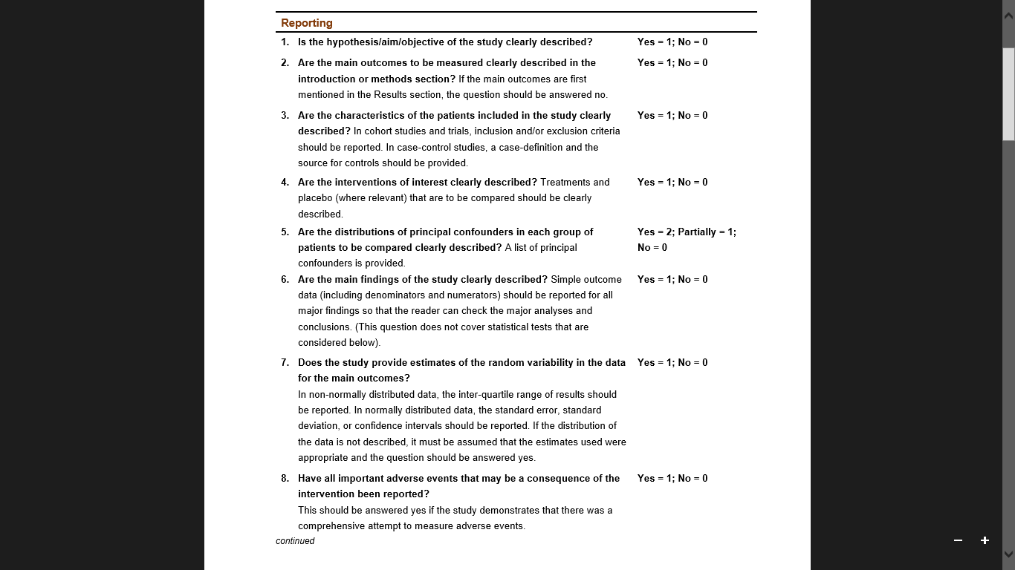

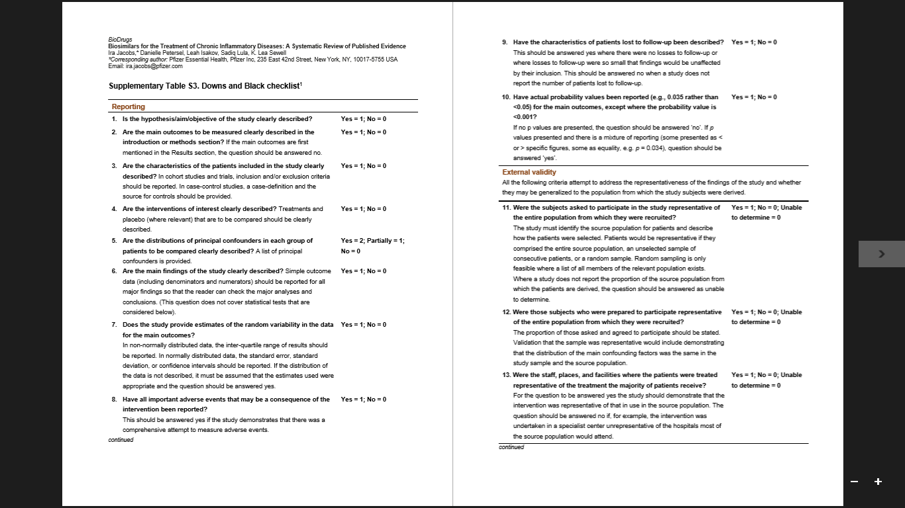

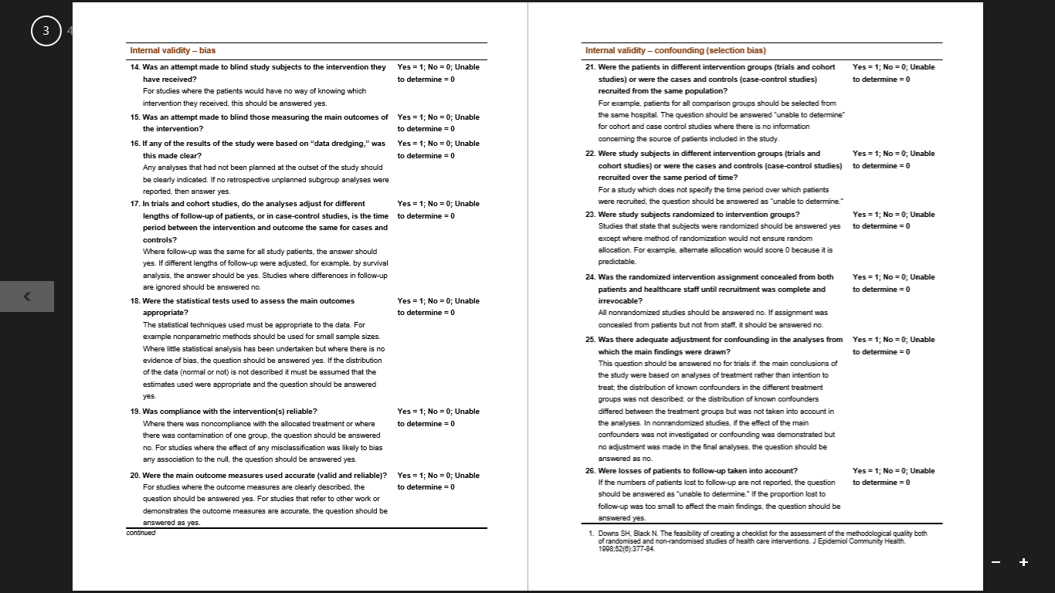



**Appendix B:** JBI Case Series Critical Appraisal Tool

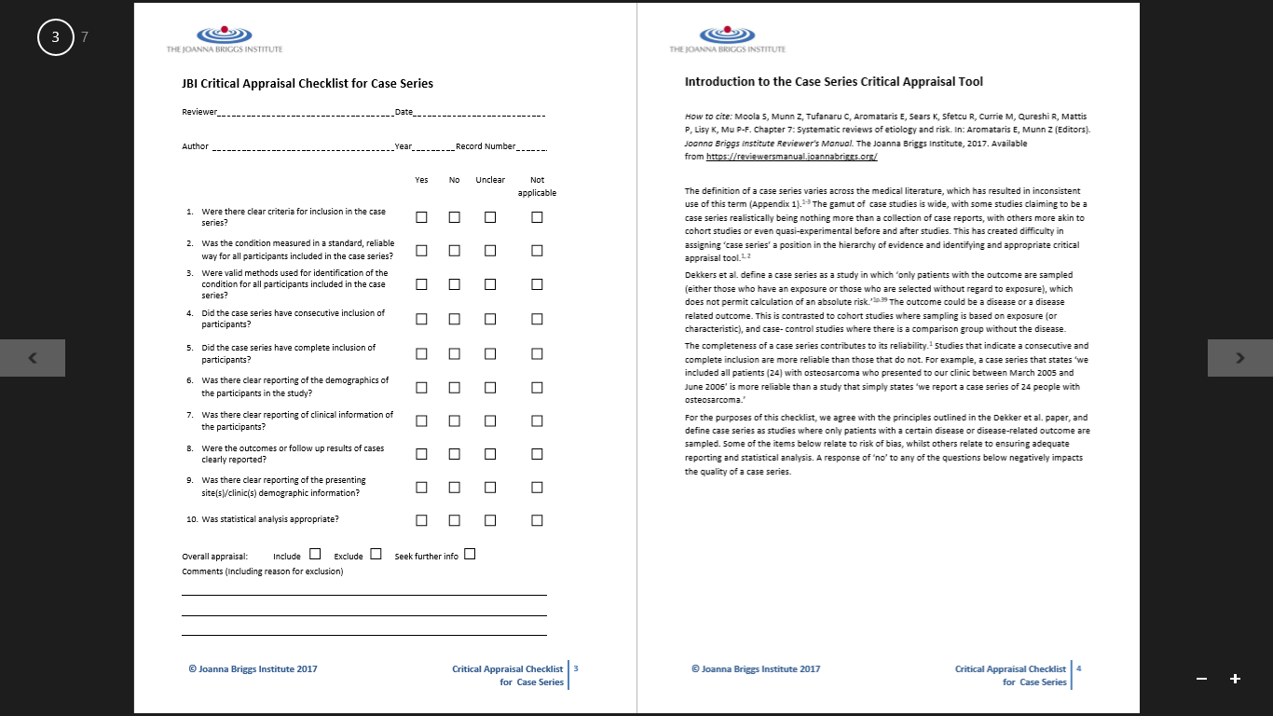

**Appendix C:** JBI Case Report Critical Appraisal Tool

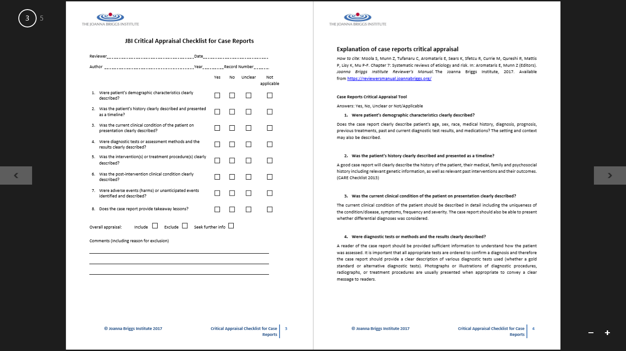

A**ppendix D**: Quality appraisal summary of randomised and non-randomised studies using Downs & Black checklist



*Notes.* Quality analysis results. ■ = Full points. = Partial points. ■ = Undeterminable. ■ = No points. Blank/white = Not relevant. Items scored 1 where criteria were met except on item 5, where the maximum score was 2. Items scored 0 where criteria were not met or this was undeterminable. Items assessed reporting (1-10), external validity (11-13), bias (14-20), confounding (21-26), and power (27).

**Appendix E**: Quality appraisal summary of case series using JBI case series critical appraisal tool



**Appendix F**: Quality appraisal summary of case reports using JBI case report critical appraisal tool



**Section Two**

**Research Report**

**The impact of mental imagery manipulation on mood, self-esteem and self-compassion in non-clinical grandiosity**.

**Abstract**

**Objectives.** Grandiose delusions (GDs) are associated with positive affect and high self-esteem. This study examined the impact of imagery manipulation in relation to non-clinical grandiosity, and whether positive imagery increased positive affect, self-esteem and self-compassion for individuals experiencing grandiose beliefs, and whether experiencing grandiose beliefs would lead to rating imagery more vividly.

**Method.** Participants were randomly allocated to a positive or negative imagery manipulation. Groups were formed based on experiencing grandiose beliefs or not experiencing grandiose beliefs, and imagery condition. Outcome measures assessing affect, self-esteem and self-compassion were completed pre- and post-manipulation. Participants rated vividness of the generated imagery.

**Results.** Baseline analyses showed grandiose groups reported higher mania, trait self-esteem and positive affect. The grandiose beliefs group reported significantly higher positive affect and self-esteem following positive imagery manipulation compared to the no grandiose beliefs group, in addition change scores reflected an amplification of positive affect for the grandiose group, although not significantly differently to the non-grandiose group. Self-compassion and imagery vividness were not significantly different between groups.

**Conclusions.** Individuals experiencing grandiose beliefs had an amplification of positive affect and improved self-esteem following positive imagery manipulation. Imagery manipulation was not related to self-compassion or imagery vividness.

**Practitioner points**

***Clinical implications***

* Positive imagery manipulation amplifies positive affect and improves self-esteem for non-clinical individuals experiencing grandiose beliefs.
* Amplification of positive affect through positive imagery may be associated with pre-experiencing goals as if they were real.

***Limitations***

* Unequal group sizes may have led to underpowered analyses comparing grandiose beliefs and no grandiose beliefs groups.
* Attrition from the study was higher than expected, possibly due to the study length or online administration.

**Introduction**

Grandiose delusions (GDs) are a subtype of delusions, which commonly occur within diagnoses such as schizophrenia and bipolar disorder (BD; Knowles, McCarthy-Jones, & Rowse, 2011). GDs are defined as “the conviction of having some great (but unrecognised) talent or insight or having made some important discovery” (American Psychiatric Association, 2013), including conviction in having special powers, talents or abilities whilst not holding them; being famous; or having a special relationship to a famous person or deity (Arciniegas, 2015).

GDs are the second most common delusion after persecutory delusions (PDs; Stompe et al., 2006). Appelbaum, Robbins and Roth (1999) found 43% of patients with delusions reported GDs; these were common in BD (59%), schizophrenia (49%) and depression (21%). Prevalence studies report GDs in both clinical and non-clinical samples (Laroi & Van der Linden, 2006; Verdoux et al., 1998). Continuum theories of psychosis suggest sub-clinical experiences that can be conceptualised as psychosis occur in non-clinical populations (van Os, Linscott, Myin-Germeys, Delespaul, & Krabbendam, 2008), where risk factors overlap with clinical populations, creating an increased likelihood of being diagnosed with a psychotic disorder (van Os, Hanssen, Bijl, & Ravelli, 2000). Based on this, Freeman (2007) argues non-clinical experiences of delusions may be the same phenomena as clinical experiences, therefore examining non-clinical experiences of grandiosity could inform understandings of clinical grandiosity.

The frequent co-occurrence of GDs with other diagnoses leaves only 10-16% experiencing GDs in isolation (Knowles et al., 2011). However GDs are distinctive; they are associated with higher conviction and less negative affect (Appelbaum et al., 1999) and higher self-esteem, lower depression and negative self-evaluations compared to PDs (Garety et al., 2012). In both clinical and non-clinical samples, Fowler et al. (2006) found exaggerated positive self-evaluations associated with grandiosity compared to paranoia. The evidence suggests grandiosity is associated with positive affect and positive self-evaluations, which may make it distinct from other delusions.

Freeman and Garety (2003) suggest GDs arise from elated mood, which amplifies pre-existing positive perceptions of self, creating a grandiose belief. Knowles et al. (2011) offer a theoretical model of GDs which integrates emotion-consistent and delusion-as-defense accounts of psychosis, two theoretical positions in the psychosis literature. Their model proposes that individuals become motivated to change experiences of negative affect and low self-esteem (delusion-as-defense) and may associate an initial grandiose thought with a positive event or change in mood (emotion-consistent). Initial grandiose thoughts may develop into GDs through interactions with cognitive biases, poor social feedback detection or theory of mind deficits. The model emphasises the role of mental imagery in the continued amplification of positive affect, through a process of rumination about future goal attainment, which can involve positively appraising imagery, thus reinforcing the grandiose thought and improvements in self-esteem and affect (Knowles et al., 2011).

Mental imagery can be defined as ‘seeing with the mind’s eye’ and ‘hearing with the mind’s ear’ (Kosslyn, Ganis, & Thompson, 2001). Imagery can be intrusive or deliberately self-generated (Hackmann & Holmes, 2004), and enable reliving memories, or pre-experiencing future events (Holmes, Geddes, Colom, & Goodwin, 2008). Intrusive images are common features of psychological disorders and are often vivid and accompanied by strong emotional and physical responses (Brewin, Gregory, Lipton, & Burgess, 2010).

Individuals with psychosis can have long-standing proneness to intrusive imagery (Steel, Fowler, & Holmes, 2004), which may be maintained by appraising them as real (Morrison, 2001). Glazer, Mason, King and Brewin (2013) report associations between involuntary imagery and psychosis-proneness in a non-clinical sample. In a clinical sample, 74.3% of participants with psychosis reported intrusive imagery related to affect, where imagery increased conviction in beliefs (Morrison et al., 2002). Schulze, Freeman, Green and Kuipers (2013) also found paranoia-related intrusive imagery in patients with persecutory beliefs and Malcolm, Picchioni and Ellet (2015) report higher rates of prospective imagery in patients with schizophrenia. Higher levels of imagery vividness were also found in patients with schizophrenia (Oertel et al., 2009). This evidence suggests imagery in psychosis may be vivid, and enhance affect and belief in psychotic experiences, however imagery in GDs is under-researched.

As GDs are most likely to be reported clinically within presentations of BD (Appelbaum et al., 1999), examining imagery research in BD may be relevant to understanding imagery in GDs. Ivins, Di Simplicio, Close, Goodwin and Holmes (2014) found imagery was more vivid and positive in participants with BD compared to those with depression. Similarly, Holmes et al. (2011) found participants with BD reported more vivid and prospective imagery compared to controls, and Gregory, Brewin, Mansell and Donaldson (2010) found participants with BD experienced vivid, pleasurable prospective images in recent hypomanic episodes. A link has also been postulated between imagery and positive affect; Holmes et al’s (2008) model of mental imagery in BD suggests positive emotion can be amplified when individuals with BD experience positive imagery related to goal attainment, supporting Knowles et al’s (2011) theory of GDs. The experience of imagery in BD can be vivid, positive and future-based, which may also be found in GDs.

Experimental studies using imagery manipulation are useful to elaborate on the impact of different types of imagery. Bullock, Newman-Taylor and Stopa (2016) manipulated paranoia using positive and negative self-imagery generation with a non-clinical population. Positive imagery reduced levels of paranoia, anxiety and negative affect, and amplified positive affect, self-esteem and self-compassion more than negative imagery, which induced paranoia. This supports the theory that positive imagery can amplify positive affect (Holmes et al., 2008; Knowles et al., 2011).

Evidence suggests self-esteem is higher in people experiencing GDs compared to other delusions (Garety et al., 2012). As self-esteem and self-compassion can be correlated (Neff, 2003), self-compassion may also be expected to be elevated in GDs. Bullock et al’s (2016) findings indicate imagery moderated the relationship between self-compassion and delusions. Lincoln, Hohenhaus and Hartmann (2013) found compassionate imagery resulted in higher self-esteem and lower negative emotions and paranoia in a non-clinical sample. In a clinical sample experiencing paranoid delusions, compassionate imagery enhanced positive self-relating and positive affect (Ascone, Sundag, Schlier, & Lincoln, 2017). The potential relationship between self-compassion and grandiosity is under-researched, however, based on this evidence individuals with grandiose beliefs may display high levels of self-compassion in response to positive imagery.

The current study will test the aspect of Knowles et al’s (2011) model proposing the role of imagery in the amplification of positive affect in GDs. Following Bullock et al’s (2016) imagery manipulation in a non-clinical population experiencing paranoia, similarly manipulating imagery in a non-clinical population experiencing grandiosity could highlight how imagery impacts affect, self-esteem and self-compassion. Investigating imagery in relation to grandiosity could indicate interventions for GDs and BD (where GDs largely present) to target aspects of mood and self-evaluations, including imagery rescripting interventions, which have shown applications in psychosis (Ison, Medoro, Keen, & Kuipers, 2014; Keen, Hunter, Peters, 2017). The present study is therefore needed to understand whether imagery is a factor potentially related to grandiosity, and whether an association exists between imagery, mood and self-evaluations in relation to grandiosity.

**Aims**

* To evaluate and compare the effects of positive self-imagery manipulation in a non-clinical population who experience grandiose beliefs to those who do not experience grandiose beliefs and evaluate whether:
  + positive imagery amplifies mood
  + positive imagery improves self-esteem
  + positive imagery improves self-compassion.
* To examine whether imagery is experienced more vividly by individuals who experience grandiose beliefs compared to those who do not experience grandiose beliefs.

**Hypotheses**

1. Participants experiencing grandiose beliefs will score higher on positive affect, self-esteem and self-compassion measures in response to positive self-imagery manipulation, compared to control participants who do not experience grandiose beliefs.
2. Positive self-imagery manipulation will amplify positive affect more for participants who experience grandiose beliefs compared to those who do not experience grandiose beliefs.
3. Participants who experience grandiose beliefs will rate images as more vivid than participants who do not experience grandiose beliefs.

**Methods**

**Design**

A randomised controlled design was employed, with two between-subjects variables, each with two levels (grandiose beliefs vs no grandiose beliefs and positive vs negative imagery) and one within-subjects variable with two levels (time-point: pre-manipulation and post-manipulation). Group formation depended on whether grandiose beliefs (GB) or no grandiose beliefs (NGB) were endorsed, and imagery condition (positive or negative imagery), leading to a grandiose beliefs positive imagery (GB-Positive), grandiose beliefs negative imagery (GB-Negative), no grandiose beliefs positive imagery (NGB-Positive) and no grandiose beliefs negative imagery (NGB-Negative) group. Trait measures of imagery use, self-esteem and mania were measured pre-manipulation. Pre- and post-manipulation measures included the primary outcome variable positive affect and secondary outcome variables self-esteem, self-compassion, negative affect and vividness.

Two items from the Peters Delusion Inventory (PDI-21; Peters, Joseph, Day, & Garety, 2004; Appendix A) acted as a screening tool to form groups based on grandiosity endorsement; endorsement of an item indicated experience of grandiose beliefs. This is a standard methodology utilised in the wider psychosis literature to identify experience of certain beliefs (Bentall et al, 2009; Fowler et al., 2006). Participants were randomly allocated via the survey software Qualtrics (2017) to a positive or negative imagery manipulation condition. Allocation was designed to be balanced between conditions.

**Participants**

Initial recruitment was aimed at university volunteers, including students and staff members. Subsequent recruitment aimed to widen the demographic representation of a non-clinical population by recruiting through libraries, survey sharing platforms and social media. Participants under the age of 18 were excluded from the study (n=51); no other inclusion or exclusion criteria were applied.

Groups could only be formed post-survey completion when responses to PDI-21 were analysed, however an apriori power analysis (Cohen, 1992) indicated each group required a minimum of 45 participants to achieve a medium effect size of d = 0.50 with a significance level of α = .05 and 80% power. Minimum overall sample size required was 198 to enable equal groups and potential of 10% attrition during the survey, where acceptable rates of attrition for survey research should be 20% (Altman, 2000).

**Trait measures**

**The Peters Delusion Inventory (PDI-21).** The PDI-21 (Appendix A) measures delusion proneness in non-clinical populations. Only components measuring grandiosity were administered, as previously used to identify grandiosity (Fowler et al., 2006). Grandiosity items include item 6 (‘*Do you ever feel as if you are, or destined to be someone very important?’*) and item 7 (‘*Do you ever feel that you are a very special or unusual person?’*). Each item is answered with a yes/no response, and also includes sub-components of distress, frequency and conviction related to each item, with scores for each sub-component ranging from 1-5, producing a maximum score of 15 for each item. In the current study, the grandiosity items of the PDI-21 were included to screen endorsement of grandiose beliefs to form groups, therefore ratings of the sub-components were not examined. Instead, a score was produced for each participant to identify the number of grandiose items endorsed (0, 1 or 2). Participants answering yes to one or both grandiose items formed the grandiose beliefs group (GB group) and participants answering no to both grandiose items (scoring 0), formed the no grandiose beliefs group (NGB group).

The PDI-21 has good internal consistency in non-clinical samples (α = 0.82) and good test-retest reliability (r = 0.78-0.81). It also demonstrated both construct and criterion validity (Peters et al., 2004).

**Spontaneous Use of Imagery Scale (SUIS)**. The SUIS (Reisberg, Pearson, & Kosslyn, 2003; Appendix B) measures everyday mental imagery experiences. Participants rate their use of imagery in everyday situations based on 12 items. Responses range from never appropriate to always appropriate on a 5-point scale. Total scores calculated by summing item scores range from 12 to 60, where higher scores indicate higher mental imagery use. The SUIS demonstrated high internal consistency (α = 0.98; Reisberg et al., 2003).

**Rosenberg Self-esteem Scale (RSE).** The RSE (Rosenberg, 1965; Appendix C) is a 10-item measure of global self-worth, measuring positive and negative self-esteem, with negative items reversed. Scores range from 1 (strongly agree) to 4 (strongly disagree). Total scores between 15-25 indicate normal self-esteem, scores below 15 indicate low self-esteem. The RSE has high internal reliability (α = 0.92) and test-retest reliability (*r* = 0.85 and 0.88). It displays concurrent, predictive and construct validity and correlates well with other measures of self-esteem (Rosenberg, 1979).

**Altman Self-rating Mania Scale (ASRM).** The ASRM (Altman, Hedeker, Peterson, & Davis, 1997; Appendix D) is a five-item scale measuring cheerfulness, inflated self-confidence, reduced need for sleep, talkativeness and excessive activity level. Scores range from 0 to 20, where a cut-off score of 6 or higher indicates high probability of a manic/hypomanic condition. The ASRM has good reliability (α = 0.79), high internal test-retest reliability (*r* = 0.86-0.89), and good concurrent validity against other scales for manic symptoms (Altman et al., 1997).

**State measures**

**Positive and Negative Affect Schedule (PANAS).** The PANAS (Watson, Clark, & Tellegen, 1988; Appendix E) is a 20-item measure of positive and negative affect. Participants rate present moment positive and negative emotions on a scale from 1 (very slightly) to 5 (extremely). Scores, summed separately for positive and negative affect items, range from 10-50, where higher scores on PANAS-Positive Affect (PANAS-PA) indicate high positive affect, and lower scores on PANAS-Negative Affect (PANAS-NA) indicate lower negative affect. Both scales have good internal reliability (PA α = 0.86-0.90, NA α = 0.84-87), test-retest reliability (PA *r* = 0.63, NA *r* = 0.60) and excellent convergent and discriminant validity (Watson et al., 1988).

**State Self-Esteem Scale (SSES).** The SSES (Heatherton & Polivy, 1991; Appendix F) is a 20-item measure of explicit state self-esteem, measuring performance, social and appearance self-esteem. Positive and (reverse scored) negative items are rated 1 (not at all) to 5 (extremely), with scores ranging from 20-100. Higher scores indicate higher self-esteem. The SSES has good internal consistency (α = 0.90), good test-retest reliability (*r* = 0.71) and high construct and discriminant validity (Heatherton & Polivy, 1991).

**Self-Compassion Scale (SCS).** The SCS (Neff, 2003; Appendix G) measures three components of self-compassion: self-kindness/self-judgement, common humanity/perceived isolation and mindfulness/over-identification. Items are rated on a 5-point scale from 1 (strongly disagree) to 5 (strongly agree), with negative items reverse-scored. A total score is derived from a grand mean of subscale item means. Scores indicate low self-compassion (below 2.5), moderate self-compassion (2.5-3.5), or high self-compassion (3.5-5). The SCS has good internal consistency (α = 0.76), test-retest reliability (*r* = 0.93), and high construct validity and discriminant validity against self-esteem measures (Neff, 2003).

**Positive and negative imagery scripts**

Imagery scripts developed for people with social anxiety (Hirsch, Clark, Mathews, & Williams, 2003) were adapted to manipulate paranoia where participants imagined a time they felt secure with others (positive) or suspicious of others (negative) (Bullock et al., 2016). These scripts were adapted for this study to manipulate grandiosity and create positive (Appendix H) and negative (Appendix I) self-images. Audio scripts recorded for each imagery condition by the lead researcher, guided participants to imagine themselves as an influential or successful person they admired (positive imagery) or imagine themselves failing to achieve an important dream or goal (negative imagery).

A further audio clip aimed to enhance the imagery generated, by asking participants to hold the image vividly and think about details in the image, including visual and auditory elements, involvement of others, images of themselves and emotional responses. Participants rated the vividness of the image, where ratings represented 1 (no image), 2 (vague and dim), 3 (moderately clear), 4 (clear and reasonably vivid), or 5 (clear and vivid like normal vision), adapted from Marks’ (1973) study examining vividness of imagery to aid recall.

Face validity of the adapted scripts was tested by piloting the survey and audio imagery manipulation with volunteers (n=5). This data is excluded from the analysis, however feedback sought from volunteers suggested significant alterations were not required.

**Procedure**

The survey was developed and hosted on Qualtrics (www.qualtrics.com). Initial recruitment involved sending an email advert to the university volunteers email list (Appendix J). The advert was further adapted to suit relevant audiences (Appendix K) and shared with a library, and social media and survey platforms.

The first page of the survey offered information about the study and participating (Appendix L). Participants were asked to consent to participating before continuing (Appendix M). Demographic information on gender, age, ethnicity, employment and educational achievement was also gathered. Participants completed two screening items of the PDI-21, which were analysed post-survey completion to form groups based on endorsement or no endorsement of grandiosity.

Pre-manipulation, participants completed trait measures SUIS, RSE and ASRM and state measures PANAS, SSES and SCS. Participants were randomly allocated by Qualtrics to a positive or negative imagery manipulation condition; participants were blind to the condition they received. Audio scripts instructed participants to develop either positive or negative imagery; these were less than a minute long. A further audio script encouraged development of the image, following which participants rated imagery vividness. Participants were asked to hold the image in mind whilst re-rating state measures.

Whilst distress was anticipated to be minimal, in line with previous research involving imagery manipulation (Bullock et al., 2016), participants experiencing negative imagery manipulation were directed to a mood repair task to alleviate any potential distress (Appendix N). Participants were debriefed about the study at survey completion (Appendix O). See Figure 1 for a visual representation of the procedure.

**Ethics**

The University of Sheffield Research Ethics Committee provided ethical approval (Appendix P). Participants were fully informed about the study and prompted to give consent before participating. Data was also securely stored on Qualtrics, which generated identifiers to anonymise participant data. Participants could optionally leave an email address to receive results of the study and be entered into a prize draw for a monetary voucher.

A mood repair task (Appendix N) for participants experiencing negative imagery manipulation was included, as imagining failing to achieve a dream or goal could be distressing. The debrief information signposted individuals to appropriate services should they require further psychological support.

ENTER SURVEY: Study information

Consent requested

Demographic information requested

Complete PDI-21 to identify grandiosity:

Complete measures - **TRAIT:** SUIS, RSE, ASRM

**STATE:** PANAS, SSES, SCS

Did not endorse grandiosity item(s)

Endorsed grandiosity item(s)

Randomly assigned by Qualtrics to condition

No Grandiose Beliefs-Positive (NGB-Positive)

Imagery manipulation

Grandiose Beliefs-Negative (GB-Negative)

Imagery manipulation

Grandiose Beliefs-Positive (GB-Positive)

Imagery manipulation

No Grandiose Beliefs-Negative (NGB-Negative)

Imagery manipulation

Rate vividness & repeat state measures: PANAS, SSES, SCS

Debrief information

Negative imagery condition: Mood repair task

END SURVEY

**Figure 1.** Participants’ progress through the survey

**Data Analysis**

All statistical analyses were undertaken in IBM SPSS version 24.0. Data was downloaded from Qualtrics and entered into an SPSS file. A two-tailed significance level at an alpha of .05 was used to interpret all analyses.

Analyses were conducted and reported according to intention-to-treat (ITT) and per-protocol. ITT analyses included all participants randomised to a condition (positive or negative imagery condition), to provide estimates of manipulation effect which ignored withdrawals (Gupta, 2011). Data of participants lost to follow-up was generated using a last observation carried forward (LOCF) method of imputation, commonly used with drop-outs in trials (Hamer & Simpson, 2009). Per-protocol analyses were conducted with complete data, where data was defined as completed if participants had a minimum of one post-imagery manipulation outcome measure.

Tests of assumptions for parametric tests were conducted. Normal distribution was analysed using Shapiro-Wilk tests, which were significant for all measures at baseline (p<0.001) except RSE (p = .090). They were also significant for all variables post-manipulation, indicating the data could be significantly different from a normal distribution. In large samples (200 or more), visual inspection of the distribution along with the skewness statistic can be more useful than normality tests (Field, 2005). Histogram and Q-Q plots indicated PANAS-PA, SSES and SCS were normally distributed with skewness statistics below 1, where an acceptable range for normality is skewness between -1 to 1 (Chan, 2003). Plots and skewness statistics showed the variable PANAS-NA was significantly and positively skewed towards the lower end of the scale. A Log10 transformation of baseline and post-manipulation PANAS-NA scores reduced skewness to below 1. In large sample sizes (more than 40), violation of the normality assumption may not create major difficulties (Jekel, Katz, & Elmore, 2001; Pallant, 2007), as normality tests can be limited by indicating significant results from small deviations within large samples (Field, 2005). Parametric tests were therefore employed for all analyses, using transformed PANAS-NA data.

As groups were formed post-manipulation based on grandiosity endorsement, we may expect that groups differed from the start and variances were not equally distributed. However, Levene’s tests for homogeneity of variance on baseline scores across groups were non-significant for all measures (p>.05).

Descriptive statistics were calculated for demographic information and baseline outcome measure scores, including comparisons between completers and non-completers of the study. In per-protocol analyses, comparisons were made between GB-Positive, GB-Negative, NGB-Positive and NGB-Negative groups.

Due to an unidentified error, demographic information was not collected for initial participants completing the survey (n=45). Analysis of baseline outcome measures indicated significant differences for negative affect between participants with demographic information (M = 1.24, SD = .17) to those without demographic information (M = 1.16, SD = .13) (*t*(80.01) = -5.71, p<0.001).

Hypotheses 1 was tested using multiple ANCOVAs to analyse group differences on post-manipulation positive affect, self-esteem and self-compassion scores, with baseline scores as covariates. In ITT analyses, the LOCF method was used to compute post-manipulation scores, with baseline scores carried over. Additional secondary analyses using ANCOVAs were conducted to explore potential differences between groups on negative affect as hypotheses were not formed about the outcome. Tests to examine the assumption of homogeneity of regression slopes were significant for SCS (p = .022), indicating the relationship between the outcome variable and covariate may have differed between groups, and findings should be interpreted cautiously (Field, 2005).

Hypothesis 2 was tested using two dependent t-tests, to first assess whether GB-Positive and NGB-Positive had significant change in positive affect between baseline and post-manipulation. Change scores, which were calculated by subtracting baseline scores from post-manipulation scores, were examined using an independent samples t-test to assess whether change scores for positive affect were significantly different between GB-Positive and NGB-Positive. Hypothesis 3 was tested using a Chi-square analysis of ratings of vividness, comparing the grandiose (GB-Positive and GB-Negative) and non-grandiose (NGB-Positive and NGB-Negative) groups.

**Results**

A total of 475 participants entered the survey and of those, 424 were eligible for the study with those aged under 18 excluded. A further 148 participants were excluded after dropping out before randomisation. A total of 276 participants were randomised and of those, 216 completed the survey (at least one post-manipulation measure completed). A CONSORT diagram shows the flow of participants through the study (Figure 2).

Groups based on endorsement of grandiosity were formed post-survey completion, however groups were unequal as more participants endorsed grandiose beliefs (n=174) than did not endorse grandiose beliefs (n=102). Group sizes in ITT

Enrolment

Excluded:

Aged under 18 (n=51)

Dropped out before randomisation (n=148)

Started the survey

(n=475)

Randomised

(n=276)

Allocation

NGB-Negative

(n=56)

NGB-Positive

(n=46)

GB-Positive

(n=89)

GB-Negative

(n=85)

Lost to follow up

NGB-Negative (n=15)

Lost to follow up

NGB-Positive (n=18)

Follow-up

Lost to follow up

GB-Positive (n=14)

Lost to follow up

GB-Negative (n=13)

GB-Positive

(n=89)

NGB-Negative

(n=56)

NGB-Positive

(n=46)

GB-Negative

(n=85)

Analysis

**Figure 2.** CONSORT diagram showing the flow of participants through the study

analyses met minimum requirements for power (see Figure 2), however in per-protocol analyses, the no grandiose beliefs groups were underpowered with group sizes as follows: GB-Positive (n=75), GB-Negative (n=72), NGB-Positive (n=28), NGB-Negative (n=41). Grandiose groups were considerably larger than non-grandiose groups, with the smallest group (NGB-Positive) 37.33% smaller than the largest group (GB-Positive).

**Completers and non-completers**

A series of Chi-square analyses were conducted on demographic variables of completers and non-completers, and independent samples t-tests were conducted to analyse differences on baseline outcome measure scores. Table 1 shows summary demographic variables of completers and non-completers.

There were no significant differences between completers and non-completers on gender (χ2 (1) = 0.36, p = .551), ethnicity (χ2 (14) = 23.62, p = .056) or employment (χ2 (7) = 10.77, p = .154). There were significant differences between groups on age (χ2 (6) = 19.81, p = .004) and education (χ2 (7) = 15.86, p = .024). Compared to those completing the study, those that did not complete it were more likely to belong to older age categories and be educated to degree level or above.

Analyses show completers had significantly higher mania scores than non-completers (*t*(274) = -2.068, *p* = .040). There were no statistical differences between completers and non-completers on imagery use (*t*(80.26) = -1.858, *p* = .067), trait self-esteem (*t*(274) = -.380, *p* = .704), or state measures of positive affect (*t*(273) = .181, *p* = .857), negative affect (*t*(273) = -.905, *p* = .366), state self-esteem (*t*(273) = .989, *p* = .323), or self-compassion (*t*(272) = .462, *p* = .645). See Table 2 for outcome measure scores for completers and non-completers.

|  |  |  |
| --- | --- | --- |
| Table 1  Demographic characteristics of completers and non-completers | | |
| Variable  N (%) | Completers  (*n*=186)\* | Non–completers  (*n*=45)\* |
| **Gender** |  |  |
| Female | 141 (75.8) | 36 (80) |
| Male | 45 (24.2) | 9 (20) |
| **Age** |  |  |
| 18-21 | 78 (41.9) | 13 (28.9) |
| 22-34 | 86 (46.2) | 17 (37.8) |
| 35-44 | 12 (6.5) | 13 (28.9) |
| Over 45 | 8 (4.3) | 2 (4.4) |
| **Ethnicity** |  |  |
| White background | 109 (58.60) | 29 (64.4) |
| Other ethnic backgrounds | 77 (41.4) | 16 (35.6) |
| **Employment** |  |  |
| Employed/ self-employed | 100 (53.8) | 27 (60) |
| Student | 6 (3.2) | 4 (8.9) |
| Unemployed | 62 (33.3) | 8 (17.8) |
| Other | 18 (9.7) | 6 (13.3) |
| **Education** |  |  |
| Less than degree level | 43 (23.1) | 9 (20) |
| Degree or above | 96 (51.6) | 27 (60) |
| None | 23 (12.4) | 2 (4.4) |

*Note:* \*Demographic information not based on full sample due to missing data; ‘Do not wish to answer’ responses excluded from calculations

|  |  |  |
| --- | --- | --- |
| Table 2  Baseline mean scores of outcome measures for completers and non-completers | | |
| Outcome measure | Completers  (*n*=216)  *M (SD)* | Non-completers  (*n*=60)  *M (SD)* |
| **Trait** | | |
| SUIS | 41.95 (8.68) | 39.08 (11.06) |
| RSE | 17.17 (5.58) | 17.50 (7.04) |
| ASRM | 6.33 (3.58)\* | 5.25 (3.70)\* |
| **State** | | |
| PANAS-PA | 25.23 (8.77) | 25.46 (8.36) |
| PANAS-NA | 1.23 (.17) | 1.20 (.17) |
| SSES | 63.77 (15.38) | 66.03 (16.36) |
| SCS | 3.09 (.46) | 3.13 (.44) |
| *Key:* SUIS = Spontaneous Use of Imagery Scale; RSE = Rosenberg Self-esteem Scale; ASRM = Altman Self-Rating Mania scale; PANAS-PA = Positive and Negative Affect Schedule-Positive Affect; PANAS-NA = Positive and Negative Affect Schedule-Negative Affect; SSES = State Self-esteem Scale; SCS = Self-Compassion Scale. \*p < .05 | | |

**Per-protocol randomisation checks**

Demographic variables and outcome measures of participants with complete data were analysed with a series of Chi-square analyses and one way ANOVAs to test for differences at randomisation between GB-Positive, GB-Negative, NGB-Positive and NGB-Negative groups. There were no significant differences between groups on gender (χ2 (3) = 2.37, p = .494), employment (χ2 (18) = 28.18, p = .052) or education (χ2 (21) = 22.94, p = .350). There were significant differences between groups on age (χ2 (18) = 30.49, p = .028) and ethnicity (χ2 (14) = 81.07, p = .001). Compared to other groups, NGB-Negative participants were more likely to be older and from a white background. See Table 3 for demographic characteristics of groups.

There were statistically significant differences on trait self-esteem (*F*(3,212) = 2.78, *p* = .0.042) and mania (*F*(3,212) = 6.69, *p* <0.001), and positive affect (*F*(3,212) = 7.55, p<0.001), with grandiose groups scoring significantly higher than non-grandiose groups. See Table 4 for the outcome measure scores for each group.

**Per-protocol: Descriptive data**

**Trait measures.** All groups scored moderately for everyday mental imagery use. There were significant differences in trait self-esteem (*F*(3,212) = 2.78, *p* = .0.042); all groups scored in the normal range, however GB-Positive scored slightly highest (M = 17.99, SD = 5.70) and NGB-Positive scored the lowest (M = 14.54, SD = 4.60). According to the criteria of the mania scale (ASRM), mania scores of GB-Positive (7.39) and GB-Negative (6.56) groups were above the cut-off of 6, which suggests a high probability of a manic/hypomanic condition in grandiose groups, in contrast to non-grandiose groups who scored below the cut-off.

**State measures.** Groups were significantly different on ratings of positive affect (*F*(3,212) = 7.55, p<0.001), with the greatest difference between GB-Positive with highest positive affect (M = 27.87, SD = 8.93) and NGB-Positive with lowest positive affect (M = 19.64, SD = 7.41). As well as highest scores on positive affect, grandiose groups also reported most negative affect. All groups scored moderately on measures of state self-esteem and self-compassion.

|  |  |  |  |  |
| --- | --- | --- | --- | --- |
| Table 3  Demographic characteristics across groups | | | | |
| Variable  *N* (%) | GB-Positive  (*n* =68)\* | GB-Negative  (*n*=63)\* | NGB-Positive  (*n*=23)\* | NGB-Negative  (*n*=32)\* |
| **Gender** |  |  |  |  |
| Female | 48 (70.59) | 48 (76.2) | 18 (78.3) | 27 (84.4) |
| Male | 20 (29.41) | 15 (23.8) | 5 (21.7) | 5 (15.6) |
| **Age** |  |  |  |  |
| 18-21 | 32 (47.1) | 32 (50.8) | 10 (43.5) | 4 (12.5) |
| 22-34 | 32 (47.1) | 22 (34.9) | 9 (39.1) | 23 (71.9) |
| 35-44 | 1 (1.5) | 5 (7.9) | 3 (13) | 3 (9.4) |
| Over 45 | 2 (2.9) | 3 (4.76) | 1 (4.3) | 2 (6.3) |
| **Ethnicity** |  |  |  |  |
| White background | 40 (58.82) | 32 (50.79) | 13 (56.52) | 24 (75) |
| Other ethnic backgrounds | 28 (41.17) | 31 (49.2) | 10 (43.48) | 25 (25) |
| **Employment** |  |  |  |  |
| Employed/ self-employed | 30 (44.12) | 28 (44.4) | 16 (69.6) | 24 (75) |
| Variable  *N* (%) | GB-Positive  (*n* =68)\* | GB-Negative  (*n*=63)\* | NGB-Positive  (*n*=23)\* | NGB-Negative  (*n*=32)\* |
| Student | 2 (2.9) | 5 (7.9) | 0 | 1 (3.1) |
| Unemployed | 28 (41.2) | 25 (29.7) | 6 (26.1) | 4 (12.5) |
| Other | 8 (11.76) | 5 (7.94) | 1 (4.3) | 3 (9.38) |
| **Education** |  |  |  |  |
| Less than degree level | 22 (32.35) | 11 (17.46) | 6 (26.09) | 4 (12.5) |
| Degree or above | 27 (39.71) | 34 (53.97) | 13 (56.52) | 22 (68.75) |
| None | 10 (14.7) | 6 (9.5) | 4 (17.4) | 3 (9.4) |
| *Note:* \*Demographic information not based on full sample due to missing data; ‘Do not wish to answer’ responses excluded from calculations | | | | |

|  |  |  |  |  |
| --- | --- | --- | --- | --- |
| Table 4  Baseline mean scores on trait and state outcome measures across groups | | | | |
| Outcome  measure | GB-Positive  *(n*=75)  *M (SD)* | GB-Negative  (*n*=72)  *M (SD)* | NGB-Positive  (*n*=28)  *M (SD)* | NGB-Negative  (*n*=41)  *M (SD)* |
| **Trait** | | | | |
| SUIS | 42.96 (8.34) | 41.64 (9.34) | 41.43 (8.89) | 41.02 (8.05) |
| RSE | 17.99 (5.70)\* | 17.47 (5.56)\* | 14.54 (4.60)\* | 16.95 (5.63)\* |
| ASRM | 7.39 (3.61)\*\* | 6.56 (3.47)\*\* | 4.46 (2.99)\*\* | 5.24 (3.18)\*\* |
| **State** | | | | |
| PANAS-PA | 27.87 (8.93)\*\* | 25.82 (8.32)\*\* | 19.64 (7.41)\*\* | 23.17 (8.11)\*\* |
| PANAS-NA | 1.22 (0.17) | 1.26 (0.19) | 1.18 (0.15) | 1.20 (0.17) |
| SSES | 65.80 (15.23) | 62.85 (15.02) | 59.29 (14.98) | 64.73 (16.30) |
| SCS | 3.19 (0.41) | 3.02 (0.55) | 3.04 (0.35) | 3.11 (0.40) |
| *Key:* SUIS = Spontaneous Use of Imagery Scale; RSE = Rosenberg Self-esteem Scale; ASRM = Altman Self-Rating Mania scale; PANAS-PA = Positive and Negative Affect Schedule-Positive Affect; PANAS-NA = Positive and Negative Affect Schedule-Negative Affect; SSES = State Self-esteem Scale; SCS = Self-Compassion Scale.  GB groups significantly different from NGB groups at \*p < .05 or \*\*p < .001. | | | | |

**Hypothesis 1: Participants experiencing grandiose beliefs will score higher on positive affect, self-esteem and self-compassion measures in response to positive self-imagery manipulation, compared to control participants who do not experience grandiose beliefs.**

A series of three one-way between-groups ANCOVAs were conducted to compare outcomes on positive affect, state self-esteem and self-compassion between participants in GB-Positive and NGB-Positive. The independent variable was group allocation, the dependent variables were post-manipulation outcome measure scores and respective baseline scores for each measure were the covariates.

The data was screened for parametric assumptions; Levene’s tests were non-significant for all variables (p>0.05). The baseline score (covariate) for each measure was significantly related to the respective post-manipulation score; positive affect (*F*(1,101) = 59.63, p<0.001,  = .374), state self-esteem (*F*(1,101) = 211.11, p<0.001,  = .685) and self-compassion (*F*(1,101) = 106.27, p<0.001,  = .539).

The primary analyses show that, after controlling for covariates, GB-Positive reported significantly higher positive affect (M = 29.18, SE = 0.98, CI = 27.23, 31.12) than NGB-Positive (M = 25.20, SE = 1.68, CI = 21.90, 28.51) (*F*(1,100) = 3.96, p = .049,  = .038). There were no significant differences between GB-Positive and NGB-Positive groups on reports of state self-esteem (*F*(1,97) = 2.95, p = .089) or self-compassion (*F*(1,92) = .921, p = .340). See Table 5 for mean scores between groups after controlling for covariates.

Hypothesis 1 was additionally subjected to an ITT analysis, which confirmed significant differences for positive affect, where GB-Positive (M = 28.31, SE = 0.80, CI = 26.72, 29.90) scored higher than NGB-Positive (M = 24.86, SE = 1.15, CI = 22.59, 27.14) (*F*(1,132) = 5.53, p = .020,  = .040). The ITT analysis also found significant differences on state self-esteem, where GB-Positive scored higher (M= 66.73, SE = 0.81, CI = 65.13, 68.33) than NGB-Positive (M = 63.91, SE = 1.13, CI = 61.67, 66.16) (*F*(1,100) = 4.01, p = .047,  = .030). Significant findings are illustrated in Figures 3 and 4.

|  |  |  |
| --- | --- | --- |
| Table 5  Mean scores of positive imagery manipulation groups, after controlling for covariates. | | |
| Outcome  measure | GB-Positive  (*n*=75)  *M (SE)* | NGB-Positive  (*n*=28)  *M (SE)* |
| PANAS-PA | 29.18 (0.98)\* | 25.20 (1.68)\* |
| SSES | 67.52 (1.00) | 64.16 (1.66) |
| SCS | 3.05 (0.03) | 3.12 (0.06) |
| *Key:* PANAS-PA = Positive and Negative Affect Schedule-Positive Affect; SSES = State Self-esteem Scale; SCS = Self-Compassion Scale. \*p < .05 | | |

**Hypothesis 2: Positive self-imagery manipulation will amplify positive affect more for participants experiencing grandiose beliefs compared to those not experiencing grandiose beliefs.**

In order to test whether positive imagery manipulation amplified positive affect for GB-Positive and NGB-Positive i.e. significant change occurred between baseline and post-manipulation, dependent t-tests analysed change scores for each group. A significantly higher positive affect score was found for GB-Positive post-manipulation (M = 2.97, SD = 1.23) compared to pre-manipulation (M = 27.87, SE = 1.03) *t*(74) = -2.84, p = .006. There were no significant differences in positive affect for NGB-Positive between pre-manipulation (M = 19.64, SE 1.40) and post-manipulation (M = 20.75, SE = 1.86) *t*(27) = -.859, p = .398. This shows positive affect was significantly amplified following positive imagery manipulation for GB-Positive but not for NGB-Positive.

Following this, an independent samples t-test analysed whether changes in positive affect were significantly different between GB-Positive and NGB-Positive. Findings show positive affect change scores were not significantly different between GB-Positive and NGB-Positive (*t*(101) = .989, p = .325). See Table 7 for positive affect pre- and post-manipulation, and mean change scores for positive imagery groups.

**Hypothesis 3: Participants experiencing grandiose beliefs will rate images as more vivid than participants not experiencing grandiose beliefs.**

A Chi-square analysis was conducted on ratings of vividness for the generated images to compare the grandiose beliefs groups (GB-Positive and GB-Negative) to non- grandiose beliefs groups (NGB-Positive and NGB-Negative). A summary table shows frequency and percentages of ratings in each category according to group (Table 8).

The GB groups mostly rated images as ‘clear and reasonably vivid’ or ‘clear and vivid like normal vision’, and the NGB groups mostly rated images as ‘moderately clear’ or ‘clear and reasonably vivid’. The Chi-square analysis shows differences in ratings of vividness between GB and NGB groups were not significant (χ2 (3) = 6.84, p = .141).

|  |  |  |
| --- | --- | --- |
| Table 6  Positive affect pre- and post-manipulation, and change scores for positive imagery groups | | |
| PANAS-PA Scores | GB-Positive  (*n*=75)  *M (SE)* | NGB-Positive  (*n*=28)  *M (SE)* |
| Pre-manipulation  Post-manipulation    Mean change | 27.87 (1.03) | 19.64 (1.40) |
| 30.84 (1.23) | 20.75 (1.86) |
| 2.97 (1.05) | 1.11 (1.29) |
| *Key:* PANAS-PA = Positive and Negative Affect Schedule-Positive Affect | | |

|  |  |  |
| --- | --- | --- |
| Table 7  Frequency and percentages of vividness ratings for groups | | |
| Vividness category | Grandiose Beliefs (GB)  *N* (%) | No Grandiose Beliefs (NGB)  *N* (%) |
| 1. No image | 2 (1.4) | 4 (5.8) |
| 2. Vague & dim | 15 (10.2) | 7 (10.1) |
| 3. Moderately clear | 32 (21.8) | 22 (31.9) |
| 4. Clear & reasonably vivid | 60 (40.8) | 22 (31.9) |
| 5. Clear & vivid | 38 (25.9) | 14 (20.3) |

**Secondary analyses**

As hypotheses were not stated for negative affect, analysis using a one-way ANCOVA was conducted to test for potential differences in post-manipulation negative affect between GB-Positive and NGB-Positive groups.

Analyses showed baseline negative affect scores were significantly related to post-manipulation negative affect scores in comparisons between GB-Positive and NGB-Positive (*F*(1,101) = 63.59, p<0.001,  = .389). After controlling for the covariate, negative affect was significantly higher (indicating worse negative mood) in GB-Positive (M = 1.21, SE = .014, CI = 1.18, 1.24) than NGB-Positive group (M = 1.15, SE = .023, CI = 1.11, 1.20) (*F*(1,100) = 4.43, p = .038,  = .042). This was also confirmed in ITT analyses, GB-Positive scored higher (M = 1.41, SE = .014, CI = 1.39, 1.44) than NGB-Positive (M = 1.36, SE = .020, CI = 1.31, 1.40) (*F*(1,132) = 4.19, p = .043,  = .031). Findings are illustrated in Figure 5.

**Discussion**

The current study aimed to test Knowles et al’s (2011) model of grandiose delusions (GDs), proposing that imagery can amplify positive affect to maintain GDs. This was evaluated by comparing imagery manipulation on a non-clinical population experiencing grandiose beliefs, to individuals not experiencing grandiose beliefs.

Positive imagery manipulation led to significantly higher positive affect and self-esteem when grandiose beliefs were experienced (GB-Positive group) compared to when grandiose beliefs were not experienced (NGB-Positive group). However, self-compassion was not significantly different between GB-Positive and NGB-Positive. Self-esteem, which just reached significance (p = .047), was only significant in intention-to-treat (ITT) analyses. Similarly, positive affect just reached significance (p = .049) in per-protocol analyses, but findings were stronger in ITT analyses. Findings should therefore not be overstated, and per-protocol analyses should be used to complement the ITT analyses which are often more pragmatic (Gupta, 2011; Armijo-Olivo, Warren & Magee, 2009).

Further analyses of positive affect change scores showed a significant amplification of positive affect following positive imagery manipulation when grandiose beliefs were held (GB-Positive) compared to when they were not held (NGB-Positive), however this was not significantly different between groups. There were no significant differences in imagery vividness between grandiose beliefs (GB) groups and the no grandiose beliefs (NGB) groups.

The amplification of positive affect following positive imagery when grandiose beliefs are experienced appears to be a consistent finding. This supports evidence highlighting the enhanced presence of positive affect associated with grandiosity (Freeman & Garety, 2003), and Knowles et al’s (2011) proposal of imagery as an amplifier of positive affect, which possibly maintains GDs. However, the amplification was not significantly different to individuals without grandiose beliefs, possibly as the measure was able to detect differences but not able to discriminate significant change over time sensitively enough.

Group differences on outcomes existed at baseline. Mania scores were significantly higher and above the clinical cut-off (indicating a manic condition) for GB groups compared to NGB groups, who were below cut-off. Trait self-esteem and positive affect were also higher for GB groups at baseline. These significant differences confirm that GB groups fit the profile of individuals more likely to experience grandiose beliefs, i.e. with manic symptoms, increased positive affect and self-esteem (Knowles et al., 2011; Garety et al., 2012). This improves generalisability of findings to clinical presentations of GDs, and bipolar disorder (BD), where GDs commonly present (Appelbaum et al., 1999) and highlighting the role imagery plays to maintain positive affect in clinical grandiosity.

The higher incidence of self-reported mania associated with GB groups suggests GDs share commonalities with BD. Pre-experiencing ambitious goals may be crucial to understand the impact of positive imagery on positive affect in both GDs and BD (Knowles et al., 2011; Holmes et al., 2008). Ambitious and grandiose goal-setting can be fundamentally associated with mania (Johnson, 2005). Tharp, Johnson, Sinclair and Kumar (2016) demonstrated that compared to controls, individuals with BD expressed more ambitious, difficult to achieve (grandiose) goals associated with high levels of mania. Ivins et al. (2014) found individuals with BD associated positive mood with prospective imagery about goal attainment or being valued. Images were more vivid, compelling and pleasurable and predicted drive to achieve goals. In this study, individuals with grandiose beliefs who developed aspirational goals in the positive imagery condition may have experienced pleasure and felt goals were more real, thus amplifying positive affect and raising self-esteem.

Self-esteem increased more for individuals experiencing grandiose beliefs following positive imagery manipulation, although findings were not consistently strong across analyses, possibly as the GB-Positive group experienced generally small changes to self-esteem. Knowles et al. (2011) suggest individuals with GDs may experience momentary positive fluctuations in self-esteem related to specific aspects of self-worth rather than global fluctuations, therefore aspirations to be like someone else may have been irrelevant to an individual’s self-worth. They also argue social self-esteem which relates to perceptions of social rank may be more important in GDs. Although the self-esteem measure (SSES) assessed social self-esteem, Renny (2016) argues self-report measures inadequately capture the complexities of self-esteem in GDs, which involves a multi-faceted sense of self. The current study may have benefitted from multi-faceted measures of self-esteem, or the more reliable measurement of implicit self-esteem (Heatherton & Wyland, 2003).

Based on evidence indicating self-esteem and self-compassion are correlated (Neff, 2003), it was hypothesised that self-compassion would improve similarly to self-esteem for the grandiose group following positive imagery manipulation, however no significant differences were found. Evidence indicates self-esteem and self-compassion may be unrelated; Leary, Tate, Adams, Batts Allen and Hancock (2010) found self-compassion was related to thoughts, feelings and behaviours differently to self-esteem. Self-compassion may have related differently to grandiose beliefs compared to self-esteem, however this relationship is poorly understood and this study may not have captured the complexities adequately, indicating further testing is warranted. Also, the self-compassion measure may not have reflected a good state measure to detect changes; Bullock et al. (2016) reported improvements to self-compassion following imagery manipulation using an adapted state version of the SCS (Breines & Chen, 2013), however this was not validated.

The study focused on the impact of positive imagery which is most closely associated to GDs, therefore analyses did not examine the impact of negative imagery manipulation, however visual inspection of the mean scores for the GB-Negative group reflect largely unaltered affect (positive and negative) and slightly higher self-esteem following negative imagery manipulation. Delusion-as-defense accounts suggest that grandiose beliefs serve a defensive function against threats to self-esteem (e.g. failure of goals), therefore the GB-Negative group’s goals may have instead been reinforced by the imagery manipulation, subsequently resulting in unaltered affect and increased self-esteem (Knowles et al., 2011). Future studies could examine the impact of negative imagery manipulation on the self-esteem of individuals with grandiose beliefs.

Research indicates individuals with psychosis experience imagery more vividly (Oertel et al., 2009). Although mean ratings of vividness were higher in the grandiose groups, there were no significant differences compared to the non-grandiose groups. The scale measuring vividness was brief and only assessed visual images, however Bell and Halligan (2009) suggest vividness solely of visual imagery may not be a good trait marker of psychosis in non-clinical populations. Studies assessing vividness in psychosis often utilise measures assessing multiple modalities which may have been better (e.g. Bett’s Questionnaire of Mental Imagery (QMI), Sheehan, 1967). Also, images can be more vivid if they are images of pre-existing intrusive memories compared to non-intrusive memories, relevant to the individual’s concerns (Bywater, Andrade, & Turpin, 2004; Hackmann & Holmes, 2004). Future studies could manipulate pre-existing images or memories, similar to Bullock et al. (2016) who manipulated memories related to paranoia and trust.

Positive imagery generally reduced negative affect, however despite this, negative affect remained significantly higher in GB-Positive compared to NGB-Positive, which contrasts evidence suggesting GDs are related to low negative affect (Appelbaum et al., 1999). Baseline negative affect was higher for the grandiose groups compared to non-grandiose groups, therefore grandiosity may be associated with positive and negative affect. O’Donnell, Di Simplicio, Brown, Holmes and Heyes (2017) found positive imagery led to amplification of both positive and negative affect following hypomanic-like experiences, where negative aspects in mania, including irritability, depression and anxiety explained the presence of negative affect. It is possible individuals with grandiose beliefs are more emotionally labile and experience fluctuations in both positive and negative affect. Affective lability has been suggested to be a characteristic trait of individuals with bipolar disorder, where rapid shifts from euthymia to depression and elation, and shifts to elation from depression have been reported (Henry et al., 2001). This indicates that affect regulation may also be a potential difficulty associated with grandiosity.

**Limitations**

The unequal group sizes in the per-protocol analyses meant the non-grandiose groups were underpowered, which increased the likelihood of Type II error, potentially missing a significant effect of positive imagery manipulation. The ITT analyses had more statistical power and can be a more robust indication of imagery manipulation effect when combined with findings from per-protocol analyses (Gupta, 2011). Per-protocol analyses could have been improved by assessing the number of individuals endorsing/not endorsing grandiosity until minimum numbers were achieved.

Interestingly, unequal group sizes could indicate more individuals in a non-clinical population endorse grandiosity than do not, supporting continuum theories highlighting psychosis exists in non-clinical populations (van Os et al., 2008). The greater representation of younger participants (aged <34 years) completing the study supports evidence that grandiosity is more commonly reported in younger individuals (Verdoux et al., 1998). Online administration of the survey may also have attracted younger participants (Andrews, Nonnecke & Preece, 2003), although possibly excluding older participants who were more likely to be non-completers in this study.

Attrition was greater than expected, with 21.74% dropping out, possibly resulting from the survey being too long. A laboratory design could control better for attrition and enhance validity of imagery formation. However, online administration widened access to the study, gaining a large sample which a laboratory study may not achieve. Strengths of the study lie in managing attrition through conducting ITT analyses and comparing completers and non-completers.

Transformation of data may not always guarantee a better approximation of normal distribution (Feng, 2014). Alternative non-parametric tests, such as the Kruskal-Wallis tests could have been employed to analyse negative affect, although non-parametric tests may have further under-powered the study. The use of LOCF in the ITT analyses may have introduced bias and inaccurate estimates of treatment effects (Kenward & Molenberghs, 2009). Significant differences found in ITT analyses which were not confirmed in per-protocol analyses may mean a difference was inaccurately detected. The use of multiple tests without adjustment (such as Bonferroni correction) may also have increased the type I error. However, the inconsistent findings may be more likely due to increased chance of type II error where the per-protocol analyses did not detect a difference due to being underpowered. Adjusting for multiple testing can also increase the type II error and may not always be necessary (Rothman, 1990; Perneger, 1998).

**Clinical Implications**

The findings contribute to a small but growing evidence base examining the relationship between imagery and positive affect in grandiosity. Findings within non-clinical populations can be indicative of the types of interventions to consider for clinical populations with GDs. Ng, Di Simplicio and Holmes (2016) emphasise developing imagery-based micro-formulations to promote therapeutic alliances and mutual understanding of relationships between images and mood amplification. This could be crucial for selecting interventions, as evidence suggests imagery can be more strongly related to emotion than verbal thoughts, with imagery-based methods more effective than verbal (Holmes, Mathews, Mackintosh, & Dalgleish, 2008).

The study highlights the role of pre-experiencing goals in the amplification of positive affect in GDs. Intense images associated with positive mood and prospective rewards may amplify positive mood to extreme levels, leading to risky, impulsive behaviours (Ivins et al., 2014), although findings show the amplification of positive affect was not significantly different to individuals without grandiose beliefs. Imagery rescripting could be useful to explore the pros and cons of behaviours and modify images to involve disengagement from behaviours (Ng et al., 2016). The greater conviction with which GDs are associated may pose potential barriers, as techniques involving reality testing may be limited, therefore a shared rationale for intervention could be crucial (Knowles at el., 2011).

Interventions could also introduce negative consequences of impulsive behaviours to inhibit them (Brewin et al., 2010), although there are ethical issues surrounding potential distress. Alternatively, Ng et al (2016) recommend replacing images promoting excessive positive emotions with balanced compassionate images, or images emphasising contentment with the self. Research suggests GDs function to preserve or enhance self-esteem and social rank (Knowles et al., 2011), therefore compassionate imagery could be an alternative to improve self-esteem, alongside improving social networks to raise social rank (Knowles et al., 2011). The experiential nature of developing compassionate imagery could compensate for difficulties with verbal techniques (Ng et al., 2016).

**Future research**

The current study develops our understanding of the role of imagery in relation to grandiose beliefs, and offers some support to Knowles et al’s (2011) theory that imagery amplifies positive affect in GDs. Future research should address limitations of the current study, including recruiting a sufficient sample and managing attrition. In addition, manipulation of pre-existing goals and images may amplify affect and vividness more, to emphasise differences when grandiose beliefs are held. This could involve comparing emotionally neutral imagery to positive and negative imagery to understand whether vividness and type of imagery moderate amplification of affect (O’Donnell et al., 2017). Longitudinal research designs could investigate the outcomes following amplification of positive affect using imagery, to examine whether it lasts and understand what maintains GDs, including whether conviction in beliefs or pursuit of goals are factors.

The study should be extended to a clinical population reporting GDs, to understand whether a similar amplification of positive affect occurs. Imagery interventions incorporating positive imagery training during periods of low mood, or utilising imagery rescripting of GDs could be evaluated with clinical populations experiencing GDs and BDs. Finally, further aspects of the Knowles et al. (2011) model of GDs requires testing, including examination of fluctuations in self-esteem where Experience Sampling Methodologies (Hulbert & Heavey, 2006) could be implemented with individuals with GDs. Also, investigation of potential negative imagery related to life events including trauma, which is often associated with psychosis (Hardy, 2017), could help understand negative affect in GDs.

**Conclusions**

The current study shows evidence that positive imagery manipulation increased positive affect and self-esteem for individuals experiencing grandiose beliefs, where positive imagery amplified positive affect. This supports Knowles et al’s (2011) model proposing imagery as an amplifier of affect in GDs. Future studies should extend this study to a clinical population and further investigations of the role of imagery in the onset and maintenance of grandiose beliefs.

**References**

Altman, D. G. (2000). Statistics in medical journals: Some recent trends. *Statistics in Medicine*, *19*, 3275-3289. doi: [I10.1002/1097-0258(20001215)19:23<3275::A D-SIM626>3.0.CO;2-M](https://doi.org/10.1002/1097-0258(20001215)19:23%3C3275::AID-SIM626%3E3.0.CO;2-M)

Altman, E. G., Hedeker, D., Peterson, J. L., & Davis, J. M. (1997). The Altman Self-Rating Mania Scale. *Biological Psychiatry, 42,* 948-55. doi: 10.1016/s0006-3223(96)00548-3

American Psychiatric Association (2013). *Diagnostic and Statistical Manual of Mental Disorders (5th Ed.).* Washington, DC: American Psychiatric Association.

Andrews, D., Nonnecke, B., & Preece, J. (2003). Electronic survey methodology: A case study in reaching hard-to-involve internet users. *International Journal of Human-computer Interaction*, *16*, 185-210. doi: [10.1207/S15327590IJHC1602\_04](https://doi.org/10.1207/S15327590IJHC1602_04)

Appelbaum, P. S., Robbins, P. C., & Roth, L. H. (1999). Dimensional approach to delusions: Comparison across types and diagnoses. *American Journal of Psychiatry*, *156,* 1938-1943. doi: 10.1176/ajp.156.12.1938

Arciniegas, D. B. (2015). Psychosis. *Continuum: Lifelong Learning in Neurology*, *21*, 715-736. doi: [10.1212/01.CON.0000466662.89908.e7](https://dx.doi.org/10.1212%2F01.CON.0000466662.89908.e7)

Ascone, L., Sundag, J., Schlier, B., & Lincoln, T. M. (2017). Feasibility and effects of a brief compassion‐focused imagery intervention in psychotic patients with paranoid ideation: A randomized experimental pilot study. *Clinical Psychology & Psychotherapy*, *24*, 348-358. doi: [10.1002/cpp.2003](https://doi.org/10.1002/cpp.2003)

Bell, V., & Halligan, P. W. (2010). Additional data on whether vividness of visual mental imagery is linked to schizotypal traits in a non-clinical population. *Psychiatry Research*, *178*, 568-569. doi: [10.1016/j.psychres.2009.05.003](https://doi.org/10.1016/j.psychres.2009.05.003)

Bentall, R.P., Rowse, G., Shryane, N., Kinderman, P., Howard, R., Blackwood, N., . . . Corcoran, R. (2009). The cognitive and affective structure of paranoid delusions: A transdiagnostic investigation of patients with schizophrenia spectrum disorders and depression. *Archives of General Psychiatry*, *66*, 236-247. doi: 10.1001/archgenpsychiatry.2009.1.

Breines, J. G., & Chen, S. (2013). Activating the inner caregiver: The role of support-giving schemas in increasing state self-compassion. *Journal of Experimental Social Psychology*, *49*, 58-64. doi: [10.1016/j.jesp.2012.07.015](https://doi.org/10.1016/j.jesp.2012.07.015)

Brewin, C. R., Gregory, J. D., Lipton, M., & Burgess, N. (2010). Intrusive images in psychological disorders: Characteristics, neural mechanisms, and treatment implications. *Psychological Review*, *117*, 210-232. doi: [10.1037/a0018113](http://psycnet.apa.org/doi/10.1037/a0018113)

Bullock, G., Newman-Taylor, K., & Stopa, L. (2016). The role of mental imagery in non-clinical paranoia. *Journal of Behavior Therapy and Experimental Psychiatry*, *50*, 264–268. doi: 10.1016/j.jbtep.2015.10.002

Bywaters, M., Andrade, J., & Turpin, G. (2004). Determinants of the vividness of visual imagery: The effects of delayed recall, stimulus affect and individual differences. *Memory*, *12*, 479-488. doi: [10.1080/09658210444000160](https://doi.org/10.1080/09658210444000160)

Chan, Y. H. (2003). Biostatistics 101: Data presentation. *Singapore Medical Journal*, *44*, 280-285. No doi found.

Cohen, J. (1992). A power primer. *Psychological Bulletin, 112*, 155-159. doi: [10.1037/0033-2909.112.1.155](http://psycnet.apa.org/doi/10.1037/0033-2909.112.1.155)

Feng, C., Wang, H., Lu, N., Chen, T., He, H., & Lu, Y., (2014). Log-transformation and its implications for data analysis. *Shanghai Archives of Psychiatry*, *26*, 105-109. doi: [10.3969/j.issn.1002-0829.2014.02.009](https://dx.doi.org/10.3969%2Fj.issn.1002-0829.2014.02.009)

Field, A. (2005). *Discovering statistics using SPSS (2nd Ed.).* London: Sage Publications Ltd.

Fowler, D., Freeman, D., Smith, B. E. N., Kuipers, E., Bebbington, P., Bashforth, H., . . . Garety, P. (2006). The Brief Core Schema Scales (BCSS): Psychometric properties and associations with paranoia and grandiosity in non-clinical and psychosis samples. *Psychological Medicine*, *36*, 749-759. doi: [10.1017/S0033291706007355](https://doi.org/10.1017/S0033291706007355)

Freeman, D. (2007). Suspicious minds: The psychology of persecutory delusions. *Clinical Psychology Review*, *27*, 425-457. doi: [10.1016/j.cpr.2006.10.004](https://doi.org/10.1016/j.cpr.2006.10.004)

Freeman, D., & Garety, P. A. (2003). Connecting neurosis and psychosis: The direct influence of emotion on delusions and hallucinations. *Behaviour Research and Therapy*, *41*, 923-947. doi: [10.1016/S0005-7967(02)00104-3](https://doi.org/10.1016/S0005-7967(02)00104-3)

Garety, P. A., Gittins, M., Jolley, S., Bebbington, P., Dunn, G., Kuipers, E., . . . Freeman, D. (2012). Differences in cognitive and emotional processes between persecutory and grandiose delusions. *Schizophrenia Bulletin*, *39*, 629–639. doi: 10.1093/schbul/sbs059

Glazer, D. A., Mason, O., King, J. A., & Brewin, C. R. (2013). Contextual memory, psychosis-proneness, and the experience of intrusive imagery. *Cognition & Emotion*, *27*, 150-157. doi: [10.1080/02699931.2012.683850](http://dx.doi.org/10.1080/02699931.2012.683850)

Gregory, J. D., Brewin, C. R., Mansell, W., & Donaldson, C. (2010). Intrusive memories and images in bipolar disorder. *Behaviour Research and Therapy*, *48*, 698-703. doi: [10.1016/j.brat.2010.04.005](https://doi.org/10.1016/j.brat.2010.04.005)

Gupta, S. K. (2011). Intention-to-treat concept: A review. *Perspectives in Clinical Research*, *2*, 109-112. doi: [10.4103/2229-3485.83221](https://dx.doi.org/10.4103%2F2229-3485.83221)

Hackmann, A., & Holmes, E. (2004). Reflecting on imagery: A clinical perspective and overview of the special issue of memory on mental imagery and memory in psychopathology. *Memory*, *12*, 389-402. doi: [10.1080/09658210444000133](https://doi.org/10.1080/09658210444000133)

Hamer, R. M., & Simpson, P. M. (2009). Last observation carried forward versus mixed models in the analysis of psychiatric clinical trials. *The American Journal of Psychiatry, 166*, 639-641. doi: [10.1176/appi.ajp.2009.09040458](https://doi.org/10.1176/appi.ajp.2009.09040458)

Hardy, A. (2017). Pathways from trauma to psychotic experiences: A theoretically informed model of posttraumatic stress in psychosis. *Frontiers in Psychology*, *8*, 1-20. doi: [10.3389/fpsyg.2017.00697](https://doi.org/10.3389/fpsyg.2017.00697)

Heatherton, T.F. & Polivy, J. (1991). Development and validation of a scale for measuring state self-esteem. *Journal of Personality and Social Psychology, 60,* 895-910. doi: [10.1037/0022-3514.60.6.895](http://psycnet.apa.org/doi/10.1037/0022-3514.60.6.895)

Heatherton, T. F., & Wyland, C.L. (2003) Assessing self-esteem. In S. J. Lopez & C. R.

Synder (Eds.), *Positive psychology assessment: A handbook of models and measures* (pp. 219-233). Washington DC: American Psychological Association.

Henry, C., Mitropoulou, V., New, A. S., Koenigsberg, H. W., Silverman, J., & Siever, L. J. (2001). Affective instability and impulsivity in borderline personality and bipolar II disorders: Similarities and differences. *Journal of Psychiatric Research*, *35*, 307-312. doi: [10.1016/S0022-3956(01)00038-3](https://doi.org/10.1016/S0022-3956(01)00038-3)

Hirsch, C. R., Clark, D. M., Mathews, A., & Williams, R. (2003). Self-images play a causal role in social phobia. *Behaviour Research and Therapy, 41*, 909-921. doi: 10.1016/s0005-7967(02)00103-1

Holmes, E. A., Deeprose, C., Fairburn, C. G., Wallace-Hadrill, S. M., Bonsall, M. B., Geddes, J. R., & Goodwin, G. M. (2011). Mood stability versus mood instability in bipolar disorder: A possible role for emotional mental imagery. *Behaviour Research and Therapy*, *49*, 707-713. doi: [10.1016/j.brat.2011.06.008](https://doi.org/10.1016/j.brat.2011.06.008)

Holmes, E. A., Geddes, J. R., Colom, F., & Goodwin, G. M. (2008). Mental imagery as an emotional amplifier: Application to bipolar disorder. *Behaviour Research and Therapy*, *46*, 1251–1258. doi: 10.1016/j.brat.2008.09.005

Holmes, E. A., Mathews, A., Mackintosh, B., & Dalgleish, T. (2008). The causal effect of mental imagery on emotion assessed using picture-word cues. *Emotion*, *8*, 395. doi: [10.1037/1528-3542.8.3.395](http://psycnet.apa.org/doi/10.1037/1528-3542.8.3.395)

Hurlburt, R. T., & Heavey, C. L. (2006). *Exploring inner experience: The descriptive experience sampling method*. University of Nevada, NV: John Benjamins.

Jekel, J. F., Katz, D. L., & Elmore, J. G. (2001). *Epidemiology, biostatistics and preventive medicine.* Philadelphia, PA: W.B. Saunders Company.

Johnson, S. L. (2005). Mania and dysregulation in goal pursuit: A review. *Clinical Psychology Review*, *25*, 241-262. doi: [10.1016/j.cpr.2004.11.002](https://doi.org/10.1016/j.cpr.2004.11.002)

Ison, R., Medoro, L., Keen, N., & Kuipers, E. (2014). The use of rescripting imagery for people with psychosis who hear voices. *Behavioural and Cognitive Psychotherapy*, *42*, 129-142. doi: [10.1017/S135246581300057X](https://doi.org/10.1017/S135246581300057X)

Ivins, A., Di Simplicio, M., Close, H., Goodwin, G. M., & Holmes, E. (2014). Mental imagery in bipolar affective disorder versus unipolar depression: Investigating cognitions at times of “positive” mood. *Journal of Affective Disorders*, *166*, 234–242. doi:10.1016/j.jad.2014.05.007

Keen, N., Hunter, E. C., & Peters, E. (2017). Integrated trauma-focused cognitive-behavioural therapy for post-traumatic stress and psychotic symptoms: A case-series study using imaginal reprocessing strategies. *Frontiers in Psychiatry*, *8*, 1-17. doi: [10.3389/fpsyt.2017.00092](https://doi.org/10.3389/fpsyt.2017.00092)

Kenward, M. G., & Molenberghs, G. (2009). Last observation carried forward: A crystal ball? *Journal of Biopharmaceutical Statistics*, *19*, 872-888. doi: [10.1080/10543400903105406](https://doi.org/10.1080/10543400903105406)

Knowles, R., McCarthy-Jones, S., & Rowse, G. (2011). Grandiose delusions: A review and theoretical integration of cognitive and affective perspectives. *Clinical Psychology Review*, *31*, 684–696. doi: 10.1016/j.cpr.2011.02.009

Kosslyn, S. M., Ganis, G., & Thompson, W. L. (2001). Neural foundations of imagery. *Nature Reviews Neuroscience*, *2*, 635-642. doi: 10.1038/35090055

Larøi, F., & Van der Linden, M. (2005). Metacognitions in proneness towards hallucinations and delusions. *Behaviour Research and Therapy*, *43*, 1425–1441. doi: 10.1016/j.brat.2004.10.008

Leary, M. R., Tate, E. B., Adams, C. E., Batts Allen, A., & Hancock, J. (2007). Self-compassion and reactions to unpleasant self-relevant events: The implications of treating oneself kindly. *Journal of Personality and Social Psychology*, *92*, 887-904. doi: [10.1037/0022-3514.92.5.887](http://psycnet.apa.org/doi/10.1037/0022-3514.92.5.887)

Lincoln, T. M., Hohenhaus, F., & Hartmann, M. (2013). Can paranoid thoughts be reduced by targeting negative emotions and self-esteem? An experimental investigation of a brief compassion-focused intervention. *Cognitive Therapy and Research*, *37*, 390-402. doi: 10.1007/s10608-012-9470-7

Malcolm, C. P., Picchioni, M. M., & Ellett, L. (2015). Intrusive prospective imagery, posttraumatic intrusions and anxiety in schizophrenia. *Psychiatry Research*, *230*, 899-904. doi: [10.1016/j.psychres.2015.11.029](http://dx.doi.org/10.1016/j.psychres.2015.11.029)

Marks, D. F. (1973). Visual imagery differences in the recall of pictures. *British Journal of Psychology*, *64*, 17-24. doi: [10.1111/j.2044-8295.1973.tb01322.x](https://doi.org/10.1111/j.2044-8295.1973.tb01322.x)

Morrison, A. P. (2001). The interpretation of intrusions in psychosis: An integrative cognitive approach to hallucinations and delusions. *Behavioural and Cognitive Psychotherapy*, *29*, 257-276. doi: [10.1017/S1352465801003010](https://doi.org/10.1017/S1352465801003010)

Morrison, A. P., Beck, A. T., Glentworth, D., Dunn, H., Reid, G. S., Larkin, W., & Williams, S. (2002). Imagery and psychotic symptoms: A preliminary investigation. *Behaviour Research and Therapy*, *40*, 1053–1062. doi: 10.1016/s0005-7967(01)00128-0

Neff, K. D. (2003). Development and validation of a scale to measure self-compassion. *Self and Identity, 2*, 223-250. doi: 10.1080/15298860309027

Ng, R. M., Di Simplicio, M., & Holmes, E. A. (2015). Mental imagery and bipolar disorders: Introducing scope for psychological treatment development? *The International Journal of Social Psychiatry*, *62*, 110-113. doi: [10.1177/0020764015615905](https://doi.org/10.1177/0020764015615905)

O'Donnell, C., Di Simplicio, M., Brown, R., Holmes, E. A., & Heyes, S. B. (2017). *The role of mental imagery in mood amplification: An investigation across subclinical features of bipolar disorders.* Manuscript submitted for publication*.*

Oertel, V., Rotarska-Jagiela, A., van de Ven, V., Haenschel, C., Grube, M., Stangier, U., . . . Linden, D. E. (2009). Mental imagery vividness as a trait marker across the schizophrenia spectrum. *Psychiatry Research*, *167*, 1-11. doi: [10.1016/j.psychres.2007.12.008](https://doi.org/10.1016/j.psychres.2007.12.008)

Pallant J. (2007). *SPSS survival manual: A step-by-step guide to data analysis using SPSS for windows* *(Version 15)* *(3rd Ed.).* Crow’s Nest, Australia: Allen & Unwin.

Perneger, T. V. (1998). What’s wrong with Bonferroni adjustments. *BMJ: British Medical Journal*, *316*, 1236-1238. doi: [10.1136/bmj.316.7139.1236](https://doi.org/10.1136/bmj.316.7139.1236)

Peters, E., Joseph, S., Day, S., & Garety, P. (2004). Measuring delusional ideation: The 21-item Peters et al. delusions inventory (PDI). *Schizophrenia Bulletin*, *30*, 1005–1022. doi: 10.1093/oxfordjournals.schbul.a007116

Qualtrics (2017). *http://www.qualtrics.com*. Utah, UT: Qualtrics.

Reisberg, D., Pearson, D. G., & Kosslyn, S. M. (2003). Intuitions and introspections about imagery: The role of imagery experience in shaping an investigator’s theoretical views. *Applied Cognitive Psychology*, *17*, 147–160. doi: 10.1002/acp.858

Renny, L. (2016). *Grandiose and persecutory beliefs: Exploring perceptions of interpersonal relationships* (Unpublished doctoral dissertation). Canterbury Christ Church University, UK.

Rosenberg, M. (1965). *Society and the adolescent self-image.* Princeton, NJ: Princeton University Press.

Rosenberg, M. (1979). *Conceiving the self.* New York: Basic Books.

Rothman, K. J. (1990). No adjustments needed for multiple comparisons. *Epidemiology*, 43-46. No doi found.

Schulze, K., Freeman, D., Green, C., & Kuipers, E. (2013). Intrusive mental imagery in patients with persecutory delusions. *Behaviour Research and Therapy*, *51*, 7-14. doi: [10.1016/j.brat.2012.10.002](http://dx.doi.org/10.1016/j.brat.2012.10.002)

Sheehan, P. W. (1967). Reliability of a short test of imagery. *Perceptual and Motor Skills*, *25,* 744-748. doi: [10.2466/pms.1967.25.3.744](http://psycnet.apa.org/doi/10.2466/pms.1967.25.3.744)

Steel, C., Fowler, D., & Holmes, E. A. (2005). Trauma-related intrusions and psychosis: An information processing account. *Behavioural and Cognitive Psychotherapy*, *33*, 139-152. doi: [10.1017/S1352465804001924](https://doi.org/10.1017/S1352465804001924)

Stompe, T., Karakula, H., Rudalevičiene, P., Okribelashvili, N., Chaudhry, H. R., Idemudia, E. E., & Gscheider, S. (2006). The pathoplastic effect of culture on psychotic symptoms in schizophrenia. *World Cultural Psychiatry Research Review*, *1*, 157-163. No doi found.

Tharp, J. A., Johnson, S. L., Sinclair, S., & Kumar, S. (2016). Goals in bipolar I disorder: Big dreams predict more mania. *Motivation and Emotion*, *40*, 290-299. doi: 10.1007/s11031-015-9519-5

van Os, J., Hanssen, M., Bijl, R. V., & Ravelli, A. (2000). Strauss (1969) revisited: A psychosis continuum in the general population? *Schizophrenia Research*, *45*, 11-20. doi: [10.1016/S0920-9964(99)00224-8](https://doi.org/10.1016/S0920-9964(99)00224-8)

van Os, J., Linscott, R. J., Myin-Germeys, I., Delespaul, P., & Krabbendam, L. (2009). A systematic review and meta-analysis of the psychosis continuum: Evidence for a psychosis proneness–persistence–impairment model of psychotic disorder. *Psychological Medicine*, *39*, 179-195. doi: [10.1017/S0033291708003814](https://doi.org/10.1017/S0033291708003814)

Verdoux, H., van Os, J., Maurice-Tison, S., Gay, B., Salamon, R., & Bourgeois, M. (1998). Is early adulthood a critical developmental stage for psychosis proneness? A survey of delusional ideation in normal subjects. *Schizophrenia Research*, *29*, 247–254. doi: 10.1016/s0920-9964(97)00095-9

Watson, D., Clark, L.A., & Tellegen, A. (1988). Development and validation of brief measures of positive and negative affect: The PANAS scales. *Journal of Personality and Social Psychology, 47*, 1063-1070. doi: 10.1037/0022-3514.54.6.1063

**Appendix A: The Peters Delusion Inventory (PDI-21)**

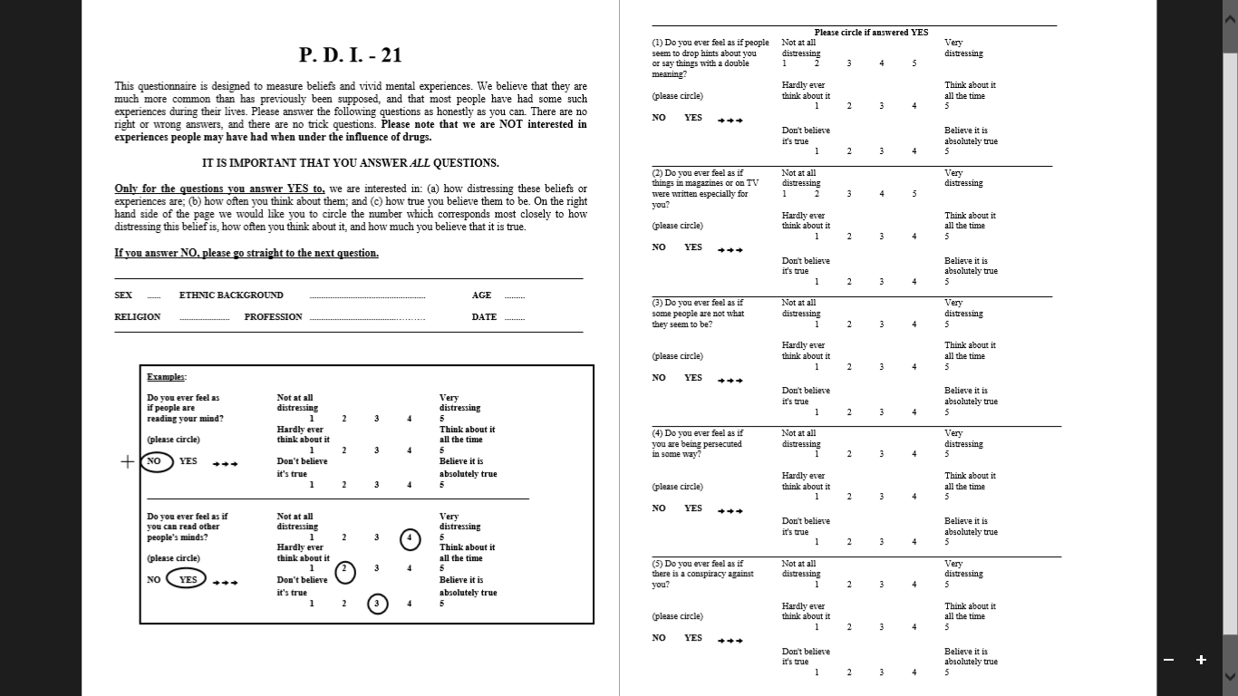



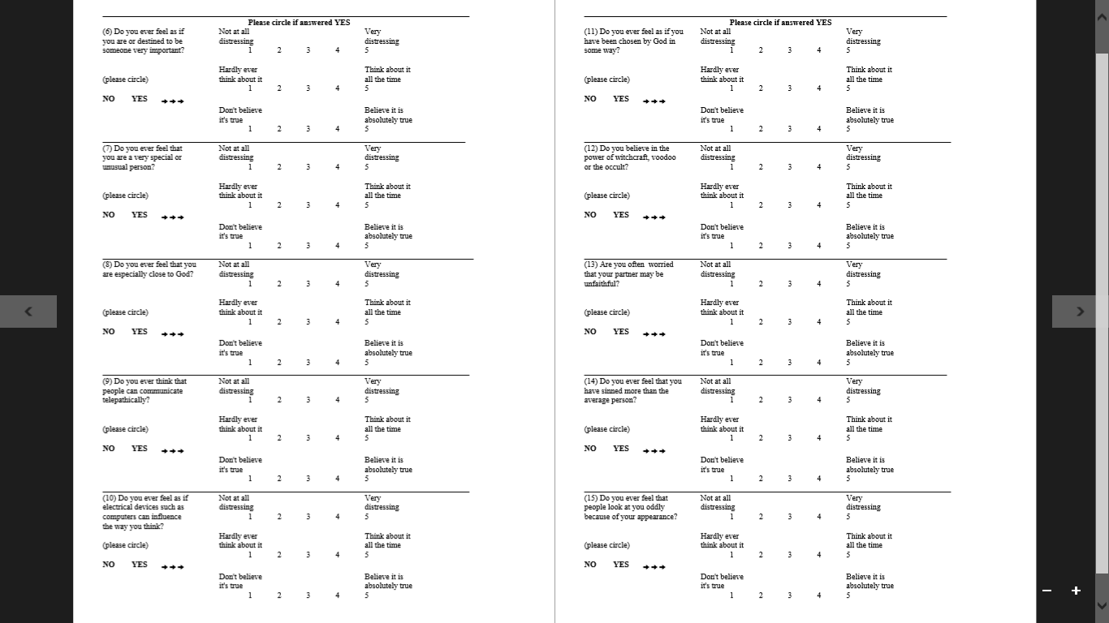

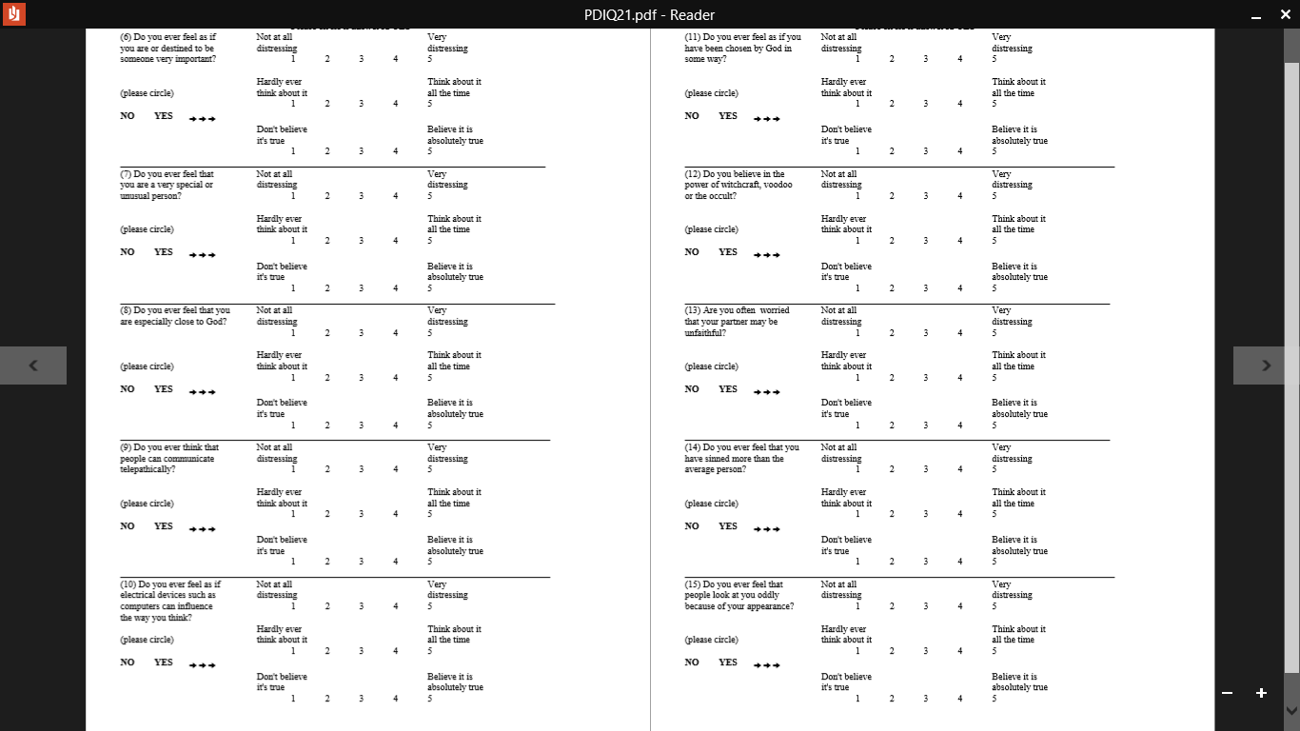

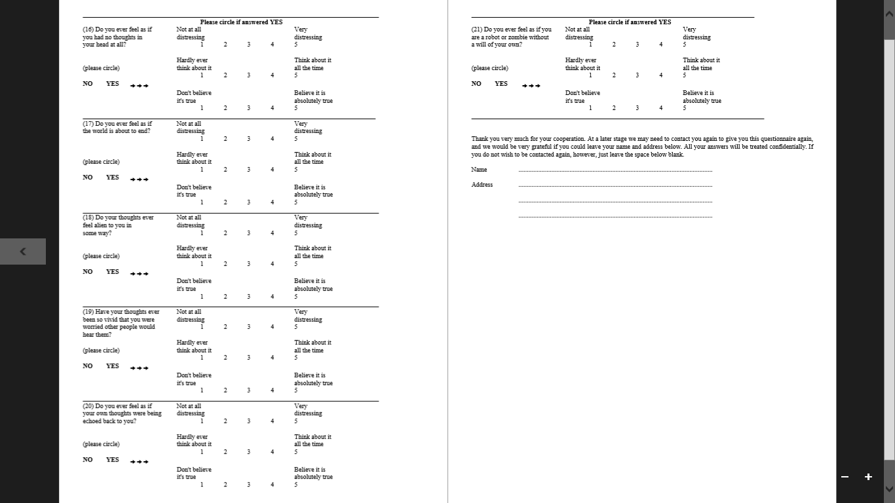



**Appendix B: Spontaneous Use of Imagery Scale**

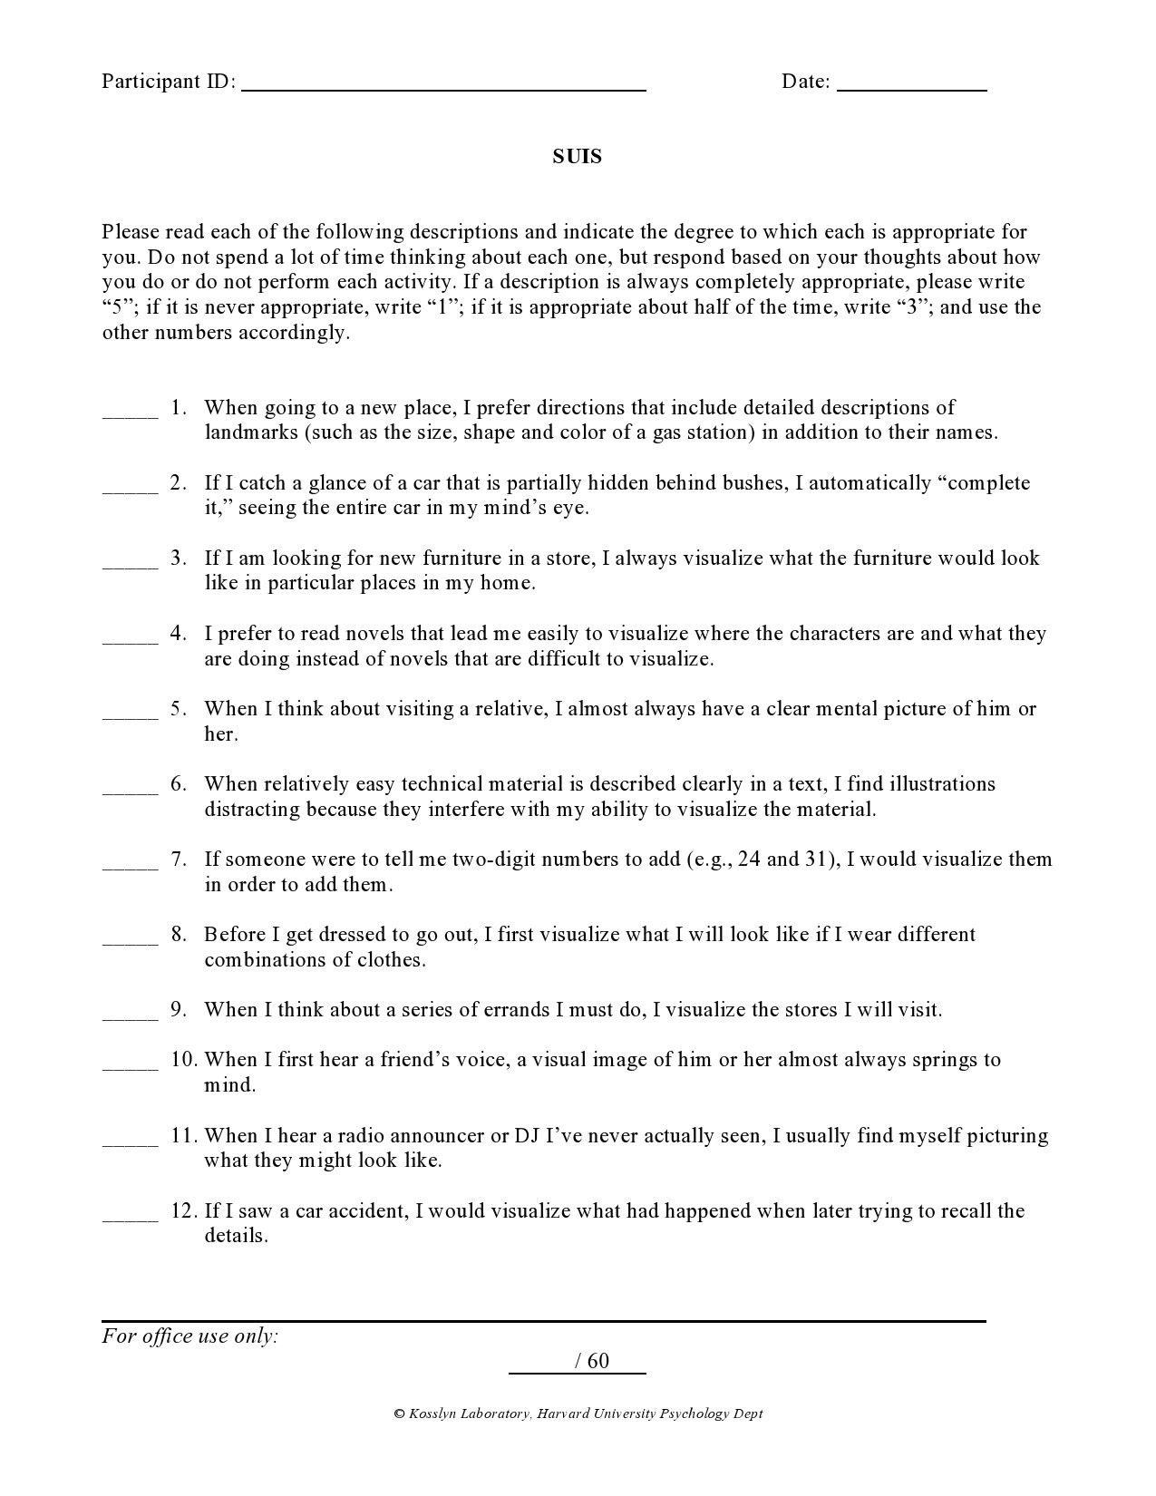

**Appendix C: Rosenberg Self-Esteem Scale**

Please record the appropriate answer for each item, depending on whether you Strongly agree, agree, disagree, or strongly disagree with it.

1. = Strongly agree
2. = Agree
3. = Disagree
4. = Strongly disagree

|  |  |
| --- | --- |
| \_\_\_\_\_ 1. | On the whole, I am satisfied with myself. |
| \_\_\_\_\_ 2. | At times I think I am no good at all. |
| \_\_\_\_\_ 3. | I feel that I have a number of good qualities. |
| \_\_\_\_\_ 4. | I am able to do things as well as most other people. |
| \_\_\_\_\_ 5. | I feel 1do not have much to be proud of. |
| \_\_\_\_\_ 6. | I certainly feel useless at times. |
| \_\_\_\_\_ 7. | I feel that I'm a person of worth. |
| \_\_\_\_\_ 8. | I wish I could have more respect for myself. |
| \_\_\_\_\_ 9. | All in all, I am inclined to think that I am a failure. |
| \_\_\_\_\_ 10. | I take a positive attitude toward myself. |

**Appendix D: Altman Self-rating Mania Scale**

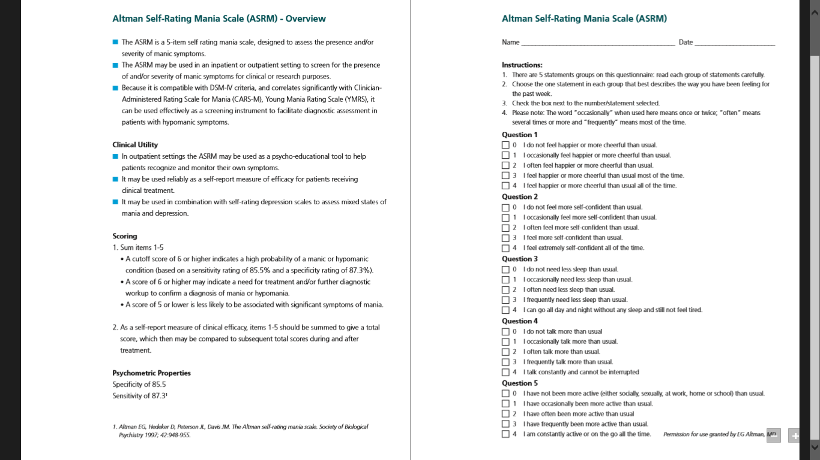

**Appendix E: Positive and Negative Affect Schedule**

This scale consists of a number of words that describe different feelings and emotions. Read each item and then list the number from the scale below next to each word. **Indicate to what extent you feel this way right now, that is, at the present moment***.*

|  |  |  |  |  |
| --- | --- | --- | --- | --- |
| 1 | 2 | 3 | 4 | 5 |
| Very Slightly or Not at All | A Little | Moderately | Quite a Bit | Extremely |
| *\_\_\_\_\_\_\_\_*\_ 1. Interested | | \_\_\_\_\_\_\_\_\_\_ 11. Irritable | | |
| \_\_\_\_\_\_\_\_\_\_ 2. Distressed | | \_\_\_\_\_\_\_\_\_\_ 12. Alert | | |
| \_\_\_\_\_\_\_\_\_\_ 3. Excited | | \_\_\_\_\_\_\_\_\_\_ 13. Ashamed | | |
| \_\_\_\_\_\_\_\_\_\_ 4. Upset | | \_\_\_\_\_\_\_\_\_\_ 14. Inspired | | |
| \_\_\_\_\_\_\_\_\_\_ 5. Strong | | \_\_\_\_\_\_\_\_\_\_ 15. Nervous | | |
| \_\_\_\_\_\_\_\_\_\_ 6. Guilty | | \_\_\_\_\_\_\_\_\_\_ 16. Determined | | |
| \_\_\_\_\_\_\_\_\_\_ 7. Scared | | \_\_\_\_\_\_\_\_\_\_ 17. Attentive | | |
| \_\_\_\_\_\_\_\_\_\_ 8. Hostile | | \_\_\_\_\_\_\_\_\_\_ 18. Jittery | | |
| \_\_\_\_\_\_\_\_\_\_ 9. Enthusiastic | | \_\_\_\_\_\_\_\_\_\_ 19. Active | | |
| \_\_\_\_\_\_\_\_\_\_ 10. Proud | | \_\_\_\_\_\_\_\_\_\_ 20. Afraid | | |

**Appendix F: State Self Esteem Scale**

This is a questionnaire designed to measure what you are thinking at this moment. There is of course, no right answer for any statement. The best answer is what you feel is true of yourself at the moment. Be sure to answer all of the items, even if you are not certain of the best answer. Again, answer these questions as they are true for you RIGHT NOW.

1. **I feel confident about my abilities.**

|  |  |  |  |  |
| --- | --- | --- | --- | --- |
| 1 | 2 | 3 | 4 | 5 |
| Not at all | A little bit | Somewhat | Very much | Extremely |

1. **I am worried about whether I am regarded as a success or failure.**

|  |  |  |  |  |
| --- | --- | --- | --- | --- |
| 1 | 2 | 3 | 4 | 5 |
| Not at all | A little bit | Somewhat | Very much | Extremely |

1. **I feel satisfied with the way my body looks right now.**

|  |  |  |  |  |
| --- | --- | --- | --- | --- |
| 1 | 2 | 3 | 4 | 5 |
| Not at all | A little bit | Somewhat | Very much | Extremely |

1. **I feel frustrated or rattled about my performance.**

|  |  |  |  |  |
| --- | --- | --- | --- | --- |
| 1 | 2 | 3 | 4 | 5 |
| Not at all | A little bit | Somewhat | Very much | Extremely |

1. **I feel that I am having trouble understanding things that I read.**

|  |  |  |  |  |
| --- | --- | --- | --- | --- |
| 1 | 2 | 3 | 4 | 5 |
| Not at all | A little bit | Somewhat | Very much | Extremely |

1. **I feel that others respect and admire me.**

|  |  |  |  |  |
| --- | --- | --- | --- | --- |
| 1 | 2 | 3 | 4 | 5 |
| Not at all | A little bit | Somewhat | Very much | Extremely |

1. **I am dissatisfied with my weight**

|  |  |  |  |  |
| --- | --- | --- | --- | --- |
| 1 | 2 | 3 | 4 | 5 |
| Not at all | A little bit | Somewhat | Very much | Extremely |

1. **I feel self-conscious.**

|  |  |  |  |  |
| --- | --- | --- | --- | --- |
| 1 | 2 | 3 | 4 | 5 |
| Not at all | A little bit | Somewhat | Very much | Extremely |

1. **I feel as smart as others.**

|  |  |  |  |  |
| --- | --- | --- | --- | --- |
| 1 | 2 | 3 | 4 | 5 |
| Not at all | A little bit | Somewhat | Very much | Extremely |

1. **I feel displeased with myself.**

|  |  |  |  |  |
| --- | --- | --- | --- | --- |
| 1 | 2 | 3 | 4 | 5 |
| Not at all | A little bit | Somewhat | Very much | Extremely |

1. **I feel good about myself.**

|  |  |  |  |  |
| --- | --- | --- | --- | --- |
| 1 | 2 | 3 | 4 | 5 |
| Not at all | A little bit | Somewhat | Very much | Extremely |

1. **I am pleased with my appearance right now.**

|  |  |  |  |  |
| --- | --- | --- | --- | --- |
| 1 | 2 | 3 | 4 | 5 |
| Not at all | A little bit | Somewhat | Very much | Extremely |

1. **I am worried about what other people think of me.**

|  |  |  |  |  |
| --- | --- | --- | --- | --- |
| 1 | 2 | 3 | 4 | 5 |
| Not at all | A little bit | Somewhat | Very much | Extremely |

**14. I feel confident that I understand things.**

|  |  |  |  |  |
| --- | --- | --- | --- | --- |
| 1 | 2 | 3 | 4 | 5 |
| Not at all | A little bit | Somewhat | Very much | Extremely |

**15. I feel inferior to others at this moment.**

|  |  |  |  |  |
| --- | --- | --- | --- | --- |
| 1 | 2 | 3 | 4 | 5 |
| Not at all | A little bit | Somewhat | Very much | Extremely |

**16. I feel unattractive.**

|  |  |  |  |  |
| --- | --- | --- | --- | --- |
| 1 | 2 | 3 | 4 | 5 |
| Not at all | A little bit | Somewhat | Very much | Extremely |

**17. I feel concerned about the impression I am making.**

|  |  |  |  |  |
| --- | --- | --- | --- | --- |
| 1 | 2 | 3 | 4 | 5 |
| Not at all | A little bit | Somewhat | Very much | Extremely |

**18. I feel that I have less scholastic ability right now than others.**

|  |  |  |  |  |
| --- | --- | --- | --- | --- |
| 1 | 2 | 3 | 4 | 5 |
| Not at all | A little bit | Somewhat | Very much | Extremely |

**19. I feel like I'm not doing well**

|  |  |  |  |  |
| --- | --- | --- | --- | --- |
| 1 | 2 | 3 | 4 | 5 |
| Not at all | A little bit | Somewhat | Very much | Extremely |

**20. I am worried about looking foolish.**

|  |  |  |  |  |
| --- | --- | --- | --- | --- |
| 1 | 2 | 3 | 4 | 5 |
| Not at all | A little bit | Somewhat | Very much | Extremely |

**Appendix G: Self-Compassion Scale**

**HOW I TYPICALLY ACT TOWARDS MYSELF IN DIFFICULT TIMES**

Please read each statement carefully before answering. To the left of each item, indicate how often you behave in the stated manner, using the following scale:

**Almost Almost never always 1 2 3 4 5**

\_\_\_\_\_ 1. I’m disapproving and judgmental about my own flaws and inadequacies.

\_\_\_\_\_ 2. When I’m feeling down I tend to obsess and fixate on everything that’s wrong.

\_\_\_\_\_ 3. When things are going badly for me, I see the difficulties as part of life that everyone goes through.

\_\_\_\_\_ 4. When I think about my inadequacies, it tends to make me feel more separate and cut off from the rest of the world.

\_\_\_\_\_ 5. I try to be loving towards myself when I’m feeling emotional pain.

\_\_\_\_\_ 6. When I fail at something important to me I become consumed by feelings of inadequacy.

\_\_\_\_\_ 7. When I'm down and out, I remind myself that there are lots of other people in the world feeling like I am.

\_\_\_\_\_ 8. When times are really difficult, I tend to be tough on myself.

\_\_\_\_\_ 9. When something upsets me I try to keep my emotions in balance.

\_\_\_\_\_ 10. When I feel inadequate in some way, I try to remind myself that feelings of inadequacy are shared by most people.

\_\_\_\_\_ 11. I’m intolerant and impatient towards those aspects of my personality I don't like.

\_\_\_\_\_ 12. When I’m going through a very hard time, I give myself the caring and tenderness I need.

\_\_\_\_\_ 13. When I’m feeling down, I tend to feel like most other people are probably happier than I am.

\_\_\_\_\_ 14. When something painful happens I try to take a balanced view of the situation.

\_\_\_\_\_ 15. I try to see my failings as part of the human condition.

\_\_\_\_\_ 16. When I see aspects of myself that I don’t like, I get down on myself.

\_\_\_\_\_ 17. When I fail at something important to me I try to keep things in perspective.

\_\_\_\_\_ 18. When I’m really struggling, I tend to feel like other people must be having an easier time of it.

\_\_\_\_\_ 19. I’m kind to myself when I’m experiencing suffering.

\_\_\_\_\_ 20. When something upsets me I get carried away with my feelings.

\_\_\_\_\_ 21. I can be a bit cold-hearted towards myself when I'm experiencing suffering.

\_\_\_\_\_ 22. When I'm feeling down I try to approach my feelings with curiosity and openness.

\_\_\_\_\_ 23. I’m tolerant of my own flaws and inadequacies.

\_\_\_\_\_ 24. When something painful happens I tend to blow the incident out of proportion.

\_\_\_\_\_ 25. When I fail at something that's important to me, I tend to feel alone in my failure.

\_\_\_\_\_ 26. I try to be understanding and patient towards those aspects of my personality I don't like.

**Appendix H: Positive Imagery Manipulation Script**

**Audio clip:** *“I’d like you to think of a person who you think has been influential or successful that you admire or aspire to – this could be someone you know or it could be someone you don’t know personally, you may have read about them or seen them in the media……Have you got someone in mind?*

*I would now like you to think about what it would be like if you were this person – if you had achieved what they had and were as influential or successful as them. I would like you to think about being in their place instead of them.”*

**Q1**: Can you think of being influential or successful like this person? *Yes / No*

**Q2**: Can you briefly tell me about this? Who is the person? Do you know them? What have they achieved? What do you admire about them?

**Q3**: Can you now rate how important and special it would make you feel if you achieved what this person had achieved. Please use the scale to choose between **0 to 100** based on how important and special you would feel.

* *If participants do not rate above 60%, Qualtrics is coded to invite participants to choose another situation:*

Q: The answer you have given on the previous page suggests the image may not be very strong.

Can you think of another example which gives you a stronger image?

*Yes / No*

* If yes, start again at the first question.
* If no, offer more prompts to generate a person or if they fail to produce another example, use the initial example and continue to next question.

**Prompts:** *If you are finding it difficult to think of a strong example, try to think about something that means a lot to you. It may be something you have often thought about before and is significant to you. Or, it may be an idea that really appeals to you, even if you are not sure why.  
You may have spoken to others about it or made previous attempts to try to achieve something similar. It could also be something that you would be upset about if you could not achieve it.   
Are you able to think of another example?*

* If yes or no, return to question 2 prompting participants to use the example which has made them feel the **most** important and special.

**Audio:** *I would like you to now close your eyes and hold the image you were asked to think about earlier. Hold this image of yourself as vividly as possible whilst I ask you some questions about it. There is no need to write any of your answers down, just think about them as I ask you to hold the image of yourself in mind.*

*What is happening in the image that you can see right now? Think about what is going on. (Pause)*

*What are you doing in the image? (Pause)*

*Who are you with? What are they doing? (Pause)*

*What can you see and hear? (Pause)*

*What do you look like to other people; what would others see? (Pause)*

*How do you feel in this situation? (Pause)*

*I’d like you to stay focused on that situation, try to get a really clear picture or sense of what it was like, where you were, who you were with, what you were doing…* (*Pause*)

*You will now be asked some questions about this image.*

**Q4:** When people are thinking about themselves, they may have a positive or negative image or sense of themselves in their mind.   
What kind of image or sense of yourself do you have now?

**Q5:** How vivid is the image/ sense of yourself? *1 – clear and vivid like normal vision, 2 – clear and reasonably vivid, 3 – moderately clear and vivid, 4 – vague and dim, 5 – no image.*

**Q6:** Now keeping that situation clearly in mind, can you write how you are feeling about yourself?

This can include your thoughts and emotions towards yourself at this moment.

For example, how positive or negative do you feel about yourself? What kind of thoughts are you having about yourself now?

You have now completed the imagery exercise.

**Appendix I:** **Negative Imagery Manipulation Script**

**Audio:** *I would like you to think of an important dream or goal you have had about achieving something for yourself– this could be one you have had ever since being a child, or it could be one that you developed later on. The dream or goal can be about achieving anything that is important to you. Take a moment to think about what this could be (pause).*

*I would now like you to think about what it would be like if you didn’t achieve this dream or goal. Place yourself in the situation where you have just realised you didn’t achieve this dream or goal.*

**Q1:** Can you think of a situation where you have not achieved a dream or goal? *Yes/ No*

**Q2:** Can you briefly tell me about this? What is the dream or goal? What is important about it to you? How long have you held it?

**Q3**: Can you now rate how important and special it would make you feel if you did not achieve this dream or goal. Please use the scale to choose between **0 to 100** based on how important and special you would feel.

* *If participants do not rate below 60%, Qualtrics is coded to invite participants to choose another situation:*

Q: The answer you have given on the previous page suggests the image may not be very strong.

Can you think of another example which gives you a stronger image?

*Yes / No*

* If yes, start again at the first question.
* If no, offer more prompts to generate a person or if they fail to produce another example, use the initial example and continue to next question.

**Prompts:** *If you are finding it difficult to think of a strong example, try to think about something that means a lot to you. It may be something you have often thought about before and is significant to you. Or, it may be an idea that really appeals to you, even if you are not sure why.  
You may have spoken to others about it or made previous attempts to try to achieve something similar. It could also be something that you would be upset about if you could not achieve it.   
Are you able to think of another example?*

* If yes or no, return to question 2 prompting participants to use the example which has made them feel the **most** important and special.

**Audio:** *I would like you to now close your eyes and hold the image you were asked to think about earlier. Hold this image of yourself as vividly as possible whilst I ask you some questions about it. There is no need to write any of your answers down, just think about them as I ask you to hold the image of yourself in mind.*

*What is happening in the image that you can see right now? Think about what is going on. (Pause)*

*What are you doing in the image? (Pause)*

*Who are you with? What are they doing? (Pause)*

*What can you see and hear? (Pause)*

*What do you look like to other people; what would others see? (Pause)*

*How do you feel in this situation? (Pause)*

*I’d like you to stay focused on that situation, try to get a really clear picture or sense of what it was like, where you were, who you were with, what you were doing…* (*Pause*)

*You will now be asked some questions about this image.*

**Q4:** When people are thinking about themselves, they may have a positive or negative image or sense of themselves in their mind.   
What kind of image or sense of yourself do you have now?

**Q5:** How vivid is the image/ sense of yourself? *1 – clear and vivid like normal vision, 2 – clear and reasonably vivid, 3 – moderately clear and vivid, 4 – vague and dim, 5 – no image.*

**Q6:** Now keeping that situation clearly in mind, can you write how you are feeling about yourself?

This can include your thoughts and emotions towards yourself at this moment.

For example, how positive or negative do you feel about yourself? What kind of thoughts are you having about yourself now?

You have now completed the imagery exercise.

**Appendix J: Advert sent via university email list**

**HEADER :** “How does your self-image impact your mood? Can you help us understand the role of imagery on our mood?”

My name is Razia Akhtar and I am a trainee clinical psychologist from the University of Sheffield.  
  
I am doing my doctoral research project on how people experience imagery about themselves and how this can impact our mood.

I would like to invite you to participate in an online questionnaire. This is followed by an online audio imagery exercise. This should take no more than 30 minutes to finish. To complete the audio imagery exercise, you will require access to speakers or headphones to listen to the audio content, preferably in a quiet location.   
  
If you wish to participate or require more information, please follow the link below which will direct you to the online questionnaire and more information about the research.

[(Link)](https://sheffieldpsychology.eu.qualtrics.com/jfe/form/SV_3rNT3cL33z8sM9n)

As a thank you for participating, you will be entered into a prize draw to **win a £25 Amazon** **voucher.**  
  
This project has been approved by the University of Sheffield Department of Psychology research ethics committee and is supervised by Dr Georgina Rowse.  
   
Feel free to get in touch with any questions/ comments: [(email)](mailto:rakhtar3@sheffield.ac.uk)

**Appendix K: Advert used for further recruitment waves**

**How does your image of yourself impact your mood?**

*Can you help us understand the role of self-imagery on our mood?*

*Complete a short survey to be entered into a prize draw for a* ***£25 Amazon voucher****.*

**What is the study about?**

The study is examining how people experience imagery about themselves and how this can impact mood. This could help us to understand specific clinical problems where imagery impacts mood, and help to recommend clinical interventions for treatment.

**What you need to know:**

* All you need to do is complete an online survey, which takes around 20 minutes.
* You need access to speakers or headphones to listen to short audio clips, preferably in a quiet location.
* You will be asked to complete brief questionnaires before and after the audio clips.
* The study is completely confidential and anonymous.

***Use this link to complete the survey:***

(Link)

Thank you for your time with the study.

Please do not hesitate to contact me via email on [(email)](mailto:rakhtar3@sheffield.ac.uk) with any questions.

Razia Akhtar (Trainee Clinical Psychologist)

Department of Psychology, Sheffield University

**Appendix L: Information page on Qualtrics**

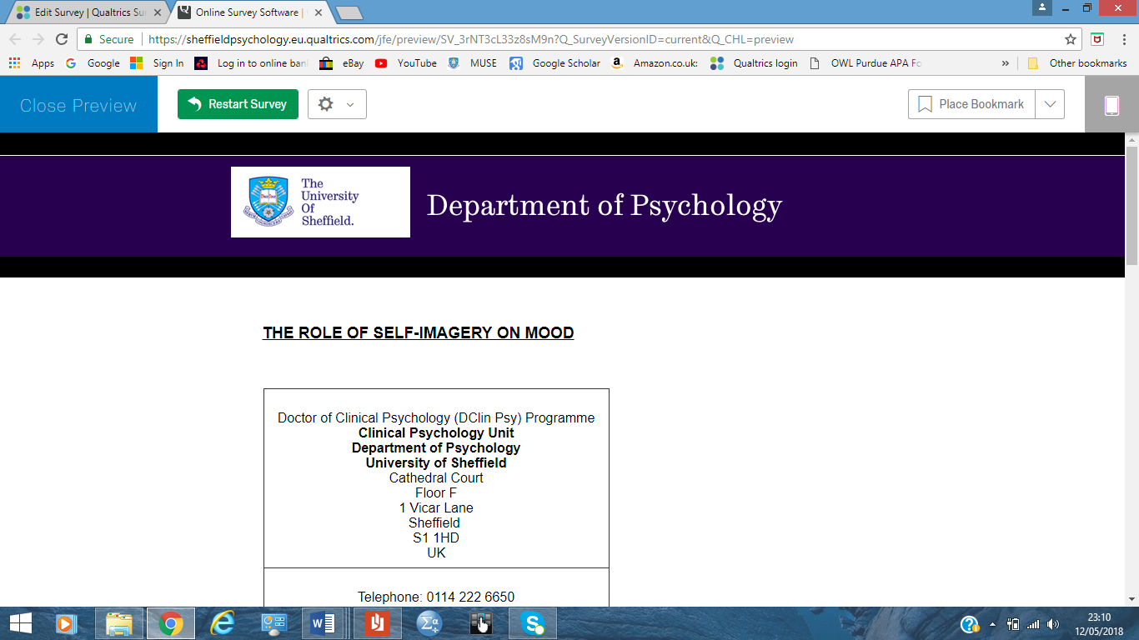

**THE ROLE OF SELF-IMAGERY ON MOOD**

|  |
| --- |
| Doctor of Clinical Psychology (DClin Psy) Programme  **Clinical Psychology Unit**  **Department of Psychology**  **University of Sheffield**  Cathedral Court Floor F 1 Vicar Lane Sheffield  S1 1HD UK |
| Telephone: 0114 222 6650  Fax: 0114 2226610  Email: (email) |

**Study Information**

You are being invited to take part in this research project. Before you decide to do so, it is important you understand why the research is being done and what it will involve. Please take time to read the following information carefully.

**What is the study about?**

The study hopes to explore the imagery we can have about ourselves and it's role in our mood. The findings can help to understand specific clinical problems where imagery could impact mood, in order to recommend interventions for treatment.

**What does taking part involve?**

* You will initially be asked to complete some questionnaires about beliefs and imagery.
* You will then complete an audio recorded imagery exercise and answer some questions about the image.
* You will then repeat some of the questionnaires after the imagery exercise.
* This should all take no more than 30 minutes to complete.
* You will need to be able to play the audio from your device and preferably be in a quiet room to do the exercise.
* **Please note, the audio file will not work in Firefox browser. It is recommended you use Google Chrome or Internet Explorer.**

**Do I have to take part?**  
  
It is up to you to decide whether to take part. If you decide to take part you will be able to indicate your agreement on a subsequent page.

You can exit the online study at any time. You may also withdraw entirely from the study and request to have your data withdrawn at any time. To withdraw from the study, you can contact the researcher via email and your data will be deleted.

**Is everything confidential and anonymous?**  
  
All the information collected from you will be kept strictly confidential and not identifiable in any of the research as the computer software will create a unique participant ID for you. All data will be stored securely and anonymously online.  
   
**Are there any risks in participating?**  
  
The study has received ethical approval from the University of Sheffield Research Ethics Committee. There are no known risks associated with this study.  However, it is possible you may find the imagery exercise potentially distressing. If during or after taking part, you feel that you have been adversely affected by any part of the study, please speak to the researcher or seek the help of your GP or university counselling service. Alternatively, please call **Samaritans -** 08457 90 90 90 or **Mind -** 0300 123 3393.  
   
**Are there any benefits in participating?**  
  
It is hoped that this research will make a beneficial contribution to understanding the role that imagery about ourselves can play in our mood. The findings could also be used to design interventions to help clinical populations who have difficulties with their mood. If you would like a summary of the findings once the research is completed, please contact the researcher.  
   
**What will be done with the results?**  
  
The results from this study will be written up and submitted as a thesis for the clinical psychology doctorate at the University of Sheffield. Additionally, the results will be disseminated through publishing in a peer-reviewed journal. No participants will be identifiable in any publications as data will be pooled from all participants.

**Contacts details**

If you need any further information please contact the lead researcher:

|  |  |
| --- | --- |
| **Lead researcher**  Razia Akhtar  rakhtar3@sheffield.ac.uk  \*0114 2226650 | **Supervisor**  Georgina Rowse  g.rowse@sheffield.ac.uk  \*0114 2226650 |

\*Please note this telephone number will take you through to the research support officer who will only be able to relay messages but cannot answer any queries relating to the study.

**Appendix M: Consent page on Qualtrics**

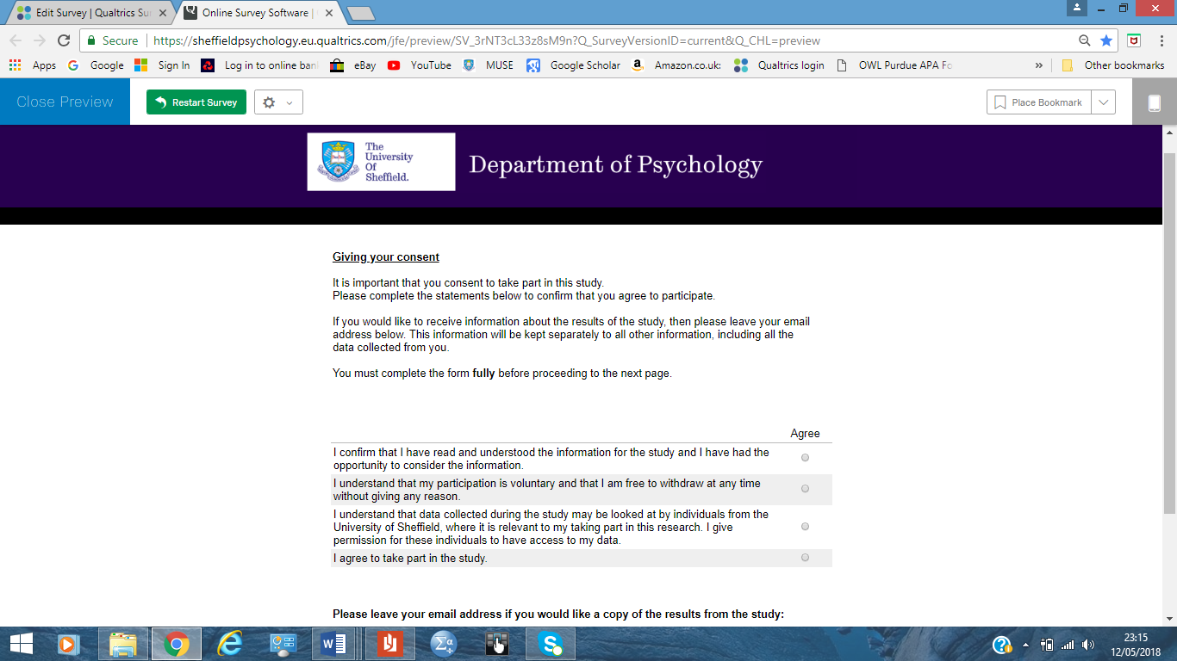

**Appendix N: Mood repair exercise**

Please list five of the best things in your life:

1)

2)

3)

4)

5)

**Appendix O: Debrief page on Qualtrics**



**End of Study Information**

Thank you for your participation, the study has now been completed.

Please read this information which tells you what the aims and hypotheses of the study were and where you can get more information.

**The aims of the study:**  
  
This study examined the role of imagery in the development of thoughts which can be grandiose in nature. This includes thoughts about being special or very important.

Research shows that grandiose thoughts can be strengthened when experiencing imagery linked to the thoughts. It can also help improve mood and self-esteem when thoughts about being special or important are experienced.

It is important to investigate this to try to develop clinical interventions for individuals who may unhelpfully believe in their grandiose thoughts.

**How was this tested?**  
  
In this study you completed questionnaires to detect the presence of grandiose thoughts and your use of everyday imagery. The computer software will have identified participants who indicated presence of grandiose thoughts and those who did not.

Participants will have been randomly allocated to hear an imagery script, to encourage you to generate either positive imagery (being an influential or successful person) or negative imagery (not achieving a personal dream or goal).

Your mood, self-esteem and self-compassion were also recorded before and after to investigate whether they changed following the imagery exercise.

**Hypotheses and main questions:**  
  
We expect to find that participants who express grandiose thoughts will have better mood and self-esteem, especially those experiencing the positive imagery exercise, compared to those not experiencing grandiose thoughts.

We also expect that those with grandiose thoughts will have more positive change in their mood in response to developing a positive image of themselves. This relates to research which suggests that grandiose thoughts are linked to positive mood.

**What happens with my information?**  
  
Your data will remain confidentially stored online. The data will also remain anonymous as you will have been assigned a unique participant ID.

Participants will not be identifiable in any publications, as data will be pooled from all participants. You can also withdraw your data should you change your mind about participating. Please contact the lead researcher if you wish to withdraw.

**Further information:**  
  
If you have been adversely affected by any part of the study, please speak to the researcher or seek the help of your GP or University counselling service. Alternatively, please call **Samaritans -** 08457 90 90 90 or **Mind -** 0300 123 3393.

If you would like a summary of the findings once the research is completed, please contact the lead researcher.   
  
  
**Contacts details:**

|  |  |
| --- | --- |
| **Lead researcher**  Razia Akhtar  rakhtar3@sheffield.ac.uk  \*0114 2226650 | **Supervisor**  Georgina Rowse  g.rowse@sheffield.ac.uk  \*0114 2226650 |

\*Please note this telephone number will take you through to the research support officer who will only be able to relay messages but cannot answer any queries himself.

**Appendix P: Ethical approval letter & email**

