SOCIAL AND BEHAVIOURAL FACTORS ASSOCIATED WITH COGNITIVE AND FUNCTIONAL PERFROMANCE IN COGNITIVELY HEALTHY OLDER ADULTS

Department of Sociological Studies
The University of Sheffield

G. Pavlidis

Thesis resubmitted for the degree of Doctor of Philosophy
04/05/2018

Supervisor: Prof. A. B. Vivas, The University of Sheffield, International Faculty, City College, Department of Psychology
Supervisor: Prof. A.Walker, The University of Sheffield, Department of Sociological Studies

Abstract
The current paradigm on cognitive ageing suggests that greater social participation, higher socioeconomic status, as well as more physical and mental exercise, have a positive effect on cognitive decline trajectories with ageing. In turn, favourable cognitive decline trajectories with ageing lead to better outcomes in terms of everyday functioning. Although this paradigm has received significant recognition in research and policymaking, it has been insufficiently examined among cognitively healthy older adults. This research set out to examine explicitly among cognitively healthy older adults, whether higher social participation, higher socioeconomic status, as well as more physical exercise and Internet use have a beneficial effect on cognitive vitality and everyday functioning. Firstly, a meta-analysis of studies that examined the relationship between cognitive performance and everyday functioning among healthy older adults was conducted. Subsequently, the translation and cultural validation of two measures of everyday functioning from English to Greek was carried out. Lastly, a cross-sectional study that examined the relationship between social participation, socioeconomic status, physical exercise, Internet, cognitive performance and everyday functioning was conducted. The findings indicate that cognitive performance and everyday functioning are moderately related in the healthy spectrum of cognitive performance. Furthermore, social participation, education, Internet use and exercise seem to moderate age-related decrements in cognitive performance. These effects seem to be contingent upon certain age groups and subpopulations with specific characteristics. The findings do not support the transferability of cognitive benefits to everyday functioning. It was concluded that social participation, Internet use and exercise might have a significant beneficial effect on at least one domain of cognitive performance (executive function) in older adults with specific characteristics, without resulting necessarily in everyday functioning benefits.

Acknowledgements
I would like to thank Dr. Liz Mestheneos, Sociologist, from the 50plus Hellas organization, Dr Vivas, Dr. Elisavet Chrysochoou and Dr. Ypislanti, Cognitive Neuropsychologist, at the International Faculty of the University of Sheffield, and Ms Penelope Katsavou, Philologist of English literature, working at the secondary education in Greece, for their contribution in translating and linguistically validating in the Greek language the two everyday functionality assessment tools used in this thesis. I feel particularly grateful to Professor Jose Manuel Reales Aviles, for giving me the incentive and support to learn the process of statistical meta-analyses, and for honour me with his collaboration in finalizing my relevant work for this thesis. I would also like to thank my research assistants, Ms Stephanie Hatzifilalithis, PhD candidate of Gerontology, and Mr Nikolaos Zawaher, graduate of BSc Psychology, for their invaluable help, professionalism and devotion during the lengthy, demanding process of data collection for this thesis. I would like to thank Mr Kyriakos Foulidis, Sociologist, and social worker at the Day Care Centers in the Neapel-Sykies municipality for his collaboration during my work and data collection, as well as to all social workers that took over the appointments’ planning with all the seniors participating in this study. For the same reason, I would like to thank the municipality of Neapel-Sykies for trusting me and granting me access to the seniors’ citizens they take care of, as well as for providing me with suitable space for my fieldwork. Lastly, I would like to thank all seniors that honoured me with their participation for the needs of this thesis. During this procedure, they gave many invaluable life lessons, confirming that old age comprises a human capital waiting to be acknowledged and capitalized!

Table of Contents
Abstract II
Acknowledgements III
Table of Contents IV
Glossary VIII
CHAPTER 1 INTRODUCTION 1
The Challenges Posed by the Demographic Change into an Ageing Population 4
The Need for the Examination of the Healthy Spectrum of Older Age 6
Advancing the Discourse of Ageing in the Healthy Spectrum of Cognitive Performance 9
Research Questions and Hypothesis 11
Contribution to Knowledge 12
Thesis Plan 14
CHAPTER 2 THE AGEING POPULATION AND THE CONCEPT OF ‘SUCCESSFUL’ AGEING 17
Introduction 17
Method 17
Who is Old? 18
Who is Healthy in Older Age? 20
Who is Older and Cognitively Healthy? 22
The Challenges posed by the Demographic Change into an Ageing Population 24
The Development of Successful Ageing Concepts 29
The Success of the Successful Ageing Concepts 32
Conclusions 36
CHAPTER 3 COGNITIVE AND FUNCTIONAL PERFORMANCE IN OLDER AGE 39
Introduction 39
Method 40
Cognitive Performance and Cognitive Decline with Ageing 40
The effect of Physical Exercise on Cognitive Vitality 42
The effect of Social Participation on Cognitive Vitality 45
The effect of Mental Activities on Cognitive Vitality 48
The effect of Socio Economic Status on Cognitive Vitality 50
The Relation of Cognitive Performance with Everyday Functioning 51
The Healthy Spectrum of Cognitive Performance 58
Methodological Considerations 63
Assessing Physical Exercise 68
Assessing Social Participation 69
Assessing Socio Economic Status 73
Assessing Cognitive and Functional Performance 75
Conclusions 76
CHAPTER 4 NEUROPSYCHOLOGICAL AND EVERYDAY FUNCTIONALITY TESTS: A META-ANALYSIS 78
Introduction 78
Method 82
Inclusion and exclusion criteria 82
Moderator and mediator analysis 85
Search strategies 85
Coding procedures 85
Statistical Methods 86
Results 87
Discussion 99
Conclusion 103
CHAPTER 5 THE EVERYDAY PROBLEM TEST AND THE OBSERVED TASKS OF DAILY LIVING 104
Introduction 104
Selection of everyday functioning tools 105
Cultural adaptation and translation of the OTDL-R and the EPT 28-items version 107
Method 109
Step1: Adaptation and translation of measures 109
Step 2. Revision of the translated and adapted versions of the instruments – Adaptation of the draft instrument on the basis of the comments of reviewers 110
Step 3. Pilot testing of the instruments 111
Step 5. Validation process 112
Step 6. Developing a manual and other document for the users of the assessment devices 113
Step 7. Train users – Collect reactions from users 113
Results 114
Discussion 118
CHAPTER 6 METHODOLOGY 121
Introduction 121
Proposed Examination and Analysis 123
Analysis 1 Validation of the OTDL-G and EPT-G 124
Analysis 2 The Relation Between Cognitive Performance and Everyday Functioning 125
Analysis 3 Social participation, Exercise, Internet use, SES, and Cognitive Performance 127
Analysis 4 Social Factors that Influence Older Adults’ Social Participation, Exercise, and Internet use 128
Analysis 5 Examining the Mediation Effects of Cognitive Performance 129
Required Sample Size 129
Note: Adapted From Knofczynski And Mundfrom (2017) 132
Participants 132
Instruments 134
Everyday Problem Test – Greek version. 134
Mini Mental State Examination (MMSE). 134
Montreal Cognitive Assessment (MoCA). 134
Verbal Fluency. 135
Trail Making Test Part A and B. 135
California Verbal Learning Test 135
Perceived Health. 136
Loneliness: 136
Physical Activity: 136
Social Network Size: 137
Social Participation frequency: 137
Internet use: 138
Other activities: 138
Internal consistency issues for social participation frequency and social network size 138
Procedure and Ethical Issues 139
CHAPTER 7 ANALYSES AND RESULTS 141
Analysis 1 Validation of the OTDL-G and EPT-G 141
Introduction 141
Analysis and Results 141
Discussion 145
Conclusion 147
Analysis 2 The Relation Between Cognitive Performance and Everyday Functioning 147
Introduction 147
Analysis and Results 149
Analysis 3 The Relation Between Social Participation, Exercise, Internet use, Education, and Cognitive Performance 150
Introduction 150
Analysis plan 151
Descriptive analysis 152
Analysis and Results 153
Discussion 159
Conclusion 162
Analysis 4 Social Factors that Influence Older Adults’ Social Participation, Internet use, and Exercise 163
Introduction 163
Preliminary analysis 164
Discussion 170
Conclusion 171
Analysis 5 Examining Mediation effects in a Holistic Model 171
Introduction 171
Analysis and Results 172
Discussion and conclusion 174
CHAPTER 8 COGNITIVE PERFORMANCE AND AGEING 175
The Research Questions and Hypotheses 177
Summary of findings 178
Study strengths and limitations 180
Theoretical contribution 186
Implications for policy and future research 192
Conclusion 195
References 196
Appendix I 234
Studies Included in the Meta-Analysis 234
Appendix II 239
The OTDL-R Booklet for Measuring Everyday Functioning 239
Material for Medication Use Assessment 256
Material for Telephone Use Assessment 260
Material for Financial Handling Assessment 263
Appendix III 264
The Everyday Problem Test 28-item version 264
Appendix IV 278
The OTDL-G 278
Material for medication handling 294
Material for telephone handling 297
Material for finance handling 300
Question cards 304
Appendix V 311
The EPT-G 311
Appendix VI 325
Scoring Manual for the OTDL-G 325
Appendix VII 329
Scoring Manual for the EPT-G 329
Appendix VIII 331
Questionnaires (Translated) 331
Mental activities 331
Other activities 331
Social participation 331
Social network 332
Loneliness 332
Perceived Health 332
Demographics 332

Glossary
ACTIVE = Advanced Cognitive Training for Independent and Vital Elderly
ADL = Activities of Daily Living
APA = American Psychological Assosiation
BDNF = Brain Derived Neurotrophic Factor
BLSA = the Baltimore Longitudinal Study of Ageing
CDC = Centre of Disease Control and Prevention
CHARLS = China Health and Retirement Longitudinal Study
CMA = Comprehensive Meta-Analyses
CVLT = California Verbal Learning Test
D-KEFS = Delis-Kaplan Executive Function System
EF = Executive Function
ELSA = English Longitudinal Study in Ageing
EPT - G = Everyday Problem Test – Greek version
EPT = Everyday Problem Test
EvF = Everyday Functioning
FUCAS = Functional Cognitive Assessment Scale
GPS = Global Positioning System
GSH = General Slowing Hypothesis
GVLT = The Greek version of the California Verbal Learning Test
HLE = Healthy Life Expectancy
HRS = Health and Retirement Study
IADL = Instrumental Activities of Daily Living
ILS = Independent Living Scale
LASI = Longitudinal Aging Study in India
LC = Learning Curve
LTM = Long Term Memory
MARS = Meta-Analyses Reporting Standards
MAS = Memory Assessment Scale
MCI = Mild Cognitive Impairment
MoCA = Montreal Cognitive Assessment
MRI = Magnetic Resonance Imaging
MSE = Mini Mental State Examination
OECD = Organization for Economic Cooperation and Development
OTDL - G = Observed Tasks of Daily Living – Greek version
OTDL = Observed Tasks of Daily Living
OTDL-R = Observed Tasks of Daily Living - Revised
SD = Standard Deviation
SEM = Structural Equation Modelling
SES = Socio Economic Status
SHARE = Survey of Health, Ageing and Retirement in Europe
SOC = Selection, Optimization, and Compensation model
SoP = Speed of Processing
STM = Short Term Memory
TMT-A = Trail Making Test part A
TMT-B = Trail Making Test part B
US = United Stated of America
VF = Verbal Fluency
WEF = World Economic Forum
WHO = World Health Organization
WM = Working Memory

CHAPTER 1 INTRODUCTION
Advances in medicine, hygiene, and nutrition have resulted in a decrease in acute and life-threatening diseases and consequently an increase in average life expectancy at birth (Hamilton, 2011; Hertzog, Kramer, Wilson, & Lindenberger, 2009). This is a successful outcome. In conjunction with the contemporary decline in birth rates however, it fashion the ever-growing representation of older adults in the general population (Atchley & Barush, 2004; Hamilton, 2012). This demographic change poses certain challenges for the pensions systems’ financial sustainability, due to changes brought in the old-age dependency ratio (The Bank of America Merrill Lynch, 2014). In addition, it raises concerns for the financial sustainability of the welfare systems, as the increased prevalence of chronic (and often debilitating) diseases in older age, demands increased resources for healthcare and long-term care (Organization for Economic Cooperation and Development, 2014a,b).
To address those challenges, there has been a conscious effort to shape a healthier population, placing attention on the average Healthy Life Expectancy (HLE), namely the ‘Average number of years that a person can expect to live in full health’ (World Health Organization, 2014a). Following this direction, many political initiatives have taken place, forming an agenda that is widely known as the healthy and active ageing agenda. In the European Union for example, one of the main short-term health strategies has been the promotion of good health and productivity in older age (European Commission, 2014b,c). Similar political initiatives are seen worldwide, echoing a large history of scientific findings in the ageing discourse.
The scientific discourse on ageing counts 60 years of systematic research from multiple perspectives, including sociological (Cumming & Henry, 1961), medical (Depp & Jeste, 2006) and neuropsychological approaches (Salthouse, 2006). The available empirical evidence highlights that having good health (physically, mentally, and socially) is an essential preventive component for healthy and active ageing objectives, as well as a desirable outcome in older age (Johnson & Mutchler, 2013). In this context, an adequate status of cognitive vitality in older age is considered a benchmark for older adults’ good mental health (Hertzog et al., 2009), as it allows them to be productive (e.g., participation in labour; OECD, 2013) and live independently (Petersen, 2004). The volume of knowledge produced in this field has been invaluable and has informed scholars in the creation of various ageing theories and concepts, including that of successful ageing (Rowe & Kahn, 1987). In turn, policy makers have been informed from the relevant theories and theoretical concepts, shaping strategic objectives that aim to promote longevity, health and productivity in older age.
The present thesis engages with the normative arguments and the empirical findings that have been created in the discourse of cognitive and functional decline with ageing. It is motivated by a critique of the prevailing paradigm of cognitive ageing and the predominant methodologies used to assess cognition and functioning among older people. A critical examination of the relevant literature gives ground to argue for the scientific examination of cognitive and functional performance among cognitively intact older adults, as the relevant discourse has been mainly preoccupied with the documentation of cognitive shortcomings and neuronal degenerations that accompany older age (Depp & Jeste, 2006; Hertzog et al., 2009). In other words, there is an evident bias in the scientific examination of cognitive decline with ageing to examine and document the age-related neurological conditions that lead to cognitive deficits.
This thesis explores various ageing theories in terms of behaviour (e.g., everyday functioning) and cognitive vitality (e.g., memory capacity) and argues that the existence of a bias in documenting negative outcomes with ageing has contributed to the misrepresentation of the non-pathological course of cognitive ageing. It argues that this tendency may have contributed to the formation of an erroneous paradigm of cognitive ageing, which in turn led to erroneous, yet influential assumptions about older adults’ cognitive and functional performance.
The prevalence of age-related neurological diseases is by definition higher in older age, and therefore, their prevention has a particular importance. This argument testifies that neurological diseases are probable incidences for older adults, and therefore does not justify their dominant representation in developmental models of older age. A consequence of conceptualizing poor cognitive vitality as a dominant component of older age is the resilient tendency among scholars and policy makers to over-emphasize the negative effects of age on cognitive vitality, often projecting the effects of age-related neurological conditions into the healthy spectrum of cognitive ageing. This has contributed to an ill-described paradigm of cognitive ageing, where cognitive decline trajectories are described as routes inevitably leading to age-related neurological disorders, and therefore to the loss of functional ability (Hertzog et al., 2009). This thesis argues that, based on the prevailing paradigm of cognitive ageing, many scholars have transformed the probabilistic nature of age-related neurological disorders into a catholic reality of the cognitive ageing process, with the available epidemiological evidence not being supportive of this position (Anderson-Ranberg, Vasegaard, & Jeune, 2001; Ball, Ross, & Viamonte, 2010).
This thesis argues that the healthy spectrum of cognitive ageing has been left under-examined and under-explained, informing poorly the objectives set to foster a good life in older age, as well as to maximise the exploitation of older adults' potential. By reviewing the available literature, and by using quantitative empirical research and statistical meta-analyses, this thesis constitutes a preliminary attempt to examine explicitly the healthy spectrum of cognitive and everyday functioning among Greek older adults.
This introductory chapter discusses in more detail the challenges posed by the demographic change into an ageing population, the prevalence of age–related neurological disorders in older age, as well as the relation between cognitive and functional decline with ageing. Then, the efforts made in policy making and in science to address the challenges that refer to older adult’s cognitive vitality and functional capacity are discussed in more detail, stating the thesis’s concerns with regard to the validity of various assumptions that have been made in this context. Subsequently, the scope of the thesis (i.e., the healthy spectrum of cognitive and everyday functioning) and the respective research questions are stated. This introductory chapter concludes with the contribution that this thesis makes to the scientific discourse on cognitive ageing. Finally, the chapter provides a brief overview of the arguments made by the thesis and describes briefly the content of the chapters that follow.

The Challenges Posed by the Demographic Change into an Ageing Population
One challenge that arises from the demographic change into an ageing population is the welfare system’s financial sustainability, resulting from the potential changes in the old-age dependency ratio for the period 2010 to 2050 (The Bank of America Merrill Lynch, 2014). The old-age dependency ratio is the ratio between the numbers of those in the working population to those receiving pension schemes. Worldwide, the old-age dependency ratio was 11.7% in 2010, whereas in 2050 it is estimated to be 25.4% (The Economist, 2009), resulting from an increase of the 65+ populations and a decrease of the working force (The Bank of America Merrill Lynch, 2014). According to The Bank of America Merrill Lynch (2014), this may be translated in additional costs of up to 50% of the Gross Domestic Product (GDP) to cover the expenses posed by an increased demand in pensions and healthcare costs. If no reforms take place in the near future, pensions in 2050 may drop below the threshold of poverty even in states with seemingly healthy economies (Galatsiatou, 2013).
Due to the increased prevalence of chronic diseases in older age (and in the whole population in general), the demographic change into an ageing population signifies more years spent in less than perfect health for some, and in poor health for others. The Centre of Disease Control and Prevention (CDC, 2011) released a report depicting that 80% of older adults have one chronic condition, whereas 50% of them have at least two. The relevant epidemiological studies (CDC, National Centre of Health Statistics, National Vital Statistics System, 2007 as cited in CDC, 2011) illustrated that the leading causes of death among US adults older than 65 are chronic conditions, such as heart diseases, cancer, stroke, respiratory diseases, Alzheimer disease, and diabetes.
It has been argued that the stress posed by the ageing populations on the welfare and pension systems’ financial sustainability can be alleviated by a set of measures and initiatives that shape a growing dynamic for the average HLE. In the relevant report released from the World Economic Forum (WEF, 2015, p.5), it is stated that:
... a healthy population is able to work for a greater number of years before retirement, contributing more to the social welfare system and depending less on the benefit it offers … Unhealthy populations lead to increases in government expenditure, reductions in the amount of taxable household income on account of ill people withdrawing from the workforce and, through increased morbidity rates, greater numbers taking early retirement (as well as additional costs incurred by social support systems and family)
The WEF (2015) proposed a model that explains how investments in creating a healthier population are closely related to economic growth (Figure 1.1). The objectives set for the average HLE, as well as those set within the healthy and active ageing agenda tap well into the WEF model of health and economic growth, as it expands from younger to older age, thus it adopts a life span perspective.
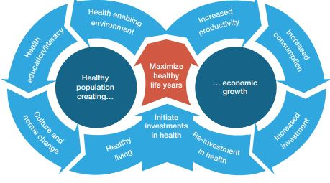
Figure 1.1 A Virtuous Cycle: Healthy Life Years as a Source for Continuous Economic Growth. From World Economic Forum (2015)

The Need for the Examination of the Healthy Spectrum of Older Age
It is evident that the statement from the WEF (2015) focuses on the dynamic in shaping an older but healthy population, and equally frames the threat and the “burden” that can be posed by a potential increase in the numbers of unhealthy older adults. These statements find great support in a body of research that examined extensively age-related pathologies. Yet, they could not have relied to any great extent on empirical findings that examined the healthy spectrum of ageing. As Johnson and Mutchler (2013) argue, much of the literature on ageing has concentrated on the inevitable decline of human capacity and dependency rates in older age, whereas only recently and only some scholarly efforts have addressed the positive aspects of ageing. A positive approach to older age constitutes the foundations of positive gerontology, emphasizing on older adults’ productivity, contribution to society, as well as their civic engagement.
Similar conceptualizations of positive aspects in older age are often referred to as successful ageing. Some researchers used the term successful ageing to describe the prevalence of positive outcomes in older age, such as joy, happiness and satisfaction (Carstensen, Isaacowitz, & Charles, 1999; Havighurst, 1963; Maddox, 1970). Others used the term to describe the effective functional adaptation of older adults, namely the process of maintaining behavioural performance despite cognitive deteriorations (Baltes & Baltes, 1990; Freund & Baltes 2007). The most elaborated model of successful ageing was offered from Rowe and Kahn (1997), a medical doctor and a psychologist who argued that good physical, social and mental health in older age determine how positive the developmental outcomes are in later stages of life.
Many researchers have adopted Rowe and Kahn’s (1997) model to form specific indicators of “success” in older age (Hsu & Jones, 2012; Ng et al., 2011; Wahl et al., 2013). Most of these studies however described risk ratios and prevalence rates of diseases and disability in older age, interpreting the avoidance of such conditions as success. Although providing invaluable knowledge, this approach shifts the scope of examination away from the healthy spectrum of ageing, focusing more into the illustration of age-related pathologies. A similar trend can be observed in the discourse of cognitive ageing. As it is stated in the Alzheimer’s Association (2017) official website
Dementia is often incorrectly referred to as "senility" or "senile dementia," which reflects the formerly widespread but incorrect belief that serious mental decline is a normal part of ageing.
A representative and influential example is the extensive review of Hertzog et al. (2009), who examined the factors that influence cognitive decline with ageing. Based on the evidence of this review, the authors offered a theoretical framework (Figure 1.2), which depicts a set of differential cognitive decline trajectories depending on a number of social (i.e., social engagement, socioeconomic status, education) and behavioural (i.e., physical activity) factors.
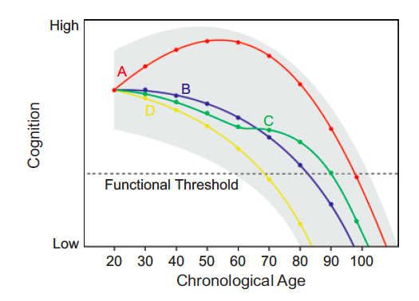
Area A

Area B

Figure 1.2 Differential cognitive decline trajectories over the life span and the threshold of functional loss. Area A represents the healthy spectrum of cognitive ageing. Area B represents the pathological spectrum of cognitive ageing. Adapted from Hertzog et al. (2009)
The conceptualization of cognitive ageing as depicted in the theoretical framework of Hertzog et al. (2009) embraces a large range of interventions (and a respectable proportion of public spending in research funding) to boost cognitive vitality and prolong the average years living independently (Bamidis et al., 2014; Diehl et al., 2005; Jobe et al., 2001). Such interventions are based on the rational that improvements in cognitive performance within the course of adult development carry the potential to alter favourably cognitive decline trajectories (as depicted with the green line C in Figure 2) and postpone the point at which poor cognitive performance bridges a threshold of functional dependency.
This assumption could have a firm theoretical basis if everybody would bridge the threshold of dependency when growing older. This position however does not fit well with existing epidemiological evidence (Anderson-Ranberg, Vasegaard, & Jeune, 2001; Ball, Ross, & Viamonte, 2010) which suggests that the effect of cognitive training interventions in postponing functional dependency is not consistent. Such a beneficial effect can be only concluded safely if longitudinal studies using intervention and control groups will detect to the former reductions in the risk of developing age-related neurological diseases, or a difference at the point that functional dependency is manifested. Such studies are costly and hard to implement, and therefore, there is scarce relevant evidence in this direction to this date. Instead, many argue for the protective effect produced by cognitive training intervention for cognitively healthy older adults based among others on the assumption that cognitive performance and everyday functioning are strongly related, and that the threshold is to be reached at some point in life.

Advancing the Discourse of Ageing in the Healthy Spectrum of Cognitive Performance
The discussion so far has concentrated on the gap that exists in the examination of the healthy spectrum of cognitive ageing and the associated peril in proceeding with false assumptions concerning the cognitive ageing process. The discourse of cognitive ageing carries the potential to provide better information about the typical (healthy) spectrum of cognitive performance in older age, by providing more precise theoretical models of cognitive ageing. Such models can be utilized to inform policies that aim to boost economic growth and prosperity through positive cognitive outcomes in older age. Such information cannot be anticipated by examining the avoidance of age-related neurological diseases, but by examining how functioning and cognitive vitality in older age evolves in the absence of any age-related cognitive neuropathology. In order to support the latter objective, the healthy spectrum of cognitive ageing has to be examined explicitly and as vigorously as the pathological spectrum of cognitive ageing.
In this discourse, it is important to examine the social factors that influence older adults’ successful adaptation to a set of healthy lifestyle choices. This would (to great extent) discourage negative outcomes in older age being interpreted as the failure of older adults to adapt, or seeing older adults as the sole potential agents of change in the context of healthy and active ageing policies and practises. Incontrovertibly, there are certain social inequalities in terms of income, gender, and education, which shape the ageing process. These inequalities can be observed and measured (Aichenbaum & Brengston, 1994; OECD, 2017).
A large volume of research has already established the effect of social inequalities in terms of Socioeconomic Status (SES) and access to health on the occurrence of age-related neurological disorders (Hertzog et al., 2009; Wilson et al., 2009). The potential relationship between SES, social participation, mental and physical exercise with cognitive and functional decline in the healthy spectrum of cognitive ageing has not been established directly, but rather is often assumed in the context of avoiding age-related neurological pathologies. A recent meta-analytic review (Young, Angevaren, Rusted, & Tabet, 2015) and a number of large-scale longitudinal studies (Christensen et al., 2001; Hofer et al., 2002; Mackinnon, Christensen, Hofer, Korten, & Jorm, 2003; Tucher-Drop, Johnson, & Jones, 2009; Wilson et al., 2009) have challenged the assumptions that SES, social participation, mental and physical exercise have the same effects on cognitively healthy older individuals, as they do on those affected by an age-related neuropathology .
This thesis examines the relationship between social factors (i.e., SES) and engagement in health-related behaviours (i.e., physical exercise, mental exercise, social participation) on cognitive vitality, restricting the sample used for this examination to cognitively healthy older adults. In other words, this research deviates from an examination of the pathological spectrum of cognitive functioning, and examines whether the beneficial effects of SES, social participation, mental activities, and physical exercise can be evidenced among cognitively healthy older adults. Such an examination lies at the intersection of social gerontology and neuropsychology, made possible by quantitative methods that assess social participation, physical exercise, as well as performance in neuropsychological and everyday functioning assessments. For the purpose of informing theory and policies for the typical (non-pathological) spectrum of cognitive vitality, the thesis will use an interdisciplinary, culturally sensitive approach.

Research Questions and Hypothesis
The following research questions are addressed in this thesis:
  - Research Question 1: Is cognitive performance related to everyday functioning among cognitively healthy older adults? This research question is addressed in Chapters 4 and 7.
  - Research Question 2: Does cognitive performance mediate age-related decrements in everyday functioning? This research question is addressed in Chapter 7.
  - Research Question 3: Are older adults’ cognitive and functional performance related with SES, social participation, education, and participation in mental and physical activities? This research question is addressed in Chapter 7
  - Research question 4: Do social participation, education, and participation in mental and physical activities moderate age-related decrements in cognitive performance? This research question is addressed in Chapter 7
The hypotheses formation was driven by the normative arguments that are shaped within the current paradigm of cognitive ageing, and which are expressed in influential theories and policies to date, as described above. More precisely, it was hypothesized that
- Hypothesis 1: Cognitive performance will be related with everyday functioning in the healthy spectrum of cognitive performance.
- Hypothesis 2: SES, social participation, education, mental and physical exercise will be related with everyday functioning through cognitive performance among older adults.
- Hypothesis 3: SES, social participation, education, mental and physical exercise will be related to cognitive performance among older adults.
- Hypothesis 4: Social participation, education, mental and physical exercise will moderate the relationship between age and cognitive performance

Contribution to Knowledge
This thesis contributes to the current state of knowledge in several ways. Several reviews have examined the relationship between cognitive vitality and functioning in the past (Martyr & Clare, 2012; Royall et al., 2007), yet, no reviews in this respect have been made explicitly on the healthy spectrum of cognitive performance. Measures of everyday functioning are the only tangible and observable outcomes that can inform scholars and policy makers about seniors’ ability to live independently, as well as whether improvements in cognitive performance lead to better functional outcomes in older adults’ everyday life. This thesis provides the first statistical meta-analyses examining the relationship between cognitive performance and everyday functioning in the healthy spectrum of cognitive ageing. In this way, it provides evidence on the relation between seniors’ cognitive vitality and everyday functioning in the healthy spectrum of cognitive performance, and more precisely on i) the strength of the relation, ii) which cognitive domains seem to relate more with everyday functioning, and iii) which everyday functioning assessments have better psychometric properties.
Secondly, the available tools for assessing everyday functioning in Greece are not designed to detect performance fluctuation among healthy older adults, rather than that they focus on functional restrictions posed by certain pathologies. The only available tool that theoretically examines cognitively healthy older adults’ everyday functioning is the Greek translation of the IADL (Mystakidou et al., 2013). This measure can serve as a self-report, or as an informant report questionnaire-based assessment of everyday functioning. Concerns have been raised however that this instrument is susceptible to self-evaluation biases, because participants tend to present themselves in the best positive light (in the case of self-reports), or to overestimate/underestimate everyday functioning in others (in the case of informant-reports). Observation-based and performance-based assessments provide a useful alternative, as they are more objective measures of everyday functioning (Diehl, Marsiske, Horgas, Rosenberg, Saczynski, & Willis, 2005). In this research therefore, one observation-based and one performance based everyday functioning measure were translated, culturally adapted and validated for research purposes among cognitively healthy Greek older adults. These tools are the first of their nature to be used in the Greek cultural context.
There is little dispute that the sum, type, and frequency of seniors’ social participation may be heterotypical among cultures. Gross cultural disparities in social relations and self-identification (i.e., individualistic societies vs. collectivistic societies), as well as subtler cultural disparities among interrelated states (i.e., between states within the European Union), has been shown to influence seniors’ social behaviour (Christelis & Dobresku, 2012; Fiori, Antonucci & Akiyama, 2008). This thesis reports the first study that examined cognitively healthy seniors’ social participation in Greece, providing a deeper insight in the most representative sample of older Greeks, namely those that are cognitively healthy.
The current paradigm on cognitive ageing describes that SES, social participation and physical exercise have an effect on cognitive and functional decline with ageing. This paradigm has not been well grounded in scientific evidence, as considerable (though sparse in number) publications (Wilson et al., 2009; Young et al., 2015), as well as conceptual and methodological issues, challenge the generalizability of these effects to the healthy spectrum of cognitive performance in Greece. This thesis adds to the body of knowledge concerning the operation of these factors in the healthy spectrum of cognitive performance, using a methodology that respects the differentiated nature of cognitive vitality in the pathological and the non-pathological spectrum of cognitive performance.

Thesis Plan
Chapter 2 defines key concepts in gerontology that are relevant to this investigation, such as who is considered old and who is considered cognitively healthy. What follows is an outline of concepts that describe positive outcomes in older age, some of which constitute the foundation of positive gerontology. There, a critical approach is used to identify significant gaps in describing positively and more accurately the cognitive ageing process. Chapter 3 consists of a literature review on cognitive ageing, in order to examine and approach critically i) the factors that influence cognitive performance in older age, ii) the relation between cognitive performance and everyday functioning in the healthy spectrum of cognitive ageing, iii) the methodologies and the measures used to assess SES, social participation, mental and physical exercise, cognitive performance and everyday functioning.
Chapter 4 addresses the first research question and begins by discussing the relation between cognitive performance and everyday functioning among cognitively healthy older adults, focusing on the healthy spectrum of cognitive performance. Then, it describes a systematic literature review on the topic using a set of keywords, followed by the process of extracting effect sizes from relevant studies. It continues by presenting the raw data and by conducting a meta-analysis on them. Lastly, it presents the research findings of the analysis and provides some conclusion on the relation between cognitive performance and everyday functioning among cognitively healthy older adults.
Since no measures suitable for assessing everyday functioning in cognitively intact Greek seniors exist, one performance based and one observation-based measure of this nature were translated and culturally adapted in Chapter 5. This Chapter describes how the original measures of Everyday Problem Test – 24 items (Willis et al., 2006) and the Observed Tasks of Daily Living – Revised (Diehl et al., 2005) were translated in the Greek language using the translation-back translation process, as well as culturally and linguistically adapted to the Greek context, using the Geisinger (1994) suggestions. Chapter 4 describes the results and the conclusions for the translation and adaptation process, noting that the reliability and validity analysis of the measures will be conducted in the fieldwork of the thesis (i.e., Chapter 7) .
Chapter 6 addresses the methodology used for the examination of the four research questions and their related hypotheses, by proposing a specific examination model and a corresponding research protocol. This model describes a series of direct and indirect effects, that provide either predictions, moderation effects, or mediation effects. Although describing one original study, the analysis of the relevant data is completed in a stepwise fashion, following an examination model. This chapter gives a full account of the process followed to examine restrictively cognitively healthy older adult, excluding those who may suffer from Mild Cognitive Impairment (MCI; Petersen, 2004). The measures used to assess social participation, SES, mental and physical exercise, along with their operationalization are described in the final section of this chapter.
The analysis of the thesis’ fieldwork is presented in Chapter 7, by providing a short introduction for each step followed in the analyses, along with an explanation of the statistical means used. The statistical techniques used and their interpretation followed the recommendations of Frazier, Tix and Barron (2004), as well as of Salthouse and Pink (2008), in order to establish predictions and moderation effects using regression analysis, and mediation effects through Structural Equation Modelling. The analysis of each step follows a brief discussion of the results.
Chapter 8 brings the discussion together, stressing the assumptions that have been made in the prevailing paradigm of cognitive ageing so far, juxtaposing them with the findings of this thesis, both from the empirical research, as well as from the literature review. It discusses issues raised throughout the preceding chapters and stresses and justifies the need for the formation of a more accurate and positive theoretical framework of cognitive ageing. Chapter 8 concludes by summarizing how the research questions have been addressed, how these have contributed to scientific knowledge, and how this contribution has policy-making implications, as well as implications for research and clinical practises. The last chapter also provides some possible directions for future research, in order to develop further knowledge concerning the ageing process by adopting a more positive approach in the examination of the effects of age on mental abilities.

CHAPTER 2 THE AGEING POPULATION AND THE CONCEPT OF ‘SUCCESSFUL’ AGEING

Introduction
This chapter describes relevant key concepts in the field of gerontology, such as who is considered old and healthy, what the ‘ageing population’ is, and discusses why the latter produced financial considerations that have led to extensive discussions in policy making. The discussion focuses on the central position that health has in the conceptualization of positive outcomes with ageing, which often have been termed as ‘successful ageing’. The findings of the literature review are synthesized and approached critically, in order to identify whether various theories developed to describe positive outcomes with ageing have addressed the healthy, non-pathological spectrum of ageing, thus producing an accurate depiction of cognitive ageing.

Method
The methodology followed to retrieve information from the ageing discourse was the typical one used in desktop research, namely a literature review. The articles were retrieved from an online search conducted in the database of the University of Sheffield. This database includes the most well-known scientific catalogues of scientific journals, such as Scopus, EBSCO, Web of Knowledge, and APA. No restriction on date of publication was imposed, where the articles were chosen based on their relevance to the topics of ageing, cognitive ageing, positive outcomes with ageing, successful outcomes with ageing, healthy and active ageing. The findings were supplemented from sources referenced in the articles retrieved and with information retrieved from a typical search using the Google search engine.

Who is Old?
Defining who is considered old, or else, how to define the threshold of old age, constitutes a great challenge. The French statistician Quetelet (1836, as cited in Hamilton, 2012) placed the onset of old age in the 60th year of life, claiming that at this age, most of the human energy gets lost, and the probability of living longer becomes vastly smaller. It is relatively unknown if these arguments held true for those living in the 19th century, but one can be doubtful about their relevance nowadays. Recent studies have challenged whether the point of decay for many mental processes is the age of 60, as the relevant empirical findings depict that some cognitive abilities start to decay much earlier, whereas others do not manifest any significant decay (Hamilton, 2012; Hertzog et al., 2009; Salthouse, 2006; Shaie, 1994).
Despite that, tendencies to demark old age using criteria such as retirement, decays in appearance, and proximity to death still persist (for a review, see Hamilton, 2012, p. 1-6). These do not comprise a valid set of criteria for the systematic examination of the ageing process, as they do not offer any discriminative or differential ability. Retirement and pensions for example, are inventions of the 19th Century that initially served as incentives for older workers to retire and “make room” for the younger generations in the labour market. Following this rational, many who were not working (e.g., a large percentage of women in the 50’s that have never being placed in paid jobs), or were never granted a pension, cannot be considered old at some point in their lives. Similarly, appearance, health status, and proximity to death vary and it is not age dependent; one may look younger, or be healthier, than most people of their age, or may be closer to death due to illness. That does not mean that they could (or could not) be acknowledged as old individuals. As Hamilton (2012, p.3) stresses:
It is perfectly possible to argue that by having a threshold age, we lose sight of the fact that age is a part of the continuum. We do not become old overnight when we reach 60.
The same author argues that most age thresholds set by researchers in the literature are arbitrary, and as such, they do not demark the onset of old age. As the World Health Organization (WHO, 2017a) argues:
Most developed world countries have accepted the chronological age of 65 years as a definition of 'elderly' or older person … while this definition is somewhat arbitrary, it is many times associated with the age at which one can begin to receive pension benefits. At the moment, there is no United Nations standard numerical criterion, but the UN agreed cut-off is 60+ years to refer to the older population … The ages of 60 and 65 years are often used, despite its arbitrary nature, for which the origins and surrounding debates can be followed from the end of the 1800's through the mid-1900's.
In other words, the WHO (2017) accepts its inability to apply strict numerical criteria to demark the onset of old age, thus the age threshold of 60 can be used only as a ‘working definition’. In this context, the Survey of Health, Ageing and Retirement in Europe (SHARE, 2017), the largest longitudinal study conducted among 120,000 non-institutionalized populations in 27 European countries (with the addition of Israel) have used the age threshold of 50 as their working definition of older age. The same working definition of old age has been adopted by the English Longitudinal Study in Ageing (ELSA, 2017), by the Health and Retirement Study in the United States of America (HRS, 2017), as well as by the Japanese Study of Aging and Retirement (Research Institute of Economy, Trade and Industry, 2017). Differently, but still deviating from the practice proposed by WHO (2017a), the China Health and Retirement Longitudinal Study (CHARLS) and the Longitudinal Aging Study in India (LASI, 2017) use the age threshold of 45 as their working definition of older adults.
Given that there are not valid scientific criteria that demark the onset of older age, and given that there is not a great consensus for the definition of older age, this thesis follows the example of the SHARE, ELSA and HRS studies and uses the age of 50 as the working definition of older age. This working definition does not imply any onset of any kind of decline at this age, but is used purely to facilitate the discussion around the progressive nature of ageing, and to define the target population of examination in this thesis.

Who is Healthy in Older Age?
Equally challenging with defining who is old is to define who is considered healthy in older age. The WHO conceptualizes health as ‘the complete physical, mental, and social well-being, not simply the absence of injury or disease or infirmity’ (WHO, 2017b). This conceptualization is known as the biopsychosocial paradigm of health, adopted and described by WHO for the first time in 1948 (as cited in WHO, 2017b). The advantages of the biopsychosocial paradigm of health are that it uses a life span and dynamic perspective. As such, the mere absence of disease is not considered a good predictor of positive health outcomes in the future, as concurrent malignant lifestyles (e.g., smoking, obesity, sedentary lifestyles) or social conditions (poverty, poor access to health and quality diets) may predict adverse health outcomes in the near future.
The disadvantage of the biopsychosocial model of health is that it gives a rather rigid and unrealistic definition of health, namely a “complete absence of injury or disease or infirmity”. This kind of health status is hardly prevalent among older adults. Epidemiological studies illustrate that 80% of older adults have one chronic condition, and 50% have at least two. The leading causes of death among older adults are chronic conditions, such as heart diseases, cancer, stroke, respiratory diseases, Alzheimer disease, and diabetes (CDC, 2011).
The vast majority of chronic conditions are not debilitating to a great extent. Hypertension for example is a condition that differentiates one’s health status from the “complete absence of injury or disease or infirmity”, but when treated adequately it does not have an adverse effect on ones’ productivity or functional ability. The continuous treatment for hypertension may be translated to constant health care costs (e.g., for medication), however, they are far less expensive compared to those needed in the case of frailty. As such, it is questionable if an individual suffering from hypertension or any other treatable condition that does not affect productivity or functional ability can be considered as 'unhealthy' or as a frail older adult.
The definition of health has a particular importance in policy making processes, as retaining a good state of health and an active lifestyle in older age has become an articulated political objective with a dual value; to maximize seniors’ productivity in goods or services, and to restrict public expenditure for health care costs (Walker, 2002). This raises the question whether in the political dialogue, the criteria used to define good health in an older person are as strict as denoting the complete absence of any illness or other health conditions, or if it is closely tied to health care costs and productivity. A precise definition of good health may facilitate the direct comparison of relevant scientific findings and inform policy makers better in this respect. A “loose” interpretation of health would make the synthesis and comparison of empirical results from different studies on health a very difficult task, but it would offer a more pragmatic view of what constitutes a good (but not perfect) health status in older age. As Glass (2003) stated (p. 382):
We must protect ourselves against the belief that successful ageing is impossible if disease and disability occur. If our concept of successful ageing includes dignity, autonomy, social engagement, and the absence of suffering, we will be better positioned to configure our systems of care to address the needs of older populations
Under this light, older individuals that are treated for chronic conditions could be considered both as ‘healthy’ and ‘productive’ adults, whereas seemingly healthy individuals with unfavourable social characteristics and habits could be considered members of an at-risk population. Given the complexity of assessing and categorizing physical health with empirical means, physical health will not be considered as an inclusion/exclusion criterion in this thesis. The implications of cognitive health however will be examined thoroughly. As it will be described in the next section, defining who is cognitively healthy proves to be a much easier task, and therefore, cognitive health will be a defining criterion for the empirical part of this thesis.

Who is Older and Cognitively Healthy?
In the first chapter, it was illustrated that cognitive decline with ageing is an inescapable process in life. In this context, only the occurrence of age-related neurological disorders lead to severe functioning impairments (Alzheimer’s Association, 2017; Farias et al., 2009; Kramer, et al., 2004; Petersen, 2004). The term commonly associated with age-related cognitive decline is that of dementia, an umbrella-term that includes a wide range of age-related neurological disorders, Alzheimer’s being the most representative and prevalent example. It is estimated that to date, 1-10% of older individuals live with Alzheimer’s dementia after the age of 65 with women being affected twice as frequently as men (Alzheimer’s Association, 2017; Hamilton, 2011).
Despite the vigorous examination of this disease and the numerous publications produced on this topic, there is not a broad consensus for the exact prevalence rates of Alzheimer’s disease (Brookmayer, Gray, & Kawas, 2007). The main reason for the disparity among epidemiological studies is the debate on whether Mild Cognitive Impairment (MCI) is the pre-clinical stage of Alzheimer’s disease or not. This condition is characterized by subtle cognitive impairments accompanied by subtle everyday functioning impairments (Petersen, 2004), and affects 20% of those older than 65 (Alzheimer’s Association, 2017), differing from Alzheimer’s in the severity of the underlying symptoms.
Studies support that the cognitive function of those diagnosed with MCI can either reverse to normal (an estimated 20%), progress to Alzheimer’s (an estimate of 20 to 40%), or remain stable (Roberts & Knobman, 2013). In contrast, Alzheimer’s disease has a progressive nature that inevitably leads to death. As such, some argue that MCI is the pre-clinical stage of Alzheimer's disease despite its differential nature, whereas others argue that MCI should be regarded as a separate diagnostic category. Depending on whether MCI is included as the pre-clinical stage of Alzheimer’s disease in epidemiological studies, the prevalence rates of Alzheimer's disease can vary from 1-10% (Hamilton, 2011).
In this thesis, cognitively healthy older adults are considered those who are older than 50 and have not suffered a stroke, do not have an official diagnosis of Alzheimer’s disease, or of any other form of dementia, including that of MCI. These criteria will be applied to ensure that the target group under examination will represent those that are free of any indications of impaired cognitive ability, thus representing the healthy spectrum of cognitive performance in older age.

The Challenges posed by the Demographic Change into an Ageing Population
The ageing population refers to a change in the distribution of age, where older adults increasingly account for a greater percentage of the population. This demographic change has been explained as the result of a simultaneous but inverse tendency where i) the average life expectancy at birth has increased sharply the last 100 years and ii) fertility and birth rates have declined sharply the last 50 years (Hamilton, 2011). To the extension of the average life expectancy have contributed the vast advances in medicine, hygiene, and nutrition, which in turn have resulted in a decrease in acute and life-threatening diseases. As a result, from an average life expectancy of 50 years in 1900, developed countries have experienced a rise to almost 80 years in 2009 (Population Reference Bureau, 2016a). This tendency continued in Europe during the period 2002-2015 (Figure 2.1), where the average life expectancy increased by 2.9 years in this specific time period, from 77.7 to 80.6 years (Eurostat, 2017).
Inversely, modern lifestyles in western societies and financial strains in various periods after the Second World War have led to decreased rates of fertility and to a significant decline in birth rates (Figure 2.3), which are estimated to decrease further due to the recent era of economic recession (Population Reference Bureau, 2016b). In the European Union for example, there was an evident decline in birth rates in the period 2013-2015, with the lowest birth rates reported in Greece, Spain, Cyprus and Portugal. Namely, those countries applied for financial help from the European Union in order to avoid bankruptcy during this period (Eurostat, 2017b).
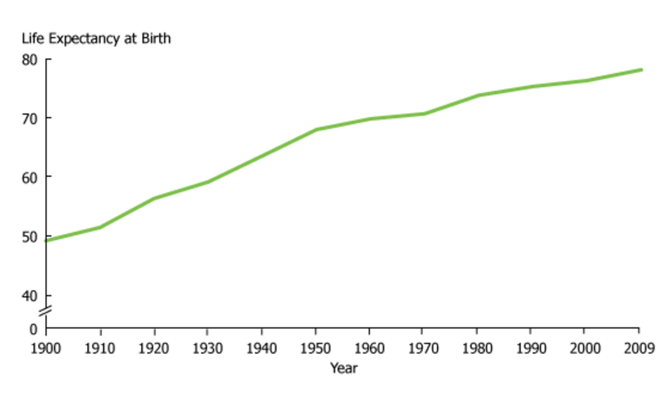
Figure 2.1 Life expectancy at birth in the United States, in the period 1900-2009. From the Population Reference Bureau (2016a)

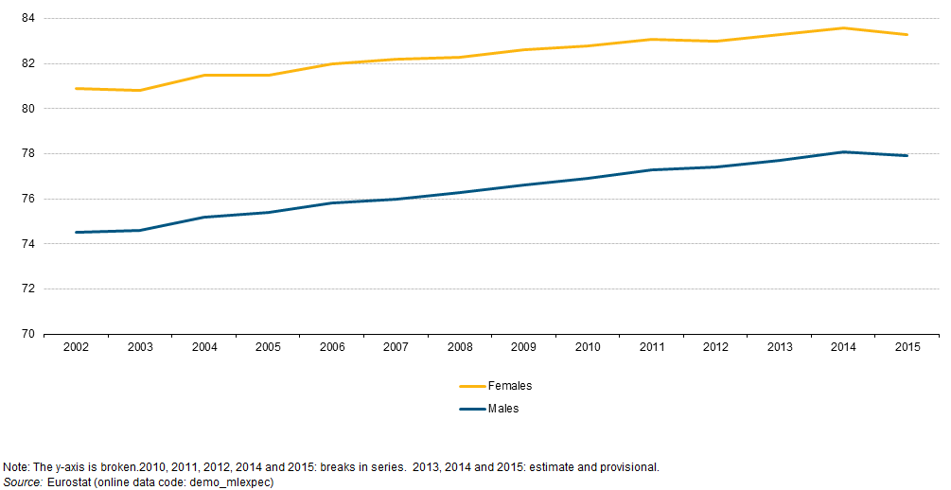

Figure 2.2 Life expectancy at birth in the European Union, in the period 2002-2015. From Eurostat (2017a)
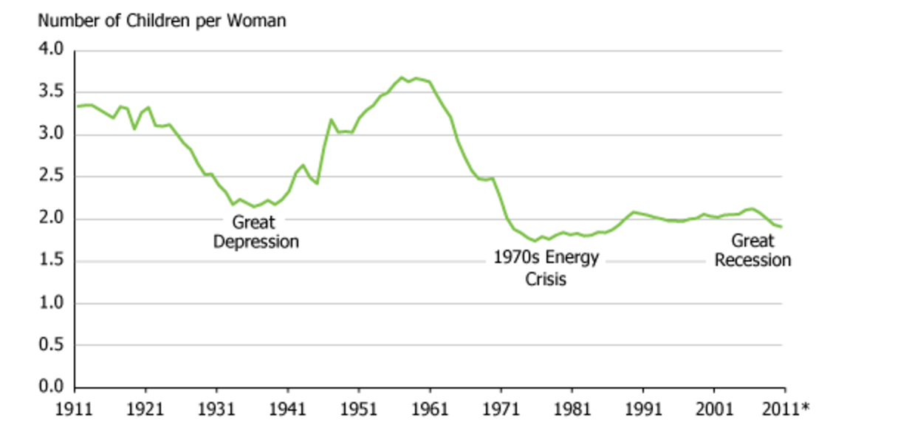
Figure 2.3 Fertility rates in the United States, in the period 1911-2011. From the Population Reference Bureau (2016b)

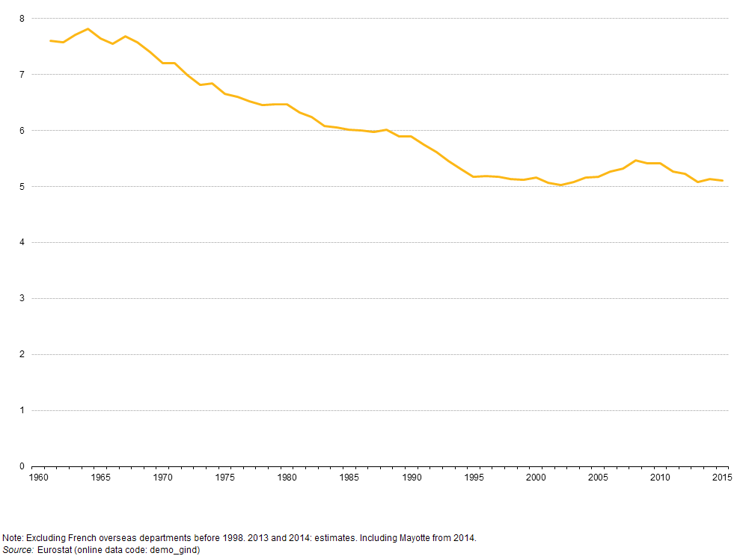
Figure 2.4 Fertility rates in the European Union, in the period 1960-2015. From Eurostat (2017b)
Somewhat differently than the rise of the average life expectancy in the last century, the decline in birth rates did not follow a homogeneously progressive decline. A visual examination in Figure 2.3 reveals that there was an explosion of new births at the end of the Second World War, a generation that is widely known to date as the baby-boomers (Atchley & Barush, 2004). The representation of the baby-boom generation (who have reached their retirement age to date) accounts for 19.3 % of the population in the European Union, with Greece having the second highest share (21.3%) among the 28 member states.
The Bank of America Merrill Lynch (2014) published a report starting that the specificities of the demographic change into an ageing population will produce severe financial sustainability risks for the retirement system in the near future. The risks stem from the expected upsurge of pension beneficiaries to 77% in the period 2010 to 2050, and the parallel shrinkage of the workforce to 16%. According to the same report, by 2050 and for any developed country, this may be translated in additional costs up to 50% of the Gross Domestic Product (GDP). These costs are based on the calculation of the old-age dependency ratio, namely the ratio between the populations that comprises those of working age (ages 16-65), to those eligible for receiving pensions (ages 65+).
The old-age dependency ratio is a rather gross estimation that conceptualizes financial productivity as the only measurable contribution of citizens to society. In this context, younger and middle-aged workers are regarded as the only productive members in a society, within which they contribute to the sustainability of their own needs, as well as through their salary and tax withholding for state pensions and health care systems. At the same time, older adults are regarded as unproductive and passive recipients of state pensions and health care schemes, therefore dependent upon the former group of workers.
This conceptualization contains several inaccuracies that lead often to erroneous conclusions and ageist views. For example, the old-age dependency ratio assumes all individuals over the age of 65 are pensioners; but the demographic evidence cannot support this view. Many business owners, consultants and politicians for example remain in the working force way beyond the age of 65, whereas many pensioners take on part-time or substitute jobs (International Longevity Center-USA, as cited in Kaye, Butler, & Webster, 2003). In addition, seniors are significant contributors in society, for example as tax payers, by covering childcare needs for working parents, and by producing a broad array of social benefits through volunteering.
Two working parents in the same household has become increasingly the traditional family structure in western societies, which poses important child rearing needs within the core family (Wheelock & Jones, 2002). Although formal care structures can cover some of those needs, many times it is a solution that becomes unfeasible or insufficient, due to financial strains or due to additional hours for childcare needed. Much of those childcare needs are taken over by grandparents, without any financial compensation being sought (Livingston & Parker 2013; Wheelock & Jones, 2002).
The financial quantification of seniors’ contribution to childcare has not been explored thoroughly yet, though seniors’ participation in volunteering has been. More precisely, seniors’ participation in volunteering in the US has been estimated to correspond to 36 billion hours of services, valued in 1993 up to 15.3 million dollars (Fisher & Shaffer, 1993). Finally, the old-age dependency ratio ignores that much of seniors’ health care needs are not covered from state welfare systems. It is indisputable that older age brings higher than average rates of long-term care needs due to illness and frailty than any other age group. However, the evidence of Bien et al., (2013) study in 6 European countries (i.e., Germany, Greece, Italy, Poland, United Kingdom, Sweden) illustrated that the largest proportion of long-term care is not covered by formal structures, especially in those countries that have poor social services (e.g., Greece, Poland, Italy). Consequently, most of the (unmet) care needs of older frail adults are covered informally by their spouse or another member of the family (Pinquart & Sorensen, 2011).
The old-dependency ratio may have contributed to overstating and overestimating the financial “burden” of the ageing population, and obscuring the positive and contributing dynamics of this age group (Walker, 2002; Walker & Maltby, 2012). The examination for positive outcomes in older age, as well as seniors’ contribution in society can be seen as an effort to remedy the financial concerns brought by a demographic change into an ageing population, or as a ‘rallying cry for elders’ advocates looking for a more positive approach to ageing’ (Walker, 1999, p.123).

The Development of Successful Ageing Concepts
After the end of the Second World War, there was a conscious effort in the United States of America ‘to secure the kind of knowledge which may assist ageing persons on such questions as employment, health, civic participation and the issue of leisure time’ (Committee of Human Development, 1947). Only limited evidence was available at the time for the ageing process, mainly stemming from the psychoanalytic perspective and the work of Erikson (1950) on the stage theory of psychosocial development. According to the latter, in each period of life, certain emotional or motivational conflicts occur, where a person may (or may not) resolve effectively. A successful psychosocial development can be achieved only by resolving effectively the conflict of the specific developmental stage, giving the necessary psychological maturity to move into the next one.
Erikson’s theory (1950) was hardly based on empirical evidence, dealing mainly with older adult’s psychological adaptation in the ageing process. In other words, it gave little insight into seniors’ social behaviour and the social context. Using a different approach, Cumming and Henry (1961) conducted a large-scale study by observing a large sample of Kansas City’s residents. The authors used a sociological perspective and concluded that old age is marked by a gradual withdrawal from society, presumably as a consequence of retirement and the death of loved ones, which results inevitably to a mass loss of social ties. Social withdrawal with ageing was understood as a ‘natural’ process, since realizing one’s mortality leads to lose any motivation for personal welfare, preparing for one’s own death. The conclusions of Cumming and Henry (1961) were summed up in the disengagement theory.
Since its publication, the disengagement theory has been criticized vigorously. At the same time however, it stimulated many scholars to engage in empirical research to support a more positive view of ageing. In this vein, Havighurst (1963) through activity theory, and Atchley (1971) through continuity theory, argued that ageing successfully means to maintain middle-age activities and attitudes as long as possible in older age. Many commented that this might be a desirable goal, however as an approach, it neglects the biological limitation that the ageing process brings upon. As a consequence, the activity and the continuity theories were criticized as being too idealistic and unrealistic (Hamilton, 2012). Walker (2002, p. 122) commented:
… successful ageing was to be achieved by denying the onset of old age and replacing those relationship, activities and roles of middle age that are lost with new ones in order to maintain activities and job satisfaction … it placed an unrealistic expectation on ageing individuals to maintain the levels of activity associated with middle age through to advanced age.
Havighurst (1963) and Atchley (1971) had great difficulties in developing measurable indicators, in order to support their theory. Reacting to this need, the Baltimore Longitudinal Study of Ageing (BLSA) was set out to examine the ageing process from a multidisciplinary perspective. The basic assumption of the BLSA scientific group was that the pure effect of ageing (also referred to as normal ageing) is distinct to the processes that characterize the occurrence of illness and disorders. As it was stated (Shock, 1984, p. 22):
Although ageing changes proceed at a much slower rate than changes that occur with growth and development, and are often associated with decrements in performance, it cannot be assumed that ageing is always characterized by impairment of function ... Although the incidence of disease increases with age, ageing and disease are not synonymous
The scientific group of the BLSA study was based in Duke University, and traced 1000 seemingly healthy individuals for over 23 years (starting from 1957), with women being underrepresented in many stages of the study. It was the first large-scale study that examined empirically the process of cognitive ageing, examining psychological, medical and behavioural outcomes. More precisely, it measured changes in human physiology (e.g., body fat composition, drug metabolism, pulmonary function and cardiovascular performance), psychological dimensions (e.g., intelligence and personality), and provided evidence for age-related declines in seniors’ cognitive performance using neuropsychological measures of reaction time, accuracy, vigilance, learning, and memory.
The BLSA provided invaluable knowledge for the physiological and psychological changes that occur with ageing. However, it provided limited evidence for the possible effects that income and education might have on those changes. Furthermore, it did not examine as thoroughly the evolvement of civic or social participation with age, and how the latter are influenced, or can predict, physical and cognitive health. Rowe and Kahn addressed these issues by using a more holistic conceptualization of positive outcomes in older age, and by developing the concept of successful ageing (Rowe & Kahn, 1987). This concept advocated for three main components of positive outcomes in older age; i) avoiding disease and disability, ii) engagement with life, and iii) high cognitive and physical function. The authors developed a graphical model that included these components (Figure 2.5), arguing that the area where they overlap depicts successful ageing.

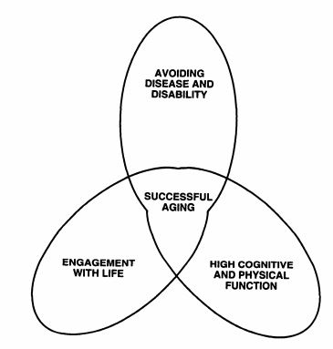.
Figure 2.5 The model of successful aging by Rowe and Kahn (1997)

The Success of the Successful Ageing Concepts
The concept of successful ageing evolved in parallel in the fields of psychosocial and biomedical studies (Glass, 2003) and gained a prominent position, as it provided a theoretical framework for the operationalization of successful ageing indicators. As a model however, it did not provide a suitable context for the examination of positive outcomes in older age, including that of cognitive health. The critique for this model lies in that avoiding health issues appears as a prerequisite in the conceptualization of positive outcomes in older age. Health issues are a concern at any age; yet, avoiding them has not been included as a determinant of positive developmental outcomes in any other developmental model of infancy, adolescents, or middle age. The emphasis in health in the successful ageing model may contribute in creating a subtle impression that poor health is a characteristic of older age, or as Shock (1984) stated that ageing and disease are synonymous, despite their probabilistic nature.
Relevant studies give a provoking illustration of why disability and illness retain a probabilistic nature in older age. Franke (1987) reported that 25% of centenarians have a good functionality, Lehr (1991) reported 18% of them to have little physical impairment and to be very active, Gondo and Hirose (2006) reported 20% of them as being functionally independent with no sever sensory impairment, whereas Arnold et al. (2010) reported 43% of them not having any cognitive impairment (as cited in Johnson & Mutchler, 2013). Cho, Martin and Poon (2012) reported that 48% of the centenarian participants in the Georgia Centenarian Study, as well as 62% of the octogenarians, could be classified as ‘successful’ if the criteria used were those of perceived health, happiness, and economic status. However, none of the centenarians and only 15% of the octogenarians could be classified as ‘successful agers’ when the criteria stemming from the successful aging model from Rowe and Kahn (1997) were strictly applied (e.g., absence of disease).
It may not come as a surprise that studies applying strictly Rowe and Kahn’s (1997) theoretical model as the context for the development of measurable successful ageing indicators (Hsu & Jones, 2012; Ng et al., 2011; Wahl et al., 2013 as cited in Johnson & Mutchler, 2013) were mostly describing risk ratios of diseases and disability, interpreting the avoidance of such conditions as success indicators for older age. This may be because the use of the word ‘success’ to describe positive outcomes in older age puts the ‘yardstick of success to life’s final chapter’ (Glass, 20003, p. 382) by perceiving health in older age as ‘the chimera of younger adults’ health in an older adults’ body’ (Martin et al., 2015, p. 22). As such, the successful ageing model cannot be used (and will not be used in this thesis) as the dominant theoretical framework to examine positive outcomes in older age.
Subsequent concepts developed to describe positive outcomes in older age were not successful in overcoming the inherent limitation of the successful ageing concept. A representative example is the healthy ageing concept. Peel, Bartlett, McClure (2004) reviewed the available literature on this concept, and argued that it served well to describe successful life-course transitions and a lifelong process for optimizing and improving physical, social and mental health in older age. They also commented that although the healthy ageing concept helped greatly to frame policy-making goals and strategies, it failed to provide rigid measurable indicators to validate such processes or outcomes empirically. According to their review, it was argued that:
The arbitrary nature of the definition, populations sampled, domains selected and measures within the domains resulted in considerable variation between the studies in the proportion of the study population classified as ‘healthy ageing’, which ranged from 3% to 80% (Peel et al., 2004, p.115)
Furthermore, they criticized the applicability of the healthy ageing concept in terms that it may apply for the successful ageing concept as well (Peel et al., 2004, p.115):
An example of the confusion relating to the concept of healthy ageing is that, despite policy documents conceiving healthy ageing in positive terms, empirical research has largely been based on negative aspects; mortality, morbidity and disability. Many studies of the aged population have examined functional status decline or restricted assessment to individual disease specific outcomes, such as dementia. Descriptive and evaluative research based on such ‘pathology’ models neglects the vast heterogeneity in health status among older adults, and cannot adequately address the issue of healthy ageing
Other overlapping concepts used interchangeably in the literature in order to describe positive outcomes in older age where that of resilient ageing, and ageing well (Peel et al., 2004). Hicks and Conner (2013) argued that resilient ageing is a healthy ageing concept that has a health promotion perspective, focusing in a clearly stated problem (i.e., the health challenges posed by older age), along with the personal ability to adapt successfully in reducing the related health risks. As a concept, resilient ageing seems to put the responsibility of addressing age-related health challenges exclusively on the shoulders of the older, the obvious shortcoming of that being that it neglects the social determinants of health (e.g., availability of health-related facilities, access to health care). The ageing well concept on the other hand was developed focusing on the lay perception of positive outcomes in older age. In the relevant cross-cultural study from Fernandez-Ballesteros et al. (2010, p.54), it was concluded that:
… a set of key components, such as health, psychological and social components of successful ageing, constitutes a quasi-universal conceptualization in older people themselves.
In this thesis, it is argued that being healthy in older age can be only characterized as a success if the meaning of the word ‘success’ transcends its official etymology: ‘a good result or a happy outcome’ (Douglas Harper, 2016). It is also argued in this thesis that a positive approach to ageing will allow us to examine more thoroughly the healthy spectrum of cognitive vitality, by constraining in the relevant discourse what Depp and Jeste (2006, p.16) termed as a ‘bias towards studying negative outcomes’.
Most concepts that aim at describing positive outcomes in older age consider physical health, psychological health and social context as essential components. The factors contributing to positive outcomes in older age have been described to derive from these three respective spheres, namely the physical, psychological and social ones. The common ground of the aforementioned concepts is that ageing by itself cannot account as the sole factor that determines positive outcomes in older age (i.e., the more the age, the less positive outcomes experienced). Rather than that, the social environment and health related conditions might constitute significant risk factors as well, among others for the occurrence of age-related neurological conditions.

Conclusions
The demographic change in the ageing population has brought certain official concerns, due to the reduction in later life labour market participation, and the parallel increase in pension beneficiaries and health care costs (Bank of America Merrill Lynch, 2014). The ageing population has been more often than not identified as a “burden”, living out of sight the social contribution of older adults in labour, childcare, volunteering, as well as in long-term care (Walker, 2002). Mobilizing the potential of the ageing population can be jeopardized by the increased prevalence of infirmity and disability in older age, a hazard that has stimulated the last 60 years extensive research (Martin et al., 2015). Some approaches have been useful by adopting a life-span perspective and by examining positive developmental outcomes in older age. The model of Rowe and Kahn (1997) has been the most representative example, setting three criteria of successful ageing: avoiding disease and disability, engagement with life, and high cognitive and physical function.
Despites its prominence in science and its ability to set ‘successful’ ageing indicators however, the corresponding efforts have led mostly to describing risk ratios of diseases and disability, interpreting the avoidance of such conditions as success. This approach constitutes an illustration of the pathological landscape of ageing and not the depiction of positive outcomes in older age. As such, the successful ageing concept is not considered in this thesis as a suitable framework to examine positive outcomes in older age. This thesis argues that physical health, psychological health and social integration are essential parts in conceptualizing positive outcomes in older age, as well as three categories of interdependent factors, where a factor from one category (e.g., social participation) can determine outcomes in other categories (i.e., cognitive vitality). Therefore, this thesis will adopt the biopsychosocial model of health to discuss the effects of certain lifestyles and social conditions on cognitive outcomes and everyday functioning in older age.
This thesis will define its target group as those older than 50 years who are cognitively healthy, noting that this age threshold is a working definition to facilitate the discussion around older age, without implying the onset of any kind of age-related decline at this age. Instead of adopting success as a criterion, cognitively healthy older adults will be classified as those who do not have any age-related neurological condition that can challenge their everyday functioning, based on the criteria set by Petersen (2004), and those set of the Alzheimer’s Association (2017) for the respective diagnoses.
The next Chapter discusses the cognitive ageing process and its correspondence to functional ability. Then, the discussion focuses in the healthy spectrum of cognitive ageing, approaching critically the volume of empirical evidence that depict the relation between cognitive and functional decline with ageing, the methodology used in this field, as well as the measures developed for this purpose. Finally, the Chapter evaluates to what extend the vision of positive gerontology to approach the ageing process in a positive manner has been transfused in the field of cognitive neuropsychology successfully.

CHAPTER 3 COGNITIVE AND FUNCTIONAL PERFORMANCE IN OLDER AGE

Introduction
This chapter discusses key concepts in the field of cognitive neuropsychology, such as what cognition is, what everyday functioning is, and how these constructs are assessed through various measures and tests. It gives a brief overview on the inevitability of cognitive decline with ageing, and the theories that have attempted to explain the process of cognitive ageing. Then, it describes the risk ratios for the occurrence of age-related neurological disorders with ageing as described in the scientific literature, implicating the assessment of everyday functioning in the relevant diagnoses.
This chapters aims at answering two fundamental questions: i) what are the factors that influence cognitive and functional performance among cognitively healthy older adults, and ii) what is the relation between the performances in neuropsychological and everyday functioning assessments when examining cognitively healthy older adults. It discusses how in the field of cognitive neuropsychology, the tendency to examine the cognitive and functional shortcomings that occur with age has left the healthy spectrum of cognitive and functional performance under-examined, projecting the properties of age-related neurological condition in the non-pathological spectrum of cognitive ageing. This gap in the literature has created the need to examine empirically the factors that influence cognitive performance and everyday functioning directly among cognitively healthy older adults.
This discussion was developed by approaching the literature on cognitive and functional ageing critically, giving an account on the inherent limitations of several scientific methodologies in producing empirical findings that explain developmental processes in this respect. The chapter discusses how previous research and theory on adult development does not provide an account of the factors that influence cognitive performance and everyday functioning in the healthy spectrum of cognitive ageing, proposing an alternative framework, which justifies the aim of the present Thesis.

Method
The method followed to retrieve information from the literature was the typical one used in a desktop research, namely a literature review. The articles were retrieved from an online search conducted in the online database of the University of Sheffield. This database includes the most well-known scientific catalogues of scientific journals, such as Scopus, EBSCO, Web of Knowledge, and APA. No restriction on date of publication was imposed. The articles reviewed here were chosen based on their relevance with the ageing discourse on cognitive and everyday functioning performance. Several sources of information were books, sought after they were identified in the retrieved articles and regarded from the author as relevant and useful. In addition, some information has been retrieved from a simple search in the web using the Google search engine.

Cognitive Performance and Cognitive Decline with Ageing
Cognition has been described as the sum of many cognitive processes that allows perceiving the world, as well as to think and act upon external and internal stimuli (Marcotte, Scott, Kamat, & Heaton, 2010). As such, cognition is a latent entity that is inferred, assessed, and measured by its products in neuropsychological assessments, or else by one’s cognitive performance. It is assumed that different neuropsychological tests and sub-tests (e.g., memorizing a list of items to shop, executing a task in the correct order), tap on distinct cognitive domains (e.g., memory, attention, language etc.). Age-related decrements in cognitive performance are inevitable in most cognitive domains, but their properties (e.g., in what age the relevant declines commence) and magnitude of decline differs among different cognitive domains. The later remains a controversial issue in the literature, with the factors leading against achieving clarity being methodological and theoretical (Hertzog et al., 2009).
One of the earliest theories aimed at explaining cognitive decline with ageing was the disuse theory (Milne, 1956). This theory posits that several cognitive processes involved in goal directed behaviours decay because the corresponding behaviours are used less over time. This postulation was contradicted by Salthouse (1992), who demonstrated that with age, architects and airplane pilot manifest declines in performance at neuropsychological assessments of visuospatial ability, despite the fact that they utilize visuospatial skills daily in their work. In addition, Salthouse, Berish and Miles (2002) study demonstrated that among older individuals who were engaged in less cognitively stimulating activities, cognitive stimulation couldn’t serve statistically as an independent predictor of cognitive decline with age.
The General Slowing Hypothesis (GSH), also referred to as the processing speed theory (Salthouse, 1996), was offered as an alternative explanation for cognitive changes with age. The GSH argues for a slowing in the transmission speed at the neuronal level, due to biological changes. Salthouse (1996, p. 403) argued that:
Cognitive performance is degraded when processing is slow because relevant operations cannot be successfully executed (limited time) and because the products of early processing may no longer be available when later processing is complete (simultaneity).
Consistent with the GSH are the findings of Cerella (1985) meta-analysis of 35 relevant studies including 69 information-processing tasks, as well as from Sheppard and Vernon (2008) meta-analyses of 172 studies, which reports a robust relation between speed of processing and measures of intelligence. The potential mediation role of speed of processing in cognitive declines with ageing (i.e., reduced speed of processing being responsible for the declines evident in cognitive abilities) has been demonstrated explicitly in studies that examined differences in fluid intelligence (Zimprich & Martin, 2002), reasoning, memory, knowledge, and verbal fluency (Lindenberger, Mayr, & Klieg, 1993), and performance in signal detection tasks (Ratcliff, Thapar, & McKoon, 2001).
Cognitive decline with ageing however is not a homogeneous process. The available empirical evidence depicts that the greater the age of the group under examination, the greater the heterogeneity in scores deriving from neuropsychological assessments (Ardila, 2007; Hertzog et al., 2009). This indicates a developmental process where factors other than age have an effect on cognitive performance, leading to differential paths and outcomes in cognitive vitality among the older. The most influential factors that have been discussed in the ageing discourse are exercise and health, social participation, mentally stimulating activities, and SES.

The effect of Physical Exercise on Cognitive Vitality
One of the basic recommendations for fostering positive outcomes in older age is the adequate participation in physical activity. On their official Internet site, the Centre of Disease Control and Prevention (CDC, 2014) argues that:
As an older adult, regular physical activity is one of the most important things you can do for your health. It can prevent many of the health problems that seem to come with age. It also helps your muscles grow stronger so you can keep doing your day-to-day activities without becoming dependent on others.
The terms physical activity and exercise have been used interchangeably in the literature to describe any type of bodily movement produced by skeletal muscles that results in energy expenditure (Caspersen, Powell, & Christenson, 1985; Prince, Adamo, Hamel, Hardt, Gorber, & Tremblay, 2008). According to Caspersen et al. (1985), the difference between the two terms is that physical activity entails any form of activity performed to sustain life. These activities include sleeping, eating, cooking, working, walking or commuting. Exercise on the other hand is regarded as a subcategory of physical activity, entailing a set of leisure activities that are 'planned, structured, repetitive, and purposive in the sense that improvement or maintenance of one or more components of physical fitness is an objective' (Caspersen et al., 1985, p.128).
In the ageing literature, physical activity is usually described as a set of activities that denote the avoidance of sedentary lifestyles, including a variety of activities, such as housework chores, walking, or gardening (Hertzog et al., 2009). In many studies, this type of activity has been termed as "active lifestyles" (e.g., Hill, Wahlin, Winblad, Beackman, 1995). Physical exercise on the other hand, is mostly described as the purposeful participation of older adults in aerobic or non-aerobic activities. In this direction, the customized CDC (2014) guidelines for seniors recommend at least 2.5 hours moderate intensity aerobic activity per week (e.g. brisk walking), or alternatively, 1.25 hours of intense aerobic activity (i.e., jogging or running).
A direct link of the CDC (2014) recommendations for fostering health in older age, with the scientific evidence based upon which these recommendations were made could not be traced. However, there is ample relevant empirical evidence in the literature depicting significant physical and mental health benefits deriving from physical activity. For instance, Morris, Heady, Raffle, Roberts and Park (1953) have demonstrated early on that physical activity and death rates from coronary heart diseases are inversely related. Relevant evidence for the beneficial effects of physical activity exists on avoiding the occurrence or the severity of osteoporosis (Kelley, 1998), cardiovascular diseases (Oguma & Shidona-Tawaga, 2004), type 2 diabetes (Laaksonen et al., 2005), as well as of colon and breast cancer (Lee, 2003).
In turn, such pathologies have been related with poorer cognitive vitality (Cukierman, Gerstein, & Williamson, 2005; Daliento, Mapelli, & Volpe, 2006; Nail, 2006), indicating an indirect relation between physical activity and cognitive performance through health. This relation is mediated by a compromised pulmonary function and consequent poorer oxygenation of neurons in the brain (Moss, Franks, Briggs, Kennedy, & Scholey, 2005; Ortapamuk & Naldoken, 2006). On the other hand, better cardiovascular conditioning and therefore oxygenation of neurons in the brain seems to attenuate age-related cerebral degenerations, which is manifested as better cognitive performance in the relevant neuropsychological assessments (Dishman, Berhoud, & Booth, 2006).
Supportive evidence for the mediating role of pulmonary function in the relationship between physical health and cognitive vitality comes from studies that used neuropsychological and neuroimaging assessments with people under different conditions of oxygen deprivation/intake. Thus, two studies on deep sea divers (Ridgway & McFarland, 2006) and mountaineers (Kramer, Coyne, & Strayer, 1993) concluded that extreme oxygen deprivation results to compromised cognitive performance, which is restored when the levels of oxygen return to normal levels. Erickson et al. (2009, 2011) examined the relationship between improvements in oxygen intake capacity through exercise on older adults’ cognitive performance. In their study, participation in 6 months of aerobic exercise led to a 7.78% improvement in maximal oxygen intake, compared to 1.1% in the control group that was assigned to a stretching program. By using MRI, the researchers found that for participants assigned to the aerobic group, there was an evident and significant increase in the volume of their anterior hippocampus (i.e., a region in the brain that is related with memory function). They also observed improved cognitive performance in spatial memory tasks in this group. These improvements were also related with increased Brain Derived Neurotrophic Factor (BDNF) serum levels, a protein that is related to nerve growth. Together, these findings led to the conclusion that increased levels of exercise augment the segregation of the BDNF, leading to more neurogenesis in brain tissue in areas that are related with memory.
Similarly, Rosano et al. (2010) found that seniors engaging regularly in exercise had better cognitive performance in speed of processing and greater activation in related brain areas. This was further supported by Colcombe et al. (2004) study who found that older adults who participate in exercise showed greater activation in areas that are related with spatial selection, attention and inhibitory functions. Finally, the meta-analysis from Colcombe and Kramer (2003) of 18 intervention studies on healthy but sedentary older adults showed that increased levels of exercise improved cognitive performance on average 0.5 SD in 4 cognitive domains, namely the speed of processing, visuospatial skills, controlled processing, and executive control.

The effect of Social Participation on Cognitive Vitality
The relation between social participation and cognitive vitality in older age has attracted much attention. Social participation was highlighted early on as a key strategy in the political agenda of the WHO (2002) for the emerging health challenges of the demographic change into an ageing population. At the same time, social participation seems to be greatly valued by older adults, as it provides them with meaningful activities that elicit a sense of fulfillment (Levasseur, St-Cyr Tribble, & Desrosiers, 2009). Consequently, it may not come as a surprise that those who are challenged by age-related neurological disorders face difficulties in their social life. Recent findings however argue that the reverse may hold true as well. More precisely, loneliness and social isolation are described to affect drastically older adults’ health and quality of life (Cattan et al., 2005), probably because they lead to inactivity, smoking, and adverse health behaviours (Shankar et al. 2011).
In this direction, Bowling and Stafford (2007), as well as Sharf, Phillipson, and Smith (2004) argued that neighbourhoods of lower SES have poorer availability of social and public resources, which discourages an active lifestyle in older age. Magai et al. (2001), as well as Stalker (2011) added that withdrawal in older age relates to economic hardship, especially if one is a member of an ethnic minority group. Corsi and Lodovici (2013) argued that women have larger periods of working inactivity, in their greater effort to balance work and family life with age. Therefore, they are over represented in part time employment (Simonazzi, 2009), and are in average less compensated than men. This leads to disadvantages in allocating resources and social benefits for retirement, which in turn determine greatly life standards and access to quality health care (Walker, 1981).
Barnes, Mendes de Leon, Wilson, Bienias, and Evans (2004) found that among African Americans, those who had large social network sizes (90th percentile) and were very socially active, compared to those (10th percentile) who had narrow social networks and were socially isolated, had respectively 39% and 91% reduced rates of cognitive decline. Similarly, James, Wilson, Barnes and Bennett (2011) found that the rate of global cognitive decline was reduced by an average of 70% in persons who were very socially active (90th percentile) compared to persons who were infrequently socially active (10th percentile).
In this direction, Hertzog et al. (2009) argued for a general beneficial effect of social participation on cognitive performance, known as the social enrichment effect. The authors argued that increased social participation requires a greater amount of interactions with other people, as well as an adaptation to cognitive demands in environmental settings, constituting this way a rich context of cognitive stimulation. The frequent repetition of such social interactions comprises a frequent in vivo cognitive training that buffers against cognitive decline with ageing. Supporting evidence derive from the study of Zunzunegui, Alvarado, Del Ser, and Otero (2003), as well as that of Bland, Zunzunegui, Alvarado, Otero, & Del Ser (2005), who argued that social participation has a positive effect on cognitive trajectories among Spanish seniors. Similarly, Fiori et al. (2008) study illustrated that among older Americans, having a smaller social network, and having less frequent contact with friends and family, were related with more depressive symptoms, worse health, and less survival rates in a 12 years period of time.
Kawachi and Berkman (2001) reviewed the relevant literature and argued in favour of the protective effect of social participation on mental health, but they cautioned that this may not be uniform across cultures. In their cross-cultural study, mental illness was less evident among socially active individuals, however inversely it was more evident in older women that had poor resources and at the same time were expected to provide social support to others. The Fiori et al. (2008) study also illustrated that although a positive effect of social participation on cognitive vitality was evident among older Americans, the same effect was not evident among the Japanese. The authors explained the contrasting findings in relation to the collectivistic nature of Japanese culture, which can be seen as a social setting that brings more homogeneity to several aspects of their lives. More precisely, Japanese older adults learn to be happy with what their social circumstances bring; a mind-set that may protect them from disappointments and distress, which are factors that have been linked with poorer cognitive outcomes. In an individualistic culture however, there is less homogeneity among individuals, where many social circumstances are perceived as ‘less than deserved’, leading to feelings of disappointment and distress.

The effect of Mental Activities on Cognitive Vitality
The effect of mental exercise on cognitive decline has been already mentioned in the context of the disuse theory (Milne, 1956). Salthouse (2006) argued that the idea of mental exercise affecting levels of cognitive functioning and the rate of age-related cognitive declines is very appealing, because it gives a sense of personal agency. More precisely, it implies that a change in certain lifestyle factors (i.e., reading books) is a possible solution to assert control over adverse cognitive outcomes in older age (see Figure 3.1). Indeed, a study of Hertzog, McGuire, Horhota and Jopp (2008) illustrated that 30 to 40% of older adults mentioned cognitive stimulation or cognitive exercise as the mean to control memory and prevent cognitive decline with ageing.
In the context of scientific enquiry, many studies examined the potential protective effects deriving from playing bridge, solving crossword puzzles, learning a foreign language, or learning to play a musical instrument (Salthouse, 2006). Relevant evidence derives from intervention studies, such as the Seattle Longitudinal study (Shaie, 2005) and the Advanced Cognitive Training for Independent and Vital Elderly (ACTIVE) study (Ball et al., 2002). These studies were of longitudinal design, randomized control trials, providing evidence for durable (evident in up to 7 years follow ups) beneficial effects in cognitive vitality, deriving from intense cognitive training sessions. Similar projects have provided a combination of cognitive and physical training, reporting beneficial effects in cognitive vitality among those who are cognitively intact, as well as among those that suffer from MCI (Bamidis et al, 2015).
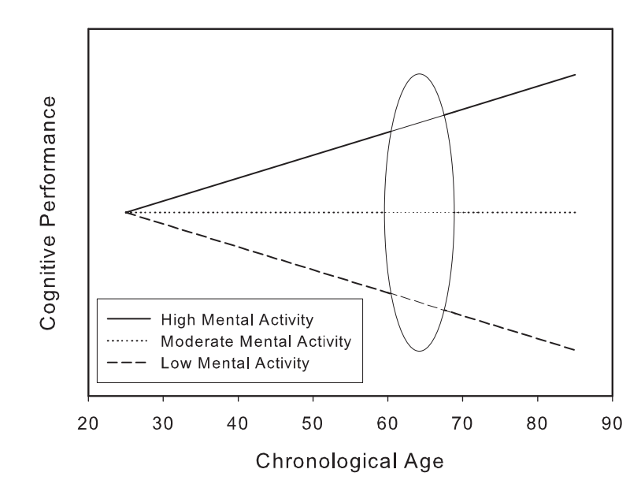
Figure 3.1 Schematic representation of how mental activity can moderate cognitive decline trajectories with ageing. Adapted from Salthouse (2006)
In this context, the benefits deriving from Internet use and learning activities on cognitive vitality growingly accumulate empirical support (Chan, Haber, Drew, & Park, 2014; Tun & Lachman, 2010). For example, preliminary evidence using MRI on older adults demonstrate that Internet use may engage a greater extent of neural circuitry in the human brain than reading text pages (Small, Moody, Siddarth, & Bookheimer, 2009). Accordingly, Chan et al. (2014) demonstrated that older adults who committed for 3 months to use tablet computers improved their performance in neuropsychological assessments of episodic memory and speed of processing. Similarly, Hatzifilalithis, Chrysochoou, Pavlidis and Vivas (2015) findings indicate that greater online social participation may be associated with benefits in cognitive performance, suggesting that the former could serve both as a form of social participation, as well as of cognitive training.

The effect of Socio Economic Status on Cognitive Vitality
In the development of the Mini Mental State Examination (MMSE), Brayne and Callowey (1990) observed that both lower education and SES are related with increased ratios of dementia prevalence. Similarly, Evans et al. (1997) argued that fewer years of formal education, income and occupational status are independent predictors of Alzheimer’s disease. Fotenos et al. (2008), using neuropsychological and MRI examinations, concluded that non-demented participants of higher SES exhibited less brain volume loss over age. In addition, they concluded that among participants diagnosed with Alzheimer’s disease, those of higher SES exhibited later the neuropsychological symptoms of the disease, as well as in a milder form.
Ardila et al. (2000) argued, that the protective effect of higher SES on cognitive decline may derive from better living conditions, less exposure to environmental hazards (e.g., work accidents, air pollution), better access to health services, all leading through better health to favourable cognitive decline trajectories. In this direction, a review of Anstey and Christensen (2000) on a number of longitudinal studies with an average follow-up period of 7.7 years argued that education, hypertension, health and cardiovascular diseases are valid predictors of cognitive change with ageing.
An alternative theory, i.e. the cognitive reserve hypothesis postulates that individuals of higher education engage in more mentally stimulating activities over life, which leads to a denser and better neuronal connectivity through brain plasticity (Perry, 2002). This was argued to build a cognitive reserve that can more effectively bear, as well as compensate for, age-related neuronal degeneration (Mortiner, 1988). The cognitive reserve hypothesis was used to explain a string of research findings in cognitive ageing that showed that people who had higher education or better linguistic abilities exhibited better cognitive performance in older age (Snowdon et al., 1996). Bosma, van Boxtel, Ponds, Houx and Joles (2003) longitudinal study found in a group of 708 older adults that the relevant declines in cognitive performance, assessed by list recall and performance in the Stroop task, as well as scores in the MMSE, were significantly smaller for those with higher education. Similarly, Lyketsos, Chen and Anthony’s (1999) 12 years longitudinal study depicted greater declines in MMSE scores for those having 8 years or fewer of education.

The Relation of Cognitive Performance with Everyday Functioning
Abnormal cognitive decline trajectories usually indicate the existence of age-related neurological conditions, which typically coexist with evident everyday functioning impairments. Marcotte et al. (2010, p.5) commented that:
Neuropsychological assessments are still critical if one wants to know the nature and severity of any behavioural manifestation that may result from brain abnormalities. Indeed, increasingly, a primary reason for referrals to neuropsychological testing is to answer questions regarding the effects that brain alternations are likely to have to everyday functioning, such as the ability to successful work, live independently, handle finances, or drive automobile
Everyday functioning is usually assessed by measures of basic Activities of Daily Living (ADL) and Instrumental Activities of Daily Living (IADL). Measures of ADL include basic behaviours such as bathing, grooming, dressing, and eating. IADL typically include more complex tasks, such as managing finance, medication handling, using the phone and using home appliances (Farias et al., 2009). From the two measures, IADLs are more cognitive demanding and involve adjustments in more complex information. This complexity leads IADL decrements to become more pronounced even when subtle deteriorations in cognitive vitality are evident (Cerella, 1994; Deary & Der, 2005). On the other hand, ADL include behaviours that are often practised in the point that have become automatized, and therefore, the relevant decrements are evident in advanced stages of a neuropsychological condition.
The differential nature of the ADL and IADL may be explained from their reliance on different cognitive processes and on different brain areas. It has been argued that ADL are frequently practised tasks and therefore rely more on cognitive process that are based in the basal ganglia, an area that becomes less affected from age-related neuronal degenerations. On the other hand, IADL seem to rely on the hippocampal and enthorhinal structures of the brain, areas that seem to be more susceptible to age-related degenerations (Loewenstein & Acevedo, 2010). In a study on Parkinson’s disease patients, executive function (EF) impairments (and especially sequencing) were significantly and selectively related with IADL, but not with ADL (Cahn et al., 1998). In the same study, motor impairments were associated with ADL abilities but not with IADL. This indicates the contribution of EF to the two types of everyday functioning. Marcotte et al. (2010, p.11) commented that:
We can have the most confidence that global cognitive impairments are associated with worse performance on everyday functioning measures... At the domain specific level, a broad review of the literature suggests that executive measures may be the strongest predictor of everyday functioning ... It has been suggested that future research should specifically focus on executive functioning as a predictor of real world performance.
The assumption that cognitive and functional decline with ageing are strongly related has been, and still persists to be, a strong statement in science and in policy-making. Inappropriately, this assumption has led to challenge older workers’ job performance as well. One of the early lines of such argumentation stems from Cumming and Henry (1961, p.213) who stated:
Ageing is usually accompanied by decrements in knowledge and skill. At the same time, success in an industrialized society is based in knowledge and skill and age-grading is a mechanism used to ensure that the young are sufficiently trained to assume authority and the old are retired before they lose skill.
The arguments of Cumming and Henry (1961) came long before the scientific community had a better insight in cognitive ageing and functional performance. Despite the limited empirical examination for this relationship however, the notion that cognitive ageing is strongly related with poorer job performance still persists. A recent study by the Organization for Economic Cooperation and Development (OECD, 2013) argued that job performance in technology rich environments declines with age. This conclusion was based on neuropsychological assessments of literacy, numeracy and problem solving, indicating that these abilities peak in our 30s (years of age), declining steadily thereafter. Notably, job performance was not measured explicitly, assuming that declines in cognitive performance in the respective neuropsychological assessments would correspond to declines in job performance in real life.
Yet, the available empirical evidence cannot support a strong correspondence between cognitive and functional decline. In contrast, there are ample examples where individuals suffered extensive cognitive impairments, with their functional ability remaining relatively intact (Loewenstein & Acevedo, 2010). To illustrate better this issue, Martyr and Clare (2012) reviewed studies that examined the relation between cognitive performance and everyday functioning in Alzheimer’s disease patients, concluding that performance in these measures are only moderately related. Royall et al. (2007) review also the available literature (although not conducting a statistical meta-analysis), and found that performance in neuropsychological and everyday functioning assessments appear moderately related. They concluded that (p.259):
Either cognition is not as strongly associated with disability as we might imagine, or currently available measures are inadequate to demonstrate their true association.
It has been argued that the relationship between cognitive performance and functioning does not appear as strong in research because it is moderated by our innate ability to employ compensating strategies (Franzen & Wilhelm, 1996). Baltes and Baltes (1990) and Freund and Baltes (2007), using the Selection, Optimization, and Compensation model (SOC) argued that one engages in a selection process, where certain behaviours become the allocation area of mental resources, at the cost of performance in other behaviours. This leads to the optimization of the selected behaviours’ performance, attenuating this way in great extend the effect of cognitive aging. This trade-off of behaviour, favour those that are more important at the expense of the less important ones.
Salthouse (1984) used the SOC model, in order to explain the findings of a study that compared the performance of young and old typists in a controlled environment. He found that older typists had slower movements in their fingers, and poorer performance in neuropsychological assessments. However, there was no difference in their typing speed when assigned in one of their typical working duties: that is typing documents. The author observed that older typists could read in average more words ahead, thus could plan ahead longer sequences of finger movements. This ability allowed them to compensate for their shortcomings in physical and mental speed, and to maintain their job performance. A similar experiment was performed on medical laboratory technicians (Hoyer & Ingolfsdottir, 2003). When no instructions were provided, there were evident differences between older and younger technicians in the time needed to detect malicious cell structures in microscope slides. However, when they were provided with information of the target structure, these age differences disappeared. Notably, in their everyday practise, laboratory technicians are always provided with this description of the malformation that they are expected to detect.
Similar results have been found when examining performance in gaming. Charness (1979, 1981) focused on the cognitive strategies that may compensate age related cognitive declines in bridge and chess performance. The author concluded that although older individuals performed worse than younger individuals in neuropsychological assessments of problem solving and memory, their performance in bridge and chess remained unaffected by age. This was explained as the result of older players’ ability to access a reach pool of games from their memory (or else experience), compensating this way for decrements in cognitive performance.
The existence of an adaptive compensatory mechanism to counteract age-related deteriorations has been further used to explain neuronal plasticity in older age. Park and Reuter-Lorenz (2009) reviewed several relevant studies that used neuroimageing techniques, and proposed that age related declines in cognitive performance are attenuated by a greater engagement of the prefrontal cortex. They reported that the expected relation between reduced brain activation and volume in the hippocampal area and reduced memory capacity was not evident in older adults who showed a simultaneous increased activity in the prefrontal cortex (Park & Gutchess, 2005 as cited in Park and Reuter-Lorenz, 2009; Persson, Lustig, Nelson, & Reuter-Lorenz, 2007). The authors concluded that functional reorganization with ageing leads to the prefrontal cortex becoming increasingly involved in cognitive processes (e.g., memory) that are typically located in hippocampal structures in younger ages.
Cabeza (2002) argued that task specific behaviours are related with greater activation in the prefrontal cortex, however this activation tends to be less lateralized (i.e., located in one hemisphere) in older age, as part of a compensatory mechanism to maintain performance. Greenwood (2007) suggested a different compensatory mechanism, arguing that although the prefrontal and parietal cortices manifest the most shrinkage with ageing, they increase their activation levels when performing a task. The latter author argued that this process drives a functional and neuronal reorganization in the specific and adjacent areas of the brain in order to maintain functional abilities with age.
As a theoretical model, the SOC model never provided the context of forming concrete testable hypotheses. In the literature, there are several studies that examined the differences between the younger and the older in dual-task performance (i.e., performing two tasks at the same time; Li, Lindenberger, Freund, & Baltes, 2001; Lindenberger, Marsiske, & Baltes, 2000). The relevant findings indicated that the costs deriving from the cognitive load of performing two tasks instead of one are greater in older age, especially if the one task is as important as retaining balance when walking. Although valuable, this evidence did not depict the existence of a compensatory mechanism.
In other words, our current status of understanding for the relation between cognitive and functional decline in older age (i.e., that they are strongly related) is not sufficiently grounded in empirical findings, remaining still an influential assumption. The influence of this assumption is depicted among others in the comments of Depp and Jeste (2006), who suggested that disability and physical functioning appear in most definitions of successful ageing in the literature, as n intact everyday functioning is one of the few tangible and measurable indicators of positive outcomes in older age. The conclusions of Royall et al. (2007) and Marytr and Clare (2012) on the relation between cognitive performance and everyday functioning cannot remain the endpoint of the relevant discourse, as it entails the danger to retain ungrounded ageist views about older adults’ functional abilities.
A significant concern in drawing conclusions for the relationship between cognitive and functional performance derives from the ecological validity of the measures used. Ecological validity refers to the extent that findings derived from controlled experiments and environments can be generalized to the real world (Franzen, 2000). Specifically, for neuropsychology, ecological validity has been coined as the functional and predictive power of one’s performance in neuropsychological assessments on one’s behaviour in a variety of real world situations (Sbordone, 1996). Goldstein (1996) criticised intensively the ecological validity of laboratory-based behaviours, stating that they cannot be assumed as real-world behaviours. More precisely, the author argued that there is a distinction between one’s ability (one’s performance in neuropsychological tests) that can be tested in a laboratory, with the corresponding functionality (one’s ability to perform behaviours) in the real world.
In general, it is unclear how much one’s performance in basic neuropsychological assessments translates into behaviour changes within varying environments. Despite the large advances in neuroscience, there is little known about how the brain allows us to interact with the environment, even for simple activities like cooking (Burgess et al., 2006). Increasing the ecological validity of empirical measures in order to predict real world behaviours remains a constant objective in the scientific inquiry. Cherner (2010) cautioned to this direction that translating and culturally adapting everyday functioning measures may contribute to the measures’ ecological validity. As Loewenstein and Acavedo (2010) posed, several cross-cultural studies on everyday functioning did not rely on culturally adjusted IADL measures, although everyday tasks are fundamentally different in some cultures. In other words, these studies may have produced larger measurement errors, due to cultural specific discrepancies in what was measured and what should be measured in each culture, a discrepancy that cannot be adjusted for with statistical means.

The Healthy Spectrum of Cognitive Performance
The theoretical framework of Hertzog et al. (2009; Figure 1.2) can be used to conceptualize how the factors presented in this chapter (i.e., physical activity, mental activity, SES and social participation) can exert an effect on cognitive decline trajectories with ageing. According to this theoretical framework, the effects of physical activity, mental activity, SES and social participation on cognitive performance are constant and extend from the non-pathological spectrum (Area A) of cognitive performance to the pathological one (Area B). An important assumption made from this framework is that less favourable cognitive decline trajectories lead to the occurrence of age-related neuropsychological disorders sooner for those having less physical activity, mental activity, SES and social participation.
The theoretical framework of Hertzog et al. (2009) has been proposed based on an extensive review of the literature examined by a group of experts. It would be anticipated that the evidence about the factors exerting an effect on the non-pathological spectrum of cognitive performance would derive from studies that examined cognitively intact older adults. In turn, the knowledge for the factors leading to the occurrence of age-related neuropsychological disorders would derive from studies examining those who were initially cognitively healthy, but developed an age-related neuropsychological disorder later on. There is ample of evidence for what contributes to the occurrence of an age-related neuropsychological pathology (e.g. epidemiological studies) in the available literature on cognitive ageing to date, however, a disproportionally smaller number of studies examine effects on the non-pathological spectrum of cognitive performance.
The issue under examination is whether the distinction between the pathological and the non-pathological spectrums of cognitive performance was well respected in the review and report of Hertzog et al. (2009), rendering the resulting theoretical framework as an accurate depiction of cognitive ageing. This consideration emerges by reviewing the empirical findings in the relevant discourse and the theoretical framework proposed. For example, according to the thesis of the Hertzog et al (2009) review, exposure to better education, or exposure to better socioeconomic conditions exerts constant beneficial effects on cognitive vitality. This is not in accordance however with the evidence depicting that among Alzheimer’s disease patients, those of higher education have demonstrated more rapid rates of cognitive decline (Andel, Vigen, Mack, Clark, & Gatz, 2006). In addition, recent longitudinal studies depict that higher SES is associated with higher levels of cognitive performance, but not with more favourable cognitive decline trajectories over time (Christensen et al., 2001; Hofer et al., 2002; Mackinnon, et al., 2003). In a recent relevant meta-analysis (Young et al., 2015) of studies examining the effect of exercise on older adults' cognitive vitality, the authors did not argue for relevant beneficial effect among those who are cognitively intact, but only for those affected from a cognitive or affective disorder. More precisely Young et al. (2015, p. 22) stated:
This Cochrane Review examined the effect of physical activity aimed at improving cardiorespiratory fitness on cognitive function in healthy older people without known cognitive impairment. The hypothesis being tested is that physical activity brings about improvements in cognition, which are mediated by increased cardiovascular (aerobic) fitness (Colcombe et al., 2004; Kramer, 1999; McAuley, 2004). If true, this would imply that a physically active lifestyle resulting in enhanced fitness could positively affect people’s cognitive abilities as they age and may even prevent, or at least delay, the onset of neurodegenerative disorders such as Alzheimer’s disease. Nine of the 12 included trials reported that aerobic exercise interventions resulted in increased cardiorespiratory fitness of the intervention group…. However, this was not accompanied by any impact on cognitive function.
Young et al. (2015) observed that previous reviews or meta-analysis reported significant benefits of exercise on cognitive performance with ageing, because they included studies that used mixed samples of participants consisting both of seniors being cognitively healthy and those cognitively affected by a neurological condition (Colcombe & Kramer, 2003; Etnier, Nowell, Landers, & Sibley, 2006; Smith et al., 2010; van Uffelen, Chin, Hopman-Rock, & van Mechelen 2008, as cited in Young et al., 2015). When studies included only healthy participants (Etnier et al., 1997, as cited in Young et al., 2015) were examined, none or marginal beneficial effects of exercise on cognitive decline with ageing were found. Therefore, the Cochrane Review concluded that exercise could be beneficial for specific subgroups of the population, such as those who suffer from dementia or depression. But there is no evidence to support such an effect for those who lie in the healthy spectrum of cognitive performance.
In a similar line, Salthouse (2006) challenged the value of cognitive training on cognitive vitality in the healthy spectrum of ageing, stating that there is no solid supportive evidence in his own research, as well as in the literature, for such an effect. In his study of 1200 individuals, no statistically significant relation between Need for Cognition (i.e., an individual’s tendency to participate in cognitively stimulating activities) and cognitive decline with ageing occurred, although Need for Cognition by itself was positively related with hours spend in cognitively demanding activities. Salthouse (2006) also contested that the beneficial effect of mental exercise may be evident to those having very low levels of cognitive ability, or very low educational level. He added however, that this limits significantly the applicability of the mental exercise hypothesis only to those who have a disadvantage in these respects.
Lovden, Ghisletta and Lindenberger (2005) argued that social participation may not be the driving force behind cognitive decline, and therefore increased social participation may not reduce significantly rates of cognitive decline. The relevant beneficial effects may emerge only when the extreme ends of social participation and cognitive performance (namely social isolation and age-related neurological conditions) are considered. For example, Cattan et al., (2005) and Shankar et al. (2011) reported significant effects of social participation on health and cognitive vitality respectively, by contrasting socially isolated seniors and comparing them with the average. In the same vein, Bassuk, Glass, & Berkman, (1999), Barnes et al. (2004) and James et al. (2011) argued for the beneficial effect of social participation on cognitive performance, by comparing seniors that are either socially isolated with those that are exceptionally social.
It is a basic statistical fact that comparing the two ends of a continuum yields greater possibilities to identify statistically significant differences. However, the two ends of the continuum on social participation and cognitive performance is not the typical representation of seniors’ aptitude or behaviour in cognitive performance and social participation respectively, and as such, the results derived from these studies are not very informative for the healthy (typical) spectrum of either dimensions (i.e., of cognitive performance and social participation). In other words, the protective effect of social participation against the prevalence and the progression of dementia (Bennett, Schneider, Tang, Arnold, & Wilson, 2006; Fratiglioni, Paillard-Borg, & Winbald, 2004; Wang et al., 2002) may be evident, but it is questionable if this can be projected as a constant effect in the non-pathological spectrum of cognitive performance or behaviour as well.
In the same vein, the longitudinal studies from Barnes et al. (2004) and James et al. (2011) could not find an independent significant effect of education and income (the major components of SES) on cognitive trajectories among cognitively intact older adults. A recent longitudinal study on 6000 older adults suggested that poorer education may lead to worse cognitive performance scores, and to greater risk ratios for the occurrence of age-related neurological disorders. Yet, it did not predict steeper cognitive decline trajectories in the healthy spectrum of cognitive ageing (Wilson et al., 2009). This gives rise to the possibility that the effect of SES on cognitive decline may not be constant in the healthy spectrum of cognitive ageing.
In sum, the literature provides solid evidence for the protective effect of exercise, mental activities, social participation and SES against the prevalence of age-related neurological conditions. It also provides evidence that relevant interventions on those affected from a cognitive or affective disorder, or socially isolated, will produce benefits in terms of cognitive vitality. In the healthy spectrum of cognitive ageing however, the beneficial effects of exercise, social participation and SES on cognitive vitality are not well supported by scientific evidence.
This thesis will be a preliminary attempt to clarify this issue by examining the effect that exercise, mental activity, social participation and SES has on cognitive performance in the healthy spectrum of cognitive ageing. This examination lies at the intersection of cognitive neuropsychology and social gerontology, requiring an interdisciplinary approach. The first step towards this direction is to examine carefully the numerous methodological considerations that are embedded in the scientific examination on the topic, as well as to identify the common research designs employed to examine cognitive changes and social participation with ageing.

Methodological Considerations
Evidence of cognitive changes with age derives from observational or intervention studies using a cross-sectional or a longitudinal design (Hertzog et al., 2009). Cross-sectional studies measure individuals of different ages on cognitive performance at one time point. The hypothesis that changes in one factor (e.g., mental activity) can produce beneficial effects on cognitive performance over time has been tested in cross-sectional studies by using regression analysis. Using a regression analysis, the relationship between age (the predictor) and cognitive performance (the outcome) is examined, tracing any potential moderating effect of mental activities (Cohen, Cohen, West, & Aiken, 2003; Hertzog et al., 2009; Salthouse, 2006).
Longitudinal studies allow the examination of person-specific changes in cognitive and everyday functioning performance in depth of time, by examining the same group of individuals repetitively at various intervals. This approach allows the direct examination for the of various factors on cognitive changes, using statistical analyses such as the latent growth models (Hertzog et al., 2009). Intervention studies allow the pre-post examination of the same group of individuals, after providing physical or mental training. Any beneficial effects can be inferred by the potential significant differences that may emerge in the mean scores of cognitive performance before and after these interventions (Hertzog et al., 2009).
The inherent disadvantage of intervention studies is that not all qualities are amendable to interventions (i.e., intervening in SES). Intervention studies have been also criticized to depict beneficial effects that survive only for a brief period of time (Hertzog et al., 2009; Salthouse, 2006), and therefore cannot depict accurately developmental processes. For the latter purpose, longitudinal and cross-sectional studies seem to be more useful, as they allow the examination of wider time frames. The evidence of the respective studies however entails some methodological limitations.
Longitudinal studies are very demanding, necessitating a commitment to multiple and repeated sessions of testing over a longer period of time. These demands shape samples that rarely represent the general population. As Baltes (1968) argued, the surviving participants of longitudinal studies tend to be more than the average intelligent, and of higher SES. In addition, those that are less healthy and cognitively fit, as well as less engaged in mentally stimulating activities in their lives, tend to dropout more easily from follow up stages in longitudinal studies (Hertzog et al., 2009). This has important implications for the generalization of longitudinal studies’ results, as the respective analysis reflects a selective bias to those who enjoy better developmental outcomes in their lives.
Another limitation of longitudinal studies is that of testing or practice effect. Testing effects refer to the observed improvements in a given task as a result of practice (Baltes, 1968). The repetitive testing in the context of longitudinal studies allows the rehearsal on specific tasks, which by itself leads to improvements to test performance, potentially concealing age-related cognitive declines (Sliwinski & Buschke, 1999). Testing effects can be controlled for within complicated statistical models if the knowledge for their rehearsal effect is known. Testing effects in various neuropsychological assessments however have been rarely examined in the ageing discourse of cognition, rendering their statistical adjustment as a rare opportunity (Hertzog et al., 2009).
Cross-sectional and longitudinal designs have differential advantages-disadvantages in capturing or ignoring cohort effects (Baltes, 1968). Cohort effects refer to the fact that different cohorts most likely live in different socioeconomic and environmental conditions, which among others lead them experiencing different major events (e.g., war, economic crisis, technology). Therefore, different cohorts are characterized by average differences in many aspects, the case of education being the most representative example. For example, due to socioeconomic and political conditions, older generations have received in average less years of education than younger generations (Hamilton, 2011). As education is one of the strongest correlates of performance in neuropsychological assessments, many studies on cognitive ageing have adjusted the levels of cognitive performance according to the educational level of the participants, in order to control for potential confounding effects in this respect (Sliwinski & Buschke, 1999).
In cross-sectional studies, it is not clear if statistically significant relations between cognitive performance and education indicate within-person differences (i.e., those having less years of education exhibit steeper trajectories of cognitive decline), cohort differences (younger cohorts have more years of education, and at the same time better cognitive performance), or both. Longitudinal studies can compare individuals of the same cohort, capturing more reliably within-person differences in cognitive decline trajectories as a function of education. Therefore, longitudinal studies are preferred over cross-sectional studies in the examination of developmental processes (Baltes, 1968; Hertzog et al., 2009). It has been argued that cross-sectional studies on cognitive ageing may lead to an underestimation of cognitive changes (Desrosiers, Hebert, Bravo, & Rochette, 1998), or for age to account for a smaller variability of those changes than it should (Wilson, Beckett, Bennett, Albert, & Evans, 1999; Wilson, Beckett, et al., 2002 as cited in Hertzog et al., 2009). Sliwinski and Buschke (1999, p.4) commented however that:
Given the expense and difficulty of conducting longitudinal research, it is not surprising that most theories of cognitive ageing have emerged from cross-sectional research
The utility of cross-sectional designs in examining developmental issues is a vivid discussion in the ageing discourse (Hertzog et al., 2009). Their comparative advantages to longitudinal studies lies in the decreased cost, as well as the possibility to examine much larger samples, increasing this way statistical power. Given these pragmatic considerations, the estimation differences between cross-sectional and longitudinal studies have been examined by Desrosiers et al (1998, p.362), who concluded:

In many tests, cross-sectional and longitudinal designs were comparable for estimating the changes in upper extremity performance with age. However, in some tests, the decline with age using a cross-sectional design was underestimated. The upper extremity performance decline observed with the longitudinal design was larger than the decline predicted with the cross-sectional design. The withdrawal and survivor biases related to the longitudinal design and the cohort bias associated with the cross-sectional design may, in part, explain these results.
In a similar note, Sliwinski and Buschke (1999) argued that cross-sectional studies of cognitive change approximate the estimations of cognitive change produced in longitudinal studies, however ‘Neither cross-sectional nor longitudinal effects provide pure estimates of cognitive aging’. In their own study, they proceeded to a comparison of cross-sectional and longitudinal effects of age on cognitive performance. Their results showed that the average within-person cognitive decline in the longitudinal analysis was larger than the cross-sectional age differences for 12 out of the 13 neuropsychological assessments they used.
Similarly, Pfefferbaum and Sullivan (2015) evaluated and compared the available cross-sectional and longitudinal evidence on hippocampal volume loss with ageing. They found that cross-sectional designs were less sensitive in tracking age-changes in brain volume, as the advantage produced by the increased statistical power (provided from examining an increased sample of participants) was diminished by the variability in the initial hippocampal volume between the participants. They concluded however that (Pfefferbaum & Sullivan (2015, p.6):
Despite their advantages, longitudinal studies also suffer limitations. In addition to potential biases from sampling related to genetic, environmental, and other potentially relevant factors, almost all longitudinal studies of normal aging or disease progression across ages are based on a cross-sectional and/or longitudinal design, in effect, collections of short trajectories. That is, the baseline, or initial, data point is typically age-asynchronous, meaning collected on subjects at different ages, rendering aging trajectories vulnerable to interaction with cohort effects–people born in different eras may age differently
As such, no comparative advantage for either the cross-sectional or longitudinal studies can be assumed in this thesis for the estimation of developmental outcomes. The respective evidence will be evaluated however under the light of the inherent advantages and disadvantages that each research design entails, cautioning that cross-sectional designs are more appropriate to investigate cognitive and functional performance at a certain point, whereas longitudinal designs are more useful for tracking person-specific changes over time. It is also argued in this thesis, that the inherent advantages and disadvantages of cross-sectional and longitudinal studies are not the only methodological issues that should be taken into account. The following parts of this chapter discuss how physical exercise, social participation, SES, as well as cognitive and functional performance have been subjected either to significantly heterogeneous or erroneous measurement practices, questioning this way the comparability and validity of the relevant research findings on developmental outcomes.

Assessing Physical Exercise
Physical exercise is typically measured with self-report questionnaires, surveys, diaries, or interviews. Alternatively, physical exercise can be measured by using calorimetry, by assessing physiologic markers (i.e., cardiorespiratory fitness, biomarkers), by employing motion sensors and monitors (e.g., global positioning system [GPS], pedometers, heart rate monitors), or by having direct observation. Self-report measures of physical exercise are usually preferred due to their increased applicability, as well as their low-cost, low-burden, and high acceptability. Direct measures of physical exercise are used usually when precision and accuracy are essential. Their demanding nature however (i.e., availability of specialized devices, time needed for the respective measures), has restricted their utility mainly to validating self-reports of physical exercise (Prince et al., 2008).
Prince et al. (2008) conducted a systematic literature review in studies that used both self-report and direct measures of physical exercise. They found a moderate mean correlation between the two types of measure (r = .37), with a great heterogeneity in this respect (.95 < r > .17). They also observed that this pattern of relativity between self-report and direct measures of physical exercise persisted in studies that examined older adults as well. Unfortunately, the lack of homogeneity in measures and units employed to assess physical activity in the respective literature did not allow the authors to proceed to a statistical meta-analysis, in order to calculate an overall mean effect. Therefore, no estimation for any comparative advantage of self-reports or direct measures of physical activity could be made.
Dishman, Washburn, and Shoeller (2001) argued that self-report measures of physical exercise are the most practical and cost-effective ones in measuring physical exercise in free-living populations. They argued that their validity cannot be undermined based only on the fact that they are vulnerable to self-serving biases, because no golden standard exists in validating such measures. They cautioned however that self-reported measures of physical exercise should include the type, frequency, duration and intensity of activity in order to be more informative, as well as they should be aligned with the research question posed in each study. These suggestions will be adopted in this thesis for the empirical examination of exercise among older adults.

Assessing Social Participation
In the previous chapter, it was explored how social participation is a key determinant of positive outcomes in older age. In that chapter, it was described how social participation constitutes an emerging intervention goal for health professionals in order to promote cognitive health in older age. Despite its growing importance, there is not a common agreement in the literature on the definition of social participation (as a concept), nor for its underlying dimensions, activities, nor its operationalization. As Richard et al (2012) commented, the operationalization of social participation indicators has been equivocal and rather arbitrary (or fluent) in the ageing discourse. In a comprehensive review, Levassaur et al. (2010, p. 2142) commented that:
Despite the wide interest in social participation there is no agreement around a common definition. In fact, the fields of public health and rehabilitation seem to have different ways of defining social participation. Moreover, many similar concepts such as participation, social engagement, social connectedness, social capital, social support, social network, social integration, and community involvement have sometimes been used interchangeably with social participation.
Most studies in the field of gerontology have not provided a systematic justification for choosing the initial pull of items for the development of their own social participation (or the relevant concept) questionnaire, making questionable whether their differential origin results in instrument that represent the typical set of activities that older adults' take part in the specific culture (e.g., Aartsen et al., 2002; Dahlberg & McKee, 2016; Glass, Mendes de Leon, Maroliotti, & Berkman, 1999; Hill et al., 1995; 1995; Richards, Hardy, & Wadsworth, 2003; Hultsch, Hertzog, Small, & Dixon, 1999; Hultsch, Hammer, & Small, 1993). Although this methodological approach has clear limitations, it has been adopted in large-scale, cited, and replicated studies, such as the MacArthur study (Seeman et al., 2001) or the SHARE study (Christelis & Dobresku, 2012).
Further discrepancies in the examination of social participation exist in providing (or not) psychometric properties for the proposed questionnaire. A small minority of studies have reported a confirmatory analysis or internal consistency indexes for validating the dimensionality of their social participation questionnaire (e.g., Dahlberg & McKee, 2016), creating however sometimes concepts that overlap with that of physical activity (e.g., the concept of "active lifestyles" in Hill et al., 1995). Most studies have not reported any psychometric properties for the social participation questionnaire they used (e.g., the SHARE study; Christelis & Dobresku, 2012).
In other words, the landscape of research in the examination of social participation to date consists of a great variety of dissimilar questionnaires containing different items and distinct (if any) validation processes. Levasseur et al. (2010, p.2142) commented that:
The lack of consensus around a definition of social participation has important consequences: communication difficulties between those using the concept, problems in the development and selection of instruments to measure social participation and blurred or incomplete social policy efforts … For researchers, another important consequence of the lack of consensus around a definition is the difficulty in comparing results stemming from a variety of conceptualizations (theoretical organization of a concept) and measurement scales.
In an effort to give a more comprehensive theoretical context for social participation indexes, Levasseur et al. (2010) conducted an inventory and content analysis of the measures used in the literature. In their final analysis, they proposed that social participation (Levasseur et al., 2010, p.2141) 'mostly focused on the person’s involvement in activities providing interactions with others in society or the community'. They did not define however any specific set of activities that represent social participation, rather than that, they proposed a specific taxonomy of criteria, or else a description of activities that can be regarded as participation, social participation, or social engagement. These activities are those depicting older adults i) interacting with others without doing a specific activity with them, ii) doing an activity with others, iii) helping others, and iv) contributing to the society.
This thesis proceeds with the working definition of Levasseur et al. (2010) for the concept of social participation in the following chapters, giving a separate emphasis to social network size. Zunzunequi et al (2003) proposed that social networks are defined by their structural characteristics (e.g., number of ties, proximity of ties), as well as from their functional characteristics (e.g., frequency of contacts, reciprocity). The functional characteristics of social networks can be conceptualized as social participation following the Levasseur et al. (2010) criteria. The same however does not account for social networks' structural characteristics: someone may have an available social network, however due to personality dispositions, they may not utilize it.
As Maddox (1970) argued and Barnes, Mendes de Leon, and Bienios (2004) later supported, social withdrawal is observed frequently among those that manifest isolation tendencies throughout their lives. Under the definition of Levasseur et al. (2010) for social participation, such individuals would score low in social participation, insinuating erroneously that they have a small social network size as well. The fundamental difference here is that their social network size may be rich, but due to personal dispositions and manifested isolation tendencies they do not utilize it.
This calls for caution in the conceptualization of social isolation, social network and loneliness. Social isolation and loneliness are two notions that are closely related (Anderson 1998; Wegner, Davies, Shahtahmasebi, & Scott, 1996), though not identical. Loneliness is regarded as a subjective affective state that can be evoked by emotional isolation, which stems out of unwelcomed feelings of companionship loss and social interaction interruptions (Dahlberg & MacKee, 2014; Holwerda et al., 2014; Townsend, 1957). Social isolation on the other hand, is considered an objective absence of social contacts and the damaged interaction between the old and society (Weiss, 1982). As such, the term social network size and loneliness will be used separately from that of social participation in this thesis, limiting the conceptualization and operationalization of social network to the number of individuals that a person has regular contact with (Seeman et al., 2001), and loneliness to the subjective affective state that is evoked by limited and undesired social network size or reduced social participation (Yeh & Liu, 2003).

Assessing Socio Economic Status
Earlier in this chapter, it was illustrated how SES has a significant influence on older adults' cognitive vitality (Brayne & Callowey, 1990; Evans et al., 1997; Fotenos et al., 2008), through shaping life conditions and in extend health outcomes (Ardila et al., 2000; Walker, 1981) leading this way to diversified developmental pathways (Aichenbaum & Brengston, 1994).
In his comprehensive review, Oakes (2017) argued that the concept of SES is widely examined by contemporary scholars interested in the long-established effects of SES on various measures of well-being. Despite its prominence, SES remains a concept with no well-accepted agreement on its definition, measurement and operationalization. More precisely, some scholars have used simple univariate measures of income or education as indexes of SES, with other scholars forming composite (multivariate) measures of SES, including occupation, education, income, and household prestige.
For example, the Duncan Socioeconomic Index uses occupational type as an index of SES, using census data as the basis for a stratified categorization and comparison (Duncan, 1961). Based on this data, better education is inferred (and not measured) as a prerequisite for having a better occupation, and income as an expected outcome of having a better occupation. The Nam-Powers Occupational Status Score on the other hand is a composite index of SES, measuring income and education. The final composite score is created by assigning a weight on each measure based on evidence deriving from census data (Nam & Powers, 1968).
The use of census data in order to produce a valid and reliable index of SES deems the corresponding index as culture specific, with a limited ability of cross-cultural comparisons. A recent attempt to measure SES with an index that does not depend on culture specific census data was that of CAPSES (Oakes & Rossi 2003). This index includes a great variety of measures, such as material capital (income, wealth, trust funds), human capital (skills, abilities, credentials), and social capital (instrumental relationships such as being friends with lawyers and doctors). As Oakes (2017) argued however, the measurement of more variables did not add any value to SES indexes, as those measuring only income or education are equally predictive.
To the author's knowledge based on extensive searches, there is no country-specific scale of SES developed in Greece. Taking the different conceptual frameworks that exist around SES, and the limited ability to identify a comparative advantage between them, this thesis adopts Oakes (2017) suggestion and select simple measures of SES to inform the thesis' research question. Therefore, the concept of SES is measured by three separate variables: income, education, and SES of the residing neighborhood. No composite score will be used for this purpose, following the approach and suggestion of Oakes (2017) for using separate indexes in a regression analysis, as:
... optimal control for SES in a regression framework entails having many measures that tap the multiple elements of the latent SES in the model. One might include measures of annual income, educational attainment, parental job prestige, residential neighborhood income or home values, and so forth

Assessing Cognitive and Functional Performance
Cullum et al. (2002) and Farias et al. (2011) commented that most neuropsychological assessments were designed to detect certain neuropathology or disabilities. Therefore, they usually produce a small range of scores, and as a result, may not be sensitive enough to capture fluctuation in cognitive performance at the non-pathological levels of cognition. For example, the MMSE was developed explicitly to facilitate the diagnosis of various forms of dementia. Any scores below a certain threshold (e.g., 26 points for the Canadian population, in a scoring range from 0 to 30) may indicate significant cognitive impairments due to dementia (Fountoulakis, Tsolaki, Chantzi, & Kazis, 2000). The use of this measure offers only a range of 5 units to assess cognitive performance in the non-pathological levels. This constitutes the MMSE a hardly sensitive tool for the examination of cognitive aptitude among cognitively healthy older adults.
Similar concerns are expressed for everyday functioning measures. Moore, Palmer, Patterson and Jeste (2007) commented that many everyday functioning tools provide categorical scores, indicating the existence (or not) of functional impairments. The use of ADL measures for research purposes in the healthy spectrum of cognitive ageing may not be suitable, as they may not be sensitive enough to capture performance fluctuation in non-pathological levels. In this respect, IADL measures may be more suitable to assess everyday functioning in the healthy spectrum of cognitive ageing, where ADL may be more suitable to assess the pathological levels.
It is noteworthy however how many studies in the literature select or describe the measurements of cognitive and functional abilities, without any reference to the sensitivity/adequacy of these measures with regard to the cognitive status of the sample examined (cognitively intact or affected by dementia). This practise entails great methodological consideration, as it potentially maximizes the measurement error in their estimates (e.g., Diehl et al., 2005; Royall et al., 2007), as well as the external validity of their results. For example, it is highly questionable if a score above 26 in the MMSE indicates better cognitive performance. Surprisingly, scores on the MMSE are many times interpreted as reflecting a continuous cognitive capacity/ability (Royall et al., 2007).
In sum, the methodology (i.e., cross-sectional or observational) and the different methodological approaches used in measuring exercise, social participation and SES add limitations in comparing directly evidence, effects, and predictive values of positive outcomes in older age. The suitability of neuropsychological and everyday functioning assessments in assessing the respective domains among cognitively intact older adults will be addressed in the next chapter by conducting a systematic review and meta-analysis on the relevant effect sizes reported. The rest of this chapter will aim to draw the theoretical framework within which the examination of cognitively intact older adults can produce findings will refer only to the healthy spectrum of cognitive ageing.

Conclusions
Cognitive ageing is an inescapable process in life (Farias et al., 2009; Kramer, et al., 2004), where abnormal trajectories of cognitive decline go along with severe everyday functioning impairments, indicating the occurrence of age-related neurological disorders (Petersen, 2004). Lower SES, poor health, social isolation and sedentary lifestyles seem to constitute risk factors for the occurrence of age-related neurological conditions (Bryane & Callowey, 1990; Colcombe & Kramer, 2003; Hertzog et al., 2009). This landscape of evidence formed a theoretical framework of cognitive ageing that has led often to erroneous assumptions about seniors’ cognitive performance in the healthy spectrum of cognitive ageing.
For example, the adverse effects of lower SES, social participation and physical activity on seniors’ cognitive health have been erroneously generalized in the healthy spectrum of cognitive ageing as well. This assumption has not been examined as rigorously among cognitively intact older seniors, yet it has been conceptualized as constant effects leading to steeper cognitive decline trajectories. Recent findings have not been supportive of this view, rendering the closer examination of the healthy spectrum of cognitive performance as important, in order to avoid strong but erroneous statements in science and in policy-making. In this context, this thesis is a preliminary attempt to examine the factors that influence cognitive performance in the healthy spectrum of cognitive ageing. This information may produce a greater insight into seniors’ cognitive vitality and functioning, leading to more knowledge of how positive cognitive and functional outcomes in older age can be fostered.
The next chapter consists of the first part of this thesis’s empirical work, and describes a meta-analysis conducted on studies that have examined the relation between cognitive performance and everyday functioning mostly among cognitively intact older adults. This study is the first of its nature and gives valuable information about the psychometric properties of everyday functioning assessments in the healthy spectrum of cognitive ageing. It also provides important information about what type of everyday functioning measures is more suitable to be used in cognitively intact older adults, as well as which cognitive domains relate more to everyday functioning decrements.

CHAPTER 4 NEUROPSYCHOLOGICAL AND EVERYDAY FUNCTIONALITY TESTS: A META-ANALYSIS

Introduction
In the previous chapter, the importance of examining the influence of SES, social participation, mental and physical exercise on cognitive and functional performance in the healthy spectrum of cognitive ageing was explored. It was also argued that the premise of cognitive vitality being strongly related to functional performance is an influential one both in the realm of science and in policy making, yet not as strongly supported by empirical evidence. The statistical meta-analyses of Martyr and Clare (2012) found a consistent but moderate relation between cognitive performance and everyday functioning in studies that examined patients with various forms of dementia. Royall et al. (2007) reviewed studies examining the cognitive and functional performance of older adults irrespective of their cognitive status (i.e., a mixed sample of studies examining cognitively intact or challenged by a disorder older adults), concluding that a small to moderate relation between them is reported.
However, these two studies are less informative study with regard to the healthy spectrum of cognitive ageing. That is, Martyr and Clare’s study (2012) was restricted to participants that suffered from an age-related neuropsychological disorder, and the Royall et al. (2007) review included both studies examining cognitively healthy older adults and studies that examined cognitively affected older adults (e.g., from dementia). Consequently, the findings and conclusions derived from these studies cannot be applied and generalized with confidence to cognitively healthy older adults, as the sample of examination was blended in terms of the participants’ cognitive status. In addition, the Royall et al. (2007) study plotted a graph with the correlation based effect sizes (i.e., Pearson correlations, standardized beta values, and R²) extracted from the studies reviewed. As Borenstein and colleagues (Borenstein, Hedges, Higgins, & Rothstein, 2009) have pointed out when each study’s strength (power) and measurement error margins is not taken into account, as it was the case of Royall et al’s study, the final estimation of the effect size and the respective margin of error cannot be considered statistically sound (Borenstein, Hedges, Higgins, & Rothstein, 2009). Consequently, the final estimation, made in the study, of the overall strength for the relation between cognitive performance and everyday functioning might have not been accurate.
Unquestionably, both studies (Martyr and Caler, 2012; Royall et al., 2007) provided valuable insights, as they were the first reviews of this nature. However, the universal suitability of everyday functioning measures irrespective of the participants’ cognitive status is not a valid assumption. As most assessments were designed to detect and assess the severity of functional impairments in age-related neurological conditions, it is not known which ones are sensitive enough to capture subtle fluctuation of performance in the absence of any cognitive pathology. The current status of understanding is that in the non-pathological spectrum of cognitive performance, seniors’ ability in conducting ADLs is most probably not affected (Moore et al., 2007). On the other hand, IADL measures may be more sensitive in assessing everyday functioning in the face of subtle cognitive impairments, as the respective tasks are more complex, hence cognitively demanding and less automatized. However, the assumed comparative advantage of the IADL to assess cognitively intact older adults' everyday functioning, has not been, to the authors knowledge, examined empirically.
A better understanding of which cognitive domains relate more to everyday functioning in the healthy spectrum of cognitive performance is essential, as it will inform as to which measures have better psychometric properties. Of equal importance is to gain further insight into IADL measures, and their sensitivity to capture age-related cognitive decrements. At the same time, it is of essence to achieve a greater understanding about the sensitivity of IADL measures to capture age-related cognitive decrements. The IADL decrements most commonly used in research are either questionnaire-based or observation-based, the former usually being self-report or informant report measures (Mystakidou et al., 2013). Observation-based everyday functioning assessments are useful when precision and objectivity are most important. Usually though, they are much time-consuming and require more resources than the administration of questionnaire-based measures, and therefore are not preferred over the latter. On the other hand, significant concerns have been raised for the accuracy and the reliability either of one’s evaluation of others and of one’s own everyday functionality (Ball et al., 2010). As Diehl et al. (2005, p2.) stated:
Self-report measures are subject to self-evaluation biases, including both overestimation and underestimation of functioning and lack of congruence with proxy or clinician ratings.
A comparative analysis that examines potential psychometric advantages between the two types of everyday functioning assessments (i.e., questionnaire-based and observation based) has not been made to date. A clear separation in this respect could lead to the examination of the assessment tools’ suitability, made possible by reporting those neuropsychological assessments that correlate stronger with everyday functioning assessments. The finding of a stronger correlation could be taken as an indication that they capture more effectively the correspondence of cognitive decrements to functional impairments.
A note of caution for this examination, as well as for the examination of the relation between cognitive performance and everyday functioning is the potential moderation effects that age and education can have. The relation between education and cognitive vitality was discussed in detail in the previous chapter, in the context of the cognitive reserve hypothesis, which postulates that individuals of higher education build a cognitive reserve through neuronal plasticity that can more effectively bear age-related neuronal degeneration (Mortiner, 1988). Marcotte et al. (2010) commented that most neuropsychological and functional assessments follow a structure and procedure that assimilate those of class-based tests. As a consequence, less educated individuals may be less familiar with such types of tests, thus facing additional challenges in completing them. As older generations have received less years of education in average, greater age and less education may lead to an underestimation of the strength of the relation between cognitive performance and everyday functioning, reflecting education-related difficulties in completing those tests rather than less cognitive capacity.
In the context of this thesis, a better understanding of the relation between cognitive performance and everyday functioning in the healthy spectrum of cognitive ageing was considered an imperative. Therefore, a statistical meta-analysis was conducted, in order to examine in the healthy spectrum of cognitive ageing i) the strength of the relation between cognitive performance and everyday functioning, ii) which cognitive domains seem to relate more strongly with everyday functioning, and iii) which everyday functioning measurements, questionnaire-based vs observation-based, relate most strongly with cognitive performance, iv) any potential moderation effect of education and age in the relation between cognitive performance and everyday functioning.
An initial review of the literature on cognitive ageing, including cross-sectional and longitudinal studies that used observational or experimental (i.e., intervention studies) designs was first conducted. The strengths and weaknesses of these types of studies were analysed and discussed in the previous chapter. In the case of longitudinal data, only the baseline effects sizes where extracted for the relation between cognitive performance and everyday functioning. To make the comparability of the results possible, only correlation based effects sizes (Pearson correlations, standardized regressions, or R²) were extracted. This allowed synthesizing all effect sizes reported for the relation of cognitive performance with everyday functioning at one time point.
It was hypothesized that cognitive performance would be related with everyday functioning among cognitively healthy older adults. It was also hypothesized that the effect sizes of this relation would be stronger among observation-based measures of everyday functioning. Lastly, it was hypothesized that age and education would moderate the relation that cognitive and functional performance of older adults has in the reviewed studies. To the author’s knowledge, this is the first meta-analytic review that examined these research questions.

Method
The meta-analytic process followed the Meta-Analyses Reporting Standards (MARS) from APA (2008), both in content and structure. These are recommendations for inclusion in manuscripts that report new data collections regardless of research design. For the case of meta-analytic studies, the recommendations are set as described in table 4.1.

Inclusion and exclusion criteria
Studies that used in their research protocol neuropsychological and everyday functioning assessments were considered for inclusion in this meta-analysis. The exclusion criteria for the studies were, i) the examination of a clinical population, ii) no correlations, standardized regression betas (β), or R² could be extracted, iii) studies on animals iv) meta-analyses not specifically addressing cognitively healthy older adults, v) did not examine older adults, and vi) had samples with more that 50% of the total sample suffering from dementia or other age-related neuropsychological conditions. Studies that examined participants suffering from MCI were included, in order to increase the power of the meta-analysis (increased sample of studies), and because diagnostically, MCI remains a grey area in terms of severity and diagnostic inclusion (Hamilton, 2011).
Table 4.1 The Meta-Analyses Reporting Standards (MARS) from APA (2008)
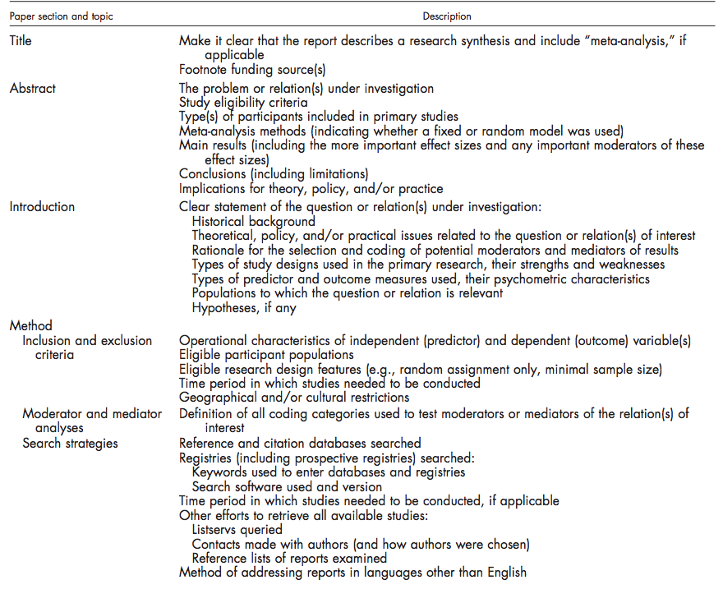

Table 4.1 Continued
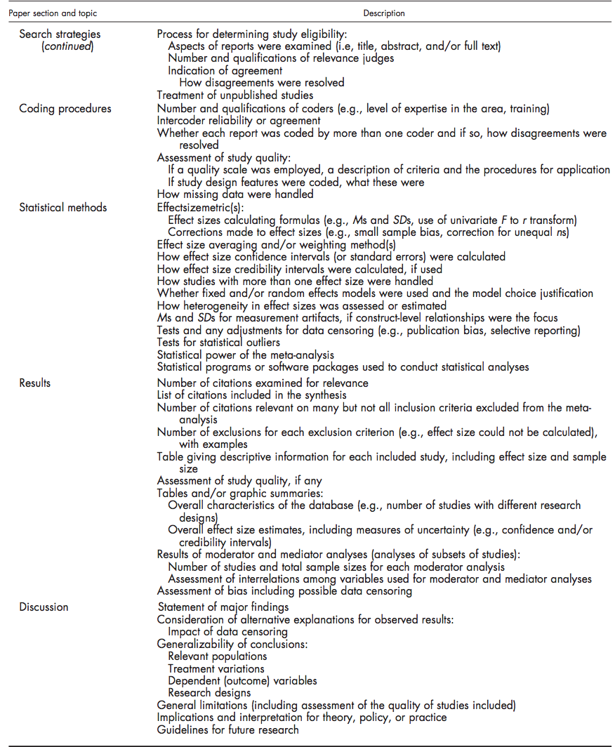

Moderator and mediator analysis
Age was measured by the mean reported age for the specific sample under examination in each study. Education was measured by the mean years of education for the specific sample under examination in each study.

Search strategies
A systematic literature review of articles published in English that examined the relation between cognitive performance and everyday functioning in cognitively healthy older adults was conducted in June 2014 by the author, using the University of Sheffield’s online database (i.e., Star Plus) and the respective search engine. This database includes the most well-known peer-review scientific databases such as, Web of Science, Scopus, and APA. No restriction on date of publication was imposed. In total, 60 online searches were performed, which corresponds to one search for each combination of the keywords “elderly”, “elder”, “old”, “older”, or “senior”, and the keywords “activities of daily living”, “everyday functionality”, “daily functioning”, “functional”; and one of the keywords “cognitive”, “memory” and “executive function”. The search engine was instructed to search for the keywords in the titles of the articles. The references of the included articles were examined further for any relevant studies not identified by the original search attempts.

Coding procedures
All neuropsychological tests and composites used in the studies were reviewed and categorized by two independent researchers in the field of neuropsychology. The neuropsychological tests and composites were categorized depending on the cognitive process they examined in one of the following categories, i) memory, ii) EF, iii) global cognitive status, iv) attention, v) language, vi) visuospatial ability, vii) speed of processing. The everyday functioning assessment were categorized based on the type of administration, as it was reported by the reviewed studies' authors; namely self-reports, informant-reports, observation-based, and test-based. The procedure was repeated and controlled by an independent experienced researcher in the field, in order to ensure the repeatability of the process, the accuracy of the categorization, and the accuracy of the data extracted. No discrepancies or conflicts emerged.

Statistical Methods
The effect size used for the meta-analysis was the Pearson’s correlation coefficient (r), following the procedure described by Borenstein et al. (2009). The dispersion of the effect sizes was calculated using the I² index. For the facilitation of cross-study comparisons, any reports of standardized regression beta values (β) were converted into Pearson correlation coefficient using the formula r = β + 0.05, as suggested by Peterson and Brown (2005), and as applied in Martyr and Clare (2012) meta-analyses. Reports on variance explained (R²) were back translated into Pearson correlation coefficient, using its square root, according to the suggestions of Harel (2009). As suggested by Borenstein et al. (2009), when within the same study two effect sizes on the same cognitive domain were reported, their effect sizes were combined using the formula Y= ½* (Y₁+Y₂). A fixed positive correlational direction was used, meaning all negative correlation coefficients were inverted to positive ones, when they reflected a positive effect (i.e., the higher the cognitive performance, the higher the everyday functioning performance).
The Comprehensive Meta-Analyses software (CMA) v.2 was used for the statistical meta-analyses. All computations were based on Fischer’s z values. Since the studies used different methodologies, distinct combinations of cognitive assessments and everyday functioning measurement tools, as well as heterogeneous samples, the effect sizes were calculated using the random effect model. As such, the confidence intervals of the effect sizes reflected the variance within a study plus the variance between the studies. The software was instructed to use the mean of the comparison variables, as well as of the outcome variables, when possible and appropriate. Publication bias was examined by Egger’s regression intercept test. A meta-regression analysis was used to compute the moderation effects of age and education, using the unrestricted maximum likelihood computation.

Results
In total, 164 unique abstracts where retrieved and reviewed. From them, 44 were excluded because i) no data could be extracted (3), ii) they examined a sample that suffered a traumatic brain injury (3), iii) no quantitative data were reported (34), iv) were studies on animals (1), v) cognition was not examined (1), and vi) were meta-analyses not specifically addressing cognitively healthy older adults (2). The remaining 120 articles were reviewed in depth. Studies were included if they had samples of seniors that to at least 50% of the total did not suffer from dementia or other age-related neuropsychological conditions. Further 91 studies were excluded because i) they examined at least 50% of the sample seniors that suffered from dementia or other severe age-related neuropsychological conditions (68), or ii) did not report parametric correlations, standardized regression betas (β), or R² (23).
In total, 29 articles, examining 29 distinct samples (Appendix I) were included in the final analysis. Of them, 20 were peer-reviewed articles and 9 were dissertations. The studies were published in the period 1998 – 2014, undertaken in 16 countries [USA (21), Australia (2), Italy (1), Brazil (1), and Hong-Kong (1)]. One study included participants from 11 European countries (i.e., Denmark, Sweden, Austria, France, Germany, Switzerland, Belgium, the Netherlands, Spain, Italy, and Greece). Only 13 studies examined strictly healthy older adults. For one study, the proportion of participants that suffered from dementia was 46%. For four studies, the proportion of participants that suffered from Mild Cognitive Impairment (MCI) was 55.5%, 50%, 38.5%, and 30% respectively. Another 3 studies included a mixed sample that to 70%, 64%, 36% respectively, suffered either from MCI or dementia. One study used senior participants of whom 13% had suffered a stroke. One study examined patients of carotic stenosis, another examined individuals that suffered from depression, one examined seniors with diabetes, and two examined individuals that had various cardiovascular conditions. In those studies, either no cognitive impairments were observed during the participants’ examination, or the effect of the participants’ comorbidity was statistically controlled for in the respective correlations reported.
164 articles found and abstracts were reviewed
44 articles excluded because:
- Data could not be extracted (3)
- Sample suffered from a traumatic Brain
Injury (3)
- No quantitative data were reported (34)
- Study on animals (1)
- No cognition was examined (1)
- Meta-analyses (2)

Further 91 studies excluded because:
- Examined seniors that to more than 50% suffered from dementia or other severe age-related neuropsychological conditions (68)
- Did not report correlations, standardized regression betas (β), or R².

29 studies that examined Cognitive Performance and Everyday Functionality where included
Total number of participants N = 27094

Figure 1.1 Flow chart of the literature review procedure

Table 4.2 Neuropsychological Assessment Of Memory Included In The Meta-Analysis
Abbreviation | Neuropsychological Assessment | Used in study
ADAC-cog | Alzheimer’s Disease assessment Scale- Delayed recall test (Chu, Chiu, Hui, Yu, Tsui, & Lee, 2000) | Tam & Lam (2012)
AVLT | Auditory Verbal learning Test (Brandt, 1991) | Gross, Rebok, Unvertzagt, Willis, & Brandt (2011)
BVMRT-R | Brief Visuospatial Memory Test (Benedict, 1997) | Schmitter- Edgecombe, & Parsey (2014)
CFT | Complex Figure Test (Loring et al., 1990) | Alosco, et al. (2013)
DWR | Delayed Word Recognition (Aichenberger, Busch, Reischies, Stroehle, Heinz, & Rapp, 2010) | Aichenberger, Busch, Reischies, Stroehle, Heinz, Rapp (2010)
HVLT | Hopkins Verbal Learning Test (Brandt &  Benedict, 2001) | Gross, Rebok, Unvertzagt, Willis, & Brandt, (2011)
MAS | Memory Assessment Scale (Williams, 1991) | Schmitter- Edgecombe, McAlister, & Weakly (2012); Schmitter- Edgecombe, Parsey, & Cook (2011); Schmitter- Edgecombe, & Parsey (2014)
Memory_{composite} | Memory composite | Burton (2007); Christman, Vannorsdall, Godfrey, Hill-Briggs, & Schretlen, (2010); Everaets (2013); Reppermund et al. (2010)
PM | Activity-Based Multiple Memory Processes Paradigm (Schmitter-Edgecombe, Woo, & Greely, 2009) | Schmitter- Edgecombe, McAlister, & Weakly (2012)
PVLT | Philadelphia Verbal Learning Test (Price et al., 2009) | Selingman, Giovannetti, Sestitio, & Libon (2013)
RBANST_{memory} | Repeated Battery for the Assessment of Neuropsychological Status- memory subtest (Randolph, 1998) | Keil (2005)
RBMT | Rivermead Behavioural Memory Test (Wilson, Cochburn, & Baddelley, 1991) | Keil (2005)
SENAS_{memory} | Spanish and English Neuropsychological Assessment Scales-Memory subset(Mungas et al. 2000) | Farias, Mungas, Reed, & Haan, (2004)
SENAS_{verbal span} | Spanish and English Neuropsychological Assessment Scales-Verbal span subset (Mungas et al., 2004) | Farias, Mungas, Reed, & Haan (2004)

Table 4.3 Neuropsychological Assessment Of Executive Function Included In The Meta-Analysis
Abbreviation | Neuropsychological Assessment | Used in study
AFT | Animal Fluency test (Morris et al., 1989) | Alosco, et al. (2013)
BADS | Behavioural Assessment of the Dysexecutive Syndrome (Wilson, Alderman, Burgess, Emslie, & Evans, 1996) | Schmitter- Edgecombe, McAlister, & Weakly (2012)
BDS | Backwards Digit Span | Tam & Lam (2012)
COWA | Controlled Oral Word Association (Spreen & Strauss, 1991) | Jefferson, Paul., Ozonoff, & Cohen (2006)
COWAT | Control Oral Word Association Test  (Benton and Hamsher, 1976) | Bell-McGinty, Podell, Franzen, Baird, & Williams, (2002)
CVFLT | Category Verbal Fluency Test (Lam, Ho, Lui, & Tam, 2006) | Tam & Lam (2012)
D-KEFS | Delis-Kaplan Executive Function System (Delis, Kaplan, & Kramer, 2001) | Aichenberger, Busch, Reischies, Stroehle, Heinz, & Rapp (2010); Greco, S. P. (2004) ; Jefferson, Paul., Ozonoff, & Cohen (2006); Mitchell, M. (2006); Schmitter- Edgecombe, Parsey, & Cook (2011); Schmitter- Edgecombe, & Parsey (2014)
EF_{composite} | Executive Function composite | Alosco, et al. (2013); Alosco (2013); Burton (2007); Christman, Vannorsdall, Godfrey, Hill-Briggs, & Schretlen, (2010); Reppermund et al. (2010); Everaets (2013)
EXIT25 | Executive Cognitive Test (Royall, Mahurin, & Gray, 1992) | Burnett, Dyer, & Naik (2009)  Royall, Palmer, Chiodo, & Polk (2004)  Pereira, Yassuda. & Oliveira, (2008)
MPT | Manual Postures Test (Goldberg, Podell, Bilder, & Jaeger, 2000) | Bell-McGinty, Podell, Franzen, Baird, & Williams, (2002)
PASAT | Paced Auditory Serial Addition Task (Gornwall, 1977) | Jefferson, Paul., Ozonoff, & Cohen (2006)
RFFT | Ruff Figural Fluency test (Ruff, Light, & Evans, 1987) | Jefferson, Paul., Ozonoff, & Cohen (2006)
TMT-B | Trail Making Test, part B (Reitan and Wolfson, 1985) | Alosco et al. (2012); Bell-McGinty, Podell, Franzen, Baird, & Williams, (2002); Jefferson, Paul., Ozonoff, & Cohen (2006); Tam & Lam (2012)
WCST | Wisconsin Card Sorting Test( Kongs, Thompson, Iverson, & Heaton, 2000) | Bell-McGinty, Podell, Franzen, Baird, & Williams, (2002)
WMS-MC | Wechsler Memory Scale-Mental Control  (Lamar, Price, Davis, KaplFan, & Libon, 2002) | Selingman, Giovannetti, Sestitio, & Libon (2013)
Table 4.4 Neuropsychological assessment per various cognitive domains included in the meta-analysis
Abbreviation | Neuropsychological Assessment | Used in study | Domain
DRS | Mattis Dementia Rating Scale (Mattis, 1998) | Bell-McGinty, Podell, Franzen, Baird, & Williams, (2002); Suchy, Williams, Kraybill, Franchow, & Butner (2010) | Global Cognitive Status
MMSE | Mini Mental State Examination (Folstein, Folstein, & McHugh, 1975) | Alosco et al. (2012); Burnett, Dyer, & Naik (2009); Farias et al. (2008); Jefferson, Paul., Ozonoff, & Cohen (2006); Lucca et al. (2011); O’ Connor (2010); Royall, Palmer, Chiodo, & Polk (2004); Selingman, Giovannetti, Sestitio, & Libon (2013); Tam & Lam (2012) | Global Cognitive Status
RBANST_{gc} | Repeated Battery for the Assessment of Neuropsychological Status (Randolph, 1998) | Keil (2005); Landgraff (2004) | Global Cognitive Status
TICS | Telephone Interview of Cognitive Status (Brandt & Folstein, 2003) | Schmitter- Edgecombe, Parsey, & Cook (2011); Schmitter- Edgecombe, & Parsey (2014) | Global Cognitive Status
Cognistat_{conpoaite} | Cognistat (Kiernan et al., 1987) | Klinger (1998) | Global Cognitive Status
RBANST_{attention} | Repeated Battery for the Assessment of Neuropsychological Status-attention subtest (Randolph, 1998) | Keil (2005) | Attention
Attention _{Composite} | Attention Composite | Everaets (2013) | Attention
Clox | Clock’s 2 (Royall, Cordes, & Polk, 1998) | Burnett, Dyer, & Naik (2009); Schmitter- Edgecombe, Parsey, & Cook (2011) | Visuospatial ability
Block Design | Block Design (Wechsler, 1981) | Reppermund et al. (2010) | Visuospatial ability
RBANST_{visuospatial} | Repeated Battery for the Assessment of Neuropsychological Status-visuospatial ability subtest (Randolph, 1998) | Keil (2005) | Visuospatial ability
SENAS_{visuospatial} | Spanish and English Neuropsychological Assessment Scales-visuospatial subset (Mungas et al., 2004) | Farias, Mungas, Reed, & Haan (2004) | Language
Language ^{composite} | Language Composite | Everaets (2013); Reppermund et al. (2010) | Language
RBANST_{language} | Repeated Battery for the Assessment of Neuropsychological Status-language subtest (Randolph, 1998) | Keil (2005) | Language
SENAS_{object naming} | Spanish and English Neuropsychological Assessment Scales- Object Naming subset (Mungas et al., 2004) | Farias, Mungas, Reed, & Haan (2004) | Language
SENAS_{vct} | Spanish and English Neuropsychological Assessment Scales- Verbal Conceptual Thinking subset (Mungas et al., 2000) | Farias, Mungas, Reed, & Haan (2004) | Language
Visuospatial _{composite} | Visuospatial Ability Composite | Everaets (2013) | Language

Table 4.5 Everyday Functioning Assessments Included In The Meta-Analysis
Abbreviation | EvF Assessment | Study | Type of assessment
IADLSR | Items based on Instrumental Activities of Daily Living (Lawton & Broady, 1963) | Aichenberger, Busch, Reischies, Stroehle, Heinz, & Rapp (2010); Alosco et al. (2012); Alosco (2013); Alosco et al., (2012); Gross, Rebok, Unvertzagt, Willis, & Brandt, (2011); Landgraff (2004); Schmitter- Edgecombe, Parsey, & Cook (2011) | Self-Reports
DHQ | Driving habits Questionnaire (Stalvey, Owsley, Sloane, & Ball, 1999) | O’Connor, 2010 | Self-Reports
IADLIR | Items based on Instrumental activities of Daily Living (Lawton& Broady, 1963) | Christman, Vannorsdall, Godfrey, Hill-Briggs, & Schretlen, (2010); Jefferson, Paul., Ozonoff, & Cohen (2006); Reppermund et al. (2010); Schmitter- Edgecombe, McAlister, & Weakly (2012) | Informant-Reports
Ecog | Everyday Cognition (Farias & Mungas, 2008) | Farias & Mungas (2014) | Informant-Reports
MFAQ | Multidimensional Functional Assessment Questionnaire (Fillenbaum, 1978) | Royall, Palmer, Chiodo, & Polk (2004) | Informant-Reports
SBI-SI | Spontaneous Behaviour Interview (Lucca, Tettamanti, Martell, Luchelli, Alberoni, & Spangoli, 1996) | Lucca et al. (2011) | Informant-Reports
IQCODE | Informant Questionnaire on Cognitive Decline in the Elderly (Jorrn, & Jacomb, 1989) | Farias, Mungas, Reed, & Haan (2004)  ; Lucca et al. (2011) | Informant-Reports
DAD | Disability Assessement for Dementia Scale ( | Tam & Lam (2012) | Informant-Reports
TIADL | Performance Based IADL (Owsley, Sloane, mcGwin, & Ball, 2002) | Suchy, Williams, Kraybill, Franchow, & Butner (2010) | Observation
ILS | Independent Living Scale (Loeb, 1996) | Bell-McGinty, Podell, Franzen, Baird, & Williams, (2002); Everaerts (2013); Greco, (2004) | Observation
KELS | Kohlman Evaluation of Living Skills (1992) | Burnett, Dyer, & Naik (2009) | Observation
OTDL-R | Observed Tasks of Daily Living | Schmitter- Edgecombe, Parsey, & Cook (2011) | Observation
DAFS | Direct Assessment of Functional Status (Loewenstein & Bates, 1989) | Pereira, Yassuda. & Oliveira, (2008); Keil (2005); Klinger (1998); Mitchell (2006) | Observation
Observation | Observation in Campus Room (Schmitter- Edgecombe, Parsey, & Cook (2011) | Schmitter- Edgecombe, Parsey, & Cook (2011); Schmitter- Edgecombe, & Parsey (2014) | Observation
DOT | Day Out Task (Schmitter- Edgecombe, McAlister, & Weakly, 2012) | Schmitter- Edgecombe, McAlister, & Weakly (2012) | Observation
NAT | The Naturalisitc Action Test (Schwartz, F, Veramonti, ferraro, & Buxbaum, 2002) | Selingman, Giovannetti, Sestitio, & Libon (2013) | Observation
EvF_{compositeO} | Everyday Functionality composite | Gross, Rebok, Unvertzagt, Willis, & Brandt, (2011) | Observation
EPT | Everyday Problem Test (Willis, 1993) | Burton (2007); Schmitter- Edgecombe, Parsey, & Cook (2011) | Test Based

Table 4.6 Neuropsychological Assessment Of Speed Of Processing Included In The Meta-Analysis
Abbreviation | Neuropsychological Assessment for Speed of Processing |  | Used in study
DSC |  | Digit Symbol Coding (Smith, 1983) | Alosco, et al. (2013)
SoP_{composite} |  | Speed of Processing composite | Burton (2007)  Christman, Vannorsdall, Godfrey, Hill-Briggs, & Schretlen, (2010)  Everaets (2013)  Reppermund et al. (2010)
SDMT |  | Symbol Digit Modality Test (Smith, 1991) | Schmitter- Edgecombe, Parsey, & Cook (2011)  Schmitter- Edgecombe, & Parsey (2014)
TMT-A |  | Trail making Test, part A (Reitan & Wolfson, 1985) | Alosco, et al. (2012); Tam & Lam (2012)
The total number of participants in the included studies was N = 27094, with a mean age of M_{age} = 75.96, and mean years of education M_{education} = 12.38. Five studies (5) did not report the participants’ years of education. In total, 208 unique correlations between cognitive performance and everyday functioning assessment tools were extracted. As reported below, 48 distinct neuropsychological tests, as well as 4 composite scores of neuropsychological test batteries were used. For the assessment of everyday functioning, 16 tests were used.
Publication bias was examined by Egger’s regression intercept test, indicating insignificant levels in this respect (p = .0875). In the first analyses the everyday functioning assessments were used as the outcome measures and the distinct neuropsychological tests as the comparison groups The analyses indicated that the samples of the included studies were very heterogeneous (I² = 98.46), where a moderate statistically significant effect size between CP and EvF emerged (N_{studies} = 29, ES = .436, CI: .328 - .533, p < .001). A moderate to large and statistical significant effect size emerged among the studies that examined strictly healthy older adults as well (N_{studies} = 13, I2 = 95.14, ES = .478, CI: .390 - .557, p < .001).

Figure 4.2 High resolution plot of the effect sizes of the relation between older adults’ performance in neuropsychological assessments and everyday functionality assessments
Figure 4.3 Meta-regression for the effect of age in the effect sizes’ slope in the relation between performance in neuropsychological and everyday functionality assessments
Figure 4.4 Meta-regression for the effect of education in the effect sizes’ slope in the relation between performance in neuropsychological and everyday functionality assessments
A meta-regression analysis, revealed that age was a statistically significant moderator of the relation between cognitive performance and everyday functioning (N_{studies} = 29, z = 2.036, p = .043, R²= 14%), indicating that the effect sizes of the relation between cognitive performance and everyday functioning tend to become higher when examining samples of older seniors. Similarly, to age, education was a statistically significant moderator as well (N_{studies} = 24, z = -2.153, p = .031, R² = 24%), indicating that the effect sizes of the relation between cognitive performance and everyday functioning tend to decrease when examining samples of older adults with more years of formal education. The analysis on the studies that examined strictly healthy older adults did not provided any evidence that age (N_{studies} = 13, z =0.540, p = .956) and education (N_{studies} = 10, z =-1.363, p = .173, 3 missing data) are statistically significant moderators of the relation between cognitive performance and everyday functioning.
The second set of analyses compared the relation between different cognitive domains (i.e., attention, executive function, general cognition, language, memory, speed of processing, visuospatial ability), with everyday functioning. The everyday functioning assessments were used as the outcome variables and the distinct cognitive domains as the comparison groups. The CMA software was instructed to use the mean of the comparison groups and the mean of the outcomes, as well as to treat the cognitive domains in each study independently. This allowed the synthesis of the effect sizes for cognitive domains across studies. The results provided supportive evidence for the relation of all aforementioned cognitive domains, except for attention, with everyday functioning (Table 4.7).
The third set of analyses examined the relation between seniors’ performance in various neuropsychological tests with their performance in everyday functioning assessments. Only the neuropsychological tests that were used in at least 3 studies (i.e., the D-KEFS, EF composites, MAS, memory composites, MMSE, speed of processing composites, and the TMT-B) were taken under consideration. The everyday functioning assessments were used as the outcome variables and the neuropsychological assessments as the comparison groups. The software was instructed to treat the neuropsychological assessments in each study independently. This allowed the comparison of the same neuropsychological tests’ effect sizes across studies. The results provided supportive evidence for the relation between D-KEFS, EF composites, MAS, memory composites, speed of processing composites, the TMT-B, but not for MMSE, with everyday functioning (Table 4.8).
Table 4.7 Effect Size, Confidence Intervals And Levels Of Significance Of The Relation Between Several Cognitive Domains And Everyday Functioning
Cognitive domains | N | ES | CI | p
Attention | 2 | .298 | -.052 - .582 | .094
Executive Function | 20 | .448 | .277 -.591 | .000
General Cognition | 16 | .397 | .121 - .616 | .006
Language | 4 | .331 | .120 - .513 | .002
Memory | 14 | .360 | .264 - .448 | .000
Speed of processing | 9 | .310 | .177 - .433 | .000
Visuospatial | 6 | .270 | .126 - .404 | .000
Level of significance p < .05

Table 4.8 Effect Size, Confidence Intervals And Levels Of Significance Of The Relation Between Several Neuropsychological Assessments And Everyday Functioning
Assessments | N | ES | CI | p
D-KEFS | 4 | .544 | .084 - .813 | .023
EF_{composite} | 5 | .284 | .141 - .415 | .000
MAS | 3 | .317 | .193 - .432 | .000
Memory_{composite} | 4 | .230 | .110 - .343 | .000
MMSE | 10 | .409 | -.010 - .706 | .055
SoP_{composite} | 4 | .395 | .109 - .620 | .008
TMT-B | 4 | .269 | .105 - .418 | .001
Level of significance p < .05, D-KEFS = Delis-Kaplan Executive Function System, EF = executive function, MAS = Memory Assessment Scale, MMSE = Mini Mental State Examination, SoP = Speed of Processing, TMT-B=Trail Making Test, part B

The fourth and final set of analyses examined the relation between seniors’ performance in neuropsychological tests with different types of everyday functioning assessments (i.e., self-reports, informant-reports, observation- based, and test-based). The neuropsychological tests were used as the outcome variables and the different types of everyday functioning assessments as the comparison groups. Since test-based everyday functioning assessments were administered only in one study they were excluded from this analysis.
The software was instructed to treat each everyday functioning assessment type as an independent measure, combining when possible the effect sizes of different types of neuropsychological assessments within studies. The results are presented in Table 4.9. Subsequently, self-reports and informant-reports EvF assessments were grouped together as questionnaire based EvF assessments, and contrasted with observation-based ones (Table 4.10).
Table 4.9 Effect Size, Confidence Intervals And Levels Of Significance Of The Relation Between Neuropsychological Assessments And Three Types Of Everyday Functioning Assessments
EvF assessments | N | ES | CI | p
Informant Reports | 8 | .451 | .025 - .719 | .038
Observation Based | 14 | .529 | .354 -.668 | .000
Self-Reports | 11 | .309 | .171 - .435 | .000
Level of significance p < .05, EvF = Everyday Functionality

Table 4.10 Effect Size, Confidence Intervals And Levels Of Significance Of The Relation Between Neuropsychological Assessments And Two Types Of Everyday Functioning Assessments
EvF assessments | N | ES | CI | p
Questionnaire-based | 14 | .361 | .211 -.495 | .000
Observation-based | 19 | .529 | .354 -.668 | .000
Level of significance p < .05, EvF = Everyday Functionality

Discussion
This chapter aimed at investigating the relation between cognitive performance and everyday functioning among cognitively healthy older adults. A conscious effort was made to systematically review the relevant literature and conduct a statistical meta-analysis, including studies that narrowed their sampling strategy to participants in the healthy spectrum of cognitive ageing. It was hypothesized that cognitive performance would be related with everyday functioning among cognitive healthy older adults, and that the effect sizes of this relation would be stronger when using observation-based measures. Lastly, it was hypothesized that age and education would moderate the relationship found.
Although studies that examined everyday functioning using ADL measures were not purposefully excluded, almost all (but one) studies utilized IADL measures. This indicates that most researchers regarded IADL measures as the most suitable tools to assess everyday functioning in the healthy spectrum of cognitive ageing. Consistent with the first hypothesis, the results of the meta-analysis indicate a consistent and moderate relation between performance in neuropsychological and everyday functioning among cognitively healthy older adults. This relationship was retained, even when seniors’ cognitive status was restricted from mixed samples to strictly healthy samples (i.e., with no official diagnosis of dementia or MCI). The effect sizes’ confidence intervals were of moderate heterogeneity, advocating the robustness of the relation between cognitive performance and everyday functioning in the healthy spectrum of cognitive performance.
Consistent with the third hypothesis, age and education had important moderation effects on the relation between cognitive performance and everyday functioning. Age explained 14%, and education explained 24%, of the total variance in the effect sizes of the respective relation under examination. This variance may not indicate a direct moderation effect of education and age on cognitive or functional decline with ageing, as a shared variance may be possible. Given the relationship that age and education have (i.e., older adults have received in average less years of education), the aforementioned percentages may not represent a unique variance explained by education or age, rather than that of some shared variance. The meta-analysis however, did not allow for an examination of both age and education in the same statistical model as separate predictors.
No moderation effect for both education and age was evident when the sample examined was strictly restricted to cognitively intact older adults. This may be due to the decreased power for the respective analysis, brought by a decreased number of studies under examination, or a bias in examining highly educated individuals in the respective studies. As such, it is uncertain whether the respective moderation effects are evident only i) when examining a larger number of participants populations, ii) if these effects are evident when this examination includes a greater prevalence of age-related neuropsychological conditions, or iii) when examining older adults of lower levels of educational attainment.
The direction of education’s moderation effect in the mixed sample of studies directs to more years of formal education producing weaker correlations between cognitive performance and everyday functioning. As discussed earlier, most neuropsychological and everyday functioning assessments follow a structure and procedure that assimilate those of the class-based tests (Marcotte et al., 2010). The weaker relation among more educated older adults may indicate that test-familiarity masks the effect that cognitive decrements have on everyday functioning. This is consistent with the hypothesis of Stern (2002) who stated that in the face of a neuropathology, individuals of higher education may be more capable of engaging in compensatory mechanisms to attenuate the underlying cognitive impairments and maintain behavioural efficiency. This hypothesis is not examined in this chapter, and therefore, no conclusions in this respect are made here.
In addition, the findings indicate that cognitive performance in all cognitive domains under examination (i.e., executive function, general cognition, language, memory, speed of processing, and visuospatial ability), except attention, are moderately related with everyday functioning among cognitively intact older adults. Examination of Table 4.7 reveals that the measures of EF, general cognitive status and memory correlate more strongly with performance in everyday functioning assessments, with measures of EF having the highest effect sizes among all. These findings are consistent with the research by Ball et al., (2010), who argued that among the age-related declines in cognitive performance, those in EF are probably related the most with decrements in everyday goal directed behaviours. The limited number of studies included in this meta-analysis however prohibited a thorough statistical examination between all cognitive domains, and therefore, the identification of a comparative advantage of EF using inferential statistics can be regarded only as descriptive and not as inferential.
Despite that, not all neuropsychological assessments of global cognitive status related significantly with everyday functioning, as the effect sizes of the relation between MMSE and IADL measures were not significant across most studies. In Chapter 2, it was discussed how the MMSE was designed to screen for dementia, and thus may not be sensitive enough to capture cognitive performance fluctuations in the healthy spectrum of cognitive ageing. Indeed, in the Martyr and Clare (2012) meta-analyses, 25 out of the 52 studies reviewed reported correlations of MMSE with everyday functioning, yielding statistical significant effect size of (ES = .451, CI: .376 - .520, p < .001). Although evidently useful in the diagnosis of dementia, the findings of this chapter do not support its usefulness to measure cognitive performance in healthy older adults.
Regarding the different assessment types of everyday functioning (i.e., informant-reports, self-reports, and observation-based), the findings indicate that all produce consistently statistically significant correlation with cognitive performance. Questionnaire based measures were more frequently employed than observation-based assessments in the reviewed studies, indicating the preference placed in time-efficient measures of everyday functioning. Informant-reports measures had the widest heterogeneity in effect sizes (CI: .046 - .729) and self-reports had the weakest effect sizes (CI: .171 - .435). Observation-based assessments on the other hand had the narrowest confidence intervals (CI: .326 -.679), indicating that they produce the most consistent and strong association with cognitive performance among cognitively intact older adults.
Given the small number of studies that used self-report and informant-report assessments, a statistical comparison between the two types of assessment (i.e., self-report vs. informant-reports) was not feasible. But when self-reports and informant-reports where grouped together (i.e., based on the rational that both are questionnaire based) such a comparison was made possible. A visual examination of Table 4.10 reveals that observation-based assessments produced higher effect sizes, suggesting that they are the most suitable measures in the healthy spectrum of ageing.

Conclusion
As a conclusion, the evidence supports the hypothesis that cognitive performance and everyday functioning are related among cognitively healthy older adults. This relationship appears in many cognitive domains and seems to have a robust moderate strength. In this relationship, age and education seem to have a significant moderation effect, indicating that not being test-wise may augment or mask the adverse effect of subtle cognitive performance declines on everyday functioning. However, this moderation effect was not evident in studies that examined only cognitively intact older adults. In addition, it remains unclear if this effect is more obvious only in older cohorts that have received in average less years of education.
The results also indicate that global cognition measures are valuable predictors of everyday functioning in the healthy spectrum of cognitive performance, with no such support being offered to the widely used screening instrument MMSE (Bradey & Calloway, 1990). In addition, the evidence indicates that observation-based everyday functioning measures may be better in assessing cognitively healthy older adults, as they show a stronger correlation with performance in neuropsychological assessments.
The findings of this chapter were used as a guide in this thesis for the selection of neuropsychological and everyday functioning assessments in the empirical part. The confidence of selecting assessment tools that are sensitive enough to capture functional performance among cognitive healthy older adults leans towards the observation-based IADLs. Therefore, the next chapter is devoted to process followed for the translation and cultural adaptation to Greece of two IADL measures, observation-based and test-based, specifically for the purposes of this research.

CHAPTER 5 THE EVERYDAY PROBLEM TEST AND THE OBSERVED TASKS OF DAILY LIVING

Introduction
It was argued in this thesis that IADL measures might be useful in examining the healthy spectrum of cognitive performance, because they are more sensitive to capture the effects of subtle cognitive decrements on functional decline. Such tools are important for the purposes of this thesis, as the underlying research questions requires the examination of both cognitive performance and everyday functioning among cognitively healthy older adults in Greece. Yet, the available tools for assessing everyday functioning in Greece are mostly ADL measures, such as the Greek versions of the Oswerty and Ronald Morris Disability Questionaire (Boskainos et al., 2003), the Bath Ankylosing Functional Index, (Chatzitheodorou et al., 2007), and the Functional Cognitive Assessment Scale (FUCAS; Kounti et al., 2006).
The only IADL measure available to examine Greek older adults’ everyday functioning is the translated version of the Lawton and Broady (1969) questionnaire, a tool that can be used either as a self-report or as an informant-report assessment (Mystakidou et al., 2013). It has been suggested though that a questionnaire based assessments may be susceptible to self-serving or overestimation biases (Diehl et al., 2005). These conclusions were further supported by the results of the meta-analysis conducted and described in the previous Chapter, which illustrated that observation based instruments may be comparatively more useful in the examination of cognitively healthy older adults, having narrower confidence intervals and stronger correlations with cognitive performance. Hence, the emergent gap in the literature is that no observation-based assessment tool for IADL is available in Greek, although valuable for the examination of everyday day functioning among Greek older adults. The selection, translation and cultural adaptation of two observation-based IADL assessments are described in this Chapter.

Selection of everyday functioning tools
Moore et al. (2007) reviewed the literature on performance based measures of functional living skills, and proposed that the Everyday Problem Test (EPT; Willis et al., 2006), the Observed Task of Daily Living (OTDL; Diehl, Willis, & Shaie, 1995), as well as the Independent Living Scale (ILS; Loeb, 1996), are the most appropriate everyday functioning assessment tools for research purposes among healthy older adults. They commented that these tools are sensitive and have unambiguous standardization samples and good psychometric support. The ILS (Loeb, 1996) and the OTDL (Diehl et al., 2005) are observation-based measures, where participants have to react to several real-world material and stimuli. That is, they are asked to carry out a number of tasks, whereas the examiner observes and scores their behaviour in a structured manner.
As the ILS is a pay-to-use instrument it was not considered further for this thesis, due to the lack of resources available for the purposes of this research. The OTDL (Diehl, Willis, & Shaie, 1995) on the other hand is a free-to-use instrument, with administration instructions and training videos available that can be used online as a self-study material (http://www.phhp.ufl.edu/marsiskelab/otdl/otdl.html). The first version of the OTDL instrument contains 31 tasks asking from the participants to identify, or to generate, a solution for prototypical problems encountered in daily life. The instrument was later revised in a shorter version (from 31 to 9 tasks), called the OTDL-Revised, in order to have a shorter time of administration in the context of the ACTIVE study (Diehl et al., 2005).
The OTDL-R examines the ability of cognitively intact older adults to carry out 3 tasks in medication handling, 3 tasks in telephone handling, and 3 tasks in handling finances. The respective tasks are i) following medicine label directions, understanding an aspirin leaflet, and completing a patient record form (for medication handling); ii) finding and dialing a number from the yellow pages, finding and dialing a number from a directory of social service resources from the phonebook, using a rate discount chart from a phone book (for telephone handling), and iii) making change with coins and bills, balancing a check book, paying an utility bill with a check and mailing it (for finance handling). In Appendix II, the testing booklet of the OTDL-R along with some of the material used during the assessment can be found (i.e., an actual phone device is used as well).
In past studies, older adults' performance in the 3 domains of the OTDL-R was correlated moderate to strongly, leading the authors to suggest the uni-dimensionality of the measure. In addition, the OTDL-R correlated moderately with cognitive performance in various neuropsychological assessments (i.e., verbal ability, memory, inductive reasoning, and perceptual speed), self-reported health, age and education, as well as weakly with the IADL measure of Lawton and Broady (1969). These correlations were highlighted as a typical pattern of contingency (i.e., regarded as a criterion related validity) seen in the discourse of cognitive ageing (Diehl et al., 2005). As an uni-dimensional measure, the OTDL-R exhibited a satisfactory internal consistency a = .82, however, no test-retest reliability was reported for the revised version (Diehl et al., 2005), nor for the initial OTDL measure (Diehl et al., 1995), nor in the articles that used this instrument thereafter (e.g., Ball et al., 2002; Willis et al., 2006) in the context of the ACTIVE study.
The EPT is a paper-and-pencil test that measures adults’ ability to solve everyday tasks in a paper-and-pencil form (Marsiske & Willis, 1995; Willis, 1990). Participants are expected to react to everyday tasks of shopping, telephone use, driving, medication handling, finance handling, nutrition, and commuting. Over the years, the test was developed in four versions; the 84-item and the 48-item (Willis, 1990), the 32-item (Willis, 1993), and the 28-item version (Willis et al., 2006). The last version was developed in the context of the ACTIVE study in order to shorten the administration time needed (Klimber, 2013). The EPT 28-items was used in this thesis because is cost-free to use, along with the availability of a detailed scoring and training manual online (https://sharepoint.washington.edu/uwsom/sls/ Documents/Manual%20EPT%20Cgn%20 Chal%20Elderly%20copy.pdf). Appendix III contains the testing booklet of the EPT-G.
Performance in the EPT 28-items has been correlated weakly with scores in the IADL measure of Lawton and Broady (1969), and strongly with performance in the OTDL-R. It provided moderate correlations with neuropsychological assessments of inductive reasoning and with age (Klimber, 2013). No test-retest reliability and internal consistency was reported for this instrument, nor was a correlation analysis with education performed in the study of Klimber (2013). Previous publications for the 32 items version of the EPT reported a two months test-retest reliability index of r = .94, an internal consistency of a = .84 and a moderate statistically significant correlation (r = .49) with education (Willis, 1993).

Cultural adaptation and translation of the OTDL-R and the EPT 28-items version
The translation and cultural adaptation of an instrument is not a simple process (Nordin, Elf, McKee, & Wijk, 2015). Still, developing a new instrument requires a volume of work that exceeds the capacity of resources available for this thesis, and therefore, a translation and cultural adaptation of the OTDL-R and the EPT 28-items version was preferred. As Cherner (2010) pointed out, the suitability of everyday functioning tools depends largely on their cultural relevance. A visual inspection of the everyday tasks in the EPT 28-items and the OTDL-R tools reveals important cultural discrepancies with Greece, namely some everyday tasks not commonly conducted in Greece. Further discrepancies can be seen in the material and metrics used. For example, balancing a check account or preparing a check to pay an electricity bill via the post may be common everyday tasks in the United States of America (USA), but are unfamiliar to Greek older adults. In addition, the metrics used (i.e., dollars for currency, feet for distance) are distinct from those used in Greece (i.e., euros for currency, meters for distance). Given the fact that the effect of such cultural discrepancies on everyday functioning cannot be controlled with statistical means, the corresponding tools must be culturally adapted.
The approaches proposed for the translation and adaptation processes from one language to another are many, each addressing a specific area of interest. Proposed approaches exist for the assessment of nursing facilities (Nordin et al., 2015), questionnaires (Hambelton, 2001), self-report measures (Beaton, Bombardier, Gulliemin, & Ferraz, 2000) and many more. Given that none of the available recommendation address specifically observation based or paper and pencil tests of everyday functioning, a more general context of practice will be followed in this thesis, following the recommendation of Geisinger (1994). As Geisinger (1994, p.305-306) argues:
The procedures provided later are intended to serve as general guidelines for adapting and assessment instrument and to a new culture and language population … In some case, all of the steps provided here will be required. In other situations, either additional steps will be recommended or some of the steps provided here will be not required.
Such flexibility was rendered as necessary for the cultural and linguistic adaptation of the OTDL-R and the EPT 28-items, as described in detail below.

Method
The adaptation and translation phase used a mixed-method design following 7 steps, as proposed from Geisinger (1994); adapt and translate the measure, review the translated and adapted versions of the instruments – adapt the draft instruments on the basis of the comments of the reviewers, pilot testing of the instruments, field testing of the instrument, validation research, develop manuals and other documents for the users of the assessment device, and train users - collect reactions from users.
As the use of the original instruments OTDL-R and EPT 28-items is for research purposes, no cut-off scores are provided. Cut off scores are typically used in clinical practise in order to identify the existence (or not) of an abnormality (e.g., the MMSE test for dementia screening). The OTDL-R and the EPT 28-items were proposed to be used only for research purposes (Moore et al., 2007), with their value in clinical practise to remain unexamined to date (Diehl et al., 2005). Therefore, the standardization process that is proposed from Geisinger (1994) was not performed in the adaptation process of this instrument.

Step1: Adaptation and translation of measures
OTDL-R: The first set of tasks in the original OTDL-R includes the use of bottles containing particular pharmaceuticals. The commercial names of this medication and the use of bottles to dispense medication is not a common practise in Greece. These were substituted with medication packaging having hand-written administration guidelines from a pharmacist, as it is common practise in Greece. The third set of tasks in the original OTDL-R includes the balance sheet of a check book, asking from the participants to balance it, using certain information. The use of checks is not a common practise in Greece, and therefore, it was substituted with a bank account sheet. There, the participants were asked to balance it using certain information. Lastly, the original OTDL-R asks from participants to mail a check in order to pay an electricity bill, using materials provided from the researcher. This task is completely unfamiliar to Greek adults and therefore, it was substituted with an application form for the automatic payment of electricity bills from a bank account, using copies of the original materials provided by a local bank. The adapted instrument was named OTDL-G, which is presented in Appendix IV.
EPT-28 items: The metrics of this test were substituted in meters for distance and euro for currency. Names, telephone numbers, cities, and telecommunication providers, were substituted with Greek ones. The 8th item in EPT was modified to represent taxi rates when travelling in a foreign country (i.e., in a hypothetical travel abroad). The resulting instrument is presented in Appendix V.
The items not adapted in both tests were translated-back translated by two independent bilingual neuropsychologists, as recommended by Hambleton (2001), after the author of this thesis explained and clarified the concepts and meanings of the items to reduce the risk of misinterpretation, as recommended by Nordin et al. (2015).

Step 2. Revision of the translated and adapted versions of the instruments – Adaptation of the draft instrument on the basis of the comments of reviewers
Two independent neuropsychologist, researchers and lecturers in a British institution with experience in European research project, as well as a British bilingual sociologist living in Greece for over 2 decades, with expertise in social gerontology and active participation in European projects related to ageing checked for the conceptual equivalence of the adjusted items and the quality of the translation. The panel translating the OTDL-R and EPT 28-items version shared their comments between them, as well as with the author of this thesis. No issues emerged from this discursive process. Given that the review panel did not raise any issues for the translation and the adaptation of the instruments, not further adaptations were made. A Greek bilingual philologist of English literature and the aforementioned British bilingual sociologist checked independently, for the linguistic appropriateness of the items and the materials used in the EPT-G and OTDL-G instruments. This panel examined also for any potential linguistic inconsistencies or abnormalities. They concluded that the final instruments reflect to their best judgment everyday tasks in Greece.

Step 3. Pilot testing of the instruments
Both tests were administered initially to an independent neuropsychologist, in order to check for potential problems faced by responding to the assessment instrument, such as the understandability of the instructions, acceptability of the time limits, and wording of the items. No issues emerged during this process, and therefore no changes were made.
The instruments were also administered to 10 older individuals in order to examine the understandability of the instructions, acceptability of the time limits, and wording of the items. These individuals were screened for their mental status using the MMSE (Fountoulakis et al., 2000) and the Montreal Cognitive Assessment test (Kounti et al., 2007). None of the participants scored below 23 in the MMSE and 25 in the MoCA, indicating that they had no symptoms of dementia or MCI. The participants were given the opportunity to comment on the items separately, as well as for the instruments as a whole, with no issues emerging in this respect. The only emerging theme was that of familiarity for some items (proceed with financial affairs, nutrition and cooking issues, driving), a topic that will be discussed in detail in the results section.

Step 4. Field testing of the instrument
The field testing of the instrument is discussed in detail in Chapter 7. The purpose of postponing this reporting is that as a process, field testing requires the production of quantitative indexes, necessitating a larger sample of the target population (people over the age of 50). This sample was made available in the fieldwork (later stages) of this thesis. There, the reliability of the tools was assessed through internal consistency analysis and inter-rater reliability analysis. A comparison with the results of the original instrument was made as suggested by Geisinger (1994). A differential functioning analysis was realized (i.e., correct versus incorrect responses) examining if the items included in the translated and adapted measures are disproportionally difficult than those included in the original versions. Geisinger (1994, p.306) commented that ‘test re-test reliability analysis should be included if possible, in this phase of instrument’s adaptation process’. Test-retest reliability however could not be realized in this thesis, due to time and resources constrictions that were posed in this study. This fact is noticed as a limitation of this study and as a recommendation for future research.

Step 5. Validation process
As Geisinger (1994) proposes, a validation process in the adaptation phase of an instrument can come from three sources: construct-related evidence, content–related validation, and criterion-related validation. He noted however that criterion-related validation (Geisinger 1994, p.310) ‘… will continue to serve as a primary technique for evaluating the usefulness of a measure within a given culture’. Criterion-related validity is perhaps the most frequently used type of test validation, assessed by the test’s score correlation to some criterion. It is usually examined postdictively (i.e., with a test administered in the past), concurrently (i.e., with a test administered at the same time), or predictively (i.e., with a test administered in the future (CPS, 2017). From the three types of criterion-related validity, the concurrent criterion-related validation is the most frequently used in research (CPS, 2017).
The authors of the original OTDL-R and EPT 28-items instruments used as a criterion-related validity indexes their correlation (i.e., the correlation between OTDL-R and EPT), as well as each instruments’ correlation with age, education and basic cognitive abilities. They argued that this pattern of correlations is typical and representative of the relationships between cognitive performance and everyday functioning as widely reported in the aging research literature (Diehl et al., 2005).
As the corresponding analyses require the production of quantitative indexes, a larger sample of the target population is necessary. Therefore, the validation process for the OTDL-G and EPT-G using criterion-related indexes is discussed in detail in Chapter 7. The scoring range, as well as the calculation principles of the OTDL-G and the EPT-G remained unchanged, in order to preserve the equivalence with the original measures (i.e., the OTDL-R and the EPT-G).

Step 6. Developing a manual and other document for the users of the assessment devices
Documents describing the appropriate use of the adapted instruments are an important part of an adaptation phase (Geisinger, 1994). Both the OTDL-R (Appendix II) and EPT 28-items (Appendix III) are accompanied from a scoring manual and administration guide, produced for the purposes of the ACTIVE study. These guides were translated and adapted for the Greek versions OTDL-G and EPT-G, and are available in Appendix VI and VII.

Step 7. Train users – Collect reactions from users
Geisinger (1994) stated that it is important for new users of revised assessments to be trained on them. This helps avoiding misinterpretation of the scores and adds to the validity, reliability, interpretation and scoring consistency. Enabling users to comment on the instruments’ use leads to clarifications and suggestions for future changes.
The author engaged in a training process with 3 users. They were undergraduate students of psychology, two of them serving as research assistants for the fieldwork of this thesis. The training program consisted of i) a review of the literature for the original instruments, ii) a review of the training material available online for the original instruments, iii) undertaking the adapted instruments as participants, iv) administer the tests to the author, v) administer the tests to each other with the supervision of the author, vi) administer the tests to one of their relatives unsupervised, vii) administer the tests to older individual with the author being present, with the latter sitting in the examination table and intervening when appropriate , viii) administer the tests under supervision with the author being present in the room but not sitting in the examination table, ix) administering the test under supervision with the examiner not being in the examination room and x) scoring 3 tests, reviewed subsequently by the author. All participants in the phase of the adaptation process were informed of the nature of the study, signed a consent form, and were debriefed that the OTDL-G and the EPT-G are not screening tools that can detect any abnormalities.
Depending on the level of confidence expressed by the author and the users for administering the tests, each user underwent a 20-30 hour of training. The users were able to comment on the instruments during the whole process of their training. These comments were taking into account in order to modify the administration process, to collect information about the instruments and to guide suggestions for future modification and research.

Results
The results follow the sequential order in which the translation and adaptation process was performed. The results do not include the analysis of the quantitative data generated during the fieldwork of this thesis, which are presented in Chapter 7. A flow chart describing the overall adaptation and translation process is presented in Figure 5.1. The modifications made by the authors in the OTDL-R and EPT 28-items in order to represent more accurately everyday tasks in Greece were well received from the panel of experts, the translators, the expert being administered the tests, the group of older individuals that were administered the tests, as well as the trained users. The translation-back translation process faced no issues and the unanimous acceptance of the final versions did not face any complications. Almost all of the older users being administered the OTDL-G and the EPT-G, the expert being administered with the test, and the trained users of the test identified the EPT-G to have a greater level of difficulty than the OTDL-G. A minority of older women not driving in real life found the material for the driving tasks in the EPT-G measure unfamiliar. The same claim was made from a minority of older women for the financial issues tasks (i.e., the preparation of the taxes sheet, balancing a bank account, applying for the automatic payment of electricity bills) stating for example: “I have never done that. My husband takes care of such affairs”. A minority of older men faced difficulties with the cooking recipes and nutritional guidelines tasks, stating: “My wife does the cooking usually”.
The administration manuals and the scoring guidelines for the OTDL-G and the EPT-G did not produce any particular difficulties to the research assistants, as they were well received and comprehended by them. The training protocol seems to have provided the research assistants with the necessary confidence in delivering and scoring the tests effectively. However, the research assistants had little confidence in delivering the scores to the participants even after gaining some experience in the fieldwork of this thesis.

Step 1

- Adaptation of items in the OTDL-R and EPT 28-items not representing everyday tasks in Greece
- Translation to Greek for items not substituted

Process

- Substitution of items from the original instruments with similar items representing everyday tasks in Greece
- Translation to Greek– back translation from Greek to English

Outcome
- OTDL-G: 3 tasks for medication handling, 3 tasks for telephone handling, 3 tasks for finance handling
- EPT-G: 28-items for shopping, telephone use, driving, medication handling, finance handling, nutrition, using home appliances and commuting.

Step 2

- Review OTDL-G and EPT-G
- Adapt the measures on the basis of the comments of reviewers

Process
- Check for the conceptual equivalence of the adjusted items and the quality of the translation.
- Panel discussion on the items
- Check the linguistic appropriateness

Outcome
- Conceptual equivalence and quality of translation verified
- No further modifications proposed from the panel
- Linguistic appropriateness verified

Process
- Check for the conceptual equivalence of the adjusted items and the quality of the translation.
- Panel discussion on the items
- Check the linguistic appropriateness

Step 3

Pilot testing of the instruments

Process
- Administering the test to an expert
- Administering the test to 10 older individuals
- Examining the understandability of the instructions, acceptability of the time limits, and wording of the items

Outcome

- The tests were well received and comprehended
- No changes were proposed
- Comments from the users were collected

Step 4

Field testing

Process
- Internal consistency analysis
- Inter-rater reliability analysis
- Differential functioning analysis (correct vs incorrect responses)

Outcome

Field testing was made available and reported in the fieldwork (7th chapter) of this thesis.

Step 5

Validation

Process

Criterion-related validity based on concurrent criterion validity coefficient with:
- Age
- Cognitive ability
- Other everyday functioning measure

Outcome

Criterion-related validity was made available and reported in the fieldwork (7th chapter) of this thesis.

Step 6

Developing a manual and other document for the users of the assessment devices

Process
- Translating the scoring guide and administration manual of the original OTDL-R and EPT 28-items
- Adapting the manuals according to the modified items

Outcome

- Scoring guide and administration manual for the OTDL-G
- Administration guide and scoring manual for the EPT-G

Step 7

Train users – Collect reactions from users

Process
- Training protocol created
- Training 3 users for 20-30 hours
- Collect comments from users after administration of the tests

Outcome

- 3 users trained
- Comments collected

Figure 5.1. Flow chart of the translation and adaptation process of the Observed Tasks of Daily Living – Revised and the Everyday Problem Tests 28-items

Discussion
Although the author was the only one modifying the material used in the OTDL-R and EPT 28-items, the adjustments were well received from the panel of experts, the translators, the expert being administered the test in the pilot phase, the group of older individuals that were administered the tests, as well as the trained users. Notably, the OTDL-G and the EPT-G were not created anew from a fieldwork undertaken for this purpose, rather than that, the original instruments OTDL-R and EPT 28-items were translated and culturally adapted in order to make the corresponding instruments available. This was made possible using the approach of Geisinger (1994), by following multiple steps of translation and adaptations.
The emergent issue of unfamiliarity is some of the instruments’ tasks may reflect the manifestation of deficiencies in performing everyday tasks that are not closely bounded to cognitive aptitude, rather than to conditions created by cultural and societal factors. Hsu (2015) argued that older women tend to be less financially literate, because they relied more on their spouses for these affairs in their lives. This resulted from a stronger gender division in labour in the 20th century, leading to a stronger gender division in the household organization as well. As a consequence, the development of certain skills over the life span tended to become more gender-specific, with women being poorer in financial literacy and men poorer in household skills.
Such gender differences have been evident in studies on driving, where older women used to be underrepresented and therefore became less skilful in some respects (Bauer, Adler, Kuskowski, & Rottunda, 2003). Similarly, studies on male widowers have illustrated that a significant proportion of them have poor diets and a preference to ready-made meals (Hughes, Bennet, & Hetherington, 2004). These everyday functioning deficits may have been reflected in some tasks of the OTDL-G and EPT-G as well, noting that they may be a confounding factor in examining the relationship between everyday functioning and cognitive performance. Poor performance in this respect is regarded as an outcome of poorer cognitive performance, yet may moderate and weaken the relation between cognitive performance and everyday tasks in empirical research. This adds another explanation why performance in neuropsychological assessments and everyday functioning tests appears to be less powerful than expected (Royall et al., 2007).
As a conclusion, the ODTL-G and the EPT-G seem to be valuable measures to assess everyday functioning in Greek seniors that lie in the healthy spectrum of cognitive performance. The tests have been well received from a panel of reviewers, participants and users in this study. The validity and the reliability of ODTL-G and the EPT-G are reported in Chapter 7. There, the ODTL-G and the EPT-G are used in assessing MCI among the participants in the thesis’s fieldwork. The detection of MCI is a difficult task, since it requires a detailed examination of both cognitive performance and everyday functioning, detecting evident but subtle decrements in both areas (Petersen, 2004). In this thesis, the identification and exclusions of those who may suffer from MCI is possible, by detecting those who display evident decrements in cognitive performance and everyday functioning. The exclusion of the relevant participants from the final analysis will increase the confidence that the sample of the target population is limited to those who are cognitively intact. The next Chapter describes the methodology followed in the fieldwork of this thesis.

CHAPTER 6 METHODOLOGY

Introduction
Chapter 3 examined how social participation, SES, physical and Internet use may have beneficial effects on cognitive performance. It was also argued that these beneficial effects should be examined in the healthy spectrum of cognitive performance, as this represents a notable gap in the research literature. This Chapter explores how these effects could be examined in a holistic manner, taking into account the social factors that influence older adults’ participation in the relevant activities. It was advocated in this thesis that the effects of exercise and social participation on cognitive health are well established, yet the corresponding adoption of healthy lifestyles cannot be considered only a matter of personal choice. This is because certain social conditions exert a significant effect on the motivation and the opportunities created to adopt healthy lifestyles.
For example, Lindstorm, Hanson, and Ostergren (2001) illustrated that among the Swedish, those of lower SES had a higher risk of being inactive. Estabrooks, Lee, and Gyurcsik (2003) findings support that those who reside in lower SES neighbourhoods may have limited ability to participate in physical activity due to inaccessible exercise environments. Their study included pay-for-use and free-for-use facilities, where neighbourhoods of lower SES had the least availability in both categories. Similar results were yield in the Gordon-Larsen, Nelson, Page and Popkin (2006) study, illustrating that lower SES and high minority block groups experience reduced access to physical activity facilities, which in turn may be associated with lower exercise and increased rates of surplus weight. Booth, Owen, Bauman, Clavitsi, and Leslie (2000) argued that those reporting greater physical activity have a greater accessibility to public spaces and facilities, allowing them to exercise more (e.g., cycle paths, parks, golf course, and swimming pool).
Sharf et al. (2004) argued that neighbourhoods of lower SES have poorer availability in social and public resources, discouraging this way an active lifestyle in older age. Magai et al. (2001), as well as Stalker (2011) added that social withdrawal in older age relates to economic hardship, especially if one is member of an ethnic minority group. In general, the research evidence presented in Chapter 3 can be summarized graphically in the model depicted below.
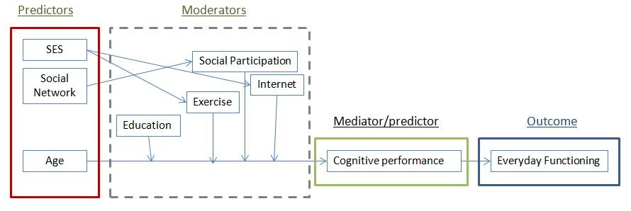
Figure 6.1 Visual representations of the direct and indirect relationships that social factors, social participation, exercise and Internet use, as well as cognitive and functional performance have among older adults.
This figure captures only a fragment of the existing complexity in the relationships between the social factors that influence directly or indirectly cognitive performance and as a consequence everyday functioning in older age. The examination model proposed here is based on main arguments found in the scientific discourse of cognitive ageing and the dialogues created in policy-making, as presented in the 1st, 2nd and 3rd Chapter. As a model, it denotes the need to examine cognitive performance in a more holistic context, including factors that derive from the physical, social and psychological sphere, as discussed in the 2nd Chapter of this thesis. Finally, it is aligned with the postulation of Diehl et al. (2005) about the ability to examine the relation of cognitive performance and everyday functioning using complex models, denoting that:
In general, a growing body of empirical studies supports the notion that cognition is an important component of older adults’ everyday functioning and provides support for a hierarchical model of everyday cognition. The core premise of this model is that cognition in everyday contexts is likely to be related to basic or laboratory-based measures of psychometric intelligence and cognition. In this framework, basic or academic intelligence is seen as a resource set that is drawn on in the management of everyday challenges. Moreover, because everyday problems are likely to be complex and multidimensional, the model also hypothesizes that broad measures of everyday problem solving will be related to multiple intellectual abilities.
Therefore, it is argued here that the model described in Figure 6.1 may serve as a basis to form testable hypothesis and examine the relation between social factors, behaviour, cognitive performance and everyday functioning (as the main outcome) restrictively in the healthy, non-pathological spectrum of cognitive performance.

Proposed Examination and Analysis
Given the complexity of the aforementioned examination, the underlying research questions and hypotheses will be conducted in a stepwise fashion, including 5 separate sets of analysis. This does not signify that the corresponding examination relies in separate samples, but that the differential sets of analysis address distinct research questions, all feeding into the overarching research question and hypothesis. The proposed examination and analysis contains a number of direct and indirect effects, having predictors and outcome variables in all occasions, but examining moderation effects in some instances (e.g., the moderation effect of social participation, Internet use, exercise, and education in the relation between age and cognitive performance) and mediation effects in others (e.g., the relation between age with everyday functioning, mediated by cognitive performance).
Predictors and moderation effects will be examined using multiple regression analyses, and mediation effects will be examined using Structural Equation Modelling (SEM), as proposed by Frazier et al. (2004). The precondition for a variable to serve as a predictor is to correlate statistically significant with the outcome variable (Salthouse & Pink, 2008). In order for a variable to serve as a mediator, the precondition is for this variable to relate statistically significantly with both the predictor and the outcome variable (Frazier et al., 2004). As Frazier et al. (2004) stated, both continuous and categorical variables can be examined in a multiple regression model.

Analysis 1 Validation of the OTDL-G and EPT-G
The first examination and analysis addresses the psychometric properties of the everyday functioning tools OTDL-G and EPT-G. This analysis is necessary as to examine their reliability and validity, by performing an interrater reliability analysis, internal consistency analysis, criterion-related validity analysis and differential item difficulty analysis (correct vs incorrect responses). Following the recommendations of Geisinger (1994), the indexes resulting from this analysis will be compared with those of the original instruments in order to assess their equivalence, and as indication of their successful adaptation in the Greek context. These types of analyses necessitate a larger sample of participants, and therefore could not be conducted on the pilot study described in the previous Chapter.

Analysis 2 The Relation Between Cognitive Performance and Everyday Functioning
The second examination in the fieldwork of this thesis will be the relationship between cognitive performance and everyday functioning. In Chapter 3, it was discussed that cognition is not a single entity and is usually measured via neuropsychological assessments in multiple domains. The results of the meta-analysis in Chapter 4 were informative to which cognitive domains are correlated with functional performance in the healthy spectrum of cognitive performance. Although multiple testing of cognitive performance adds a considerable complexity in the analysis needed, the model proposed in this Chapter allows this examination. As Salthouse and Pink (2008, p. 2) argued:
Although the preceding possibilities can be examined with simple bivariate correlations, …, more informative analyses can also be carried out. For example, several cognitive abilities can be examined simultaneously to determine the unique influences of each. When only a single predictor is examined, as with simple correlations, that variable absorbs all of the variance it shares with other variables that are not included in the analyses, and therefore the results could be misleading with respect to the unique contribution of the variable that is included … This problem of omitted predictors can be minimized by using a contextual analysis procedure, in which multiple cognitive abilities are included in the same analysis. That is, when several cognitive abilities are examined simultaneously, the influence of one ability …, can be determined after controlling for influences of other abilities, such as perceptual speed, episodic memory, and vocabulary.
To address this research question, and based on the results of Chapter 4, the cognitive domains that will be examined simultaneously in a regression model are those of executive function, speed of processing, memory, and verbal fluency. The preliminary analysis will examine the potential correlations between the several cognitive domains with everyday functioning. Subsequently, the domains that correlate statistically significant with everyday functioning measures will be included in a regression model, to examine their shared variance, as well as their independent predictive ability. Everyday functioning will be examined using the OTDL-G and EPT-G instruments in two independent regression analyses. The reason for this is their differential nature in terms of difficulty (as identified in the previous Chapter), administration type (i.e., observation-based vs. paper and pencil test), and because regression models allow the examination of one dependent variable each time.
An additional factor that will be taken into account is the moderation effect of education. The results of Chapter 4 indicate that education may moderate the relation between cognitive performance and everyday functioning. The direction of education’s moderation effect directs to more years of formal education producing weaker correlations between cognitive performance and everyday functioning. This effect was explained by the fact that most neuropsychological and everyday functioning assessments follow a structure and procedure that assimilate those of the class-based tests (Marcotte et al., 2010). The weaker relation among more educated older adults with everyday functioning measures may indicate that test-familiarity mask the effect that cognitive decrements have on everyday functioning. Therefore, a stepwise regression analysis including the interaction terms of education with each neuropsychological assessment added in a separate step will be conducted in order to examine the potential moderation effect of education in the relation between the scores in neuropsychological assessments and those in everyday functioning, as proposed by Frazier et al. (2004).

Analysis 3 Social participation, Exercise, Internet use, SES, and Cognitive Performance
The 3rd analysis will examine the beneficial effect that social participation, exercise, Internet use and education may have on cognitive performance among cognitively intact older adults, over and above age. The literature depicting these interrelations was presented in Chapter 3, along with the emerging methodological and theoretical considerations. The beneficial effect of social participation, exercise and Internet use on cognitive vitality remains a strong statement in policy making, health prevention strategies, intervention studies to foster independence with ageing, and ageing research overall (Bamidis et al., 2015; Hertzog et al., 2009; Salthouse, 2006). As Hertzog et al (2009, p. 47) argued:
Taken together, the available evidence from animal models, aerobic-fitness interventions, some of the cognitive interventions, and epidemiological studies lends support to the hypothesis that a cognitively enriched lifestyle can influence the course of intellectual development in late adulthood and old age. Specifically, such a lifestyle may attenuate cognitive decline in late adulthood and old age, extend the ability to lead an independent life, and postpone the onset of a dementing illness.
The assumptions relating to the beneficial effects evident in the healthy spectrum of cognitive performance will be examined in the healthy spectrum of cognitive ageing using a moderation analysis, as suggested by Cohen et al. (2003) and Salthouse (2006). Although the relevant discussion may point to developmental issues, the current examination will be performed using a cross-sectional design. The ability of cross-sectional studies to illustrate developmental processes was discussed in Chapter 3, noting several strengths and limitations compared to longitudinal studies.
This examination will adopt the approach of Frazier et al., (2004) using a regression model, to identify the potential moderation effect that social participation, education, exercise and Internet use have in the relation between age (the independent variable) with each of the cognitive domains under examination (i.e. executive function, speed of processing, memory, and verbal fluency). More precisely, several regression models will include age in the first step, introducing in the second step the interaction variables produced by multiplying age with social participation, education, exercise and Internet use. Each cognitive domain will be the outcome variable in independent regression analyses.
The effect of education on performance in neuropsychological assessments will be taken into account in this examination as a potential moderator. The effect of education of cognitive performance has been explained in the context of the cognitive reserve hypothesis, which postulates that individuals of higher education build a cognitive reserve through neuronal plasticity that can effectively bear age-related neuronal degeneration (Mortiner, 1988). As such, education can be included in the first step of the regression model, along with age, as a potential moderator of cognitive performance with ageing.

Analysis 4 Social Factors that Influence Older Adults’ Social Participation, Exercise, and Internet use
Earlier in this Chapter, it was described how participation in activities that benefit cognitive performance cannot be considered solely a personal choice for older adults. As Aichenbaum and Brengston (1994) argued, major life events and SES can diversify developmental pathways within the ageing process. The 4^{rth} analysis will examine how various social factors (i.e., age, SES, gender, social network) may predict independently Greek older adults’ social participation, exercise, and Internet use.
As with analyses 2 and 3, this analysis will follow two steps following the suggestions of Salthouse and Pink (2008). The variables (predictors) relating significantly with social participation, exercise and Internet use will be introduced in a regression model, in order to identify their shared variance, as well as their predictive ability. For each of the social participation, exercise and Internet use, a separate regression analysis will be performed, as regression analyses allow the examination of only one dependent variable each time.

Analysis 5 Examining the Mediation Effects of Cognitive Performance
The final analysis will take advantage of the evidence produces in the first 4 studies and examine whether age influences Greek older adults cognitive performance, the latter mediating this effects on everyday functioning. The mediation effect will be examined (i.e., path analysis) using Structural Equation Modelling, as recommended from Frazier et al., (2004). The included factors in the proposed analysis will be identified from the results and conclusions of the previous analyses.

Required Sample Size
The target sample size required for the aforementioned analyses is set to 100 participants according to three criteria.. First, and according to Lumley, Diehr, Emerson and Chan (2002), a sample size of 100 is sufficiently large in order for the normal distribution of the data to be rendered as unimportant, when the level of confidence is set to p =.05. As Lumley et al. (2002, p.166) argued:
The t-test and least-squares linear regression do not require any assumption of normal distribution in sufficiently large samples. Previous simulations studies show that “sufficiently large” is often under 100 … . This means that in public health research, where samples are often substantially larger than this, the t-test and the linear model are useful default tools for analyzing differences and trends in many types of data, not just those with normal distributions. Formal statistical tests for normality are especially undesirable as they will have low power in the small samples where the distribution matters and high power only in large samples where the distribution is unimportant
In their conclusions, Lumley et al. (2002, p.151) argued:
The major limitation on the t-test and linear regression for inference about associations is not a distributional one, but whether detecting and estimating a difference in the mean of the outcome answers the scientific question at hand.
The second criterion was to secure the sufficient statistical power for the analysis. According to a number of studies, sufficient statistical power in a regression depends on the magnitude of the effect size expected (small, medium. large) and the number of predictors included in a regression model (Bujang, Sa’at, & Sidik, 2017; Knofczynski & Mundfrom, 2017). A table with the corresponding recommendation, when the level of confidence is set to p =.05 is available below.
The primary research question set in each analysis is whether an effect of SES, social participation, exercise and Internet use is evident, and if these effects are as strong as assumed in the context of scientific enquiry and political dialogue. Given that a moderate relation between cognitive performance and everyday functioning is expected in each regression model, a sample of 100 participants would allow the concurrent examination of 7 predictors by providing a good prediction level, according to the recommendations of Knofczynski and Mundfrom (2017) and Lumley et al. (2002).
For the SEM required in the 5th analysis (i.e., mediation analysis), the issue of sample size and statistical power is less defined and more complicated. As Wolf, Harringhton, Clark and Miller (2013) argued, depending the number of indicators and factors, the magnitude of factor loadings and path coefficients, and the amount of missing data, the data set required can vary from 30 to 460 cases. A clear definition and stratification of the sample size requirements depending on the aforementioned elements in SEM was not made possible in the Wolf et al. (2013) study. They concluded however that in terms of SEM and sample size, no one size fits all approaches, as sample size requirements may vary depending on the underlying research question. In addition, they concluded that more is not always better, as considering the missing data, biases and measurement error are or equal importance as power. Therefore, in this thesis, the estimation of the analysis’s power in the SEM will be performed post hoc, taking into account the number of indicators and factors, magnitude of factor loadings and path coefficients, and using the information provided by Wolf et al. (2013).
The third criterion was the pragmatic considerations generated from the nature of then research questions’ examination. As it is described in this Chapter, and illustrated in Figure 6.1, the complexity of the underlying research questions of this thesis’s fieldwork is considerable, rendering a stepwise of examination as necessary. This examination requires the assessment of many variables in a single research protocol, translated in increased requirements in time and resources (i.e., 2 hours of examination for each participant). Given that a sample size of 100 ensures the power of the study in sufficient levels, the restriction of the target sample will also facilitate the successful sampling process for the fieldwork of this thesis. Taking all the aforementioned factors into account, the sampling strategy, the description of the sample and the instruments used to measure the variables under examination in the fieldwork of this thesis are described below.
Table 6.1 Sample Size Recommendations At Selected Levels Of Squared Population Multiple Correlation Coefficients For Varying Numbers Of Predictor Variables.
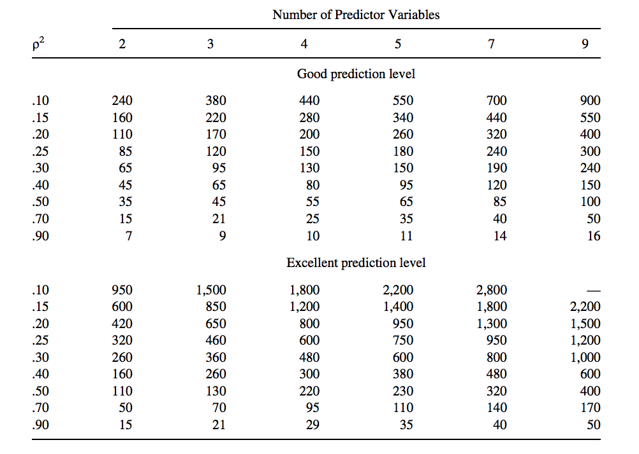

Note: Adapted From Knofczynski And Mundfrom (2017)

Participants
A hundred and twenty-five (125) respondents of an open call via poster announcements at the premises of the University, and at three day-care centres in Thessaloniki (Greece), participated in the study. From the total, 5 were excluded because they were foreigners (not able to be tested in Greek, as the testing procedure was prepared), 4 because they suffered from Parkinson’s disease, seizures, dyslexia, or they had a stroke in the past. Three (3) additional participants were excluded because they were taking sedative medications or were drunk at the time of the examination, and 2 because they were illiterate. Another 8 participants that had a MMSE score below 23 were excluded, as they might have been challenged from dementia (Fountoulakis et al., 2000). Applying the Petersen’s (2004) criteria, 11 participants that had acceptable scores in MMSE and MoCA, and were willing but unable to complete the EPT and OTDL test were excluded. This indicated that they might have cognitive related everyday functionality shortcomings, consistent with an MCI diagnosis.
The final sample of 92 participants belonged to the cognitively healthy spectrum of ageing (M_{MMSE} = 28.44, SD = 1.21, Range = 25-30, M_{age}= 62.64, SD = 7.19, Range = 50-83). From the total, 61 participants were married, 18 were single, and 13 were widowed. Although residing in the same city, 51 were examined in our lab in the city-centre, and 36 in the Neapel County (5 missing data), two distinct neighbourhoods of Thessaloniki, Greece. Their educational level is presented in Table 6.2.
Table 6.2 Demographic Variables For The Final Sample
Variable | N
Gender
Men | 30
Women | 61
Education (level)
Primary | 11
Gymnasium | 3
Lyceum | 37
Technical School | 14
University | 24
Masters | 2
Doctoral | 1
Health Status (level)
Poor | 2
Fair | 23
Good | 31
Very Good | 27
Excellent | 9

Instruments
The complete battery of assessments and interviews were counterbalanced across the testing process during the fieldwork. Seniors’ perceived health status, loneliness, exercise, social participation, and social network were measured using a questionnaire based structured interview. The corresponding items were translated-back translated by two bilingual professionals, as recommended by Hambleton (2001). A Greek bilingual philologist checked for the appropriateness of the language used in the final questionnaire and examined for inconsistencies. The questionnaire package is available in Appendix VIII
Everyday Problem Test – Greek version. All participants had to complete the EPT-G, the Greek version of EPT 28-items (Willis et al., 2006). The scoring range and schemes, as well as the calculation principles of the EPT-G remained unchanged, in order to persevere equivalence with the original measure (i.e., the EPT 28-items). Similar to the original EPT tests, in the Greek versions, higher scores of EPT-G indicated better everyday functioning.
Mini Mental State Examination (MMSE). The Greek version of the MMSE was used in the screening process to identify whether participants exhibited symptoms that point to a neurodegenerative disease. The MMSE is a broadly used instrument to screen for general cognitive deficits, assisting for the detection of dementia (Fountoulakis et al., 2000). The MMSE is standardized for the Greek population and has a cut of score of 23, with scores under this threshold indicating serious neuropsychological impairments consistent with the existence of various forms of dementia.
Montreal Cognitive Assessment (MoCA). The Greek version of Montreal Cognitive Assessment (MoCA) was used to assess whether participants exhibit symptoms that are consistent with a diagnosis of MCI. The MoCA is not validated yet in the Greek population (Kounti et al., 2007). The original instrument (Nasreddine et al., 2005) aims to assist in the detection of MCI, a clinical state that often progresses to dementia.
Verbal Fluency. Verbal Fluency (VF) was measured by asking the participants to recall as many words that start for the Greek letter ‘x’, within one minute. This item derives from the MoCA instrument and used as an assessment of verbal fluency in the SHARE study (SHARE, 2014).
Trail Making Test Part A and B. The Greek versions of the Trail Making Test Part A (TMT-A) and the Trail Making Test Part B (TMT-B) (Vlachou & Kosmidou, 2002) were administered to all participants. TMT-A is a timed test that requires participants to draw a line connecting 25 consecutively numbers. TMT-B is timed and requires connecting consecutive numbers and letters, alternating between the two sequences (i.e., 1-A-2-B-3-C . . . L-12). During the administration of the TMT-A and TMT-B, errors were pointed out by the researchers. The participants were redirected to the last correct circle while timing continued. Two indexes were calculated: i) the seconds required to complete the TMT-A task, as an indicator of speed of processing (for a review, see Hester, Kinsellla, Ong, & McGregor, 2005). Higher scores in TMT-A indicate slower speed of processing; ii) the seconds required to complete the TMT-B task. This has been frequently used as an index of cognitive flexibility and set-shifting (Hester et al., 2005). Higher scores in TMT-B indicate worse EF (Hester et al., 2005)
California Verbal Learning Test. The Greek version of the California Verbal Learning Test (GVLT; Vlachou et al., 2012) is a verbal memory measure, which assess learning, retention, and recall of verbal information. The GVLT is the Greek adaptation of the California Verbal Learning Test (CVLT; Delis, Kramer, & Kaplan, 1987). Five learning trials were provided in which the researcher reads a shopping list for Monday, and the participant is requested to recall as many of the items as possible, regardless of order, after each reading. The interference (Tuesday) list was read subsequently, followed by an immediate free recall of the Monday list. Then, for approximately 20 minutes, the OTDL-G was administered. Finally, delayed recall was assessed, by asking the participants to recall the items from the initial list. The indices created from this test were: i) the amount of words remembered after the first reading of the Monday list, a measure of working memory (WM); ii) the total amount of words recalled during the five learning trials, a measure of the participants’ learning curve (LC); iii) the total amount of words recalled after the interference list, a measure of short term memory (STM); and iv) the amount of words recalled after the 20 minutes interval, a measure of long-term memory (LTM; Vlachou et al., 2012). Higher scores in all indices indicate better memory performance in the corresponding domains.
Perceived Health. Perceived Health was assessed by the item “Would you say that your health is”, with the available forced choices to range from “excellent” to “poor” (Range of possible answers = 5). As Rodin and McAvay (1992) demonstrated, self-reported health is highly related with actual health, as well as it is independently predictive of chronic illnesses, sick days, hospitalization and medication use, especially in seniors.
Loneliness: Loneliness was assessed by the item ‘Do you feel lonely?’, as in the Yeh and Liu (2003) study. The available responses were ‘never’, ‘sometimes’, and ‘often’.
Physical Activity: A Greek version of the Godin Leisure Time questionnaire (Barkoukis, Lazouras, Ourda, Galanis, & Oxizoglou, 2009) was used to measure exercise. Following the suggestions of Dishman et al. (2001), this tool was used because i) self-report measures of physical exercise are most practical and cost-effective in measuring physical exercise in free-living populations, ii) it examines type, frequency, duration and intensity of activity in order to be more informative, and iii) is aligned with the research question posed in the study.
The questionnaire was slightly modified to reflect the Centre for Disease Control and Prevention guidelines for older adults (CDC, 2014). The questionnaire yields an index of participation in exercise that is a continuous variable, which is calculated by the equation x = 9*intensive activity + 6* moderate activity + 3*low intensity activity. A second index was created to reflect adequate participation in exercise, by adding the frequency of participation in high and moderate exercise, reflecting the recommendations of CDC (2014) for older adults’ adequate participation in physical activity. A score equal or higher than 3 (i.e., per week in exercise of duration more than 15 minutes) was regarded as participating adequately in exercise.
Social Network Size: Social Network Size was measured using the approach of Glei, Landau, Goldman, Chuang, Rodriguez, and Weinstein (2005). The questionnaire consists of 3 open ended questions, asking the number of people living together in the household the last 12 months, number of other relatives with at least weekly contact the last 12 months, number of friends and neighbours with at least weekly contact the last 12 months. Summing the scores of the items, a single index of social network size was created, higher scores of which indicate larger social network size. In the original instrument, no internal consistency analysis was performed and reported.
Social Participation frequency: The items for the social participation questionnaire derived from the narrow definition of social participation in the SHARE study (Christelis & Drobesku, 2012). This narrow definition includes only the items that have been reported most frequently from older participants in the context of the SHARE study in 11 European countries, and are i) volunteering or charity work, ii) taking part in a political or community organization, iii) following educational or training courses, iv) gone to sport, social, or other kind of clubs. All responses were forced choice in a 5-point Likert scale, with higher scores indicating greater social participation. A reliability analysis for the social participation questionnaire was not performed and reported in the original study. The higher the sum of social participation frequency for all social activities indicated greater social participation.
Internet use: This variable was measured by asking the participants for the use of internet to navigate /email /shop / chat or for video calling
Other activities: Given the importance placed in the political dialogue for older adults’ participation in childrearing, labour and care giving, three additional items were included in the research protocol. Older adults’ participation in these activities were assessed by the items i) have you worked receiving compensation, ii) have you looked after children (grandchildren, friends’ or neighbours’ kids), and iii) have you cared for a disabled or handicapped person. All responses were forced choice in a 5-point Likert scale, with higher scores indicating greater participation in these activities. No single index was created for this type of activities

Internal consistency issues for social participation frequency and social network size
As Spector and Jex (1998) argued, in a traditional effect indicator scale, the included items replicate one another, so that in a structural equation modelling terms, each response reflects directly the underlying construct. In the case of measuring social participation and social network size however, each item is not the manifestation of the same activity, but all combined constitute a construct. As Spector and Jex (1998) argued, “we would not say that having poor equipment is equivalent to having inadequate training. However, having both represents a higher level of constraints than only having one”. Given this argument, and as the original instruments created for social participation and social network size did not report an internal consistency analysis, the corresponding indexes will be treated in the same manner in this thesis.

Procedure and Ethical Issues
The study received ethics approval from the Department of Sociological Studies in the University of Sheffield. Participants were informed of the purposes of the study and signed an informed consent form. The participants were informed and aware that they could withdraw from the study at any time. Each participant underwent a 2-hour session. The sessions were undertaken in one to one basis from three examiners, namely the author and two assistant researchers, the latter two being undergraduate students of psychology. The research assistants underwent 20-hours of training on the administration of the specific neuropsychological tests battery, as well as on the everyday functionality tests. Their work was closely supervised in the entire duration of the data collection phase. Only the author scored the results. There were no statistically significant differences in the participants’ scores depending on the person that administered the tests.
The primary ethical issue was how to address individuals that score poorly in the neuropsychological assessments, since this would potentially signify the existence of a neurodegenerative disorder. For this case, the following protocol was applied. The author was the only one who was informing the participants about the results. During this process, the author stated and made clear to the participant that: i) He/she tends to forget a bit more than usually observed ii) The screening tests are not diagnostic tools and therefore cannot inform of the existence or absence of any neurodegenerative disorder. They just assess one’s cognitive aptitude only, iii) A referral to the nearest examination centre, or to the participants’ general physician, was proposed, stating that ‘this is just to be on the safe side. Prevention is better and more effective than the treatment for any physical or psychological disorder’ iv) a sheet that included the nearest neuropsychological examination centre’s address, telephone number, and a map to go there was handed to the participant, along with the author’s telephone number vi) The author stated clearly that he would be available for any question regarding this issue or for any difficulties faced in setting an appointment for the examination vii) The participant’s information was available to any individual that escorted the participant, under the condition that the participant allowed so.
The next Chapter discussed the results of the analyses described above to address the research questions and test the hypotheses. This is made in stepwise fashion, where the first analyses (analyses 1 to 4) will inform the mediation analysis in the 5th analyses. For this reason, a brief discussion will follow the reporting of results in each analyses. To add clarity, each analysis will describe all the variables involved and the statistical procedure involved. The data were analysed using the SPSS v.24 software and the SPSS v.20 Amos software.

CHAPTER 7 ANALYSES AND RESULTS

Analysis 1 Validation of the OTDL-G and EPT-G

Introduction
The first analysis will address the psychometric properties of the everyday functioning tools OTDL-G and EPT-G. In addition, it will compare the results with the corresponding indexes of the original instruments, in order to assess their equivalence, and as an indication of their successful translation and adaptation to the Greek context (Geisinger, 1994). In this context, the instruments’ reliability will be examined with Cronbach’s internal consistency, as well as with interrater reliability analysis. The instruments’ validity will be assessed by their criterion-related validity, namely whether the instruments correlate statistically significant with age, education, TMT-A, TMT-B, , VF, WM, LC, STM and LTM, as proposed by Diehl et al. (2005). Validity will also be assessed by a differential item difficulty analysis (correct vs. incorrect responses), assessing whether they are in accordance with the commonly set standard range (i.e., 20 to 80%) for item difficulty (Taib & Yusoff, 2014).

Analysis and Results
The average completion time was 48 minutes (SD = 18.06) for the EPT-G and 22.56 minutes (SD = 4.63) for the OTDL-G. The EPT-G had an internal consistency of α = .880, and the OTDL-G had an internal consistency of α = .678. Pearson correlation coefficient analysis revealed that the EPT-G and the OTDL-G correlate strongly (r = .704, p < .001). One way ANOVA analysis did not reveal any statistically significant differences in EPT-G and OTDL-G scores between the three researchers [for EPT scores F(2,85) = 1.816, p = .169 and for OTDL-G scores F(2,85) = 1.360, p = .262]. The Pearson correlation coefficients of the participants’ performance in the neuropsychological assessments and the two everyday functioning assessments, along with the means and standard deviations of the measures are depicted in Table 7.1.
Table 7.1 Pearson Correlation Coefficients, Means and Standard Deviations of Scores in Neuropsychological and Everyday functioning Assessments
 |  | VF | TMT-A | TMT-B | WM | LC | STM | LTM | Age | M | SD
EPT_{score} |  | .322** | -.038 | -.307** | .149 | .328** | .268** | .279** | -.414** | 15.56 | 6.58
OTDL_{score} |  | .224* | .020 | -.234* | .044 | .191 | .239* | .271** | -.494** | 54.76 | 10.67
M |  | 12.86 | 47.91 | 115.48 | 6.35 | 46.56 | 9.82 | 9.94 | - | - | -
SD |  | 3.82 | 39.28 | 59.54 | 2.05 | 10.98 | 3.12 | 3.55 | - | - | -
 | Note. * = p<.05, ** = p<.005, ¹In seconds, ² To be remembered items. VF = Verbal Fluency, TMT = Trail Making Test, WM = Working Memory, LC = learning Curve, STM = Short Term Memory, LTM = Long Term Memory, OTDL = Observed Tasks of Daily Living, EPT = Everyday Problem Test
One way ANOVA analysis revealed statistically significant main effects of education level (primary education, Lyceum, technical school, university) on mean EPT-G scores [F(3,82) = 20.853, p < .001], OTDL-G [F(3,81) = 11.834, p < .001] and age [F(3,82) = 3.868 p = .012]. No such statistically significant differences emerged with any of the neuropsychological assessments. Subsequent Tukey post-hoc comparison revealed that those completing only primary education were significantly older (ps = 0.15) than those completing a university degree (see Figure 7.1). In addition, Tukey post-hoc comparisons revealed significant differences (ps < .001) only between primary education with any of the rest educational levels for the mean scores of EPT-G and OTDL-G (see Figure 7.2 and 7.3).
Figure 7.1 Mean age in years as a function of educational levels

Figure 7.2 Mean scores in EPT-G scores as a function of educational levels
Figure 7.3 Mean scores in OTDL-G as a function of educational levels
In terms of item difficulty for the EPT-G, the results indicated that it covered a wide range, from fairly easy (i.e. 1st phone task) where 62.8% of the participants answered correctly both questions of the item, to moderately difficult items (i.e., taxi rates) where 66.3% participants answered correctly only to one question, and fairly difficult items (i.e., nutrition and insurance) where 43% of the participants did not answer both questions correctly. The overall mean difficulty of the EPT-G was 37.12%, calculated as the proportion of those answering correctly to both questions (36.71%), plus the proportion of those answering correctly one question for each item (37.54%) divided by two. These percentages are considered optimal according to the commonly set standard range (i.e., 20 to 80%) for item difficulty (Taib & Yusoff, 2014)
Regarding the item and task difficulty of the OTDL-G, the results indicated that it ranged from easy items, where 83.5% of the participants answered correctly (i.e., giving change) to very difficult items (e.g., the drowsiness task in medication handling), where only 3.5% of the participants answered correctly (although this increased to 23.5% when some prompts were given, as described in the administration guidelines). The overall task difficulty of the OTDL-G was 40.6%, considered optimal according to the set standard range (i.e., 20 to 80%) suggested by Taib and Yusoff (2014).

Discussion
The internal consistency of the EPT-G seems to be at optimal levels, however the relevant results for the OTDL-G need further elaboration. According to Ponterotto and Ruckdeschel (2017), different minimal acceptable levels of internal consistency have been set from different authors (Table 7.2).
Table 7.2 Recommendation Guidelines For Minimal Acceptable Levels Of Internal Consistency For Research Measures In Psychology.
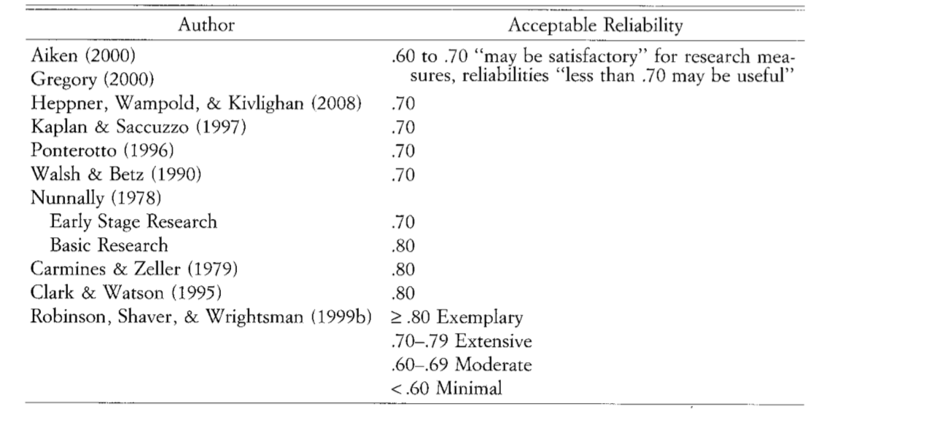
Note. Adapted from Ponterotto and Ruckdeschel (2017)
Based on this differentiation in the acceptability of internal consistency levels, it could be argued that the OTDL-G does not reach optimal levels, however it can be considered as moderate, potentially satisfactory, or rendering the measure as potentially useful. Therefore, the OTDL-G measure for the assessment of everyday functioning of older adults is used in the fieldwork of this thesis, noting however that increasing the measure’s internal consistency should be pursued in future research.
Inter-rater reliability analysis did not yield any statistically significant difference in the means scores as a function of the researcher conducting the assessment. This indicates that the translation and the adaptation of the instrument, the guidelines, and the training received was adequate to ensure that the assessment of everyday functioning using the OTDL-G and the EPT-G reliably produces equal scores independently from the researcher performing the assessment. In terms of criterion-related validity, both the EPT-G and OTDL-G correlate statistically significantly with various measures of cognitive performance, as well as with age. This pattern of relativity is similar to the original instrument, indicating that everyday functioning is an ability that declines with age and relates with the corresponding age-related decline in cognitive performance.
The analysis of the results also indicates that those who have completed only primary education (6 years of schooling in the Greek context) score lower in the EPT-G and OTDL-G. This effect can be explained by the fact that most neuropsychological and everyday functioning assessments follow a structure and procedure that assimilate those of the class-based tests (Marcotte et al., 2010). Ardila (1998) argued for a similar pattern in the context of the cognitive reserve hypothesis, namely that the effect of lower education on cognitive performance is strong between those having received none, with those having received 3 years of education. This effect seems to decline when comparing those of 3 and 6 years of education, until the effect of poorer education reaches a plateau, with no significant effects observed. The results of the first analysis indicate that a similar pattern of relationship with education may be evident in measuring everyday functioning as well.

Conclusion
As a conclusion, the OTDL-R and EPT-28items seem to have been translated and adapted successfully in the Greek context, yielding two reliable and valid instruments that measure everyday functioning in the healthy spectrum of cognitive performance. The findings replicate the ranges reported for the original instruments OTDL-R and EPT-28items, validating the equivalence of the adapted and translated instruments OTDL-G and EPT-G (Geisinger, 2994).
Further development of the instruments should include an examination of test-retest reliability, as well as effecting an increase in the internal consistency for the OTDL-G. The administration of the EPT-G and OTDL-G should be made with caution, as those having received only primary education may be disproportionally challenged by the tasks, an effect that may not be attributable to cognitive performance. The latter possibility will be examined in the second analysis.

Analysis 2 The Relation Between Cognitive Performance and Everyday Functioning

Introduction
The second analysis examines the relation between cognitive performance and everyday functioning. It was hypothesized that cognitive performance would predict performance in everyday functioning tests. Following Salthouse and Pink’s (2008) suggestions, two conditions needed to be satisfied in order for a relation of this nature to be established. The first is that a factor must be statistically significant correlated with the outcome variable. This condition was satisfied (see Analysis 1), since VF, TMT-B, STM, and LTM, but not TMT-A and WM, were statistically significant correlated with EPT-G and OTDL-G. The LC measure was statistically significant correlated only with the EPT-G measure. As such, a stepwise regression analysis was performed, including age in the first step; VF, TMT-B, STM, and LTM in the second step; and education in the third step, in order to identify any statistically significant independent predictors of OTDL-G and EPT-G. In this analysis, education was examined by an effect coding variable, with 1 representing those completing primary school only, and 2 representing those completing more than primary school, following the suggestions of Frazier et al., (2004).
The scores of the neuropsychological assessments were standardized and subsequently, an interaction term for each neuropsychological assessment with education was created, which subsequently were entered in the regression model. Following the suggestions of Frazier et al. (2004), if the second step of the regression analysis explains an additional variance in the model (i.e., R²_{change}), then education has a moderation effect in the relation between cognitive performance and everyday functioning. The list of the variables included in the regression models for each neuropsychological assessment, as well as their nature (i.e., predictor, moderator, outcome) is presented below (table 7.3).
Table 7.3 Variables Included In Examining The Moderation Effect Of Education In The Relation Between Cognitive Measures And Everyday Functioning
Predictors | Moderators | Outcomes
Verbal Fluency (VF) | VF*educational level  TMT-B*educational level  D-TMT*educational level | Observed Tasks of Daily Living  Everyday Problem test
Trail Making Test – A (TMT-A) | TMT-A*educational level | Observed Tasks of Daily Living  Everyday Problem test
Trail Making Test-B (TMT-B) | TMT-B*educational level  D | Observed Tasks of Daily Living  Everyday Problem test
Working Memory (WM) | WM*educational level | Observed Tasks of Daily Living  Everyday Problem test
Short Term Memory (STM) | STM*educational level | Observed Tasks of Daily Living  Everyday Problem test
Long Term Memory (LTM) | LTM*educational level | Observed Tasks of Daily Living  Everyday Problem test

Analysis and Results
Consistent with the hypothesis of the 2nd analysis, cognitive performance explained a statistically significant proportion of the variance in the EPT-G but not in the OTDL-G scores. The moderation effect of education in the relation between cognitive performance and everyday functioning was not evident in any of the analyses. In the regression model, the total variance explained was .50 and .60, which makes the inclusion of 7 predictors in samples of 92 participants sufficient for a good prediction level (Knofczynski & Mundfrom, 2017). Among the cognitive measures, only VF and TMT-B predicted independently Greek seniors’ EPT-G scores in the final model. Age and education however were statistically significant predictors of both EPT-G and OTDL-G.
Table 7.4 Stepwise Regression Analysis Predicting EPT-G Scores
Step and variable | B | β | R²_{change}
Step 1 |  |  | .205**
Age | -.417 | -.453**
Step 2 |  |  | .183**
Age | -.904 | -.301**
Verbal fluency | .326 | .227*
Trail Making Test – Part B | -.031 | -.252*
Learning Curve | .109 | .185
Short Term Memory | -.167 | -.080
Long Term Memory | .199 | .109
Step 3 |  |  | .186**
Age | -.204 | -.222*
Verbal fluency | .326 | .194*
Trail Making Test – Part B | -.022 | -.183*
Learning Curve | .089 | .150
Short Term Memory | -.101 | -.048
Long Term Memory | .104 | .057
Education (level) | 9.009 | .458**
Note. **p<.005, *p<.05

Table 7.5 Stepwise Regression Analysis Predicting OTDL-G Scores
Step and variable | B | β | R²_{change}
Step 1 |  |  | .284**
Age | -.862 | -.541**
Step 2 |  |  | .060
Age | -.720 | -.452**
Verbal fluency | .422 | .152
Trail Making Test – Part B | -.032 | -.157
Working Memory | .013 | -.013
Short Term Memory | -.092 | -.027
Long Term Memory | .341 | .114
Step 3 |  |  | .186**
Age | -.589 | -.370**
Verbal fluency | .334 | .116
Trail Making Test – Part B | -.020 | -.100
Working Memory | -.036 | .150
Short Term Memory | .014 | .004
Long Term Memory | .222 | .074
Education (level) | 12.713 | .392**
Note. **p<.005, *p<.05

Analysis 3 The Relation Between Social Participation, Exercise, Internet use, Education, and Cognitive Performance

Introduction
The 3rd analysis will examine the potential beneficial effect that social participation, exercise, mental activities and education may have on cognitive performance among cognitively intact older adults. The beneficial effect of social participation, exercise and mental activities on cognitive vitality remains a strong statement in policy making, health prevention strategies, and interventions aiming to foster independency with ageing (Bamidis et al., 2015; Hertzog et al., 2009; Salthouse, 2006). A direct effect of education on cognitive decline with ageing has been argued in the context of test familiarity (Marcotte and al., 2010), however this effect was not evident in the first analysis of this Chapter. Therefore, education will not be examined as a potential predictor of cognitive performance in this analysis, but as a potential moderator of the relation between age and cognitive performance, following the rational postulated by the cognitive reserve hypothesis.

Analysis plan
Social participation was represented from the measures of loneliness and social participation frequency following the narrow description of Christelis and Dobresku (2012). For the items asking about working, childrearing and care giving, no single index was employed, but they were examined separately. Exercise was measured with a continuous index (i.e., as operationalized in the previous Chapter), including a categorical index as well to describe those that exercise sufficiently and those not doing so.
Table 7.6 Correlation Analysis Between Social Participation Indexes, Internet Use, And Exercise With Cognitive Performance Variables
Variables | VF | TMT-B | STM | LTM
Age
Social participation (narrow definition)
Internet use
Other activities (working, childrearing, caregiving)
Exercise index
Note. VF = Verbal Fluency, TMT = Trail Making Test, STM = Short term memory, LTM = Long term memory
The hypothesis that social participation, exercise, and Internet use have a beneficial effect on each of the cognitive measures, over and above age was examined with a moderation analysis, as proposed by Salthouse (2006). The moderation ability of social participation, exercise, Internet use and education in the relation between age with cognitive performance was examined through a series of regression analyses for each measure of cognitive performance (i.e., TMT-B, VF, STM and LTM), along with the standardized age and the standardized score of one of the potential moderator variables (i.e., social participation, exercise, Internet use), in the second step their interaction term was included.
Table 7.7 List Of Variables Included In The Regression Models Testing The Moderation Effect Of Social Participation, Exercise, Education And Internet Use In The Relation Between Age And Cognitive Measures
Predictors (z) scores) | Moderators | Outcomes
Age | Education | Trail Making Test – Part B
Age | Social Participation | Long Term Memory
Age | Internet use | Short Term Memory
Age | Exercise | Verbal Fluency

Descriptive analysis
Descriptive statistics (frequencies) for social participation, Internet use, working, childrearing, and care giving are presented in Tables 7.8 and 7.9. The mean and standard deviation of the exercise index were M = 22.26, SD = 17.26, with 60% of the participants reporting that they do not exercise at all, 14% that they exercise but not in adequate levels, and 26% exercising adequately. The mean and standard deviation for the social participation activities were M = 6.57 and SD = .80. Among the participants, 45% reported never to feel lonely, 38% sometimes and 17% sometimes
Table 7.8 Percentages Of Seniors’ Participation (Narrow Definition)
 | Never  once a year | Sometimes a year | Sometimes a month | Sometimes a week | Everyday (almost)
Volunteering (%) | 61 | 15 | 12 | 5 | 6
Political/community organization (%) | 62 | 24 | 12 | 2 | 0
Sport, social, or other clubs (%) | 11 | 66 | 12 | 3 | 0
Educational or training courses (%) | 59 | 27 | 9 | 4 | 0
Note. * Social participation frequency (continuous variable) M = 6.96, SD = 2.04, Range 4-13

Table 7.9 Percentages Of Seniors’ Participation In Internet Use And Social Activities
 | Never | Once/twice a week | Most days | Almost everyday | Everyday
Using the Internet (%) | 42 | 10 | 8 | 6 | 34
Working (%) | 83 | 1 | 0 | 11 | 5
Childrearing (%) | 45 | 24 | 13 | 4 | 14
Caregiving (%) | 79 | 11 | 3 | 1 | 5

Analysis and Results
Pearson correlation coefficient analysis of age with cognitive performance measures yielded statistically significant results with TMT-B (r = .345, p = .001), STM (r = -.271, p = .009) and LTM (r = -.308, p = .003) but not with VF. Pearson correlation coefficient analysis among social participation, Internet use, working, childrearing, caregiving and exercise with VF, TMT-B, STM and LTM yielded statistically significant results only for the relation of social participation with VF (r = .258, p = .013). Pearson correlation coefficient analysis of age with social participation, Internet use, and exercise revealed statistically significant relations for age with Internet use (r = -.317, p = .002), and exercise (r = -.227, p = .007). One way ANOVA analysis did not reveal statistically significant main effects of loneliness levels on the mean scores of any cognitive performance measures. Independent samples t-test did not reveal any difference in the mean age, nor in the mean scores in any of the neuropsychological assessments between those that exercised adequately with those not doing so.
Regression analyses were performed to examine the potential moderation effect of social participation, Internet use and exercise in the relation between age and the cognitive measures. No moderation effect emerged, except for the TMT-B scores. The results indicate a moderation effect for social participation, Internet use and exercise, but not of loneliness in the relation between age and TMT-B. A regression analysis was conducted in order to examine the potential moderation effect of education in the relation between age with cognitive performance. The results indicated that education moderates the relation between VF and TMT-B with age. No other moderation effect of education emerged.
Table 7.10 Testing The Moderation Effect Of Internet Use In The Relation Between Age And The Score Of Trail Making Test Part B
Step and variable | B | β | R²_{change}
Step 1
Age (z score) | 19.049 | .321**
Internet use (z score) | -4.413 | -.074 | .124**
Step 2
Age x Internet use (z scores) | 15.035 | .250* | .061*
Note. **p<.005, *p<.05
Table 7.11 Testing The Moderation Effect Of Social Participation In The Relation Between Age And The Score Of Trail Making Test Part B
Step and variable | B | β | R²_{change}
Step 1
Age (z score) | 20.012 | .336**
Social participation (z score) | -3.662 | -.062 | .122**
Step 2
Age x social participation (narrow definition) | 13.326 | .221* | .045*
Note. **p<.005, *p<.05
Table 7.12 Testing The Moderation Effect Of Exercise In The Relation Between Age And The Score Of Trail Making Test Part B
Step and variable | B | β | R²_{change}
Step 1
Age (z score) | 19.442 | .328**
Exercise (z score) | 3.539 | .060 | .122**
Step 2
Age x exercise (z scores) | -15.589 | .287** | .080**
Note. **p<.005, *p<.05

Table 7.13 Testing The Moderation Effect Of Education In The Relation Between Age And Verbal Fluency
Step and variable | B | β | R²_{change}
Step 1
Age (z score) | -.311 | -.081
Education (z score) | 1.023 | .268* | .087*
Step 2
Education x Age (z scores) | -1.219 | -.344** | .107**
Note. **p<.005, *p<.05

Table 7.14 Testing The Moderation Effect Of Education In The Relation Between Age And Trail Making Test Part B
Step and variable | B | β | R²_{change}
Step 1
Age (z score) | 20.323 | .343**
Education (z score) | -.481 | -.008 | .119**
Step 2
Age x education (z scores) | 19.439 | .353** | .113**
Note. **p<.005, *p<.05

Table 7.15 Testing The Moderation Effect Of Education In The Relation Between Social Participation And Trail Making Test Part B
Step and variable | B | β | R²_{change}
Step 1
Social participation (z score) | -4.977 | -.084
Education (z score) | -2.938 | -.049 | -.010
Step 2
Social participation x education (z scores) | 19.238 | .345** | .081**
Note. **p<.005, *p<.05

Table 7.16 Testing The Moderation Effect Of Exercising Adequately Or Not In The Relation Between Age And Trail Making Test Part B
Step and variable | B | β | R²_{change}
Step 1
Age(z score) | 18.746 | .316**
Exercise | 13.925 | .111 | .130**
Step 2
Age (z score) x exercise | -35.159 | -.912** | .081**
Note. **p<.005, *p<.05

Figure 7.4 Trail Making Test part B scores as a function of social participation levels and age
Figure 7.5 Trail Making Test part B scores as a function of Internet use levels and age

Figure 7.6 Trail Making Test part B scores as a function of exercise and age

Figure 7.7 Trail Making Test part B scores as a function of education and age
Figure 7.8 Verbal Fluency scores as a function of education and age

Figure 7.9 Trail Making Test part B scores as a function of social participation and education

Discussion
The results depicted a negative relationship of age with Internet use and exercise, the latter possibly reflecting a cohort effect (i.e., older generations use less the Internet and are less keen to exercise). The findings of this analysis support the hypothesis that education, social participation, exercise, and Internet use moderate the relation between age and cognitive performance. Their moderation effects however do not point to a clear beneficial effect. The interpretation of the corresponding findings can be understood through the prism of temporal or developmental effects, pointing to the relevant discussion in Chapter 3 concerning the ability of cross-sectional data to depict (or not) developmental processes.
Social participation: Examining the evidence for social participation through the lens of temporal effects, the findings depict an expected poorer performance in TMT-B in older age, with those participating more frequently in social activities having a better performance in TMT-B. The examination of the results through the lens of developmental processes leads to the same conclusion, indicating that social participation does not influence the rate of cognitive decline with age. The last is consistent with the preserved differentiation hypothesis of Salthouse (2006), stating that having greater social participation may not discriminate older adults in their rate of cognitive decline, but only their level of cognitive performance at each time point. The findings also indicate that increased social participation has a beneficial effect on TMT-B only among those who had completed primary education. This effect does not seem to be evident among those who completed higher levels of educational, as participating more or less frequently than the mean in social activities did not discriminate their performance in TMT- B significantly.
Internet use: Through the lens of temporal effects, the evidence on Internet use depicts that younger participants who are frequent users have better performance in TMT-B than those who use the Internet once or twice a week, or never. The inverse relation emerges among older participants; those who use the Internet frequently have poorer performance in TMT-B than those who use the Internet once or twice a week, or never. The examination of the results through the lens of developmental processes indicates that those who do not use the Internet, or do so once or twice a week retain their TMT-B levels with age, whereas more frequent or everyday use leads to poorer performance in TMT-B with age. This evidence argues in favour of the preservation differentiation hypothesis (Hertzog et al., 2009), namely that modest use of Internet may lead to more favourable cognitive decline trajectories with ageing.
Under the lens of examining developmental processes, the findings indicate that using the Internet more than once or twice a week may initially produce benefits in TMT-B scores, but does not help in retaining levels of cognitive performance in older age. A potential explanation would be that excessive Internet use may lead to more sedentary lifestyles, and therefore to worse cognitive decline trajectories. Yet, post-hoc Pearson correlation analysis revealed that those who use the Internet more frequently are also more socially active (r = .247, p = .018), whereas the relationship between Internet use and exercise was not statistically significant (r = -.134, p = .203). Therefore, no such conclusion could be made based on the findings of this thesis.
Exercise: The interpretation of the result for the effect of exercise through the lens of temporary effects indicate that more exercise is related to worse TMT-B performance among the younger, but this effect dissipates when examining exercise among the older age group. The examination of the results through the lens of developmental processes indicates that exercising has a beneficial effect in retaining performance in TMT-B, as those who exercise less manifest steeper cognitive decline trajectories. This pattern argues again in favour of the preservation differentiation hypothesis as argued by Hertzog et al. (2009), namely that exercising may lead to more favourable cognitive decline trajectories with ageing.
Education: The interpretation of the result for the effect of education through the lens of temporary effects indicate that having completed an educational level higher than primary school leads to better scores in TMT-B and VF performance, independent from age. Through the lens of developmental process, it seems that performance of TMT-B in younger age is better among those who are more educated, with this effect dissipating in older age. Contrarily, performance differences in VF seem to be more pronounced in older age.
The moderation effect of education in the relation between age and cognitive performance could indicate that education is a resource that benefits cognitive performance with age, as postulated by the cognitive reserve hypothesis (Mortiner, 1988; Perry, 2002). Given that education is a resource that accumulates at younger stages of life, and that education could not serve as a predictor of cognitive performance (i.e., there were no direct statistically significant relationship with cognitive performance), this hypothesis cannot be supported in the population of examination (i.e., 50+ of age). At the same time however, the moderation effect of education in the relation between age and cognitive performance may indicate that those of lower education are more challenged in completing the neuropsychological assessments, due to their unfamiliarity with such types of cognitive tasks (Marcotte et al., 2010). The findings of this study could argue for a conditional effect of this type, namely that it is evident in certain age groups and only for the TMT-B and VF.

Conclusion
As a conclusion, more education, social participation, Internet use and physical exercise seem to benefit cognitive performance only in the domain of EF and VF. The interpretation of the findings varies depending on the lens of examination, namely whether the results depict temporal or developmental effects. Overall, the evidence is consistent with the hypothesis that those with more education, social participation, and physical exercise have higher levels of cognitive performance in older age. The relation of age, Internet use and EF is more complicated as the findings indicate a beneficial effect only if the specific frequency of use is restricted to certain levels of use per week. In addition, more social participation seems to be beneficial to those who are of lower education, with the evidence not providing support for such an effect among those who have completed more than 6 years of education (i.e., primary schools in the Greek context).
The next analysis will examine whether age, social network size, SES, and gender have an influence on Greek seniors’ social participation, exercise and Internet use, which in turn may influence their cognitive performance.

Analysis 4 Social Factors that Influence Older Adults’ Social Participation, Internet use, and Exercise

Introduction
Earlier in this chapter, it was described how participation in activities that benefit cognitive performance cannot be considered solely a personal choice for older adults. As Aichenbaum and Brengston (1994) and Sharf et al. (2004) argued, income, gender, and education are some of the factors that diversify developmental pathways with ageing, leading to variation in older adults’ social participation. Therefore, the fourth analysis examined how various social factors (i.e., age, SES, gender, social network) may influence Greek older adults’ social participation, exercise and Internet use. In this analysis, SES was represented by income, education, and the SES of the residing neighbourhood, following the suggestions of Oakes (2017). Social participation was represented from the measures of loneliness and social participation frequency following the narrow description of Christelis and Dobresku (2012). Exercise was measured with a continuous index (i.e., as operationalized in the previous Chapter), including a categorical index as well to describe those that exercise sufficiently and those not doing so. The preliminary analysis described the interrelations between the predictors of this analysis, namely age, income, education, gender, social network, and the SES of the residing neighbourhood. As with the analyses 2 and 3, the current main analysis was conducted in two steps in line with the suggestions of Salthouse and Pink (2008).

Table 7.17 Predictors And Outcomes Included In The Regression Models In This Analysis
Predictors | Outcomes
- Age  - Education  - Gender  - Social Network Size  - Income  - Socioeconomic Status of the Residing Neighbourhood | Social Participation  Internet use  Exercise

Preliminary analysis
The mean and standard deviations sizes for social network size were M = 7.48, SD = 4.17, and for income M = 1169.42, SD = 963.58. Independent sample t-test revealed that there were statistical significant differences between the residents of two locations (City Centre N = 51, and Neapel N =36) in the mean income [t(80) = 2.887, p = .005, M_{City Centre} = 1244.91, M_{Neapel} = 854.52] and the mean age [t(80) = -2.489, p = .015, M_{City Centre} = 60.79, M_{Neapel} = 64.65] . Chi square analysis on the levels of education with the location of residence revealed a statistically significant dependency [X² (12, N = 87) = 28.303, p = .005]. A visual examination of table 7.18 reveals that those residing in the city centre were comparatively more likely to have completed higher education, with those in the Neapel area to be more likely to have completed only primary education. This pattern of results indicates that the City Centre and Neapel areas have a different SES in terms of income and education, thus they are two areas of different SES.

Table 7.18 Chi Square Analysis Of The Cross-Tabulation For Educational Level And Location Of Residence
 | Unidentified | City Centre | Neapel
Primary education | 0 | 2 | 9
High school | 0 | 1 | 3
Lyceum | 0 | 22 | 15
Technical School | 2 | 9 | 2
University | 1 | 15 | 8
Masters | 4 | 1 | 6
Doctoral | 0 | 1 | 0
Pearson correlation coefficient analysis revealed a statistically significant relation between age and social network size (r = -.222, p = .030), but not between age and income, or income and social network size. One-way ANOVA on the mean scores of social network size among participants having different educational level revealed a statistically significant difference [F(3,84) = 3.500, p = .019]. Subsequent post-hoc analyses (Tukey HSD) revealed that these differences were between those who completed primary education with those completing the Lyceum (p = .025, M_{primary education} = 4.38, SD = 1.58, M_{Lyceum} M = 8.20, SD = 4.68) or a technical school (p = .035, M_{Technical school,} M = 8.68, SD = 4.05), but not with university graduates. No statistically significant differences emerged for income between participants of different educational level.
Figure 7.10 Mean scores of social networks size as a function of levels of education
Cross tabulation and subsequent Chi square analysis did not reveal any statistically significant dependency of gender with the educational level of the participants. Independent samples t-tests examining statistically significant differences among men and women in the mean scores of social network size, age and income (in euros) revealed statistically significant results only for income [t(84) = 4.361, p < .001, M_{men}= 1744.13, M_{women} = 869.47].
Age: Pearson correlation coefficient analysis of age with social participation and exercise revealed a statistically significant relationship only between exercise and age (r = -.227, p = .007) but not between age and social participation. One-way ANOVA and subsequent post-hoc analyses (Tukey HSD) on the mean age of various levels of Internet use (as described in Table 7.8) revealed statistically significant differences among those never using the Internet and those doing so everyday [F(4, 87) = 2.749, p = .033, M_{never} = 65.08, SD = 6.32, M_{everyday} M = 59.87, SD = 7.61]. No such differences emerged for the mean age as a function of loneliness levels.
Education: One-way ANOVA and subsequent post-hoc analyses (Tukey HSD) on the mean scores of social participation between the participants of different educational level revealed statistically significant differences between those that completed primary school, with those having a university degree [F(3,84) = 4.100, p = .009, M_{primary education} = 5.72, SD = 1.10, M_{university degree} M = 7.78, SD = 2.08]. No statistically significant differences emerged for exercise between participants of different educational level. Cross tabulation and subsequent Chi square analysis did not reveal any statistically significant dependency of educational level with Internet use frequency (as described in categories in Tables 7.8), as well as with levels of loneliness.
Gender: Independent samples t-tests examining statistically significant differences among men and women in the mean scores of social participations and exercise did not reveal any statistically significant results. Cross tabulation and subsequent Chi square analysis examining the dependency of gender with Internet use frequency, (as described in categories in Table 7.8), as well as for levels of loneliness, revealed statistically significant results only for Internet use [X² (4, N = 91) = 11.938, p = .018]. A visual examination of table 7.19 revealed that women were more likely than men to report never using the Internet, once or twice a week or most days.
Table 7.19 Chi Square Analysis Of The Cross-Tabulation For Internet Use Per Gender
 | Never | Once/twice a week | Most days | Almost everyday | Everyday
Men (n) | 8 | 2 | 1 | 2 | 17
Women (n) | 31 | 7 | 6 | 4 | 13
Social Network size: Pearson correlation coefficient analysis of social network size with social participation and exercise revealed statistically significant relations only between social participation and social network size (r = .358, p = .001). One-way ANOVA did not reveal any statistically significant differences in the mean social network size among different levels of Internet use or loneliness.
Income: Pearson correlation coefficient analysis of income with social participation and exercise revealed statistically significant relations only for social participation (r = .358, p = .001). One-way ANOVA and subsequent post-hoc analyses (Tukey HSD) revealed statistically significant differences in the mean income between those who never used the Internet with those who did everyday [F(4, 86) = 3.191, p = .017, M_{never} = 789.29, M_{everyday} = 1588.86]. No statistically significant differences emerged in levels of loneliness.
Socioeconomic Status of the Residing Neighbourhood: Independent sample t-test did not reveal any statistically significant differences in social participation and exercise among those who resided in the two neighbourhoods examined. Cross tabulation and subsequent Chi square analysis examining the dependency of the residing neighbourhood with Internet use frequency revealed statistically significant results [X² (8, N = 91) = 19.191, p = .014]. A visual examination of Table 7.20 reveals that a greater percentage of those residing in Neapel (i.e., lower SES neighbourhood) reported not using the Internet or using it once/twice a week, while a greater percentage of those residing in the City-centre reported using the Internet everyday.

Table 7.20 Chi Square Analysis Of The Cross-Tabulation For Internet Use Per Neighbourhood
 | Never | Once/twice a week | Most days | Almost everyday | Everyday
City Centre (n) | 15 | 7 | 3 | 4 | 22
Neapel (n) | 23 | 1 | 4 | 2 | 6

Regression analysis predicting social participation: Social participation was statistically significantly related with education, social network size, and income, and not with age, gender and the residing neighbourhood. Following the suggestions of Salthouse and Pink (2008), education, social network size, and income were introduced in a regression model, in order to examine their predictive validity. Education was entered as a continuous variable, with higher scores representing higher levels of education. The regression analysis resulted in a statistically significant model that explained AR² = 14% (R² = .171, p = .001) of the variance in social participation, with income being the only statistically significant independent predictor (β = .295, p = .001).
Regression analysis predicting Internet use: Internet use was statistically significantly related with age, gender, income, and the residing neighbourhood, but not with education and social network size. Therefore, age, gender, income, and the residing neighbourhood, were introduced in a regression model, in order to examine their predictive validity on Internet use. Internet use was used as a continuous variable with higher scores representing more frequent use of Internet. The regression analysis resulted to a statistically significant model that explained AR² = 23% (R² = .270, p < .001) of the variance in Internet use, with gender (β = -.257, p = .020) and age (β = -.272, p = .007) being the independent statistically significant predictors.
Regression analysis predicting Exercise and Loneliness: Exercise was statistically significantly related only with age, whereas loneliness was not statistically significantly related with any of the variables examined in this analysis. Therefore, no regression analysis was performed to identify predictors of exercise and loneliness.

Discussion
Consistent with the postulation of Walker (1981), the findings of this study indicate that Greek older women have a substantial lower income than men. This trend exists even when there is no evidence that Greek older women have completed lower levels of education than Greek older men. The findings indicated that increased age and lower income is related with a decreased social network size. The evidence also suggests that those having completed only primary education may have a decreased social network compared to those with higher educational attainment. This relationship however appears to have an inverse U-shape, as those with a University degree do not have statistically significant different social network size from those completing only primary school. As such, the evidence suggests tentatively that having a poorer or higher than secondary education may be related with poorer social network size.
However, there is no evidence that increased age and social network size decline leads to decreased social participation. These findings are inconsistent with the arguments of Cummings and Henry (1961) who advocated the manifestation of social withdrawal in older age, with the loss of social ties to be a plausible explanation for a reduction in social participation. The relevant evidence points to increased income influencing one’s social participation frequency positively, suggesting that it may help in retaining social participation in the face of social ties losses with age.
In relation to Internet use, the predictive ability of age may reflect a cohort effect, namely that older cohorts have lower rates of Internet use than younger generations. These findings are consistent with evidence depicting that globally, older adults have the lowest percentages of Internet use compared to all other age groups (Zickhur and Madden, 2012). The evidence however also depicts that being an older woman in Greece predicts even less Internet use.
The evidence deriving from the regression analyses in this chapter should be taken under consideration with extreme caution. As the model in total explained a variance between .171 and .270, the inclusion of 3 to 4 predictors with the sample size available (N = 92) does not offer enough statistical power for a good prediction level (Knofczynski & Mundfrom, 2017). As such, the risk of having produced a type II error has been comparatively higher in these analyses.

Conclusion
The evidence of this study indicates that women are in disadvantaged position in terms of financial resources in older age. Independently from gender, increased income seems to benefit social participation in older age, in the face of age-related loss of social ties. Older women seem to use the Internet less than older men, with the evidence suggesting that older generations of older adults have lower rates of Internet use.

Analysis 5 Examining Mediation effects in a Holistic Model

Introduction
The final set of analyses takes advantage of the evidence produced in the first four sets of analyses and examines the mediation effects of cognitive performance in the relation between age and everyday functioning. As described in Chapter 3, a strong relationship between cognitive vitality and everyday functioning is an influential assumption in the political dialogue and in the discourse of gerontology. The findings of the first analysis depicted that everyday functioning is an ability that declines with age in the healthy spectrum of cognitive performance. The findings of the second analysis indicate that VF, TMT-B, STM and LTM are statistically significant correlated with both everyday functioning measures. Therefore, they satisfy the first criterion to be included as mediators in a model, as posed by Frazier et al., (2004). The result of the 3rd analysis revealed that age was statistically significant correlated with TMT-B, STM, and LTM, but not with VF. The mediation analysis was performed using SEM.

Analysis and Results
In a SEM, the OTDL-G and the EPT-G were placed as the outcome variables (y), with TMT-B, VF, STM and LTM placed as endogenous variables (M), and age as the predictor (x). The error variance of STM and LTM were correlated to depict their shared variance. Due to missing data, 11 participants were eliminated from this analysis. The analysis included the direct effects of age in both OTDL-G and EPT-G, as well as the corresponding indirect effects though the cognitive measures. The first analysis did not yield a good fit of the data, with LTM and STM not predicting the scores in OTDL-G and EPT-G over and above age. Therefore, the LTM and then the STM were removed sequentially from the model in two subsequent analyses. The model not including STM and LTM provided a good fit of the data [χ² (1, N = 82) = 1.179, p = .278, RMSEA = .047, RMR = .032, CFI = .998]. The direct and indirect effects of age on everyday functioning are presented in table 7.21.

Table 7.21 Direct, Indirect, And Total Effects (Standardized) Of Age On Everyday Problem Test – Greek Version And Observed Tasks Of Daily Living – Greek Versions, Through Trail Making Test Part B And Verbal Fluency
Predictor | Total | Direct | Indirect | Outcome
Age | -.456 | -.358 | -.098 | EPT-G
 | -.529 | -.468 | -.062 | OTDL-G
Note. **p<.005, *p<.05, EPT-G = Everyday Problem Tests – Greek version, OTDL-G = Observed Tasks of Daily Living – Greek version
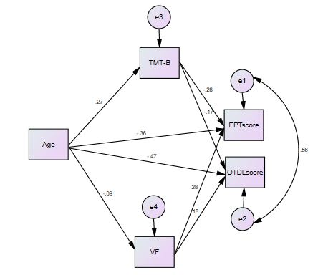
Figure 7.11 Standardized effects of the relationships between age, TMT-B, VF, EPT-G and OTDL-G, using a Structural Equation Modelling.
Note: TMT-B = Trail Making Test part B, VF = Verbal Fluency, EPTscore = scores in the Everyday Problem Test – Greek version, OTDLscore = scores in the Observed Tasks of Daily Living, Greek version

Discussion and conclusion
The results of this study indicate that cognitive performance mediates the relationship between age and everyday functioning in the domains of EF and verbal fluency. A visual inspection of Table 7.21 reveals that this mediation effect is only partial, with the magnitude of the direct effect being significantly larger than the indirect ones. This indicates that cognitive performance may mediate only partially the effects that age has on everyday functioning. The next and final chapter of this thesis bring all the evidence presented in this and the preceding chapter for discussion.

CHAPTER 8 COGNITIVE PERFORMANCE AND AGEING
This thesis began by discussing the demographic change into an ageing population, as well as the relevant concerns expressed with regard to the financial sustainability of state healthcare and pension structures. These concerns derive from normative arguments about older adults’ role in society, insinuating that older age is characterized by reduced contributions (in terms of productivity and withholdings), and at the same time, by increased demands on social benefits (Bank of America Merrill Lynch, 2014). It was argued that this line of argumentation has brought an extensive dialogue about the ‘burden’ of older age, which has more often than not overstated and overestimated the cognitive decrements that accompany older age. This tendency has led, among others, to erroneous assumptions about older adults’ cognitive and functional ability, leaving out of account the factors that may promote older adults’ contribution to labour, childcare, volunteering, as well as in long-term care out of sight (Walker, 2002; Walker & Maltby, 2012).
It is argued in this thesis that a more accurate depiction of cognitive performance in the non-pathological spectrum of cognitive ageing would inform better the political agenda on healthy and active ageing. Relevant scholarly efforts in the past gave rise to concepts such as ‘successful ageing’ (Rowe & Kahn, 1997), which regarded the avoidance of illness and disability as a successful outcome in older age. As a consequence, the studies using Rowe and Kahn’s (1997) model produced findings that described risk ratios of diseases and disabilities, interpreting the avoidance of such conditions as ‘successful’ outcomes in older age. It is argued that this illustration constitutes the pathological landscape of ageing and does not depict the typical cognitive outcomes in older age. At the same time, it has created a bias in examining and documenting age-related cognitive shortcomings and pathologies, living the healthy spectrum of cognitive performance comparatively under-examined.
In general, most research efforts examining older adults’ cognitive abilities are focused on those factors that lead to the occurrence of age-related neurological disorders (Martin et al., 2015). This tendency has resulted in an erroneous projection of the maladaptive properties of age-related neurological disorders in the non-pathological spectrum of cognitive ageing, as depicted in the theoretical framework of Hertzog et al. (2009). The central theme running throughout this thesis is that a positive approach to cognitive ageing is greatly needed, in order to examine more thoroughly the healthy, non-pathological landscape of cognitive performance. A similar approach has been developed in the context of positive gerontology, developing concepts that describe a positive adjustment (both personal and social) to the ageing process, such as that of ‘active ageing’. Active ageing focuses on the social integration of older individuals, by mobilizing their potential and avoiding social exclusion (Walker, 1999; Walker & Maltby, 2012). In this context, this thesis examins which social factors can influence cognitive performance in the healthy, non-pathological spectrum of cognitive ageing, fostering this way an active lifestyle in older age.
This examination uses the objectivity that the scientific methodology offers, in order to eliminate what Depp and Jeste (2006, p.16) termed as a ‘bias towards studying negative outcomes’ in older age. The scope of this thesis was set away from depicting the pathological landscape of cognitive performance, and by taking into account the wider social context. The thesis focuses on the cognitive and functional performance in older age, examining the influences deriving from certain social factors (i.e., social network size, SES, gender, education), and certain behaviours (i.e., exercise, social participation and Internet use). This concluding chapter begins by discussing how the research questions were set out in this thesis, and how they have been addressed. Thereafter, it summarises the thesis’s main findings and how they contributed to the current knowledge in the field of ageing. This chapter explores this thesis’s strengths and limitations, along with the theoretical contribution and implications in the conceptualization of cognitive ageing, influencing both theory and practice (i.e., policy making, research and clinical practices). The chapter concludes with some suggestions for future research that can advance further a positive approach to cognitive ageing in the discourse of cognitive neuropsychology, aligned with the principles of positive gerontology discussed above.

The Research Questions and Hypotheses
In order to examine the non-pathological spectrum of cognitive performance by taking into account the wider social context and by using a positive approach to ageing, the following research questions are addressed in this thesis.
  - Research Question 1: Is cognitive performance related with everyday functioning among cognitively healthy older adults? This research question was addressed in Chapters 4 and 7.
  - Research Question 2: Does cognitive performance mediate age-related decrements of everyday functioning? This research question was addressed in Chapter 7.
  - Research Question 3: Are older adults’ cognitive and functional performance related with SES, social participation, education, and participation in mental and physical activities? This research question was addressed in Chapter 7.
  - Research Question 4: Do social participation, education, and participation in mental and physical activities moderate age-related decrements of cognitive performance? This research question was addressed in Chapter 7.
The hypotheses formation is driven by the normative arguments that are shaped within the current paradigm of cognitive ageing, and which are expressed in influential theories and policies to date. More precisely, it was hypothesized that:
- Hypothesis 1: Cognitive performance will be related with everyday functioning in the healthy spectrum of cognitive performance
- Hypothesis 2: Cognitive performance will mediate the relation between age and everyday functioning
- Hypothesis 3: SES, social participation, education, mental and physical exercise will be related with cognitive performance among older adults.
- Hypothesis 4: Social participation, education, mental and physical exercise will moderate the relation between age and cognitive performance

Summary of findings
The examination of the first research question began by conducting a systematic literature review on studies that examined the relationship of cognitive performance and everyday functioning among cognitively intact older adults. The relevant effect sizes were extracted and synthesized, using a statistical meta-analysis. The findings indicated that cognitive performance and everyday functioning are moderately related in the healthy spectrum of cognitive ageing, under the preconditions that everyday functioning is not measured with ADL and cognitive performance is not measured with the MMSE. In that respect, measures of EF seem to have a better relationship with everyday functioning, whereas observation-based everyday functioning measures seem to have a better relationship with cognitive performance.
Consistently, the findings of Chapter 7 indicates that cognitive performance correlates moderately with everyday functioning among cognitively healthy older adults, with EF emerging as a statistically significant independent predictor of EPT-G and as a mediator of the relation between age with both everyday functioning measures (i.e., EPT-G and OTDL-G). Although confirming the thesis’s second hypothesis, this mediation effect was rather low, as the direct effects of age on both everyday functioning measures were disproportionally larger than the indirect effects through cognitive performance.
The findings provided evidence that completing more than primary education improves performance in everyday functioning assessments in the healthy spectrum of cognitive performance. Further analyses however did not indicate a moderation effect of education in the relation between cognitive performance and everyday functioning. This evidence is consistent with the findings of the meta-analysis, where no moderation effect of education emerged in the relation between cognitive performance and everyday functioning when the sample was restricted to studies of cognitively healthy older adults.
The findings of this thesis did not indicate a direct relationship between social participation, exercise, Internet use and education on cognitive performance. These findings could not support the thesis’s third hypothesis. However, social participation, exercise, Internet use and education moderated the relationship between age and cognitive performance and thus supported the fourth hypothesis. A visual examination of the relevant graphs indicates that those exercising more than the average had worse EF in younger age. In addition, the examination of the moderation effect of Internet use in the relation between age and EF indicates an overuse effect, namely that no or moderate use of Internet helps retaining performance in EF. Internet use most days of the week or more produced worse cognitive performance in EF in older age.
In this study, 39% of seniors reported participating in volunteering sometimes or more frequently every year. Regarding childcare, the evidence showed that 55% of Greek seniors care for children once or more per week. In addition, 55% of those who provided care for children reported doing so most days, almost every day, or every day. Similarly, 21% of the participants reported providing care to disabled individuals. The percentage of Greek seniors that did not exercise at all was 60% in this study, with 14% exercising to the recommended levels. Many Greek seniors did not use the Internet (42%) in this study, with this trend being more evident among women.
Lastly, the findings of this thesis indicate that the OTDL-G has a moderate, potentially satisfactory internal consistency, whereas the EPT-G reached excellent levels of internal consistency. Inter-rater reliability analysis did not yield any statistically significant difference in the means scores as a function of the researcher administering the assessments. The findings of thesis also gave support to the criterion-related validity of the EPT-G and OTDL-G, as both correlate statistically significantly with various measures of cognitive performance, as well as with age. This indicates that the translation and the adaptation of the OTDL-G and the EPT-G was successful in producing two reliable and valid instruments of everyday functioning that can be used for research purposes among Greek seniors.

Study strengths and limitations
This thesis set out to examine the social factors that influence cognitive performance and everyday functioning in older age. There was a conscious effort to adopt a holistic approach taking into account the complex nature of ageing, including factors that are social, behavioural, and psychological. There was also a conscious effort to adopt a positive approach to cognitive ageing and address the non-pathological spectrum of cognitive performance, in order to examine the factors that may foster functional independency in the most representative sample of older individuals: those that are cognitively healthy. In order to achieve these objectives, the study aimed at a detailed and culture sensitive examination of cognitive performance and everyday functioning, which required detailed neuropsychological examinations and the adaptation of the relevant everyday functioning assessment tools.
This examination was undertaken using an interdisciplinary approach, combining social science and neuropsychology. The effect of SES was examined simultaneously by three different indexes, namely income, education and the SES of the residing neighborhood. This approach allowed the detailed examination of social factors’ effect on cognitive performance, using sensitive measures that can capture performance fluctuations at the healthy spectrum of cognitive vitality. The fieldwork deviated from the common practice in assuming as cognitively healthy those individuals that are screened with the MMSE or the MoCA tools beyond a threshold in cognitive performance. As was evidenced in Chapter 7, 10% of the sample was excluded based on their inability to conduct everyday tasks in adequate levels (as assessed with the OTDL-G and EPT-G), although their MMSE and MoCA scored did not indicate significant abnormalities in their cognitive status. This indicates that a detailed screening process is necessary, and therefore a recommended practice for future studies in the fields of gerontology and neuropsychology.
The normative arguments examined in this thesis are both influential and widely discussed in the realm of the scientific discourse and political dialogue. The approach used in the screening phase which included only those who were cognitively healthy, allowed to examine those arguments in the healthy spectrum of cognitive and functional performance, filling a research gap in this field, as described in Chapter 3. This gap was evidenced by the fact that no meta-analytic studies have been conducted examining the relationship between cognitive performance and everyday functioning among cognitively healthy older adults, although the assumption that age-related cognitive declines drastically affects everyday functioning remains a strong statement. This thesis proceeded with a statistical meta-analysis on the relation between cognitive performance and everyday functioning, which guided more soundly the selection of assessment tools that are sensitive enough to capture performance fluctuation in cognitive performance and everyday functioning among cognitively healthy older adults.
The common practice in ageing studies is to have cognitive performance as the main outcome. This thesis deviated from this practice by employing two measures of everyday functioning as the central point of reference. The selection of the instruments followed a careful and evidence-based consideration of their sensitivity in capturing performance fluctuations in the healthy spectrum of cognitive performance. The nature of these assessments (observation-based and paper and pencil test) require an increased amount of time and resources for their administration. Most research on ageing has used questionnaire-based assessments instead, due to pragmatic considerations for the time needed for their administration. Yet, observation-based and paper and pencil based measures were preferred in this research because they are more sensitive and less susceptible to self-serving biases, offering more detailed and objective estimations of functional performance.
The detailed examination of everyday functioning in this research was not conducted at the expense of a detailed examination of cognitive performance. Rather, cognitive performance was assessed using six cognitive measures, increasing its construct validity on the one hand, and dissociating specific aspects of cognitive performance in its relation with everyday functioning on the other. This produced a highly time-consuming data collection process, allowing a more in-depth examination of the relation between cognitive performance and everyday functioning having the limitation though of not being feasible to achieve a relatively large sample size.
The limitations in the present research should caution for a careful consideration of the research evidence produced and the conclusions made. The number of participants in this study was sufficient for a good prediction level in most of the statistical analyses performed, nevertheless could not secure excellent prediction levels. The limited number of participants did not allow conducting a moderated mediation analysis, in order to examine the mediation effect of cognitive performance in the relation between age and everyday functioning, a mediation effect that was moderated by education, Internet use, exercise and social participation. This restrained the researcher’s ability to examine the holistic model proposed in Chapter 6 as a single model, as well as to infer with confidence the null findings of this thesis.
Although limited statistically significant evidence was present in this thesis, the possibility of Type I error due to multiple testing should be considered. As Sainani (2009) pointed out, every statistical test bares the possibility to produce falsely positive results (i.e., Type I error), which becomes greater if multiple outcomes (or predictors) are tested in a given sample. This study also tested a given sample of older adults with multiple neuropsychological assessments, the results of which were used both as predictors or outcome variables in various stages of the analyses. Type I errors cannot be eliminated in scientific enquiry, but they can be limited by certain strategies (as suggested by Sainani, 2009) that were adopted in this research. Firstly, the empirical work was hypothesis and theory driven, minimizing this way the potential error. Secondly, it tested widely held assumptions based on true effects in a large body of the scientific literature, as well as in political dialogue. Lastly, the effect sizes that were inferred as meaningfully significant were only those of at least moderate magnitude, as in the example of the comparison between direct and indirect effect in the relation of age, TMT-B, VF and everyday functioning measures.
Referring further to the study’s ability to depict real effects, it must be noted that the nature of the sampling strategy (i.e., convenience sampling) limited the ability of the research to capture a representative sample of cognitively healthy older adults. A stratified and representative sample of older individuals across the whole spectrum (i.e., low, medium, high) of the variables examined here (i.e., age, education, income, exercise, Internet use, social participation, cognitive aptitude) would allow one to draw safer conclusions in regard to the effect that SES, social participation, exercise, and Internet use have on cognitive performance in various age groups. The corresponding research protocol discussed in Chapter 6 could be implemented in future studies using a greater number of participants, in order to give a greater confidence in the results produced.
Additional considerations emerge from the reduced internal consistency of the OTDL-G assessment, and by the fact that both the EPT-G and the OTDL-G have not been examined for their test-retest reliability. It should also be considered that these instruments have not been developed from scratch using the Greek cultural context as its original point of reference, rather than that the instruments were adapted from two pre-existing everyday functioning assessments developed in a distinct cultural setting. This may raise concerns about their cultural specificity, and as such for their ecological validity.
The evidence of this thesis should be viewed in the light of the ongoing debate on whether cross-sectional studies can depict developmental processes. As was discussed in Chapter 7, as well as in this chapter, the interpretation of the data can differ significantly depending on whether they are viewed through the lens of temporal effects, or through the lens of developmental processes. As this thesis could not offer any further insight on this debate, it is suggested that future studies could employ a larger sample size and a sequential design (i.e., the combination of cross-sectional and longitudinal examination) to illuminate the influence of social factors in the healthy spectrum of cognitive ageing, and as a consequence to everyday functioning. A sequential approach would be informative for the accumulative effects that various social factors have on cognitive performance.
From a developmental perspective, temporal changes in social participation, Internet use and exercise may not exert a significant effect on cognitive vitality. As such, the questionnaire-based examination of social participation, exercise and Internet use employed in this study does not show securely accumulative effects beyond a period of time of 12 months. The effects of SES may be more accurate, as income and education are relatively invariant in one’s life. Particular consideration should be placed on the limitations produced by the construct of social participation, as the questionnaire used included a limited number of items, thus may not depict accurately what truly social participation in Greece is to date. Difficulties to secure both an internal consistency and an adequate representativeness of social participation are widespread in the current literature, a fact that adds hazards for significant measurement errors and measurement biases.
The severe consequences brought by the austerity measures in the context of the European Union’s memorandum of understanding for Greece serves as note of caution for the findings of this research, as it may have coloured seniors’ social participation in an unusual manner. Greece entered several strict economic adjustment programmes at the time of the study (i.e. the period 2010-2014; European Commission, 2014a) that, among others things, has led Greece to have the highest unemployment rates in Europe (25%), bringing many strains, adjustments, and social turbulences. Stergiou (2014) claims that in the context of the austerity measures implemented, Greek pensioners have faced pension cuts of up to 40%.
Economic hardship has been related with social withdrawal among seniors in past studies (Magai et al., 2001), and it may be responsible for some of the findings in this study. Although cultural factors may differentiate the reaction of seniors in the face of economic crisis and the growth of social inequalities, the absence of any scientific reports that examined Greek seniors’ social participation before the implementation of the austerity measures makes it difficult to argue with certainty for any behavioural changes brought by the economic crisis. Further limitations derive from the fact that the vast majority of the participants employed in this study were fairly healthy, and as such, any indirect effect of exercise on cognitive performance through poor health could not be captured. The same accounts for the effect of poor health in social participation and loneliness.

Theoretical contribution
In this thesis, the need to form a positive theoretical framework on cognitive ageing emerged from the need to interpret empirical findings on cognitive decline, without projecting the negative properties of age-related neurological disorders into the typical, non-pathological course of cognitive vitality with age. The motivation to come up with a model that can accommodate more effectively an array of non-significant results for the relation of SES, social participation and exercise with cognitive performance (Christensen et al., 2001; Hofer et al., 2002; Mackinnon, et al., 2003; Young et al., 2015; Wilson et al., 2009), with those depicting risk ratios for the occurrence of neurodegenerative disorders (Hertzog et al., 2009) is increasing. This research cautions that particular attention should be paid to depict the process of cognitive ageing more accurately, avoiding any bias to describe and document age-related negative cognitive outcomes. This bias may be avoided by respecting the correspondence of the assessment tools used to assess cognitive performance and everyday functioning, depending on the cognitive status of the individuals under examination.
The evidence of this research indicates that cognitive performance cannot be regarded as a proxy measure of everyday functioning among cognitively intact older adults, as the effects in cognitive vitality are rather poorly transformed into effects in everyday functioning. These findings raise concerns for the validity of the arguments stated in setting intervention studies to foster independency through cognitive training, thus improving everyday functioning through cognitive performance. The findings of this research suggest that intervention studies should target directly daily functioning and not only cognitive performance, in order to form more accurate predictions.
The findings of this research could not tell us why the relationship between cognitive performance and everyday functioning appears to be weaker than it is widely assumed. Royall et al. (2007) raised the possibility that the available measures of cognitive performance and everyday functioning are not able to depict their true association in the real world. A better understanding of this argument derives from examining the ability of neuropsychological and everyday functioning measures to predict and represent real-world outcomes. The reduced ecological validity of tests assessing cognitive performance and everyday functioning, and specifically the veridicality and verisimilitude of the measures has been a strong statement in the literature (Franzen &Wilhelm, 1996).
Veridicality refers to the extent to which test results reflect or predict phenomena in the open environment, where verisimilitude refers to the topographical similarity of the data collection method to a task in a free environment (Franzen &Wilhelm, 1996). Frazier et al. (2004) argued that a reduced reliability and internal consistency of the predictors and the outcome variables within a statistical examination can weaken the relevant effect sizes. Under this light, the weak relation between cognitive performance and everyday functioning in empirical research (as well as in this study) may be an indication that the artificial nature of examination does not allow the depiction of their true relationship in the real world. Therefore, a future objective in the fields of neuropsychology could be to increase the ecological validity of the neuropsychological and everyday functioning measures used in the ageing discourse, in order to increase the predictability of functional outcomes based on cognitive assessments. The findings of this research however caution that strong statements for functional outcomes in older age should be avoided, as the current ecological validity of the measures used to assess functional performance and its relationship with cognitive decline may not support adequately such a discourse.
The design of this research could not eliminate measurement errors as described above, although particular attention was placed on increasing the cultural specificity of the everyday functioning assessments, contributing to an increase in their ecological validity. Yet, some confounding effects that may have led to poorer estimations of the relationship between cognitive performance and everyday functioning were identified. Certain gender roles that influence everyday functioning in some tasks (e.g., financial management, driving rules, cooking) emerged in the adaptation process of the OTDL-G and EPT-G (see Chapter 5). This gender-specific bias in everyday tasks may have affected the relationship between cognitive performance and everyday functioning.
This study used multiple measures of cognitive performance, assessing several cognitive domains such as speed of processing, executive function, verbal fluency, and memory. The evidence could only support that over and above age and education, executive function and verbal fluency can be considered as independent predictors of everyday function. This is consistent with the postulation of Marcotte et al. (2010), who argued that among the neuropsychological assessments available, those of EF are more probable to relate with everyday functioning in empirical research. Based on the findings of this thesis, it remains unknown if there is a comparative advantage of EF in predicting everyday functioning at the healthy spectrum of cognitive performance, as the sample size (and the power) of this study was rather low to draw safe conclusions. The rather low mediation effect of cognitive performance in the relation between age and everyday functioning however may reinforce the position that there is still much to know about how the brain allows us to conduct even simple everyday activities (Burgess et al., 2006).
The findings of Chapter 7 provided evidence that age and education are independent predictors of everyday functioning. The evidence suggest that completing more than primary education improves performance in everyday functioning assessments in the healthy spectrum of cognitive performance. Further analysis however did not indicate a moderation effect of age or education in the relation between cognitive performance and everyday functioning. As such, both OTDL-G and EPT-G seem to be instruments that capture age-related cognitive decrements, without being susceptible to differences in educational levels.
The thesis provided evidence of a moderation effect of education between age and cognitive performance, indicating that more educated people are more test wise (Marcotte et al., 2010) or that more educated people may have a higher cognitive reserve (Mortiner, 1988). This advantage emerged only when comparing those completing primary school with those of higher education attainment. Within the research design of this study it was not possible to disentangle whether this advantage is an indication of being test-wise or whether it stems from a better cognitive reserve. Nonetheless, it shows that the detrimental effect of poorer education refers only to those that have not completed the statutory set minimum years of schooling.
The cognitive benefits that may derive from exercise, Internet use and social participation have been examined in Chapter 7, providing evidence for their effect in moderating age-related decrements in cognitive performance. At first sight, this evidence is consistent with the postulation of the social enrichment hypothesis (Hertzog et al., 2009), as well as those of Colcombe and Kramer (2003) for the beneficial effect of exercise in cognitive performance, and of Cahn et al. (2014) for the relevant beneficial effect of Internet use. Social participation benefited cognitive performance only in the domain of EF and VF, with the interpretation of these findings varying depending on the lens of examination.
Under the rational that cross-sectional data reflect only temporal effects, higher social participation leads to better EF and VF scores, independent from the age group under examination. Examining the results under the assumption that cross-sectional can depict developmental processes (as argued by Salthouse, 2006), then social participation does not seem to differentiate significantly the rate of cognitive decline with ageing. These findings are consistent with the preserved differentiation postulation of Salthouse (2006) who argued that higher social participation may lead to better cognitive performance in older age, but it may not influence cognitive decline rates with ageing.
A closer examination of the evidence indicates that the beneficial effects of social participation, exercise and Internet use may not be evident across the whole spectrum of cognitive ageing, as they appeared conditionally to certain age groups or to older individuals with certain characteristics. For example, social participation seems to be particularly beneficial in maintaining or even improving EF among those who completed only primary education. For exercise and Internet use, this thesis provides evidence that can be hardly explained by previous theory and empirical findings. More precise, the evidence depicted exercise influencing beneficially the rate of cognitive decline with ageing, with those exercising more than the average however having worse EF in younger age. In addition, the examination of the moderation effect of Internet use in the relation between age and EF indicates an overuse effect, namely that no or moderate use of Internet helps retaining performance in EF. Internet use most days of the week or more however, produced worse cognitive performance in EF with age. As such, this thesis could not provide support for a universal effect of exercise, Internet use and social participation, on cognitive performance.
Assuming that developmental processes can be explained by cross-sectional data , this thesis illustrated that age-related effects on cognitive performance could be explained by both the preserved-differentiation hypothesis (i.e., in the case of social participation) and the differential-preservation hypothesis (i.e., in the case of exercise). As such, the evidence of this thesis supported the conclusions that each hypothesis may explain the cognitive related effects of some factors with ageing, but not of others. In other words, it gives rise to the possibility that both the preserved-differentiation hypothesis and differential-preservation hypothesis may co-exist, without either being a grand theory explaining all age-related effects in cognitive decline with ageing.
The findings of this thesis did not indicate any direct effect of age on social participation among Greek seniors. These findings contradict the postulation of Cumming and Henry (1961) who argued for a form of social withdrawal among older people. Instead the evidence shows that, in the face of age-related decreases in social network size, higher income may be beneficial in sustaining social participation in older age. In this direction, the evidence of this research indicates that women are in disadvantaged position, as on average they have lower income than men. Lastly, this study offers clear evidence of Greek seniors’ contribution in the society, manifested by their participation rates in volunteering, childcare, and care provide to disabled individuals. Although this thesis did not give support for any benefits of these activities on older adults’ cognitive vitality, it suggest that promoting active lifestyles in older age yields significant social benefits for all.

Implications for policy and future research
A better understanding of cognitive ageing is essential as the theoretical and practical implications in the formation of theories, hypotheses or clinical expectations are unquestionably important. In practical terms, this research does not challenge that poorer exercise, SES and social participation are risk factors for the occurrence of age-related neurological conditions. It also does not question that exercise or a socially active lifestyle in older age carry benefits in seniors’ physical health and well-being in general terms (CDC, 2014; Hertzog et al., 2009; Salthouse, 2006; Young et al., 2015).
The suggestions posed in this thesis do not aim to shift attention away from vulnerable, or at risk groups, such as those who adopt sedentary lifestyles, are socially isolated, have low financial resources, suffer from loneliness, depression, or age-related neurological conditions. Instead, it is suggested that a positive framework of cognitive ageing may provide the basis to produce more accurate estimations and predictions, as well as in avoiding ageist and scientifically ungrounded views about older adults’ functional ability.
In the light of these findings, the merits that are advocated to derive from interventions that provide exercise or cognitive training in cognitive intact seniors become rather questionable. Such interventions aim at decreasing cognitive decline rates and postponing functional dependency in older age, as it is described with the line C in the Hertzog et al. (2009) theoretical framework. These interventions have been criticized in the past as providing only short-term benefits in cognitive performance (Young et al., 2015), where none has provided concrete evidence for improvements in everyday functioning (Diehl et al., 2005). The findings of this research argue that any claims about the benefits on seniors’ ability to live independently through cognitive training should be made with extreme caution.
This gives rise to the unsettling fact that many policies and clinical interventions may rely more on the face validity of the relationship between cognitive performance and everyday functioning, rather than being grounded in scientific evidence. Any interventions advocating long-term benefits in everyday functioning through improvements in cognitive performance measured in the short-term should be taken into account from a rather sceptical stance. This thesis may contribute to the initiation of a positive movement in the discourse of cognitive ageing and especially in cognitive neuropsychology, aiming to depict cognitive changes in the course of life more accurately. The positive theoretical framework on cognitive ageing introduced in this thesis may serve as a valid basis for the initiation of such a discussion, particularly in drawing actions to examine more systematically the healthy spectrum of cognitive performance. These actions could eventually inform policy making on how the potential of older adults can be mobilized in benefit of the individual and the society overall.
The evidence of this research has been discussed in relation to the ability of the currently assessment tools to measure accurately cognitive performance and everyday functioning, as well as to represent real-world behaviours and outcomes. As such, it cautioned that the current capacity of scientific inquiry cannot support strong arguments about any age-related declines in older adults’ functional abilities, a realization that may contribute in avoiding scientifically ungrounded ageist views. Extended longevity has been a huge success of humanity; however, we are standing scientifically unprepared to examine this success for the greater good. As colourfully stated by Carstensen (2011), a shift to a more positive paradigm on ageing may also shift the discussion away from the ‘burden of older age’ and ‘how to save the old folks’, into a direction of findings ways of ‘how we can make them save us all’.
Taking into account the importance of exercise in promoting and retaining a positive state of physical health, the low percentages of Greeks who exercise at the recommended levels in older age are alarming. Similar concerns are raised for Greek older adults’ social integration in our growingly digitalized society, as raising a particular hazard for a digitally mediated social exclusion for them.
Future studies could examine the social factors influencing cognitive and functional performance using sequential designs and larger sample sizes. Using the research methodology discussed in Chapter 6 as a basis, future studies could develop more elaborated models of cognitive decline with ageing. In addition, future studies could examine thoroughly the moderation effects of Internet use and exercise. Future research efforts should also aim at raising the ecological validity and cultural sensitivity of everyday function measures. In this context, a greater understanding is needed for the compensatory mechanisms that are employed for age-related cognitive decrements. An increased understanding of these mechanisms, as well as their quantification, could lead to a greater insight on how functional ability can be preserved and promoted in older age, despite age-related cognitive decrements.
Lastly, there is great need to understand better what are the needs, as well as the contributions of the ageing population. To date, this tends to be quantified financially in terms of productivity and expenses, using the old-age dependency ratio or similar indexes as a point of reference. These approaches however fall short in quantifying (financially) older adults’ contributions through volunteering, child rearing, and long-term care, contributions which will increase in the near future due to the demographic change. At the same time, it fails to represent accurately the changes that the extended longevity and the increased healthy life expectancy have brought in abilities and lifestyles of older individuals. This refers to a shift of the paradigm of ageing, which cannot be restricted merely to a description of health care costs. An updated paradigm of ageing has to describe the changes brought by new generations of older individuals who live longer, are healthier, and fitter than any other generation at that age before. As such, future research should adopt a more positive approach towards cognitive ageing and examine the potential of older individuals, as well as the factors that can mobilize this potential for the greater good, as well as for personal welfare and wellbeing.

Conclusion
As a final conclusion, cognitive performance and everyday functioning seem to be moderately related in the healthy spectrum of cognitive vitality. Social participation, education, Internet use and exercise seem to moderate age-related decrements of cognitive performance. These effects however seem to be conditional on certain age groups and to a subpopulation with specific characteristics. The transferability of benefits to everyday functioning through cognitive performance seems to be questionable, as the mediation effect of cognitive performance on the relationship between age and everyday functioning was rather low in this research. The findings did not support a social withdrawal with ageing hypothesis, but illustrated that income may attenuate the effect of age-related decrements in social network size to social participation. These conclusions are discussed in relation to a great number of limitations of this study, along with the practical and theoretical implications that emerged.

References
Aartsen, M., J., Smits, C., H., Tilburg, T., Knipsheer, C., P., & Deeg, D., J. (2002). Activity in older adults: cause or consequence of cognitive functioning? A longitudinal study on everyday activities and cognitive performance in older adults. Journal of Gerontology, 57B(2), 153-162.
Aichenbaum, W., A., Bregston, V., L. (1994). Re-engageing the disengagement theory of ageing: On the history and assessment of theory development in Gerontology. The gerontologist, 34(6), 756-763
Aichenberger, M., C., Busch, M., A., Reischies, F., M, Stroehle, A., Heinz, A., Rapp, M., A. (2010). Effect of physical inactivity on cognitive performance after 2.5 years of follow up. Geropsychology, 23(1), 7-15, http://dx.doi.org/10.1024/1662-9647/a000003
Alosco, M. L. (2013). Executive function and instrumental ADL performance in older adults with heart failure. Available at https://etd.ohiolink.edu/!etd.send_file?accession=kent1364204867&disposition=inline
Alosco, M. L., Spitznagel, M. B., Cohen, R. C., Sweet, L., Colbert, L. H., Josephon, R., et al. (2013). Executive dysfunction is independently associated with reduced functional independence in heart failure. Journal of Clinical Nursing, 23, 829–836, doi: 10.1111/jocn.12214
Alosco, M. L., Spitznagel, M. B., Cohen, R. C., Sweet, L., Colbert, L. H., Josephon, R., et al. (2012). Cognitive impairment is independently associated with reduced instrumental adls in persons with heart failure. Journal of Cardiovascular Nursing, 27(1), 44-50, doi: 1 0.1097/JCN.0b013e318216a6cd
Alzheimer’s Association, (October, 2017). 2017 Alzheimer's disease facts and figures. Available at: https://www.alz.org/facts/
Andel, R., Vigen, C., Mack, W. J., Clark, L. J., & Gatz, M. (2006). The effect of education and occupational complexity on rate of cognitive decline in Alzheimer's patients. Journal of the International Neuropsychological Society, 12(01), 147-152, doi: 10.10170S1355617706060206
Anderson-Ranberg, K., Vasegaard, L., & Jeune, B. (2001). Dementia is not inevitable: a population based study of Danish centenarians. Journal of Gerontological Psychology, 56B, 152-159, doi: 10.1093/geronb/56.3.P152
Anstey, K., & Christensen, H. (2000). Education, activity, health, blood pressure and apolipoprotein E as predictors of cognitive change in old age: a review. Gerontology, 46(3), 163-177, doi: 10.1159/000022153
A. P. A. (2008). Reporting standards for research in psychology: why do we need them? What might they be?. The American Psychologist, 63(9), 839.
Ardila, A. (1998). A note of caution. Normative neuropsychological test performance. Effects of age, education, gender and ethnicity: A comment on Saykin et al. (1995). Applied Neuropsychology, 5, 51-53
Ardila, A. (2007). Normal ageing increases cognitive heterogeneity: Analysis of dispersion in WAIS-III scores across age. Archives of Clinical Neuropsychology, 22, 1003-1011
Ardila, A., Ostrosky-Solis, F., Roselli, M., & Gomez, C. (2000). Age related cognitive decline during normal ageing. The complex effect of education. Archives of Clinical Neuropsychology, 16(6), 495-513, doi: 10.1016/S08887-6177(99)00040-2
Atchley, R. (1971). Retirement and leisure participation: Continuity or crises? The Gerontologist, 11(1), 13-17
Atchley, R.C., & Barush, A. (2004). Social forces and ageing. An Introduction to social Gerontology (10th edition). CA, USA:Wadsworth
Ball, K., Berch, D.B., Helmers, K.F., Jobe, J.B., Leveck, M.D., Marsiske, M., Morris, J.N., Rebok, G.W., Smith, D.M., Tennstedt, S.L., Unverzagt, F.W., & Willis, S.L. (2002). Effects of cognitive training interventions with older adults: A randomized controlled trial. Journal of the American Medical Association, 288, 2271–228, doi: 10.1001/jama.288.18.2271
Ball, K., Ross, L., A., & Viamonte, S. (2010). Normal ageing and everyday functioning. . In Marcotte, T. D. & Grant, I. (eds), Neuropsychology of everyday functioning, London, UK: The Guilford Press
Baltes, P. B. (1968). Longitudinal and cross-sectional sequences in the study of age and generation effects. Human development, 11(3), 145-171.
Baltes, P., B., & Baltes, M., M. (1990). Psychological perspectives on successful ageing: The model of selective optimization with compensation. In P.B. Baltes and M.M. Baltes (eds) Successful Ageing: Perspectives from the behavioral Sciences. Cambridge: Cambridge University Press
Bamidis, P. D., Fissler, P., Papageorgiou, S. G., Zilidou, V., Konstantinidis, E. I., Billis, A. S., et al. (2015). Gains in cognition through combined cognitive and physical training: the role of training dosage and severity of neurocognitive disorder. Frontiers in aging neuroscience, 7, doi: 10.3389/fnagi.2015.00152
Bamidis, P. D., Vivas, A. B., Styliadis, C., Frantzidis, C., Klados, M., Schlee, W., et al. (2014). A review of physical and cognitive interventions in ageing. Neuroscience & Biobehavioral Reviews, 44, 206-220, doi: 10.1016/j.neubiorev.2014.03.019
The Bank of America Merrill Lynch (2014, June). The silver dollar – longevity revolution primer. Available at http://www.longfinance.net/images/reports/pdf/baml_silverdollar_2014.pdf
Barkoukis, V., Lazouras, L Ourda, D., Galanis, D., & Oxizoglou, N. (2009). The role of anticipated regret on the formation of healthy behaviors during physical education classes. Hellenic Journal of Physical Education & Sport Science, 29, 3, 256-271.
Barnes, L.L., Mendes de Leon, C.F., Bienios, J.L (2004). A longitudinal study of black-white differences in social resources. Journal of Gerontology, b, Psychological Sciences and Social Sciences, 59, 146-153
Bassuk, S., S., Glass, T., A., & Berkman, L., F. (1999). Social disengagement and incident cognitive decline in community-dwelling elderly persons. Annals of internal medicine, 131(3), 165-173
Bauer, M., J., Adler, G., Kuskowski, M., A., & Rottunda, S. (2003). The influence of age and gender on the driving patterns of older adults. Journal of Women & Aging, 15(4), 3-16, doi: 10.1300/J074v15n04_02
Beaton, D. E., Bombardier, C., Guillemin, F., & Ferraz, M. B. (2000). Guidelines for the process of cross-cultural adaptation of self-report measures. Spine, 25(24), 3186-3191.Available at http://staff.ui.ac.id/system/files/users/andisk/material/guidelinesfortheprocessofcrossculturaladaptation.pdf
Bell-McGhinty, S., Podell, K., Franzen, M., Baird, A., & Wlliams, M., J. (2002). Standard measures of executive function in predicting instrumental activities of daily living in older adults. International Journal of Geriatric Psychiatry, 17, 828-834
Benedict, R., B (1997). Brief Visuospatial Memory Test – Revised. Odessa, FL: Psychological Assessment Resources, Inc.
Bennett, D.A., Schneider, J.A., Tang, Y., Arnold, S.E., & Wilson, R.S. (2006). The effect of social networks on the relation between Alzheimer’s disease pathology and level of cognitive function in old people: A longitudinal cohort study. Lancet Neurology, 5, 406–412.
Benton, A. L., & Hamsher, K. (1976). Multilingual aphasia examination. University of Iowa Press: Iowa City; Iowa.
Bien, B., McKee, K.J., Doehner, H., Triantafyllou, J., Lamura, G., Doroszkiewicz, H., et al. (2013). Disabled older people’s use of health and social care services and their unmet needs in six European countries. European Journal of Public Health, 1-7
Booth, M., L, Owen, N., Bauman, A., Clavisi, O., & Leslie, E. (2000). Social cognitive and perceived environment influences associated with physical activity in older Australians, Preventive medicine, 31, 15-22, doi: 10.1006/pmed.2000.0661
Borenstein, M., Hedges L., V., Higgins J., T., & Rothstein H., R. (2009). Introduction to Meta-Analysis.Chichester: Wiley and Sons
Boskainos, P., J., Sapkas, G., Stilianessi, E., Prouskas, K., & Papadakis, S., A. (2003). Greek Versions of the Oswerty and Ronald Morris Disability Questionnares. Clinical Orthopeadics and related Research, 411, 40-53. Available at http://www.rmdq.org/downloads/greek.pdf
Bowling A., & Stafford M. (2007). How do objective and subjective assessments of neighbourhood influence social and physical functioning in older age? Findings from a British survey of ageing. Social Science and Medicine, 64, 2533-2549.
Brandt, J. (1991). The Hopkins Verbal Learning Test: development of a new memory test with six equivalent forms. The Clinical Neuropsychologist, 5,125–142, doi: 10.1080/13854049108403297
Brandt, J., & Folstein, M. (2003). Telephone interview for cognitive status. Lutz, FL: Psychological Assessment Resources, Inc.
Brandt, J., & Benedict, R., B. (2001). Hopkins Verbal Learning Test–Revised: Professional manual. Odessa, FL: Psychological Assessment Resources
Brayne, C., & Calloway, P. (1990). The association of education and socioeconomic status with the Mini Mental State Examination and the clinical diagnosis of dementia in elderly people. Age and ageing, 19, 92-96
Bosma, H., Van Boxtel, M., P., Ponds, R., W., Houx, P., H., & Jolles, J. (2003). Education and age-related cognitive decline: the contribution of mental workload. Educational gerontology, 29(2), 165-173, doi: http://dx.doi.org/10.1080/10715769800300191
Brookmeyer, R., Gray, S., & Kawas, C. (1998). Projections of Alzheimer's disease in the United States and the public health impact of delaying disease onset. American journal of public health, 88(9), 1337-1342, doi: https://doi.org/10.1016/j.jalz.2007.04.381
Burgess, P.W., Alderman, N., Forbes, C., Costello, A., Coates, L. M., Dawson, D. R., et al. (2006). The case for the development and use of ecological valid measures of executive function in experimental and clinical neuropsychology. Journal of the International Neuropsychological Society, 12(2), 194-209, doi: 10.10170S1355617706060310
Burnett, M., S., Carmel, B., D., & Aanand, D., N. (2009). Convergent validation of the evaluation of living skills (kels) as a screening tool of older adults’ capacity to live safely and independently in the community. Archives of Physiology and Medical Rehabilitation, 90 (11), doi:10.1016/j.apmr.2009.05.021
Burton, C., L. (2007). Cognitive ability and inconsistency in reaction time as predictors of everyday problem solving in older adults. Available at http://dspace.library.uvic.ca/handle/1828/181?show=full
Bujang, M. A., Sa’at, N., & Bakar, T. M. I. T. A. (2017). Determination of Minimum Sample Size Requirement for Multiple Linear Regression and Analysis of Covariance Based on Experimental and Non-experimental Studies. Epidemiology, Biostatistics and Public Health, 14(3), available at: http://ebph.it/article/download/12117/11431
Cabeza, R. (2002). Hemispheric asymmetry reduction in old adults: The HAROLD model. Psychology of Ageing, 17, 85-100, doi: 10.1037//0882-7974.17.1.85
Cahn, D. A., Sullivan, E. V., Shear, P. K., Pfefferbaum, A., Heit, G., & Silverberg, G. (1998). Differential contributions of cognitive and motor component processes to physical and instrumental activities of daily living in Parkinson’s disease. Archives of Clinical Neuropsychology, 13(7), 575-583, doi: http://dx.doi.org/10.1016/S0887-6177(98)00024-9
Carstensen, L. (December, 2011). Older people are happier. Available at https://www.ted.com/talks/laura_carstensen_older_people_are_happier/transcript?language=en
Caspersen, C. J., Powell, K. E., & Christenson, G. M. (1985). Physical activity, exercise, and physical fitness: definitions and distinctions for health-related research. Public health reports, 100(2), 126.
Cattan, M., White, M., Bond, J. & Learthmouth, A. (2005). Preventing social isolation and loneliness among older: a systematic review of health promotion interventions.
Centre of Disease Control and Prevention (2011). Healthy Ageing. Helping people to live long and productive lives and enjoy a good quality of life. Available at http://www.cdc.gov/chronicdisease/resources/publications/AAG/ageing.htm
Centre of Disease Control and Prevention (2014, November). How much physical activity do older adults need? Available at http://www.cdc.gov/physicalactivity/everyone/guidelines/olderadults.html
Cerella, J. (1985). Information processing rates in the elderly. Psychological Bulletin, 98(10), 67-83, doi: 10.1037/0033-2909.98.1.67
Cerella, J. (1994). General slowing in Britney plots. Journal of Gerontology, 49(2), 65-71
Chan, M. Y., Haber, S., Drew, L., M., & Park, D., C. (2014). Training older adults to use tablet computers: Does it enhance cognitive function? The Gerontologist, doi: doi: 10.1093/geront/gnu057
CHARLS (October, 2017). China Health and Retirement Longitudinal Study (CHARLS). Available at: https://dornsife.usc.edu/johnstrauss/charls/
Charness, N. (1979). Components of skill in bridge. Canadian Journal of Psychology, 133, 1-16, doi: 10.1037/h0081698
Charness, N. (1981). Ageing and skilled problem solving. Journal of Experimental Psychology, 110, 21-38
Chatzitheodorou, D., Kabitsis, C., Papadopoulos, N., G., & Galanopoulou, V. (2007). Evaluation of the Greek version of the Bath Ankylosing Spondylitis Functional Index: reliability, validity, and factor analysis. Clinical, Experimental Rheumatology, 25(4), 571-576. Available at http://www.clinexprheumatol.org/article.asp?a=3120
Cherner, M. (2010). Considerations in the cross-cultural assessment of functional abilities. . In Marcotte, T. D. & Grant, I. (eds), Neuropsychology of everyday functioning, London, UK: The Guilford Press
Cho, J., Martin, P., & Poon, L., W. (2012). The older they are, the less successful they become? Findings from the Georgia Centenarian Study. Journal of Aging Research, 2012, doi: 10.1155/2012/695854
Christensen, H., Hofer, S. M., MacKinnon, A. J., Korten, A. E., Jorm, A. F., & Henderson, A. S. (2001). Age is no kinder to the better educated: absence of an association investigated using latent growth techniques in a community sample. Psychological medicine, 31(01), 15-28, doi
Christelis, D., & Dobresku, L., I. (2012). The impact of social activities on cognitive ageing: Evidence from eleven European Countries. Centre for studies in Economics and Finance. Available at: http://www.csef.it/WP/wp320.pdf
Christman, A., L., Vannorsdall, T., D., Pearlson, G., D., Hill-Briggs, F., & Schretlen, D., J. (2010). Cranial volume, mild cognitive deficits, and functional limitations associated with diabetes in a community sample. Archives of Clinical Neuropsychology, 25(1), 49-59, doi:10.1093/arclin/acp091
Chu, L. W., Chiu, K. C., Hui, L. C., Yu, G. K., Tsui, W. J., Lee, P. W. (2000). The reliability and validity of the Alzheimer’s Disease Assessment Scale Cognitive Subscale (Adas- cog) among the elderlyChinese in Hong Kong. Neurobiology of Ageing, 29, 479-485, doi: 10.1016/S0197-4580(00)83371-0
Cohen, J., Cohen, P.,West, S.G., & Aiken, L.S. (2003). Applied multiple regression/correlation analysis for the behavioral sciences (3rd ed.). Mahwah, NJ: Erlbaum.
Colcombe, S. J., Kramer, A. F., Erickson, K. I., Scalf, P., McAuley, E., Cohen, N. J., et al. (2004). Cardiovascular fitness, cortical plasticity, and aging. Proceedings of the National academy of Sciences of the United States of America, 101(9), 3316-332, doi: 10.1073/pnas.0400266101
Colcombe, S., & Kramer, A. F. (2003). Fitness effects on the cognitive function of older adults a meta-analytic study. Psychological science, 14(2), 125-130
Committee of Human Development (1947). Annual Report. University of Chicago.
Corsi, M., & Lodovici, S. (2013). Active ageing and gender equality. Available at https://dipot.ulb.ac.be/dspace/bitstream/2013/137877/1/wp13004.pdf
Cukierman, T., Gerstein, H., C., & Williamson, J., D. (2005). Cognitive decline and dementia in diabetes: Systematic overview of prospective observational studies. Diabetologia, 48, 2460–2469.
Cumming, E., & Henry, W.E. (1961). Growing old. New York: Basic Books
Dahlberg, L., & McKee, K., J. (2014). Correlates of social and emotional loneliness in older people: Evidence from an English community study. Aging & mental health 18, (4), 504-514, doi: 10.1080/13607863.2013.856863
Dahlberg, L., & McKee, K. J. (2016). Living on the Edge: Social Exclusion and the Receipt of Informal Care in Older People. Journal of aging research, 2016, http://dx.doi.org/10.1155/2016/6373101
Daliento, L., Mapelli, D.,& Volpe, B. (2006). Measurement of cognitive outcome and quality of life in congenital heart disease. Heart, 92, 569–574.
Deary, I. J., & Der, G. (2005). Reaction time, age and cognitive ability: Longitudinal findings from age 16 to 63 years in representative population samples. Ageing, Neuropsychology, and Cognition, 12, 187-215, doi: 10.1080/13825580590969235
Delis, D., C., Kaplan, E., & Kramer, J., H. (2001). Delis-Kaplan executive function system. The psychological Corporation, Harcourt Assessment Company
Delis, D., C., Kramer, J., H., Kaplan, E., & Ober, B., A. (1987). California Verbal Learning Test: Adult version. San Antonio, TX: The Psychological Corporation.
Depp, C., A., & Jeste, D., V. (2006). Definitions and predictors of successful aging: a comprehensive review of larger quantitative studies. The American Journal of Geriatric Psychiatry, 14(1), 6-20
Desrosiers, J., Hébert, R., Bravo, G., & Rochette, A. (1998). Comparison of cross-sectional and longitudinal designs in the study of aging of upper extremity performance. The Journals of Gerontology Series A: Biological Sciences and Medical Sciences, 53(5), B362-B368.
Diehl, M., Willis, S., L., Schaie, K.,W. (1995) Everyday problem solving in older adults: observational assessment and cognitive correlates. Psychology and Ageing, 10, 478–491
Diehl, M., Marsiske, M., Horgas, A. L., Rosenberg, A., Saczynski, J. S., & Willis, S. L. (2005). The revised Observed Tasks of Daily Living. A performance based assessment of everyday problem solving in older adults. Journal of Applied Gerontology, 24, 3, 211-230, doi: 10.1177/0733464804273772
Dishman, R. K., Berthoud, H. R., Booth, F. W., Cotman, C. W., Edgerton, V. R., Fleshner, M.et al. (2006). Neurobiology of exercise. Obesity, 14(3), 345-356, doi: 10.1038/oby.2006.46
Douglas Harper, (November, 2016). Online etymology dictionary. Available at: http://www.etymonline.com/index.php?term=success
Duncan, O. D. (1961). A Socioeconomic Index for all Occupations. In J. Reiss, Jr. (Ed.), Occupations and Social Status (pp. 109–138). New York: Free Press of Glencoe
ELSA (October, 2017). Insight into a maturing population. Available at: https://www.elsa-project.ac.uk/
Erickson, K. I., Prakash, R. S., Voss, M.W., Chaddock, L., Hu, L., Morris, K. S., et al., (2009). Aerobic fitness is associated with hippocampal volume in elderly humans. Hippocampus, 19(10), 1030-1039, doi:10.1002/hipo.20547
Erickson, K. I., Voss, M. W., Prakash, R. S., Basak, C., Szabo, A., Chaddock, L., & Kramer, A. F. (2011). Exercise training increases size of hippocampus and improves memory. Proceedings of the National Academy of Sciences of the United States of America, 108(7), 3017–3022. doi:10.1073/pnas.1015950108
Erikson, E. H. (1950). Growth and crises of the" healthy personality." Oxford, UK: Josiah Macy, Jr. Foundation,
Estabrooks, P., A., Lee, R., E., & Gyurcsik, N. C (2003). Resources and physical activity participation. Does availability and accessibility differ by neighborhood socioeconomic status? Annals of Behavioral Medicine, 25(2), 100-104
European Commission (December, 2014a). Economic and financial affairs: Financial assistance to Greece. Available at http://ec.europa.eu/economy_finance/assistance_eu_ms/greek_loan_facility/index_en.htm
European Commission (October, 2014b). Public health: Health strategy. Available at http://ec.europa.eu/health/strategy/objectives/index_en.htm
European Commission (October, 2014c). Public health: Europe 2020 – for a healthier EU. Available at http://ec.europa.eu/health/europe_2020_en.htm
Eurostat (October, 2017_{a}). Mortality and life expectancy statistics. Available at: http://ec.europa.eu/eurostat/statistics-explained/index.php/Mortality_and_life_expectancy_statistics
Eurostat (October, 2017_{b}). Fertility statistics. Available at: http://ec.europa.eu/eurostat/statistics-explained/index.php/Fertility_statistics
Evans, A., D., Hebert, L., E., Beckett, L., A., Scherr, P., A., Albert, M., S., Chown, M., J., et al. (1997). Education and other measures of socioeconomic status and risk of incident Alzheimer disease in a defined population of older persons. Archives of Neurology, 54(11), 1399-1405, doi: 10.1001/archneur.1997.00550230066019
Everaets, A., M. (2013). Across the continuum of care: Neurocognitive profiles that influence where older adults live. Available at: http://gradworks.umi.com/35/89/3589279.html
Farias, S., T., Mungas, D., Reed, B., Haan, M., N., & Jagust, W., J. (2004). Everyday functioning in relation to cognitive functioning and neuroimageing in community-dwelling Hispanic and Non-Hispanic older adults. Journal of the Internaitonal Neuropsychological Society, 10(3), 342–354, doi:10.1017/S1355617704103020
Farias, S., T., Cahn-Weiner, D., A., Harvey, D., J., Reed, B., R., Mungas, D., Kramer, J., H., et al., (2009). Longitudinal changes in memory and executive functioning are associated with longitudinal change in instrumental activities of daily living in older adults. Clinical Neuropsychology, 23, 3, 446-461
Farias, S., T., Mungas, D., Reed, B., R., Cahn-Weiner, D., Jagust, W., Bayenes, K. et al. (2008). The measurement of everyday cognition (ECog): Scale development and psychometric properties. Neuropsychology, 22(4), 531544, doi: 10. 1037/0894-4105.22.4.531
Farias, S., T., Mungas, D., Harvey, D., Simmons, A., Reed, B., R., & DeCarli, C. (2011). The measurement of everyday cognition: Development and validation of short form of the Everyday Cognition scales. Alzheimer and Dementia, 7, 593-601
Fernández-Ballesteros, R., GARCIA, L. F., Abarca, D., Blanc, E., Efklides, A., Moraitou, D., ... & Orosa, T. (2010). The concept of ‘ageing well’in ten Latin American and European countries. Ageing & Society, 30(1), 41-56. doi:10.1017/S0144686X09008587
Fillenbaum, G., G. (1978). Validity and reliability of the Multidimensional Functional Assessment Questionnaire. In: Duke University Center for the Study of Ageing and Human Development. The OARS methodology. Durham, NC: Duke University
Fiori, K., L., Antonucci, T., C., & Akyihama, H. (2008). Profiles of social relations among older adults: a cross-cultural approach. Ageing and Society, 28,203-231, doi:10.1017/S0144686X07006472.
Fisher, L., R., & Schaffer, K., B. (1993). Older volunteers: A guide to research and practice. Newbury Park, CA: Sage.
Folstein, M., Folstein, S., McHugh, P. R. (1975). Mini-mental state: A practical method for grading the cognitive state of patients for the clinician. Journal of Psychiatric Research, 12,189–198, doi: http://dx.doi.org/10.1016/0022-3956(75)90026-6
Fotenos, A., F., Mintun, M., A., Snyder, A., Z., Morris, J., C., Buckner, R., L. (2008). Brain volume in ageing. Evidence for a relation between socioeconomic status, preclinical Alzheimer disease, and reserve. Archives of Neurology, 65(1), 113-120, doi: 10.1001/archneurol.2007.27
Fountoulakis, K., N., Tsolaki, M., Chantzi, H., & Kazis, A. (2000). Mini Mental State Examination (MMSE): A validation study in Greece. American Journal of Alzheimer’s Disease and other Dementias, 15, 342 -345, doi: 10.1177/153331750001500604
Frazier, P. A., Tix, A. P., & Barron, K. E. (2004). Testing moderator and mediator effects in counseling psychology research. Journal of counseling psychology, 51(1), 115, doi: 10.1037/0022-0167.51.1.115
Franzen, M., D. (2000). Reliability and validity in neuropsychological assessments. NY, US: Springer
Franzen, M., D., & Wilhelm, K., L. (1996). Conceptual foundations of ecological validity in neuropsychological assessments. In Sbordone, R. J. & Long, C.J. (eds), Ecological validity of neuropsychological testing, Delray Beach, US: St. Luice Press
Fratiglioni, L., Paillard-Borg, S., & Winblad, B. (2004). An active and socially integrated lifestyle in late life might protect against dementia. The Lancet Neurology, 3(6), 343-353
Freund, A., M., & Baltes, P., B. (2007). Towards a theory of successful ageing: Selection, optimization and compensation. In Fernandez – Ballesteros, R. (ed) Geropsychology: European perspectives for an ageing world. Ashland: Hogrefe and Huber
Galatsiatou (July, 2013). Ageing poverty in a reach Germany. Available at http://news.kathimerini.gr/4dcgi/_w_articles_world_2_28/07/2013_528291
Glass, T. A., De Leon, C. M., Marottoli, R. A., & Berkman, L. F. (1999). Population based study of social and productive activities as predictors of survival among elderly Americans. BMJ, 319(7208), 478-483.
Glass, T., A. (2003). Assessing the success of successful aging. Annals of Internal Medicine, 139, 382-383.
Glei, D., A., Landau, D. A., Goldman, N., Chuang, Y., Rodriguez, G., & Weinstein, M. (2005). Participating in social activities helps preserve cognitive function: an analysis of a longitudinal, population based study of the elderly. International Journal of Epidemiology, 34(4), 864-871
Gorelick, P. B., Nyenhuis, D. (2015). Stroke and Cognitive Decline. JAMA, 314(1), 29–30. doi:10.1001/jama.2015.7149
Goldberg, E., Podell, K., Bilder, R., & Jaeger, J. (2000). The executive control battery. Psychology Press: Melbourne
Goldstein, G. (1996). Functional considerations in neuropsychology. In Sbordone, R. J., & Long, C.J. (eds), Ecological validity of neyropsychological testing. Delray Beach, US: ST. Luice Press
Gordon-Larsen, P., Nelson, M., C., Page, P., & Popkin, B., M. (2006). Inequalities and the built environment underlie key health disparities in physical activity and obesity. Pediatrics, 117(2), 417-424
Greco, S. P. (2004) .To examine the relationship between neuropsychological tests of executive functioning and living independently. Available at http://scholarship.shu.edu/cgi/viewcontent.cgi?article=2743&context=dissertations
Greenwood, P., M. (2007). Functional plasticity in cognitive ageing: Review and hypothesis. Neuropsychology, 21, 657-673, doi: 10.1037/0894-4105.21.6.657
Gross, A., L., Rebok, G., W., Unverzagt, F., W., Willis, S., L., & Brandt, J. (2011). Word list memory predicts everyday function and problem-solving in the elderly: results from the active cognitive intervention trial. Neuropsychological Development Cognitive, Ageing, Neuropsycholy and Cognition 18(2): 129–146. doi:10.1080/13825585.2010.516814.
Hambleton, R., K. (2001). The next generation of the ITC test translation and adaptation guidelines. European Journal of Psychological Assessment, 17(3), 164-172.
Hamilton, I., S. (2011). Introduction. In An introduction to gerontology (ed.). Edinburgh, UK: Cambridge University Press.
Hamilton, I., S. (2012). The psychology of ageing: An introduction. London, UK: Jessica Kinsley Publisher
Harel, O. (2009). The estimation of R² and adjusted R² in incomplete data sets using multiple imputation. Journal of Applied Statistics, 36(10), 1109-1118, doi:10.1080/02664760802553000
Hatzifilalithis, S., Chrysochoou, E., Pavlidis, G. & Vivas, A., B. (2015). On-line social networking and cognitive performance in older adults: A Greek-Canadian cross-cultural study. Poster presented at the 19th European Society for Cognitive Psychology (ESCoP), Pafos, Cyprus.
Havighurst, R. (1963). Successful ageing. In R. Williams, C. Tibbitts & W. Donahoe (eds), Process of Ageing, University of Chicago Press, 311-315
Hertzog, C., Kramer, A., F., Wilson, R. S., & Linderberg, U. (2009). Enrichment effects on adult cognitive development: Can the functional capacity of older adults be preserved and enhanced? Psychological science in the public interest, 9(1), 1-64
Hester, R., L., Kinsella, G., J., Ong, B., & McGregor (2005). Demographic influences on baseline and derived scores from the trail making test in healthy older Australian adults. The Clinical Neuropsychologist, 19, 45-54, doi: 10.1080/13854040490524137
Hill, R. D., Wahlin, Å., Winblad, B., & Bäckman, L. (1995). The role of demographic and life style variables in utilizing cognitive support for episodic remembering among very old adults. The Journals of Gerontology Series B: Psychological Sciences and Social Sciences, 50(4), 219-227.
Hofer, S., M., Christensen, H., Mackinnon, A., J., Korten, A., E., Jorm, A., F., Henderson, A., S., & Easteal, S. (2002). Change in cognitive functioning associated with apoE genotype in a community sample of older adults. Psychology and |Aging, 17(2), 194, doi: 10.1037//0882-7974.17.2.194
Holwerda, T., J., Deeg, D., J., Beekman, A., T., Tilburh, T., G, Stek, M., L, Jonker, et al. (2014). Feelings of loneliness, but not social isolation, predict dementia onset: results from the Amsterdam Study of the Elderly (AMSTEL). Journal of Neurology, Neurosurgery, and Psychiatry, 85, 135-142, doi:10.1136/jnnp-2012-302755
Hoyer, W., J., & Ingolfsdottir, D. (2003). Age, skill and contextual cuing in target detection. Psychology of Ageing, 18, 210-18.
HRS (October, 2017). The health and retirement study. Available at: http://hrsparticipants.isr.umich.edu/
Hsu, J., W. (2015). Aging and strategic learning: the impact of spousal incentives on financial literacy. Journal of Human Resources.
Hughes, G., Bennett, K., M., & Hetherington, M., M. (2004). Old and alone: barriers to healthy eating in older men living on their own. Appetite, 43(3), 269-276, doi: 10.1016/j.appet.2004.06.002
Hultsch, D. F., Hertzog, C., Small, B. J., & Dixon, R. A. (1999). Use it or lose it: engaged lifestyle as a buffer of cognitive decline in aging?. Psychology and aging, 14(2), 245.
Hultsch, D. F., Hammer, M., & Small, B. J. (1993). Age differences in cognitive performance in later life: Relationships to self-reported health and activity life style. Journal of Gerontology, 48(1), P1-P11.
James, B., D., Wilson, R., S., Barnes, L., L., Bennett, D., A., & Evans, T., G. (2011). Late life social activity and cognitive decline in old age. Journal of International Neuropsychological Society, 17(6), 998-1005
Jefferson, A., L., Paul, R., H., Ozonoff, A., & Cohen, R., A. (2006). Evaluating elements of executive functioning as predictors of instrumental activities of daily living (IADLs). Archives of Neuropsychology, 21, 311-320, doi:10.1016/j.acn.2006.03.007
Jobe, J., B., Smith, D., M., Ball, K., Tennstedt, S., L., Marsiske, M., Willis, S., L., et al. (2001). ACTIVE: A Cognitive Intervention Trial to Promote Independence in Older Adults. Controlled Clinical Trials, 22(4), 453–479
Johnson, K., J., & Mutchler, J., E. (2013). The emergence of a positive gerontology: From disengagement to social involvement. The Gerontologist, doi: 10.1093/geront/gnt099
RIETI (October, 2017). Japanese Study of Aging and Retirement. Available at: http://www.rieti.go.jp/en/projects/jstar/
Kaye, L., W, Butler, S., S., Webster, N., M. (2003). Towards a productive ageing paradigm for geriatric practice. Ageing International, 28, 2, 200-213
Kawachi, I., & Berkman, L., F. (2001). Social ties and mental health. Journal of Urban health, 78(3), 458-467.
Kelley, G., A. (1998). Exercise and regional bone mineral density in postmenopausal women: A meta-analytic review of randomized trials. American Journal of Physical Medicine and Rehabilitation, 77, 76–87.
Kiernan, R., J., Mueller, J., Langston, J.,W., & Van Dyke, C. (1987). The Ncurobehavioral Cognitive Status Examination: A brief but quantitative approach to cognitive assessment. Annals of Internal Medicine. 107, 481-485
Kimbler, K. J. (2013). Everyday problem solving and instrumental activities of daily living: Support for domain specificity. Behavioral Sciences, 3(1), 170-191, doi: 10.3390/bs3010170
Klinger, J. (1998). Predictability of everyday task performance by perceived health, self-efficacy and cognitive ability. Available at: http://ro.ecu.edu.au/theses/1002/
Knofczynski, G. T., & Mundfrom, D. (2008). Sample sizes when using multiple linear regression for prediction. Educational and Psychological Measurement, 68(3), 431-442, doi: 10.1177/0013164407310131
Kohlman, L. (1992). Kohlman evaluation of living skills. 2nd ed.American Occupational Therapy Association
Kongs S., K., Thompson L., L., Iverson G., R., Heaton R., K. (2000). Wisconsin Card Sorting Test. Psychological Assessment Resources: Odessa, FL.
Kounti F., Tsolaki M., Eleftheriou M., Agogiatou C., Karagiozi K., Bakoglidou, E. et al (2007). Administration of Montreal Cognitive Assessment (MoCA) test in Greek elderly patients with mild cognitive impairment and patients with dementia. 9th European Conference on Psychological Assessment; and 2nd International Conference of the Psychological Society of Northern Greece, 155-156
Kounti, F., Tsolaki, M., & Kioseoglou, G. (2006). Functional cognitive assessment scale (FUCAS): a new scale to assess executive cognitive function in daily life activities in patients with dementia and mild cognitive impairment. Human Psychopharmacological Clinical Experimentation, 21, 305-311, doi: 10.1002/hup.772
Kramer, A., F., Bhere, L., Colcombe, J., S., Dong, W., & Greenough, W., T. (2004). Environmental influences on cognitive and brain plasticity during ageing. The journals of Gerontology, 59A, 9, 940-957
Kramer, A., F., Coyne, J., T., & Strayer, D., L. (1993). Cognitive function at high altitude. Human Factors, 35, 329–344
Laaksonen, D., E., Lindstrom, J., Lakka, T., A., Eriksson, J., G., Niskanen, L., Wikstrom, K., et al. (2005). Physical activity in the prevention of type 2 diabetes. The Finnish Diabetes Prevention Study. Diabetes, 54, 158–165.
Lam, L., C., Ho, P., Lui, V., W., & Tam, C. W (2006). Reduced semantic fluency as an additional screening tool for subjects with questionable dementia. Dementia and Geriatric Cognitive Disorders, 22, 159-164, doi: 10.1159/000094543
Lamar, M., Price, C., C., Davis, K., L., Kaplan, E., & Libon, D., J. (2002). Capacity to maintain mental set in dementia. Neuropsychologia, 40, 435–445.
Landgraph, N., C. (2004). Cognitive and physical performance in patients with asymptomatic carotid artery stenosis and occlusion. Available at: http://dscholarship.pitt.edu/7700/1/landgraff04.pdf
LASI (October, 2017). Longitudinal ageing study in India. Available at: https://lasi.hsph.harvard.edu/
Lawton, M., P., & Brody, E. M. (1969). Assessment of older people: self-maintaining and instrumental activities of daily living. Gerontologist, 9, 179–186.
Lee, I., M. (2003). Physical activity and cancer prevention – data from epidemiologic studies. Medical Science in Sports & Exercise, 35, 823–827
Levasseur, M., Tribble, D. S. C., & Desrosiers, J. (2009). Meaning of quality of life for older adults: importance of human functioning components. Archives of gerontology and geriatrics, 49(2), e91-e100, https://doi.org/10.1016/j.archger.2008.08.013
Levasseur, M., Richard, L., Gauvin, L., & Raymond, E. (2010). Inventory and analysis of definitions of social participation found in the ageing literature: Proposed taxonomy of social activities. Social Science & Medicine, 71(12), 2141–2149. doi:10.1016/j.socscimed.2010.09.041
Lindenberger, U., Mayr, U., & Kliegl, R. (1993). Speed and intelligence in old age. Psychology and Ageing, 8(2), doi: 10.1037/0882 7974.8.2.207
Lindenberger, U., Marsiske, M., & Baltes, P. B. (2000). Memorizing while walking: increase in dual-task costs from young adulthood to old age. Psychology and aging, 15(3), 417.
Li, K. Z., Lindenberger, U., Freund, A. M., & Baltes, P. B. (2001). Walking while memorizing: Age-related differences in compensatory behavior. Psychological Science, 12(3), 230-237.
Lindstorm, M., Hanson, B., S., and Ostergeren, P. (2001). Socioeconomic differences in leisure time physical activity: the role of social participation and social capital in shaping health related behavior. Social Science and Medicine, 52, 441-451
Livingston, G., & Parker, K. (2013). Since the start of the Great Recession. More children raised by grandparents. Available at http://www.pewsocialtrends.org/files/2010/10/764-children-raised-by-grandparents.pdf
Loeb P., A. (1996). Independent Living Scales (ILS). The Psychological Corporation, San Antonio
Loewenstein, D., A, & Bates, B., C (1992). The Direct Assessment of Functional Status (DAFS) Manual for Administration and Scoring: Scale for Older Adults. Miami Beach: Mount Sinai Medical Center
Loewenstein, D., & Acevedo, A. (2010). The relationship between instrumental activities of daily living and neuropsychological performance. In Marcotte, T. D. & Grant, I. (eds), Neuropsychology of everyday functioning, London, UK: The Guilford Press
Loring, D., Martin, R., Meador, K., & Lee, G. (1990). Psychometric construction of the Rey-Osterrieth Complex Figure: methodological considerations and interrater reliability. Archives of Clinical Neuropsychology 5, 1–14, doi: 10.1093/arclin/5.1.1
Lovden, M., Ghisletta, P., & Lindenberger, U. (2005). Social participation attenuates decline in perceptual speed in old and very old age. Psychology and aging, 20(3), 423, doi: 10.1037/0882-7974.20.3.423
Lucca, U., Garri, M., Recchia, A., Logroscino, G., Tiraboshi, P., Franceschi, M. et al. (2011). A population-based study of dementia in the oldest old: the Monzino 80-plus Study. BMC Neurology, 11(54), 1-14
Lucca, U., Tettamanti, M., Martelli, P., Lucchelli, F., Alberoni, M., & Spagnoli, A. (1996). Spontaneous Behaviour Interview: from test performance to daily lifebased Alzheimer patient evaluation [abstract]. The challenge of the dementias Edinburgh, UK: The Lancet
Lumley, T., Diehr, P., Emerson, S., & Chen, L. (2002). The importance of the normality assumption in large public health data sets. Annual review of public health, 23(1), 151-169, doi: 23.100901.140546
Lyketsos, C., G., Chen, L., S., & Anthony, J., C. (1999). Cognitive decline in adulthood: an 11.5-year follow-up of the Baltimore Epidemiologic Catchment Area study. American Journal of Psychiatry, 156(1), 58-65.
Maddox, G., I. (1970). Themes and issues in sociological theories of human ageing. Human Development, 13, 17-27
Mackinnon, A., Christensen, H., Hofer, S., M., Korten, A., E., & Jorm, A. (2003). Use it and still lose it? The association between activity and cognitive performance established using latent growth techniques in a community sample. Aging, Neuropsychology, and Cognition, 10(3), 215-229.
Magai, C., Cohen, C., Milburn, N., Thorpe, B., McPherson, R., & Peralta, D. (2001). Attachment styles in older European American and African American adults. Journal of Gerontology, b, Psychological Sciences and Social Sciences, 56, 28-45
Marcotte, T., D., Scott, J., C., Kamat, R.,M, & Heaton, R., K. (2010). Neuropsychology and the prediction of everyday functionality. In Marcotte, T. D. & Grant, I. (eds), Neuropsychology of everyday functioning, London, UK: The Guilford Press
Martin, P., Kelly, N., Kahana, B., Kahana, E., Willcox, B., J., Willcox, D., C., & Poon, L., W. (2015). Defining successful aging: A tangible or elusive concept?. The Gerontologist, 55(1), 14-25, doi: 10.1093/geront/gnu044
Martyr, A., & Clare, L. (2012). Executive function and activities of daily living in Alzheimer disease: a correlational meta-analysis. Dementia Geriatric Cognitive Disorders, 189-203, doi:10.1159/000338233
Mattis, S. (1988). Dementia Rating Scale. Odessa, FL: Psychological Assessment Resources, Inc.
Milne, G., G. (1956). Deterioration and over-learning. Australian Journal of Psychology, 8, 163-172
Mitchell, M. (2006). Executive functioning and daily functioning in older adults. Available at https://getd.libs.uga.edu/pdfs/mitchell_meghan_b_200605_ms.pdf
Moore D., J., Palmer, B., M., Patterson, T., L., & Jeste, D.,V. (2007). A review of performance based measures of functional living skills. Journal of Psychiatric Research, 41, 97-118
Morris, J., N., Heady, J., A., Raffle, P., B., Roberts, C., G., & Parks, J., W. (1953). Coronary heart-disease and physical activity of work. The Lancet, 262(6796), 1111-1120.
Morris, J., Heyman, A., Mohs, R., Hughes, J., P., van Belle, G., Fillenbaum, G., et al. (1989). The consortium to establish a registry for Alzheimer’s disease (CERAD). Part I. Clinical and neuropsychological assessment of Alzheimer’s disease. Neurology, 39, 1159–1165
Mortiner, J., A., (1988). Do psychosocial factors contribute to Alzheimer’s disease? In Etiology of dementia of Alzheimer’s type, A.S Hendersen, J. H. Hendersen (eds.) pp. 39-52. John Wiley and Sons, Chichester, UK
Moss, M., Franks, M., Briggs, P., Kennedy, D., & Scholey, A. (2005). Compromised arterial oxygen saturation in elderly asthma suffers results in selective cognitive impairment. Journal of Clinical and Experimental Neuropsychology, 27, 139–150.
Mungas, D., Reed, B., R., Marshall, S., C., González, H. M. (2000). Development of psychometrically matched English and Spanish neuropsychological tests for older persons. Neuropsychology, 14, 209–223, doi: http://dx.doi.org/10.1037/0894-4105.14.2.209
Mystakidou, K., Parpa, E., Tsilika, E., Panagioutou, I., Roumeliotou, A., Symeonidi, M. et al., (2013). Evaluation of instrumental activities of daily living in Greek patients with advanced cancer. International Journal of Rehabilitation Research, 36(1), 75-80, doi: 10.1097/MRR.0b013e328359a2cc
Nail, L., M. (2006). Cognitive changes in cancer survivors. American Journal of Nursing, 106, 48–54
Nam, C. B., & Powers, M. G. (1968). Changes in the Relative Status of Workers in the United States, Social Forces, 47, 158-170.
Nasreddine, Z., S., Phillips, N., A., Bedirian, V., Charbonneau, S., Whitehead, V., Collin, I., et al. (2005). The Montreal Cognitive Assessment, MoCA: a Brief Screening Tool for Mild Cognitive Impairment. American Journal of Geriatric Society, 53(4), 695-99, doi: 10.1111/j.1532-5415.2005.53221.x
Nordin, S., Elf, M., McKee, K., & Wijk, H. (2015). Assessing the physical environment of older people’s residential care facilities: development of the Swedish version of the Sheffield Care Environment Assessment Matrix (S-SCEAM). BMC geriatrics, 15(1), 3, available at http://www.biomedcentral.com/1471-2318/15/3
Nova Southeaster University (January, 2018). Criterion related validity. Available at http://www.cps.nova.edu/~cpphelp/class/psy0507/critv.html
Oakes, J., M., & P., H., Rossi (2003). The measurement of SES in health research: current practice and steps toward a new approach. Social Science & Medicine, 56(4), 769-784, doi:
Oakes (November, 2017). Measuring Socio Economic Status. Available at: http://www.esourceresearch.org/Portals/0/Uploads/Documents/Public/Oakes_FullChapter.pdf
O' Connor, M. L. (2010). How does mobility change over time for older adults, and how are changes influenced by cognitive functioning? Available at http://scholarcommons.usf.edu/etd/1728
OECD (2013). The Survey of Adult Skills: Reader’s Companion, OECD Publishing. Available athttp://dx.doi.org/10.1787/9789264204027-en
OECD (2014_{a}). Mortality assumptions and longevity risk: Implications for pensions and funds and annuity providers. OECS publishing. Available at http://www.keepeek.com/Digital-Asset-Management/oecd/finance-and-investment/mortality-assumptions-and-longevity-risk_9789264222748-en#page1
OECD (2014_{b}). OECD Pension outlook 2014. OECD Publishing, doi: 10.1787/9789264222687-en
OECD (2017). Population ageing and rising inequality will hit younger generations hard. Available at: http://www.oecd.org/pensions/population-ageing-and-rising-inequality-will-hit-younger-generations-hard.htm
Oguma, Y., & Shinoda-Tagawa, T. (2004). Physical activity decreases cardiovascular disease risk in women: Review and meta-analysis. American Journal of Preventive Medicine, 26, 407–418.
Ortapamuk, H., & Naldoken, S. (2006). Brain perfusion abnormalities in chronic obstructive pulmonary disease: Comparison with cognitive impairment. Annals of Nuclear Medicine, 20, 99–106.
Owsley, C., Sloane, M., McGwin, G., Jr., & Ball, K. (2002). Timed instrumental activities of daily living tasks: Relationship to cognitive function and everyday performance assessments in older adults. Gerontology, 48, 254–265, doi: 10.1159/000058360
Park, D., C., & Reuter –Lorenz, P., A. (2009). The adaptive brain: Ageing and neurocogntive scallfolding. Annual Review of Psychology, 60, 173-196, 10.1146/annurev.psych.59.103006.093656
Peel, N., Bartlett, H., & McClure, R. (2004). Healthy ageing: how is it defined and measured?. Australasian Journal on Ageing, 23(3), 115-119
Pereira, F., S., Yassuda, M., S., Oliveira, A., M. & Florenza, O., V. (2008). Executive dysfunction correlates with impaired functional status in older adults with varying degrees of cognitive impairment. International Psychogeriatrics, 20(6), 1104–1115, doi:10.1017/S1041610208007631
Perry, B., D. (2002). Childhood experience and the expression of genetic potential: What childhood neglect tells us about nature and nurture? Brain Mind, 3, 79-100, doi: 10.1023/A:1016557824657
Persson, J., Lustig, C., Nelson J., K., & Reuter-Lorenz, P., A. (2007). Age differences in deactivation: a link to cognitive control? Journal of Cognitive Neuroscience, 19(6), 1021–1032.
Petersen, R., C. (2004). Mild cognitive impairment as a diagnostic entity. Journal of Internal Medicine, 256, 183-194
Peterson R., A, & Brown S., P. (2005). On the use of beta coefficients in meta-analysis. Journal of Applied Psychology, 90, 175–181, doi: 10.1037/0021-9010.90.1.175
Pinquart, M., & Sorensen, S. (2011). Spouses, adult children, and children in law as caregivers of older adults. A meta-analytic comparison. Psychology and Ageing, 26(1), 1-14
Ponterotto, J. G., & Ruckdeschel, D. E. (2007). An overview of coefficient alpha and a reliability matrix for estimating adequacy of internal consistency coefficients with psychological research measures. Perceptual and motor skills, 105(3), 997-1014, doi:10.2466/PMS.105.3.997-1014
Population Reference Bureau (November, 2016a). More of us on track to reach age 100: genes, habits, baboons examined for longevity clues. Available at: http://www.prb.org/Publications/Articles/2011/biodemography.aspx
Population Reference Bureau (November, 2016b). Fact sheet: The decline in U.S. Fertility. Available at: http://www.prb.org/publications/datasheets/2012/world-population-data-sheet/fact-sheet-us-population.aspx
Price, C., C., Garrett, K., D., Jefferson, A., L., Cosentino, S., Tanner, J., J., Penney, D., L., et al. (2009). Leukoaraiosis severity and list-learning in dementia. The Clinical Neuropsychologist, 23, 944–961, doi:10.1080/13854040802681664
Prince, S. A., Adamo, K. B., Hamel, M. E., Hardt, J., Gorber, S. C., & Tremblay, M. (2008). A comparison of direct versus self-report measures for assessing physical activity in adults: a systematic review. International Journal of Behavioral Nutrition and Physical Activity, 5(1), 56, doi:10.1186/1479-5868-5-56
Randolph, C. (1998). Repeatable battery for the assessment of neuropsychological status. San Antonio, TX: The Psychological Corporation
Ratcliff, R., Thapar, A., & McKoon, G. (2001). The effect of ageing on reaction time in a signal detection task. Psychology and Ageing, 16, 323-41
Reitan R., M.,Wolfson, D. (1985). The Halstead—Reitan Neuropsychological Test Battery. Neuropsychology Press: Tucson
Reporting Standards for Research in Psychology (2008). Journal Article Reporting Standards (JARS), Meta-Analysis Reporting Standards (MARS), and Flow of Participants Through Each Stage of an Experiment or Quasi-Experiment. Available at: http://www.apastyle.org/manual/related/JARS-MARS.pdf
Reppermund, S., Sachdev, P., S., Crawford, J., Kochan, N., A., Slavin, M., J., Kang, K. et al. (2010). The relationship of neuropsychological function to instrumental activities of daily living in mild cognitive impairement. Geriatric Psychiatry, 26, 843-852
Pfefferbaum, A., & Sullivan, E. V. (2015). Cross-sectional versus longitudinal estimates of age-related changes in the adult brain: overlaps and discrepancies. Neurobiology of Aging, 36(9), 2563–2567. http://doi.org/10.1016/j.neurobiolaging.2015.05.005
Richard, M., Hardy, R., & Wadsworth, M. E. (2003). Does active leisure protect cognition? Evidence from a national birth cohort. Social science & medicine, 56(4), 785-792
Richard, L., Gauvin, L., Kestens, Y., Shatenstein, B., Payette, H., Daniel, M., et. al (2012). Neighborhood resources and social participation among older adults: results from the VoisiNuage study. Journal of Aging and Health, 25(2), 296-318, d doi: 0.1177/0898264312468487
Ridgway, L., & McFarland, K. (2006). Apnea diving: Long-term neurocognitive sequelae of repeated hypoxemia. Clinical Neuropsychology, 20, 160–176.
Roberts, R., & Knopman, D. S. (2013). Classification and epidemiology of MCI. Clinics in geriatric medicine, 29(4), 1-19. doi: 10.1016/j.cger.2013.07.003
Rodin, J., & McAvay, G. (1992). Determinants of change in perceived health in a longitudinal study of older adults. Journal of Gerontology, 47(6), 373-384
Rosano, C., Venkatraman, V., K., Guralnik, J., Newman, A., B., Glynn, N., W., Launer, L., et al. (2010). Psychomotor speed and functional brain MRI 2 years after completing a physical activity treatment. The Journals of Gerontology Series A: Biological Sciences and Medical Sciences, 65(6), 639-647, doi: doi:10.1093/gerona/glq038
Rowe, J., W., & Kahn, R., L. (1987). Human aging: usual and successful. Science, 237(4811), 143-149
Rowe, J., W., & Kahn, R. L. (1997). Successful aging. The gerontologist, 37(4), 433-440
Royal, M., D., Palmer, R., Chiodo, L., K., & Polk, M., J. (2004). Declining executive control in normal ageing predicts change in functional status: the Freedom House study. Journal of American Geriatric Society, 52, 346-352
Royall, D., R., Cordes, J., & Polk, M., J. (1998). CLOX: an executive clock-drawing task. Journal of Neurology, Neurosurgery, and Psychiatry, 64, 588–594,
Royall, D., R., Lauterbach, E., C., Malloy, P., Coburn, K., L., Blak, K., J. (2007). The cognitive correlates of functional status: a review from the committee on research of the American neuropsychiatric association. Journal of Neuropsychiatry and Clinical Neuroscience, 19, 249-265
Royall, D., R., Mahurin, R., K., Gray, K., F (1992). Bedside assessment of executive cognitive impairment: the executive interview. Journal of the American Geriatric Society, 40, 1221–1226, doi: 10.1111/j.1532-5415.1992.tb03646.x
Ruff, R., M., Light, R., H. & Evans, R.,W. (1987). The Ruff figural fluency test: A normative study with adults. Developmental Neuropsychology, 3, 37–52

Sainani, K. L. (2009). The problem of multiple testing. PM&R, 1(12), 1098-1103. Available at: https://www.pmrjournal.org/article/s1934-1482(09)01460-9/pdf
Salthouse, T. (1984). Effects of age and skill in typing. Journal of Experimental Psychology, 113(3), 345-371
Salthouse, T. (1992). Reasoning and spatial abilities. In Craik and T. Salthouse (eds). The Handbook of ageing and cognition. Hilldale, NJ: Lowrence Erlbaum.
Salthouse, T. (2006). Mental exercise and mental ageing. Evaluating the validity of the use it or lose it hypothesis. Perspectives of Psychological Science, 1(1), 848-87l
Salthouse, T. A. (1996). The processing-speed theory of adult age differences in cognition. Psychological Review, 103, 403-428
Salthouse, T. A., & Pink, J. E. (2008). Why is working memory related to fluid intelligence?. Psychonomic bulletin & review, 15(2), 364-371, doi:
Sbordone, R., J. (1996). Ecological validity: Some critical issues for the neuropsychologist. In Sbordone, R., J. & Long, C., J. (eds), Ecological validity of neuropsychological testing, Delray Beach, US: St. Luice Press
Sharf T., Phillipson C., & Smith A. (2004). Poverty and social exclusion:.growing older in deprived urban neighbourhoods. In: Walker A, Hagan Hennessy C (eds), Growing older: quality of life in old age. OU Press, Maidenhead, 168–200
Schmitter- Edgecombe, M., & Parsey, C. (2014). Assessment of functional change and cognitive correlates in the progression from healthy cognitive ageing to dementia. Neuropsychology, 28(6), 881-893, http://dx.doi.org/10.1037/neu0000109
Schmitter-Edgecombe, M., McAlister, C., & Weakly, A. (2012). Naturalistic assessment of everyday functioning in individuals with mild cognitive impairment: The day out Task. Neuropsychology, 26(5), 631-641, doi:10.1037/a0029352
Schmitter-Edgecombe, M., Parsey, C., & Cook, D. J. (2011). Cognitive correlates of functional performance in older adults: comparison of self-reports, direct observation, and performance based measures. Journal of the International Neuropsychological Society, 17, 853-864, doi: 10.1017/S1355617711000865
Schmitter-Edgecombe, M., Woo, E., & Greeley, D. (2009). Characterizing multiple memory deficits and their relation to everyday functioning in individuals with mild cognitive impairment. Neuropsychology, 2, 168–177, doi:10.1037/a0014186
Schwartz, M., F., Segal, M., Veramonti, R., Ferraro, M., & Buxbaum, L., J. (2002). The Naturalistic Action Test: A standardised assessment for everyday action impairment. Neuropsychological Rehabilitation, 12, 311–339, doi: 10.1080/09602010244000084
Seeman, T., E., Lusingolo, T., M., Albert, M., & Berkman, L. (2001). Social relationships, social support, and patterns of cognitive ageing in healthy, high-functioning older adults: The MacArthur studies of successful ageing. Health Psychology, 20(4), 243-255, doi: 10.1037//0278-6133.20.2.23
Selingman, S., C., Giovannetti, T., Sestitio, J., & Libon, D. J. (2013). A new approach to the characterization of subtle errors in everyday action: implications for mild cognitive impairment. The Clinical neuropsychologist, 28(1), 97-115, doi:10.1080/13854046.2013.852624
Shaie, K. W. (1985). Schaie-Thurstone Adult Mental Abilities Test.; Palo Alto, CA: Consulting Psychologists Press
Shaie, K. W. (1994). The course for adult intellectual development. American Psychology, 49(4), 304-313
Shankar, A., McMunn, A., Banks, J., & Steptoe, A. (2011). Loneliness, social isolation, and behavioral and biological health indicators in older adults. Health Psychology, 30(4), 377-385
SHARE (October, 2014). Share 2004: Questionnaire version 10. Available at http://www.share-project.org/t3/share/new_sites/Fragebogen/ma-Gree.pdf
SHARE (October, 2017). Survey of Health, Ageing and Retirement in Europe. Available at: http://www.share-project.org/
Sheppard, L., D., & Vernon, P., A. (2008). Intelligence and speed of information-processing: A review of 50 years of research. Personality and Individual Differences, 44, 535-51, doi: 10.1016/j.paid.2007.09.015
Shock, N., W. (1984). Normal human aging: The Baltimore longitudinal study of aging. Available at: http://files.eric.ed.gov/fulltext/ED292030.pdf
Simonazzi, A. M. (2009). Ageing employment: Old and new challenges in a global crisis scenario. Available at http://urbact.eu/fileadmin/general_library/article-SIMONAZZI_01.pdf
Small, G., W., Moody, T., D., Siddarth, P., & Bookheimer, S., Y. (2009). Your brain on Google: Patterns of cerebral activation during internet searching. The American Journal of Geriatric Psychiatry, 17(2), 116-126, doi: http://dx.doi.org/10.1097/JGP.0b013e3181953a02
Smith, A. (1983). Clinical psychological practice and principals of neuropsychological assessment. In Handbook of Clinical Psychology: Theory, Research, and Practice. (ed. Walker). Homewood, IL: Dorsey Press
Smith, A. (1991). Symbol Digit Modalities Test. Los Angeles, CA: Western Psychological Services
Snowdon, D., A., Kemper, S., J., Mortimer, J., A., Greiner, L., H., Wekstein, D., R., & Markesbery, W., R. (1996). Linguistic ability in early life and cognitive function and Alzheimer's disease in late life: findings from the Nun Study. Jama, 275(7), 528-532, doi: 10.1001/jama.1996.03530310034029
Spector, P., E., & Jex, S., M. (1998). Development of Four Self-Report Measures of Job Stressors and Strain: Interpersonal Conflict at Work Scale, Organizational Constraints Scale, Quantitative Workload Inventory, and Physical Symptoms Inventory. Journal of Occupational Health Psychology, 3, 356-367
Spreen, O., & Strauss, E. (1991). A compendium of neuropsychological tests. New York: Oxford University Press.
Stalker, G. (2011). Leisure diversity as an indicator of cultural capital. Leisure Sciences, 33, 88-102
Stalvey, B., T., Owsley, C., Sloane, M., E., & Ball, K., K. (1999). The Life Space Questionnaire: A measure of the extent of mobility of older adults. Journal of Applied Gerontology, 18(4), 460-478, doi: 10.1177/07334648990180040
Stergiou, L. (2014). Reduction 40% in pensions after the budget cuts. Available at http://www.kathimerini.gr/452099/article/oikonomia/ellhnikh-oikonomia/meiwseis-40-stis-synta3eis-meta-tis-perikopes
Stern, Y. (2002). What is cognitive reserve? Theory and research application of the reserve concept. Journal of the International Neuropsychological Society, 8(03), 448-460, doi: 10.1017.S1355617701020240
Suchy, Y., Williams, p. G., Kraybill, M. L. Franchow, E., & Butner, J. (2010). Instrumental activities of daily living among community-dwelling older adults: personality associations with self-report, performance, and awareness of functional difficulties. Journal of Gerontology: Psychological Sciences, doi: 10.1093/geronb/gbq037
Taib, F., & Yusoff, M. S. B. (2014). Difficulty index, discrimination index, sensitivity and specificity of long case and multiple choice questions to predict medical students’ examination performance. Journal of Taibah University Medical Sciences, 9(2), 110-114, doi: https://doi.org/10.1016/j.jtumed.2013.12.002
Townsend, P. 1957. The Family Life of Older People. London, UK: Routledge and Kegan Paul
Tucher-Drop, E., M., Johnson, K., E., & Jones, R., N. (2009). The cognitive reserve hypothesis: a longitudinal examination of age-associated declines in reasoning and processing speed. Developmental psychology, 45(2), 431- 446,
Tun, P., A., & Lachman, M., E. (2010). The association between computer use and cognition across adulthood: use it so you won't lose it?. Psychology and aging, 25(3), 560–568, doi:10.1037/a0019543
Vlachou, C., H., & Kosmidou, M. H. (2002). Η ελληνική δοκιμασία οπτικο-νοητικής ιχνηλάτησης: Προκαταρτικές νόρμες για κλινική και ερευνητική εφαρμογή. Psychology, 9(3), 336-352
Vlachou, C., H., Kosmidis, M., H., Dardagani, A., Tsotsi, S., Giannakou, M., Giazkoulidou, A. et al. (2012). Development of the Greek Verbal Learning Test: reliability, construct validity, and normative standards. Archives of Clinical Neuropsychology, 28, 52-64
Walker, A. (1981). Towards a political economy of old age. Ageing and society, 1, 73-94, doi: doi:10.1017/S0144686X81000056
Walker, A. (1999). The future of pensions and retirement in Europe: Towards productive ageing. Hallam International Journal of Ageing, 1(2), 3-15, doi:10.2190/HAI.2.a
Walker, A. (2002). A strategy for active ageing. International Social Security Review, 55(1), 121-139.
Walker, A. & Maltby, T. (2012). Active ageing: A strategic policy solution to demographic ageing in the European Union. International Journal of Social Welfare, 21, 117-130, doi doi:10.1017/S0144686X81000056
Wang, H., X., Karp, A., Winblad, B., & Fratiglioni, L. (2002). Late-life engagement in social and leisure activities is associated with a decreased risk of dementia: a longitudinal study from the Kungsholmen project. American journal of epidemiology, 155(12), 1081-1087,
Wechsler, D. (1981). WAIS-R: Wechsler Adult Intelligence Scale-Revised. NY: The Psychological Corporation
Weiss, R., S. 1982. Issues in the study of loneliness. In Peplau, L. and Perlman, D. (eds), Loneliness : A Source Book of Current Theory, Research and Therapy. Wiley, New York, 71–80.
Wegner, G. C., Davies, R., Shahtahmasebi, S. and Scott, A. 1996. Social-isolation and loneliness in old-age: review and model refinement. Ageing and Society, 16, 333–58.
Wheelock, J., & Jones, K. (2002). Grandparents are the next best thing: informal childcare for working parents in urban Britain. Journal of Social Policy, 31, 441-463, doi:10.1017/S0047279402006657
Williams, J., M. (1991). Memory Assessment Scales professional manual. Psychological Assessment Resources, Inc.; Odessa: 1991.
Willis, S., L. (1990). Everyday Problems Test. Philadelphia, PA: Pennsylvania State University.
Willis, S., L., & Marsiske, M. (1993). Manual for the Everyday Problems Test. University Park: Department of Human Development and Family Studies, Pennsylvania State University.
Willis, S. L., Jay, G., M., Diehl, M., & Marsiske, M. (1992). Longitudinal Change and Prediction of Everyday Task Competence in the Elderly. Research on Ageing, 14(1), 68–91. doi:10.1177/0164027592141004
Willis, S., L., Tennstedt, S., L., Marsiske, M., Ball, K., Elias, J., Koepke,K.M., et al. (2006). Long-term effects of cognitive training on everyday functional outcomes in older adults. Journal of the American Medical Association, 296, 2805–2814
Wilson, B., A., Alderman, N., Burgess, P., W., Emslie, H., Evans, J., J. (1996). Behavioural assessment of the dysexecutive syndrome. Thames Valley Test Company: Bury St Edmunds
Wilson, B., Cochburn, J., & Baddelley, A. (1991). The Rivermead Behavioural Memory Test (2nd Edition). Bury-St-Edmonds, England: Thames Valey Test Company
Wilson, R. S., Hebert, L. E., Scherr, P. A., Barnes, L. L., De Leon, C. M., & Evans, D. A. (2009). Educational attainment and cognitive decline in old age. Neurology, 72(5), 460-465.
Wolf, E. J., Harrington, K. M., Clark, S. L., & Miller, M. W. (2013). Sample size requirements for structural equation models: An evaluation of power, bias, and solution propriety. Educational and psychological measurement, 73(6), 913-934, doi: 10.1177/0013164413495237
World Economic Forum (January, 2015). Maximizing healthy life years: Investments that pay off. Available at: http://www3.weforum.org/docs/WEF_Maximizing_Healthy_Life_Years.pdf
World Health Organization (2002). Active Ageing: A Policy Framework. Madrid, Spain: 2002.
World Health Organization (2005). Launch of the chronic disease report. Available at http://www.who.int/dg/lee/speeches/2006/mauritius_chronic_disease/en/
World Health Organization (October, 2014a). Healthy life expectancy (HALE). Available at http://www.who.int/healthinfo/statistics/indhale/en/
World Health Organization (December, 2014b). Active ageing: a policy framework. Available at http://www.who.int/ageing/publications/active_ageing/en/
World Health Organization (December, 2017_{a}). Proposed working definition of an older person in Africa for the MDS Project. Available at http://www.who.int/healthinfo/survey/ageingdefnolder/en/
World Health Organization (October, 2017_{b}). Constitution of WHO: principles. Available at: http://www.who.int/about/mission/en/
Yeh, S., J., & Liu, Y. (2003). Influence of social support on cognitive function in the elderly. BMC Health services Research, 3(9), 1-9
Young, J., Angevaren, M., Rusted, J., & Tabet, N. (2015). Aerobic exercise to improve cognitive function in older people without known cognitive impairment. Cochrane Database of Systematic Reviews, 4, 1-145, doi: 0.1002/14651858.CD005381.pub4.
Zimprich, D., & Martin, M. (2002). Can longitudinal changes in processing speed explain longitudinal age changes in fluid intelligence? Psychology and Ageing, 17(4), 690-695, doi: 10.1037/0882-7974.17.4.690
Zunzunegui, M., V., Alvarado, B., E., Del Ser, T., & Otero, A. (2003). Social networks, social integration, and social engagement determine cognitive decline in community-dwelling Spanish older adults. The Journals of Gerontology Series B: Psychological Sciences and Social Sciences, 58(2), 93-100, doi: 10.1093/geronb/58.2.S9

Appendix I

Studies Included in the Meta-Analysis
Aichenberger, M., C., Busch, M., A., Reischies, F., M, Stroehle, A., Heinz, A., Rapp, M., A. (2010). Effect of physical inactivity on cognitive performance after 2.5 years of follow up. Geropsychology, 23(1), 7-15, http://dx.doi.org/10.1024/1662-9647/a000003
Alosco, M. L. (2013). Executive function and instrumental ADL performance in older adults with heart failure. Available at https://etd.ohiolink.edu/!etd.send_file?accession=kent1364204867&disposition=inline
Alosco, M. L., Spitznagel, M. B., Cohen, R. C., Sweet, L., Colbert, L. H., Josephon, R., et al. (2013). Executive dysfunction is independently associated with reduced functional independence in heart failure. Journal of Clinical Nursing, 23, 829–836, doi: 10.1111/jocn.12214
Alosco, M. L., Spitznagel, M. B., Cohen, R. C., Sweet, L., Colbert, L. H., Josephon, R., et al. (2012). Cognitive impairment is independently associated with reduced instrumental adls in persons with heart failure. Journal of Cardiovascular Nursing, 27(1), 44-50, doi: 1 0.1097/JCN.0b013e318216a6cd
Ball, K., Berch, D. B., Helmers, K. F., Jobe, J. B., Leveck, M. D., Marsiske, M., ... & Unverzagt, F. W. (2002). Effects of cognitive training interventions with older adults: a randomized controlled trial. Jama, 288(18), 2271-2281, doi:10.1001/jama.288.18.2271
Bell-McGhinty, S., Podell, K., Franzen, M., Baird, A., & Wlliams, M., J. (2002). Standard measures of executive function in predicting instrumental activities of daily living in older adults. International Journal of Geriatric Psychiatry, 17, 828-834
Burnett, J., Dyer, C. B., & Naik, A. D. (2009). Convergent validation of the Kohlman Evaluation of Living Skills as a screening tool of older adults' ability to live safely and independently in the community. Archives of physical medicine and rehabilitation, 90(11), 1948-1952, doi: http://dx.doi.org/10.1016/j.apmr.2009.05.021
Burton, C., L. (2007). Cognitive ability and inconsistency in reaction time as predictors of everyday problem solving in older adults. Available at: http://dspace.library.uvic.ca/handle/1828/181?show=full
Christman, A., L., Vannorsdall, T., D., Pearlson, G., D., Hill-Briggs, F., & Schretlen, D., J. (2010). Cranial volume, mild cognitive deficits, and functional limitations associated with diabetes in a community sample. Archives of Clinical Neuropsychology, 25(1), 49-59, doi:10.1093/arclin/acp091
Everaets, A., M. (2013). Across the continuum of care: Neurocognitive profiles that influence where older adults live. Available at: http://gradworks.umi.com/35/89/3589279.html
Farias, S., T., Mungas, D., Reed, B., Haan, M., N., & Jagust, W., J. (2004). Everyday functioning in relation to cognitive functioning and neuroimageing in community-dwelling Hispanic and Non-Hispanic older adults. Journal of the Internaitonal Neuropsychological Society, 10(3), 342–354, doi:10.1017/S1355617704103020
Farias, S., T., Mungas, D., Reed, B., R., Cahn-Weiner, D., Jagust, W., Bayenes, K. et al. (2008). The measurement of everyday cognition (ECog): Scale development and psychometric properties. Neuropsychology, 22(4), 531-544, doi: 10. 1037/0894-4105.22.4.531
Greco, S. P. (2004). To examine the relationship between neuropsychological tests of executive functioning and living independently. Available at http://scholarship.shu.edu/cgi/viewcontent.cgi?article=2743&context=dissertations
Gross, A., L., Rebok, G., W., Unverzagt, F., W., Willis, S., L., & Brandt, J. (2011). Word list memory predicts everyday function and problem-solving in the elderly: results from the active cognitive intervention trial. Neuropsychological Development Cognitive, Ageing, Neuropsycholy and Cognition 18(2): 129–146. doi:10.1080/13825585.2010.516814.
Jefferson, A., L., Paul, R., H., Ozonoff, A., & Cohen, R., A. (2006). Evaluating elements of executive functioning as predictors of instrumental activities of daily living (IADLs). Archives of Neuropsychology, 21, 311-320, doi:10.1016/j.acn.2006.03.007
Keil, M. (2005). Brief Neuropsychological Assessment in the Prediction of Everyday Functional Abilities of Older Adults. (Electronic Thesis or Dissertation). Retrieved from https://etd.ohiolink.edu/
Klinger, J. (1998). Predictability of everyday task performance by perceived health, self-efficacy and cognitive ability. Available at: http://ro.ecu.edu.au/theses/1002/
Lam, L. C. W., & Tam, C. W. C. (2012). Cognitive function, functional performance and severity of depression in Chinese older persons with late-onset depression. East Asian Archives of Psychiatry, 22(1), 12.
Landgraff, N., C. (2004). Cognitive and physical performance in patients with asymptomatic carotid artery stenosis and occlusion. Available at: http://dscholarship.pitt.edu/7700/1/landgraff04.pdf
Lucca, U., Garri, M., Recchia, A., Logroscino, G., Tiraboshi, P., Franceschi, M. et al. (2011). A population-based study of dementia in the oldest old: the Monzino 80-plus Study. BMC Neurology, 11(54), 1-14, doi: 10.1186/1471-2377-11-54
Mitchell, M. (2006). Executive functioning and daily functioning in older adults. Available at https://getd.libs.uga.edu/pdfs/mitchell_meghan_b_200605_ms.pdf
O' Connor, M. L. (2010). How does mobility change over time for older adults, and how are changes influenced by cognitive functioning? Available at http://scholarcommons.usf.edu/etd/1728
Pereira, F., S., Yassuda, M., S., Oliveira, A., M. & Florenza, O., V. (2008). Executive dysfunction correlates with impaired functional status in older adults with varying degrees of cognitive impairment. International Psychogeriatrics, 20(6), 1104–1115, doi:10.1017/S1041610208007631
Reppermund, S., Sachdev, P., S., Crawford, J., Kochan, N., A., Slavin, M., J., Kang, K. et al. (2010). The relationship of neuropsychological function to instrumental activities of daily living in mild cognitive impairment. Geriatric Psychiatry, 26, 843-852, doi: 10.1002/gps.2612
Royal, M., D., Palmer, R., Chiodo, L., K., & Polk, M., J. (2004). Declining executive control in normal ageing predicts change in functional status: the Freedom House study. Journal of American Geriatric Society, 52, 346-352
Schmitter- Edgecombe, M., & Parsey, C. (2014). Assessment of functional change and cognitive correlates in the progression from healthy cognitive ageing to dementia. Neuropsychology, 28(6), 881-893, http://dx.doi.org/10.1037/neu0000109
Schmitter-Edgecombe, M., McAlister, C., & Weakly, A. (2012). Naturalistic assessment of everyday functioning in individuals with mild cognitive impairment: The day out Task. Neuropsychology, 26(5), 631-641, doi:10.1037/a0029352
Schmitter-Edgecombe, M., Parsey, C., & Cook, D. J. (2011). Cognitive correlates of functional performance in older adults: comparison of self-reports, direct observation, and performance based measures. Journal of the International Neuropsychological Society, 17, 853-864, doi: 10.1017/S1355617711000865
Selingman, S., C., Giovannetti, T., Sestitio, J., & Libon, D. J. (2013). A new approach to the characterization of subtle errors in everyday action: implications for mild cognitive impairment. The Clinical neuropsychologist, 28(1), 97-115, doi:10.1080/13854046.2013.852624
Suchy, Y., Williams, p. G., Kraybill, M. L. Franchow, E., & Butner, J. (2010). Instrumental activities of daily living among community-dwelling older adults: personality associations with self-report, performance, and awareness of functional difficulties. Journal of Gerontology: Psychological Sciences, doi: 10.1093/geronb/gbq037

Appendix II

The OTDL-R Booklet for Measuring Everyday Functioning
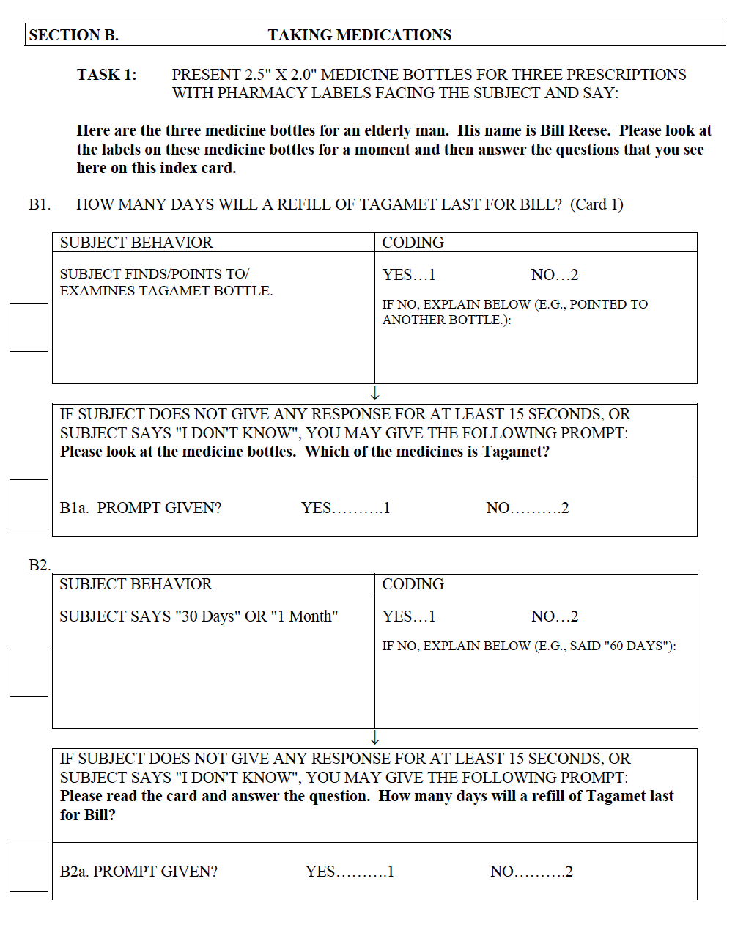
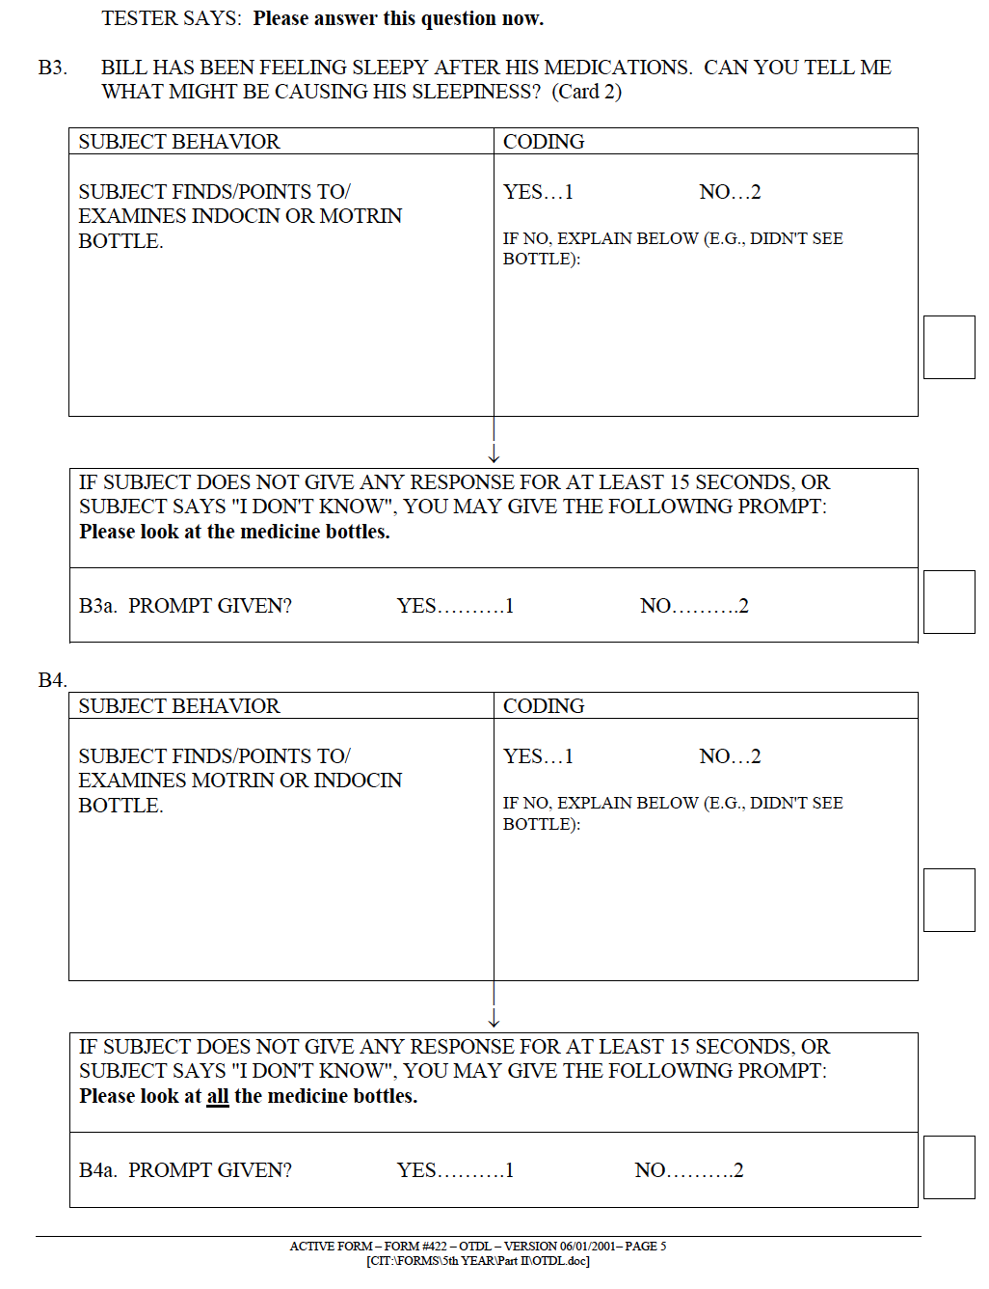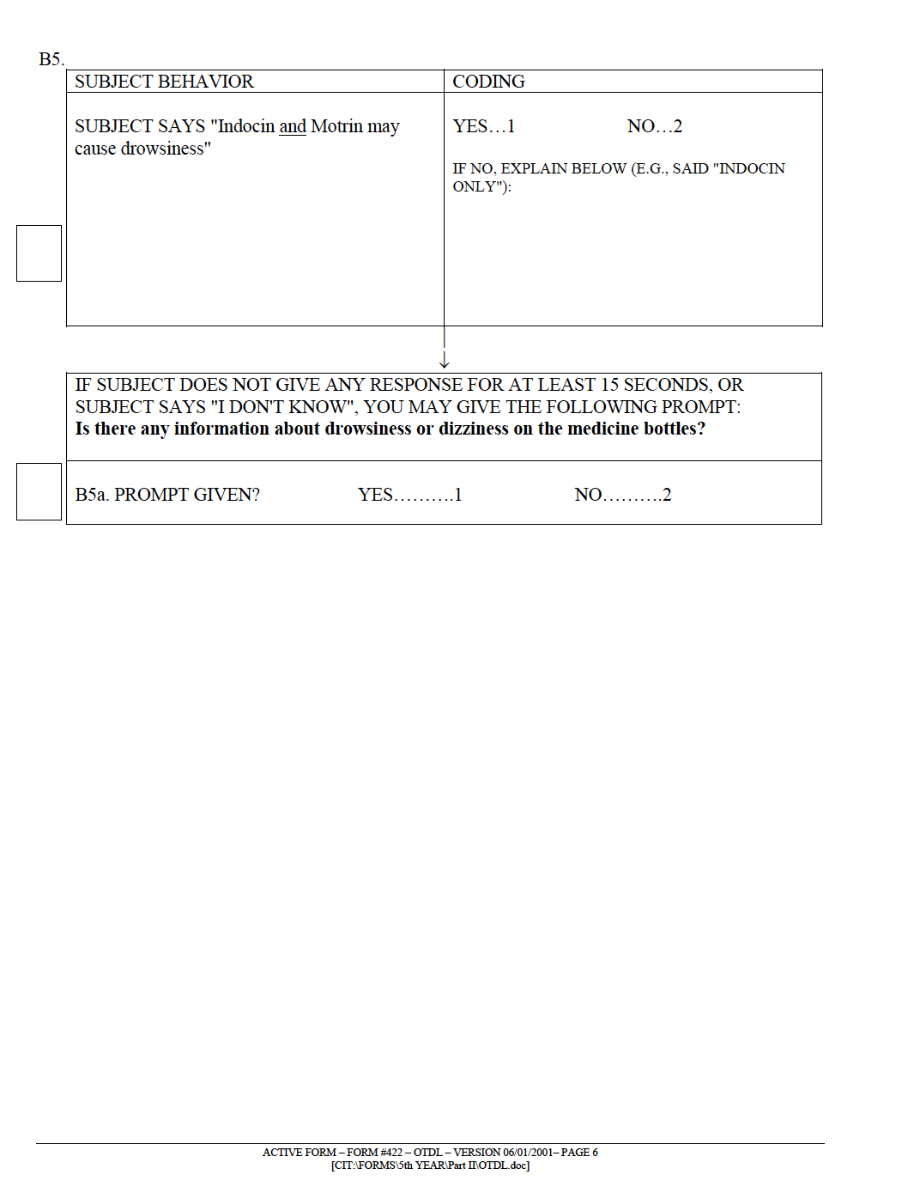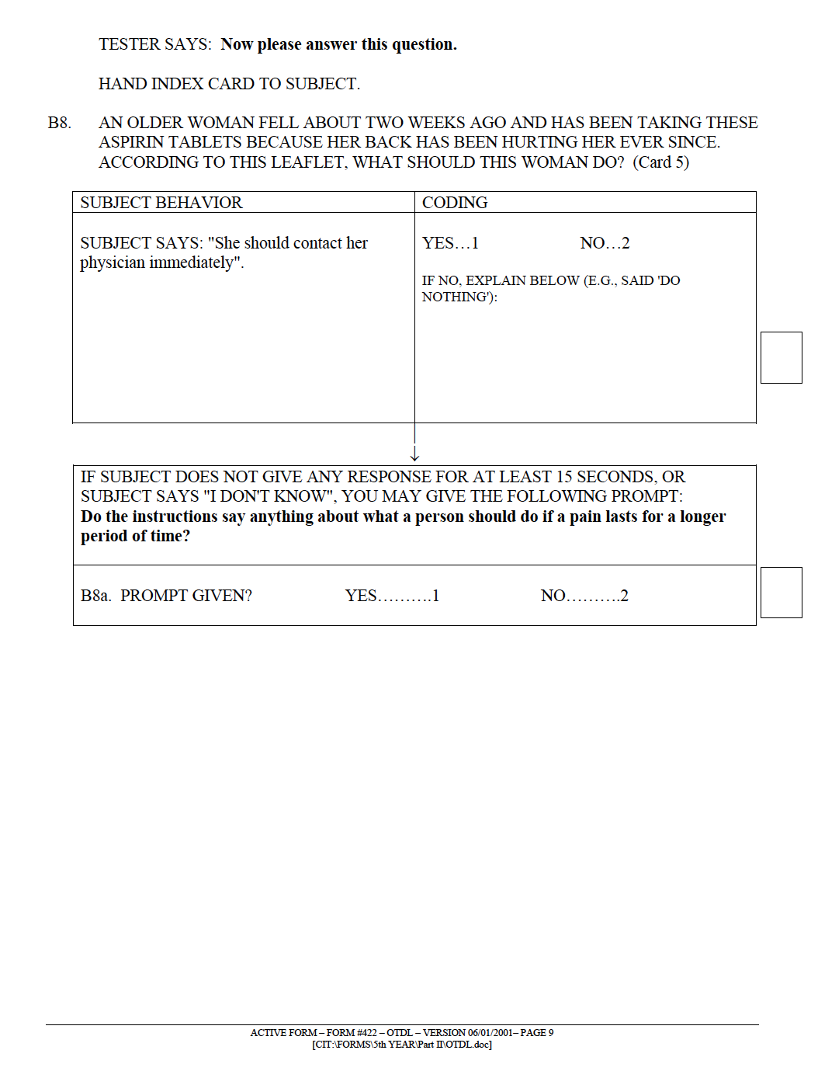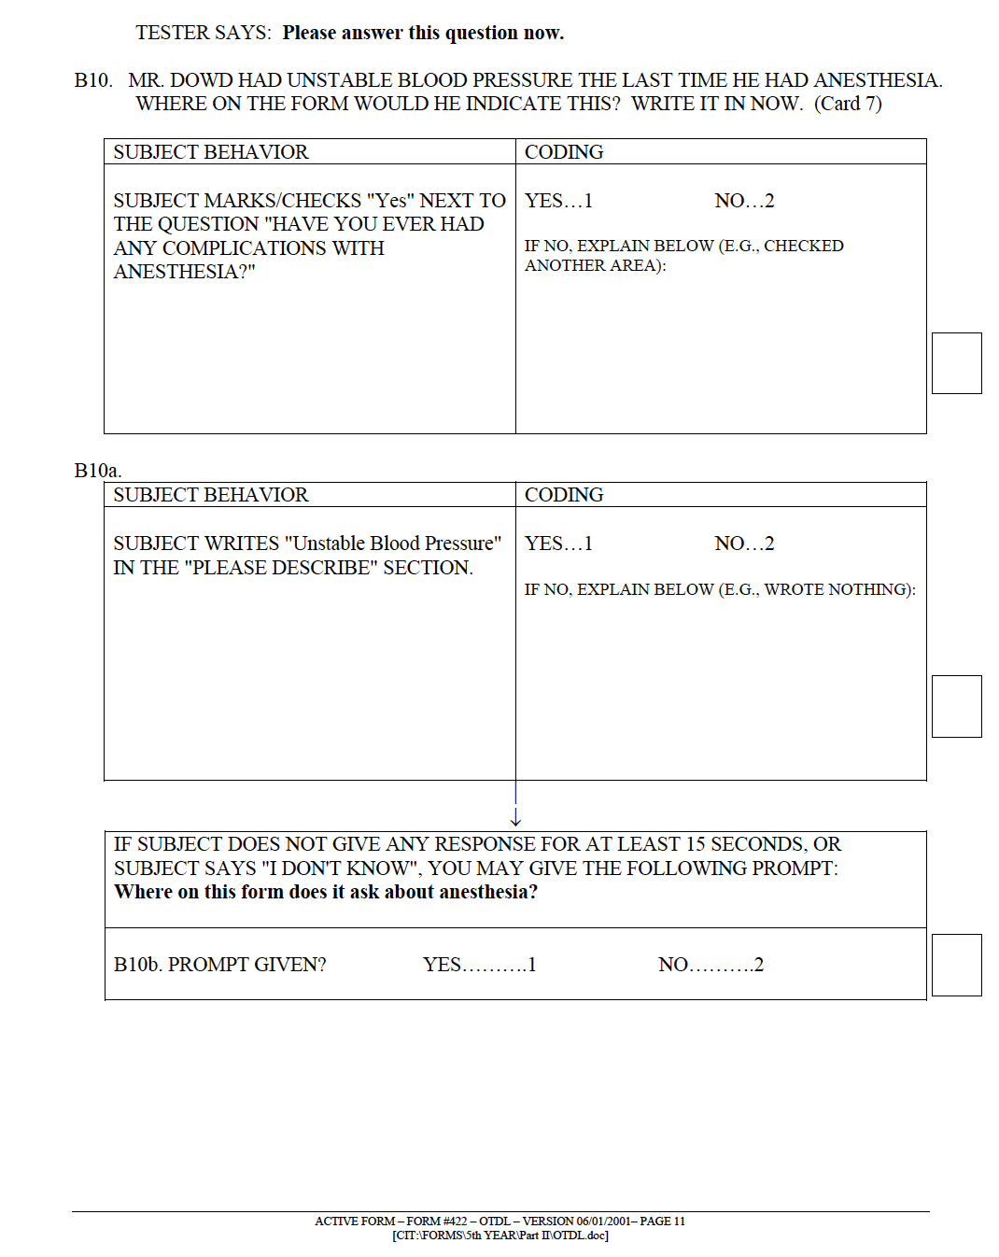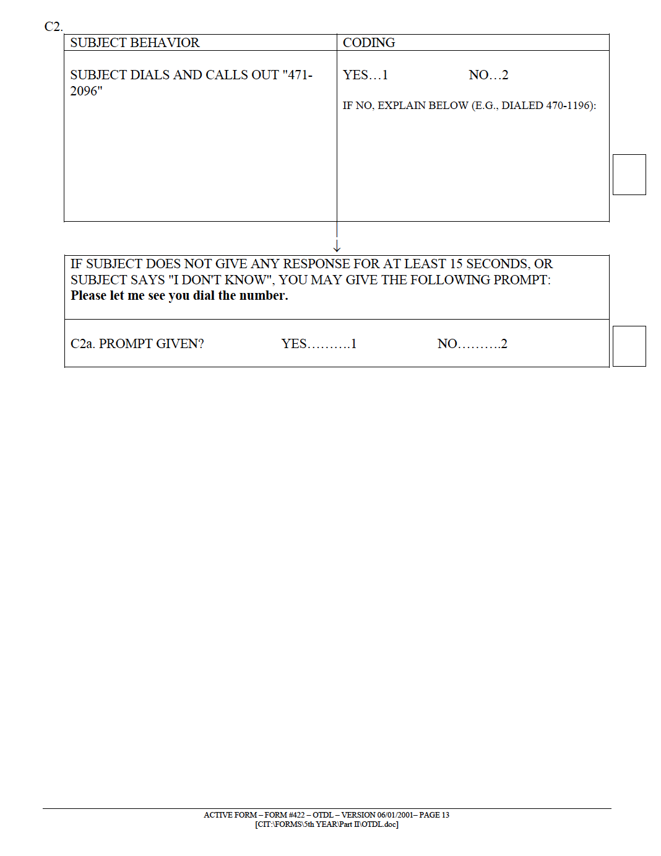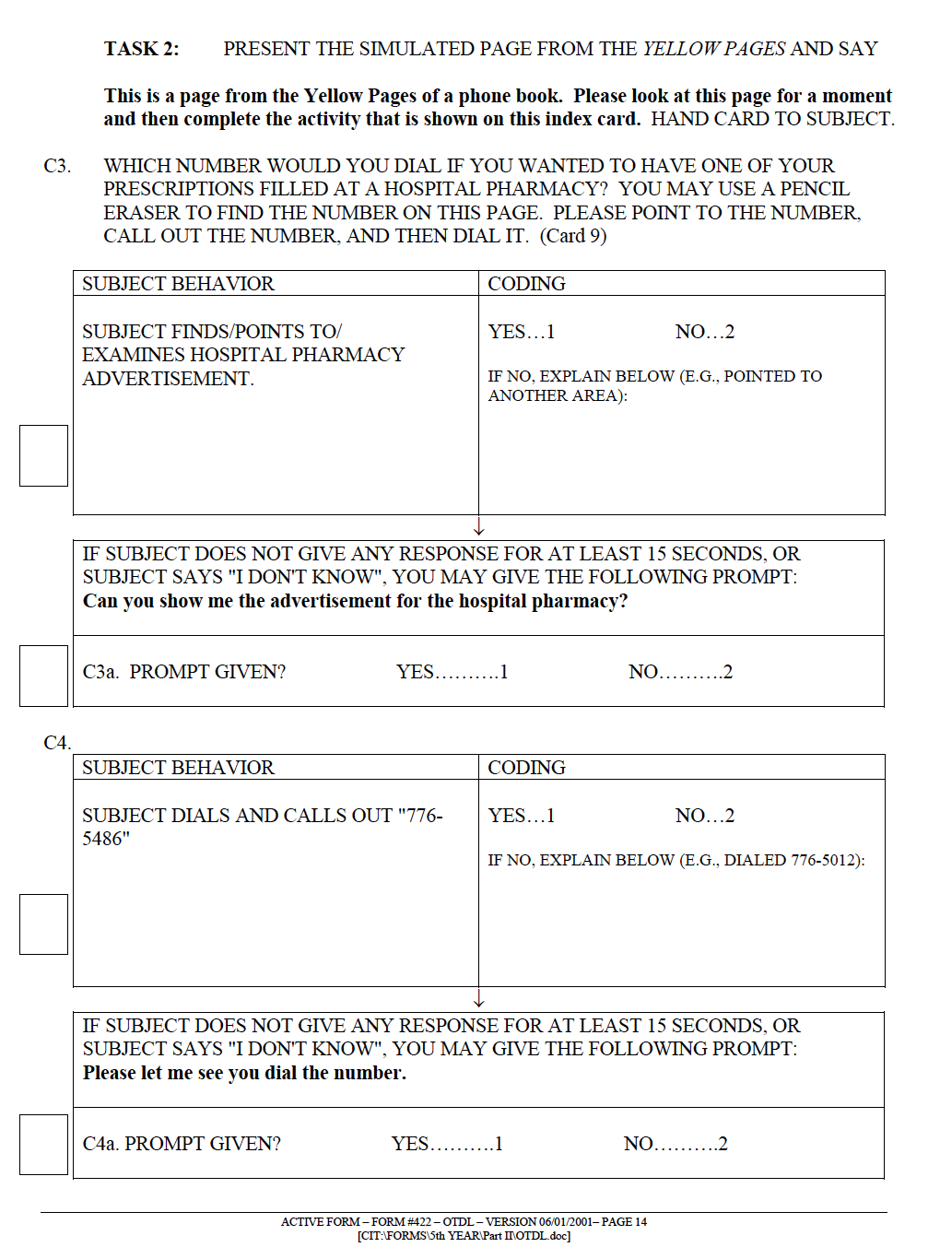
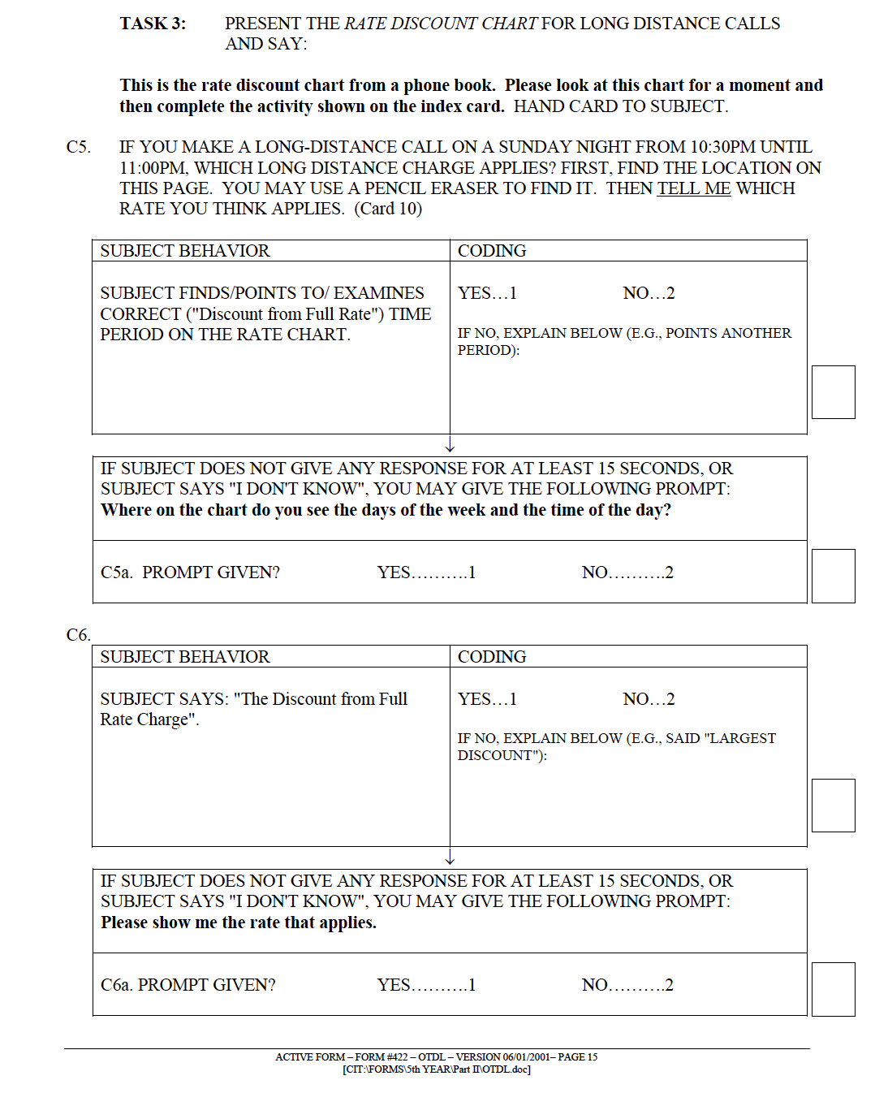
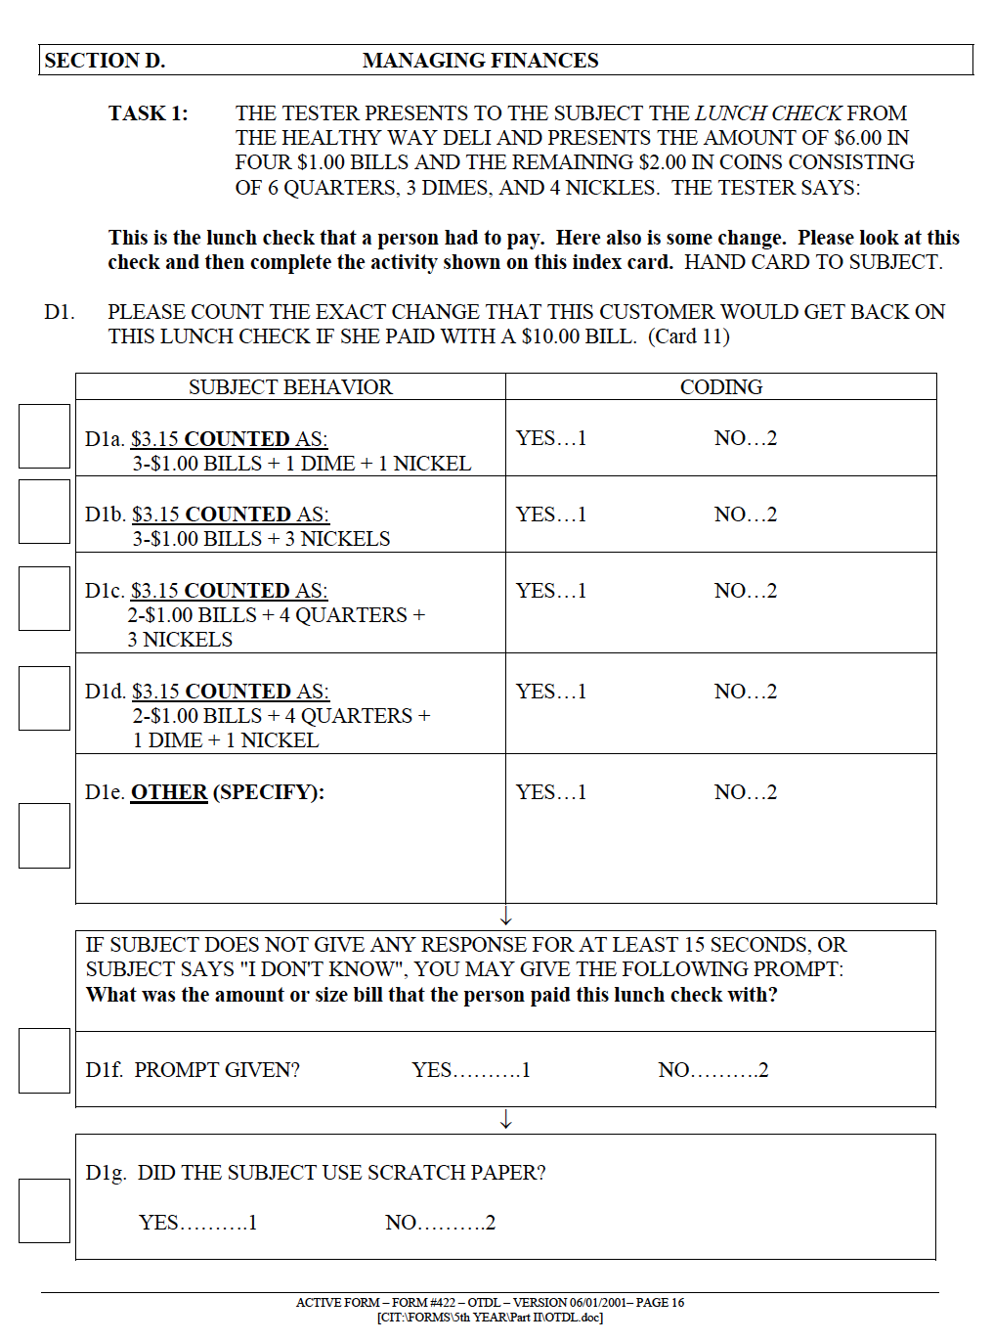






Material for Medication Use Assessment

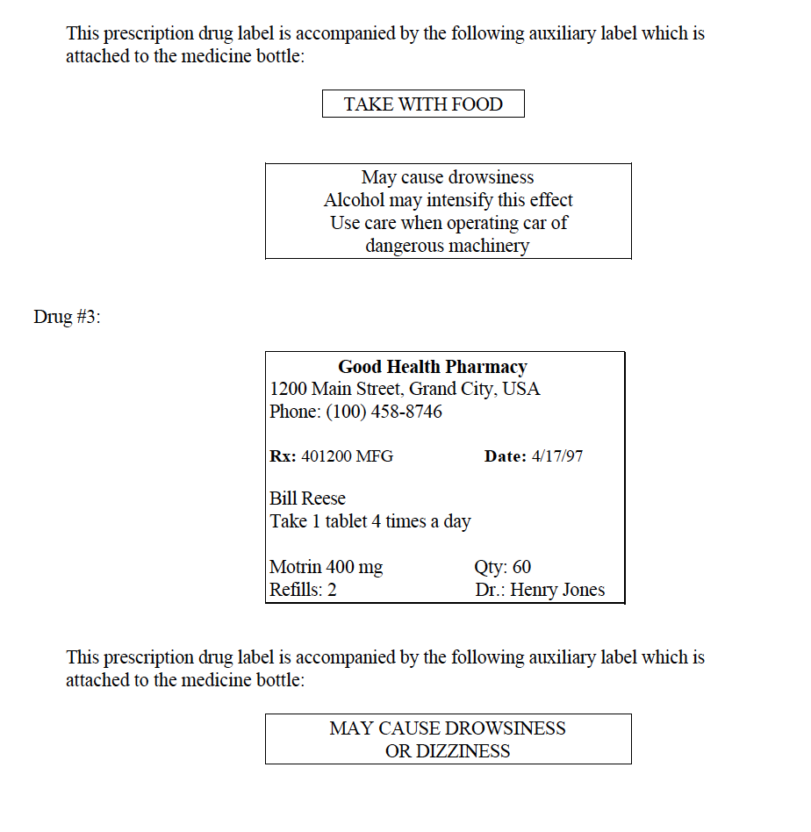

Maximum Aspirin
For relief of painful discomforts in the following conditions:
• Headaches • Colds and Flu • Toothaches and Extractions
• Muscular Aches and Pains • Arthritis and Rheumatism
• Bursitis, Lumbago, and Sciatica • Sore Throat and Minor Throat Irritations
• Menstrual Pain • Neuralgia—Neuritic (Nerve) Pain

Directions for Use (500 mg tablet)
Adults: Take 1 or 2 tablets with a glass of water (or fruit juice). Repeat
after 4 hours, if necessary. Do not exceed 8 tablets in a 24-hour period.

Caution: If pain persists for more than 10 days or redness is present, or
in conditions affecting children under 12 years of age, consult a physician
immediately.

Maximum Aspirin
For relief of painful discomforts in the following conditions:
• Headaches • Colds and Flu • Toothaches and Extractions
• Muscular Aches and Pains • Arthritis and Rheumatism
• Bursitis, Lumbago, and Sciatica • Sore Throat and Minor Throat Irritations
• Menstrual Pain • Neuralgia—Neuritic (Nerve) Pain

Directions for Use (500 mg tablet)
Adults: Take 1 or 2 tablets with a glass of water (or fruit juice). Repeat
after 4 hours, if necessary. Do not exceed 8 tablets in a 24-hour period.

Caution: If pain persists for more than 10 days or redness is present, or
in conditions affecting children under 12 years of age, consult a physician
immediately.

Material for Telephone Use Assessment
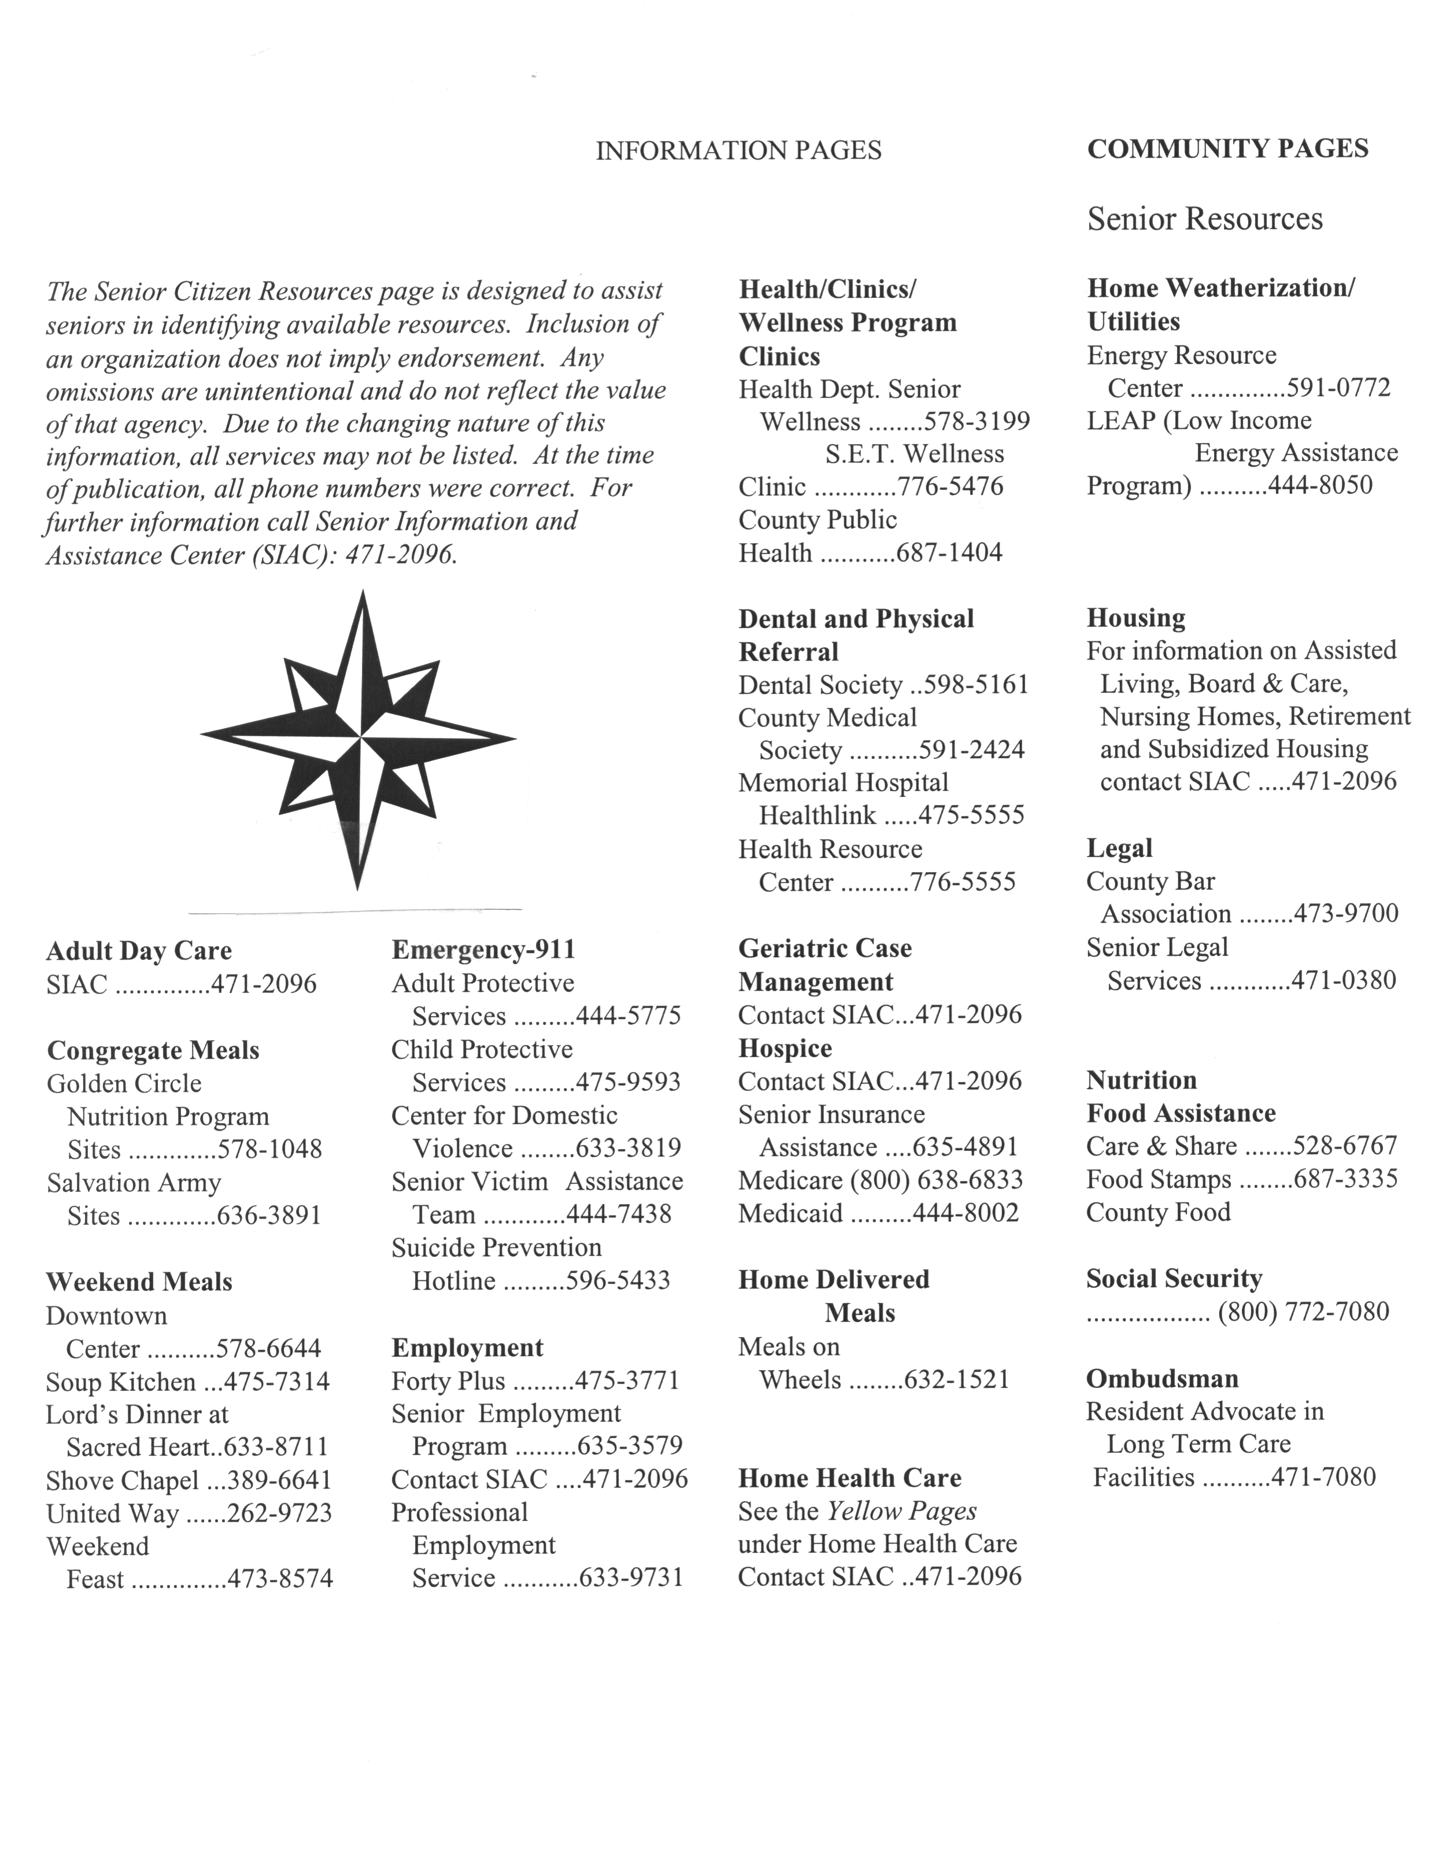

Material for Financial Handling Assessment

Appendix III

The Everyday Problem Test 28-item version


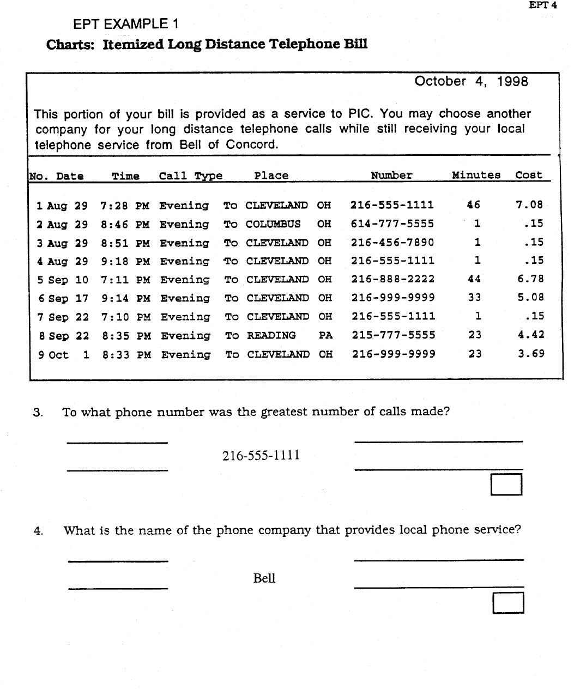

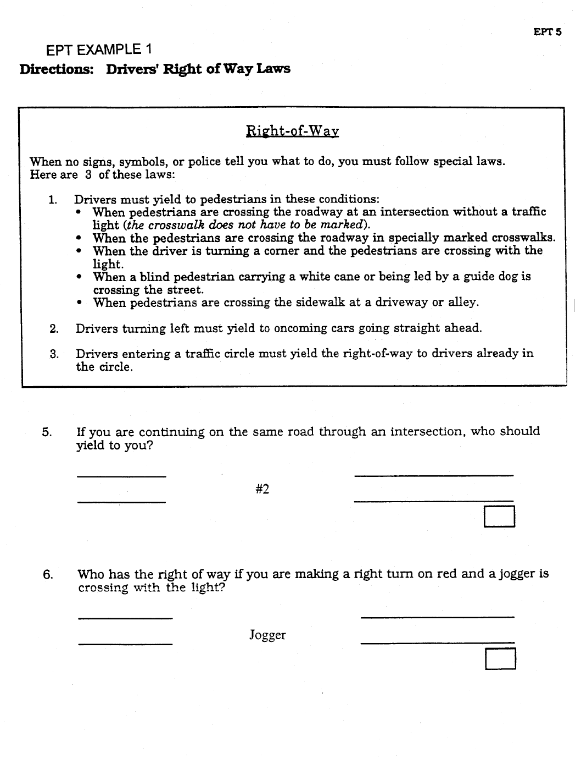

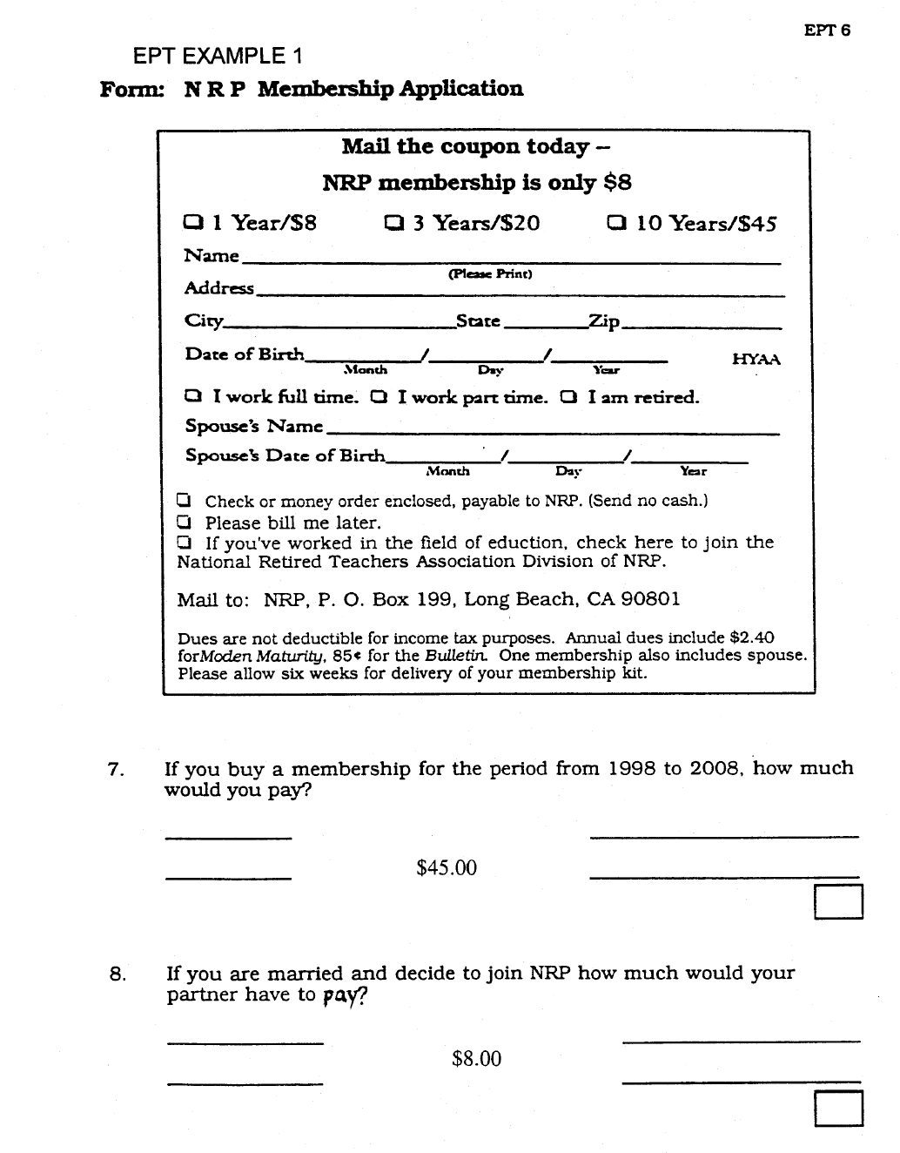



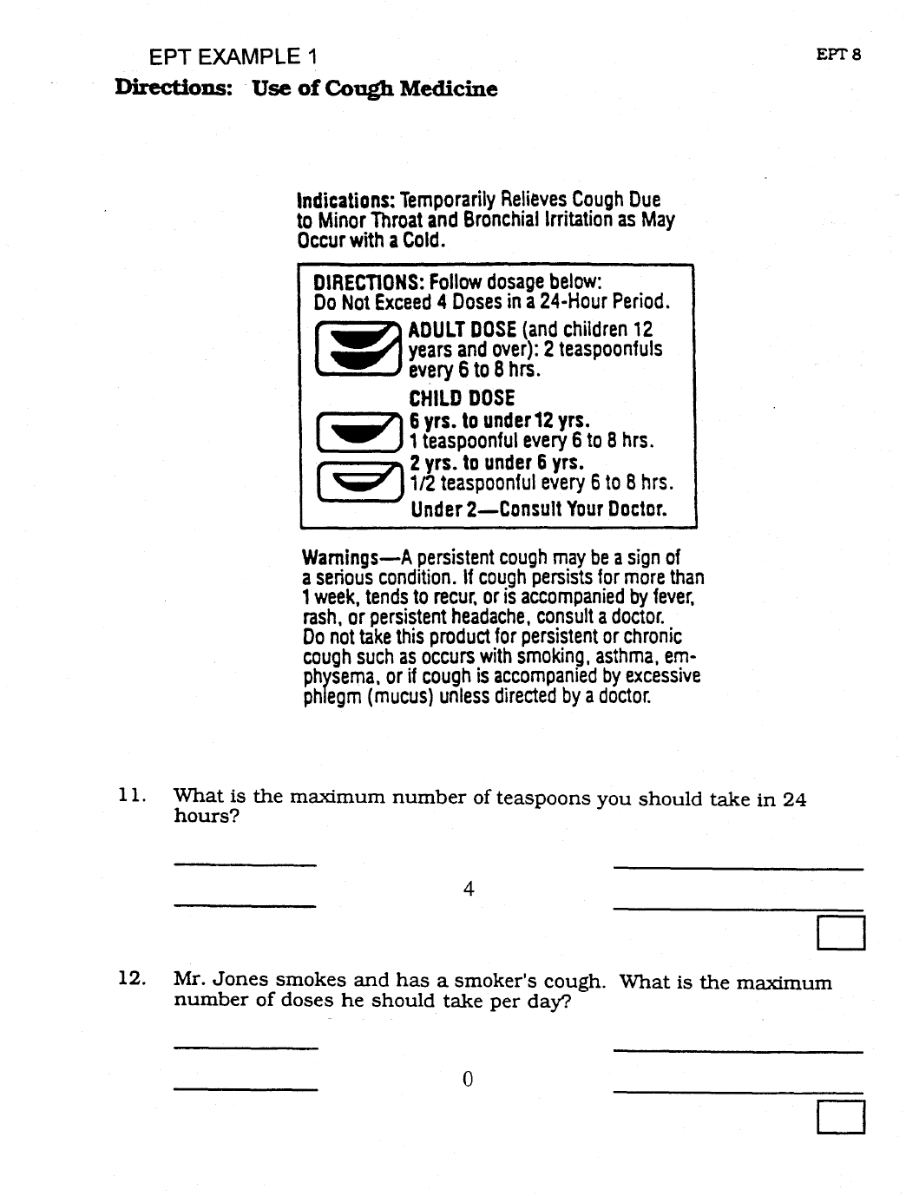

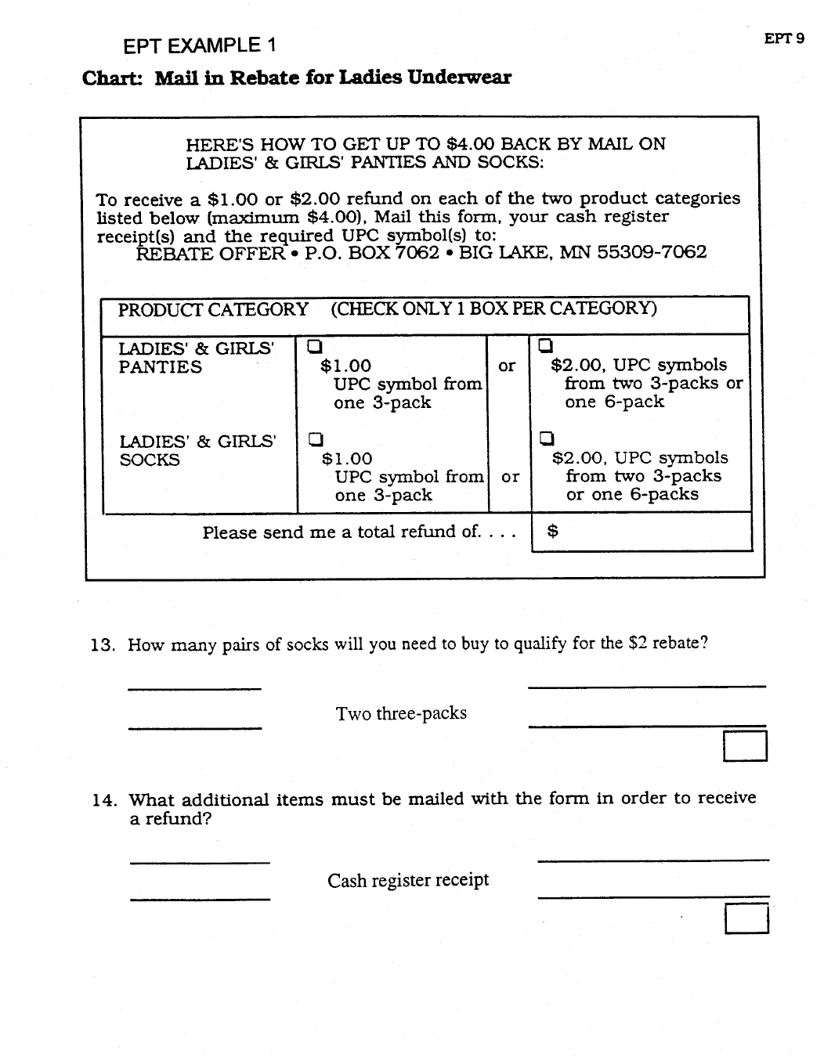
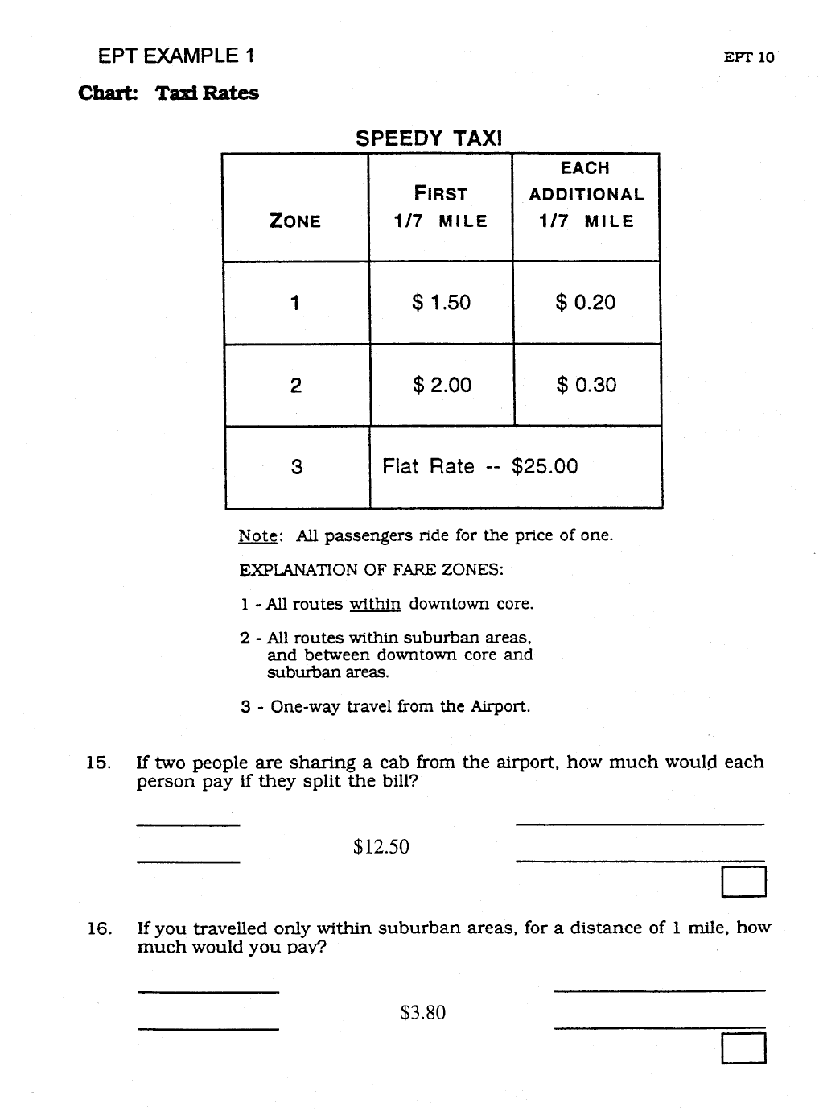



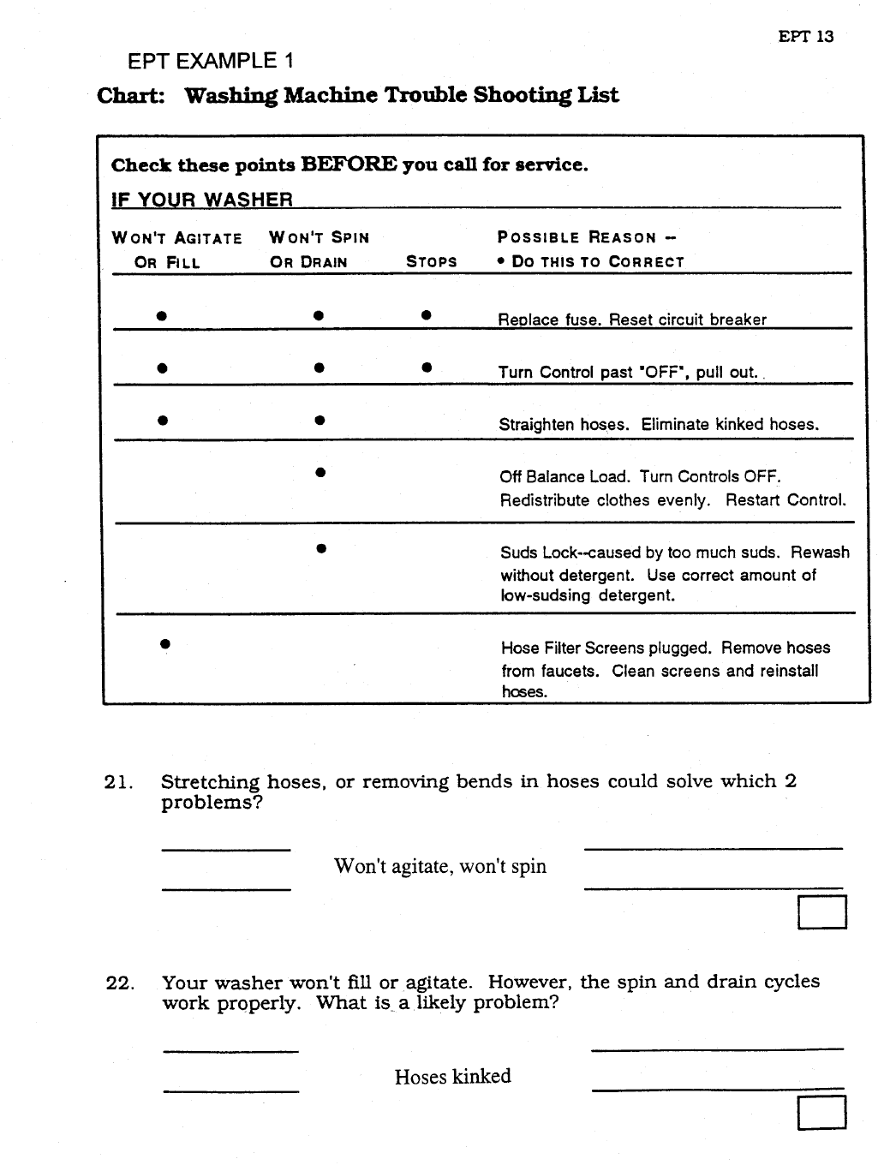



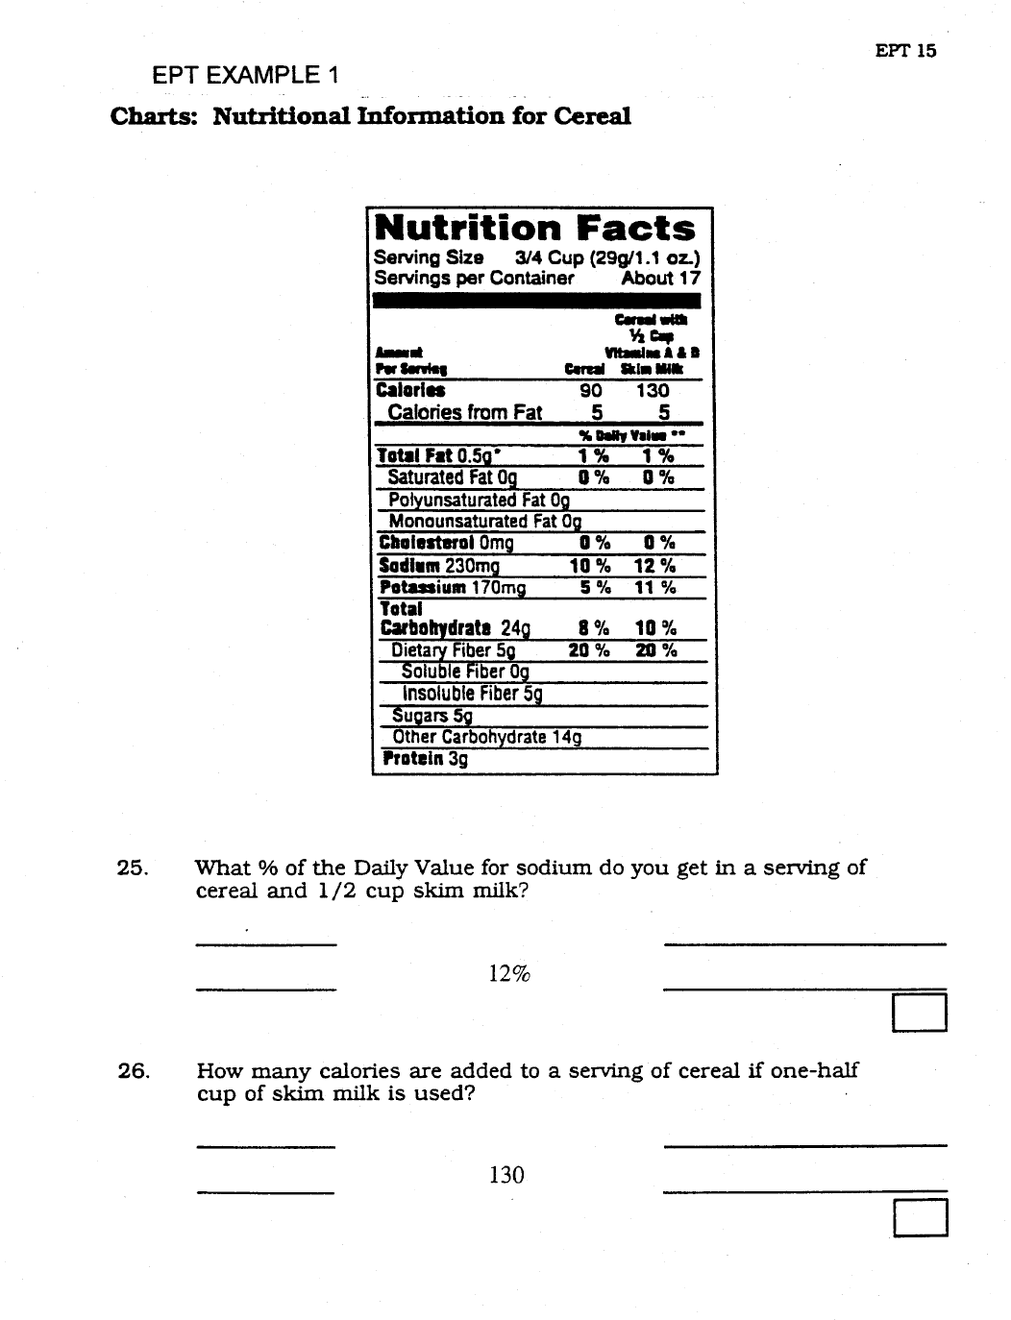

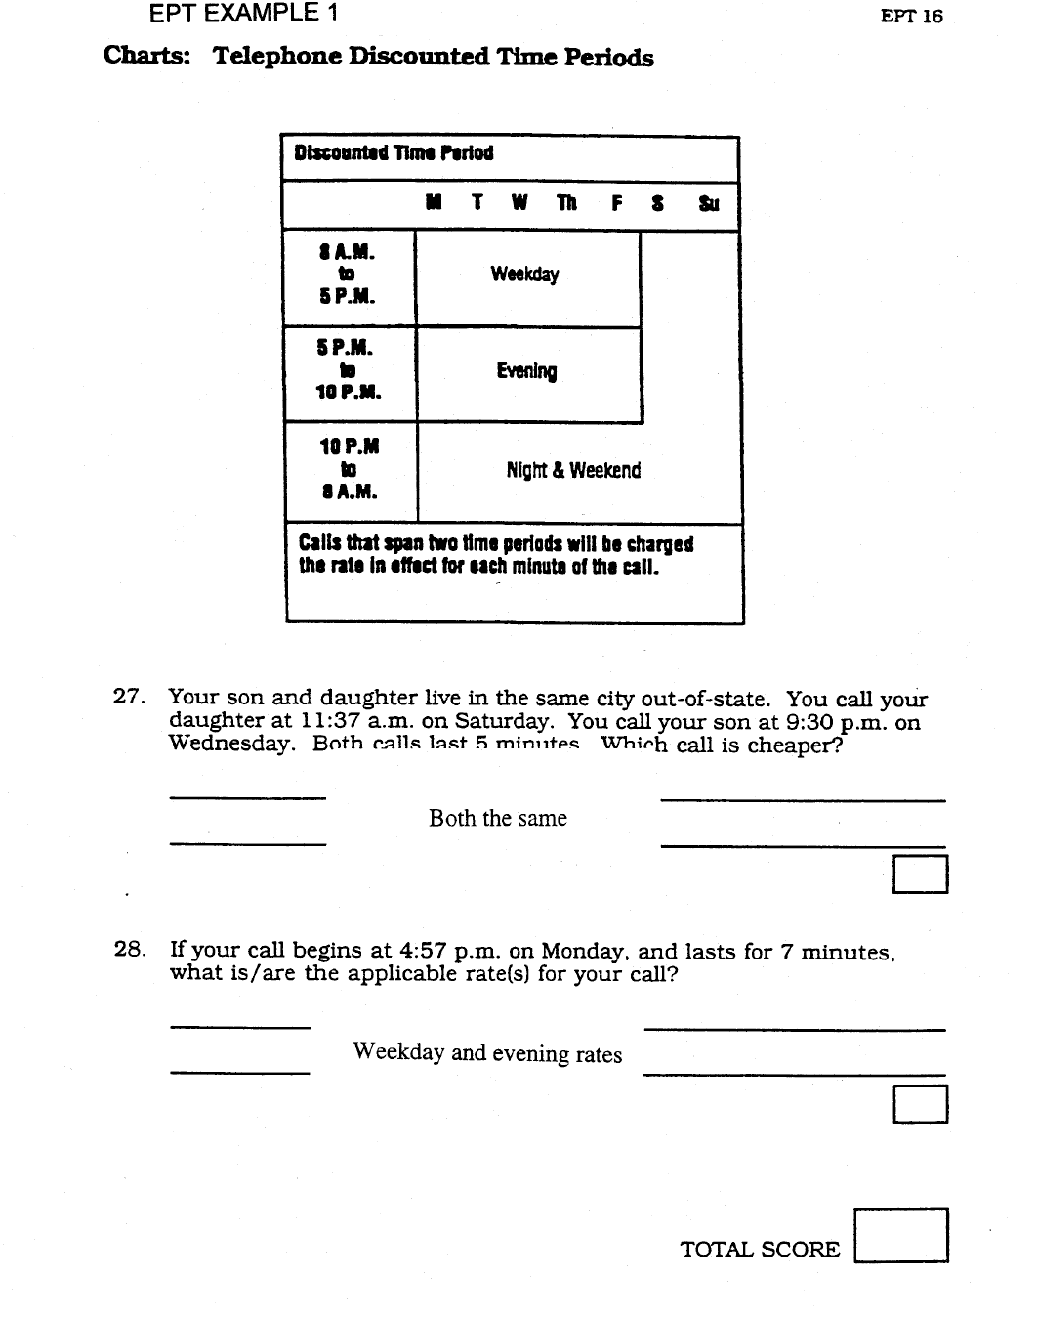

Appendix IV

The OTDL-G

OTDL - G

ID Νο ____

Ημερομηνία__/__/____

Εισαγωγικό κείμενο: Διαβάστε το κείμενο από το εσωτερικό εξώφυλλο.

Τώρα θα σας δείξω κάποιες ενέργειες τις οποίες τα περισσότερα άτομα μεγαλύτερης ηλικίας πρέπει να κάνουν στην καθημερινότητά τους. Αυτές οι ενέργειες έχουν να κάνουν με τη λήψη της φαρμακευτική τους αγωγή, τη χρήση του τηλεφώνου και τη χρήση χρημάτων για να πληρώσουν διάφορα πράγματα. Για κάθε μια από αυτές τις ενέργειες θα σας δείξω συγκεκριμένα αντικείμενα- για παράδειγμα, κάποια φάρμακα ή έναν λογαριασμό κοινής ωφελείας- και θα σας ζητήσω να κοιτάξετε αυτό το υλικό για λίγο έτσι ώστε να καταλάβετε περί τίνος πρόκειται. Έπειτα θα σας κάνω μια ερώτηση και θέλω να μου δώσετε τη σωστή απάντηση. Υπάρχει πάντα μια σωστή απάντηση και θα ήθελα να μου απαντήσετε στις ερωτήσεις όσο καλύτερα μπορείτε. Είστε έτοιμος/η να ξεκινήσουμε;

Ώρα εκκίνησης __:__
ΛΗΨΗ ΦΑΡΜΑΚΩΝ
ΔΟΚΙΜΑΣΙΑ 1:ΠΑΡΟΥΣΙΑΣΕ ΤΑ 3 ΚΟΥΤΙΑ ΦΑΡΜΑΚΩΝ ΣΤΟΝ ΣΥΜΜΕΤΕΧΩΝΤΑ ΚΑΙ ΠΕΣ:

Εδώ παρουσιάζονται τρία φάρμακα σε έναν ηλικιωμένο άντρα. Ονομάζεται κ. Παπαδόπουλος. Παρακαλώ κοιτάξτε τα κουτιά των φαρμάκων για λίγο και μετά απαντήστε στην ερώτηση της κάρτας.

ΔΩΣΕ ΤΗΝ ΚΑΡΤΑ ΜΕ ΤΗΝ ΕΡΩΤΗΣΗ ΣΤΟΝ ΣΥΜΜΕΤΕΧΟΝΤΑ

Β1. Πόσες μέρες θα διαρκέσει ένα κουτί MAALOX για τον κ. Παπαδόπουλο; (Κάρτα 1)

ΣΥΜΠΕΡΙΦΟΡΑ ΣΥΜΜΕΤΕΧΟΝΤΑ | ΚΩΔΙΚΟΠΟΙΗΣΗ
Ο ΣΥΜΜΕΤΕΧΟΝΤΑΣ ΒΡΙΣΚΕΙ/ΔΕΙΧΝΕΙ/ΕΞΕΤΑΖΕΙ ΤΟ ΚΟΥΤΙ MAALOX. | ΝΑΙ…1 | ΟΧΙ…2
Ο ΣΥΜΜΕΤΕΧΟΝΤΑΣ ΒΡΙΣΚΕΙ/ΔΕΙΧΝΕΙ/ΕΞΕΤΑΖΕΙ ΤΟ ΚΟΥΤΙ MAALOX. | ΑΝ ΟΧΙ, ΕΞΗΓΗΣΤΕ (Π.Χ., ΕΔΕΙΞΕ ΑΛΛΟ KOYTI)

ΑΝ Ο ΣΥΜΜΕΤΕΧΟΝΤΑΣ ΔΕΝ ΔΙΝΕΙ ΚΑΜΙΑ ΑΠΑΝΤΗΣΗ ΓΙΑ ΤΟΥΛΑΧΙΣΤΟΝ 15 ΔΕΥΤΕΡΟΛΕΠΤΑ, Ή ΠΕΙ «ΔΕΝ ΞΕΡΩ», ΜΠΟΡΕΙΤΑΙ ΝΑ ΔΩΣΕΤΕ ΤΗΝ ΠΑΡΑΚΑΤΩ ΠΡΟΤΡΟΠΗ
Παρακαλώ κοιτάξτε αυτά τα φάρμακα. Ποιο από αυτά είναι το Maalox;
Β1α. ΔΩΘΗΚΕ ΠΡΟΤΡΟΠΗ; | ΝΑΙ……….1 | ΟΧΙ……….2

Β2.
ΣΥΜΠΕΡΙΦΟΡΑ ΣΥΜΜΕΤΕΧΟΝΤΑ | ΚΩΔΙΚΟΠΟΙΗΣΗ
Ο ΣΥΜΜΕΤΕΧΟΝΤΑΣ ΛΕΕΙ «25 ΜΕΡΕΣ» | ΝΑΙ…1 | ΟΧΙ…2
Ο ΣΥΜΜΕΤΕΧΟΝΤΑΣ ΛΕΕΙ «25 ΜΕΡΕΣ» | ΑΝ ΟΧΙ, ΕΞΗΓΗΣΤΕ (Π.Χ., ΕΙΠΕ 30 ΜΕΡΕΣ)

ΑΝ Ο ΣΥΜΜΕΤΕΧΟΝΤΑΣ ΔΕΝ ΔΙΝΕΙ ΚΑΜΙΑ ΑΠΑΝΤΗΣΗ ΓΙΑ ΤΟΥΛΑΧΙΣΤΟΝ 15 ΔΕΥΤΕΡΟΛΕΠΤΑ, Ή ΠΕΙ «ΔΕΝ ΞΕΡΩ», ΜΠΟΡΕΙΤΑΙ ΝΑ ΔΩΣΕΤΕ ΤΗΝ ΠΑΡΑΚΑΤΩ ΠΡΟΤΡΟΠΗ
Παρακαλώ διαβάστε την κάρτα και απαντήστε στην ερώτηση: Πόσες μέρες θα διαρκέσει ένα κουτί MAALOX για τον κ. Παπαδόπουλό;
Β2α. ΔΩΘΗΚΕ ΠΡΟΤΡΟΠΗ; | ΝΑΙ……….1 | ΟΧΙ………..2

Ο ΕΞΕΤΑΣΤΗΣ ΛΕΕΙ: Παρακαλώ τώρα, απαντήστε στην εξής ερώτηση

Β3. O κ. Παπαδόπουλος νιώθει νυσταγμένος μόλις λαμβάνει τη φαρμακευτική του αγωγή, που περιλαμβάνει και τα τρία σκευάσματα που έχετε μπροστά σας . Μπορείτε να μου πείτε τι μπορεί να προκαλεί την υπνηλία του; (Κάρτα 2)

ΣΥΜΠΕΡΙΦΟΡΑ ΣΥΜΜΕΤΕΧΟΝΤΑ | ΚΩΔΙΚΟΠΟΙΗΣΗ
Ο ΣΥΜΜΕΤΕΧΟΝΤΑΣ ΒΡΙΣΚΕΙ/ΔΕΙΧΝΕΙ/ΕΞΕΤΑΖΕΙ ΤΟ ΚΟΥΤΙ DEPON | ΝΑΙ…1 | ΟΧΙ…2
Ο ΣΥΜΜΕΤΕΧΟΝΤΑΣ ΒΡΙΣΚΕΙ/ΔΕΙΧΝΕΙ/ΕΞΕΤΑΖΕΙ ΤΟ ΚΟΥΤΙ DEPON | ΑΝ ΟΧΙ, ΕΞΗΓΗΣΤΕ (Π.Χ., ΔΕΝ ΕΙΔΕ ΤΟ ΚΟΥΤΙ)

ΑΝ Ο ΣΥΜΜΕΤΕΧΟΝΤΑΣ ΔΕΝ ΔΙΝΕΙ ΚΑΜΙΑ ΑΠΑΝΤΗΣΗ ΓΙΑ ΤΟΥΛΑΧΙΣΤΟΝ 15 ΔΕΥΤΕΡΟΛΕΠΤΑ, Ή ΠΕΙ «ΔΕΝ ΞΕΡΩ», ΜΠΟΡΕΙΤΑΙ ΝΑ ΔΩΣΕΤΕ ΤΗΝ ΠΑΡΑΚΑΤΩ ΠΡΟΤΡΟΠΗ
Παρακαλώ κοιτάξτε πάνω σε όλα τα κουτιά των φαρμάκων.
Β3α. ΔΩΘΗΚΕ ΠΡΟΤΡΟΠΗ; | ΝΑΙ………..1 | ΟΧΙ………..2

Β4.
ΣΥΜΠΕΡΙΦΟΡΑ ΣΥΜΜΕΤΕΧΟΝΤΑ | ΚΩΔΙΚΟΠΟΙΗΣΗ
Ο ΣΥΜΜΕΤΕΧΟΝΤΑΣ ΒΡΙΣΚΕΙ/ΔΕΙΧΝΕΙ/ΕΞΕΤΑΖΕΙ ΤΟ ΚΟΥΤΙ ΤΟ ΚΟΥΤΙ BRUFEN | ΝΑΙ…1 | ΟΧΙ…2
 | ΑΝ ΟΧΙ, ΕΞΗΓΗΣΤΕ (Π.Χ., ΔΕΝ ΕΙΔΕ ΤΟ ΚΟΥΤΙ)

ΑΝ Ο ΣΥΜΜΕΤΕΧΟΝΤΑΣ ΔΕΝ ΔΙΝΕΙ ΚΑΜΙΑ ΑΠΑΝΤΗΣΗ ΓΙΑ ΤΟΥΛΑΧΙΣΤΟΝ 15 ΔΕΥΤΕΡΟΛΕΠΤΑ, Ή ΠΕΙ «ΔΕΝ ΞΕΡΩ», ΜΠΟΡΕΙΤΑΙ ΝΑ ΔΩΣΕΤΕ ΤΗΝ ΠΑΡΑΚΑΤΩ ΠΡΟΤΡΟΠΗ
Παρακαλώ κοιτάξτε πάνω σε όλα κουτιά των φαρμάκων.
Β4β. ΔΩΘΗΚΕ ΠΡΟΤΡΟΠΗ; | ΝΑΙ………..1 | ΟΧΙ………..2

Β5.
ΣΥΜΠΕΡΙΦΟΡΑ ΣΥΜΜΕΤΕΧΟΝΤΑ | ΚΩΔΙΚΟΠΟΙΗΣΗ
Ο ΣΥΜΜΕΤΕΧΟΝΤΑΣ ΛΕΕΙ « Το Depon και το Brufen μπορούν να προκαλέσουν υπνηλία» | ΝΑΙ…1 | ΟΧΙ…2
 | ΑΝ ΟΧΙ, ΕΞΗΓΗΣΤΕ (Π.Χ., ΕΙΠΕ ΜΟΝΟ «DEPON»)

ΑΝ Ο ΣΥΜΜΕΤΕΧΟΝΤΑΣ ΔΕΝ ΔΙΝΕΙ ΚΑΜΙΑ ΑΠΑΝΤΗΣΗ ΓΙΑ ΤΟΥΛΑΧΙΣΤΟΝ 15 ΔΕΥΤΕΡΟΛΕΠΤΑ, Ή ΠΕΙ «ΔΕΝ ΞΕΡΩ», ΜΠΟΡΕΙΤΑΙ ΝΑ ΔΩΣΕΤΕ ΤΗΝ ΠΑΡΑΚΑΤΩ ΠΡΟΤΡΟΠΗ
Ποια σκευάσματα προκαλούν υπνηλία στον κο Παπαδόπουλο;
Β5α. ΔΩΘΗΚΕ ΠΡΟΤΡΟΠΗ; | ΝΑΙ……….1 | ΟΧΙ………..2

ΔΟΚΙΜΑΣΙΑ 2:ΠΑΡΟΥΣΙΑΣΕ TΙΣ ΟΔΗΓΙΕΣ ΑΠΟ ΕΝΑ ΜΗ ΣΥΝΤΑΓΟΓΡΑΦΟΥΜΕΝΟ ΠΡΟΙΟΝ ΑΣΠΙΡΙΝΗΣ ΚΑΙ ΠΕΣ: Αυτό είναι το εσώκλειστο φυλλάδιο οδηγιών από ένα κουτί Ασπιρίνης το οποίο μπορεί κανείς να αγοράσει για να αντιμετωπίσει κάποιον ελαφρύ πόνο. Παρακαλώ κοιτάξτε αυτό το φυλλάδιο για λίγα λεπτά και έπειτα διαβάστε την ακόλουθη ερώτηση.

ΔΩΣΕ ΤΗΝ ΚΑΡΤΑ ΕΡΩΤΗΣΗΣ ΣΤΟΝ ΣΥΜΜΕΤΕΧΟΝΤΑ

Β6. Σύμφωνα με αυτό το εσώκλειστο φυλλάδιο οδηγιών, μέχρι πόσα χάπια ασπιρίνης μπορεί κάποιος να πάρει μέσα σε 24 ώρες; (Κάρτα 3)

ΣΥΜΠΕΡΙΦΟΡΑ ΣΥΜΜΕΤΕΧΟΝΤΑ | ΚΩΔΙΚΟΠΟΙΗΣΗ
Ο ΣΥΜΜΕΤΕΧΟΝΤΑΣ ΛΕΕΙ «Ως 8 χάπια» | ΝΑΙ…1 | ΟΧΙ…2
Ο ΣΥΜΜΕΤΕΧΟΝΤΑΣ ΛΕΕΙ «Ως 8 χάπια» | ΑΝ ΟΧΙ, ΕΞΗΓΗΣΤΕ (Π.Χ., ΕΙΠΕ «4 χάπια»)

ΑΝ Ο ΣΥΜΜΕΤΕΧΟΝΤΑΣ ΔΕΝ ΔΙΝΕΙ ΚΑΜΙΑ ΑΠΑΝΤΗΣΗ ΓΙΑ ΤΟΥΛΑΧΙΣΤΟΝ 15 ΔΕΥΤΕΡΟΛΕΠΤΑ, Ή ΠΕΙ «ΔΕΝ ΞΕΡΩ», ΜΠΟΡΕΙΤΑΙ ΝΑ ΔΩΣΕΤΕ ΤΗΝ ΠΑΡΑΚΑΤΩ ΠΡΟΤΡΟΠΗ
Υπάρχουν καθόλου πληροφορίες σχετικά με το μέχρι πόσα χάπια μπορεί κάποιος να πάρει μέσα σε 24 ώρες;
Β6α. ΔΩΘΗΚΕ ΠΡΟΤΡΟΠΗ; | ΝΑΙ………..1 | ΟΧΙ………..2

Β7. (ΔΩΣΕ ΣΤΟΝ ΣΥΜΜΕΤΕΧΟΝΤΑ ΤΗΝ ΕΠΟΜΕΝΗ ΚΑΡΤΑ ΕΡΩΤΗΣΗΣ). Σύμφωνα με αυτό το εσώκλειστο φυλλάδιο οδηγιών , ποιο χρονικό διάστημα πρέπει να μεσολαβήσει πριν κάποιος πάρει ένα χάπι ξανά; (Κάρτα 4)

ΣΥΜΠΕΡΙΦΟΡΑ ΣΥΜΜΕΤΕΧΟΝΤΑ | ΚΩΔΙΚΟΠΟΙΗΣΗ
Ο ΣΥΜΜΕΤΕΧΟΝΤΑΣ ΛΕΕΙ «Σε διαστήματα 4 ωρών» Η «Κάθε 4 ώρες» | ΝΑΙ…1 | ΟΧΙ…2
Ο ΣΥΜΜΕΤΕΧΟΝΤΑΣ ΛΕΕΙ «Σε διαστήματα 4 ωρών» Η «Κάθε 4 ώρες» | ΑΝ ΟΧΙ, ΕΞΗΓΗΣΤΕ (Π.Χ., ΕΙΠΕ «ΚΑΘΕ 8 ΩΡΕΣ)

ΑΝ Ο ΣΥΜΜΕΤΕΧΟΝΤΑΣ ΔΕΝ ΔΙΝΕΙ ΚΑΜΙΑ ΑΠΑΝΤΗΣΗ ΓΙΑ ΤΟΥΛΑΧΙΣΤΟΝ 15 ΔΕΥΤΕΡΟΛΕΠΤΑ, Ή ΠΕΙ «ΔΕΝ ΞΕΡΩ», ΜΠΟΡΕΙΤΑΙ ΝΑ ΔΩΣΕΤΕ ΤΗΝ ΠΑΡΑΚΑΤΩ ΠΡΟΤΡΟΠΗ
Αναφέρουν οι οδηγίες κάτι σχετικά με το χρονικό διάστημα που πρέπει να μεσολαβήσει πριν κάποιος πάρει τα χάπια ξανά;
Β7α. ΔΩΘΗΚΕ ΠΡΟΤΡΟΠΗ; | ΝΑΙ………..1 | ΟΧΙ………..2

Ο ΕΞΕΤΑΣΤΗΣ ΛΕΕΙ: Τώρα παρακαλώ, απαντήστε στην εξής ερώτηση
ΔΩΣΕ ΤΗΝ ΚΑΡΤΑ ΕΡΩΤΗΣΗΣ ΣΤΟΝ ΣΥΜΜΕΤΕΧΟΝΤΑ

B.8 Μια ηλικιωμένη γυναίκα έπεσε περίπου δύο εβδομάδες πριν και παίρνει αυτά τα χάπια Ασπιρίνης διότι πονάει η μέση της από τότε. Σύμφωνα με το φυλλάδιο, τι πρέπει να κάνει; (Κάρτα 5)

ΣΥΜΠΕΡΙΦΟΡΑ ΣΥΜΜΕΤΕΧΟΝΤΑ | ΚΩΔΙΚΟΠΟΙΗΣΗ
Ο ΣΥΜΜΕΤΕΧΟΝΤΑΣ ΛΕΕΙ: «Πρέπει να επικοινωνήσει με τον γιατρό της άμεσα» | ΝΑΙ…1 | ΟΧΙ…2
 | ΑΝ ΟΧΙ, ΕΞΗΓΗΣΤΕ (Π.Χ.,ΕΙΠΕ «ΤΙΠΟΤΑ»)

ΑΝ Ο ΣΥΜΜΕΤΕΧΟΝΤΑΣ ΔΕΝ ΔΙΝΕΙ ΚΑΜΙΑ ΑΠΑΝΤΗΣΗ ΓΙΑ ΤΟΥΛΑΧΙΣΤΟΝ 15 ΔΕΥΤΕΡΟΛΕΠΤΑ, Ή ΠΕΙ «ΔΕΝ ΞΕΡΩ», ΜΠΟΡΕΙΤΑΙ ΝΑ ΔΩΣΕΤΕ ΤΗΝ ΠΑΡΑΚΑΤΩ ΠΡΟΤΡΟΠΗ
Αναφέρουν οι οδηγίες κάτι σχετικά με το τι πρέπει να κάνει κάποιος εάν ο πόνος διαρκεί για μεγαλύτερο χρονικό διάστημα;
Β8α. ΔΩΘΗΚΕ ΠΡΟΤΡΟΠΗ; | ΝΑΙ………..1 | ΟΧΙ………..2
ΔΟΚΙΜΑΣΙΑ 2:ΠΑΡΟΥΣΙΑΣΕ ΤΟ ΙΑΤΡΙΚΟ ΙΣΤΟΡΙΚΟ ΣΤΟΝ ΣΥΜΜΕΤΕΧΟΝΤΑ ΚΑΙ ΠΕΣ:
Ένας άντρας ο οποίος ονομάζεται κ. Παπαδόπουλος πηγαίνει σε έναν καινούργιο γιατρό. Αυτό είναι ένα έντυπο, το οποίο οι ασθενείς πρέπει να συμπληρώσουν όταν βλέπουν έναν καινούργιο γιατρό. Παρακαλώ, κοιτάξτε αυτό το ιστορικό ασθενούς και έπειτα συμπληρώστε την ακόλουθη δραστηριότητα.

ΔΩΣΕ ΤΗΝ ΚΑΡΤΑ ΕΡΩΤΗΣΗΣ ΣΤΟΝ ΣΥΜΜΕΤΕΧΟΝΤΑ
Β9. Σε ποιο σημείο αυτού του εντύπου θα γράψει ο κ. Παπαδόπουλος ότι καλύπτεται από την ασφάλεια του ΕΟΠΥΥ; Γράψτε το τώρα στο έντυπο. (Κάρτα 6)

ΣΥΜΠΕΡΙΦΟΡΑ ΣΥΜΜΕΤΕΧΟΝΤΑ | ΚΩΔΙΚΟΠΟΙΗΣΗ
Ο ΣΥΜΜΕΤΕΧΟΝΤΑΣ ΓΡΑΦΕΙ: «ΕΟΠΥΥ» ΣΤΟ ΠΛΑΙΣΙΟ «ΑΣΦΑΛΕΙΑ» ΤΗΣ ΦΟΡΜΑΣ | ΝΑΙ…1 | ΟΧΙ…2
 | ΑΝ ΟΧΙ, ΕΞΗΓΗΣΤΕ (Π.Χ.,ΔΕΝ ΕΓΡΑΨΕ ΚΑΤΙ)

ΑΝ Ο ΣΥΜΜΕΤΕΧΟΝΤΑΣ ΔΕΝ ΔΙΝΕΙ ΚΑΜΙΑ ΑΠΑΝΤΗΣΗ ΓΙΑ ΤΟΥΛΑΧΙΣΤΟΝ 15 ΔΕΥΤΕΡΟΛΕΠΤΑ, Ή ΠΕΙ «ΔΕΝ ΞΕΡΩ», ΜΠΟΡΕΙΤΑΙ ΝΑ ΔΩΣΕΤΕ ΤΗΝ ΠΑΡΑΚΑΤΩ ΠΡΟΤΡΟΠΗ
Βλέπετε κάποιο χώρο για πληροφορίες σχετικά με την ασφάλεια;
Β9α. ΔΩΘΗΚΕ ΠΡΟΤΡΟΠΗ; | ΝΑΙ………..1 | ΟΧΙ………..2

Ο ΕΞΕΤΑΣΤΗΣ ΛΕΕΙ: Τώρα παρακαλώ, συμπληρώστε αυτή τη δραστηριότητα.

Β10. O κ. Παπαδόπουλος είχε ασταθή πίεση αίματος την τελευταία φορά που υπεβλήθη σε αναισθησία. Σε ποιο σημείο αυτού του εντύπου θα κάνει σημείωση αυτής της κατάστασης; Γράψτε το τώρα στο έντυπο. (Κάρτα 7)

ΣΥΜΠΕΡΙΦΟΡΑ ΣΥΜΜΕΤΕΧΟΝΤΑ | ΚΩΔΙΚΟΠΟΙΗΣΗ
Β10α. Ο ΣΥΜΜΕΤΕΧΟΝΤΑΣ ΜΑΡΚΑΡΕΙ/ΤΣΕΚΑΡΕΙ «Ναι» ΔΙΠΛΑ ΣΤΗΝ ΕΡΩΤΗΣΗ «ΕΙΧΑΤΕ ΠΟΤΕ ΕΠΙΠΛΟΚΕΣ ΑΝΑΙΣΘΗΣΙΑΣ» | ΝΑΙ…1 | ΟΧΙ…2
 | ΑΝ ΟΧΙ, ΕΞΗΓΗΣΤΕ (Π.Χ.,ΤΣΕΚΑΡΕ ΑΛΛΗ ΠΕΡΙΟΧΗ)

ΣΥΜΠΕΡΙΦΟΡΑ ΣΥΜΜΕΤΕΧΟΝΤΑ | ΚΩΔΙΚΟΠΟΙΗΣΗ
Β10β. Ο ΣΥΜΜΕΤΕΧΟΝΤΑΣ ΓΡΑΦΕΙ «Ασταθής αρτηριακή πίεση» ΣΤΟ ΠΛΑΙΣΙΟ «ΠΑΡΑΚΑΛΩ ΠΕΡΙΓΡΑΨΤΕ» | ΝΑΙ…1 | ΟΧΙ…2
 | ΑΝ ΟΧΙ, ΕΞΗΓΗΣΤΕ (Π.Χ.,ΔΕΝ ΕΓΡΑΨΕ ΚΑΤΙ)

ΑΝ Ο ΣΥΜΜΕΤΕΧΟΝΤΑΣ ΔΕΝ ΔΙΝΕΙ ΚΑΜΙΑ ΑΠΑΝΤΗΣΗ ΓΙΑ ΤΟΥΛΑΧΙΣΤΟΝ 15 ΔΕΥΤΕΡΟΛΕΠΤΑ, Ή ΠΕΙ «ΔΕΝ ΞΕΡΩ», ΜΠΟΡΕΙΤΑΙ ΝΑ ΔΩΣΕΤΕ ΤΗΝ ΠΑΡΑΚΑΤΩ ΠΡΟΤΡΟΠΗ
Σε ποιο σημείο αυτού του εντύπου έχει ερώτηση σχετικά με την αναισθησία;
Β10γ. ΔΩΘΗΚΕ ΠΡΟΤΡΟΠΗ; | ΝΑΙ………..1 | ΟΧΙ………..2

ΧΡΗΣΗ ΤΗΛΕΦΩΝΟΥ

ΔΟΚΙΜΑΣΙΑ 1:ΠΑΡΟΥΣΙΑΣΕ ΤΟ ΤΗΛΕΦΩΝΟ ΚΑΙ ΤΟΝ ΚΑΤΑΛΟΓΟ ΠΛΗΡΟΦΩΡΙΩΝ ΓΙΑ ΗΛΙΚΙΩΜΕΝΟΥΣ ΣΤΟΝ ΣΥΜΜΕΤΕΧΩΝΤΑ ΚΑΙ ΠΕΣ:

Εδώ υπάρχει ένα τηλέφωνο με κουμπιά και μια σελίδα από έναν τηλεφωνικό κατάλογο, ο οποίος έχει καταχωρημένες διάφορες υπηρεσίες για πολίτες μεγαλύτερης ηλικίας. Παρακαλώ κοιτάξτε αυτή τη σελίδα για λίγα λεπτά και μετά συμπληρώστε την δραστηριότητα που παρουσιάζεται εδώ.

Γ.1 Ποιο τηλέφωνο θα καλούσατε εάν θα θέλατε να μάθετε για επιδοτούμενη διαμονή σε κατοικίες για ηλικιωμένους ή οίκους ευγηρίας; Μπορείτε να χρησιμοποιήσετε ένα στυλό για να βρείτε το νούμερο σε αυτή τη σελίδα. Παρακαλώ, δείξτε το νούμερο, διαβάστε το δυνατά και καλέστε. (Κάρτα 8)

ΣΥΜΠΕΡΙΦΟΡΑ ΣΥΜΜΕΤΕΧΟΝΤΑ | ΚΩΔΙΚΟΠΟΙΗΣΗ
Ο ΣΥΜΜΕΤΕΧΟΝΤΑΣ ΒΡΙΣΚΕΙ/ΔΕΙΧΝΕΙ/ΕΞΕΤΑΖΕΙ ΤΗΝ ΣΤΗΛΗ «ΚΑΤΟΙΚΙΕΣ» | ΝΑΙ…1 | ΟΧΙ…2
 | ΑΝ ΟΧΙ, ΕΞΗΓΗΣΤΕ (Π.Χ.,ΔΕΙΧΝΕΙ ΑΛΛΗ ΣΤΗΛΗ)

ΑΝ Ο ΣΥΜΜΕΤΕΧΟΝΤΑΣ ΔΕΝ ΔΙΝΕΙ ΚΑΜΙΑ ΑΠΑΝΤΗΣΗ ΓΙΑ ΤΟΥΛΑΧΙΣΤΟΝ 15 ΔΕΥΤΕΡΟΛΕΠΤΑ, Ή ΠΕΙ «ΔΕΝ ΞΕΡΩ», ΜΠΟΡΕΙΤΑΙ ΝΑ ΔΩΣΕΤΕ ΤΗΝ ΠΑΡΑΚΑΤΩ ΠΡΟΤΡΟΠΗ
Μπορείτε να δείτε κάποιες πληροφορίες σε αυτή τη σελίδα οι οποίες αναφέρονται σε κατοικίες;
Γ1α. ΔΩΘΗΚΕ ΠΡΟΤΡΟΠΗ; | ΝΑΙ………..1 | ΟΧΙ………..2

Γ.2
ΣΥΜΠΕΡΙΦΟΡΑ ΣΥΜΜΕΤΕΧΟΝΤΑ | ΚΩΔΙΚΟΠΟΙΗΣΗ
Ο ΣΥΜΜΕΤΕΧΟΝΤΑΣ ΚΑΛΕΙ ΤΟ  «2310-285692» | ΝΑΙ…1 | ΟΧΙ…2
Ο ΣΥΜΜΕΤΕΧΟΝΤΑΣ ΚΑΛΕΙ ΤΟ  «2310-285692» | ΑΝ ΟΧΙ, ΕΞΗΓΗΣΤΕ (Π.Χ.,ΚΑΛΕΣΕ ΤΟ 2310-510440)

ΑΝ Ο ΣΥΜΜΕΤΕΧΟΝΤΑΣ ΔΕΝ ΔΙΝΕΙ ΚΑΜΙΑ ΑΠΑΝΤΗΣΗ ΓΙΑ ΤΟΥΛΑΧΙΣΤΟΝ 15 ΔΕΥΤΕΡΟΛΕΠΤΑ, Ή ΠΕΙ «ΔΕΝ ΞΕΡΩ», ΜΠΟΡΕΙΤΑΙ ΝΑ ΔΩΣΕΤΕ ΤΗΝ ΠΑΡΑΚΑΤΩ ΠΡΟΤΡΟΠΗ
Παρακαλώ θα ήθελα να σας δω να καλείται τον αριθμό.
Γ2α. ΔΩΘΗΚΕ ΠΡΟΤΡΟΠΗ; | ΝΑΙ………..1 | ΟΧΙ………..2

ΔΟΚΙΜΑΣΙΑ 2:ΠΑΡΟΥΣΙΑΣΕ ΤΗΝ ΣΕΛΙΔΑ ΑΠΟ ΤΟΝ ΧΡΥΣΟ ΟΔΗΓΟ ΚΑΙ ΠΕΣ:

Αυτή είναι μια σελίδα από τον Χρυσό Οδηγό. Παρακαλώ κοιτάξτε τη σελίδα για λίγα λεπτά και μετά συμπληρώστε την δραστηριότητα που βρίσκεται σε αυτή τη κάρτα.

ΔΩΣΕ ΤΗΝ ΚΑΡΤΑ ΕΡΩΤΗΣΗΣ ΣΤΟΝ ΣΥΜΜΕΤΕΧΟΝΤΑ

Γ.3 Ποιο νούμερο θα καλούσατε εάν ψάχνατε ένα σκεύασμα από φαρμακείο; Μπορείτε να χρησιμοποιήσετε ένα στυλό και για να βρείτε το νούμερο σε αυτή τη σελίδα. Παρακαλώ δείξτε το νούμερο, διαβάστε το δυνατά και καλέστε. (Κάρτα 9)

ΣΥΜΠΕΡΙΦΟΡΑ ΣΥΜΜΕΤΕΧΟΝΤΑ | ΚΩΔΙΚΟΠΟΙΗΣΗ
Ο ΣΥΜΜΕΤΕΧΟΝΤΑΣ ΒΡΙΣΚΕΙ/ΔΕΙΧΝΕΙ/ΕΞΕΤΑΖΕΙ ΤΗΝ ΔΙΑΦΗΜΙΣΗ ΤΟΥ ΦΑΡΜΑΚΕΙΟΥ | ΝΑΙ…1 | ΟΧΙ…2
 | ΑΝ ΟΧΙ, ΕΞΗΓΗΣΤΕ (Π.Χ.,ΕΔΕΙΞΕ ΑΛΛΟ)

ΑΝ Ο ΣΥΜΜΕΤΕΧΟΝΤΑΣ ΔΕΝ ΔΙΝΕΙ ΚΑΜΙΑ ΑΠΑΝΤΗΣΗ ΓΙΑ ΤΟΥΛΑΧΙΣΤΟΝ 15 ΔΕΥΤΕΡΟΛΕΠΤΑ, Ή ΠΕΙ «ΔΕΝ ΞΕΡΩ», ΜΠΟΡΕΙΤΑΙ ΝΑ ΔΩΣΕΤΕ ΤΗΝ ΠΑΡΑΚΑΤΩ ΠΡΟΤΡΟΠΗ
Μπορείτε να μου δείξετε τα διαφημιζόμενα φαρμακεία;
Γ3α. ΔΩΘΗΚΕ ΠΡΟΤΡΟΠΗ; | ΝΑΙ………..1 | ΟΧΙ………..2
Γ.4
ΣΥΜΠΕΡΙΦΟΡΑ ΣΥΜΜΕΤΕΧΟΝΤΑ | ΚΩΔΙΚΟΠΟΙΗΣΗ
Ο ΣΥΜΜΕΤΕΧΟΝΤΑΣ ΚΑΛΕΙ ΚΑΙ ΛΕΕΙ ΦΩΝΑΧΤΑ «2310-513541» | ΝΑΙ…1 | ΟΧΙ…2
Ο ΣΥΜΜΕΤΕΧΟΝΤΑΣ ΚΑΛΕΙ ΚΑΙ ΛΕΕΙ ΦΩΝΑΧΤΑ «2310-513541» | ΑΝ ΟΧΙ, ΕΞΗΓΗΣΤΕ (Π.Χ.,ΠΗΡΕ 2310-208484)

ΑΝ Ο ΣΥΜΜΕΤΕΧΟΝΤΑΣ ΔΕΝ ΔΙΝΕΙ ΚΑΜΙΑ ΑΠΑΝΤΗΣΗ ΓΙΑ ΤΟΥΛΑΧΙΣΤΟΝ 15 ΔΕΥΤΕΡΟΛΕΠΤΑ, Ή ΠΕΙ «ΔΕΝ ΞΕΡΩ», ΜΠΟΡΕΙΤΑΙ ΝΑ ΔΩΣΕΤΕ ΤΗΝ ΠΑΡΑΚΑΤΩ ΠΡΟΤΡΟΠΗ
Παρακαλώ θα ήθελα να σας δω να καλείται τον αριθμό.
Γ4α. ΔΩΘΗΚΕ ΠΡΟΤΡΟΠΗ; | ΝΑΙ………..1 | ΟΧΙ………..2

ΔΟΚΙΜΑΣΙΑ 3:ΠΑΡΟΥΣΙΑΣΕ ΤΟΝ ΠΙΝΑΚΑ ΧΡΕΩΣΕΩΝ ΓΙΑ ΥΠΕΡΑΣΤΙΚΑ ΤΗΛΕΦΩΝΑ ΚΑΙ ΠΕΣ:

Αυτός είναι ένας πίνακας χρεώσεων από έναν τηλεφωνικό κατάλογο. Παρακαλώ κοιτάξτε τις χρεώσεις για λίγα λεπτά και μετά συμπληρώστε την δραστηριότητα αυτής της κάρτα.

ΔΩΣΕ ΤΗΝ ΚΑΡΤΑ ΕΡΩΤΗΣΗΣ ΣΤΟΝ ΣΥΜΜΕΤΕΧΟΝΤΑ

Γ.5 Εάν πραγματοποιήσεις μια υπεραστική κλήση την Κυριακή το βράδυ από τις 10:30 μμ μέχρι τις 11:00 μμ, ποιες χρεώσεις ισχύουν για υπεραστικές κλήσεις; Πρώτα βρείτε την περιοχή σε αυτή την σελίδα. Μπορείτε να χρησιμοποιήσετε ένα στυλό για να βρείτε την τοποθεσία σε αυτή τη σελίδα. Παρακαλώ πείτε μου ποιες χρεώσεις πιστεύετε ότι ισχύουν. (Κάρτα 10)

ΣΥΜΠΕΡΙΦΟΡΑ ΣΥΜΜΕΤΕΧΟΝΤΑ | ΚΩΔΙΚΟΠΟΙΗΣΗ
Ο ΣΥΜΜΕΤΕΧΟΝΤΑΣ ΒΡΙΣΚΕΙ/ΔΕΙΧΝΕΙ/ΕΞΕΤΑΖΕΙ THN ΣΩΣΤH (Περίοδος ‘Εκπτωσης) ΣΤΗΛΗ ΧΡΕΩΣΗΣ ΣΤΟΝ ΠΙΝΑΚΑ | ΝΑΙ…1 | ΟΧΙ…2
 | ΑΝ ΟΧΙ, ΕΞΗΓΗΣΤΕ (Π.Χ.,ΔΕΙΧΝΕΙ ΑΛΛΗ ΣΤΗΛΗ)

ΑΝ Ο ΣΥΜΜΕΤΕΧΟΝΤΑΣ ΔΕΝ ΔΙΝΕΙ ΚΑΜΙΑ ΑΠΑΝΤΗΣΗ ΓΙΑ ΤΟΥΛΑΧΙΣΤΟΝ 15 ΔΕΥΤΕΡΟΛΕΠΤΑ, Ή ΠΕΙ «ΔΕΝ ΞΕΡΩ», ΜΠΟΡΕΙΤΑΙ ΝΑ ΔΩΣΕΤΕ ΤΗΝ ΠΑΡΑΚΑΤΩ ΠΡΟΤΡΟΠΗ
Σε ποιο σημείο αυτού του πίνακα βλέπετε τις ημέρες της εβδομάδας και την ώρα της ημέρας;
Γ5α. ΔΩΘΗΚΕ ΠΡΟΤΡΟΠΗ; | ΝΑΙ………..1 | ΟΧΙ………..2
Γ.6
ΣΥΜΠΕΡΙΦΟΡΑ ΣΥΜΜΕΤΕΧΟΝΤΑ | ΚΩΔΙΚΟΠΟΙΗΣΗ
Ο ΣΥΜΜΕΤΕΧΟΝΤΑΣ ΛΕΕΙ «Η Περίοδος ‘Εκπτωσης » | ΝΑΙ…1 | ΟΧΙ…2
Ο ΣΥΜΜΕΤΕΧΟΝΤΑΣ ΛΕΕΙ «Η Περίοδος ‘Εκπτωσης » | ΑΝ ΟΧΙ, ΕΞΗΓΗΣΤΕ (Π.Χ.,ΕΙΠΕ «ΤΗΝ ΜΕΓΑΛΥΤΕΡΗ ΧΡΕΩΣΗ»)

ΑΝ Ο ΣΥΜΜΕΤΕΧΟΝΤΑΣ ΔΕΝ ΔΙΝΕΙ ΚΑΜΙΑ ΑΠΑΝΤΗΣΗ ΓΙΑ ΤΟΥΛΑΧΙΣΤΟΝ 15 ΔΕΥΤΕΡΟΛΕΠΤΑ, Ή ΠΕΙ «ΔΕΝ ΞΕΡΩ», ΜΠΟΡΕΙΤΑΙ ΝΑ ΔΩΣΕΤΕ ΤΗΝ ΠΑΡΑΚΑΤΩ ΠΡΟΤΡΟΠΗ
Παρακαλώ δείξτε μου τις ισχύουσες χρεώσεις.
Γ6α. ΔΩΘΗΚΕ ΠΡΟΤΡΟΠΗ; | ΝΑΙ………..1 | ΟΧΙ………..2

ΔΙΑΧΕΙΡΙΣΗ ΟΙΚΟΝΟΜΙΚΩΝ

ΔΟΚΙΜΑΣΙΑ 1:Ο ΕΞΕΤΑΣΤΗΣ ΔΕΙΧΝΕΙ ΣΤΟΝ ΣΥΜΜΕΤΕΧΟΝΤΑ ΤΟΝ ΛΟΓΑΡΙΑΣΜΟ ΕΝΟΣ ΓΡΗΓΟΡΟΥ ΓΕΥΜΑΤΟΣ ΑΠΟ ΤΟ «ΠΑΡΑΔΟΣΙΑΚΟ ΜΙΚΡΟΓΕΥΜΑΤΑ» ΚΑΙ ΠΑΡΟΥΣΙΑΖΕΙ ΤΟ ΣΥΝΟΛΟ ΤΩΝ 12.70€ ΣΕ 1 ΧΑΡΤΟΝΟΜΙΣΜΑ ΤΩΝ 5€, 2 ΚΕΡΜΑΤΑ ΤΩΝ 2€, 2 ΚΕΡΜΑΤΑ ΤΟΥ 1ος €, 6 ΚΕΡΜΑΤΑ ΤΩΝ 20 ΣΕΝΤ, 3 ΚΕΡΜΑΤΑ ΤΩΝ 10 ΣΕΝΤ, ΚΑΙ 4 ΚΕΡΜΑΤΑ ΤΩΝ 5 ΣΕΝΤ. Ο ΕΞΕΤΑΣΤΗΣ ΛΕΕΙ:

Αυτός είναι ο λογαριασμός ενός γεύματος τον οποίο ένα άτομο πρέπει να πληρώσει. Εδώ επίσης υπάρχουν και κάποια ψιλά. Παρακαλώ κοιτάξτε αυτόν τον λογαριασμό και μετά συμπληρώστε την ακόλουθη δραστηριότητα αυτής της κάρτα.

(ΔΩΣΕ ΤΗΝ ΚΑΡΤΑ ΕΡΩΤΗΣΗΣ ΣΤΟΝ ΣΥΜΜΕΤΕΧΟΝΤΑ)

Δ1. Παρακαλώ υπολογίστε τα ρέστα που θα πάρει ο πελάτης εάν πλήρωνε με ένα χαρτονόμισμα των €10.00. (Κάρτα 11)
ΣΥΜΠΕΡΙΦΟΡΑ ΣΥΜΜΕΤΕΧΟΝΤΑ | ΚΩΔΙΚΟΠΟΙΗΣΗ
Δ1_{α}. 3.15€ ΜΕΤΡΗΜΕΝΑ ΩΣ:  1x2€ ΚΕΡΜΑ+1€ ΚΕΡΜΑ+10 ΣΕΝΤΣ+5 ΣΕΝΤΣ | ΝΑΙ…1 ΟΧΙ…2
Δ1_{β.} 3.15€ ΜΕΤΡΗΜΕΝΑ ΩΣ:  1x2€ ΚΕΡΜΑ+1€ ΚΕΡΜΑ+3x5 ΣΕΝΤΣ | ΝΑΙ…1 ΟΧΙ…2
Δ1_{γ.} 3.15€ ΜΕΤΡΗΜΕΝΑ ΩΣ:  1x2€ ΚΕΡΜΑ +5x20 ΣΕΝΤΣ+10 ΣΕΝΤΣ+5 ΣΕΝΤΣ | ΝΑΙ…1 ΟΧΙ…2
Δ1_{δ.} 3.15€ ΜΕΤΡΗΜΕΝΑ ΩΣ:  1x2€ ΚΕΡΜΑ +5x20 ΣΕΝΤΣ+3x5 ΣΕΝΤΣ | ΝΑΙ…1 ΟΧΙ…2
Δ1_{ε.} ΑΛΛΟ (ΔΙΕΥΚΡΙΝΗΣΕ) | ΝΑΙ…1 ΟΧΙ…2

ΑΝ Ο ΣΥΜΜΕΤΕΧΟΝΤΑΣ ΔΕΝ ΔΙΝΕΙ ΚΑΜΙΑ ΑΠΑΝΤΗΣΗ ΓΙΑ ΤΟΥΛΑΧΙΣΤΟΝ 15 ΔΕΥΤΕΡΟΛΕΠΤΑ, Ή ΠΕΙ «ΔΕΝ ΞΕΡΩ», ΜΠΟΡΕΙΤΑΙ ΝΑ ΔΩΣΕΤΕ ΤΗΝ ΠΑΡΑΚΑΤΩ ΠΡΟΤΡΟΠΗ
Ποιος είναι ο ακριβής λογαριασμός τον οποίο αυτό το άτομο πλήρωσε για να γευματίσει;
Δ1_{ζ}. ΔΩΘΗΚΕ ΠΡΟΤΡΟΠΗ; | ΝΑΙ………..1 | ΟΧΙ………..2

Δ1_{η}. ΧΡΗΣΗΠΟΠΟΙΗΣΕ Ο ΣΥΜΜΕΤΕΧΟΝΤΑΣ ΠΡΟΧΕΙΡΟ | ΝΑΙ………..1 | ΟΧΙ………..2

Αυτό είναι το ενημερωτικό υπόλοιπο λογαριασμού από το βιβλιάριο καταθέσεων ενός ανθρώπου μεγαλύτερης ηλικίας. Παρακαλώ υπολογίστε το υπόλοιπο του λογαριασμού χρησιμοποιώντας τις πληροφορίες από αυτή τη κάρτα, και ενημερώστε το βιβλιάριο όπως θα έκανε η τράπεζα.

(ΔΩΣΕ ΤΗΝ ΚΑΡΤΑ ΕΡΩΤΗΣΗΣ ΣΤΟΝ ΣΥΜΜΕΤΕΧΟΝΤΑ)

Δ2. Ένα άτομο που καταγράφει την κίνηση του τραπεζικού λογαριασμού του, περιμένει να πιστωθεί σε αυτόν μια επιταγή των €50.00 και επίσης να πληρωθεί από αυτόν ένας λογαριασμό ΔΕΗ του ποσού των €29.21. Παρακαλώ υπολογίστε το υπόλοιπο λογαριασμού που θα έχει. (Κάρτα 12)

ΣΥΜΠΕΡΙΦΟΡΑ ΣΥΜΜΕΤΕΧΟΝΤΑ | ΚΩΔΙΚΟΠΟΙΗΣΗ
Δ2α.  Δ2α. Ο ΣΥΜΜΕΤΕΧΟΝΤΑΣ ΓΡΑΦΕΙ 50 ΣΤΗΝ ΣΤΗΛΗ ΚΑΤΑΘΕΣΕΙΣ /ΠΙΣΤΩΣΕΙΣ ΚΑΙ ΥΠΟΛΟΓΙΖΕΙ ΤΟ ΠΡΩΤΟ ΥΠΟΛΟΙΠΟ 781.50€*  Ή  Δ2β.  Ο ΣΥΜΜΕΤΕΧΟΝΤΑΣ ΓΡΑΦΕΙ 29.21€ ΣΤΗΝ ΣΤΗΛΗ ΑΝΑΛΗΨΕΙΣ /ΠΙΣΤΩΣΕΙΣ ΚΑΙ ΥΠΟΛΟΓΙΖΕΙ ΤΟ ΠΡΩΤΟ ΥΠΟΛΟΙΠΟ 702.29€  *ΣΗΜΕΙΩΣΗ: ΑΝ Ο ΣΥΜΜΕΤΕΧΟΝΤΑΣ ΜΕ ΤΗΝ ΑΝΑΛΗΨΗ ΠΡΩΤΑ, ΠΡΟΣΠΕΡΑΣΤΕ ΑΥΤΟ ΤΟ ΜΕΡΟΣ ΚΑΙ ΠΗΓΑΙΝΕΤΕ ΣΤΟ Δ2Β | ΝΑΙ…1 | ΟΧΙ…2
 | ΑΝ ΟΧΙ, ΕΞΗΓΗΣΤΕ (Π.Χ.,ΕΓΡΑΨΕ ΣΩΣΤΑ €50 ΑΛΛΑ ΑΡΙΘΜΗΤΙΚΑ ΛΑΘΟΣ – ΤΟ ΥΠΟΛΟΙΠΟ ΗΤΑΝ 701.72; Ή ΔΕΝ ΕΓΡΑΨΕ 50€ ΣΤΗΝ ΣΩΣΤΗ ΣΤΗΛΗ, ΑΛΛΑ ΤΟ ΥΠΟΛΟΙΠΟ ΗΤΑΝ ΣΩΣΤΟ):
ΝΑΙ…1 ΟΧΙ…2

ΑΝ ΟΧΙ, ΕΞΗΓΗΣΤΕ (Π.Χ.,ΕΓΡΑΨΕ ΣΩΣΤΑ €29.21 ΑΛΛΑ ΑΡΙΘΜΗΤΙΚΑ ΛΑΘΟΣ; Ή ΔΕΝ ΕΓΡΑΨΕ 29.21€ ΣΤΗΝ ΣΩΣΤΗ ΣΤΗΛΗ, ΑΛΛΑ ΤΟ ΥΠΟΛΟΙΠΟ ΗΤΑΝ ΣΩΣΤΟ):

ΑΝ Ο ΣΥΜΜΕΤΕΧΟΝΤΑΣ ΔΕΝ ΔΙΝΕΙ ΚΑΜΙΑ ΑΠΑΝΤΗΣΗ ΓΙΑ ΤΟΥΛΑΧΙΣΤΟΝ 15 ΔΕΥΤΕΡΟΛΕΠΤΑ, Ή ΠΕΙ «ΔΕΝ ΞΕΡΩ», ΜΠΟΡΕΙΤΑΙ ΝΑ ΔΩΣΕΤΕ ΤΗΝ ΠΑΡΑΚΑΤΩ ΠΡΟΤΡΟΠΗ
Ποιο είναι το ποσό που πιστώνεται;

Δ2γ. ΔΩΘΗΚΕ ΠΡΟΤΡΟΠΗ; | ΝΑΙ………..1 | ΟΧΙ………..2

Δ2.
ΣΥΜΠΕΡΙΦΟΡΑ ΣΥΜΜΕΤΕΧΟΝΤΑ | ΚΩΔΙΚΟΠΟΙΗΣΗ
Δ2δ.  Ο ΣΥΜΜΕΤΕΧΟΝΤΑΣ ΓΡΑΦΕΙ 29.21€ ΣΤΗΝ ΣΤΗΛΗ ΑΝΑΛΗΨΕΙΣ /ΧΡΕΩΣΕΙΣ ΚΑΙ ΥΠΟΛΟΓΙΖΕΙ ΤΟ ΤΕΛΙΚΟ ΥΠΟΛΟΙΠΟ 752.29€*  Δ2ε.  Ή  Ο ΣΥΜΜΕΤΕΧΟΝΤΑΣ ΓΡΑΦΕΙ 50€ ΣΤΗΝ ΣΤΗΛΗ ΚΑΤΑΘΕΣΕΙΣ /ΠΙΣΤΩΣΕΙΣ ΚΑΙ ΥΠΟΛΟΓΙΖΕΙ ΤΟ ΠΡΩΤΟ ΥΠΟΛΟΙΠΟ 752.29  *ΣΗΜΕΙΩΣΗ: ΑΝ Ο ΣΥΜΜΕΤΕΧΟΝΤΑΣ ΜΕ ΤΗΝ ΑΝΑΛΗΨΗ ΣΤΟ Δ2, ΠΡΟΣΠΕΡΑΣΤΕ ΑΥΤΟ ΤΟ ΜΕΡΟΣ ΚΑΙ ΠΗΓΑΙΝΕΤΕ ΣΤΟ Δ3Β | ΝΑΙ…1 | ΟΧΙ…2
 | ΑΝ ΟΧΙ, ΕΞΗΓΗΣΤΕ (Π.Χ.,ΕΓΡΑΨΕ ΣΩΣΤΑ €29.21 ΑΛΛΑ ΑΡΙΘΜΗΤΙΚΑ ΛΑΘΟΣ – ΤΟ ΥΠΟΛΟΙΠΟ ΗΤΑΝ 701.72; Ή ΔΕΝ ΕΓΡΑΨΕ29.21€ ΣΤΗΝ ΣΩΣΤΗ ΣΤΗΛΗ, ΑΛΛΑ ΤΟ ΥΠΟΛΟΙΠΟ ΗΤΑΝ ΣΩΣΤΟ):
ΝΑΙ…1 ΟΧΙ…2

ΑΝ ΟΧΙ, ΕΞΗΓΗΣΤΕ (Π.Χ.,ΕΓΡΑΨΕ ΣΩΣΤΑ €50 ΑΛΛΑ ΑΡΙΘΜΗΤΙΚΑ ΛΑΘΟΣ; Ή ΔΕΝ ΕΓΡΑΨΕ 50€ ΣΤΗΝ ΣΩΣΤΗ ΣΤΗΛΗ, ΑΛΛΑ ΤΟ ΥΠΟΛΟΙΠΟ ΗΤΑΝ ΣΩΣΤΟ):

ΑΝ Ο ΣΥΜΜΕΤΕΧΟΝΤΑΣ ΔΕΝ ΔΙΝΕΙ ΚΑΜΙΑ ΑΠΑΝΤΗΣΗ ΓΙΑ ΤΟΥΛΑΧΙΣΤΟΝ 15 ΔΕΥΤΕΡΟΛΕΠΤΑ, Ή ΠΕΙ «ΔΕΝ ΞΕΡΩ», ΜΠΟΡΕΙΤΑΙ ΝΑ ΔΩΣΕΤΕ ΤΗΝ ΠΑΡΑΚΑΤΩ ΠΡΟΤΡΟΠΗ
Ποιο είναι το ποσό που χρεώνεται.
Δ2ζ. ΔΩΘΗΚΕ ΠΡΟΤΡΟΠΗ; | ΝΑΙ………..1 | ΟΧΙ………..2

Δ2η. ΧΡΗΣΗΠΟΠΟΙΗΣΕ Ο ΣΥΜΜΕΤΕΧΟΝΤΑΣ ΠΡΟΧΕΙΡΟ ΣΤΑ ΠΕΡΙΘΩΡΙΑ Δ4 Ή Δ5 | ΝΑΙ………..1 | ΟΧΙ………..2

ΔΟΚΙΜΑΣΙΑ 3: ΠΑΡΟΥΣΙΑΣΕ ΣΤΟΝ ΣΥΜΜΕΤΕΧΟΝΤΑ ΤΟΝ ΛΟΓΑΡΙΑΣΜΟ ΤΗΣ ΔΕΗ, ΤΗΝ ΚΑΡΤΑ ΤΩΝ ΤΡΑΠΕΖΙΚΩΝ ΑΡΙΘΜΩΝ ΛΟΓΑΡΙΑΣΜΩΝ ΚΑΙ ΤΟ ΤΡΑΠΕΖΙΚΟ ΕΝΤΥΠΟ ΤΗΣ ΠΑΓΙΑΣ ΕΝΤΟΛΗΣ ΚΑΙ ΠΕΣ:

Αυτός είναι ένας λογαριασμός της ΔΕΗ που ήρθε με το ταχυδρομείο. Επισκέπτεστε την τράπεζά σας και εκφράζετε την επιθυμία να πληρώνεται κάθε λογαριασμός της ΔΕΗ μέχρι του ποσού των 200 € απευθείας με χρέωση του τραπεζικού λογαριασμού που διατηρείται σε αυτήν. Σας δίνουν το παρόν έντυπο για να το συμπληρώσετε. Παρακαλώ συμπληρώστε όλα τα στοιχεία που είναι απαραίτητα για να ολοκληρωθεί αυτή η διαδικασία. Μπορείτε να χρησιμοποιήσετε ένα ψεύτικο όνομα και διεύθυνση, για να διατηρηθεί η ανωνυμία σας στο τεστ.
Δ4. (ΚΑΡΤΑ 13)

ΣΥΜΠΕΡΙΦΟΡΑ ΣΥΜΜΕΤΕΧΟΝΤΑ | ΚΩΔΙΚΟΠΟΙΗΣΗ
Δ4_{α}. Ο ΣΥΜΜΕΤΕΧΟΝΤΑΣ ΓΡΑΦΕΙ ΤΑ ΣΤΟΙΧΕΙΑ ΤΟΥ  ΣΤΟ ΠΡΩΤΟ ΜΕΡΟΣ ΤΗΣ ΑΙΤΗΣΗΣ | ΝΑΙ…1 ΟΧΙ…2  ΑΝ ΟΧΙ, ΕΞΗΓΗΣΤΕ (Π.Χ.,)
Δ4_{β.} Ο ΣΥΜΜΕΤΕΧΟΝΤΑΣ ΓΡΑΦΕΙ ΤΟΝ ΑΡΙΘΜΟ  ΠΑΡΟΧΗΣ 2 20197936-04 0 | ΝΑΙ…1 ΟΧΙ…2  ΑΝ ΟΧΙ, ΕΞΗΓΗΣΤΕ (Π.Χ.,ΕΓΡΑΨΕ ΑΛΛΟΝ ΑΡΙΘΜΟ)
Δ4_{γ.} Ο ΣΥΜΜΕΤΕΧΟΝΤΑΣ ΓΡΑΦΕΙ 200€ ΣΤΟ ΠΕΔΙΟ  «Και μέχρι του ποσού των …….» | ΝΑΙ…1 ΟΧΙ…2  ΑΝ ΟΧΙ, ΕΞΗΓΗΣΤΕ (Π.Χ.,ΕΓΡΑΨΕ ΑΛΛΟ ΠΟΣΟ)
Δ4_{δ.} Ο ΣΥΜΜΕΤΕΧΟΝΤΑΣ ΓΡΑΦΕΙ ΤΟΝ ΑΡΙΘΜΟ  358/919-23100 | ΝΑΙ…1 ΟΧΙ…2  ΑΝ ΟΧΙ, ΕΞΗΓΗΣΤΕ (Π.Χ.,ΕΓΡΑΨΕ ΑΛΛΟΝ ΑΡΙΘΜΟ)
Δ1_{ε.} Ο ΣΥΜΜΕΤΕΧΟΝΤΑΣ ΓΡΑΦΕΙ ΤΗΝ  ΗΜΕΡΟΜΗΝΙΑ ΚΑΙ ΥΠΟΓΡΑΦΕΙ | ΝΑΙ…1 ΟΧΙ…2  ΑΝ ΟΧΙ, ΕΞΗΓΗΣΤΕ (Π.Χ., ΥΠΕΓΡΑΨΕ ΣΕ ΛΑΘΟΣ ΠΕΔΙΟ)

ΑΝ Ο ΣΥΜΜΕΤΕΧΟΝΤΑΣ ΔΕΝ ΔΙΝΕΙ ΚΑΜΙΑ ΑΠΑΝΤΗΣΗ ΓΙΑ ΤΟΥΛΑΧΙΣΤΟΝ 15 ΔΕΥΤΕΡΟΛΕΠΤΑ, Ή ΠΕΙ «ΔΕΝ ΞΕΡΩ», ΜΠΟΡΕΙΤΑΙ ΝΑ ΔΩΣΕΤΕ ΤΗΝ ΠΑΡΑΚΑΤΩ ΠΡΟΤΡΟΠΗ
Παρακαλώ δείξτε μου όλα τα απαραίτητα βήματα τα οποία κάποιος πρέπει να ακολουθήσει για να συνδέσει επιτυχώς τον λογαριασμό της ΔΕΗ με τον λογαριασμό τραπέζης του.
Δ1_{ζ}. ΔΩΘΗΚΕ ΠΡΟΤΡΟΠΗ; | ΝΑΙ………..1 | ΟΧΙ………..2

Δ1_{η}. ΑΝ ΤΟ Δ1_{ζ} ΕΙΝΑΙ «ΝΑΙ», ΤΟΤΕ ΠΩΣ ΦΟΡΕΣ ΔΩΣΑΤΕ ΚΑΠΟΙΑ ΠΡΟΤΡΟΠΗ | 1 2 3 4 5 6 7 άλλο νούμερο ……

Material for medication handling
Υπεύθυνος άδειας κυκλοφορίας:
Sanofi Aventis ΑΕΒΕ
Λεωφ. Συγγρού 34- Κτίριο Α
176 74 Καλλιθέα-Αθήνα
Τηλ. +30 210 90 01 600

Αρ. Άδειας κυκλ.51871/10-12-10

Δοσολογία και τρόπος χορήγησης

Τρόπος χορήγησης: Από στόματος χρήση.

Δοσολογία: 1 δισκίο, δύο φορές την ημέρα.

ΖΗΤΗΣΤΕ ΤΗΝ ΣΥΜΒΟΥΛΗ ΤΟΥ ΓΙΑΤΡΟΥ ΣΑΣ
πριν πάρετε οποιαδήποτε μη-συνταγογραφούμενη φαρμακευτική ουσία, γιατί μερικές μπορεί να επιδρούν στην δράση του φαρμάκου.

Υπεύθυνος άδειας κυκλοφορίας:
Sanofi Aventis ΑΕΒΕ
Λεωφ. Συγγρού 34- Κτίριο Α
176 74 Καλλιθέα-Αθήνα
Τηλ. +30 210 90 01 600

Αρ. Άδειας κυκλ.48827/10-09-09

Δοσολογία και τρόπος χορήγησης

Τρόπος χορήγησης: Από στόματος χρήση, ΜΕΤΑ ΤΟ ΦΑΓΗΤΟ

Δοσολογία: 1 δισκίο, 3 φορές την ημέρα.

Μπορεί να προκαλέσει υπνηλία
Το αλκοόλ μπορεί να εντείνει αυτή την παρενέργεια
Προσοχή όταν οδηγείτε αμάξι ή βαρέα και επικίνδυνα οχήματα

Υπεύθυνος άδειας κυκλοφορίας:
Sanofi Aventis ΑΕΒΕ
Λεωφ. Συγγρού 34- Κτίριο Α
176 74 Καλλιθέα-Αθήνα
Τηλ. +30 210 90 01 600

Αρ. Άδειας κυκλ.48827/10-09-09

Δοσολογία και τρόπος χορήγησης

Τρόπος χορήγησης: Από στόματος χρήση

Δοσολογία: 1 δισκίο, 4 φορές την ημέρα.

ΜΠΟΡΕΙ ΝΑ ΠΡΟΚΑΛΕΣΕΙ ΥΠΝΗΛΙΑ
Η ΖΑΛΗ

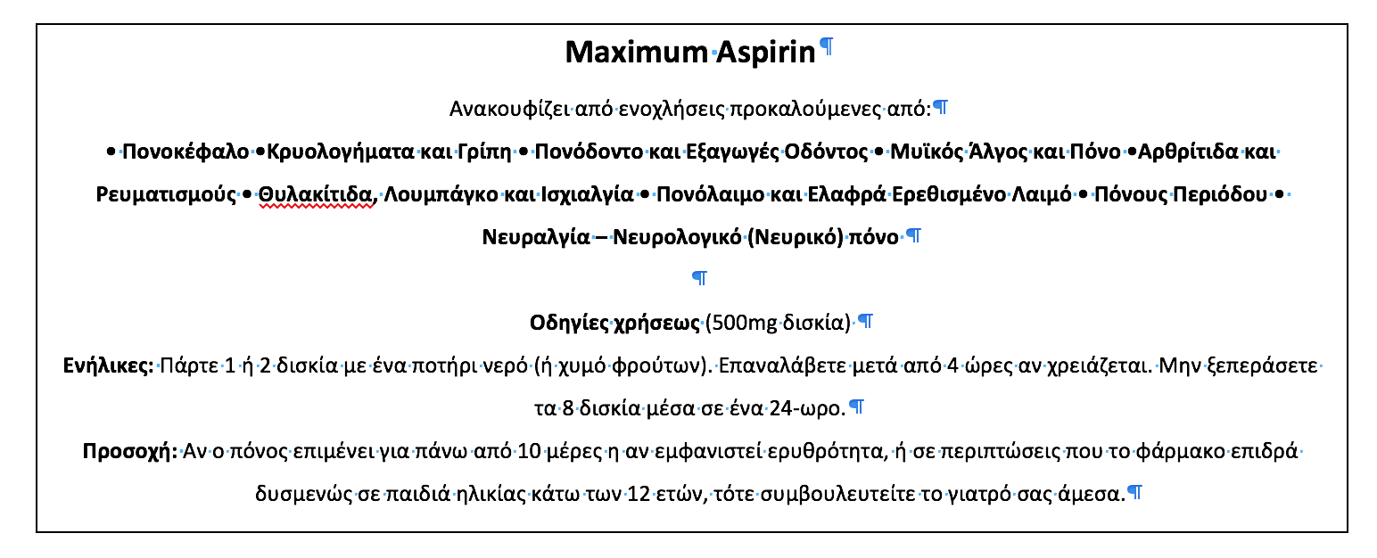

Ιστορικό Ασθενούς
Όνομα:__________________________________________ Αρ. Ασθενή:___________
Ημ. Γέννησης:___/___/___ Τηλέφωνο οικίας:_______________ Αρ. Ταυτοτ.:________________
Ασφάλεια:____________________________ ΑΜΚΑ:__________________________________

Διεύθυνση οικίας:
Οδός:______________________________: Πόλη:______________________ Τ.Κ.:____________
Πρόσωπο επείγουσας επικοινωνίας:_________________________ Τηλ:____________________

Όνομα Γιατρού:____________________________________Τηλεφωνο:____________________
Το ύψος σας:____________ Το βάρος σας: __________
Πρόσφατα προβλήματα υγείας /Συμπτώματα: Έχετε λάβει θεραπεία για αυτό το νόσημα στο
παρελθόν;
(1) _______________________________________ Ναι – Όχι Έτος ________
(2) _______________________________________ Ναι – Όχι Έτος ________
(3) _______________________________________ Ναι – Όχι Έτος ________
(4) _______________________________________ Ναι – Όχι Έτος ________
(5) _______________________________________ Ναι – Όχι Έτος ________

Έχετε κάποια αλλεργία σε φάρμακα; Ναι / Όχι
Παρακαλώ προσδιορίστε: ________________________________________________________
________________________________________________________

Έχετε χειρουργηθεί στο παρελθόν; Ναι / Όχι
Παρακαλώ περιγράψτε: ________________________________________________________
________________________________________________________

Είχατε ποτέ επιπλοκές κατά την διάρκεια αναισθησίας; Ναι / Όχι
Παρακαλώ περιγράψτε: ________________________________________________________
________________________________________________________

Material for telephone handling
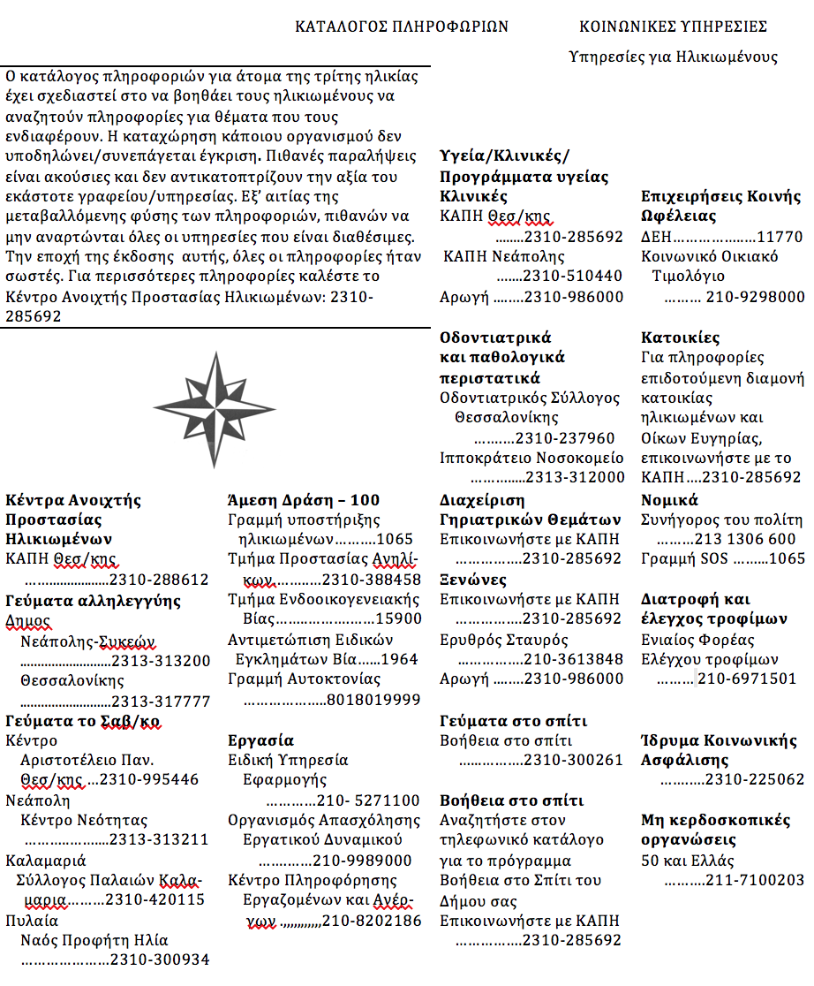





Material for finance handling
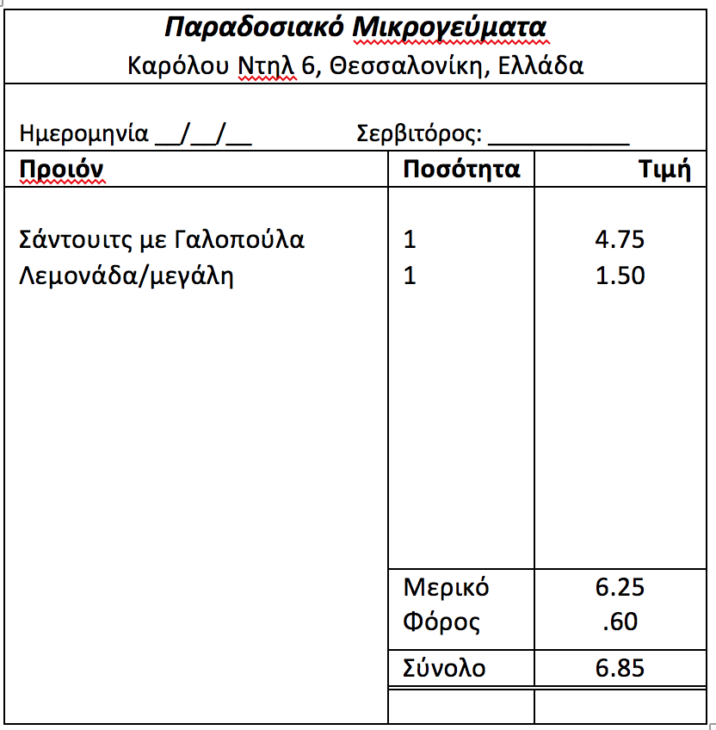

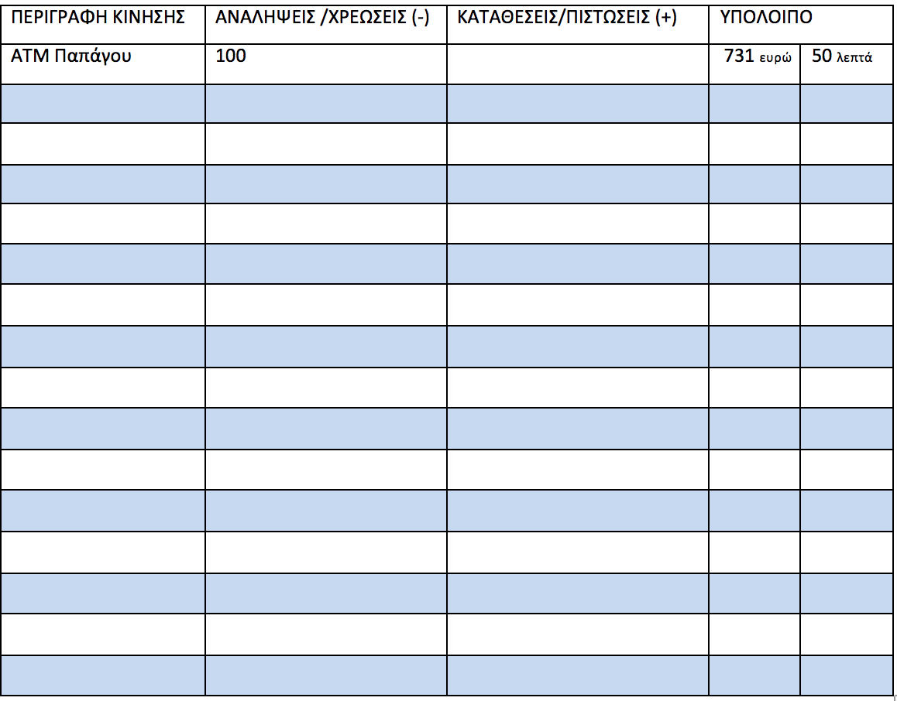

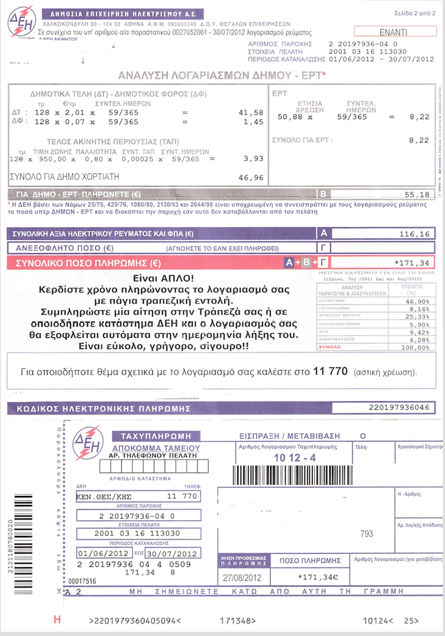


Question cards
A. Δοκιμασία 1 – Λήψη Φαρμάκων
Ερώτηση 1

Πόσες μέρες θα διαρκέσει ένα κουτί MAALOX για τον κ. Παπαδόπουλο;

Κάρτα 1 (SoFa CoDe)

A. Δοκιμασία 1 – Λήψη Φαρμάκων
Ερώτηση 2

O κ. Παπαδόπουλος νιώθει νυσταγμένος μόλις λαμβάνει τη φαρμακευτική του αγωγή, που περιλαμβάνει και τα τρία σκευάσματα. Μπορείτε να μου πείτε τι μπορεί να προκαλεί την υπνηλία του;

Κάρτα 2 (SoFa CoDe)

A. Δοκιμασία 2 – Λήψη Φαρμάκων
Ερώτηση 1

Σύμφωνα με αυτό το εσώκλειστο φυλλάδιο οδηγιών, μέχρι πόσα χάπια ασπιρίνης μπορεί κάποιος να πάρει μέσα σε 24 ώρες;

Κάρτα 3 (SoFa CoDe

A. Δοκιμασία 1 – Λήψη Φαρμάκων
Ερώτηση 2

Σύμφωνα με αυτό το εσώκλειστο φυλλάδιο οδηγιών , ποιο χρονικό διάστημα πρέπει να μεσολαβήσει πριν κάποιος να μπορεί να πάρει ένα χάπι ξανά;

Κάρτα 4 (SoFa CoDe

A. Δοκιμασία 2 – Λήψη Φαρμάκων
Ερώτηση 3

Μια ηλικιωμένη γυναίκα έπεσε περίπου δύο εβδομάδες πριν και παίρνει αυτά τα χάπια Ασπιρίνης διότι πονάει η μέση του από τότε. Σύμφωνα με το φυλλάδιο, τι πρέπει να κάνει;

Κάρτα 5 (SoFa CoDe

A. Δοκιμασία 3 – Ιατρικό ιστορικό
Ερώτηση 1

Σε ποιο σημείο αυτού του εντύπου θα γράψει ο κ. Παπαδόπουλος ότι καλύπτεται από την ασφάλεια του ΕΟΠΥΥ; Γράψτε το τώρα

Κάρτα 6 (SoFa CoDe

A. Δοκιμασία 3 – Ιατρικό ιστορικό
Ερώτηση 1

. O κ. Παπαδόπουλος είχε ασταθή πίεση αίματος την τελευταία φορά που υπεβλήθη σε αναισθησία. Σε ποιο σημείο αυτού του εντύπου θα κάνει σημείωση αυτής της κατάστασης; Γράψτε το τώρα..

Κάρτα 7 (SoFa CoDe

B. Δοκιμασία 1 – Χρήση Τηλεφώνου

Ποιο τηλέφωνο θα καλούσατε εάν θα θέλατε να μάθετε για επιδοτούμενη διαμονή σε κατοικίες για ηλικιωμένους ή οίκους ευγηρίας; Μπορείτε να χρησιμοποιήσετε ένα στυλό για να βρείτε το νούμερο σε αυτή τη σελίδα. Παρακαλώ, δείξτε το νούμερο, διαβάστε το δυνατά και καλέστε.

Κάρτα 8 (SoFa CoDe

B. Δοκιμασία 2 – Χρήση Τηλεφώνου

Ποιο νούμερο θα καλούσατε εάν ψάχνατε ένα σκεύασμα από φαρμακείο; Μπορείτε να χρησιμοποιήσετε ένα στυλό και για να βρείτε το νούμερο σε αυτή τη σελίδα. Παρακαλώ δείξτε το νούμερο, διαβάστε το δυνατά και καλέστε..

Κάρτα 9 (SoFa CoDe

B. Δοκιμασία 3 – Χρήση Τηλεφώνου

Εάν πραγματοποιήσεις μια υπεραστική κλήση την Κυριακή το βράδυ από τις 10:30 μμ μέχρι τις 11:00 μμ, ποιες χρεώσεις ισχύουν για υπεραστικές κλήσεις; Πρώτα βρείτε την περιοχή σε αυτή την σελίδα. Μπορείτε να χρησιμοποιήσετε ένα στυλό για να βρείτε την τοποθεσία σε αυτή τη σελίδα. Παρακαλώ, πείτε μου ποιες χρεώσεις πιστεύετε ότι ισχύουν.

Κάρτα 10 (SoFa CoDe

Γ. Δοκιμασία 1 – Διαχείριση οικονομικών

Παρακαλώ υπολογίστε τα ρέστα που θα πάρει ο πελάτης εάν πλήρωνε με ένα χαρτονόμισμα των €10.00

Κάρτα 11 (SoFa CoDe

Γ. Δοκιμασία 2 – Διαχείριση οικονομικών

Ένα άτομο που καταγράφει την κίνηση του τραπεζικού λογαριασμού του, περιμένει να πιστωθεί σε αυτόν μια επιταγή των €50.00 και επίσης να πληρωθεί από αυτόν ένας λογαριασμό ΔΕΗ του ποσού των €29.21. Παρακαλώ υπολογίστε το υπόλοιπο λογαριασμού που θα έχει.

Κάρτα 12 (SoFa CoDe

Γ. Δοκιμασία 3 – Διαχείριση οικονομικών

Αυτός είναι ένας λογαριασμός της ΔΕΗ που ήρθε με το ταχυδρομείο. Επισκέπτεστε την τράπεζά σας και εκφράζετε την επιθυμία να πληρώνεται κάθε λογαριασμός της ΔΕΗ μέχρι του ποσού των 200 € απευθείας με χρέωση του τραπεζικού λογαριασμού που διατηρείται σε αυτήν. Σας δίνουν το παρόν έντυπο για να το συμπληρώσετε. Παρακαλώ συμπληρώστε όλα τα στοιχεία που είναι απαραίτητα για να ολοκληρωθεί αυτή η διαδικασία. Μπορείτε να χρησιμοποιήσετε ένα ψεύτικο όνομα και διεύθυνση, για να διατηρηθεί η ανωνυμία σας.

Κάρτα 13 (SoFa CoDe

Appendix V

The EPT-G
Διάγραμμα: Διαλέγοντας Γυαλιστικά Προϊόντα Επίπλων
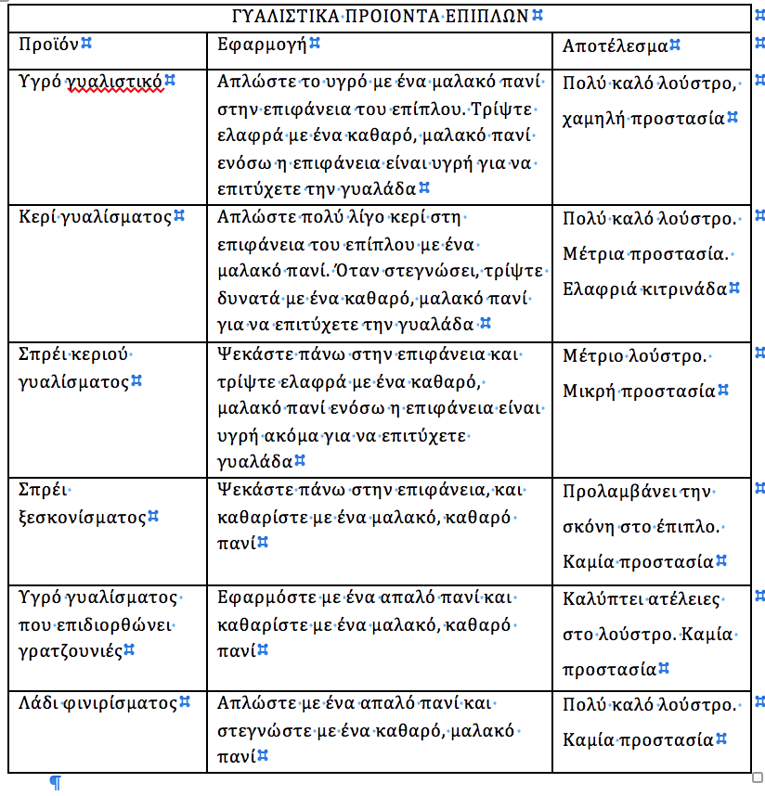
- Ποιο προϊόν πρέπει να χρησιμοποιήσετε για να καλύψετε ατέλειες στο λούστρο του επίπλου; _________________________________________________________________________________________
- Ποιό προϊόν πρέπει να διαλέξετε αν θέλετε την μέγιστη δυνατή προστασία για το έπιπλό σας? ___________________________________________________________________________________

4 Οκτωβρίου 2013
Αυτό το μέρος του λογαριασμού αφορά τις παρεχόμενες υπηρεσίες από εναλλακτικό πάροχο επικοινωνίας. Επιλέξατε άλλη εταιρία για τις υπεραστικές και διεθνείς σας κλήσεις, διατηρώντας τις υπηρεσίες του ΟΤΕ για τις τοπικές κλήσεις.
Νο | Ημερομηνία | Ώρα | Τύπος | Προς | Νούμερο | Λεπτά | Κόστος
1 | Αυγουστ 29 | 7:28 ΜΜ | Απογευμ | ΑΘΗΝΑ | 210-2165551 | 46 | 7.08
2 | Αυγουστ 29 | 8:46 ΜΜ | Απογευμ | ΛΑΡΙΣΑ | 2410-614777 | 1 | .15
3 | Αυγουστ 29 | 8:51 ΜΜ | Απογευμ | ΑΘΗΝΑ | 210-2164567 | 1 | .15
4 | Αυγουστ 29 | 9:28 ΜΜ | Απογευ. | ΑΘΗΝΑ | 210-2165551 | 1 | .15
5 | Σεπτεμβ 10 | 7:11 ΜΜ | Απογευμ | ΑΘΗΝΑ | 210-2168882 | 44 | 6.78
6 | Σεπτεμβ 17 | 9:14 ΜΜ | Απογευ. | ΑΘΗΝΑ | 210-2169999 | 33 | 5.08
7 | Σεπτεμβ 22 | 7:10 ΜΜ | Απογευμ | ΑΘΗΝΑ | 210-2165551 | 1 | .15
8 | Σεπτεμβ 22 | 8:35 ΜΜ | Απογευμ | ΠΑΤΡΑ | 2610-215777 | 23 | 4.42
9 | Οκτωμβ 01 | 8:33 ΜΜ | Απογευμ | ΑΘΗΝΑ | 210-2169999 | 23 | 3.69
Διάγραμμα: Αναλυτικός Λογαριασμός Υπεραστικών Κλήσεων

- Σε ποιό τηλεφωνικό νούμερο έγιναν οι πιο πολλές κλήσεις; _________________________________________________________________________________________
- Ποιό είναι το όνομα της εταιρίας που σας προσφέρει τις υπηρεσίες της για τοπικές κλήσεις; _________________________________________________________________________________________

Οδηγίες: Κανονισμοί Για Παροχή Προτεραιότητας από Οδηγούς

ΠΑΡΟΧΗ ΠΡΟΤΕΡΑΙΌΤΗΤΑΣ
Όταν δεν υπάρχουν στο δρόμο πινακίδες, σημάνσεις, η παρουσία αστυνομίας που θα σας επισημάνουν τι να κάνετε , πρέπει να ακολουθήσετε συγκεκριμένους κανονισμούς. Ακολουθούν τρεις τέτοιοι κανονισμοί.
- Οι οδηγοί πρέπει να δώσουν προτεραιότητα στις ακόλουθες περιπτώσεις:
  - Όταν πεζοί διασχίζουν τον δρόμο σε σταυροδρόμι που δεν υπάρχει φωτεινός σηματοδότης (η διάβαση δεν χρειάζεται να είναι διαγραμμισμένη) .
  - Όταν πεζοί διασχίζουν τον δρόμο σε ειδικά διαγραμμισμένες διαβάσεις.
  - Όταν ο οδηγός στρίβει σε έναν δρόμο και οι πεζοί διασχίζουν τον δρόμο έχοντας πράσινο.
  - Όταν ένας τυφλός πεζός που φέρει ειδικό μπαστούνι ή συνοδεύεται από σκύλο καθοδήγησης διασχίζει τον δρόμο.
  - Όταν πεζοί διασχίζουν ένα πεζοδρομημένο σοκάκι ή δρόμο.
- Οδηγοί που στρίβουν αριστερά πρέπει να δίνουν προτεραιότητα σε διερχόμενα οχήματα που διατηρούν την ευθεία πορεία τους.
- Οδηγοί που βρίσκονται εντός κυκλικού κόμβου πρέπει να παρέχουν την προτεραιότητα στους οδηγούς που εισέρχονται στον κόμβο.

- Αν οδηγείτε ευθεία στον δρόμο διασχίζοντας ένα σταυροδρόμι, ποιός πρέπει να σας παρέχει την προτεραιότητα; _________________________________________________________________________________________
- Ποιος έχει προτεραιότητα όταν στρίβετε δεξιά έχοντας πορτοκαλί σήμανση που αναβοσβήνει, και ένας πεζός που κάνει τζόκινγκ περνάει την διάβαση τους δρόμου που εισέρχεστε έχοντας πράσινη σήμανση; _________________________________________________________________________________________

Ταχυδρομήστε το κουπόνι σας σήμερα-
Το να είσαι μέλος της ΕΣΥΠ κοστίζει μόνο 8 €

☐ 1 χρόνος/8€ ☐ 3χρόνια/20€ ☐ 10 χρόνια/45€
Όνομα__________________________________________________________
Διεύθυνση ______________________________________________________
Πόλη__________________ Νομός ___________________Τ.Κ. __________
Ημερομηνία γέννησης ____________/____________/___________
Μέρα Μήνας Έτος
☐ Δουλεύω με πλήρη απασχόληση ☐ Δουλεύω με μερική απασχόληση
☐ Είμαι συνταξιούχος/α
Όνομα συζύγου _________________________________________________
Ημερομηνία γέννησης συζύγου ____________/____________/___________
Μήνας Μέρα Έτος
☐ Έχω εσωκλείσει επιταγή ή συναλλαγματική με δικαιούχο την ΕΣΥΠ (μην στείλετε μετρητά)
☐ Παρακαλώ χρεώστε με το ποσό αργότερα
☐ Αν έχετε δουλέψει στο τομέα της εκπαίδευσης στο παρελθόν, μαρκάρετε αυτό το πεδίο για να γίνεται μέλος της Πανελλήνιας Ένωσης Συνταξιούχων Διδασκάλων της ΕΣΥΠ.

Ταχυδρομήστε στην διεύθυνση: ΕΣΥΠ, Συγγρού 56, Τ.Κ. 11742, Αθήνα

Το ποσό της συνδρομής δεν εκπίπτει από τον φόρο εισοδήματος. Οι ετήσιες συνδρομές περιλαμβάνουν 2,40€ για την Σύγχρονη Ωριμότητα και 85 λεπτά για το Ενημερωτικό Δελτίο. Η συνδρομή καλύπτει και τον/την σύζυγο σας. Παρακαλώ δώστε περιθώριο 6 εβδομάδων για την αποστολή των σχετικών αποδεικτικών και δελτίων.
Έντυπο: Αίτηση Εγγραφής Μέλους ΕΣΥΠ

7. Αν αγοράζατε μια συνδρομή για την περίοδο από το 2013 μέχρι το 2023, πόσα θα πληρώνατε; ______________________________________________________________________________________________
8. Αν είστε παντρεμένος/η και αποφασίσετε να γίνεται μέλος της ΕΣΥΠ, πόσο χρειάζεται να πληρώσει ο/η σύζυγός σας; ______________________________________________________________________________________________

Έντυπο: Ιατρικό Ιστορικό ασθενούς

ΟΛΕΣ ΟΙ ΠΛΗΡΟΦΟΡΙΕΣ ΕΊΝΑΙ ΕΜΠΙΣΤΕΥΤΗΚΕΣ ΑΡΧΙΚΟ/ΕΤΗΣΙΟ ΙΣΤΟΡΙΚΟ ΑΣΘΕΝΟΥΣ
ΙΑΤΡΙΚΟ ΙΣΤΟΡΙΚΟ
ΕΧΕΤΕ ΤΩΡΑ Ή ΕΙΧΑΤΕ ΠΟΤΕ: | ΝΑΙ | ΟΧΙ
Α)Ζάλη/θολή όραση/ισχυρούς πονοκεφάλους ή ημικρανίες
Β)Επιληψία/κρίσεις με έντονους σπασμούς
Γ)Νευρικό κλονισμό/κόπωση/κατάθλιψη/συναισθηματικά προβλήματα
Δ)Πνευμονολογικά προβλήματα/άσθμα/αιμοπτύσεις/φλέγματα
Ε)Επίμονο βήχα ή βραχνάδα
Ζ)Πρόβλημα με τον θυρεοειδή
Η)Καρδιολογικά /ρευματικό πυρετό/ πόνους στο στήθος/ δύσπνοια
Θ)Υπέρταση/εγκεφαλικό επεισόδιο/υπερλυπιδιμία (χοληστερίνη, τριγλυκερίδια
/χοληστερόλη)
Ι)Θρόμβους στα πόδια/φλεβίτιδα (κιρσούς)/μούδιασμα
Κ)Προβλήματα με το συκώτι (ίκτερο, μονοπυρήνωση, ηπατίτιδα)
Λ)Προβλήματα με την χολή
Μ)Δυσπεψία ή προβλήματα κατάποσης
Ν)Παχυσαρκία/αύξηση βάρους/απώλεια βάρους (πόσο και για πόσο καιρό;)
Ξ)Διατροφικά προβλήματα/σκελετικά προβλήματα ή οστεοαρθρίτιδα
Ο)Νεφρά/ουροδόχο κύστη/ προβλήματα στη ούρηση ή ουρικές φλεγμονές
Π)Αλλαγές στην συνήθειες αφόδευσης ή ούρησης
Ρ) Κολίτιδα/πολύποδα στο μέγα ή παχύ έντερο/αιμορραγία από το παχύ έντερο/αίμα στα κόπρανα

9. Αν είσασταν συχνά κουρασμένος και θλιμμένος, σε ποιά γραμμή στον παραπάνω πίνακα θα το αναφέρατε/σημειώνατε; ______________________________________________________________________________________________

10. Αν έχετε καούρες μετά το φαγητό, σε ποιά γραμμή στον παραπάνω πίνακα θα το αναφέρατε/σημειώνατε; ____________________________________________________________________________________________
Ενδείξεις: Ανακουφίζει Προσωρινά τον Βήχα που Προκαλείται από Μικρούς Ερεθισμούς του Λαιμού και των Βρόγχων, Όπως Παρατηρείται στο Κοινό Κρυολόγημα.

Οδηγίες: Ακολουθήστε την παρακάτω δοσολογία:
Μην ξεπεράσετε τις 4 δόσεις ανά 24-ωρο.
 | ΔΟΣΟΛΟΓΙΑ ΕΝΗΛΙΚΑ(και παιδιών άνω των 12 ετών): 2 κουτάλια του τσαγιού κάθε 6 με 8 ώρες.  ΔΟΣΟΛΟΓΑ ΠΑΙΔΙΟΥ  6χρν. μέχρι 12 χρν.  Ι κουτάλι του τσαγιού κάθε 6 με 8 ώρες  2χρν. μέχρι 6χρν.  ½ κουτάλι του τσαγιού κάθε 6 με 8 ώρες  Κάτω των 2 χρν– Συμβουλευτείτε τον γιατρό σας
Προσοχή- Ένας επίμονος βήχας μπορεί να αποτελεί ένδειξη μιας σοβαρής κατάστασης. Αν ο βήχας επιμένει πάνω από μία εβδομάδα, υποτροπιάζει, ή συνοδεύεται από πυρετό, εξάνθημα, ή επίμονο πονοκέφαλο, συμβουλευτείτε έναν γιατρό. Μην λαμβάνεται αυτό το προϊόν για επίμονο ή χρόνιο βήχα που οφείλεται στο κάπνισμα, σε άσθμα, ή εμφύσημα, καθώς και αν ο βήχας συνοδεύεται από υπερβολικά φλέγματα εκτός αν σας το έχει προτείνει ο γιατρός σας.
Οδηγίες: Χρήση Φαρμάκου για τον Βήχα

11. Ποιος είναι ο μέγιστος αριθμός κουταλιών τσαγιού από το φάρμακο που θα μπορούσατε να πάρετε εσείς σε 24 ώρες; ____________________________________________________________________________________________

12. Ο κος Παπαδόπουλος καπνίζει και έχει τσιγαρόβηχα. Ποιός είναι ο μέγιστος αριθμός δόσεων που μπορεί να πάρει κάθε μέρα; ____________________________________________________________________________________________

Διάγραμμα: Ταχυδρομήστε για Επιστροφή Χρημάτων από Αγορά Γυναικείων
Εσώρουχων

Πώς να πάρετε ταχυδρομικά μέχρι 4€ πίσω από
αγορά γυναικείων εσωρούχων και καλτσών

Για να έχετε 1€ ή 2€ επιστροφή σε κάθε μία από τις παρακάτω δύο κατηγορίες προϊόντων (μέγιστη επιστροφή 4€), ταχυδρομήστε αυτό το έντυπο, τις αποδείξεις αγοράς και τους κωδικούς των προϊόντων στην διεύθυνση:
ΠΡΟΣΦΟΡΑ ΕΠΙΣΤΡΟΦΗΣ- ΤΑΧΥΔΡΟΜΙΚΗ ΘΥΡΙΔΑ 7062-ΜΑΡΟΥΣΙ, ΑΘΗΝΑ, 57010

 | ΚΑΤΗΓΟΡΙΑ ΠΡΟΙΌΝΤΟΣ (ΤΣΕΚΑΡΕΤΕ ΜΟΝΟ 1 ΚΟΥΤΑΚΙ ΓΙΑ ΚΑΘΕ ΚΑΤΗΓΟΡΙΑ)
 | ΓΥΝΑΙΚΕΙΑ ΕΣΩΡΟΥΧΑ | ☐  1.00€  Κωδικός από ένα πακέτο των 3ων | ή | ☐  2.00€  Κωδικοί από δύο πακέτα των 3ων ή ένα πακέτο των 6
 | ΓΥΝΑΙΚΕΙΕΣ  ΚΑΛΤΣΕΣ | ☐  1.00€  Κωδικός από ένα πακέτο των 3ων | ή | ☐  2.00€  Κωδικοί από δύο πακέτα των 3ων ή ένα πακέτο των 6
Παρακαλώ επιστρέψτε μου το συνολικό ποσό των |  |  |  | €

13. Πόσα ζευγάρια κάλτσες θα χρειαστεί να αγοράσετε για να σας επιστραφούν 2€; ____________________________________________________________________________________________

14. Τι χρειάζεται να ταχυδρομήσετε μαζί με το παραπάνω έντυπο για να σας επιστραφούν τα χρήματα;
____________________________________________________________________________________________

Διάγραμμα: Χρεώσεις Ταξί

Ταχύ-ΤΑΞΙ
ΖΩΝΗ | 1/7 ΧΙΛΙΟΜΕΤΡΟΥ | ΚΑΘΕ ΕΠΙΠΛΕΟΝ 1/7 ΧΙΛΙΟΜΕΤΡΟΥ
1 | 1.5€ | 0.20€
2 | 2.00€ | 0.30€
3 | Πάγια χρέωση – 25.00€

Σημείωση: Όλοι οι επιβάτες επιβαίνουν με συνολική χρέωση του ενός εξ αυτών

ΕΠΕΞΗΓΗΣΗ ΖΩΝΩΝ ΧΡΕΩΣΗΣ:

1 – Όλες οι διαδρομές εντός του κέντρου της πόλης.
2 – Όλες οι διαδρομές μέσα σε προάστια, και μεταξύ του κέντρου της πόλης και των προαστίων.
3 – Διαδρομή μονής κατεύθυνσης από το αεροδρόμιο.

15. Αν δύο άτομα μοιραστούν ένα ταξί από το αεροδρόμιο, πόσο θα πληρώσει ο καθένας αν χωρίσουν τον λογαριασμό στα δυο; ____________________________________________________________________________________________

16. Αν ταξιδεύατε μέσα σε προαστιακή περιοχή, πόσο θα πληρώνατε για μια απόσταση 1 χιλιομέτρου? ____________________________________________________________________________________________

Έντυπο: Επιστροφή Φόρου Εισοδήματος και Καθαρά Κέρδη
ΥΠΟΛΟΓΙΣΜΟΣ ΦΟΡΟΛΟΓΙΣΙΜΟΥ ΕΙΣΟΔΗΜΑΤΟΣ

ΕΙΣΟΔΗΜΑ (εισόδημα από μισθούς εργασίας πλήρους ή μερικής απασχόλησης, ημερομίσθια, προμήθειες, μπόνους, αμοιβές, φιλοδωρήματα). Αντίγραφο από τα κέρδη και την φορολογική δήλωση (έντυπο Ε-2 και/ή 1099) από κάθε εργοδότη ΠΡΕΠΕΙ να επισυνάπτεται σε αυτό το έντυπο.

ΕΡΓΟΔΟΤΗΣ | ΔΙΕΥΘΥΝΣΗ | ΕΙΣΟΔΗΜΑ
5. Μερικό σύνολο εισοδήματος (αθροίστε τα εισοδήματα από τους παραπάνω εργοδότες)
6. Ελάχιστα επιτρεπτά επαγγελματικά έξοδα υπαλλήλου και/ή αφορολόγητο εισόδημα
7. ΣΥΝΟΛΙΚΟ ΕΙΣΟΔΗΜΑ (Γραμμή 5 μείον την γραμμή 6)
ΚΑΘΑΡΑ ΚΕΡΔΗ: (Αν υπάρχει καθαρή ζημία, το 0 πρέπει να μπει στην κατάλληλη σειρά)
8. Κέρδη από επιχειρήσεις, επάγγελμα, αγρόκτημα ως μοναδικός ιδιοκτήτης (επισυνάψτε το έντυπο Γ/Ζ)
9. Κέρδη από επιχειρήσεις, επάγγελμα, αγρόκτημα ως συνεταίρος (έντυπο Κ-1)
10. Κέρδη από δικαιώματα, πατέντες, τέλη, αμοιβές, κ.τ.λ.
11. ΣΥΝΟΛΙΚΑ ΚΕΡΔΗ (Προσθέστε τις γραμμές από το 8 ως και 10)
ΣΥΝΟΛΙΚΟ ΦΟΡΟΛΟΓΙΣΙΜΟ ΕΙΣΟΔΗΜΑ:
12. Συνολικό εισόδημα και καθαρά κέρδη (σειρές 7 ως και 11)

Δηλώνω λαμβάνοντας υπόψη τις ποινές που προβλέπει η νομοθεσία, αυτή η δήλωση έχει εξεταστεί από εμένα και είναι εξ όσων μπορώ να γνωρίζω αληθινή, ορθή και πλήρης.

13. _______________________________________________ 14. _____________________________________
Υπογραφή φορολογούμενου Ημερομηνία

Οδηγίες: Οδηγίες για Μαγείρεμα Μείγματος Γέμισης

19. Σύμφωνα με τις οδηγίες, για να γίνει η γέμιση ποιο στεγνή, τι μπορείτε να κάνετε; ____________________________________________________________________________________________

20. Στη μέθοδο ετοιμασίας σε κατσαρόλα, πόσο πρέπει να βράσετε την γέμιση ακόμα αφότου προσθέσετε τα ψίχουλα ψωμιού; ____________________________________________________________________________________________

ΟΔΗΓΙΕΣ

1 πακέτο Μείγμα Γέμισης | 2. Ανακατεύετε με ψίχουλα ψωμιού.
 | Σκεπάστε, απομακρύνετε από την
1 ^{2/3} κούπες νερό* | φωτιά και αφήστε το για 5 λεπτά.  Λιώστε το μίγμα με ένα πιρούνι.
^{1/4} της κούπας (μισή συσκευασία) βούτυρο ή μαργαρίνη | ΣΤΟΝ ΦΟΥΡΝΟ ΜΙΚΡΟΚΥΜΑΤΩΝ
 | 1.Αναμιγνύεται το περιεχόμενο του πακέτου με τα λαχανικά / καρυ-κεύματα, το ζεστό νερό και το βούτυρο, κόβετε σε κομμάτια, και το βάζετε το σε ένα μπολ 1^{1/2} λίτρου κατάλληλο για φούρνο μικροκυμάτων. Ανακατέψτε με ψίχουλα ψωμιού.
* Για ποιο ζουμερή γέμιση, αυξήστε το νερό κατά 2 κουταλιές του τσαγιού: για λιγότερο ζουμερή γέμιση, μειώστε το νερό κατά 2 κουταλιές του τσαγιού.

ΣΤΗΝ ΚΑΤΣΑΡΟΛΑ
1. Αναμιγνύεται το περιεχόμενο του πακέτου με τα λαχανικών / καρυ-κεύματα, το νερό και το βούτυρο σε μια μέτρια κατσαρόλα . Αφήστε τα να βράσουν. Μειώστε την φωτιά: σκεπάστε και σιγοβράστε για 5 λεπτά

 | 2. Σκεπάστε και ζεστάνετε σε δυνατή φωτιά για 5 με 6 λεπτά.** Λιώστε το μίγμα με ένα πιρούνι .
 | ** Οι φούρνοι διαφέρουν μεταξύ τους. Ο χρόνος για το ζέσταμα ορίζεται κατά προσέγγιση
Οδηγίες: Οδηγίες για Μαγείρεμα Μείγματος Γέμισης

19. Σύμφωνα με τις οδηγίες, για να γίνει η γέμιση ποιο στεγνή, τι μπορείτε να κάνετε; ____________________________________________________________________________________________

20. Στη μέθοδο ετοιμασίας σε κατσαρόλα, πόσο πρέπει να βράσετε την γέμιση ακόμα αφότου προσθέσετε τα ψίχουλα ψωμιού; ____________________________________________________________________________________________

Διάγραμμα: Λίστα Αντιμετώπισης Προβλημάτων Πλυντηρίου Ρούχων

Ελέγξτε αυτά τα σημεία ΠΡΙΝ πάρετε τηλέφωνο για service
ΑΝ ΤΟ ΠΛΥΝΤΗΡΙΟ ΣΑΣ
Δεν Αναδεύει ή Γεμίζει με Νερό | Δεν Περιστρέφεται ο Κάδος ή δεν Αποστραγγίζει | Σταματάει | Πιθανό αίτιο –  • Κάντε το παρακάτω για να το διορθώσετε
• | • | • |  | Αντικαταστήστε την ηλεκτρική ασφάλεια. Εκκινήστε ξανά από τον διακόπτη ασφαλείας.
• | • | • |  | Γυρίστε τον Διακόπτη Χειρισμού πέρα από την ένδειξη ‘OFF’ και τραβήξτε προς τα έξω
• | • |  |  | Ισιώστε τους σωλήνες. Αποκατα-στήστε τυχόν τσακισμένους σωλήνες
 | • |  |  | Ανισομερή κατανομή βάρους. Γυρίστε τους διακόπτες στην ένδειξη’OFF’ . Κατανείματε τα ρούχα ισομερώς. Εκκινήστε ξανά από τον διακόπτη Ελέγχου
 | • |  |  | Παύση σαπουνάδας—λόγο υπερβολικής σαπουνάδας. Πλύνετε ξανά χωρίς απορρυπαντικό. Χρησιμο-ποιείστε την σωστή ποσότητα από-ρρυπαντικού που παράγει περιορισμέ-νη σαπουνάδα.
• |  |  |  | Βουλωμένα φίλτρα νερού. Αποσυνδέστε τους σωλήνες τροφοδοσίας από την βρύση. Καθαρίστε τα φίλτρα και επανασυνδέστε τους σωλήνες

21. Τεντώνοντας τους σωλήνες, ή αποκαθιστώντας τσακισμένα σημεία στους σωλήνες, ποια 2 προβλήματα λύνει κανείς; ____________________________________________________________________________________________

22. Το πλυντήριό σας δεν γεμίζει νερό ούτε αναδεύει. Παρόλα αυτά, οι λειτουργίες περιστροφής και αποστράγγισης του πλυντηρίου λειτουργούν κανονικά. Ποιο είναι το πιθανό πρόβλημα; ____________________________________________________________________________________________

Διάγραμμα: Πλάνο Αποζημίωσης Προνομίων Ασφαλιστής Κάλυψης Υγείας

ΑΣΦΑΛΕΙΑ ΝΟΣΟΚΟΜΙΑΚΗΣ ΠΕΡΙΘΑΛΨΗΣ (ΜΕΡΟΣ Α) ΚΑΛΥΨΗ ΥΠΗΡΕΣΙΩΝ ΓΙΑ ΤΟ 2012

Υπηρεσίες | Προνόμιο | Η Ασφάλεια Πληρώνει | Εσείς Πληρώνετε
ΝΟΣΗΛΙΑ ΣΕ ΝΟΣΟΚΟΜΕΙΟ  Ημι-ιδιωτικό δωμάτιο και διαμονή, γενική περίθαλψη και άλλες νοσοκομειακές υπηρεσίες και προμήθειες(Ασφαλιστική κάλυψη υγείας με βάση την περίοδο προνομίων: βλέπε σελ. 3) | Πρώτες 60 μέρες | Όλα εκτός από 760€ | 760€
 | 61^{η} μέχρι 90^{η} μέρα | Όλα εκτός από 190€ την μέρα | 190€ την μέρα
 | 91^{η} μέχρι 150^{η} μέρα | Όλα εκτός από 380€ την μέρα | 380€ την μέρα
 | Πέρα από 150 μέρες | Τίποτα | Όλο το κόστος
ΕΙΔΙΚΕΥΜΕΝΗ ΝΟΣΗΛΕΥΤΙΚΗ ΦΡΟΝΤΙΔΑ  Ημι-ιδιωτική διαμονή και διατροφή, ειδικευμένη περίθαλψη και υπηρεσίες αποκατάστασης καθώς και άλλες υπηρεσίες και προμήθειες.**  (Ασφαλιστική κάλυψη υγείας με βάση την περίοδο προνομίων: βλέπε σελ. 3) | Πρώτες 20 μέρες | 100% του εγκριμένου ποσού | Τίποτα
 | Επιπλέον 80 μέρες | Όλα εκτός από 95€ την ημέρα | Μέχρι 95€ την ημέρα
 | Πέρα από 100 μέρες | Τίποτα | Όλο το κόστος

23. Ποιο είναι το ποσό που εκπίπτει όταν κανείς πληρώνει για την παροχή ενδονοσοκομειακών υπηρεσιών κατά τις 30 πρώτες ημέρες; ____________________________________________________________________________________________________

24. Ο κ_{ος} Παπαδόπουλος εισήχθη σε γηροκομείο την 1 Ιανουαρίου του 2012. Τι ποσό κάλυψε η Ασφαλιστική Κάλυψη Υγείας (Μέρος Α)για την φροντίδα του τον Ιούλιο του 2012; ____________________________________________________________________________________________________

Διάγραμμα: Διατροφικές Πληροφορίες για Δημητριακά

Διατροφικά Στοιχεία
Μέγεθος Μερίδας | ¾ της Κούπας (29γρ/1.1 oz)
Μερίδες ανά Συσκευασία |  |  |  |  |  | Περίπου 17
Ποσότητα ανά μερίδα |  | Δημητριακά |  |  |  |  |  | Δημητριακά με ½ κούπα άπαχου γάλακτος με βιταμίνη Α&D
Θερμίδες |  | 90 |  |  |  |  |  | 130
Θερμίδες από λίπη |  | 5 |  |  |  |  |  | 5
% αναγκαίας ημερήσιας κατανάλωσης
Συνολικά λίπη 0.5 γρ* |  | 1% |  |  |  |  |  | 1%
Κορεσμένα Λίπη |  | 0% |  |  |  |  |  | 0%
Πολυακόρεστα Λίπη 0γρ
Μονοακόρεστα Λίπη 0γρ
Χοληστερόλη 0μγρ |  | 0% |  |  |  |  |  | 0%
Νάτριο 230μγρ |  | 10% |  |  |  |  |  | 12%
Κάλιο 170 μγρ |  | 5% |  |  |  |  |  | 11%
Συνολικοί  Υδατάνθρακες 24γρ |  | 8% |  |  |  |  |  | 10%
Φυτικές ίνες 5γρ |  | 20% |  |  |  |  |  | 20%
Διαλυτές φυτικές ίνες 0γρ
Αδιάλυτες φυτικές ίνες 5γρ
Ζάχαρα 5γρ
Άλλοι υδατάνθρακες 14γρ
Πρωτεΐνη 3γρ

25. Τι ποσοστό από την Αναγκαία Ημερήσια Κατανάλωση νατρίου λαμβάνετε από μία μερίδα δημητριακών και ½ κούπας άπαχου γάλακτος; ____________________________________________________________________________________________________

26. Πόσες θερμίδες προστίθενται σε μια μερίδα δημητριακών αν τα καταναλώσετε με μισή κούπα άπαχου γάλατος; ____________________________________________________________________________________________________

Διάγραμμα: Χρονικές Περίοδοι Έκπτωσης Τηλεφωνικών Κλήσεων

Χρονική Περίοδος Έκπτωσης
Δ Τ Τ Π Π Σ Κ
8 Π.Μ. μέχρι  5 Μ.Μ. | Καθημερινή
5 Μ.Μ μέχρι  10 Μ.Μ. | Απόγευμα
10 Μ.Μ. μέχρι  8 Π.Μ. | Νύχτα και Σαββατοκύριακο
Οι κλήσεις που εκτείνονται σε δύο χρονικές περιόδους θα χρεώνονται με βάση την εκάστοτε ισχύουσα χρέωση της περιόδου για κάθε λεπτό κλίσης.

27. Ο γιος και η κόρη σας ζουν εκτός νομού αλλά στην ίδια πόλη. Τηλεφωνείτε την κόρη σας στις 11.37 π.μ. το Σάββατο. Τηλεφωνείτε τον γιό σας στις 9.30 μμ. την Τετάρτη. Και οι δυο κλήσεις διαρκούν 5 λεπτά. Ποια κλήση είναι φθηνότερη; ____________________________________________________________________________________________________

28. Αν το τηλεφώνημά σας αρχίζει στις 4.57 μμ. την Δευτέρα και διαρκεί 7 λεπτά, ποια είναι η χρέωση/ποιες είναι οι χρεώσεις που εφαρμόζονται στην κλήση σας; ____________________________________________________________________________________________________

Appendix VI

Scoring Manual for the OTDL-G
No | Συμπεριφορά |  | Πόντοι | Σχόλια
Β1 | Ο ΣΥΜΜΕΤΕΧΟΝΤΑΣ ΒΡΙΣΚΕΙ/ΔΕΙΧΝΕΙ/ΕΞΕΤΑΖΕΙ ΤΟ ΚΟΥΤΙ MAALOX. | NAI  OXI | 1  0 | Αυτό το βήμα πρέπει να γίνει πρώτο.
Β1α | ΔΩΘΗΚΕ ΠΡΟΤΡΟΠΗ; | NAI  OXI | 1  2 | Δέστε κανόνες προτροπών
Β2 | Ο ΣΥΜΜΕΤΕΧΟΝΤΑΣ ΛΕΕΙ «25 ΜΕΡΕΣ» | NAI  OXI | 1  0
Β2α | ΔΩΘΗΚΕ ΠΡΟΤΡΟΠΗ; | NAI  OXI | 1  2 | Δέστε κανόνες προτροπών
Β3 | Ο ΣΥΜΜΕΤΕΧΟΝΤΑΣ ΒΡΙΣΚΕΙ/ΔΕΙΧΝΕΙ/ΕΞΕΤΑΖΕΙ ΤΟ ΚΟΥΤΙ DEPON | NAI  OXI | 1  0 | Για το Β3 και Β4, η σειρα με την οποία ο συμμετέχοντας βρίσκει τα φάρμακα δεν έχει σημασία
Β3α | ΔΩΘΗΚΕ ΠΡΟΤΡΟΠΗ; | NAI  OXI | 1  2 | Δέστε κανόνες προτροπών
Β4 | Ο ΣΥΜΜΕΤΕΧΟΝΤΑΣ ΒΡΙΣΚΕΙ/ΔΕΙΧΝΕΙ/ΕΞΕΤΑΖΕΙ ΤΟ ΚΟΥΤΙ ΤΟ ΚΟΥΤΙ BRUFEN | NAI  OXI | 1  0 | Για το Β3 και Β4, η σειρα με την οποία ο συμμετέχοντας βρίσκει τα φάρμακα δεν έχει σημασία
B4α | ΔΩΘΗΚΕ ΠΡΟΤΡΟΠΗ; | NAI  OXI | 1  2 | Δέστε κανόνες προτροπών
Β5 | Ο ΣΥΜΜΕΤΕΧΟΝΤΑΣ ΛΕΕΙ « Το Depon και το Brufen μπορούν να προκαλέσουν υπνηλία»  Ο ερευνητής διαπίστωσε ότι είπε μόνο DEPON  Ο ερευνητής διαπίστωσε ότι είπε μόνο BRUFEN  Ο ερευνητής διαπίστωσε ότι DEN είπε ούτε DEPON ούτε BRUFEN. | NAI  OXI | 1  0 | Για να πάρει πόντους, ο συμμετέχοντας πρέπει να πει και τα δυο ονόματα των φαρμάκων.
Β5α | ΔΩΘΗΚΕ ΠΡΟΤΡΟΠΗ; | NAI  OXI | 1  2 | Δέστε κανόνες προτροπών
B6 | Ο ΣΥΜΜΕΤΕΧΟΝΤΑΣ ΛΕΕΙ «Ως 8 χάπια» | NAI  OXI | 1  0
B6α | ΔΩΘΗΚΕ ΠΡΟΤΡΟΠΗ; | NAI  OXI | 1  2 | Δέστε κανόνες προτροπών
Β7 | Ο ΣΥΜΜΕΤΕΧΟΝΤΑΣ ΛΕΕΙ «Σε διαστήματα 4 ωρών» Η «Κάθε 4 ώρες» | NAI  OXI | 1  0 | Οι 4 ώρες είναι το κριτίριο
Β7α | ΔΩΘΗΚΕ ΠΡΟΤΡΟΠΗ; | NAI  OXI | 1  2 | Δέστε κανόνες προτροπών
Β8 | Ο ΣΥΜΜΕΤΕΧΟΝΤΑΣ ΛΕΕΙ: «Πρέπει να επικοινωνήσει με τον γιατρό της άμεσα» | NAI  OXI | 1  0
Β8α | ΔΩΘΗΚΕ ΠΡΟΤΡΟΠΗ; | NAI  OXI | 1  2 | Δέστε κανόνες προτροπών
Β9 | Ο ΣΥΜΜΕΤΕΧΟΝΤΑΣ ΓΡΑΦΕΙ: «ΕΟΠΥΥ» ΣΤΟ ΠΛΑΙΣΙΟ «ΑΣΦΑΛΕΙΑ» ΤΗΣ ΦΟΡΜΑΣ | NAI  OXI | 1  0 | Ο συμμετέχοντας πρέπει να γράψει το όνομα της ασφάλειας ή τα αρχικά της.
Β9α | ΔΩΘΗΚΕ ΠΡΟΤΡΟΠΗ; | NAI  OXI | 1  2 | Δέστε κανόνες προτροπών
Β10α | Ο ΣΥΜΜΕΤΕΧΟΝΤΑΣ ΜΑΡΚΑΡΕΙ/ΤΣΕΚΑΡΕΙ «Ναι» ΔΙΠΛΑ ΣΤΗΝ ΕΡΩΤΗΣΗ «ΕΙΧΑΤΕ ΠΟΤΕ ΕΠΙΠΛΟΚΕΣ ΑΝΑΙΣΘΗΣΙΑΣ» | NAI  OXI | 1  0 | Ο συμμετέχοντας μπορεί να πάρει πόντους ακόμα και αν δεν απαντήσει σωστά στο Β10β
Β10β | Ο ΣΥΜΜΕΤΕΧΟΝΤΑΣ ΓΡΑΦΕΙ «Ασταθής αρτηριακή πίεση» ΣΤΟ ΠΛΑΙΣΙΟ «ΠΑΡΑΚΑΛΩ ΠΕΡΙΓΡΑΨΤΕ» | NAI  OXI | 1  0 | Ο συμμετέχοντας μπορεί να πάρει πόντους ακόμα και αν δεν απαντήσει σωστά στο Β10α
Β10γ | ΔΩΘΗΚΕ ΠΡΟΤΡΟΠΗ; | NAI  OXI | 1  2 | Δέστε κανόνες προτροπών
Γ1 | Ο ΣΥΜΜΕΤΕΧΟΝΤΑΣ ΒΡΙΣΚΕΙ/ΔΕΙΧΝΕΙ/ΕΞΕΤΑΖΕΙ ΤΗΝ ΣΤΗΛΗ «ΚΑΤΟΙΚΙΕΣ» | NAI  OXI | 1  0 | Αυτό πρέπει να γίνει πρώτο
Γ1α | ΔΩΘΗΚΕ ΠΡΟΤΡΟΠΗ; | NAI  OXI | 1  2 | Δέστε κανόνες προτροπών
Γ2 | Ο ΣΥΜΜΕΤΕΧΟΝΤΑΣ ΚΑΛΕΙ ΤΟ  «2310-285692» | NAI  OXI | 1  0 | Ο συμμετέχοντας πρέπει να καλέσει και να πεί αυτό το νούμερο; μόνο να πεί το νούμερο δεν είναι αρκετό
Γ2α | ΔΩΘΗΚΕ ΠΡΟΤΡΟΠΗ; | NAI  OXI | 1  2 | Δέστε κανόνες προτροπών
Γ3 | Ο ΣΥΜΜΕΤΕΧΟΝΤΑΣ ΒΡΙΣΚΕΙ/ΔΕΙΧΝΕΙ/ΕΞΕΤΑΖΕΙ ΤΗΝ ΔΙΑΦΗΜΙΣΗ ΤΟΥ ΦΑΡΜΑΚΕΙΟΥ | NAI  OXI | 1  0 | Αυτό το βήμα πρέπει να γίνει πρώτο
Γ3α | ΔΩΘΗΚΕ ΠΡΟΤΡΟΠΗ; | NAI  OXI | 1  2 | Δέστε κανόνες προτροπών
Γ4 | Ο ΣΥΜΜΕΤΕΧΟΝΤΑΣ ΚΑΛΕΙ ΚΑΙ ΛΕΕΙ ΦΩΝΑΧΤΑ «2310-513541» | NAI  OXI | 1  0
Γ4α | ΔΩΘΗΚΕ ΠΡΟΤΡΟΠΗ; | NAI  OXI | 1  2 | Δέστε κανόνες προτροπών
Γ5 | Ο ΣΥΜΜΕΤΕΧΟΝΤΑΣ ΒΡΙΣΚΕΙ/ΔΕΙΧΝΕΙ/ΕΞΕΤΑΖΕΙ THN ΣΩΣΤH (Η Περίοδος ‘Εκπτωσης) ΣΤΗΛΗ ΧΡΕΩΣΗΣ ΣΤΟΝ ΠΙΝΑΚΑ | NAI  OXI | 1  0 | Αυτό το βήμα πρέπει να γίνει πρώτο
Γ5α | ΔΩΘΗΚΕ ΠΡΟΤΡΟΠΗ; | NAI  OXI | 1  2 | Δέστε κανόνες προτροπών
Γ6 | Ο ΣΥΜΜΕΤΕΧΟΝΤΑΣ ΛΕΕΙ «Περίοδος ‘Εκπτωσης » | NAI  OXI | 1  0 | Ο συμμετέχοντας πρέπει να πεί το όνομα της περιόδου έκπτωσης. Μόνο να το δείξει δεν αρκεί
Γ6α | ΔΩΘΗΚΕ ΠΡΟΤΡΟΠΗ; | NAI  OXI | 1  2 | Δέστε κανόνες προτροπών
Δ1α | 3.15€ ΜΕΤΡΗΜΕΝΑ ΩΣ:  1x2€ ΚΕΡΜΑ+1€ ΚΕΡΜΑ+10 ΣΕΝΤΣ+5 ΣΕΝΤΣ | NAI  OXI | 4  0 | Για τα Δ1α-Δ1ε, διάφοροι συνδιασμοί μπορούν να οδηγήσουν σε μια σωστή απάντηση. Οπότε, μια από αυτή  Μπορεί να κωδικοποιηθεί σαν ΝΑΙ, και τα υπόλοιπα ως ΟΧΙ.
Δ1β | 3.15€ ΜΕΤΡΗΜΕΝΑ ΩΣ:  1x2€ ΚΕΡΜΑ+1€ ΚΕΡΜΑ+3x5 ΣΕΝΤΣ | NAI  OXI | 4  0
Δ1γ | 3.15€ ΜΕΤΡΗΜΕΝΑ ΩΣ:  1x2€ ΚΕΡΜΑ +5x20 ΣΕΝΤΣ+10 ΣΕΝΤΣ+5 ΣΕΝΤΣ | NAI  OXI | 4  0
Δ1δ | 3.15€ ΜΕΤΡΗΜΕΝΑ ΩΣ:  1x2€ ΚΕΡΜΑ +5x20 ΣΕΝΤΣ+3x5 ΣΕΝΤΣ | NAI  OXI | 4  0
Δ1ε | Δ1_{ε.} ΑΛΛΟ (ΔΙΕΥΚΡΙΝΗΣΕ) | NAI  OXI | 4  0 | Το 0 σε μία απάντηση επιτρέπει ένα 4 σε άλλη απάντηση. Οι πόντοι πρέπει να εκτιμηθούν σε όλες τις απαντήσεις. Λέγοντας 3.15 δεν είναι αρκετό. Τα ρέστα πρέπει να δωθούν με το χέρι
Δ1ζ | ΔΩΘΗΚΕ ΠΡΟΤΡΟΠΗ; | NAI  OXI | 1  2 | Δέστε κανόνες προτροπών
Δ1η | ΧΡΗΣΗΜΟΠΟΙΉΘΗΚΕ ΠΡΌΧΕΙΡΟ; | NAI  OXI | 1  2 | Δέστε κανόνες πρόχειρου
Δ2 | Ο ΣΥΜΜΕΤΕΧΟΝΤΑΣ ΓΡΑΦΕΙ 50 ΣΤΗΝ ΣΤΗΛΗ ΚΑΤΑΘΕΣΕΙΣ /ΠΙΣΤΩΣΕΙΣ ΚΑΙ ΥΠΟΛΟΓΙΖΕΙ ΤΟ ΠΡΩΤΟ ΥΠΟΛΟΙΠΟ 781.50€*  Ή  Ο ΣΥΜΜΕΤΕΧΟΝΤΑΣ ΓΡΑΦΕΙ 29.21€ ΣΤΗΝ ΣΤΗΛΗ ΑΝΑΛΗΨΕΙΣ /ΠΙΣΤΩΣΕΙΣ ΚΑΙ ΥΠΟΛΟΓΙΖΕΙ ΤΟ ΠΡΩΤΟ ΥΠΟΛΟΙΠΟ 702.29€  ΟΧΙ, ΑΛΛΑ ΤΟ ΥΠΟΛΟΙΠΟ ΕΙΝΑΙ ΣΩΣΤΟ  ΟΧΙ, ΑΛΛΑ ΤΟ ΠΟΣΟ ΣΤΗΝ ΣΤΗΛΗ ΠΙΣΤΩΣΗ ΚΑΙ ΧΡΕΩΣΗ ΕΙΝΑΙ ΣΩΣΤΟ  ΟΧΙ, ΚΑΜΙΑ ΕΓΓΡΑΦΗ ΔΕΝ ΕΙΝΑΙ ΣΩΣΤΗ | NAI  OXI  ΟΧΙ  ΟΧΙ | 2  1  1  0 | Παρόλο που τα Δ2/Δ3 είναι έτσι ώστε ο συμμενέχοντας να κάνει την κατάθεση πρώτα, και μετά την ανάληψη, η αντίθετη φορά είναι αποδεκτή. Οι πόντοι θα δοθούν για τα σωστά νούμερα στις σωστές στήλες, και για τον σωστό υπολογισμό του υπολοίπου.
Δ2γ | ΔΩΘΗΚΕ ΠΡΟΤΡΟΠΗ; | NAI  OXI | 1  2
Δ3 | Ο ΣΥΜΜΕΤΕΧΟΝΤΑΣ ΓΡΑΦΕΙ 29.21€ ΣΤΗΝ ΣΤΗΛΗ ΑΝΑΛΗΨΕΙΣ /ΧΡΕΩΣΕΙΣ ΚΑΙ ΥΠΟΛΟΓΙΖΕΙ ΤΟ ΤΕΛΙΚΟ ΥΠΟΛΟΙΠΟ 752.29€*  Ή  Ο ΣΥΜΜΕΤΕΧΟΝΤΑΣ ΓΡΑΦΕΙ 50€ ΣΤΗΝ ΣΤΗΛΗ ΚΑΤΑΘΕΣΕΙΣ /ΠΙΣΤΩΣΕΙΣ ΚΑΙ ΥΠΟΛΟΓΙΖΕΙ ΤΟ ΠΡΩΤΟ ΥΠΟΛΟΙΠΟ 752.29  ΟΧΙ, ΑΛΛΑ ΤΟ ΥΠΟΛΟΙΠΟ ΕΙΝΑΙ ΣΩΣΤΟ  ΟΧΙ, ΑΛΛΑ ΤΟ ΠΟΣΟ ΣΤΗΝ ΣΤΗΛΗ ΠΙΣΤΩΣΗ ΚΑΙ ΧΡΕΩΣΗ ΕΙΝΑΙ ΣΩΣΤΟ  ΟΧΙ, ΚΑΜΙΑ ΕΓΓΡΑΦΗ ΔΕΝ ΕΙΝΑΙ ΣΩΣΤΗ | NAI  OXI  ΟΧΙ  ΟΧΙ | 2  1  1  0
Δ3γ | ΔΩΘΗΚΕ ΠΡΟΤΡΟΠΗ; | NAI  OXI | 1  2 | Δέστε κανόνες προτροπής
Δ3δ | ΧΡΗΣΗΜΟΠΟΙΉΘΗΚΕ ΠΡΌΧΕΙΡΟ; | NAI  OXI | 1  2 | Δέστε κανόνες πρόχειρου
Δ4α | Ο ΣΥΜΜΕΤΕΧΟΝΤΑΣ ΓΡΑΦΕΙ ΚΑΙ ΤΑ 5 ΣΤΟΙΧΕΙΑ ΤΟΥ ΣΤΟ ΠΡΩΤΟ ΜΕΡΟΣ ΤΗΣ ΑΙΤΗΣΗΣ,  Γράφει μερικά στοιχεία  ΔΕΝ ΓΡΆΦΕΙ ΚΑΝΈΝΑ ΣΤΟΙΧΕΊΟ | ΝΑΙ  ΟΧΙ  ΟΧΙ | 5  Κάθε στοιχείο 1 πόντο  0
Δ4β | Ο ΣΥΜΜΕΤΕΧΟΝΤΑΣ ΓΡΑΦΕΙ ΤΟΝ ΑΡΙΘΜΟ ΠΑΡΟΧΗΣ 220197936-040 | NAI  OXI | 1  0 | Είναι αποδεκτό να τα γράψει χωρίς την παύλα
Δ4γ | Ο ΣΥΜΜΕΤΕΧΟΝΤΑΣ ΓΡΑΦΕΙ 200€ ΣΤΟ ΠΕΔΙΟ «Και μέχρι του ποσού των …….» | NAI  OXI | 1  0
Δ4δ | Ο ΣΥΜΜΕΤΕΧΟΝΤΑΣ ΓΡΑΦΕΙ ΤΟΝ ΑΡΙΘΜΟ 358/919-23100 | NAI  OXI | 1  0 | Είναι αποδεκτό να τα γράψει χωρίς την παύλα ή την κάθετη
Δ4ε | Ο ΣΥΜΜΕΤΕΧΟΝΤΑΣ ΓΡΑΦΕΙ ΤΗΝ ΗΜΕΡΟΜΗΝΙΑ ΚΑΙ ΥΠΟΓΡΑΦΕΙ  Ο ΣΥΜΜΕΤΕΧΟΝΤΑΣ ΓΡΑΦΕΙ ΜΟΝΟ ΤΗΝ ΗΜΕΡΟΜΗΝΙΑ  Ο ΣΥΜΜΕΤΕΧΟΝΤΑΣ ΜΟΝΟ ΥΠΟΓΡΑΦΕΙ  Ο ΣΥΜΜΕΤΕΧΟΝΤΑΣ ΔΕΝ ΓΡΑΦΕΙ ΟΥΤΕ ΤΗΝ ΗΜΕΡΟΜΗΝΙΑ ΟΥΤΕ ΥΠΟΓΡΑΦΕΙ | ΝΑΙ  ΟΧΙ  ΟΧΙ  ΟΧΙ | 2  1  1  0
Δ3γ | ΔΩΘΗΚΕ ΠΡΟΤΡΟΠΗ; | NAI  OXI | 7- Ένα πόντος για κάθε προτροπή

Appendix VII

Scoring Manual for the EPT-G
Δοκιμή | Σωστές απαντήσεις (1 πόντο) | Λάθος απαντήσεις (0 πόντους)
1 | Υγρό γυαλίσματος που επιδιορθώνει γρατσουνιές
2 | Κερί γυαλίσματος
3 | 210-2165551
4 | OTE
5 | - Οδηγοί που στρίβουν αριστερά  - To 2 | Οδηγοί από αριστερά
6 | - Αυτός που κάνει τζόκινγκ  - Ο πεζός  - Το 3
7 | 45 ευρώ
8 | - Τίποτα  - 0  - η συνδρομή καλύπτει τον σύζυγο  - ο σύζυγος είναι δωρεάν με την συνδρομή σου
9 | - Γ  - Στην γραμμή Γ  - Νευρικό κλονισμό / κόπωση/ κατάθλιψη κτλ.
10 | - Μ  - Στην γραμμή Μ  - Δυσπεψία ή προβλήματα κατάποσης
11 | - 8  - 8 κουταλάκια | 4 δόσεις
12 | - Κανένα  - Δεν πρέπει να πάρει  - Μην λαμβάνετε αυτό το προϊόν για επίμονο ή χρόνιο βήχα που οφείλεται στο κάπνισμα  - Να συμβουλευτεί τον γιατρό του
13 | - 6 ζευγάρια  - 2 πακέτα των 3  - 1 πακέτο των 6
14 | Απόδειξη αγοράς και τους κωδικούς των προϊόντων | Μόνο την απόδειξη αγοράς ή μόνο τους κωδικούς των προϊόντων
15 | 12.5 ευρώ | Το μισό από τα 25 ευρώ
16 | 3.80 ευρώ
17 | - Τα ελάχιστα επιτρεπτά επαγγελματικά έξοδα υπαλλήλου και αφορολόγητο εισόδημα  - Την γραμμή 6 | Μόνο τα ελάχιστα επιτρεπτά επαγγελματικά έξοδα υπαλλήλου ή μόνο αφορολόγητο εισόδημα
18 | 13.000 ευρώ
19 | - Μειώστε το νερό κατά 2 κουταλιές του γλυκού  - Μειώστε το νερό  - Βάλε λιγότερο νερό
20 | - Καθόλου  - 0  - Απομακρύνεται από την φωτιά  - Απομακρύνεται από την φωτιά και | 5 λεπτά
Δοκιμή | Σωστές απαντήσεις (1 πόντο) | Λάθος απαντήσεις (0 πόντους)
 | αφήστε το
21 | - Δεν Αναδεύει ή Γεμίζει με Νερό και δεν Στύβει ή δεν Αποστραγγίζει  - Δεν Αναδεύει και δεν Στύβει  - Δεν Γεμίζει με Νερό και δεν Αποστραγγίζει | Δεν Αναδεύει ή Γεμίζει με Νερό (μόνο)  Δεν Στύβει ή δεν Αποστραγγίζει (μόνο)
22 | Βουλωμένα φίλτρα νερού. Καθαρίστε τα φίλτρα
23 | 760 ευρώ | Όλα εκτός από 760 ευρώ
24 | - Τίποτα  - 0
25 | 12%
26 | 40
27 | - Το τηλεφώνημα στην κόρη  - Κόρη  - Σάββατο στην κόρη  - Σάββατο στις 11.37 πμ  - Σάββατο  - Το πρωινό τηλέφωνο  - Το τηλέφωνο στο σαββατοκύριακο
28 | - Καθημερινή και απογευματινή χρέωση  - 3 λεπτά καθημερινή και 4 λεπτά απογευματινή χρέωση | Την χρέωση που ισχύουν σε κάθε λεπτό του τηλεφωνήματος

Appendix VIII

Questionnaires (Translated)

Mental activities
“During the last 7 days, how often…”
- Have you used the internet to navigate /email /shop / chat or for video calling?
1. Never 2. Once or twice 3. Most days 4. Almost every day 5. Everyday

Other activities
“During the last 7 days, how often…”
- Have you worked receiving compensation?
1. Never 2. Once or twice 3. Most days 4. Almost every day 5. Everyday
- Have you looked after children (grandchildren, friends’ or neighbours’ kids)?
1. Never 2. Once or twice 3. Most days 4. Almost every day 5. Everyday
- Have you cared for a disabled or handicapped person? (verbal explanation)
1. Never 2. Once or twice 3. Most days 4. Almost every day 5. Everyday

Social participation
“During the last 12 months, how often …..”
- Have you worked voluntarily?
1 2 3 4 5
- Have you attended meetings of organizations such as neighborhood, community or political groups?
1 2 3 4 5
- Have you attended a sport or social club event?
1 2 3 4 5
- Have you attended an education or recreational course or class?
1 2 3 4 5

1. Once a year or less 2. Several times a year 3. Several times a month 4. Several times a week 5. Everyday / almost every day

Social network
- Number of people living together in the household (the last 12 months) ____
- Number of relatives with at least weekly contact (the last 12 months) ____
- Number of friends and neighbors with at least weekly contact (the last 12 months) ____

Loneliness
- Do you feel lonely?
1. Never 2. Sometimes 3. Often

Perceived Health
- Would you say that your health is
1. Excellent 2. Very good 3. Good 4.Fair 5.Poor
- For the past six months at least, to what extent have you been limited because of a health problem in activities people usually do?
1. Severely limited 2. Limited, but not severely 3. Not limited

Demographics
1. Highest degree obtained
- None
- Primary
- Secondary
- Lyceum, High school, technical school
- IEK
- University
- Msc, MA
- PhD
- Still in school/university

2. Marital status
- Never married
- Living together with someone in long-term
- Married and living together with someone
- Married but not living together
- Divorced
- Widowed

3. TOTAL AMOUNT OF PROFITS AT THE END OF THE YEAR _______________
4. CURRENT JOB SITUATION
- In pension
- Working/self employed
- Unemployed
- Disabled
- Take care of home and of family
- Other ____________

5. Years since retirement (if applicable) _____________
6. Area that you live _________________

7. Gender
- Female
- Male

