
An Investigation of Methods for Predicting Rheumatoid Arthritis Patient Response in Clinical Trials from Clinical Biomarkers and Patient Characteristics
Thesis submitted in Fulfilment for the Degree of Doctor of Philosophy
School of Health and Related Research (ScHARR)

Paul Mahoney 2017

Acknowledgements

This work would not have been completed without the support of individuals and organisations. First and foremost, I would like to express my gratitude to my supervisors, Professor Steven Julious and Professor Mike Campbell, for their invaluable advice and unwavering support during the course of this research. Their patience has been tested to the limit.

I would like to thank the Roche Products Limited for providing funding support, study time, use of company facilities and the clinical trial data which form the basis of this research.

Dedication

To Michelle, for the encouragement, review and support (and cajoling when needed) to get me to this point. To Luke, Katie and Jeannie in believing I could do it.

Disclaimer and Author’s Declaration

The views expressed in this research are those of the author and not necessarily those of the organisations of which the author is affiliated. The author has no competing interests to declare.

The author declares that this thesis is his original work and that none of the material contained in this thesis has previously been submitted for a degree to any awarding institution. The work contained in this thesis has been undertaken by me, with the support from those individuals or collaborators mentioned in the Acknowledgements section.

Abstract

Introduction: Rheumatoid Arthritis (RA) is a chronic, destructive, autoimmune disorder of unknown cause and with no known cure. RA is a multi-factorial disease with many factors influencing onset, severity and outcome.

Research Question: Of interest is to understand how selection of patients might influence patient outcome in clinical trials. Specifically, which are the patient characteristics or biomarkers measurable at enrolment that would be important in predicting response? In this PhD we will attempt to answer the question where response is the dichotomous outcome ACR20.

Methods: The research for this dissertation accessed clinical trial data from over 11,700 patients enrolled into 16 late stage RA clinical trials from 1998 to 2008. Through systematic review and a review and selection process, logistic regression and CART were selected to compare head to head in simulations. In simulations each method was compared using Variable Selection (VaSe) plots developed in the PhD. In most scenarios CART outperformed logistic regression, and was selected to apply to the clinical database.

Results: The CART analysis, generated a model that had an overall predictive accuracy for ACR20 of just 60%, although the explanatory variables selected in the model were plausible for predicting patient outcome: baseline tender joint count, region, joint space narrowing score, number of previous treatments and race. When one considered the 8 individual components of the ACR20, the predictive accuracy increased from 60% to between 67% - 82%.

Conclusions: Through the use of a large RA dataset, we were unable to predict ACR20 response to a satisfactory level. However, we were able to predict each component of the ACR20 well. This is likely due to the complexity of the ACR20 as a tool for patient response as well as the heterogeneity of this multifactorial condition. From a patient perspective it may be of more value to be able to predict a disease symptom such as number of swollen joints rather than a composite score.

This dissertation provides a framework for investigating predictive markers for patient response in clinical trial in RA and other disease areas.

Table of Contents
Acknowledgements ii
Dedication iii
Disclaimer and Author’s Declaration iv
Abstract v
Chapter 1 : Introduction 1
1.1. Background 2
1.2. Research question and rationale 3
1.3. Specific Objectives 3
1.4. Scope of the research 4
1.5. Thesis Roadmap 4
1.6. Summary 5
Chapter 2 : Background to Rheumatoid Arthritis 6
2.1. Introduction 7
2.2. Aims 7
2.3. Rheumatoid Arthritis 7
2.4. Descriptive Epidemiology 8
2.5. Causes of Rheumatoid Arthritis 10
2.6. Diagnosis 10
2.7. Manifestations and co-morbidities associated with rheumatoid arthritis 12
2.8. Pathophysiology 14
2.9. Risk Factors for RA 15
2.10. Summary 17
Chapter 3 : Rheumatoid Arthritis Clinical Trial Design and Endpoints 19
3.1. Introduction 20
3.2. Aims 20
3.3. Assessing disease activity 20
3.3.1. American College of Rheumatology (ACR) criteria 21
3.3.2. Disease Activity Score (DAS28) 24
3.3.3. European League Against Rheumatism (EULAR) response criteria 25
3.3.4. Radiographic evaluation in clinical development 25
3.3.5. Health Assessment Questionnaire Disability Index (HAQ–DI). 27
3.3.6. Functional Assessment of Chronic Illness–Fatigue. (FACIT-Fatigue) 27
3.4. Regulatory pathway for approval of new therapies 28
3.5. Current treatment strategies for rheumatoid arthritis 29
3.6. Phase III Clinical Trial Design 31
3.7. Summary 33
Chapter 4 : Data Description 35
4.1 Introduction 36
4.2. Aims 36
4.3. Projects and Studies 36
4.3.1. Project A 37
4.3.2. Project M 41
4.3.3. Project O 45
4.3.4. Project T 48
4.4. Operational challenges in database creation 52
4.5 Dependent and Explanatory Variables 56
4.6. Response & Demography and Disease History 59
4.7. Available and Missing Data 61
4.8. Response Data 65
4.9. Demography and Disease History Data 65
4.10. Baseline ACR components Data 66
4.11. Vital Signs and Radiography Data 66
4.12. Laboratory Data 69
4.13. SF36 Data 70
4.14. Correlations and Associations with ACR20 71
4.15. Limitations 75
4.16. Criteria for method selection 76
4.16.1. Mixed Data 76
4.16.2. Missing Values 77
4.16.3. Outliers 77
4.16.4. Scalability 77
4.16.5. High Dimensions 77
4.16.6. Interpretability 77
4.17. Summary 78
Chapter 5 : Data Mining Methodologies 81
5.1. Introduction 82
5.2. Aims 83
5.3. CART 84
5.3.1. Bagging 87
5.3.2. Boosting 88
5.3.3. Random Forest 89
5.4. k-Nearest Neighbour Classification 91
5.5. Support Vector Machines 92
5.6. Linear Regression and Logistic Regression 94
5.6.1. Ridge Regression 95
5.6.2. Lasso 95
5.7. Principal Components 97
5.8. Cross Validation 97
5.9. Missing Data 98
5.10. Summary 99
Chapter 6 : Multivariate Methods Systematic Review 101
6.1. Introduction 102
6.2. Aims 102
6.3. Systematic review of multivariate methods applied in RA research 103
6.3.1. Methods 103
6.3.2. Results 104
6.4. Systematic Review of Data Mining Methodologies 108
6.4.1. Methods 108
6.4.2. Results 108
6.4.3. CART 108
6.4.4. Random Forest 109
6.4.5. Nearest Neighbour 109
6.4.6. Kernel 109
6.4.7. Support Vector Machines 110
6.4.8. Ridge Regression and Lasso 110
6.4.9. Principal Components 110
6.4.10. Cross Validation 110
6.5. Systematic Review Summary 111
6.6. Systematic Review comparing CART and Logistic Regression 112
6.7. Summary 113
Chapter 7 : Simulations 115
7.1. Introduction 116
7.2. Aims 117
7.3. Methods for Generating Simulations 117
7.4. Simulations with continuous explanatory variables and no missing data 119
7.5. Simulations with continuous explanatory variables and no missing data 120
7.5.1. Initial Simulations Introduction 120
7.5.2. Methods 120
7.5.3. Results of Comparisons of CART versus Logistic Regression 123
7.5.4. Improving the performance of Logistic Regression 127
7.5.5. Initial Simulations Conclusions 130
7.6. Simulations with continuous and categorical explanatory variables and no missing data 131
7.6.1. Categorical and Continuous Simulations Introduction 131
7.6.2. Methods 131
7.6.3. Results 131
7.6.4.1. Categorical and Continuous Simulations Conclusions 133
7.7. Simulations with continuous explanatory variables and missing data 134
7.7.1. Missing Data Simulations Introduction 134
7.7.2. Methods 134
7.7.3. Results 134
7.7.4. Missing Data Simulations Conclusions 137
7.8. Summary 137
7.9. Limitations 140
7.10 Recommendations 141
Chapter 8 : Application of CART using Clinical Trial Data 143
8.1. Introduction 144
8.2. Aims 145
8.3. Methods 145
8.4. Primary Analysis Results 146
8.5. Additional analyses on primary endpoint 150
8.5.1. CART analysis with boosting & bagging 150
8.5.2. CART analysis with Random Forest 152
8.5.3. k-fold cross validation 153
8.5.4. Logistic regression analysis 154
8.5.5. CART analysis on completers 155
8.6. Exploratory Analysis 156
8.6.1. CART analysis on subgroups 156
8.6.2. CART analysis exploring study specific variables 159
8.6.3. CART analysis on ACR components 161
8.6.4. Logistic regression with multiple imputation 167
8.6.5. CART analysis with multiple imputation 169
8.7. Summary 170
Chapter 9 : Discussion and Conclusions 173
9.1. Introduction 174
9.2. Main findings 175
9.3. Objective 1: Choice of statistical or data mining method that best identifies biomarkers 176
9.3.1. Systematic Reviews 177
9.3.2. Simulations 178
9.4. Objective 2: Identification of biomarkers and baseline patient assessments that predict patient outcome 180
9.5. Objective 3: Improvement in study design in RA clinical trials through patient selection and collection of most relevant data points 183
9.6. Main Thesis Strengths and Achievements 185
9.7. Key Limitations 186
9.8. Future Related Research 187
9.9. Overall Conclusions 187
References 190
Appendices 197
Appendix A: Systematic Reviews 198
A.1. Multivariate Methods Systematic Reviews 199
A.1.1. Medline Systematic Review 199
A.1.2. Embase Systematic Review 204
A.1.3. Medline – revised criteria 210
A.1.4. Systematic Review of Data Mining Methodologies 211
A.1.5. Systematic Review of logistic regression and CART in the context of variable selection 212
Appendix B: Clinical Trial Dataset 215
B.1. Detail of variables 216
B.2. Summary statistics 219
Appendix C: Simulations 239
C.1. Simulation Protocol 240
C.2. Simulation code 243
C.2.1. R Code simrpart.R 244
C.2.2. SAS Code simmacro.sas 245
C.2.3. SAS Code simmacro.sas 246
C.3. Simulation Scenarios 249
C.4. Simulation Poster 250
Appendix D: Analyses 251
D.1. Primary CART Analysis 252

Table of Figures
Figure 2.1 Inflamed Synovium (Pannus) Causes Joint Destruction 13
Figure 3.1 Joints measured for swelling and tenderness 23
Figure 3.2 Typical RA Phase III Trials at Roche 32
Figure 4.1 ACR20 Response by Treatment Type and Gender 61
Figure 4.2 Missing Data across all variables 62
Figure 4.3 Variables with more than 50% missing data 63
Figure 4.4 Variables with 10% to 50% missing data 64
Figure 4.5 Percentage of patients with an ACR Response assessment 65
Figure 4.6 Percentage of patients with Demographic data 66
Figure 4.7 Percentage of patients with baseline ACR component data 66
Figure 4.8 Percentage of patients with Vital Sign and X-ray data 67
Figure 4.9 Percentage of patients with Vital Sign and X-ray data by project 68
Figure 4.10 Percentage of patients with laboratory data 69
Figure 4.11 Percentage of patients with laboratory data in Project A 69
Figure 4.12 Percentage of patients with laboratory data in Project M 70
Figure 4.13 Percentage of patients with laboratory data in Project O 70
Figure 4.14 Percentage of patients with laboratory data in Project T 70
Figure 4.15 Percentage of patients with SF36 Component data 71
Figure 4.16 Percentage of patients with SF36 Component scores 71
Figure 5.1 Planned analysis method refinement 83
Figure 5.2 Example of CART 86
Figure 5.3 Example ROC Curve 87
Figure 5.4 Bagging 88
Figure 5.5 Boosting 89
Figure 5.6 Random Forest 90
Figure 5.7 Example Support Vector Machine 93
Figure 5.8 Comparison of Ridge Regression and Lasso 96
Figure 6.1 Flowchart of planned analysis method refinement 114
Figure 7.1 Flowchart of planned analysis method refinement 116
Figure 7.2 Example VaSe plot 120
Figure 7.3 Generation of Simulated Datasets 122
Figure 7.4 VaSe plot of logistic regression and CART for 50% response rate and zero correlation 125
Figure 7.5 VaSe plot of logistic regression and CART for 50% response rate and low correlation at 0.1 125
Figure 7.6 VaSe plot of logistic regression and CART for 50% response rate and low correlation at 0.2 126
Figure 7.7 VaSe plot of logistic regression and CART for 50% response rate and low correlation at 0.3 126
Figure 7.8 Effect of changing entry and exit criteria in Logistic Regression for 50% Response with zero correlation 128
Figure 7.9 Effect of changing entry and exit criteria in Logistic Regression for 50% Response with low correlation at 0.1 129
Figure 7.10 Effect of changing entry and exit criteria in Logistic Regression for 50% Response with low correlation at 0.2 129
Figure 7.11 Effect of changing entry and exit criteria in Logistic Regression for 50% Response with low correlation at 0.3 130
Figure 7.12 Effect of dichotomising explanatory variables in Logistic Regression vs CART for 50% Response 133
Figure 7.13 VaSe plot of logistic regression and CART by rate of missing values none, 0.1% and 1% (missing-completely-at-random) 136
Figure 7.14 VaSe plot of logistic regression and CART by rate of missing values none, 0.001 and 0.01 (missing not at random) 137
Figure 7.15 Flowchart of analysis method refinement 142
Figure 8.1 CART primary analysis 147
Figure 8.2 Loss function Operating Characteristic Curve 149
Figure 8.3 Boosting Variable Importance 151
Figure 8.4 Bagging Variable Importance 152
Figure 8.5 Random Forest Variable Importance 153
Figure 8.6 Receiver operating characteristic curve for logistic regression 155
Figure 8.7 CART completers analysis 156
Figure 8.8 CART including study parameters 159
Figure 8.9 CART excluding Project T 160
Figure 8.10 CART 20% Improvement in Tender Joint Count 163
Figure 8.11 CART 20% Improvement in Swollen Joint Count 163
Figure 8.12 CART 20% Improvement in CRP 164
Figure 8.13 CART 20% Improvement in ESR 164
Figure 8.14 CART 20% Improvement in HAQ 165
Figure 8.15 CART 20% Improvement in Patient's Assessment of Pain 165
Figure 8.16 CART 20% Improvement in Physician's Global Assessment of Disease Activity 166
Figure 8.17 CART 20% Improvement in Patient's Global Assessment of Disease Activity 166
Figure 8.18 CART analysis with multiple imputation 170
Figure 9.1 Example VaSe plot 179
Figure A1 Results of Medline Review 200
Figure A2 Results of Revised Medline Review 209
Figure A3 Results of logistic regression and CART variable selection systematic review 211
Figure B1 Histogram, Boxplot and Normal Q-Q plot for continuous variables 218
Figure B2 Categorical variables 229
Figure B3 Medical History variables 231
Figure C1 Generation of Simulated Datasets 242

Table of Tables
Table 2.1 Prevalence of RA worldwide (cases per 100 inhabitants) (2004) 9
Table 2.2 Incidence rates of RA worldwide (2004) 10
Table 2.3 Association between rheumatoid arthritis and cigarette smoking 16
Table 3.1 American College of Rheumatology definition of ACR20 measure 22
Table 3.2 EULAR response 25
Table 4.1 Summary of Project A studies 38
Table 4.2 Summary of Project M studies 42
Table 4.3 Summary of Project O studies 46
Table 4.4 Summary of Project T studies 49
Table 4.5 Summary of RA database available for analysis 51
Table 4.6 Summary of ACR20 response rates by study 52
Table 4.7 Variables available for analysis in RA Database 57
Table 4.8 Summary of ACR20 and Demographic Data 60
Table 4.9 Correlations between ordinal categorical variables and ACR20 72
Table 4.10 Associations between non ordinal categorical variables and ACR20 response rates 73
Table 4.11 Correlations between continuous variables and ACR20 75
Table 4.12 Methodology Selection Criteria 79
Table 5.1 Methodology Selection Criteria for CART 91
Table 5.2 Methodology Selection Criteria for k-Nearest Neighbour 92
Table 5.3 Methodology Selection Criteria for Support Vector Machines 94
Table 5.4 Methodology Selection Criteria for Logistic Regression 96
Table 5.5 Methodology Selection Criteria for Principal Components 97
Table 5.6 Some characteristics of classification and data mining methods 99
Table 6.1 Summary of Medline and Embase Systematic Reviews 105
Table 6.2 Data Mining Systematic Review 108
Table 6.3 Some characteristics of classification and data mining methods 112
Table 7.1 Some characteristics of CART and Logistic Regression 141
Table 8.1 CART prediction results 147
Table 8.2 CART prediction results 148
Table 8.3 Impact on accuracy of adapting loss function 149
Table 8.4 Boosting prediction results 150
Table 8.5 Bagging prediction results 151
Table 8.6 Random Forest prediction results on all data 152
Table 8.7 Correlations between X-Ray assessments 153
Table 8.8 Logistic Regression prediction results on CART final model 155
Table 8.9 CART completers prediction results 156
Table 8.10 CART and Random Forest Subgroup Analyses 157
Table 8.11 CART prediction results including study parameters 159
Table 8.12 CART prediction excluding Project T 160
Table 8.13 CART summary of ACR components 161
Table 8.14 Tree nodes from CART analysis of ACR components 167
Table 8.15 Logistic Regression prediction results with multiple imputation 169
Table 8.16 CART prediction results with multiple imputation 169
Table 8.17 Summary of CART and Logistic regression methods on ACR20 172
Table 9.1 Selection assessment for method selection 177
Table A0.1 Medline Search for statistical methods used to analyse risk factors in RA 199
Table A0.2 Embase Search for statistical methods used to analyse risk factors in RA 203
Table A0.3 Summary of Medline and Embase Systematic Reviews 206
Table A0.4 Data Mining Systematic Review 210
Table C0.1 Summary of number of datasets created for main simulations 248
Table C0.2 Summary of number of data points generated in simulations 248

Table of Abbreviations

Anti-TNF Anti-Tumour Necrosis Factor
ACR American College of Rheumatology
CART Classification and Regression Tree
CCP Citrulline Containing Proteins
CDISC Clinical Data Interchange Standards Consortium
CRP C - reactive protein
DAS28 Disease Activity Score (28 Joints)
DMARD Disease-Modifying Anti-Rheumatic Drug
EMA European Medicines Agency
ESR Erythrocyte Sedimentation Rate
EULAR European League Against Rheumatism
FACIT-Fatigue Functional Assessment of Chronic Illness–Fatigue
FDA Food and Drug Administration
GEE Generalised Estimating Equations
GH Global Health
HAQ-DI Health Assessment Questionnaire Disability Index
HLA Human Leukocyte Antigen
IL-1 Interleukin-1
IL-6R Interleukin 6 receptor
Ln Natural Logarithm
LR Logistic Regression
MANOVA Multivariate Analysis of Variance
NICE National Institute for Health and Clinical Excellence
MCP Metacarpophalangeal
MTX Methotrexate
PCA Principal Components Analysis
PIP Proximal Interphalangeal
RA Rheumatoid Arthritis
RF Rheumatoid Factor
ROC Receiver Operating Characteristic
ROW Rest of World
SD Standard Deviation
SJC Swollen Joint Count
SLE Significance Level for Entry in the model
SLS Significance Level for Staying in the model
sJIA systemic Juvenile Idiopathic Arthritis
TJC Tender Joint Count
VaSe Variable Selection
WHO World Health Organisation

: Introduction

Background

When developing a new medicine, a question a clinical development team may wish to explore is what lessons can be learnt from past clinical development experiences. In particular, when there is in-house experience in the disease area, the research question is whether this valuable information could be used for the development of a new asset in the most efficient way.
Prognostic markers can have utility in segmentation of patient populations, for example in setting the inclusion criteria for early stages of clinical development (Jenkins, 2011). In oncology, for example, sometimes there is sufficient evidence to suggest that potential benefit is limited to a specific biomarker defined subgroup of patients. In these situations the efficiency of targeted clinical trials can be dramatically increased (Simon & Maitoutnam, 2004). In 2012, the US Food and Drug Administration (FDA) published a draft guidance on enrichment strategies for clinical trials (FDA, 2012). The guidance defines enrichment as “the prospective use of any patient characteristic to select a study population in which detection of a drug effect (if one is in fact present) is more likely than it would be in an unselected population”, where biomarker characteristics can be drawn from demographic, pathophysiologic, historical, genetic or proteomic, clinical, and psychological sources. By recruiting patients with a higher likelihood of having a certain event can lead to a higher effect size, reduce heterogeneity and lead to smaller more efficient clinical trials.
In this research we have access to a large clinical Rheumatoid Arthritis (RA) database. The data has accumulated from 4 previous clinical programs covering more than 10 years of RA clinical development. We were able to explore this historical data to inform new clinical development. We were interested to understand how selection of patients might influence patient outcome, specifically which patient characteristics measurable at screening and baseline would be important either in a univariate or multivariate fashion.
Before we can utilise the database however, we will explore the best statistical methods for identifying the risk factors. This research will describe simulations to compare the performance of those methods most expected to be able to select risk factors correlated with response under differing scenarios with known data relationships.
The method that performs better will be applied to the clinical database.

Research question and rationale

We are interested to understand how selection of patients might influence patient outcome in clinical trials. Specifically, which patient characteristics or biomarkers measurable at enrolment in clinical trials would be important in predicting response? With the available data we will attempt to answer the question; which factors identify risk for progression of RA in clinical trials, where progression is measured by the dichotomous response outcome ACR20.

Specific Objectives

The specific objectives to address the research question are:
- Identify the statistical or data mining method that best identifies biomarkers;
- Identify biomarkers and baseline patient assessments that predict patient outcome for disease progression;
- Improve study design in RA clinical trials through patient selection and collection of most relevant data points.
In this thesis, a biomarker is a biological characteristic recorded at enrolment to a clinical trial. This characteristic may be demographic, pathophysiologic, historical, genetic or proteomic, clinical, or psychological, and is a way to identify subgroups of the patient population either by a categorisation of the marker or by a defined cut-point of a quantitative measure. The data utilised later in this thesis will include demographic, pathophysiologic, historical, and clinical characteristics.
To achieve these objectives this research will:
- Review and describe data mining methodologies for classification;
- Systematically review available literature for multivariate methods identifying risk factors for RA;
- Through the application of simulations, identify the best classification method for selecting risk factors;
- Describe the epidemiology, aetiology and diagnosis of RA, as well as risk factors and assessments of disease activity;
- Collate and describe the available clinical data;
- Apply the best method from simulations to clinical database;
- Review current designs of clinical trials in RA and strategies for approval.

Scope of the research

The thesis shall focus on identifying multivariate and data mining methods for predicting patient response in simulated RA data. The best performing methods will be used to identify clinical biomarkers to predict individual patient response in RA disease progression in a RA patient dataset. The data used will be from phase III clinical trials in 4 investigational drugs developed between 1998 and 2010 at Roche Products Ltd.

Thesis Roadmap

First of all, to answer the objectives for this research, this thesis will in Chapter 2, describe RA as a disease, present a definition of the disease, as well as the postulated causes of RA, risk factors believed to affect occurrence, severity, epidemiology of RA, and comorbidities and pathophysiology. Chapter 3 will explain how RA is diagnosed in clinical practice and to discuss the various measures used in clinical practice and clinical trials to assess disease activity. The regulatory pathways for registration and approval of new treatments for RA, and current treatment strategies in the clinic will also be discussed.
Chapter 4 will introduce the clinical RA database. Here the data will be described in detail in in terms of: projects and studies, dependent and explanatory variables, missing data, observed correlations, and potential limitations.
Building on the description of the data in Chapter 4, Chapter 5 will describe some statistical and data mining methodologies that may be appropriate for application to this data, and through reflection, reduce the number of methods that will be explored in simulations later in the thesis.

Systematic reviews of literature will be performed in Chapter 6 to achieve multiple aims. Firstly, this chapter will explore the use of multivariate methods and specific data mining tools for identifying risk factors for RA. These methods will be described as well other data mining classification methodologies and reflect on their usefulness in the context of the available RA clinical trial data. Later in this chapter literature specifically comparing Classification and Regression Trees (CART) and Logistic Regression in the context of variable selection will be identified.
Following findings in previous chapters, Chapter 7 will describe simulations conducted to explore how CART and logistic regression perform under differing scenarios with known data relationships with the intention of reducing the number of methods to apply to the real patient database as well as to indicate which analysis parameters to apply.
Chapter 8 brings in the learnings from the simulations in Chapter 7 and applies the optimal methodology to the data described in Chapter 4.
In conclusion, Chapter 9 completes the thesis with a discussion, recommendations for best practice for future RA drug development, limitations, and overall conclusions

Summary
RA is a multi-factorial disease with many postulated factors influencing onset, severity and outcome. There is a considerable variation of disease expression among different populations and groups of patients. Many measures of outcome rely on multiple subjective and objective assessments, leading to clinical trial designs with large numbers of patients and recorded explanatory variables. A better understanding of data collected at enrolment into RA clinical trials could lead to improvements in the design and conduct of randomised clinical trials in drug development, a potential to predict clinical trial outcomes from baseline data, and an increased focus on personalised healthcare leading to a reduction on the burden on patient volunteers.

: Background to Rheumatoid Arthritis

Introduction

Rheumatoid arthritis (RA) is a systemic, multi-faceted disease that is not yet fully understood. Methods for diagnosing the disease have evolved over time as more is learnt through clinical observation (Aletaha, 2010). The symptoms manifested by the disease are many, from joint pain to fatigue and restrictions in activities of daily living, thus making a single objective measure that summarises the status of RA very difficult (Smolen et al., 2008). In addition to describing RA, this chapter will explain the diagnosis of RA, detail some of the commonly used measures of disease activity, describe some of the known risk factors for prognosis and prediction of disease course and outline a common strategy for registration of a new molecule for clinical use.
The discussion from this chapter will lend context to the research question, describe the endpoint of interest and identify potential important factors influencing the endpoint of interest.

Aims

The objectives of this chapter are:
- To describe RA as a disease;
- To present a definition of the disease and the postulated causes of RA;
- To summarise the risk factors and biomarkers believed to affect occurrence, severity, outcome, and epidemiology of RA, as well as comorbidities and pathophysiology.

Rheumatoid Arthritis

Rheumatoid arthritis is a chronic, destructive, inflammatory, autoimmune disease that has both articular and systemic manifestations (Smolen & Steiner, 2003). Estimates from the World Health Organisation (WHO, 2008) suggest RA affects 23.7 million people worldwide, with a prevalence of 0.8–1.0% of the adult population (Table 2.1). Around twice as many women as men are affected and can start at any age, with a peak incidence between the fourth and sixth decade of life (Woolf & Pfleger, 2010). As the disease progresses, patients with RA suffer significant disability and a marked reduction in their quality of life (Smolen & Steiner, 2003). Approximately one third of patients cease work because of the disease within two years of onset, and this prevalence increases thereafter (NCCfCC, 2015). RA directly affects patients’ ability to carry out normal daily tasks, has a significant impact on patient quality of life and has economic implications for patients, their families and the healthcare system (Cooper, 2000).

Descriptive Epidemiology

Incidence and prevalence are two common epidemiologic measures used to describe the frequency of a disease or condition.

Prevalence is a measure of how commonly a disease occurs in a population. It measures how much of some disease there is in a population at a particular point in time. The prevalence is calculated by dividing the number of persons with the disease at a particular time point by the number of individuals examined (WHO, 2008).

Incidence is a measure of the rate of occurrence of new cases of a disease. It is calculated as the number of new cases of a disease in a specified time period (usually a year) divided by the size of the population under consideration who are initially disease free (WHO, 2008).

Prevalence and incidence are usually expressed as a percentage, if values are low, they are often expressed as the number of cases per 100,000 of the population.

There are relatively limited data on trends on incidence and prevalence of RA over time; however studies from North America, Europe and Japan suggest a decline in prevalence and incidence of RA since the 1960’s (Cross et al., 2014; WHO, 2008). Table 2.1 and Table 2.2 show some examples of worldwide prevalence and incidence respectively. In Europe and North America the prevalence ranges from about 0.14–0.65% of the adult population. In the UK this equates to approximately 400,000 people with this condition (NCCfCC, 2015; NICE, 2009). The incidence of the disease is low, a rate of 0.02 to 0.09 per 100 of the general adult population per year. This translates into approximately 12,000 people being diagnosed with new RA each year in the UK (NCCfCC, 2015; NICE, 2009).

Table 2.1 Prevalence of RA worldwide (cases per 100 inhabitants) (2004)
Region | Prevalence (95% CI)
 | Male | Female
Global  Asia, central  Asia, east  Asia Pacific, high income  Asia, south  Asia, southeast  Australasia  Caribbean  Europe, central  Europe, eastern  Europe, western  Latin America, andean  Latin America, central  Latin America, southern  Latin America, tropical  North Africa Middle East  North America, high income  Oceania  Sub-Saharan Africa, central  Sub-Saharan Africa, east  Sub-Saharan Africa, south  Sub-Saharan Africa, west | 0.13 (0.12, 0.13)  0.16 (0.12, 0.21)  0.08 (0.08, 0.09)  0.22 (0.18, 0.26)  0.08 (0.07, 0.09)  0.08 (0.07, 0.09)  0.26 (0.15, 0.46)  0.15 (0.12, 0.18)  0.15 (0.11, 0.19)  0.14 (0.08, 0.22)  0.24 (0.21, 0.28)  0.15 (0.10, 0.22)  0.14 (0.12, 0.17)  0.20 (0.13, 0.30)  0.14 (0.13, 0.15)  0.09 (0.08, 0.11)  0.24 (0.22, 0.27)  0.09 (0.05, 0.14)  0.12 (0.07, 0.18)  0.11 (0.08, 0.14)  0.10 (0.09, 0.12)  0.10 (0.09, 0.12) | 0.35 (0.34, 0.37)  0.39 (0.30, 0.53)  0.24 (0.22, 0.27)  0.57 (0.48, 0.69)  0.26 (0.24, 0.29)  0.23 (0.21, 0.26)  0.66 (0.37, 1.11)  0.39 (0.32, 0.49)  0.41 (0.31, 0.52)  0.38 (0.24, 0.57)  0.63 (0.55, 0.75)  0.39 (0.25, 0.59)  0.40 (0.34, 0.49)  0.51 (0.33, 0.78)  0.38 (0.35, 0.41)  0.24 (0.20, 0.28)  0.63 (0.58, 0.70)  0.25 (0.15, 0.41)  0.30 (0.19, 0.47)  0.29 (0.23, 0.37)  0.30 (0.26, 0.34)  0.28 (0.25, 0.32)
Source: (Cross et al., 2014; WHO, 2008)

Table 2.2 Incidence rates of RA worldwide (2004)
Population | Incidence  (Annual rate per 100 population)
North America  USA (Caucasian)  USA (native-Americans) | 0.024–0.075  0.09–0.89
Northern Europe  UK Finland Norway  Netherlands | 0.02–0.33  0.040-0.042  0.020-0.025  0.045
Southern Europe  France (Lorraine) | 0.009
Source: (Abdel Nasser et al., 1997; Kvien, 2004)

Causes of Rheumatoid Arthritis

RA is a heterogeneous autoimmune disease of unknown cause and with a variable clinical expression; however certain antigens are associated with poorer outcomes (Choy & Panayi, 2001; Silman & Pearson, 2002). There appears to be a genetic component to the aetiology of RA with the HLA (human leukocyte antigen) region a major genetic risk area (van der Helm, 2007). A number of environmental factors have been implicated in the aetiology of RA, but smoking is the only well-established environmental risk factor (Pedersen et al., 2006; Sugiyama et al., 2010). Investigations have failed to associate RA with any specific infectious agent, although it is possible that infection per se may trigger RA in individual cases (Silman & Pearson, 2002).

Diagnosis

Aletaha (Aletaha, 2010) discussed how there is no single laboratory test or procedure that is used to diagnose RA. A set of criteria were developed in 1956 by a committee of the American Rheumatism Association. These criteria were developed by 5 committee members based on their clinical experiences, as well as a review of the then current epidemiologic data and a review of 332 cases of RA. Eleven criteria and 9 exclusions were proposed which diagnosed three grades of RA: definite, probable and possible. Aletaha et al described how they were revised in 1958 and in 1966, but widespread use diminished due to the cumbersome nature of the revisions. Aletaha et al’s final revision was made in 1987 by 14 experts representing the Rheumatoid Arthritis Criteria Subcommittee of the Diagnostic and Therapeutic Criteria Committee of the American Rheumatism Association, using data from 262 patients and 262 control subjects. These adapted criteria for diagnosing RA achieved around 90% specificity and sensitivity and remained in common use (Arnett et al., 1988) (For further description of specificity and sensitivity see Section 5.3). In 2010, a collaborative initiative between the American College of Rheumatology (Aletaha et al.) and the European League Against Rheumatism (Aletaha et al.) developed a new approach to classifying RA with an increased focus on identifying early RA (Aletaha, 2010). Since the data for this research predates these new criteria, these are not discussed further here.

The 7 criteria identified by the 1987 committee (Arnett et al., 1988) are:
- morning stiffness in and around the joints lasting for at least 1 hour before maximal improvement,
- arthritis of three or more joint areas observed by a physician,
- arthritis of hand joints with at least one joint area swollen (in wrist, metacarpophalangeal (MCP) or proximal interphalangeal (PIP) joint),
- symmetric arthritis,
- rheumatoid nodules (subcutaneous nodules over bony prominences that are observed by a physician),
- presence of rheumatoid factor (RF) in serum, and
- radiographic changes (including erosions or bony decalcification localised in or adjacent to the involved joints).

The committee (Arnett et al., 1988) stated that for classification purposes, a patient is said to have rheumatoid arthritis if he or she satisfied at least four of the above criteria. The first four must have been present for at least six weeks.

The physical effects of early disease are often subtle, and may overlap with symptoms of other conditions, making the diagnosis of RA challenging (O'Dell, 2004). However, early diagnosis and treatment are important, as potentially irreversible joint damage occurs early in the course of disease (Lindqvist et al., 2003).

Typically the onset of RA emerges insidiously over several weeks or months (Ruffing & Clifton, 2016). The first signs observed are usually symmetrical joint swelling and increases in RF, Erythrocyte Sedimentation Rate (ESR), C - reactive protein (CRP), anaemia and high platelet counts (thrombocytosis) (Ruffing & Clifton, 2016). The severity and to some degree the clinical course of RA was categorised into ordinal 4 classes by Hochberg (Hochberg et al., 1992) ranging from self-limiting to chronic progressive disease. Hochberg et al identified 3 classes of daily activity: self-care (dressing, feeding, bathing, grooming and toileting), vocational (work, school, homemaking) and avocational (recreational, leisure). Class I disease is the mildest disease state where the patient is completely able to perform usual activities of daily living. With Class II disease the patient is able to perform usual self-care and vocational activities but is limited in avocational activities. Patients with Class III disease are able to perform usual self-care activities but are limited in vocational and avocational activities. Class is the most advanced disease state where patients have limited ability in all usual activities of daily living.

Manifestations and co-morbidities associated with rheumatoid arthritis

RA affects the small joints of the hands and feet, as well as larger joints throughout the body. In a healthy joint, the delicate internal lining of the joint, the synovium, covers all the intra-articular structures except for cartilage and areas of exposed bone (Smolen & Steiner, 2003). In RA, the synovium is invaded by immune cells, which multiply and express damaging enzymes, forming an aggressive front of inflammatory tissue known as pannus (Firestein, 2003). This digests the extracellular matrix and destroys the surrounding articular structure of the joint, leading to potentially irreversible cartilage damage, joint damage and bone erosion (Aletaha et al., 2006; Firestein, 2003; Smolen & Steiner, 2003) (Figure 2.1). This expresses as joint pain, stiffness and swelling, which can cause severe impairment in the movement of joints and result in significant disability (Smolen & Steiner, 2003).

Figure 2.1 Inflamed Synovium (Pannus) Causes Joint Destruction
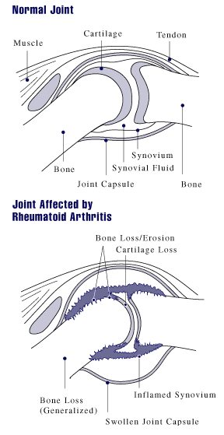
Figure Downloaded from (https://commons.wikimedia.org/w/index.php?curid=1819650 By US gov - US gov, Public Domain.). Last accessed 31/5/2017

In addition to destruction of joints, RA is associated with a wide range of extra-articular and systemic manifestations that lead to further functional impairment and a reduction in life expectancy (Smolen & Steiner, 2003). As the systemic effects of RA progress, patients have a greater risk of dying from urogenital, gastrointestinal, respiratory and cardiovascular diseases, infections and cancers, compared with the general population (Sihvonen et al., 2004).

Rindfleisch and Muller (Rindfleisch & Muller, 2005) identify a host of the most common clinical complications associated with RA. The authors state that lymphomas and leukaemias are two to three times more common in patients with rheumatoid arthritis. RA patients are at increased risk for various solid tumours, although genitourinary cancer risk is reduced in rheumatoid arthritis, perhaps in the view of the authors, because of the common use of non-steroidal anti-inflammatory drugs. A third of patients may have asymptomatic fluid around the heart (pericardial effusion) at diagnosis. Lung nodules can coexist with cancers and form cavitary lesions, cricoarytenoid joint inflammation can arise with hoarseness and laryngeal pain and lung inflammation (pleuritis) is present in 20 percent of patients at onset of disease (Rindfleisch & Muller, 2005). Anaemia correlates with ESR and disease activity, 75 percent of patients have chronic anaemia, although one fourth of patients respond to iron therapy. Males with high rheumatoid factor titres, treatment with steroids, and higher numbers of disease-modifying anti-rheumatic drugs (DMARD) prescribed have an increased risk of developing vasculitis. Vasculitis is associated with increased risk of myocardial infarction, and forms include distal arteritis, pericarditis, peripheral neuropathy, cutaneous lesions, arteritis of viscera, and coronary arteritis (Rindfleisch & Muller, 2005).

Pathophysiology

Multiple pathogenic mechanisms appear to be implicated in RA (Firestein, 2003). As an autoimmune disease, the tissue damage associated with RA can be triggered as a result of the body mounting an immune response to antigens on its own cells (Firestein, 2003). In the case of RA, the targeted antigens are so expressed in the body that they cannot be eliminated, so, instead of reaching resolution, their continual presence produces a chronic and persistent immune response (Firestein, 2003). Many autoantibody systems that could participate in inflammatory joint disease are now recognised in RA. Some, like rheumatoid factor (RF), are produced by rheumatoid synovial B-cells (Firestein, 2003). The presence of RF in serum, however, is still not specific for RA, although patients with active RA have significantly higher serum RF levels compared with those with inactive disease (Ates et al., 2007).The presence of antibodies directed against proteins containing citrulline (CCPs) appears to be more useful to correctly diagnose patients with RA (Silveira et al., 2007).

Activation of immunity is thought to occur early in the course of RA and may be a key pathogenic mechanism in initiating synovial inflammation (Choy & Panayi, 2001). Many of the effects of RA are assisted by pro-inflammatory cytokines – a family of proteins that regulate survival, growth, and functions of cells, particularly those in the immune system (Choy & Panayi, 2001). Activated T-cells in the synovium stimulate monocytes, macrophages and synovial fibroblasts to produce various pro-inflammatory cytokines, and drive the continued recruitment of immune cells and result in an accumulation of T-cells in the inflamed synovium (Firestein, 2003). Activated T-cells also stimulate B-cells to produce immunoglobulins, including RF, and drive the expression of damaging enzymes that initiate the destructive phase of the disease (Firestein, 2003).

Risk Factors for RA

A significant amount of research has been performed to identify risk factors for the incidence and severity of RA. Alamanos and Drosos (Alamanos & Drosos, 2005) highlight that there is evidence that the occurrence and severity of RA are related to genetic factors. The author goes on to state that twin and family studies offer a strong suggestion of that risk of the disease is influenced by shared genetic factors, and studies in patients with advanced disease suggest an association with alleles coding to a shared ‘rheumatoid epitope’. The relationship of rheumatoid epitope, tumour necrosis factor alleles or other genetic factor related to the risk or severity of RA still remains unclear, although the differences seen in the various populations seen in Table 2.1 for example could be explained partly by genetic variation, (Alamanos & Drosos, 2005).

The incidence of RA is higher in women than in men. The ratio varies in studies from 2:1 to 3:1 (Alamanos & Drosos, 2005). A British study by Symmons (Symmons et al., 1994) estimated the RA incidence for females of 0.036% compared to a 0.014% rates for males. The age of disease onset reaches a peak in the fifth or sixth decade of life (Alamanos & Drosos, 2005). A study of RA in North America highlights an age and gender interaction in the incidence of RA (Doran et al., 2002). Males tend to experience a very low incidence up to 34 years of age, after which there is a steady progression through to 85 years. In females, the incidence of RA rises through ages 55 to 64 after which incidence declines. (Doran et al., 2002).

Smoking appears to influence both the risk of developing the disease as well as the severity although there is some variation in the extent (Table 2.3). The postulated association is most clear for heavy smokers (Alamanos & Drosos, 2005).

Table 2.3 Association between rheumatoid arthritis and cigarette smoking
Study | Cases | Controls | Smoking Group | Odds Ratio (95% CI)
Hutchinson et al | 239 | 239 | 41-50 Pack years  Ever smoked  Never smoked | 13.5 (2.9–63.4)  1.8 (1.2–2.2)  1.0
Symmons et al | 165 | 178 | Current smoker  Ex smoker  Never smoked | 0.95 (0.6-1.6)  1.7 (0.95-3.1)  1.0
Karlson et al | 7697 | 370,000 | Current smoker  Ex smoker  Never smoked | 1.2 (1.1-1.3)  1.0 (0.95-1.1)  1.0
Uhlig, Hagen and Kvien | 361 | 5851 | Current smoker (male)  Current smoker (female)  Never smoked | 2.4 (1.5-3.9)  1.1 (0.8-1.6)  1.0
Sources: (Hutchinson et al., 2001), (Symmons et al., 1997), (Karlson et al., 1999), (Uhlig et al., 1999).

Despite these data, Wilson and Goldsmith (Wilson & Goldsmith, 1999) found that the association between other conditions such as lung cancer and heart disease have been much more convincing than that for smoking and RA. In RA they found the association only apparent in men.

Socioeconomic factors tend to impact the course and outcome of RA rather than the risk of developing the disease. Factors such as education, occupation and marital status appear to be predictors for severity and outcome. Studies are conflicting on the question of how socioeconomic factors influence the onset of RA (Alamanos & Drosos, 2005).

Epidemiological studies suggest a protective effect of a regular diet of fish, olive oil and cooked vegetables. A study of RA patients by Skoldstam, (Skoldstam et al., 2003) compared a Mediterranean diet to a western diet and concluded that a Mediterranean diet did tend to reduce inflammatory activity. Fish oils also appear protective against a severe course of the disease (Alamanos & Drosos, 2005).

Differences in the occurrence of RA among different populations have been reported by several studies. As seen in Table 2.1 the prevalence of RA in European and North American populations are relatively constant. The geographic variation of the disease occurrence and increased incidence in certain ethnic groups, suggest an association of ethnicity with RA (Alamanos & Drosos, 2005). Notably the Chippewa and Pima Indians in North America have the highest known prevalence of RA at 5.3% and 6.8% respectively. Populations with very low prevalence include African populations in South Africa and Nigeria where no cases were found in studies of 500 and 2000 adults, respectively (Silman & Pearson, 2002). It is possible that the low rates may be due to low reporting rates.

Summary

In this chapter we have described RA as a disease, its postulated causes and potential biomarkers for occurrence. RA is a chronic, destructive, inflammatory, autoimmune disease that has both articular and systemic manifestations that affects approximately 1% of the general adult population. The causes of RA are unknown although there are many risk factors believed to affect occurrence and severity, these risk factors include age, gender, smoking, genetics, ethnicity, diet, and socioeconomic status. RA is recognised as a multi-faceted disease and as may be expected, a multitude of measures are used in clinical practice and clinical trials to assess disease activity and progression.

Section 2.6 described how RA is diagnosed using criteria developed in 1987. A patient is said to have RA if he or she satisfied at least four of 7 criteria, with the first four present for at least six weeks.

In clinical trials, regulatory submissions and real-life settings, there are great advantages in being able to predict patient outcome from early data. In drug development, trials can be made more efficient through targeted recruitment and improved stopping rules. In the clinic, knowing a patient’s likely disease outcome, can lead to a more personalised healthcare strategy. This thesis will look at how well patient outcome can be predicted from baseline biomarkers and patient characteristics. As has been described in this chapter, RA is a complex disease that is not attuned to simple characterisation in diagnosis, treatment or measurement of severity of disease or response. In the next chapter we will see what measures are used in practice to assess disease activity and to measure response. This will identify the variable we will aim to predict.

: Rheumatoid Arthritis Clinical Trial Design and Endpoints

3.1. Introduction

Chapter 2 described RA as a disease, including risk factors and biomarkers believed to affect incidence, severity, outcome, and epidemiology of RA, as well as comorbidities and pathophysiology and how RA is diagnosed in clinical practice. The objective of this research is to look at how well patient outcome can be predicted from baseline biomarkers and patient characteristics, and this chapter will explore the key measures of disease activity and response in a clinical trial setting. From this we will identify and justify an endpoint for prediction.

This chapter will describe phase III clinical trial designs and strategies for drug registration and approval, thus setting the context for the clinical trial database available from Roche for this research. In the context of this thesis, some understanding of clinical trial design in RA may inform improvements that could be made following the results obtained from this research.

3.2. Aims

The objectives of this chapter are:
- To discuss the various measures used in clinical practice and clinical trials to assess disease activity;
- To describe typical phase III clinical trial designs for RA;
- To describe the regulatory pathways for registration and approval of new treatments for RA in Europe and USA, and current treatment strategies in the clinic.

3.3. Assessing disease activity

As previous discussed, RA is a systemic multifactorial disease with considerable variation of disease expression. Symptoms are many and include joint pain, fatigue, restrictions in activities of daily living, and increasing disability. Section 2.6 described how diagnosis of RA has changed over time, reflecting changing clinician views on definition of the disease and the complexity of its expression. As may be expected, several methods are used to measure RA disease activity and associated impairment of function and quality of life. A number of these are detailed below.

3.3.1. American College of Rheumatology (ACR) criteria

Originally published in 1995, these criteria are widely used by clinicians, drug makers and regulators to measure response to therapy (Felson et al., 1995). The ACR criteria, measure an improvement to treatment as opposed to a measurement of disease state. The ACR committee led by Felson pointed out that in 1992, of the 15 trials published for RA treatment at that time, only 6 used improvement criteria and each of these used different criteria. In order to develop a de facto improvement measure, the committee surveyed the rheumatology community for which improvement criteria were used in practice. The committee asked rheumatologists to review fictional patient data. The focus then turned to those fictional patients on which 80% of the physicians agreed had improved. This reduced the potential criteria to 20 variations. Clinical trial data was then used to identify criteria which showed the clearest differentiation of treatment difference between a control and an effective treatment. The final 8 definitions were then reviewed for ease of use and accordance with rheumatologists’ impressions of improvement and then combined into a composite score (Felson et al., 1995).

A 20% improvement in these criteria, a result that is known as ACR20, requires a 20% reduction in: the number of swollen joints on a 66-joint count, the number of tender joints on a 68-joint count and in three of five other criteria (Felson et al., 1995) (Table 3.1). The extra 2 joints in tender count being the hip joints, where swelling is considered difficult to assess (Sokka & Pincus, 2005). See Figure 3.1 for a diagram of joints assessed for swelling and tenderness.

Table 3.1 American College of Rheumatology definition of ACR20 measure
≥20% improvement in tender  68-joint count | AND | ≥20% improvement in swollen 66-joint count | AND | ≥20% improvement in three of the following measures  • Patient’s assessment of pain  • Patient’s global assessment of disease activity  • Physician’s global assessment of disease activity  • Patient’s assessment of physical function  • Markers of inflammation (e.g. ESR or CRP)
(Felson et al., 1995)

Figure 3.1 Joints measured for swelling and tenderness
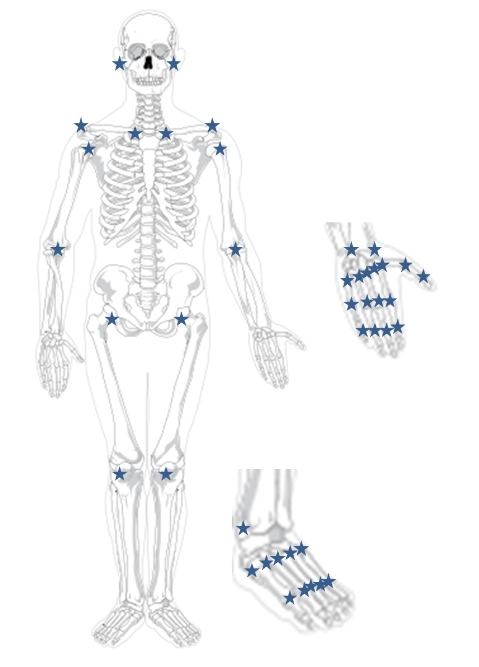
Figure adapted from (https://commons.wikimedia.org/wiki/File%3AHuman_skeleton_front_no-text_no-color.svg By LadyofHats Mariana Ruiz Villarreal [Public domain]. Wikipedia Commons is a licence free media repository.) Last accessed 31/5/2017

In order to assess greater responses to therapy, ACR50 and ACR70 are often calculated using the same methodology as ACR20 except they require 50% and 70% reductions, respectively (Rindfleisch & Muller, 2005). At a patient level, these ACR thresholds define a patient as a responder, each measure then is a dichotomous outcome: responder or non-responder. In addition, a further variable ACRn can be derived. ACRn is defined as each patient’s lowest percent improvement from baseline in 3 measures: Tender joint count (TJC) (68 joints), Swollen joint count (SJC) (66 joints), and the improved score achieved in at least 3 of the 5 remaining ACR core set parameters. So that a patient with an ACRn value of 20 is equivalent to ACR20 response.

3.3.2. Disease Activity Score (DAS28)

In contrast to the ACR criteria, which measure an improvement from a baseline in RA symptoms, the Disease Activity Score 28 (DAS28) measures the level of disease state (van der Heijde et al., 1990). The DAS28 was developed and validated by a group of Dutch investigators in 1990 from 113 RA patients (van der Heijde et al., 1990). These patients were divided into low and high disease activity groups. Factor analysis was applied using a high number of clinical and laboratory values leading to the selection of 5 important factors. Discriminant analysis was then performed to ascertain to what extent each factor contributed to discrimination between high and low disease activity.

The resulting index, using a number of measures, including a 28 tender/swollen joint count, ESR and general health status, is calculated as follows:

DAS28 = 0.56 x sqrt (TJC28) + 0.28 x sqrt (SJC28) + 0.70 x ln (ESR) +0.014 x GH
Abbreviations:
ESR, erythrocyte sedimentation rate;
GH, global health (visual analogue scale 0 to 10);
SJC28, swollen joint count based on a count of 28 joints;
TJC28, tender joint count based on a count of 28 joints.
Ln, Natural Log

In determining DAS28 joint counts and ESR are considered more important. In clinical practice a 3 item DAS28 can be calculated where general health assessment is omitted (Fransen & van Riel, 2009).
The score can range on a continuous spectrum from 0 to 10, with a score >5.1 indicating severe disease. A DAS28 of <2.6 is commonly used to define remission, and is associated with a lower level of disease activity (fewer active joints, lower ESR) than an ACR70 response (van der Heijde et al., 1990).

In the context of a clinical trial the DAS28 and change from baseline in DAS28 endpoints are usually treated as Normally distributed continuous variables (Fransen & van Riel, 2009).

3.3.3. European League Against Rheumatism (EULAR) response criteria

In an effort to convert DAS28 back into an improvement score this measure combines the DAS28 at the time of evaluation with the change in DAS28 between two time points. Response categories include good, moderate and no response (Table 3.2) (van Gestel et al., 1996).

Table 3.2 EULAR response
 | Reduction from Baseline in DAS28 score
DAS28 | >1.2 | >0.6 and ≤ 1.2 | ≤ 0.6
≤ 3.2 | Good | Moderate | No Response
> 3.2 to ≤ 5.1 | Moderate | Moderate | No Response
>5.1 | Moderate | No Response | No Response

The EULAR response is can be analysed as a dichotomous variable by combining good and moderate categories.

3.3.4. Radiographic evaluation in clinical development

Radiography provides an objective measure of the extent of anatomical joint damage. A range of radiographic scores are currently used, many of which combine assessments of erosions and joint space narrowing (Baron et al., 2007).

The European Medicines Agency (EMA) (EMA, 2003) recommends that in order to demonstrate radiological differences of hands and feet on the basis of before/after comparisons, the radiographs should be taken not less than a year apart and ideally for two years using full randomization and pre-agreed criteria (EMA, 2003). The FDA (FDA, 2010) similarly recommends prevention of structural damage as an important goal of RA therapy. The duration of such trials are expected to be at least one-year duration. Claims that can be pursued include slowing X-ray progression, using either the Larsen, modified Sharp or another validated radiographic index, or prevention of new x-ray erosions – maintaining an erosion-free state or preventing new erosions (FDA, 2010).

Larsen (Larsen et al., 1977) or Modified Sharp Scores (Sharp et al., 1985) are common validated methods used to assess radiographs. In the Larsen method, the pooled information is captured in grading whereas the Sharp score captures information on erosion and joint space narrowing and combines into a total score. In practice, the Sharp Score is modified in one or two ways: Genant (Genant, 1983) or van der Heijde (Heijde, 2002).

For the van der Heijde modification, in each hand there are 16 areas measured for erosions and 15 areas measured for joint space narrowing. In the foot, 6 areas are measured for erosions and 6 for joint space narrowing. The erosion score for each joint in the hand is rated on a scale from 0 to 5. Zero represents no erosion and 5 a complete collapse of the joint or the full surface of the joint is affected by erosion. Thus the maximum score for erosions in the hand is 80. Joint space narrowing is measured on a scale from 0 to 4, where normal joint spacing is 0 and 4 can represent a fusing of the joint or complete dislocation. Thus the maximum score for joint space narrowing in the hand is 60. Similar ratings are used for the joints in the feet. The total maximum scores combining both hands and feet are 280 for erosions and 168 for joint space narrowing. The total Modified Sharp Score is obtained by totalling erosion and joint space narrowing scores, leading to a maximum possible score of 448.

Baron (Baron et al., 2007) summarised radiographic methods reported in clinical trials. In 65.2% of the 46 assessable articles more than 2 radiographic scores were used (e.g. erosions and joint space narrowing). Among the scores combining erosions and joint space narrowing the Sharp Score and Larsen Score were the most used (47.8% and 34.7% respectively).

Due to the nature of joint damage, radiographic data generally has a non-Normal distribution (Landewe & van der Heijde, 2005).

3.3.5. Health Assessment Questionnaire Disability Index (HAQ–DI).

The Stanford Health Assessment Questionnaire disability index (HAQ-DI) is a patient completed questionnaire specific for rheumatoid arthritis (Fries et al., 1980). It consists of 20 questions referring to 8 domains: dressing/grooming, arising, eating, walking, hygiene, reach, grip, and common daily activities. Each domain has at least two component questions.

There are four possible responses for each component.
0 = without any difficulty
1 = with some difficulty
2 = with much difficulty
3 = unable to do

The HAQ score is a continuous outcome variable that is defines as the mean of the highest scores across the eight domains and ranges from 0 to 3, with higher levels reflecting greater disability.

3.3.6. Functional Assessment of Chronic Illness–Fatigue. (FACIT-Fatigue)

This brief, validated measure is used to monitor fatigue and the effects of this important symptom on the quality of life of patients with RA (Cella et al., 2005). It was previously validated in patients with cancer and patients with anaemia (Yellen et al., 1997). Patients are asked to rate 13 items on a scale of 0 (Not at all) to 4 (very much). Items include “I feel fatigued”, “I have trouble finishing things because I am tired”, and “I need to sleep during the day”. Possible FACIT-fatigue scores range from 0 to 52, with higher scores indicating more fatigue (Cella et al., 2005). Although the FACIT-fatigue can take integer values, it is usually treated as a continuous outcome.

3.4. Regulatory pathway for approval of new therapies

In the context of approval of novel therapies for RA there are 3 main regulatory claims which are often sought in a stepwise fashion: improvement of signs and symptoms, prevention of structural damage to joints, and improvement in physical function and disability (EMA, 2003; FDA, 2010).

The FDA state the claim for improvement of signs and symptoms is intended to reflect the demonstration of symptomatic benefit that includes improvement in the signs of the disease as well as symptoms (FDA, 2010). This claim is usually the initial claim granted for marketing approval, and is based on following patients for a minimum of 24 weeks (6 months) (FDA, 2010). The acceptable outcome measure that supports this claim is the American College of Rheumatology (Aletaha et al.) definition of improvement ACR20 (see Section 3.3.1 for detailed definition). Regulatory authorities’ submission requirements currently mandate the use of ACR20 as the minimum primary efficacy endpoint in marketing authorisation applications for RA treatments however, with better treatments now being initiated earlier in the course of the disease, treatment goals for RA have shifted towards achieving remission (EMA, 2003; FDA, 2010).

The FDA indicate that a claim for prevention of structural damage to joints is an important goal of RA therapy and that trials evaluating this outcome should be at least 1 year in duration (FDA, 2010). They recommend that outcome measures to support the prevention of structural damage include x-ray evidence showing slowing of progression and prevention of new erosions.

The FDA allows claims for improvement in physical function and disability to encourage long term trials in RA (FDA, 2010). The primary outcome measure for this claim is the Health Assessment Questionnaire Disability Index (HAQ-DI), this is a validated measure and for this claim is reported at 2 to 5 years from study start.

The US Food and Drug Administration (FDA, 2010) in their 2010 guidance extend the ACR20 criteria to evaluate longer term and higher hurdle benefits for new treatments. They define major clinical response as a six-month period of success by the ACR 70.

The definition of an ACR remission requires that 5 of the following criteria are met for at least two consecutive months: morning stiffness of less than 15 minutes, no fatigue (defined as a score of 52 on the Functional Assessment of Chronic Illness–Fatigue (FACIT-Fatigue) questionnaire), no joint pain, no joint tenderness or pain on motion, no soft tissue swelling in joints or tendon sheaths, and an ESR (Westergren method) of less than 30 mm/hr for females or 20 mm/hr for males (Pinals et al., 1981).

The FDA (FDA, 2010) also define complete clinical response. Complete clinical response is intended to describe a therapeutic benefit of greater magnitude than the major clinical response. Complete clinical response is defined as a continuous 6 month period of both remission by ACR criteria and radiographic arrest (no radiographic progression (Larsen et al., 1977) or modified Sharp methods (Sharp et al., 1985). Complete clinical response implies a benefit requiring ongoing drug therapy; remission is defined by the same result while off all anti-rheumatic drugs. The 1981 ACR remission criteria (Pinals et al., 1981) require at least five of the following: morning stiffness less than 15 minutes, no fatigue, no joint pain by history, no joint tenderness or pain on motion, no swelling of joints or tendon sheaths, and ESR less than 20 for males or less than 30 for females (FDA, 2010).

The ACR20, ACR50, ACR70, the various methods of remission and response reduce multiple components to a dichotomous outcome (FDA, 2010; Felson et al., 1995).

3.5. Current treatment strategies for rheumatoid arthritis

The early recognition and treatment of RA is considered important for minimising disability and maximising quality of life (Nell et al., 2004). A delay in treatment of just a few months can result in significantly more joint damage subsequently in the course of disease (Lard et al., 2001).

The optimal control of RA is best achieved by regularly assessing disease progression (every 2–4 months) and subsequently modifying treatment if appropriate (Smolen & Steiner, 2003).

Therapies for RA generally fall into two broad categories (Smolen & Steiner, 2003):
- Therapies for symptomatic treatment;
- Disease-modifying agents (Gaffo et al., 2006).

Therapies for symptomatic treatment provide relief from the pain and inflammation characteristic of RA but are unable to prevent progressive joint damage (Gaffo et al., 2006). They include non-steroidal anti-inflammatory drugs, selective cox-2 inhibitors and aspirin, as well as glucocorticoid drugs, such as prednisolone (Gaffo et al., 2006). Glucocorticoids can relieve inflammation and in high doses can have a dramatic effect on the symptoms of RA, however, they are generally used only temporarily and at low doses because of their association with serious adverse effects such as fractures, serious infections and gastrointestinal events (Gotzsche & Johansen, 1998; Saag et al., 1994).

Disease-modifying agents have a demonstrated ability to halt the destructive course of RA and prevent joint damage. This category of drugs can be further subdivided into two groups:
- Synthetic (non-biologic/traditional/conventional) disease-modifying anti-rheumatic drugs (DMARDs), such as methotrexate, act as general anti-inflammatory and anti-proliferative agents (Gaffo et al., 2006). These agents tend to have a slower onset of action than corticosteroids and lack a direct pain relief effect (O'Dell, 2004);
- Biological agents (biologics), such as anti-Tumour Necrosis Factors (anti-TNFs) (adalimumab, etanercept, infliximab), B-cell targeted therapies (rituximab), T-lymphocyte co-stimulation modulators (abatacept) and Inteleukin-1 (IL-1) inhibitors (anakinra), are immune modulators that directly target the intracellular signalling pathways, cytokines, and other mediators contributing to the pathogenesis of RA (O'Dell, 2004). They are usually prescribed in combination with methotrexate or in some cases as monotherapy if patients have a history of methotrexate intolerance or if methotrexate is inappropriate.

Despite the increasing range of synthetic and biologic agents available for the treatment of RA, evidence suggests that approximately 30–40% of patients fail to respond, or respond inadequately, to therapy (Voll & Kalden, 2005). In addition, many patients are unable to tolerate currently available treatment options.

In England and Wales the National Institute for Health and Clinical Excellence (NICE) publish guidelines for management and treatment for RA in adults (NICE, 2009, 2015). The NICE guidelines recommend a combination of DMARDs (including methotrexate and at least one other DMARD, plus short-term glucocorticoids) as first-line treatment as soon as possible. The guideline also recommends “an annual review to: assess disease activity and damage, and measure functional ability (e.g. Health Assessment Questionnaire)”.

3.6. Phase III Clinical Trial Design

The costs of developing a new medicine are very high. A typical clinical development plan for registration of an RA drug will include multiple phase I, phase II and phase III trials. A typical phase III trial costs an estimated $11.9 million (Sertkaya, 2016). In the light of regulatory guidance described in Section 3.4, phase III confirmatory trials are usually designed for a patient duration of at least 6 months. The usual primary endpoint is the ACR20 (as described in Section 3.3.1). Typical phase III trials at Roche are randomised, parallel group, double blind (for first 6 or 12 months). Figure 3.2 illustrates a typical phase III design. A background therapy of stable methotrexate is included in each, unless the objective is for approval for monotherapy. Due to the availability of effective treatments, in more recent trials, patients have the option to ‘escape’ onto active treatment after 16 weeks based on lack of therapeutic response. Such patients are then considered non responders for ACR20 assessment at 6 months.

Figure 3.2 Typical RA Phase III Trials at Roche
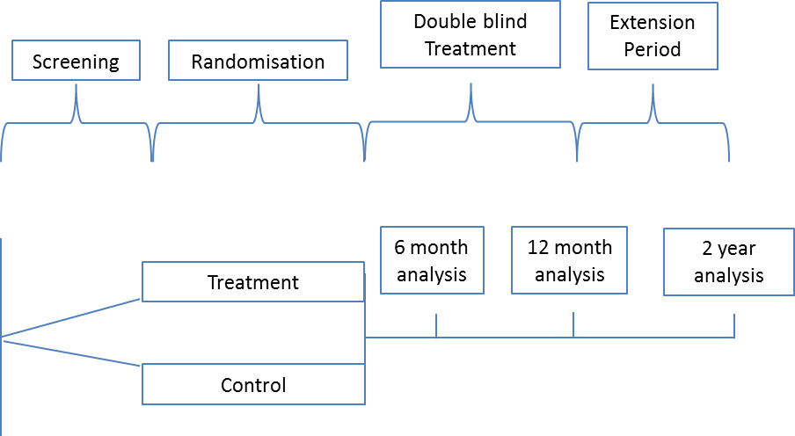

Assessment of ACR20 at 6 months allows a claim for improvement of signs and symptoms. Trials that continue to 1 year and that collect X-ray data, can be submitted to health authorities for a claim of prevention of structural damage to joints. Furthermore, trials that continue to 2 years in duration can claim for an improvement in physical function and disability based upon improvement in Health Assessment Questionnaire Disability Index (HAQ-DI). This strategy is still followed by pharmaceutical companies currently developing RA treatments. On 28th June 2017 Janssen presented their clinical development program of Sirukumab™, which included 2 pivotal phase III trials. Primary endpoints were ACR20 at week 16 for improvement of signs and symptoms, inhibition of structural damage measured by Sharp score at 1-year and improvement in physical function measured by HAQ-DI at 2 years (FDA, 2017).

The design of clinical trials in RA has the potential to benefit from application of enrichment designs. In 2012, the FDA published a draft guidance on enrichment strategies for clinical trials (FDA, 2012). The guidance defines enrichment as “the prospective use of any patient characteristic to select a study population in which detection of a drug effect (if one is in fact present) is more likely than it would be in an unselected population”, where characteristics can be drawn from demographic, pathophysiologic, historical, genetic or proteomic, clinical, and psychological sources. By recruiting patients with a higher likelihood of having a certain event can lead to a higher effect size, reduce heterogeneity and lead to smaller more efficient clinical trials.

3.7. Summary

This chapter described the key disease change and disease status measures: ACR20, DAS28, EULAR Score and radiologic evaluations. In the main, these measures rely on subjective patient or physician reported outcomes at fixed points in time. The exceptions being ESR and CRP components of ACR20 and DAS28 and the radiologic assessments. The measures do not include any acknowledgement of within patient variability, although one would expect high correlation of subjective assessments from visit to visit. E.g. arthritic pain assessed by a patient at month 2 would likely be recorded based on a comparison to the level of pain at month 1. Ward (Ward, 2004) discusses clinical and laboratory measures in RA, he notes that serial measures such as tender joint count and pain increase or decrease coincidentally at a patient level, demonstrating longitudinal construct validity. Notably, duration of morning stiffness does not follow these other measures, and this is likely why morning stiffness is not used as a measure of disease status, despite being a measure used in diagnosis. The ACR20 and the EULAR response criteria are both constructs of responder analyses from continuous based measures. One drawback of this type of assessment is that small changes in a patient’s disease can lead to an exaggerated change in status. For example, in a hypothetical case where an improvement of 50% is considered a response, a patient is classified as a responder with 51% improvement and a non-responder with 49% improvement, when in fact the patient’s disease state is essentially the same. Although the ACR20 is a measure of this type, it may be more robust to this phenomenon as it is dependent on 7 measures to determine response.

The regulatory pathway for approval of novel therapies is typically achieved in 3 steps. First, a claim is made for improvement of signs and symptoms with 6 months data using ACR20. Secondly a claim for prevention of structural damage to joints with 1 year of radiological data (such as Sharp Score and Joint Space Narrowing). Finally, a claim for an improvement in physical function and disability can be pursued with 2 years of patient data (with HAQ-DI). This chapter has also described a typical Roche phase III clinical trial that is designed to meet the regulatory requirements, in the period that these trials were conducted, the study design was similar to rival competing pharmaceutical companies (FDA, 2017).

In this research, I have selected ACR20 to be used as the primary outcome of interest to define patient response. ACR20 values will be generated in simulations and biomarkers to predict ACR20 will be sought. Rheumatoid Arthritis is a multi-factor, systemic disease with a multitude of symptoms, and as described in Section 3.3.1 the ACR20 reduces the measurement of disease change to a dichotomous response/ no response result. I have chosen ACR20 since it is available from all phase III clinical trials in this research and is the earliest regulatory measure on which to assess efficacy of a medicine for RA.

The purpose of this research is to understand how selection of patients might influence patient outcome. Chapter 2 described RA as a disease, and this chapter went on to describe endpoints for assessing disease status and progression as well as clinical trial designs employed in Roche RA development.

The ACR20 outcome has usually been the primary endpoint for RA clinical trials; therefore, this research will attempt to predict ACR20 from patient data available at time of recruitment. The ACR20 is a composite endpoint that was developed to represent patient improvement in this multifactorial disease. If trial sponsors understand more about markers predictive of patients, then if may be possible to build this information into design of trials to: guide patient recruitment to those most likely to benefit, or stratify randomisation to optimise sample size estimates.

Chapter 4 will describe the RA clinical data available for analysis in this thesis. The data will inform simulations and choice of statistical and data methods that will be applied.

: Data Description

Introduction
Chapter 3 described endpoints and trial designs in RA. This chapter summarises the data set to be used in this dissertation and the analysis strategy. The attributes of this data will direct which statistical and data mining analysis methods will be the most appropriate for analysis. In addition, the structure of the data and the relationships between variables will inform the parameters of the simulations that will be conducted in Chapter 7.

4.2. Aims
The objectives of this chapter are to describe the data available to inform simulations that will be conducted in the next chapter.

The chapter will describe:
- projects and studies;
- dependent and explanatory variables;
- missing data;
- observed correlations;
- potential limitations.

4.3. Projects and Studies

For this research, a rich and substantial pooled database was created to explore the methods for predicting patient response. These data exist in the form of SAS® datasets that were available from Roche Products Limited on 4 distinct development products for the treatment of RA. The data comprise of 11,705 adult patients diagnosed with RA from 16 Randomised Clinical Trials enrolled between 1998 and 2008 (Table 4.5). These studies were chosen as they represent phase III registration studies for the adult RA indications of the 4 development products. The database includes data from patients with established RA and a variety of subpopulations including: patients refractory to anti-TNF treatment, patients refractory to other DMARDs and patients naïve to biologic treatment for their disease. Assembling the database took over a year to complete; details of operational issues to compile the data are described in Section 4.4.

4.3.1. Project A

Project A concerned the clinical drug development of a recombinant humanized, anti-human monoclonal antibody of the immunoglobulin directed against the soluble and membrane bound interleukin 6 receptor (IL-6). IL-6 has been shown to be involved in such diverse physiological processes as T cell activation, induction of acute phase proteins, stimulation of hemopoietic precursor cell growth and differentiation, proliferation of hepatic, dermal and neural cells, bone metabolism, lipid metabolism and hepatoprotection (Pasare & Medzhitov, 2004). Elevated tissue and serum levels of IL 6 have been implicated in the disease pathology of several inflammatory and autoimmune disorders including RA. Therefore, inhibition of the biological activity of IL 6 and/or its receptor represented a promising approach for the treatment of RA.

Five pivotal Phase III studies from the Project A development program were included in this research. All studies were randomised, double blind parallel group designs.
Table 4.1 Summary of Project A studies
 | Population | Inclusion Criteria | Treatment arms
Study A1 | Moderate to severe active RA with inadequate response to MTX | SJC ≥ 6 and  TJC ≥ 8 and  CRP ≥ 1 mg/dL or  ESR ≥ 28 mm/hr | 2 active arms plus MTX vs placebo plus MTX
Study A2 | Moderate to severe active RA with inadequate response to MTX | SJC ≥ 6 and  TJC ≥ 8 and  CRP ≥ 1 mg/dL or  ESR ≥ 28 mm/hr | 2 active arms plus MTX vs placebo plus MTX
Study A3 | Moderate to severe active RA with no MTX treatment in last 6 months | SJC ≥ 6 and  TJC ≥ 8 and  CRP ≥ 1 mg/dL or  ESR ≥ 28 mm/hr | 1 active arm plus MTX vs placebo plus MTX
Study A4 | Moderate to severe active RA with prior inadequate response to anti-TNF therapy | SJC ≥ 6 and  TJC ≥ 8 and  CRP ≥ 1 mg/dL or  ESR ≥ 28 mm/hr | 2 active arms plus MTX vs placebo plus MTX
Study A5 | Moderate to severe active RA with prior inadequate response to DMARD therapy | SJC ≥ 6 and  TJC ≥ 8 and  CRP ≥ 1 mg/dL or  ESR ≥ 28 mm/hr | 1 active arm plus MTX vs placebo plus MTX

Study A1 was a phase III, randomized, double-blind, placebo-controlled, parallel group study. Patients were recruited who had moderate to severe active RA and who had previously had an inadequate clinical response to Methotrexate (MTX) therapy. In this study 2 dose levels of active treatment in combination with MTX were compared to a placebo plus MTX arm. Patients who did not achieve a 20% improvement from baseline in both Swollen and Tender Joint Counts at week 16 could, if requested and deemed necessary by the investigator, receive escape therapy. A total of 623 patients were enrolled at 73 centres in 17 countries (Argentina, Australia, Austria, Brazil, Bulgaria, Canada, France, Germany, Hong Kong, Hungary, Israel, Italy, Mexico, Singapore, Slovakia, Switzerland and Thailand). Enrolment took place in 2005 and 2006. Statistically significant ACR20 responses at week 24 were observed in active treatment over control in this study (26% control response vs 48% and 59% in the active arms). In the primary analysis a pre-defined site based stratification was included in the model.

Study A2 was a phase III, randomized, double-blind, placebo-controlled, parallel group study. Patients were recruited who had moderate to severe, active RA who had an inadequate response to MTX. In this study 2 dose levels of active treatment in combination with MTX were compared to a placebo plus MTX arm. Patients who did not achieve a 20% improvement from baseline in both Swollen and Tender Joint Counts at week 16 could, if requested and deemed necessary by the investigator, receive escape therapy. A total of 1196 patients were enrolled at 137 centres in 15 countries (Australia, Brazil, China, Denmark, Finland, France, Greece, Italy, Mexico, Norway, Poland, Switzerland, South Africa, Spain and the United States). Enrolment took place in 2005 and 2006. This study was designed to assess the reduction in signs and symptoms of RA after 24 weeks, prevention of joint damage at 52 weeks (evaluated by radiographs, with confirmation at 104 weeks), and physical function at 52 weeks (with confirmation at 104 weeks). After week 52, all remaining patients were switched to open-label active treatment for the second year, patients could opt for a 3rd year of open label treatment. Statistically significant ACR20 responses at week 24 were observed in active treatment over control in this study (27% control response vs 51% and 56% in active arms). In the primary analysis a pre-defined site based stratification was included in the model.

Study A3 was a phase III, randomized, double-blind, placebo-controlled, parallel group study. Patients were recruited who had active RA and who had not been treated with MTX within 6 months prior to randomization, and who had not discontinued previous MTX treatment as a result of clinically important toxic effects or lack of response as determined by the investigator. In this study, one arm of active treatment in combination with MTX was compared to a placebo arm in combination with MTX. Patients who did not achieve a 20% improvement from baseline in both Swollen and Tender Joint Counts at week 16 could, if requested and deemed necessary by the investigator, receive escape therapy. In addition, active treatment was compared to a third arm of patients receiving placebo MTX. A total of 673 patients were enrolled at 120 centres in 18 countries (Argentina, Australia, Canada, China, Denmark, France, Israel, Italy, Lithuania, Mexico, Norway, Peru, Portugal, Serbia/Montenegro, Slovenia, South Africa, Spain and the United States). Enrolment took place in 2005 and 2006. Statistically significant ACR20 responses at week 24 were observed in active treatment over control in this study (52% control response vs 71% in active arm). In the primary analysis disease duration and a pre-defined site based stratifications were included in the model.

Study A4 was a phase III, randomized, double-blind, placebo-controlled, parallel group study. Patients were recruited who had previously had an inadequate clinical response or were intolerant to treatment with one or more anti-TNF therapies within one year prior to randomization and who were receiving a stable dose of MTX. Patients who did not achieve a 20% improvement from baseline in both Swollen and Tender Joint Counts at week 16 could, if requested and deemed necessary by the investigator, receive escape therapy. In this study 2 dose levels of active treatment in combination with MTX were compared to a placebo plus MTX arm. A total of 499 patients were enrolled at 128 centres in 13 countries (Australia, Belgium, Canada, France, Germany, Great Britain, Iceland, Italy, Mexico, The Netherlands, Sweden, Switzerland, and the United States). Enrolment took place in 2005 and 2006. Statistically significant ACR20 responses at week 24 were observed in the active treatment arms over the control arm (10% control response vs 30% and 50% in active arms). In the primary analysis a pre-defined site based stratification was included in the model.

Study A5 was a phase III, randomized, double-blind, placebo-controlled, parallel group study. Patients were recruited who had moderate to severe active RA who had an inadequate clinical response to current DMARD therapy. In this study 1 arm of active treatment in combination with MTX was compared to a placebo plus MTX arm. Patients who did not achieve a 20% improvement from baseline in both Swollen and Tender Joint Counts at week 16 could, if requested and deemed necessary by the investigator, receive escape therapy. A total of 1220 patients were enrolled at 130 centres in 18 countries (Argentina, Australia, Brazil, Canada, China, Costa Rica, Czech Republic, Finland, France, Germany, Mexico, Panama, Russia, Spain, Sweden, Thailand, South Africa and the United States). Enrolment took place in 2005 and 2006. Statistically significant ACR20 responses at week 24 were observed in active treatment over control in this study (25% control response vs 61% in active arm). In the primary analysis a pre-defined site based stratification was included in the model.

The studies in Project A had a very similar design, with identical key inclusion criteria. There were some differences between studies with respect to previous experience of RA treatments. Other differences between the studies included choice of sites and countries, so that whilst the analysis of ACR20 included site based stratification, the grouping of sites was different for each study depending partly on enrolment in individual sites.

4.3.2. Project M

Project M was a glycosylated immunoglobulin chimeric mouse/human antibody that binds to the CD20 antigen present on the majority of B cells. Expression of CD20 is restricted to the B-lymphocyte lineage from the pre–B cell stage until terminal differentiation into plasma cells. Treatment with this compound induces a rapid and sustained depletion of peripheral CD20+ B cells. Depletion of B cells is maintained from a few months to over 5 years. The pivotal phase III studies were conducted over several years and in coordination with a development partner. The impact of this is that there is substantial variability in study design, analysis strategy and programming consistency, making pooling of data for just this project non trivial (see Section 4.4 for further details).

Five pivotal phase III studies from Project M development program were included in this research. All studies were randomised, double blind parallel group designs.

Table 4.2 Summary of Project M studies
 | Population | Inclusion Criteria | Treatment arms
Study M1 | Active RA with inadequate response to MTX | SJC ≥ 8 and  TJC ≥ 8 and  CRP ≥ 0.6 mg/dL or  ESR ≥ 28 mm/hr | 2 active arms plus MTX vs placebo plus MTX
Study M2 | Moderate to severe active RA and naïve to MTX | SJC ≥ 8 and  TJC ≥ 8 and  CRP ≥ 1 mg/dL | 2 active arms plus MTX vs placebo plus MTX
Study M3 | Active RA with prior inadequate response to anti-TNF therapy | SJC ≥ 8 and  TJC ≥ 8 and  CRP ≥ 1.5 mg/dL or  ESR ≥ 28 mm/hr | 1 active arm plus MTX vs placebo plus MTX
Study M4 | Severe active RA with prior inadequate response to DMARD and MTX therapy | SJC ≥ 8 and  TJC ≥ 8 and  CRP ≥ 1.5 mg/dL or  ESR ≥ 28 mm/hr | 1 active arms,  1 active arm plus cyclophosphamide,  1 active arm plus MTX vs placebo plus MTX
Study M5 | Moderate to severe active RA with prior inadequate response to DMARD and MTX therapy | SJC ≥ 8 and  TJC ≥ 8 and 2 of the following:  CRP ≥ 1.5 mg/dL,  ESR ≥ 30 mm/hr,  Morning stiffness > 45 minutes | 1 active arms,  1 active arm plus cyclophosphamide,  1 active arm plus MTX vs placebo plus MTX

Study M1 was a phase III, randomized, double-blind, placebo-controlled, parallel group study. Patients were recruited who had active RA and had an inadequate clinical response to methotrexate (MTX) therapy. In this study 2 arms of active treatment in combination with MTX were compared to a placebo plus MTX arm. Between weeks 16 and 23, patients who had less than a 20% improvement in both tender and swollen joint counts compared to baseline were allowed to initiate “rescue” treatment with one non-biologic DMARD, the choice of which is at the discretion of their treating physician. These patients could receive further courses of active treatment if eligible, but were considered to be non-responders for all categorical efficacy endpoints at week 24. Patients received medication at day 1 and day 15 and then returned for assessments every 4 weeks until week 24, then every 8 weeks until week 48, and then every 12 weeks until B cells returned to baseline levels or to normal range. A total of 512 patients were enrolled at 102 centres in 11 countries (Canada, France, Germany, Great Britain, Guatemala, Mexico, Poland, Romania, Slovenia, Sweden, and the United States). Enrolment took place in 2005 and 2006. Statistically significant ACR20 responses at week 24 were observed in active treatment over control in this study (23% control response vs 55% and 51% in active arms). Analysis was stratified by RF status at baseline and region (US, Rest of World - ROW).

Study M2 was a phase III, randomized, double-blind, placebo-controlled, parallel group study. Patients were recruited who had active RA and were naïve to MTX therapy. In this study 2 arms of active treatment in combination with MTX were compared to a placebo plus MTX arm. Rescue treatment with one non biologic DMARD was available from week 52 for eligible patients. A total of 755 patients were enrolled at 169 centres in 27 countries (Australia, Belgium, Brazil, Canada, China, Czech Republic, Denmark, Finland, France, Germany, Great Britain, Guatemala, India, Italy, Mexico, Norway, Panama, Peru, Philippines, Poland, Romania, Russia, South Korea, Spain, Sweden, The Netherlands and The United States). Enrolment took place in 2006 and 2007. The primary endpoint for this study was not ACR20 at week 24 but rather the change in Sharp score at 52 weeks. The week 24 analysis was a pre-planned interim analysis. Patients were to receive study medication for a total of 3 years and followed until B Cells repleted. Statistically significant ACR20 responses at week 24 were observed in active treatment over control in this study (59% control response vs 73% and 75% in active arms).

Study M3 was a phase III, randomized, double-blind, placebo-controlled, parallel group study. Patients were recruited who had active RA and had failed to respond or were intolerant to anti-TNF therapies. In this study 1 arm of active treatment in combination with MTX was compared to a placebo plus MTX arm. Patients who failed to respond to treatment during the study (i.e., achieved < 20% improvement in both swollen and tender joint counts) could receive rescue therapy from weeks 16 to 24. Patients received medication at day 1 and day 15 and then returned for assessments every 4 weeks until week 24. After week 24, patients entered the post-treatment period and were followed up every two months for 18 months, giving an overall study duration of 24 months. A total of 520 patients were enrolled at 114 centres in 11 countries (Belgium, Canada, France, Germany, Great Britain, Ireland, Israel, Italy, Norway, The Netherlands and the United States). Enrolment took place in 2003 and 2004. Statistically significant ACR20 responses at week 24 were observed in active treatment over control in this study (18% control response vs 51% in active arm). Analysis was stratified by RF status at baseline and region.

Study M4 was a phase IIb, randomized, double-blind, double-dummy, controlled, multifactorial study of nine different treatment regimens in a 3 x 3 configuration, that comprised 2 different active doses plus placebo and three different corticosteroid regimens (including placebo), along with a weekly regimen of MTX. Patients were recruited who had RA, had failed 1-5 DMARDs, other than MTX, (for lack of efficacy) and who currently had an inadequate response to MTX. A rescue arm was available for eligible patients from weeks 16 to 24. Patients received medication at day 1 and day 15 and then returned for assessments every 4 weeks until week 24. After week 24, patients entered the post-treatment period and were followed up every two months for 18 months, giving an overall study duration of 24 months. A total of 465 patients were enrolled at 95 centres in 14 countries (Australia, Brazil, Canada, Czech Republic, Finland, Germany, Great Britain, Italy, Mexico, New Zealand, Poland, Spain, Sweden, and the United States). Enrolment took place in 2003 and 2004. Statistically significant ACR20 responses at week 24 were observed in the active treatment over control in this study (28% control response vs 55% and 54% in active arms). Analysis was stratified by corticosteroid use baseline and region.

Study M5 was a phase III, randomized, double-blind, placebo-controlled, parallel group study. Patients were recruited who had RA, had failed 1-5 DMARDs and who had a partial clinical response to therapy with MTX monotherapy. Patients were assigned to 1 of 4 treatment arms: MTX, active treatment, active treatment plus cyclophosphamide, or active treatment plus MTX. Patients received medication at day 1 and day 15 and then returned for assessments every 4 weeks until week 24. Patients had a 4 week follow up assessment after week 24. A total of 161 patients were enrolled at 26 centres in 11 countries (Australia, Belgium, Canada, Czech Republic, Germany, Great Britain, Israel, Italy, Poland, Spain and The Netherlands). Enrolment took place in 2001 and 2002. Statistically significant ACR20 responses at week 24 were observed in active treatment over control in this study (38% control response vs 65%, 76% and 73% in active arms). Analysis was stratified by rheumatoid factor and region.

The studies in Project M also had a very similar design and again differed in populations of patients studied, ranging from patients who were naïve to MTX treatment through to patients who had poor response to not just MTX but to other biologic treatments. There was some variation in key inclusion criteria, particularly with respect to CRP and ESR, however joint count requirements were consistent across all studies. In addition in Project M the analysis of ACR20 included a more mixed choice of analysis stratification from study to study.

4.3.3. Project O

Project O was a humanized anti-CD20 monoclonal antibody, and has the same method of action and had been shown to be at least as effective as the antibody in Project M in depleting B-cells. Following the results of the pivotal phase III studies, the indication for RA was not considered competitive and the project was not submitted for registration in RA. The pivotal phase III trials selected in this research were designed at the same time, although the enrolment dates differed slightly. This parallel development meant that the design of the protocols, analysis plans, programming were very consistent between studies, enabling very easy pooling. This project was the most recent development project of the four, and is the only project to incorporate the new Clinical Data Interchange Standards Consortium (CDISC) standards in data structure (see Section 4.4 for more detail).

Project O comprised of 4 studies. All studies were randomised, double blind parallel group designs.

Table 4.3 Summary of Project O studies
 | Population | Inclusion Criteria | Treatment arms
Study O1 | Active RA with inadequate response to MTX | SJC ≥ 4 and  TJC ≥ 4 and  CRP ≥ 0.6 mg/dL and  RF or CCP positive | 2 active arms plus MTX vs placebo plus MTX
Study O2 | Moderate to severe active RA with inadequate response to anti-TNF therapy | SJC ≥ 4 and  TJC ≥ 4 and  CRP ≥ 0.6 mg/dL and  RF or CCP positive | 2 active arms plus MTX vs placebo plus MTX
Study O3 | Active RA with inadequate response to MTX | SJC ≥ 4 and  TJC ≥ 4 and  CRP ≥ 0.6 mg/dL or ESR ≥ 28 mm/hr and  RF or CCP positive | 2 active arms plus MTX vs placebo plus MTX
Study O4 | Moderate to severe active RA and naïve to MTX | SJC ≥ 8 and  TJC ≥ 8 and  CRP ≥ 1 mg/dL and  RF or CCP positive | 2 active arms plus MTX vs placebo plus MTX

Study O1 was a phase III, randomized, double-blind, placebo-controlled, parallel group study. Patients were recruited who had active RA and who had previously had an inadequate clinical response to MTX therapy. In this study 2 arms of active treatment in combination with MTX were compared to a placebo plus MTX arm. Patients received double blind medication up to week 48 and then were eligible for open label treatment for a further 2 years or until B-cells returned to baseline or normal levels. A total of 1015 patients were enrolled at 209 centres in 24 countries (Argentina, Australia, Austria, Belgium, Brazil, Canada, China, France, Germany, Great Britain, Greece, Guatemala, Israel, Mexico, New Zealand, Panama, Peru, Russia, South Korea, Spain, Taiwan, Thailand, Ukraine and the United States). Enrolment took place between 2006 and 2008. Statistically significant ACR20 responses at week 24 were observed in active treatment over control in this study (36% control response vs 57% and 55% in active arms). Analysis was stratified by RF status and region.

Study O2 was a phase III, randomized, double-blind, placebo-controlled, parallel group study. Patients were recruited who had active RA and who had previously had an inadequate clinical response to an anti-TNF-α therapy. In this study 2 arms of active treatment in combination with MTX were compared to a placebo plus MTX arm. Patients received double blind medication up to week 48 and then were eligible for open label treatment for a further 2 years or until B-cells returned to baseline or normal levels. A total of 840 patients were enrolled at 227 centres in 25 countries (Argentina, Australia, Belgium, Brazil, Canada, Czech Republic, France, Germany, Hungary, Israel, Italy, Japan, Mexico, New Zealand, Panama, Peru, Poland, Slovakia, Slovenia, Spain, Sweden, Switzerland, Taiwan, The Netherlands, and the United States). Enrolment took place in 2007 and 2008. Statistically significant ACR20 responses at week 24 were observed in active treatment over control in this study (22% control response vs 42% and 48% in active arms). Analysis was stratified by baseline DMARD therapy and region.

Study O3 was a phase III, randomized, double-blind, placebo-controlled, parallel group study. Patients were recruited who had active RA and who had an inadequate clinical response to at least 12 weeks of prior MTX therapy (with or without previous exposure to biologic DMARDs). In this study 2 arms of active treatment in combination with MTX were compared to a placebo plus MTX arm. Patients received double blind medication up to week 48 and then were eligible for open label treatment for a further 2 years or until B-cells returned to baseline or normal levels. A total of 314 patients were enrolled at 96 centres in 14 countries (Australia, Canada, France, Germany, Great Britain, Italy, Mexico, Poland, Romania, South Korea, Spain, Switzerland, Thailand and the United States). Enrolment took place in 2008. ACR20 responses at week 24 were not statistically significant (28% control response vs 38% and 53% in active arms). Analysis was stratified by baseline DMARD therapy and region.

Study O4 was a phase III, randomized, double-blind, placebo-controlled, parallel group study. Patients were recruited who had moderate to severe RA and who were naïve to MTX. In this study 2 arms of active treatment in combination with MTX were compared to a placebo plus MTX arm. Patients received double blind medication up to week 104 and then were eligible for open label treatment for a further 1 year or until B-cells returned to baseline or normal levels. A total of 613 patients were enrolled at 154 centres in 21 countries (Argentina, Australia, Brazil, Israel, Italy, Lithuania, Mexico, New Zealand, Panama, Peru, Philippines, Poland, Russia, South Korea, Spain, South Africa, Sweden, Switzerland, Taiwan, Thailand, and the United States). Enrolment took place in 2007 and 2008. Statistically significant ACR20 responses at week 52 were observed in active treatment over control in this study (57% control response vs 73% and 71% in active arms). Analysis was stratified by CRP status and region.

The studies in Project O were perhaps more homogenous they had a very similar design, differed a little in populations of patients studied and included the same treatment arm regimens. There were more differences here in inclusion criteria compared with Project A and M, as well as variation within this project for the joint count criterion. Nonetheless the study reports still considered this population to be moderately to severe in severity. In the analysis of ACR20 stratification always included region, but differed slightly in second stratification factor.

4.3.4. Project T

Project T was a potent and selective inhibitor of collagenase, thus preventing cleavage of triple helical collagen fibres. It is orally active in models of cartilage degradation and preserves joint integrity in animal models of arthritis. Since the results of the studies were not positive in the radiographic endpoints, the project was not submitted for registration. Project T is the oldest of the 4 projects under consideration and presented challenges in terms of versions of SAS, and converting legacy datasets to newer versions (see Section 4.4 for more details). In addition, some endpoints such as ACR20 were not standard at the time of development planning and were therefore calculated post hoc from the available data for the purposes of this research, the primary endpoint in these studies was based on radiographic assessment.

Project T comprised of 2 studies. Both studies were randomised, double blind parallel group designs.

Table 4.4 Summary of Project T studies
 | Population | Inclusion Criteria | Treatment arms
Study T1 | Established RA | SJC ≥ 4 and  ≥ 1 joint with erosion and  CRP ≥ 1 mg/dL or  ESR ≥ 28 mm/hr | 4 active arms plus MTX vs placebo plus MTX
Study T2 | Established RA | SJC ≥ 4 and  ≥ 1 joint with erosion and  CRP ≥ 1 mg/dL or  ESR ≥ 28 mm/hr | 4 active arms plus MTX vs placebo plus MTX

Study T1 was a phase III, randomized, double-blind, placebo-controlled, parallel group study. Patients were recruited who had established RA. Patients with RA were randomized to receive one of four doses of active treatment or placebo once daily for 104 weeks. All patients received background MTX therapy. Patients were stratified by low-dose oral corticosteroid use. A total of 1145 patients were enrolled at 98 centres in 20 countries (Australia, Austria, Belgium, Brazil, Canada, Canary Islands, Chile, Finland, France, Germany, Great Britain, Ireland, Italy, Mexico, New Zealand, Portugal, South Africa, Spain, Switzerland and The Netherlands). Enrolment took place between 1998 and 2000. ACR20 responses at week 24 were observed in active treatment over control in this study (26% control response vs 29%, 31%, 22% and 24% in active arms). The study failed to meet its primary radiographic endpoint (Sharp Score).

Study T2 was a phase III, randomized, double-blind, placebo-controlled, parallel group study. Patients were recruited who had established RA. Patients with RA were randomized to receive one of four doses of active treatment or placebo once daily for 104 weeks. All patients received background MTX therapy. Patients were stratified by low-dose oral corticosteroid use. A total of 1153 patients were enrolled at 104 centres in 6 countries (Brazil, Canada, Costa Rica, Mexico, South Africa, and the United States). Enrolment took place between 1998 and 2000. ACR20 responses were not analysed in this study but were calculated post hoc in this thesis. The study failed to meet its primary radiographic endpoint (Sharp Score).

Project T includes 2 identically designed studies in different regions. Despite the fact that the trials were not registrational due to the results, they nonetheless include useful data from over 2000 patients with RA.

Some of these study characteristics are displayed and summarised in Table 4.5.
Table 4.5 Summary of RA database available for analysis
Source | Start of Enrol-ment | Version of SAS | MTX Control patients | Placebo Patients | Active Treatment Patients* | Total
Study A1 | 2005 | 8.2 | 204 |  | 419 | 623
Study A2 | 2005 | 8.2 | 394 |  | 802 | 1196
Study A3 | 2005 | 8.2 | 284 | 101 | 289 | 674
Study A4 | 2005 | 8.2 | 161 |  | 338 | 499
Study A5 | 2005 | 8.2 | 415 |  | 805 | 1220
Total Project A |  |  | 1458 | 101 | 2653 | 4212
Study M1 | 2005 | 8.2 | 172 |  | 340 | 512
Study M2 | 2006 | 8.2 | 251 |  | 504 | 755
Study M3 | 2003 | 8.2 | 209 |  | 311 | 520
Study M4 | 2003 | 8.2 | 148 |  | 317 | 465
Study M5 | 2001 | 8.2 | 40 |  | 121 | 161
Total Project M |  |  | 820 |  | 1593 | 2413
Study O1 | 2006 | 9.1 | 324 |  | 691 | 1015
Study O2 | 2007 | 9.1 | 277 |  | 563 | 840
Study O3 | 2008 | 9.1 | 64 |  | 250 | 314
Study O4 | 2007 | 9.1 | 210 |  | 403 | 613
Total Project O |  |  | 875 |  | 1907 | 2782
Study T1 | 1998 | 6.12 | 220 |  | 925 | 1145
Study T2 | 1998 | 6.12 | 229 |  | 924 | 1153
Total Project T |  |  | 449 |  | 1849 | 2298
Overall |  |  | 3602 | 101 | 8002 | 11705
* Patients on investigational drug

Each study design follows patients for at least 24 weeks, and includes patient disposition, demographic information, medical history, concomitant medication, and efficacy measurements as described in Section 3.3. There are also safety laboratory variables from haematology, biochemistry, and RA specific markers (including Rheumatoid Factor).

Table 4.6 displays the ACR20 response rates by study. In the MTX control group the ACR20 response ranges from 10.1% to 60.4%. The rates in the lower responding studies, A4, M3 and O2; are associated with study populations that had inadequate clinical response to an anti-TNF-α therapy. The rates in the higher responding studies, were A3, M2 and O4; are associated with populations that were naïve to MTX or had at least a 6-month treatment break from MTX at the time of enrolment. Whilst this heterogeneity is noted, the dependent variables of ‘popir’, and ‘popra’ in the clinical trial dataset incorporate this information and are available for the analyses in Chapter 8.
Table 4.6 Summary of ACR20 response rates by study
Source | MTX Control | Placebo | Active Treatment
 | (%) | (%) | 1 (%) | 2 (%) | 3 (%) | 4 (%)
Study A1 | 26.5 |  | 47.9 | 58.5
Study A2 | 26.9 |  | 50.6 | 56.2
Study A3 | 52.5 | 43.6 | 69.9
Study A4 | 10.1 |  | 30.4 | 50.0
Study A5 | 24.5 |  | 60.8
Study M1 | 23.3 |  | 54.5 | 50.6
Study M2 | 58.0 |  | 72.5 | 75.0
Study M3 | 17.9 |  | 51.3
Study M4 | 27.9 |  | 55.3 | 54.1
Study M5 | 32.5 |  | 41.4 | 42.5
Study O1 | 35.7 |  | 56.9 | 54.5
Study O2 | 22.0 |  | 42.2 | 47.9
Study O3 | 28.1 |  | 37.6 | 52.7
Study O4 | 60.4 |  | 68.3 | 77.6
Study T1 | 27.6 |  | 29.9 | 31.8 | 21.4 | 25.0
Study T2 | 22.6 |  | 22.5 | 16.2 | 22.2 | 21.3

4.4. Operational challenges in database creation

As discussed earlier in this chapter, the strength of this data is that the data comprise of adult patients diagnosed with RA from 16 Randomised Clinical Trials enrolled between 1998 and 2008 representing registration studies for the adult RA indications of 4 development products. This presented however a number of practical challenges that took over one year to program and collate, the details of these challenges are described in this section.

The first general challenge for each of the studies was to identify the most relevant datasets to include. For example, study M2 in Project M was a study that as a primary endpoint evaluated radiographic endpoints at 52 weeks. In this research we are interested in the ACR20 response at 24 weeks; this was a planned interim analysis in study M2. For this study a database snapshot was created for the week 24 analysis and for the week 52 analysis to enable regulatory submission to the USA and Europe. Additional snapshots of the data were created for safety updates as required by regulatory process as well snapshots for later publication purposes at conferences and in journals. The decision to be made therefore is which snapshot to use for the week 24 ACR20 analyses. Although one might expect this to be the same, ongoing data management cleaning activities have the potential to impact already reported endpoints. So for each of the studies a careful review of study and project documentation was performed and the input of the original programmer and statistician were sought if they still worked for the company. In general, I decided to use the snapshot used for the original registration submission in order to be consistent with the published study reports as much as possible.

Fortunately, during the 11-year span in study initiation the computer environment was consistent (UNIX environment on a HP Integrity rx7640 server) however many other aspects of the studies and projects varied. The version of SAS ranged from version 6.12 to version 9.1, and with these multiple versions of SAS, the formats of SAS datasets also varied (Table 4.5). In order to bring some consistency to the datasets, each study dataset was updated to the current working version on the UNIX server at the time of this research (version 9.2).

Conventions in data collection and regulatory requirements changed over the 11 years spanned by the studies. For example, the earlier studies recorded race in greater granularity (Oriental, Chinese, Bangladesh, Philippino, Filipino, Cuban, Maori) these needed to be mapped in a manner consistent with later trials (Asian, Hispanic, and Pacific Islander).

Similarly, some studies collected country information whilst others summarised by region, and regions were not always consistent. For example, some studies categorised region as “US, Europe and Other”, or “North America, Non North America” or by groupings of countries based on patient recruitment (sometimes Canada was “North America” and sometimes “Rest of World” depending on study). In studies, such as M4, a difference of ACR20 response in both placebo and active treatment appeared to be lower in USA and Canada. The most practicable way to divide region according to the available data was as “North America” and “Non North America”.

Laboratory results were captured inconsistently between studies, and required substantial data manipulation. Laboratory results were recorded sometimes as numeric values and other times as character values. When collected as character, the fields contained such contents as “No Valid Result”, “NK”, “ND”, “Neg”, or “Trace”. All laboratory values were converted to numeric to allow computation, with the fields above converted to missing or 0 as appropriate. Laboratory values were not consistently collected in the same units. Conversions to consistent units were required. For example, Glucose was reported as both mg/dL and as mmol/L. For this database, Glucose was reported as mmol/L, so mg/dL reported values were converted by dividing the reported value by the conventional and accepted conversion factor of 18.016. In some studies, RF was captured as a numeric variable, in other studies RF was captured as a categorical variable either as Negative/Positive or 0/1.

Medical History was recorded differently between studies. This was derived from different fields of the case report form. This was variously captured as Negative/Positive, 0/1 or (blank)/Yes. For consistency all medical history results were converted to a 0/1 format.

For earlier studies DAS28, ACRn was not databased, so needed to be calculated from component values. Similarly, ACR70, ACR90 were calculated post hoc for some earlier studies. The nomenclature for ACR20 changed between studies, and care needed to be taken to be satisfied that ACR20 was calculated consistently. In some studies, ACR20 was based on ESR, others were based on CRP. There were differing ACR20 calculation conventions depending on how the individual components were imputed when values were missing. Since ACR20 was most commonly calculated using CRP, this was used whenever possible.

Individual component percentage improvements that were reported in section 8.6.2, were not retained from ACR20 calculations in most studies. These values were calculated specifically for this thesis.

Over the time period that these trials were conducted, many teams and individuals were involved in the clinical development programs. During that period versions of SAS changed, innovations in programming emerged and opinions changed on best data structure. In addition, depending on the needs of the project needs different data types and the decisions to accommodate them were made. Their decisions were not always consistent with previous RA drug development programs, so that for example, the same variable from trial to trial may be labelled differently, if not from trial to trial then almost certainly from project to project. In the course of this research, identifying and mapping equivalent variables from study to study proved a very time consuming process.

In 1997 the Clinical Data Interchange Standards Consortium (CDISC) was created to create standards for data content and structure (FDA, 2016). The most recent studies in this research embraced these new standards, which were quite different in structure to earlier studies. In September 2017 the FDA required that Sponsors, whose studies started after 17th December 2016, must submit data in the data formats supported by FDA and listed in the FDA Data Standards Catalogue.

In undertaking a pooled analysis of this type and scale, the amount of data manipulation should not be underestimated. Whilst it was expected that some changes in SAS and some differences in what was collected would be observed, the subtle changes in ACR20 calculation and different database conventions led to substantial data manipulation. In addition, the nature of clinical development of a chronic disease with multiple reporting events created an unexpected issue in choosing and finding the most appropriate data source.

With the adoption of CDISC by FDA and other regulatory agencies, combining data from future clinical trials should become easier. Nonetheless care should be taken to ensure subtle changes in definitions of variables are recognised.

Dependent and Explanatory Variables

Table 4.7 describes the types of the variables available for analysis. As can be seen there is a wealth of data in terms of patients, dependent variables and independent variables. The data comprise 151 variables, of which 7 are response variables measured at week 24 and 144 are independent variables measured at baseline. With such a large amount of data there is sufficient scope to apply sophisticated methods described in later chapters.

All data, except for week 24 endpoints are baseline assessments recorded on or shortly after enrolment into the clinical trials. The patient disposition / demography domain captures RA independent patient characteristics such as age, gender, race, smoking history and histories of any other disease. The patient disposition / demography domain also captures RA specific information at enrolment into the trials, such as duration and severity of RA, and previous use of other agents to treat RA.

The baseline disease status domain includes variables relating to assessment of RA. This domain includes the baseline individual components of the ACR20, Rheumatoid Factor (RF) status, DAS28, SF36 component and summary measures as well as baseline radiographic assessments.

In addition, baseline safety and laboratory data are included. These domains represent vital signs variables as well as results from baseline haematology and biochemistry blood samples and urinalysis.

Within these domains there is a mixture of data type. There are continuous data such as age, weight, duration of disease, blood pressure. Some of the continuous variables are distributed approximately Normally, e.g. HAQ, pain score, blood pressure, Haemoglobin. Other continuous variables have skewed distributions e.g. joint counts, RA duration, SF36 mental component score. Histograms, boxplots and Normal Q-Q plots for continuous variables are shown in Appendix B.2. The clinical trial data also includes dichotomous data such as gender, steroid use, and occurrence of previous diseases such as cardiac, gastrointestinal and other disorders. Further there are categorical measures relating to RA history, RA severity, SF36 questions, and urinalysis.

Appendix B.1 details a complete list of endpoints available in the data. Appendix B.2 includes various plots of the distributions of these variables.

Table 4.7 Variables available for analysis in RA Database
Domain | Continuous | Dichotomous | Categorical
Patient Disposition/  Demography | Age*, Height*, Weight, Years of Smoking.  Duration of disease. | Gender, Region, Steroid Use History.  Other Disease History:  Blood & Lymphatic, Cardiac, CNS, Ear Disorders, Eye Disorders, Gastrointestinal Disorders, Genetic and Familial Disorders, Hepatobiliary Disorders, Immune Disorders, Infections, Injuries, Metabolic Disorders, Musculoskeletal Disorders, Neoplasms, Pregnancy and Lactation Disorders, Psychiatric Disorders, Renal Disorders, Reproductive Disorders, Respiratory Disorders, Skin Disorders, Social Disorders, Surgery, Vascular Disorders. | Project, Protocol, RA Population, History of Inadequate Response, Treatment Assigned, Race, Smoking History, Previous use of DMARDs, Year of Enrolment.
* Normally distributed
Table 4.7 Variables available for analysis in RA Database (continued)
Domain | Continuous | Dichotomous | Categorical
Baseline Disease status | ACR Components:  Tender joint assessments*, Swollen joint assessments, ESR, CRP, HAQ*, Pain Score*, Patient Global Assessment*, Physician Global Assessment*.  DAS28*  Short Form36  Summary Scores: Mental Component, Physical Component, Bodily Pain*, General Health*, Mental Health*, Physical Functioning*, Role Limitation Emotional, Role Limitation Physical, Social Functioning, Vitality*.  Radiographic measures:  Erosion Score, Joint space narrowing, Sharp Score. | RF Status. | Short Form36  36 Individual questions.
Baseline Safety Endpoints | Vital Signs:  Diastolic* and Systolic* Blood Pressure, Heart Rate*.
Baseline Laboratory data | Haematology, Blood Chemistry. |  | Urine.
Efficacy Endpoints  (Week 24) | ACRn, DAS28. | ACR20, ACR50, ACR70, ACR90.
* Normally distributed

4.6. Response & Demography and Disease History

In order to rationalise the number of treatment groups across all projects and studies, drug type categorises treatment into 3 groups: Placebo, Methotrexate control arm (MTX) and experimental treatment (Active). ACR20 averaged a 50% response in the Active group compared with 32% in MTX and 44% in Placebo. The Placebo data was generated by Study A3 in patients with mild RA. With the exception of smoking years where the placebo arm had no data, demographic variables were balanced across treatment (Table 4.8). ACR20 response across categorical demographic factors such as gender also showed consistent results. Despite a difference in numbers of females vs males, response in ACR20 was similar, 48.8% vs 47.2% respectively in the active treatment arm and 31.4% vs 31.7% for the MTX group (Figure 4.1).

Table 4.8 Summary of ACR20 and Demographic Data
Variable | Treat-ment | n/N* | Mean | Mini-mum | Maxi-mum | Median | SD
ACR20 | Placebo | 101/101 | 0.44 | 0 | 1 | 0 | 0.50
ACR20 | MTX | 3515/3602 | 0.32 | 0 | 1 | 0 | 0.47
ACR20 | Active | 7774/8002 | 0.50 | 0 | 1 | 0 | 0.50
Age (years) | Placebo | 101/101 | 51.3 | 21 | 84 | 51 | 12.9
Age (years) | MTX | 3602/3602 | 52.1 | 18 | 85 | 53 | 12.5
Age (years) | Active | 8002/8002 | 52.5 | 18 | 90 | 53 | 12.5
Duration of RA (years) | Placebo | 101/101 | 7.62 | 0.16 | 41.68 | 3.27 | 9.43
Duration of RA (years) | MTX | 3601/3602 | 7.50 | 0.01 | 53.30 | 5.03 | 7.81
Duration of RA (years) | Active | 7999/8002 | 7.37 | 0.00 | 61.97 | 5.08 | 7.61
Smoking history (years) | Placebo | 101/101 | 0.00 | 0 | 0 | 0.00 | 0.00
Smoking history (years) | MTX | 2684/3602 | 1.20 | 0 | 60 | 0.00 | 5.16
Smoking history (years) | Active | 5256/8002 | 1.33 | 0 | 60 | 0.00 | 5.38
Height (cm) | Placebo | 101/101 | 165.0 | 150 | 188 | 164 | 9.12
Height (cm) | MTX | 3581/3602 | 163.3 | 126 | 200 | 163 | 9.41
Height (cm) | Active | 7950/8002 | 163.3 | 130 | 200 | 163 | 9.37
Weight (kg) | Placebo | 101/101 | 78.87 | 49.9 | 131.8 | 74.8 | 20.40
Weight (kg) | MTX | 3582/3602 | 74.43 | 34.5 | 186.0 | 71.5 | 19.11
Weight (kg) | Active | 7952/8002 | 74.13 | 28.0 | 189.5 | 71.0 | 18.78
Number of previous DMARDs (n) | Placebo | 101/101 | 1.3 | 0 | 7 | 1 | 1.5
Number of previous DMARDs (n) | MTX | 3153/3602 | 1.4 | 0 | 10 | 1 | 1.6
Number of previous DMARDs (n) | Active | 6153/8002 | 1.5 | 0 | 11 | 1 | 1.6
* n/N – data-points evaluable / total number of patients
SD = standard deviation

Figure 4.1 ACR20 Response by Treatment Type and Gender

4.7. Available and Missing Data

Figure 4.2 gives a holistic view of those variables with missing data according to domain type (i.e. X-ray, SF36, Demography, Laboratory, Endpoint, ACR, Vital Signs). Figure 4.3 and Figure 4.4 express the detail of the missing data. Depending on the variable, the amount of missing data ranges from 0% to 93% (Unmodified Sharp Score). Some of the variables had missing data by design, for example those variables with more than 50% missing data related mostly to X-ray data which were not collected in every study (Figure 4.3). Scott (Scott, 2000) identified that radiographic damage at baseline as one of three important predictive factors for RA progression. RF score was not always collected as a numeric value in all studies, sometimes merely recorded as positive or negative. Of the 26 variables with 10% to 50% missing data, 11 concerned SF36, and 8 for laboratory measures. The remaining were baseline (n=5), X-ray (n=1) and endpoint (n=1) (Figure 4.4). SF36 was a tertiary endpoint in each trial, as well as being a patient recorded outcome, therefore the ability to query missing data during the study conduct would have been more limited. Conversely ACR outcomes were primary endpoints and for ACR20 patients who withdrew early or moved on to escape therapy were defined as non-responders, therefore missing values were much fewer.

Figure 4.2 Missing Data across all variables

Blue = X-ray, Green = SF36, Red = Demography, Black = Laboratory, Yellow = Endpoint, Orange = ACR, Purple = Vital Signs

Figure 4.3 Variables with more than 50% missing data

Blue = X-ray, Red = Demography

Figure 4.4 Variables with 10% to 50% missing data

Blue = X-ray, Green = SF36, Red = Demography, Black = Laboratory, Yellow = Endpoint,

4.8. Response Data

The amount of missing data varies by study and data domain. The calculation of ACR20, ACR50, ACR70 and ACR90 is missing for 2.7% of the patients, reducing the effective size of the analysis from 11,705 to 11,390 patients (Figure 4.5). A higher amount of missing data is observed for ACRn (15.7%), the higher amount is due to imputation rules for withdrawals not applicable to ACRn (for definition of ACRn, see section 3.3.1).

Figure 4.5 Percentage of patients with an ACR Response assessment

4.9. Demography and Disease History Data

For most of the common demographic characteristics such as gender, age, region, race, RF status, medical history, weight, and height, the amount of missing data is very low (< 1%). The exceptions are smoking history and steroid use at baseline, numeric value for RF at baseline, and number of previous DMARDs which were not collected in all studies (missing rate 29% to 64%)(Figure 4.6). Projects A and T did not collect RF at baseline for any study. All patients had disease history data.

Figure 4.6 Percentage of patients with Demographic data
RF = rheumatoid factor

4.10. Baseline ACR components Data

Baseline ACR component data is available on all variables for more than 99% of the patients (Figure 4.7). Project T did not collect Baseline DAS28 data.

Figure 4.7 Percentage of patients with baseline ACR component data

4.11. Vital Signs and Radiography Data

The proportion of missing vital sign data is very low at <1%. Radiographic data were only collected in 50% of the studies and up to 56% of the patients, depending on the variable. Sharp score, Joint Space Narrowing and Erosion score were the most consistently collected variables across studies that assessed X-Rays (Figure 4.8 and Figure 4.9).

Figure 4.8 Percentage of patients with Vital Sign and X-ray data

Figure 4.9 Percentage of patients with Vital Sign and X-ray data by project

4.12. Laboratory Data

The laboratory data comprises 30 variables, the rate of missing data ranges from 1% to 31%. Whilst many of the variables were collected consistently, 6 (Calcium, Cholesterol, LDH, Phosphate, RF, Uric Acid) were not collected at all in Project T - see Figure 4.10 and Figure 4.14. RF and Glycosuria were not collected in Project O - see Figure 4.13.

Figure 4.10 Percentage of patients with laboratory data

Figure 4.11 Percentage of patients with laboratory data in Project A

Figure 4.12 Percentage of patients with laboratory data in Project M

Figure 4.13 Percentage of patients with laboratory data in Project O

Figure 4.14 Percentage of patients with laboratory data in Project T

4.13. SF36 Data

The proportion of missing SF36 individual component scores ranged from 3.0% to 11.7% (Figure 4.15). Similarly, 2.8% to 8.2% of SF36 summary score values were missing (Figure 4.16).

Figure 4.15 Percentage of patients with SF36 Component data

See Appendix B.2 for SF36 component labels

Figure 4.16 Percentage of patients with SF36 Component scores

4.14. Correlations and Associations with ACR20

Table 4.9 shows the correlations between ordinal categorical variables and ACR20 by project and pooled data. Spearman’s rank statistics are presented due to ordinal nature of the variables and for consistency. The statistics give a broad indication of relationship with ACR20. The presence of steroid use at baseline and a positive RF have a small relationship with ACR20 response. Active and to some degree MTX control are more associated with response with the exception of Project T. Table 4.10 shows the associations between ACR20 and categorical variables by project and pooled data. For most of the categorical variables the general associations were higher and null hypotheses could be rejected with very low p-values (<0.0001). This is mostly replicated for projects A, M and O. Notably Project T is the earliest project and least effective medicine which may account for this heterogeneity. Drug Type (Active treatment, MTX Control or Placebo) has the highest and consistent correlation amongst categorical variables.

Table 4.9 Correlations between ordinal categorical variables and ACR20
Variable | Spearman’s Rank Correlation (p-value)
Project | A | M | O | T | Total**
Steroid Use at Baseline (order: No, Yes) | 0.0363 (0.0186) | 0.0316 (0.2350) | 0  na | 0.0405 (0.0643) | 0.0265 (0.0200)
Drug Type (order: Active, MTX control, Placebo) | -0.2405 (<.0001) | -0.2345 (<.0001) | -0.1691 (<.0001) | 0.0115 (0.5987) | -0.1605 (<.0001)
RF Category (order: Negative, Positive) | 0.0652 (<.0001) | 0.0584 (0.0047) | 0.0255 (0.1807) | na* | 0.0125 (0.1825)
* single category, **naïve pooled, p-value = Cochrane-Mantel-Haenszel

Table 4.10 Associations between non ordinal categorical variables and ACR20 response rates
Variable | ACR20 Response rate (p-value)
Project | A | M | O | T | Total**
Compound | 0.4629 | 0.5337 | 0.4911 | 0.2408 | 0.4436(<.0001)
RA Population | (<.0001) | na* | ( <.0001) | na* | (<.0001)
Active RA | 0.5861 | 0.5337 | 0.4364 | 0.2408 | 0.4255
Moderate / Severe RA | 0.4393 | - | 0.6860 | - | 0.4754
IR Population | (<.0001) | (<.0001) | ( <.0001) | na* | (<.0001)
DMARD IR | 0.4844 | 0.5589 | na | - | 0.5081
MTX IR | 0.4459 | 0.4263 | 0.4757 | - | 0.4540
TNF IR | 0.5861 | 0.6925 | 0.6860 | - | 0.3581
No IR | 0.3052 | 0.3827 | 0.3744 | 0.2408 | 0.4450
Race | (<.0001) | (<.0001) | (<.0001) | (0.8319) | (<.0001)
American Indian | 0.5880 | 0.2778 | 0.6237 | - | 0.5823
Asian | 0.4458 | 0.5233 | 0.4754 | 0.2399 | 0.3968
Black | 0.4500 | 0.4423 | 0.3425 | 0.2198 | 0.3785
Hispanic | 0.4688 | 0.5349 | - | - | 0.5169
Multiple | 0.5043 | 0.7135 | - | - | 0.5995
Pacific Islander | 1.0000 | 0.6667 | 0.6250 | - | 0.6923
Other | 1.000 | 0.4286 | 0.5955 | 0.2629 | 0.4532
White | 0.4499 | 0.5000 | 0.4887 | 0.1667 | 0.4649
Region | (<.0001) | (<.0001) | (<.0001) | (<.0001) | (<.0001)
Europe | 0.4847 | - | 0.5636 | 0.2917 | 0.4393
North America | 0.3750 | 0.4167 | 0.4053 | 0.2073 | 0.3606
South America | 0. 5762 | - | 0.6723 | - | 0.6049
Rest of World | 0. 4742 | 0.6409 | 0.5230 | 0.2005 | 0.5118
Non North America | - | 0.5191 | - |  | 0.5191
* single category,**naïve pooled, IR=Inadequate response,
p-value = Cochrane-Mantel-Haenszel

Table 4.10 (continued) Associations between non ordinal categorical variables and ACR20 response rates
Variable | ACR20 Response rate (p-value)
Project | A | M | O |  | T | Total**
Gender | (0.9853) | (0.4565) |  | (0.2775) | (0.5780) | (0.5343)
Female | 0.4628 | 0.5300 |  | 0.4859 | 0.2375 | 0.4451
Male | 0.4632 | 0.5495 |  | 0.5116 | 0.2491 | 0.4380
Smoking History | (0.0060) | (<.0001) | (0.0011) |  | na | (<.0001)
Current Smoker | 0.4179 | 0.4802 | 0.4394 |  | - | 0.4349
Never Smoked | 0.4728 | 0.6321 | 0.5212 |  | - | 0.5072
Past Smoker | - | 0.5349 | 0.4638 |  | - | 0.4846
* single category,**naïve pooled, p-value = Cochrane-Mantel-Haenszel

Correlations between numeric variables and ACR20 were in general quite low. The highest magnitude in the pooled analysis observed was 0.18566 (Table 4.11). Again Project T seems to behave differently to the other 3 projects. There appears to be some consistency between Projects A, M and O for Psychiatric disorder medical history and possibly number of previous DMARDs, RA Duration, and Vitality. Also of note is that when they are measured, the radiographic assessments at baseline have the highest correlations with ACR20 with the highest magnitude at 0.23379.
Table 4.11 Correlations between continuous variables and ACR20
Variable | Pearson Correlation Coefficient
Project | A | M | O | T | Total*
Number of DMARDs | -0.1210 | -0.0242 | -0.1377 | na | -0.1197
Year of Enrolment | na | 0.1167 | -0.0272 | na | 0.1857
Psychiatric History | -0.1100 | -0.114 | -0.1010 | -0.0014 | -0.0702
GI History | -0.0628 | -0.1090 | na | -0.0624 | -0.0105
Erosion | na | -0.2296 | -0.1103 | na | -0.0894
Joint Space Narrowing | na | -0.2273 | -0.1137 | na | -0.1157
Sharp Genant | na | -0.2338 | -0.1152 | na | -0.1084
RA Duration | -0.0533 | -0.1245 | -0.1258 | -0.0665 | -0.0546
Calcium | -0.0087 | -0.1589 | -0.0019 | na | -0.0589
SF36 Mental Component | 0.3203 | -0.1225 | -0.0027 | -0.0641 | -0.1119
SF36 Physical Component | 0.0858 | -0.1077 | 0.0869 | -0.0481 | -0.0845
SF36 Vitality | 0.0994 | 0.1220 | 0.0819 | -0.0277 | 0.0160
SF36 General Health | 0.0616 | 0.1163 | 0.0329 | -0.0649 | -0.0097
SF36 Mental Health | 0.0258 | 0.1034 | -0.0063 | -0.0570 | -0.0428
SF36 Feel full of pep | -0.1032 | -0.0927 | -0.0592 | -0.0372 | -0.0545
SF36 Lot of Energy | -0.0762 | -0.1221 | -0.0655 | -0.0386 | -0.0308
Baseline TJC | -0.0358 | -0.0020 | -0.0184 | 0.1312 | 0.0868
Baseline Pain VAS | -0.0131 | 0.0238 | 0.0071 | 0.1058 | 0.0732
Baseline Patient Global Score | -0.0116 | 0.0524 | 0.0248 | 0.1183 | 0.0942
Baseline Physician Global Score | -0.0181 | 0.0843 | 0.0058 | 0.0910 | 0.1098
*naïve pooled, greater magnitude correlations shaded

4.15. Limitations

Whilst all studies recruited adult patients with RA there are some potential sources of heterogeneity between the studies. As mentioned above patients were recruited over a period from 1998 to 2008, during this period the treatment of RA has evolved, as observed by changes in methotrexate dosing. Patients have varying response to other treatments for RA such as inadequate response to methotrexate, anti-TNF therapies and other DMARDs. The data also represents patients from 50 countries which introduces possible heterogeneity through factors such as diet and standard of medical care, see study descriptions in Section 4.3 for further details.

As seen in Figure 4.3 some variables have a high amount of missing values overall. Joint space narrowing of hands and of feet for example were only collected in Project T therefore it would be prudent to consider omitting these variables from the overall analysis and include them only when analysing the data at a project level.

Some of the radiographic variables when considered by project have higher correlations than other variables. By design, not all studies performed X-rays to capture these data. When performing the analysis later in this research it would be prudent to consider an analysis subset on those studies that were designed to capture radiographic data.

4.16. Criteria for method selection

Further in this thesis, a method will be applied to the data described in this chapter to predict patient outcome. The features of the chosen methodology will in a large part need to be compatible with the characteristics of the data.

4.16.1. Mixed Data

The data described in this chapter features explanatory variables of multiple types

Table 4.7). Whilst the outcome variable of ACR20 is dichotomous, there are also dichotomous variables such as gender, steroid use, disease history (yes, no), and RF status (positive, negative). The data features categorical variables such as race, treatment assigned, smoking history (never, ex-smoker, current), patient population, and some SF36 scale data. Finally, the dataset comprises data that is continuous or can be treated as continuous such as vital sign and laboratory measurements, joint counts, age, height and weight. A method will be chosen that is able to manage well multiple variable types in order to make best use of the data.

4.16.2. Missing Values

As discussed in Section 4.7 missing values are an important feature of this data. The amount of missing values ranges from 0% to 93% (Unmodified Sharp Score). Some of the missing data is by design, i.e. where data on a particular variable was not collected in all studies. Sometimes there is a higher level of missing data on a variable due to it not being of primary nor secondary importance. When considering all explanatory variables available in this data, every patient has at least one missing data point, therefore it is important that any method applied does not delete patients with missing data from the analysis.

4.16.3. Outliers

Many of the continuous explanatory variables are subject to extreme values. For example, years of smoking, RA duration and Baseline CRP, display very skewed distributions (see Appendix B.2 for histograms and boxplots).

4.16.4. Scalability

This data contains data from over 11,000 patients and 151 variables. A viable method needs to be able to have computational scalability to manage a dataset of this size.

4.16.5. High Dimensions

Section 4.5 informed that the data comprise 151 variables, of which 7 are response variables measured at week 24 and 144 are independent variables measured at baseline. A data point of the 144 independent variables can be considered as residing in 144-dimensional space. Any method therefore needs to be able to handle high dimensional data well.

4.16.6. Interpretability

Results from this research are intended to inform future clinical trial design and drug development. Decisions are made by multidisciplinary study teams and clinical development teams of which the statistician is usually one member of many. Although perhaps not an essential requirement, interpretability of findings for a non-statistician is a preferred criterion.

4.17. Summary

This chapter has described a large database of randomised clinical trials in Adult RA patients. With 11,705 patients, to the best of my knowledge this is larger than any of the research described in the systematic review (Chapter 6).

This data comprises a variety of drug projects and a substantial number of individual studies. Within these randomised clinical trials is a selection of RA patient types characterised by their inadequate response to various therapies, whose data have been collected in clinical trials from 6 months and up to one year. These studies have collected data points to enable derivation of the endpoints described in Section 3.3 as well as the many of the risk factors mentioned in Section 2.9. In addition, there is available an abundance of additional explanatory variables from sources such as laboratory data, safety data, vital sign data and immunology sampling.

From my reflections on the data described in this chapter, Table 4.12 lists out criteria that I consider important in selecting a methodology for predicting ACR20 response in this dataset.

Table 4.12 Methodology Selection Criteria
Characteristic
Can handle ‘mixed’ data | Dataset contains continuous, dichotomous and categorical data
Handling of missing values | In some explanatory variables over 50% missing values
Robust to outliers | Large clinical dataset, large number of variables. Potential for outliers is high
Computational Scalability | Large clinical dataset, large number of variables.
Can manage high dimensionality | Large clinical dataset, large number of variables.
Interpretability | Results intended to inform clinical development. Decision makers typically not statistical experts

In my opinion, the methodology selected to identify predictors for ACR20 in this dataset must be able to handle continuous, dichotomous and categorical explanatory variables. A list of these variables is described in Table 4.7. These data were generated from 4 development programs across 16 clinical trials over 11 years. In that time there were some changes in choice of variables collected. In my dataset this leads to a wide range of missing data rates from 0% to 93% (Section 4.7); therefore, in my opinion the methodology selected must be able to manage missing data without deleting entire patients. With over 11,000 patients from multiple development programs, studies, years and countries any chosen methodology must be resistant to impact of outliers. This is a large dataset in terms of number of patients (n=11,705) and in the number of independent variables (144 variables), therefore computational scalability and ability to manage high dimensionality will be important requirements. Finally, in order to share the results of this research to a clinical audience, I maintain that the interpretability of findings is desirable.

This data will inform the selection criteria for methods explored in Chapters 5 and 6. The features of the data with respect to amount of missing data, the mixture of categorical, dichotomous and continuous variables and the correlation structures will guide the parameters for the simulations described in the Chapter 7. The results of the missing value assessment of the clinical dataset together with the simulations investigation of missing values will inform how the final analysis will be performed. The level of actual correlations will be considered in the assessment of the simulations which will inform methods for statistical analysis in Chapter 8.

: Data Mining Methodologies

5.1. Introduction

As indicated in the abstract and in Chapter 1, this research aims to explore and evaluate methods to predict response outcomes in RA patients. Chapters 2 and 3 presented important characteristics and risk factors for diagnosis and pathophysiology as well as a summary of measures of disease severity. Chapter 3 identified ACR20 as a primary endpoint of interest for the purposes of classification in this research. Chapter 4 summarised the structure and features of the clinical trial data available to this research and made recommendations for criteria required for a classification method. This chapter will describe some methods in more detail and describe how the methods may be used to help predict outcomes for individual patients based on clinical biomarkers. Chapter 6 will go on to review the literature to see how these and other methods have been used in practice to predict outcomes in RA data. By the end of Chapter 6 a recommendation will be made to choose which methods will be applied to simulated data, with an aim to select a single method to apply to the available clinical trial data (Figure 5.1). This research will attempt to predict ACR20, a categorical outcome of response. This type of outcome may be predicted by classification methods such as CART, nearest neighbour averaging and support vector machines or by logistic regression. The advantages, disadvantages and suitability for application to RA data will be explored in this chapter.

Figure 5.1 Planned analysis method refinement

5.2. Aims

The aims of this chapter are:
- To describe a selection of data mining methodologies that are being considered for application to the available data;
- Through application of criteria proposed in Chapter 4, reduce the number of methods that will be explored in later simulations.
The following methods will be discussed:
- CART (including Boosting, Bagging and Random Forest);
- K-nearest neighbour classification;
- Support vector machines;
- Logistic regression;
- Lasso;
- Principal components;
- Cross validation.

5.3. CART
Classification and regression tree (CART) models are a form of supervised learning, i.e. where the target of the analysis is to identify a relationship between a set of explanatory variables and one or more outcome variables (Hastie et al., 2011). CART was first introduced by Breiman (Breiman et al., 1984) who brought together the concepts classification tree analysis and regression tree analysis under a single method; where classification tree analysis is when the predicted outcome is a class (e.g. responder or non-responder), and regression tree analysis is when the outcome is numerical (e.g. change in cholesterol). The basic purpose of classification is to produce an accurate classifier to uncover predictive structure of a problem. i.e. which variables or interaction of variables drive a response.
CART models are suited for the analysis of complex data as well as being flexible and robust analytically. They can deal with nonlinear relationships, high-order interactions, and missing values. Classification and regression trees explain variation of a single response variable by repeatedly splitting the data into more homogeneous groups, using combinations of explanatory variables that may be categorical and/or continuous.
CART in a classification setting works in a stepwise fashion by first considering all the possible values of the explanatory variables and identifying a cut point whereby the responses in the outcome variable are best separated (primary splitter). Here ‘best’ is determined by the split that maximises a reduction in impurity. Impurity is a measure that takes the value zero when all of the cases in the node are the same (homogeneous) and increases as the contents of the node become heterogeneous. For classification, impurity is derived from the proportions, c, of responses in each category. Common methods of determining impurity are: the information index (entropy) and the Gini index. Entropy takes the form -∑c ln(c), where ∑ is summation over categories. The Gini index takes the form 1-∑c². Entropy and Gini index have similar performance for growing trees (Hastie et al., 2011). In RA, a split may be say, the baseline CRP value of 0.37 that best partitions responders from non-responders. In the next step CART will consider each partition and again identify a cut point whereby the responses in the outcome variable are best separated (e.g. Age = 50). This continues until a stopping rule is applied. Stopping rules include splitting until a minimum node size is reached or until no splits further decrease the impurity beyond a specified threshold. The predicted value for a terminal node is decided by the majority vote within that node.
CART methodology can effectively manage missing values by using surrogate splits. These are alternative variables and values that split the data in the same way as the primary splitter. When CART partitions the data, the remaining independent variables are ranked according to the proportion of cases in which they would misclassify the primary splitter. Predictors that do no better than the marginal distribution of the primary splitter are dropped. The variable with the lowest misclassification rate for the primary splitter is then used in place of the primary splitter to assign classes when primary splitter is missing. If this first surrogate is missing, then the next best surrogate can be used. If second surrogate is missing then third surrogate can be used, and so on. When it comes to making predictions on future data, the surrogate can be used when primary splitter is missing.
The tree is usually represented graphically thus aiding exploration and understanding (Breiman et al., 1984). See Figure 5.2 for a hypothetical example of CART illustrating factors leading to progression of a disease. From the first node (top circle), 25% of the patients are over 50 years old, and they had a progression of disease with probability 0.6. Fifteen percent of the patients who were 50 years old and younger, had no previous history of disease and were not female had a progression of disease with probability 0.2.
Figure 5.2 Example of CART
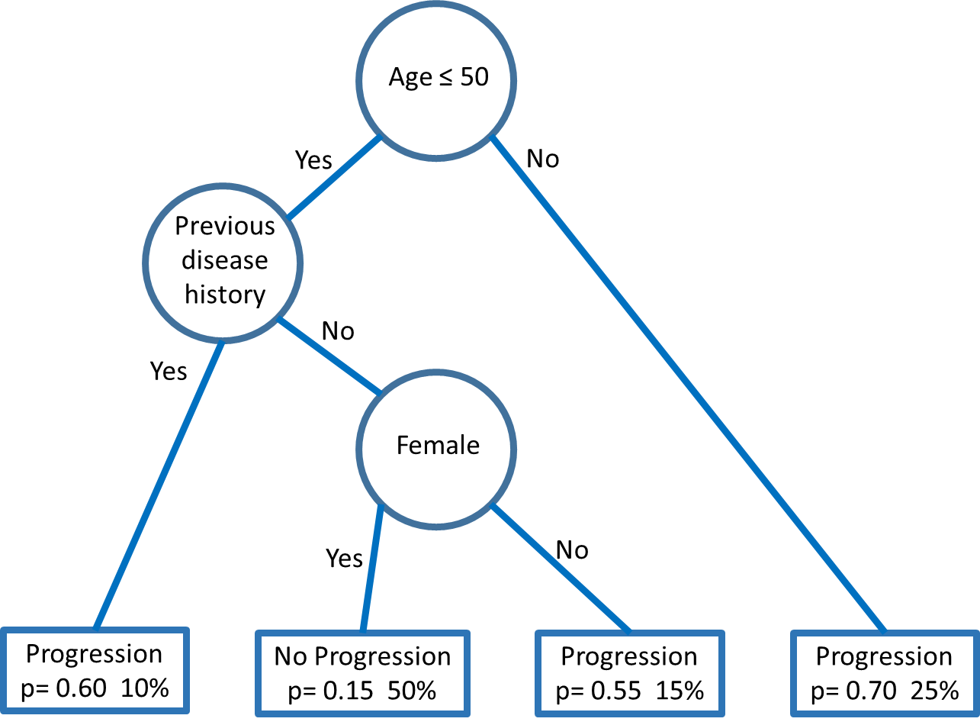
Advantages of trees include: the flexibility to handle a broad range of response types, such as numeric, categorical, ratings, and survival data; they are intuitive to interpret; can handle large datasets; and the ability to handle missing values in both response and explanatory variables (Breiman et al., 1984). Disadvantages of CART include: large trees can become hard to interpret; prediction performance can be poor in higher dimensions where the number of explanatory variables is high; and over-emphasising interactions, i.e. the ‘best’ model may be main effects only (Hastie et al., 2011).
Although it is a potential problem with classification, highly imbalanced classification where one class greatly outnumbers the other (in a binary setting) can lead to a distorted degree of accuracy with the majority class enjoying a high level of accuracy (close to 100%) and the minority class having low accuracy (0 to 10%) (He & Garcia, 2009). To some degree this bias can be ameliorated by applying a cost function so that a higher or lower cost can be associated with misclassifying a responder compared to misclassifying a non-responder. Other methods to overcome the problems associated with imbalanced response include: under-sampling, and over-sampling. In under-sampling, a subset of observations is chosen (randomly or informatively) from the majority class, thus eliminating data until the responses are balanced. Over-sampling works with the minority class by replicating observations (randomly or informatively) to synthetically balance the classes. In the clinical data available for this research, there are differences in response rates, but those differences are not extreme enough to warrant adjustments.
The performance of classification can be measured by sensitivity and specificity (Hastie et al., 2011). Sensitivity is the probability of predicting, for example, a disease when the true state is disease. Conversely specificity is the probability of predicting, non- disease when the true state is non-disease (Altman & Bland, 1994). By varying cut points on trees (cost function) and plotting sensitivity vs. specificity, Receiver Operating Characteristic (ROC) Curves (Casey et al.) curves can be constructed (Figure 5.3), to measure performance.
Figure 5.3 Example ROC Curve
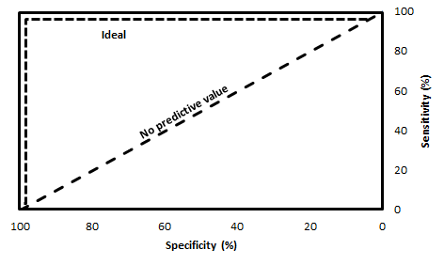

Whilst the performance of CART can be poor in high dimensions (i.e. a large number of explanatory variables), there are methods available which can greatly enhance performance such as Bagging, Random Forests and Boosting (Hastie et al., 2011).

5.3.1. Bagging

Bagging, or bootstrap aggregation, begins by splitting the available dataset into training and test datasets. Bagging then generates many trees by constructing bootstrap samples with replacement from the training data, where each bootstrapped sample is the same size or smaller than the training data. For each bootstrapped sample a tree is constructed. In the prediction, using test data, each data point is tested against each tree and the most frequent classification is selected as the ‘bagged’ predictor, i.e. simple voting determines classification (Breiman, 1996) (Figure 5.4). By taking an average of multiple trees bootstrapped from the training set, this method has the attribute of reducing the variance of the estimated prediction.
Figure 5.4 Bagging

Training Data Set
Test
Data Set
Class 0, 1
Class 0, 1
Class 0, 1
Classification by majority vote
Bootstrapped resampling

5.3.2. Boosting
Boosting, like bagging, is an approach that can be used to learn from multiple trees (Freund & Schapire, 1999). Boosting fits many large or small trees to reweighted versions of the training data. Boosting begins in the same way as bagging by creating a resampled dataset from the training data. This first bagged dataset is used to create a tree. The performance of this first tree is tested on the original training data, and the data points in the original data that are poorly predicted are identified. This procedure is repeated in the second round resampling, with the difference that the previously identified points that were poorly predicted are given a greater weight of being selected in the next bagged dataset. Once again new poorly predicted data points in the training set are identified and the procedure continues. As with bagging the test data is applied to each generated tree and classification is determined by a majority vote (Figure 5.5).
As with bagging this method can greatly reduce the variance of the estimated prediction.

Figure 5.5 Boosting

Training Data Set
Test Data Set
Class 0,1
Class 0,1
Class 0,1
Classification by majority vote
Bootstrapped resampling
Bootstrapped resampling weighted on previous poorly predicted training data points
1
Class 0,1
Class 0,1
Class 0,1
2
32

5.3.3. Random Forest
A more popular variant of Bagging is Random Forests (Hastie et al., 2011){Hastie, 2011 #124}. A known feature of bagging with large datasets is that even with bootstrapped resampling, the method can produce very similar trees with each iteration, thus increasing the likelihood of over-fitting and limiting the opportunity to reduce prediction variance. Random Forest methodology attempts to mitigate this by not only bootstrapping the cases in the training set but also randomly selecting a subset of features on which to create each bootstrapped tree. This brings some additional heterogeneity into the generated trees, thus reducing risk of over-fitting. This can result in an increased reduction of variance of the estimated prediction compared with bagging alone (Figure 5.6).

Training Data Set
Test
Data Set
Class 0, 1
Class 0, 1
Class 0, 1
Classification by majority vote
Bootstrapped resampling, on subset of variables from training
Figure 5.6 Random Forest

The advantages of CART and its refinements lend the methods well to RA data and an ACR20 endpoint (Table 5.1). From my review of the methodology, CART can manage missing values without loss of patient numbers and can handle a mixture of categorical and continuous explanatory variables. The RA data for analysis described in chapter 4 has over 11,000 patients and over 140 explanatory variables, in my opinion CART is an appropriate methodology to apply here.
Table 5.1 Methodology Selection Criteria for CART
Characteristic | Assessment | Rating
Can handle ‘mixed’ data | CART can manage missing values without loss of patient numbers and can handle a mixture of categorical and continuous explanatory variables. | Good
Handling of missing values | CART can make use of surrogate variables to overcome missing values. | Fair
Robust to outliers | CART applies ‘best’ cut for each split. Outliers have little impact. | Good
Computational Scalability | Can handle large N | Good
Can manage high dimensionality | Performs internal feature selection | Good
Interpretability | Trees can be too large to interpret if not pruned | Fair

5.4. k-Nearest Neighbour Classification

Given a specific combination of dependent variables k-nearest neighbour classifiers use the responses of the k-nearest points to classify a response for a specific data point. For example, suppose we are given 3 factors; a patient’s age, time since diagnosis and CRP level. Then we can look for the nearest k points in 3 dimensional Euclidean space (Hastie et al., 2011). By noting whether these ‘neighbours’ are responders or non-responders to treatment we can apply a rule such as majority vote to classify the new patient, i.e. we classify the new patient as a responder if the majority of its k neighbours are responders. The advantages of nearest neighbour methods are: they are a good method when prediction dimension is low; when k=1 works well for 1/3 of problems and outperforms other methods for classification The disadvantages are that these methods often fail when we have a large number of predictor variables leading to high dimensionality and they are not straightforward to interpret (Hastie et al., 2011).
Improvements can be made to nearest neighbour methods by applying kernel smoothing and / or assuming structure such as linear models, additive models or to restrict predictors to bring number of dimensions down. Kernel smoothing applies weights to the k nearest points (e.g. by inverse of distance).
In my opinion, the application of k-nearest neighbour classification are limited in the context of RA data for this research (Table 5.2). Firstly, the data has high dimensionality (denoted by many explanatory variables) so that this method is known to perform badly. Secondly k-nearest neighbour classification deletes cases with missing values in explanatory variables when trying to find neighbours.
Table 5.2 Methodology Selection Criteria for k-Nearest Neighbour
Characteristic | Assessment | Rating
Can handle ‘mixed’ data | Concept of a ‘neighbour’ is not intuitive for non-ordered categorical variables | Poor
Handling of missing values | Will find next neighbour when encounters missing values | Fair
Robust to outliers | Outliers often not a neighbour | Good
Computational Scalability | Computationally intensive with large N | Fair
Can manage high dimensionality | Computation increases exponentially with increase in dimensions (number of variables) | Poor
Interpretability | Concept of neighbour easy to understand | Good

5.5. Support Vector Machines

A support vector machine (Cortes & Vapnik, 1995) is a procedure that creates hyperplanes that act as decision boundaries to enable classification of an outcome from a set of input data. The method identifies the largest boundary around the hyperplane based on input data.
Figure 5.7 Example Support Vector Machine
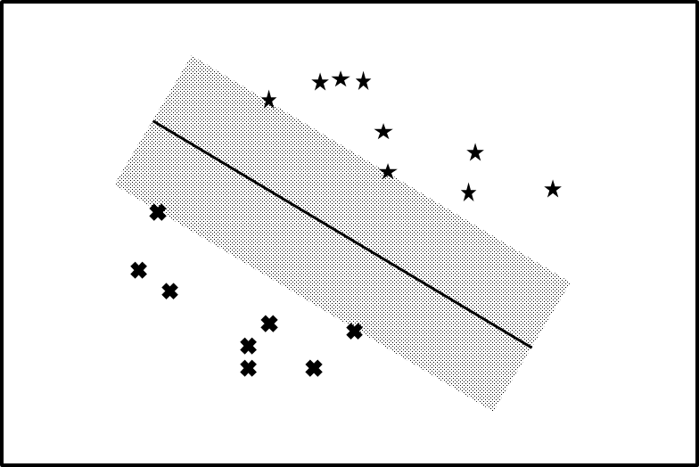

Figure 5.7 illustrates a support vector machine. The crosses and stars represent two types of outcome (e.g. ACR20 responder or non-responder) in multi-dimensional space. The solid line represents a hyperplane, outcomes below the hyperplane would be classified as a cross, items above as a star. The algorithm seeks to maximise the shaded margin area in determining the hyperplane (Cortes & Vapnik, 1995). Figure 5.7 shows a linear decision boundary but the method can be extended to non-linear solutions, and where outcomes are not separable. Interpretation can become challenging where outcomes are not separable. Similar to nearest neighbour methodology, this method does not perform well in higher dimensions. Support vector machines prediction accuracy is generally high and robust to overfitting; however, interpretation can be difficult.
Since RA data for this research has missing values, and highly dimensional, my assessment is that this method would not be suitable (Table 5.3).
Table 5.3 Methodology Selection Criteria for Support Vector Machines
Characteristic | Assessment | Rating
Can handle ‘mixed’ data | Concept of a distance not defined for non-ordinal categorical variables | Poor
Handling of missing values | Missing values are pairwise deleted | Poor
Robust to outliers | Method uses all non-missing values. Outliers contribute to generation of hyperplane | Fair
Computational Scalability | Computationally intensive with large N | Fair
Can manage high dimensionality | Poor performance in high dimensions | Poor
Interpretability | Difficult to interpret in high dimensions and when outcomes not separable | Poor

5.6. Linear Regression and Logistic Regression

Regression, either as logistic regression or linear regression is a useful, powerful and a frequently used tool for prediction. Logistic regression is a linear method for classification and is widely used where there are dichotomous responses such as survival / non survival or responder / non-responder. Explanatory variables may be quantitative or qualitative, continuous or categorical. When using regression to predict outcomes we can build models from the available data, such methods as forward and backward stepwise are available to identify an optimal model. Adding variables to the model enables the model to fit to the given data better, i.e. reduces the bias of the model, where bias is the difference between our estimate and the true mean. However, if the model is too complex then small changes to the data can lead to substantial changes to the model (a high variance model). Since the data available for analysis in this research has many potential independent variables, overfitting is a risk. Overfitting occurs when the model is too complex and doesn’t generalise well outside the study sample.
One way of controlling for overfitting is by shrinking the coefficients towards, or equal to, zero. This also has the advantage of encouraging simpler models, leading to easier interpretation. Two prominent shrinkage methods are Ridge Regression and Lasso (Hastie et al., 2011).

5.6.1. Ridge Regression

When constructing a model, ridge regression imposes a penalty against models that have large coefficients (Hastie et al., 2011). Specifically, ridge regression limits the sum of squares of the coefficients to less than a given constant. The selection of this constant value can be determined through cross validation (see Section 5.8 below). The left hand side of Figure 5.8(a) represents this graphically. If β hat represents ordinary least squares regression, the ellipses represent the contours of the residual sums of squares. Ordinary least squares regression aims to select the smallest ellipse. The circular shaded area represents the constraint where the sums of squares of the β’s are less than a constant. In ridge regression the β’s selected are those where the contours of the ellipse and circle meet.

5.6.2. Lasso

Similarly Lasso penalises models with large coefficients (Tibshirani, 1996). It does this by requiring the sum of the absolute values of the coefficients to less than a constant value. In the right hand side of Figure 5.8(b) this constraint is represented by a diamond. Although this is a subtle adaptation of ridge regression, it does have the useful property that very often the intersection between the ordinary least squares regression contour and lasso constraint will occur on an axis. In Figure 5.8(b) we can see the intersection occurs when β₂ is zero. In general, this allows us to control the number of features in our regression model.
Once again this constant value can be determined through cross validation (see Section 5.8 below). The lasso has some advantages over ridge regression in that coefficients can be reduced to zero, effectively removing the parameter from the model.

Figure 5.8 Comparison of Ridge Regression and Lasso
β₁
β₂
β₁
β₂
(a) Ridge Regression
(b) Lasso
Regression models are powerful and frequently used. In the presence of collinearity regularisation methods such as ridge regression or lasso can reduce inflated variances of ordinary least squares estimates at the cost of a small amount of bias in the estimators. Regression models can be influenced by extreme values and treat missing values by pairwise deletion (Table 5.4). In the setting of a stepwise or lasso scenario with RA data this can potentially dramatically reduce the effective sample size. In my opinion regression can be a good to fair methodology to apply to the clinical trial database available to this research.
Table 5.4 Methodology Selection Criteria for Logistic Regression
Characteristic | Assessment | Rating
Can handle ‘mixed’ data | Easily managed | Good
Handling of missing values | Observations are pairwise deleted in presence of missing values | Fair
Robust to outliers | Method uses all non-missing values | Fair
Computational Scalability | Can manage large N | Good
Can manage high dimensionality | Forward selection methods manages high dimensions well | Good
Interpretability | Well established method | Good

5.7. Principal Components

The technique of principal components was introduced at the turn of the 20th century by Karl Pearson (Pearson, 1901). Principal components analysis (PCA), is a dimension reduction technique that can take a large number of variables and create a fewer number of linear combinations of these variables (principal components) that are uncorrelated to each other and yet retain information of the original set of data (Fieller, 2011). In the context of regression these reduced number of principal components can form the input variables to the regression models. For RA data principal components discards records with incomplete data (Table 5.5).
Table 5.5 Methodology Selection Criteria for Principal Components
Characteristic | Assessment | Rating
Can handle ‘mixed’ data | Problematic if data contains non-ordinal categorical variables | Fair
Handling of missing values | Discards records with incomplete data | Poor
Robust to outliers | Method uses all non-missing values | Fair
Computational Scalability | Manages large datasets well | Good
Can manage high dimensionality | Method is designed to manage high dimensions | Good
Interpretability | Individual principal components can be difficult to characterise | Fair

5.8. Cross Validation

The intention of this research is to derive models through data mining methods that predict outcomes in RA trials. The performance of a model can be measured by its prediction rate on independent test data (Kohavi, 1995). In many of the methods described in this chapter choices on model parameters are often required – these can be referred to as tuning parameters. For example in CART analysis cross validation can be used to identify the optimal tree size that minimises prediction error Tibshirani (Hastie et al., 2011).
Cross validation is a commonly used method that is useful in this context (Kohavi, 1995). In a data rich situation, such as that available for this research, cross validation can be applied by dividing the dataset into three parts: a training set, a validation set, and a test set. The training set would be used to fit the models, the validation set to assess the prediction error rate for the models, and the test set to assess the general error of the final model. Typically, the training set comprises 50%, and 25% for validation and test sets.
A common method of cross validation is k-fold cross validation. In this method the training and validation datasets are combined and then split into k roughly equal parts. Then for each k=1,2,3…k, your model is fitted using your k^{th} partition as validation set and the remaining k-1 partitions as training sets.
Kohavi (Kohavi, 1995) compared several approaches to estimate accuracy: cross-validation (including regular cross validation, leave-one-out cross-validation, stratified cross-validation) and bootstrap (sample with replacement), and recommended stratified 10-fold cross validation as the best model selection method, as it tends to provide less biased estimation of the accuracy.

5.9. Missing Data

The methods described in this chapter are affected to different degrees by missing data, and certainly this is an important feature of the clinical trial dataset available to this research. One approach to managing the effect of missing data is by pre-processing the data and imputing values. Missing data generally falls into 3 types: missing completely at random, missing at random, and not missing at random. A data point can be considered missing completely at random if the presence of missing is unrelated to any other observed or unobserved variable. A data point can be considered missing at random if the presence of missing is related to other observed variables but not to its own unobserved value. A data point can be considered not missing at random if neither missing completely at random nor missing at random. Most approaches to missing data assume missing completely at random or missing at random.
Multiple imputation is a popular choice that approaches missing values based on repeated simulations. In multiple imputation, a set of complete datasets is generated from an existing incomplete dataset. Methods such as regression are used to fill in the missing data. The statistical methods of analysis are then applied to each dataset and outcomes combined to provide estimated results that take into account the uncertainty caused by missing values. One alternative to multiple imputation is simple imputation, in which the missing values are replaced by a single value (e.g. a mean or median), but is known to produce biased results for data that isn’t missing completely at random especially for large amounts of missing data (Kabacoff, 2015).

5.10. Summary

In this chapter a number of data mining methodologies have been described that can be applied to a rich RA dataset to predict patient outcomes. At the end of Chapter 4 some desirable characteristics based upon the clinical trial data structure were identified. Table 5.6 rates the methods described in this chapter against these characteristics.
Table 5.6 Some characteristics of classification and data mining methods
Characteristic | CART | k-NN | SVM | Logistic Regression | Principal Components
Can handle ‘mixed’ data | Good | Poor | Poor | Good | Fair
Handling of missing values | Good | Fair | Poor | Poor | Poor
Robust to outliers | Good | Good | Fair | Fair | Fair
Computational Scalability (Large N) | Good | Fair | Fair | Good | Good
Can manage high dimensionality | Good | Poor | Poor | Good | Good
Interpretability | Good | Good | Poor | Good | Fair

As described in Section 5.3 CART is expected to perform well against these criteria, so long as trees are kept to a reasonable size. Performance of CART can also be enhanced by boosting, bagging and random forests, albeit at the cost of interpretability.
On balance, logistic regression is a good choice as a classifier so long as missing data doesn’t lead to the deletion of too much data, and that the data is not subject to influence of extreme outliers. Regularisation methods such as lasso and ridge regression can improve logistic performance, but is still subject to data deletion in the presence of missing values.
The concept of k-nearest neighbours is intuitive and simple to understand, but is limited of limited utility when applied to high dimensional and mixed data that are features of the clinical trial data described in Chapter 4. Similarly support vector machines fall foul of the same disadvantages without the advantages of robustness to outliers and interpretability.
Although not a classification method, principal components analysis could have proved useful to reduce the dimensionality of the data. However, management of missing values, impact of outliers and interpretability of components may make this an undesirable method with respect to the intended clinical trial data.
Not only have methods been described that can classify a patient’s response based on explanatory variables (e.g. CART, ridge regression, support vector machines) but also a methodology to control for overfitting (cross validation).
At this juncture it appears to me that CART and Logistic regression would be the best methods to consider in simulations. Depending on the impact of missing data, multiple imputation methods can be applied and compared on both these methods.
The next chapter will apply systematic reviews to identify where these methods have been applied to RA databases, and also to identify any other methods used in the context of RA and the prediction of patient response. The discussion from this chapter and findings in the next chapter will be applied to select which reduced set of methods will be applied in simulations.

: Multivariate Methods Systematic Review

6.1. Introduction

Chapter 5 described a selection of data mining and statistical methods that may be useful in classifying ACR20 response in RA data. The purpose of this research is to identify any further methods which may have been used in practice to predict patient response with RA data. This chapter will apply systematic review methodology to explore which multivariate statistical methods have been used to identify clinical biomarkers for RA response. This chapter will also apply systematic review methodology to ascertain how data mining methods are applied in RA research. This will inform decisions on which methods to explore using the data available. Finally, the available literature for comparisons of logistic regression and CART in the context of variable selection will be reviewed to inform the simulations performed in Chapter 7.

There are various risk factors known to predict an individual’s propensity to develop Rheumatoid Arthritis (RA). Alamanos (Alamanos & Drosos, 2005) discusses the factors smoking history, age, gender, genetics, socioeconomics, geography and ethnicity. Many papers discuss these factors in a univariate fashion, however very few, if any, discuss these factors in a multivariate way. A more sophisticated understanding of the influences of RA may lead to a better approach to personalised healthcare for patients with RA.

The systematic reviews considered sources relating to an adult RA population, patients with juvenile variations of RA (e.g. systemic juvenile idiopathic arthritis (sJIA)) and related inflammatory diseases (e.g. Lupus, Castleman’s disease, psoriatic arthritis) were excluded.

6.2. Aims

Through the application of systematic reviews, this chapter’s aims are:
- To identify through available literature which biological factors are considered to influence progression of the disease;
- To summarise methods and results that are assessed in a multivariate analysis;
- To identify which data mining methods have been applied in RA;
- To ascertain whether prediction of ACR20 response has been investigated before.

Along with methods described in Chapter 5, these findings will enable recommendations for simulations in Chapter 7.

6.3. Systematic review of multivariate methods applied in RA research

6.3.1. Methods

Systematic reviews were conducted in Medline and Embase. Three reviews were conducted with search terms refined and updated in second and third reviews. Details of the search criteria, results and review annotations can be found in Appendix A.1.

The search criteria included data on adult patients with RA. In identifying methods, the following general and specific terms were included in the searches:
- CART;
- Multivariate analysis;
- Classification;
- Discriminant analysis;
- Cluster analysis;
- Factor analysis.
These terms were expected to identify both methods described in Chapter 5, as well as any other data mining or statistical method used to predict classification of RA response.

6.3.2. Results

Following systematic reviews conducted in Embase and Medline, 12 articles were identified that applied multivariate or data mining methodology to an Adult RA dataset. These 12 articles are summarised in Table 6.1. None of these articles included prediction of ACR20 as an endpoint. Numbers of patients available to these research articles was in the main modest, although 2 papers had access to 1448 and 1905 patients. Methodology applied varied substantially, Generalised Estimating Equations (GEE) were applied in 3 papers to analyse longitudinal categorical endpoints, and principal components were applied on 2 occasions to reduce the dimensionality. CART and logistic regression were applied multiple times.
In as much as there was variation in types of methodology applied, there was varied choice of explanatory variables (47 different variables). The most common explanatory variables in these 12 articles were: Joint count, age and ESR which were used in 6, 5, and 5 times respectively. Rheumatoid factor was mentioned in 4 articles and gender 3 times.

Table 6.1 Summary of Medline and Embase Systematic Reviews
Reference | Outcome | Sample Size | Statistical Methods | Explanatory Variables
Curtis et al | Disease Adjustment (longitudinal dichotomous assessment) | 59 | Pearson Correlation  Hierarchical regression  Principal Components | Stress  Social Support  Coping  Age  Illness Duration  ESR  Joint Count
Dessein et al | Atherosclerosis (dichotomous assessment) | 74 | Mann Whitney U  Chi Square  Logistic regression  Classification & Regression Tree (CART)  Factor analysis with Varimax rotation | Age  Gender  Race  Smoking History  Disease duration, Disease severity  HAQ  ESR, CRP  Joint Count, Joint space narrowing  Drug therapy  Waist  Hypertension  Systolic blood pressure  Triglycerides  Uric acid  Hypothyroidism  Polymorphonuclear count  Glomerular filtration rate  Risk of Cardiovascular event

Table 6.1 (continued) Summary of Medline and Embase Systematic Reviews

Reference | Outcome | Sample Size | Statistical Methods | Explanatory Variables
Wolfe, Pincus and O’Dell | Change in therapy (longitudinal dichotomous assessment) | 1905 | Generalised Estimating Equations (GEE)  Logistic regression  CART | Joint count  Pain  Global severity  ESR  Grip strength  HAQ  Depression  Anxiety  Morning stiffness  Fatigue  Sleep Disturbance
Wiles et al | Disability (longitudinal dichotomous assessment) | 684  (325 RA) | Principal Components  GEE | Age  Gender  Delay to presentation  Morning Stiffness  Joint count  Rheumatoid factor status  Presence of nodules
Watkins et al | Coping (multiple outcomes) | 121 | Multivariate Analysis of Variance (MANOVA)  Hierarchical regression | Age  Pain
Isaacs and Ferraccioli | Discussion of biomarkers | - | None | -

Table 6.1 (continued) Summary of Medline and Embase Systematic Reviews

Reference | Outcome | Sample Size | Statistical Methods | Explanatory Variables
Rioja et al | Active vs Quiescent RA using DAS28(continuous assessment) | 163 | Partial least squares discriminant analysis | Age  Gender  CRP, ESR, RF  Joint counts  DAS  Concomitant medication
Wild et al | Diagnosis of RA (dichotomous assessment) | 1448  (906 RA) | Receiver Operating Curves (Casey et al.)  Regularised discriminant analysis | Anti-CCP
Gourraud et al | Genetic association | 160 | Chi-Square, Fishers exact test | RF, Genetic Alleles
den-Broeder et al | Radiological outcomes (dichotomous assessment) | 47 | t-test, Wilcoxon, Pearson correlation, logistic regression. | Markers of cartilage and synovium turnover  Markers of endothelial activation  Treatment status  Immunoglobulins  Rheumatoid factor  Baseline DAS & Sharp score
Voll and Burkhardt | Erosive disease | 400 | None | Unknown
Lin et al | RA Disease Activity (longitudinal continuous assessment) | 212 | GEE | serum secreted phospholipase  Lansbury index, Effusions  Joint Counts  ESR  Platelet count, Haemoglobin

6.4. Systematic Review of Data Mining Methodologies

6.4.1. Methods

Additional systematic reviews were conducted on specific data mining terms to identify their use with RA data. The data mining terms searched on were: CART, Cross Validation, Nearest Neighbour, Lasso, Bagging, Kernel, Principal Components, Ridge Regression and Support Vector Machines. Details of the systematic review can be found in Appendix A.1.4.

6.4.2. Results

A summary of results is shown in Table 6.2. Even though over 40 articles were identified that applied data mining methodology to an RA setting, just one applied these methods to predict RA outcomes from biomarkers.
Table 6.2 Data Mining Systematic Review
Data Mining/ Statistical Term | Articles | Prediction of RA outcomes in Adults using clinical biomarkers
CART | 4 | 0
Bagging | 0 | 0
Boosting | 0 | 0
Random Forest | 2 | 0
Nearest Neighbour | 3 | 0
Kernel | 2 | 0
Support Vector Machines | 1 | 0
Ridge Regression | 0 | 0
Lasso | 0 | 0
Principal Components | 14 | 0
Cross Validation | 6 | 1

6.4.3. CART

This systematic review yielded 4 results for the use of CART in RA data, none of which addressed predicting patient response in RA progression. Dessein (Dessein et al., 2005) investigated cardiovascular risk factors are associated with atherosclerosis in RA, CART was applied here to compare to models developed from application of logistic regression. Wolfe (Wolfe et al., 2001) aimed to predict change in therapy and also employed CART and logistic regression. The authors turned to CART for nonlinear prediction and to better manage missing values. Sokoloff and Varma (Sokoloff & Varma, 1988) studied Chondrocalcinosis in surgically resected joints, however ‘CART’ was picked up by the systematic review due to the included phrase “which….was the horse and which was the cart’. Philbin, Ries and French (Philbin et al., 1995) looked at the effect of exercise on hip and knee, and again CART in this paper was not a statistical method but an exercise measuring device (‘metabolic cart’).
No results were found for Boosting and Bagging extensions of CART.

6.4.4. Random Forest

Two articles were identified that applied Random Forest methodology to RA data. O’Hanlon (O'Hanlon et al., 2011) applied multivariate random forest modelling to differentiate different types of autoimmune diseases in a small selection of monozygotic twins. Wolfe and Michaud (Wolfe & Michaud, 2009) applied CART and Random Forest to predict depression in RA patients.

6.4.5. Nearest Neighbour

Systematic review revealed 3 results associating Nearest Neighbour methodology with Adult RA data. Park (Park et al., 2007) applied nearest neighbour as well as bootstrapping and kernel methods to establish propensity scores for matching patients in an observational radiographic RA dataset. Edwards (Edwards et al., 2007) applied a nearest neighbour analysis to identify genetic transcripts preferentially expressed in RA that they proposed could aid early diagnosis and treatment. Carano (Carano et al., 2004) used a nearest neighbour analysis to evaluate a new tool to classify RA patients by extent of bone lesions appearing in hands.

6.4.6. Kernel

The keyword kernel flagged two articles, Park (Park et al., 2007) is described in Section 6.4.5. Yokoyama and Muto (Yokoyama & Muto, 2006) presented a case study of a RA patient with rice kernel sized papules, kernel in this article refers to size of blisters rather than a statistical method.

6.4.7. Support Vector Machines
One article from Liu (Liu et al., 2008) used support vector machine as a classifier to illustrate how mass spectrometry could identify potential biomarkers for the diagnosis of RA.

6.4.8. Ridge Regression and Lasso

No articles were identified that applied the shrinkage methods ridge regression and Lasso to RA data.

6.4.9. Principal Components

Of the 14 results yielded for principal components analysis, Jones et al (Jones et al., 1993), Burckhardt and Bjelle (Burckhardt & Bjelle, 1994), Guillemin, Briançon and Pourel (Guillemin et al., 1992), Suurmeijer (Suurmeijer et al., 1994), Barlow and Wright (Barlow & Wright, 1998), and Szilasiová et al (Szilasiová et al., 2002) implemented the technique to validate various scales related to RA outcomes. Korman et al (Korman et al., 2009) and Juang et al (Juang et al., 2011) used principal components analysis in gene expression studies. Iverson et al (Iversen et al., 2004) developed exercise profiles, Chiaravalloti et al (Chiaravalloti et al., 2003) identified factors that influence learning and memory, and Girard et al (Girard et al., 2002) found patterns in health care use. Casey, Bland and Crockard (Casey et al., 1996), used principal components analysis to simplify the 20 question HAQ down to 10 questions for RA patients with cervical myelopathy. Mielenz et al (Mielenz et al., 2006) and Goeppinger et al (Goeppinger et al., 1998) both used principal components analysis to identify factors that were most influential in RA scales (Health Related Quality of Life and HAQ respectively).

6.4.10. Cross Validation

Six results were identified by the systematic review linking cross validation with RA. Dessein et al (Dessein et al., 2005) investigated cardiovascular risk factors associated with atherosclerosis in RA and used cross validation to validate prediction of plaques in CART modelling. Ware et al (Ware et al., 1999) developed an Arthritis scale based on SF-36 using multiple studies, and Metsios et al (Metsios et al., 2008) predict resting energy expenditure. Julia et al (Julià et al., 2009) used cross validation to build prediction models to predict response according to EULAR, this had some similarities with the aims of this research albeit in a genetic marker framework. Van der Helm (van der Helm, 2007) used logistic regression to predict progression from undifferentiated (early) arthritis to RA or other diagnosis. Cross validation was utilised in order to avoid over-fitting of logistic regression models. Cole et al (Cole et al., 2005) applied cross validation to RA patient data in order to validate the HAQ DI scale.

6.5. Systematic Review Summary

The data mining systematic reviews identified 43 articles that apply data mining methodology to RA data. Of these just one directly attempted to predict patient outcomes from clinical biomarker data. Van der Helm et al (van der Helm, 2007) used logistic regression to predict progression to full RA from early undifferentiated arthritis using baseline characteristics. Through a combination of logistic regression and cross validation, 9 clinical variables were identified that together predict progression, to an accuracy of around 87%.
Considered together the articles offer some insights into statistical methods utilised used to explore relationships between outcomes and demographic and clinical measures. Wiles et al (Wiles et al., 2000) and Watkins et al (Watkins et al., 1999) go a little further than the others and begin to consider interactions and longitudinal nature of data. Wild et al (Wild et al., 2008) included a large number of patients and a modest number of markers to aid diagnosis of RA.
In chapter 5 we described some data mining methodologies, in this chapter we applied broad search criteria in systematic reviews to attempt to find other methodology applied to predict RA patient response. No methods were found in addition to those described in Chapter 5. The rating of methods therefore, remains unchanged, Table 6.3 summarises some characteristics of these methods.
Table 6.3 Some characteristics of classification and data mining methods
Characteristic | CART | k-NN | SVM | Logistic Regression | Principal Components
Can handle ‘mixed’ data | Good | Poor | Poor | Good | Good
Handling of missing values | Fair | Fair | Poor | Fair | Poor
Robust to outliers | Good | Good | Poor | Fair | Fair
Computational Scalability (Large N) | Good | Poor | Poor | Good | Good
Can manage high dimensionality | Good | Poor | Poor | Good | Good
Interpretability | Fair | Good | Poor | Good | Fair

Following findings in chapter 5 and this chapter, it appears that CART and Logistic regression would be methods to consider in simulations. This chapter will next look a systematic review to identify comparisons between CART and logistic regression in variable selection

6.6. Systematic Review comparing CART and Logistic Regression

Appendix A.1.5 describes in detail a systematic review that was conducted seeking comparisons of logistic regression and CART in the context of variable selection. Five articles were found that compared logistic regression and CART, none in RA.

There has been some literature comparing logistic regression and CART in the context of variable selection. Largely the focus has been on prediction performance rather than variable selection. Only one reference was found that simulated data, and this was in a “semi-artificial” way (Rousseau et al., 2008). Literature neither compared the performance of CART and logistic regression to select variables from a large dataset with many variables, nor assessed performance in a variety of scenarios.
In each of the articles, there appeared to be no concern with volume of missing data. The numbers of subjects in each of the manuscripts varied from 252 to over 180,000 but the number of explanatory variables was low (<47) compared to the data available in this thesis. Apart from some minor fluctuations, each author found the performance of CART and logistic regression to be comparable.

6.7. Summary

Five systematic reviews were conducted in exploring methods for use later in this research. The first 3 systematic reviews, searched for methods used in adult RA data. The search included cluster analysis, factor analysis, discriminant analysis and more general terms such as multivariate analysis, classification. This search yielded some interesting results but was limited to the context of RA, and thus other methods used in other disease areas or outside medicine may be overlooked. The fourth review considered methods identified in these reviews and their application to predict RA outcomes.

In the multiple systematic reviews, no evidence was discovered that research has been published to predict ACR20 response in RA patients from baseline characteristic and biomarker data. Therefore, there is an opportunity with the clinical data available in this research to answer this outstanding question.

Through systematic review, joint counts, age, ESR, and rheumatoid factor were identified as common biological factors considered to influence progression of the disease.

In this chapter a broad search criteria were applied in systematic reviews to attempt to find other methodology applied to predict RA patient response. No methods were found applied in practice in addition to those described in Chapter 5.

In chapter 4 we reviewed the clinical data available for analysis. In Table 6.3 we compared the reviewed methods and recommended CART and logistic regression as the highest rated methods for this data. The fifth literature review revealed little consensus on performance of CART over logistic regression in the context of variable selection. Although the search was limited by the term variable selection, the resulting literature also included discussion of prediction performance of CART and logistic regression. Following reviews in this chapter, we will use the characteristics of this data to generate simulated datasets for comparing CART and logistic regression (Figure 6.1).

Figure 6.1 Flowchart of planned analysis method refinement

: Simulations

7.1. Introduction

Chapters 5 and 6 described data mining methodologies and pros and cons of these methods for analysing RA data such as CART, nearest neighbour classification, support vectors machines and logistic regression. The systematic review in Chapter 6 revealed that no research has been published comparing logistic regression and CART in the context of variable selection for RA data.

This chapter will describe simulations conducted to explore how CART and logistic regression perform under differing scenarios with known data relationships with the intention of reducing the number of methods to apply to the real patient database as well as to indicate which analysis parameters to apply as illustrated in Figure 7.1. The scenarios will be developed with known predetermined features, including but not limited to the characteristics of the data described in Chapter 4.

Figure 7.1 Flowchart of planned analysis method refinement
This chapter will describe methods for generating simulated datasets and steps taken to fine tune parameters of CART and logistic regression for use with a real patient dataset.

7.2. Aims
The aims of this chapter are:
- to describe the simulations performed;
- to identify how CART and logistic regression perform in predicting patient ACR response in an RA setting;
- to select a shortlist of methods and parameters to later apply to the available real patient RA clinical trial database.

7.3. Methods for Generating Simulations
The generation of simulations incorporates recommendations for conducting simulation studies proposed by Burton (Burton A., 2006) and Smith (Smith, 2010). The simulations follow a simulation protocol (Appendix C.1) which includes:
- Definition of aims and objectives
- Simulation procedures
  - Level of dependence between simulated datasets
  - Software
  - Random number generator
  - Seed specification
- Data generation methods
- Scenarios (e.g. missing data structure)
- Statistical methods to be evaluated
- Number of simulations to perform (with justification)
- Performance criteria
- Presentation of results
The aims and objectives given in the simulation protocol will identify how CART and logistic regression perform in predicting patient ACR20 response in an RA setting under differing scenarios, and to select a shortlist of methods to later apply to available real life RA clinical trial database.

In the simulation protocol, the simulated datasets were planned to be independent via the application of different seeds being applied. The software used was specified as SAS version 9.4 and R-Studio installed on a UNIX environment on a HP Integrity rx7640 server.

In chapter 4 the patient database was described. This represents over 11,000 adult patients diagnosed with RA from 18 randomised clinical trials in 4 development drug projects enrolled between 1998 and 2008. There are over a 100 explanatory variables available for inclusion in the analysis. Variables available include such patient disposition and demographic data such as country, gender, age, height, weight, BMI, race, and duration of disease. Included also are baseline assessments of ACR (Tender joint assessments, Swollen joint assessments, ESR, CRP, HAQ, pain score, patient global assessment, physician global assessment), SF36 and DAS28. Laboratory data from haematology, blood chemistry were also to be pooled. Simulations were generated to mimic this real patient database.

Two types of variable will be generated in the simulated datasets: continuous and dichotomous. In this simulation, continuous variables will be generated from an underlying Normal distribution, using a formula developed by Frison and Pocock (Frison & Pocock, 1997) and adapted by Julious (Julious, 2000). This formula will generate independent variables with a specified correlation to a given dependent outcome. SAS Code for generating simulated data can be found in Appendix C.2.2. The clinical data contains a mixture of dichotomous, categorical and continuous data and is fully described in chapter 4.
Simulated datasets were generated in stages:
- In the first stage, 100 continuous variables will be generated with different means and variances to reflect the real patient dataset as described in Chapter 4. Ten of these independent variables will be generated to have higher correlation with the response and 90 will be generated to have lower correlation with the response. These simulations are intended to see how well CART and logistic regression select explanatory variables from a large set. Since over 100 variables are available in the real patient database, this is considered sufficient and manageable in the context of multiple simulations.
- Following the first stage, based on observed results, the scope of simulations will be reduced. In the second stage half of the explanatory variables will be converted to dichotomous and categorical variables in order to reflect the different types of variable in the real patient database.
- In the third stage missing data will be introduced. Missing data will be generated missing completely at random whereby the rate of missing data will be generated randomly across all subjects and all explanatory variables. In addition, missing data will be generated by informed missing where the rate of missing data will still be generated randomly but the rate is dependent on the response variable. See chapter 4 for description of missing data in this real patient database.

Full details of simulation criteria, including SAS and R code can be found in the Simulation Protocol (Appendix C.1).

7.4. Simulations with continuous explanatory variables and no missing data

The performance of CART and logistic regression in selecting the higher correlated variables will be assessed by calculation of variable selection sensitivity and specificity and presenting these paired values in Variable Selection (VaSe) plots. For this dissertation VaSe plots have been developed based on ROC curves. Figure 7.2 depicts an example of a VaSe plot. This plot specifically simulates 100 patients, where the higher correlated variables are correlated at 0.90 with response. In this plot, points are plotted on scale where the x-axis display the probability of correctly excluding low correlated variables and the y-axis display probability of correctly selecting high correlated variables. When the method selects only the 10 higher correlated variables and none of the lower correlated variables the points will be plotted in the top left corner of the VaSe plots. In later sections of this chapter these plots will be presented in a trellis form with multiple choices for patient numbers and multiple values of high correlations.

Please note, this plot is not an ROC curve for individual patient response prediction, but rather it measures the precision of CART and logistic regression in selecting variables that are correlated to patient response.
Figure 7.2 Example VaSe plot
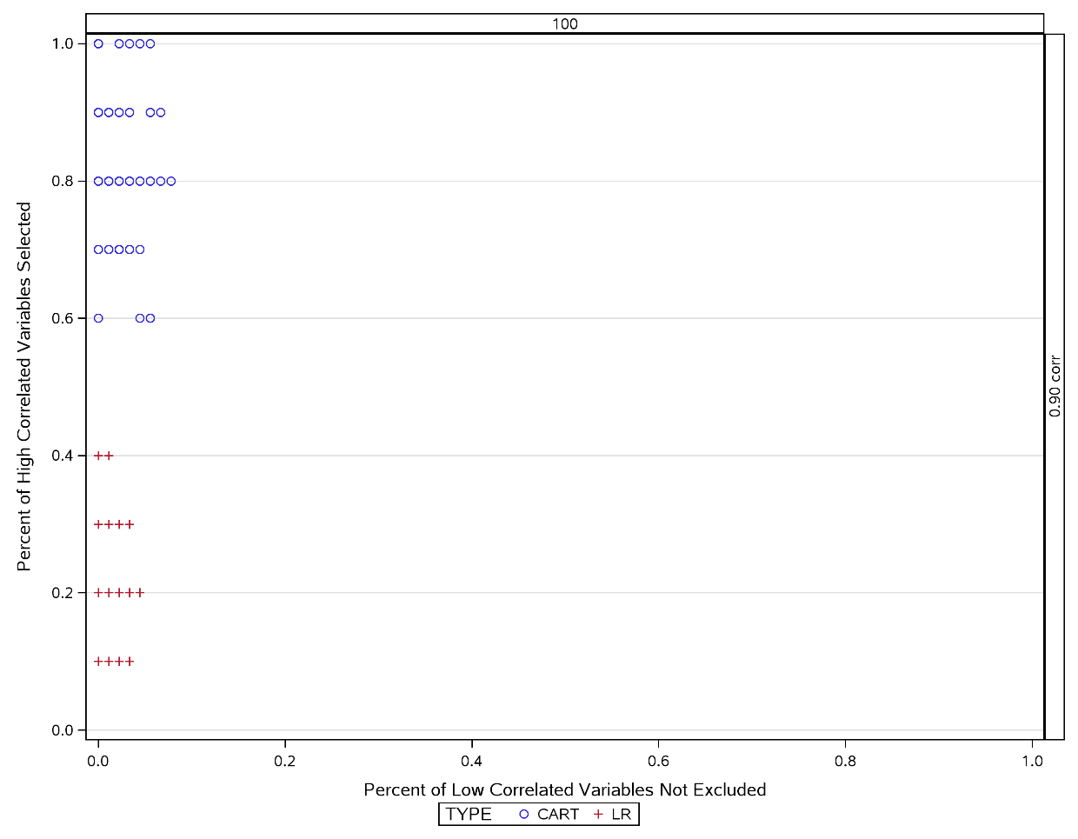

7.5. Simulations with continuous explanatory variables and no missing data

7.5.1. Initial Simulations Introduction

The first stage of the simulations will investigate how logistic regression and CART performs in selecting variables with a known correlation structure, under varying sample sizes, varying response rates, with continuous explanatory variables and no missing data.

7.5.2. Methods

In the first stage each simulation will generate a dichotomous response with 10 random Normal variables correlated with this response, and 90 random Normal variables not correlated with this response. Simulations of size 100, 1,000 and 10,000 will be generated in SAS 9.2. For both continuous and dichotomous data, a seed will be specified to enable reproducibility. The variables generated will be correlated in separate simulations at 0.90, 0.80. 0.70, 0.60, 0.30, 0.20, 0.10 and 0.0. The dichotomous response will be generated at 90%, 50% and 25% to approximately resemble response rates for ACR20, ACR50 and ACR70 respectively (see Section 4.7). A simulated dataset will be generated in SAS for each combination of sample size (3 options), response rate (3 options), higher correlation (4 options), and lower correlation (4 options) leading to 144 separate scenarios. Each scenario will be simulated 100 times, creating a total of 14,400 datasets to be applied to the 2 methods.

The CART analysis will be performed using rpart package of the R software application (Therneau et al., 2017). The R routine rpart, authored by Terry Therneau and Elizabeth Atkinson from the Mayo Foundation, will build classification and regression trees. Parameters selected in this R routine include: equal weights, ANOVA modelling, the retention of observations if one or more predictors are missing, equal costs, and a minimum of 20 observations per node in order for a split to be attempted. Stepwise logistic regression will be performed in SAS with the significance level for entry (SLE) (Wild et al.) and significance level for staying (SLS) in the model set to the same value. This value will be varied and set to 0.30, 0.20, 0.10, 0.05, 0.01 and 0.001. Each value will be applied to stepwise logistic regression for each simulated dataset, for a total of 86,400 analyses on logistic regression and 14,400 analyses on CART.

In addition, 4 simulations of missing data (Section 7.6) and a simulation with dichotomised data (Section 7.5) will be created for each of CART and logistic regression leading to a total of 1028 simulated datasets (Appendix C.3).

Figure 7.3 illustrates how simulated datasets will be generated. Each simulated dataset will be created in SAS using a macro called simmacro. The data for the simulation will be exported to an R instance where the package rpart will be applied to create a classification and regression tree. The nodes of the generated tree will then be exported back into the SAS environment. The same simulated data will also be used by SAS in Proc Logistic where a stepwise logistic regression will be applied, and the variables selected by the final model will be extracted. The specificity and sensitivity of logistic regression and CART for selecting the higher correlated variables will then be calculated. This procedure will be repeated 100 times and the resultant 100 specificities and 100 sensitivities for CART and logistic regression will be output to permanent datasets.

Figure 7.3 Generation of Simulated Datasets
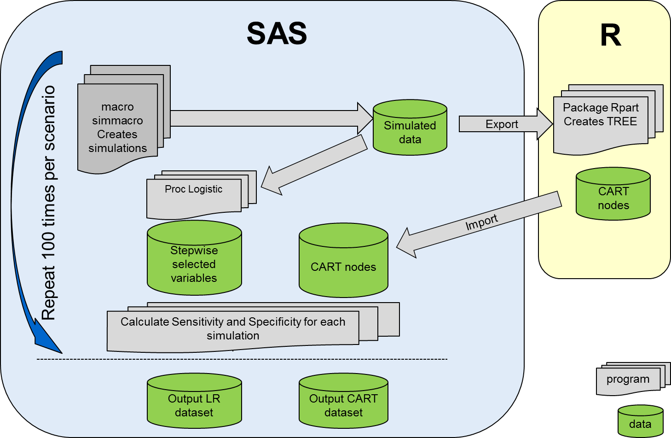
The main SAS program will utilise macros written for the dissertation in SAS to generate each simulation. For each dataset created, the SAS program will use a Unix utility to run R code within SAS for the CART analysis to identify CART selected nodes to compare with variables logistic regression identified in stepwise regression.

The explanatory variables selected by CART and logistic regression will be displayed in VaSe plots. Figure 7.4 displays logistic regression and CART in VaSe plots for the scenario where the response rate of the dependent variable is 50% and the lower correlated independent variables are simulated to have 0.0 correlation with the outcome. Figure 7.4 displays 12 separate VaSe plots. The columns are arranged by simulation size of 100, 1000 and 10,000 subjects. The rows represent the correlation of the higher correlated variables with correlation of 0.60 at the top, then 0.70, 0.80 and then 0.90 correlation on the bottom row. Within each VaSe plot the x-axis displays the probability of correctly excluding low correlated variables and the y-axis displays probability of correctly selecting high correlated variables. With respect to the data points within each VaSe plot, the CART results on 100 simulations are represented by blue circles and the logistic regressions on 100 simulations by red crosses.

7.5.3. Results of Comparisons of CART versus Logistic Regression

The simulations are computationally intensive. For the larger sample sizes (N=10,000) each stepwise logistic regression analysis alone can take 2 to 3 minutes, for a simulation of 100 repetitions this represents 200 to 300 minutes of processing time for a single scenario on logistic regression. The practical implications mean that each run of simulations can take 2 to 3 days of processing time, with frequent, unpredictable early terminations of the submitted program, due to memory limitations even on a Unix network. At the time of this research, better hardware was not available. This practical consideration limits the options to increase the number explanatory variables to generate beyond 100 or to increase the number of repetitions of each scenario beyond 100. As mentioned in section 7.5.2, the simulations comprise some 1028 datasets, creating 3,929,000 simulated patients with a total of 39,688,960,000 simulated data points (Appendix C.3).

With respect to results, for simulations based on 100 patients there is clear separation on the VaSe plots of CART and Logistic Regression (first column of Figure 7.4 to Figure 7.7). Whilst both methods exhibit similar low correlated variable selection, CART displays superior high correlated variable selection (true positive rate). This is consistent for responses at 25%, 50% and 90% and for all combinations of correlation between response and high (0.9, 0.8, 0.7, 0.6 the rows of the trellis plots) and low (0, 0.1, 0.2, 0.3 figures 2, 3, 4, 5 respectively) correlated explanatory variables.

For simulations based on 1,000 patients (second column of Figure 7.4 to Figure 7.7), CART tends to perform better, but different trends are expressed. Compared to 100 patient simulations both CART and logistic regression are increasingly sensitive but have poorer low correlated variable selection (false positive rate). In other words, for the 1,000 patient simulations the 2 methods are better at selecting the higher correlated variables, but also erroneously select a greater amount of lower correlated variables. There is also apparent, a gradual shift left to right (worsening of low correlated variable selection) as the correlation of highly correlated variables move from 0.9 to 0.6, this would be expected as high correlated variables would be less differentiated to lower correlated variable. This reduction of distinction between higher and lower correlated variables leads to a higher number of lower correlated variables being selected.

Simulations based on 10,000 patients (third column of Figure 7.4 to Figure 7.7), are more pertinent to the overall aims of this research as they more closely match the numbers of patients available on the real patient clinical database. Compared to 1,000 patient simulations, the increased sample sizes lead to much more tightly clustered estimates of high and low correlated variable selection. The CART data has consistently almost perfect classification with 1.0 high correlated variable selection and low correlated variable selection of < 0.1. Whilst logistic regression matches CART for high correlated variable selection, low correlated variable selection varies across almost the whole range. As observed in the 1,000 patient based simulations, for the same reasons improvements in low correlated variable selection are seen with higher correlations in highly correlated variables. Also more apparent are improvements for low correlations of lowly correlated variables, this is consistent with expecting better results when correlations are more differentiated. Take for example the top right hand corner of Figure 7.4. In this 10,000 patient simulation, 90 of the 100 variables are 0.20 correlated with the response and 10 are 0.60 correlated with the response. Both CART and logistic regression analyses select all 10 higher correlated variables as shown by 100% high correlated variable selection. However logistic regression selects many a greater number of lower correlated variables in the final model. Section 7.4.4 will explore ways to reduce this over-selection by logistic regression.

Performance in all scenarios is similar between all response rates (25%, 50%, and 90%).

Figure 7.4 VaSe plot of logistic regression and CART for 50% response rate and zero correlation
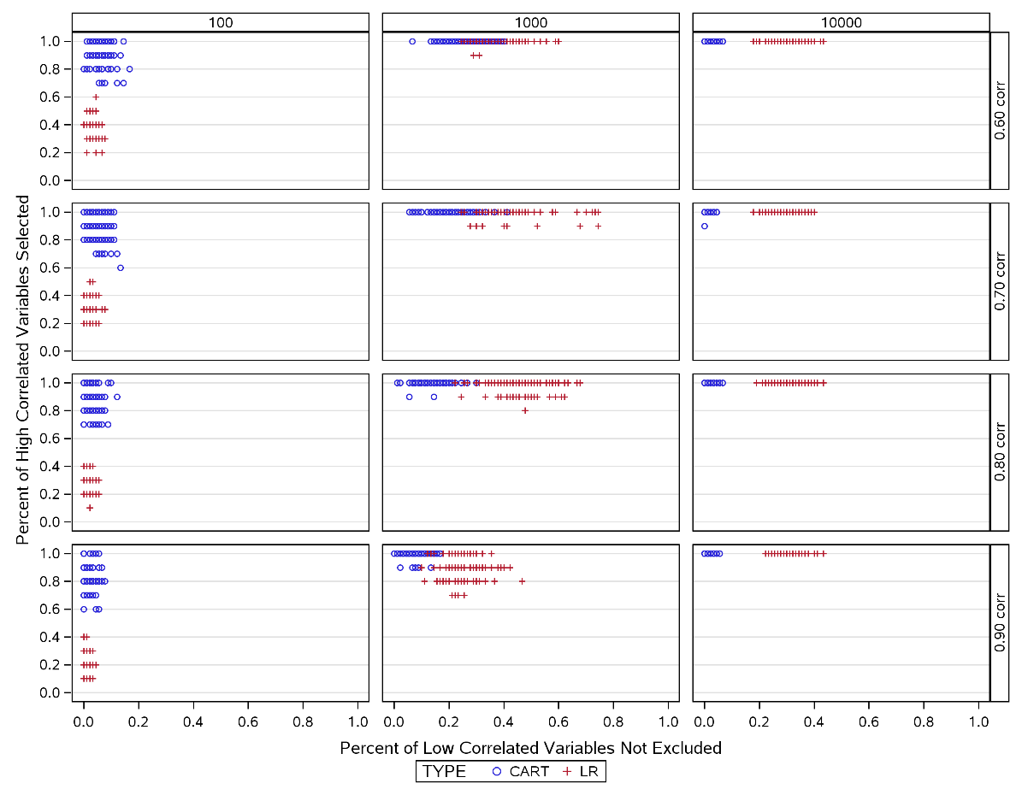
Figure 7.5 VaSe plot of logistic regression and CART for 50% response rate and low correlation at 0.1
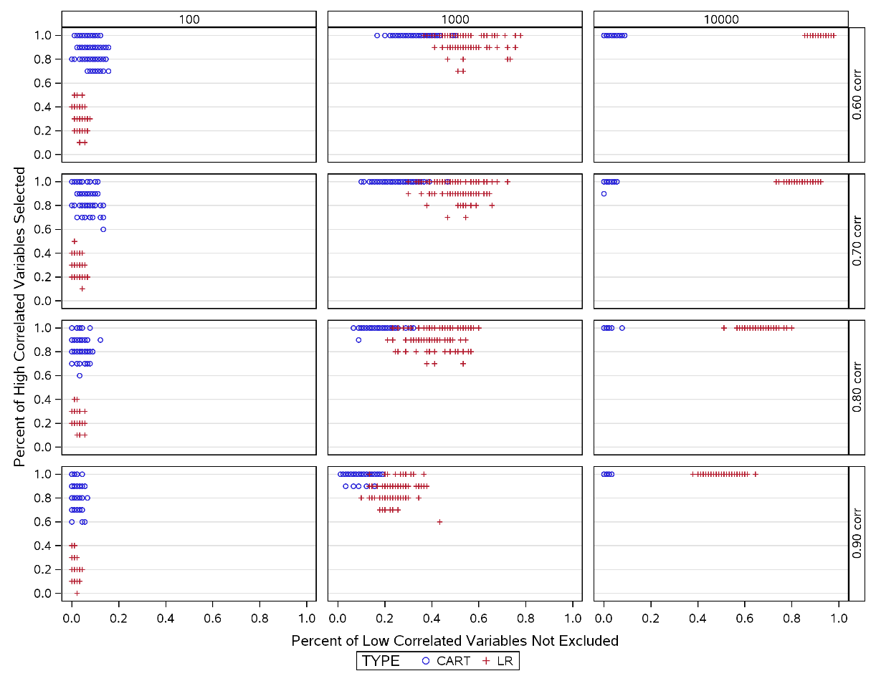
Figure 7.6 VaSe plot of logistic regression and CART for 50% response rate and low correlation at 0.2
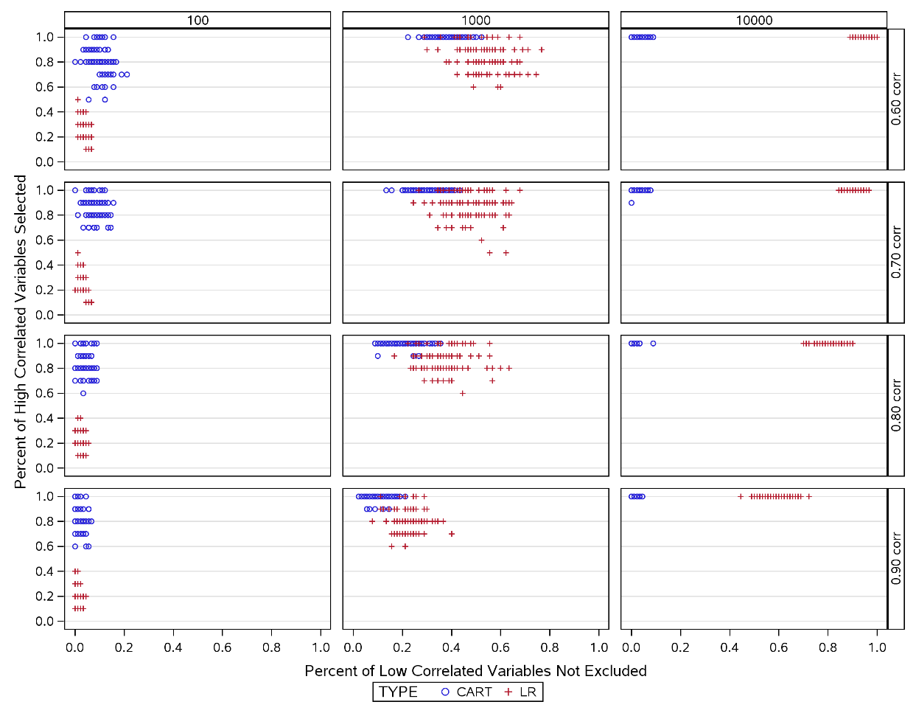
Figure 7.7 VaSe plot of logistic regression and CART for 50% response rate and low correlation at 0.3
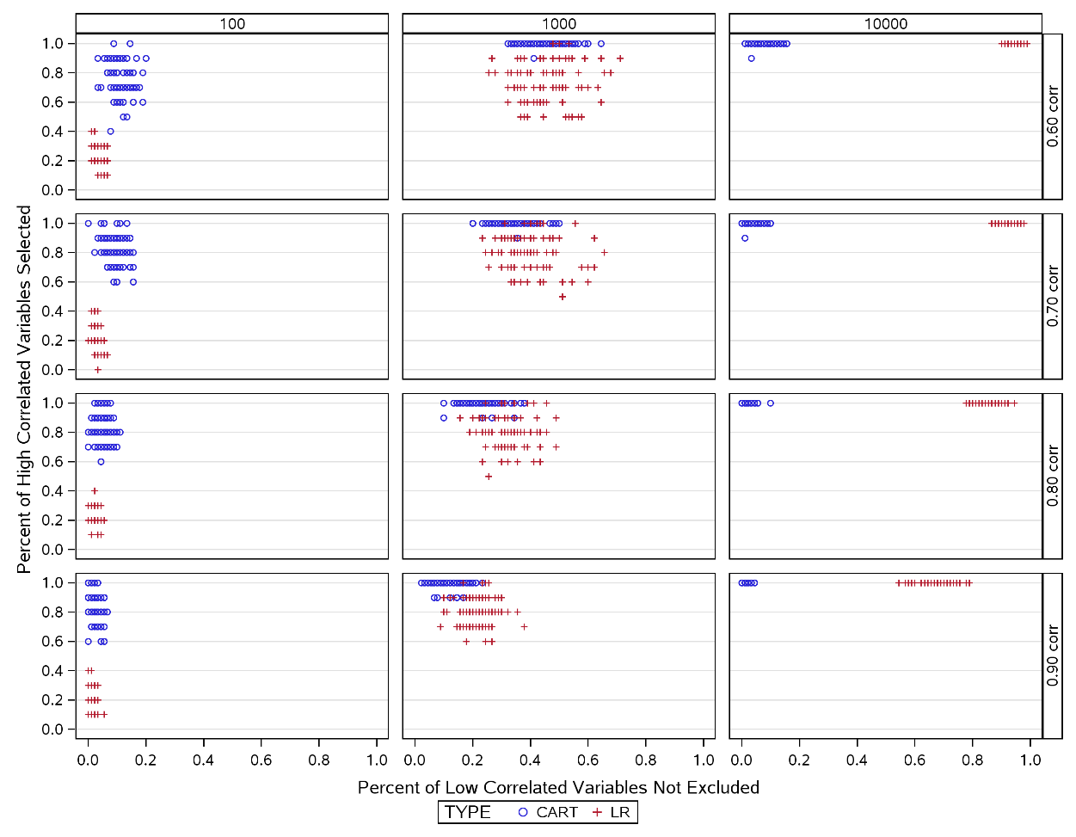

7.5.4. Improving the performance of Logistic Regression

As described in Section 7.5.3, with increasing numbers of subjects in the simulations logistic regression improved in high correlated variable selection but performance worsened in low correlated variable selection. That is logistic regression tended to over-select variables in the final model. The comparisons of logistic regression with CART were based upon a stepwise logistic regression with significance levels for entry (Wild et al.) and staying (SLS) set at alpha = 0.30. This boundary was further explored at values of 0.2, 0.1, 0.05, 0.01 and 0.001 (Figure 7.8, Figure 7.9, Figure 7.10, and Figure 7.11). For each combination of response, high correlation and low correlation, no observable differences were seen for high correlated variable selection, however lower values of significance improved percent of low correlated variables exclusion.

Across all scenarios a reduction in significance for entry and staying is associated with improvement in low correlated variable selection. So, as the criteria for selection in the model become stricter, the tendency for logistic regression to over-select is reduced. The impact on selection of high correlated variables is a more mixed picture.

The changes in entry and staying significance values made little visible difference for 100 subject simulations (the first column in figures). One can see slight improvements in low correlated variable selection as significance decreases, but no improvements in high variable selection.

For simulations based on 1,000 subjects, lower significance values are associated with improved low correlated variable selection as described above. However, there is not a consistent pattern with respect to high correlated variable selection. For high correlations at 0.60 (top row, middle column of figures), an entry and staying significance of 0.001 performs the best, however at other values of high correlation, a less strict significance of 0.01 often performs better for high correlated variable selection. This suggests that a too strict significance sometimes throws the baby out with the bathwater when excluding higher correlated variables.

For lower values of significance and for simulations based on 10,000 patients (third column of Figure 7.8 to Figure 7.11), logistic regression competes well with the performance of CART. Also seen in these figures, high correlated variable selection was consistently high and stricter significance leads to improved low correlated variable selection. Where there is a greater separation in low and high correlated variables and for a significance of 0.001 (Figure 7.8 and last row of Figure 7.9) logistic regression can achieve perfect variable selection.
Figure 7.8 Effect of changing entry and exit criteria in Logistic Regression for 50% Response with zero correlation
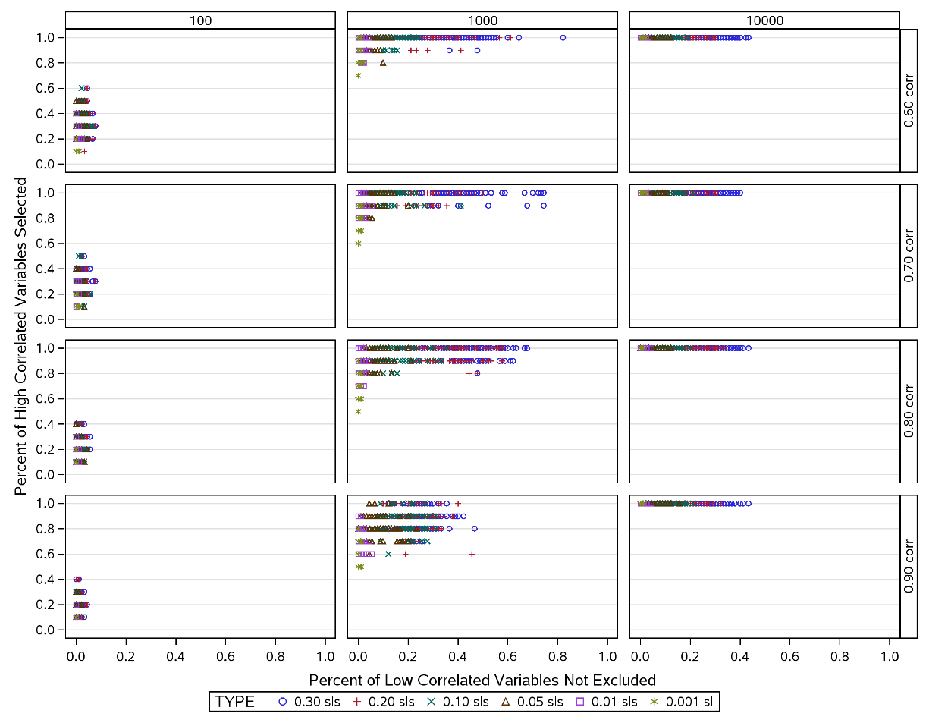

Figure 7.9 Effect of changing entry and exit criteria in Logistic Regression for 50% Response with low correlation at 0.1
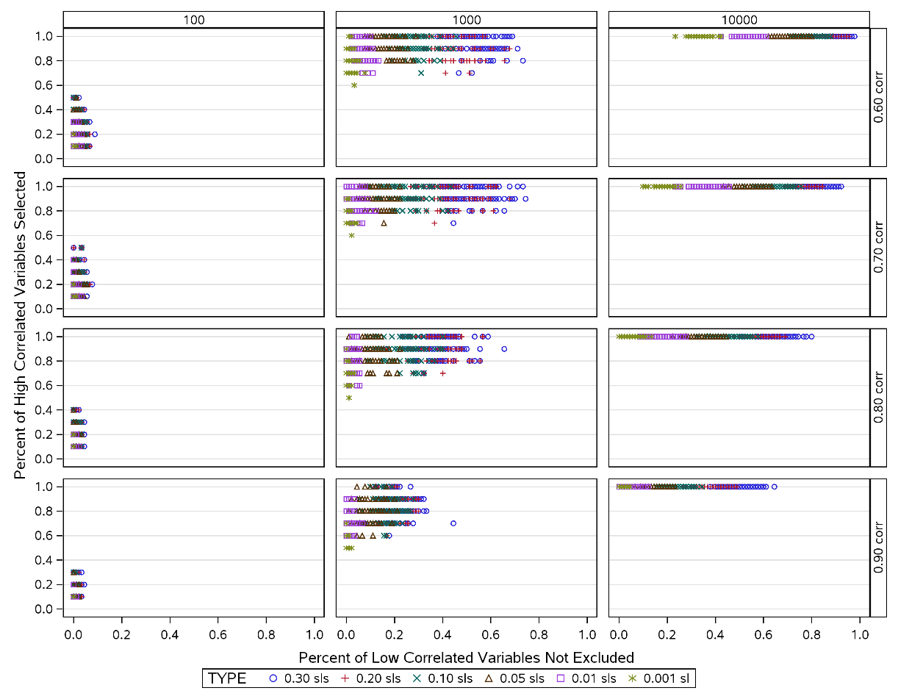

Figure 7.10 Effect of changing entry and exit criteria in Logistic Regression for 50% Response with low correlation at 0.2
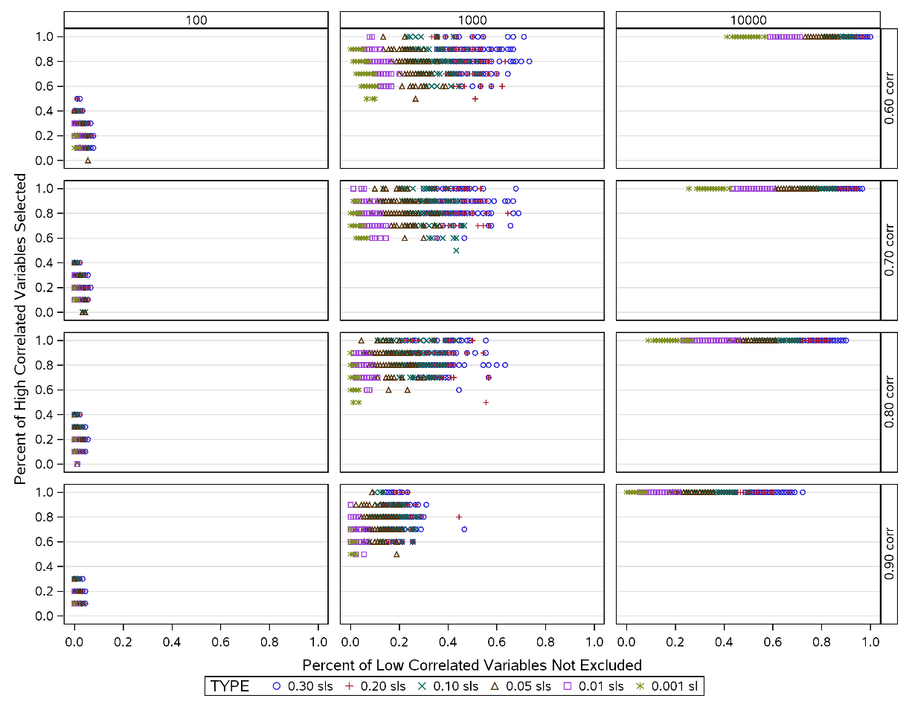
Figure 7.11 Effect of changing entry and exit criteria in Logistic Regression for 50% Response with low correlation at 0.3
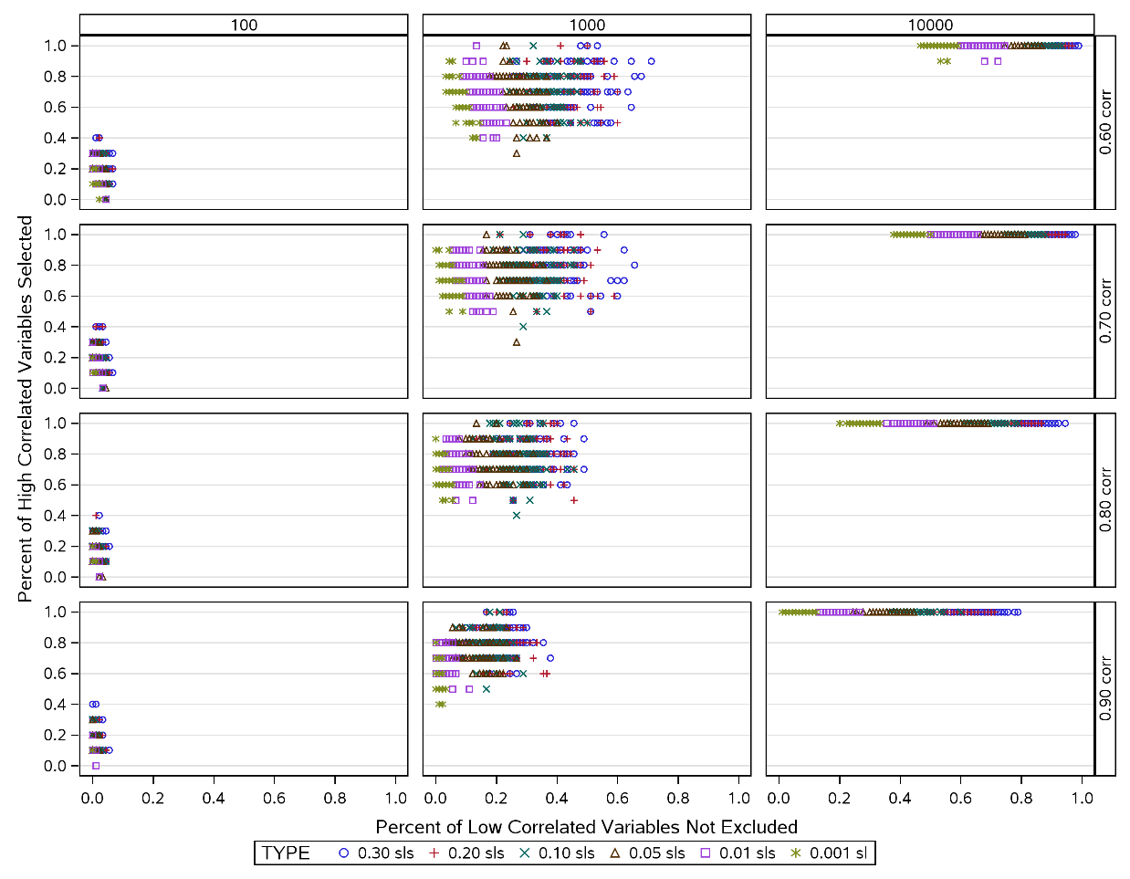

7.5.5. Initial Simulations Conclusions

Within the parameters of this dissertation, the greater interest was in the performance of the 10,000 patient simulations since these are comparable to the number of subjects available for analysis in the real patient dataset described in Section 4. Thus next stages were to be conducted on these only.

In Section 7.5.3, observed results were consistent between lower correlated values set at 0.10, 0.20 and 0.30 correlation. Similarly within each of Figure 7.4 to Figure 7.7 the higher correlations of 0.70 and 0.80 showed little differentiation. In Figure 7.8 to Figure 7.11 for the 10,000 patient based simulations inform the reader that smaller values of SLS and SLE improve the performance of the logistic regression to be more comparable to CART. Thus further explorations of the performance of CART and logistic regression were performed on a more focussed selection of scenarios.

For the investigation of categorical response in Section 7.6 and impact of missing values in Section 7.7, further simulations were based on a sample size of 10,000 patients, with lower correlated variables reduced to 0.0 and 0.3, with higher correlated variables reduced to 0.60 and 0.90. In addition, for further simulations, the values of SLS and SLE will be explored at 0.001 only.

7.6. Simulations with continuous and categorical explanatory variables and no missing data

7.6.1. Categorical and Continuous Simulations Introduction

In Section 7.5, we have shown by using continuous explanatory variables that CART analysis tends to outperform logistic regression, particularly for simulations with a higher numbers of subjects. For these larger simulated datasets, logistic regression is more competitive with CART only when entry and staying significance set at stricter (lower) levels. However, the available real patient clinical database, as described in Chapter 4, contains both continuous and categorical independent variables, so in this section simulated datasets were adapted to reflect this. SAS code is included in Appendix C.2.

7.6.2. Methods

In the following analyses, five of the 10 higher correlated variables and 45 of the 90 lower correlated variables were converted to categorical values. Each of the 50 variables was split into equal dichotomous groups according to median value. Whilst this may not reflect all the possible permutations in the real dataset, some gross trends may become apparent with this simplest approach. Simulations of sample size 10,000, with entry and staying significance for logistic regression set at 0.001, were generated on this mixture of 50 continuous and 50 categorical variables, for 2 scenarios: low correlations at zero vs high correlations at 0.90 and low correlations at 0.30 versus high correlations at 0.60 as proposed in Section 7.4.

7.6.3. Results

Figure 7.12 displays the results of simulations introducing dichotomous variables for 50% response. Trends were similar for 25% and 90% response. The second column shows the effect on logistic regression and CART by introducing categorical variables, compared with only continuous variables displayed in the first column. With the introduction of categorical variables, the performance of CART in selecting higher correlated variables deteriorated.

In the first row of Figure 7.12 where higher correlated variables are correlated at 0.90 with response and lower correlated variable correlated at 0.0, low correlated variable selection was maintained at similar levels for CART whilst high correlated variable selection declined indicating that CART was less efficient at selecting all higher correlated variables. Conversely in this scenario, logistic regression maintained high correlated variable selection whilst overcoming the previous tendency to over-select, to the level where logistic regression now outperforms CART.

For CART, a similar effect is seen in the second row of Figure 7.12 where the differentiation between low correlated variables and high correlated variables is less pronounced (0.30 and 0.60, respectively). Here low correlated variable selection is similar albeit slightly impaired, and high correlated variable selection deteriorates in a similar manner to the top row. Once again logistic regression improves markedly, particularly for high correlated variable selection but not as much as the first row and is not as competitive with CART.

In both scenarios of correlations, the logistic regression results improved and the CART results appeared to worsen. Where correlations were more differentiated (0.00 vs 0.90 first row), logistic regression outperforms CART. Where the correlations were less differentiated CART was still a better performer although some high correlated variable selection was still natively impacted.

Figure 7.12 Effect of dichotomising explanatory variables in Logistic Regression vs CART for 50% Response
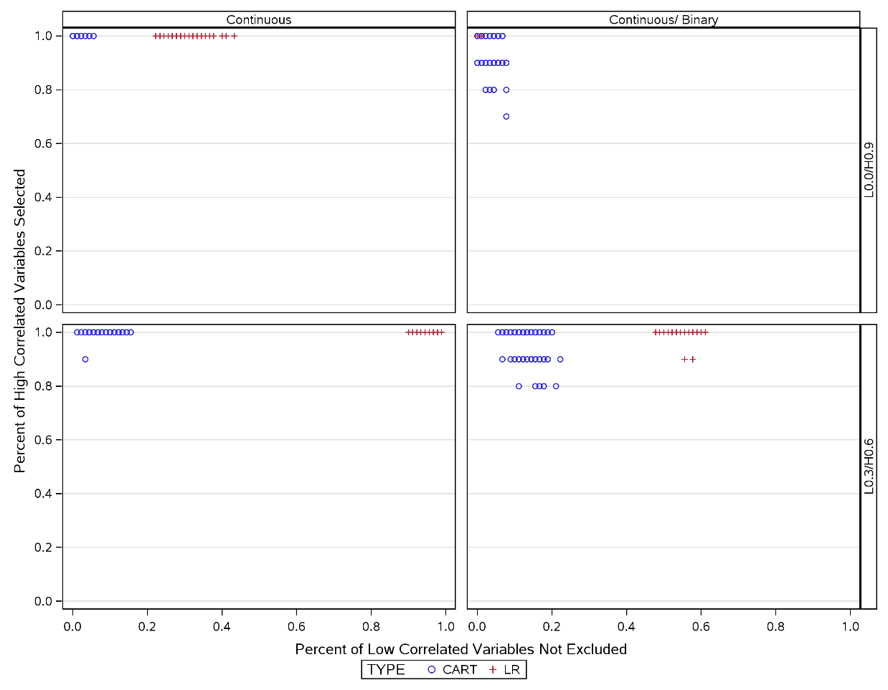L0.0/H0.9 – Low correlations at 0.0, high correlations at 0.9
L0.3/H0.6 – Low correlations at 0.3, high correlations at 0.6

Categorical and Continuous Simulations Conclusions

In simulations with higher sample sizes CART out performs logistic regression where explanatory variables are continuous. However as categorical variables are introduced, logistic regression improves in low correlated variable selection whilst maintaining high correlated variable selection. We have seen that in some scenarios where there are no missing values, that logistic regression can outperform CART in variable selection. In the next section we will explore how the presence of missing values could impact variable selection performance.

7.7. Simulations with continuous explanatory variables and missing data

7.7.1. Missing Data Simulations Introduction

In Section 7.6 we observed how a change in characteristics of the explanatory variables by introducing categorical variables impacted the performance of CART and logistic regression. In clinical development in general and for RA trials specifically drug developers must expect missing data despite efforts to reduce the levels. The real patient clinical database described in chapter 4 contains different rates of missing values depending on the variable and also on the source clinical trial. In this section we will explore the impact of missing values.

7.7.2. Methods

Two scenarios were selected for assessment of impact of missing values. Maintaining consistency with Section 7.5, sample size was set at 10,000 to reflect size of clinical database for use in later chapters. Response rate was set at 50% to reflect expected ACR20 response. Further, low correlation at 0.00 and high correlation at 0.90 were contrasted with low correlation of 0.30 and high correlation of 0.60 as these parameter selections exhibited different behaviours in Section 7.5.

Two types of missing values were generated. Firstly, data missing completely at random were created, whereby any explanatory variables value could be missing at a rate of 1% and 0.1%. Thus for any subject none, one or more than one explanatory variable value could be missing. Secondly, data missing dependent on response was produced, such that data was missing at a higher rate when response was 0 (missing rate 0.002 and 0.02) compared to 1 (missing rate 0.001 and 0.01 respectively) to reflect the possibility that a patient may be more likely to have missing data if treatment response is poor. See Appendix C.2 for SAS code.

7.7.3. Results

In SAS PROC Logistic any observation with missing values for the response, strata, or explanatory variables is excluded (listwise deletion) from the analysis, although for categorical explanatory variables, missing can be defined as an extra category.

For missing-at-random data, in a single simulation, a low rate of missing values for each variable of 0.1% excluded 959 and 985 observations out of 10,000 (approximately 10%) in the 2 sets of parameter selections. Similarly, at a higher rate of missing values of 1% a single simulation excluded 6319 and 6354 observations out of 10,000 (approximately 63%).

For not missing-at-random data, a single simulation, a low rate of missing values of 0.1%, excluded 952 and 927 observations out of 10,000 (approximately 10%) in the 2 sets of parameter selections. Similarly, at a higher rate of missing values of 1% a single simulation excluded 6351 and 6330 observations out of 10,000 (approximately 63%).

Conversely CART does not exclude subjects due to missing values. In a single simulated dataset, where the rate of missing values is 1% CART recognises up to 97 and 112 values missing when calculating node splits. Similarly, where the rate of missing values is 0.1% CART recognises up to 10 and 15 values missing when calculating node splits. CART recognises the missing values by variable rather than by observation.

So whether missing-at-random or not missing-at-random, logistic regression excludes a large proportion of data when rates of missing are at 1% or more. The risk of excluding data is magnified when including more explanatory variables that are expected to have missing values.

Results of effects of rate of missing values, where missing is completely at random amongst the explanatory variables, are seen in Figure 7.13. The first column displays the high correlated variable selection and low correlated variable selection where no missing values are present. The second and third columns display the effect of 0.1% and 1% missing values respectively. For missing-completely-at-random, it can be seen that as the rate of missing changes, CART performance changes very little however the performance of logistic regression improves particularly with respect to low correlated variable selection. Considering that for logistic regression missing values reduces the effective sample size, this impact is not surprising and is consistent with logistic regression performance observed in Figure 7.4 to Figure 7.7 in Section 7.5 where smaller sample sizes had improved low correlated variable selection. This may be explained by the expectation that lower correlated variables less likely to meet the criteria for entry in smaller datasets.

Figure 7.13 VaSe plot of logistic regression and CART by rate of missing values none, 0.1% and 1% (missing-completely-at-random)
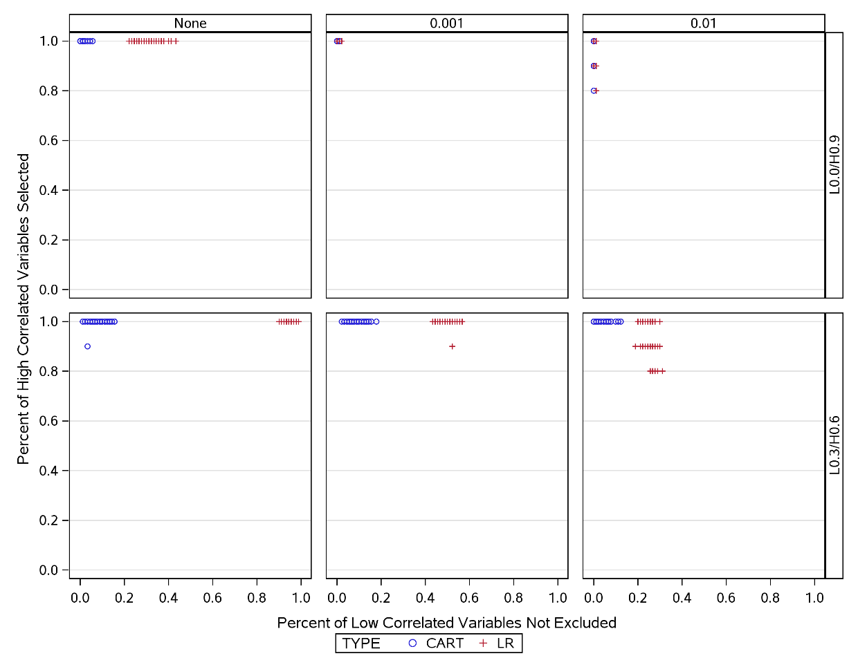
L0.0/H0.9 – Low correlations at 0.0, high correlations at 0.9
L0.3/H0.6 – Low correlations at 0.3, high correlations at 0.6

Results of effects of rate of missing values, where missing is not at random amongst the explanatory variables, are seen in Figure 7.14. For lower missing rates, the behaviour is much the same as missing-at-random. However, for a larger rate of missing values the CART performance again begins to decline in both high and low correlated variable selection, whilst logistic regression improves in high correlated variable selection.

Figure 7.14 VaSe plot of logistic regression and CART by rate of missing values none, 0.001 and 0.01 (missing not at random)
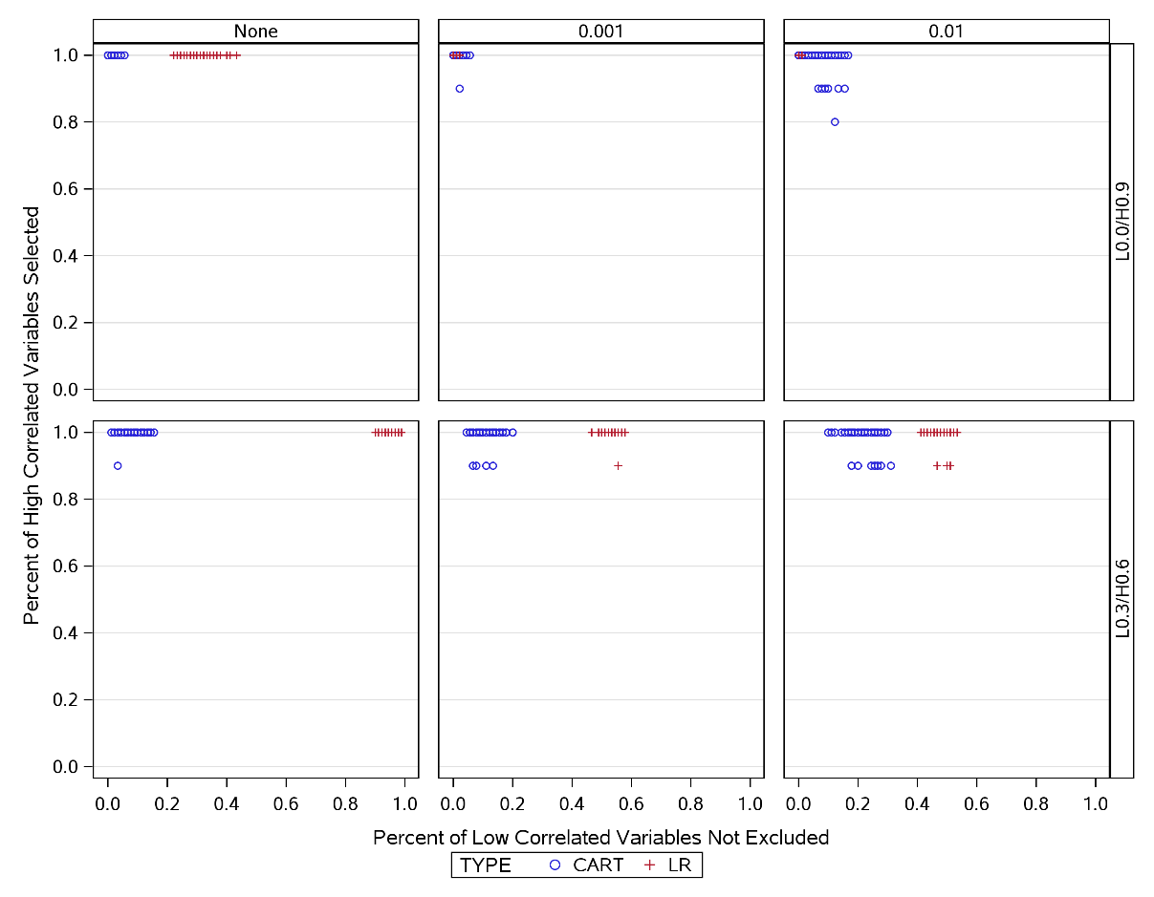 L0.0/H0.9 – Low correlations at 0.0, high correlations at 0.9
L0.3/H0.6 – Low correlations at 0.3, high correlations at 0.6

7.7.4. Missing Data Simulations Conclusions

In this section we have seen how CART and logistic regression manage missing values. The biggest impact is how logistic regression manages missing values by excluding a whole observation if one or more observations are missing. Since a missing value could occur in any of the 100 explanatory variables, with just 1% missing values throughout the simulated dataset, as much as 63% of the data could be excluded. CART on the other hand still utilises data from non-missing variables even if an observation contains variables with missing values.

7.8. Summary
In this chapter we have seen the introduction of variable selection (VaSe) plots (Section 7.4). These have been developed in order to visually establish the performance of competing multivariate methods to be able to select highly correlated variables for a large complex dataset. Through the use of VaSe plots we have seen throughout this chapter that within the scope of the simulations it seems clear that CART outperforms logistic regression in most scenarios, as illustrated by the development and introduction of the VaSe plots. Section 7.5 simulated an ideal situation where there are no missing values and all explanatory variables are continuous. Throughout 144 variations of this scenario CART clearly outperforms logistic regression, particularly in the case of high subject numbers (n=10,000). In Section 7.5.4 we saw that we can improve the performance of logistic regression by selecting significance levels for entry and staying set at low values. In the simulations with high subject numbers, a significance of 0.001 seemed to deliver the most comparative performance with CART.

Section 7.5 also allowed for the refining down of scenarios to employ for further simulations. Results were consistent between the different outcomes of the response variable (25%, 50% and 90% response). When varying lower correlations at 0.10, 0.20 and 0.30 homogeneity was observed in performance as was by varying higher correlations between 0.70, 0.80, and 0.90. Further investigations were performed on 50% response, sample size 10,000, significance 0.001 on 2 scenarios:
- low correlation 0.0, high correlation 0.9
- low correlation 0.3, high correlation 0.6
In Section 7.5.5 these scenarios gave the greatest differentiation in performance of CART and logistic regression and were used in Sections 7.6 and 7.7.

Section 7.6 introduced dichotomous variables to the simulations. Half of both the higher and lower correlated explanatory variables were dichotomised. Here the arguably more realistic scenario where explanatory variables can be continuous or dichotomous, CART maintained low correlated variable selection but worsened in high correlated variable selection. Logistic regression improved dramatically in low correlated variable selection and seemed to outperform CART where the difference in lower and higher correlations in explanatory was most extreme. In perhaps a more representative situation with less difference in correlations, CART was still superior.

Section 7.7 introduced missing values to the simulations. Two types of missing data were explored: missing-completely-at-random, and missing-not-at-random. For missing- completely-at-random, missing values were assigned at random to the 100 explanatory variables and to each subject, at a missing rate of 1% and 0.1%. So any explanatory variable or subject could have none, one, or more than one missing value. For missing-not-at-random the missing value rate was assigned according to level of response variable, missing value rate was doubled when response was 0, compared to a response of 1.

Exploring higher rates of missing data proved prohibitive by the way logistic regression in SAS handles missing data. SAS excludes the entire subject from the analysis if one or more response, strata or explanatory variable contains a missing value. At a rate of just 1% missing data, logistic regression excluded more than 60% of the data. CART excluded just 1% or 0.1% according to given missing data rate.

In terms of performance, in the presence of missing-completely-at-random data, CART changed very little. Much like phenomenon seen in adding categorical variables, logistic regression improved in low correlated variable selection, particularly in the more extreme 0.0 vs 0.9 correlations. For missing-not-at-random, logistic regression acted similarly to missing-at-random, but CART loses some performance in both high and low correlated variable selection. CART still outperforms logistic regression in more realistic 0.3 vs 0.6 scenario.

The handling of missing values by logistic regression would seem to be the most significant disadvantage of the method for use in a RA dataset. Particularly since, as we saw from Chapter 4, large amounts missing values are expected in datasets of this source. The ability to manage missing values and the pairwise deletion would make this the most important consideration for logistic regression as a selection method.

In the simulations in this chapter we have seen that CART usually outperforms logistic regression in variable selection. The few scenarios where logistic regression outperforms CART are those that are least likely such as where the lower correlated variable are at a minimum of 0.0 correlation with the response and the higher correlated variables are correlated at a maximum of 0.90 with the response.

7.9. Limitations
The simulations performed in this chapter have not been exhaustive. We have not explored the combination of categorical and missing values, or non-binary categorisation of explanatory variables and we have not explored correlations between explanatory variables. Neither have we explored compensating for the way SAS Proc Logistic manages missing data by nominating missing data as a class variable: in real practice we wouldn’t be able to assume data is missing for the same reason. In order to keep number of simulations manageable we have not considered non-Normal continuous data. Nonetheless, in the scenarios explored, CART has been robust in performance in both high and low correlated variable selection compared to logistic regression.

Whilst this staged approach intends to mimic aspects of the real patient database, it is recognised that it may be limited in expressing the nuances in such a large database and complex disease area. For example, the correlations explored in the simulations go beyond that seen in the real patient database. Also of note was that higher correlated variables tended to be correlated highly with each other and lower correlated variables also highly correlated with each other.

Missing data was generated either missing completely at random or missing dependent on outcome response. No account was taken with respect to other independent variables when generating missing values. In reality a missing record of say tender joint count may well be associated with swollen joint count, and also if one value is present of the 2 then one would expect a high correlation between these two data-points.

These simulations can only inform an approach to analysing the real patient data rather than definitively compare these methods in a real life data setting. As such conclusions drawn may only be valid for the situations explored. However, despite these limitations, CART appeared more robust in its performance compared to logistic regression.

Nonetheless this chapter has shown the value of undertaking simulations. For example, for large datasets we have seen that by applying a very strict entry and staying criteria for the logistic regression we can improve performance in terms of high and low correlated variable selection.

7.10 Recommendations
In the next chapter we will use CART to analyse the real patient RA clinical trial data. In simulations, logistic regression performed well in most of the criteria for method selection (Table 7.1), however it became clear that the handling of missing values became too large an issue to overcome (Figure 7.15). Therefore, my assessment for handling of missing values was changed from fair to poor. In contrast, CART handled missing values with ease and also pruning of trees produced interpretable trees with high performance. As such, I upgraded missing value and interpretability ratings to good on the basis of the simulations. In the analysis of the real patient data, CART will be applied and additional data mining methodologies such as cross validation as described in Chapter 5 will be considered to maximise validity of findings.

Table 7.1 Some characteristics of CART and Logistic Regression
Characteristic | CART | Logistic Regression
Can handle ‘mixed’ data | Good | Good
Handling of missing values | Good | Poor
Robust to outliers | Good | Fair
Computational Scalability (Large N) | Good | Good
Interpretability | Good | Good
Can manage high dimensionality | Good | Good

We will apply CART to the data as a whole and also explore heterogeneity by comparing subgroups of data such as drug compound, dates study was conducted, geographical region of patients. Since CART seemed to be superior without the enhancements of boosting, bagging and random forest, the method will be applied first without these adaptations.

Figure 7.15 Flowchart of analysis method refinement

: Application of CART using Clinical Trial Data

8.1. Introduction

In chapter 2 we depicted RA as a disease. We described the epidemiology, postulated causes of RA and diagnosis. Chapter 2 went on lay out the manifestations and co-morbidities of RA, as well as pathophysiology and risk factors for incidence and severity. Some of the hypothesised factors believed to affect occurrence and severity included age, gender, smoking, ethnicity, genetics, diet and socioeconomic status.
Since the data for this thesis is generated from clinical trials at Roche, chapter 3 illustrated how phase III clinical trials are typically designed at Roche. This chapter details endpoints, trial designs and regulatory strategies that are acceptable for gaining approval for new therapies in RA.
Chapter 4 follows on from chapter 3, by summarising the clinical trial data available for analysis in this research. These data are sourced from 16 phase 3 clinical trials conducted to support 4 separate drug development projects. The trials enrolled 11,705 adult patients diagnosed with RA over a period from 1998 to 2008. This chapter goes into some detail to convey which variables are available to predict outcome and the numbers of patients with those data. We also explore the amount of missing data and some correlations and associations with study endpoints. This information is later used to inform simulations.
In this research we intended to compare multivariate and data mining methods for predicting patient response in RA patients. Chapter 5 describes a selection of data mining methodologies that are being considered for application to the available data, and through reflection, reduce the number of methods that will be explored in the later simulations. Methods for logistic regression and CART included some enhancements to improve performance; Lasso and ridge regression for logistic regression, boosting, bagging and random forest for CART.
Through systematic reviews, chapter 6 identified biological factors that influence progression of the disease and to summarise methods and results that are assessed in a multivariate analysis. Further systematic reviews identified which data mining methods have been applied in RA. By the end of chapter 6, by understanding the characteristics of the data available to us for analysis and evaluating benefits and limitations of each method, we were able to reduce the number of statistical methods under consideration to logistic regression and CART.

The conclusions of chapter 6 to progress with 2 methods, along with the characteristics of the data described on chapter 4, were used to inform the simulations conducted in chapter 7. The simulations conducted explored how CART and logistic regression perform under differing scenarios with known data relationships with the intention of identifying preferred methods to apply to the real patient database. Simulations tested how well each method selected variables with known correlation with outcome. Simulations were repeated under differing sample sizes, correlation levels, missing value rates, and variable type. This chapter concluded that within the scope of the simulations CART outperformed logistic regression in most scenarios, and was selected as the primary analysis method to apply to the clinical trial dataset.

8.2. Aims

The aims of this chapter are to apply and evaluate CART analyses for prediction of patient response in the RA clinical trial database.

8.3. Methods

The CART procedure from the R routine ‘rpart’ (Therneau et al., 2017) will be applied to these data. In order to control for over-fitting a cross validation procedure will be used whereby 75% of the data will be randomly selected and used to build the training set. The CART model will be created from the training set. The remaining 25% of the data (test set) will be used measure the performance of the CART model; sensitivity, specificity and accuracy will be calculated. A receiver operating characteristic curve will be generated by adjusting the loss function in the CART procedure.
Further exploratory analyses will be applied to explore the robustness of results through applying boosting, bagging and random forest enhancements to CART, as well as attempting to apply logistic regression to confirm choice of CART as a superior methodology in the context of these data.
Random Forest methodology will also be applied using the R routine ‘randomForestSRC’ (Ishwaran & Kogalur, 2017). Boosting and Bagging will utilise the R routine ‘adabag’ (Alfaro et al., 2015).

8.4. Primary Analysis Results

Figure 8.1 shows the results of the CART analysis on the RA clinical trial dataset. See Appendix D.1 for detailed ‘rpart’ output. In this pruned tree a patient is predicted to be a responder via two routes:
- a baseline tender joint count of ≥ 7.5 and
region not North America and
Joint Space Narrowing Score < 0.49.
- a baseline tender joint count of ≥ 7.5 and
region not North America and
Joint Space Narrowing Score ≥ 0.49 and
Number of Previous DMARDs < 3.5 and
Race not equal to Asian, Other or Unknown.

Figure 8.1 CART primary analysis

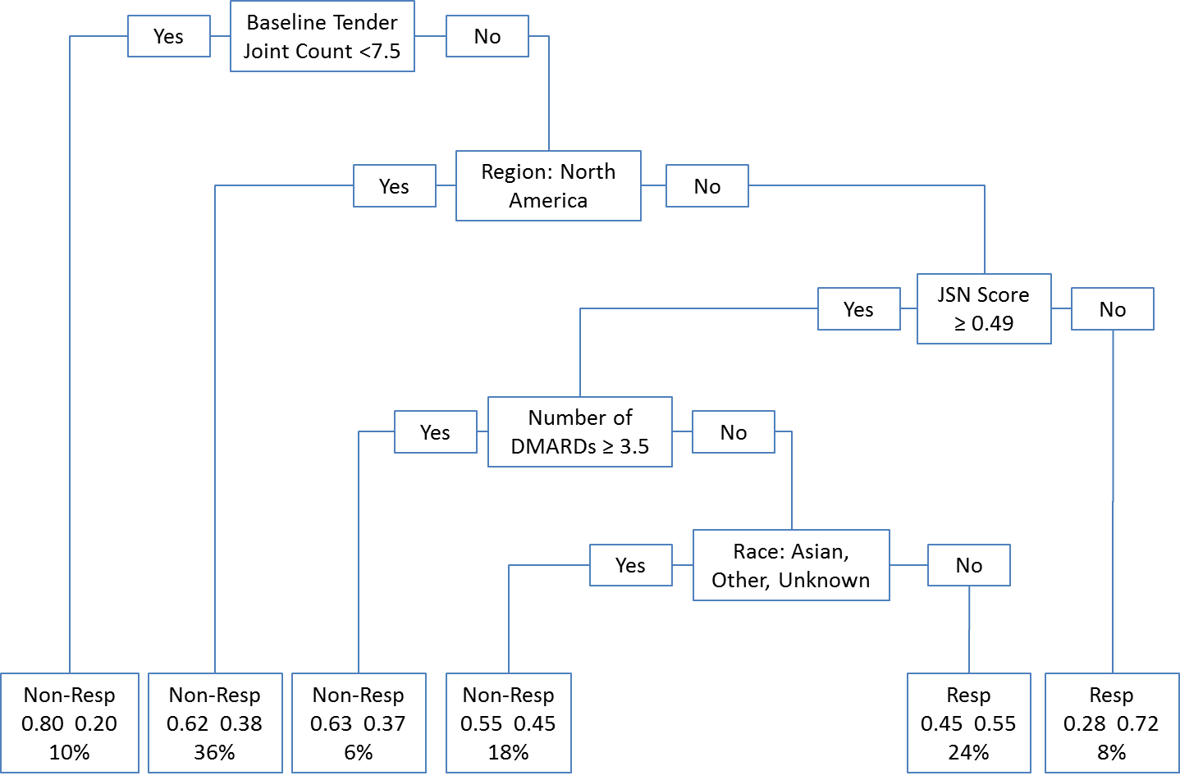

Table 8.1 shows the results of applying the test dataset to the CART model, the test data comprised 25% of the available data (n=2848) as described in Section 8.3. The model performed poorly in identifying those patients who responded to treatment with sensitivity of 0.41 (522/1279), although it was better at recognising non-responders with specificity 0.76 (1200/1569). Overall accuracy was still low at 0.60 ( (1200+522)/2848 ).

Table 8.1 CART prediction results
 |  | Predicted |  | Total
 |  | Non-Responder | Responder | Total
Actual | Non-Responder | 1200 | 369 | 1569
Actual | Responder | 757 | 522 | 1279
Total |  | 1957 | 891 | 2848
Sensitivity |  | 0.41
Specificity |  | 0.76
Accuracy |  | 0.60

Table 8.2 describes the surrogates selected in the CART analysis. Details of the surrogate variables and analysis can be found in Appendix D.1. One can see for example that Baseline Swollen Joint Count can be substituted for Baseline Tender Joint Count when the latter has a missing assessment. Baseline Swollen Joint Count will agree with Baseline Tender Joint Count 91.2% of the time. For other nodes of primary analysis CART, although surrogates have been identified, they do not have the as good levels of agreement, and perhaps the medical rational is not so clear. For example, Region (defined as North America vs Non North America), can be replaced with surrogates such as History of Psychiatric, Immune, General, CNS disorders, or weight.
Table 8.2 CART prediction results
Primary Split | Surrogate Splits | Agreement
Baseline Tender Joint Count | Baseline Swollen Joint Count | 0.912
Region | History of Psychiatric Disorders | 0.684
 | History of Immune Disorders | 0.663
 | Weight | 0.662
 | History of General Disorders | 0.653
 | History of Nervous System and Neurological Disorders | 0.650
JSN Score | RA Duration | 0.797
 | Age | 0.760
 | Race | 0.759
Number of DMARDs | Baseline CRP | 0.866
Race | Baseline CRP | 0.691
 | SF36 Mental Component Score | 0.654
 | SF36 Physical Component Score | 0.653
 | Red Blood Cell Count | 0.651
 | SF36 General Health | 0.641

To further explore the characteristics of the CART analysis a loss function operating characteristic curve was generated by adjusting the loss function in the CART procedure (Table 8.3 and Figure 8.2). A loss function was applied where the loss due to misclassifying a non-responder ranged from 0.1 to 2. That is, a loss function of 2 assumes that the cost of misclassifying a non-responder as a responder was twice as high as that of misclassifying a responder as a non-responder. In Figure 8.2, lower loss functions appear in top right corner and increase in value towards bottom left corner. The accuracy for all CART analyses with loss functions ranged from 0.49 to 0.60, with the highest accuracy relating to analysis with equal loss, this is the point at the furthest distance to the solid red diagonal line and illustrated by the green dashed line on Figure 8.2. Adjusting the loss function did not seem to improve overall accuracy of the prediction. Extreme values for the loss function improve sensitivity or specificity, but at the cost to accuracy.
Table 8.3 Impact on accuracy of adapting loss function
Loss Function | Sensitivity | Specificity | Accuracy
0.1 | 0.01 | 1.00 | 0.56
0.3 | 0.00 | 1.00 | 0.55
0.6 | 0.12 | 0.95 | 0.57
0.9 | 0.28 | 0.85 | 0.59
1.0 (equal losses) | 0.40 | 0.76 | 0.60
1.1 | 0.52 | 0.66 | 0.60
1.2 | 0.64 | 0.53 | 0.58
1.3 | 0.72 | 0.46 | 0.58
1.4 | 0.73 | 0.47 | 0.59
1.5 | 0.72 | 0.46 | 0.58
1.6 | 0.80 | 0.37 | 0.57
1.7 | 0.82 | 0.35 | 0.56
1.8 | 0.83 | 0.36 | 0.57
1.9 | 0.82 | 0.35 | 0.56
2.0 | 0.97 | 0.10 | 0.49

Figure 8.2 Loss function Operating Characteristic Curve

8.5. Additional analyses on primary endpoint

In Section 5.3 we described methods that can improve the performance of CART, namely boosting, bagging and random forests.

Bagging or bootstrap aggregation generates many trees by constructing bootstrap samples with replacement from the available data, a prediction method is applied to each bootstrap sample, simple voting determines classification. Boosting, like bagging, is an approach that can be used to combine multiple trees these into a single tree. As with bagging this method greatly reduces the variance of the estimated prediction. Random Forests select a random set of features on which to create each bootstrapped tree. This can result in a reduction of variance of the estimated prediction compared with boosting alone.
In the following section we will also apply k-fold cross validation to explore whether any improvement to prediction can be observed.
Logistic regression will also be implemented to confirm whether the choice made following simulations in Chapter 7 was justified.

8.5.1. CART analysis with boosting & bagging

For the purposes of exploratory analyses, boosting and bagging methods were applied to CART. The R package ‘adabag’ (Alfaro et al., 2015), was used for boosting and bagging analysis.
The prediction results of boosting and bagging are shown in Table 8.4 and Table 8.5. Overall accuracy remains similar to results seen in primary CART and there is a little fluctuation in sensitivity and specificity.
Table 8.4 Boosting prediction results
 |  | Predicted |  | Total
 |  | Non-Responder | Responder | Total
Actual | Non-Responder | 1128 | 441 | 1569
Actual | Responder | 645 | 634 | 1279
Total |  | 1773 | 1075 | 2848
Sensitivity |  | 0.50
Specificity |  | 0.71
Accuracy |  | 0.62

Table 8.5 Bagging prediction results
 |  | Predicted |  | Total
 |  | Non-Responder | Responder | Total
Actual | Non-Responder | 1188 | 381 | 1569
Actual | Responder | 722 | 557 | 1279
Total |  | 1910 | 938 | 2848
Sensitivity |  | 0.44
Specificity |  | 0.76
Accuracy |  | 0.61

Since these methods generate and then aggregate multiple trees, no tree chart is available, but comparative variable importance is shown in Figure 8.3 and Figure 8.4. Variable importance is computed from the number of times each variable is selected as a split for any tree. Baseline tender joint count is the most important variable in both methods.

Figure 8.3 Boosting Variable Importance

Figure 8.4 Bagging Variable Importance

8.5.2. CART analysis with Random Forest

The primary CART analysis was repeated by applying the Random Forest R routine (‘randomForestSRC’), the results are shown in Table 8.6. Compared with CART, Random Forest prediction improved sensitivity but specificity worsened and overall accuracy was similar. Figure 8.5 shows the variables with the highest relative importance in the random forest. Both CART and Random Forest select the variables: Baseline Tender Joint Count, Region, Joint Space Narrowing Score and Race. Random Forest selects some additional variables related to X-Ray assessments (Sharp Score and Erosion Score), likely due to high correlation with Joint Space Narrowing Score (Table 8.7).

Table 8.6 Random Forest prediction results on all data
 |  | Predicted |  | Total
 |  | Non-Responder | Responder | Total
Actual | Non-Responder | 1304 | 265 | 1569
Actual | Responder | 811 | 468 | 1279
Total |  | 2115 | 733 | 2848
Sensitivity |  | 0.64
Specificity |  | 0.62
Accuracy |  | 0.62

Figure 8.5 Random Forest Variable Importance

Table 8.7 Correlations between X-Ray assessments
Pearson Correlation/  Spearman Correlation/  N | Joint Space narrowing | Sharp Score | Erosion Score
Joint Space narrowing | 1.00  1.00  6602 | 0.96  0.96  5799 | 0.86  0.82  5799
Sharp Score |  | 1.00  1.00  5799 | 0.97  0.95  5799
Erosion Score |  |  | 1.00  1.00  5799

8.5.3. k-fold cross validation
In Section 5.8 we described a common method of cross validation: K-fold cross validation. In this method the training and validation datasets are combined and then split into k roughly equal parts. Then for each k=1,2,3…k, your model is fitted using the k^{th} partition as validation set and the remaining k-1 partitions as training sets. The literature suggests that a value of k =10 provides a least biased estimation of the accuracy. When 10-fold cross-validation is applied to the primary CART analysis, accuracy remains almost unchanged at 0.61.

8.5.4. Logistic regression analysis
In Chapters 5, and 6, we considered logistic regression as a potential method before finally choosing CART over logistic regression following simulations in Chapter 7. In order to confirm our choice of method, a forward stepwise logistic regression was run on all the data. Since every patient had at least one missing value in at least one variable, all data were deleted from the analysis.
In a further exploratory analysis the variables identified by the primary CART analysis were applied in a logistic regression analysis. The logistic therefore considered the following dependent variables:
- Baseline Tender Joint Count
- Region (North America or Non North America)
- Joint Space Narrowing Score
- Number of Previous DMARDs
- Race
With just these 5 variables only 4375 of 11705 patients (37%) were available for logistic regression analysis due to pairwise deletion in the presence of missing data. The data set was split into training and test data sets (ratio 75%: 25% respectively), with the model estimates generated from the training set and prediction results reported from fitting the test data. In the logistic regression, all dependent variables were significant in the model (p<.0001) apart from Baseline Tender Joint Count (p=0.8714). Once again, the prediction was very similar to the CART primary analysis (Table 8.8) (0.60 for CART vs 0.59 for logistic regression), and the area under the curve for the ROC was low at 0.6355 (Figure 8.6).

Table 8.8 Logistic Regression prediction results on CART final model
 |  | Predicted |  | Total
 |  | Non-Responder | Responder | Total
Actual | Non-Responder | 324 | 220 | 544
Actual | Responder | 243 | 350 | 593
Total |  | 567 | 570 | 1137
Sensitivity |  | 0.61
Specificity |  | 0.57
Accuracy |  | 0.59

Figure 8.6 Receiver operating characteristic curve for logistic regression
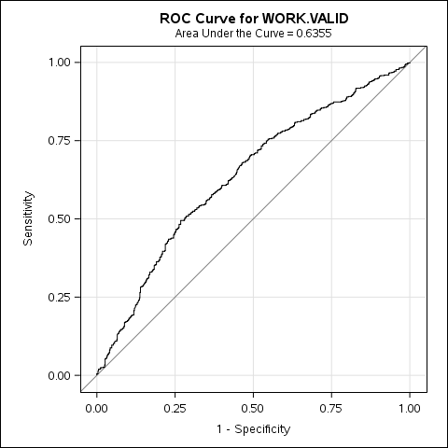

8.5.5. CART analysis on completers

For the purposes of comparison, a CART analysis was performed on the set of patients analysable in the logistic regression of section 8.5.4. That is patients for whom ACR20, baseline tender joint count, region (North America or Non North America), joint space narrowing score, number of previous DMARDs and race were not missing. The slight variation in overall totals is due to different seeds for random split of training and test sets between SAS and R and the subsequent numbers of patients deleted in the test sets. Results of CART completers analysis are shown in Table 8.9 and Figure 8.7. The sensitivity, specificity and accuracy of the predictions mirror those of the logistic regression, although the predictors are much fewer with just region and joint space narrowing score selected by the model.
Table 8.9 CART completers prediction results
 |  | Predicted |  | Total
 |  | Non-Responder | Responder | Total
Actual | Non-Responder | 293 | 223 | 516
Actual | Responder | 223 | 355 | 578
Total |  | 516 | 578 | 1094
Sensitivity |  | 0.61
Specificity |  | 0.57
Accuracy |  | 0.59

Figure 8.7 CART completers analysis
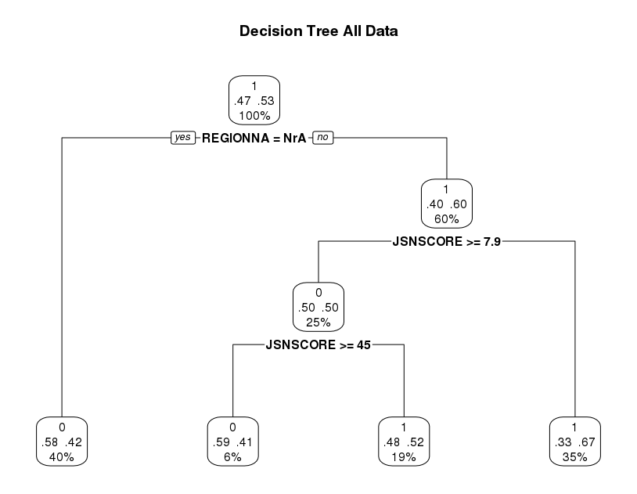

8.6. Exploratory Analysis

8.6.1. CART analysis on subgroups

Table 8.10 displays results of subgroup analyses performed to explore where prediction could be improved. Subgroup analyses were generated on each project separately as well as patients that had radiographic assessments and on patients on methotrexate control (MTX). Since smoking and Rheumatoid Factor were identified in Section 2.9 as risk factors for RA, the subgroup analyses were repeated on the group of patients where these assessments were available. Finally, further subgroup analyses based on groups of patients identified in the primary analysis were also explored.

Table 8.10 CART and Random Forest Subgroup Analyses
Subgroup | Train  N | ACR20  Response | CART Sensitivity | CART Specificity | CART Accuracy | Random Forest Accuracy
All patients
All patients | 8556 | 0.44 | 0.41 | 0.76 | 0.60 | 0.62
X-ray patients | 4849 | 0.43 | 0.57 | 0.65 | 0.62 | 0.66
Project A | 3165 | 0.47 | 0.65 | 0.53 | 0.58 | 0.66
Project M | 1737 | 0.53 | 0.52 | 0.58 | 0.55 | 0.61
Project O | 2084 | 0.49 | 0.59 | 0.57 | 0.58 | 0.59
Project T | 1570 | 0.24 | na* | na* | na* | 0.73
MTX patients | 2630 | 0.32 | 0.09 | 0.96 | 0.67 | 0.69
Smoking Status not missing
All patients | 8502 | 0.44 | 0.44 | 0.74 | 0.61 | 0.63
X-ray patients | 4849 | 0.43 | 0.44 | 0.77 | 0.63 | 0.66
Project A | 3165 | 0.47 | 0.58 | 0.59 | 0.58 | 0.62
Project M | 1737 | 0.53 | 0.50 | 0.64 | 0.57 | 0.62
Project O | 2084 | 0.49 | 0.54 | 0.64 | 0.59 | 0.60
Project T | 1289 | 0.24 | na* | na* | na* | 0.73
MTX patients | 2630 | 0.32 | 0.09 | 0.96 | 0.67 | 0.70
RF not missing
All patients | 3130 | 0.53 | 0.68 | 0.49 | 0.58 | 0.62
X-ray | 2311 | 0.57 | 0.66 | 0.54 | 0.61 | 0.62
Project A** | 0 | na | na | na | na | na
Project M | 1081 | 0.58 | 0.73 | 0.38 | 0.6 | 0.65
Project O | 2049 | 0.50 | 0.56 | 0.64 | 0.6 | 0.6
Project T** | 0 | na | na | na | na | na
MTX patients | 996 | 0.40 | 0.34 | 0.84 | 0.65 | 0.65
Other Subgroups
JSN Score < 0.5 | 984 | 0.59 | 0.79 | 0.34 | 0.64 | nd
BTJC < 7.5 | 819 | 0.21 | 0.12 | 0.92 | 0.77 | nd
BTJC <7.5 or JSN Score < 0.5 | 1764 | 0.42 | 0.74 | 0.72 | 0.73 | nd
RF= Rheumatoid Factor, JSN=Joint Space Narrowing, BTJC=Baseline Tender Joint Count
* Tree not computable
**Numeric RF not recorded

The primary CART analysis yielded a predictive accuracy of just 0.60 (marginally increased to 0.62 when applying random forest methodology). In addition to the primary analysis, CART was applied to each project separately. Whilst there were some variations in sensitivity and specificity, overall accuracy was poorer on projects A, M and O. A CART was not computable for project T as complexity parameter threshold could not be achieved, however the random forest led to an improved accuracy over primary analysis (0.73 vs 0.62). Project T is the oldest project, recruiting patients from 1998. It is also the project with the lowest ACR20 response (approximately 24%). In addition to looking patients project by project, CART was also applied to those patients on the control arm (Methotrexate background therapy) and on patients with x-ray evaluations. The overall accuracy for patients on methotrexate control arms was higher than the primary CART analysis but this was driven by high specificity at the expense of low sensitivity meaning that the analysis seems to over-select non-responders. Of the patients with x-ray evaluations of joints, there was little improvement in prediction accuracy.
In the description of the demographic data in Section 4.9, we can see that approximately 29% of patients do not have smoking data, however Section 2.9 discusses literature postulating the association between RA and cigarette smoking. Therefore, the subset of patients with data on smoking status were analysed as a subset. For this subset of patients, results were very similar across all available patients, by project and on methotrexate and x-ray patients.
Similarly, Section 2.8 describes how patients with active RA have significantly higher serum rheumatoid factor (RF) levels compared with those with inactive disease, and Section 4.8 shows 74% of patients without a numeric RF value. In all patients and subsets of patients no significant improvement was seen in prediction.
Based on CART primary analysis results, some small subgroups were explored. i.e. where BTJC <7.5 or JSN Score < 0.5. Some bigger improvements to overall accuracy of prediction could be seen (0.73, 0.77) but in a very small number of patients.
In most subgroups there was no significant improvement in overall accuracy, either from CART analysis or random forest. In the instances where accuracy reached 0.70 or more, this came at cost to sensitivity, i.e. the model selected fewer patients overall as responders.

8.6.2. CART analysis exploring study specific variables

The intent of this research was to identify biomarkers and baseline patient assessments that predict patient outcome for disease progression, and from these results to improve study design in RA clinical trials through patient selection. Therefore, study specific identifiers such as compound, protocol, drug were omitted in order to identify a set of biomarkers that might have a general application. Table 8.11 and Figure 8.8 show the results of including study specific variables. Compound, and specifically Compound T, was identified as a splitter in the first node of this tree, followed by drug type (MTX, Placebo vs Active treatment). This is perhaps not surprising where the development programs feature potent medicines, however this may have limited utility in predicting response in a new or general setting. With these parameters the sensitivity increased (0.41 to 0.56) but there was little change in specificity (0.76 to 0.73) and still accuracy remained modest (0.60 to 0.65).

Table 8.11 CART prediction results including study parameters
 |  | Predicted |  | Total
 |  | Non-Responder | Responder | Total
Actual | Non-Responder | 1140 | 429 | 1569
Actual | Responder | 558 | 721 | 1279
Total |  | 1698 | 1150 | 2848
Sensitivity |  | 0.56
Specificity |  | 0.73
Accuracy |  | 0.65

Figure 8.8 CART including study parameters
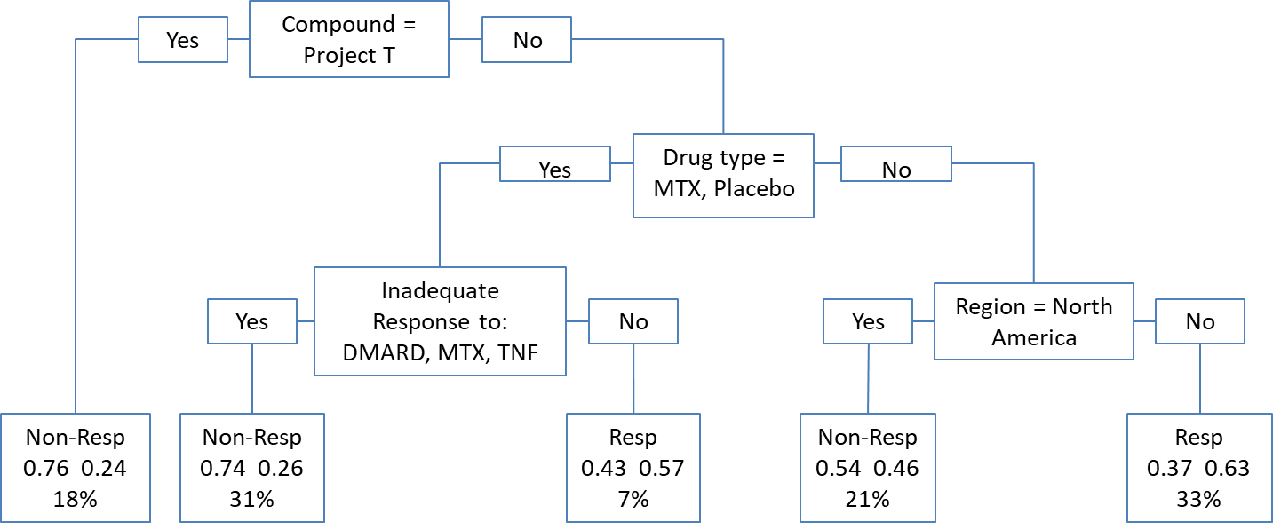
Given the impact of Project T in the previous analysis, the primary analysis was rerun excluding this project. Results can be seen in Table 8.12 and Figure 8.9. Here accuracy remains unchanged and there is an improvement in sensitivity balanced with a worsening of specificity.

Table 8.12 CART prediction excluding Project T
 |  | Predicted |  | Total
 |  | Non-Responder | Responder | Total
Actual | Non-Responder | 730 | 457 | 1187
Actual | Responder | 478 | 662 | 1140
Total |  | 1208 | 1119 | 2327
Sensitivity |  | 0.58
Specificity |  | 0.61
Accuracy |  | 0.60

Figure 8.9 CART excluding Project T
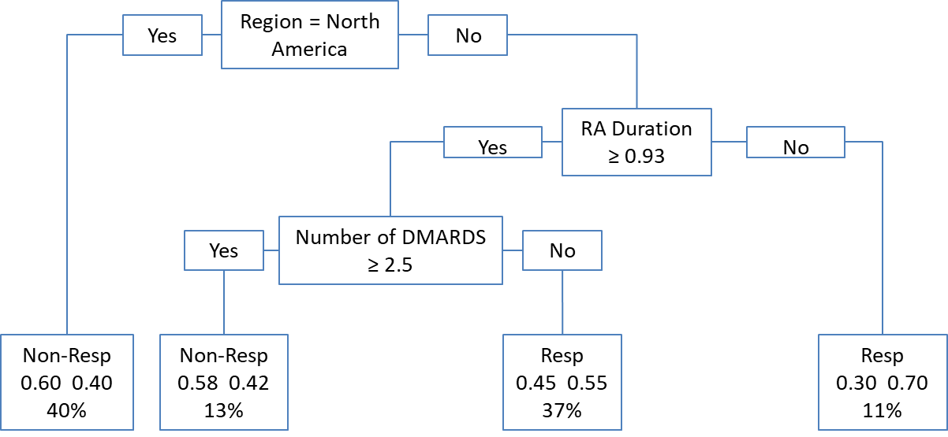

8.6.3. CART analysis on ACR components

The primary endpoint of this research is ACR20. As described in Section 3.3.1 the ACR20 is defined as a 20% reduction in: the number of swollen joints on a 68-joint count, the number of tender joints on a 66-joint count and in 3 of the 5 following criteria: patient’s assessment of pain, patient’s global assessment of disease activity, physician’s global assessment of disease activity, patient’s assessment of physical function and a markers of inflammation (i.e. ESR or CRP). Since the prediction for ACR20 was less than desirable, the ability to predict each of these 8 components as 20% response variables was investigated. Table 8.13 shows the sensitivity, specificity and accuracy of predicting each component when primary CART analysis is applied.

Table 8.13 CART summary of ACR components
 | Overall Response
20% response variable | Active | Control | Sensitivity | Specificity | Accuracy
ACR20 | 0.50 | 0.32 | 0.41 | 0.76 | 0.60
Tender joint count | 0.63 | 0.60 | 0.98 | 0.54 | 0.81
Swollen joint count | 0.64 | 0.60 | 0.96 | 0.56 | 0.82
CRP | 0.57 | 0.41 | 0.99 | 0.56 | 0.79
ESR | 0.61 | 0.44 | 0.92 | 0.52 | 0.75
Health assessment questionnaire | 0.50 | 0.43 | 0.85 | 0.48 | 0.67
Patient’s assessment of pain | 0.55 | 0.47 | 0.98 | 0.41 | 0.71
Physician’s global assessment of disease activity | 0.64 | 0.57 | 0.98 | 0.51 | 0.80
Patient’s global assessment of disease activity | 0.56 | 0.49 | 0.96 | 0.42 | 0.71

One can see that the sensitivity is very high for each of the components, indicating that responders are selected by the model with high probability. Conversely, specificity is lower than primary CART analysis for each component, indicating that fewer non-responders are correctly classified. Nonetheless, aside from health assessment questionnaire, overall accuracy of individual component classification is impressive and ranges from 0.70 to 0.82. Results were very similar to within 0.02 improvements when boosting and bagging methods are applied. Other than the Health Assessment Questionnaire Disability Index (HAQ-DI), these 8 components are not usually used individually for regulatory claims but do impact the patient (e.g. pain, tender joints, and global health). The HAQ-DI is occasionally filed as a secondary endpoint.

The tree nodes that were selected by applying CART to each component response can be seen in Table 8.14 and Figure 8.10 to Figure 8.17. Interestingly 3 of 5 nodes selected by the primary analysis, region, joint space narrowing score, and number of previous DMARDs, were not selected by any of the ACR component trees. Conversely, serum creatinine at baseline was selected as a tree node in 7 of 8 and baseline CRP was selected by 6 of 8 of the components but neither were selected by the primary analysis.

Figure 8.10 CART 20% Improvement in Tender Joint Count
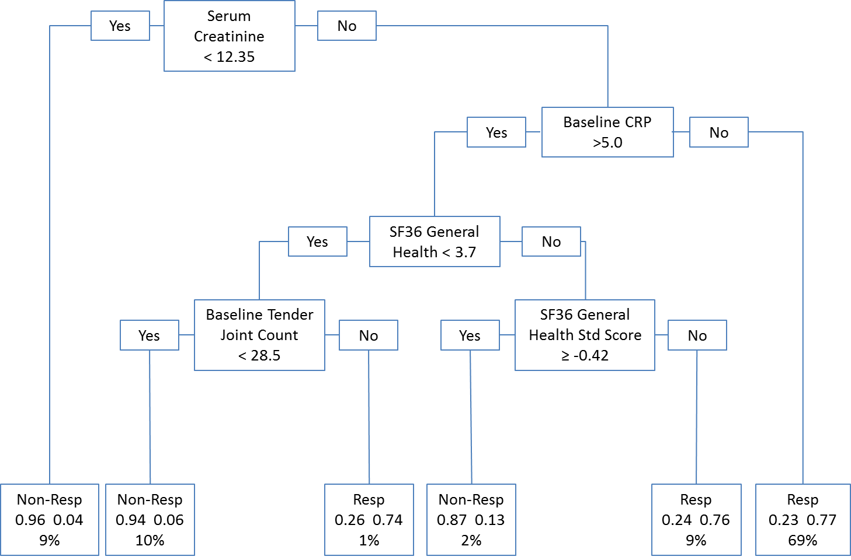

The first 2 nodes for swollen joint count are similar to tender joint count, but diverge somewhat as we progress further down the tree.

Figure 8.11 CART 20% Improvement in Swollen Joint Count
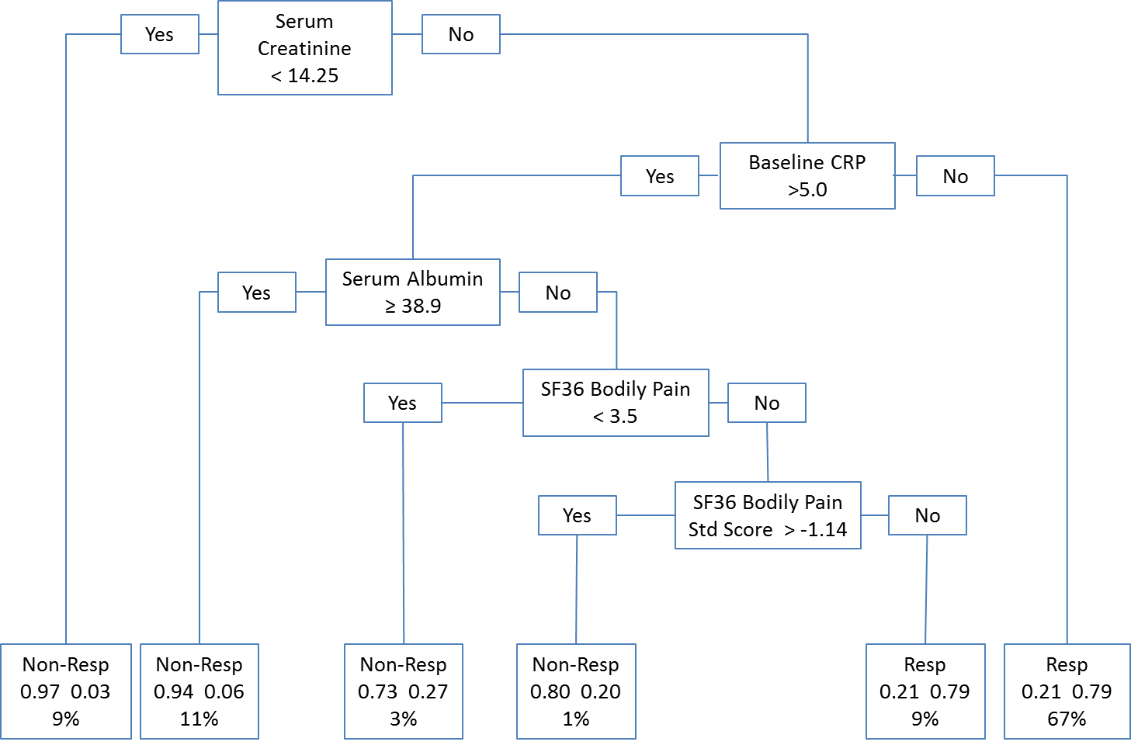

CRP has higher affinity with SF36 scores than perhaps other ACR20 components. Of note is that ESR, which is often interchanged with CRP in the calculation of ACR20 also includes SF36 Mental Component Score higher up in the hierarchy of nodes.

Figure 8.12 CART 20% Improvement in CRP
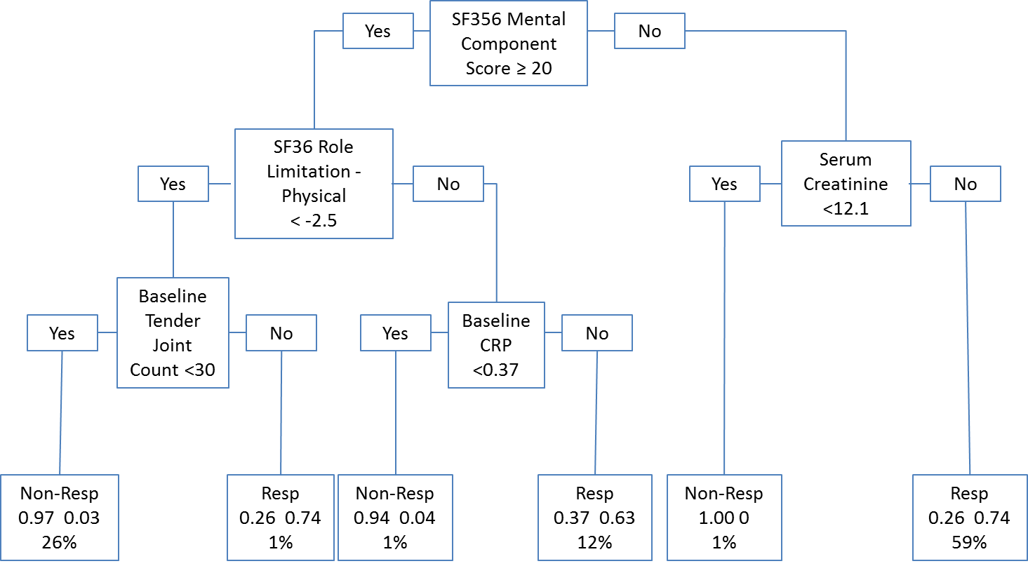

Figure 8.13 CART 20% Improvement in ESR
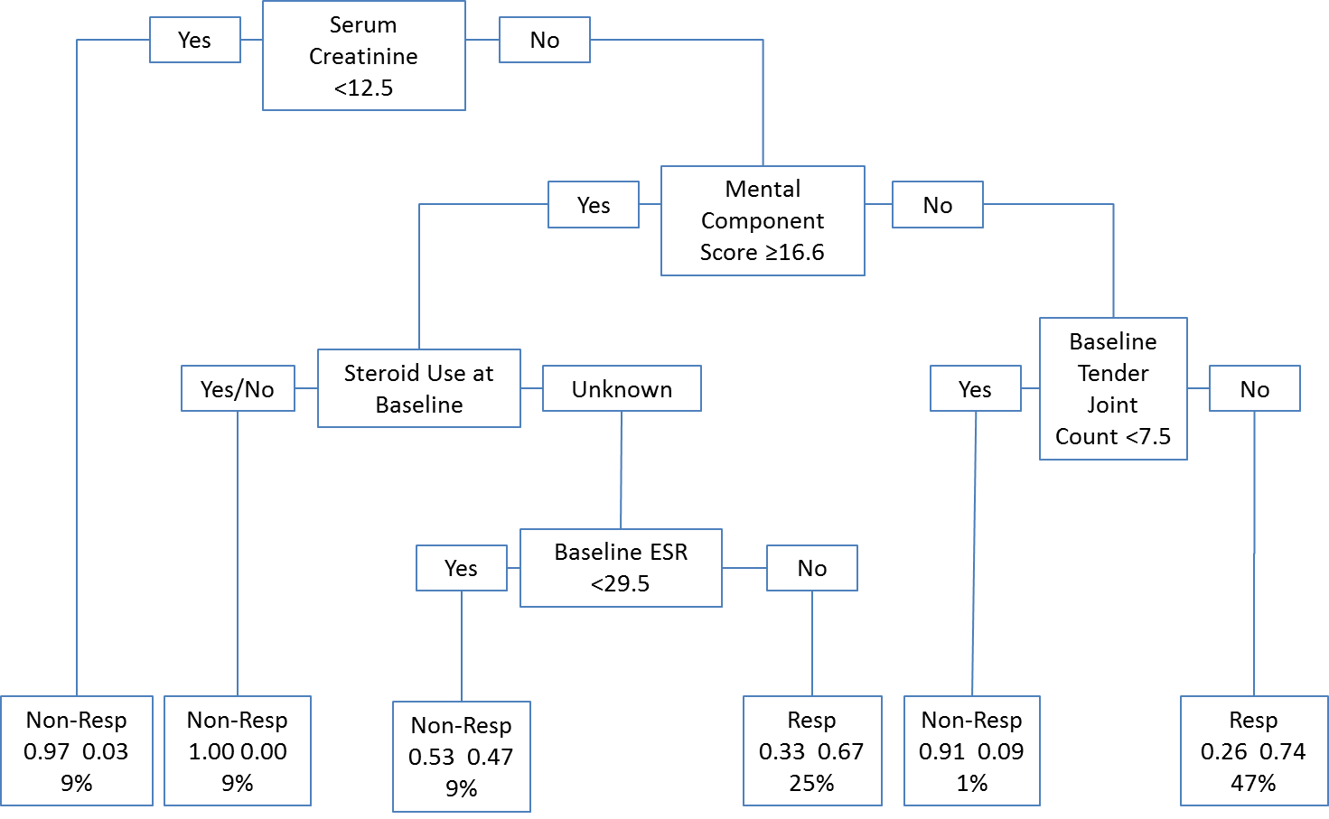

The HAQ has a small number of nodes selected in order to predict the response

Figure 8.14 CART 20% Improvement in HAQ
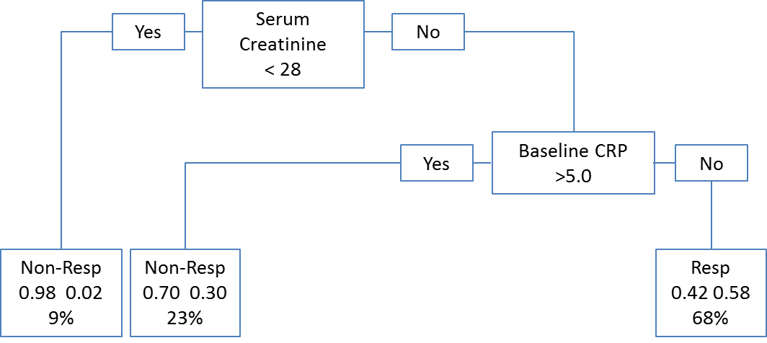

Also of note, perhaps intuitively, is that patient’s assessment of pain is predicted by baseline bodily pain and bodily pain standardised score from SF36 (with 0.71 accuracy).

Figure 8.15 CART 20% Improvement in Patient's Assessment of Pain
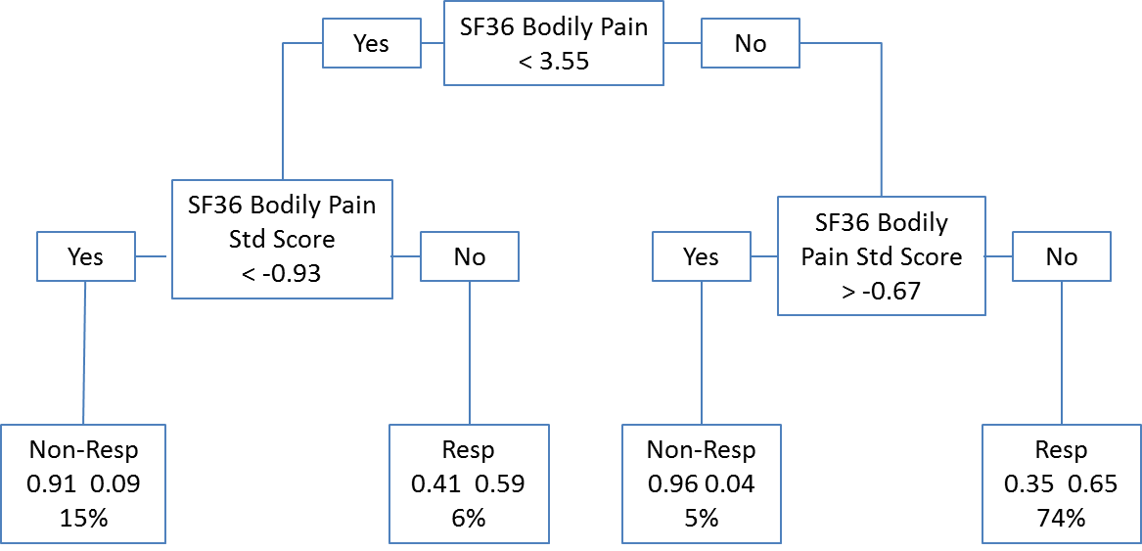

Patient’s and physician’s global assessment of disease activity share some similar nodes (serum creatinine and baseline CRP) at the top of their respective trees.

Figure 8.16 CART 20% Improvement in Physician's Global Assessment of Disease Activity
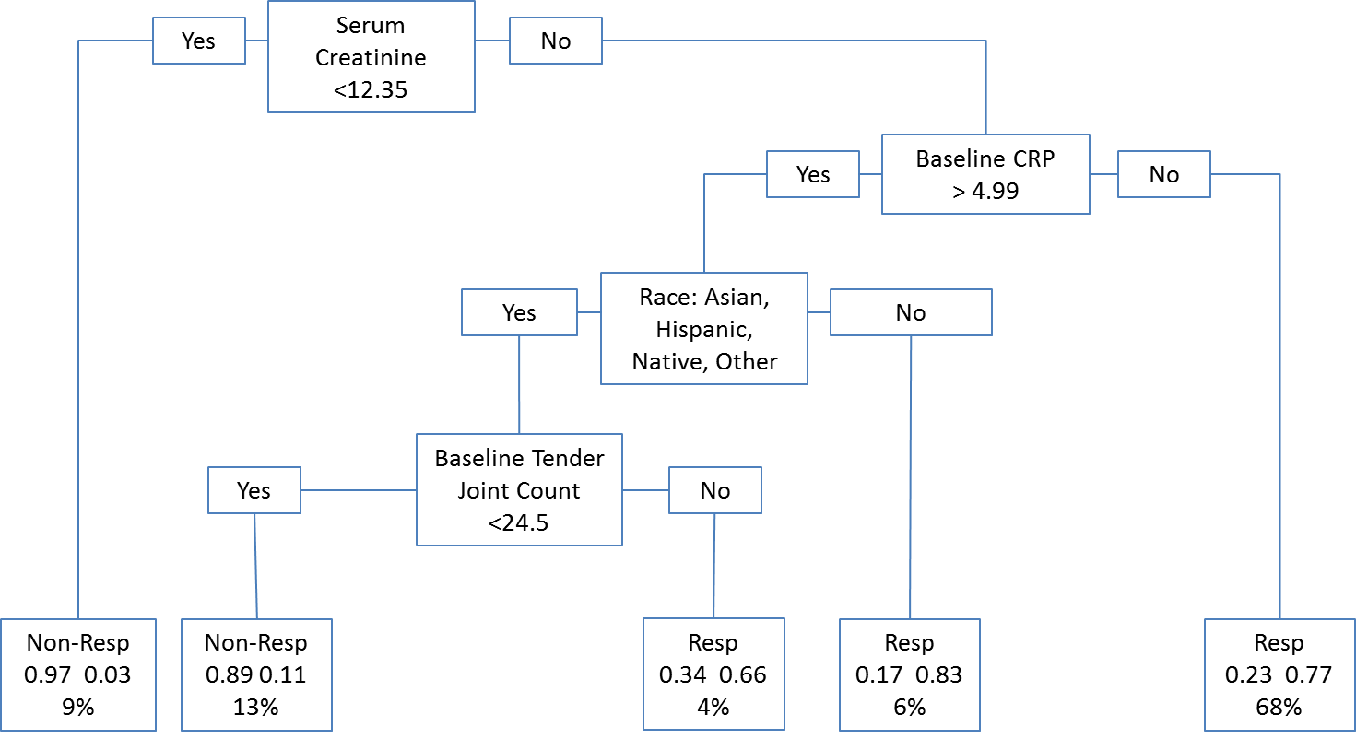
Figure 8.17 CART 20% Improvement in Patient's Global Assessment of Disease Activity
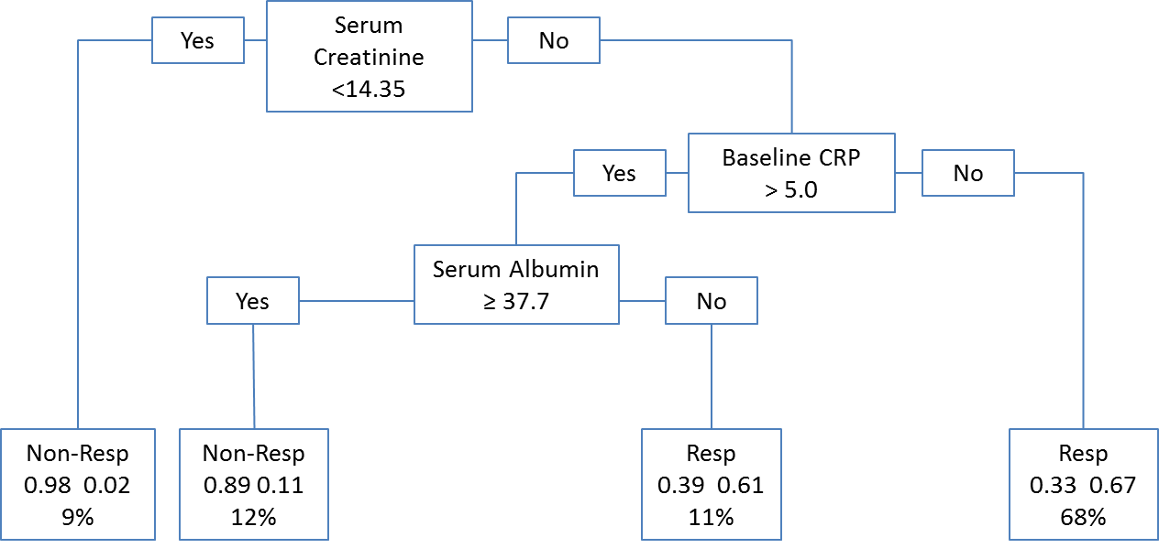
Table 8.14 Tree nodes from CART analysis of ACR components
20% response variable | Tree nodes (in order of importance)
ACR20 | Baseline tender joint count  Region  Joint space narrowing score  Number of previous DMARDs  Race
Tender joint Count | Serum creatinine  Baseline CRP  SF36 general health  Baseline tender joint count  SF36 General health standard score
Swollen joint Count | Serum creatinine  Baseline CRP  Serum albumin  SF36 Bodily pain  SF36 Bodily pain standard score
CRP | SF36 Mental component score  SF36 Role limitation - physical standard score  Serum creatinine  Baseline tender joint count  Baseline CRP
ESR | Serum creatinine  SF36 Mental component score  Steroid use at baseline  Baseline tender joint count  Baseline ESR
Health assessment questionnaire | Serum creatinine  Baseline CRP
Patient’s assessment of pain | SF36 Bodily pain  SF36 Bodily pain standard score
Physician’s global assessment of disease activity | Serum creatinine  Baseline CRP  Race  Baseline tender joint count
Patient’s global assessment of disease activity | Serum creatinine  Baseline CRP  Serum albumin

8.6.4. Logistic regression with multiple imputation

As discussed in simulations in Section 7.7, the management of missing values by logistic regression was a significant disadvantage compared to CART which ameliorates the effect of missing data through identification of surrogate splits.
In this section we applied multiple imputation to explore whether the results of logistic regression could be improved. In section 4.7 we investigated the amount of missing data in the available clinical dataset. We noted that some of the missing data is by design, i.e. where data on a particular variable was not collected in all studies and other data was missing at random. In the first step of multiple imputation we identified structurally missing data such as x-rays, i.e. data that was not collected by design of the study protocol. Variables not identified as structurally missing, we considered as missing at random. In the second step, we split the available dataset randomly into a training dataset (75%) and a test dataset (25%). For the training dataset we imputed missing values through multiple imputation using the SAS procedure PROC MI. Imputed values are generated by regression (linear or logistic as appropriate). By default, this method generates 5 iterations of imputed data. Since we had so many variables and so many missing data points, 25 iterations were applied, yielding 25 imputed datasets. A forward stepwise logistic regression was performed on each of the 25 imputed datasets using strict entry and exit criteria of 0.001, as informed by the simulations in Chapter 7. The results were combined into a single model using SAS procedure PROC MIANALYZE. The coefficients of the final model were the arithmetic mean of the individual coefficients estimated for each of the 25 logistic regression models. The parameters identified in the final model then applied to the non-imputed test dataset.
When we applied the above steps to the clinical data, the 25 iterations of logistic regression selected similar but not the same variables in the models. The final combined model from PROC MIANLYZE included:
- Region (North America, Non North America);
- Inadequate Response Population (MTX IR, DMARD IR, TNF IR, No IR);
- Year of Enrolment;
- Drug Type (MTX, Placebo, Active);
- Baseline Patient Global Score;
- SF36 Pain interfere with work.
These variables were then included in a predictive logistic regression model (Table 8.15). Even though the test data set was not imputed only 9% of the data was lost due to missing values (2730 out of 2926).
Table 8.15 Logistic Regression prediction results with multiple imputation
 |  | Predicted |  | Total
 |  | Non-Responder | Responder | Total
Actual | Non-Responder | 1168 | 376 | 1544
Actual | Responder | 550 | 636 | 1186
Total |  | 1718 | 1012 | 2730
Sensitivity |  | 0.54
Specificity |  | 0.76
Accuracy |  | 0.66

The overall accuracy of the predicted model of 0.66 is a little better than non-imputed CART (0.60) and non-imputed logistic regression models (0.59), however the magnitude is still modest.

8.6.5. CART analysis with multiple imputation

For completeness and for the purposes of comparison, the training dataset generated through multiple imputation in section 8.6.4 was applied to CART and the resulting CART model was used with the test dataset to predict outcome. Results in Table 8.16 and Figure 8.18. Note the total number of patients differ to results in Table 8.15 due to handling of missing values present in test dataset.
Table 8.16 CART prediction results with multiple imputation
 |  | Predicted |  | Total
 |  | Non-Responder | Responder | Total
Actual | Non-Responder | 1309 | 308 | 1617
Actual | Responder | 814 | 427 | 1241
Total |  | 2123 | 735 | 2858
Sensitivity |  | 0.34
Specificity |  | 0.81
Accuracy |  | 0.61

Figure 8.18 CART analysis with multiple imputation
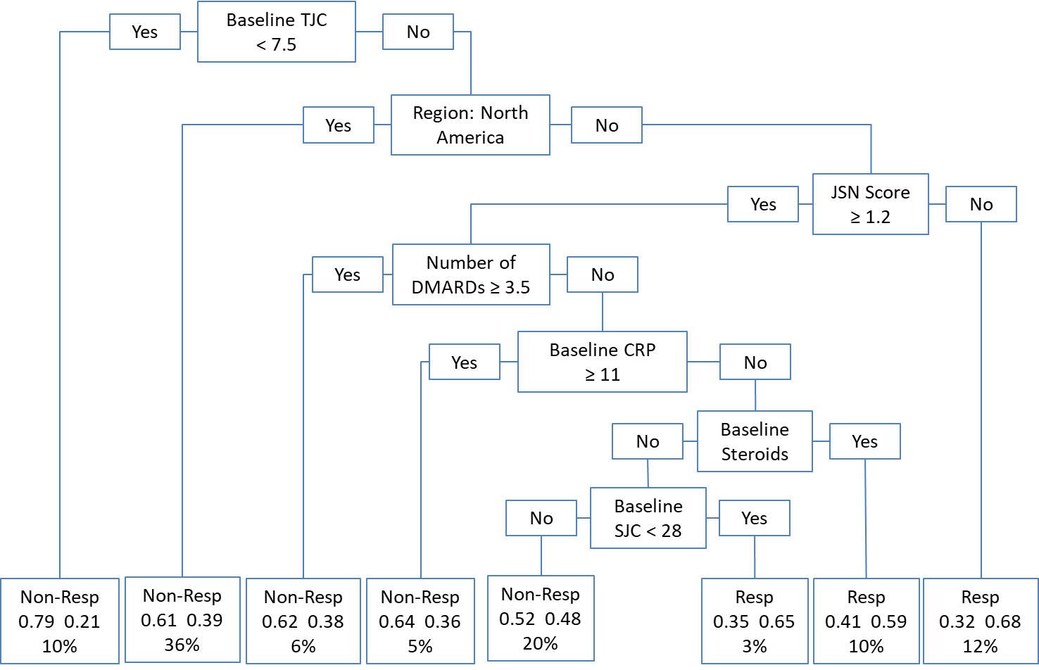
TJC= Tender Joint Count, SJC= Swollen Joint Count
In this analysis with multiple imputation the first 4 variables mirror that of the primary CART analysis (Baseline Tender Joint Count, Region, Joint Space Narrowing Score, Number of previous DMARDs). This similarity is not a surprise as the data originates from the same source. The tree begins to differ with the Baseline CRP node, however race is selected as a surrogate in the detailed analysis. Since the multiple imputation generates 25 datasets the resulting tree is able to include additional nodes before stopping rules are activated. Compared to the primary CART analysis the results are very similar (sensitivity 0.34 vs 0.41, specificity 0.81 vs 0.76, accuracy 0.61 vs 0.60), so in this situation little is to be gained by CART in applying multiple imputation methodology.

8.7. Summary

In this chapter we have presented the results of the CART analyses to predict patient response in the RA clinical trial database. The primary CART analysis, considering all available baseline and biomarker variables on all patients, generated a model that had an overall predictive accuracy of just 60%, although the explanatory variables selected in the model seem plausible for predicting patient outcome: a baseline tender joint count, region, joint space narrowing score, number of previous DMARDs and race. Of note, was that baseline swollen joint count was a good surrogate for baseline tender joint count (agreement 0.912), another strong surrogate was baseline CRP for number of DMARDs (agreement 0.866).
Analysing the same patient population using random forest, bagging and boosting selected many of the same variables as important predictors but did little to improve predictive performance.
Subgroup analyses by project, on patients with radiographic data, on control group (methotrexate), by smoking status and by rheumatoid factor saw some fluctuations in sensitivity and specificity also did little to improve overall predictive performance.
As expected from simulations in chapter 7, a logistic regression analysis deleted too many patients to be able to conduct a stepwise analysis, thus justifying the selection of CART. As a further exercise, a logistic regression analysis was performed using the 5 variables identified by the primary CART analysis and using training and test datasets (Section 8.5.4). Even so, more than 60% of these data were excluded from the analysis due to missing data. The predictive performance of logistic regression proved to be similar to the CART analysis.
The intent of this research was to identify biomarkers that might have a general application, therefore study specific variables were excluded from the above analyses. When study specific variables were allowed back into the model, compound, and drug type were primary and secondary splits in the tree, however performance of the model was still not impressive even when the oldest and least potent project (Project T) was excluded.
Handling of missing values has been identified as a significant disadvantage of logistic regression especially as compared to CART, and was an important factor in selecting an appropriate method. A further exploratory analysis was therefore conducted whereby multiple imputation was performed on a training subset of the data to build a predictive model, and then applied to a non-imputed test set. Whilst this allowed an unrestricted forward stepwise model to be conducted, good prediction of ACR20 still remained elusive.
In order to make fairer comparisons between CART and logistic regression with respect to handling of missing values, CART analyses were additionally performed on completers and on multiple imputed datasets (Table 8.17).
Table 8.17 Summary of CART and Logistic regression methods on ACR20
Method | Sensitivity | Specificity | Accuracy
CART Primary | 0.41 | 0.76 | 0.60
CART on completers | 0.61 | 0.57 | 0.59
CART on imputed data | 0.34 | 0.81 | 0.61
Logistic Regression on completers | 0.61 | 0.57 | 0.59
Logistic Regression on imputed data | 0.54 | 0.76 | 0.66

Nonetheless, overall accuracy across CART and logistic regression on raw data, complete records (on a limited subset of variables), or on multiple imputed data remained within a low, narrow range (0.59 to 0.66). Logistic regression with imputation has a slight edge over the other methods, but this comes with a number of assumptions and decisions to make such as, how to model the distribution for regression, deciding which variables are missing at random, missing completely at random or not missing at random.
Although it was not an aim of this PhD, prediction of classification of ACR20 components was much more accurate, mostly driven in all components by sensitivities ranging from 0.85 to 0.99. There was some consistency in variables selected as tree nodes for the component scores but little consistency with overall ACR20 classification.
Although there is relatively high accuracy of classification of the component scores, there is still variation in node selection between components. The ACR20 is a reductive measure to summarise patient response in a systemic, multi-faceted, chronic disease. This variation may indicate a certain insensitivity of the ACR20 and the ability to predict outcome.
In the next chapter we will reflect on these results and their relevance for future clinical trials in RA.

: Discussion and Conclusions

9.1. Introduction

Rheumatoid Arthritis (RA) is the most common inflammatory joint disease. It is a systemic, chronic, destructive, autoimmune disorder of unknown cause and no known cure. There is a considerable variation of disease occurrence and expression among different populations and groups of patients. RA is a multi-factorial disease with many postulated factors influencing onset, severity and outcome.

There is extensive research on the disease and a significant amount of studies on the triggers and factors influencing duration and severity of the disease. The risk factors discussed in literature include gender, age, smoking, diet, ethnicity, and genetic factors. Studies investigating factors are largely limited to utilising univariate methodology, very few employ multivariate methods and even less consider the relationships between explanatory markers.

When developing a new medicine, a question a clinical development team may wish to explore is what lessons can be learnt from past clinical development experiences. In particular, when there is in-house experience in the disease area, whether this valuable information could be used for the development of a new asset in the most efficient way.

This thesis pursued 3 objectives;
- To identify the statistical or data mining method that best identifies biomarkers;
- To identify biomarkers and baseline patient assessments that predict patient outcome for disease progression;
- From these results to improve study design in RA clinical trials through patient selection and collection of most relevant data points attempted to predict patient response from data available at enrolment in clinical trials.
If successful, this would lead to more efficient study designs that would take into account a patient’s likelihood of response by, for example, inclusion criteria and or stratification of analyses. Chapters 2 and 3 set the scene for this thesis by describing the disease of RA as well as how clinical trials are designed to demonstrate the effectiveness of investigational drugs. The clinical trial data available for exploitation in this thesis was described in Chapter 4. This is a large dataset pooled across 16 trials in 4 drug development programs, in this selection, any findings could potentially be generalised and applied to future programs.

9.2. Main findings

From the disease background and in particular the description of RA clinical trials and regulatory pathways, it was clear that the ACR20 would be the endpoint of interest for prediction.
Since the ACR20 is a dichotomous response endpoint, then this became an exercise in classification. Chapters 5 and 6 explored and explained various data mining and statistical methods for classification. Chapter 5 focussed on a selection of methods of interest, whilst Chapter 6 described the outcomes of systematic reviews to identify methods applied in RA. In Chapter 6 it became clear that based on the features of the available clinical trial dataset, that logistic regression and CART would likely be the best methods for classification. Therefore, Chapter 6 went on to describe a systematic review on comparisons of CART and logistic regression not restricted to a RA setting.
In the next step, Chapter 7 aimed to reduce the number of methods to a single choice based upon performance in simulated data with known correlations and structure. In Chapter 8, the winner, CART was applied to the clinical trial dataset.
Chapter 1 laid out 3 specific objectives for this research:
- Identify the statistical or data mining method that best identifies biomarkers;
- Identify biomarkers and baseline patient assessments that predict patient outcome for disease progression;
- Improve study design in RA clinical trials through patient selection and collection of most relevant data points.
The next 3 sections summarise how this research addressed these objectives.

9.3. Objective 1: Choice of statistical or data mining method that best identifies biomarkers

This objective was approached by considering the following steps in section 1.2:
- Review and describe data mining methodologies for classification;
- Systematically review available literature for multivariate methods identifying risk factors for RA;
- Through the application of simulations, identify the best classification method for selecting risk factors.
Methods that were considered included:
- CART (including Boosting Bagging and Random Forest);
- k-nearest neighbour classification;
- support vector machines;
- logistic regression (including Lasso and Ridge Regression);
- principal components;
- cross validation.
Systematic reviews revealed a few other methods that have been utilised in RA data, but these were not relevant in predicting a dichotomous outcome, such as ACR20.

In identifying and choosing a suitable method for classifying ACR20 response, I developed a shortlist of characteristics based upon general preferences and features I recognised in the available RA clinical trial dataset, and that I thought were important.
These were:
- Ability to handle ‘mixed’ data;
- Handling of missing values;
- Robustness to outliers;
- Computational scalability;
- Interpretability;
- Ability to manage high dimensionality.

Table 9.1 Selection assessment for method selection
Characteristic | CART | k-NN | SVM | Logistic Regression | Principal Components
Can handle ‘mixed’ data | Good | Poor | Poor | Good | Good
Handling of missing values | Fair | Fair | Poor | Fair | Poor
Robust to outliers | Good | Good | Poor | Fair | Fair
Computational scalability (Large N) | Good | Poor | Poor | Good | Good
Can manage high dimensionality | Good | Poor | Poor | Good | Good
Interpretability | Fair | Good | Poor | Good | Fair

Based on these criteria, I considered CART and logistic regression to be the most preferred methods for an RA dataset (Table 9.1).

9.3.1. Systematic Reviews

As mentioned in the previous section, systematic reviews were conducted to reveal which data mining and statistical methods I thought would be useful in classifying ACR20 response. Whilst restricting searches to an RA setting, the search terms for methods aimed to be broad. The terms used to search for methods were: CART, Multivariate analysis, Classification, Discriminant analysis, Cluster analysis, and Factor analysis. One could have considered not restricting the searches to just RA, however I considered the number of methods identified to be sufficient even if the search would not be considered exhaustive. However, when comparing the shortlisted methods of CART and logistic regression, no therapeutic area restriction was applied, some articles were identified outside of the field of medicine.

Although articles were identified that used most of these methods in literature, none were used in the context of predicting ACR20 or dichotomous response in a RA dataset. Therefore, to the best of my knowledge, this thesis addresses a gap in known research.

9.3.2. Simulations

A substantial number of simulations were conducted to explore the performance of logistic regression and CART in selecting variables with known high correlations to a dichotomous response variable. In the simulations 100 explanatory variables were generated, 10 of which were highly correlated with response and 90 with low correlation with response. In the simulations, over a thousand scenarios, replicated 100 times, were created ranging in size from 100 to 10,000 simulated patients (Appendix C.3). The computational intensity of the simulations was challenging. For the larger simulated patient datasets (N= 10,000), each scenario of 100 repetitions could take 200 to 300 minutes of processing time. Each run of the simulations could take 2 to 3 days, with frequent, unpredictable early terminations of the submitted program, due to memory limitations even on a Unix network. Scenarios were created by: varying the size of data sets, varying the level of high and low correlations with response, creating continuous and then dichotomous explanatory variables, and generating missing data. The scenarios generated were not an exact match for the available clinical trial dataset, nor were they exhaustive. Correlations for example were extended beyond that seen in the data, however in other respects such as types of variables and missing data rates, I considered the simulations to be anchored in the real world data. Therefore, I believe the simulations to be a valuable tool in selecting an analysis method.
In the course of generating simulations, I created, developed and used VaSe plots to compare the performance of the chosen methods in being able to select higher correlated variables. In the example VaSe plot (Figure 9.1), higher performing methods will plot closer to the top right hand corner. The advantage of this type of display is that the reader can quickly compare the performance of multiple methods. I found this very useful when looking at the multiple plots in chapter 7, for example to visually see how changing the sample size from 100 to 1,000 to 10,000 affected the accuracy of selecting highly correlated variables and not selecting lower correlated variables. A potential disadvantage is that these plots are potentially confused with Receiver Operating Characteristic curves, so care has been taken in the text when describing results of variable selection.
Figure 9.1 Example VaSe plot
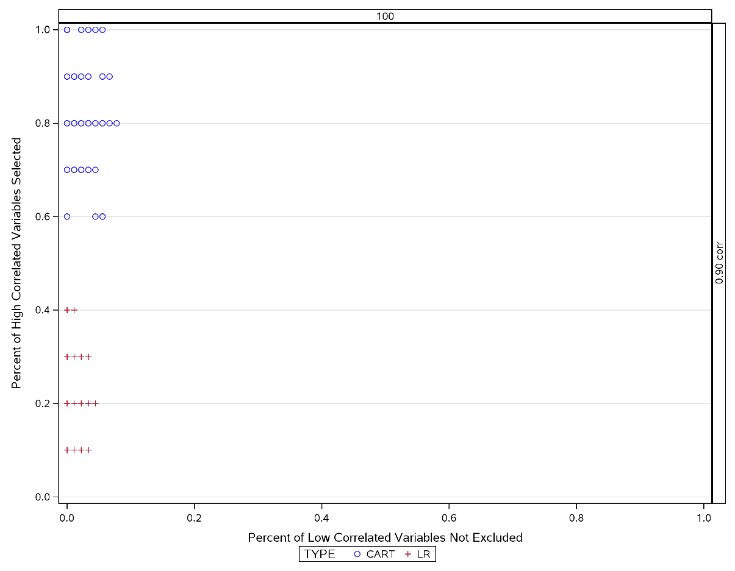
In almost all cases, we saw that CART usually outperforms logistic regression in variable selection. The few scenarios where logistic regression outperforms CART are those that are least likely such as where the lower correlated variable are at a minimum of 0.0 correlation with the response and the higher correlated variables are correlated at a maximum of 0.90 with the response.
CART seemed to be particularly robust to missing values in the dataset. Logistic regression on the other hand, lost much of the data through listwise deletion so that with even a small rate of missing of just 1%, over 63% of the data was ignored. Higher rates of simulated missing data became untenable for a logistic regression analysis.

9.4. Objective 2: Identification of biomarkers and baseline patient assessments that predict patient outcome

This objective was approached by considering the following steps in section 1.2:

- Describe the epidemiology, aetiology and diagnosis of RA, as well as risk factors and assessments of disease activity;
- Collate and describe the available clinical data;
- Apply the best method from simulations to clinical database.

The background research, data processing, systematic reviews, methods research, and simulations in this thesis led to the analysis in Chapter 8. This was a planned and systematic process with the aim to be able to present robust, repeatable results. As identified in the systematic reviews, there is a gap in the literature concerning the prediction of ACR20 for patients with RA. In Chapter 8 CART was implemented to attempt to classify ACR20.
The primary model identified baseline tender joint count, geographic region, joint space narrowing score, number of previous disease modifying anti-rheumatic drugs and race as the most important variables for predicting ACR20. Whilst these seem to be quite plausible features for disease response the prediction accuracy was disappointing at just 60%. The model identified just 41% of those patients who responded to treatment (sensitivity), although it was better at recognising non-responders at 76% (specificity). Enhancements to CART procedure (Bagging, Boosting and Random Forest) did little to improve accuracy of prediction. Further exploratory analyses looking at subgroups such as drug project, smoking status, or rheumatoid factor, also had little effect on improving prediction.
The primary model originally excluded study specific variables in the hope that a model generated could be applied generally. In an exploratory analysis, I decided to implement CART on a dataset that included compound, protocol number and drug type. As may be expected in a dataset featuring approved medicines for RA; compound and drug type featured as primary and secondary splitters of the tree. However, performance of prediction changed little. In a further analysis, Compound T (the oldest and least potent compound) was excluded from the data and again there was no improvement in prediction. I found this result consistent with the primary CART analysis in that baseline tender joint count and region from the primary analysis were good surrogate splitters for compound and drug type, indicating good interchangeability of these variables and I believe explains the similar prediction accuracy between analyses.
As I expected from simulations, a naïve forward selection logistic regression, listwise deleted all of the data from the analysis. Nevertheless, when I applied logistic regression using just those variables selected by the primary CART analysis, I found the prediction accuracy remained almost unchanged. A rationale for this may be that when the 2 methods are able to use the same level of information from the dataset (without over deletion) then their performance is similar.
CART manages missing data by identifying surrogate variables for those chosen in the tree, so that when it comes to prediction, more of the data is utilised. In a dataset of this type where missing data are a prominent feature, this gives a distinct advantage for CART over logistic regression. Methods exist to deal with missing data, from complete case analysis to single imputation to multiple imputation. In order to tip the balance more in favour of logistic regression, I did some further investigation through implementing multiple imputation. I did this by applying multiple imputation on a training set, on which a logistic regression model was re-generated, and then used this predictive model to a non-imputed test set. In this scenario, logistic regression performed very similar to CART, albeit with a different but overlapping set of predictor variables.
The use of multiple imputation for logistic regression enabled the effective use of the method. Since missing data are imputed from other variables, the full information is used in the data, as does surrogate splitters in CART. With logistic regression now able to utilise the richness of the full information in the training data set, this could explain the equity of prediction performance between the 2 methods. With these results being so similar, I would still favour one one-step approach of CART over a two-step logistic regression with multiple imputation. Multiple imputation route is more reliant on assumptions and choices such as: how to model the distribution for regression, deciding which variables are missing at random, missing completely at random and not missing at random.
Although not an aim of this PhD, we did see though some interesting results with high accuracy when considering the 8 ACR20 components separately. Sensitivity was very high (range 0.85 to 0.99) for all components individually, although specificity was lower, the overall accuracy was improved across all components compared with the ACR20 composite endpoint.
Notably each of the individual component’s trees varied but variables such as baseline serum creatinine, baseline CRP, baseline tender joint count were selected by at least half of the components.
As described in Section 3.3.1 the ACR20 is a binary, dichotomised endpoint, calculated by a composite algorithm. This algorithm includes in its calculation swollen and tender joint counts for all patients, but then the best 3 of the 5 remaining measures for each calculation. The impact being that the precise calculation will vary from patient to patient. Add to that the convention that missing patients are considered to be non-responders, may lead to ACR20 being too blunt an instrument to predict. Dichotomised endpoints, particularly those dichotomised from continuous data have issues with efficiency (Senn & Julious, 2009). In a simple setting of a single dichotomised endpoint, maximum efficiency is no more than 64%, less if the dichotomisation is not at the median value. For ACR20, the dichotomisation is not at the median but rather at an arbitrary value (20%), in addition multiple dichotomies are created, perhaps compounding the inefficiency of the endpoint.
The high prediction rates for each of the components of ACR20 would seem to bear out the description of ACR20 as a blunt instrument and supporting the assertion that multiple dichotomisation compounds inefficiency. The improved prediction of the components also suggests that the methods are valuable, but the choice of classifier unyielding. On reflection it might be that the simulations conducted in Chapter 7 were more reflective of a simpler constructed response variable, than of the composite endpoint that is the ACR20.
In my view the clinical relevance of the results of chapter 8 are mixed. ACR20 is a well-established, well understood and accepted endpoint for measuring improvement of RA in the context of clinical trials and development strategies for gaining regulatory approval for RA medicines. In clinical practice, in interactions between patient and physician, it is of little utility, usually their interest is of disease state (e.g. DAS28) or on a focus with a particular symptom (e.g. tender joints, pain). So in my opinion in the context of relevance in a clinic setting, the results seen in improvements in specific symptoms could be useful, and might enable a physician to predict what sort of improvements a patient might expect in 6 months.
If we had seen strong prediction results for ACR20, then I would argue there is clinical relevance for clinical trial design (see enrichment discussion in next section). In chapter 8, the prediction of ACR20 is not strong, and possibly because of this weakness, the selection of predictors is something of a moving target. In the primary model, baseline tender joint count, region, joint space narrowing score, numbers of DMARDs and race were nodes on the developed tree and I judge these to be clinically feasible predictors of outcome. However, baseline tender joint count could adequately be replaced by the surrogate baseline swollen joint count and number of DMARDs replaced by baseline CRP. If we accept exploratory analyses, then by allowing study specific parameters in the dataset; then compound, drug type and population type become important predictors (with same level of prediction). So it is still a little unclear what recommendation for choice of predictor one could make to predict ACR20.

9.5. Objective 3: Improvement in study design in RA clinical trials through patient selection and collection of most relevant data points

This objective was approached by considering the previous objectives and the following step in section 1.2:
- Review current designs of clinical trials in RA and strategies for approval;
In 2012, the US Food and Drug Administration (FDA) published a draft guidance on enrichment strategies for clinical trials (FDA, 2012). The guidance defines enrichment as “the prospective use of any patient characteristic to select a study population in which detection of a drug effect (if one is in fact present) is more likely than it would be in an unselected population”, where characteristics can be drawn from demographic, pathophysiologic, historical, genetic or proteomic, clinical, and psychological sources. By recruiting patients with a higher likelihood of having a certain event can lead to a higher effect size, reduce heterogeneity and lead to smaller more efficient clinical trials. In a clinical study which incorporates an enrichment design, patients are screened for the presence (or absence) of a biomarker or characteristic. Only these patients are randomised into the trial. In these studies, the safety, and benefit of the treatment only within this patient segment is assessed. Where the presence of the marker or characteristic is low (<30%), great savings can be made in cost of clinical trials versus all-comer designs.
The FDA guidance notes trastuzumab (Herceptin) as an example of enrichment in metastatic breast cancer. Patients with high HER 2/neu expressing tumours -- about 25% of all breast cancer patients, achieved significant survival of 5 months versus less than 2 months' survival in all-comers. “The strategy of focusing part of the trial on the specific population of patients with high HER 2/neu-expressing tumours ultimately supported use of the drug in the marker-selected population despite the significant cardiotoxicity that emerged," the guidance notes.
Enrichment designs are usually implemented when there is strong evidence that patients will respond in a biomarker defined subpopulation. Enrichment designs can avoid dilution of the effect of intervention caused by patients not expected to respond. Results of these trials therefore are only applicable to this restricted population, whilst the treatment effect in the general population would remain unclear. In the context of personalised healthcare, medicines developed through enrichment strategies, might be expected to have increased certainty of response. For payers, such as the NHS in the UK, this would be appealing and economic savings may be gained by not treating patients unlikely to respond. For pharmaceutical companies a premium price could be negotiated without additional burden on healthcare systems. To take this approach however there needs to be strong belief in the biomarkers, otherwise it could be that patients not selected for trials might still have had a reduced, but still valuable, response to treatment.
Due to the low predictive accuracy of prediction of ACR20 as discussed in Chapter 8, my assessment is that this objective was not achievable with the data available and in this thesis.

9.6. Main Thesis Strengths and Achievements

I maintain that this research is based on sound planning and a thorough investigation into data from an RA population. Based on systematic reviews and best available knowledge, this thesis appears to be the only research attempting to predict RA patient response with respect to ACR20, and is the first research that compares CART and logistic regression in variable selection in an RA setting. As far as I am aware this is the only research that has used a dataset of this size and type to attempt to predict RA response.
In general, I found little research in predicting patient outcomes as measured in RA clinical trials. The systematic review in Section 6.3 found just one article that used DAS28 to discriminate between active and quiescent disease and another that used disease activity to correlate with serum secreted phospholipase. Just one author directly attempted to predict patient outcomes from clinical biomarker data. Van der Helm et al (van der Helm, 2007) used logistic regression to predict progression to full RA from early undifferentiated arthritis using baseline characteristics, this research was not affected to the same extent by missing data.
This research used a large comprehensive dataset to develop evaluation criteria for selecting the most applicable method for predicting ACR20. Whilst these criteria were specifically selected due to the nature of the available dataset, features such as missing data, mixed data types will be common to other clinical trials in other diseases.
In the simulations, this thesis compared the performance of CART and logistic regression in being able to select highly correlated variables in a large and high dimensional dataset. This research developed the variable selection (VaSe) plots to enable visually the comparative performance. I generated datasets under known conditions and varied correlation structure, number of patients, types of variable and rates of missing value. Within the scope of the simulations I conducted, CART outperformed logistic regression in most scenarios. Even with enhancements to logistic regression by amending significance levels for entry and staying CART was still unbeaten. In my judgement, there was not a need to improve performance by applying boosting, bagging or random forest enhancements to CART.
With respect to the final analysis of predicting ACR20 response from measures recorded at enrolment to clinical trials, the results were disappointing with prediction rates at little more than 60%. Whilst this is better than random guessing, it has little value in practical terms. Although not an aim of this thesis, but nonetheless interesting, was the ability to predict the individual components of the ACR20 with much more accuracy. Most of the components could be predicted at levels around 70 to 80%, but each had different sets of predictors. This suggests to me that the methodology employed was of utility but the chosen endpoint of ACR20 was not predictable from the available variables in the data. The ACR20 was developed as a measured that could capture the response to therapy in this multifactorial disease, the ACR20 therefore is a broad measure. On reflection it is perhaps this generalisation and bluntness of the measure that makes it so hard to predict.

9.7. Key Limitations

The final results of this thesis are based on a patient database from patients that were recruited over a period from 1998 to 2008, during this period the treatment of RA has evolved, as observed by changes in methotrexate dosing. Patients have varying response to other treatments for RA such as inadequate response to methotrexate, anti-TNF therapies and other DMARDs. The data also represents patients from 50 countries which introduces possible heterogeneity through factors such as diet and standard of medical care. It’s possible that this data may not be representative of patients today or even of real world patients not recruited into clinical trials.
Some of the radiographic variables when considered by project have higher correlations than other variables. By design, not all studies performed X-rays to capture these data. In the final analysis, joint space narrowing derived from X-rays, was one of the key predictors for the main CART model in the primary analysis.
The simulations performed in this thesis have not been exhaustive, but are anchored within RA clinical development and the distributional forms and clinical parameters are informed by the clinical data. We have not explored the combination of categorical and missing values, or non-binary categorisation of explanatory variables and we have not explored correlations between explanatory variables. Neither have we explored compensating for the way SAS Proc Logistic manages missing data by nominating missing data as a class variable: in real life practice we wouldn’t be able to assume data is missing for the same reason, however this is rarely done in practice. We have also not considered non-Normal continuous data. Nonetheless, in the scenarios explored, CART has been robust in performance in both sensitivity and specificity compared to logistic regression.
Whilst this staged approach intends to mimic the real patient database, it is recognised that it may be limited in expressing the nuances in such a large database and complex disease area. These simulations are anchored in the dataset I had available, but can only inform an approach to analyse the real patient data rather than definitively compare these methods in a real life data setting. As such conclusions drawn may only be valid for these situations, and caution should be exercised in attempting to draw general conclusions.
Nonetheless the simulations have shown the value of undertaking simulations. For example, for large datasets we have seen that by applying a very strict entry and staying criteria for the logistic regression we can improve performance in terms of specificity and sensitivity of variable selection.

9.8. Future Related Research

In the conduct of this research, the thesis was limited by the available database. Some risk factors for diagnosis and progression of disease were not available, such as diet, and genetic factors. In regard to genetic factors, literature suggests a genetic component to the aetiology of RA with the HLA (human leukocyte antigen) region a major genetic risk area. A more prospective research could be considered to incorporate these other sources of data.
Recently, there have been calls to make pharmaceutical clinical trial more available to researchers (Godlee, 2012). Extension of the database to RA trials conducted by other organisations would be a useful project for future research.

9.9. Overall Conclusions

To the best of my knowledge this is the only research that thoroughly explores the prediction of RA response through baseline characteristics in clinical trials. During the course of this thesis we have developed some useful variable selection (VaSe) graphics to compare performance of methods.
This research found the application of CART to predict patient ACR20 response is justified over logistic regression in data of this type, specifically with respect to management of missing data. In this respect, the simulations conducted on the variety of scenarios were successful in identifying the better method. Multiple imputation was useful in improving performance of logistic regression, but no more than CART performance.
Unfortunately, the final primary results of the analysis have not been of sufficient level of predictability to be able to impact either individual patient prediction or overall RA clinical trial design. The primary model was able to identify non-responders 76% of the time, but responders to treatment just 41% of the time. Application of enhancements to CART gave little improvement to the prediction models.
The results from this research could be beneficial for helping to predict patient response to specific components of the ACR20, such as swollen and tender joint counts. For both these measures baseline serum creatinine and CRP seemed to be important measures in models that identify over 96% of responders and over 54% of non-responders.
The methods, results and evaluation process described in this research could be used for other clinical developments that seek to exploit biomarkers and baseline characteristics in study design, not just for RA but also for other disease areas. It is recommended that for research of this type, a systematic review of predictive markers is performed as well as a systematic review of methodology. In addition, it is recommended to perform simulations based on expected data structure to assess the performance of methods against a ‘known truth’. A protocol for simulations would increase validity, and finally apply the optimal method to retrospective data.
For the research question addressed in this dissertation, we chose to predict the regulatory accepted endpoint of ACR20. This research, through its large clinical database illuminates that this is too tall an expectation to be able to predict ACR20. Nonetheless when one considers individual components that include pain, global health, joint status, this research was able to predict with high accuracy. In the context of personalised health care, prediction of the course specific symptoms may be more relevant to the patient than a complex composite score.

References

Abdel Nasser, A., Rasker, J., & Valkenberg, H. (1997). Epidemiological and Clinical Aspects Relating to the Variability of Rheumatoid Arthritis. Seminars in Arthritis and Rheumatism, 27(2), 123-140.
Alamanos, Y., & Drosos, A. (2005). Epidemiology of adult rheumatoid arthritis. Autoimmunity reviews, 4(3), 130-136.
Aletaha, D. (2010). 2010 Rheumatoid Arthritis Classification Criteria. In ARTHRITIS & RHEUMATISM
An American College of Rheumatology/European League Against Rheumatism Collaborative Initiative (Vol. 62, pp. 2569-2581). (Reprinted from: Not in File).
Aletaha, D., Landewe, R., Karonitsch, T., Bathon, J., Boers, M., Bombardier, C., . . . Acr. (2008). Reporting disease activity in clinical trials of patients with rheumatoid arthritis: EULAR/ACR collaborative recommendations. Arthritis Rheum, 59(10), 1371-1377. doi:10.1002/art.24123
Aletaha, D., Smolen, J., & Ward, M. (2006). Measuring function in rheumatoid arthritis: Identifying reversible and irreversible components. Arthritis and Rheumatism, 54(9), 2784-2792.
Alfaro, E., Gamez, M., & Garcia, N. (2015). adabag: Applies Multiclass AdaBoost.M1, SAMME and Bagging: R package version 4.1. Retrieved from https://cran.r-project.org/web/packages/adabag/
Altman, D. G., & Bland, J. M. (1994). Diagnostic Tests 1: sensitivity and specificity. BMJ, 308, 1552.
Arnett, F. C., Edworthy, S. M., Bloch, D. A., McShane, D. J., Fries, J. F., Cooper, N. S., . . . . (1988). The American Rheumatism Association 1987 revised criteria for the classification of rheumatoid arthritis. Arthritis Rheum, 31(3), 315-324.
Ates, A., Kinikli, G., Turgay, M., Akay, G., & Tokgoz, G. (2007). Effects of rheumatoid factor isotypes on disease activity and severity in patients with rheumatoid arthritis: a comparative study. Clin Rheumatol, 26(4), 538-545. doi:10.1007/s10067-006-0343-x
Barlow, J. H., & Wright, C. C. (1998). Dimensions of the Center of Epidemiological Studies-Depression Scale for people with arthritis from the UK. Psychological reports 83(3), 915-919.
Baron, G., Boutron, I., Giraudeau, B., & Ravaud, P. (2007). Reporting of radiographic methods in randomised controlled trials assessing structural outcomes in rheumatoid arthritis. Annals of the rheumatic diseases, 66(5), 651-657.
Breiman, L. (1996). Bagging Predictors. Machine Learning, 24(2), 123-140.
Breiman, L., Friedman, J., Olshen, R. A., & Stone, C. J. (1984). Classification and Regression Trees: Chapman and Hall.
Broeder, d., Joosten, L. A. B., Saxne, T., Heinegard, D., Fenner, H., Miltenburg, A. M. M., . . . Barrera, P. (2002). Long term anti-tumour necrosis factor alpha monotherapy in rheumatoid arthritis: Effect on radiological course and prognostic value of markers of cartilage turnover and endothelial activation. Annals of the Rheumatic Diseases, 61(4), 311-318.
Burckhardt, C. S., & Bjelle, A. A. (1994). Swedish version of the short-form McGill Pain Questionnaire. Scandinavian journal of rheumatology 23(2), 77-81.
Burton A., A. D. G., Royston P., Holder, R.L. . (2006). The design of simulation studies in medical statistics. Statistics in medicine, 25, 4279-4292.
Carano, R. A. D., Lynch, J. A., Redei, J., Ostrowitzki, S., Miaux, Y., Zaim, S., . . . H.K., G. (2004). Multispectral analysis of bone lesions in the hands of patients with rheumatoid arthritis. Magnetic resonance imaging 22(4), 505-514.
Casey, A. T., Bland, J. M., & Crockard, H. A. (1996). Development of a functional scoring system for rheumatoid arthritis patients with cervical myelopathy. Annals of the Rheumatic Diseases, 55(12), 901-906.
Cella, D., Yount, S., Sorensen, M., Chartash, E., Sengupta, N., & Grober, J. (2005). Validation of the Functional Assessment of Chronic Illness Therapy Fatigue Scale relative to other instrumentation in patients with rheumatoid arthritis. The Journal of rheumatology, 32(5), 811-819.
Chiaravalloti, N. D., Christodoulou, C., Demaree, H. A., & DeLuca, J. (2003). Differentiating simple versus complex processing speed: influence on new learning and memory performance. Journal of clinical and experimental neuropsychology, 25(4), 489-501.
Choy, E. H., & Panayi, G. S. (2001). Cytokine pathways and joint inflammation in rheumatoid arthritis. The New England Journal of Medicine, 344(12), 907-916.
Cole, J. C., Motivala, S. J., Khanna, D., Lee, J. Y., Paulus, H. E., & Irwin, M. R. (2005). Validation of single-factor structure and scoring protocol for the Health Assessment Questionnaire-Disability Index. Arthritis Rheum, 53(4), 536-542.
Cooper, N. J. (2000). Economic burden of rheumatoid arthritis: a systematic review. Rheumatology. (Oxford), 39(1), 28-33.
Cortes, C., & Vapnik, V. N. (1995). Support-Vector Networks. Machine Learning, 20(3), 273-297.
Cross, M., Smith, E., Hoy, D., Carmona, L., Wolfe, F., Vos, T., . . . March, L. (2014). The global burden of rheumatoid arthritis: estimates from the Global Burden of Disease 2010 study. Ann Rheum Dis, 0, 1-7.
Curtis, R., Groarke, A., Coughlan, R., & Gsel, A. (2005). Psychological stress as a predictor of psychological adjustment and health status in patients with rheumatoid arthritis. Patient Education & Counseling, 59(2), 192-198.
Dessein, P. H., Joffe, B. I., Veller, M. G., Stevens, B. A., Tobias, M., Reddi, K., & Stanwix, A. E. (2005). Traditional and Nontraditional Cardiovascular Risk Factors Are Associated with Atherosclerosis in Rheumatoid Arthritis. Journal of Rheumatology, 32(3), 435-442.
Doran, M., Pond, G., Crowson, C., Fallon, W., & Gabriel, S. (2002). Trends in incidence and mortality in rheumatoid arthritis in Rochester, Minnesota, over a forty-year period. Arthritis and rheumatism, 46(3), 625-631.
Edwards, C. J., Feldman, J. L., Beech, J., Shields, K. M., Stover, J. A., Trepicchio, W. L., . . . Pittman, D. D. (2007). Molecular profile of peripheral blood mononuclear cells from patients with rheumatoid arthritis. Molecular medicine 13(1-2), 40-58.
EMA. (2003). Points to Consider on the Clinical Investigation of Medicinal Products other than Nsaids in Rheumatoid Arthritis.
FDA. (2010). Guidance for Industry Clinical Development Programs for Drugs, Devices, and Biological Products for the Treatment of Rheumatoid Arthritis (RA). In. (Reprinted from: Not in File).
FDA. (2012). Guidance for Industry: Enrichment Strategies for Clinical Trials to Support Approval of Human Drugs and Biological Products.
FDA. (2016). Study Data Standards: What you need to know. Retrieved from https://www.fda.gov/downloads/Drugs/DevelopmentApprovalProcess/FormsSubmissionRequirements/ElectronicSubmissions/UCM511237.pdf
FDA. (2017). Briefing Document Arthritis Advisory Committee PLIVENSIA™ (sirukumab). Retrieved from https://www.fda.gov/downloads/advisorycommittees/committeesmeetingmaterials/drugs/arthritisadvisorycommittee/ucm569153.pdf
Felson, D. T., Anderson, J. J., Boers, M., Bombardier, C., Furst, D., Goldsmith, C., . . . Strand, V. (1995). American College of Rheumatology Preliminary definition of improvement in rheumatoid arthritis. Arthritis and Rheumatism, 38(6), 727-735.
Fieller, N. (2011). Multivariate Data Analysis course notes. University of Sheffield.
Firestein, G. (2003). Evolving concepts of rheumatoid arthritis. Nature, 423(6937), 356-361.
Fransen, J., & van Riel, P. (2009). The Disease Activity Score and the EULAR response criteria. Rheumatic diseases clinics of North America, 35(4), 745-757.
Freund, Y., & Schapire, R. E. (1999). A Short Introduction to Boosting. Journal of Japanese Society for Artificial Intelligence, 14(5), 771-780.
Fries, J. F., Spitz, P., Kraines, R. G., & Holman, H. R. (1980). Measurement of patient outcome in arthritis. Arthritis Rheum, 23(2), 137-145.
Frison, L. J., & Pocock, S. J. (1997). Linearly divergent treatment effects in clinical trials with repeated measures: efficient analysis using summary statistics. Stat Med, 16, 2855-2872.
Gaffo, A., Saag, K. G., & Curtis, J. R. (2006). Treatment of rheumatoid arthritis. Am. J. Health Syst. Pharm, 63(24), 2451-2465. doi:10.2146/ajhp050514
Gao, P., Zhou, X., Wang, Z.-n., Song, Y.-x., Tong, L.-l., Xu, Y.-y., . . . Xu, H.-m. (2012). Which Is a More Accurate Predictor in Colorectal Survival Analysis? Nine Data Mining Algorithms vs. the TNM Staging System. PloS one, 7(7), e42015. doi:doi:10.1371/journal.pone
Genant, H. K. (1983). Methods of assessing radiographic change in rheumatoid arthritis. The American journal of medicine, 75(6A), 35-47.
Girard, F., Guillemin, F., Novella, J. L., Valckenaere, I., Krzanowska, K., Vitry, F., . . . Le Loët, X. (2002). Health-care use by rheumatoid arthritis patients compared with non-arthritic subjects. Rheumatology 41(2), 167-175.
Godlee, F. (2012). The new BMJ policy on sharing data from drug and device trials. BMJ, 345(e7888).
Goeppinger, J., Doyle, M. A., Charlton, S. L., & Lorig, K. (1998). A nursing perspective on the assessment of function in persons with arthritis. Research in nursing & health 11(5), 321-331.
Gotzsche, P. C., & Johansen, H. K. (1998). Meta-analysis of short-term low dose prednisolone versus placebo and non-steroidal anti-inflammatory drugs in rheumatoid arthritis. BMJ (Clinical research ed. ), 316(7134), 811-818.
Gourraud, P., Dieude, P., Boyer, J., Nogueira, L., Cambon, T., Mazieres, B., . . . Constantin, A. (2007). A new classification of HLA-DRB1 alleles differentiates predisposing and protective alleles for autoantibody production in rheumatoid arthritis. Arthritis research & therapy, 9(2), R27.
Guillemin, F., Briançon, S., & Pourel, J. (1992). Validity and discriminant ability of the HAQ Functional Index in early rheumatoid arthritis. Disability and rehabilitation 14(2), 71-77.
Hastie, T., Tibshirani, R., & Friedman, J. (2011). The Elements of Statistical Learning (Second ed.): Springer
He, H., & Garcia, E. A. (2009). Learning from Imbalanced Data. IEEE TRANSACTIONS ON KNOWLEDGE AND DATA ENGINEERING, 21(9), 1263-1284.
Heijde, v. d. (2002). Structural damage in rheumatoid arthritis as visualized through radiographs. Arthritis research, 4, S29-S33.
Hochberg, M. C., Chang, R. W., Dwosh, I., Lindsey, S., Pincus, T., & Wolfe, F. (1992). The American College of Rheumatology 1991 revised criteria for the classification of global functional status in rheumatoid arthritis. Arthritis and Rheumatism, 35(5), 498-502.
Hutchinson, D., Shepstone, L., Moots, R., Lear, J. T., & Lynch, M. P. (2001). Heavy cigarette smoking is strongly associated with rheumatoid arthritis RA, particularly in patients without a family history of RA. Annals of the Rheumatic Diseases, 60(3), 223-227.
Isaacs, J., & Ferraccioli, G. (2011). The need for personalised medicine for rheumatoid arthritis. Annals of the rheumatic diseases, 70(1), 4-7.
Ishwaran, H., & Kogalur, U. (2017). randomForestSRC: Random Forests for Survival, Regression, and Classification (RF-SRC). R package version 2.5.0.
Iversen, M. D., Eaton, H. M., & Daltroy, L. H. (2004). How rheumatologists and patients with rheumatoid arthritis discuss exercise and the influence of discussions on exercise prescriptions. Arthritis and Rheumatism, 51(1), 63-72.
James, K. E., White, R. F., & Kraemer, H. C. (2005). Repeated split sample validation to assess logistic regression and recursive partitioning: An application to the prediction of cognitive impairment. Stat Med, 24(19), 3019-3035.
Jenkins, M., Flynn, A., Smart, T., Harbron, C., Sabin, T.., Ratnayake, J., Delmar, P., Herath, A., Jarvis, P., Matcham, J. (2011). A statistician’s perspective on biomarkers in drug development. Pharmaceutical Statistics, 10, 494-507.
Jones, P. W., Ziade, M. F., Davis, M. J., & Dawes, P. T. (1993). An index of disease activity in rheumatoid arthritis. Statistics in medicine 12(12), 1171-1181.
Juang, Y. T., Peoples, C., Kafri, R., Kyttaris, V. C., Sunahori, K., Kis-Toth, K., . . . Tsokos, G. C. (2011). A systemic lupus erythematosus gene expression array in disease diagnosis and classification: a preliminary report. . Lupus, 20(3), 243-249.
Julià, A., Erra, A., Palacio, C., Tomas, C., Sans, X., Barceló, P., & Marsal , S. (2009). An eight-gene blood expression profile predicts the response to infliximab in rheumatoid arthritis. PloS one, 4(10), e7556.
Julious, S. (2000). Letter to the Editor Repeated measures in clinical trials: analysis using mean summary statistics and its implications for design. Stat Med, 19, 3133-3135.
Kabacoff, R. I. (2015). R In Action: Manning.
Karlson, E. W., Lee, I. M., Cook, N. R., Manson, J. E., Buring, J. E., & Hennekens, C. H. (1999). A retrospective cohort study of cigarette smoking and risk of rheumatoid arthritis in female health professionals. Arthritis and Rheumatism, 42(5), 910-917.
Kitsantas, P., Hollander, M., & Li, L. (2006). Using classification trees to assess low birth weight outcomes. Artif Intell Med, 38(3), 275-289. doi:10.1016/j.artmed.2006.03.008
Kohavi, R. (1995). A Study of Cross-Validation and Bootstrap for Accuracy Estimation and Model Selection. Proceedings of the Fourteenth International Joint Conference on Artificial Intelligence 2(12), 1137-1143.
Korman, B. D., Seldin, M. F., Taylor, K. E., Le, J. M., Lee, A. T., Plenge, R. M., . . . Remmers, E. F. (2009). The chromosome 7q region association with rheumatoid arthritis in females in a British population is not replicated in a North American case-control series. Arthritis and Rheumatism, 60(1), 47-52.
Kuhnert, P. M., Do, K. A., & McClure, R. (2000). Combining non-parametric models with logistic regression : an application to motor vehicle injury data. Computational Statistics & Data Analysis 34, 371-386.
Kvien, T. K. (2004). Epidemiology and Burden of Illness of Rheumatoid Arthritis. PharmacoEconomics, 22 Suppl(1), 1-12.
Landewe, R., & van der Heijde, D. (2005). Presentation and analysis of radiographic data in clinical trials and observational studies. Annals of the rheumatic diseases, 64, iv48-iv51.
Lard, L. R., Visser, H., Speyer, I., vander, H., Zwinderman, A., Breedveld, F. C., & Hazes, J. M. (2001). Early versus delayed treatment in patients with recent-onset rheumatoid arthritis: comparison of two cohorts who received different treatment strategies. The American journal of medicine, 111(6), 446-451.
Larsen, A., Dale, K., & Eek, M. (1977). Radiographic evaluation of rheumatoid arthritis and related conditions by standard reference films. Acta Radiol. Diagn. (Stockh), 18(4), 481-491.
Lin, M. K., Farewell, V., Vadas, P., Bookman, A. A., Keystone, E. C., & Pruzanski, W. (1996). Secretory phospholipase A2 as an index of disease activity in rheumatoid arthritis. Prospective double blind study of 212 patients. The Journal of rheumatology, 23(7), 1162-1166.
Lindqvist, E., Jonsson, K., Saxne, T., & Eberhardt, K. (2003). Course of radiographic damage over 10 years in a cohort with early rheumatoid arthritis. Annals of the Rheumatic Diseases, 62(7), 611-616.
Liu, W., Li, X., Ding, F., & Li, Y. (2008). Using SELDI-TOF MS to identify serum biomarkers of rheumatoid arthritis. Scandinavian journal of rheumatology 37(2), 94-102.
Metsios, G. S., Stavropoulos-Kalinoglou, A., Panoulas, V. F., Koutedakis, Y., Nevill, A. M., K.M., D., . . . Kitas, G. D. (2008). New resting energy expenditure prediction equations for patients with rheumatoid arthritis Rheumatology, 47(4), 500-506.
Mielenz, T., Jackson, E., Currey, S., DeVellis, R., & Callahan, L. F. (2006). Psychometric properties of the Centers for Disease Control and Prevention Health-Related Quality of Life (CDC HRQOL) items in adults with arthritis. Health and quality of life outcomes, 4(66), 1-8.
Moher, D., Cook, D. J., Eastwood, S., Olkin, I., Rennie, D., & Stroup, D. F. (1999). Improving the quality of reports of meta-analyses of randomised controlled trials: the QUOROM statement Quality of Reporting of Meta- analyses. Lancet, 354(9193), 1896-1900.
NCCfCC. (2015). Rheumatoid arthritis: national clinical guideline for management and treatment in adults: London: Royal College of Physicians.
Nell, V. P. K., Machold, K. P., Eberl, G., Stamm, T. A., Uffmann, M., & Smolen, J. S. (2004). Benefit of very early referral and very early therapy with disease- modifying anti-rheumatic drugs in patients with early rheumatoid arthritis. Rheumatology (Oxford England), 43(7), 906-914.
NICE. (2009). Rheumatoid Arthritis National clinical guideline for management and treatment in adults. In. (Reprinted from: Not in File).
NICE. (2015, December 2015). Rheumatoid arthritis in adults: management. Retrieved from https://www.nice.org.uk/guidance/cg79/chapter/recommendations
O'Dell, J. (2004). Therapeutic strategies for rheumatoid arthritis. The New England journal of medicine, 350(25), 2591-2602.
O'Hanlon, T. P., Li, Z., Gan, L., Gourley, M. F., Rider, L. G., & Miller, F. W. (2011). Plasma proteomic profiles from disease-discordant monozygotic twins suggest that molecular pathways are shared in multiple systemic autoimmune diseases. Arthritis research & therapy, 13(6), R181.
Park, G. S., Wong, W. K., Oh, M., Khanna, D., Gold, R. H., Sharp, J. T., & Paulus, H. E. (2007). Classifying radiographic progression status in early rheumatoid arthritis patients using propensity scores to adjust for baseline differences. Statistical methods in medical research 16(1), 13-29.
Pasare, C., & Medzhitov, R. (2004). Toll-like receptors: linking innate and adaptive immunity. Microbes and Infection, 6(15), 1382-1387.
Pearson, K. (1901). On lines and planes closest fit to a system of points in space. Philos. Mag., 2, 559-572.
Pedersen, M., Jacobsen, S. r., Klarlund, M., Pedersen, B., V, Wiik, A., Wohlfahrt, J., & Frisch, M. (2006). Environmental risk factors differ between rheumatoid arthritis with and without auto-antibodies against cyclic citrullinated peptides. Arthritis research & therapy, 8(4), R133.
Philbin, E. F., Ries, M. D., & French, T. S. (1995). Feasibility of maximal cardiopulmonary exercise testing in patients with end-stage arthritis of the hip and knee prior to total joint arthroplasty. Chest, 108(1), 174-181.
Pinals, R. S., Masi, A. T., & Larsen, R. A. (1981). Preliminary criteria for clinical remission in rheumatoid arthritis. Arthritis Rheum, 24(10), 1308-1315.
Ranganath, V., Elashoff, D., Khanna, D., Park, G., Peter, J., Paulus, H., & rhuemotologists., W. c. o. p. (2005). Age adjustment corrects for apparent differences in erythrocyte sedimentation rate and C-reactive protein values at the onset of seropositive rheumatoid arthritis in younger and older patients. The Journal of rheumatology, 32(6), 1040-1042.
Rindfleisch, J. A., & Muller, D. (2005). Diagnosis and management of rheumatoid arthritis. Am. Fam. Physician, 72(6), 1037-1047.
Rioja, I., Hughes, F., Sharp, C., Warnock, L., Montgomery, D., Akil, M., . . . Dickson, M. C. (2008). Potential novel biomarkers of disease activity in rheumatoid arthritis patients: CXCL13, CCL23, transforming growth factor alpha, tumor necrosis factor receptor superfamily member 9, and macrophage colony-stimulating factor. . Arthritis Rheum, 58(8), 2257-2267.
Rousseau, R., Govaerts, B., Verleysen, M., & Boulanger, B. (2008). Comparison of some chemometric tools for metabonomics biomarker identification. Chemometrics and Intelligent Laboratory Systems, 91(1), 54-66. doi:10.1016/j.chemolab.2007.06.008
Rousseau, R., Govaerts, B., Verleysen, M., & Boulanger, B. (2008). Comparison of some chemometric tools for metabonomics biomarker identification. Chemometrics and Intelligent Laboratory Systems, 91, 54-66.
Ruffing, V., & Clifton, O. B. (2016, 13 January 2016). Rheumatoid arthritis – clinical presentation Retrieved from http://www.hopkinsarthritis.org/arthritis-info/rheumatoid-arthritis/ra-symptoms/
Saag, K. G., Koehnke, R., Caldwell, J. R., Brasington, R., Burmeister, L. F., Zimmerman, B., . . . Furst, D. E. (1994). Low dose long-term corticosteroid therapy in rheumatoid arthritis: an analysis of serious adverse events. The American journal of medicine, 96(2), 115-123.
Scott, D. L. (2000). Prognostic factors in early rheumatoid arthritis. Rheumatology (Oxford England), 39(suppl. 1), 6.
Senn, S., & Julious, S. (2009). Measurement in clinical trials: A neglected issue for statisticians? Stat Med, 28, 3189-3209.
Sertkaya, A., Wong, H.,Jessup, A., Beleche, T. (2016). Key cost drivers of pharmaceutical clinical trials in the United States. Clinical Trials, 13(2), 117-126.
Sharp, J. T., Young, D. Y., Bluhm, G. B., Brook, A., Brower, A. C., Corbett, M., . . . Goodman, N. (1985). How many joints in the hands and wrists should be included in a score of radiologic abnormalities used to assess rheumatoid arthritis? Arthritis and Rheumatism, 28(12), 1326-1335.
Sihvonen, S., Korpela, M., Laippala, P., Mustonen, J., & Pasternack, A. (2004). Death rates and causes of death in patients with rheumatoid arthritis: a population-based study. Scandinavian journal of rheumatology, 33(4), 221-227.
Silman, A. J., & Pearson, J. E. (2002). Epidemiology and genetics of rheumatoid arthritis. Arthritis Res, 4 Suppl 3, S265-S272.
Silveira, I. G., Burlingame, R. W., von, M. h., Bender, A. L., & Staub, H. L. (2007). Anti-CCP antibodies have more diagnostic impact than rheumatoid factor RF in a population tested for RF. Clinical rheumatology, 26(11), 1883-1889.
Simon, R., & Maitoutnam, A. (2004). Evaluating the Efficiency of Targeted Designs for Randomized Clinical Trials. Clinical Cancer Research, 10, 6759-6763.
Skoldstam, L., Hagfors, L., & Johansson, G. (2003). An experimental study of a Mediterranean diet intervention for patients with rheumatoid arthritis. Annals of the Rheumatic Diseases, 62(3), 208-214.
Smith, M. K., Marshall, A. (2010). Importance of protocols for simulation studies in clinical drug development. Statistical Methods in Medical Research, 00, 1-12.
Smolen, J., Aletaha, D., Grisar, J., Redlich, K., Steiner, G., & Wagner, O. (2008). The need for prognosticators in rheumatoid arthritis. Biological and clinical markers: where are we now? . Arthritis Res Ther, 10(3), 208-219.
Smolen, J., & Steiner, G. (2003). Therapeutic Strategies for Rheumatoid Arthritis. In Nature Reviews Drug Discovery (Vol. 2, pp. 473-488). (Reprinted from: Not in File).
Sokka, T., & Pincus, T. (2005). Quantitative joint assessment in rheumatoid arthritis. Clinical and Experimental Rheumatology, 23(S39), S58-S62.
Sokoloff, L., & Varma, A. A. (1988). Chondrocalcinosis in surgically resected joints. Arthritis and Rheumatism, 1988(31), 6.
Sugiyama, D., Nishimura, K., Tamaki, K., Tsuji, G., Nakazawa, T., Morinobu, A., & Kumagai, S. (2010). Impact of smoking as a risk factor for developing rheumatoid arthritis: a meta-analysis of observational studies. Annals of the rheumatic diseases, 69(1), 70-81.
Suurmeijer, T. P., Doeglas, D. M., Moum, T., Briançon, S., Krol, B., Sanderman, R., . . . van den Heuvel, W. J. (1994). The Groningen Activity Restriction Scale for measuring disability: its utility in international comparisons. American journal of public health, 84(8), 1270-1273.
Symmons, D. P., Bankhead, C. R., Harrison, B. J., Brennan, P., Barrett, E. M., Scott, D. G., & Silman, A. J. (1997). Blood transfusion, smoking, and obesity as risk factors for the development of rheumatoid arthritis: results from a primary care-based incident case-control study in Norfolk, England. Arthritis and Rheumatism, 40(11), 1955-1961.
Symmons, D. P., Barrett, E. M., Bankhead, C. R., Scott, D. G., & Silman, A. J. (1994). The incidence of rheumatoid arthritis in the United Kingdom: results from the Norfolk Arthritis Register. British journal of rheumatology, 33(8), 735-739.
Szilasiová, A., Macejová, Z., Nagyová, I., ., Kovarová, M., Béresová, A., & J., S. (2002). Reliability and validation of the Slovak modified version of the Stanford Health Assessment Questionnaire using the functional disability index in patients with rheumatoid arthritis Vnitr̆ní lékar̆ství 48(1), 8-16.
Therneau, T., Atkinson, B., & Ripley, B. (2017). rpart: Recursive Partitioning and Regression Trees. R package version 4.1-11. Retrieved from https://cran.r-project.org/web/packages/rpart/index.html
Tibshirani, R. (1996). Regression shrinkage and selection via the lasso. Journal of the Royal Statistical Society, Series B, 58(1), 267-288.
Uhlig, T., Hagen, K. B., & Kvien, T. K. (1999). Current tobacco smoking, formal education, and the risk of rheumatoid arthritis. The Journal of rheumatology, 26(1), 47-54.
van der Heijde, D., Hof, M. A., P., v. R., Theunisse, L. A., Lubberts, E. W., van Leeuwen, M. A., . . . van de Putte, L. (1990). Judging disease activity in clinical practice in rheumatoid arthritis: first step in the development of a disease activity score. Annals of the Rheumatic Diseases, 49(11), 916-920.
van der Helm, A. (2007). Emerging Patterns of Risk Factor Make-Up Enable Subclassification of Rheumatoid Arthritis. In ARTHRITIS & RHEUMATISM (Vol. 56, pp. 1728-1735). (Reprinted from: Not in File).
van Gestel, A. M., Prevoo, M. L., van T Hof, M. A., van Rijswijk, M. H., van de Putte, L. B. A., & van Riel, P. L. C. M. (1996). Development and validation of the European League Against Rheumatism response criteria for rheumatoid arthritis Comparison with the preliminary American College of Rheumatology and the World Health Organization/International League Against Rheumatism Criteria. Arthritis and Rheumatism, 39(1), 34-40.
Voll, R., & Burkhardt, H. (2000). Prospective multicenter observational study of early rheumatoid arthritis--prognostic factors and predictors of disease course. Zeitschrift fnr Rheumatologie, 59(2), 113-116.
Voll, R., & Kalden, J. (2005). Do we need new treatment that goes beyond tumor necrosis factor blockers for rheumatoid arthritis? Annals of the New York Academy of Sciences, 1051, 799-810.
Ward, M. (2004). Clinical and Laboratory Measures. In E. W. St Clair (Ed.), Rheumatoid Arthiritis. USA: Lippincott Williams and Wilkins.
Ware, J. E., Keller, S. D., Hatoum, H. T., & Kong, S. X. (1999). The SF-36 Arthritis-Specific Health Index (ASHI): I. Development and cross-validation of scoring algorithms. Medical care 37(5), MS40-50. .
Watkins, K. W., Shifren, K., Park, D. C., & Morrell, R. W. (1999). Age, pain, and coping with rheumatoid arthritis. Pain, 82(3), 217-228.
WHO. (2008). The global burden of disease (updated 2008):. In. (Reprinted from: Not in File).
Wild, N., Karl, J., Grunert, V., Schmitt, R. I., Garczarek, U., Krause, F., . . . Zolg, W. (2008). Diagnosis of rheumatoid arthritis: Multivariate analysis of biomarkers. Biomarkers, 13(1), 88-105.
Wild, N., Karl, J., Grunert, V. P., Schmitt, R. I., Garczarek, U., Krause, F., . . . Zolg, W. (2008). Diagnosis of rheumatoid arthritis: multivariate analysis of biomarkers. Biomarkers, 13(1), 88-105. doi:10.1080/13547500701669410
Wiles, N., Dunn, G., Barrett, E., Silman, A., & Symmons, D. (2000). Associations between demographic and disease-related variables and disability over the first five years of inflammatory polyarthritis: a longitudinal analysis using generalized estimating equations. . Journal of Clinical Epidemiology, 53(10), 988-996.
Wilson, K., & Goldsmith, C. H. (1999). Does smoking cause rheumatoid arthritis? The Journal of rheumatology, 26(1), 1-3.
Wolfe, F., & Michaud, K. (2009). Predicting depression in rheumatoid arthritis: the signal importance of pain extent and fatigue, and comorbidity. Arthritis and Rheumatism, 61(5), 667-673.
Wolfe, F., Pincus, T., & O'Dell, J. (2001). Evaluation and documentation of rheumatoid arthritis disease status in the clinic: which variables best predict change in therapy. The Journal of rheumatology 28(7), 1712-1717.
Woolf, A., & Pfleger, B. (2010). Burden of major musculoskeletal conditions. In Bulletin of the World Health Organization. (Reprinted from: Not in File).
Yellen, S. B., Cella, D. F., Webster, K., Blendowski, C., & Kaplan, E. (1997). Measuring fatigue and other anemia-related symptoms with the Functional Assessment of Cancer Therapy FACT measurement system. Journal of pain and symptom management, 13(2), 63-74.
Yokoyama, E., & Muto, M. (2006). Adult variant of self-healing papular mucinosis in a patient with rheumatoid arthritis: predominant proliferation of dermal dendritic cells expressing CD34 or factor XIIIa in association with dermal deposition of mucin. The Journal of dermatology 33(1), 30-35.

Appendices

Appendix A: Systematic Reviews

A.1. Multivariate Methods Systematic Reviews

There are various risk factors known to predict an individual’s propensity to develop Rheumatoid Arthritis (RA). Alamanos (Alamanos & Drosos, 2005) discusses the factors smoking history, age, gender, genetics, socioeconomics, geography and ethnicity. Many papers discuss these factors in a univariate fashion, however very few, if any, discuss these factors in a multivariate way. A more sophisticated understanding of the influences of RA may lead to a better approach to personalised healthcare for patients with RA.

These systematic reviews seek to identify through available literature which biological factors influence progression of the disease and to summarise methods and results that are assessed in a multivariate analysis.

The review considered sources relating to an adult RA population, patients with juvenile variations of RA (e.g. systemic juvenile idiopathic arthritis (sJIA)) and related inflammatory diseases (e.g. Lupus, Castleman’s disease, psoriatic arthritis) were excluded.

A.1.1. Medline Systematic Review

Aims
- To identify patient characteristics considered to influence progression of RA
- To review methods used to draw out these conclusions
- To identify where this has been analysed in a non-univariate manner

Methods
A systematic review was undertaken according to the general principles outlined in the QUOROM statement (Moher et al., 1999). The QUOROM Statement is specifically aimed at systematic reviews of randomised clinical trials. Principles will be applied in this more general context.

Search Strategy
A search of electronic databases including MEDLINE, EMBASE.

Inclusion criteria
- Adults diagnosed with RA
- Studies investigating response in subgroups of patients

Study Types
- Systematic Reviews
- Randomised controlled trials
- Cohort studies
- Case control studies
- Cross sectional surveys

Exclusion Criteria
- Juvenile patients
- Non RA diseases such as Lupus, Castleman’s disease, psoriatic arthritis
- Non English references

Results Medline
Table A0.1 shows the results of a search performed using Medline. This search identified 113 articles.

Table A0.1 Medline Search for statistical methods used to analyse risk factors in RA
 | Search Term | Results
1 | Rheumatoid Arthritis.mp. or Arthritis, Rheumatoid | 88931
2 | limit 1 to ("all adult (19 plus years)" or "young adult (19 to 24 years)" or "adult (19 to 44 years)" or "young adult and adult (19-24 and 19-44)" or "middle age (45 to 64 years)" or "middle aged (45 plus years)" or "all aged (65 and over)" or "aged (80 and over)") | 40336
3 | cluster analysis/ or analysis/ or factor analysis, statistical/ | 49443
4 | cart.tw | 2379
5 | 3 or 4 | 51782
6 | 2 and 5 | 113

The 113 articles were reviewed against the following criteria:
- Are the participants adult?
- Are the participants diagnosed with Rheumatoid Arthritis (RA)?
- Is diagnosis of RA explicit or implicit?
- What endpoints are analysed in the paper?
- Are baseline characteristics or clinical biomarkers specified?
- Are Multivariate methods applied

Figure A1 Results of Medline Review
Results from Medline (n=113)
Not adult
(n= 8)
Not RA
(n= 37)
No bio/ clinical markers
(n= 90)
Adult RA Marker analysis (n= 13)
For further discussion (n= 5)
Univariate Methods
(n=8)

Full articles were obtained and reviewed since some of the required information was not typically available in the article abstracts. Despite the search terms, the review of the 113 articles identified 37 articles not based on RA patients and 8 articles not based on data from adults. Ninety articles did not explore the impact of clinical or biomarker on RA outcomes. Of the remaining 13 articles, 8 only dealt with simple univariate analyses (Figure A1).

Discussion of Medline results
The final 5 articles and their titles identified by the Medline systematic review were:

Psychological stress as a predictor of psychological adjustment and health status in patients with rheumatoid arthritis. (Curtis et al., 2005)

Traditional and non-traditional cardiovascular risk factors are associated with atherosclerosis in rheumatoid arthritis. (Dessein et al., 2005)

Evaluation and documentation of rheumatoid arthritis disease status in the clinic: which variables best predict change in therapy? (Wolfe et al., 2001)

Associations between demographic and disease-related variables and disability over the first five years of inflammatory polyarthritis: a longitudinal analysis using generalized estimating equations. (Wiles et al., 2000)

Age, pain, and coping with rheumatoid arthritis. (Watkins et al., 1999)

Curtis et al studied the extent to which perceived stress, social support, coping and clinical disease indicators predicted adjustment to disease in patients with RA. Whilst this research involved adults with RA and considered markers such as ESR and joint counts, it focused on predicting stress as an outcome rather than disease diagnosis or progression. Nonetheless the methods used merit further consideration. In the first step Pearson correlations were used to assess the relationship between disease indicators and psychological variables. Secondly hierarchical regression analyses identified sets of variables significantly related to outcome. Finally, a principal components analysis was conducted to reduce the number of predictors in the final model. Curtis et al claimed to demonstrate predictors of stress but did not examine how those predictors interacted. The sample size of this study was also quite small (n=59), making the use of techniques such as principal component analysis of limited utility.

Dessein et al aimed to determine the association between cardiovascular risk factors and atherosclerosis in patients with RA. Their research included 74 adult patients with RA and considered clinical and laboratory disease markers. In their article Dessein et al compared characteristics of patients with and without atherosclerosis and with or without plaque using Mann Whitney U tests or Chi-Square tests. Associations were examined using simple logistic regression. Variables with the strongest univariate associations were considered in multi-variable models. Alternate models were explored using classification and regression tree (CART) analysis. Finally, factor analysis with varimax rotation was applied to see whether predictors associated with atherosclerosis or plaque were associated with the same factored RA characteristic. Dessein et al’s study presented some useful methods for looking at disease risk factors although, as with Curtis et al, the sample size is small given the statistical methods applied. There is some consideration to the relationship between predictor variables through the use of Factor analysis, however the exploration and discussion of such relationships was quite limited.

Wolfe, Pincus and O’Dell studied a large number of adult RA patients (n=1905) to determine which disease status variables were most associated with a change in Disease-Modifying Anti-Rheumatic Drug (DMARD) therapy. Aside from the outcome measure there were close parallels to the intent of the research of this thesis. The strength of association between individual clinical predictor variables and outcome (treatment changes) were analysed using generalised estimating equations (GEE). GEE is a method that enables, amongst other things, analysis of categorical repeated measures. Wolfe, Pincus and O’Dell claimed to look at multivariate associations using GEE in a logistic regression model although any such association is only displayed in a 1st order manner (no interaction terms). In addition to GEE, CART analyses were performed to explore non-linear predictor variables. This study achieved its aim to identify variables associated with change in therapy but despite the use of potentially sophisticated methods, applied them in a basic manner.
Wiles et al studied a population which included a subset of RA adult patients and used demographic and disease related variables to investigate their relationship with disability during the first five years of disease. Aware of the high degree of correlation between certain variables, the researchers first applied a principal components analysis to eliminate collinearity problems and to reduce the number of variables included in later models. The research discussed the importance of examining factors over time rather than at arbitrary points in time. Wiles et al proposed the use of GEE to fully utilise the full potential of longitudinal data. An odds ratio was calculated for each variable and assumed to be constant over time, therefore after modelling, the interaction between clinical variables and time was assessed by introducing a multiplicative term into the GEE model. Again this research answered a different question to the proposed aims of this thesis, but the methodology and approach may useful to replicate.
Watkins et al examined the impact of age and pain severity in predicting coping strategies in a modest sample (n=121) of adult RA patients. Although the outcome of coping strategy was not of interest in this thesis, there were other aspects of this study of interest. Watkins et al analysed dependent measures in a “doubly multivariate analysis of variance” using age as a between-subjects factor and pain severity as a within-subjects factor. This allowed the researchers to study age and pain severity interaction in predicting outcomes. Possible confounding variables such as disease duration were also analysed. Lastly hierarchical regression analyses were conducted to determine the extent to which outcomes were associated with demographic factors and coping strategies.

A.1.2. Embase Systematic Review

Following systematic review using Medline above, a second systematic review was performed using Embase. An exploratory run of the same Medline criteria on Embase generated 178 hits instead of 113. In the Medline review the ratio of initial hits to final shortlist was high (113: 5), therefore the criteria were refined to focus on biological markers. Table A0.2 shows the results of a search performed using Embase. This search identified 7 articles.

Table A0.2 Embase Search for statistical methods used to analyse risk factors in RA
 | Search Term | Results
1 | Rheumatoid-Arthritis.de. | 119616
2 | Adult.w..de or middle-aged.w..de | 4239576
3 | 1 and 2 | 34054
4 | Multivariate-Analysis.de | 59134
5 | Classification.w..de | 223184
6 | Discriminant-Analysis.de | 8231
7 | 4 or 5 or 6 | 288376
8 | Biological-Marker.de | 72940
9 | 3 and 7 and 8 | 7

Discussion of Embase Results
The 7 articles with their titles identified by the Embase systematic review were:
The need for personalised medicine for rheumatoid arthritis. (Isaacs & Ferraccioli, 2011)
Potential novel biomarkers of disease activity in rheumatoid arthritis patients: CXCL13, CCL23, transforming growth factor alpha, tumour necrosis factor receptor superfamily member 9, and macrophage colony-stimulating factor. (Rioja et al., 2008)
Diagnosis of rheumatoid arthritis: Multivariate analysis of biomarkers. (Wild et al., 2008)
A new classification of HLA-DRB1 alleles differentiates predisposing and protective alleles for autoantibody production in rheumatoid arthritis. (Gourraud et al., 2007)
Long term anti-tumour necrosis factor alpha monotherapy in rheumatoid arthritis: Effect on radiological course and prognostic value of markers of cartilage turnover and endothelial activation. (Broeder et al., 2002)
Prospective multicentre observational study of early rheumatoid arthritis--prognostic factors and predictors of disease course. (Voll & Burkhardt, 2000)
Secretory phospholipase A2 as an index of disease activity in rheumatoid arthritis. Prospective double blind study of 212 patients. (Lin et al., 1996)
Isaacs and Ferraccioli publication is a general discussion of personalised medicine. Whilst some predictors for response are discussed they are mentioned mostly in a univariate sense. A multivariate analysis from a paper on Rituximab is mentioned but not in detail. Interestingly the authors conclude that ‘biomarkers may be of limited value and should ideally be studied in combination with one another’ yet little is done here to examine this question.
In the research by Rioja et al, the authors attempted to identify proteins that may distinguish between 'active disease’ and ‘quiescent disease’. They identified 5 proteins through partial least squares discriminant analysis that are expressed differently in the 2 disease states and found that levels of these proteins correlate well with disease activity measures such as DAS28. This research was based on 163 plasma proteins and a relatively small number of subjects (44 patients & 16 controls), in concluding the authors recommended further work to validate their findings.
Wild et al investigated how combinations of biomarkers could improve the diagnosis of RA. The authors used information from a large number of subjects (n=1448) and a modest number of biomarkers (n=32) to develop models for diagnosing RA. The authors used 4 different mathematical models and ‘regularised discriminant analysis’. According to the authors this allows for combination of marker values and their interaction whilst controlling overfitting. With little detail the authors also comment that they applied and compared the performance of other statistical methods with regularised discriminant analysis such as Bayes Logistic Regression, Bayes Linear Support Vector Machine and Bayes Kernel Support Vector Machine.
Gourraud et al considered a few genetic alleles for predisposition to RA. Whilst this is a study with adult RA patients and includes the biomarker Rheumatoid Factor in the statistical analysis, very simple statistics, such as Pearson’s Chi Square test, Fisher’s Exact test and odds ratios were used to test association between genetic markers and presence of disease. This paper was selected by EMBASE search due to its new classification of HLA-DRB1 SE+ alleles.
In the paper by den-Broeder et al, the authors consider the effect of baseline characteristics on radiological outcome for a small number (n=36) RA patients. Whilst the statistical methods state that ‘potential interactions between independent variables’ were to be tested, this is not apparent or mentioned again in results or elsewhere in the publication. In the logistic regression that was conducted just 3 independent variables were included in the model.
The paper by Voll and Burkhardt mentions no statistical methods.
Lin et al correlated serum secreted phospholipase with disease activity using data from 212 patients in a retrospective study. Lin et al performed regressions through generalised estimating equations methodology. In all the models employed main effects of baseline characteristics were included but interactions were not considered.

Table A0.3 Summary of Medline and Embase Systematic Reviews
Reference | Outcome | Sample Size | Statistical Methods | Explanatory Variables
Curtis et al | Disease Adjustment (longitudinal dichotomous assessment) | 59 | Pearson Correlation  Hierarchical regression  Principal Components | Stress  Social Support  Coping  Age  Illness Duration  ESR  Joint Count
Dessein et al | Atherosclerosis (dichotomous assessment) | 74 | Mann Whitney U  Chi Square  Logistic regression  Classification & Regression Tree (CART)  Factor analysis with Varimax rotation | Age  Gender  Race  Smoking History  Disease duration, Disease severity  HAQ  ESR, CRP  Joint Count, Joint space narrowing  Drug therapy  Waist  Hypertension  Systolic blood pressure  Triglycerides  Uric acid  Hypothyroidism  Polymorphonuclear count  Glomerular filtration rate  Risk of Cardiovascular event
Wolfe, Pincus and O’Dell | Change in therapy (longitudinal dichotomous assessment) | 1905 | Generalised Estimating Equations (GEE)  Logistic regression  CART | Joint count  Pain  Global severity  ESR  Grip strength  HAQ  Depression  Anxiety  Morning stiffness  Fatigue  Sleep Disturbance
Wiles et al | Disability (longitudinal dichotomous assessment) | 684  (325 RA) | Principal Components  GEE | Age  Gender  Delay to presentation  Morning Stiffness  Joint count  Rheumatoid factor status  Presence of nodules
Watkins et al | Coping (multiple outcomes) | 121 | Multivariate Analysis of Variance (MANOVA)  Hierarchical regression | Age  Pain
Isaacs and Ferraccioli | Discussion of biomarkers | - | None | -
Rioja et al | Active vs Quiescent RA using DAS28(continuous assessment) | 163 | Partial least squares discriminant analysis | Age  Gender  CRP, ESR, RF  Joint counts  DAS  Concomitant medication
Wild et al | Diagnosis of RA (dichotomous assessment) | 1448  (906 RA) | Receiver Operating Curves (Casey et al.)  Regularised discriminant analysis | Anti-CCP
Gourraud et al | Genetic association | 160 | Chi-Square, Fishers exact test | RF, Genetic Alleles
den-Broeder et al | Radiological outcomes (dichotomous assessment) | 47 | t-test, Wilcoxon, Pearson correlation, logistic regression. | Markers of cartilage and synovium turnover  Markers of endothelial activation  Treatment status  Immunoglobulins  Rheumatoid factor  Baseline DAS & Sharp score
Voll and Burkhardt | Erosive disease | 400 | None | Unknown
Lin et al | RA Disease Activity (longitudinal continuous assessment) | 212 | GEE | serum secreted phospholipase  Lansbury index, Effusions  Joint Counts  ESR  Platelet count, Haemoglobin

A.1.3. Medline – revised criteria

Due to the differences in the search results of the Medline and Embase searches, the Embase criteria were run on Medline database.
Figure A2 Results of Revised Medline Review
Results from Medline (n=37)
Not adult
(n= 1)
Not RA
(n= 6)
No bio/ clinical markers
(n= 6)
Adult RA Marker analysis (n= 27)
For further discussion (n= 25)
Univariate Methods
(n=2)
The revised Medline search yielded 37 results (Figure A2), of which just three ((Wild et al., 2008), (Broeder et al., 2002), (Lin et al., 1996)) appeared in the Embase results.
After filtering out non-RA, non-adult studies, those which did not investigate clinical biomarkers and those not utilising multivariate methods, 25 articles remained. From these 25 articles, 23 articles translated multivariate methods as linear or logistic regression but without any examination of interactions. The other 2 were Wild et al and Lin et al who used discriminant analysis and GEE respectively.

A.1.4. Systematic Review of Data Mining Methodologies
Additional systematic reviews were conducted on specific data mining terms to identify their use with RA data. The data mining terms searched on were: CART, Cross Validation, Nearest Neighbour, Lasso, Bagging, Kernel, Principal Components, Ridge Regression and Support Vector Machines. Details of the systematic review can be found in Appendix A.
Results

A summary of results is shown in Table A0.4. Even though over 40 articles were identified that applied data mining methodology to an RA setting, just one applied these methods to predict RA outcomes from biomarkers.
Table A0.4 Data Mining Systematic Review
Data Mining/ Statistical Term | Articles | Prediction of RA outcomes in Adults using clinical biomarkers
CART | 4 | 0
Bagging | 0 | 0
Boosting | 0 | 0
Random Forest | 2 | 0
Nearest Neighbour | 3 | 0
Kernel | 2 | 0
Support Vector Machines | 1 | 0
Ridge Regression | 0 | 0
Lasso | 0 | 0
Principal Components | 14 | 0
Cross Validation | 6 | 1

A.1.5. Systematic Review of logistic regression and CART in the context of variable selection

Search criteria:
CART AND Logistic Regression AND "variable selection"
Databases:
- BIOSIS Previews®
- Current Contents® Search
- Derwent Drug File
- Embase®
- Embase® Alert
- Gale Group PROMT®
- International Pharmaceutical Abstracts
- MEDLINE®
- SciSearch®: A Cited Reference Science Database

Results
Figure A3 Results of logistic regression and CART variable selection systematic review
Results databases (n=64)
Not Variable Selection
(n= 59)
Comparison using ROC (n=2)
Variable selection discussed (n=5)
Comparison of variable selection (n= 3)
Comparison of variable selection in RA (n= 0)

64 Publications reviewed
59 did not compare CART vs logistic regression in variable selection. Some did not compare methods at all, some used CART for variable selection and then used logistic regression for model building. Others did compare CART and logistic regression but in terms of prediction in propensity scoring.
2 indirectly compared CART vs logistic regression in variable selection.
Combining non-parametric models with logistic regression: an application to motor vehicle injury data. (Kuhnert et al., 2000)
Which Is a More Accurate Predictor in Colorectal Survival Analysis? Nine Data Mining Algorithms vs. the TNM Staging System. (Gao et al., 2012).
3 directly compared CART vs logistic regression in variable selection.
Comparison of some chemometric tools for metabonomics biomarker identification. (Rousseau et al., 2008).
Using classification trees to assess low birth weight outcomes. (Kitsantas et al., 2006).
Repeated split sample validation to assess logistic regression and recursive partitioning: An application to the prediction of cognitive impairment. (James et al., 2005)
Discussion

Kuhnert et al (Kuhnert et al., 2000), compare multivariate adaptive regression splines (MARS) modelling with logistic regression and CART in an epidemiological setting of injuries resulting from motor vehicle accidents. The data consist of 55 cases and 663 controls and a small number of explanatory variables (less than 20). The paper compares the variables selected by each method. The authors found that strengths of each method counteract the weaknesses of another but conclude that MARS outperforms Logistic Regression and CART on this particular dataset based on sensitivity and specificity. The authors recognise that this performance may not be generalisable outside of this data.
Gao et al (Gao et al., 2012), compared a selection of data mining methods and their performance in predicting 5 year survival rate of colorectal cancer. The methods included CART and logistic regression. They used 2 datasets: a large American dataset of 10,000 cases and twenty variables, and a smaller Chinese origin dataset of 760 cases and 20 variables. Each method was compared using AUC of the ROC curve, but little comparison of variable selection. Here the authors claim logistic regression outperformed CART, but AUCs were very close at 81% and 80% respectively with mostly overlapping confidence intervals.
Rousseau et al (Rousseau et al., 2008), explore the use of 6 multivariate methods for biomarker identification. The methods include logistic regression and CART. The authors constructed a “semi-artificial” dataset of 800 spectra representing rat urine, and 46 potential biomarkers. Each multivariate method was employed to identify the 6 independent biomarkers. In their analysis Logistic regression identified 5 of 6 biomarkers and CART just 3. The authors concluded that ‘basic CART’ can be efficient in situations with low noise but not able to find signals where there is high noise. Further the authors concluded that once a biomarker is found with logistic regression, others dependent on the first tend to be ignored. Similarly, they claim CART only identifies independent biomarkers.
James et al (James et al., 2005), aim to select predictors for cognitive impairment. The authors aimed to predict illness in 252 patients from 5 to 7 tests from an available 22 tests. The ROC curves for logistic regression and CART were almost identical. CART had slightly better sensitivity whilst logistic regression produced somewhat better specificity. The authors found methods were comparable in performance, but found CART easier for clinician to use.
Kitsantas et al (Kitsantas et al., 2006), research low birth weights in Florida based on over 180,000 births. The authors compared CART and logistic regression using ROC curves and sensitivity and specificity. Ten explanatory variables were considered in the models. For their data, Kitsantas et al, found that logistic regression and CART revealed similar risk factors with some slight variations across regions. Sensitivity and specificity were found to be comparable.

Appendix B: Clinical Trial Dataset

B.1. Detail of variables
The CONTENTS Procedure
Data Set Name PHDLIB.ALLALL Observations 11705
Member Type DATA Variables 178
Engine V9 Indexes 0
Created 03/13/2017 20:25:43 Observation Length 1487
Last Modified 03/13/2017 20:25:43 Deleted Observations 0

Engine/Host Dependent Information
Data Set Page Size 65536
Number of Data Set Pages 153
Number of Data Set Repairs 0
Filename /opt/BIOSTAT/home/mahonep1/phd/libraries/allall.sas7bdat
Release Created 9.0401M3
Host Created Linux
Inode Number 1771330
Access Permission rw-rw-r--
Owner Name mahonep1
File Size 10MB
File Size (bytes) 10092544

Alphabetic List of Variables and Attributes (1)
# Variable Type Label

26 ACR20 Num ACR20
27 ACR50 Num ACR50
28 ACR70 Num ACR70
56 ACR90 Num ACR90
29 ACRN Num ACRN
3 AGE Num Age (years) at screening
65 APH Num Alkaline Phosphatase U/L
66 BASO Num Basophils 10**9/L
30 BCRP Num Baseline CRP
55 BDAS Num Baseline DAS
31 BESR Num Baseline ESR
32 BHAQ Num Baseline HAQ
67 BILT Num Total Bilirubin umol/L
154 BLOOD Num Hx Blood and Lymphatic Disorders
133 BP_Z Num SF36 Bodily Pain Std Score
33 BSJC Num Baseline Swollen Joint Count
22 BSTEROID Char Steroid use at Baseline
34 BTJC Num Baseline Tender Joint Count
35 BVASPAIN Num Baseline Pain VAS
36 BVASPHGS Num Baseline Physician Global Score VAS
37 BVASPTGS Num Baseline Patient Global Score VAS
68 CA Num Calcium mmol/L
155 CARDIAC Num Hx Cardiac Disorders
69 CHL Num Chloride mmol/L
70 CHOL Num Cholesterol mmol/L
170 CNS Num Hx Nervous System and Neurological
14 COMPOUND Char Drug Compound
58 CRP20 Num CRP Response (20%)
46 CRP24 Num CRP Week 24
2 CRTN Num Clinical Research Task #
25 DASCW24 Num DAS CRP Week 24
24 DASEW24 Num DAS ESR Week 24
54 DASW24 Num DAS Week 24
101 DBP Num Diastolic Blood Pressure
23 DMARDNUM Num Number of previous DMARDS
18 DRUGTYPE Char Treatment type
8 DSETTYPE Char Data Domain
Alphabetic List of Variables and Attributes (2)

158 EAR Num Hx Ear and Labyrinth Disorders
162 ENDOCRIN Num Hx Endocrine Disorders
71 EOS Num Eosinophils 10**9/L
151 ERNSCORE Num Erosion Score
107 EROSION Num Erosion Score
59 ESR20 Num ESR Response (20%)
47 ESR24 Num ESR Week 24
159 EYE Num Hx Eye Disorders
163 GASTRO Num Hx Gastrointestinal Disorders
164 GENERAL Num Hx General Disorders
156 GENETIC Num Hx Congenital and Genetic Disorders
134 GH_Z Num SF36 General Health Std Score
72 GLU Num Fasting Glucose mmol/L
57 HAQ20 Num HAQ Response (20%)
48 HAQ24 Num HAQ Week 24
73 HCT Num Haematocrit fraction
11 HEIGHT Num Height
165 HEPBIL Num Hx Hepato-Biliary Disorders
74 HGB Num Haemoglobin g/L
160 IMMUNE Num Hx Immune System Disorders
166 INFECT Num Hx Infestations and Infestations
167 INJURY Num Hx Injury and Poisoning
168 INVEST Num Hx Investigations
117 JSNFEET Num Joint Space Narrowing - Feet
118 JSNHANDS Num Joint Space Narrowing - Hands
119 JSNSCORE Num Joint Space Narrowing Total Score
75 LDH Num Lactic dehydrogenase U/L
76 LYM Num Lymphocytes 10**9/L
121 MCS Num SF36 Mental Component Score
157 METABOL Num Hx Metabolism and Nutrition Disorders
135 MH_Z Num SF36 Mental Health Std Score
77 MONO Num Monocytes 10**9/L
169 MUSCULO Num Hx Musculoskeletal and Connective Tissue Disorders
153 NEOPLASM Num Hx Neoplasms
78 NTT Num Neutrophils 10**9/L
38 PCRP Num Percent change in CRP
126 PCS Num SF36 Physical Component Score
39 PESR Num Percent change in ESR
136 PF_Z Num SF36 Physical Functioning Std Score
40 PHAQ Num Percent change in HAQ
79 PHOS Num Phosphate mmol/L
80 PLT Num Platelets 10**9/L
16 POPIR Char Inadequate Response Population
15 POPRA Char RA Population
81 POT Num Potassium mmol/L
171 PREG Num Hx Pregnancy Conditions
82 PROT Num Total Protein g/L
1 PROTO Char Protocol (in upper case)
41 PSJC Num Percent change in SJC
172 PSYCH Num Hx Psychiatric Disorders
12 PT Num Patient #
42 PTJC Num Percent change in TJC
115 PULSE Num Heart Rate
43 PVASPAIN Num Percent change in Pain
44 PVASPHGS Num Percent change in Phys Global Score
45 PVASPTGS Num Percent change in Patient Global Score
5 RACE Char Race
7 RADUR Num Duration of RA (years)
83 RBC Num RBC 10**12/L
6 REGION Char GEOGRAPHIC REGION
173 RENAL Num Hx Renal and Urinary Disorders
161 REPRO Num Hx Reproductive and Breast Disorders
174 RESP Num Hx Respiratory Thoracic Mediastinal Disorders
137 RE_Z Num SF36 Role Limitation - Emotional Std Score
84 RF Num RF U/mL
20 RFCAT Char RF positive negative
21 RFNUM Num RF value
138 RH_Z Num SF36 RH Std Score
139 RP_Z Num SF36 Role Limitation - Physical Std Score
85 SALB Num Albumin g/L
132 SBP Num Systolic Blood Pressure
86 SCRT Num Creatinine umol/L
4 SEX Char Sex
113 SF0101 Num SF36 General Health
Alphabetic List of Variables and Attributes (3)

111 SF0201 Num SF36 Health Compared to 1 year ago
145 SF0301 Num SF36 Vigorous Activity
122 SF0302 Num SF36 Moderate Activity
120 SF0303 Num SF36 Lifting
100 SF0304 Num SF36 Climbing several flights stairs
99 SF0305 Num SF36 Climbing one flight stairs
96 SF0306 Num SF36 Bending
146 SF0307 Num SF36 Walking more than a mile
148 SF0308 Num SF36 Walking several blocks
147 SF0309 Num SF36 Walking one block
95 SF0310 Num SF36 Bathing and Dressing
127 SF0401 Num SF36 Physical: Cut time on work or activities
125 SF0402 Num SF36 Physical: Accomplished Less
130 SF0403 Num SF36 Physical: Limited in work or activities
128 SF0404 Num SF36 Physical: Difficulty in work or activities
105 SF0501 Num SF36 Emotional: Cut time on work or activities
104 SF0502 Num SF36 Emotional: Accomplished Less
103 SF0503 Num SF36 Emotional: not as careful
131 SF0601 Num SF36 Interference with normal social activities
98 SF0701 Num SF36 Bodily Pain
124 SF0801 Num SF36 Pain interfere with work
108 SF0901 Num SF36 Feel full of pep
123 SF0902 Num SF36 Been nervous
102 SF0903 Num SF36 Down in the dumps
129 SF0904 Num SF36 Felt calm and peaceful
106 SF0905 Num SF36 Lot of energy
97 SF0906 Num SF36 Felt downhearted and blue
150 SF0907 Num SF36 Felt wornout
109 SF0908 Num SF36 Been happy
144 SF0909 Num SF36 Felt tired
116 SF1001 Num SF36 Amount of time interfered with social
143 SF1101 Num SF36 Get sick easier
110 SF1102 Num SF36 As healthy as anybody
114 SF1103 Num SF36 Expect health to get worse
112 SF1104 Num SF36 Health is excellent
140 SF_Z Num SF36 Social Functioning Std Score
87 SGOT Num ASAT (SGOT) U/L
88 SGPT Num ALAT (SGPT) U/L
142 SHARP Num Sharp Genant Score
152 SHPSCORE Num Sharp Score
60 SJC20 Num SJC Response (20%)
49 SJC24 Num Swollen Joints Week 24
175 SKIN Num Hx Skin and Subcutaneous Disorders
9 SMOKHIS Char Smoking history
10 SMOKYR Num Years since stopped smoking (derived)
176 SOCIAL Num Hx Social Circumstances
89 SOD Num Sodium mmol/L
177 SURGERY Num Hx Surgical and Medical Procedures
61 TJC20 Num TJC Response (20%)
50 TJC24 Num Tender Joints Week 24
13 TRTMENT Char Treatment assigned
90 UAC Num Uric Acid umol/L
91 UBLD_QLT Num Haematuria 0 to 4+
92 UGLU_QLT Num Glycosuria 0 to 4+
93 UREA Num BUN mmol/L
178 VASCULAR Num Hx Vascular Disorders
62 VPAIN20 Num VAS Pain Response (20%)
51 VPAIN24 Num Pain Score Week 24
63 VPHGS20 Num VAS Phys Global Score Response (20%)
52 VPHGS24 Num Physician Global Score Week 24
64 VPTGS20 Num VAS Patient Global Score Response (20%)
53 VPTGS24 Num Patient Global Score Week 24
141 VT_Z Num SF36 Vitality Std Score
94 WBC Num White blood cell (WBC) 10**9/L
19 WEIGHT Num Weight kg
149 WITHERN Num Number of joints with erosion
17 YOE Num Year of first enrolment

B.2. Summary statistics

Figure B1 Histogram, Boxplot and Normal Q-Q plot for continuous variables
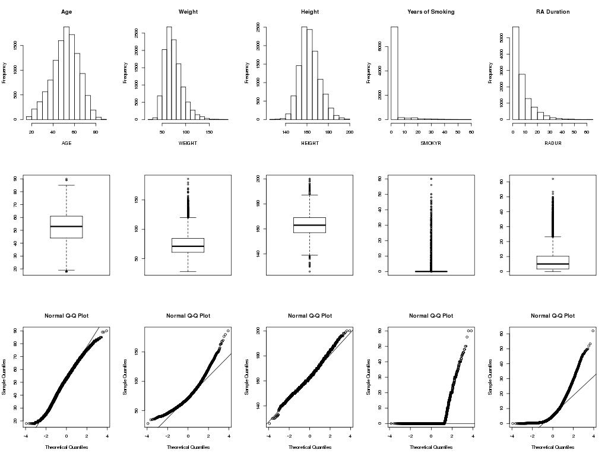

Figure B1 Histogram, Boxplot and Normal Q-Q plot for continuous variables (continued)

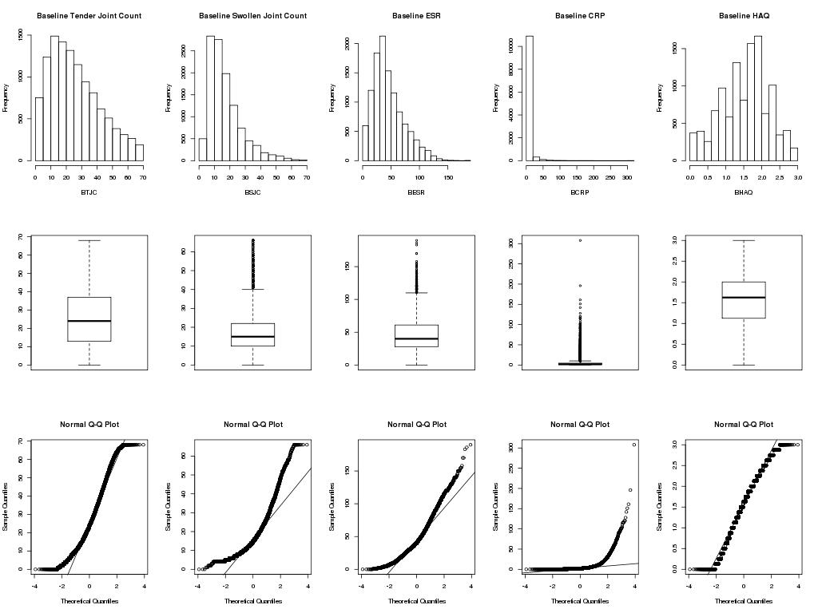
Figure B1 Histogram, Boxplot and Normal Q-Q plot for continuous variables (continued)
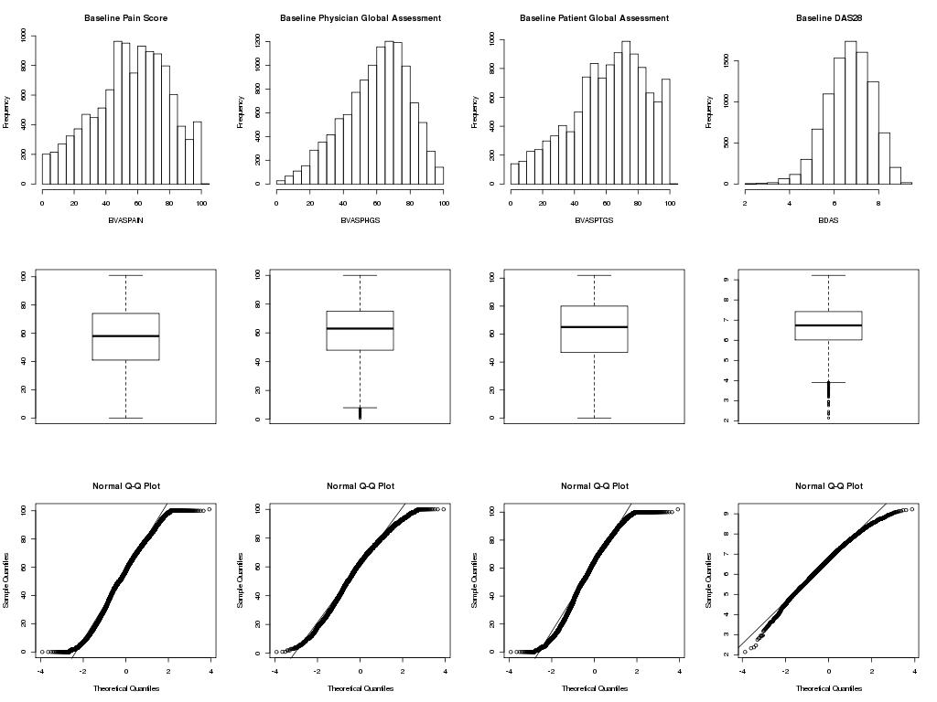
Figure B1 Histogram, Boxplot and Normal Q-Q plot for continuous variables (continued)
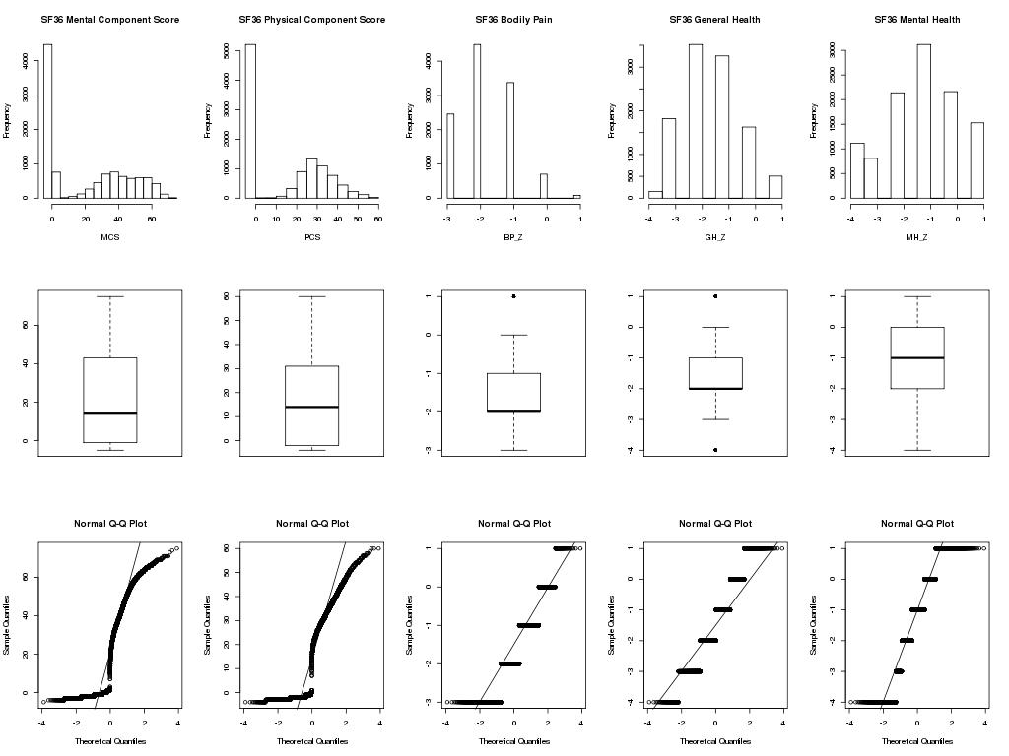
Figure B1 Histogram, Boxplot and Normal Q-Q plot for continuous variables (continued)
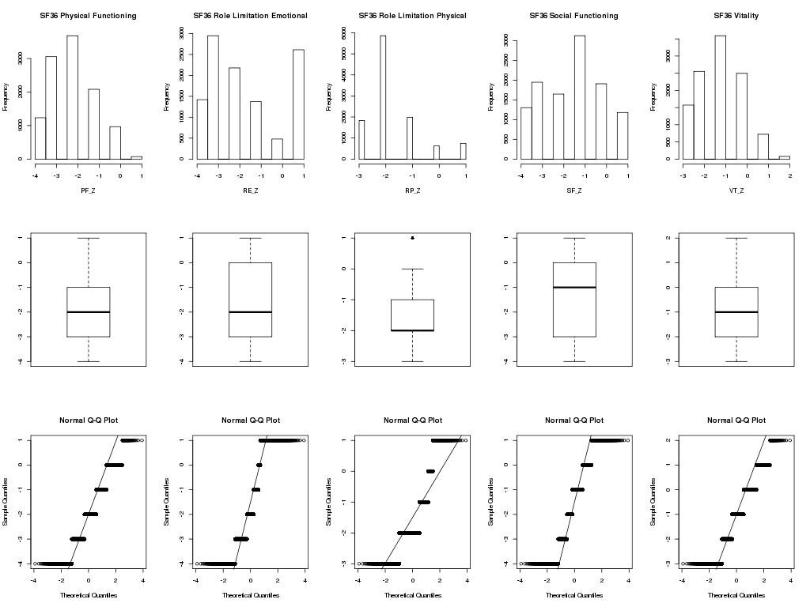
Figure B1 Histogram, Boxplot and Normal Q-Q plot for continuous variables (continued)
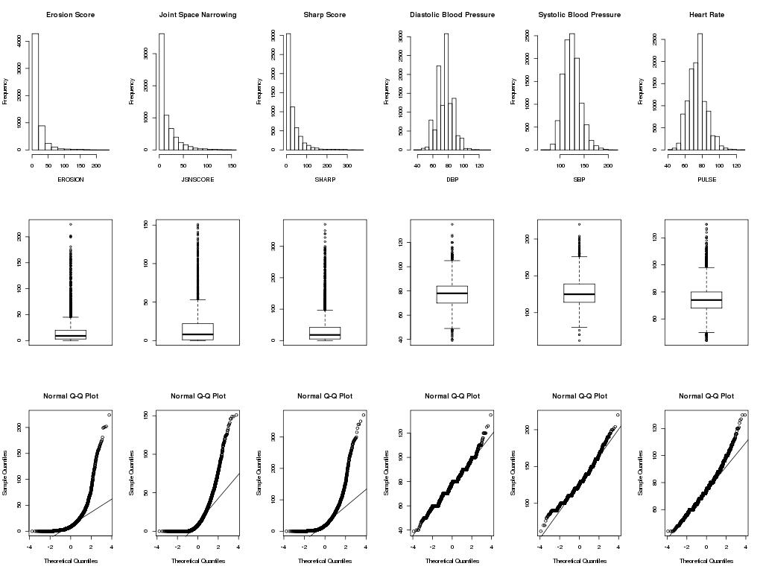
Figure B1 Histogram, Boxplot and Normal Q-Q plot for continuous variables (continued)
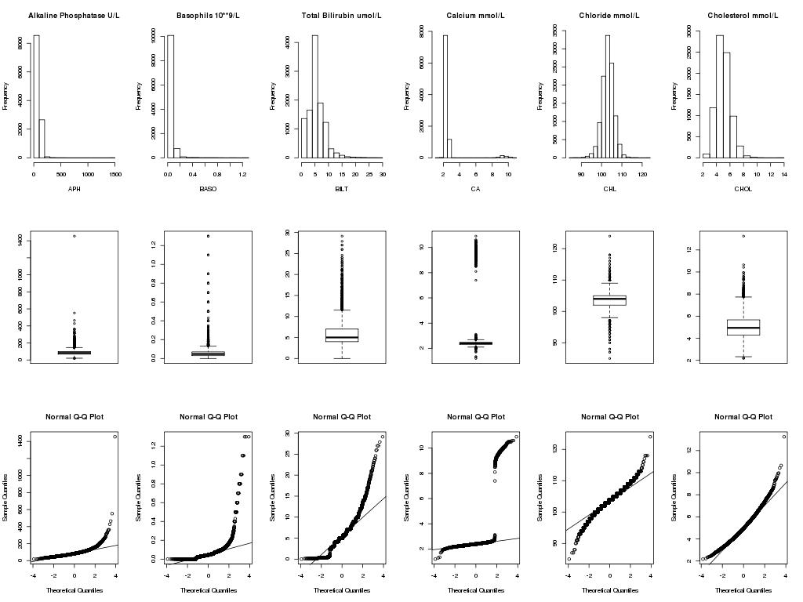
Figure B1 Histogram, Boxplot and Normal Q-Q plot for continuous variables (continued)
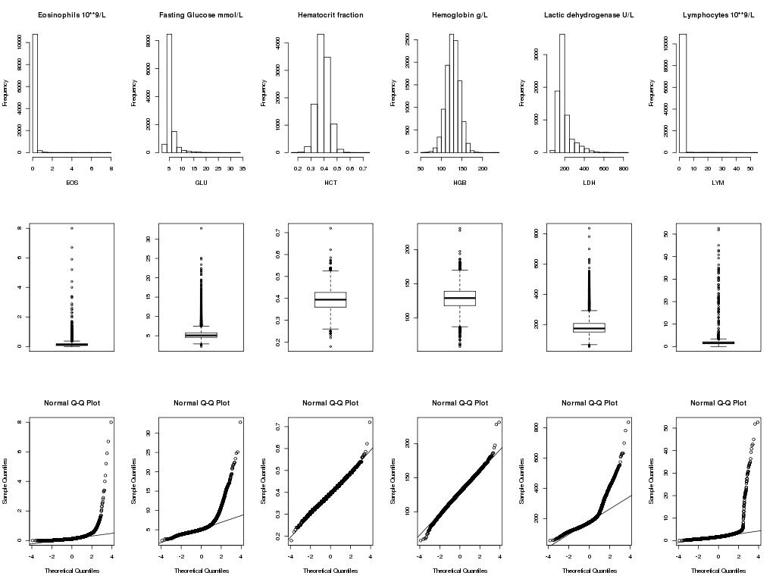
Figure B1 Histogram, Boxplot and Normal Q-Q plot for continuous variables (continued)
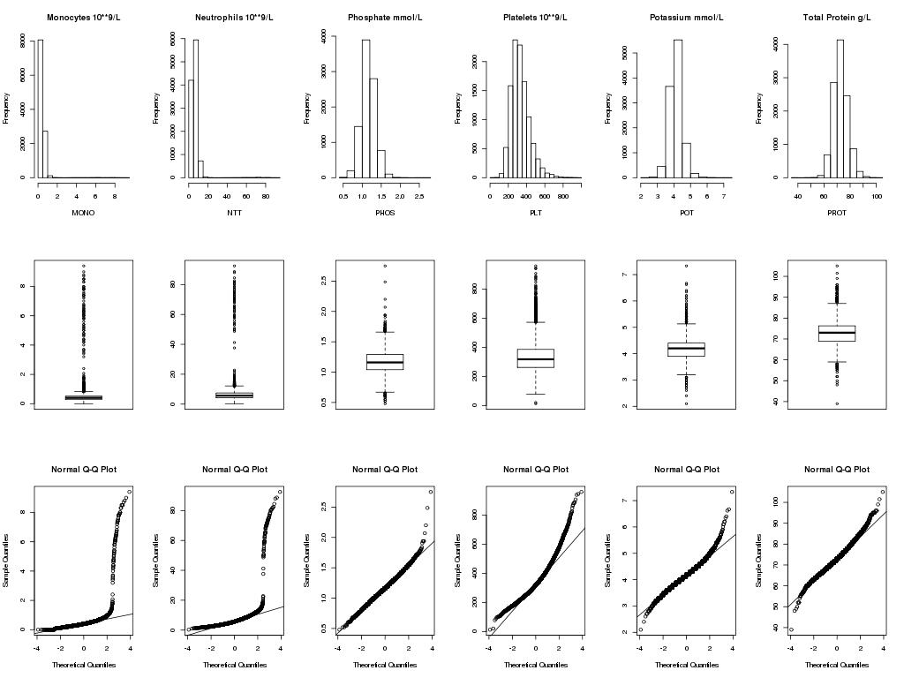
Figure B1 Histogram, Boxplot and Normal Q-Q plot for continuous variables (continued)
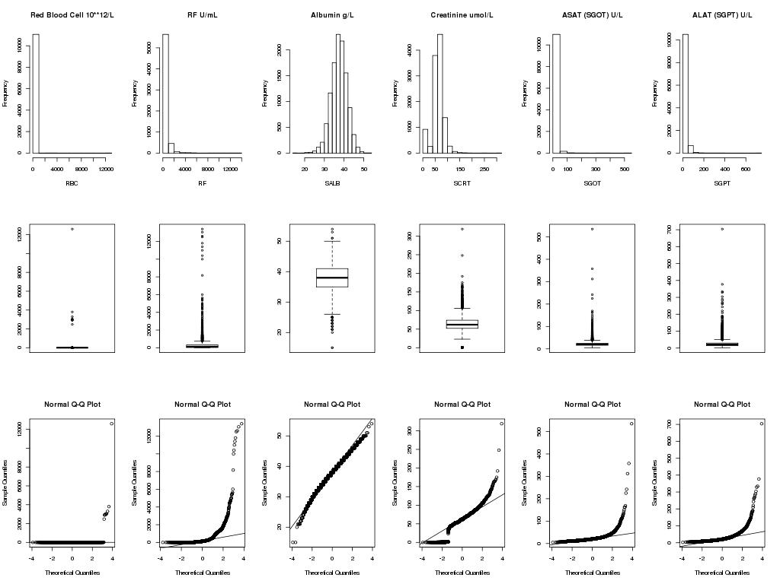
Figure B1 Histogram, Boxplot and Normal Q-Q plot for continuous variables (continued)
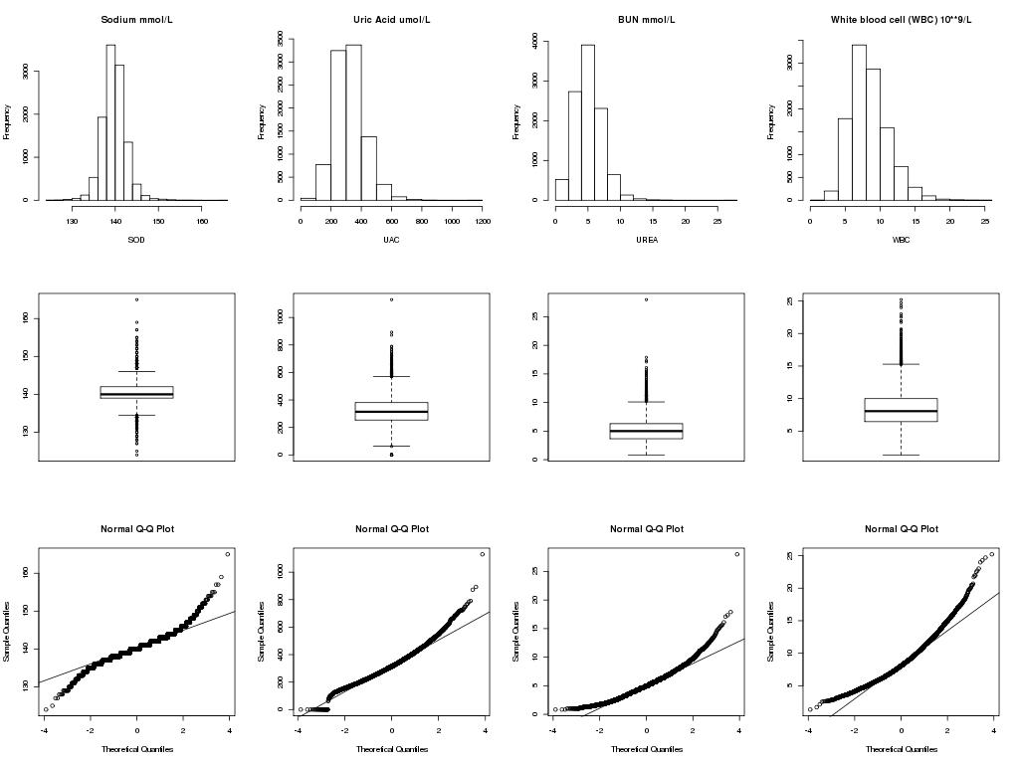
Figure B2 Categorical variables

Figure B2 Categorical variables (continued)

Figure B3 Medical History variables
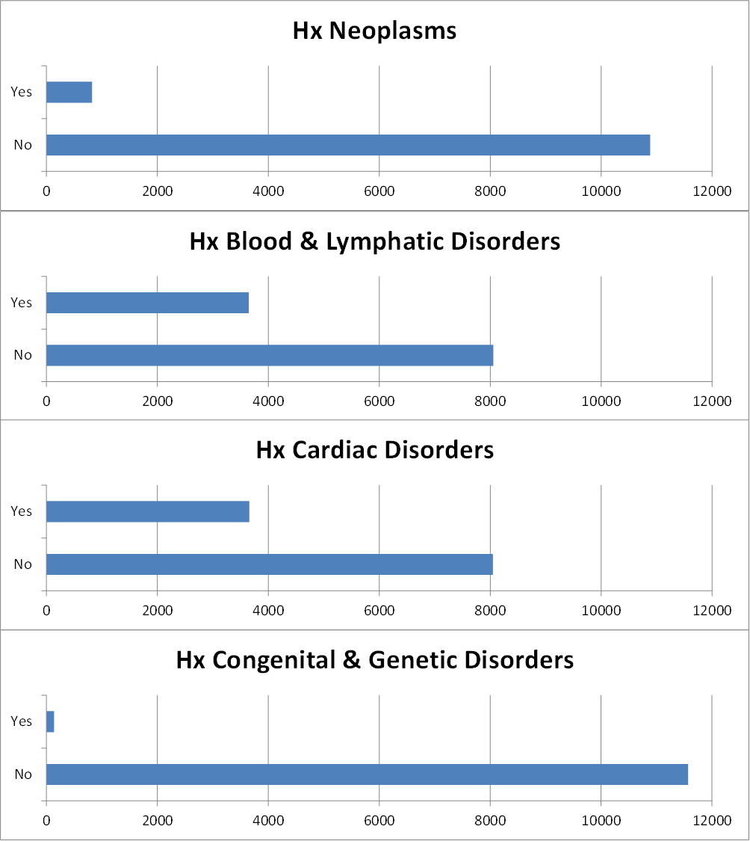
Figure B3 Medical History variables (continued)
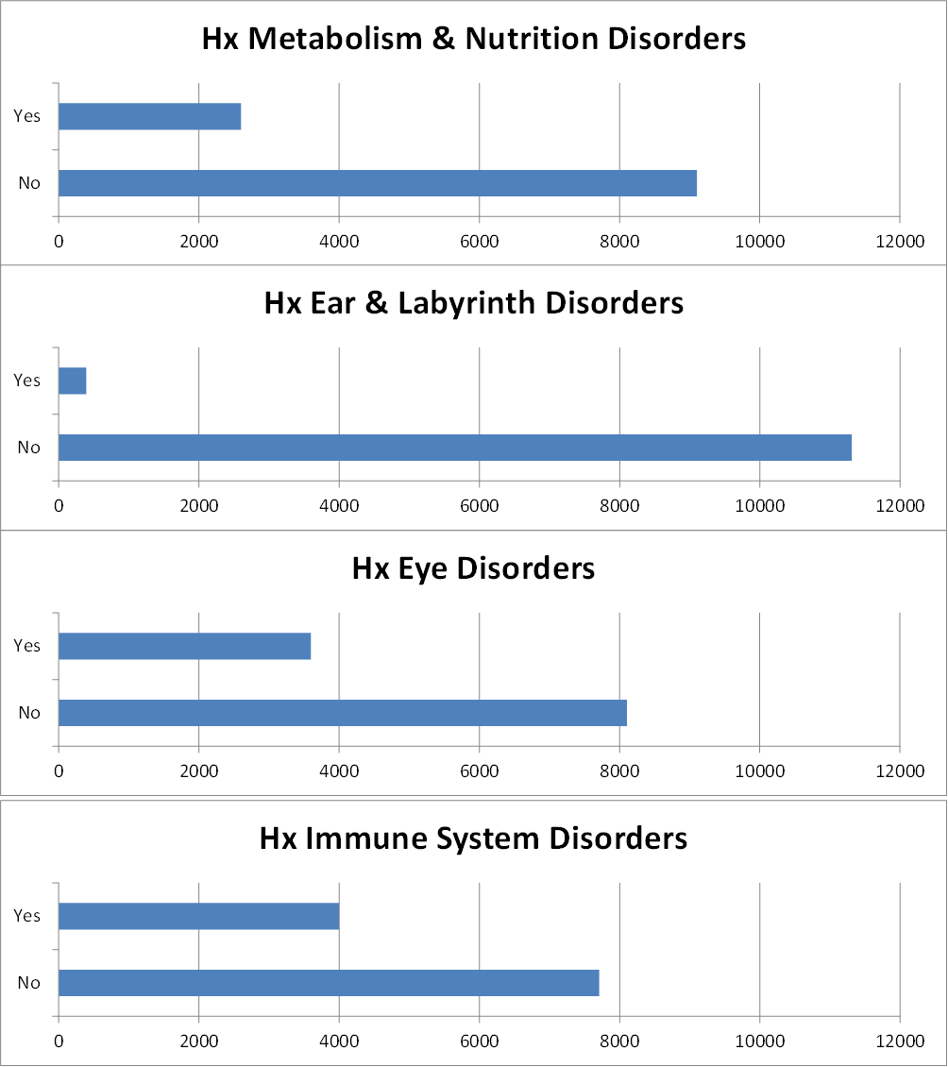

Figure B3 Medical History variables (continued)
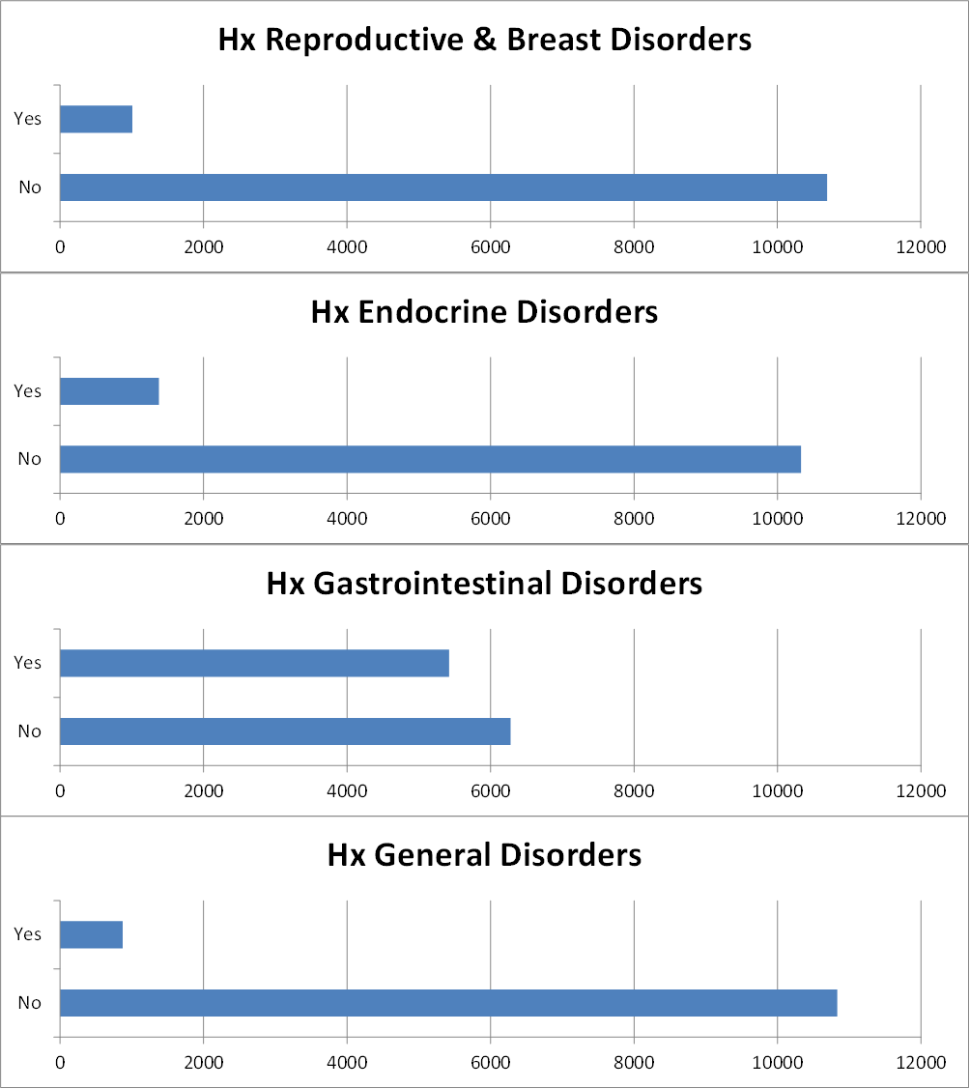
Figure B3 Medical History variables (continued)
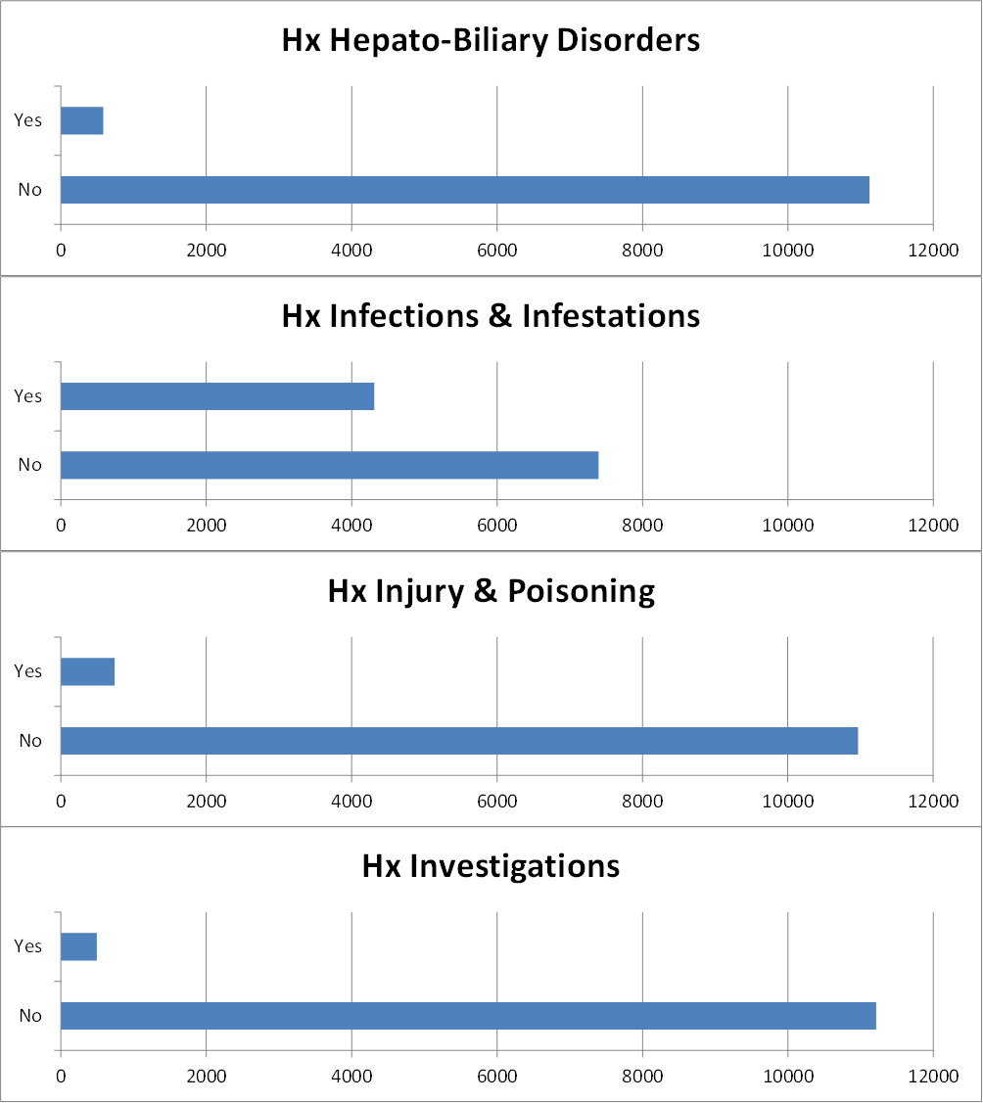

Figure B3 Medical History variables (continued)
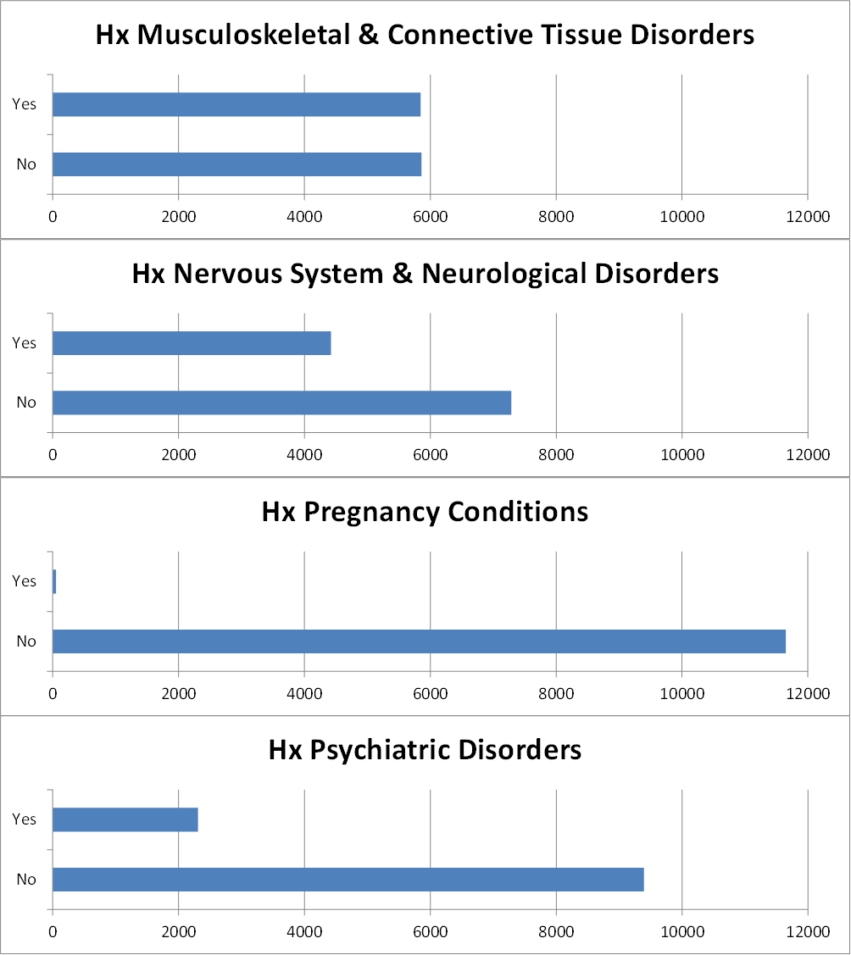

Figure B3 Medical History variables (continued)
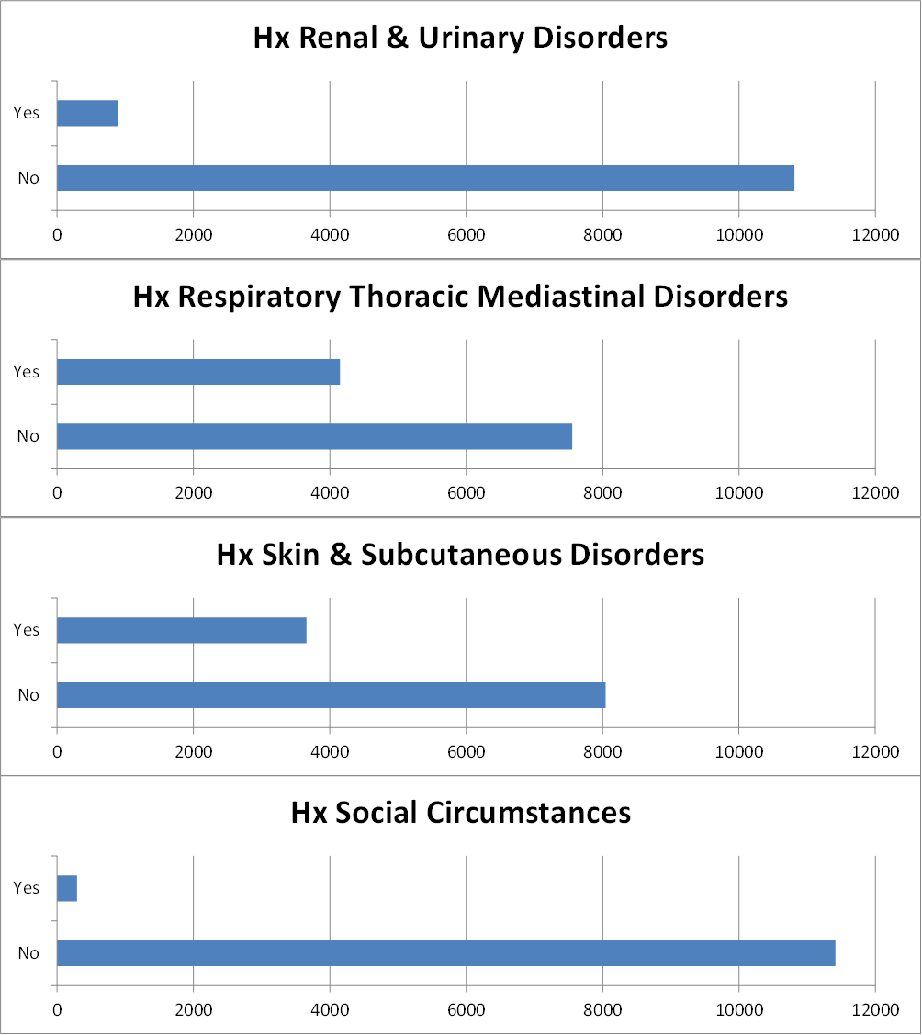

Figure B3 Medical History variables (continued)
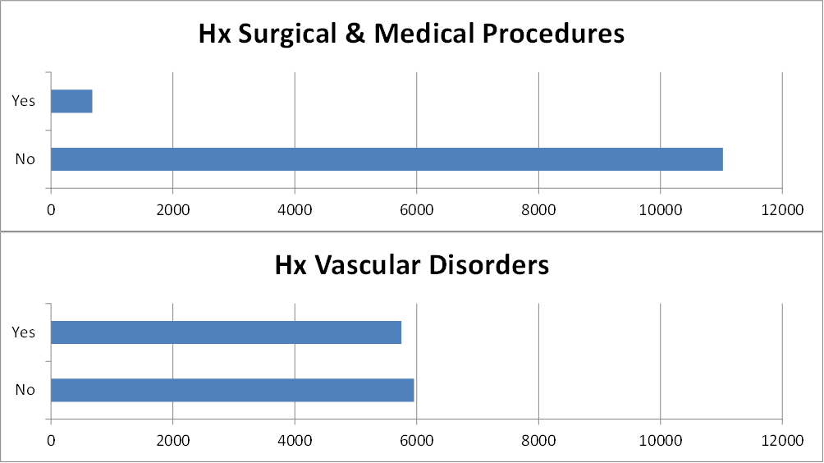

Appendix C: Simulations

C.1. Simulation Protocol

Characterising Outcomes in Rheumatoid Arthritis
Paul Mahoney
ScHARR, University of Sheffield
11/1/2011

Overall objectives
The objective of this simulation is to identify how CART and logistic regression perform in predicting patient ACR20, ACR50 and ACR90 response in an RA setting under differing scenarios, and to select a shortlist of methods to later apply to available real life RA clinical trial database.

Simulation procedures
A series of simulated datasets will be created to probe how CART and logistic regression perform under changes in data structure. Simulated datasets will be generated independently in SAS (Version 9.4), with different seeds for each simulation. CART analysis will be performed in R (package rpart (Therneau et al., 2017)), whilst logistic regression will be performed in SAS (Version 9.4).

Data generation methods
The clinical trial database represents over 11,000 adult patients diagnosed with RA from 18 randomised clinical trials in 4 development drug projects enrolled between 1998 and 2008. Simulations will be generated that mimic this real life database.
Two types of variable will be generated in the simulated datasets: continuous and binary. In this simulation, continuous variables will be assumed to be normally distributed or assumed that they can be approximated by a Normal distribution due to large sample size.
Simulated datasets will be generated in stages.
In the first stage the simulation will generate a binary response followed by 10 random Normal variables highly correlated with this response, and 90 random Normal variables with low correlation with this response. Since around 100 variables are available in the clinical database, this is sufficient and manageable in the context of multiple simulations. Simulations of size 100, 1,000 and 10,000 will be generated. For both continuous and binary data, a seed will be specified to enable reproducibility.
In the second stage, the impact of dichotomisation of explanatory variables will be evaluated, with one half of the correlated and uncorrelated variables transformed to binary variables.
The third stage will explore how missing values affect the performance of CART and logistic regression. Two types of missing value will be generated: missing completely at random and missing not at random. For missing not at random, missing values will be assigned depending on the value of the response variable. That is, a higher probability of being missing will be set higher for non-responders.
If homogeneity of outcomes is observed in the first stage, a reduced set of simulations may be applied to subsequent stages.

Statistical methods to be investigated
Following generation of the datasets, logistic regression models will be fitted, to ascertain which correlated variables are selected as significant predictors of outcome. Stepwise logistic regression will be performed in SAS with the significance level for entry (Wild et al.) and significance level for staying (SLS) in the model set to the same value.
The CART analysis will be performed using rpart package of the R software application to see if high correlated variables are selected in the final tree. Parameters applied include: equal weights, anova modelling, retention of observations if one or more predictors are missing, equal costs, and a minimum of 20 observations per node in order for a split to be attempted.

Scenarios to be investigated
The initial scenarios will assume no missing values in the data.
The following overall adaptations will be implemented:
Sample Size: 100, 1,000, 10,000
High Correlation: 0.90, 0.80, 0.70, 0.60
Low Correlation: 0, 0.10, 0.20, 0.30
Response 0.25, 0.50, 0.90
The Logistic Regression analysis will follow the stepwise procedure with parameters SLENTRY and SLSTAY determining the significance levels for entry and removal of effects from the model.
SLENTRY and SLSTAY will be adapted for values: 0.30, 0.20, 0.10, 0.05, 0.01, 0.001
For simulations evaluating the impact of dichotomisation and missing values, a subset of scenarios may be applied, depending on any homogeneity of results observed from the initial stage.

Number of Simulations to be performed
Each combination of the parameters of the simulation will be performed 100 times, leading to 14,400 analyses on CART and 86,400 analyses on logistic regression. The number of simulations is subject to system processing limitations, particularly for the 10,000 subject simulations.

Performance criteria
For each analysis, the rate of highly correlated variables selected by each method (sensitivity) and the rate of low correlated variables not selected by each method (specificity) will be calculated. These paired values will be presented in Sensitivity and Specificity (VaSe) plots. VaSe plots will be developed based on ROC curves, where points are plotted on scale where the x-axis displays 1-specificity and the y-axis displays sensitivity. When the method selects only the 10 higher correlated variables and none of the lower correlated variables the sensitivity and specificity will be 100%, visually this will be in the top left corner of the VaSe plots.

Presentation of results
Sensitivity and inverse specificity will be plotted on VaSe plots. CART and logistic regression results will be plotted together for each simulation scenario, so that performance can easily be compared.
VaSe plots curves will also be produced for logistic regression only displaying together the varying SLENTRY and SLSTAY values so that the optimal value can be identified.
VaSe plots comparing dichotomisation and non-dichotomisation will be produced together as will VaSe plots for non-missing, missing at random and missing not at random.

Summary
This protocol outlines the planned simulation strategy for evaluating the performance of CART and logistic regression for simulated RA data. The results of the simulations are intended to enable selection of an optimal method to analyse the real life clinical database and to identify the highest performing analysis parameters.

C.2. Simulation code

The code for simulations was generated as depicted in figure C2.1 and described in Section 7.4.2.

Figure C1 Generation of Simulated Datasets

C.2.1. R Code simrpart.R
Summary:
- Reads in simulated dataset from SAS (sim.csv).
- Generates CART using package rpart
- Identifies nodes of the created tree
- Outputs a text file of nodes to be read by SAS program (rpart.txt)

# load packages
library("rpart", lib.loc="/usr/lib64/R/library")

# simulation with n=100
sima <- read.csv("./sim.csv", header=T)

# cart on sima100
fit<- rpart(RESP~ ., data=sima)
summary(fit)

# what are components of fit
names(fit)

# frame seems to contain nodes
#nodes<-fit$frame[fit$frame.var!=" <leaf>",1]
nodes<-fit$variable.importance

# output this to a file that SAS can pick up
dput(nodes, file="rpart.txt")

C.2.2. SAS Code simmacro.sas

/********************************************************************************
Create a series of simulated datasets
simulation a:
constant variance
shift in means
80% correlation for 10 x's, 0 correlation for 90 x's
response 50/50
repeat for n=100 (sima100)
n=1000 (sima1000)
n=9000 (sima9000)
*********************************************************************************/
%macro sim(dset,s,p,corr1,corr2,seed);

data &dset;
do study=1 to &s;
between = 5*rannor(&seed);

%do high=1 %to 9;
if &corr2 gt 0 then total0&high = 5+(between+sqrt(((1-&corr2)/&corr2))*5*rannor(&seed+&high));
%end;

if &corr2 gt 0 then total10 =10+(between+sqrt(((1-&corr2)/&corr2))*5*rannor(&seed+10));

%do low=11 %to 100;
if &corr1 = 0 then total&low = 5+10*rannor(&seed+&low);
else total&low = 5+(between+sqrt(((1-&corr1)/&corr1))*10*rannor(&seed+&low));
%end;

**** between determines split of response and non response ****;
* *** cut off 0 gives 50/50 ***;
*** use N(0,1) table to find other splits ***;

if between >=0 then resp=1;
else resp=0;

output;
end;
run;

options nosource nonotes;*turn off export code;
proc export data=&dset
outfile="sim.csv"
dbms=csv
replace;
run;
options source notes;

title "Correlation= &corr1 &corr2";
%mend sim;

C.2.3. SAS Code simmacro.sas
/****************************************************************************
Creates a series of simulated datasets simulation
For a specific number of simulations.
each simulated dataset is used by R rpart procedure - variables used in tree are reimported into SAS
dataset created to summarise each rpart.
use this to generate ROC info

*****************************************************************************/

options symbolgen mprint mlogic;
%include 'environ.sas';

** Get macro ;
%inc 'simmacro0.sas';
* parameters of simmacro ;
* dset = dataset to be created ;
* s = number of patients ;
* also s used to name output dataset;
* p = ;
* corr1 = correlation for top 10 vars ;
* corr2 = correlation for 90 vars ;
* seed = seed for rannor ;

%macro cartroc(howmany,dset,s,corr1,corr2,sle,sls);

* create empty dataset for appending later cartrocs;
data cartroc;
length truepos 8 falspos 8 trueneg 8 falsneg 8 iter 8;
label truepos ='No. of highly correlated variables identified by CART as predictive'
falspos ='No. of lowly correlated variables identified by CART as predictive'
trueneg ='No. of lowly correlated variables not identified by CART as predictive'
falsneg ='No. of highly correlated variables not identified by CART as predictive'
iter ='Seed';
stop;
run;

* create empty dataset for appending later lrrocs;
data lrroc;
length truepos 8 falspos 8 trueneg 8 falsneg 8 iter 8;
label truepos ='No. of highly correlated variables identified by LR as predictive'
falspos ='No. of lowly correlated variables identified by LR as predictive'
trueneg ='No. of lowly correlated variables not identified by LR as predictive'
falsneg ='No. of highly correlated variables not identified by LR as predictive'
iter ='Seed';
stop;
run;

%do i=1 %to &howmany;

** create simulation dataset;
%sim(&dset, &s, 3, &corr1, &corr2, &i);

** run the CART on each dataset *******************************************************************;

** Execute R that runs CART analysis and returns nodes of tree ;
x 'rr simrpart.R';

data cartpick;
infile "./rpart.txt" firstobs=1 delimiter="," dsd scanover;
input @'TOTAL' value1 $3. @@;
valuen=input(compress(value1,'("'),6.0);
if valuen le 10 then truepos=1; else truepos =0; * cart rightly predict hi correlates;
if valuen gt 10 then falspos=1; else falspos =0; * cart wrongly predict lo correlates;
run;

proc summary data=cartpick;
var truepos falspos;
output out=cartsum sum=truepsum falspsum;
run;

data cartroc&i(rename=(truepsum=truepos falspsum=falspos) drop=_FREQ_ _TYPE_);
set cartsum;
falsneg=10-truepsum; *cart wrongly didnt pick out these hi correlates;
trueneg=90-falspsum; *cart rightly didnt pick out these lo correlates;
iter=&i;
run;

proc datasets nolist;
append base=cartroc data=cartroc&i force;
run;

proc datasets;
delete cartroc&i;
run;

** run the logistic regression on each dataset *******************************************************************;

* for same dataset as rpart run a logistic regression ;
title "Stepwise Regression &dset";

proc logistic data=&dset outest=betas covout;
model resp(event='1')=total01--total100 / selection=stepwise slentry=&sle slstay=&sls details lackfit;
output out=pred p=phat lower=lcl upper=ucl predprob=(individual crossvalidate);
run;

proc print data=betas; title2 'Parameter Estimates and Covariance Matrix'; run cancel;

proc print data=pred; title2 'Predicted Probabilities and 95% Confidence Limits'; run cancel;

data lrpick(keep = _name_ intercept valuen truepos falspos);
set betas;
where intercept ne . and _name_ not in ("RESP","Intercept");
valuen=input(compress(_name_,'TOTAL'),6.0);
if valuen le 10 then truepos=1; else truepos =0; * cart rightly predict hi correlates;
if valuen gt 10 then falspos=1; else falspos =0; * cart wrongly predict lo correlates;
run;

proc summary data=lrpick;
var truepos falspos;
output out=lrsum sum=truepsum falspsum;
run;

data lrroc&i(rename=(truepsum=truepos falspsum=falspos) drop=_FREQ_ _TYPE_);
set lrsum;
falsneg=10-truepsum; *cart wrongly didnt pick out these hi correlates;
trueneg=90-falspsum; *cart rightly didnt pick out these lo correlates;
iter=&i;
run;

proc datasets nolist;
append base=lrroc data=lrroc&i force;
run;

proc datasets;
delete lrroc&i;
run;

%end; * end i to howmany loop ;

data phdlib.c&dset;
set cartroc;
label sens ='Sensitivity'
specinv ='1 - Specificity';
utt=&s;type='CART';parm="&corr2 corr";
sens=truepos/(truepos+falsneg);
specinv=1-(trueneg/(trueneg+falspos));
run;

data phdlib.l&dset;
set lrroc;
label sens ='Sensitivity'
specinv ='1 - Specificity';
utt=&s;type='LR';parm="&corr2 corr";
sens=truepos/(truepos+falsneg);
specinv=1-(trueneg/(trueneg+falspos));
run;

%mend cartroc;

************************************************
** zero correlation on low correlated variables ***;
** simulations on 100 patients *****
%cartroc(100,sa100,100,0,0.90,0.30,0.30);
%cartroc(100,sb100,100,0,0.80,0.30,0.30);
%cartroc(100,sc100,100,0,0.70,0.30,0.30);
%cartroc(100,sd100,100,0,0.60,0.30,0.30);
** simulations on 1000 patients *****;
%cartroc(100,sa1000,1000,0,0.90,0.30,0.30);
%cartroc(100,sb1000,1000,0,0.80,0.30,0.30);
%cartroc(100,sc1000,1000,0,0.70,0.30,0.30);
%cartroc(100,sd1000,1000,0,0.60,0.30,0.30)**
** simulations on 10000 patients *****/
%cartroc(100,sa10000,10000,0,0.90,0.30,0.30);
%cartroc(100,sb10000,10000,0,0.80,0.30,0.30
%cartroc(100,sc10000,10000,0,0.70,0.30,0.30);
%cartroc(100,sd10000,10000,0,0.60,0.30,0.30);

** 0.10 correlation on low correlated variables ***;
** simulations on 100 patients *****;
%cartroc(100,se100,100,0.1,0.90,0.30,0.30);
%cartroc(100,sf100,100,0.1,0.80,0.30,0.30);
%cartroc(100,sg100,100,0.1,0.70,0.30,0.30);
%cartroc(100,sh100,100,0.1,0.60,0.30,0.30);
** simulations on 1000 patients *****;
%cartroc(100,se1000,1000,0.1,0.90,0.30,0.30);
%cartroc(100,sf1000,1000,0.1,0.80,0.30,0.30);
%cartroc(100,sg1000,1000,0.1,0.70,0.30,0.30);
%cartroc(100,sh1000,1000,0.1,0.60,0.30,0.30);
** simulations on 10000 patients *****;
%cartroc(100,se10000,10000,0.1,0.90,0.30,0.30);
%cartroc(100,sf10000,10000,0.1,0.80,0.30,0.30);
%cartroc(100,sg10000,10000,0.1,0.70,0.30,0.30);
%cartroc(100,sh10000,10000,0.1,0.60,0.30,0.30);

** 0.20 correlation on low correlated variables ***;
** simulations on 100 patients *****;
%cartroc(100,si100,100,0.2,0.90,0.30,0.30);
%cartroc(100,sj100,100,0.2,0.80,0.30,0.30);
%cartroc(100,sk100,100,0.2,0.70,0.30,0.30);
%cartroc(100,sl100,100,0.2,0.60,0.30,0.30);
** simulations on 1000 patients *****;
%cartroc(100,si1000,1000,0.2,0.90,0.30,0.30);
%cartroc(100,sj1000,1000,0.2,0.80,0.30,0.30);
%cartroc(100,sk1000,1000,0.2,0.70,0.30,0.30);
%cartroc(100,sl1000,1000,0.2,0.60,0.30,0.30);
** simulations on 10000 patients *****;
%cartroc(100,si10000,10000,0.2,0.90,0.30,0.30);
%cartroc(100,sj10000,10000,0.2,0.80,0.30,0.30);
%cartroc(100,sk10000,10000,0.2,0.70,0.30,0.30);
%cartroc(100,sl10000,10000,0.2,0.60,0.30,0.30);

** 0.30 correlation on low correlated variables ***;
** simulations on 100 patients *****;
%cartroc(100,sm100,100,0.3,0.90,0.30,0.30);
%cartroc(100,sn100,100,0.3,0.80,0.30,0.30);
%cartroc(100,so100,100,0.3,0.70,0.30,0.30);
%cartroc(100,sp100,100,0.3,0.60,0.30,0.30);
** simulations on 1000 patients *****;
%cartroc(100,sm1000,1000,0.3,0.90,0.30,0.30);
%cartroc(100,sn1000,1000,0.3,0.80,0.30,0.30);
%cartroc(100,so1000,1000,0.3,0.70,0.30,0.30);
%cartroc(100,sp1000,1000,0.3,0.60,0.30,0.30);
* simulations on 10000 patients *****;
%cartroc(100,sm10000,10000,0.3,0.90,0.30,0.30);
%cartroc(100,sn10000,10000,0.3,0.80,0.30,0.30);
%cartroc(100,so10000,10000,0.3,0.70,0.30,0.30);
%cartroc(100,sp10000,10000,0.3,0.60,0.30,0.30);

C.3. Simulation Scenarios

Table C0.1 Summary of number of datasets created for main simulations

Most cells in this table represent 3 datasets of size 100, 1000, 10000 (n=3). Cells with n=8, represent additional datasets for missing values and dichotomisation, which were not created on all scenarios.

Table C0.2 Summary of number of data points generated in simulations

Summary of simulation scenarios created
With stats on number of datasets and patients

C.4. Simulation Poster

Appendix D: Analyses

D.1. Primary CART Analysis
> # clear datasets
> rm(list=ls())
>
> # read data from BCE
> allall <-read_bce('/opt/BIOSTAT/home_ext2/mahonep1/phd/libraries/allall.sas7bdat')
>
> ########################################
> # a function written to calculate performance
> ########################################
> performance <- function(table, n=2){ if(!all(dim(table) == c(2,2)))
+ stop("Must be a 2 x 2 table")
+ tn = table[1,1]
+ fp = table[1,2]
+ fn = table[2,1]
+ tp = table[2,2]
+ sensitivity = tp/(tp+fn)
+ specificity = tn/(tn+fp)
+ ppp = tp/(tp+fp)
+ npp = tn/(tn+fn)
+ hitrate = (tp+tn)/(tp+tn+fp+fn)
+ result <- paste("Sensitivity = ", round(sensitivity, n) ,
+ "\nSpecificity = ", round(specificity, n),
+ "\nPositive Predictive Value = ", round(ppp, n),
+ "\nNegative Predictive Value = ", round(npp, n),
+ "\nAccuracy = ", round(hitrate, n), "\n", sep="")
+ cat(result)
+ }
>
> ########################################
> # all patients and biomarkers only
> ########################################
>
> ########################################
> # read in mega dataset
> ########################################
> setwd("~/phd")
> #setwd("/opt/BIOSTAT/home_ext2/mahonep1/phd")
> #allall <- read.csv("./allall.csv", header=T)
> # make ACR20 a factor variable for Random Forest
> allallc1 <-transform(allall, ACR20=as.factor(ACR20))
> allallc <- subset(allallc1, ACR20!="NA")
>
> # make region binary and drop region in drops3
> allallc$REGIONNA <- as.factor(ifelse(allallc$REGION=="NORTH AMERICA", "North America", "Non North America"))
>
> drops3 <-c("ACRN","ACR50","ACR70","ACR90","CRTN","PT","DSETTYPE","DASEW24","DASCW24","DASW24"
+ ,"COMPOUND","DRUGTYPE","POPIR","POPRA","SMOKHIS","YOE","REGION", "SJC24","TJC24"
+ ,"CRP24","ESR24","VPAIN24","HAQ24","VPHGS24","VPTGS24")
> allallred2 <- allallc[,!(names(allallc) %in% drops3)]
>
> # drop some study type variables
> drops4 <-c("TRTMENT","PROTO")
> allallred3 <- allallred2[,!(names(allallred2) %in% drops4)]
>
> ########################################
> # Create train and test datasets
> ########################################
>
> ## 75% of the sample size
> ## 75% of the sample size
> smp_size <- floor(0.75 * nrow(allallred3))
>
> ## set the seed to make partition reproducible
> set.seed(1234)
> train_ind1 <- sample(seq_len(nrow(allallred3)), size = smp_size)
>
> trainall1 <- allallred3[train_ind1, ]
> testall1 <- allallred3[-train_ind1,]
>
> ########################################
> # CART Analysis on all
> ########################################
> library(rpart)
> library(rpart.plot)
>
> trainfitall1<- rpart(ACR20~ ., data=trainall1, method="class")
> trainfitall1$cptable
CP nsplit rel error xerror xstd
1 0.03312136 0 1.0000000 1.0000000 0.01216151
2 0.02287582 2 0.9337573 0.9401166 0.01206797
3 0.01000000 5 0.8651298 0.9054054 0.01199742

> plotcp(trainfitall1)
>
> trainfitall1.pruned <- prune(trainfitall1, cp=0.01343166)
> trainfitall1.pruned
n= 8542

node), split, n, loss, yval, (yprob)
* denotes terminal node

1) root 8542 3774 0 (0.5581831 0.4418169)
2) BTJC< 7.5 815 166 0 (0.7963190 0.2036810) *
3) BTJC>=7.5 7727 3608 0 (0.5330659 0.4669341)
6) REGIONNA=North America 3085 1162 0 (0.6233387 0.3766613) *
7) REGIONNA=Non North America 4642 2196 1 (0.4730720 0.5269280)
14) JSNSCORE>=0.4903846 3993 1977 0 (0.5048835 0.4951165)
28) DMARDNUM>=3.5 473 175 0 (0.6300211 0.3699789) *
29) DMARDNUM< 3.5 3520 1718 1 (0.4880682 0.5119318)
58) RACE=ASIAN,OTHER,UNKNOWN 1508 686 0 (0.5450928 0.4549072) *
59) RACE=AMERICAN INDIAN OR ALASKA NATIVE,BLACK,HISPANIC,MULTIPLE,NATIVE HAWAIIAN/OTHER PACIFIC ISLANDER,WHITE 2012 896 1 (0.4453280 0.5546720) *
15) JSNSCORE< 0.4903846 649 180 1 (0.2773498 0.7226502) *

> summary(trainfitall1.pruned)
Call:
rpart(formula = ACR20 ~ ., data = trainall1, method = "class")
n= 8542

CP nsplit rel error xerror xstd
1 0.03312136 0 1.0000000 1.0000000 0.01216151
2 0.02287582 2 0.9337573 0.9401166 0.01206797
3 0.01000000 5 0.8651298 0.9054054 0.01199742

Variable importance
BTJC REGIONNA JSNSCORE DMARDNUM PSYCH RACE IMMUNE WEIGHT GENERAL CNS
27 22 14 6 5 5 3 3 3 3
RADUR BSJC BCRP MCS PCS RBC SF0101
2 2 1 1 1 1 1

Node number 1: 8542 observations, complexity param=0.03312136
predicted class=0 expected loss=0.4418169 P(node) =1
class counts: 4768 3774
probabilities: 0.558 0.442
left son=2 (815 obs) right son=3 (7727 obs)
Primary splits:
BTJC < 7.5 to the left, improve=102.27610, (2 missing)
SHARP < 5.5 to the right, improve= 90.41307, (4307 missing)
JSNSCORE < 0.5 to the right, improve= 83.54683, (3703 missing)
REGIONNA splits as RL, improve= 79.86411, (0 missing)
EROSION < 4.5 to the right, improve= 69.53788, (4307 missing)
Surrogate splits:
BSJC < 5.5 to the left, agree=0.912, adj=0.081, (0 split)

Node number 2: 815 observations
predicted class=0 expected loss=0.203681 P(node) =0.09541091
class counts: 649 166
probabilities: 0.796 0.204

Node number 3: 7727 observations, complexity param=0.03312136
predicted class=0 expected loss=0.4669341 P(node) =0.9045891
class counts: 4119 3608
probabilities: 0.533 0.467
left son=6 (3085 obs) right son=7 (4642 obs)
Primary splits:
REGIONNA splits as RL, improve=83.69613, (0 missing)
SHARP < 4.5 to the right, improve=63.54933, (4279 missing)
RADUR < 0.939863 to the right, improve=57.45138, (0 missing)
JSNSCORE < 0.5 to the right, improve=54.34351, (3675 missing)
EROSION < 7.5 to the right, improve=52.58031, (4279 missing)
Surrogate splits:
PSYCH < 0.5 to the right, agree=0.684, adj=0.209, (0 split)
IMMUNE < 0.5 to the right, agree=0.663, adj=0.155, (0 split)
WEIGHT < 85.25 to the right, agree=0.662, adj=0.153, (0 split)
GENERAL < 0.5 to the right, agree=0.653, adj=0.131, (0 split)
CNS < 0.5 to the right, agree=0.650, adj=0.124, (0 split)

Node number 6: 3085 observations
predicted class=0 expected loss=0.3766613 P(node) =0.3611566
class counts: 1923 1162
probabilities: 0.623 0.377

Node number 7: 4642 observations, complexity param=0.02287582
predicted class=1 expected loss=0.473072 P(node) =0.5434325
class counts: 2196 2446
probabilities: 0.473 0.527
left son=14 (3993 obs) right son=15 (649 obs)
Primary splits:
JSNSCORE < 0.5 to the right, improve=54.29425, (2247 missing)
SHARP < 5.5 to the right, improve=45.59904, (2709 missing)
RADUR < 3.278329 to the right, improve=40.66651, (0 missing)
EROSION < 7.5 to the right, improve=39.38122, (2709 missing)
DMARDNUM < 3.5 to the right, improve=33.62045, (512 missing)
Surrogate splits:
RADUR < 0.517631 to the right, agree=0.797, adj=0.159, (2247 split)
AGE < 18.5 to the right, agree=0.760, adj=0.007, (0 split)
RACE splits as LLL-LRLLL, agree=0.759, adj=0.002, (0 split)

Node number 14: 3993 observations, complexity param=0.02287582
predicted class=0 expected loss=0.4951165 P(node) =0.4674549
class counts: 2016 1977
probabilities: 0.505 0.495
left son=28 (473 obs) right son=29 (3520 obs)
Primary splits:
DMARDNUM < 3.5 to the right, improve=24.40744, (504 missing)
BSJC < 11.5 to the left, improve=16.42077, (0 missing)
PROT < 69.15 to the left, improve=14.11071, (33 missing)
SF1103 < 2.5 to the left, improve=13.46342, (422 missing)
BCRP < 7.815 to the right, improve=12.78504, (1 missing)
Surrogate splits:
BCRP < 107.4 to the right, agree=0.866, adj=0.004, (503 split)

Node number 15: 649 observations
predicted class=1 expected loss=0.2773498 P(node) =0.07597752
class counts: 180 469
probabilities: 0.277 0.723

Node number 28: 473 observations
predicted class=0 expected loss=0.3699789 P(node) =0.05537345
class counts: 298 175
probabilities: 0.630 0.370

Node number 29: 3520 observations, complexity param=0.02287582
predicted class=1 expected loss=0.4880682 P(node) =0.4120815
class counts: 1718 1802
probabilities: 0.488 0.512
left son=58 (1508 obs) right son=59 (2012 obs)
Primary splits:
RACE splits as RLRRRRLLR, improve=17.15819, (0 missing)
BCRP < 8.54 to the right, improve=14.78012, (1 missing)
PROT < 73.25 to the left, improve=14.46744, (31 missing)
SF0101 < 2.5 to the left, improve=13.50631, (141 missing)
BSJC < 11.5 to the left, improve=13.25879, (0 missing)
Surrogate splits:
BCRP < 4.995 to the right, agree=0.691, adj=0.280, (0 split)
MCS < 16.5 to the right, agree=0.654, adj=0.192, (0 split)
PCS < 4.5 to the right, agree=0.653, adj=0.189, (0 split)
RBC < 4.335 to the left, agree=0.651, adj=0.186, (0 split)
SF0101 < 2.5 to the left, agree=0.641, adj=0.161, (0 split)

Node number 58: 1508 observations
predicted class=0 expected loss=0.4549072 P(node) =0.1765395
class counts: 822 686
probabilities: 0.545 0.455

Node number 59: 2012 observations
predicted class=1 expected loss=0.445328 P(node) =0.235542
class counts: 896 1116
probabilities: 0.445 0.555

>
> prp(trainfitall1.pruned, type = 2, extra = 104,
+ fallen.leaves = TRUE, main="Decision Tree All Data")
>
> fitall1.pred <- predict(trainfitall1.pruned, testall1, type="class")
> fitall1.perf <- table(testall1$ACR20, fitall1.pred,
+ dnn=c("Actual", "Predicted"))
> fitall1.perf
Predicted
Actual 0 1
0 1200 369
1 757 522
> performance(fitall1.perf)
Sensitivity = 0.41
Specificity = 0.76
Positive Predictive Value = 0.59
Negative Predictive Value = 0.61
Accuracy = 0.6

########################################
# randomforest using randomForestSRC
########################################
> library(randomForestSRC)
> set.seed(1234)
> rfsrcfit1 <- rfsrc(ACR20~.,data=rftrain, na.action="na.impute", importance=TRUE)
> rfsrcfit1
Sample size: 8542
Frequency of class labels: 4768, 3774
Was data imputed: yes
Number of trees: 1000
Minimum terminal node size: 1
Average no. of terminal nodes: 1810.558
No. of variables tried at each split: 12
Total no. of variables: 135
Analysis: RF-C
Family: class
Splitting rule: gini
Normalized Brier score: 92.11
Error rate: 0.39, 0.19, 0.64

Confusion matrix:

predicted
observed 0 1 class.error
0 3845 923 0.1936
1 2390 1384 0.6333

Overall error rate: 38.76%

all 0 1
JSNSCORE 0.0036 0.0019 0.0005
SHARP 0.0036 0.0019 0.0005
BTJC 0.0030 0.0016 0.0005
EROSION 0.0028 0.0013 0.0007
REGIONNA 0.0028 0.0009 0.0012
RADUR 0.0019 0.0002 0.0013
BVASPHGS 0.0017 0.0010 0.0001
RACE 0.0016 0.0010 0.0000
MCS 0.0015 0.0008 0.0003
BILT 0.0014 0.0007 0.0002
SCRT 0.0013 0.0007 0.0002
WITHERN 0.0012 0.0012 -0.0005
BVASPTGS 0.0012 0.0007 0.0001
RE_Z 0.0012 0.0007 0.0001
DMARDNUM 0.0012 0.0004 0.0005
SF0101 0.0010 0.0005 0.0002
PCS 0.0010 0.0007 0.0000
BSJC 0.0009 0.0006 0.0001
RH_Z 0.0009 0.0004 0.0002
SF_Z 0.0009 0.0004 0.0002
SF0908 0.0009 0.0006 0.0000
JSNHANDS 0.0009 0.0008 -0.0003
PSYCH 0.0008 0.0004 0.0001
BCRP 0.0008 0.0006 0.0000
BESR 0.0008 0.0005 0.0001
SF0601 0.0008 0.0004 0.0002

> plot(rfsrcfit1)

> rftest <-transform(testall1, SEX=as.factor(SEX), RACE=as.factor(Ranganath et al.),
+ RFCAT=as.factor(RFCAT), BSTEROID=as.factor(BSTEROID))
> rfsrc1.pred <- predict(rfsrcfit1, rftest, na.action="na.impute")
> rfsrc1.pred
Sample size of test (predict) data: 2848
Was test data imputed: yes
Number of grow trees: 1000
Average no. of grow terminal nodes: 1810.558
Total no. of grow variables: 135
Analysis: RF-C
Family: class
Test set Normalized Brier score: 92.38
Test set error rate: 0.38, 0.17, 0.64

Confusion matrix:

predicted
observed 0 1 class.error
0 1304 265 0.1689
1 811 468 0.6341

Overall error rate: 37.82%
