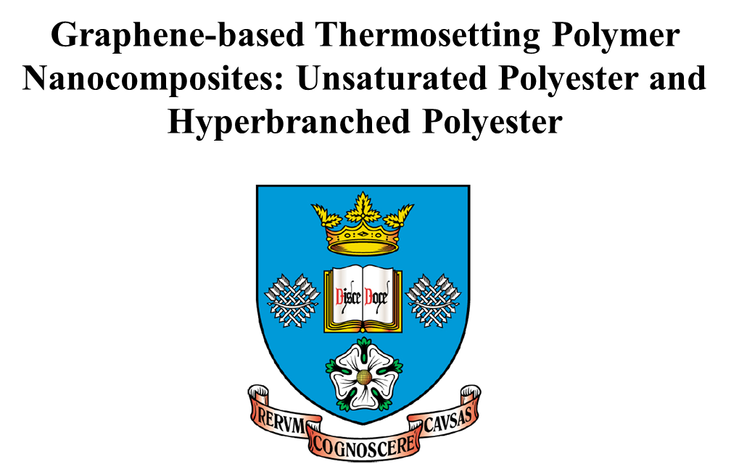
Yahui Wen
University of Sheffield
Department of Materials Science and Engineering
December 2017

A thesis submitted to the University of Sheffield for the degree of Doctor of Philosophy
Abstract
Graphene has attracted tremendous interests from scientists and researchers due to its excellent physical such as strong mechanical properties, excellent thermal and electrical conductivity, and low cost. In this work, graphene oxide (GO) was synthesized by Hummers method. Graphene based unsaturated polyester (UPR) nanocomposites were prepared by simple mixing method with and without organic solvent. Tensile test, 3-point bending test, Dynamic mechanical analysis (DMA), Thermogravimetric analysis (TGA) were carried out to study the effect of GO on mechanical properties, glass transition temperature, and thermal stability of UPR. Scanning electron microscope (SEM) and Fourier-transform infrared spectroscopy (FTIR) were employed to investigate the fracture surface of composites and the chemical structure of composites, respectively. In addition, the influence of GO on the crosslinking density of UPR was studied as well.
L-ascorbic acid (vitamin C) is a non-toxic reductant for reducing of GO, which exhibit similar electrical conductivity as rGO reduced by Hydrazine hydrate. To enable the insulating UPR to be electrical conductive, UPR/rGO composites were synthesized in two method: 1) the reduction of GO was carried out prior to the synthesis of UPR composites. 2) The reduction of GO was carried out during the synthesis of UPR composites. Electrical conductivity, thermal conductivity, thermal stability, glass transition temperature and mechanical properties were investigated.
A 100% eco-friendly and toxic free method was employed for bio-based hyperbranched polyester (HBPE) with water resistance, partially automatically self–healing properties. Stable GO/ethanol dispersion was achieved by modification of GO by Paraphenylenediamine (PPD), which can last for few months without precipitation. A series of HBPE/P-rGO nanocomposites were synthesized by using in situ polymerization. Nuclear Magnetic Resonance (1H NMR, 13C NMR), titration were performed to characterize neat HBPE. DMA was used to investigate the glass transmission temperature (Tg) of HBPE in nanocomposites. TGA was employed to study the thermal properties. Tensile tests were carried out for the investigation of hysteresis properties, mechanical properties, and self–healing behavior.

Acknowledgement
First of all, I am much appreciated that I got so much help and guidance from my Supervisor Professor Biqiong Chen. Her knowledge, creativity and rigor attitude on the research work helped me a lot on the experiments, fundamental knowledge, and writing.
I am also very appreciate that Dr. Joel Foreman for providing me lots support when I did some experiments in Composite Centre, as well as some help during my writing up period after Professor Biqiong Chen left.
The research fellow, Dr Tongfei Wu shared lots of knowledge and experience with me, which was very helpful during my PhD study.
I am very appreciate that I got lots help from my colleagues in my group during my whole PhD study: Dr Richard Justin, Dr Martin Frydrych, Dr Yongzhe Piao, Dr Yasemin Tamer, Xiangshuai Geng, Sungkwon Yoon, Ehssan DJ Al-Bermany, Zaid G Mohammadsalih, and Ahmed Alzahrany.
Finally, I would like to say thank you to my beloved parents who support my PhD study in UK.

Table of Contents

Chapter 1: Introduction 2
Chapter 2: Literature review 6
2.1. Composite material and polymer composites 6
2.2. Polymer nanocomposites 7
2.3. Graphene and graphene derivative 8
2.3.1. Graphene 8
2.3.2. Graphene oxide (GO) 10
2.3.3. Dispersion of graphene oxide in organic solvents 12
2.3.4. Modification of Graphene 13
2.3.4.1. Chemical modification of graphene 13
2.3.4.2. π-π interaction of graphene 16
2.3.4.3. Electrochemical modification of graphene 17
2.4. Polymer matrix materials 18
2.4.1. Common polymeric matrix 18
2.4.2. Polyester and unsaturated polyester 19
2.5. Polymer/graphene nanocomposites 21
2.5.1. Preparation of polymer/graphene nanocomposites 22
2.5.2. Properties of polymer/graphene nanocomposites 23
2.5.2.1. Reinforcement and mechanical properties 23
2.5.2.2. Thermal properties 27
2.5.2.3. Electrical conductivity 29
2.5.2.4. Glass transition temperature (T_{g}) 31
2.5.2.5. Morphology of polymer/graphene nanocomposites 31
2.6. Bio-based hyperbranched polymer/graphene nanocomposites 33
2.6.1. Bio-based polymers 33
2.6.2. Hyperbranched polymers 35
2.6.3. Branching degree (DB) 35
2.6.4. Hyperbranched polymer/graphene nanocomposites 36
2.6.4.1 Preparation of hyperbranched polymer/graphene nanocomposites 36
2.6.4.2 Properties of graphene based hyperbranched polymer nanocomposites 37
2.7. Summary 41
Chapter 3: The study of unsaturated polyester/graphene oxide composites 43
3.1. Introduction 43
3.2. Experimental section 45
3.2.1. Materials 45
3.2.2. Preparation of graphene oxide (GO) 45
3.2.3. Preparation of graphene oxide–based unsaturated polyester nanocomposites 46
3.2.4. Preparation of GO–MEKP and GO–Cobalt hybrids 46
3.2.5. Characterization 46
3.2.5.1. Atomic force microscopy (AFM) 46
3.2.5.2. Fourier transformed infrared spectroscopy (FTIR) 47
3.2.5.3. Scanning electron microscopy (SEM) 47
3.2.5.4. Tensile and 3–point bending tests 47
3.2.5.5. Dynamic mechanical analysis (DMA) 47
3.2.5.6. Thermogravimetric analysis (TGA) 48
3.3. Results and discussion 48
3.3.1. Characterization of GO 48
3.3.2. Chemical structure of neat UPR, and UPR/GO nanocomposites with THF 49
3.3.2.1 FTIR analysis of neat UPR with post cured and non-post cured 49
3.3.2.2 FTIR analysis of UPR, UPR-THF, and 0.1 wt.% UPR/GO composite with post cure 50
3.3.3. Morphology of UPR, and UPR/GO composites 53
3.3.4. Mechanical properties 54
3.3.4.1. Tensile properties of UPR, UPR/GO rectangular bars (prepared without THF, non-post cured) 55
3.3.4.2. Mechanical properties of UPR, UPR/GO rectangular bars (prepared without THF, post cured at 80 °C for 3 h) 58
3.3.5. Dynamic mechanical properties of GO – UPR composites 63
3.3.6. Thermal properties of UPR, and UPR/GO composites 66
3.3.7. The effect of GO on the curing process of UPR 67
3.4. Conclusion 72
Chapter 4: Synthesis and characterization of unsaturated polyester composites incorporated with vitamin C-reduced graphene oxide 75
4.1. Introduction 75
4.2. Experimental section 77
4.2.1. Materials 77
4.2.2. Reduction of GO by vitamin C 78
4.2.3. Synthesis of UPR/rGO composites 78
4.2.4. Characterization 78
4.2.4.1. X-ray photoelectron spectroscopy (XPS) 78
4.2.4.2. Fourier transform infrared spectroscopy (FTIR) 79
4.2.4.3. Electrical conductivity 79
4.2.4.4. Thermal conductivity 79
4.2.4.5. Mechanical tests 79
4.2.4.6. Dynamic mechanical analysis (DMA) 80
4.2.4.7. Thermogravimetric analysis (TGA) 80
4.2.4.8. Scanning electron microscopy (SEM) 80
4.3. Results and Discussion 81
4.3.1. Characterization of rGO reduced by vitamin C 81
4.3.1.1. X-ray photoelectron spectroscopy 81
4.3.1.2. FTIR Analysis 82
4.3.1.3. Thermogravimetric analysis (TGA) 83
4.3.2. Chemical structure of UPR, and UPR/rGO composites 84
4.3.3. Electrical conductivity 86
4.3.4. Thermal conductivities of UPR and URP/rGO composites 88
4.3.5. Mechanical properties of UPR, and UPR/rGO composites 90
4.3.5.1. Tensile properties 90
4.3.5.2. Compression properties 93
4.3.6. Dynamic mechanical properties of UPR, and UPR/rGO composites 97
4.3.7. Thermal stability of UPR, and UPR/rGO composites 100
4.3.8. Morphology of UPR and UPR/rGO composites 102
4.4. Conclusion 104
Chapter 5: Conductive unsaturated polyester composites incorporated with vitamin C-reduced graphene oxide in one pot method 106
5.1. Introduction 106
5.2. Experimental section 107
5.2.1. Materials 107
5.2.2. Low-temperature reduction of graphene oxide (GO) by L-ascorbic acid (vitamin C) 107
5.2.3. Preparation of UPR/GO and UPR/rGO composites 108
5.2.4. Characterization 109
5.2.4.1. Fourier transform infrared spectroscopy (FTIR) 109
5.2.4.2. Thermogravimetric analysis (TGA) 109
5.2.4.3. Dynamic mechanical analysis (DMA) 109
5.2.4.4. Scanning electron microscope (SEM) 110
5.2.4.5. Electrical conductivity 110
5.3. Results and Discussion 110
5.3.1. Low-temperature reduction of GO by L-ascorbic acid (vitamin C) 110
5.3.1.1. FTIR analysis 110
5.3.1.2. Thermogravimetric analysis (TGA) 111
5.3.2. Chemical structures of UPR, UPR/rGO, and UPR/GO composites 112
5.3.3. Thermal stability of UPR, UPR/GO, and UPR/rGO composites 114
5.3.4. Electrical property of UPR/rGO composites 116
5.3.5. Dynamic mechanical properties of UPR, UPR/GO, and UPR/rGO composites 118
5.3.6. The morphology of UPR, UPR/GO, and UPR/rGO composites. 122
5.4. Conclusion 124
Chapter 6: Synthesis and characterization of bio-based hyperbranched polyester and its nanocomposites with self-healing behavior 125
6.1. Introduction 125
6.2. Experiment 127
6.2.1. Materials 127
6.2.2. Synthesis of hyperbranched polyester (HBPE) through condensation polymerization 127
6.2.3. Preparation of poly(p-phenylenediamine)-reduced GO hybrid (P-rGO) 127
6.2.4. Synthesis of HBPE/P-rGO nanocomposites 128
6.2.5. Characterization 128
6.2.5.1. Nuclear magnetic resonance (NMR) spectroscopy 128
6.2.5.2. Gel permeation chromatography (GPC) 129
6.2.5.3. Potentiometric titration of end groups of HBPE pre-polymer 129
6.2.5.4. Fourier transform infrared (FTIR) spectroscopy 131
6.2.5.5. Water swelling tests 131
6.2.5.6. Scanning electron microscope (SEM) 131
6.2.5.7. Dynamic mechanical analysis (DMA) 131
6.2.5.8. Tensile properties 132
6.2.5.9. Thermogravimetric analysis (TGA) 132
6.3. Results and discussion 132
6.3.1. Characterization of bio-based hyperbranched polyester 132
6.3.1.1. Chemical structure of HBPE pre-polymer 132
6.3.1.2. Molar Mass of HBPE pre-polymer 139
6.3.1.3. Titration analysis of end–groups of HBPE pre-polymer 140
6.3.1.4. FTIR spectroscopy of HBPE 143
6.3.1.5. Water swelling behavior of HBPE 146
6.3.2. Characterization of poly (p-phenylenediamine)-reduced GO hybrid (P-rGO). 146
6.3.2. Characterization of HBPE/P-rGO nanocomposites 151
6.3.2.1. Morphology of HBPE/P-rGO nanocomposites 151
6.3.2.2. FTIR analysis of HBPE/P-rGO nanocomposites 152
6.3.3. Stress-strain behavior of HBPE and HBPE/P-rGO nanocomposites 153
6.3.3.1. Tensile properties of HBPE and HBPE/P-rGO nancomposites 153
6.3.3.2. Hysteresis behavior of HBPE and HBPE/P-rGO nanocomposites 156
6.3.3.3. Fatigue behavior of HBPE and HBPE/P-rGO nanocomposites 160
6.3.4. Glass transition temperature (T_{g}) 161
6.3.5. Thermal stability 162
6.3.6. Self-healing efficiency 164
6.4. Conclusions 167
Chapter 7: Conclusions 169
Chapter 8: Future work 172
References 173

List of Figures
Figure 2.1. Graphene as a building block of graphitic materials. (a) fullerenes. (b) carbon nanotubes. (c) graphite (Reproduced from reference [20]). 9
Figure 2.2. (a) Lerf-Klinowski model structure of GO (Reproduced from reference [22]), (b) ~25 μm thick GO strip, (c) SEM image of side of GO sheet with 10 μm thickness (Reproduced from reference [45]) 11
Figure 2.3. Digital images of GO in water and 13 organic solvents after ultra-sonication and after 3 weeks (Reproduced from reference [50]). 13
Figure 2.4. Schematic diagram of the formation of carbamate and amide functionalities of iGO (Reproduced from reference [34]). 15
Figure 2.5. Schematic illustration of graphene aqueous (0.25 mg ml-1): (a) reduced GO aqueous, (b) rGO-PDI aqueous, and (c) rGO-PyS aqueous (Reproduced from reference [58]). 17
Figure 2.6. Experimental set-up diagram (left) and the exfoliation of the graphite anode (right) (Reproduced from reference [59]). 18
Figure 2.7. Schematic diagram for 4 possible reactions in UPR/styrene system: (a) intermolecular crosslinking E-(Sn)-E, (b) intermolecular crosslinking E-E, (c) intramolecular crosslinking E-(Sn)-E, (d) intramolecular crosslinking E-E, (e) branching growth E-(Sn); (f) styrene homopolymerization Sn-Sn [1]. 21
Figure 2.8. Mechanical properties of PVA/graphene nanocomposites: stress-strain curve (left) and tensile strength and elongation at break versus graphene loadings (Reproduced from reference [81]). 25
Figure 2.9. Schematic models of various dispersion types of graphene nanosheets in polymer matrix: (1) Graphene nanosheets are individually dispersed in the matrix at intervals. (2) The edges of graphene nanosheets just join together side by side. (3) Graphene nanosheets are overlapping with each other. (4) Graphene nanosheets are restacking together by layers (Reproduced from reference [81]). 26
Figure 2.10. Thermal conductivity with various filler contents of MWCNTs/epoxy, graphene/epoxy, and Py-PGMA–graphene (Reproduced from reference [98]). 29
Figure 2.11. TEM images of poly(urethane) filled with various nanofillers: (a) unexfoliated graphite, (b) TEGO, prepared by melt mixing. (c) and (d) show TEGO/polyurethane composites produced by solution blending and in situ polymerization, respectively (Reproduced from reference [82]). 33
Figure 2.12. Stress-strain curves for PU/EG composites. Insert is the low strain region of stress-strain curves for PC/EG (Reproduced from reference [133]). 38
Figure 2.13. a) Synthetic route of HB-NH2; b) Schematic illustration of the synthesis of the self-healing nanocomposite (HBN-GO) 40
Figure 2.14. Self-healing behaviour of HB-NH2 composites with GO at a) 1 wt%, b) 2 wt% and c) 4 wt% upon different healing time at room temperature; d) Strain-stress curves of HBN-2% GO composites of 10 min healing time after different waiting time. 41

Figure 3.1. (a, b) AFM image of GO in water and (c) FTIR spectrum of GO. 49
Figure 3.2. FTIR spectrum of (a) neat UPR non-post cured and post cured; (b) UPR, UPR-THF, and 0.1 wt.% UPR/GO composite. 52
Figure 3.3. SEM images of (a) neat UPR, (b) 0.01 wt.% UPR/GO, (c, d) 0.05 wt.% UPR/GO, and (e, f) 0.1 wt.% UPR/GO. 54

Figure 4. 1. XPS spectra of graphite, graphene oxide (GO), and reduced graphene oxide (rGO): (a) survey spectra and (b) C 1s of XPS spectra. 84
Figure 4. 2. FITR spectra of graphite, graphene oxide (GO), and reduced graphene oxide (rGO). 85
Figure 4. 3. TGA of graphene oxide (GO), and reduced graphene oxide (rGO) and vitamin C. 86
Figure 4. 4. FTIR spectra of UPR, UPR-THF, UPR/rGO (1.0 wt.%), and rGO. 87
Figure 4. 5. Electrical conductivity of UPR/rGO composites. 89
Figure 4. 6. Thermal conductivity of UPR and UPR/rGO composites at elevated temperatures. 91
Figure 4.7. Tensile properties of UPR and UPR/rGO composites: (a) stress-strain curves, (b) Young’s modulus, (c) tensile strength, (d) elongation at break, and (e) energy at break. 95
Figure 4. 8. Compressive properties of UPR and UPR/rGO composites: (a) stress-strain curves, (b) Young’s modulus, (c) compressive strength, (d) compressive strain at break, (e) energy at break, (e) yield strength and (f) yield strain. 98
Figure 4. 9. Dynamic mechanical properties of UPR/rGO composites: (a) storage modulus, (b) loss modulus, and (c) tan δ. 102
Figure 4. 10. Thermal properties of UPR and UPR/rGO composites: (a) TGA and (b) DTG. 104
Figure 4. 11. SEM images of the fracture surfaces of UPR and UPR/rGO composites: (a) neat UPR, (b) 0.05 wt.%, (c) 0.1.0 wt.%, (d) 0.3 %, (e) 0.5 wt.%, and (f) 1.0 wt.%. 106
Figure 4. 12. SEM images of UPR/rGO composites at high magnification (×8000): (a) 0.05 wt.% and (b) 1.0 wt.%. 107

Figure 5.1. The evolution of FTIR spectrum of GO reduced by vitamin C at 40 °C over 4 days. 111
Figure 5.2. TGA of GO and rGO reduced by vitamin C at low temperature up to 4 days. 112
Figure 5.3. FTIR spectra of GO, vitamin C, UPR, UPR (THF/DMF) and UPR/rGO1.32. 113
Figure 5.4. Thermal properties of UPR, UPR/GO, and UPR/rGO composites: (a) TGA and (b) DTG. 116
Figure 5.5. Electrical conductivity of UPR/rGO composites. 117
Figure 5.6. The dynamic mechanical properties of UPR, UPR/GO, and UPR/rGO composites: (a) Storage modulus and (b) Loss modulus. 121
Figure 5.7. SEM images of the fracture surfaces of (a, b) UPR/rGO1.32, (c) UPR/rGO1.32 (DMF), (d) UPR/GO0.96, (e) UPR, and (f) UPR(THF/DMF) 123

Figure 6.1. NMR spectra of Pripol 2030. 134
Figure 6.2. NMR spectra of Pripol 1040. 135
Figure 6.3. Schematic representation of synthesis of bio-based hyperbranched polyester (prepolymer) 137
Figure 6.4. NMR spectra of HBPE pre-polymer. CH2OH: 2 should be subscript. 138
Figure 6.5. Probable segments of HBPE pre-polymer. 139
Figure 6.6. GPC chromatogram (CDCl3 eluent, RI detector) of HBPE pre-polymer. 140
Figure 6.7. Potentiometric titration curve for determination of hydroxyl number with TSI reagent. 142
Figure 6.8. FTIR spectra of monomers, HBPE pre-polymer and HBPE. 145
Figure 6.9. Water swelling behavior of HBPE 146
Figure 6.10. FTIR spectra of PPD, GO, poly-PPD, and P-rGO. 148
Figure 10.11. Schematic representations of (a) the polymerization of PPD and (b) preparation of P-rGO in one pot method. 149
Figure 6.12. Digital photographs of P-rGO aqueous dispersions after 3 weeks: (a) pH ~5, (b) pH ~3, and (c) pH ~2. 150
Figure 6.13. Optical images (a) and SEM micrographs, (b) of HBPE and HBPE/P-rGO nanocomposites. 151
Figure 6.14. FTIR spectra of HBPE and HBPE/P-rGO nanocomposites with various P-rGO loadings. 153
Figure 6.15. Representative tensile stress–strain curves of HBPE and HBPE/P-rGO nanocomposites with various P-rGO loadings. 154
Figure 6.16. Cyclic stress–strain behavior of HBPE and HBPE and HBPE/P-rGO nanocomposites: (a)-(d) 4 cycles with an extension of 200% and (e) hysteresis of 1st cycle with an extension of 200%. 158
Figure 6.17. Stress–strain curves with different extensions of HBPE and HBPE/P-rGO nanocomposite (0.5 wt.%). 159
Figure 6.18. Stress–strain curve of cyclic fatigue test: (a) HBPE, (b) 0.01 wt.%, (c) 0.1 wt.%, and (d) 0.5 wt.%. 161
Figure 6.19. Glass transition temperature Tg determined from Tan δ curves. 162
Figure 6.20. TGA curves of (a) GO, P-rGO, and PPD, and (b) HBPE and HBPE/P-rGO nanocomposites with different loadings. 163
Figure 6.21. Self-healing properties: Stress–strain properties of HBPE and HBPE/P-rGO nanocomposites. 166

List of Tables
Table 3. 1. Tensile properties of UPR, UPR-THF and UPR/GO films (prepared with THF, post cured). 57
Table 3. 2. Tensile properties of UPR and UPR/GO nanocomposites (prepared without THF, non-post cured). 60
Table 3. 3. Tensile properties of UPR, and UPR/GO nanocomposites (no THF, post cured). 61
Table 3. 4. Dynamic mechanical properties of UPR/GO nanocomposites. 67

Table 4.1. The values of C1s/O1s (atomic ratios) obtained by XPS survey spectra. 82
Table 4.2. Thermal conductivity of UPR and UPR/rGO composites. 89
Table 4.3. Tensile properties of UPR, UPR-THF, and UPR/rGO composites. 93
Table 4.4. Compressive properties of UPR and UPR/rGO composites. 95
Table 4. 5. Dynamic mechanical properties of UPR/rGO composites. 100
Table 4.6. Thermal stability of UPR, and UPR/rGO composites. 102

Table 5.1. Formulas for synthesis UPR, UPR/GO, UPR/rGO composites. 109
Table 5.2. TGA results of UPR, UPR/GO, and UPR /rGO composites prepared by in situ method. 116
Table 5.3. Dynamic mechanical properties of UPR-rGO composites. 122

Table 6.1. The titration results of carboxylic acid groups. 143
Table 6.2. Summary of tensile properties of HBPE and HBPE/P-rGO composites. 155
Table 6.3. Hysteresis behavior of HBPE and HBPE/P-rGO nanocomposites. 157
Table 6.4. The hysteresis ratio of HBPE and 0.5 wt.% HBPE/P-RGO at various extensions 159
Table 6.5. Summary of self-healing properties of HBPE and HBPE/P-rGO nanocomposites at different P-rGO loadings. 167

Chapter 1: Introduction

Polymer nanocomposites are defined as a polymer composite in which reinforcement go down to nanoscales (e.g. 10-100 nm) [1]. Since it was first discovered by Toyota research group, it has opened a new dimension in the field of material science [2]. Owing to its unique properties such as light weight, excellent chemical resistance, fire-retardant properties, etc., it has attracted tremendous attentions from scientists and researchers. Graphene, a monolayer of sp²-hybridized carbon atoms arranged in a 2-dimensional lattice, is first fabricated by Geim and Novoselov at University of Manchester by using micro mechanical cleavage/Scotch tape technique in 2004 [3]. It possesses huge specific surface, impressive mechanical properties, electrical properties, high intrinsic mobility, high thermal conductivity, etc., Therefore, graphene and graphitic fillers, such as graphene oxide (GO), reduced graphene oxide (rGO), thermal expended graphene (TEG), and chemical modified graphene (CMG), are considered as a promising candidate for polymer nanocomposites. Dispersion of graphene and the interfacial interaction between fillers and polymeric matrix is the key for improvements of graphene-based polymer nanocomposites. However, aggregation of graphene is the big challenge due to the van der Waas force between the filler sheets. To address this problem, modification of graphene is usually needed. To date, extensive works of various modification method of graphene have been reported, which exhibits excellent dispersion and excepted performance. Aside from dispersion quality, the orientation of graphene, interfacial interaction between filler and matrix, graphene size, graphene content are also playing an important role on the performance of polymer composites.
Unsaturated polyester resins (UPR) are the most widely used thermosetting polymers. The commercial UPR is usually a mixture of UPR and dilute solvent like styrene. The curing process of UPR is free radical chain growth polymerization between UPR and styrene at the presence of catalyst, which is normally an organic peroxide like Methyl ethyl ketone peroxide (MEKP) and Benzoyl peroxide (BPO). UPR has been used in many applications, including boats, automotive industry, marine industry, sanitary-ware etc. due to its high chemical resistance, water resistance, good mechanical properties, and feasibility.
By introducing graphitic fillers into UPR matrix, some promising properties can be achieved even at low filler content, such as the Young’s modulus, tensile strength, thermal stability, glass transition temperature, thermal conductivity, and electrical conductivity etc. Like other polymer composite, graphene-based UPR can be prepared by in situ polymerization, solution compounding, and melt mixing. There are two big problems for preparation of high-performance graphene-based UPR composites: 1) Graphene tends to aggregate in UPR matrix as the graphitic fillers content increases. Hence, good dispersion can only be achieved at low concentration. 2) The addition of graphene can also affect the curing process and crosslinking density of UPR. In the fact that both styrene and graphene possess aromatic structures, some styrene may be adsorbed on graphene surface via π-π interaction. Therefore, the amount of free styrene monomers for polymerization with UPR polymer chains is reduced, resulting in a reduced crosslinking density. Hence, the mechanism of the improvements on the final properties of graphene-based UPR is quite complicate.
Hyperbranched polymers (HBP) are special types of dendritic polymer. They are usually prepared by a simple in one-pot method, which limits the control of the branching structure. Therefore, HB polymers prepared by this method have much more random branches and less regular structures [4,5]. Owing to some terminal functional groups on polymer chains, HB polymers exhibit self-healing properties by formation of hydrogen bonding. Some HB polymers act as elastomers, and have some typical elastomer properties, such as high stretch ability, low modulus and strength, and hysteresis. The low modulus and strength can be enhanced largely by introduction of rigid fillers like graphene, carbon nanotubes (CNTs), carbon black, etc. However, other properties like hysteresis and self-healing capacity would be negatively influenced.
The overall aims of this project are to investigate effect of graphene oxide (GO) and reduced graphene oxide (rGO) on the mechanical, thermal properties, glass transition temperature, and electrical conductivity of UPR. In addition, the influence of introduction of GO on the curing behaviour and crosslinking density of UPR are also studied. Finally, the performance of graphene-based HB polyester nanocomposites are also studied. The main objectives are as follows:
1) To enhance the mechanical properties, thermal stability, glass transition temperature, the UPR/GO composites were prepared by simply mixing method, and solution compounding method.
2) To enable the insulating UPR by reduced GO (rGO), composites were prepared with two different preparation process: First, UPR was simply mixed with rGO which was reduced by vitamin C prior to the preparation of composite. Second, UPR was mixed with GO and vitamin C for longer times, in which the reduction of GO was carried out during the incorporation between UPR and GO.
3) To improve the dispersion of GO in ethanol and HB polyester, GO was modified by Paraphenylenediamine (PPD). The P-rGO hybrid can form a stable dispersion in ethanol for few months.
4) To investigate the properties of HB polyester, it was synthesized from bio-based diol and trimer acid, which exhibit excellent strectchability, and high resilience.
5) To study the effect of GO on the performance of HB polyester, HBPE/P-rGO composites with enhanced tensile properties were synthesized by in situ polymerization.

Chapter 2: Literature review

2.1. Composite material and polymer composites
Composite materials are materials that combine with two or more materials on a macroscopic scale. This type of materials exhibits better properties than either of the original constituents independently [6]. Composite materials are not new materials, they have been used for very long time. For example, wood is a nature composite which composed with cellulose fibres and lignin matrix. Portland cement, asphalt mixed with sand, and glass fibres in resin are common engineering composite materials [7].
Owing to their unique performances like feasibility, productivity, lightweight, ductile nature, and low cost, polymers grasp increasing attention of scientists and researchers [8–10]. However, the inferior mechanical properties like strength, moduli compared to their counterpart materials such as metal and ceramic limit their applications. By adding strong reinforcements into polymeric matrix , such as fibres, calcium carbonate and carbon blacks, lightweight high-performance polymer composites can be developed that is widely used in aerospace, automotive, electrical devices, chemical industries, infrastructure and construction [9,11]. Generally, the properties of polymer composites depend on the classes of polymer matrix, reinforcements, the orientation and size of reinforcements, and the compatibility of matrix and reinforcements.

2.2. Polymer nanocomposites
Polymer nanocomposite is a kind of polymer composites in which reinforcements are shrunk from microscale (e.g. 10-100 µm) to the nanoscale (e.g. 10-100 nm) [1]. Owing to the huge specific surface area (the volume can be as 3 times as that of micro sized fillers) of nano fillers, the optimum properties of polymers can be achieved even at low concentration due to the strong interfacial interaction between polymer matrix and reinforcements. These includes enhanced modulus, strength, high chemical and heat resistance, and decreased flammability [12]. Currently, extensive works have been published on polymer nanocomposites. For instance, Chan et al. synthesized polypropylene/calcium carbonate (PP/CaCO₃) nanocomposites by melt mixing method, which exhibited a 85% improvement on Young’s modulus [13]. Liu et al. developed nylon 11/organ clay nanocomposite by melting compounding method, which exhibited an enhanced tensile strength, Young’s modulus, storage modulus and thermal stability [14]. To date, the common nanofillers includes carbon nanotubes, nanoclay, graphene and its derivatives. Layered silicate clay is an effective reinforcement for polymers due to its high specific surface area (750 m² g⁻¹) and lamellar structure [15,16]. However, clay is poor in electrical and thermal conductivity, which limit its applications like electrical devices. Carbon nanotubes (CNTs) possesses high Young’s modulus (270-950 GPa), high tensile strength (11-63 GPa), intrinsic electron mobility (10⁵ cm² V⁻¹ s⁻¹ at room temperature) [17,18]. However, the high production cost is the big drawback for CNTs which limits its applications. CNTs has been considered as the strongest nanofillers for a long time until the discovery of graphene. Graphene is predicted to have a potential for tremendous applications due to its high modulus and tensile strength which is similar or slightly higher than that of CNTs. Moreover, it exhibit high electrical conductivity, thermal conductivity, high aspect surface area, and low cost [19]. Since the discovery of graphene in 2004, abundant works on graphene has been reported in literature.

2.3. Graphene and graphene derivative

2.3.1. Graphene
Graphite, the raw material for graphene, is a crystal lattice composed of many graphene sheets tightly stacked together with the interlayer distance of 0.335 nm by weak van der Waals’ force.
Graphene is a single layer of sp²-hybridized carbon atoms arranged in hexagonal lattice structure. It is the building block of graphitic materials, including fullerenes (0 dimensional, 1985), carbon nanotubes (1 dimensional, 1991), graphite (2 dimensional) (Figure 2.1.) [20,21]. It was firstly fabricated from bulk graphite by Geim and Novoselov at University of Manchester using micro mechanical cleavage /Scotch tape technique in 2004, which was previously considered to be thermodynamically unstable and could not exist in its free state [3]. Graphene possesses impressive mechanical and electrical properties, such as Young’s modulus is 1 TPa, fracture strength is 130 GPa, high intrinsic mobility at room temperature is 200 000 cm² V⁻¹ s⁻¹, thermal conductivity is 5000 W m⁻¹ K⁻¹, optical transmittance is 97.7%, high thermal stability up to approx. 600 °C, and large theoretical specific surface of graphene of 2630 m² g⁻¹[20,22,23]. Owing to its promising properties, graphene has the potential in the applications in solar cells, sensors, drug delivery, polymer composites, etc.
Generally, some approaches have been developed for preparation of graphene, including micro-mechanical exfoliation of highly ordered pyrolytic graphite, epitaxial growth, chemical vapor deposition (CVD), and the thermal or chemical reduction of graphene oxide (GO). Micromechanical exfoliation can be used for very high quality and thin of graphene even for single layer graphene sheets but the productivity is quite low [3,20]. CVD is the method of decompose of ethylene on nicke surface or Cu foil. Large graphene can be easily obtained by this method, but little research has been done on the mechanism of graphene in a DVD process [24,25]. Epitaxial growth is a method for graphene growing on an electrically insulting substrate like SiC [26]. To date, reduction of graphene oxide (GO) is a promising approach for bulk graphene preparation due to its easy feasibility and cost-effectivity. Many publications described the thermal reduction of GO, in which GO or graphite intercalation compounds (GIC) was hearted rapidly (>2000 °C min⁻¹ , up to 1050 °C) in inert (argon or nitrogen) atmosphere [27–30]. In contrast, chemical reduction is a low-cost and effective way to synthesis graphene [31]. Many reduction agents have been studied, including hydrazine hydrate [32–34], sodium borohydride [35,36], hydroquinone [37], and vitamin C (L-ascorbic acid) [38,39].

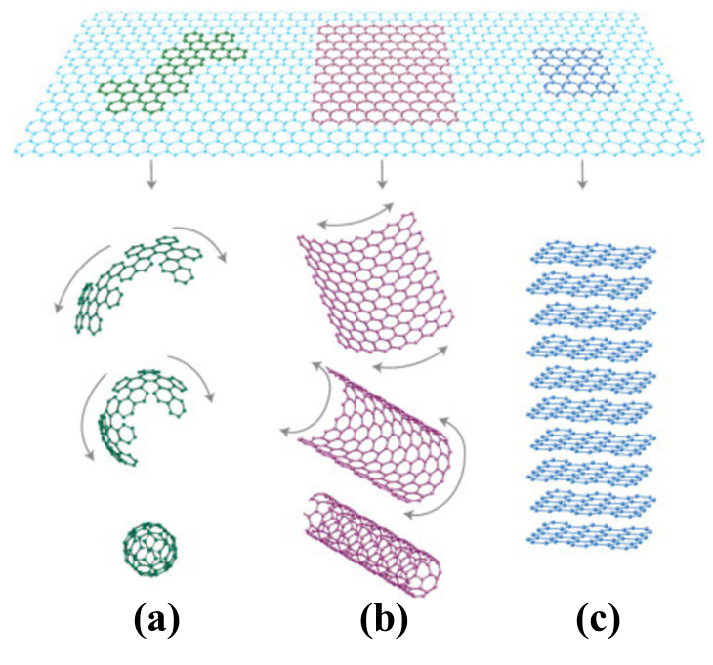
Figure 2.1. Graphene as a building block of graphitic materials. (a) fullerenes. (b) carbon nanotubes. (c) graphite (Reproduced from reference [20]).

2.3.2. Graphene oxide (GO)
Graphene oxide is the oxidation form of graphene, which is simply considered as the combination of graphene sheets and oxygen groups. The structure of GO has been debated for decades with the type and distribution of oxygen functional groups, including Hofmann, Holst’s, Ruess, Scholz-Boehm, Nakajima-Matsuo, and Lerf-Klinowski models etc [40]. Among them, Lerf-Klinowski model is the most supported structure of GO by NMR, in which epoxide and hydroxyl groups are presented in the graphene planar and carboxyl and carbonyl groups are at the edges [22,40,41]. These oxygen functional groups offer four main advantages: Firstly, GO is hydrophilic nature depending on the degree of functional groups. Secondly, these functional groups extend the interlayer distance from 0.35 nm in graphite to 0.6 nm even to 1 nm in GO depending on the humility, resulting in a much easier exfoliation of graphite due to weak van der Waals’ force. Thirdly, these polar groups exposed into polymer matrix enhance the interfacial interaction between GO and matrix. Finally, the presence of oxygen functional groups allows GO to be further surface-modified for certain special demands [40,42,43]. However, the oxidation of graphene breaks up the sp²-hybridized structure of graphene sheets which generates some defects in graphene structure. Therefore, GO is an electrical insulator material [22,44].

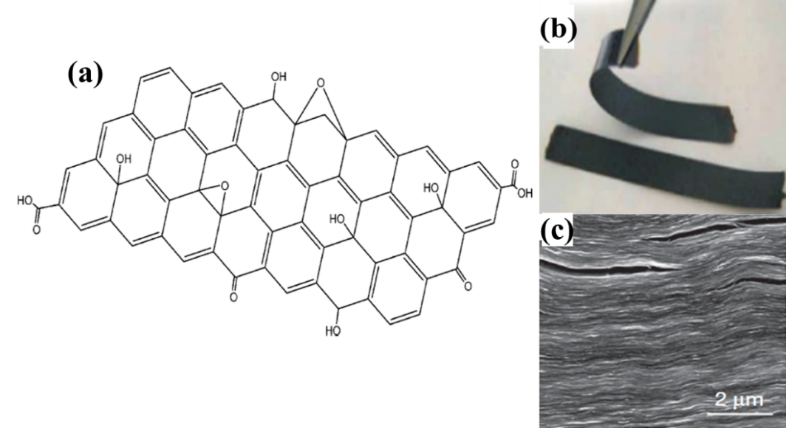
Figure 2.2. (a) Lerf-Klinowski model structure of GO (Reproduced from reference [22]), (b) ~25 μm thick GO strip, (c) SEM image of side of GO sheet with 10 μm thickness (Reproduced from reference [45])

GO was first explored by Brodie in 1859, in which potassium chlorate (KClO₃) and fuming nitric acid (HNO₃) were used as the oxidant. Staudenmaier developed Brodie method by using sulphuric acid (H₂SO₄) and fuming nitric acid (HNO₃) instead of individual HNO₃. However, the drawback of these two methods is the liberation of toxic gas like NO₂, and N₂O₄. Hummers method is a popular and common way for preparation of GO in recent research, which was firstly proposed by Hummer in1958. For this method, a combination of concentrated H₂SO₄ and potassium permanganate (KMnO₄) were employed [46]. In Hummers method, diamanganese heptoxide (Mn₂O₇) is the reactive oxidant which is formed from KMnO₄ and H₂SO₄, as shown in Scheme 2.1. [46,47]. The drawback of this method is the potential contamination by excess permanganate ions, which needs to be removed by H₂O₂ treatment, followed by washing and dialysis [22].
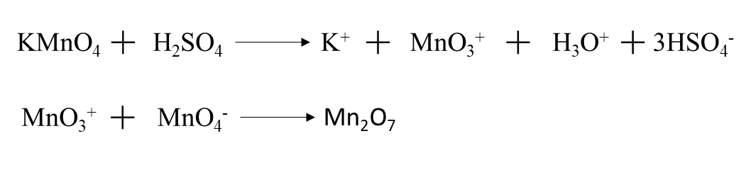
Scheme 2.1. Formation of dimanganese heptoxide (Mn₂O₇) from KMnO₄ (Reproduced from reference [46])

2.3.3. Dispersion of graphene oxide in organic solvents
Graphene is hydrophobic which is not soluble in both aqueous and organic solvents. GO can be exfoliated into single or few layers in aqueous and some polar solvents by mechanical shearing and ultrasonication due to its hydrophilic nature. However, the dispersion of GO in polymer matrix and weakly polar organic solvents is quite poor [48–51]. For reinforced polymer nanocomposites, the dispersion quality of graphene in polymer matrix is a key for the final properties. To date, GO is an attractive intermedia for polymer nanocomposites. This is because: 1) water soluble polymers like PVA can be reinforced by GO aqueous directly followed by reduction. 2) The interfacial interaction between GO and polymers are stronger compared to that of graphene and polymers. Many efforts have been made to disperse graphene and GO in water and organic solvents by modification, which will be discussed later. Paredes et al. studied the dispersion of GO in water and 13 different organic solvents by bath ultrasonication for 1 h. Figure 2.3 shows the digital pictures of as-prepared GO dispersion after 3 weeks [50]. UV-vis and AFM were employed to investigate the dispersion capability and thickness of GO. DMF, THF, NMP, and ethylene glycol displayed similar dispersion as that in water, with an average thickness of 1.0-1.4 nm, indicating that GO was exfoliated into single to few layers in these four organic solvents. However, other solvents shoed a bad dispersion of GO. The mechanism of the dispersion of GO in solvents are not clear, but one possible reason is the polarity of solvent molecules. Solvents with high electrical dipole moment value can offer good GO-solvent interaction, resulting in a good dispersion of GO [50,52].
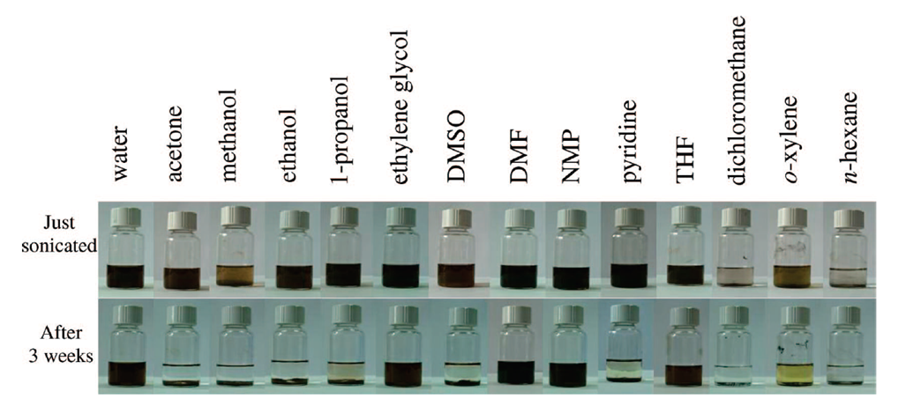
Figure 2.3. Digital images of GO in water and 13 organic solvents after ultra-sonication and after 3 weeks (Reproduced from reference [50]).

2.3.4. Modification of Graphene
Owing to its hydrophobic nature and tendency to agglomerate, the dispersion of graphene in water, organic solvents and polymeric matrix is a big challenge for fabrication of graphene based composites [34,44]. The surface modification of graphene/GO can facilitate the dispersion of graphene and stabilize graphene in organic solvents and polymer matrix to prevent agglomeration. To date, graphene can be modified by chemical modification, π-π interaction, and electrochemical modification methods [53].

2.3.4.1. Chemical modification of graphene
Chemical modification is normally carried out after the oxidation of graphene. It is an attractive way because it can improve the dispersion of graphene in organic solvents and polymeric matrix, as well as enhance the interfacial interaction with polymers. Lots of work based on chemical modification has been reported including, covalent modification, non-covalent modification, reduction of GO in a stabilization medium, etc.

  - Covalent modification of graphene oxide
Covalent modification of graphene is one of most common method to modify graphene, including amination, esterification, and isocyanate/diisocyanate modification [44]. Nanocomposites based on the covalently modified GO exhibits better homogeneity, resulting in great mechanical properties and electrical properties [53]. Niyogi et al. synthesized modified GO by amination method, in which octadecylamine (ODA) was used to couple with GO, thionyl chloride (SOCl₂) was used to active the carboxylic acid groups of GO. This ODA-modified GO was soluble in THF, CCl₄, and 1,2-dichloroethane. Sasha et al. modified GO by isocyanate (iGO) under nitrogen for 24 h and the reaction was quenched by adding methylene chloride [34]. This iGO can form stable dispersion in most of organic solvents like DMF, THF, NMP, and DMSO. For amination modification, carboxyl acid groups from GO react with amide groups from amide by formation of carbamate ester and amide groups, as shown in Figure 2.4. Similar to amination, esterification is another important approach for modification of GO by reaction between carboxylic acid groups from GO and -CH₂OH terminated functional groups from polymers. Yu et al. modified GO by the -CH₂OH terminated P₃HT, and the SOCl₂ treated GO was carried out under reflux for 24 h prior to the esterification with P₃HT. The GO-P₃HT is soluble in common organic solvents such as THF, DMF, and NMP [54].
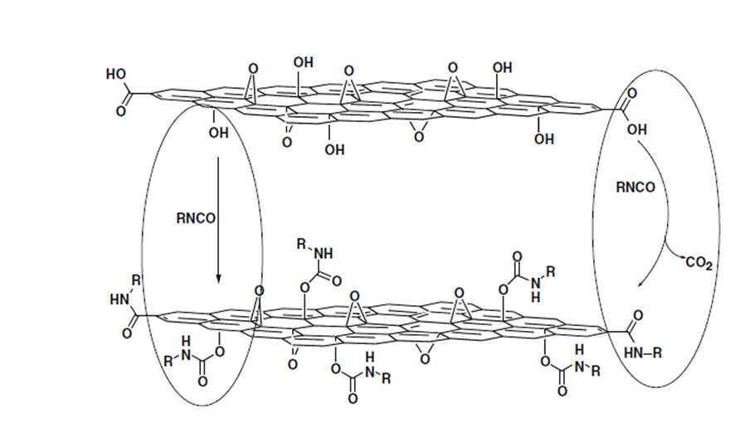
Figure 2.4. Schematic diagram of the formation of carbamate and amide functionalities of iGO (Reproduced from reference [34]).

  - Non-covalent modification of graphene oxide
For non-covalent modification, graphene is functionalized by wrapping or coating them with surfactants like amphiphilic polymer poly(sodium 4-styrenesulfonate) (PSS), ionic liquids, and macromolecules. Therefore, the structural integrity of graphene can’t be altered, resulting in outstanding properties of sp²-network [53]. Hao et al. reported TCNQ (7,7,8,8-tetracyanoquinodimethane)-anion-stabilized graphene by negative charges from TCNQ anion on graphenes and strong π-π stacking interaction with graphene, which can be re-dispersed in water, DMF and DMSO [55]. Pu et al. prepared well-dispersed graphene in water and organic solvents by different types of surfactants, including tetradecyltrimethylammonium bromide (CTAB), polyoxyethylene (40) nonylphenylether (CO890), sodium dodecyl sulfate (SDS), and polycarboxylate (H14N). The conductive graphene films were made by spray- or drop-coating on substrates [56].
  - Reduction of GO in a stabilization medium
Park et al. prepared a homogeneous aqueous chemical reduced graphene (CRG) under strong basic atmosphere. Prior to reduction, the addition of KOH in GO aqueous offered numerous amount of negative charges by reaction with epoxy, carboxylic acid groups, resulting in extensive coatings on GO sheets with negative charges and K⁺, which can further stabilize the reduced GO by reductant hydrazine monohydrate in water for 4 months. The advantage of this method is to produce bulk graphene aqueous without surfactants [57].

2.3.4.2. π-π interaction of graphene
Aromatic molecules are frequently used to disperse graphene in aqueous and organic media by π-π stacking interaction with the π orbitals of graphene. For example, pyrene and its derivatives is great for dispersing of graphene due to its large planar aromatic structure, resulting in a strong affinity to graphene basal plane by π-π stacking interaction. Some works based on stabilizing of graphene by aromatic molecules have been reported. For instance, Su et al. used pyrene-1-sulfonic acid sodium salt (PyS) and diasodium salt of 3,4,9,10-perylenetetracarboxylic diimide bisbenzenesulfonic acid (PDI) to prepare stable dispersion of graphene. Briefly, GO aqueous was mixed with sodium hydroxide and hydrazine monohydrate with PyS or PDI under 80 ºC for 24 h. The resulting rgo films exhibit great electrical conductivity, which is 13.9 S cm⁻¹ for rGO-PDI, and 1.9 S cm⁻¹ for rGO-PyS, respectively [58]. The excellent stabilization efficiency of PDI and PyS is contributed to two reasons: First, the strong π-π stacking between large planer aromatic structures of stabilizers and graphene. Secondly, the negative charges on stablilizers’ planes react with carboxylic acid of GO, resulting in negative charges on GO sheets. Therefore, the dispersion of graphene in aqueous can be further enhanced by static repulsion force, as shown in Figure 2.5.
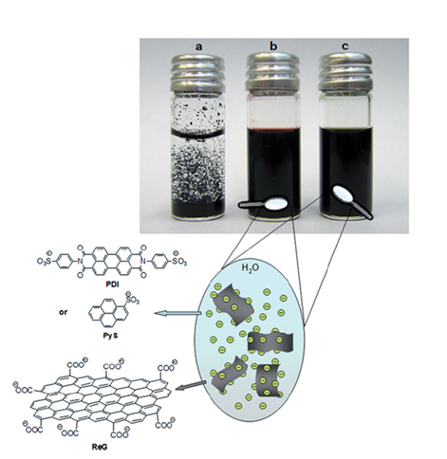
Figure 2.5. Schematic illustration of graphene aqueous (0.25 mg ml⁻¹): (a) reduced GO aqueous, (b) rGO-PDI aqueous, and (c) rGO-PyS aqueous (Reproduced from reference [58]).

2.3.4.3. Electrochemical modification of graphene
Graphene was produced by electrochemical functionalized of graphite, which is a low toxicity, negligible vapor methods. This is a new area for graphene, rare works has been reported in literature. Liu et al. produced graphene nano sheets (GNS) by electrochemical modification, the schematic diagram is shown in Figure 2.6. Commercial graphite electrodes were immersed in a mixture of water and imidazolium-based ionic liquid (ILs). A static potential of 15 V was applied between the two graphite electrodes, and the black precipitate was obtained at the bottom of the reactor, which is GNS^{IL}. As-prepared GNS^{IL} showed a thickness of 1.1 nm, and can be re-dispersed in DMF (1 mg ml-1) by ultrasonication [59].
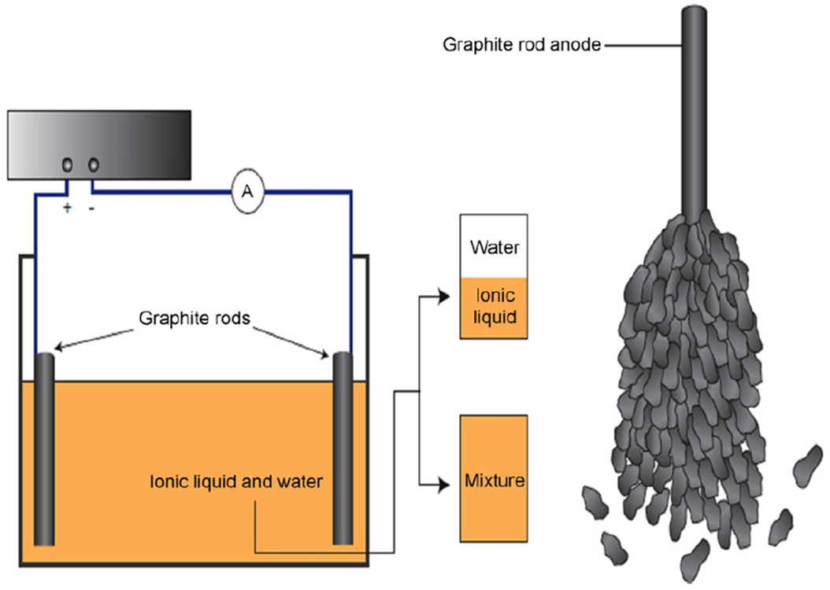
Figure 2.6. Experimental set-up diagram (left) and the exfoliation of the graphite anode (right) (Reproduced from reference [59]).

2.4. Polymer matrix materials

2.4.1. Common polymeric matrix
Polymers are large molecules or macromolecules, which are composed of huge number of repeated subunits. They are classified into two categories: natural polymers (DNA, RNA) and synthesis polymers such as polystyrene, polyester [3]. Generally, polymer is classified into two categories: thermoplastics and thermosetting. Thermoplastic is a polymer that can be soften or melt under heating. The curing process is reversible as no chemical bonding takes place. It can be reshaped, remolded and recycled without any negative effects on the physical properties. However, the disadvantage of this polymer is the high price and poor thermal stability. Thermosetting is a plastic that in cured from a soft solid or viscous liquid prepolymer or resin. Unlike thermoplastics, thermosetting polymer cannot be melt or reshaped because the chemical network is formed during the curing process. The most common used thermoplastics are polypropylene (PP), polyethylene (PE), and poly vinyl chloride (PVC). Thermosetting polymers possess high chemical and temperature resistance, strong mechanical properties, and high dimensional stability. However, the disadvantage is that they can’t be recycled, reshaped and remolded. Epoxy, unsaturated polyester are the most common thermosetting polymers [19,60–62].

2.4.2. Polyester and unsaturated polyester
Polyesters are one of the most versatile synthetic copolymers which contain ester groups in its main chain [63,64]. They are widely used as fibres, plastics, composites and coatings. Common polyesters include saturated polyester resin, unsaturated polyester resin, alkyd resin, and vinyl ester resin, etc [64]. Unsaturated polyester resins (UPR) are thermosetting polymers, which is condensed from unsaturated acids or anhydrides and diols. The vinyl groups (C=C bond) in polyester chains provides active sites for crosslinking under proper condition [63,65]. Owing to its feasibility, high chemical resistance, and good mechanical properties, UPR has been widely used in many applications such as sanitary-ware, pipes, tanks, gratings, and high performance components for boats, buses and automotive industry [66,67]. Compared to epoxy, the mechanical properties of UPR is inferior. However, this can be solved by combing various reinforcements for specific requirements. There three categories of UPR, which is ortho-phthalic polyester resin, iso-phthalic polyester resin, and tere-hthalic polyester resin. . Ortho-phthalic polyester resin is a basic economic resin for many manufacture with general purpose. It is much cheaper compared to other resins, but the properties such as strength, chemical resistance is relatively inferior. Iso-phthalic polyester exhibits higher-grade performance of strength, chemical resistance, water resistance, and flexibility. However, it is only utilized in demanding applications. Tere-phthelic polyester resin is currently manufactured in a very limited volume and applied as a specific resin. That is because it is difficult for making it from tere-phthelic acid and glycol.
Most of unsaturated polyester resins are viscous, pale coloured liquid in low-molar-mass solvent, which is usually styrene (normally 33-35 wt.%, up to 50%). The presence of styrene is to make the UPR easier to be handled at room temperature by reducing the viscosity. Moreover, it acts as an agent for linking the adjacent polyester molecules [1]. During the curing process, organic peroxide (i.e. Methyl ethyl ketone peroxide (MEKP)) is usually used as catalysts or initiators, cobalt salts used as accelerators or promoters [13]. In the UPR/styrene system, styrene links polymer chains by free radical reactions, which is initiated by organic peroxide. Figure 2.7 illustrates the mechanism of the crosslinking reaction of UPR, in which it shows four possible polymerization: (1) Intermolecular crosslinking with or without linking through styrene monomers (microscopic network formation). (2) Intramolecular crosslinking with or without linking through styrene monomers (cyclization) which occur among pendant C=C bonds. (3) Branching on the polyester molecules by styrene monomers, which do little effect on the formation of network. (4) Styrene homopolymerization. However, the first two reactions contribute the ST-UPS system. There is a trend for these long chains to coil up to spherical structures because of the intramolecular crosslinking among pendant C=C bonds. This spherical-type structure also called “micro gel particles” [7].

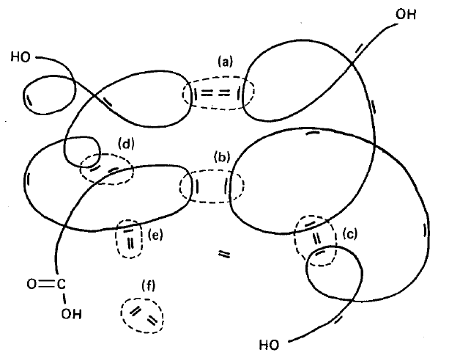

Figure 2.7. Schematic diagram for 4 possible reactions in UPR/styrene system: (a) intermolecular crosslinking E-(Sn)-E, (b) intermolecular crosslinking E-E, (c) intramolecular crosslinking E-(Sn)-E, (d) intramolecular crosslinking E-E, (e) branching growth E-(Sn); (f) styrene homopolymerization Sn-Sn [1].

2.5. Polymer/graphene nanocomposites
Owing to its large specific surface area, and strong mechanical properties, graphene and its derivatives, such as graphene oxide, reduced graphene oxide, and expanded graphite etc., are considered as a potential candidate to reinforce polymer materials for widely applications. To date, many studies based on graphene-based polymers have been reported, such as epoxy/graphene [68], PMMA/graphene [69], polypropylene/graphene [70], and polysyrene/graphene [71], etc. Graphene-based polymer nanocomposites are normally processed by three main methods: in situ polymerization, solution intercalation, and melt blending. Moreover, a combination of these three methods is also used for some study [22,53,61].

2.5.1. Preparation of polymer/graphene nanocomposites
In situ polymerization
In situ polymerization is an effective method to improve the dispersion of graphitic fillers in polymeric matrix. In this method, the polymerization of polymers is carried out at the presence of fillers, leading to a stronger interfacial interaction between reinforcing fillers and matrix. Therefore, graphene-based polymer composites exhibit better mechanical and thermal properties, as well as lower percolation threshold compared to composites prepared from melting method and solution method [21,44]. A variety of polymer nanocomposites have been prepared by this method, such as polystyrene/graphene [72], poly(methyl methacrylate)/EG [73] . However, the disadvantage of this method is that it is not suitable for bulk synthesis due to the abundant amount of electric energy is needed [21].

Solution intercalation
Solution intercalation is based on a solvent system in which polymer is dissolved in a solvent, followed by the addition of given amount of graphitic fillers. Solvent needs to be removed before casting. The good dispersion of graphitic fillers in a solvent can be achieved by modification. However, the removal of solvent is a big issue for this technique which causes environmental problem. Therefore, this method is not suitable for bulk fabrication for graphene-based composites [21,44]. A wide range of polymer nanocomposites such as poly(vinyl alcohol)/graphene [74], polypropylene/graphene [75], polystyrene/graphene [76], etc. prepared by solution intercalation technique have been reported.

Melt blending
Melt blending is cost effective, environmental friendly, and direct technique for manufacturing polymer /GO nanocomposites, in which graphitic fillers is dispersed in the polymeric matrix in its molten state under elevated temperature without any solvent. In this method, conventional methods are usually employed such as extrusion and injection moulding. However, this method is only used for thermoplastic polymers, which limits its application [21,44]. Moreover, the quality of dispersion of fillers is not as good as in situ polymerization and solution intercalation. Thus, a harsh shearing process is employed to exfoliate graphitic fillers and to overcome the interaction forces among graphitic sheets [42]. To date, a widely range of polymer nanocomposites are prepared by using this method, i.e. polypropylene/EG [77], HDPE/EG [78], polyphenylene sulphide/EG [79], etc.

2.5.2. Properties of polymer/graphene nanocomposites
Owing to its strong mechanical properties, great thermal and electrical conductivity, and high specific surface area, graphitic fillers are expected to be a promising reinforcement for polymer nanocomposite. The common graphitic fillers for polymer nanocomposites are modified graphene, graphene oxide (GO), expanded graphene (EG), etc. In this section, the effect of graphitic fillers on the mechanical properties, thermal properties, electrical conductivity, glass transition temperature (T_{g}), and morphologic properties are discussed.

2.5.2.1. Reinforcement and mechanical properties
The main purpose of incorporation of graphitic fillers into polymeric matrix is to improve the mechanical properties, including modulus, strength, and toughness. The influence of mechanical properties of polymer nanocomposites is very complex, which is determined by many factors. Normally, the final mechanical properties is determined by both polymer matrix and the rigid fillers, the modulus and strength increase with increasing nanofiller content. Theoretically, the dispersion quality of nanofillers is a main factor for the reinforcement capacity. Homogeneous dispersion of nanofillers in polymeric matrix can improve the modulus and strength by constraining the mobility of polymer chains. However, graphene and its derivatives tend to aggregate with the increasing filler content due to its van der Waals' force. Therefore, the effective aspect ratio of nanofiller is reduced, resulting in a reduced modulus and strength. Numerous works have been reported that the addition of graphitic fillers can enhance the mechanical properties of polymers at low concentration [80]. Zhao investigated the influence of graphene on the mechanical properties of PVA (Figure 2.8) [81]. In his study, the Young’s modulus and tensile strength increased dramatically with graphene content up to 1.8 vol%. Whereas, the elongation at break is reduced significantly. This may be contributed to a large aspect ratio of graphene and good interfacial interaction between graphene and polymeric matrix. When the graphene content increased more than 1.8 vol%, both Young’s modulus and tensile strength are reduced. Whereas, the elongation is increased compared to PVA composites with lower concertation. The reason for this phenomenon is presumably due to the restacking of graphene caused by van der Waals' force after a critical graphene content (mechanical percolation), resulting in a reduced interfacial interaction between graphene and PVA. Moreover, the arrangement of graphene can change from exfoliated graphene to piled graphene and stacked graphene when graphene content reaches or over the mechanical percolation, which may cause slippage between graphene nanosheets. Hence, Young’s modulus and tensile strength were reduced after 1.8 vol%. Whereas, elongation at break increased [81].

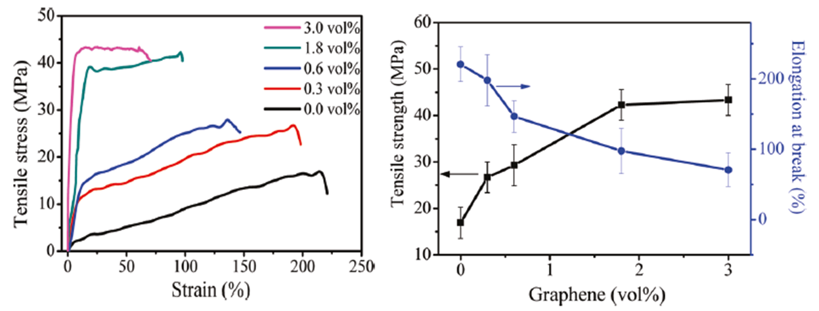
Figure 2.8. Mechanical properties of PVA/graphene nanocomposites: stress-strain curve (left) and tensile strength and elongation at break versus graphene loadings (Reproduced from reference [81]).

The dispersion of graphene in polymer matrix can be explained by the schematic models of arrangement of graphene, as shown in Figure 2.9. It is assumed that there are four types of arrangements of graphene in polymeric matrix. (1) Graphene nanosheets are individually dispersed in the matrix at intervals. (2) The edges of graphene nanosheets just join together side by side. (3) Some of graphene nanosheets are overlapping with each other. (4) Graphene nanosheets are restacking together by layers [81]. When the graphene is at very low loading, it is exfoliated into single layers through matrix, which constrains the mobility of polymer chains, resulting in an enhanced modulus, strength, and reduced elongation at break. The arrangement (2) is the optimum state for reinforcement capacity. With the increase of graphene content, the arrangement of graphene would be changed from exfoliated single layer (1) to piled graphene (3), and then to stacked graphene (4). Therefore, some slippage of graphene sheets and the tendency of aggregation could happen upon external force, resulting in a lowered reinforcement capacity [81].

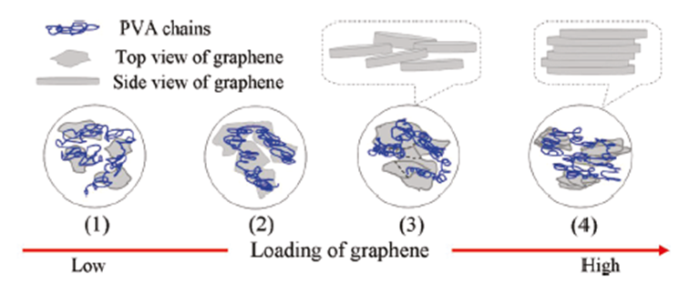
Figure 2.9. Schematic models of various dispersion types of graphene nanosheets in polymer matrix: (1) Graphene nanosheets are individually dispersed in the matrix at intervals. (2) The edges of graphene nanosheets just join together side by side. (3) Graphene nanosheets are overlapping with each other. (4) Graphene nanosheets are restacking together by layers (Reproduced from reference [81]).

Strong interfacial adhesion is another crucial factor for reinforcement capacity, and the incompatibility between fillers and polymers may reduce the modulus and strength [82]. There are two main ways to enhance the interfacial adhesion. First, the hydrogen bonding between graphitic fillers, i.e. GO and modified graphene, and polymers [74]. Second, the covalent bonding between G-O and monomers that contains reactive functional groups in an in situ polymerization method [83]. Either hydrogen bonding or covalent bonding can enhance the interfacial adhesion between fillers and polymers compared to nanocomposites with only van der Waals force, resulting in an improved modulus and strength. Interfacial energy is normally 50-300 J m² for covalent bonds at the interface of nanofillers and polymer matrix, and 50-350 mJ m² for only van der Waals force [84]. When a material is subjected to an external force, the defects for covalent bonds that facilitate the crack propagation at the interfaces are much larger than at for van der Waals force. For instance, Poly(methyl methacrylate)/graphene exhibit a shear stress up to 2.3 MPa [85], which is similar to the shear stress value of poly(ethylene)/CNT nanocomposites [86]. While, CNT/polymer composite with covalent bonding exhibit a shear stress up to 47 MPa [87].
Aside from the dispersion of graphitic fillers and the interfacial adhesion, the reinforcement capacity is also affected by the intrinsic structure of graphitic fillers. For some thermal expanded graphene oxide (TEGO), it shows wavy or wrinkled structures which may reduce the modulus [88]. This is because crumpled graphitic fillers tend to unfold rather than stretch under an external force. Moreover, some structural defects generated during exfoliation under the elevated temperature may also reduce the effective modulus.

2.5.2.2. Thermal properties
Thermal conduction is the ability for heat transfer that involves the transport of energy from one place to another by energy carriers, such as random molecules (gas), molecule diffusion (liquid), electrons and phonons (solid). For most polymers, the heat is transferred by phonons because there is no free movement of electrons in polymers [89,90]. Normally, the thermal conductivity is varies from 0.2 W m⁻¹ K⁻¹ for amorphous polymers to 0.5 W m⁻¹ K⁻¹ for highly crystalline polymers [90], The thermal conductivity of polymers has been enhanced by incorporation of thermally conductive fillers, such as carbon black, carbon nanotubes, graphite, ceramic and metal particle [91–94]. Graphene is expected to be a promising candidate for the enhancement of thermal conductivity of polymers due to its high thermal conductivity (5000 W m⁻¹ K⁻¹ at room temperature) large specific surface area [22].
The interfacial thermal resistance is the barrier to heat flow due to the differences between electronic and vibrational properties in different materials. It is associated with the interfaces between nanofillers and polymeric matrix. Theoretically, fully exfoliated graphitic fillers, large aspect ratio and flat surface of graphitic fillers, and the reduced size of fillers, could increase the interfaces between fillers and polymeric matrix, resulting in a lower interfacial thermal resistance. Therefore, more transmission of phonons carried out at the interfaces, resulting in an higher thermal conductivity [78,95–97]. Moreover, the covalent bonding between filler and matrix can reduce the phonon scattering at the interfaces, resulting in an improved thermal conductivity [61]. To date, some works have been published that the significant improvement on thermal conductivity of polymers can be improved by addition graphitic fillers. Teng et al. investigated the effects of different nanofillers on the thermal conductivity of epoxy, as shown in Figure 2.10. The significant improvements of thermal conductivity are observed in graphene/epoxy and Py-PGMA-graphene/epoxy, which is much higher than that of MWCNs/epoxy. This is due to the higher aspect ratio and flat surface of graphene than MWCNT, resulting in large interfaces and lower barrier for phonon transport. Py- Py-PGMA-graphene/epoxy exhibits the highest thermal conductivity. This is presumably contributed to two reasons: 1) Py-PGMA modified GNS can be dispersed well in polymeric matrix due to its excellent solubility in solvent, resulting in an increased interface between filler and matrix. 2) The functional groups on Py-PGMA-graphene/epoxy can form covalent bonds with polymerix matrix, resulting in a strong interfacial interaction. Therefore, the interfacial thermal resistance is lower than that for graphene/epoxy, resulting in a superior thermal conductivity over graphene/epoxy [98].
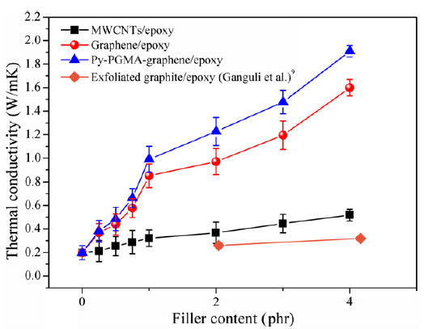
Figure 2.10. Thermal conductivity with various filler contents of MWCNTs/epoxy, graphene/epoxy, and Py-PGMA–graphene (Reproduced from reference [98]).

The thermal stability of polymers are defined by the onset temperature, the temperature of maximum mass loss rate, and char yield. Extensive work has been reported that the incorporation of graphitic nanofillers can improve the thermal stability of polymers [78,95,97]. The mechanism of the improvement of polymer nanocomposites by nanofillers is not clear yet. It is usually well accepted that good dispersion and strong interfacial adhesion are beneficial for the enhancement of thermal stability [96].

2.5.2.3. Electrical conductivity
One of the most promising aspects of graphene-based materials is their potential for electronic devices [61]. Paper-like graphene is measured to be highly electrical conductive, and the electrical conductivity is approximately 35,100 S m⁻¹[22,99]. Therefore, it is potential for improving the conductivity of both conductive polymers and insulating polymer. Once dispersed in polymer matrix, nanofillers form a tunneling surrounded by thin polymer layers, where the current flows through [100]. The tunneling resistance is a barrier for the current flow associated to the electrical conductivity.
Electrical percolation threshold is the minimum nanofiller content for polymer material, where a conductive network of nanofillers is formed for current transfer. The alignment of the filler plays an important role on percolation threshold. When the anisotropic nanofillers are aligned under external forces like compression force, the interconnectivity between fillers are negatively affected, resulting in an increased percolation threshold [101,102]. For example, Kim developed polycarbonate/graphene composites by injection molding. The anisotropic disk-like modified graphene get aligned under external force. The electrical percolation threshold is one order of magnitude higher over that of poly(propylene)/graphene prepared by compression molding [103].
As well known, the dispersion of nanofillers is the key for the performance of polymer nanocomposites, including mechanical properties, thermal properties, grass transition temperature, etc. However, high dispersion quality may not necessary for a low electrical percolation threshold and high conductivity. For a well dispersed system, the polymer may coat the surface of nanofillers, which would prevent the contact area between fillers, leading to a higher tunneling resistance and percolation threshold. It is observed that the fillers segregated from matrix can form an conductive network rather than homogeneously dispersed nanofillers [61]. Besides, percolation threshold is also determined by the experimental process, and the intrinsic properties of fillers. Folded, winkled nanofillers would also reduce the contact area between fillers, resulting in an increased percolation threshold [104].
The insulating polymer can be turned into electrical conductive by incorporating with conductive nanofillers like graphene. Electrical conductivity of polymer composites is determined by the filler content, the conductivity of fillers, the intrinsic of fillers, and the percolation threshold between fillers and polymers. When the filler content reaches the percolation threshold, the conductivity can be calculated by simple power-law expression below [61]:
$σ_{c }= σ_{f }{(φ - φ_{c})}^{t}$ (2.1)
Where $σ_{c }$is the electrical conductivity of composite, $σ_{f }$is the conductivity of filler, $φ$ is filler volume, $φ_{c}$ is the percolation threshold.

2.5.2.4. Glass transition temperature (T_{g})
Glass transition temperature is a temperature range in which the glass transition happens. It is reported that the incorporation of graphitic fillers can change T_{g}. Fundamentally, the interface between fillers and polymeric matrix can restrict the mobility of polymer chains at low graphitic filler content. However, some aggregations happens as an increased filler content, resulting in some free interfaces. Therefore, the ability to constrain the mobility of polymer chains are reduced, resulting in reduced T_{g} [105]. Moreover, the strength at the interfaces is another factor to affect T_{g}. A strong strength at interfaces like chemical and covalent bonding between graphitic fillers is beneficial to T_{g} [105,106].

2.5.2.5. Morphology of polymer/graphene nanocomposites
The enhancement on the properties of polymer nanocomposites, such as mechanical properties, thermal stability, thermal conductivity, and glass transition temperature, etc. strongly depends on the microstructure of nanocomposites. Effective characterization of polymer composites plays an important role on the relationship between structure and properties. Scanning Electron Microscopy (SEM) and Transmission electron microscopy (TEM) are most common techniques for investigation of dispersion of nanofillers and the microstructure of graphene-based polymer nanocomposites.
A scanning electron microscope (SEM) is a type of electron microscope that produce images of a sample by scanning the surface with a beam of electrons. The electrons react with atoms of sample, producing various signals that contains the information about the surface topography and composition of the sample. Normally, SEM provides images with magnifications up to ~X50,000 allowing submicron-scale features to be seen i.e. well beyond the range of optical microscopes [107]. SEM plays a vital role for assessing the morphology of composites and the microstructure-properties correlation. However, the dimension of nanofillers is only few orders magnitude below the wavelength of electron beam. Thus, it is not a good technique to assess the detailed morphologic property of nanocomposites [108].
TEM is a microscopy technique in which an electron beam is transmitted through a specimen to form an image. Owing to its significant higher resolution over SEM, TEM is an important method to investigate composites at nanoscale. The techniques used to process graphene-based polymer nanocomposites can affect the microstructure of polymers and the orientation of graphitic fillers. Figure 2.11 shows the morphological differences in pol y(urethane) composites with various nanofillers produced by different techniques. When composites are processed by injection molding, graphitic fillers may show aligned state near the surface while more random orientation near the interior [103]. Composites prepared by melt mixing method, graphitic fillers may exhibit more oriented and stacked structure, as shown in Figure 2.11(b). However, composites prepared by solution and in situ polymerization methods, random oriented and exfoliated graphitic fillers may be favoured, as shown in Figure 2.11(c, d) [82].
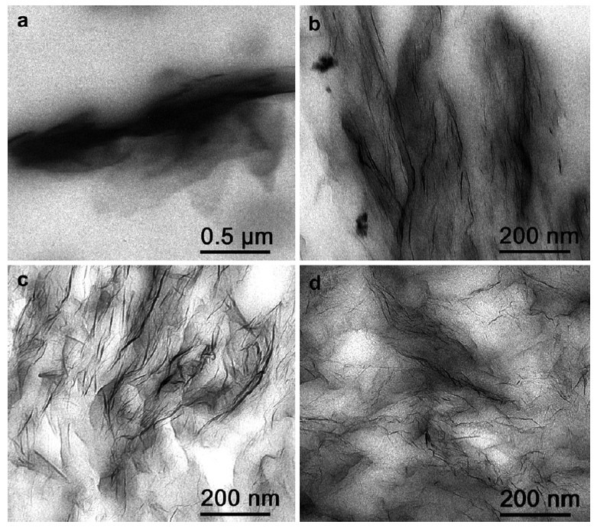
Figure 2.11. TEM images of poly(urethane) filled with various nanofillers: (a) unexfoliated graphite, (b) TEGO, prepared by melt mixing. (c) and (d) show TEGO/polyurethane composites produced by solution blending and in situ polymerization, respectively (Reproduced from reference [82]).

2.6. Bio-based hyperbranched polymer/graphene nanocomposites

2.6.1. Bio-based polymers
Currently, the consumptions of chemical and energy are increasing dramatically due to the rapid increasing in energy demand. More than 90% of organic chemicals and 80% of energy in the world are derived from fossil fuels [1]. However, the extraction of petroleum and utilization of these petrochemicals cause seriously environmental problems [1,2]. In order to solve this issue, researchers have been looking for new candidates to replace/reduce the consumptions of the conventional fossil resources. Bio-based polymers are the products derived from renewable resources, namely biomass, including plants, agricultural food, animal wastes, sugar, trees, etc. Nowadays only 3-4% of biomass has been used for food and non-food applications [1]. Therefore, these renewable, recyclable, sustainable novel bio-based products and their applications are attracting increasing attention of researchers [1,3]. Bio-based polymers are classified into three main: nature polymers, such as proteins, starch, cellulose [4]; polymers from microbial fermentation, such as polyhydroxybutyrate (PHB), polyhydroxyalkanoate (PHA) [5]; synthesis polymers from natural monomers, such as PLA [6,7]. Up to date, numerous bio-based synthetic polymers have been prepared successfully such as bio-based polyesters which are made from broccoli seed oil via a two-step process (epoxidation of double carbon bond followed by ring opening with dicarboxylic acids) [8], polylactic acid (PLA) produced from 100 % renewable resources like cornstarch, tapioca roots, chips and sugar beets, aliphatic-aromatic copolymers poly(butylene succinate-co-butylene furandicarboxylate) (PBSF) synthesized from 2,5-fulrandicarboxylic acid (FA), succinic acid (SA), and 1,4-butanediol (BDO) [9]. Bio-based polymers can be decomposed into H2O, CO2, and humus by bacteria or other living organisms. They have been employed in biomedical and pharmaceutical applications like sutures, stents, drug delivery, and tissue engineering due to its biocompatible, biodegradable, versatile properties and good mechanical properties [1,6,7].

2.6.2. Hyperbranched polymers
Hyperbranched Dendritic polymers are classified into dendrimers and hyperbranched polymers. Due to their unique properties and chemical architecture, these type polymers possesses good solubility, low viscosity, allowing them to be utilized in applications like rheology, drug delivery, self-healing, and energy transfer, etc. [4,5]. Dendrimers are normally synthesized by a multi-step method, resulting in regular and highly branched three-dimensional well-defined architecture [4,109,110]. Unlike dentrimers, hyperbranched polymers are generally prepared by simple one-pot polymerization procedure that is much less laborious than multi-step method, while polymers have much more random branches and less regular structures. At present, hyperbranched polymers are generously synthesized by condensation polymerization of AB_{x}-type (x ≥ 2) monomers [4,111–114]. However, AB_{x}–type monomers are very limited in the commercial industries, so there are fewer works are based on the copolymerization of commercial A_{n} and B_{m} monomers which are more available in the industry markets and can be used directly [5,115–118]. Besides, self-condensation vinyl polymerization (SCVP) developed by Frechet et al. [119–122], and self-condensation ring-opening polymerization (SCROP) can also be employed for synthesis of hyperbranched polymers [123–128].

2.6.3. Branching degree (DB)
Branching degree (DB) is the extent of branching for hyperbranched polymers. The chemical structure and DB have a profound influence on the physical and chemical properties of a hyperbranched polymers, which is necessary to identify the potential applications [129]. DB is a structural property that is determined by the concentration of linear (L), terminal (T) and dendritic (D) units. Two main methods are usually employed to calculate DB by Frechet [56,57] and Frey [58], which are presented equation (2.2), and (2.3):

${DB}_{Frechet} = \frac{(N_{D}+ N_{T})}{(N_{D}+N_{T}+ N_{L})}$ (2.2)
${DB}_{Frey } = \frac{2N_{D}}{2N_{D}+ N_{L}}$ (2.3)

Where, N_{D}, N_{T}, N_{L} are the contents of dendritic, terminal, and linear units, respectively, which can be determined by 13C NMR and by 1H NMR [113]. However, this method is not suitable for the hyperbranched polymer synthesized from large monomers. This is because it is very difficult to determine the main point which is used for distinguishing N_{D}, N_{T}, N_{L} from NMR. Therefore, DB of hyperbranched polymers synthesized from large monomers is still a big challenge.

2.6.4. Hyperbranched polymer/graphene nanocomposites

2.6.4.1 Preparation of hyperbranched polymer/graphene nanocomposites
Similar to thermosetting/graphene composites, hyperbranched polymer/graphene composites can be synthesized by in situ polymerization, solution compounding and melt mixing. Among them, in situ polymerization is a most common method for graphene-based synthesis of hyperbranched polymer nanocomposites. For example, Xu and his workers developed hyperbranched polymer/graphene nanocomposites by in situ grafting from approach, in which the ring-opening polymerization was carried out in the reaction system of 3-ethyl-3-oxetanethanol, GO/CHCl₃ solution and catalyst [130].

2.6.4.2 Properties of graphene based hyperbranched polymer nanocomposites
  - Mechanical properties
For a typical elastomer, it exhibits low modulus, low strength, high elongation at break, and hysteresis properties. It has been reported that the incorporation of rigid nanofillers such as graphene, carbon nanotubes, and carbon blacks can largely enhance the mechanical properties including Young’s modulus, tensile strength, and toughness, which is much more significant than that of other polymer nanocomposites [61,131,132]. This is presumably due to the large difference in modulus and strength between soft elastomers and rigid nanofillers, which makes elastomers less sensitive to the defects caused by fillers [61]. Abundant work has been reported that the large gain on Young’s modulus, tensile strength of elastomers can be achieved by the incorporation of graphitic fillers. Khan et al. produced polyurethane(PU)/EG nanocomposites. In order to compare the different effects of EG for soft elastomer and rigid polymer, polycarbonate(PC)/EG composites were prepared in the same method. The moduli of PU/EG composites improved dramatically by addition of EG, and the maximum value was observed at 55% which was enhanced from 10 MPa to 1.5 GPa. However, the modulus for the PC/EG is reduced except a similar value at 55%, which is presumably due to the dispersion of EG and the crosslinking density impacted by EG [133].
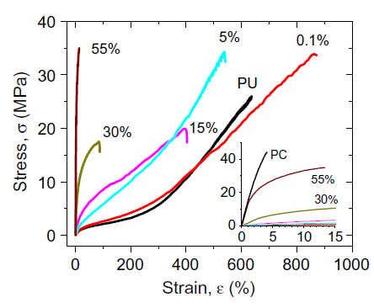
Figure 2.12. Stress-strain curves for PU/EG composites. Insert is the low strain region of stress-strain curves for PC/EG (Reproduced from reference [133]).

Hysteresis is another important property for elastomers. It is determined as the energy loss during a cycle, which is associated to viscoelasticity, viscoelasticity, and strain-induced crystallization. Cyclic tensile test is normally carried out to investigate the hysteresis behaviour, and the area under loading and unloading path of stress-strain curves are defined as the energy loss/hysteresis. Hysteresis is caused by the internal friction between polymer chains, which resist both loading and unloading path. Fundamentally, hysteresis increases as the reinforcement and the strain rate increases. So far, the study on the effect of graphitic fillers on hysteresis behaviour of elastomers is very rare.

  - Self-healing behaviour
Self-healing polymers are designed on reversible bonds, which are able to associate and dissociate upon external energy like heat, light or stimulators. Hyperbranched polymers possesses terminal groups which have the potential for hydrogen bonding. Therefore, some hyperbranched polymers based on hydrogen bonding network exhibit great self-healing behaviour with or without external energy. Theoretically, the density of the hydrogen bonding is the key for the self-healing ability. The incorporation of GO can significantly enhance the mechanical strength and modulus of hyperbranched polymers due to its high mechanical properties, abundant oxygen functional groups and high specific surface area. However, the addition of GO can alter the density of hydrogen bonding sites, which in turn would affect the self-healing capacity [134–137]. Wang et.al. developed amine-terminal hyperbranched polymer and its GO composites. In his work, he investigated the self-healing behaviour of HB-HN₂ composites with various GO loadings. The decay of self-healing efficiency was also studied. HB-HN₂ polymers exhibited rapid self-healing behaviour by the hydrogen bonding formed between amine and carboxyl groups, as shown in Figure 2.13 [135]. For each healing time (from 1 min to 1 h), the self-healing capacity decreases as the GO content increases, in which HBN-1% GO can be self-healed 60^ of its original tensile strength for 1 min, and a complete healing achieved for 1 h. However, HBN-2% GO and HBN-4% GO can only recover 36% and 20% of its original strength in 1 min, respectively. This is because the presence of GO in the polymer chains would prevent the formation of hydrogen bonding. Moreover, GO may also form hydrogen bonding with amine groups in polymer. Therefore, the density of active hydrogen bonding for self-healing is reduced, and the influence increases with increasing GO content [135,138]. Figure 2.14(d) shows the decay of self-healing behaviour of HBN-2% GO composites, in which a given self-healing time of 10 min and various waiting times (1 h, 24 h, and 48 h) were used. Significant decay of self-healing was observed which increases as the waiting time increases. There is slightly drop of tensile strength for 1 h waiting. After 24 h waiting, the strength can be recovered nearly 90% of its original strength. The self-healing capacity with 48 h waiting shows a 50% drop on the tensile strength. Principally, numerous of non-associated groups ‘eager’ to link cross the interface of two broken parts. If the sample is not mended immediately after being cut, some non-associated groups on the broken surface ‘look for ’ other non-associated groups within the broken part during the waiting time, resulting in a less number of free groups. Therefore, the self-healing efficiency is reduces with increasing waiting time [139].
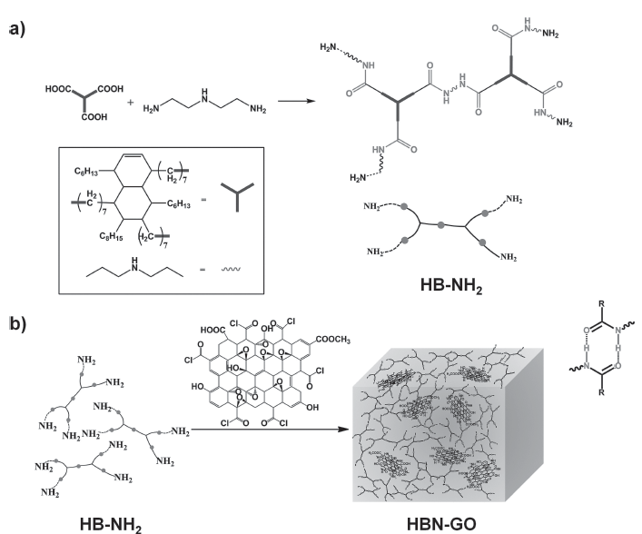
Figure 2.13. a) Synthetic route of HB-NH₂; b) Schematic illustration of the synthesis of the self-healing nanocomposite (HBN-GO)
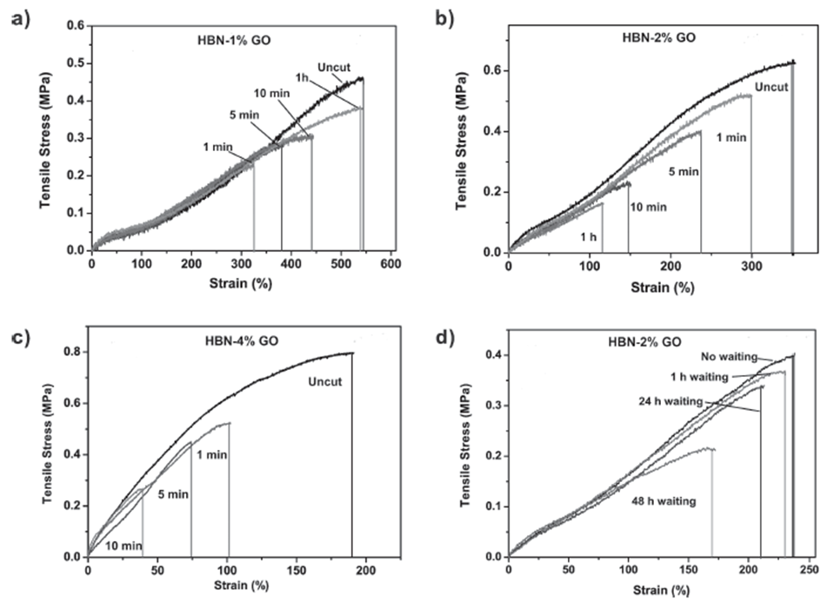
Figure 2.14. Self-healing behaviour of HB-NH₂ composites with GO at a) 1 wt%, b) 2 wt% and c) 4 wt% upon different healing time at room temperature; d) Strain-stress curves of HBN-2% GO composites of 10 min healing time after different waiting time.

2.7. Summary
This review summarized some general concepts, the synthesis method, and properties for graphene-based polymers. The performance of polymer nanocomposites are determined by the process condition, microstructure, the dispersion and orientation of graphitic fillers, the interfacial interaction between fillers and matrix, etc. Graphitic fillers tend to aggregate due to the van der Waas force, and lack of compatibility with polymers. Therefore, some negative effects are usually gains. To address this issue, graphitic fillers are modified via covalent or non-covalent method, which can improve the dispersion of fillers in solvents and the polymer matrix, as well as the compatibility with matrix. Moreover, the process techniques can also improve the properties for specific requirement. For instance, injection molding can produce an aligned polymer/graphene composites, which is beneficial for the mechanical properties. While, composite prepared by the solution compounding followed by the solvent evaporation shows a random orientation of graphitic fillers, which is beneficial for the electrical conductivity. Morphological properties is a key factor for the properties of a polymer/graphene composites. Characterizations such as SEM, TEM, and XRD etc. are usually employed to investigate the microstructure, which can be used for future explanation of the performance of nanocomposites. It has been extensively reported that, the great enhancements of mechanical, thermal, and electrical properties can be achieved for a well-dispersed graphene-based polymer composites at a low concentration.
Owing to its unique structure (branched, terminal functional groups), hyperbranched polymer exhibits some unique properties like self-healing properties. Elastomers are soft polymers, which is highly stretchable, hysteresis, low mechanical properties, and low T_{g}. In order to improve the modulus and strength, rigid graphitic nanofillers are introduced. Compared to hard polymers, large gains of modulus and strength can be obtained. However, the addition of graphitic nanofillers would also increase the hysteresis due to the increased internal friction between polymer chains. Meanwhile, the self-healing capacity is influenced due to the altered density of hydrogen bonding on polymer chains.

Chapter 3: The study of unsaturated polyester/graphene oxide composites

3.1. Introduction
Unsaturated polyester (UPR) is an important thermosetting polymer which has been widely used in coating, construction, automobile, aerospace, storage tanks, and piping due to its low cost, easy processing, low moisture absorption, excellent chemical resistance and good mechanical characteristics [140,141]. However, the mechanical properties of UPR are lower than those of epoxy resin [141]. Therefore, the addition of nanofillers, such as carbon nanotubes [142–145], clay [146–148], and carbon fibres [149,150], is an attractive approach to prepare UPR composites with improved properties even at very low concentrations.
Graphene, a monolayer of sp²–hybridized carbon atoms densely packed into a 2 dimension (2D) honeycomb lattice, has attracted tremendous attention of scientists and researchers due to its remarkable properties, such as Young’s modulus (1 TPa), fracture strength (130 GPa), high intrinsic electron mobility (200000 cm² V⁻¹ S⁻¹ at room temperature), thermal conductivity (5000 W m⁻¹ K⁻¹), optical transmittance (97.7%), and theoretical specific surface (2630 m² g⁻¹ ) [23,42,151]. Graphene oxide (GO) is an oxidation form of graphene, in which epoxide and hydroxyl groups are in the graphene basal planar, carboxyl and carbonyl groups are at the edges [41,61,152]. These abundant oxygen functional groups may create chemically reactive sites on GO surface to form strong interfacial interaction with polymer chains [22,23,41,99]. Recently, GO has been successfully incorporated into water-soluble polymers such as poly(vinyl alcohol) [153], and chitosan [154] via solution method by using water (and acetic acid in the latter) as a solvent. However, this method cannot be used for the fabrication of graphene based organic solvent-soluble polymer composites like UPR composites.
To the best of our knowledge, only few works based on graphene or GO UPR composites have been reported to date. Liu and his workers developed UPR/GO nanocomposites via in situ polymerization which showed an improvement of 53.6% in tensile strength and 48.4% in tensile modulus at 0.08 wt.% GO content. Water was used for GO dispersion and ethylene glycol (EG) monomer [155]. However, the use of water limits its applications for most of polymers which are organic-soluble. Moreover, the in situ polymerization method needs to start from monomers, which is time-consuming and not useful for bulk production of nanocomposites [21]. Tang and Kang [156] fabricated bio-based polyester/GO composite by simple solution mixing method. To graft polyester onto GO, Catalyst DMAP was used to initiate the esterification reaction between hydroxyl groups of polyester and carboxyl groups of GO. High electrical conductivity and thermal conductivity were achieved by this method, which is 0.33 S m⁻¹ at 1.06 vol.% and 0.542 W m⁻¹ K⁻¹ at 1.45 vol.%. However, no mechanical properties were reported in their work. Moreover, the addition of catalyst would also bring some defects on the final properties of composites [61]. In this work, UPR/GO composites were synthesized by simple solution mixing method. Owing to the presence of the oxygen functional groups in the structure of UPR, GO has the potential to form hydrogen bonding with UPR. Therefore, no chemicals were further used for GO modification, which in turn can void any defects caused by additional chemicals. Mechanical properties, thermal properties and dynamic mechanical properties were studied in this work. The effects of GO on the curing process of UPR was also investigated.

3.2. Experimental section

3.2.1. Materials
The unsaturated polyester resin used in this work was CRYSTIC D 3061(R50054, Scott Bader), which was composed of isophthalic acid (25 mol%, 37 wt.%), maleic acid (25 mol%, 22 wt.%), diethylene glycol ((25 mol%, 24 wt.%), and propylene glycol ((25 mol%, 17 wt.%). The average molecular weight (M_{w}) was 2778 Daltons, with polydispersity index of 1.94. It was dissolved in styrene of 33±2 wt.%, with toluhydriqunone and hydriquione as an inhibitors. Methyl ethyl ketone peroxide (MEKP, 30-37 wt.% in diisononyl phthalate, Scott Bader) was used as a initiator, cobalt salt E (2-4 wt.% cobalt 2 ethylhexanoate in styrene, Scott Bader) was an accelerator. Other chemicals including graphite flake (<20µm), concentrated sulfuric acid (98%), sodium nitrate, potassium permanganate, H₂O₂ solution (30%), tetrahydrofuran (THF), and hydrochloric acid (37%) were purchased from Sigma Aldrich.

3.2.2. Preparation of graphene oxide (GO)
Graphene oxide was prepared by modified Hummers method [157]. Briefly, 138 ml of concentrated H₂SO₄ was added slowly in portions into the mixture of graphite flakes (6 g) and NaNO₃ (3 g), followed by stirring rigorously for 30 min in an ice bath. KMnO₄ (18 g) was introduced in portions into the mixture under stirring and the reaction was kept at around 35 ˚C for 7 h. Afterwards, another 18 g of KMnO₄ was added in portions followed by stirring for another 12 h at around 35 ˚C. The reaction mixture was poured into 600 ml ice with a mixture of 15 ml H₂O₂ (30 %) and 330 ml HCl (37%) to reduce excess KMnO_{4.} GO powder was obtained by Centrifuging, ultra-sonication, and dialysis, followed by freeze-drying.

3.2.3. Preparation of graphene oxide–based unsaturated polyester nanocomposites
To prepare neat UPR, and UPR/GO composites with various concentrations of 0.01 wt.%, 0.05 wt.%, and 0.1 wt.% bars, the required amount of GO was dispersed in 40 g UPR by magnetically agitation for 1 h, followed by 1 h mild sonication. The mixture was then degassed in a vacuum oven for 1 h to remove bubbles caused by mixing. 2 wt.% initiator (MEKP), 1 wt.% promoter (cobalt salt) was added, stirred for 5 min, respectively The UPR/GO Dumb-bell bars (12 bars for each concentration) were casted in silica moulds for 24 h at room temperature, followed by half of samples post cured at 80 °C for 3 hours.

3.2.4. Preparation of GO–MEKP and GO–Cobalt hybrids
To study the factors which affect the curing process of UPR, GO–MEKP and GO–cobalt mixtures were prepared by mixing 0.04g GO with 0.8 g MEKP, and with 0.8 g cobalt (the same ratio of 0.1 wt.% UPR/GO composites), respectively. Magnetically agitation for 10 min was needed before cured at room temperature for 24 hours, and post cured at 80 °C for 3 hours. The mixtures were washed with acetone by centrifuging for 3 times to remove the excess MEKP and cobalt residues, and the resultant powders were obtained by drying in a vacuum oven overnight.

3.2.5. Characterization

3.2.5.1. Atomic force microscopy (AFM)
AFM of GO sheets was conducted on Verso Dimension 3100 with Olympus AC160TS probe, in tapping mode at 0.5 Hz on a mica substrate. GO clear suspension was created by mechanical agitation, ultra-sonication and centrifuge at 6000 rpm.

3.2.5.2. Fourier transformed infrared spectroscopy (FTIR)
FTIR of neat UPR, UPR/GO composites, GO–MEKP and GO-Cobalt hybrids were conducted on Spectrum 100 (Perkin Elmer, USA) in the wavenumber range of 4000–500 cm⁻¹ with a resolution of 1 cm⁻¹.

3.2.5.3. Scanning electron microscopy (SEM)
SEM studies were carried out on an FEG-SEM (with a Gatan MonoCL₄ cathodoluminescence spectrometer attached, UK), with an accelerated voltage of 10 kV. Prior to the SEM observation, the fracture surface which was previously ruptured by tensile test was sputter-coated with gold by using an SPI sputter-coater for enhanced conductivity.

3.2.5.4. Tensile and 3–point bending tests
A Hounsfield Test Equipment LTD was employed to study the mechanical properties of neat UPR, and UPR/GO composites. Tensile testing was carried out on specimens of dumb-bell shape (25 mm in gauge length, 5 mm in width at narrow portion) with loading cell of 1 kN (under speed of 2 mm min⁻¹); 3 point bending testing was carried out on specimens of (20 mm x 5 mm) rectangular bars with load cell of 1 kN (under a speed of 1 mm min⁻¹).

3.2.5.5. Dynamic mechanical analysis (DMA)
DMA of neat UPR, and UPR/GO composites with various GO loadings was carried out on a DMA 8000 (Perkin Emler, USA) under a tensile mode, with a temperature range from -20 °C to 160 °C under a heating rate of 2 °C min⁻¹ with a consistent frequency of 1 Hz and pre strain of 0.01 mm (0.1 % of length). The specimens for DMA tests were prepared in rectangular stripe of 10 mm (L) x 5 mm (W) x 3 mm (T).

3.2.5.6. Thermogravimetric analysis (TGA)
TGA of UPR/GO composites, as well as GO–MEKP, and GO–cobalt hybrids was performed on a Thermogravimetric Analyzer Pyris 1 (Perkin Elmer, USA), with the temperature range from 25 °C to 800 °C, heating rate of 10 °C min⁻¹ under a nitrogen flow of 20 ml min⁻¹.

3.3. Results and discussion

3.3.1. Characterization of GO
Oxygenic functional groups on GO sheets allow GO to be readily dispersed in aqueous media like water via suitable agitation and mild sonication. Stable and clear GO aqueous suspension was dropped onto mica substrates. The thickness and dimension of as–prepared GO sheets was observed by AFM in tapping mode. The AFM image of GO sheets in water is shown in Figure 3.1(a, b), which shows that the average thickness of single GO sheet is around 0.7~0.8 nm, similar to the thickness of GO sheet in previous research [48]. Moreover, the particle size obtained from AFM is from 0.43 μm to 0.89 μm, with an average value of 0.66 μm. This implies that GO produced by modified Hummers method could be exfoliated into individual layers in aqueous media via mild agitation with sonication treatment. Compared with the average thickness of single graphene sheet around 0.34 nm [34], GO represented a thicker layer due to the extension between layers caused by the functional groups such as epoxy rings, COOH, C=O, and OH. Besides, the displacement of sp³-hybridized carbon atoms slightly above and below the original graphene plane is another reason for the widened inter layer space [22,157].
The chemical structure of GO was investigated by FTIR analysis, as shown in Figure 3.1(c). Characteristic peaks at 3240 cm⁻¹, 1734 cm⁻¹, and 1618 cm⁻¹ are assigned to O-H, C=O, and C=C stretching vibrations, respectively [141,156]. The peak at 1074 cm⁻¹ is attributed to C-O stretching vibration, which confirmed the presence of epoxy groups on GO sheets [155]. This indicates that oxygenated functional groups have been successfully introduced onto graphite by modified Hummers method. Both FTIR and AMF verify that GO has been successfully oxidized and exfoliated into single layers by modified Hummers method with mild sonication treatment.
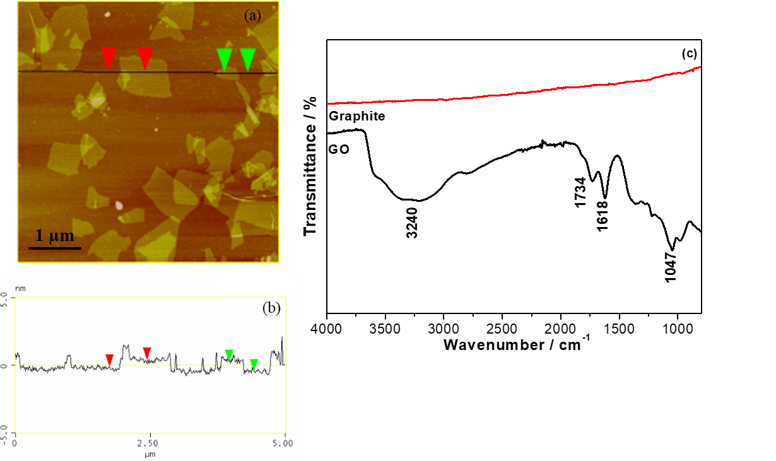
Figure 3.1. (a, b) AFM image of GO in water and (c) FTIR spectrum of GO.

3.3.2. Chemical structure of neat UPR, and UPR/GO nanocomposites with THF

3.3.2.1 FTIR analysis of neat UPR with post cured and non-post cured
Figure 3.2(a) shows the FTIR spectra of neat UPR with post cured at 80 °C and non-post cured. FTIR spectrum of non-post cured UPR shows peak at 2915 cm⁻¹, which is attributed to C-H stretch from alkyl. Peaks at 2184 cm⁻¹, 2011 cm⁻¹, 1584 cm⁻¹, 1473 cm⁻¹ are assigned to C=C stretch from UPR polymer chains and styrene [158,159]. Peak at 1709 cm⁻¹ is assigned to the C=O stretch from ester groups which confirms the formation of polyester resin [160]. Peaks at 1217 cm⁻¹, 1096 cm⁻¹ are contributed to C-O stretch from ester group. Compared to non-post cured UPR, some shifts are observed in the spectrum of UPR with post cured at 80 °C. In details, aromatic C=C peaks at 2184 cm⁻¹, 2011 cm⁻¹, 1584 cm⁻¹, and 1473 cm⁻¹ shift to 2198 cm⁻¹, 2008 cm⁻¹, 1579 cm⁻¹, and 1428 cm⁻¹, respectively. Moreover, peak at 1428 cm⁻¹ is much weaker compared with the peak at 1473 cm⁻¹. This indicates that the further polymerization reaction of reactive C=C bonds between UPR and styrene in curing process are carried out at 80 °C. In addition, peaks of C=O (1709 cm⁻¹), C-O (1096 cm⁻¹) shift to 1715 cm⁻¹, and 1090 cm⁻¹, respectively. All these imply that post cured at 80 °C is essential for UPR to possess higher crosslinking density and better mechanical properties.

3.3.2.2 FTIR analysis of UPR, UPR-THF, and 0.1 wt.% UPR/GO composite with post cure
It is well known that the interaction bonding between polymeric matrix and inorganic filler is the basis for the improvement of interfacial interaction between polymer and nanofillers and enhancement of mechanical, thermal, electrical properties, etc. In this work, the interfacial interaction between UPR and GO is investigated by FTIR analysis, as shown in Figure 3.2. To study the effect of THF on the chemical structure of UPR, controlled sample UPR-THF were prepared in the same procedure of UPR. No significant changes of UPR and UPR-THF are observed from FTIR spectra, indicating that the addition of THF doesn’t affect the chemical structure of UPR. FTIR spectrum of 0.1 wt.% UPR/GO composite shows some changes in comparison with UPR. Specifically, the C=O stretching, C-O stretching, and C-H bending are shifted from 1715 cm⁻¹ to 1710 cm⁻¹, 1096 cm⁻¹ to 1089 cm⁻¹, and 1371 cm⁻¹ to 1373 cm⁻¹, respectively. This confirms the formation of hydrogen bonding between oxygen functional groups from GO and UPR chains. Moreover, absorption peaks of aromatic C=C are shifted from 1428 cm⁻¹ to 1431 cm⁻¹, 2198 cm⁻¹ to 2176 cm⁻¹, and 2008 cm⁻¹ to 2004 cm⁻¹, respectively. This is related to the п-п interaction of aromatic rings from GO and UPR [156]. Therefore, FTIR spectra confirm that UPR chains are grafted on GO sheets by hydrogen bond and п-п interaction, which is the potential for enhanced properties of UPR/GO composites.
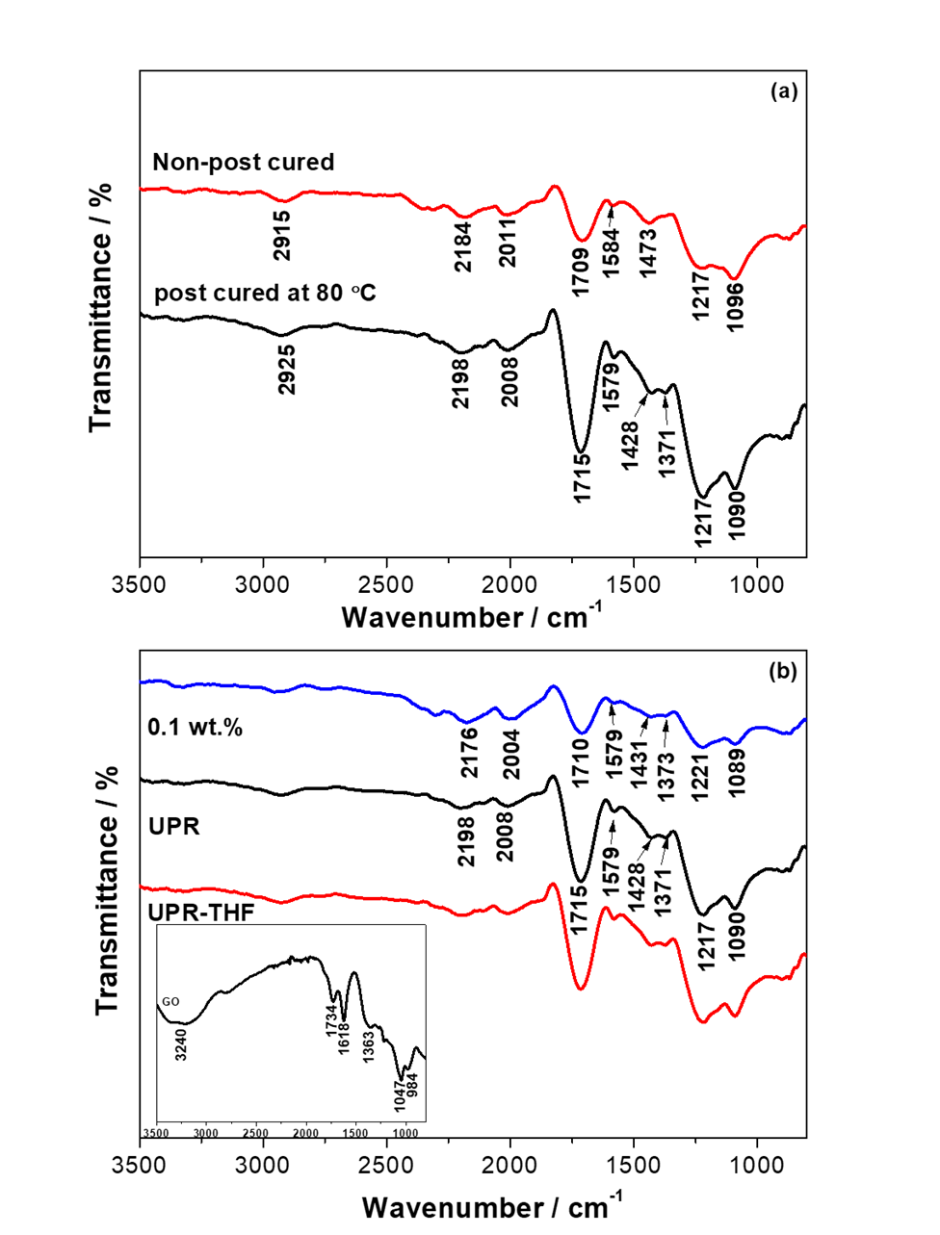
Figure 3.2. FTIR spectrum of (a) neat UPR non-post cured and post cured; (b) UPR, UPR-THF, and 0.1 wt.% UPR/GO composite.

3.3.3. Morphology of UPR, and UPR/GO composites
To examine the quality of the dispersion of GO in UPR matrix, SEM is performed on the cross-section of UPR, and UPR/GO composites as shown in Figure 3.3. The cross-section of samples for SEM analysis is fractured by tensile test. Neat UPR (Figure 3.3(a)) shows smooth flat surface with some stripes and debris which are the typical signs of brittle materials after tensile test. Compared to neat UPR, some rough, wrinkled–structure are represented in the SEM images of UPR/GO composites. In detail, no GO sheet can be observed in SEM image of 0.01 wt.% UPR/GO composite, indicating a strong interfacial interaction between GO and UPR. For 0.05 wt.% UPR/GO composite, still no visible GO sheet can be seen from SEM image. However, few clusters are observed, as highlighted under higher magnification (Figure 3.3.(d)). This implies that GO starts to aggregate from 0.05 wt.%, but the overall dispersion of GO in UPR matrix at 0.05 wt.% is homogeneous. The significant aggregation of GO sheets is observed in SEM image of 0.1 wt.% UPR/GO, indicating that GO tends to agglomerate at 0.1 wt.% due to the Van der Waals’ forces between GO sheets. This morphology of UPR, and UPR/GO composites can further explain the effects of GO on the properties of UPR.

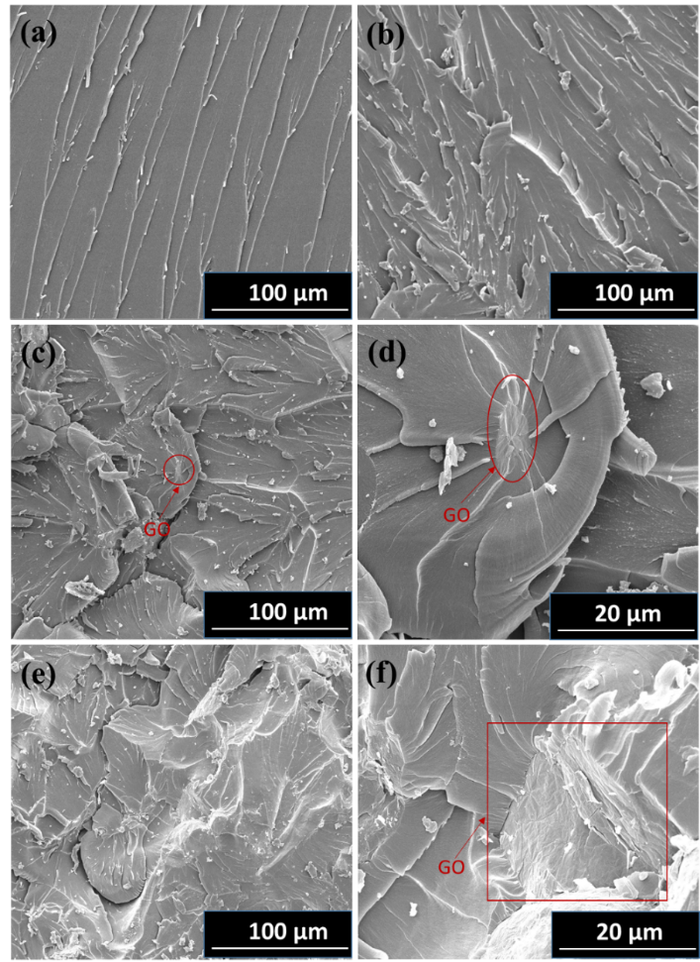
Figure 3.3. SEM images of (a) neat UPR, (b) 0.01 wt.% UPR/GO, (c, d) 0.05 wt.% UPR/GO, and (e, f) 0.1 wt.% UPR/GO.

3.3.4. Mechanical properties
Owing to its high specific surface area, numerous oxygen functional groups, and aromatic structures, GO is considered as a great reinforcement for UPR nanocomposites. To study the effect of GO, and the effect of post curing process on the mechanical properties, the tensile tests and 3-point bending tests were carried out on both UPR/GO composites with and without post curing.

3.3.4.1. Tensile properties of UPR, UPR/GO rectangular bars (prepared without THF, non-post cured)
The tensile properties of non-post cured UPR and UPR/GO bars are shown in Figure 3.4 and Table 3.1.
Young’s modulus, related to the linear elastic behaviour of a material, is obtained from the slope of linear region of stress-strain curve. It increases with the increasing GO content, and the highest value of 1.67 GPa is observed at 0.05 wt.%, which is 31% higher over neat UPR. However, 0.1 wt.% UPR/GO displays a reduced Young’s modulus of 1.28 GPa. For the tensile strength, 0.01 wt.% UPR/GO exhibits an improvement of 4% over neat UPR, which is statistically significant (p < 0.05, two-tailed t-test). The enhancement of Young’s modulus and tensile strength is contributed to the strong interfacial interaction between GO and UPR by hydrogen bonding or п-п interaction which is confirmed by FTIR. Therefore, the stress can be transferred from matrix to rigid fillers, resultin g in a more stiff material with higher modulus and tensile strength. However, as discussed in SEM analysis, GO starts to aggregate from 0.05 wt.% due to van der Waals’ forces. Owing to the fact that the aggregation of GO at 0.05 wt.% is not significant, it processes an enhanced Young’s modulus with slightly decreased tensile strength which is statistically insignificant (p > 0.05, two-tailed t-test). Significant decreases on the mechanical properties are observed at 0.1 wt.% UPR/GO, which is 1.28 GPa for Young’s modulus, and 37.8 MPa for tensile strength. This is because the significant aggregation of GO at 0.1 wt.%, as represented in SEM images, negatively impacts the specific surface of GO. Therefore, the interfacial interaction between GO and UPR is reduced at 0.1 wt.%, resulting in reduced mechanical properties [141,161]. Elongation at break gradually reduced with increasing GO content, and the lowest value of 3.95% is observed at 0.1 wt.% UPR/GO, which is 33% lower than neat UPR. For the content of GO below 0.05 wt.%, GO restricts the movement of UPR polymer chains due to the high specific surface of GO and strong interfacial interaction between GO and UPR, resulting in a reduced elongation at break [141]. However, the reason for the reduced elongation at break at 0.1 wt.% is not clear. Energy at break is the combination of tensile strength and elongation at break. It reduces gradually with increasing GO content, even for 0.01 wt.% UPR/GO which processes an improved tensile strength, and the lowest value happens at 0.1 wt.%, which is 50% lower than neat UPR. Similar results were also observed for other graphene/GO based polymer composites [81,162].
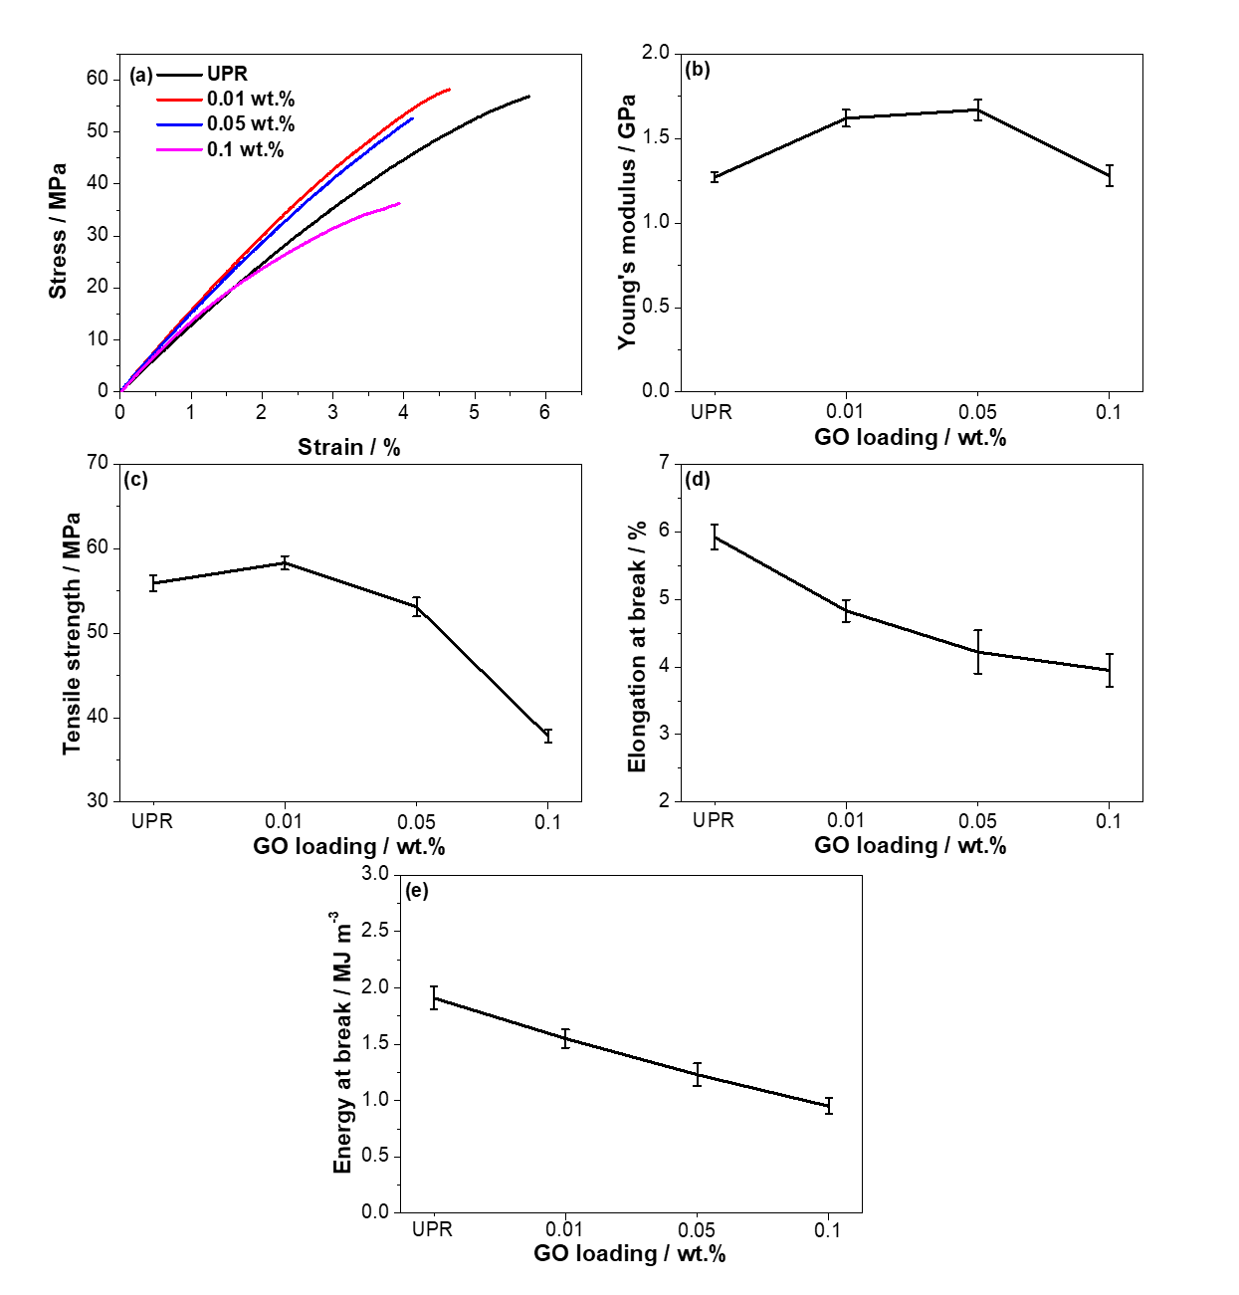
Figure 3.4. Tensile properties of UPR, and UPR/GO bars: (a) stress-strain curves, (b) Young’s modulus, (c) tensile strength, (d) elongation at break, and (e) energy at break.

Table 3.1. Tensile properties of UPR and UPR/GO nanocomposites (prepared without THF, non-post cured).
 | Young’s modulus  / GPa | Tensile strength  / MPa | Elongation at break  / % | Energy at break  / MJ m⁻³
UPR | 1.27±0.03 | 55.9±0.9 | 5.92±0.18 | 1.91±0.10
0.01 wt.% | 1.62±0.05 | 58.3±0.8 | 4.83±0.16 | 1.55±0.08
0.05 wt.% | 1.67±0.06 | 53.1±1.1 | 4.22±0.32 | 1.23±0.10
0.1 wt.% | 1.28±0.06 | 37.8±0.8 | 3.95±0.25 | 0.95±0.07

3.3.4.2. Mechanical properties of UPR, UPR/GO rectangular bars (prepared without THF, post cured at 80 °C for 3 h)

Tensile properties
As well known, the curing reaction of unsaturated polyester (UPR) is a free radical chain growth crosslinking between styrene monomers and UPR oligomers. The curing temperature is an important parameter for the curing reaction, which is associated with the final mechanical and thermal properties [163–165]. In order to study the effect of post cured for UPR, UPR and UPR/GO composites are post cured at 80 °C for 3 h, and the tensile tests are performed to study the tensile properties, as shown in Figure 3.5 and Table 3.2. Briefly, Young’s modulus increases at a very low GO loading (0.01 wt.%, 11% over neat UPR), then slightly decreases with increasing GO content. Tensile strength is enhanced at 0.01 wt.%, which is 10% over neat UPR. 0.05 wt.% shows a slight increase over neat UPR, which is statistically insignificant (p > 0.05, two-tailed t-test). While, 0.1 wt.% UPR/GO exhibits a decrease on tensile strength than neat UPR. In addition, elongation at break and energy at break decrease with the increasing GO content. As aforementioned reasons, the increment of Young’s modulus of tensile strength is due the strong interfacial interaction between GO and UPR. While, the reduction of tensile strength at 0.1 wt.% is due to the aggregation of GO at relatively higher GO content. According to the DMA results in the later part, the T_{g} increases with GO contents, indicating that the addition of GO restricts the mobility of UPR chains. Therefore, elongation at break reduces with GO content which is in a good agreement of the results from tensile tests.
Compared to non-post cured neat UPR, neat UPR post cured at 80 °C exhibits higher mechanical properties, including Young’s modulus, tensile strength, elongation at break, and energy at break. Yan reported that the conversion of C=C bonds in styrene monomers increases with increasing temperature, resulting in a high crosslinking density [165]. Hence, the mobility of UPR chains is restricted remarkably, leading to a harder material with higher mechanical properties.

Table 3.2. Tensile properties of UPR, and UPR/GO nanocomposites (no THF, post cured).
 | Young’s modulus  / GPa | Tensile strength  / MPa | Elongation at break  / % | Energy at break  / MJ m⁻³
UPR | 1.49±0.06 | 59.8±1.5 | 8.92±0.14 | 2.70±0.11
0.01 wt.% | 1.65±0.07 | 65.8±1.8 | 7.78±0.28 | 3.35±0.07
0.05 wt.% | 1.62±0.06 | 61.3±1.6 | 7.25±0.32 | 3.09±0.08
0.1 wt.% | 1.60±0.05 | 54.8±1.7 | 6.5±0.19 | 2.87±0.13

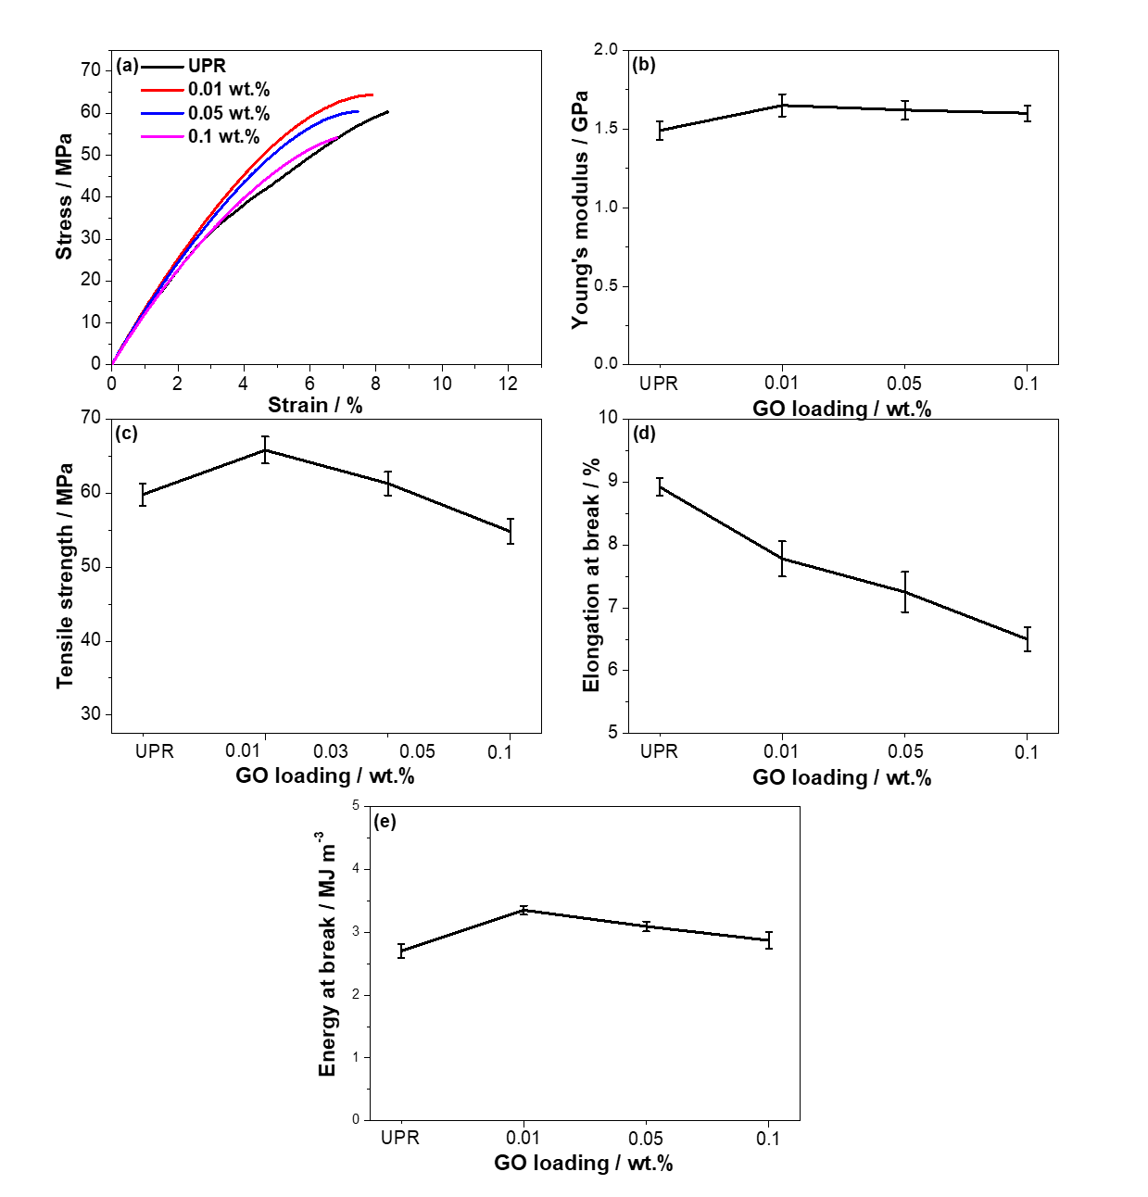
Figure 3.5. Tensile properties of UPR, and UPR/GO bars: (a) stress-strain curves, (b) Young’s modulus, (c) tensile strength, (d) elongation at break, and (e) energy at break.

Flexural properties
The effect of GO on the flexural properties of UPR is investigated by 3-point bending tests, and the results are shown in Figure 3.6 and Table 3.3. Flexural modulus, the slope of the elastic region of stress-strain curve, increases with increasing GO content, and the highest value is observed at 0.05 wt.%, which is a 72.80% improvement over neat UPR. The flexural strength increases with GO loadings, and the highest value is observed at 0.01 wt.%, which is 11.8% improvement over neat UPR. 0.1 wt.% UPR/GO composite shows a decreased flexural modulus of 1.37 GPa compared to that of 0.01 wt.% and 0.05 wt.% UPR/GO composites, and a decreased flexural strength of 99.89 MPa, which is presumably due to the aggregation occurred at 0.1 wt.% as discussed previously. The deflection and energy at break gradually decreased with GO loadings, and the lowest values are observed at 0.1 wt.%, which is 3.76%, 1.88 MJ m⁻³, respectively. The improvements on flexural modulus and flexural strength are presumably due to the strong interfacial interaction between GO and UPR at very low GO concentration (≤ 0.05 wt.%), which in turn contributes to the reasonable load transfer from UPR to GO when a external force is applied [166,167].

Table 3.3. Flexural properties of UPR, and UPR/GO nanocomposites (post cured).
 | Flexural modulus  / GPa | Flexural strength  / MPa | Deflection  / % | Energy at break  / MJ m⁻³
UPR | 1.25±0.12 | 110.43±4.3 | 6.95±1.12 | 5.07±0.62
0.01 wt.% | 1.84±0.23 | 123.49±3.7 | 5.47±0.36 | 3.92±0.26
0.05 wt.% | 2.16±0.11 | 121.90±5.4 | 4.54±0.82 | 3.10±0.53
0.1 wt.% | 1.37±0.25 | 99.89±5.1 | 3.76±0.33 | 1.88±0.28

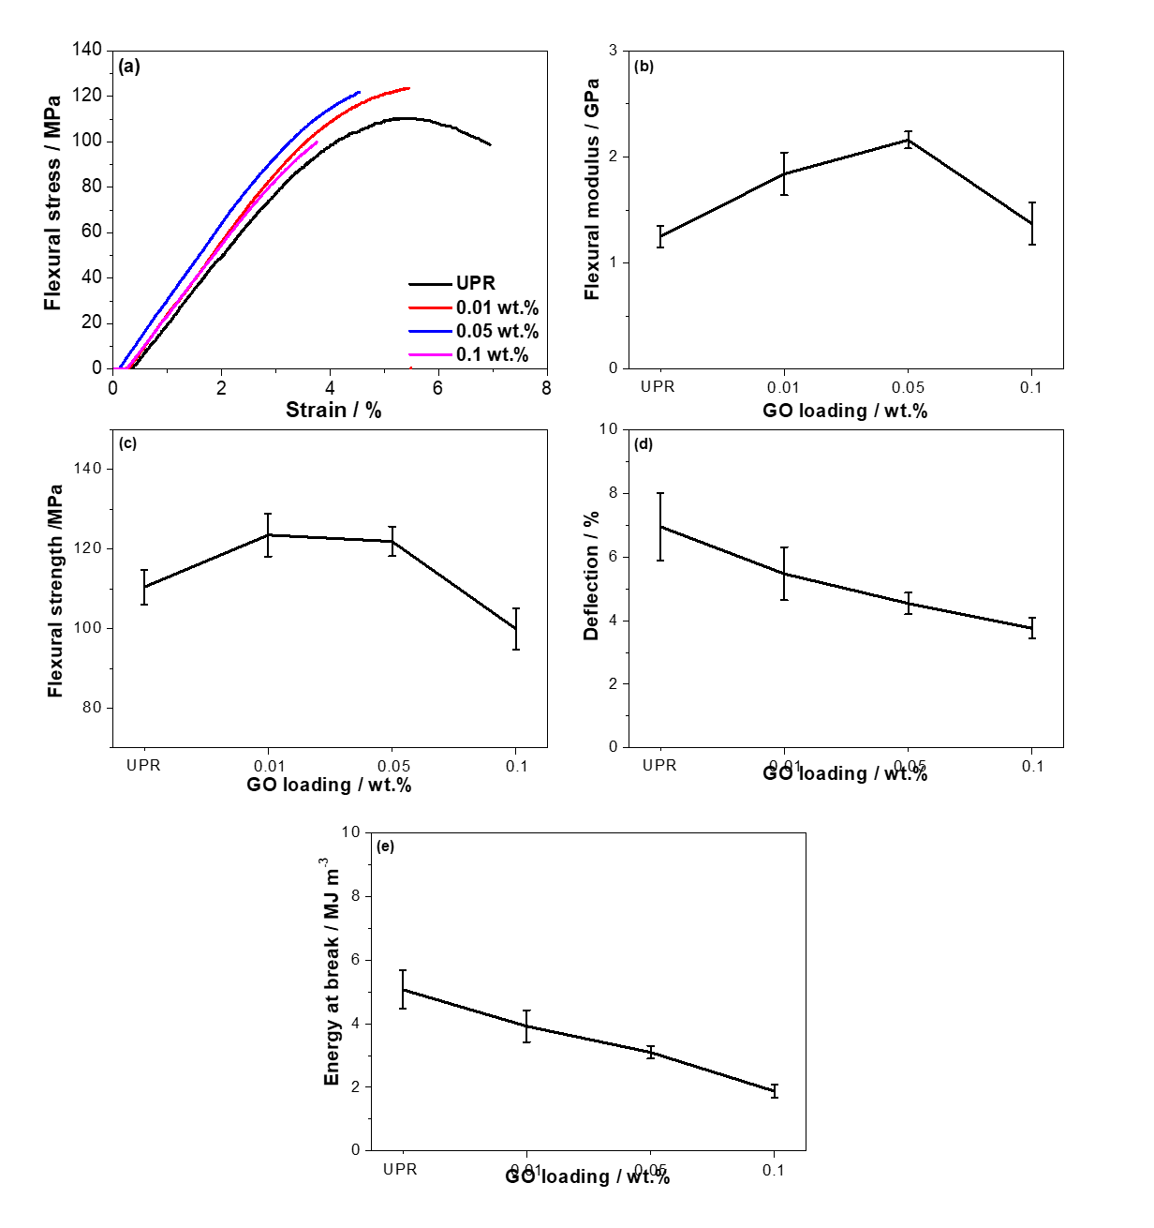

Figure 3.6. Flexural properties of UPR, UPR-THF, and UPR/GO bars: (a) stress-strain curves, (b) flexural modulus, (c) flexural strength, (d) deflection, and (e) energy at break.

3.3.5. Dynamic mechanical properties of GO – UPR composites
The dynamic mechanical properties including storage modulus ($E'$), loss modulus ($E''$), and loss factor (Tanδ = $E''$/$E'$) of the post-cured UPR/GO nanocomposites are measured as a function of temperature by DMA, and the results are shown in Figure 3.7 and Table 3.4. 0.05 wt.% shows a slight improvement with 5% on glass transition temperature (Tg). The storage modulus, is related to the stiffness of materials, represents the elastic energy received during deformation that is stored into the material and released at the end of the loading [168]. It decreases with temperature before glass transition temperature due to the increased molecular mobility caused by heating, as represented in storage modulus against temperature curve [168,169]. From Figure 3.7(a) and Table 3.4, the storage modulus of UPR/GO composites at glassy state (60 ºC) is enhanced with addition of GO, which are 555% (0.01 wt.%), 210% (0.05 wt.%), and 398% (0.1 wt.%) over neat UPR, respectively. The increment on the storage modulus at glassy state is due to the strong interfacial interaction between GO and UPR matrix which restricts the mobility of polymer chains, resulting in a stiff material. As discussed previously, some GO clusters are observed from 0.05 wt.%. Therefore, the interaction of GO with UPR is getting weaker over 0.01 wt.% UPR/GO, resulting in some reduction for 0.05 wt.% and 0.1 wt.%. However, the high modulus of GO contributes to the final modulus at the higher GO content, 0.1 wt.% UPR/GO exhibits higher storage modulus over that of 0.05 wt.%.
The glass transition temperature (T_{g}) is defined as the maximum peaks of damping factor (tanδ) against temperature curve, which corresponds to the ability of restoring energy for polymers. It is a measurement of how well a material can dissipate energy during heating [170].
According to Figure 3.7(b) and Table 3.4, the T_{g} increases slightly over neat UPR, which is 1.3 ºC (0.01 wt.%), and 3.2 ºC (0.1 wt.%) higher than that of neat UPR. While, 0.05 wt.% UPR/GO displays slightly decrease over neat UPR, which is 1 ºC. This is presumably because the presence of GO restricts the mobility of UPR polymer chains, resulting in a slightly improvement at 0.01 wt.% and 0.05 wt.% [171]. However, these influences are negligible, which might be due to the fact that the low GO content does not significantly affect T_{g}.
Loss modulus is indicative to the dissipation of energy in a material under cyclic loading. It is the viscous response to applied force compared to storage modulus, which is an elastic response [170,172,173]. It increases before and around glass transition region and decreases in rubbery plateau due to the movement friction between polymer segments. The width of the peak reveals the morphological rearrangement and the degree of interaction between fillers and matrix [170], the broader peak is the better interaction will be. From Figure 3.7(c), 0.01 wt.% gives a broader peak compared to 0.05 wt.% and 0.1 wt.%, indicating that the incorporation between GO and UPR is strong when GO content is 0.01 wt.%. Coefficient C, the difference between the dynamic mechanical moduli at glass state and rubbery plateau, is employed here to investigate the effectiveness of nanoparticles on the moduli of the composites [168,169,171]. It can be obtained by the equation (1) below, where E'_{g} is storage modulus at glass state, and E'_{r} is storage modulus at rubbery plateau. A lower coefficient C means higher effectiveness of GO filler [170]. In this case, 60 ºC and 120 ºC are picked as the temperatures for $E'g$ and $E'r$, respectively. The lowest value of 0.23 is seen at 0.01 wt.%, and the highest value of 0.33 is seen at 0.05 wt.%. This is in the agreement with the results of storage modulus at glassy stage.

$C= \frac{{(E^{'}}_{g }/{E^{'}}_{r})comp}{{(E^{'}}_{g }/{E^{'}}_{r})resin}$ (1)

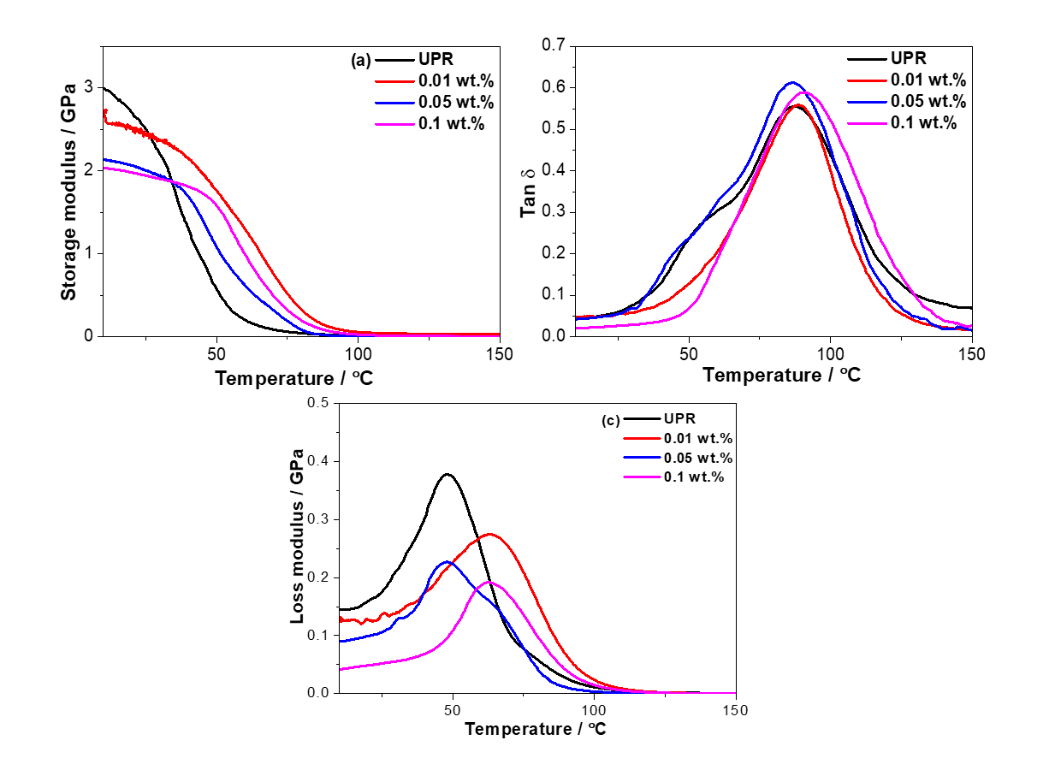
Figure 3.7. The dynamic mechanical properties of post-cured UPR/GO nanocomposites: the effect of temperature on (a) storage modulus, (b) loss modulus, and (c) damping factor.

Table 3.4. Dynamic mechanical properties of UPR/GO nanocomposites.
Samples | E' at various T / GPa |  |  | T_{g} / ºC | Coefficient C
 | 60 ºC | 80 ºC | 120 ºC
UPR | 0.2 | 0.045 | 0.02 | 87.5 | -
0.01 wt.% | 1.31 | 0.33 | 0.03 | 88.8 | 0.23
0.05 wt.% | 0.62 | 0.09 | 0.02 | 86.5 | 0.33
0.1 wt.% | 0.99 | 0.20 | 0.03 | 90.7 | 0.30

3.3.6. Thermal properties of UPR, and UPR/GO composites
The effect of GO on the thermal properties of UPR is investigated by TGA, and the results are presented in Figure 4.8 and Table 3.5. As shown in Figure 3.8, UPR starts to decompose from 362 ºC ( $T_{d}^{onset}$), the maximum decomposition rate happens at 415 ºC ( $T_{d}^{peak}$), and the 50% weight loss happens at 410 ºC ($T_{d}^{1/2}$) with a char yield of 0.0025 wt.% at 700 ºC. This is related to the decomposition of polymeric network of polymer. $T_{d}^{onset}$ Increases gradually with the increasing GO content, and the highest $T_{d}^{onset}$ is observed at 0.1 wt.%, which is 13 ºC higher over neat UPR. This is due to the presence of high thermally stable GO which restricts the mobility of polymer chains and has strong interfacial interaction with UPR, which is proved by the increased T_{g} via DMA test. A slight fluctuation (±2 ºC) is observed on $T_{d}^{onset}$ and $T_{d}^{1/2}$, which is negligible. Char yield is the final residual weight which cannot further decompose. From Table 6, the char yield increases with addition of GO, and the highest char yield occurs at 0.01 wt.%, which is 8.69 wt.%. The increment on char yield at 0.01 wt.% is presumably because that UPR chains are intercalated evenly into GO sheets due to the homogeneous dispersion , and some of them cannot be decomposed and released under the protection of GO sheets. While, 0.1 wt.% UPR/GO composite shows the lower char yield of 0.86 due to uneven intercalation of UPR chains into GO sheets caused by aggregation. Hence, the thermal stability of UPR is enhanced by addition of GO.

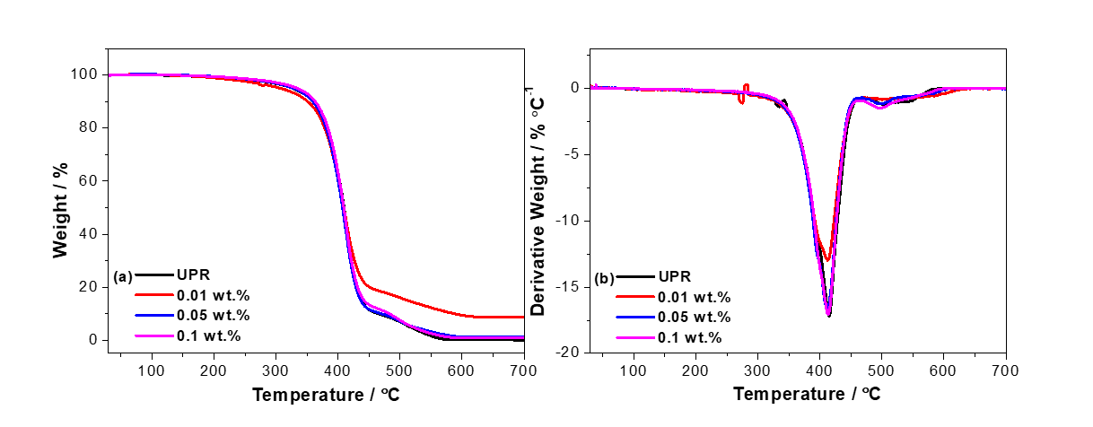
Figure 3.8. Thermal properties of UPR and UPR/GO nanocomposites: (a) TGA, and (b) DTG.

Table 3.5. Thermal properties of post cured UPR and its GO composites.
Samples | $T_{d}^{onset}$/ °C | $T_{d}^{peak}$ / °C | $T_{d}^{1/2}$ / °C | Char yield / wt.%
UPR | 362±2 | 415±1 | 410±2 | 0.025±0.02
0.01 wt.% | 365±1 | 413±1 | 409±3 | 8.69±1.27
0.05 wt.% | 370±2 | 412±3 | 408±1 | 1.15±0.83
0.1 wt.% | 375±3 | 413±2 | 409±2 | 0.86±0.23

3.3.7. The effect of GO on the curing process of UPR
The curing mechanism of UPR-styrene system is a free radical chain growth polymerization between UPR and styrene (inter polymerization), as well as UPR and UPR (intrapolymerization). Methyl ethyl ketone peroxide (MEKP) is used as an initiator, which decomposes into free radicals by the promoter (cobalt salt) [66,174,175]. Owing to its importance on the final properties of UPR, the study of curing kinetics and curing process is essential. There are several parameters that define the curing process of UPR, including curing temperature, curing time, styrene concentration, initiator concentration, and promoter concentration [36–38, 49]. In order to investigate the effects of GO, styrene, MEKP and cobalt on the curing process of UPR, control samples of GO-MEKP, and GO-cobalt hybrids are prepared under the same process as UPR/GO composites. FTIR and TGA are employed on GO-MEKP, GO-cobalt hybrids, and GO powder which is treated at 80 ºC for 3 h. Initiator MEKP is Methyl ethyl ketone peroxide (30 –37%) in solvent Diisohonyl phthalate (DINP, 45 – 65%), promoter Cobalt salt is 1% tin(II) octoate/ tin(II)2-ethylhexanoate in styrene solvent, and the chemical structures are represented in Scheme 3.1.

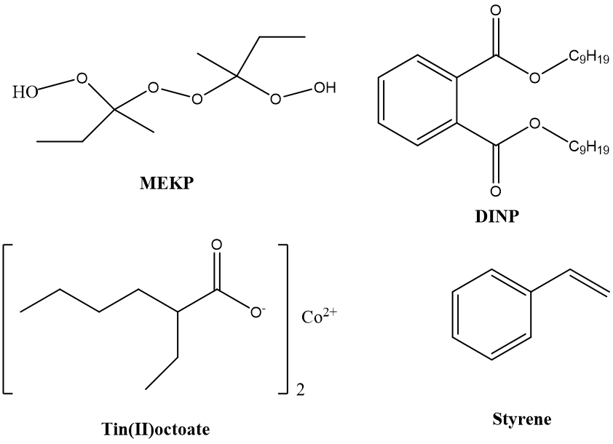
Scheme 3.1. The representation of chemical structures of initiator and promoter.

3.3.7.1. FTIR
Figure 3.9 shows the FTIR spectrum of GO (heated under 80 °C for 3 h), GO-MEKP, and GO-cobalt hybrids. From Figure 3.9(a), the typical peaks of Cobalt salt are observed at 1752 cm⁻¹, 1684 cm⁻¹, and 1629 cm⁻¹, which are corresponded to C=O stretch from tin(II) octoate, alkane C=C stretch, and aromatic C=C stretch from the solvent styrene, respectively. The Peak at 1082 cm⁻¹ is assigned to C-O stretch from COOH group in cobalt. Peaks at 990 cm⁻¹ and 905 cm⁻¹ are related to =C-H bending from solvent styrene. Moreover, there are various weak peaks from 1400 cm⁻¹ to 1300 cm⁻¹, which are related to alkane C-H stretch. Compared to FTIR spectrum of GO-cobalt hybrid, there are some changes observed in the FTIR spectrum of treated GO (80 ºC, 3 h). In detail, the peak of aromatic C=C is shifted from 1625 cm⁻¹ (treated GO) to 1623 cm⁻¹ (GO-cobalt hybrid). Moreover, a new peak is observed at 1684 cm⁻¹, which is the alkane C=C from solvent styrene. This implies that styrene is physically adsorbed on GO surface by π-π interaction due to the fact that both styrene and GO have aromatic ring structure. In addition, the peak of C-O from hydroxyl group is shifted from 1076 cm⁻¹ (treated GO) to 1068 cm⁻¹ (GO-cobalt hybrid), presumably due to the formation of hydrogen bonding between tin(II) octoate and GO.
As shown in Figure 3.9(b), the typical peaks of MEKP seen at 3415, 1724, and 1274 unit are attributed to O-H stretch from MEKP, C=O stretch from DINP, and C-O stretch from DINP, respectively. Peaks at 1600, 1580, and 1462 unit are related to the aromatic C=C stretch from DINP. Peaks at 1123 and 1074 unit (and for the following wave numbers) are assigned to ether O-O stretch from MEKP. In comparison with treated GO, GO-MEKP shows a shift of aromatic C=C group from 1624 (treated GO) to 1628 (GO-MEKP hybrid), indicating the physical adsorption of DINP by π-π interaction. Moreover, the peak of treated GO at 1067 (epoxy group) shifts to 1077, presumably due to the reaction between hydroxyl groups from MEKP and epoxy group from GO. It is concluded that both MEPK and cobalt can incorporate with GO sheets by chemical reaction and formation of hydrogen bonding. As discussed above, the solvent styrene in cobalt salt can be physically adsorbed on GO surface by π-π interaction. In other words, the styrene monomer in UPR resin has the tendency to be physically adsorbed on the GO surface as well, which in turn affects the crosslinking density of UPR due to the less amount of active free styrene monomers that copolymerize with UPR chains.
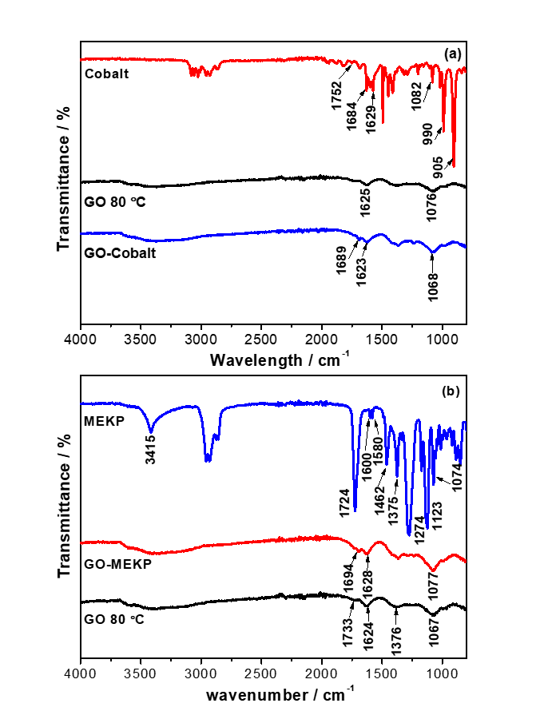
Figure 3.9. FTIR spectra of GO (80 ºC, 3 h), GO–MEKP, and GO–Cobalt hybrids: (a) GO-cobalt, and (b) GO-MEKP.
3.3.7.2. TGA of GO, GO–MEKP, and GO–Cobalt hybrids
TGA is employed to further study the effect of GO on the curing process of UPR, as shown in Figure 3.10. According to Lala, and Montoro’s work [177], TGA of cobalt salt shows three weight loss steps. the first major weight loss of 15 wt.% happened under the temperature range from ambient to 183 °C which relates to the conversion of Co into producing CO₂, Co₃O₄, and CoO. The second biggest weight loss of cobalt salt (40 wt.%) occurred from 245 °C to 330 °C which is the decomposition of organic chains. Compared to GO, treated GO (80 ºC) exhibits a very similar TGA curve except the char yield, which is 39.4 % for GO, and 42 % for treated GO (80 ºC). This implies that GO loses a tiny amount of oxygen functional groups during the heating under 80 °C. There is no significant difference of TGA curves of treated GO (80 ºC), and GO-MEKP hybrid, indicating that only a tiny amount of initiator has incorporated with GO, which is negligible. However, TGA curve of GO-cobalt hybrid exhibits a significant difference, compared to treated GO. Briefly, there are three steps in TGA curve of GO-cobalt hybrid. In the first step (25 ºC to 100 ºC), there is a 10% weight loss due to the moisture. In the second step (100 ºC to 160 ºC), 11% weight loss occurs, which is related to the styrene physically adsorbed on GO sheet. In the third step (160 ºC-250 ºC), the majority of weight loss of 26.3% occurs that is related to the pyrolysis of oxygen functional groups of GO, yielding CO, CO₂ and steam. Moreover, the char yield of GO-cobalt is 25%, which is lower than that of treated GO (80 ºC). This implies that the weight loss between 250 ºC to 800 ºC is related to the weight loss of decomposition of the organic chains of cobalt salt and the organic carbon-carbon bonds. This further confirms that cobalt is incorporated on GO surface.
The FTIR and TGA results confirm that during the curing process of UPR, some catalyst (cobalt) and the tiny amount of initiator (MEKP) can also interact with GO by formation of hydrogen bond and chemical reaction. Therefore, the amount of free cobalt is reduced, resulting in a longer curing time. Meanwhile, some styrene monomers from UPR-styrene system can be physically adsorbed on the GO surface by π-π interaction, resulting in less free reactive styrene for copolymerization with UPR. Therefore, the influence of GO on the mechanical, thermal properties, and T_{g} is not significant.
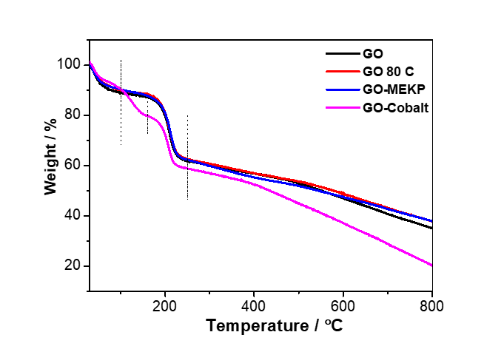
Figure 3.10. TGA of GO (80 ºC, 3 h), GO-MEKP, and GO–Cobalt hybrids.

3.4. Conclusion
In this work, GO was prepared by Hummers method and UPR/GO composite with different GO contents were synthesised by crosslinking at the presence of GO powder. AFM images confirm that single layer GO would be obtained by Hummers method with mild sonication treatment. The dispersion quality of GO in UPR matrix is good at 0.01 wt.%, but starts to aggregate from 0.05 wt.%, which can further explain the properties of UPR/GO composites. The successful interaction of GO sheets and UPR polymer chains is verified. For non-post cured UPR/GO bars, Young’s modulus and tensile strength are improved by addition of GO, and 0.01 wt.% composite shows improvements of 27.5%, and 4% over neat UPR, respectively. For post cured UPR/GO bars, 0.01 wt.% composite exhibits enhancement of 10.7% on Young’s modulus, and 10% on tensile strength over neat UPR, respectively. The improvement of post cured UPR/GO on Young’s modulus is lower than that of non-post cured UPR/GO composite. This is presumably because that the non-post cured sample possesses more flexibility with lower crosslinking density, which return shows more significant effect by the introduction of GO. The elongation at break are reduced by addition of GO for both non-post cured and post cured composites. Moreover, flexural modulus is improved more than 400% over neat UPR, but no significant improvement on flexural strength. All these mechanical properties indicates that the interfacial interaction of GO with UPR is strong at 0.01 wt.%, which can restrict the mobility of polymer chains, resulting in a stiffer material with higher modulus and lower elongation at break. Meanwhile, the external force can be transferred from polymeric matrix to the strong nanofillers. From the tensile properties of non-post cured UPR and post cured UPR, the post cured process is essential for a higher mechanical performance due to the higher crosslinking density for UPR. The thermal properties is enhanced by interaction of GO with UPR with a gradually increased onset decomposition temperature and increased char yield. However, the glass transition temperature (T_{g}) is not significantly influenced, which is a slight improvement observed at 0.1 wt.% over neat UPR. It is concluded that 0.01 wt.% is the optimum GO content for the performance of UPR/GO composites. However, the improvement on mechanical properties of UPR is not significant as some results from other GO based thermosetting polymers reported. FTIR and TGA of control samples of GO-MEKP and GO-cobalt hybrids confirms that some cobalt and styrene monomers can be adsorbed on GO surface by chemical reaction and п-п interaction. Therefore, the curing time is prolonged due to the less catalyst and the crosslinking density is reduced due to the less amount of free reactive styrene monomers. Hence, the addition of GO doesn’t significantly improve the mechanical properties and T_{g} of UPR.

Chapter 4: Synthesis and characterization of unsaturated polyester composites incorporated with vitamin C-reduced graphene oxide

4.1. Introduction
Vitamin C, a natural antioxidant for many metabolic functions in living organisms and food additives, is found to be a great alternative to hydrazine for reducing GO [178]. The reduction efficiency and average conductivity of rGO reduced by vitamin C is comparable with rGO reduced with hydrazine [38,39]. To date, the mechanism of the reduction of GO by vitamin C is still in question, but it can be roughly speculated as a three-step reaction, as represented in Scheme 4.1. At the first step, vitamin C dissociates protons (H⁺) to form an oxygen anion of L-ascorbic acid (HOAO⁻). At the second step, both epoxide groups and hydroxide groups on GO sheets can be attacked by nucleophilic anion of L-ascorbic acid (HOAO⁻) and releases H₂O. For the last step, GO are further reduced by thermal elimination, resulting in a plain graphene sheets theoretically [179,180].
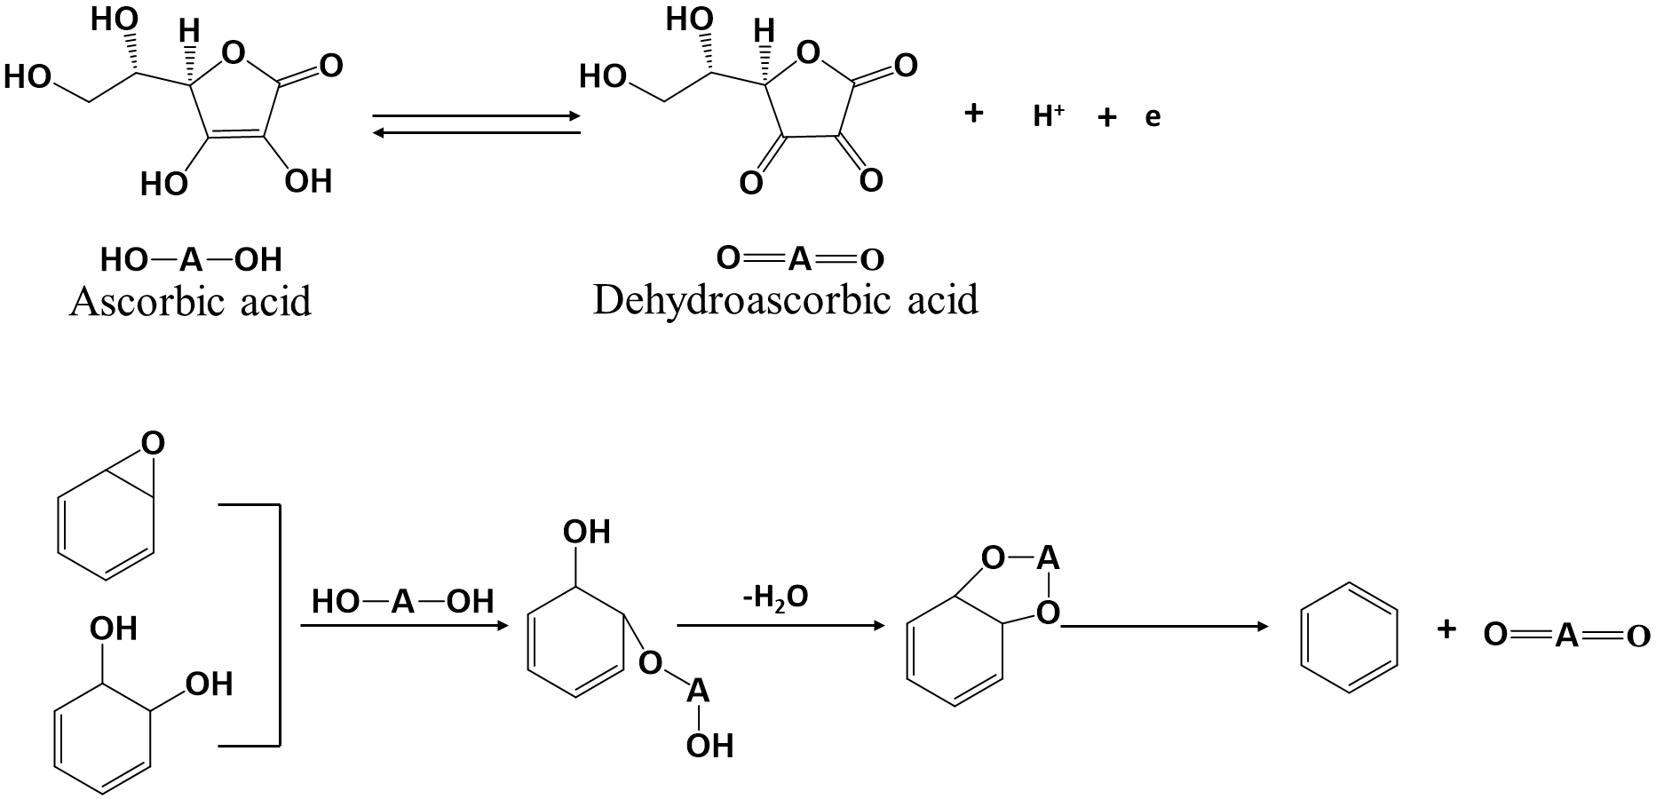
Scheme 4.1. Proposed mechanism for the reduction of graphene oxide by L-ascorbic acid (vitamin C) [179,180].

Many thermosetting polymers, such as unsaturated polyester resin (UPR), are electrically insulating, which limits some of their applications. The addition of graphene can enable them to become electrical conductors at relatively low graphene loadings by forming percolated pathways due to its high specific surface area (2600 m² g⁻¹) [181]. To date, many works have been done on polymer/graphene composites. For example, Wang et al. reduced GO-EO₁₃₃PO₅₀EO₁₃₃ hybrid by hydrazine monohydrate, which can form a stable aqueous suspension. Chitosan/rGO composites show enhanced electrical conductivity and mechanical properties [182]. However, water was used as a solvent in this method, which is not common for most of polymers which are hydrophobic. Meanwhile, the addition of EO₁₃₃PO₅₀EO₁₃₃ for the stability of rGO aqueous would also affect the properties of composites and make the process more complicated. Bora et al. reduced GO by hydrazine monohydrate prior to the preparation of UPR/rGO composites, and the result shows the highest electrical conductivity of 3.7 × 10⁻⁴ S cm⁻¹ at 3 wt.% rGO loading [181]. One drawback of this method is the use of hydrazine for reduction of GO, which is highly toxic and explosive. Hence, nontoxic and eco-friendly reductants, such as chitosan and vitamin C, are considered as great candidates for GO reduction [31,183,184].
To our knowledge, Graphene can be produced by micro-mechanical exfoliation, epitaxial growth, chemical vapor deposition, thermal reduction, and chemical reduction of graphene oxide (GO) [27,31,34,39,178,185]. Hydrazine hydrate [32–34], sodium borohydride [35,186], hydroquinone [37], chitosan [31], and vitamin C (L-ascorbic acid) [39,178] are common agents for reduction of GO. Limited work on UPR/rGO composites has been reported. In this chapter, the work is focused on the electrical conductivity of UPR/rGO composites with some improvements on other properties. In the previous chapter, the composites were synthesized by incorporation GO with UPR without reduction. But, the reduction of GO is essential for conductive graphene based UPR composites. To avoid toxic chemical reductants, vitamin C was used to reduce GO. UPR/rGO composites with various rGO concentrations were prepared by simple solution mixing method. The effect of rGO on the electrical properties, along with mechanical properties, thermal properties and dynamic mechanical properties, were investigated.

4.2. Experimental section

4.2.1. Materials
Vitamin C (L-ascorbic acid, reagent grade) was purchased from Sigma-Aldrich. Graphene oxide (GO) was prepared from graphite by improved Hummers method reported in previous work [187]. Unsaturated polyester resin (UPR) was CRYSTIC D3061 (R50054, Scott Bader), which was prepared from isophthalic acid (~25 mol%, 37 wt.%), maleic acid ((~25 mol%, 22.0 wt.%), diethylene glycol ((~25 mol%, 24 wt.%), and propylene glycol ((~25 mol%, 17 wt.%). UPR (D3061) had an average molecular weight of 2778 Daltons, with styrene content of 33±2.0 wt.%, and toluhydriqunone and hydriquione as inhibitors. Methyl ethyl ketone peroxide (MEKP, 30-37 wt.% in diisononyl phthalate, Scott Bader) was used as hardener, cobalt sault E (2-4 wt.% cobalt 2 ethylhexanoate in styrene, Scott Bader) was accelerator/promoter. All other chemicals used in this chapter were reagent grade, purchased from VWR international LTD.

4.2.2. Reduction of GO by vitamin C
Clear GO aqueous dispersion (1 mg ml⁻¹) was obtained by sonication for 30 min, and a clear vitamin C aqueous dispersion (1mg ml⁻¹) was obtained via magnetic agitation and sonication. The mixture with a weight ratio of vitamin C and GO of 3:1 was stirred under 90 °C for 6 hours. The resultant black precipitate was washed 4 times by centrifuging to remove the residue vitamin C, and reduce GO (rGO) powder was obtained by freeze drying.

4.2.3. Synthesis of UPR/rGO composites
Prior to mixing with UPR, rGO THF dispersion (0.5 mg ml⁻¹) was obtained by shear mixing (for 30 min, at 3500 rpm) and sonication (for 60 min). The rGO/THF dispersion and resin were mixed by shear mixing (for 30 min, at 3500 rpm), followed by sonication for 30 min. In order to remove THF by evaporation, magnetic agitation of the mixture containing rGO and resin for 24 hours was needed. 2.0 wt.% hardener and 1.0 wt.% catalyst based on the resin were added and gently stirred for 5 min, followed by the curing procedure: at ambient temperature for 48 days to further remove the residue of THF, at 80 °C for 3 hour, at 120 °C for 1 hour, and at 200 °C for 3 hours. UPR/rGO composites with 0.05 wt.%, 0.1.0 wt.%, 0.3 wt.%, 0.5 wt.% of rGO were synthesized.

4.2.4. Characterization

4.2.4.1. X-ray photoelectron spectroscopy (XPS)
The elemental composition analysis of graphite, GO, and rGO were carried out by using fundamental XPS (Kratos Axis Ultra-DLD), with monochromatic aluminum source. Information of the relative levels of oxidation, C/O ratios and the chemical environment of atoms were collected. All spectra were calibrated with the position of the C–C peak at 284.6 ± 0.4 eV. Samples were prepared by pushing a small amount of powder into soft indium foil prior to analysis.

4.2.4.2. Fourier transform infrared spectroscopy (FTIR)
FTIR of graphite, GO, rGO, and UPR/rGO composites were carried out on a Spectrum 100 (Perkin Elmer, USA) in a wavelength range of 4000–500 cm⁻¹ with a resolution of 4 cm⁻¹.

4.2.4.3. Electrical conductivity
The electrical conductivity of UPR/rGO rectangular bars was determined by the measurement of their resistance by using a FLUKE 287 digital multimeter with two-probe mode. Neat UPR, 0.05 wt.%, 0.1.0 wt.%, 0.3 wt.%, 0.5 wt.%, 1.0 wt.%, 1.5 wt.%, and 2.0 wt.% UPR/rGO composites were prepared for electrical conductivity test. Silver paint (RS 186-3600) was applied to the two ends of each sample to form contact points. 2 specimens were used for each test.

4.2.4.4. Thermal conductivity
The thermal conductivity of UPR and UPR/rGO composites was measured by a Flashline 3000 thermal conductivity analyzer (Anter corporation USA) at 50 ºC, 70 ºC, 90 ºC, and 110 ºC. The specimen with dimension of 10 mm × 10 mm × 0.7 mm was sprayed by graphite prior to test.

4.2.4.5. Mechanical tests
Mechanical tests were carried out by using a Hounsfield universal mechanical testing machine with 10 kN load cell. The standard method of ISO-604 was employed for compression tests with a strain rate of 2mm min⁻¹, while ISO-527 for tensile tests with a strain rate of 1 mm min⁻¹. Five specimens were measured for each sample.

4.2.4.6. Dynamic mechanical analysis (DMA)
DMA was carried out on a DMA 8000 instrument equipped with single cantilever geometry mode. The sample size was a rectangular stripe: length × width × thickness = 5 mm × 6 mm × 1 mm. Dynamic measurements were performed at a frequency of 1 Hz from -80 °C to 170 °C at a heating rate of 2 °C min⁻¹.

4.2.4.7. Thermogravimetric analysis (TGA)
TGA of GO, rGO, and UPR/rGO composites were performed by using a Pyris 1 (Perkin Elmer, USA), with the temperature range from 25 °C to 700 °C, heating rate of 10 °C min⁻¹ under a nitrogen flow of 20 ml min⁻¹.

4.2.4.8. Scanning electron microscopy (SEM)
SEM was carried out on an FEI Inspect F scanning electron microscope, with a voltage of 10 kV. Prior to the SEM observation, samples were sputter–coated in gold by using an SPI sputter–coater for enhanced conductivity.

4.3. Results and Discussion

4.3.1. Characterization of rGO reduced by vitamin C

4.3.1.1. X-ray photoelectron spectroscopy
The chemical structure and C/O ratios of graphite, GO and rGO are investigated by XPS. Figure 4.1 shows the C 1s XPS spectra of graphite, graphene oxide, and reduced graphene oxide. Graphite presents only one very sharp peak at 284.6 eV, which is assigned to sp² carbon bond. After deconvolution, C 1s spectrum of GO contains three peaks at 285.0 eV, 287.1 eV, and 288.8 eV, corresponding to the sp² carbon, C-bonds like carboxyl groups and epoxy rings, and carboxylate groups, respectively [188–190]. Although these peaks of oxygen groups are still visible in C 1s spectrum of rGO, the peaks are much weaker and broader, indicating that GO was reduced successfully by vitamin C at 90 ºC for 6 hours with some remaining C-O and carboxylate groups. The chemical composition and C/O ratio are summarized in survey spectrum (Figure 5.1(b)) and Table 4.1. In detail, graphite exhibits one major C1s peak with tiny O1s that can be neglected. The C1s/O1s ratio of rGO (6.4:1) is much larger over that of GO (2:1), implicating the reduction of GO.

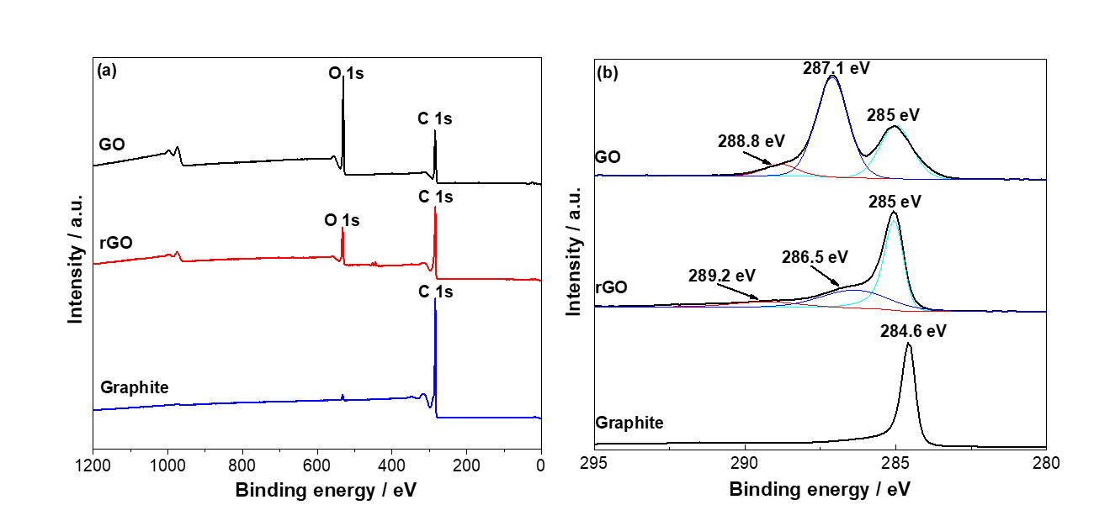

Figure 4.1. XPS spectra of graphite, graphene oxide (GO), and reduced graphene oxide (rGO): (a) survey spectra and (b) C 1s of XPS spectra.

Table 4.1. The values of C1s/O1s (atomic ratios) obtained by XPS survey spectra.
Samples | C 1s | O 1s | C /O ratio
Graphite | 98.39 | 1.61 | 61:1
GO | 66.08 | 32.42 | 2:1
rGO | 86.12 | 13.49 | 6.4:1

4.3.1.2. FTIR Analysis
The chemical structures of graphite, GO and rGO, were investigated by FTIR (Figure 4.2). The FTIR spectrum of graphite is a straight line with no peaks, implying that graphite has no oxygen functional groups. According to the FTIR spectrum of GO, there is a wide hump around 3000 cm⁻¹–3500 cm⁻¹, which is attributed to the O-H stretching vibrations of the hydrogen groups and water. Absorption peaks of GO at 1723 cm⁻¹, 1567 cm⁻¹, 1203 cm⁻¹, and 1024 cm⁻¹ are related to the C=O, aromatic C=C stretching, and C-O-C stretching. The FTIR curve of rGO shows a much more flat curve with one peak at 1548 cm⁻¹ (weak, aromatic C=C stretching), and one peak at 1176 cm⁻¹ (weak, C-O stretching) [191,192], indicating carboxyl groups and ester groups has been reduced. Hence, GO is successfully reduced by vitamin C at 90 °C for 6 hours with few oxygen groups remaining on GO sheets, which is in agreement with the XPS result.
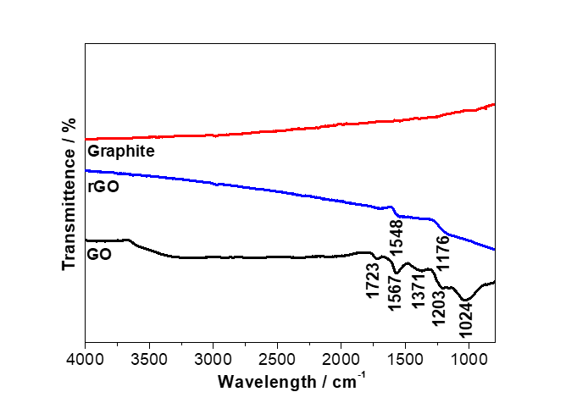
Figure 4.2. FITR spectra of graphite, graphene oxide (GO), and reduced graphene oxide (rGO).

4.3.1.3. Thermogravimetric analysis (TGA)
The reduction of GO by vitamin C is further confirmed by TGA analysis (Figure 4.3.). In the TGA curve of vitamin C, it shows two thermal decomposition steps. The first step starts from 190 °C, and the second step starts from 240 ºC, indicating that vitamin C start to decompose at 190 °C [193]. According to TGA curve of GO, the weight loss below 100 ºC is related to the moisture, which is around 10%. The major weight loss of 48% is observed 200 ºC, presumably due to the pyrolysis of oxygen functional groups, yielding CO, CO₂ and steam [34,41]. TGA curve of rGO shows a 2.3% mass loss below 100 ºC, and only an 8% mass loss around 200 ºC, The residual weights at 700 ºC of GO and rGO are 63.8%, and 27.5%, respectively. All these TGA results indicates that the majority of oxygen groups on GO sheets have been reduced by vitamin C.
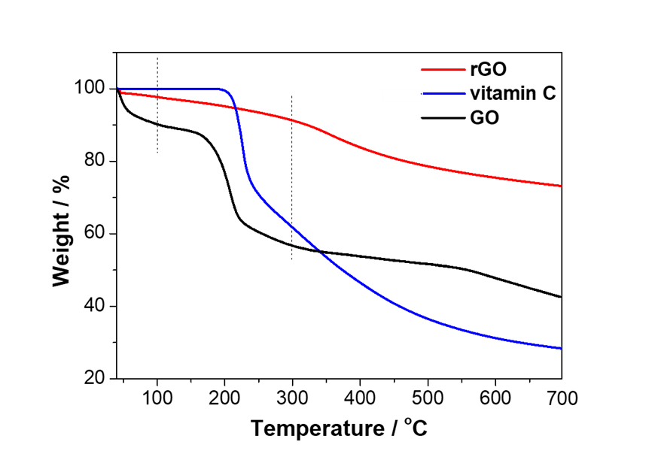
Figure 4.3. TGA of graphene oxide (GO), and reduced graphene oxide (rGO) and vitamin C.

4.3.2. Chemical structure of UPR, and UPR/rGO composites
The chemical structures of UPR, UPR/RGO composite, and interactions between rGO and UPR matrix are investigated by FTIR (Figure 4.4). To study the influence of THF, the control sample (UPR-THF) was prepared through the same procedure with UPR/rGO composites using THF as the solvent. In comparison to the UPR without the treatment of THF, it can be seen that there is no difference between the FTIR spectra of UPR and UPR-THF, indicating that the solvent did not affect the final chemical structure of UPR polymers. The peaks at 1718 cm⁻¹, 1606 cm⁻¹, 1453 cm⁻¹, 1298 cm⁻¹, and 1229 cm⁻¹, correspond to C=O stretch, aromatic C=C stretch, and C-O stretch from COOH groups, respectively [194,195]. For FTIR spectra of rGO, peaks at 1548, and 1176, are assigned to aromatic C=C stretch, and C-O stretch, as discussed previously. In the FTIR spectra of UPR/rGO composite (1.0 wt.%), the peaks of C=O (1718 cm⁻¹), aromatic C=C stretch ( 1606 cm⁻¹, 1453 cm⁻¹), and C-O from carboxyl acid groups (1229 cm⁻¹ ) shift to 1714 cm⁻¹, 1609 cm⁻¹, 1438 cm⁻¹, and 1226 cm⁻¹, respectively. Meanwhile, peak at 1298 cm⁻¹ (C-O from carboxyl acid groups) become sharper in the UPR/rGO composite. The shifting of these peaks indicates that the interactions of the polyester segments (C=O, COOH) with the remaining oxygen functional groups of rGO through hydrogen bond [196].
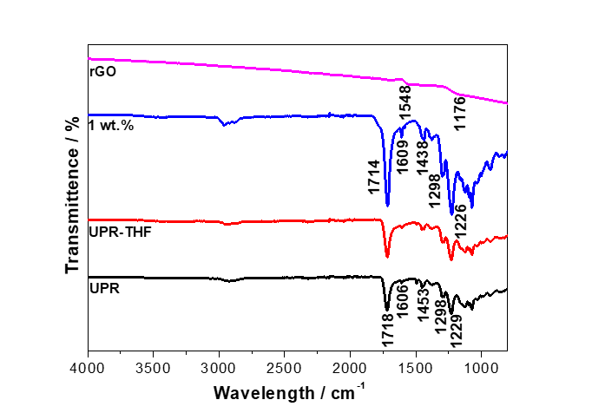
Figure 4.4. FTIR spectra of UPR, UPR-THF, UPR/rGO (1.0 wt.%), and rGO.

4.3.3. Electrical conductivity
The electrical conductivity of UPR and UPR/RGO composites with various rGO content (Neat UPR, 0.05 wt.%, 0.1.0 wt.%, 0,3 wt.%, 0.5 wt.%, 1.0 wt.%, 1.5 wt.%, and 2.0 wt.%) are carried out on rectangular bars with 0.3 mm thickness. The electrical conductivity (σ) are obtained by calculating the inverse of resistivity which is measured by using digital multimeter (equation (4.1)), and the results are shown in Figure 5.5. Neat UPR and UPR/rGO composites with low concentrations (<1.0 wt.%) are electrical non-conductivity (insulator). The conductivity of 1.0 wt.% UPR/rGO composite is 1.3 x 10⁻⁴ S m⁻¹, which is higher than the antistatic criterion (1.0 x 10⁻⁶ S m⁻¹) [182,197]. The conductivity of the composite increases for 3 orders more of magnitude to 0.52 S m⁻¹ as rGO content increases from 1.0 wt.% to 1.5 wt.%. 2.0 wt.% UPR/rGO composite exhibit the maximum conductivity of 3.08 S m⁻¹ which is 4 orders more of magnitude compared to that of 1.0 wt.% UPR/rGO composite. This indicates that rGO content of 1.0 wt.% and above can form an consecutive conductive path through the UPR matrix. The conductivity of UPR/rGO composites increased with increasing rGO content. This is because the conductivity network is getting denser with the increasing rGO content, resulting in a more effective conductivity pathway [156,182,198]. Considering the electrical conductivity of UPR/GO composites in chapter 2, insulating UPR couldn’t be turned into electrically conductive. This confirms that the electrical conductivity of GO can be restored during reduction by vitamin C.
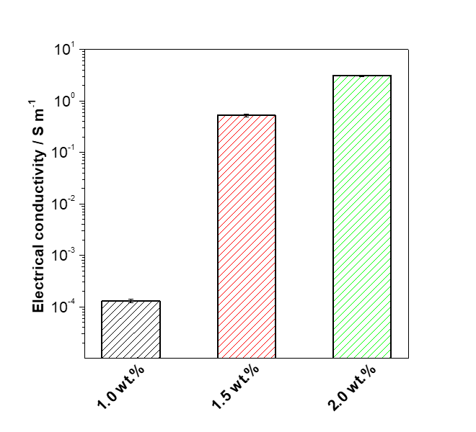
Figure 4.5. Electrical conductivity of UPR/rGO composites.

$Resistivity \left(Ω m\right)=resistance \left(Ω\right) × \frac{area (m^{2})}{length (m)}$ (4.1)
For composites, the electrical percolation threshold can be calculated by simple power-law expression (equation (4.2), in which σ_{c} is the electrical conductivity of composite, σ_{f} is the electrical conductivity of filler, φ is the filler volume, and φ_{c} is the electrical percolation threshold, τ is the universal critical exponent [61,151]. According to the electrical conductivity of 1 wt.%, 1.5 wt.%, and 2 wt.% obtained from electrical tests, the electrical threshold is around 0.8 wt.%.
$σ_{c }= σ_{f }{(φ - φ_{c})}^{t}$ (4.2)

4.3.4. Thermal conductivities of UPR and URP/rGO composites
The thermal conductivities of UPR and UPR/rGO composites are measured by a thermal conductivity analyzer at various temperatures of 50 °C, 70 °C, 90 °C, and 110 °C. The thermal conductivity as a function of temperature is shown in Figure 4.6, and the results are summarized in Table 4.2. As shown in Figure 4.6, the thermal conductivities increase with the increasing temperature. This is because the number of active phonon increases with increasing temperatures, resulting in an increasing interaction between different phonons in polymer with a lower thermal interfacial barrier resistance which is the barrier to the heat flow [89]. Theoretically, the thermal conductivity of polymer composite is affected by the reinforcement structure, the matrix, the dispersion quality and the thermal interfacial resistance between fillers and matrix [199,200]. According to Figure 4.6 and Table 4.2, the thermal conductivities of UPR/rGO composites increase as rGO content increases (≤0.5 wt.%). The maximum values are observed at 0.5 wt.%, which displays improvements of 39% at 50 °C, 50% at 70 °C, 58% at 90 °C, and 60% at 110 °C over neat UPR, respectively due to high thermal conductivity of graphene. However, UPR/rGO of 1.0 wt.% shows a decrease over neat UPR. This is because that rGO processes large surface area to contact with polymer matrix, the thinner polymer layers on rGO can create a lower thermally conductive interface [90]. When the rGO content is no more than 0.5 wt.%, rGO can disperse homogeneously through polymeric matrix and forms a path for phonon diffusion with a lower thermal interfacial resistance. Hence, the thermal conductivity of composites increases with rGO loadings below 0.5 wt.%. However, when rGO content reaches 1.0 wt.%, rGO tends to aggregate, which reduces the aspect ratio of fillers. Consequently, the contact area between rGO and UPR matrix is decreased, resulting in a restricted phonon transport and a high thermal interfacial resistance. Therefore, the thermal conductivity of 1.0 wt.% UPR/rGO composite is reduced over neat UPR [199–202].

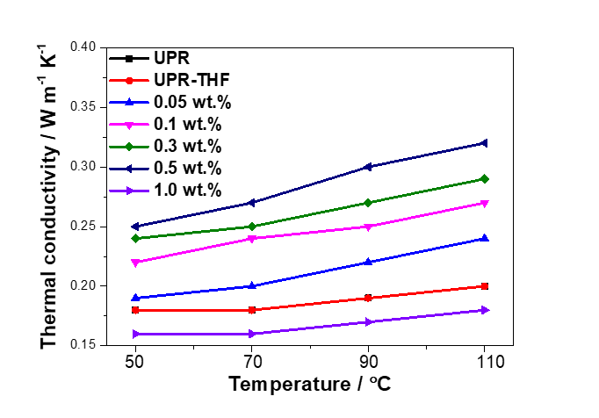
Figure 4.6. Thermal conductivity of UPR and UPR/rGO composites at elevated temperatures.

Table 4.2. Thermal conductivity of UPR and UPR/rGO composites.
Temperature / °C | Thermal conductivity / W m⁻¹ K⁻¹
 | UPR | UPR-THF | 0.05 wt.% | 0.1wt.% | 0.3 wt.% | 0.5 wt.% | 1.0 wt.%
50 | 0.18 | 0.18 | 0.19 | 0.22 | 0.24 | 0.25 | 0.16
70 | 0.18 | 0.18 | 0.20 | 0.24 | 0.25 | 0.27 | 0.16
90 | 0.19 | 0.19 | 0.22 | 0.25 | 0.27 | 0.30 | 0.17
110 | 0.20 | 0.20 | 0.24 | 0.27 | 0.29 | 0.32 | 0.18

4.3.5. Mechanical properties of UPR, and UPR/rGO composites

4.3.5.1. Tensile properties
Figure 4.7 shows the tensile properties of UPR and its rGO composites, and the results are summarized in Table 4.3. In order to investigate the influence of THF on the mechanical properties of UPR, the tensile test was carried out on the control sample (UPR-THF). According to the tensile properties, the difference between UPR and UPR-THF is statistically insignificant (p > 0.05, two-tailed t-test). Hence, the addition of THF does not affect the mechanical properties of UPR. Young’s modulus, and tensile strength, decrease with rGO loadings, and the lowest values are observed at 0.5 wt.% (0.6 GPa for Young’s modulus, and 17.8 MPa for tensile strength). In contrast, 1.0 wt.% exhibits a relatively high Young’s modulus (1.2 GPa) and tensile strength (21.3 MPa). Furthermore, the elongation at break increases with the rGO loading below 0.5 wt.%, which is statistically insignificant (p > 0.05, two-tailed t-test). 0.5 wt.% UPR/rGO exhibits a significant improvement on elongation at break of 17.9% (120% over UPR-THF and neat UPR). However, 1.0 wt.% UPR/rGO composite exhibits the lowest value of 3.9%.
The addition of nanoparticles could affect the curing process of polymers, which in turn determines the rheological behavior, cure kinetics, and crosslinking density, resulting in significant changes on the mechanical properties, thermal properties, etc. [203]. Fundamentally, the mechanical properties of polymer nanocomposites mostly depend on the mechanical properties of the polymer matrix and the nanoparticles, the dispersion of nanoparticles, the shape and type of nanoparticles, and the density of crosslinking [203,204]. As discussed in previous chapter, some styrene and cobalt may absorbed on the surface of GO sheet via chemical bonding and п-п interaction. At a lower concentration (≤0.5 wt.%), rGO can be dispersed homogeneously in polymeric matrix. Therefore, the amount of styrene for crosslinking with UPR chains are reduced. Although the reduced amount of cobalt does not directly affect crosslinking density, the curing time would be negatively affected. In other word, the crosslinking density would be reduced for a given curing time. Therefore, a homogeneous dispersion of GO at lower concentration would reduce the crosslinking density, resulting in a more flexible material with reduced Young’s modulus, tensile strength, and increased elongation at break [205,206]. However, at the higher concentration of 1.0 wt.%, the dispersion of rGO is relatively poorer than that of composites at lower rGO loadings (≤0.5 wt.%) due to the aggregation of rGO particles, resulting in a reduced specific surface area despite of the higher amount. Therefore, less amount of styrene and cobalt are absorbed on rGO surface, that is, more reactive styrene monomers can polymerize with UPR. Moreover, the high modulus of rGO at high concentration also contributes to the final mechanical properties of UPR/rGO composites. Hence, UPR/rGO (1.0 wt.%) exhibits increased mechanical properties and reduced elongation at break. According to the results of energy at break, the UPR/rGO (0.5 wt.%) shows an improvement of 7.5% over pristine UPR. This is because that energy at break, the area underneath of the stress-strain curve, is a combination of Young’s modulus, tensile strength, and elongation at break. UPR/rGO composites with concentrations below 0.5 wt.% possess deceased tensile strength with slightly increased elongation at break, resulting in reduced energy at break with rGO loadings. However, UPR/rGO (1.0 wt.%) displays a much higher elongation at break, so the energy at break is much higher compared to other composites and UPR due to the value of deformation. In other words, UPR/rGO (0.5 wt.%) composite is more ductile and the deformation allows the energy absorbed to be dissipated, leading to a higher energy to be broken [207].

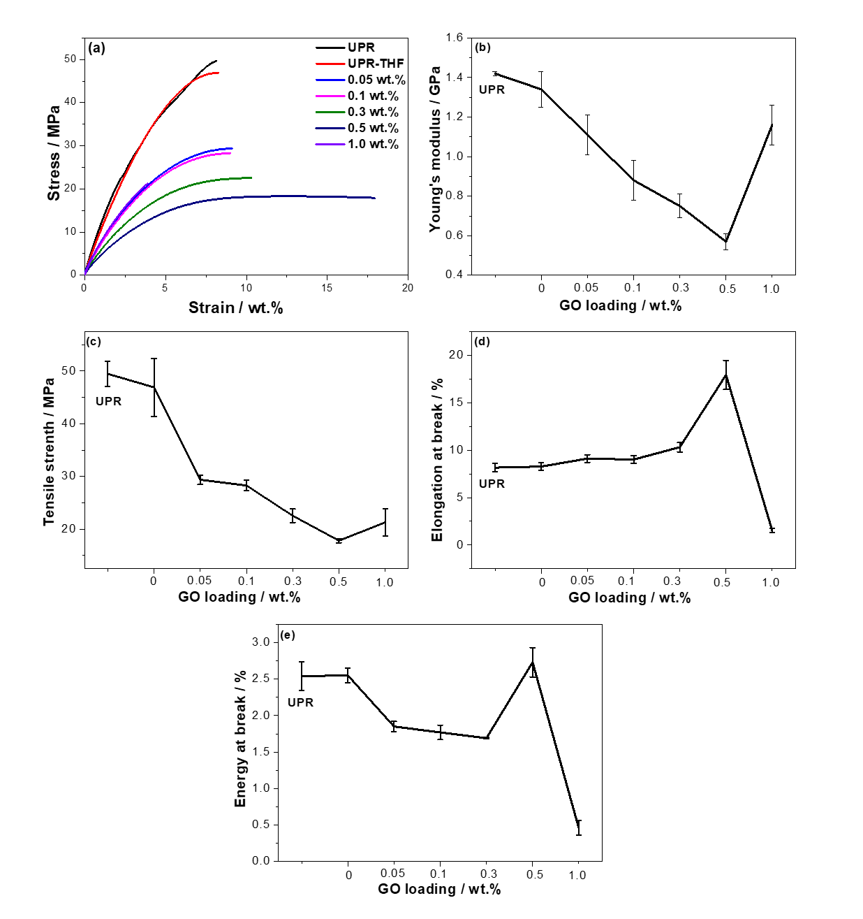
Figure 4.7. Tensile properties of UPR and UPR/rGO composites: (a) stress-strain curves, (b) Young’s modulus, (c) tensile strength, (d) elongation at break, and (e) energy at break.

Table 4.3. Tensile properties of UPR, UPR-THF, and UPR/rGO composites.
 | Young’s modulus  / GPa | Tensile Strength  / MPa | Elongation at break  / % | Energy at break / MJ m⁻³
UPR | 1.4±0.01 | 49.5±2.4 | 8.2±0.4 | 2.5±0.2
UPR-THF | 1.3±0.09 | 46.9±5.5 | 8.3±0.4 | 2.6±0.1
0.05 wt.% | 1.1±0.10 | 29.4±0.9 | 9.1±0.4 | 1.9±0.07
0.1.0 wt.% | 0.9±0.10 | 28.3±1.0 | 9.0±0.4 | 1.8±0.1
0.3 wt.% | 0.8±0.06 | 22.6±1.3 | 10.3±0.5 | 1.7±0.01
0.5 wt.% | 0.6±0.04 | 17.8±0.4 | 17.9±1.5 | 2.7±0.2
1.0 wt.% | 1.2±0.10 | 21.3±2.6 | 3.9±0.2 | 0.5±0.1

4.3.5.2. Compression properties
Figure 4.8 shows the compressive properties of UPR and UPR/rGO composites, and the results are summarized in Table 4.3. Figure 4.8(a) displays the stress-strain behavior under uniaxial compressive load, in which brittle UPR and UPR/rGO composites show ductile failure by yielding. This is different from the tensile stress-strain curve which shows typical brittle failure without yielding, presumably because of the sliding of molecules on top of each other under compression stress, leading to shear yielding [208,209]. However, the yield point, is getting less visible and more flat with the increasing rGO content up to 0.5 wt.%. This might be because the addition of rGO restricts the movement of polymer chains, which prevents the sliding of molecules from each other under compression stress. In contrast, the yielding of 1.0 wt.% UPR/rGO is much more significant. This is presumably due to the less restriction of polymer chains caused by the aggregation of rGO at higher rGO loading, resulting in a relatively easier sliding of molecules under compression load. Compared to neat UPR, UPR-THF material shows slightly difference in the Young’s modulus, fracture strength, strain at break, energy at break, and yield strain, which are statistically insignificant (p > 0.05, two-tailed t-test). Hence, the addition of THF does not affect the compressive properties of UPR. The compressive properties of UPR/rGO exhibit similar trend to that of tensile properties. In detail, the Young’s modulus, and fracture strength decrease with increasing rGO content, and the lowest values are observed at 0.5 wt.% (0.34 GPa for Young’s modulus, and 79.9 MPa for fracture strength). 1.0 wt.% UPR/rGO shows an increased Young’s modulus and fracture strength over other UPR/rGO composites with lower concentrations (≤0.5 wt.%). As discussed previously, this is because the absorbed styrene monomers and cobalt on rGO sheets increases with increasing rGO content at lower rGO concentrations (≤0.5 wt.%), resulting in reduced amount of active styrene for polymerization. Hence, the crosslinking density reduced gradually with increasing rGO content, resulting in reduced Young’s modulus and fracture strength. When rGO content reaches 1.0 wt.%, the high strength and modulus of rGO plays an important role in the mechanical properties of UPR composite. Moreover, rGO tends to aggregate, resulting in a reduced specific surface area of rGO. Consequently, 1.0 wt.% UPR/rGO exhibits higher Young’s modulus, and fracture strength due to the increased crosslinking density caused by more free reactive UPR oligomers for polymerization.
Strain at break of UPR/rGO composites increases after addition of rGO. The highest value of 51.0% is observed at 0.05 wt.% (10% over UPR), and the lowest value of 45.1% is observed at 1.0 wt.% (2.5% over UPR). As aforementioned reasons, the UPR/rGO composites at lower rGO concentrations (≤0.5 wt.%) is relatively flexible due to the reduced crosslinking density caused by the less reactive styrene monomers, resulting in an increment on strain at break. In contrast, 1.0 wt.% UPR/rGO is relatively rigid due to the rigid nanoparticles and higher crosslinking density, resulting in a reduction on strain at break. Similar to tensile properties, the energy at break (the area underneath the stress-strain curve) in compressive test is reduced with increasing rGO content, except 1.0 wt.% composite. This is because both Young’s modulus and fracture strength are reduced when rGO content below 0.5 wt.%, whereas the slight increment of fracture strain at break cannot compensate the reduction from modulus and strength. When the rGO content is 1.0 wt.%, Young’s modulus is increased significantly over other UPR/rGO composites, resulting in an increased energy at break.

Table 4.4. Compressive properties of UPR and UPR/rGO composites.
 | Young’s modulus  / GPa | Fracture strength  / MPa | Fracture strain  / % | Energy at break  / MJ m⁻³ | Yield strength  / MPa | Yield strain  / %
UPR | 1.38±0.03 | 128.4±10.1 | 46.3±1.4 | 35.3±2.8 | 89.1±1.0 | 9.27±0.10
UPR-THF | 1.31±0.05 | 132.8±7.8 | 48.1±1.3 | 36.4±2.3 | 86.3±1.2 | 9.31±0.15
0.05 wt.% | 0.66±0.02 | 113.6±5.2 | 51.0±0.8 | 21.5±0.5 | 25.9±1.1 | 5.54±0.19
0.1.0 wt.% | 0.60±0.05 | 83.3±1.7 | 47.3±0.5 | 17.7±1.0 | 22.7±1.0 | 5.81±0.13
0.3 wt.% | 0.49±0.05 | 85.3±3.3 | 48.9±0.6 | 15.1±0.3 | 15.1±0.9 | 4.59±0.48
0.5 wt.% | 0.34±0.02 | 79.9±4.3 | 48.8±0.6 | 14.7±0.3 | 14.8±0.4 | 5.12±0.19
1.0 wt.% | 0.94±0.03 | 70.2±1.4 | 45.1±1.3 | 21.3±1.1 | 53.9±0.2 | 8.19±0.13
*The yield strength is defined as yield strength (at 0.2% offset) here. Measurement: a straight line is drawn from point of 0.2% strain at the same slope as the initial portion of stress-strain curve. The point of the intersection of the new line and stress-strain curve is considered as yield point. The stress and strain at this point are yield strength and yield strain.

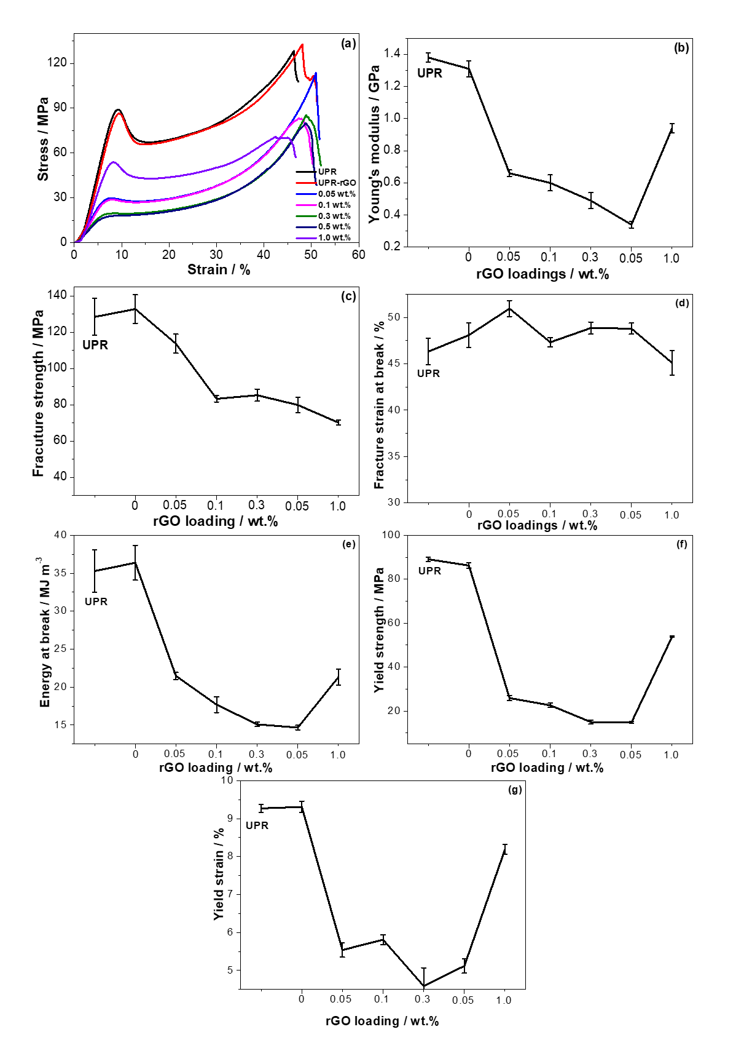

Figure 4.8. Compressive properties of UPR and UPR/rGO composites: (a) stress-strain curves, (b) Young’s modulus, (c) compressive strength, (d) compressive strain at break, (e) energy at break, (e) yield strength and (f) yield strain.

4.3.6. Dynamic mechanical properties of UPR, and UPR/rGO composites
Storage modulus (E'), loss modulus (E"), and glass transition of temperature (T_{g}) of UPR were measured by dynamic mechanical analysis (DMA), and the results are shown in Figure 4.9 and summarized in Table 4.5. The storage modulus, is related to the stiffness of materials, represents the elastic energy received during deformation that is stored into the material and released at the end of the loading [168]. It decreases with temperature before glass transition temperature due to the increased molecular mobility caused by heating, as represented in storage modulus against temperature curve [168,169]. According to Figure 4.9(a), the storage modulus in glassy state (below glass transition temperature T_{g}) decreases with the increasing rGO content, and the lowest value is observed at 0.5 wt.% UPR/rGO. Although there is a slightly increase occurred at 0.05 wt.% UPR/rGO, the overall trend is reduction. 1.0 wt.% shows a significant improvement on storage modulus (87% at -40 °C, 93% at 20 °C, and 98% at 40 °C over UPR). These results are presumably attributed to three factors. 1). Storage modulus is depended on the crosslinking density that is affected by the addition of rGO. 2). The addition of stiff rGO particles restricts the movement of polymer chains. 3). The high modulus of reinforcement (rGO) contributes the modulus of UPR/rGO composites. As discussed previously, crosslinking density decreases gradually due to the reduced amount of styrene monomers absorbed on rGO surface, resulting in a reduced modulus. However, the movements of polymer chains are restricted by rGO, resulting in an increased modulus. Hence, there is not a clear trend on storage modulus at glassy state, which shows an overall reduction on storage modulus except a slightly increase occurred at 0.05 wt.% (-20 ºC). When the rGO content is 1.0 wt.%, rGO tends to aggregate, leading to a reduced surface area and higher crosslinking density over other UPR/rGO composites. Moreover, the modulus of rigid rGO also contributes on storage modulus of UPR composites at high rGO content. Hence, 1.0 wt.% UPR/rGO exhibits much higher storage modulus over UPR and other UPR/rGO composites at glassy state.
The glass transition temperature (T_{g}) is defined as the peaks of both loss modulus and damping factor against temperature curves. Normally, damping factor against temperature is a most common way to determine T_{g}. In this work, T_{g} of 1.0 wt.% UPR/rGO is enhanced by 5 ºC over neat UPR. However, T_{g} values of composites with lower rGO contents are reduced over neat UPR, which are 28 °C (0.05 wt.%), 31 °C ( 0.1 wt.%), 32 °C (0.3 wt.%), and 35 °C (0.5 wt.%) lower than neat UPR. The crosslinking density is a key parameter for T_{g}. As discussed previously, the crosslinking density decreases at low rGO content (≤0.5 wt.%) due to the surface absorption of styrene monomers on rGO sheets, resulting in flexible materials with lower T_{g}. One the contrary, at high concentration (1.0 wt.%), rGO tends to aggregate, resulting in a higher crosslinking density. Moreover, the presence of RGO restricts the mobility of the UPR chains, which is also contribute to the T_{g}. Hence, 1.0 wt.% composite possesses an improved T_{g}.
The loss modulus is indicative to the energy dissipation with temperature under cyclic load. It is the viscous response to an applied force, while storage modulus is an elastic response to an applied force. It increases before and around glass transition region and decreases in rubbery plateau due to the movement friction between polymer segments. The loss (or damping) factor tanδ is the ability of restoring energy for polymers. Similar to loss modulus, it is a measurement of how well a material can dissipate energy under heating. Coefficient C, the difference between the dynamic mechanical moduli at glassy state and rubbery plateau, is employed here to investigate the effectiveness of nanoparticles on the moduli of the composites [210,211]. It can be obtained by the equation (4.3), where E'_{g} is storage modulus at glassy state, and E'_{r} is storage modulus at rubbery plateau, and the results are summarized in Table 4.5 (40 ºC and 110 ºC are selected as glassy state, and rubbery state, respectively). 1.0 wt.% UPR/rGO composite displays the lowest coefficient C, indicating that 1.0 wt.% is the optimum concentration for enhancing the storage modulus.

$C= \frac{{(E^{'}}_{g }/{E^{'}}_{r})comp}{{(E^{'}}_{g }/{E^{'}}_{r})resin}$ (4.3)
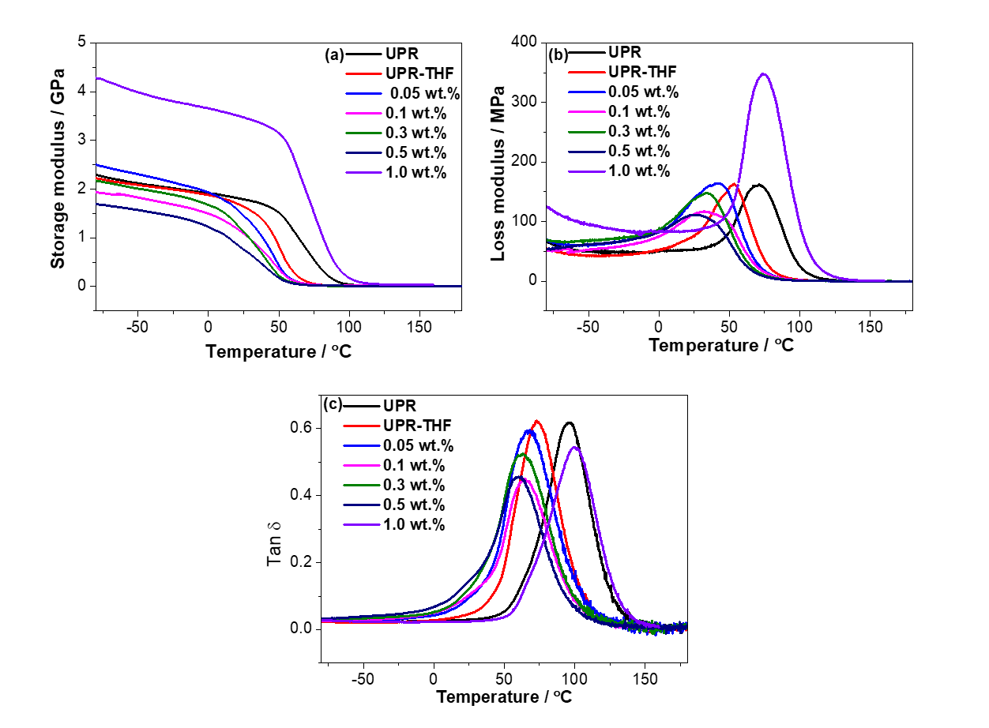
Figure 4.9. Dynamic mechanical properties of UPR/rGO composites: (a) storage modulus, (b) loss modulus, and (c) tan δ.

Table 4. 5. Dynamic mechanical properties of UPR/rGO composites.
 | Storage modulus E' / GPa |  |  |  |  | T_{g} / ºC | Coefficient C
Samples | -40 ºC | 20 ºC | 40 ºC | 110 ºC | -
UPR | 2.1±0.03 | 1.8±0.03 | 1.2±0.02 | 0.02 | 95±2 |  | -
UPR-THF | 2.1±0.02 | 1.7±0.04 | 1.3±0.04 | 0.01 | 73±4 |  | -
0.05 wt.% | 2.2±0.05 | 1.6±0.02 | 0.9±0.05 | 0.01 | 67±3 |  | 1.12
0.1 wt.% | 2.0±0.04 | 1.3±0.04 | 0.6±0.03 | 0.01 | 64±2 |  | 0.83
0.3 wt.% | 1.0±0.07 | 1.2±0.07 | 0.7±0.07 | 0.01 | 63±3 |  | 0.70
0.5 wt.% | 1.5±0.05 | 0.9±0.05 | 0.4±0.02 | 0.01 | 60±2 |  | 0.50
1.0 wt.% | 3.9±0.06 | 3.5±0.08 | 3.3±0.09 | 0.08 | 100±4 |  | 0.48

4.3.7. Thermal stability of UPR, and UPR/rGO composites
The influence of rGO on the thermal properties of UPR was investigated by TGA, and the results are presented in Figure 4.10 and Table 4.6 As shown in Figure 4.10(a), the onset temperature ($T_{d}^{onset}$) of UPR, which is defined as the degradation temperature at 5% weight loss [212], is observed at 367 ºC, and yields a 95% mass loss when the temperature reaches 800 °C (char yield). The 50 % weight loss and maximum weight loss occur at 413 °C (T_{d}^{1/2})), and 419 °C ($T_{d}^{peak}$), respectively. This is associated to the decomposition of polymeric network [140]. Compared to UPR, UPR-THF displays very similar thermal properties on $T_{d}^{onset}$, $T_{d}^{peak}$, and T_{d}^{1/2}, which is negligible, indicating that the use of solvent does not affect the thermal properties of UPR. The $T_{d}^{onset}$ of UPR/rGO composites are very similar to that of neat UPR, except 0.05 wt.% and 1.0 wt.% composites which are 7 °C lower, and 6 °C higher over UPR, respectively. As aforementioned reasons, the addition of rGO reduces the amount of styrene monomers for polymerization with polymer chains, resulting in a reduced crosslinking density [213,214]. Therefore, 0.05 wt.% of UPR/rGO composite shows a slightly decrease on the.$T_{d}^{onset}$ When the rGO loading reaches 1.0 wt.%, the number of reactive styrene monomers for polymerization is increased due to the reduced specific surface area of rGO caused by aggregation of rGO at higher concentration. Therefore, $T_{d}^{onset}$ at 1.0 wt.% is improved over UPR. Slightly decreases of both $T_{d}^{peak}$ and T_{d}^{1/2} of UPR/rGO composites are observed over neat UPR, and the lowest values (413 °C for $T_{d}^{peak}$, and 405 °C for T_{d}^{1/2}) are observed at 0.5 wt.%, which are 413 °C, and 405 °C respectively, which is 6 °C and 8 °C lower compared to UPR. These slightly decreases are presumably due to the addition of rGO particles which would limit the formation of polymer network, resulting in some changes on the thermal behavior [214]. The char yields of UPR/rGO composites are improved over UPR. The highest value of 6.82% occurs at 0.05 wt.%, which is 37.5% improvement over UPR. This might because rGO sheets forms barriers on the surface of polymer chains during the TGA analysis. Therefore, the combustible molecules cannot go out, and oxygen can’t go in, resulting in a higher char yield [214].

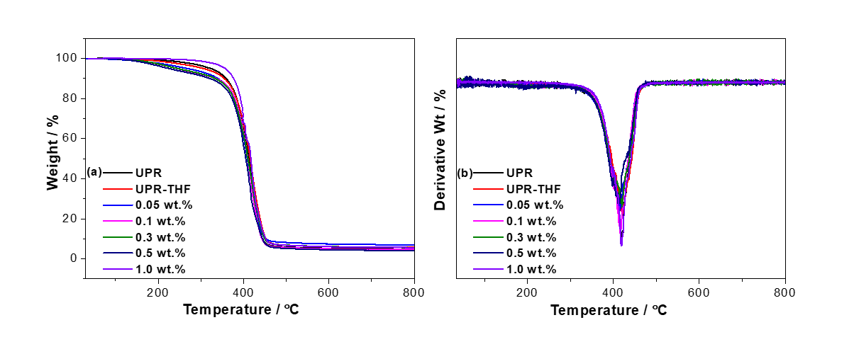
Figure 4.10. Thermal properties of UPR and UPR/rGO composites: (a) TGA and (b) DTG.

Table 4.6. Thermal stability of UPR, and UPR/rGO composites.
Samples | $T_{d}^{onset}$/ °C | $T_{d}^{peak}$ / °C | $T_{d}^{1/2}$ / °C | Char yield / wt.%
UPR | 367 | 419 | 413 | 4.96
UPR-THF | 366 | 420 | 414 | 5.87
0.05 wt.% | 360 | 415 | 409 | 6.82
0.1.0 wt.% | 368 | 416 | 410 | 4.32
0.3 wt.% | 366 | 419 | 410 | 5.27
0.5 wt.% | 367 | 413 | 405 | 4.33
1.0 wt.% | 373 | 418 | 417 | 5.28

4.3.8. Morphology of UPR and UPR/rGO composites
The fracture surfaces of neat UPR and UPR/rGO composites are investigated by SEM (Figure 4.11 and 4.12). For neat UPR (Figure 4.11 (a)), the fracture surface is flat and smooth with some stripes and debris which are the typical signs of a glassy material. In contrast, some rGO clusters are observed for UPR/rGO composites, and they increase with increasing rGO content, as shown in Figure 4.11. This is because the removal of oxygen functional groups allows rGO sheets easily to be stacked together due to the van der Waal’s force. Figure 4.12 shows the fracture structures of UPR/rGO of 0.05 wt.% and 1.0 wt.% at high magnification. Compared with 0.05 wt.% UPR/rGO composite, the aggregation of rGO in 1.0 wt.% UPR/rGO is much more serious. This confirms that the specific surface of rGO of 1.0 wt.% composite is much smaller than other composites. Hence, the crosslinking density of UPR/rGO composites at low concentration (≤0.5 wt.%) is influenced by addition of rGO more significantly over that of UPR/rGO at 1.0 wt.%. Therefore, the mechanical properties, thermal properties, and glass transition temperature are reduced by 0.5 wt.%, then increased at 1.0% rGO content.
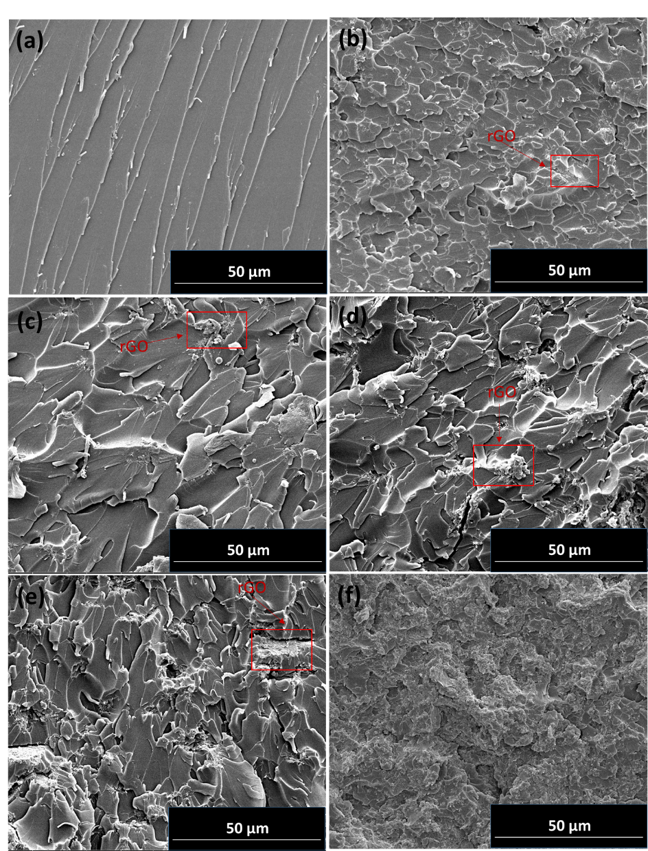

Figure 4.11. SEM images of the fracture surfaces of UPR and UPR/rGO composites: (a) neat UPR, (b) 0.05 wt.%, (c) 0.1.0 wt.%, (d) 0.3 %, (e) 0.5 wt.%, and (f) 1.0 wt.%.

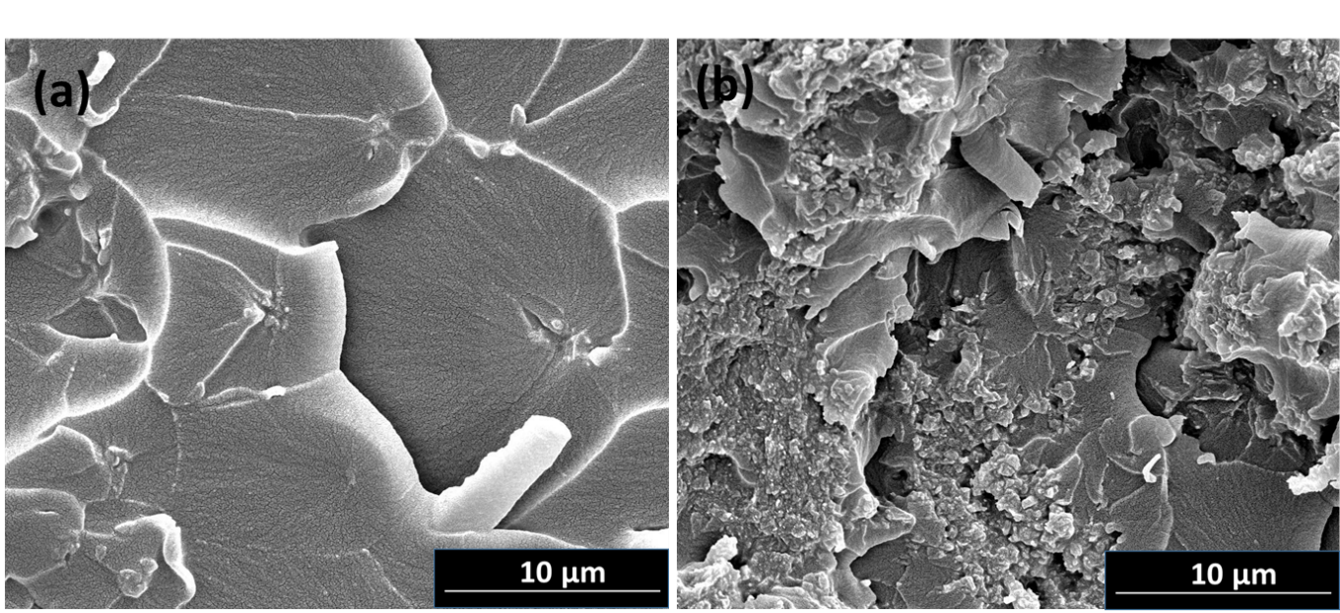
Figure 4.12. SEM images of UPR/rGO composites at high magnification (×8000): (a) 0.05 wt.% and (b) 1.0 wt.%.

4.4. Conclusion
In this chapter, GO was successfully reduced in an eco-friendly and cost effective method by vitamin C at 90 ºC for 6 hours, with some functional groups remaining that is confirmed by FTIR and XPS. As shown in SEM images, rGO is dispersed homogeneously when the concentration is no more than 0.5 wt.%. However, significant aggregation is observed when GO content reaches to 1.0 wt.%. This morphology of UPR/rGO composites and dispersion quality of rGO further explains the results of mechanical properties, thermal properties, glass transition temperature, and thermal conductivity. In this work, the electrical conductivity of UPR/rGO was observed , which is 1.3 x 10⁻⁴ S m⁻¹ at 1.0 wt.%, and 3.08 S m⁻¹ at 2.0 wt.%. According to some electrical results from literature reviews, graphene/polystyrene composites exhibits 1 S m⁻¹ at 2.5 vol.% [151], PMMA/NanoG film reached 10⁻³ S m ⁻¹ when the graphite content is at 2.0 wt.% [215], GNS-PS composites displayed a conductivity of 2.9 x 10⁻² S m⁻¹ at 2 wt.% [216], UPR/RGO composites prepared in this method shows a great improvements. This indicated that the electrical properties of GO can be restored by reducing with vitamin C, which can form a effective pathway for electrons transfer. Therefore, rGO reduced by vitamin C has the potential to enable insulator polymer to be electrically conductive for some specific applications such as electric devices. Besides, some improvement is also observed on the thermal conductivity, which increases with rGO content. The maximum thermal conductivity occurs at 0.5 wt.% composite, while 1.0 wt.% shows the lowest value. For tensile testing and compression testing, modulus, strength, energy at breaks were reduced with rGO content (<0.5 wt.%), with increased elongation at break. However, 1.0 wt.% UPR/rGO showed an increased modulus, strength, energy at break, with a reduced elongation at break. Tg reduces gradually as the rGO content increase, expect 1.0 wt.% composite which exhibits a 5 °C increase over neat UPR. All these results are contributed to the dispersion of rGO that is in turn related to crosslinking density. When rGO content is no more than 0.5 wt.%, more styrene monomers tends to be absorbed on rGO surface by п-п interaction, resulting in a low crosslinking density. In contrast, when the rGO content is 1.0 wt.%, less styrene monomers are absorbed on rGO surface due to the aggregation, resulting in a high crosslinking density.

Chapter 5: Conductive unsaturated polyester composites incorporated with vitamin C-reduced graphene oxide in one pot method

5.1. Introduction
In previous Chapter, UPR/rGO composites were prepared by simply mixing UPR and rGO that was reduced prior to the synthesis of composites. The UPR/rGO composites show an enhanced electrical conductivity and thermal conductivity. However, there is no significant influence with thermal stability. T_{g} decreases as rGO content (≤ 0.5 wt.%) increases. Moreover, the mechanical properties is reduced when the rGO content is below 0.5 wt.%. This is may be contributed to the weak interfacial interaction between rGO and UPR. After reduction, most of the oxygen functional groups on GO basal plane have been removed, which is difficult for the formation of hydrogen bonding between GO and polymer matrix. Moreover, the hydrophobic nature and Van der Waals forces cause rGO to agglomerate and restack in organic solvents and polymer matrix, resulting in poor dispersion and properties [217]. To address this issue, UPR/GO composites are prepared by in one pot method, in which the formation of GO with UPR and the reduction of GO are carried out simultaneously. In this method, GO possesses extensive oxygen functional groups before reduction, which allows GO to combine with UPR polymer chains. Moreover, polymer chains also act as a stabilizer to prevent aggregation of GO during reduction [217,216,218–221]. For example, Ganiu et al. prepared rGO/epoxy composites by dispersing GO in epoxy resin, followed by thermal reduction of GO at a relatively high temperature prior to addition of hardener and catalyst [220]. Liu prepared polyester/rGO nanocomposites by mixing GO with monomers and the thermal reduction carried out at high temperature (280 °C) and low pressure (65 Pa) [219]. Hu synthesized graphene/polystyrene xxx by mixing GO with monomer and surfactant, followed by reduction by hydrazine at 100 °C for 2 h [216]. In this chapter, UPR/rGO composites with given rGO content are prepared by in one pot method. To study the effects of the solution on the electrical properties, thermal stability and T_{g}, DMF and THF-DMF are used.

5.2. Experimental section

5.2.1. Materials
The chemicals used in this work were same in chapter 2. Briefly, unsaturated polyester resin (UPR) used in this work was CRYSTIC D3061 (R 50054, Scott Bader). Vitamin C (L-ascorbic acid) was purchased from Sigma-Aldrich. Graphene oxide was prepared from graphite by Hummers method reported in previous work [187]. Other chemicals used in the experiments were reagent grade, purchased from VWR international LTD.

5.2.2. Low-temperature reduction of graphene oxide (GO) by L-ascorbic acid (vitamin C)
Clear GO aqueous suspension (1 mg ml⁻¹) was obtained by mild agitation and sonication. Vitamin C aqueous solution (1 mg ml⁻¹) was added into the GO suspension to make a mixture with a Vitamin C/GO weight ratio of 6/1. Then the mixture was stirred under 40 ºC for up to 4 days. The resultant reduced GO by Vitamin C was collected and washed for 4 times by centrifuge to remove the vitamin C, followed by freeze-drying.

5.2.3. Preparation of UPR/GO and UPR/rGO composites
To prepare UPR/rGO composites, GO organic solvent suspension at 1.0 mg ml⁻¹ was prepared by magnetic agitation for 30 min, followed by mild sonication for another 30 min. Vitamin C was dissolved in 1 ml DMF by mild sonication. Then the two dispersions and UPR resin were mixed under stirring at 40 °C for 4 days to reduce GO by vitamin C. Solvents were removed by evaporation. After adding the hardener and promoter under stirring, the mixture was molded and cured with the following heating procedure: ambient temperature for 4 days, 80 °C for 3 hours, 120 °C for 1 hour, and 200 °C for 3 hours. The products were denoted as UPR/rGO0.91, and UPR/rGO1.32, where the fractions indicated the weight percentage of GO in the formulation. The composite UPR/GO0.96 was also prepared without adding vitamin C for comparison. Two controlled neat UPR samples, denoted as UPR and UPR (THF/DMF), were prepared by the same curing procedure. UPR was directly prepared from UPR resin, while UPR (THF/DMF) was prepared from UPR resin solution (resin/THF/DMF: 10 g/100 ml/1 ml) following the same solvent-removing and curing procedure that for preparing UPR/rGO composites. Another sample UPR/rGO1.32 (DMF) was prepared by using DMF to replace THF for the dispersion of GO for comparison. The formulas for preparing UPR, UPR/rGO, UPR/GO composites are summarized in Table 5.1.

Table 5.1. Formulas for synthesis UPR, UPR/GO, UPR/rGO composites.
 | Fill content / % | UPR  / g | GO  / g | vitamin C  / g | Hardener  / g | Promoter  / g
UPR | 0 | 10 | 0 | 0 | 0.2 | 0.1
UPR/(THF/DMF) | 0 | 10 | 0 | 0 | 0.2 | 0.1
UPR/GO0.96 | 0.96 | 10 | 0.1 | 0 | 0.2 | 0.1
UPR/rGO0.91 | 0.91 | 10 | 0.1 | 0.6 | 0.2 | 0.1
UPR/rGO1.32 | 1.32 | 10 | 0.15 | 0.9 | 0.2 | 0.1
UPR/rGO1.32(DMF) | 1.32 | 10 | 0.15 | 0.9 | 0.2 | 0.1

5.2.4. Characterization

5.2.4.1. Fourier transform infrared spectroscopy (FTIR)
FTIR spectroscopy of GO, rGO and UPR/rGO composites were carried out on a Spectrum 100 with ATR (Perkin Elmer, USA) in the wavenumber range of 4000–500 cm⁻¹ with a resolution of 4 cm⁻¹.

5.2.4.2. Thermogravimetric analysis (TGA)
TGA were performed by using a Thermogravimetric Analyzer Pyris 1 (Perkin Elmer, USA), with a temperature range from 25 °C to 800 °C, a heating rate of 10 °C min⁻¹ under a nitrogen flow of 20 ml min⁻¹.

5.2.4.3. Dynamic mechanical analysis (DMA)
DMA was carried out on a DMA 8000 instrument (Perkin Elmer, USA) equipped with single cantilever geometry mode. Measurements were performed from -80 °C to 180 °C at a heating rate of 2 °C min⁻¹ with a frequency of 1 Hz.

5.2.4.4. Scanning electron microscope (SEM)
SEM analysis was carried out on a FEI Inspect F scanning electron microscope, with a voltage of 10 kV. Prior to the SEM observation, samples were sputter–coated in gold by using an SPI sputter-coater for enhanced conductivity.

5.2.4.5. Electrical conductivity
The electrical conductivity of UPR, UPR/rGO, and UPR/GO composites was measured by using a FLUKE 287 digital multimeter with two probes. Silver paint was applied to the ends of test samples (n=3) to form contact points.

5.3. Results and Discussion

5.3.1. Low-temperature reduction of GO by L-ascorbic acid (vitamin C)

5.3.1.1. FTIR analysis
The reduction of GO by vitamin C at 40 ºC up to 4 days are investigated by FTIR, as shown in Figure 5.1. A wide hump around 3000 cm⁻¹–3500 cm⁻¹ is observed, which is attributed to the O-H stretching vibrations of the hydrogen groups and water [39]. GO peaks at 1723 cm⁻¹, 1567 cm⁻¹, 1203 cm⁻¹, 1024 cm⁻¹ are related to the C=O, aromatic C=C stretching, and C-O-C stretching [39,222]. Compared to the four FTIR spectra curves, the carboxyl groups (C=O), ester groups (C-O-C) were gradually diminished with the reaction time, implying that the oxygen groups started to be reduced by vitamin C under mild temperature from the 2nd day and effectively reduced for 4 days.
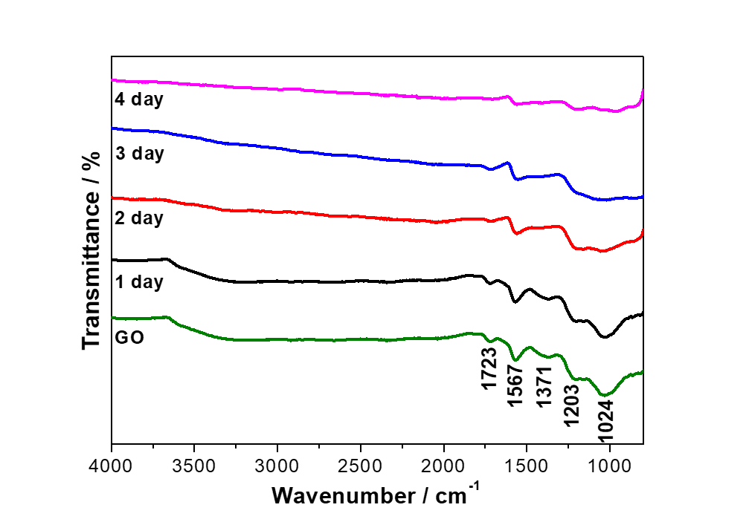
Figure 5.1. The evolution of FTIR spectrum of GO reduced by vitamin C at 40 °C over 4 days.

5.3.1.2. Thermogravimetric analysis (TGA)
The reduction of GO by vitamin C at low temperature (40 °C) for various days are investigated by TGA analysis (Figure 5.2). The first step around 100 °C relates to the moisture, which are 12.0% for GO, 9.7% for rGO (day1), 8.3 % for rGO (day2), 5.9 % for rGO (day3), and 1.3 % for rGO (day4), respectively. This implies a comparatively less amount of moisture is trapped in rGO with reduction time [32]. The major weight loss around 200 °C relates to the loss of oxygen functional groups, which are 36.3% for GO, 33.9% rGO (day1), 33.3% for rGO (day2), 33.3% for rGO (day3), 15.9% for rGO (day4) from 100 °C to 300 °C, respectively. This is due to the pyrolysis of the oxygen-containing functional groups, yielding CO, CO₂, and steam [32,34]. The weight remaining at 800 °C are 49.0% for GO, 52.6% for rGO (day1), 52.8% for rGO (day2), 54.1% for rGO (day3), and 70.15 % for rGO (day4), respectively. This indicates an enhanced thermal stability of rGO. All these TGA results confirmed that GO has been effectively reduced by vitamin C at a low temperature as 40 ºC for relatively longer reaction time, with an optimum reduction time of 4 days.
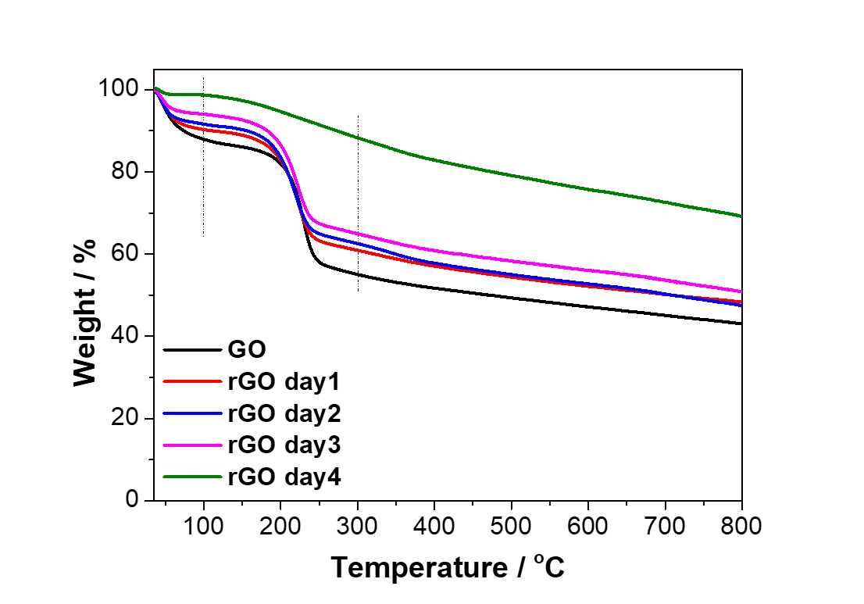
Figure 5.2. TGA of GO and rGO reduced by vitamin C at low temperature up to 4 days.

5.3.2. Chemical structures of UPR, UPR/rGO, and UPR/GO composites
The chemical structures of UPR and its composites are investigated by FTIR. According to Figure 5.3, FTIR peaks of vitamin C at 3524 cm⁻¹, 3404 cm⁻¹, 3308 cm⁻¹, are attributed to O-H stretch. Peaks at 3008 cm⁻¹, 1752 cm⁻¹, 1650 cm⁻¹, and 1272 cm⁻¹ are assigned to =C-H stretch, C=O stretch, C=C stretch, C-O stretch from COOH groups, respectively. There are several weak peaks from 1498 cm⁻¹ to 1314 cm⁻¹, which is due to the C-H bend. Peaks at 1112 cm⁻¹, and 1022 cm⁻¹ are due to C-O-C stretch. Peaks at 986 cm⁻¹ and 968 cm⁻¹ are related to the =C-H bend. These are in great agreement with Yang’s work [223]. As discussed before, the typical peaks of GO at 1723 cm⁻¹, 1567 cm⁻¹, 1203 cm⁻¹, and 1024 cm⁻¹ are related to the C=O, aromatic C=C stretching, and C-O-C stretching [39,222]. To study the influence of solvents of THF and DMF, the control samples UPR(THF/DMF) were prepared in the same procedure for UPR using a mixture of THF and DMF as solvent. According to the FTIR spectra of UPR and UPR(THF/DMF), there is no visible difference, indicating that the addition of THF and DMF doesn’t affect the final chemical structure of UPR. Compared to UPR, peaks at 1716 cm⁻¹, 1296 cm⁻¹, and 1118 cm⁻¹ shift to 1714 cm⁻¹, 1292 cm⁻¹, and 1128 cm⁻¹ in UPR/rGO1.32 composite, respectively. This is presumably due to the interactions of the polyester segments like C=O, COOH with oxygen functional groups of GO via polar-polar interactions or hydrogen bonding [196]. Combining the results from FTIR and TGA of GO and the RGO reduced by vitamin C at 40 C for various days, it confirmed that GO has been reduced by vitamin C successfully during the synthesis of UPR/rGO composites, and the interaction between GO and UPR occurs simultaneously through what bonding by what groups.
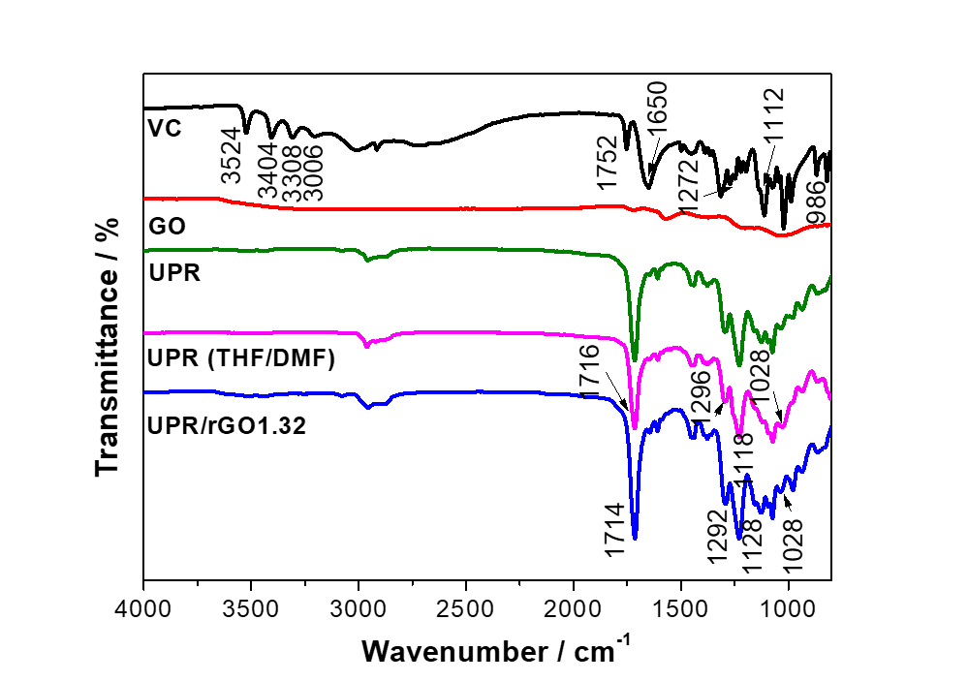
Figure 5.3. FTIR spectra of GO, vitamin C, UPR, UPR (THF/DMF) and UPR/rGO1.32.

5.3.3. Thermal stability of UPR, UPR/GO, and UPR/rGO composites
The thermal stability of UPR, UPR/GO, and UPR/rGO composites is studied by TGA analysis (Figure 5.4), and the results are summarized in Table 5.2. $T_{d}^{oneset}$, which is determined as the temperature of 5% weight loss, is 339 °C for neat UPR. $T_{d}^{peak}$ , $T_{d}^{1/2}$ of neat UPR is 418 °C, and 417 °C, respectively. Compared to the TGA of UPR (Figure 5.4(a)), UPR(THF/DMF) materials shows no significant changes on $T_{d}^{oneset}$ , $T_{d}^{peak},$ and $T_{d}^{1/2}$ indicating that the addition of solvents (THF and DMF) does not significantly affect the thermal stability of UPR. There is no significant influence on $T_{d}^{oneset}$ of UPR composites, except a reduction at UPR/rGO1.32 (24 °C lower than UPR). Moreover, $T_{d}^{1/2}$ of UPR composites shows similar values as that of UPR, except a significant reduction at UPR/RGO1.32 (8 °C lower than UPR), and an improvement at UPR/rGO1.32(DMF) (14 °C higher than UPR). This results presumably due to three reasons. 1) When rGO content is 0.91 wt.%, it can be dispersed well in polymer matrix as discussed in SEM analysis later. Therefore, rGO plays a role as an insulator and tends to reduce the flammability of UPR composites [224]. 2) GO tends to aggregate when GO content reaches 1.32 wt.% after reduction by vitamin C, which in turn reduce the heat transfer efficiency due to the poor interfacial adhesion between rGO and UPR. Therefore, both $T_{d}^{oneset}$ and $T_{d}^{1/2}$ are reduced for UPR/rGO1.32. However, the presence of unreacted vitamin C could also affect the heat transfer efficiency by reducing the interfacial adhesion between rGO and UPR. Hence, the influences on $T_{d}^{oneset}$ and $T_{d}^{1/2}$ are quite complex, resulting in an unclear trend. 3) The use of DMA for dispersion of GO instead of THF can produce a better dispersion of GO organic suspension. Meanwhile, the dispersion of vitamin C in DMF is better than that in THF/DMF mixture. Hence, the interfacial interaction between rGO and UPR matrix is much stronger compared to other composites, resulting in enhanced$T_{d}^{1/2}$. Regarding to char yield, UPR/rGO1.32(DMF) exhibits the highest char yield of 11.2%, which is a 20% improvement over UPR. This is presumably because during the TGA analysis, rGO layer as a barrier surrounded polymer chains. The combustible molecules cannot go out and oxygen cannot go in, resulting in an increased char yield.
DTA analysis is used to determine the rate of the weight loss, and the temperature of the maximum rate of weight loss (peak) is determined as the $T_{d}^{peak}$. According to the DTA curves (Figure 5.4(b)), UPR, UPR(THF/DMF), and UPR/GO show sharp single peaks. In contrast, UPR/rGO0.91, UPR/rGO1.32, and UPR/rGO1.32(DMF) composites show two peaks. The $T_{d}^{peak}$ is defined by the main sharp peak, which is related to the major decomposition of polymer chains. The other small peak is presumably duo to the derivatives from vitamin C during the curing process under heating program (80 °C for 3 h, 120 °C for 1 °h, and 200 °C for 3 h). Briefly, 436 °C for UPR/rGO0.91, 396 °C for UPR/rGO1.32, and 410 °C for UPR/rGO1.32(DMF) are considered as the decomposition temperature for vitamin C derivatives. UPR/rGO1.32 exhibits a significant increase on$T_{d}^{peak}$, which is 37 °C higher than that of neat UPR. DMF is a great solvent for both GO and vitamin C, in which GO and vitamin C can be dispersed homogeneously without precipitation via mechanical agitation and mild sonication. Therefore, GO can be reduced successfully by vitamin C at the presence of UP matrix, which is also proved by FTIR and TGA previously.

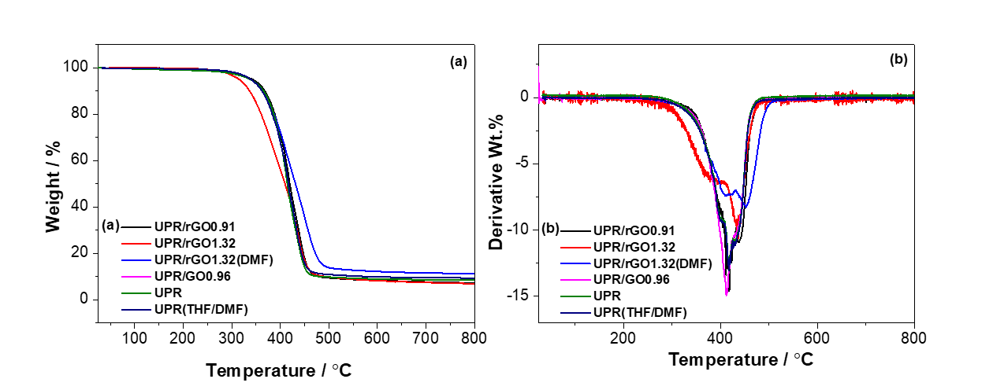
Figure 5.4. Thermal properties of UPR, UPR/GO, and UPR/rGO composites: (a) TGA and (b) DTG.

Table 5.2. TGA results of UPR, UPR/GO, and UPR /rGO composites prepared by in situ method.
samples | $T_{d}^{onset}$ / °C | $T_{d}^{peak}$ / °C | $T_{d}^{1/2}$ / °C | Char yield / wt.%
UPR/rGO0.91 | 342 | 436/417 | 419 | 7.2
UPR/rGO1.32 | 315 | 437/396 | 409 | 6.8
UPR/rGO1.32(DMF) | 338 | 455/410 | 431 | 11.2
UPR/GO0.96 | 337 | 412 | 414 | 8.6
UPR(THF/DMF) | 338 | 419 | 419 | 9.1
UPR | 339 | 418 | 417 | 9.3

5.3.4. Electrical property of UPR/rGO composites
The electrical conductivity of UPR/rGO composites prepared via various routines are shown in Figure 5.5. UPR and UPR/GO0.96 are electrical insulator, and the electrical conductivity value could not be measured by resistivity from test due to the measuring range of multi meter used. In contrast, UPR/rGO composites prepared from one pot method showed relatively good conductivity. In detail, the percolation threshold is 0.91 wt.% of rGO loadings, which means reduced GO can form an effective percolation path across the entire composite when it is over 0.91 wt.% due to the high electron mobility of reduced GO (10 000 cm² V⁻¹ s⁻¹) [225]. UPR/rGO0.91 and UPR/rGO1.32 composites show electrical conductivity of 2.4 x 10⁻⁴ S m⁻¹, and 0.17 S m⁻¹, respectively. The maximum conductivity of 0.71 S m⁻¹ was achieved at UPR/rGO1.32 (DMF) composite. This might be because GO exhibits better dispersion in DMF over THF, resulting in a better compatibility between rGO and UPR. All these three composites above present a conductivity higher than the anti-static criteria for thin films, which is 1 x 10⁻⁶ S m⁻¹ [197]. The percolation threshold can be calculated by equation 5.1(universal critical exponent τ is 2.74±0.2), which is 0.86 wt.% [61,151].

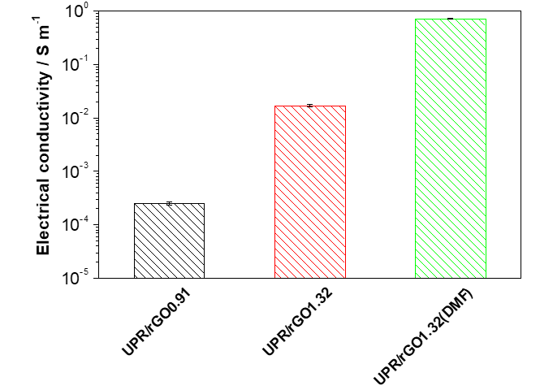
Figure 5.5. Electrical conductivity of UPR/rGO composites.
$σ_{c }= σ_{f }{(φ - φ_{c})}^{t}$ (5.1)

5.3.5. Dynamic mechanical properties of UPR, UPR/GO, and UPR/rGO composites
Dynamic mechanical properties including storage modulus (E'), loss modulus (E"), and glass transition of temperature (T_{g}) of UPR, UPR/GO, and UPR/rGO composites are measured by DMA analysis with a temperature range from -50 °C to 150 °C, and the results are shown in Figure 5.6 and summarized in Table 5.3. The storage modulus, related to the stiffness of materials, represents the elastic behavior during cyclic loading-unloading. It decreases with an increasing temperature due to its more flexible polymer chains under higher temperature as represented in storage against temperature curve [168]. According to Figure 5.6(a) and Table 5.3, the storage moduli of UPR are affected by the addition of rGO and solvents. The control sample UPR (THF/DMF) shows reduced storage moduli over neat UPR at -40 °C, 20 ºC, 60 ºC (glassy stage), indicating that the addition of solvents can impact the storage modulus of polymer at glassy state. In terms of the curing kinetics of UPR, the polymerization between UP and styrene monomers happens at low temperature around 100 °C (formation of crosslinking network). However, the homopolymerization between UP oligomers (formation of polymer chains) happens at high temperature around 200 °C [204]. According to the results in the previous chapter, THF does not affect the storage modulus at glassy state. Hence, the reduction of storage modulus over neat UPR here probably duo to the addition of DMF. The boiling temperature of DMF (154 °C) is much higher than that of THF (66 °C). When UPR (THF/DMF) is cured at 200 C for 1 h, tiny amount of DMF is still in the curing system, resulting in a reduced polymer chains, which in turn negatively influences the storage modulus. Compared to UPR (THF/DMF) material, UPR/GO, UPR/rGO composites show an improvement on the storage modulus at glassy state (-40 ºC, 20 ºC). The highest values are observed at UPR/rGO1.32(DMF), which is 65% at -40 ºC, and 58% at 20 ºC over UPR(THF/DMF), respectively. However, UPR/rGO0.91 represents lower storage modulus over UPR(THF/DMA) at glassy state. As described in Chapter 4, the storage modulus of UPR composites depends on: 1) The dispersion quality of nanoparticles and vitamin C; 2) The interaction between UPR and nanoparticles; 3) The crosslinking density of polymers; 4) The moduli of UPR and nanoparticles; 5) Surface absorption of UP oligomers on nanoparticles. rGO is dispersed homogeneously in UPR matrix at a relatively low concentration of 0.91 wt.% and 0.96 wt.%. Some UP oligomers are absorbed on rGO surfaces, resulting in a less amount of free reactive UP oligomers for polymerization. Moreover, the presence of unreacted vitamin C may also prevent the polymerization of UPR in the curing process. Consequently, both the length of polymer chains and crosslinking density are reduced, resulting in reduced storage moduli at glassy state. UPR/GO0.96 composite displays higher storage moduli over UPR/rGO0.91. This is presumably because that the interaction between GO and UPR are much stronger due to more oxygen functional groups on GO surface. Therefore, the movements of polymer chains are restricted by GO, resulting in an increment on storage moduli for UPR/GO0.96. Meanwhile, there is no vitamin C in the curing system to influence the polymerization like UPR/rGO composite. As a result, the storage moduli of UPR/GO0.96 enhanced over UPR(THF/DMF) and UPR/rGO0.91. The storage moduli of both UPR/rGO1.32 and UPR/rGO1.32(DMF) increase over UPR, UPR(THF/DMF), and UPR/GO0.96. This is presumably because that the high modulus of rGO contributes a lot on the storage modulus of UPR composites. Moreover, rGO at higher concentration tends to aggregate, resulting in a reduced specific surface area. Therefore, the crosslinking density is relatively higher due to the reduced amount surface absorption of UP on rGO and more free reactive UP oligomers.
Compared to UPR/rGO1.32, UPR/rGO1.32(DMF) exhibit a higher storage modulus. This is maybe because that the dispersion of GO in DMF is better than that in THF. Moreover, vitamin C/DMF dispersion is more stable than vitamin C/THF/DMF duo to the insolubility of vitamin C in THF. Therefore, the reduction of GO by vitamin C and the interaction between GO and UPR chains are better than that for UPR/rGO1.32, leading to stronger storage modulus.
The loss modulus represents the viscous behavior of a material and is indicative to the energy dissipation with temperature. It increases before and around glass transition region and decreases in rubbery plateau due to the movement friction between polymer segments. The glass transition temperature (T_{g}) can be defined as the maximum value of loss modulus against temperature curve. According to Figure 5.6(b), there is no difference of T_{g} between UPR and UPR(THF/DMF), indicating that the addition of solvents doesn’t affect the crosslinking density of UPR. T_{g} of UPR/GO is reduced slightly which can be negligible. T_{g} gradually decreases from UPR/rGO0.91 to UPR/rGO1.32, and the lowest value happens at UPR/rGO1.32. This presumably because that the addition of reinforcement and vitamin C influence the formation of crosslinking network, and the influence increases with increasing GO and vitamin C contents, resulting in a lower crosslinking density and lower T_{g}. For UPR/rGO1.32(DMF), the interaction between GO and UPR are stronger compared to UPR/rGO1.32, resulting in a relatively higher T_{g} over UPR/rGO1.32.
As discussed in previous chapter, coefficient C is a key parameter to investigate the effectiveness of nanoparticles on the moduli of the composites [210,211], which is associated to T_{g}. It is obtained by the equ. (5.2) [211] , and the results are summarized in Table 2 (-40 ºC and 80 ºC are selected as glassy state, and rubbery state, respectively). The lowest coefficient C of 0.66 is observed at UPR/GO0.96, which is lower than that for UPR/rGO0.91. This presumably duo to two reasons. 1) The interaction between GO and UPR chains for UPR/RGO0.91 is poorer than that for UPR/RGO0.96 due to the lower oxygen functional groups on GO sheets caused by the reduction. 2) The existence of vitamin C influence the reaction between GO and UPR chains, resulting in a relatively poorer interaction between GO and UPR. UPR/rGO1.32 and UPR/rGO1.32(DMF) exhibit much higher coefficient C over other materials, and the highest value occurs at UPR/rGO1.32. The increased coefficient C is presumably due to the poorer interaction between GO and UPR chains. As aforementioned reasons, the presence vitamin C prevents the reaction between GO and UPR chains during curing process, and this effect increases with increasing vitamin C content. Hence, the coefficient C of UPR/rGO composites at 1.32 wt.% is higher than that of UPR/RGO0.91. Moreover, the dispersion of GO in DMF is better than that in THF. Therefore, for the same amount of GO and vitamin C, the interaction of UPR/rGO1.32(DMF) between GO and UPR chains is relatively better than that of UPR/rGO1.32, resulting in a lower coefficient C over that of UPR/rGO1.32.

$C= \frac{{(E^{'}}_{g }/{E^{'}}_{r})comp}{{(E^{'}}_{g }/{E^{'}}_{r})resin}$ (5.2)

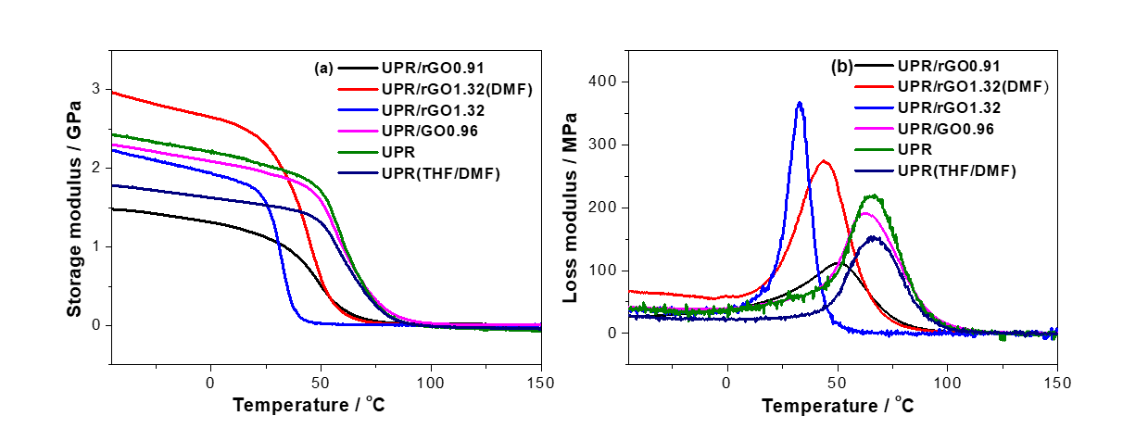
Figure 5.6. The dynamic mechanical properties of UPR, UPR/GO, and UPR/rGO composites: (a) Storage modulus and (b) Loss modulus.

Table 5.3. Dynamic mechanical properties of UPR-rGO composites.
Samples | E' at various T/ GPa |  |  |  |  | T_{g} / ºC | Coefficient C
 | -40 ºC | 20 ºC | 60 ºC | 80 ºC | -
UPR/rGO0.91 | 1.5 | 1.2 | 0.2 | 0.04 | 50.6 |  | 2.1
UPR/rGO1.32 | 2.2 | 1.7 | 0.02 | 0.01 | 33.7 |  | 12.8
UPR/rGO1.32(DMF) | 2.9 | 2.4 | 0.2 | 0.02 | 45.0 |  | 8.5
UPR/GO0.96 | 2.3 | 2.0 | 1.0 | 0.2 | 63.4 |  | 0.7
UPR(THF/DMF) | 1.8 | 1.5 | 0.9 | 0.13 | 66.4 |  | -
UPR | 2.4 | 2.1 | 1.1 | 0.14 | 66.5 |  | -

5.3.6. The morphology of UPR, UPR/GO, and UPR/rGO composites.
The fracture surface of UPR, UPR/GO, and UPR/rGO composites is investigated by SEM (Figure 5.7). For neat UPR (Figure 5.7 (e)), the fracture surface is flat and smooth with some stripes and debris which are the typical signs of a glassy material. There is no difference between UPR and UPR(THF/DMF), indicating that the addition of solvents doesn’t affect the fracture surface of UPR. Figure 5.7(a) shows the fracture surface of UPR/rGO1.32, in which the dispersion of rGO through UPR matrix is homogeneous. Few cavities are observed, which is presumably due to the defect caused by vitamin C that is not removed after synthesis of UPR/rGO composite. Figure 5.7(b), (c), and (d) show the fracture surface of UPR/rGO1.32, UPR/rGO1.32 (DMF), and UPR/GO0.96 under same magnification of 20 000. Compared to UPR/GO, the SEM images of UPR/rGO composites show much more reinforcements due to the GO or rGO contents. Moreover, few layers of GO sheets are observed in the UPR/GO0.96 composites. However, some aggregations can be seen in UPR/rGO1.32 and UPR/rGO1.32 (DMF) composites. This is presumably due to two reasons: 1) rGO tends to aggregated at higher concentration due to the van der Waals' force between rGO sheets, and 2) the removal of oxygen functional groups on GO sheets makes it easier to stack back together.

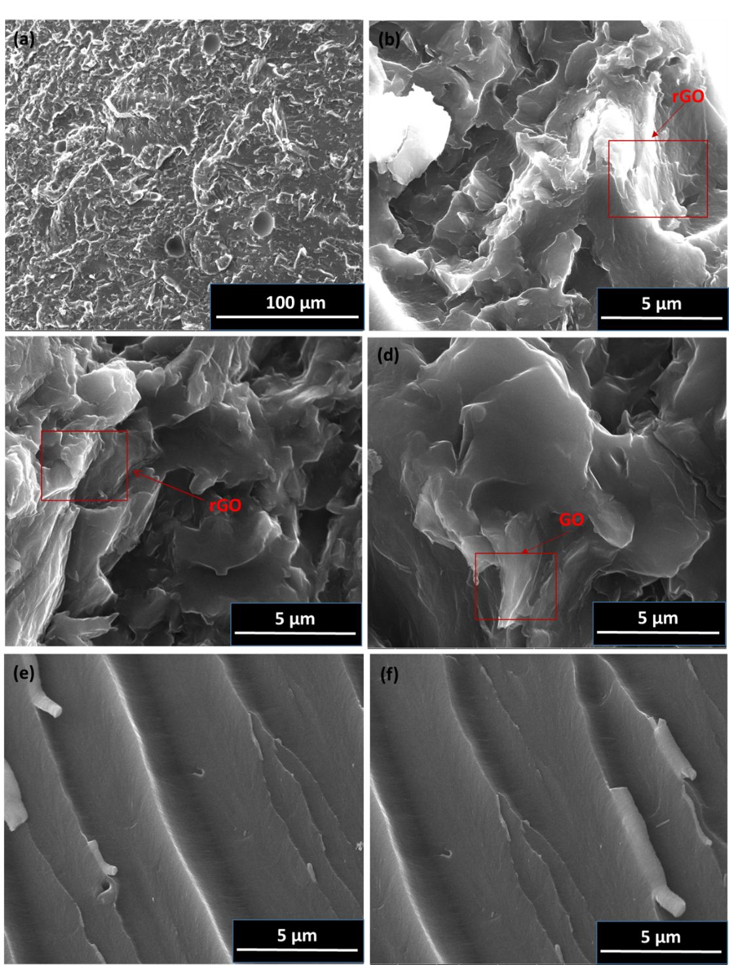
Figure 5.7. SEM images of the fracture surfaces of (a, b) UPR/rGO1.32, (c) UPR/rGO1.32 (DMF), (d) UPR/GO0.96, (e) UPR, and (f) UPR(THF/DMF)

5.4. Conclusion
Graphene oxide (GO) was successfully reduced by L-ascorbic acid (vitamin C) at low temperature (40 ºC) for 4 days. UPR/rGO films show that GO can enable insulating UPR into electrically conductive by in one pot method. The morphology of UPR and its composites are investigated by SEM, which shows homogeneous dispersion of rGO in polymer matrix at 1.32 wt.%. However, some aggregations are observed in UPR/rGO1.32, implying that the dispersion of rGO in polymeric matrix with DMF solvent is better than that with THF/DMF solvents. This can further explain the results from thermal and dynamic mechanical properties. UPR/rGO1.32 (DMA) exhibits a higher value of electrical conductivity of 0.713 S m⁻¹, and enhanced thermal stability with similar$T_{d}^{onset}$, higher $T_{d}^{peak}$(37 ºC over neat UPR), and higher $T_{d}^{1/2}$ (14 ºC over neat UPR). Glass transition temperature (T_{g}) decreases with the addition of reinforcements due to the reduced crosslinking density caused by the less amount of free reactive styrene monoers for polymerization. In contrast, the storage modulus was enhanced with rGO due to the strong modulus of rGO, and the highest value is observed at UPR/rGO1.32(DMF). Compared to the results from Chapter 4, UPR/rGO composites prepared by in one pot method exhibit significant improvements on the thermal stability. Moreover, the electrical conductivity at 0.96 wt.% is higher than that of UPR/rGO 1.0 wt.%.
In conclusion, UPR/rGO1.32(DMF) composites prepared in one pot method exhibit enhanced electrical conductivity, thermal stability, and dynamic storage modulus due to the good dispersion of GO and vitamin C in DMF solvent, successful reduction by vitamin C during synthesis of composite, and great interfacial interaction between GO and UPR. However, it is hard to get samples with good shapes due to the difficulties removal of solvents especially DMF. Moreover, the unreacted vitamin C cannot be removed from UPR/GO system, which would affect T_{g}.

Chapter 6: Synthesis and characterization of bio-based hyperbranched polyester and its nanocomposites with self-healing behavior

6.1. Introduction
Currently, the majority of organic chemicals and energy over the world are still derived from fossil fuels which have caused serious environmental problems [226,227]. In order to solve this issue, scientists have been diligently looking for renewable candidates to replace/reduce the consumptions of the conventional fossil resources. Bio-based polymers are the products derived from renewable resources, namely biomass, such as plants, agricultural food, animal wastes, sugar and trees [227,228]. Bio-based polymers that are able to be decomposed into H₂O, CO₂, and humus by bacteria or other living organisms, have been employed in biomedical and pharmaceutical applications like sutures, stents, drug delivery, and tissue engineering, because of their excellent biocompatible, biodegradable properties, and good mechanical properties [227,229,230].
Scientists noticed that most natural tissues possess healing ability upon damages. For example, a minor wound on human’s skin can be self-healed over time [135]. Inspired by nature, self-healing polymers are developed based on reversible bonds, such as hydrogen bonds, п–п stacking, or certain metal–ligand coordination bonds [231], which can associate and dissociate automatically or under external stimuli such as heat or light. This unique capability could be employed for designs on the extension of materials’ lifetime, personalized electronics such as portable and wearable energy storage devices [135,137,231–238]. Owing to the unique properties and chemical architecture, hyperbranched polymers can be used in many applications like rheological agents, drug carriers, self-healing devices, and energy transfer [4,109,110].
At present, bio-based hyperbranched polyesters (HBPEs) are generously synthesized by condensation polymerization of AB_{x}-type (x ≥ 2) monomers [4,111–114], or A_{n} and B_{m} (n, m is the number of functional groups for polymerizaiton) monomers [5,115–118]. AB_{x}–type monomers are very limited in the commercial industries, so there are more works based on the copolymerization of commercial A_{n} and B_{m} monomers which are more available in the industry markets and can be used directly[5,115–118]. Besides of normal condensation polymerizations, self-condensation vinyl polymerization [119–122], and self-condensation ring-opening polymerization can also be employed for synthesis of hyperbranched polymers [123–128].
To our knowledge, the work on the synthesis of HBPE from 100% bio-based monomers is very rare in the literature. In this chapter, 100% bio-based HBPE are synthesized from diol (Pripol 2030) and trimer acid (Pripol 1040), which exhibits excellent durability and partially self-healing behavior. p-phenylenediamine (PPD) was used to reduce GO and the resultant poly-PPD-reduced GO hybrid (P-rGO) displayed a good stability in ethanol for several weeks. P-rGO hybrid was used to prepare HBPE nanocomposites through in-situ polymerization. The influence of P-rGO on the self-healing ability, hysteresis, mechanical, thermal, and dynamical properties of HBPE was also investigated.

6.2. Experiment

6.2.1. Materials
Pripol 2030 (diol, molecular weight ~ 306 g mol⁻¹) and Pripol 1040 (75% trimer, 25% dimer, molecular weight ~715 g mol⁻¹) were provided by Croda International Plc. Ethyl alcohol (absolute, 99.8%) was purchased from Fisher Scientific. Graphite flakes (Sigma-Aldrich, <20μm), p-phenylenediamine (PPD), hydrochloric acid (0.1M), p-toluenesulfonyl isocyanate (TSI, 96%), potassium hydrogen phthalate (KHP), tetrabutylammonium hydroxide solution (1M in methanol), ethyl alcohol (95%, ACS spectrophotometric grade), acetonitrile (≥ 99.9%, HPLC plus) and methanol (≥ 99.9%, HPLC) were purchased from Sigma-Aldrich. Potassium hydroxide (99.98% metals basis, 85% min pellets) was purchased from Alfa Aesar.

6.2.2. Synthesis of hyperbranched polyester (HBPE) through condensation polymerization
Pripol 2030 (11.60 g, 0.0758 mol of hydroxyl) and Pripol 1040 (20 g, 0.0758 mol of carboxyl) were mixed in a 500 ml three-necked flask equipped with a reflux condenser under mechanically stirring. The reaction was carried out under nitrogen gas (N₂) at 120 °C for 8 hours and stopped by cooling down prior to gel point. The obtained product was denoted as HBPE pre-polymer. Then, the pre-polymer was transferred into a PTFE petri dish followed by further curing at 140 °C in a vacuum oven for 30 hours. Finally, cured HBPE was washed by ethanol for 4 times to remove the free species like un reacted monomers, and dried at room temperature for further tests.

6.2.3. Preparation of poly(p-phenylenediamine)-reduced GO hybrid (P-rGO)
GO was synthesized from graphite flakes by Hummers method [187]. To prepare P-rGO, the reduction of GO and polymerization of PPD were carried out simultaneously in one pot. In detail, 250 mL of GO aqueous dispersion (1 mg ml⁻¹) was measured. Then the pH value of GO dispersion was adjusted to ~2 by diluted HCl. The same amount of PPD aqueous solution (1 mg ml⁻¹) was mixed with the GO dispersion. The mixture was magnetically agitated for 24 hours at 75 °C. The black hybrid product (denoted as P-rGO) was collected and washed with water (4 times) and acetone (2 times) by centrifugation. The washed P-rGO was transferred into ethyl alcohol by solvent exchange and the concentration of P-rGO alcoholic suspension was measured as 0.19 mg ml⁻¹.

6.2.4. Synthesis of HBPE/P-rGO nanocomposites
HBPE/P-rGO nanocomposites were synthesized through in-situ polymerization. In detail, Pripol 2030 (11.60 g, 0.0758 mol of hydroxyl), Pripol 1040 (20 g, 0.0758 mol of carboxyl), and an appropriated amount of P-rGO were mixed in a 500 ml three-necked flask equipped with a reflux condenser under mechanical stirring. The mixture was heated up to 120 °C, and kept for 8 hours under N₂ and then transferred into a PTFE petri dish for further curing under vacuum at 140 °C for 30 hours. The final products were washed by ethanol for 4 times, and dried at room temperature.

6.2.5. Characterization

6.2.5.1. Nuclear magnetic resonance (NMR) spectroscopy
Prior to NMR analysis, HBPE pre-polymer was washed by ethanol in order to remove the unreacted monomers. After drying in a desiccator at room temperature for 24 hours, HBPE pre-polymer was dissolved in deuterated chloroform (CDCl₃). ¹H NMR and ¹³C NMR were performed on a Bruker DRX nuclear magnetic resonance spectroscope at 25 °C, operating at 400 MHz and 125 MHz, respectively. The spectrometer was equipped with an inverse geometry 5 mm VSP probe with a single z-gradient. The software TOPSPIN 1.3 was used for data analysis.

6.2.5.2. Gel permeation chromatography (GPC)
GPC of HBPE pre-polymer was carried out on a Viscotek GPC max with Waters 410 RI detector and Gilson 831 column heater at 25 °C. The instrument was calibrated with polystyrene standards, and THF was used as the solvent.

6.2.5.3. Potentiometric titration of end groups of HBPE pre-polymer
To determine the amount of hydroxyl (-OH) group, the titration was carried out in accordance with ASTM Standard E1899-08 using reaction with p-toluenesulfonyl isocyanate to form acidic carbamate (TSI, Scheme 7.1), and potentiometric titration with 0.1 mol L⁻¹ tetrabutylammonium hydroxide (Bu₄NOH) methanol/2-propanol solution. Prior to the titration, the concentration of Bu₄NOH solution was standardized by potassium hydrogen phthalate 3 times (KHP, dried under 120 C for 2 hours followed by 1 hour in desiccator prior to use), and calculated by equation (6.1) below:
$N=\frac{KHP, g}{0.20423 ×Bu4NOH, ml }$ (6.1)

Where, N refers to the concentration of the 0.1 meq ml⁻¹ Bu₄NOH expressed in unit of g ml⁻¹. 0.20423 is the molecular weight of KHP expressed in unit of kg mol⁻¹.
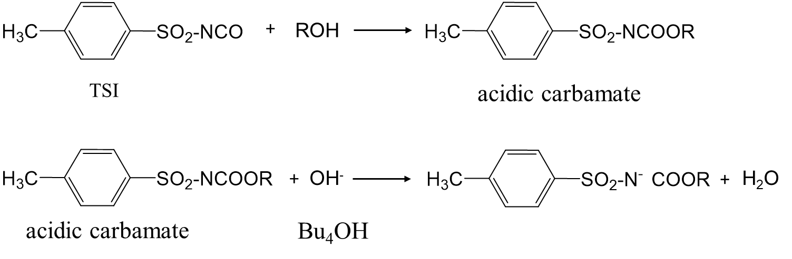
Scheme 6.1. The mechanism of titration.

An appropriated amount of HBPE pre-polymer was weighed and dissolved in 10 ml of THF. 10 ml of TSI acetonitrile solution (containing 0.4 ml TSI) was added. The solution was magnetically stirred for 5 mins and the excess TSI agent was decomposed by adding 0.5 ml of distilled water. The solution was diluted by adding 30 ml of acetonitrile and stirred slowly for a few minutes. The titration was performed twice by using standardized Bu₄NOH. The hydroxyl volume (OHV) was calculated based on the consumption of Bu₄NOH and the average OHV was reported.

To determine the amount of carboxylic acid (-COOH) group, 0.1 mol L⁻¹ potassium hydroxide (KOH) alcoholic solution was used as titrant, which was standardized by KHP. According to the ASTM method (D4662-03), an appropriated amount of HBPE pre-polymer was weighed and dissolved in 50 ml of THF, followed by adding of 0.5 ml of indicator (phenolphthalein solution: 0.5 g of phenolphthalein in 100 ml of a mixture of 50 ml water and 50 ml ethyl alcohol). The HBPE pre-polymer was titrated immediately with 0.1 mol L⁻¹ KOH for twice. The acid volume (AV) was calculated based on the consumption of KOH and the average AV was reported.

6.2.5.4. Fourier transform infrared (FTIR) spectroscopy
FTIR analysis was conducted on a Spectrum 100 (Perkin Elmer, USA) in the wavelength range of 4000 – 500 cm⁻¹ with a resolution of 4 cm⁻¹.

6.2.5.5. Water swelling tests
Water swelling tests were carried out on two different sizes of square HBPE samples (width x length x thickness : 8 mm x 8 mm x 1 mm, 6 mm x 6 mm x 1 mm, respectively). Prior to test, HBPE films were immersed in distilled water for 4 hours, 12 hours, 24 hours, and 48 hours. The surface water was gently wiped by tissue paper and weight was measured immediately.

6.2.5.6. Scanning electron microscope (SEM)
SEM was carried out on an FEI Inspect F scanning electron microscope at 10 kV. Prior to the SEM observation, the cross-section surface was ruptured in liquid nitrogen and sputter-coated by gold using SPI sputter-coater for enhanced conductivity.

6.2.5.7. Dynamic mechanical analysis (DMA)
DMA was employed to measure the glass transition temperature (T_{g}) of HBPE and carried out on a DMA 8000 instrument equipped with single cantilever geometry. The specimens were rectangular stripes (5 mm × 6 mm) and put between two same-size PTFE films for DMA tests, owing to the extremely low hardness of samples. Measurements were performed at a frequency of 1 Hz from -150 °C to 40 °C at a heating rate of 2 °C min⁻¹.

6.2.5.8. Tensile properties
Tensile tests were carried out on a Hounsfield universal testing machine (Tinius Olsen Ltd.) at room temperature, with 10 N loading cell, at 100 mm/min strain rate. Hysteresis tests were performed in two different cyclic tensile tests: 1) 4-cycle tensile test with a consist strain of 200%; 2) 4 cycles with different strains of 10%, 20%, 50%, and 100%, respectively. Fatigue tests were conducted by cyclic testing with 1000 repeated cycles.

6.2.5.9. Thermogravimetric analysis (TGA)
TGA was performed by a thermogravimetric analyzer Pyris 1 (Perkin Elmer, USA). The studied temperature range was from 25 °C to 800 °C, with a heating rate of 10 °C min⁻¹ under a nitrogen flow of 20 ml min⁻¹.

6.3. Results and discussion

6.3.1. Characterization of bio-based hyperbranched polyester

6.3.1.1. Chemical structure of HBPE pre-polymer
Pripol 2030 is C36 dimer alcohol. Pripol 1040 is a mixture of C54 trimer fatty acid and C36 dimer fatty acid, according to the information provided by Croda [239,240]. To get the precise chemical structures of these bio-based monomers, ¹H NMR and ¹³C NMR were conducted. In ¹H NMR spectrum of Pripol 2030 (Figure 6.1), the signal at 7.3 ppm relates to the solvent (deuterated chloroform) [241]. The triplet signal at 3.66 ppm is assigned to the methyl protons (Hª) next to hydroxyl groups. The resonance (multiplet) at 0.91 ppm is attributed to the protons of -CH₃ end groups. A wide peak around 1.28 ppm relates to the protons of alkyl chains [242–244]. The ratio of the integral of each resonance is 1 (Hª): 15.41 (H^{b}-H^{p}): 1.53 (H^{q}), approximately 4: 62: 6. This is in an excellent agreement of the expected chemical structure of Pripol 2030. In ¹³C NMR spectrum (Figure 6.1) of Pripol 2030, the peak corresponding to the carbons connected to hydroxyl groups is visible at 63.07 ppm. The signal of primary carbon atom (-CH₃, end group) can be seen at 14.11 ppm. Peaks (b-p) are related to the various alkyl carton atoms [242–244]. In ¹H NMR spectrum of Pripol 1040 (Figure 6.2), the resonance of the methylene proton (Hª) next to carboxyl acid groups are visible around 2.37 ppm [245]. Signals of protons at 0.91 ppm, 1.29 ppm, and 1.65 ppm are assigned to methyl protons at the end (H^{c}), alkyl proton of monomer chains, and methylene protons next to Hª (H^{b}), respectively [244,246,247]. The ratio of the integral of each resonance is 1 (Hª): 1 (H^{b}): 11.81 (H^{e}): 1.5 (H^{c}), approximately 6:6:70:9. Theoretically, taking 25% as the mass percentage of the dimer fatty acid, the average number of alkyl protons is calculated as 70. Therefore, it is in great agreement of the expected structure and composition reported in previous work. In ¹³C NMR spectrum of Pripol 1040, the carbon atom of carboxyl acid group is visible at 180 ppm [245]. The secondary carbon atom next to carboxyl acid groups can been seen around 37.07 ppm [245]. Resonance at 14.11 ppm is related to the end methyl carbon atoms. Various signals can be observed between 20 ppm and 35 ppm are associated to the methyl carbon atoms due to the large molecular size [241,246–248].
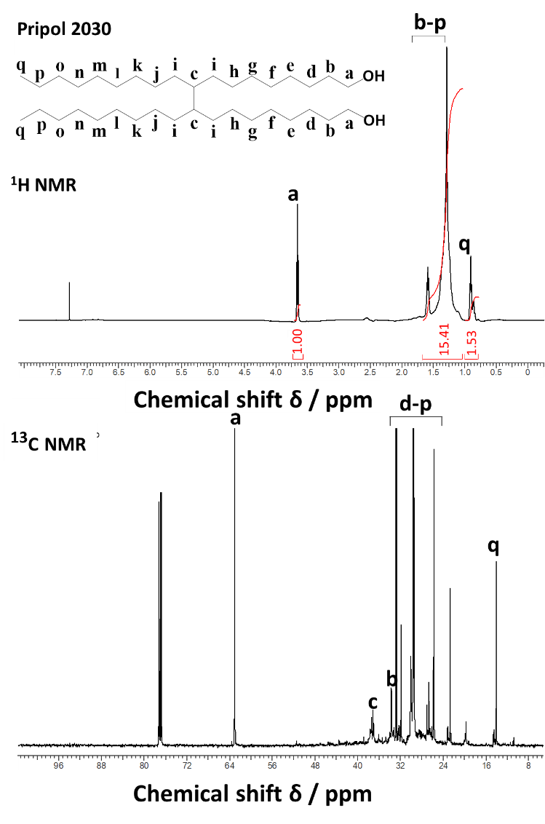
Figure 6.1. NMR spectra of Pripol 2030.
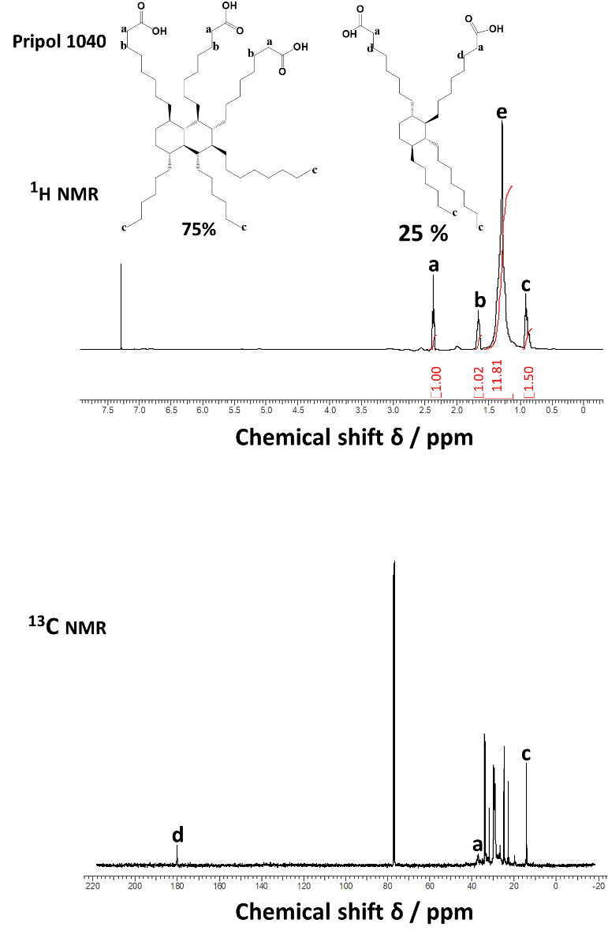
Figure 6.2. NMR spectra of Pripol 1040.

HBPE was synthesized from Pripol 2030 and Pripol 1040 through condensation polymerization as shown in Figure 6.3, including two steps: synthesis of HBPE pre-polymer and curing/molding at 120 ºC in a vacuum oven. The chemical structure of HBPE pre-polymer was investigated via ¹H NMR and ¹³C NMR, as shown in Figure 6.4. The new signal at 4.09 ppm in the ¹H NMR spectrum is associated with the protons of ester groups. The proton of methyl group next to –OH is still visible around 3.78 ppm, indicating the presence of hydroxyl end groups. The peak at 0.91 ppm refers to the proton of –CH₃ at the end of alkyl chains from diol and fatty acid. Besides, the peaks at 1.65 ppm, and 1.28 ppm are related to various protons of methyl groups in polymer chains [243,244,246,248]. ¹³C NMR also provides some information of the condensation. New resonance at 174 ppm is related to the carbon atom of ester groups. The signal of carboxyl acid groups around 180 ppm is much smaller than that in ¹³C NMR of fatty acid, indicating that the carboxyl acid group reacted with hydroxyl groups. There are two different peaks at 64.45 ppm and 63.05 ppm, which is assigned to carbon atoms connected to different –OH groups [244,246]. It might be due to the –OH groups in linear units and terminal units shown in Figure 6.5. Besides, signal at 14.11 ppm is associated to the carbon atoms from –CH₃. Peaks from 37.46 ppm to 18.43 ppm refer to various carbon atoms in methyl groups [244,246–248].
Due to the presence of trimer acid in Pripol 1040, the products made from Pripol 2030 and Pripol 1040 have numerous randomly formed chemical structures. Figure 6.5 shows five probable segment structures in HBPE pre-polymer.
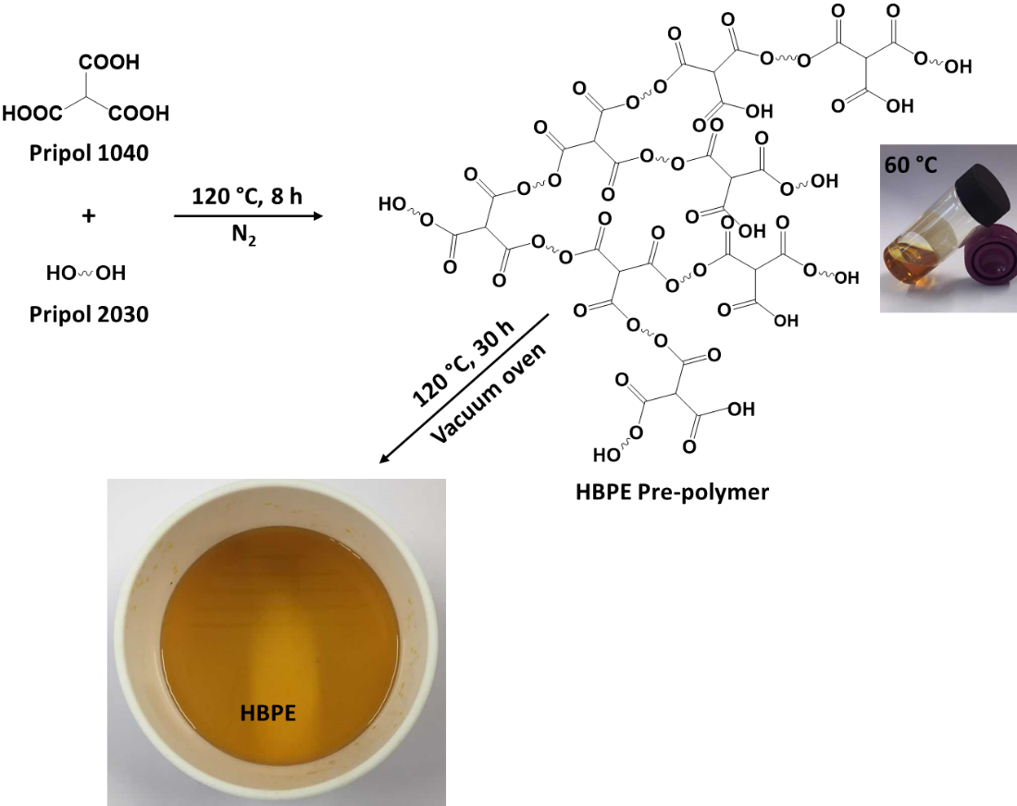
Figure 6.3. Schematic representation of synthesis of bio-based hyperbranched polyester (prepolymer).

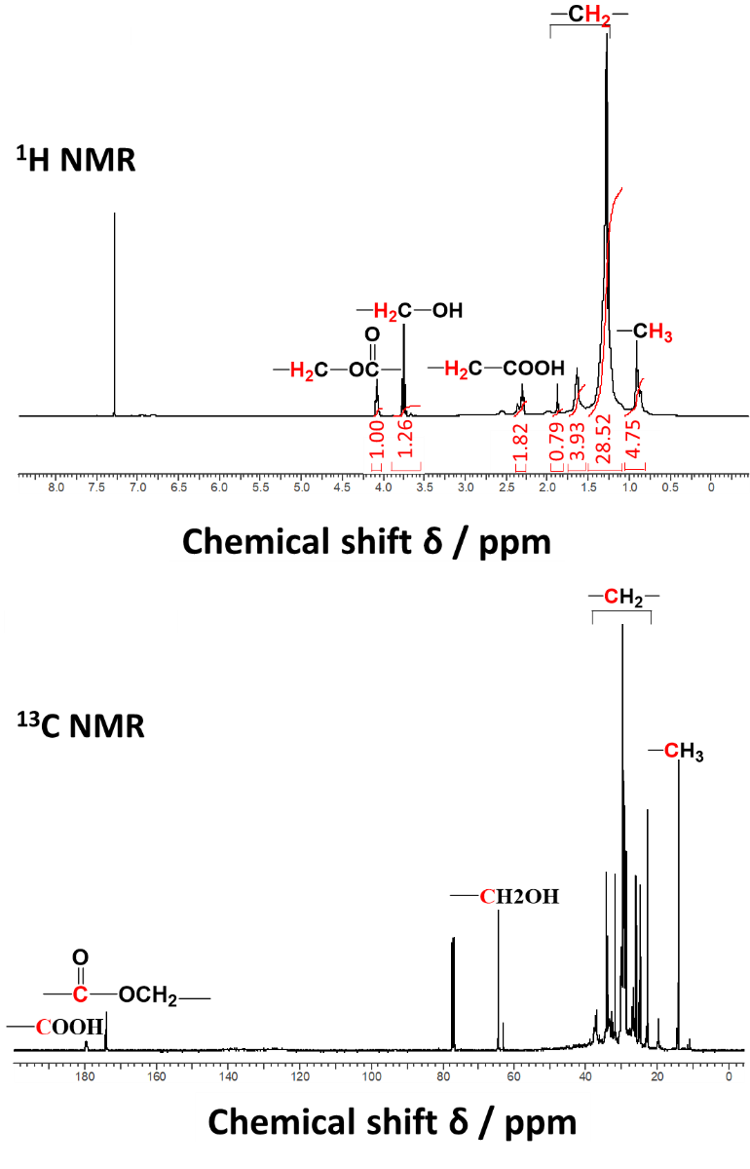
Figure 6.4. NMR spectra of HBPE pre-polymer. CH2OH: 2 should be subscript.
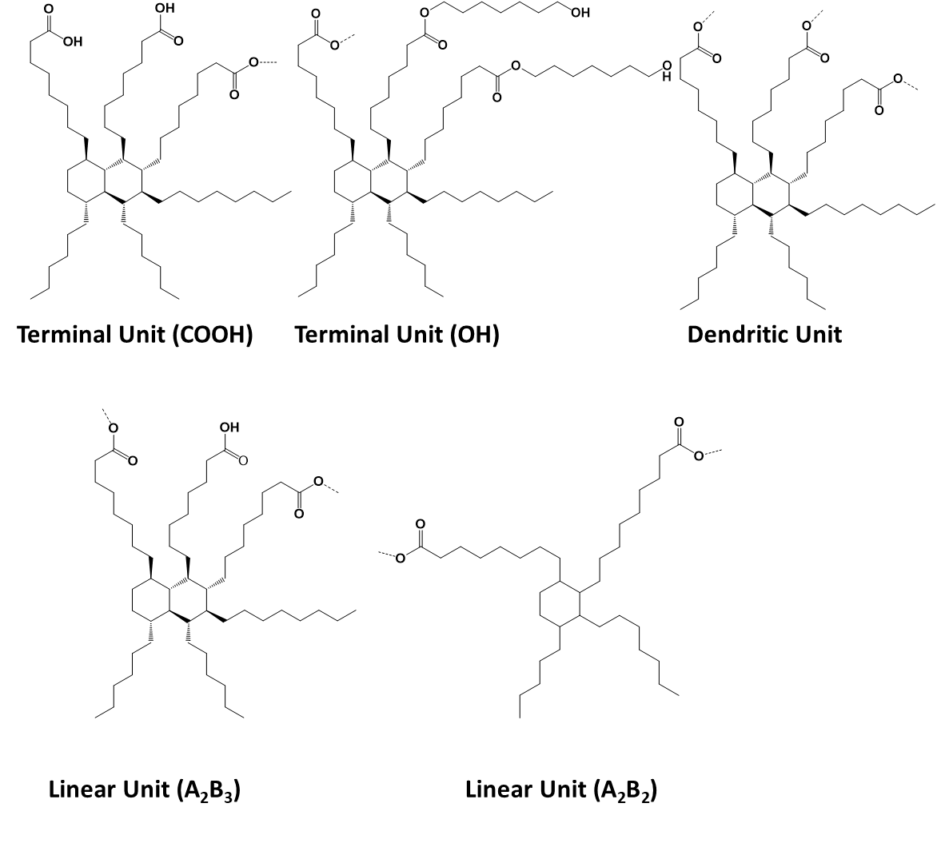
Figure 6.5. Probable segments of HBPE pre-polymer.

6.3.1.2. Molar Mass of HBPE pre-polymer

Gel permeation chromatography (GPC)
GPC was employed to determine the average molecular weight (${\overline{M}}_{n}$ and ${\overline{M}}_{w}$) and molecular weight distribution (MWD) of HBPE pre-polymer (Figure 6.6). The number average molecular weight (${\overline{M}}_{n}$), and weight average molecular weight (${\overline{M}}_{w}$) obtained from GPC were 5641 and 27013, respectively, with a MWD of 4.78.
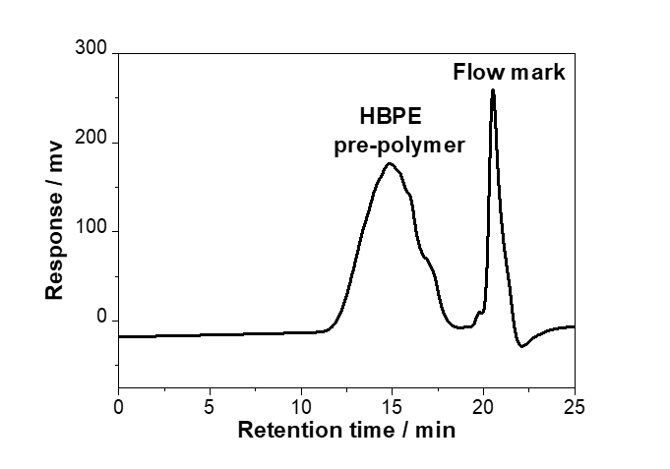
Figure 6.6. GPC chromatogram (CDCl₃ eluent, RI detector) of HBPE pre-polymer.

6.3.1.3. Titration analysis of end–groups of HBPE pre-polymer
Theoretically, the multiple end groups, highly depended on the ratio of starting monomers and the polymerization degree for A₂B₃-type polymers, are expected to produce branched polymers. Therefore, it is important to study the number of end-groups on the HBPE pre-polymers. Titration is one effective end-group analysis method. Here, both hydroxyl value (OHV) and acid value (AV) were titrated by potassium hydroxide based on the standards ASTM E 1899–08, and ASTMD 4662 – 03, respectively.

Hydroxyl value (OHV)
The OHV corresponds to the amount of hydroxyl groups and was obtained from equation (6.2) below:
$OHV =\frac{\left(V_{2}-V_{1}\right) × N ×56.1}{W}$ (6.2)
where
V₁: The volume of titrant (Bu₄OH) at the first step
V₂: The volume of titrant (Bu₄OH) at the second step
N: Concentration of Bu₄OH solution, mol L⁻¹, which is 0.1017 mol L⁻¹ from equation (6.1)
56.1: Molecular mass of KOH, mol g⁻¹
W: Sample used, g
The titration curve of pH against volume of titrant (Bu₄OH) was shown in Figure 6.7. The first consumption volume of Bu₄OH (V₁) was calculated as 0.2 ml from the first step around pH 3-5 which is related to the age of reagent (TSI). The second consumption volume of Bu₄OH (V₂) was calculated as 1.7 ml from the second step around pH 6-8 which is related to the reaction of sample and Bu4OH, and the difference of two consumption volumes are proportional to the titration of the acidic carbamate formed from the hydroxyl compound and the TSI reagent. The hydroxyl number of HBPE pre-polymer obtained from this method is 8.57 mg KOH g⁻¹.

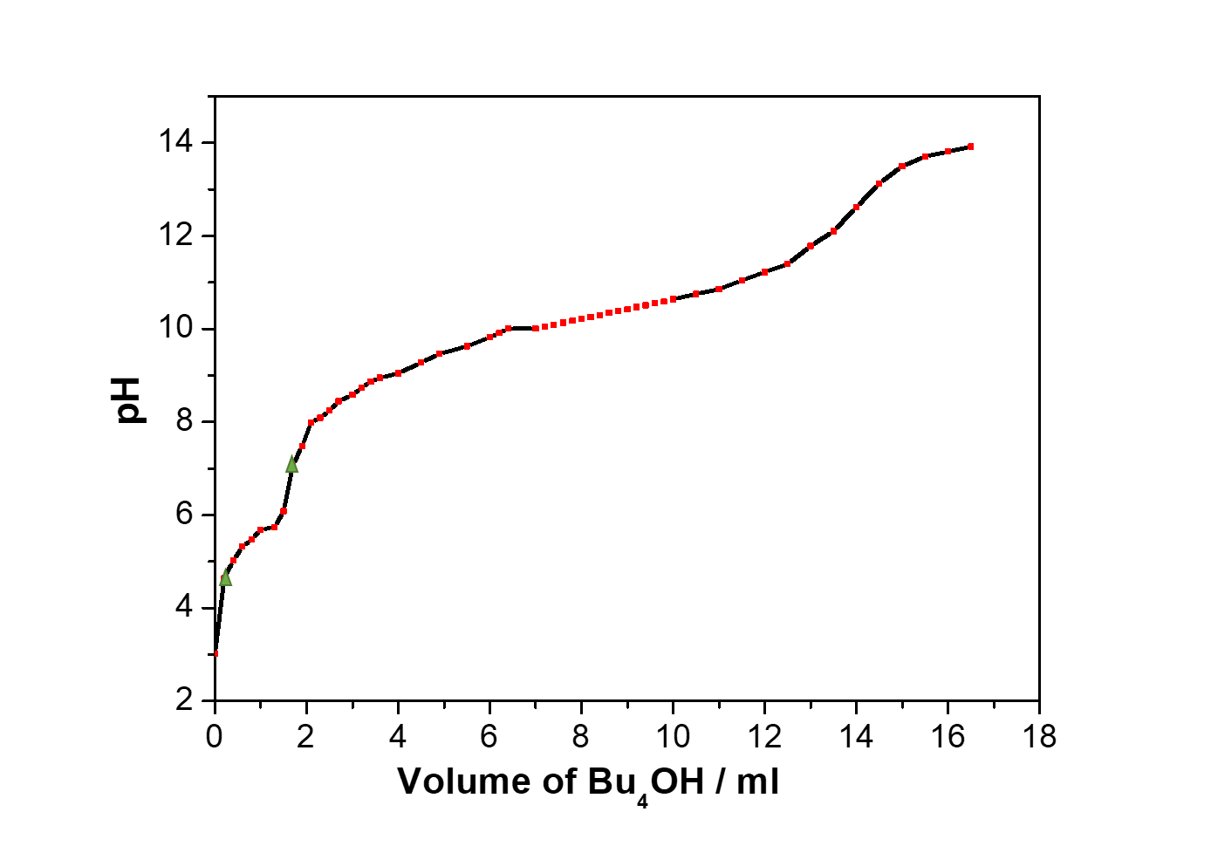
Figure 6.7. Potentiometric titration curve for determination of hydroxyl number with TSI reagent.

Acid value (AV)
Acid volume (AV) corresponds to the amount of carboxylic acid groups, and is given in mg KOH per gram sample. AV was calculated by equation (6.3), and the results are summarized in Table 6.1.

$AV=\frac{(A-B)N×56.1}{W}$ (6.3)
where:
A: KOH solution required for titration of the sample (HBPE), ml
B: KOH solution required for titration of the blank (solvents without sample), ml
56.1: Molecular mass of KOH, mol g⁻¹
N: Concentration of KOH solution, 0.0948 mol L⁻¹ calculated from equation (6.1)
W: Sample used, g

Table 6.1. The titration results of carboxylic acid groups.
Sample used / g | A* / ml | B* / ml | AV / mg KOH g⁻¹ | Average AV / mg KOH g⁻¹
0.8284  0.6435 | 9.60  7.75 | 0.15  0.16 | 60.6  62.7 | 61.7 ± 1.5
* A refers to the volume of KOH solution required for titration of the sample (HBPE), and B for the volume of KOH solution required for titration of the blank (solvents without sample). Titration was performed twice to get the average AV.

6.3.1.4. FTIR spectroscopy of HBPE
The chemical structure of monomers, HBPE pre-polymer, HBPE and the esterification reaction was investigated by FTIR analysis, as shown in Figure 6.8. FTIR spectrum of Pripol 2030 shows the absorption peaks at 3321 cm⁻¹, 2921 cm⁻¹ and 2852 cm⁻¹, 1460 cm⁻¹ and 1377 cm⁻¹, 1056 cm⁻¹, which are assigned to O-H stretch, C-H stretch from alkane, C-H bending from alkane, and C-O stretch from alcohol groups, respectively. The spectrum of Pripol 1040 shows the peaks at 2921 cm⁻¹ and 2852 cm⁻¹, 1705 cm⁻¹, 1458 cm⁻¹ and 1421 cm⁻¹, 1283 cm⁻¹ and 1236 cm⁻¹, 1034 cm⁻¹, which are attributed to C-H stretch from alkane, C=O stretch from carbonyl, C=C stretch, C-O stretch from carboxyl group, C-H bending from alkene, respectively [249,250]. From spectrum of HBPE, new peaks at 1737 cm⁻¹ can be observed which is related to C=O stretch from COOH groups. Peak at 1705 cm⁻¹ from acid shift to 1709 cm⁻¹ in HBPE, which is attributed to C=O stretch. New peaks at 1167 cm⁻¹ and 1100 cm⁻¹ from HBPE are related to C-O stretch from ester groups. Peaks at 1283 cm⁻¹ from acid shifts to 1261 cm⁻¹, which is assigned to C-O from ester groups [247,251,252]. All phenomenon above confirmed the presence of ester groups formed between hydroxyl groups and carboxyl groups. Compared with the FTIR spectra of pre-polymer, the peak at 1171 cm⁻¹ (pre-polymer) shifts to 1167 cm⁻¹ (C-O stretch from ester groups), and two new peaks at 1655 cm⁻¹ and 1544 cm⁻¹ (C-O stretch from ester groups) were also observed [252]. This implies the further esterification between monomers carried out under vacuum oven at 120 ºC. Meanwhile, the peaks at 1018 cm⁻¹ and 3284 cm⁻¹ are observed from FTIR curve of HBPE, which is attributed to C-O stretch, and O-H stretch from hydroxyl groups. This phenomenon certifies the existence of hydroxyl groups at the end of HBPE, which is in good agreement of the hypothesis that –OH groups could exist on resultant polymers with the functional group ratio beyond 2:3 [118] and will also be discussed in NMR analysis part.
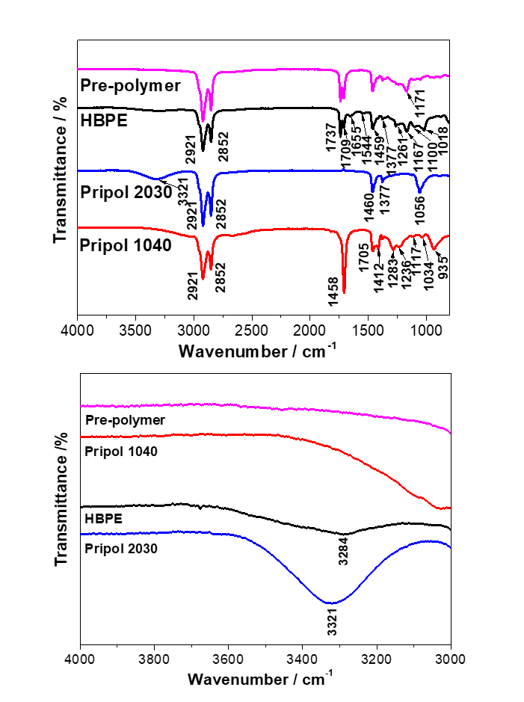
Figure 6.8. FTIR spectra of monomers, HBPE pre-polymer and HBPE.

6.3.1.5. Water swelling behavior of HBPE
The water absorption behavior of HBPE was studied by water swelling tests. Two pieces of pure HBPE with different sizes were immersed into distilled water for 4 hours, 12 hours, 24 hours, and 48 hours respectively. The resulted weight changes are presented in Figure 6.9, in which there is no difference in the weight even after 48 hours immersed in water, indicating the excellent water resistance of HBPE.
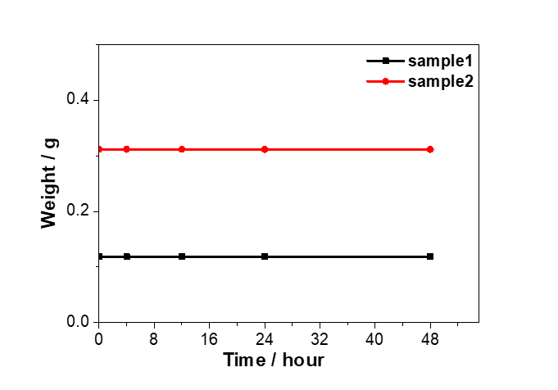
Figure 6.9. Water swelling behavior of HBPE

6.3.2. Characterization of poly (p-phenylenediamine)-reduced GO hybrid (P-rGO).
GO can be dispersed well in water due to its hydroxyl, epoxy and carboxyl groups at the basal plane and edges. However, the dispersion of reduced GO shows bad stability in both water and organic solvents. P-rGO, prepared through the reduction of GO and polymerization of PPD simultaneously in one pot method, presented a stable dispersion in ethanol for months. In order to study the mechanism, FTIR spectra of PPD, poly-PPD, GO and P-rGO are given in Figure 6.10. From the FTIR spectrum of PPD, three strong bands at 3373 cm⁻¹, 3299 cm⁻¹, and 3197 cm⁻¹ are assigned to N-H stretch vibration of NH₂ groups. Peak at 1628 cm⁻¹ is related the aromatic C=C stretch. Peak at 1510 cm⁻¹ is due to the stretching of benzene ring skeleton vibration. Three peaks at 1258 cm⁻¹, 1127 cm⁻¹, and 1309 cm⁻¹ are attributed to the C-N stretch vibration. Peak at 821 cm⁻¹ is related to the aromatic ring C-H out of plane deformation vibration of benzene rings [253]. According to the FTIR curve of P-rGO, N-H stretching vibration of PPD at 3373 cm⁻¹, 3299 cm⁻¹, and 3197 cm⁻¹ shifts to 3373 cm⁻¹, 3323 cm⁻¹, and 3208 cm⁻¹. C-N stretching vibration peaks of PPD at 1258 cm⁻¹, 1127 cm⁻¹ shift to 1263 cm⁻¹, and 1125 cm⁻¹. Aromatic C-H stretch vibration peak of PPD at 1628 cm⁻¹ shifts to 1633 cm⁻¹. In addition, the new peak of poly-PPD is observed at 1577 cm⁻¹, which is assigned to C=N from quinoid. All these indicate a poly-PPD was copolymerized [254–256]. The mechanism of the polymerization of PPD is presented in Figure 12(a).
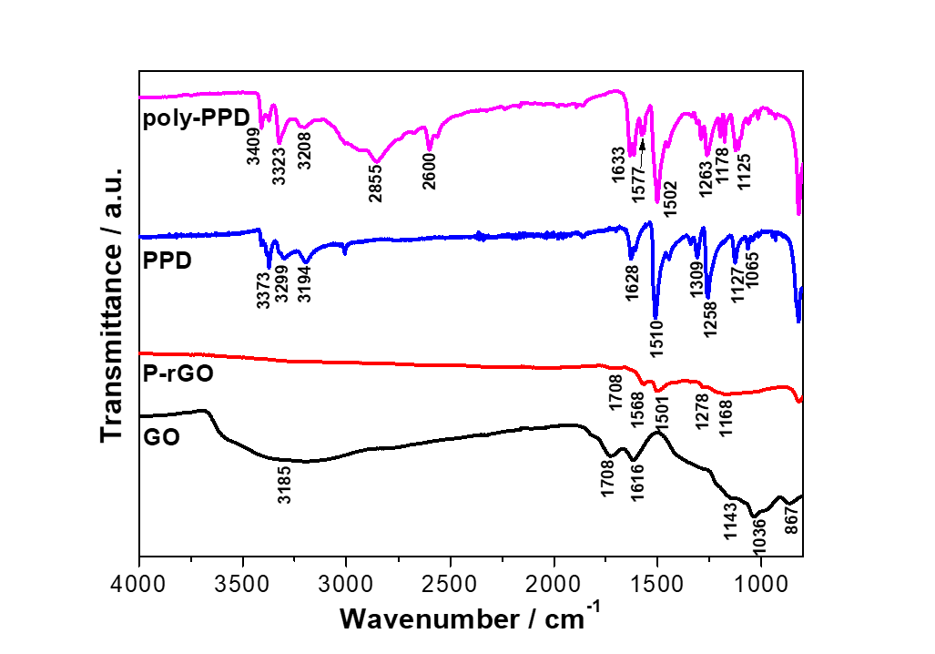
Figure 6.10. FTIR spectra of PPD, GO, poly-PPD, and P-rGO.

In the FTIR spectra of GO, there is a broad strong peak around 3185 cm⁻¹, which is assigned to O-H group from alcohol. Peaks at 1728 cm⁻¹, 1618 cm⁻¹, 1036 cm⁻¹, and 867 cm⁻¹ are attributed to C=O stretch from COOH groups, aromatic C=C stretch, C-O stretch from epoxy rings, and C-H stretch from alkene groups, respectively. After reaction with PPD, the peak at 1728 cm⁻¹ (GO spectrum) disappeared and a new weak peak at 1717 cm⁻¹ in P-rGO FTIR curve. This confirmed that the carboxyl groups in GO sheets were reduced, and C(=O)NH band was formed via nucleophilic substitution reaction. New peaks at 1278 cm⁻¹ and 1168 cm⁻¹ are assigned to C-N stretching vibration, which confirmed the formation of C-N-C reflecting the presence of poly-PPD.

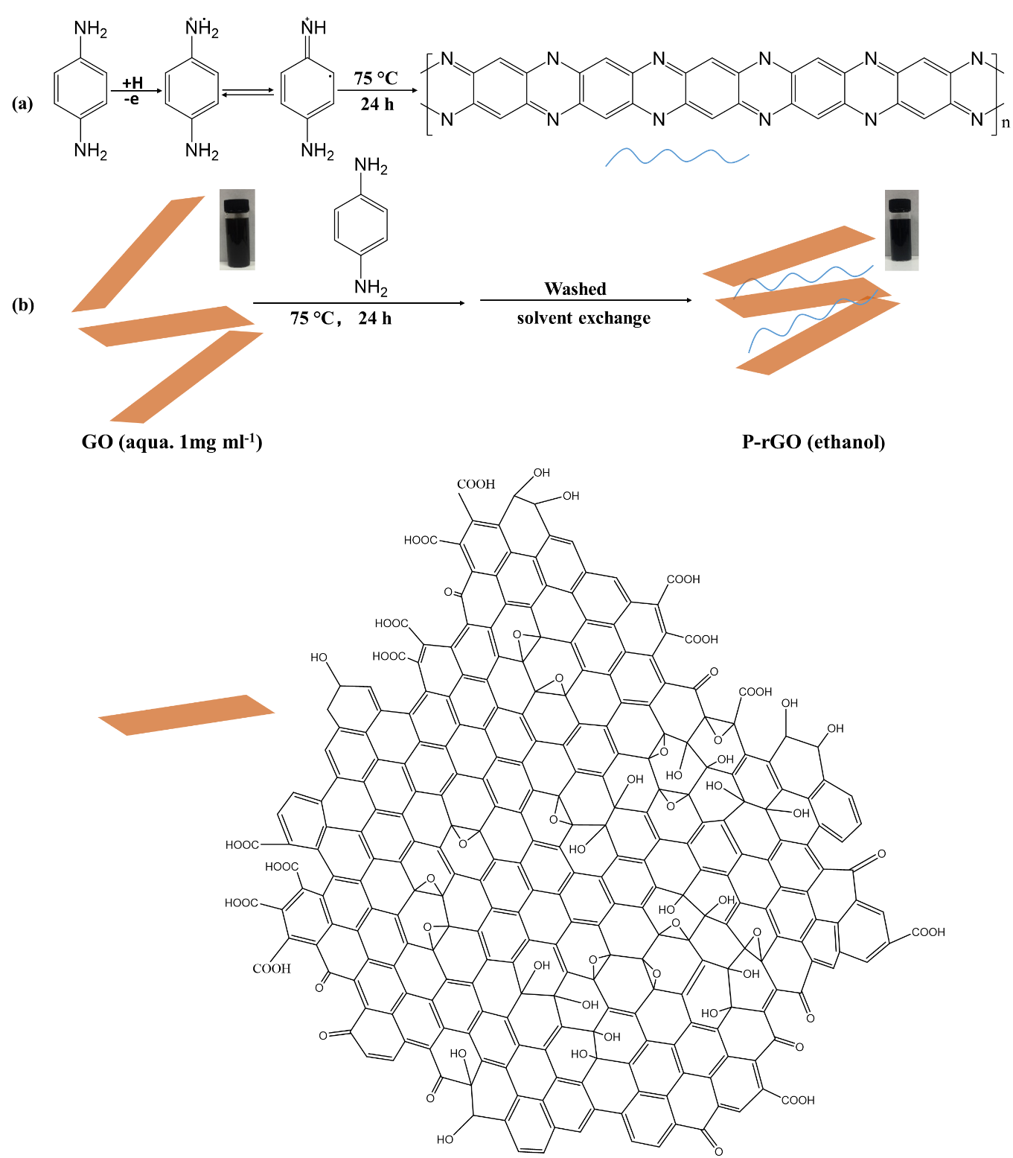
Figure 10.11. Schematic representations of (a) the polymerization of PPD and (b) preparation of P-rGO in one pot method.

According to the FTIR results discussed above, GO was reduced by PPD by removing oxygen atoms via the formation between amine groups on benzene rings and carboxyl groups and hydrogen groups on GO sheets. Meanwhile, PPD is a good stabilizer for P-rGO in ethanol as well. The mechanism is presented in Figure 6.11. During this process, PPD could copolymerize to poly-PPD, which inserts into GO sheets by п – п stacking due to the similar benzene structures in both PPD and GO [253–256]. Hence, GO sheets were extended and dispersed well in ethanol. Figure 6.12 shows that the pH value significantly affects the stability of P-rGO dispersion in ethanol, in which lower pH value (~2) presents much better dispersion even after 3 months. However, neutral solution has poor dispersion in which precipitation occurred in a few hours. One possibility is that H⁺ could initiate one free radical of PPD, which can copolymerize poly-PPD and intercalate into GO sheets, resulting in a stable GO dispersion in ethanol [256].

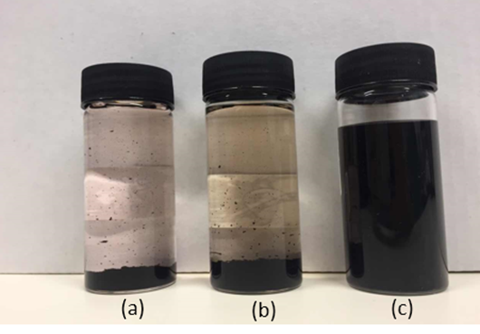
Figure 6.12. Digital photographs of P-rGO aqueous dispersions after 3 weeks: (a) pH ~5, (b) pH ~3, and (c) pH ~2.

6.3.2. Characterization of HBPE/P-rGO nanocomposites

6.3.2.1. Morphology of HBPE/P-rGO nanocomposites
HBPE film is yellow transparent, shown in Figure 6.13(a). The color was uniform for all nanocomposite samples and became darker with increasing P-rGO loading. Meanwhile, the sample lost the transparency at the higher P-rGO loadings (0.1 wt.% and 0.5 wt.%), due to the light absorption of P-rGO.

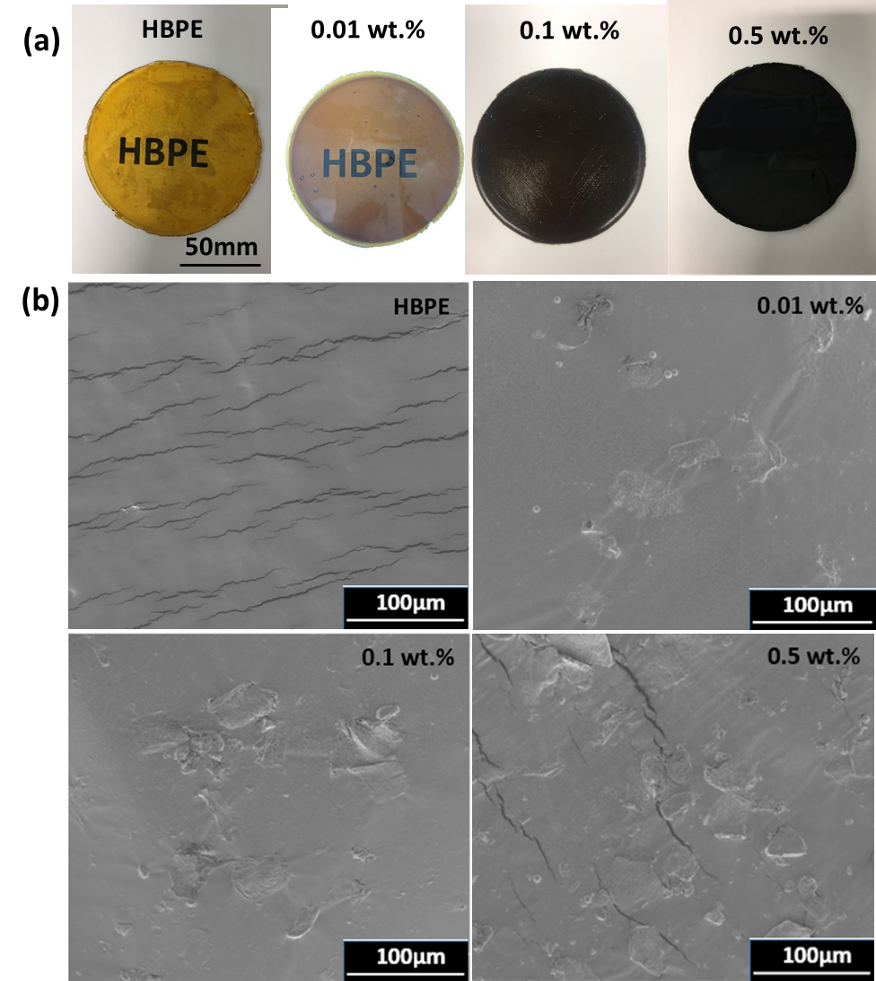
Figure 6.13. Optical images (a) and SEM micrographs, (b) of HBPE and HBPE/P-rGO nanocomposites.
The dispersion quality of P-rGO in HBEP matrix was investigated by SEM. The samples were fractured in liquid nitrogen prior to SEM analysis. According to Figure 6.13(b), neat HBPE shows a flat and smooth surface, with some cracks caused by its brittleness in liquid nitrogen. From SEM images of HBPE/P-rGO composites, P-rGO can be observed in the polymer matrix, and increases with the P-rGO loading.

6.3.2.2. FTIR analysis of HBPE/P-rGO nanocomposites
FTIR spectra of HBPE and HBPE/P-rGO nanocomposite are given in Figure 6.14. As discussed previously, typical peaks of HBPE were observed at 2921 cm⁻¹, 2852 cm⁻¹, 1737 cm⁻¹, and 1167 cm⁻¹, corresponding to C-H stretch from alkane, C=O stretch from ester groups, and C-O stretch from ester groups. After addition of P-rGO, the peaks at 1655 cm⁻¹, 1544 cm⁻¹, and 1018 cm⁻¹ disappeared in HBPE/P-RGO composites, indicating that P-rGO has been successfully grafted onto HBPE.
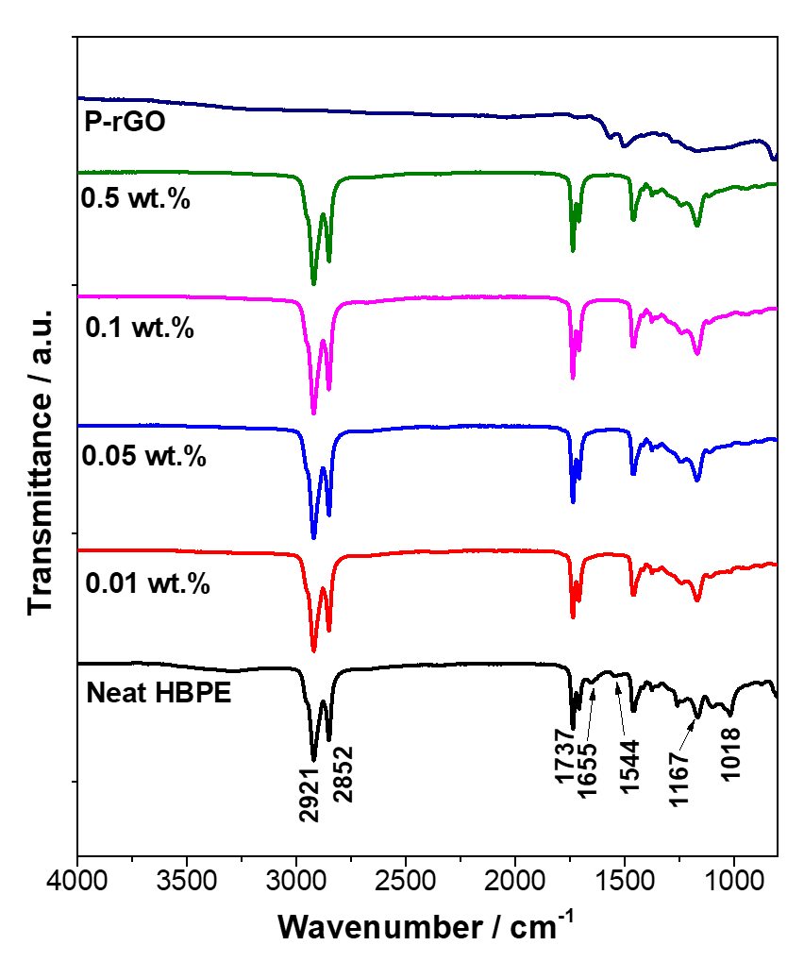
Figure 6.14. FTIR spectra of HBPE and HBPE/P-rGO nanocomposites with various P-rGO loadings.

6.3.3. Stress-strain behavior of HBPE and HBPE/P-rGO nanocomposites

6.3.3.1. Tensile properties of HBPE and HBPE/P-rGO nancomposites
Compared to conventional linear polymers, hyperbranced polymers process poor mechanical properties due to the less entanglements caused by abundant of branches [5]. For most of the graphene/elastomers reported previously, the Young’s modulus and tensile strength were enhanced with graphene content. However, the elongation at break was depending on the synthesis process and the graphene concentration [257]. In this work, tensile tests were carried out to investigate the influence of P-rGO on the mechanical properties of HBPE, and HBPE/P-rGO composites, and the results are shown in Figure 6.15 and summarized in Table 6.2.
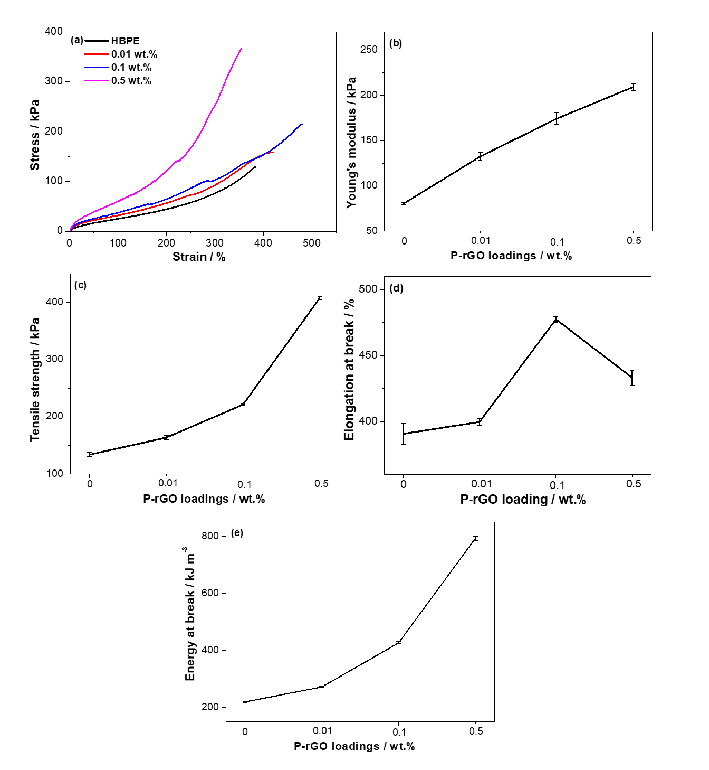
Figure 6.15. Representative tensile stress–strain curves of HBPE and HBPE/P-rGO nanocomposites with various P-rGO loadings.
Figure 6.15(a) shows a typical tensile stress–strain plot of an elastomer, in which the stress-strain curve is non-linearity and there is no constant value of the elastic modulus [258]. According to Figure 6.15, it is obvious that the addition of P-rGO into the polymer matrix has a significant influence on the mechanical behavior. Elongation at break increases was improved by addition of P-rGO nanofillers, and the maximum happened at 0.1 wt.% composite (22% increase over neat HBPE). The Young’s modulus, tensile strength, energy at break of HBPE/P-rGO composites increase with P-rGO loading, and up to 209.3 KPa, 407.9 KPa, 792.8 KJ m⁻³ at 0.5 wt.% HBPE/rGO composites, respectively. That is, 0.5 wt.% composite exhibits an enhancement of 160% (Young’s modulus), 205% (tensile strength), 261% (energy at break) over neat HBPE respectively. Meanwhile, the elongation at break of 0.1 wt.% composite was improved by 22% over neat HBPE. The addition of GO enhanced both tensile strength, and elongation at break, which is presumably because of the GO structure. GO sheets are parallel to each other, which can be slippery under external force, resulting in increased elongation at break. This promising result certifies the excellent dispersion of P-rGO in polymer matrix and the strong interactions between the organic matrix and fillers, as well as high modulus and strength of P-rGO.

Table 6.2. Summary of tensile properties of HBPE and HBPE/P-rGO composites.
Samples | Young’s Modulus  / kPa | Tensile Strength  / kPa | Elongation at Break  / % | Energy at Break  / kJ m⁻³
HBPE | 80.6 ± 1.4 | 133.8 ± 3.7 | 390.8 ± 7.6 | 219.8 ± 2.2
0.01 wt.% | 132.4 ± 4.5 | 163.8 ± 3.8 | 399.8 ± 2.7 | 272.2 ± 2.6
0.1 wt.% | 174.3 ± 6.8 | 221.4 ± 1.4 | 477.5 ± 2.0 | 426.8 ± 4.2
0.5 wt.% | 209.3 ± 3.7 | 407.9 ± 2.5 | 433.3 ± 5.8 | 792.8 ± 7.3
* Young’s modulus is secant modulus at 10% strain of nonlinear materials (standard D638-02a)

6.3.3.2. Hysteresis behavior of HBPE and HBPE/P-rGO nanocomposites
For a typical elastomer, it possesses low modulus, high elongation at break, and non-linearity [258,259]. It can be stretched under an external force and quickly returned to its original state once the stress is removed. When an elastomer is stretched to a high strain, and upon unloading it presents non-Hookean behavior, in which the unloading path is below the loading path. This is related to the energy dissipation in the strain cycle caused by the internal friction. This phenomenon is known as hysteresis. The hysteresis, or loss energy, W_{d}, may be determined by evaluating the area between the extension and retraction curves. Hysteresis ratio, h_{r}, may be defined by
$h_{r }= \frac{W_{0 }- W_{r}}{W_{0}} = \frac{W_{d}}{W_{0}}$ (6.4)
where
W₀: the input strain-energy density, is the area under extension curve
W_{r}: the retraction strain-energy density, is the area under retraction curve
W_{d}: the loss energy, is the area between extension and retraction curves

In this work, hysteresis behavior of HBPE and HBPE/P-rGO nanocomposites was investigated by cyclic tensile tests at a strain rate of 200 mm min⁻¹ with various extensions, as shown in Figure 6.16 and Figure 6.17, and the results are summarized in Table 6.3 and Table 6.4. Figure 6.16(a-d) presents 4 repetitions of the cyclic test with a given extension of 200%. In this test, there is a 5 seconds gap between cycle 2 and cycle 3. For both neat HBPE and its P-rGO composites, no noticeable changes can be observed for the stress at 200%. The stress–strain curves of cycle 1 and cycle 3, cycle 2 and cycle 4 are most overlapped, implying excellent recovery within 5 seconds. After the first cyclic tensile test, the neat HBPE and HBEP/P-rGO composites can recover around 77.0% (neat), 81.5% (0.01 wt.%), 82.6% (0.1 wt.%), and 87.0% (0.5 wt.%) of its original length instantly. Figure 6.16(e) presents the 1st cyclic tensile-strain curves of HBPE and HBPE/P-rGO nancomposites, in which the hysteresis increases with P-rGO loadings, and the highest hysteresis of 19.7 kJ m⁻³ was received at 0.5 wt.% composite. It is presumably because the internal friction increased by the introduction of P-rGO particles, which inhibits both extension and contraction behavior, resulting in bigger energy dissipation or hysteresis at a higher P-rGO concentration [258,259]. Same as hysteresis, hysteresis ration increase with P-rGO content, and the maximum hysteresis of 0.30 was observed at 0.1 wt.%, whereas a lower hysteresis ratio of 0.22 was received at 0.5 wt.%. This is because hysteresis ratio is the fraction of the energy loss in the energy of extension. According to the tensile test, 0.5 wt.% exhibited much stronger mechanical properties over HBPE and HBPE/P-rGO composites with lower concentrations (Figure 6.15(a)). Hence, both energy of extension and hysteresis of the 0.5 wt% composite are much significant over HBPE and composites with lower P-rGO concentrations, resulting in a decreased hysteresis ratio.

Table 6.3. Hysteresis behavior of HBPE and HBPE/P-rGO nanocomposites.
Sample | Hysteresis at 1stcycle  / kJ m⁻³ | Hysteresis ratio
 |  | 1st cycle | 2nd cycle | 3rd cycle | 4th cycle
HBPE | 17.6 | 0.25 | 0.19 | 0.25 | 0.19
0.01 wt.% | 17.8 | 0.27 | 0.19 | 0.25 | 0.19
0.1 wt.% | 18.7 | 0.30 | 0.24 | 0.33 | 0.23
0.5 wt.% | 19.7 | 0.22 | 0.19 | 0.22 | 0.19

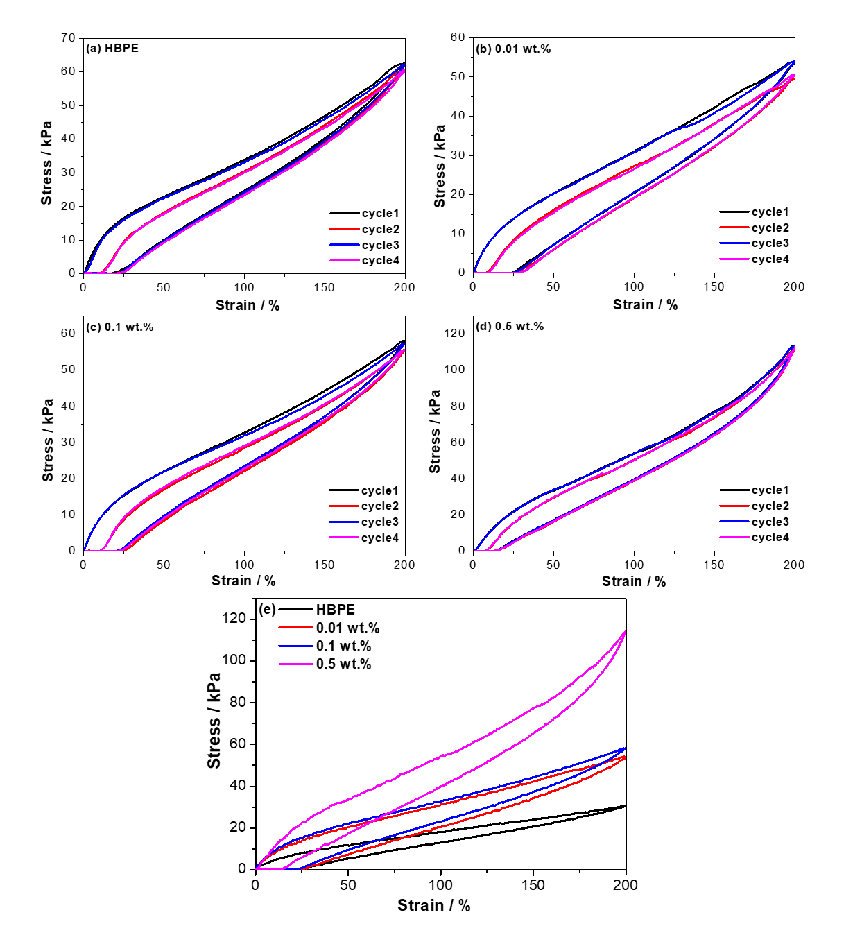
Figure 6.16. Cyclic stress–strain behavior of HBPE and HBPE and HBPE/P-rGO nanocomposites: (a)-(d) 4 cycles with an extension of 200% and (e) hysteresis of 1st cycle with an extension of 200%.

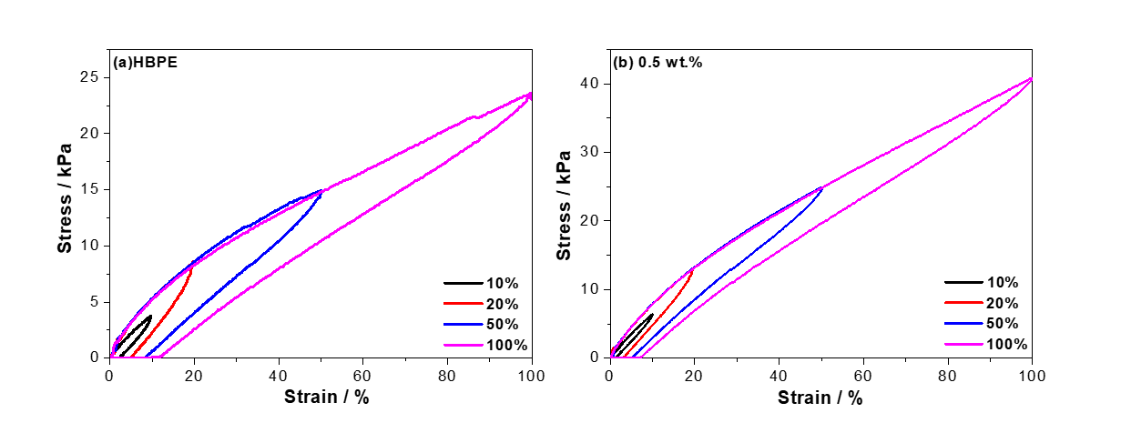

Figure 6.17. Stress–strain curves with different extensions of HBPE and HBPE/P-rGO nanocomposite (0.5 wt.%).

Table 6.4. The hysteresis ratio of HBPE and 0.5 wt.% HBPE/P-RGO at various extensions
Samples | Hysteresis ratio with various extensions
 | 10% | 20% | 50% | 100%
HBPE | 0.40 | 0.45 | 0.37 | 0.25
0.5 wt.% | 0.25 | 0.32 | 0.25 | 0.19

In order to study the hysteresis behavior for various extensions, cyclic tensile tests with different extensions (10%, 20%, 50%, and 100%) with a waiting time of 5 seconds between each cycle were performed on HBPE and 0.5 wt.% HBPE/P-rGO nanocomposite, and the results are shown in Figure 6.17 and Table 6.4. When the cycle was repeated, the sample recovered completely without any residue strain, indicating a great resilience. According to Figure 6.17, the hysteresis increases with the extension as expected. In terms of hysteresis ratio, the HBPE/P-rGO nanocomposite exhibited a significantly lower value over HBPE, same as the results of 4 cyclic tensile test with an extension of 200% (See Figure 6.16 and Table 6.3). Similar to the previous results, hysteresis was getting worse with the incorporation with the P-rGO particles. However, composites show better recovery ability to its original state over neat HBPE.

6.3.3.3. Fatigue behavior of HBPE and HBPE/P-rGO nanocomposites
Under fluctuating loads, polymers can also fail at stress levels much lower than they can withstand under monotonic loading conditions. Hence, the resistance of polymers to fatigue life is another important parameter [260–262]. In order to evaluate the mechanical durability and fatigue failure properties of HBPE and its P-rGO nanocomposites, cyclic tests were conducted under 1000 repeated cycles with a given extension of 100% at an extension rate of 100 mm min⁻¹. From Figure 6.18, compared to the first cycle, the stress at 100% extension after 1000 cycles was reduced by 18.3% (neat), 18.3% (0.01%), 17.5%(0.1%), and 15.2% (0.5%), respectively. Meanwhile, the hysteresis values at 50% extension are 8.97 kPa (neat), 8.95 kPa (0.01 wt.%), 9.25 kPa (0.1 wt.%), and 12.0 kPa (1 wt.%), respectively. In addition, after 1000 repetitive loads, the recovery can be observed at 86.3% (neat), 86.9% (0.01 wt.%), 87.4% (0.1 wt.%), and 88.0% (0.5 wt.%), respectively. However, there are no visible cracks or fractures even after 1000 cycles with 100% extension. It implied that HBPE possesses excellent durability at high – cyclic loads. According to the results above, it can also be seen that the hysteresis behavior is increased by incorporation of P-rGO, which is in agreement with previous cyclic tensile tests in literature. However, the introduction of P-rGO improves the resistance to the fatigue failure when the nanofiller reaches 0.5 wt.%. This may be due to the fact that the introduction of rigid particles in soft matrix enhances the stiffness of composites, and the failure energy absorption is increased by nucleation sites provided by P-rGO simultaneously.
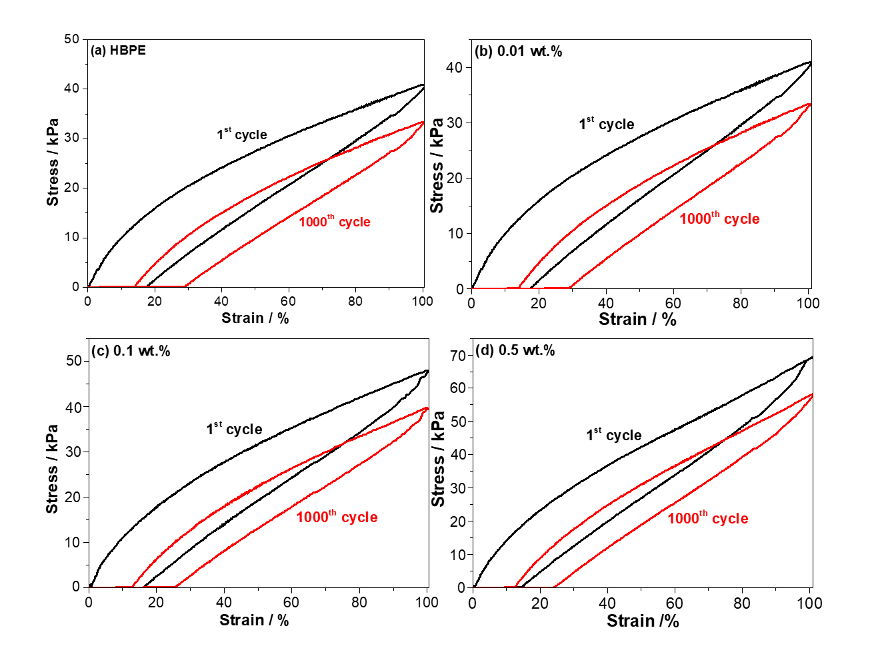
Figure 6.18. Stress–strain curve of cyclic fatigue test: (a) HBPE, (b) 0.01 wt.%, (c) 0.1 wt.%, and (d) 0.5 wt.%.

6.3.4. Glass transition temperature (T_{g})
T_{g} is an important parameter in the applications of polymer because it defines the states (glassy, or rubbery) of polymer. For most elastomers, they are used at the temperature above their T_{g} for their flexibility. In this work, DMA was used to study the T_{g} of HBPE and its P-rGO composites. In Figure 6.19, the T_{g} of neat HBPE is around -38 °C. T_{g} is increased with the introduction of P-rGO, and the maximum T_{g} with -28 °C occurred at 0.5 wt.%. This is because that the excellent interactions of P-rGO with HBPE matrix limits the movement of polymer chains, resulting in a higher T_{g}. However, the dynamic mechanical properties like storage modulus and loss modulus cannot be obtained via DMA test. This is due to the softness of samples that results in very weak force signals.
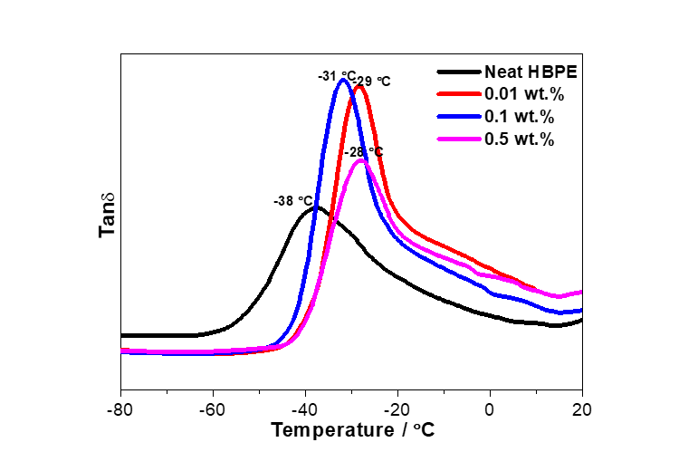
Figure 6.19. Glass transition temperature T_{g} determined from Tan δ curves.

6.3.5. Thermal stability
The thermal stability of P-rGO and HBPE/P-rGO nano composites is studied by TGA analysis. According to Figure 6.20(a), P-rGO hybrid processes better thermal stability over GO. In detail, a small weight loss appeared around 100 °C for both GO and P-rGO, which is related to the moisture. For GO, the main loss of 35.5% occurred around 200 °C, presumably due to the decomposition of the oxygen functional groups, yielding CO₂, CO and steam [34]. The remaining weight of GO at 700 °C is 44.5%. For P-rGO, the main loss of only 17.8% happened around 200 °C– 300 °C, with 49.5% remaining weight. This is presumably because that some oxygen functional groups have been removed by PPD during the reduction process. Figure 6.20(b) presents the thermal stability of HBPE and its P-rGO composites. The starting degradation temperatures ($T_{d}^{onset}$) of HBPE and HBPE/P-rGO composites are observed at 404 °C (HBPE), 404 °C (0.01 wt.%), 405 °C (0.1 wt.%), and 407 °C (0.5 wt.%), respectively. The remaining weights are 2.89% (HBPE), 1.41% (0.01 wt.%), 0.5% (0.1 wt.%), and 4.86% (0.5 wt. %). It concludes that HBPE and its composites with a low P-rGO loading (below 0.1 wt.%) possess similar thermal properties. However, the incorporation of P-rGO could enhance the thermal stability when P-rGO concentration reaches 0.5 wt.%. This is because the rigid nanoparticles (P-rGO) are compatible with HBPE matrix and could inhibit the movement of polymer chains when it reaches 0.5 wt.% of P-rGO [253].

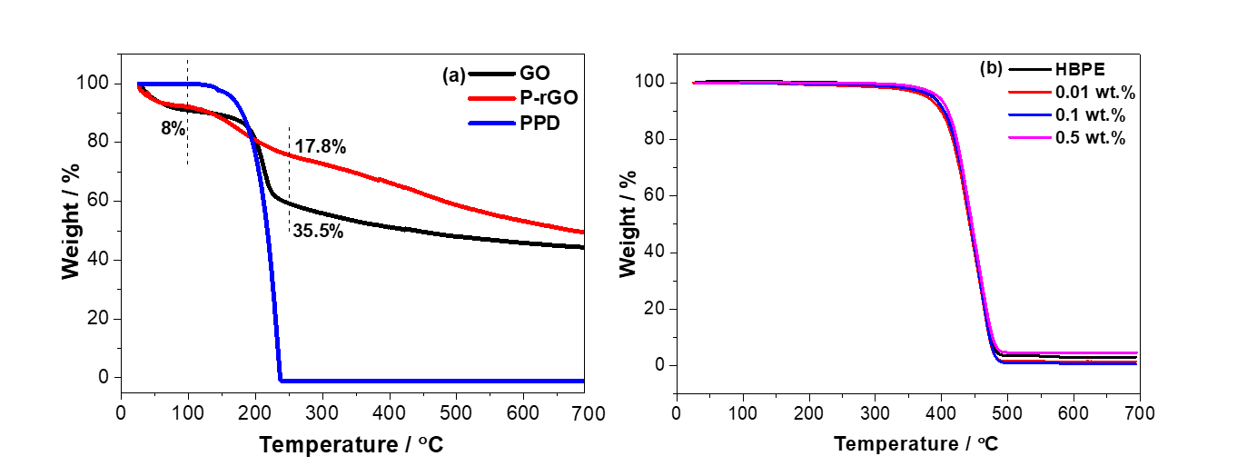
Figure 6.20. TGA curves of (a) GO, P-rGO, and PPD, and (b) HBPE and HBPE/P-rGO nanocomposites with different loadings.

6.3.6. Self-healing efficiency
For an ideal self–healing polymer, it should be able to rapidly and completely recover its physical properties during its repair process. However, in practice, this may not always be possible. For most cases, the re-established polymers present the reduced mechanical properties in comparison with its undamaged polymers, and the fracture always happened at the initial fracture sites due to remnant defects [134]. Self-healing efficiency is used here to investigate its self-healing ability [234] (equation (6.5)).

$Healing efficiency=\frac{{Mechanical value}_{healed}}{{Mechanical value}_{pristine}} ×100\%$ (6.5)

In this work, the monomer ratio of the trimer acid (Pripol 1040) and diol (Pripol 2030) is 2:3, which means the amount of –COOH group and –OH group is equal. Theoretically, both hydroxyl groups and carboxyl groups are presented at the end of the polymer chains [22], which has been proven by FTIR. In this case, there is a potential for self–healing via hydrogen bonds to occur between carbonyl groups and hydroxyl groups. In order to demonstrate this effect, samples were cut into completely two separate pieces by using a razor blade, the cut surfaces were gently brought back together subsequently, and were allowed to heal at room temperature for 10 min and 24 h, respectively. Tensile tests were carried out to investigate the self–healing efficiency, and the restoration on modulus, tensile strength, elongation at break, and energy at break was shown in Figure 6.21 and Table 6.5. Normally, toughness or energy at break are used to quantify the mechanical healing efficiency, because both stress and strain are taken into account.
In this work, the healing efficiency of HBPE was 5.8% after 10 min and 40.5% after 24 h ambient conditions. The self-healing capacity after 48 h showed the similar value as that after 24 h, indicating that hydrogen bonding did not continue to re-associate after 24 h. However, the self–healing efficiencies were affected significantly with the increasing GO loadings. In detail, the self-healing efficiencies within 10 min were increased and the highest efficiency of 20.9% occurred at 0.01 wt.% HBPE/P-rGO composite. This is presumably because that the excellent interactions of P-rGO with polymer matrix at low concentration could hinder the crosslinking of polymers, resulting in more flexible polymer chains and more active hydrogen bonding sites. This leads to a higher density of hydrogen bonding with an enhanced mechanical self-healing efficiency, which is a common phenomenon for most of self-healing elastomers [135,139,263]. In contrast, 0.5 wt.% HBPE/P-rGO nanocomposite showed a decreased self-healing efficiency of only 3.2%. This is presumably because some of the fracture surface area was occupied by P-rGO particles, resulting in a less hydrogen bonding density which is a key parameter for self-healing capacity [134,135]. Adversely, the self-healing efficiencies after 24 h were reduced significantly and the lowest efficiency of 7.7% occurred at 0.5 wt.% HBPE/P-rGO composite. This is presumably because that lower crosslinking degree leads a higher diffusion and re-association of hydrogen bonding, which is a key parameter for the fast self-healing within short time (10 min). However, for the self-healing within long time (24 h), the density of hydrogen bonding is the key parameter rather than crosslinking degree. The surface for functional groups (carbonyl groups and hydroxyl groups) was occupied by the addition of P-rGO particles, resulting in a reduced density of hydrogen bonding to re-associate [135].
As we know, most of healable elastomers require healing agents or external stimuli like light or heat, and only few samples can be automatically repaired at room temperature [136]. For example, self-healing supramolecular polymers made from fatty diacid, triacid and diethylene triamine shows 34% recovery of extension after 15 min, and fully recovered after 3 h [139]. Amine-terminated hyperbranched polymer (HN-NH₂) GO composite (1 wt.%) exhibited a fast healing speed, in which it can be healed to 60% of its original tensile strength and completed healing after 1 h [135]. In this work, HBPE and HBPE/P-rGO nanocomposites showed relatively lower self-healing capacity. This presumably because that the hydrogen bonding formed between carbonyl groups and hydroxyl groups are weaker than that formed from carbonyl groups and amine groups.
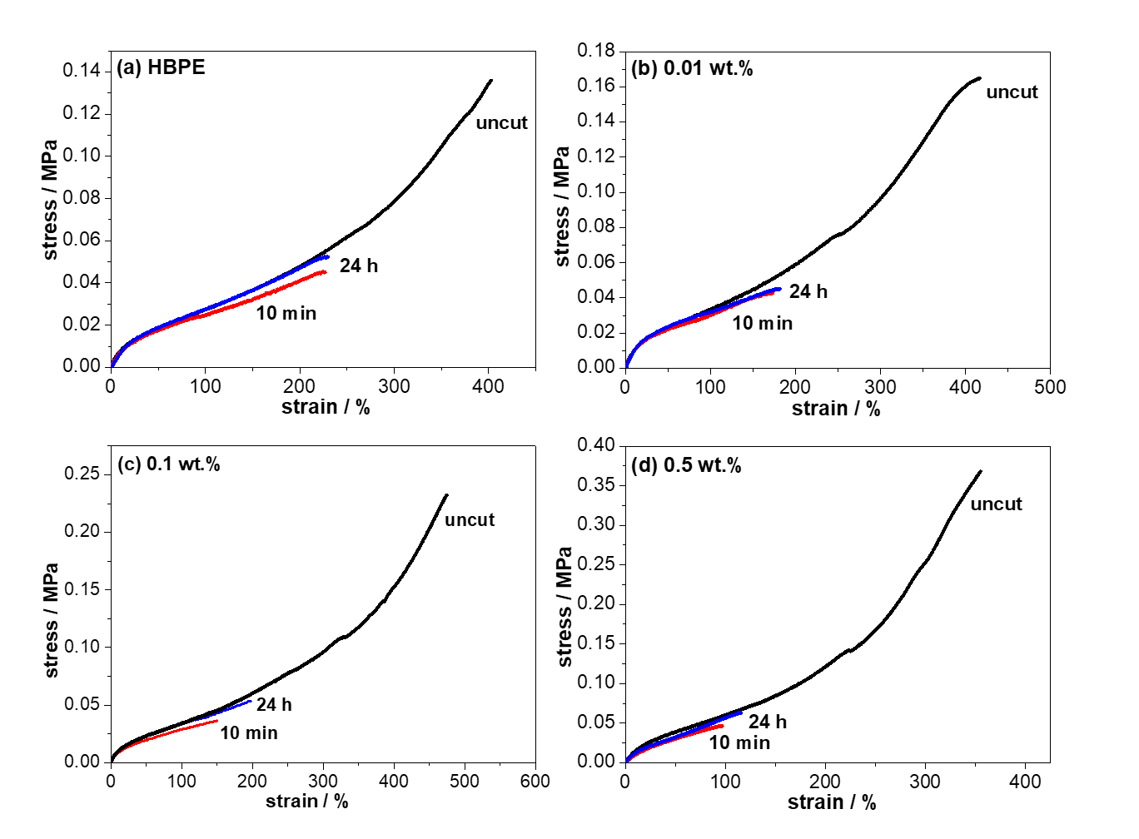
Figure 6.21. Self-healing properties: Stress–strain properties of HBPE and HBPE/P-rGO nanocomposites.

Table 6.5. Summary of self-healing properties of HBPE and HBPE/P-rGO nanocomposites at different P-rGO loadings.
 | Restoration  (Young’s modulus) |  | Restoration  (Tensile strength) |  | Restoration  (Elongation at break) |  | Efficiency  (Energy at break)
 | 10 min | 24 h | 10 min | 24 h | 10 min | 24 h | 10 min | 24 h
HBPE | 95.0% | 99.0% | 37.9% | 43.0% | 49.1% | 64.7% | 5.8% | 40.5%
0.01 wt.% | 84.9% | 93.9% | 25.7% | 27.7% | 41.5% | 43.6% | 20.9% | 23.3%
0.1 wt.% | 75.9% | 89.9% | 15.9% | 22.9% | 31.6% | 41.8% | 10.2% | 18.4%
0.5 wt.% | 74.2% | 82.3% | 12.8% | 17.3% | 27.3% | 32.7% | 3.2% | 7.7%
*The average values were obtained with 6 measurements for each sample.

6.4. Conclusions
Graphene oxide was functionalized by poly-PPD, which exhibited excellent stability in ethanol, resulting in a great incorporation with polymer matrix with significant improvement on the mechanical and thermal properties of HBPE elastomers. Bio-based HBPE and HBPE/P-rGO nanocomposites prepared by simply in-situ polymerization method present excellent stretching ability and resilience, which could be restore back to their original state when they are stretched into 200% extension, and they could be stretched up to 477% extension before fracture. However, the hysteresis properties of HBPE increased with GO loading due to the interruption of P-rGO in the polymer matrix, which would prevent the recovery of polymer. HBPE shows partially self-healing behavior at room temperature without any plasticizer, solvent, healing agents or external stimuli. HBPE exhibited a healing efficiency of 5.8% after 10 min and 40.5% after 24 h. The self-healing efficiency after 10 min was enhanced by addition of P-rGO, in which the maximum efficiency happened at 0.01 wt.% HBPE/P-rGO with 20.9%, but decreased at 0.5 wt.% with 3.2% due to the lower crosslinking degree caused by higher amount of P-rGO particles. However, the longtime self-healing efficiency was reduced by addition of P-rGO content due to the lower density of hydrogen bonding.

Chapter 7: Conclusions

In this thesis, GO was prepared by Hummers method. UPR/GO composites with different GO loadings were prepared by crosslinking of UPR at the presence of GO. The effect of addition of GO on the crosslinking density of UPR, GO-MEKP, and GO-cobalt hybrid were prepared in the same method as composite. FTIR and TGA analysis confirmed that styrene and cobalt may adsorbed on GO surface by π-π interaction and chemical bonding. Therefore, crosslinking density is reduced, which in turn also contribute to the final properties of UPR composites. As for Chapter 3, Young’s modulus, tensile strength were enhanced for both cured and non-cured polymers. However, compared to other graphene-based polymers, the improvements are not significant. Moreover, T_{g} and thermal stability is not significant influenced as well. For UPR/GO system, the final properties of composites are contributed to both crosslinking density and the interfacial interaction (hydrogen bonding). Therefore, the reduced crosslinking density may lower the enhancement capacity of GO.
The electrical conductivity of UPR cannot be achieved by addition of GO. However, the addition of rGO which is reduced by vitamin C would enable insulating UPR to be electrically conductive. As for Chapter 4, UPR/rGO exhibit electrical conductivity of 1.3 x 10⁻⁴ S m⁻¹ at 1.0 wt.%, and 3.08 S m⁻¹ at 2.0 wt.%, respectively. However, both strength and modulus reduced with increasing rGO content. Compared to the tensile properties of UPR/GO, UPR/rGO shows a opposite tendency. This is because rgo has less oxygen functional groups for forming hydrogen bonding with UPR. Therefore, this method is good for electrical properties. However, other properties including mechanical properties, stability and T_{g} cannot be achieved at the same time. In order to improve mechanical properties, thermal stability, and T_{g}, one pot method was employed to synthesis UPR/rGO composites. In this method, more functional groups on GO sheets to form hydrogen bonding with UPR before and during reduction process. The electrical conductivity shows 2.4 x 10 -4 S m-1 at 0.96 wt.%, which is roughly double of the value of 1.0 wt.% UPR/rGO from Chapter 4. Moreover, the thermal stability is enhanced significantly, which is 18 ºC for $T_{d}^{peak}$ and 2 C for $T_{d}^{1/2}$ at 0.96 wt.%. All this confirmed a stronger interfacial interaction between rGO and UPR is formed by in one pot method. However, this method has two main drawbacks: First, the unreacted vitamin C still remains in the final product which cannot be removed due to the process limit. These unreacted vitamin C may bring some defects on the structure of composite that has been confirmed in SEM images. Therefore, Tg of UPR/rGO composites are reduced compared to neat UPR. Second, the removal of DMF is a big challenge for UPR composites. It is very hard to be removed which needs high temperature, vacuum, and longer evaporation time. However, styrene would also evaporate under this condition, which would significant reduce the crosslinking density. Thus, it is quite difficult to prepare a good sample with designed shape.
HBPE synthesized from bio-based diol and trimer acid present excellent stretching ability and resilience, which could be restore back to their original state. It is a typical elastomer, which exhibits low modulus, low strength and hysteresis behaviour. As discussed in Chapter 6, the mechanical properties were largely enhanced by addition of P-rGO at very low GO content. However, the hysteresis increased as P-rGO increased. Moreover, HBPE also shows partially self-healing capacity due to the formation of hydrogen bonding formed between carboxyl groups and hydroxyl groups without any plasticizer, solvent, healing agents or external stimuli. Compared to other self-healing elastomers, the self-healing efficiency is quite low. This is presumably due to the hydrogen bonding formed between carboxyl groups and hydroxyl groups is weaker than hydrogen bonding formed between hydroxyl groups and amine groups. Unlike other hyperbranched polymer, the branching degree (BD) of this HBPE couldn’t be obtained by NMR. This is because the starting monomers are large and complex, the terminal unit, linear unit and dendritic unit can’t be determined by NMR.

Chapter 8: Future work

The dispersion and interaction of GO in polymer matrix (UPR) is the key parameter for the properties of UPR composites. For the preparation of UPR/GO composites via simple blending method, the evaporation of styrene in UPR cannot be avoid during the sonication/degass process. Moreover, the adsorption of styrene on graphene and GO sheets would negatively impact the crosslinking density and final properties of composites. In order to compensate the negative effects from the preparation method, there are two methods would be used in the future. 1). GO is modified by introducing some functional groups, resulting in strong interaction between GO and UPR via the formation of covalent bonding. This may compensate the negative effect from evaporation and surface absorption of styrene. 2) Mix GO with UPR by strong mechanical agitation without solvents like THF. Figure out how much styrene would evaporate during the degass process. Add same amount of styrene to compensate the loss of styrene during the process. To avoid evaporate the styrene during the mixing process by distillation. However, this method is only suitable for low concentration of composites.

References
[1] Z.-M. Huang, Y.-Z. Zhang, M. Kotaki, and S. Ramakrishna, “A review on polymer nanofibers by electrospinning and their applications in nanocomposites,” Compos. Sci. Technol., vol. 63, pp. 2223–2253, Nov. 2003.
[2] K. O. Okada A, KawasumiM, Usuki A, Kojima Y, Kurauchi T, “Synthesis and properties of nylon-6/clay hybrids,” in Polymer based molecular composites, S. DW and M. JE, Eds. Materials Research Society, 1990, pp. 45–50.
[3] K. S. Novoselov, A. K. Geim, S. V. V. Morozov, D. Jiang, Y. Zhang, S. V. Dubonos, I. V. Grigorieva, and A. A. Firsov, “Electric Field Effect in Atomically Thin Carbon Films,” Science (80-. )., vol. 306, no. 5696, pp. 666–669, 2004.
[4] H. Cao, Y. Zheng, J. Zhou, W. Wang, and A. Pandit, “A novel hyperbranched polyester made from aconitic acid (B3) and di(ethylene glycol) (A2),” Polym. Int., vol. 60, pp. 630–634, 2011.
[5] M. Jikei and M. Kakimoto, “Hyperbranched aromatic polyamides prepared by direct polycondensation,” High Perform. Polym., vol. 13, pp. 33–43, 2001.
[6] R. M. Jones, Mechanics of composite materials, Second. Taylor & Francis, 1975.
[7] K. K. Chawla, Composite materials: Science and Engineering, Third. Springer, 1987.
[8] N. Saheb and J. Jog, “Natural Fiber Polymer Composites : A Review,” Adv. Polym. Technol., vol. 18, pp. 351–363, 1999.
[9] K. P. Matabola, A. R. De Vries, F. S. Moolman, and A. S. Luyt, “Single polymer composites: a review,” J. Mater. Sci., vol. 44, pp. 6213–6222, 2009.
[10] N. J. Capiati and R. S. Porter, “The concept of one polymer composites modelled with high density polyethylene,” J. Mater. Sci., vol. 10, no. 10, pp. 1671–1677, 1975.
[11] J. Jordan, K. I. Jacob, R. Tannenbaum, M. A. Sharaf, and I. Jasiuk, “Experimental trends in polymer nanocomposites—a review,” Mater. Sci. Eng. A, vol. 393, pp. 1–11, Feb. 2005.
[12] E. P. Giannelis, “Polymer-layered silicate nanocomposites: Synthesis, properties and applications,” Appl. Organomet. Chem., vol. 12, pp. 675–680, 1998.
[13] C.-M. Chan, J. Wu, J.-X. Li, and Y.-K. Cheung, “Polypropylene/calcium carbonate nanocomposites,” Polymer (Guildf)., vol. 43, no. 10, pp. 2981–2992, 2002.
[14] T. Liu, K. P. Lim, W. C. Tjiu, K. P. Pramoda, and Z. K. Chen, “Preparation and characterization of nylon 11/organoclay nanocomposites,” Polymer (Guildf)., vol. 44, no. 12, pp. 3529–3535, 2003.
[15] Emmanuel P. Giannelis, “Polymer layered silicate nanocomposites,” Macromol. Mater. Eng., vol. 8, pp. 29–35, 1996.
[16] N. Bitinis, M. Hernandez, R. Verdejo, J. M. Kenny, and M. A. Lopez-Manchado, “Recent advances in clay/polymer nanocomposites,” Adv. Mater., vol. 23, no. 44, pp. 5229–5236, 2011.
[17] L. Dai and J. Sun, “Mechanical properties of carbon nanotubes-polymer composites,” in Carbon nanotubes-current progress of their polymer composites, M. R. B. and I. H. Hafez, Ed. Intech, 2013, pp. 155–194.
[18] Z. Spitalsky, D. Tasis, K. Papagelis, and C. Galiotis, “Carbon nanotube-polymer composites: Chemistry, processing, mechanical and electrical properties,” Prog. Polym. Sci., vol. 35, no. 3, pp. 357–401, 2010.
[19] T. Kuilla, S. Bhadra, D. H. Yao, N. H. Kim, S. Bose, and J. H. Lee, “Recent advances in graphene based polymer composites,” Prog. Polym. Sci., vol. 35, no. 11, pp. 1350–1375, 2010.
[20] R. Rohini, P. Katti, and S. Bose, “Tailoring the interface in graphene/thermoset polymer composites: A critical review,” Polymer (Guildf)., vol. 70, pp. A17–A34, 2015.
[21] R. Sengupta, M. Bhattacharya, S. Bandyopadhyay, and A. K. Bhowmick, “A review on the mechanical and electrical properties of graphite and modified graphite reinforced polymer composites,” Prog. Polym. Sci., vol. 36, no. 5, pp. 638–670, May 2011.
[22] O. C. Compton and S. T. Nguyen, “Graphene oxide, highly reduced graphene oxide, and graphene: Versatile building blocks for carbon-based materials,” Small, vol. 6, no. 6, pp. 711–723, 2010.
[23] Y. Zhu, S. Murali, W. Cai, X. Li, J. W. Suk, J. R. Potts, and R. S. Ruoff, “Graphene and graphene oxide: Synthesis, properties, and applications,” Adv. Mater., vol. 22, no. 35, pp. 3906–3924, 2010.
[24] M. Eizenberg and J. M. Blakely, “Carbon monolayer phase condensation on Ni(111),” Surf. Sci., vol. 82, no. 1, pp. 228–236, 1979.
[25] Z. Luo, S. Lim, Z. Tian, J. Shang, L. Lai, B. MacDonald, C. Fu, Z. Shen, T. Yu, and J. Lin, “Pyridinic N doped graphene: synthesis, electronic structure, and electrocatalytic property,” J. Mater. Chem., vol. 21, pp. 8038–8044, 2011.
[26] C. Berger, Z. Song, and X. Li, “Electronic Confinement and Coherence in patterned epitaxial graphene,” Science (80-. )., vol. 312, pp. 1191–1196, 2006.
[27] M. J. McAllister, J. L. Li, D. H. Adamson, H. C. Schniepp, A. A. Abdala, J. Liu, M. Herrera-Alonso, D. L. Milius, R. Car, R. K. Prud’homme, and I. A. Aksay, “Single sheet functionalized graphene by oxidation and thermal expansion of graphite,” Chem. Mater., vol. 19, no. 18, pp. 4396–4404, 2007.
[28] H. C. Schniepp, J. L. Li, M. J. McAllister, H. Sai, M. Herrera-Alonson, D. H. Adamson, R. K. Prud’homme, R. Car, D. A. Seville, and I. A. Aksay, “Functionalized single graphene sheets derived from splitting graphite oxide,” J. Phys. Chem. B, vol. 110, pp. 8535–8539, 2006.
[29] and N. K. Mohammad A. Rafiee, Javad Rafiee, Zhou Wang, Huaihe Song, Zhong Zhen Yu, “Enhanced mechanical properties of nanocomposites at low graphene content,” ACS Nano, vol. 3, no. 12, pp. 3884–3890, 2009.
[30] P. Steurer, R. Wissert, R. Thomann, and R. M??lhaupt, “Functionalized graphenes and thermoplastic nanocomposites based upon expanded graphite oxide,” Macromol. Rapid Commun., vol. 30, pp. 316–327, 2009.
[31] Y. Guo, X. Sun, Y. Liu, W. Wang, H. Qiu, and J. Gao, “One pot preparation of reduced graphene oxide (RGO) or Au (Ag) nanoparticle-RGO hybrids using chitosan as a reducing and stabilizing agent and their use in methanol electrooxidation,” Carbon N. Y., vol. 50, no. 7, pp. 2513–2523, 2012.
[32] S. Park, J. An, J. R. Potts, A. Velamakanni, S. Murali, and R. S. Ruoff, “Hydrazine-reduction of graphite and graphene oxide,” Carbon N. Y., vol. 49, no. 9, pp. 3019–3023, 2011.
[33] S. Stankovich, R. D. Piner, X. Chen, N. Wu, S. T. Nguyen, and R. S. Ruoff, “Stable aqueous dispersions of graphitic nanoplatelets via the reduction of exfoliated graphite oxide in the presence of poly(sodium 4-styrenesulfonate),” J. Mater. Chem., vol. 16, pp. 155–158, 2006.
[34] S. Stankovich, D. A. Dikin, R. D. Piner, K. A. Kohlhaas, A. Kleinhammes, Y. Jia, Y. Wu, S. B. T. Nguyen, and R. S. Ruoff, “Synthesis of graphene-based nanosheets via chemical reduction of exfoliated graphite oxide,” Carbon N. Y., vol. 45, no. 7, pp. 1558–1565, 2007.
[35] H. J. Shin, K. K. Kim, A. Benayad, S. M. Yoon, H. K. Park, I. S. Jung, M. H. Jin, H. K. Jeong, J. M. Kim, J. Y. Choi, and Y. H. Lee, “Efficient reduction of graphite oxide by sodium borohydride and its effect on electrical conductance,” Adv. Funct. Mater., vol. 19, pp. 1987–1992, 2009.
[36] M. Periasamy and M. Thirumalaikumar, “Methods of enhancement of reactivity and selectivity of sodium borohydride for applications in organic synthesis,” J. Organomet. Chem., vol. 609, pp. 137–151, 2000.
[37] G. Wang, J. Yang, J. Park, X. Gou, B. Wang, H. Liu, and J. Yao, “Facile synthesis and characterization of graphene nanosheets,” J. Phys. Chem. C, vol. 112, pp. 8192–8195, 2008.
[38] and J. M. D. T. M. J. Fernandez-Merino, J.Guardia, J.I.Paredes, S.Villar-Rodil, P.Solis-Fernandez, A.Martinez-Alonso, “Vitamin C is an ideal substitute for hydrazine in the reduction of graphene oxide suspensions,” J. Phys. Chem. C, vol. 114, pp. 6426–6432, 2010.
[39] H. Ding, S. Zhang, J.-T. Chen, X.-P. Hu, Z.-F. Du, Y.-X. Qiu, and D.-L. Zhao, “Reduction of graphene oxide at room temperature with vitamin C for RGO–TiO2 photoanodes in dye-sensitized solar cell,” Thin Solid Films, vol. 584, pp. 29–36, 2015.
[40] B. C. Brodie, “The chemistry of graphite oxide,” Chem. Soc. Rev., vol. 39, pp. 228–240, 2010.
[41] A. Lerf, H. He, M. Forster, and J. Klinowski, “Structure of Graphite Oxide Revisited ‖,” J. Phys. Chem. B, vol. 102, no. 23, pp. 4477–4482, 1998.
[42] C. Wan and B. Chen, “Reinforcement and interphase of polymer/graphene oxide nanocomposites,” J. Mater. Chem., vol. 22, no. 8, pp. 3637–3646, 2012.
[43] K. A. Mkhoyan, A. W. Contryman, J. Silcox, A. Derek, G. Eda, C. Mattevi, S. Miller, M. Chhowalla, K. A. Mkhoyan, A. W. Contryman, J. Silcox, D. A. Stewart, G. Eda, C. Mattevi, and S. Miller, “Atomic and Electronic Structure of Graphene-Oxide,” vol. 9, pp. 1058–1063, 2009.
[44] T. Kuilla, S. Bhadra, D. H. Yao, N. H. Kim, S. Bose, and J. H. Lee, “Recent advances in graphene based polymer composites,” Prog. Polym. Sci., vol. 35, pp. 1350–1375, 2010.
[45] D. A. Dikin, S. Stankovich, E. J. Zimney, R. D. Piner, G. H. B. Dommett, G. Evmenenko, S. T. Nguyen, and R. S. Ruoff, “Preparation and characterization of graphene oxide paper,” Nature, vol. 448, no. 7152, pp. 457–460, 2007.
[46] and R. S. R. Daniel R. Dreyer, Sungjin park, Christopher W. Bielawski, “The chemistry of graphene oxide,” R. Soc. Chem., pp. 228–240, 2010.
[47] K. R. Koch, “Oxidation by Mn207: An impressive demonstration of the powerful oxidizing property of dimanganeseheptoxide,” J. Chem. Educ., vol. 59, no. 11, p. 973, 1982.
[48] M. M. Gudarzi and F. Sharif, “Enhancement of dispersion and bonding of graphene-polymer through wet transfer of functionalized graphene oxide,” Express Polym. Lett., vol. 6, no. 12, pp. 1017–1031, 2012.
[49] S. Dubin, S. Gilje, K. Wang, V. C. Tung, K. Cha, A. S. Hall, J. Farrar, R. Varshneya, Y. Yang, and R. B. Kaner, “A one-step, solvothermal reduction method for producing reduced graphene oxide dispersions in organic solvents,” ACS Nano, vol. 4, no. 7, pp. 3845–3852, 2010.
[50] J. I. Parades, S. Villar-Rodil, A. Martínez-Alonso, and J. M. D. Tascón, “Graphene oxide dispersions in organic solvents,” Langmuir, vol. 24, pp. 10560–10564, 2008.
[51] S. Pan and L. A. Asay, “Factors Controlling the Size of Graphene Oxide Sheets Produced via the Graphite Oxide Route,” ACS Nano, vol. 5, pp. 4073–4083, 2011.
[52] P. Blake, P. D. Brimicombe, R. R. Nair, T. J. Booth, D. Jiang, F. Schedin, L. A. Ponomarenko, S. V Morozov, H. F. Gleeson, E. W. Hill, A. K. Geim, and K. S. Novoselov, “Graphene-Based Liquid Crystal Device,” Nano Lett., vol. 8, no. 6, pp. 1704–1708, 2008.
[53] S. P. Lonkar, Y. S. Deshmukh, and A. A. Abdala, “Recent advances in chemical modifications of graphene,” Nano Res., vol. 8, no. 4, pp. 1–38, 2015.
[54] D. S. Yu, Y. Yang, M. Durstock, J. B. Baek, and L. M. Dai, “Soluble P3HT-grafted graphene for efficient bilayer-heterojunction photovoltaic devices,” ACS Nano, vol. 4, pp. 5633–5640, 2010.
[55] R. Hao, W. Qian, L. Zhang, and Y. Hou, “Aqueous dispersions of TCNQ-anion-stabilized graphene sheets,” Chem. Commun., no. 48, pp. 6576–6578, 2008.
[56] N. W. Pu, C. A. Wang, Y. M. Liu, Y. Sung, D. S. Wang, and M. Der Ger, “Dispersion of graphene in aqueous solutions with different types of surfactants and the production of graphene films by spray or drop coating,” J. Taiwan Inst. Chem. Eng., vol. 43, no. 1, pp. 140–146, 2012.
[57] S.Park, J. An, RD.Piner, and I.Jung, “Aqueous suspension and characterization of chemically modified graphene sheets,” Chem Mater, vol. 20, pp. 6592–6594, 2008.
[58] Q. Su, S. Pang, V. Alijani, C. Li, X. Feng, and K. M??llen, “Composites of craphene with large aromatic molecules,” Adv. Mater., vol. 21, no. 31, pp. 3191–3195, 2009.
[59] N. Liu, F. Luo, H. Wu, Y. Liu, C. Zhang, and J. Chen, “One-step ionic-liquid-assisted electrochemical synthesis of ionic-liquid-functionalized graphene sheets directly from graphite,” Adv. Funct. Mater., vol. 18, no. 10, pp. 1518–1525, 2008.
[60] H. Ku, H. Wang, N. Pattarachaiyakoop, and M. Trada, “A review on the tensile properties of natural fiber reinforced polymer composites,” Compos. Part B Eng., vol. 42, no. 4, pp. 856–873, 2011.
[61] J. R. Potts, D. R. Dreyer, C. W. Bielawski, and R. S. Ruoff, “Graphene-based polymer nanocomposites,” Polymer (Guildf)., vol. 52, no. 1, pp. 5–25, 2011.
[62] R. Verdejo, M. M. Bernal, L. J. Romasanta, and M. A. Lopez-manchado, “Graphene filled polymer nanocomposites †,” J. Mater. Chem., vol. 21, pp. 3301–3310, 2011.
[63] Reinhold, Polyesters and their applications. Bjorksten research laboratories, 1956.
[64] B. Dholakiya, “Unsaturated Polyester Resin for Specialty Applications,” in Polyester, H. E.-D. M.Saleh, Ed. Intech, 2012, pp. 167–202.
[65] O. C. Zaske and S. H. Goodman, “Unsaturated Polyester and Vinyl Ester Resins,” in Handbook of Thermoset Plastics, 1998, pp. 97–168.
[66] O. E. A, “Curing Behaviour and Tensile Properties of Unsaturated Polyester Containing Various Styrene Concentrations,” Malaysian Polym. J., vol. 7, no. 2, pp. 46–55, 2012.
[67] X. Cao and L. J. Lee, “Control of shrinkage and residual styrene of unsaturated polyester resins cured at low temperatures : I . Effect of curing agents,” Polymer (Guildf)., vol. 44, pp. 1893–1902, 2003.
[68] I. Zaman, T. T. Phan, H. C. Kuan, Q. Meng, L. T. Bao La, L. Luong, O. Youssf, and J. Ma, “Epoxy/graphene platelets nanocomposites with two levels of interface strength,” Polymer (Guildf)., vol. 52, no. 7, pp. 1603–1611, 2011.
[69] T. Ramanathan, A. A. Abdala, S. Stankovich, D. A. Dikin, M. Herrera-Alonso, R. D. Piner, D. H. Adamson, H. C. Schniepp, X. Chen, R. S. Ruoff, S. T. Nguyen, I. A. Aksay, R. K. Prud’Homme, and L. C. Brinson, “Functionalized graphene sheets for polymer nanocomposites,” Nat. Nanotechnol., vol. 3, no. 6, pp. 327–331, 2008.
[70] T. G. Gopakumar and D. J. Y. S. Pagé, “Polypropylene/graphite nanocomposites by thermo-kinetic mixing,” Polym. Eng. Sci., vol. 44, no. 6, pp. 1162–1169, 2004.
[71] X. Y. Qi, D. Yan, Z. Jiang, Y.-K. Cao, Z. Z. Yu, F. Yavari, and N. Koratkar, “Enhanced Electrical Conductivity in Polystyrene Nanocomposites at ultra-low graphene content,” ACS Appl. Mater. Interfaces, vol. 3, pp. 3130–3133, 2011.
[72] M. Fang, K. Wang, H. Lu, Y. Yang, and S. Nutt, “Covalent polymer functionalization of graphene nanosheets and mechanical properties of composites,” J. Mater. Chem., vol. 19, no. 38, p. 7098, 2009.
[73] G. Chen, D. Wu, and W. Weng, “Exfoliation of graphite flakes and its nanocomposites,” Carbon N. Y., vol. 41, pp. 619–621, 2003.
[74] J. Liang, Y. Huang, and Y. Wang, “Molecular-level dispersion of graphene into poly(vinyl alcohol) and effective reinforceMent of their nanocomposites,” Adv. Funct. Mater., vol. 19, pp. 2297–2302, 2009.
[75] K. Kalaitzidou, H. Fukushima, and L. Drzal, “A new compounding method for exfoliated graphite-polypropylene nanocomposites with enhanced flexural porperties and lower percolation threshold,” Compos. Sci. Technol., vol. 67, pp. 2045–2051, 2007.
[76] W. Wanga and C. Pana, “Preparation and characterization of polystyrene/graphite composite prepared by cationic grafting polymerization,” Poolymer, vol. 45, no. 3987–3995, 2004.
[77] K. Kalaitzidou, H. Fukushima, and L. T. Drzal, “Multifunctional polypropylene composites produced by incorporation of exfoliated graphite nanoplatelets,” Carbon N. Y., vol. 45, no. 7, pp. 1446–1452, 2007.
[78] S. Kim, I. Do, and T. Lawrence, “Fatigue properties of highly oriented polypropylene tapes and all-polypropylene composites,” Polym. Compos., vol. 10, pp. 755–761, 2010.
[79] G. Chen, C. Wu, and W. Weng, “Preparation of polystyrene/graphite nanosheet composite,” Polymer (Guildf)., vol. 44, pp. 1781–1784, 2003.
[80] D. W. Schaefer and R. S. Justice, “How nano are nanocomposites,” Macromolecules, vol. 40, pp. 5801–8517, 2007.
[81] X. Zhao, Q. Zhang, D. Chen, and P. Lu, “Enhanced mechanical properties of graphene-based polyvinyl alcohol composites,” Macromolecules, vol. 43, no. 5, pp. 2357–2363, 2010.
[82] H. Kim, Y. Miura, and C. W. Macosko, “Graphene/polyurethane nanocomposites for improved gas barrier and electrical conductivity,” Chem. Mater., vol. 22, pp. 3441–3450, 2010.
[83] A. Richard and H. Wagner, “Framework for nanocomposites,” Materialstoday, vol. 7, pp. 32–37, 2004.
[84] H. D. Wagner, O. Lourie, Y. Feldman, and R. Tenne, “Stress-induced fragmentation of multiwall carbon nanotubes in a polymer matrix,” Appl. Phys. Lett., vol. 72, no. 2, pp. 1–4, 1998.
[85] L. Gong, I. A. Kinloch, R. J. Young, I. Riaz, R. Jalil, and K. S. Novoselov, “Interfacial stress transfer in a graphene monolayer nanocomposite,” Adv. Mater., vol. 22, no. 24, pp. 2694–2697, 2010.
[86] S. J. V Frankland, A. Caglar, D. W. Brenner, and M. Griebel, “Molecular simulation of the influence of chemical cross-links on the shear strength of carbon nanotube-polymer interfaces,” J. Phys. Chem. B, vol. 106, no. 12, pp. 3046–3048, 2002.
[87] A. H. Barber, S. R. Cohen, and H. D. Wagner, “Measurement of carbon nanotube-polymer interfacial strength,” Appl. Phys. Lett., vol. 82, no. 23, pp. 4140–4142, 2003.
[88] H. Kim and C. Macosko, “Morphology and Properties of Polyester/Exfoliated Graphite Nanocomposites,” Macromolecules, vol. 41, no. 3317–3327, 2008.
[89] D. E. Kline, “Thermal conductivity studies of polymers,” J. Polym. Sci., vol. 50, no. 154, pp. 441–450, 1961.
[90] Z. Han and A. Fina, “Thermal conductivity of carbon nanotubes and their polymer nanocomposites: A review,” Prog. Polym. Sci., vol. 36, no. 7, pp. 914–944, 2011.
[91] B. T. Kelly, Physics Of Graphite. Applied Science, 1981.
[92] W. M. Wolff S, Carbon black science & technology, 2nd ed. New York: Marcel Dekker, 1993.
[93] G. Wypych, Handbook of fillers: physical properties of fillers and filled materials. Toronto: ChemTec Publishing, 2000.
[94] P. HO., Handbook of carbon, graphite, diamond and fullerenes: properties. Processing and applications. Noyes Publications, 1993.
[95] E. P. G. SEEMA ANSARI, “Functionalized graphene sheet-poly(vinylidene fluoride)conductive nanocomposites,” J. Polym. Sci. Part B Polym. Phys., vol. 47, pp. 888–897, 2009.
[96] A. Leszczy, J. Njuguna, K. Pielichowski, and J. R. Banerjee, “Polymer/montmorillonite nanocomposites with improved thermal properties Part I . Factors influencing thermal stability and mechanisms of thermal stability improvement,” Thermochimicaacta, vol. 453, pp. 75–96, 2007.
[97] I. H. Kim and Y. G. Jeong, “Polylactide/exfoliated graphite nanocomposites with enhanced thermal stability, mechanical modulus, and electrical conductivity,” J. Polym. Sci. Part B Polym. Phys., vol. 48, no. 8, pp. 850–858, 2010.
[98] C. C. Teng, C. C. M. Ma, C. H. Lu, S. Y. Yang, S. H. Lee, M. C. Hsiao, M. Y. Yen, K. C. Chiou, and T. M. Lee, “Thermal conductivity and structure of non-covalent functionalized graphene/epoxy composites,” Carbon N. Y., vol. 49, no. 15, pp. 5107–5116, 2011.
[99] A. K. Geim and K. S. S. Novoselov, “The rise of graphene,” Nat. Mater., vol. 6, no. 3, pp. 183–191, 2007.
[100] V. I. Roldughin and V. V. Vysotskii, “Percolation properties of metal-filled polymer films, structure and mechanisms of conductivity,” Prog. Org. Coatings, vol. 39, no. 2–4, pp. 81–100, 2000.
[101] R. Haggenmueller, H. H. Gommans, A. G. Rinzler, J. E. Fischer, and K. I. Winey, “Aligned single-wall carbon nanotubes in composites by melt processing methods,” Chem. Phys. Lett., vol. 330, no. 3–4, pp. 219–225, 2000.
[102] S. Kale, F. A. Sabet, I. Jasiuk, and M. Ostoja-starzewski, “Effect of filler alignment on percolation in polymer nanocomposites using tunneling-percolation model,” Appl. Phys., vol. 120, pp. 1–11, 2016.
[103] H. Kim and C. W. Macosko, “Processing-property relationships of polycarbonate/graphene composites,” Polymer (Guildf)., vol. 50, no. 15, pp. 3797–3809, 2009.
[104] G. Eda and M. Chhowalla, “Graphene-based Composite Thin Films for Electronics Graphene-based Composite Thin Films for Electronics,” Nano Lett., vol. 9, no. January, pp. 814–818, 2009.
[105] P. Rittigstein, R. D. Priestley, L. J. Broadbelt, and J. M. Torkelson, “Model polymer nanocomposites provide an understanding of confinement effects in real nanocomposites,” Nat. Mater., vol. 6, no. 4, pp. 278–282, 2007.
[106] R. Qiao and L. Catherine Brinson, “Simulation of interphase percolation and gradients in polymer nanocomposites,” Compos. Sci. Technol., vol. 69, no. 3–4, pp. 491–499, 2009.
[107] D. J. Stokes, Principles and Practice of Variable Pressure Environmental Scanning Electron Microscopy. John Wiley & Sons.
[108] R. Adhikari and G. H. Michler, “Polymer nanocomposites characterization by microscopy,” Polym. Rev., vol. 49, no. 3, pp. 141–180, 2009.
[109] J. M. Frechet, “Functional polymers and dendrimers: reactivity, molecular architecture, and interfacial energy,” Science (80-. )., vol. 263, no. 5154, pp. 1710–1715, 1994.
[110] D. A. Tomalia and J. M. J. Fréchet, “Discovery of dendrimers and dendritic polymers: A brief historical perspective,” J. Polym. Sci. Part A Polym. Chem., vol. 40, no. 16, pp. 2719–2728, 2002.
[111] Z. Xue, A. D. Finke, and J. S. Moore, “Synthesis of hyperbranched poly(m-phenylene)s via suzuki polycondensation of a branched AB2 monomer,” Macromolecules, vol. 43, pp. 9277–9282, 2010.
[112] Y. H. Kim and O. W. Webster, “Hyperbranched polyphenylenes,” Macromolecules, vol. 25, pp. 5561–5572, 1992.
[113] W. J. Feast, N. M. Stainton, and N. M. Station, “Synthesis, Structure and Properties of some hyperbranched polyesters,” vol. 5, no. 3, pp. 405–411, 1995.
[114] X. Wang, Y. Shi, R. W. Graff, X. Cao, and H. Gao, “Synthesis of Hyperbranched Polymers with High Molecular Weight in the Homopolymerization of Polymerizable Trithiocarbonate Transfer Agent without Thermal Initiator,” Macromolecules, vol. 49, no. 17, pp. 6471–6479, 2016.
[115] H. Kudo, K. Maruyama, S. Shindo, T. Nishikubo, and I. Nishimura, “Syntheses and properties of hyperbranched polybenzoxazole by thermal cyclodehydration of hyperbranched poly[o-(t-butoxycarbonyl)amide] via A2+B3 Approach,” J. Polym. Sci. Part A Polym. Chem., vol. 44, no. 1, pp. 3640–3649, 2006.
[116] T. Emrick, H. Chang, and J. M. J. Frechet, “The Preparation of Hyperbranched Aromatic and Aliphatic Polyether Epoxies by Chloride-Catalyzed Proton Transfer Polymerization from ABn and A2+B3 Monomers,” J. Polym. Sci. Part A Polym. Chem., vol. 38, pp. 4850–4869, 2000.
[117] T. Emrick, H. T. Chang, and J. M. J. Frechet, “An A2+ B3 approach to hyperbranched aliphatic polyethers containing chain end epoxy substituents,” Macromolecules, vol. 32, pp. 6380–6382, 1999.
[118] Q. Lin, T. E. Long, D. Wu, Y. Liu, L. Chen, C. Bin He, T. S. Chung, S. H. Goh, Q. Lin, and T. E. Long, “polymerization of A2 with B3 monomers: a facile approach to hyperbranched poly(aryl ester)s,” Macromolecules, vol. 36, pp. 9809–9816, 2003.
[119] C. Gao and D. Yan, “Hyperbranched polymers: From synthesis to applications,” Prog. Polym. Sci., vol. 29, no. 3, pp. 183–275, 2004.
[120] J. M. J. Frechet, M. Henmi, I. Gitsov, S. Aoshima, M. R. Leduc, and R. B. Grubbs, “Self-Condensing Vinyl Polymerization - an Approach to Dendritic Materials,” Science (80-. )., vol. 269, no. 5227, pp. 1080–1083, 1995.
[121] C. Y. Hong and C. Y. Pan, “Synthesis and characterization of hyperbranched polyacrylates in the presence of a tetrafunctional initiator with higher reactivity than monomer by self-condensing vinyl polymerization,” Polymer (Guildf)., vol. 42, pp. 9385–9391, 2001.
[122] S. G. Gaynor, S. Edelman, and K. Matyjaszewski, “Synthesis of Branched and Hyperbranched Polystyrenes,” Macromolecules, vol. 29, pp. 1079–1081, 1996.
[123] H. Magnusson, E. Malmström, and A. Hult, “Synthesis of hyperbranched aliphatic polyethers via cationic ring-opening polymerization of 3-ethyl-3-(hydroxymethyl) oxetane,” Macromol. Rapid Commun., vol. 20, pp. 453–457, 1999.
[124] M. Suzuki, S. Yoshida, K. Shiraga, and T. Saegusa, “New Ring-Opening Polymerization via a π -Allylpalladium Complex . 5 . Multibranching Polymerization of Cyclic Carbamate To Produce Hyperbranched Dendritic Polyamine,” Macromolecules, vol. 31, pp. 1716–1719, 1998.
[125] A. Sunder, R. Hanselmann, H. Frey, and R. Mülhaupt, “Controlled synthesis of hyperbranched polyglycerols by ring-opening multibranching polymerization,” Macromolecules, vol. 32, pp. 4240–4246, 1999.
[126] M. Liu, N. Vladimirov, and J. M. J. Fréchet, “A new approach to hyperbranched polymers by ring-opening polymerization of an AB nonomer: 4-(2-hydroxyethyl)-ε-caprolactone,” Macromolecules, vol. 32, pp. 6881–6884, 1999.
[127] D. Yan, J. Hou, X. Zhu, J. J. Kosman, and H.-S. Wu, “A new approach to control crystallinity of resulting polymers: Self-condensing ring opening polymerization,” Macromol. Rapid Commun., vol. 21, pp. 557–561, 2000.
[128] M. Suzuki, A. Ii, and T. Saegusai, “Multibranching Polymerization: Palladium-Catalyzed Ringopening Polymerization of Cyclic Carbamate To Produce Hyperbranched Dendritic Polyamine,” Macromolecules, vol. 25, pp. 7071–7072, 1992.
[129] D. Hölter, A. Burgath, and H. Frey, “Degree of branching in hyperbranched polymers,” Acta Polym., vol. 48, pp. 30–35, 1997.
[130] Q. Xu, Y. Gong, Y. Fang, G. Jiang, Y. Wang, X. Sun, and R. Wang, “Straightforward synthesis of hyperbranched polymer/grapheme nanocomposites from graphite oxide via in situ grafting from approach,” Bull. Mater. Sci., vol. 35, no. 5, pp. 795–800, 2012.
[131] P. Xu, J. Loomis, R. D. Bradshaw, and B. Panchapakesan, “Load transfer and mechanical properties of chemically reduced graphene reinforcements in polymer composites,” Nanotechnology, vol. 23, no. 50, 2012.
[132] K. K. Sadasivuni, D. Ponnamma, S. Thomas, and Y. Grohens, “Evolution from graphite to graphene elastomer composites,” Prog. Polym. Sci., vol. 39, no. 4, pp. 749–780, 2014.
[133] U. Khan, P. May, A. O’Neill, and J. N. Coleman, “Development of stiff, strong, yet tough composites by the addition of solvent exfoliated graphene to polyurethane,” Carbon N. Y., vol. 48, no. 14, pp. 4035–4041, 2010.
[134] B. C.-K. Tee, C. Wang, R. Allen, and Z. Bao, “An electrically and mechanically self-healing composite with pressure- and flexion-sensitive properties for electronic skin applications,” Nat. Nanotechnol., vol. 7, no. 12, pp. 825–832, 2012.
[135] C. Wang, N. Liu, R. Allen, J. B. H. H. Tok, Y. Wu, F. Zhang, Y. Chen, and Z. Bao, “A rapid and efficient self-healing thermo-reversible elastomer crosslinked with graphene oxide,” Adv. Mater., vol. 25, no. 40, pp. 5785–5790, 2013.
[136] C.-H. Li, C. Wang, C. Keplinger, J.-L. Zuo, L. Jin, Y. Sun, P. Zheng, Y. Cao, F. Lissel, C. Linder, X.-Z. You, and Z. Bao, “A highly stretchable autonomous self-healing elastomer,” Nat. Chem., vol. 8, no. 6, pp. 618–624, 2016.
[137] R. P. Wool, “Self-healing materials: a review,” Soft Matter, vol. 4, no. 3, pp. 400–418, 2008.
[138] H. P. Cong, P. Wang, and S. H. Yu, “Stretchable and self-healing graphene oxide-polymer composite hydrogels: A dual-network design,” Chem. Mater., vol. 25, no. 16, pp. 3357–3362, 2013.
[139] P. Cordier, F. Tournilhac, C. Soulié-Ziakovic, and L. Leibler, “Self-healing and thermoreversible rubber from supramolecular assembly,” Nature, vol. 451, no. 7181, pp. 977–980, 2008.
[140] Y. Shih, Y. Wang, R. Jeng, and K. Wei, “Expandable graphite systems for phosphorus-containing unsaturated polyesters . I . Enhanced thermal properties and flame retardancy,” Polym. Degrad. Stab., vol. 86, pp. 339–348, 2004.
[141] C. Bora, P. Gogoi, S. Baglari, and S. K. Dolui, “Preparation of polyester resin/graphene oxide nanocomposite with improved mechanical strength,” Appl. Polym. Sci., vol. 10, no. 6, pp. 3432–3438, 2013.
[142] M. Moniruzzaman and K. I. Winey, “Polymer nanocomposites containing carbon nanotubes,” Macromolecules, vol. 39, no. 16, pp. 5194–5205, 2006.
[143] M. M. Shokrieh, A. Saeedi, and M. Chitsazzadeh, “Mechanical properties of multi-walled carbon nanotube / polyester nanocomposites,” J. nanostructure Chem., vol. 452–453, no. 24, pp. 1–5, 2013.
[144] H. Ma, “Processing, structure, and properties of fibers from polyester/carbon nanofiber composites,” Compos. Sci. Technol., vol. 63, pp. 1617–1628, 2003.
[145] A. Battisti, A. A. Skordos, and I. K. Partridge, “Percolation threshold of carbon nanotubes filled unsaturated polyesters,” Compos. Sci. Technol., vol. 70, pp. 633–637, 2010.
[146] D.J.Suh, Y.T.Lim, and O.O.Park, “The property and formation mechanism of unsaturated polyester–layered silicate nanocomposite depending on the fabrication methods,” Polymer (Guildf)., vol. 41, pp. 8557–8563, 2000.
[147] S. Sinha Ray and M. Okamoto, “Polymer/layered silicate nanocomposites: A review from preparation to processing,” Prog. Polym. Sci., vol. 28, pp. 1539–1641, 2003.
[148] X. Kornmann, L. a. Berglund, J. Sterte, and E. P. Giannelis, “Nanocomposites based on montmorillonite and unsaturated polyester,” Polym. Eng. Sci., vol. 38, pp. 1351–1358, 1998.
[149] S. Bagherpour, Fibre Reinforced Polyester Composites. Intech, 2012.
[150] E. K. Gamstedt, M. Skrifvars, T. K. Jacobsen, and R. Pyrz, “Synthesis of unsaturated polyesters for improved interfacial strength in carbon fibre composites,” Compos. Part A Appl. Sci. Manuf., vol. 33, no. 9, pp. 1239–1252, 2002.
[151] S. Stankovich, D. A. Dikin, G. H. B. Dommett, K. M. Kohlhaas, E. J. Zimney, E. A. Stach, R. D. Piner, S. B. T. Nguyen, and R. S. Ruoff, “Graphene-based composite materials,” Nature, vol. 442, pp. 282–286, 2006.
[152] D. R.Dreyer, S. Park, C. W.Bielawski, and R. S. Ruoff, “The chemistry of graphene oxide,” R. Soc. Chem., no. 39, pp. 228–240, 2010.
[153] Y. Xu, W. Hong, H. Bai, C. Li, and G. Shi, “Strong and ductile poly(vinyl alcohol)/graphene oxide composite films with a layered structure,” Carbon N. Y., vol. 47, no. 15, pp. 3538–3543, 2009.
[154] A. Singh, G. Sinsinbar, M. Choudhary, V. Kumar, R. Pasricha, H. N. Verma, S. P. Singh, and K. Arora, “Graphene oxide-chitosan nanocomposite based electrochemical DNA biosensor for detection of typhoid,” Sensors Actuators, B Chem., vol. 185, pp. 675–684, 2013.
[155] C. Liu, Z. Wang, Y. Huang, H. Xie, Z. Liu, Y. Chen, W. Lei, L. Hu, Y. Zhou, and R. Cheng, “One-pot preparation of unsaturated polyester nanocomposites containing functionalized graphene sheets via a novel solvent-exchange method,” RSC Adv., vol. 3, no. 44, pp. 22380–22388, 2013.
[156] Z. Tang, H. Kang, Z. Shen, B. Guo, L. Zhang, and D. Jia, “Grafting of polyester onto graphene for electrically and thermally conductive composites,” Macromolecules, vol. 45, no. 8, pp. 3444–3451, 2012.
[157] D. . C. Marcano, D. . V Kosynkin, J. M. Berlin, A. Sinitskii, Z. Z. Sun, A. Slesarev, L. B. Alemany, W. Lu, and J. M. Tour, “Improved Synthesis of Graphene Oxide,” ACS Nano, vol. 4, no. 8, pp. 4806–4814, 2010.
[158] B. Nagarajaganesh and R. Muralikannan, “Comprehensive Characterization of Lignocellulosic Fruit Fibers Reinforced Hybrid Polyester Composites,” Compos. Mater., vol. 1, no. 1, pp. 1–6, 2016.
[159] S. Swain, “Synthesis and Characterization of Graphene Based Unsaturated Polyester Resin Composites,” Trans. Electr. Electron. Mater., vol. 14, pp. 53–58, 2013.
[160] Bharat Dholakiya, “Unsaturated polyester resin for speciality applications,” in Polyester, vol. 7, H. E.-D. M. Saleh, Ed. Intech, 2012.
[161] K. Liu, L. Chen, Y. Chen, J. Wu, W. Zhang, F. Chen, and Q. Fu, “Preparation of polyester/reduced graphene oxide composites via in situ melt polycondensation and simultaneous thermo-reduction of graphene oxide,” J. Mater. Chem., vol. 21, no. 24, p. 8612, 2011.
[162] Y. Xu, H. Bai, W. Hong, C. Li, and G. Shi, “Chemically Converted Graphene Induced Molecular Flattening\rof 5,10,15,20-Tetrakis(1-methyl-4-pyridinio)porphyrin and Its\rApplication for Optical Detection of Cadmium(II) Ions\r,” J.AM.CHEM.SOC., vol. 131, pp. 13490–13497, 2009.
[163] D. S. Kumar, M. J. Shukla, K. K. Mahato, D. K. Rathore, R. K. Prusty, and B. C. Ray, “Effect of post-curing on thermal and mechanical behavior of GFRP composites,” IOP Conf. Ser. Mater. Sci. Eng., vol. 75, no. 1, 2015.
[164] A. ARUNIIT, J. KERS, A. KRUMME, T. POLTIMÄE, and K. TALL, “Preliminary Study of the Influence of Post Curing Parameters to the Particle Reinforced Composite’s Mechanical and Physical Properties,” Mater. Sci., vol. 18, no. 3, pp. 256–261, 2012.
[165] Y.-J. Huang and J.-S. Leu, “Curing of unsaturated polyester resins. Effects of temperature and initiator: 1. Low temperature reactions,” Polymer (Guildf)., vol. 34, pp. 295–304, Jan. 1993.
[166] S. Chatterjee, J. W. Wang, W. S. Kuo, N. H. Tai, C. Salzmann, W. L. Li, R. Hollertz, F. A. Nüesch, and B. T. T. Chu, “Mechanical reinforcement and thermal conductivity in expanded graphene nanoplatelets reinforced epoxy composites,” Chem. Phys. Lett., vol. 531, pp. 6–10, 2012.
[167] Y.-J. Wan, L.-X. Gong, L.-C. Tang, L.-B. Wu, and J.-X. Jiang, “Mechanical properties of epoxy composites filled with silane-functionalized graphene oxide,” Compos. Part A, vol. 64, pp. 79–89, 2014.
[168] M. Bastiurea, M. S. Rodeanu, D. Dima, M. Murarescu, and G. Andrei, “Thermal and Mechanical Properties of Polyester Composites With Graphene Oxide and Graphite,” Dig. J. Nanomater. Biostructures, vol. 10, no. 2, pp. 521–533, 2015.
[169] M. Idicula, S. K. Malhotra, K. Joseph, and S. Thomas, “Dynamic mechanical analysis of randomly oriented intimately mixed short banana/sisal hybrid fibre reinforced polyester composites,” Compos. Sci. Technol., vol. 65, pp. 1077–1087, 2005.
[170] L. A. Pothan, Z. Oommen, and S. Thomas, “Dynamic mechanical analysis of banana fiber reinforced polyester composites,” Compos. Sci. Technol., vol. 63, pp. 283–293, 2003.
[171] N. Hameed, P. A. Sreekumar, B. Francis, W. Yang, and S. Thomas, “Morphology, dynamic mechanical and thermal studies on poly(styrene-co-acrylonitrile) modified epoxy resin/glass fibre composites,” Compos. Part A Appl. Sci. Manuf., vol. 38, no. 12, pp. 2422–2432, 2007.
[172] D. M. Price, “Thermomechanical, Dynamic Mechanical and Dielectric Methods,” in Principles of Thermal Analysis and Calorimetry, 1 edition., P. Haines, Ed. Cambridge: Royal Society of Chemistry, 2002, pp. 94–125.
[173] D. S. Jones, “Dynamic mechanical analysis of polymeric systems of pharmaceutical and biomedical significance.,” Int. J. Pharm., vol. 179, pp. 167–78, 1999.
[174] Y.-J. Huang, T.-J. Lu, and W. Hwu, “Curing of Unsaturated Polyester Resins.Effects of temperature and initiator:1.low temperature reactions,” Polym. Eng. Sci., vol. 34, no. 1, pp. 295–304, 1993.
[175] S. Waigaonkar, B. J. C. Babu, and A. Rajput, “Curing studies of unsaturated polyester resin used in FRP products,” Indian J. Eng. Mater. Sci., vol. 18, no. 1, pp. 31–39, 2011.
[176] W. Li and L. J. Lee, “Low temperature cure of unsaturated polyester resins with thermoplastic additives I . Dilatometry and morphology study,” Polymer (Guildf)., vol. 41, pp. 685–696, 2000.
[177] S. M. Lala, L. A. Montoro, E. di Donato, and J. M. Rosolen, “Synthesis of LiCoO2 by metallo-organic decomposition-MOD,” J. Power Sources, vol. 114, pp. 127–132, 2003.
[178] M.J.Fernandez-Merino, L.Guardia, J.I.Paredes, S.Villar-Rodil, P.Solis-Fernandez, A.Martinez-Alonso, and J.M.D.Tascon, “Vitamin C Is an Ideal Substitute for Hydrazine in the Reduction of Graphene Oxide Suspensions,” J. Phys. Chem. C, vol. 114, pp. 6426–6432, 2010.
[179] C. K. Chua and M. Pumera, “Chemical reduction of graphene oxide: a synthetic chemistry viewpoint,” Chem. Soc. Rev., vol. 43, no. 1, pp. 291–312, 2014.
[180] J. Gao, F. Liu, Y. Liu, N. Ma, Z. Wang, and X. Zhang, “Environment-friendly method to produce graphene that employs vitamin C and amino acid,” Chem. Mater., vol. 22, pp. 2213–2218, 2010.
[181] P. N. Khanam, D. Ponnamma, and M.A.AL-Madeed, Graphene-Based Polymer Nanocomposites in Electronics. Springer, 2015.
[182] X. Wang, H. Bai, Z. Yao, A. Liu, and G. Shi, “Electrically conductive and mechanically strong biomimetic chitosan/reduced graphene oxide composite films,” J. Mater. Chem., vol. 20, no. 41, pp. 9032–9036, 2010.
[183] K. V. Harish Prashanth and R. N. Tharanathan, “Chitin/chitosan: modifications and their unlimited application potential-an overview,” Trends Food Sci. Technol., vol. 18, pp. 117–131, 2007.
[184] X. Yang, Y. Tu, L. Li, S. Shang, and X. M. Tao, “Well-dispersed chitosan/graphene oxide nanocomposites,” ACS Appl. Mater. Interfaces, vol. 2, no. 6, pp. 1707–1713, 2010.
[185] S. Pei and H. M. Cheng, “The reduction of graphene oxide,” Carbon N. Y., vol. 50, pp. 3210–3228, 2012.
[186] S. Yongchao, Samulski Edward T, Y. Si, and E. T. Samulski, “Synthesis of water soluble graphene,” Nano Lett., vol. 8, no. 6, pp. 1679–1682, 2008.
[187] D. V. K. Daniela C. Marcano, “Improved Synthesis of Graphene Oxide,” ACS Nano, vol. 4, no. 8, pp. 4806–4814, 2010.
[188] S. Rella, A. Giuri, C. E. Corcione, M. R. Acocella, S. Colella, G. Guerra, A. Listorti, A. Rizzo, and C. Malitesta, “X-ray photoelectron spectroscopy of reduced graphene oxide prepared by a novel green method,” Vacuum, vol. 119, pp. 159–162, 2015.
[189] D. Yang, A. Velamakanni, G. Bozoklu, S. Park, M. Stoller, R. D. Piner, S. Stankovich, I. Jung, D. A. Field, C. A. Ventrice, and R. S. Ruoff, “Chemical analysis of graphene oxide films after heat and chemical treatments by X-ray photoelectron and Micro-Raman spectroscopy,” Carbon N. Y., vol. 47, no. 1, pp. 145–152, 2009.
[190] C. Marquez, N. Rodriguez, R. Ruiz, and F. Gamiz, “Electrical Characterization and Conductivity Optimization of Laser Reduced Graphene Oxide on Insulator using Point-Contact Methods,” RSC Adv., vol. 6, pp. 46251–46237, 2016.
[191] N. Cao and Y. Zhang, “Study of Reduced Graphene Oxide Preparation by Hummers’ Method and Related Characterization,” J. Nanomater., vol. 2015, pp. 1–5, 2014.
[192] C. Xu, X. Shi, A. Ji, L. Shi, C. Zhou, and Y. Cui, “Fabrication and characteristics of reduced graphene oxide produced with different green reductants,” PLoS One, vol. 14, no. 12, 2015.
[193] S. Y. Reda, “Evaluation of antioxidants stability by thermal analysis and its protective effect in heated edible vegetable oil,” Ciência e Tecnol. Aliment., vol. 31, no. 2, pp. 475–480, 2011.
[194] C. M. C. Pereira, M. Herrero, F. M. Labajos, A. T. Marques, and V. Rives, “Preparation and properties of new flame retardant unsaturated polyester nanocomposites based on layered double hydroxides,” Polym. Degrad. Stab., vol. 94, no. 6, pp. 939–946, 2009.
[195] N. Delahaye, S. Marais, J. M. Saiter, and M. Metayer, “Characterization of unsaturated polyester resin cured with styrene,” J. Appl. Polym. Sci., vol. 67, pp. 695–703, 1998.
[196] C. Bora, P. Bharali, S. Baglari, S. K. Dolui, and B. K. Konwar, “Strong and conductive reduced graphene oxide/polyester resin composite films with improved mechanical strength, thermal stability and its antibacterial activity,” Compos. Sci. Technol., vol. 87, pp. 1–7, 2013.
[197] D. D. L. Chung, “Review Electrical applications of carbon materials,” J. Mater. Sci., vol. 39, no. 8, pp. 2645–2661, 2004.
[198] A. B. Kaiser, “Electronic transport properties of conducting polymers and carbon nanotubes,” Reports Prog. Phys., vol. 64, pp. 1–49, 2001.
[199] S.-Y. Yang, C.-C. M. Ma, C.-C. Teng, Y.-W. Huang, S.-H. Liao, Y.-L. Huang, H.-W. Tien, T.-M. Lee, and K.-C. Chiou, “Effect of functionalized carbon nanotubes on the thermal conductivity of epoxy composites,” Carbon N. Y., vol. 48, no. 3, pp. 592–603, 2010.
[200] S. Y. Yang, W. N. Lin, Y. L. Huang, H. W. Tien, J. Y. Wang, C. C. M. Ma, S. M. Li, and Y. S. Wang, “Synergetic effects of graphene platelets and carbon nanotubes on the mechanical and thermal properties of epoxy composites,” Carbon N. Y., vol. 49, no. 3, pp. 793–803, 2011.
[201] C. Lin and D. D. L. Chung, “Graphite nanoplatelet pastes vs. carbon black pastes as thermal interface materials,” Carbon N. Y., vol. 47, no. 1, pp. 295–305, 2009.
[202] M.-T. Le and S.-C. Huang, “Thermal and Mechanical Behavior of Hybrid Polymer Nanocomposite Reinforced with Graphene Nanoplatelets,” Materials (Basel)., vol. 8, pp. 5526–5536, 2015.
[203] V. Mittal, Ed., Modeling and prediction of polymer nanocomposite properties. The petroleum institute chemical engineering department, 2010.
[204] M. Monti, D. Puglia, M. Natali, L. Torre, and J. M. Kenny, “Effect of carbon nanofibers on the cure kinetics of unsaturated polyester resin: Thermal and chemorheological modelling,” Compos. Sci. Technol., vol. 71, no. 12, pp. 1507–1516, 2011.
[205] D. J. Suh, Y. T. Lim, and O. O. Park, “The property and formation mechanism of unsaturated polyester-layered silicate nanocomposite depending on the fabrication methods,” Polymer (Guildf)., vol. 41, no. 24, pp. 8557–8563, 2000.
[206] K. Shibayama and Y. Suzuki, “Effect of crosslinking density on the viscoelastic properties of unsaturated polyesters,” J. Polym. Sci. Part A …, vol. 3, pp. 2637–2651, 1965.
[207] E. M. Pearce, “principles of polymerization,” J. Polym. Sci. part A Polym. Chem., vol. 30, no. 7, p. 1508, 1992.
[208] G. Gunduz, “Mechanical Properties of Unsaturated Polyester-Isocyanate Hybrid Polymer Network and Its E-Glass Fiber-reinforced Composite,” J. Compos. Mater., vol. 39, no. 17, pp. 1577–1589, 2005.
[209] D. W. Clegg, The structure and properties of polymeric materials. The Bourne Press, London, 1993.
[210] N. E. Marcovich, M. M. Reboredo, and M. I. Aranguren, “Mechanical properties of woodflour unsaturated polyester composites,” J. Appl. Polym. Sci., vol. 70, no. 11, pp. 2121–2131, 1998.
[211] A. LALY, O. ZACHARIAH, and S. THOMAS, “Dynamic mechanical analysis of banana fiber reinforced polyester composites,” Compos. Sci. Technol., vol. 63, pp. 283–293, 2003.
[212] Y. Wang, J. Yu, W. Dai, D. Wang, Y. Song, H. Bai, X. Zhou, C. Li, C.-T. Lin, and N. Jiang, “Epoxy composites filled with one-dimensional SiC nanowires–two-dimensional graphene nanoplatelets hybrid nanofillers,” RSC Adv., vol. 4, no. 103, pp. 59409–59417, 2014.
[213] S. Lu, S. Li, J. Yu, Z. Yuan, and B. Qi, “Epoxy nanocomposites filled with thermotropic liquid crystalline epoxy grafted graphene oxide,” RSC Adv., vol. 3, no. 23, p. 8915, 2013.
[214] Y. Guo, C. Bao, L. Song, B. Yuan, and Y. Hu, “In situ polymerization of graphene, graphite oxide, and functionalized graphite oxide into epoxy resin and comparison study of on-the-flame behavior,” Ind. Eng. Chem. Res., vol. 50, no. 13, pp. 7772–7783, 2011.
[215] G. Chen, W. Weng, D. Wu, and C. Wu, “PMMA / graphite nanosheets composite and its conducting properties,” vol. 39, pp. 2329–2335, 2003.
[216] H. Hu, X. Wang, J. Wang, L. Wan, F. Liu, H. Zheng, R. Chen, and C. Xu, “Preparation and properties of graphene nanosheets-polystyrene nanocomposites via in situ emulsion polymerization,” Chem. Phys. Lett., vol. 484, no. 4–6, pp. 247–253, 2010.
[217] A. S. Patole, S. P. Patole, H. Kang, J. B. Yoo, T. H. Kim, and J. H. Ahn, “A facile approach to the fabrication of graphene/polystyrene nanocomposite by in situ microemulsion polymerization,” J. Colloid Interface Sci., vol. 350, no. 2, pp. 530–537, 2010.
[218] Y. Huang, Y. Qin, Y. Zhou, H. Niu, Z. Z. Yu, and J. Y. Dong, “Polypropylene/graphene oxide nanocomposites prepared by in situ ziegler-natta polymerization,” Chem. Mater., vol. 22, no. 13, pp. 4096–4102, 2010.
[219] K. Liu, L. Chen, Y. Chen, J. Wu, W. Zhang, F. Chen, and Q. Fu, “Preparation of polyester/reduced graphene oxide composites via in situ melt polycondensation and simultaneous thermo-reduction of graphene oxide,” J. Mater. Chem., vol. 21, no. 24, pp. 8612–8617, 2011.
[220] G. B. Olowojoba, S. Eslava, E. S. Gutierrez, A. J. Kinloch, C. Mattevi, V. G. Rocha, and A. C. Taylor, “In situ thermally reduced graphene oxide/epoxy composites: thermal and mechanical properties,” Appl. Nanosci., vol. 6, no. 7, pp. 1015–1022, 2016.
[221] Z. Xu and C. Gao, “In situ polymerization approach to graphene-reinforced nylon-6 composites,” Macromolecules, vol. 43, no. 16, pp. 6716–6723, 2010.
[222] J. Zhang, H. Yang, G. Shen, P. Cheng, J. Zhang, and S. Guo, “Reduction of graphene oxide via L-ascorbic acid,” Chem. Commun., vol. 46, no. 7, pp. 1112–1114, 2010.
[223] H. Yang and J. Irudayaraj, “Rapid determination of vitamin C by NIR, MIR and FT-Raman techniques,” J. Pharm. Pharmacol., vol. 54, pp. 1247–1255, 2002.
[224] R. B. Mohammad Jawaid, Abou el Kacem Qaiss, No Title, Springer. .
[225] M. D. Stoller, S. Park, Y. Zhu, J. An, and R. S. Ruoff, “Graphene-based ultracapacitors,” Nano Lett., vol. 8, pp. 3498–502, 2008.
[226] S. Fernando, S. Adhikari, C. Chandrapal, and N. Murali, “Biorefineries: Current Status, Challenges, and Future Direction,” Energy Fuels, vol. 20, pp. 1727–1737, 2006.
[227] K. M. Zia, A. Noreen, M. Zuber, S. Tabasum, and M. Mujahid, “Recent developments and future prospects on bio-based polyesters derived from renewable resources: A review,” Int. J. Biol. Macromol., vol. 82, pp. 1028–1040, 2016.
[228] S. K. Maity, “Opportunities, recent trends and challenges of integrated biorefinery: Part II,” Renew. Sustain. Energy Rev., vol. 43, pp. 1446–1466, 2015.
[229] R. E. Drumright, P. R. Gruber, and D. E. Henton, “Polylactic acid technology,” Adv. Mater., vol. 12, pp. 1841–1846, 2000.
[230] J. Lunt, “Large-scale production, properties and commercial applications of polylactic acid polymers,” Polym. Degrad. Stab., vol. 3910, pp. 145–152, 1998.
[231] R. J. Wojtecki, M. A. Meador, and S. J. Rowan, “Using the dynamic bond to access macroscopically responsive structurally dynamic polymers,” Nat. Mater., vol. 10, no. 1, pp. 14–27, 2011.
[232] J. Bollinger, J. Britton, N. Gisin, P. Knight, P. Kwiat, and I. Percival, “Autonomic healing of polymer composites,” Nature, vol. 409, no. February, pp. 1804–1807, 2001.
[233] Y. Chen, A. M. Kushner, G. A. Williams, and Z. Guan, “Multiphase design of autonomic self-healing thermoplastic elastomers,” Nat. Chem., vol. 4, no. 6, pp. 467–472, 2012.
[234] S. Burattini, B. W. Greenland, D. Chappell, H. M. Colquhoun, and W. Hayes, “Healable polymeric materials: a tutorial review,” Chem. Soc. Rev., vol. 39, no. 6, pp. 1973–1985, 2010.
[235] Y. Huang, M. Zhong, Y. Huang, M. Zhu, Z. Pei, Z. Wang, Q. Xue, X. Xie, and C. Zhi, “A self-healable and highly stretchable supercapacitor based on a dual crosslinked polyelectrolyte,” Nat. Commun., vol. 6, pp. 1–7, 2015.
[236] M. B. Gordon, J. M. French, N. J. Wagner, and C. J. Kloxin, “Dynamic Bonds in Covalently Crosslinked Polymer Networks for Photoactivated Strengthening and Healing,” Adv. Mater., vol. 27, no. 48, pp. 8007–8010, 2015.
[237] F. W. Chen, X., Matheus A. Dam, Kanji Ono, Ajit Mal, Hongbin Shen, Steven R. Nutt, Kevin Sheran, “A Thermally Re-mendable Cross-Linked Polymeric Material,” Science (80-. )., vol. 295, no. 5560, pp. 1698–1702, 2002.
[238] S. D. Bergman and F. Wudl, “Mendable polymers,” J. Mater. Chem., vol. 18, no. 1, pp. 41–62, 2008.
[239] L. J. Peter G. Odell, Rina Carlini, “Processing for preparing difunctional compounds,” United States Pat., vol. 7, no. 12, pp. 0–4, 2009.
[240] R. Vendamme, K. Olaerts, M. Gomes, M. Degens, T. Shigematsu, and W. Eevers, “Interplay between viscoelastic and chemical tunings in fatty-acid-based polyester adhesives: Engineering biomass toward functionalized step-growth polymers and soft networks,” Biomacromolecules, vol. 13, no. 6, pp. 1933–1944, 2012.
[241] E. Cieckiewicz, L. Angenot, V. Mathieu, B. Pirotte, P. de Tullio, and M. Frédérich, “Hemisynthesis and in vitro photodynamic activity evaluations of halogenated and glycosylated derivatives of pheophorbide a,” EUR. J. ORG. CHEM., vol. 80, no. 16, pp. 1–15, 2015.
[242] D. Schmaljohann, H. Komber, and B. I. Voit, “Conversion dependence of the structural units and the degree of branching of a hyperbranched polyester based on 4,4-bis-(4′-hydroxyphenyl)pentanoic acid determined by NMR spectroscopy,” Acta Polym., vol. 50, no. 5–6, pp. 196–204, 1999.
[243] D. Thomasson, F. Boisson, E. Girard-Reydet, and F. Méchin, “Hydroxylated hyperbranched polyesters as crosslinking agents for polyurethane networks: Partial modification of the OH chain ends,” React. Funct. Polym., vol. 66, no. 12, pp. 1462–1481, 2006.
[244] F. K. Karataeva, M. V. Rezepova, M. P. Kutyreva, G. a. Kutyrev, and N. a. Ulakhovich, “Structure of hyper-branched polyester polyol BOLTORN H2O-COOH. NMR data,” Russ. J. Gen. Chem., vol. 80, no. 9, pp. 1831–1835, 2010.
[245] M. A. C. Broeren, B. F. M. De Waal, M. H. P. Van Genderen, H. M. H. F. Sanders, G. Fytas, and E. W. Meijer, “Multicomponent host-guest chemistry of carboxylic acid and phosphonic acid based guests with dendritic hosts: An NMR study,” J. Am. Chem. Soc., vol. 127, no. 29, pp. 10334–10343, 2005.
[246] Q. Lin and T. E. Long, “polymerization of A2 with B3 monomers: a facile approach to hyperbranched poly(aryl ester)s,” Macromolecules, vol. 36, pp. 9809–9816, 2003.
[247] A. K. Mishra, K. K. Jena, and K. V. S. N. Raju, “Synthesis and characterization of hyperbranched polyester-urethane-urea/K10-clay hybrid coatings,” Prog. Org. Coatings, vol. 64, no. 1, pp. 47–56, 2009.
[248] G. Pawel, Parzuchowski, M. Grabowska, M. Jaroch, and M. Kusznerczuk, “Synthesis and characterization of hyperbranched polyesters from glycerol based AB2 monomers,” J. Polym. Sci., vol. 10, pp. 3860–3868, 2009.
[249] L. Ojamäe, C. Aulin, H. Pedersen, and P. O. Käll, “IR and quantum-chemical studies of carboxylic acid and glycine adsorption on rutile TiO2 nanoparticles,” J. Colloid Interface Sci., vol. 296, no. 1, pp. 71–78, 2006.
[250] F. P. Rotzinger, J. M. Kesselman-Truttmann, S. J. Hug, V. Shklover, and M. Grätzel, “Structure and Vibrational Spectrum of Formate and Acetate Adsorbed from Aqueous Solution onto the TiO 2 Rutile (110) Surface,” J. Phys. Chem. B, vol. 108, no. 16, pp. 5004–5017, 2004.
[251] E. Pamula, M. Blazewicz, C. Paluszkiewicz, and P. Dobrzynski, “FTIR study of degradation products of aliphatic polyesters-carbon fibres composites,” J. Mol. Struct., vol. 596, pp. 69–75, 2001.
[252] E. Martuscelli, P.Musto, G.Ragosta, G. Scarinzi, and E. Bertotti, “Reactive rubbers as toughening agents for thermoset polyester resins. Molecular analysis by FTIR and fracture behavior of the resulting blends,” J. Polym. Sci. Part B Polym. Phys., vol. 31, no. 6, pp. 619–632, 1993.
[253] H.-L. Ma, H.-B. Zhang, Q.-H. Hu, W.-J. Li, Z.-G. Jiang, Z.-Z. Yu, and A. Dasari, “Functionalization and Reduction of Graphene Oxide with p -Phenylene Diamine for Electrically Conductive and Thermally Stable Polystyrene Composites,” ACS Appl. Mater. Interfaces, vol. 4, pp. 1948–1953, 2012.
[254] Y. Cao, H. J. Choi, W. L. Zhang, B. Wang, C. Hao, and J. Liu, “Eco-friendly mass production of poly(p-phenylenediamine)/graphene oxide nanoplatelet composites and their electrorheological characteristics,” Compos. Sci. Technol., vol. 122, pp. 36–41, 2016.
[255] Y.-L. Min, T. Wang, Y.-G. Zhang, and Y.-C. Chen, “The synthesis of poly(p-phenylenediamine) microstructures without oxidant and their effective adsorption of lead ions,” J. Mater. Chem., vol. 21, no. 18, p. 6683, 2011.
[256] F. Liu, L. Wang, Q. Yin, and B. Jiang, “Optimization of thermoelectric figure of merit in poly(p-phenylenediamine)/exfoliated graphene nanosheets composites,” RSC Adv., vol. 4, no. 93, pp. 51558–51568, 2014.
[257] D. G. Papageorgiou, I. A. Kinloch, and R. J. Young, “Graphene/elastomer nanocomposites,” Carbon N. Y., vol. 95, pp. 460–484, 2015.
[258] Judson T. Bauman, “Rubber stress-strain behavior,” in Fatigue , Stress , and Strain of Rubber Components, 2008, pp. 9–11.
[259] A. N. Gent, Engineering with Rubber, 3rd ed. 2012.
[260] C. S. Grimmer and C. K. H. Dharan, “High-cycle fatigue of hybrid carbon nanotube/glass fiber/polymer composites,” J. Mater. Sci., vol. 43, no. 13, pp. 4487–4492, 2008.
[261] L.A.Pruitt, “Fatigue of Polymers,” vol. 4, no. 6, pp. 499–531, 1980.
[262] G. Tao and Z. Xia, “Ratcheting behavior of an epoxy polymer and its effect on fatigue life,” Polym. Test., vol. 26, no. 4, pp. 451–460, 2007.
[263] M. Burnworth, L. Tang, J. R. Kumpfer, A. J. Duncan, F. L. Beyer, G. L. Fiore, S. J. Rowan, and C. Weder, “Optically healable supramolecular polymers,” Nature, vol. 472, no. 7343, pp. 334–337, 2011.

