

The Regulation of Potential Driver Genes in Colorectal Cancer

Clair Fellows
Academic Unit of Molecular Oncology, Department of Oncology and Metabolism, University of Sheffield

Thesis submitted to the University of Sheffield for the degree of Doctor of Philosophy

June 2018

Declaration

I hereby declare that no part of this thesis has previously been submitted to this, or any other academic institution and that all the work submitted is my own work unless otherwise stated. Permission for adaption of figures has been requested where appropriate.

Acknowledgements

Firstly I would like to take this opportunity to say thank you to my supervisors Dr Angela Cox and Dr Spencer Collis, who have helped and supported me throughout the project. I have learnt a huge variety of skills and couldn’t have asked for two more encouraging supervisors, who were always there when I needed guidance, I will forever be grateful for the opportunities they provided. Thank you to everyone past and present in the Collis and Bryant laboratories for your help, teaching and friendship, especially Katie, without whom I would still have a million questions and many outstanding Taqman PO numbers, and Charlotte, Natasha and Caroline whose friendship and constant cake supply made the last three years fun and fattening! The Academic Unit of Molecular Oncology and the wider University of Sheffield Medical School was a fantastic place to conduct my studies, and a big thanks to all the technical staff that made it possible.

This whole process has been made possible by the love and support of my family and friends. Especially my parents, thank you for the emotional and financial support you have provided, and thank you for always believing in me, without you I wouldn’t have got this far.

And finally I’d like to acknowledge Yorkshire Cancer Research and The University of Sheffield for the funding of this PhD, and the opportunities they have provided to present my work.

Abstract

Around 13,000 people die from colorectal cancer (CRC) in England every year. The response rate of combination therapy in patients with advanced disease is around 50%, indicating a need for further therapeutics that are tailored to a patient’s genomic background, with epigenetic treatments fast becoming an emerging field. Two in-house screens combined with bioinformatic analysis of publically available data identified SNF2-related CREBBP Activator Protein (SRCAP) as a potential driver gene of CRC. SRCAP is the core catalytic component of a multi-subunit chromatin-remodeling factor, responsible for the replacement of the H2A histone with its variant H2A.Z within the nucleosome, in order to promote open chromatin and subsequent transcription initiation. We therefore hypothesised that SRCAP is a driver gene of CRC and could provide a novel druggable target. To address this hypothesis, SRCAP levels were either reduced or increased within CRC cells, and several consequential phenotypic hallmarks of cancer determined.

Over-expression of SRCAP in cell lines using cDNA proved challenging to accomplish, due to transfection efficiencies, the size of the construct and a lack of validated antibodies. However, using a CRISPR/dCas9 activation system, over-expression of endogenous SRCAP could be established, which was associated with increased levels of DNA damage. However, due to unstable expression throughout the experimental process, the results were not reproducible and we were not able to draw confident conclusions. Knockdown of SRCAP was successful in two CRC cell lines, and caused an increase in genomic instability, alterations to cellular cycling and decreased growth over time, and an increased sensitivity to clinically used chemotherapeutics in a TP53-dependent manner. SRCAP depletion in an oncogene activated cell background again showed increased DNA damage and cell cycle profile changes but with differing outcomes in different cell lines. Preliminary evidence suggests that SRCAP depletion alone was the main driving force behind these phenotypes. Finally genes associated with the progression of cancer were also identified in whole-genome RNA microarray analyses of SRCAP knockdown and knock up samples.

Abbreviations
5-FU | 5-Flurouracil
Ab | Antibody
aCGH | Array base comparative genome hybridisation
AFAP | Attenuated Familial Adenomatous Polyposis
ANOVA | Analysis of variance
APC | Adenomatous Polyposis Coli
APE1 | Apurinic/apyrimidinic endonuclease 1
ATCC | American Type Culture Collection
ATM | Ataxia-Telangiectasia Mutated
ATP | Adenosine triphosphate
ATR | Ataxia-Telangiectasia and Rad3 related
ATRIX | X-linked alpha thalassemia/mental retardation
AURKA | Aurora Kinase-A
BLAST | Basic Local Alignment Search Tool
BRCA1 | Breast cancer type 1 susceptibility protein
BRCC3 | BRCA1/BRCA2-Containing Complex Subunit 3
BUBR1 | Budding uninhibited by benzimidazole-related 1
CALB2 | Calretinin
CARM-1 | Coactivator-associated arginine methyltransferase 1
Cas9 | CRISPR associated protein 9
CBP | CREB Binding protein
CCDC34 | Coil coil domain protein 34
CDKN1A | Cyclin Dependent Kinase Inhibitor 1A
cDNA | Complimentary Deoxyribonucleic acid
CGH | Comparative genome hybridisation
CIMP | CpG island methylator phenotype
CIN | Chromosomal instability
CK1a | Casein kinase 1a
CMV | Cytomegalovirus
CNV | Copy number variations
COG | Children''s Oncology Group
CPA4 | Carboxypeptidase A4
CpG | 5'—Cytosine—phosphate—Guanine—3'
CRC | Colorectal cancer
CREB | cAMP response element binding protein
CRISPR | Clustered Regularly Interspaced Short Palindromic Repeats
cRNA | Comlimentary Ribonucleic acid
CRUK | Cancer Research UK
CtIP | CtBP interacting protein
DAPI | 4',6-diamidino-2-phenylindole
dCas9 | Deactivated CRISPR associated protein 9
ddH2O | Double distilled water
DDR | DNA damage response
DMEM | Dulbecco's Modified Eagle's Medium
DNA | Deoxyribonucleic acid
DNA-PK | DNA dependent protein kinase
dNTPs | Deoxynucleotides
DOM | Domino
DPD | Dihydropyrimidine dehydrogenase
DSB | Double strand breaks
Dsh | Dishevelled
EdU | 5-ethynyl-2’-deoxyuridine
EGF | Epidermal growth factor
EGFR | Epidermal growth factor receptor
ELK3 | ETS transcription factor
ERK | Extracellular signal-regulated kinases
EXO1 | Exonuclease 1
FACS | Fluorescent activated cell sorting
FAM | Carboxyfluorescein
FAP | Familial Adenomatous Polyposis
FCC | Familial Colorectal Cancer
FCS | Foetal Calf Serum
FGFBP1 | Fibroblast Growth Factor Binding Protein 1
FHS | Floating-Harbor Syndrome
FITC | Fluorescein isothiocyanate
FOLFIRI | Folinic acid, fluorouracil and irinotecan
FOLFOX | Folinic acid, fluorouracil and oxaliplatin
Fzd | Frizzled
GAP | RAS GTPase activating protein
GDP | Guanosine diphosphate
GFP | Green fluorescent protein
GPR3 | G protein-coupled receptor 3
GRIP-1 | Glutamate receptor-interacting protein-1
gRNA | Guide ribonucleic acid
GSK3 | Glycogen synthase kinase 3
GTP | Guanosine-5'-triphosphate
HATs | Histone acetyltransferase
HDACi | Histone deacetylase inhibitor
HDACs | Histone deacetylases
HDMs | Histone demethylases
HDR | Homologous directed repair
HELLS | Lymphoid Specific Helicase
HGF | Hepatocyte growth factor
HIC1 | Hypermethylated in cancer 1
HMTs | Histone methyltransferase
HNPCC | Hereditary Non-Polyposis Colorectal Cancer
HR | Homologous recombination
HRAS | Harvey Rat Sarcoma
HRP | Horseradish Peroxidase
Hsp | Heat shock protein
hTERT | Human telomerase reverse transcriptase
IF | Immunofluorescence
INO80/SWR1 | Inositol/choline-responsive element-dependent gene activation mutant 80
IQR | Interquartile range
ISWI | Imitation SWI
IVT | In vitro transcription
KIF11 | Kinesin Family Member 11
KLK5 | Kallikrein-related peptidase 5
KRAS | Kirsten rat sarcoma
KRTAP | Keratin associated proteins
LEF | Lymphoid enhancer factor
LRP5/6 | Low density lipoprotein receptor-related protein 5/6
MAPK | Mitogen activated protein kinase
MGMT | O-6-Methylguanine-DNA Methyltransferase
Mi-2/NuRD | Nucleosome Remodelling deacetylases
MMR | DNA mismatch repair
MN | Micrococcal Nuclease
Mnase | Micrococcal Nuclease
mRNA | Messenger Ribonucleic acid
MS | Microsatellite sequences
MSI | Microsatellite instability
MSS | Microsatellite stable
MSX1 | Msh homeobox 1
MTA1 | Metastasis-associated gene 1
mTOR | Mammalian Target of Rapamycin
MTT | 3-(4,5-dimethylthiazol-2-yl)-2,5-diphenyltetrazolium bromide
MUTLα | Mutator L
MUTSα | Mutator S
MW | Molecular weight
NCBI | National Center for Biotechnology Information
NDN | Necdin
NF-κB | Nuclear factor-Kappa B
NHEJ | Non-homologous end joining
NHS | National Health Service
NICE | National Institute for Health and Care Excellence
NLS | Nuclear localisation sequence
NOC | N-nitroso-compounds
NRAS | Neuroblastoma RAS
OD | Optical density
PAM | protospacer adjacent motif
PARP | Poly (ADP-ribose) polymerase
PCR | Polymerase chain reaction
PCYOX1L | Prenylcysteine oxidase 1 like
PHLDA2 | Pleckstrin homology-like domain family A member 2
PI | Propidium Iodide
PI3K | Phosphoinositide 3-kinase
PORCN | Protein-serine O-palmitoleoyltransferase
PP2A | Protein phosphatase 2
PS | Phosphatidylserine
PSA | Prostate specific antigen
RAC1 | Ras-related C3 botulinum toxin substrate 1
RIN | RNA integrity number
RISC | RNA-induced silencing complex
RNA | Ribonucleic acid
RPA | Replication protein A
RT-PCR | Real time-Polymerase chain reaction
RUNX3 | Runt-related transcription factor 3
SANT | SWI3, ADA2, NCOR, TFIIIB
SCNAs | Somatic copy number aberrations
SDS-PAGE | Sodium dodecyl sulfate polyacrylamide gel electrophoresis
SH3BP4 | SH3 Domain Binding Protein 4
shRNA | Short hairpin ribonucleic acid
siRNA | Small interfering ribonucleic acid
SITRAN | Sheffield Institute for Translational Neuroscience
SLC2A14 | Solute carrier family 2 member 14
SLCA3 | Solute carrier family 3
SOX4 | SRY-Box 4
SRCAP | SNF-related CREBBP Activator Protein
STR | Short Tandem Repeat
SWI/SNF | Switch/Sucrose Non Fermentable
TCF | T-cell factor
TCGA | The Cancer Genome Atlas
TdT | Terminal deoxynucleotidyl transferase
TGF-β | Transcription growth factor-β
TNM | Tumour, node, metastasis
TOP1 | Topoisomerase I
TOP2A | Topoisomerase II Alpha
TP53 -/- | Tumour protein 53 deficient
TS | Thymidylate synthase
TSG | Tumour suppressor genes
UDG | Uracil-DNA glycosylase
UTR | Untranslated region
UV | Ultra violet
VEGF | Vascular endothelial growth factor
WB | Western Blot
WHO | World Health Organisation
YFP | Yellows Fluorescent Protein
ZFP36 | Zinc finger protein 36

Contents

Chapter 1:Introduction……………………………………………………………………………………..11
  - Cancer Overview………………………………………………………………………………….12
  - DNA Damage and the Repair Pathways………………..…………………………..…17
1.3 Colorectal Cancer………………………………………………………………………………..19
1.4 Tumourigenesis Enabling Pathways in Colorectal Cancer…………………...25
1.5 Diagnosis and Treatments of Colorectal Cancer………………………………….36
1.6 Epigenetic Factors in Cancer Progression…………………………………………...43
1.7 Preliminary Project Data……………………………………………………………………..48

Chapter 2: Materials and Methods……………………………………………………………………59
2.1 Materials……………………………………………………………………………………..……..61
2.2 Methods……………………………………………………………………………………………..68

Chapter 3: Studying the effects of SRCAP over-expression……………………………….93
3.1 Introduction…………………………………………………………………………………..…..95
3.2 Transient transfection of SRCAP cDNA shows no over-expression…….99
3.3 Mutation of the consensus Kozak sequence results in correct localisation of YFP SRCAP………………………………………………………………….102
3.4 XL10 competent cell propagation leads to SRCAP over-expression…..107
3.5 Tetracycline induction Flp. System shows a small increase in over expression of SRCAP……………………………………………………………………….…110
3.6 Transient transfection of deactivated CRIPSR/Cas9 as an alternative means to generate SRCAP over-expressing cells…………………………………………….…114
3.7 Lentiviral CRISPR/dCas9 utilisation creates viable SRCAP over-expressing clones……………………………………………………………………………………………….…..118
3.8 Lentiviral CRISPR/dCas9 SRCAP over-expression alters cellular phenotypes……………………………………………………………………….………………122
3.9 Lentiviral CRISPR/dCas9 does not show stable expression……………….128
3.10 Discussion……………………………………………………………………………………….131

Chapter 4: Investigating the effect of SRCAP knockdown on the DDR in CRC cells………………………………………………………………………………………………………………..137
4.1 Introduction………………….………………………………………………………………….139
4.2 Confirming the SRCAP knockdown…………………………………………………..140
4.3 SRCAP knockdown induces genome instability………………………………..143
4.4 Chromatin changes are a feature of SRCAP depletion……………………..149
4.5 SRCAP knockdown produces cell cycle changes……………………………...153
4.6 Combining SRCAP knockdown with clinical treatments………….…..…..161
4.7 Discussion……………………………………………………………………………………..….171

Chapter 5: Biological consequences of SRCAP levels in RAS oncogene activated cells……………………………………………………………………………..………………………………..177
5.1 Introduction…………………………………………………… ………………………………178
5.2 Induction of RAS over-expression and the effect on SRCAP levels…..181
5.3 RAS over-expression causes differential cellular responses depending on parental cell lineage…………………………………………………………………………184
5.4 Effect of SRCAP knockdown in normal fibroblast cells……………………..191
5.5 Discussion………………………………………………………………………………………….194

Chapter 6: Transcriptomic analysis of the effects of SRCAP deregulation……….198
6.1 Introduction……………………………………………………………………..……………….200
6.2 Collection of RNA samples and quality control…………………….……………202
6.3 Data Analysis………………………………………………………..……………………………207
6.4 Hit validation……………………………….…………………………………………………….218
6.5 Discussion……………………….…………………………………………………………………227

Results Chapter Summaries………….………………………………………………………………..234

Chapter 7: Discussion and Future Perspectives. …………………………………………….238
7.1 SRCAP as a driver of CRC………………………………………..…………………………238
7.2 SRCAP over-expression……………………………………………………………………..239
7.3 SRCAP knockdown…………………………………………………………….………………241
7.4 SRCAP as a potential drug target………………………………………………………243
7.5 SRCAP and transcriptome analysis…….……………………………………………..244
7.6 Strengths and Limitations…………………………………………………………………246
7.6 Future Perspectives………………………………………………………………………….247

References…………………………………………………………………………………………………….249
Appendix 1…………………………………………………………………………………………………….271
Appendix 2…………………………………………………………………………………………………….272
Appendix 3…………………………………………………………………………………………………….273
Appendix 4…………………………………………………………………………………………………….274
Appendix 5…………………………………………………………………………………………………….275
Appendix 6…………………………………………………………………………………………………….276
Appendix 7…………………………………………………………………………………………………….277
Appendix 8…………………………………………………………………………………………………….278
Appendix 9…………………………………………………………………………………………………….279
Appendix 10……………………………………………………………………………………………….…281
Appendix 11………………………………………………………………………………………………….282
Appendix 12………………………………………………………………………………………………….284
Appendix 13………………………………………………………………………………………………….285
Image Use Licences…………………………………………………………………………………….…286

Chapter 1: Introduction
  - Cancer Overview
- Cancer Statistics and Genetics
- Driver and Passenger Genes
- The Hallmarks of Cancer
- Cancer Profiling
1.2 DNA Damage and the Repair Pathways
- Causes
- Base excision repair and nucleotide excision repair
- Non-homologous end joining and homologous recombination
1.3 Colorectal Cancer
- Prevalence and Progression
- Sporadic Colorectal Cancer
- Hereditary Colorectal Cancer
  - Tumourigenesis Enabling Pathways in Colorectal Cancer
- Chromosomal Instability (CIN)
- Microsatellite Instability (MSI)
- Methylation Status (CIMP)
- New Models of Colorectal Cancer
1.5 Diagnosis and Treatments of Colorectal Cancer
      - Diagnosis
      - Treatment Overview
      - 5-Fluorouracil
      - Irinotecan
      - Oxaliplatin
      - Immunotherapy
  - Epigenetic Factors In Cancer Progression
- Epigenetics and the Nucleosome
- ATP Dependent Chromatin Remodelers
  - Preliminary Project Data
- Target Selection
- SNF2-related CREBBP Activator Protein (SRCAP)
- Floating-Harbor Syndrome
- H2A.Z and its Implications for Cancer
- Hypothesis and Aims

List of Figures
1.1 DNA Damage Response
1.2. The Multistep Colorectal Cancer Model
1.3. The Mismatch Repair Response
1.4 APC mutations within the WNT signalling pathway
1.5 The RAS/RAF signalling pathway
1.6 Typical pathways to colon cancer progression
1.7 SRCAP’s role in chromatin remodelling

List of Tables
1.1 The Ten Hallmarks of Cancer
1.1 Cancer Overview

- Cancer Statistics and Genetics
The National Cancer Institute defines cancer as- “the name given to a collection of related diseases, where some of the body’s cells begin to divide without stopping and spread into surrounding tissues” (National Cancer institute, 2015). In fact there are around 200 types of cancer ranging from nearly all cell types of the human body, and as of January 2015 approximately 910 people per day were diagnosed with some form of cancer in the UK (CRUK, 2015a). This makes cancer a leading cause of death across the world, and the number of new instances is predicted to increase by 70% in the coming decade (World Health Organisation, 2015). Such statistics highlight that although there have been vast improvements into cancer treatment and care; there is still a continued need for new research findings and novel therapeutics.

Cancer arises due to the accumulation of various genetic and epigenetic changes within somatic cells and their subsequent clonal expansion. This results in a population of cells with unconstrained growth, able to invade and colonise other areas of the body (Miller, 1980). At the turn of the twentieth century the involvement of the genome came to the forefront of cancer research when Theodor Boveri and David von Hansemann recognized that cancer cells had aberrations within the genetic material (reviewed in (Bignold et al., 2006). This was then supported by the later discovery of how mutations caused by DNA damaging agents can be passed on to daughter cells, which then confer a predisposition for proliferation (reviewed in (Loeb and Harris, 2008). However, it wasn’t until the 1990’s that the impact of genetically acquired cancer became important, due to linkage studies on families with high breast cancer prevalence (Hall et al., 1990).

Mutations can occur endogenously such as from damaging metabolic by-products or from exogenous sources like ionizing radiation. The body’s DNA monitoring and repair systems will usually detect aberrations and either repair the damage, or direct the cell for destruction, in order to maintain genomic integrity (Figure 1.1). In this way mutations should be quite rare, and genome integrity maintained. However, if the DNA repair systems become defective (potentially through deleterious mutations or through heightened replication stress driven oncogene activation), then the initial mutation increases the probability of acquiring successive ones in order to progress tumourigenesis, this is known as the ‘mutator phenotype’ (Collins and Dritschilo, 2009).
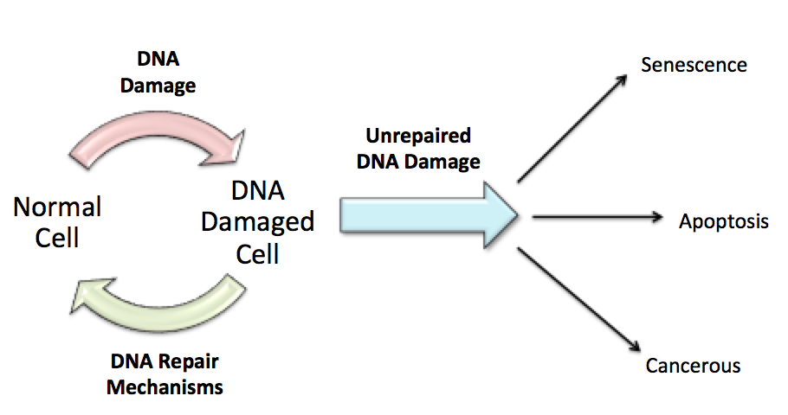
Figure 1.1 DNA Damage Response.
Normal somatic cells often accumulate mutations during mitosis due to the large amount of cell cycling that occurs within the body. This damage to the genome is detected by DNA repair mechanisms (DDR) and normal function is often restored. However, sufficient repair sometimes isn’t possible, and in these cases the cells move into a programmed death. Further to this, cell growth can be sequestered to prevent cancerous growth by enforcing a state of dormancy, otherwise known as senescence. If DNA damage isn’t detected, then the cells are able to replicate and pass on the mutated genome to daughter cells. The mutations may be in oncogenes or tumour suppressor genes and so these cells have an increased chance of acquiring more cancer hallmarks and becoming tumourigenic (Adapted and modified with permission from(Mandal et al., 2011).
- Driver and Passenger Genes
Mutations can be categorized depending on whether they confer cancer progression or not. For example, driver mutations confer a selective growth advantage and contribute to oncogenesis, whereas passenger mutations do not have any functional advantage to the cancer cells, but are passed on in clonal expansion. Passenger mutations outnumber driver mutations, however, it is now widely thought that tumours have more than one gene driving progression. The original Vogelstein model (Vogelstein et al., 1988) suggested 5-7 mutations. However, recent research suggests this could be up to 20 driver mutations (Sjöblom et al., 2006). The number of mutations which are driving tumour progression differs between cancer types, with the average being 4, but this can be 1 in thyroid cancers and >10 in colorectal cancers (Martincorena et al., 2017). The identification of somatic copy number changes has shown distinct profiles of alterations for specific cancers. However, the cancer genomes contain many mutations, so it is important to determine which are drivers of tumourigenesis and which are mutations that have accumulated by chance and have no bearing on tumour progression (Beroukhim et al., 2010). Often cancers become resistant to therapies, and it is thought that subtypes of driver mutations are responsible for this phenotype. The theory is that these mutations are actually passengers in the absence of therapy, but when treatment is given the environmental change pushes them into the initiation of growth advantage and therefore reoccurrence of the disease manifests (Stratton et al., 2009). Therefore the identification of cancer driver genes could change the way cancer subtypes are classified and alter therapeutics in a more patient personalised manner (Martincorena et al., 2017). For example, differing molecular signatures could indicate high-risk individuals or whether resistance to treatment agents will occur and therefore prevent unnecessary interventions that are unlikely to be of benefit. It would also be clinically beneficial if such diagnostic tests could be done from readily available bodily fluids and therefore reduce the invasiveness of the tests (Balmain et al., 2003).

- The Hallmarks of Cancer
A seminal paper by Hanahan and Weinburg (2000), illustrated the theory that there are six hallmarks of cancer. These provide a framework to understanding how the differing mutations fit into specific categories and pathways that drive tumour progression. Also, in reality cancer cells interact with their microenvironment to create a dynamic and complex tumour. More recently the authors expanded this theory to include two further hallmarks; the avoidance of immune destruction and deregulation of cellular energetics. In addition, two enabling characteristics are now included; these are tumour promotion of inflammation, and genome instability and mutation. All 10 hallmarks are summarized in Table 1.1 (Hanahan and Weinberg, 2011).

Hallmark of Cancer | Description | Therapeutic approaches
1. Self-sufficiency in Growth Signals | Up regulation of growth factors or over-expression of growth receptors in tumour and normal cells to drive cell proliferation. | EGFR Inhibitors
2. Insensitivity to Anti-Growth Signals | These usually block proliferation by pushing cells into quiescence; in cancer cells circumvent these signals to allow uncontrolled growth. | Cycling-dependent kinase inhibitors
3. Invasion and Metastasis | This is the ability of cells to disseminate from the primary and move to potentially distant locations to create secondary growths, often associated with adhesion molecules. | Inhibitors of HGF/c-met
4. Limitless Replicative Potential | They have an infinite number of divisions meaning they become immortal, possibly due to up regulation of telomerase to maintain chromosome length. | Telomerase Inhibitors
5. Inducing Angiogenesis | To be able to progress into more complex tumours the cells require their own vasculature to gain nutrients and oxygen. | Inhibitors of VEGF signaling
6. Resisting Cell Death | Cells evade apoptosis through loss of tumour suppressors and up regulation of oncogenes. | Proapoptotic BH3 mimetics
7. Avoiding Immune Destruction | Cells should be monitored by the immune response and cancer cells destroyed, however they avoid this by disabling factors of the immune system. | Immune activating antibodies
8. Deregulation of Cellular Energetics | Cancer cells undergo a metabolic switch where they limit their metabolism to glycolysis even in the presence of oxygen, resulting in energy to fuel growth. | Aerobic glycolysis inhibitors
9. Tumour Promoting Inflammation | Cells of the immune system infiltrate tumours and can enhance their progression through release of tumour-promoting factors. | Anti-inflammatory drugs
10. Genome Instability and Mutation | Tumours either have inherited mutations and/or they acquire random sporadic mutations that present a selective advantage. | PARP inhibitors
Table 1.1 The Ten Hallmarks of Cancer
Hanahan and Weinburg first established the hallmarks of cancer in 2000 as a way of simplifying and categorizing the vast amounts of knowledge that had been investigated within the cancer biology field and indicate possible directions for further research. Table 1.1 shows a brief summary of the ten different characteristics shared by human cancers, and the possible treatments connected to these, including four hallmarks, which were added in 2011. (Hanahan and Weinburg 2000 & 2011)

- Cancer Profiling
Initially investigations into the genetic links in cancer focused on twin and family studies, however due to the advancement in human genome sequencing it is now much easier to look for variants within different populations (Chung and Chanock, 2011). Second generation sequencing and high-throughput arrays have changed the accessibility to genomic information for cancer research. These allow more comprehensive mapping of tumour DNA and the identification of areas of copy number variations and point mutations that hadn’t previously been explored on a genome-wide basis (Campbell et al., 2008, Ley et al., 2008). Over the last few years comprehensive molecular profiling of various cancers has been conducted by a cohort of various institutions under The Cancer Genome Atlas (TCGA) project, as a way of identifying novel prognostic and therapeutic markers (Brat et al., 2015, Ceccarelli et al., 2016, TCGANetwork et al., 2017). Firstly, mapping of the genome and highlighting where the variations occur is critical, the next step is to then determine biological functioning towards cancer progression in order to ascertain whether the mutation to the gene is a driver or passenger, and hence whether it would be a suitable target for therapy (Stratton et al., 2009). A study in 2010 showed that out of 3,131 cancers tested for copy number profiles, there was an average of 17% amplification in the genome and 16% deletion (Beroukhim et al., 2010). This a significant increase when compared with 0.35% and <0.1% respectively in normal tissue samples. Beroukhim et al. also attempted to identify relationships between the genes implicated within the somatic copy number aberrations (SCNAs). Enriched pathways included: cell cycle and apoptosis regulators, and MYC and NF-𝜅B family members. Interestingly out of 158 regions of SCNA, 122 did not contain a known cancer driver gene, indicating that there may be a large number of undiscovered driver genes present within the cancer genome and therefore many therapeutic possibilities still to be explored.

1.2 DNA Damage and the Repair Pathways

- Causes
DNA damage is constantly occurring in the human body due to both exogenous factors, such as ionizing radiation, mutagenic chemicals and UV, and endogenous factors, such as spontaneous hydrolysis of nucleotides, replication errors and reactive oxygen species. In fact, it is calculated that each cell has 10⁴-10⁵ lesions per day. Therefore it is essential that there are DNA damage repair (DDR) pathways in place to ensure the propagation of correct genetic material during DNA synthesis, replication and transcription. If this is not conducted correctly then mutations can be passed onto daughter cells, and ultimately cancer can ensue if the mutation creates an unregulated proliferative state. Lesions can also cause cells to enter senescence or undergo apoptosis to a greater extent than normal if they are not properly repaired, and this can result in a damage-associated accelerated aging phenotype. Damage can be in the form of base alkylation and oxidation, bulky adducts and/or single or double stranded breaks, and these are repaired by several DDR systems within eukaryotes. Mutations to many DDR proteins are frequent in cancer, and thee have become targets for recent anti-cancer drugs, for example the BRCA1 gene (Giglia-Mari et al., 2011).

- Base excision repair and nucleotide excision repair
These DNA repair mechanisms occur when only one strand of DNA is affected or there is a ssDNA break, and therefore the other strand can be used as a template, through excision of the damage and incorporation of correct bases. Base excision repair (BER) occurs when the damage is small and does not distort the helical structure of DNA, for example base oxidation or alkylation. DNA glycosylases recognise and excise the incorrect base, leaving an apurinic/apyrimidinic base (AP site). AP endonucleases then nick the DNA backbone at these AP sites and DNA polymerase incorporates the homologous base, whilst a complex of XRCC1 and ligase III seals the nick (Robertson et al., 2009). PARP (poly ADP-ribose polymerase) plays a role within BER by recognising single strand DNA nicks, and when bound to the DNA through its zinc finger structure, begins the formation of PAR chains (polymeric adenosine dephosphate ribose). These chains are a signal for repair factors complexes including ligase and polymerase to form at the break (Bryant et al., 2005)

Nucleotide excision repair (NER) is activated when there is larger helical-destabilising damage, such as crosslinking or bulky adducts caused by UV. Firstly helicase TFIIH unwinds the DNA for approximately 30 nucleotides and this is stabilised by RPA and XPA. Then XPG and ERCC1-XPF endonucleases cut out the damaged area of bases, leaving a single strand gap. This is filled with nucleotides pairing to the template strand by DNA polymerase, and ligated by ligase I or III. RPA in this system also acts to activate ATM and rad3-related (ATR) kinase, as this creates a phosphorylation cascade to arrest the cell cycle and prevent damage from being propagated until the repair has been finished (Shuck et al., 2008).

In addition to BER and NER to repair single strand DNA aberrations there is also the mismatch repair (MMR) response, which is involved in correcting base-base mismatches or insertion deletion loops (Kelley et al., 2014), this will be later discussed within its role in colorectal cancer in section 1.3.III and figure 1.3.

- Non-homologous end joining and homologous recombination
The most cytotoxic lesions are double strand breaks (DSBs), as they cannot rely on the other strand to be a repair template; these can occur naturally during DNA replication and replication fork collapse or through cytotoxic DNA damaging agents. There are two pathways that repair DSBs- non-homologous end joining (NHEJ) and homologous recombination (HR) (Kass and Jasin, 2010).

NHEJ is not cell cycle specific and so can join two DNA ends at any point within the cell cycle, usually without much end processing. Firstly Ku70/80 interacts with DNA-PK to join the two ends of DNA at a DSB. The break is then sealed using the complex of DNA ligase IV and XRCC4, the latter of which helps to stabilise and enhance the ligation process. NHEJ does not only repair blunt ended breaks, as the system can also interact with Artemis to cleave any damaged overhanging bases, with any gaps being filled in by polymerase μ or λ. Although NHEJ is rapid and protects against DNA damage, this is error-prone, due to a repair template not being in place and nucleotides can easily be lost or gained from the fragile DNA ends (Weterings and Chen, 2008).

HR utilises recognition and end resection proteins such as the MRN (MRE11, RAD50 and NBS1) complex and CtIP, BRCA1 and EXO1 to create 3’ single stranded DNA (ssDNA) overhangs at DSBs, during late S and G2. This is initiated by cyclin dependent kinases (CDKs) and their subsequent phosphorylation action. The ssDNA is bound by RPA, which signals for other HR proteins to be recruited such as RAD51. RAD51 is the catalyst behind the strand invasion of homologous DNA to be used as a repair template, usually the sister chromatid, forming a structure called a D-loop (DNA heteroduplex). Hence, this pathway is primarily active in S/G2 as there is a sister chromatid present at that stage of the cell cycle, and this process is considered more robust than NHEJ and less likely to incur errors. Following the strand invasion, DNA polymerases extend the damaged strand to form Holliday junctions, these are resolved and the remaining nicks are sealed by ligases (Krejci et al., 2012).

The DNA damage response at DSBs is regulated by a phosphorylation cascade, primarily starting with either ataxia telangiectasia (ATM) or ATR kinase activation in order to signal checkpoint activation and cell cycle arrest or apoptosis. MRN is the main activator of ATM and causes the phosphorylation of many down stream effectors such as Chk2, p53, BRCA1 and H2AX. These create a platform for the stabilisation and recruitment of repair factors and checkpoint activators. ATR, as mentioned previously is primarily activated by ssDNA and the subsequent binding of RPA through its binding partner ATRIP (Stadler and Richly, 2017).

1.3 Colorectal Cancer

- Prevalence and Progression
Around 35,000 people were diagnosed with colorectal cancer (CRC) in England in 2015; making it the third most common cancer. The 2015 Office for National Statistics report shows that although advancements have been made in screening and treatment regimes since 1995, the incidence rates have stayed consistent in this time frame, and mortality rates have exhibited only a modest decrease (Office for National Statistics, 2015). When research into the genetics behind CRC began to emerge, what was once thought of as a single disease became a group of heterogeneous diseases (Ogino and Goel, 2008). Not only does CRC have a high incidence and mortality rate, it is also second in heritability tables (de la Chapelle, 2004); 25% of cases of CRC are familial or due to a hereditary syndrome, with the other 75% being sporadic cancers (Souglakos, 2007). Although studies several decades ago uncovered well-known driver genes of CRC tumour progression, such as the tumour over-expression of c-MYC and the somatic loss of the adenomatous polyposis coli (APC) tumour suppressor gene, inherited polymorphic variation also contributes to sporadic CRC (Erisman et al., 1989). Genome wide association studies in more recent years have uncovered low-penetrance allelic variation that increase people’s risk of developing familial forms of CRC, and contributes towards susceptibility of sporadic cancer (Peters et al., 2012).

CRC progression follows the multistage clonal expansion model, in which normal epithelial cells develop mutations during mitotic divisions, which cause differentiation into adenomatous polyps (Fearon and Vogelstein, 1990). These are benign growths that contain an inactivation of the APC gene (Groden et al., 1991). The resulting decrease in APC allows $β$-catenin accumulation within the nucleus, and thus up-regulation of the WNT signaling pathway, which switches on proliferation (Abdelmaksoud-Damak et al., 2015). The polyps can then acquire more mutations and progress through low, intermediate and high-risk polyps before becoming malignant tumours (Kushnir et al., 2014) (Figure 1.2). It is suggested that patients may have adenomas for many years before a genetic instability event triggers cancerous progression (Jones et al., 2008). In fact 30% of over 50s present with colorectal adenomas, however, only a small proportion (5%) of these patients will go on to develop colorectal cancer. Therefore it is vital that a screening method is developed which is able to distinguish between high-risk adenomas and those that will not progress to malignancy (Eshghi et al., 2011).

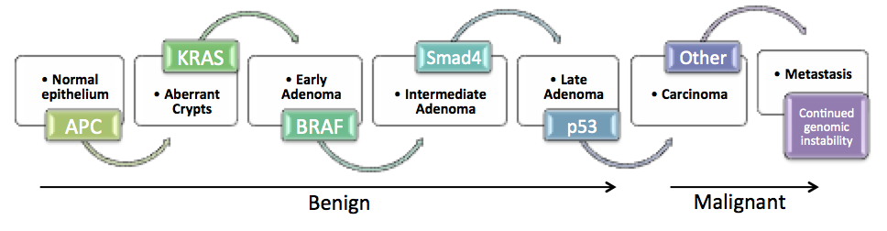
Fearon and Vogelstein were the pioneers of the multistep tumourigenesis theory in CRC in the 1990s, and although the model they created was rudimentary, it is still used as a basis for cancer studies. Vogelstein believed that it was the number of cumulative mutations (~4-5) that was the driving factor towards tumourigenesis, and not the order in which they were accumulated (Fearon and Vogelstein, 1990). In one study they investigated the prevalence of RAS mutations in the literature and found that 50% of colorectal tumours have this aberration (Bos et al., 1987), as did high-risk polyps, possibly implicating the RAS gene as a major malignancy driver (Vogelstein et al., 1988).
Figure 1.2. The Multistep Colorectal Cancer Model.
Colorectal epithelial tissue moves through a series of steps before it becomes cancerous. These steps are initiated by the accumulation of mutations. The genes in the figure above are examples of possible mutation pathways and it is believed to be the build up of such mutations, which are important, rather than the series in which they are acquired. Mutation to APC is, more often than not, one of the only mutations seen in the early stages of polyp formation suggesting this is crucial in the progression from normal to aberrant epithelium (Adapted and modified with permission from Fearon and Vogelstein 1990).

- Sporadic Colorectal Cancer
Sporadic CRC is usually the result of accumulations of genetic aberrations over a number of decades turning a normal cell into a mutated cell with a specific phenotype (Fearon and Vogelstein, 1990). This is why older patients often present with a larger number of mutations, as they have had an increased time of exposure to environmental factors, as well as the increased likelihood of erroneous DNA repair (Boardman et al., 2007). As with many cancers, the environmental risk factors for CRC include smoking, obesity and alcohol consumption (de la Chapelle, 2004). However, much research has been conducted into how diet affects the colon and whether a high intake of red and processed meat can contribute to sporadic CRC. Recently the International Agency for Research on Cancer set up a working group to investigate the effect of red and processed meat on the colon and found a positive association between consumption and CRC (IARC, 2015). This may be, in part, to do with N-nitroso-compounds (NOC), chemicals found in meat after the curing process and also generated in the human colon during digestion of red meat. Although there is little evidence that increased levels of NOC can cause DNA damage (Bouvard et al., 2015).

- Hereditary Colorectal Cancer
Out of the 25% of CRC patients who exhibit a family history, only 5-6% of these cases are due to an inherited mutation, while the remaining patients probably have inherited combinations of low penetrance risk alleles with exogenous factor interaction such as diet and environment. If patients aren’t diagnosed with one of the hereditary forms of CRC, but appear to have a familial link then they are termed familial colorectal cancer (FCC) sufferers (Migliore et al., 2011).

Familial Adenomatous Polyposis (FAP) is an autosomal dominant disease that accounts for 1% of CRC cases. Inheriting an APC mutation on one allele causes the disease, with prevalence in the population of around 1 in 8000, but does not necessarily mean the patient develops colorectal cancer (Half et al., 2009). As described earlier, loss of APC leads to activation of the WNT pathway, resulting in proliferation and adenoma formation. This therefore confers a high risk of developing malignant growths from the hundreds of adenomas that form along the colon wall (Lal and Gallinger, 2000). Malignancy occurs in around 1 out of every 10⁶ colorectal epithelial cells, if a somatic mutation occurs on the wild type allele of the other chromosome (Kinzler and Vogelstein, 1996). Surgery to remove the bowel is often carried out at an early age in FAP patients (Buturovic, 2014), due to the almost 100% probability that the patients will develop CRC in their 20s-30s (Schmoll et al., 2012). There are less aggressive forms of FAP that are also a result of mutations in the APC gene; the different forms depend on which codons the mutation occurs in. Therefore attenuated FAP (AFAP) patients have a reduced risk of CRC from 100% to 69% (Migliore et al., 2011).

Hereditary Non-Polyposis Colorectal Cancer (HNPCC) is another autosomal dominant disease more prevalent than FAP, with 5% of CRC being linked to it (Guillem et al., 1999). HNPCC patients having a higher susceptibility of malignant growths at an earlier age than in sporadic CRC due to inherited mutations. Such mutations occur in genes responsible for the DNA mismatch repair (MMR) mechanism e.g. hMLH1, hMSH2, hMSH6, PMS1 or PMS2 (Figure 1.3). Loss of function of these genes causes microsatellite instability (see Section 1.4.II) and contributes to the successive accumulation of point mutations and small insertions and deletions, and thus to the multi-step CRC progression process (Pinsky, 2000). HNPCC not only causes CRC with a high penetrance of 80%, but also predisposes individuals to other cancers such as endometrial (60% penetrance) and many others (20% penetrance), (de la Chapelle, 2004). A common feature of HNPCC tumours is that they often display wild type APC function, however, other WNT pathway down stream targets are instead mutated such as β-catenin, which then continuously keeps the WNT pathway activated regardless of APC status (Figure 1.4) (Miyaki et al., 1999).

HNPCC patients are assessed using the Amsterdam criteria, which states that the possibility of FAP must be excluded, patients must have at least three relatives across two generations that have had the disease, with one being a first degree relation, and have early onset (<50 years old) (Vasen et al., 1991). However, there has been some debate over the years as to whether these criteria exclude too many patients with HPNCC and therefore underestimate the frequency. For example, the above diagnosis dismisses de novo mutations where there is no family history (Lynch et al., 1997). Tumours in HPNCC patients generally exhibit significantly fewer metastases and therefore this localized phenotype results in better patient survival (Sankila et al., 1996).

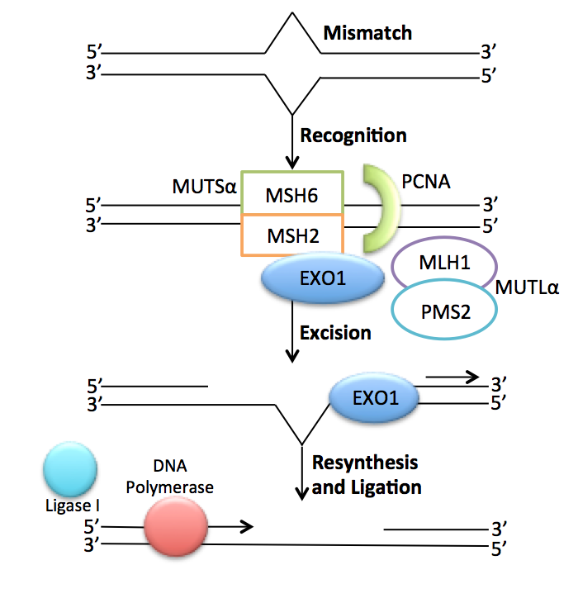
Figure 1.3. The Mismatch Repair Response.
This mechanism aims to restore genomic stability when base misincorporations have been included in the DNA during synthesis and haven’t been recognized by the proofreading ability of polymerase. This occurs through the dimerization of MSH2 with MSH6 to make the MUTS$α$ complex and the same with MLH1 and PMS2 to give MUTL$α$. These are the active components that recognize the mismatch and recruit EXO1 an exonuclease that removes the wrong base and DNA polymerase follows behind to incorporate the correct base along with Ligase I to re-anneal the strand. In HNPCC, mutations have been found in the complexes that initiate the process (usually MLH1 or MSH2), therefore allowing mismatches to be passed on to daughter cells without repair (Adapted and modified with permission from(Guillotin and Martin, 2014).
Not only is the mismatch repair response its own individual pathway of repair, but evidence has shown that it interacts with other DDR systems (outlined in 1.2), and so creates a much more complex and highly functioning repair system to prevent mutations from occurring. For example during NHEJ there can be the accidental annealing of mismatching bases due to incorrect end processing and the loss or gain of bases. The MMR repair pathway then plays a role in correcting these aberrations. There is also evidence that MSH2 is involved in the NER pathway when UV damage is detected in order to remove the bulky adduct that is created (Liu et al., 2017). Further to this, MMR proteins are functionally involved in the repair of inter-strand crosslinks through the Fanconi anaemia (FA) pathway. MSH2 and MLH1 are implicated in the monoubiquitination of an FA protein-FANCD2. This modification is essential of ATR activation and downstream cell cycle effector activation such as CHK1 and TP53 in order to arrest cells for repair or destruction (Kobayashi et al., 2013). Therefore, defects to the MMR pathway in colon cancer can potentially have a knock-on affect on a variety of different repair pathway meaning that deleterious mutations go unrepaired and could help to create a permissive state for tumour progression.

1.4 Tumourigenesis Enabling Pathways in Colorectal Cancer

Patients present with differing subtypes of colorectal cancer tumour, with each one a unique genetic profile. Classification of the tumour is dependent mainly on clinical and histological analysis of tumour grade and stage using the TNM or Dukes’ staging as mentioned previously, although molecular characteristics are now being considered as an extremely important aspect of prognosis (Ogino and Goel, 2008). Sporadic colorectal tumours are often classified as chromosomal or microsatellite unstable depending on the type of genetic mutations they carry, and the tumours can also vary in their epigenetic status. These three phenotypic characteristics aren’t always mutually exclusive, even though many reviews deal with them separately. Investigating the genomic patterns of variation and how this impacts gene expression can then be correlated to different tumour characteristics and prognosis, resulting in individualized treatment plans (Poulogiannis et al., 2010).

- Chromosomal Instability (CIN)
Chromosomal instability (CIN) is a form of genetic instability accounting for around 80% of CRC cases. It results in chromosomal abnormalities such as amplifications/deletions/rearrangements of parts or whole chromosomes, with a frequent characteristic being aneuploidy (Lengauer et al., 1997). Tumours displaying a CIN phenotype mostly have a poorer prognosis and decreased survival rates compared to tumours that display the other main molecular pathway of tumourigenesis- microsatellite instability (MSI), possibly due to their increased tendency to metastasis (Pino and Chung, 2010). New technologies such as array based comparative genome hybridisation (aCGH) have allowed for high resolution screening of the entire genome for chromosomal aberrations. However, many of these aberrations can be large and so identifying the genes within these regions which drive cancer progression, and are not simply passengers, can be challenging (Brosens et al., 2010).

This type of instability often displays alterations within well-characterized tumour suppressor genes (TSGs) and oncogenes such as APC and KRAS, respectively. In fact it is the loss of the tumour suppressor gene APC that is thought to initiate this pathway in CRC (Perea et al., 2011). APC functions as a negative-regulator of β-catenin in order to control cellular growth (Figure 1.4), and binds to microtubules in order to stabilize them ready for chromosome segregation. CRC inactivating mutations of the APC gene result in aberrant cell proliferation as well as irregular chromosome stabilization and separation, leading to further chromosomal abnormalities (Zhang and Shay, 2017, Kaplan et al., 2001). It would be predicted that mutations within other factors affecting chromosomal segregation, such as spindle checkpoints, would also be regulators of the CIN phenotype. In fact this was suggested almost 100 years ago by Boveri, who suggested that tumourigenesis might originate from a genetically unstable cell with defects to the mitotic spindle formation and therefore segregation (reviewed in (Pino and Chung, 2010). However, BUBR1 (budding uninhibited by benzimidazole-related 1), a kinase involved in the spindle assembly checkpoint is rarely mutated in CRC and therefore is not thought to be an initiator of the CIN pathway of tumourigenesis in CRC (Cahill et al., 1998). There has however, been studies identifying the oncogene Aurora Kinase-A (AURKA) as a possible CIN promoter in CRC. AURKA plays a pivotal role throughout mitosis, with association to spindle assembly and checkpoint regulation, chromosome alignment and centrosome maturation and separation. AURKA was found to be amplified within CRC cell lines and patient samples which displayed a CIN phenotype (Nishida et al., 2007). Analysis of 517 CRC tumours by Baba et al. (2009) also supported the hypothesis that AURKA had an association with colorectal tumours displaying a CIN phenotype, however they also went on to show that AURKA over-expression did not correlate to grade of the tumour or prognosis. However, AURKA could be a promising therapeutic target in the future, as an inhibitor to AURKA (Alisertib) is currently in clinical trials for advanced sarcoma, leukemia and breast cancer among others (Dickson et al., 2016, Fathi et al., 2017, Kozyreva et al., 2016).

Hermsen et al. (2002) found that adenomas contained an average of 4.6 chromosomal aberrations, whereas malignant polyps had a significantly increased number of aberrations of 10.5, suggesting that there is an association between the accumulation of cancer-associated events and progression from adenoma. However, it appears that specific patterns of variations need to be present and not simply an increase in chromosomal aberrations per se. Interestingly, there was no difference in APC mutation rate between the groups, supporting the theory that this mutation occurs very early on in polyp formation. This group’s work therefore highlighted that chromosomal instability is not merely random but does follow distinct patterns of mutations that could correlate to tumour progression (Hermsen et al., 2002).
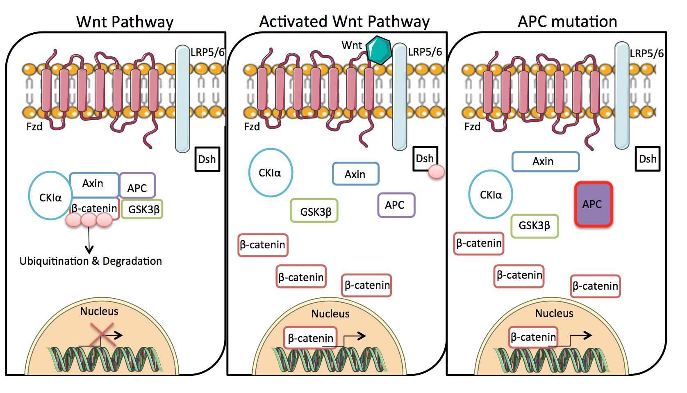
Figure 1.4 APC mutations within the WNT signalling pathway
The WNT pathway plays a central role in gene expression, WNT ligands bind to Frizzled (Fzd) receptors along with co-receptors such as LRP 5/6 on cell membranes which signals to intracellular phosphoprotein Dishevelled (Dsh). This activation then disrupts the negative WNT protein Axin by dephosphorylation. Axin is usually bound to adenomatosis polyposis coli (APC), glycogen synthase Kinase 3 (GSK3) and casein Kinase 1a (CK1a) in a destruction complex which targets β-catenin for ubiquitination and so proteasome degradation. However, when Axin becomes unstable Dsh is phosphorylated and β-catenin is able to accumulate within the nucleus and activate cellular responses through transcriptional complexes. For example the accumulation of nucleic β-catenin can signal for the up-regulation of c-Myc and other cell cycle proteins like cyclin D1, by binding to transcription factor TCF/LEF, in order to increase transition from G1 to S phase. APC therefore acts as a tumour suppressor, however mutations to APC cause a constitutively active WNT pathway without the need for WNT ligand binding, as the destruction complex isn’t compatible and therefore β-catenin is able to circumvent degradation and accumulate in the nucleus. (Adapted and modified with permission from (de Sousa et al., 2011)

Another chromosomal aberration currently under investigation is telomere shortening. Telomeres are comprised of tandem repeats found at the end of chromosomes, which protect against degradation of the DNA and chromosome fusion, and so maintain genomic integrity. During replication of the genome, prior to mitosis, the telomeres shorten by 30-200 base pairs; this erosion can be further enhanced by exogenous genotoxic factors such as smoking and endogenous factors such as oxidative stress. This continued shortening eventually leads to an apoptosis checkpoint when the telomere has become too small. However, many cancers can circumvent this (usually by the re-activation of telomerase) and continue proliferating, resulting in cells displaying genomic instabilities such as chromosome fusion. An average of 72% of CRCs display shortened telomeres in comparison to adjacent normal tissue (Suraweera et al., 2016). Rampazzo et al. (2010) also found this when comparing tumour tissue to normal mucosa of the colon or rectum, and hypothesized that telomere shortening was an initiating event leading to chromosomal instability. However they also claimed there was no correlation between tumour progression and the shortening of telomeres, which was supported by further studies (Gertler et al., 2004, Sullivan et al., 2006). In fact emerging data suggests that it is telomerase activity that could potentially be a prognostic marker within CIN CRC cancer, rather than the length of telomeres, with higher activity correlating to worse overall survival (Bertorelle et al., 2014).

- Microsatellite Instability (MSI)
Microsatellite sequences (MS) are categorized as short-repeat units of nucleotides (1-6bp), found throughout the genome, and which are polymorphic among individuals. Often during replication the DNA is copied incorrectly resulting in mismatched bases or the incorrect number of bases, especially where there are repeats such as at microsatellites. This can result in either point mutations or strand slippage and temporary insertion-deletion loops which then results in nonsense mutations and a truncated protein. The mis-match repair (MMR) system recognizes and repairs the replication errors that have escaped exonuclease proof reading and therefore prevent mutations being passed on to daughter cells (as was shown in Figure 1.3). However, if this repair system is operating insufficiently then mutations can begin to accumulate (Horvat and Stabuc, 2011). Therefore, defects in MMR contribute to the MSI phenotype. In contrast to CIN, the majority of colorectal tumours with MSI have a diploid chromosomal pattern and therefore the changes to the genome are smaller and less easily detectable (Lengauer et al., 1997). This phenotype occurs in around 15% of CRC cases (Dyrsø et al., 2011).

A CRC tumour is said to be microsatellite stable for the individual if the repeating sequences are identical in every malignant cell (Worthley and Leggett, 2010). MSI has to be established using Bethesda markers, these are five repeating sequences used as markers, either mononucleotide repeats- BAT25 or BAT26 or dinucleotide repeats- D2S123, D5S346 or D17S250 (Loukola et al., 2001). If even one of these markers is altered then the tumour is classed as MSI. This status is then grouped into MSI high (MSI-H) or MSI low (MSI-L) depending on the number of markers that differ. One variation in markers is classed as low and 2 or more is high (Boland et al., 1998).

As previously mentioned, in HNPCC the majority of aberrations are due to inherited mutations to mismatch repair genes (e.g. hMLH1, hMSH2), followed by somatic loss of the second allele. However, in sporadic MSI CRC, a common mechanism of loss of MLH1 expression is through methylation silencing of the hMLH1 promoter (this accounts for ~80% of MSI cases). Inherited MSI occurs in younger patients and they usually display KRAS mutations, however, sporadic MSI CRC occurs in older patients, as methylation increases with age, and often display BRAF mutations (Boland and Goel, 2010). Although these activating mutations are within different genes, due to both KRAS and BRAFs roles within the mitogen associated kinase pathway, they are actually functionally equivalent (Figure 1.5) (Rajagopalan et al., 2002).
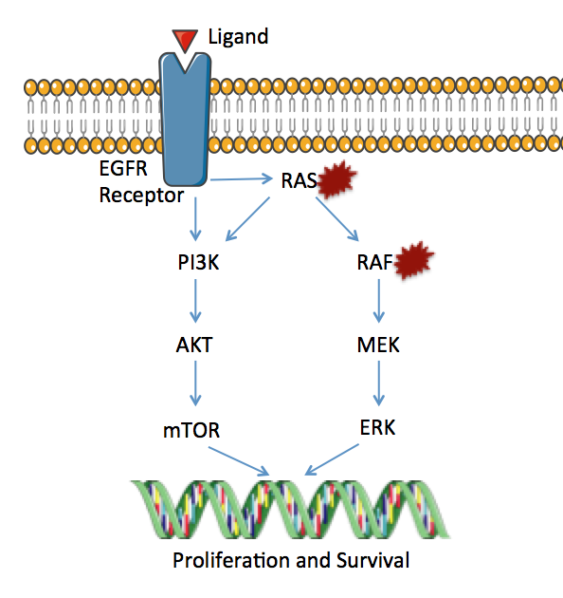
Figure 1.5 The RAS/RAF signalling pathway
This pathway is activated by the binding of a ligand to a receptor at the cell membrane, such as the binding of epidermal growth factor (EGF) to the epidermal growth factor receptor (EGFR). This in turn promotes the detachment of GDP from RAS and the subsequent binding of GTP, which activates RAS signalling. Activated RAS then begins a kinase-signalling cascade through RAF, which then phosphorylates MEK, and this kinase in turn phosphorylates ERK. ERK regulates many different transcription factors such as c-Myc and CREB; activation of these factors then regulates transcription of genes involved in the cell cycle and so increases cellular growth and survival. RAS activation also plays a role in the activation of the mTOR-signalling pathway, the activation of which again promotes cellular proliferation and survival. Mutations in CRC to RAS make it constitutively switched on, therefore the pathway is continually sending signals for transcription factors to enhance cellular proliferation independent of whether a ligand has bound to the receptors. RAF also displays frequent mutations and again positively affects the signalling pathway. These oncogenic mutations increase tumourigenesis. (Adapted and modified with permission from (Tian et al., 2013).

MSI tumours have been shown to confer a better prognosis than CIN tumours (Hemminki et al., 2000), however, due to the older patient population within this cohort, overall survival is often hard to judge as these patients are more susceptible to infections and present with co-morbidities. Conflicting studies dismiss this and state that overall survival is not affected by MSI (Feeley et al., 1999, Salahshor et al., 1999). It is difficult to compare all of these studies due to their differing sample populations and follow up periods of time. The study by Hemminki et al. (2000) used over double the number of samples (1044) compared to the others and also selected patients with a certain stage and therapeutic background. Whereas the other studies used a range of samples from 50 to 416 and these were from all stages or just noted as unselected. Therefore, although Hemminki found that MSI confers a better outlook on survival this may only apply to certain subset of colorectal cancer patients. It is interesting to note that the conflicting studies comprised of a more variable set of samples.

One theory behind MSI tumours having a better prognosis is that there is an increased active cytotoxic lymphocyte population within the tumours compared to microsatellite stable (MSS) tumours (Phillips et al., 2004). There is, however, some debate as to whether tumours displaying the MSI genotype are drug resistant (Ribic et al., 2003). For example 5-FU inhibits the enzyme thymidylate synthase and thus stimulates mutations in the DNA and therefore triggers the apoptotic pathway. However without an intact mismatch repair response (which MSI cells lack) 5-FU is ineffective (Fischer et al., 2007, Jover et al., 2006, Carethers et al., 2004). There have also been differing reports from clinical trials surrounding the efficacy of these treatments for MSI and MSS patients. Some studies contradict the findings, or don’t show any difference in drug response between MSI and MSS tumours (Lamberti et al., 2007, Barratt et al., 2002). However, MSI with defects in the DNA repair response are, as mentioned previously, often seen in older patients who appear to be generally under represented in the analyzed cohorts, possibly due to co-morbidities. Also it is difficult to conclusively compare studies when they all vary in whether they include both colon and rectal tumours (Lamberti et al., 2007). One hypothesis to the lack of response of MSI tumours to therapeutics is that standard chemotherapeutics tend to dampen the immune system of the patients and in MSI it appears that the high levels of lymphatic infiltrates cause an anti-tumour response and so a better prognosis, this increased lymphatic response is therefore decreased in the presence of treatments such as 5-FU due to killing of the lymphocytes and so shows little benefit to tumour response (Boland and Goel, 2010).

- Methylation Status (CIMP)
Another emerging tumourigenesis pathway in CRC is characterised by DNA methylation of important regulatory genes, which alters the expression of these genes, or in some cases leads to gene silencing (Lee et al., 2004). Methylation usually occurs at CpG islands; these are typically unmethylated when gene expression is activated, and these areas of repeating cysteine-guanine nucleotides are associated with 70% of gene promoters (Deaton and Bird, 2011). As mentioned in the previous section, tumours can acquire epigenetic changes that lead to MSI. For instance it has been shown that in nearly all sporadic MSI CRC cases, the reason behind inadequate replication fidelity is the hypermethylation, and hence inactivation of the hMLH1 and/or hMSH2 gene promoters (Kanth et al., 2014), this has also been corroborated in other cancers such as gastric cancer (Leung et al., 1999).

It is not just MMR genes that are methylated within CRC, but also other tumour suppressor genes, and it is this multiple regional hypermethylation that is termed the CpG island methylator phenotype (CIMP). For example, it has been shown that Necdin (NDN) is down-regulated in CRC through hypermethylation of CpG islands in its promoter. NDN is a transcriptional repressor, which negatively regulates cell proliferation through its association with the WNT co-receptor gene LRP6. Therefore upon gene silencing, LRP6 can activate the WNT pathway without regulation and increase cellular proliferation (Hu et al., 2017). The cell cycle regulator p16 is another important gene that has been investigated with regards to hypermethylation in CRC. In fact, methylation of p16 has been detected within blood samples from CRC patients and correlated to an advanced metastatic tumour type with poor survival (Nakayama et al., 2007).

These are only a small sample of the genes that are currently being investigated as markers of CRC progression resulting from a hypermethylation phenotype. A systematic review of the literature by Rasmussen et al. (2016) highlights the large number of epigenetic changes that can be detected within blood and stool samples including genes such as APC, HIC1, MGMT and RUNX3. And that depending on optimisation of methods, such methylation changes could become predictive markers useful for screening, prognosis and recurrence detection. It is also well recognised that a single methylation change may not be enough to push a cell towards tumourigenesis, but that it is often a pattern of methylation within a specific subset of genes which then confers a specific subtype of CRC tumour and prognosis (Rasmussen et al., 2016).

Although regions of the genome are hypermethylated, there is also evidence to suggest large-scale methyl group losses along the length of the chromosome in adenomas and other cancers, and these early changes can affect chromosome stability. For example, methylation can affect chromatin condensation and therefore correct separation during mitosis. This further emphasizes the interconnecting mechanisms for CRC progression, and how the complex genetic framework behind these has yet to be fully elucidated (Hernandez- Blazquez et al., 2000, Okugawa et al., 2015).
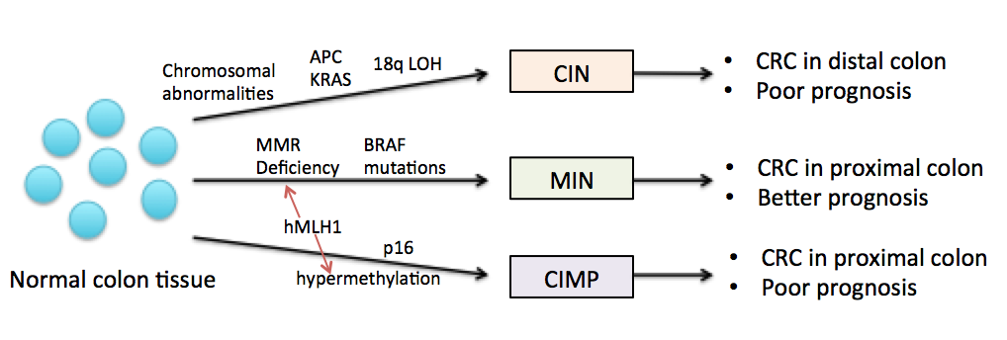
Figure 1.6 Typical pathways to colon cancer progression.
The three typical pathways of colon carcinogenesis as described in this section. This is a simplistic representation as the three pathways aren’t exclusive, with some tumours showing features from more than one pathway (Adapted and modified with permission from (Issa, 2008).
- New Models of Colorectal Cancer
Recently there has been some criticism about how CRC tumours are categorised based on their genetics and that the three current categories- CIN, MSI and CIMP are not stringent enough to distinguish between patients with differing outcome, response to treatment and recurrence (Del Rio et al., 2017). Therefore, several papers have tried to develop new strategies on how to classify CRC, and therefore more easily identify biomarkers and individualised therapeutic regimens.

Sadanandam et al. (2013) used gene expression profiles of resected primary CRC tumours and classified them into five subtypes depending on the genes they expressed; goblet-like, enterocyte, stem-like, inflammatory and transit amplifying. They found that the subtypes were situated in distinct anatomical regions within the colon crypts and that they had differing responses to standard chemotherapy combinations such as 5-FU and irinotecan. They also made progress in defining biomarkers for each subtype whether immunohistochemically or using qRT-PCR, and that each sub-type was also displayed in well-characterised CRC cell lines.

De Sousa E Melo et al. (2013), focused on just three colon cancer subtypes (CCS1/2/3) with a 90 patient cohort, the results were then validated on further independent data sets as well as CRC cell lines. The CCS1 group contained tumours displaying KRAS and/or TP53 mutations and so were mostly CIN in phenotype, CCS2 corresponded to MSI and CIMP positive tumours, whilst CCS3 were a MS and CIMP mixed set of tumours, which displayed a serrated histology. Thus while CCS1 and 2 were similar to already mentioned subtypes of CRC, CCS3 represented a novel subtype which had a poor response to treatment and a 50% recurrence rate, therefore indicating a subset of patients which may benefit from further research.

Based on gene expression data Marisa et al. (2013), classified CRC tumours from 750 patients into six groups. 1- CIN with a deregulation of immune pathways, 2- MSI, 3-KRAS mutations, 4- CIN with stem-like phenotype, 5- CIN with aberrant up regulation of WNT and 6- CIN with serrated carcinoma. Here it can be seen that the CIN pathway, which corresponds to the majority of CRC, has been split into a number of different categories depending on gene expression and histology. A down-side to the study however was that tumour grade was not known; so before this classification system can be used it would need further verification.

And finally a more recent international consortium put together a four-group classification using large scale data sharing and analysis, of which included the information from Marisa et al. and De Sousa E Melo et al. (Guinney et al., 2015). They identified: 1- MSI with strong immune activation, 2- Canonical with CIN and WNT and MYC activation, 3- metabolic deregulation and 4- TGF-β activation with stromal invasion and increased angiogenesis. This was considered a robust model, which could be taken into the clinic for use in therapeutic interventions.

These four papers show the heterogeneity of CRC and how it can be differentially subtyped. It will still take many more years to fully elucidate the differing mechanisms in which CRC progresses and how this then affects patient outcomes and treatment responses.

1.5 Diagnosis and Treatments of Colorectal Cancer

- Diagnosis
Currently the clinical method of choice for colorectal cancer staging is the standard TNM (Tumour, node, metastasis) classification used for most cancer types, which gives a wide range of information, however, the historical Dukes’ staging system to classify CRC tumours is still used by many. This is where the tumour is given a letter from A-D depending on the degree of invasion and metastasis. “A” means the tumour is still within the inner lining of the bowel. “B” indicates the tumour has progressed through the muscle lining of the bowel, “C” means a spread to at least 1 lymph node within close proximity to the bowel, and finally “D” refers to metastasis to other parts of the body (Dukes, 1932).

In recent years CRC screening has been introduced in the UK, in the form of a yearly standard test sent to adults aged 60-69 years. This involves the collection of stool samples and return of the kit within 14 days. The stools are tested for faecal occult blood, which usually is not visible, and if there are any abnormalities, the individuals are contacted and asked to attend a clinic for further testing. In this way early detection of CRC is increasing in the UK (NHS, 2014). However in economically less developed countries this is not yet a possibility, and CRC incidence in India, for example, is still on the rise (Kanth et al., 2014).

- Treatment Overview
The main treatment for early stage disease is surgery to remove the tumour (CRUK, 2015b). However, patients often present with metastasis upon first examination, and at this point prognosis is poor, with chemotherapy usually being palliative (Graham et al., 2014). Distant metastasis in bowel cancer is usually to the liver or lungs. Metastasis of the liver can often be removed surgically along with the primary tumour, giving the patients a better outlook, and this is usually preceded by chemotherapy to downstage the metastasis (Tappenden et al., 2012). Sporadic CRC, because it typically presents at an older age, often has a worse prognosis than familial tumours, and this is usually due to co-morbidities affecting the treatment of the disease. In CRC, tumours presenting in the clinic with the same stage also often have differing responses to treatments, highlighting the molecular heterogeneity and the need for personalized therapies, as many patients go through the traumatic effects of unsuccessful chemotherapy (Horvat and Stabuc, 2011).

An example of this is the commonly administered antimetabolite drug 5-flurouracil (5-FU), which only leads to a response in 20-25% of patients. The outcome is a little better (45-50%) when 5-FU is combined with novel treatments, such as immunotherapy (CRUK, 2015b). 5-FU plus oxaliplatin is currently recommended by NICE for Dukes stage C cancer patients; this is usually a 6-8 week course and can also be given to stage B patients if they were particularly young or with poorly differentiated tumours (NICE, 2006). However, there needs to be alternative therapeutic interventions for the other 50% of patients whose tumours have a level of resistance to these drugs, which could be indicative of differing genome abnormalities (Ocvirk, 2009).

The majority of the genetic research effort not only aims to identify differing molecular signatures between tumours, but also to apply this knowledge in order to distinguish specific clinical markers, and ascertain targets for novel drugs, which could lead to personalized medicine (Papamichael et al., 2015). Although a large number of cancer driver genes have been identified, Workman and Lazikani (Workman et al., 2013) have suggested that only 5% of these known targets actually have approved drugs in use. This may come to down to the fact that drugs targeting oncoproteins have a limited efficacy owing to the complex and distinct genetic profiles within individuals.

- 5-Fluorouracil
5-Fluorouracil (5-FU) is a commonly administered fluoropyrimidine chemotherapy drug that has been used for around 50 years in many different cancers, such as breast and head and neck cancer. However, it is in the treatment of CRC that 5-FU has proved most effective, although in metastatic CRC, patient response to 5-FU is only 10-15% (Johnston and Kaye, 2001) and this increases to 40-50% when 5-FU is used in combination with other therapeutic agents (Giacchetti et al., 2000, Douillard et al., 2000)

The 5-FU mechanism of action is through its conversion into active metabolites (fluorodeoxyuridine-monophosphate, fluorodeoxyuridine-triphosphate and fluorouridine triphosphate), which inhibit RNA synthesis and thymidylate synthase (TS) action. TS is an enzyme which catalyses the reduction of 2’-deoxyuridine-5’-monophosphate by addition of a methylene group from folate (CH₂H₄) to create deoxythymidine-5’-monophosphate. After phosphorylation this becomes 2’deoxythymindine-5’-triphosphate, which is an intracellular source of thymidylate, essential for DNA replication and repair. When 5-FU is present it is catabolised by dihydropyrimidine dehydrogenase (DPD) and one of its metabolites- 5-fluoro-deoxyuridine-monophosphate- binds to TS and creates a stable complex that prevents TS from catalysing its normal reaction through direct competition for the active site. This inhibition therefore means that thymidylate ultimately is not produced and there is an imbalance in the dNTP pools due to a lack of dTTP. These types of imbalances can directly disrupt DNA synthesis and repair, causing DNA damage and ultimately cell death. Another DNA disruption mechanism is through the accumulation of dUTP and the 5-FU metabolite fluorodeoxyuridine-triphosphate, which can be misincorporated into DNA. Attempted nucleotide-excision repair of these misincorporations actually results in more mutations; DNA breaks and consequently cell death and therefore reduction in tumour burden. A further 5-FU metabolite, fluorouridine triphosphate, can also be incorporated into RNA, which inhibits RNA maturation, post-transcriptional modifications and splicing (Longley et al., 2003). Patients with MSI tumours do not seem to respond to 5-FU treatment, with some reports claiming it is even detrimental; this could be due to the mutated MMR pathway and therefore incorrect base incorporation are not sensed or repaired. In cell line models, restoration of MMR function induces a G2-M cell cycle arrest typically seen in MMR proficient cells, which have a 5-FU response (Jo and Carethers, 2006).

Importantly, the level of TS expression within cancer cells appears to be a prognostic factor for response to treatment and relapse. Studies have shown that low TS expression in patient tumours corresponds to sensitivity to 5-FU, with the opposite effect being seen when TS levels are high, plus these patients have worst survival outcomes (Johnston et al., 1995). Therefore many effective TS inhibitors have been created such as raltitrexed and ZD9331. However, over time tumours begin to up-regulate TS expression and therefore patients become resistant to 5-FU (Chu et al., 2003). A further mechanism of 5-FU resistance is through the rescuing of thymidylate levels from thymidine, so that DNA synthesis can still occur even when TS is inhibited (Longley et al., 2003). Within the clinic 5-FU is administered along side leucovorin, which enhances the cytotoxicity of the drug by increasing the concentration of folate and stabilise the complex between TS and 5-FUs active metabolites, to enhance inhibition. However, overall survival of patients did not increase when leucovorin was combined with 5-FU even though response rates were higher (AdvancedColorectalCancerMeta-AnalysisProject, 1992).

- Irinotecan
Irinotecan is an inhibitor of topoisomerase I (TOP1), after conversion to the active metabolite SN-38. TOP1 is a nuclear enzyme, which upon formation of a covalent bond between the enzyme and the DNA creates single strand breaks in order to relax the DNA and allow DNA replication and transcription. TOP1 then plays a role in re-ligation of the break in order to maintain genomic integrity. Cancer cell death by irinotecan occurs through the trapping of DNA cleavage complexes containing the TOP1 enzyme, and leading to the inhibition of the enzyme and therefore no re-ligation of DNA strands, resulting in DSBs and ultimately the inhibition of DNA replication and transcription. The drugs are considered to be cell cycle specific as they have a 1000 fold more sensitivity in S phase cells in comparison to other phases of the cell cycle, due to the interaction between the inhibited, bound complex and advancing replication forks, which cause lethal DSBs (Rothenberg et al., 1999). Irinotecan response also appears to be independent of the MMR status of the cell so can be used to treat MSI patients (Jo and Carethers, 2006).

It was previously shown that irinotecan as a single agent had anti-tumour potential in metastatic colorectal cancer that was not responsive to the traditional and widely used 5-FU chemotherapy (Cunningham et al., 1998). Therefore, in 1999 the first phase II trial took place of irinotecan in combination with the standard bimonthly 5-FU and leucovorin (known as FOLFIRI) as a third line therapy, in order to investigate toxicity and feasibility (André et al., 1999). After promising outcomes, further trials were undertaken to escalate irinotecan to a first-line therapy and optimise dosing and delivery schedule (Teufel et al., 2004, Lee et al., 2005). One trial showed an increase in overall tumour response rate from 18% with the original 5-FU treatment to 40% when irinotecan was combined (Colucci et al., 2005). Irinotecan is still used in combination in the clinic today, and further research is currently being conducted into alternative drug combinations, such as with bevacizumab (an angiogenesis inhibitor) or cetuximab (a EGFR inhibitor), in order to increase the efficacy even further (Cascinu et al., 2017, Zhao et al., 2017). However, a recent study using some of the novel classification mechanisms mentioned in the introduction has shown that the FOLFIRI treatment regimen is only suitable for a very select set of patients based on their tumour molecular signature. For example, patients with CIN tumours with up-regulation of the WNT pathway had a two-fold increase in survival compared with those that did not, and CIN tumours with a decrease in immune response did not respond, compared to tumours that had normal immune infiltration. This demonstrates that much more work is needed to assess how patient’s specific tumour molecular backgrounds impact response to treatment (Del Rio et al., 2017).

- Oxaliplatin
Oxaliplatin is another chemotherapy drug commonly used in the clinic to treat CRC; this drug is a platinum compound that forms inter and intra strand cross links within the DNA and so prevents replication and synthesis, ultimately resulting in the death of the cell (Mohelnikova-Duchonova et al., 2014). Like 5-FU it appears that oxaliplatin has lower response rates in patients displaying MSI due to their defective MMR pathway and so the non-recognition of the DNA aberrations (Jo and Carethers, 2006). The use of oxaliplatin as a single agent only gave a 10% response rate, however, much like irinotecan when it was combined with standard 5-FU plus leucovorin (known as FOLFOX) response rose as high as 20-30% (de Gramont et al., 1997). In more recent years the dosing regimen has been optimised and response rates have risen, with overall survival reaching over 20 months in one study (Tournigand et al., 2004). Again much in the same way as with irinotecan, oxaliplatin is now being tried in combination with the VEGF inhibitor Bevacizumab (Giantonio et al., 2007), and the FOLFOX and FOLFIRI regimens are used as both first and second-line therapies depending on the response to the original treatment given in metastatic CRC (Goldberg et al., 2004). Most recently it has been proposed that treatment with all three drugs at the same time (FOLFOXIRI) as first line therapy for metastatic CRC would be the most optimal, this is due to the fact that not all patients will be able to receive a second line therapy so may not get the benefit from either irinotecan or oxaliplatin, and that survival appears to be higher in patients who received all three drugs at some point during their disease course. When 5-FU, irinotecan and oxaliplatin were combined, progression free survival increased by 3 months compared to FOLFIRI, and although toxicity was slightly increased, it was still at a tolerable limit (Falcone et al., 2007).

- Immunotherapy
Although response rates to the chemotherapy agents mentioned above is now at around 50%, there is still a need for further, more personalised treatment regimens focusing on genetics and the tumour microenvironment. A vital component of the microenvironment both for tumour growth and suppression of cancer is the immune system. Therefore, immunotherapy treatments are coming to the forefront of cancer research. Immunotherapies aid in eradication of tumours through the recognition of specific antigens, culminating in an immune response. Types of treatments in this field include active cancer vaccines, which enhance the immune response by inducing tumour specific antigens as the target, and passive adoptive cell therapy where immune effectors are transplanted into the patient instead of activating their own (Xiang et al., 2013).

CRC has the ability to evade the body’s normal immune system response by releasing immunosuppressive and pro-tumourigenic factors such as TGF-β and IL-6 to create an inflammatory environment and harnessing anti-immune response cells such as myeloid derived suppressor cells (Arora and Mahalingam, 2018). However, in MSI tumours it has been noted that there is an influx of tumour infiltrating lymphocytes (TILs), specifically cytotoxic CD8+, and these are an indicator of good prognosis. MSI tumours often contain multiple point mutations and frame shifts, this hypermutator phenotype can trigger a T-cell immune response, due to the change in amino acid sequence and the presentation of this neoantigen via the tumours major histocompatibility complex (MHC) (Kather et al., 2018). Nevertheless, this does not necessarily mean that the tumour will be eradicated by the immune system, due to cancer cells having escape mechanisms such as co-inhibitory molecules like PD-L1, CTLA4 and IDO (Llosa et al., 2015). MSI tumours express these genes at much higher levels than MSS tumours. This is thought to be due to their activation by interferon (IFN-γ), which is up regulated by the increase in TILs (Lee et al., 2016). This up regulation of co-inhibitory molecules results in T-cell death through binding to the complimentary receptors on effector T cells. Therefore, some of the latest immunotherapy research is into monoclonal antibodies against these inhibitors to reactivate immune cell checkpoints. Initially it was thought that PD-1 inhibitors did not show response in CRC, however, after follow up it was found that PD-1 blockade caused an anti-tumour response in MMR deficient patients compared to those proficient in MMR, due to the increased amount of mutations and inability to repair them. Therefore meaning that MSI patients could potentially benefit from this immunotherapy, as most will have defects to the MMR pathway (Arora and Mahalingam, 2018).

Check point inhibitors such as the monoclonal antibodies against PD-1, pembrolizumab and nivolumab, are currently FDA approved for head and neck, non-small cell lung cancer and melanoma, and are in further clinical trials to establish which patients get the most benefit from having them in their treatment regimen and how they interact with clinically used chemotherapy (Kalyan et al., 2018). The latest national comprehensive cancer network guidelines recommends these immunotherapy agents for use in metastatic MSI CRC, and that implementation of an ‘immunoscore’ (taking into account immune microenvironment features and co-disorders) when diagnosing grade and stage of tumours for subsequent therapy would vastly improve patient response and survival (Arora and Mahalingam, 2018).

1.6 Epigenetic Factors in Colorectal Cancer Progression

- Epigenetics and the Nucleosome
Although novel agents, such as immunotherapies, and the push for more personalised therapy options have been revolutionary within cancer treatment, there are still a large number of patients who are not yet benefitting from these care regimes. Thus highlighting the need for more research towards innovative drug development. One of the most active and exciting areas emerging from the field of drug discovery is that of epigenetics. While this area has been studied for several years and abnormalities have been associated with tumourigenesis, drugs targeting epigenetic factors have proved of little worth to solid malignancies (Morel et al., 2017, Nervi et al., 2015). Epigenetic refers to modifications affecting gene expression rather then the actual genetic code and include DNA methylation, histone acetylation and other post-translational modifications of histones. These changes are dynamic and can be easily targeted as demonstrated by their ability to be affected by environmental changes, thus highlighting the exciting way in which epigenetic aberrations can be utilised as cancer therapeutics (Bhattacharjee et al., 2016). Although DNA methylation has been widely studied as an epigenetic factor affecting tumourigenesis pathways of CRC, as previously mentioned, it is now the impact that chromatin remodelling has on cancer progression, which is becoming widely regarded as an important area of research.

With around 3 billion base pairs per cell, eukaryotic DNA needs to be extensively folded in order to fit within the nucleus, and this is where histones play a vital role. Approximately 147 base pairs are wrapped around a histone octamer, consisting of two H2A-H2B dimers and one H3-H4 tetramer, termed as the canonical histones. This creates the core nucleosome, with a H1 histone sitting on the linker DNA next to the nucleosome to provide stability to the wound DNA. Histones also contain N- and C- terminal tails that provide an area for reversible post-translational modifications (PTM). These nucleosomes then form a repeating chain, which can be further supercoiled and condensed into higher order structures, forming the chromosomes (Wilson and Costa, 2017). The canonical histones are deposited onto newly synthesized DNA during replication ensuring correct folding, with the multiple genes that code for histones in clusters along the genome so that equal and sufficient pools are constantly being generated (Buschbeck and Hake, 2017). In addition to allowing for the compaction of the genome, histones and the nucleosomes in general are integral in modifying accessibility to the DNA, for DNA replication and repair, as well as transcription factor binding for gene expression. In fact it has been found that the DNA double helix unwinds and re-anneals up to 4 times every second in order to regulate access (Riedel et al., 2015).

As well as canonical histones there are also histone variants that all confer specific functional and structural changes to the chromatin, and all the histones, apart from H4, have multiple variants. These are only coded for by one or two genes, which do not reside within the histone gene clusters and are thereby independently transcribed. Variants of H3 are: H3.3, H3.1T, H3.5, H3.X and CENP-A, variants of H2A are: H2A.X, H2A.Z.1, H2A.Z.2.1, H2A.Z.2.2, H2A.B, macroH2A1.1, macroH2A1.2 and macroH2A2, and there are two testis specific variants of H2B: H2B.W and TSH2B. Histones are deposited into the nucleosomes by unique chaperone proteins and the nucleosomes can therefore have many different variations of histones present. For example, they can be heterotypic with a canonical histone and a variant or even with two different variants, highlighting the specificity and dynamic nature of nucleosomes (Buschbeck and Hake, 2017). The different compositions of histones and their variants facilitate gene expression by changing the stability of the nucleosome-DNA interaction and therefore facilitating or hindering access of transcription factors. Each histone variant will have specific functionalities, for instance, double variant enrichment of H3.3 and H2A.Z is found at transcriptionally active areas of the genome, and it is thought this incorporation causes unstable nucleosomes and thus an open chromatin architecture (Chen et al., 2014).

Histones can also be modified by the enzymatic addition or removal of post-translational modifications including methylation, phosphorylation, acetylation and ubiquitination, usually at the free N-terminal tails. These modifications alter the affinity of the histones to bind the DNA that is wound around them via steric hindrance or charge interactions. For example acetylation of lysine residues creates open chromatin architecture by diminishing the positive-negative histone-DNA attraction, thereby promoting transcriptional factors to bind (Khan et al., 2015). In contrast, tri-methylation specifically of H3 further condenses the DNA to protect from transcription factor binding. However, there are many different distinctive nucleosome states causing differing stabilities, which in turn leads to binding or opposing of transcription factors and so gene expression (Barski et al., 2007). The histone code theory was developed in 2000 by Strahl and Allis, and states that there are ‘writers’ such as histone methyltransferase (HMTs) and acetyltransferase (HATs), ‘erasers’ such as histone demethylases (HDMs) and deacetylases (HDACs), which modify the histones and this in turn leads to ‘readers’ which are proteins recruited to the histone modifications and therefore affect DNA processes such as transcription, depending on the modification available (Strahl and Allis, 2000). Thus the histone code is complex and has a large number of effects on processes such as DNA replication and gene expression, although the mechanisms by which many of these processes occur is still unclear.

The first generation of epigenetic targeting drugs was aimed at DNA demethylation, as this is involved in cellular cycling and the repair of DNA, two pathways relevant to the progression of cancer, however, they did not succeed in showing sensitisation to DNA methylation inhibitors such as Decitabine, within solid tumours (Nervi et al., 2015). Therefore, later research examined HDAC inhibitors (HDACi), with the aim of up-regulating histone acetylation, leading to increased gene expression of various tumour suppressor genes. The HDACi demonstrated anti-tumourigenic effects with regards to proliferation, apoptosis and chemosensitisation. HDACi such as Vorinostat and Romidepsin are currently approved by the FDA for second line treatment of haematological malignancies such as T-cell lymphoma. However, these HDACi have also not shown efficacy for solid tumours, but they are still in further clinical trials for solid tumours in combination with other treatments such as conventional chemotherapy, radiotherapy and checkpoint inhibitors (Morel et al., 2017). Thus although there is potential for cancer treatments focusing on nucleosomal properties, there is still a large amount of research needed in this area.

- ATP Dependent Chromatin Remodelers
Chromatin requires constant and dynamic remodelling in order to allow transcription and replication factors access to the otherwise condensed and protected DNA. As well as the control of chromatin state through post-translational modifications of histones, there are also ATP dependent chromatin remodelers. There are four main families of chromatin remodelers, which all use ATP hydrolysis to alter histone interactions by sliding, twisting or expelling them from the DNA, and also exchanging for histone variants. These families are; Switch/Sucrose Non Fermentable (SWI/SNF), Imitation SWI (ISWI), Inositol/choline-responsive element-dependent gene activation mutant 80 (INO80/SWR1) and Nucleosome Remodelling deacetylases (Mi-2/NuRD) (Clapier and Cairns, 2009). All of the remodelers contain an ATPase domain, but differ in other subunits, which aid in their function. The ISWI family have a SANT domain (SWI3, ADA2, NCOR, TFIIIB), which allows binding of the chromatin remodelers to unmodified histone tails to induce transcriptional activation and elongation. The SWI/SNF remodelers cause disorganisation in nucleosome spacing for transcription purposes by binding to acetylated histone tails via a bromodomain. Mi-2/NuRD remodelers have chromodomains, which recognise methylated histone tails for transcriptional repression, and finally the INO80 family have split ATPase domains for histone variant incorporation. However, there are functional overlaps as the INO80 and SWI/SNF families both contribute to the chromatin remodelling required for DNA damage response mechanisms (Wang et al., 2007).

With chromatin remodelers playing critical roles in cellular fates, it isn’t surprising that aberrations in these proteins could have the potential to drive cellular progression. The SWI/SNF family is the most highly researched in this regard. In fact in recent genetic profiling, one of the most frequent mutations in all cancer types is in the SWI/SNF complex, with mutations being found in around 20% of cancers, thus showing that there may be potential in targeting this area (Kadoch et al., 2013). For example the SWI/SNF subunit BRG1, also known as SMARCA4, has been reported to have tumour suppressor properties, as its loss is found in a variety of cancers including breast and pancreatic cancers (Decristofaro et al., 2001), and heterozygous BRG1 mice develop epithelial tumours (Bultman et al., 2000). The knockdown of BRG1 is associated with sensitisation to the clinically used Docetaxel in cell line models, suggesting that BRG1 status could become a prognostic factor for treatment response (Gurard-Levin et al., 2016). In comparison, there are also oncogenic properties within the MTA1 (metastasis-associated gene 1) subunit of the Mi-2/NuRD family. Over expression of this gene is seen in colorectal and gastric cancers where it confers an invasive phenotype with increased vasculature (Toh et al., 1997).

Some studies have found that tumours with epigenetic alterations in chromatin remodelers are often aggressive and therefore have a worse prognosis (Morel et al., 2017). Although research into ATP dependent chromatin remodelers has uncovered some exciting possibilities regarding novel cancer therapies, there are currently no prognostic or therapeutic techniques based on these in use within the clinic. Improved mechanistic understanding of the function of these proteins may help suggest novel clinical approaches.

1.7 Preliminary Project Data

- Target Selection
In previous work conducted by George Burghel in the Cox laboratory, 45 MSS stable colon tumour samples were assessed for the presence of gene amplifications and deletions using comparative genome hybridisation (CGH) against matched peripheral blood DNA (Burghel et al., 2013). CGH first came to the forefront in cancer gene identification in the 1990s, by applying the technique to quantitatively measure copy number aberrations (CNA) across tumour sequences in comparison to the normal genome (Kallioniemi et al., 1992). Albertson et al. (2000) later showed that by using aCGH they could determine peaks of CNA, which could be used to localize genes important in driving cancer progression, for example amplified oncogenes and deleted tumour suppressor genes.

At the start of the current project, the data from the Burghel CGH screen was combined with several other datasets in a bioinformatic analysis carried out by James Bradford to identify potential cancer driver genes. Firstly, publicly available CNA data from The Cancer Genome Atlas (TCGA) (https://cancergenome.nih.gov/) was used to identify genes for which there was evidence of CNA (based on least one sample with amplification or deletion), and to identify genes for which the gene copy number correlated with gene expression. Secondly, the canSAR database (https://cansar.icr.ac.uk/) was used in order to determine whether there was any available evidence suggesting that such genes could be druggable targets (Burghel et al., 2013). Thirdly, data from another previously conducted screen was cross-referenced to these data. This was a genome-wide (~22,000 gene) human siRNA screen carried out by Spencer Collis in HCT116 cells, using increased γH2AX as a read out/marker of increased DNA damage, to identify potential novel regulators of genome stability. The screen was carried out at the RNA screening facility at CRUKs Lincoln's Inn Field, and hits were identified as having a z-score greater than non-targeting siRNA control samples, using various positive controls such as TOP2A, RPA1 and KIF11. This has led to the identification and characterization of several novel regulators of genome stability by the Collis laboratory (Staples et al., 2012, Staples et al., 2014, Barone et al., 2016, Myers et al., 2016, Staples et al., 2016).
Genes were prioritized according to the following criteria: significant evidence of amplification in the Burghel aCGH screen; evidence of CNA in the TCGA data; evidence of gene copy number and gene expression correlation in the TCGA data; evidence of druggability in the canSAR database, and magnitude of the siRNA screen Z-score. These data are shown in Appendix 1. Using this approach, five candidate driver genes were shortlisted which were highly amplified in the colon tumour samples and the TCGA, a z score over 2 from the siRNA screen and evidence of potential druggability. From these five genes, SNF-related CREBBP Activator Protein (SRCAP) was chosen for further experimental investigation based on already published literature that highlights how it is an important regulator of genome instability in chromatin remodeling.

- SNF-related CREBBP Activator Protein (SRCAP)
Johnston et al., (1999a) were the first group to discover and name SRCAP from a yeast two-hybrid screen which was devised to identify novel proteins which bound to the N-terminal transcription activation domain (amino acids 227 to 460) of CREB- binding protein (CBP). cAMP-responsive element-binding protein (CREB) stimulates transcription following phosphorylation of serine 133 by a number of kinases such as protein kinase A. This phosphorylation then allows the interaction with its co-activator CBP and thus the regulation of a large number of genes, either by direct interaction with general transcription factors such as RNA helicase A, or by acetylating histones or other transcription factors such as c-MYB. Johnson et al. found that the protein contained an ATPase domain that was conserved between the Snf2 family of proteins, and that it increased the ability of CBP to activate transcription of reporter genes; therefore they termed this novel protein Snf2 Related CBP Activator Protein. Snf2 family members, including Rad16, Chd1 and Hip116, all have the critically conserved ATPase domain, however they have very diverse roles within chromatin remodelling, DNA repair and transcription activation. The yeast Snf2 functions to remodel chromatin in order to stop the repression of transcription by allowing transcription factors access to the DNA. Johnston’s group also hypothesised that as well as binding to CBP, SRCAP had a motif in the C terminal domain found in many DNA binding proteins.

Two years later the same group showed that increased levels of SRCAP lead to an up-regulation of CREB-mediated transcription, and conversely, if the interaction between CBP and SRCAP was inhibited, then levels of CREB-mediated transcription fell (Monroy et al., 2001). These findings indicated that SRCAP levels could be a factor in the regulation of a large number of genes. However, when they mutated the ATPase domain, SRCAP was still able to activate CREB-mediated transcription and bind to CBP. This pointed to a secondary, as yet unknown function for the SRCAP complex which utilised the ATPase domain. A few years later and this group further discovered that SRCAP also plays a role in glucocorticoid-receptor mediated transcription (Monroy et al., 2003). As well as being a co-activator by its interaction with CBP, they found by co-immunoprecipitation that SRCAP also interacts with CARM-1 and GRIP-1, which significantly increased transcription activation. It appears however that CBP needs to be present in order for the interaction with GRIP-1 to be of consequence, and that it is the synergistically functioning protein connections between these four proteins which needs to occur to maximise transcription activation.

It was first mentioned in 2004 that the function of the ATPase in SRCAP could possibly be involved in the deposition of histone variant H2A.Z in place of the canonical histone H2A (Kobor et al., 2004). However, this was just speculation as the original data was derived from the S. cerevisiae SNF2 related SWRI complex. Kobor et al. showed that this complex did indeed bind tightly to H2A.Z and is needed for its deposition into the nucleosome. Due to the homology between SNF2 and SRCAP they therefore suggested that SRCAP might function in the same way.

As further work on the yeast protein SWRI and how it was involved in histone exchange was published, it became apparent that SRCAP had several homologous subunits and that similar proteins could be found in many different species, indicating a highly conserved gene family. Studies in Drosophila using the related protein Domino (DOM) suggested that it was essential for organism viability through roles in development and haematopoiesis (Eissenberg et al., 2005). Eissenberg et al. showed that SRCAP binds to Drosophila chromosomes, often at the site of active transcription and that when DOM is absent, SRCAP can reactivate its role in Notch-mediated wing development, demonstrating another co-activator that SRCAP interacts with in order to regulate gene expression.

Cai et al., (2006) were the first to purify the SRCAP protein, and another publication that year from the same laboratory showed for the first time that SRCAP was able to catalyse ATP-dependent exchange of H2A-H2B dimers for the variant dimer H2A.Z-H2B in vitro (Ruhl et al., 2006). However, it was still unclear why SRCAP deposited H2A.Z at certain sites, until in 2007 a publication by Wong et al., sought to answer many of the remaining questions about SRCAP function. Using a promoter array they showed that SRCAP was present at around 10% of promoters, which were both active and inactive. However, active promoters were more enriched for SRCAP, possibly indicating the need for increased levels of H2A.Z in order to keep up with the rapid turn over of nucleosomes and open chromatin state for transcriptional proteins to be able to bind. Wong et al. hypothesised that certain histone modifications would direct SRCAP recruitment to promoter regions. Indeed they observed that the histone modification triMeH3K4 was up regulated in nucleosomes containing H2A.Z, however, the methylation did not correspond to SRCAP binding sites, suggesting that it is probably not a specific target for recruitment. Additionally for the first time, Wong et al. presented data showing that knockdown of SRCAP with siRNA correlated to a 60-80% decrease in H2A.Z deposition, which resulted in decreased transcription rates and 40-50% lower mRNA levels. However, whether this was because of the decrease of H2A.Z or because of the loss of SRCAP CREB-mediated transcription remained unknown (Wong et al., 2007).

We now know that the SRCAP gene situated on chromosome 16p11.2 codes for the core catalytic component (ATPase) of the multi-subunit SRCAP complex, which is a member of the INO80/SWR1 family of ATP dependent chromatin remodelers. This subunit has been shown to be essential in the incorporation of H2A.Z to chromatin, and plays a role in many transcription activation pathways (Figure 1.7). However, the other subunits are also critical and recently their crystallised structures have been determined and functions elucidated. For example subunit YL1 has been shown to bind the H2A.Z-H2B dimer in order to deposit it into the nucleosome. It has four residues essential for this binding, and appears to be the major subunit involved in the final deposition step (Liang et al., 2016, Latrick et al., 2016).
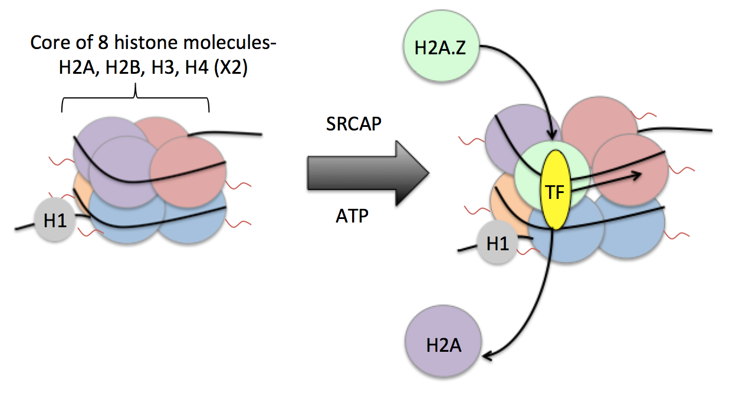
Figure 1.7 SRCAP’s role in chromatin remodelling
SRCAP uses the hydrolysis of ATP to catalyse the removal of the H2A-H2B histone dimer for its variant H2A.Z-H2B. In doing this it allows creates and more unstable nucleosome which means the histones are held further apart and this in turns means the DNA wound around the histones is more loosely compacted. This more open architecture means transcription factors gain access to the DNA, bind and can activate transcription.
Changes to H2A.Z levels have been implicated in the progression of tumourigenesis (discussed in detail in 1.5.IV) and therefore it would be expected that differing levels of the protein involved in H2A.Z deposition, namely SRCAP, would also have associations with cancer development. Consistent with this idea, other chromatin remodelers have been shown to play a vital role in tumourigenesis.

- Floating Harbor Syndrome
Floating Harbor syndrome (FHS) is a rare autosomal dominant disease characterised by distinctive facial features such as a wide flat mouth, thin upper lip and triangular face, as well as skeletal development delay and intellectual disabilities (Seifert et al., 2014). Its name originates from the two hospitals where it was first reported Boston’s Floating Hospital in 1973 and Harbor General Hospital in California in 1975 (Messina et al., 2016). Although the disease was clinically characterised many years ago it was only recently that high-throughput genetic sequencing of 13 patients uncovered the underlying genetic cause- a heterozygous C-terminal truncating mutation in SRCAP, resulting in the loss of functional domains. The delay in finding the genetic cause could be due to the rarity of the disease with only around 50 cases being reported in the literature and the fact that the majority seem to arise spontaneously, with less than 10% due to heritability (Hood et al., 2012). All the mutations were nonsense or frame-shift variants and were found clustered in exon 34 of SRCAP, possibly affecting the three C-terminal AT-hook motifs for binding DNA. However, it is yet unclear what effects the mutation has on transcriptional activity and how this affects phenotype. A recent paper hypothesised that the truncated SRCAP variants either compete with wild type SRCAP for chromatin binding sites or that they actually interact and form heterodimers, resulting in the loss of binding potential and therefore chromatin remodelling (Messina et al., 2016), however there is yet no evidence to support this.

Recent work on FHS has looked to uncover specific methylation signatures, as other Snf2 chromatin remodelling family members; Lymphoid Specific Helicase (HELLS) and X-linked alpha thalassemia/mental retardation (ATRX) have been shown to influence methylation patterns. Indeed, Hood et al., (2016) identified a DNA methylation signature in FHS patient peripheral blood samples, with 116 differentially expressed genes, and enrichment analysis highlighted genes associated with developmental processes especially neurological systems. However, it is still unclear whether truncation of SRCAP causes this differing methylation signature or whether it is due to a secondary compensatory mechanism because of the SRCAP mutation. Further work is also needed to understand how this methylation pattern then affects transcription regulation, and whether any of these effects are translatable to what happens as a result of SRCAP aberrations in tumours. There is no evidence suggesting that patients with FHS have an increased risk of developing cancer, however with only 50 cases reported within the literature, and all the patients displaying varying degrees of intensity of the disease it is proving difficult to characterise. Although genetic testing can be utilised for suspected FHS patients, as in the past it has been difficult to diagnose the very non-specific features, any therapeutic targets are a long way off being developed (Nikkel et al., 2013).
- H2A.Z and its Implications for Cancer
H2A.Z is a variant of histone H2A, which is deposited into the nucleosome in a replication independent manner, by members of the INO80 family of chromatin remodelers, which includes SRCAP and p400. H2A.Z is removed from the nucleosome, again in an ATP-dependent manner by INO80 itself, which swaps H2A back in, and this process has been found to occur at promoters during transcriptional induction (Papamichos-Chronakis et al., 2011). p400 expression levels are increased in CRC cell lines, and p400 knock down resulted in decreased proliferation (Mattera et al., 2009). This suggests that alterations of chromatin remodelling complexes could be potential cancer drivers, certainly in terms of cell growth. p400 also acts within the WNT pathway to alter transcriptional regulation. Therefore unregulated expression of p400 in CRC leads to activation of WNT target genes, which drives cellular proliferation (Chevillard-Briet et al., 2014). It is possible that similar phenotypes could result from SRCAP up-regulation. However, one group proposed the theory that SRCAP and p400 deposit H2A.Z at different promoters, and in consequence have differing actions on transcription (Bowman et al., 2011).

H2A.Z makes up 10% of cellular H2A molecules. The H2A.Z sequence differs from H2A by approximately 40%, with differing residues within the carboxyl-terminal region that can directly interact with transcriptional machinery such as RNA polymerase II. H2A.Z depletion in S. cerevisiae has been shown to lead to a decrease in the efficient recruitment of these proteins (Adam et al., 2001). Another key modification to H2A.Z is a simple glutamine to glycine substitution within the domain required to bind to the H3/H4 tetramer, which weakens the interaction and so destabilises the nucleosome (Suto et al., 2000). This destabilisation has been implicated in many cellular processes such as transcription, genome stability and cellular progression. It is widely regarded, following genome wide studies in yeast, that H2A.Z is highly prevalent at transcriptional start sites and that its presence is required for transcription initiation (Sura et al., 2017). However, yeast studies show an inverse correlation between enrichment of H2A.Z and the activity of the genes where it is found (Guillemette et al., 2005), whereas animal studies show a positive correlation (Hardy et al., 2009). It is now widely recognised that the enrichment of H2A.Z, usually at the 5’ end of genes, can be associated with the activation or repression of transcription depending on other factors within the histone code, as they are also subject to post-translational modifications such as acetylation (Brahma et al., 2017). Knockdown of H2A.Z causes an increase in genome instability and this is due to its essential function in chromosome segregation during mitosis through its role in the correct localisation of HP1α (Rangasamy et al., 2004). Homozygous H2A.Z deficient mouse embryos were not viable, highlighting the essential functions H2A.Z plays in correct chromosome segregation and transcriptional activity (Faast et al., 2001).

H2A.Z also plays a crucial role in the DDR pathway, whereby it is deposited at sites of DNA damage so that the change in nucleosome structure can open up the chromatin and this open configuration extends away from the double strand breaks (DSBs), allowing access for DDR proteins. The structure seen where H2A.Z regions flank a nucleosome free region around the DSB, is much like that seen at transcriptional start sites, both allowing access to the DNA for a complex of proteins (Xu et al., 2012). It may also be that such flanking by H2A.Z inhibits the DNA resection by CtIP, an important protein in the DDR, and thus push the cells to favour the error-prone non-homologous end joining (NHEJ) DNA repair pathway. Indeed it appears that H2A.Z presence within nucleosomes at DSB sites is important for BRCA1 and KU70/80 loading ready for NHEJ. Xu et al. also hypothesised that the loss of H2A.Z could therefore result in unregulated end resection and so defective homologous recombination (HR). Indeed in yeast there is an increased sensitivity to DNA damaging agents resulting in genome instability when H2A.Z is lost (Morillo-Huesca et al., 2010). However, research into how, and even if, H2A.Z plays a role at double strand breaks is heavily debated due to conflicting results. For example, another study did not see any H2A.Z presence at DSBs, and explained the differential result by hypothesizing that the accumulation of H2A.Z at DSBs is cell line specific, as their study used an osteosarcoma cell line (U2OS) and immortalised human fibroblasts (Taty-Taty et al., 2014), compared with HEK293 cells which did show H2A.Z localisation to DSBs (Xu et al., 2012). With H2A.Z having such a wide expanse of functions in chromatin remodelling and transcription it is perhaps not surprising that studies uncover inconsistent results, especially due to possible indirect effects that have yet to be explored.
H2A.Z is over-expressed in a variety of cancer types such as sporadic colorectal, prostate and breast cancer (Hua et al., 2008, Dunican et al., 2002, Dryhurst et al., 2012), and in breast cancer this over-expression appears to correlate with poor prognosis and an increase in lymph node metastasis (Svotelis et al., 2010). This up-regulation causes the activation of oncogenes, which enhances the proliferative nature of the tumour cells. For example, in melanoma, H2A.Z over-expression controls E2F transcription to increase tumour growth, and depletion of H2A.Z sensitises to chemotherapies, suggesting novel therapeutic possibilities (Vardabasso et al., 2015). It is important to point out that H2A.Z has two isoforms; H2A.Z.1 and H2A.Z.2, which differ by three amino acids, and isoform-specific knockdown studies suggest that they might not be functionally redundant (Eirín-López et al., 2009). Many papers do not specify which variant was analysed, possibly due to the fact that most antibodies are not specific for the isoforms, but it has been found that both isoforms are over-expressed in cancer, with H2A.Z.1 being the most widely researched (Vardabasso et al., 2014).

H2A.Z role within hormone dependent cancers, and the impact of H2A.Z over-expression on cellular proliferation, is more widely studied. For example, in oestrogen dependant breast cancer there is an activation of the oncogene c-MYC, which in turn up-regulates the transcription of H2A.Z.1 (Hua et al., 2008). H2A.Z.1 has also been shown to positively regulate oestrogen signalling, as depletion of the histone variant results in defective oestrogen signalling and a decrease in hormone dependent tumour proliferation (Gévry et al., 2009). Interestingly, in a cell line model using MCF7 breast cancer cells and under low oestrogen levels, plus the oestrogen receptor antagonist tamoxifen, (which prevents transcription of oestrogen dependent genes), the over-expression of H2A.Z still promoted cell proliferation, indicating a role independent of hormone status (Svotelis et al., 2010). Although in prostate cancer, c-MYC also binds to the H2A.Z promoter region to increase expression of H2A.Z.1 (but not H2A.Z.2) upon androgen stimulation, it has been shown that levels of H2A.Z decrease at the prostate-specific antigen (PSA) promoter when androgen treatment is present. This may indicate that the increased H2A.Z expression primes the gene, but upon androgen stimulation is then removed from the nucleosomes (Dryhurst et al., 2012).
Taken together, these data suggests that H2A.Z could be driving tumour progression in a number of complex ways, such as enhancing transcription and proliferation directly or creating genome instability through disruption of the DDR and/or chromosome segregation. This could all be mediated via a direct increase in H2A.Z levels or by an increase or alterations in the chaperones that deposit them into the nucleosomes, such as SRCAP. Our understanding of many of these mechanisms remains limited and further research is required to determine whether these pathways can be utilised for cancer therapies.

- Hypothesis and Aims
Previous findings have uncovered copy number aberrations in DNA extracted from chromosomal unstable colon tumours. Using bioinformatics, these aberrations were ranked based on frequency and magnitude and then further prioritised using a series of database criteria, such as correlated gene expression in TCGA and also the potential for druggability. These data, together with a siRNA knockdown screen looking at DNA damage/genome instability, identified SRCAP as a potential driver of colorectal cancer.

The aim of the project was to therefore test the hypothesis that SRCAP is a driver gene of colorectal cancer and favours a cancer phenotype; if so, this gene could provide a novel druggable target.

The objectives of the project were to:

- Create two SRCAP over-expression CRC cell line models, firstly using cDNA transient vector transfection and also utilising the new CRISPR/dCas9 technology to endogenously over-express SRCAP. Then assess how this over-expression alters cell function through functional assays looking at DNA damage, proliferation, apoptosis, cellular cycling and chromatin structure.
- Use a knockdown SRCAP CRC cell line model to again assess how this affects the cancer phenotype using the functional assays stated above, and also use clinical therapeutics to see what effect SRCAP depletion has on cell survival following treatment with these.
- Determine the biological consequences of SRCAP levels in RAS oncogene activated cells, again utilising functional assays described in point one.
- Assess the effect of differing SRCAP expression on gene expression using RNA samples from SRCAP over-expressing and SRCAP knockdown cell models in a microarray analysis in order to measure genome-wide transcript levels.

Throughout the thesis two main cell lines will be used, these are SW480 and HCT116 human CRC cell lines. SW480 cells display chromosomal instability and are therefore comparable to the patient cohort used in the original CGH screen. In comparison, HCT116 cells are microsatellite unstable and were used in the siRNA screen. Hence the work carried out is based on the two major molecular subtypes of CRC, so that comparisons between them could be drawn and any differences in response highlighted.

Chapter 2: Materials and Methods
2.1 Materials
- Standard Equipment List
- Consumables List
- Reagent List
- Preparation of Solutions
- Antibodies
- Cell Lines
2.2 Methods
- Bacterial Culture and Cloning
- SRCAP cloning and LR reaction
- Transformation of SRCAP cDNA into DH5α E. Coli
- Transformation of SRCAP cDNA into XL10 Gold ultra-competent cells
- DNA quantification
- DNA Sequencing of SRCAP constructs
- Mutagenesis of cDNA
- Ras construct transformation
- SRCAP cloning into pDEST-FRT-N-YFP (Flp. compatible)
- Mammalian Tissue Culture
- Tissue culture
- Cell line authentication
- cDNA SRCAP transfection
- Transfection Optimisation
- Stable Ras transfection
- pDEST-FRT-N-YFP tet inducible stable transfection
- Transient CRISPR/Cas9 SRCAP transfection
- CRISPR/Cas9 SRCAP Lentiviral antibiotic concentration determination
- CRISPR/Cas9 SRCAP Lentiviral stable transfection
- siRNA knockdown of SRCAP
- RNA Studies
- RNA extraction
- RT-PCR
- Taqman Assay for relative expression of mRNA
- RNA Microarray: Sample collection and fluorescent activated cell sorting
- RNA quality assessment
- Affymetrix Genechip RNA microarray
- Protein Studies
- Protein extraction and quantification
- SDS-PAGE and Western blotting
- Functional Assays
- Immunofluorescence studies for DNA damage
- Immunofluorescence studies for DNA transfection
- Alkaline comet assay for DNA damage
- Cell proliferation overtime
- Micrococcal Nuclease Assay
- Cell cycle analysis by propidium iodide staining
- Apoptosis analysis by dual propidium iodide and Annexin V staining
- Phosphorylated H3 flow cytometry for mitotic cells
- Click-iT EdU assay
- MTT Cytotoxicity assays
- Clonogenic Survival
- Statistics
List of Figures
2.1 The highlighted area that was deleted by the two primers at the start of the SRCAP gene
2.2 Affymetrix Genechip Cartridge diagram, showing where the hybridisation mix should be added
2.3 BSA standard curve allowing for calculation of protein concentration

List of Tables
2.1 Site directed mutagenesis PCR programme
2.2 Amounts of each component used from the Taqman RT-PCR kit
2.3 RT-PCR Programme to make cDNA
2.4 Lysis Buffer for extraction of protein
2.5 SDS-PAGE Buffers
2.6 Reagents used in the Click-iT cocktail, must be added in the order listed, kept in the dark and used within 15mins

2.1 Materials
- Standard Equipment List

Equipment | Supplier
2100 Bioanalyser | Agilent
2200 Tapestation Bioanalyser | Agilent
Balance SG-60 | Fisher Scientific
Centrifuge 5415R | Eppendorf
Class II microbiology safety cabinet | Walker
CO2 incubator | Sanyo
Cyro Freezing Container | Nalgene
Electrophoresis Tank | Bio-Rad
FACS Aria | BD Biosciences
FACS Calibur | BD Biosciences
Fluorescent Microscope Eclipse TE200 | Nikon
Gel imager- U:GENIUS | Syngene
Genechip Fluidics Station 450 | Thermo Fisher
Genechip Hybridisation Oven 640 | Thermo Fisher
GeneChip Scanner 3000 7G | Thermo Fisher
Gyrorocker SSL3 | Stuart
Haemocytometer | Neubauer
Heating block DB-2D | Techne
Heraeus Microfuge 16 | Thermo Scientific
HT7900 RT-PCR machine | Thermo Fisher
Ice Machine AF80 | Scotsman
JB Aqua 18 plus water bath | Grant
Light Microscope | Optika
Magnetic Stirrer SM1 | Stuart Scientific
Microwave | Proline
Multiskan FC plate reader | Thermo Scientific
Nanodrop Spectrophotometer ND-100 | Fisher Scientific
pH 3510 meter | Jenway
Pipette Buoys | FisherBrand
Power Pack | Bio-Rad
Precast western blotting tanks | Invitrogen
S1000 Thermal Cycler | Bio-Rad
SRX 101A Film Processor | Konica
Vortex | Fisher Scientific
Water Filter Triple Red Nanopure | Thermo Scientific
Western blotting tanks | Biorad
- Consumables List

Consumables | Supplier
15ml Centrifuge tubes | SLS
384 well plate seals | Star lab
384 well plates | Star lab
50ml Centrifuge tubes | Fisher
Bacterial agar dishes | Fisher
Cell culture 6 well plates | Star lab
Cell culture 96 well plates | Corning Incorporated
Cell culture dishes (10cm) | Greiner
Cell culture flasks | Fisher
Cell scrapers | Sarstedt
Clonogenic 6 well plates | Thermo Scientific
Cover slips | Fisher
Cryovials | Sarstedt
Eppendorfs | Greiner
Filter Tips | Sarstedt
Gloves | Star lab
Microbacterial loops | Microspec
Microscope slides | Thermo Scientific
PCR tubes | Star Lab
Reagent Reservoirs | Corning Incorporated
Stripettes | Fisher
Syringe Filters | Fisher
Syringes (10ml) | Fisher
Weigh boats | Fisher

- Reagents List

Item | Supplier
30% acrylamide mix | Geneflow
4x LDS sample buffer | Novex
5-Fluorouracil | Sigma
Acetic Acid | Fisher
Ammonium Persulphate (APS) | Fisher
Ampicillin | Melford
Benzonase | Novagen
Blasticidin | Melford
Bovine Serum Albumin (BSA) | Sigma
Bromophenol Blue | Sigma
Calcium Chloride (CaCl₂) | Melford
Camptothecin | Fisher
Cisplatin | Sigma
Dimethyl sulfoxide (DMSO) | Fisher
DNA loading dye (5x) | Bioline
DTT | Sigma
Dulbecco’s Modified Eagle’s Medium (DMEM) | Lonza
EDTA | Sigma
Ethanol | Fisher
Ethidium Bromide | Sigma
Foetal Calf Serum (FCS) | Biosera
Glycerol | Fisher
Glycine | Fisher
Hydrochloric Acid (HCL) | Fisher
Hygromycin | Melford
Hyperladder I & V | Bioline
Industrial Methylated spirit | Adams
LB Agar | Melford
LB Broth | Melford
Lipofectamine 2000 | Invitrogen
Magnesium Chloride (MgCl₂) | Melford
Methanol | Fisher
Methylene Blue | Fisher
Milk powder | Marvel
Paraformaldehyde (PFA) | Santa Cruz
Phosphatase Inhibitors | Sigma
Polybrene | Sigma
Potassium Chloride (KCL) | Fisher
Propidium Iodide | Sigma
Protease Inhibitors | Sigma
Protein Assay Dye Reagent | Biorad
Puromycin | Fisher
RNAiMax | Invitrogen
RNase A | Sigma
SeaKem LE Agarose | Fisher
SeeBlue Plus 2 ladder | Invitrogen
SOC medium | Invitrogen
Sodium Chloride (NaCl) | Fisher
Sodium Dodecyl Sulphate (SDS) | Sigma
Sodium hydroxide (NaOH) | Sigma
Spectinomycin | Sigma
SYBR gold DNA gel stain | Fisher
TEMED | Prolabo
Tetracycline | Sigma
Thiazolyl blue tetrazolium bromide (MTT) | Melford
Tris base | Fisher
Triton X-100 | Sigma
Tryphan Blue | Sigma
Trypsin | Lonza
Tween 20 | Sigma
Zeocin | Melford
β-mercaptoethanol | Fisher
- Preparation of Solutions
- All solutions were stored at room temperature unless stated otherwise.
- Sterilisation of solutions was carried out in the Academic Unit of Molecular Oncology central stores, using a MP24 Rodwell autoclave (Scientific Laboratory Supplies) at 15 p.s.i at 120ºC for 15mins.
- Ultra pure deionised water was obtained from a Triple Red Nanopure water filter machine (ddH₂O) present within the laboratory.
- Any reagents used for tissue culture methods were filter sterilised in tissue culture hoods using sterile syringe filters.

Tris 1.5M (pH 8.8): 181.7g Tris Base dissolved in 600ml ddH₂O, pH acquired with addition of concentrated HCL and the solution made to 1000ml with ddH₂O.

Tris 1M (pH 6.8): 131.4g Tris Base dissolved in 600ml ddH₂O, pH acquired with addition of concentrated HCL and the solution made to 1000ml with ddH₂O.

10X SDS PAGE Running Buffer: 30.3g Tris Base, 144g Glycine and 10g SDS dissolved in 1000ml ddH₂O.

10X SDS PAGE Transfer Buffer: 30.3g Tris Base, 144g Glycine dissolved in 1000ml ddH₂O.

10% APS: 1g ammonium persulphate dissolved in 10ml ddH₂O.

5M NaCl: 146g of sodium chloride dissolved in 500ml ddH₂O.

50X TAE: 242g Tris Base, 57.1ml Acetic acid and 100ml 500mM EDTA dissolved in ddH₂O to make up to 1000ml.

500mM EDTA: 186.1g Ethylenediaminetetraacetic acid dissolved in 1000ml ddH₂O.

1X PBS: 1 tablet (oxoid BR0014) to 100ml ddH₂O, autoclaved 120ºC for 15mins (obtained from central stores in the Academic Unit of Molecular Oncology).

PBS-T: 500ml 1X PBS with 500μl Tween 20.

10% SDS: 50g of Sodium Dodecyl Sulphate dissolved in 500ml ddH₂O.

LB Broth: 10g of premade LB broth dissolved in 400ml ddH₂O and autoclaved before use.

LB Agar: 14.8g of premade LB Agar dissolved in 400ml of ddH₂O and autoclaved before use.

10X DNA loading buffer: 3.9ml Glycerol, 500μl 0.5M EDTA, 0.025g bromophenol blue, 0.025g xylene cyanol dissolved to make up 10ml in ddH₂O.

Methylene Blue: 0.4% methylene blue in 70% Methanol.

Alkaline Unwinding Solution: 4g NaOH pellets and 2.5ml 200mM EDTA (supplied in comet kit) was dissolved in ddH₂O to make 500ml.

Electrophoresis Comet Buffer: 8g NaOH pellets and 2ml 500mM EDTA was dissolved in ddH₂O to make 1000ml (stored at 4ºC).

Precept: 4 2.5g tablets (Johnson & Johnson) dissolved in 5000ml tap water.

- Antibodies

Primary Antibodies | Raised in | Clonality | Manufacturer | Concentration | Use | Protein size
anti- β- Tubulin | Mouse | Polyclonal | Abcam | 1:1000 | WB | 51kDa
anti-53BP1 (ab36823) | Rabbit | Polyclonal | Abcam | 1:1000 | IF | 220 kDa
anti-Flag M2 (F3165) | Mouse | Monoclonal | Sigma | 1:2000 | WB | <1 kDa
anti-Flag M2 HRP conjugated monoclonal (A8592) | Mouse | Monoclonal | Sigma | 1:2000 | WB | <1 kDa
anti-GFP (ab290) | Rabbit | Polyclonal | Abcam | 1:2000 | WB, IF | 27 kDa
anti-Ras (3339S) | Rabbit | Polyclonal | Cell signalling | 1:500 | WB | 21 kDa
anti-SRCAP (ab99408) | Goat | Polyclonal | Abcam | 1:250-1:1000 | WB | 340 kDa
anti-β-Actin (ab8226) | Mouse | Monoclonal | Abcam | 1:2000 | WB | 37 kDa
anti-γH2AX (ser139) (05-636) | Mouse | Monoclonal | Millipore | 11000 | IF | 17 kDa
Histone H3 Phospho antibody (ab14955) | Mouse | Polyclonal | Abcam | 1:1000 | FACS | 15 kDa
Myc-tag (2276) | Mouse | Monoclonal | Cell signalling | 1:1000 | WB | <1 kDa
SRCAP T-15 (sc-133312) | Rabbit | Polyclonal | Santa Cruz | 1:250-1:1000 | WB, IF | 340 kDa

Secondary Antibodies | Manufacturer | Concentration | Use
Alexa-Fluor 488 goat anti-mouse (A11001) | Life technologies | 1:1000 | IF
Alexa-Fluor 594 goat anti-rabbit (A11012) | Life technologies | 1:1000 | IF
Polyclonal goat anti-mouse immunoglobulin HRP (P0447) | Dako | 1:1000 | WB
Polyclonal rabbit anti-goat immunoglobulin HRP (P0160) | Dako | 1:1000 | WB
Polyclonal swine anti-rabbit immunoglobulin HRP (P0399) | Dako | 1:1000 | WB

- Cell Lines

Cell line | Origin and Molecular Phenotype | Antibiotic Selectivity | Reference
HCT116 | Colorectal Adenocarcinoma- Microsatellite unstable (hMLH1 mutation), WT TP53, KRAS mutant, APC WT |  | (Brattain et al., 1981)
HCT116 Flp-In TRex | Colorectal Adenocarcinoma with Flp. in recombination site (made in house)-  Microsatellite unstable (hMLH1 mutation), WT TP53, KRAS mutant, APC WT | Blasticidin, Zeocin | (Gagou et al., 2014)
HCT116 TP53-/- | Colorectal Adenocarcinoma with p53 deficiency (made in house)-  Microsatellite unstable (hMLH1 mutation), TP53 mutant, KRAS mutant, APC WT | Hygromycin | (Bunz et al., 1998)
HEK293 | Embryonic kidney –  Chromosomal unstable, vitronectin expressing, WT TP53 |  | (Da Costa et al., 1996)
Hela | Cervical Adenocarcinoma-  Chromosomal unstable, WT TP53 |  | (Macville et al., 1999)
MRC5 | Normal lung fibroblast-  Normal diploid chromosome, 42-46 doublings before senescence |  | (Landers et al., 1997)
RPE-1 | Normal Retinal Epithelium (hTERT immortalised)-  Diploid expression, WT TP53 |  | (Bodnar et al., 1998)
SW480 | Colorectal Adenocarcinoma (Dukes’ B)-  Chromosomal unstable, TP53, KRAS and APC mutant |  | (Rodrigues et al., 1990)
SW620 | Colorectal Adenocarcinoma (Dukes’ C)-  Chromosomal unstable, TP53, KRAS and APC mutant |  | (Trainer et al., 1988)
U20S | Bone Osteosarcoma Epithelial-  Chromosomal unstable, WT TP53 |  | (Landers et al., 1997)

2.2 Methods
- Bacterial Culture and Cloning

- SRCAP cloning and LR reaction
A fully sequence verified SRCAP construct in the entry vector pENTR223.1 was purchased from Dharmacon and the bacterial culture containing this plasmid was grown for 16hrs in 5ml of LB broth and 100$μ$g/ml of spectinomycin at 37ºC. The resulting bacterial preparation was processed through a Qiagen Spin Miniprep Kit following the specified protocol in order to extract and purify the plasmid DNA. An aliquot was also taken before processing and combined with glycerol to make a stock to be stored at -80ºC. In order to clone SRCAP cDNA into appropriate expression vectors 100ng each of the DNA and destination vector from lab stocks was placed with 1$μ$l of LR clonase enzyme mix (Invitrogen), which catalyzes the recombination from entry vector into destination vectors, and left for 3hrs. The three mammalian expression destination vectors (Amp^{R}) used were pDEST-CMV-MYC (N terminal), pDEST-FRT-N-YFP and pDEST-FRT-N-Flag. These plasmids were courtesy of Simon Boulton in the CRUK Clare Hall laboratories, and are modified plasmids based on the pcDNA-DEST53 vector.

- Transformation of SRCAP cDNA into DH5$α$ E. Coli
After the LR reaction the destination vectors were transformed into competent DH5$α$ E. Coli (made in house). To do this 20$μ$l of 5X KCM (500mM KCL, 150mM CaCl₂, 250mM MgCl₂), 65$μ$l of ddH₂O and 5$μ$l of DNA was combined along with 90$μ$l of DH5$α$ E. Coli. This mixture was left on ice for 20 minutes, room temperature for 10 minutes and then 1ml of LB broth added and the culture was incubated for 1hr at 37ºC. 90$μ$l of ddH₂O was combined with 90$μ$l of cells in a similar way to use as a control. After the 1hr incubation, the solution was centrifuged for 1 minute at 13000rpm, 800$μ$l of the supernatant removed and the pellet resuspended in the remaining LB broth. This solution was spread over ampicillin (100ng/$μ$l) plates and left over night to grow at 37ºC. Successfully transformed cells grew as colonies and were picked, grown over night in 5ml LB broth with ampicillin and gentle shaking at 37ºC, and plasmid DNA was isolated from the single colony solution by using the miniprep kit as specified previously.

- Transformation of SRCAP cDNA into XL10 Gold ultra-competent cells
100$μ$l of XL10 cells (Agilent) were incubated on ice for 10mins with 4$μ$l β-mercaptoethanol, with gentle swirling at intervals. 1$μ$l of 100ng/$μ$l of the SRCAP in destination vector DNA was then added and left on ice for 30mins. The transformation mix was then subjected to a 30 second heat pulse at 42ºC followed by 2mins on ice. Finally 900$μ$l of SOC medium was added and the cells allowed to grow for 1hr with shaking at 225-250rpm at 30ºC. The solution was spread on ampicillin plates and left at 30ºC for 20hrs. Colonies were picked and then grown in LB broth, and plasmid DNA was then extracted as per the protocol above.

- DNA Quantification
DNA quantification of isolated/purified plasmids was determined using a NanoDrop spectrophotometer (ND-1000) and the corresponding ND-1000 software using the nucleic acids function. The machine was blanked using ddH₂O and then 1$μ$l of each sample loaded onto the sensor, with cleaning of the sensor between each sample. DNA concentration was calculated by the software using the Beer Lambert equation which correlates the amount of light absorbed to the concentration of the absorbing molecule- c=(A*e)/b, where c is the concentration of DNA in ng/$μ$l, A is the absorbance at 260nm, e is the absorbance coefficient (50$μ$g/ml for dsDNA, 33$μ$g/ml for ssDNA or 40$μ$g/ml for ssRNA) and b is path length. The spectrophotometer also shows the sample purity through the 260nm:280nm or 260nm:230nm ratios, as proteins absorb light at 280nm and other organic compounds at 230nm, the ratios for pure DNA are considered to be around 1.8 to 2.0. DNA was also assessed via a 1% agarose gel (2g agarose powder (SeaKem LE) in 200ml 1xTAE, plus 4$μ$l ethidium bromide (10mg/ml)). Samples were run in 1xTAE at 70V for 1-1.5hrs and compared to 5$μ$l of hyperladder I molecular weight marker, then imaged using a Syngene Ugenius.

- DNA Sequencing of SRCAP constructs
Sequencing of the plasmid constructs was carried out by the Genomic Core Facility of Sheffield Medical School, using primers designed in-house and supplied by Sigma Aldrich (Ebersberg, Germany) The primers spanned the entire SRCAP gene to check for any mutations from the NCBI SRCAP sequence (BC172428), and to check for the presence of the stop codon, and there was also a reverse primer near the start to allow us to sequence back into the destination vector, to check that it was in frame. The primers were supplied lyophilized and were re-suspended in ddH₂O to a concentration of 100pmol/$μ$l, as the supplier detailed. These are shown below, F= forward primer and R= reverse primer:
srCAP-1F – GTA CAA AAA AGC AGA AGG GCC
srCAP-223F - CCA GAT GGT GCC ACA GTG CCC
srCAP-751F - AAC TGA AAA GTA CTC GGA CCT
srCAP-1281F -CTA TAG CAG CTG AGG AAC AGT
srCAP-1803F -CAG CTG AAA GTC TCC AGC CCA
srCAP-2430F -TCT TCC AGT CTC ATC GCC AGT
srCAP-3051F -GCC GGA CAG TGG TGG TGG TGA
srCAP-3681F -TGA CTT TGA CTG GTG CCC AGG
srCAP-4311F -CTG TGT CCT CTA CAG TCT CAG
srCAP-4941F -CTA CTC CAG GAA CCT CTT TAG
srCAP-5571F -ATG AGC CTG ACA CAC TGA CAT
srCAP-6201F -AGG CAG AGG GCC ACC GAG TGC
srCAP-6831F -CTG AGC TTG CAG AAT TTA ATG
srCAP-7440F -CAG CCC CAA ATC CAA TAA CCA
srCAP-8061F -AGC TGA CAG AGG CCA AGA CCC
srCAP-8700F -CCA ATG GGG CTG ACC CAG TCC
srCAP-9427F- AGA GAC TGA GAA GTT GCC TCG
srCAP 199R- GCC TGG AGG TCC ATC CAG TGA

10$μ$l of 10ng/$μ$l template DNA was submitted to the Genomics Facility along with 10$μ$l of each primer at 1pmol/ul. The samples were sequenced on a 3730 DNA analyser (Applied Biosystems) and the resulting sequences were analysed through FinchTV software (Perkin Elmer) and then compared with the NCBI SRCAP entry (BC172428) using nucleotide BLAST (NCBI).
- Mutagenesis of cDNA
In order to delete the endogenous SRCAP Kozak consensus and start site sequence, which is highlighted in Figure 2.1, two primers were designed; one forward and one reverse in order to carry out site-directed mutagenesis to remove the highlighted section (primers obtained from Sigma Aldrich).

srCAP Kozak F- GCA GAA GGG CCG TCA AGG CAG AGC AGC CCC TCC CCT GC
srCAP Kozak R- GCA GGG GAG GGG CTG CTC TGC CTT GAC GGC CCT TCT GC
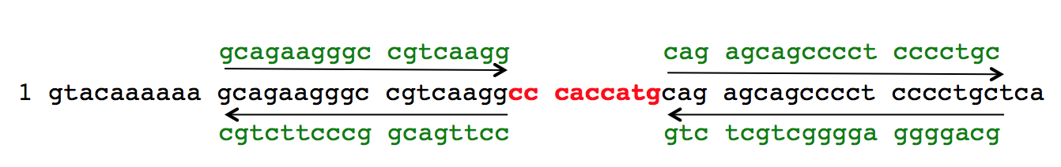
Figure 2.1 The highlighted area was deleted by the two primers at the start of the SRCAP gene

100ng of the Entry, MYC, FLAG and YFP constructs already made and sequenced were put in separate PCR tubes, along with 100$μM$ of each primer. Then using the KOD Hot Start DNA Polymerase kit (Novagen), 5$μ$l of 10x buffer and dNTPs and 2$μ$l of MgSO₄ was added to each tube. This solution was made up to 49$μ$l with ddH₂O and finally 1$μ$l of KOD polymerase was added before vortexing. These tubes were then placed into a Bio-Rad S1000 thermal cycler for around 7hrs with the following settings:
Step | Temperature | Time (minutes)
1-Denaturation | 95ºC | 3
2-Annealing and extension | 95ºC | 1
3 | 60ºC | 1
4 | 72ºC | 14 (25 cycles)
5 | 72ºC | 5
6- Keep cold | 4ºC | $∝$
Table 2.1 Site directed mutagenesis PCR programme

The PCR products were then subjected to restriction enzyme digestion by Dpn1 (New England Biolabs) to digest the parental (methylated) plasmid DNA. 2$μ$l of Dpn1 at 20000U/ml was added and incubated for 3hrs at 37ºC. 10$μ$l of sample for each construct was electrophoresed on a 1% agarose gel. And then the constructs were transformed into DH5$α$ competent cells, miniprepped and sequenced (core facility) using the same method as described above (section 2.2.I.e).

- RAS construct transformation
A sample of HRAS in a CAG vector (Appendix 6) was kindly provided by the Meuth laboratory from the University of Sheffield. In order to make sufficient quantities the construct was transformed into bacteria, agar plated, colonies picked, grown and DNA extracted as described above. However, instead of using DH5$α$ E. Coli, CAG competent cells were used.

- SRCAP cloning into pDEST-FRT-N-YFP (Flp compatible)
Mutated SRCAP in the entry vector was cloned in to the pDEST-FRT-N-YFP (Flp compatible) vector by LR reaction as previously described. The resulting plasmid was then transformed into DH5$α$ E. Coli, then colonies were grown, picked and DNA extracted and quantified as above. These were then sent for sequencing as described previously.

- Mammalian Tissue Culture

- Tissue Culture
Adherent cell lines from American Type Culture Collection (ATCC) were grown in Dulbecco’s Modified Eagle’s Medium (DMEM) supplemented with 10% fetal calf serum (FCS) at 37ºC with 5% CO_{2.} Cell culture was performed under sterile conditions in a class 2 microbiology safety cabinets. At 80-90% confluency cell cultures were passaged in order to keep the cells proliferating and healthy. Passaging was carried out by removing the media, washing cell monolayers with sterile PBS and adding trypsin (0.5g/l trypsin, 0.2g/l versene; 2ml per T75 flask). These were then incubated at 37ºC until the cells had detached. After washing the flasks with media to quench trypsin activity, a single cell suspension was created via pipetting. The resulting cell suspension was then diluted to either 1:10 or 1:20 depending on the cell line and degree of confluency. Antibiotic agents were only added to media where appropriate to make and maintain stable cell lines as shown in 2.1.6.

Cell stocks were stored in 10% FCS containing media at -80ºC with 10% DMSO. In order to thaw cells quickly to avoid the toxic affects of DMSO, they were placed in a water bath at 37ºC, then the media/DMSO removed by centrifugation at 1200rpm for 3mins. The cell pellet was then re-suspended in 6ml of complete media and placed in a T25 flask for the cells to settle and begin growing before being transferred to a T75 flask.

Cell counts were determined using a Neubauer haemocytometer, approximately 7$μ$l of cell suspension was pipetted under a coverslip placed on the haemocytometer. All four corners were counted on the grid, with each corner consisting of 4X4 squares. An average of the four corners was taken and multiplied by 10,000 to give the number of cell per ml.

Over the course of the project cell lines were regularly mycoplasma tested by departmental technicians using the EZ-PCR Mycoplasma Test Kit from Geneflow.

- Cell Line Authentication
Using the Sheffield University Genomics Core Facility the newly purchased SW480 cell line was authenticated against 10 markers. DNA was extracted using the miniprep method previously mentioned and sent to the facility at 100ng/$μ$l. The facility then used short-tandem repeat (STR) genotyping to determine whether the sample provided was a match to the COG (Children’s Oncology Group) cell culture and xenograft repository data (an open online database including STR profiles from ATCC). HCT116 and MRC5 cells lines were authenticated in 2011, and cells for this project were taken from original frozen stocks.

- cDNA SRCAP Transfection
Cells were seeded onto a six well plate and left for 24hrs. $1μ$g of each plasmid was diluted in 250$μ$l of serum free DMEM, and then in a separate tube, 4$μ$l of Lipofectamine 2000 was made up to 250$μ$l with serum free DMEM. These two mixtures were left for 5 minutes, then mixed and incubated at room temperature for 25 minutes. Negative control transfections were made using sterile ddH₂O in place of DNA. 500$μ$l of media was removed from each well and then 500$μ$l of the combined DNA solution was added. The plates were incubated for 24 or 48hrs at 37ºC for transient transfections. To make stably expressing SRCAP over-expression cells, the above protocol was followed, but 24hrs after transfection the cells were placed in media containing 250$μ$g/ml of hygromycin. The cells were kept in antibiotic selection media until the cells on the control plate had all died.

- Transfection Optimisation
SW480 cells were seeded in six well plates and 24hrs later transfected with 1$μ$g YFP SRCAP or ddH₂O for 24/48hrs. In addition to the standard transfection using Lipofectamine 2000 as described above. Genejuice (Millipore), Fugene (Promega), Lipofectamine LTX (Thermofisher) and TransIT 2020 (Mirus) sample transfection reagents were also used according to the respective manufacturer’s protocols. The cells were then trypsinised and washed in PBS before being resuspended in 400$μ$l of PBS and analysed on the FACS Calibur machine to determine transfection efficiency. This technique allows for parameters such as cell size and granularity to be assessed as well as fluorescence. Cells are passed in a constant stream through a laser and the light scatter plus fluorescence is detected. Here cells were gated using the Flowjo software depending on whether they expressed YFP or not and the percentage of cells in each category was calculated.

- Stable RAS transfection
Cells were seeded in 6 well plates and left to adhere for 24hrs before the RAS construct was added using the same transfection technique as above (section 2.2.II.c). The plates were left 48hrs, then the cells trypsinised and seeded onto 10cm dishes with media containing 1$μ$g/ml Puromycin. These were left until all the cells on the control plate were dead, but colonies of cells had started to form on the plate transfected with the RAS construct. Colonies were picked and grown up separately for assessment of RAS expression. Selection was maintained by continual growth in media containing puromycin.

- pDEST-FRT-N-YFP tet-inducible stable transfection
The YFP SRCAP Flp. vector was transfected into Flp-In compatible HCT116 cells, which had been grown in selection media of 5$μ$g/ml Blasticidin and 250$μ$g/ml zeocin. Cells were seeded for 24hrs then a transfection mixture added. 1$μ$g of YFP SRCAP Flp. vector and 1$μ$g of pPGKFLPobpA recombinase in 100$μ$l serum free DMEM was added to 4$μ$l Lipofectamine 2000 in 100$μ$l serum free DMEM and left for 20mins before adding to the cells. 24hrs later the cells were trypsinised and seeded into 10cm dishes and the selection changed to 5$μ$g/ml of Blasticidin and 200$μ$g/ml of Hygromycin. The dishes were left until the cells on the control plate were all dead and the transfected plates had continued to proliferate. At this point the expression of YFP SRCAP needed to be switched on with tetracycline to check the expression had worked. Cells from the transfected population were seeded into 6 well plates and tetracycline was added after 24hrs at a concentration of 2$μ$g/ml. Samples were then taken 24, 48 and 72hrs after tetracycline addition for protein and RNA extraction and analysis. Continued antibiotic selection of the stable cells was maintained by continuous growth in media supplemented with blasticidin and hygromycin.

- Transient CRISPR/Cas9 SRCAP transfection
After 24hrs seeded cells were subjected to CRISPR/Cas9 SRCAP transfection using the Santa Cruz SRCAP CRISPR Activation plasmid (sc-403049-ACT) and the corresponding Santa Cruz Control CRISPR Activation plasmid (sc-437275), as described in section 3.1, 3.6 and figure 3.2. 10$μ$l of 0.1$μ$g/$μ$l plasmid DNA (control or SRCAP) was combined with 140$μ$l of serum free DMEM and 5$μ$l of Lipofectamine 2000 was combined with 145$μ$l of serum free DMEM. These solutions were left for 5mins, combined then left for a further 20mins at room temperature, before the 300$μ$l was added to 2.7ml of media and added to the cells to incubate for 48/72 hrs.

- CRISPR/Cas9 SRCAP Lentiviral antibiotic concentration determination
150,000 RPE-1, HEK293, SW480 and HCT116 cells were seeded per well into six well plates and variable concentrations of hygromycin, blasticidin and puromycin were added in 2ml media as follows:
Hygromycin ($μ$g/ml)- 0, 100, 200, 300, 400, 500
Blasticidin ($μ$g/ml)- 0, 1, 5, 10, 15, 20
Puromycin ($μ$g/ml)- 0, 1, 2.5, 5, 7.5, 10
The cell number was then counted in each well at 72hrs using tryphan blue and haemocytometer manual counting. The concentration for each selection agent was selected when around 80-90% of cell death had occurred in the untransfected cells.

- CRISPR/Cas9 SRCAP Lentiviral stable transfection
The solution supplied by Santa Cruz contains three lentiviral vectors containing guide RNA to SRCAP, VP64 transcriptional activator and deactivated Cas9 nuclease (as described in section 3.1, 3.7 and figure 3.2). In order to transfect cells with this vector solution, RPE-1, HCT116, SW480 and HEK293 cells were seeded into 6 well plates and grown until around 60% confluent, then 5$μ$g/ml of polybrene was added. This neutralises the charge interactions in order to allow the pseudo viral capsid to bind to the cell membrane and therefore permit the vectors to enter the cell. After this 10$μ$l of the lentiviral vector solution was added directly to the cells (or ddH₂O for control) and the plates incubated at 37ºC for 48hrs. At this point antibiotic selection media was added, including 200$μ$g/ml Hygromycin, 5$μ$g/ml Blasticidin and 1$μ$g/ml Puromycin in normal DMEM media. This selection media was changed every 4 days until all the cells on the control plates were dead and colonies had begun to form on the transfected plates. Colonies were picked and grown separately for SRCAP expression testing, and the remaining transfected cells were combined to form a mixed over-expression population.

- siRNA Knockdown of SRCAP
Cells were seeded on to a six well plate at a density of 2x10⁵ cells per well either into empty wells, or onto coverslips (13mm) for immunofluorescence, and left for 24hrs. 5$μ$l of 20$μ$M SRCAP siRNA (MWG) or 1$μ$l of 100$μM$ low GC non-specific scrambled control (MWG) was added to 245$μ$l or 249$μl$respectively of serum free DMEM media, and in a separate tube, 5$μ$l of RNAiMax was added to 245$μ$l of serum free DMEM media. These were incubated separately at room temperature for 5mins, then combined and left for a further 20mins. 500$μ$l of media was removed from each well and the 500$μ$l siRNA mix added and left for 24/48/72hrs depending on the experiment. (These amounts were scaled up depending on the number of wells in the experiment).
siRNA probes: si5- GGAUAGACAUGGGUCGAUU
si6- CGAUUGAAGUUGAAGAACA
si7- GGUCGUGUCUCUCGAUAUG
si8- UCCGAGAGCUGUUUGAUAU
- RNA Studies

- RNA Extraction
In order to extract the RNA from cultured cells, media was removed and cells washed with PBS. 350$μ$l of RLT buffer (Qiagen) was added, the wells scraped to detach cell monolayers and transferred into a qIAshredder (Qiagen) and centrifuged for 2mins in order to lyse the cells, remove cellular debris, and inactivate RNase to ensure stable RNA. 350$μ$l of 70% ethanol was then added to the supernatant to provide optimum binding conditions and the whole 700$μ$l was then transferred to an RNeasy minispin column. RNA was extracted using the manufacturer’s protocol from the RNeasy Mini Kit. The kit uses a high salt buffer to allow binding of the RNA within the sample to the column; then the column was washed to remove contaminants and the RNA eluted with water. The samples were then quantified using the ND-1000 NanoDrop spectrophotometer with the RNA function selected and using the Beer Lambert calculation as described previously in section 2.2.I.d.

- RT-PCR
The RNA was then subjected to reverse transcription PCR using the Taqman reverse transcriptase kit (Applied Biosystems). A master mix was made using the following quantities (for one sample):

Reagent | Quantity
dNTPs | 5.5$μ$l
MgCl₂ | 5$μ$l
Random Hexamers | 1.25$μ$l
RNase Inhibitor | 0.5$μ$l
Multiscribe RTase | 0.625$μ$l
10x Buffer | 2.5$μ$l
Table 2.2 Amounts of each component used from the Taqman RT-PCR kit

This mix was made up to 25$μ$l with 200ng of RNA and ddH₂O in PCR tubes. These were incubated on a PCR machine using the following settings:

Step | Temperature | Time (Minutes)
1 | 25ºC | 5
2 | 48ºC | 60
3 | 95ºC | 5
4 | 4ºC | $∝$
Table 2.3 RT-PCR Programme to make cDNA

- Taqman Assay for relative expression of mRNA
For the Taqman assay, 5$μ$l of master mix (Applied Biosystems), 0.5$μ$l of probe mix (Applied Biosystems) and 2.5$μ$l of ddH₂O was added to each well needed in a 384 well PCR plate, then 2$μ$l of PCR product from the above RT-PCR reaction was added to triplicate wells. This was carried out for the SRCAP (Hs00198472_m1) and p400 (Hs01566078_m1) Taqman probes, as well as control 18S probe as a housekeeping gene (Hs03003631_g1, Applied Biosystems). 18S was chosen as a housekeeping gene due to previous optimisation within the Collis laboratory. The plate was run on a 7900 RT-PCR machine using the SDS 2.4 programme, with repeat settings of 40 and the reporter set to FAM. The data was then exported to excel and the 2^{-ΔΔCt} method applied in order to assess changes in expression levels, as follows. Firstly an average was taken of the three repeat Ct values for the gene of interest and the control housekeeping gene. The average housekeeping gene value was subtracted from the gene of interest value giving the delta Ct value for both experimental and control data. Next the difference between the delta Ct for experimental and delta Ct for control was calculated to get the delta delta Ct value. And finally to obtain the relative mRNA expression, 2^{-ΔΔCt} was calculated (Livak and Schmittgen, 2001).

- RNA Microarray: Sample Collection and Fluorescent Activated Cell Sorting
HCT116 cells were transfected with si6, non-specific control probe or YFP SRCAP vector as per the transfection protocols described previously. After 48hrs the knockdown and control samples were lysed to collect RNA. Whilst the cells transfected with YFP SRCAP were taken for sterile fluorescent activated cell sorting (FACS) in the flow cytometry core facility of the Sheffield Medical School. This was carried out by the core technical support. YFP-positive and negative cells were sorted from the total cell population based on YFP intensity, using an untransfected population as a guide for gating (see Appendix 7). Negative YFP and positive YFP cells were sorted into separate tubes containing sterile media. Due to the low transfection efficiency and the need for high RNA yields, the populations were then re-seeded into 6 well plates, left for 72hrs to proliferate and then the RNA was harvested as described in section 2.2.III.a The RNA samples were then checked for relative mRNA SRCAP levels using previously described protocols (section 2.2.III.b&c).

- RNA Quality Assessment
Before samples could be used in the microarray assay they had to be assessed for quality and concentration and given a score known as a RNA integrity number (RIN). RINs can be between 0-10, with a score of around 7 being sufficient quality to use for assays. The quality assessment was carried out using an Agilent 2100 Bioanalyser using the RNA 6000 Nano Kit (Agilent). The protocol for the kit was followed, where an electrophoresis gel matrix mixture is loaded onto the chip using the Chip priming station supplied, this gel allows separation of nucleic acids based on size as an electric current is applied. The ladder and samples (1μl) are then loaded into the designated wells and the cartridge placed in the machine, with analysis on the Agilent 2100 expert software. The electrophoretic trace produced allows the software to calculate the RIN by comparing the distinct ribosomal peaks for 18S and 28S to the levels of any degradation products.

- Affymetrix Genechip RNA Microarray
After determination of quality, the high quality RNA samples were treated with the Genechip WT PLUS reagent kit by Affymetrix in order to analyse whole transcriptome expression; the steps for this kit are described below and this work was conducted by Catherine Gelsthorpe, a research technician working in Dr Paul Heath’s laboratory at the Sheffield Institute for Translational Neuroscience (SITraN).

Firstly poly-A RNA controls were spiked into the RNA as an exogenous positive control. A series of dilutions was made using Poly-A control stock and Poly-A control dilution buffer and the 4th (1:10) of these added to 100ng of each of the RNA samples and made up to a total volume of 5$μ$l with nuclease free water.

In order to amplify the RNA samples, the above-mentioned Genechip WT PLUS kit was used for reverse transcription using primers tagged with T7 promoter sequence in order to create single stranded complimentary DNA (cDNA) with a 5’ T7 promoter. Here 4$μ$l of first-strand buffer and 1$μ$l of first strand enzyme were combined and added to the 5$μ$l of RNA/ poly-A mix and incubated on a thermo cycler for 1hr at 25ºC, 1hr at 42ºC and 2mins at 4ºC. Following this, the single stranded cDNA was converted to double-stranded cDNA by use of RNase H to degrade the RNA, and DNA polymerase to transcribe the complimentary sequence. The protocol for this was as follows: 18$μ$l second strand buffer plus 2$μ$l of second strand enzyme was combined with the previous first strand cDNA sample and returned to the thermo cycler for 1hr at 16ºC, 10mins 65ºC and 2mins 4ºC. The cDNA then serves as a template for antisense RNA synthesis by in vitro transcription (IVT) using a T7 RNA polymerase that binds to the previously modified strand containing the T7 promoter sequence. This creates around a 1000 fold amplification of complimentary RNA (cRNA) to the original mRNA samples. At this stage 24$μ$l of IVT buffer plus 6$μ$l of IVT enzyme is added to the second strand cRNA with thermo cycling step as follows: 16hrs at 40ºC, then 4ºC.

Purification of the cRNA then occurs, again following the kit protocol. Here, any waste, such as unincorporated nucleotides, enzymes etc. are separated from the cRNA by using magnetic purification beads. The 60$μ$l cRNA and 100$μ$l of beads were mixed and the beads plus any attached cRNA were pulled to the bottom of the well using a magnet and the supernatant containing any waste was removed. The beads were washed in 80% ethanol three times and then the cRNA eluted from the beads in nuclease-free water at 65ºC. The yield of cRNA was quantified using a nanodrop as previously described in section 2.2.I.d. For the next step the cRNA concentration was adjusted to 15μg in 24μl.

A subsequent round of synthesis of cDNA was then carried out. The cRNA was combined with second cycle buffers (8$μ$l) and enzyme (4$μ$l) in a reverse transcription reaction to generate sense-strand cDNA containing dUTP instead of dTTP, using the thermo cycler programme: 10mins at 25ºC, 90mins at 42ºC, then 10mins at 70ºC and 2mins at 4ºC. 4$μ$l of RNase H was again used to hydrolyse the cRNA template strand and leave single stranded cDNA using the following thermo cycler programme: 45mins at 37ºC, 5mins at 95ºC and 2mins at 4ºC. After this the 2nd cycle single stranded cDNA was purified as previously described using purification beads, this time however 100% ethanol was also added along with the beads according to the instructions in order for the cDNA to bind. Eluted pure cDNA was then quantified again on a nanodrop, this time the concentration was adjusted to 5.5μg in 31.2μl.

Next the cDNA was fragmented using uracil-DNA glycosylase (UDG) and apurinic/apyrimidinic endonuclease 1 (APE1) which cleaves at the atypical dUTP bases. Here 1$μ$l of each UDG and APE1 was added to the ss-cDNA along with 4.8$μ$l of 10x cDNA fragmentation buffer and put in a thermo cycler for the following incubations: 1hr at 37ºC, 2mins at 93ºC and 2mins at 4ºC. In order to check the fragmentation process had worked the samples were again analysed on the 2100 Bioanalyser using the RNA 600 Nano Kit as described previously. This time a single peak was seen between 40-70 nucleotides long.

The fragments were then labelled with 2$μ$l of terminal deoxynucleotidyl transferase (TdT) and the kit DNA labelling reagent that is covalently linked to biotin (1$μ$L) plus 12$μ$l of 5X TdT buffer using the following incubations: 1hr at 37ºC, 10mins at 70ºC and 2mins at 4ºC. In order to check labelling a gel-shift assay was performed. 2μl of sample was heated at 70ºc for 5mins and 5μl of a 1:5 dilution of Neutravidin (Thermo Scientific) added to 1μl, and as a negative control 5μl of dH₂O was added to the other 1μl of sample. These were incubated for 5mins at room temperature then 5μl of loading dye added. Samples were then loaded onto a 4-20% TBE precast gel (Invitrogen) in 1x TBE buffer (Affymetrix) and electrophoresed for 1hr at 150V. The gel was then washed in 0.001% ethidium bromide for 30mins before being imaged.

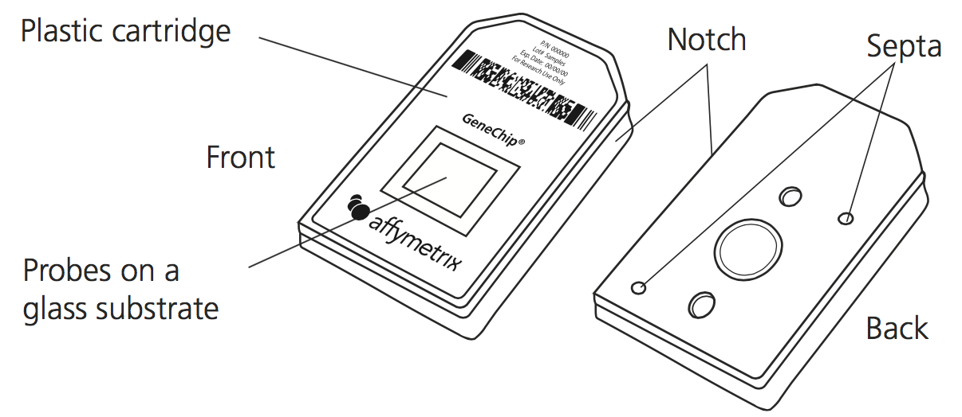
The hybridisation step was accomplished using the Genechip Hybridisation, Wash and Stain kit (Affymetrix). Here a hybridisation cocktail was made including oligo B2 control (1.7$μ$l), which adhere to specific areas of the array for ease of orientation, as well as 20x hybridisation controls (5$μ$l), 2x hybridisation mix (50$μ$l), nuclease free water (9.3$μ$l) and DMSO (7$μ$l), which allows for a lower T_{m} during the incubation. This mix was added to each sample and incubated 5mins at 99ºC and 5mins at 45ºC. Then 80μl of each sample loaded into the lower septum of separate Genechip cartridges (Affymetrix) as shown in Figure 2.2, while a tip was placed in the other septum to allow venting. Tough spots were put over the Septa to prevent leaking and the cartridges incubated at 45ºC in the hybridisation oven on rotation (60rpm) for 16hrs.

Figure 2.2 Affymetrix Genechip Cartridge diagram, showing where the hybridisation mix should be added.

The next day the hybridisation mix was removed from the cartridges and the Genechip Hybridisation, Wash and Stain kit (Affymetrix) was then used to wash and stain the arrays with streptavidin-phycoerythrin, using a Fluidics Station 450 and a specified fluidics protocol (FS450_0007). Once stained, the cartridges were scanned on a Genechip 3000 using Affymetrix Command Console software and the data was exported. The data was analysed using Expression Console and Transcriptome Analysis Console software. Here each array is checked against a series of quality control metrics such as hybridisation and labeling controls and probe intensities, which are discussed in more detail in the results section. The software calculated fold changes by comparing the control samples and either the SRCAP over expressed samples or the siRNA SRCAP samples. These files were exported to Microsoft Excel for further analysis to be carried out.

- Protein Studies
- Protein Extraction and Quantification
Cells were washed in PBS then harvested by addition of 50-150$μ$l of lysis buffer (Table 2.4) depending on confluency of the cells, then scraped and transferred to an eppendorf to lyse for 30 minutes. The cells were centrifuged at 4ºC for 15 minutes and the supernatant carefully transferred into a new eppendorf. Protein quantification was determined using a Bradford Assay and calculated using the BSA standards as shown in Figure 2.3, where y=mx+c (m=gradient, c=y axis intercept which was set at 0). This was carried out by adding 200$μ$l of Protein Assay Dye Reagent to a 1:40 dilution of sample and the concentration determined at 595nm optical density. 4x LDS sample buffer with 1$μ$l of 4mM DTT in every 100$μ$l of loading buffer was added to samples and they were boiled at 95ºC for 5mins before being stored in the -80ºC freezer ready for analysis.

Reagent | Stock | Amount for 5ml | Company
50mM Tris pH 8.0 | 1M | 250$μ$l | Fisher
200mM NaCl | 5M | 200$μ$l | Fisher
1% Triton X-100 | 100% | 50$μ$l | Sigma
1mM DTT | 1M | 5$μ$l | Sigma
1mM EDTA | 500mM | 10$μ$l | Sigma
Benzonase | 25U/ml | 10$μ$l | Novagen
PIB | 10x | 500$μ$l | Sigma
Phos. Inhibitors | 100x | 50$μ$l | Sigma
ddH²O | - | 3.97ml | -

Table 2.4 Lysis Buffer for extraction of protein

Figure 2.3 BSA standard curve allowing for calculation of protein concentration

- SDS-PAGE and Western Blotting
Between 20-50$μ$g (depending on protein being analysed) of each protein sample was separated on a 4%, 10 well, precast gel (Novex, Life Technologies) with 20x Nupage running buffer (Invitrogen). For all SDS-PAGE gels the protein standard MW ladder SeeBlue Plus 2 (Invitrogen) was used. The gels were then transferred onto nitrocellulose membrane (GE Healthcare) between Whatmann paper, with 20x Nupage transfer buffer (Novex) and using a Biorad powerpack HC. After transfer, blotting was conducted in 5% milk solution in PBS-T for 1hr with gentle shaking. Primary antibodies were either made up in the 5% milk or 5% Bovine Serum Albumin at concentrations specified in table 2.1.V and were incubated with the membrane over night at 4ºC with shaking. Secondary antibodies were made up in 5% milk and left on the blots for an 1hr at a concentration of 1:1000. Protein bands were visualized using Pierce ECL western blotting substrate and developed at differing exposure times using a Konica SRX 101A processor and Fuji Medical X-ray film.

Non-precast SDS-PAGE gels and buffers were also used (Table 2.5); the same power packs, blocking buffers, ladders and antibodies were used as for precast gels.

1L 10x Running Buffer | 30.3g Tris base  144g Glycine  10g SDS
1L 10x Transfer Buffer | 30.3g Tris Base  144g Glycine
1L 1.5M Tris pH8.8 | 181.71g Tris, alter pH with concentrated HCL
8% Separating gel (for 25ml) | 11.5ml H₂O  6.7$μ$l 30% acrylamide mix  6.3$μ$l 1.5M Tris pH 8.8  0.25$μ$l 10% SDS  0.25$μ$l 10% ammonium persulfate  0.015$μ$l TEMED
5% Stacking gel (for 10ml) | 6.8ml H₂0  1.77$μ$l 30% acrylamide mix  1.25$μ$l 1.0M Tris pH 6.8  0.1$μ$l 10% SDS  0.1$μ$l 10% ammonium persulfate  0.01$μ$l TEMED
Table 2.5 SDS-PAGE buffers

- Functional Assays

- Immunofluorescence studies for DNA damage
In order to assess the amount of DNA damage within samples, markers of DNA damage such as $γ$H2AX and 53BP1 can be detected using immunofluorescent techniques (IF). To do this, media was initially removed from the cell monolayers seeded on coverslips and the coverslips washed in PBS. Then the cells on the coverslips were fixed in 4% paraformaldehyde (PFA) for 10mins, washed again and permeabilised using 0.5% Triton X-100 in 3% BSA made up in PBS, for 5mins. After washing again in PBS, primary antibody in 3% BSA was applied for an 1hr at room temperature. After washing thoroughly again, coverslips were incubated in the secondary antibodies in 3% BSA for 1hr and kept in the dark. These contained 1:1000 Alexa-Fluor 488 goat anti-mouse (green) for $γ$H2AX and Alexa-Fluor 594 goat anti-rabbit (red) for 53BP1, plus 1:1000 DAPI DNA fluorescent stain. The coverslips were washed again and mounted using immune-mount (Thermo) to microscope slides. Slides were imaged using velocity software and a Nikon Eclipse TE200 fluorescent microscope with an 80x oil immersion lense and using the FITC, DAPI and Texas Red filters. In order to score the images, 100 cells were counted by eye and the number of foci in each of these cells was recorded. The total number of foci per test condition was then divided by 100 to get the average number of foci per cell.

- Immunofluorescence for DNA transfection
In order to determine YFP SRCAP cellular localisation, transfected cells were stained for YFP using the immunofluorescence protocol as outlined above. The primary antibody was 1:2000 anti-GFP (Abcam). The secondary antibody was Alexa-Fluor 488 goat anti-rabbit (green).

- Alkaline Comet Assay for DNA Damage
This assay uses the principle that DNA containing breaks will migrate out of the supercoiled main DNA head (derived from the permeabilised cell nucleus) when a current is applied, and so can be visualised and quantified as a tail extending behind. The Trevigen alkaline comet assay protocol was followed using the manufacturers instructions. This involves carefully suspending cells in an agarose gel on comet slides by keeping everything at 37ºC to avoid causing DNA damage. Then cells are lysed with pre-chilled lysis buffer (provided in the kit) for 1hr at 4ºC, in order for them to form nucleoids of supercoiled DNA loops. The nucleoids were then subjected to an alkaline unwinding solution again for 1hr at 4ºc and finally a current of 21V for 30mins was applied within an electrophoresis tank, using electrophoresis buffer. Negative DNA migrates towards the positive cathode, however loops that contain single or double DNA strand breaks trail behind the head of the nucleoid, and the length and intensity of this tail has been extensively verified as a measure of DNA damage. After the slides were washed in water, then 70% ethanol for 5mins each and dried, 100$μ$l of SYBR Gold nucleic acid gel staining solution was added to each circle of agarose for 30mins and then poured off and left to dry. 50 cells per condition were imaged with velocity software and a Nikon Eclipse TE200 fluorescent microscope using a 20x lense and the FITC channel; the images were exported and scored on the TriTek CometScore software. This involved drawing around each comet and allowing the software to calculate the size, shape and amount of DNA both in the head and tail of each one. Tail moment was used, as calculated by the software, to demonstration the amount of DNA damage as this measurement takes into account the smallest detectable size of DNA based on the tail length and the number of broken pieces as represented by the intensity.

- Cell Growth
Cells were plated in 6 well plates at a consistent density of 2x10⁵ cells/well. Every day for 144hrs a plate was removed, and the cells trypsinised and counted. Trypan blue was added at a ratio of 1:1 to an aliquot of each sample and live and dead cells counted manually using a haemocytometer as described in section 2.2.II.a, with three repeat counts for each well. After the 72hr time point, the cells for the later time points were expanded up to T75 flasks.

- Micrococcal Nuclease Assay
Micrococcal nuclease (MN) is an endo-exonuclease that preferentially cuts unobstructed DNA; therefore it will cleave linker DNA between nucleosomes but not the DNA that is wound around them. In order to assess how alteration to the SRCAP gene affects the chromatin architecture, the EZ nucleosomal DNA prep kit (Zymo Research) was used. Cells in six well plates were washed and trypsinised and then subjected to the Micrococcal nuclease kit as per the supplier’s protocol. This included isolating the nuclei through lysis of other components of the cell, then treating for varying lengths of time (from 5-30mins) with micrococcal nuclease. A stop reagent was added at the appropriate time and the nucleosomal DNA purified using the Zymo spin columns included in the kit. The samples were then quantified using the nanodrop spectrophotometer and run on a 1% agarose gel against Hyperladder I and Hyperladder V in order to assess nucleosome pattern and amount of MN digestion.

The DNA samples digested with micrococcal nuclease were taken to the Genomics Department within Sheffield Children’s Hospital in order to more accurately quantify amount of digestion. These were analysed on a 2200 Tapestation bioanalyser by Emilie Jarratt, using the D1000 screen tape and reagents (Agilent). Following the company’s protocol, 3$μ$l of sample buffer was added to 1$μ$l of DNA or 1$μ$l of ladder within a 96 well plate, vortexed and loaded into the machine. The data was then exported and analysed using the 4200 Tapestation analysis software. Here the software shows electrophoretic traces for each sample and gates were drawn around each peak at set numbers of base pairs to correspond to mono-, di-, tri- and multiple nucleosomes. For each gated peak the software then provides the DNA content for each peak as a percentage of the total.

- Cell cycle analysis by Propidium Iodide staining
In order to determine the proportion of cells at each stage of the cell cycle propidium iodide (PI) staining was used, as this binds the DNA present in fixed cells in a stoichiometric manner. Cells seeded on plates were trypsinised and centrifuged (1000rpm for 3mins), along with the media and PBS wash so that no cells were lost. The pellet was resuspended slowly and with gentle agitation in 1ml of 70% ice-cold ethanol in order to fix the cells to allow entry of the PI dye. Here the samples could be kept at -20ºC for up to 2 weeks. The alcohol was removed by centrifugation and the pellet washed in PBS. 5$μ$l of RNase A was added for 15 mins to remove any RNA that the PI could bind to. Finally 400$μ$l of 500$μ$g/$μ$l PI was added and the samples kept at 4ºC for 24hrs. The samples were then analysed using a FACS Calibur machine. The data was analysed using FlowJo software; here any doublet cells were gated out, as these would skew the data, because they contain twice the amount of DNA and therefore could be incorrectly classed as G2-M cells. The dot plots were converted to histograms and appropriate gates were set to look at the percentage of cells in G1, S, G2-M and Sub G1 phases of the cell cycle.

- Apoptosis analysis by dual propidium iodide and Annexin V staining
In order to assess cells in early and late apoptosis the cells were dual stained with Annexin V and PI. Live cells with intact membranes exclude the two dyes. However, damaged and apoptotic cells have permeable membranes which allows PI to enter the cells and intercalate between the base pairs in double stranded DNA, causing fluorescence, which thus represents the percentage of cells in late apoptosis/necrosis. During early apoptosis, phosphatidylserine (PS), usually found on the inner plasma membrane, is relocated to the extracellular membrane to mark cells as targets for phagocytosis. Annexin V, a member of the phospholipid binding protein family, preferentially binds to PS and so distinguishes cells in early apoptosis. Cells seeded on 6 well plates were trypsinised at 24, 48 and 72hrs after siRNA transfection and 1x10⁵ cells resuspended in 100$μ$l of 1x DNA binding buffer. 5$μ$l of Annexin V or PI, or both, were added to each sample and left in the dark for 15mins, a control sample with no dye added was also included. Then 400$μ$l of 1x binding buffer was added and the samples analysed within an 1hr on the FACS Calibur flow cytometer. All reagents were from the FITC Annexin V apoptosis detection kit from BD Pharmingen. Data was then exported again to be analysed on Flowjo, dot plots of Annexin V vs. PI were established and gates set for no stain, PI only, Annexin V only and dual stain. Within each gate the percentage of cells was stated.

- Phosphorylated H3 flow cytometry for mitotic cells
Histone H3 is phosphorylated during mitosis and the phosphorylated form can be detected by specific antibodies, and thus the percentage of M-phase cells can be calculated by flow cytometry. Cells were seeded in 6 well plates, treated with siRNA according to the protocol previously mentioned in section 2.2.2.VI and left for 48hrs. The cells were trypsinised, washed in PBS then fixed in 1ml of 70% ethanol and stored at 20ºC prior to antibody detection (up to a week). The cell suspension was then centrifuged for 3mins at 1000rpm, washed twice with PBS and left to permeabilise in PBS with 0.5% BSA and 0.25% Triton-X for 15mins on ice. Again this was centrifuged, the supernatant removed, and primary pH3 antibody added at 1:1000 in 100$μ$l PBS (with 0.5% BSA and 0.25% Triton-X) added for 1hr. The cell pellets were washed twice in PBS and 0.25% Triton-X and then secondary antibody added at 1:100 in 100$μ$l of PBS and 1% BSA for 30 minutes in the dark. Cells were washed once more in PBS then the pellet resuspended in 5$μ$l of 1mg/ml RNase A and 400$μ$l of 50$μ$g/ml PI. This was incubated for approximately 15 minutes before analysis on the FACS Calibur flow cytometer. Dot plots of DNA content (PI) vs. pH3 staining were made on Flowjo and a gate drawn around the population that had shifted upwards from the main population, as this indicated pH3 positive cells.

- Click-iT EdU Assay
The 5-ethynyl-2’-deoxyuridine (EdU) assay was conducted using the Click-iT EdU Alexa Fluor 488 Imaging Kit (Fisher) and following the manufacturer’s protocol. With this assay, the thymidine analogue EdU is incorporated into DNA during active DNA synthesis and can be labelled with an Alexa Fluor dye using Click-iT chemistry. The EdU contains an alkyne and the Alexa Fluor dye contains an azide, so when combined there is a copper-catalysed covalent reaction between the azide and alkyne allowing for the detection of incorporated EdU. 10$μ$l of 10mM EdU was made up to a final concentration of 20$μ$M in 5ml 10% FCS DMEM media, and 0.5ml EdU media added to 0.5ml normal media on top of already seeded cells on coverslips in a 6 well plate. The cells were then incubated for 20mins to allow the EdU to be incorporated. The media was removed and cells fixed in 1ml 4% PFA for 15mins. After washing twice with 3% BSA in PBS, 0.5% Triton-X 100 in PBS was added for 20mins to permeabilise the cells. The cells were then washed twice again and 0.5ml Click-iT cocktail added for 30mins in the dark; the cocktail included the reagents and quantities in table 2.7.1. After the incubation the cells were washed once and 1X Hoechst (5$μ$g/ml) then added for 30mins incubation in the dark. Cells were washed a final time before being mounted and imaged with the DAPI and FITC channels as per the protocol for immunofluorescence (see section 2.2.V.a). In order to score, 10 images were captured per test condition, the number of cells counted using the DAPI filter, then this was switched to FITC and the number of EdU positive cells recorded. The total number of EdU positive cells was then calculated as a percentage of the total number of cells.
Reaction Component | Quantity (for 1 coverslip)
1x Click-iT reaction buffer | 430$μ$l
CuSO₄ | 20$μ$l
Alexa Fluor azide | 1.2$μ$l
Reaction buffer additive | 50$μ$l

Table 2.6 Reagents used in the Click-iT cocktail, must be added in the order listed, kept in the dark and used within 15mins

- MTT Cytotoxicity Assay
3-(4,5-dimethylthiazol-2-yl)-2,5-diphenyltetrazolium bromide (MTT) is reduced to purple formazan by NAD(P)H-dependent cellular oxidoreductase enzymes in living cells. So this reaction can be used to assess the fraction of viable cells within an assay. Cells were seeded in 96 well plates, left to adhere for 24hrs and siRNA or control added as per previous protocol (see section 2.2.II.J). 48hrs after transfection, cytotoxic drugs (5-Fluorouracil, Camptothecin or Cisplatin) were added at concentrations stated within appropriate figure legends. Four days later 50$μ$l of 3mg/ml MTT solution dissolved in PBS was added to each well for 3hrs. Media and MTT solution was removed and 200$μ$l of dimethyl sulfoxide (DMSO) added per well in order to dissolve the purple formazan produced. Each well’s optical density (OD) was determined at 540nm and from the OD readings surviving fraction was calculated by dividing the average OD for each concentration by the average OD for 0$μ$M, then multiplying by 100.

- Clonogenic Survival
In order to examine how addition of cytotoxic drugs to cells affects their ability to form colonies over time, cells were transfected for 48hrs with siRNA or control and then re-plated into 6 well plates at densities of 200 and 2000 cells per well. 4hrs later 5-FU or cisplatin at differing concentrations was added for 48hrs. After this time the media was changed to normal 10% FCS DMEM. The plates were then left for 7-10 days for the cells to form colonies. The media was removed from the plates and viable colonies in each well fixed and stained with methylene blue for 30mins, this was washed off with tap water and left to dry. Colonies were counted if they contained around 50 cells or more, and surviving fraction calculated depending on plating efficiency. The average plating efficiency was determined at the 0$μ$M concentration for each condition by dividing the colony count by number of cells plated, then calculating the surviving fraction by calculating: colony count/(200*average plating efficiency).
- Statistics
Graphs were generated using the Graphpad Prism 6 software or Microsoft Excel, and the appropriate statistical tests and graphical representation are stated in each figure legend. Mann Whitney non-parametric tests were used when two variables needed to be compared for significant differences. Kruskal-Wallis non-parametric tests were used when the experiment had three or more groups; this gave an overall p value as to whether any of the data sets varied from each other. Individual multiple comparisons were then assessed using the Kruskal-Wallis test between the data sets using an uncorrected Dunn’s correction. This gives an individual exact p value between each pair that was compared for example control vs si6. A significant p value was classified as p≤0.05. Linear regression analysis was conducted on cell proliferation data in order to compare the slopes of the proliferation graphs. And finally Spearman nonparametric test was used to measure the correlation and direct association between two ranked variables.

Chapter 3: Studying the effects of SRCAP over-expression

  - Introduction
  - Transient transfection of SRCAP cDNA shows no over-expression
  - Mutation of the consensus Kozak sequence results in correct localisation of YFP SRCAP
  - XL10 competent cell propagation leads to SRCAP over-expression
  - Tetracycline induced Flp-In expression system shows a small increase in over-expression of SRCAP
  - Transient transfection of deactivated CRIPSR/Cas9 as an alternative approach to generate SRCAP over-expressing cells
  - Lentiviral CRISPR/dCas9 utilisation creates viable SRCAP over-expressing clones
  - Lentiviral CRISPR/dCas9 SRCAP over-expression alters cellular phenotypes
  - Lentiviral CRISPR/dCas9 does not show stable expression
  - Discussion
- Transfection efficiencies and antibodies hindered expression analysis
- SRCAP constructs already published
- Endogenous over-expression as an alternative approach
- CRISPR/Cas9 Limitations
- Experimental Limitations

List of Figures
3.1 SRCAP aberrations within different cancers
3.2 Deactivated CRISPR/Cas9 system for over-expression of endogenous genes
3.3 Endogenous levels of SRCAP cannot be visualised by western blotting
3.4 Transient transfection of SRCAP shows no detectable expression
3.5 YFP SRCAP transfection shows nuclear localisation after Kozak mutation
3.6 Assessment of YFP-SRCAP transfection efficiency using a range of different transfection reagents
3.7 Transfection with mutated SRCAP constructs does not show heightened SRCAP expression
3.8 Protein banding pattern in western blot sample could indicate cleavage of SRCAP
3.9 XL10 competent cell transformed constructs show SRCAP over-expression
3.10 Cell Cycle profiles show increased sub G1 population in transfected samples
3.11 Tetracycline inducible cells show potential SRCAP over-expression at 72hrs after Tet addition
3.12 SRCAP over-expressing cells via Tet-induction shows no difference in DNA damage compared to cells not over expressing the YFP SRCAP construct
3.13 Transfection with SRCAP CRISPR reagents results in SRCAP over-expression at the mRNA level
3.14 Transfection with the CRISPR reagents affects cell growth
3.15 New control CRISPR reagent shows the same trend in reduced cell growth
3.16 SRCAP over-expressing CRISPR clones can be generated in CRC cell lines
3.17 SRCAP CRISPR clones show differing morphologies to parental cells
3.18 SRCAP CRISPR over-expressing cells have similar growth rates to control parental cells
3.19 DNA damage is increased when SRCAP is over-expressed
3.20 DNA damage visualisation via the comet assay is increased in SRCAP over-expressing clones
3.21 Nuclear abnormalities aren’t significantly different in SRCAP over expressing clones
3.22 Cell cycle and apoptotic profiles are unchanged in SRCAP over-expressing cells
3.23 Retest of SRCAP expression in CRISPR clones shows no over-expression of SRCAP
3.24 Lentiviral CRISPR clones over-expressing SRCAP are unable to be created

3.1 Introduction

SRCAP was found to be amplified within patient CRC tumour samples in a CGH array conducted within the Cox laboratory in the department of Oncology and Metabolism at Sheffield Medical School. Other groups have previously corroborated this finding in other cancer types; for example, there was an eight-fold increase in SRCAP gene expression in malignant ovarian tissue in an expression profile experiment looking for markers for ovarian cancer diagnosis (Santin et al., 2004). SRCAP was also over-expressed in ductal cell carcinoma of the breast in a gene expression array, compared to disease free mammary epithelium (Zucchi et al., 2004). However, SRCAP over-expression was not seen in metastatic breast cancer taken from an axillary node, and this was a similar pattern for many other genes that were over-expressed in the ductal cell breast carcinoma sample. In comparison, Zucchi et al. found that genes down regulated in the ductal cell breast carcinoma sample were also down regulated in the metastatic tumour sample. Therefore, the group hypothesised that genes that were down regulated underpin the basic formation of malignancy, while over-expressed genes then control the overall evolution and fate of the tumour. Interestingly another study showed that SRCAP was up-regulated in primary prostate cancer samples, however, when assessing metastatic prostate tumour there was a down regulation of SRCAP (Bianco-Miotto et al., 2010). These two studies therefore suggest that the over-expression of SRCAP may play an early role in tumourigenesis, but possibly not in progression of more aggressive late stage tumours.

Although SRCAP over-expression had previously been shown in cancers, it wasn’t until 2010 that it was shown that SRCAP could potentially be a tumour driver (Slupianek et al.), by having a pro-proliferative role within androgen-dependent prostate cancer. Slupianek et al. found that the SRCAP protein interacted with the prostate specific antigen (PSA) promoter. PSA is a well-known marker used in the prognosis and treatment response for prostate cancer, and upon SRCAP depletion cellular PSA levels also decreased. In addition, SRCAP depletion within a cell model of prostate cancer resulted in a decrease in cellular proliferation, indicating that SRCAP could play a central role in tumour growth. Although the authors showed that the chromatin remodeller was expressed in both normal prostate tissue as well as tumour tissue by immunohistological staining, they didn’t quantify these levels or investigate whether levels differed depending on tumour stage. The gene expression array data from patient tumours plus the pro-proliferative in vitro data by Slupianek et al. hints at a potential role for SRCAP in driving tumour initiation in a number of different cancer types. It has also been observed in TCGA data that SRCAP is mutated in several types of tumour (Figure 3.1).
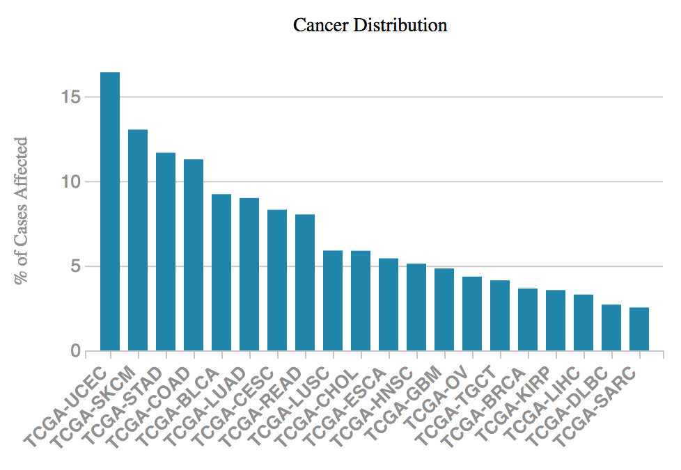

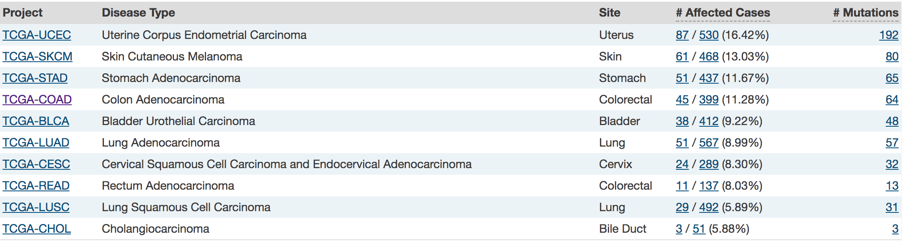

As mentioned in the introduction (section 1.5.IV) it is well known that changes to H2A.Z deposition within the nucleosome have an impact on cancer progression, and therefore aberrations to the protein which catalyses the H2A-H2B to H2A.Z-H2B exchange; SRCAP, could also potentially lead to tumour progression. A review by Rangasamy (2010), showed that there is a fine balance required in the levels of the histone variant H2A.Z in order to maintain functioning cellular mechanisms, which don’t lead to aberrations to the DNA. An up-regulation of H2A.Z leads to increased cell growth due to the variant binding to the p21 promoter and decreasing the expression of p21 (a cell cycle inhibitor), which tends to push the cells through the cell cycle, by inactivating cyclin-CDK complexes. In contrast, down regulation of H2A.Z leads to transcription of p21 leading to cellular senescence (Gévry et al., 2007). Thus highlighting that any variations to SRCAP could in turn cause abnormal distribution of H2A.Z into the nucleosomes and therefore also potentially cause differences in cellular cycling. Given that SRCAP can catalyse the deposition of H2A.Z into the nucleosome, low levels of the chromatin remodeller could decrease cancer cell’s proliferative nature by also decreasing the levels of H2A.Z at specific promoters such as p21 and therefore diminishing cells ability to cycle. In contrast, high levels of SRCAP could increase proliferation and invasiveness by increasing the amount of nucleosomes containing H2A.Z and therefore altering transcription levels in favour of tumourigenesis, making it an interesting gene for investigation with regards to cancer initiation and progression.
Figure 3.1 SRCAP aberrations within different cancers
The above graph highlights the number of cases with mutations to SRCAP in data sets from the TCGA bio-portal. This highlights that aberrations to SRCAP have been found within a wide variety of cancers, with CRC having one of the highest frequency of SRCAP mutations at 11.28% (Taken from the TCGA Nov. 2017).

We hypothesise that SRCAP is a potential driver of CRC tumours and could therefore be a novel therapeutic target. This first results chapter describes efforts to create SRCAP over-expressing cell lines in order to assess how this affects the cellular phenotype and understand how SRCAP gene amplification may impact on tumour growth and progression. To do this two methods were utilised, firstly the traditional either stable or transient transfection of a tagged vector containing the SRCAP construct, in order to exogenously over-express SRCAP, and secondarily creating endogenous over-expression via a CRISPR/dCas9 activation system.

The CRISPR/Cas9 (Clustered Regularly Interspaced Short Palindromic Repeats) technology is adapted from the immune response of bacteria, where it is used as a mechanism to detect and degrade foreign material (Barrangou et al., 2007). When a piece of genetic material foreign to the bacteria is detected, it is integrated into the CRISPR loci, and this sequence is then stored in case of future invasion by the same foreign material. The bacteria can then automatically detect the invading DNA and activate CRISPR associated proteins such as the nuclease Cas9 to degrade it through the formation of DSBs (Horvath and Barrangou, 2010).

This relatively new RNA-guided endonuclease technology started to be used in 2013 as a way of editing the genome (Bassett et al., 2013, Cong et al., 2013). Usually the system involves transfecting into the cells a guide RNA (gRNA) for the gene of interest and the Cas9 complex. The gRNA binds to the complimentary DNA of the gene of interest and directs the activity of Cas9. The Cas9 nuclease has two functional domains (RuvC and HNH) which each cut one of the DNA strands upstream of a protospacer adjacent motif (PAM). These double strand breaks are then repaired by non-homologous end joining (NHEJ), this however is error prone and can result in mutations to the DNA such as insertions or deletions, which in turn disrupt the gene expression. These random mutations don’t always produce clones which have the gene knocked down however, so the clones have to be screened experimentally for alterations (Voets et al., 2017, Manikoth Ayyathan et al., 2017). Alternatively, if the Cas9 is mutated to nick only one strand of the DNA only, the single strand break will preferentially be repaired through homologous directed repair (HDR). Using this method plus an exogenously transfected repair template containing a single nucleotide mutation, a specific edit can be made to the genome (Ran et al., 2013).

The CRISPR/Cas9 system can also be used in a slightly different way to over-express an endogenous gene. Here, along with the gRNA, there is a catalytically dead Cas9 (dCas9). The dCas9 has had 2 amino acids altered within each of its functional nuclease domains (point mutations D10A and H840A) in order to render them inactive. Although dCas9 lacks nuclease activity, it is still able to bind the DNA, directed by the gRNA, but doesn’t cause any DNA breaks. Instead, it’s c terminus is conjugated to a VP64 transcriptional activator, which fuses to regulatory domains near the promoter of the gene of interest and increases the recruitment and functioning of RNA polymerase II and other transcriptional activators to up regulate transcription (Maeder et al., 2013, Park et al., 2017) (Figure 3.2).

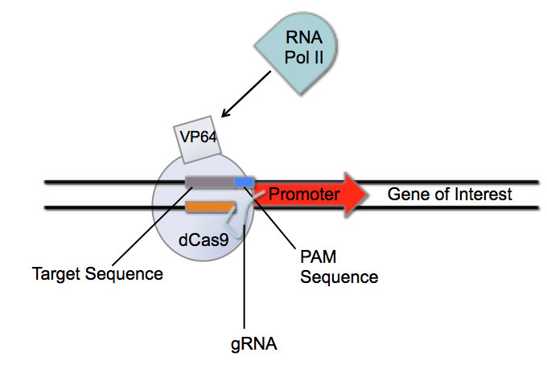
Figure 3.2 Deactivated CRISPR/Cas9 system for over-expression of endogenous genes.
The transfected deactivated Cas9 (dCas9) binds to the target DNA as directed by gRNA upstream of a PAM sequence. The attached VP64 then up-regulates transcription and recruits RNA polymerase II in order to over-express the gene of interest.

3.2 Transient transfection of SRCAP cDNA shows no over-expression

Prior to trying to over-express the gene, two SRCAP antibodies were evaluated for their ability to detect endogenous SRCAP. Unfortunately good antibodies for SRCAP were not readily available; one was an untested (“fast track”) antibody from Abcam and the other was from Santa Cruz and previously cited (Iwai et al., 2011). Additionally, previous studies have used in house made SRCAP antibodies (Ruhl et al., 2006, Wong et al., 2007, Dong et al., 2014). Multiple requests were made to these research groups to try and acquire some of these antibodies, however, neither group replied to the request for use of the published reagents. After multiple optimisation steps with both available antibodies such as: long run times, differing transfer membranes, poured vs. precast gels, the concentration of the antibody and different lysis solutions, endogenous SRCAP could still not be detected (Figure 3.3). As can be seen in the representative image in Figure 3.3, a band around the 200kDa mark was the largest detected, but SRCAP is predicted to have a size of ~340kDa. Large proteins are often harder to detect on western blots than smaller proteins, and it may also be that endogenous levels are low and/or the purchased antibodies are only capable of detecting over-expressed/exogenous SRCAP.

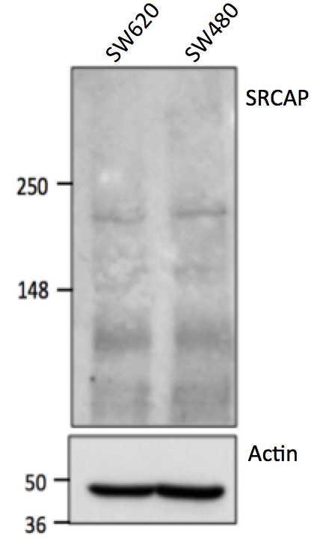
Figure 3.3 Endogenous levels of SRCAP cannot be visualised by western blotting.
Using cell lysates from SW480 and SW620 colorectal cancer cell lines, membranes were probed for endogenous SRCAP using 40ng of sample and 1:250 SRCAP antibody from Abcam, with Actin used as a loading control. The largest band detected was below the 250kDa molecular weight marker as indicated by the red arrow, which is too low to be SRCAP.

In order to create over-expressing SRCAP cell lines, human SRCAP cDNA (BC172428) was purchased from Dharmacon in the pENTR223.1 vector. Firstly the SRCAP cDNA bacterial solution provided was grown in spectinomycin selective LB broth over night at 37ºC and the DNA extracted and purified. This resulted in a low yield of only 38.2ng/μl of plasmid DNA; however, a DNA gel confirmed that the DNA was of the correct size and quantity (Figure 3.4a). This cDNA was then transformed into three destination vectors tagged with YFP, MYC and Flag (full names described in methods). The purified vector DNA was sent for sequencing at the Medical School Core Facility to check correct start and stop codons were in frame by using the 9427F and 199R primers detailed in the methods section. Each resulting destination vector containing the SRCAP cDNA was transfected into HCT116 cells for 48hrs before the cells were lysed and then protein was extracted and purified. SRCAP is known to localise to the nucleus. However, when the YFP SRCAP transfected cells were checked for fluorescence, although the cells were expressing YFP, it did not appear to be nuclear (Figure 3.4b). Furthermore, there was a lack of bands detected in the protein lysates from these cells when probed with MYC, FLAG or GFP antibodies that were well established within the laboratory (Figure 3.4c). Although the SRCAP antibodies had so far not detected bands at the correct molecular weight for endogenous protein levels, it was predicted they might show over-expressed SRCAP. However, no over-expression of SRCAP was observed as the highest band detected in any of the transfected samples was just below 148 kDa (Figure 3.4bd).
b.)
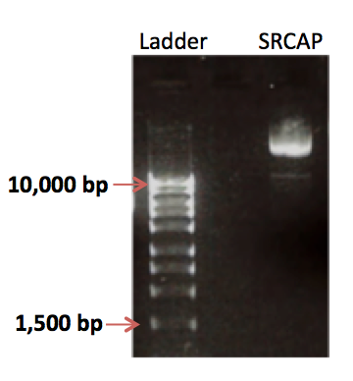
a.)

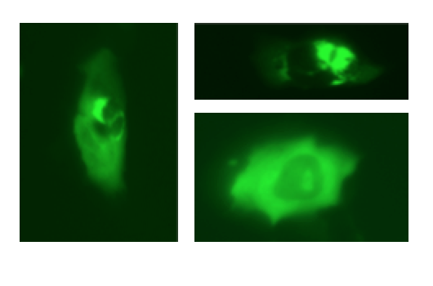
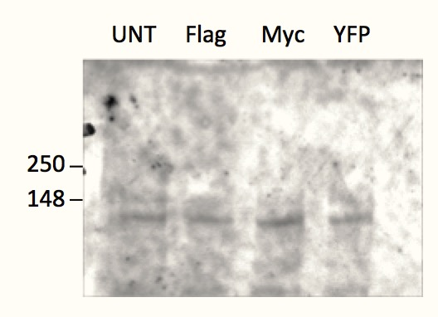
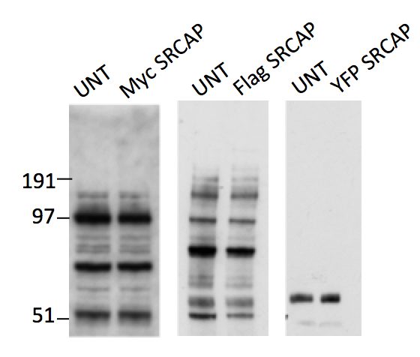
Figure 3.4 Transient transfection of SRCAP shows no detectable expression
a.) 5μl of SRCAP DNA in the entry vector at a concentration of 38.2ng/μl was run on an agarose gel at 70V for 1.5hrs against Hyperladder I, showing it was of the correct weight and concentration.
b.) Representative fluorescent images of YFP SRCAP transfected cells showing no nuclear localisation of the YFP.
c.) Untransfected HCT116 cells (UNT), plus HCT116 cells transfected by Lipofectamine 2000 with either MYC, FLAG or YFP SRCAP constructs were lysed for protein after 48hrs of transfection and 50ng loaded per sample onto a precast gel. The membranes were probed with either anti-Myc tag, anti-Flag M2 unconjugated or anti-GFP primary antibody No bands were detected at the correct molecular weight in any of the transfected lanes.
d.) The sample lysates as used in a. were also probed for SRCAP using the Abcam antibody at a concentration of 1:500. This however, was on a poured 8% gel. Again no band could be seen which corresponded to the molecular weight of SRCAP at 340kDa.
d.)
c.)
3.3 Mutation of the consensus Kozak sequence results in correct localisation of YFP SRCAP

The non-nuclear localisation of YFP and the inability to show tagged-SRCAP protein over-expression suggested that the YFP was being expressed but not the SRCAP portion of the construct. Therefore the construct sequences were again assessed for sequence integrity, during which a Kozak sequence directly before the ATG start site on the provided cDNA was discovered (Figure 3.5a). Kozak sequences play a major role in the initiation of translation, whereby they are recognised on mRNA by the ribosome as a start site for translation of the protein to begin. However, the destination vectors also have a Kozak sequence just before the tag sequence to allow translation of the N-terminally tagged protein. Therefore when the SRCAP cDNA was inserted into the destination vectors, resulting translation from the transfected vectors may have initiated from both Kozak sequences and so disrupting the proper protein translation. This may therefore explain why the YFP SRCAP constructs did not exhibit nuclear localisation and why no SRCAP could be detected by western blotting. The Kozak and start site in the Entry, MYC, FLAG and YFP constructs containing SRCAP cDNA were subsequently mutated using site directed mutagenesis (as described in materials and method section 2.2.I.f). Each of the newly purified DNA extracts was sent for sequencing of the whole gene using the 18 primers described in the methods (section 2.2.I.e). The fully verified constructs were once again transfected and this time the YFP SRCAP construct showed nuclear localisation both with YFP fluorescence alone and when probed with GFP antibody compared to untransfected samples (Figure 3.5b&c). However, there was a low rate of transfection efficiency of around 10% when assessed under the microscope.

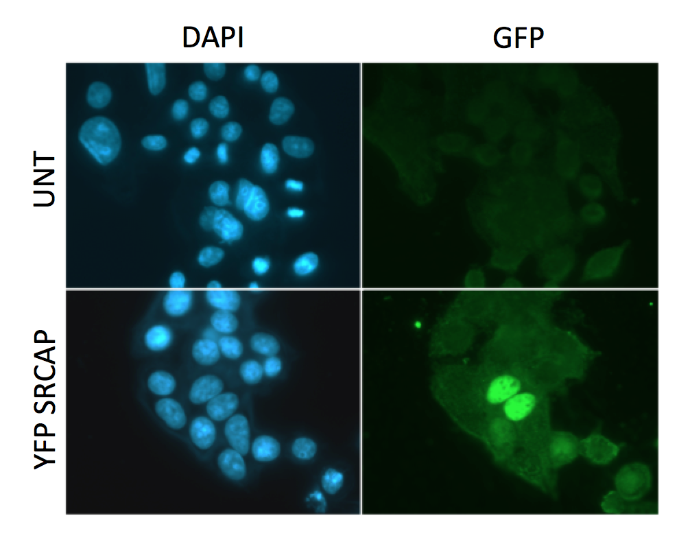
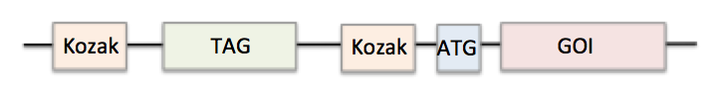
c.)
b.)
a.)
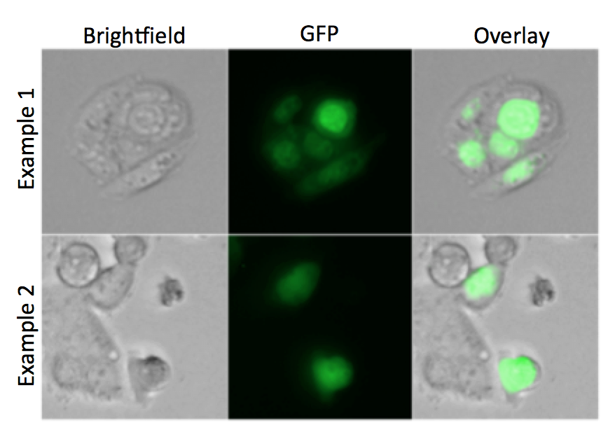
Figure 3.5 YFP SRCAP transfection shows nuclear localisation after Kozak mutation
a.) The commercially sourced SRCAP cDNA included an ATG site at the start of the gene of interest (GOI); this was preceded by a Kozak and start sequence of CCCACCATG. However, when the SRCAP cDNA was transformed into the destination vectors there was also a kozak sequence before the tag sequence, which meant translation could potentially initiate from two different sites. Proteins produced from the internal Kozak transcript would also lack the N-terminal tags.
b.) SW480 cells were transfected with 1μg of Kozak mutated YFP SRCAP in a six well plate and the live cells imaged on the microscope. Above are representative light microscope images, FITC images and merged images of cells expressing YFP SRCAP, which appears to be nuclear.
c.) The same cells in the plates as in a. were fixed and the GFP antibody used to detect YFP SRCAP localisation along with DAPI staining of the nucleus. From the representative images, transfected cells can clearly be seen (as indicated by the white arrow) as fluorescing in the FITC channel in the nucleus compared with the untransfected cells (UNT).

It was felt that the relatively low transfection efficiency would be detrimental to future experiments aimed at assessing phenotypes associated with cellular over expression of SRCAP. Therefore, transfection reagents other than Lipofectamine 2000 were used in an attempt to increase the number of transfected cells. These were- Genejuice, Fugene, LTX, and Mirus. Cells were transfected with YFP SRCAP and the percentage of fluorescent cells assessed on the FACS Calibur flow cytometer. After 24hrs of transfection Lipofectamine 2000 was the reagent that gave the highest transfection efficiency along with LTX. At 48hrs LTX and Fugene were the most optimal. However, the maximum amount of cells transfected was still only 15% (Figure 3.6). The low transfection efficiencies may therefore be a result of the fact that we are transfecting a large construct of 9754 base pairs. Unfortunately the other transfection reagents were samples requested from the companies and so this experiment was only repeated once. However, due to the lack of overt improvements observed, and reasons of cost, all further experiments continued to use Lipofectamine 2000.
n=1
Figure 3.6 Assessment of YFP SRCAP transfection efficiency using a range of different transfection reagents.
SW480 cells were seeded at 200,00 cells per well in a 6 well plate and transfected with 1μg of the mutated YFP SRCAP, or ddH₂O as control, using one of five transfection reagents and following the manufacturers protocol (TRAN= transfected with YFP SRCAP, UNT=mock transfection with ddH₂0). After 24 and 48hrs samples were trypsinised and washed in PBS before being run on the FACS Calibur flow cytometry machine. Cells were gated depending on whether they showed fluorescence in the FL1 channel and the percentage of cells YFP positive calculated. UNT samples showed less than 1% positive cells, whereas the TRAN samples ranged from 1-15%. Graph shows the percentage of YFP positive cells from one experiment.

Even though the new YFP SRCAP construct showed nuclear localisation, there was no over-expression of SRCAP mRNA as assessed using a Taqman assay at 48 or 72hrs after transfection (Figure 3.7a). However, this may be because the transfected population of cells was not large enough to have an affect on the overall SRCAP mRNA levels in the collective cell population. Western blots did not show over-expression when probing with an SRCAP antibody or with FLAG compared to the untransfected. However, there were two bands higher than 191kDa in the YFP SRCAP transfected sample when probed with GFP antibody, which suggests cells could have been expressing YFP-tagged SRCAP (Figure 3.7b &c).
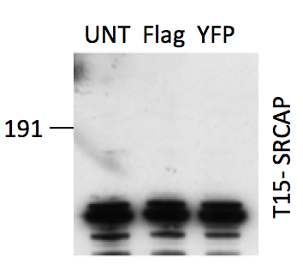
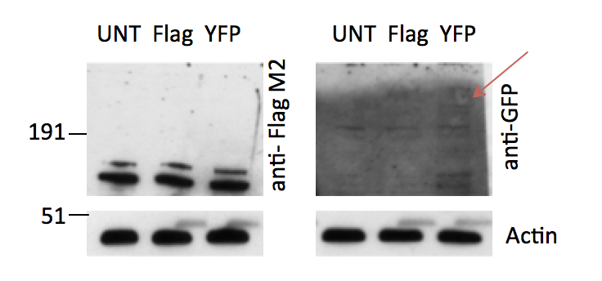
Figure 3.7 Transfection with mutated SRCAP constructs does not show heightened SRCAP expression
a.) SW480 cells were transfected with 1μg of mutated YFP SRCAP construct or ddH₂O (Untransfected) for 24 or 48hrs, then lysed to extract RNA and the SRCAP expression assessed via Taqman PCR. After two repeats there was no significant difference between SRCAP expression in YFP SRCAP transfected and untransfected samples when a non-parametric Mann-Whitney test was applied (48hrs- p=0.6667, 72hrs- p=0.6667). The graph shows the median and range from the two repeats (p≤0.05).
b.) SW480 cells were transfected with the mutated YFP or Flag SRCAP construct and lysed for protein 48hrs later. 50ng of each sample was separated on a precast gel and probed with anti-Flag M2 HRP conjugated or anti-GFP. There were no bands detected at the correct molecular weight in the Flag transfected sample, there were two bands above 191kDa in the YFP SRCAP sample as indicated by the red arrow. The same blot as was probed with GFP antibody was re-blocked and the Santa Cruz SRCAP antibody used at 1:250. There were no bands that indicated over-expression of SRCAP, compared to the untransfected sample (UNT).
a.)
b.)
Although high molecular weight bands were seen in the YFP SRCAP lane in figure 3.7b, when this was repeated in HEK293 cells, there was a new banding pattern in the transfected sample not seen in the untransfected (Figure 3.8a). These cells were used as they have been highly characterised in this laboratory, and can be easily transfected. However, the presence of a low MW band of around 60-80 kDa suggested that the YFP SRCAP protein could be being cleaved at ~30-50 kDa into the SRCAP sequence. Indeed when the SRCAP sequence was analysed in the online EXPASY peptide cutter (https://web.expasy.org/peptide_cutter/), there was a caspase cleavage site at amino acid 471, consistent with a potential 60-80kDa product, supporting the theory that the SRCAP protein maybe being degraded in HEK293 cells. Using the online nuclear localisation sequence (NLS) mapper there was no NLS within the first 471 amino acids. Therefore, cleavage of SRCAP at this specific point does not explain how a nuclear localised YFP-tagged protein was observed. To study this further, YFP-SRCAP transfected cells were treated with either a caspase or proteasome inhibitor for 16hrs before lysing and assessing whether SRCAP over-expression could be detected. However, there was no difference between untransfected samples and transfected whether they had had inhibitor on or not (Figure 3.8b).
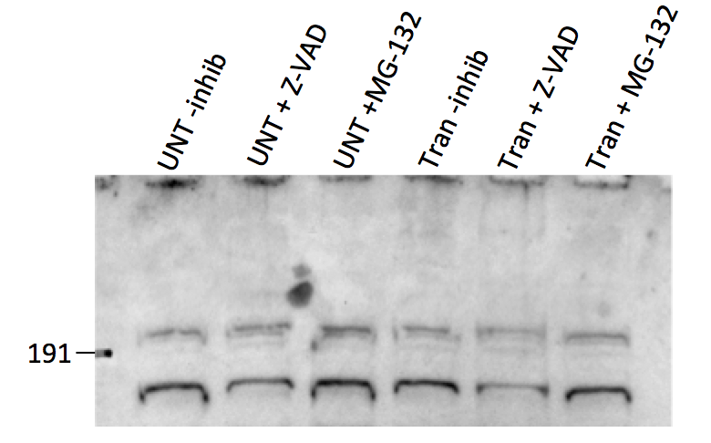
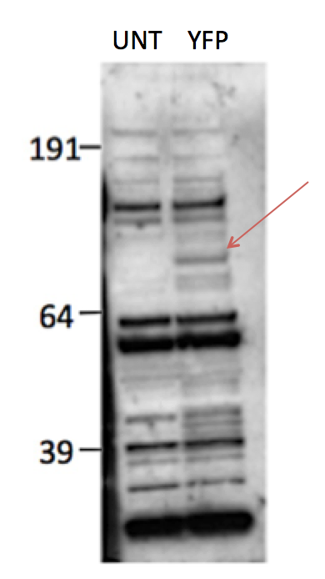
b.)
a.)

Figure 3.8 Protein banding pattern in western blot sample could indicate cleavage of SRCAP
a.) HEK293 cells were transfected with YFP SRCAP for 48hrs or with ddH₂O (UNT), lysed for protein and 50ng of each sample loaded onto a precast gel. Anti-GFP was used as the primary antibody. In the YFP transfected sample there were a number of bands just above 64kDa, which were not present in the untransfected sample as indicated by the red arrow.
b.) Z-VAD caspase inhibitor or MG-132 proteasome inhibitor (20μM) was added to the media 4hrs after cDNA transfection and left for 16hrs before cells were lysed for protein. 50ng of protein was run on a precast gel and probed for with anti-GFP (1:2000) primary antibody. There was no difference between samples with or without inhibitor addition.

3.4 XL10 competent cell propagation leads to SRCAP over-expression

In an attempt to improve transfection efficiencies, XL10 Gold ultra competent cells were used to transform the Kozak mutated YFP, MYC and FLAG SRCAP constructs, as these cells are more robust for large gene inserts. Following DNA extraction and purification, the YFP and MYC constructs exhibited the correct size on an agarose gel, however the FLAG construct was smaller than expected. Despite this all three newly prepared construct solutions were transfected into Hela cells (selected because HeLa cells are well established for high transfection efficiencies). For the first time, the MYC and YFP SRCAP transfections showed an increase in SRCAP mRNA, compared to an untransfected control, although the FLAG construct did not show over-expression, which is likely explained by the smaller size of this construct on the DNA gel (Figure 3.9a). Furthermore, the YFP SRCAP construct also showed nuclear localisation (Figure 3.9b). Although the SRCAP antibody did not show any protein over-expression in western blot analysis, there was a faint band using the GFP antibody in the transfected cells (Figure 3.9c). However, again the transfection efficiencies were below 10%, and so this low efficiency would be affecting how much SRCAP protein was present in the samples and detectable by western blotting.

Stably expressing YFP SRCAP cells were also generated in an attempt to circumvent the problems of low transient transfection efficiencies and to facilitate phenotypic assessment of SRCAP over-expression. However, following two weeks of antibiotic selection post-transfection, all YFP transfected SW480 cells were dead and no colonies formed, suggesting that chronic over-expression of SRCAP may be cytotoxic. Consistent with this notion, a significant increase in the sub-G1 population was observed overtime in Hela cells transfected with SRCAP cDNA (Figure 3.10), compared to ddH₂O mock transfected control cells. This increase in cells in sub G1 then corresponded to a significant decrease in the percentage of MYC or YFP SRCAP transfected cells in G1. This would also potentially explain why protein over-expression was not observed in transiently transfected cells even when SRCAP mRNA levels were increased.

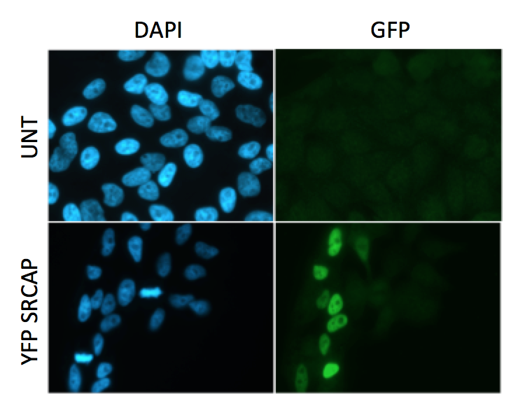
b.)
a.)
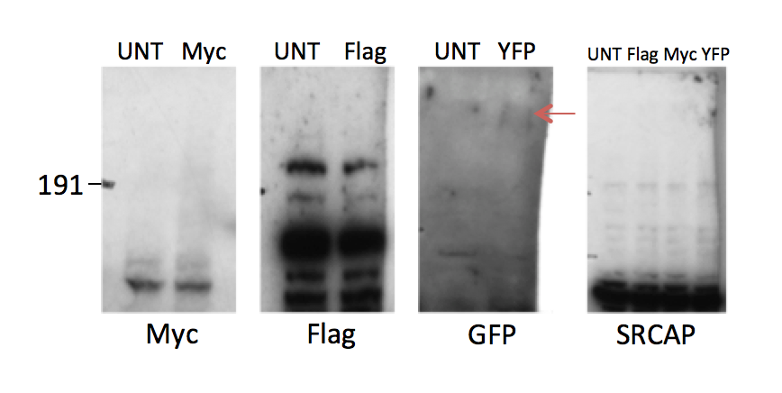
Figure 3.9 XL10 competent cell transformed constructs show SRCAP over-expression
a.) Hela cells were transfected for 48hrs with 1μg of YFP, Myc or Flag SRCAP construct that had been transformed in XL10 competent cells. RNA was extracted and Taqman PCR undertaken to given the SRCAP expression levels. One repeat with three internal repeat values, to give the mean and positive and negative error, plotted above, showed that Myc and YFP SRCAP were over-expressing SRCAP, but FLAG SRCAP wasn’t, compared to untransfected control (UNT), n=1.
b.) YFP SRCAP transfected Hela cells, as in a., were fixed on coverslips and the transfected cells detected using the GFP antibody. Transfected cell populations (YFP SRCAP) show nuclear localisation of YFP SRCAP, compared to the undetected untransfected (UNT) cell population.
c.) HEK293 cells were transfected with 1μg of YFP, Myc or FLAG SRCAP construct for 48hrs, then lysed for protein. 100μg of protein for each sample was loaded onto a precast gel and Myc, Flag (unconjugated), GFP or SRCAP (Santa Cruz) antibodies used. The Myc, Flag and SRCAP blots showed no bands higher than 191kDa in transfected or untransfected (UNT) lanes. There looks like the possibility of a band at 370kDa in the YFP SRCAP transfected lane when probed with GFP antibody.
c.)

Figure 3.10 Cell Cycle profiles show increased sub G1 population in transfected samples.
Hela cells were transfected with 1μg of YFP or MYC SRCAP construct or ddH₂O as an untransfected control (UNT) and cells fixed and stained with PI 24, 48 and 72hrs after transfection. The samples were assessed for cell cycle profiles on the FACS Calibur via the gating protocol specified in the methods. Over time there was an increase in the sub G1 phase of the cell cycle in the YFP and MYC transfected samples compared to the untransfected control. This correlated with a decrease in the percentage of cells entering G1. As assessed using a Kruskal-Wallis non-parametric test and comparing YFP or MYC to untransfected cells (UNT) individually at each phase of the cell cycle, with the significance stars of the comparison shown on the graphs of median and range (* = p≤0.05).
3.5 Tetracycline induced Flp-In expression system shows a small increase in over-expression of SRCAP

In order to try to over-express SRCAP more robustly, a tetracycline (Tet) inducible model was established in order to minimise any inherent cytotoxicity associated with chronic/constitutive SRCAP over-expression. The YFP SRCAP construct (which was already contained within a Flp-In compatible construct) was transfected into the HCT116 Flp-In cell line. Cells were placed in antibiotic selection media until colonies began to form on the transfected dish but not on the control untransfected dish. The colonies were combined into one population ready for tetracycline addition and SRCAP expression level testing. Firstly, protein expression was established via probing for YFP. Figure 3.11a shows a band in the Tet induced lane after 72hrs above the 191kDa marker. This was thought to be around the correct weight of 370kDa (SRCAP ~340kDa plus the YFP tag) indicating that at 72hrs post Tet induction there was over-expression of YFP SRCAP compared with the parental HCT116 Flp-In cells, as well as untransfected cell populations and the un-induced transfected control cell population. However, this protein over-expression was not seen at 24 or 48hrs, or at later time points of 96 and 120hrs post-Tet induction. Additionally, Taqman PCR assessment of the SRCAP mRNA levels did not show over-expression of SRCAP at any of the time points (Figure 3.11b). There did appear to be a trend towards an increase in SRCAP expression in the Tet induced cells at 24 and 72hrs, however, the repeats were very variable and so no conclusive conclusions could be made from these data.

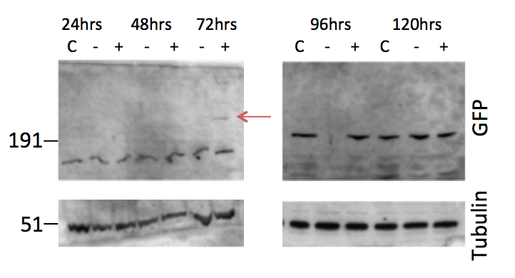
b.)
a.)
Figure 3.11 Tetracycline inducible cells show potential SRCAP over-expression at 72hrs after Tet addition
a.) The HCT116 Flp-In cells that had been transfected and antibiotically selected for were seeded and had 2μg/ml of tetracycline added to the media of one well (+) and not to the other well (-). Cells were lysed for protein after 24, 48, 72, 96 or 120hrs in the Tet media. 50μg of each sample were loaded onto a precast gel and probed for with GFP antibody. Tubulin antibody was also used as a loading control. HCT116 Flp. cells that had not being transfected were used as control (C). A band above 191kDa was observed in the Tet induced cells after 72hrs which could possibly represent YFP SRCAP, as indicated by the red arrow. This was consistently observed over two individual repeat experiments.
b.) RNA samples were taken from the indicated HCT116 Flp-In transfected cells and SRCAP levels assessed via Taqman PCR. Using a Kruskal-Wallis non-parametric test there was no significant difference in SRCAP expression between any of the conditions (p=0.5420), after four repeats (p≤0.05).
Additionally, potential Tet-inducible YFP-SRCAP expression was determined in these cells using immunofluorescent detection of GFP (shown in Figure 3.12a). GFP positive cells were present at 72hrs post-Tet induction, which was not observed in the parental HCT116 Flp-In cells (Figure 3.12a). Calculation of the percentage of cells that were over-expressing YFP SRCAP after Tet addition in three individual repeats experiments revealed an average of 41% (standard deviation ±9.4). This is an improvement from the <10% transfection efficiency that was usually obtained in transient transfections (see previous). Unfortunately, low levels of GFP expression were observed in un-induced cell populations, indicating that the system could be ‘leaky’, potentially due to a small amount of Tet being present within the FCS in the media. Calculation of the percentage of YFP SRCAP expressing cells uncovered 18% (standard deviation ±8.6) of cells without Tet induction still expressed the construct. This could explain why there was a large amount of variability in the mRNA expression levels as there was still over half of transfected cells not over-expressing SRCAP, and in the non-Tet samples there was some SRCAP over-expression which would be skewing the data.

To determine the potential effects of SRCAP over-expression on genome stability, DNA damage was evaluated in YFP SRCAP over-expressing cells using two well-known immunofluorescence markers- γH2AX and 53BP1. H2AX is another variant of the histone H2A and is phosphorylated by ATM, ATR or DNA-PK at serine 139 when a double strand DNA break is detected. This modification allows for a more relaxed chromatin state and therefore repair proteins can be recruited and bound to the damaged DNA (Sharma et al., 2012). 53BP1 rapidly accumulates at sites of DSBs due to ATM mediated signalling and here it promotes further signalling and repair proteins to bind (Schultz et al., 2000). As such, these markers are widely used and validated surrogate markers of DNA damage and DNA DSBs respectively, which can be easily visualised and quantified, as shown in Figure 3.12a. Quantification of the DNA damage markers showed a significant increase in DNA damage when cells were transfected with the YFP SRCAP construct compared to the parental HCT116 Flp-In cells. However, there was no difference in the average number of foci per cell between samples that had had Tet induction and those that hadn’t (Figure 3.12b). In addition there was also no difference in DNA damage between YFP SRCAP expressing cells and those that did not express YFP SRCAP, within the same Tet induced samples. This suggests that an increase in SRCAP does not induce genome instability in the form of DNA damage. However, it is possible that the over-expression of SRCAP would need to persist for a longer amount of time within the cells before effects on DNA damage would be seen.

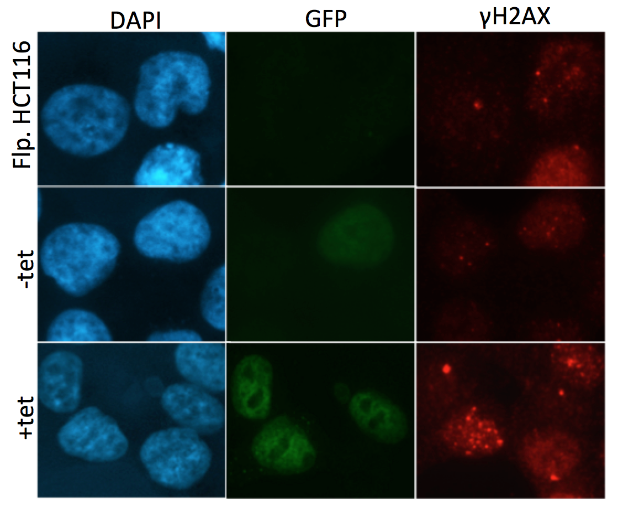
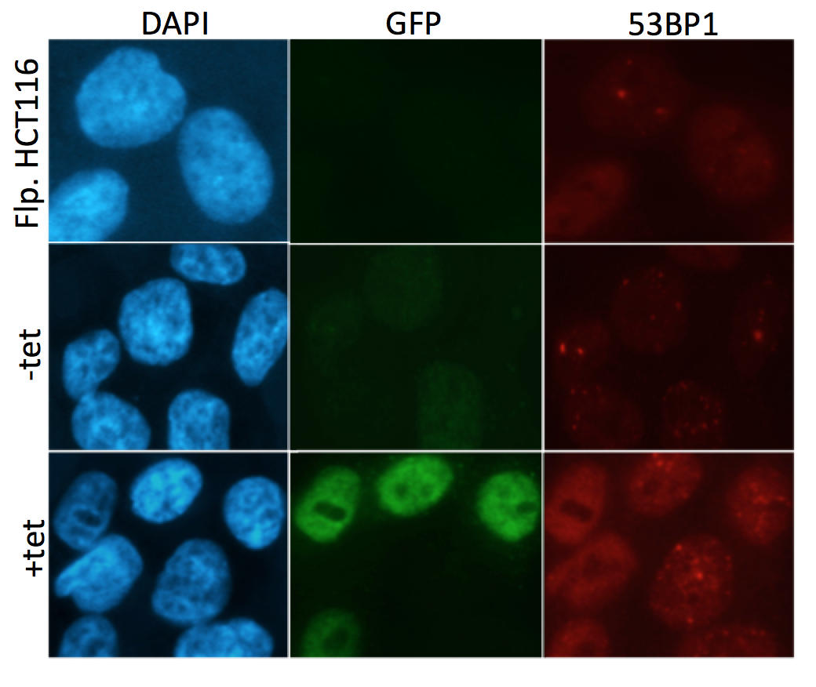
b.)
a.)
Figure 3.12 SRCAP over-expressing cells via Tet-induction shows no difference in DNA damage compared to cells not over-expressing the YFP SRCAP construct
a.) Representative images of the HCT116 Flp-In cells transfected with YFP SRCAP and subjected to 72hrs of Tet induction. With anti-GFP antibody used to detect the YFP construct, and γH2AX and 53BP1to look at markers of DNA damage
b.) The number of foci per cell was counted for 100 cells per condition and averaged. The parameters counted were the parental HCT116 Flp-In cells, transfected cells with no Tet induction (-tet YFP SRCAP), Tet induced cells which didn’t show YFP fluorescence (+tet – YFP SRCAP) and Tet induced cells, which did show YFP fluorescence (+tet + YFP SRCAP). Using a Kruskal- Wallis non-parametric test there was a significant difference in γH2AX- p=0.0418, but not in 53BP1- p=0.0502 overall. However, the individual p values using multiple comparisons gave significance with both markers when compared against control Flp. HCT116 cells as shown by the significance stars on the graph (* = p≤0.05).
3.6 Transient transfection of deactivated CRIPSR/Cas9 as an alternative approach to generate SRCAP over-expressing cells

As part of the over-expression studies, a CRISPR/dCas9 gene activation system with a gRNA for SRCAP was purchased from Santa Cruz Biotechnology in order to create cells over-expressing endogenous SRCAP. This system contained a solution of three plasmids at a 1:1:1 ratio, containing the deactivated Cas9 complex conjugated to a VP64 transcription activator, gRNA with hairpin aptamers to allow bind of MS2 bacteriophage coat proteins and an activation helper vector containing MS2-P65-HSF1. This is known as the synergistic activation mediator system or SAM. The gRNA binds to the complimentary base pairs of the gene of interest and directs the dCas9-VP64 complex to bind as well. This will increase transcriptional activation through RNA polymerase II recruitment, however the third vector codes for MS2 proteins conjugated to two further transcriptional mediators-p65 and HSF1. These MS2 proteins can therefore bind to the specific sites engineered onto the gRNA to further up regulate transcriptional activation of the gene of interest (Zhang et al., 2015). Using this system of modified CRISPR/Cas9, SRCAP should be able to be endogenously overexpressed within cell lines. Including in this system is a control CRISPR/dCas9 solution, contained the same three plasmids but with a non-specific gRNA. The latter should therefore not recognise any sequence of DNA and should not activate transcription, so act as a control.

The SRCAP or control CRISPR system was transfected into SW480 cells according to the protocol in the methods (section 2.2.II.g), and expression of SRCAP was assessed to determine if the system was capable of increasing endogenous levels of SRCAP. Expression levels were assessed at three different time point post-transfection, however, the relative mRNA expression value outputs were all very different so were not combined into one graph (Figure 3.13.a, b & c). Each of the repeats showed that over-expression of SRCAP could be detected at 48 and 72hrs after transfection. It wasn’t clear why large differential expression was occurring between the repeat experiments, as the same amount of plasmid was transfected each time. It is possible that a different number of cells were taking up the plasmid each time, meaning the efficiency of transfection was having an effect on the overall population SRCAP expression levels.
b.)

c.)
a.)
Figure 3.13 Transfection with SRCAP CRISPR reagents results in SRCAP over-expression at the mRNA level.
SW480 cells were seeded for 24hrs in 6 well plates, transfected with the CRISPR reagents as per the protocol and SRCAP mRNA expression assessed after 48 and 72hrs. Each graph above represents one repeat with mean and positive and negative error of the internal experimental three repeats plotted. As, although they all follow the same trend of SRCAP CRISPR transfection causing an over-expression of SRCAP in comparison to control, the expression values differ massively between repeats as can be seen by the y axis (each graph represents n=1).
During this process it was noted that the SW480 cells were exhibiting reduced growth in the six well plates and very little RNA was being extracted even after 96hrs post-transfection with the dCas9 plasmids. Therefore, we examined cell growth over time. 24hrs after seeding, the cells were increasing in number, however as soon as they were transfected with either control or SRCAP CRISPR at this time point, both cell populations began to decrease in cell number to a level below the original seeding level. This cannot be explained as the effect of trying to over-express SRCAP within the cell line, since the effect was also observed with the control system, which does not affect gene expression. The transfection was carried out again, but this time SW480 cells were also mock transfected with ddH₂O. The cells that were mock transfected grew steadily over 72hrs as would be expected, but again both the control and SRCAP CRISPR transfected cells decreased in numbers in exactly the same way as before (Figure 3.14a). To ascertain if the transfection reagent was a potential cause of the cell toxicity (even though Lipofectamine 2000 had been extensively used on this cell line previously), the same test was conducted but with Fugene HD transfection reagent. Again the graph of cell growth shows the mock-transfected cells increasing, however the CRISPR transfected cells do not decrease in cell number as they did with Lipofectamine 2000, but they do remain at the base line seeded number of 200,000 (Figure 3.14b).
b.)
a.)
Figure 3.14 Transfection with the CRISPR reagents affects cell growth
a.) 200,000 SW480 cells were seeded in 6 well plates and left for 24hrs, they were then transfected with CRISPR reagents or ddH₂O using Lipofectamine 2000. Over 72hrs the cells were trypsinised and manually haemocytometer counted three times per condition per time point (as shown by SD error bars), using tryphan blue to look for viable cells. CRISPR transfected cells decreased in number over time whereas mock transfected proliferated as would be expected (n=1).
b.) The same protocol as above was repeated in SW480 cells but instead using the Fugene HD transfection reagent. Again after 72hrs the number of viable cells in mock-transfected samples increased, whereas the CRISPR transfected cells stayed at the same cell number as was seeded (n=1).

After discussions with the company (Santa Cruz Biotechnology) regarding this cell growth problem, they provided a new control plasmid solution to test. The control CRISPR was transfected into SW480 cells as before, in addition to U2OS cells, which have been regularly used for transfection within the laboratory, to check that there was no cell specific issue. However, the cells transfected with the new control plasmid again did not grow in either cell line, but the mock transfected ones continued to proliferate over 72hrs as would be expected (Figure 3.15). Therefore these experiments demonstrated that there was no problem with the transfection reagents or cell line, suggesting that the CRISPR system was affecting cell growth. The company was not willing to provide the specific nucleotide sequence of the control gRNA, so there was no way to carry out a BLAST search to see whether the control was actually specific to any parts of the genome and thus affecting cell growth. Although this is one possible explanation, the fact that the SRCAP CRISPR system also decreased the cell growth over time may mean that some component of the plasmid mix is causing the decrease in cell viability. However, without a sequence for the control system this would be hard to explore, especially as the plasmids come pre-mixed so cannot be transfected separately.

Figure 3.15 New control CRISPR reagent shows the same trend in reduced cell growth
SW480 and U2OS cells were again seeded in 6 well plates at a density of 200,000 cells per well. They were transfected with Lipofectamine 2000 at 24hrs with the new control CRISPR or ddH₂O and left to proliferate, with viable cells being manually haemocytometer counted every day. Three samples per time point, per condition were counted to give the SD error bars on the graph. Again the CRISPR transfected cells did not grow, whereas the mock transfection did not affect cell growth (n=1).
3.7 Lentiviral CRISPR/dCas9 utilisation creates viable SRCAP over-expressing clones

In order to generate a CRISPR/dCas9 mediated SRCAP over-expression cell line; the next step was to try a lentiviral system. Here the same components as previously mentioned in section 3.6 are transfected into the cells as before, but in a lentiviral package, and so should actively pass through the nuclear membrane and integrate into the genome via integrase functioning to stably over-express the target gene, depending on antibiotic resistance mechanisms. This approach negates the need for a control CRISPR system, as the same cells are mock transfected with ddH₂O and incubated with the appropriate three antibiotics according to the resistance genes within the three vectors. As they are not resistant to the antibiotics the control cell population should all die, whereas the CRISPR transfected cells are expected to continue to proliferate and form colonies. SW480, HCT116, RPE-1 and HEK293 cells were firstly subjected to differing antibiotic concentrations over 72hrs in order to ascertain optimal antibiotic concentrations suitable for selection of resistant clones (Appendix 2). Once this was determined, the same four cell lines were transfected with the lentiviral CRISPR/dCas9 system, incubated with antibiotics and left to form colonies. A number of clones were picked after around 10 days and the expression of SRCAP assessed (Figure 3.16). The transfected HEK293 cell line did not form any colonies and died in a similar manner to the control cell population. This may be due to the fact that these cells will have been through an antibiotic selection process previously as part of the hTERT immortalisation process. Although the other immortalised non-cancerous cell line RPE-1 did form colonies, when the expression of SRCAP was determined there was no difference in expression levels between the CRISPR transfected clones and the parental control (Figure 3.16a), possibly suggesting that the lentiviral CRISPR/dCas9 system cannot be used in hTERT immortalised cell lines due to previous antibiotic selection pressures. However, both HCT116 and SW480 cell lines produced clones that over-expressed SRCAP to differing degrees (Figure 3.16b & c). The clones highlighted in red were picked to go on for further assessment to investigate how over-expression of SRCAP may affect cellular phenotype.

Figure 3.16 SRCAP over-expressing CRISPR clones can be generated in CRC cell lines
a.) RPE-1 clones that had survived antibiotic treatment after SRCAP CRISPR transfection were lysed for RNA extraction and SRCAP expression levels tested using the Taqman PCR method with three internal repeats of one experiment, as shown by the positive and negative error bars on the graphs of mean expression. No clones showed any difference in expression compared to control cells.
b.) SRCAP expression was assessed as above in 15 HCT116 clones. Clones 4, 11, 13, 14 and 17 were picked as over-expressing SRCAP compared to control, these are highlighted in red on the graph.
c.) SRCAP expression in SW480 clones was assessed as in Rpe clones and clones 2, 3, 5 and 9 were picked as over-expressing SRCAP, these are highlighted in red on the graph.
a.)
b.)
c.)
Interestingly it was noted that the SRCAP over-expressing cell lines that had been developed via the CRISPR/dCas9 technology looked morphologically different in the flasks when assessed by light microscopy, the use of which was kindly supplied by Dr Chryso Kanthou (Department of Oncology and Metabolism, Sheffield Medical School). The phase contrast images shown in Figure 3.17 show very differing morphologies compared to control cells including spindle projections and large bubble like structures (as indicated by red arrows). Such abnormalities could possibly be evidence of cells entering a senescent state or autophagy and cell death, and further analysis would need to be conducted to establish this. Other members of the lab also saw this when using the lentiviral CRISPR system with different genes of interest, suggesting that this phenomenon was probably due to the CRISPR/Cas9 system and not a result of SRCAP
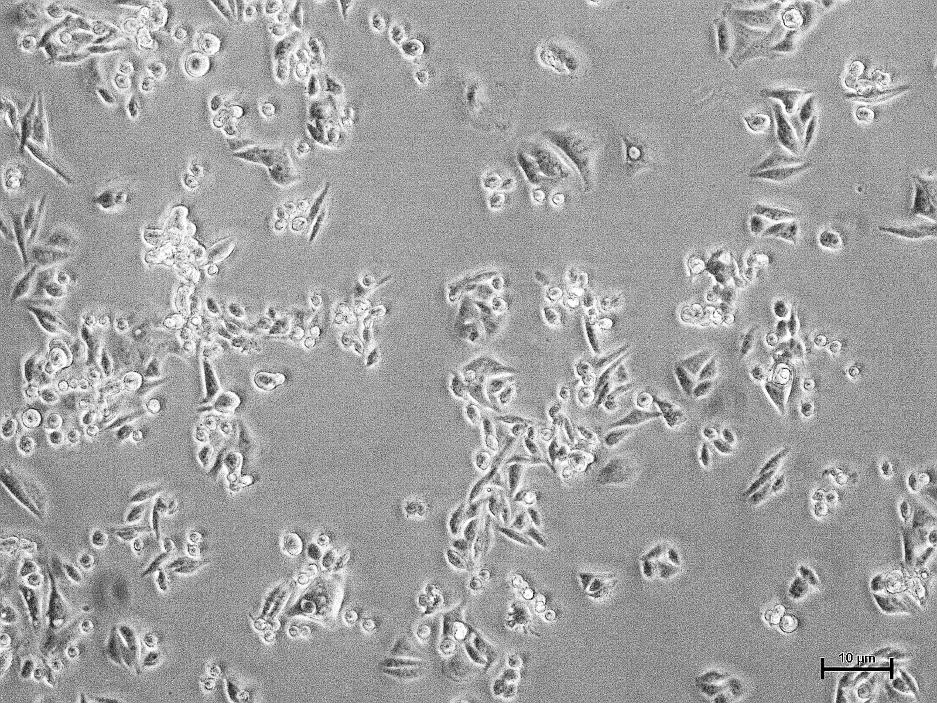
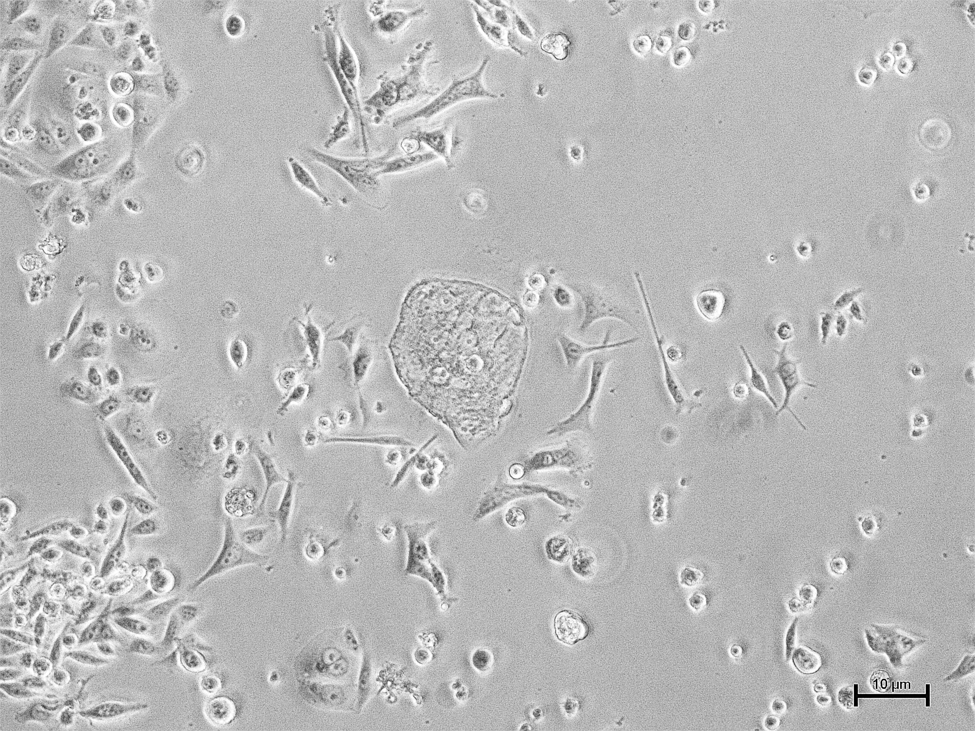
over-expression.
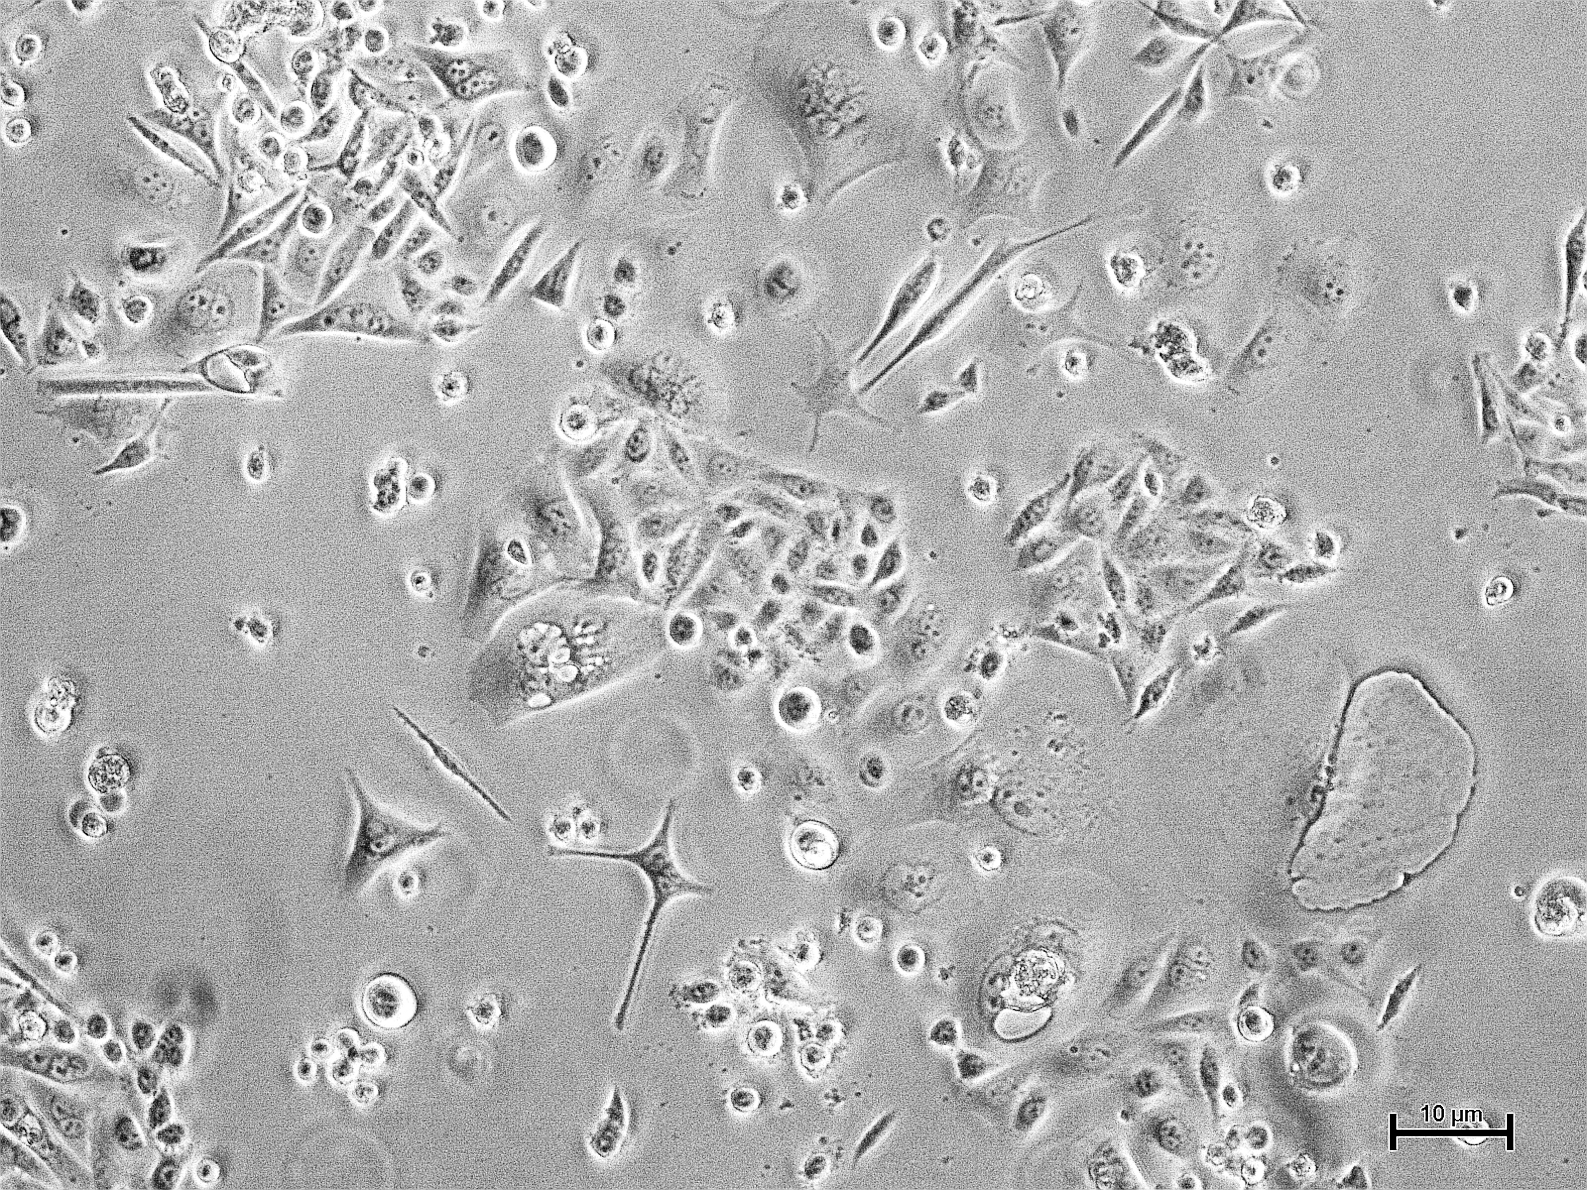
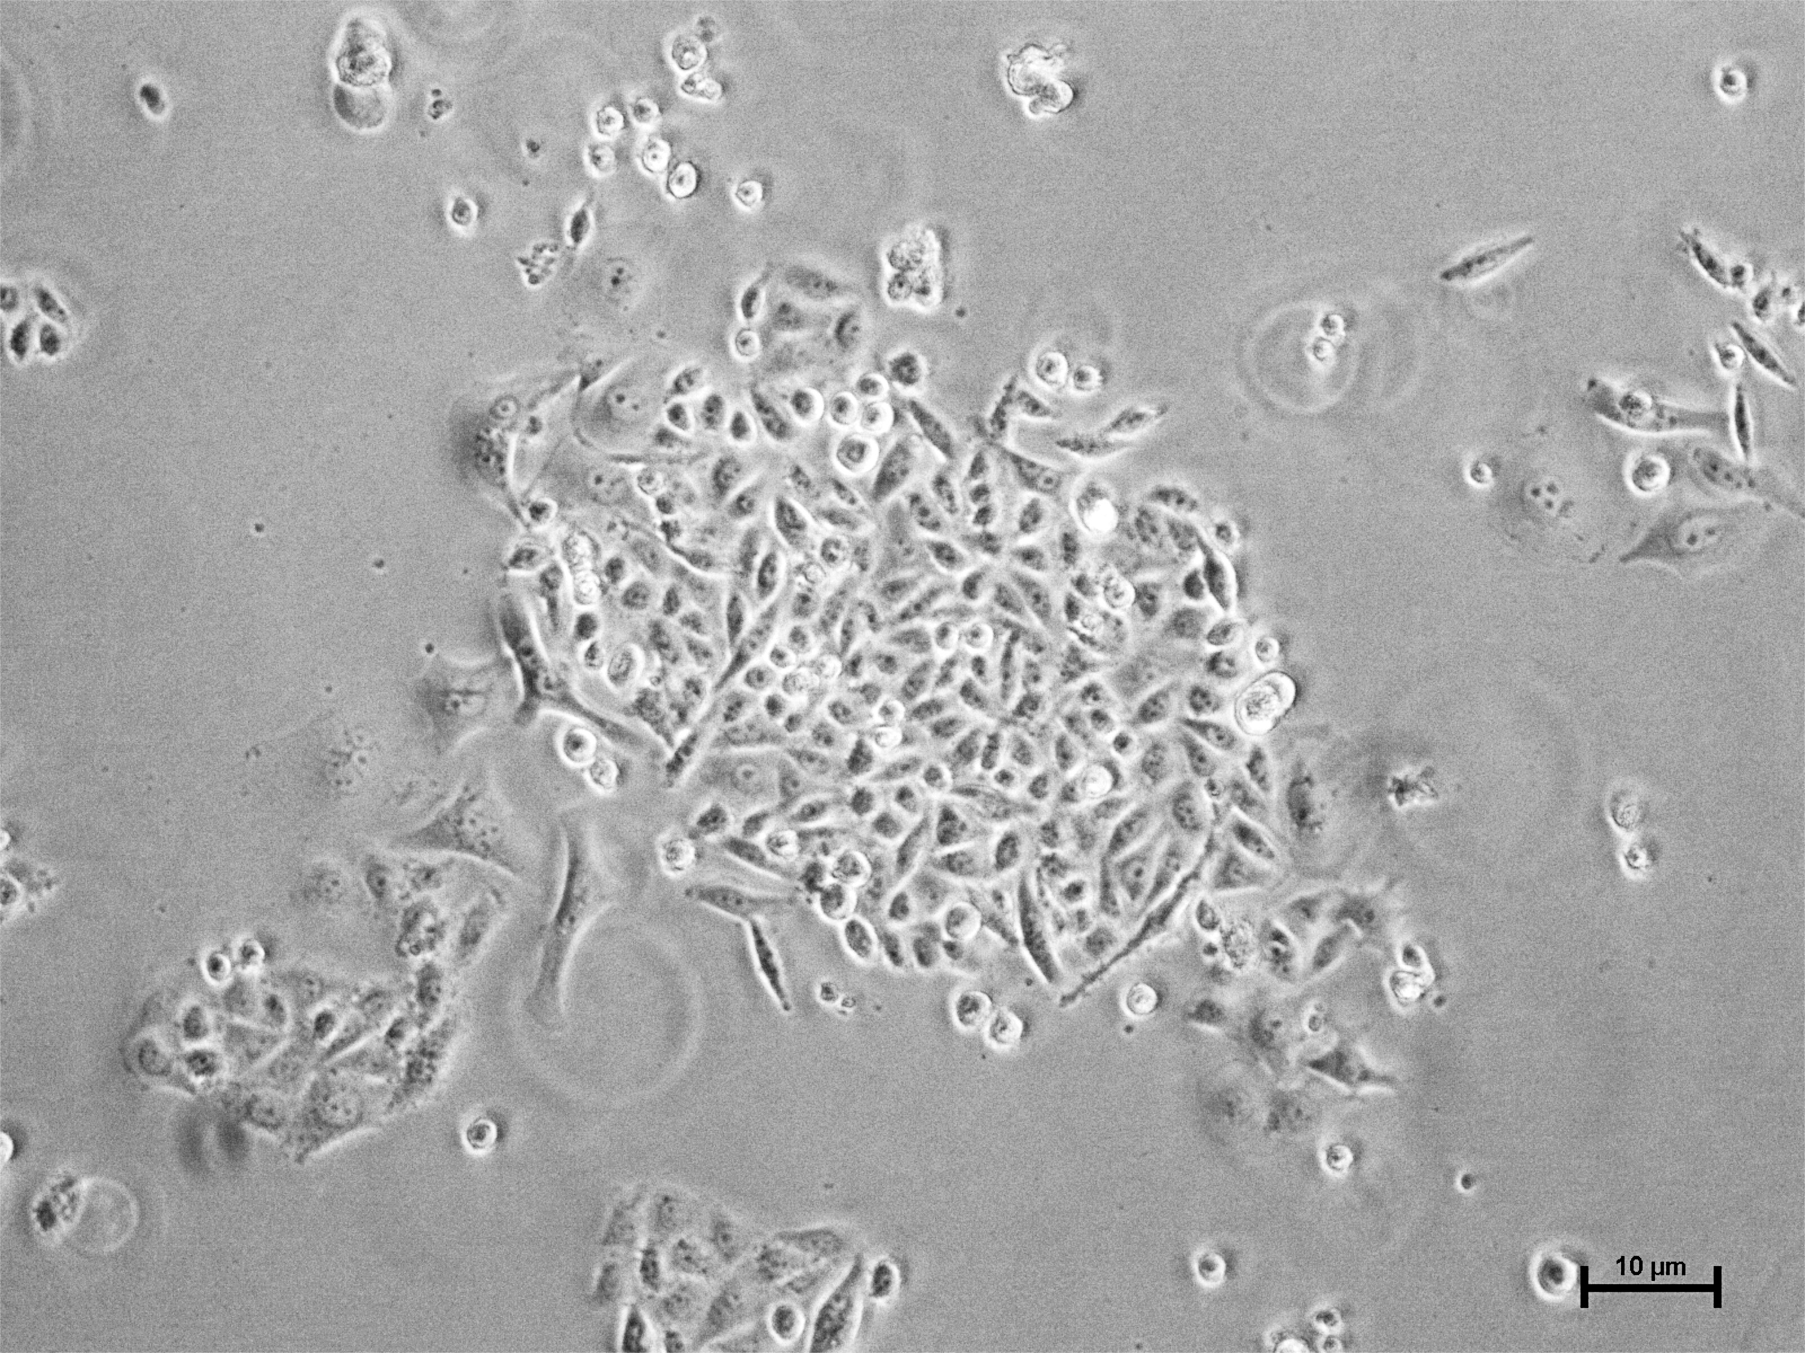
Figure 3.17 SRCAP CRISPR clones show differing morphologies to parental cells
Above are representative images of the different morphologies that the CRISPR transfected clones show, taken on a Nikon phase contrast microscope, compared to parental cells. Here SW480 cells and the SW480 clone 2, which has SRCAP over-expression, have been seeded in 6 well plates and images taken. The red arrows indicate different morphologies of the cells that are seen, including spindle projections and bubble like cells.
SW480 Parental
SW480 CRISPR Clone 2
Due to the problems with cell growth seen in the original CRISPR/dCas9 system purchased from the same company, the growth of the stable SRCAP over expressing clones was assessed. Over 120hrs the HCT116 over-expressing clones along with a parental control cell line were counted each day and the number of viable cells plotted over time. As can be seen in Figure 3.18, after two repeats there was an increase in cell number in the SRCAP over-expressing cells, suggesting that the system was not affecting the cell proliferation rates as the previous CRISPR/dCas9 system had done. The over-expressing cells also grew at a similar rate to the parental control cells, and when statistically assessed showed no difference in the slopes compared to control, showing that when SRCAP is over-expressed there does not appear to be a significant difference in growth rates.

Figure 3.18 SRCAP CRISPR over-expressing cells have similar growth rates to control parental cells
HCT116 parental control cells and the 5 over-expressing CRISPR clones from figure 1.b were seeded at 150,000 cells per well and manually haemocytometer counted viable cells via tryphan blue staining over 120hrs. After two repeats there was no significant difference between the slopes of any of the clones compared to the control cells when analysed using linear regression (4- p=0.8677, 11- p=0.5729, 13-p=0.5658, 14- p=0.3038, 17- p=0.4865.)

3.8 Lentiviral CRISPR/Cas9 SRCAP over expression alters cellular phenotypes

Due to SRCAP being predicted as a driver of CRC, it was hypothesised that over-expression of SRCAP in a cell line would lead to altered cellular responses and possibly phenotypes associated with tumour growth/progression. Therefore a number of such phenotypes were assessed in the HCT116 SRCAP over-expressing CRISPR clones in order to understand how the increase in SRCAP may affect such cellular processes. Firstly DNA damage was assessed using the two DNA damage markers outlined previously- γH2AX and 53BP1. When the five over-expressing clones were assessed against control parental cells there was a significant increase in γH2AX and 53BP1 foci across nearly all the over-expressing SRCAP CRISPR clones (apart from clone 4 and 14 53BP1 foci, which did show an increased trend but weren’t significant) (Figure 3.19). This indicates that when SRCAP is over-expressed, via the lentiviral CRISPR technology, there is a significant increase in DNA damage markers suggesting that high levels of SRCAP may be associated with increased genomic instability.

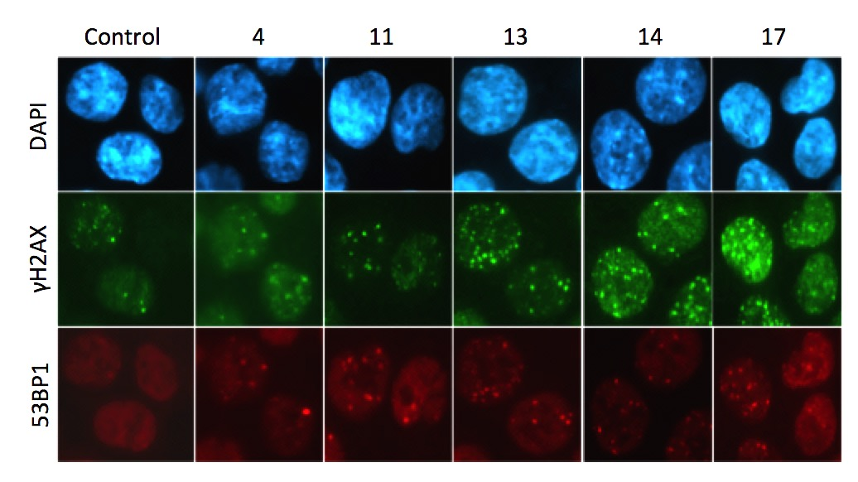
DNA damage was also measured using the alkaline comet assay. With this assay damage can be directly visualised instead of using markers, as any DNA containing breaks will migrate away from the main nucleoid head and form a trailing tail extending behind the head during electrophoresis (Ostling and Johanson, 1984). Comet tail moment was calculated using the software and parameters specified in the methods section, this is a measure of the length and intensity of the comet tails in comparison to the head and gives a quantitative value for the amount of DNA and the lengths of the fragments the tail contains. Over-expression of SRCAP levels through the lentiviral CRISPR system caused a significant increase in tail moment in all the SRCAP over-expressing clones (Figure 3.20), reinforcing the data from Figure 3.19. There was however, a large variability within the tail moment data obtained from the clones over the different repeats. This method can be quite difficult to achieve reproducible results, as there are many variables that affect the assay, although the close tail moment values for the control cells possibly suggest that it is the actual cell clones which can vary between repeat experiments.
Figure 3.19 DNA damage is increased when SRCAP is over-expressed
HCT116 CRISPR clones and parental control cells were seeded for 24hrs to allow time to settle and begin proliferating. After this time the cells were fixed and antibodies used to detect γH2AX and 53BP1. Images were taken and the number of foci in 100 cells counted per condition and averaged. The graphs represent each repeat as separate symbols with median and range plotted. A Kruskal-Wallis non-parametric test showed no significant p value for 53BP1 (p=0.0502) but significance for γH2AX (p=0.0418) when comparing all the groups together. However using individual comparisons of each clone against the control there were significant increases in both DNA damage markers when SRCAP was over-expressed (* = p≤0.05, **=p≤ 0.01).

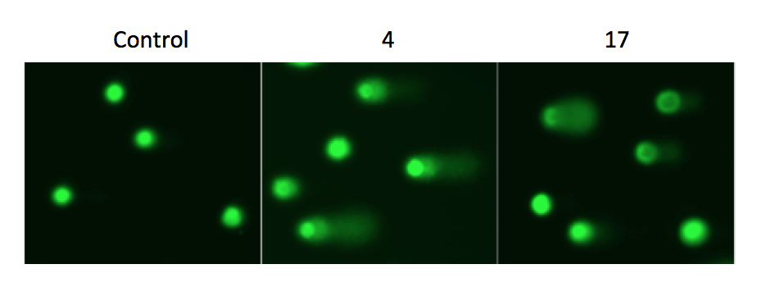
b.)
a.)
Figure 3.20 DNA damage visualisation via the comet assay is increased in SRCAP over-expressing clones
a.) Representative comet images of control HCT116 cells and clones 4 and 17 in the FITC channel after being stained with SYBR Gold, showing increased comet tails in the SRCAP over-expressing clones
b.) Cells were seeded for 24hrs in 6 well plates and the comet assay performed, comet tail moment was provided by the software and the above graph shows each repeat as a separate symbol with the median and range. The Kruskal-Wallis test gave a significant overall p value of 0.0212, and when each clone was compared against control all the clones were significantly different to the control group (* = p≤0.05, ** = p≤0.01).

A further way to assess genomic instability and particularly disruption to normal chromosome separation is by looking at abnormalities in the normal nuclear morphology (Fenech, 2002). A nuclear abnormality was scored as either a bridge between cells, micronuclei, or any other abnormality which changed the morphology of the nucleus when looking at DAPI stained cell images as shown in Figure 3.21a. There was a significant increase in nuclear abnormalities only in clones 11, although there did appear to be a trend forming showing an increase in nuclear abnormalities in the other SRCAP over-expressing CRISPR clones, but much like the comet assay, the clones showed variability (Figure 3.21b). Collectively, these data suggest that an increase in SRCAP may increase genome instability; however, the variability between repeats in the SRCAP over-expressing clones in the comet assay and looking at nuclear abnormalities compared to the control cells is puzzling.
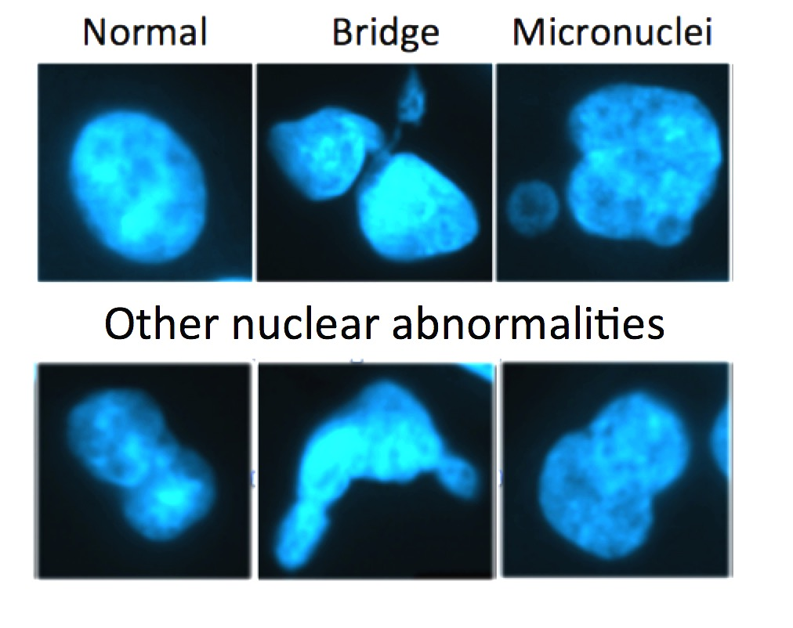
Figure 3.21 Nuclear abnormalities aren’t significantly different in SRCAP over-expressing clones
a.) Representative images of HCT116 cells with nuclear abnormalities compared to the morphology of a normal nucleus.
b.) HCT116 parental control cells or the CRISPR clones were seeded onto coverslips for 24hrs to allow for adhering and then fixed and stained with DAPI. 10 images were taken per condition and the total number of cells counted, plus the number of cells with nuclear abnormalities. The graph shows the three repeats as separate symbols with the median and range plotted. A Kruskal-Wallis test showed no significant overall p value (0.2772) and comparing each clone to the control individually showed a statistically significant increase in nuclear abnormalities between control and clone 11 only (* = p≤0.05).
b.)
a.)
Cellular cycle distribution and apoptosis were also assessed in these SRCAP up-regulated cells, to investigate if the over-expression of SRCAP affected how the cells progressed through the cell cycle. There was no difference in the cell cycle profiles when the clones or HCT116 control cells were fixed and stained with PI (Figure 3.22c). PI intercalates between the bases of DNA with no sequence preference and therefore can be a measure of the amount of DNA within the nucleus, which varies depending on which phase of the cell cycle the cells are in. The fact that there was no difference in cell cycle profiles is consistent with the proliferation data (Figure 3.18), where the over-expressing clones appear to be cycling similarly to the control HCT116 cells. Further to this there was also no difference in apoptosis levels (Figure 3.22d), however only two repeats of this experiment were carried out. Apoptotic cells were gated as those cells which were PI and Annexin V positive, as specified in the methods. These data suggest that although genome instability is increased when SRCAP is over-expressed, the cells are not cycling any differently to control cells. This is contrary to patient data, where the up regulation of H2A.Z has been shown to increase the proliferative and invasive nature of the tumours (Rangasamy, 2010, Hua et al., 2008), and so an increase in SRCAP would be expected to increase the deposition of H2A.Z, which would in turn up-regulate transcription mechanisms and enhance proliferation. It is also important to note that normally cellular mechanisms should alter the cell cycling in response to heightened levels of DNA damage in order to facilitate DNA repair or apoptotic mechanisms. This is particularly true for the HCT116 cells used in these studies that have functional TP53, which should be a protective agent against the continued replication of damaged DNA. Therefore it appears that the increase in genome instability observed within SRCAP over-expressing cells does not elicit the appropriate cell cycle checkpoint response, which could compound the deleterious effects of this phenotype.

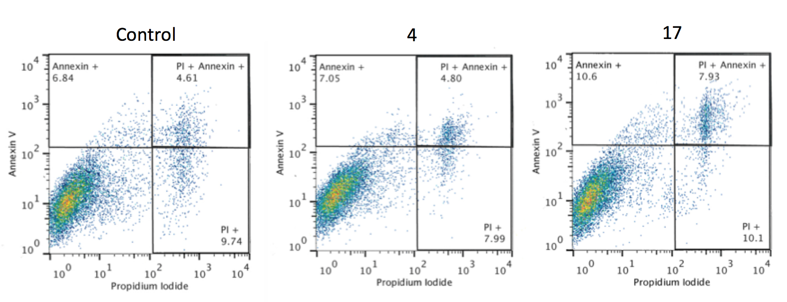
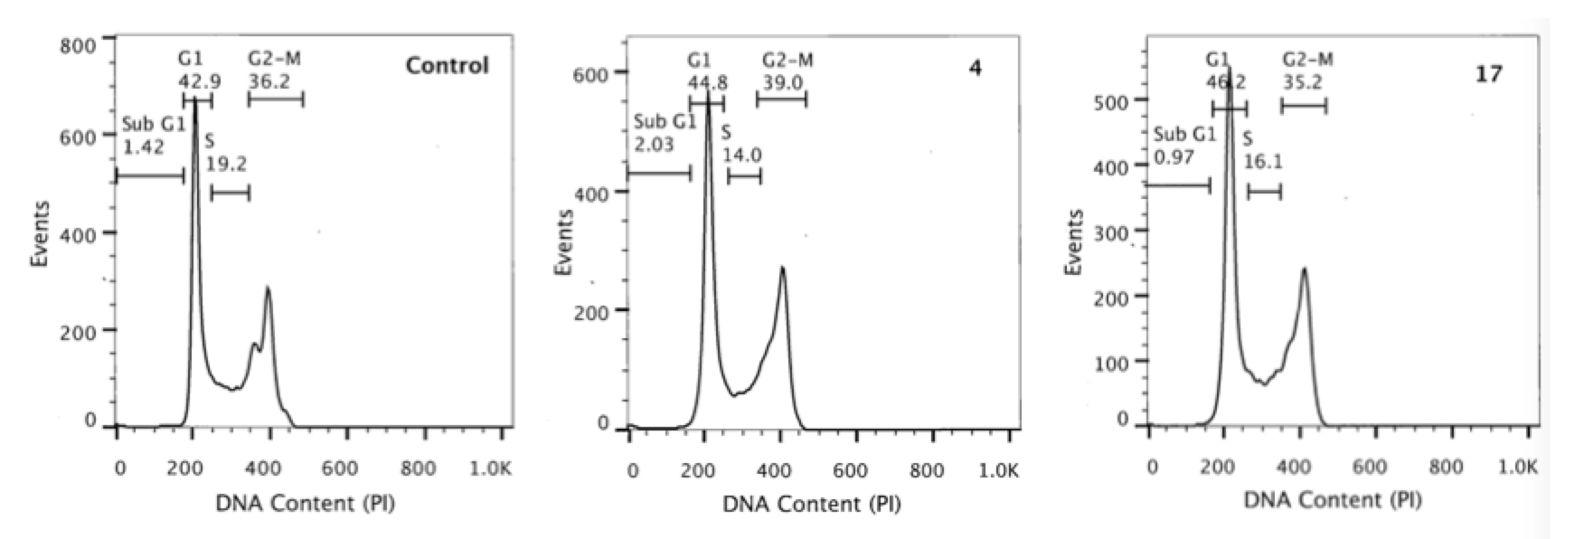
c.)
d.)
Figure 3.22 Cell cycle and apoptotic profiles are unchanged in SRCAP over-expressing cells
a.)Representative histograms of the cell cycle profiles of control HCT116 cells and clones 4 and 17
b.)Representative dot plots of the gating of the PI and Annexin V dual stained cells in control HCT116 cells and clone 4 and 17.
c.) Again HCT116 control cells and clones were seeded for 24hrs to allow for cell cycling to settle and then fixed and PI stained as per the protocol. After three repeats, as shown by the median and range on the graph above, there was no significant difference in the percentage of cells in any phase of the cell cycle following a Kruskal-Wallis non-parametric test (Sub G1- p=0.6990, G1- p=0.9164, S- p=0.2546, G2-M- p=0.7462).
d.) Following the protocol for PI and Annexin V staining specified in the methods section HCT116 SRCAP over-expressing clones and control cells were assessed for apoptosis levels after being seeded for 24hrs. Apoptotic cells were classed as being PI and Annexin V positive. After two repeats, as shown by the median and range plotted on the graph there was no significant overall difference between the groups following a Kruskal-Wallis non-parametric test (p=0.8987), and again no significant difference between the control and the individual clones, where significance is classified as p≤0.05.

.
a.)
b.)
3.9 Lentiviral CRISPR/Cas9 does not show stable expression

There was some indication that the results of the above assays were not consistent between earlier and later repeats. Therefore, before carrying on with the assays in the SW480 clones, all the clones were again assessed for SRCAP expression. SW480 clone 5 did not grow when scaled up from a plate to a flask and therefore was disregarded for the rest of the analyses. All the HCT116 SRCAP over-expressing CRISPR clones; along with the SW480 clones no longer showed an increase in SRCAP mRNA levels compared to parental control cells after 6 weeks in culture (Figure 3.23a&b).

Although the clones had been subjected to antibiotic selection after three weeks during the experimental period in order to make sure the cells that were proliferating still contained the plasmids, this was repeated again but for a prolonged period of two weeks with twice weekly sub-culturing. There was a rapid decrease in cell number, showing that a large percentage of the cells were no longer antibiotic resistant and so were likely not carrying the CRISPR plasmids. However, using a flask of parental HCT116 cells with antibiotic selection media as a control to determine when they had all died, a proportion of the CRISPR population for each clone continued to proliferate and it seemed as though these cells still carried the plasmids and would therefore be over-expressing SRCAP. However, upon SRCAP expression determination there was again no over-expression even after the antibiotic rescue (Figure 3.23c). In parallel, new vials of frozen (-80ºC) HCT116 clones (which had been frozen on the same day as the initial expression data was analysed in figure 3.16), were thawed, placed in antibiotic selection media and grown. However, clones 14 and 17 were no longer viable. Expression of the remaining viable clones was also tested two weeks after thawing and interestingly there was again no over-expression (Figure 3.23c).

Figure 3.23 Retest of SRCAP expression in CRISPR clones shows no over-expression of SRCAP
a.) HCT116 clones- 4, 11, 13, 14 and 17, along with the parental control cells had RNA extracted and assessed for SRCAP expression using the Taqman PCR assay. Expression levels had fallen sharply from what was seen in figure 3.16. HCT116 clones showed lower expression than control HCT116 cells. Graphs show the mean from three internal repeats of one experiment with the positive and negatives errors (n=1).
b.) SW480 clones-2, 3 and 9 were assessed for SRCAP expression in the same way. The clones had slightly raised expression compared to control cells, however nowhere near the extent that was shown previously in figure 3.16 (n=1).
c.) SRCAP expression was assessed in the same HCT116 clones as in Figure 3.23a but after two weeks of subjection to antibiotic selection media there was no SRCAP over-expression compared to control cells, these are on the left of the graph under the title of rescue.
New vials of the HCT116 over-expressing clones were thawed and also grown in selection media. There was again, no over-expression of SRCAP compared to control cells. The graphs show the mean of three internal repeats in the Taqman PCR along with positive and negative errors (n=1).

c.)
b.)
a.)
With this is mind it was now uncertain whether the assays assessing the phenotypic attributes of the cells were valid, as there was no idea as to when the clones began to lose the SRCAP over-expression. It could be reasonable to hypothesize however that the variation we observed between the repeats could be due to the gradual loss of SRCAP over-expression over time. Therefore in order to track the expression regularly after the initial transfection and antibiotic selection process and so see whether it was a gradual decline in expression or a loss after a specific time frame, we attempted to generate new HCT116 clones over-expressing SRCAP. However, with the remaining reagents, no over-expressing clones were obtained out of 18 tested, (Figure 3.24). A possible explanation for this could be the repeat freeze thawing of the lentiviral plasmids or to loss of activity during the two months between transfections. Given the problems trying to make stable clones using the normal method of cDNA transfection mentioned earlier in this chapter, and the decrease in expression of SRCAP within the clones, despite the antibiotic selection, and the large size of the SRCAP protein, it is possible that the continuous SRCAP over-expression is actively selected against within the cell populations. However, another member of the lab group, who was using lentiviral CRISPR methods, also saw a similar decrease in expression when using the same stable over-expression reagents, possibly pointing to a problem with the system itself, such as promoter methylation silencing.

Figure 3.24 Lentiviral CRISPR clones over-expressing SRCAP are unable to be created.
HCT116 cells were transfected with SRCAP lentiviral CRISPR reagent, or mock transfected with ddH₂O, as stated in the methods, placed into antibiotic selection media containing puromycin, hygromycin and blasticidin and left until the control plate was dead and colonies had formed on the transfected dish. 18 colonies were picked and SRCAP expression assessed via RNA lysis and Taqman PCR, along with control parental cells and the mixed transfected population from lysing the rest of the dish. None of the clones had SRCAP expression levels higher than the control population as shown by plotting the mean with positive and negative errors of three internal Taqman PCR repeats (n=1).
3.10 Discussion

In this chapter the creation of cell lines that over-expressed SRCAP was attempted, using a number of different approaches. Unfortunately it proved difficult to achieve a model that stably exhibited over-expression in such a way as to allow for phenotypic assays to be reliably conducted. It has previously been shown that SRCAP is up-regulated in breast and ovarian cancer primary tissue (Santin et al., 2004, Zucchi et al., 2004), and the justification behind looking into SRCAP function within CRC was that patients with microsatellite stable CRC tumours displayed amplification of the SRCAP gene (See Chapter 1-Introduction). These results suggest that over-expression of SRCAP may play a role within driving tumour progression, but we have not been able to reliably assess this hypothesis.

- Transfection efficiencies and antibodies hindered expression analysis
Commercial antibodies towards SRCAP were sparse. From the two that were purchased, only one had been cited within the published literature (Iwai et al., 2011). However, endogenous levels of SRCAP were unable to be observed by western blotting techniques even after several optimisation steps used for other large proteins within the laboratory such as ATM (~350 KDa). Further optimisation could have been used to deduce whether the SRCAP antibodies were working efficiently or not. For example the lowest concentration used was 1:250, this was due to the small amount of antibody provided and financial issues which meant we couldn’t be using large quantities of an antibody for one test. Although several colorectal and non-colorectal cell lines were used throughout western blotting optimisation, it could have also been beneficial to use a panel of cell lines that we knew were supposed to express SRCAP highly. Also we could have purchased a recombinant SRCAP protein and this should have given us a more definitive answer as to whether the antibodies were efficient at detecting the specific molecular weight of SRCAP or not. It was concluded that expression of SRCAP may be low in the cell lines we used and therefore only by over-expressing it would protein be able to be visualised using these antibodies.

Therefore SRCAP cDNA was successfully cloned into a number of destination vectors and transfected into cell lines in order to create a transient over-expression model. However, no over-expression could be detected using either the SRCAP antibodies or the antibodies towards the tags within the destination vectors. After immunofluorescence analysis of the localisation of the YFP SRCAP construct, it was observed to be non-nuclear. This led us to check the construct sequences for abnormalities, and a Kozak sequence was found on the SRCAP cDNA as well as on the tag. This double Kozak could have been initiating translation from two different points and therefore not forming the correct protein structure for SRCAP.

After the Kozak sequence was deleted by site-directed mutagenesis, and the constructs re-transfected back in to cells, the localisation of YFP SRCAP was now observed to be nuclear. However, again no over-expression could be detected via western blot or Taqman PCR. This could have been due to the low transfection efficiency, which was consistently less than 10% using various transfection reagents. Reports that used transfected vectors containing SRCAP either seemed to use Lipofectamine reagents (Johnston et al., 1999a, Monroy et al., 2003) or Fugene (Gévry et al., 2007, Slupianek et al., 2010), both of which were trialled here.

SRCAP is a large gene and so the cDNA was transformed through XL10 Gold ultra competent cells as these are specifically designed to propagate large genes, whereas previously DH5α E.Coli cells had been used and this could have contributed to degradation of the construct. After XL10 transformation the purified YFP and MYC constructs showed SRCAP over-expression compared to untransfected samples via Taqman PCR. However, yet again protein over-expression was not seen, this could be partly due to the antibodies not being efficient but also due to the low transfection efficiency. Stable transfections were therefore attempted but results suggested that the cells containing the construct had died. Consistent with this, cell cycle profiles up to 72hrs after transfection showed a large increase in the sub G1 population, which is indicative of the accumulation of dead cells.

Use of a Tet inducible system was thought to be a solution to this as the SRCAP over-expression could be switched on when required and assays conducted in a restricted time frame. However, although protein over-expression was observed at 72hrs post-Tet induction, the mRNA levels of SRCAP varied between samples. Calculation of the percentage of cells expressing the construct when Tet was added was less than 50%, which although was an improvement from the previous transient transfections, may have impacted on the data derived from these cells. It was also determined that the induction system was ‘leaky’ as samples with no Tet addition exhibited low level expression of YFP SRCAP. Interestingly there was no difference in DNA damage markers when SRCAP was over-expressed compared to the cells not expressing the construct with or without Tet induction. This is contradictory to what would be hypothesised, as it is thought an increase in SRCAP is driving tumour progression and hence possibly an increase in genome instability.

- SRCAP constructs already published
Previous publications have successfully showed SRCAP over-expression using in house or externally made antibodies (Slupianek et al., 2010, Dong et al., 2014). Although several of these laboratories were contacted to either ask for advice or for use of the antibody, none responded. An early paper only used amino acids 1275-2971 of the SRCAP gene as the plasmid insert, whereas the cDNA used here was for the entire 3230 amino acids (Johnston et al., 1999b). A later paper used a SRCAP plasmid with 1-2971 amino acids (Bowman et al., 2011). In fact the earlier publications only show a gene map of 2971 amino acids (Monroy et al., 2001, Johnston et al., 1999b). Whereas Iwai et al. (2011), which was the paper that used the SRCAP Santa Cruz antibody, showed a gene map extending to 3230. Therefore, with so many papers not using the full length SRCAP insert, it may be that the C terminal region affects correct expression of the protein and cell survival within the system described in this chapter. After 2971 amino acids there are AT hooks, which aid in binding to the DNA, however deletion of the 2972-3230 amino acids appears to have no affect on the ability of SRCAP to catalyse the ATP dependent exchange of H2A for H2A.Z. Iwai et al. (2011) did successfully show SRCAP over-expression using the full 3230 amino acid insert as well as a partial coding region of 1639-1990, contradicting the possibility that the inability here to show stable over-expression was due to not removing the c-terminal from the SRCAP cDNA.

- Endogenous over-expression as an alternative approach
A possible solution to these problems was to over-express endogenous levels of SRCAP using the CRISPR/dCas9 activation technique. However, the transient system could not be utilised since the control plasmid resulted in significantly reduced cell proliferation in a range of cell lines. The lentiviral CRISPR/dCas9 technology proved interesting as over-expressing clones were established in two CRC cell lines. However, normal cell lines that had been immortalised were not able to show SRCAP over-expression possibly because of previous antibiotic selection during the immortalisation process the cell lines would have been subjected to when first being established.

The over-expressing HCT116 clones did not show any difference in growth compared to control cells. This is contradictory to what would be hypothesised, as it has been shown that increased levels of H2A.Z were associated with an increase in cell proliferation (Rangasamy, 2010). Therefore, we would expect that SRCAP over-expression would in turn increase H2A.Z deposition into the nucleosome, enhancing transcription and elevating proliferation rates.

DNA damage was increased in the HCT116 over-expressing clones both by IF for damage markers and using the alkaline comet assay. There was some evidence for an increase in nuclear abnormalities when SRCAP was over-expressed; however high variability between repeats meant that no firm conclusions could be drawn. Looking at cell cycle profiling there was no difference between any of the clones and control cells, nor was there any difference in apoptosis levels. The increase in genome instability when SRCAP was increased could be contradictory to what we expected, as Dong et al. (2004) highlighted that SRCAP played an integral role in CtIP recruitment at double strand breaks in order for end resection and HR. When SRCAP was knocked down consequently DNA damage repair was impeded, so increasing the amount of DNA damage markers seen (discussed further in Chapter 4.1). Therefore if SCRAP is up regulated should there be an increase in HR mediated damage repair? Would this have a protective effect and decrease the number of double strand breaks seen? However, this was not the result seen in this thesis, the increase in genomic instability could possibly be due to the lentiviral system itself, and by making use of a control gRNA in the lentiviral system, which shouldn’t induce DNA damage, this could be assessed.

Compounding the above results, at some point over the six weeks in culture the clones began losing their SRCAP over-expression and this could explain why some of the previous results were variable. After antibiotic selection rescue and new frozen samples were thawed, there was still no SRCAP over-expression observed. The loss of over-expression may not be specific to the SRCAP gene, but may relate to a more general problem with the CRISPR/dCas9 activation system, as another member of the same laboratory showed a similar decrease in clone expression levels.

- CRISPR/Cas9 Limitations
An interesting paper explored the idea that the Cas9 system might have a reduced ability to bind to the DNA and cause nicks in eukaryotic cells due to the nucleosome packaging not found in the bacterial genome, which inhibits binding of sequence specific factors (Isaac et al., 2016). However, Cas9 inhibition by nucleosome packaging does not appear to occur, as rates of Cas9 binding are equivalent to those on naked DNA. This is probably due to a phenomenon known as nucleosome breathing, where DNA separates from the histones and then re-anneals, or because of chromatin remodelling factors. In this way DNA is free and Cas9 able to bind (Isaac et al., 2016). Therefore, the up-regulation of SRCAP could be interfering with the specific binding of dCas9 to the DNA and so not allowing for the system to work efficiently, leading to reduced SRCAP expression. It has also been found that co-transfection of four gRNAs targeting different sequences of the same gene, along with the dCas9 and VP64 activator, produce a much higher increase in expression of the gene of interest than when just one gRNA was used alone (Perez-Pinera et al., 2013). Therefore, the system used in this thesis may become more robust if more than one gRNA was utilised.

The decrease in expression of SRCAP in the lentiviral dCas9 system could possibly be explained due to promoter silencing by methylation. This may be a consequence of the cells actively selecting against the over-expression of SRCAP. However, we also don’t know for sure that the gRNA and dCas9 bound in the correct place and wasn’t causing off target effects. A recent paper discussed using chromatin immunoprecipitation and DNA sequencing (ChIP-seq) in order to analyse where dCas9 was binding. In fact it appears that all though Cas9 has high rates of off-target binding, dCas9 binds much more efficiently possibly because it has a smaller window of binding which must be adjacent to transcriptional start sites. Therefore even though off target-binding will occur, it is much less likely to cause a phenotype as they may not be efficient to modulate transcription (Dominguez et al., 2016).

- Experimental Limitations
Unfortunately, due to these technical difficulties a detailed assessment of how the over-expression of SRCAP affected cellular phenotypes related to the hallmarks of cancer such as proliferation and genome instability was not possible. Over-expression using cDNA proved difficult due to low transfection efficiency, and the large size of the SRCAP encoding plasmid, which may have also effected long-term over-expression. To circumvent the low transfection efficiency of the transient transfection, YFP SRCAP transfected cell populations were sorted via FACS for positive and negative YFP expressing cells to gain a pure SRCAP over-expressing population. This will be further reported in results Chapter 6.

The lentiviral CRISPR/dCas9 system appeared to be the solution at first, as this approach successfully led to over-expressed endogenous levels of SRCAP, and was able to produce clones of differing expression levels. However, over-expression of SRCAP could not be sustained over several weeks in culture. Overall, we cannot conclusively say that the amplification of SRCAP seen in CRC patient’s samples contributed to driving tumour progression, as the cell line studies did not effectively reveal how over-expression of SRCAP contributes to a cancer phenotype.

Chapter 4: Investigating the effect of SRCAP knockdown on the DDR in CRC cells

4.1 Introduction
4.2 Confirming the SRCAP knockdown
4.3 SRCAP knockdown induces genomic instability
4.4 Chromatin changes are a feature of SRCAP depletion
4.5 SRCAP knockdown produces cell cycle changes
4.6 Combining SRCAP knockdown with clinical treatments
- 5-Flurouracil
- Irinotecan/Camptothecin
- Oxaliplatin/Cisplatin
4.7 Discussion
- SRCAP depletion increases genomic instability
- SRCAP depletion creates cell cycling aberrations
- SRCAP as a possible novel therapeutic in CRC
- Study Limitations and Future Directions

List of Figures
4.1 siRNA transfection shows knock down at the mRNA level
4.2 siRNA knockdown of SRCAP cannot be visualised at the protein level
4.3 SRCAP knockdown has no effect on p400 levels
4.4 H2AX/53BP1 detection in SRCAP knockdown cells shows increased DNA damage.
4.5 Differences in pan-nuclear 𝛾H2AX were not seen after SRCAP knockdown
4.6 Alkaline comet assay shows increased DNA damage after SRCAP knockdown
4.7 Cells with SRCAP knockdown show increased nuclear abnormalities
4.8 Micrococcal Nuclease digestion of chromatin with SRCAP depletion shows distinctive patterns of digestion
4.9 Quantitative results of MNase digestion shows differing patterns depending on cell line
4.10 Cell growth over time is decreased when SRCAP is knocked down
4.11 Apoptosis levels after SRCAP knockdown aren’t significantly different to control
4.12 Cell Cycle profile differences after SRCAP knock down
4.13 EdU incorporation showed no difference in S phase cells
4.14 The mitotic fraction of SRCAP depleted cells is decreased compared to control cells
4.15 5-FU treatment plus SRCAP knockdown causes both resistance and sensitisation depending on cell line
4.16 TP53 deficient HCT116 cells show differing response to 5-FU compared to TP53 wild type HCT116 cells
4.17 Clonogenic assays correlate to MTT data with 5-FU and SRCAP knockdown
4.18 Camptothecin plus SRCAP knockdown shows no difference to control cells
4.19 MTT cell survival data follows same trend of resistance/sensitisation as was shown with 5-FU
4.20 Cisplatin plus SRCAP knockdown only causes a significant difference in HCT116 cells by clonogenic assay
4.21 TP53-/- HCT116 cells show differing responses to cisplatin in comparison to wild type cells

4.1 Introduction

Patient samples, both in house and from other published articles, show over-expression of SRCAP in varying types of cancers, and with this comes an increased invasiveness trait. Therefore, Slupianek and colleagues hypothesised that SRCAP knockdown may decrease the proliferative nature of prostate cancer cells (Slupianek et al., 2010). Indeed, when SRCAP was knocked down in the 22RVI prostate cancer cell line this not only resulted in decreased cellular proliferation in an androgen-dependent manner but also correlated to a decrease in binding of H2A.Z to the PSA promoter and its consequent down-regulation. These results suggest that SRCAP does have activities relevant for driving tumour progression, and if it could be targeted with inhibitors this may have the potential to decrease tumour growth, with potential therapeutic relevance.

More recently data has emerged implicating SRCAP within the DNA damage response pathway, which could therefore have implications as to whether SRCAP could become a therapeutic target or not. It was shown that Hela cells were sensitised to irradiation or mitomycin following shRNA mediated knockdown (Dong et al., 2014), thus indicating that SRCAP may be essential for cell survival after DNA damage. The article then went on the show that SRCAP played a major role in DSB repair as depletion of SRCAP levels produced a decrease in homologous recombination (HR), reduced recruitment of RAD51 and RPA2, and that these effects could be due to the decrease in recruitment of CtIP to DNA damage sites after SRCAP knockdown. These results suggest that SRCAP plays a role in the end resection of DNA following DSBs, necessary for HR and cellular survival after damage. The authors found a functional interaction between SRCAP and CtIP, providing a stabilisation of CtIP at DSBs. So although SRCAP can have an indirect role on DNA damage repair, by altering chromatin architecture to allow access to the DNA by repair proteins, it appears to also have a crucial direct role in actual recruitment of essential signalling and repair proteins.

The concept of a direct role for SRCAP in DDR is consistent with the second screen that formed the initial analysis for this project, in which a genome-wide human siRNA screen was carried out in HCT116 cells using increased γH2AX as a marker of increased DNA damage to identify potential novel regulators of genome stability. SRCAP had a z score of 2.27 indicating levels of γH2AX staining were elevated over two standard deviations higher then the mean of the negative control cells. Therefore, it does indeed appear that SRCAP plays an integral role in the repair of DNA damage and that when levels are depleted the repair mechanisms are not able to function as efficiently, thus enhancing genomic instability.

Given the above observations, this results chapter focuses on establishing CRC cell line models in which SRCAP can be depleted, and the cellular consequences of this knockdown. We also examined how clinically used treatments and SRCAP knockdown together affect cell survival and so whether SRCAP could become a novel therapeutic target.

4.2 Confirming the SRCAP knockdown

Previous studies have proved that SRCAP knockdown using shRNA transfection was suitable to produce an effect on cellular assays such as proliferation, cell survival and DNA damage (Slupianek et al., 2010, Dong et al., 2014). In order to test how depletion of SRCAP affects these and other cancer phenotypes, I established a robust knockdown cell line model using the SW480 and HCT116 human colorectal cancer cell lines. These were transfected with 4 different small double-stranded interfering RNAs (siRNA) designed to cover a region of the SRCAP gene (section 2.2.II.j). The RNA-induced silencing complex (RISC) uses the siRNA as a template for locating the target mRNA which is then cleaved by ribonuclease. In this way transcription is silenced and therefore a reduction in protein production should also be seen.

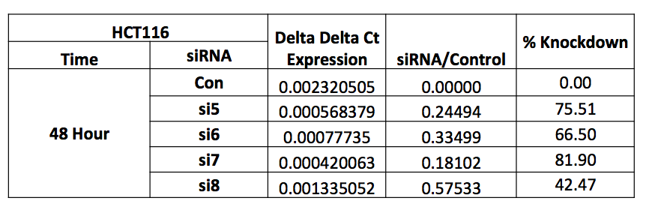
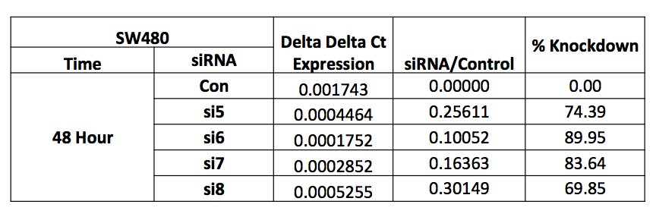
After 48hrs the cells were harvested and the RNA extracted for reverse transcription; the resulting cDNA then underwent quantitative PCR using a SRCAP Taqman probe and primers, compared to an 18S control probe/primer set. The Taqman assay results show a reduction in mRNA levels of SRCAP for all four siRNA compared to a non-specific scrambled control siRNA in both cell lines (Figure 4.1a). Therefore, all four siRNA would have been suitable for use in further experiments as they knockdown the SRCAP gene expression to some degree (Figure 4.1b). However, it was decided that si6 and si7 would be selected for further studies at the 48hr transfection time point. It may be significant to note that the knockdown was at a greater percentage in SW480 cells, and that HCT116 control cells had a slightly higher amount of SRCAP mRNA than the SW480 control cells. Knock down at 72hrs was assessed as well and showed similar SRCAP expression levels as at 48hrs. It was decided not to look at the knock down expression levels past 72hrs as this is standard practice in our laboratory, and for subsequent assays the time point for harvesting would be after 48hrs of knock down. Even though assays like MTT and clonogenics last beyond 48hrs, this was the time point that drugs were added and that lesions would have occurred.
a.)
b)
Figure 4.1 siRNA transfection shows knockdown at the mRNA level.
a.) At 48hrs siRNA transfection of all four siRNA, in SW480 cells (n=2) and HCT116 (n=3), significantly knockdowns the mRNA expression of SRCAP when compared to a non-specific low GC scrambled probe. Each symbol represents an individual experiment each of which consisted of three repeats and the median and range of the experiments are shown on the graphs. A Kruskal Wallis non-parametric test gave the following overall p values, SW480: p=0.1016 (n/s), HCT116: p=0.0043 (significant). Comparing each siRNA to the control gave significant knockdown with si6 and si7 in SW480 cells and si5 and si7 in HCT116 cells (* = p≤0.05, **=p≤ 0.01).
b.) The average delta delta Ct value was calculated for each cell line and then the following calculation applied: 1- (average expression of each siRNA probe/ average expression of the control probe)*100. This gave the average percentage that each siRNA probe knocked down SRCAP in comparison to the non-specific control probe.
Having confirmed in figure 4.1 that siRNA transfection does decrease SRCAP mRNA levels, the next step was to assess whether this affected the protein levels via SDS-PAGE gel and western blotting. As previously mentioned, commercial SRCAP antibodies were limited and although several optimisation methods were employed, neither antibody revealed protein bands at the correct molecular weight for SRCAP of 340kDa (Figure 4.2a&b). Due to the significant decrease in mRNA after siRNA transfection and the inability to visualise endogenous or over-expressed SRCAP by western blot, it was therefore assumed that siRNA were reducing SRCAP levels.
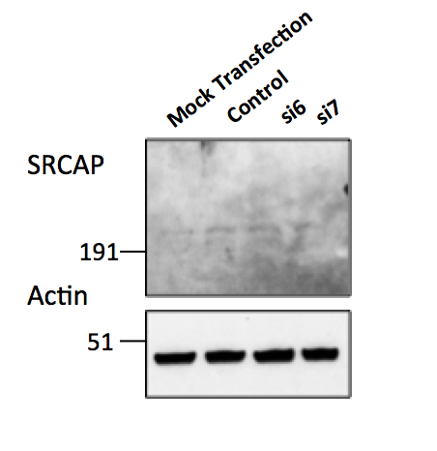
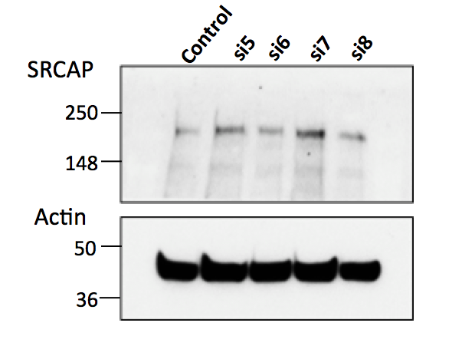
b.)
Figure 4.2 siRNA knock down of SRCAP cannot be visualised at the protein level.
a.) SW480 cells were transfected with control siRNA probe or si5, 6, 7, or 8, and lysed for protein 48hrs later. 40μg of protein was loaded onto an 8% poured gel. Primary antibodies were left on over night at 4ºC in 5% milk (SRCAP 1:500 (Abcam), Actin 1:1000 (Abcam)). Bands are seen in all lanes just below the 250kDa marker.
b.) SW480 cells were transfected for 48hrs with control, si6 or si7 or mock transfected with sterile ddH₂O, then lysed for protein. 100μg of protein was loaded in each lane of a precast gel. Primary antibodies were left on over night at 4ºC in 5% milk (SRCAP 1:500 (Santa Cruz), Actin 1:1000 (Abcam)). Bands can still only be seen at a lower molecular weight than would be expected.

a.)
As previously mentioned it is known that there are two chromatin-remodelling complexes that affect the deposition of H2A.Z into the nucleosome- SRCAP and p400. However, it has been proposed that SRCAP and p400 deposit H2A.Z at different promoters, and in consequence have differing actions on transcription (Bowman et al. 2011). Therefore, in order to assess whether knockdown of SRCAP affected p400 levels, quantitative PCR using a p400 Taqman probe was conducted on SRCAP knockdown RNA samples from Figure 4.1a. As Figure 4.3 shows, knockdown of SRCAP with si6 or si7 did not change the expression of p400 to any significant degree in comparison to transfection with control siRNA in either cell line. So, it appears that SRCAP knockdown has no significant affect on p400 gene expression.
Figure 4.3 SRCAP knockdown has no effect on p400 levels.
After 48hrs of SRCAP siRNA transfection RNA was collected from SW480 and HCT116 cells and used in a Taqman PCR assay to check mRNA expression levels of p400. Each dot represents an individual repeat with the median and range shown. Using a Kruskal-Wallis non-parametric test, there was no significant difference between any of the conditions. SW480: p=0.9945, HCT116: p=0.6298.
4.3 SRCAP knockdown induces genomic instability

In order to assess whether SRCAP knockdown was having an impact on DNA damage and also to validate the original siRNA screen data, where SRCAP had a high z score for damage (2.27), immunofluorescence analysis was carried out using antibodies against the DNA damage and DNA double strand break markers- $γ$H2AX and 53BP1. Using these markers figure 4.4 shows that SRCAP knockdown significantly increases the amount of DNA damage within SW480 and HCT116 cells. The SW480 cells had a higher background level of damage, especially as measured by $γ$H2AX. Therefore, this data validates the previously mentioned screen conducted by Dr Spencer Collis, as knockdown of SRCAP by siRNA probes induced high levels of DNA damage, demonstrated with two markers of DSBs. It also supports the findings by Dong et al. that spontaneous $γ$H2AX foci occur after SRCAP knockdown. They also found that these foci persist after irradiation in SRCAP treated cells, whereas in control cells the foci have nearly all disappeared, consistent with a role for SRCAP in HR-mediated DNA damage repair.

In recent years there have been several papers looking at the formation of pan-nuclear $γ$H2AX staining within cells (Ewald et al., 2007, Marti et al., 2006). This pan-nuclear $γ$H2AX appears to not only be related to irradiation mediated damage as first thought, but also occurs upon transfection with DNA fragments and when there are chromatin changes due to hypotonic treatment (Baure et al., 2009). After UV damage, one group reported that pan-nuclear $γ$H2AX corresponded to pre-apoptotic S phase cells, but not to DSBs (de Feraudy et al., 2010). They went on to hypothesise that a genome wide chromatin architecture change was responsible for the pan$γ$H2AX. Therefore, the images from the $γ$H2AX foci experiment above were also counted for pan $γ$H2AX, since SRCAP plays a vital role in the chromatin structure (Figure 4.5). However, there was no significant difference in pan $γ$H2AX scoring between control cells and those with SRCAP knocked down, possibly indicating that the knockdown of SRCAP does not have a genome wide effect large enough to induce pan $γ$H2AX.

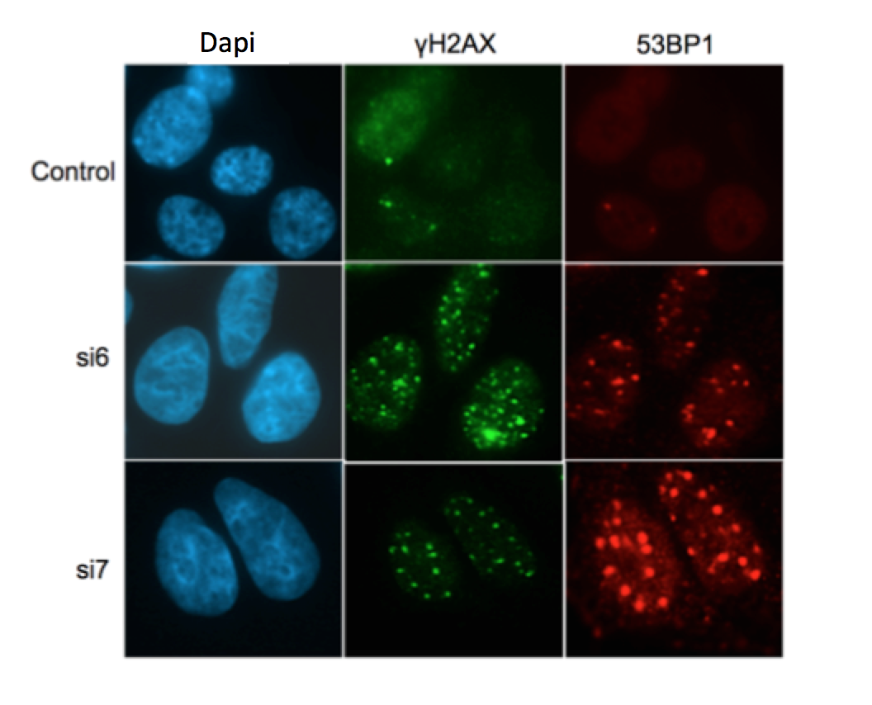
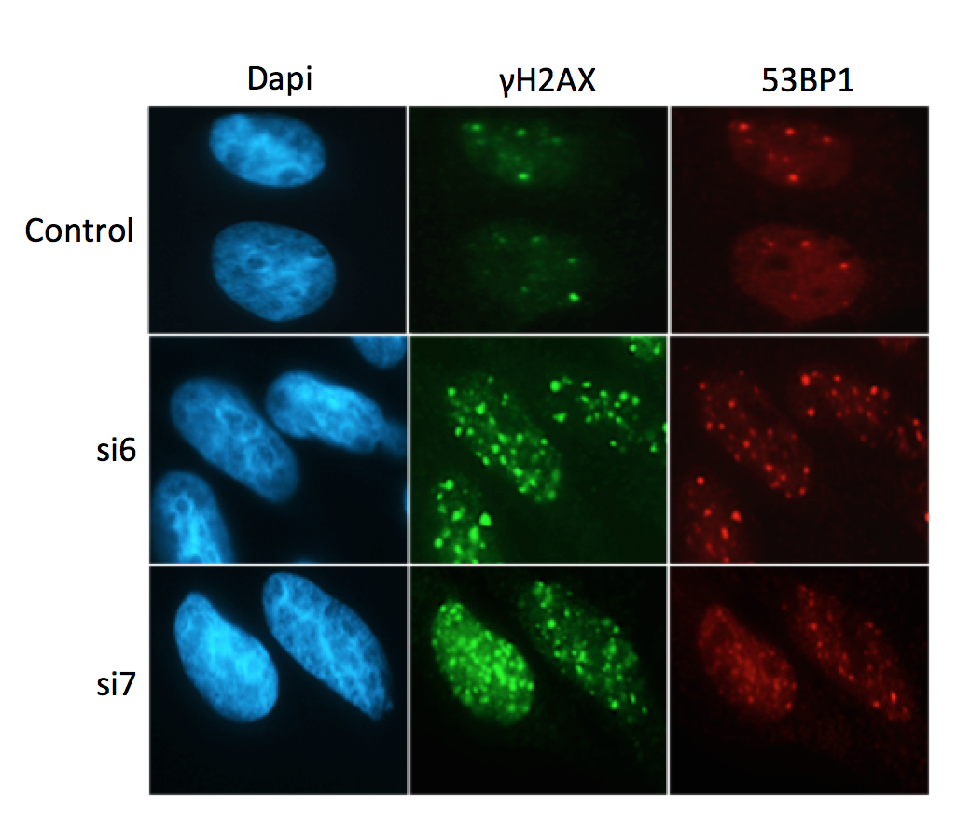
Figure 4.4. $γ$H2AX/53BP1 detection in SRCAP knockdown cells shows increased DNA damage.
a.) SW480 cells seeded onto coverslips and transfected with si6, si7 or control non-specific siRNA for 48hrs and probed for $γ$H2AX and 53BP1. The number of foci per cell was counted by eye and an average taken of 100 cells. Again each symbol on the graphs represents an individual experiment and the median and range plotted. After a Kruskal Wallis statistical test both markers were significantly different (SW480: $γ$H2AX p=0.03, 53BP1 p=0.0048) and comparing each siRNA to the control individually also gave significance as shown by the stars on the graphs (*=p≤0.05, **= p≤0.01), showing an increase in damage when SRCAP is knocked down.
b.) In HCT116 cells using the same experimental and analytical parameters there was a significant result in increasing DNA damage from both markers and both siRNA (HCT116: $γ$H2AX p=0.025, 53BP1 p=0.0107), however comparing the siRNA to control individually only showed significance with si7 (*=p≤0.05).
b.) HCT116
a.) SW480
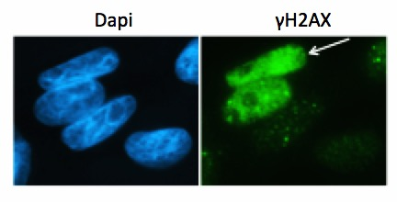
a.)
b.)

Figure 4.5. Differences in pan-nuclear𝛾$γ$H2AX were not seen after SRCAP knockdown.
a.) Representative image of HCT116 cells using the $γ$H2AX antibody with the arrow indicating a cell that was scored as pan $γ$H2AX.
b.) The number of pan-nuclear $γ$H2AX cells was counted, and a percentage of the total number of cells taken for both SW480 and HCT116 cell lines. The graphs show the average for each experiment as a separate symbol with the median and range shown. Using a Kruskal-Wallis non-parametric test there was no significant difference in the percentage of pan $γ$H2AX between any of the groups (SW480: p=0.4360, HCT116: p=0.4393).
In addition to assessing markers of DNA damage, an alkaline comet assay was carried out to directly visualise DNA damage after SRCAP knockdown with siRNA. Three repeat experiments showed that there was a significant increase in comet tail moment, in both cell lines but only with si6, only si7 was showing a trend towards a significant increase in damage (Figure 4.6). Therefore, the comet data is consistent with the IF data, in that when SRCAP is knocked down there is an increase in DNA damage in both colorectal cancer cell lines. However, in HCT116 cells in the IF data only DNA damage after si7 knock down was statistically significantly increased. Looking back at the initial knockdown data (Figure 4.1) there is a greater SRCAP knockdown with si6 in SW480 cells, which may explain the more significant DNA damage. Also si6 wasn’t statistically significantly knocked down in HCT116 cells, which may explain why the IF data also wasn’t significant.
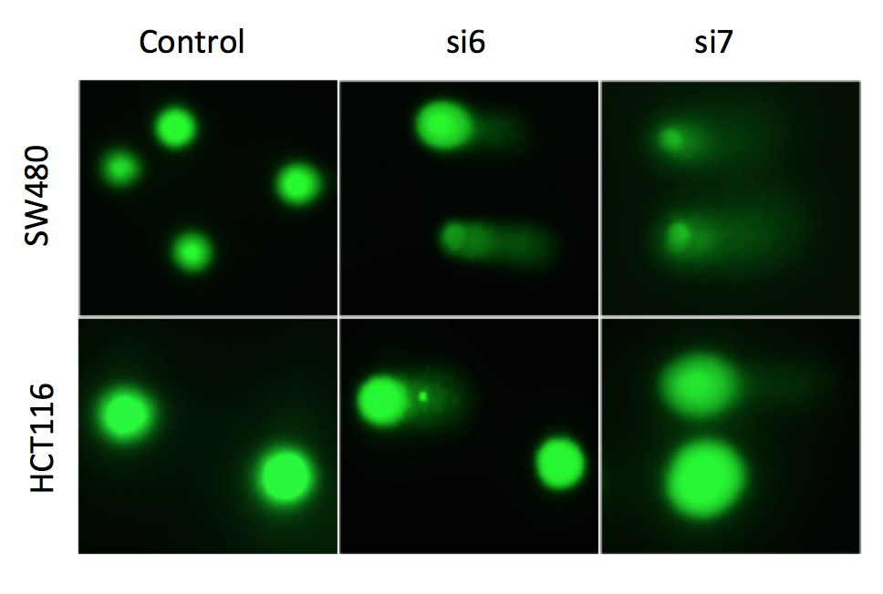
a.)
b.)
Figure 4.6 Alkaline comet assay shows increased DNA damage after SRCAP knockdown
a.) Representative images of SW480 and HCT116 cells imaged in the FITC channel after the comet assay and stained with SYBR Gold.
b.) SW480 and HCT116 cells were transfected with si6, si7 or non-specific control siRNA for 48hrs and then the Trevigen alkaline comet assay kit followed. 40 comets, such as the ones shown above, were scored for tail moment per experiment, with each symbol on the graph representing an individual experiment and the median and range of the three shown. A Kruskal-Wallis test showed significance for both SW480 and HCT116 cells (p=0.0107, p=0.05 respectively), and comparing each siRNA to the control only gave significance with si6 (*=p≤0.05).

A further way to examine the effects of SRCAP depletion on genome instability was to look at the morphology of the fixed and DAPI stained nuclei. It was hypothesised that knockdown of SRCAP would cause nuclear abnormalities due to its apparent role in DNA double strand repair. A nuclear abnormality was scored as either a chromatin bridge between cells, micronuclei, or any other abnormality which changed the morphology of the nucleus, as outlined in Figure 3.21 in the previous chapter. When SRCAP was knocked down there was no significant difference in the number of chromatin bridges between cells formed or the number of micronuclei in SW480 cells compared to control transfected cells (Figure 4.7 a&b), although there was a significant increase in micronuclei when using si6 in HCT116 cells. When all nuclear abnormalities were collated together (including bridges and micronuclei) there was a significant increase in aberrations in the SRCAP knockdown cells in both cell lines (Figure 4.7c). This data along with the DNA damage data suggests that knockdown of SRCAP causes genome instability, which is consistent with previous reports suggesting that SRCAP plays a role in chromatin segregation and DNA damage repair (Rangasamy et al., 2004, Dong et al., 2014).

Figure 4.7. Cells with SRCAP knockdown show increased nuclear abnormalities.
a.) The total number of cells, plus the number of cells with bridges between them were counted from 10 immunofluorescence images per experimental repeat (100-200 cells), and the percentage of cells with that aberration calculated. There was no difference in the number of bridges between cells when SRCAP was knocked down as shown by a Kruskal-Wallis test-SW480: p=0.8130, HCT116: p=0.3607.
b.) There was also no overall statistically significant difference in the number of micronuclei- SW480: p=0.1706, HCT116: p=0.1, but when comparing the individual siRNA to control, si6 showed a significant increase in micronuclei compared to control (*=p≤0.05).
c.) When all the nuclear abnormalities were scored together there was no overall significant difference in HCT116 cells (p=0.0714) but there was in SW480 (p=0.0107) using the Kruskal-Wallis test, comparing the knockdown results to the control individually showed there was a significant increase in abnormalities in both cell lines, but only with si7 in HCT116 cells (*=p≤0.05). All graphs show individual repeats as separate symbols with the median and range plotted.
c.)
b.)
a.)
4.4 Chromatin changes are a feature of SRCAP depletion

After demonstrating that SRCAP knockdown causes DNA damage and nuclear abnormalities, the next step was to assess how this knockdown affected the chromatin structure as a whole. To do this, micrococcal nuclease (MNase) was employed, as this gives an efficient way to map the chromatin and determine where the nucleosomes are within the DNA. This is due to its preference to cleave DNA that is not wound around the histones, which means it will cleave linker DNA, giving mono-nucleosome length DNA fragments. In the Dong et al. paper they showed that after 2mins incubation with MNase, Hela cells which had had SRCAP depleted, were less sensitive to chromatin digestion. This was shown by use of agarose gels with image analysis quantification of the band intensities. This suggests that, when SRCAP is knocked down the chromatin is much more compact and so less easily accessible for the MNase to cleave. In order to test whether the same was true in both colorectal cancer cell lines, the MNase kit was used as outlined in the methods (section 2.2.V.e), with the MNase enzyme incubation for four different lengths of time, and the resulting DNA fragment mix was run on an agarose gel.

It can clearly be seen that at all four time points there is a less prominent band at the top of the gel in the control lanes compared to the SRCAP knockdown lanes in SW480 cells (Figure 4.8a). This indicates that the DNA fragments are larger in the SRCAP depleted samples, suggesting that the MNase is not digesting the DNA as efficiently. As the nuclease is left on for longer periods of time there is a clear increase in digestion in the control lanes, and in contrast larger fragments are observed in the SRCAP knockdown lanes. The band at the bottom of the gel, corresponding to a 147bp marker represents approximately the size of DNA wound around a single nucleosome. At 20mins and 30mins there is a slight increase in 147bp band intensity in the control lanes, suggesting these have been digested more efficiently than in the SRCAP knockdown samples. However, the HCT116 cells do not show the same pattern of digestion as the SW480 cells, in fact there is no clear overall conclusion in these cells, as most samples look the same.

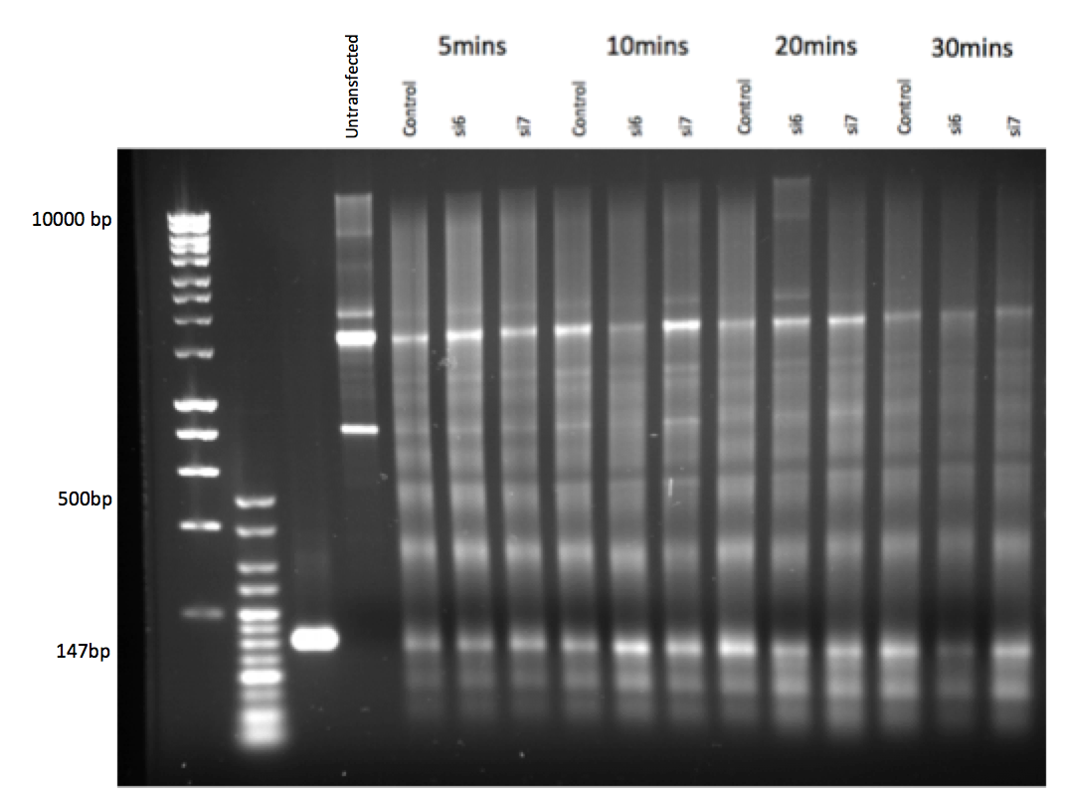
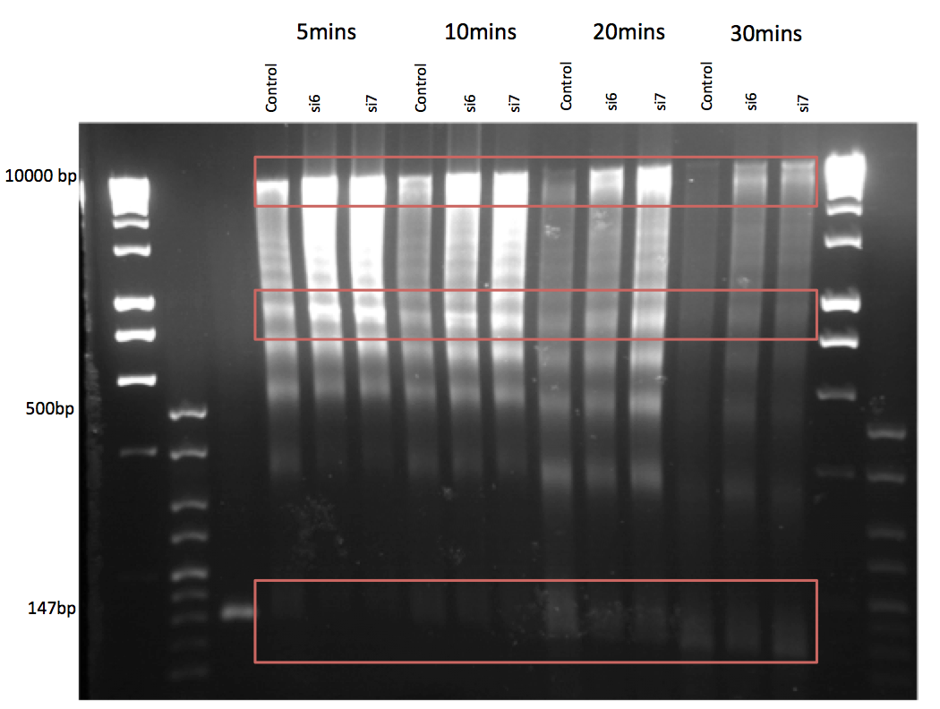
Figure 4.8 Micrococcal Nuclease digestion of chromatin with SRCAP depletion shows distinctive patterns of digestion
a.) SW480 cells were transfected with SRCAP or non-specific control siRNA for 48hrs, the cells trypsinised and subjected to the MNase assay kit. The enzyme was left on for 5,10, 15 or 20mins. Then 5μl of sample, plus 1μl of DNA loading buffer was run on a 1% agarose gel alongside Hyperladder I and Hyperladder V, plus a 147bp marker. This is a representative image of the pattern, which was seen across 3 repeats, the red box at the top shows that in the control lanes there is less DNA than in the knockdown lanes, moving down to the second red box and the pattern is the same. However, towards the bottom of the gel there appears to be more DNA in the control lanes that then correlates to the hypothesis that more digestion is occurring when SRCAP is present as there is access to the DNA.
b.) HCT116 cells were treated in the same way as above. However, after MNase digestion they did not follow the same pattern as was seen in SW480 cells as the representative image above shows. Both images are representative of multiple experiments using different digestion times, run times, ladders and control markers.
a.)
b.)
The image resolution in the above experiment is not optimal for definitive conclusions regarding differing digestion rates. Therefore, the experiment was repeated using only the 20min digestion time point, and the samples were run on a 2200 Tapestation to quantifiably measure the percentage of DNA of each fragment size. Firstly Hyperladder I, the 147bp marker and undigested samples were analysed in order to check that the Tapestation was able to detect specific sizes and quantities (Appendix 3). After analysis, the SW480 and HCT116 cells showed that the quantification reflected what was seen in the agarose gels. Again, SW480 control cells had a reduction in large fragments (peak 5) and a concurrent increase in small fragments (peak 1) compared to the SRCAP knockdown samples, which had increased large fragments, showing that digestion of the DNA wasn’t occurring at the same rate and/or as efficiently (Figure 4.9b), however when statistical tests were applied these changes were not significant, possibly due to the low repeat number of two. The trend would however, suggest that access to the DNA was less efficient in cells with reduced SRCAP levels. Again the HCT116 cells did not appear to follow the same pattern. In fact, results for si7 were similar to what was observed in SW480 cells, but si6, produced the exact opposite result (Figure 4.9b).

These data can only be considered as preliminary, since further repeat experiments were not consistent with these findings. We think this is likely due to changes in the enzyme activity during storage. Thus further experiments using fresh enzyme are required.

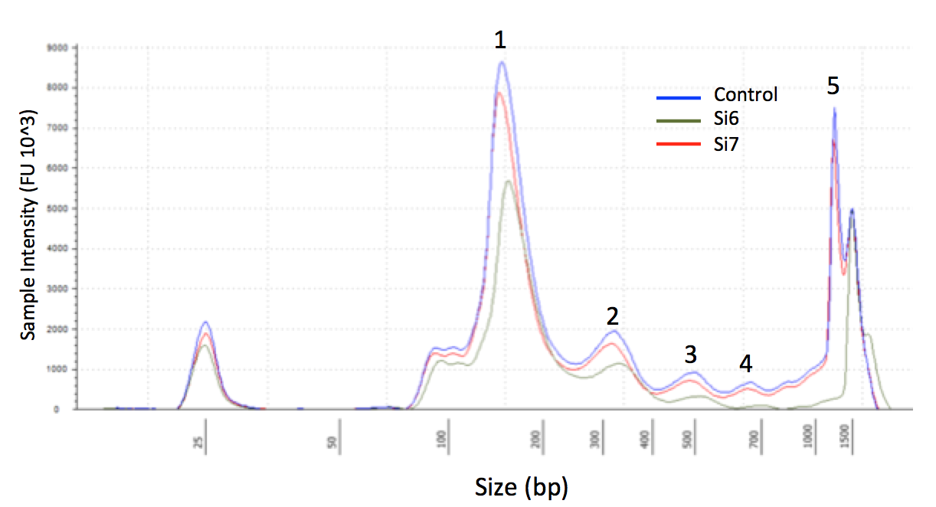
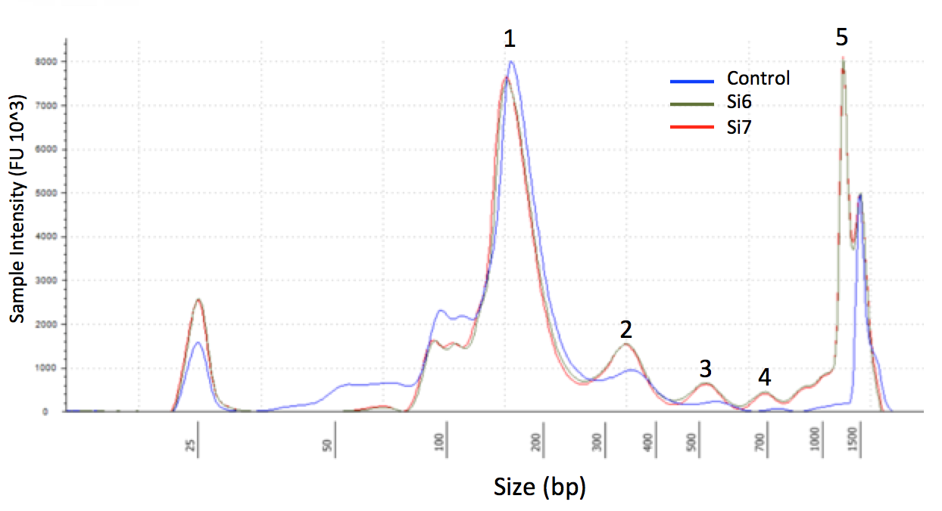
Figure 4.9 Quantitative results of MNase digestion shows differing patterns depending on cell line
a.) Bioanalyser trace images highlighting what each peak is numbered as and showing how the SRCAP knockdown samples differ to the control samples (individual electropherograms are shown in Appendix 4).
b.) SW480 and HCT116 cells were transfected with siRNA for 48hrs and then underwent micrococcal nuclease digestion for 20mins following the kits protocol. The samples were run on the 2200 Tapestation Bioanalyser and the results analysed using the 2200 software. Here each peak was selected and the amount of DNA each peak contained as a % of the whole sample calculated. The above graph shows the median and range of two repeats, with the percentage of total DNA at each peak shown. Using a Kruskal-Wallis test there was no significant difference at any peak in either cell line, even though there is clearly a large difference at peak 5 between the SRCAP knockdown SW480 cells and the control cells this wasn’t significant (p=0.2)
a.)
b.)
HCT116
SW480
4.5 SRCAP knockdown produces cell cycle changes

In the previous experiments it was noted that SRCAP depleted cells appeared to not be as confluent at the time of harvest compared to control cells and Slupianek et al. (2010) had already shown that knockdown of SRCAP in a prostate cancer cell line reduced proliferation after 24 and 48hrs. Therefore, we tracked colorectal cell line growth over a longer period of time (144hrs) by manual haemocytometer counting to see if similar effects were observed when SRCAP levels were depleted in CRC cell lines. After 144hrs there was a significant reduction in cell numbers in SRCAP knockdown cells compared to control for both cell lines. The HCT116 cells transfected with si6 appeared to barely grow in population size beyond 48hrs transfection. These results support the hypothesis that SRCAP depletion decreases proliferation rates (Figure 4.10).
Figure 4.10 Cell growth over time is decreased when SRCAP is knocked down.
HCT116 or SW480 cells were seeded at 200,000 cells per well transfected with SRCAP or control siRNA then three samples counted every day for viable cells via trypan blue and haemocytometer counting. The graphs show the mean and standard deviation of multiple repeats. Using linear regression analysis there was a significant difference between the control and si6 slope (0.0015) in SW480 cells but si7 was not significant (0.1676). In HCT116 cells there was a highly significant difference between control and SRCAP knockdown (si6 p<0.0001, si7 p=0.0006).

In the above experiment the cells were stained with trypan blue and only the number of viable cells were counted. Thus the cells could either be cycling more slowly due to alterations in their cell cycle profiles, or because SRCAP knockdown could be causing cells to progress into apoptosis. It could be predicted that apoptosis could be a feature of SRCAP knockdown due to its effects on chromatin structure determination and also the results above showing an increase in DNA damage, which can lead to increased cellular stress and possibly signal to the cells to enter apoptosis. Also, it has been widely published that mice deficient for H2A.Z are not viable (Rangasamy et al., 2004) and therefore the depletion of SRCAP and the subsequent inhibition of H2A.Z deposition may have a similar outcome on cell viability. However, figure 4.11 shows that during these studies SRCAP knockdown had no effect on apoptosis, as measured by dual staining with Annexin V and PI and assessed by flow cytometry. At 48 and 72hrs after cell transfection of either cell line there was no change in the percentage of cells which were positive for both Annexin V and PI, whether they were control or SRCAP knockdown. The single stains of just PI or just Annexin V also showed no difference between the different conditions.

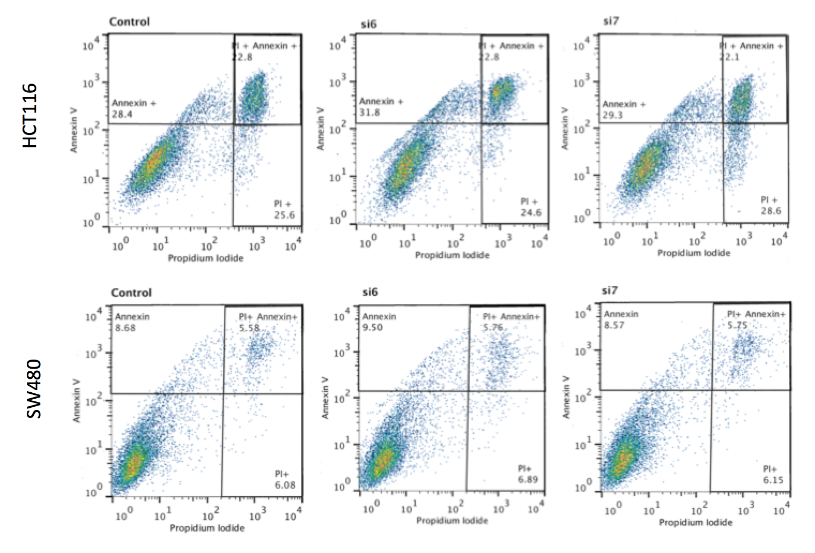
Figure 4.11 Apoptosis levels after SRCAP knockdown aren’t significantly different to control
a.) Example image of the gating of all four parameters in SW480 and HCT116 cells at 48hrs after transfection with control or SRCAP siRNA. A gate was first set on a flow cytometry sample that had no stain; this gate then marked the edges for the subsequent gates for Annexin V only, PI only or dual stain, with the overlapping gate in the top right hand corner of the dual stain image giving the percentage of apoptotic cells.
b.) Graphical representation of 4 repeats in SW480 and HCT116 cells of the apoptosis Annexin V and PI dual stain kit. The symbols each represent the percentage of cells that were positive for both Annexin V and PI in each repeat with the median and range plotted. Using a Kruskal-Wallis test there was no significant difference between any of the groups at either time point or in either cell line (SW480: 48hr-p=0.8151, 72hr-p=0.7463, HCT116: 48hr-p=0.9532, 72hr-p=0.5101) when significance was classed as p≤0.05.

b.)
a.)

Due to the lack of any difference in apoptosis, it was proposed that the cellular growth deficiencies associated with SRCAP depletion were due to aberrations in the cell cycle. Primarily, cell cycle profiles were investigated by using PI staining and flow cytometry to determine whether there were differences in the percentage of cells within each stage of the cell cycle following SRCAP depletion. As figure 4.12a shows in HCT116 cells, there was a significant decrease in S phase cells at 72hrs after SRCAP knockdown with si6. Although not significant there did also appear to be an increase in cells in G1, again with si6. This is indicative of cells accumulating DNA damage and therefore becoming stalled in G1, as HCT116 cells are known to possess a strong TP53-mediated G1 checkpoint. However, in Figure 4.12b with the SW480 cells there was no difference in the percentage of cells in any phase of the cell cycle at 48hrs or 72hrs. Neither cell cycle profile were any different at 24hrs after transfection compared to control (Appendix 5). It is also interesting to see that, although not statistically significant, there is a trend towards an increase in a Sub G1 population when SRCAP is knocked down, especially in HCT116 cells, even though the previous assay looking at apoptosis levels specifically did not show any differences. This could therefore be an indication of mitotic catastrophe, in which cell death occurs that is unlinked to apoptosis, as a result of aberrant mitosis. This would also be consistent with the DNA damage data, in which damaged cells are allowed to enter mitosis and here are arrested (Vakifahmetoglu et al., 2008). This would need to be further investigated using live cell imaging to assess aberrant mitosis in order to conclusively say that the increase in the sub G1 population is due to mitotic catastrophe and not apoptosis.

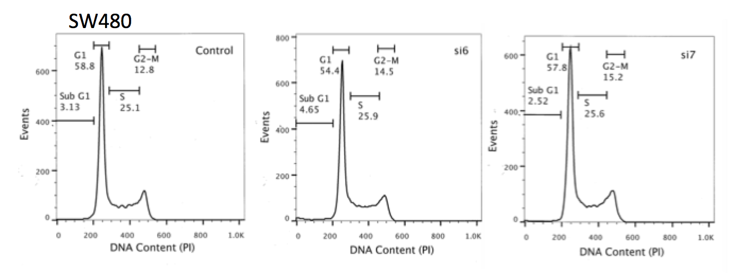
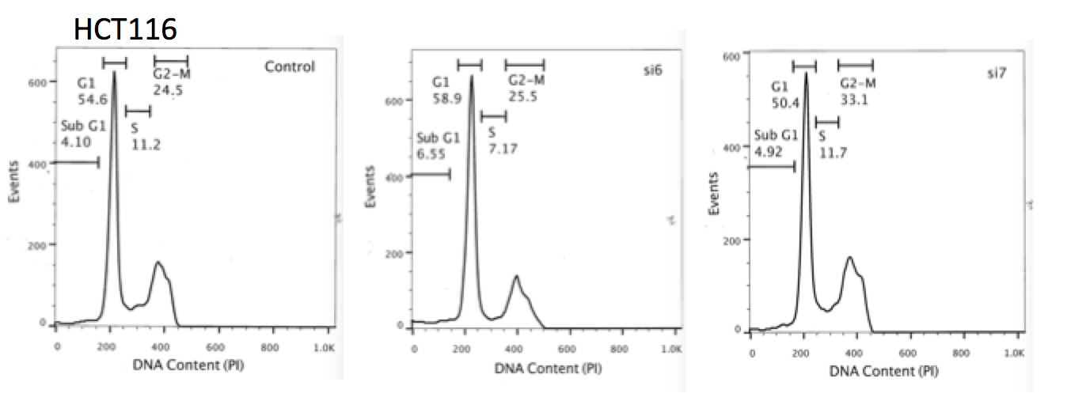
Figure 4.12 Cell Cycle profile differences after SRCAP knockdown
a.) HCT116 cells were transfected with control siRNA or SRCAP siRNA and left for 48 or 72hrs, fixed and stained with PI for flow cytometry analysis. The percentage of cells in each phase of the cell cycle was gated using the FL3 histogram channel as shown in the example plots taken from a 48hr time point. The graphs are the median percentages after three repeats with the range. Using a Kruskal-Wallis test there was no significant difference overall between the groups, however comparing the siRNA separately to control gave a significant decrease in S phase HCT116 cells at 72hrs (p=0.0171).
b.) Using the same experimental and analysis parameters as stated above the SW480 cells did not show significant differences at either time point (*=p≤0.05).
b.)
a.)
Considering that there were some differences in cell cycle profiles and to follow up further whether the cell lines were cycling slower if SRCAP was knocked down, an EdU Click-IT kit was utilised. With this approach it is possible to assess the number of S phase cells, as EdU is a modified thymidine analogue that when placed into seeded cells media is incorporated into actively synthesising DNA, and can be detected using an Alexa Fluor dye. When cells were incubated with EdU for 20mins there was no significant difference in the number of EdU+ cells in either cell line when counted by immunofluorescence (Figure 4.13). This indicates that after 48hrs of transfection with SRCAP siRNA, and in that 20min window, the cells were not cycling any differently whether they had SRCAP knock down or wild type levels. This observation is contradictory to the cell cycle profiles in HCT116 cells at least, as at 72hrs there was a statistically significant decrease in S phase cells.
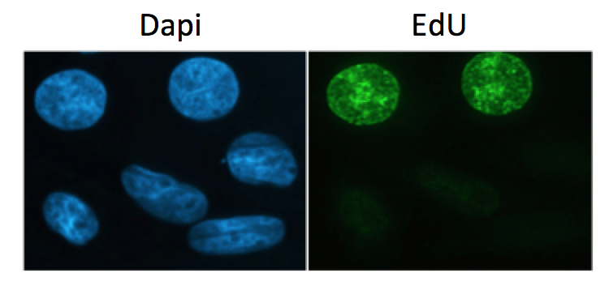

Figure 4.13 EdU incorporation showed no difference in S phase cells.
SW48O (image) or HCT116 cells were seeded onto coverslips, transfected for 48hrs with SRCAP siRNA and then EdU placed in the media for 20mins. The cells were then fixed and EdU detected using click-iT chemistry. 10 images were taken per condition, the total number of DAPI stained cells counted plus the number of positive EdU cells and the percentage of EdU positive and so S phase cells calculated. After a number of repeats, as shown by the individual symbols on the graphs and median and range plotted, there was no significant difference in the percentage of S phase cells between any of the groups using a Kruskal-Wallis non-parametric test (SW480: p=0.9945, HCT116: p=0.1679), when significance was classed as p≤0.05.
The mitotic cell fraction was then investigated, as this can also be an indicator of whether cells are cycling more slowly. The percentage of mitotic cells was calculated using a marker of mitosis in flow cytometry; Phospho histone H3 (pH3), as histone H3 becomes phosphorylated at serine 10 during mitosis. As seen in Figure 4.14 there was a significant decrease in the number of pH3 positive cells when SRCAP was knocked down in both cell lines, however, only with si6. This shows that when si6, at least, knocks down SRCAP there is a significant decrease of cells entering mitosis at 48hrs post-transfection. This decrease, however, was not seen when using PI staining, as shown in Figure 4.12.

Assessment of the cellular cycling appears to indicate that the depletion of SRCAP does not increase apoptosis significantly and therefore that the reduced growth rates over time are more likely due to slower cycling in the HCT116 cells, possibly which are accumulating in G1 because of the increase in damage. The same however cannot be said for SW480 cells, as although they have a reduced mitotic fraction by pH3 staining when SRCAP is knocked down, there was no difference in PI profiles at 48 or 72hrs. This difference in behaviour may be due to TP53 levels. SW480 cells are deficient in TP53, whereas HCT116 cells have functioning wild-type TP53. TP53 is known as the ‘guardian of the genome’ and works as a tumour suppressor to signal for cell cycle arrest at G1/S in order for DNA repair to be carried out, or for apoptosis to occur in the event of very severe DNA damage. Therefore, in the SW480 cells where TP53 is deficient, increased DNA damage would not give rise to a TP53-elicited G1 arrest.

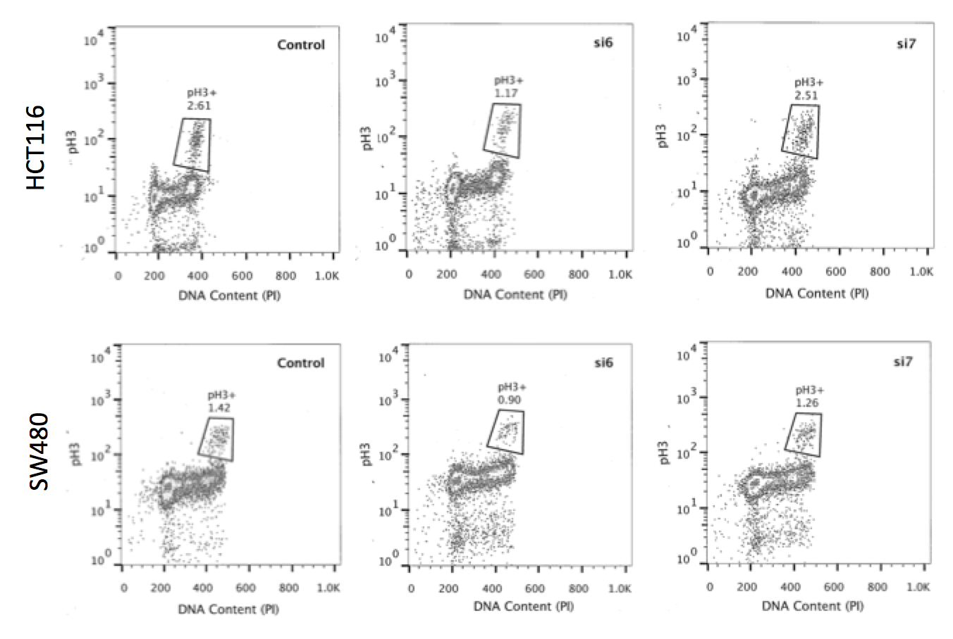
Figure 4.14 The mitotic fraction of SRCAP depleted cells is decreased compared to control cells
a.) Representative dot plot flow cytometry images showing the percentage of pH3 positive cells gated out from the rest of the population in both SW480 and HCT116 cells.
b.) SW480 and HCT116 cells were seeded and transfected 24hrs later with si6, si7 or control siRNA then left for 48hrs. Including a nocodozole positive control, nocodozole arrests the cells in mitosis as it prevents formation of metaphase spindles and so activates the spindle assembly checkpoint, it was used at a concentration of 0.2μg/ml in the media of the wells for 16hrs. After this time point the cells were stained for pH3 as per the protocol and run on the FACS Calibur. Single cells were gated and the DNA content plotted against pH3 fluorescence. The population of cells extending up from the main population to the right above the G2-M section were gated as pH3 positive. The above graphs show the median and range of three separate experiments and using a Kruskall-Wallis non-parametric test there was an overall significant difference (SW480: p=0.0286, HCT116: p=0.05). Comparing each siRNA with control showed that si6 transfected cells had a significantly lower percentage of mitotic cells than control in both cell lines as shown by the significance stars on the graphs (*=p≤0.05).

b.)
a.)
4.6 Combining SRCAP Knockdown with Clinical Treatments

Having established that the knockdown of SRCAP resulted in an increased genomic instability phenotype and reduced cell proliferation, the CRC cell lines were subjected to therapeutics commonly used in the treatment of CRC, in order to see whether a combination of therapeutic drug plus SRCAP depletion could reduce cellular survival compared to when drug alone was used.

- 5-Fluorouracil
As mentioned in the introduction, 5-FU is one of the most common chemotherapy treatments in cancer, and especially CRC. 5-FU functions as an anti-metabolite to block the action of thymidylate synthase and therefore either create a dNTP pool imbalance or by its metabolites incorporating into RNA thereby disrupting synthesis and repair of the genome (Longley et al., 2003). However, due to low response rates and high resistance, other pathways of 5-FU cytotoxicity need to be explored. In 2015 Mojardin et al. used a yeast genome wide screen to look at whether the knockdown of any genes within the library lend themselves to increasing the sensitivity of 5-FU. Interestingly they found that knockdown of genes involved in the chromosome segregation and organisation pathway conferred sensitivity to 5-FU. Following bioinformatics to obtain a protein interaction network the group found a significant enrichment in components of the histone modification family. This included yeast mutants with deletions in helicase Swr1, of which SRCAP is the human ortholog. Therefore, this work suggests that combination therapy of 5-FU and agents that target chromatin remodeling might result in higher response rates. In fact, a previous paper (Lee et al., 2006) showed that a histone deacetylase inhibitor (Trichostatin A) increases the apoptotic affect of 5-FU when in combination. Interestingly, the mechanism of action behind this was down regulation of TS through acetylation of Hsp90 and recruitment of Hsp70 to the Hsp/TS chaperone complex, thereby flagging TS for proteasomal degradation. By using an agent that does not inhibit TS directly it will hopefully avoid the chemoresistance being seen with TS inhibitors, whilst also lowering TS expression in order to significantly increase 5-FU response rates (Lee et al., 2006). This area of drug development for cancer treatment remains largely unexplored, as it is only in recent years that epigenetic alterations to chromatin architecture have been discovered as potential targets for anticancer drugs (Mojardín et al., 2015).

SW480 and HCT116 cells were subjected to treatment with differing doses of 5-FU 48hrs after being transfected with SRCAP or control siRNA. Figure 4.15 shows the percentage of cells that survived after 4 days of drug treatment using an MTT assay. HCT116 cells with SRCAP knock down were more sensitive to the 5-FU treatment; with between 30-45% cellular survival compared to 70% in the control cells at 5μM 5-FU. However, this only appeared to be true at the lower concentrations; at 25μM there was no difference between SRCAP depletion or not, possibly due to being at the end of the assay for detectable cytotoxicity (Figure 4.15a). In the SW480 cells there was a much clearer difference between the control and knockdown cells, yet this was the opposite of what was seen in HCT116 cells. SW480 cells with SRCAP knockdown became significantly more resistant to the 5-FU treatment (Figure 4.15b). Even though they represent both main molecular subtypes of CRC- chromosomally unstable (SW480) and microsatellite unstable (HCT116)- the cell lines also differ in TP53 status, as mentioned previously. Therefore, the same experiments were conducted again but in HCT116 cells which had been engineered to have deficient TP53 (TP53-/- HCT116, a kind gift from the Vogelstein laboratory (Bunz et al., 1998)). This experiment would be a good indicator of whether SRCAP knockdown plus chemotherapy is affected by TP53 status.
Figure 4.15 5-FU treatment plus SRCAP knockdown causes both resistance and sensitisation depending on cell line.
a.) 1000 HCT116 cells per well were plated in a 96 well plate, transfected with SRCAP or control siRNA for 48hrs and then different concentrations of 5-FU added for four days. The MTT protocol as outlined in the methods was then followed and surviving fraction calculated, with the graphs showing the mean and standard deviation of five repeats. Using a Kruskall-Wallis non-parametric test there was a statistically significant difference overall at each concentration apart from 25μM (2.5-p<0.0001, 5-p<0.0001, 10-p=0.0021, 25-p=0.4226) and comparing the siRNA individually to control gave a significant sensitisation when SRCAP was knocked down with both siRNA as shown by the significance stars on the graph (*=p≤0.05, **=p≤0.01, ***=p≤0.001).
b.) 1500 SW480 cells per well were plated and the protocol followed as outlined above. Using a Kruskall-Wallis non-parametric test there was a statistically significant difference overall at each concentration (2.5-p=0.0135, 5-p=0.0054, 10-p=0.0009, 25-p=0.0014) and comparing the siRNA individually to control gave a significant resistance when SRCAP was knocked down with both siRNA as shown by the significance stars on the graph (*=p≤0.05, **=p≤0.01).
Indeed TP53-/- HCT116 cells transfected with SRCAP si6 showed a significant resistance to 5-FU in comparison to the control cells, which followed a similar cell survival pattern to the wild type HCT116 cells. However, when transfected with si7 the cell survival remained unchanged from the control cells. Therefore, the TP53-/- HCT116 si7 knockdown did not show the sensitisation that was seen in the wild type HCT116 cells, and there was a large discrepancy compared to si6 knockdown siRNA (Figure 4.16). It remains unknown as to why this was the case, although si6 throughout the experiments has shown the more significant phenotype, and so although both siRNA appear to knockdown to similar extents it may be that one has a larger effect on SRCAP levels, or that there are off target effects. It has been previously shown that in vitro loss of TP53 decreases sensitivity of cells to 5-FU (Longley et al., 2002), which is consistent with what was seen here, as the TP53 deficient cell lines were either more resistant to 5-FU plus SRCAP knockdown or did not differ from the control.
Figure 4.16 TP53 deficient HCT116 cells show differing response to 5-FU compared to p53 wild type HCT116 cells.
1000 TP53-/- HCT116 cells were seeded per well in a 96 well plate and the protocol followed as in Figure 4.15. The graph shows the mean and SD of four repeats. Using a Kruskall-Wallis non-parametric test there was a statistically significant difference overall at 10 and 25 μM (2.5-p=0.2487, 5-p=0.3571, 10-p=0.0083, 25-p=0.0054) and comparing the siRNA individually to control gave a significant resistance when SRCAP was knocked down with si6 only as shown by the significance stars on the graph (*=p≤0.05, **=p≤0.01).

In order to confirm the MTT assay results and be sure that there was a differing effect on combination drug plus SRCAP knockdown depending on TP53 status, clonogenic survival assays were used. Again HCT116 cells showed a very prominent sensitivity to 5-FU after SRCAP was knocked down (Figure 4.17a), much more than what was seen in the MTT assay due to the increased sensitivity of clonogenics, whereas SW480 cells showed a trend towards resistance, however only statistically significant with si6 at the highest concentration (Figure 4.17b). When the same test was carried out on TP53-/- HCT116 cells they again showed a significant resistance to 5-FU along the same lines as was seen in SW480 cells (Figure 4.17c). These data are therefore broadly consistent with the results from the MTT assays, demonstrating that TP53 functioning cells show good sensitivity to 5-FU when in combination with SRCAP depletion. However, patients with TP53 deficient tumours would not be good targets for SRCAP inhibitors and clinically used 5-FU treatment. Therefore, although it has already been reported that TP53 deficient cells are less sensitive to 5-FU (Bunz et al., 1999), in cells with active TP53, such as HCT116 cells, there is an even bigger sensitisation to the treatment when SRCAP is also knocked out.
Figure 4.17 Clonogenic assays correlate to MTT data with 5-FU and SRCAP knockdown.
a.) HCT116 cells were seeded in 6 well plates, transfected with control or SRCAP siRNA for 48hrs then differing concentrations of 5-FU added. Clonogenic plates were stained with methylene blue and the colonies of approximately 50 cells or more manually counted. Each graph represents the mean and standard deviation from three repeats. A Kruskal-Wallis test showed an overall statistical difference at 2.5 and 5μM concentration (2.5-p=0.036, 5- p=0.025, 10-p=0.1643). Assessing the individual siRNA against control showed significance with only si6 as shown by the significance stars on the graph, highlighting a sensitisation to 5-FU when SRCAP is knocked down (*=p≤0.05, **=p≤0.01).
b.) SW480 cells were seeded and transfected in the same way as above and after three repeats a Kruskall-Wallis test showed no difference between the groups overall (2.5-p=0.3821, 5- p=0.9893, 10-p=0.0857). However, comparing the siRNA to control individually showed a significant resistance with si6 at 10μM as shown by the significance stars on the graph.
c.) TP53-/- HCT116 cells again underwent the same experimental conditions as above and also showed no significant difference between the groups overall (2.5-p=0.0857, 5- p=0.1, 10-p=0.5107). However, when compared separately si6 was significantly more resistant to 5-FU treatment than control at 5μM and si7 at 2.5μM as shown by the significance stars on the graph (*=p≤0.05, **=p≤0.01).

- Irinotecan/Camptothecin
Irinotecan is a CRC treatment often used simultaneously with 5-FU in the FOLFIRI regime (see introduction), this drug inhibits TOP1 activity resulting in DNA DSBs and consequently an inhibition of replication and transcription resulting in cell death (Rothenberg et al., 1999). Camptothecin has been used within these studies as the laboratory derivative of the clinically used colorectal cancer treatment drug Irinotecan. Camptothecin showed promising outcomes as a treatment for lung and skin cancer, among others, in the early 1970s. However, due to severe toxic effects, analogues more suitable for human use were needed, and thus irinotecan was developed (Creemers et al., 1994). Therefore, we examined SRCAP depletion along with camptothecin to assess if the potential effect of TP53 extended to other clinically used drugs. Unfortunately even though the doses in an MTT survival assay showed a 70% decrease in cell survival, this was unchanged whether SRCAP was at normal levels or knocked down in HCT116 (Figure 4.18). In SW480 cells however, there was a significant difference in control and si7 at 5μM, however the trend of the assay was similar whether SRCAP was knocked down or not, and so further follow up experiments were not conducted.
Figure 4.18 Camptothecin plus SRCAP knockdown shows no difference to control cells
a.) HCT116 cells were seeded in a 96 well plate, transfected with control or SRCAP siRNA for 48hrs then differing concentrations of Camptothecin added for 4 days. The surviving fraction was calculated from the OD values and the above graphs show the mean and standard deviations from three repeats. Using a Kruskal-Wallis test there was no significant difference between any of the groups at any of the concentrations (2.5-p=0.8261, 5-p=0.6529, 10-p=0.5249, 25-p=0.8699), or any differences when individual comparisons were made between the siRNA and the control.
b.) Using the same experimental parameters as above, there was also no significant difference overall in cell survival in SW480 cells concentrations (2.5-p=0.1835, 5-p=0.1209, 10-p=0.5606, 25-p=0.4761). However, individually assessing the siRNA vs. control showed a significant resistance to the treatment when SRCAP was knocked down with si7 at 5μM (*=p≤0.05).

Although camptothecin derivatives are effective on their own and in combination, there is still a need for further novel mechanisms that can be combined to improve efficacy. We could not find reports in the literature on how camptothecin responsiveness is affected by chromatin remodelling complexes. However, it could be presumed that a more open and relaxed chromatin architecture, such as when H2A.Z is being deposited in chromatin, allows the drug to bind to the DNA cleavage complexes and cause TOP1 inhibition more easily. However, the unaltered cell survival when SRCAP is knocked down (Figure 4.18), suggests that Camptothecin and its derivatives may not depend on chromatin remodelling in order to gain access to the DNA. One group did conduct a siRNA screen to reveal novel regulators that would improve the efficacy of TOP1 inhibitors and histone/nucleosome remodelers did not appear within the pathways that were enriched. Most significant were DNA repair and cell cycle regulators, specifically ATR, with which they found an enhanced tumour response when an ATR inhibitor was used in combination with irinotecan (Jossé et al., 2014).

- Oxaliplatin/Cisplatin
A further drug combination regime used in the clinical setting is FOLFOX, 5-FU plus the use of oxaliplatin, a platinum compound which form cross linking structures within the DNA to disrupt replication and transcription (see introduction for in depth discussion of oxaliplatin.) Cisplatin is also a platinum compound but has higher toxicity levels, especially renal toxicity, and many tumours began to show cisplatin resistance, so it was therefore chemically adapted to oxaliplatin in order for use in patients (Mohelnikova-Duchonova et al., 2014). In these experiments cisplatin will be used as the laboratory derivative of oxaliplatin. When CRC cells were subjected to cisplatin treatment in a MTT assay alongside SRCAP knockdown the HCT116 cells showed sensitivity compared to control cells with normal levels of SRCAP (Figure 4.19a). In contrast, the SW480 cells showed resistance when SRCAP was depleted (Figure 4.19b); cisplatin treatment of the cell model therefore followed the same pattern of response as when 5-FU was used. In the same way as with 5-FU treatment, a clonogenic assay was carried out to verify the results. And indeed, the HCT116 cells transfected with SRCAP siRNA showed significant sensitivity, although only with si7 (Figure 4.20a). However, SRCAP knockdown in SW480 cells showed no difference in cisplatin sensitivity compared to control cells (Figure 4.20b).
Figure 4.19 MTT cell survival data follows same trend of resistance/sensitisation as was shown with 5-FU
a.) HCT116 cells were seeded in a 96 well plate, transfected with control or SRCAP siRNA for 48hrs then increasing concentrations of cisplatin added for 4 days. Surviving fraction was calculated from the OD values and the graphs show the mean and standard deviation from three repeats. Using a Kruskal-Wallis test there was an overall significant difference at every concentration apart from 1μM (1-p=0.4269, 2.5-p=0.0165, 5-p=0.0071, 10-p=0.0027), the significance stars on the graphs show the individual comparisons made between the siRNA and the control, highlighting a sensitisation when SRCAP was knocked down (*=p≤0.05).
b.) SW480 cells were subjected to the same experimental procedure as above and showed a significant resistance to cisplatin when SRCAP was knocked down. Using a Kruskal-Wallis test there was overall significance between the groups at 2.5 and 10μM (1-p=0.3553, 2.5-p=0.0214, 5-p=0.0819, 10-p=0.0021), and multiple comparisons between the individual siRNA and the control again gave significance at those concentrations as can be seen by the significance stars on the graph (*=p≤0.05).

Figure 4.20 Cisplatin plus SRCAP knockdown only causes a significant difference in HCT116 cells by clonogenic assay
a.) HCT116 cells were seeded in six well plates, transfected with control or SRCAP siRNA for 48hrs, then cisplatin at differing concentrations added. Clonogenic plates were stained with methylene blue and colonies of approximately 50 or more cells manually counted, with each graph showing the mean and standard deviation of three repeats. Using a Kruskal-Wallis test there was a significant difference overall between the groups at 2.5 and 10μM, highlighting a sensitisation of SRCAP knockdown cells to cisplatin (2.5-p=0.0286, 5-p=0.1964, 10-p=0.0250), assessing the individual comparisons between the siRNA and control, there was only significance between si7 and control as can be seen by the significance stars on the graph (*=p≤0.05).
b.) SW480 cells were subjected to the same experimental conditions as above but with lower concentrations of Cisplatin. There was no significant difference between any of the groups over any of the concentrations using a Kruskal-Wallis test (1-p>0.9999, 2.5-p=0.5429, 5-p=0.6286), indicating that knockdown of SRCAP does not impact sensitivity of the cells to cisplatin.
As both cell lines were showing differing results, TP53-/- HCT116 cells were again utilised to check whether cisplatin treatment plus SRCAP knockdown is only sensitive in cells with functioning TP53. Interestingly, in an MTT assay, si6 again showed the opposite trend to what was observed in the wild type HCT116 cells, where it was significantly resistant compared to control cells, but si7 was the same as control (Figure 4.21a). However, the TP53-/- HCT116 cells with or without SRCAP knockdown had high values of cell survival in comparison to the wild type HCT116, showing that cells lacking in TP53 were increasingly more resistant to cisplatin then their wild type counterparts. In the clonogenic assay however, SRCAP knockdown plus cisplatin resulted in a sensitisation compared to control (Figure 4.21b). Although a large amount of variability between the repeats was seen towards the higher concentrations. The results with TP53-/- HCT116 cells and cisplatin were therefore not as conclusive as with the 5-FU data. Indeed although TP53 status does appear to play a role in the responsiveness towards a drug when SRCAP is knocked down, it may not be the only mechanism. Further insight would need to be established as to why 5-FU and cisplatin, but not camptothecin, show sensitivity in the absence of SRCAP and also check a panel of further CRC cell lines with differing TP53 status and differing instability mechanisms to conclusively deduce why differences are observed when clinical treatments are combined with the depletion of SRCAP.
Figure 4.21 TP53-/- HCT116 cells show differing responses to cisplatin in comparison to wild type cells.
a.) TP53-/- HCT116 cells were seeded in a 96 well plate, transfected for 48hrs with control or SRCAP siRNA and increasing concentrations of cisplatin added for 4 days. Surviving fraction was calculated from the OD values and the graphs show the mean and standard deviation of three repeats. Using a Kruskal-Wallis test there was no overall significant difference between the groups (1-p=0.1881, 2.5-p=0.2826, 5-p=0.0512, 10-p=0.0577). However, assessing the individual siRNA with control there was a significant difference between si6 and control at the two higher concentrations, indicating resistance to cisplatin, as shown by the significance stars on the graph (*=p≤0.05).
b.) TP53-/- HCT116 cells were this time seeded in 6 well plates for clonogenic assay, they were transfected for 48hrs and differing concentration of cisplatin added. Methylene blue was used to stain the cells and colonies of approximately 50 or more cells manually counted. Using a Kruskal-Wallis test there was an overall significance difference between the groups at the two lower concentrations (1-p=0.05, 2.5-p=0.025, 5-p=0.2321). SRCAP depleted cells with si6 only were statistically more sensitive to cisplatin than control as shown by the significance stars on the graph (*=p≤0.05).

4.7 Discussion

SRCAP was flagged as a potential driver of CRC from preliminary experimental and bioinformatic analysis and therefore could be a novel therapeutic target. Consequently, the work described in this chapter sought to establish the role that the reduction of SRCAP expression may play a role in genome instability, a key hallmark of cancer and a known driver of CRC tumourigenesis.

- SRCAP depletion increases genomic instability
Firstly, it was determined that SRCAP depletion caused an increase in genomic instability as highlighted by increased DNA damage markers, an increase in DNA damage visualized in the comet assay and also by higher levels of total nuclear abnormalities. The increase in DNA damage in SRCAP depleted cells was consistent with the original siRNA screen conducted previously in the Collis laboratory which used increased γH2AX as a marker of increased DNA damage to identify potential novel regulators of genome stability for DNA damage in HCT116 cells (Staples et al., 2014, Staples et al., 2012, Barone et al., 2016, Staples et al., 2016, Myers et al., 2016). The HCT116 cell line displays an MSI phenotype, whereas SW480 cells are MS stable, but chromosomally unstable. This suggests that effects of knockdown of SRCAP on DNA damage are independent of the genetic background of the CRC cells. Indeed it appears that SRCAP knockdown consistently causes genomic instability across other cell lines, as Dong et al. (2014), also showed an increase in γH2AX foci in Hela cells. They looked into the mechanism behind this increase in DNA damage and found that although it is hypothesized that SRCAP indirectly affects the DNA damage repair pathway through H2A.Z deposition and opening up of the chromatin to allow repair factors to bind, and SRCAP also plays a direct role through the promotion of DSB end resection and CtIP recruitment following DNA damage. These results suggest that inhibition of SRCAP could cause an increase in unrepaired DNA damage, which could be potentially lethal to the cells and mark them for apoptosis, and thereby reduce tumourigenesis. Work on H2A.Z has concluded that SRCAP depletion causes high genomic instability due to its necessary function in chromosome segregation (Rangasamy et al., 2004). Indeed this study saw increased levels of nuclear abnormalities including micronuclei and bridges; consistent with results shown here when SRCAP was knocked down. Thus the knockdown of SRCAP and therefore the subsequent inhibition of H2A.Z deposition causes similar genomic instability mechanisms within human CRC cell lines.

Dong et al. (2014) also showed that in Hela cells with SRCAP knockdown there was less digestion of the chromatin by micrococcal nuclease, possibly due to the inability of the nuclease to access the tightly wound DNA. The data presented here is broadly consistent with these findings as knockdown of SRCAP, (and so probably the depletion of H2A.Z being deposited into the nucleosome in SW480 cells), caused less digestion as shown by agarose gel images and bioanalyser traces. In SW480 cells with SRCAP depletion there was an increased percentage of larger fragments of DNA than compared to control cells after 20mins of micrococcal nuclease digestion, indicating that rates of digestion were not as fast. These data therefore may suggest that knockdown of SRCAP causes widespread chromatin remodelling changes in CIN CRC cell lines. However, as mentioned previously we were not able to reliably reproduce this result. We hypothesise that issues around the stability of the enzyme may explain the inconsistencies, and therefore further repeat experiments would be needed to allow a robust conclusion.

- SRCAP depletion creates cell cycling aberrations
Similar to published work on prostate cancer cells (Slupianek et al., 2010), it has been shown here that knockdown of SRCAP causes a decrease in cell proliferation, and additionally that this effect is longer lasting than previous studies which examined up to 48hrs post transfection. It was shown that when H2A.Z was knocked down there was an increase in p21 expression and cellular senescence (Gévry et al., 2007). This may be a similar mechanism to what happens when SRCAP is depleted and therefore H2A.Z deposition is reduced within nucleosomes. However, this could mean that when SRCAP is inhibited, the slowing of cell cycle progression and possibly senescence of a population of the tumour cells could result in resistance to standard clinically used treatments which target rapidly dividing cells, and would therefore make any SRCAP inhibitor-based therapy unsuccessful. The theory that the decrease in growth of SRCAP knockdown cells compared to control cells was due to cell cycle slowing was further supported by the Annexin V/PI flow cytometry data, which showed no difference in apoptotic cells when SRCAP was depleted in either cell line.

Investigation of the cell cycle profiles after SRCAP knockdown in HCT116 cells was consistent with the data seen in the genomic instability experiments; a higher percentage of cells in G1 with a subsequent decrease in cells in S, indicating an accumulation of cells possibly carrying DNA damage at the G1 checkpoint. However, this was not shown in SW480 cells, as SRCAP depletion resulted in no differences in cell cycle profiles. This could be explained by the fact of SW480 cells being deficient in TP53-/-, as cells with DNA damage do not efficiently activate the G1 checkpoint and so can continue to cycle as normal. Further analysis on specific stages of the cell cycle showed no difference in EdU staining, which is indicative of the DNA synthesis stage of the cell cycle, but there was a decrease in pH3 and so the number of mitotic cells when SRCAP was knocked down in both cell lines. Therefore it does appear that the lower growth rates of cells with SRCAP knockdown are likely due to differences in cellular cycling, HCT116 cells had a much lower growth rate possibly because of being TP53 proficient and so damaged cells were caught at a much earlier time point, whereas SW480 cells seem to progress through G1 and then due to lower rates of mitosis do not appear to be entering this phase as efficiently.

It could be that when SRCAP is knocked down cells are entering a senescent state and that is why grow rates in figure 4.10 are reduced compared to control and why cells weren’t entering mitosis as efficiently. Future work would be to assess whether this hypothesis of cells entering senescence is true by utilising well-known senescent markers such as senescence-associated beta-galactosidase. Cycling cells have beta-galactosidase activity at pH 4.0. However, cells in senescence have over expression of lysosomal beta-galactosidase and at pH 6.0 show activity, therefore using a pH 6.0 buffer in a cytochemical assay using X-Gal as the substrate for beta-galactosidase mediated cleavage can be utilised to assess for senescent cells as they accumulate a distinctive blue colour (Gary and Kindell, 2005).

- SRCAP as a possible novel therapeutic in CRC
5-FU is a widely studied and clinically available drug used in the study and treatment of CRC. However, in metastatic CRC there is only around a 40-50% response rate when 5-FU is combined with either irinotecan or oxaliplatin (Douillard et al., 2000, Giacchetti et al., 2000) meaning that other novel therapeutics need to be investigated in order to increase survival. Here, it was found that in HCT116 cells there was a significant increase in the sensitisation of the CRC cells to 5-FU when SRCAP was knocked down compared to control HCT116 cells. Interestingly, it has been reported that tumours displaying deficiencies in the MMR genes (which are often MSI CRC tumours) are not as sensitive to 5-FU (Meyers et al., 2001). HCT116 cells are microsatellite unstable, yet when SRCAP is knocked down the response to 5-FU significantly increased. The same cannot be said for SW480 cells, which showed a significant resistance to 5-FU when SRCAP was knocked down. A further study showed that patients with the MSI genotype actually have a much higher survival rate when given 5-FU (Elsaleh et al., 2001). Therefore, the hypothesis is that as MSI tumours often have wild type TP53, whereas MSS tumours are usually deficient in TP53, it is this functional loss that is the most important factor as to whether patients have a response to 5-FU. There was a similar pattern of response when cisplatin was used alongside SRCAP depletion, with HCT116 cells showing sensitisation both by MTT and clonogenic assay and SW480 cells showing resistance (only in MTT). Therefore, showing that disruption to SRCAP could be a means to sensitise inherently resistant MMR deficient tumours to 5-FU and cisplatin. However, MSI tumours usually have a better prognosis, as they are inherently less aggressive, compared to MSS tumours, therefore this combined therapy of 5-FU/ cisplatin may have more effect once metastasis has occurred.

Apart from the instability mechanisms of the two CRC cell lines there was also a difference in TP53 expression. Therefore isogenic TP53-/- HCT116 cells were utilised to test the theory that TP53 was playing a role in the response to chemotherapeutic drugs in combination with SRCAP knockdown. Indeed the results with si6 were consistent with this hypothesis, but si7, although it did not show sensitisation, had a differing response to the other siRNA. Throughout most of the assays shown in this chapter, si6 resulted in a more significant response; therefore this could be the reason behind the differing reaction within the drug assays as well. Previous studies have shown that 5-FU sensitisation does correlate to TP53 activity (Bunz et al., 1999, Longley et al., 2002), and it appears here that the addition of SRCAP knockdown potentiates that effect.

Indeed in 2015 (Mojardín et al., 2015) a fission yeast whole-genome screen for enhanced 5-FU cytotoxity found a surprising enrichment for genes associated with chromosome segregation and organisation, with one of the subcategories being the Swr1 complex, of which SRCAP is the human ortholog. The fact that a large number of the hits correlated to histone modification genes also highlights that this area is an important field in which to focus new therapeutics that can be used in combination with clinically validated drugs such as 5-FU. Therefore, the observed sensitisation to 5-FU in SRCAP depleted human CRC cell lines could be the first step in showing that inhibitors of ATP dependent chromatin remodelers could be effective epigenetic treatments, particularly in MMR-deficient tumours. There have been studies into inhibitors of histone modifying genes along with 5-FU in human cell lines, including Trichostatin A, which did increase the apoptotic response of the cells to the drug (Lee et al., 2006). Hence showing how the area of epigenetic research and specifically chromatin modification could have implications on future cancer treatments.

Although differing responses were seen between control and SRCAP knockdown cells with 5-FU and cisplatin there was no difference seen with camptothecin, which is the laboratory derivative for the clinically utilised irinotecan. Although Dong et al. showed in their paper that Hela cells were sensitised towards camptothecin when SRCAP was knocked down at doses between 0-20nm, with the present study using much higher concentrations. Therefore, the published result could have been a cell line specific response and so would need to be tested on further cell lines.

- Study Limitations and Future Directions
In conclusion, it has been found that knockdown of SRCAP causes genome instability, low rates of proliferation possibly due to cell cycle changes and affects response to clinically used chemotherapies, which interestingly appeared to differ according to cellular TP53 status. These data therefore suggest the notion that SRCAP could be a driver of tumour proliferation and that it has the potential to be depleted and cause a therapy-sensitization response in a subset of CRC cells.

However, a limitation to this chapter is that protein knockdown of SRCAP was not established; only mRNA, and therefore it can not be conclusively stated that SRCAP protein levels are knocked down to a similar percentage to the data for mRNA. However, because transfection of the siRNA produced phenotypic differences throughout the various assays it seems likely that not only is mRNA SRCAP reduced but also protein expression. Other than making our own antibody against SRCAP, if it were possible to generate more conclusive western blot outputs that showed YFP SRCAP over-expression, much like in Figure 3.13, these over-expressing constructs could be knocked down via siRNA transfection and the protein depletion observed via western blot. However, as the over-expressing system is not completely robust yet we have not been able to carry out this experiment.

Another future experiment to explore would be using the TP53-/- HCT116 cells in some of the phenotype assays, in order to ascertain whether there are differences in cellular cycling and genome stability when SRCAP is knocked down, compared to the wild type HCT116 cells. This could then begin to answer some of the questions as to why differing sensitization occurs in the different cell lines to 5-FU and cisplatin. SRCAP knockdown could also be explored in a variety of cancer cell lines and with different chemotherapies, such as ones used in prostate cancer, due to other groups showing SRCAP over-expression and it’s potential to be a driver is not just CRC specific.

Chapter 5: Biological consequences of SRCAP levels in RAS oncogene activated cells

5.1- Introduction
5.2- Induction of RAS over-expression and the effect on SRCAP levels
5.3- RAS over-expression causes differential cellular responses depending on the parental cell lineage
5.4- Effect of SRCAP knockdown in fibroblast cells
5.5- Discussion
- Phenotypic effects of SRCAP knockdown in RAS oncogene activated cells
- SRCAP knockdown in a fibroblast cell line
- Study Limitation-RAS isoforms
- Future Work

List of Figures
5.1- Western blotting analysis shows RAS over-expression in stable clones
5.2- Assessment of SRCAP mRNA levels when combined with RAS over-expression
5.3- RAS over expression plus SRCAP knockdown affects DNA damage to differing extents in different cell lines
5.4- RAS over-expression plus SRCAP knockdown increases nuclear abnormalities
5.5- Cell cycle profiles of RAS over-expressing cells with SRCAP depletion differ depending on cell lineage
5.6- SRCAP knockdown alone increases DNA damage in MRC5 cells
5.7- SRCAP knockdown alone causes an increase in nuclear abnormalities in MRC5 cells.

5.1 Introduction

RAS is a membrane bound protein, which is activated by GTP binding, after growth factor receptor signalling. A ligand binds to EGFR extracellularly and causes phosphorylation of the tyrosine kinase domain in the intracellular domain of EGFR, which then activates adaptor proteins to catalyse conversion of GDP to GTP. When GTP is bound RAS is switched on and in a active state, whereas when RAS-GTPase activating (GAP) proteins stimulate GTP hydrolysis to GDP, RAS is inactive (Luo et al., 2009). The active state in turn promotes downstream activation of two main pathways: mitogen-activated protein kinase (MAPK) and phosphoinositide-3 kinase (PI3K). Both of which promote cell proliferation and survival through a signalling cascade of serine-threonine kinases (Zenonos and Kyprianou, 2013) (as shown in Introduction Figure 1.5). There are four human 21kDa RAS proteins-KRASa, KRASb, NRAS and HRAS, all of which have been implicated to some degree in a variety of cancers (Troiani, 2015).

For many years it has been known that colorectal tumours contain a high frequency of RAS activating mutations, with papers citing around 40-60% of patients having mutations (McLellan et al., 1993, Schirripa and Lenz, 2016). These are point mutations, most frequently in KRAS exon 2, codon 12 or 13. Mutations to RAS prevent RAS-GAP proteins from activating GTPase enzymes; thus hydrolysis of GTP does not occur, and RAS remains active as though it is constantly simulated by the ligand and so is able to continuously drive the downstream signalling cascade, therefore making it oncogenic (Ahnen, 1991).

Although RAS mutations play a major role in tumourigenesis, approximately half of colorectal tumours do not contain RAS mutations, suggesting that other genetic events occur that promote colonic carcinogenesis. It has been found however that RAS mutations are prevalent in pre-malignant adenomas as well as colorectal tumours (Spandidos and Kerr, 1984), and although one study showed that the size of the adenomas did not correlate to whether they had RAS mutations or not (McLellan et al., 1993), it does suggest that RAS mutations are an early activating event in colon cancer progression. This is consistent with Vogelstein’s multi-step model in which one genomic instability event isn’t sufficient to push the cells towards malignancy, there has to be several gene mutations (Fearon and Vogelstein, 1990).

RAS mutational screening is the only approved genetic test when deciding whether patients should receive novel monoclonal antibody therapy in the form of EGFR inhibitor drugs like cetuximab. There have been many clinical trials published in which cetuximab has been combined with the standard FOLFIRI or FOLFOX4 therapy and the progression free survival/overall survival of the differing RAS genetic backgrounds assessed (Van Cutsem et al., 2015, Van Cutsem et al., 2011, Bokemeyer et al., 2011). Here they have shown that patients with wild type RAS respond better to combined treatments containing cetuximab, whereas when used in patients with RAS mutations there is no effect on survival. The justification for this is that the mutation to RAS causes a constitutively active state and therefore blocking the upstream receptor is ineffective as the signalling pathway is no longer dependent on it. This effect was also seen with another EGFR inhibitor- panitumumab, where patients with non-RAS mutated tumours had an average increase in survival of 5.8 months, but there was a lack of response in mutated RAS tumours (Douillard et al., 2013). Therefore, the therapeutic drugs have no effect or sometimes a detrimental effect to the patient’s health and the cells continue to proliferate. This targeted therapy approach not only reduces cost but also unnecessary toxic effects within patients (Lièvre et al., 2006).

Although this screening provides insight into treatment response, the prognostic significance of having a RAS mutation is still being investigated, and current work is looking at how RAS mutations can be utilised as a prognostic marker in liquid serum biopsies through use of digital droplet PCR (Thomsen et al., 2017). One study looking at KRAS mutational status and patient outcome found that the glycine to valine mutation in codon 12 did confer a poorer overall survival in stage III patients (Andreyev et al., 2001), however a pooled analysis of three different studies showed that none of the KRAS mutations could be a marker for disease survival in metastatic CRC (Peeters et al., 2013). This suggests that more analysis needs to be conducted, especially concentrating on stage of disease, treatment the patients receive and type of RAS mutation before it can become a predictive biomarker for survival.

As around 50% of colorectal tumours contain a RAS mutation it is an appealing gene for therapeutic targeting. However, efforts to inhibit the RAS protein has proved futile and therefore it may be more likely that targeting the downstream pathways is a better choice. Some groups have found synthetic lethal relationships using KRAS mutant cells in siRNA screens. By measuring apoptosis levels Steckel et al., (2012) found two novel hits, which selectively killed colorectal cancer cells with a KRAS mutation. These were GATA2, a transcription factor especially active in haematopoiesis, and CDC6, which regulates DNA replication during G1. Another RNA interference screen showed that knockdown of several mitotic proteins could reduce cell viability in RAS mutant cells. By utilising inhibitors to these hits the group found that they could increase mitotic stress and selectively kill RAS mutant cancer cells over the wild type RAS (Luo et al., 2009). Thus it may be possible to develop therapies that cause the oncogenic stress within the cells to become too high, producing unmanageable DNA damage and inevitably cell death.

Given the high prevalence of RAS mutations and the activation of the RAS oncogene in colorectal cancer, this next chapter explores the relationship of RAS with SRCAP and what happens to the cells when SRCAP is knocked down in cells experiencing high levels of oncogenic stress due to RAS over-expression.

5.2 Induction of RAS over-expression and the effect on SRCAP levels

A RAS over-expressing construct driven by a CAG promoter (see Appendix 6), which was a kind gift from the Meuth laboratory (Sheffield Medical School) (Gagou et al., 2014), was stably transfected into HCT116, SW480 and MRC5 cell lines and the cells selected depending on antibiotic resistance. These cell lines were chosen to complement the previous work being conducted on the two CRC cell lines, and to carry out these studies in a non-cancerous cell background for comparison. However, no colon cell line could be sourced, therefore MRC5 immortalised lung fibroblast cells were used. Clones derived from transfected cells that had incorporated the RAS construct, were selected by resistance to puromycin. A number of colonies per cell line were picked, further grown and assessed for RAS expression using protein extraction and western blotting techniques. As shown below all the clones were over-expressing RAS in comparison to the untransfected parental cell lines (Figure 5.1). Therefore, they were all suitable for further analysis, and two clones per cell line were picked to progress with. These were clones 12 & 13 for SW480 cells, clones 5 & 6 for HCT116 cells and clones 1 & 2 for MRC5.
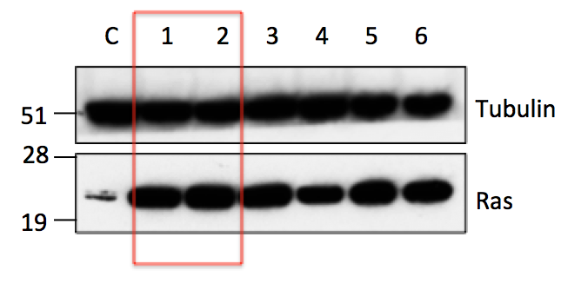
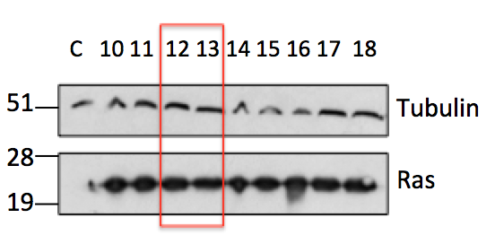
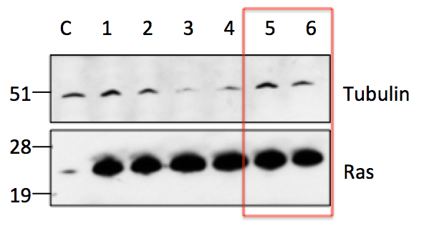
MRC5
SW480
HCT116
Figure 5.1. Western blotting analysis shows RAS over-expression in stable clones
SW480, HCT116 and MRC5 cells were transfected with 1μg of RAS construct or control transfected with ddH₂O. The cells were transferred to media containing puromycin, until the control cells had all died and the transfected cells formed colonies. These colonies were picked and lysed to extract protein as per the technique stated in the methods. 50μg of protein was loaded per sample onto precast gels and the primary used was anti-RAS Ab (Cell Signalling) left on over night in milk at 4ºC. Images above show the clone number along the top or C for control parental cells and M_{W} standards are shown on the left. All clones over-express the RAS protein compared to control cells and tubulin-loading controls are also included for each blot. Red boxes highlight clones selected for further studies.
The six clones indicated above were maintained in periodic antibiotic containing DMEM media for the duration of these experiments, along with parental cells in normal DMEM media. It was next assessed whether SRCAP could still be knocked down using siRNA in these RAS over-expressing cells and also whether the over-expression of RAS had any effect on endogenous levels of SRCAP. Samples for each of these conditions were lysed for RNA extraction, RNA was reverse transcribed to cDNA and Taqman PCR assays were carried out to assess SRCAP expression levels. It was found that SRCAP could be knocked down in the RAS over-expressing clones to a similar level as was shown in Chapter 4 when SRCAP was depleted in the parental cell lines (HCT116 & SW480). Here, it is also shown for the first time within this thesis that SRCAP can be significantly knocked down in a fibroblast cell line (MRC5) and still maintain viability of the cells. Also, endogenous SRCAP expression levels in the RAS over-expressing clones did not differ from the parental cell lines to any significant degree, showing that increasing RAS levels does not affect expression levels of the chromatin-remodelling gene SRCAP (Figure 5.2).

Figure 5.2. Assessment of SRCAP mRNA levels when combined with RAS over-expression.
Parental or RAS over-expressing clones were seeded into 6 well plates and transfected with control siRNA or SRCAP si6 or si7 24hrs later. 48hrs after transfection the samples were lysed for RNA underwent reverse transcription PCR and then SRCAP expression levels quantified using an SRCAP Taqman probe. Each graph shows the repeats as separate symbols with the median and range plotted. Using a Kruskal-Wallis non-parametric test each cell line showed a significant difference overall – SW480 p=0.0178, HCT116 p=0.0115, MRC5 p=0.0118. Comparing the individual groups to each other showed that in all three cell lines there was no significant difference in SRCAP expression between control and RAS over-expressing cells. SRCAP was significantly knocked down in RAS over-expressing clones compared to control cells and compared to RAS over-expressing clones without SRCAP knockdown in all three cells lines as shown by significance stars on the graphs (* = p≤0.05, **=p≤ 0.01), showing that it is still possible to deplete SRCAP levels when the cells are stably over-expressing RAS.

5.3 RAS over expression causes differential cellular responses depending on the parental cell lineage

It has been shown that cells displaying RAS mutations accumulate more DNA damage, as well as arresting in G2/M and inducing TP53, when exposed to damaging agents compared to their wild type counterparts (Steckel et al., 2012). This indicates that mutant RAS cells are less able to detect and cope with damage and so are under more stress. Therefore, it was hypothesised that the cell lines over-expressing RAS generated here would also have an increased DNA damage phenotype compared to parental cell lines, particularly when SRCAP is depleted to induce genome instability (see chapter 4).

DNA damage was therefore assessed as previously described in Chapter 3 using the markers γH2AX and 53BP1 (Figure 5.3a). In SW480 cells there was a trend towards an increase in DNA damage markers when RAS was over-expressed, and this increased to significance compared to the control cells when SRCAP was knocked down (Figure 5.3b). However, in HCT116 cells although there was a significant increase in damage in the RAS cells, this was not increased further when SRCAP was knocked down (Figure 5.3c). Interestingly, the data are consistent with a slight recovery in the DNA damage pathway when RAS over-expressing HCT116 cells have SRCAP depleted, although this was not statistically significant. In MRC5 cells there was an increase in DNA damage when RAS was over-expressed in RAS2; clone 1 followed the same pattern as SW480 cells i.e. SRCAP knockdown in RAS cells produced a more significant increase in damage, but clone 2 had similar numbers of foci (Figure 5.3d). It could be that the difference between the two CRC cell lines was again because of TP53 status. However, MRC5 cells are TP53 proficient like HCT116 cells (Ashcroft et al., 2000), but in clone one they seem to follow a more similar pattern to the SW480 cells.

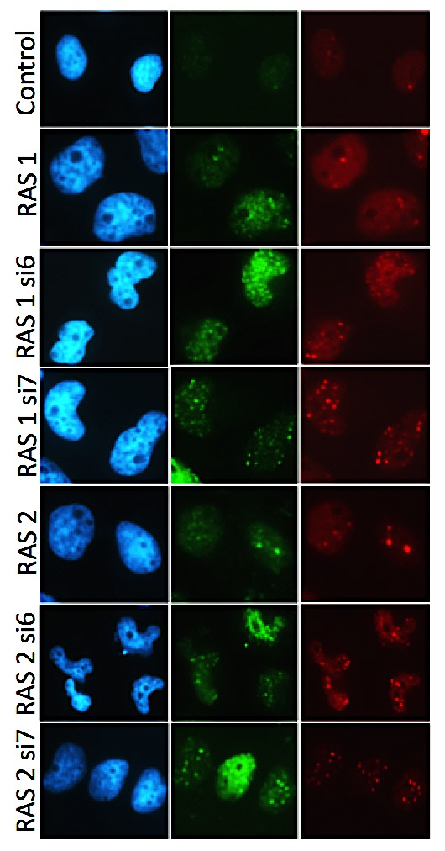
53BP1
γH2AX
a.)
DAPI

Figure 5.3. RAS over-expression plus SRCAP knockdown affects DNA damage to differing extents in different cell lines.
a.) Cells were seeded for 24hrs on glass coverslips, transfected with SRCAP siRNA or control for 48hrs and stained as per protocol for the DNA damage markers γH2AX and 53BP1. Shown are representative images of the staining in MRC5 cells, representative images of HCT116 and SW480 can be seen in Chapter 4 Figure 4.4.
b.) The number of foci in each cell counted, then the average number of foci calculated. Each symbol represents one repeat and the median and range are plotted. In SW480 cells there was a significant p value using a Kruskal-Wallis test for both markers- γH2AX p=0.0229, 53BP1- p=0.0257. Comparing the individual groups showed a significant increase when SRCAP was knocked down compared to control cells as shown by the significance stars above the symbols, and a significant difference between RAS13 and RAS13 si6.
c.) Using the same statistical tests as above there was a significant difference using the non-parametric test for γH2AX (p=0.0303), but not for 53BP1 (p=0.1657) in HCT116 cells, and with multiple comparison there was only a significant increase in γH2AX in the RAS5 and 6 clones compared to control and RAS6 clone in 53BP1.
d.) Again with the same statistical tests there was no significance in MRC5 cells (γH2AX p=0.0533, 53BP1- p=0.1098), but with multiple comparison there was a difference between control cells and the other data sets, showing an increase in DNA damage markers (* = p≤0.05, **=p≤ 0.01, ***=p≤0.001).

d.) MRC5
c.) HCT116

b.) SW480
In order to further assess how RAS status affects genomic instability mechanisms when SRCAP is depleted, cells were also assessed for nuclear abnormalities using the parameters outlined in Chapter 3 Figure 3.21. There was no significant difference in nuclear abnormalities in any of the cell lines over-expressing RAS compared to the control cells. However, when SRCAP was knocked down in the RAS over-expressing clones there was a significant increase in nuclear abnormalities compared to control cells and compared to SW480 RAS12 in the respective knockdown clones (Figure 5.4a). Interestingly, although there were minimal increases in DNA damage markers for HCT116 RAS cells, there were more significant increases in nuclear abnormalities and these increased further when SRCAP was knocked down (Figure 5.4b). In the MRC5 cells RAS over-expression plus SRCAP knockdown increased nuclear abnormalities to a level not seen in the other cell lines, with some repeats having around 50% abnormal nuclei when RAS and SRCAP aberrations were combined (Figure 5.4c). Not only was there significance between the data sets and control cells but also between RAS only cells and RAS plus SRCAP knockdown, showing a significant increase in nuclear abnormalities with si6 when the two genomic alterations were combined, this increase in nuclear abnormalities when SRCAP knock down and RAS over-expression are combined in a fibroblast cell line is noteworthy. Interestingly though RAS over-expression in itself did not significantly increase the amount of nuclear abnormalities in any of the cell lines.

b.)
a.)
Figure 5.4 RAS over-expression plus SRCAP knockdown increases nuclear abnormalities
DAPI stained cells were imaged (10 images per condition) after 48hrs of siRNA transfection and the percentage of cells with nuclear abnormalities (as stated in Chapter 3) counted. Each symbol represents a single repeat with the median and range plotted. Each cell line data underwent a Kruskal-Wallis statistical test and all had significant p values (SW480- p=0.0406, HCT116- p=0.0348, MRC5- p=0.008). Individual multiple comparisons were then assessed against control (stars above the symbols), and with the clone knockdown against their respective clones (stars below the symbols) and showed significantly increased nuclear abnormalities when SRCAP was knocked down (* = p≤0.05, **=p≤ 0.01, ***=p≤0.001).

c.)
It was also investigated whether RAS over-expression and SRCAP depletion affects cell cycle distributions given that previous reports have shown that inducing high levels of RAS plus DNA damaging agents like doxorubicin is associated with an arrest in G2/M (Steckel et al., 2012). In the SW480 cell cycle profiles there were significantly fewer cells in G1 when RAS was over-expressed in clone 13 and significantly more cells in the G2/M phase, which is consistent with previous papers indicating a cell cycle arrest in G2/M and so the accumulation of more cells in comparison to the control (Figure 5.5a). Therefore this indicates that the cells may be accumulating damage during S phase and becoming stalled at the G2/M damage checkpoint, in order to prevent aberrant mitosis. The data are also consistent with papers indicating that RAS over-expression causes an increase in cyclin D1 through the activation of the MAPK pathway, which increases the amount of mitogenic signals during G1 to accelerate the cells through this phase, and this so this shortens the length of G1 (Rodriguez-Puebla et al., 1999, Liu et al., 1995). There was a significantly increased Sub G1 population in HCT116 cells when si6 was used to knockdown SRCAP in both RAS over-expressing cells lines, which correlated with a decrease in S phase cells (Figure 5.5b). This is indicative of cells accumulating damage, arresting in G1 and then undergoing apoptosis to give a Sub G1 subset and fewer cells progressing to synthesis of new DNA. However, this is contradictory to what was seen in the DNA damage assays, where very little DNA damage was seen compared to control cells in HCT116 cells (Figure 5.3b). It may be possible that many of the cells had already undergone apoptosis and therefore the cells that had adhered to the coverslips and survived the staining process were much more viable so appeared to have lower levels of DNA damage. Cell cycle changes in MRC5 cells were fewer and less significant; there was an increase in sub G1 cells in RAS clone 1 when SRCAP was knocked down and in RAS2, and a decrease in G1 in RAS2 si7 (Figure 5.5c).

a.)
c.)
b.)
n=3
Figure 5.5 Cell cycle profiles of RAS over-expressing cells with SRCAP depletion differ depending on cell lineage.
Cells were seeded into 6 well plates for 24hrs, transfected with siRNA for 48hrs and then fixed and stained with PI. Samples were run on the FACS Calibur, where doublet cells were excluded and DNA content histograms generated. Peaks were gated for the percentage of cells present in each phase of the cell cycle. Bar charts above represent the median percentage of cells in each cell cycle phase from three separate experiments, with range bars.
a.) Using a Kruskal-Wallis test there was no significant difference between any of the data sets in SW480 cells at any of the cell cycle phases (sub G1-p=0.3638, G1-p=0.0752, S-p=0.1483, G2-M-p=0.0633), however individual assessment between control cells and the other data sets gave significant differences as displayed by significance stars.
b.) Using a Kruskal-Wallis test there was a significant difference between data sets in sub G1 and S phase in HCT116 cells (sub G1-p=0.0492, G1-p=0.9229, S-p=0.0397, G2-M-p=0.5602), individual assessment between control cells and the other data sets gave significant differences as displayed by significance stars.
c.) Using a Kruskal-Wallis test there was no significant difference between data sets in MRC5 cells across any cell cycle phase (sub G1-p=0.1879, G1-p=0.3455, S-p=0.3901, G2-M-p=0.6152), however, individual assessment between control cells and the other data sets gave significant differences as displayed by significance stars (* = p≤0.05, **=p≤ 0.01).

5.4 Effect of SRCAP knockdown in fibroblast cells

Based on the interesting results in nuclear abnormalities for MRC5 lung fibroblast cells containing RAS over-expression and SRCAP knockdown (Figure 5.4c), as well as the fact that there appeared to be an increase in DNA damage (Figure 5.3c), DNA damage and nuclear abnormalities were assessed in MRC5 parental cells with SRCAP knockdown compared with non-targeting siRNA controls. This data would indicate whether the large increase in nuclear abnormalities in MRC5 RAS over-expressing cells when SRCAP is depleted a cumulative effect of the two aberrations, or whether this is the normal phenomena when SRCAP is knocked down in this cell line

When SRCAP was singularly knocked down in MRC5 cells there was a significant increase in the DNA damage markers- γH2AX and 53BP1 (Figure 5.6a&b). When comparing the data below to that shown in Figure 5.3c, SRCAP knockdown alone induces a similar number of average foci per cell as SRCAP knockdown plus RAS over-expression. RAS over-expression alone produces only 1 to 2 fewer foci per cell than SRCAP knockdown alone (p>0.05 i.e. no significant difference). This indicates that the increase in DNA damage in MRC5 cells when RAS is over-expressed and SRCAP knocked down could be being driven primarily by the SRCAP knockdown.

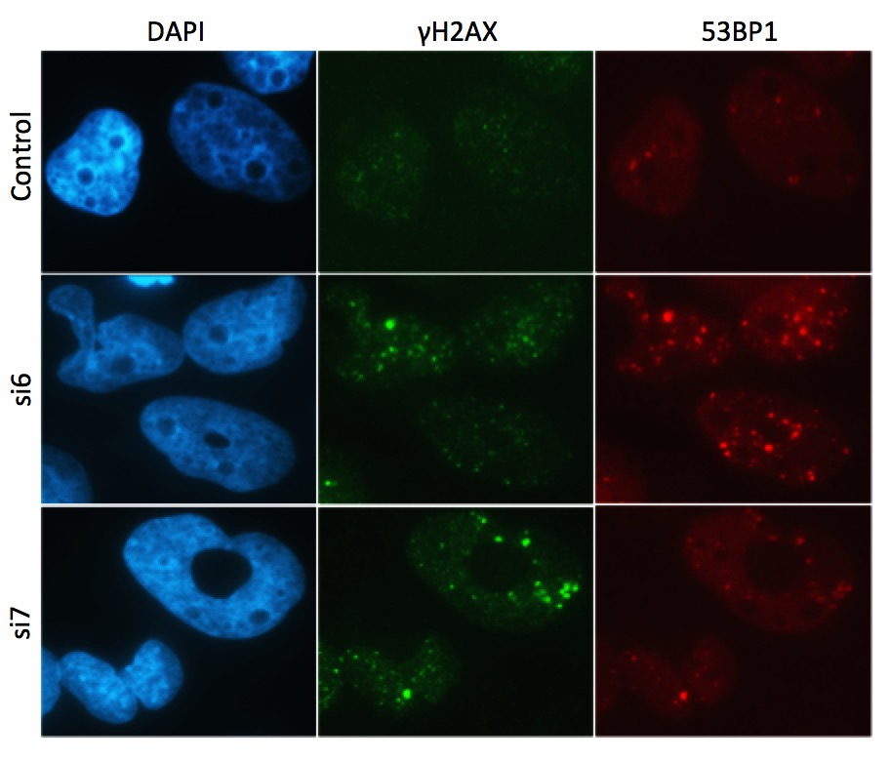
a.)
Figure 5.6 SRCAP knockdown alone increases DNA damage in MRC5 cells
a.)Representative immunofluorescence images of MRC5 cells seeded on coverslips and transfected with SRCAP or control siRNA for 48hrs, the coverslips were then fixed and γH2AX and 53BP1 antibodies used to detect the DNA damage markers.
b.) Images were taken and the foci in each one of 100 cells counted, to produce the average number of foci per cell, separate experiments are represented by individual symbols with median and range plotted. There was a significant p value for γH2AX (p=0.05) but not for 53BP1 (p=0.0714) when a Kruskal-Wallis test was applied. Comparing each siRNA probe to control showed that si7 was significantly increased compared to control in both cell lines, as indicated by the significance stars on the graphs (* = p≤0.05).
b.)

When the percentage of nuclear abnormalities was counted (as scored using the parameters outlined in Chapter 3 Figure 3.21) in MRC5 cells containing SRCAP knockdown there was a significant increase compared to control cells, only in si6, however si7 did show a trend but did not reach significance (Figure 5.7a&b). Again, compared to the MRC5 graph in Figure 5.4c this was much higher than when RAS over-expression occurs alone and around the same as when RAS was combined with SRCAP knockdown. Looking at the fold changes, si6 and si7 alone increased nuclear abnormalities compared to control by 3.3 and 2.4 fold respectively. The RAS alone fold changes were 1.5 and 1.7 for clone 1 and 2. When RAS over-expression was combined with SRCAP knockdown the fold changes in nuclear abnormalities were 3.4 and 2.3 for clone 1 si6 and si7, and 4.5 and 3.0 for clone 2 si6 and si7 respectively. Therefore, these data suggests that SRCAP alone is sufficient to induce high levels of nuclear abnormalities in MRC5 cells, and that an increase in RAS alone leads to much lower induced levels of abnormalities. It also suggests that when the two aberrations are combined there is no further increase in nuclear abnormalities from SRCAP depletion alone. It therefore appears that SRCAP knockdown is a driving force behind genomic instability in a normal cell line and that the added oncogenic stress of RAS being over-expressed has no overt bearing on nuclear abnormalities or DNA damage.
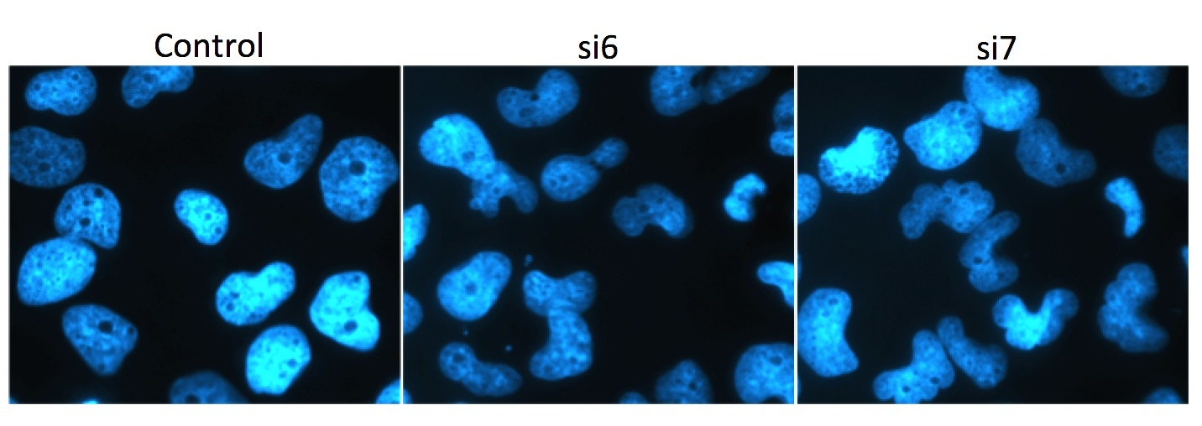
Figure 5.7 SRCAP knockdown alone causes an increase in nuclear abnormalities in MRC5 cells.
a.) The MRC5 parental cells seeded and fixed on coverslips from figure 5.6 were counted using the DAPI filter and assessed for nuclear abnormalities as stated previously. Shown are representative images of the three conditions
b.) The symbols represent the percentage of nuclear abnormalities from three separate experiments with the median and range plotted. Using a Kruskal-Wallis non-parametric statistical test there was an overall significant p of value of 0.0036, and when comparing the individual siRNA to control there was significance with si6 only, as started on the graph by significance stars (**=p≤ 0.01).

a.)
b.)
5.5 Discussion

- Phenotypic effects of SRCAP knockdown in RAS oncogene activated cells
Oncogenic stress can cause an increase in genomic instability, which could push the cells over a DNA damage threshold and instigate cell death. In this chapter RAS over-expression was used as the oncogenic stressor within several cell lines, as it is found to be an activating mutation in around 50% of colorectal cancer patients. The subsequent experiments carried out aimed to test the biological consequences of SRCAP knock down in colorectal cancer cell lines and a non-cancerous fibroblast cell line when the frequently mutated and well characterized driver of colorectal cancer, RAS, was over-expressed.

The RAS construct was successfully stably transfected into two CRC cell lines and one lung fibroblast cell line. Unfortunately a colon epithelial or fibroblast cell line could not be obtained which wasn’t from a malignant origin, as this would have been the most ideal candidate to assess the effects of RAS over-expression and SRCAP depletion in a non-tumourigenic environment. It was then proven that SRCAP could be significantly knocked down in the RAS over-expressing cell line models and that RAS over-expression alone did not affect endogenous SRCAP levels. However, a study limitation is that although the RAS protein was shown to be over-expressed, RAS activity was not assessed. One way to assess this would be to do an active RAS pull down assay in which a GST-RAF1-RBD fusion protein binds to the active form of RAS when it is bound to GTP. This is immunoprecipitated and analysis determined by western blotting techniques using a RAS antibody.

When RAS was over-expressed alone there was a slight increase in DNA damage markers, and when SRCAP knockdown was added in addition, this increased more significantly in SW480 cells. However, in HCT116 cells the damage decreased when the two aberrations were combined. It is unclear why this happened but could be again due to a differing TP53 response, and in future work it would be useful to assess what happens in the TP53 deficient HCT116 cells used in Chapter 4. Yet, when the cell cycle profiles were investigated HCT116 cells showed a profile indicative of high levels of damage when RAS over-expression was combined with si6 knockdown, with cells accumulating in G1 and a consequent decrease in S phase cells, as well as an increase in the sub G1 apoptotic phase. SW480 cells with RAS over-expression followed a similar pattern to published data (Steckel et al., 2012); with cells accumulating at the G2/M checkpoint with clone 13 only, and this did not alter when SRCAP knockdown was added. Although an indication of apoptosis levels can be gained from the percentage of cells in the sub G1 phase, further work on this area could focus on specific apoptotic assays such as dual staining with Annexin V and propidium iodide, or using caspase 3 assays. With these, a more confident determination of whether SRCAP depletion in a RAS oncogene activated cell model could be resolved.

- SRCAP knockdown in a fibroblast cell line
When damage was assessed in MRC5 cells there was a slight increase in DNA damage as assessed by nuclear foci, when RAS was over-expressed and this did not alter significantly when SRCAP knockdown was included. Additionally, the cell cycle profiles were almost exactly the same no matter the conditions. However, interestingly the RAS over-expressing MRC5 cells with SRCAP knockdown displayed high levels of nuclear abnormalities, beyond what was seen for the two CRC cell lines. We therefore investigated whether this was a consequence of combining both aberrations within the same cell line or whether it was an effect of one alone. It appeared that SRCAP knock down alone was the driving force behind the increased nuclear abnormalities seen. It is curious that these high levels were seen within a non-tumourigenic cell line, and it would be beneficial to further investigate if this is seen in other cell lines in this respect, especially colon cells.

Overall it appears that increasing the amount of oncogenic stress within a cell line and knocking SRCAP down had differing affects depending on the cell line. The chromosomally unstable SW480 cell line showed an increase in DNA damage, whilst in HCT116 cells there was a decrease in DNA damage markers in RAS over-expressing clones with SRCAP knockdown compared to the RAS over-expressing clones alone. It is also noteworthy that in a normal cell line, SRCAP knockdown still caused genome instability and at much higher levels with regards to nuclear abnormalities.
- Study Limitation- RAS isoforms
A further study limitation is that the construct used throughout this chapter was a HRAS construct, whereas the most prevalent RAS mutation within CRC is KRAS. Although the RAS variants share 80% sequence homology and are expressed in all cell lineages, they differ in their C-terminal amino acid sequence and are expressed to differing degrees depending on the tissue (Castellano and Santos, 2011). For example KRAS is most prevalent in the lung and colon, HRAS in the brain and skin and NRAS in the testis and thymus (Leon et al., 1987). The cellular localization and how this affects function is also key to understanding the differences between the isoforms, for example KRAS in the mitochondria induces apoptosis, whilst HRAS is active at the Golgi and endoplasmic reticulum but only at the latter does it set off its downstream kinase signaling cascade, and this cascade is only activated by KRAS when it is membrane bound (Castellano and Santos, 2011). Moreover, it has been found that transfection of the different isoforms into different cell lines causes altered transforming abilities, for instance HRAS has an increased transformation ability in fibroblast cell lines (Cheng et al., 2011), which could explain why the normal lung fibroblast cell line MRC5 showed an increased level of nuclear abnormalities within the experiments presented here. When the RAS isoforms were transplanted into mouse models the different isoforms induced different types of leukemia and at different potencies (Parikh et al., 2007).

KRAS is highly over-expressed in CRC and studies show that KRAS activated cells result in a more efficient increase in the anti apoptotic-signaling cascade and that they increase cell motility by alteration of RAC and N-cadherin levels. This results in a greater tumour growth advantage and invasiveness trait (Walsh and Bar-Sagi, 2001). The RAS isoforms appear to activate the same pathway, however it is their activation of the effectors within the RAS pathway that differs, as KRAS activates Raf-1 preferentially whereas HRAS activates PI3K (Yan et al., 1998). This appears to then create differing gene expression profiles in the colon adenoma cell line Caco-2; for example KRAS over-expression modified genes associated with cell adhesion and colon development, whereas HRAS showed differences in cell morphology genes. Thus it appears that the different isoforms may contribute to different aspects of colon cancer progression with HRAS playing a role in cell transformation and KRAS in creating an environment suitable for tumour development (Roberts et al., 2006). However, there are still questions to be answered about the functioning of the different RAS isoforms within different tissues and diseases and also to what extent they share functional similarities. Therefore the use of HRAS in this set of experiments may produce differing results to what would be seen if a KRAS construct were utilized, but as a preliminary model it did produce some interesting results which could be followed up.

- Future Work
Future work with the RAS over expressing cell lines would include conducting MTT and clonogenic experiments with clinically used chemotherapy drugs, as shown in chapter two on the SRCAP knock down cell lines. However, due to time constraints this wasn’t conducted for this thesis. This would therefore be interesting to see whether the RAS mutational status affected response to 5-FU and/or cisplatin with SRCAP knock down in a similar way in the two colorectal cancer cell lines, but also possibly most importantly in the fibroblast cell line MRC5. As mentioned in the introduction to this chapter RAS mutational status is a predictor of response to anti-EGFR therapies, such as cetuximab, due to it being a downstream effector in the EGFR signaling pathway (Van Cutsem et al., 2015). However, response to treatments such as 5-FU and oxaliplatin is less widely studied. It is well characterised that patients which have RAS mutations confer a poor prognosis and disease free survival, with a high rate of recurrence. However, several studies have indicated that adjuvant chemotherapy with fluoropyrimidine- alone chemotherapy or the FOLFOX regimen is of benefit to patients with RAS mutations and that there was increased response in comparison to tumours with wild-type RAS. In fact the survival rates improved in both colon and rectal RAS mutated cancer with post-operative chemotherapy (Deng et al., 2015, Sasaki et al., 2016). It is thought the reason behind this is that RAS mutations correlate to a decrease in thymidylate synthase, and lower rates of this enzyme are associated with increased 5-FU activity (Maus et al., 2015). Therefore, it would be interesting to see whether the addition of RAS over-expression to our drug response experiments correlated to the clinically seen data and gave a larger sensitization when compared to RAS wild-type cells.

Chapter 6: Transcriptomic analysis of the effects of SRCAP deregulation

6.1 Introduction
6.2 Collection of RNA samples and quality control
6.3 Data Analysis
- Control vs. si6 SRCAP knockdown
- Control vs. YFP SRCAP over-expression
  - Hit validation
- Original microarray samples
- New knockdown samples
6.5 Discussion
- SRCAP knockdown alters genes associated with cancer progression
- SRCAP over-expression shows variation between repeats
- Validation of microarray hits
- Study limitations and future directions

List of Figures

6.1 RNA sample collection shows differing SRCAP expression levels
6.2 RIN analysis shows high quality RNA samples
6.3 Microarray quality controls show inconsistency in YFP SRCAP repeat 3
6.4 Control vs. si6 data shows good correlation in fold changes between the separate repeats
6.5 Genes with a decrease in expression when SRCAP was knocked down show enrichment for nucleosomal components and gene expression regulators
6.6 Genes with an increase in expression when SRCAP was knocked down show enrichment for regulators of cell proliferation
6.7 Control vs. YFP SRCAP data shows lower correlation rates in fold changes between the separate repeats
6.8 Genes with a decrease in expression when SRCAP was over-expressed show enrichment for the negative regulation of cellular processes
6.9 Genes with an increase in expression when SRCAP was over-expressed show no enrichment for any pathways
6.10 SRCAP expression re-testing in original microarray samples
6.11 Taqman RT-PCR of original microarray samples gives validated results
6.12 Evaluation of knockdown of SRCAP on new cell samples
6.13 Validation of hits in HCT116 SRCAP knockdown cells with new RNA samples shows comparative results
6.14 Validation of hits in SW480 SRCAP knockdown cells in another CRC cell line also shows comparable results
6.15 PHLDA2 and ELK3 validated fold changes are comparable to the original microarray fold changes
6.16 CPA4 is also increased when SRCAP is knocked down

6.1 Introduction

In order to assess how the differing SRCAP expression levels affect known pathways within the development and progression of cancer, genome-wide transcript levels were assessed in both SRCAP over-expression and knockdown cell populations. For example, as previously mentioned SRCAP has been shown to be over-expressed within various cancers (Slupianek et al., 2010, Santin et al., 2004), and therefore thought to be a potential driver of tumour progression. As such, it was hypothesised that over-expression of SRCAP would lead to an increase in H2A.Z incorporation into the nucleosome leading to an increase in transcription from the relaxed chromatin state at promoters. However, what transcriptional pathways this would impact on and how this potentially drives tumourigenesis is still unknown.

Using an RNA microarray it was shown previously that the knockdown of p400 in HCT116 cells, which is also up regulated in CRC and incorporates H2A.Z into nucleosomes, leads to a significant deregulation of genes involved in the WNT pathway (Chevillard-Briet et al., 2014). The WNT pathway plays a central role in gene expression. WNT ligands bind to Frizzled receptors along with co-receptors such as LRP 5/6 on cell membranes which signals to intracellular phosphoprotein Dishevelled (Dsh). This activation then disrupts the negative WNT protein Axin by dephosphorylation. Axin is usually bound to adenomatosis polyposis coli (APC), protein phosphatase 2A (PP2A), glycogen synthase Kinase 3 (GSK3) and casein Kinase 1a (CK1a) in a destruction complex which targets β-catenin for ubiquitination and therefore proteasome degradation. However, when Axin becomes unstable Dsh is phosphorylated and β-catenin is able to accumulate within the nucleus and activate cellular responses through transcriptional complexes (Tabatabai et al., 2017). For example the accumulation of nucleic β-catenin can signal for the up-regulation of c-MYC and other cell cycle proteins like cyclin D1, by binding to transcription factor TCF/LEF, in order to increase transition from G1 to S phase and in fact the expression of both c-MYC and nucleic β-catenin has been shown to provide a worse prognosis in CRC than each alone (Bondi et al., 2004). Furthermore, in some cancers, cells have become independent of the WNT ligands by the mutation of downstream oncogenes/tumour suppressor genes that make the pathway constitutively active.

Further validation in this paper (Chevillard-Briet et al., 2014) showed that p400 expression favoured the WNT pathway and therefore unregulated expression of p400 in CRC leads to activation of WNT target genes such as PORCN and FZD2, which drives the cellular proliferation pathway. Owing to the significance of the WNT pathway in a variety of cancers it may be that p400 is also over-expressed in more than just CRC. It is interesting to note that WNT signalling pathway mutations were found in 94% of CRC by the TCGA, so it is already a highly prevalent pathway for development of therapeutics (Tabatabai et al., 2017). This is in part owing to the role that APC plays within the WNT pathway and the fact that this gene is highly mutated in CRC, so tumours displaying deficient APC have constitutively active WNT signalling (Novellasdemunt et al., 2015). Given there similar roles, this hyper-proliferative role of p400 could therefore be expected to potentially also apply to SRCAP, with a possible link to the WNT-pathway when SRCAP is deregulated.

The Affymetrix Genechip microarray used in this chapter contains oligonucleotide probes for each 3’ unique region of the genes directly synthesized onto a glass wafer; there are millions of copies of the single stranded oligonucleotides each around 25 base pairs, built up in each location, meaning expression levels of up to 47,000 transcripts can be analysed. Within the regions there are perfect match probes as well as mismatch probes, which differ by a single base pair, which allows for the calculation of any background or non-specific hybridisation, as the sample injected onto the array should not bind to the mismatch probe (Schinke-Braun and Couget, 2007). The advancement of RNA microarray technology from the first microarray in 1995 (Schena et al., 1995), has become an essential part of molecular cancer research in order to assess genome-wide transcripts for gene expression, pathways and biological mechanisms, quickly and efficiently. For example the first classification of breast cancer subtypes was based on gene expression patterns from a RNA microarray (Perou et al., 2000), and this research has led on to have prognostic significance for thousands of patients. It is however important to note that mRNA expression levels do not necessarily correlate to protein levels since the rate of production, modification and degradation of proteins play an integral role in determining the final level. Therefore, this approach sought to provide an insight into global gene activity when SRCAP was dysregulated.

6.2 Collection of RNA samples and quality control

Previous work presented in Chapter 3 that focused on trying to produce a cell line that over-expressed SRCAP found that transfection efficiency was below 10% and this was therefore resulting in a low expression level overall in the whole population. Therefore, in order to create a pure SRCAP over-expressing population, HCT116 cells were transfected with the Kozak mutated YFP SRCAP construct for 48hrs, and then sorted by fluorescent activated cell sorting (FACS) on a sterile FACS Aria machine into positive and negatively expressing YFP populations. Appendix 7 shows how the samples were gated using untransfected HCT116 cells as negative controls, and then the gating of the positive YFP SRCAP population. Again the transfection rates were low, at less than 10% and therefore the purified cell populations were re-seeded and left for 72hrs to continue proliferating before being lysed for RNA. Cells with SRCAP knock down were generated as described in Chapter 4 using si6. Figure 6.1a shows SRCAP mRNA levels for the three separate repeats of the FACS sorted cells plus the knockdown samples. All three repeats show that the negative YFP-SRCAP population had similar SRCAP expression as control siRNA transfected cells, as would be expected, whereas the YFP SRCAP positive population were over-expressing SRCAP, and the si6 transfected HCT116 cells had depleted levels of SRCAP. However, all three experiments showed differing levels of mRNA SRCAP over-expression, with the three control and the three si6 samples having similar very low expression levels as can be seen in Figure 6.1b.

a.)

Figure 6.1 RNA sample collection shows differing SRCAP expression levels
a.) HCT116 cells were either transfected with control siRNA, si6 or YFP SRCAP for 48hrs, at this point the siRNA-transfected samples were lysed for RNA and the YFP SRCAP transfected cells were FACS sorted depending on YFP fluorescence. RNA samples underwent RT-PCR and then Taqman PCR for assessment of SRCAP expression levels. In each experiment the si6 sample has SRCAP knocked down compared to control transfected and the positive YFP sorted population is over-expressing SRCAP compared to the negative YFP sorted population. Graphs show the mean 2-delta Ct value from three internal repeats of one experiment along with positive and negative error bars.
b.) The relative mRNA levels of SRCAP for the three repeats combined, showing how the controls (circles) and si6 samples (triangles) are closely matched, however the YFP SRCAP over-expression samples (squares) vary.
b.)
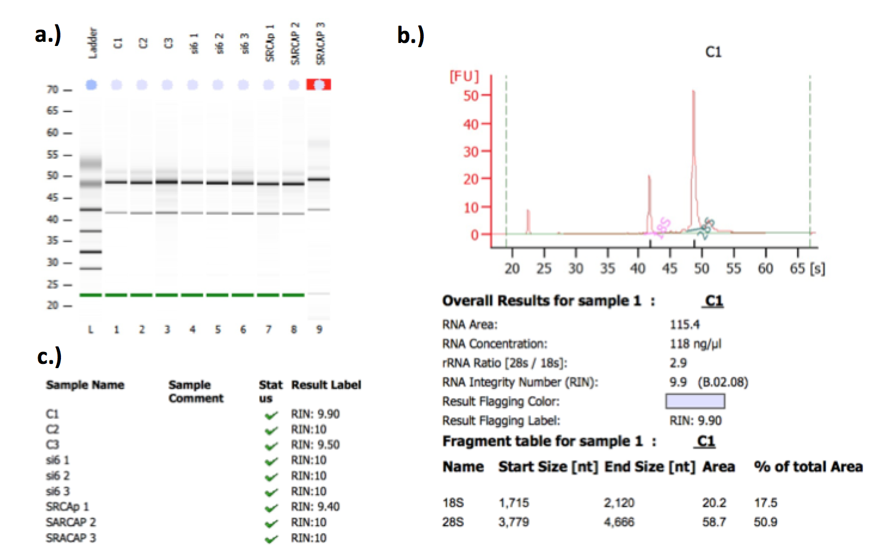
Before the RNA samples could be used for microarray analysis they were checked for quality using the RIN. This is the RNA integrity number, which is based on an algorithm, used on electrophoretic data. The samples were electrophoresed on a capillary gel, and as the nucleic acids pass through a detector an electropherogram is produced showing peaks corresponding to 18S and 28S ribosomal RNA. The RIN corresponds to the ratio under the peaks against the total area under the graph, plus the algorithm calculates the fast region, which is the area between the 5S and the 18S peak, and inputs this into the algorithm. A RIN can be between 1 and 10, with 1 being a very degraded sample and 10 being high quality RNA. In this experiment all the samples had a RIN of between 9-10, which indicated they were of good quality and suitable for microarray analysis (Figure 6.2).

Figure 6.2 RIN analysis shows high quality RNA samples
a.) Capillary electrophoresis showing how the RNA migrated through the gel in comparison to a standard ladder.
b.) Representative electropherogram of the control 1 sample showing peaks at 18S and 28S along with the observed data values of concentration, rRNA ratio, size and area of the fragments and the final RIN value
c.) Conclusive table of all the RIN values for the samples going into the microarray, they are all between 9-10 and so show high quality RNA.

Catherine Gelsthorpe (SITraN) then completed the microarray experiment as per the protocol outlined in the methods chapter. Before analysing the data, various quality controls were used throughout the process in order to check labelling efficiency and orientation of the arrays. Poly-A RNA controls were spiked into the RNA samples at different concentrations at the start of the procedure as exogenous controls. The microarray contains probe sets for the spike in RNA from B. subtilis genes, which are absent in eukaryotic samples- dap, lys, phe, thr (Figure 6.3a). The hybridisation intensity of YFP SRCAP repeat 3 was slightly different than the others especially for the thr RNA, however since this was not consistent for all the spike-ins it was classed as still acceptable for analysis according to QC criteria. The hybridisation controls evaluate the efficiency of the hybridisation of the samples to the probe sets, bioB/C/D are genes from the biotin synthesis pathway of E. Coli whilst the cre gene is a recombinase found in bacteriophage P1. The hybridisation controls (bioB, bioC, bioD, cre) were more uniform in their intensities, with C2 and YFP SRCAP 3 being slightly higher but again not significant enough to discount (Figure 6.3b). Figure 6.3c shows the relative signal box plot for all the samples, this is a measure of the distribution of the ratio of signal for each probe set to the median probe set signal across all the selected arrays. Therefore it is easy to compare each array’s signal to the median array for the group and identify any divergence. The set of arrays have comparable relative log expression signal, however, YFP SRCAP 3 showed a more variable box and whisker plot which could suggest that repeat 3 had a divergent signal. However, following technical advice from the SITraN microarray team, it was still carried forward for further analysis in order to check whether the fold changes were consistent with the other two repeats.

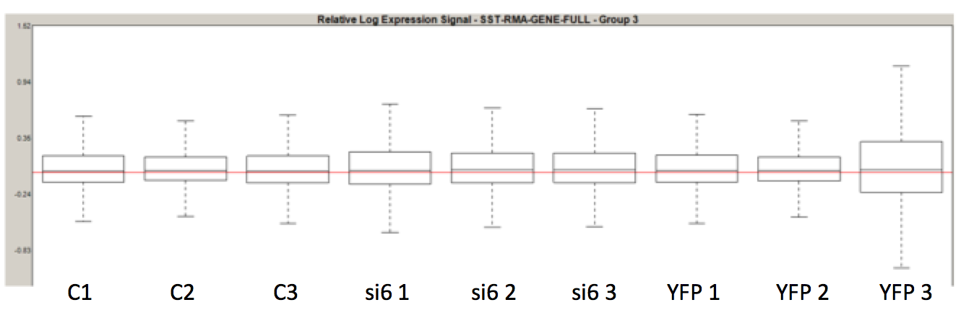
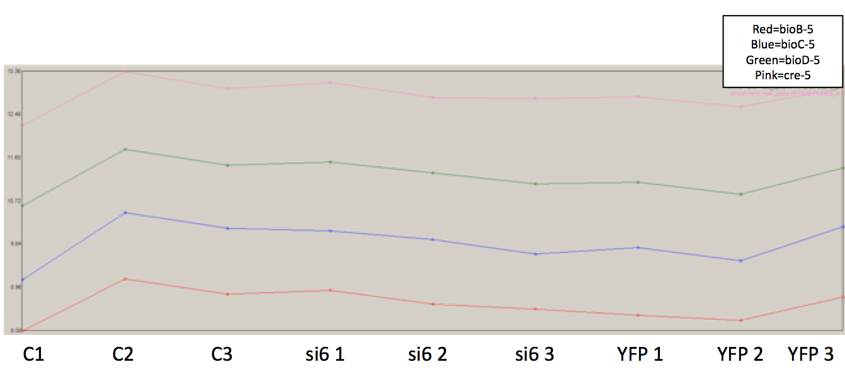
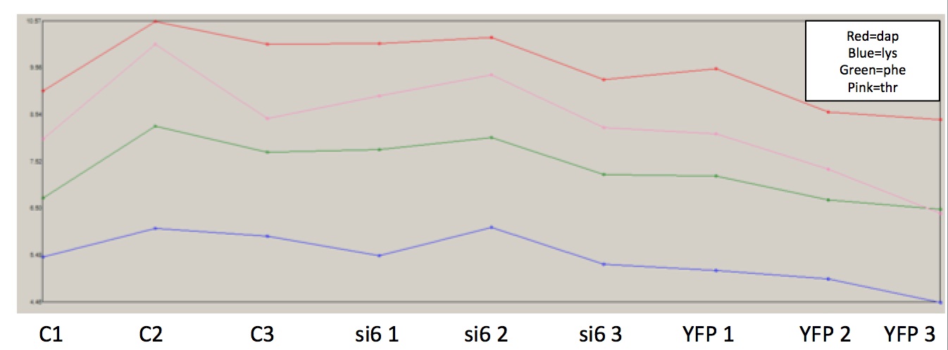
Figure 6.3 Microarray quality controls show inconsistency in YFP SRCAP repeat 3
a.) Line diagram showing the different poly-A B. subtilis RNA spike-in exogenous control hybridisation intensities at the differing concentrations. Each line colour represents a different gene as stated on the figure.
b.) Line diagram showing the four hybridisation control spike-ins at differing concentrations with each coloured line representing a different gene as outlined in the figure.
c.) Box and whisker plots for the relative log expression signal for each array, showing the spread of signal from the median expression of the probe set across all the arrays.
a.)
b.)
c.)
6.3 Data Analysis

- Control vs si6 SRCAP knockdown
Figure 6.4 shows the fold changes when all three controls and knockdown si6 experiments were combined. On the scatter plot the red dots correspond to genes that had a positive fold change (genes which have a differing expression level to the control) and these were genes that had a decreased expression when SRCAP was knocked down compared to control samples, and the green dots represent negative fold changes and these are genes which were over-expressed when SRCAP was knocked down (Figure 6.4a). These fold changes were also mapped to their chromosomal location, as can be seen in Appendix 8. Each individual experiment was then paired up with its control so that the fold changes and correlation could be assessed between the repeats. Figure 6.4b&d shows that all the fold changes between control vs. si6 had good correlation between the three repeats. There were similar mean and median values between the repeats and Spearman’s Rank correlation R-values of approximately 0.7. Using a box and whiskers plot of all the fold changes per repeat, there were several outliers in the fold changes, especially in repeats 2 and 3 (Figure 6.4c).

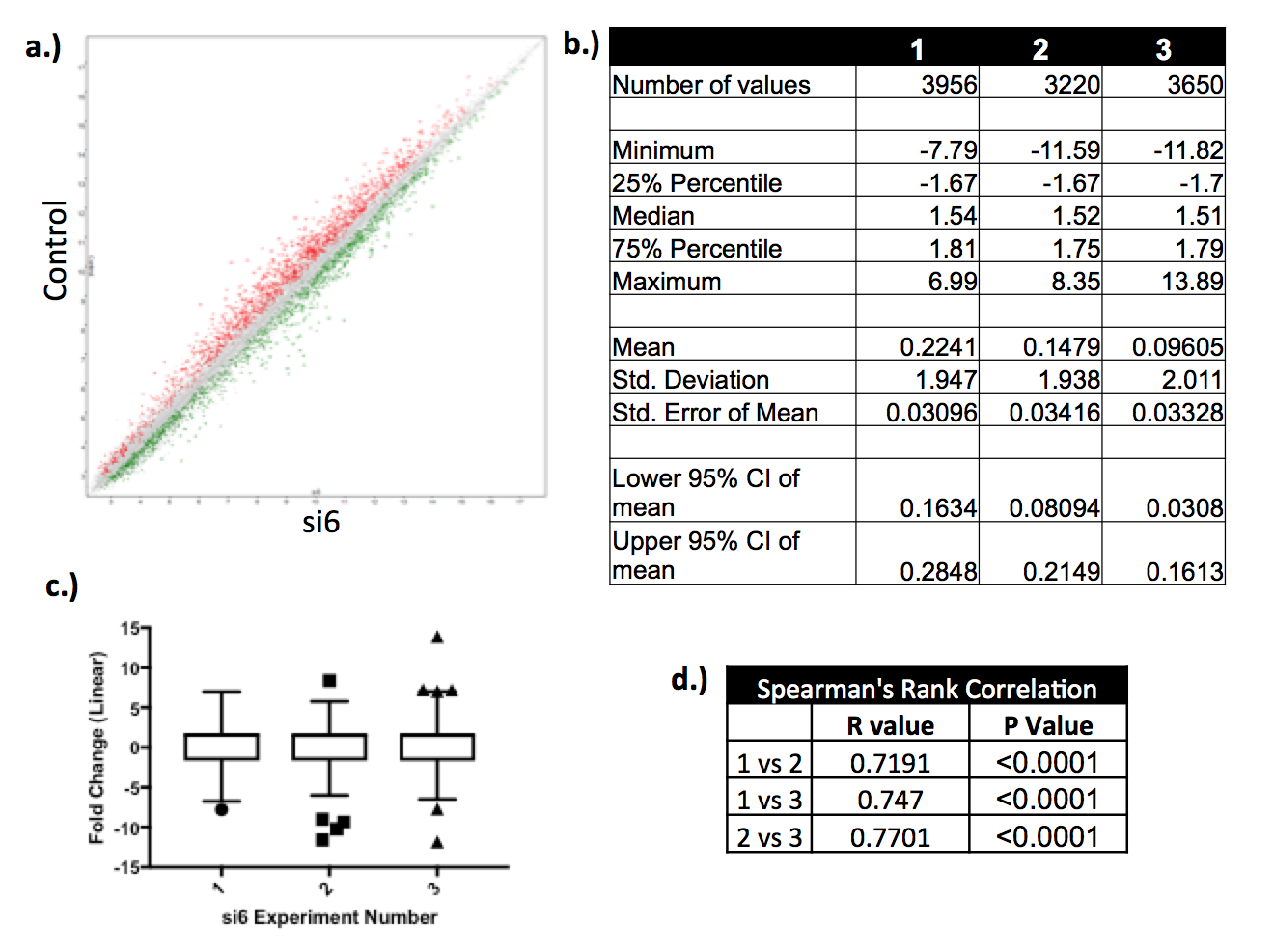
Figure 6.4 Control vs. si6 data shows good correlation in fold changes between the separate repeats
a.) Dot plot of all three repeats combined of control vs si6, with the red dots being positive fold changes, the green dot being negative fold changes and the grey showing genes which have not changed in expression between control and SRCAP knockdown samples.
b.) Table of values for the separate fold changes in each repeat, highlighting how many fold changes overall there were, taking into account both positive and negative, and displaying the means, medians and ranges.
c.) A graphical boxplot representation of the summary of the fold changes across the three repeats using the Tukey method. Here the interquartile range (IQR) is calculated (difference between the 25th and 75th percentile) and drawn as the box, with the whiskers representing the 75th percentile plus 1.5X the IQR and the 25th percentile minus 1.5X the IQR. If the highest or lowest value is inside of this value then the whisker stops at this point, however any values that were greater were considered to be outliers and so were plotted separately, as can be seen from the individual symbols. Repeats 2 and 3 had more outliers than repeat one at both negative and positive fold changes.
d.) A non-parametric Spearman’s correlation test was conducted on the three separate repeats to assess correlation, there was a R value of 0.7 for each pairing and all had a strongly significant p value.
The top 20 fold changes, both positive and negative, were then taken from each repeat and cross-referenced to identify genes that showed altered expression in all three independent experiments. Figure 6.5a shows six genes that had a positive fold change in all three repeats and so had a decrease in expression when SRCAP was knocked down compared to the control. Interestingly the HIST3H2BB gene was one of these genes, which is a member of the histone H2B family and therefore is a good proof of concept that knockdown of SRCAP seems to affect histone expression. There was also PHLDA2, which plays a role in the regulation of placenta growth, however it is also situated on an important tumour suppressor region and differential expression has been linked to various cancers including lung and breast. ELK3 is a transcriptional regulator, linked to ERK signalling and has close associations with RAS, where it inhibits transcription when RAS is absent, but promotes transcription upon RAS activation. Two other genes identified were the transcriptional regulator MYB, which functions in the haematopoiesis pathway, and SH3BP4, which plays a role in the control of clathrin mediated endocytosis. Finally CCDC34, which is a coil-coil domain protein of unknown function was also identified in these analyses (All the gene information was found on GeneCards, a free online human gene database- http://www.genecards.org/). Putting all the top 20 genes with positive fold changes in all three repeats into the STRING database (functional protein associations network) produced Figure 6.5b. This showed that there was enrichment for genes associated with the nucleosome and protein-DNA complexes, consistent with the idea that SRCAP depletion affects the nucleosomal structure by also inhibiting the expression of other related genes. When SRCAP was knocked down it also decreased the expression of genes associated with the negative regulation of gene expression and transcription.

1 |  | 2 |  | 3
Gene | Fold Change | Gene | Fold Change | Gene | Fold Change
JUND | 6.99 | CCDC34 | 8.35 | CCDC34 | 13.89
HIST3H2BB | 6.91 | ELK3 | 5.77 | HIST1H2BM | 7.24
PHLDA2 | 6.25 | PHLDA2 | 5.16 | HCFC1R1 | 7.22
CCDC34 | 5.8 | HIST3H2BB | 4.85 | HIST3H2BB | 7.03
GATAD2A | 5.55 | MYB | 4.66 | HIST1H4C | 7
TRAK2 | 5.32 | RFXAP | 4.61 | LRRCC1 | 6.95
SH3BP4 | 5.28 | SPICE1 | 4.54 | HIST1H4A | 6.86
MYB | 5.24 | ICMT | 4.39 | ELK3 | 5.83
EPN1 | 5.22 | PANX1 | 4.29 | SH3BP4 | 5.81
FAM69B | 4.99 | NEMP1 | 4.24 | CHAC1 | 5.53
SFXN2 | 4.89 | TMED8 | 4.21 | FAM129A | 5.47
HCFC1R1 | 4.78 | SLC7A11 | 4.17 | LRRIQ1 | 5.47
BRCC3 | 4.75 | ANAPC13 | 4.15 | JDP2 | 5.32
PHF21A | 4.71 | BLOC1S5 | 4.08 | MNS1 | 5.31
LIG1 | 4.67 | ZHX1 | 4.04 | ZHX1 | 5.18
XPNPEP1 | 4.58 | GRB10 | 4.01 | MYB | 5.16
SLC2A4RG | 4.32 | BRCA1 | 3.89 | PHLDA2 | 5.09
ELK3 | 4.27 | C10orf12 | 3.88 | DNAJA3 | 4.81
EFCAB14 | 4.23 | SH3BP4 | 3.8 | BRCC3 | 4.74
ARHGEF39 | 4.19 | FBXO33 | 3.79 | NRP1 | 4.64
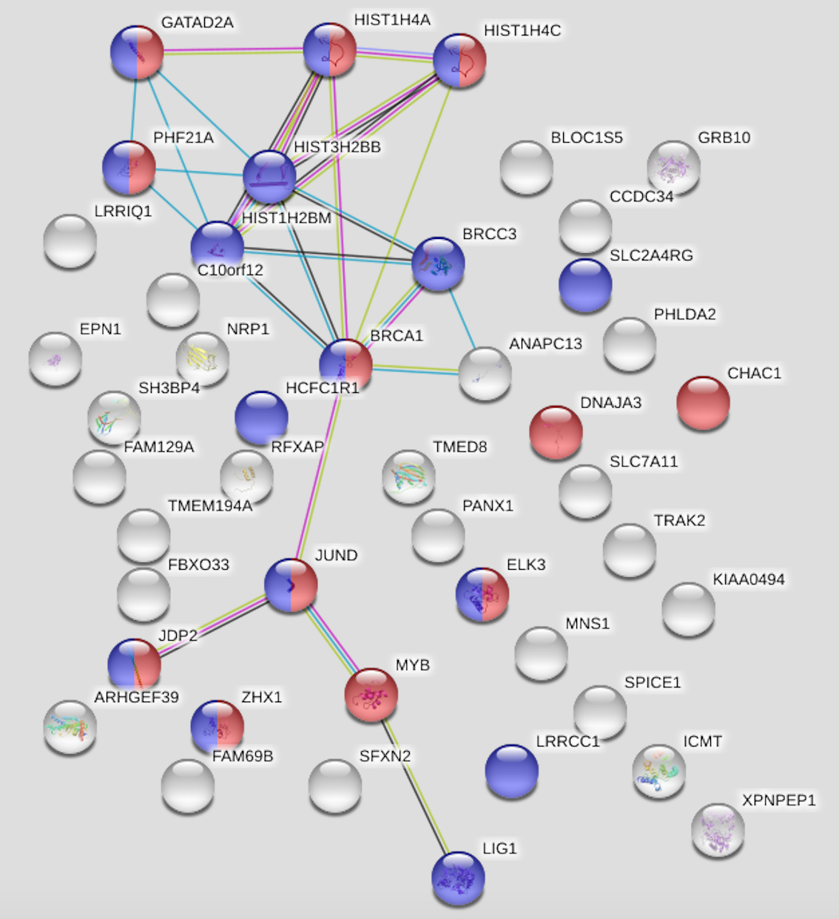
a.)
b.)

Figure 6.5 Genes with a decrease in expression when SRCAP was knocked down show enrichment for nucleosomal components and gene expression regulators.
a.) Table of the top 20 positive fold changes in control vs si6 data for each repeat. The genes highlighted were found across all three repeats.
b.) The three top 20 lists were put into the STRING database and the above network image was generated. The blue dots represent the genes associated with the nucleoplasm and the red are genes associated with the negative regulation of gene expression.

Analysis of the top 20 genes with the largest negative fold changes (those over-expressed when SRCAP is knocked down) in each of the three repeats uncovered nine genes that were present across the experiments (Figure 6.6a). These included GPR3 a G protein coupled receptor, SLC2A14 and SLCA3 members of the glucose transporter family and MSX1, which is a transcriptional repressor during embryogenesis. There were also four members of the KRTAP family and these are keratin-associated protein, which contribute to the structure of hair fibres. However, although it is interesting that four of these are highly expressed when SRCAP is knocked down it could also be because they are on the same chromosomal region (17q21.2) and so exhibit linked transcriptional changes. Finally FGFBP1 which is a fibroblast growth protein with a role in cell proliferation, it has also been implicated in CRC as an angiogenesis switch factor for tumourigenesis (Tassi and Wellstein, 2006) (All the gene information was found on GeneCards, a free online human gene database- http://www.genecards.org/). STRING database analysis of this gene list revealed enrichment for those involved in the regulation of cell proliferation (Figure 6.6b). Thus, when SRCAP is knocked down genes associated with cell proliferation are over-expressed. Previous work within this thesis has shown that when SRCAP is depleted there is a significant decrease in cell growth over time; hence highlighting that knockdown of SRCAP does have some affect on cell growth.
b.)
a.)
1 |  | 2 |  | 3
Gene | Fold Change | Gene | Fold Change | Gene | Fold Change
SLC2A3 | -7.79 | KRTAP2-1 | -11.59 | SLC2A3 | -11.82
KRTAP2-1 | -6.73 | KRTAP2-2 | -10.21 | KRTAP2-3 | -7.69
KRTAP2-3 | -5.27 | KRTAP2-3 | -9.36 | SLC2A14 | -6.5
KRTAP3-1 | -5.16 | SLC2A3 | -8.99 | MSX1 | -6.32
KRTAP2-2 | -5.16 | MSX1 | -5.98 | KRTAP3-1 | -6.25
FGFBP1 | -4.77 | FGFBP1 | -5.76 | ITGB8 | -5.8
MSX1 | -4.56 | KRTAP3-1 | -5.15 | TGFBR3 | -5.46
ITGB8 | -4.34 | PTAFR | -4.76 | FGFBP1 | -5.06
PLK2 | -3.95 | GPR3 | -4.58 | PNRC1 | -4.89
AP1M1 | -3.82 | SESN1 | -4.57 | GPR3 | -4.72
KRAS | -3.71 | SLC2A14 | -4.55 | SERTAD1 | -4.72
SLC2A14 | -3.71 | CDKN1A | -4.44 | KRTAP2-1 | -4.61
MUC12 | -3.68 | CEACAM1 | -4.44 | CDKN1A | -4.57
GPR3 | -3.64 | HMG20A | -4.27 | ACER2 | -4.38
TP53INP1 | -3.64 | F3 | -4.15 | SESN1 | -4.31
SEMA6A | -3.57 | PLK2 | -4.12 | KRTAP2-2 | -4.25
BAMBI | -3.52 | C12orf76 | -3.82 | ABCA12 | -3.98
ZNF217 | -3.51 | FAM43A | -3.81 | KRTAP2-4 | -3.96
ACTA2 | -3.49 | KRTAP2-4 | -3.8 | SERPINB5 | -3.81
ANK1 | -3.47 | CCDC92 | -3.75 | SCG2 | -3.8
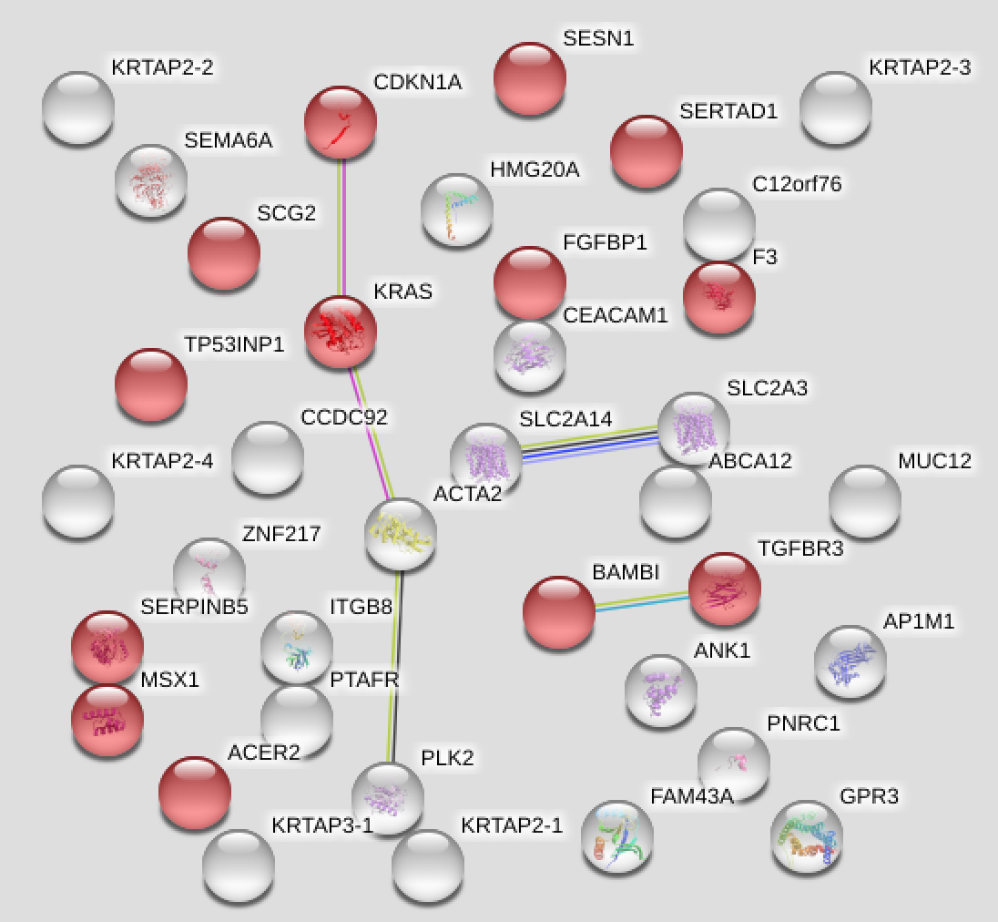
Figure 6.6 Genes with an increase in expression when SRCAP was knocked down show enrichment for regulators of cell proliferation.
a.) Table of the top 20 negative fold changes in control vs si6 data for each repeat. The genes highlighted were found across all three repeats.
b.) The three top 20 lists were put into the STRING database and the above network image was generated. The red dots represent genes associated with the regulation of cell proliferation.
All the genes that had a positive or negative two fold increase or more across all three repeats were then assessed. There were 115 genes that showed positive fold changes (genes which decrease in expression when SRCAP is knocked down) from 2 to 13.89, and when these were put into the STRING database they showed enrichment for pathways associated with the cell cycle, especially mitosis. Thus there is a decrease in gene expression associated with effects on cellular cycling when SRCAP is knocked down. Indeed from previous experimental work when SRCAP was knocked down there were cell cycle changes and a corresponding decrease in mitotic cells (see Chapter 4.5). There was also enrichment for positive regulation of metabolic and cellular processes, thus meaning these genes were decreased in expression. There were 55 genes with negative fold changes of -2 to -11.82 (genes which are over-expressed when SRCAP is knocked down). This list was enriched for genes associated with the regulation of apoptotic processes; therefore indicating that knockdown of SRCAP increases the expression of genes associated with apoptosis, whether this results in a negative or positive regulation of apoptosis is not known. Differences in apoptosis however, weren’t seen during an apoptotic assay conducted on SRCAP knockdown samples as previously described in Chapter 4.5 (These lists and STRING diagrams can be found in Appendix 9 to 12).

From this data analysis the genes HIST3H2BB, PHLDA2 and ELK3 were taken for further validation from the positive fold change data set and FGFBP1 from the negative fold change data set, as discussed later in section 6.4.

There were also several genes that were of interest but showed slightly less convincing evidence of expression changes. For example BRCC3, which plays a role in the DNA damage response by stabilising BRCA1 accumulation at DNA breaks, was found in the top 20 genes in two repeats for having a positive fold change (4.75 and 4.74) and so was down regulated when SRCAP was depleted. Further investigation showed that, even though it wasn’t in the top 20 in the second repeat, it still had a high positive fold change of 3.45 and could therefore also be an interesting gene to further investigate. This was similar for CDKN1A, which had high negative fold changes in two repeats (-4.44 and -4.57) and although not in the top 20 of repeat one did have a fold change of -2.67, and so could be a good candidate for further investigation. Especially so, as this gene functions as a negative regulator of cell cycle progression at G1, and therefore if it becomes over-expressed when SRCAP is knocked down it can lead to the increased phosphorylation of CDK substrates and block cell cycle progression (All the gene information was found on GeneCards, a free online human gene database- http://www.genecards.org/).

- Control vs YFP SRCAP over-expression
Analysis of the control vs. YFP SRCAP data revealed a difference to the siRNA data. When all the repeats were combined, the dot plot of all the fold changes (Figure 6.7a) showed much less variation compared to the dot plot in Figure 6.4a for control vs. si6. Here the red dots indicate the positive fold changes and these are all the genes which are decreased in expression when SRCAP is up-regulated and the green dots indicate negative fold changes and so show all the genes which are over-expressed when SRCAP is over-expressed. Again the locations where these changes map to on the chromosomes can be found in Appendix 8. The individual repeats showed consistent medians for the fold change summary, however the mean for repeat 3 was increased and as was the number of fold changes overall (6201 in test 3, compared to 2922 and 2084 in test 1 and 2 respectively), with more than double being detected in this third repeat (Figure 6.7b). Test three therefore also had many outliers, whereas the other two did not (Figure 6.7c). This made the correlation between the repeats much lower at around 0.4-0.5, and as little as 0.08 between tests 2 and 3 (Figure 6.7d). This is possibly due to the much higher over-expression of SRCAP in test 3, but the fact that the relative signal was increased in the microarray quality controls could also mean that an intrinsic factor affected this array cassette.

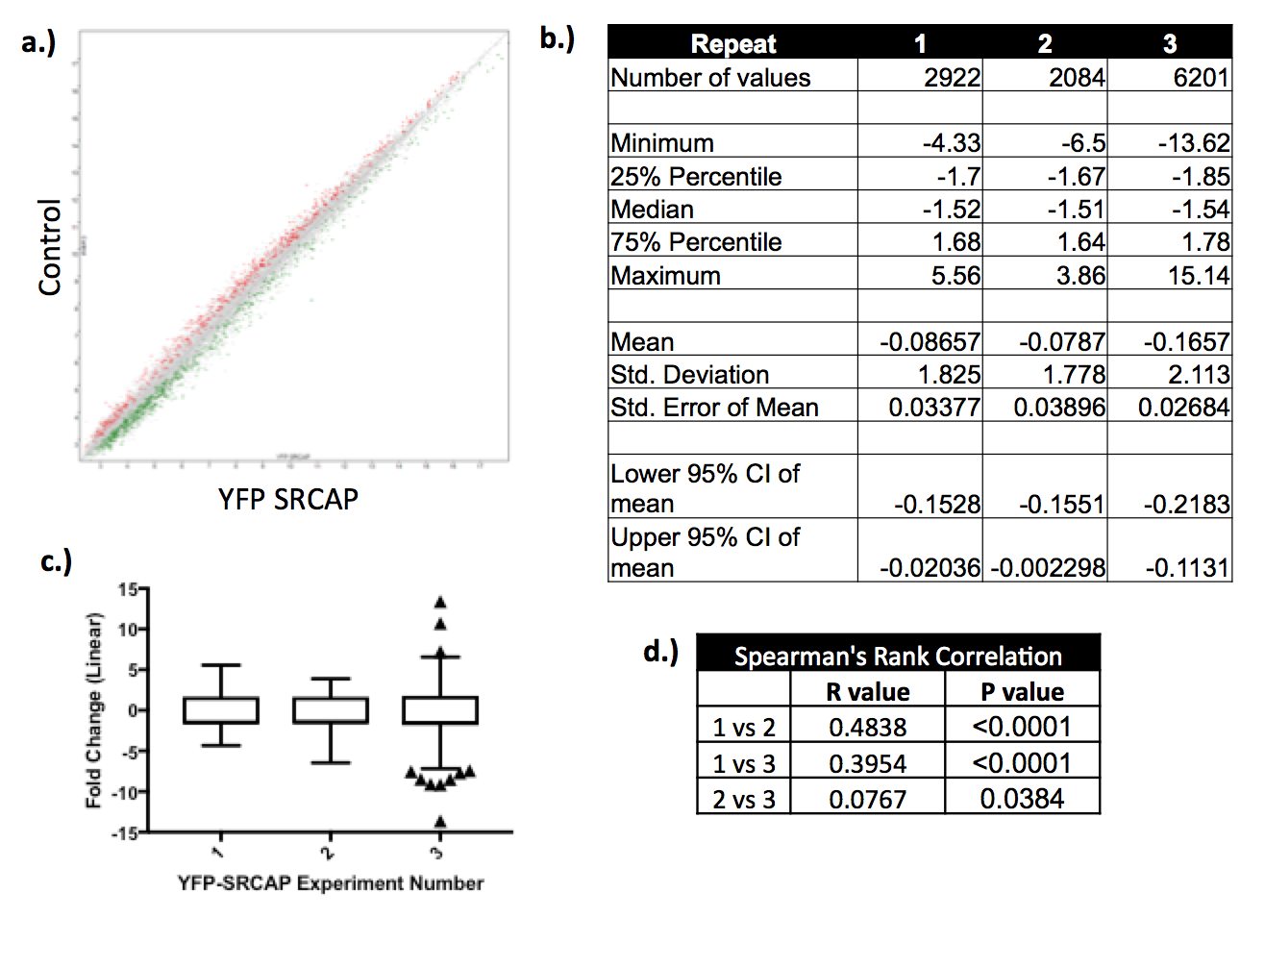
Figure 6.7 Control vs. YFP SRCAP data shows lower correlation rates in fold changes between the separate repeats
a.) Dot plot of all three repeats combined of control vs YFP SRCAP, with the red dots being positive fold changes, the green dot being negative fold changes and the grey showing genes which have not changed in expression between control and SRCAP over-expression samples.
b.) Table of values for the separate fold changes in each repeat, highlighting how many fold changes overall there were, taking into account both positive and negative, and displaying the means, medians and ranges.
c.) A graphical boxplot representation of the summary of the fold changes across the three repeats using the Tukey method as outlined in Figure 6.4c. Here only repeat 3 has outliers.
d.) A non-parametric Spearman’s correlation test was conducted on the three separate repeats to assess correlation, there were much lower R values for each pairing then in the control vs si6 data, especially 2 vs 3 with an R value of 0.08 and a less significant p value.
Initial analysis aimed to identify if any genes were found across all the repeats when taking the top 20 positive and negative fold changes. In the positive fold change cohort there were no genes that were down regulated across all three repeats when SRCAP was over-expressed (Figure 6.8a). However, SOX4 was down regulated in repeat 1 and 2. And with the non-correlation of test three, it could be that this is a real hit. SOX4 is a transcriptional regulator that does have implications in tumourigenesis (Cheng et al., 2017, Ruan et al., 2017). Putting all these genes into the STRING database came up with pathway enrichment for the negative regulation of cellular processes (Figure 6.8b), this would mean that negative regulators of cellular processes would have decreased expression when SRCAP was over-expressed, therefore resulting in a positive regulation. However, ‘cellular processes’ is a vague and broad term and could therefore include many different genes and pathways. As can be seen from Figure 6.8b the dots in red indicating these negative regulators of cellular processes do not appear to be connected into networks and so it appears that there is not a confident enrichment for a particular pathway.

In the negative fold cohort there was one gene that was over-expressed across all three repeats when SRCAP was over-expressed (Figure 6.9a). This was CPA4; this gene catalyses the release of carboxy terminal amino acids as its primary function. However, it has been implicated in histone acetylation and prostate cancer aggressiveness (Ross et al., 2009). Therefore, the fact that CPA4 is over-expressed in conjunction with SRCAP over-expression could prove interesting, also of note was that the fold change in CPA4 increased as the SRCAP over-expression increased. Test 1 had the lowest SRCAP expression (Figure 6.1b), and had the lowest fold change of CPA4 at -4.07 and test three had the highest SRCAP expression and also the highest fold change of -7.19 with repeat two sitting in the middle at -6.5. Putting the set of genes in Figure 6.9a into STRING however, showed no enrichment for pathways or processes (Figure 6.9b).

1  a.) |  | 2 |  | 3
Gene | Fold Change | Gene | Fold Change | Gene | Fold Change
LIG1 | 5.56 | ELF3 | 3.86 | DDIT4 | 15.14
PALM | 4.28 | BIRC6 | 3.65 | GPT2 | 13.41
SMAD6 | 4.21 | NR4A2 | 3.32 | CHAC1 | 10.74
OVOL1 | 3.96 | KLRC4-KLRK1 | 3.11 | HMGCL | 7.24
SOX4 | 3.91 | L3MBTL4 | 3.06 | FAM129A | 6.56
CKMT1B | 3.76 | SLC25A29 | 2.93 | PCK2 | 6
ZNF704 | 3.73 | PNPLA7 | 2.74 | GRB10 | 5.62
SFXN2 | 3.51 | ZNF608 | 2.73 | WDR6 | 5.45
LIMCH1 | 3.5 | FA2H | 2.63 | SEC61B | 5.41
GNAZ | 3.45 | AXIN2 | 2.62 | JDP2 | 5.36
SMO | 3.38 | PRKD3 | 2.58 | ERP29 | 5.18
PREX1 | 3.37 | MAP2K5 | 2.58 | TIMM13 | 5.01
MEIS3 | 3.3 | SOX4 | 2.53 | UPP1 | 4.75
TNFSF18 | 3.27 | MEDAG | 2.51 | EML2 | 4.56
FAM117A | 3.2 | PTK2 | 2.49 | CMTM6 | 4.44
MARCH9 | 3.18 | C1orf53 | 2.43 | DLST | 4.38
MYB | 3.07 | GRHL2 | 2.41 | ELFN2 | 4.28
DPYSL5 | 3.06 | ID3 | 2.4 | RNASEH2A | 4.25
CRLF1 | 3.05 | THSD4 | 2.37 | C21orf33 | 4.21
RGS2 | 3.04 | MEIOC | 2.37 | SH3BP5L | 4.19
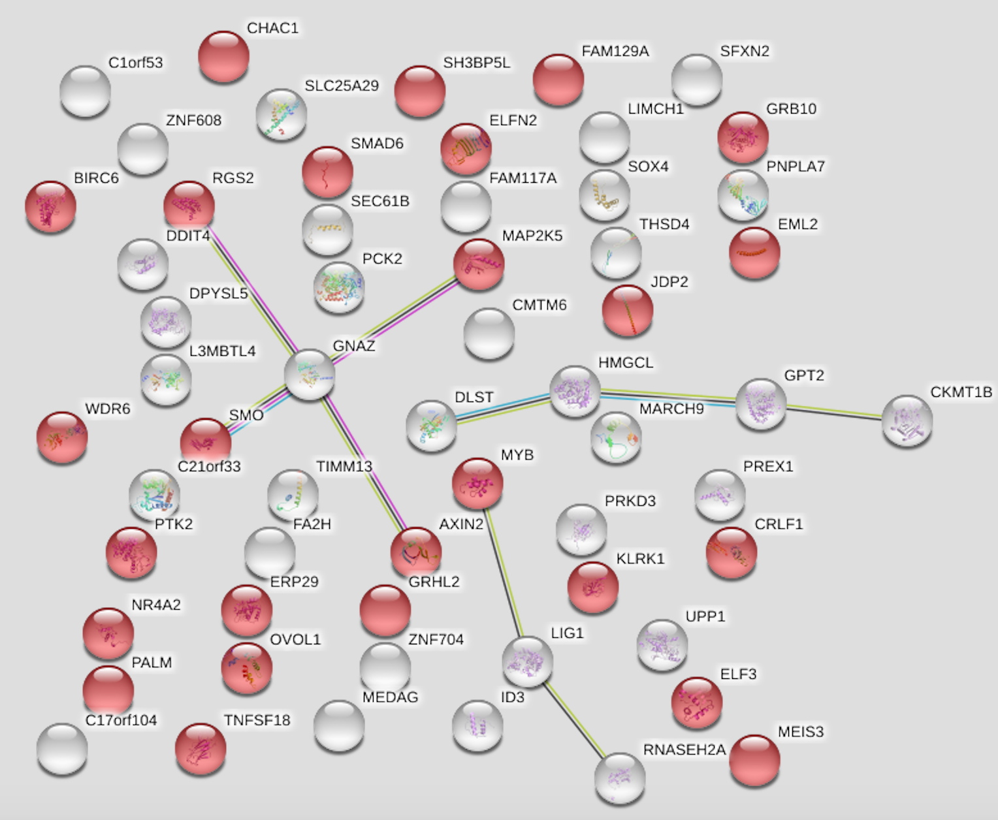
b.)
Figure 6.8 Genes with a decrease in expression when SRCAP was over-expressed show enrichment for the negative regulation of cellular processes.
a.) Table of the top 20 positive fold changes in control vs YFP SRCAP data for each repeat. No genes were found in all three repeats in the top 20, highlighted is SOX4, which was found in repeat 1 and 2.
b.) The three top 20 lists were put into the STRING database and the above network image was generated. The red dots are genes associated with the negative regulation of cellular processes
1 |  | 2 |  | 3
Gene | Fold Change | Gene | Fold Change | Gene | Fold Change
SF1 | -4.33 | CPA4 | -6.5 | MMP25-AS1 | -13.62
KLK15 | -4.2 | ARRDC3 | -4.46 | C20orf96 | -9.13
CPA4 | -4.07 | F3 | -4.34 | IL18BP | -9.08
AP1S1 | -3.99 | STIM2 | -4.12 | KRTAP2-3 | -8.5
PCDHB11 | -3.96 | CALB2 | -3.87 | NBEAL2 | -8.47
MTRNR2L6 | -3.84 | RAET1L | -3.84 | CDA | -7.68
MTRNR2L9 | -3.67 | HMG20A | -3.61 | ARL14EPL | -7.55
ELF1 | -3.6 | C1orf116 | -3.47 | ART1 | -7.42
RBM26 | -3.57 | TCN1 | -3.47 | CPA4 | -7.19
HNRNPK | -3.55 | NT5E | -3.4 | FLYWCH1 | -6.89
NECAB2 | -3.54 | RSRP1 | -3.38 | SULT1A4 | -6.66
CHAC1 | -3.47 | TACSTD2 | -3.33 | RFX7 | -6.6
CHMP7 | -3.45 | LIF | -3.31 | SYNGAP1 | -6.33
IQCF3 | -3.27 | KLK5 | -3.12 | NAT6 | -6.2
LMO7DN | -3.15 | RBMS1 | -3.08 | MLXIPL | -6.16
KLK5 | -3.12 | ULBP2 | -3.06 | GNB3 | -6
AC007292.7 | -3.07 | ALPK1 | -3.04 | PROSER3 | -5.85
TBC1D3 | -3.01 | KDM6B | -3.04 | KMT2B | -5.84
PSCA | -3.01 | MYEOV | -3.01 | LINC00173 | -5.81
TMEM167A | -2.98 | PMAIP1 | -3 | HOXB-AS3 | -5.59
b.)
a.)
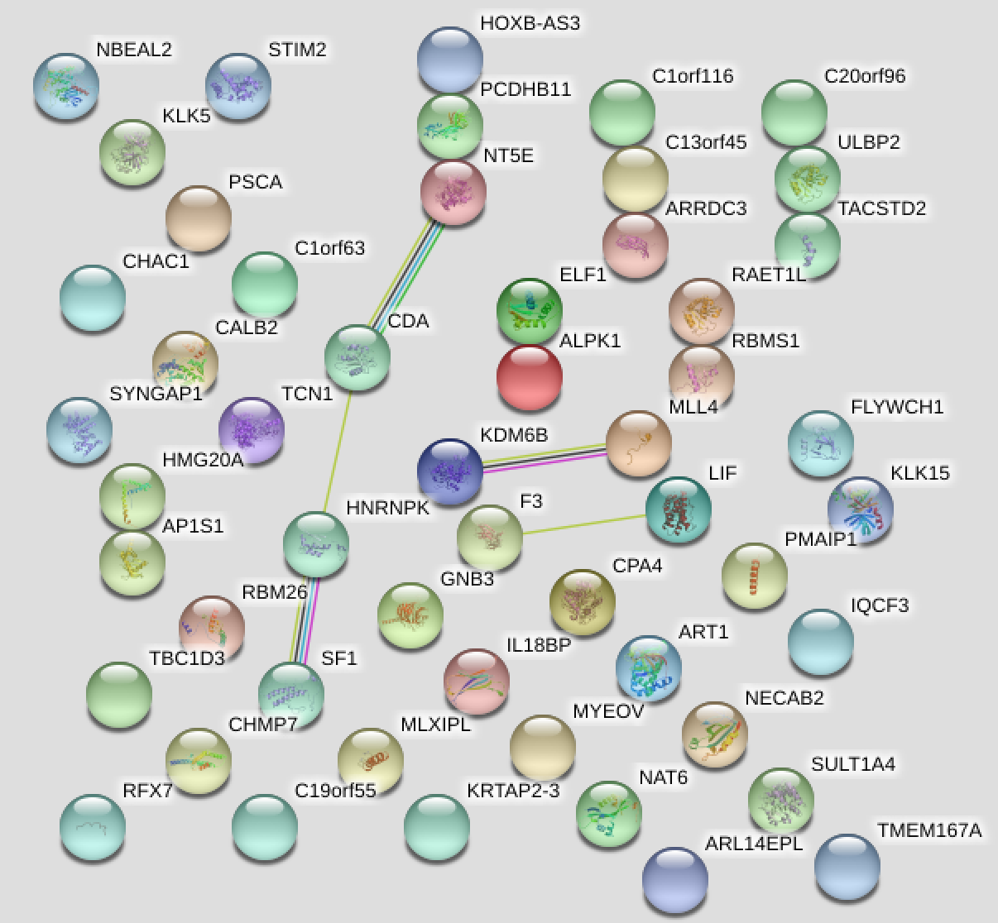

Figure 6.9 Genes with an increase in expression when SRCAP was over-expressed show no enrichment for any pathways
a.) Table of the top 20 negative fold changes in control vs YFP SRCAP data for each repeat. The gene highlighted was found across all three repeats.
b.) The three top 20 lists were put into the STRING database and the above network image was generated, however there was no pathway enrichment found.

Looking for genes which had either a positive or negative two or more fold change in all of the three repeats uncovered one gene which had a positive fold change and 5 which had a negative fold change, highlighting the much lower numbers than in control vs si6, possibly because of the variability between the samples (Found in appendix 13). The gene with the consistent positive fold changes (2.28, 2.13 and 2.6) was PCYOX1L, this gene was therefore down regulated when SRCAP was over-expressed and this gene plays a role in the homeostasis of platelet cytosolic Ca²⁺ levels. The five negative fold change genes (genes which are over-expressed as SRCAP is over-expressed) included CPA4, as well as a member of the previously mentioned KRTAP family. There was also CALB2, a calcium binding protein involved in neuronal excitability, ZFP36, an RNA-binding protein involved in polyA tail removal and KLK5 a serine protease that plays a role in desquamation of the epidermis. For these genes, unlike CPA4, the fold changes did not correlate to the SRCAP expression levels. The data from the SRCAP over-expression microarray analysis had a large amount of variability, possibly due to the differing SRCAP expression levels in the initial RNA samples. Also, the slightly larger spread of signal in the third repeat of the YFP SRCAP array may have contributed to the lack of consistent genes displayed across the three repeats, and so this may have precluded detection of pathway enrichment. However, SOX4 and CPA4 were further validated in the next section as a way of assessing whether the YFP SRCAP arrays had produced positive results.

6.4 Hit Validation

- Original microarray samples
The six hits, as mentioned above (HIST3H2BB, PHLDA2, ELK3, FGFBP1, SOX4 and CPA4), from the si6 and YFP SRCAP microarrays were selected for further analysis by Taqman qRT-PCR in order to validate the array data. Firstly the RNA samples used in the original microarray analyses were tested for the expression of the six genes, as well as SRCAP expression and 18S as the internal control. In this way a further method of expression analysis could be conducted on the same samples used to create the microarray data. Firstly the samples were checked to determine that they still exhibited similar SRCAP expression levels to the original microarray samples. Figure 6.10 highlights that the control samples and knockdown samples had expression levels of SRCAP similar to what was shown before the microarray was conducted, however although YFP1 and YFP2 were comparable, the level of YFP3 was not consistent with the original result. YFP3 appeared to be a variant in the microarray results (see section 6.2 and 6.3), and therefore this could be explained if the level of SRCAP was lower than previously thought. This sample was therefore not used for the rest of the hit validation.

Figure 6.10 SRCAP expression re-testing in original microarray samples
The RNA samples that were used in the microarray were again tested for SRCAP expression and compared to the values obtained prior to the microarray being conducted. The above graph shows the mean of three internal experimental repeats from one experiment, with positive and negative error bars.
The samples were then assessed for expression of the hits chosen from the array analysis (Figure 6.11a). Here it can be seen that the expression of both PHLDA2 and ELK3 decreases when SRCAP is knocked down as was seen from the original microarray analysis. HIST3H2BB also had a decrease in expression when SRCAP was depleted in the microarray results, however, although the validation data shows that each individual repeat exhibits a slight decrease in expression, the fold changes are low (Figure 6.11b) and there was variation between the internal repeats. FGFBP1 increased in expression in the microarray when SRCAP was knocked down and indeed repeats 1 and 3 of the validation data are increased. However, repeat 2 has a large FGFBP1 expression level in the control meaning this repeat does not show as high an increase in expression, suggesting that further validation of this hit may be required. Analysis of SOX4 showed a decrease in repeat 1 and an increase in repeat 2 when SRCAP was over-expressed, possibly indicating that this wasn’t a valid hit from the array. However, CPA4 did show comparable results to the original microarray, as the over-expression of SRCAP resulted in an increase in CPA4 via RT-PCR and Taqman analysis. Figure 6.11b shows the calculated fold changes from the control vs either knockdown or over-expression compared to the fold changes from the microarray results. Although PHLDA2, ELK3 and CPA4 follow the same trend in fold changes they are a lot lower than what was shown from the microarray, probably because this is has differing sensitivities compared to Taqman analysis.
a.)
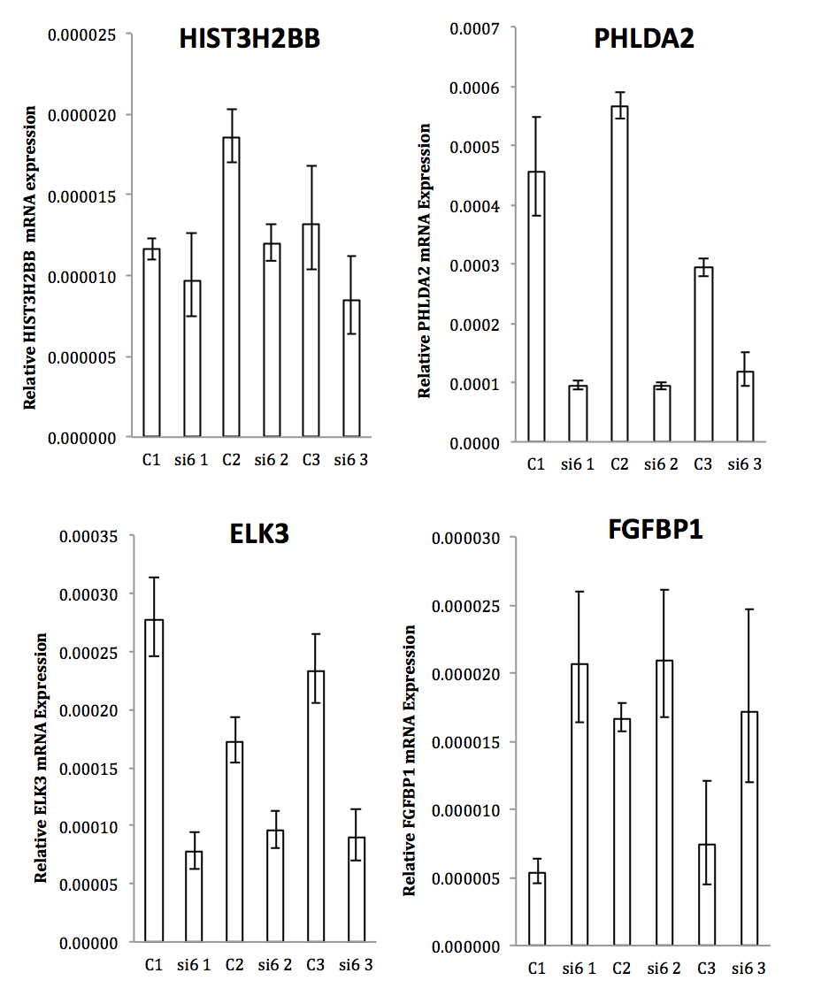

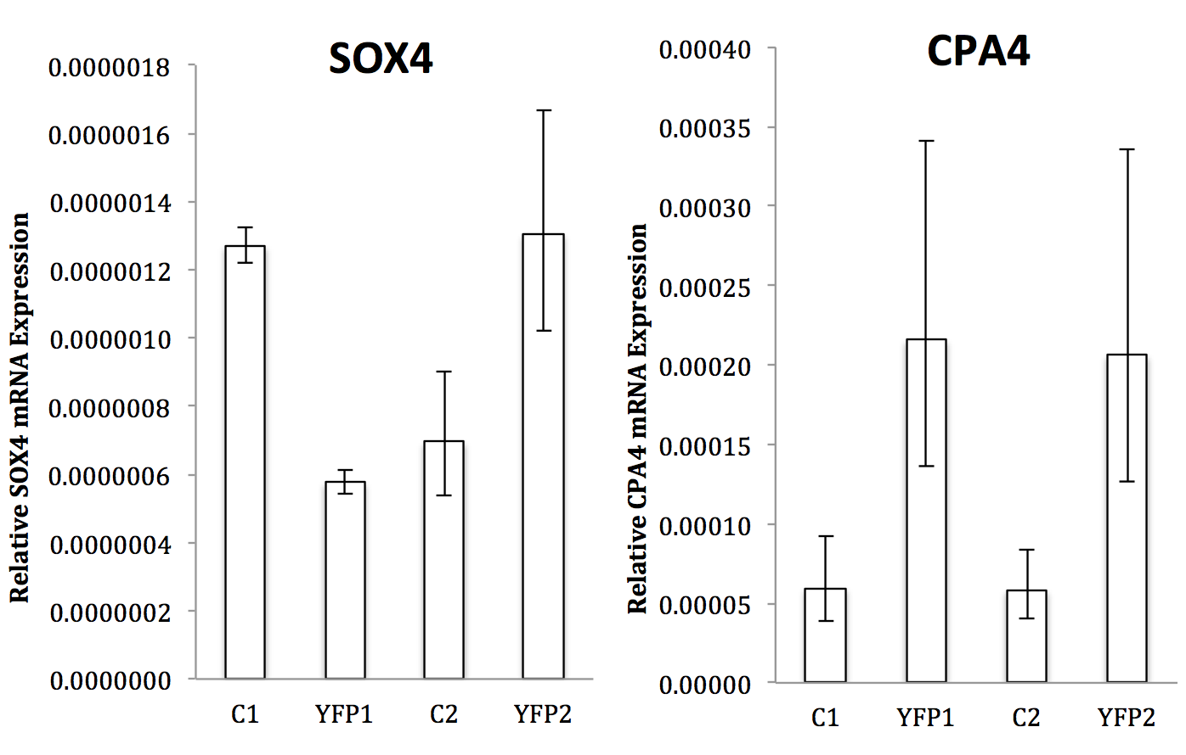
b.)

 | 1 | 2 | 3
CPA4
Microarray | -4.07 | -6.5
Validation | -1.85 | -1.82
SOX4
Microarray | 3.91 | 2.53
Validation | 1.14 | -0.91
FGFBP1
Microarray | -4.77 | -5.76 | -5.06
Validation | -1.93 | -0.32 | -1.23
ELK3
Microarray | 4.27 | 5.77 | 5.83
Validation | 1.84 | 0.86 | 1.38
PHLDA2
Microarray | 6.25 | 5.16 | 5.09
Validation | 2.27 | 2.58 | 1.3
HIST3H2BB
Microarray | 6.91 | 4.85 | 7.03
Validation | 0.26 | 0.63 | 0.64

Figure 6.11 Taqman RT-PCR of original microarray samples gives validated results
a.) Taqman RT-PCR was carried out using the original microarray samples, with each graph showing the mean and positive and negative error bars of three internal repeats of one experiment. PHLDA2, ELK3 and CPA4 all show validation from the original microarray data. FGFBP1 does show an increase in expression when SRCAP is knocked down, however repeat 2 isn’t as conclusive and HIST3H2BB again does show a decrease when SRCAP is knocked down but the changes are very small. SOX4 does not follow the expected pattern of expression.
b.) Comparison of the fold changes generated from the microarray and the fold changes from the validation, these validation fold change, although they follow the same pattern for PHLDA2, ELK3, FGFBP1, HIST3H2BB and CPA4, they are lower compared to the original microarray data.

- New knockdown samples
Fresh RNA samples were produced with SRCAP si6 knockdown in HCT116 and SW480 cells in order to further validate the hits both in the same cell line (HCT116) and whether the hits showed the same expression patterns in a different CRC cell line (SW480). SRCAP expression was assessed to check that the si6 samples exhibited sufficient knockdown compared to control transfected cells, which indeed was the case (Figure 6.12). As with the original RNA samples PHLDA2 and ELK3 showed decreases in expression levels when SRCAP was knocked down in new HCT116 cells (Figure 6.13), but HIST3H2BB did not show a conclusive pattern of expression changes even though it was picked out as highly decreased in fold change from the microarray. In these new samples, FGFBP1 also did not show over-expression to any conclusive degree when SRCAP was knocked down.

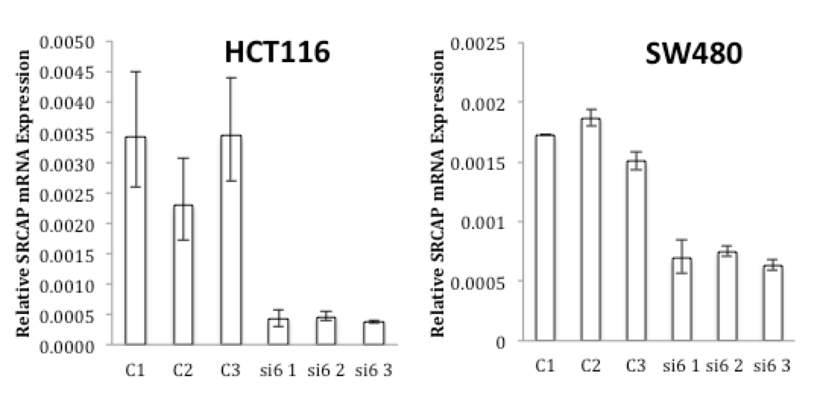
Figure 6.12 Evaluation of knockdown of SRCAP on new cell samples.
HCT116 and SW480 cells were transfected with si6 or control siRNA in three separate experiments as the protocol in the methods section states, the RNA extracted and SRCAP expression levels assessed by Taqman PCR. The above graphs show the mean and positive and negative error bars for three internal repeats of one experiment. Knockdown of SRCAP with si6 showed a decreased SRCAP relative mRNA expression compared to control transfected cells.
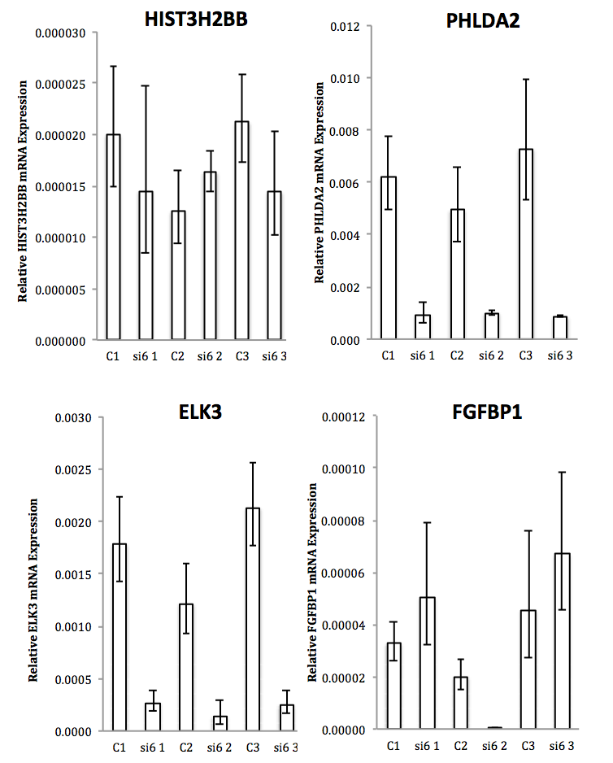
Figure 6.13 Validation of hits in HCT116 SRCAP knockdown cells with new RNA samples shows comparative results
New RNA samples were produced through knockdown of SRCAP in HCT116 cells using si6 transfection for 48hrs. The expression of the four hits from the knockdown microarrays was conducted via Taqman PCR and the above graphs show the mean and positive and negative error bars for three internal repeats of one experiment. In the new samples PHLDA2 and ELK3 show comparable results to figure 6.11a, however HIST3H2BB and FGFBP1 do not follow a set pattern of expression.
In the SW480 cells PHLDA2 and ELK3 were again decreased in expression when SRCAP was knocked down (Figure 6.14), however not to the same extent as in HCT116 cells, possibly indicating that the knockdown of SRCAP in SW480 cells has a lesser negative effect on the transcription of these genes. Consistent with the work in HCT116 cells, HIST3H2BB did not show a constant pattern of expression levels between the three repeats, thus leading to the conclusion that this may have been a false positive hit from the microarray. FGFBP1 did show over-expression in each of the three repeats conducted in SW480 cells, however the actual expression levels in the control samples were very variable between the repeats, much like what was seen in the original samples in Figure 6.11. Again the fold changes are shown in Figure 6.15 from these validation tests in HCT116 and SW480 cells and the microarray comparisons. Again ELK3 and PHLDA2 show a similar trend but the absolute fold changes were not as large as in the original microarray dataset.

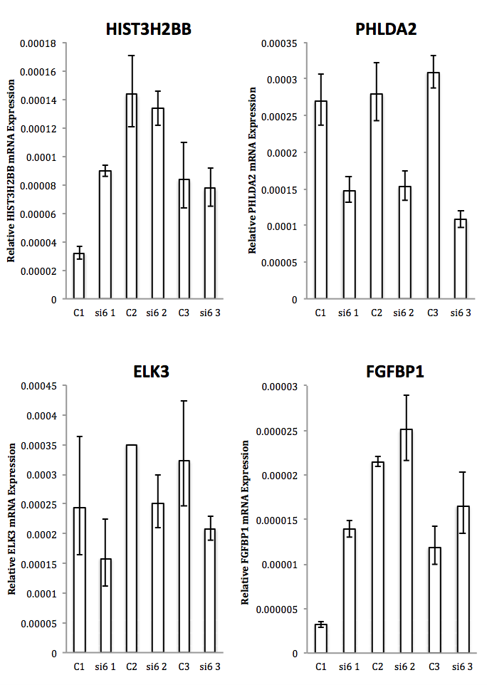
Figure 6.14 Validation of hits in SW480 SRCAP knockdown cells in another CRC cell line also shows comparable results.
SW480 cells were transfected with si6 for 48hrs and then lysed to extract RNA. These samples were also tested for expression of the knockdown hits that came out of the microarray. Again PHLDA2 and ELK3 show comparable results to Figures 6.11a and 6.12, however with less decrease in expression than was seen in HCT116 cells. Each graph shows the mean and positive and negative error bars from three internal repeats of one experiment.

HCT116
 | 1 | 2 | 3
FGFBP1
Microarray | -4.77 | -5.76 | -5.06
Validation | -0.621152 | 6.352400667 | -0.5540185
ELK3
Microarray | 4.27 | 5.77 | 5.83
Validation | 2.720933667 | 3.1236705 | 3.076013333
PHLDA2
Microarray | 6.25 | 5.16 | 5.09
Validation | 2.728356333 | 2.309058833 | 3.073506833
HIST3H2BB
Microarray | 6.91 | 4.85 | 7.03
Validation | 0.459983667 | -0.387385833 | 0.552434667

SW480
 | 1 | 2 | 3
FGFBP1
Microarray | -4.77 | -5.76 | -5.06
Validation | -2.120783333 | -0.219160833 | -0.4737295
ELK3
Microarray | 4.27 | 5.77 | 5.83
Validation | 0.628966333 | 0.476304667 | 0.635946
PHLDA2
Microarray | 6.25 | 5.16 | 5.09
Validation | 0.865492333 | 0.867563667 | 1.517393667
HIST3H2BB
Microarray | 6.91 | 4.85 | 7.03
Validation | -1.478666333 | 0.103525333 | 0.108865667

Overall, the results from the new samples did concur with the validation analyses in the original samples, in that PHLDA2 and ELK3 looked to be positive hits from the screen, and that when SRCAP is knocked down they also decrease in expression. However, HIST3H2BB was not validated, as the Taqman assay results showed no pattern in expression levels consistent with the decrease seen from the microarray. Finally in the knockdown samples, FGFBP1 showed moderate over expression in some repeats, however levels in control samples were variable which meant that the Taqman qRT-PCR result was difficult to interpret, but it could still be an interesting gene for further follow up. Unfortunately due to time and financial issues, new over-expressing samples could not be generated to further validate SOX4 and CPA4. Therefore the results from the original samples were the only validation conducted at this time. SOX4 did not show a consistent pattern of decreasing expression when SRCAP was over-expressed, which may mean it was not a positive hit, especially as its over-expression wasn’t in the top ten in repeat number three. However, CPA4 did show over-expression when SRCAP was over-expressed and could therefore go on for further investigation.
Figure 6.15 PHLDA2 and ELK3 validated fold changes are comparable to the original microarray fold changes
Fold changes were calculated from the validation RT-PCR data and compared to the original microarray fold changes as shown above. This highlights further that PHLDA2 and ELK3 follow the same pattern of decreased expression when SRCAP is knocked down, however the fold changes are again a lot lower then what was generated from the microarray.

6.5 Discussion

In this thesis and other papers (Slupianek et al., 2010) it has been shown that the depletion of SRCAP inhibits cancer cell growth, possibly indicating that the over-expression of SRCAP found in various cancer types may promote an overgrowth phenotype to facilitate tumour progression. Therefore it was hypothesised that over-expression of SRCAP would lead to a subsequent increase in genes that correlated to known cancer pathways such as proliferation, genome instability and angiogenesis. In comparison, depletion of SRCAP was hypothesised to lead to a decrease in gene expression associated with tumour progression. It may also be thought that due to p400 having links to the WNT pathway genes when aberrantly expressed (Chevillard-Briet et al., 2014), that the same could be true of SRCAP due to their functional similarities. To test these theories a RNA microarray was conducted using SRCAP knockdown and over-expression samples in order to assess genome wide transcript levels against the expression found in normal HCT116 control cells.

- SRCAP knockdown alters genes associated with cancer progression
Firstly when the individual control vs si6 repeats were put together there was good correlation in the fold changes between each of the experiments, indicating that fold changes for individual genes were reproducible and giving more confidence in the hits which were produced. Overall there was an average of 3608 differentially expressed genes between the control microarrays and the SRCAP knockdown microarrays. Within the top twenty positive fold changes there were six genes that were present in all three repeats that exhibited decreased expression in SRCAP depleted cells, which included several genes associated with the nucleosome structure and regulation of gene expression. The top twenty negative fold changes showed nine genes that exhibited increased expression in SRCAP depleted cells. Interestingly, genes associated with cell proliferation were found in these lists. There was a decrease in the expression of genes associated with the cell cycle, especially mitosis when SRCAP was knocked down and an increase in expression of genes associated with apoptosis. Overall there were several hits within the top 20 lists that already had links to cancer, and as such, these were further validated.

The STRING figures showed proof of concept that when SRCAP was depleted gene expression of nucleosome-associated factors was decreased. When SRCAP was depleted there was an increase in gene expression associated with apoptosis, although effects on apoptosis were not seen in experimental data in results chapter 4. However, the STRING database uses algorithms to combine online experimental data and published papers to determine the putative protein-protein network images, and therefore these findings are preliminary and broad and would need to be further investigated/validated. For example when the database labels genes “enriched for regulators of apoptosis” it is not clear whether this is an up-regulation of apoptosis or down-regulation, and so conclusions drawn from these statements should be tentative.

- SRCAP over-expression shows variation between repeats
The data produced from the independent control vs YFP SRCAP repeat data sets were not as correlated as with si6. Test 3 had over double the number of fold changes compared to the other two tests, which were more closely matched. Test 3 was the repeat that had the highest SRCAP expression, however it was also the repeat that had a larger signal plot indicating a divergent signal from the rest of the arrays. Therefore which of these had the largest effect on the aberrant results is unclear, or whether both contributed in some part. There were no genes within the three top twenty lists for positive fold changes which were found across all three independent repeats and only SOX4 was found in repeats 1 and 2. The STRING database analyses uncovered enrichment for regulators of cellular processes, however, this term is incredibly broad and some genes that were not included under regulators of cellular process clearly do have cellular functions. Such as PCK2, which is the gene for an enzyme that plays a role in mitochondrial metabolism by converting oxaloacetate to phosphoenolpyruvate. In the negative fold changes, increased CPA4 expression in SRCAP over-expressing cells was evident in all three independent repeats. The broader search for genes across all three repeats which had a 2 or -2 fold increase/decrease or more uncovered very little in comparison to the si6 data, suggesting that there was very little correlation between all three repeats and this could therefore be because of the differing expression levels or technical issues with the array as previously mentioned.

- Validation of microarray hits
Following RT-PCR validation of some of the interesting hits that came out of the microarray, there were two that were robustly validated from the knockdown samples. These were PHLDA2 and ELK3, both of which were decreased in expression when SRCAP was decreased. ELK3 has been previously linked to various cancers, for example it is over-expressed in breast cancer primary cells and its depletion in the triple negative breast cancer cell line MDA-MB-231 shows reduced migration and metastatic capacity (Heo et al., 2015, Kong et al., 2016), and that this led to an increased response to doxorubicin (Park et al., 2016). Furthermore in liver cancer the over-expression of ELK3 also correlated with an increased invasiveness trait (Lee et al., 2017). Interestingly we could not find any papers that discuss ELK3 expression within CRC. Therefore, this could be something worth investigating further, as if the same is true, that ELK3 is over-expressed in CRC and leads to a metastatic trait, then the subsequent decrease in expression when SRCAP is depleted could potentially be a beneficial anti-tumour effect.

Most of the work into PHLDA2 has centred on its role in placenta growth and regulation, however it was found that high expression of PHLDA2 correlates to hydatidiform moles (Fisher et al., 2004), which are abnormal clusters of cells that form around an aborting embryo rather than the standard placenta, indicating that PHLDA2 could have some role in aberrant cell differentiation and proliferation. Since then several screens have identified the gene PHLDA2 as being aberrantly expressed in neuroendocrine, osteosarcoma and breast tumours (Moon et al., 2015, Li et al., 2008, Dilley et al., 2005). Much like with ELK3, siRNA depletion of PHLDA2 in breast cancer cells significantly reduced cell migration (Moon et al., 2015), thus again showing how its decrease in expression when SRCAP is knocked down could be beneficial in reducing tumour growth.

Experiments to validate the hits derived from the over-expressing SRCAP arrays did not validate SOX4, however CPA4 was validated as being over-expressed in SRCAP over-expressing cells. CPA4 would be an interesting gene to follow up with some functional assays, such as were conducted in the previous chapters, due to publications already linking it to cancer. Not only does it seem to confer an aggressive prostate cancer phenotype (Ross et al., 2009), but also, increased levels were seen in pancreatic cancer tumour sections and correlated with metastasis (Sun et al., 2016a), along with increases in lung cancer associated with an unfavourable prognosis (Sun et al., 2016c). Furthermore in colorectal cancer levels of serum CPA4 could be a predictive marker of liver metastasis (Sun et al., 2016b), and in fact all these papers call for more research into how levels of CPA4 could be a prognostic marker. Therefore the fact that SRCAP over-expression appears to increase the transcript levels of CPA4 in a CRC cell line is definitely worth investigating further. Further analysis of knockdown microarray data also revealed that CPA4 expression is also increased in SRCAP depleted cells to quite a significant amount (fold changes: -2.81, -2.41, -2.31), and this was further validated by RT-PCR in Figure 6.16. This could have something to do with the fact that CPA4 is a downstream gene in response to the hyperacetylation of histones (Ross et al., 2009), so any change, whether negative or positive, to SRCAP gene expression could influence the histone code and lead to aberrant expression of CPA4.
Figure 6.16 CPA4 is also increased when SRCAP is knocked down
CPA4 expression was also determined in the original SRCAP knockdown samples from the microarray. The graph shows the mean and positive and negative error bars from three internal repeats of one experiment. CPA4 was also increased in expression compared to control cells in every repeat.
- Study limitations and future directions
It would have been useful to test the hits from the SRCAP over-expression arrays on new YFP SRCAP positive samples from FACS, however due to time and finances this could not be preformed. This would therefore be a vital piece of work to be conducted before moving on the any other assays with either SOX4 or CPA4. With regards to the knockdown hits, these would need further validation with different siRNA to SRCAP in order to check that these are not off target effects of si6. It would also then be useful to check this at the protein level, before moving on to functional assays. Looking back at the fold change data (highlights fold changes of 1/-1 or more) neither the over-expressing or knockdown samples highlighted any changes to SRCAP expression levels compared to control, even though they would be expected to be increased in the YFP SRCAP samples and decreased in the si6 knock down samples, and these differences in expression were proved by Taqman PCR pre and post microarray. It isn’t known why differences to SRCAP expression weren’t picked up within the microarray, but this would need to be followed up further by assessing the original data file to look at whether the fold changes were lower than 1/-1 or whether a difference in expression wasn’t picked up at all, and the possibilities of why this could have occurred.

As mentioned in the introduction to this chapter, knockdown of p400 in a HCT116 RNA microarray resulted in differential expression of WNT target genes. Therefore it was hypothesised that this pathway would be enriched in this data set from knockdown of SRCAP, due to its similar role in H2A.Z deposition as p400. However, the WNT pathway was not highlighted in the STRING enrichment analysis. Therefore manual searching through the list of fold changes for genes associated with the WNT pathway was conducted. There were several identified in the knockdown data set, but only 3 had negative fold changes across all three repeats, and were therefore increased in expression when SRCAP was knocked down. These were: AXIN-2, DKK1 and LRP6. Interestingly DKK1 is an inhibitor of the WNT pathway, by inhibiting LRP5/6 interaction with WNT ligands, so the fact that this is increased could contribute to the decrease in cell growth over time after SRCAP knockdown. There were also two genes that were decreased in expression across all three repeats when SRCAP was knocked down: MYCBP and TIAM1. TIAM1 has previously been shown to reduce growth of CRC cells when knocked down (Malliri et al., 2006), so could also be an interesting gene for further follow up. Again several WNT genes were identified throughout the over-expression data, however there were none that decreased in expression across all three repeats, however AXIN-2 and MSI1 were decreased in repeat 1 and 2. EDN1 was over-expressed when SRCAP was over-expressed in all three repeats, and again could be followed up further due to its over-expression leading to increased cell proliferation and migration within zebra fish models of hepatocarcinogenesis (Lu et al., 2014). These data therefore suggest that there is potential aberrant expression of WNT target genes when SRCAP is differentially expressed. However, this is only touching the surface of the analysis that could be carried out on the WNT genes from the microarray data, indeed other online enrichment tools could be utilised along with further validation of the genes mentioned above.

There are many other aspects that could be explored using the data produced for example the gene enrichment analysis needs to be verified on other databases. It would also be interesting to try to achieve RNA over-expression samples which were much more closely matched in SRCAP expression and run these through the microarray in order to see whether more closely correlated findings could be produced. The genes that were validated were put into the free online database cBioportal to assess any annotated copy number variation or mutational data of any of these genes within CRC. However, each gene only produced around a 1-2% frequency alteration, so out of the 200 CRC patients annotated with the cBioportal database, deletions, amplifications or mutations are only seen in 1-2 patients for these genes. However, this is not expression data and therefore does not mean that the deregulation of SRCAP does not have the affects that were uncovered here. The data from the microarrays here is by no means conclusive but it does uncover some interesting findings and validated genes that would be intriguing to take forward.

In order to assess whether SRCAP levels were actually influencing the expression of the hits we found, and they were not merely off targets effects, we would need to use reporter assays. Here the promoter sequence of the gene of interest, for example ELK3, PHLDA2 or CPA4 is cloned into a vector upstream of the reporter gene, and this is transfected into the cells. Then expression levels of the reporter can be analysed when SRCAP is up regulated or knocked down. Common reporter assays include luciferase, where this enzyme catalyses the conversion of luciferin to oxyluciferin and light, and this emitted light is quantified or blue-white β-galactosidase, when the gene of interest is being expressed and the cells are placed in media containing galactosides, the expression of the reporter lacZ converts the X-gal to a blue product which again can be quantified. Assays such as these could test the hypothesis that SCRAP is acting as a transcription factor. In order to test the hypothesis that the effects of SRCAP on gene expression are acting through alterations in chromatin structure, more extensive micrococcal nuclease assays would be required in conjunction with experiments to alter chromatin structure (perhaps by altering levels of DNA methyl-transferases or histone acetylase activity), and examining expression of the endogenous genes of interest.

Results Chapter Summaries

Chapter 3- Studying the effects of SRCAP over-expression
Transient transfection of YFP, MYC or FLAG tagged SRCAP cDNA produced no protein over-expression, indicating a problem with the construct. After further investigation it was found that there was a Kozak sequence in the supplied SRCAP cDNA, probably interfering with translation from the tags Kozak. Using XL10 ultra competent cells, which are often used to express plasmids encoding large proteins, plus the mutated Kozak construct, transient transfection of MYC and YFP tagged SRCAP showed over-expression of SRCAP mRNA levels, and nuclear localisation of YFP within IF images. Protein expression could not be seen by western blot however, and when cell cycle profiling was conducted over 72hrs there was a significant increase in the sub G1 population with a decrease in G1 in cells that had been transfected with YFP or MYC SRCAP compared to mock transfected cells. Using an alternative stable tetracycline induction system of SRCAP over-expression there was no difference in DNA damage markers in cells over-expressing YFP SRCAP after 72hrs of Tet induction compared to un-induced controls. Throughout these investigations there was a very low transfection efficiency or expression homogeneity, which may have impacted the results of these studies.

Over-expressing SRCAP CRISPR/dCas9 HCT116 and SW480 cells were successfully produced. In HCT116 SRCAP over-expressing cells there was no difference in growth rates between these and the parental cells. There was a significant increase in yH2AX and 53BP1 foci when SRCAP was over-expressed; this significant increase in DNA damage was echoed in a comet assay, and a trend in increased nuclear abnormalities. There were also no differences in cell cycle profiles or in apoptosis levels. Problematically, SRCAP over-expression reduced to normal levels after six weeks in culture and could not be rescued by antibiotic selection. This somewhat cast doubt on the results of the assays, as it was not clear as to when the cells lost over-expression.

Chapter 4- Investigating the effect of SRCAP knockdown on the DDR in CRC cells
SRCAP was successfully knocked down in both HCT116 and SW480 CRC cell lines. This knockdown induced significant genome instability in the form of increased DNA damage and nuclear abnormalities. SRCAP depletion also appeared to inhibit micrococcal nuclease digestion in SW480 cells, possibly by creating a more closed chromatin architecture. Depletion of SRCAP significantly reduced cellular growth, however this was not due to any differences in apoptosis levels. It was hypothesised that SRCAP depleted cells might be cycling slower, and indeed in HCT116 cells there was a decrease in S phase cells following PI staining. However, the decrease in S phase cells was not recapitulated in an EdU incorporation assay, although there were significantly fewer mitotic cells when assessed by pH3 positivity by flow cytometry, indicating definite cell cycle changes. SW480 cells again showed no difference in S phase cells by EdU staining but a decreased mitotic fraction. However, PI staining of SW480 cells, unlike HCT116 cells, did not show cell cycle changes, indicating an effect of SRCAP knockdown that may differ according to genetic background.

HCT116 cells depleted of SRCAP were sensitised to 5-FU and cisplatin shown by both MTT cytotoxicity and clonogenic survival assays, however, SW480 SRCAP depleted cells either showed no difference compared to parental cells, or become more resistant to these agents. One of the differences between the cell lines is TP53 status, with SW480 cells being TP53 deficient. Therefore using an isogenic TP53 deficient HCT116 cell line a significant resistance was seen to 5-FU and cisplatin via an MTT, following depletion of SRCAP, but only with one siRNA used. This is therefore different to the sensitisation seen in HCT116 TP53 wild type cells. Clonogenic survival showed a consistent significant resistance to control cells with 5-FU and SRCAP knockdown in the TP53-/- cells. However, there was a significant sensitisation with cisplatin and SRCAP knockdown in this cell line, which is inconsistent with the other results. The other clinical drug camptothecin showed no difference in sensitisation when SRCAP was knocked down compared to parental cells.

Chapter 5- Biological consequences of SRCAP levels in RAS oncogene activated cells
SW480 and HCT116 CRC cells and MRC5 normal cells were genetically manipulated to over-express the RAS oncogene. These cells displayed the same mRNA endogenous SRCAP expression as parental cells, and SRCAP was knocked down in all three cell lines. SW480 RAS over-expressing cells exhibited an increase in DNA damage markers and this was increased to further significance when SRCAP was also knocked down. HCT116 cells again had increased DNA damage markers when RAS was over-expressed but when SRCAP was knocked down there was a non-significant trend towards a decreased DNA damage level. MRC5 cells had an increase in damage, but there did not appear to be a difference whether RAS was over-expressed alone or in combination with SRCAP knockdown. There was an increase in nuclear abnormalities when RAS was over-expressed with SRCAP knockdown in SW480 and HCT116 cells. In MRC5 cells there was no significant increase in nuclear abnormalities when RAS was over-expressed but when SRCAP was knocked down as well there was a significant increase. MRC5 also showed an increase in a sub G1 population, but no other cell cycle changes. In contrast, the percentage of SW480 cells in G1 was significantly less than the parental cells with clone 13, with significantly more cells in G2-M. HCT116 cells had an increase in sub G1 when SRCAP was knocked down as well as RAS over-expression. These data therefore highlight that the consequences of SRCAP depletion in RAS activated cells differ between cell types.

The effect of SRCAP knockdown alone was investigated in MRC5 cells and there was a large increase in nuclear abnormalities, suggesting that SRCAP alone is sufficient to induce high levels of nuclear abnormalities, which was not further exacerbated by RAS over-expression. It was therefore concluded that the added oncogenic stress from RAS over-expression had no overt bearing on nuclear abnormalities when SRCAP was knocked down within an MRC5 cell background.

Chapter 6- Transcriptomic analysis of the effects of SRCAP deregulation
SRCAP over-expressing samples were collected by transient transfection of a YFP SRCAP plasmid in HCT116 cells and the subsequent fluorescent activated cell sorting of the YFP positive cells. These samples together with control or SRCAP siRNA transfected HCT116 cells were analysed using an Affymetrix Genechip microarray system in order to determine genome-wide transcript levels. The microarray produced well-correlated fold change results between each control and si6 repeat. When the top twenty genes with negative and positive fold changes were investigated, there were 6 positive and 9 negative genes identified across all repeats as having large fold changes compared to the control samples. Among these genes were several which already had implications for cancer progression and so these were selected for further validation. STRING database analysis showed a good proof of concept that knockdown of SRCAP decreased expression of genes associated with the nucleosome, and also affected cellular cycling, (especially mitosis) which was seen in experimental data in Chapter 4. Validation results in both the original and new HCT116 RNA samples, as well as SW480 samples identified ELK3 and PHLDA2 as positive hits from the microarray, and these were decreased in expression when SRCAP was depleted.

The data from control vs. YFP SRCAP had very little correlation across repeats; with the third independent experimental repeat exhibiting many more fold changes. It is not clear however whether this is due to an intrinsic problem that occurred within the microarray, which had the larger variation in relative signal, or due to this sample having the largest increase in SRCAP over-expression. There were no genes which were in the top twenty across all three repeats for positive fold change, only SOX4 across repeats 1 and 2, and only one across all three (CPA4) for negative fold change. The STRING analysis did not uncover any strong networks or enrichments. The two genes mentioned were taken on for further validation using RT-PCR and Taqman assessment on the original RNA samples. SOX4 did not show the same pattern of a decrease in expression when SRCAP was over-expressed as was shown in the microarray, possibly suggesting it was a false positive. However, CPA4 was validated through these studies, and therefore could be an interesting gene for further analysis.

Chapter 7: Discussion and Future Perspectives

7.1 SRCAP as a Potential Driver of CRC

CRC is the third most prevalent cancer in England (OfficeforNationalStatistics, 2015) and although advancements in combination treatments have been seen over the last decade, these have only increased response rates to 50% in advanced disease (Giacchetti et al., 2000, Douillard et al., 2000). The genetics of CRC has been widely studied, from Vogelstein’s early multistage clonal expansion model (Fearon and Vogelstein, 1990) to current molecular subtyping of this heterogeneous disease (Guinney et al., 2015). However, it is clear that half of CRC patients are not benefiting from the treatments used in the clinic today, and therefore more research into the drivers of tumour progression, and how these could be utilized for individualized treatment regimes, is much needed. Although it is now relatively easy to be able to profile the genetic aberrations found in tumours through aCGH or next-generation sequencing (Stratton et al., 2009), it is important to prove that the amplification of specific genes, in this case SRCAP, has a biological function towards tumour progression and that the genes are not merely passenger mutations. Therefore, in this thesis we sought to investigate how the over-expression and knockdown of SRCAP in CRC cell line models impacted on various hallmarks of cancer such as genomic instability and cellular cycling, and whether it had the potential to be a novel drug target.

The SRCAP gene was hypothesized to be a driver of CRC tumour progression due to experimental findings derived from a CNA screen of patient tumour samples (Burghel et al., 2013) and a genomic instability cell line screen (Staples et al., 2012, Staples et al., 2014, Barone et al., 2016, Myers et al., 2016, Staples et al., 2016), plus our additional bioinformatic analysis. SRCAP was amplified in patient samples, and depletion of SRCAP in HCT116 cells induced high levels of DNA damage, a common feature of increased genome instability (Jeggo et al., 2016). SRCAP was the gene chosen for further investigation out of a list of five genes (Appendix 1), due to already published research that showed it was also over-expressed in a variety of different cancers including ovarian and breast cancer (Santin et al., 2004, Zucchi et al., 2004). SRCAP over-expression in prostate cancer has also been shown to correlate with a pro-proliferative role, and its subsequent knockdown resulted in a decrease in cellular growth (Slupianek et al., 2010), indicating it may play a vital role in tumour progression. SRCAP’s function is to utilize ATP hydrolysis to exchange the H2A-H2B dimer for the variant H2A.Z-H2B in the nucleosome; the inclusion of this variant within the nucleosome has been shown to both positively and negatively regulate transcription depending on other factors of the histone code which are in play (Brahma et al., 2017). SRCAP has also has been reported to play a role in DNA repair mechanisms (Dong et al., 2014). As such, alterations in SRCAP expression could impact expression of genes involved in tumour development and/or progression.

Research into SRCAP is currently very relevant, as cancer drug discovery utilizing epigenetic targets and especially chromatin remodelers is coming to the forefront of therapeutics (Bhattacharjee et al., 2016). In fact HDACi are now approved by the FDA for hematological malignancies, and are in clinical trials for solid malignancies (Morel et al., 2017). ATP-chromatin remodelers, such as SRCAP, have recently been found to be frequently mutated across all cancer types (Kadoch et al., 2013), and so could represent a pool of untapped driver genes with therapeutic potential. However, no ATP-chromatin remodeler therapeutics are currently clinically used or in trials, as the mechanistic understanding is still deficient.

7.2 SRCAP over-expression

SRCAP has previously been shown to be over-expressed in primary prostate samples, and confers a pro-proliferative role through interaction with the PSA promoter (Slupianek et al., 2010). Therefore, the establishment of over-expressing CRC cells was attempted in order to assess if this increase in SRCAP levels in turn increased cellular growth, along with evaluation of other hallmarks of cancer in a colorectal model. However, in these studies over-expressing SRCAP via the transfection of cDNA vectors proved to be difficult due to the size of the gene, the lack of commercially validated antibodies, poor transfection efficiency and cytotoxicity associated with expression of SRCAP cDNA. Using a tetracycline induction system, protein over-expression was achieved, however, no differences in DNA damage levels were observed between cells over-expressing SRCAP and those with basal levels. This is not what would be expected if SRCAP were driving tumour progression, it would be expected that genome instability mechanisms would be increased. Although, it may be that SRCAP over-expression has to persist for a much longer period of time than the 72hrs achieved in our system for it to show effects on genomic instability.

Several groups have shown SRCAP over expression using vector transfection and with the same transfection agents used in this thesis (Monroy et al., 2003, Johnston et al., 1999a). However, as previously mentioned in the Chapter 3 discussion, early papers used 1-2971 amino acid constructs instead of the full 3230 amino acid SRCAP, and there is no explanation as to why this curtailed cDNA was used (Monroy et al., 2003, Johnston et al., 1999a), and continued to be used up to 2011 (Bowman et al., 2011). Although these papers show differences in transcription rates of various genes after binding of SRCAP to co-activators through reporter gene CAT assays, there are few that show SRCAP over-expression via western blot analysis and none by immunofluorescence. The papers that do show over-expression through antibody detection use in-house antibodies towards SRCAP, and although we contacted the laboratory groups for use of their reagents and advice, none replied to us (Dong et al., 2014, Ruhl et al., 2006). This could therefore indicate that transfection of the full SRCAP gene is not suitable for expression in cell models and/or the commercial antibodies were not efficient enough for robust detection. However, one paper in 2011 did show over expression using the Santa Cruz antibody described in this thesis and with a 3230 amino acid construct (although the construct started at amino acid position 198), indicating it should be possible to achieve (Iwai et al., 2011). Using the Tet inducible system, we did show protein over-expression after 72hrs of Tet addition, but the transfection efficiency was still low and the model system ‘leaky’ therefore to date we have not established a robust enough over-expression model that can be used for such studies.

Alternative over-expression studies using the CRISPR/dCas9 system did show an increase in DNA damage by assessment of well-known markers and direct visualisation of DNA breaks by the comet assay. However, no difference in cellular growth was observed in SRCAP over-expressing cells. It would be predicted that the over-expression of SRCAP, if it was indeed a driver of tumour progression, would increase the proliferative nature of the cells, since it has been shown that when H2A.Z was up-regulated, it bound to the p21 promoter and decreased its expression, resulting in a less restricted cell cycle (Gévry et al., 2007, Rangasamy, 2010). Therefore if SRCAP were over-expressed it would be hypothesized that H2A.Z deposition into the nucleosome would also be up regulated, and so increase cells proliferative capacity, yet we did not see this phenotype. However, the results from these assays are tentative, as after six weeks in culture the over-expressing clones had reverted back to normal SRCAP expression levels, and could not be rescued by antibiotic selection, most likely explaining the variation between repeat experiments. There has been no published work that has documented such depletion of enhanced expression levels using this system, and the company could not offer a good explanation for this phenotype. It appears that the loss of expression is not cell line or gene specific though, as another member of our laboratory saw the same decrease in expression levels using the same system but with a different gene being over-expressed. Perez-Pinera (2013) found that transfection of four gRNAs to the gene of interest produced an increase in gene expression greater than was seen when one gRNA was used, as was used in our system. Therefore, it could be that this technique could enhance the efficiency of the system and produce stable long-term over-expressing clones.

7.3 SRCAP knockdown

Dong et al. (2014) have previously shown that SRCAP plays a vital role in the DNA damage response in Hela cells by directly interacting with CtIP, and SRCAP depletion led to decreased recruitment of essential repair proteins such as RAD51. Consistent with these results, here we show that DNA damage markers, direct visualisation of damage and nuclear abnormalities are all increased in CRC cells when SRCAP is knocked down with siRNA. Furthermore, knockdown of SRCAP caused cell cycle changes indicative of DNA damage accumulation and possibly mitotic catastrophe. Dong et al. (2014) however, did not show any cell cycle changes in PI profiling in HeLa cells when they knocked SRCAP down, in contrast to what we observed. Therefore this difference in cell cycling could be cell line specific. Indeed we saw differences between HCT116 and SW480 cells, with SW480 cells showing no significant changes by PI staining. This was surmised to be due to p53 status of the cells, however SW480 cells are deficient in p53 whereas HeLa cells are p53 wild type like HCT116 cells, indicating there may be other factors that influence why HCT116 cells cycle differently when SRCAP was knocked down.

SRCAP depleted cells also showed changes to chromatin architecture suggesting that when SRCAP is absent, micrococcal nuclease cannot access the DNA as easily, possibly because there is a decrease in H2A.Z deposition and so the nucleosomes keep the DNA more tightly wound. However, this was only seen in SW480 cells, with HCT116 cells showing no clear pattern. Dong et al. (2014) also saw this decreased sensitivity to micrococcal nuclease in HeLa cells, and hypothesized that it was due to more compact chromatin when SRCAP was depleted. Interestingly the results from Dong et al., in HeLa cells appear to correspond to the phenotype we have seen in SW480 cells both in the micrococcal nuclease assay and with cell cycling. The two CRC cell lines used in this thesis represented two of the main tumourigenic pathways to colon cancer progression: CIN (SW480) and MSI (HCT116). So although the knockdown of SRCAP impacts genome instability and cell proliferation in similar ways in both cell lines, this appears not to be the case with regards to altering the chromatin architecture. Interestingly throughout the studies reported here there appeared to be greater effects in HCT116 cells, with the exception of the micrococcal nuclease assay. The reason for this is not known, but could be related to the larger chromosomal changes in SW480 cells associated with a CIN phenotype. In fact, HeLa cells depleted of SRCAP also displayed chromosomal instability (Dong et al., 2014), supporting this theory.

The effects of SRCAP knockdown was also assessed in RAS oncogene activated cell lines, due to RAS activating mutations being highly prevalent within colorectal tumours (Schirripa and Lenz, 2016). SRCAP knockdown within an activated RAS background induced high levels of genomic instability, with significant cell cycle changes being seen in SW480 cells. This was a significant decrease in G1 cells, and a consequent cell cycle arrest in G2/M. Interestingly in the normal fibroblast cell line MRC5, RAS over-expression and SRCAP depletion induced much higher levels of nuclear abnormalities than was seen in the CRC cell line. Taking the two conditions separately it was shown that SRCAP depletion alone was the driving force behind the nuclear abnormalities. There does not appear to be any papers that have assessed nuclear abnormalities in the context of SRCAP knockdown. The paper by Dong et al. (2014) does show multiple DAPI stained cell images, however, all the cells appear to have normal nuclear morphology. An explanation for the nuclear aberrations we saw could be that H2A.Z plays a role in genome instability as outlined by Rangasamy et al. (2004). Here they showed that depletion of H2A.Z in mammalian cell lines resulted in a deregulation of chromosome segregation, and in fact upon nuclear division they saw an uneven distribution of H2A.Z. Although a reason for this is unknown, they hypothesized that H2A.Z could preferentially associate with one strand of DNA during replication, therefore increasing the genomic instability in the two daughter cells produced and even causing micronuclei and other nuclear abnormalities. These results with H2A.Z would then be predicted to occur after SRCAP knockdown, and could explain why nuclear abnormalities are a phenotype of SRCAP-depleted cells.

7.4 SRCAP as a potential drug target

Work on drugs for epigenetic factors such as inhibitors of histone deacetylases have proved of worth in solid malignancies and are currently in many clinical trials for combination treatments (Morel et al., 2017). However, although aberrations to various chromatin remodelers have been found (Decristofaro et al., 2001, Toh et al., 1997), there is still a lack of mechanistic understanding and whether they could be developed into therapeutics for cancer. First line treatment for CRC includes 5-FU in combination with oxaliplatin and/or irinotecan (Goldberg et al., 2004), and recently we have seen the emergence of novel therapeutics such as angiogenesis inhibitors like Bevacizumab (Cascinu et al., 2017). However, there is still a need for new therapeutics as these regimes only show response in 50% of advanced disease (Giacchetti et al., 2000, Douillard et al., 2000). Recently a yeast genome-wide screen has uncovered that histone modifiers, including the yeast Swr1, the yeast homologue of SRCAP, confer sensitivity to 5-FU (Mojardín et al., 2015). Here we show that the knockdown of SRCAP does indeed sensitize HCT116 cells to 5-FU and cisplatin, but the same cannot be said of SW480 cells, which showed increased resistance.

Interestingly it has been shown that MSI cells are 5-FU resistant (Jover et al., 2006, Carethers et al., 2004), however, here we show that SRCAP depletion plus 5-FU caused increased sensitization in the MSI HCT116 cell line. These cells are TP53 wild type cells, suggesting that inhibition of SRCAP could be a novel therapeutic for a subset of CRC patients with MSI tumours. Indeed HCT116 cells with deficient TP53 showed a significant resistance to 5-FU when SRCAP was knocked down, although the results with cisplatin were not as consistent. Longley et al. (2002), consistent with the results here, showed that loss of TP53 in breast cancer cell lines decreases the sensitivity of the cells to 5-FU, indicating that TP53 status of patients could be a vital piece of information determining the type of treatment given. We show that although cells with wild type TP53 do respond to 5-FU, this response is increased when SRCAP is knocked down. The mechanism behind this is unknown however it could be hypothesized that due to the role of SRCAP in the DNA damage response and repair pathway that its depletion would further increase the amount of un-repaired DNA damage after 5-FU treatment and so lead to cellular death. Therefore, although MSI tumours are more resistant to 5-FU it may be that it is the functional loss of TP53 that is the main factor in drug response, and so was why SW480 cells did not show sensitization.

7.5 SRCAP and transcriptome analysis

SRCAP deposits the histone variant H2A.Z into nucleosomes, especially at promoter sites, and thus has great influence on transcription rates (Brahma et al., 2017). However, what transcriptional pathways this impacts and whether this could then drive tumour progression has not been investigated. RNA microarray analysis of p400 depleted HCT116 cells (which is an homologous protein to SRCAP whose function is to also deposit H2A.Z into nucleosomes) revealed a deregulation of WNT pathways genes (Chevillard-Briet et al., 2014), which could be a mechanism behind driving CRC tumour progression. Therefore using an RNA microarray of SRCAP over-expressing and knockdown samples, genome wide transcript levels were assessed. Here it was revealed that knockdown of SRCAP decreased the expression of nucleosome factors and mitotic genes (which would be expected and was shown in experimental work- Chapter 4.5), and increased the expression of apoptotic genes, although no difference was seen in apoptosis levels during these studies (Chapter 4.5). From the top hits, ELK3, a transcriptional regulator linked to ERK signaling, and PHLDA2, a regulator of placenta growth, were positively validated and showed a decrease in expression when SRCAP was knocked down. Both genes have been implicated in various cancers, with their knockdown suggesting a decrease in invasiveness (Heo et al., 2015, Kong et al., 2016, Moon et al., 2015). Therefore they would be good target genes to further assess via functional assays such as those conducted throughout this thesis.

However, the over-expression of SRCAP did not reveal many transcript alterations. There was a lot of variability in fold change results across all three experimental repeats and this affected the number of genes that could be investigated. STRING database analysis showed barely any enrichment for specific pathways, only for ‘cellular processes’, however, this term is very broad and would include a multitude of genes. CPA4, a gene that codes for the enzyme carboxypeptidase A4 and has links to histone hyperacetylation (Ross et al., 2009), was however validated post microarray and showed an increase in expression when SRCAP was over-expressed. This would be interesting to follow up, as CPA4 has been recently implicated in various cancers and could potentially be a prognostic marker of tumour progression (Sun et al., 2016b, Sun et al., 2016a, Sun et al., 2016c).

Although WNT signaling did not emerge in the gene enrichment analysis from the STRING online database, this was a preliminary analysis of the data. Looking through the data sets manually revealed several WNT target genes that were aberrantly expressed, indicating that indeed differing expression of SRCAP could have effects on WNT signaling and therefore be impacting on tumour progression through this pathway, much like what was found with p400 (Chevillard-Briet et al., 2014). However, further analysis would need to be conducted, as this was only a preliminary data analysis.

7.6 Strengths and Limitations

The strengths of the project include setting up a robust SRCAP knockdown model in two CRC cancer cell lines, and showing how this depletion of SRCAP increased genomic instability, and had effects on cell growth and cell cycle. These results corroborate the results found by other groups in different cell lines (Dong et al., 2014, Slupianek et al., 2010). This knockdown was also conducted in a normal fibroblast cell line and resulted in increased nuclear abnormalities; a phenomenon that has not been reported in previously published SRCAP data. A further strength is that the knockdown of SRCAP in HCT116 cells appears to sensitize to clinically used CRC treatments, and so could provide the starting point for further studies into how SRCAP could be a novel drug target. We were also able to create a pure and sterile SRCAP over-expressing population of cells that were able to go back into culture and continue growing after FACS, and this provided the resources needed to conduct the RNA microarray. The results of which, although preliminary, can now go on to possibly create new projects for future work.

The limitations to this project would include not being able to show stable over-expression of SRCAP over a long period of time, and therefore an inability to look at the effects that this has on cellular functioning. Due to SRCAP being over-expressed in a variety of different cancers (Santin et al., 2004, Zucchi et al., 2004) the fact that an over-expressing cell line model could not be robustly created was disappointing. However, the preliminary studies looking at the endogenous over-expression of SRCAP by a relatively new technique-CRISPR/dCas9-were promising, as they created clones which expressed SRCAP at differing levels and could easily be tested in functional assays. However, the decrease in gene expression over time, and the subsequent lack of ability to recreate these clones was a weakness that would require further investigation. Another limitation to the study was the lack of commercially available antibodies, and therefore SRCAP protein expression was not shown for the knockdown models and the over-expression data was not conclusively consistent. It would have been beneficial if we could have sourced an antibody from a laboratory that had previously published with it or could have made our own. Due to only using SRCAP mRNA as a measure of expression levels, there was also a limitation with using 18S as the housekeeping gene. 18S was used due to previous validation within the laboratory and because in initial experiments the Ct values for 18S did not differ when SRCAP was knocked down compared to control transfection. However, although this does suggest that 18S levels remained constant, it would have been useful to test a panel of housekeeping genes such as GAPDH, to determine which would be the optimal stably expressed for use in these cell lines and with varying the SRCAP expression levels within the cells. Finally there was a limitation towards not showing differing levels of the SRCAP gene in a non-tumourigenic colorectal cell line (such as FHC colon epithelial cells, or CCD-33Co colon fibroblast cells); however, we did show interesting increases in genomic instability in the fibroblast cell line MRC5, although we do not know if this a good model for a colon cell.

7.7 Future Perspectives

Future work on this project would include carrying out the knockdown experiments and the subsequent functional assays in a wider variety of CRC cell lines that cover the breadth of genetic pathways and TP53 status in order to further verify the results. This would also include testing out the chemotherapeutics-based survival assays to conclusively determine whether there is a specific subset of patients that would potentially benefit from an SRCAP inhibitor. It would also be important to generate over-expression of endogenous SRCAP in a non-tumourigenic colorectal cell background, if one could be sourced, to assess long-term effects on cancer cell traits and phenotypes, such as genomic instability and cellular growth. Long-term goals would be to try the SRCAP assays in other cancer cell lines (as the over-expression of SRCAP is not solely CRC specific) and therefore assess other potential drug combinations.

Data from the TCGA shows that from 55 patient samples SRCAP mutations occur along the entire gene, with most of them being prevalent in only one of the cases and resulting in missense mutations (Figure 7.1). It would be interesting to assess the original patient tumour data to examine what mutations to SRCAP are present in these and whether they correlate to the TCGA data. Immunohistochemistry could also be used on patient tumour sections to assess SRCAP protein levels and see whether they correlate to gene copy number, stage of the tumour or are associated with any particular molecular background.

There were five candidate genes that were experimentally and bioinformatically classified as potential drivers of CRC (appendix 1). SRCAP was selected for further study due to the previously published literature mentioned throughout this thesis, indicating it already had links to several other cancers. Further work would therefore include assessment of the other four potential cancer driver genes; MCF1L, SRCRB4D, MTX1 and APH1A. This would include development of knockdown and over-expression cell line models, as carried out with SRCAP, and then evaluation of how differing gene expression levels impacts on various hallmarks of cancer, using the assays conducted throughout this thesis.
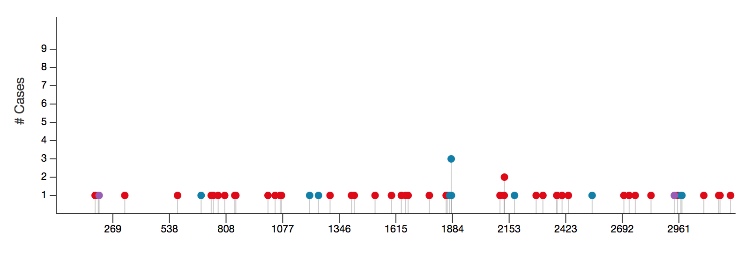
Figure 7.1 Mutations to the SRCAP protein
TCGA online data from 55 patients with mutations to their SRCAP protein, showing that they occur all along the gene. Blue dots=frame shift, red dots=missense and purple=stop gained. There are 11 frame shifts, 42 missense and 2 stops gained. Most mutations were only in one patient sample, however there were two aberrations that occurred more frequently.

References
ABDELMAKSOUD-DAMAK, R., MILADI-ABDENNADHER, I., TRIKI, M., KHABIR, A., CHARFI, S., AYADI, L., FRIKHA, M., SELLAMI-BOUDAWARA, T. & MOKDAD-GARGOURI, R. 2015. Expression and Mutation Pattern of β-Catenin and Adenomatous Polyposis Coli in Colorectal Cancer Patients. Arch Med Res.
ADAM, M., ROBERT, F., LAROCHELLE, M. & GAUDREAU, L. 2001. H2A.Z is required for global chromatin integrity and for recruitment of RNA polymerase II under specific conditions. Mol Cell Biol, 21, 6270-9.
ADVANCEDCOLORECTALCANCERMETA-ANALYSISPROJECT 1992. Modulation of fluorouracil by leucovorin in patients with advanced colorectal cancer: evidence in terms of response rate. Advanced Colorectal Cancer Meta-Analysis Project. J Clin Oncol, 10, 896-903.
AHNEN, D. J. 1991. Genetics of colon cancer. West J Med, 154, 700-5.
ALBERTSON, D. G., YLSTRA, B., SEGRAVES, R., COLLINS, C., DAIRKEE, S. H., KOWBEL, D., KUO, W. L., GRAY, J. W. & PINKEL, D. 2000. Quantitative mapping of amplicon structure by array CGH identifies CYP24 as a candidate oncogene. Nat Genet, 25, 144-6.
ANDREYEV, H. J., NORMAN, A. R., CUNNINGHAM, D., OATES, J., DIX, B. R., IACOPETTA, B. J., YOUNG, J., WALSH, T., WARD, R., HAWKINS, N., BERANEK, M., JANDIK, P., BENAMOUZIG, R., JULLIAN, E., LAURENT-PUIG, P., OLSCHWANG, S., MULLER, O., HOFFMANN, I., RABES, H. M., ZIETZ, C., TROUNGOS, C., VALAVANIS, C., YUEN, S. T., HO, J. W., CROKE, C. T., O'DONOGHUE, D. P., GIARETTI, W., RAPALLO, A., RUSSO, A., BAZAN, V., TANAKA, M., OMURA, K., AZUMA, T., OHKUSA, T., FUJIMORI, T., ONO, Y., PAULY, M., FABER, C., GLAESENER, R., DE GOEIJ, A. F., ARENDS, J. W., ANDERSEN, S. N., LÖVIG, T., BREIVIK, J., GAUDERNACK, G., CLAUSEN, O. P., DE ANGELIS, P. D., MELING, G. I., ROGNUM, T. O., SMITH, R., GOH, H. S., FONT, A., ROSELL, R., SUN, X. F., ZHANG, H., BENHATTAR, J., LOSI, L., LEE, J. Q., WANG, S. T., CLARKE, P. A., BELL, S., QUIRKE, P., BUBB, V. J., PIRIS, J., CRUICKSHANK, N. R., MORTON, D., FOX, J. C., AL-MULLA, F., LEES, N., HALL, C. N., SNARY, D., WILKINSON, K., DILLON, D., COSTA, J., PRICOLO, V. E., FINKELSTEIN, S. D., THEBO, J. S., SENAGORE, A. J., HALTER, S. A., WADLER, S., MALIK, S., KRTOLICA, K. & UROSEVIC, N. 2001. Kirsten ras mutations in patients with colorectal cancer: the 'RASCAL II' study. Br J Cancer, 85, 692-6.
ANDRÉ, T., LOUVET, C., MAINDRAULT-GOEBEL, F., COUTEAU, C., MABRO, M., LOTZ, J. P., GILLES-AMAR, V., KRULIK, M., CAROLA, E., IZRAEL, V. & DE GRAMONT, A. 1999. CPT-11 (irinotecan) addition to bimonthly, high-dose leucovorin and bolus and continuous-infusion 5-fluorouracil (FOLFIRI) for pretreated metastatic colorectal cancer. GERCOR. Eur J Cancer, 35, 1343-7.
ARORA, S. P. & MAHALINGAM, D. 2018. Immunotherapy in colorectal cancer: for the select few or all? J Gastrointest Oncol, 9, 170-179.
ASHCROFT, M., TAYA, Y. & VOUSDEN, K. H. 2000. Stress signals utilize multiple pathways to stabilize p53. Mol Cell Biol, 20, 3224-33.
BABA, Y., NOSHO, K., SHIMA, K., IRAHARA, N., KURE, S., TOYODA, S., KIRKNER, G. J., GOEL, A., FUCHS, C. S. & OGINO, S. 2009. Aurora-A expression is independently associated with chromosomal instability in colorectal cancer. Neoplasia, 11, 418-25.
BALMAIN, A., GRAY, J. & PONDER, B. 2003. The genetics and genomics of cancer. Nat Genet, 33 Suppl, 238-44.
BARONE, G., STAPLES, C. J., GANESH, A., PATTERSON, K. W., BRYNE, D. P., MYERS, K. N., PATIL, A. A., EYERS, C. E., MASLEN, S., SKEHEL, J. M., EYERS, P. A. & COLLIS, S. J. 2016. Human CDK18 promotes replication stress signaling and genome stability. Nucleic Acids Res, 44, 8772-8785.
BARRANGOU, R., FREMAUX, C., DEVEAU, H., RICHARDS, M., BOYAVAL, P., MOINEAU, S., ROMERO, D. A. & HORVATH, P. 2007. CRISPR provides acquired resistance against viruses in prokaryotes. Science, 315, 1709-12.
BARRATT, P. L., SEYMOUR, M. T., STENNING, S. P., GEORGIADES, I., WALKER, C., BIRBECK, K., QUIRKE, P. & STUDY, U. A. T. C. A. X.-R. A. F. I. 2002. DNA markers predicting benefit from adjuvant fluorouracil in patients with colon cancer: a molecular study. Lancet, 360, 1381-91.
BARSKI, A., CUDDAPAH, S., CUI, K., ROH, T. Y., SCHONES, D. E., WANG, Z., WEI, G., CHEPELEV, I. & ZHAO, K. 2007. High-resolution profiling of histone methylations in the human genome. Cell, 129, 823-37.
BASSETT, A. R., TIBBIT, C., PONTING, C. P. & LIU, J. L. 2013. Highly efficient targeted mutagenesis of Drosophila with the CRISPR/Cas9 system. Cell Rep, 4, 220-8.
BAURE, J., IZADI, A., SUAREZ, V., GIEDZINSKI, E., CLEAVER, J. E., FIKE, J. R. & LIMOLI, C. L. 2009. Histone H2AX phosphorylation in response to changes in chromatin structure induced by altered osmolarity. Mutagenesis, 24, 161-7.
BEROUKHIM, R., MERMEL, C. H., PORTER, D., WEI, G., RAYCHAUDHURI, S., DONOVAN, J., BARRETINA, J., BOEHM, J. S., DOBSON, J., URASHIMA, M., MC HENRY, K. T., PINCHBACK, R. M., LIGON, A. H., CHO, Y. J., HAERY, L., GREULICH, H., REICH, M., WINCKLER, W., LAWRENCE, M. S., WEIR, B. A., TANAKA, K. E., CHIANG, D. Y., BASS, A. J., LOO, A., HOFFMAN, C., PRENSNER, J., LIEFELD, T., GAO, Q., YECIES, D., SIGNORETTI, S., MAHER, E., KAYE, F. J., SASAKI, H., TEPPER, J. E., FLETCHER, J. A., TABERNERO, J., BASELGA, J., TSAO, M. S., DEMICHELIS, F., RUBIN, M. A., JANNE, P. A., DALY, M. J., NUCERA, C., LEVINE, R. L., EBERT, B. L., GABRIEL, S., RUSTGI, A. K., ANTONESCU, C. R., LADANYI, M., LETAI, A., GARRAWAY, L. A., LODA, M., BEER, D. G., TRUE, L. D., OKAMOTO, A., POMEROY, S. L., SINGER, S., GOLUB, T. R., LANDER, E. S., GETZ, G., SELLERS, W. R. & MEYERSON, M. 2010. The landscape of somatic copy-number alteration across human cancers. Nature, 463, 899-905.
BERTORELLE, R., RAMPAZZO, E., PUCCIARELLI, S., NITTI, D. & DE ROSSI, A. 2014. Telomeres, telomerase and colorectal cancer. World J Gastroenterol, 20, 1940-50.
BHATTACHARJEE, D., SHENOY, S. & BAIRY, K. L. 2016. DNA Methylation and Chromatin Remodeling: The Blueprint of Cancer Epigenetics. Scientifica (Cairo), 2016, 6072357.
BIANCO-MIOTTO, T., CHIAM, K., BUCHANAN, G., JINDAL, S., DAY, T. K., THOMAS, M., PICKERING, M. A., O'LOUGHLIN, M. A., RYAN, N. K., RAYMOND, W. A., HORVATH, L. G., KENCH, J. G., STRICKER, P. D., MARSHALL, V. R., SUTHERLAND, R. L., HENSHALL, S. M., GERALD, W. L., SCHER, H. I., RISBRIDGER, G. P., CLEMENTS, J. A., BUTLER, L. M., TILLEY, W. D., HORSFALL, D. J., RICCIARDELLI, C. & BIORESOURCE, A. P. C. 2010. Global levels of specific histone modifications and an epigenetic gene signature predict prostate cancer progression and development. Cancer Epidemiol Biomarkers Prev, 19, 2611-22.
BIGNOLD, L. P., COGHLAN, B. L. & JERSMANN, H. P. 2006. Hansemann, Boveri, chromosomes and the gametogenesis-related theories of tumours. Cell Biol Int, 30, 640-4.
BOARDMAN, L. A., JOHNSON, R. A., PETERSEN, G. M., OBERG, A. L., KABAT, B. F., SLUSSER, J. P., WANG, L., MORLAN, B. W., FRENCH, A. J., SMYRK, T. C., LINDOR, N. M. & THIBODEAU, S. N. 2007. Higher frequency of diploidy in young-onset microsatellite-stable colorectal cancer. Clin Cancer Res, 13, 2323-8.
BODNAR, A. G., OUELLETTE, M., FROLKIS, M., HOLT, S. E., CHIU, C. P., MORIN, G. B., HARLEY, C. B., SHAY, J. W., LICHTSTEINER, S. & WRIGHT, W. E. 1998. Extension of life-span by introduction of telomerase into normal human cells. Science, 279, 349-52.
BOKEMEYER, C., BONDARENKO, I., HARTMANN, J. T., DE BRAUD, F., SCHUCH, G., ZUBEL, A., CELIK, I., SCHLICHTING, M. & KORALEWSKI, P. 2011. Efficacy according to biomarker status of cetuximab plus FOLFOX-4 as first-line treatment for metastatic colorectal cancer: the OPUS study. Ann Oncol, 22, 1535-46.
BOLAND, C. R. & GOEL, A. 2010. Microsatellite instability in colorectal cancer. Gastroenterology, 138, 2073-2087.e3.
BOLAND, C. R., THIBODEAU, S. N., HAMILTON, S. R., SIDRANSKY, D., ESHLEMAN, J. R., BURT, R. W., MELTZER, S. J., RODRIGUEZ-BIGAS, M. A., FODDE, R., RANZANI, G. N. & SRIVASTAVA, S. 1998. A National Cancer Institute Workshop on Microsatellite Instability for cancer detection and familial predisposition: development of international criteria for the determination of microsatellite instability in colorectal cancer. Cancer Res, 58, 5248-57.
BONDI, J., BUKHOLM, G., NESLAND, J. M. & BUKHOLM, I. R. 2004. Expression of non-membranous beta-catenin and gamma-catenin, c-Myc and cyclin D1 in relation to patient outcome in human colon adenocarcinomas. APMIS, 112, 49-56.
BOS, J. L., FEARON, E. R., HAMILTON, S. R., VERLAAN-DE VRIES, M., VAN BOOM, J. H., VAN DER EB, A. J. & VOGELSTEIN, B. 1987. Prevalence of ras gene mutations in human colorectal cancers. Nature, 327, 293-7.
BOUVARD, V., LOOMIS, D., GUYTON, K. Z., GROSSE, Y., GHISSASSI, F. E., BENBRAHIM-TALLAA, L., GUHA, N., MATTOCK, H., STRAIF, K. & GROUP, I. A. F. R. O. C. M. W. 2015. Carcinogenicity of consumption of red and processed meat. Lancet Oncol.
BOWMAN, T. A., WONG, M. M., COX, L. K., BALDASSARE, J. J. & CHRIVIA, J. C. 2011. Loss of H2A.Z Is Not Sufficient to Determine Transcriptional Activity of Snf2-Related CBP Activator Protein or p400 Complexes. Int J Cell Biol, 2011, 715642.
BRAHMA, S., UDUGAMA, M. I., KIM, J., HADA, A., BHARDWAJ, S. K., HAILU, S. G., LEE, T. H. & BARTHOLOMEW, B. 2017. INO80 exchanges H2A.Z for H2A by translocating on DNA proximal to histone dimers. Nat Commun, 8, 15616.
BRAT, D. J., VERHAAK, R. G., ALDAPE, K. D., YUNG, W. K., SALAMA, S. R., COOPER, L. A., RHEINBAY, E., MILLER, C. R., VITUCCI, M., MOROZOVA, O., ROBERTSON, A. G., NOUSHMEHR, H., LAIRD, P. W., CHERNIACK, A. D., AKBANI, R., HUSE, J. T., CIRIELLO, G., POISSON, L. M., BARNHOLTZ-SLOAN, J. S., BERGER, M. S., BRENNAN, C., COLEN, R. R., COLMAN, H., FLANDERS, A. E., GIANNINI, C., GRIFFORD, M., IAVARONE, A., JAIN, R., JOSEPH, I., KIM, J., KASAIAN, K., MIKKELSEN, T., MURRAY, B. A., O'NEILL, B. P., PACHTER, L., PARSONS, D. W., SOUGNEZ, C., SULMAN, E. P., VANDENBERG, S. R., VAN MEIR, E. G., VON DEIMLING, A., ZHANG, H., CRAIN, D., LAU, K., MALLERY, D., MORRIS, S., PAULAUSKIS, J., PENNY, R., SHELTON, T., SHERMAN, M., YENA, P., BLACK, A., BOWEN, J., DICOSTANZO, K., GASTIER-FOSTER, J., LERAAS, K. M., LICHTENBERG, T. M., PIERSON, C. R., RAMIREZ, N. C., TAYLOR, C., WEAVER, S., WISE, L., ZMUDA, E., DAVIDSEN, T., DEMCHOK, J. A., ELEY, G., FERGUSON, M. L., HUTTER, C. M., MILLS SHAW, K. R., OZENBERGER, B. A., SHETH, M., SOFIA, H. J., TARNUZZER, R., WANG, Z., YANG, L., ZENKLUSEN, J. C., AYALA, B., BABOUD, J., CHUDAMANI, S., JENSEN, M. A., LIU, J., PIHL, T., RAMAN, R., WAN, Y., WU, Y., ALLY, A., AUMAN, J. T., BALASUNDARAM, M., BALU, S., BAYLIN, S. B., BEROUKHIM, R., BOOTWALLA, M. S., BOWLBY, R., BRISTOW, C. A., BROOKS, D., BUTTERFIELD, Y., CARLSEN, R., CARTER, S., CHIN, L., CHU, A., et al. 2015. Comprehensive, Integrative Genomic Analysis of Diffuse Lower-Grade Gliomas. N Engl J Med, 372, 2481-98.
BRATTAIN, M. G., FINE, W. D., KHALED, F. M., THOMPSON, J. & BRATTAIN, D. E. 1981. Heterogeneity of malignant cells from a human colonic carcinoma. Cancer Res, 41, 1751-6.
BROSENS, R. P., HAAN, J. C., CARVALHO, B., RUSTENBURG, F., GRABSCH, H., QUIRKE, P., ENGEL, A. F., CUESTA, M. A., MAUGHAN, N., FLENS, M., MEIJER, G. A. & YLSTRA, B. 2010. Candidate driver genes in focal chromosomal aberrations of stage II colon cancer. J Pathol, 221, 411-24.
BRYANT, H. E., SCHULTZ, N., THOMAS, H. D., PARKER, K. M., FLOWER, D., LOPEZ, E., KYLE, S., MEUTH, M., CURTIN, N. J. & HELLEDAY, T. 2005. Specific killing of BRCA2-deficient tumours with inhibitors of poly(ADP-ribose) polymerase. Nature, 434, 913-7.
BULTMAN, S., GEBUHR, T., YEE, D., LA MANTIA, C., NICHOLSON, J., GILLIAM, A., RANDAZZO, F., METZGER, D., CHAMBON, P., CRABTREE, G. & MAGNUSON, T. 2000. A Brg1 null mutation in the mouse reveals functional differences among mammalian SWI/SNF complexes. Mol Cell, 6, 1287-95.
BUNZ, F., DUTRIAUX, A., LENGAUER, C., WALDMAN, T., ZHOU, S., BROWN, J. P., SEDIVY, J. M., KINZLER, K. W. & VOGELSTEIN, B. 1998. Requirement for p53 and p21 to sustain G2 arrest after DNA damage. Science, 282, 1497-501.
BUNZ, F., HWANG, P. M., TORRANCE, C., WALDMAN, T., ZHANG, Y., DILLEHAY, L., WILLIAMS, J., LENGAUER, C., KINZLER, K. W. & VOGELSTEIN, B. 1999. Disruption of p53 in human cancer cells alters the responses to therapeutic agents. J Clin Invest, 104, 263-9.
BURGHEL, G. J., LIN, W. Y., WHITEHOUSE, H., BROCK, I., HAMMOND, D., BURY, J., STEPHENSON, Y., GEORGE, R. & COX, A. 2013. Identification of candidate driver genes in common focal chromosomal aberrations of microsatellite stable colorectal cancer. PLoS One, 8, e83859.
BUSCHBECK, M. & HAKE, S. B. 2017. Variants of core histones and their roles in cell fate decisions, development and cancer. Nat Rev Mol Cell Biol, 18, 299-314.
BUTUROVIC, S. 2014. Multiple colon polyposis. Med Arch, 68, 221-2.
CAHILL, D. P., LENGAUER, C., YU, J., RIGGINS, G. J., WILLSON, J. K., MARKOWITZ, S. D., KINZLER, K. W. & VOGELSTEIN, B. 1998. Mutations of mitotic checkpoint genes in human cancers. Nature, 392, 300-3.
CAI, Y., JIN, J., GOTTSCHALK, A. J., YAO, T., CONAWAY, J. W. & CONAWAY, R. C. 2006. Purification and assay of the human INO80 and SRCAP chromatin remodeling complexes. Methods, 40, 312-7.
CAMPBELL, P. J., STEPHENS, P. J., PLEASANCE, E. D., O'MEARA, S., LI, H., SANTARIUS, T., STEBBINGS, L. A., LEROY, C., EDKINS, S., HARDY, C., TEAGUE, J. W., MENZIES, A., GOODHEAD, I., TURNER, D. J., CLEE, C. M., QUAIL, M. A., COX, A., BROWN, C., DURBIN, R., HURLES, M. E., EDWARDS, P. A., BIGNELL, G. R., STRATTON, M. R. & FUTREAL, P. A. 2008. Identification of somatically acquired rearrangements in cancer using genome-wide massively parallel paired-end sequencing. Nat Genet, 40, 722-9.
CARETHERS, J. M., SMITH, E. J., BEHLING, C. A., NGUYEN, L., TAJIMA, A., DOCTOLERO, R. T., CABRERA, B. L., GOEL, A., ARNOLD, C. A., MIYAI, K. & BOLAND, C. R. 2004. Use of 5-fluorouracil and survival in patients with microsatellite-unstable colorectal cancer. Gastroenterology, 126, 394-401.
CASCINU, S., ROSATI, G., NASTI, G., LONARDI, S., ZANIBONI, A., MARCHETTI, P., LEONE, F., BILANCIA, D., IAFFAIOLI, R. V., ZAGONEL, V., GIORDANO, M., CORSI, D. C., FERRAÚ, F., LABIANCA, R., RONZONI, M., SCARTOZZI, M., GALLI, F. & INVESTIGATORS, G. 2017. Treatment sequence with either irinotecan/cetuximab followed by FOLFOX-4 or the reverse strategy in metastatic colorectal cancer patients progressing after first-line FOLFIRI/bevacizumab: An Italian Group for the Study of Gastrointestinal Cancer phase III, randomised trial comparing two sequences of therapy in colorectal metastatic patients. Eur J Cancer, 83, 106-115.
CASTELLANO, E. & SANTOS, E. 2011. Functional specificity of ras isoforms: so similar but so different. Genes Cancer, 2, 216-31.
CECCARELLI, M., BARTHEL, F. P., MALTA, T. M., SABEDOT, T. S., SALAMA, S. R., MURRAY, B. A., MOROZOVA, O., NEWTON, Y., RADENBAUGH, A., PAGNOTTA, S. M., ANJUM, S., WANG, J., MANYAM, G., ZOPPOLI, P., LING, S., RAO, A. A., GRIFFORD, M., CHERNIACK, A. D., ZHANG, H., POISSON, L., CARLOTTI, C. G., TIRAPELLI, D. P., RAO, A., MIKKELSEN, T., LAU, C. C., YUNG, W. K., RABADAN, R., HUSE, J., BRAT, D. J., LEHMAN, N. L., BARNHOLTZ-SLOAN, J. S., ZHENG, S., HESS, K., RAO, G., MEYERSON, M., BEROUKHIM, R., COOPER, L., AKBANI, R., WRENSCH, M., HAUSSLER, D., ALDAPE, K. D., LAIRD, P. W., GUTMANN, D. H., NOUSHMEHR, H., IAVARONE, A., VERHAAK, R. G. & NETWORK, T. R. 2016. Molecular Profiling Reveals Biologically Discrete Subsets and Pathways of Progression in Diffuse Glioma. Cell, 164, 550-63.
CHEN, P., WANG, Y. & LI, G. 2014. Dynamics of histone variant H3.3 and its coregulation with H2A.Z at enhancers and promoters. Nucleus, 5, 21-7.
CHENG, C. M., LI, H., GASMAN, S., HUANG, J., SCHIFF, R. & CHANG, E. C. 2011. Compartmentalized Ras proteins transform NIH 3T3 cells with different efficiencies. Mol Cell Biol, 31, 983-97.
CHENG, Q., WU, J., ZHANG, Y., LIU, X., XU, N., ZUO, F. & XU, J. 2017. SOX4 promotes melanoma cell migration and invasion though the activation of the NF-κB signaling pathway. Int J Mol Med, 40, 447-453.
CHEVILLARD-BRIET, M., QUARANTA, M., GRÉZY, A., MATTERA, L., COURILLEAU, C., PHILIPPE, M., MERCIER, P., CORPET, D., LOUGH, J., UEDA, T., FUKUNAGA, R., TROUCHE, D. & ESCAFFIT, F. 2014. Interplay between chromatin-modifying enzymes controls colon cancer progression through Wnt signaling. Hum Mol Genet, 23, 2120-31.
CHU, E., CALLENDER, M. A., FARRELL, M. P. & SCHMITZ, J. C. 2003. Thymidylate synthase inhibitors as anticancer agents: from bench to bedside. Cancer Chemother Pharmacol, 52 Suppl 1, S80-9.
CHUNG, C. C. & CHANOCK, S. J. 2011. Current status of genome-wide association studies in cancer. Hum Genet, 130, 59-78.
CLAPIER, C. R. & CAIRNS, B. R. 2009. The biology of chromatin remodeling complexes. Annu Rev Biochem, 78, 273-304.
COLLINS, S. P. & DRITSCHILO, A. 2009. The mismatch repair and base excision repair pathways: an opportunity for individualized (personalized) sensitization of cancer therapy. Cancer Biol Ther, 8, 1164-6.
COLUCCI, G., GEBBIA, V., PAOLETTI, G., GIULIANI, F., CARUSO, M., GEBBIA, N., CARTENÌ, G., AGOSTARA, B., PEZZELLA, G., MANZIONE, L., BORSELLINO, N., MISINO, A., ROMITO, S., DURINI, E., CORDIO, S., DI SERI, M., LOPEZ, M., MAIELLO, E., MONTEMURRO, S., CRAMAROSSA, A., LORUSSO, V., DI BISCEGLIE, M., CHIARENZA, M., VALERIO, M. R., GUIDA, T., LEONARDI, V., PISCONTI, S., ROSATI, G., CARROZZA, F., NETTIS, G., VALDESI, M., FILIPPELLI, G., FORTUNATO, S., MANCARELLA, S., BRUNETTI, C. & MERIDIONALE, G. O. D. I. 2005. Phase III randomized trial of FOLFIRI versus FOLFOX4 in the treatment of advanced colorectal cancer: a multicenter study of the Gruppo Oncologico Dell'Italia Meridionale. J Clin Oncol, 23, 4866-75.
CONG, L., RAN, F. A., COX, D., LIN, S., BARRETTO, R., HABIB, N., HSU, P. D., WU, X., JIANG, W., MARRAFFINI, L. A. & ZHANG, F. 2013. Multiplex genome engineering using CRISPR/Cas systems. Science, 339, 819-23.
CREEMERS, G. J., LUND, B. & VERWEIJ, J. 1994. Topoisomerase I inhibitors: topotecan and irenotecan. Cancer Treat Rev, 20, 73-96.
CRUK. 2015a. Understanding cancer statistics - incidence, survival, mortality [Online]. [Accessed].
CRUK 2015b. Which treatment for early Bowel Cancer ? Online.
CUNNINGHAM, D., PYRHÖNEN, S., JAMES, R. D., PUNT, C. J., HICKISH, T. F., HEIKKILA, R., JOHANNESEN, T. B., STARKHAMMAR, H., TOPHAM, C. A., AWAD, L., JACQUES, C. & HERAIT, P. 1998. Randomised trial of irinotecan plus supportive care versus supportive care alone after fluorouracil failure for patients with metastatic colorectal cancer. Lancet, 352, 1413-8.
DA COSTA, L. T., JEN, J., HE, T. C., CHAN, T. A., KINZLER, K. W. & VOGELSTEIN, B. 1996. Converting cancer genes into killer genes. Proc Natl Acad Sci U S A, 93, 4192-6.
DE FERAUDY, S., REVET, I., BEZROOKOVE, V., FEENEY, L. & CLEAVER, J. E. 2010. A minority of foci or pan-nuclear apoptotic staining of gammaH2AX in the S phase after UV damage contain DNA double-strand breaks. Proc Natl Acad Sci U S A, 107, 6870-5.
DE GRAMONT, A., VIGNOUD, J., TOURNIGAND, C., LOUVET, C., ANDRÉ, T., VARETTE, C., RAYMOND, E., MOREAU, S., LE BAIL, N. & KRULIK, M. 1997. Oxaliplatin with high-dose leucovorin and 5-fluorouracil 48-hour continuous infusion in pretreated metastatic colorectal cancer. Eur J Cancer, 33, 214-9.
DE LA CHAPELLE, A. 2004. Genetic predisposition to colorectal cancer. Nat Rev Cancer, 4, 769-80.
DE SOUSA E MELO, F., WANG, X., JANSEN, M., FESSLER, E., TRINH, A., DE ROOIJ, L. P., DE JONG, J. H., DE BOER, O. J., VAN LEERSUM, R., BIJLSMA, M. F., RODERMOND, H., VAN DER HEIJDEN, M., VAN NOESEL, C. J., TUYNMAN, J. B., DEKKER, E., MARKOWETZ, F., MEDEMA, J. P. & VERMEULEN, L. 2013. Poor-prognosis colon cancer is defined by a molecularly distinct subtype and develops from serrated precursor lesions. Nat Med, 19, 614-8.
DE SOUSA, E. M., VERMEULEN, L., RICHEL, D. & MEDEMA, J. P. 2011. Targeting Wnt signaling in colon cancer stem cells. Clin Cancer Res, 17, 647-53.
DEATON, A. M. & BIRD, A. 2011. CpG islands and the regulation of transcription. Genes Dev, 25, 1010-22.
DECRISTOFARO, M. F., BETZ, B. L., RORIE, C. J., REISMAN, D. N., WANG, W. & WEISSMAN, B. E. 2001. Characterization of SWI/SNF protein expression in human breast cancer cell lines and other malignancies. J Cell Physiol, 186, 136-45.
DEL RIO, M., MOLLEVI, C., BIBEAU, F., VIE, N., SELVES, J., EMILE, J. F., ROGER, P., GONGORA, C., ROBERT, J., TUBIANA-MATHIEU, N., YCHOU, M. & MARTINEAU, P. 2017. Molecular subtypes of metastatic colorectal cancer are associated with patient response to irinotecan-based therapies. Eur J Cancer, 76, 68-75.
DENG, Y., WANG, L., TAN, S., KIM, G. P., DOU, R., CHEN, D., CAI, Y., FU, X., ZHU, J. & WANG, J. 2015. KRAS as a predictor of poor prognosis and benefit from postoperative FOLFOX chemotherapy in patients with stage II and III colorectal cancer. Mol Oncol, 9, 1341-7.
DICKSON, M. A., MAHONEY, M. R., TAP, W. D., D'ANGELO, S. P., KEOHAN, M. L., VAN TINE, B. A., AGULNIK, M., HORVATH, L. E., NAIR, J. S. & SCHWARTZ, G. K. 2016. Phase II study of MLN8237 (Alisertib) in advanced/metastatic sarcoma. Ann Oncol, 27, 1855-60.
DILLEY, W. G., KALYANARAMAN, S., VERMA, S., COBB, J. P., LARAMIE, J. M. & LAIRMORE, T. C. 2005. Global gene expression in neuroendocrine tumors from patients with the MEN1 syndrome. Mol Cancer, 4, 9.
DOMINGUEZ, A. A., LIM, W. A. & QI, L. S. 2016. Beyond editing: repurposing CRISPR-Cas9 for precision genome regulation and interrogation. Nat Rev Mol Cell Biol, 17, 5-15.
DONG, S., HAN, J., CHEN, H., LIU, T., HUEN, M. S., YANG, Y., GUO, C. & HUANG, J. 2014. The human SRCAP chromatin remodeling complex promotes DNA-end resection. Curr Biol, 24, 2097-110.
DOUILLARD, J. Y., CUNNINGHAM, D., ROTH, A. D., NAVARRO, M., JAMES, R. D., KARASEK, P., JANDIK, P., IVESON, T., CARMICHAEL, J., ALAKL, M., GRUIA, G., AWAD, L. & ROUGIER, P. 2000. Irinotecan combined with fluorouracil compared with fluorouracil alone as first-line treatment for metastatic colorectal cancer: a multicentre randomised trial. Lancet, 355, 1041-7.
DOUILLARD, J. Y., OLINER, K. S., SIENA, S., TABERNERO, J., BURKES, R., BARUGEL, M., HUMBLET, Y., BODOKY, G., CUNNINGHAM, D., JASSEM, J., RIVERA, F., KOCÁKOVA, I., RUFF, P., BŁASIŃSKA-MORAWIEC, M., ŠMAKAL, M., CANON, J. L., ROTHER, M., WILLIAMS, R., RONG, A., WIEZOREK, J., SIDHU, R. & PATTERSON, S. D. 2013. Panitumumab-FOLFOX4 treatment and RAS mutations in colorectal cancer. N Engl J Med, 369, 1023-34.
DRYHURST, D., MCMULLEN, B., FAZLI, L., RENNIE, P. S. & AUSIÓ, J. 2012. Histone H2A.Z prepares the prostate specific antigen (PSA) gene for androgen receptor-mediated transcription and is upregulated in a model of prostate cancer progression. Cancer Lett, 315, 38-47.
DUKES, C. E. 1932. The classification of cancer of the rectum. Journal of Pathology, 35, 323-332.
DUNICAN, D. S., MCWILLIAM, P., TIGHE, O., PARLE-MCDERMOTT, A. & CROKE, D. T. 2002. Gene expression differences between the microsatellite instability (MIN) and chromosomal instability (CIN) phenotypes in colorectal cancer revealed by high-density cDNA array hybridization. Oncogene, 21, 3253-7.
DYRSØ, T., KØLVRAA, S., BRUUN-PETERSEN, G., CRÜUGER, D. G., LI, J., WANG, K., BOLUND, L., LI, S., LINDEBJERG, J. & JAKOBSEN, A. 2011. Identification of chromosome aberrations in sporadic microsatellite stable and unstable colorectal cancers using array comparative genomic hybridization. Cancer Genetics, 204, 84-95.
EIRÍN-LÓPEZ, J. M., GONZÁLEZ-ROMERO, R., DRYHURST, D., ISHIBASHI, T. & AUSIÓ, J. 2009. The evolutionary differentiation of two histone H2A.Z variants in chordates (H2A.Z-1 and H2A.Z-2) is mediated by a stepwise mutation process that affects three amino acid residues. BMC Evol Biol, 9, 31.
EISSENBERG, J. C., WONG, M. & CHRIVIA, J. C. 2005. Human SRCAP and Drosophila melanogaster DOM are homologs that function in the notch signaling pathway. Mol Cell Biol, 25, 6559-69.
ELSALEH, H., POWELL, B., MCCAUL, K., GRIEU, F., GRANT, R., JOSEPH, D. & IACOPETTA, B. 2001. P53 alteration and microsatellite instability have predictive value for survival benefit from chemotherapy in stage III colorectal carcinoma. Clin Cancer Res, 7, 1343-9.
ERISMAN, M. D., SCOTT, J. K. & ASTRIN, S. M. 1989. Evidence that the familial adenomatous polyposis gene is involved in a subset of colon cancers with a complementable defect in c-myc regulation. Proc Natl Acad Sci U S A, 86, 4264-8.
ESHGHI, M. J., FATEMI, R., HASHEMY, A., ALDULAIMI, D. & KHODADOOSTAN, M. 2011. A retrospective study of patients with colorectal polyps. Gastroenterol Hepatol Bed Bench, 4, 17-22.
EWALD, B., SAMPATH, D. & PLUNKETT, W. 2007. H2AX phosphorylation marks gemcitabine-induced stalled replication forks and their collapse upon S-phase checkpoint abrogation. Mol Cancer Ther, 6, 1239-48.
FAAST, R., THONGLAIROAM, V., SCHULZ, T. C., BEALL, J., WELLS, J. R., TAYLOR, H., MATTHAEI, K., RATHJEN, P. D., TREMETHICK, D. J. & LYONS, I. 2001. Histone variant H2A.Z is required for early mammalian development. Curr Biol, 11, 1183-7.
FALCONE, A., RICCI, S., BRUNETTI, I., PFANNER, E., ALLEGRINI, G., BARBARA, C., CRINÒ, L., BENEDETTI, G., EVANGELISTA, W., FANCHINI, L., CORTESI, E., PICONE, V., VITELLO, S., CHIARA, S., GRANETTO, C., PORCILE, G., FIORETTO, L., ORLANDINI, C., ANDREUCCETTI, M., MASI, G. & OVEST, G. O. N. 2007. Phase III trial of infusional fluorouracil, leucovorin, oxaliplatin, and irinotecan (FOLFOXIRI) compared with infusional fluorouracil, leucovorin, and irinotecan (FOLFIRI) as first-line treatment for metastatic colorectal cancer: the Gruppo Oncologico Nord Ovest. J Clin Oncol, 25, 1670-6.
FATHI, A. T., WANDER, S. A., BLONQUIST, T. M., BRUNNER, A. M., AMREIN, P. C., SUPKO, J., HERMANCE, N. M., MANNING, A. L., SADRZADEH, H., BALLEN, K. K., ATTAR, E. C., GRAUBERT, T. A., HOBBS, G., JOSEPH, C., PERRY, A. M., BURKE, M., SILVER, R., FOSTER, J., BERGERON, M., RAMOS, A. Y., SOM, T. T., FISHMAN, K. M., MCGREGOR, K. L., CONNOLLY, C., NEUBERG, D. S. & CHEN, Y. B. 2017. Phase I study of the aurora A kinase inhibitor alisertib with induction chemotherapy in patients with acute myeloid leukemia. Haematologica, 102, 719-727.
FEARON, E. R. & VOGELSTEIN, B. 1990. A genetic model for colorectal tumorigenesis. Cell, 61, 759-67.
FEELEY, K. M., FULLARD, J. F., HENEGHAN, M. A., SMITH, T., MAHER, M., MURPHY, R. P. & O'GORMAN, T. A. 1999. Microsatellite instability in sporadic colorectal carcinoma is not an indicator of prognosis. J Pathol, 188, 14-7.
FENECH, M. 2002. Chromosomal biomarkers of genomic instability relevant to cancer. Drug Discov Today, 7, 1128-37.
FISCHER, F., BAERENFALLER, K. & JIRICNY, J. 2007. 5-Fluorouracil is efficiently removed from DNA by the base excision and mismatch repair systems. Gastroenterology, 133, 1858-68.
FISHER, R. A., NUCCI, M. R., THAKER, H. M., WEREMOWICZ, S., GENEST, D. R. & CASTRILLON, D. H. 2004. Complete hydatidiform mole retaining a chromosome 11 of maternal origin: molecular genetic analysis of a case. Mod Pathol, 17, 1155-60.
GAGOU, M. E., GANESH, A., PHEAR, G., ROBINSON, D., PETERMANN, E., COX, A. & MEUTH, M. 2014. Human PIF1 helicase supports DNA replication and cell growth under oncogenic-stress. Oncotarget, 5, 11381-98.
GARY, R. K. & KINDELL, S. M. 2005. Quantitative assay of senescence-associated beta-galactosidase activity in mammalian cell extracts. Anal Biochem, 343, 329-34.
GERTLER, R., ROSENBERG, R., STRICKER, D., FRIEDERICHS, J., HOOS, A., WERNER, M., ULM, K., HOLZMANN, B., NEKARDA, H. & SIEWERT, J. R. 2004. Telomere length and human telomerase reverse transcriptase expression as markers for progression and prognosis of colorectal carcinoma. J Clin Oncol, 22, 1807-14.
GIACCHETTI, S., PERPOINT, B., ZIDANI, R., LE BAIL, N., FAGGIUOLO, R., FOCAN, C., CHOLLET, P., LLORY, J. F., LETOURNEAU, Y., COUDERT, B., BERTHEAUT-CVITKOVIC, F., LARREGAIN-FOURNIER, D., LE ROL, A., WALTER, S., ADAM, R., MISSET, J. L. & LÉVI, F. 2000. Phase III multicenter randomized trial of oxaliplatin added to chronomodulated fluorouracil-leucovorin as first-line treatment of metastatic colorectal cancer. J Clin Oncol, 18, 136-47.
GIANTONIO, B. J., CATALANO, P. J., MEROPOL, N. J., O'DWYER, P. J., MITCHELL, E. P., ALBERTS, S. R., SCHWARTZ, M. A., BENSON, A. B. & E3200, E. C. O. G. S. 2007. Bevacizumab in combination with oxaliplatin, fluorouracil, and leucovorin (FOLFOX4) for previously treated metastatic colorectal cancer: results from the Eastern Cooperative Oncology Group Study E3200. J Clin Oncol, 25, 1539-44.
GIGLIA-MARI, G., ZOTTER, A. & VERMEULEN, W. 2011. DNA damage response. Cold Spring Harb Perspect Biol, 3, a000745.
GOLDBERG, R. M., SARGENT, D. J., MORTON, R. F., FUCHS, C. S., RAMANATHAN, R. K., WILLIAMSON, S. K., FINDLAY, B. P., PITOT, H. C. & ALBERTS, S. R. 2004. A randomized controlled trial of fluorouracil plus leucovorin, irinotecan, and oxaliplatin combinations in patients with previously untreated metastatic colorectal cancer. J Clin Oncol, 22, 23-30.
GRAHAM, C. N., HECHMATI, G., HJELMGREN, J., DE LIÈGE, F., LANIER, J., KNOX, H. & BARBER, B. 2014. Cost-effectiveness analysis of panitumumab plus mFOLFOX6 compared with bevacizumab plus mFOLFOX6 for first-line treatment of patients with wild-type RAS metastatic colorectal cancer. Eur J Cancer, 50, 2791-801.
GRODEN, J., THLIVERIS, A., SAMOWITZ, W., CARLSON, M., GELBERT, L., ALBERTSEN, H., JOSLYN, G., STEVENS, J., SPIRIO, L. & ROBERTSON, M. 1991. Identification and characterization of the familial adenomatous polyposis coli gene. Cell, 66, 589-600.
GUILLEM, J. G., CALLE JR, J. P.-L., CELLINI, C., MURRAY, M., NG, J., PATY, P. B., QUAN, S. H. Q., WONG, W. D., COHEN, A. M. & FAZZARI, M. 1999. Varying features of early age-of- onset &#039;sporadic&#039; and hereditary nonpolyposis colorectal cancer patients.
GUILLEMETTE, B., BATAILLE, A. R., GÉVRY, N., ADAM, M., BLANCHETTE, M., ROBERT, F. & GAUDREAU, L. 2005. Variant histone H2A.Z is globally localized to the promoters of inactive yeast genes and regulates nucleosome positioning. PLoS Biol, 3, e384.
GUILLOTIN, D. & MARTIN, S. A. 2014. Exploiting DNA mismatch repair deficiency as a therapeutic strategy. Exp Cell Res, 329, 110-5.
GUINNEY, J., DIENSTMANN, R., WANG, X., DE REYNIÈS, A., SCHLICKER, A., SONESON, C., MARISA, L., ROEPMAN, P., NYAMUNDANDA, G., ANGELINO, P., BOT, B. M., MORRIS, J. S., SIMON, I. M., GERSTER, S., FESSLER, E., DE SOUSA E MELO, F., MISSIAGLIA, E., RAMAY, H., BARRAS, D., HOMICSKO, K., MARU, D., MANYAM, G. C., BROOM, B., BOIGE, V., PEREZ-VILLAMIL, B., LADERAS, T., SALAZAR, R., GRAY, J. W., HANAHAN, D., TABERNERO, J., BERNARDS, R., FRIEND, S. H., LAURENT-PUIG, P., MEDEMA, J. P., SADANANDAM, A., WESSELS, L., DELORENZI, M., KOPETZ, S., VERMEULEN, L. & TEJPAR, S. 2015. The consensus molecular subtypes of colorectal cancer. Nat Med, 21, 1350-6.
GURARD-LEVIN, Z. A., WILSON, L. O., PANCALDI, V., POSTEL-VINAY, S., SOUSA, F. G., REYES, C., MARANGONI, E., GENTIEN, D., VALENCIA, A., POMMIER, Y., COTTU, P. & ALMOUZNI, G. 2016. Chromatin Regulators as a Guide for Cancer Treatment Choice. Mol Cancer Ther, 15, 1768-77.
GÉVRY, N., CHAN, H. M., LAFLAMME, L., LIVINGSTON, D. M. & GAUDREAU, L. 2007. p21 transcription is regulated by differential localization of histone H2A.Z. Genes Dev, 21, 1869-81.
GÉVRY, N., HARDY, S., JACQUES, P. E., LAFLAMME, L., SVOTELIS, A., ROBERT, F. & GAUDREAU, L. 2009. Histone H2A.Z is essential for estrogen receptor signaling. Genes Dev, 23, 1522-33.
HALF, E., BERCOVICH, D. & ROZEN, P. 2009. Familial adenomatous polyposis. Orphanet J Rare Dis, 4, 22.
HALL, J. M., LEE, M. K., NEWMAN, B., MORROW, J. E., ANDERSON, L. A., HUEY, B. & KING, M. C. 1990. Linkage of early-onset familial breast cancer to chromosome 17q21. Science, 250, 1684-9.
HANAHAN, D. & WEINBERG, R. A. 2000. The hallmarks of cancer.
HANAHAN, D. & WEINBERG, R. A. 2011. Hallmarks of cancer: The next generation.
HARDY, S., JACQUES, P. E., GÉVRY, N., FOREST, A., FORTIN, M. E., LAFLAMME, L., GAUDREAU, L. & ROBERT, F. 2009. The euchromatic and heterochromatic landscapes are shaped by antagonizing effects of transcription on H2A.Z deposition. PLoS Genet, 5, e1000687.
HEMMINKI, A., MECKLIN, J. P., JARVINEN, H., AALTONEN, L. & JOENSUU, H. 2000. Microsatellite instability is a favorable prognostic indicator in patients with colorectal cancer receiving chemotherapy. Gastroenterology, 119, 921-928.
HEO, S. H., LEE, J. Y., YANG, K. M. & PARK, K. S. 2015. ELK3 Expression Correlates With Cell Migration, Invasion, and Membrane Type 1-Matrix Metalloproteinase Expression in MDA-MB-231 Breast Cancer Cells. Gene Expr, 16, 197-203.
HERMSEN, M., POSTMA, C., BAAK, J., WEISS, M., RAPALLO, A., SCIUTTO, A., ROEMEN, G., ARENDS, J. W., WILLIAMS, R., GIARETTI, W., DE GOEIJ, A. & MEIJER, G. 2002. Colorectal adenoma to carcinoma progression follows multiple pathways of chromosomal instability. Gastroenterology, 123, 1109-19.
HERNANDEZ- BLAZQUEZ, F. J., HABIB, M., DUMOLLARD, J. M., BARTHELEMY, C., BENCHAIB, M., DE CAPOA, A., NIVELEAU, A. & HERNANDEZ-BLAZQUEZ, F. J. 2000. Evaluation of global DNA hypomethylation in human colon cancer tissues by immunohistochemistry and image analysis. Gut, 47, 689-693.
HOOD, R. L., LINES, M. A., NIKKEL, S. M., SCHWARTZENTRUBER, J., BEAULIEU, C., NOWACZYK, M. J., ALLANSON, J., KIM, C. A., WIECZOREK, D., MOILANEN, J. S., LACOMBE, D., GILLESSEN-KAESBACH, G., WHITEFORD, M. L., QUAIO, C. R., GOMY, I., BERTOLA, D. R., ALBRECHT, B., PLATZER, K., MCGILLIVRAY, G., ZOU, R., MCLEOD, D. R., CHUDLEY, A. E., CHODIRKER, B. N., MARCADIER, J., MAJEWSKI, J., BULMAN, D. E., WHITE, S. M., BOYCOTT, K. M. & CONSORTIUM, F. C. 2012. Mutations in SRCAP, encoding SNF2-related CREBBP activator protein, cause Floating-Harbor syndrome. Am J Hum Genet, 90, 308-13.
HOOD, R. L., SCHENKEL, L. C., NIKKEL, S. M., AINSWORTH, P. J., PARE, G., BOYCOTT, K. M., BULMAN, D. E. & SADIKOVIC, B. 2016. The defining DNA methylation signature of Floating-Harbor Syndrome. Sci Rep, 6, 38803.
HORVAT, M. & STABUC, B. 2011. Microsatellite instability in colorectal cancer. Radiology and Oncology, 45, 75-81.
HORVATH, P. & BARRANGOU, R. 2010. CRISPR/Cas, the immune system of bacteria and archaea. Science, 327, 167-70.
HU, Y. H., CHEN, Q., LU, Y. X., ZHANG, J. M., LIN, C., ZHANG, F., ZHANG, W. J., LI, X. M., ZHANG, W. & LI, X. N. 2017. Hypermethylation of NDN promotes cell proliferation by activating the Wnt signaling pathway in colorectal cancer. Oncotarget, 8, 46191-46203.
HUA, S., KALLEN, C. B., DHAR, R., BAQUERO, M. T., MASON, C. E., RUSSELL, B. A., SHAH, P. K., LIU, J., KHRAMTSOV, A., TRETIAKOVA, M. S., KRAUSZ, T. N., OLOPADE, O. I., RIMM, D. L. & WHITE, K. P. 2008. Genomic analysis of estrogen cascade reveals histone variant H2A.Z associated with breast cancer progression. Mol Syst Biol, 4, 188.
IARC 2015. IARC Monographs evaluate consumption of red meat and processed meat. Press Release No. 240. World Health Organisation.
ISAAC, R. S., JIANG, F., DOUDNA, J. A., LIM, W. A., NARLIKAR, G. J. & ALMEIDA, R. 2016. Nucleosome breathing and remodeling constrain CRISPR-Cas9 function. Elife, 5.
ISSA, J. P. 2008. Colon cancer: it's CIN or CIMP. Clin Cancer Res, 14, 5939-40.
IWAI, A., TAKEGAMI, T., SHIOZAKI, T. & MIYAZAKI, T. 2011. Hepatitis C virus NS3 protein can activate the Notch-signaling pathway through binding to a transcription factor, SRCAP. PLoS One, 6, e20718.
JEGGO, P. A., PEARL, L. H. & CARR, A. M. 2016. DNA repair, genome stability and cancer: a historical perspective. Nat Rev Cancer, 16, 35-42.
JO, W. S. & CARETHERS, J. M. 2006. Chemotherapeutic implications in microsatellite unstable colorectal cancer. Cancer Biomark, 2, 51-60.
JOHNSTON, H., KNEER, J., CHACKALAPARAMPIL, I., YACIUK, P. & CHRIVIA, J. 1999a. Identification of a novel SNF2/ SWI2 protein family member, SRCAP, which interacts with CREB-binding protein. J. Biol. Chem., 274, 16370-16376.
JOHNSTON, H., KNEER, J., CHACKALAPARAMPIL, I., YACIUK, P. & CHRIVIA, J. 1999b. Identification of a novel SNF2/SWI2 protein family member, SRCAP, which interacts with CREB-binding protein. J Biol Chem, 274, 16370-6.
JOHNSTON, P. G. & KAYE, S. 2001. Capecitabine: a novel agent for the treatment of solid tumors. Anticancer Drugs, 12, 639-46.
JOHNSTON, P. G., LENZ, H. J., LEICHMAN, C. G., DANENBERG, K. D., ALLEGRA, C. J., DANENBERG, P. V. & LEICHMAN, L. 1995. Thymidylate synthase gene and protein expression correlate and are associated with response to 5-fluorouracil in human colorectal and gastric tumors. Cancer Res, 55, 1407-12.
JONES, S., PARMIGIANI, G., DIEHL, F., VELCULESCU, V. E., KINZLER, K. W., VOGELSTEIN, B., CHEN, W.-D., MARKOWITZ, S. D., WILLIS, J., SIEGEL, C., BEERENWINKEL, N., TRAULSEN, A., ANTAL, T. & NOWAK, M. A. 2008. Comparative lesion sequencing provides insights into tumor evolution. Proceedings of the National Academy of Sciences of the United States of America, 105, 4283-4288.
JOSSÉ, R., MARTIN, S. E., GUHA, R., ORMANOGLU, P., PFISTER, T. D., REAPER, P. M., BARNES, C. S., JONES, J., CHARLTON, P., POLLARD, J. R., MORRIS, J., DOROSHOW, J. H. & POMMIER, Y. 2014. ATR inhibitors VE-821 and VX-970 sensitize cancer cells to topoisomerase i inhibitors by disabling DNA replication initiation and fork elongation responses. Cancer Res, 74, 6968-79.
JOVER, R., JOVER, P., ZAPATER, A., CASTELLS, X., PIÑOL, M., LLOR, J., XICOLA, V., ANDREU, R. M., BESSA, L., CUBIELLA, J. M., BUJANDA, J., REÑÉ, X., CLOFENT, J. D., MORILLAS, D., NICOLÁS-PÉREZ, A., PAYA, C. & ALENDA, C. 2006. Mismatch repair status in the prediction of benefit from adjuvant fluorouracil chemotherapy in colorectal cancer. Gut, 55, 848-855.
KADOCH, C., HARGREAVES, D. C., HODGES, C., ELIAS, L., HO, L., RANISH, J. & CRABTREE, G. R. 2013. Proteomic and bioinformatic analysis of mammalian SWI/SNF complexes identifies extensive roles in human malignancy. Nat Genet, 45, 592-601.
KALLIONIEMI, A., KALLIONIEMI, O.-P., SUDAR, D., GRAY, J. W., WALDMAN, F., PINKEL, D. & RUTOVITZ, D. 1992. Comparative genomic hybridization for molecular cytogenetic analysis of solid tumors. Science, 258, 818-821.
KALYAN, A., KIRCHER, S., SHAH, H., MULCAHY, M. & BENSON, A. 2018. Updates on immunotherapy for colorectal cancer. J Gastrointest Oncol, 9, 160-169.
KANTH, V., BHALSING, S., SASIKALA, M., RAO, G., PRADEEP, R., AVANTHI, U. & REDDY, D. 2014. Microsatellite instability and promoter hypermethylation in colorectal cancer in India. Tumor Biol., 35, 4347-4355.
KAPLAN, K. B., BURDS, A. A., SWEDLOW, J. R., BEKIR, S. S., SORGER, P. K. & NÄTHKE, I. S. 2001. A role for the Adenomatous Polyposis Coli protein in chromosome segregation. Nat Cell Biol, 3, 429-32.
KASS, E. M. & JASIN, M. 2010. Collaboration and competition between DNA double-strand break repair pathways. FEBS Lett, 584, 3703-8.
KATHER, J. N., HALAMA, N. & JAEGER, D. 2018. Genomics and emerging biomarkers for immunotherapy of colorectal cancer. Semin Cancer Biol.
KELLEY, M. R., LOGSDON, D. & FISHEL, M. L. 2014. Targeting DNA repair pathways for cancer treatment: what's new? Future Oncol, 10, 1215-37.
KHAN, S. A., REDDY, D. & GUPTA, S. 2015. Global histone post-translational modifications and cancer: Biomarkers for diagnosis, prognosis and treatment? World J Biol Chem, 6, 333-45.
KINZLER, K. W. & VOGELSTEIN, B. 1996. Lessons from hereditary colorectal cancer. Cell, 87, 159-70.
KOBAYASHI, H., OHNO, S., SASAKI, Y. & MATSUURA, M. 2013. Hereditary breast and ovarian cancer susceptibility genes (review). Oncol Rep, 30, 1019-29.
KOBOR, M. S., VENKATASUBRAHMANYAM, S., MENEGHINI, M. D., GIN, J. W., JENNINGS, J. L., LINK, A. J., MADHANI, H. D. & RINE, J. 2004. A protein complex containing the conserved Swi2/Snf2-related ATPase Swr1p deposits histone variant H2A.Z into euchromatin. PLoS Biol, 2, E131.
KONG, S. Y., KIM, K. S., KIM, J., KIM, M. K., LEE, K. H., LEE, J. Y., OH, N., PARK, J. I., PARK, J. H., HEO, S. H., SHIM, S. H., LEE, D. R., KIM, K. P. & PARK, K. S. 2016. The ELK3-GATA3 axis orchestrates invasion and metastasis of breast cancer cells in vitro and in vivo. Oncotarget, 7, 65137-65146.
KOZYREVA, V. K., KISELEVA, A. A., ICE, R. J., JONES, B. C., LOSKUTOV, Y. V., MATALKAH, F., SMOLKIN, M. B., MARINAK, K., LIVENGOOD, R. H., SALKENI, M. A., WEN, S., HAZARD, H. W., LAYNE, G. P., WALSH, C. M., CANTRELL, P. S., KILBY, G. W., MAHAVADI, S., SHAH, N. & PUGACHEVA, E. N. 2016. Combination of Eribulin and Aurora A Inhibitor MLN8237 Prevents Metastatic Colonization and Induces Cytotoxic Autophagy in Breast Cancer. Mol Cancer Ther, 15, 1809-22.
KREJCI, L., ALTMANNOVA, V., SPIREK, M. & ZHAO, X. 2012. Homologous recombination and its regulation. Nucleic Acids Res, 40, 5795-818.
KUSHNIR, V. M., GOODWIN, J., SAFAR, E., CHOKSHI, R. V., AZAR, R. R., DAVIDSON, N. O. & WATSON, R. 2014. Advanced Colorectal Adenomas in Patients Under 45 Years of Age Are Mostly Sporadic. Digestive Diseases and Sciences.
LAL, G. & GALLINGER, S. 2000. Familial adenomatous polyposis. Semin Surg Oncol, 18, 314-23.
LAMBERTI, C., LUNDIN, C., SAUERBRUCH, C., FRIEDRICHS, C., BÜTTNER, C., BOGDANOW, C. & PAGENSTECHER, C. 2007. Microsatellite instability did not predict individual survival of unselected patients with colorectal cancer. International Journal of Colorectal Disease, 22, 145-152.
LANDERS, J. E., CASSEL, S. L. & GEORGE, D. L. 1997. Translational enhancement of mdm2 oncogene expression in human tumor cells containing a stabilized wild-type p53 protein. Cancer Res, 57, 3562-8.
LATRICK, C. M., MAREK, M., OUARARHNI, K., PAPIN, C., STOLL, I., IGNATYEVA, M., OBRI, A., ENNIFAR, E., DIMITROV, S., ROMIER, C. & HAMICHE, A. 2016. Molecular basis and specificity of H2A.Z-H2B recognition and deposition by the histone chaperone YL1. Nat Struct Mol Biol, 23, 309-16.
LEE, J. H., HUR, W., HONG, S. W., KIM, J. H., KIM, S. M., LEE, E. B. & YOON, S. K. 2017. ELK3 promotes the migration and invasion of liver cancer stem cells by targeting HIF-1α. Oncol Rep, 37, 813-822.
LEE, J. H., PARK, J. H., JUNG, Y., KIM, J. H., JONG, H. S., KIM, T. Y. & BANG, Y. J. 2006. Histone deacetylase inhibitor enhances 5-fluorouracil cytotoxicity by down-regulating thymidylate synthase in human cancer cells. Mol Cancer Ther, 5, 3085-95.
LEE, M. A., BYUN, J. H., SHIM, B. Y., WOO, I. S., KANG, J. H., HONG, Y. S., LEE, K. S., CHOI, M. G., CHANG, S. K., OH, S. T., CHOI, S. I. & LEE, D. S. 2005. Irinotecan, continuous 5-fluorouracil, and low dose of leucovorin (modified FOLFIRI) as first line of therapy in recurrent or metastatic colorectal cancer. Korean J Intern Med, 20, 205-9.
LEE, S., HWANG, K. S., LEE, H., KIM, J. & KANG, G. 2004. Aberrant CpG island hypermethylation of multiple genes in colorectal neoplasia. Lab. Invest., 84, 884-893.
LEE, V., MURPHY, A., LE, D. T. & DIAZ, L. A. 2016. Mismatch Repair Deficiency and Response to Immune Checkpoint Blockade. Oncologist, 21, 1200-1211.
LENGAUER, C., KINZLER, K. & VOGELSTEIN, B. 1997. Genetic instability in colorectal cancers. Nature, 386, 623-627.
LEON, J., GUERRERO, I. & PELLICER, A. 1987. Differential expression of the ras gene family in mice. Mol Cell Biol, 7, 1535-40.
LEUNG, S., YUEN, S., CHUNG, L., CHU, K., CHAN, A. & HO, J. 1999. hMLH1 promoter methylation and lack of hMLH1 expression in sporadic gastric carcinomas with high-frequency microsatellite instability. Cancer Res., 59, 159-164.
LEY, T. J., MARDIS, E. R., DING, L., FULTON, B., MCLELLAN, M. D., CHEN, K., DOOLING, D., DUNFORD-SHORE, B. H., MCGRATH, S., HICKENBOTHAM, M., COOK, L., ABBOTT, R., LARSON, D. E., KOBOLDT, D. C., POHL, C., SMITH, S., HAWKINS, A., ABBOTT, S., LOCKE, D., HILLIER, L. W., MINER, T., FULTON, L., MAGRINI, V., WYLIE, T., GLASSCOCK, J., CONYERS, J., SANDER, N., SHI, X., OSBORNE, J. R., MINX, P., GORDON, D., CHINWALLA, A., ZHAO, Y., RIES, R. E., PAYTON, J. E., WESTERVELT, P., TOMASSON, M. H., WATSON, M., BATY, J., IVANOVICH, J., HEATH, S., SHANNON, W. D., NAGARAJAN, R., WALTER, M. J., LINK, D. C., GRAUBERT, T. A., DIPERSIO, J. F. & WILSON, R. K. 2008. DNA sequencing of a cytogenetically normal acute myeloid leukaemia genome. Nature, 456, 66-72.
LI, Y., MENG, G. & GUO, Q. N. 2008. Changes in genomic imprinting and gene expression associated with transformation in a model of human osteosarcoma. Exp Mol Pathol, 84, 234-9.
LIANG, X., SHAN, S., PAN, L., ZHAO, J., RANJAN, A., WANG, F., ZHANG, Z., HUANG, Y., FENG, H., WEI, D., HUANG, L., LIU, X., ZHONG, Q., LOU, J., LI, G., WU, C. & ZHOU, Z. 2016. Structural basis of H2A.Z recognition by SRCAP chromatin-remodeling subunit YL1. Nat Struct Mol Biol, 23, 317-23.
LIU, D., KEIJZERS, G. & RASMUSSEN, L. J. 2017. DNA mismatch repair and its many roles in eukaryotic cells. Mutat Res, 773, 174-187.
LIU, J. J., CHAO, J. R., JIANG, M. C., NG, S. Y., YEN, J. J. & YANG-YEN, H. F. 1995. Ras transformation results in an elevated level of cyclin D1 and acceleration of G1 progression in NIH 3T3 cells. Mol Cell Biol, 15, 3654-63.
LIVAK, K. J. & SCHMITTGEN, T. D. 2001. Analysis of relative gene expression data using real-time quantitative PCR and the 2(-Delta Delta C(T)) Method. Methods, 25, 402-8.
LIÈVRE, A., BACHET, J. B., LE CORRE, D., BOIGE, V., LANDI, B., EMILE, J. F., CÔTÉ, J. F., TOMASIC, G., PENNA, C., DUCREUX, M., ROUGIER, P., PENAULT-LLORCA, F. & LAURENT-PUIG, P. 2006. KRAS mutation status is predictive of response to cetuximab therapy in colorectal cancer. Cancer Res, 66, 3992-5.
LLOSA, N. J., CRUISE, M., TAM, A., WICKS, E. C., HECHENBLEIKNER, E. M., TAUBE, J. M., BLOSSER, R. L., FAN, H., WANG, H., LUBER, B. S., ZHANG, M., PAPADOPOULOS, N., KINZLER, K. W., VOGELSTEIN, B., SEARS, C. L., ANDERS, R. A., PARDOLL, D. M. & HOUSSEAU, F. 2015. The vigorous immune microenvironment of microsatellite instable colon cancer is balanced by multiple counter-inhibitory checkpoints. Cancer Discov, 5, 43-51.
LOEB, L. A. & HARRIS, C. C. 2008. Advances in chemical carcinogenesis: a historical review and prospective. Cancer Res, 68, 6863-72.
LONGLEY, D. B., BOYER, J., ALLEN, W. L., LATIF, T., FERGUSON, P. R., MAXWELL, P. J., MCDERMOTT, U., LYNCH, M., HARKIN, D. P. & JOHNSTON, P. G. 2002. The role of thymidylate synthase induction in modulating p53-regulated gene expression in response to 5-fluorouracil and antifolates. Cancer Res, 62, 2644-9.
LONGLEY, D. B., HARKIN, D. P. & JOHNSTON, P. G. 2003. 5-fluorouracil: mechanisms of action and clinical strategies. Nat Rev Cancer, 3, 330-8.
LOUKOLA, A., EKLIN, K., LAIHO, P., SALOVAARA, R., KRISTO, P., JÄRVINEN, H., MECKLIN, J. P., LAUNONEN, V. & AALTONEN, L. A. 2001. Microsatellite marker analysis in screening for hereditary nonpolyposis colorectal cancer (HNPCC). Cancer Res, 61, 4545-9.
LU, J. W., LIAO, C. Y., YANG, W. Y., LIN, Y. M., JIN, S. L., WANG, H. D. & YUH, C. H. 2014. Overexpression of endothelin 1 triggers hepatocarcinogenesis in zebrafish and promotes cell proliferation and migration through the AKT pathway. PLoS One, 9, e85318.
LUO, J., EMANUELE, M. J., LI, D., CREIGHTON, C. J., SCHLABACH, M. R., WESTBROOK, T. F., WONG, K. K. & ELLEDGE, S. J. 2009. A genome-wide RNAi screen identifies multiple synthetic lethal interactions with the Ras oncogene. Cell, 137, 835-48.
LYNCH, H. T., SMYRK, T. & LYNCH, J. 1997. An update of HNPCC (Lynch syndrome). Cancer Genet Cytogenet, 93, 84-99.
MACVILLE, M., SCHRÖCK, E., PADILLA-NASH, H., KECK, C., GHADIMI, B. M., ZIMONJIC, D., POPESCU, N. & RIED, T. 1999. Comprehensive and definitive molecular cytogenetic characterization of HeLa cells by spectral karyotyping. Cancer Res, 59, 141-50.
MAEDER, M. L., LINDER, S. J., CASCIO, V. M., FU, Y., HO, Q. H. & JOUNG, J. K. 2013. CRISPR RNA-guided activation of endogenous human genes. Nat Methods, 10, 977-9.
MALLIRI, A., RYGIEL, T. P., VAN DER KAMMEN, R. A., SONG, J. Y., ENGERS, R., HURLSTONE, A. F., CLEVERS, H. & COLLARD, J. G. 2006. The rac activator Tiam1 is a Wnt-responsive gene that modifies intestinal tumor development. J Biol Chem, 281, 543-8.
MANDAL, P. K., BLANPAIN, C. & ROSSI, D. J. 2011. DNA damage response in adult stem cells: pathways and consequences. Nat Rev Mol Cell Biol, 12, 198-202.
MANIKOTH AYYATHAN, D., ILIĆ, N., GIL-HENN, H. & BLANK, M. 2017. Generation of SMURF2 knockout human cells using the CRISPR/Cas9 system. Anal Biochem, 531, 56-59.
MARISA, L., DE REYNIÈS, A., DUVAL, A., SELVES, J., GAUB, M. P., VESCOVO, L., ETIENNE-GRIMALDI, M. C., SCHIAPPA, R., GUENOT, D., AYADI, M., KIRZIN, S., CHAZAL, M., FLÉJOU, J. F., BENCHIMOL, D., BERGER, A., LAGARDE, A., PENCREACH, E., PIARD, F., ELIAS, D., PARC, Y., OLSCHWANG, S., MILANO, G., LAURENT-PUIG, P. & BOIGE, V. 2013. Gene expression classification of colon cancer into molecular subtypes: characterization, validation, and prognostic value. PLoS Med, 10, e1001453.
MARTI, T. M., HEFNER, E., FEENEY, L., NATALE, V. & CLEAVER, J. E. 2006. H2AX phosphorylation within the G1 phase after UV irradiation depends on nucleotide excision repair and not DNA double-strand breaks. Proc Natl Acad Sci U S A, 103, 9891-6.
MARTINCORENA, I., RAINE, K. M., GERSTUNG, M., DAWSON, K. J., HAASE, K., VAN LOO, P., DAVIES, H., STRATTON, M. R. & CAMPBELL, P. J. 2017. Universal Patterns of Selection in Cancer and Somatic Tissues. Cell.
MATTERA, L., ESCAFFIT, F., PILLAIRE, M., SELVES, J., TYTECA, S., HOFFMANN, J., GOURRAUD, P. A., CHEVILLARD-BRIET, M., CAZAUX, C. & TROUCHE, D. 2009. The p400/ Tip60 ratio is critical for colorectal cancer cell proliferation through DNA damage response pathways. Oncogene, 28, 1506-1517.
MAUS, M. K., HANNA, D. L., STEPHENS, C. L., ASTROW, S. H., YANG, D., GRIMMINGER, P. P., LOUPAKIS, F., HSIANG, J. H., ZEGER, G., WAKATSUKI, T., BARZI, A. & LENZ, H. J. 2015. Distinct gene expression profiles of proximal and distal colorectal cancer: implications for cytotoxic and targeted therapy. Pharmacogenomics J, 15, 354-62.
MCLELLAN, E. A., OWEN, R. A., STEPNIEWSKA, K. A., SHEFFIELD, J. P. & LEMOINE, N. R. 1993. High frequency of K-ras mutations in sporadic colorectal adenomas. Gut, 34, 392-6.
MESSINA, G., ATTERRATO, M. T. & DIMITRI, P. 2016. When chromatin organisation floats astray: the Srcap gene and Floating-Harbor syndrome. J Med Genet, 53, 793-797.
MEYERS, M., WAGNER, M. W., HWANG, H. S., KINSELLA, T. J. & BOOTHMAN, D. A. 2001. Role of the hMLH1 DNA mismatch repair protein in fluoropyrimidine-mediated cell death and cell cycle responses. Cancer Res, 61, 5193-201.
MIGLIORE, L., MIGHELI, F., SPISNI, R. & COPPEDÈ, F. 2011. Genetics, cytogenetics, and epigenetics of colorectal cancer. J Biomed Biotechnol, 2011, 792362.
MILLER, D. G. 1980. On the nature of susceptibility to cancer. The presidential address. Cancer, 46, 1307-1318.
MIYAKI, M., IIJIMA, T., KIMURA, J., YASUNO, M., MORI, T., HAYASHI, Y., KOIKE, M., SHITARA, N., IWAMA, T. & KUROKI, T. 1999. Frequent mutation of beta-catenin and APC genes in primary colorectal tumors from patients with hereditary nonpolyposis colorectal cancer. Cancer Res, 59, 4506-9.
MIYAZAKI, J., TAKAKI, S., ARAKI, K., TASHIRO, F., TOMINAGA, A., TAKATSU, K. & YAMAMURA, K. 1989. Expression vector system based on the chicken beta-actin promoter directs efficient production of interleukin-5. Gene, 79, 269-77.
MOHELNIKOVA-DUCHONOVA, B., MELICHAR, B. & SOUCEK, P. 2014. FOLFOX/FOLFIRI pharmacogenetics: the call for a personalized approach in colorectal cancer therapy. World J Gastroenterol, 20, 10316-30.
MOJARDÍN, L., BOTET, J., MORENO, S. & SALAS, M. 2015. Chromosome segregation and organization are targets of 5'-Fluorouracil in eukaryotic cells. Cell Cycle, 14, 206-18.
MONROY, M. A., RUHL, D. D., XU, X., GRANNER, D. K., YACIUK, P. & CHRIVIA, J. C. 2001. Regulation of cAMP-responsive element-binding protein-mediated transcription by the SNF2/SWI-related protein, SRCAP. J Biol Chem, 276, 40721-6.
MONROY, M. A., SCHOTT, N. M., COX, L., CHEN, J. D., RUH, M. & CHRIVIA, J. C. 2003. SNF2-related CBP activator protein (SRCAP) functions as a coactivator of steroid receptor-mediated transcription through synergistic interactions with CARM-1 and GRIP-1. Mol Endocrinol, 17, 2519-28.
MOON, H. G., OH, K., LEE, J., LEE, M., KIM, J. Y., YOO, T. K., SEO, M. W., PARK, A. K., RYU, H. S., JUNG, E. J., KIM, N., JEONG, S., HAN, W., LEE, D. S. & NOH, D. Y. 2015. Prognostic and functional importance of the engraftment-associated genes in the patient-derived xenograft models of triple-negative breast cancers. Breast Cancer Res Treat, 154, 13-22.
MOREL, D., ALMOUZNI, G., SORIA, J. C. & POSTEL-VINAY, S. 2017. Targeting chromatin defects in selected solid tumors based on oncogene addiction, synthetic lethality and epigenetic antagonism. Ann Oncol, 28, 254-269.
MORILLO-HUESCA, M., CLEMENTE-RUIZ, M., ANDÚJAR, E. & PRADO, F. 2010. The SWR1 histone replacement complex causes genetic instability and genome-wide transcription misregulation in the absence of H2A.Z. PLoS One, 5, e12143.
MYERS, K. N., BARONE, G., GANESH, A., STAPLES, C. J., HOWARD, A. E., BEVERIDGE, R. D., MASLEN, S., SKEHEL, J. M. & COLLIS, S. J. 2016. The bornavirus-derived human protein EBLN1 promotes efficient cell cycle transit, microtubule organisation and genome stability. Sci Rep, 6, 35548.
NAKAYAMA, G., HIBI, K., KODERA, Y., KOIKE, M., FUJIWARA, M. & NAKAO, A. 2007. P16 methylation in serum as a potential marker for the malignancy of colorectal carcinoma. Anticancer Res, 27, 3367-70.
NATIONALCANCERINSTITUTE. 2015. What is cancer? [Online]. [Accessed].
NERVI, C., DE MARINIS, E. & CODACCI-PISANELLI, G. 2015. Epigenetic treatment of solid tumours: a review of clinical trials. Clin Epigenetics, 7, 127.
NHS 2014. Bowel Cancer Screening Programme. http://www.cancerscreening.nhs.uk/bowel/.
NICE 2006. Capecitabine and Oxaliplatin in the adjuvant treatment of stage III (Dukes' C) colon cancer. Technology Appraisal Guidance 100. NICE.
NIKKEL, S. M., DAUBER, A., DE MUNNIK, S., CONNOLLY, M., HOOD, R. L., CALUSERIU, O., HURST, J., KINI, U., NOWACZYK, M. J., AFENJAR, A., ALBRECHT, B., ALLANSON, J. E., BALESTRI, P., BEN-OMRAN, T., BRANCATI, F., CORDEIRO, I., DA CUNHA, B. S., DELANEY, L. A., DESTRÉE, A., FITZPATRICK, D., FORZANO, F., GHALI, N., GILLIES, G., HARWOOD, K., HENDRIKS, Y. M., HÉRON, D., HOISCHEN, A., HONEY, E. M., HOEFSLOOT, L. H., IBRAHIM, J., JACOB, C. M., KANT, S. G., KIM, C. A., KIRK, E. P., KNOERS, N. V., LACOMBE, D., LEE, C., LO, I. F., LUCAS, L. S., MARI, F., MERICQ, V., MOILANEN, J. S., MØLLER, S. T., MOORTGAT, S., PILZ, D. T., POPE, K., PRICE, S., RENIERI, A., SÁ, J., SCHOOTS, J., SILVEIRA, E. L., SIMON, M. E., SLAVOTINEK, A., TEMPLE, I. K., VAN DER BURGT, I., DE VRIES, B. B., WEISFELD-ADAMS, J. D., WHITEFORD, M. L., WIERCZOREK, D., WIT, J. M., YEE, C. F., BEAULIEU, C. L., WHITE, S. M., BULMAN, D. E., BONGERS, E., BRUNNER, H., FEINGOLD, M., BOYCOTT, K. M. & CONSORTIUM, F. C. 2013. The phenotype of Floating-Harbor syndrome: clinical characterization of 52 individuals with mutations in exon 34 of SRCAP. Orphanet J Rare Dis, 8, 63.
NISHIDA, N., NAGASAKA, T., KASHIWAGI, K., BOLAND, C. R. & GOEL, A. 2007. High copy amplification of the Aurora-A gene is associated with chromosomal instability phenotype in human colorectal cancers. Cancer Biol. Ther., 6, 525-533.
NOVELLASDEMUNT, L., ANTAS, P. & LI, V. S. 2015. Targeting Wnt signaling in colorectal cancer. A Review in the Theme: Cell Signaling: Proteins, Pathways and Mechanisms. Am J Physiol Cell Physiol, 309, C511-21.
OCVIRK, J. 2009. Advances in the treatment of metastatic colorectal carcinoma. Radiology and Oncology, 43, 1-8.
OFFICEFORNATIONALSTATISTICS 2015. Cancer Registration Statistics, England: 2015.
OGINO, S. & GOEL, A. 2008. Molecular classification and correlates in colorectal cancer. J Mol Diagn, 10, 13-27.
OKUGAWA, Y., GRADY, W. M. & GOEL, A. 2015. Epigenetic Alterations in Colorectal Cancer: Emerging Biomarkers. Gastroenterology, 149, 1204-1225.e12.
OSTLING, O. & JOHANSON, K. J. 1984. Microelectrophoretic study of radiation-induced DNA damages in individual mammalian cells. Biochem Biophys Res Commun, 123, 291-8.
PAPAMICHAEL, D., AUDISIO, R. A., GLIMELIUS, B., DE GRAMONT, A., GLYNNE-JONES, R., HALLER, D., KÖHNE, C. H., ROSTOFT, S., LEMMENS, V., MITRY, E., RUTTEN, H., SARGENT, D., SASTRE, J., SEYMOUR, M., STARLING, N., VAN CUTSEM, E. & AAPRO, M. 2015. Treatment of colorectal cancer in older patients: International Society of Geriatric Oncology (SIOG) consensus recommendations 2013. Ann Oncol, 26, 463-476.
PAPAMICHOS-CHRONAKIS, M., WATANABE, S., RANDO, O. J. & PETERSON, C. L. 2011. Global regulation of H2A.Z localization by the INO80 chromatin-remodeling enzyme is essential for genome integrity. Cell, 144, 200-13.
PARIKH, C., SUBRAHMANYAM, R. & REN, R. 2007. Oncogenic NRAS, KRAS, and HRAS exhibit different leukemogenic potentials in mice. Cancer Res, 67, 7139-46.
PARK, J. H., KIM, K. P., KO, J. J. & PARK, K. S. 2016. PI3K/Akt/mTOR activation by suppression of ELK3 mediates chemosensitivity of MDA-MB-231 cells to doxorubicin by inhibiting autophagy. Biochem Biophys Res Commun, 477, 277-82.
PARK, J. J., DEMPEWOLF, E., ZHANG, W. & WANG, Z. Y. 2017. RNA-guided transcriptional activation via CRISPR/dCas9 mimics overexpression phenotypes in Arabidopsis. PLoS One, 12, e0179410.
PEETERS, M., DOUILLARD, J. Y., VAN CUTSEM, E., SIENA, S., ZHANG, K., WILLIAMS, R. & WIEZOREK, J. 2013. Mutant KRAS codon 12 and 13 alleles in patients with metastatic colorectal cancer: assessment as prognostic and predictive biomarkers of response to panitumumab. J Clin Oncol, 31, 759-65.
PEREA, J., LOMAS, M. & HIDALGO, M. 2011. Molecular basis of colorectal cancer: Towards an individualized management? Bases moleculares del cáncer colorrectal: ¿Hacia un manejo individualizado? Revista Espanola de Enfermedades Digestivas, 103, 29.
PEREZ-PINERA, P., KOCAK, D. D., VOCKLEY, C. M., ADLER, A. F., KABADI, A. M., POLSTEIN, L. R., THAKORE, P. I., GLASS, K. A., OUSTEROUT, D. G., LEONG, K. W., GUILAK, F., CRAWFORD, G. E., REDDY, T. E. & GERSBACH, C. A. 2013. RNA-guided gene activation by CRISPR-Cas9-based transcription factors. Nat Methods, 10, 973-6.
PEROU, C. M., SØRLIE, T., EISEN, M. B., VAN DE RIJN, M., JEFFREY, S. S., REES, C. A., POLLACK, J. R., ROSS, D. T., JOHNSEN, H., AKSLEN, L. A., FLUGE, O., PERGAMENSCHIKOV, A., WILLIAMS, C., ZHU, S. X., LØNNING, P. E., BØRRESEN-DALE, A. L., BROWN, P. O. & BOTSTEIN, D. 2000. Molecular portraits of human breast tumours. Nature, 406, 747-52.
PETERS, U., HUTTER, C. M., HSU, L., SCHUMACHER, F. R., CONTI, D. V., CARLSON, C. S., EDLUND, C. K., HAILE, R. W., GALLINGER, S., ZANKE, B. W., LEMIRE, M., RANGREJ, J., VIJAYARAGHAVAN, R., CHAN, A. T., HAZRA, A., HUNTER, D. J., MA, J., FUCHS, C. S., GIOVANNUCCI, E. L., KRAFT, P., LIU, Y., CHEN, L., JIAO, S., MAKAR, K. W., TAVERNA, D., GRUBER, S. B., RENNERT, G., MORENO, V., ULRICH, C. M., WOODS, M. O., GREEN, R. C., PARFREY, P. S., PRENTICE, R. L., KOOPERBERG, C., JACKSON, R. D., LACROIX, A. Z., CAAN, B. J., HAYES, R. B., BERNDT, S. I., CHANOCK, S. J., SCHOEN, R. E., CHANG-CLAUDE, J., HOFFMEISTER, M., BRENNER, H., FRANK, B., BÉZIEAU, S., KÜRY, S., SLATTERY, M. L., HOPPER, J. L., JENKINS, M. A., LE MARCHAND, L., LINDOR, N. M., NEWCOMB, P. A., SEMINARA, D., HUDSON, T. J., DUGGAN, D. J., POTTER, J. D. & CASEY, G. 2012. Meta-analysis of new genome-wide association studies of colorectal cancer risk. Hum Genet, 131, 217-34.
PHILLIPS, S. M., BANERJEA, A., FEAKINS, R., LI, S. R., BUSTIN, S. A. & DORUDI, S. 2004. Tumour-infiltrating lymphocytes in colorectal cancer with microsatellite instability are activated and cytotoxic. Br J Surg, 91, 469-75.
PINO, M. S. & CHUNG, D. C. 2010. The chromosomal instability pathway in colon cancer. Gastroenterology, 138, 2059-72.
PINSKY, P. F. 2000. Does Hereditary Nonpolyposis Colorectal Cancer Explain the Observed Excess Risk of Colorectal Cancer Associated with Family History? Epidemiology, 11, 297-303.
POULOGIANNIS, G., ICHIMURA, K., HAMOUDI, R. A., LUO, F., LEUNG, S. Y., YUEN, S. T., HARRISON, D. J., WYLLIE, A. H. & ARENDS, M. J. 2010. Prognostic relevance of DNA copy number changes in colorectal cancer. J Pathol, 220, 338-47.
RAJAGOPALAN, H., BARDELLI, A., LENGAUER, C., KINZLER, K. W., VOGELSTEIN, B. & VELCULESCU, V. E. 2002. Tumorigenesis: RAF/RAS oncogenes and mismatch-repair status. Nature, 418, 934.
RAMPAZZO, P. D., SERRA, P. D., TERRIN, P. D., DE ROSSI, P. D., BERTORELLE, P. D., CANDIOTTO, P. D., BIANCO, P. D., PUCCIARELLI, P. D. & NITTI, P. D. 2010. Relationship between telomere shortening, genetic instability, and site of tumour origin in colorectal cancers. British Journal of Cancer, 102, 1300-1305.
RAN, F. A., HSU, P. D., WRIGHT, J., AGARWALA, V., SCOTT, D. A. & ZHANG, F. 2013. Genome engineering using the CRISPR-Cas9 system. Nat Protoc, 8, 2281-308.
RANGASAMY, D. 2010. Histone variant H2A.Z can serve as a new target for breast cancer therapy. Curr Med Chem, 17, 3155-61.
RANGASAMY, D., GREAVES, I. & TREMETHICK, D. J. 2004. RNA interference demonstrates a novel role for H2A.Z in chromosome segregation. Nat Struct Mol Biol, 11, 650-5.
RASMUSSEN, S. L., KRARUP, H. B., SUNESEN, K. G., PEDERSEN, I. S., MADSEN, P. H. & THORLACIUS-USSING, O. 2016. Hypermethylated DNA as a biomarker for colorectal cancer: a systematic review. Colorectal Dis, 18, 549-61.
RIBIC, C. M., SARGENT, D. J., MOORE, M. J., THIBODEAU, S. N., FRENCH, A. J., GOLDBERG, R. M., HAMILTON, S. R., LAURENT-PUIG, P., GRYFE, R., SHEPHERD, L. E., TU, D., REDSTON, M. & GALLINGER, S. 2003. Tumor microsatellite-instability status as a predictor of benefit from fluorouracil-based adjuvant chemotherapy for colon cancer. N Engl J Med, 349, 247-57.
RIEDEL, S. S., NEFF, T. & BERNT, K. M. 2015. Histone profiles in cancer. Pharmacol Ther, 154, 87-109.
ROBERTS, M. L., DROSOPOULOS, K. G., VASILEIOU, I., STRICKER, M., TAOUFIK, E., MAERCKER, C., GUIALIS, A., ALEXIS, M. N. & PINTZAS, A. 2006. Microarray analysis of the differential transformation mediated by Kirsten and Harvey Ras oncogenes in a human colorectal adenocarcinoma cell line. Int J Cancer, 118, 616-27.
ROBERTSON, A. B., KLUNGLAND, A., ROGNES, T. & LEIROS, I. 2009. DNA repair in mammalian cells: Base excision repair: the long and short of it. Cell Mol Life Sci, 66, 981-93.
RODRIGUES, N. R., ROWAN, A., SMITH, M. E., KERR, I. B., BODMER, W. F., GANNON, J. V. & LANE, D. P. 1990. p53 mutations in colorectal cancer. Proc Natl Acad Sci U S A, 87, 7555-9.
RODRIGUEZ-PUEBLA, M. L., ROBLES, A. I. & CONTI, C. J. 1999. ras activity and cyclin D1 expression: an essential mechanism of mouse skin tumor development. Mol Carcinog, 24, 1-6.
ROSS, P. L., CHENG, I., LIU, X., CICEK, M. S., CARROLL, P. R., CASEY, G. & WITTE, J. S. 2009. Carboxypeptidase 4 gene variants and early-onset intermediate-to-high risk prostate cancer. BMC Cancer, 9, 69.
ROTHENBERG, M. L., COX, J. V., DEVORE, R. F., HAINSWORTH, J. D., PAZDUR, R., RIVKIN, S. E., MACDONALD, J. S., GEYER, C. E., SANDBACH, J., WOLF, D. L., MOHRLAND, J. S., ELFRING, G. L., MILLER, L. L. & VON HOFF, D. D. 1999. A multicenter, phase II trial of weekly irinotecan (CPT-11) in patients with previously treated colorectal carcinoma. Cancer, 85, 786-95.
RUAN, H., YANG, H., WEI, H., XIAO, W., LOU, N., QIU, B., XU, G., SONG, Z., XIAO, H., LIU, L., ZHOU, Y., HU, W., CHEN, K., CHEN, X. & ZHANG, X. 2017. Overexpression of SOX4 promotes cell migration and invasion of renal cell carcinoma by inducing epithelial-mesenchymal transition. Int J Oncol, 51, 336-346.
RUHL, D. D., JIN, J., CAI, Y., SWANSON, S., FLORENS, L., WASHBURN, M. P., CONAWAY, R. C., CONAWAY, J. W. & CHRIVIA, J. C. 2006. Purification of a human SRCAP complex that remodels chromatin by incorporating the histone variant H2A.Z into nucleosomes. Biochemistry, 45, 5671-7.
SADANANDAM, A., LYSSIOTIS, C. A., HOMICSKO, K., COLLISSON, E. A., GIBB, W. J., WULLSCHLEGER, S., OSTOS, L. C., LANNON, W. A., GROTZINGER, C., DEL RIO, M., LHERMITTE, B., OLSHEN, A. B., WIEDENMANN, B., CANTLEY, L. C., GRAY, J. W. & HANAHAN, D. 2013. A colorectal cancer classification system that associates cellular phenotype and responses to therapy. Nat Med, 19, 619-25.
SALAHSHOR, S., KRESSNER, U., FISCHER, H., LINDMARK, G., GLIMELIUS, B., PÅHLMAN, L. & LINDBLOM, A. 1999. Microsatellite instability in sporadic colorectal cancer is not an independent prognostic factor. Br J Cancer, 81, 190-3.
SANKILA, R., AALTONEN, L. A., JÄRVINEN, H. J. & MECKLIN, J. P. 1996. Better survival rates in patients with MLH1-associated hereditary colorectal cancer. Gastroenterology, 110, 682-7.
SANTIN, A. D., ZHAN, F., BELLONE, S., PALMIERI, M., CANE, S., BIGNOTTI, E., ANFOSSI, S., GOKDEN, M., DUNN, D., ROMAN, J. J., O'BRIEN, T. J., TIAN, E., CANNON, M. J., SHAUGHNESSY, J. & PECORELLI, S. 2004. Gene expression profiles in primary ovarian serous papillary tumors and normal ovarian epithelium: identification of candidate molecular markers for ovarian cancer diagnosis and therapy. Int J Cancer, 112, 14-25.
SASAKI, Y., AKASU, T., SAITO, N., KOJIMA, H., MATSUDA, K., NAKAMORI, S., KOMORI, K., AMAGAI, K., YAMAGUCHI, T., OHUE, M., NAGASHIMA, K. & YAMADA, Y. 2016. Prognostic and predictive value of extended RAS mutation and mismatch repair status in stage III colorectal cancer. Cancer Sci, 107, 1006-12.
SCHENA, M., SHALON, D., DAVIS, R. W. & BROWN, P. O. 1995. Quantitative monitoring of gene expression patterns with a complementary DNA microarray. Science, 270, 467-70.
SCHINKE-BRAUN, M. & COUGET, J. A. 2007. Expression profiling using affymetrix genechip probe arrays. Methods Mol Biol, 366, 13-40.
SCHIRRIPA, M. & LENZ, H. J. 2016. Biomarker in Colorectal Cancer. Cancer J, 22, 156-64.
SCHMOLL, H., VAN CUTSEM, E., STEIN, A., VALENTINI, V., GLIMELIUS, B., HAUSTERMANS, K., NORDLINGER, B., VAN DE VELDE, C. J., BALMANA, J., REGULA, J., NAGTEGAAL, I., BEETS-TAN, R. G., ARNOLD, D., CIARDIELLO, F., HOFF, P., KERR, D., KOHNE, C., LABIANCA, R., PRICE, T., SCHEITHAUER, W., SOBRERO, A., TABERNERO, J., ADERKA, D., BARROSO, S., BODOKY, G., DOUILLARD, J., EL GHAZALY, H., GALLARDO, J., GARIN, A., GLYNNE-JONES, R., JORDAN, K., MESHCHERYAKOV, A., PAPAMICHAIL, D., PFEIFFER, P., SOUGLAKOS, I., TURHAL, S. & CERVANTES, A. 2012. ESMO Consensus Guidelines for management of patients with colon and rectal cancer. A personalized approach to clinical decision making. Ann. Oncol., 23, 2479-2516.
SCHULTZ, L. B., CHEHAB, N. H., MALIKZAY, A. & HALAZONETIS, T. D. 2000. p53 binding protein 1 (53BP1) is an early participant in the cellular response to DNA double-strand breaks. J Cell Biol, 151, 1381-90.
SEIFERT, W., MEINECKE, P., KRÜGER, G., ROSSIER, E., HEINRITZ, W., WÜSTHOF, A. & HORN, D. 2014. Expanded spectrum of exon 33 and 34 mutations in SRCAP and follow-up in patients with Floating-Harbor syndrome. BMC Med Genet, 15, 127.
SHARMA, A., SINGH, K. & ALMASAN, A. 2012. Histone H2AX phosphorylation: a marker for DNA damage. Methods Mol Biol, 920, 613-26.
SHUCK, S. C., SHORT, E. A. & TURCHI, J. J. 2008. Eukaryotic nucleotide excision repair: from understanding mechanisms to influencing biology. Cell Res, 18, 64-72.
SJÖBLOM, T., JONES, S., WOOD, L. D., PARSONS, D. W., LIN, J., BARBER, T. D., MANDELKER, D., LEARY, R. J., PTAK, J., SILLIMAN, N., SZABO, S., BUCKHAULTS, P., FARRELL, C., MEEH, P., MARKOWITZ, S. D., WILLIS, J., DAWSON, D., WILLSON, J. K., GAZDAR, A. F., HARTIGAN, J., WU, L., LIU, C., PARMIGIANI, G., PARK, B. H., BACHMAN, K. E., PAPADOPOULOS, N., VOGELSTEIN, B., KINZLER, K. W. & VELCULESCU, V. E. 2006. The consensus coding sequences of human breast and colorectal cancers. Science, 314, 268-74.
SLUPIANEK, A., YERRUM, S., SAFADI, F. F. & MONROY, M. A. 2010. The chromatin remodeling factor SRCAP modulates expression of prostate specific antigen and cellular proliferation in prostate cancer cells. J Cell Physiol, 224, 369-75.
SOUGLAKOS, J. 2007. Genetic alterations in sporadic and hereditary colorectal cancer: implementations for screening and follow-up. Dig Dis, 25, 9-19.
SPANDIDOS, D. A. & KERR, I. B. 1984. Elevated expression of the human ras oncogene family in premalignant and malignant tumours of the colorectum. Br J Cancer, 49, 681-8.
STADLER, J. & RICHLY, H. 2017. Regulation of DNA Repair Mechanisms: How the Chromatin Environment Regulates the DNA Damage Response. Int J Mol Sci, 18.
STAPLES, C. J., BARONE, G., MYERS, K. N., GANESH, A., GIBBS-SEYMOUR, I., PATIL, A. A., BEVERIDGE, R. D., DAYE, C., BENISTON, R., MASLEN, S., AHEL, I., SKEHEL, J. M. & COLLIS, S. J. 2016. MRNIP/C5orf45 Interacts with the MRN Complex and Contributes to the DNA Damage Response. Cell Rep, 16, 2565-2575.
STAPLES, C. J., MYERS, K. N., BEVERIDGE, R. D., PATIL, A. A., HOWARD, A. E., BARONE, G., LEE, A. J., SWANTON, C., HOWELL, M., MASLEN, S., SKEHEL, J. M., BOULTON, S. J. & COLLIS, S. J. 2014. Ccdc13 is a novel human centriolar satellite protein required for ciliogenesis and genome stability. J Cell Sci, 127, 2910-9.
STAPLES, C. J., MYERS, K. N., BEVERIDGE, R. D., PATIL, A. A., LEE, A. J., SWANTON, C., HOWELL, M., BOULTON, S. J. & COLLIS, S. J. 2012. The centriolar satellite protein Cep131 is important for genome stability. J Cell Sci, 125, 4770-9.
STECKEL, M., MOLINA-ARCAS, M., WEIGELT, B., MARANI, M., WARNE, P. H., KUZNETSOV, H., KELLY, G., SAUNDERS, B., HOWELL, M., DOWNWARD, J. & HANCOCK, D. C. 2012. Determination of synthetic lethal interactions in KRAS oncogene-dependent cancer cells reveals novel therapeutic targeting strategies. Cell Res, 22, 1227-45.
STRAHL, B. D. & ALLIS, C. D. 2000. The language of covalent histone modifications. Nature, 403, 41-5.
STRATTON, M. R., CAMPBELL, P. J. & FUTREAL, P. A. 2009. The cancer genome. Nature, 458, 719-24.
SULLIVAN, J., RISQUES, R., MANDELSON, M., CHEN, L., BRENTNALL, T. A., BRONNER, M. P., MACMILLAN, M. P., FENG, Z., SIEBERT, JR., POTTER, J. D. & RABINOVITCH, P. S. 2006. Telomere length in the colon declines with age: a relation to colorectal cancer? Cancer Epidemiol. Biomarkers Prev., 15, 573-577.
SUN, L., BURNETT, J., GUO, C., XIE, Y., PAN, J., YANG, Z., RAN, Y. & SUN, D. 2016a. CPA4 is a promising diagnostic serum biomarker for pancreatic cancer. Am J Cancer Res, 6, 91-6.
SUN, L., GUO, C., BURNETT, J., YANG, Z., RAN, Y. & SUN, D. 2016b. Serum carboxypeptidaseA4 levels predict liver metastasis in colorectal carcinoma. Oncotarget, 7, 78688-78697.
SUN, L., WANG, Y., YUAN, H., BURNETT, J., PAN, J., YANG, Z., RAN, Y., MYERS, I. & SUN, D. 2016c. CPA4 is a Novel Diagnostic and Prognostic Marker for Human Non-Small-Cell Lung Cancer. J Cancer, 7, 1197-204.
SURA, W., KABZA, M., KARLOWSKI, W. M., BIELUSZEWSKI, T., KUS-SLOWINSKA, M., PAWEŁOSZEK, Ł., SADOWSKI, J. & ZIOLKOWSKI, P. A. 2017. Dual Role of the Histone Variant H2A.Z in Transcriptional Regulation of Stress-Response Genes. Plant Cell, 29, 791-807.
SURAWEERA, N., MOURADOV, D., LI, S., JORISSEN, R. N., HAMPSON, D., GHOSH, A., SENGUPTA, N., THAHA, M., AHMED, S., KIRWAN, M., ALEVA, F., PROPPER, D., FEAKINS, R. M., VULLIAMY, T., ELWOOD, N. J., TIAN, P., WARD, R. L., HAWKINS, N. J., XU, Z. Z., MOLLOY, P. L., JONES, I. T., CROXFORD, M., GIBBS, P., SILVER, A. & SIEBER, O. M. 2016. Relative telomere lengths in tumor and normal mucosa are related to disease progression and chromosome instability profiles in colorectal cancer. Oncotarget, 7, 36474-36488.
SUTO, R. K., CLARKSON, M. J., TREMETHICK, D. J. & LUGER, K. 2000. Crystal structure of a nucleosome core particle containing the variant histone H2A.Z. Nat Struct Biol, 7, 1121-4.
SVOTELIS, A., GÉVRY, N., GRONDIN, G. & GAUDREAU, L. 2010. H2A.Z overexpression promotes cellular proliferation of breast cancer cells. Cell Cycle, 9, 364-70.
TABATABAI, R., LINHARES, Y., BOLOS, D., MITA, M. & MITA, A. 2017. Targeting the Wnt Pathway in Cancer: A Review of Novel Therapeutics. Target Oncol.
TAPPENDEN, P., GLYNNE - JONES, R., SHORTHOUSE, A., YOUSSEF, J., SQUIRES, H. & CHILCOTT, J. 2012. Colorectal cancer and its detection, diagnosis, treatment and follow-up: disease and treatment pathways. nden, P., Glynne-Jones, R., Shorthouse, A., Youssef, J., Squires, H. and Chilcott, J. (2012) Colorectal cancer and its detection, diagnosis, treatment and follow-up: disease and treatment pathways. HEDS Discussion Paper 12/09 . (Unpublished).
TASSI, E. & WELLSTEIN, A. 2006. The angiogenic switch molecule, secreted FGF-binding protein, an indicator of early stages of pancreatic and colorectal adenocarcinoma. Semin Oncol, 33, S50-6.
TATY-TATY, G. C., COURILLEAU, C., QUARANTA, M., CARAYON, A., CHAILLEUX, C., AYMARD, F., TROUCHE, D. & CANITROT, Y. 2014. H2A.Z depletion impairs proliferation and viability but not DNA double-strand breaks repair in human immortalized and tumoral cell lines. Cell Cycle, 13, 399-407.
TCGANETWORK, MEDICINE, A. E. C. O., SERVICES, A. B., HOSPITAL, B. C., MEDICINE, B. C. O., HOPE, B. R. I. O. C. O., AGING, B. I. F. R. O., CENTRE, C. S. M. S. G. S., SCHOOL, H. M., SERVICES, H. F. G. C. C. R. I. A. C. C. H., BIOTECHNOLOGY, H. I. F., ILSBIO, L. L. C., MEDICINE, I. U. S. O., VIROLOGY, I. O. H., BIOLOGY, I. F. S., CONSORTIUM, I. G., BIOMEDICAL, L., HOSPITAL, M. G., UNIVERSITY, M. G. I. A. W., WISCONSIN, M. C. O., CAROLINA, M. U. O. S., CENTER, M. S. K. C., CENTER, M. M., NANTOMICS, INSTITUTE, N. C., NATIONAL HOSPITAL, A., N.GERIA, INSTITUTE, N. H. G. R., SCIENCES, N. I. O. E. H., DISORDERS, N. I. O. D. O. C., ONTARIO TUMOUR BANK, L. N. H. S. C., ONTARIO TUMOUR BANK, O. T. I. F. C. R., ONTARIO TUMOUR BANK, T. E. O. H., UNIVERSITY, O. H. S., SAMUEL OSCHIN COMPREHENSIVE CANCER INSTITUTE, C. D.-S. M. C., INTERNATIONAL, S., SYSTEM, S. J. S. C. H., UNIVERSITY, E. E. L. B. I. O. M. I. O. T. H., HOSPITAL, R. I. A. N. C. S., UNIVERSITY, S. K. C. C. C. A. J. H., BERGEN, U. O., CENTER, U. O. T. M. A. C., HOSPITAL, U. O. A. T., BIRMINGHAM, U. O. A. A., UNIVERSITY OF CALIFORNIA, I. V., CRUZ, U. O. C. S., CENTER, U. O. K. M., LAUSANNE, U. O., CENTER, U. O. N. M. H. S., HILL, U. O. N. C. A. C., CENTER, U. O. O. H. S., PITTSBURGH, U. O., UNIVERSITY OF SÃO PAULO, R. B. Ã. P. M. S., CALIFORNIA, U. O. S., WASHINGTON, U. O., HEALTH, U. O. W. S. O. M. P., INSTITUTE, V. A. R. & LOUIS, W. U. I. S. 2017. Integrated genomic and molecular characterization of cervical cancer. Nature, 543, 378-384.
TEUFEL, A., STEINMANN, S., SIEBLER, J., ZANKE, C., HOHL, H., ADAMI, B., SCHROEDER, M., KLEIN, O., HÖHLER, T., GALLE, P. R., HEIKE, M. & MOEHLER, M. 2004. Irinotecan plus folinic acid/continuous 5-fluorouracil as simplified bimonthly FOLFIRI regimen for first-line therapy of metastatic colorectal cancer. BMC Cancer, 4, 38.
THOMSEN, C. E. B., APPELT, A. L., ANDERSEN, R. F., LINDEBJERG, J., JENSEN, L. H. & JAKOBSEN, A. 2017. The prognostic value of simultaneous tumor and serum RAS/RAF mutations in localized colon cancer. Cancer Med, 6, 928-936.
TIAN, S., SIMON, I., MORENO, V., ROEPMAN, P., TABERNERO, J., SNEL, M., VAN'T VEER, L., SALAZAR, R., BERNARDS, R. & CAPELLA, G. 2013. A combined oncogenic pathway signature of BRAF, KRAS and PI3KCA mutation improves colorectal cancer classification and cetuximab treatment prediction. Gut, 62, 540-9.
TOH, Y., OKI, E., ODA, S., TOKUNAGA, E., OHNO, S., MAEHARA, Y., NICOLSON, G. L. & SUGIMACHI, K. 1997. Overexpression of the MTA1 gene in gastrointestinal carcinomas: correlation with invasion and metastasis. Int J Cancer, 74, 459-63.
TOURNIGAND, C., ANDRÉ, T., ACHILLE, E., LLEDO, G., FLESH, M., MERY-MIGNARD, D., QUINAUX, E., COUTEAU, C., BUYSE, M., GANEM, G., LANDI, B., COLIN, P., LOUVET, C. & DE GRAMONT, A. 2004. FOLFIRI followed by FOLFOX6 or the reverse sequence in advanced colorectal cancer: a randomized GERCOR study. J Clin Oncol, 22, 229-37.
TRAINER, D. L., KLINE, T., MCCABE, F. L., FAUCETTE, L. F., FEILD, J., CHAIKIN, M., ANZANO, M., RIEMAN, D., HOFFSTEIN, S. & LI, D. J. 1988. Biological characterization and oncogene expression in human colorectal carcinoma cell lines. Int J Cancer, 41, 287-96.
TROIANI, T. 2015. RAS in Colorectal Cancer:ESMO Biomarker Factsheet. ESMO

VAKIFAHMETOGLU, H., OLSSON, M. & ZHIVOTOVSKY, B. 2008. Death through a tragedy: mitotic catastrophe. Cell Death Differ, 15, 1153-62.
VAN CUTSEM, E., KÖHNE, C. H., LÁNG, I., FOLPRECHT, G., NOWACKI, M. P., CASCINU, S., SHCHEPOTIN, I., MAUREL, J., CUNNINGHAM, D., TEJPAR, S., SCHLICHTING, M., ZUBEL, A., CELIK, I., ROUGIER, P. & CIARDIELLO, F. 2011. Cetuximab plus irinotecan, fluorouracil, and leucovorin as first-line treatment for metastatic colorectal cancer: updated analysis of overall survival according to tumor KRAS and BRAF mutation status. J Clin Oncol, 29, 2011-9.
VAN CUTSEM, E., LENZ, H. J., KÖHNE, C. H., HEINEMANN, V., TEJPAR, S., MELEZÍNEK, I., BEIER, F., STROH, C., ROUGIER, P., VAN KRIEKEN, J. H. & CIARDIELLO, F. 2015. Fluorouracil, leucovorin, and irinotecan plus cetuximab treatment and RAS mutations in colorectal cancer. J Clin Oncol, 33, 692-700.
VARDABASSO, C., GASPAR-MAIA, A., HASSON, D., PÜNZELER, S., VALLE-GARCIA, D., STRAUB, T., KEILHAUER, E. C., STRUB, T., DONG, J., PANDA, T., CHUNG, C. Y., YAO, J. L., SINGH, R., SEGURA, M. F., FONTANALS-CIRERA, B., VERMA, A., MANN, M., HERNANDO, E., HAKE, S. B. & BERNSTEIN, E. 2015. Histone Variant H2A.Z.2 Mediates Proliferation and Drug Sensitivity of Malignant Melanoma. Mol Cell, 59, 75-88.
VARDABASSO, C., HASSON, D., RATNAKUMAR, K., CHUNG, C. Y., DUARTE, L. F. & BERNSTEIN, E. 2014. Histone variants: emerging players in cancer biology. Cell Mol Life Sci, 71, 379-404.
VASEN, H., MECKLIN, J. P., KHAN, P. & LYNCH, H. 1991. THE INTERNATIONAL- COLLABORATIVE- GROUP-ON-HEREDITARY-NON-POLYPOSIS-COLORECTAL-CANCER (ICG-HNPCC). Dis. Colon Rectum, 34, 424-425.
VOETS, O., TIELEN, F., ELSTAK, E., BENSCHOP, J., GRIMBERGEN, M., STALLEN, J., JANSSEN, R., VAN MARLE, A. & ESSRICH, C. 2017. Highly efficient gene inactivation by adenoviral CRISPR/Cas9 in human primary cells. PLoS One, 12, e0182974.
VOGELSTEIN, B., FEARON, E. R., HAMILTON, S. R., KERN, S. E., PREISINGER, A. C., LEPPERT, M., NAKAMURA, Y., WHITE, R., SMITS, A. M. & BOS, J. L. 1988. Genetic alterations during colorectal-tumor development. N Engl J Med, 319, 525-32.
WALSH, A. B. & BAR-SAGI, D. 2001. Differential activation of the Rac pathway by Ha-Ras and K-Ras. J Biol Chem, 276, 15609-15.
WANG, G. G., ALLIS, C. D. & CHI, P. 2007. Chromatin remodeling and cancer, Part II: ATP-dependent chromatin remodeling. Trends Mol Med, 13, 373-80.
WETERINGS, E. & CHEN, D. J. 2008. The endless tale of non-homologous end-joining. Cell Res, 18, 114-24.
WILSON, M. D. & COSTA, A. 2017. Cryo-electron microscopy of chromatin biology. Acta Crystallogr D Struct Biol, 73, 541-548.
WONG, M. M., COX, L. K. & CHRIVIA, J. C. 2007. The chromatin remodeling protein, SRCAP, is critical for deposition of the histone variant H2A.Z at promoters. Journal of Biological Chemistry, 282, 26132-26139.
WORKMAN, P., AL- LAZIKANI, B. & AL-LAZIKANI, B. 2013. Drugging cancer genomes.
WORLDHEALTHORGANISATION. 2015. Cancer, Fact sheet No.297 [Online]. Online: World Health Organisation. [Accessed].
WORTHLEY, D. L. & LEGGETT, B. A. 2010. Colorectal cancer: molecular features and clinical opportunities. The Clinical biochemist. Reviews / Australian Association of Clinical Biochemists, 31, 31.
XIANG, B., SNOOK, A. E., MAGEE, M. S. & WALDMAN, S. A. 2013. Colorectal cancer immunotherapy. Discov Med, 15, 301-8.
XU, Y., AYRAPETOV, M. K., XU, C., GURSOY-YUZUGULLU, O., HU, Y. & PRICE, B. D. 2012. Histone H2A.Z controls a critical chromatin remodeling step required for DNA double-strand break repair. Mol Cell, 48, 723-33.
YAN, J., ROY, S., APOLLONI, A., LANE, A. & HANCOCK, J. F. 1998. Ras isoforms vary in their ability to activate Raf-1 and phosphoinositide 3-kinase. J Biol Chem, 273, 24052-6.
ZENONOS, K. & KYPRIANOU, K. 2013. RAS signaling pathways, mutations and their role in colorectal cancer. World J Gastrointest Oncol, 5, 97-101.
ZHANG, L. & SHAY, J. W. 2017. Multiple Roles of APC and its Therapeutic Implications in Colorectal Cancer. J Natl Cancer Inst, 109.
ZHANG, Y., YIN, C., ZHANG, T., LI, F., YANG, W., KAMINSKI, R., FAGAN, P. R., PUTATUNDA, R., YOUNG, W. B., KHALILI, K. & HU, W. 2015. CRISPR/gRNA-directed synergistic activation mediator (SAM) induces specific, persistent and robust reactivation of the HIV-1 latent reservoirs. Sci Rep, 5, 16277.
ZHAO, Z., LI, J., YE, R., WU, X., GAO, L. & NIU, B. 2017. A phase II clinical study of combining FOLFIRI and bevacizumab plus erlotinib in 2nd-line chemotherapy for patients with metastatic colorectal cancer. Medicine (Baltimore), 96, e7182.
ZUCCHI, I., MENTO, E., KUZNETSOV, V. A., SCOTTI, M., VALSECCHI, V., SIMIONATI, B., VICINANZA, E., VALLE, G., PILOTTI, S., REINBOLD, R., VEZZONI, P., ALBERTINI, A. & DULBECCO, R. 2004. Gene expression profiles of epithelial cells microscopically isolated from a breast-invasive ductal carcinoma and a nodal metastasis. Proc Natl Acad Sci U S A, 101, 18147-52.

Appendix 1

Gene in wide peak | Type | cytoband | q-value | residual q-value | wide peak boundaries | RefSeq ID | siRNA screen z-score | zscore p-value | Evidence for CNV in TCGA* | TCGA correlated expression | Evidence of druggability**
SRCAP | AMPLIFICATION | 16p11.2 | 1.97E-02 | 1.97E-02 | chr16:30149029-31559345 | NM_006662 | 2.27 | 1.35E-03 | Y | Y | Y
MCF2L | AMPLIFICATION | 13q34 | 7.36E-02 | 7.36E-02 | chr13:109868605-115169878 | NM_024979 | 2.60 | 8.38E-04 | Y | Y | Y
SRCRB4D | AMPLIFICATION | 7q11.23 | 1.30E-01 | 1.30E-01 | chr7:72175349-76200185 | NM_080744 | 2.34 | 5.75E-03 | Y | N | Y
MTX1 | AMPLIFICATION | 1q21.3 | 1.39E-01 | 1.48E-01 | chr1:154874853-155307237 | NM_002455/NM_198883 | 2.12 | 2.66E-03 | Y | N | Y
APH1A | AMPLIFICATION | 1q21.3 | 1.46E-01 | 1.48E-01 | chr1:150125771-152036219 | NM_016022/NM_001077628 | 2.47 | 2.41E-04 | Y | N | Y

*At least 1 sample with amplification or homozygous deletion
** At least one piece of evidence suggesting druggability
Appendix Figure 1. Table of bioinformatics for the top 5 hits from the two preliminary screens.
The top 5 genes that were identified as potential drivers of CRC from a patient tumour copy number variation screen and a cell line screen for genes associated with genomic instability when knocked down. These, plus bioinformatic data taken from online databases highlighted these genes as interesting for further analysis.

Appendix 2

n=1
Appendix Figure 2. Antibiotic concentration determination for CRISPR/Cas9 transfection.
HCT116, Rpe, HEK293 and SW480 cells were seeded at 150,000 cells per well for 24hrs. Differing concentrations of Hygromycin, Blasticidin and Puromycin (as outlined on the graphs) were added for 72hrs and the wells trypsinised and a sample counted by eye using a haemocytometer with tryphan blue staining of viable cells.

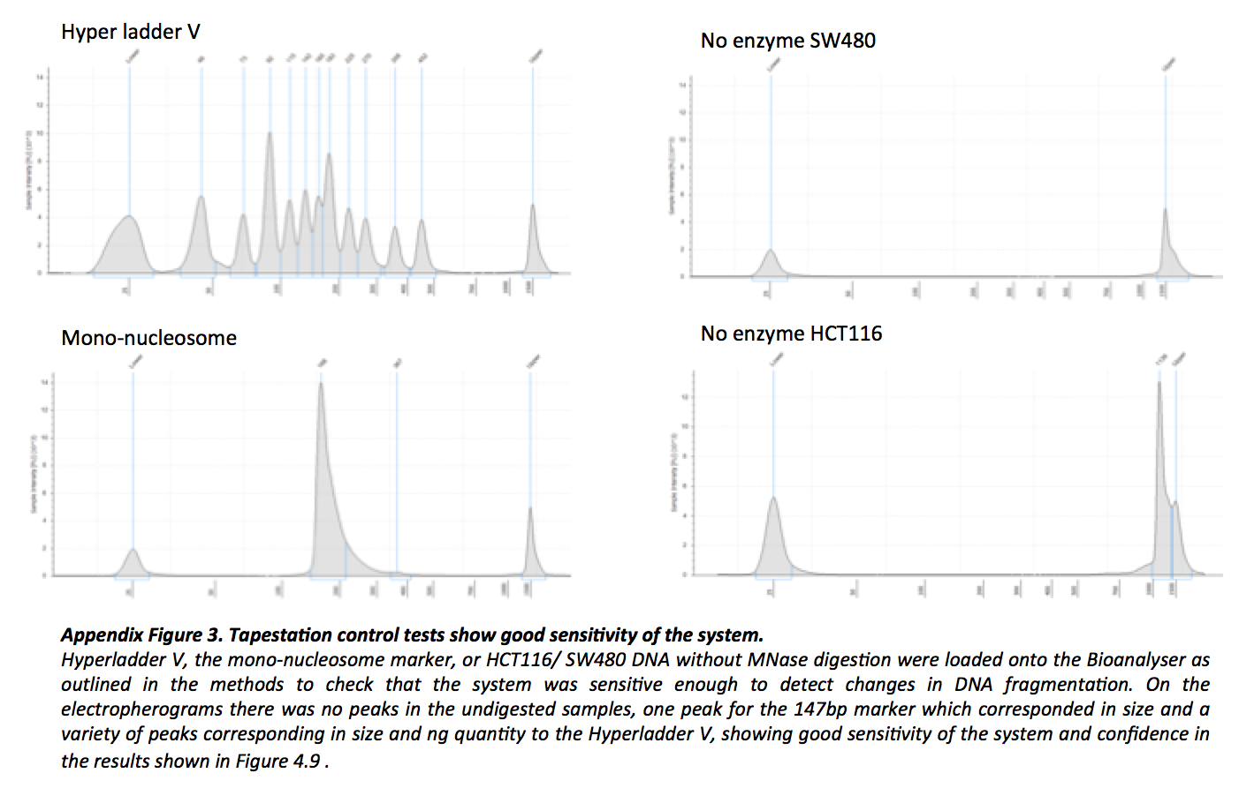
Appendix 3

Appendix 4
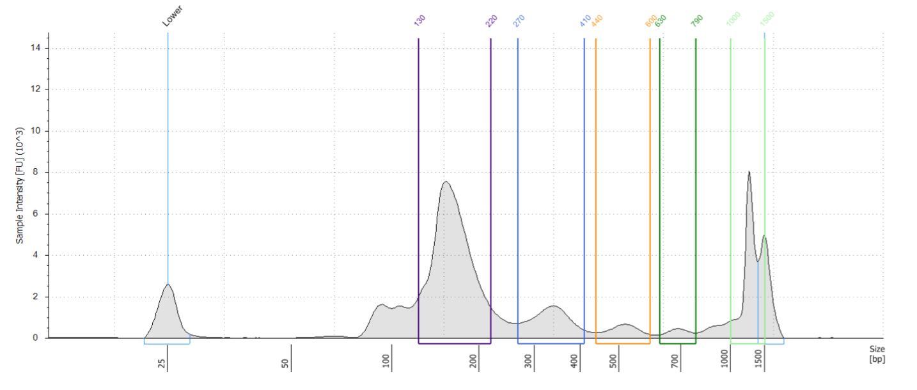
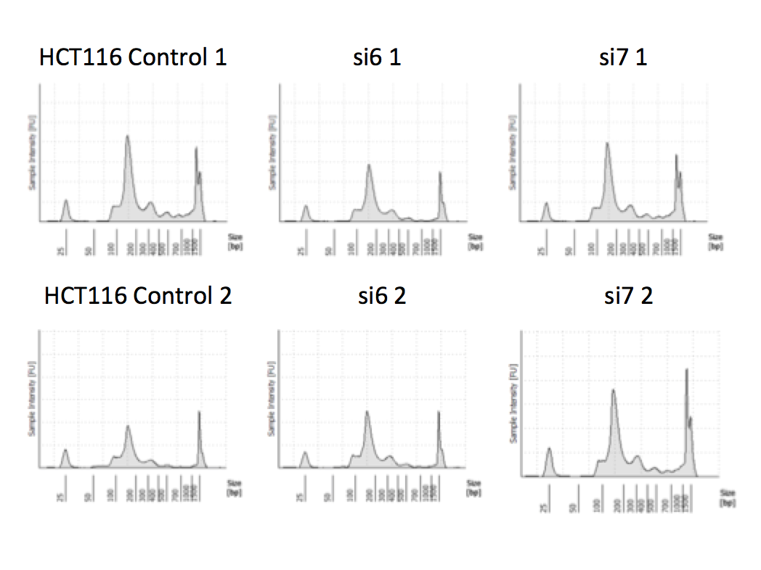
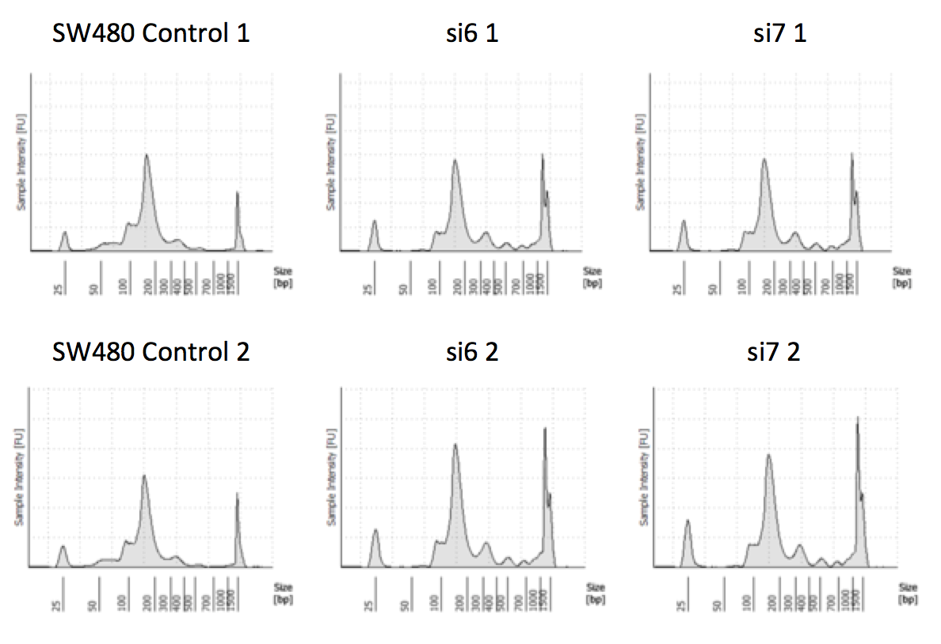
Appendix Figure 4. Individual electropherogram traces for each of the MNase digested samples.
a.) The individual traces showing the five peaks from which the analysis come from in Figure 4.9 of each MNase digested sample.
b.) A representative trace of SW480 cells transfected with si6, showing the gating of individual peaks (1-5), these gates were kept the same between samples and repeats and the software calculated the amount of DNA in each peak as a percentage of the total amount.
b.)
2
3
4
5
1
a.)

Appendix 5

Appendix Figure 5. 24hrs after transfection with SRCAP siRNA there was no difference in cell cycle profiles.
SW480 or HCT116 cells were transfected for 24hrs with SRCAP or control siRNA, then fixed and stained with PI. The samples were run on a FACS Calibur machine, doublet cells gated out and histograms made of number of events vs. DNA content (PI). The above graphs show median and range of three repeats and after a Kruskal-Wallis test there was no significant difference between any of the cell cycle phases for either cell line (SW480- SubG1-p=0.2964, G1-p=0.7214, S-p=0.5107, G2-M-p=0.5429, HCT116- SubG1-p=0.3393, G1-p=0.8286, S-p=0.1321, G2-M-p=0.9286).
n=3

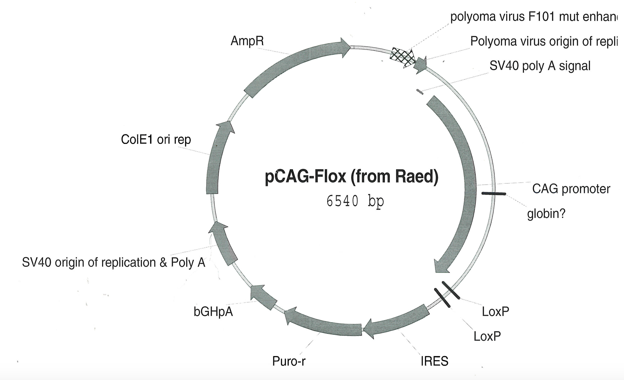
Appendix 6
Appendix Figure 6. The CAG construct
The RAS over-expression system was created using the above CAG expression vector, which is driven by a CAG promoter. It is used for long term, high levels of gene expression and consists of a CMV enhancer element, a chicken beta-actin promoter, 5’UTR and an intron with the 3’ end of the intron substituted with a rabbit beta-globin splice acceptor (Miyazaki et al., 1989).

Appendix 7
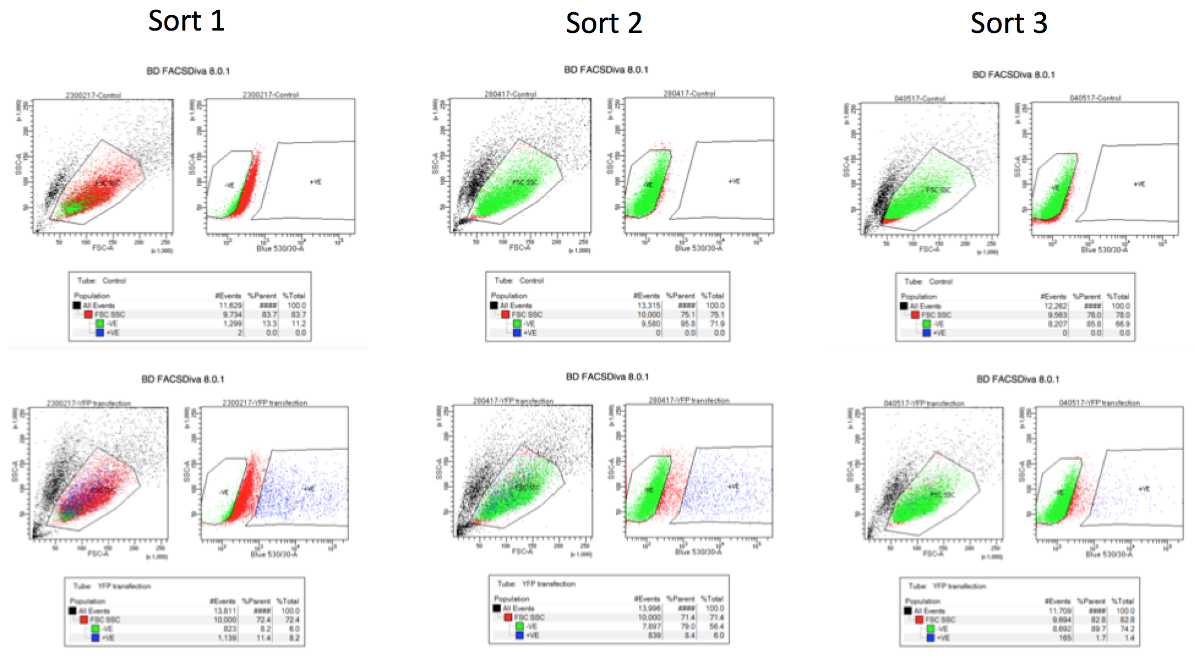
Appendix Figure 7. FACS sorts for RNA over expression samples.
Diagrams showing how untransfected HCT116 cells were used to gate the single cell population and then to gate a negative YFP population. These same gates were then utilised for sorting the YFP SRCAP transfected cells into cells expressing YFP and those that did not.

Appendix 8
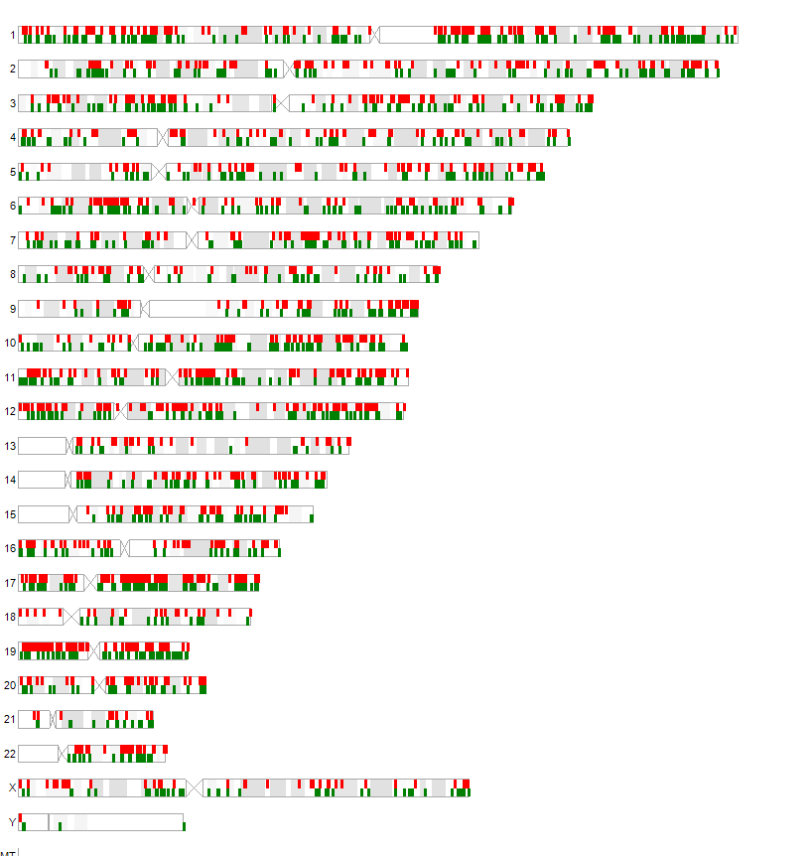
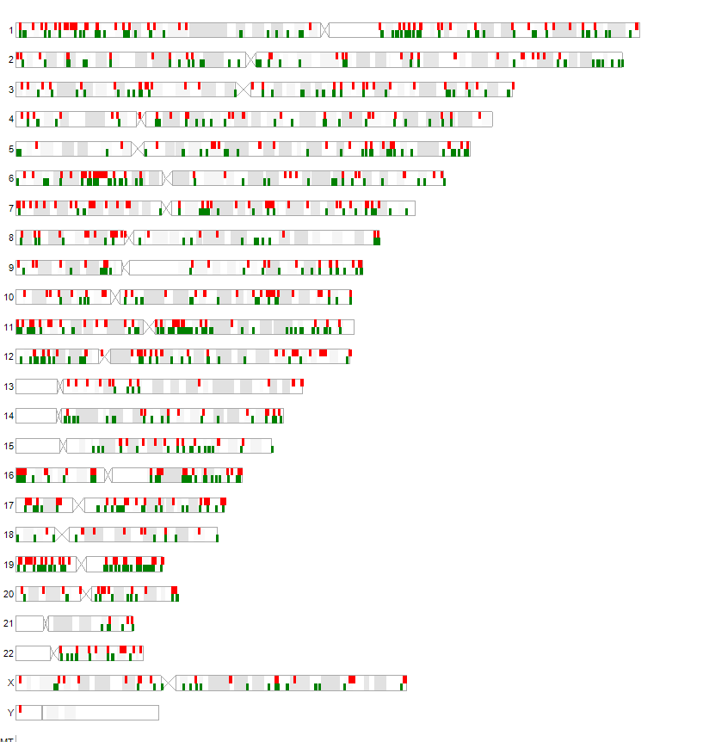
Appendix Figure 8. Fold changes can be mapped to areas of the chromosomes.
The fold changes shown in the dot plots of Figure 6.4a and Figure 6.7a are also mapped to where they correlate to on the chromosomes, with the red indicating positive fold changes and green indicating negative fold changes. Again it is clear to see that the control vs YFP SRCAP data has less fold changes than the control vs. si6 data, with the changes well spread out over the chromosomes.

Control vs YFP SRCAP
Control vs si6

Appendix 9

Gene | 1 |  | 2 |  | 3
ACLY | 2.65 |  | 2.71 |  | 2.62
AHCYL1 | 2.29 |  | 2.64 |  | 2.44
ANAPC13 | 3.71 |  | 4.15 |  | 3.93
ARHGEF2 | 2.14 |  | 2 |  | 2.22
ARNTL2 | 2.98 |  | 2.58 |  | 2.64
ASNS | 3.32 |  | 2.59 |  | 3.75
BIN1 | 3.13 |  | 2.39 |  | 2.17
BIRC2 | 2.05 |  | 2.79 |  | 2.29
BLOC1S5 | 3.04 |  | 4.08 |  | 2.16
BRCA1 | 2.76 |  | 3.89 |  | 2.72
BRCC3 | 4.75 |  | 3.45 |  | 4.74
CALR | 2.89 |  | 2.03 |  | 2.34
CCDC34 | 5.8 |  | 8.35 |  | 13.89
CCDC59 | 2.72 |  | 2 |  | 3.05
CDT1 | 3.26 |  | 2.04 |  | 2.98
CENPM | 2.25 |  | 2.03 |  | 2.99
CEP135 | 2.28 |  | 2.04 |  | 2.17
CEP290 | 2.04 |  | 2.11 |  | 2.27
CHM | 2.66 |  | 2.42 |  | 2.71
CHTF8 | 3.28 |  | 2.12 |  | 2.34
CHUK | 2.32 |  | 3.44 |  | 4.36
CLU | 2.23 |  | 2.39 |  | 2.06
CRTAP | 3.2 |  | 2.3 |  | 2.4
DBNL | 2.87 |  | 2.01 |  | 2.74
DCLRE1A | 2.69 |  | 3.04 |  | 2.92
DHFR | 2.23 |  | 2.23 |  | 2.37
DLG1 | 2.08 |  | 2.13 |  | 2.46
DNAJA3 | 3.93 |  | 3.61 |  | 4.81
E2F2 | 3.38 |  | 2.39 |  | 2.76
EFCAB14 | 4.23 |  | 3.17 |  | 3.27
ELK3 | 4.27 |  | 5.77 |  | 5.83
ESAM | 3.56 |  | 2.22 |  | 2.04
ESYT1 | 3.98 |  | 2.79 |  | 3.36
FAM111B | 2.71 |  | 3.28 |  | 3.28
FAM129A | 3.67 |  | 2.11 |  | 5.47
FAM96A | 2.24 |  | 2.62 |  | 3.43
GATAD2A | 5.55 |  | 3.09 |  | 3.26
GPAM | 2.08 |  | 2.72 |  | 2.23
GPATCH11 | 2.18 |  | 2.7 |  | 2.6
GRB10 | 2.97 |  | 4.01 |  | 3.76
HADH | 2.53 |  | 2.38 |  | 2.59
HCFC1R1 | 4.78 |  | 3.23 |  | 7.22
HIPK1 | 2.35 |  | 2.78 |  | 2.11
HIST1H4A | 2.78 |  | 3.46 |  | 6.86
HIST2H3A | 2.62 |  | 2.11 |  | 2.5
HIST3H2BB | 6.91 |  | 4.85 |  | 7.03
ICMT | 2.99 |  | 4.39 |  | 3.04
ITPR3 | 2.21 |  | 2.59 |  | 3.38
JDP2 | 2.97 |  | 2 |  | 5.32
JUND | 6.99 |  | 2.49 |  | 2.39
KDELC2 | 2.71 |  | 2.28 |  | 3.48
KIF14 | 2.14 |  | 3.26 |  | 4.09
KIFC1 | 4.13 |  | 2.34 |  | 2.24
KLF2 | 3.21 |  | 2.85 |  | 2.99
LAMTOR2 | 3.32 |  | 2.28 |  | 3.22
LIMS1 | 3.85 |  | 3.17 |  | 2.1
LRRCC1 | 3.84 |  | 3.4 |  | 6.95
LYN | 3.22 |  | 3.28 |  | 3.41
LYPLA1 | 2.76 |  | 2.03 |  | 2.17
LYRM2 | 2.98 |  | 2.07 |  | 2.34
MCM10 | 2.3 |  | 2.32 |  | 3.79
MDM4 | 3.53 |  | 3.14 |  | 3.1
MYB | 5.24 |  | 4.66 |  | 5.16
NAA15 | 2.17 |  | 2.3 |  | 2.07
NCAPH | 2.92 |  | 2.07 |  | 2.26
NCBP2 | 2.01 |  | 2.34 |  | 2.05
NEDD4 | 3.63 |  | 2.65 |  | 3.76
NEMP1 | 3.54 |  | 4.24 |  | 2.92
NUBPL | 2.52 |  | 2.47 |  | 2.52
NXT2 | 2.97 |  | 2.59 |  | 4.07
PANX1 | 2.01 |  | 4.29 |  | 2.47
PCK2 | 2.03 |  | 2.21 |  | 2.61
PEX12 | 2.64 |  | 2.39 |  | 2.12
PHLDA2 | 6.25 |  | 5.16 |  | 5.09
PLA2G12A | 3.4 |  | 3.29 |  | 4.02
POMGNT1 | 2.1 |  | 2.23 |  | 2.01
PRIMPOL | 2.22 |  | 2.74 |  | 2
PSMA1 | 2.73 |  | 2.12 |  | 2.04
RAB11FIP2 | 2.49 |  | 2.19 |  | 3.07
RAB26 | 2.24 |  | 2.97 |  | 2.24
RBBP9 | 2.09 |  | 2.91 |  | 2.3
RDX | 2.76 |  | 2.54 |  | 2.56
RFWD3 | 2.58 |  | 2.25 |  | 2.02
RFXAP | 2.37 |  | 4.61 |  | 2.27
RHOBTB3 | 2.68 |  | 2.78 |  | 2.72
RNF138 | 2.3 |  | 2.77 |  | 2.9
SF3B2 | 3.14 |  | 2.02 |  | 2.1
SGK3 | 2.21 |  | 2.1 |  | 2.08
SH3BP4 | 5.28 |  | 3.8 |  | 5.81
SLC35B4 | 2.76 |  | 2.6 |  | 2.63
SNX4 | 2.41 |  | 3.41 |  | 2.3
SRPR | 3.62 |  | 2.66 |  | 2.06
SSH1 | 3.17 |  | 3.54 |  | 3.02
STAMBP | 2.55 |  | 2.2 |  | 2.05
SUPT16H | 2.04 |  | 2.99 |  | 2.54
SYNRG | 3.11 |  | 3.36 |  | 2.58
TCEA1 | 2.47 |  | 3.01 |  | 3.56
TEF | 2.1 |  | 2.06 |  | 2.82
TINF2 | 3.09 |  | 2.32 |  | 2.59
TLR6 | 3.6 |  | 2.36 |  | 2.2
TMED8 | 3.64 |  | 4.21 |  | 2.1
TMEM265 | 2.9 |  | 2.98 |  | 4.09
TRAK2 | 5.32 |  | 3.71 |  | 2.69
TRMT10A | 4.13 |  | 2.55 |  | 3.79
TRUB1 | 2.82 |  | 2.26 |  | 2.04
TSPAN31 | 3.15 |  | 2.15 |  | 2.72
UMAD1 | 3.69 |  | 2.5 |  | 2.49
USP46 | 2.66 |  | 2.88 |  | 2.23
UXS1 | 3.17 |  | 2.2 |  | 3.61
VEPH1 | 2.32 |  | 2.02 |  | 2.17
VEZT | 3.56 |  | 2.2 |  | 2.31
WDR76 | 3.05 |  | 2.68 |  | 3.02
XPNPEP1 | 4.58 |  | 2.82 |  | 4.38
ZBTB12 | 2.04 |  | 2.44 |  | 2.23
ZCRB1 | 2.83 |  | 2.18 |  | 4.15
ZHX1 | 3.59 | 4.04 |  | 5.18

Appendix Figure 9. Control vs si6 genes that have a 2 or more fold change across all three repeats.
These genes represent all the genes that are decreased in expression by a 2 or more fold change when SRCAP is knocked down.

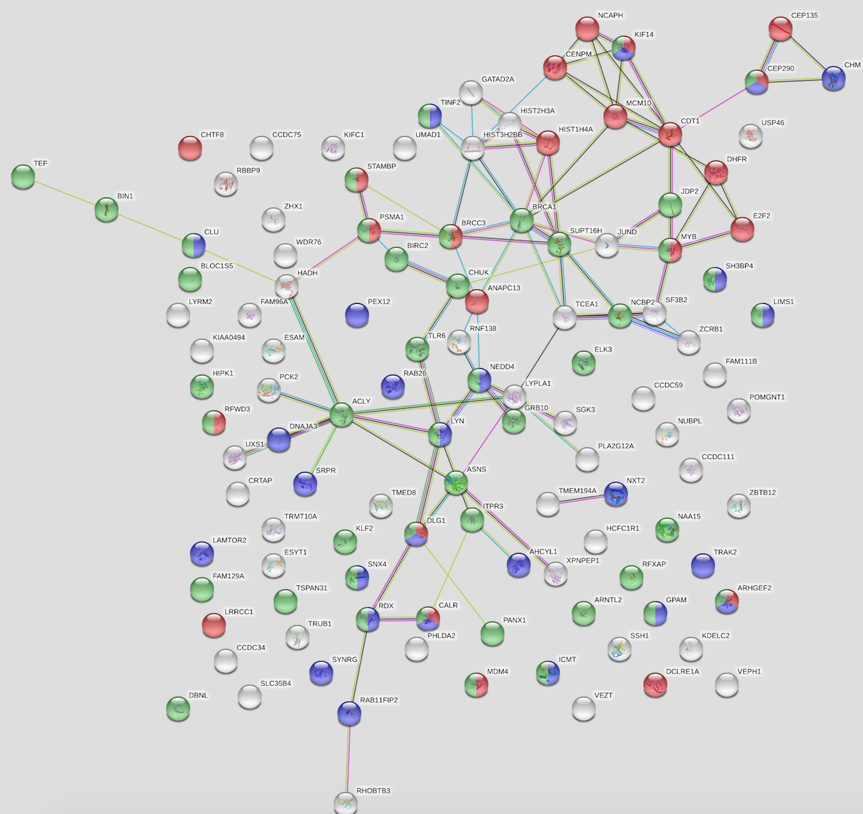
Appendix 10
Appendix Figure 9. Control vs si6 genes that have a 2 or more fold change across all three repeats.
These genes represent all the genes that are decreased in expression by a 2 or more fold change when SRCAP is knocked down.

Appendix Figure 10. STRING network analysis on the 115 genes that had a 2 or more positive fold change across all three control vs si6 repeats.
The red dots correspond to genes involved in the cell cycle, the blue dots correspond to genes involved in protein localisation and the green dots correspond to genes involved in the positive regulation of cellular processes.

Appendix 11

Gene | 1 | 2 | 3
ABCA12 | -3.22 | -2.15 | -3.98
ACTA2 | -3.49 | -2.87 | -2.59
ATXN7L3B | -2.57 | -2.04 | -2.43
BAMBI | -3.52 | -3.35 | -2.86
C12orf76 | -2.99 | -3.82 | -2.15
CDKN1A | -2.67 | -4.44 | -4.57
CEACAM1 | -3.14 | -4.44 | -3.57
COL17A1 | -2.36 | -2.35 | -3.78
COL6A1 | -2.36 | -3.12 | -2.86
CPA4 | -2.81 | -2.41 | -2.31
DKK1 | -2.35 | -2.07 | -2.22
DOCK4 | -3.15 | -2.59 | -2.34
FDXR | -2.17 | -2.08 | -2.22
FDXR | -2.03 | -2.72 | -3.6
FGFBP1 | -4.77 | -5.76 | -5.06
GPR137B | -2.01 | -2.04 | -2.26
GPR3 | -3.64 | -4.58 | -4.72
HEXIM1 | -2.74 | -2.8 | -2.64
HIPK3 | -2.39 | -2.29 | -2.55
IFNE | -2.03 | -2.82 | -3.11
INPP5D | -3.04 | -2.29 | -3.46
ITGB8 | -4.34 | -3.06 | -5.8
KRT23 | -3.39 | -2.13 | -2.66
KRTAP2-1 | -6.73 | -11.59 | -4.61
KRTAP2-2 | -5.16 | -10.21 | -4.25
KRTAP2-3 | -5.27 | -9.36 | -7.69
KRTAP2-4 | -3.28 | -3.8 | -3.96
KRTAP3-1 | -5.16 | -5.15 | -6.25
MAP3K1 | -2.46 | -2.39 | -2.83
MSX1 | -4.56 | -5.98 | -6.32
OLFM2 | -2.42 | -2.09 | -2.26
PGF | -2.07 | -2.25 | -2.57
PLK2 | -3.95 | -4.12 | -3.79
PTAFR | -2.9 | -4.76 | -2.7
RP11-380G5.2 | -2.86 | -2.08 | -2.28
RPS27L | -2.79 | -2.66 | -3.14
RRM2B | -2.4 | -2.05 | -2.31
SCG2 | -3.18 | -3.55 | -3.8
SCML2 | -2.14 | -2.06 | -3.1
SEMA6A | -3.57 | -3.43 | -3.75
SERPINB5 | -3.39 | -2.67 | -3.81
SERTAD1 | -2.65 | -2.3 | -4.72
SESN1 | -3.4 | -4.57 | -4.31
SGK1 | -2.03 | -2.19 | -2.67
SLC2A14 | -3.71 | -4.55 | -6.5
SLC2A3 | -7.79 | -8.99 | -11.82
STAT3 | -2.19 | -2.02 | -2.2
STK17A | -3.36 | -2.33 | -2.2
TGFBR3 | -2.74 | -2.19 | -5.46
TM4SF18 | -2.05 | -2.13 | -2.63
TNFRSF10B | -2.5 | -2.63 | -2.23
TP53INP1 | -3.64 | -2.99 | -3.6
TSPAN12 | -2.66 | -2.6 | -2.42
ZBTB5 | -2.05 | -3.05 | -2.88
ZNF217 | -3.51 | -2.27 | -2.58
ZNF425 | -2.78 | -2.75 | -2.49

Appendix Figure 11. Control vs si6 genes that have a -2 or more fold change across all three repeats.
These genes represent al the genes that are increased in expression by a -2 or more fold change when SRCAP is knocked down.

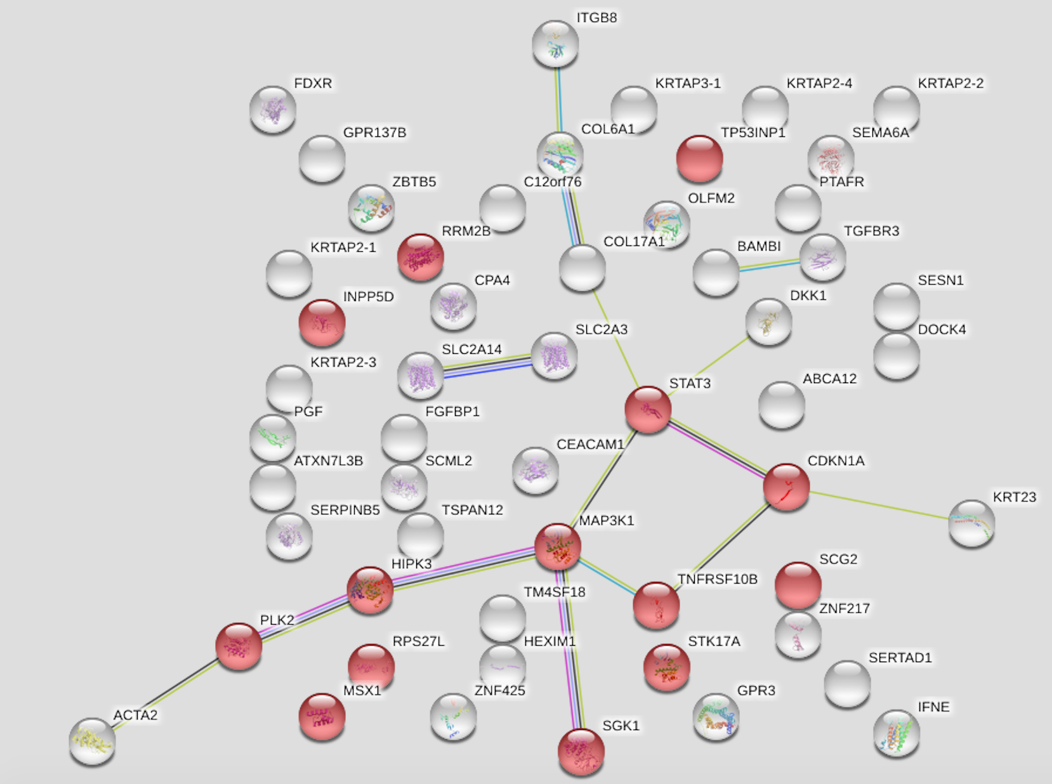
Appendix 12
Appendix Figure 12. STRING network analysis on the 55 genes that had a -2 or more negative fold change across all three control vs si6 repeats.
The red dots correspond to genes involved in the regulation of apoptotic processes.

Appendix 13

GENE | 1 | 2 | 3
PCYOX1L | 2.28 | 2.13 | 2.6
Appendix Figure 13a. Control vs YFP SRCAP genes that have a 2 or more fold change across all three repeats.
This is the only gene which is decreased in expression by a 2 or more fold change when SRCAP is over-expressed.

GENE | 1 | 2 | 3
CPA4 | -4.07 | -6.5 | -7.19
KLK5 | -3.12 | -3.12 | -2.6
CALB2 | -2.9 | -3.87 | -2.2
ZFP36 | -2.32 | -2.17 | -2.33
KRTAP2-3 | -2.3 | -2.27 | -8.5
Appendix Figure 13b. Control vs YFP SRCAP genes that have a -2 or more fold change across all three repeats.
These genes represent al the genes that are increased in expression by a -2 or more fold change when SRCAP is over-expressed.

Image Use Licenses

Where appropriate permission for adaptation and modification of images used throughout this thesis was obtained via the Copyright Clearance Centre (http://www.rightslink.com) using the online system. The individual license requests, which were granted, and the appropriate Figure they are for, are shown below.

Figure | License Number | License Publisher | License Publication | Title | Author | Date | Volume No.
1.1 | 3603640545153 | Nature Publishing Group | Nature reviews molecular cell biology | DNA damage response in adult stem cells: pathways and consequences | Mandal et al. | Mar 1, 2011 | 12
1.2 | 4223690040366 | Elsevier | Cell | A genetic model for colorectal tumourigenesis | Fearon and Vogelstein | Jun 1, 1990 | 61
1.3 | 4223680519390 | Elsevier | Experimental Cell Research | Exploiting DNA mismatch repair deficiency as a therapeutic target | Guillotin and Martin | Nov 15, 2014 | 329
1.4 | 4220151001797 | American Association for Cancer Research | Clinical Cancer Research | Targeting WNT signaling in colon cancer stem cells | de Sousa et al. | Feb 15, 2011 | 17
1.5 | 4220150202221 | BMJ Publishing group Ltd. | Gut | A combined oncogenic pathway signature of BRAF, KRAS and PI3KCA mutation improves colorectal cancer classification and cetuximab treatment prediction | Tian et al. | Apr 1, 2013 | 62
1.6 | 4235291096024 | American Association for Cancer Research | Clinical Cancer Research | Colon cancer: It’s CIN or CIMP | Issa | Oct 1, 2008 | 14

