

An investigation of torque density and losses in high-speed permanent magnet machines

By:

Anshan Yu

A thesis submitted in partial fulfilment of the requirements for the degree of
Doctor of Philosophy

The University of Sheffield
Faculty of Engineering
Department of Electronic and Electrical Engineering

10/01/2018

Abstract
High speed permanent magnet machines have been widely adopted for their ability to achieve high power densities while also retaining high efficiencies. However, operation at high speeds introduce several design and analysis challenges which encompass electromagnetic, thermal and mechanical considerations. Arguably the most challenging aspect of high-speed machine design is the reliable prediction of losses in the machine, particularly if the influence of the converter is accounted for. This thesis is focussed on the design and loss modelling of high speed permanent magnet machines, with a particular emphasis on establishing a detailed understanding factors that result in the torque density of machines decreasing with increasing speed.
The thesis reports on a systematic investigation to establish the variation of torque density and power density with machine speed by way of series of design studies for a 250kW surface-mounted permanent magnet. The torque density is shown to reduce with machine speed rating at different rates depending on the constraints applied. In several cases, an optimum speed for achieving maximum power density is observed, beyond which the power density begins to reduce.
The thesis then considers in detail the influence of ripple currents generated from hysteresis closed loop control, on machine torque output and iron losses. A novel post-processing method is developed for iron loss calculation to accommodate with the large number of data points required to fully capture the effect of high frequency current ripple. A series of analytical derivations are developed to illustrate that high frequency iron losses due to switching are largely independent of the exact nature of the switching behaviour and governed by steady-state machine parameters.
The rotor eddy current losses in rotor magnets and a metallic containment sleeve are then calculated, using a novel three-dimensional analytical model for field, current, and loss prediction. Good agreement is achieved between the analytical model and finite element simulations.

Acknowledgements
During my PhD project and final thesis writing, my supervisor, professor Geraint Jewell, spared no effort in supervising me, supporting me, and helping me through many difficulties. I would like to express my sincere thanks to him for his support, guidance, and encouragement.
I would also like to thank Rolls-Royce and The University of Sheffield for providing a bursary to cover my tuition and living expenses during my PhD study, and in supporting me to complete my project and thesis. In particular, I would like to thank Mark Borden and Ellis Chong from Rolls-Royce for their great support.
I would also like to thank my colleagues in Rolls-Royce UTC and other offices for their help and support during my PhD study. I have learned a lot from discussions with them.
Finally, I would like to thank my family for their care and support. Their encouragement through the four years gave me great strength facing the obstacles and difficulties in my study.

Table of Contents
Abstract I
Acknowledgements II
List of symbols VI
Chapter 1 Introduction - 1 -
1.1 Opportunities and challenges of high speed machines - 1 -
1.2 Material selection for high speed machines - 3 -
1.2.1 Soft magnet materials - 4 -
1.2.2 Hard magnet materials - 6 -
1.2.3 Conductors - 7 -
1.2.4 Containment materials - 8 -
1.3 Research programme overview - 9 -
References - 10 -
Chapter 2 Investigation of torque density and power density variation with machine operation speed - 12 -
2.1 Design specifications - 12 -
2.2 Machine topology selection - 14 -
2.3 Material selection - 17 -
2.4 Design methodology and results - 18 -
2.4.1 Initial dimension calculation for constant current density and split ratio designs - 18 -
2.4.2 Evaluation of the performance of the initial designs for constant current density and constant split ratio constraints - 27 -
2.4.3 Combined design approach with FE analysis - 29 -
2.4.4 Machine losses - 47 -
2.4.5 Analytical interpretation of the torque density variation - 51 -
2.4.6 Analytical interpretation of machine loss behaviour - 55 -
2.4.7 Constant current density and electrical loading design criteria - 56 -
2.4.8 Constant heat flux design criteria - 77 -
2.4.9 Effect of different slot-pole combination on torque density and power density variation - 83 -
2.4.10 Impact of different parameters on the torque density and power density variation in constant split ratio design - 88 -
References - 94 -
Chapter 3 The impact of switching current waveforms on machine performance - 96 -
3.1 Determination of machine electrical properties - 101 -
3.2 Implementation of the control strategy - 108 -
3.3 Current ripple impact on machine performance - 114 -
3.3.1 Hysteresis band determination - 114 -
3.3.2 Influence of switching frequency on electromagnetic torque - 121 -
3.3.3 Intrinsic six-step space vector switching process in Hysteresis control - 127 -
References - 132 -
Chapter 4 Current ripple impact on machine iron losses - 134 -
4.1 Literature review of the development of Iron loss calculation - 135 -
4.1.1 Iron loss calculation models - 135 -
4.1.2 Influence of converter PWM on iron losses - 141 -
4.2 Development of new post-processing model for iron loss calculation - 143 -
4.2.1 Underlying principles of the new post-processing model - 145 -
4.2.2 Implementation details of the new post-processing method - 147 -
4.3 Validation of the new post-processing method - 152 -
4.4 Interpretation of the influence of ripple current on iron loss behaviour - 167 -
4.5 Investigation into the influence of operating speed on iron loss produced by converter switching - 188 -
References - 202 -
Chapter 5 3D eddy current loss calculation in rotor metallic structures - 206 -
5.1 State of art in eddy current calculation in rotor metallic structures - 207 -
5.2 Development of a three-dimensional analytical eddy current loss calculation model - 210 -
5.2.1 Analysis of the stator current - 210 -
5.2.2 The composition of the analytical system - 218 -
5.2.3 Reformation of the original boundary condition - 225 -
5.2.4 General solutions for the governing equations - 228 -
5.2.5 Application of boundary conditions - 238 -
5.2.6 Circumferential insulation boundary conditions between magnets and inter-pole regions - 255 -
5.2.7 Calculation of the field components and circumferential eddy currents - 263 -
5.3 First step validation of the analytical model - 278 -
5.4 Calculation of the loss - 292 -
5.5 Influence of rotational speed on rotor eddy current loss - 299 -
5.6 Effect of circumferential segmentation on eddy current loss - 320 -
5.7 Limitations of the analytical method and ongoing work - 339 -
5.8 Eddy current loss under open circuit condition - 340 -
References - 347 -
Chapter 6 Conclusion - 351 -
Appendix I Tables for the detailed data in Chapter 3 - 354 -
Appendix II Ripple current waveforms generated from hysteresis control for FE calculation and corresponding torque waveforms - 358 -
Appendix III Predicted iron loss results from conventional and new developed post processing methods - 384 -

List of symbols
Symbol | Explanation | Unit
Chapter 1
$σ_{t}$ | Tangential stress | Pa
$δ$ | Mass density | Kg/m³
$v$ | Tangential line speed | W
Chapter 2
$R_{o}$ | Stator outer radius | mm
$R_{r}$ | Rotor radius | mm
$L_{a}$ | Axial length | mm
$λ_{s}$ | Slot pitch length | mm
$λ_{p}$ | Pole pitch length | mm
$w_{t}$ | Stator tooth width | mm
$h_{t}$ | Stator tooth height | mm
$h_{bi}$ | Stator back-iron thickness | mm
$d_{tip}$ | Stator tooth tip top height | mm
$h_{tip}$ | Stator tooth tip bottom height | mm
$L_{g}$ | Effective airgap thickness | mm
$L_{gmech}$ | Mechanical airgap clearance | mm
$L_{cm}$ | Containment thickness | mm
$h_{rbi}$ | Rotor back-iron thickness | mm
$L_{m}$ | Magnet thickness | mm
$D_{r}$ | Rotor diameter | mm
$R_{1}$ | Radius until the bottom of the stator winding | mm
$D_{o}$ | Stator outer diameter | mm
$D_{end}$ | Average end winding diameter | mm
$N_{s}$ | Number of slots
$N_{p}$ | Number of poles
$T$ | Electromagnetic torque | Nm
$k_{w}$ | Winding factor
$B_{ave}$ | Magnetic loading | T
$Q_{rms}$ | rms. Electrical loading | A/m
$k_{T}$ | Torque constant | Nm/A
$I_{rms}$ | rms. phase current | A
$φ$ | phase angle difference between the back-EMF waveform and the current waveform
$B_{m}$ | Flux density output from magnets to the airgap | T
$B_{r}$ | Magnet remanence field | T
$B_{t}$ | Flux density inside stator teeth | T
$B_{bi}$ | Flux density inside stator back iron | T
$A_{slot}$ | Slot area | mm²
$N_{ph}$ | Phase number of turns
$k_{p}$ | Packing factor
$J_{rms}$ | rms. current density | A/mm²
$ϕ_{p}$ | Flux per pole | Web
$μ_{r}$ | Relative permeability
$B_{g}$ | Airgap flux density | T
$σ_{max}$ | Maximum stress | Pa
$δ_{c}$ | Containment mass density | kg/m³
$ω$ | Angular speed | rad/s
$ν_{c}$ | Poisson ratio of containment
$d_{co}$ | Outer diameter of the containment | mm
$d_{ci}$ | Inner diameter of the containment | mm
$m_{eq}$ | Equivalent dead mass acting on the containment | kg
$r_{meq}$ | Equivalent radius of the dead mass | mm
$d_{mo}$ | Magnet outer diameter | mm
$d_{mi}$ | Magnet inner diameter | mm
$α$ | Magnet pole arc | degree
$δ_{m}$ | Magnet mass density | kg/m³
$δ_{ip}$ | Inter-pole material mass density | kg/m³
$ρ_{cu}$ | Resistivity of copper | $Ω⋅{mm}^{2}/m$
$M$ | Machine mass | kg
$δ_{ave}$ | Average mass density of active parts of the machine | kg/m³
$V$ | Total volume of machine | m³
$s$ | split ratio
$P_{cu}$ | Copper loss | W
$ζ_{cu}$ | Copper loss per unit machine total mass | W/kg
$κ_{cu}$ | Copper loss per unit surface area of the core back | W/m²
Chapter 3
$HB$ | Hysteresis band | A
$a^{'}$ | Weighted mean voltage coefficient
$V_{DC}$ | DC supply voltage | V
$f_{s}$ | Switching frequency | Hz
$L_{ph}$ | Phase inductance | H
$E_{ph}$ | Phase back-EMF | V
$i_{c}$ | Instantaneous command current | A
$V_{eff}$ | Effective voltage | V
$T$ | Electrical cycle length | s
$\sum{t_{\frac{4}{3}}}$ | Total time when $\frac{4}{3}V_{DC}$ is applied to one phase | s
$\sum{t_{\frac{2}{3}}}$ | Total time when $\frac{2}{3}V_{DC}$ is applied to one phase | s
$\sum{t_{0}}$ | Total time when $0$ voltage is applied to one phase | s
$Λ_{s}$ | Magnetic reluctance | A*turn/Web
$L_{A}$ | Phase A self-inductance | H
$L_{B}$ | Phase A self-inductance | H
$L_{C}$ | Phase A self-inductance | H
$M_{BA}$ | Phase A to B mutual inductance | H
$M_{CA}$ | Phase A to C mutual inductance | H
$M_{AB}$ | Phase B to A mutual inductance | H
$M_{CB}$ | Phase B to C mutual inductance | H
$M_{AC}$ | Phase C to A mutual inductance | H
$M_{BC}$ | Phase C to B mutual inductance | H
$L_{sync}$ | Synchronous phase inductance | H
$N_{coil}$ | Number of turns per coil
$R_{ph}$ | Phase resistance | $Ω$
$V_{R}$ | Voltage drop on phase resistance | $Ω$
$k_{E}$ | Back-EMF coefficient | V/(rad/s)
$ω_{r}$ | Mechanical angular speed | rad/s
${k_{E}}^{'}$ | Back-EMF coefficient in terms of phase turn number | V/turn
$V_{s}$ | Phase supply voltage | V
$ω_{s}$ | Electrical angular speed | rad/s
$k_{s}$ | Supply voltage coefficient in terms of phase turn number | V/turn
$V_{muA}$ | Voltage drop in phase A due to mutual inductance | V
$N_{sw}$ | Number of switching events
$T_{F}$ | Time period of hysteresis control | s
$E_{p}$ | Peak back-EMF | V
$I_{c}$ | Peak command current | A
$f_{ave}$ | Average switching frequency | Hz
Chapter 4
$P_{Fe}$ | Iron loss | W
$\hat{B}$ | Peak flux density | T
$C_{SE}$ | Steinmetz coefficient
$α$ | Steinmetz coefficient
$β$ | Steinmetz coefficient
$P_{FeN}$ | Iron loss of N^{th} hysteresis loop (major or minor) | W
$ΔB_{N}$ | peak to peak flux density of the current calculated loop | T
$W$ | total eddy current loss including the domain wall effect | W
$W_{c}$ | the classical eddy current term in (4.6) | W
$P_{hyst}$ | Hysteresis loss | W
$P_{ec}$ | Eddy current loss | W
$P_{exc}$ | Excess loss | W
$I_{1}(x)$ | first order modified Bessel function of first kind
$L$ | Width of the magnetic domain
$d$ | Thickness of the magnetic domain in (4.6)
$B_{m}$ | Peak of the excitation | T
$B_{s}$ | Saturation induction | T
$C_{hyst}$ | Hysteresis loss coefficient
$C_{ec}$ | Eddy current loss coefficient
$C_{exc}$ | Excess loss coefficient
$S$ | Lamination cross section area
$η_{L}$ | Lavers minor loop correction
$d_{L}$ | Thickness of the core lamination | mm
$a$ | Linear curve fitting coefficients in hysteresis loss calculation
$b$
$A_{elem}$ | Area of each sub-element | m²
Chapter 5
$α$ | Mechanical angular coordinate in stator reference system
$M$ | Number of phases
$I_{n}$ | the peak current of $n^{th}$ order time harmonics | A

Introduction

Opportunities and challenges of high speed machines
High speed electrical machines have been widely adopted for their ability to achieve high power densities. There is no consistent definition of what constitutes a high-speed machine, and indeed definitions tend to change with power ratings. However, for medium-sized machines, e.g. up to 250kW or so, high speed machine are often regarded as machines operating at speeds of 10,000 rpm and above. Ultra-high speed machines operating at up to 1,000,000rpm have already gained wide application in domestic appliances [1]-[4] and automotive exhaust mounted turbo-generators [5].
If the rotor structure is simplified to a rotating cylinder, then the tangential stress induced by centrifugal forces on the rotor can be expressed as being proportional to the square of the circumferential speed [6]
$$σ_{t}∝δv^{2}$$ | (1.1)
For a given maximum stress criteria of the rotor material, the maximum tangential velocity can be established according to (1.1), but the angular velocity can vary markedly depending on the rotor periphery size. Therefore, it is more reasonable to define the term ‘high speed’ in terms of the rotor peripheral speed than the rotation speed. In [7], tangential speeds of 367m/s has been suggested as a threshold for high-speed. Since in high speed applications, it is increasingly challenging for design with increasing speed requirement, it is essential to have an index to level the difficulty in reaching the high speed, high power density requirement, and in [8], an $rpm\sqrt{kW}$ index is introduced as a useful measure. Currently, a limit of $1×{10}^{6} rpm\sqrt{kW}$ has been realised for solid rotor induction machines. In addition to the high tensile stress introduced by centrifugal force during rotation, the rotor dynamics, including the rotor bending and vibration, are also critical issues when designing high speed machine. These problems have obtained wide attention in research and there have been methods to calculate the critical speed of each rotor bending mode [9].
The three most commonly used types of machines for high speed applications are permanent magnet machines, induction machines, and switched reluctance machines [2][4][10][11]. Permanent magnet machines offer high efficiency, high power density, and straightforward accurate speed / position control. Switched reluctance machines are sometimes favoured because they offer the most robust structure, inherent fault tolerant capability and an ability to operate in a high temperature environment. Induction machines also have robust construction, particularly solid rotor variants which are suitable for high speed applications, and they exhibit fewer current harmonics and smoother torque than switched reluctance machines. In [4], the authors did a thoroughly review of the published high speed machine designs, as shown in Figure 1.1, indicating the popularity of the three machine topologies in high speed applications. In the same paper, they also did comparison designs between permanent magnet machine and induction machine under the same power and speed ratings. It is shown that for the same specifications the induction machine is always about 40% to 60% bigger in size than the PM machines. Similar data collection was also carried out in [1] to [3].
Figure 1.1 Power-speed data published of high-speed electrical machines [4]
Therefore, for applications that require power-dense solutions, particularly in the tens of kW and above power range, permanent magnet machines are usually preferred. Among the various candidate topologies of permanent magnet machine, surface-mounted permanent magnet machine with concentrated winding has several beneficial features compared to other topologies such as compact end-windings, high flux weakening capabilities, and high fault tolerance, and therefore is suitable for applications requiring constant power operation over a wide speed range [4][12].
The design of high speed permanent magnet machines usually involves several more challenges than low speed machines in terms of electromagnetic performance, mechanical design and thermal management.
It is a generally accepted maxim in the design of electrical machines that electrical machines are sized on the basis of their torque rating and not their power rating per se. This would suggest that increasing the speed of an electrical machine leads to a proportionate increase in its power density. Whereas the underlying premise is generally well-founded, in practice, this relationship is far from straightforward. In many applications, it is not a simple case that the power density will increase linearly with the machine rotational speed. This is a consequence of the trend for torque density to diminish with increasing rotational speed as mechanical considerations and core loss come increasingly into play. There are a number of factors that will tend to diminish the torque density as the rotational speed is increased:
- Centrifugal forces on the rotor magnets increase with the square of the rotational speed and the square of the rotor diameter. In order to counteract these forces on the magnets, a carbon-fibre or metallic sleeve is usually fitted over the magnets. The higher peripheral speeds encountered in high speed machines will require thicker rotor magnet containment sleeves to withstand the centrifugal loading. Since these containment sleeves sit in the working airgap they will tend to increase the effective magnetic airgap and hence lead to a progressive decrease in the magnetic loading with rotor peripheral speed. A thicker containment sleeve will also make the removal of heat from the rotor magnets more difficult.
- There is a general trend for torque density to increase with overall diameter of the machine (discussed in more detail in chapter 2). This scaling factor will tend to favour lower speed machines which are able to be designed with larger diameters for a given power rating.
- A higher speed will lead to a higher fundamental electrical frequency in the machine which will lead to an increase in iron loss density (increasing at a rate which approaches the square of the frequency).
- The high electrical frequency of the currents encountered in high speed machines will result in an increase in the rotor magnet eddy current loss. Given the difficulties of removing heat from the rotor, this can ultimately limit the electric loading that can be applied.
- Almost all high performance electrical machines operate in conjunction with a power converter which employs high frequency switching to synthesise the desired current waveform. For a given switching frequency (which is usually selected to limit the switching loss in the converter) a higher electrical frequency will lead to a deterioration of power quality since the number of switching events per cycle of the fundamental will reduce. This deterioration in the harmonics in the current waveform may lead to increase in core losses.
- In order to match the supply voltage, high speed machines tend to operate with a low number of turns per phase compared to a machine of the same size operating at a lower speed. The low number of turns in high speed machines in turn leads to small phase inductances (order of a few tens to low hundreds of $µH$) which can result in significant high frequency current ripple due to converter switching and hence additional core losses.
In combination, these many factors will inevitably result in a progressive decrease in torque density with increasing rotational speed for a particular power rating and cooling arrangement. This will reduce the rate at which power density increases with speed. Thermal management is always a key consideration when designing electrical machines. In high-speed machines, it is more challenging to manage the increased loss densities (particularly from the iron loss), which will limit the torque density that can be achieved.
Qualitatively this trend is well recognised, but there is little or no published literature which systematically quantifies this trend for a representative high power specification. This thesis is focussed on establishing the influence of rotor speed on torque density, including addressing some of the loss mechanisms above in detail.

Material selection for high speed machines
In high speed machines, consideration needs to be given to mechanical properties of rotor materials in addition to ensuring competitive magnetic properties. Both rotating and static active components of the machine will be subjected to greater electromagnetic and thermal stresses due to high speed, e.g. skin effect and high iron loss density, which result from the high fundamental frequency and harmonic rich environment.
In general, electrical machines contain five categories of materials: soft magnetic cores, hard or permanent magnets, electrical conductors, insulators, and structural materials, in particular for the containment sleeve for the rotor permanent magnets. The key requirements for each category of material are summarised qualitatively in Table 1.1 [10].

Table 1.1 Requirements for different categories of electrical machine materials [10]
Material type | Locations in machine | Properties of interest
Soft magnetic | Rotor  Stator | - Saturation flux density (B_{s})  - Yield and tensile strengths (YS, UTS)  - Ductility and brittleness  - Low iron loss behaviour over a wide frequency range
Hard magnetic | Rotor  Stator | - Coercivity (H_{c})  - Remanent flux density (B_{r})  - Yield and tensile strengths  - Operating temperature  - Temperature variation  - Electrical conductivity
Conductors | Rotor  Stator | - Electrical conductivity  - Mechanical strength
Electrical insulators | Rotor  Stator | - Maximum operating temperature  - Method of application  - Aging mechanisms  - Thermal conductivity
Containment materials | Rotor | - Yield strength  - Magnetic properties  - Electrical conductivity (low conductivity required)  - Thermal conductivity

Soft magnet materials
There are several low loss soft magnetic materials that could be considered for the stator and rotor cores, although the loss requirements for the rotor core are less onerous. The main characteristics of candidate soft magnetic materials are shown in Table 1.2, [13], [14], [15]. Some important features of these material are:
- There are often trade-offs between mechanical strength and magnetic performance. Specifically, reducing the grain size achieves the goal of increasing the mechanical strength, but it leads to the increase of the inter-domain forces as well and therefore causes an increase in coercivity $H_{c}$ and a decrease in magnet flux density for a certain H. As a result, the B-H loop becomes wider and the hysteresis loss is increased correspondingly. Therefore, there is trade-off between hysteresis loss and mechanical strength [16].
- During the shaping of the stator core laminations from the starting sheet material, sheared zones, due to laminate stamping, or heat affected zones caused by laser cutting, will lead to increase in hysteresis component of the total iron losses. Thus, annealing before assembling of the stack is essential for laminates processed in this way.
- Edge-welding technique is seldom implemented on stator laminations for high speed machines with adhesive bonding or mechanical clamping often being preferred.
- To reduce material wastage, it is preferable to use the same soft magnet material for both stator and rotor core. However, due to the special requirement of mechanical strength on the rotor part at high speed and the fact that enhancing the mechanical properties of the soft magnet materials will lead to a sacrifice in their magnetic performance, stator and rotor core materials are usually chosen separately in high speed machines.
Table 1.2 Recent advances in soft magnet materials [13][14][15]
Property | Vacoflux 48 | Vacoflux 50 | Hiperco 50 HS | 10JNEX900 | 10JNHF600
Alloy type | CoFe | CoFe | CoFe | SiFe | SiFe
Saturation B_{s} (T) | 2.3 | 2.28 | 2.3 | 1.2 | 1.87
H_{s} (A/m) | 80 | 80 | 16000 | 156 | 30000
Available lamination thickness (mm) | 0.35 | 0.35 | 0.152 | 0.1 | 0.1
W/kg at 1T 400Hz | 12 | 22 | 44 | 5.7 | 10.1
Mass density (kg/m³) | 8120 | 8120 | 8110 | 7650 | 7650
Yield strength R_{0.2} (MPa) | 200 | 450 | 683 | 604 | 546
Poisson’s ratio |  |  | 0.33 | 0.3 | 0.3
Maximum elongation | 2% | 6% | 15% | 5% | 13.5%
Comments | 0.1mm laminations are also available with 6.8W/kg at 1T 400Hz
In addition, there are also reports from different companies stating the advancement of mechanical strength of their soft magnet materials, including the 35HXT class of steels by Nippon Steel and Sumitomo Metals, which has reached yield strength of up to 780MPa though at the expense of increased iron loss density to 52.4W/kg (1T 400Hz) [17], AISI 4130 alloy steel with strength 517MPa [18] and AerMet 100 with strength up to 1.5GPa [19], making it possible to achieve tangential velocity up to 290m/s.

Hard magnet materials
Although many types of permanent permanents, e.g. Alnico, ceramic ferrite and rare earth (both bonded and sintered), find applications in many different machine types in different market sectors, all high performance machines tend to employ sintered rare-earth magnets which have by some distance the best magnetic properties of the available material, albeit at with the highest cost [20] - [24]. Typical properties of commercial hard magnetic material are shown in Table 1.3.
Table 1.3 Typical properties of commonly used hard magnets (20$℃$) [25]
Property | Units | Anisotropic Ferrite | Alnico | Sintered SmCo | Sintered NdFeB
Remanence $B_{r}$ | T | 0.35 – 0.43 | 0.6 – 1.35 | 0.7 – 1.05 | 1.0 – 1.3
Intrinsic coercivity $H_{ci}$ | kA/m | 180 – 400 | 40 – 130 | 800 – 1500 | 800 – 1900
Relative permeability $μ_{r}$ |  | 1.05 – 1.15 | 1.9 – 7 | 1.02 – 1.07 | 1.04 – 1.1
$$({BH}_{max})$$ | kJ/m³ | 24 – 36 | 20 – 100 | 140 – 220 | 180 – 320
Max. working temperature | $$℃$$ | 250 | 500 – 550 | 250 – 350 | 80 – 200
Curie temperature | $$℃$$ | 450 | 850 | 700 – 800 | 310 – 350
Mass density | kg/m³ | 4900 | 7300 | 8200 | 7400
Cost |  | Lowest | Low | Highest | High

The two rare earth elements used in the production of permanent magnets are Neodymium (Nd) and Samarium (Sm), which belong to the Lanthanide group of elements. Although numerous alloy formulations of rare earth magnets have been patented, the most commonly used in commercial produced materials are Neodymium-Iron-Boron and Samarium Cobalt. Neodymium-Iron-Boron magnets with chemical composition Nd₂Fe₁₄B, are currently the most powerful type of magnets among all commercialized magnet categories in terms of their room temperature magnetic capabilities. They provide the highest energy product of up to 52MGOe and offer superior mechanical properties compared to Samarium Cobalt magnets. This said, NdFeB in common with many materials produced by a powder-sinter route are very poor in tension, only exhibiting reliable mechanical properties in compression. Despite their outstanding room temperature magnetic properties, NdFeB magnets have poor corrosion resistance and long-term stability and hence protective coatings are required in most applications. Furthermore, NdFeB magnets have relatively low temperature stability and their magnetic performance. High temperature grades of NdFeB which include significant additions of Dysprosium can be used at temperatures up to 220$℃$. However at these temperatures, they tend to exhibit inferior magnetic properties compared to high performance grades of Samarium Cobalt, although they do offer a cost advantage.
There are two main types of Samarium Cobalt magnets: SmCo₅, with energy product ranging from 15 to 22 MGOe, and Sm₂Co₁₇, with energy product ranging from 22 to 32MGOe. As noted previously they exhibit superior high temperature characteristics compared Neodymium magnets, both in terms of maximum operating temperature (350°C compared to 220°C) and Sm₂Co₁₇ exhibit higher magnetic performance at a cross-over temperature of 180°C or so depending on the exact grades. In addition to superior high temperature properties Samarium Cobalt magnets (both SmCo₅ and Sm₂Co₁₇) have much better intrinsic corrosion resistance and hence have become the preferred hard magnetic material for aerospace applications.

Conductors
Copper is almost always the preferable material for machine winding due to its high conductivity and modest cost. However, because of the high fundamental frequency in high speed machines, electrical behaviour of the copper conductors must take skin effect and AC winding losses, which can be neglected in low speed machines, but become significant at high speed. Therefore, copper Litz wire, in which a single piece of copper wire is replaced by a number of parallel strands of much smaller diameter to form the same cross-section area, is widely used in high speed applications. Aluminium, which is 3.3 times lighter than copper has been considered on numerous occasions as an alternative to copper. However, the increased resistivity of Aluminium compared to copper and the consequent increase in the size of the slots and hence core to accommodate the larger cross-section conductors tend to outweigh the benefits of the reduced winding mass. In addition, the reliable jointing of Aluminium conductor to each other or to terminal is challenging because of the tendency to produce an electrically insulation oxide. In [26], efforts have been reported on co-extruding copper and Aluminium to form a conductor with copper outer surface and Aluminium core with a view to reduce mass. However, fine stranding of the this type of wire is not available commercially. Aluminium based Litz wire has also been developed by Japanese company Kyowa Electric to reduce the winding weight [27].

Containment materials
As noted previously, containment sleeves are often employed in permanent magnet rotors to retain the magnets in contact with the rotor hub across the full space. This is vitally important in high speed applications since the centrifugal force on the rotor magnets is proportional to the square of the speed, as shown previously in equation (1.1). There are three high-strength materials that are used for mechanical containment at high speeds, which are Inconel, Titanium (usuall Ti₆Al₄V), and carbon fibre filament wound composites.
Inconel 718 offers a good combination of strength, good temperature stability of its yield strength, which is 1100MPa at room temperature, and drops only by 100MPa when the temperature rises up to 500$℃$ [28], good thermal conductivity of 11.4W/(m$⋅$K), which is beneficial in heat dissipation and cooling of the rotor, and high corrosion resistance, making it ideal for applications in highly corrosive or elevated temperature environment. However, the mass density of this material is 8.19g/cm³, which is much higher than the other two types of materials.
Titanium alloys such as Ti₆Al₄V, are much lighter than Inconel 718, with mass density of 4.4 g/cm³, which is only half of that of the Inconel. This is useful in terms of the self-loading of the sleeve. However, it has slightly lower yield strength at room temperature and much greater temperature sensitivity, which is 950MPa at room temperature but only 450MPa at 500$℃$ [29]. Moreover, the thermal conductivity of 6.7W/(m$⋅$K) is poor compared to Inconel 718.
Carbon fibre sleeve material are even lighter, with a mass density of only 1.79g/cm³. The fibres themselves have a very high tensile strength ranging from 3.5GPa to 5.5GPa [30]. However, as the fibres are combined with epoxy resin to form a composite for commercial use, and the net tensile strength is reduced dramatically compared to the fibres alone. The exact properties vary significantly with composition and processing methods. For example, for a 60% fibre composite formed in 120$℃$ epoxy resin environment, the typical tensile strength is ~1.8GPa. If the fibres are filament wounded to produce a cylindrical sleeve, the tensile strength can be degraded by a factor of ~0.62 for low modulus carbon fibres such as IM7 and ~0.54 for high modulus carbon fibres such as M60J, compared to the raw fibre stiffness [31]. Attempts have been made to improve the winding factors that influence the performance of the final composite by applying a number of layers, which is reported to reach tested strength of 3.4GPa to 4.1GPa [32]. A fibre reinforcement method is also described in [32] that the fibre tows are directly winded on the rotor surface with epoxy resin introduced at the same time. In [33], another method is also reported, which is the combined usage of prefabricated fibre net and filament wounded sleeves.
Both Inconel and Titanium sleeves are electrically conducting and are hence the inevitable source of eddy current losses whereas the carbon-fibre can be reasonably regarded as an electrical insulator for the purposes of induced eddy currents because of the very small individual fibres which are present. Hence, carbon-fibre composite sleeves are often preferred to metallic sleeves, particularly in high speed applications unless the temperature conditions exceed the capabilities of composite. There is also a phenomena referred to as strain-relaxation which can cause a problem in fibre composites. This is a gradual relaxing of any pre-stress when the composite operates for extended periods at elevated temperatures.

Research programme overview
The programme of research reported in this thesis is focused on the optimisation of the electromagnetic performance of high speed permanent magnet machines, which includes:
- Design and analysis of machine performance at high speed operating point using selected machine topology and accounting for the mechanical effect in the rotor structure. This involves a systematic study into the trade-off between torque density and speed for high-speed PM machines
- Improving loss prediction models for high frequency operation, which includes novel and comprehensive models for induced eddy current loss in rotor magnets, rotor and stator core loss, and parasitic losses in metallic structure (e.g. Inconel sleeve)
- Controller design study, specifically study on interaction between inverter switching strategies and losses in both machine and converter
The central theme of the research is the development of a detailed understanding of the factors that influence the power density of high speed permanent magnet machines.

Current publications and prepared papers
Anshan Yu, Geraint W Jewell, “A systematic design study into the influence of rotational speed on the torque density of surface-mounted permanent magnet machines”, PEMD 2018, Liverpool
Anshan Yu, Geraint W Jewell, “A study of core losses generated by high frequency switching in permanent magnet machines”, in preparation for IEEE Transactions
Anshan Yu, Geraint W Jewell, “Three-dimensional analytical model of rotor magnet and containment sleeve loss for 9-slot 8-pole permanent magnet machine”, in preparation for IEEE Transactions

References
[1] Zwyssig C., Kolar J., Round SD., “Mega-speed Drive Systems: Pushing Beyond 1 Million r/min,” IEEE/ASME TRANSACTIONS ON MECHATRONICS, 2009. 14(5): p. 564-574.
[2] A. Boglietti, A. Cavagnino, A. Tenconi, and S. Vaschetto, "Key design aspects of electrical machines for high-speed spindle applications," in IECON 2010 - 36th Annual Conference on IEEE Industrial Electronics Society, 2010, pp. 1735-1740.
[3] Z. Kolondzovski, A. Arkkio, J. Larjola, and P. Sallinen, "Power Limits of High-Speed Permanent-Magnet Electrical Machines for Compressor Applications," Energy Conversion, IEEE Transactions on, vol. 26, pp. 73-82, 2011.
[4] A. Arkkio, T. Jokinen, and E. Lantto, "Induction and permanent-magnet synchronous machines for high-speed applications," in Electrical Machines and Systems, 2005. ICEMS 2005. Proceedings of the Eighth International Conference on, 2005, pp. 871-876 Vol. 2.
[5] S. D. Calverley, G. W. Jewell, and R. J. Saunders, "Design of a High Speed Switched Reluctance Machine for Automotive Turbo-Generator Applications," 1999.
[6] A. Binder, T. Schnieder, “High-Speed Inverter-Fed AC Drives,” in Electrical Machines and Power Electronics, 2007. ACEMP '07. International Aegean Conference on. 2007, IEEE
[7] J. Huppunen, J. Pyrhonen, “A New Medium Speed Solid Rotor Induction Motor for a High Speed Milling Machine,” in SPEEDAM'96. 1996.
[8] RD. Millingen, JD. Millingen, “Phase shift Torque-meters for Gas Turbine Development and Monitoring,” in International Gas Turbine and Aero-engine Congress and exposition. 1991, American Society of Mechanical Engineers: Orlando.
[9] E. Swanson, C. D. Powell, and S. Weissman, "A Practical Review of Rotating Machinery Critical Speeds and Modes," SOUND AND VIBRATION, p. 8, 2005.
[10] J. B. Bartolo, Z. He, D. Gerada, L. de Lillo, and C. Gerada, "High speed electrical generators, application, materials and design," in Electrical Machines Design Control and Diagnosis (WEMDCD), 2013 IEEE Workshop on, 2013, pp. 47-59.
[11] S. D. Calverley, G. W. Jewell, and R. J. Saunders, "Prediction and measurement of core losses in a high-speed switched-reluctance Machine," Magnetics, IEEE Transactions on, vol. 41, pp. 4288-4298, 2005.
[12] A. M. El-Refaie and T. M. Jahns, "Scalability of surface PM Machines with concentrated windings designed to achieve wide speed ranges of constant-power operation," in IEEE Transactions on Energy Conversion, vol. 21, no. 2, pp. 362-369, June 2006.
[13] Vacuumschmelze Gmbh & Co. Kg, Hanau, “Soft Magnetic Iron-Cobalt-Alloys Vacoflux Vacodur,” PHT-004, Dec. 2004.
[14] Carpenter T C, “HipercoR 50 HS Datasheet,” CTC, Editor. 2009, Carpenter Technology Corporation: www.cartech.com.
[15] JFE Steel Corporation, “JFE Super cores Magnetic Property Curves,” JFE, Editor. 2009, JFE Steel Corporation: http://www.jfesteel.co.jp/en/products/electrical/catalog/f2e-001.pdf.
[16] G.J. N Volbers, “High Saturation, High Strength Iron Cobalt Alloy for Electrical Machines,” in INDUCTICA CWIEME. 2012. Berlin: CWIEME.
[17] Nippon Steel & Sumitomo Metal, “Electrical Steel Sheet Catalog,” N.S.S. Metal, Editor. 2012: www.nssmc.com.
[18] UK, A.M., “AISI 4130 Datasheet,” Q.A. ltd, Editor. 2013, www.aircraftmaterialsuk.com
[19] Carpenter T C, “AerMet100 Alloy Datasheet,” CTC, Editor. 2011, Carpenter Technology Corporation: www.cartech.com.
[20] Magnetic Materials Producers Association, Chicago, Illinois 60603, USA, “Standard specifications for permanent magnet materials”, No. 0100-00.
[21] Magcraft, Vienna, VA 22182, USA, “Permanent Magnet Selection and Design Handbook,” Ver. 1, Rev. 04/07.
[22] Arnold Magnetic Technologies, “Neodymium-Iron-Boron Magnet catalog,” AMT, Editor. 2012, Arnold Magnetic Technologies: www.arnoldmagnetics.com.
[23] Constantinides S, “Rare Earth Materials Update May 2011,” in SMMA Management Conference. 2011, Arnold Magnetic Technologies: San Diego.
[24] P.C. Dent, J. Liu, M. Marinescu, C.N. Chinnasamy, G. Hadjipanayis, A. Gabay, “Higher Electrical Resistivity Rare Earth Permanent Magnets,” in UK Magnetics Society 2012 meeting in Hanau Germany. 2012, Electron Energy Corporation.
[25] Hendershot Jr., J.R., and Miller, T.J.E., “Design of Brushless Permanent-Magnet Motors,” Oxford 1994.
[26] Bruker EST, “Cupronal TM Information sheet,” Bruker, Editor. 2013: http://www.bruker-est.com/he-cuponal.html.
[27] Bulletin, J.M., “Kyowa Electric Develops Al Litz Wire for Wireless EV charging Coil,” 2012.
[28] Metals, S., “Inconel 718 & 718SPF Datasheet,” S. Metals, Editor. 2013: www.specialmetals.com.
[29] Gysler A, Lotjering G., “Influence of Test Temperature and Microstructure on the Tensile Properties of Titanium Alloys,” American Society for Metals, The Metallurgical Society of America, Metallurgical Transactions A, 1981. 13A.
[30] TORAY CARBON FIBERS AMERICA, I., “T300 DATA SHEET TECHNICAL DATA SHEET No. CFA-001,” 2013: www.torayusa.com.
[31] Nagy G, Rossenwasser S., “The Evaluation of Advanced Composite Material Performance in High Speed Pulsed Power Rotor Applications,” IEEE TRANSACTIONS ON MAGNETICS, 2001. 37(1): p. 314-317.
[32] Tzeng J, E.R., Moy P, “Composite flywheels for energy storage,” Composites Science and Technology, 2006. 66: p. 2520-2527.
[33] Schunkgraphite, “Carbon Fiber Reinforced Polymer Products catalogue,” 2013, www.schunkgraphite.com

Investigation of torque density and power density variation with machine operation speed

This chapter is focused on a systematic study to explore the nature of the relationship between torque density, power density and rotational speed. This is achieved within the context of a detailed design study on a series of electrical machines to meet a specific load, torque and speed rating.
Three different design constraints have been considered, viz. constant current density and split ratio design; constant current density and electrical loading design; and constant heat flux design. The machines are designed using a combination of analytical equations and finite element analysis, and trends in the variation of torque density with machine speed rating are interpreted using analytical methods.
The design study is focussed on a series of 250kW rated permanent magnet machines. This power rating is representative of a 250kVA low-pressure shaft aero engine generator which can be driven either as direct-drive or via a series of gearboxes of various ratios. However, for the purposes of the design study in this chapter which is targeted at establishing trends in torque and power density, the study is focussed on the machine operating in motoring mode as this allows a more consistent approach to be taken which lends itself better to analytical modelling. More specifically, the torque rating of the machine is not dependent on the machine losses so various designs can be performed for a known fixed torque with losses being supplied from the converter side. In a generator by contrast, the torque rating varies with changing losses as these losses are supplied from the mechanical prime mover. Hence, there is something of a circular problem in applying generalised and systematic methods to generator designs which have the same capability.
The efficiency is an important parameter during the machine design, especially in domestic and electrical vehicle (EV) applications, and many machine designs aiming at those applications are specifically optimized to achieve as high efficiency as possible. However, usually, this brings sacrifice in terms of torque density and power density, which is not desired in the aerospace applications, as the additional mass brought up into the space would result in significant cost increase, which would overweigh the benefits brought by the additional increase in efficiency. Thus, in aerospace applications, the torque density and power density is usually the preferred criteria to achieve optimal design, and efficiency is less important. During the design studies in this chapter, the efficiency is not compared between machines under the same constraints.

Design specifications
Although the output power of each machine is set at the same level, they are operating at different speed ratings, starting from direct drive (i.e. 1:1 speed ratio between the machine and its load) up to a speed ratio of 14:1. The design study on a load base speed of 1000 rpm, with an extended speed range of 5:1. Hence, the base speed of the designed machines ranges from 1,000 rpm up to 14,000 rpm, and the maximum speed ranges from 5,000 rpm up to 70,000 rpm. The headline performance specifications for the various machine designs are summarised in Table 2.1.
The series of machines need to have the ability to deliver constant power over a wide speed range, while also exhibiting high power density. More specifically, each design needs to accommodate the high torque requirement at the low speed end, which means an increased overall machine size, as well as the high back-EMF induced at the high-speed end, which means the requirement of flux weakening technique. Moreover, at the high end of the 5:1 speed range, mechanical considerations become more important and this can often lead to a thicker magnet retaining sleeve, causing an increase in the effective airgap and hence degradation of torque density.
Table 2.1 Specifications of the designed machines
Machine number | Rated power (kW) | Supplied voltage (V) | Base rotating speed (rpm) | Maximum rotating speed (rpm) | Torque required at base speed (Nm)
1 | 250 | 540 | 1000 | 5000 | 2387
2 | 250 | 540 | 2000 | 10000 | 1194
3 | 250 | 540 | 3000 | 15000 | 796
4 | 250 | 540 | 4000 | 20000 | 597
5 | 250 | 540 | 5000 | 25000 | 477
6 | 250 | 540 | 6000 | 30000 | 398
7 | 250 | 540 | 7000 | 35000 | 341
8 | 250 | 540 | 8000 | 40000 | 298
9 | 250 | 540 | 9000 | 45000 | 265
10 | 250 | 540 | 10000 | 50000 | 239
11 | 250 | 540 | 11000 | 55000 | 217
12 | 250 | 540 | 12000 | 60000 | 199
13 | 250 | 540 | 13000 | 65000 | 184
14 | 250 | 540 | 14000 | 70000 | 171

Machine topology selection
As discussed in chapter 1, there are primarily three candidate topologies for high speed applications, viz. induction machines, switched reluctance machines, and permanent magnet machines. While these three machine types all have their unique benefits for high speed operation, permanent magnet machines are particularly well-suited to high speed applications which also require high power density, since the singly excited magnetic field in induction and switch reluctance machines tend to be compromised as machine size reduces. In contrast, the airgap flux densities that can be achieved with permanent magnets tend not diminish in smaller machines.
There are several useful review papers in the literature which have collated data on many different individual designs for high speed applications in order to establish some rationale for identifying the preferred machine types [1]-[4]. The papers also provide comprehensive reviews of the speed and power limits for the various machine types. In [4] the authors provide a curve fit based on data for a series of published machine designs, in turn generating trends for torque density variation with machine operating speed. However, although a useful indication these trends are not arrived at in a systematic and consistent manner, since the collated machine designs are targeted at different applications with a range of different constraints while performance data is not always presented for at steady state operation. Hence, such comparisons only provide general guidelines of the benefits expected from each machine type. Therefore, a systematic design study with a series of machine designs performed for the same application and under the same set of constraints is necessary to have a more rigorous understanding of the trend of torque density and power density variation with machine operating speed. In [5], an empirical speed-power limit relationship is given for permanent magnet machine, which is then further developed and generalized using analytical method in [6].
Among the various topologies of permanent magnet machine, surface mounted permanent magnet (SMPM) machines are the most commonly used as the topology for high speed applications [1][4]. The performances of machines with high pole number and low pole number are compared to provide some guidance of the selection of the most appropriate pole number, and these published results show that high pole number machines offer better magnet utilisation and reduced core cross-sections while low pole number machines have lower iron losses for every unit power output. Furthermore, at high rotational speeds, the high fundamental frequency produced with a high pole number will tend to results in lower quality current waveforms for a given converter switching frequency.
Field weakening capability enables permanent magnet machines to operate over a wide speed range, a feature which is included in this design study. However, in the conventional distributed winding SMPM topologies, the intrinsic field weakening capability is often inadequate since SMPM machines have relatively low inductance values due to the relatively large effective airgap thickness, which includes the thickness of the mechanical clearance, the containment, and the surface mounted magnets. For many low to medium speed applications in which field weakening is a key design criterion (often with ranges greater than the factor of 5 considered in this study), so-called interior permanent magnet (IPM) rotors are often favoured. However, IPM machines are generally not well-suited to very high speed applications because of the need to limit localised mechanical stresses within the rotor.
In order to address the problem of modest field weakening capability in SMPM machines, several different strategies have been proposed to realise a large speed range, e.g. designing the machine with higher knee point voltage, which however leads on an oversized VA rating of the power converter and hence increases system cost; or by including an external inductance in addition to the winding inductance to increase the magnitude of the inductance for field weakening. Alternatively, adopting a concentrated winding topology for SMPM machines which brings an inherently high winding inductance and therefore increase the intrinsic capability of the machine for field weakening and corresponding wide speed range operation [7]. Several papers have investigated the potential of using concentrated winding SMPM machines as the solution for high speed applications, with extensive discussion regarding the design of concentrated winding PM machines for optimal flux weakening in [8], and the possibility of using this topology in a 2kW, 220krpm turbocharger application where wide speed range operation is required [9].
However, these winding configuration generate armature reaction fields containing large spatial harmonics which give rise to significant eddy current losses in retention sleeves and magnets. These losses, if not suitably managed can lead to overheating of the rotor structure in some cases [7]. Therefore, efforts have been made to reduce such losses. In some low power applications, slotless stator structures and winding topology have been employed [1] [10], while in high power applications, where the containment is made of non-conductive material, an additional Aluminium shielding layer has been incorporated over the magnets to shield them from high frequency spatial harmonics.
Fractional-slot concentrated winding permanent magnet machines has attracted significant attention in recent years. Despite having an unbalanced magnetic structure and richer spatial harmonics, the fractional-slot machine usually has higher slot fill factor, especially when equipped with pre-winded segmented stator tooth, leading to high power density, reduced cogging torque (which results in smoother operation), short end-windings compared with traditional distributed winding topology, higher flux weakening capability due to intrinsically high phase inductance, natural fault tolerance due to the limited mutual coupling between phases, especially in the alternate teeth wound PM machine, and high efficiency. As a consequence, factional-slot concentrated winding permanent magnet machines have been identified as a leading topology for applications requiring constant power over a wide speed range and aiming for high power density [11].
In the design study in this thesis, the selection of the pole number is based on a trade-off between the machine fundamental electrical frequency and the overall machine mass, as the low pole number always has the benefit of reducing the operating electrical frequency at the high mechanical speed, but has the drawback of requiring a bigger core cross-section area, especially in stator back yoke, to prevent significant over saturation, and vice versa for the high pole number. For applications less sensitive to the torque density and power density, it is usually beneficial to have very low pole numbers, e.g. 2 or 4 poles. However, in this design study, the torque density and power density is the first priority, and thus a slightly bigger pole number is selected. The same consideration is also accounted when selecting the slot number. As mentioned before, integer slot per pole per phase (SPP) combinations usually have long and overlapping end windings, while the fractional slot concentrated windings have very compact end winding layouts. Combined with other previously mentioned benefits brought by the fractional slots, three slot-pole combinations of fractional slot concentrated winding PM machine, viz. 9 slots and 8 poles, 12 slots and 8 poles, and 12 slots and 10 poles, were designed to compare their electromagnetic performance.
Despite having half a slot per pole per phase (0.5 SPP), the 12-8 combination actually has the same balanced magnetic structure and low airgap harmonics contents as the conventional distributed winding integer SPP machine topology. The other two topologies, in contrast, exhibit more significant unbalanced forces and richer spatial harmonics, but have higher winding factors and smaller torque ripple. A design of 9-slot-8-pole variant was established first, with the arising leading dimensions acting as the starting point of the designs of the other two slot-pole combinations.
Almost all high-speed SMPM machines require some form of containment sleeve to retain the magnets in contact with the rotor core against the action of the centrifugal loading. The commonly used technique for applying the containment material onto the rotor structure is to pre-treat it into high stress status with the tensile stress inside the material near its maximum stress criteria, and then reinforce it onto the rotor surface. By doing this the tensile stress in various rotor parts introduced by centrifugal forces can be compensated by the high compressive stress delivered from the containment. This will not do harm to the magnets and rotor core due to the fact that the magnetic materials have the ability of absorbing high amount of compressive stress though their tensile strength is low. Therefore, as long as the stress caused by the centrifugal forces does not exceed the containment strength capability, the net stress on magnets and rotor core would always be compressive and thus protects those parts from the potential decomposition [12]. However, when arc shaped magnets are used careful treatment is needed in that the curvature of the inner magnet surface should be exactly the same as that of the rotor core outer surface. Any little mismatch between these two curvatures would present big problems when containment with high compressive stress is applied onto the rotor, and will easily cause cracks on the inner surface of the magnets due to the unevenly distributed stress throughout the surface and finally lead to breakdown of all the magnets. As a result, loaf shaped magnets are usually preferred in such circumstances due to their flat inner surface which provides perfect alignment with the outer surface of rotor core.

Material selection
In order to generate a series of designs which are representative of high performance aerospace machines, the stator and rotor cores were based on Cobalt Iron while the rotor magnets were a high performance grade of Sm₂Co₁₇. Table 2.2 summarises key properties of the selected materials, which were drawn from the data provided in [13], [14], and [15].
Table 2.2 properties of machine materials [13] [14] [15]
Machine component | Stator and rotor core | Permanent magnet | Winding | Containment
Material | Cobalt iron (Vacoflux 50) | Sm₂Co₁₇ rare earth magnet | Copper | Carbon fibre
Remanence (T) | - | 1.0 | - | -
Relative permeability | 7000 (max.) | 1.05 | - | -
Saturation (T) | 2.3 | - | - | -
Resistivity ($Ω⋅{mm}^{2}/m$, 20$℃$) | 0.44 | 0.86 | 0.017241 | -
Mass density (kg/m³) | 8120 | 8400 | 8900 | 1661
Ultimate tensile strength (MPa) | 350 | 35 | - | 2138
Packing factor | - | - | 0.5 | -
Thermal expansion coefficient (10⁻⁶/K) | 9.5 | 11.0/8.0* | 16.8 | 0.1
Poisson ratio | - | 0.3** | - | 0.3
* The thermal expansion coefficient is not isotropic in rare earth magnet. It is 11.0 when the expansion direction is perpendicular to the magnetising orientation, and 8.0 when the direction is parallel to the orientation.
** The value for NdFeB magnet is used here.
In this series of designs, arc shaped permanent magnet were selected with a span of 150⁰ (elec.) for each magnet pole, since a full span magnet provides little additional benefit in terms of magnet usage due to the inter-pole leakage. The resulting inter-pole space would be filled with a high-strength, non-magnetic, electrical insulating material such as Hylomar.

Design methodology and results
As discussed previously, in order to ensure that the resulting designs can be compared on a systematic basis, it is necessary to establish some consistent design objectives, norms and constraints. In this stage of design study, three alternative constraints were considered:
- Constant current density and split ratio:
With this design constraint, the current density and the split ratio (i.e. ratio of airgap diameter to overall stator diameter) were kept constant at 10A/mm² and 0.6 respectively. This value of current density is representative of fairly aggressive cooling such as liquid jacket cooling, although it is some way short of the 12-15 A/mm² that can be considered with direct or spray oil cooling.
- Constant current density and electric loading (Q) designs:
In this series of designs, the current density is kept constant at 10A/mm² and each machine dimension are set so that the electrical loading (ampere turns per unit of airgap periphery) remains constant through the whole series of designs at different speeds. Three levels of electrical loading were investigated, which are 50A/mm, 125A/mm and 200A/mm.
- Constant heat flux per unit surface area of stator core back:
The heat flow per unit surface area through the stator core back was set as a constraint for each machine in the series. This set of constraints in effects defines a fixed stator casing cooling level for all the machines in one series. Two levels of heat flux were selected for the investigation, which are 15kW/m² and 24.6kW/m².

Initial dimension calculation for constant current density and split ratio designs
This phase of the design is based on meeting constant current density and split ratio constraints. Values for the fixed parameters for the entire series are as follows:
- 3-phase stator winding
- 9-slot-8-pole combination
- 250 kW power rating
- Coil packing factor: 0.5
- Split ratio: 0.6
- Aspect ratio: 1
- Current density in stator winding: 10A/mm²
For each machine, the dimensions that need to be determined are listed in Table 2.3, and illustrated in Figure 2.1.
Table 2.3 Dimensions to be determined for each machine
Parameter name | Symbol | Units
Stator outer radius | $R_{o}$ | mm
Rotor radius | $R_{r}$ | mm
Axial length | $L_{a}$ | mm
Slot pitch length | $λ_{s}$ | mm
Pole pitch length | $λ_{p}$ | mm
Stator tooth width | $w_{t}$ | mm
Stator tooth height | $h_{t}$ | mm
Stator back-iron thickness | $h_{bi}$ | mm
Stator tooth tip top height | $d_{tip}$ | mm
Stator tooth tip bottom height | $h_{tip}$ | mm
Effective airgap thickness | $L_{g}$ | mm
Mechanical airgap clearance | $L_{gmech}$ | mm
Containment thickness | $L_{cm}$ | mm
Rotor back-iron thickness | $h_{rbi}$ | mm
Magnet thickness | $L_{m}$ | mm
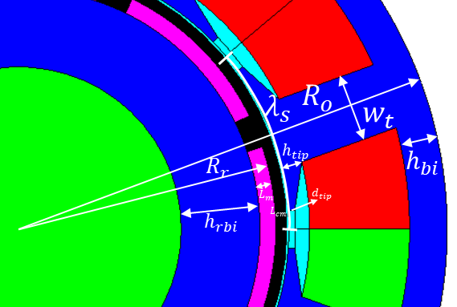
Figure 2.1 Illustration of machine dimensions
The various dimensions in Table 2.3 are not independent of each other, and the following relationships exist:
$$L_{g}=L_{gmech}+L_{cm}$$ | (2.1)
$$λ_{s}=\frac{2π(R_{r}+L_{g})}{N_{s}}≈\frac{2πR_{r}}{N_{s}}$$ | (2.2)
$$λ_{p}=\frac{2πR_{r}}{N_{p}}$$ | (2.3)
The analytical torque equation for a brushless AC permanent magnet machine can be expressed as [16]
$$T=\frac{π^{2}}{4\sqrt{2}}k_{w}B_{ave}Q_{rms}{D_{r}}^{2}L_{a}$$ | (2.4)
and an equivalent form of equation (2.4) is also introduced in [16]
$$T=k_{T}I_{rms}cos⁡(φ)=\frac{3}{\sqrt{2}}pk_{w}N_{ph}ϕ_{p}I_{rms}cos⁡(φ)$$ | (2.5)
To fully utilize the torque capability of the machine, the phase of the current waveform should be controlled such that it is in phase with the back-EMF waveform, i.e., $φ=0$. For a permanent magnet machine with 9 slots and 8 poles, the winding factor $k_{w}=0.945$.

Rotor radius calculation
Since each magnet pole spans 150⁰ (electric), the average flux density in the airgap needs to be modified according to:
$$B_{ave}=\frac{150}{180}B_{m}$$ | (2.6)
whereas the value of airgap flux density achieved is determined by the ratio of the magnet length to the overall effective magnetic airgap, a useful starting point (which also serves to ultimately provide a degree or resilience against demagnetization) is to assume that sufficient magnet length will be employed to achieve an airgap flux density which is some 80% of the remanence of the permanent magnet:
$$B_{m}=0.8B_{r}=0.8T$$ | (2.7)
Combining (2.6) and (2.7) yields:
$$B_{ave}=0.67T$$ | (2.8)
In brushless AC permanent magnet machine, and neglecting any leakage, the flux in the airgap under one stator tooth will pass into the tooth body. Therefore, the following analytical relation, albeit rather simplified, can be employed:
$$B_{t}w_{t}=B_{ave}λ_{s}$$ | (2.9)
To avoid undue saturation in the stator tooth, it is reasonable to set its width such that the flux density in the tooth body ($B_{t}$) is around the knee point of the $B-H$ curve of the core material, which is $\sim$1.8T for Cobalt iron. Therefore, combining (2.2) and (2.6) yields
$$w_{t}=\frac{B_{ave}λ_{s}}{B_{t}}=0.26R_{r}$$ | (2.10)
Similarly, the flux from one magnet pole will pass through the stator back-iron and return to the adjacent magnet pole, which results in the following relationship
$$2B_{bi}h_{bi}=B_{ave}λ_{p}$$ | (2.11)
As was the case with the tooth body, in order to avoid undue saturation in the back-iron, it is reasonable to set $B_{bi}$ to 1.8T
$$h_{bi}=\frac{B_{ave}λ_{p}}{2B_{bi}}=0.15R_{r}$$ | (2.12)
The following parameters can also be expressed in terms of $R_{r}$, based on similar flux path analysis and the limited flux carrying capability of the core material
$$h_{tip}=0.082R_{r}$$ | (2.13)
$$d_{tip}=0.026R_{r}$$ | (2.14)
Therefore, an expression for slot area can be obtained
$$A_{slot}={\left[π{\left(R_{o}-h_{bi}\right)}^{2}-π{R_{1}}^{2}\right]}/{N_{s}}-w_{t}\left(R_{o}-h_{bi}-R_{1}\right)$$ | (2.15)
where
$$R_{1}=\sqrt{{\left(\sqrt{{\left(R_{r}+L_{g}\right)}^{2}-{\left({w_{t}}/2\right)}^{2}}+h_{tip}\right)}^{2}+{\left({w_{t}}/2\right)}^{2}}=1.08R_{r}$$ | (2.16)
Combining (2.15) and (2.16) yields
$$A_{slot}=0.29{R_{r}}^{2}$$ | (2.17)
For each phase, the effective MMF can be calculated using
$$N_{ph}I_{rms}=0.5k_{p}J_{rms}A_{slot}×3$$ | (2.18)
Since the concentrated winding topology is selected, a relatively high value of slot fill factor can be achieved, leading to a high overall packing factor. Therefore, in this initial design, a value of 0.5 was assigned to the slot packing factor $k_{p}$. Substituting for $k_{p}$ into (2.18) together with the predefined phase current density, the MMF per phase can be obtained as
$$N_{ph}I_{rms}=2.14×{10}^{6}{R_{r}}^{2}$$
There is considerable freedom available in the selection of an aspect ratio for the rotor, i.e. the ratio of its axial length to outer diameter. In some cases, it may be necessary to employ a high ratio, e.g. to achieve high torque to inertia values for servo-drives or to limit centrifugal loading on the rotor in high speed applications. However, cooling in the middle section of the core can become a major issue in such machines. In order to provide a systematic framework for comparing design at this stage, the aspect radio is fixed for all machines belonging to one series, and two values have been adopted, the value of 1 by which the machine has a comparable axial length to the diameter, and the value of 2 by which smaller radial dimensions can be accepted to maintain the same level of torque capability, leading to smaller centrifugal force at the same high speed, and thus thinner rotor containment. For aspect ratio of 1,
$$L_{a}=D_{o}=2R_{o}=3.33R_{r}$$ | (2.19)
In (2.5), the pole flux $ϕ_{p}$ can be calculated by
$$ϕ_{p}=B_{ave}⋅\frac{2πR_{r}L_{a}}{N_{p}}=0.526R_{r}L_{a}=1.75{R_{r}}^{2}$$ | (2.20)
Combining (2.5) to (2.20) yields
$$T=3.01×{10}^{7}{R_{r}}^{4}$$ | (2.21)
Using the individual torque requirements for the 14 machines, the resulting rotor radii can be calculated using equation (2.21). By way of example, for machine design 1, the required torque is 2387Nm. Using equation (2.21) the corresponding rotor radius is
$$R_{r}=94.41mm$$
Having established a value for rotor radius, and recalling that the various design constraints enforce some dependant relationships, then substituting of $R_{r}$ into equations (2.10), (2.12), (2.13) and (2.14) yields many of the remaining dimensions, with the exception of the containment thickness, the magnet thickness, and the airgap radial thickness. Table 2.4 summarizes the magnitudes of the main dimensions of the machine from the analytical calculation.
Table 2.4 Summary of the analytical calculation of machine dimensions
Machine base speed rating (rpm) | Rotor radius (mm) | Stator outer radius (mm) | Axial length (mm) | Stator tooth width (mm) | Stator back iron thickness (mm)
1000 | 94.41 | 157.35 | 314.69 | 24.54 | 13.80
2000 | 79.39 | 132.31 | 264.62 | 20.63 | 11.61
3000 | 71.73 | 119.56 | 239.11 | 18.64 | 10.49
4000 | 66.76 | 111.26 | 222.52 | 17.35 | 9.76
5000 | 63.13 | 105.22 | 210.45 | 16.41 | 9.23
6000 | 60.32 | 100.54 | 201.07 | 15.68 | 8.82
7000 | 58.04 | 96.73 | 193.47 | 15.08 | 8.49
8000 | 56.14 | 93.56 | 187.12 | 14.59 | 8.21
9000 | 54.51 | 90.84 | 181.69 | 14.17 | 7.97
10000 | 53.09 | 88.48 | 176.96 | 13.80 | 7.76
11000 | 51.84 | 86.40 | 172.80 | 13.47 | 7.58
12000 | 50.72 | 84.54 | 169.08 | 13.18 | 7.42
13000 | 49.72 | 82.86 | 165.73 | 12.92 | 7.27
14000 | 48.81 | 81.34 | 162.69 | 12.68 | 7.14

Effective airgap thickness determination
In order to calculate the magnet thickness which will yield the desired airgap flux density, the effective airgap thickness needs to be first determined. However, as shown in equation (2.1), the effective airgap is composed of two parts, viz. the non-magnetic containment thickness and the actual mechanical clearance between the outer surface of the containment and the stator bore. However, this has the potential to become a circular problem as the containment thickness depends on the loading imposed by the dead-weight magnet segment, the value of which is itself dependant on the magnet thickness.
Given that some mechanical containment is necessary even in those machines with very modest levels of centrifugal loading (even if only to provide some environmental protection) a minimum containment thickness of 0.5mm was specified. Hence, within the design process, if the calculated containment thickness is smaller than this minimum value, then the containment thickness is simply set to this minimum. The mechanical clearance between the outer surface of the containment and the stator bore was set to 0.5mm in this design for all cases. This in turn gives rise to a minimum effective airgap thickness of 1mm.

Magnet thickness calculation
The required magnet thickness can be estimated based on an analytical equation derived from a simplified form of the machine magnetic circuit in the absence of stator currents [16]
$$B_{g}=\frac{B_{r}}{1+μ_{r}\frac{L_{g}}{L_{m}}}$$ | (2.22)
$B_{g}$ here is not the average airgap flux density, but the flux density in the airgap that is adjacent to the magnet face. Hence, $B_{g}=B_{m}=0.8B_{r}=0.8T$. Using equation (2.22) gives rise to:
$$L_{m}=4.2mm$$

Containment thickness calculation
An analytical equation derived from well-established theory for rotating cylinders is introduced in [17] in order to calculate the containment thickness required for a given combination of magnet mass, rotational speed and maximum containment stress criterion. The magnet is regarded as dead weight acting on the containment. The net stress on the containment, which can be estimated by super-position of the stress resulting from its own self-loading and the stress caused by the magnet, can be expressed as
$$σ_{max}=\frac{δ_{c}ω^{2}}{8}\left[\left(3+ν_{c}\right)\left(\frac{{d_{co}}^{2}}{2}+\frac{{d_{ci}}^{2}}{4}\right)-\left(1+3ν_{c}\right)\frac{{d_{ci}}^{2}}{4}\right]+\left(\frac{{d_{co}}^{2}+{d_{ci}}^{2}}{{d_{co}}^{2}-{d_{ci}}^{2}}\right)\left(\frac{m_{eq}r_{meq}ω^{2}}{πd_{mo}}\right)$$ | (2.23)
For an arc magnet, parameter $m_{eq}$ and $r_{meq}$ in (2.23) have the following expression
$$m_{eq}=\frac{π}{4}\left({d_{mo}}^{2}-{d_{mi}}^{2}\right)\left[\frac{αδ_{m}}{180}+\left(1-\frac{α}{180}\right)δ_{ip}\right]$$ | (2.24)
$$r_{meq}=\frac{\sqrt{2}}{2}\sqrt{\frac{{d_{mo}}^{4}-{d_{mi}}^{4}}{4\left({d_{mo}}^{2}-{d_{mi}}^{2}\right)}}$$ | (2.25)
The magnitudes of the physical properties in (2.23) – (2.25) are listed in Table 2.2, and a maximum 1GPa tensile stress is used for the carbon fibre containment. Since the inter-pole material is relatively light in weight, the mass density of the inter-pole material is neglected in the calculation, i.e. $δ_{ip}=0$. Geometrically, the following relationships exist
$$d_{ci}=d_{mo}=2R_{r}$$ | (2.26)
$$d_{co}=d_{ci}+L_{cm}$$ | (2.27)
$$d_{mi}=d_{mo}-L_{m}$$ | (2.28)
Since the rotating speed for each machine is not constant and varies over a 5:1 speed range, the containment need to be dimensioned to as to remain within its specific maximum stress criterion at the maximum operating speed. Therefore, the containment thickness is calculated from the maximum rotating speed of each machine. By way of example, for the lowest speed direct-drive machine (designated machine 1) with 4.2mm thick magnet
$$L_{cm}=0.074mm<0.5mm$$
Therefore, 0.5mm was adopted as the containment thickness of machine 1. However, for higher speed machines containment considerably exceed the minimum of 0.5mm. In such cases the effective airgap needs to be adjusted according to the calculated containment thickness, which in turn will result in a reduction in airgap flux density $B_{g}$. The nature of the relationship between the airgap flux density, the magnet thickness and the output torque will be explored in section 2.4.3 .
In the design of a machine to meet a specific torque-speed envelope and to operate with a particular converter voltage, it is necessary to set the number of turns per coil to provide a reasonable level of match to the supply. This requires detailed consideration of the mode of control, e.g. the extent to which field-weakening is used to meet the extended speed range etc. Moreover, it requires a detailed assessment of the influence of machine reactance (and to a lesser extent resistance) in order to ensure that rated current can be supplied within the voltage constraint imposed by the converter. However, in this study, the setting of a precise number of turns per coil for each and every design is not necessary in order to explore the relationship between torque or power density and rotational speed. Hence, the machine winding can be left as normalised 1 turn windings in the knowledge that the torque performance would not be compromised if the stator were wound with a particular combination of turns and conductor cross-section which meets the same packing factor.

Evaluation of the performance of the initial designs for constant current density and constant split ratio constraints

Back-EMF waveform
Having established the initial machine designs via analytical calculation for constant current density and split ratio constraints, the resulting dimensions were used in a finite element model to more precisely evaluate several elements of performance, starting with the back-EMF waveform. Figure 2.2 shows the predicted back-EMF waveform of the three phases in machine design 1 (i.e. the 1,000rpm base speed) with one turn per coil. As will be apparent, the waveform is far from purely sinusoidal, with the presence of several high order harmonics. Figure 2.3 shows the corresponding Fourier analysis of the back-EMF waveform at 1000rpm in which the 10% 3rd harmonic is the most significant component.
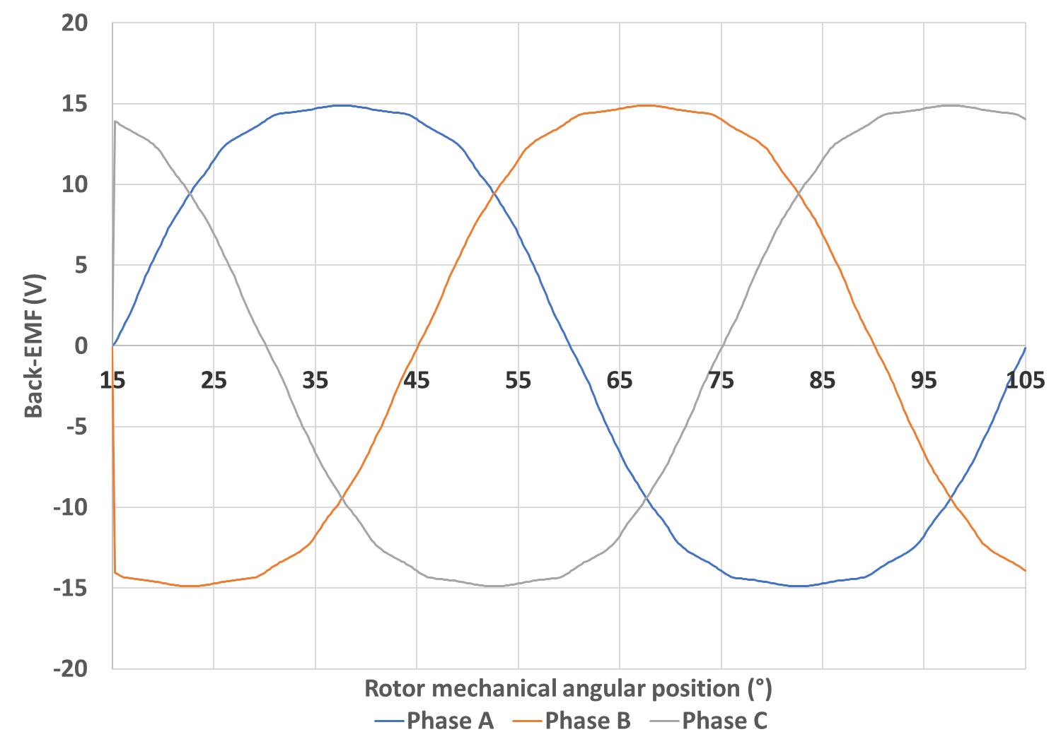
Figure 2.2 Back-EMF waveform of 3 phases at 1000rpm for machine design 1
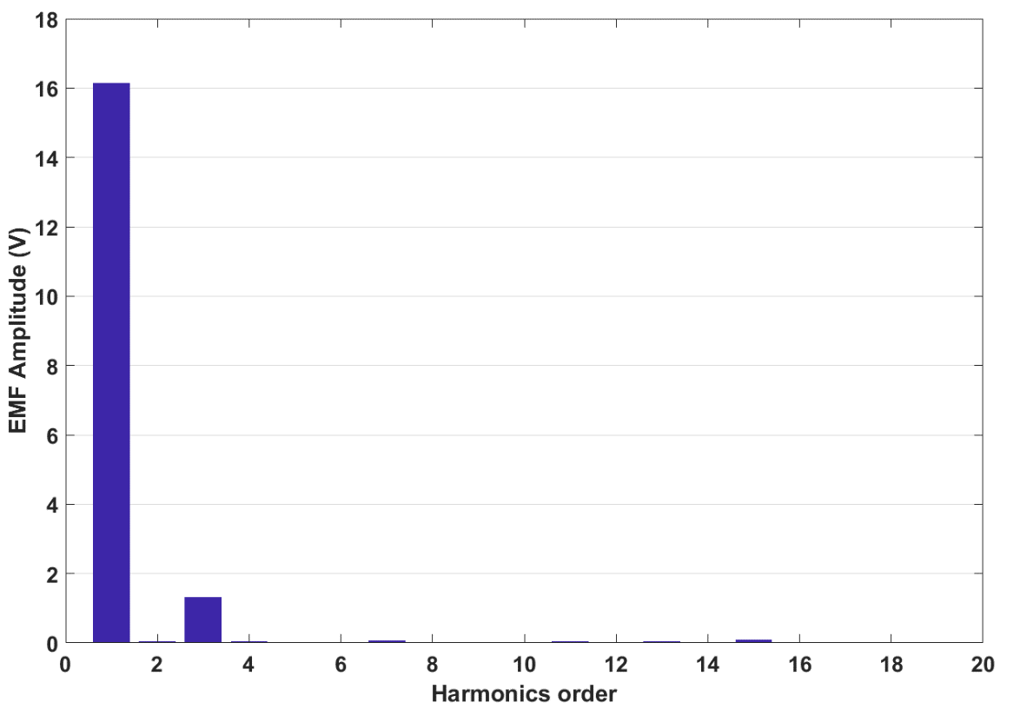
Figure 2.3 Fourier analysis of the back-EMF waveform of Figure 2.2

Torque waveform
As noted previously, the current waveform needs to be in phase with the back-EMF waveform in order to fully harness the torque capability of the machine. Figure 2.4 shows the resulting torque waveform for machine 1 when this condition is satisfied.
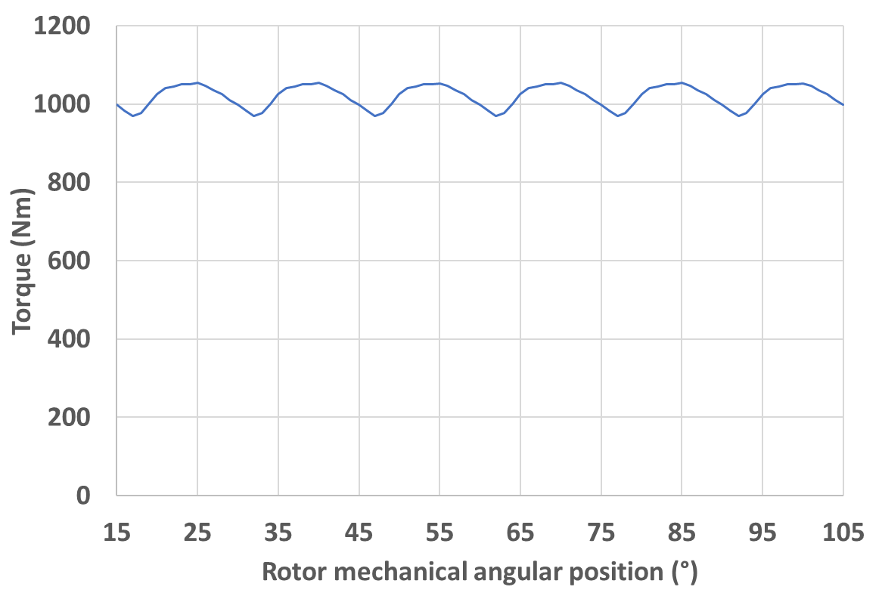
Figure 2.4 Torque waveform of machine design 1 at rated current density of 10A/mm² and operation speed 1000rpm

Combined design approach with FE analysis

Influence of magnet thickness on torque
As can be seen from Figure 2.4, the output torque of the initial design of machine 1 which was evaluated by FE analysis is lower than that predicted by the analytical expressions used to size the machine (as is often the case). Figure 2.5 shows the flux density distribution in the machine at a time instant corresponding to the 60 degree point in Figure 2.2, with instantaneous values of current of 0A, 1271.71A and -1271.71A in phases A, B and C respectively. It can be seen that the influence of the permanent magnet component of flux is dominant in regions where there is no current flow, i.e. in the vicinity of phase A. In these regions, the net flux density in the stator teeth is ~1.8T, which ensures that the analytical methods used to dimension the machine are likely to provide reasonable estimates of the stator flux. However, in regions in the vicinity of the teeth occupied by phase B and C in which high current is flowing, the flux in the stator core is strongly influenced by the armature flux produced by the stator current, a component which is not accounted for in the analytical calculation. Hence, for high current density designs, and hence electric loading designs, the armature flux may be sufficient to cause marked saturation of the stator core, in turn reducing the torque constant. One method to mitigate this problem is to increase the magnet thickness, thus reducing the sensitivity of the net flux to increases in stator core permeability.
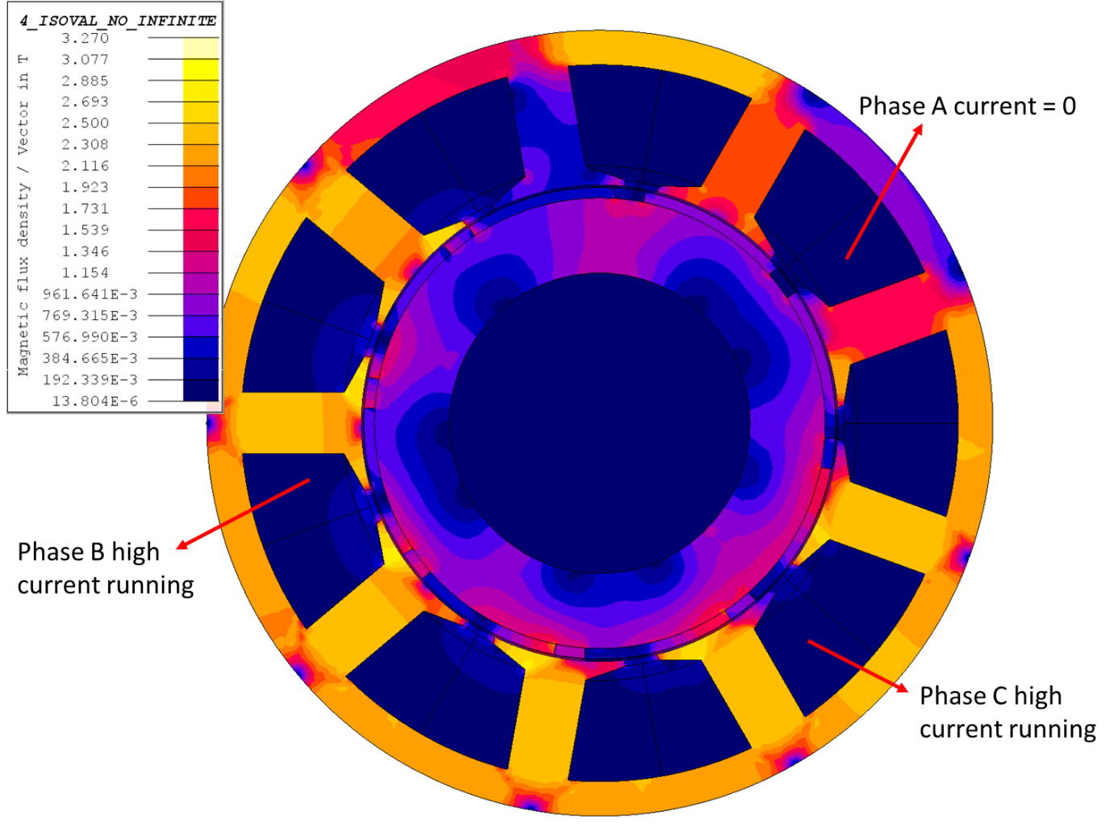
Figure 2.5 Flux density distribution in machine 1 with thin magnets (4.2mm)
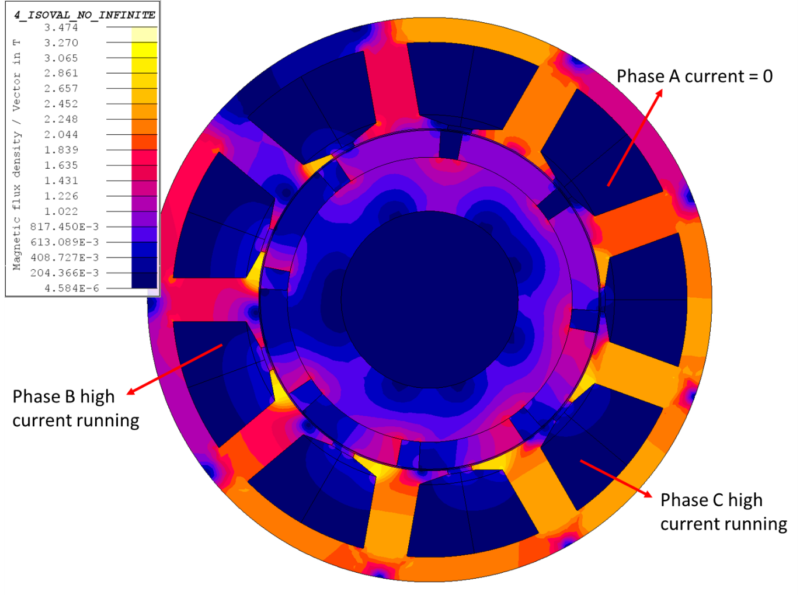
Figure 2.6 Flux density distribution in machine 1 with thick magnets (15mm)
Figure 2.7 shows the finite element predicted variation in torque as a function of magnet thickness for machine design 1. As machine 1 rotates at a relatively low speed, the calculated containment thickness required is below 0.5mm at all these magnet thicknesses, and is hence set to the minimum 0.5mm thickness. As would be expected, progressive gains in torque are gained with diminishing return as the magnet thickness is increased. Although it is somewhat a matter of judgement as the preferred magnet thickness, a reasonable criterion is to select a magnet thickness of 15mm which coincides with the ‘knee’ of the characteristic. Figure 2.6 shows the flux density distribution in machine 1 with 15mm thick magnet at the same time instant as shown in Figure 2.5. It is clear that a significant reduction in the influence of the armature reaction field on the material saturation have been achieved by increasing the magnet thickness. Inevitably, an increase in the open circuit flux density also happens, which can be seen in the vicinity of phase A, in which current is zero at this time instant.
The corresponding torque variations with magnet thickness for machine designs 2 to 14 are shown in Figure 2.8 and Figure 2.9. In contrast to the direct drive variant (machine 1) as the machine rated speeds increase progressively from designs 2 to 14, the containment thickness implications of increasing the magnet thickness increasingly play a role in reducing the flux density. Indeed, beyond a certain point, which varies from one machine design to another, the torque starts to drop. As was the case with machine design 1, for machine designs 2 to 14, a magnet thickness near the knee point of the torque versus magnet thickness is a reasonable point to select. The final selected magnet thickness and corresponding output torque and power for each machine are summarised in Table 2.5.
It is worth noticing that as the design speed rating increases, the knee point magnet thickness gradually decreases. This is the combined effect from both the reduced overall machine size, which would cause a proportional drop of magnet size for the same magnetic loading, and the increased containment thickness, which would significantly diminish the benefits of increasing the magnet thickness. Inevitably, a thinner magnet at the high speed end would be more vulnerable to demagnetization. However, such effect would be attenuated by the large effective airgap caused by big containment and reduced electrical loading due to reduced overall machine size [16]. Besides, the permanent magnet material selected for the design study, i.e. Sm₂Co₁₇ magnets, has very strong resistivity to demagnetization, with a coercivity of around 800kA/m, and a linear characteristic with no demagnetization knee point at the second quadrat of the B-H curve [13]. The above factors ensure not significant demagnetization would happen in the design study. Besides, as will be shown later, the extreme cases where only thin magnets are allowed are already beyond the optimum power density point. The further reduction of torque performance brought by the demagnetization would not have significant influence on the obtained characteristic of the torque density and power density variation. Hence, the demagnetization of each machine would not be discussed into very detail in this study.
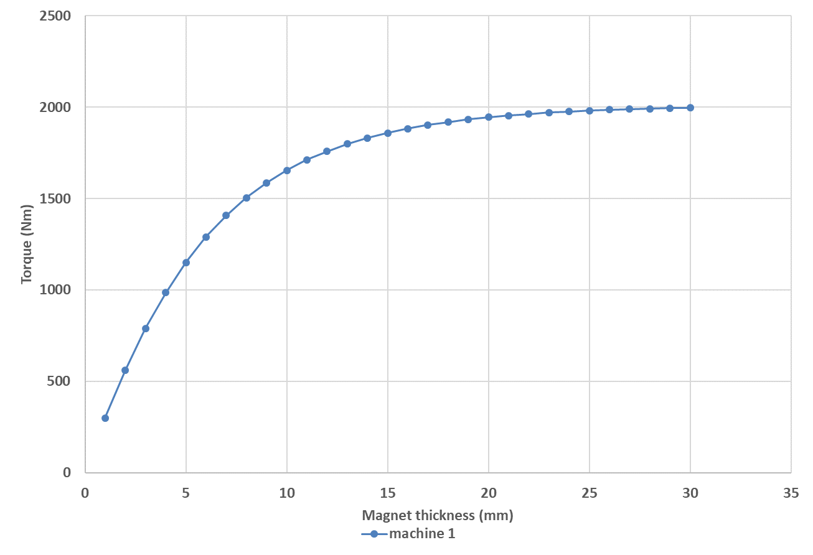
Figure 2.7 Torque variation with magnet thickness (machine 1)
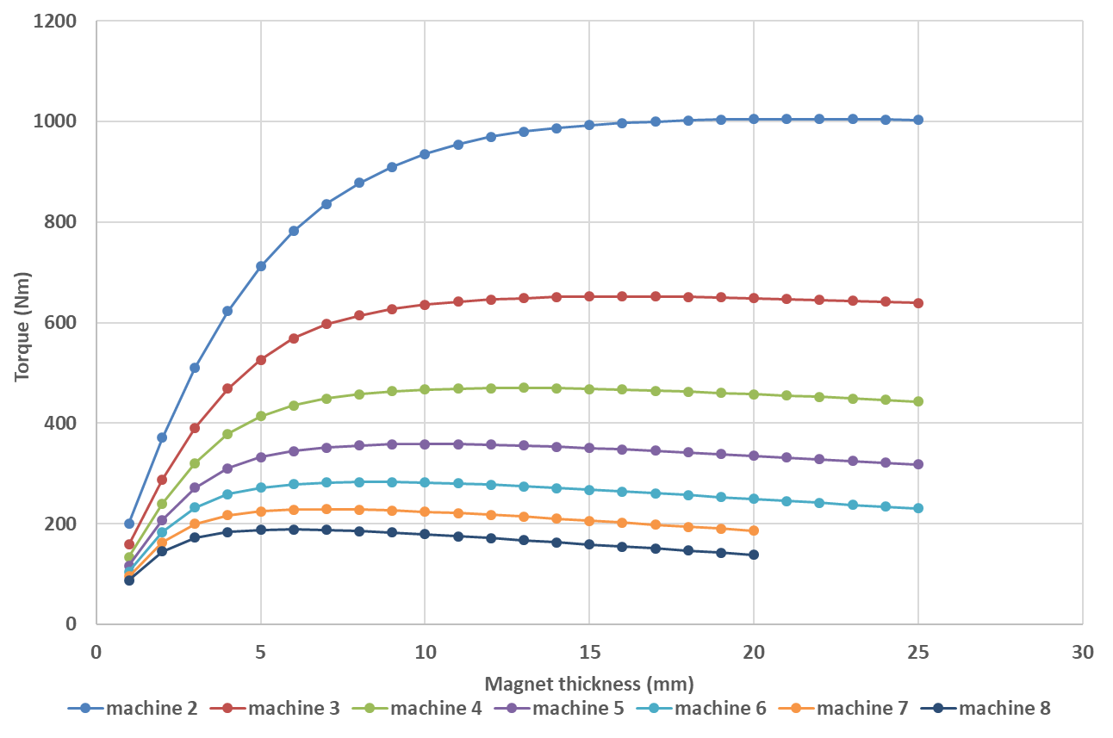
Figure 2.8 Torque variation with magnet thickness (machine 2 to 8)
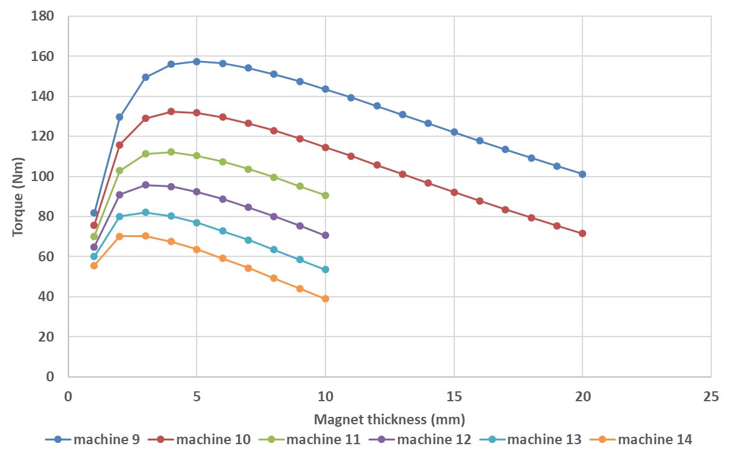
Figure 2.9 Torque variation with magnet thickness (machine 9 to 14)
Table 2.5 The output torque and power of each machine after magnet thickness increase
Machine base speed rating (rpm) | Magnet thickness (mm) | Output torque (Nm) | Output power (kW)
1000 | 15 | 1859.48 | 194.72
2000 | 12 | 969.76 | 203.11
3000 | 10 | 635.52 | 199.65
4000 | 8 | 457.79 | 191.76
5000 | 7 | 351.79 | 184.20
6000 | 6 | 278.78 | 175.16
7000 | 5 | 225.28 | 165.14
8000 | 5 | 187.98 | 157.48
9000 | 4 | 155.92 | 146.95
10000 | 4 | 132.36 | 138.60
11000 | 3 | 111.31 | 128.23
12000 | 3 | 95.74 | 120.31
13000 | 3 | 82.09 | 111.75
14000 | 2 | 70.07 | 102.72

Electromagnetic split ratio and mechanical split ratio
As can be seen from Table 2.5, the output power of each machine design produced with constant current density and split ratio, even after increasing the magnet thickness still do not reach the required 250kW power rating for this design study. The are several potential contributions to these shortfalls.
The first is that the initial dimensions are selected on the basis of open-circuit conditions, in which the average point of the cores are set close to the knee point of the core initial magnetisation curve. However, at a current density level of 10A/mm², the armature flux cannot be set-aside when the machine is at full load condition. The additional flux density in the core, which could be sufficient to produce significant magnetic saturation and cause the output torque from the finite element analysis to be lower than the predicted value from analytical method.
Secondly, the analytical sizing method is underpinned by a simplified one-dimensional expression for the airgap flux density, and since the airgap, which includes the mechanical clearance and the containment, is usually ignorable compared to other dimensions, it is a good approximation to let the stator inner bore radius equal to the rotor outer radius, and thus simplifies the calculation. However, as the machine speed increases, the containment thickness becomes significant and so is the airgap. Such increment, though still cannot make airgap thickness comparable to other machine dimensions, could significantly change the flux flow in the airgap, making it more two dimensional and causing bigger inter-pole leakage. Therefore, the output torque given by the FE model, which considers the above effect, would produce a lower torque than the analytical predicted. However, the analytical method gives an insight of the dependence of torque on the machine size. Combined with FE analysis, the effect of armature reaction and transient saturation in the core material can be considered and the ultimate design reaching the requirement for each machine can be achieved.
The methodology based on this combination of finite element analysis and analytical calculation is shown schematically in Figure 2.10. It is based on an iterative process which starts with an initial estimate of the rotor radius, following which the other stator and rotor dimensions except magnet thickness and containment thickness can be established by analytical calculation, as demonstrated previously. The analytically calculated rotor radius is set as the starting point of the iteration, and the magnet thickness is initially set to 1mm. The two parameters are then serve as input into tensile stress calculation for rotor containment using the theory in section 2.4.1.4 , from which a corresponding containment thickness can be obtained.
The calculated dimensions are then input into a parameterised finite element model in order to predict the electromagnetic torque. At each rotor radius, a sweep of the magnet thickness across a prescribed magnitude range is carried out, with containment thickness adjusted for each magnitude. This allows the variation in torque with magnet thickness to be obtained, which is similar to Figure 2.7 to Figure 2.9 shown previously. An optimal magnet thickness can then be selected around the knee point of the curve and the corresponding torque is compared with the rated value. If there is a significant deviation between the two values, the rotor radius will be adjusted and another iteration performed. By repeated iteration, a design with torque performance close to the requirement will be obtained.
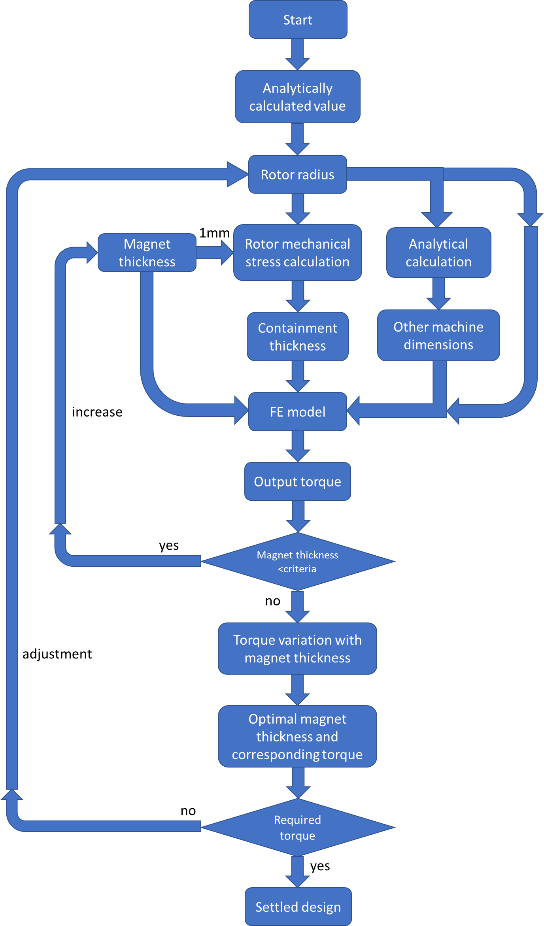
Figure 2.10 Schematic diagram of the combined design method
A precise and consistent definition of split ratio is important during the design process since the containment thickness required increases rapidly with machine operation speed and magnet thickness. Not only does the resulting increase in the effective magnetic airgap diminish electromagnetic performance, but it also occupies more space in the rotor for a fixed overall size. There are two options to accommodate the increase in thickness of rotor containment in terms of defining a split ratio. As is well established in general theory, the torque of a permanent magnet machine is produced by the tangential Maxwell stress operating on the surface of the rotor magnets, which means the regions of the rotor up to the magnet outer surface make contribution to the torque production. Hence, a useful definition can be based as defining the useful electromagnetic radius of the rotor as $R_{r}$ in equation (2.21). This is denoted as the electromagnetic rotor radius in the remainder of this chapter. However, the actual rotating elements of the rotor also includes the rotor containment sleeve, which only provides mechanical function and makes no contribution to the torque production. The overall rotor radius which includes the containment and is greater than the electromagnetic radius, is denoted as mechanical rotor radius in the remainder of this chapter.
Correspondingly, there are two definitions of the split ratio, i.e. electromagnetic split ratio, which represents the ratio of electrical rotor radius to the stator outer radius, and mechanical split ratio, which represents the ratio of mechanical rotor radius to the stator outer radius. Figure 2.11 shows two machine cross-sections, which are for high-speed designs with thick magnets, which have the same split ratio but for the two definitions. This is the most extreme case encountered in the design study, but it nevertheless illustrates the importance of a precise definition of the split ratio.
Therefore, for constant split ratio and current density design constraints, if the electromagnetic split ratio is adopted as the definition, this means the distance between magnet outer surface and stator outer surface is fixed in ratio, then an increase in containment thickness would squeeze the area available to accommodate the stator slots and teeth, causing a drop in electrical loading but maintaining a larger rotor radius for torque production. In contrast, if the mechanical split ratio is adopted, this means the distance between the containment outer surface and stator outer surface is fixed in ratio, then any increase in containment thickness squeezes the area of the remaining rotor structure, causing a reduction of the rotor radius which contributes to the torque production, but maintains the electrical loading.

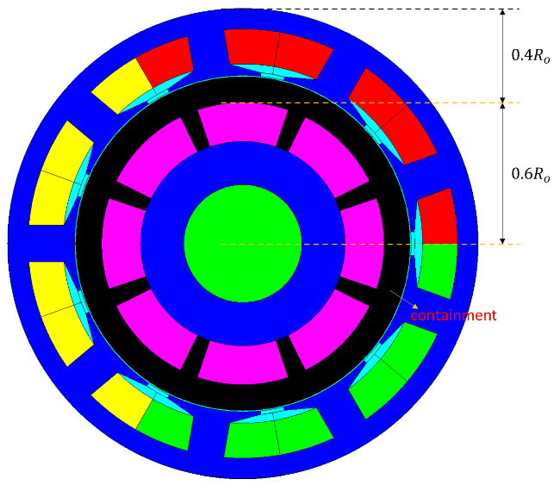 | 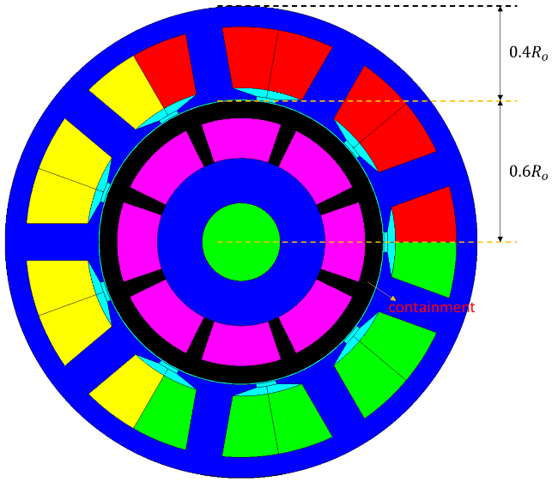
Electromagnetic split ratio = 0.6 | Mechanical split ratio = 0.6
Figure 2.11 Extreme cases for difference in split ratio definitions

Torque density and power density variation with machine speed rating using electromagnetic split ratio
Using the design process described in the above section, a series of refined designs for each base speed from 1,000rpm to 14,000rpm was obtained for an electromagnetic split ratio of 0.6. The variation of torque with magnet thickness for each the 14 different machines in the final design are shown in Figure 2.12, Figure 2.13, and Figure 2.14. Table 2.6 summarises the key dimensions and performance of the final designs.
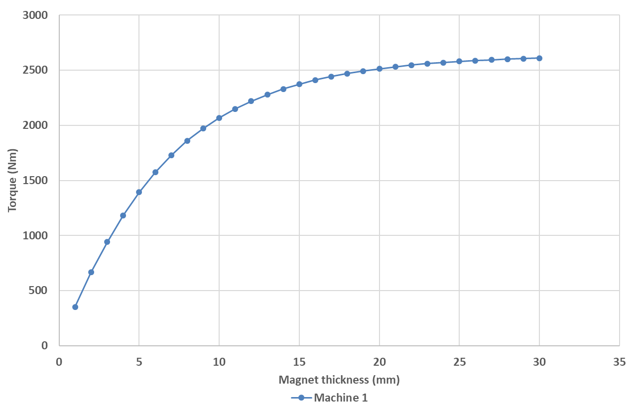
Figure 2.12 Torque variation with magnet thickness (machine 1)
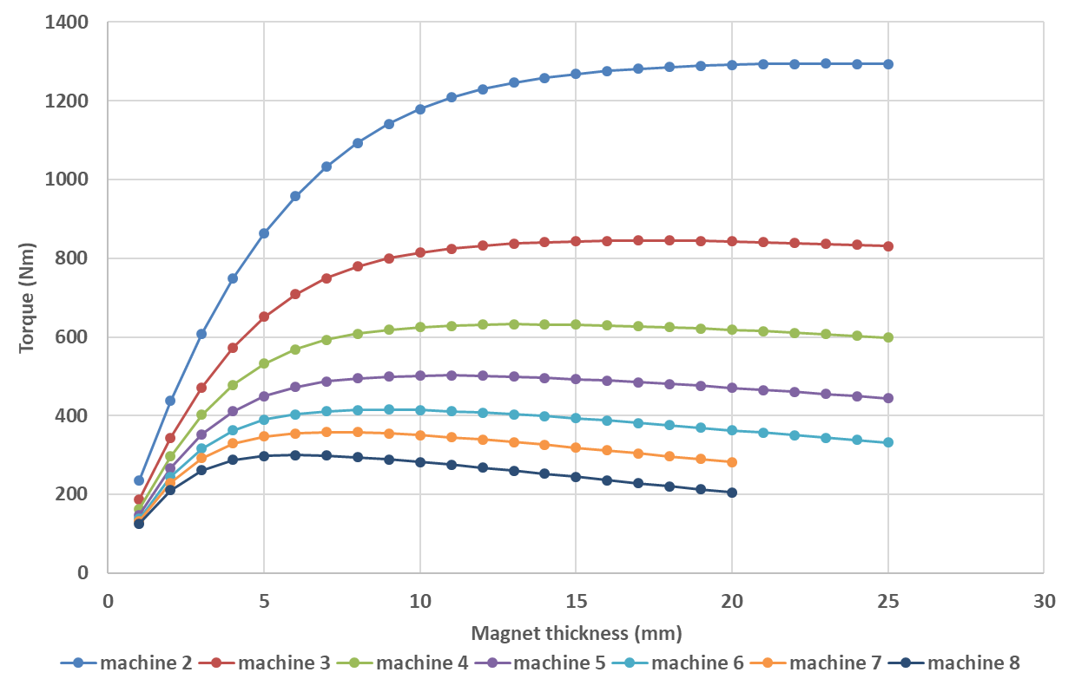
Figure 2.13 Torque variation with magnet thickness (machine 2 to 8)
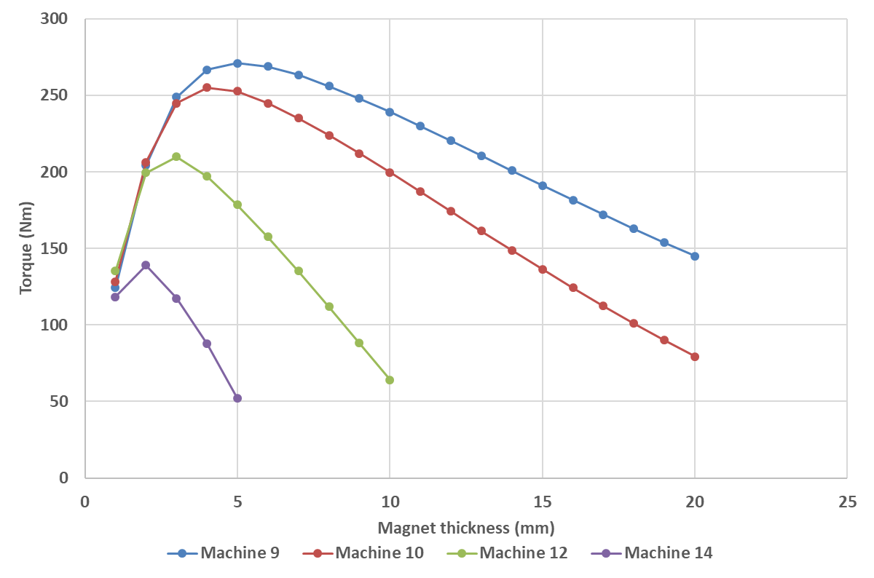
Figure 2.14 Torque variation with magnet thickness (machine 9 to 14)
Table 2.6 Key parameters of the final design of the machine series using a fixed electromagnetic split ratio of 0.6
Machine number | Electromagnetic rotor radius (mm) | Stator outer radius (mm) | Magnet thickness (mm) | Containment thickness (mm) | Torque (Nm) | Power (kW)
1 | 101.50 | 169.17 | 15.0 | 0.50 | 2375.51 | 248.76
2 | 85.00 | 141.67 | 12.0 | 0.57 | 1229.90 | 257.59
3 | 77.00 | 128.33 | 10.0 | 0.89 | 813.52 | 255.57
4 | 72.50 | 120.83 | 8.0 | 1.15 | 607.63 | 254.52
5 | 69.50 | 115.83 | 7.0 | 1.49 | 486.68 | 254.83
6 | 67.50 | 112.50 | 6.0 | 1.78 | 403.52 | 253.54
7 | 66.50 | 110.84 | 5.0 | 2.03 | 347.31 | 254.59
8 | 65.00 | 108.33 | 5.0 | 2.61 | 297.42 | 249.16
9 | 65.30 | 108.83 | 4.0 | 2.81 | 266.78 | 251.43
10 | 67.00 | 111.67 | 3.0 | 2.93 | 244.84 | 256.40
12 | 71.00 | 118.33 | 2.0 | 3.85 | 199.38 | 250.55
14 | 71.00 | 118.33 | 2.0 | 6.74 | 138.92 | 203.67

As will be apparent, in the case of a machine design for a base-speed of 14,000rpm, the maximum power achieved was limited to 203kW, falling well short of the 250kW specification. When the electromagnetic split ratio is fixed at 0.6, the containment thickness required to accommodate the 70,000rpm maximum speed dramatically reduces the airgap flux density, the stator cross-sectional area and electrical loading. There is little or no scope to increase the rotor radius beyond 71mm. The only means by which 250kW could be realised with this combination of current density and speed would be to relax the constraint on the aspect ratio and increase the axial length.
Figure 2.15 and Figure 2.16 show the variation in the torque density and power density for these designs, which are based on a fixed current density of 10A/mm² and a fixed electromagnetic split ratio of 0.6. Several interesting observations can be drawn from the trends shown in Figure 2.15 and Figure 2.16. As the machine operating speed increases, the power density tends to increase. Indeed, if the torque density remained constant then there would be a simple proportional relationship between power density and rotation speed. However, it is clear that the torque density is not constant for different machine operating speeds, and decreases with increasing speed rating. This behaviour is largely governed by two aspects for this set of design constraints, which are the increasing containment thickness which increases the effective magnetic airgap and the inherent scaling behaviour of torque density which tends to favour larger machines. Since there is no penalty attributed to core loss in this particular set of constraints, there is no influence of core loss on the behaviour shown in Figure 2.16. At a particular operating speed rating (~8000-9000prm in this case) the power density no longer benefits from further speed increases. The maximum power density for this series of machine designs using an electromagnetic split ratio of 0.6 is reached at around 8000rpm with the magnitude around 4.51kW/kg (mass based on active mass only). This achieved power density might not be high compared to a machine designed to operate specifically at the speed rating of 8000rpm, since the requirement of constant power over a speed range needs the mechanical containment to cope with the centrifugal force at both the low and high end of the speed range, which means increased containment thickness is required compared to machine operating only at 8000rpm, and performance reduction is inevitable.
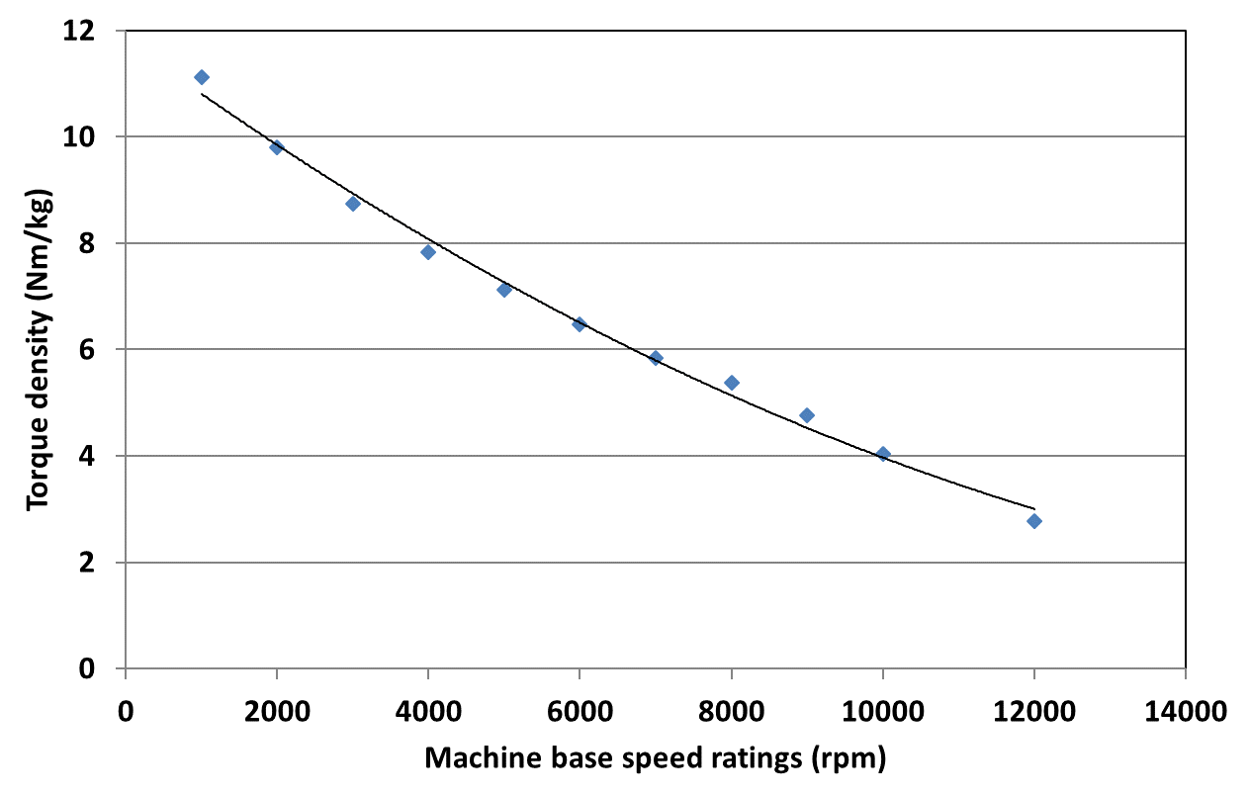
Figure 2.15 Torque density variation with machine speed rating for constant electromagnetic split ratio design
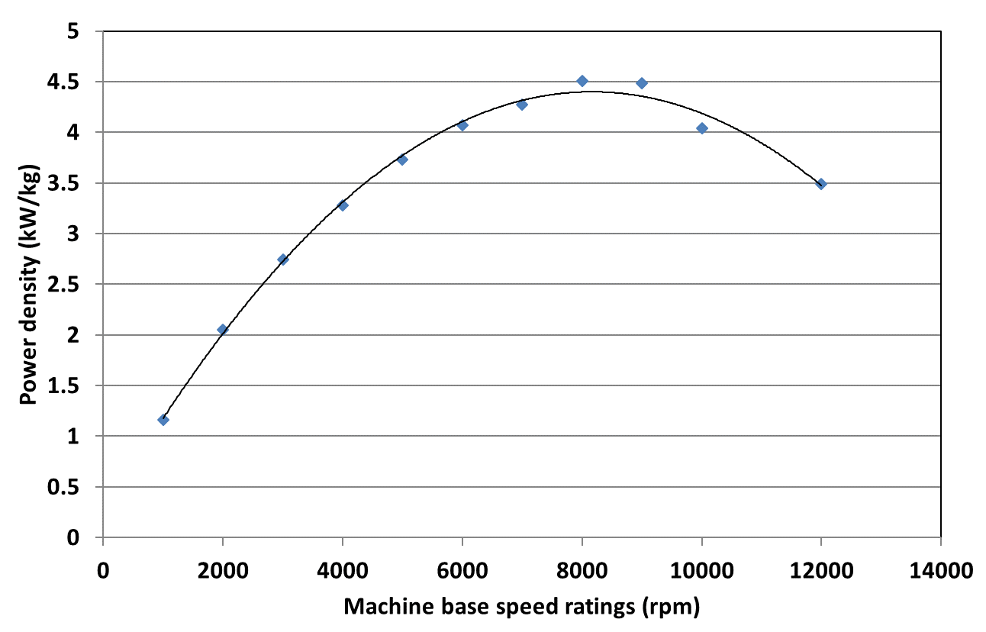
Figure 2.16 Power density variation with machine speed rating for constant electromagnetic split ratio design

Torque density and power density variation with machine speed ratings using mechanical split ratio
Using the design process described previously in section 2.4.3.2 , a further series of machines were designed using a fixed mechanical split ratio of 0.6 and a fixed stator current density of 10A/mm². Figure 2.17 to Figure 2.19 shows the torque variation with magnet thickness for each machine in the series machine. The leading dimensions and performance characteristics are summarised in Table 2.7.
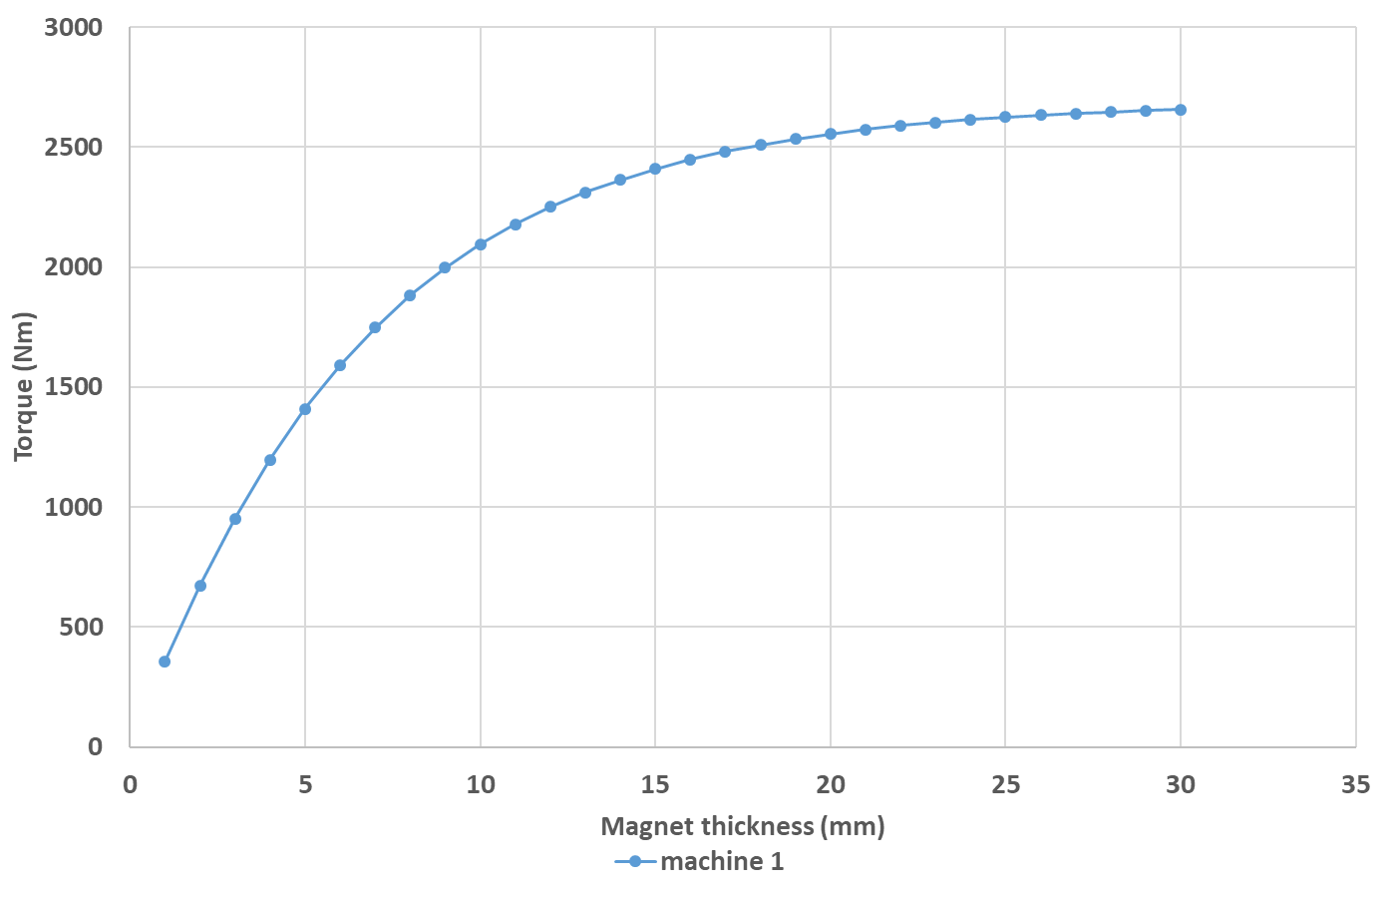
Figure 2.17 Torque variation with machine operating speed rating (machine 1)
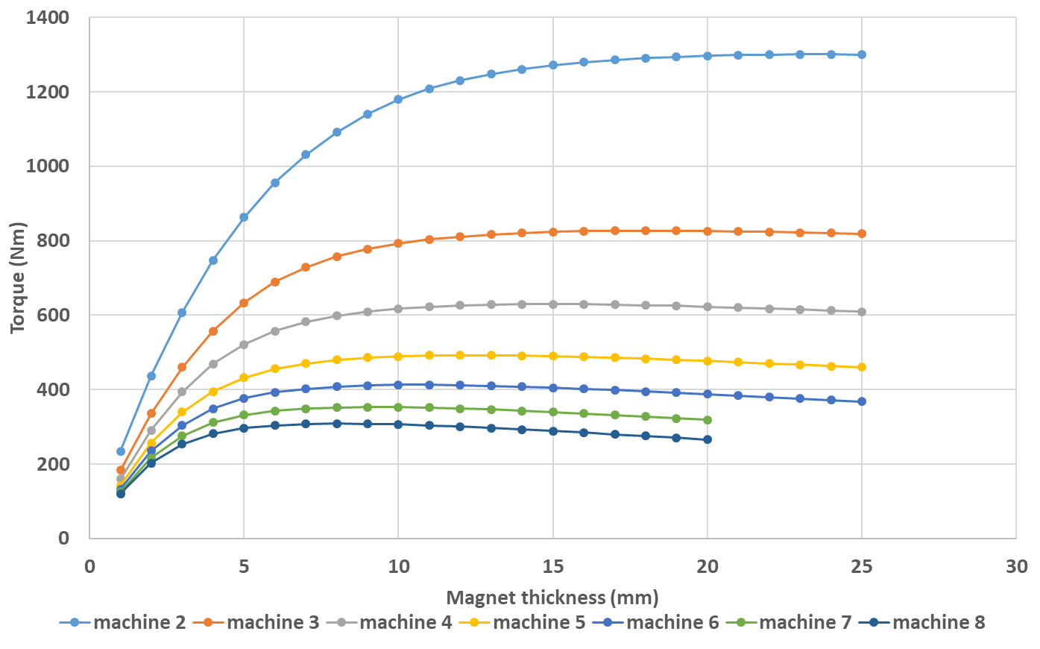
Figure 2.18 Torque variation with machine operating speed rating (machine 2 to 8)
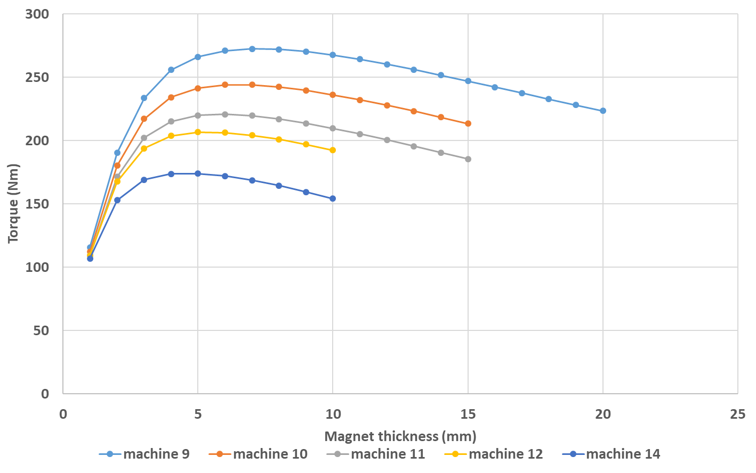
Figure 2.19 Torque variation with machine operating speed rating (machines 9 to 14)

Table 2.7 Key parameters of the final design of machine series using mechanical split ratio
Machine number | Mechanical rotor radius (mm) | Stator outer radius (mm) | Magnet thickness (mm) | Containment thickness (mm) | Torque (Nm) | Power (kW)
1 | 102.00 | 170.00 | 15 | 0.50 | 2408.95 | 252.26
2 | 85.00 | 141.67 | 12 | 0.56 | 1230.65 | 257.75
3 | 76.30 | 127.17 | 11 | 0.93 | 803.52 | 252.43
4 | 72.00 | 120.00 | 10 | 1.35 | 617.47 | 258.65
5 | 68.50 | 114.17 | 9 | 1.73 | 485.83 | 254.38
6 | 66.50 | 110.83 | 8 | 2.11 | 407.98 | 256.34
7 | 65.00 | 108.33 | 7 | 2.45 | 348.95 | 255.79
8 | 64.00 | 106.67 | 6 | 2.72 | 303.85 | 254.56
9 | 63.30 | 105.50 | 6 | 3.39 | 270.90 | 255.32
10 | 63.00 | 105.00 | 5 | 3.59 | 241.40 | 252.80
11 | 63.00 | 105.00 | 5 | 4.41 | 219.88 | 253.29
12 | 64.00 | 106.67 | 4 | 4.61 | 203.63 | 255.88
14 | 66.00 | 110.00 | 4 | 7.13 | 173.74 | 254.72

As can be seen from Figure 2.12 to Figure 2.14, and Figure 2.17 to Figure 2.19, at low speed end, the machine series with the 0.6 mechanical split ratio has similar torque variation curve with the series using the electromagnetic split ratio of 0.6, since the two radiuses, i.e. electromagnetic rotor radius and mechanical rotor radius, are very close at low speed, and hence there is little difference between the two split ratios. However, at the high speed end, differences appear between the curves for the two different split ratio definitions, with the knee point of the curve for mechanical split ratio moving rightwards compared to the curve for electromagnetic split ratio. This is because the machines designed with a fixed mechanical split ratio has smaller electromagnetic rotor radius than the machines based on a fixed electromagnetic split ratio, since the space used to accommodate the increasing containment is now taken from the rotor, and hence reduces the containment thickness for a given rotational speed. This in turns allows thicker magnets to be used to enhance the airgap flux density.
Of particular note in the series of designs with the fixed mechanical split ratio is that it is now possible to realise a 14,000rpm base speed design within the aspect ratio constraint. This is due to the capability of accommodating thicker magnets at such speed compared to the circumstance of constant electromagnetic split ratio design, due to reasons demonstrated above, introduces additional excitation from the magnet remanence, and no loss of electric loading, since squeezing the stator region is no longer needed to accommodate the substantial containment, guarantees enough excitation from the stator armature. The increase of the two excitation source compared to the constant electromagnetic split ratio design, where the two excitation is dramatically reduced, ensures even under constrained machine overall dimensions, and such a high speed (14000rpm base speed up to 70000rpm top speed), the power rating of 250kW is still achievable.
The torque density and power density for each machine in the series with a fixed mechanical split ratio of 0.6 are shown in Figure 2.20 and Figure 2.21, together with the corresponding curves for a fixed electromagnetic split ratio of 0.6. The machine series with a fixed mechanical split ratio has similar torque density for the lower base speeds as those with a fixed electromagnetic split ratio. However, for designs with the higher end base speeds, those derived with a fixed mechanical split ratio exhibit an advantage compared the machine series with electromagnetic split ratio.
A maximum power density of 5.18kW/kg is achieved by the fixed mechanical split ratio design that has a base speed of 11000rpm. It is worth noting that other than fixing a current density of 10A/mm² thermal consideration have not featured in the optimisation of these series of designs.

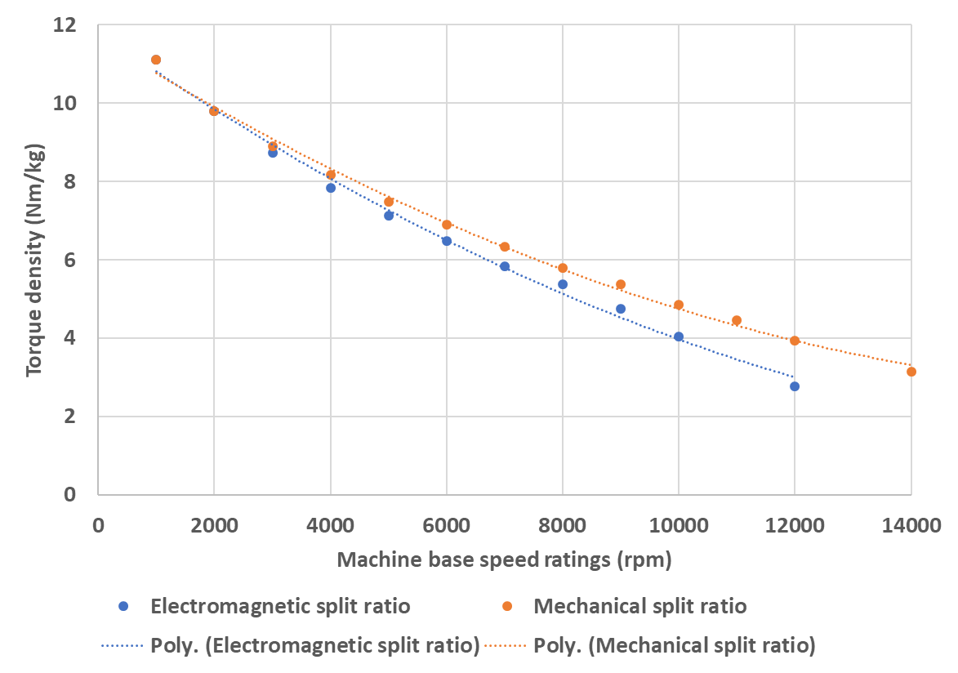
Figure 2.20 Torque density variation with machine speed rating
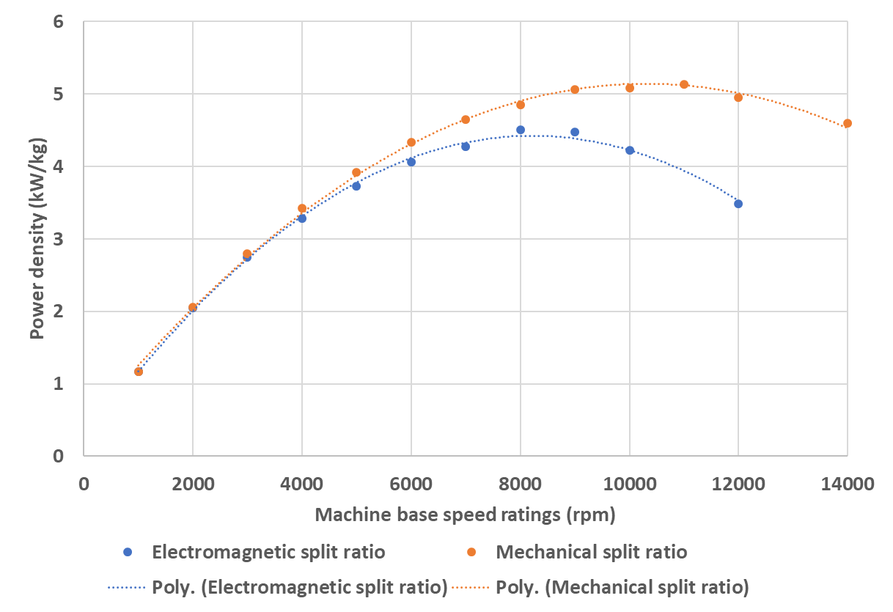
Figure 2.21 Power density variation with machine speed rating

Machine losses
The copper loss of a given machine can be calculated analytically, assuming that the concentrated coil end windings at each end of the machine can be approximated as semi-circles:
$$P_{cu}={J_{rms}}^{2}⋅k_{p}A_{slot}⋅ρ_{cu}\left(L_{a}+\frac{π}{2}w_{t}\right)×N_{s}$$ | (2.29)
The iron loss of the machine can be obtained from the post processing solutions time-stepped finite element analysis, using the temporal variation of the flux density value in each individual element. The core loss is predicted using the method developed in [18] by means of a stand-alone MATLAB post processor. For the purposes of the design studies in this chapter, a purely sinusoidal current waveform is used for the calculation of iron loss. The issue of iron loss due to current ripple will be revisited in Chapter 4 .
Figure 2.22 shows the variation of machine losses for each of the machine designs established using a fixed electromagnetic split ratio of 0.6. As can be seen, at low speed end, copper loss is the dominant component. However, as machine size reduces with increasing machine speed, copper loss reduces and iron loss becomes progressively more important. Beyond the base speed rating where the maximum power density is reached, the machine size starts to increase again as does the copper loss. However, the rapid increase in iron loss for successive designs, caused by a combination of increased speed and machine size, eventually leads to iron loss exceeding copper loss.
The corresponding loss per unit machine total mass and the loss per unit surface area of the core back for each machine, which are useful in assessing the relative challenges involved in the thermal management of the various designs, are shown in Figure 2.23 and Figure 2.24, respectively. The copper loss per unit machine total mass stays roughly the same throughout the speed rating range, the reason of which will be explained later in an analytical way. The increase in iron loss per unit machine total mass with machine speed (and hence electrical frequency) leads to an increase of overall machine loss per unit machine total mass.
It can be seen that the machine design series with the fixed mechanical split ratio has similar, but slightly higher, losses than the corresponding machine designs with the fixed electromagnetic split ratio at least up the speed rating where the maximum power density in machine series with electromagnetic split ratio is reached. This is a consequence of the higher electric loading in machines with mechanical split ratio. However, beyond 8000rpm or so, the increase in machine size for the electromagnetic split ratio designs causes a more rapid increase of the various losses, leading to a significant deviation of loss level between the two machine series.

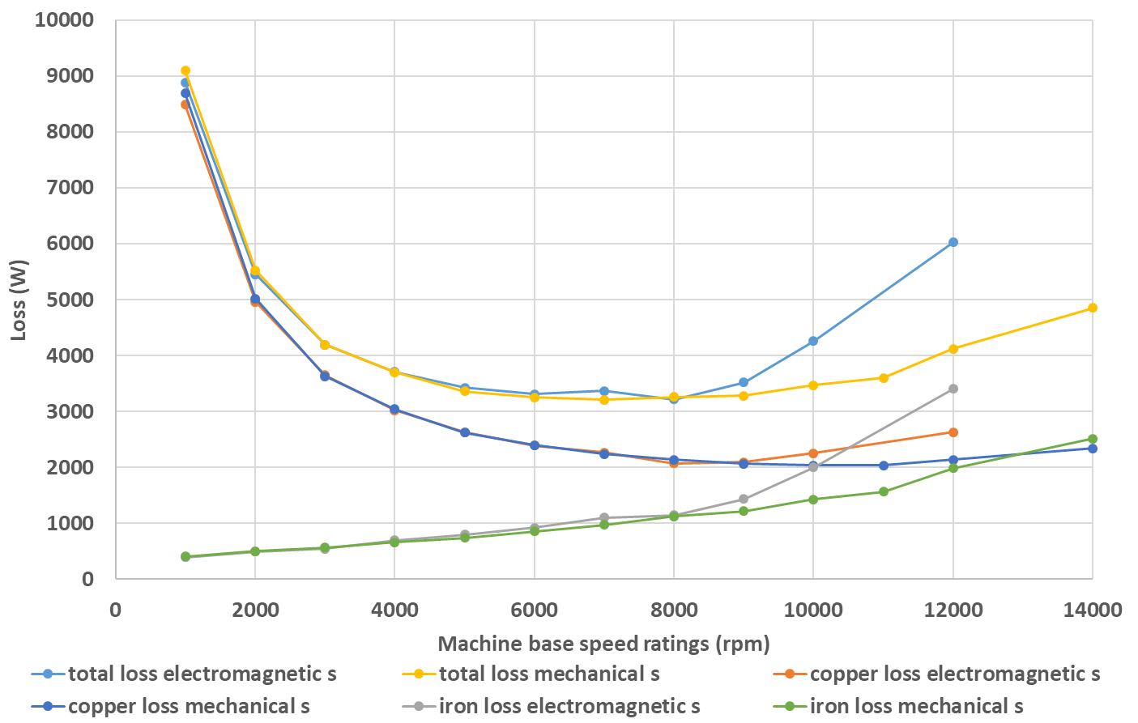
Figure 2.22 Losses of machine series using electromagnetic split ratio and mechanical split ratio
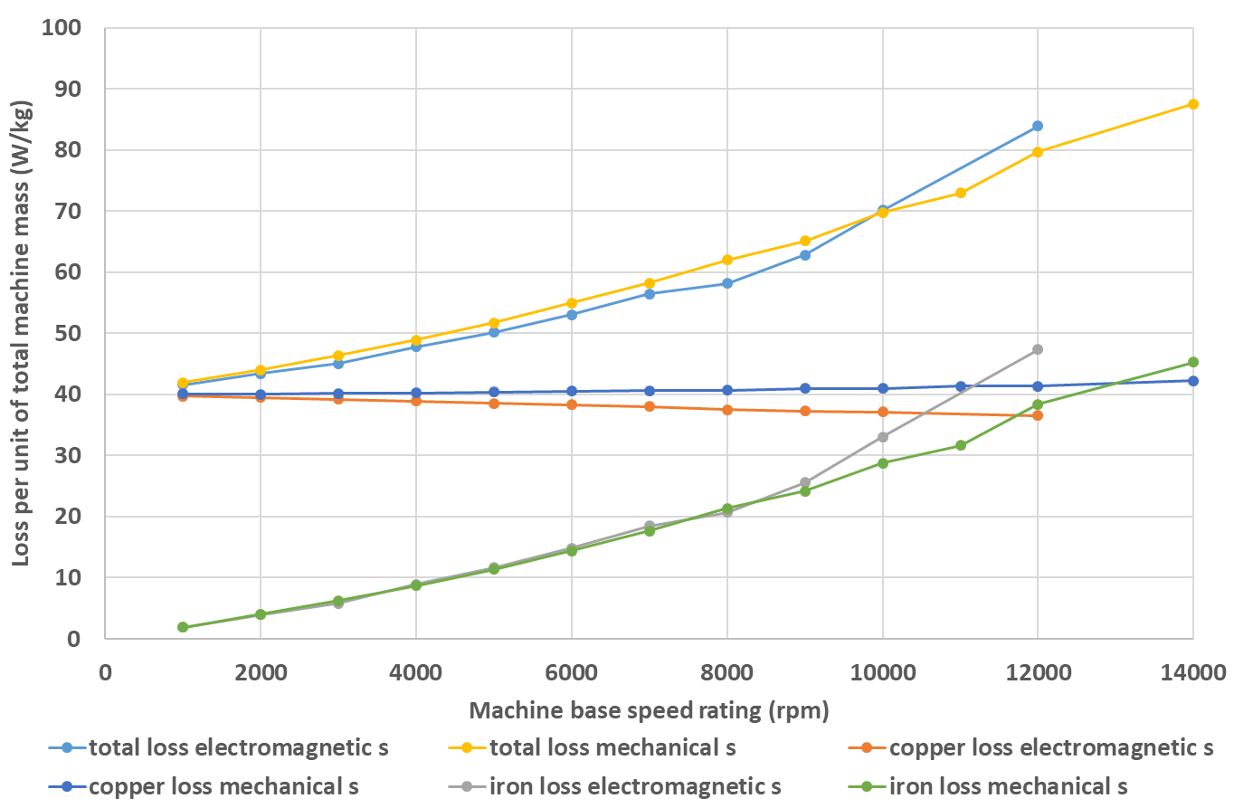
Figure 2.23 Loss per unit of total machine mass for machine series using electromagnetic split ratio and mechanical split ratio
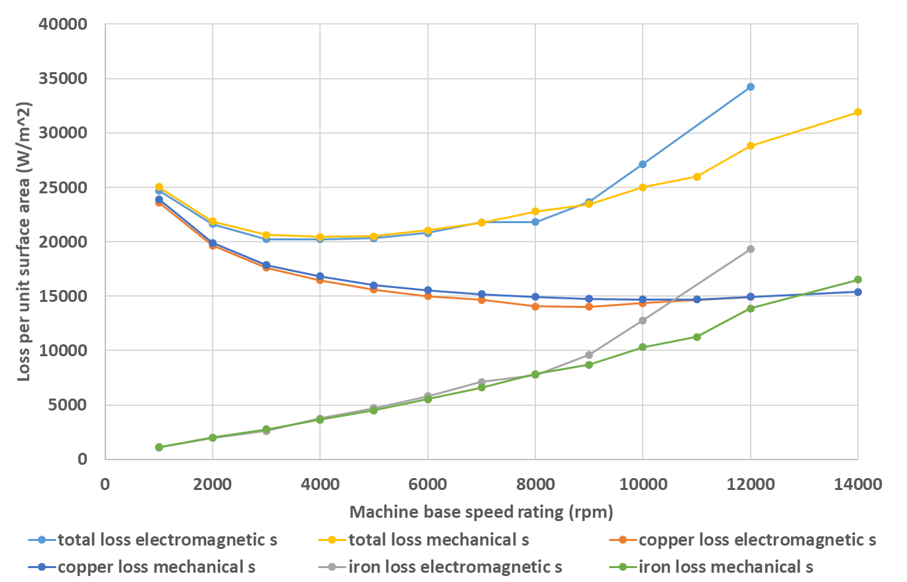
Figure 2.24 Loss per unit surface area of machine series using electromagnetic split ratio and mechanical split ratio
Another interesting outcome of the design study is the effective mass density of the machine. A practical machine consists of a combination of stator and rotor cores (7800-8000 kg/m³), coils (8900 kg/m³ at some prescribed packing factor) and rotor magnets (8000 kg/m³) in various proportions. However, as illustrated by Figure 2.25, although the cross-sections do vary in proportions, the effective mass density of the machines is reasonably consistent at around 7000 kg/m³ (which itself is an interesting finding for future first order trade studies).
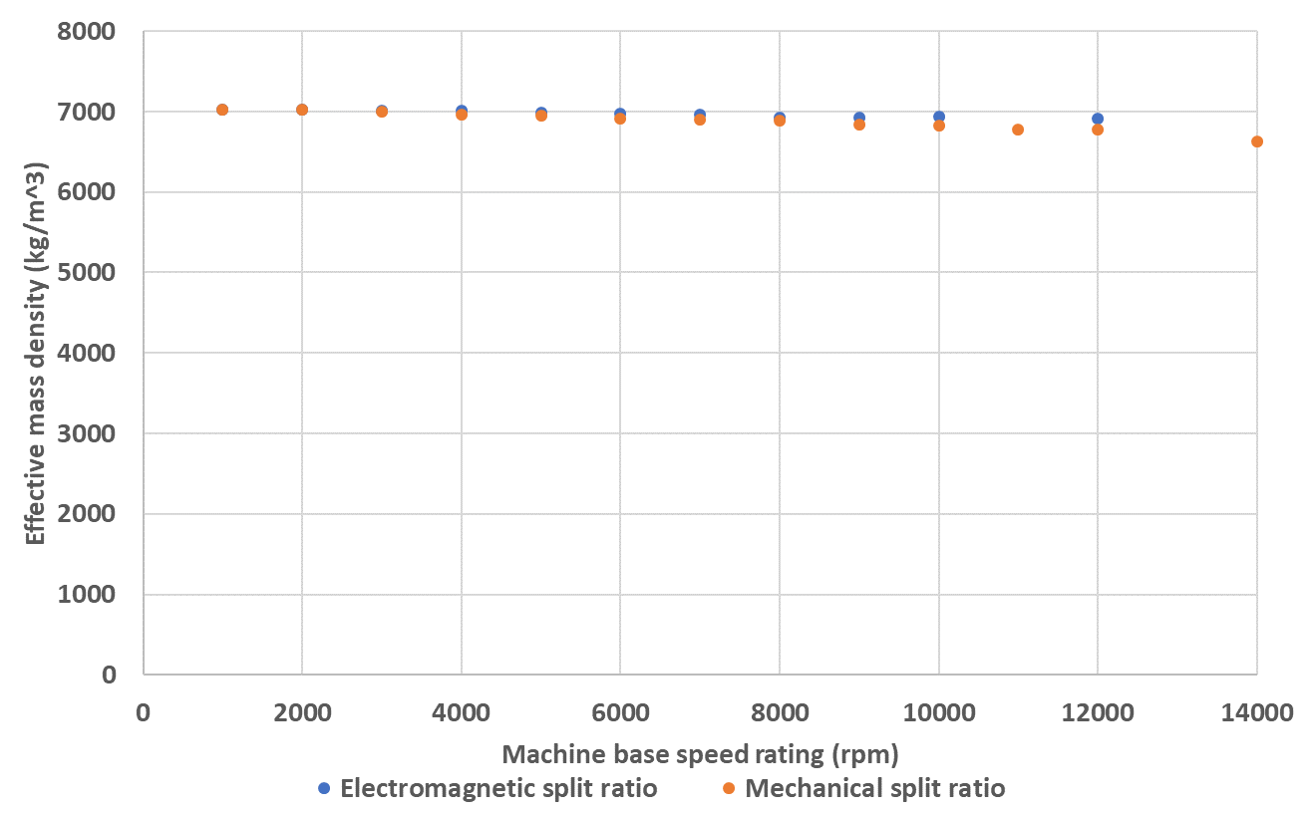
Figure 2.25 Effective mass density of machine series

Analytical interpretation of the torque density variation
The trends observed in torque density with machine speed rating under constant current density and split ratio constraints can be explained with recourse to analytical methods. Starting with the torque equation (2.4) then:
$$Torque density=\frac{T}{M}=\frac{T}{δ_{ave}V}=\frac{\frac{π^{2}}{4\sqrt{2}}k_{w}BQ{D_{r}}^{2}L_{a}}{δ_{ave}×\frac{π}{4}{D_{o}}^{2}L_{a}}=\frac{π}{\sqrt{2}δ_{ave}}k_{w}BQ{(\frac{D_{r}}{D_{o}})}^{2}=\frac{π}{\sqrt{2}δ_{ave}}k_{w}BQs^{2}$$ | (2.30)
As shown in the previous section, the average mass density $δ_{ave}$ takes a fairly consistent value of 7000 kg/m³ across a large spectrum of designs. The electrical loading, $Q$, is given by
$$Q=\frac{6N_{ph}I_{rms}}{πD_{r}}$$ | (2.31)
From (2.18), it can be shown that
$$N_{ph}I_{rms}∝{D_{r}}^{2}$$ | (2.32)
Combining (2.30), (2.31) and (2.32) leads to
$$Torque density∝\frac{1}{δ_{ave}}BD_{r}s^{2}$$ | (2.33)
This equation demonstrates that as would be expected, the torque density is inversely proportional to the average mass density, and proportional to the magnetic loading, rotor diameter and square of split ratio. Based on the definition of rotor diameter in the torque equation (2.4), the split ratio in this case refers to the electromagnetic split ratio. Therefore, for machine series using electromagnetic split ratio, $s^{2}$ remains constant in all machines, while for machine series using mechanical split ratio, there is a slight drop in $s^{2}$ as the speed ratings goes up. Since the average mass density remains broadly constant throughout the machine series, as noted previously, its contribution to torque density variation will be marginal. Therefore, for designs with constant current density and split ratio constraints, the drop of torque density is mainly contributed by the magnetic loading and rotor diameter, which means that there is a natural reduction of torque density with machine size, and as machine speed rating increases, the containment thickness would gradually increase, and so would the effective airgap. This would cause the reduction of the magnetic loading, and hence a further drop in torque density. Figure 2.26 shows the variation of magnetic loading in the machine series using electromagnetic and mechanical split ratios. Due to the benefit of having lower containment thickness, the machine series with mechanical split ratio has higher magnetic loading for the designs with the higher base speed specifications.
The variation of the product of magnetic loading and rotor diameter, i.e. $BD_{r}$, for the series of designs is shown in Figure 2.27. It can be clearly seen that, despite the effect of material saturation on the torque performance, which is not accounted for in the analytical interpretation, the variation of $BD_{r}$ shows a similar trend with the variation in torque density, shown previously in Figure 2.20.
As shown in (2.33) there are two additional factors other than $B$ and $D_{r}$ which influence the torque density, i.e. the effective mass density ( $δ_{ave}$ ) and the electromagnetic split ratio. However, since $δ_{ave}$ remains essentially fixed (with a few percent variation across the range of designs considered) and the electromagnetic split ratio again only varies by a small amount across the series of designs in which the mechanical split ratio is fixed (0.597 to 0.535), the trends observed in Figure 2.27 provide a good indicator of the reduction in torque density with increasing base speed from the analytical analysis.
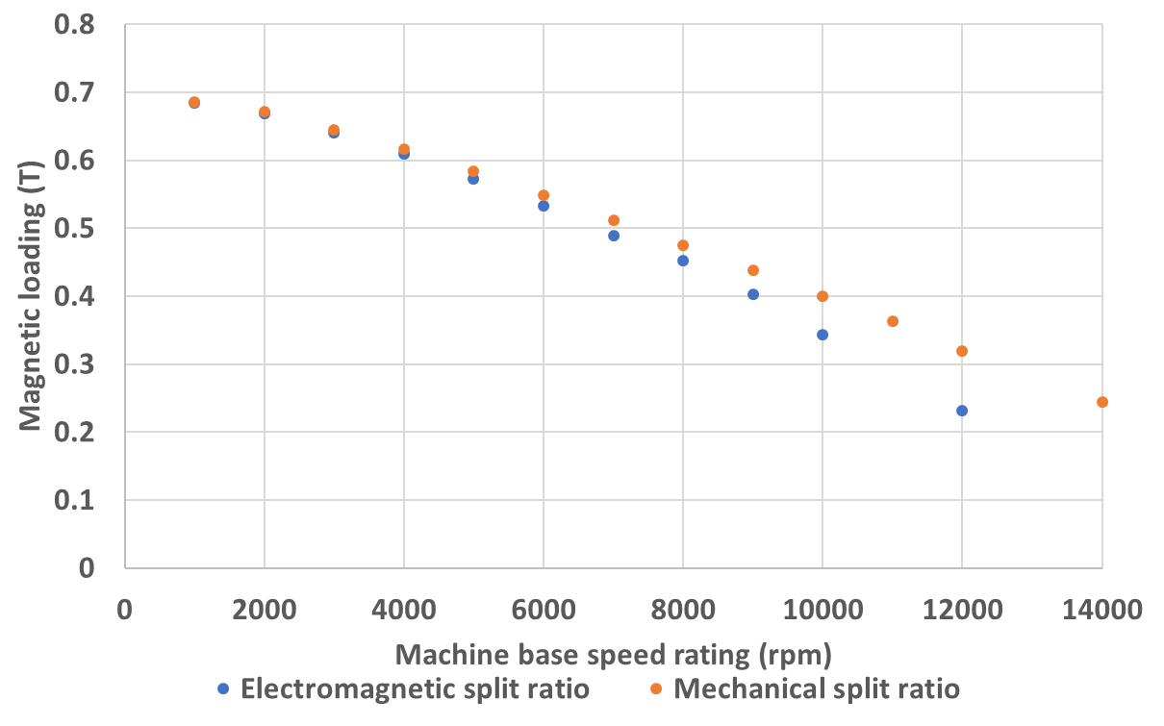
Figure 2.26 Variation of magnetic loading in machine series
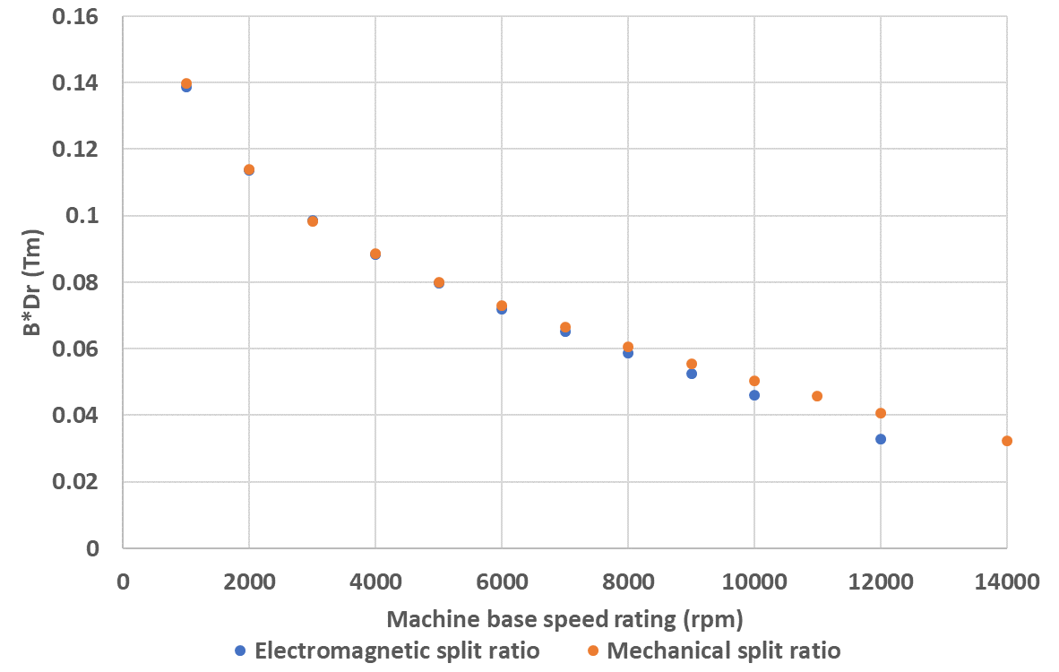
Figure 2.27 Variation of magnetic loading times rotor diameter in machine series
Another means to validate the analytical interpretation is to evaluate the extent by which the torque density reduces solely with machine size. This can be achieved by maintaining a constant magnetic loading throughout the machine series. To realise this, the influence of the containment thickness is removed from the designs of a series of machines, by specifying a fixed containment thickness of 0.5mm for all the machines irrespective of whether this results in non-viable mechanical designs. However, new curves which show the variation of torque with magnet thickness need to be plotted for each machine since the previous knee points were selected with the varying containment thickness. The absence of mechanical considerations inevitably pushes the knee points rightwards towards thicker magnets. Since the split ratio in equation (2.33) refers to the electromagnetic split ratio, the machine series with constant electromagnetic split ratio was selected.
Having adopted a fixed containment but left the leading dimensions to be the same as those arrived at while accounting for containment stress, the various machine designs no longer have same level of power ratings. With a fixed containment thickness of 0.5mm, the torque density of the machines at speeds beyond 8000rpm would start to rise again due to increased machine overall dimensions. Under this set of design constraints, the machine size for a given output power will always reduce with increasing speed rating. This illustrates the key role of the containment thickness in ultimately limiting the continued increase of power density with speed.
The linear relationship between torque density and size is more explicit in Figure 2.28, which shows the finite element predicted torque density variation with rotor diameter for the machine series. Since the machine size decreases from 1000rpm to 8000rpm, and increase again beyond the speed rating point 8000rpm, the lowest torque density point is at 8000rpm, and the torque density of machines with speed ratings beyond 8000rpm increases. These finite element results coincide well with the analytical relationship (2.33). However, since this behaviour is a consequence of increased electric loading with machine size, the linear relationship cannot always be maintained between machine size and torque density, and at the higher values of rotor radius, magnetic saturation will come into play and the rate of increase will start to diminish.
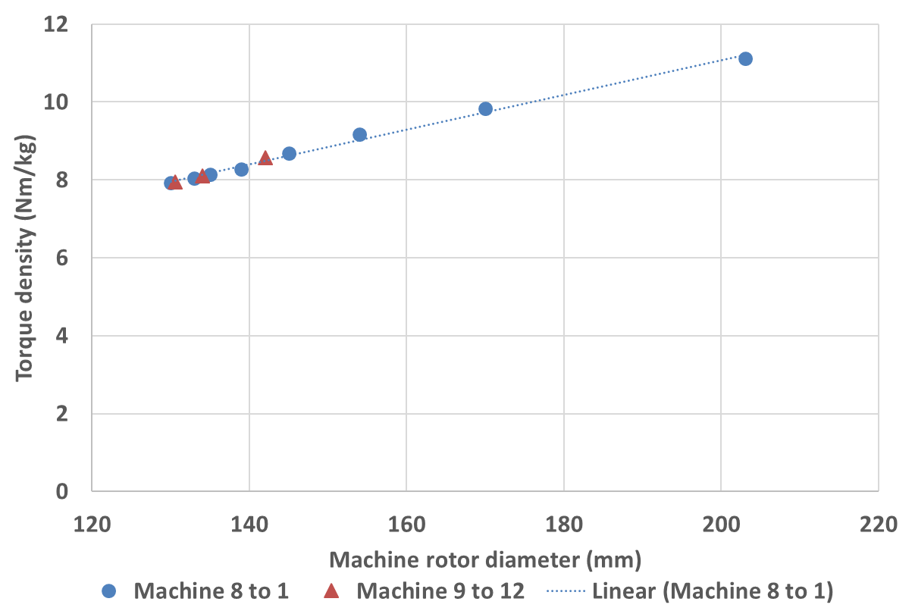
Figure 2.28 Torque density variation with machine rotor diameter with fixed containment thickness

Analytical interpretation of machine loss behaviour
The above analytical analysis can be extended to consider loss per unit machine total mass and loss per unit surface area of the core back. Starting from the analytical expression for copper loss (2.29), the copper loss per unit machine total mass (denoted as $ζ_{cu}$) can be calculated as
$$ζ_{cu}=\frac{P_{cu}}{δ_{ave}V}=\frac{{J_{rms}}^{2}⋅k_{p}A_{slot}⋅ρ_{cu}\left(L_{a}+\frac{π}{2}w_{t}\right)×N_{s}}{δ_{ave}×\frac{π}{4}{D_{o}}^{2}L_{a}}=\frac{4N_{s}k_{p}}{πδ_{ave}}{J_{rms}}^{2}ρ_{cu}⋅\frac{A_{slot}}{{D_{o}}^{2}}\left(1+\frac{πw_{t}}{2L_{a}}\right)$$ | (2.34)
and the copper loss per unit surface area of the core back (denoted as $κ_{cu}$) is
$$κ_{cu}=\frac{P_{cu}}{πD_{o}L_{a}}=\frac{{J_{rms}}^{2}⋅k_{p}A_{slot}⋅ρ_{cu}\left(L_{a}+\frac{π}{2}w_{t}\right)×N_{s}}{πD_{o}L_{a}}=\frac{N_{s}k_{p}}{π}{J_{rms}}^{2}ρ_{cu}⋅\frac{A_{slot}}{D_{o}}\left(1+\frac{πw_{t}}{2L_{a}}\right)$$ | (2.35)
From (2.10), (2.17) and (2.19), the following three relationships can be obtained
$$w_{t}∝D_{r}$$ | (2.36)
$$L_{a}∝D_{r}$$ | (2.37)
$$A_{slot}∝{D_{r}}^{2}$$ | (2.38)
Combining (2.34) to (2.38) yields
$$ζ_{cu}∝s^{2}$$ | (2.39)
$$κ_{cu}∝sD_{r}$$ | (2.40)
The split ratio here in (2.39) and (2.40) refers to electromagnetic split ratio in constant electromagnetic split ratio design, and mechanical split ratio in mechanical split ratio design, and is therefore fixed in both series of design. As a consequence, the copper loss per unit machine total mass is constant throughout the machine series, while the copper loss per unit area decreases with the machine diameter. This analytically derived relationship correlates well with the behaviour calculated by finite element analysis, which was shown previously in Figure 2.23 and Figure 2.24.

Constant current density and electrical loading design criteria
The principal reason for the reduction in torque density when current density and split ratio are fixed in the design process is that the electrical loading, as defined in equation (2.31) and (2.32), decreases in smaller machines. An alternative design criterion is to maintain the electric loading at a constant value throughout the machine series while also maintaining a fixed current density and hence copper loss density. In principle, this would largely eliminate the torque density drop due solely to machine size, although the influence of the containment will still be present.
From (2.18) and (2.31), it is known that in order to maintain a constant electric loading, the total stator slot area needs to scale linearly with the machine size, a relationship which is different from that in the preceding constant current density and split ratio design methodology. In order to adopt a different methodology in which the electric loading remains fixed, the stator outer diameter needs to be adjusted to ensure sufficient slot area to maintain a constant electric loading.
In this series of constant electric loading designs, three values of electrical loading, i.e. 50A/mm, 125A/mm and 200A/mm, were considered in order to investigate the impact of different level of saturation caused by armature reaction on the torque density. When using electromagnetic split ratio, any increase in containment thickness tends to squeeze the stator slot area, making it hard to realise constant electrical loading criteria, and as will be shown later in this section, designs with constant electrical loading tend to have relatively large rotor diameter compared with previous designs meeting the constant split ratio criteria. As a consequence, a design approach based on a mechanical split ratio was adopted for constant current density and electrical loading designs.
An analytical method is used for initial machine sizing, in which torque equation (2.4) is used instead of (2.5) in order to establish the rotor diameter. The magnetic loading, i.e. $B_{ave}$ in (2.4), was set at the same value of 0.67T adopted in the previous constant current density and split ratio designs.
As discussed above, for constant electrical loading design, the stator outer diameter is no longer determined by a combination of a fixed split ratio and the rotor diameter, but determined by the stator slot area, and the rotor diameter. More specifically, by reorganising equation (2.15), the following second order polynomial equation can be obtained,
$$\frac{π}{N_{s}}{R_{o}}^{2}-\left(\frac{2π}{N_{s}}h_{bi}+w_{t}\right)R_{o}+\frac{π}{N_{s}}{h_{bi}}^{2}-\frac{π}{N_{s}}{R_{1}}^{2}+w_{t}\left(h_{bi}+R_{1}\right)-A_{slot}=0$$ | (2.41)
where $R_{1}$ has the expression (2.16), and the solution for $R_{o}$ is
$$R_{o}=h_{bi}+\frac{N_{s}}{2π}w_{t}±\sqrt{{\left(R_{1}-\frac{N_{s}}{2π}w_{t}\right)}^{2}+\frac{N_{s}}{π}A_{slot}}$$ | (2.42)
From inspection of (2.42), it can be seen that the term $\frac{N_{s}}{2π}w_{t}$ represents a radius which is smaller than the stator inner bore radius, since $w_{t}$ is smaller than the slot pitch. Hence the entire term which follows $h_{bi}$ should be the radius up to the slot bottom, since $h_{bi}$ is the thickness of the stator back yoke. Therefore, only the solution with $+\sqrt{{\left(R_{1}-\frac{N_{s}}{2π}w_{t}\right)}^{2}+\frac{N_{s}}{π}A_{slot}}$ is viable for a practical machine design:
$$R_{o}=h_{bi}+\frac{N_{s}}{2π}w_{t}+\sqrt{{\left(R_{1}-\frac{N_{s}}{2π}w_{t}\right)}^{2}+\frac{N_{s}}{π}A_{slot}}$$ | (2.43)
The axial length, which is equal to stator diameter for 1:1 aspect ratio, can be expressed as
$$L_{a}=2h_{bi}+\frac{N_{s}}{π}w_{t}+2\sqrt{{\left(R_{1}-\frac{N_{s}}{2π}w_{t}\right)}^{2}+\frac{N_{s}}{π}A_{slot}}$$ | (2.44)
Substituting (2.44) into (2.4), yields the following equation:
$$T=\frac{π^{2}}{4\sqrt{2}}k_{w}B_{ave}Q_{rms}{D_{r}}^{2}\left[2h_{bi}+\frac{N_{s}}{π}w_{t}+2\sqrt{{\left(R_{1}-\frac{N_{s}}{2π}w_{t}\right)}^{2}+\frac{N_{s}}{π}A_{slot}}\right]$$ | (2.45)
Since mechanical split ratio is used in this design series, the mechanical rotor diameter, which includes the containment thickness and the electromagnetic diameter $D_{r}$ in (2.45), are used to calculate the other geometric parameters in (2.45) via the expressions in section 2.4.1.1 . The containment thickness, which can be expressed in terms of $D_{r}$ and the magnet thickness by combining (2.23) to (2.28), cannot be directly substituted into equation (2.45) since the magnet thickness is a geometric parameter which is independent from the rotor diameter and does not have a defined magnitude. Therefore, an assumption has been made in this initial analytical machine sizing process that the magnet is thin enough that the required containment thickness is always smaller than the minimum value set of 0.5mm in section 2.4.1.2 . Fixed value of containment thickness can then be used to calculate the mechanical rotor diameter and other geometric parameters. Such assumption significantly simplifies the analytical calculation, but the resulting limitations of the analysis in terms of machines that might require additional containment beyond 0.5mm needs to be kept in mind.
The slot area, $A_{slot}$, can be obtained by combining the pre-set value for electrical loading with (2.18) and (2.31). After substituting the expressions for various geometric parameters into (2.45), it is clear that a direct solution for $D_{r}$ is difficult to obtain from the equation itself, and hence an iterative estimation method is used to arrive at an approximated solution, subject to a prescribed convergence tolerance. More specifically a method was used which is based on a least square estimator, with the difference that the absolute value, instead of the square, of the error is controlled to achieve convergence. A schematic flowchart of the method is shown in Figure 2.29. An upper limit, which has a relatively large predefined value to include the neighborhood of the exact answer, and a lower limit, which is predefined as 0, are set to provide a starting point for the rotor diameter for subsequent iteration. The starting value adopted was the mean of the two limits. The other machine dimensions are then calculated accordingly, and so in turn is the slot area. The resulting dimensions and parameters are then substituted into equation (2.45) to obtain the output torque, which is then compared with the torque specification. If the convergence is not met and the calculated torque is greater than the requirement, the upper limit is updated with the latest estimate of rotor diameter and vice versa for calculated torques below the specification. Another cycle of iteration is then performed and a new value for rotor diameter is obtained from the mean of the updated limits, until the convergence is met. In this way, the whole process converges in the speed of $\frac{1}{2^{n}}$, where $n$ is the number of iterations, and for a convergence level of $1×{10}^{-6}$, only 20 iterations are needed. After a converged solution for the rotor diameter is obtained, the remaining machine dimensions other than the magnet thickness and containment thickness can also be determined. Table 2.8 to Table 2.10 show the calculated dimensions of the machine design series for the three pre-set values of electrical loading, i.e. 50A/mm, 125A/mm and 200A/mm.

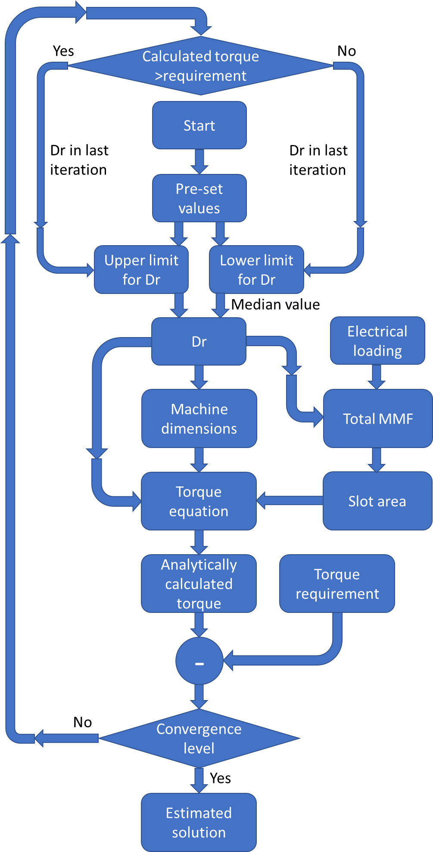
Figure 2.29 Schematics of the estimation method
Table 2.8 Initial calculated dimensions for machine series under constant electrical loading constraint (Q = 50A/mm)
Machine base speed rating (rpm) | Mechanical rotor radius (mm) | Stator outer radius (mm) | Stator tooth height (mm) | Axial length (mm) | Stator tooth width (mm) | Stator back iron thickness (mm)
1000 | 160.58 | 210.83 | 13.37 | 421.67 | 23.48 | 41.74
2000 | 126.84 | 169.24 | 13.17 | 338.48 | 18.54 | 32.97
3000 | 110.44 | 148.99 | 13.04 | 297.97 | 16.15 | 28.70
4000 | 100.09 | 136.18 | 12.94 | 272.36 | 14.63 | 26.01
5000 | 92.72 | 127.05 | 12.85 | 254.11 | 13.56 | 24.10
6000 | 87.10 | 120.08 | 12.78 | 240.16 | 12.73 | 22.64
7000 | 82.60 | 114.50 | 12.72 | 229.01 | 12.08 | 21.47
8000 | 78.89 | 109.90 | 12.66 | 219.79 | 11.53 | 20.50
Table 2.9 Initial calculated dimensions for machine series under constant electrical loading constraint (Q = 125A/mm)
Machine base speed rating (rpm) | Mechanical rotor radius (mm) | Stator outer radius (mm) | Stator tooth height (mm) | Axial length (mm) | Stator tooth width (mm) | Stator back iron thickness (mm)
1000 | 113.46 | 169.37 | 29.81 | 338.73 | 29.49 | 16.59
2000 | 88.93 | 138.20 | 28.73 | 276.39 | 23.11 | 13.00
3000 | 77.05 | 122.94 | 28.05 | 245.89 | 20.02 | 11.26
4000 | 69.57 | 113.26 | 27.54 | 226.52 | 18.08 | 10.17
5000 | 64.26 | 106.34 | 27.13 | 212.67 | 16.70 | 9.39
6000 | 60.21 | 101.03 | 26.78 | 202.06 | 15.65 | 8.80
7000 | 56.98 | 96.78 | 26.48 | 193.55 | 14.81 | 8.33
8000 | 54.32 | 93.26 | 26.22 | 186.51 | 14.12 | 7.94
9000 | 52.08 | 90.27 | 25.99 | 180.54 | 13.53 | 7.61
10000 | 50.14 | 87.69 | 25.78 | 175.38 | 13.03 | 7.33
11000 | 48.46 | 85.43 | 25.59 | 170.86 | 12.59 | 7.08
12000 | 46.96 | 83.42 | 25.41 | 166.84 | 12.21 | 6.87
Table 2.10 Initial calculated dimensions for machine series under constant electrical loading constraint (Q = 200A/mm)
Machine base speed rating (rpm) | Mechanical rotor radius (mm) | Stator outer radius (mm) | Stator tooth height (mm) | Axial length (mm) | Stator tooth width (mm) | Stator back iron thickness (mm)
1000 | 93.17 | 157.29 | 42.68 | 314.59 | 24.21 | 13.62
2000 | 72.61 | 129.88 | 40.48 | 259.77 | 18.87 | 10.62
3000 | 62.70 | 116.38 | 39.12 | 232.76 | 16.30 | 9.17
4000 | 56.48 | 107.77 | 38.13 | 215.54 | 14.68 | 8.26
5000 | 52.07 | 101.59 | 37.35 | 203.18 | 13.53 | 7.61
6000 | 48.71 | 96.84 | 36.71 | 193.68 | 12.66 | 7.12
7000 | 46.05 | 93.02 | 36.17 | 186.04 | 11.97 | 6.73
8000 | 43.85 | 89.85 | 35.69 | 179.70 | 11.40 | 6.41
9000 | 42.00 | 87.16 | 35.27 | 174.32 | 10.91 | 6.14
10000 | 40.40 | 84.83 | 34.89 | 169.66 | 10.50 | 5.91
11000 | 39.01 | 82.78 | 34.54 | 165.57 | 10.14 | 5.70
12000 | 37.79 | 80.97 | 34.23 | 161.93 | 9.82 | 5.52
13000 | 36.69 | 79.33 | 33.94 | 158.67 | 9.54 | 5.36
14000 | 35.70 | 77.86 | 33.67 | 155.71 | 9.28 | 5.22
15000 | 34.81 | 76.51 | 33.42 | 153.02 | 9.05 | 5.09
16000 | 33.99 | 75.27 | 33.19 | 150.55 | 8.83 | 4.97

Refinement of the initial calculated dimensions
Following the initial analytical based sizing of the machine dimensions, the resulting dimensions were used to produce finite element models of each design. As discussed in the case of the constant split ratio design, the magnet thickness determined through 1-dimensional analytical magnetic circuit analysis cannot fully represent the torque capability of the designed machine, since the knee point of the torque variation curve with magnet thickness calculated by the analytical method, which is used to select the initial magnet thickness, is under open circuit condition and will be shifted when combined with the armature flux. This can also be explained by the shifting of the magnet working point due to the armature flux, which is described in [16]. Therefore, a new curve which described the torque variation with magnet thickness is required with the influence of armature flux included. This modified curve, which is best derived with finite element analysis, can then be used to determine the preferred magnet thickness.
Figure 2.30 to Figure 2.32 show the variation in torque variation with magnet thickness for the machine series with constant electrical loading of 50 A/mm, in each case with the appropriate containment thickness calculated.
It can be seen in Figure 2.30 to Figure 2.32, that the variations in torque for machine series with constant electric loading of 50A/mm have different form to the corresponding curves for constant split ratio design, specifically, in the way that there is flatter top in the curves for 50A/mm constant electric loading series. It is worth noting that a 50A/mm electric loading is lower than the level of electric loading in constant split ratio design described in section 2.4.3 . This reduced armature flux ensures that these curves are closer to the curve for the open circuit condition.
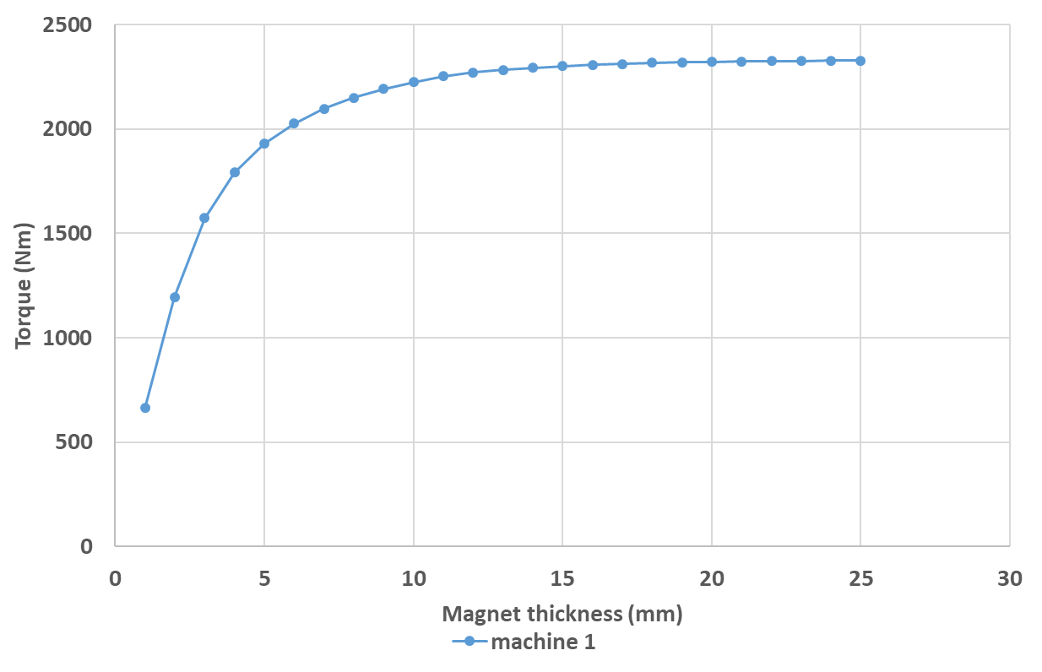
Figure 2.30 Torque variation with magnet thickness for machine series with constant electric loading of 50 A/mm (machine corresponds to 1,000rpm base speed design)
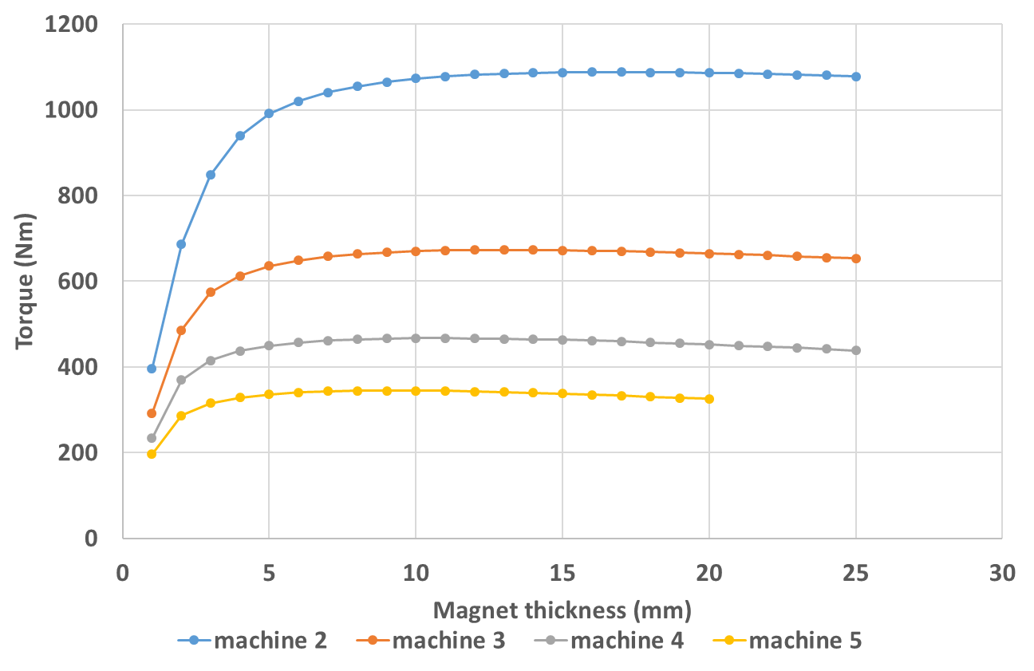
Figure 2.31 Torque variation with magnet thickness for machine series with constant electric loading of 50 A/mm (machine 2 to 5 correspond to base speed designs from 2,000rpm to 5,000rpm)
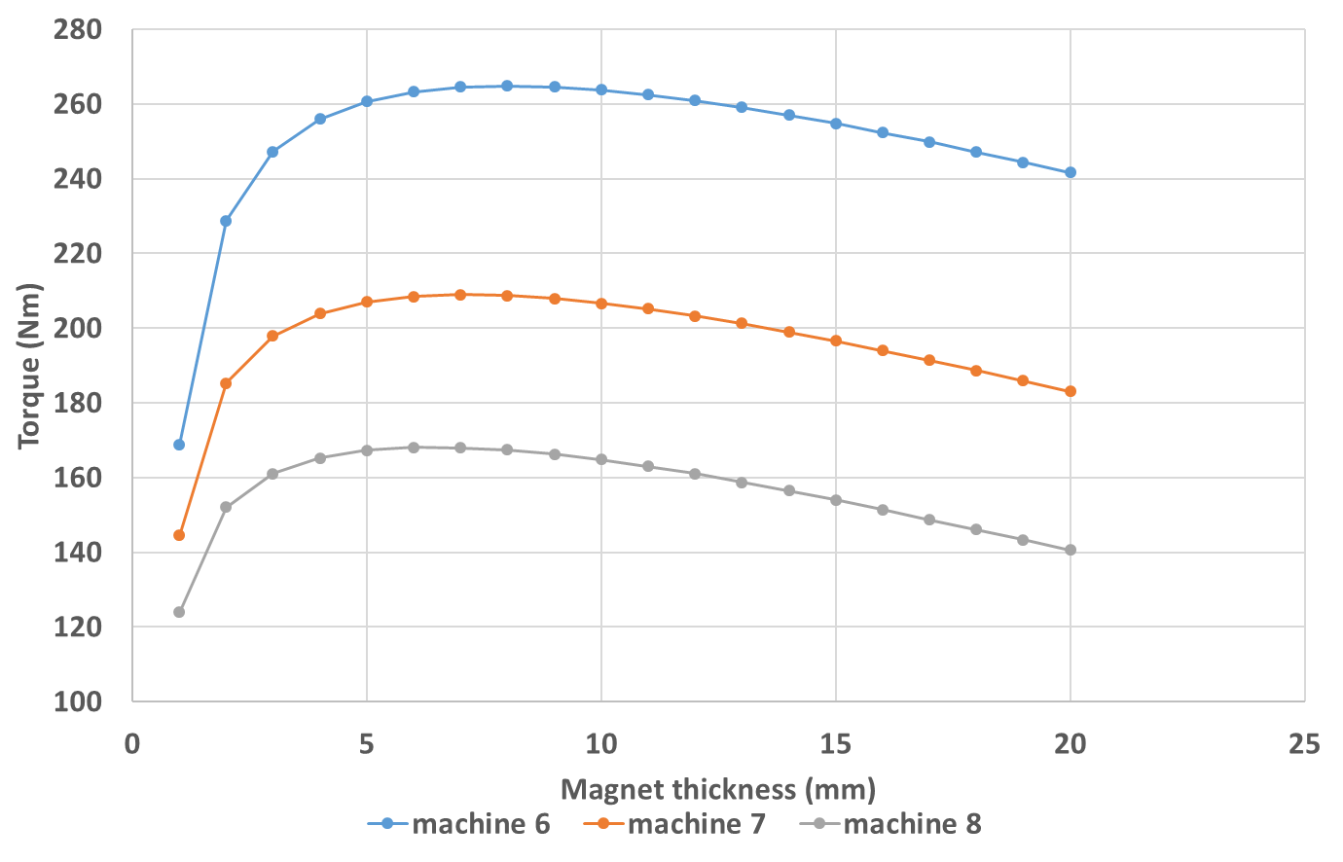
Figure 2.32 Torque variation with magnet thickness for machine series with constant electric loading of 50 A/mm (machine 6 to 8 correspond to base speed designs from 6,000rpm to 8,000rpm)
Even following the optimization of the magnet thickness, there is still shortfall of the output torque relative to the specification since the remaining dimensions have remained more or less constant. In order to achieve the rated output power of 250kW, the combined finite element and analytical design method demonstrated previously in section 2.4.3.2 , was used to obtain a final design for each machine. Figure 2.33 to Figure 2.35 shows the torque variation with magnet thickness for the final design of each machine in the machine series.
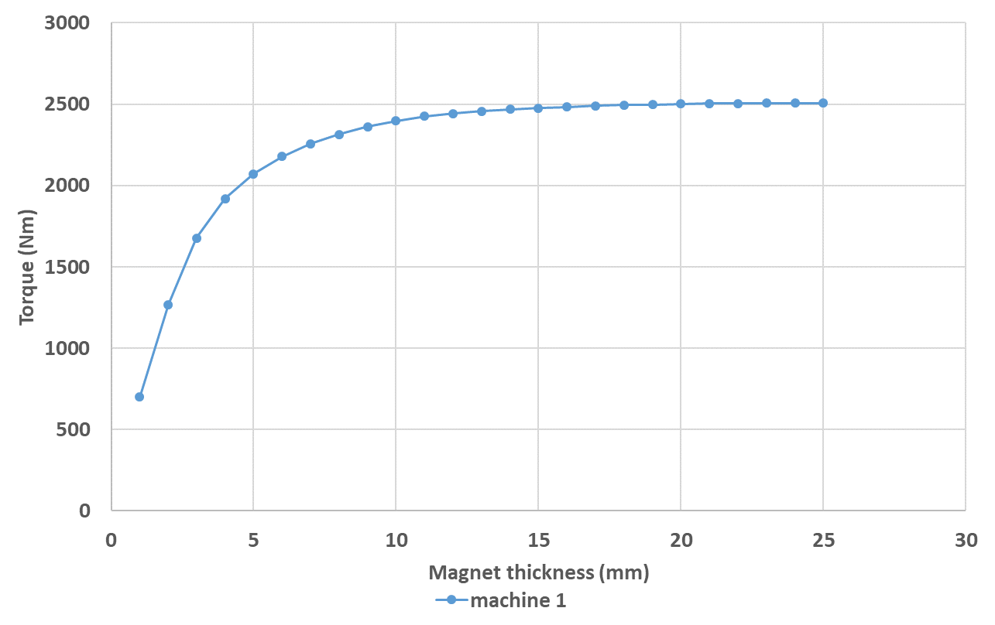
Figure 2.33 Torque variation curve of the final design for machine series with 50 A/mm constant electric loading (machine 1)
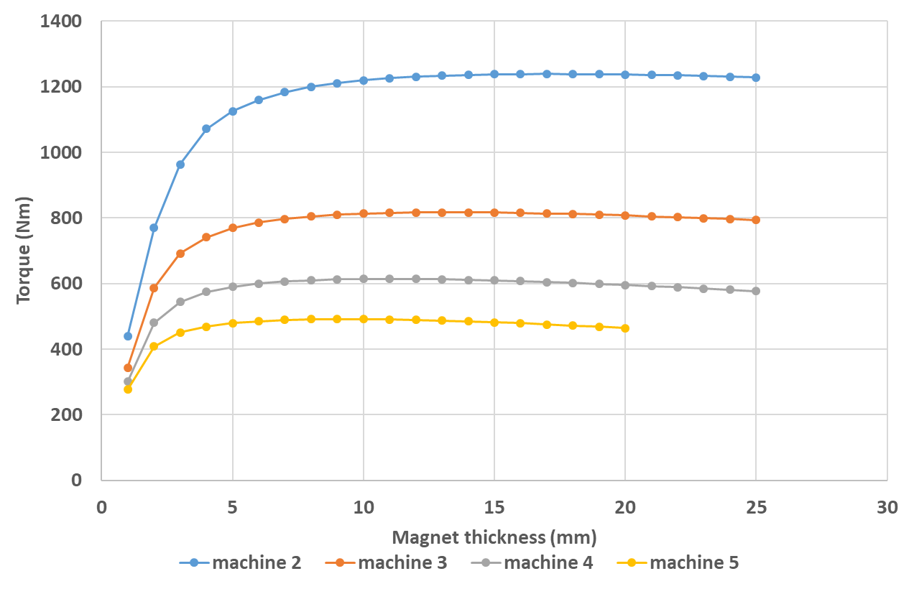
Figure 2.34 Torque variation curve of the final design for machine series with 50 A/mm constant electric loading (machine 2 to 5)
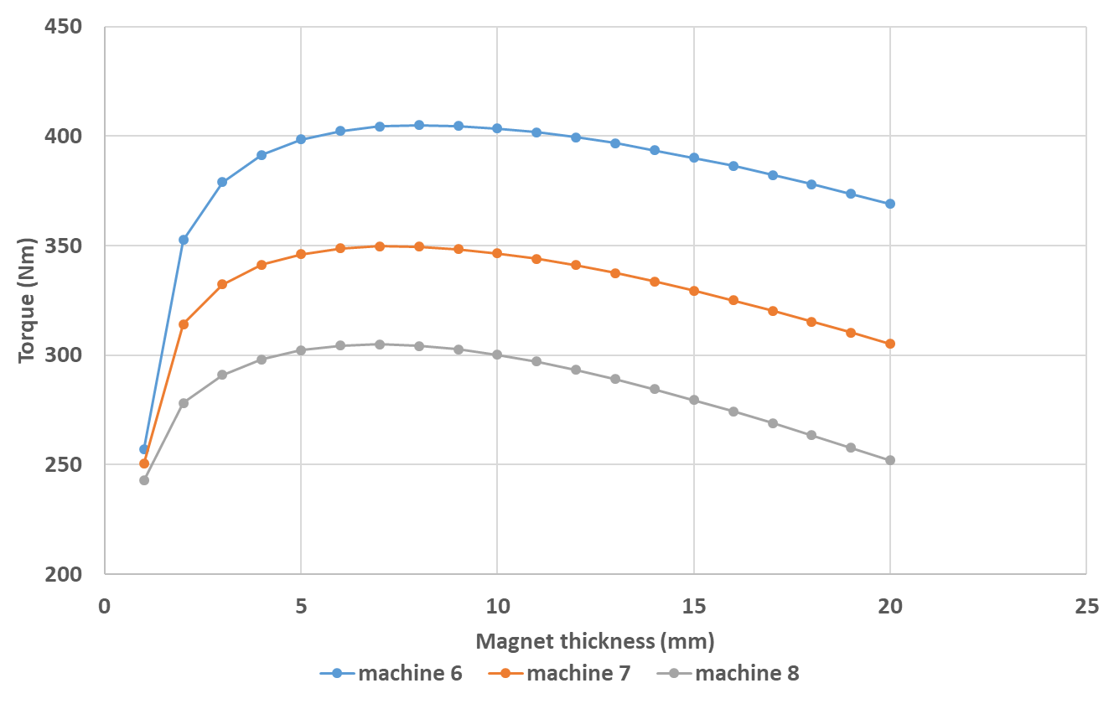
Figure 2.35 Torque variation curve of the final design for machine series with 50 A/mm constant electric loading (machine 6 to 8)
The same design process is applied to the machine series with constant electric loading of 125A/mm and 200A/mm as well. Figure 2.36 to Figure 2.38 show the torque variation with magnet thickness for the final design of machine series with electric loading of 125A/mm, and for 200A/mm electric loading series, the curves are shown in Figure 2.39 to Figure 2.41.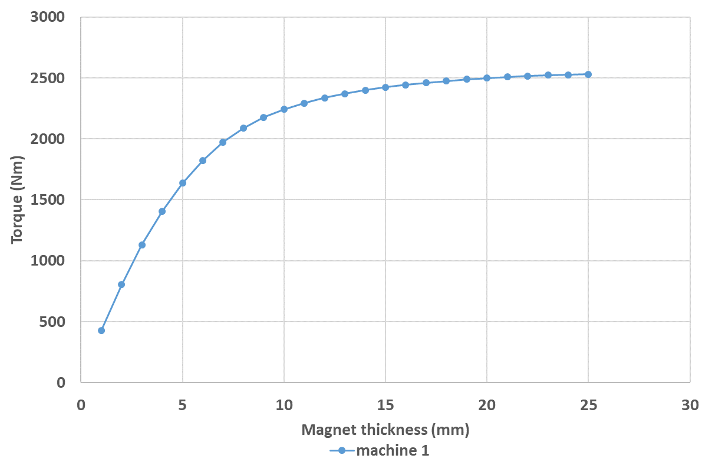
Figure 2.36 Torque variation with magnet thickness for the final design of the machine series with constant electric loading of 125A/mm (machine 1)
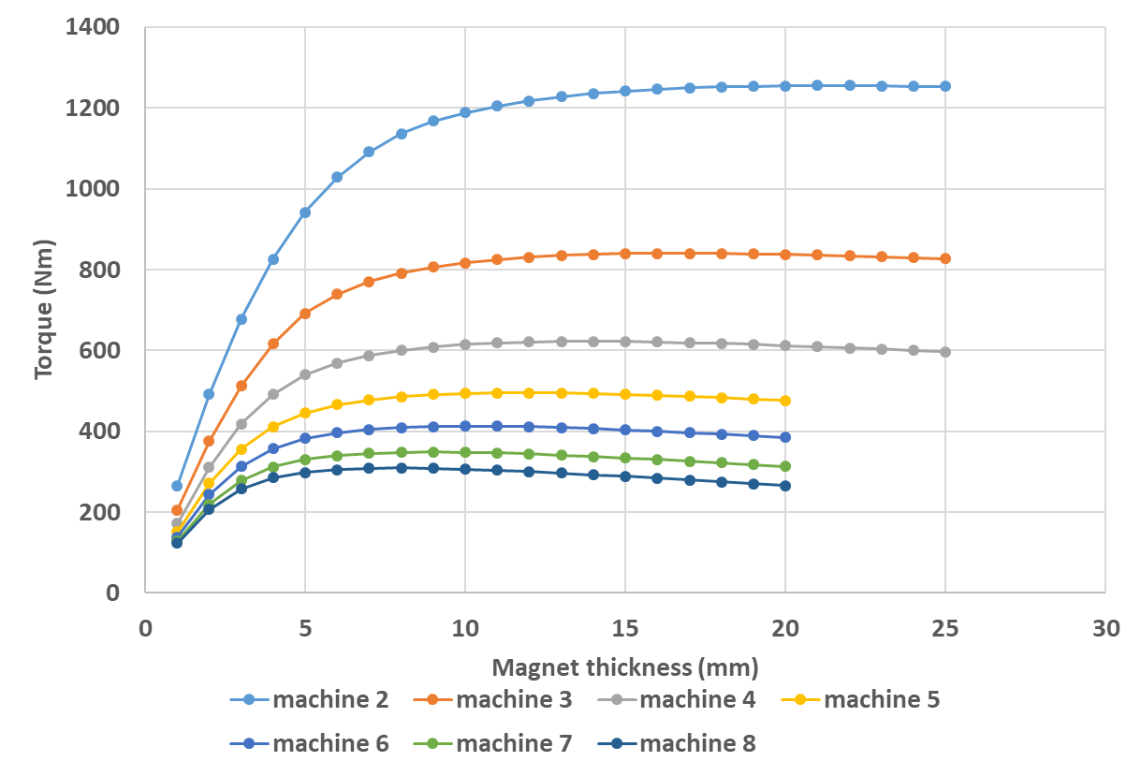
Figure 2.37 Torque variation with magnet thickness for the final design of the machine series with constant electric loading of 125A/mm (machine 2 to 8)
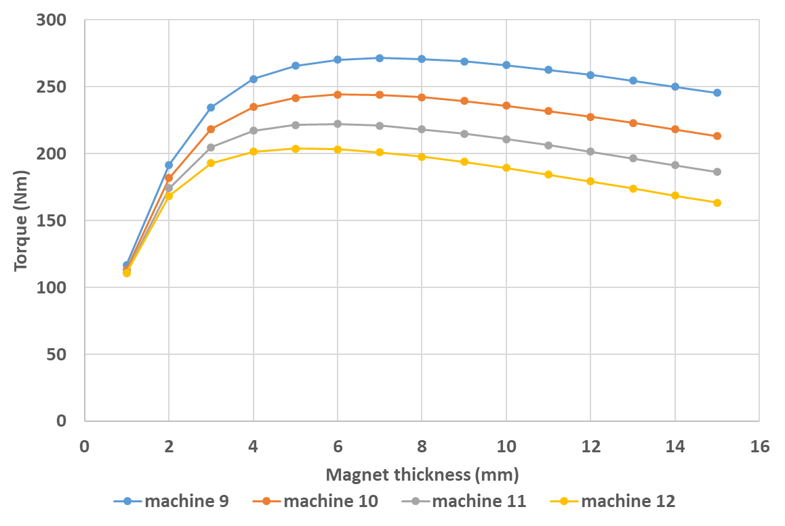
Figure 2.38 Torque variation with magnet thickness for the final design of the machine series with constant electric loading of 125A/mm (machine 9 to 12)
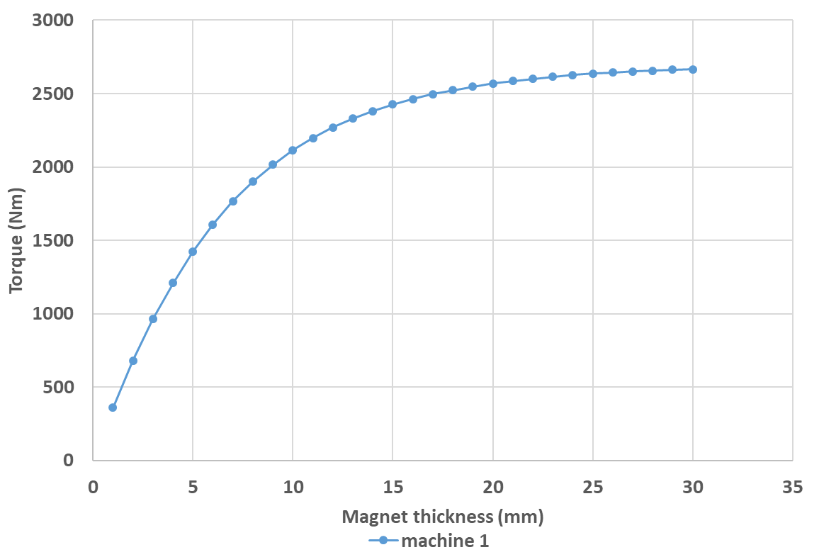
Figure 2.39 Torque variation with magnet thickness for the final design of the machine series with constant electric loading of 200A/mm (machine 1)
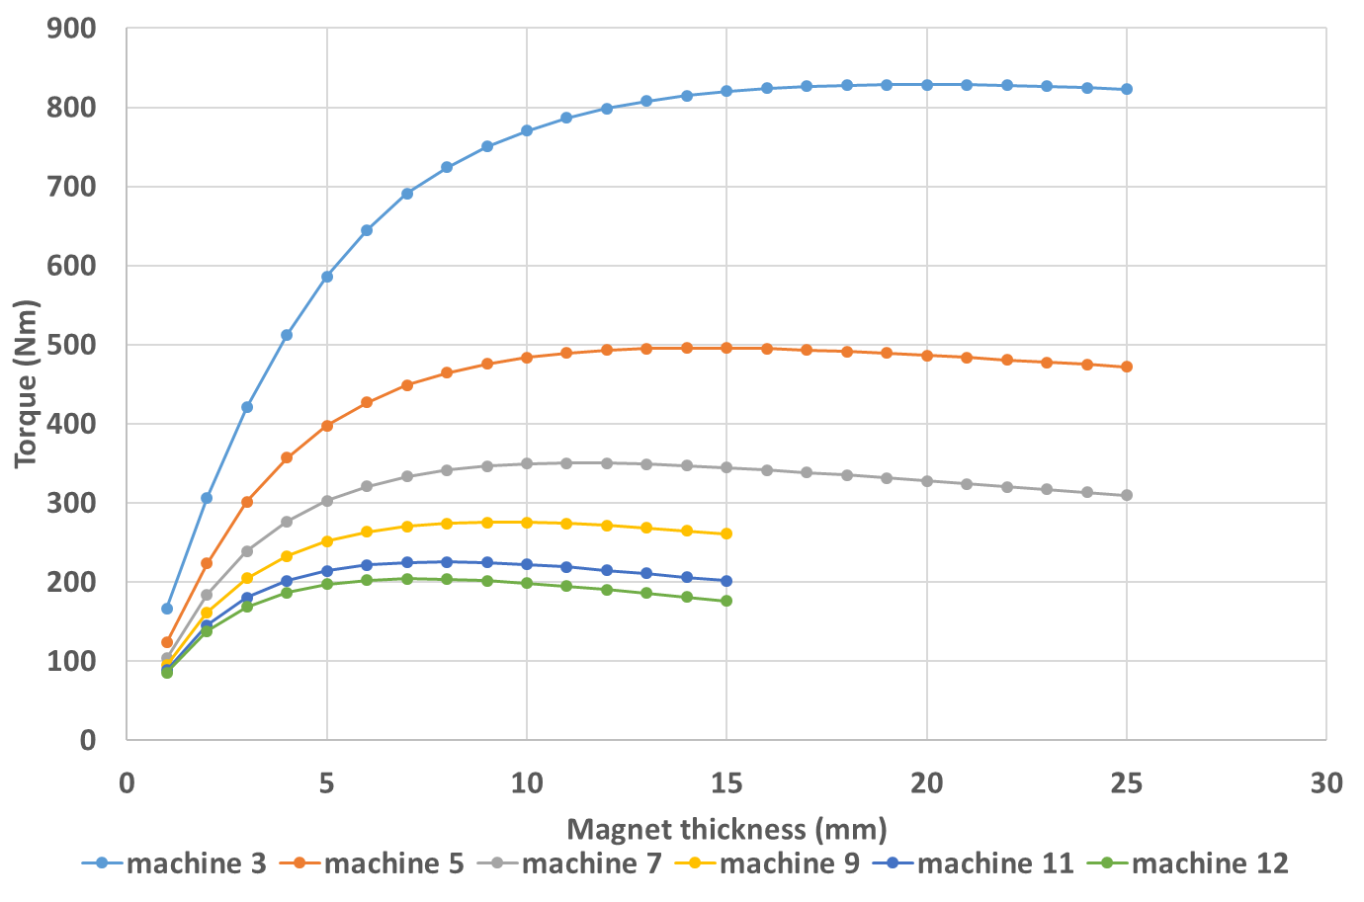
Figure 2.40 Torque variation with magnet thickness for the final design of the machine series with constant electric loading of 200A/mm (machine 3 to 12)
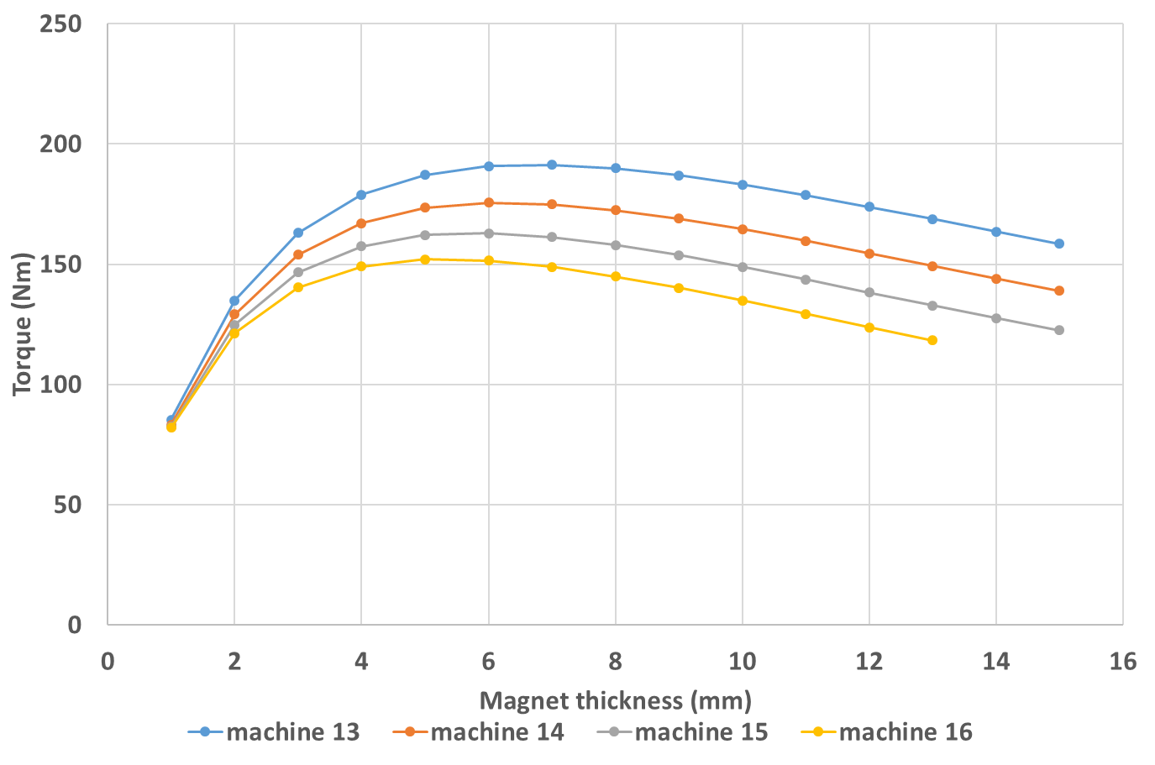
Figure 2.41 Torque variation with magnet thickness for the final design of the machine series with constant electric loading of 200A/mm (machine 13 to 16)
Clear differences can be observed between the torque variation curves at 50A/mm and the curves of 125A/mm and 200A/mm. As would be expected given the presence of more armature reaction effects at higher electric loadings, there is a shift in the knee points towards thicker magnets. This is close to the case of constant split ratio design, and means that the significant increase in armature flux brought by the high value of electric loading has further weakened the magnet flux and further shift the working point of the magnets leftwards in the second quadrature of the B-H coordinate system compared to the 50A/mm electric loading. This shifting moves the magnets away from working in the usual region on the B-H curve where the torque capability could be better stimulated, which is around 80% of the magnet remanence, as described in section 2.4.1.1 . Therefore, thicker magnet is needed to provide stronger field and shift the working point rightward back to the normal working region, so as to better utilize the torque capability of the machine. This explains the fact of right shifting of the knee point of torque variation curve with magnet thickness for high electric loading of 125A/mm and 200A/mm compared to the low electric loading of 50A/mm.
Table 2.11 to Table 2.13 summarizes the key parameters of the final design for machine series with electric loading of 50A/mm, 125A/mm and 200A/mm, respectively. The torque density and power density are calculated for each machine belonging to the three machine series and plotted in Figure 2.42 and Figure 2.43, respectively.
Table 2.11 Key parameters of the final design for machine series of 50A/mm constant electric loading
Machine base speed rating (rpm) | Mechanical rotor radius (mm) | Stator outer radius (mm) | Stator tooth height (mm) | Axial length (mm) | Stator tooth width (mm) | Stator back iron thickness (mm)
1000 | 164.80 | 216.03 | 13.39 | 432.06 | 42.83 | 24.09
2000 | 133.00 | 176.84 | 13.21 | 353.67 | 34.57 | 19.44
3000 | 119.00 | 159.56 | 13.11 | 319.11 | 30.93 | 17.40
4000 | 112.00 | 150.91 | 13.05 | 301.82 | 29.11 | 16.37
5000 | 108.50 | 146.58 | 13.02 | 293.17 | 28.20 | 15.86
6000 | 107.00 | 144.73 | 13.01 | 289.46 | 27.81 | 15.64
7000 | 109.50 | 147.82 | 13.03 | 295.64 | 28.46 | 16.01
8000 | 117.00 | 157.09 | 13.10 | 314.17 | 30.41 | 17.11

Table 2.12 Key parameters of the final design for machine series with 125A/mm constant electric loading
Machine base speed rating (rpm) | Mechanical rotor radius (mm) | Stator outer radius (mm) | Stator tooth height (mm) | Axial length (mm) | Stator tooth width (mm) | Stator back iron thickness (mm)
1000 | 118.50 | 175.73 | 29.98 | 351.45 | 30.80 | 17.32
2000 | 94.00 | 144.68 | 28.99 | 289.35 | 24.43 | 13.74
3000 | 83.00 | 130.61 | 28.41 | 261.21 | 21.57 | 12.13
4000 | 76.00 | 121.59 | 27.98 | 243.18 | 19.75 | 11.11
5000 | 71.50 | 115.77 | 27.67 | 231.54 | 18.58 | 10.45
6000 | 68.50 | 111.87 | 27.46 | 223.74 | 17.80 | 10.01
7000 | 66.00 | 108.61 | 27.26 | 217.23 | 17.15 | 9.65
8000 | 65.00 | 107.31 | 27.19 | 214.62 | 16.89 | 9.50
9000 | 63.80 | 105.74 | 27.09 | 211.48 | 16.58 | 9.33
10000 | 63.50 | 105.35 | 27.06 | 210.70 | 16.50 | 9.28
11000 | 63.80 | 105.74 | 27.09 | 211.48 | 16.58 | 9.33
12000 | 64.80 | 107.05 | 27.17 | 214.10 | 16.84 | 9.47
Table 2.13 Key parameters of the final design for machine series of 200A/mm constant electric loading
Machine base speed rating (rpm) | Mechanical rotor radius (mm) | Stator outer radius (mm) | Stator tooth height (mm) | Axial length (mm) | Stator tooth width (mm) | Stator back iron thickness (mm)
1000 | 103.00 | 170.20 | 43.53 | 340.40 | 26.77 | 15.06
3000 | 70.20 | 126.62 | 40.17 | 253.25 | 18.24 | 10.26
5000 | 60.50 | 113.35 | 38.78 | 226.70 | 15.72 | 8.85
7000 | 55.50 | 106.41 | 37.97 | 212.81 | 14.42 | 8.11
9000 | 53.20 | 103.18 | 37.56 | 206.37 | 13.83 | 7.78
11000 | 52.00 | 101.49 | 37.34 | 202.99 | 13.51 | 7.60
12000 | 51.50 | 100.79 | 37.25 | 201.58 | 13.38 | 7.53
13000 | 52.00 | 101.49 | 37.34 | 202.99 | 13.51 | 7.60
14000 | 52.00 | 101.49 | 37.34 | 202.99 | 13.51 | 7.60
15000 | 52.50 | 102.20 | 37.43 | 204.40 | 13.64 | 7.68
16000 | 53.50 | 103.60 | 37.62 | 207.21 | 13.90 | 7.82

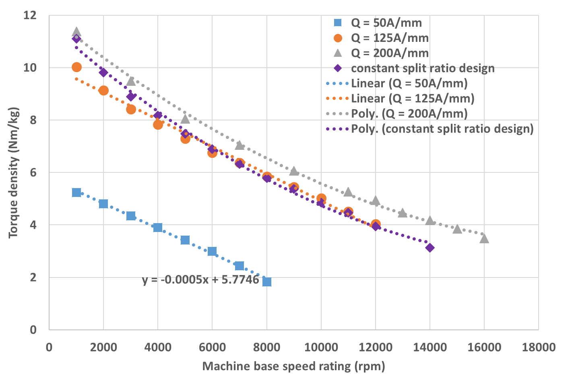
Figure 2.42 Torque density variation with machine speed rating for constant electric loading design of 50A/mm, 125A/mm, and 200A/mm and constant split ratio design using mechanical split ratio
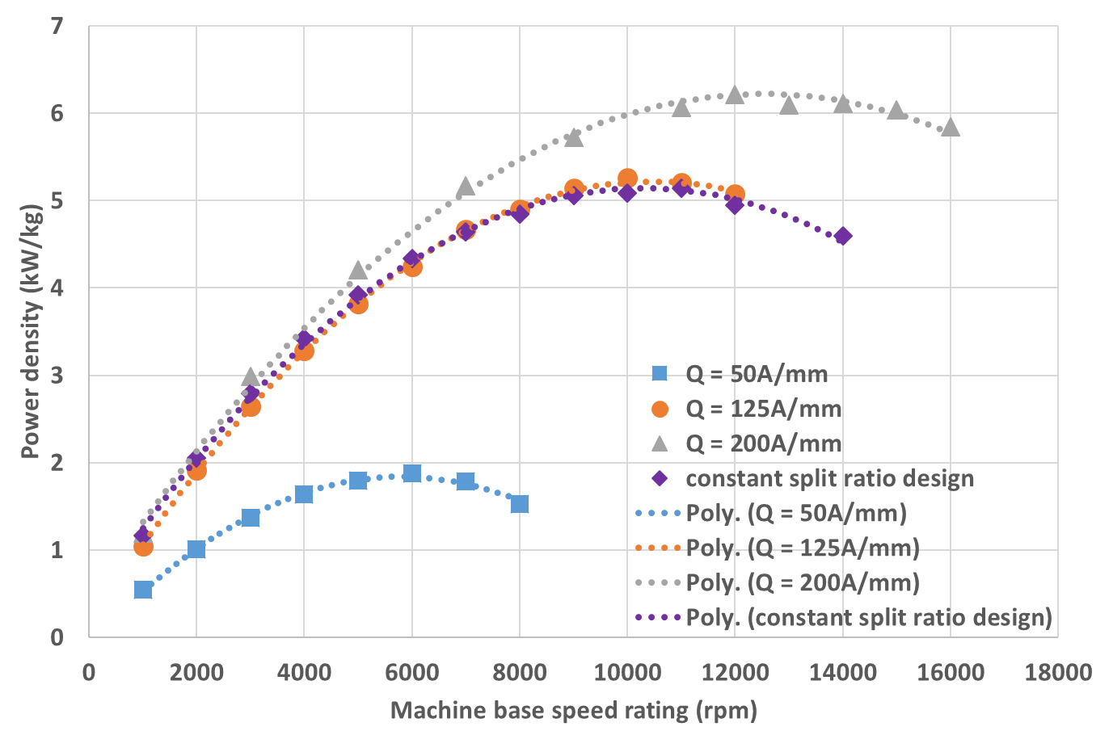
Figure 2.43 Power density variation with machine speed rating for constant electric loading design of 50A/mm, 125A/mm, 200A/mm and constant split ratio design using mechanical split ratio
From Figure 2.42, it can be seen that compared to the constant split ratio design, of which the torque density variation curve under mechanical split ratio definition is also included in Figure 2.42, the decrease in torque density with machine speed ratings for constant electric loading design is slowed down, since one parameter once contributing to the drop of the torque density is now kept constant, and the magnetic loading, which is affected by the effective airgap thickness, is now the only dominant contributor to torque density descending. In fact, for machine series with electrical loading of 50A/mm and 125A/mm, the torque density almost drops linearly with machine speed ratings. Compared to the quadratic variation trend with bigger increment, this has the potential of further enhancing the power density of each machine belonging to one series. For machine series with electric loading of 200A/mm, although the decreasing of torque density returns to a quadratic trend, the increment is significantly reduced. Therefore, it is clear to see the benefits of keeping the electric loading from decreasing as the machine speed rating increases. Moreover, as shown in Figure 2.45, the machine series with higher electric loading always has a lower split ratio, since the high copper volume needs more space to accommodate. This means a smaller rotor and hence less requirement for rotor containment. This is beneficial in high speed applications no matter from mechanical aspect and thermal aspect, and the loss in torque performance due to the reduce in rotor size can be compensated by the high electric loading in the stator. Another interesting point is that the starting point of the torque density curve, i.e. the level of the torque density a machine series can reach, is decided by the level the electric loading injected into that series. This offers an interesting trade-off study in machine designs that although the series with low electric loading has slower dropping of torque density and less challenges from thermal issue brought by the stator current, the fact of low electric loading means that it cannot have a high level of torque density, and thus power density, and for machine series with very high electric loading, high torque density and power density can be easily achieved but suffering from the high level of heat generated from stator winding and induced challenges on thermal management is unavoidable. Furthermore, as can be seen from Figure 2.42 and Figure 2.43, there is a big leap forward of both the torque density and power density from machine series with 50A/mm electric loading to 125A/mm electric loading, while from 125A/mm to 200A/mm, the increasing rate is diminished. This means the torque density is not exactly linearly proportional to the electric loading, as indicated from the analytical analysis, even at low speed end, where the effect of containment thickness is ignorable and the torque density is governed by the level of electric loading injected. This is mainly due to the saturation effect of the core material, which is not fully considered in the analytical method, since the very high electric loading of 200A/mm has pushed the saturation level of the machine onto a limit. Therefore, despite the significant increase in investment of electric loading from 125A/mm to 200A/mm, there is no equal return of profit in terms of torque density and power density enhancement. Therefore, in the design studies for applications demanding high torque density and power density, where intensive cooling system, like water jacket, oil cooling, and forced air cooling, can be applied on, high electric loading is usually preferred, and consideration needs to be taken whether further increase in electric loading from high level to an even higher level to exploit the remaining torque density capability of the machine is worth the heat generation level it brings and the risk it adds onto the thermal stability of the entire system. Figure 2.44 shows the variation of magnetic loading in the three machine series. Since the machine series with lower electric loading has larger rotor diameters, and hence larger containment thicknesses at the same speed rating, the magnetic loading drops in a faster rate. Based on the analytical interpretation (2.30), the machine average mass density and the electromagnetic split ratio can also affect the torque density. Those two parameters, while staying constant as constraint or having small changes in the previous constant split ratio designs, now have bigger changes in order to maintain a constant electric loading through the machine series, as shown in Figure 2.45 and Figure 2.46, and thus inevitably have bigger influence on the torque density variation. Figure 2.47 shows the analytically calculated torque density based on equation (2.30), using the FE exported magnetic loading and the same geometric information used to build the FE model, for machine series with 3 levels of electric loading. There are several interesting points to be investigated of the comparison between the torque density calculated using analytical equation and the torque density directly calculated from FE results. Good agreement of the variation trend is observed between the analytical results and FE results, with the linear variation trend also seen for machine series with electric loading of 50A/mm and 125A/mm, and exactly the same increment at 50A/mm between analytical and FE results. However, since the saturation effect is not fully considered in the analytical method, the analytical calculated torque densities obviously have bigger magnitudes than the FE calculated, and bigger increase of torque density is observed in analytical results by increasing the electric loading from 125A/mm to 200A/mm.
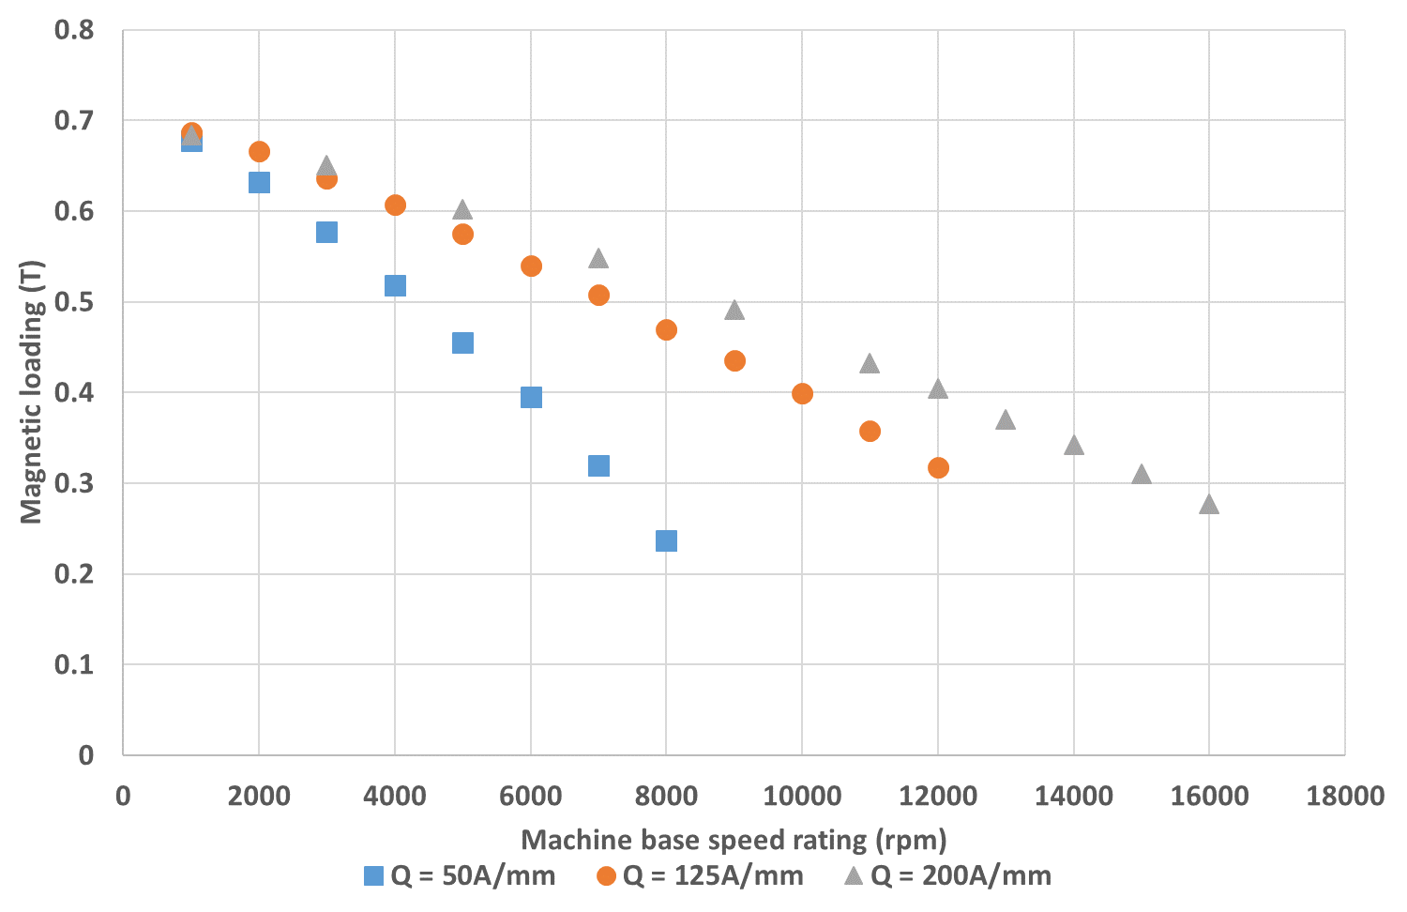
Figure 2.44 Magnetic loading variation within the machine series with constant electric loading of 50A/mm, 125A/mm, 200A/mm
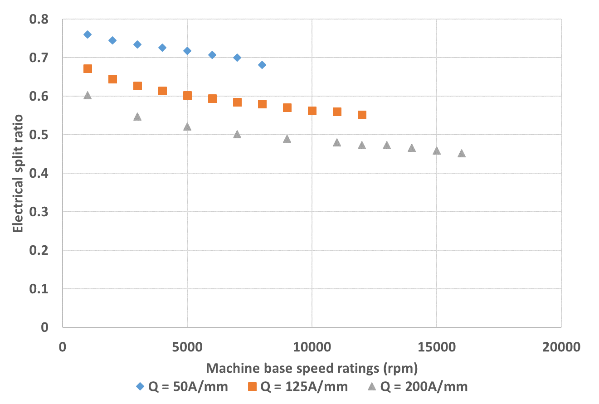
Figure 2.45 Electromagnetic split ratio variation within the machine series with constant electric loading of 50A/mm, 125A/mm and 200A/mm
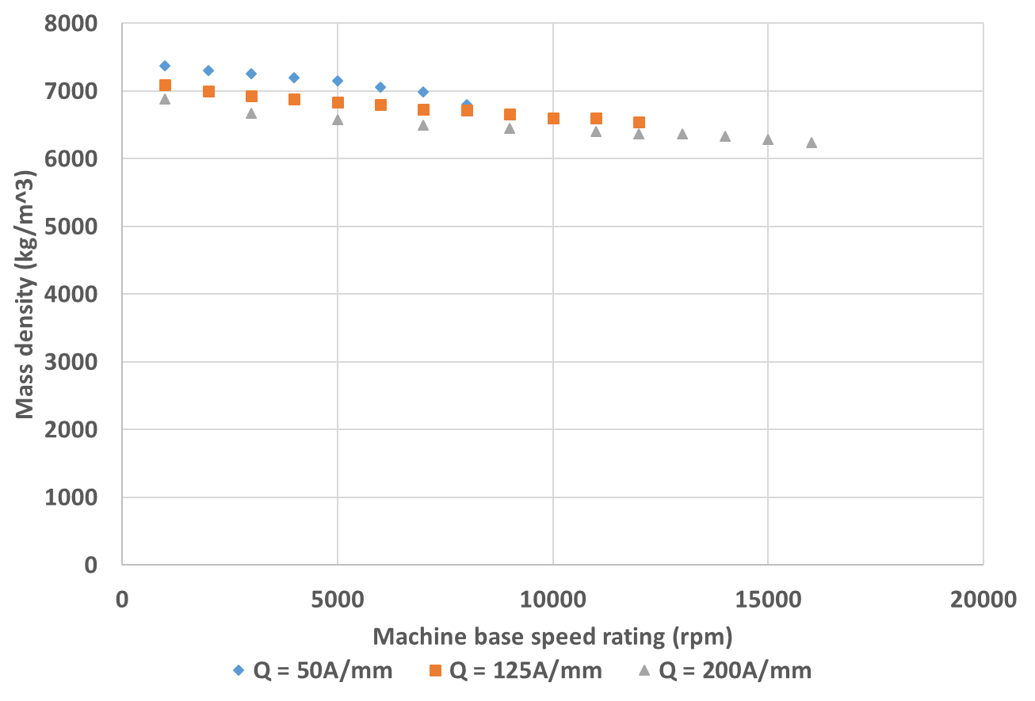
Figure 2.46 Average mass density variation within the machine series with constant electric loading of 50A/mm, 125A/mm, and 200A/mm
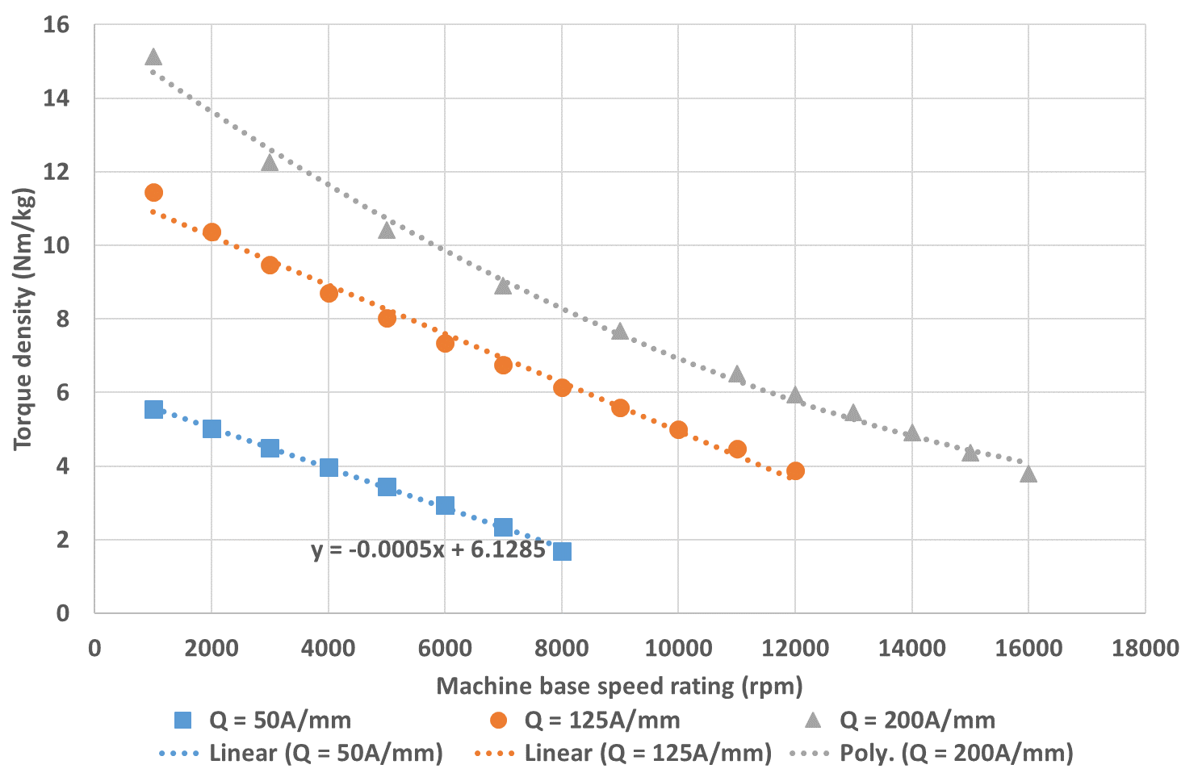
Figure 2.47 Analytically calculated torque density for machine series with constant electric loading of 50A/mm, 125A/mm and 200A/mm

Constant heat flux design criteria
As mentioned at the start of this chapter, there are three sets of constraints used to investigate the torque density and power density variation with machine speed rating, and constant heat flux criteria is one of them. Despite the common constraints set in one machine series, i.e. SPM topology, 9 slots and 8 poles, 250kW power rating, and 0.5 packing factor, this design criteria considers from the thermal point of view to confine the machine series under same condition, viz. all machines belonging to one series has the same level of heat dissipation through the outer surface of the stator back yoke. At this stage, only copper loss and iron loss are considered as heat source. Parasitic losses, such as AC winding loss, rotor magnet loss, and mechanical losses like friction loss, are not considered. Since the control strategy is not yet included in the machine design, pure sinusoidal current is used for calculating the losses. The effect of ripple current generated by modulation technique on machine torque performance and losses will be discussed in later chapters.
The copper loss and iron loss variation for machine series under constant split ratio criteria are shown in Figure 2.22, and the heat flux per unit surface area induced by those losses is also calculated for each machine and shown in Figure 2.24. This provides a good starting point for the constant heat flux design, and the machine series using electromagnetic split ratio is selected for implementation. Two levels of heat flux are investigated for this design criteria, including 24.6kW/m², which is the original heat flux level of machine 1 in the machine series, and 15kW/m², which is a reduced level for less thermal challenges. The method to achieve constant heat flux throughout the machine series is based on the fact that the copper loss, as indicated by equation (2.29), is quadratically proportional to the current density, while the output torque, as indicated by equations (2.4), (2.18) and (2.31), is linearly proportional to the current density. The iron loss, as will be discussed later, is more related to the frequency of current changing and machine size, and less affected by amplitude of the current density in the stator winding. Therefore, for machines with original heat flux per unit surface area lower than the defined condition, increasing the heat flux level while keeping the output torque unchanged is achievable by reducing the slot depth while keeping other dimensions fixed, which would cause the reduce of the slot area, and increasing the current density. In this way, the overall machine size would be reduced and torque density would be further increased. For machines with higher original heat flux level than the pre-set condition, opposite adjusting process will be carried out.
Therefore, there is another iteration process for this machine series, which is adjusting the slot depth and current density to meet the criteria. A convergence level by controlling the heat flux per unit surface area for each machine within the range of 0.5% of the pre-set value is set for the iterations. Figure 2.48 shows the schematics of the design process. After the slot depth and current density adjustment in every iteration, the updated design is put into FE software for validation to make sure the output torque stays the same and also to extract the flux density data for each element to outside file for later iron loss calculation in MATLAB. The heat flux per unit surface area obtained from the calculated copper loss and iron loss is compared with the criteria. If the convergence is met, the design is settled, otherwise another iteration will start and further adjustment of slot depth and current density will be carried out. Table 2.14 and Table 2.15 summarize the key parameters of the final designs of the two machine series, respectively. Since the heat flux level of machine 12 cannot meet the criteria of 24.6kW/m² and machine 9, 10, and 12 cannot meet the criteria of 15kW/m² after the iterations, there are no final designs for those machines.
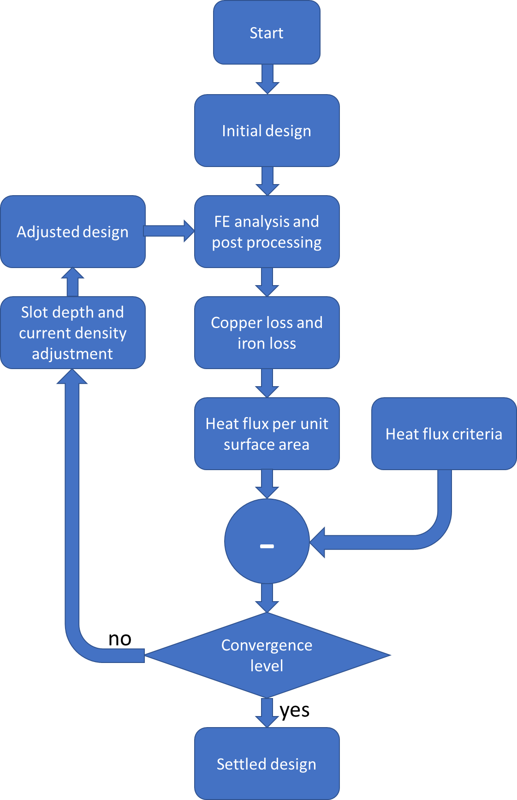
Figure 2.48 Schematics of design process of constant heat flux criteria
Table 2.14 Key parameters of the final design of the machine series with constant heat flux per unit surface area of 24.6kW/m²
Machine base speed rating (rpm) | Electrical rotor diameter (mm) | Stator outer diameter (mm) | Stator tooth height (mm) | Current density (A/mm²) | Split ratio | Axial length (mm)
1000 | 203.00 | 338.33 | 43.84 | 10.00 | 0.60 | 338.33
2000 | 170.00 | 273.02 | 31.30 | 12.05 | 0.62 | 283.33
3000 | 154.00 | 244.48 | 26.50 | 12.85 | 0.63 | 256.67
4000 | 145.00 | 229.39 | 24.20 | 13.13 | 0.63 | 241.67
5000 | 139.00 | 219.51 | 22.60 | 13.33 | 0.63 | 231.67
6000 | 135.00 | 213.80 | 21.90 | 13.15 | 0.63 | 225.00
7000 | 133.00 | 212.05 | 22.00 | 12.68 | 0.63 | 221.67
8000 | 130.00 | 207.35 | 20.90 | 12.71 | 0.63 | 216.67
9000 | 130.60 | 211.86 | 22.60 | 11.55 | 0.62 | 217.67
10000 | 134.00 | 228.44 | 28.70 | 8.92 | 0.59 | 223.33
Table 2.15 Key parameters of the final design of the machine series with constant heat flux per unit surface area of 15kW/m²
Machine base speed rating (rpm) | Electrical rotor diameter (mm) | Stator outer diameter (mm) | Stator tooth height (mm) | Current density (A/mm²) | Split ratio | Axial length (mm)
1000 | 203.00 | 368.16 | 58.80 | 6.91 | 0.55 | 338.33
2000 | 170.00 | 301.32 | 45.50 | 7.58 | 0.56 | 283.33
3000 | 154.00 | 270.99 | 39.80 | 7.80 | 0.57 | 256.67
4000 | 145.00 | 255.89 | 37.50 | 7.68 | 0.57 | 241.67
5000 | 139.00 | 247.61 | 36.70 | 7.42 | 0.56 | 231.67
6000 | 135.00 | 244.89 | 37.50 | 6.80 | 0.55 | 225.00
7000 | 133.00 | 251.31 | 41.70 | 5.75 | 0.53 | 221.67
8000 | 130.00 | 250.21 | 42.40 | 5.31 | 0.52 | 216.67
As can be seen from the final design summary sheets, since only the stator slot depth and current density is adjusted to meet the thermal constraints, only the related geometric parameters like split ratio and stator outer diameter change correspondingly. The remaining rotor and stator dimensions stay the same with the machines in constant split ratio design. Therefore, the machine series under constant heat flux criteria no longer has fixed aspect ratio of 1:1. The torque density and power density for each machine belonging to this series are calculated and plotted in Figure 2.40 and 2.41, respectively.
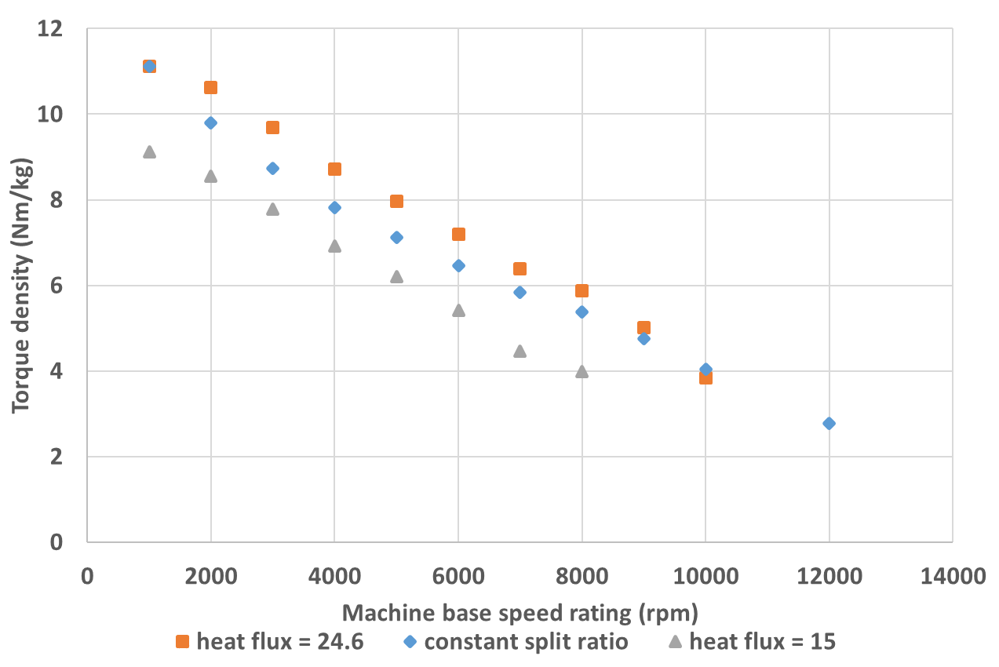
Figure 2.49 Torque density variation with machine speed rating for constant heat flux design and constant split ratio design using electromagnetic split ratio
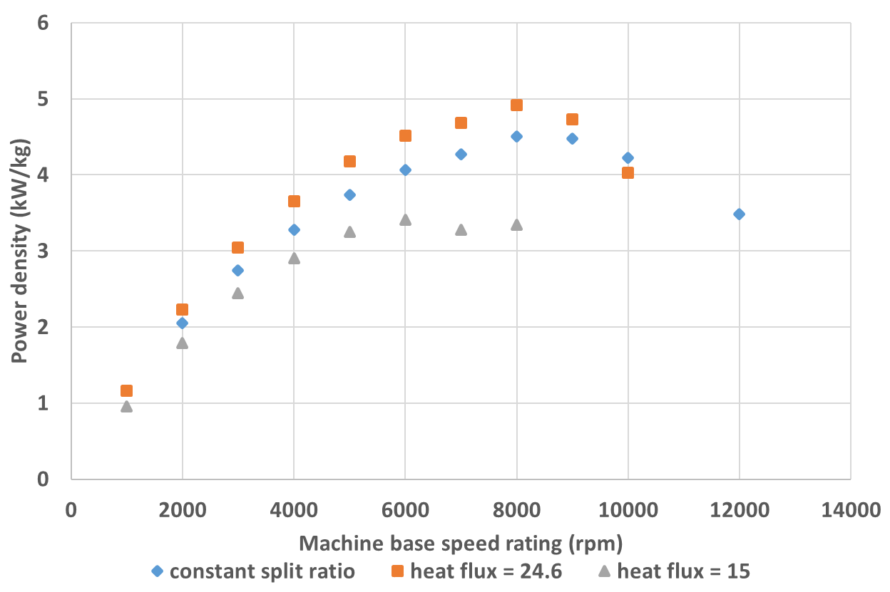
Figure 2.50 Power density variation with machine speed rating for constant heat flux design and constant split ratio design using electromagnetic split ratio
As can be seen from Figure 2.49 and Figure 2.50, since the machines in the middle speed range have lower initial heat flux per unit surface area, which can be seen from Figure 2.24, their thermal capability can be further exploit by reducing the slot area and increasing the current density, and hence torque density and power density can be further increased due to reduced machine size. For machines at high speed end, due to the higher initial heat flux through the surface than the criteria, the slot area has to be increased and the current density has to be reduced to reduce the thermal pressure brought by stator winding, while keeping the output torque unchanged. In this way, the torque density and power density drops. Figure 2.51 and Figure 2.52 shows the current density and split ratio variation with machine speed rating for constant heat flux design. For 15kW/m² heat flux level, more space is needed in the stator area to accommodate higher volume of copper in order to compensate the drop in output torque due to the reduction in current density. Hence, smaller split ratio than machine series with 24.6kW/m² heat flux is observed for machine series with 15kW/m² heat flux.
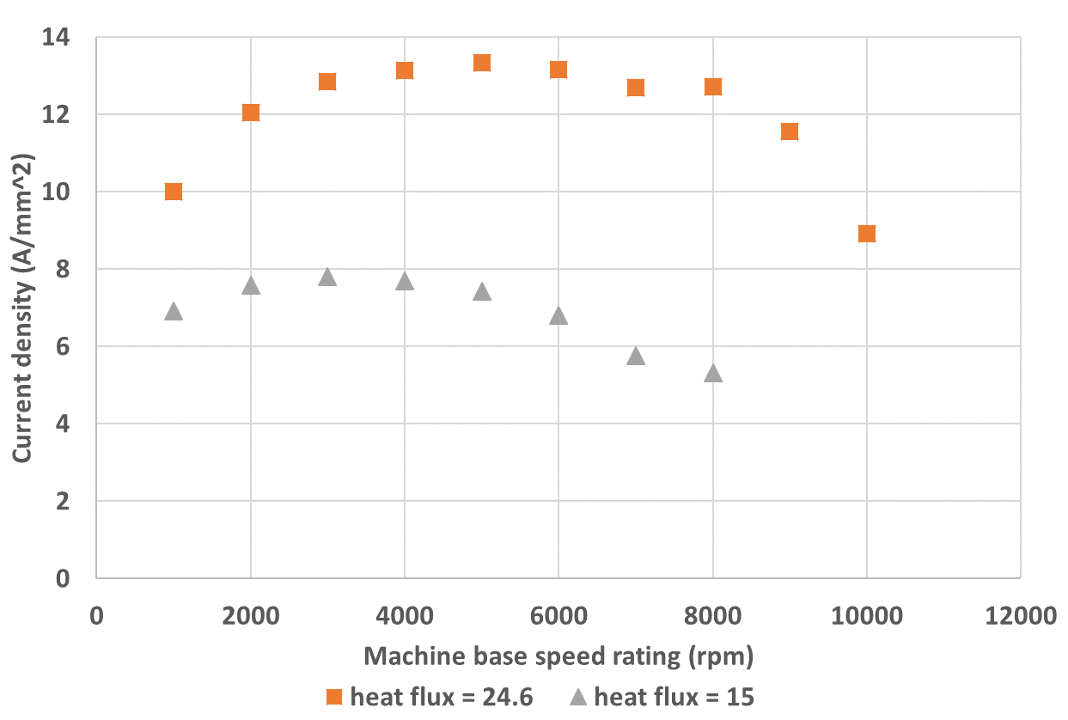
Figure 2.51 Current density variation within machine series of constant heat flux of 24.6kW/m² and 15kW/m²
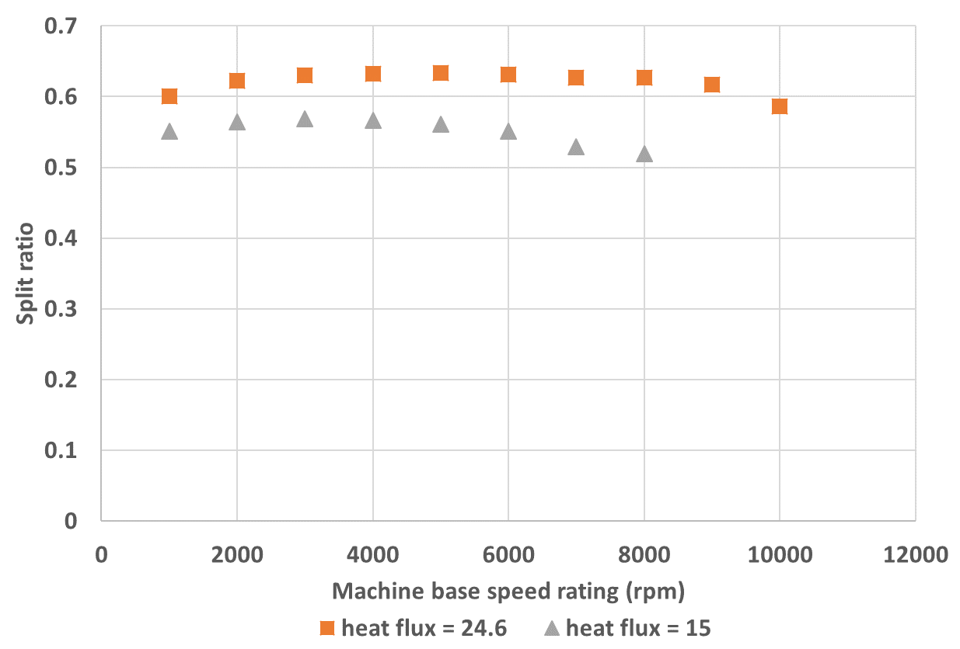
Figure 2.52 Split ratio variation within machine series of constant heat flux of 24.6kW/m² and 15kW/m²

Effect of different slot-pole combination on torque density and power density variation
The previous designs are based on the 9-slot-8-pole surface mounted PM machine, which belongs to the category of fractional-slot concentrated winding PM machine and has the advantages of high winding factor, short end winding, low torque ripple, high fault tolerance and high flux weakening capability. However, it also has the drawbacks of natural unbalanced magnetic force, and rich spatial harmonics and hence relatively high rotor eddy current loss.
This section selected other two PM machine topologies, viz. 12-8 slot-pole combination, which belongs to the factional slot machine category, with 0.5 SPP (slot/pole/phase), but has the characteristics of conventional integer slot machine topology (balanced magnetic structure and low spatial harmonics), and 12-10 slot-pole combination, which is another fractional slot machine topology and has similar advantages and drawbacks as the 9-8 slot-pole combination, to investigate the impact of slot-pole combination on torque density and power density variation.
As indicated by torque equation (2.4), for machines with the same magnitude of magnetic loading, electric loading, and machine size, which is achievable for different slot-pole combination, the difference in torque performance only comes from the difference in winding factor, and according to equations (2.13) to (2.15), as long as the proportion of magnet pole/inter-pole region stays the same, the number of poles on rotor structure does not affect the thickness of rotor containing structure, e.g. the 16-pole rotor structure could be composed by dividing each pole in an 8-pole rotor structure equally into 2 parts and reorganizing the sequence of different poles and inter-pole region, and hence the containment thickness does not need to be changed.
Therefore, there is no need for initial analytical sizing and later on combined design process for the machine series with 12-8 slot-pole and 12-10 slot-pole combinations, and the settled designs for 9-8 slot-pole combination could be well used as the starting point for those two machine series. The machine series under constant split ratio design criteria with mechanical split ratio is selected for implementation. For 12-8 slot-pole combination, the 9 slots are transformed into 12 slots by changing the stator tooth width $w_{t}$, and stator tooth tip top thickness $d_{tip}$, into 9/12 of their original magnitudes, while keeping the stator back iron thickness unchanged. In this way, the original geometric relationship settled by 1-D magnetic circuit analysis between these stator dimensions with rotor radius in equations (2.9) to (2.12) and (2.14) is still valid. In order to keep the total slot area and hence the electric loading unchanged, the stator tooth tip bottom thickness $h_{tip}$ is not changed in this transforming process, which means there would be less saturation in the area around the stator tooth tip bottom. For 12-10 slot-pole combination, the 9 slots are transformed into 12 slots in the same way, and the 8 poles are transformed into 10 poles without changing the other machine dimensions. The stator back iron thickness, which is smaller at higher pole number under the same saturation level, based on the 1-D magnetic circuit analysis (2.11), is kept unchanged at this pole transforming process, in order to keep the split ratio and electric loading the same with the machine series with 9 slots and 8 poles. In this way, there is less saturation in the region of stator back yoke, as indicated by magnetic circuit analysis, but the benefits of further increasing torque density from the reduction of stator back iron thickness cannot be obtained, and the increased fundamental frequency due to increased pole number will add burden to the controlling part of the machine. Table 2.16 and Table 2.17 show the key parameters of the designs for machine series with 12-8 slot-pole and 12-10 slot-pole combinations, respectively. The torque density and power density for each machine belonging to 12-8 and 12-10 designs are calculated and plotted in Figure 2.53 and Figure 2.54, respectively.
Table 2.16 Key parameters for machine series with 12 slots and 8 poles
Machine base speed rating (rpm) | Mechanical rotor radius (mm) | Stator outer radius (mm) | Stator tooth width (mm) | Stator backiron thickness (mm) | Torque (Nm) | Power (kW)
1000 | 102.00 | 170.00 | 19.88 | 14.91 | 2130.24 | 223.08
2000 | 85.00 | 141.67 | 16.57 | 12.43 | 1085.13 | 227.27
3000 | 76.30 | 127.17 | 14.87 | 11.16 | 714.80 | 224.56
4000 | 72.00 | 120.00 | 14.03 | 10.53 | 555.48 | 232.68
5000 | 68.50 | 114.17 | 13.35 | 10.01 | 442.12 | 231.49
6000 | 66.50 | 110.83 | 12.96 | 9.72 | 374.87 | 235.54
7000 | 65.00 | 108.33 | 12.67 | 9.50 | 323.12 | 236.86
8000 | 64.00 | 106.67 | 12.48 | 9.36 | 283.04 | 237.12
9000 | 63.30 | 105.50 | 12.34 | 9.25 | 254.27 | 239.65
10000 | 63.00 | 105.00 | 12.28 | 9.21 | 227.13 | 237.85
11000 | 63.00 | 105.00 | 12.28 | 9.21 | 207.48 | 239.00
12000 | 64.00 | 106.67 | 12.48 | 9.36 | 192.19 | 241.51
14000 | 66.00 | 110.00 | 12.87 | 9.65 | 163.70 | 240.00
Table 2.17 Key parameters for machine series with 12 slots and 10 poles
Machine base speed rating (rpm) | Mechanical rotor radius (mm) | Stator outer radius (mm) | Stator tooth width (mm) | Stator backiron thickness (mm) | Torque (Nm) | Power (kW)
1000 | 102.00 | 170.00 | 19.88 | 14.91 | 2354.91 | 246.61
2000 | 85.00 | 141.67 | 16.57 | 12.43 | 1194.37 | 250.15
3000 | 76.30 | 127.17 | 14.87 | 11.16 | 771.22 | 242.29
4000 | 72.00 | 120.00 | 14.03 | 10.53 | 591.49 | 247.76
5000 | 68.50 | 114.17 | 13.35 | 10.01 | 465.43 | 243.70
6000 | 66.50 | 110.83 | 12.96 | 9.72 | 391.39 | 245.92
7000 | 65.00 | 108.33 | 12.67 | 9.50 | 335.39 | 245.85
8000 | 64.00 | 106.67 | 12.48 | 9.36 | 292.98 | 245.45
9000 | 63.30 | 105.50 | 12.34 | 9.25 | 259.15 | 244.24
10000 | 63.00 | 105.00 | 12.28 | 9.21 | 231.89 | 242.83
11000 | 63.00 | 105.00 | 12.28 | 9.21 | 208.83 | 240.55
12000 | 64.00 | 106.67 | 12.48 | 9.36 | 194.88 | 244.90
14000 | 66.00 | 110.00 | 12.87 | 9.65 | 161.59 | 236.90

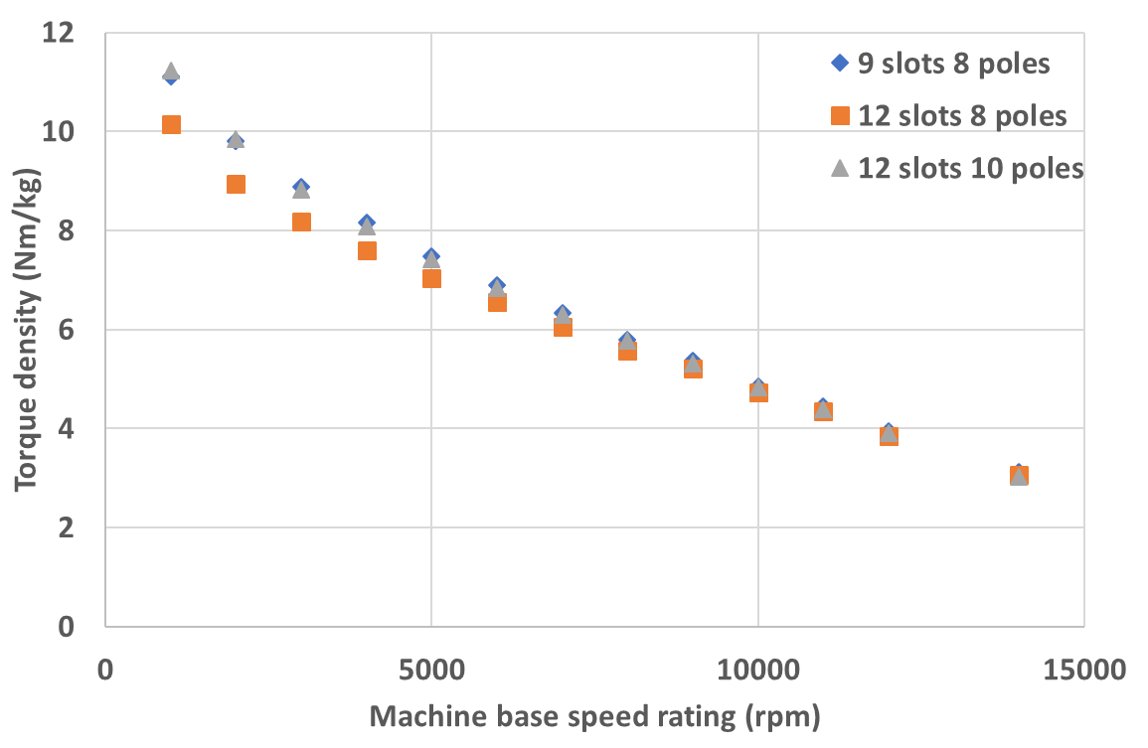
Figure 2.53 Torque density variation with machine speed ratings for machine series with 9-slot-8-pole, 12-slot-8-pole, 12-slot-10-pole combinations under the same machine size and electric loading
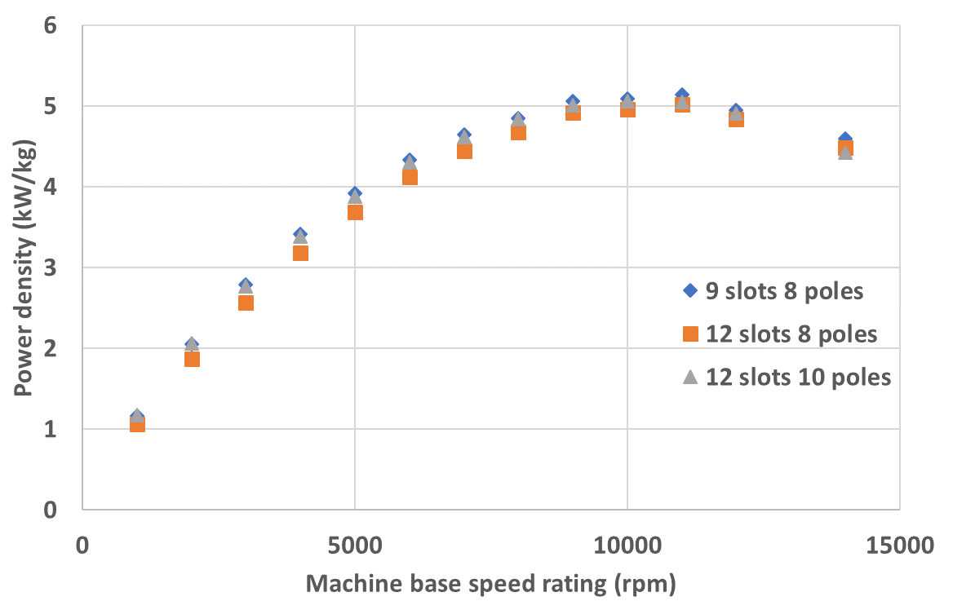
Figure 2.54 Power density variation with machine speed rating for machine series with 9-slot-8-pole, 12-slot-8-pole, and 12-slot-10-pole combinations under same machine size and electric loading
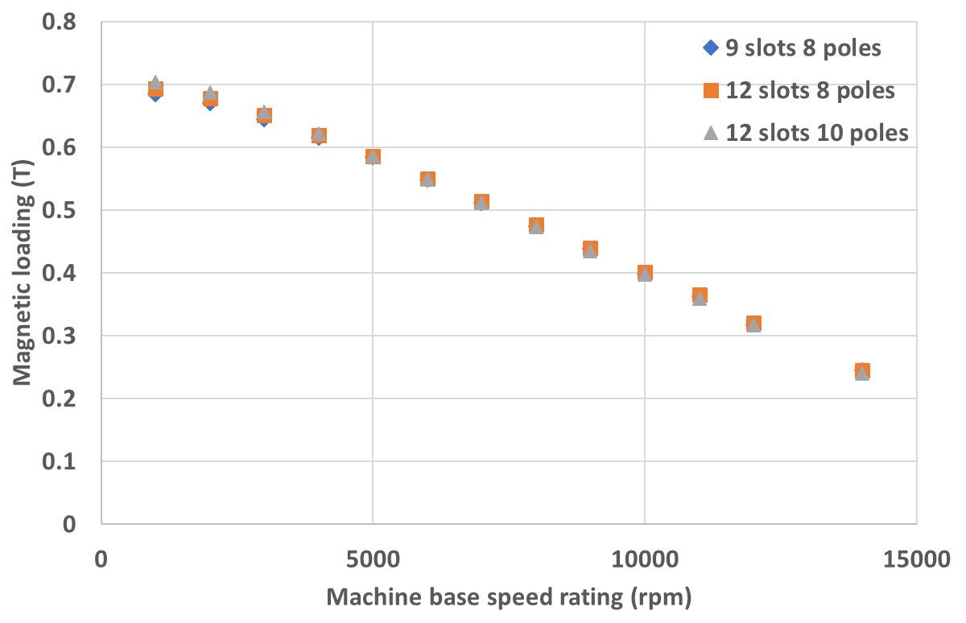
Figure 2.55 Magnetic loading variation within machine series with 9-slot-8-pole, 12-slot-8-pole, and 12-slot-10-pole combinations
Figure 2.55 shows the magnetic loading variation within the machine series with three slot-pole combinations, which is solved under open circuit condition. It can be seen that although the three machine series have the same rotor dimensions at each speed rating, including the containment thickness, there is still little difference in magnetic loading between them at low speed end. This difference is brought by the different slot-pole combination since the magnetic loading is determined by the airgap permeance and magnet working point, and the modulation effect from the stator slots could affect the airgap permeance and change the magnet working point, which has been studied in detail using analytical field analysis by authors in [19] and good agreement with FE results is achieved. As the slot-pole combination changes, the modulation effect is also changed. This modulation change has more influence at low speed end since as the speed rating increases, the effective airgap becomes bigger and bigger and is thus less and less affected by the slot modulation. Therefore, the magnetic loading variation in three machine series starts to merge, as indicated in Figure 2.55.
Under the same machine size, very close electric loading and magnetic loading, the difference in torque density and power density between the machine series with three different slot-pole combinations mainly comes from the difference in winding factor, which is 0.866 for 12-8 combination, 0.933 for 12-10 combination, and 0.945 for 9-8 combination, as indicated by analytical equations. Therefore, the 12-8 design should have the lowest output torque and power on the same machine size, and the 12-10 design should have close but slight lower torque performance than the 9-8 design. The FE calculated results shown in Table 2.16 and Table 2.17 and the torque density and power density variation curves shown in Figure 2.53 and Figure 2.54 well prove the analytical prediction. The 12-8 design also has the biggest torque ripple at low speed end, which is observed from the FE results. At high speed end, however, as the containment thickness becomes the dominant factor that influence the torque density and power density, the difference in winding factor in the three machine series no longer has significant influence on the torque density and power density, and the variation curves of torque density and power density for the 12-8 machine series become very close to the curves of other two machine series, as shown in Figure 2.53 and Figure 2.54. The torque ripple of 12-8 design also becomes very small, as observed from FE results, due to very large effective airgap thickness. There is another concentrated winding configuration for 12-10 slot-pole combination, which is alternate tooth wound topology, that can increase the winding factor from 0.933 to 0.966 while still keeping very short end winding and high fault tolerance. The torque density and power density would be slightly increased but have similar variation trend for that winding configuration compared to all tooth wound configuration. Since for 9-8 and 12-8 combination, the machine design is focused on all tooth wound configuration, the alternate tooth wound topology for 12-10 combination is not discussed here. In the following chapters, the 9-slot-8-pole machine topology will continue to be used for control technique implementation and loss study.

Impact of different parameters on the torque density and power density variation in constant split ratio design
In this section, different parameters are adjusted to investigate their impact on torque density and power density variation with machine speed rating. The machine series using electromagnetic split ratio under constant split ratio design is selected for investigation, and aspect ratio and slot packing factor are adjusted to investigate the impact on torque density and power density variation.

Impact of aspect ratio on torque density and power density variation
From the settled design for machine series using electromagnetic split ratio under constant split ratio constraints, the aspect ratio is adjusted from 1:1 to 2:1. The combined design method demonstrated in section 2.4.3.2 is used to settle the final design for machine series with 2:1 aspect ratio to meet the torque and power requirement. Table 2.18 shows the key parameters of the final design for machine series with aspect ratio of 2:1. The torque density and power density are calculated for each machine belonging to the series and plotted in Figure 2.56 and Figure 2.57, respectively.
Table 2.18 Key parameters of the final design for machine series with aspect ratio of 2:1 under constant split ratio design
Machine base speed rating (rpm) | Electrical rotor radius (mm) | Stator outer radius (mm) | Axial length (mm) | Magnet thickness (mm) | Containment thickness (mm) | Electrical loading (A/mm)
1000 | 84.00 | 140.00 | 560.00 | 12.00 | 0.50 | 167.45
3000 | 64.00 | 106.67 | 426.67 | 7.00 | 0.50 | 126.68
5000 | 57.50 | 95.83 | 383.33 | 5.00 | 0.72 | 112.85
8000 | 53.00 | 88.33 | 353.33 | 4.00 | 1.32 | 101.35
10000 | 52.50 | 87.50 | 350.00 | 3.00 | 1.61 | 99.31
12000 | 52.00 | 86.67 | 346.67 | 3.00 | 2.44 | 95.03
14000 | 53.00 | 88.33 | 353.33 | 2.00 | 2.57 | 96.75
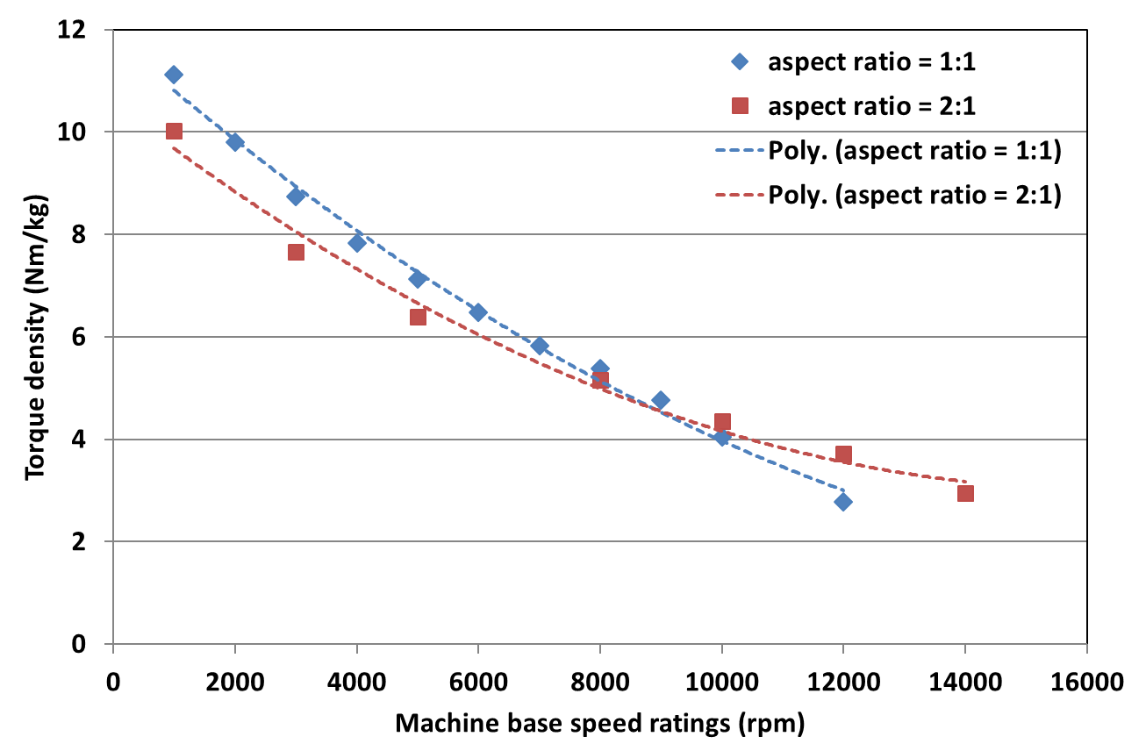
Figure 2.56 Torque density variation with machine speed rating for constant split ratio design under the definition of electromagnetic split ratio with aspect ratio of 1:1 and 2:1
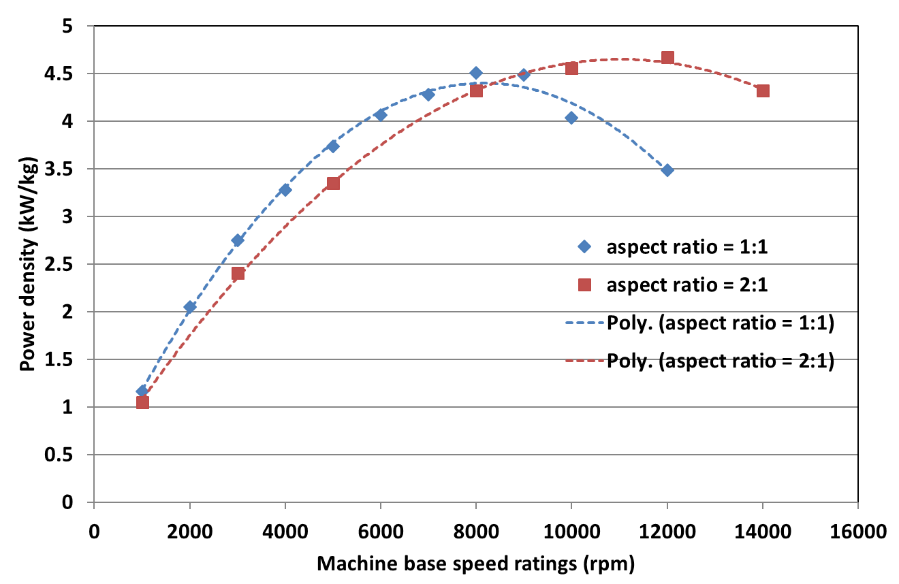
Figure 2.57 Power density variation with machine speed rating for constant split ratio design under the definition of electromagnetic split ratio with aspect ratio of 1:1 and 2:1
As indicated from equation (2.4), the output torque is linearly proportional to axial length $L_{a}$, but proportional to the cube of electrical rotor diameter, since the electric loading is also proportional to the electrical rotor diameter. Due to the fact that the machine volume is proportional to square of stator outer diameter times axial length, under constant split ratio design criteria, doubling the length in axial direction cannot get an equal return of machine size shrinking in radial direction from the point of total machine volume under the same torque output requirement and inevitably the overall machine size would increase when adjusting the aspect ratio from 1:1 to 2:1. This can well explain the phenomena shown in Figure 2.56 and Figure 2.57 at low speed end where the machine series with 2:1 aspect ratio has lower torque density and power density than the machine series with 1:1 aspect ratio. However, at high speed end, where the effect of containment thickness becomes more and more important, the benefit of having smaller rotor diameter for machine series with 2:1 aspect ratio starts to emerge, and above certain point of speed ratings, the torque density and power density of machine series with 2:1 aspect ratio becomes bigger than the machine series with 1:1 aspect ratio.

Impact of slot packing factor on the torque density and power density variation
Again, starting from the settled design for machine series using electromagnetic split ratio with constant split ratio constraints, the slot packing factor is reduced from 0.5 to 0.355. This unavoidably leads to an increased overall machine size and reduced torque density and power density under the same torque requirement and constant split ratio condition. Combined design method is also used for this machine series to meet the design requirements, and Table 2.19 shows some key parameters for the final design of this machine series. The torque density and power density for each machine is calculated and plotted in Figure 2.58 and Figure 2.59, respectively.
Table 2.19 Key parameters of the final design for machine series with packing factor of 0.355 under constant split ratio criteria using electromagnetic split ratio
Machine base speed rating (rpm) | Electrical rotor radius (mm) | Stator outer radius (mm) | Axial length (mm) | Stator tooth width (mm) | Stator backiron thickness (mm) | Torque (Nm)
1000 | 108.00 | 180.00 | 360.00 | 28.07 | 15.79 | 2391.20
2000 | 90.50 | 150.83 | 301.67 | 23.52 | 13.23 | 1199.26
3000 | 83.00 | 138.33 | 276.67 | 21.57 | 12.13 | 806.83
4000 | 79.00 | 131.67 | 263.33 | 20.53 | 11.55 | 617.61
5000 | 75.50 | 125.83 | 251.67 | 19.62 | 11.04 | 482.02
6000 | 74.00 | 123.33 | 246.67 | 19.23 | 10.82 | 406.67
7000 | 73.00 | 121.67 | 243.33 | 18.97 | 10.67 | 344.72
8000 | 72.00 | 120.00 | 240.00 | 18.71 | 10.53 | 298.89
10000 | 74.00 | 123.33 | 246.67 | 19.23 | 10.82 | 242.02
12000 | 86.00 | 143.33 | 286.67 | 22.35 | 12.57 | 195.40

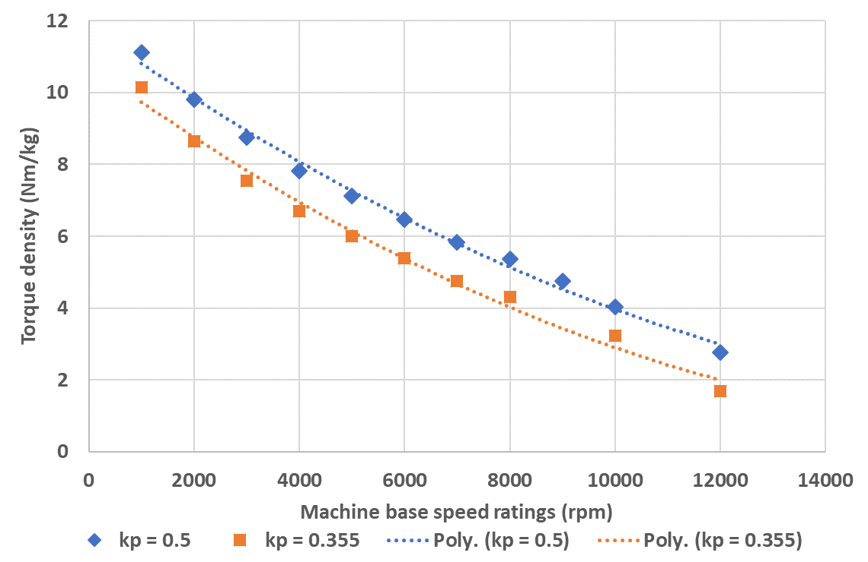
Figure 2.58 Torque density variation with machine speed rating for machine series with packing factor of 0.355 and 0.5 under constant split ratio design using electromagnetic split ratio
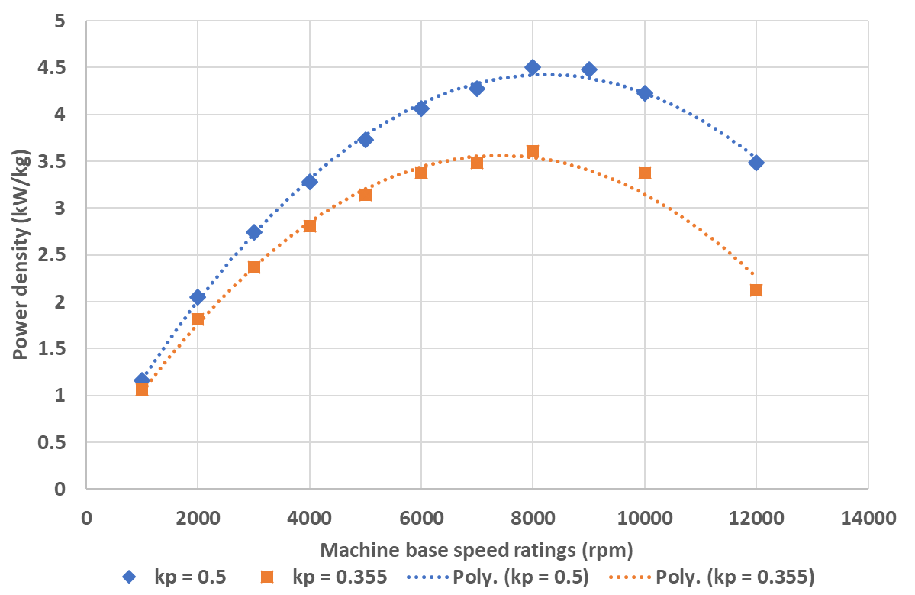
Figure 2.59 Power density variation with machine speed rating for machine series with packing factor of 0.355 and 0.5 under constant split ratio design using electromagnetic split ratio
As can be seen from Figure 2.58 and Figure 2.59, there is a drop in torque density and power density after the packing factor is adjusted from 0.5 to 0.355, and as the speed rating increases, the deviation becomes more and more significant. This is due to the more and more benefit obtained as the speed increases for machine series with 0.5 packing factor from relatively small rotor dimensions and hence relatively small containment thickness.

Conclusion
In this chapter, the following goals are achieved:
- The torque density and power density variation with machine speed ratings are investigated systematically, with the application of several sets of constraints, viz. constant current density and split ratio, constant current density and electrical loading, and constant heat flux
- The mechanism of the torque density variation is analysed using the analytical methods, revealing a natural drop of torque density with machine speed rating
- A maximum point for power density is found under each set of design constraints, and the benefits of having high electrical loading in the stator is seen in pushing the maximum power density towards the higher speed end
- Different parameters are investigated of their impact on torque density and power density variations. Benefits have been seen of having bigger aspect ratio at the high speed end, but limitations exists.

References
[1] Zwyssig C., Kolar J., Round SD., “Mega-speed Drive Systems: Pushing Beyond 1 Million r/min,” IEEE/ASME TRANSACTIONS ON MECHATRONICS, 2009. 14(5): p. 564-574.
[2] A. Arkkio, T. Jokinen, and E. Lantto, "Induction and permanent-magnet synchronous machines for high-speed applications," in Electrical Machines and Systems, 2005. ICEMS 2005. Proceedings of the Eighth International Conference on, 2005, pp. 871-876 Vol. 2.
[3] Z. Kolondzovski, A. Arkkio, J. Larjola, and P. Sallinen, "Power Limits of High-Speed Permanent-Magnet Electrical Machines for Compressor Applications," Energy Conversion, IEEE Transactions on, vol. 26, pp. 73-82, 2011.
[4] A. Boglietti, A. Cavagnino, A. Tenconi, and S. Vaschetto, "Key design aspects of electrical machines for high-speed spindle applications," in IECON 2010 - 36th Annual Conference on IEEE Industrial Electronics Society, 2010, pp. 1735-1740.
[5] A. Binder, T. Schnieder, “High-Speed Inverter-Fed AC Drives,” in Electrical Machines and Power Electronics, 2007. ACEMP '07. International Aegean Conference on. 2007, IEEE
[6] A. Borisavljevic, H. Polinder, and J. A. Ferreira, "On the Speed Limits of Permanent-Magnet Machines," Industrial Electronics, IEEE Transactions on, vol. 57, pp. 220-227, 2010.
[7] Gerada D., Borg Bartolo D., Mebarki A., Micallef C., Brown NL., Gerada C., “Electrical Machines for High Speed Applications with a Wide Constant-Power Region Requirement,” in Electrical Machines and Systems (ICEMS), International Conference on. 2011, IEEE.
[8] El-Rafaie, Jahns TM, “Scalibility of Surface PM Machines With Concentrated Windings Designed to Achieve Wide Speed Ranges of Constant-Power Operation,” IEEE TRANSACTIONS ON ENERGY CONVERSION, 2006. 21(2).
[9] Noguchi T., Takata Y., Yamashita Y., Komatsu Y., Ibaraki S., “220000 r/min 2kW PM Motor Drive for Turbo-charger,” IEEE TRANSACTIONS ON INDUSTRY APPLICATIONS, 2005. 125(9): p. 854-861.
[10] Garavaglia M, M.E., Piero B., Secondo G., “Stator for high-speed radial flux machines,” 1998: Italy.
[11] A. M. EL-Refaie, "Fractional-Slot Concentrated-Windings Synchronous Permanent Magnet Machines: Opportunities and Challenges," in IEEE Transactions on Industrial Electronics, vol. 57, no. 1, pp. 107-121, Jan. 2010.
[12] Binder A., Schneider T., Klohr, “Fixation of Buried and Surface-Mounted Magnets in High-Speed Permanent-Magnet Synchronous Machines,” IEEE TRANSACTIONS ON INDUSTRY APPLICATIONS, 2006. 42(4): p. 1031-1037.
[13] Magnetic Materials Producers Association, Chicago, Illinois 60603, USA, “Standard specifications for permanent magnet materials”, No. 0100-00.
[14] Metals, S., “Inconel 718 & 718SPF Datasheet,” S. Metals, Editor. 2013: www.specialmetals.com.
[15] Paulides, J.J.H, “High performance 1.5MW 20,000rpm permanent magnet generator with uncontrolled rectifier for ‘more-electric’ ship applications”, Ph.D. thesis, University of Sheffield, 2005.
[16] Professor Zhu, Z.Q., Lecture Notes in the Course of Machine Design, University of Sheffield
[17] Harris, C.O., “Introduction to stress analysis”, The MacMillan company, New York, p. 256, 1959.
[18] K. Atallah and D. Howe, "The calculation of iron losses in brushless permanent magnet dc motors," Journal of Magnetism and Magnetic Materials, vol. 133, pp. 578-582, 1994/05/01/ 1994.
[19] Z. Q. Zhu and D. Howe, "Instantaneous magnetic field distribution in brushless permanent magnet DC motors. III. Effect of stator slotting," in IEEE Transactions on Magnetics, vol. 29, no. 1, pp. 143-151, Jan. 1993.

The impact of switching current waveforms on machine performance

The investigation of torque density and power density variation with machine speed ratings in the previous chapter has considered the torque capability of the machine with some account of core loss. However, as was noted, this was undertaken with a pure sinusoidal current. One additional factor that will give rise to some reduction in torque density and/or efficiency with increasing rotational speed is the impact of the converter, in particular the presence of significant switching related ripple in the current waveform.
One factor which influences the converter loss and quality of the current waveform (in terms of harmonics, ripple etc.) is the separation between the fundamental electrical frequency and the switching frequency of the converter. If the switching frequency of the converter is limited to some maximum fixed value due to considerations of switching losses etc., then the number of converter switching events per cycle of the fundamental electrical frequency reduces as the machine speed rating increases. By way of example, for a 5kHz switching frequency (which is typical of 250kW sized mainstream drives) then for an 8-pole machine with a base-speed of 1,000rpm there will be 75 switching events in each cycle of the fundamental, which reduces to fewer than 6 for a machine with a base speed of 14,000rpm. This dramatic reduction in the number of switching events will inevitably impact significantly on the extent of current ripple in the waveform. This increased ripple may result in increased torque ripple, potential reduced average torque, increased core losses and increased rotor magnet eddy current losses. Hence, the simplified analysis based on ideal sinusoidal currents is likely to be slightly over-optimistic in terms of the performance of the higher speed rated machine. Factoring in current ripple for a fixed converter switching frequency is likely to favour lower speed machines. In order to quantitatively determine the extent of any additional reduction in torque density as a result of increasing rotational speed, a systematic study of the behaviour of the various machine designs with a defined converter was undertaken.
There are several constraints that could be imposed to provide a consistent framework for comparing machine designs, in terms of factors such as switching strategy (e.g. PWM, SVPWM or hysteresis) and switching frequency. The approach adopted in this study is based on hysteresis control as this offers a more generic means of comparing machines which is not influenced by the intricacies of various PWM strategies. Specifically, the hysteresis method has no direct control of switching frequency and the duration of individual switching cycles (i.e. on to off and back to off) varies over one cycle. This is contrast to most PWM modulation strategies for example where a fixed switching cycle frequency is used with current being controlled by duty cycle.
The power converter considered in this chapter comprises a three phase voltage source inverter (VSI) as power supply and hysteresis controller to provide current feedback. Since the main objective of this controlling study is to investigate the distortion of the current waveform due to increasing fundamental frequency during steady-state machine operation, speed control was not implemented here. Figure 3.1 and Figure 3.2 show the basic structure of the voltage source inverter and hysteresis current feedback implemented in this study, with S_{A}, S_{B}, and S_{C} representing the switching signal for phases A, B, and C, respectively. The entire control strategy can be implemented once the various electrical properties of the designed machine are determined, i.e. number of turns per phase, phase inductance, phase resistance, and required phase rms. current.
The basic principle of hysteresis control is illustrated in Figure 3.3. A hysteresis band with an upper and lower limit either side of the command current waveform is used to confine the actual current flowing within this band using simple negative feedback. The switching signal is generated by comparing the error signal, which is subtraction between actual feedback current and command current, with the pre-set hysteresis band. If, in any of the three phases the error signal exceeds the upper limit of the hysteresis band, the lower switch in the corresponding inverter leg, e.g. Q2 in Figure 3.1 for phase A, is switched on to connect that phase to the negative DC voltage, forcing the current to drop down and vice versa for the lower band. The width of the hysteresis band, can be selected to guarantee a given level of tracking of the command current. This is recognised as an advantage of the hysteresis control method [1]. In addition, there is also potential of reducing the number of switching events per electrical cycle for some operating points when the combination of machine winding inductance, resistance, back-EMF, and DC voltage source are such that the actual current naturally follows the command current without encroaching on the hysteresis band.
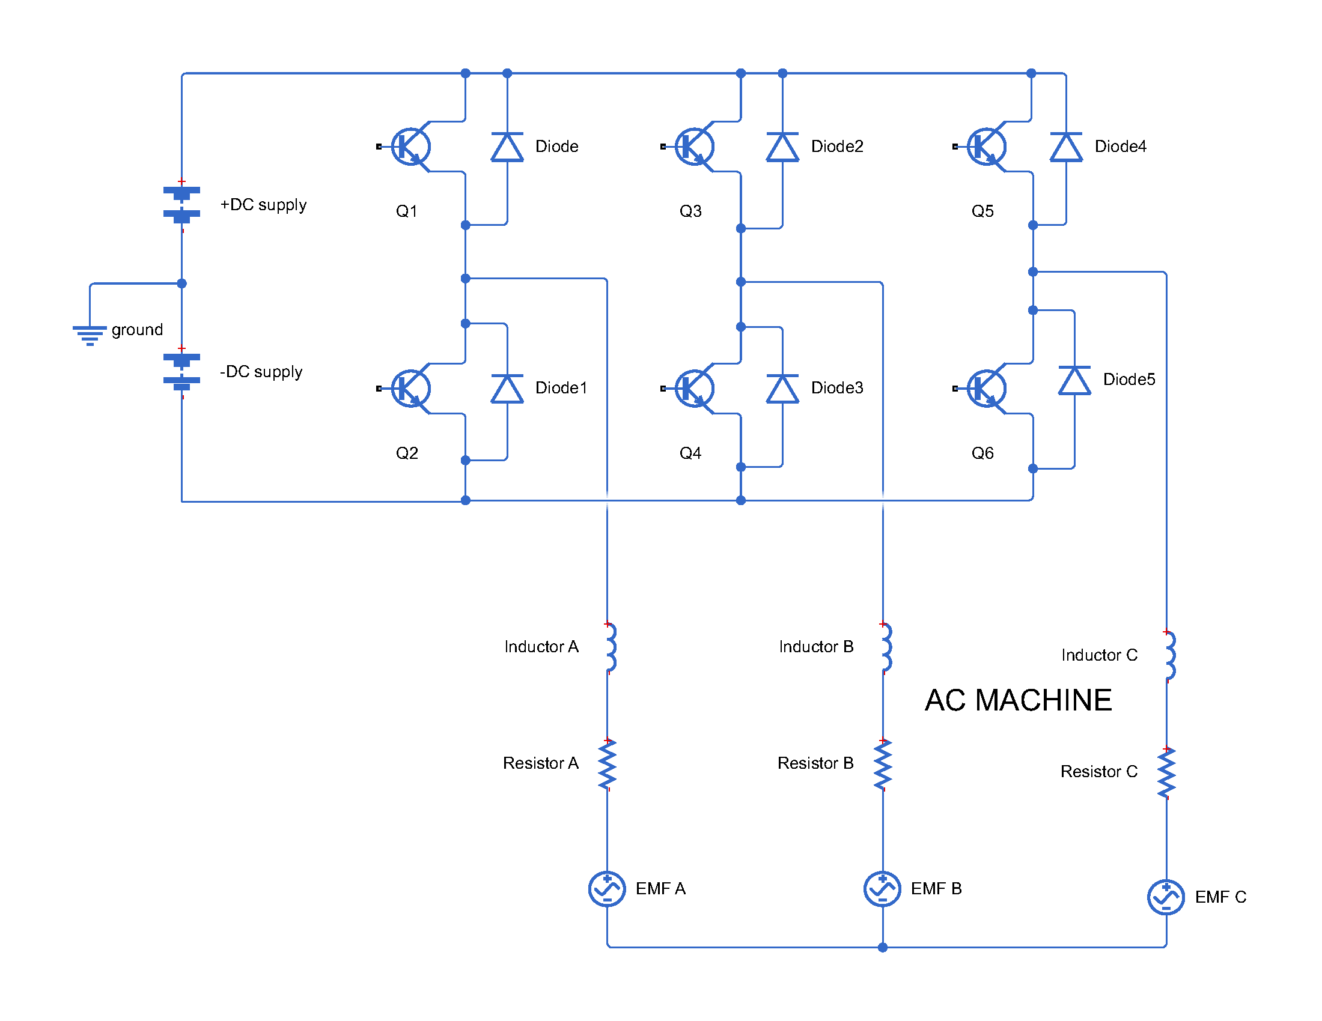
Figure 3.1 Basic structure of the voltage source inverter
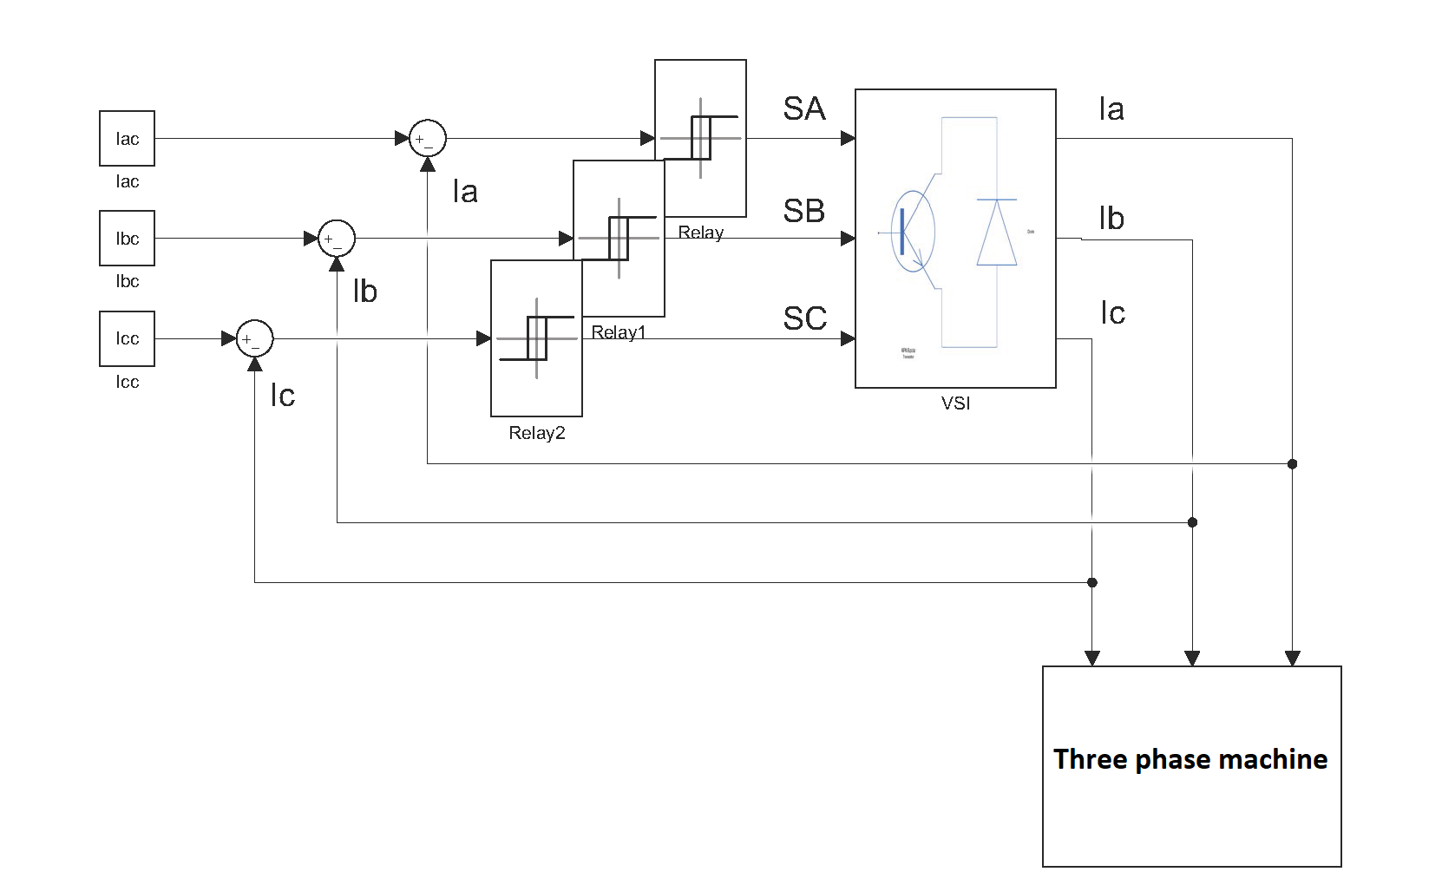
Figure 3.2 Block diagram for a hysteresis current feedback VSI controller
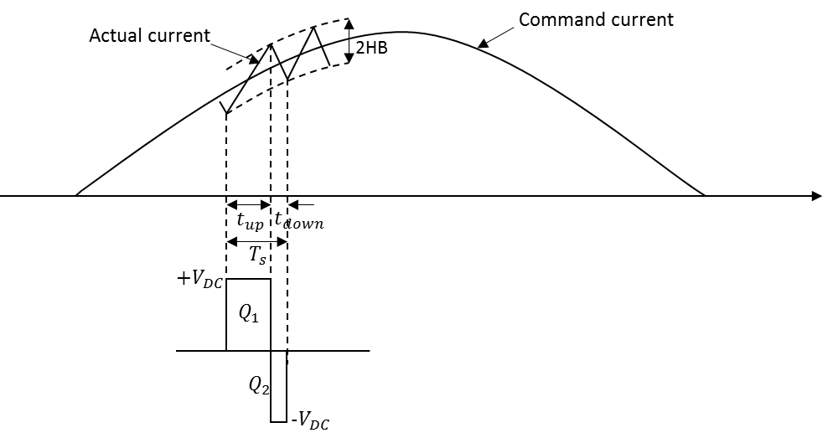
Figure 3.3 Basic operation principle of hysteresis control
However, one well-known features of hysteresis control is that there is no direct control over the switching frequency, which can be a disadvantage since this may bring instability to the whole system. Clearly, there is coupling between the magnitude of the hysteresis band and the resulting switching frequency, but setting a hysteresis band of a certain size on an a-priori basis does not precisely control the switching frequency for all operating conditions. Various attempts have been made to fix the switching frequency and ensure that the whole process is more controllable and stable, [2]-[10]. In [2], the following relationship between the hysteresis band width and the PWM switching frequency was derived through a theoretical analysis of the hysteresis process.
$$HB=\frac{0.25a^{'}V_{DC}}{f_{s}L_{ph}}\left[1-\frac{{L_{ph}}^{2}}{{a^{'}}^{2}{V_{DC}}^{2}}{\left(\frac{E_{ph}}{L_{ph}}+\frac{di_{c}}{dt}\right)}^{2}\right]$$ | (3.1)
The weighted mean voltage coefficient $a^{'}$ is present because the three phases are star connected instead of isolated from each other, and therefore the voltage applied to a given phase is no longer simply $±V_{DC}$, but could be $±\frac{4}{3}V_{DC}$, $±\frac{2}{3}V_{DC}$, or $0V_{DC}$, depending the switching status of the remaining phases. Hence, the effective voltage applied to each phase over a period is given by:
$$V_{eff}=\frac{4}{3}V_{DC}\frac{\sum{t_{\frac{4}{3}}}}{T}+\frac{2}{3}V_{DC}\frac{\sum{t_{\frac{2}{3}}}}{T}+0V_{DC}\frac{\sum{t_{0}}}{T}$$
Therefore, the weighted mean voltage coefficient has the following expression
$$a^{'}=\frac{4}{3}\frac{\sum{t_{\frac{4}{3}}}}{T}+\frac{2}{3}\frac{\sum{t_{\frac{2}{3}}}}{T}+0\frac{\sum{t_{0}}}{T}$$
The switching frequency can thus be expressed as
$$f_{s}=\frac{0.25a^{'}V_{DC}}{HBL_{ph}}\left[1-\frac{{L_{ph}}^{2}}{{a^{'}}^{2}{V_{DC}}^{2}}{\left(\frac{E_{ph}}{L_{ph}}+\frac{di_{c}}{dt}\right)}^{2}\right]$$ | (3.2)
By adjusting in real-time the magnitude of the hysteresis band according to (3.2), the switching frequency can be kept more or less constant. However, there are some limitations in this calculation, e.g. the weighted mean voltage coefficient, $a^{'}$ is an average effect and cannot be determined instantaneously or be predicted as a lookup table since its value is affected by the switching states of all the six switches in the H-bridge inverter, which is different for different occasions and does not have a general formula.
Since the focus of this thesis is establishing a systematic means of investigating the torque density variation with machine rated speed, improving the hysteresis control itself by controlling the frequency throughout the whole process does not assist in establishing a consistent means of comparing the different machines. The approach adopted in this study is to set up the same average switching rate in the converter for all the machines belonging to one series of designs, e.g. 5,000 switching events per second. This can be considered at one level as being the same as an average switching frequency of 5kHz in terms of converter losses. Such approach ensures that a comparison between different machines can be made with the same converter losses for all the machines belonging to one series.
In order to enforce this constraint, the width of the hysteresis band for each machine and operating speed, which satisfies the condition of 5,000 switching events per second in hysteresis control, needs to be determined. This hysteresis band magnitude can be obtained either analytically from equation (3.2), or numerically by iterative simulations with the Simulink model shown previously in Figure 3.2.
For the purposes of this study, the analytical method was utilised in the first instance to establish a baseline for the magnitude of the hysteresis band required for each machine design. Fine adjustment of calculated hysteresis band width was then carried out in the Simulink model to match the requirement for a 5kHz average switching frequency. Similarly, the width of hysteresis band meeting the criteria of 10kHz, 15kHz, and 20kHz average switching frequency were also determined for each machine. Of the many series of machines designed in last chapter, the machine series for constant current density and split ratio criteria was used to carry out the control strategy study.

Determination of machine electrical properties
In order to implement the control strategy and simulate it within a SIMULINK model, the electrical parameters of each machine design needs to be determined, specifically, the number of turns per phase, phase inductance, and phase resistance. The approach adopted is based on firstly calculating the number of turns per phase. The number of turns can then be used in the phase inductance and resistance calculation. The phase inductance has the following relationship with the phase number of turns [11]
$$L_{ph}=\frac{{N_{ph}}^{2}}{\sum{Λ_{s}}}$$ | (3.3)
Determining the total reluctance inside the magnetic circuit for inductance calculation using analytical methods to a reasonable precision is difficult because of the irregular geometry inside the machine and the numerous contributions from leakage flux. However, for a machine of a fixed geometry a good estimate of the reluctance can be obtained using finite element analysis.
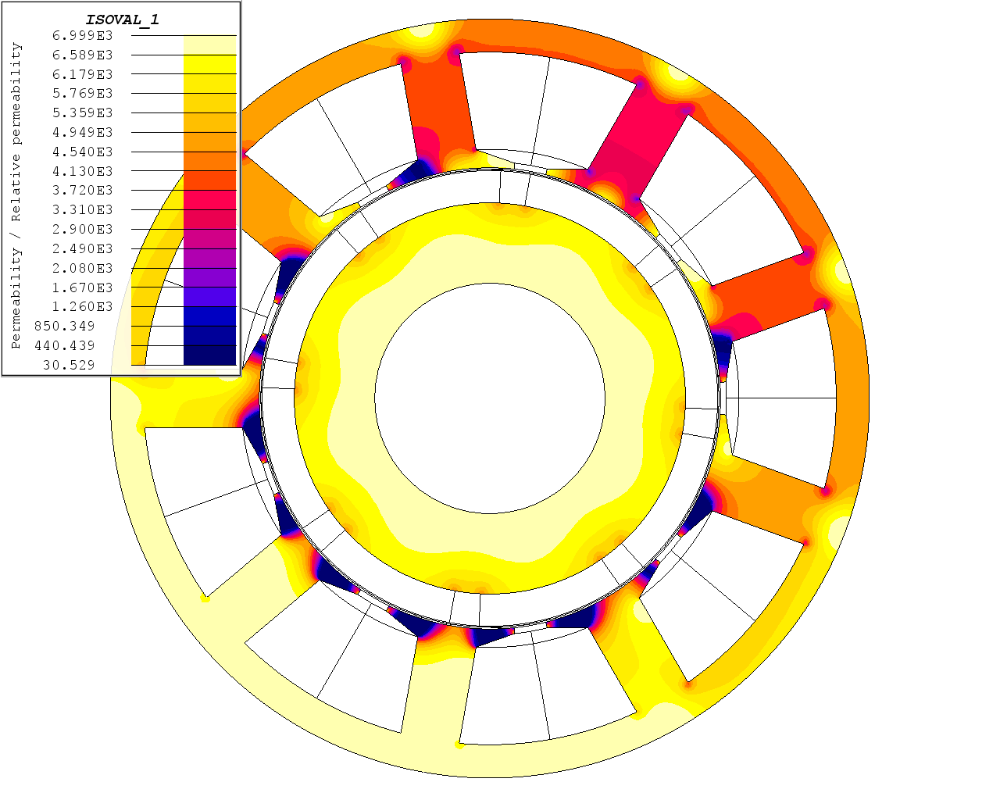
Figure 3.4 Spatial distribution of relative permeability frozen at one rotor position in core region for inductance calculation
In this study, a so-called ‘frozen permeability’ method has been adopted for calculation of phase inductance. This method can accommodate the change in saturation condition in core region from load condition to no load condition and the magnet flux could be calculated solely at open circuit condition but represent the part of magnet flux from total flux at load condition. This provides convenience of separating the magnet flux from total flux at load condition with high accuracy and improves the precision of inductance calculation. More specifically, for each machine, the built FE model is put into transient solving with rotor rotating by one electrical cycle, when only one phase, e.g. phase A, is imposed on a DC current $I_{A}$, whose value ramps through certain range by a series of transient solving to change the saturation level, while other two phases are kept open circuit. In the post-processing stage, the flux through each phase, i.e. $Φ_{A}$, $Φ_{B}$, and $Φ_{C}$, whose value has the contribution from both the armature flux and the magnet remanence flux, is detected and extracted from the FE software. At each step of rotor position, the relative permeability at different geometric position in the stator and rotor core, which represents the transient saturation level at that position, is frozen and stored in a spatial quantity. Afterwards, the same transient solving is rerun but with all three phases open circuit, i.e. no armature flux. The relative permeability of stator and rotor core material is now initialized using the pre-stored permeability map, an example shown in Figure 3.4, instead of the BH curve, by which the saturation level of the previous solving, when armature and remanence flux both exist, is imported into this solving process. In the postprocessing stage, the flux through each phase, i.e. $Φ_{AM}$, $Φ_{BM}$, and $Φ_{CM}$, whose value now only have the contribution from the magnet remanence flux, is detected and extracted from the FE software. The self-inductance of phase A, can be calculated using the following equation,
$$L_{A}=\frac{Φ_{A}-Φ_{AM}}{I_{A}}$$ | (3.4)
and the mutual inductance of phase A to B and A to C can be calculated using the following corresponding equations,
$$M_{BA}=\frac{Φ_{B}-Φ_{BM}}{I_{A}}$$ | (3.5)
$$M_{CA}=\frac{Φ_{C}-Φ_{CM}}{I_{A}}$$ | (3.6)
The same mutual inductance would be obtained for phase A when current is present in phase B or C, i.e.
$$M_{AB}=M_{BA}$$ | (3.7)
$$M_{AC}=M_{CA}$$ | (3.8)
The self and mutual inductances of phase B and C can also be obtained using the same method. Alternatively, due to the balanced nature of three phase current under normal operation, the following relationships can be used:
$$L_{B}=L_{C}=L_{A}$$ | (3.9)
$$M_{AB}=M_{AC}=M_{BC}$$ | (3.10)
The self-inductances of the other two phases can thus be directly obtained from (3.9). Combining (3.5) - (3.8), (3.10), and the following relationship
$$M_{CB}=M_{BC}$$ | (3.11)
the mutual inductances for all the three phases can be settled.
Having calculated the phase self and mutual inductances, the synchronous inductance for each phase can be obtained, e.g. for phase A,
$$L_{sync}=L_{A}-\frac{1}{2}M_{AB}-\frac{1}{2}M_{AC}$$ | (3.12)
By way of an example, Figure 3.5 shows the variation in the phase synchronous inductance with phase current for machine 8 in series of designs (i.e. base speed of 8,000rpm at a fixed electromagnetic split ratio). This particular variation in inductance was calculated using a frozen permeability method, with the number of turns on each coil temporally set to 3, i.e. 9 turns per phase. As can be seen, beyond ~200A (corresponds to 600$A⋅turns$ per coil), the impact of armature flux on saturation condition in the core becomes increasingly more significant with a gradual drop in inductance. For implementation of the control strategy, a single value of phase inductance needs to be determined. For the purposes of this controller, the single value was set to the mean value of the flat top, a value which does not include any meaningful saturation effect.
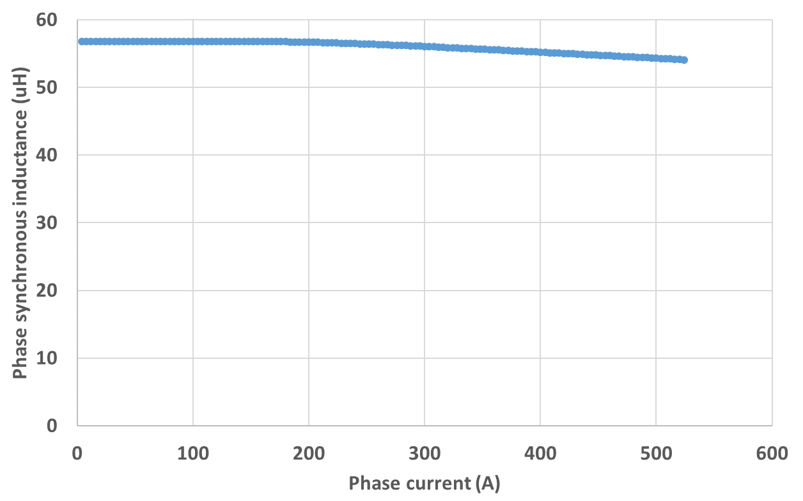
Figure 3.5 Phase synchronous inductance variation with phase current for 3 turns per coil
The rms. ampere-turns in the slot can be expressed in terms of the current density as:
$$2N_{coil}I_{rms}=J_{rms}A_{slot}k_{p}$$
Hence, the phase rms. current can be expressed as:
$$I_{rms}=\frac{J_{rms}A_{slot}k_{p}}{2N_{coil}}=\frac{mJ_{rms}A_{slot}k_{p}}{2N_{ph}}$$ | (3.13)
where $m=3$ is the number of phases in the machine.
Assuming the end winding geometry can be reasonably represented as a series of semi-circles at each end of the machine active section, then the phase resistance can be simply calculated using the following expression
$$R_{ph}=ρ_{cu}\frac{\left(L_{a}+\frac{π}{2}D_{end}\right)⋅2{N_{ph}}^{2}}{k_{p}A_{slot}}$$ | (3.14)
An expression for the resistive voltage drop can be obtained by combining (3.13) and (3.14):
$$V_{R}=I_{rms}R_{ph}=J_{rms}ρ\left(L_{a}+\frac{π}{2}D_{end}\right)×2N_{ph}$$ | (3.15)
The induced back-EMF in one phase can be expressed as
$$E_{ph}=k_{E}ω_{r}=\frac{3}{\sqrt{2}}pk_{w}N_{ph}ϕ_{p}ω_{r}$$ | (3.16)
For a fixed machine geometry and speed, $p$, $k_{w}$, $ϕ_{p}$ and $ω_{r}$ are fixed. This relationship can be expressed using a coefficient ${k_{E}}^{'}$, i.e.
$$E_{ph}={k_{E}}^{'}N_{ph}$$ | (3.17)
In the case of machine 8, ${k_{E}}^{'}=11.06V/turn$.
In the equivalent circuit for one phase, the phasor relationship between the various voltages can be expressed as
$$V_{s}=\sqrt{{\left(ω_{s}L_{ph}I_{rms}\right)}^{2}+{\left(E_{ph}+I_{rms}R_{ph}\right)}^{2}}$$ | (3.18)
By substituting (3.3), (3.13), (3.15), and (3.17) into (3.18), the phase supply voltage can be expressed as a linear function of the phase number of turns, i.e.
$$V_{s}=k_{s}N_{ph}$$ | (3.19)
For machine 8, $k_{s}=22.44V/turn$. Therefore, providing the phase supply voltage is known, the number of turns per phase can be calculated correspondingly. For high power aerospace systems, currently the DC supply voltage for the inverter is limited to $±$270V. Ideally this would correspond to a peak value of the phase voltage of 270V. However, due to a combination of limits imposed on duty cycle, the introduction dead time of the two switches on each inverter leg and various device losses, the actual voltage that can be obtained for each phase tends to be slightly lower than the ideal 270V. A reasonable assumption, adopted in this analysis, is a 10V reduction in the peak value. The corresponding rms. value $V_{s}=260/\sqrt{2}=183.85V$. Therefore, the number of turns per phase can be calculated for each machine, and the corresponding electrical properties, including phase inductance, phase resistance and rated phase rms. current can also be calculated using (3.3), (3.14), and (3.13), respectively. However, the direct application of this series of equations will inevitably lead to non-integer numbers of turns per coil. Practical coils however need to be formed with an integer number of turns. In order to ensure that the desired power can be realised within the limitations of the supply voltage with an integer number of turns, and considering each phase has three coils with each coil having integer number of turns, the nearest multiple-of-3 below the calculated number of turns per phase needs to be adopted. The finally determined phase number of turns, phase inductance and phase resistance for machine series with constant mechanical split ratio are shown in Figure 3.6 to Figure 3.8, respectively. The detailed calculated electrical properties for the two machine series are summarized in Appendix I.
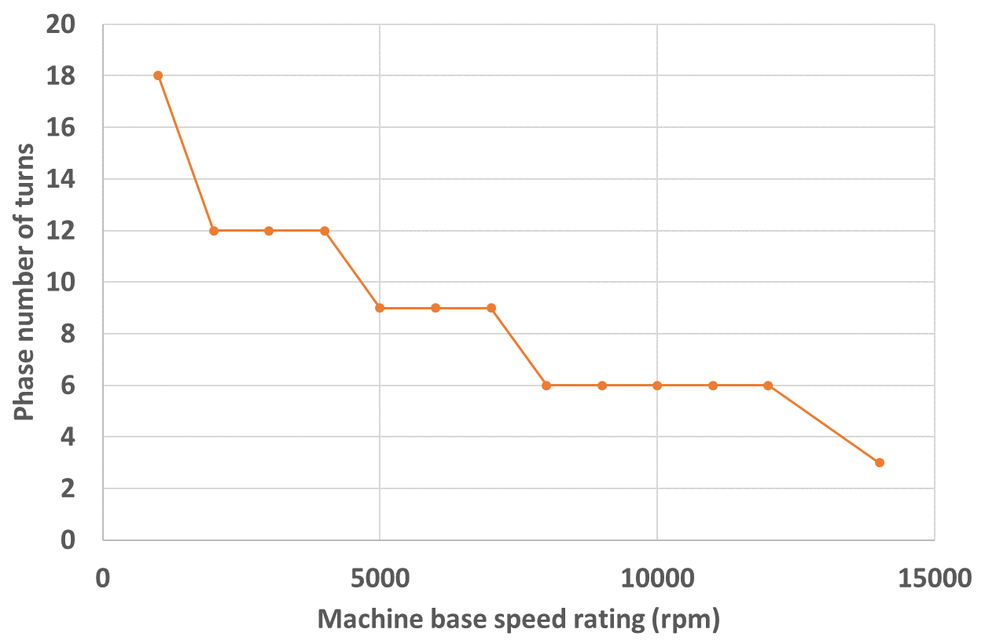
Figure 3.6 Final determined phase number of turns for machine series with constant mechanical split ratio
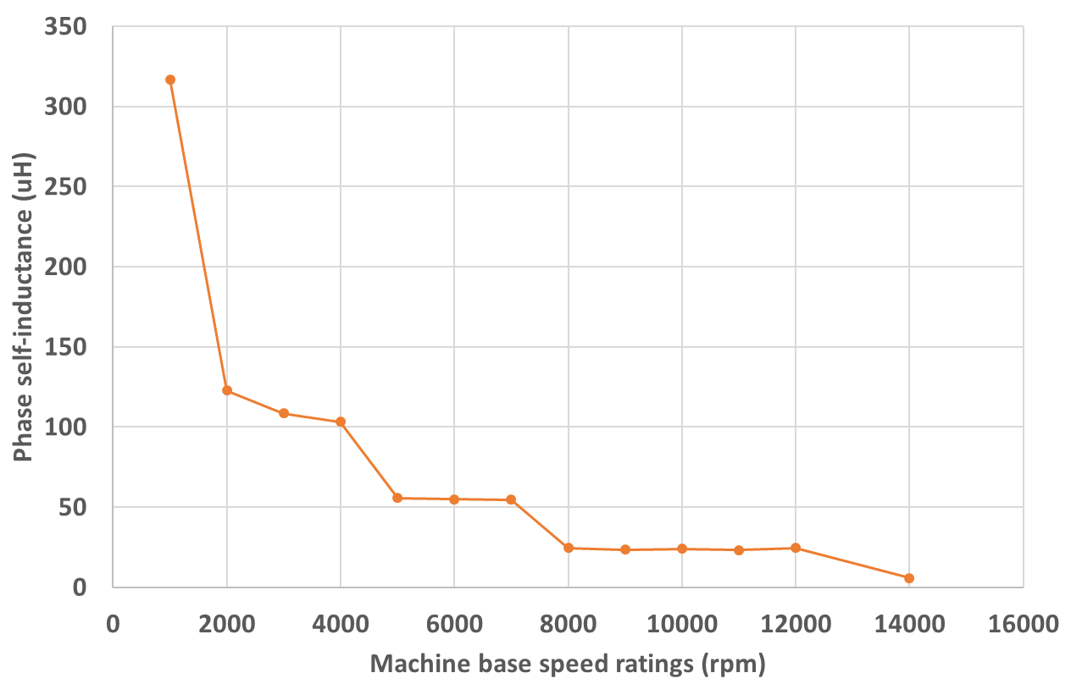
Figure 3.7 Final determined phase self-inductance for machine series with constant mechanical split ratio
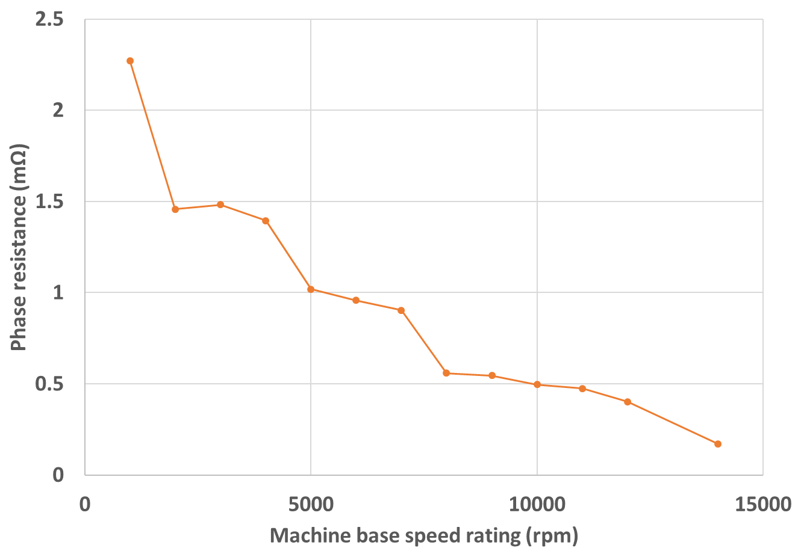
Figure 3.8 Final determined phase resistance for machine series with constant mechanical split ratio

Implementation of the control strategy
A SIMULINK based model was developed to implement the hysteresis control strategy. The Simulink model comprises a three-phase voltage source inverter, the electrical circuit model representing the machine electromagnetic behaviors and the current feedback loop to generate the switching signal. Each phase of a given design of machine is represented by a circuit incorporating the phase self-inductance, phase resistance, and a voltage source equal to phase back-EMF. The three phases are magnetically coupled by the mutual inductance and electrically coupled by non-earthed star connection which acts as a floating neutral point. Figure 3.9 shows the block diagram of the entire model.
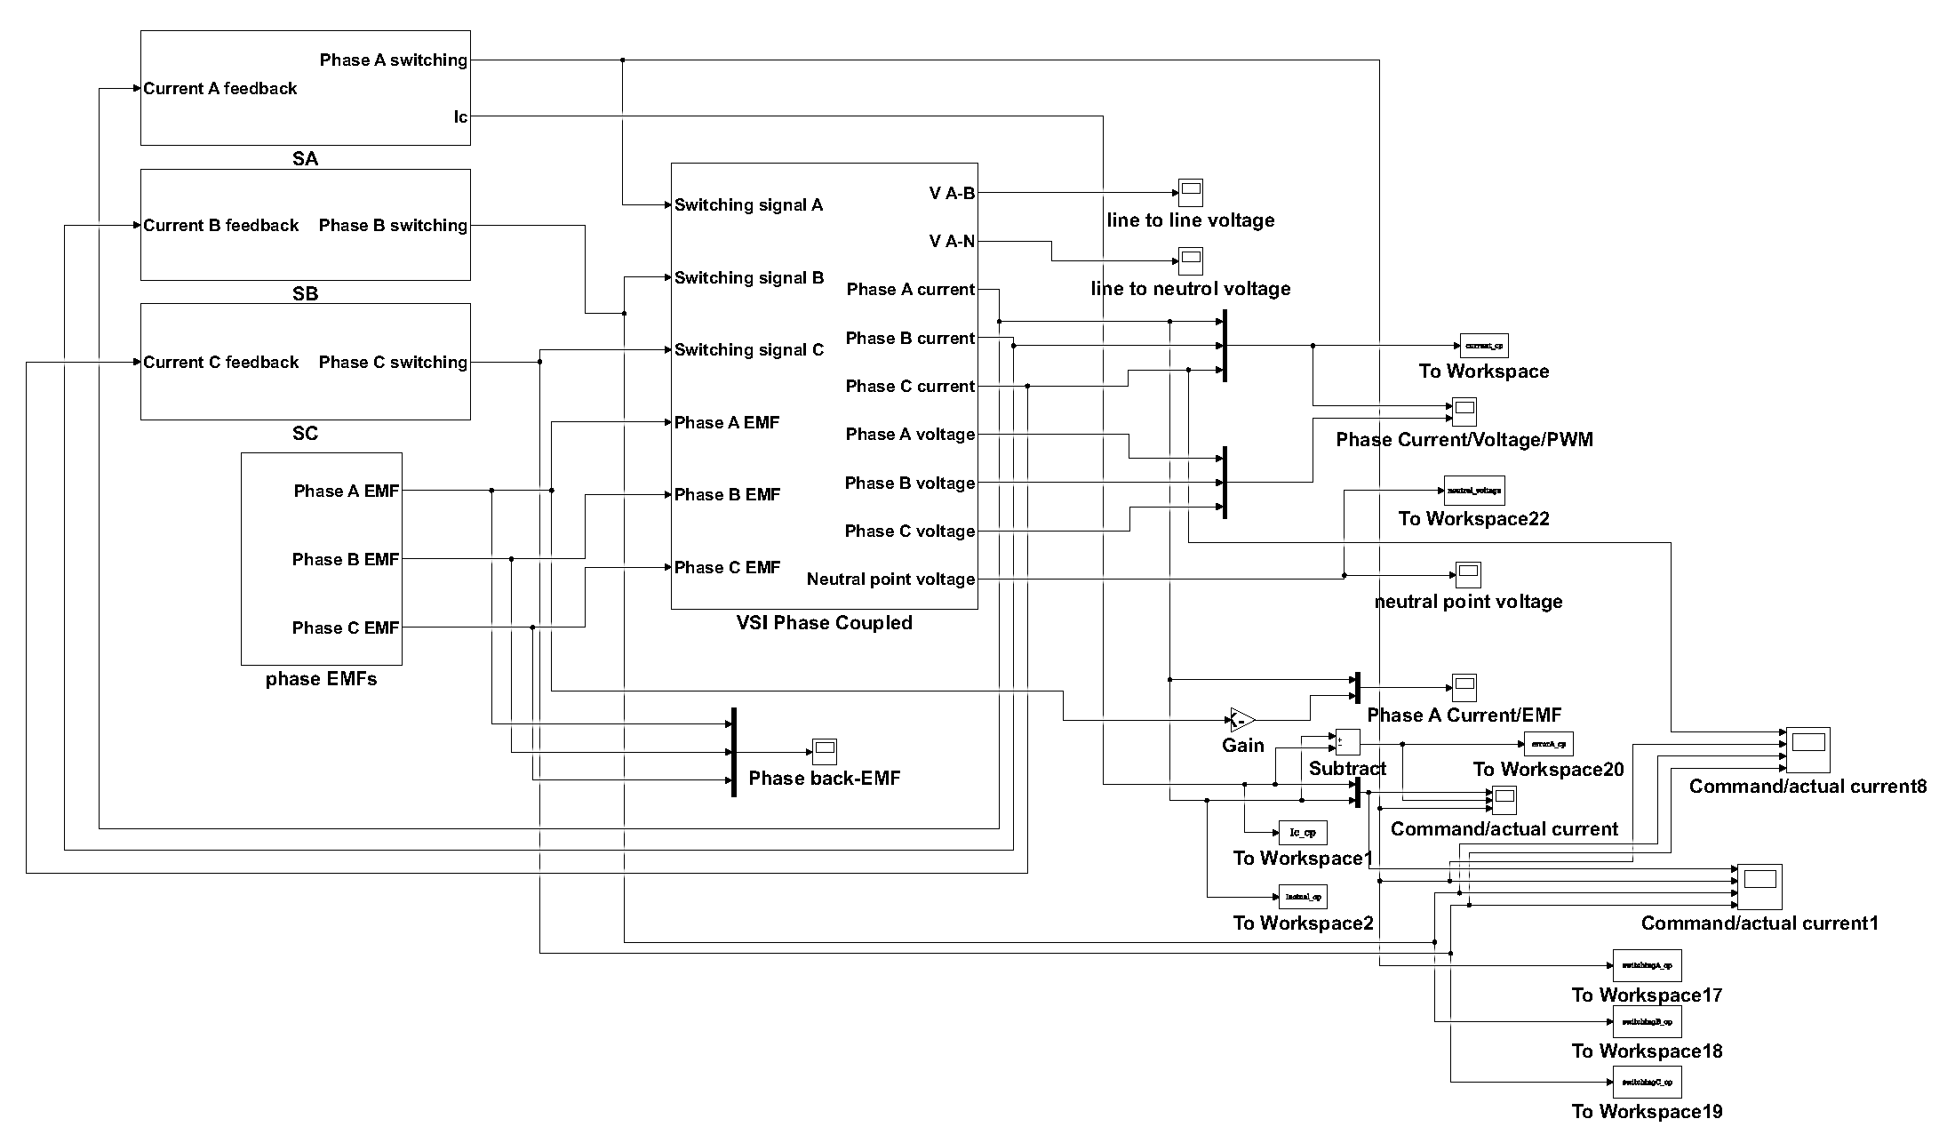
Figure 3.9 Overall block diagram of the converter and machine model with hysteresis current controller
The voltage source inverter block, shown in Figure 3.10, includes a conventional 3 phase 6-switch inverter which utilizes the signal generated from the switching signal generation blocks to control the 6 switches on the bridges, connecting the three phase legs to either +260V or -260V DC voltage source to increase or decrease the phase current. Each phase leg incorporates the phase back-EMF, which is realized in the simulation circuit by using a controlled voltage source whose instantaneous magnitude is equal to the output signal from the corresponding back-EMF generation block, the phase self-inductance, and the phase resistance. The magnetic coupling from the other two phases is realized by adding a further controlled voltage source into the phase leg, whose value is equal to the output signal from the mutual coupling voltage generation block. The actual current flowing in each phase is detected via the current sensor in each phase leg, and used for instantaneous feedback into the switching signal generation block.
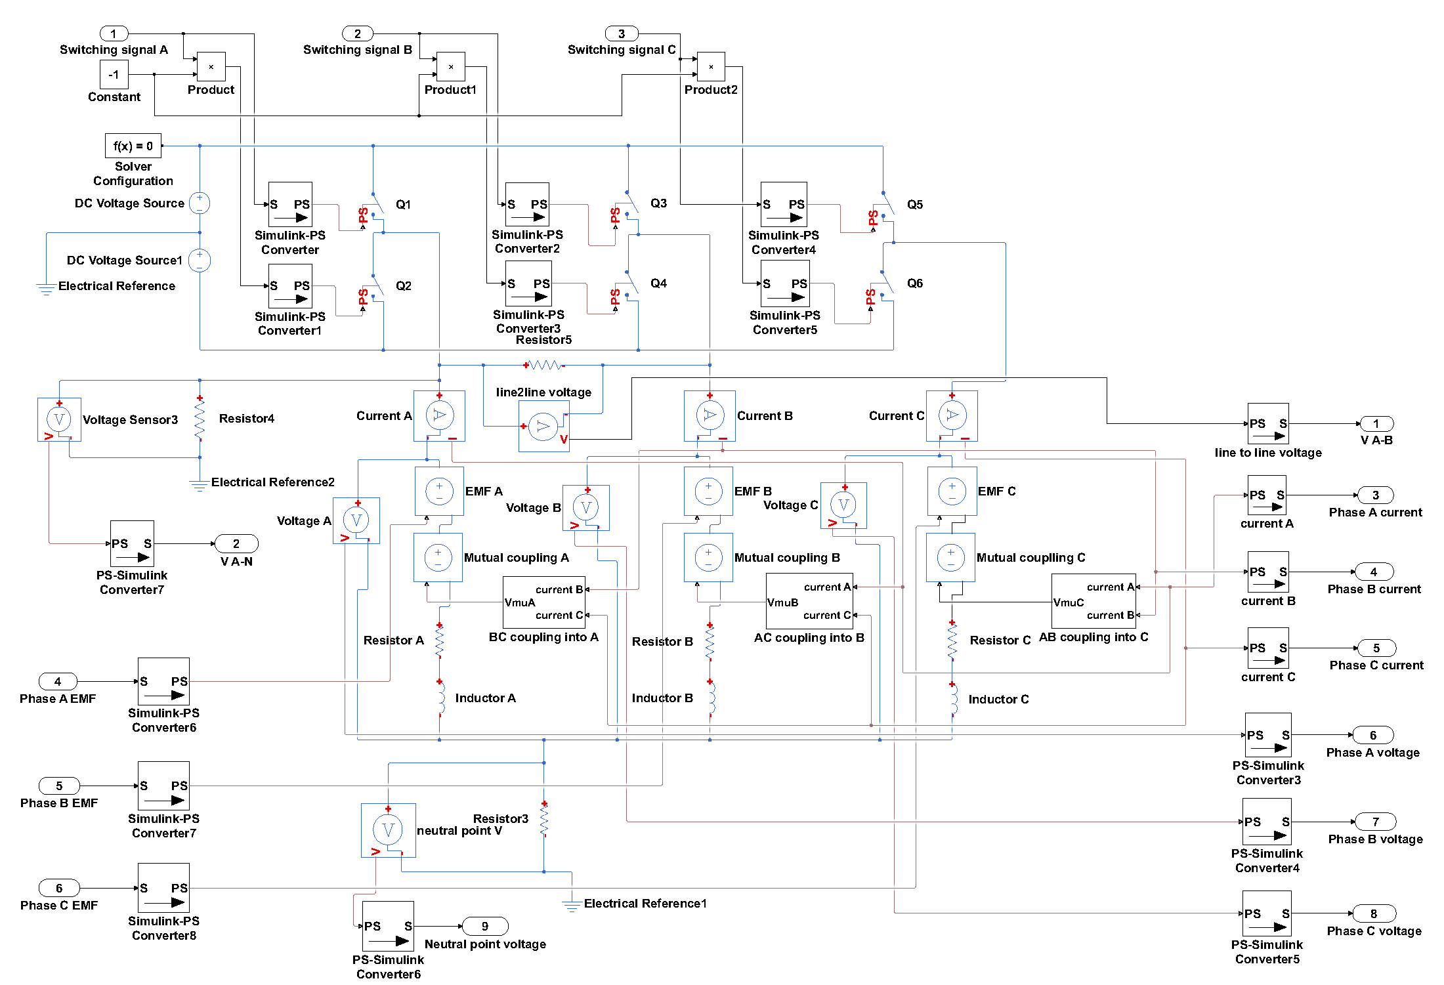
Figure 3.10 VSI Phase coupled block
The mutual coupling voltage calculation block shown in Figure 3.11 calculates the actual voltage associated with the magnetic mutual coupling effect. As an example, for phase A, the contribution to the overall voltage is given by:
$$V_{muA}=M_{AB}\frac{dI_{B}}{dt}+M_{AC}\frac{dI_{C}}{dt}$$ | (3.20)
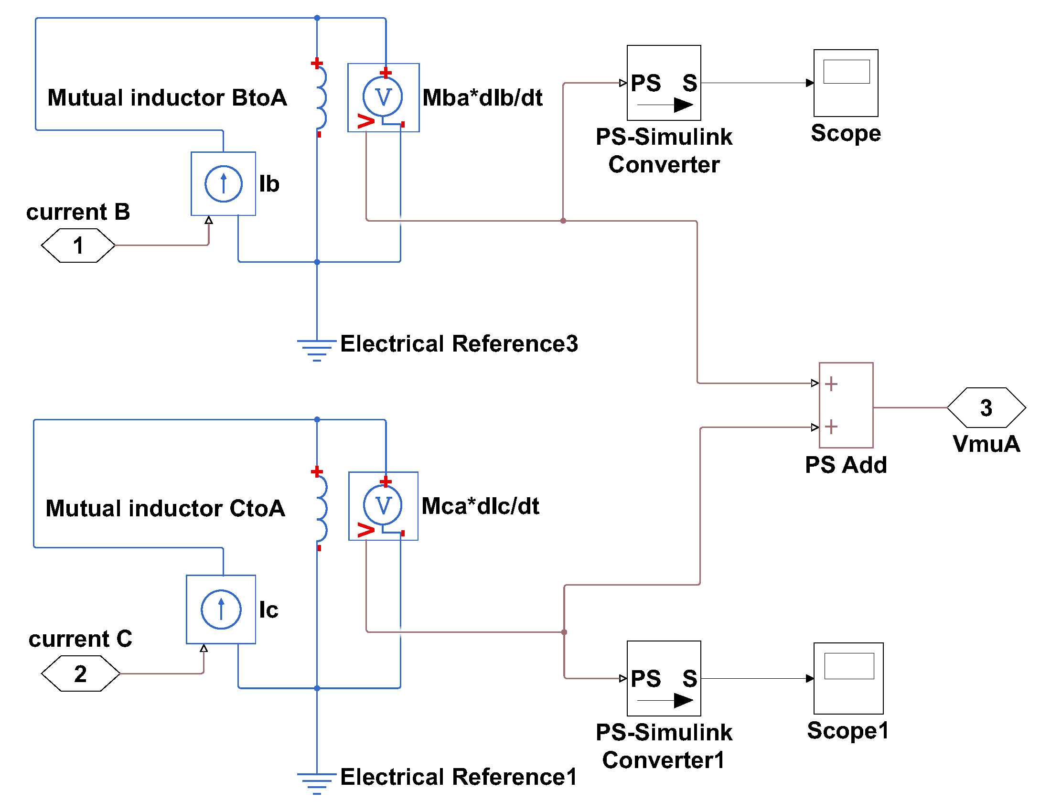
Figure 3.11 Structure of the mutual voltage calculation block
The detailed structure of the back-EMF generation block is shown in Figure 3.12. The back-EMF waveform for each phase is derived from a series of Flux2D finite element modes under open circuit conditions, and imported into the Simulink model in the form of a normalised lookup table.
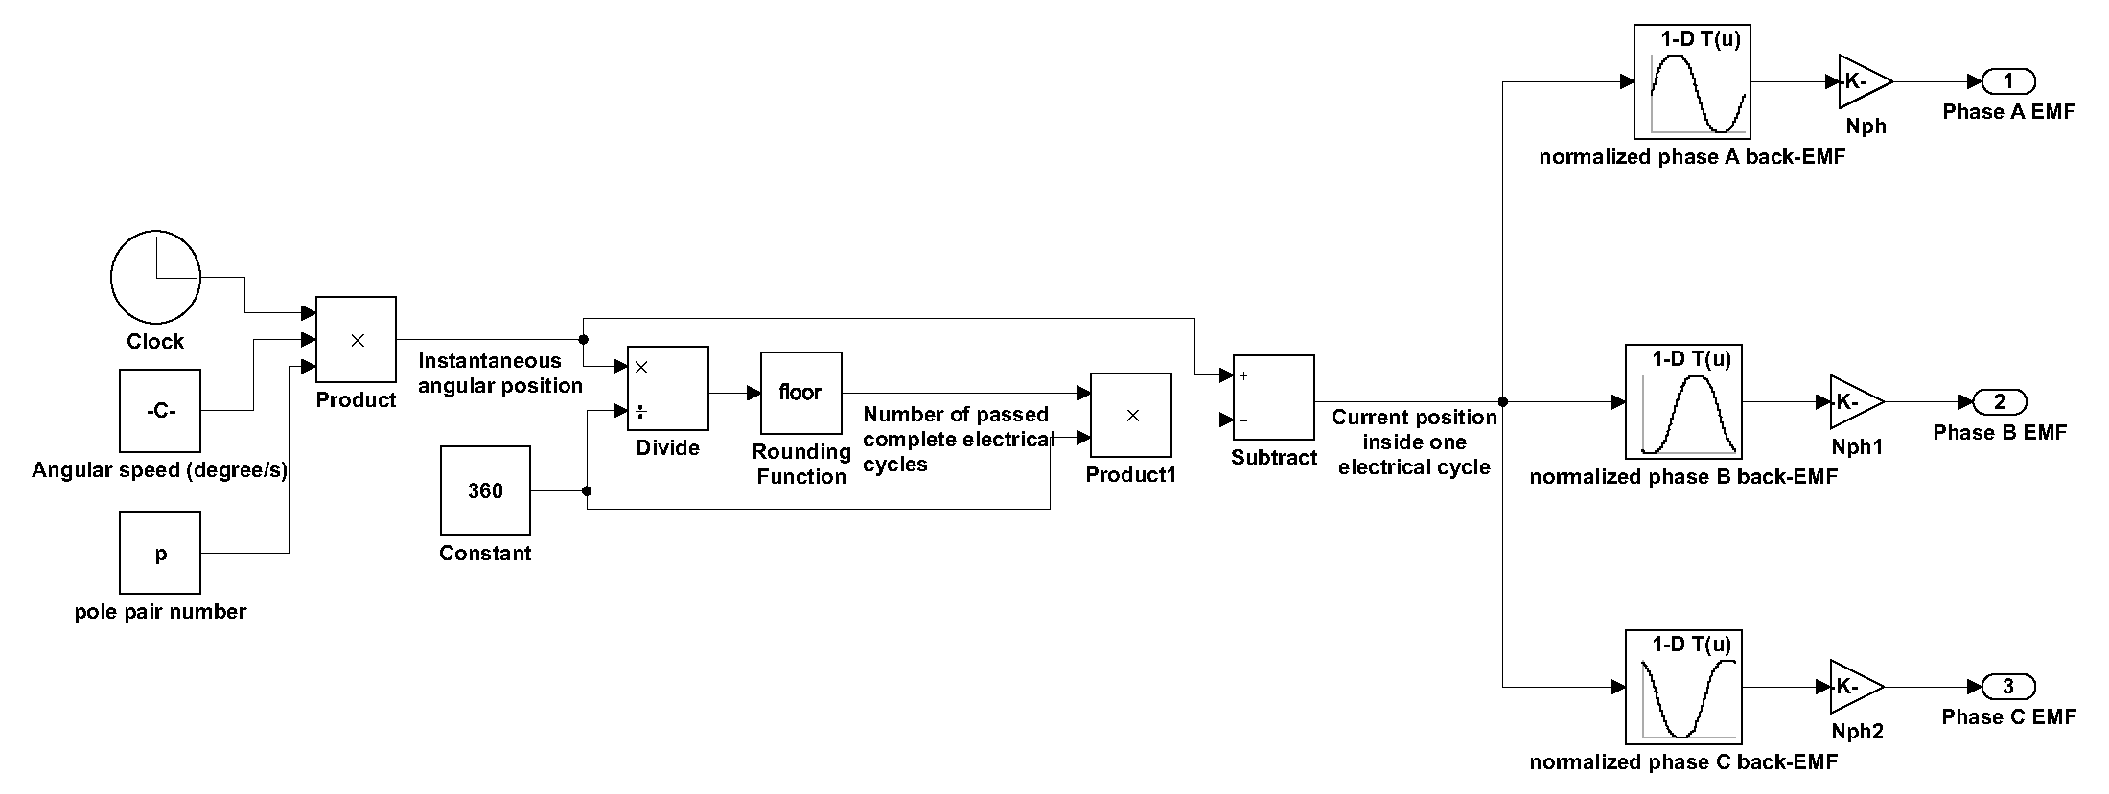
Figure 3.12 Structure of the back-EMF generation block
The current flowing in each phase is used as feedback into the switching signal generation block, whose main function is to produce the switching signals for the individual switches in the inverter. The detailed structure of the switching signal block, taking phase A as an example, is shown in Figure 3.13. It compares the error between the actual current and command current with the pre-set hysteresis band. If the error breaches the lower band, the output signal from the block changes to 1, which will close the upper switch in the corresponding inverter leg in the VSI block and connects the phase to positive DC voltage, causing the phase current to rise, and vice-versa when the current rise above the upper bound of the hysteresis band.
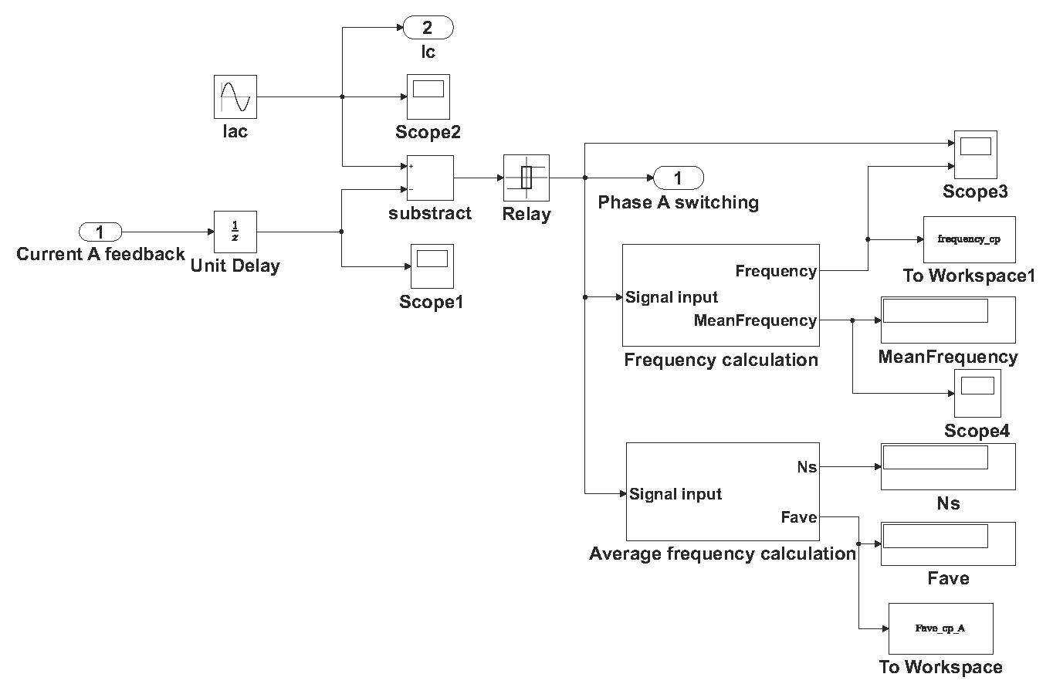
Figure 3.13 Structure of switching signal generation block
In each switching signal generation block, there are two frequency acquisition blocks for monitoring purposes only, i.e. they do not have an influence of the control. The upper block, denoted as frequency calculation block and whose structure is shown in Figure 3.14, calculates the instantaneous switching frequency based on the measured time between two successive switching rising edges and the average of those instantaneous values over one electrical cycle. The lower block, denoted as average frequency calculation block, whose structure is shown in Figure 3.15, calculates the mean switching frequency over the whole simulation period.
In Figure 3.14, every rising edge of the input signal triggers the subsystem, whose output signal is kept at a fixed value during its off time, and only refreshed during each trigger instant. Therefore, the time signal arriving at the ‘timeEdge’ port of the MATLAB S-function is only updated with the clock at every rising edge of the input switching signal, but kept constant in between. Hence, the time between two consecutive rising edge of the switching signal can be easily acquired by monitoring the changes at the timeEdge port, and the instantaneous switching frequency can then be calculated, which is completed inside the MATLAB S-function. The mean switching frequency over one electrical cycle is also calculated in this block, using the built-in mean value calculation block.
In Figure 3.15, the clock signal also enters the timeEdge port via a triggered subsystem, which acts like a transfer gate and is open only at the rising edge of the input switching signal. By monitoring the changes of signal at the timeEdge port, the counting of the number of rising edge of the switching signal, which is equal to the number of switching cycles, over the entire simulation process can be carried out inside the MATLAB S-function.
In this model, the first electrical cycle is not considered when counting the number of switching cycles as the actual current is not settled to steady state in the first cycle. The average switching frequency over the entire simulation process, excluding the non-steady-state first electrical cycle, can be calculated then by dividing the number of switching events counted by the total simulation time minus the first cycle period.
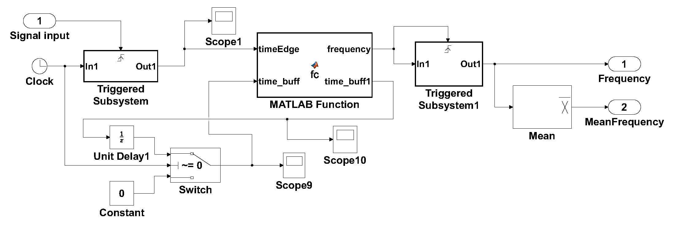
Figure 3.14 Structure of the frequency calculation block
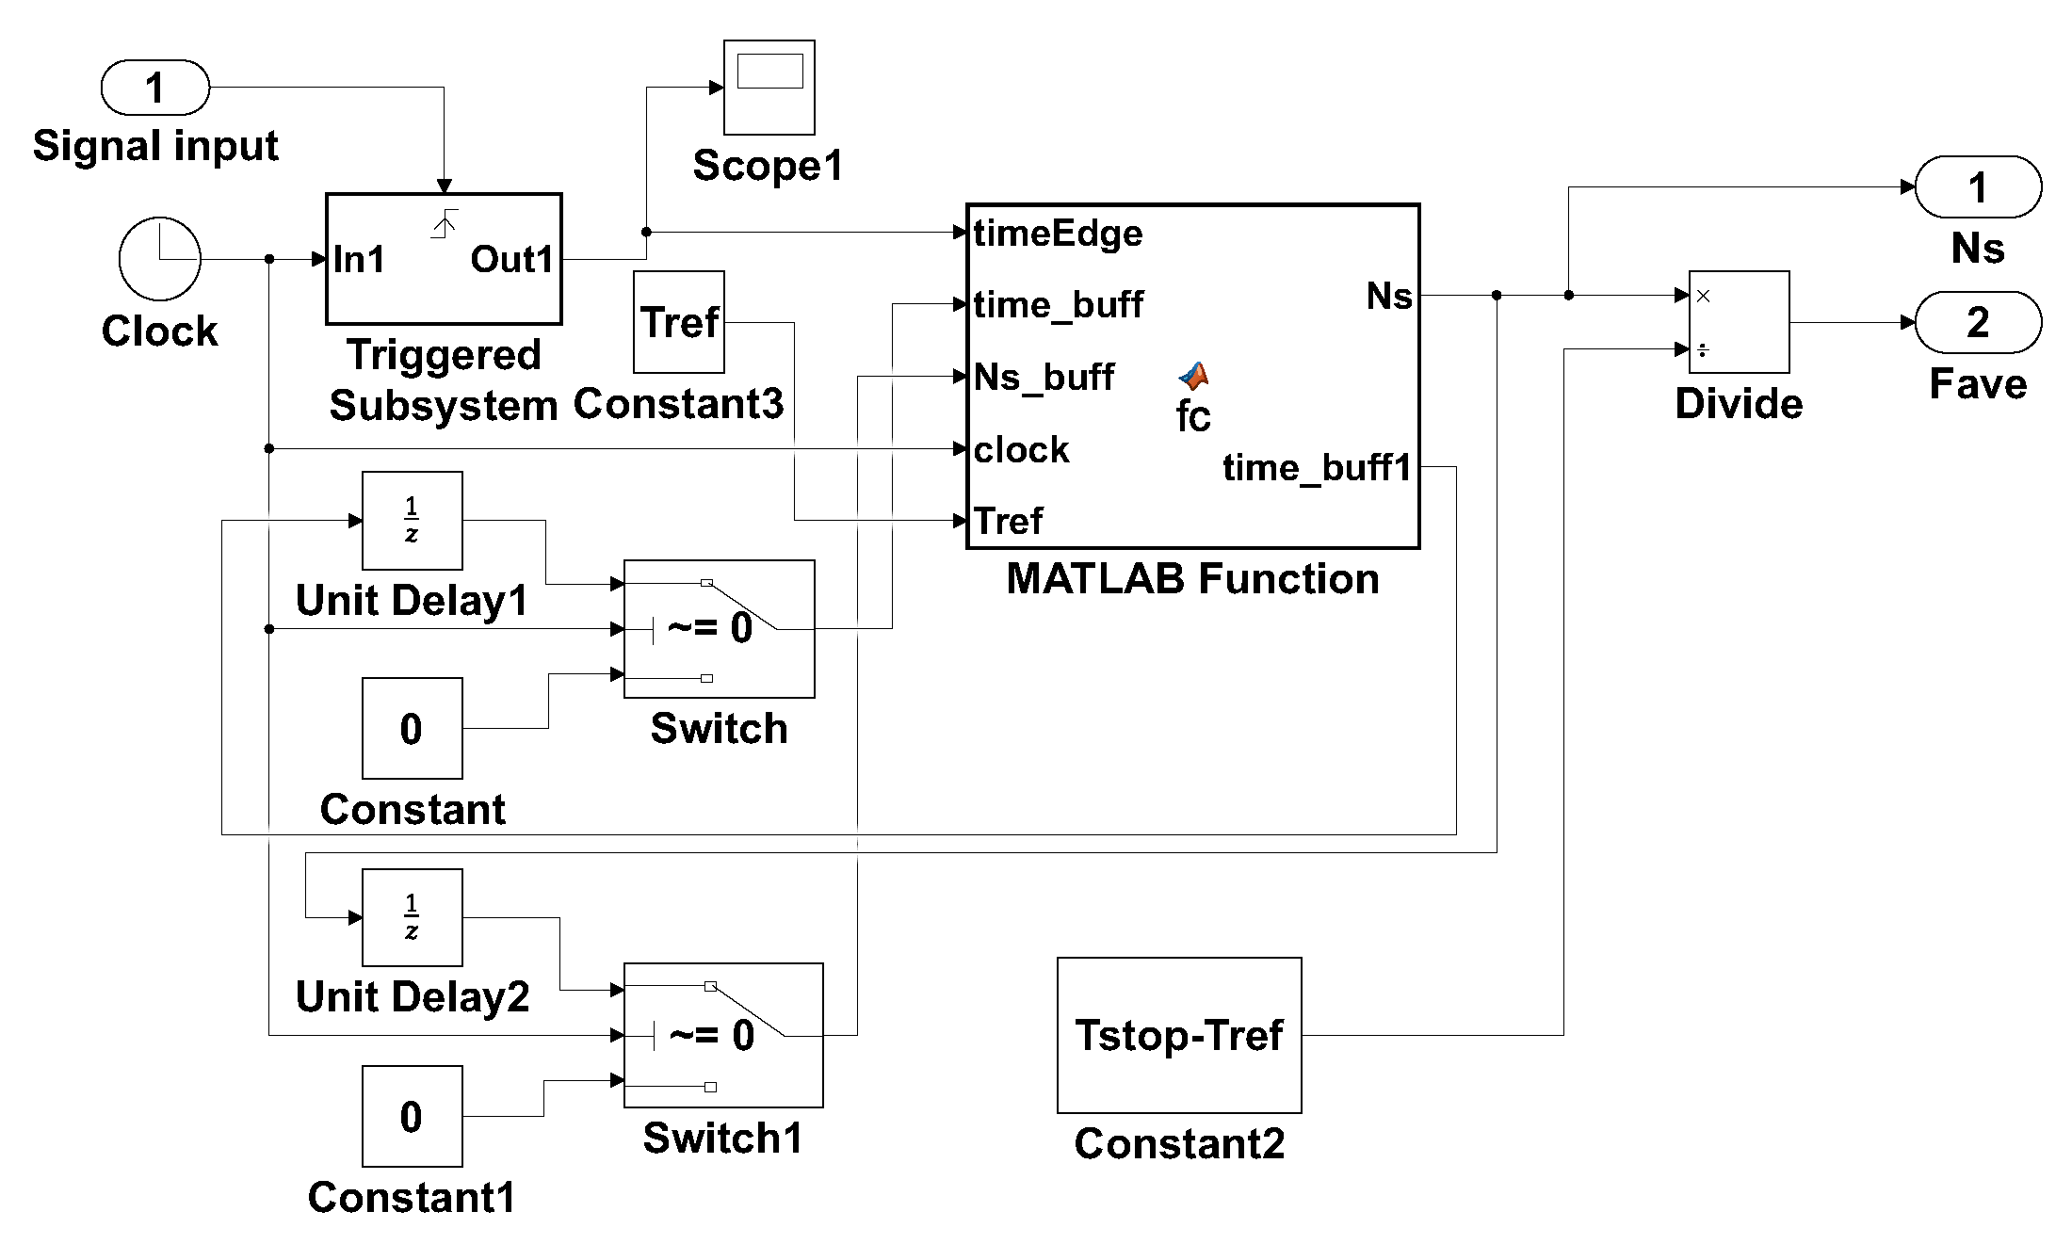
Figure 3.15 Structure of the average frequency calculation block

Current ripple impact on machine performance

Hysteresis band determination
Four levels of switching frequency, i.e. 5kHz, 10kHz, 15kHz, and 20kHz, are considered in order to investigate the impact of ripple current on machine performance. In order to achieve these frequencies it is necessary to calculate the hysteresis band corresponding to each switching frequency for every operating speed. There are published analytical equations such as (3.2) in [2], which are able to describe the whole hysteresis switching process for a star connected three phase system. However, the fluctuating neutral point voltage in an isolated star connection adds significant complexity to the final derivation compared to the individual phase case. This is accommodated by the introduction of parameters which contribute various inaccuracies to the analytical predicted frequency. Since the average switching frequency can be measured inside the control system, an iteration process could be carried out, i.e. adjusting the hysteresis band to gradually match the required average frequency.
The analytical equation (3.2) has been used as a starting point for further derivation to calculate the hysteresis band corresponding to each average switching frequency under different operating speeds. Since the switching frequency in (3.2) is an instantaneous value, its integral over time represents the number of switching events during a given period. More specifically, from (3.2), the number of switching events over a period of time is
$$N_{sw}=\int_{0}^{T_{F}}{f_{s}dt}=\int_{0}^{T_{F}}{\frac{0.25a^{'}V_{DC}}{HBL_{ph}}\left[1-\frac{{L_{ph}}^{2}}{{a^{'}}^{2}{V_{DC}}^{2}}{\left(\frac{E_{ph}}{L_{ph}}+\frac{di_{c}}{dt}\right)}^{2}\right]dt}$$ | (3.21)
If the back-EMF waveform is assumed to be ideally sinusoidal, then for each of the three phases,
$$E_{ph}=E_{p}sin⁡(ωt)$$ | (3.22)
$$i_{c}=I_{c}sin⁡(ωt)$$ | (3.23)
Substituting (3.22) and (3.23) into (3.21), and evaluating the integral, the expression for the number of switching events over the integration period can be obtained:
$$N_{sw}=\frac{0.25a^{'}V_{DC}}{HBL_{ph}}T_{F}-\frac{0.25L_{ph}}{HBa^{'}V_{DC}}\left\{AT_{F}+\frac{B}{2ω}\sin\left(2ωT_{F}\right)+\frac{C}{2ω}\left[1-\cos\left(2ωT_{F}\right)\right]\right\}$$
where
$$A=\frac{1}{2}\left[{\left(ωI_{c}\right)}^{2}+{\left(\frac{E_{p}}{L_{ph}}\right)}^{2}\right]$$
$$B=\frac{1}{2}\left[{\left(ωI_{c}\right)}^{2}-{\left(\frac{E_{p}}{L_{ph}}\right)}^{2}\right]$$
$$C=\frac{E_{p}ωI_{c}}{L_{ph}}$$
Therefore, the average switching frequency over the time period is given by:
$$f_{ave}=\frac{N_{sw}}{T_{F}}=\frac{0.25a^{'}V_{DC}}{HBL_{ph}}-\frac{0.25L_{ph}}{HBa^{'}V_{DC}}\left\{A+\frac{B}{2ωT_{F}}\sin\left(2ωT_{F}\right)+\frac{C}{2ωT_{F}}\left[1-\cos\left(2ωT_{F}\right)\right]\right\}$$
If the integration is performed over multiples of the period of one electrical cycle, i.e. $T_{F}=NT$, then
$$f_{ave}=\frac{0.25a^{'}V_{DC}}{HBL_{ph}}\left\{1-\frac{{L_{ph}}^{2}}{{\left(a^{'}V_{DC}\right)}^{2}}\left\{A+\frac{B}{4πN}\sin\left(4πN\right)+\frac{C}{4πN}\left[1-\cos\left(4πN\right)\right]\right\}\right\}$$
When a large number of periods are considered, i.e. $N≫1$, then
$$f_{ave}=\frac{0.25a^{'}V_{DC}}{HBL_{ph}}\left[1-\frac{{L_{ph}}^{2}}{{\left(a^{'}V_{DC}\right)}^{2}}A\right]=\frac{0.25a^{'}V_{DC}}{HBL_{ph}}\left\{1-\frac{{L_{ph}}^{2}}{{2\left(a^{'}V_{DC}\right)}^{2}}\left[{\left(ωI_{c}\right)}^{2}+{\left(\frac{E_{p}}{L_{ph}}\right)}^{2}\right]\right\}$$ | (3.24)
Given this expressions, then for a specified average switching frequency, the corresponding hysteresis band can be obtained from the above equation:
$$HB=\frac{0.25a^{'}V_{DC}}{f_{ave}L_{ph}}\left\{1-\frac{{L_{ph}}^{2}}{{2\left(a^{'}V_{DC}\right)}^{2}}\left[{\left(ωI_{c}\right)}^{2}+{\left(\frac{E_{p}}{L_{ph}}\right)}^{2}\right]\right\}$$ | (3.25)
As mentioned previously, since the switching process for hysteresis control has some degree of unpredictability over one electrical cycle, the occupied time for each switching state of the 3 phase inverter is different under different conditions. Hence, there is no definitive value for the weighted mean voltage coefficient $a^{'}$ in (3.25).
In this initial calculation of hysteresis band, the coefficient was set to be 2/3, and the band corresponding to each average switching frequency for every machine belonging to the machine series under constant split ratio design was calculated and summarised in Table 3.1 and Table 3.2.

Table 3.1 Analytically predicted hysteresis band corresponding to different average switching frequency for machine series with electromagnetic split ratio
Machine number | Hysteresis band (A)
Machine number | 5kHz | 10kHz | 15kHz | 20kHz
1 | 44.47 | 22.23 | 14.82 | 11.12
2 | 126.10 | 63.05 | 42.03 | 31.53
3 | 126.67 | 63.33 | 42.22 | 31.67
4 | 238.90 | 119.45 | 79.63 | 59.72
5 | 232.41 | 116.21 | 77.47 | 58.10
6 | 217.99 | 109.00 | 72.66 | 54.50
7 | 545.19 | 272.60 | 181.73 | 136.30
8 | 583.66 | 291.83 | 194.55 | 145.91
9 | 519.01 | 259.50 | 173.00 | 129.75
10 | 2110.57 | 1055.29 | 703.52 | 527.64
12 | 1740.89 | 870.45 | 580.30 | 435.22
Table 3.2 Analytically predicted hysteresis band corresponding to different average switching frequency for machine series with mechanical split ratio
Machine number | Hysteresis band (A)
Machine number | 5kHz | 10kHz | 15kHz | 20kHz
1 | 44.01 | 22.01 | 14.67 | 11.00
2 | 125.15 | 62.58 | 41.72 | 31.29
3 | 135.85 | 67.92 | 45.28 | 33.96
4 | 132.43 | 66.21 | 44.14 | 33.11
5 | 274.60 | 137.30 | 91.53 | 68.65
6 | 266.31 | 133.15 | 88.77 | 66.58
7 | 253.66 | 126.83 | 84.55 | 63.41
8 | 650.83 | 325.41 | 216.94 | 162.71
9 | 675.60 | 337.80 | 225.20 | 168.90
10 | 629.96 | 314.98 | 209.99 | 157.49
11 | 642.13 | 321.07 | 214.04 | 160.53
12 | 553.13 | 276.56 | 184.38 | 138.28
14 | 2916.84 | 1458.42 | 972.28 | 729.21

The predicted bands for different switching frequency and operating speed were then entered into the Simulink model for validation, together with the calculated electrical properties for the corresponding machine. Since the pre-set value for the weighted mean coefficient $a^{'}$ of 2/3 inevitably introduces some inaccuracy to the prediction, the measured frequency in the model for all the hysteresis bands from the analytical calculation were below the frequency calculated by equation (3.24). Hence the hysteresis bands could be tightened compared to the values derived analytically. Starting from the analytically calculated values, an iterative process was carried out using the SIMULINK model to adjust the band to match the frequency set-points for each of the machine designs at their rated speed and torque. Table 3.3 and Table 3.4 show the final hysteresis bands for each average switching frequency and operating speeds.

Table 3.3 Final hysteresis bands established from SIMULINK model for different average switching frequency for machine series with electromagnetic split ratio
Machine  design number | Hysteresis band – (A peak to peak)
Machine  design number | 5kHz | 10kHz | 15kHz | 20kHz
1 | 12.50 | 5.90 | 4.10 | 3.10
2 | 40.50 | 20.00 | 14.00 | 10.00
3 | 35.00 | 18.00 | 12.00 | 9.00
4 | 65.00 | 38.00 | 28.00 | 20.00
5 | 73.50 | 33.00 | 23.30 | 18.00
6 | 57.00 | 29.00 | 20.00 | 15.00
7 | 155.00 | 80.00 | 63.00 | 50.00
8 | 167.00 | 87.00 | 64.00 | 52.00
9 | 135.00 | 80.00 | 59.50 | 38.00
10 | 600.70 | 335.00 | 217.00 | 150.00
12 | 437.00 | 246.00 | 170.00 | 138.00
Table 3.4 Final hysteresis bands established from SIMULINK model for different average switching frequency for machine series with mechanical split ratio
Machine number | Hysteresis band (A)
Machine number | 5kHz | 10kHz | 15kHz | 20kHz
1 | 12.50 | 5.80 | 4.00 | 3.00
2 | 43.00 | 20.50 | 14.00 | 10.10
3 | 40.30 | 19.50 | 13.50 | 10.00
4 | 34.70 | 17.00 | 12.00 | 9.00
5 | 77.50 | 41.50 | 33.00 | 22.00
6 | 79.80 | 39.00 | 26.00 | 19.50
7 | 66.10 | 33.00 | 23.00 | 18.00
8 | 192.00 | 101.00 | 72.50 | 58.00
9 | 193.50 | 100.00 | 68.50 | 60.00
10 | 173.00 | 86.00 | 63.00 | 47.50
11 | 174.00 | 91.00 | 66.00 | 55.00
12 | 160.00 | 72.00 | 54.00 | 37.00
14 | 765.00 | 435.00 | 309.00 | 240.00

As can be seen, the finally hysteresis bands are significantly narrowed from the analytical prediction. However, they follow a very similar trend in terms of machine base-speed. This suggests that the pre-set value for the weighted mean voltage coefficient $a^{'}$ (which was derived using the guideline from [2]) is higher than the actual value which was present in the SIMULINK simulations. By further adjusting the coefficient $a^{'}$ from 2/3 downwards, specifically, to 0.190 for the machine series with electromagnetic split ratio, and to 0.191 for machine series with mechanical split ratio, the analytical predicted come into line with the values established from the SIMULINK model as shown in Figure 3.16 to Figure 3.19.
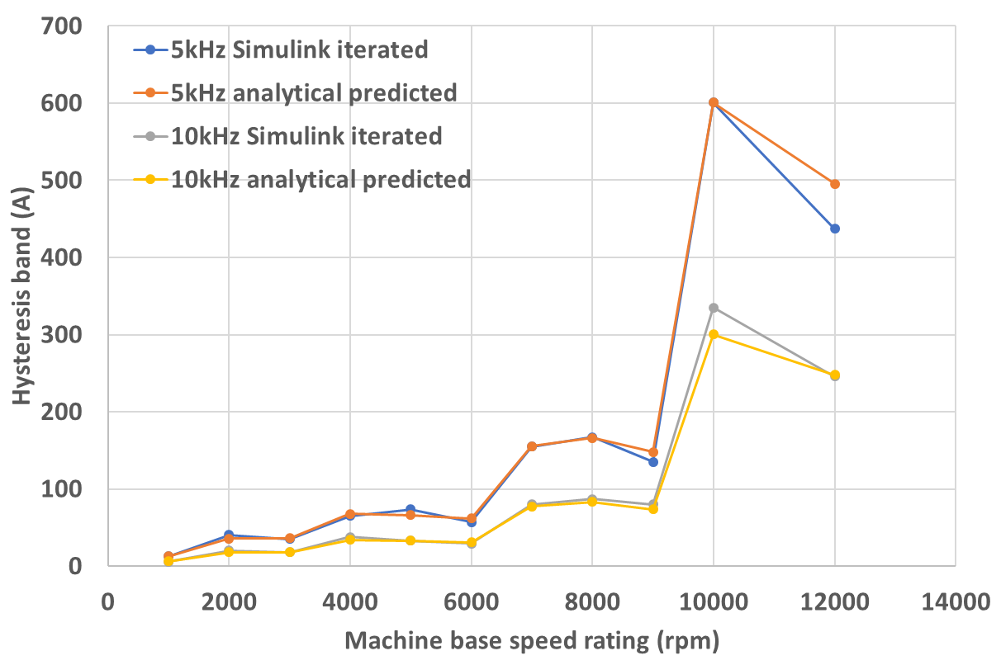
Figure 3.16 Hysteresis band variation with speed rating from analytical predicted and Simulink determined under 5kHz and 10kHz for electromagnetic split ratio design
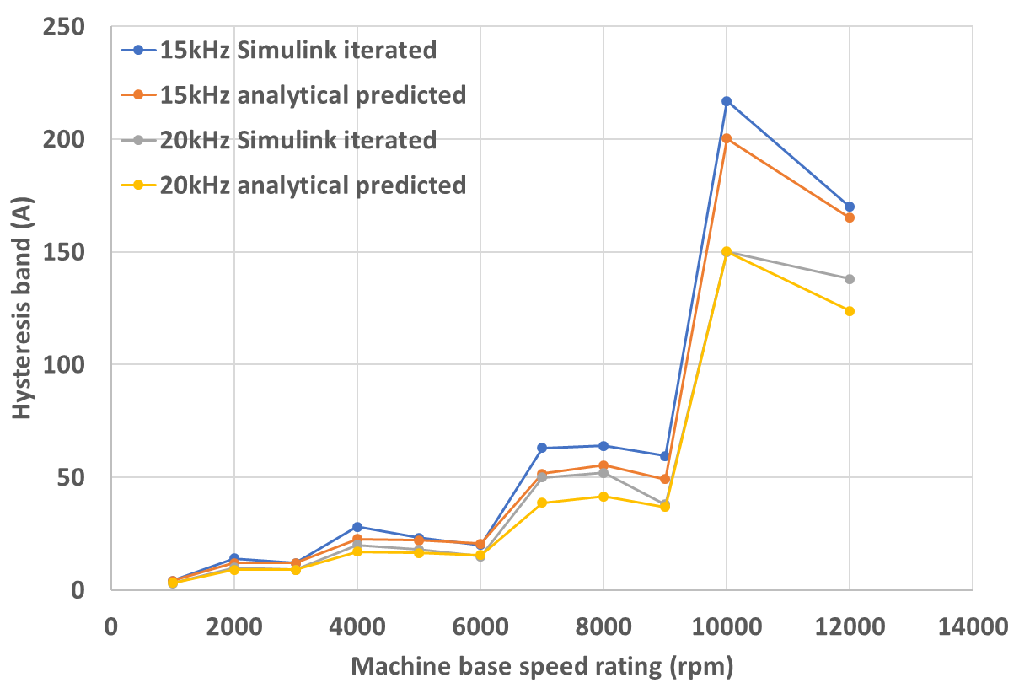
Figure 3.17 Hysteresis band variation with speed rating from analytical predicted and Simulink determined under 15kHz and 20kHz for electromagnetic split ratio design
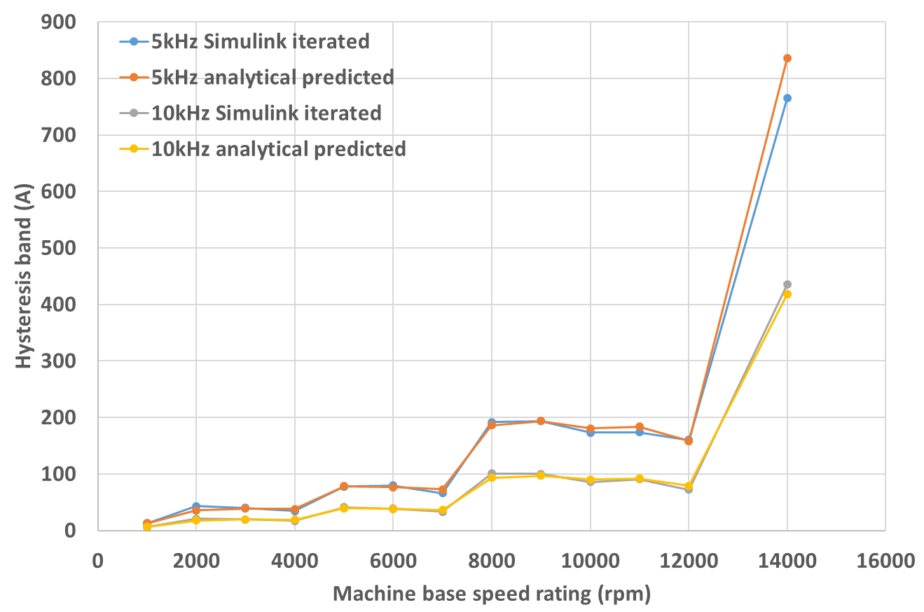
Figure 3.18 Hysteresis band variation with speed rating from analytical predicted and Simulink determined under 5kHz and 10kHz for mechanical split ratio design
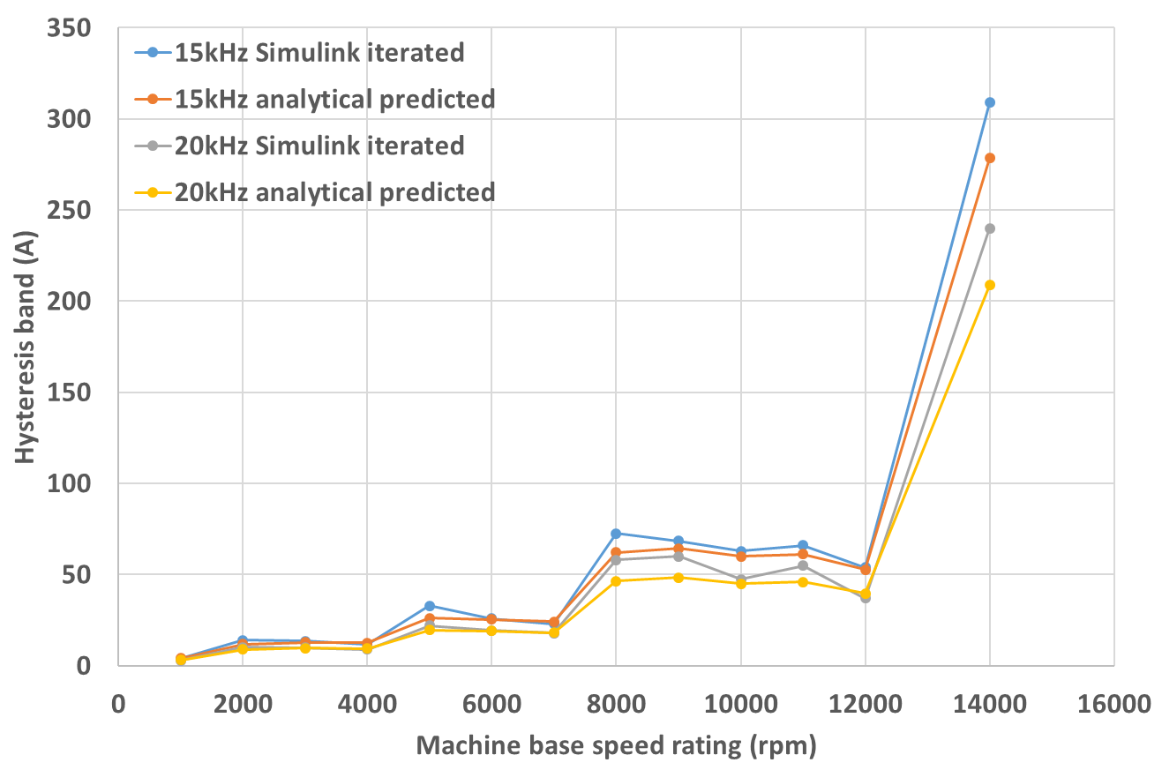
Figure 3.19 Hysteresis band variation with speed rating from analytical predicted and Simulink determined under 15kHz and 20kHz for mechanical split ratio design

Influence of switching frequency on electromagnetic torque
For each of the hysteresis bands shown previously in Table 3.3 and Table 3.4, the current waveforms for the specified base speed rated power conditions were predicted using the SIMULINK model. The resulting current waveforms were then set up as look-up tables to define the current input to a series of two-dimensional finite element simulations (Flux 2D) in order to calculate the average torque over one electrical cycle. For the purposes of having reasonable computation times, each finite element simulation was performed with 900 discrete values of current per electrical cycle which were extracted from the SIMULINK simulations (which were simulated with much finer time steps). For the purposes of calculating average torque, this was deemed adequate, although as will be demonstrated in chapter 4, this may not be adequate for predicting iron losses.
The full set of current waveforms for each combination of machine design and switching frequency are shown in Appendix II along with the resulting predictions of electromagnetic torque. Two of these current waveforms at the extremes of the conditions encountered are shown in Figure 3.20 for the case of the lowest average switching frequency of 5kHz. The waveform shown in Figure 3.20(a) is for the lowest rated speed design (i.e. machine design 1 from a fixed mechanical split ratio), while Figure 3.20(b) is for the highest speed design (base speed of 14,000rpm).
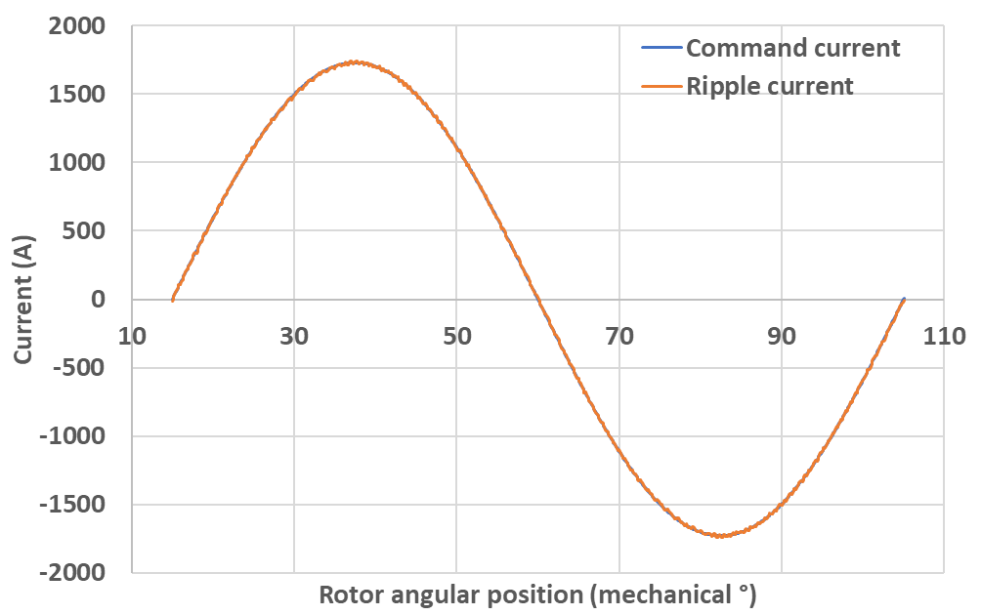
- 1,000rpm (25A peak-to-peak hysteresis band – average switching frequency of 5kHz)
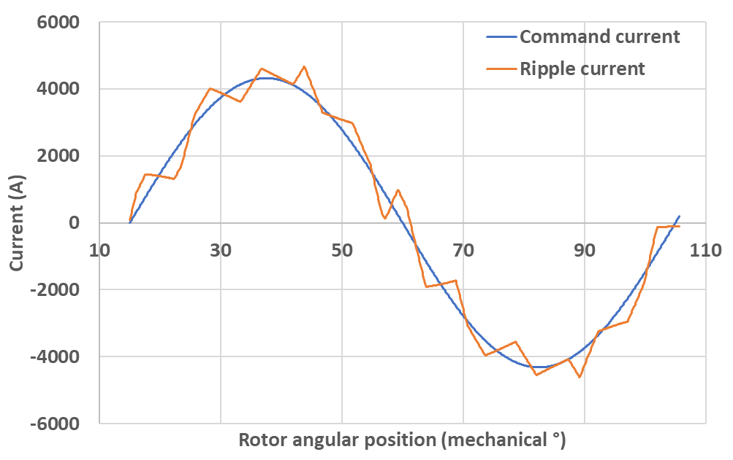
- 14,000rpm (1530A peak-to-peak hysteresis band – average switching frequency of 5kHz)
Figure 3.20 Extremes of current waveforms at 5kHz average switching frequency in mechanical split ratio series
The resulting predicted average torque values derived from the SIMULINK models and subsequent finite element calculations for all the machines in two series are shown in Table I.3 and Table I.4 in Appendix I, with the results for the two extreme speed ratings discussed before plotted in Figure 3.21 and Figure 3.22, respectively. As will be apparent, over the vast range of ripple currents considered in this study, the presence of significant current ripple has little or no meaningful influence on the average output torque. This is perhaps unsurprising given that the machines are operating with a hysteresis controller and hence tends to deliver current waveform close to the average of the demand waveform. However, it increases the magnitude of torque ripple which may have other consequences in terms of rotor-dynamics or vibration.
Another useful measure of the effects on the current waveform introduced by switching is total harmonic distortion. Figure 3.23 and Figure 3.24 show two examples of the Fourier transforms, which are for machine 1 and machine 14 at 5kHz switching frequency, respectively, from the design based on a fixed mechanical split ratio. The waveform for machine 1 shows very little harmonics content whereas in machine 14, there is a much richer harmonic content. The corresponding calculated THD are plotted in Figure 3.25 and Figure 3.26, respectively, together with the results for the same two machines under other switching frequencies. The THD values for other machines in the two series are shown in Table I.5 and Table I.6 in Appendix I. It is inevitable that as the number of switching events per electrical cycle reduces, the harmonics introduced into the generated currents would increase, vice versa. Hence, for each machine the THD decreases with increasing average switching frequency. This is also reflected onto the generated torque ripple from FE, which is shown in Figure 3.27 and Figure 3.28 for the two extreme machine speeds in fixed mechanical split ratio design, and in Table I.7 and Table I.8 in Appendix I for other machines in the two series. In order to exclude the impact of spatial harmonics and slot opening on torque ripple, the torque waveform obtained by hysteresis ripple current is subtracted by the torque waveform obtained by purely sinusoidal current when calculating the rms. value of the torque ripple, and hence only the effect of phase current ripple on torque ripple production is accounted. It is also worth noting that the rms. torque ripple is expressed as a percentage of average torque.
Due to the staircase nature of the variation in electrical parameters and hence the hysteresis band with machine speed rating, the THD and rms. torque ripple does not increase with machine rated speed, but follows a similar staircase trend to that observed with the hysteresis bands.
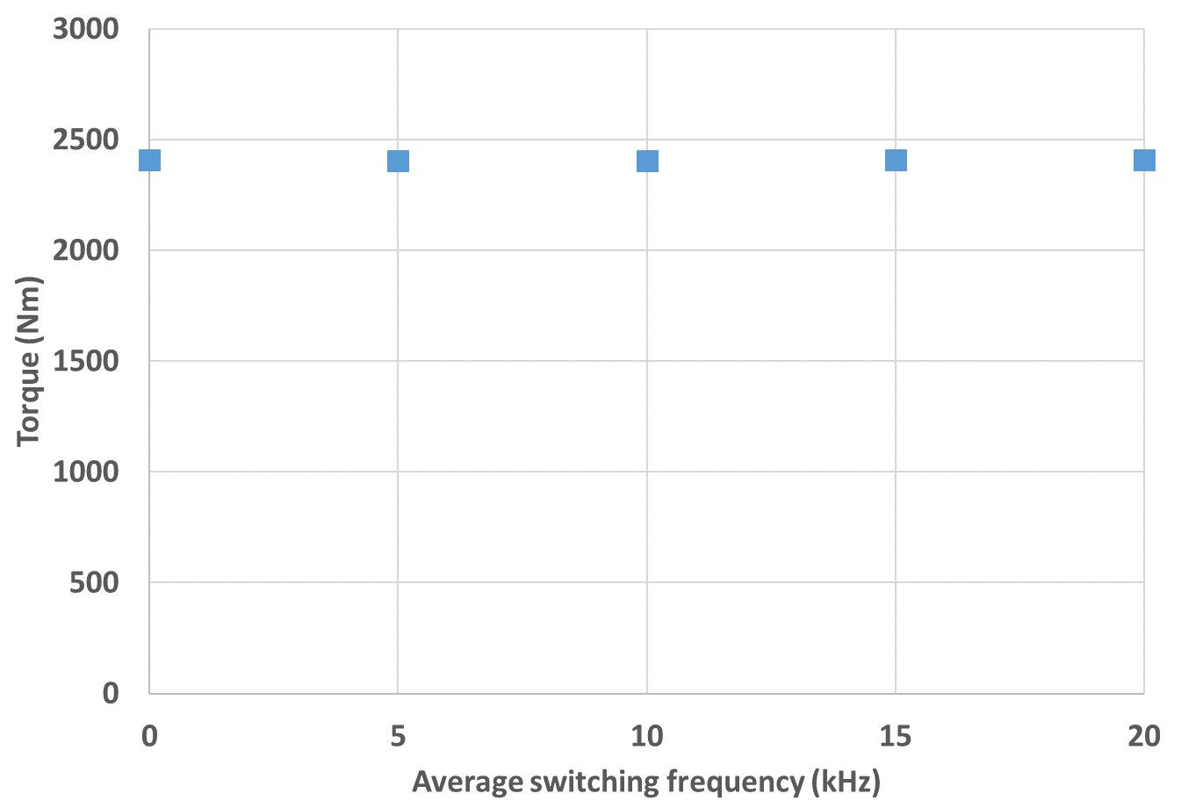
Figure 3.21 Output torque of the machine with 1000rpm base speed under constant mechanical split ratio
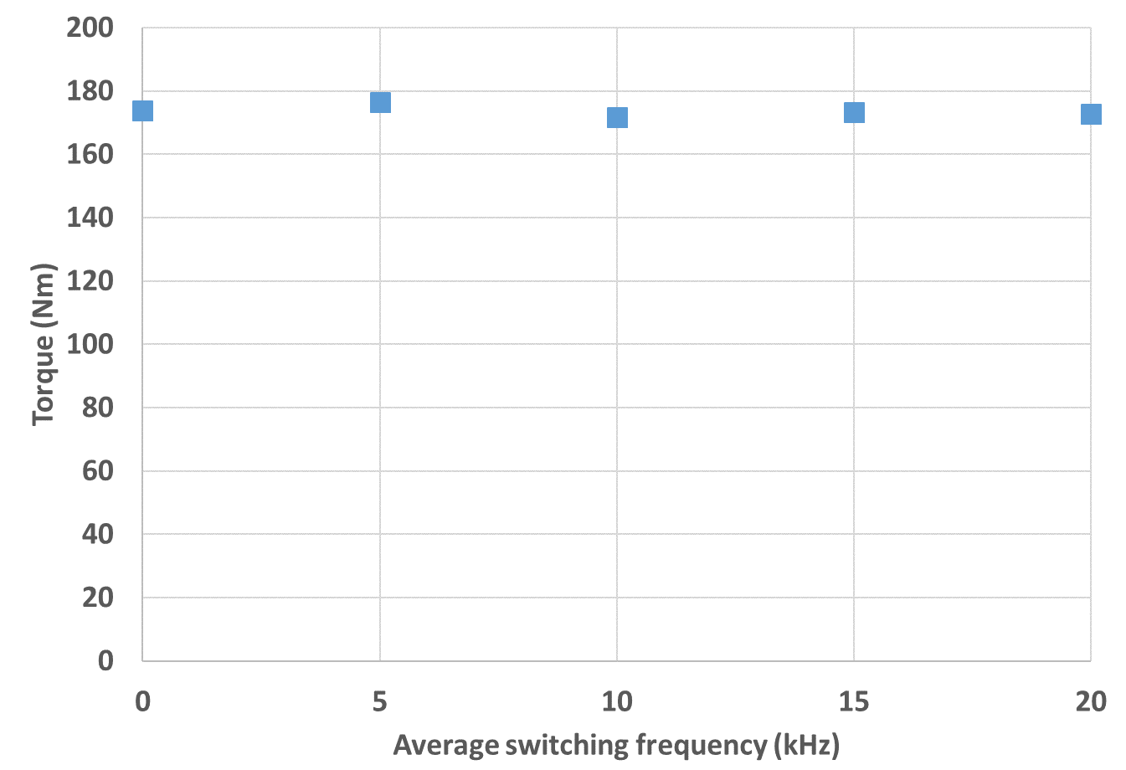
Figure 3.22 Output torque of the machine with 14000rpm base speed under constant mechanical split ratio
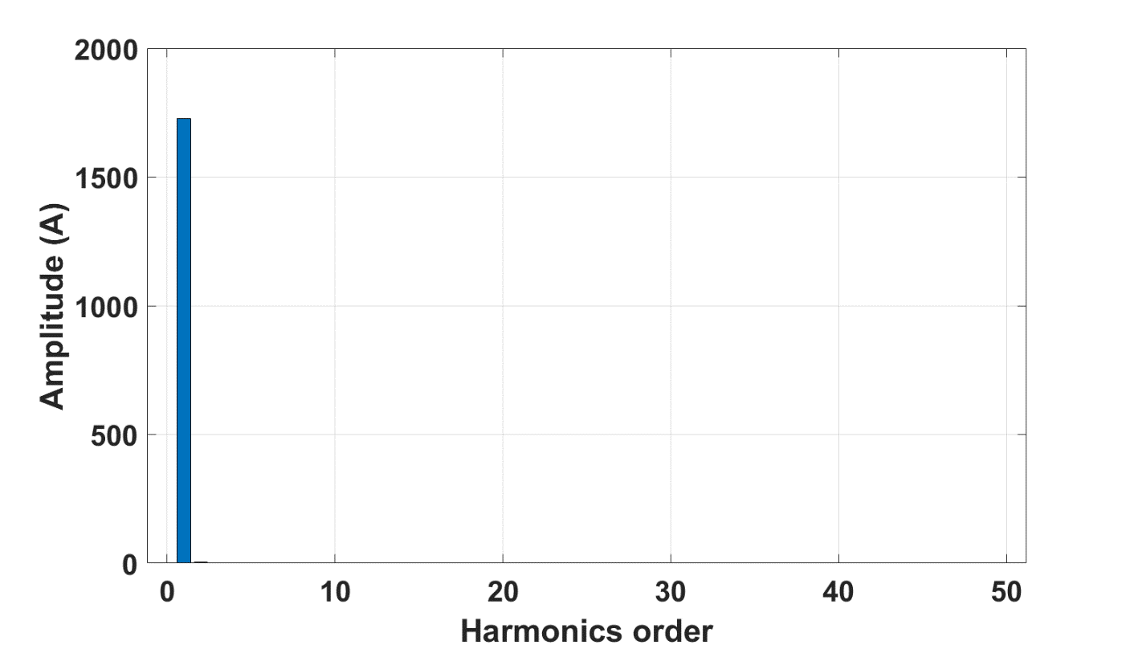
Figure 3.23 Fourier result for machine 1 in series using mechanical split ratio
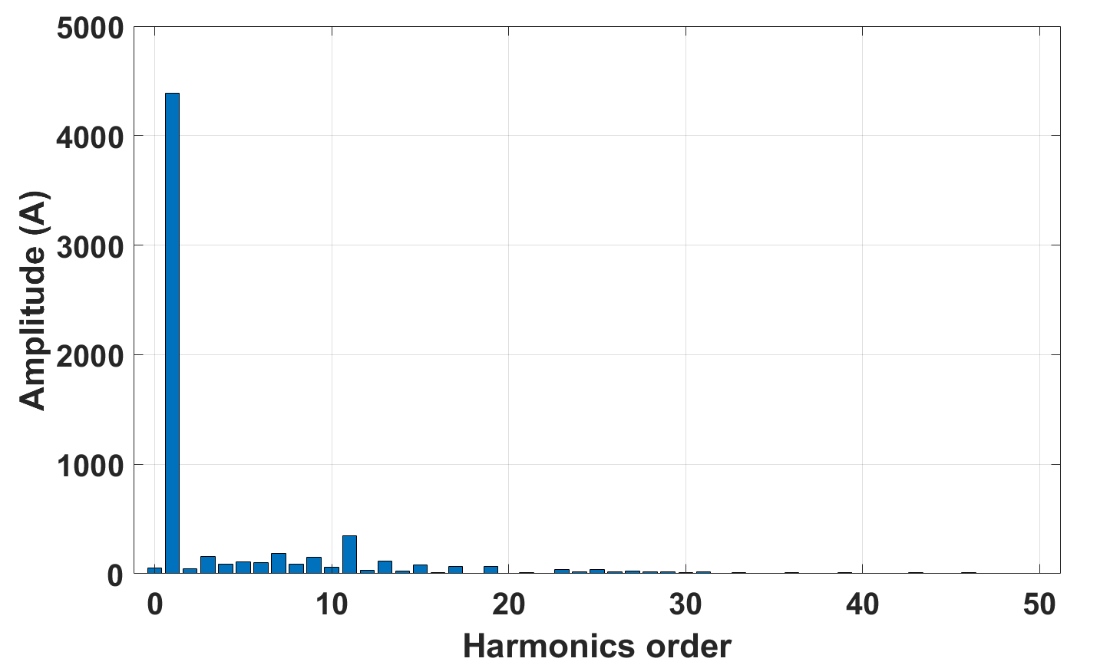
Figure 3.24 Fourier result for machine 14 in series using mechanical split ratio
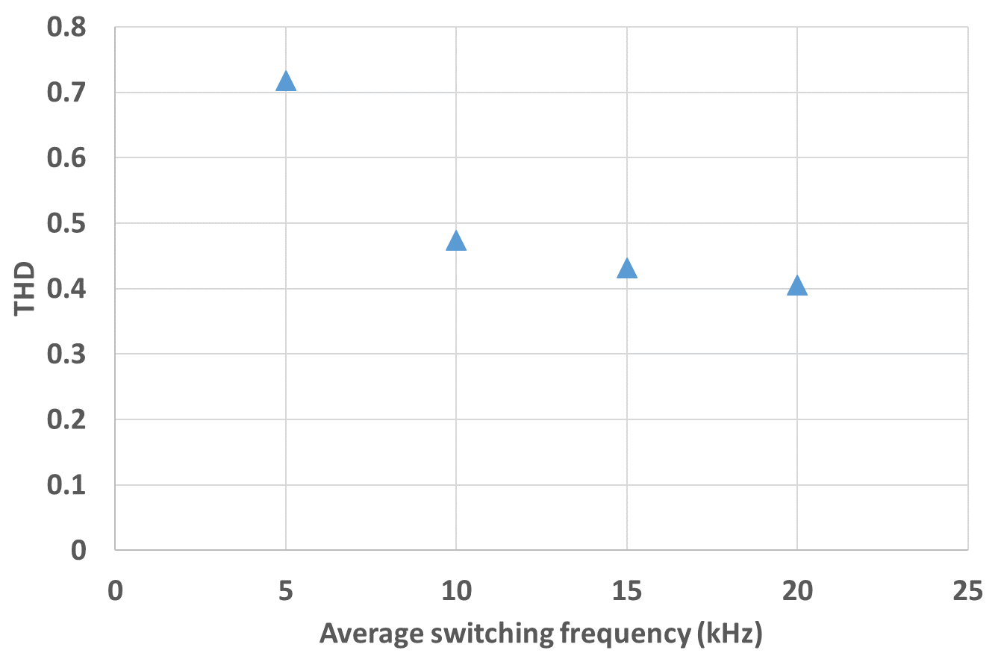
Figure 3.25 THD for machine 1 in fixed mechanical split ratio design (base speed 1000rpm) under different average switching frequency
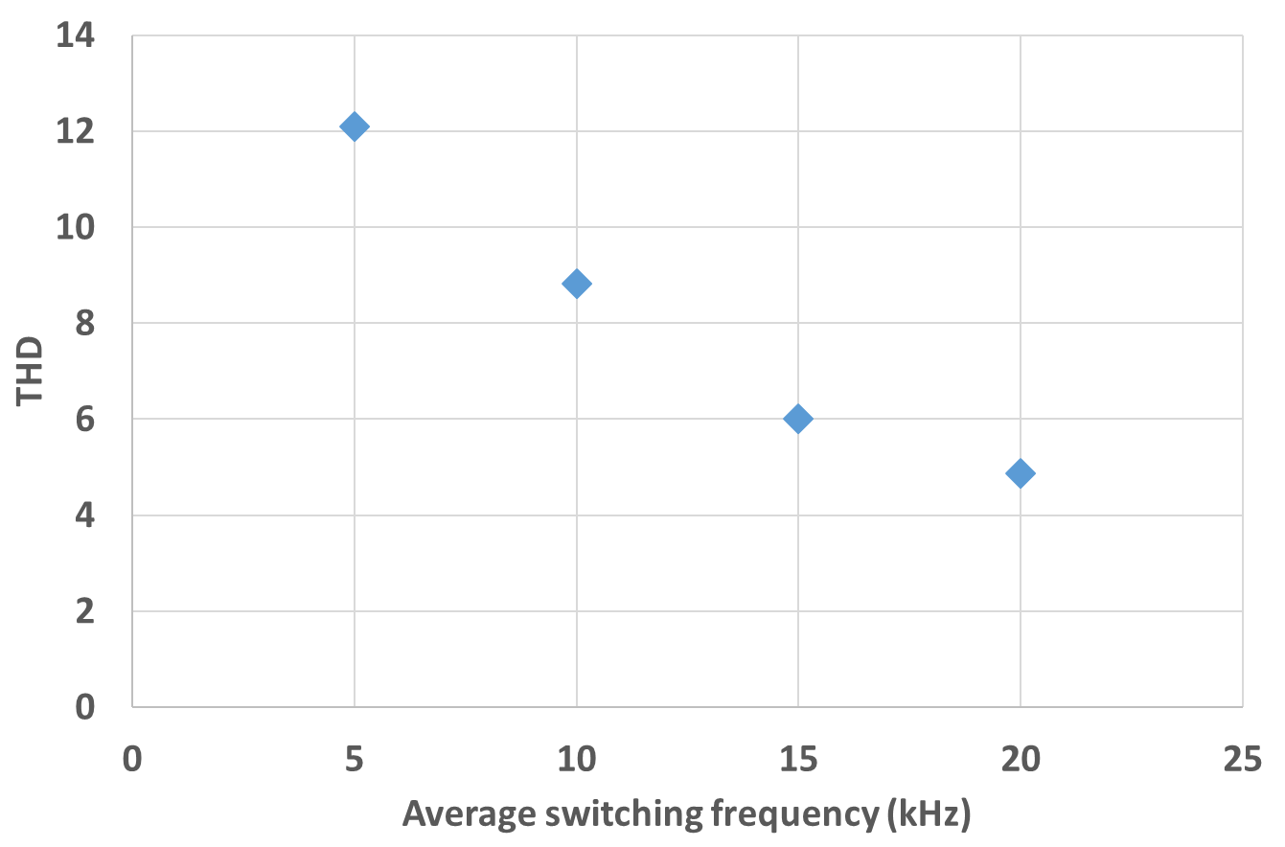
Figure 3.26 THD for machine 14 in fixed mechanical split ratio design (base speed 14000rpm) under different average switching frequency
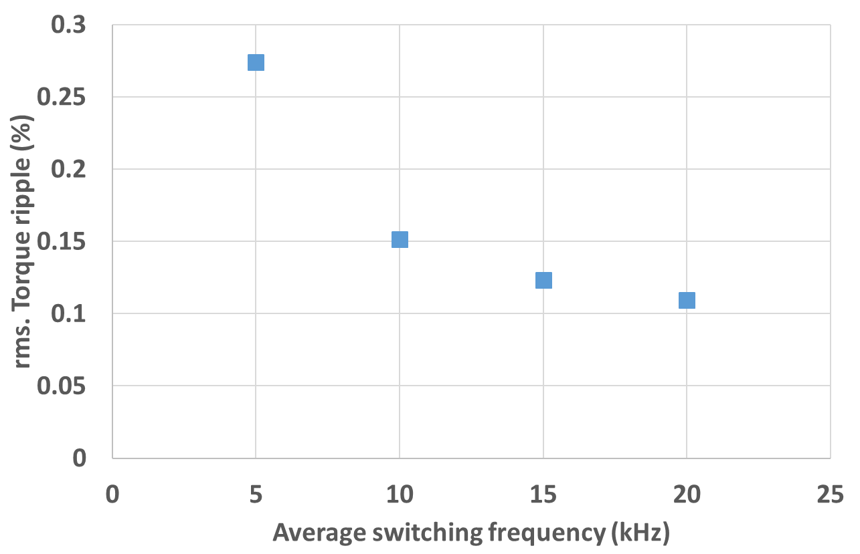
Figure 3.27 rms. Torque ripple for machine 1 in fixed mechanical split ratio design
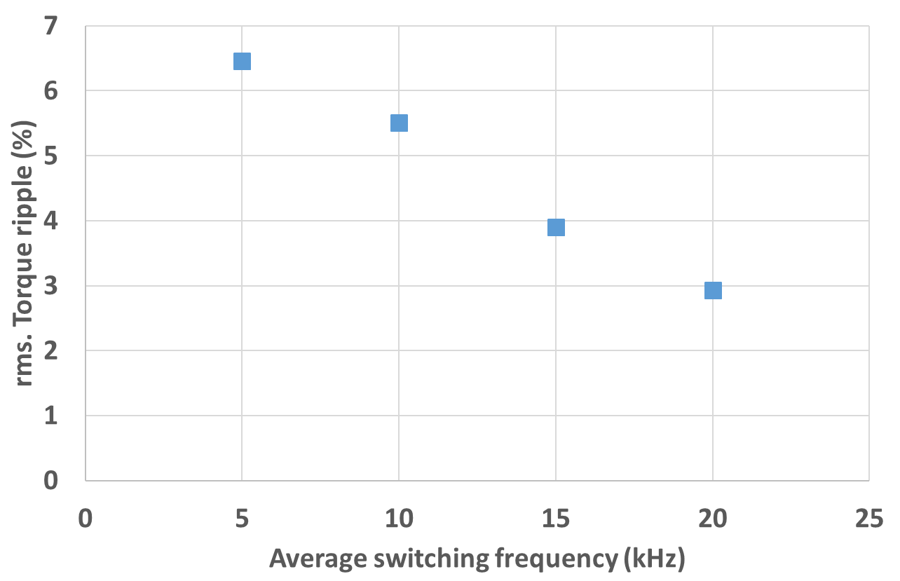
Figure 3.28 rms. Torque ripple for machine 14 in fixed mechanical split ratio design

Intrinsic six-step space vector switching process in Hysteresis control
Since the hysteresis control does not have direct control over the switching frequency and the duty cycle of each switching period, which is in contrast to classical PWM modulation, the on and off state of each switch of the three-phase inverter only changes when the phase current reaches the pre-set hysteresis band. During the current waveform generation for each machine at different switching frequency in the last section, it was observed that there are, in effect, two switching frequencies at play in the hysteresis control of a given phase. The first is associated with the actual switching events of the switches in the phase leg. The second is associated with the interaction between the three phases via the star connection and a floating neutral point. This additional switching behaviour which results from shifts in the neutral point voltage gives rise to a smoother waveform than would be achieved by the hysteresis action with that phase alone.
As an example, Figure 3.29 shows the generated current waveform for machine 14 in the design series with a fixed mechanical split ratio. The hysteresis band is 1530A (peak to peak) at 5kHz switching frequency, together with the error between the generated and command current and the switching states of the three-phase inverter during that period. It can be seen that there are more slope changing events in the current waveform than the switching events in the phase A bridge switches, and many slope changes happen inside the band area, which means the generated current ripple is actually smaller than the pre-set hysteresis band width. The additional slope changes arise from the change in switching states in the other two phases, which affects the total voltage between the terminal of phase A and the neutral point. This process is akin the process of space vector control, where the phase current can be controlled to closely follow the command current under certain sequence of switching states in the three-phase inverter. The difference is that in the hysteresis control process, the space vector variation is a passive process which is difficult to predict reliably in advances as there is no pre-set switching sequence. Table 3.5 shows different combinations of switching states in the inverter and the corresponding supply voltage applied on each phase, with 1 representing the corresponding phase connected to the positive terminal of the supply, i.e. $+V_{DC}$, and -1 representing the corresponding phase connected to the negative terminal of the supply, i.e. $-V_{DC}$.
Table 3.5 Different combination of switching states and the corresponding supply voltage [12]
Switching states |  |  | Supply voltage
Phase A | Phase B | Phase C | Phase A | Phase B | Phase C
1 | -1 | -1 | $$\frac{4}{3}V_{DC}$$ | $$-\frac{2}{3}V_{DC}$$ | $$-\frac{2}{3}V_{DC}$$
1 | 1 | -1 | $$\frac{2}{3}V_{DC}$$ | $$\frac{2}{3}V_{DC}$$ | $$-\frac{4}{3}V_{DC}$$
1 | -1 | 1 | $$\frac{2}{3}V_{DC}$$ | $$-\frac{4}{3}V_{DC}$$ | $$\frac{2}{3}V_{DC}$$
-1 | 1 | 1 | $$-\frac{4}{3}V_{DC}$$ | $$\frac{2}{3}V_{DC}$$ | $$\frac{2}{3}V_{DC}$$
-1 | -1 | 1 | $$-\frac{2}{3}V_{DC}$$ | $$-\frac{2}{3}V_{DC}$$ | $$\frac{4}{3}V_{DC}$$
-1 | 1 | -1 | $$-\frac{2}{3}V_{DC}$$ | $$\frac{4}{3}V_{DC}$$ | $$-\frac{2}{3}V_{DC}$$
1 | 1 | 1 | 0 | 0 | 0
-1 | -1 | -1 | 0 | 0 | 0
As described in [12], the magnitudes of supply voltage for the three phases under the six different combinations of switching states, together with the phase phasor angles, form six different space vectors distributing uniformly around the circumference, each separated by 60 degrees from the adjacent phasor. These six space vectors, together with the two zero vectors formed by the two zero switching states, can fully describe any three-phase current state, and hence could be used to control the phase current to follow the command current. For a certain command, a certain sequence of switching can be generated for the inverter to implement. In this hysteresis control process, the six space vectors, together with two zero vectors, also play a role, but with no pre-set switching sequence.
At a certain switching frequency, this means the hysteresis band could be narrowed since the additional switching required to confine the current within the two bands could be provided by the space vector variation. Finally, a smoother current waveform could be obtained at a lower switching frequency. A detailed analysis of the space vector variation in one switching period is carried out at the time duration between 0.02s and 0.0215s in Figure 3.29, where one switching period in phase A almost covers the whole electrical cycle, but generates a waveform close to a sinusoidal waveform instead of a straight triangular waveform, is selected for the detailed analysis.
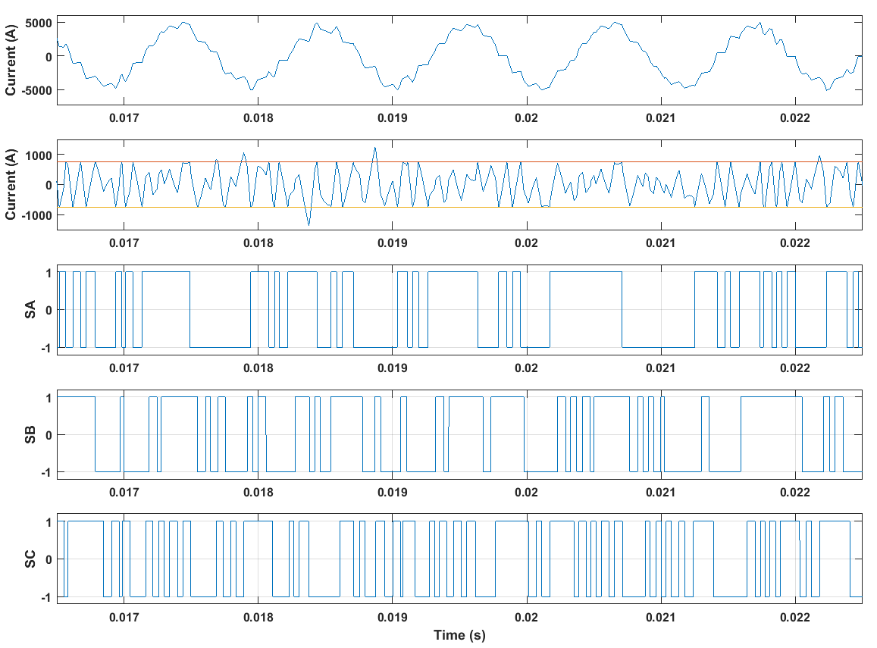
Figure 3.29 Phase A current waveform for machine 14 with mechanical split ratio at 5kHz switching frequency, the error between generated current and command current, and the switching states of the three-phase inverter
Figure 3.30 shows the current waveform, error between generated and command current, and the switching states of the three-phase inverter during the time period for detailed analysis.

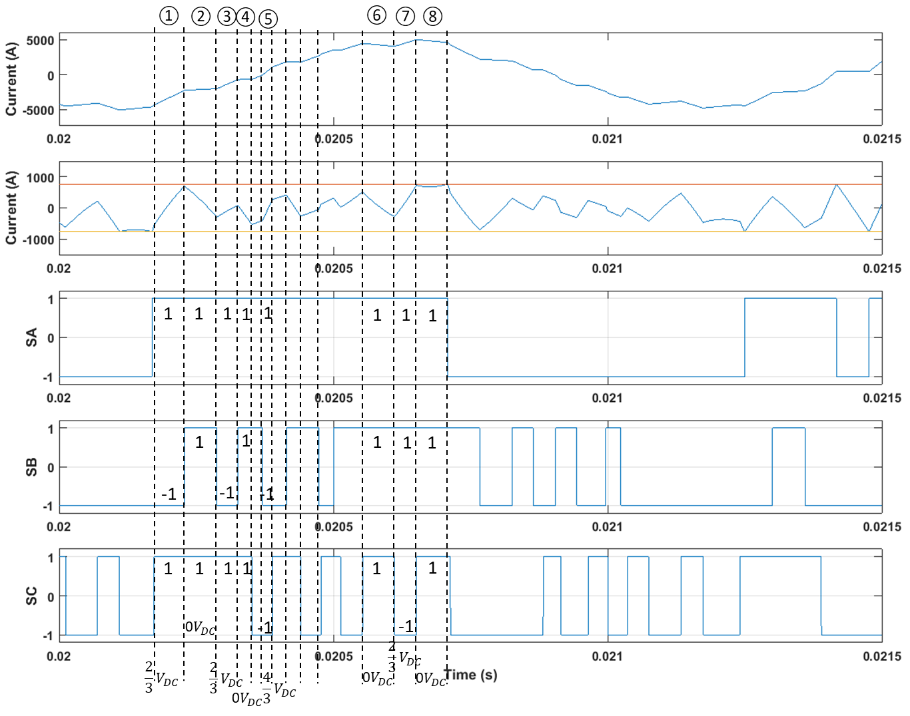
Figure 3.30 Intrinsic space vector switching process during one switching event in phase A
It can be observed that there are many space vector variations happening during one switching period. During this interval, which is nearly half of one electrical cycle, the current behave more like sinusoidal waveform than simple triangular waveform which is assumed in most switching waveform analysis. Again, this reduces the number of switching events needed to exercise control over the current in order for it to follow the command and make more sinusoidal waveform achievable for 14000rpm operating speed at 5kHz switching frequency. In Figure 3.30, the switching states corresponding to each slope change in phase A current waveform during one switching period are denoted, together with the voltage supplied on that phase according to Table 3.5. Neglecting the coil resistance, which usually makes a small contribution to the overall voltage drop in the phase, the rate of change of current in one phase can be expressed as:
$$\frac{di}{dt}=\frac{V-E_{ph}}{L_{ph}}$$ | (3.26)
For slope changing period ① in Figure 3.30, $\frac{2}{3}V_{DC}$ supplied on phase A due to the (1, -1, 1) switching states in the inverter, together with a negative close-to-peak back-EMF (-33.67V at time 0.0202s), results in a relatively fast positive increment of phase current, which has a rate of $3.81×{10}^{7}A/s$ at 0.0202s. Since phase A switches slightly earlier to 1 than phase C, which can be seen from the figure, there is a small slope changing period caused by real switching in phase A with a (1, -1, -1) state and $\frac{4}{3}V_{DC}$ supply, i.e. faster current increasing, before period ①. These two periods together drag the current back from the negative hysteresis band to the command current, which has a lower rate of change ($1.53×{10}^{7}A/s$ at 0.0202s). At the end of period ①, before the phase current reaches the positive band to cause another switching event, the switch of phase B from -1 to 1 drops the phase A supply voltage from $\frac{2}{3}V_{DC}$ to 0. With no supply voltage, the increase of the generated current is now only driven by the negative back-EMF, which itself also has a reduced magnitude around -26.59V during that period. Therefore, the rate of change is reduced to around $4.89×{10}^{6}A/s$ during the period, which is lower than the rate of change of command current (around $2.05×{10}^{7}A/s$). This leads to the actual current converging with the command without inducing another switching in phase A. There follows several similar interaction caused by switching states variation which manages to keep the current error between the two hysteresis band without causing another switching event in phase A.
Figure 3.29 also demonstrates that there are a significant number of slope changing periods where zero space vector is present and the rate of change of generated current is driven by the back-EMF. This, to some extent, provides an insight into the low value of the weighted mean voltage coefficient $a^{'}$ in equation (3.25).
Another phenomenon evident in Figure 3.29 is that the phase current occasionally exceeds the upper hysteresis band. This is also brought by the space vector switching process. Two examples in the interval between 0.018s and 0.019s are selected for investigation. Figure 3.31 shows the corresponding current waveform, error, and three-phase switching states during the interval. In period ① in the figure, phase A is connected to the positive terminal of the DC supply with the upper switch of its leg on, and the algorithm of hysteresis control is that once the upper switch is on, the error between the generated current and command current will be compared with the upper band limit to prevent an over-shoot of phase current due to connected positive supply voltage, and the switching states do not change until the upper limit of the hysteresis band is reached. However, due to the interaction from the other two phases, the supply voltage of phase A is reduced to zero in period ①, and the change in phase current is dominated by the phase back-EMF, which has a positive value at that period. According to (3.26), this would lead to a decrease of phase current. Hence, unless the space vector jumps out of the zero state, the phase current would continue to decrease, exceeding the lower band limit. According to Table 3.5, any change in switching in the other two phases would result in a positive supply voltage in phase A again, either with the magnitude of $\frac{2}{3}V_{DC}$ or $\frac{4}{3}V_{DC}$. A similar process happens during period ②, but in an opposite polarity.
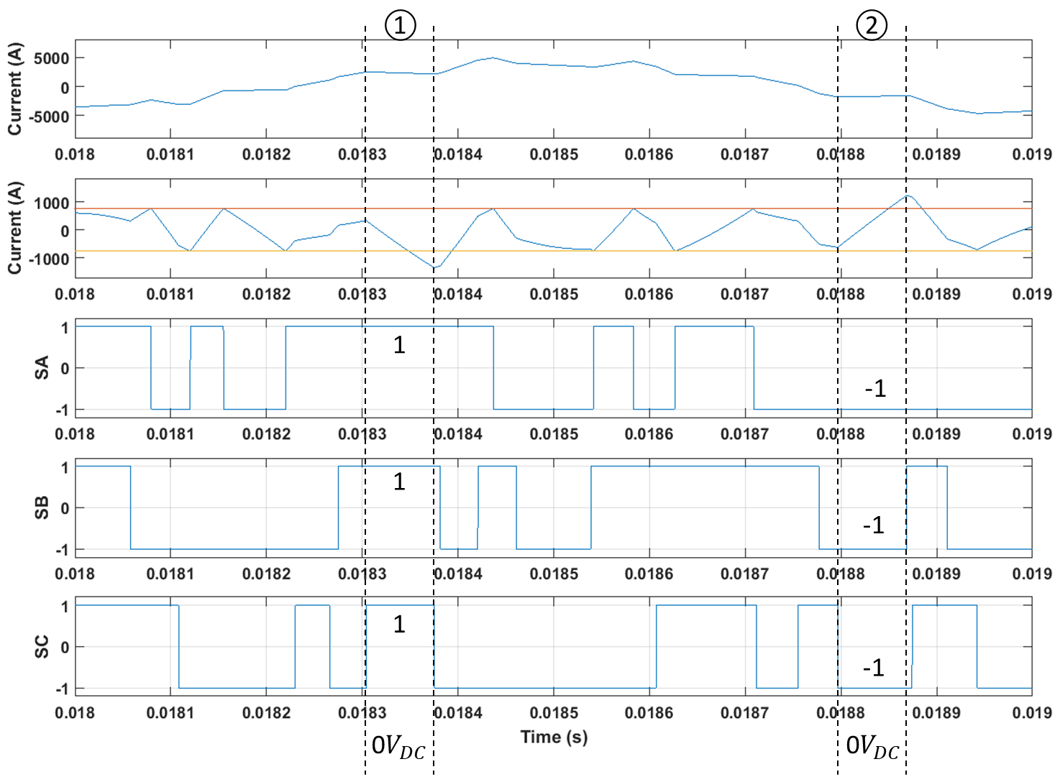
Figure 3.31 The switching states in the period of exceeding the hysteresis band

Conclusion
In this chapter, the following achievements have been accomplished:
- The electrical properties of the designed machine are determined based on the specific supply condition, and a staircase decrease of the parameters with the machine speed rating has been observed
- The ideal sinusoidal phase currents are replaced with ripple currents generated by hysteresis feedback control. An average switching frequency is defined as a criteria for the level of current ripple
- The quality of the generated phase currents and the impact of current ripple on machine performance is evaluated using different methods. Based on the proposed control methodology, the current ripple is found to have little effect on the average output torque, but big impact on the phase current harmonics and torque ripple. Bigger torque ripple and richer current harmonics would exist at high speeds
- An investigation of the natural space vector switching process during the hysteresis control is carried out, showing that a smoother current waveform can be achieved under the bouncing neutral point.

References
[1] M. P. Kazmierkowski and L. Malesani, "Current control techniques for three-phase voltage-source PWM converters: a survey," Industrial Electronics, IEEE Transactions on, vol. 45, pp. 691-703, 1998.
[2] B. K. Bose, “An adaptive hysteresis-band current control technique of a voltage-fed PWM inverted for machine drive system,” IEEE Trans. Ind. Electron., vol. 37, pp. 402–408, Oct. 1990.
[3] T. W. Chun and M. K. Choi, “Development of adaptive hysteresis band current control strategy of PWM inverter with constant switching frequency,” in Proc. IEEE APEC’96, San Jose, CA, 1996, pp. 194–199.
[4] A. Kawamura and R. G. Hoft, “Instantaneous feedback controlled PWM inverters with adaptive hysteresis,” IEEE Trans. Ind. Applicat., vol. IA-20, pp. 769–775, July/Aug. 1984.
[5] L. Malesani, L. Rossetto, L. Sonaglioni, P. Tomasin, and A. Zuccato, “Digital, adaptive hysteresis current control with clocked commutations and wide operating range,” IEEE Trans. Ind. Applicat., vol. 32, pp. 1115–1121, Mar./Apr. 1996.
[6] L. Malesani and P. Tenti, “A novel hysteresis control method for current controlled VSI PWM inverters with constant modulation frequency,” IEEE Trans. Ind. Applicat., vol. 26, pp. 88–92, Jan./Feb. 1990.
[7] L. Malesani, P. Tenti, E. Gaio, and R. Piovan, “Improved current control technique of VSI PWM inverters with constant Modulation frequency and extended voltage range,” IEEE Trans. Ind. Applicat., vol. 27, pp. 365–369, Mar./Apr. 1991.
[8] E. Perssen, N. Mohan, and B. Ben Banerjee, “Adaptive tolerance band control of standby power supply provides load-current harmonic neutralization,” in Conf. Rec. IEEE PESC’92, Toledo, Spain, 1992, pp. 320–326.
[9] Q. Yao and D. G. Holmes, “A simple, novel method for variable hysteresis-band current control of a three phase inverter with constant switching frequency,” in Conf. Rec. IEEE-IAS Annu. Meeting, 1993, pp. 1122–1129.
[10] A. Nabae, S. Ogasawara, and H. Akagi, “A novel control scheme of current-controlled PWM inverters,” IEEE Trans. Ind. Applicat., vol. IA-22, pp. 697–701, July/Aug. 1986.
[11] Professor Zhu, Z.Q., Lecture Notes in the Course of Machine Design, University of Sheffield
[12] Professor Wang, J.B., Lecture Notes in the Course of Motion Control and Servo Drives, University of Sheffield

Current ripple impact on machine iron losses

In Chapter 3 , the ideal sinusoidal currents used for the prediction of performances in chapter 2, were replaced with hysteresis generated ripple current. This demonstrated little impact on the average torque density or the copper loss compared to ideal sinusoids, even in the case of highly distorted waveforms with large hysteresis bands. In this chapter, these considerations are extended to quantify the impact of current ripple on iron losses.
The iron loss calculations employed in this thesis are based on post-processing approach to iron loss calculation using a series of previously calculated magneto-static calculations.
As a consequence, the dynamic effect of iron loss on the input current, the machine flux density distribution and output performance are not fully accounted for. In order to do this, it would be necessary to include a loss calculation method based on a dynamic instantaneous component, with an additional variable resistor included in parallel with the phase equivalent circuit for electric-circuit coupled machine transient analysis. The approximate approach adopted in this thesis is suitable for machines in motor mode since the added iron loss could be compensated simply by increasing the power rating the supplying power electronics. However, for machines in generator mode, the exclusion of iron loss during the transient solving of the machine performance could cause an over-estimation of the quality since the machine is now the energy source, and the existence of machine losses would dissipate part of the energy throughout the machine operation, which should be considered from the outset.
In this chapter, a novel post-processing method is developed for iron loss calculation in order to account for the iron loss resulting from the high frequency current ripple. In particular, it is well suited to account for very high frequency ripple, which require large number of data points for appropriate sampling so as to avoid aliasing effects. The number of data points required per electrical cycle can be in many thousands and this tends to be prohibitive in terms of generating a unique finite element field prediction for each data point. The new calculation method well avoids those limitations of finite element methods and can calculate the iron loss induced by three-phase ripple currents using large numbers of data points with reasonable speed and accuracy.

Literature review of the development of Iron loss calculation

Iron loss calculation models
Iron losses play an important role in the overall machine loss, particularly in high speed machines where fundamental frequency of the current is high and many harmonics exist. Indeed, as was shown in Chapter 2 , for machines operating at high mechanical speeds, the iron loss can become the dominant contributor to the total loss.
Theoretical studies of iron losses have been carried out for decades and considerable efforts have been made to understand the intricacies of the loss mechanisms. However, the accurate calculation of losses in electrical machines both statically and dynamically, remains a topic with many limitations. In some models, correction factors have been introduced to try to match the predictions with measurements, and it is not uncommon to see such factors exceeding value 2, which indicates that the error between prediction and measurements of some components is of the order of 100% [20]. Challenges for precise iron loss prediction includes the diversity of flux density variations throughout the stator core and across the operating range, complexity of loss mechanisms, and uncertainties in material properties. The latter can be affected by the manufacturing methods and processes, such as cutting, punching during the material production and stacking, welding during the machine assembly [1] - [3].
In the history of iron loss research, many different types of models have been proposed for the calculation of iron loss, ranging from empirical and analytical models based from simple Steinmetz equation to so-called iron loss separation models, which can include detailed numerical approaches to describe hysteresis behaviour such as the Preisach model and the Jiles-Atherton model.

Steinmetz model
In 1892, Steinmetz introduced the first empirical equation for iron loss calculation, which became known as the Steinmetz equation [4]:
$$P_{Fe}=C_{SE}f^{α}{\hat{B}}^{β}$$ | (4.1)
The parameters $C_{SE}$, $α$ and $β$ can be determined by curve fitting the model to measurements at key reference points.
Various improvements have been made to the original Steinmetz equation to overcome the limitation that the original equation can only be applied on pure sinusoidal flux density waveform. The so-called Generalized Steinmetz equation (GSE) was introduced in [5] with iron loss expressed as integral of the time-varying flux density and its derivative, as shown in (4.2). It is connected to the original Steinmetz equation by incorporating the various Steinmetz coefficients.
$$P_{Fe}=\frac{1}{T}\int_{0}^{T}{C_{SE}{\left|\frac{dB}{dt}\right|}^{α}{\left|B(t)\right|}^{β-α}dt}$$ | (4.2)
However, if the flux density waveform contains significant low order harmonics, e.g. third or fifth harmonics being common, then the precision of GSE model is adversely affected because the harmonics will generate minor loops in addition to the major hysteresis loop. Therefore, in [6], an improved Generalised Steinmetz equation (iGSE) model was developed to account for the minor loop effect by splitting the minor loops from the major loop and calculating the iron loss caused by each minor loop and the major loop separately using the equation:
$$P_{FeN}=\frac{1}{T}\int_{0}^{T}{C_{SE}{\left|\frac{dB_{N}}{dt}\right|}^{α}{\left|ΔB_{N}\right|}^{β-α}dt}$$ | (4.3)
However, models based on Steinmetz’s empirical theory have one common drawback in that the Steinmetz coefficients are frequency dependent, which means if the measured flux density waveform has notable harmonic contents spanning a wide frequency range and is far away from the pure sinusoidal form, the Steinmetz coefficients cannot be determined precisely to cover all the frequencies and accuracy of the models will be adversely affected.

Iron loss separation models and numerical hysteresis models
The major limitation of Steinmetz based models is their poor adaption to variations in the form of flux density excursions, in accommodating harmonics. In order to establish a method to accommodate essentially arbitrary flux density waveform, iron loss separation models have been developed. These methods are based on the notion of splitting the iron losses into the dynamic eddy current losses and static hysteresis losses. Several forms and analytical interpretations have been proposed for the two parts of the iron loss separation model. These methods are not arguably the most widely used model for calculating iron loss.
The concept of iron loss separation originates from the solution of the Poynting’s equation, which is commonly used to describe the power flow around and inside the studied objects, and has the following general form:
$$-\oint{\left(\vec{E}×\vec{H}\right)⋅d\vec{S}}=\oint{\vec{H}⋅\frac{d\vec{B}}{dt}dv}+\frac{1}{σ}\oint{{\left|J\right|}^{2}dv}$$ | (4.4)
The $\vec{E}×\vec{H}$ term is the well-known Poynting vector, which describes the direction and density of the power flow, and the whole left-hand side refers to the net energy through the studied surface per unit time. The right-hand side of the equation refers to how the energy is stored or dissipated inside the area enclosed by that surface. From an electrical machine point of view, it indicates that the energy consumed by iron losses can be divided into two components, namely the energy dissipated due to the hysteresis characteristic of the magnetic material, which can be obtained from the first term on the right-hand side and the energy dissipated as Joule losses caused by the eddy currents, which is described in the second term on the right-hand side. In the frequency domain, the two parts of the iron loss can be expressed as [7] - [11][42]:
$$P_{Fe}=P_{hyst}+P_{ec}=C_{hyst}f{\hat{B}}^{α}+C_{ec}f^{2}{\hat{B}}^{2}$$ | (4.5)
with $C_{hyst}$ and $C_{ec}$ being the hysteresis loss coefficient and eddy current loss coefficient respectively and $α$ being the Steinmetz coefficient in (4.1). Although good agreement has been demonstrated for some materials based on the model which results in equation (4.5) compared to experimentally measured results, significant discrepancies are still present for some silicon iron materials and operating conditions. In [12], the authors developed a domain wall model to modify the original term for eddy current loss in (4.5) to include the effect of domain structure, introducing a coefficient relative to the original expression as follows
$$η=\frac{W}{W_{c}}=\frac{96}{π^{3}}\frac{L}{d}\sum_{n=odd}^{∞}{\frac{1}{n^{3}}\left[\coth\left(nq\right)+\frac{2I_{1}\left(nq\frac{B_{m}}{B_{s}}\right)}{nq\frac{B_{m}}{B_{s}}\sinh\left(nq\right)}\right]}$$ | (4.6)
where $q=2πL/d$.
This model provided a well-founded explanation of the deviations between calculated and measure loss in Silicon iron for the model of equation (4.5) and good agreement was achieved with the measured data for grain oriented 3% SiFe. However, as this model is based on a planar domain wall shape, this model is only applicable to low frequency excitation, up to the frequency where excessive domain wall bowing occurs.
In a further development to the above model, G. Bertotti etc. [13] separated the loss component induced by the domain wall effect from the classical eddy current loss and introduced another term called excess loss to equation (4.5):
$$P_{Fe}=P_{hyst}+P_{ec}+P_{exc}=C_{hyst}f{\hat{B}}^{α}+C_{ec}f^{2}{\hat{B}}^{2}+C_{exc}f^{1.5}B^{1.5}$$ | (4.7)
In [14] and [15], a deeper physical insight of the additional loss mechanism and an analytical and statistical method to calculate the excess loss coefficient was presented, indicating that the additional loss from the eddy current results from the inhomogeneity within the magnetic material, which is neglected in the classical calculation of eddy current. This inhomogeneity is due to the presence of the individual domain walls, which cause additional localized eddy current loss when the magnetic domains are forced to move by the change of external applied field. In [14] and [16], Bertotti provided an interpretation of the origin of dynamic losses, which is the dynamic balance of the external applied field and the internal coercive, magneto-static, and eddy current reaction field. By analysing the additional damping field caused by the localized inhomogeneous domain wall motion, Bertotti provided a means of splitting the eddy current loss induced around the domain walls from the total eddy current losses, by which the assumption of homogenous distribution of eddy current can still be used for the classical calculation, and treating that localized eddy current loss as excess loss. Based on Bertotti’s statistic model [10][14][15], the excess loss coefficient can be expressed as
$$C_{exc}=\sqrt{SV_{0}σG}$$ | (4.8)
where G$≈$0.136 is a dimensionless coefficient, and $V_{0}$ represents the statistical distribution of the localized eddy current spots.
The analysis of eddy currents by Bertotti is focused on inaccuracies and subsequent improvements in the modelling of the dynamic loss component. Whereas these improvements provided improved estimation of dynamic losses even with distorted excitation sources, the hysteresis component of many models used for electrical machines was assumed to be independent of the excitation waveform, with losses only dependant on the peak value of flux density and frequency of the excitation.
The advantage of this simplified representation of the hysteresis loop is that the measured hysteresis loss under sinusoidal excitation with a particular frequency can be used for calculation of hysteresis loss at any other frequency. The validity of the assumption is dependent on the relative magnitude of the minor loops [15].
In [13], [17] and [18], the authors demonstrated the origin of hysteresis loss is that magnetisation process is composed of reversible and irreversible domain wall displacement, and domain polarity reversion and rotation. The resulting is a friction type loss caused by the dissipation of energy consumed by the discontinuous magnetisation process called Barkhausen jump, which largely exists in the irreversible domain wall motion and polarity reversion period. Barkhausen first validated the existence of magnetic domains experimentally and discovered the discontinuous jumping process in magnetisation by receiving pulse signal from the material when smoothly increasing and decreasing excitation applied to it [18]. Since the Barkhausen jumps have typically very short time scales of the order of microsecond, which is short enough to be regarded as instantaneous compared to the time scales of the magnetic behaviours in the electrical machines. Hence it is reasonable to assume that the hysteresis loss generated by a given number of Barkhausen jumps is linearly proportional to the frequency [19].
To accurately describe the magnetization process and each flux reversal, various numerical model has been developed, including the Preisach model, Jiles-Atherton model, and loss surface model [20]. Among these various models, the mathematical model promoted by Russian mathematician Krasnoselskii using the physical principles from Preisach is the most widely used numerical method for describing the hysteresis [21]. This model divides the material into a large number of tiny magnetic units called hysteron, which can be regarded as hysteresis operators in a mathematical sense. Each hysteron has a square hysteresis shape of B-H loop with a turn on limit to magnetized state with polarity aligned with external applied field, and a turn off limit to reversely magnetized state with polarity exactly opposite to before. Different hysterons have different turn-on and turn-off limits. Therefore, the transient magnetization process with excitation field increased from $H$ to $H+∆H$ can be described by the integral of the density of the hysterons whose turn-on limit lies in the range between $H$ and $H+∆H$. The polarity of those hysterons will be forced to align with external field during that transient increase of $∆H$ and contribute to the flux increase in the magnetic material. The integral used to describe the magnetization loop is called the Everett Integral and the function to represent the density of the hysterons with different limits is called the Everett function. The Everett function can be determined either experimentally as a loop-up table [22], or analytically using approximation function, e.g. Lorentzian function [23] or Hyperbolic model [18], whose coefficients, however, still require experimental measurements.
Although the Preisach model can describe the magnetization process with minor loops in great detail and with good accuracy, the entire process including the extensive experiment characterisation of the specific grade of material to establish the numerous coefficients required by the model is still time consuming.
An alternative method, that is widely used in the prediction of electrical machines is to employ an empirical correction to the hysteresis term in (4.7) to include the effect of minor loops on hysteresis [24]-[28]. The most widely used method is that proposed by Lavers et al [29]. The method accounts for the contribution of each minor loop to the hysteresis loss by adding a correction term which includes the summation of the peak to peak flux density ripples of all the minor loops onto the hysteresis component:
$$P_{hyst}=C_{hyst}f{\hat{B}}^{α}η_{L}$$ | (4.9)
where,
$$η_{L}=1+\frac{k}{\hat{B}}\sum_{i=1}^{n}{ΔB_{i}}$$ | (4.10)
and k is a parameter which for most commercial soft magnetic materials falls into a narrow range from 0.6 to 0.7.
The various empirical and analytical model for iron loss calculation have been developed to provide reasonable estimates of iron loss over a reasonably wide range of operating conditions. However, several limitations still exist with the models used for electrical machines. In [30] - [32], it was shown that in order to extend analytical expressions to cater for wider frequency ranges and larger amplitude excitation, the loss coefficients in (4.7) need to vary with both frequency and induction, not simply take single constant values. In addition, the separation between classical eddy current component and an excess component is not always beneficial, as demonstrated in [33].
Therefore, equation (4.7) was discarded by several researches [28],[30]-[34] and the previous expression (4.5) has been adopted with a single dynamic loss term, but with coefficients that are dependent on excitation frequency and the magnitude of induction. Furthermore, the influence of temperature on the loss coefficients variation has been included in latest research [28][34].
It is worth noting that many recent developments in iron loss calculation methods for electrical machines have focused more on improved fitting between the experimental data and the numerical predictions, by introducing flexibility into the original expression with more parameters and dependences, rather than on focussing on physical explanations of loss behaviour.
In [25] and [26], the power of the hysteresis component is modified to a first order polynomial of the peak flux instead of a constant:
$$P_{hyst}=C_{hyst}f{\hat{B}}^{a+b\hat{B}}$$ | (4.11)
where $a$ and $b$ could be determined by curve fitting. This attempts to account for the impact of rotational flux on hysteresis loss. For iron losses caused by rotational flux density, the most widely adopted method is to decompose the rotational flux into two alternating components in orthogonal directions and sum the losses induced by the two components together, as described in [19][24][35]. Although the commonly selected directions for the two orthogonal components are the radial and circumferential directions, in [26], the authors investigated the optimum directions for decomposing the rotational flux, and defined axis locally to follow the direction where the rotational flux density is largely oriented. In this way, the inevitable inaccuracies introduced by decomposition can be minimised.

Influence of converter PWM on iron losses
In the development of iron loss prediction models for electrical machines it is important to recognise that a critical issue is accuracy of the model in calculating iron loss under arbitrary excitation waveforms. Setting aside minor loops which might be caused by the high order harmonics in the waveform for the time being, there are two ways to calculate the iron losses induced by distorted waveforms. Firstly, calculating the iron losses in the frequency domain, i.e. the summation of losses induced by each harmonic in the waveform using the iron loss separation model (4.7) [36]:
$$P_{Fe}=P_{hyst}+P_{ec}+P_{exc}=C_{hyst}\sum_{n=1}^{N}{f_{n}{{\hat{B}}_{n}}^{α}}+C_{ec}\sum_{n=1}^{N}{{f_{n}}^{2}{{\hat{B}}_{n}}^{2}}+C_{exc}\sum_{n=1}^{N}{{f_{n}}^{1.5}{{\hat{B}}_{n}}^{1.5}}$$ | (4.12)
where $N$ is the highest order of harmonics existing in the waveform. This method of calculating iron loss needs an accurate Fourier analysis of the induction waveform to fully capture all the included harmonics [27]. The second method is to calculate iron losses in the time domain, using an equivalent integral expression for equation (4.7) as described in [22]:
$$P_{Fe}=P_{hyst}+P_{ec}+P_{exc}=\frac{1}{T}\int_{0}^{T}{H\frac{dB}{dt}dt}+C_{ec}\frac{1}{T}\int_{0}^{T}{{\left(\frac{dB}{dt}\right)}^{2}dt}+C_{exc}\frac{1}{T}\int_{0}^{T}{{\left(\frac{dB}{dt}\right)}^{1.5}dt}$$ | (4.13)
In the case of laminations which are ‘thin’ in comparison to the skin depth at the various frequencies of interest, the classical eddy current coefficient $C_{ec}$ can be obtained from Maxwell’s equations as:
$$C_{ec}=\frac{σ{d_{L}}^{2}}{12}$$ | (4.14)
The scalar expression for hysteresis loss in (4.13) is obtained from the Poynting equation (4.4). In this way, the part of minor loop hysteresis losses is naturally included since $H$ and $B$ in (4.13) represent the total waveform including all the harmonics. Since the finite element model uses an anhysteretic B-H curve to calculate the flux density within each element, the exported instantaneous flux density from FE cannot be used for calculation of hysteresis loss integral in (4.13) directly. It is possible to integrate a numerical Preisach model into the finite element to obtain the instantaneous $H$ and $B$ accounting for the hysteresis effect, which can be then incorporated into (4.13) for hysteresis loss calculation. Several dynamic iron loss prediction models have been developed [37][38], which can be incorporated into transient finite element analysis to consider the instantaneous effect of iron loss on flux density distribution and machine performance.
The iron loss due to the current ripple induced by PWM modulations in the inverter can thus be calculated, either in frequency domain or time domain. For fixed frequency inverter switching, the induced harmonics from current ripple concentrate around the switching frequency, the amplitudes forming a Gaussian distribution with median frequency being the switching frequency, as shown in [36]. In [39] and [40], the impact of some key parameters in PWM modulation, including the switching frequency and modulation ratio, on machine iron losses was investigated, showing that increasing modulation ratio would cause decrease in iron loss, and the increase in switching frequency would also bring down the iron loss to some extent. In [41], the authors found about 70% increase in iron loss induced by PWM switching generated current compared to the ideal sinusoidal case.
The benefits of using time domain calculation of iron loss are that the harmonics missed by Fourier analysis can be included. However, as discussed in [27], the main problem with a time domain method, especially with a PWM modulated current, is that the switching frequency is usually much higher than the fundamental frequency, so that large number of data points would be required to fully capture the behaviour of the current waveform. This is certainly time consuming if solving the full finite element model at each time step. In the same paper, the authors introduced a shortcut to quickly capture the harmonics in flux density waveform without the need of carrying out the full finite element analysis, by utilizing the periodicity of the machine geometry and analysing the behaviour of the elements in the same periodic position. The method was validated by comparison with spectrum obtained from full time-step finite element analysis, and it is shown that all the time harmonics were captured by the rapid method. Hence, for frequency domain calculation of iron loss induced by PWM modulated current, this method provides some promise as a means to rapidly gather the harmonics information required.

Development of new post-processing model for iron loss calculation
In this section, a new post-processing method is developed to calculate the iron loss in the time domain. As mentioned previously, this eliminates the problems associated with Fourier analysis but it does require a large numbers of data points to fully capture the switching detail in the ripple current waveform.
The new post-processing method greatly reduces the computational time of deriving a time domain finite element based estimate of iron losses in the presence of significant switching harmonics. It allows a very large number of data points to be generated without the need for a prohibitive number of finite element calculations to be performed.
By applying the new post-processing method, an interesting phenomenon different from the previous studies is discovered that well-controlled current waveforms generated by high switching frequency, with lots of tiny ripples and close to sinusoidal, could produce similar level of iron loss compared to highly distorted current waveforms generated by low switching frequency, provided the same machine conditions, i.e. supply voltage, switching strategy, machine topology and electrical properties. The level of iron loss is not determined by the tidiness of the current waveform, but largely affected by the supply voltage, phase back-EMF, and phase inductance, especially for the loss components related with the transient behaviour of the current waveform, i.e. eddy current loss and excess loss. An analytical interpretation will be carried out on the behaviours of different loss components under ripple current waveform in later sections, and rigorous derivation of the relationship between eddy current loss and supply voltage, back-EMF, and phase inductance will be given.
Prior to developing the post-processing method, the methodology for iron loss calculation needs to be determined. Since this method calculates iron loss in time domain, the integral form of the iron loss separation model with constant loss coefficients, viz. (4.13), is selected as the base equation. However, as demonstrated before, the flux density solved by the finite element software cannot be directly used to calculate the hysteresis loss integral in (4.13), since an anhysteretic B-H curve used by the finite element model. However, the flux density extracted from time stepped finite element solutions provide a good representation in terms of the peak amplitude of the major loop and the scale of each flux reversal. Therefore, it can be used for calculation of hysteresis loss by combining (4.9) and (4.11):
$$P_{hyst}=C_{hyst}f{\hat{B}}^{a+b\hat{B}}η_{L}$$ | (4.15)
In this way, the major loop hysteresis losses could be considered by setting $f$ equal to the fundamental frequency, i.e. calculating the loss purely induced by fundamental sinusoidal excitation. The effect of the minor loops caused by higher order harmonics, including from the inverter switching, can be included by adopting Lavers correction factor, i.e. $η_{L}$ [29]. Hence, the hysteresis loss can be divided into components due to the major hysteresis loop and a summation of the individual minor loop hysteresis losses:
$$P_{major}=C_{hyst}f{\hat{B}}^{a+b\hat{B}}$$ | (4.16)
$$P_{minor}=C_{hyst}f{\hat{B}}^{a+b\hat{B}}\frac{k}{\hat{B}}\sum_{i=1}^{n}{ΔB_{i}}$$ | (4.17)
Hence, the final formula for iron loss is:
$$P_{Fe}=C_{hyst}f{\hat{B}}^{a+b\hat{B}}η_{L}+C_{ec}\frac{1}{T}\int_{0}^{T}{{\left(\frac{dB}{dt}\right)}^{2}dt}+C_{exc}\frac{1}{T}\int_{0}^{T}{{\left(\frac{dB}{dt}\right)}^{1.5}dt}$$ | (4.18)
The classical eddy current coefficient $C_{ec}$ has the expression of (4.14), while the values for other parameters need to be determined by curve fitting with experimental data in frequency domain. During this study, previously measured coefficients for Cobalt Iron, Vacoflux50 in specific, were used [43]. These specific coefficients are listed in Table 4.1.
Table 4.1 Values for the coefficients in formula (4.18)
Symbol | $$C_{hyst}$$ | $$a$$ | $$b$$ | $$C_{exc}$$ | k
Value | 0.016 | 1.405 | 0.075 | 3.7e-5 | 0.65

Underlying principles of the new post-processing model
The new post-processing model is based on the idea of separating the fundamental sinusoidal excitation from the high frequency ripple excitation. More specifically, the variation at the fundamental frequency is captured by an appropriate number of finite element calculations spanning an electrical cycle, while the high frequency switching variations are calculated outside the finite element model as part of the post-processing. In this way, the number of finite calculations can be relatively modest, e.g. 360 time steps at 1°electrical intervals. The higher frequency behaviour is calculated during post-processing via a perturbation method.
The flux density variation induced by the high order harmonics in each phase is calculated by establishing an approximation to ${dB}/{dI}$ in each individual finite element in the stator core. Having performed a series of finite element calculations with the rated sinusoidal current at angular increments spanning one electrical cycle, this yields the reference value of flux density in each element at each time step. The values of ${dB}/{dI}$ in each element and at each time step can be established from a corresponding further series of finite element simulations with a unit perturbation to the current in a particular phase current. In the $i^{th}$ element of the stator core finite element mesh at the $j^{th}$ time step an approximation to ${dB}/{dI}$ can be calculated:
$$\frac{dB_{ij}}{dI_{j}}≅\frac{B_{ij}\left(I+∆I\right)-B_{ij}\left(I\right)}{∆I}$$ | (4.19)
This method only requires one further series of magneto-static finite element simulations at a modest resolution, e.g. one solution per electrical degree. In this method, the saturation state in each element is reflected in ${dB}/{dI}$. Having established each value of ${dB}/{dI}$ and extracted these from the finite element simulations, the flux density variations associated with any ripple current can be calculated within a MATLAB script at a much higher sampling rate (using interpolated values of ${dB}/{dI}$ established for the coarser time step). This flux density variation is then combined with the original flux density calculated under the purely sinusoidal excitation, again with appropriate interpolation onto a finer time scale, and the net flux density waveform due to the hysteresis generated ripple current would be achieved. The net flux density waveform can then be used for time domain iron loss calculation.
Figure 4.1 shows a schematic of the well-established loss calculation procedure, which directly imports the hysteresis controller generated phase currents into an FE model as a series of look-up tables. This is same method as used in Chapter 3 for investigation of current ripple impact on machine output torque. In the case of torque calculation, the small but very high frequency flux density variations will not have a discernible effect on the torque.
Figure 4.2 shows a schematic of the proposed new procedure for iron loss calculation. The key feature of this method is that it enables very fine time steps to be used for the loss calculation without the need for a finite element solution at each time step. It is possible to undertake one to two orders of magnitude more time steps in the loss calculation than the underlying field calculations. This allows sufficient sampling of the flux density waveforms to be adopted as to avoid aliasing effects that would result in an underestimate of the contribution from higher frequency variations.
Since the obtained flux density turbulence $∆B_{unit}$ for each element at each angular position during the sinusoidal operation contains the specific saturation information for the element at that angular position, which would not be much affected by the introduced perturbation, for a fixed set of three-phase sinusoidal current, only one set of $∆B_{unit}$ is needed for any form of added ripple current. However, as will be shown later, inaccuracies might arise if a large current ripple (and hence deviation from the underlying sinusoid) is present.
In this study, ${dB}/{dI}$ is calculated at one degree increments over one electrical cycle, i.e. in total 360 values are generated for each element of the core region over one electrical cycle, and the flux density from fundamental three-phase current is generated in the same density from FE analysis. In practice, this level of density is sufficient to obtain an accurate description of the total flux density induced by the ripple current, when linear interpolation is used.
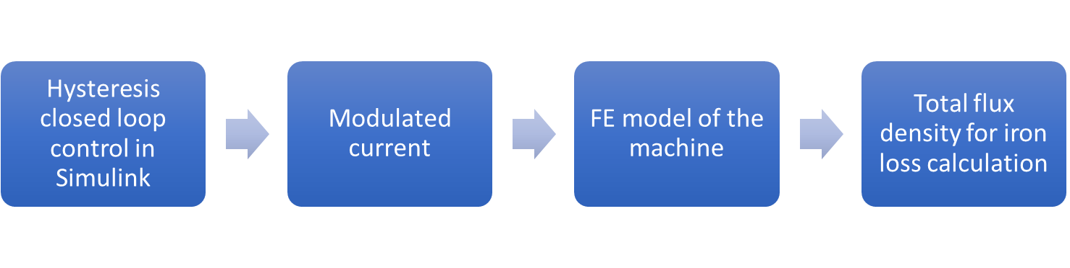
Figure 4.1 Schematic of the conventional data generation process for iron loss calculation
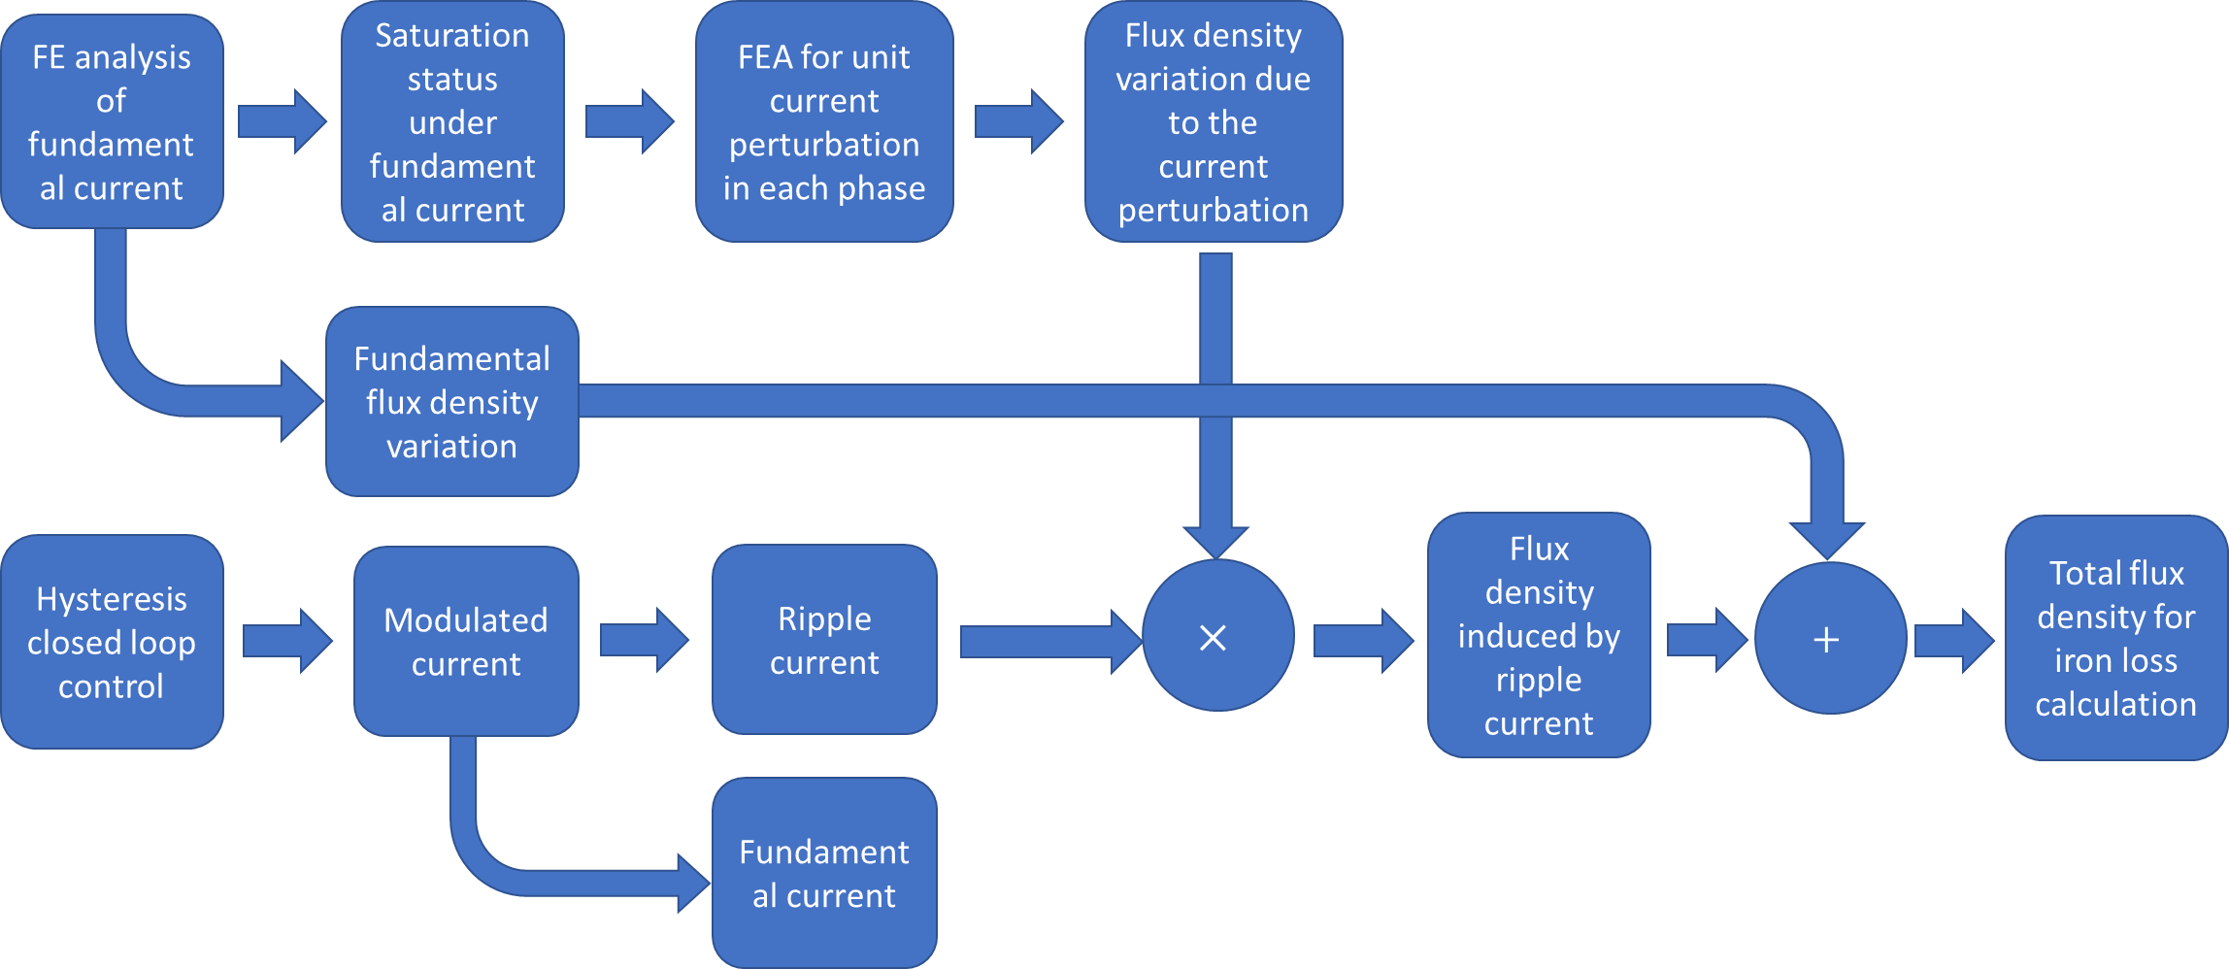
Figure 4.2 Schematic of the data generation process for iron loss calculation in the new post-processing method

Implementation details of the new post-processing method
Following the detailed waveform data generation process described in the previous section, the resulting total flux density waveforms can then be utilized for iron loss calculation.
For initial validation of the model, machine design 8 with 8000rpm base speed in machine series with constant electromagnetic split ratio was selected.
Only the iron loss in stator laminations was considered for this validation as this is by far the dominant component. However, the method developed can also be applied to the iron loss calculation in rotor core, with the correct treatment of the changing node coordinates due to rotating geometry.
In the iron loss calculation process, three types of data are required, viz. the coordinates of each node in each element of the studied region, the relationship between elements and nodes, and the calculated flux density components in each element. The finite element solver used in this analysis, FLUX2D, uses second order triangular elements, i.e. the vector potential has quadratic variation with position within a given element, and hence the flux density varies linearly with position inside the element. In addition to the three nodes at the three vertices of each triangular element, there are additional three nodes in the middle of the three edges of each triangle, as shown in Figure 4.3. The fidelity provided by the flux density variation at the three nodes on the edges is usually not exploited if each element is assigned a single value of flux density derived by averaging the flux density at the three corner nodes. In the newly developed post-processing method, the original element in FE model is further divided into four sub-elements, with the help of the nodes on the edges. In this way, the flux density values at all nodes could be fully utilized, and the spatial resolution and potentially the accuracy of the loss model can be further improved.
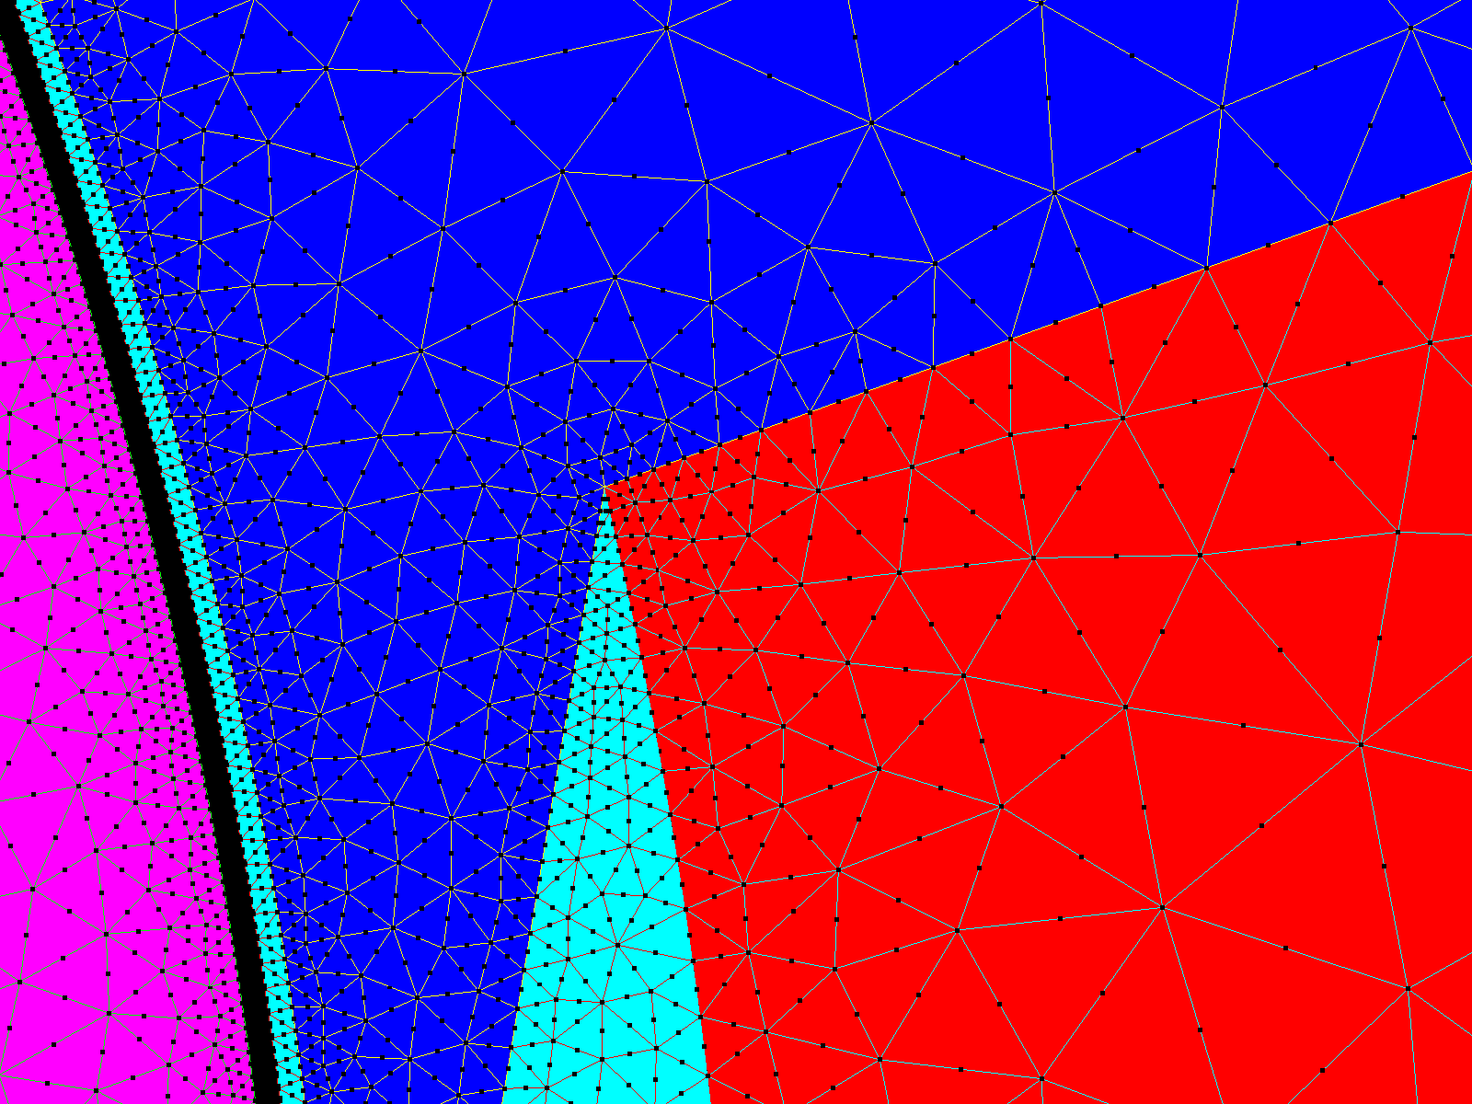
Figure 4.3 Elements and nodes distribution
In Flux2D, the node coordinates, and the relationship between the nodes and elements can be exported outside the built model into a DEC format file, which also contains summary information like the total number of elements, and the total number of nodes in the studied region. Table 4.2 shows the geometric information extracted from the DEC file for one arbitrarily selected element, including the related node indices and corresponding X and Y coordinates of each node. By analysing the geometric relationship between the six nodes, the node indices corresponding to each sub-element can be determined as shown in Table 4.3. The geometry of the four sub-elements is regenerated based on the information in Table 4.2, and is shown in Figure 4.4, along with the outline of the original element.
Table 4.2 Node geometric information for the selected element
Element index | 1
Node index in the element | 1 | 2 | 3 | 4 | 5 | 6
Node index in the entire mesh region | 2438 | 2752 | 3052 | 13329 | 13273 | 13240
Node X coordinate (mm) | -21.46 | -20.74 | -21.55 | -21.10 | -21.15 | -21.51
Node Y coordinate (mm) | 68.20 | 68.78 | 69.10 | 68.49 | 68.94 | 68.65
Table 4.3 Nodes corresponding to each sub-element from the original element
Sub-element index | First node index in the element | Second node index in the element | Third node index in the element
1 | 1 | 4 | 6
2 | 4 | 2 | 5
3 | 6 | 5 | 3
4 | 4 | 5 | 6

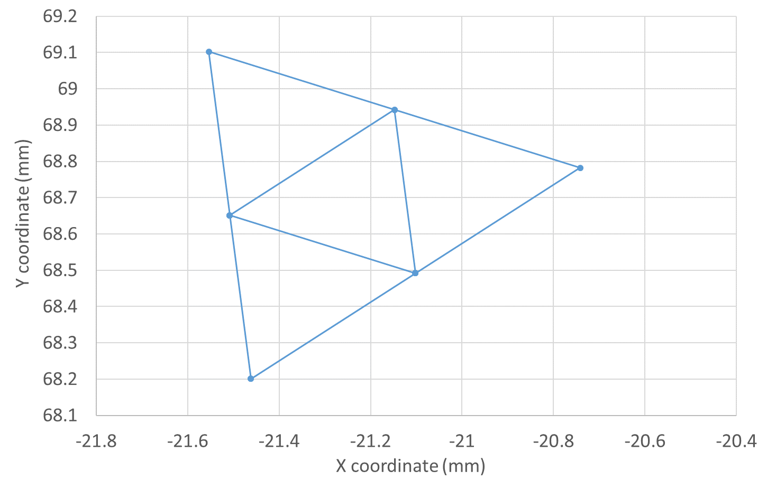
Figure 4.4 Regenerated geometry of the selected element and four sub-elements
Figure 4.5 and Figure 4.6 show the original and sub-divided meshes respectively. The finer discretisation of stator geometry should be beneficial for subsequent iron loss calculation.
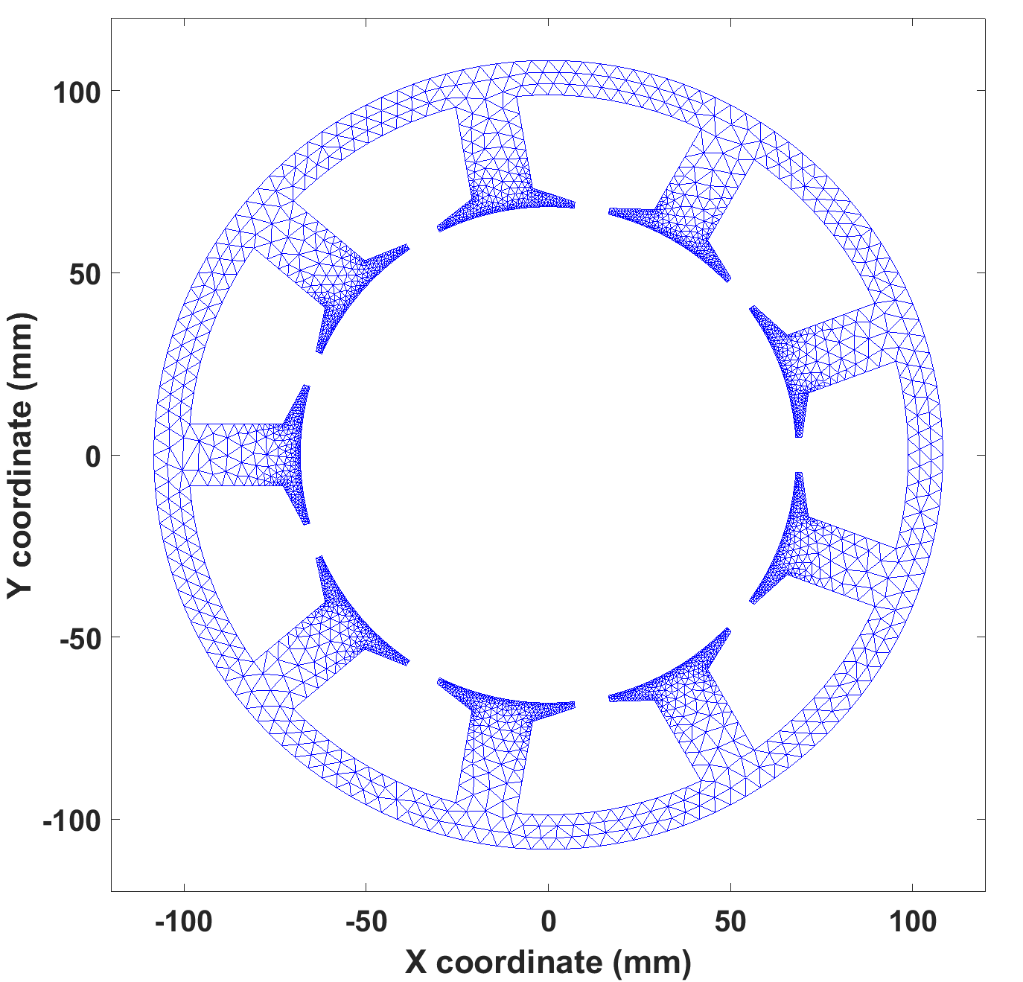
Figure 4.5 Regenerated stator core geometry inside MATLAB from the original mesh elements in FE model
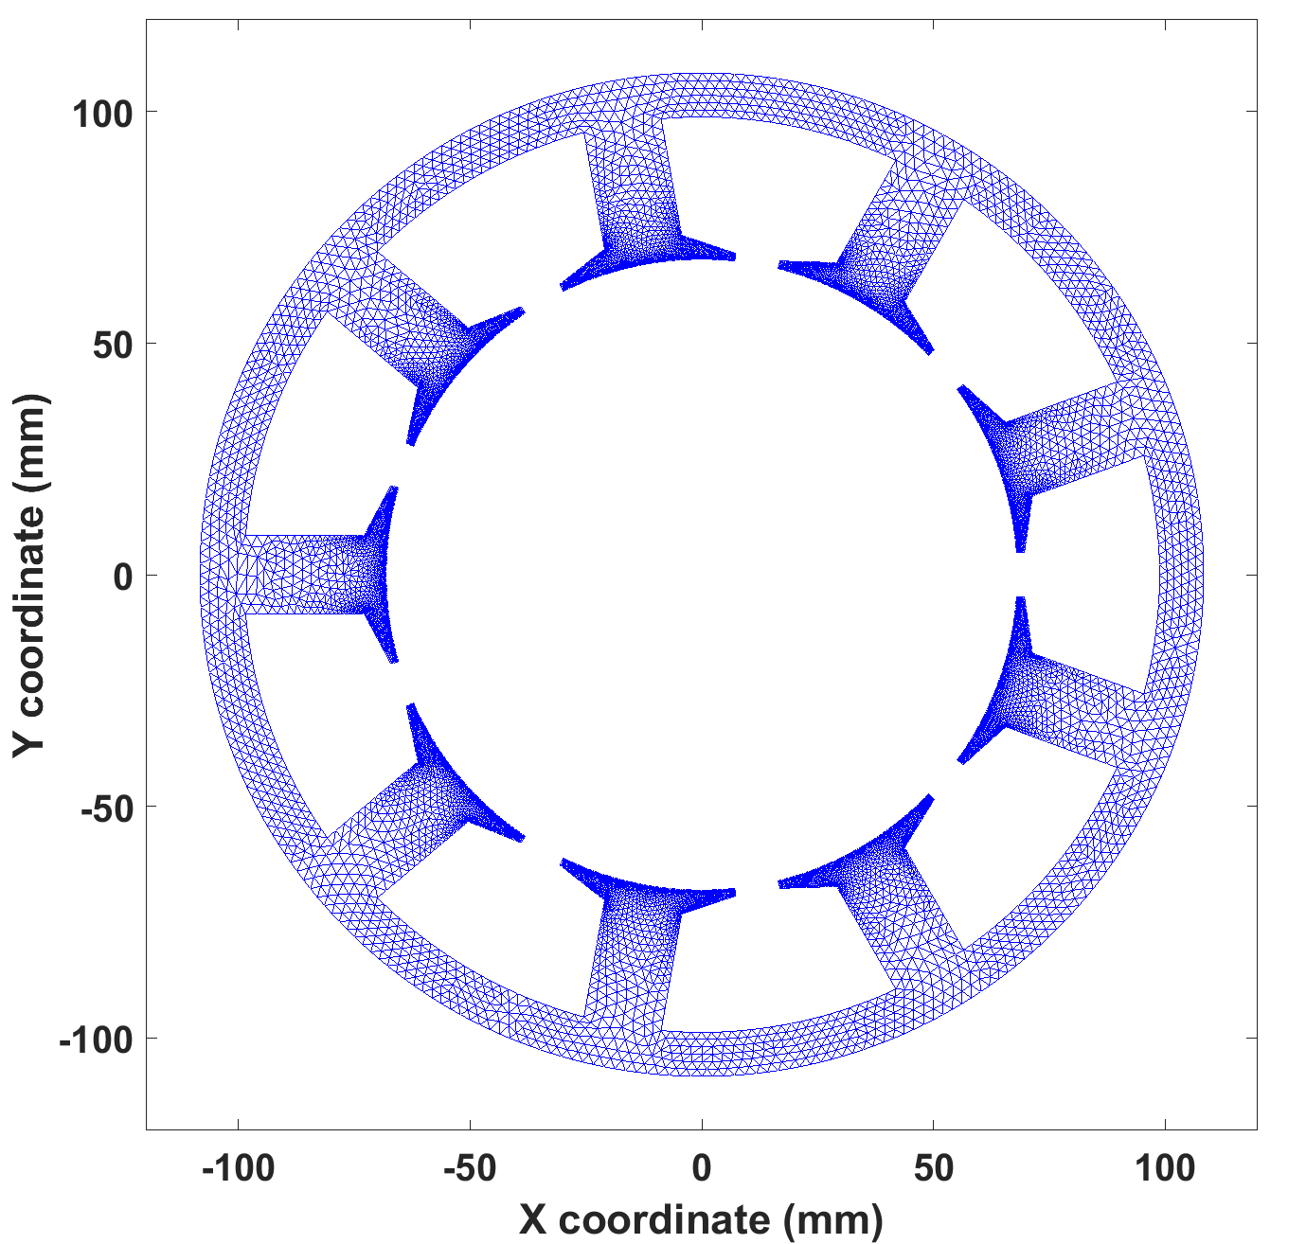
Figure 4.6 Regenerated stator core geometry by MATLAB script using divided sub-elements
After the geometric and mesh information of the studied region is incorporated in MATLAB, the area of each sub-element is calculated using the corresponding node coordinates, as follows
$$A_{elem}=0.5\left[X_{1}\left(Y_{2}-Y_{3}\right)+X_{2}\left(Y_{3}-Y_{1}\right)+X_{3}\left(Y_{1}-Y_{2}\right)\right]$$ | (4.20)
where $\left(X_{1},Y_{1}\right)$, $\left(X_{2},Y_{2}\right)$, $\left(X_{3},Y_{3}\right)$ are the coordinates for the three nodes on the vertices of the sub-element. As discussed previously, the rotational iron loss, which can occur with the complex geometry and flux density variations in electrical machines, can be approximated by decomposing the rotating flux density into two orthogonal alternating flux density components and summing the loss produced by each component. It is common to decompose the rotating flux density into radial and circumferential components.
The same sampling process, which was used in current waveform generation for torque performance investigation in section 3.3.2 is again applied here on the ripple current to generate waveform with different sampling rate. In the last step of the data generation process, the flux density in every element in the revised stator mesh is calculated for each time step in the sampled ripple current waveform (which is usually at a much higher sampling rate than the number of finite element calculations performed in each electrical cycle). The flux density variations are calculated from interpolated values of ${dB}/{dI}$ in combination with the ripple current and the interpolated values of the fundamental flux density. The flux density components for each sub-element are obtained by averaging the values of the flux density components at the three vertices of that sub-element. This is applicable due to the linear variation characteristic of flux density inside one element.
In practice, the size of the resulting matrices storing the data of the detailed flux density information for each element at every time step can become very big for fine time steps, e.g. for the finite element mesh used in the validation, then with 75000 time steps per electrical cycle the matrices can occupy ~40GB of space. Handling such matrices can be problematic in terms of computer memory usage. Therefore, in the developed methodology, the processed flux density data is generated, transferred and cleared from memory to hard drive every 1000 time steps, ensuring both a stable operation and avoiding significant time consumed by I/O process between memory and hard disk.
With all the flux density information collected and processed for each element at each time step, the iron loss calculation process can be undertaken. The stored data in the hard disk are re-read into MATLAB, but rather than reading the flux density of all the elements on a time step by time step basis (which is the manner the information is stored in the data generation process), the flux density at all time steps for one element is read in to form a complete flux density waveform for a given element for loss computation. The radial and circumferential component waveforms of flux density are then used with equation (4.18) to calculate the loss. The integrals for eddy current loss and excess loss are computed by numerical integration with the time step $Δt$. The major loop loss for each element is calculated by detecting the maximum and minimum of the component waveform, and averaging these peaks to establish a mean peak for the major loop which is then substituted into (4.16). The minor loop loss is calculated by identifying each flux reversal in the waveform and the corresponding peak to peak excursion, and substitute the $ΔB_{i}$ into (4.17). Finally, the losses of the two components are summed to obtain the total iron loss.

Validation of the new post-processing method
As mentioned previously, machine 8 with an 8000rpm base speed in the series of constant electromagnetic split ratio designs was selected for validation of the new developed post-processing method. For comparison, the loss was also calculated in an existing standard implementation of a loss separation model based on a series of finite element calculations using the methodology shown previously in Figure 4.1.
Instead of using a fixed average switching frequency as the constraint to generate the ripple current via hysteresis control, during this validation, five levels of hysteresis band, i.e. ±10A, ±100A, ±200A, ±300A, ±400A, are set to generate the ripple current for the selected machine. Two different phase connections were considered, viz. star-connected three phases, and isolated three phases. In the isolated phase case, both the electric and magnetic mutual coupling between the three phases, i.e. fluctuating neutral point and mutual inductance are not accounted for. Therefore, this provides a complete and rather ideal isolation between the three phases, which is difficult to achieve in practical case, especially in terms of the magnetic isolation. However, the 9 slots and 8 pole combination results in a low mutual inductance. In order to investigate the impact of sampling of current on iron loss, the original current generated from the Simulink model was sampled at a series of different rates to generate waveforms with different number of data points per electrical cycle, both for the new developed method and the conventional method. Table 4.4 and Table 4.5 show the current waveforms corresponding to the various hysteresis bands at a sampling rate of 750 data points per electrical cycle.
Table 4.4 Current waveforms for machine 8 of star-connected three phases under different levels of hysteresis band
Hysteresis band | Current waveform
±10A | 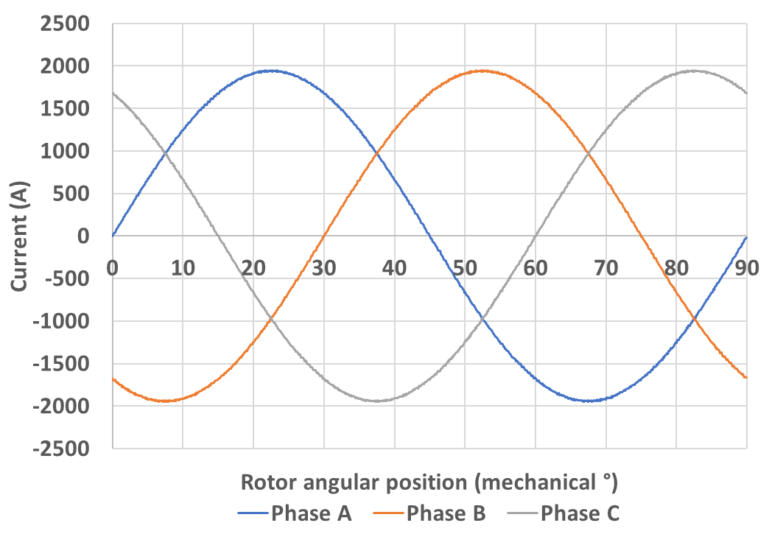
±100A | 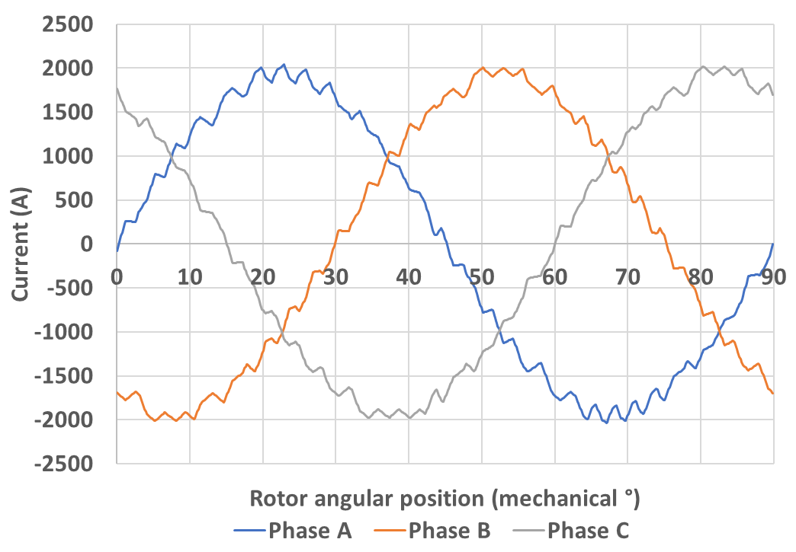
±200A | 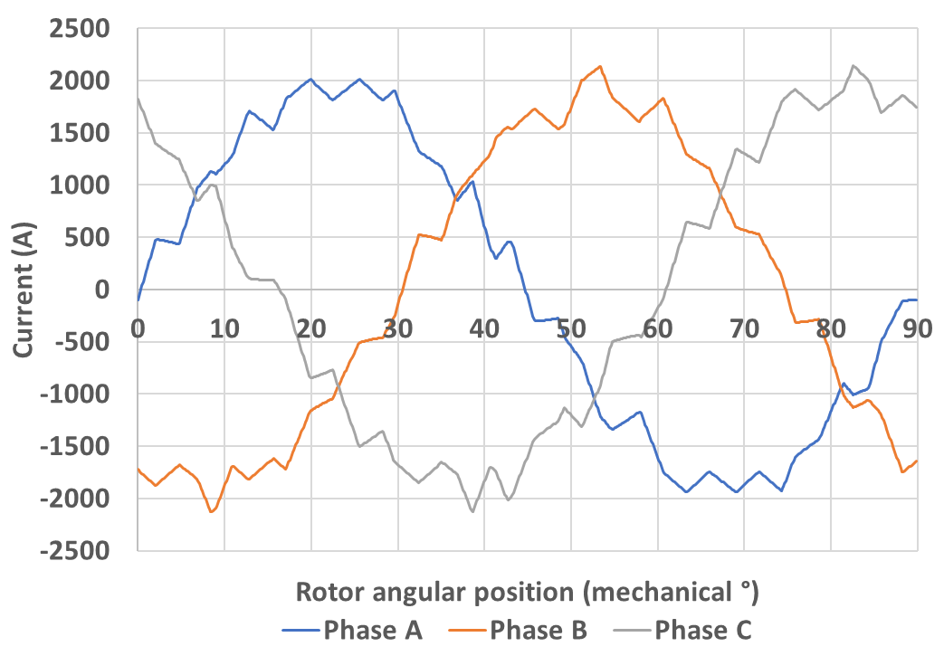
±300A | 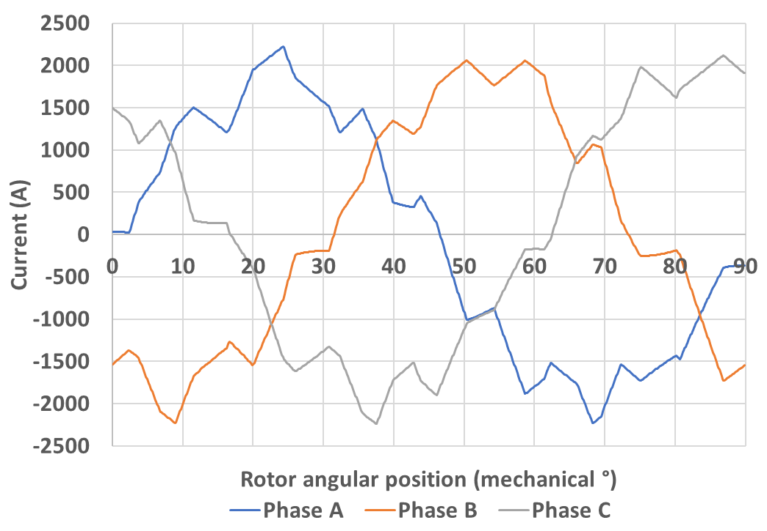
±400A | 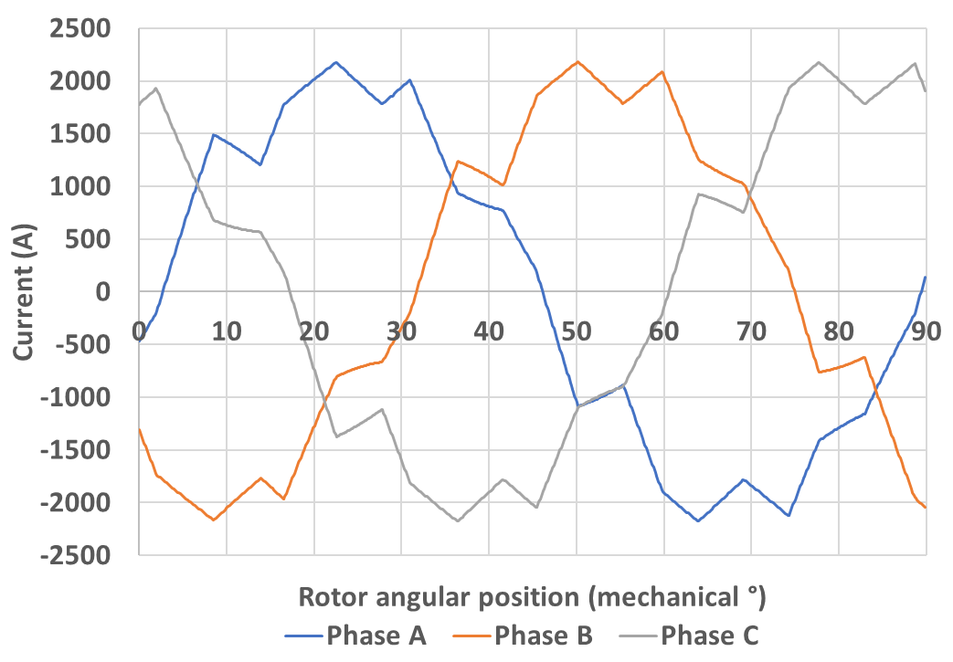
Table 4.5 Current waveforms for machine 8 of isolated three phases under different levels of hysteresis band
Hysteresis band | Current waveform
±10A | 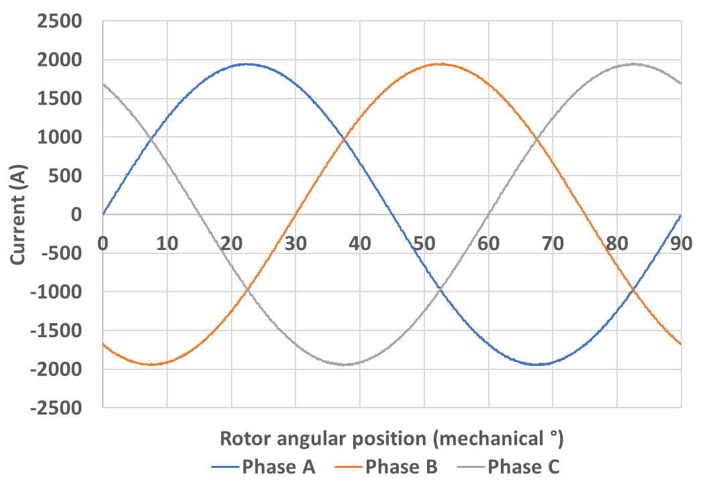
±100A | 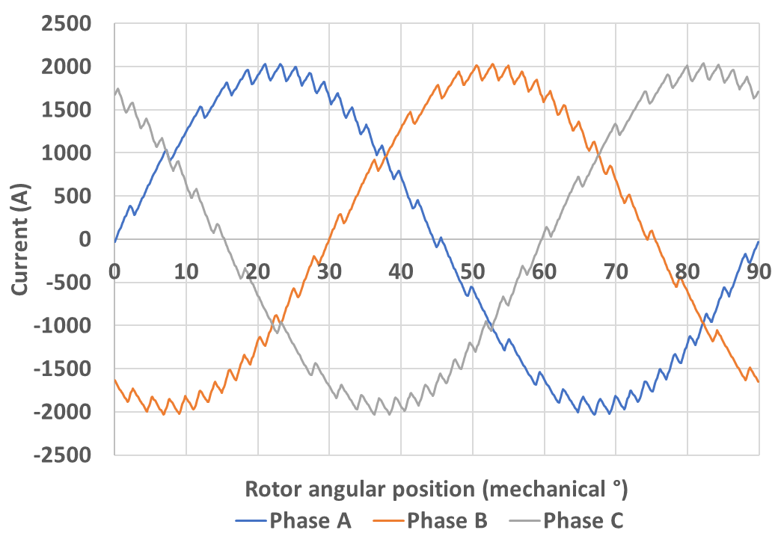
±200A | 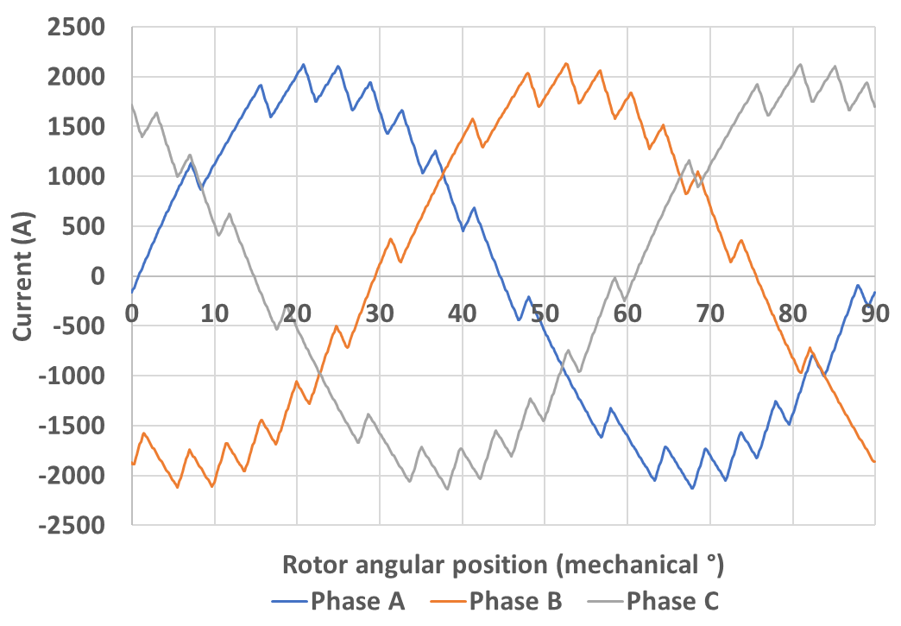
±300A | 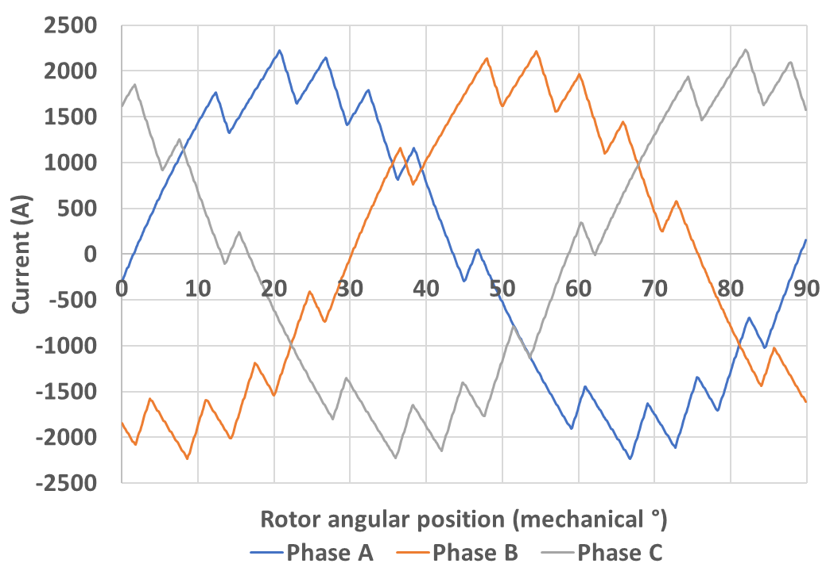
±400A | 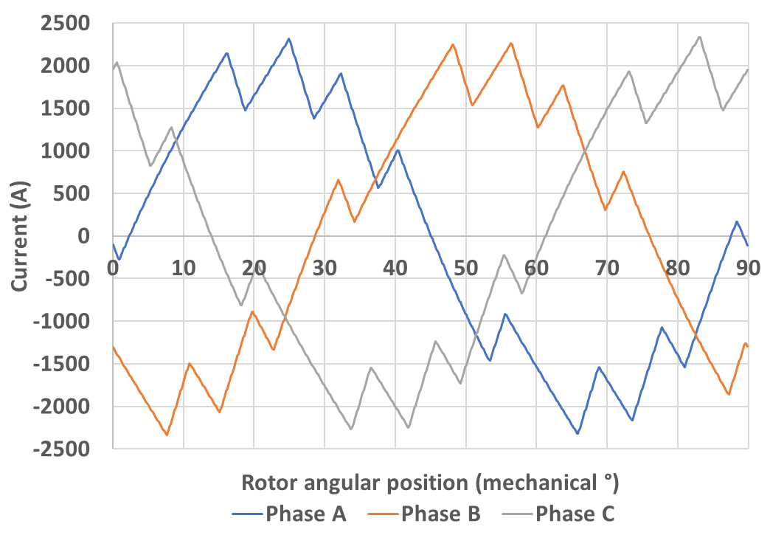
As would be expected, with the ±10A hysteresis band produces a very close approximation to sinusoidal current waveform, while for the ±400A hysteresis band, the deviation between generated current and ideal sinusoidal current becomes significant. It is also worth noting that the ripple for the case of the isolated phases are far more regular than for the 3-phase star-connected machines. This is a consequence of the fact that there is no influence from the other two phases in terms of shift in the star-point voltage as discussed in Chapter 3 .
To generate the fundamental flux density information for the selected machine in the new post-processing method, a magneto-static finite element model was solved under sinusoidal fundamental current with 360 time steps per electrical cycle. These 360 finite element calculation were then repeated twice but with the fundamental current for one phase adjusted upwards by $0.5∆I$ in the first case, and downwards by $0.5∆I$ in the second case, while keeping the current in the remaining two phases unchanged. In this way, the flux density change due to unit current perturbation in one phase at the magnetic saturation state of fundamental current can be calculated later via equation (4.19). Although Table 4.4 and Table 4.5 showed current waveforms generated by the SIMULINK model with 750 sample points per electrical cycle, for this investigation, 15 levels of sampling rate were considered, i.e. 10, 25, 50, 100, 250, 500, 750, 1250, 1500, 2000, 2500, 5000, 7500, 9375, and 15625 points per electrical cycle.
For the conventional method of iron loss calculation, current waveforms with different sampling rates were also created. However, these current waveforms were served as input for a series of finite element calculations to obtain element-by-element flux density waveforms with one data point per finite element calculations. The size of the data look-up table that can be used in FLUX2D is limited to 1000 points, and hence for some of the higher sampling rates it was necessary to divide the finite element simulations up into a series of intervals. As the simulations are magneto-static the flux density waveforms can be simply appended to each other.
The final calculated iron losses from the two models at the 3 common investigated sampling rates, i.e. 750, 2000 and 5000 date points per electrical cycle, are shown in Table III.1 and Table III.2, for star connected and isolated three phases, respectively, in Appendix III. As an example, the results for star connected three phases and hysteresis band of ±100A under the sampling frequency of 750 data points per electrical cycle are plotted in Figure 4.7. It is worth noting that generating 5000 data points per cycle from the more established method required 5000 finite element calculations, a total which is prohibitive for routine use, but it nevertheless a useful reference exercise in this investigation.
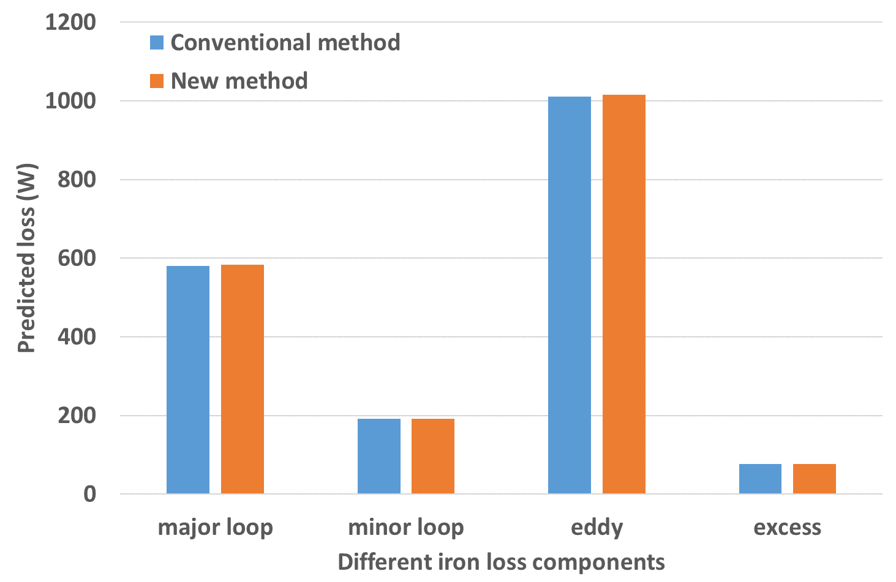
Figure 4.7 Predicted iron loss from two post-processing methods for hysteresis band of ±100A and star connected three phase currents under 8000rpm operation
It is important to recognise that both the proposed method and the more established approach to loss separation are based on the same underlying loss equations and hence providing the deviation caused by the ripple is not large and under the same sampling frequency, both methods should agree. Hence, as would be expected, it can be seen from Table III.1 and Table III.2, there is good agreement between the losses from the two models at low hysteresis bands (i.e. small deviation from a pure sine wave current) for the same sampling rate. However, as the hysteresis band increases, e.g. ±400A, the difference between the two losses increases due to problems with the small signal perturbation method used in the new processing method.
In addition, at low sampling frequency (750 data points per electrical cycle) with a narrow hysteresis band (10 A), while there is good agreement between the two models in major loop loss, eddy current loss, and excess loss components, there is discernible difference in the minor loop loss between the two methods. This is due to the difference in the minor loop detection methods between the two post-processing models, which would cause a slight shifting of the peak and position of each minor loop between the two methods. However, as the sampling frequency increases and there are increasing number of data points to describe each minor loop, the effect of shifting of peak and position of minor loops from the detection of the two post-processing models is reduced. This is evident in Table III.1 and Table III.2 where the agreement at higher sampling frequency is improved.
It would be expected that as the sampling frequency increases, the losses should become insensitive to further sampling rate increases, i.e. the loss values should reach an asymptotic value when the sampling frequency is sufficient to capture the full dynamics of the flux density variations at an appropriate resolution. The resulting losses will still contain errors compared to the true loss due to various shortcomings in the model, but these will not be due to insufficient sampling. While there is some evidence of this in Table III.1 and Table III.2 for the case of the new post-processing methods, in the case of fundamental iron loss in the conventional post-processing model, the losses seem to continue to grow, particularly in the case of minor loop hysteresis loss.
The source of this behaviour with the conventional post-processing method was investigated further. Figure 4.8 and Figure 4.9 plot the radial and tangential flux density variation, respectively, at the three sampling frequencies for one mesh node within stator tooth tip, where circumferential flux density tends to be dominant, although there is also some rotational flux density variation. Although the three variations at different sampling frequencies seem to be almost identical on the scale shown, the zoomed-in waveforms shown in Figure 4.10 and Figure 4.11 indicate that there is high frequency element, which differs between different sampling frequencies, being more evident at 2000 and 5000 than at 750 sample points per electrical cycle. This high frequency fluctuations are caused by small mismatches of the mesh at different discrete steps and is more serious at the edge elements between different regions than the elements inside the region.
Since this mismatch derives from geometrical steps, at higher number of data points per electrical cycle, the greater the number of small fluctuations in flux density that arise. Each of these small fluctuations in flux density caused by localised mesh changes will generate minor loop loss. For the new post-processing model, the flux density information obtained from FE is based on solutions of 360 data points per electrical cycle, and thus the fine-scale geometric induced fluctuations effect on the loss result is not significant.
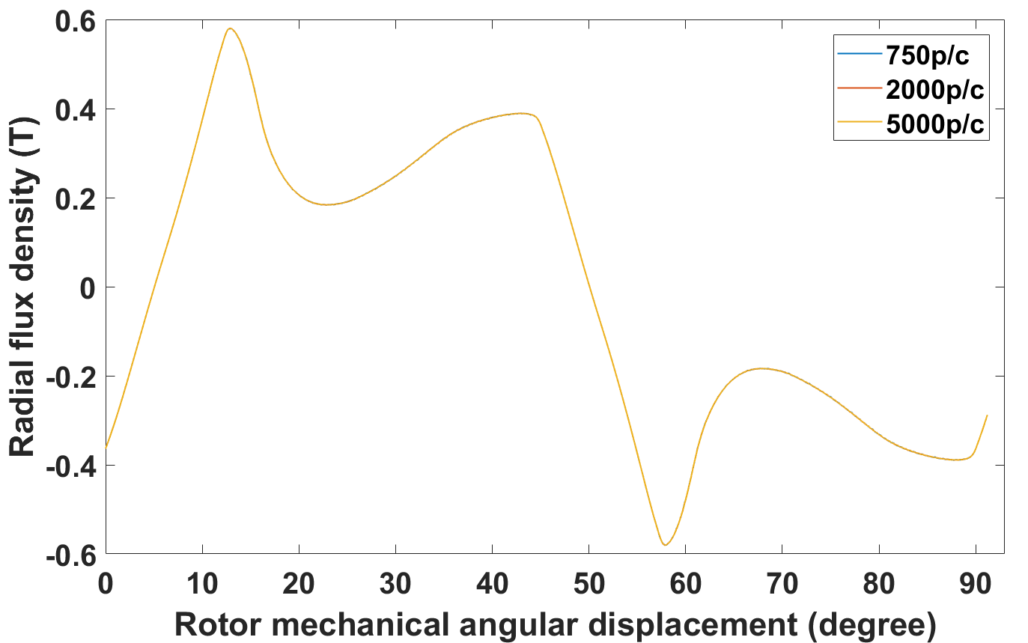
Figure 4.8 Radial flux density of one mesh node in stator tooth tip
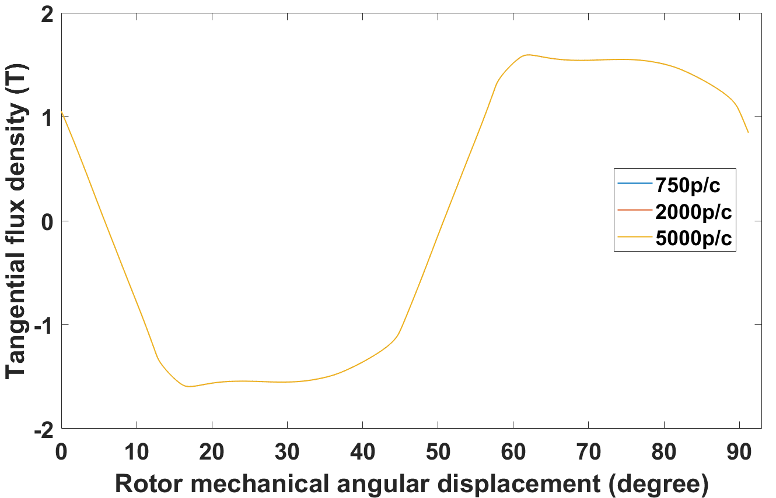
Figure 4.9 Tangential flux density of one mesh node in stator tooth tip
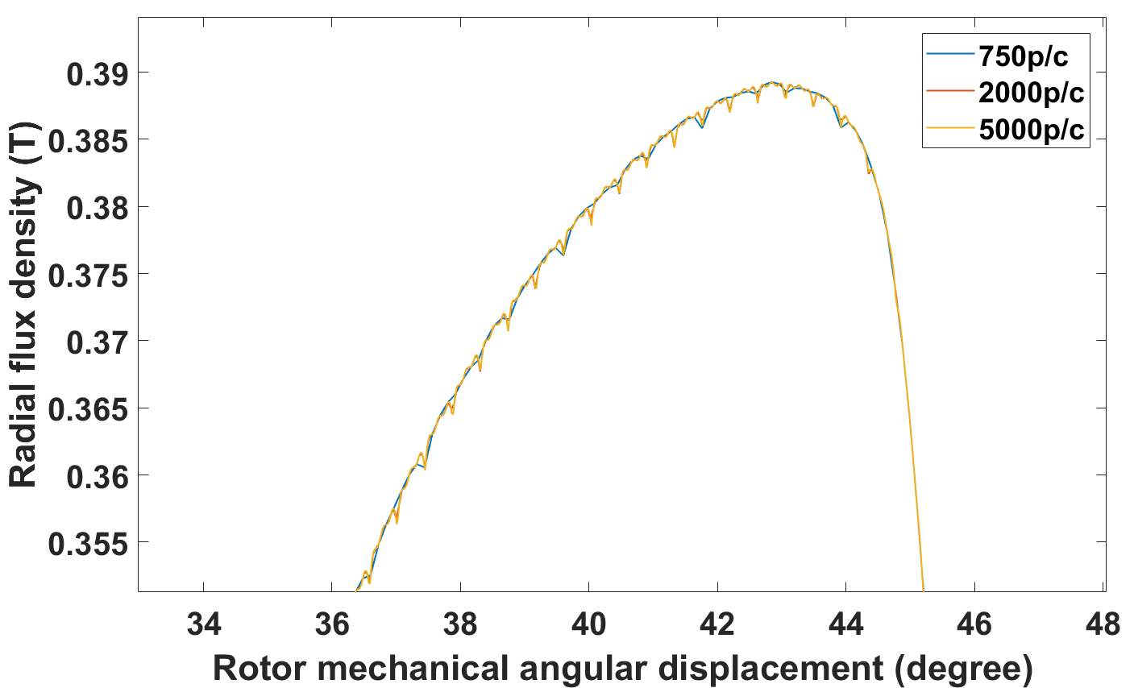
Figure 4.10 Part of radial flux density waveform from Figure 4.8
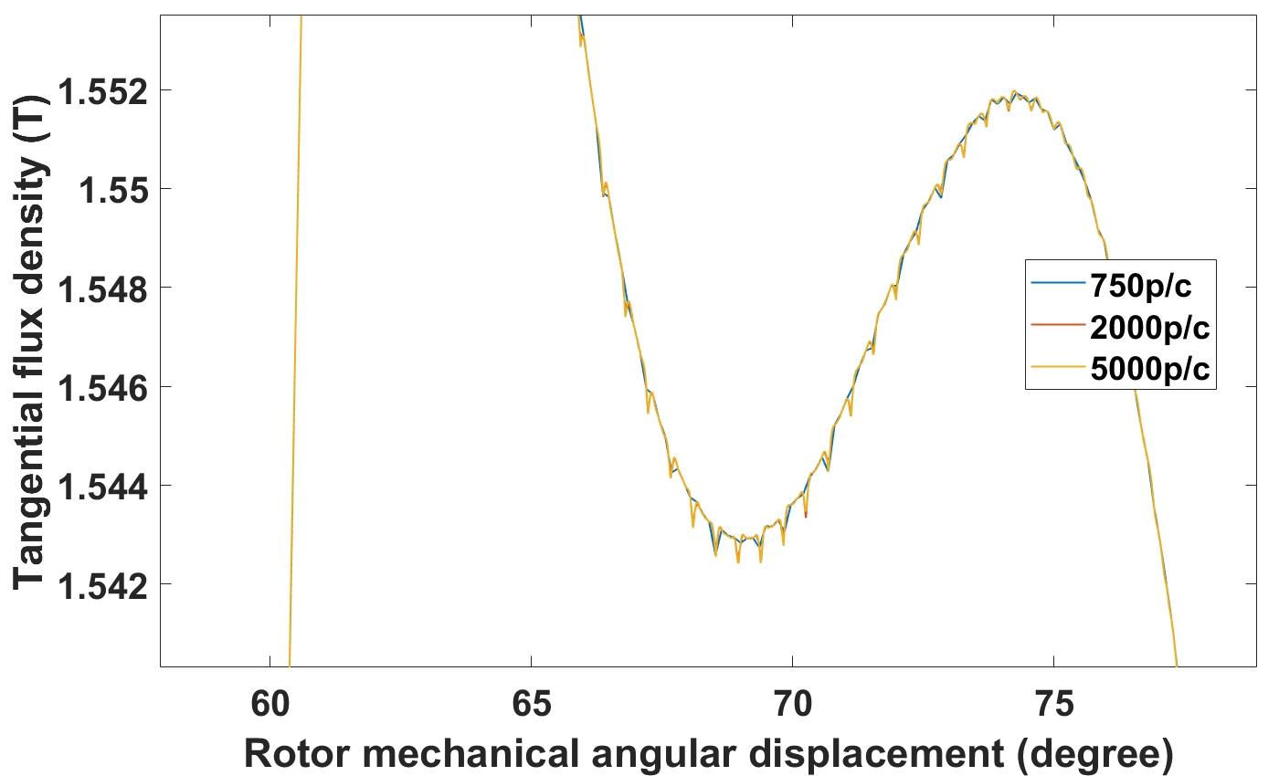
Figure 4.11 Part of tangential flux density waveform from Figure 4.9
To accommodate this problem, a Fourier based filtering technique was introduced to attenuate the high frequency noise. To make this filtering effective without attenuating the underlying flux density variations, the first 90 orders of harmonics were preserved with the remainder discarded. This proved effective in eliminating the small fluctuations caused by mesh geometry during rotation. Figure 4.12 and Figure 4.13 shows the radial and tangential flux density variation respectively, in the same position as Figure 4.10 and Figure 4.11, for the same mesh node before and after filtering. It can be clearly seen that after the FFT filtering the high frequency fluctuations are greatly diminished. The filtered waveforms are then put into the conventional post-processing model again to calculate the iron loss. The predicted losses for a range of sampling frequencies are shown in Table 4.6. It can be seen that after filtering, the loss results, especially the minor loop loss from the conventional post-processing model level off with sampling frequency, and good agreement is achieved between the two post-processing methods.
Table 4.6 Iron loss results for fundamental excitation after filtering using conventional post-processing method and comparison with new post-processing results
HB | Major loop loss | Minor loop loss | total hysteresis loss | Eddy current loss | Excess loss | Total iron loss
750 data points per electrical cycle
Conventional post-processing method
0 | 565 | 16 | 581 | 534 | 50 | 1165
New post-processing method
0 | 566 | 16 | 583 | 538 | 50 | 1171
2000 data points per electrical cycle
Conventional post-processing method
0 | 565 | 16 | 581 | 535 | 50 | 1166
New post-processing method
0 | 566 | 16 | 583 | 538 | 50 | 1171
5000 data points per electrical cycle
Conventional post-processing method
0 | 559 | 17 | 575 | 535 | 50 | 1161
New post-processing method
0 | 566 | 17 | 583 | 539 | 50 | 1172

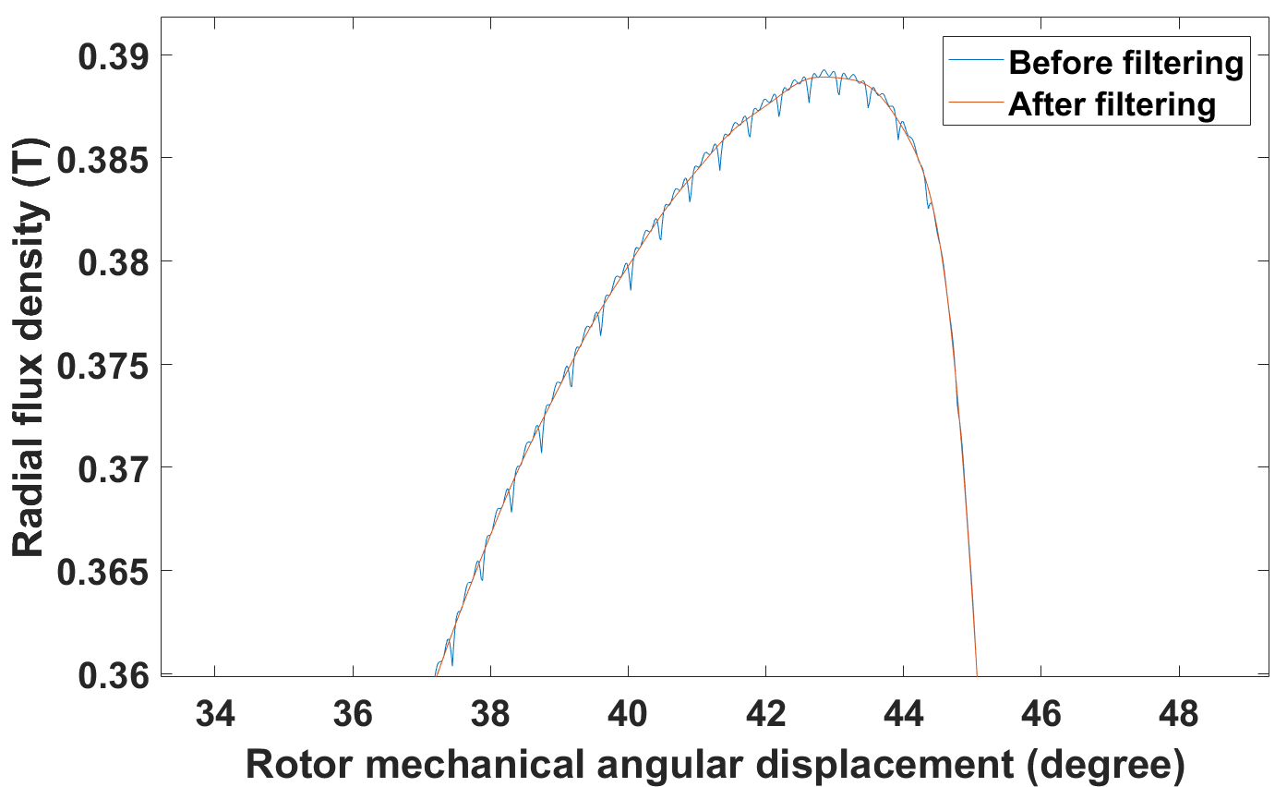
Figure 4.12 Fundamental radial flux density variation before and after filtering
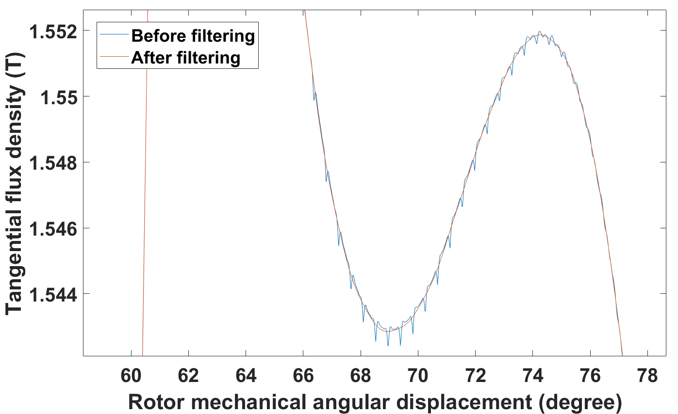
Figure 4.13 Fundamental tangential flux density variation before and after filtering
Having shown agreement between the new method and the more conventional post-processing route to loss calculation at low to medium sampling frequencies, the new method was used for the full 15 sampling frequencies listed previously, up to a maximum of 15625 points per electrical cycle. Figure 4.14 and Figure 4.15 show the iron loss variation with sampling frequency for star connected and isolated three phases, respectively, using the new post processing method. It can be seen that as the sampling frequency increases the predicted loss tends to settle at a final value, with this behaviour being, as expected, a function of the hysteresis band and hence the frequency of the flux density ripple. The smaller the hysteresis band, the higher the sampling frequency required to achieve a near constant value of loss. In the case of a 10A hysteresis band, which generates a switching frequency of the order of ~244 events per electrical cycle, over 10000 data points are required to make the loss largely invariant with sampling rate. This number of steps would be prohibitive with a conventional post-processing approach of one field solution per data point.
Arguably the more interesting feature is that similar level of iron loss is generated irrespective of the magnitude of the hysteresis bands, for both the star connected case or the phase isolated case. Although this might not always be the case, as will be discussed later, with the inclusion of minor loop loss, this holds for major loop loss, eddy current loss, and excess loss. Figure 4.16 and Figure 4.17 show the variation of these three loss components with sampling frequency, for the two connection arrangements. The observed behaviour of the new post-processing model is also evident with the conventional post-processing method for iron loss calculation, as shown in Table III.1 and Table III.2, although only three levels of sampling density are investigated.
As a contrast, the iron loss induced by purely sinusoidal three phase currents only varies with the sampling frequency when the data points per electrical cycle reduces to a very low number, where aliasing effect even happens with the fundamental frequency waveform. Figure 4.14 and Figure 4.15 also show that at the stabilized condition, i.e. sufficient sampling, the introduction of ripple onto the original sinusoidal excitation current results in a 66% increase in iron loss in the star-connected three phase case compared to the pure sinusoidal waveform. The increase is even higher at 136% increase in the isolated three phase case. This reinforces the observation in Chapter 3 that the star connection case with fluctuating neutral point results in better performance than an isolated phase isolated case, even under the same hysteresis band.

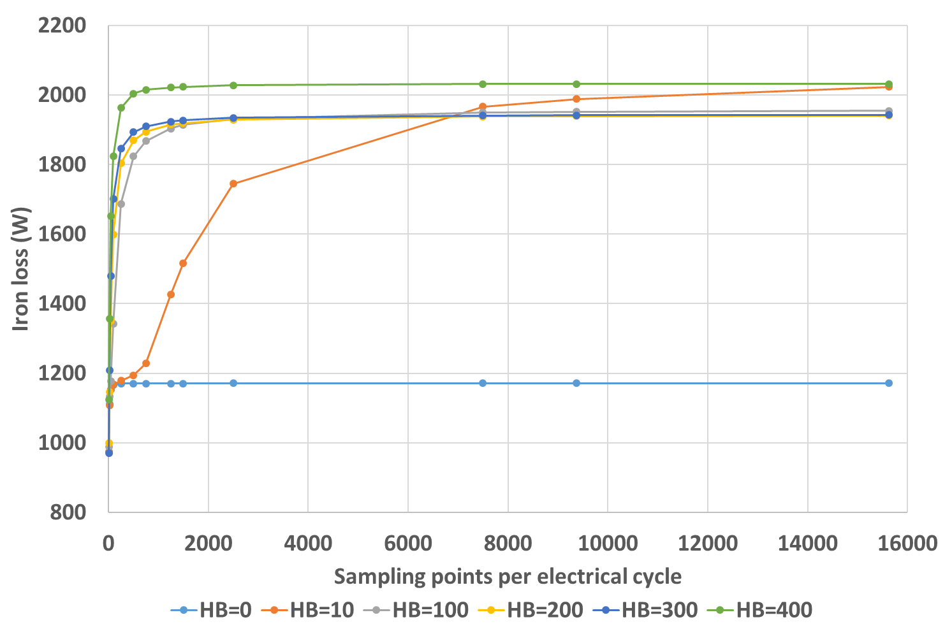
Figure 4.14 Iron loss variation with sampling rate for star-connected three-phase current under different levels of hysteresis band using results from the new post-processing method
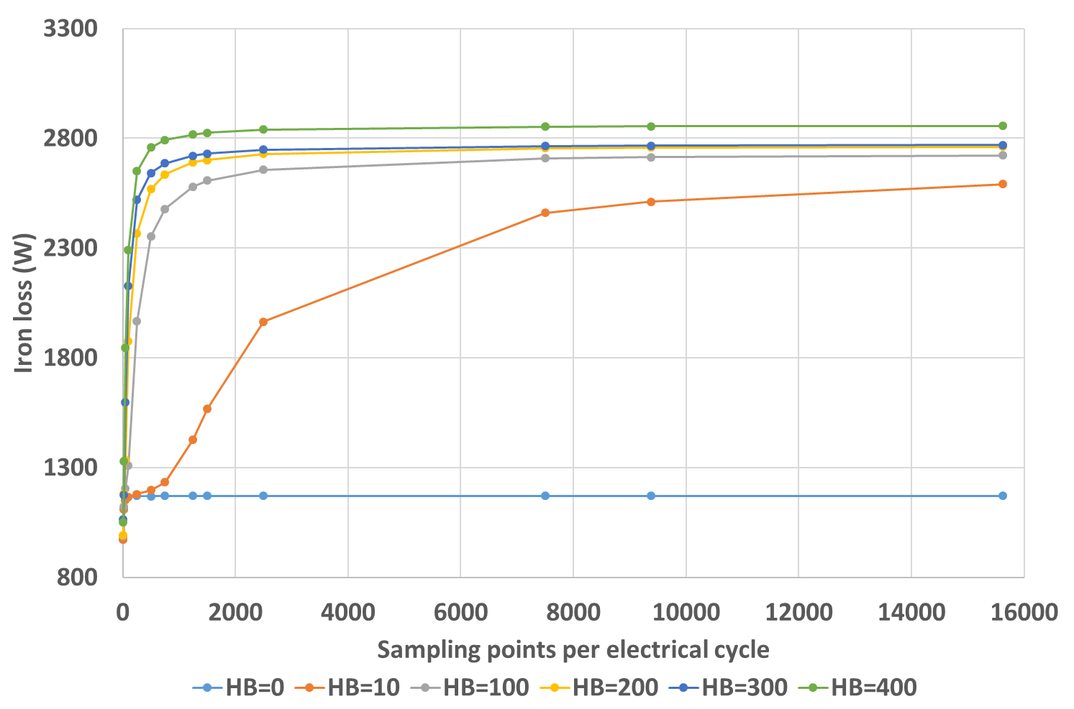
Figure 4.15 Iron loss variation with sampling rate for isolated three-phase current under different levels of hysteresis band using results from the new post-processing method
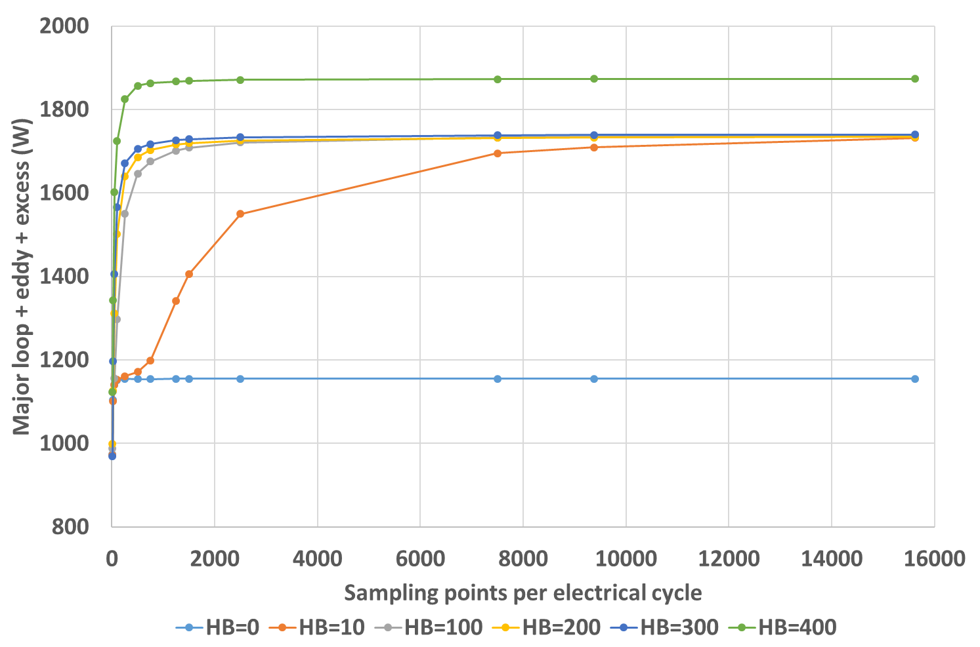
Figure 4.16 Variation of three loss components (major loop + eddy current + excess) with sampling rate for star-connected three phases using the new post-processing results
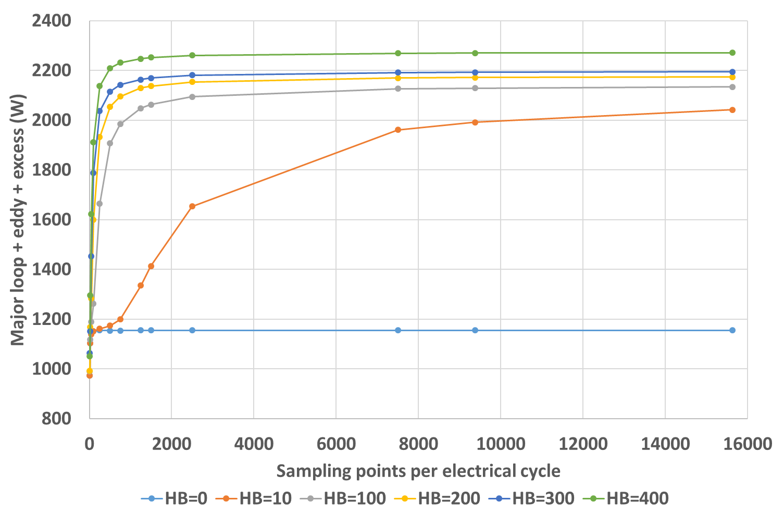
Figure 4.17 Variation of three loss components (major loop + eddy current + excess) with sampling rate for isolated three phases using the new post-processing results

Interpretation of the influence of ripple current on iron loss behaviour
The different components which make up the overall iron loss exhibit different behaviours under non-sinusoidal excitation. In this section, interpretations and analytical derivations are carried out to analyse the behaviour of the different components present in iron loss separation model (4.18).
Since the major loop loss is only related to the fundamental frequency and the peak amplitude, it is not affected by the rate of change of current due to switching. There will be some limited impact from the current ripple amplitude in that it can increase the peak flux density by up to half the hysteresis controller. In addition, the impact of sampling frequency on the major loop loss is also small, since only a few data points are needed to establish a good approximation to the peak flux density. However, since the increasing sampling frequency provides a higher fidelity representation of the flux density waveform, the major loop loss does increases slowly with sampling frequency since the peak captured by the sampling is more likely to coincide with the true peak. Figure 4.18 shows the variation in major loop loss with sampling frequency for star connected three phases with different current ripple amplitudes. It can be seen that the major loop loss does increase with the ripple amplitude due to increased peak flux density. It is also evident that the major loop loss is only affected by the sampling frequency at very low sampling frequency, i.e. <100 or so samples per electrical cycle, where the aliasing effect has significantly impact the capture of the true peak flux density.
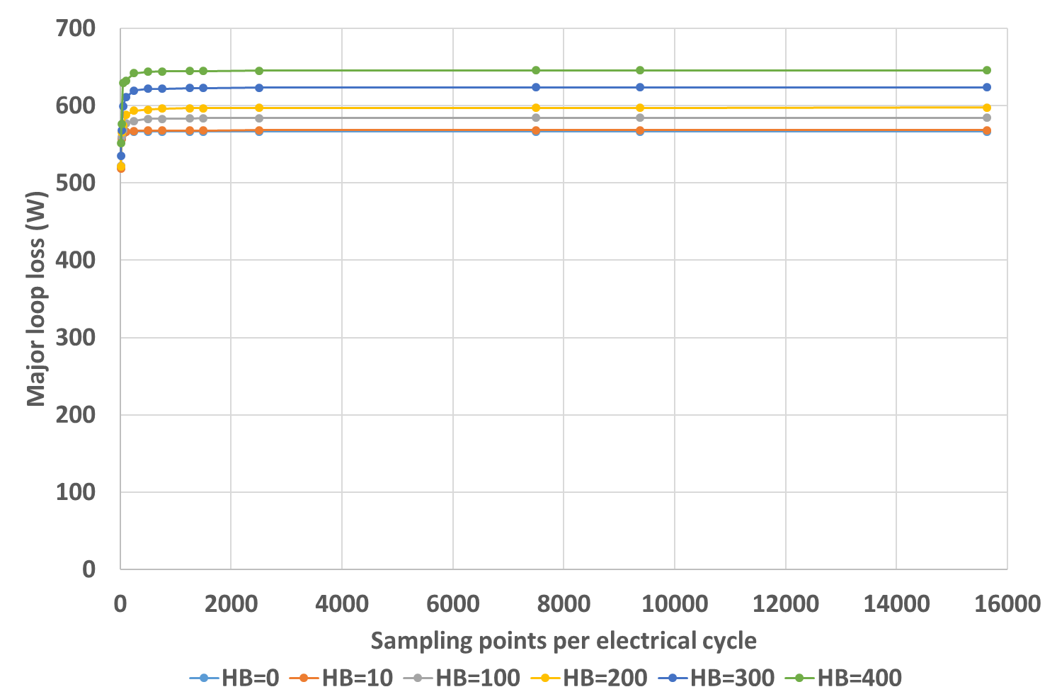
Figure 4.18 Variation of major loop loss with sampling frequency for star-connected three phases with different hysteresis bands and hence of ripple amplitudes
From equation (4.18), it can be seen that the average classical eddy current loss and excess loss over a certain time interval are dependent on the rate of change of flux density. Any change in flux density arising from converter switching is due to the change in the excitation field, which itself is a result of the phase current. According to Ampere’s law, the change in phase current would cause a proportional change in the excitation field strength, which is translates into a flux density variation governed by the non-linear B-H curve. Hence, the phase current change has a direct relationship with the flux density change, and for the eddy current loss component, the expression in (4.18) can be related to the following expression in which $C_{ec}$ is the classical eddy current coefficient inherited from (4.18)
$$C_{ec}\frac{1}{T}\int_{0}^{T}{{\left(\frac{di}{dt}\right)}^{2}dt}$$ | (4.21)
The above integral can be considered for three circumstances, where the effect from the phase resistance is not considered due to its small contribution to the total voltage drop in high power machines:
- Case of a purely inductive load from the supply point of view, i.e. neglecting the back-EMF, with a set of isolated three phases
In this case, the rate of change of current can be expressed as
$$\frac{di}{dt}=\frac{V_{DC}}{L_{ph}}$$ | (4.22)
when the phase is connected to the positive terminal of DC link, and
$$\frac{di}{dt}=\frac{-V_{DC}}{L_{ph}}$$ | (4.23)
when it is connected to the negative terminal of the supply.
Suppose that over the entire integral period $T$, there are in total $N_{1}$ intervals in which the current is rising, and in total $N_{2}$ intervals in which the current is falling. If the duration of the $i^{th}$ rising current interval is $t_{i}$, and the duration for the $j^{th}$ current falling interval is $t_{j}$, then the integral in equation (4.21) can be divided into a summation of integrals of short intervals in which the current is either rising or falling:
$$C_{ec}\frac{1}{T}\left[\sum_{i=1}^{N_{1}}{\int_{t_{1}}^{t_{1}+t_{i}}{{\left(\frac{di}{dt}\right)}^{2}dt}}+\sum_{j=1}^{N_{2}}{\int_{t_{2}}^{t_{2}+t_{j}}{{\left(\frac{di}{dt}\right)}^{2}dt}}\right]$$ | (4.24)
where $t_{1}$ and $t_{2}$ are the starting time of the $i^{th}$ current rising interval and $j^{th}$ current falling interval, respectively. Substituting (4.22) and (4.23) into (4.24), yields the following expression:
$$C_{ec}\frac{1}{T}\left[\sum_{i=1}^{N_{1}}{\int_{t_{1}}^{t_{1}+t_{i}}{{\left(\frac{V_{DC}}{L_{ph}}\right)}^{2}dt}}+\sum_{j=1}^{N_{2}}{\int_{t_{2}}^{t_{2}+t_{j}}{{\left(\frac{-V_{DC}}{L_{ph}}\right)}^{2}dt}}\right]=C_{ec}\frac{1}{T}\left[\sum_{i=1}^{N_{1}}{{\left(\frac{V_{DC}}{L_{ph}}\right)}^{2}\left(t_{1}+t_{i}-t_{1}\right)}+\sum_{j=1}^{N_{2}}{{\left(\frac{V_{DC}}{L_{ph}}\right)}^{2}\left(t_{2}+t_{j}-t_{2}\right)}\right]=C_{ec}\frac{1}{T}{\left(\frac{V_{DC}}{L_{ph}}\right)}^{2}\left(\sum_{i=1}^{N_{1}}{t_{i}}+\sum_{j=1}^{N_{2}}{t_{j}}\right)$$ | (4.25)
The summation of time of all small switching interval is simply:
$$\sum_{i=1}^{N_{1}}{t_{i}}+\sum_{j=1}^{N_{2}}{t_{j}}=T$$
Hence, (4.25) becomes
$$C_{ec}{\left(\frac{V_{DC}}{L_{ph}}\right)}^{2}$$
Therefore, the expression of the integral (4.21) is
$$C_{ec}\frac{1}{T}\int_{0}^{T}{{\left(\frac{di}{dt}\right)}^{2}dt}=C_{ec}{\left(\frac{V_{DC}}{L_{ph}}\right)}^{2}$$ | (4.26)
Since the current ripple amplitudes are determined by the duration of each switching period, i.e. $t_{i}$ and $t_{j}$, and since the final expression (4.26) does not include any time quantities, the ripple current amplitude does not affect the result of the integral (4.21), i.e. in this analysis the classical eddy current component of loss contributed by the switching of the converter is not dependent on the amplitude of the hysteresis band.
In practice, since there is a nonlinear relationship between B and H which is determined by the magnetization of the core material, the change in flux density is not linearly proportional to the change in phase current. However, as mentioned previously, since the flux density fluctuations due to current ripple tends not to have a significant influence on the saturation level, then the assumption that the flux density change caused by switching ripple is linearly proportional to change in excitation current is reasonable. Hence, it is reasonable to conclude that current waveforms with small components of ripple will generate similar levels of classical eddy current to a waveform with much more significant ripple for the same machine inductance. However, for very large current ripple the resulting flux density variations may not be linearly proportional to the current due to a significant change in the magnetic saturation conditions.
- Case of inclusion of phase back-EMF but the three phases are still isolated
This analysis extends that derived above to account for the back-EMF in each phase. In this case, the rate of change of current during the rising intervals is given by:
$$\frac{di}{dt}=\frac{V_{DC}-E_{ph}}{L_{ph}}$$ | (4.27)
where the phase back-EMF can be reasonably represented as a sinusoidal waveform for many permanent magnet machines
$$E_{ph}=E_{p}\sin\left(ωt+θ\right)$$ | (4.28)
For intervals in which the current is falling, the rate of change can be expressed as
$$\frac{di}{dt}=\frac{-V_{DC}-E_{ph}}{L_{ph}}$$ | (4.29)
Using the same approach as that adopted in case 1, the same integral expression (4.24) can be obtained. Substituting (4.27), (4.28), and (4.29) into (4.24), the following expression can be obtained
$$C_{ec}\frac{1}{T}\left\{\sum_{i=1}^{N_{1}}{\int_{t_{1}}^{t_{1}+t_{i}}{{\left[\frac{V_{DC}-E_{p}\sin\left(ωt+θ\right)}{L_{ph}}\right]}^{2}dt}}+\sum_{j=1}^{N_{2}}{\int_{t_{2}}^{t_{2}+t_{j}}{{\left[\frac{-V_{DC}-E_{p}\sin\left(ωt+θ\right)}{L_{ph}}\right]}^{2}dt}}\right\}=C_{ec}\frac{1}{T}\left\{\frac{1}{{L_{ph}}^{2}}\sum_{i=1}^{N_{1}}{\int_{t_{1}}^{t_{1}+t_{i}}{\left[{V_{DC}}^{2}+{E_{p}}^{2}\sin^{2}\left(ωt+θ\right)-2V_{DC}E_{p}\sin\left(ωt+θ\right)\right]dt}}+\frac{1}{{L_{ph}}^{2}}\sum_{j=1}^{N_{2}}{\int_{t_{2}}^{t_{2}+t_{j}}{\left[{V_{DC}}^{2}+{E_{p}}^{2}\sin^{2}\left(ωt+θ\right)+2V_{DC}E_{p}\sin\left(ωt+θ\right)\right]dt}}\right\}=C_{ec}\frac{1}{T}\left\{\frac{1}{{L_{ph}}^{2}}\sum_{i=1}^{N_{1}}{\int_{t_{1}}^{t_{1}+t_{i}}{\left[{V_{DC}}^{2}+{E_{p}}^{2}\frac{1-\cos\left(2ωt+2θ\right)}{2}-2V_{DC}E_{p}\sin\left(ωt+θ\right)\right]dt}}+\frac{1}{{L_{ph}}^{2}}\sum_{j=1}^{N_{2}}{\int_{t_{2}}^{t_{2}+t_{j}}{\left[{V_{DC}}^{2}+{E_{p}}^{2}\frac{1-\cos\left(2ωt+2θ\right)}{2}+2V_{DC}E_{p}\sin\left(ωt+θ\right)\right]dt}}\right\}=C_{ec}\frac{1}{T}\frac{1}{{L_{ph}}^{2}}\left\{\sum_{i=1}^{N_{1}}{\int_{t_{1}}^{t_{1}+t_{i}}{\left({V_{DC}}^{2}+\frac{1}{2}{E_{p}}^{2}\right)dt}}+\sum_{j=1}^{N_{2}}{\int_{t_{2}}^{t_{2}+t_{j}}{\left({V_{DC}}^{2}+\frac{1}{2}{E_{p}}^{2}\right)dt}}-\frac{1}{2}{E_{p}}^{2}\left[\sum_{i=1}^{N_{1}}{\int_{t_{1}}^{t_{1}+t_{i}}{\cos\left(2ωt+2θ\right)dt}}+\sum_{j=1}^{N_{2}}{\int_{t_{2}}^{t_{2}+t_{j}}{\cos\left(2ωt+2θ\right)dt}}\right]-2V_{DC}E_{p}\left[\sum_{i=1}^{N_{1}}{\int_{t_{1}}^{t_{1}+t_{i}}{\sin\left(ωt+θ\right)dt}}-\sum_{j=1}^{N_{2}}{\int_{t_{2}}^{t_{2}+t_{j}}{\sin\left(ωt+θ\right)dt}}\right]\right\}$$ | (4.30)
Similar to the integrals in (4.25), for the first two integrals in (4.30), the following result can be obtained:
$$\sum_{i=1}^{N_{1}}{\int_{t_{1}}^{t_{1}+t_{i}}{\left({V_{DC}}^{2}+\frac{1}{2}{E_{p}}^{2}\right)dt}}+\sum_{j=1}^{N_{2}}{\int_{t_{2}}^{t_{2}+t_{j}}{\left({V_{DC}}^{2}+\frac{1}{2}{E_{p}}^{2}\right)dt}}=\left({V_{DC}}^{2}+\frac{1}{2}{E_{p}}^{2}\right)\left(\sum_{i=1}^{N_{1}}{t_{i}}+\sum_{j=1}^{N_{2}}{t_{j}}\right)=T\left({V_{DC}}^{2}+\frac{1}{2}{E_{p}}^{2}\right)$$ | (4.31)
Since in the switching process, a positive switching event, i.e. connecting the phase to the positive terminal of the supply, must be followed by a negative switching event and vice versa, the number of positive switching periods $N_{1}$ should only have $±1$ difference with the number of negative switching periods $N_{2}$, depending on the starting and ending point. For a large number of switching in the entire integral period then:
$$N_{1}=N_{2}≅N$$ | (4.32)
Furthermore, with no loss of the generality, it can be supposed that the current rising period $t_{i}$ and the current dropping period $t_{j}$ is two consecutive periods and the complete switching cycle they belong to has a length of $T_{n}$. Hence, the following relationships exist:
$$t_{2}=t_{1}+t_{i}$$ | (4.33)
$$t_{2}+t_{j}=t_{1}+T_{n}$$ | (4.34)
Under this circumstance, the second two integrals in (4.30) can be extracted from the two summations and combined into one integral:
$$\int_{t_{1}}^{t_{1}+t_{i}}{\cos\left(2ωt+2θ\right)dt}+\int_{t_{2}}^{t_{2}+t_{j}}{\cos\left(2ωt+2θ\right)dt}=\int_{t_{1}}^{t_{1}+T_{n}}{\cos\left(2ωt+2θ\right)dt}$$ | (4.35)
and combining (4.32), the two summations can be combined into one summation as:
$$\sum_{n=1}^{N}{\int_{t_{1}}^{t_{1}+T_{n}}{\cos\left(2ωt+2θ\right)dt}}$$ | (4.36)
Since for the entire integral period, the following relationship exists,
$$\sum_{n=1}^{N}{T_{n}}=T$$ | (4.37)
then, the summation of integrals in (4.36) could be concatenated into one integral:
$$\sum_{n=1}^{N}{\int_{t_{1}}^{t_{1}+T_{n}}{\cos\left(2ωt+2θ\right)dt}}=\int_{0}^{T}{\cos\left(2ωt+2θ\right)dt}$$ | (4.38)
If the entire integral duration $T$ is multiples of one electrical cycle, then the final result for the integral in (4.38) is zero.
The last two integrals in (4.30) can be extracted out of the summations in the same way, and the two summations can be combined into one, i.e.
$$\sum_{n=1}^{N}{\left[\int_{t_{1}}^{t_{2}}{\sin\left(ωt+θ\right)dt}-\int_{t_{2}}^{t_{1}+T_{n}}{\sin\left(ωt+θ\right)dt}\right]}=\sum_{n=1}^{N}{\left[-{\left.\frac{1}{ω}\cos\left(ωt+θ\right)\right|}_{t_{1}}^{t_{2}}+{\left.\frac{1}{ω}\cos\left(ωt+θ\right)\right|}_{t_{2}}^{t_{1}+T_{n}}\right]}=-\frac{1}{ω}\sum_{n=1}^{N}{\left\{2\cos\left(ωt_{2}+θ\right)-\cos\left(ωt_{1}+θ\right)-\cos\left[ω\left(t_{1}+T_{n}\right)+θ\right]\right\}}$$ | (4.39)
Hence, when considering the back-EMF, the final result for integral (4.21) is
$$C_{ec}\frac{1}{T}\int_{0}^{T}{{\left(\frac{di}{dt}\right)}^{2}dt}=C_{ec}\frac{1}{{L_{ph}}^{2}}\left({V_{DC}}^{2}+\frac{1}{2}{E_{p}}^{2}\right)+C_{ec}\frac{1}{{L_{ph}}^{2}}\frac{V_{DC}E_{p}}{mπ}\sum_{n=1}^{N}{\left\{2\cos\left(ωt_{2}+θ\right)-\cos\left(ωt_{1}+θ\right)-\cos\left[ω\left(t_{1}+T_{n}\right)+θ\right]\right\}}$$ | (4.40)
where $m$ is the number of electrical cycles in the integration period. Clearly, when compared to the integration result in case 1, i.e. equation (4.26), the presence of the back-EMF not only introduces another term into the constant part of the final expression, but also introduces a summation related to ripple amplitude, which is the result of the time varying characteristic of the back-EMF. For a switching frequency with many events within electrical cycle of the back-EMF, the variation of the back-EMF during one switching cycle is small, and the transition point from the rising period to the falling period, i.e. $t_{2}$, is very close to the middle point of the switching cycle, and hence the following relationship exists
$$t_{2}≈\frac{t_{1}+\left(t_{1}+T_{n}\right)}{2}$$ | (4.41)
For short duration switching cycles (short relative to the period of the back-EMF), the back-EMF waveform can be approximated as a linear curve, and hence,
$$\cos\left(ωt_{2}+θ\right)≈\frac{\cos\left(ωt_{1}+θ\right)+\cos\left[ω\left(t_{1}+T_{n}\right)+θ\right]}{2}$$ | (4.42)
Therefore, the second varying term in (4.40) only has a minor influence since every element in the summation is close to zero. Even for large ripple waveforms, where the transition point $t_{2}$ is not close to the midpoint of the switching cycle, the summation in the second term would still not give rise to a significant influence on the integral, since for period when the fundamental current is rising, the following relationship exists:
$$\cos\left(ωt_{2}+θ\right)<\frac{\cos\left(ωt_{1}+θ\right)+\cos\left[ω\left(t_{1}+T_{n}\right)+θ\right]}{2}$$ | (4.43)
due to 90-degree phase shift of the cos waveform relative to the back-EMF, and for the falling period of the fundamental current, an opposite relationship exists,
$$\cos\left(ωt_{2}+θ\right)>\frac{\cos\left(ωt_{1}+θ\right)+\cos\left[ω\left(t_{1}+T_{n}\right)+θ\right]}{2}$$ | (4.44)
Hence, the increment brought by the summation during the fundamental rising period will be largely cancelled by the reverse increment during the fundamental falling period, due to equal amount of time for the increasing and decreasing periods. Finally, a small magnitude summation will be produced. Therefore, it is reasonable to neglect the second term of (4.40), and hence the expression for the classical eddy current term of the iron loss can be further simplified to
$$C_{ec}\frac{1}{T}\int_{0}^{T}{{\left(\frac{di}{dt}\right)}^{2}dt}=C_{ec}\frac{1}{{L_{ph}}^{2}}\left({V_{DC}}^{2}+\frac{1}{2}{E_{p}}^{2}\right)$$ | (4.45)
Hence, when the back-EMF is accounted for, the integral (4.21) is still largely determined by a series of machine specific constants, i.e. supply voltage, phase inductance and peak phase back-EMF. Hence, as was the case when the back-EMF was not accounted for, current waveforms with different ripple amplitudes will generate similar level of eddy current loss. However, in addition to the nonlinearity of the B-H curve, the time varying back-EMF also introduces a minor term related to ripple amplitude (particularly for large hysteresis bands and hence low switching frequency), which would introduce some difference between eddy losses of different ripple waveforms.
- Star-connected three phase current considering back-EMF
In this case, due to the effect of floating neutral point and the coupling between phases, there is an intrinsic space vector switching process carrying out inside one hysteresis switching period, as analyzed in Chapter 3 . As noted in the analysis presented in Chapter 3, the supply voltage on one phase is no longer fixed to $+V_{DC}$ in the positive switching period, and $-V_{DC}$ in the negative switching period, but affected by the voltage state of the other two phases.
Suppose that during the positive switching period of one complete switching cycle, there are in total $n_{1}$ times space vector switching periods, with each of duration $t_{ik}$, and during the negative switching period of one switching cycle, a total $n_{2}$ times space vector switching periods exist, each of duration $t_{jl}$. For each space vector switching period, the supply voltage applied on one phase is
$$V_{s}=aV_{DC}$$ | (4.46)
and the corresponding rate of change of current is:
$$\frac{di}{dt}=\frac{aV_{DC}-E_{ph}}{L_{ph}}$$ | (4.47)
where $a$ is the voltage coefficient and might have the value of 2/3, 4/3, and 0 for positive switching period, and -2/3, -4/3, and 0 for negative switching period, according to Table 3.5. Retaining the original notations, the transformation of integral (4.21) to (4.24), is still valid. Substituting the expression for the rate of change of current in (4.47) for each space vector switching period into (4.24), each integral element in the summations could be further divided:
$$C_{ec}\frac{1}{T}\left\{\sum_{i=1}^{N_{1}}{\sum_{k=1}^{n_{1}}{\int_{t_{1k}}^{t_{1k}+t_{ik}}{{\left[\frac{a_{ik}V_{DC}-E_{p}\sin\left(ωt+θ\right)}{L_{ph}}\right]}^{2}dt}}}+\sum_{j=1}^{N_{2}}{\sum_{l=1}^{n_{2}}{\int_{t_{2l}}^{t_{2l}+t_{jl}}{{\left[\frac{a_{jl}V_{DC}-E_{p}\sin\left(ωt+θ\right)}{L_{ph}}\right]}^{2}dt}}}\right\}$$ | (4.48)
where $t_{1k}$ and $t_{2l}$ are the starting time of each space vector switching process in the positive and negative switching period, respectively.
As was the case previously in case 2 and with no loss of generality, the two small summations inside the positive and negative switching period can be extracted out of the two large summations, and the two large summations can be combined, if it is assumed that the positive and negative switching periods make up the same switching cycle. For the two small summations:
$$\sum_{k=1}^{n_{1}}{\int_{t_{1k}}^{t_{1k}+t_{ik}}{{\left[\frac{a_{ik}V_{DC}-E_{p}\sin\left(ωt+θ\right)}{L_{ph}}\right]}^{2}dt}}+\sum_{l=1}^{n_{2}}{\int_{t_{2l}}^{t_{2l}+t_{jl}}{{\left[\frac{a_{jl}V_{DC}-E_{p}\sin\left(ωt+θ\right)}{L_{ph}}\right]}^{2}dt}}=\frac{1}{{L_{ph}}^{2}}\sum_{k=1}^{n_{1}}{\int_{t_{1k}}^{t_{1k}+t_{ik}}{\left[{\left(a_{ik}V_{DC}\right)}^{2}+{E_{p}}^{2}\sin^{2}\left(ωt+θ\right)-2a_{ik}V_{DC}E_{p}\sin\left(ωt+θ\right)\right]dt}}+\frac{1}{{L_{ph}}^{2}}\sum_{l=1}^{n_{2}}{\int_{t_{2l}}^{t_{2l}+t_{jl}}{\left[{\left(a_{jl}V_{DC}\right)}^{2}+{E_{p}}^{2}\sin^{2}\left(ωt+θ\right)-2a_{jl}V_{DC}E_{p}\sin\left(ωt+θ\right)\right]dt}}=\frac{1}{{L_{ph}}^{2}}\sum_{k=1}^{n_{1}}{\int_{t_{1k}}^{t_{1k}+t_{ik}}{\left[{\left(a_{ik}V_{DC}\right)}^{2}+{E_{p}}^{2}\frac{1-\cos\left(2ωt+2θ\right)}{2}-2a_{ik}V_{DC}E_{p}\sin\left(ωt+θ\right)\right]dt}}+\frac{1}{{L_{ph}}^{2}}\sum_{l=1}^{n_{2}}{\int_{t_{2l}}^{t_{2l}+t_{jl}}{\left[{\left(a_{jl}V_{DC}\right)}^{2}+{E_{p}}^{2}\frac{1-\cos\left(2ωt+2θ\right)}{2}-2a_{jl}V_{DC}E_{p}\sin\left(ωt+θ\right)\right]dt}}=\frac{1}{{L_{ph}}^{2}}\left\{\sum_{k=1}^{n_{1}}{\int_{t_{1k}}^{t_{1k}+t_{ik}}{\left({a_{ik}}^{2}{V_{DC}}^{2}+\frac{1}{2}{E_{p}}^{2}\right)dt}}+\sum_{l=1}^{n_{2}}{\int_{t_{2l}}^{t_{2l}+t_{jl}}{\left({a_{jl}}^{2}{V_{DC}}^{2}+\frac{1}{2}{E_{p}}^{2}\right)dt}}-\frac{1}{2}{E_{p}}^{2}\sum_{k=1}^{n_{1}}{\int_{t_{1k}}^{t_{1k}+t_{ik}}{\cos\left(2ωt+2θ\right)dt}}-\frac{1}{2}{E_{p}}^{2}\sum_{l=1}^{n_{2}}{\int_{t_{2l}}^{t_{2l}+t_{jl}}{\cos\left(2ωt+2θ\right)dt}}-2E_{p}\sum_{k=1}^{n_{1}}{\int_{t_{1k}}^{t_{1k}+t_{ik}}{a_{ik}V_{DC}\sin\left(ωt+θ\right)dt}}-2E_{p}\sum_{l=1}^{n_{2}}{\int_{t_{2l}}^{t_{2l}+t_{jl}}{a_{jl}V_{DC}\sin\left(ωt+θ\right)dt}}\right\}$$ | (4.49)
For the first two summations of integrals in (4.49), the following result can be obtained,
$$\sum_{k=1}^{n_{1}}{\int_{t_{1k}}^{t_{1k}+t_{ik}}{\left({a_{ik}}^{2}{V_{DC}}^{2}+\frac{1}{2}{E_{p}}^{2}\right)dt}}+\sum_{l=1}^{n_{2}}{\int_{t_{2l}}^{t_{2l}+t_{jl}}{\left({a_{jl}}^{2}{V_{DC}}^{2}+\frac{1}{2}{E_{p}}^{2}\right)dt}}=\sum_{k=1}^{n_{1}}{\left({a_{ik}}^{2}{V_{DC}}^{2}+\frac{1}{2}{E_{p}}^{2}\right)t_{ik}}+\sum_{l=1}^{n_{2}}{\left({a_{jl}}^{2}{V_{DC}}^{2}+\frac{1}{2}{E_{p}}^{2}\right)t_{jl}}={V_{DC}}^{2}\left(\sum_{k=1}^{n_{1}}{{a_{ik}}^{2}t_{ik}}+\sum_{l=1}^{n_{2}}{{a_{jl}}^{2}t_{jl}}\right)+\frac{1}{2}{E_{p}}^{2}\left(\sum_{k=1}^{n_{1}}{t_{ik}}+\sum_{l=1}^{n_{2}}{t_{jl}}\right)$$ | (4.50)
The second summation is the total duration of the switching cycle, i.e.:
$$\sum_{k=1}^{n_{1}}{t_{ik}}+\sum_{l=1}^{n_{2}}{t_{jl}}=t_{i}+t_{j}=T_{n}$$ | (4.51)
By defining a weighted rms. voltage coefficient $a_{n}^{''}$, which has the following relationship
$$a_{n}^{''}=\sqrt{\frac{1}{T_{n}}\left(\sum_{k=1}^{n_{1}}{{a_{ik}}^{2}t_{ik}}+\sum_{l=1}^{n_{2}}{{a_{jl}}^{2}t_{jl}}\right)}$$ | (4.52)
Then (4.50) becomes
$${\left(a_{n}^{''}V_{DC}\right)}^{2}T_{n}+\frac{1}{2}{E_{p}}^{2}T_{n}$$ | (4.53)
Summing (4.53) for the entire integration period:
$$\sum_{n=1}^{N}{\left[{\left(a_{n}^{''}V_{DC}\right)}^{2}T_{n}+\frac{1}{2}{E_{p}}^{2}T_{n}\right]}={V_{DC}}^{2}\sum_{n=1}^{N}{{\left(a_{n}^{''}\right)}^{2}T_{n}}+\frac{1}{2}{E_{p}}^{2}\sum_{n=1}^{N}{T_{n}}$$ | (4.54)
and defining a weighted rms. coefficient for the entire integration:
$$a^{''}=\sqrt{\frac{1}{T}\sum_{n=1}^{N}{{\left(a_{n}^{''}\right)}^{2}T_{n}}}=\sqrt{\frac{1}{T}\sum_{n=1}^{N}{\left(\sum_{k=1}^{n_{1}}{{a_{ik}}^{2}t_{ik}}+\sum_{l=1}^{n_{2}}{{a_{jl}}^{2}t_{jl}}\right)}}$$ | (4.55)
allows the following result to be obtained:
$${\left(a^{''}V_{DC}\right)}^{2}T+\frac{1}{2}{E_{p}}^{2}T$$ | (4.56)
From (4.55), it can be seen that the defined coefficient $a^{''}$ is actually the weighted rms. value of the voltage coefficient in every space vector switching process. In Chapter 3 , there is an important coefficient in the hysteresis controlled star-connected three phase current generation process, viz. the weighted mean voltage coefficient, which is introduced in [44], to represent an average influence of the supply voltage on ripple amplitude for a certain switching frequency. Here, the introduced weighted rms. coefficient represents the average effect of supply voltage on eddy current loss.
For the second two summations of integrals in (4.49), since all the integral elements in the two summations have consecutive upper and lower limits, the second two summations can be concatenated into a single integral, which has the same form as (4.36). In a similar manner to the derivation process in case 2, when summed over the entire integration period $T$, the concatenated integral would be further concatenated into a final integral with the same form with (4.38), which has a result of zero over the integration period.
For the last two summations of integrals in (4.49), the following derivation can be carried out:
$$-2E_{p}\sum_{k=1}^{n_{1}}{\int_{t_{1k}}^{t_{1k}+t_{ik}}{a_{ik}V_{DC}\sin\left(ωt+θ\right)dt}}-2E_{p}\sum_{l=1}^{n_{2}}{\int_{t_{2l}}^{t_{2l}+t_{jl}}{a_{jl}V_{DC}\sin\left(ωt+θ\right)dt}}=\frac{2E_{p}V_{DC}}{ω}\left[\sum_{k=1}^{n_{1}}{a_{ik}{\left.\cos\left(ωt+θ\right)\right|}_{t_{1k}}^{t_{1k}+t_{ik}}}+\sum_{l=1}^{n_{2}}{a_{jl}{\left.\cos\left(ωt+θ\right)\right|}_{t_{2l}}^{t_{2l}+t_{jl}}}\right]=\frac{2E_{p}V_{DC}}{ω}\left\{\sum_{k=1}^{n_{1}}{a_{ik}\left\{\cos\left[ω\left(t_{1k}+t_{ik}\right)+θ\right]-\cos\left(ωt_{1k}+θ\right)\right\}}+\sum_{l=1}^{n_{2}}{a_{jl}\left\{\cos\left[ω\left(t_{2l}+t_{jl}\right)+θ\right]-\cos\left(ωt_{2l}+θ\right)\right\}}\right\}$$ | (4.57)
Summing the result (4.57) for the whole integration period yields
$$\frac{2E_{p}V_{DC}}{ω}\sum_{n=1}^{N}{\left\{\sum_{k=1}^{n_{1}}{a_{ik}\left\{\cos\left[ω\left(t_{1k}+t_{ik}\right)+θ\right]-\cos\left(ωt_{1k}+θ\right)\right\}}+\sum_{l=1}^{n_{2}}{a_{jl}\left\{\cos\left[ω\left(t_{2l}+t_{jl}\right)+θ\right]-\cos\left(ωt_{2l}+θ\right)\right\}}\right\}}$$ | (4.58)
Therefore, in star connected three phases, considering the back-EMF, the final result for integral (4.21) is
$$C_{ec}\frac{1}{T}\int_{0}^{T}{{\left(\frac{di}{dt}\right)}^{2}dt}=C_{ec}\frac{1}{{L_{ph}}^{2}}\left[{\left(a^{''}V_{DC}\right)}^{2}+\frac{1}{2}{E_{p}}^{2}\right]+C_{ec}\frac{1}{{L_{ph}}^{2}}\frac{V_{DC}E_{p}}{mπ}\sum_{n=1}^{N}{\left\{\sum_{k=1}^{n_{1}}{a_{ik}\left\{\cos\left[ω\left(t_{1k}+t_{ik}\right)+θ\right]-\cos\left(ωt_{1k}+θ\right)\right\}}+\sum_{l=1}^{n_{2}}{a_{jl}\left\{\cos\left[ω\left(t_{2l}+t_{jl}\right)+θ\right]-\cos\left(ωt_{2l}+θ\right)\right\}}\right\}}$$ | (4.59)
Compared to the result obtained in case 2, the floating neutral point in the star connection case brings a weighted rms. voltage coefficient to the constant part of the final result, and divides the term $2\cos\left(ωt_{2}+θ\right)-\cos\left(ωt_{1}+θ\right)-\cos\left[ω\left(t_{1}+T_{n}\right)+θ\right]$ in the summation part into further summations, with each element multiplied by a voltage coefficient, i.e. since the existence of the following relationship
$$t_{1k}+t_{ik}=t_{1(k+1)}$$ | (4.60)
$$t_{2l}+t_{jl}=t_{2(l+1)}$$ | (4.61)
By neglecting the voltage coefficient of each space vector switching period, and extracting the sign included inside the voltage coefficients, the summation part in the result for case 3, i.e. (4.59), would be exactly the same as the summation part in the result for case 2, i.e. equation (4.40). When considering the voltage coefficients, starting from index 1, the elements in the first summation enclosed in the curly bracket of the final result (4.59) could be listed as follows,
$$\begin{matrix}a_{i1}\left\{\cos\left[ω\left(t_{11}+t_{i1}\right)+θ\right]-\cos\left(ωt_{11}+θ\right)\right\} \\ a_{i2}\left\{\cos\left[ω\left(t_{12}+t_{i2}\right)+θ\right]-\cos\left(ωt_{12}+θ\right)\right\} \\ a_{i3}\left\{\cos\left[ω\left(t_{13}+t_{i3}\right)+θ\right]-\cos\left(ωt_{13}+θ\right)\right\} \\ ⋮ \\ a_{in_{1}}\left\{\cos\left[ω\left(t_{1n_{1}}+t_{in_{1}}\right)+θ\right]-\cos\left(ωt_{1n_{1}}+θ\right)\right\}\end{matrix}$$ | (4.62)
Based on the relationship (4.60), when summing all the elements together, the following result can be obtained,
$$a_{in_{1}}\cos\left[ω\left(t_{1n_{1}}+t_{in_{1}}\right)+θ\right]-\left(a_{in_{1}}-a_{i\left(n_{1}-1\right)}\right)\cos\left(ωt_{1n_{1}}+θ\right)-\left(a_{i\left(n_{1}-1\right)}-a_{i\left(n_{1}-2\right)}\right)\cos\left(ωt_{1\left(n_{1}-1\right)}+θ\right)-…-\left(a_{i2}-a_{i1}\right)\cos\left(ωt_{12}+θ\right)-a_{i1}\cos\left(ωt_{11}+θ\right)$$ | (4.63)
Similarly, for the second summation enclosed in the curly bracket of the final result, the following result could be obtained,
$$a_{jn_{2}}\cos\left[ω\left(t_{2n_{2}}+t_{jn_{2}}\right)+θ\right]-\left(a_{jn_{2}}-a_{j\left(n_{2}-1\right)}\right)\cos\left(ωt_{2n_{2}}+θ\right)-\left(a_{j\left(n_{2}-1\right)}-a_{j\left(n_{2}-2\right)}\right)\cos\left(ωt_{2\left(n_{2}-1\right)}+θ\right)-…-\left(a_{j2}-a_{j1}\right)\cos\left(ωt_{22}+θ\right)-a_{j1}\cos\left(ωt_{21}+θ\right)$$ | (4.64)
It is worth noting that since the positive and negative switching periods belong to one switching cycle, the following relationships exist
$$t_{1n_{1}}+t_{in_{1}}=t_{21}=t_{2}$$ | (4.65)
$$t_{2n_{2}}+t_{jn_{2}}=t_{1}+T_{n}$$ | (4.66)
and due to representing the same starting point, the following relationship exists
$$t_{11}=t_{1}$$ | (4.67)
Hence, by introducing another two averaging coefficients, $C_{1}$ and $C_{2}$, with the following expressions:
$$C_{1}=a_{in_{1}}-\sum_{k=2}^{n_{1}}{\left(a_{ik}-a_{i\left(k-1\right)}\right)\frac{\cos\left(ωt_{1k}+θ\right)}{\cos\left(ωt_{2}+θ\right)}}$$ | (4.68)
$$C_{2}=a_{jn_{2}}-\sum_{l=2}^{n_{2}}{\left(a_{jl}-a_{j\left(l-1\right)}\right)\frac{\cos\left(ωt_{2l}+θ\right)}{\cos\left[ω\left(t_{1}+T_{n}\right)+θ\right]}}$$ | (4.69)
the final result (4.59) can be transformed into
$$C_{ec}\frac{1}{T}\int_{0}^{T}{{\left(\frac{di}{dt}\right)}^{2}dt}=C_{ec}\frac{1}{{L_{ph}}^{2}}\left[{\left(a^{''}V_{DC}\right)}^{2}+\frac{1}{2}{E_{p}}^{2}\right]+C_{ec}\frac{1}{{L_{ph}}^{2}}\frac{V_{DC}E_{p}}{mπ}\sum_{n=1}^{N}{\left\{C_{1}\cos\left(ωt_{2}+θ\right)-a_{i1}\cos\left(ωt_{1}+θ\right)+C_{2}\cos\left[ω\left(t_{1}+T_{n}\right)+θ\right]-a_{j1}\cos\left(ωt_{2}+θ\right)\right\}}$$ | (4.70)
By extracting the negative sign inside the voltage coefficients in the negative switching period, i.e. $a_{jl}$, the expression (4.70) can be further transformed into
$$C_{ec}\frac{1}{T}\int_{0}^{T}{{\left(\frac{di}{dt}\right)}^{2}dt}=C_{ec}\frac{1}{{L_{ph}}^{2}}\left[{\left(a^{''}V_{DC}\right)}^{2}+\frac{1}{2}{E_{p}}^{2}\right]+C_{ec}\frac{1}{{L_{ph}}^{2}}\frac{V_{DC}E_{p}}{mπ}\sum_{n=1}^{N}{\left\{\left[C_{1}+\left(-a_{j1}\right)\right]\cos\left(ωt_{2}+θ\right)-a_{i1}\cos\left(ωt_{1}+θ\right)-\left(-C_{2}\right)\cos\left[ω\left(t_{1}+T_{n}\right)+θ\right]\right\}}$$ | (4.71)
Hence, following the above derivation, instead of further dividing the term $2\cos\left(ωt_{2}+θ\right)-\cos\left(ωt_{1}+θ\right)-\cos\left[ω\left(t_{1}+T_{n}\right)+θ\right]$ in (4.40) into summations, the influence of the star connection is included by replacing the original coefficients $\left(2, 1, 1\right)$ with coefficients $\left(C_{1}+\left(-a_{j1}\right), a_{i1}, -C_{2}\right)$. Reorganizing the summation in (4.68) into the following form,
$$\sum_{k=2}^{n_{1}}{a_{ik}\frac{\cos\left(ωt_{1k}+θ\right)}{\cos\left(ωt_{2}+θ\right)}}-\sum_{k=2}^{n_{1}}{a_{i\left(k-1\right)}\frac{\cos\left(ωt_{1k}+θ\right)}{\cos\left(ωt_{2}+θ\right)}}$$ | (4.72)
For high frequency switching relative to the fundamental electrical frequency of the back-EMF, there is negligible difference in cos waveform between the time instant $t_{1k}$ and $t_{1\left(k-1\right)}$, and hence:
$$\cos\left(ωt_{1k}+θ\right)≈\cos\left(ωt_{1\left(k-1\right)}+θ\right)$$ | (4.73)
Even for current waveforms with large ripple amplitude, since one switching cycle is divided into a number of space vector switching periods, the difference between the two time instants would still not be significant. Therefore, (4.72) can be further transformed into
$$\sum_{k=2}^{n_{1}}{a_{ik}\frac{\cos\left(ωt_{1k}+θ\right)}{\cos\left(ωt_{2}+θ\right)}}-\sum_{k=2}^{n_{1}}{a_{i\left(k-1\right)}\frac{\cos\left(ωt_{1\left(k-1\right)}+θ\right)}{\cos\left(ωt_{2}+θ\right)}}=a_{in_{1}}\frac{\cos\left(ωt_{1n_{1}}+θ\right)}{\cos\left(ωt_{2}+θ\right)}-a_{i1}\frac{\cos\left(ωt_{11}+θ\right)}{\cos\left(ωt_{2}+θ\right)}=a_{in_{1}}-a_{i1}\frac{\cos\left(ωt_{1}+θ\right)}{\cos\left(ωt_{2}+θ\right)}$$ | (4.74)
with the fraction in the first term equal to one due to the approximation (4.73). A similar simplification process could be carried out for the coefficient $C_{2}$, and the following two expressions are obtained for the two coefficients,
$$C_{1}=a_{i1}\frac{\cos\left(ωt_{1}+θ\right)}{\cos\left(ωt_{2}+θ\right)}$$ | (4.75)
$$C_{2}=a_{j1}\frac{\cos\left(ωt_{2}+θ\right)}{\cos\left[ω\left(t_{1}+T_{n}\right)+θ\right]}$$ | (4.76)
Substituting (4.75) and (4.76) into (4.71),
$$C_{ec}\frac{1}{T}\int_{0}^{T}{{\left(\frac{di}{dt}\right)}^{2}dt}=C_{ec}\frac{1}{{L_{ph}}^{2}}\left[{\left(a^{''}V_{DC}\right)}^{2}+\frac{1}{2}{E_{p}}^{2}\right]+C_{ec}\frac{1}{{L_{ph}}^{2}}\frac{V_{DC}E_{p}}{mπ}\sum_{n=1}^{N}{\left\{\left[a_{i1}\frac{\cos\left(ωt_{1}+θ\right)}{\cos\left(ωt_{2}+θ\right)}+\left(-a_{j1}\right)\right]\cos\left(ωt_{2}+θ\right)-a_{i1}\cos\left(ωt_{1}+θ\right)-\left(-a_{j1}\frac{\cos\left(ωt_{2}+θ\right)}{\cos\left[ω\left(t_{1}+T_{n}\right)+θ\right]}\right)\cos\left[ω\left(t_{1}+T_{n}\right)+θ\right]\right\}}=C_{ec}\frac{1}{{L_{ph}}^{2}}\left[{\left(a^{''}V_{DC}\right)}^{2}+\frac{1}{2}{E_{p}}^{2}\right]+C_{ec}\frac{1}{{L_{ph}}^{2}}\frac{V_{DC}E_{p}}{mπ}\sum_{n=1}^{N}{\left\{a_{i1}\cos\left(ωt_{1}+θ\right)-a_{j1}\cos\left(ωt_{2}+θ\right)-a_{i1}\cos\left(ωt_{1}+θ\right)+a_{j1}\cos\left(ωt_{2}+θ\right)\right\}}=C_{ec}\frac{1}{{L_{ph}}^{2}}\left[{\left(a^{''}V_{DC}\right)}^{2}+\frac{1}{2}{E_{p}}^{2}\right]$$ | (4.77)
i.e. the summation part in the final result becomes zero and only constant part remains.
Hence, using the same approximation method with case 2, the varying term with ripple amplitude is completely eliminated and the integral (4.21) is only related to the machine specific constants, i.e. supply voltage, phase back-EMF, and phase inductance. Combined with the analysis done in case 1 about the nonlinearity in the B-H curve, the same conclusion can be obtained, viz. a current waveform with small ripples will tend to generate a similar level of eddy current loss to a current waveform with large ripple amplitude. Figure 4.19 shows the eddy current loss variation with sampling frequency for star-connected three phases predicted by the new finite element post-processing method discussed in section 4.2. As will be apparent, with the exception of the 400A hysteresis band where a change in saturation conditions is at play, very similar levels of eddy current loss are produced, a finding which is consistent with the analytical analysis presented above.
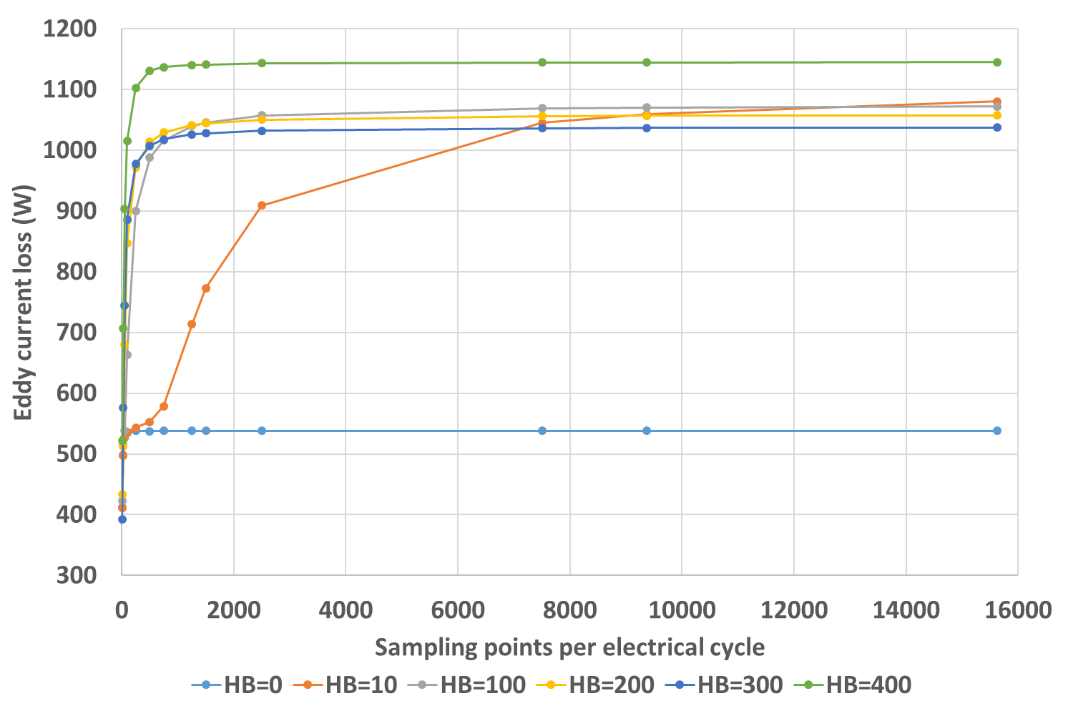
Figure 4.19 Variation of eddy current loss with sampling frequency for star-connected three phases under different levels of ripple amplitudes
The above analysis on the three cases are for the eddy current loss component of the iron loss. Since the excess loss is localized eddy current loss due to domain wall motion, as mentioned before, a similar conclusion could be obtained for the excess loss as well. Figure 4.20 shows the predicted excess loss variation with sampling frequency for star-connected three phases under different ripple amplitudes. It can be seen that excitations with different ripple amplitudes also generates similar level of excess loss.
Therefore, when only considering the three loss components considered in this section, i.e. major loop loss, eddy current loss, and excess loss, it has been demonstrated both by finite element analysis and analytical analysis that similar levels of losses will be generated by converter switching irrespective of the magnitude and indeed the frequency of the current ripple. However, as will be discussed below, minor loop loss does not follow this pattern.
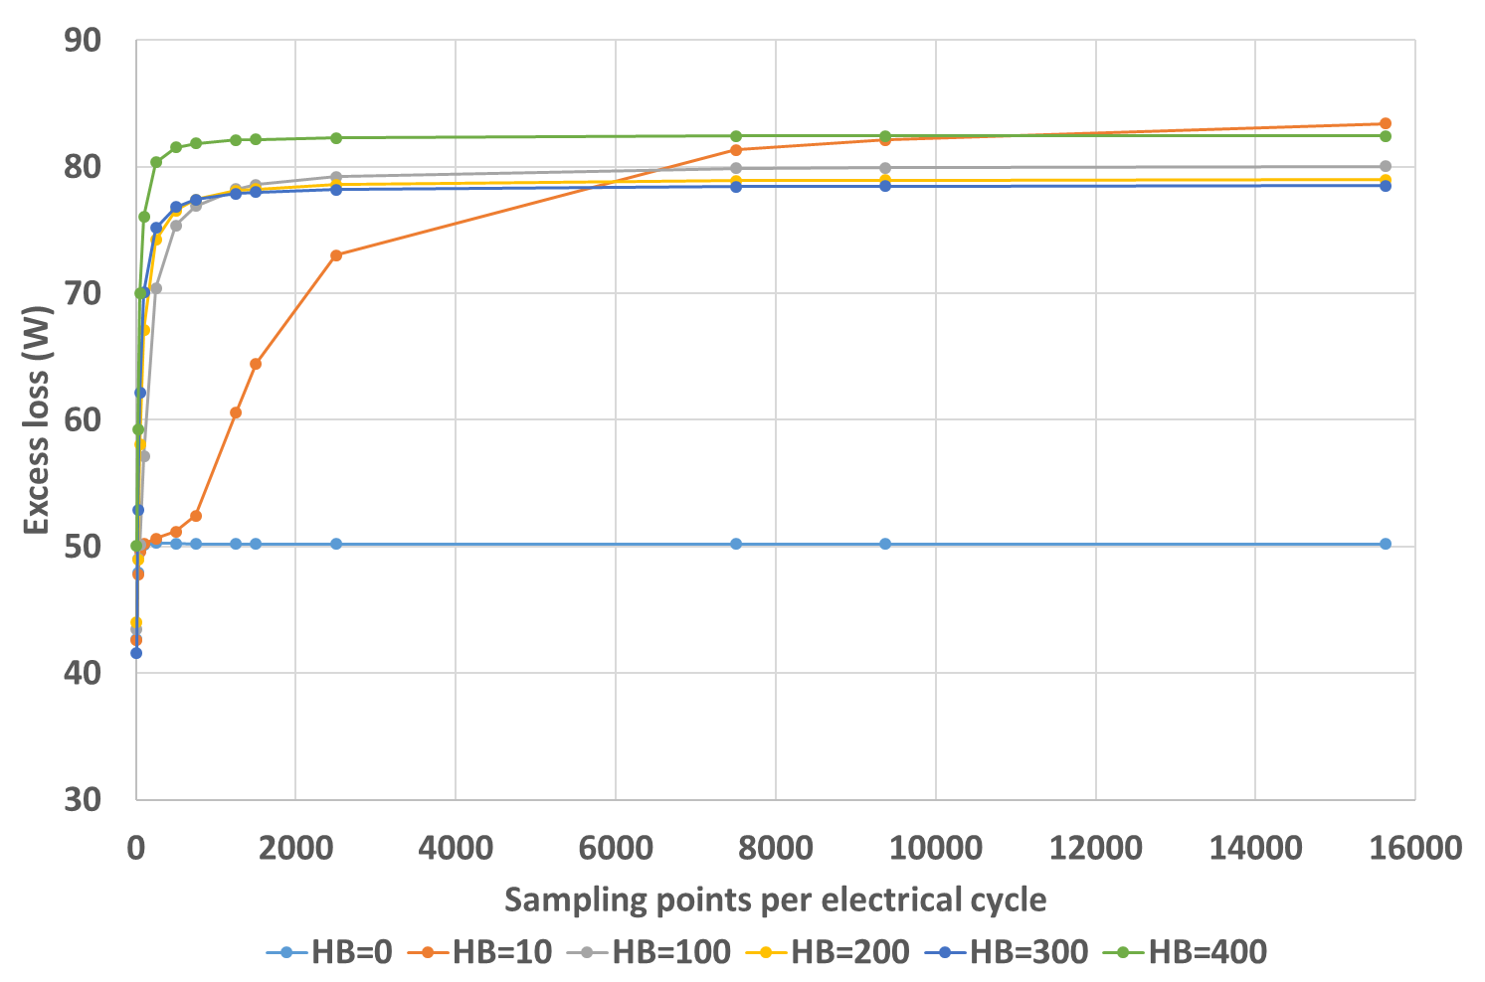
Figure 4.20 Variation of excess loss with sampling frequency for star-connected three phases under different levels of ripple amplitudes
The minor loop loss can be quantized using the number of flux reversals and the magnitude of each reversal, according to the Lavers correction (4.10). As mentioned previously, the change in flux density can be approximated to be proportional to the change in phase current, albeit with inaccuracies introduced by the nonlinearity of the B-H curve. Hence, the Lavers correction is related to the following expression:
$$1+\frac{k}{\hat{B}}\sum_{i=1}^{n}{ΔI_{i}}=1+\frac{k}{\hat{B}}\sum_{i=1}^{n}{\left[I\left(t_{i2}\right)-I\left(t_{i1}\right)\right]}$$ | (4.78)
where $ΔI_{i}$ is the total current change in the $i^{th}$ current reversal period, and $I\left(t_{i2}\right)$ and $I\left(t_{i1}\right)$ are the starting and ending point for the $i^{th}$ current reversal. Clearly, the value given by (4.78) is not related to the transient behaviour of the current waveform, but only related to the increment, i.e. as long as two waveforms have the following relationship
$$\sum_{i=1}^{N_{1}}{ΔI_{i}}=\sum_{k=1}^{N_{2}}{ΔI_{k}}$$ | (4.79)
they would generate a similar level of minor loop loss, irrespective of how the ripple are distributed, the ripple amplitude and whether the machine is star-connected or comprises isolated three phases. Hence, based on Lavers theory, the minor loop loss has no direct relationship with the ripple amplitude, and the current waveform with small-in-amplitude but large-in-number ripples could generate similar level of minor loop loss with the current waveform with large-in-amplitude but small-in-number ripples.
However, this is not guarantee that similar minor loop losses would be generated by current waveforms with different ripple content, since no rigorous derivation is carried out starting from a current waveform with arbitrary ripple condition to finally conclude that the Lavers correction (4.78) is only related to machine constants. In practice, there is possibility that the current waveform with small ripple amplitudes could generate lower or higher level of minor loop loss than waveform with large ripple content. Figure 4.21 shows the minor loop loss variation with sampling frequency for star-connected three phases under different ripple amplitudes which were predicted with the new finite element post processing method described in section 4.2. As can be seen, minor loop losses generated by excitations with different perturbation levels no longer level off at similar magnitudes. Instead, the current excitation with very small magnitude ripple generates higher level of minor loop loss than excitation with large ripples, due to the significant number of flux reversals. However, since the minor loop loss does not make a large contribution to the total iron loss under this machine operating condition, the total iron losses generated by current waveforms with different ripple amplitudes are still on similar levels, as was shown earlier in Figure 4.14 and Figure 4.15.
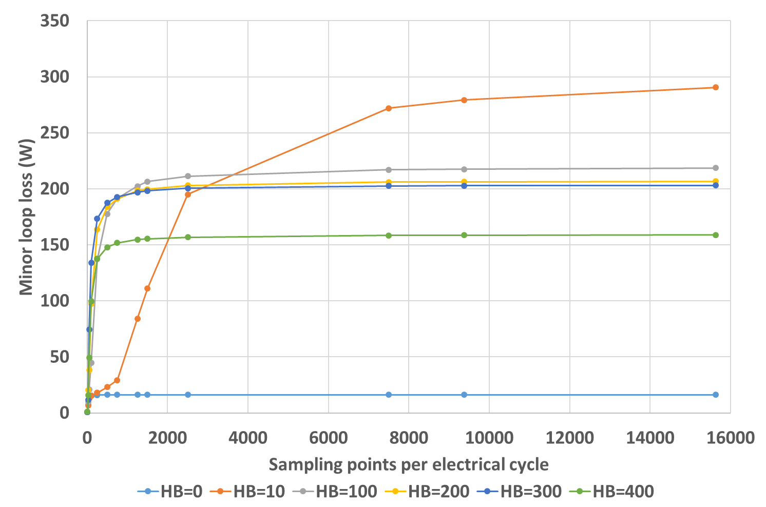
Figure 4.21 Variation of minor loop loss with sampling frequency for star-connected three phases under different levels of ripple amplitudes

Investigation into the influence of operating speed on iron loss produced by converter switching
In section 4.3 , machine design 8 from series with constant electromagnetic split ratio with a base speed of 8000rpm was considered. The iron loss was calculated with the new post-processing iron loss calculation model when operating at its rated base speed of 8000rpm. In this section, the operating speed of the same machine design is reduced from 8000rpm to 1000rpm but at the same rated torque and hence current. Although this will result in a marked reduction in the iron loss due to the lower fundamental frequency of the back-EMF and stator currents, the behaviour in terms of the additional losses produced by the converter is less straightforward. At the reduced speed and with the same DC link supply voltage, reduced back-EMF will tend to increase the rate of change of current according to equation (3.26) which will increase those components of loss that are dependent on the rate of change of current. For a given hysteresis band, this speed reduction would significantly increase the number of switching events per electrical cycle, and hence the ripple frequency compared to the previous operating speed of 8000rpm. This increased switching activity will inevitably require higher sampling frequency to fully capture the details of the waveform.
The ripple currents for three phases under different hysteresis bands at 1000rpm were generated and sampled in the same way as previously for the two post-processing methods. Since the machine condition is not changed in terms of the current waveform relative to rotor angular position and recalling that the field solutions are magneto-static, the flux density information required from finite element for the new post-processing method does not need to be updated. Table 4.7 and Table 4.8 show the generated current waveforms for star-connected and isolated three phases, respectively, under different hysteresis bands using, in this case, a sampling rate of 750 data points per electrical cycle.
Table 4.7 Current waveforms under different hysteresis bands for star-connected three phases in 1000rpm operation for machine design 8 (base speed of 8000rpm)
Hysteresis band | Current waveform
±10A | 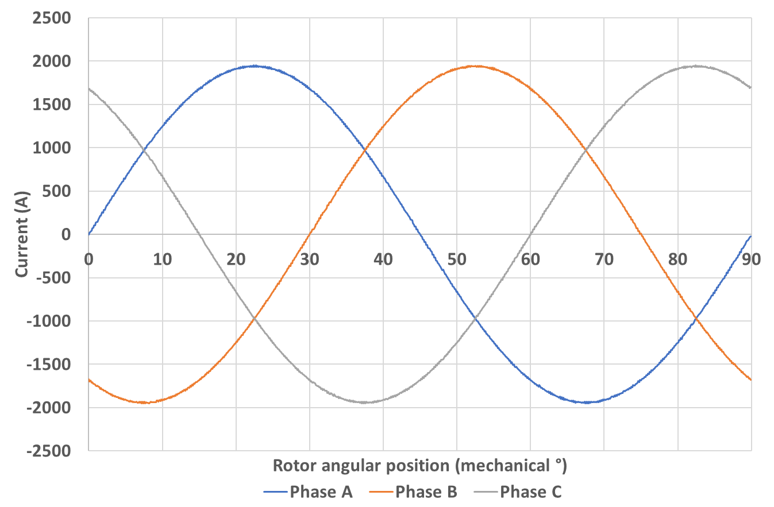
±100A | 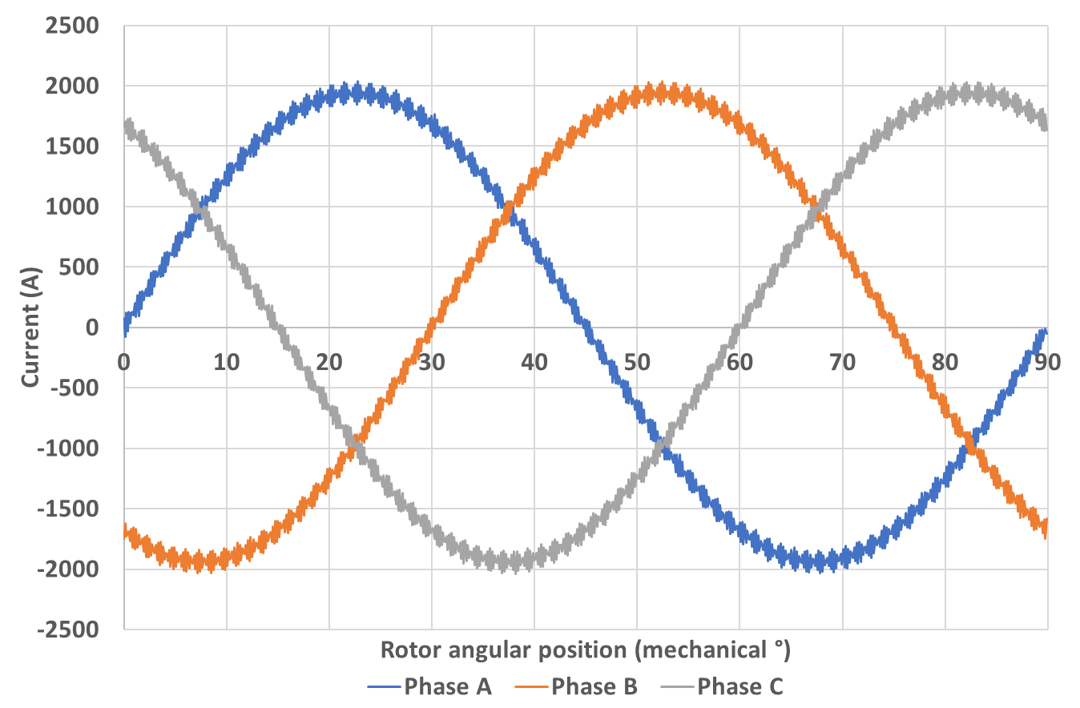
±200A | 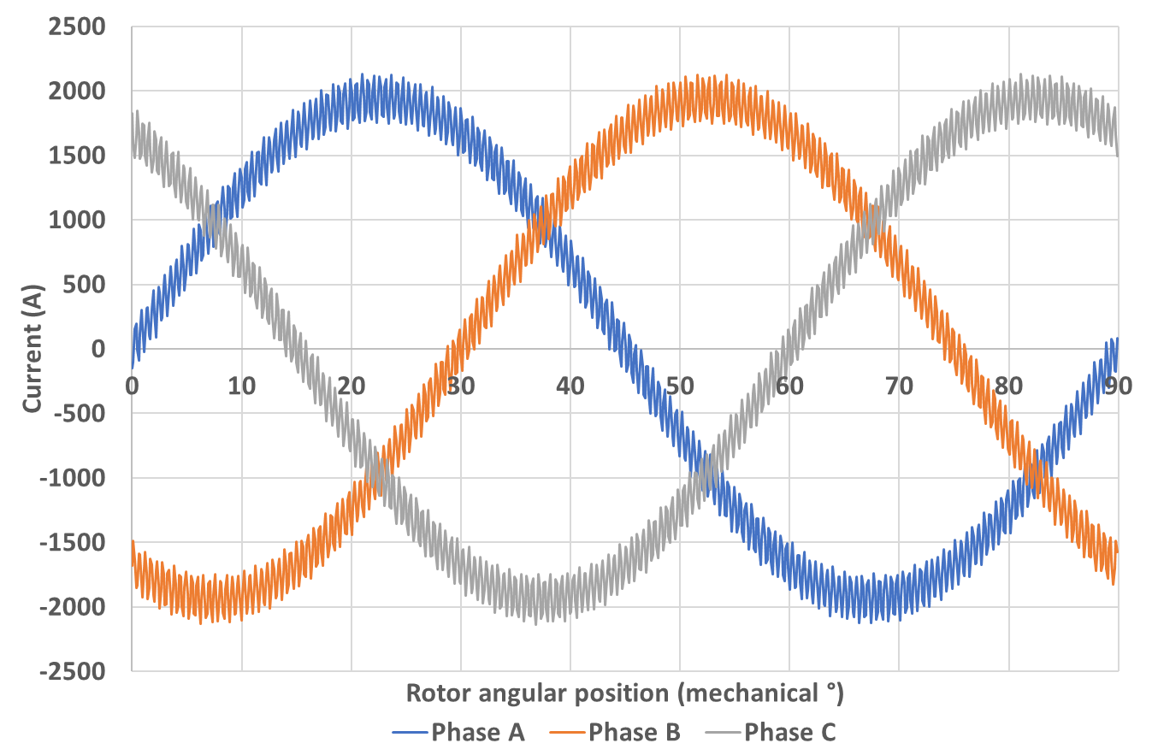
±300A | 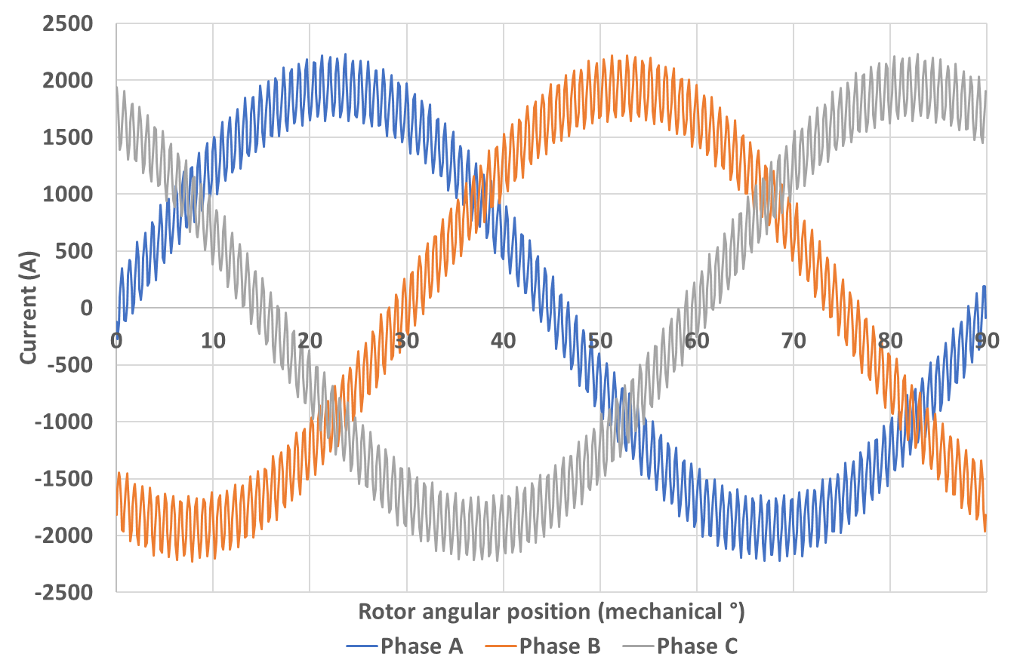
±400A | 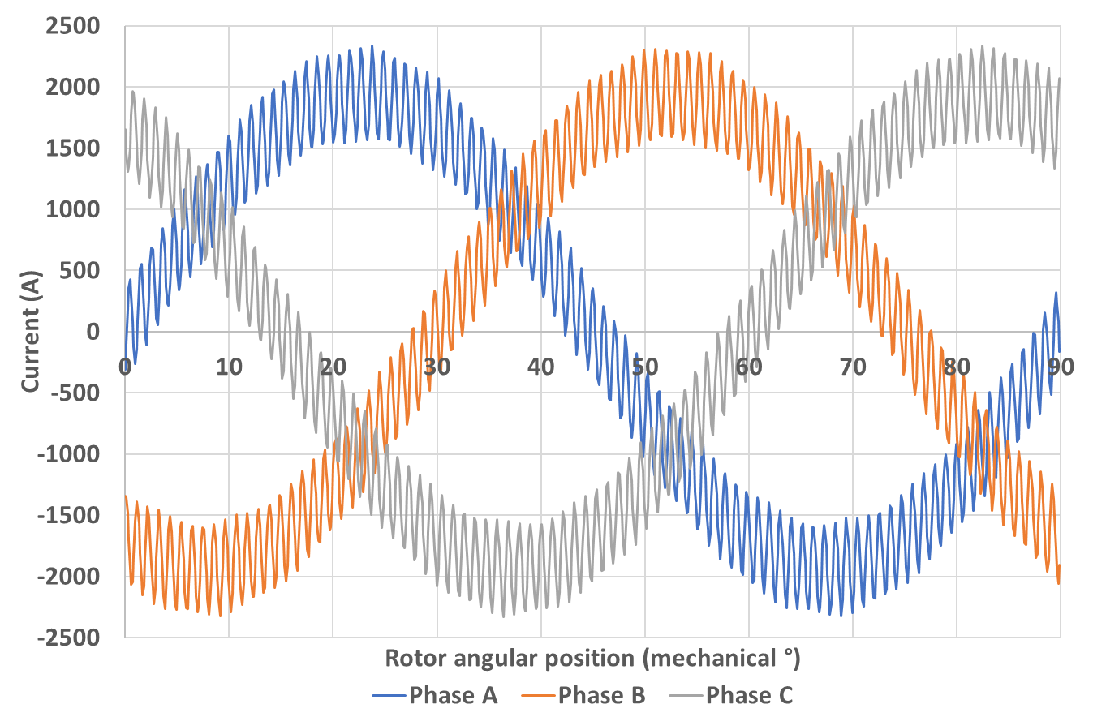
Table 4.8 Current waveforms under different hysteresis bands for isolated three phases in 1000rpm operation for machine design 8 (base speed of 8000rpm)
Hysteresis band | Current waveform
±10A | 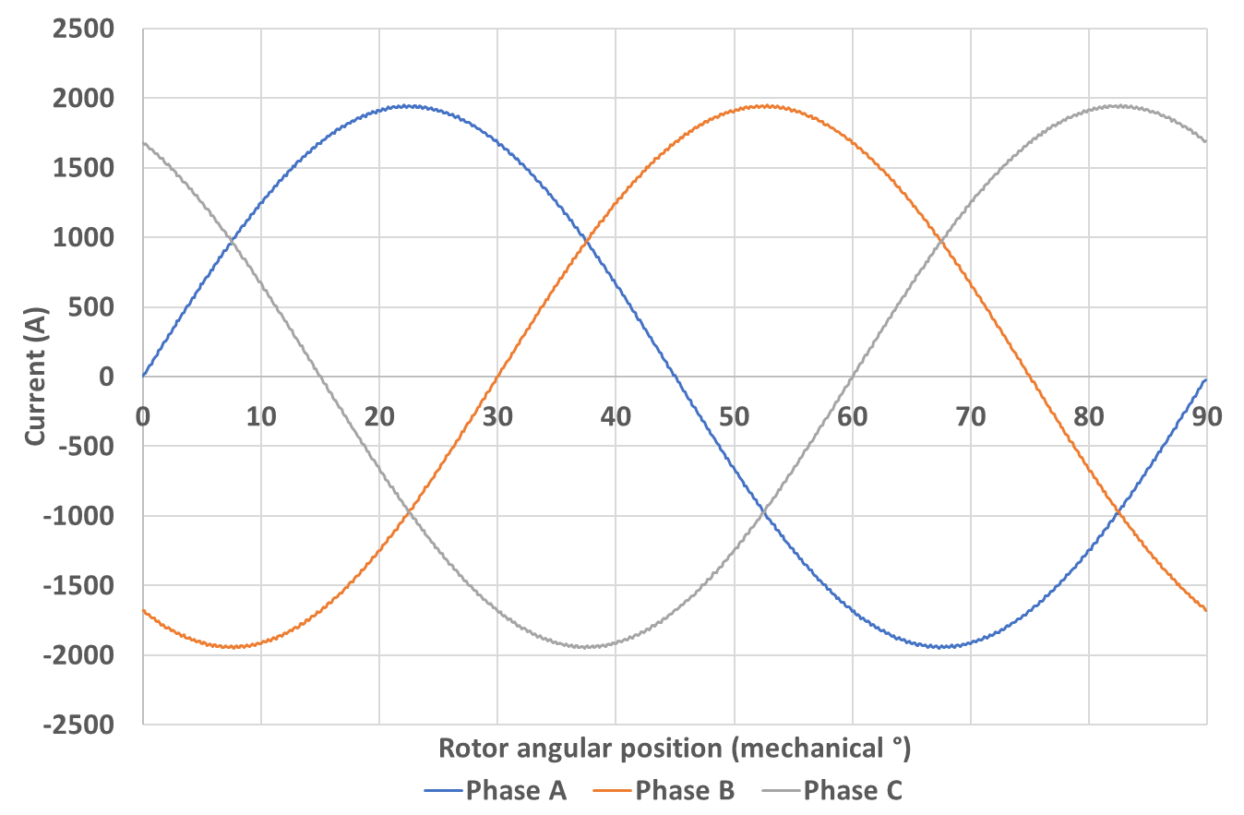
±100A | 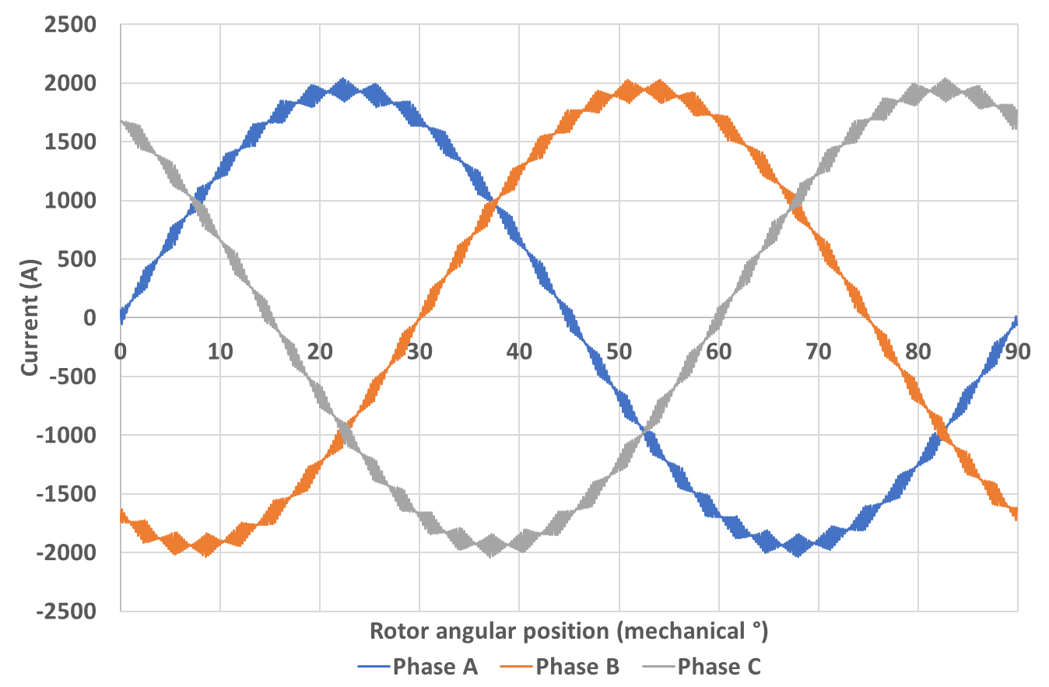
±200A | 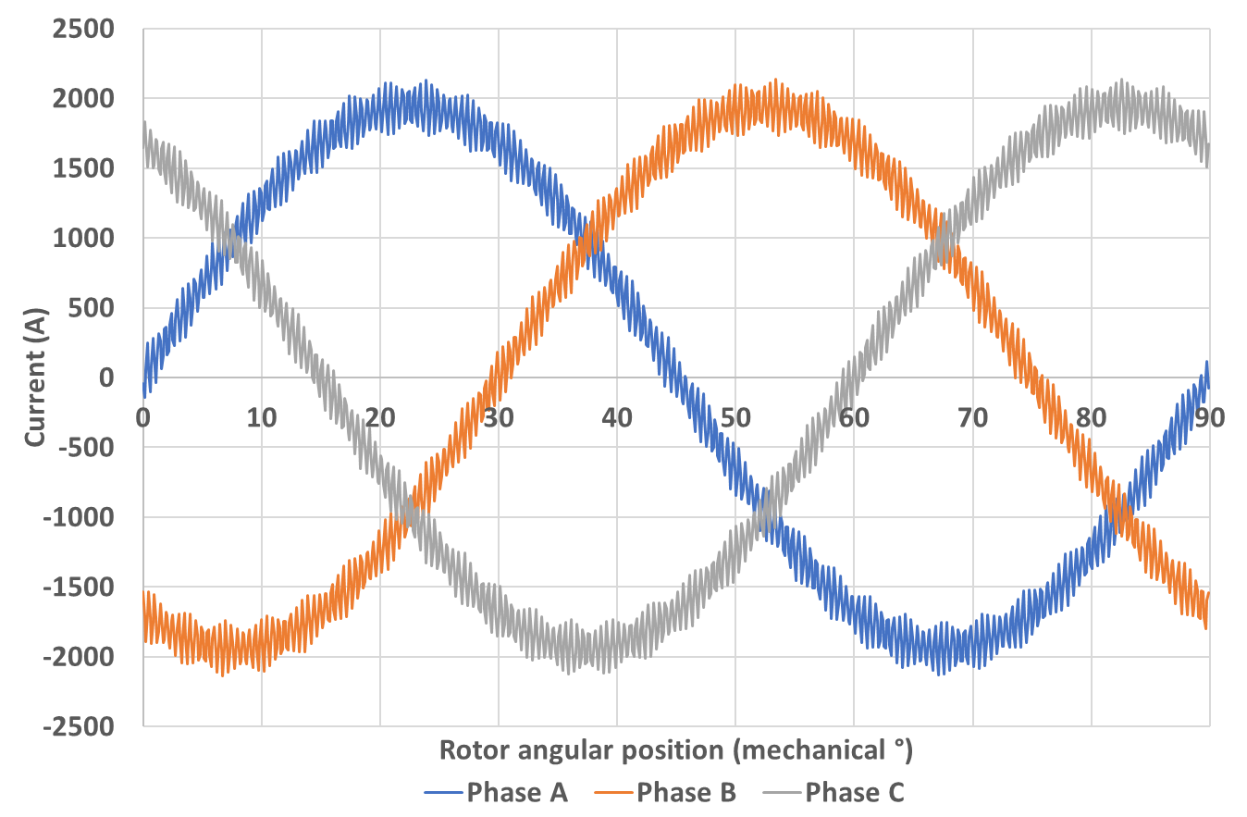
±300A | 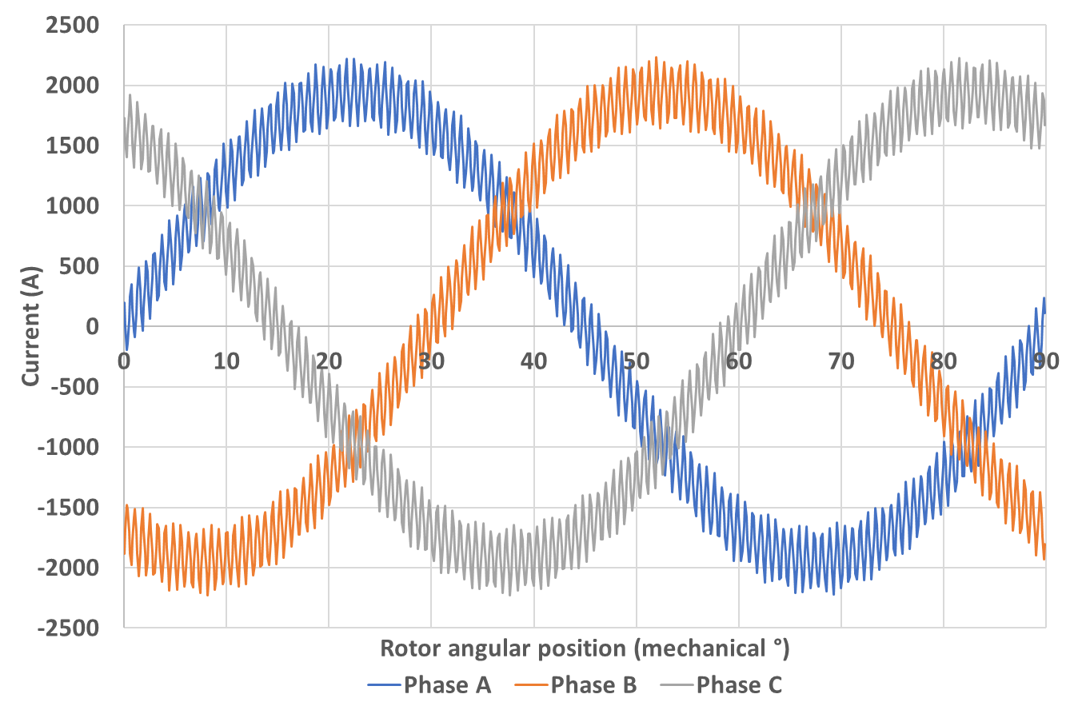
±400A | 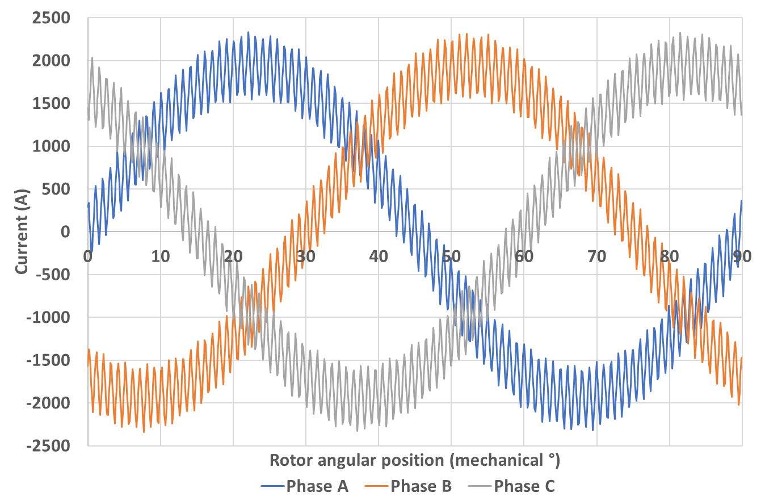
As can be seen from Table 4.7 and Table 4.8, at 1000rpm operating speed, there are relatively few intrinsic space vector changes during one switching cycle in the star-connected three phase currents due to the very high switching frequency which is taking place. Furthermore, under 750 sampling points per electrical cycle, some aliasing effect is already present in the current waveforms with 100A and 200A hysteresis bands. As an example, Figure 4.22 and Figure 4.23 show the phase A current with ±100A hysteresis band under different data point density. Figure 4.22 is the simulated waveform produced with 375000 data points per electrical cycle, while Figure 4.23 shows the waveform sampled at 750 data points per electrical cycle for the same nominal conditions. It is clearly evident that the waveform is under-sampled at 750 sampling points per electrical cycle, with much of ripple content suppressed.
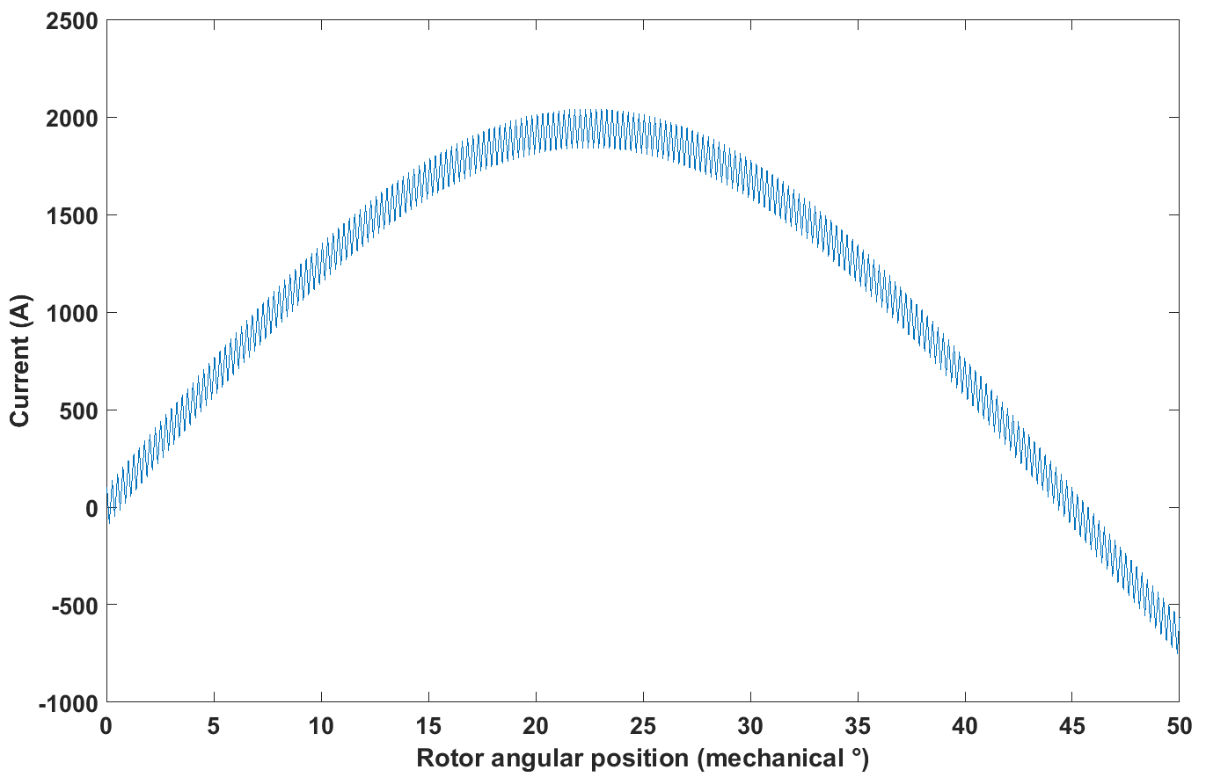
Figure 4.22 Phase A current with ±100A hysteresis band genuinely from the SIMULINK simulation with 375000 data points per electrical cycle
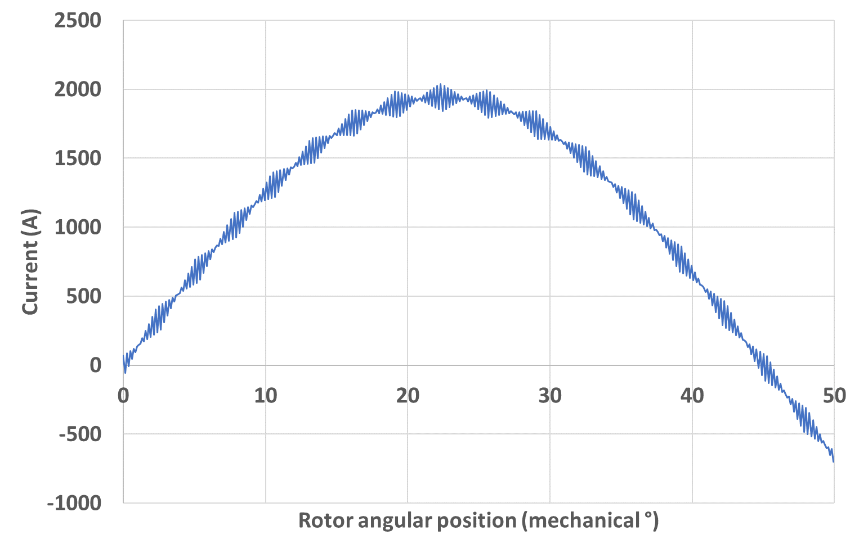
Figure 4.23 Phase A current with 100A hysteresis band sampled at 750 points per electrical cycle
The generated three-phase currents are then put into the two methods for iron loss calculation, viz. the new post-processing method developed in section 4.2 and a more conventional post-processing method which draws on one finite element solution per data point. Since the level of sampling is controlled inside the script for the new method without requiring additional finite element solutions, there is great flexibility in adjusting the sampling rate to investigate issues around under-sampling aliasing effect. In this study, 17 levels of sampling rate were investigated with the new post-processing method, i.e. 10, 15, 20, 30, 50, 100, 250, 500, 750, 1875, 2500, 3750, 5000, 7500, 18750, 37500, and 75000 data points per electrical cycle. For the conventional method of iron loss calculation, 3 levels of sampling frequency were calculated for comparison, i.e. 2500, 5000, and 7500 data points per electrical cycle. These three sampling rates required a large number of finite element simulations to be performed. In a similar manner to that discussed previously, since the number of data points that can be entered into a look-up table in the finite element software is limited to 1000, for these three sampling rates, the current waveform over one electrical cycle was divided up into a series of sequential simulations.
The resulting calculated losses from the two models for iron loss components under the common investigated sampling frequencies, i.e. 2500, 5000 and 7500 data points per electrical cycle, are shown respectively in Table III.3 and Table III.4 in Appendix III for star connected and isolated three phases. As an example, Figure 4.24 shows the results from the two methods for hysteresis band of ±100A and star connected three phases under 2500 sampling frequency.
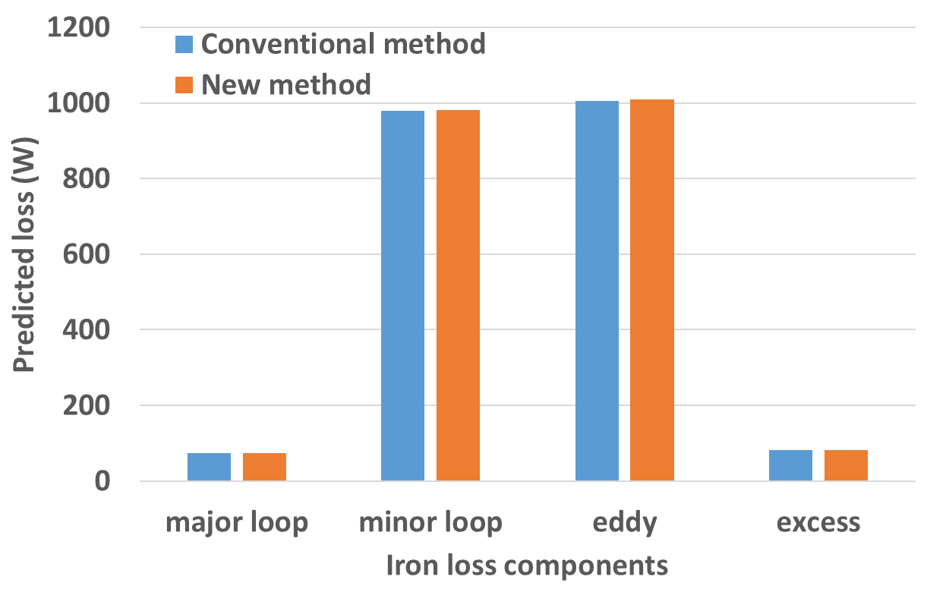
Figure 4.24 Predicted iron loss from two post-processing methods for hysteresis band of ±100A and star connected three phase currents under 1000rpm operation
As can be seen from Table III.3 and Table III.4, and would be expected, good agreement is again achieved between the two methods for small hysteresis bands at a given sampling rate, and improved agreement is achieved compared to the 8000rpm operating with wider hysteresis bands. As noted in section 4.3 , this is to be expected since other than small differences in the minor loop detection method, these are based on the same underlying loss equations. The advantage of the new method comes from its ability to calculate loss with much higher sample rates for the same number of finite element solutions. This advantage is not evident when the two models are operating at the same sampling rate. For the fundamental waveform, high frequency noise is also seen at this operating speed and the corresponding loss results shown in Table III.3 and Table III.4 are results after the Fourier filtering technique is applied. It is seen again that after the high frequency noise is removed from the fundamental waveform, the predicted iron loss stays constant at the investigated three sampling frequencies.
Since the machine speed is reduced from 8000rpm to 1000rpm, the iron loss produced by fundamental current waveform drops to only 7% of the magnitude of the previous operating condition. However, once the increased ripple current is accounted for, the predicted iron loss when sufficient samples are used is greater than the levels predicted at 8000rpm. This is shown in Figure 4.24 and Figure 4.25, which plot the iron loss variation with sampling frequency for star-connected and isolated three phases, respectively, using the results from new post-processing method.
This increased ripple loss is largely the result of increased rate of change of current rate due to reduced back-EMF, which increases eddy current loss and excess loss, as can be seen from Figure 4.29 and Figure 4.30. There is a further significant increase in minor loop loss, as can be seen from Figure 4.31, due to many more flux reversals at 1000rpm than 8000rpm with the same hysteresis band. However, the major loop loss decreases to about 1/8 of the magnitude of the previous condition due to its linear dependence on the fundamental frequency, as can be seen from Figure 4.28.
From Figure 4.24 and Figure 4.25, it can also be seen that, as the sampling frequency increases, the predicted iron losses for different hysteresis bands only level off above certain data sampling rates. In addition, current waveforms with different hysteresis bands generate very similar levels of loss (which are closer to each other than was the case at 8000rpm) even though the minor loop loss is a major contributing component. This is due to the close level of minor loop losses generated from current waveforms with different hysteresis bands in this operating condition, as can be seen from Figure 4.31. The behaviour of minor loop loss at 1000rpm operating speed indicates that, at this operating condition, the relationship between the flux reversals generated by current waveforms with different hysteresis bands is close to the relationship established in equation (4.79). Moreover, the different behaviours of minor loop loss in the two operating conditions reveal that a guarantee cannot be given that the minor loop losses generated by current waveforms with different ripple amplitudes will level off to a similar level, as what would be the case with the other three loss components. From Figure 4.28, Figure 4.29, and Figure 4.30, it can be seen that the behaviours of the remaining three loss components, i.e. major loop loss, eddy current loss, and excess loss, are very similar in their general behaviours to that observed at the 8000rpm operating condition. However, since there are many more switching events per unit time at 1000rpm, more data points are required to fully describe the ripple content in the waveforms. Hence the level of sampling rate above which the predicted losses level off is higher than the 8000rpm operating condition. It is important however to recognise that an electrical cycle is 8 times longer at 1000rpm and hence expressing sampling rate in terms of data points per electrical cycle will implicitly lead to an eight-fold increase in this measure even at the same time sampling rate. This behaviour is also observed with the minor loop loss and total iron loss. Indeed, at this speed, the narrow ±10A hysteresis band case does not reach a level value even with 75,000 data points per electrical cycle. This is to be expected given that for this combination of machine inductance and back-EMF at 1000rpm there are typically 2325 switching events in an electrical cycle.
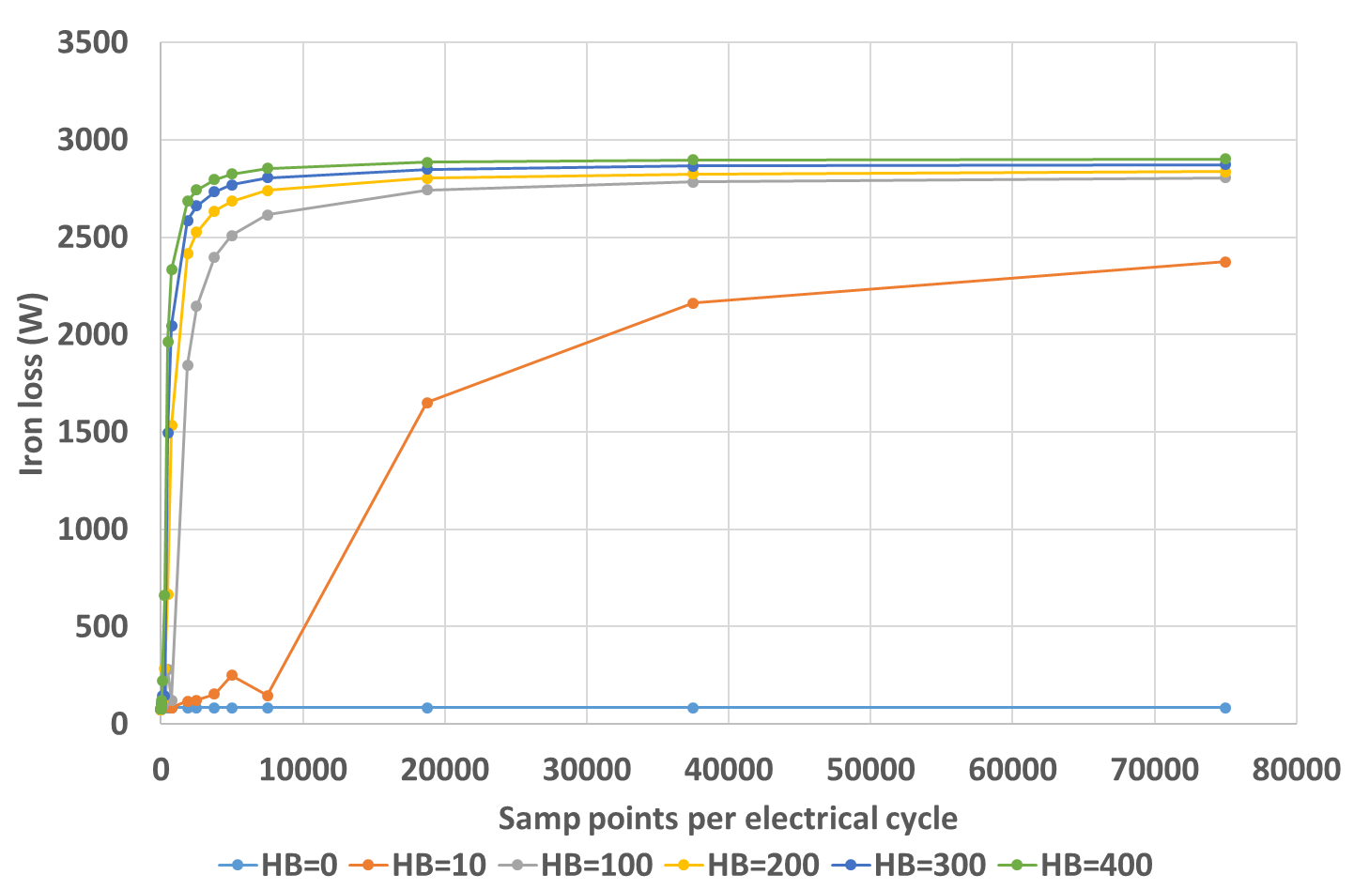
Figure 4.25 Iron loss variation with sampling density for star-connected three phases under 1000rpm operation using the new post-processing results
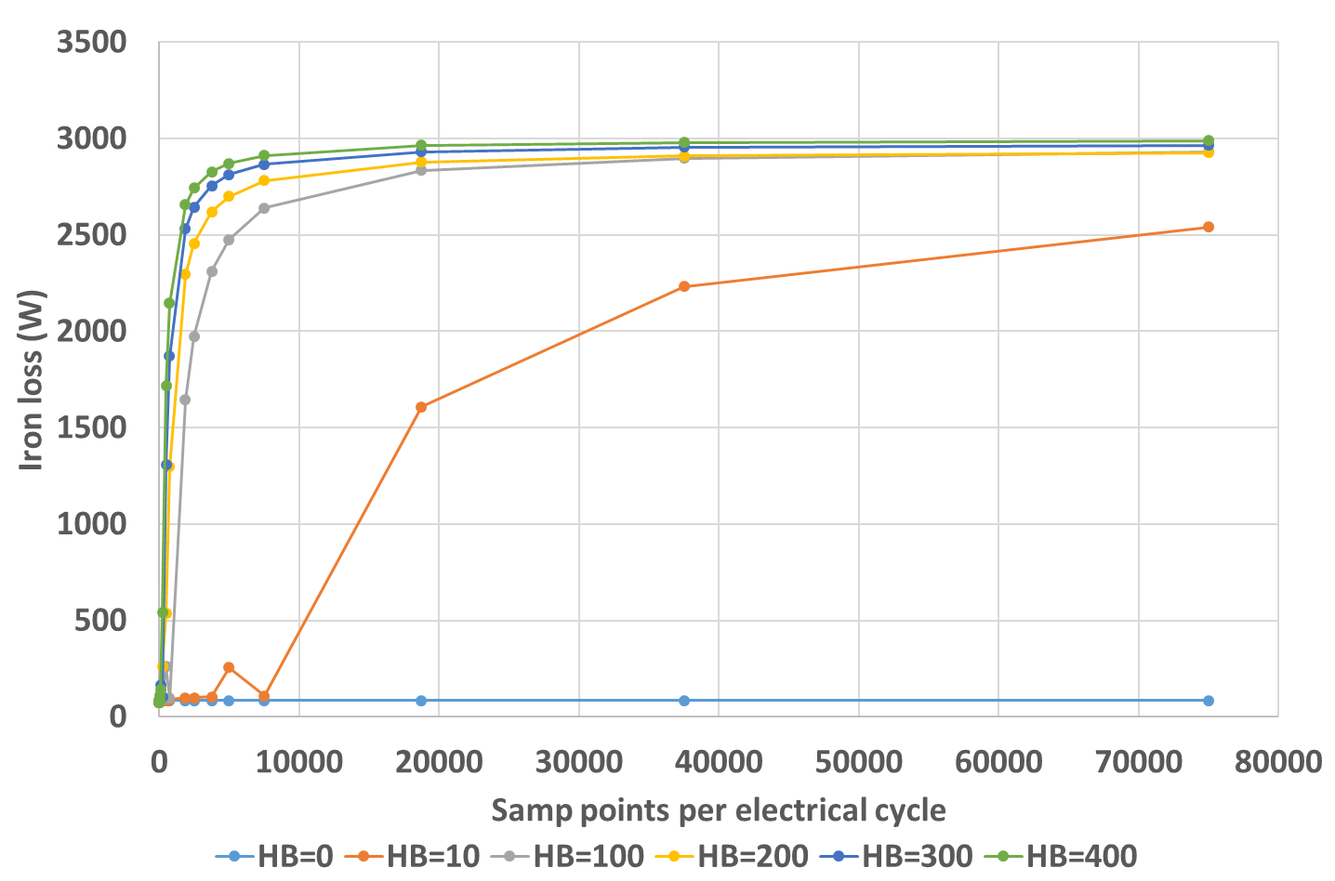
Figure 4.26 Iron loss variation with sampling density for isolated three phases under 1000rpm operation using the new post-processing results
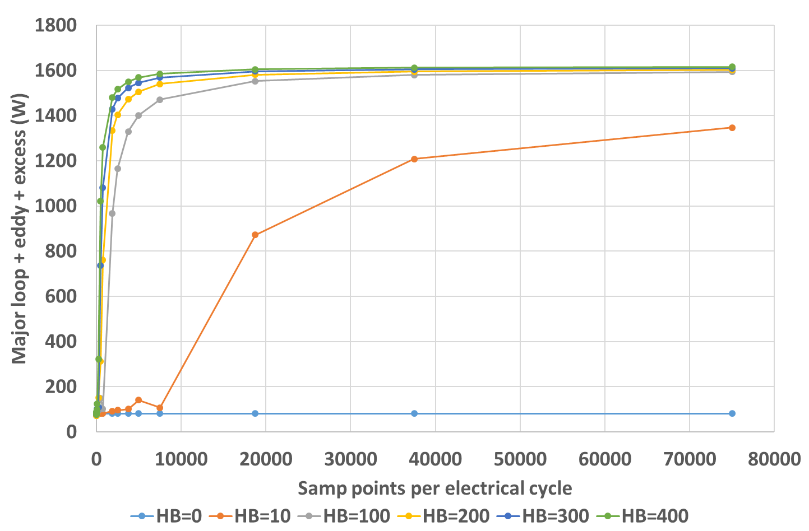
Figure 4.27 Variation of three loss components (major loop + eddy current + excess) with sampling rate for star-connected three phases in 1000 rpm operation using the new post-processing results
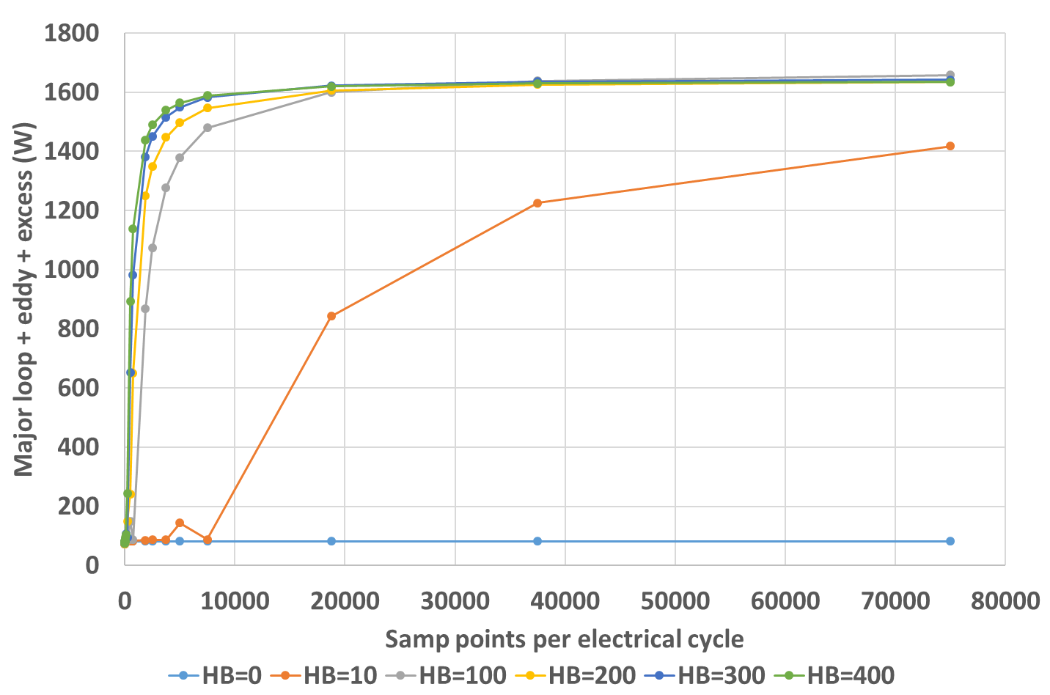
Figure 4.28 Variation of three loss components (major loop + eddy current + excess) with sampling rate for isolated three phases in 1000 rpm operation using the new post-processing results
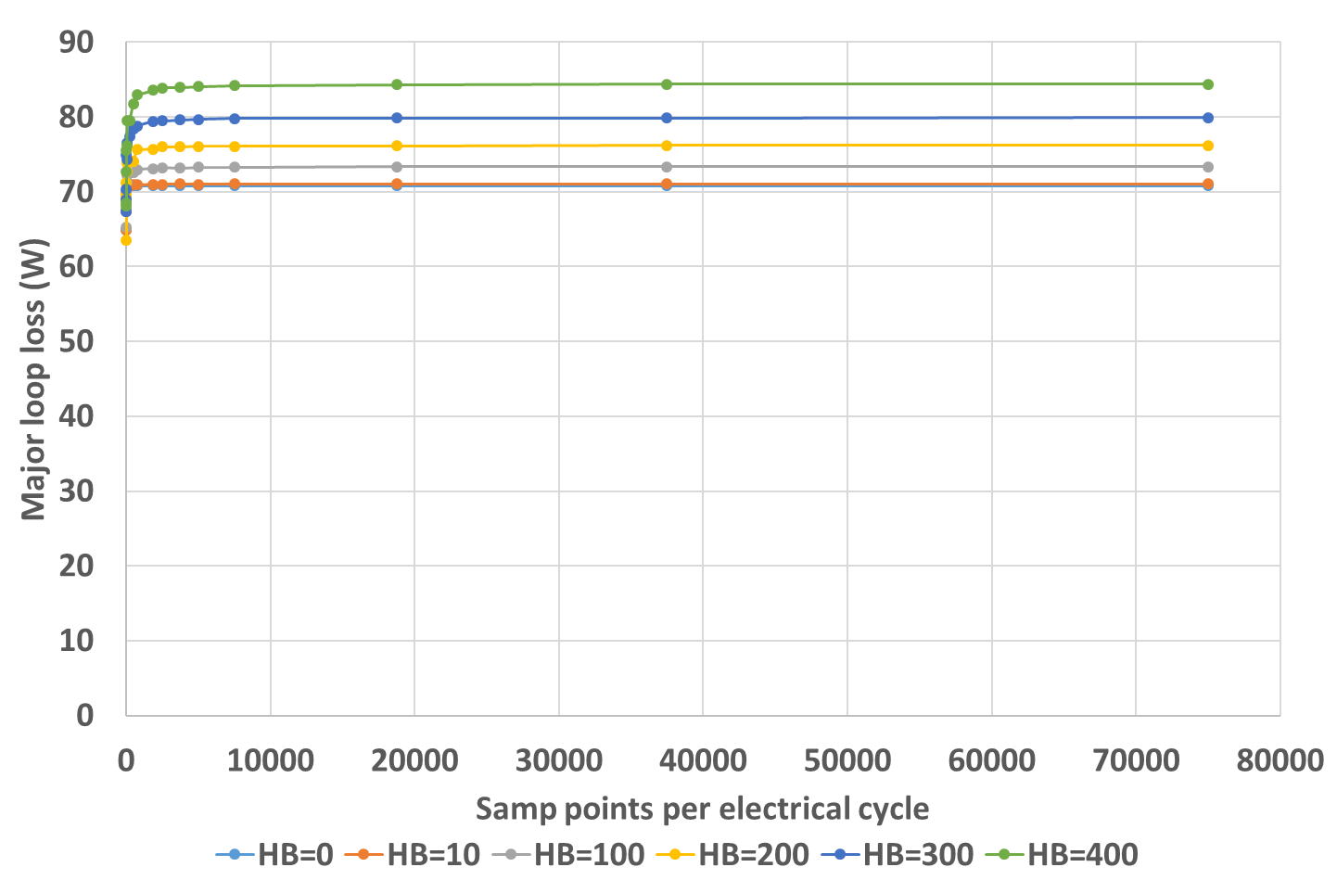
Figure 4.29 Major loop loss variation with sampling frequency for star-connected three phases in 1000rpm operation
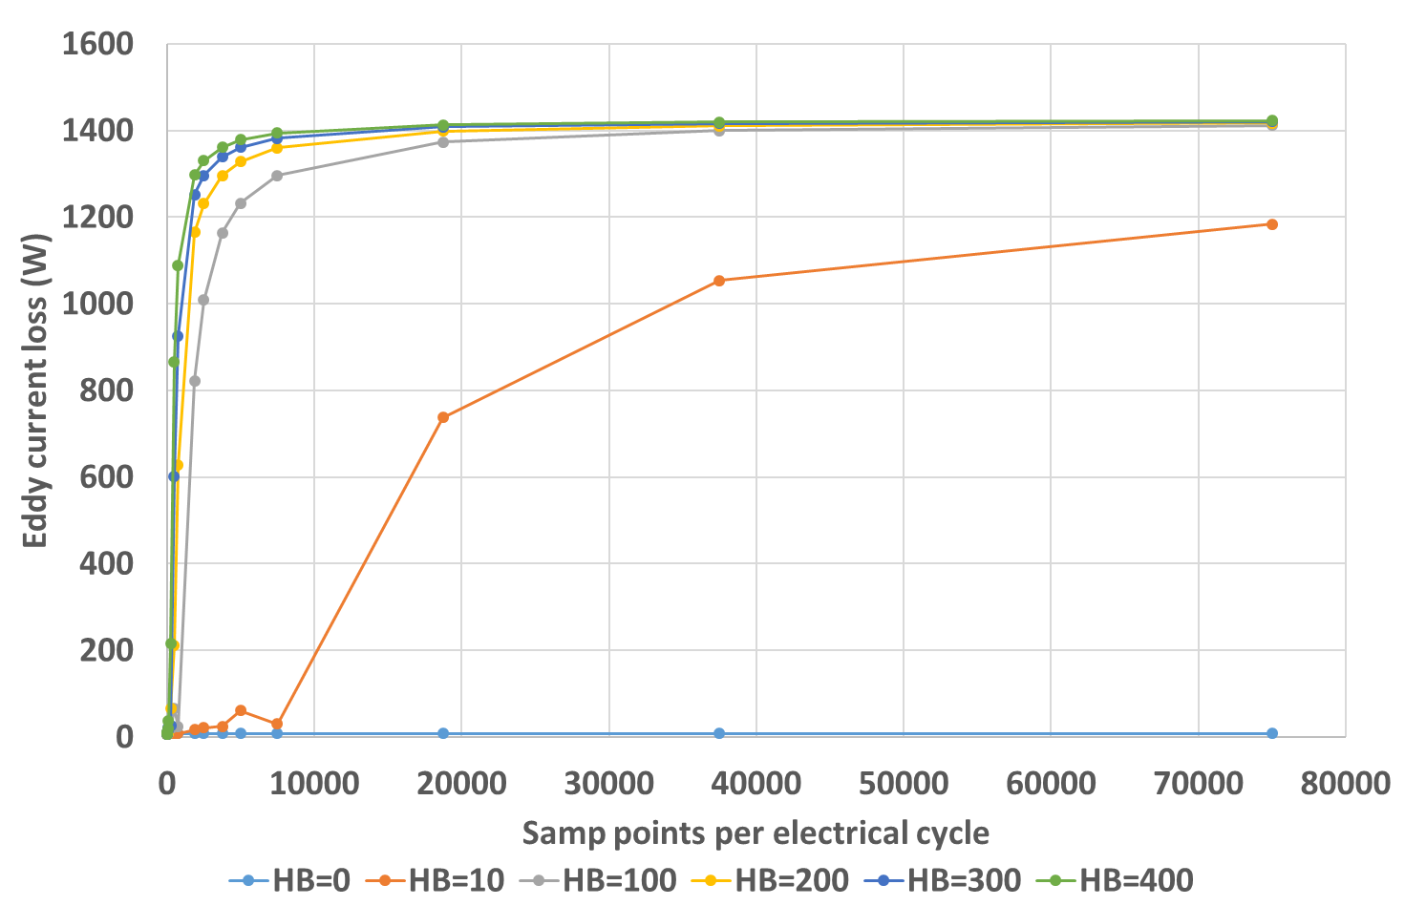
Figure 4.30 Eddy current loss variation with sampling frequency for star-connected three phases in 1000rpm operation
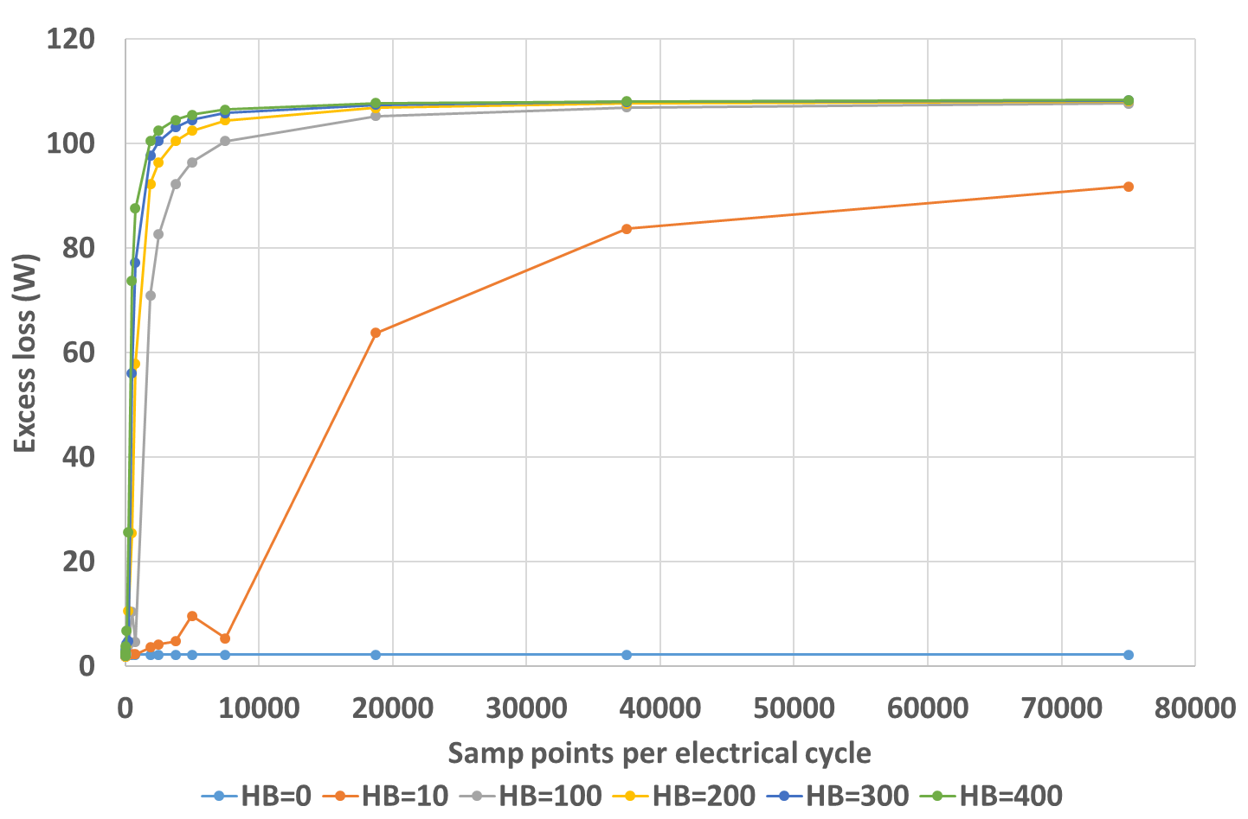
Figure 4.31 Excess loss variation with sampling frequency for star-connected three phases in 1000rpm operation
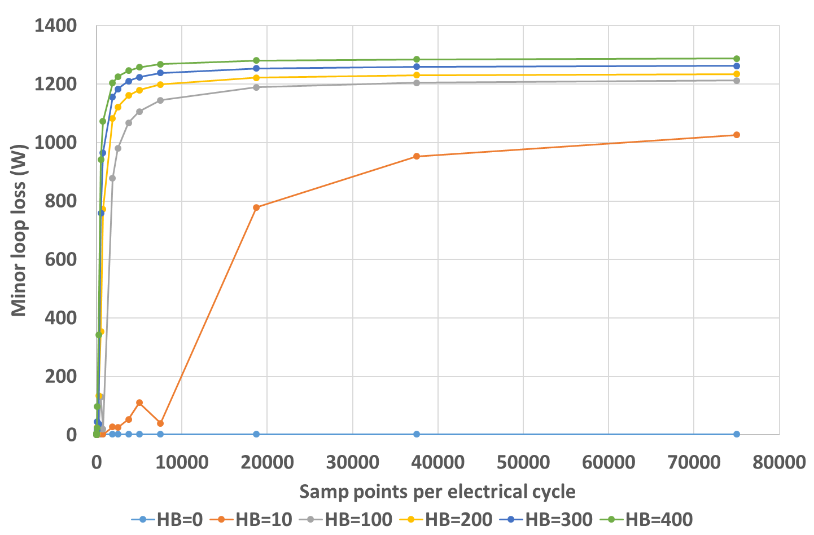
Figure 4.32 Minor loop loss variation with sampling frequency for star-connected three phases in 1000rpm operation

Conclusion
In this chapter, the following studies are carried out
- The impact of current ripple on machine iron loss is investigated, and big increase in loss is seen when the ripples are introduced
- A new post-processing method is developed for iron loss calculation to cope with the large number of data points required to fully capture the details of every ripple in a fast and accurate way. Good matches are achieved with the conventional post-processing method
- Under sufficient sampling, an interesting phenomenon is discovered that the current waveforms with different levels of ripple amplitudes can generate similar levels of iron loss provided the same machine environment and supply condition.
- The behaviour of each iron loss component is analysed analytically, and rigorous derivation is given for the eddy current loss component. Same conclusion with what is observed from the post processing iron loss calculation is obtained from the analytical interpretation
- The machine iron loss behaviour at operating speed lower than rated is also investigated. With the presence of current ripples, the variation of iron loss with frequency is different from the underlying behaviour in pure sinusoidal current case, and high level of iron loss is also seen even at the low operating speed

References
[1] A. Schoppa, J. Schneider, and J. O. Roth, “Influence of the cutting process on the magnetic properties of non-oriented electrical steels,” Journal of Magnetism and Magnetic Materials, vol. 215-216, pp. 100–102, Jun. 2000.
[2] R. Rygal, A. J. Moses, N. Derebasi, J. Schneider, and A. Schoppa, “Influence of cutting stress on magnetic field and flux density distribution in non-oriented electrical steels,” Journal of Magnetism and Magnetic Materials, vol. 215-216, pp. 687–689, Jun. 2000.
[3] A. Schoppa, J. Schneider, C. D. Wuppermann, and T. Bakon, “Influence of welding and sticking of laminations on the magnetic properties of non-oriented electrical steels,” Journal of Magnetism and Magnetic Materials, vol. 254, pp. 367–369, 2003.
[4] C. P. Steinmetz, "On the Law of Hysteresis," American Institute of Electrical Engineers, Transactions of the, vol. IX, pp. 1-64, 1892.
[5] J. Li, T. Abdallah, and C. Sullivan, “Improved calculation of core loss with nonsinusoidal waveforms,” in Industry Applications Conference, 2001. Thirty-Sixth IAS Annual Meeting. Conference Records, vol. 4, 2001, pp. 2203–2210.
[6] K. Venkatachalam, C. Sullivan, T. Abdallah, and H. Tacca, “Accurate prediction of ferrite core loss with non-sinusoidal waveforms using only Steinmetz parameters,” in IEEE Workshop on Computers in Power Electronics, 2002, pp. 36–41.
[7] J. Shilling and G. Houze, "Magnetic properties and domain structure in grain-oriented 3% Si-Fe," in IEEE Transactions on Magnetics, vol. 10, no. 2, pp. 195-223, June 1974.
[8] Y. Hayashi and T. J. E. Miller, "A new approach to calculating core losses in the SRM," Industry Applications, IEEE Transactions on, vol. 31, pp. 1039-1046, 1995.
[9] M. Lei, M. Sanada, S. Morimoto, and Y. Takeda, "Prediction of iron loss in rotating machines with rotational loss included," Magnetics, IEEE Transactions on, vol. 39, pp. 2036-2041, 2003.
[10] G. Bertotti, "General properties of power losses in soft ferromagnetic materials," Magnetics, IEEE Transactions on, vol. 24, pp. 621-630, 1988.
[11] K. Atallah, Z. Q. Zhu, and D. Howe, "An improved method for predicting iron losses in brushless permanent magnet DC drives," Magnetics, IEEE Transactions on, vol. 28, pp. 2997-2999, 1992.
[12] R. H. Pry and C. P. Bean, "Calculation of the Energy Loss in Magnetic Sheet Materials Using a Domain Model," Journal of Applied Physics, vol. 29, pp. 532-533, 1958.
[13] G. Bertotti, Hysteresis in magnetism: for physicists, materials scientists, and engineers. San Diego, Calif.; London: Academic Press, 1998.
[14] G. Bertotti, “Physical interpretation of eddy current losses in ferromagnetic materials. I. theoretical considerations,” Journal of Applied Physics, vol. 57, no. 6, pp. 2110–2117, Mar. 1985.
[15] F. Fiorillo and A. Novikov, “An improved approach to power losses in magnetic laminations under non-sinusoidal induction waveform,” IEEE Transactions on Magnetics, vol. 26, no. 5, pp. 2904–2910, 1990.
[16] G. Bertotti, "Physical interpretation of eddy current losses in ferromagnetic materials. II. Analysis of experimental results," Journal of Applied Physics, vol. 57, pp. 2118-2126, 1985.
[17] E. D. Torre, Magnetic hysteresis: IEEE Press, 1999.
[18] Jenõ Takács (2012). The Everett Integral and Its Analytical Approximation, Advanced Magnetic Materials, Dr. Leszek Malkinski (Ed.), InTech, DOI: 10.5772/36732. Available from: https://www.intechopen.com/books/advanced-magnetic-materials/the-everett-integral-and-its-analytic-approximation
[19] K. Atallah, “Iron losses in brushless permanent magnet dc machines,” PhD., Electronic and Electrical Engineering, University of Sheffield, Sheffield, 1993.
[20] A. Krings and J. Soulard, "Overview and Comparison of Iron Loss Models for Electrical Machines," Journal of Electrical Engineering, vol. 10, pp. 162-169, 2010.
[21] I. D. Mayergoyz, "Mathematical Models of Hysteresis," Physical Review Letters, vol. 56, pp. 1518-1521, 04/14/ 1986.
[22] L. K. Rodrigues and G. W. Jewell, "Model Specific Characterization of Soft Magnetic Materials for Core Loss Prediction in Electrical Machines," in IEEE Transactions on Magnetics, vol. 50, no. 11, pp. 1-4, Nov. 2014.
[23] G. Finocchio, M. Carpentieri, E. Cardelli, and B. Azzerboni, "Analytical solution of Everett integral using Lorentzian Preisach function approximation," Journal of Magnetism and Magnetic Materials, vol. 300, pp. 451-470, 2006/05/01/ 2006.
[24] K. Atallah and D. Howe, "The calculation of iron losses in brushless permanent magnet dc motors," Journal of Magnetism and Magnetic Materials, vol. 133, pp. 578-582, 1994/05/01/ 1994.
[25] J. J. H. Paulides, G. W. Jewell and D. Howe, "An evaluation of alternative stator lamination materials for a high-speed, 1.5 MW, permanent magnet generator," in IEEE Transactions on Magnetics, vol. 40, no. 4, pp. 2041-2043, July 2004.
[26] S. D. Calverley, G. W. Jewell, and R. J. Saunders, "Prediction and measurement of core losses in a high-speed switched-reluctance Machine," Magnetics, IEEE Transactions on, vol. 41, pp. 4288-4298, 2005.
[27] A. M. Knight and Y. Zhan, "Identification of Flux Density Harmonics and Resulting Iron Losses in Induction Machines With Nonsinusoidal Supplies," in IEEE Transactions on Magnetics, vol. 44, no. 6, pp. 1562-1565, June 2008.
[28] S. Xue et al., "Iron Loss Model for Electrical Machine Fed by Low Switching Frequency Inverter," in IEEE Transactions on Magnetics, vol. 53, no. 11, pp. 1-4, Nov. 2017.
[29] J. D. Lavers, P. Biringer, and H. Hollitscher, "A simple method of estimating the minor loop hysteresis loss in thin laminations," Magnetics, IEEE Transactions on, vol. 14, pp. 386-388, 1978.
[30] D. M. Ionel, M. Popescu, S. J. Dellinger, T. J. E. Miller, R. J. Heideman and M. I. McGilp, "On the variation with flux and frequency of the core loss coefficients in electrical machines," in IEEE Transactions on Industry Applications, vol. 42, no. 3, pp. 658-667, May-June 2006.
[31] D. M. Ionel, M. Popescu, M. I. McGilp, T. J. E. Miller, S. J. Dellinger, and R. J. Heideman, "Computation of Core Losses in Electrical Machines Using Improved Models for Laminated Steel," Industry Applications, IEEE Transactions on, vol. 43, pp. 1554-1564, 2007.
[32] M. Popescu and D. M. Ionel, "A Best-Fit Model of Power Losses in Cold Rolled-Motor Lamination Steel Operating in a Wide Range of Frequency and Magnetization," in IEEE Transactions on Magnetics, vol. 43, no. 4, pp. 1753-1756, April 2007.
[33] A. Boglietti, A. Cavagnino, M. Lazzari, and M. Pastorelli, "Predicting iron losses in soft magnetic materials with arbitrary voltage supply: an engineering approach," Magnetics, IEEE Transactions on, vol. 39, pp. 981-989, 2003.
[34] S. Xue et al., "Iron Loss Model Under DC Bias Flux Density Considering Temperature Influence," in IEEE Transactions on Magnetics, vol. 53, no. 11, pp. 1-4, Nov. 2017.
[35] K. Atallah and D. Howe, "Calculation of the rotational power loss in electrical steel laminations from measured H and B," Magnetics, IEEE Transactions on, vol. 29, pp. 3547-3549, 1993.
[36] F. Liu, T. Lu, Z. Zhao, Q. Gu, L. Yuan and K. Li, "Iron loss evaluation and comparison in application of reduced common mode voltage PWM methods," 2015 IEEE Energy Conversion Congress and Exposition (ECCE), Montreal, QC, 2015, pp. 4026-4032.
[37] T. Chevalier, A. Kedous-Lebouc, B. Cornut, and C. Cester, "A new dynamic hysteresis model for electrical steel sheet," Physica B: Condensed Matter, vol. 275, pp. 197-201, 1// 2000.
[38] D. Lin, P. Zhou, W. N. Fu, Z. Badics and Z. J. Cendes, "A dynamic core loss model for soft ferromagnetic and power ferrite materials in transient finite element analysis," in IEEE Transactions on Magnetics, vol. 40, no. 2, pp. 1318-1321, March 2004.
[39] A. Krings, J. Soulard and O. Wallmark, "PWM Influence on the Iron Losses and Characteristics of a Slotless Permanent-Magnet Motor With SiFe and NiFe Stator Cores," in IEEE Transactions on Industry Applications, vol. 51, no. 2, pp. 1475-1484, March-April 2015.
[40] Z. C. Sun, J. X. Shen, M. J. Jin and H. Hao, "Research of the influence of different PWM inverters on the iron losses for induction motors," 2014 17th International Conference on Electrical Machines and Systems (ICEMS), Hangzhou, 2014, pp. 96-100.
[41] A. Boglietti, A. Cavagnino, T. L. Mthombeni and P. Pillay, "Comparison of lamination iron losses supplied by PWM voltages: US and European experiences," IEEE International Conference on Electric Machines and Drives, 2005., San Antonio, TX, 2005, pp. 1431-1436.
[42] D. Fang, "An improved iron loss estimation for permanent magnet brushless machines," Energy Conversion, IEEE Transactions on, vol. 14, pp. 1391-1395, 1999.
[43] L. Rodrigues, “HIGH TEMPERATURE EMBEDDED ELECTRICAL MACHINES FOR AEROSPACE TURBINE APPLICATIONS,” PhD., Electronic and Electrical Engineering, University of Sheffield, Sheffield, 2013.
[44] B. K. Bose, “An adaptive hysteresis-band current control technique of a voltage-fed PWM inverted for machine drive system,” IEEE Trans. Ind. Electron., vol. 37, pp. 402–408, Oct. 1990.

3D eddy current loss calculation in rotor metallic structures

As discussed previously in chapter 1, another factor which must be considered when increasing the rotational speed of the electrical machine is the effect on rotor eddy current losses. In this chapter, a three-dimensional analytical eddy current calculation model is developed for the encompassing eddy currents in a conducting sleeve and rotor magnets.
The rotor of a permanent magnet machine is nominally exposed to a stationary magnetic field from the stator since it rotates synchronously with the stator field [1]-[4].
However, most practical machines produce asynchronous airgap field harmonics due to factors such as discrete space distribution of stator windings producing non-sinusoidal space waveform, existence of slot openings causing modulations in airgap permeance, etc. As a consequence, the rotor is exposed to some level of time varying incident fields which in turn result in induced eddy currents in any electrically conducting components in the rotor, in particular the rotor magnets and an electrically conducting containment sleeve if used. These asynchronous airgap field components are particularly pronounced in fractional slot permanent magnet machines. This type of machine has attracted increasing attention in many market sectors due to short end winding geometry, high winding factor, high fault tolerance, high flux weakening capability, and low torque ripple [5]. However, fractional slot machines produce harmonic rich airgap fields, containing both low and high order harmonics, since the torque is produced in these machines via the interaction of higher order armature harmonics with the magnet field rather the fundamental armature field [3][6]. Since these asynchronous harmonics can give rise to significant eddy current loss in a rotor metallic sleeve and magnets, leading to overheating and potential demagnetization. Therefore, it is vital important to analyse the eddy current distribution and corresponding losses in the rotor structures.
Eddy current loss in rotor magnets and in a metallic containment sleeves can be a limiting factor on machine performance despite often being regarded as a parasitic loss. Problems arise because even modest amounts of loss directly heat the magnets and this loss can be difficult to extract from the rotor. The resulting temperature rise in the magnets causes a progressive reduction in the material remanence with a consequent reduction in the torque constant of the machine, e.g. at a rate of -0.03% per °C in Sm2Co17 and -0.11% per °C in NdFeB. Furthermore, elevated temperatures increase the risk of irreversible demagnetization.
The difficulties associated with rotor magnet and metallic sleeve losses are compounded in high power density machines, since the power density is usually realized through high stator electric loadings, with a corresponding increase in the magnitude of the problematic asynchronous airgap field harmonics, and high operating speed, which all lead to further increase in rotor losses.
It is worth pointing out that armature fields are not the only source of rotor eddy current losses and some level of loss is usually observed even under open-circuit conditions with no stator currents present. These eddy currents are the result of permeance modulation generated by stator slot-openings causing changes in the working point of the permanent as they successively pass slot-openings. The resulting small fluctuations in the flux density in the magnets and the conducting sleeve drive the eddy currents and hence generate loss. Open-circuit losses, which are not accounted for in the analytical model, are discussed later in section 5.8 of this chapter.

State of art in eddy current calculation in rotor metallic structures
In recognition of its significance in limiting the performance of high power density machine, there is a wealth of analysis methods and investigations reported in literature. Reported studies encompass both analytical calculation methods and numerical finite element simulations [1]-[4],[6]-[17]. In common with other aspects of electromagnetic modelling, analytical methods tend to be computationally efficient and the resulting analytical expression may offer some insight into the underlying behaviour, although many of the arising expressions may be so complex as to hinder a simple interpretation of the physical phenomenon. However, these benefits are often accrued at the expense of the need to include several simplifying assumptions. In contrast, finite element methods, when appropriately used, can provide very accurate results if the spatial discretization is sufficiently fine and the time step is chosen carefully. However, finite element analysis can be very time consuming, particularly as high frequency eddy current problems can require very fine discretisation to deal with ‘skin-effect’ phenomena [12][18][19]. Moreover, finite element method provides no direct insight into the physics and mechanism of the machine, albeit that it provides a useful tool for undertaking repeated simulations to make deductions about the underlying behaviour. Therefore, analytical methods provide a useful option to complement finite element methods when designing and analysing permanent magnet machines.
There are several different varieties of analytical models for calculating rotor eddy current loss. Some methods [1]-[3][6][11][13]-[16][18] focused on the calculation of the so-called resistance-limited case, in which the eddy current reaction field is not considered when solving the field distribution inside different parts of the machine. In [1] and [16], the effect of circumferential and axial segmentation on reducing the rotor magnet loss is investigated for resistance-limited case. The resistance limited case only provides a reasonable representation up to a particular combination of frequency and electrical conductivity. To address this, methods [4][7]-[10][20][21][27] have been developed to extend the analysis to include the eddy current reaction effect, i.e. so-called inductance limited eddy currents. These methods use diffusion equation to solve the field and eddy current distribution. In [8]-[10], Fang established a rather complete analytical model to calculate the rotor magnet loss, albeit in two dimensions. In this method, the space and time harmonics of the stator current were considered, as well as the curvature effect in the magnet and the eddy current reaction effect. Zhu extended Fang’s method by considering the eddy current in both the metallic containing structure and the rotor magnets [4]. Zhu also published a series of papers earlier in 1993 demonstrating detailed analytical calculation of the field distribution and considering many effects such as stator slotting, curvature, space and time harmonics [22]-[25]. These analytical field calculations were further improved later in [26] by considering the parallel magnetization and different winding layouts. In 2011, Pfister et al derived a generalized diffusion equation (GDE) of vector potential providing a complete consideration of different conditions and incorporating them into one equation [27]. The Laplace equation, quasi-Poisson equation and diffusion equation can be easily deduced from the GDE. In 2016, this method is used in a full analysis of machine performance including field calculation, torque calculation, back-EMF calculation and inductance calculation, and good agreement is achieved between analytical and FE results [28].
In representing the stator current distribution in any field calculation, then at present, two methods are predominant in literature. The first method treats the stator current as equivalent current sheets distributed at the stator slot openings, [1]-[4][6]-[10][15][16][27] while the second uses a so-called sub-domain model [28]-[32]. The distributed stator current sheets provide an accurate and rapid means to determine the spatial harmonics corresponding to a specific winding distribution, which can then be utilized in the field calculation. However, such method does not consider the effect of slot openings in terms of permeance and the localised field, and the slot opening effect needs to be accommodated separately using complex geometric method such as conformal mapping [24]. In contrast, a sub-domain model naturally includes the slot opening effect since instead of compressing the stator current into thin sheets, it treats each slot as a subdomain and directly solves the static Poisson equation inside the stator slot. Theoretically, this method is applicable to any circumstances, since the same field equations are also used in the finite element analysis. However, in reality, for complex stator geometries, especially around the tooth tips, the boundary condition might become so complicated that analytically establishing a final unique solution for the field equations becomes too challenging. Hence, this method is mainly used for simple stator geometries such as rectangular stator tooth tips, where it is more straightforward and tractable to define boundary conditions.
The above methods are focused on the two-dimensional calculation of rotor magnet loss, which is based on the assumption that the machine has infinite axial length. While this can be a reasonable approximation when the machine aspect ratio is large and the individual magnet pieces span the full length, it always leads to an overestimate of losses, which can become very problematic for shorter axial length machines or when the magnet poles are subdivided axially into a number of separate magnet pieces. This is often a practical approach that it adopted to manage rotor eddy current losses, but is one that cannot be modelled with any a degree of robustness in two-dimensions.
Three-dimensional modelling of rotor magnet loss calculations, although far more challenging, has also been investigated. In 2012, Mirzaei et al published a paper presenting a quasi-3D analytical method for rotor magnet loss calculation, and investigated the circumferential and axial segmentation effects on rotor magnet loss [12]. In 2016, Chen et al presented a method of combing the FE and an analytical method for rotor magnet loss calculation [18][19]. In this method, two-dimensional field solution from finite element analysis was treated as the excitation source and extended it into 3D using image theory. This method utilizes the high accuracy of the 2D FE analysis and avoids the time-consuming computation of 3D FE by replacing it with analytical method. However, the above two methods are based on Cartesian coordinates and therefore the curvature effect were not included. To date, there are no reported analytical methods for a full three-dimensional analytical solution to the diffusion equation which accounts for machine geometry.

Development of a three-dimensional analytical eddy current loss calculation model
In this chapter, a three-dimensional analytical model is developed for rotor eddy current loss calculation. It considers the curvature effect, the eddy current reaction effect, and both the space and time harmonics of the stator winding current. The current sheet method is utilized to represent the stator current in this model, and a similar Fourier analysis method as [23] is carried out to obtain the spatial harmonics of the stator current. However, rather than using real number Fourier series, the complex Fourier series is used for convenience and compatibility with the later field calculation. The model only calculated the rotor eddy current loss induced by the winding armature field and does not account for the effect on the magnet working point of permeance modulation caused by stator slotting. In this analytical model, the magnets are treated as pure conductors with no remanent field, and thus this model cannot be used for calculation of the rotor eddy current loss under open circuit conditions, where there is no armature field. The losses induced by the armature field tend to be dominant contributor to the total eddy current loss (as will be demonstrated later in this chapter using finite element modelling).

Analysis of the stator current
Although a generalized stator current harmonic analysis could be carried out for any slot-pole combination, at this stage, the analytical model is developed specifically for the 9-slot-8-pole combination used in previous machine designs. In the formulation of an analytical model to predict induced eddy currents and the associated loss in the rotor magnets and sleeve, several assumptions and simplifications have been adopted:
- The core material has linear B-H characteristics and is infinite permeable.
- The machine outer boundaries are homogenous, which means the magnetic field is confined within the studied area. This condition ensures that the variable separation method can be used in the derivation, and that it can be satisfied if the fringing effect at the axial ends of the machine is not accounted for.
- The detailed geometry of the end winding is not considered, and the end winding current is assumed to concentrate on the edges of the machine, forming a square shape circulating path for the current belonging to one coil. In this way, the stator current satisfies the homogenous boundary condition where image theory can be applied.
- The radial component of the magnetic vector potential is not considered in the derivation. It will be demonstrated later that this simplifying assumption has little detrimental effect on the accuracy of the analytical results.
- The metallic sleeve is electrically insulated from the magnets beneath. This is necessary in order to eliminate a radial component of eddy current between the two regions.
The stator current is confined into infinitely thing current sheets distributed across the series of slot openings. The volume current in the slots is transformed into an equivalent line current uniformly distributed across the corresponding opening. Figure 5.1 shows the distribution of stator current sheets. Defining $i$ as being the total current enclosed in one coil, the spatial distribution of line current density inside current sheets belonging to phase A is shown in Figure 5.2, with the zero axis in the middle of phase A, as illustrated in Figure 5.1.
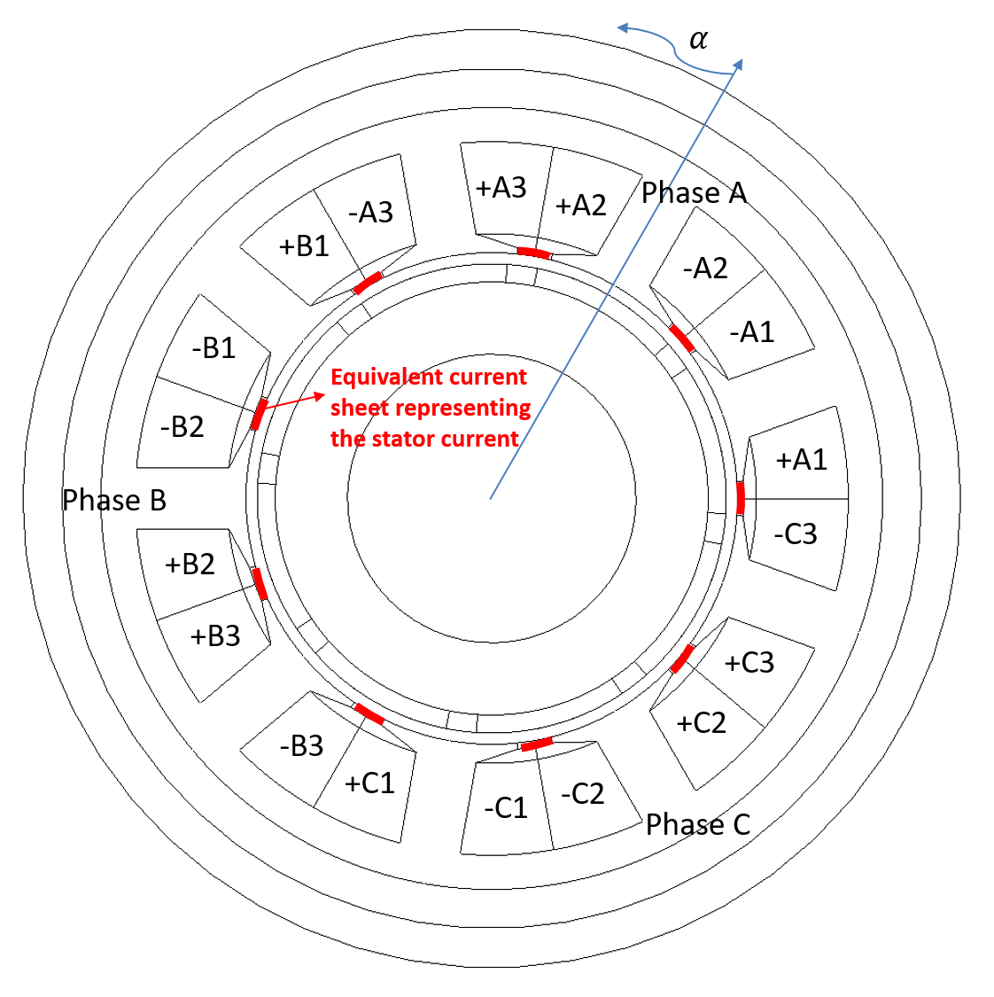
Figure 5.1 Stator current sheet distribution and zero axis
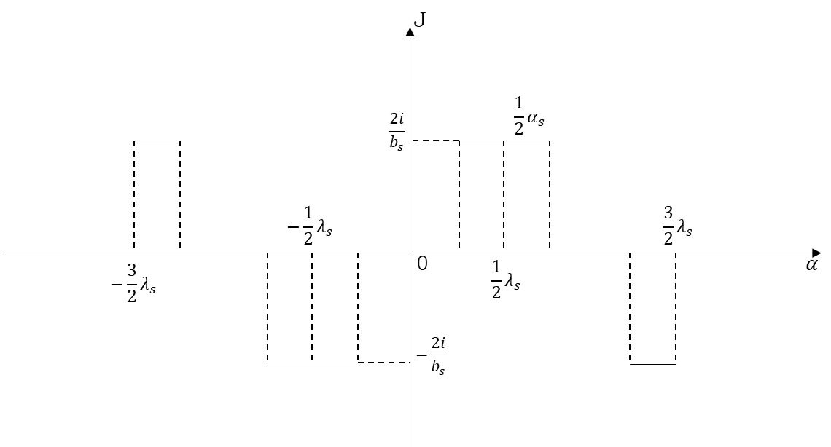
Figure 5.2 Current sheet distribution for one phase
This distribution can be represented as:
$$J\left(α,R_{s},t\right)=\left\{\begin{aligned}\frac{2i}{b_{s}} \frac{1}{2}\left(λ_{s}-α_{s}\right)≤α≤\frac{1}{2}\left(λ_{s}+α_{s}\right) or -\frac{3}{2}λ_{S}≤α≤-\frac{1}{2}(3λ_{S}+α_{S}) \\ -\frac{2i}{b_{s}} -\frac{1}{2}\left(λ_{s}+α_{s}\right)≤α≤-\frac{1}{2}\left(λ_{s}-α_{s}\right) or \frac{1}{2}(3λ_{S}-α_{S})≤α≤\frac{3}{2}λ_{S} \\ 0 other α\end{aligned}\right.$$ | (5.1)
where the stator slot pitch $λ_{s}$ is expressed in radian here
$$λ_{s}=\frac{2π}{N_{s}}$$ | (5.2)
$α_{s}$ is the slot opening in radian with expression
$$α_{s}=0.2×\frac{2π}{N_{s}}=\frac{2π}{45}$$ | (5.3)
$b_{s}$ is the slot opening in length with expression
$$b_{s}=0.2×\frac{2πR_{s}}{N_{s}}$$ | (5.4)
The total current assigned to each coil is:
$$i=\left\{\begin{aligned}\frac{N_{ph}M}{N_{s}}\sum_{n=1}^{∞}{I_{n}e^{j\left(npω_{r}t+θ_{n}\right)}} for phase a \\ \frac{N_{ph}M}{N_{s}}\sum_{n=1}^{∞}{I_{n}e^{j\left[n\left(pω_{r}t-\frac{2}{3}π\right)+θ_{n}\right]}} for phase b \\ \frac{N_{ph}M}{N_{s}}\sum_{n=1}^{∞}{I_{n}e^{j\left[n\left(pω_{r}t+\frac{2}{3}π\right)+θ_{n}\right]}} for phase c\end{aligned}\right.$$ | (5.5)
Since the spatial distribution of the current density $J\left(α,R_{s},t\right)$ satisfies the natural boundary condition, then:
$$J\left(α+2π,R_{s},t\right)=J\left(α,R_{s},t\right)$$ | (5.6)
This can be expanded into complex Fourier series with period $T=2π$:
$$J\left(α,R_{s},t\right)=\sum_{m=-∞}^{∞}{a_{m}e^{j\left(\frac{mπα}{l}\right)}}$$ | (5.7)
where, $l=0.5T=π$. The coefficients
$$a_{m}=\frac{1}{2l}\int_{-l}^{l}{f\left(ξ\right){\left(e^{j\left(\frac{mπξ}{l}\right)}\right)}^{*}dξ}=\frac{1}{T}\left[\int_{\frac{2}{45}T}^{\frac{1}{15}T}{\frac{2i}{b_{s}}{\left(e^{j\left(\frac{mπξ}{l}\right)}\right)}^{*}dξ}+\int_{-\frac{1}{6}T}^{-\frac{7}{45}T}{\frac{2i}{b_{s}}{\left(e^{j\left(\frac{mπξ}{l}\right)}\right)}^{*}dξ}-\int_{-\frac{1}{15}T}^{-\frac{2}{45}T}{\frac{2i}{b_{s}}{\left(e^{j\left(\frac{mπξ}{l}\right)}\right)}^{*}dξ}-\int_{\frac{7}{45}T}^{\frac{1}{6}T}{\frac{2i}{b_{s}}{\left(e^{j\left(\frac{mπξ}{l}\right)}\right)}^{*}dξ}\right]$$ | (5.8)
The integral
$$\int{{\left(e^{j\left(\frac{mπξ}{l}\right)}\right)}^{*}dξ}=\int{\left[\cos\left(\frac{mπξ}{l}\right)-j\sin\left(\frac{mπξ}{l}\right)\right]dξ}=\frac{l}{mπ}\sin\left(\frac{mπξ}{l}\right)+j\frac{l}{mπ}\cos\left(\frac{mπξ}{l}\right)=-\frac{l}{mπ}\cos\left(\frac{mπξ}{l}+\frac{π}{2}\right)+j\frac{l}{mπ}\sin\left(\frac{mπξ}{l}+\frac{π}{2}\right)=-\frac{l}{mπ}e^{-j\left(\frac{mπξ}{l}+\frac{π}{2}\right)}$$
Therefore,
$$a_{m}=\frac{2i}{Tb_{s}}\left[-\frac{l}{mπ}e^{-j\left(\frac{2}{15}mπ+\frac{π}{2}\right)}+\frac{l}{mπ}e^{-j\left(\frac{4}{45}mπ+\frac{π}{2}\right)}-\frac{l}{mπ}e^{-j\left(-\frac{14}{45}mπ+\frac{π}{2}\right)}+\frac{l}{mπ}e^{-j\left(-\frac{1}{3}mπ+\frac{π}{2}\right)}+\frac{l}{mπ}e^{-j\left(-\frac{4}{45}mπ+\frac{π}{2}\right)}-\frac{l}{mπ}e^{-j\left(-\frac{2}{15}mπ+\frac{π}{2}\right)}+\frac{l}{mπ}e^{-j\left(\frac{1}{3}mπ+\frac{π}{2}\right)}-\frac{l}{mπ}e^{-j\left(\frac{14}{45}mπ+\frac{π}{2}\right)}\right]=-\frac{i}{mπb_{s}}e^{-j\frac{π}{2}}\left(e^{-j\frac{2}{15}mπ}-e^{-j\frac{4}{45}mπ}+e^{j\frac{14}{45}mπ}-e^{j\frac{1}{3}mπ}-e^{j\frac{4}{45}mπ}+e^{j\frac{2}{15}mπ}-e^{-j\frac{1}{3}mπ}+e^{-j\frac{14}{45}mπ}\right)=\frac{i}{πb_{s}}C_{m}$$ | (5.9)
where
$$C_{m}=-\frac{1}{m}e^{-j\frac{π}{2}}\left(e^{-j\frac{2}{15}mπ}-e^{-j\frac{4}{45}mπ}+e^{j\frac{14}{45}mπ}-e^{j\frac{1}{3}mπ}-e^{j\frac{4}{45}mπ}+e^{j\frac{2}{15}mπ}-e^{-j\frac{1}{3}mπ}+e^{-j\frac{14}{45}mπ}\right)$$ | (5.10)
Since the spatial function of line current density is real function, and from Figure 5.2 it can be seen that the function is also odd function, with (5.9) substituted, the Fourier series (5.7) can be reformulated to:
$$J\left(α,R_{s},t\right)=\frac{i}{πb_{s}}\sum_{m=1}^{∞}{\left[C_{m}e^{jmα}+{C_{m}}^{*}e^{-jmα}\right]}$$ | (5.11)
The Fourier series of (5.11) contains all the spatial harmonics resulting from the distribution of phase A. Considering the spatial displacement between the three phases, and replacing $i$ with the time harmonics expression (5.5), the time and spatial harmonics for the entire stator current can be obtained:
$$J\left(α,R_{s},t\right)=\frac{N_{ph}M}{πN_{s}b_{s}}\sum_{n=1}^{∞}{I_{n}}\sum_{m=1}^{∞}{C_{m}\left\{e^{jmα}e^{j\left(npω_{r}t+θ_{n}\right)}+e^{jm\left(α-\frac{2}{3}π\right)}e^{j\left[n\left(pω_{r}t-\frac{2}{3}π\right)+θ_{n}\right]}+e^{jm\left(α+\frac{2}{3}π\right)}e^{j\left[n\left(pω_{r}t+\frac{2}{3}π\right)+θ_{n}\right]}\right\}+{C_{m}}^{*}\left\{e^{-jmα}e^{j\left(npω_{r}t+θ_{n}\right)}+e^{-jm\left(α-\frac{2}{3}π\right)}e^{j\left[n\left(pω_{r}t-\frac{2}{3}π\right)+θ_{n}\right]}+e^{-jm\left(α+\frac{2}{3}π\right)}e^{j\left[n\left(pω_{r}t+\frac{2}{3}π\right)+θ_{n}\right]}\right\}}=\frac{N_{ph}M}{πN_{s}b_{s}}\sum_{n=1}^{∞}{I_{n}}\sum_{m=1}^{∞}{C_{m}\left\{e^{j\left(npω_{r}t+θ_{n}+mα\right)}+e^{-j\left(m+n\right)\frac{2}{3}π}e^{j\left(npω_{r}t+θ_{n}+mα\right)}+e^{j\left(m+n\right)\frac{2}{3}π}e^{j\left(npω_{r}t+θ_{n}+mα\right)}\right\}+{C_{m}}^{*}\left\{e^{j\left(npω_{r}t+θ_{n}-mα\right)}+e^{j\left(m-n\right)\frac{2}{3}π}e^{j\left(npω_{r}t+θ_{n}-mα\right)}+e^{-j\left(m-n\right)\frac{2}{3}π}e^{j\left(npω_{r}t+θ_{n}-mα\right)}\right\}}=\frac{N_{ph}M}{πN_{s}b_{s}}\sum_{n=1}^{∞}{I_{n}}\sum_{m=1}^{∞}{C_{m}\left[1+e^{-j\left(m+n\right)\frac{2}{3}π}+e^{j\left(m+n\right)\frac{2}{3}π}\right]e^{j\left(npω_{r}t+θ_{n}+mα\right)}+{C_{m}}^{*}\left[1+e^{j\left(m-n\right)\frac{2}{3}π}+e^{-j\left(m-n\right)\frac{2}{3}π}\right]e^{j\left(npω_{r}t+θ_{n}-mα\right)}}$$ | (5.12)
In (5.12), the term
$$1+e^{-j\left(m±n\right)\frac{2}{3}π}+e^{j\left(m±n\right)\frac{2}{3}π}=1+2\cos\left[\left(m±n\right)\frac{2}{3}π\right]$$
Hence, when $m±n=3c$, where c is positive integers,
$$1+2\cos\left[\left(m±n\right)\frac{2}{3}π\right]=1+2\cos\left(2cπ\right)=3$$
Otherwise,
$$1+2\cos\left[\left(m±n\right)\frac{2}{3}π\right]=1+2×(-\frac{1}{2})=0$$
Therefore, the following result can be obtained
$$1+e^{-j\left(m±n\right)\frac{2}{3}π}+e^{j\left(m±n\right)\frac{2}{3}π}=\left\{\begin{aligned}0 when m±n≠3c \\ 3 when m±n=3c\end{aligned}\right.$$ | (5.13)
where $c=0, 1, 2, 3,⋯$
Thus, the expression for current density in current sheets including the spatial and time harmonics can be simplified into
$$J\left(α,R_{s},t\right)=\left\{\begin{aligned}\frac{N_{ph}M}{πN_{s}b_{s}}\sum_{n=1}^{∞}{\sum_{m=1}^{∞}{3I_{n}{C_{m}}^{*}e^{j\left(npω_{r}t+θ_{n}-mα\right)}}} when m=3c+n \\ \frac{N_{ph}M}{πN_{s}b_{s}}\sum_{n=1}^{∞}{\sum_{m=1}^{∞}{3I_{n}C_{m}e^{j\left(npω_{r}t+θ_{n}+mα\right)}}} when m=3c-n\end{aligned}\right.$$ | (5.14)
Substituting (5.4) into (5.14) yields:
$$J\left(α,R_{s},t\right)=\left\{\begin{aligned}\sum_{n=1}^{∞}{\sum_{m=0}^{∞}{J_{n}{C_{m}}^{*}e^{j\left(npω_{r}t+θ_{n}-mα\right)}}} when m=3c+n \\ \sum_{n=1}^{∞}{\sum_{m=0}^{∞}{J_{n}C_{m}e^{j\left(npω_{r}t+θ_{n}+mα\right)}}} when m=3c-n\end{aligned}\right.$$ | (5.15)
where
$$J_{n}=\frac{15N_{ph}M}{2π^{2}R_{s}}I_{n}$$ | (5.16)
Up to this point, the spatial distribution of stator current in the circumferential direction is analysed, and the corresponding spatial harmonics are captured. While this is sufficient for two-dimensional field calculation, this is not sufficient to solve the three-dimensional field and eddy current distribution in the regions of interest. Hence, the stator current distribution needs to be expanded into a third dimension, i.e. the axial distribution of the stator current needs to be defined and included into the formulation. Generally speaking, the stator current is composed of two components, the axial component, which is the component having the previously obtained spatial harmonics, and is the dominant component for torque production and eddy current induction. The circumferential component, exists in the end winding only to form the return path for each coil. This end-winding component has little influence over the field to which the vast majority of the rotor is exposed. It nevertheless contributes to the copper loss. As stated previously, since a square shape stator current circulating path is assumed, for the axial component of the stator current, the zero boundary condition is satisfied. Due to uniform distribution of axial component of current along the axis of the machine, the axial component of current has the following spatial distribution,
$$J_{z}\left(R_{s},α,z,t\right)=\left\{\begin{aligned}J\left(R_{s},α,t\right) z∈(0,L_{a}) \\ 0 elsewhere\end{aligned}\right.$$ | (5.17)
In this model, the method proposed in [12] is utilized to accommodate the zero boundary conditions applied to the axial component of current. The method adds two imaginary components contacting the boundary of the original axial stator current with equal quantities of current but of opposite polarity, i.e. direction. The zero boundary conditions can be made equivalent in this way since every contacting pair of currents will cancel with each other at the common boundary. The additional non-zero boundaries with the two imaginary components can be compensated in the same way, and thus this combination can be expanded along the positive and negative axial direction into infinity to form a periodic square waveform. Hence, the original axial distribution (5.17) is replaced with the following distribution
$$J_{z}\left(R_{s},α,z,t\right)=\left\{\begin{aligned}J\left(R_{s},α,t\right) z∈[2kL_{a},(2k+1)L_{a}) \\ -J\left(R_{s},α,t\right) z∈[\left(2k+1\right)L_{a},\left(2k+2\right)L_{a})\end{aligned}\right.$$ | (5.18)
which is illustrated in Figure 5.3
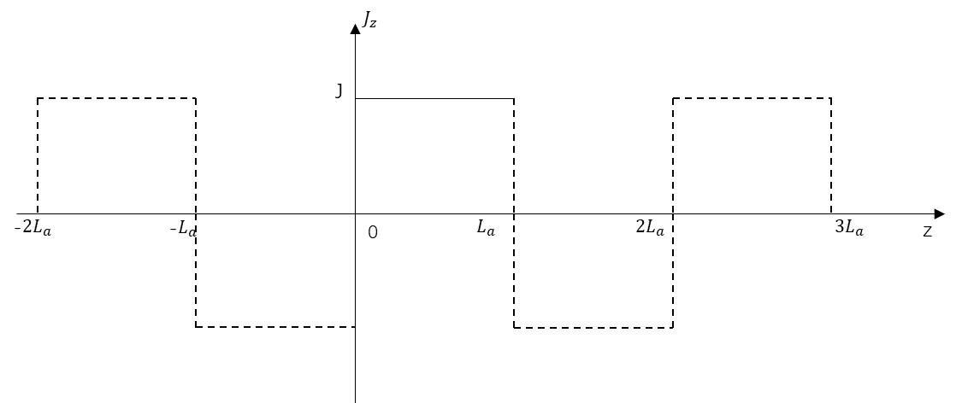
Figure 5.3 The axial spatial distribution of the axial stator current component
A Fourier expansion can be applied on the this axial spatial distribution with period $T=2L_{a}$, and finally (5.18) can be transformed into
$$J_{z}\left(R_{s},α,z,t\right)=J\left(R_{s},α,t\right)\sum_{l=odd}{\frac{4}{lπ}\sin\left(\frac{lπ}{L_{a}}z\right)}=\left\{\begin{aligned}\sum_{n=1}^{∞}{\sum_{m=0}^{∞}{J_{n}{C_{m}}^{*}e^{j\left(npω_{r}t+θ_{n}-mα\right)}}}\sum_{l=odd}{\frac{4}{lπ}\sin\left(\frac{lπ}{L_{a}}z\right)} when m=3c+n \\ \sum_{n=1}^{∞}{\sum_{m=0}^{∞}{J_{n}C_{m}e^{j\left(npω_{r}t+θ_{n}+mα\right)}}}\sum_{l=odd}{\frac{4}{lπ}\sin\left(\frac{lπ}{L_{a}}z\right)} when m=3c-n\end{aligned}\right.=\left\{\begin{aligned}\sum_{m,n,l}{\frac{4}{lπ}J_{n}{C_{m}}^{*}e^{j\left(npω_{r}t+θ_{n}-mα\right)}\sin\left(\frac{lπ}{L_{a}}z\right)} when m=3c+n \\ \sum_{m,n,l}{\frac{4}{lπ}J_{n}C_{m}e^{j\left(npω_{r}t+θ_{n}+mα\right)}\sin\left(\frac{lπ}{L_{a}}z\right)} when m=3c-n\end{aligned}\right.$$ | (5.19)
Since the eddy current is distributed in the rotor conducting area, which is rotating with speed $ω_{r}$ relative to the stator static reference system, it is more convenient to solve the eddy current distribution in the rotor reference system than in the stator reference system. The relationship between stator reference system and rotor reference system can be expressed as
$$α=θ+ω_{r}t$$ | (5.20)
Therefore, the stator current harmonics can be expressed inside rotor angular system to yield the final expression for the current distribution:
$$J_{z}\left(R_{s},θ,z,t\right)=\left\{\begin{aligned}\sum_{m,n,l}{\frac{4}{lπ}J_{n}{C_{m}}^{*}e^{j\left[npω_{r}t+θ_{n}-m\left(θ+ω_{r}t\right)\right]}\sin\left(\frac{lπ}{L_{a}}z\right)} when m=3c+n \\ \sum_{m,n,l}{\frac{4}{lπ}J_{n}C_{m}e^{j\left[npω_{r}t+θ_{n}+m\left(θ+ω_{r}t\right)\right]}\sin\left(\frac{lπ}{L_{a}}z\right)} when m=3c-n\end{aligned}\right.=\left\{\begin{aligned}\sum_{m,n,l}{\frac{4}{lπ}J_{n}{C_{m}}^{*}e^{j\left[\left(np-m\right)ω_{r}t+θ_{n}-mθ\right]}\sin\left(\frac{lπ}{L_{a}}z\right)} when m=3c+n \\ \sum_{m,n,l}{\frac{4}{lπ}J_{n}C_{m}e^{j\left[\left(np+m\right)ω_{r}t+θ_{n}+mθ\right]}\sin\left(\frac{lπ}{L_{a}}z\right)} when m=3c-n\end{aligned}\right.$$ | (5.21)

The composition of the analytical system
In the analytical model, the excitation source, i.e. the stator current, was already established in the previous section, and the corresponding time and spatial harmonics have been combined into a unified expression (5.21). The remaining machine problem domain is divided into three layers, viz. the airgap, the metallic sleeve, and rotor magnets as shown in Figure 5.4. Since the rotor magnets are insulated from each other with non-magnetic, non-conducting inter-pole regions, the inter-pole regions need to be treated differently from the magnets. Two locations will be encountered for the three layers:
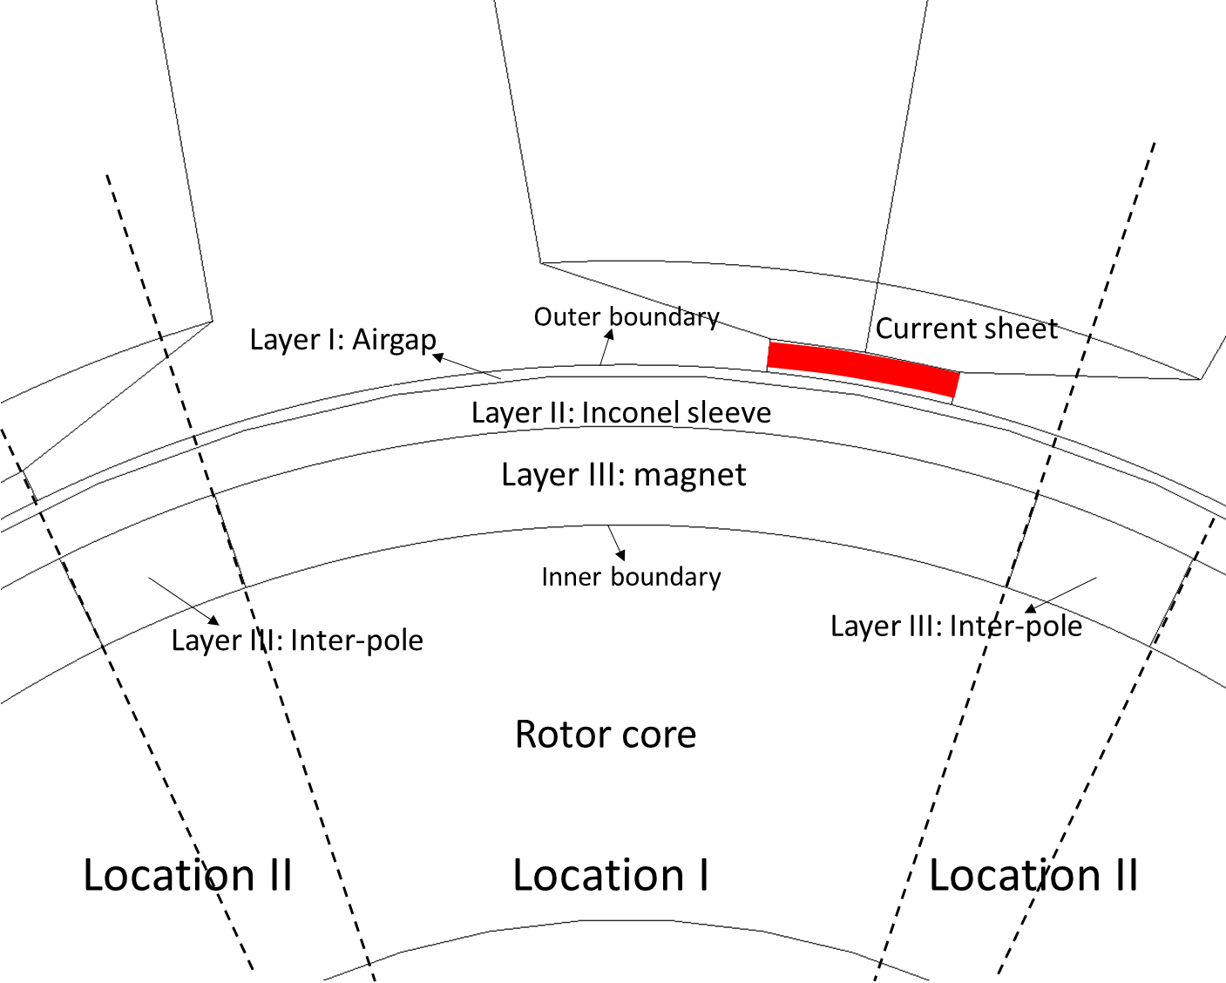
Figure 5.4 Illustration of 2D cross section of the system for analytical field and eddy current calculation
- Location I,
  - Layer I: the airgap
Since no eddy current and excitation current exist, the field in the airgap can be solved using the Laplace equation of vector potential:
$$∇^{2}{\vec{A}}_{I}=0$$ | (5.22)
  - Layer II: the metallic sleeve
Due to the presence of the induced eddy current, diffusion equation must be used to account for the eddy current reaction effect:
$$∇^{2}{\vec{J}}_{II}=σ_{sl}μ_{sl}\frac{∂{\vec{J}}_{II}}{∂t}$$ | (5.23)
  - Layer III: the conducting magnets
Similarly, in the electrically conducting magnets, the diffusion equation also needs to be used to solve for the field and eddy current distribution:
$$∇^{2}{\vec{J}}_{III}=σ_{m}μ_{m}\frac{∂{\vec{J}}_{III}}{∂t}$$ | (5.24)
- Location II,
For the parts of layer I and layer II that face the inter-pole regions of layer III, the same governing equations (5.22) and (5.23) are used. For the inter-pole regions, since there is no eddy current reaction and excitation source, the he governing equation is the Laplace equation:
$$∇^{2}{\vec{A}}_{IV}=0$$ | (5.25)
The stator current excitation contains both spatial and time harmonics. The time harmonics are a series of sinusoidal variations that have no coupling, the only interactions being with spatial harmonics to form a planar wave propagating in the airgap. Hence, the time harmonics can be separated from the spatial harmonics. Due to the sinusoidal time variation of the excitation source, the field should have the same behaviour in the time domain, i.e.:
$$\vec{A}=\vec{A}\left(r,θ,z\right)\sum_{n}{e^{j\left[\left(np±m\right)ω_{r}t+θ_{n}\right]}}$$ | (5.26)
$$\vec{J}=\vec{J}\left(r,θ,z\right)\sum_{n}{e^{j\left[\left(np±m\right)ω_{r}t+θ_{n}\right]}}$$ | (5.27)
Substituting (5.26) into the Laplace equation and (5.27) into the diffusion equation, and noting that the Laplace operator is only related to spatial variation yields:
$$∇^{2}\vec{A}\left(r,θ,z\right)\sum_{n}{e^{j\left[\left(np±m\right)ω_{r}t+θ_{n}\right]}}=0$$ | (5.28)
$$∇^{2}\vec{J}\left(r,θ,z\right)\sum_{n}{e^{j\left[\left(np±m\right)ω_{r}t+θ_{n}\right]}}=σμ\vec{J}\left(r,θ,z\right)\frac{∂}{∂t}\sum_{n}{e^{j\left[\left(np±m\right)ω_{r}t+θ_{n}\right]}}=j\left(np±m\right)ω_{r}σμ\vec{J}\left(r,θ,z\right)\sum_{n}{e^{j\left[\left(np±m\right)ω_{r}t+θ_{n}\right]}}$$ | (5.29)
For (5.28), since the time variation cannot remain at zero, it follows that
$$∇^{2}\vec{A}\left(r,θ,z\right)=0$$ | (5.30)
For (5.29), the following Helmholtz equation can be obtained
$$∇^{2}\vec{J}\left(r,θ,z\right)=j\left(np±m\right)ω_{r}σμ\vec{J}\left(r,θ,z\right)$$ | (5.31)
Hence, only the spatial variation of the field needs to be considered in the following derivation. The time variation can be simply added later onto the solved distribution to form a complete solution.
After the vector potential and eddy current distribution have been determined, the field components can be calculated correspondingly. For distribution solved by Laplace equation, the field can be calculated using:
$$\vec{B}=∇×\vec{A}=\left(\frac{1}{r}\frac{∂A_{z}}{∂θ}-\frac{∂A_{θ}}{∂z}\right)\vec{e_{r}}+\left(\frac{∂A_{r}}{∂z}-\frac{∂A_{z}}{∂r}\right)\vec{e_{θ}}+\left[\frac{1}{r}\frac{∂}{∂r}\left(rA_{θ}\right)-\frac{1}{r}\frac{∂A_{r}}{∂θ}\right]\vec{e_{z}}$$ | (5.32)
Since the component $A_{r}$ only relate to the field component $H_{α}$ and $H_{z}$, which are the minor contributors compared to the dominant radial field, it is reasonable to neglect $A_{r}$, and therefore:
$$\vec{B}=\left(\frac{1}{r}\frac{∂A_{z}}{∂θ}-\frac{∂A_{θ}}{∂z}\right)\vec{e_{r}}+\left(-\frac{∂A_{z}}{∂r}\right)\vec{e_{θ}}+\left[\frac{1}{r}\frac{∂}{∂r}\left(rA_{θ}\right)\right]\vec{e_{z}}$$ | (5.33)
Hence, the field components are given by:
$$\left.\begin{aligned}B_{r}=\frac{1}{r}\frac{∂A_{z}}{∂θ}-\frac{∂A_{θ}}{∂z} \\ H_{θ}=-\frac{1}{μ_{0}}\frac{∂A_{z}}{∂r} \\ H_{z}=\frac{1}{μ_{0}}\frac{1}{r}\frac{∂}{∂r}\left(rA_{θ}\right)=\frac{1}{μ_{0}}\left(\frac{1}{r}A_{θ}+\frac{∂A_{θ}}{∂r}\right)\end{aligned}\right\}$$ | (5.34)
For distribution solved by diffusion equation, the field components can be calculated using
$$\left.\begin{aligned}∇×\vec{E}=-\frac{∂\vec{B}}{∂t}=-j\left(np±m\right)ω_{r}\vec{B} \\ \vec{J}=σ\vec{E}\end{aligned}\right\}$$ | (5.35)
Hence,
$$\vec{B}=-\frac{1}{j\left(np±m\right)ω_{r}σ}∇×\vec{J}=-\frac{μ_{0}μ_{r}}{τ^{2}}∇×\vec{J}=-\frac{μ_{0}μ_{r}}{τ^{2}}\left\{\left(\frac{1}{r}\frac{∂J_{z}}{∂θ}-\frac{∂J_{θ}}{∂z}\right)\vec{e_{r}}+\left(\frac{∂J_{r}}{∂z}-\frac{∂J_{z}}{∂r}\right)\vec{e_{θ}}+\left[\frac{1}{r}\frac{∂}{∂r}\left(rJ_{θ}\right)-\frac{1}{r}\frac{∂J_{r}}{∂θ}\right]\vec{e_{z}}\right\}$$ | (5.36)
Since the component $J_{r}$ only relates to the field component $H_{α}$ and $H_{z}$, which are the minor contributors compared to the dominant radial field, it is reasonable to neglect $J_{r}$, and therefore:
$$\vec{B}=-\frac{μ_{0}μ_{r}}{τ^{2}}\left\{\left(\frac{1}{r}\frac{∂J_{z}}{∂θ}-\frac{∂J_{θ}}{∂z}\right)\vec{e_{r}}+\left(-\frac{∂J_{z}}{∂r}\right)\vec{e_{θ}}+\left[\frac{1}{r}\frac{∂}{∂r}\left(rJ_{θ}\right)\right]\vec{e_{z}}\right\}$$ | (5.37)
Hence, the field components are given by:
$$\left.\begin{aligned}B_{r}=-\frac{μ_{0}μ_{r}}{τ^{2}}\left(\frac{1}{r}\frac{∂J_{z}}{∂θ}-\frac{∂J_{θ}}{∂z}\right) \\ H_{θ}=\frac{1}{τ^{2}}\frac{∂J_{z}}{∂r} \\ H_{z}=-\frac{1}{τ^{2}}\frac{1}{r}\frac{∂}{∂r}\left(rJ_{θ}\right)=-\frac{1}{τ^{2}}\left(\frac{1}{r}J_{θ}+\frac{∂J_{θ}}{∂r}\right)\end{aligned}\right\}$$ | (5.38)
With governing equations alone, only general solutions can be obtained, which contain unresolved coefficients and reflect the general behaviour of the distribution corresponding to the equations. The application of appropriate boundary conditions yields a unique solution which is specific to the particular geometry and excitations. In this machine environment, the conditions on boundaries between different layers and the outer boundaries can be defined, and can be classified into two categories:
- Radial boundary conditions
Since the stator current is confined into thin current sheets and the stator core is assumed to be infinite permeable, the outer boundary of the problem domain is the stator inner bore surface ($r=R_{s}$), where the following conditions can be applied:
$$H_{θI}=J\left(R_{s},θ,z\right)$$ | (5.39)
$$H_{zI}=0$$ | (5.40)
with $J\left(R_{s},θ,z\right)$ being the spatial component of the stator current. At the interface between airgap and rotor metallic sleeve ($r=R_{sl}$), the following conditions can be applied:
$$B_{rI}=B_{rII}$$ | (5.41)
$$H_{θI}=H_{θII}$$ | (5.42)
$$H_{zI}=H_{zII}$$ | (5.43)
Since layer III is divided into magnet poles and inter-pole regions, the boundary condition needs to be adjusted for the different cases. For interfaces between the metallic sleeve and magnet poles ($r=R_{m}$), the following relationships exist:
$$B_{rII}=B_{rIII}$$ | (5.44)
$$H_{θII}=H_{θIII}$$ | (5.45)
$$H_{zII}=H_{zIII}$$ | (5.46)
while for interfaces between the metallic sleeve and inter-pole regions ($r=R_{m}$), the following relationships exist
$$B_{rII}=B_{rIV}$$ | (5.47)
$$H_{θII}=H_{θIV}$$ | (5.48)
$$H_{zII}=H_{zIV}$$ | (5.49)
Since the rotor core is also assumed to be infinite permeable, another outer boundary of the problem domain is the interface between layer III and rotor core. For magnet poles and rotor core, the conditions are
$$H_{θIII}=0$$ | (5.50)
$$H_{zIII}=0$$ | (5.51)
For inter-pole regions and rotor core, the conditions are
$$H_{θIV}=0$$ | (5.52)
$$H_{zIV}=0$$ | (5.53)
- Axial and circumferential boundary conditions
Since fringing effects at the ends of the airgap and rotor are not considered in this analysis, the field and eddy current are confined within the studied area, and hence for the axial outer boundaries of the machine environment, homogenous boundary conditions are satisfied. Specifically, for axial component of vector potential and eddy current, the first kind of homogenous boundary condition is satisfied:
$$A_{z}(z=0,L_{a})=0$$ | (5.54)
$$J_{z}(z=0,L_{a})=0$$ | (5.55)
and for the circumferential component of vector potential and eddy current, the second kind of homogenous boundary condition is satisfied:
$${\left.\frac{∂A_{θ}}{∂z}\right|}_{z=0,L_{a}}=0$$ | (5.56)
$${\left.\frac{∂J_{θ}}{∂z}\right|}_{z=0,L_{a}}=0$$ | (5.57)
The field and eddy current also satisfy the natural boundary condition:
$$A_{z}\left(r,θ+2π,z\right)=A_{z}\left(r,θ,z\right)$$ | (5.58)
$$A_{θ}\left(r,θ+2π,z\right)=A_{θ}\left(r,θ,z\right)$$ | (5.59)
$$J_{z}\left(r,θ+2π,z\right)=J_{z}\left(r,θ,z\right)$$ | (5.60)
$$J_{θ}\left(r,θ+2π,z\right)=J_{θ}\left(r,θ,z\right)$$ | (5.61)
Besides, there is also inner boundary conditions inside layer III, which the insulation boundary conditions between magnet poles and inter-pole regions, which will be discussed in detail in later derivations.
For the vector potential, the well-known Coulomb’s gauge can be applied which ensures the uniqueness of the definition of vector potential:
$$∇⋅\vec{A}=0$$ | (5.62)
In an insulated conductor, there will be zero net flow of eddy current from the conductor surface. On a micro scale, this means the divergence of eddy current is zero at every point of the conductor:
$$∇⋅\vec{J}=0$$ | (5.63)
In cylindrical coordinates, (5.62) and (5.63) can be expressed as
$$\frac{1}{r}\frac{∂}{∂r}\left(rA_{r}\right)+\frac{1}{r}\frac{∂A_{θ}}{∂θ}+\frac{∂A_{z}}{∂z}=0$$ | (5.64)
$$\frac{1}{r}\frac{∂}{∂r}\left(rJ_{r}\right)+\frac{1}{r}\frac{∂J_{θ}}{∂θ}+\frac{∂J_{z}}{∂z}=0$$ | (5.65)
Again neglecting $A_{r}$ and $J_{r}$, the following expressions can be obtained:
$$\frac{∂A_{z}}{∂z}=-\frac{1}{r}\frac{∂A_{θ}}{∂θ}$$ | (5.66)
$$\frac{∂J_{z}}{∂z}=-\frac{1}{r}\frac{∂J_{θ}}{∂θ}$$ | (5.67)
i.e. the increment of axial component vector potential (eddy current) in the axial direction is a consequence of the inverse increment of circumferential component vector potential (eddy current) in circumferential direction. This provides the coupling effect between the two components.
As can be seen from (5.19), there are two types of spatial harmonics in the stator current, one interacting with time harmonics to form the propagating wave that is in the same direction with rotor rotating, which is the first expression with $m=3c+n$, the other interacting to form a wave that is propagating in the opposite direction with the rotor rotation, which corresponds the second expression with $m=3c-n$. The contra-rotating propagating waves have higher relative speed to the rotor structures compared to the co-rotating waves. This is also evident in (5.21). Amongst the spatial harmonics that form to co-rotating field, there are certain orders that fulfil the following relationship with the time harmonics,
$$np-m=0$$ | (5.68)
According to (5.21), the relationship (5.68) means that the rotating field formed by the specific time and spatial harmonics would be synchronous with the rotor rotation, and hence will not generate eddy current in rotor conducting materials. For the fundamental time variation, i.e. $n=1$, the interaction with 4th order spatial harmonics would produce a synchronous rotating field, which is the dominant field component for the net torque production. For 15th order time harmonics, the interaction with 60th order spatial harmonics would also produce a synchronous rotating field, which also make a minor contribution on the net torque production. For these combinations of harmonics, the eddy current diffusion equation is no longer applicable to solve the field distribution in the conducting region, and Laplace equations can be used instead, viz. for those combinations of harmonics, the governing equations in conducting sleeves and rotor magnets would be
$$∇^{2}{\vec{A}}_{II}=0$$ | (5.69)
and
$$∇^{2}{\vec{A}}_{III}=0$$ | (5.70)
respectively. The established boundary conditions are still valid, though the field components need be calculated using (5.34) instead of (5.38) in conducting regions.

Reformation of the original boundary condition
The previous section demonstrates the composition of the analytical system. It is worth noting that there are in total 10 boundary conditions for each parallel case in the radial direction. Meanwhile, for the vector potential and eddy current, in which the radial component is not considered, there are two components, i.e. axial and circumferential components, to be solved by the governing equation for the general solution in each layer. As will be seen later, the general solution for each component has two coefficients in radial direction that need to be determined by applying boundary conditions. Hence, to generate a unique solution, there are in total 12 radial coefficients to be determined. Since the 10 boundary conditions can only establish 10 equations, it is clear that the 12 coefficients cannot be fully resolved by the existing boundary conditions. In this analytical model, the idea proposed in [12] is utilized here to accommodate this shortcoming with the use of the two constraint equations (5.62) and (5.63).
To start with, all the boundary conditions associated with the axial components, viz. $A_{z}$ and $J_{z}$, are listed as follows,
- For location I
$$\left.\begin{aligned}H_{θI}=J\left(R_{s},θ,z\right) \\ B_{rI}=B_{rII}, H_{θI}=H_{θII} \\ B_{rII}=B_{rIII}, H_{θII}=H_{θIII} \\ H_{θIII}=0\end{aligned}\right\}$$ | (5.71)
- For location II
$$\left.\begin{aligned}H_{θI}=J\left(R_{s},θ,z\right) \\ B_{rI}=B_{rII}, H_{θI}=H_{θII} \\ B_{rII}=B_{rIV}, H_{θII}=H_{θIV} \\ H_{θIV}=0\end{aligned}\right\}$$ | (5.72)
From (5.34) and (5.38), it is known that the tangential field strength is only related to the axial component of vector potential or eddy current, while the radial flux density is related to both axial and circumferential components. If the circumferential components are replaced by the axial components in the expressions for radial flux density, then the boundary conditions in (5.71) are sufficient to determine all the radial coefficients. To accomplish this, constraint equations are utilized.
For the axial component of vector potential, applying a further partial derivative of $z$, i.e. $\frac{∂}{∂z}$, to (5.66) yields
$$\frac{∂^{2}A_{z}}{∂z^{2}}=-\frac{1}{r}\frac{∂^{2}A_{θ}}{∂z∂θ}$$ | (5.73)
Meanwhile, since the radial flux density is continuous at all angular positions of the interfaces, it is differentiable. Applying a further partial derivative of $θ$, i.e. $\frac{∂}{∂θ}$, onto the expression for radial flux density in (5.34) yields:
$$\frac{∂B_{r}}{∂θ}=\frac{1}{r}\frac{∂^{2}A_{z}}{∂θ^{2}}-\frac{∂^{2}A_{θ}}{∂z∂θ}$$ | (5.74)
Substituting (5.73) into (5.74) gives:
$$\frac{∂B_{r}}{∂θ}=\frac{1}{r}\frac{∂^{2}A_{z}}{∂θ^{2}}+r\frac{∂^{2}A_{z}}{∂z^{2}}$$ | (5.75)
For the axial component of the eddy current, a similar derivation process could be carried out, leading to
$$\frac{∂B_{r}}{∂θ}=-\frac{μ_{0}μ_{r}}{τ^{2}}\left(\frac{1}{r}\frac{∂^{2}J_{z}}{∂θ^{2}}+r\frac{∂^{2}J_{z}}{∂z^{2}}\right)$$ | (5.76)
where,
$$τ^{2}=j\left(np±m\right)ω_{r}σμ_{0}μ_{r}$$ | (5.77)
In this way, the axial components $A_{z}$ and $J_{z}$ can be solved independently without considering the other components $A_{θ}$ and $J_{θ}$. Since (5.75) and (5.76) are partial derivative of radial flux density, the related boundary conditions need to be modified as well. The original boundary conditions for the two locations are:
- For location I
$$\left.\begin{aligned}B_{rI}=B_{rII} \\ B_{rII}=B_{rIII}\end{aligned}\right\}$$ | (5.78)
- For location II
$$\left.\begin{aligned}B_{rI}=B_{rII} \\ B_{rII}=B_{rIV}\end{aligned}\right\}$$ | (5.79)
If the radial flux densities from the two layers are equal at every angular position of the circular interface, their circumferential changing rate, i.e. $\frac{∂B_{r}}{∂θ}$, must be equal as well:
- For location I
$$\left.\begin{aligned}\frac{∂B_{rI}}{∂θ}=\frac{∂B_{rII}}{∂θ} \\ \frac{∂B_{rII}}{∂θ}=\frac{∂B_{rIII}}{∂θ}\end{aligned}\right\}$$ | (5.80)
- For location II
$$\left.\begin{aligned}\frac{∂B_{rI}}{∂θ}=\frac{∂B_{rII}}{∂θ} \\ \frac{∂B_{rII}}{∂θ}=\frac{∂B_{rIV}}{∂θ}\end{aligned}\right\}$$ | (5.81)
For axial components in the three layers, there are in total 6 radial coefficients to determine, and the 6 radial boundary conditions related to the axial components can set up 6 independent equations for the coefficients. Therefore, the system can be fully solved and the specific solutions can be determined.
After establishing solutions for $A_{z}$ and $J_{z}$, the circumferential components $A_{θ}$ and $J_{θ}$ can be calculated using the following indefinite integrals respectively, which are derived from the constraint equations:
$$A_{θ}=\int{-r\frac{∂A_{z}}{∂z}}dθ$$ | (5.82)
$$J_{θ}=\int{-r\frac{∂J_{z}}{∂z}}dθ$$ | (5.83)
The constants introduced by the indefinite integrals can be determined by the natural boundary condition and the insulation boundary conditions, which will be discussed in detail later.

General solutions for the governing equations
In this section, the governing equations for the axial components of vector potential and eddy current in different layers will be solved, with the assistance of homogenous boundary conditions.
- Layer I
In the airgap layer, Laplace equation (5.22) is used to solve the field distribution.
$$\left(∇^{2}A_{zI}\right){\vec{e}}_{z}+\left(∇^{2}A_{θI}\right){\vec{e}}_{θ}=0$$
Since only the axial component of vector potential is considered, only the following component of (5.22) needs to be solved
$$∇^{2}A_{zI}=0$$ | (5.84)
In cylindrical coordinates, (5.84) is expressed as
$$\frac{∂^{2}A_{zI}}{∂r^{2}}+\frac{1}{r}\frac{∂A_{zI}}{∂r}+\frac{1}{r^{2}}\frac{∂^{2}A_{zI}}{∂θ^{2}}+\frac{∂^{2}A_{zI}}{∂z^{2}}=0$$ | (5.85)
As mentioned previously, the variable separation method can be used for solving the partial differential equation. $A_{zI}$ can be expressed as the product of three independent functions in different dimensions:
$$A_{zI}=R\left(r\right)Φ\left(θ\right)Z\left(z\right)$$ | (5.86)
Substituting (5.86) into (5.85),
$$\frac{d^{2}R}{dr^{2}}ΦZ+\frac{1}{r}\frac{dR}{dr}ΦZ+\frac{1}{r^{2}}\frac{d^{2}Φ}{dθ^{2}}RZ+\frac{d^{2}Z}{dz^{2}}RΦ=0$$ | (5.87)
Dividing the two sides of (5.87) by $RΦZ$ gives
$$\frac{1}{R}\frac{d^{2}R}{dr^{2}}+\frac{1}{R}\frac{1}{r}\frac{dR}{dr}+\frac{1}{Φ}\frac{1}{r^{2}}\frac{d^{2}Φ}{dθ^{2}}=-\frac{1}{Z}\frac{d^{2}Z}{dz^{2}}$$ | (5.88)
The left-hand side of (5.88) is related to $r$ and $θ$, while the right-hand side is related to $z$. Hence, they cannot be equal to each other unless they are equal to the same constant, i.e.
$$\frac{1}{R}\frac{d^{2}R}{dr^{2}}+\frac{1}{R}\frac{1}{r}\frac{dR}{dr}+\frac{1}{Φ}\frac{1}{r^{2}}\frac{d^{2}Φ}{dθ^{2}}=-\frac{1}{Z}\frac{d^{2}Z}{dz^{2}}=-μ$$
Hence,
$$\left.\begin{aligned}Z^{''}-μZ=0 \\ \frac{1}{R}\frac{d^{2}R}{dr^{2}}+\frac{1}{R}\frac{1}{r}\frac{dR}{dr}+\frac{1}{Φ}\frac{1}{r^{2}}\frac{d^{2}Φ}{dθ^{2}}+μ=0\end{aligned}\right\}$$ | (5.89)
The second equation in (5.89) can be further reformulated into
$$r^{2}\frac{1}{R}\frac{d^{2}R}{dr^{2}}+r\frac{1}{R}\frac{dR}{dr}+\frac{1}{Φ}\frac{d^{2}Φ}{dθ^{2}}+μr^{2}=0$$
to give
$$r^{2}\frac{1}{R}\frac{d^{2}R}{dr^{2}}+r\frac{1}{R}\frac{dR}{dr}+μr^{2}=-\frac{1}{Φ}\frac{d^{2}Φ}{dθ^{2}}$$
Since the left-hand side is only related to dimension $r$, while the right-hand side is only related with dimension $z$, the two sides cannot be equal to each other unless they are equal to the same constant:
$$r^{2}\frac{1}{R}\frac{d^{2}R}{dr^{2}}+r\frac{1}{R}\frac{dR}{dr}+μr^{2}=-\frac{1}{Φ}\frac{d^{2}Φ}{dθ^{2}}=λ$$
Therefore,
$$\left.\begin{aligned}Φ^{''}+λΦ=0 \\ r^{2}\frac{1}{R}\frac{d^{2}R}{dr^{2}}+r\frac{1}{R}\frac{dR}{dr}+μr^{2}-λ=0\end{aligned}\right\}$$ | (5.90)
The second equation of the pair in (5.90) can be reformulated as:
$$\frac{d^{2}R}{dr^{2}}+\frac{1}{r}\frac{dR}{dr}+\left(μ-\frac{λ}{r^{2}}\right)R=0$$
Therefore, following variable separation, three independent differential equations, each related to only one dimension, can be obtained:
$$Z^{''}-μZ=0$$ | (5.91)
$$Φ^{''}+λΦ=0$$ | (5.92)
$$R^{''}+\frac{1}{r}R^{'}+\left(μ-\frac{λ}{r^{2}}\right)R=0$$ | (5.93)
For equation (5.91), if $μ>0$, the particular solution is
$$Z\left(z\right)=Ae^{\sqrt{λ}z}+Be^{-\sqrt{λ}z}$$
which does not satisfy the homogenous boundary condition at $z=0,L_{a}$.
If $μ=0$, the particular solution is
$$Z\left(z\right)=Az+B$$
which also does not satisfy the homogenous boundary condition.
If $μ<0$, letting $-μ=ν^{2}$, equation (5.91) becomes
$$Z^{''}+ν^{2}Z=0$$
the particular solution is
$$Z\left(z\right)=Acos\left(νz\right)+Bsin\left(νz\right)$$
Applying the homogenous boundary condition at $z=0,L_{a}$,.
$$A_{zI}(z=0)=0$$
$$A_{zI}(z=L_{a})=0$$
the following expressions can be obtained
$$A=0$$
$$Acos\left(νL_{a}\right)+Bsin\left(νL_{a}\right)=0$$
Therefore,
$$A=0$$
$$sin\left(νL_{a}\right)=0$$
Hence,
$$A=0$$
$$ν=\frac{lπ}{L_{a}} (l=0,1,2,3,…)$$
The general solution for $Z\left(z\right)$ is thus
$$Z\left(z\right)=\sum_{l=0}^{∞}{B_{l}\sin\left(\frac{lπ}{L_{a}}z\right)}$$ | (5.94)
For equation (5.92), combined with the natural boundary condition, the particular solution is
$$Φ\left(θ\right)=Ae^{j\sqrt{λ}θ}+Be^{-j\sqrt{λ}θ}$$
Applying the natural boundary condition
$$Φ\left(θ+2π\right)=Φ(θ)$$
The following equation can be obtained
$$Ae^{j\sqrt{λ}\left(θ+2π\right)}+Be^{-j\sqrt{λ}\left(θ+2π\right)}=Ae^{j\sqrt{λ}θ}+Be^{-j\sqrt{λ}θ}$$
which can be reformulated into using the Euler’s law:
$$\left(A+B\right)\cos\left[\sqrt{λ}\left(θ+2π\right)\right]+\left(A-B\right)j\sin\left[\sqrt{λ}\left(θ+2π\right)\right]=\left(A+B\right)\cos{\sqrt{λ}θ}+(A-B)j\sin{\sqrt{λ}θ}$$ | (5.95)
Since the cos function has a period of $2π$, (5.95) can be transformed into
$$\left(A+B\right)\cos\left[\sqrt{λ}\left(θ+2π\right)\right]+\left(A-B\right)j\sin\left[\sqrt{λ}\left(θ+2π\right)\right]=\left(A+B\right)\cos\left(\sqrt{λ}θ+2mπ\right)+(A-B)j\sin\left(\sqrt{λ}θ+2mπ\right)$$
Therefore,
$$\sqrt{λ}=m$$
hence,
$$λ=m^{2}$$
where,
$$m=0,1,2,3,…$$
Therefore, the general solution for $Φ(θ)$ is
$$Φ\left(θ\right)=\sum_{m=0}^{∞}{\left(A_{m}e^{jmθ}+B_{m}e^{-jmθ}\right)}$$ | (5.96)
Substituting the expressions for $μ$ and $λ$ into equation (5.93), the following equation can be obtained
$$\frac{d^{2}R}{dr^{2}}+\frac{1}{r}\frac{dR}{dr}-\left(ν^{2}+\frac{m^{2}}{r^{2}}\right)R=0$$ | (5.97)
Introducing a new variable $x=νr$, then the first order derivative in (5.97) can be transformed as follows
$$\frac{dR}{dr}=\frac{dR}{dx}\frac{dx}{dr}=ν\frac{dR}{dx}$$ | (5.98)
and the second order derivative in (5.97) can also be transformed as
$$\frac{d^{2}R}{dr^{2}}=\frac{d}{dr}\left(\frac{dR}{dr}\right)=ν\frac{d}{dx}\left(ν\frac{dR}{dx}\right)=ν^{2}\frac{d^{2}R}{dx^{2}}$$ | (5.99)
By substituting (5.98) and (5.99), then (5.97) can be transformed into
$$ν^{2}\frac{d^{2}R}{dx^{2}}+\frac{ν^{2}}{x}\frac{dR}{dx}-\left(ν^{2}+\frac{ν^{2}m^{2}}{x^{2}}\right)R=0$$ | (5.100)
Dividing the two sides of (5.100) by $ν^{2}$ yields
$$\frac{d^{2}R}{dx^{2}}+\frac{1}{x}\frac{dR}{dx}-\left(1+\frac{m^{2}}{x^{2}}\right)R=0$$ | (5.101)
(5.101) is the $m$ order modified Bessel equation, whose general solution is
$$R\left(νr\right)=\sum_{m=0}^{∞}{\left[C_{1m}I_{m}\left(νr\right)+C_{2m}K_{m}\left(νr\right)\right]}$$ | (5.102)
where $I_{m}\left(x\right)$ is the $m$ order modified Bessel function of the first kind, and $K_{m}\left(x\right)$ is the $m$ order modified Bessel function of the second kind.
Substituting (5.94), (5.96), and (5.102) into (5.86), the general solution for $A_{zI}$ is
$$A_{zI}=\sum_{m=0}^{∞}{\sum_{l=0}^{∞}{\left[A_{mzI}I_{m}\left(νr\right)+B_{mzI}K_{m}\left(νr\right)\right]\left(C_{mzI}e^{jmθ}+D_{mzI}e^{-jmθ}\right)\left[E_{lzI}\sin\left(\frac{lπ}{L_{a}}z\right)\right]}}$$ | (5.103)

- Layer II
For the spatial harmonics that generate synchronous rotating fields, the governing equation for the axial component in layer II is
$$∇^{2}A_{zII}=0$$
Using the same variable separation method for solving the Laplace equation that was used in layer I, the general solution can be obtained as
$$A_{zII}=\sum_{m=0}^{∞}{\sum_{l=0}^{∞}{\left[A_{mzII}I_{m}\left(νr\right)+B_{mzII}K_{m}\left(νr\right)\right]\left(C_{mzII}e^{jmθ}+D_{mzII}e^{-jmθ}\right)\left[E_{lzII}\sin\left(\frac{lπ}{L_{a}}z\right)\right]}}$$ | (5.104)
For other spatial harmonics which do not give rise to synchronous rotating fields, the diffusion equation (5.23) must be solved to establish the field distribution. With time harmonics separated, the following Helmholtz equation for the axial component can be obtained,
$$∇^{2}J_{zII}={τ_{sl}}^{2}J_{zII}$$ | (5.105)
where
$${τ_{sl}}^{2}=j\left(np±m\right)ω_{r}σ_{sl}μ_{sl}μ_{0}$$ | (5.106)
In cylindrical coordinate system, equation (5.105) becomes
$$\frac{∂^{2}J_{zII}}{∂r^{2}}+\frac{1}{r}\frac{∂J_{zII}}{∂r}+\frac{1}{r^{2}}\frac{∂^{2}J_{zII}}{∂θ^{2}}+\frac{∂^{2}J_{zII}}{∂z^{2}}={τ_{sl}}^{2}J_{zII}$$ | (5.107)
Using variable separation method, $J_{zII}$ can be expressed as
$$J_{zII}=R\left(r\right)Φ\left(θ\right)Z(z)$$ | (5.108)
Substituting (5.108), the partial differential equation (5.107) becomes
$$\frac{d^{2}R}{dr^{2}}ΦZ+\frac{1}{r}\frac{dR}{dr}ΦZ+\frac{1}{r^{2}}\frac{d^{2}Φ}{dθ^{2}}RZ+\frac{d^{2}Z}{dz^{2}}RΦ={τ_{sl}}^{2}RΦZ$$
Dividing the above equation by $RΦZ$ gives
$$\frac{1}{R}\frac{d^{2}R}{dr^{2}}+\frac{1}{R}\frac{1}{r}\frac{dR}{dr}+\frac{1}{Φ}\frac{1}{r^{2}}\frac{d^{2}Φ}{dθ^{2}}+\frac{1}{Z}\frac{d^{2}Z}{dz^{2}}={τ_{sl}}^{2}$$
and hence
$$\frac{1}{R}\frac{d^{2}R}{dr^{2}}+\frac{1}{R}\frac{1}{r}\frac{dR}{dr}+\frac{1}{Φ}\frac{1}{r^{2}}\frac{d^{2}Φ}{dθ^{2}}-{τ_{sl}}^{2}=-\frac{1}{Z}\frac{d^{2}Z}{dz^{2}}$$ | (5.109)
The left-hand side of (5.109) is only related with dimensions $r$ and $θ$, while the right-hand side is only related with dimension $z$. They cannot be equal to each other unless they are equal to the same constant:
$$\frac{1}{R}\frac{d^{2}R}{dr^{2}}+\frac{1}{R}\frac{1}{r}\frac{dR}{dr}+\frac{1}{Φ}\frac{1}{r^{2}}\frac{d^{2}Φ}{dθ^{2}}-{τ_{sl}}^{2}=-\frac{1}{Z}\frac{d^{2}Z}{dz^{2}}=-μ$$
Therefore,
$$\left.\begin{aligned}Z^{''}-μZ=0 \\ \frac{1}{R}\frac{d^{2}R}{dr^{2}}+\frac{1}{R}\frac{1}{r}\frac{dR}{dr}+\frac{1}{Φ}\frac{1}{r^{2}}\frac{d^{2}Φ}{dθ^{2}}-{τ_{sl}}^{2}+μ=0\end{aligned}\right\}$$ | (5.110)
The second equation in (5.110) can be further reformulated into
$$r^{2}\frac{1}{R}\frac{d^{2}R}{dr^{2}}+r\frac{1}{R}\frac{dR}{dr}-\left({τ_{sl}}^{2}-μ\right)r^{2}=-\frac{1}{Φ}\frac{d^{2}Φ}{dθ^{2}}$$ | (5.111)
The left-hand side of (5.111) is only related with dimension $r$, while the right-hand side is only related with dimension $θ$. They are not equal to each other unless they are equal to the same constant:
$$r^{2}\frac{1}{R}\frac{d^{2}R}{dr^{2}}+r\frac{1}{R}\frac{dR}{dr}-\left({τ_{sl}}^{2}-μ\right)r^{2}=-\frac{1}{Φ}\frac{d^{2}Φ}{dθ^{2}}=λ$$
Therefore,
$$\left.\begin{aligned}Φ^{''}+λΦ=0 \\ r^{2}\frac{1}{R}\frac{d^{2}R}{dr^{2}}+r\frac{1}{R}\frac{dR}{dr}-\left({τ_{sl}}^{2}-μ\right)r^{2}-λ=0\end{aligned}\right\}$$ | (5.112)
The second equation in (5.112) can be reformulated into
$$\frac{d^{2}R}{dr^{2}}+\frac{1}{r}\frac{dR}{dr}-\left({τ_{sl}}^{2}-μ+\frac{λ}{r^{2}}\right)R=0$$
Hence, three independent equations are obtained after variable separation:
$$Z^{''}-μZ=0$$ | (5.113)
$$Φ^{''}+λΦ=0$$ | (5.114)
$$\frac{d^{2}R}{dr^{2}}+\frac{1}{r}\frac{dR}{dr}-\left({τ_{sl}}^{2}-μ+\frac{λ}{r^{2}}\right)R=0$$ | (5.115)
For equation (5.113), if $μ>0$, the particular solution is
$$Z=Ae^{\sqrt{μ}z}+Be^{-\sqrt{μ}z}$$
which does not satisfy the homogenous boundary conditions at $z=0,L_{a}$.
If $μ=0$, the particular solution is
$$Z=Az+B$$
which also does not satisfy the homogenous boundary conditions.
If $μ<0$, letting $-μ=ν^{2}$, equation (5.113) becomes
$$Z^{''}+ν^{2}Z=0$$
The particular solution is
$$Z=A\cos{νz}+B\sin{νz}$$
Applying the homogenous boundary condition at $z=0,L_{a}$, viz.
$$J_{zII}(z=0)=0$$
$$J_{zII}(z=L_{a})=0$$
the following equations can be obtained
$$A=0$$
$$Acos\left(νL_{a}\right)+Bsin\left(νL_{a}\right)=0$$
which means
$$A=0$$
$$sin\left(νL_{a}\right)=0$$
Hence,
$$A=0$$
$$ν=\frac{lπ}{L_{a}} (l=0,1,2,3,…)$$
The general solution for $Z\left(z\right)$ is thus
$$Z\left(z\right)=\sum_{l=0}^{∞}{B_{l}\sin\left(\frac{lπ}{L_{a}}z\right)}$$ | (5.116)
For equation (5.114), combined with the natural boundary condition for circumferential component, the particular solution is
$$Φ=Ae^{j\sqrt{λ}θ}+Be^{-j\sqrt{λ}θ}$$
Applying the natural boundary condition
$$Φ\left(θ+2π\right)=Φ(θ)$$
The following equation can be obtained
$$Ae^{j\sqrt{λ}\left(θ+2π\right)}+Be^{-j\sqrt{λ}\left(θ+2π\right)}=Ae^{j\sqrt{λ}θ}+Be^{-j\sqrt{λ}θ}$$
and hence,
$$\left(A+B\right)\cos\left[\sqrt{λ}\left(θ+2π\right)\right]+\left(A-B\right)j\sin\left[\sqrt{λ}\left(θ+2π\right)\right]=\left(A+B\right)\cos{\sqrt{λ}θ}+(A-B)j\sin{\sqrt{λ}θ}$$
Since the cos function has a period of $2π$, the above equation can be transformed into
$$\left(A+B\right)\cos\left[\sqrt{λ}\left(θ+2π\right)\right]+\left(A-B\right)j\sin\left[\sqrt{λ}\left(θ+2π\right)\right]=\left(A+B\right)\cos\left(\sqrt{λ}θ+2mπ\right)+(A-B)j\sin\left(\sqrt{λ}θ+2mπ\right)$$
Hence,
$$\sqrt{λ}=m$$
which means
$$λ=m^{2}$$
where,
$$m=0,1,2,3,…$$
The general solution for $Φ(θ)$ is thus
$$Φ\left(θ\right)=\sum_{m=0}^{∞}{\left(A_{m}e^{jmθ}+B_{m}e^{-jmθ}\right)}$$ | (5.117)
Substituting the expressions for $μ$ and $λ$, equation (5.115) becomes
$$\frac{d^{2}R}{dr^{2}}+\frac{1}{r}\frac{dR}{dr}-\left({τ_{sl}}^{2}+ν^{2}+\frac{m^{2}}{r^{2}}\right)R=0$$
Introducing a new variable ${μ_{1}}^{'}={τ_{sl}}^{2}+ν^{2}$, and $x=\sqrt{{μ_{1}}^{'}}r$, equation (5.115) can be transformed into
$$\frac{d^{2}R}{dx^{2}}+\frac{1}{x}\frac{dR}{dx}-\left(1+\frac{m^{2}}{x^{2}}\right)R=0$$ | (5.118)
(5.118) is the m order modified Bessel equation, whose general solution is
$$R\left(\sqrt{μ^{'}}r\right)=\sum_{m=0}^{∞}{\left[C_{1m}I_{m}\left(\sqrt{{μ_{1}}^{'}}r\right)+C_{2m}K_{m}\left(\sqrt{{μ_{1}}^{'}}r\right)\right]}$$ | (5.119)
Substituting (5.116), (5.117), and (5.119) into (5.108), the general solution for $J_{zII}$ is
$$J_{zII}=\sum_{m=0}^{∞}{\sum_{l=0}^{∞}{\left[A_{mzII}I_{m}\left(\sqrt{{μ_{1}}^{'}}r\right)+B_{mzII}K_{m}\left(\sqrt{{μ_{1}}^{'}}r\right)\right]\left(C_{mzII}e^{jmθ}+D_{mzII}e^{-jmθ}\right)\left[E_{lzII}\sin\left(\frac{lπ}{L_{a}}z\right)\right]}}$$ | (5.120)
- Layer III
- Location I (rotor magnets)
As will be discussed later, some harmonics which generate eddy current loss in the metallic sleeve no longer generate eddy current loss in the magnets due to circumferential insulating boundary conditions between magnets and inter-pole regions. For the harmonics which do not generate eddy currents in magnets, the governing equation for the axial component in the magnets is
$$∇^{2}A_{zIII}=0$$ | (5.121)
Using the same variable separation method for solving the Laplace equation in layer I, the general solution for (5.121) can be obtained:
$$A_{zIII}=\sum_{m=0}^{∞}{\sum_{l=0}^{∞}{\left[A_{mzIII}I_{m}\left(νr\right)+B_{mzIII}K_{m}\left(νr\right)\right]\left(C_{mzIII}e^{jmθ}+D_{mzIII}e^{-jmθ}\right)\left[E_{lzIII}\sin\left(\frac{lπ}{L_{a}}z\right)\right]}}$$ | (5.122)
For other spatial harmonics, the diffusion equation (5.24) is used to solve the field distribution. With time harmonics separated, the following Helmholtz equation for the axial component can be obtained,
$$∇^{2}J_{zIII}={τ_{m}}^{2}J_{zIII}$$ | (5.123)
where
$${τ_{m}}^{2}=j\left(np±m\right)ω_{r}σ_{m}μ_{m}μ_{0}$$ | (5.124)
Using the same variable separation method for solving the Helmholtz equation in the layer II, the general solution for $J_{zIII}$ is obtained as
$$J_{zIII}=\sum_{m=0}^{∞}{\sum_{l=0}^{∞}{\left[A_{mzIII}I_{m}\left(\sqrt{{μ_{2}}^{'}}r\right)+B_{mzIII}K_{m}\left(\sqrt{{μ_{2}}^{'}}r\right)\right]\left(C_{mzIII}e^{jmθ}+D_{mzIII}e^{-jmθ}\right)\left[E_{lzIII}\sin\left(\frac{lπ}{L_{a}}z\right)\right]}}$$ | (5.125)
where
$${μ_{2}}^{'}={τ_{m}}^{2}+ν^{2}$$ | (5.126)
- Location II (inter-pole regions)
For all the spatial harmonics in the non-conducting inter-pole regions, the Laplace equation is the governing equation for field solutions. For the axial component, this means
$$∇^{2}A_{zIV}=0$$ | (5.127)
Using the same variable separation method, the general solution for $A_{zIV}$ can be obtained:
$$A_{zIV}=\sum_{m=0}^{∞}{\sum_{l=0}^{∞}{\left[A_{mzIV}I_{m}\left(νr\right)+B_{mzIV}K_{m}\left(νr\right)\right]\left(C_{mzIV}e^{jmθ}+D_{mzIV}e^{-jmθ}\right)\left[E_{lzIV}\sin\left(\frac{lπ}{L_{a}}z\right)\right]}}$$ | (5.128)

Application of boundary conditions
After the general solutions for different layers in the two locations have been established, the radial boundary conditions can be applied to determine the unresolved coefficients in the general solutions to finally obtain the specific solutions describing the field distribution in the problem domain.
To start with, the field components need to be calculated. Since the original boundary conditions for radial flux density are reformulated into forms using the spatial derivative of radial flux densities, the derivatives are calculated here, and the expressions for radial flux densities will be derived later.
- Layer I
The first order derivative of radial flux density is given by:
$$\frac{∂B_{rI}}{∂θ}=\frac{1}{r}\frac{∂^{2}A_{zI}}{∂θ^{2}}+r\frac{∂^{2}A_{zI}}{∂z^{2}}=\sum_{m=0}^{∞}{\sum_{l=0}^{∞}{\left[A_{mzI}\frac{1}{r}I_{m}\left(νr\right)+B_{mzI}\frac{1}{r}K_{m}\left(νr\right)\right]\left(-m^{2}C_{mzI}e^{jmθ}-m^{2}D_{mzI}e^{-jmθ}\right)\left[E_{lzI}\sin\left(\frac{lπ}{L_{a}}z\right)\right]}}+\sum_{m=0}^{∞}{\sum_{l=0}^{∞}{\left[A_{mzI}rI_{m}\left(νr\right)+B_{mzI}rK_{m}\left(νr\right)\right]\left(C_{mzI}e^{jmθ}+D_{mzI}e^{-jmθ}\right)\left[-{\left(\frac{lπ}{L_{a}}\right)}^{2}E_{lzI}\sin\left(\frac{lπ}{L_{a}}z\right)\right]}}=-\sum_{m=0}^{∞}{\sum_{l=0}^{∞}{\left\{\left[\frac{m^{2}}{r}+r{\left(\frac{lπ}{L_{a}}\right)}^{2}\right]A_{mzI}I_{m}\left(νr\right)+\left[\frac{m^{2}}{r}+r{\left(\frac{lπ}{L_{a}}\right)}^{2}\right]B_{mzI}K_{m}\left(νr\right)\right\}\left(C_{mzI}e^{jmθ}+D_{mzI}e^{-jmθ}\right)\left[E_{lzI}\sin\left(\frac{lπ}{L_{a}}z\right)\right]}}$$ | (5.129)
The tangential field strength is given by:
$$H_{θI}=-\frac{1}{μ_{0}}\frac{∂A_{zI}}{∂r}=-\frac{1}{μ_{0}}\sum_{m=0}^{∞}{\sum_{l=0}^{∞}{\left[νA_{mzI}{I_{m}}^{'}\left(νr\right)+νB_{mzI}{K_{m}}^{'}\left(νr\right)\right]\left(C_{mzI}e^{jmθ}+D_{mzI}e^{-jmθ}\right)\left[E_{lzI}\sin\left(\frac{lπ}{L_{a}}z\right)\right]}}$$ | (5.130)
- layer II
- For the spatial harmonics generating synchronous rotating field, the first order spatial derivative of radial flux density is
$$\frac{∂B_{rII}}{∂θ}=\frac{1}{r}\frac{∂^{2}A_{zII}}{∂θ^{2}}+r\frac{∂^{2}A_{zII}}{∂z^{2}}=-\sum_{m=0}^{∞}{\sum_{l=0}^{∞}{\left\{\left[\frac{m^{2}}{r}+r{\left(\frac{lπ}{L_{a}}\right)}^{2}\right]A_{mzII}I_{m}\left(νr\right)+\left[\frac{m^{2}}{r}+r{\left(\frac{lπ}{L_{a}}\right)}^{2}\right]B_{mzII}K_{m}\left(νr\right)\right\}\left(C_{mzII}e^{jmθ}+D_{mzII}e^{-jmθ}\right)\left[E_{lzII}\sin\left(\frac{lπ}{L_{a}}z\right)\right]}}$$ | (5.131)
and the tangential field strength
$$H_{θII}=-\frac{1}{μ_{0}}\frac{∂A_{zII}}{∂r}=-\frac{1}{μ_{0}}\sum_{m=0}^{∞}{\sum_{l=0}^{∞}{\left[νA_{mzII}{I_{m}}^{'}\left(νr\right)+νB_{mzII}{K_{m}}^{'}\left(νr\right)\right]\left(C_{mzII}e^{jmθ}+D_{mzII}e^{-jmθ}\right)\left[E_{lzII}\sin\left(\frac{lπ}{L_{a}}z\right)\right]}}$$ | (5.132)
- For spatial harmonics generating eddy currents, the spatial derivative of radial flux density is
$$\frac{∂B_{rII}}{∂θ}=-\frac{μ_{0}μ_{sl}}{{τ_{sl}}^{2}}\left(\frac{1}{r}\frac{∂^{2}J_{zII}}{∂θ^{2}}+r\frac{∂^{2}J_{zII}}{∂z^{2}}\right)=-\frac{μ_{0}μ_{sl}}{{τ_{sl}}^{2}}\left\{\sum_{m=0}^{∞}{\sum_{l=0}^{∞}{\left[A_{mzII}\frac{1}{r}I_{m}\left(\sqrt{{μ_{1}}^{'}}r\right)+B_{mzII}\frac{1}{r}K_{m}\left(\sqrt{{μ_{1}}^{'}}r\right)\right]\left(-m^{2}C_{mzII}e^{jmθ}-m^{2}D_{mzII}e^{-jmθ}\right)\left[E_{lzII}\sin\left(\frac{lπ}{L_{a}}z\right)\right]}}+\sum_{m=0}^{∞}{\sum_{l=0}^{∞}{\left[A_{mzII}rI_{m}\left(\sqrt{{μ_{1}}^{'}}r\right)+B_{mzII}rK_{m}\left(\sqrt{{μ_{1}}^{'}}r\right)\right]\left(C_{mzII}e^{jmθ}+D_{mzII}e^{-jmθ}\right)\left[-{\left(\frac{lπ}{L_{a}}\right)}^{2}E_{lzII}\sin\left(\frac{lπ}{L_{a}}z\right)\right]}}\right\}=\frac{μ_{0}μ_{sl}}{{τ_{sl}}^{2}}\sum_{m=0}^{∞}{\sum_{l=0}^{∞}{\left\{\left[\frac{m^{2}}{r}+r{\left(\frac{lπ}{L_{a}}\right)}^{2}\right]A_{mzII}I_{m}\left(\sqrt{{μ_{1}}^{'}}r\right)+\left[\frac{m^{2}}{r}+r{\left(\frac{lπ}{L_{a}}\right)}^{2}\right]B_{mzII}K_{m}\left(\sqrt{{μ_{1}}^{'}}r\right)\right\}\left(C_{mzII}e^{jmθ}+D_{mzII}e^{-jmθ}\right)\left[E_{lzII}\sin\left(\frac{lπ}{L_{a}}z\right)\right]}}$$ | (5.133)
and the tangential field strength
$$H_{θII}=\frac{1}{{τ_{sl}}^{2}}\frac{∂J_{zII}}{∂r}=\frac{1}{{τ_{sl}}^{2}}\sum_{m=0}^{∞}{\sum_{l=0}^{∞}{\left[\sqrt{{μ_{1}}^{'}}A_{mzII}{I_{m}}^{'}\left(\sqrt{{μ_{1}}^{'}}r\right)+\sqrt{{μ_{1}}^{'}}B_{mzII}{K_{m}}^{'}\left(\sqrt{{μ_{1}}^{'}}r\right)\right]\left(C_{mzII}e^{jmθ}+D_{mzII}e^{-jmθ}\right)\left[E_{lzII}\sin\left(\frac{lπ}{L_{a}}z\right)\right]}}$$ | (5.134)
- layer III
- Location I (rotor magnets)
- For spatial harmonics that do not generate eddy currents, the spatial derivative of radial flux density is
$$\frac{∂B_{rIII}}{∂θ}=\frac{1}{r}\frac{∂^{2}A_{zIII}}{∂θ^{2}}+r\frac{∂^{2}A_{zIII}}{∂z^{2}}=-\sum_{m=0}^{∞}{\sum_{l=0}^{∞}{\left\{\left[\frac{m^{2}}{r}+r{\left(\frac{lπ}{L_{a}}\right)}^{2}\right]A_{mzIII}I_{m}\left(νr\right)+\left[\frac{m^{2}}{r}+r{\left(\frac{lπ}{L_{a}}\right)}^{2}\right]B_{mzIII}K_{m}\left(νr\right)\right\}\left(C_{mzIII}e^{jmθ}+D_{mzIII}e^{-jmθ}\right)\left[E_{lzIII}\sin\left(\frac{lπ}{L_{a}}z\right)\right]}}$$ | (5.135)
and the tangential field strength
$$H_{θIII}=-\frac{1}{μ_{0}}\frac{∂A_{zIII}}{∂r}=-\frac{1}{μ_{0}}\sum_{m=0}^{∞}{\sum_{l=0}^{∞}{\left[νA_{mzIII}{I_{m}}^{'}\left(νr\right)+νB_{mzIII}{K_{m}}^{'}\left(νr\right)\right]\left(C_{mzIII}e^{jmθ}+D_{mzIII}e^{-jmθ}\right)\left[E_{lzIII}\sin\left(\frac{lπ}{L_{a}}z\right)\right]}}$$ | (5.136)
- For spatial harmonics that generate eddy current loss, the spatial derivative of radial flux density is
$$\frac{∂B_{rIII}}{∂θ}=-\frac{μ_{0}μ_{m}}{{τ_{m}}^{2}}\left(\frac{1}{r}\frac{∂^{2}J_{zIII}}{∂θ^{2}}+r\frac{∂^{2}J_{zIII}}{∂z^{2}}\right)=\frac{μ_{0}μ_{m}}{{τ_{m}}^{2}}\sum_{m=0}^{∞}{\sum_{l=0}^{∞}{\left\{\left[\frac{m^{2}}{r}+r{\left(\frac{lπ}{L_{a}}\right)}^{2}\right]A_{mzIII}I_{m}\left(\sqrt{{μ_{2}}^{'}}r\right)+\left[\frac{m^{2}}{r}+r{\left(\frac{lπ}{L_{a}}\right)}^{2}\right]B_{mzIII}K_{m}\left(\sqrt{{μ_{2}}^{'}}r\right)\right\}\left(C_{mzIII}e^{jmθ}+D_{mzIII}e^{-jmθ}\right)\left[E_{lzIII}\sin\left(\frac{lπ}{L_{a}}z\right)\right]}}$$ | (5.137)
and the tangential field strength
$$H_{θIII}=\frac{1}{{τ_{m}}^{2}}\frac{∂J_{zIII}}{∂r}=\frac{1}{{τ_{m}}^{2}}\sum_{m=0}^{∞}{\sum_{l=0}^{∞}{\left[\sqrt{{μ_{2}}^{'}}A_{mzIII}{I_{m}}^{'}\left(\sqrt{{μ_{2}}^{'}}r\right)+\sqrt{{μ_{2}}^{'}}B_{mzIII}{K_{m}}^{'}\left(\sqrt{{μ_{2}}^{'}}r\right)\right]\left(C_{mzIII}e^{jmθ}+D_{mzIII}e^{-jmθ}\right)\left[E_{lzIII}\sin\left(\frac{lπ}{L_{a}}z\right)\right]}}$$ | (5.138)
- Location II (inter-pole regions)
- For all the spatial harmonics, the spatial derivative of radial flux density
$$\frac{∂B_{rIV}}{∂θ}=\frac{1}{r}\frac{∂^{2}A_{zIV}}{∂θ^{2}}+r\frac{∂^{2}A_{zIV}}{∂z^{2}}=-\sum_{m=0}^{∞}{\sum_{l=0}^{∞}{\left\{\left[\frac{m^{2}}{r}+r{\left(\frac{lπ}{L_{a}}\right)}^{2}\right]A_{mzIV}I_{m}\left(νr\right)+\left[\frac{m^{2}}{r}+r{\left(\frac{lπ}{L_{a}}\right)}^{2}\right]B_{mzIV}K_{m}\left(νr\right)\right\}\left(C_{mzIV}e^{jmθ}+D_{mzIV}e^{-jmθ}\right)\left[E_{lzIV}\sin\left(\frac{lπ}{L_{a}}z\right)\right]}}$$ | (5.139)
and the tangential field strength
$$H_{θIV}=-\frac{1}{μ_{0}}\frac{∂A_{zIV}}{∂r}=-\frac{1}{μ_{0}}\sum_{m=0}^{∞}{\sum_{l=0}^{∞}{\left[νA_{mzIV}{I_{m}}^{'}\left(νr\right)+νB_{mzIV}{K_{m}}^{'}\left(νr\right)\right]\left(C_{mzIV}e^{jmθ}+D_{mzIV}e^{-jmθ}\right)\left[E_{lzIV}\sin\left(\frac{lπ}{L_{a}}z\right)\right]}}$$ | (5.140)
After the field components have been calculated, the radial boundary conditions can be applied.
- At the stator inner bore surface, i.e. the outer surface of the analytical system ($r=R_{s}$), the boundary condition (5.39) gives
$$-\frac{1}{μ_{0}}\sum_{m=0}^{∞}{\sum_{l=0}^{∞}{\left[νA_{mzI}{I_{m}}^{'}\left(νR_{s}\right)+νB_{mzI}{K_{m}}^{'}\left(νR_{s}\right)\right]\left(C_{mzI}e^{jmθ}+D_{mzI}e^{-jmθ}\right)\left[E_{lzI}\sin\left(\frac{lπ}{L_{a}}z\right)\right]}}=\left\{\begin{aligned}\sum_{m=0}^{∞}{\sum_{l=odd}{\frac{4}{lπ}J_{n}{C_{m}}^{*}e^{-jmθ}\sin\left(\frac{lπ}{L_{a}}z\right)}} when m=3c+n \\ \sum_{m=0}^{∞}{\sum_{l=odd}{\frac{4}{lπ}J_{n}C_{m}e^{jmθ}\sin\left(\frac{lπ}{L_{a}}z\right)}} when m=3c-n\end{aligned}\right.$$ | (5.141)
By comparing the corresponding terms on the left and right hand side of (5.141), the relationship between the coefficients can be obtained as follows
$$C_{mzI}=\left\{\begin{aligned}0 m=3c+n \\ C_{m} m=3c-n\end{aligned}\right.$$ | (5.142)
$$D_{mzI}=\left\{\begin{aligned}{C_{m}}^{*} m=3c+n \\ 0 m=3c-n\end{aligned}\right.$$ | (5.143)
$$E_{lzI}=\left\{\begin{aligned}0 l=even \\ \frac{4}{lπ} l=odd\end{aligned}\right.$$ | (5.144)
$$-\frac{1}{μ_{0}}\left[νA_{mzI}{I_{m}}^{'}\left(νR_{s}\right)+νB_{mzI}{K_{m}}^{'}\left(νR_{s}\right)\right]=J_{n}$$ | (5.145)
- At the interface between layer I and II ($r=R_{sl}$), the boundary condition for the tangential field strength (5.42) gives
- For spatial harmonics generating eddy current in the metallic sleeve
$$-\frac{1}{μ_{0}}\sum_{m=0}^{∞}{\sum_{l=0}^{∞}{\left[νA_{mzI}{I_{m}}^{'}\left(νR_{sl}\right)+νB_{mzI}{K_{m}}^{'}\left(νR_{sl}\right)\right]\left(C_{mzI}e^{jmθ}+D_{mzI}e^{-jmθ}\right)\left[E_{lzI}\sin\left(\frac{lπ}{L_{a}}z\right)\right]}}=\frac{1}{{τ_{sl}}^{2}}\sum_{m=0}^{∞}{\sum_{l=0}^{∞}{\left[\sqrt{{μ_{1}}^{'}}A_{mzII}{I_{m}}^{'}\left(\sqrt{{μ_{1}}^{'}}R_{sl}\right)+\sqrt{{μ_{1}}^{'}}B_{mzII}{K_{m}}^{'}\left(\sqrt{{μ_{1}}^{'}}R_{sl}\right)\right]\left(C_{mzII}e^{jmθ}+D_{mzII}e^{-jmθ}\right)\left[E_{lzII}\sin\left(\frac{lπ}{L_{a}}z\right)\right]}}$$ | (5.146)
By comparing the left and right hand side of equation (5.146), the following relationships between coefficients can be obtained
$$-\frac{1}{μ_{0}}\left[νA_{mzI}{I_{m}}^{'}\left(νR_{sl}\right)+νB_{mzI}{K_{m}}^{'}\left(νR_{sl}\right)\right]=\frac{1}{{τ_{sl}}^{2}}\left[\sqrt{{μ_{1}}^{'}}A_{mzII}{I_{m}}^{'}\left(\sqrt{{μ_{1}}^{'}}R_{sl}\right)+\sqrt{{μ_{1}}^{'}}B_{mzII}{K_{m}}^{'}\left(\sqrt{{μ_{1}}^{'}}R_{sl}\right)\right]$$ | (5.147)
$$C_{mzI}=C_{mzII}$$ | (5.148)
$$D_{mzI}=D_{mzII}$$ | (5.149)
$$E_{lzI}=E_{lzII}$$ | (5.150)
Combining (5.142) with (5.148), (5.143) with (5.149), and (5.144) with (5.150), the axial and circumferential coefficients in layer II can be determined
$$C_{mzII}=\left\{\begin{aligned}0 m=3c+n \\ C_{m} m=3c-n\end{aligned}\right.$$ | (5.151)
$$D_{mzII}=\left\{\begin{aligned}{C_{m}}^{*} m=3c+n \\ 0 m=3c-n\end{aligned}\right.$$ | (5.152)
$$E_{lzII}=\left\{\begin{aligned}0 l=even \\ \frac{4}{lπ} l=odd\end{aligned}\right.$$ | (5.153)
- For spatial harmonics generating synchronous rotating field
By comparing the left and right hand of an equation similar to (5.146), the only difference in the case of synchronous spatial harmonics with the case of non-synchronous spatial harmonics is the relationship obtained for the radial coefficients:
$$\frac{1}{μ_{0}}\left[νA_{mzI}{I_{m}}^{'}\left(νR_{sl}\right)+νB_{mzI}{K_{m}}^{'}\left(νR_{sl}\right)\right]=\frac{1}{μ_{0}}\left[νA_{mzII}{I_{m}}^{'}\left(νR_{sl}\right)+νB_{mzII}{K_{m}}^{'}\left(νR_{sl}\right)\right]$$ | (5.154)
The reformulated boundary condition for radial flux density, i.e. first equation in (5.80), gives
- For spatial harmonics generating eddy current in metallic sleeve
$$-\sum_{m=0}^{∞}{\sum_{l=0}^{∞}{\left\{\left[\frac{m^{2}}{R_{sl}}+R_{sl}{\left(\frac{lπ}{L_{a}}\right)}^{2}\right]A_{mzI}I_{m}\left(νR_{sl}\right)+\left[\frac{m^{2}}{R_{sl}}+R_{sl}{\left(\frac{lπ}{L_{a}}\right)}^{2}\right]B_{mzI}K_{m}\left(νR_{sl}\right)\right\}\left(C_{mzI}e^{jmθ}+D_{mzI}e^{-jmθ}\right)\left[E_{lzI}\sin\left(\frac{lπ}{L_{a}}z\right)\right]}}=\frac{μ_{0}μ_{sl}}{{τ_{sl}}^{2}}\sum_{m=0}^{∞}{\sum_{l=0}^{∞}{\left\{\left[\frac{m^{2}}{R_{sl}}+R_{sl}{\left(\frac{lπ}{L_{a}}\right)}^{2}\right]A_{mzII}I_{m}\left(\sqrt{{μ_{1}}^{'}}R_{sl}\right)+\left[\frac{m^{2}}{R_{sl}}+R_{sl}{\left(\frac{lπ}{L_{a}}\right)}^{2}\right]B_{mzII}K_{m}\left(\sqrt{{μ_{1}}^{'}}R_{sl}\right)\right\}\left(C_{mzII}e^{jmθ}+D_{mzII}e^{-jmθ}\right)\left[E_{lzII}\sin\left(\frac{lπ}{L_{a}}z\right)\right]}}$$ | (5.155)
By comparing the left and right-hand side of (5.155), the same expressions with (5.151) to (5.153) for circumferential and axial coefficients would be obtained, and the following relationships can be obtained for the radial coefficients
$$-\left[\frac{m^{2}}{R_{sl}}+R_{sl}{\left(\frac{lπ}{L_{a}}\right)}^{2}\right]A_{mzI}I_{m}\left(νR_{sl}\right)-\left[\frac{m^{2}}{R_{sl}}+R_{sl}{\left(\frac{lπ}{L_{a}}\right)}^{2}\right]B_{mzI}K_{m}\left(νR_{sl}\right)=\frac{μ_{0}μ_{sl}}{{τ_{sl}}^{2}}\left[\frac{m^{2}}{R_{sl}}+R_{sl}{\left(\frac{lπ}{L_{a}}\right)}^{2}\right]A_{mzII}I_{m}\left(\sqrt{{μ_{1}}^{'}}R_{sl}\right)+\frac{μ_{0}μ_{sl}}{{τ_{sl}}^{2}}\left[\frac{m^{2}}{R_{sl}}+R_{sl}{\left(\frac{lπ}{L_{a}}\right)}^{2}\right]B_{mzII}K_{m}\left(\sqrt{{μ_{1}}^{'}}R_{sl}\right)$$ | (5.156)
- For spatial harmonics generating synchronous rotating field
The following relationship for radial coefficients can be obtained
$$\left[\frac{m^{2}}{R_{sl}}+R_{sl}{\left(\frac{lπ}{L_{a}}\right)}^{2}\right]A_{mzI}I_{m}\left(νR_{sl}\right)+\left[\frac{m^{2}}{R_{sl}}+R_{sl}{\left(\frac{lπ}{L_{a}}\right)}^{2}\right]B_{mzI}K_{m}\left(νR_{sl}\right)=\left[\frac{m^{2}}{R_{sl}}+R_{sl}{\left(\frac{lπ}{L_{a}}\right)}^{2}\right]A_{mzII}I_{m}\left(νR_{sl}\right)+\left[\frac{m^{2}}{R_{sl}}+R_{sl}{\left(\frac{lπ}{L_{a}}\right)}^{2}\right]B_{mzII}K_{m}\left(νR_{sl}\right)$$ | (5.157)
- At the interface between layer II and layer III ($r=R_{m}$), two kinds of boundary conditions exist:
  - Location I
At the interfaces between metallic sleeve and rotor magnets, the boundary condition for tangential field strength (5.45) gives
- For spatial harmonics generating eddy currents in magnets
$$\frac{1}{{τ_{sl}}^{2}}\sum_{m=0}^{∞}{\sum_{l=0}^{∞}{\left[\sqrt{{μ_{1}}^{'}}A_{mzII}{I_{m}}^{'}\left(\sqrt{{μ_{1}}^{'}}R_{m}\right)+\sqrt{{μ_{1}}^{'}}B_{mzII}{K_{m}}^{'}\left(\sqrt{{μ_{1}}^{'}}R_{m}\right)\right]\left(C_{mzII}e^{jmθ}+D_{mzII}e^{-jmθ}\right)\left[E_{lzII}\sin\left(\frac{lπ}{L_{a}}z\right)\right]}}=\frac{1}{{τ_{m}}^{2}}\sum_{m=0}^{∞}{\sum_{l=0}^{∞}{\left[\sqrt{{μ_{2}}^{'}}A_{mzIII}{I_{m}}^{'}\left(\sqrt{{μ_{2}}^{'}}R_{m}\right)+\sqrt{{μ_{2}}^{'}}B_{mzIII}{K_{m}}^{'}\left(\sqrt{{μ_{2}}^{'}}R_{m}\right)\right]\left(C_{mzIII}e^{jmθ}+D_{mzIII}e^{-jmθ}\right)\left[E_{lzIII}\sin\left(\frac{lπ}{L_{a}}z\right)\right]}}$$ | (5.158)
By comparing the left and right hand side of (5.158), the following relationship for coefficients can be obtained
$$\frac{1}{{τ_{sl}}^{2}}\left[\sqrt{{μ_{1}}^{'}}A_{mzII}{I_{m}}^{'}\left(\sqrt{{μ_{1}}^{'}}R_{m}\right)+\sqrt{{μ_{1}}^{'}}B_{mzII}{K_{m}}^{'}\left(\sqrt{{μ_{1}}^{'}}R_{m}\right)\right]=\frac{1}{{τ_{m}}^{2}}\left[\sqrt{{μ_{2}}^{'}}A_{mzIII}{I_{m}}^{'}\left(\sqrt{{μ_{2}}^{'}}R_{m}\right)+\sqrt{{μ_{2}}^{'}}B_{mzIII}{K_{m}}^{'}\left(\sqrt{{μ_{2}}^{'}}R_{m}\right)\right]$$ | (5.159)
$$C_{mzII}=C_{mzIII}$$ | (5.160)
$$D_{mzII}=D_{mzIII}$$ | (5.161)
$$E_{lzII}=E_{lzIII}$$ | (5.162)
Combining (5.151) with (5.160), (5.152) with (5.161), and (5.153) with (5.162), the circumferential and axial coefficients in rotor magnets can be determined:
$$C_{mzIII}=\left\{\begin{aligned}0 m=3c+n \\ C_{m} m=3c-n\end{aligned}\right.$$ | (5.163)
$$D_{mzIII}=\left\{\begin{aligned}{C_{m}}^{*} m=3c+n \\ 0 m=3c-n\end{aligned}\right.$$ | (5.164)
$$E_{lzIII}=\left\{\begin{aligned}0 l=even \\ \frac{4}{lπ} l=odd\end{aligned}\right.$$ | (5.165)
- For harmonics that do not generate eddy current loss inside magnets due to circumferential insulation boundary conditions, the same expressions with (5.163) to (5.165) would be obtained for the circumferential and axial coefficients. For radial coefficients, the following relationship can be obtained
$$\frac{1}{{τ_{sl}}^{2}}\left[\sqrt{{μ_{1}}^{'}}A_{mzII}{I_{m}}^{'}\left(\sqrt{{μ_{1}}^{'}}R_{m}\right)+\sqrt{{μ_{1}}^{'}}B_{mzII}{K_{m}}^{'}\left(\sqrt{{μ_{1}}^{'}}R_{m}\right)\right]=-\frac{1}{μ_{0}}\left[νA_{mzIII}{I_{m}}^{'}\left(νR_{m}\right)+νB_{mzIII}{K_{m}}^{'}\left(νR_{m}\right)\right]$$ | (5.166)
- For harmonics that generate synchronous rotating field with the rotor, the following relationship for radial coefficients can be obtained
$$\frac{1}{μ_{0}}\left[νA_{mzII}{I_{m}}^{'}\left(νR_{m}\right)+νB_{mzII}{K_{m}}^{'}\left(νR_{m}\right)\right]=\frac{1}{μ_{0}}\left[νA_{mzIII}{I_{m}}^{'}\left(νR_{m}\right)+νB_{mzIII}{K_{m}}^{'}\left(νR_{m}\right)\right]$$ | (5.167)
The reformulated boundary condition for radial flux density, viz. the second equation in (5.80), gives
- For spatial harmonics generating eddy current in magnets
$$\frac{μ_{0}μ_{sl}}{{τ_{sl}}^{2}}\sum_{m=0}^{∞}{\sum_{l=0}^{∞}{\left\{\left[\frac{m^{2}}{R_{m}}+R_{m}{\left(\frac{lπ}{L_{a}}\right)}^{2}\right]A_{mzII}I_{m}\left(\sqrt{{μ_{1}}^{'}}R_{m}\right)+\left[\frac{m^{2}}{R_{m}}+R_{m}{\left(\frac{lπ}{L_{a}}\right)}^{2}\right]B_{mzII}K_{m}\left(\sqrt{{μ_{1}}^{'}}R_{m}\right)\right\}\left(C_{mzII}e^{jmθ}+D_{mzII}e^{-jmθ}\right)\left[E_{lzII}\sin\left(\frac{lπ}{L_{a}}z\right)\right]}}=\frac{μ_{0}μ_{m}}{{τ_{m}}^{2}}\sum_{m=0}^{∞}{\sum_{l=0}^{∞}{\left\{\left[\frac{m^{2}}{R_{m}}+R_{m}{\left(\frac{lπ}{L_{a}}\right)}^{2}\right]A_{mzIII}I_{m}\left(\sqrt{{μ_{2}}^{'}}R_{m}\right)+\left[\frac{m^{2}}{R_{m}}+R_{m}{\left(\frac{lπ}{L_{a}}\right)}^{2}\right]B_{mzIII}K_{m}\left(\sqrt{{μ_{2}}^{'}}R_{m}\right)\right\}\left(C_{mzIII}e^{jmθ}+D_{mzIII}e^{-jmθ}\right)\left[E_{lzIII}\sin\left(\frac{lπ}{L_{a}}z\right)\right]}}$$ | (5.168)
By comparing the left and right hand side of (5.168), the same expressions with (5.163) to (5.165) would be obtained for circumferential and axial coefficients. For radial coefficients, the following relationship can be obtained
$$\frac{μ_{0}μ_{sl}}{{τ_{sl}}^{2}}\left[\frac{m^{2}}{R_{m}}+R_{m}{\left(\frac{lπ}{L_{a}}\right)}^{2}\right]A_{mzII}I_{m}\left(\sqrt{{μ_{1}}^{'}}R_{m}\right)+\frac{μ_{0}μ_{sl}}{{τ_{sl}}^{2}}\left[\frac{m^{2}}{R_{m}}+R_{m}{\left(\frac{lπ}{L_{a}}\right)}^{2}\right]B_{mzII}K_{m}\left(\sqrt{{μ_{1}}^{'}}R_{m}\right)=\frac{μ_{0}μ_{m}}{{τ_{m}}^{2}}\left[\frac{m^{2}}{R_{m}}+R_{m}{\left(\frac{lπ}{L_{a}}\right)}^{2}\right]A_{mzIII}I_{m}\left(\sqrt{{μ_{2}}^{'}}R_{m}\right)+\frac{μ_{0}μ_{m}}{{τ_{m}}^{2}}\left[\frac{m^{2}}{R_{m}}+R_{m}{\left(\frac{lπ}{L_{a}}\right)}^{2}\right]B_{mzIII}K_{m}\left(\sqrt{{μ_{2}}^{'}}R_{m}\right)$$ | (5.169)
- For harmonics no longer generating eddy current in magnets, the following relationship can be obtained for radial coefficients:
$$\frac{μ_{0}μ_{sl}}{{τ_{sl}}^{2}}\left[\frac{m^{2}}{R_{m}}+R_{m}{\left(\frac{lπ}{L_{a}}\right)}^{2}\right]A_{mzII}I_{m}\left(\sqrt{{μ_{1}}^{'}}R_{m}\right)+\frac{μ_{0}μ_{sl}}{{τ_{sl}}^{2}}\left[\frac{m^{2}}{R_{m}}+R_{m}{\left(\frac{lπ}{L_{a}}\right)}^{2}\right]B_{mzII}K_{m}\left(\sqrt{{μ_{1}}^{'}}R_{m}\right)=-\left[\frac{m^{2}}{R_{m}}+R_{m}{\left(\frac{lπ}{L_{a}}\right)}^{2}\right]A_{mzIII}I_{m}\left(νR_{m}\right)-\left[\frac{m^{2}}{R_{m}}+R_{m}{\left(\frac{lπ}{L_{a}}\right)}^{2}\right]B_{mzIII}K_{m}\left(νR_{m}\right)$$ | (5.170)
- For harmonics generating synchronous rotating field, the following relationship can be obtained for radial coefficients:
$$\left[\frac{m^{2}}{R_{m}}+R_{m}{\left(\frac{lπ}{L_{a}}\right)}^{2}\right]A_{mzII}I_{m}\left(νR_{m}\right)+\left[\frac{m^{2}}{R_{m}}+R_{m}{\left(\frac{lπ}{L_{a}}\right)}^{2}\right]B_{mzII}K_{m}\left(νR_{m}\right)=\left[\frac{m^{2}}{R_{m}}+R_{m}{\left(\frac{lπ}{L_{a}}\right)}^{2}\right]A_{mzIII}I_{m}\left(νR_{m}\right)+\left[\frac{m^{2}}{R_{m}}+R_{m}{\left(\frac{lπ}{L_{a}}\right)}^{2}\right]B_{mzIII}K_{m}\left(νR_{m}\right)$$ | (5.171)
- Location II
At the interfaces between the metallic sleeve and inter-pole regions, the boundary condition for tangential field strength (5.48) gives
- For spatial harmonics generating eddy current in metallic sleeve,
$$\frac{1}{{τ_{sl}}^{2}}\sum_{m=0}^{∞}{\sum_{l=0}^{∞}{\left[\sqrt{{μ_{1}}^{'}}A_{mzII}{I_{m}}^{'}\left(\sqrt{{μ_{1}}^{'}}R_{m}\right)+\sqrt{{μ_{1}}^{'}}B_{mzII}{K_{m}}^{'}\left(\sqrt{{μ_{1}}^{'}}R_{m}\right)\right]\left(C_{mzII}e^{jmθ}+D_{mzII}e^{-jmθ}\right)\left[E_{lzII}\sin\left(\frac{lπ}{L_{a}}z\right)\right]}}=-\frac{1}{μ_{0}}\sum_{m=0}^{∞}{\sum_{l=0}^{∞}{\left[νA_{mzIV}{I_{m}}^{'}\left(νR_{m}\right)+νB_{mzIV}{K_{m}}^{'}\left(νR_{m}\right)\right]\left(C_{mzIV}e^{jmθ}+D_{mzIV}e^{-jmθ}\right)\left[E_{lzIV}\sin\left(\frac{lπ}{L_{a}}z\right)\right]}}$$ | (5.172)
By comparing the left and right hand side of (5.172), the following relationship could be obtained for the coefficients
$$\frac{1}{{τ_{sl}}^{2}}\left[\sqrt{{μ_{1}}^{'}}A_{mzII}{I_{m}}^{'}\left(\sqrt{{μ_{1}}^{'}}R_{m}\right)+\sqrt{{μ_{1}}^{'}}B_{mzII}{K_{m}}^{'}\left(\sqrt{{μ_{1}}^{'}}R_{m}\right)\right]=-\frac{1}{μ_{0}}\left[νA_{mzIV}{I_{m}}^{'}\left(νR_{m}\right)+νB_{mzIV}{K_{m}}^{'}\left(νR_{m}\right)\right]$$ | (5.173)
$$C_{mzII}=C_{mzIV}$$ | (5.174)
$$D_{mzII}=D_{mzIV}$$ | (5.175)
$$E_{lzII}=E_{lzIV}$$ | (5.176)
Combining (5.151) with (5.174), (5.152) with (5.175), and (5.153) with (5.176), the circumferential and axial coefficients can be determined:
$$C_{mzIV}=\left\{\begin{aligned}0 m=3c+n \\ C_{m} m=3c-n\end{aligned}\right.$$ | (5.177)
$$D_{mzIV}=\left\{\begin{aligned}{C_{m}}^{*} m=3c+n \\ 0 m=3c-n\end{aligned}\right.$$ | (5.178)
$$E_{lzIV}=\left\{\begin{aligned}0 l=even \\ \frac{4}{lπ} l=odd\end{aligned}\right.$$ | (5.179)
- For spatial harmonics generating synchronous rotating field, the following relationship can be obtained for radial coefficients
$$\frac{1}{μ_{0}}\left[νA_{mzII}{I_{m}}^{'}\left(νR_{m}\right)+νB_{mzII}{K_{m}}^{'}\left(νR_{m}\right)\right]=\frac{1}{μ_{0}}\left[νA_{mzIV}{I_{m}}^{'}\left(νR_{m}\right)+νB_{mzIV}{K_{m}}^{'}\left(νR_{m}\right)\right]$$ | (5.180)
The reformulated boundary condition for radial flux density, viz. the second equation in (5.81), gives
- For spatial harmonics generating eddy current in metallic sleeve,
$$\frac{μ_{0}μ_{sl}}{{τ_{sl}}^{2}}\sum_{m=0}^{∞}{\sum_{l=0}^{∞}{\left\{\left[\frac{m^{2}}{R_{m}}+R_{m}{\left(\frac{lπ}{L_{a}}\right)}^{2}\right]A_{mzII}I_{m}\left(\sqrt{{μ_{1}}^{'}}R_{m}\right)+\left[\frac{m^{2}}{R_{m}}+R_{m}{\left(\frac{lπ}{L_{a}}\right)}^{2}\right]B_{mzII}K_{m}\left(\sqrt{{μ_{1}}^{'}}R_{m}\right)\right\}\left(C_{mzII}e^{jmθ}+D_{mzII}e^{-jmθ}\right)\left[E_{lzII}\sin\left(\frac{lπ}{L_{a}}z\right)\right]}}=-\sum_{m=0}^{∞}{\sum_{l=0}^{∞}{\left\{\left[\frac{m^{2}}{R_{m}}+R_{m}{\left(\frac{lπ}{L_{a}}\right)}^{2}\right]A_{mzIV}I_{m}\left(νR_{m}\right)+\left[\frac{m^{2}}{R_{m}}+R_{m}{\left(\frac{lπ}{L_{a}}\right)}^{2}\right]B_{mzIV}K_{m}\left(νR_{m}\right)\right\}\left(C_{mzIV}e^{jmθ}+D_{mzIV}e^{-jmθ}\right)\left[E_{lzIV}\sin\left(\frac{lπ}{L_{a}}z\right)\right]}}$$ | (5.181)
By comparing the left and right hand side of the equation, the following relationship for radial coefficients can be obtained
$$\frac{μ_{0}μ_{sl}}{{τ_{sl}}^{2}}\left[\frac{m^{2}}{R_{m}}+R_{m}{\left(\frac{lπ}{L_{a}}\right)}^{2}\right]A_{mzII}I_{m}\left(\sqrt{{μ_{1}}^{'}}R_{m}\right)+\frac{μ_{0}μ_{sl}}{{τ_{sl}}^{2}}\left[\frac{m^{2}}{R_{m}}+R_{m}{\left(\frac{lπ}{L_{a}}\right)}^{2}\right]B_{mzII}K_{m}\left(\sqrt{{μ_{1}}^{'}}R_{m}\right)=-\left[\frac{m^{2}}{R_{m}}+R_{m}{\left(\frac{lπ}{L_{a}}\right)}^{2}\right]A_{mzIV}I_{m}\left(νR_{m}\right)-\left[\frac{m^{2}}{R_{m}}+R_{m}{\left(\frac{lπ}{L_{a}}\right)}^{2}\right]B_{mzIV}K_{m}\left(νR_{m}\right)$$ | (5.182)
and the same expression with (5.177) to (5.179) can be obtained for the circumferential and axial coefficients.
- For spatial harmonics that generate the synchronous rotating field, the following relationship can be obtained for the radial coefficients
$$\left[\frac{m^{2}}{R_{m}}+R_{m}{\left(\frac{lπ}{L_{a}}\right)}^{2}\right]A_{mzII}I_{m}\left(νR_{m}\right)+\left[\frac{m^{2}}{R_{m}}+R_{m}{\left(\frac{lπ}{L_{a}}\right)}^{2}\right]B_{mzII}K_{m}\left(νR_{m}\right)=\left[\frac{m^{2}}{R_{m}}+R_{m}{\left(\frac{lπ}{L_{a}}\right)}^{2}\right]A_{mzIV}I_{m}\left(νR_{m}\right)+\left[\frac{m^{2}}{R_{m}}+R_{m}{\left(\frac{lπ}{L_{a}}\right)}^{2}\right]B_{mzIV}K_{m}\left(νR_{m}\right)$$ | (5.183)
- At the rotor core outer surface ($r=R_{r}$), i.e. another outer boundary of the analytical system, again, two conditions will be encountered
- Location I
At the inner surfaces of magnets, the boundary condition for tangential field strength (5.50) gives
- For spatial harmonics that generate eddy current in magnets
$$\frac{1}{{τ_{m}}^{2}}\sum_{m=0}^{∞}{\sum_{l=0}^{∞}{\left[\sqrt{{μ_{2}}^{'}}A_{mzIII}{I_{m}}^{'}\left(\sqrt{{μ_{2}}^{'}}R_{r}\right)+\sqrt{{μ_{2}}^{'}}B_{mzIII}{K_{m}}^{'}\left(\sqrt{{μ_{2}}^{'}}R_{r}\right)\right]\left(C_{mzIII}e^{jmθ}+D_{mzIII}e^{-jmθ}\right)\left[E_{lzIII}\sin\left(\frac{lπ}{L_{a}}z\right)\right]}}=0$$ | (5.184)
Since the circumferential and axial coefficients are already determined, which are not zero, the left-hand side of (5.184) is equal to zero only because
$$\frac{1}{{τ_{m}}^{2}}\left[\sqrt{{μ_{2}}^{'}}A_{mzIII}{I_{m}}^{'}\left(\sqrt{{μ_{2}}^{'}}R_{r}\right)+\sqrt{{μ_{2}}^{'}}B_{mzIII}{K_{m}}^{'}\left(\sqrt{{μ_{2}}^{'}}R_{r}\right)\right]=0$$ | (5.185)
- For spatial harmonics generating no eddy current in magnets, similarly, the following relationship can be obtained for radial coefficients
$$\frac{1}{μ_{0}}\left[νA_{mzIII}{I_{m}}^{'}\left(νR_{r}\right)+νB_{mzIII}{K_{m}}^{'}\left(νR_{r}\right)\right]=0$$ | (5.186)
- Location II
At the inner surface of the inter-pole regions, for all spatial harmonics, the boundary condition for tangential field strength (5.52) gives
$$-\frac{1}{μ_{0}}\sum_{m=0}^{∞}{\sum_{l=0}^{∞}{\left[νA_{mzIV}{I_{m}}^{'}\left(νR_{r}\right)+νB_{mzIV}{K_{m}}^{'}\left(νR_{r}\right)\right]\left(C_{mzIV}e^{jmθ}+D_{mzIV}e^{-jmθ}\right)\left[E_{lzIV}\sin\left(\frac{lπ}{L_{a}}z\right)\right]}}=0$$ | (5.187)
Since the circumferential and axial coefficients are already determined, which are not zero, the only reason causing the left-hand side of (5.187) equal to zero is
$$\frac{1}{μ_{0}}\left[νA_{mzIV}{I_{m}}^{'}\left(νR_{r}\right)+νB_{mzIV}{K_{m}}^{'}\left(νR_{r}\right)\right]=0$$ | (5.188)
Therefore, after applying the boundary conditions, the circumferential and axial coefficients are all determined, resulting in expressions (5.142) to (5.144), (5.151) to (5.153), (5.163) to (5.165), and (5.177) to (5.179). For radial coefficients, 6 linear equations are created for each location, and for each category of spatial harmonics:
- Location I (airgap + metallic sleeve + magnets)
- For spatial harmonics generating eddy current in both conducting layers, the 6 linear equations for radial coefficients are (5.145), (5.147), (5.156), (5.159), (5.169) and (5.185)
- For spatial harmonics generating eddy current only in metallic sleeve, the 6 linear equations are (5.145), (5.147), (5.156), (5.166), (5.170), and (5.186)
- For spatial harmonics that generate synchronous rotating field, i.e. no eddy current in either conducting layer, the 6 linear equations are (5.145), (5.154), (5.157), (5.167), (5.171), and (5.186)
- Location II (airgap + metallic sleeve + inter-pole regions)
- For spatial harmonics generating eddy current in the metallic sleeve, the 6 linear equations for radial coefficients are (5.145), (5.147), (5.156), (5.173), (5.182), and (5.188)
- For spatial harmonics generating synchronous rotating field, i.e. no eddy current in metallic sleeve, the 6 linear equations are (5.145), (5.154), (5.157), (5.180), (5.183), and (5.188)
As can be seen, for the second category of harmonics in location I and the first category of harmonics in location II, the same set of governing equations are used for the field distribution in the three layers, viz. Laplace equation in layer I + diffusion equation in layer II + Laplace equation in layer III, and hence the two categories have the same set of coefficients, though their subscripts are different. Also, for spatial harmonics generating synchronous rotating fields, the two locations can actually be combined as one, since no eddy current is generated anywhere within the region, and Laplace equation is used for all three layers for the field distribution. Hence, the five categories of harmonics in two locations actually generate three different sets of coefficients, and the 6 linear equations in different cases can be generalized into the one uniform equation group
$$\left\{\begin{aligned}K_{1}A_{mzI}+K_{2}B_{mzI}=J_{n} \\ K_{3}A_{mzI}+K_{4}B_{mzI}+K_{5}A_{mzII}+K_{6}B_{mzII}=0 \\ K_{7}A_{mzI}+K_{8}B_{mzI}+K_{9}A_{mzII}+K_{10}B_{mzII}=0 \\ K_{11}A_{mzII}+K_{12}B_{mzII}+K_{13}A_{mzIII}+K_{14}B_{mzIII}=0 \\ K_{15}A_{mzII}+K_{16}B_{mzII}+K_{17}A_{mzIII}+K_{18}B_{mzIII}=0 \\ K_{19}A_{mzIII}+K_{20}B_{mzIII}=0\end{aligned}\right.$$ | (5.189)
where the subscript $mzIII$, i.e. magnets, will be changed into $mzIV$, i.e. inter-pole regions, in location II, and the linear equation group can be further equivalented into a matrix equation:
$$\left[\begin{matrix}K_{1} & K_{2} & 0 & 0 & 0 & 0 \\ K_{3} & K_{4} & K_{5} & K_{6} & 0 & 0 \\ K_{7} & K_{8} & K_{9} & K_{10} & 0 & 0 \\ 0 & 0 & K_{11} & K_{12} & K_{13} & K_{14} \\ 0 & 0 & K_{15} & K_{16} & K_{17} & K_{18} \\ 0 & 0 & 0 & 0 & K_{19} & K_{20}\end{matrix}\right]\left[\begin{matrix}A_{mzI} \\ B_{mzI} \\ A_{mzII} \\ B_{mzII} \\ A_{mzIII} \\ B_{mzIII}\end{matrix}\right]=\left[\begin{matrix}J_{n} \\ 0 \\ 0 \\ 0 \\ 0 \\ 0\end{matrix}\right]$$ | (5.190)
Since direct numerical solution of the matrix equation (5.190) using software such as MATLAB could cause inaccuracy as the coefficient matrix might become singular at some harmonics orders, in this analytical model, the matrix equation is solved algebraically for best accuracy, though decomposition of matrix to manage with the singularity could be another option. In order to confine the thesis size, the detailed solving process is not included here. The expressions for radial coefficients are finally obtained as follows
$$\left.\begin{aligned}A_{mzI}=\frac{Q_{2}}{K_{1}Q_{2}-K_{2}Q_{1}}J_{n} \\ B_{mzI}=\frac{Q_{1}}{K_{2}Q_{1}-K_{1}Q_{2}}J_{n} \\ A_{mzII}=\frac{C_{3}Q_{2}-C_{4}Q_{1}}{K_{1}Q_{2}-K_{2}Q_{1}}J_{n} \\ B_{mzII}=\frac{C_{1}Q_{2}-C_{2}Q_{1}}{K_{1}Q_{2}-K_{2}Q_{1}}J_{n} \\ A_{mzIII}=\frac{\left(C_{7}C_{3}+C_{8}C_{1}\right)Q_{2}-\left(C_{7}C_{4}+C_{8}C_{2}\right)Q_{1}}{K_{1}Q_{2}-K_{2}Q_{1}}J_{n} \\ B_{mzIII}=\frac{\left(C_{5}C_{3}+C_{6}C_{1}\right)Q_{2}-\left(C_{5}C_{4}+C_{6}C_{2}\right)Q_{1}}{K_{1}Q_{2}-K_{2}Q_{1}}J_{n}\end{aligned}\right\}$$ | (5.191)
where
$$\left.\begin{aligned}Q_{1}=K_{19}\left(C_{7}C_{3}+C_{8}C_{1}\right)+K_{20}\left(C_{5}C_{3}+C_{6}C_{1}\right) \\ Q_{2}=K_{19}\left(C_{7}C_{4}+C_{8}C_{2}\right)+K_{20}\left(C_{5}C_{4}+C_{6}C_{2}\right)\end{aligned}\right\}$$ | (5.192)
and
$$\left.\begin{aligned}C_{1}=\frac{K_{3}K_{9}-K_{5}K_{7}}{K_{5}K_{10}-K_{6}K_{9}} \\ C_{2}=\frac{K_{4}K_{9}-K_{5}K_{8}}{K_{5}K_{10}-K_{6}K_{9}} \\ C_{3}=-\frac{K_{3}K_{10}-K_{6}K_{7}}{K_{5}K_{10}-K_{6}K_{9}} \\ C_{4}=-\frac{K_{4}K_{10}-K_{6}K_{8}}{K_{5}K_{10}-K_{6}K_{9}} \\ C_{5}=\frac{K_{11}K_{17}-K_{13}K_{15}}{K_{13}K_{18}-K_{14}K_{17}} \\ C_{6}=\frac{K_{12}K_{17}-K_{13}K_{16}}{K_{13}K_{18}-K_{14}K_{17}} \\ C_{7}=-\frac{K_{11}K_{18}-K_{14}K_{15}}{K_{13}K_{18}-K_{14}K_{17}} \\ C_{8}=-\frac{K_{12}K_{18}-K_{14}K_{16}}{K_{13}K_{18}-K_{14}K_{17}}\end{aligned}\right\}$$ | (5.193)
For different category of harmonics, different set of $K_{1}$ to $K_{20}$ can be applied onto the expressions (5.191) to (5.193) and the corresponding radial coefficients can be determined. Since the airgap layer and metallic sleeve layer are complete circles with no circumferential insulation, the field and eddy current inside the two layers will be continuous in the circumferential direction. Hence, the radial coefficients in layer I and layer II in the two locations should be equal for each category of spatial harmonics, which means that the coefficients $A_{mzI}$, $B_{mzI}$, $A_{mzII}$, $B_{mzII}$ solved in location I could be used for the matrix equation established for location II. Therefore, the computational effort for the whole system could be further reduced. With all the coefficients in the general solutions determined, particular solutions describing the field distribution in different layers of the specific studied environment can be obtained.

Circumferential insulation boundary conditions between magnets and inter-pole regions
As mentioned previously, in the airgap and metallic sleeve, there is no insulation boundaries in the circumferential direction, and only natural boundary conditions, i.e. the circular periodicity, needs to be fulfilled, and has been fulfilled in the previously obtained particular solutions. However, since the magnet layer is not a continuous conducting cylinder, but discrete pole arcs insulated by inter-pole regions, there are insulation boundaries circumferentially between magnet poles and inter-pole regions, which inevitably affect the continuity of eddy current circulation, and confine the eddy current within each magnet pole region. Such effects were not considered in the previous particular solutions, and is discussed in this section.
In [1], the authors introduced an integration constant to satisfy the zero net current flow condition in each magnet pole. In this model, a compensation constant $C_{comp}$ is introduced for each magnet pole into the circumferential part of the particular solution of eddy current axial component, which makes the axial component satisfy the following integral, and guarantees the satisfaction of the insulation boundary conditions,
$$\int_{kλ_{p}-\frac{1}{2}α_{p}}^{kλ_{p}+\frac{1}{2}α_{p}}{J_{zIII}dθ}=0$$ | (5.194)
where $k$ is the index for magnet pole, and has the value from 0 to $N_{p}-1$ based on the relative position of poles to the circumferential zero axis. For convenience, in the following derivations, the compensation constant in the pole with index $k$ is denoted as $C_{\left(k\right)cp}$, and $C_{comp}$ is a general denotation. The modified particular solution for axial component of eddy current in magnet poles is thus
$$J_{zIII}=\sum_{m=0}^{∞}{\sum_{l=0}^{∞}{\left[A_{mzIIISeg}I_{m}\left(\sqrt{{μ_{2}}^{'}}r\right)+B_{mzIIISeg}K_{m}\left(\sqrt{{μ_{2}}^{'}}r\right)\right]\left(C_{mzIII}e^{jmθ}+D_{mzIII}e^{-jmθ}+C_{comp}\right)\left[E_{lzIII}\sin\left(\frac{lπ}{L_{a}}z\right)\right]}}$$ | (5.195)
with the radial coefficients $A_{mzIII}$ and $B_{mzIII}$ replaced with $A_{mzIIISeg}$ and $B_{mzIIISeg}$, respectively, to denote the introduction of the compensation. Substituting (5.195) into (5.194) yields:
$$\sum_{m=0}^{∞}{\sum_{l=0}^{∞}{\left[A_{mzIII}I_{m}\left(\sqrt{{μ_{2}}^{'}}r\right)+B_{mzIII}K_{m}\left(\sqrt{{μ_{2}}^{'}}r\right)\right]\int_{kλ_{p}-\frac{1}{2}α_{p}}^{kλ_{p}+\frac{1}{2}α_{p}}{\left(C_{mzIII}e^{jmθ}+D_{mzIII}e^{-jmθ}+C_{\left(k\right)cp}\right)dθ}\left[E_{lzIII}\sin\left(\frac{lπ}{L_{a}}z\right)\right]}}=0$$
Since for each harmonics order, the radial and axial part cannot remain at zero, the above equation means that
$$\int_{kλ_{p}-\frac{1}{2}α_{p}}^{kλ_{p}+\frac{1}{2}α_{p}}{\left(C_{mzIII}e^{jmθ}+D_{mzIII}e^{-jmθ}+C_{\left(k\right)cp}\right)dθ}=0$$ | (5.196)
Completing the integral, the expression for the introduced constant in magnet pole $k$ can be obtained as:.
$$C_{\left(k\right)cp}=-\frac{1}{jmα_{p}}\left(C_{mzIII}e^{jmkλ_{p}}+D_{mzIII}e^{-jmkλ_{p}}\right)\left(e^{jm\frac{1}{2}α_{p}}-e^{-jm\frac{1}{2}α_{p}}\right)$$ | (5.197)
The physical interpretation of the compensation constants in magnet poles can be established. As mentioned previously, in a fractional slot machine topology such as the 9-slot-8-pole combination studied here, there are abundant spatial harmonics, both high orders and low orders. These spatial harmonics, interacting with the time harmonics in the stator current, form rotating magnetic fields with different electrical frequencies. Under the same machine operation condition, the rotating field with different electrical frequencies can be regarded as synchronous with different rotors with the same radial dimensions, rotating with the same mechanical speed, but with different pole numbers.
Specifically, in the particular machine studied, the rotating field formed by the fundamental time variation and 4th order spatial harmonics is synchronous with the 8-pole rotor, and has an electrical rotating speed that is 4 times the mechanical rotating speed of the rotor structure. However, the rotating field formed by fundamental time variation and 1st order spatial harmonics would have an electrical rotating speed that is only ¼ of the speed of synchronous field. At the same rated speed, this rotating field can be regarded as synchronous with a rotor with 2 magnet poles. In general, the low order harmonics present will induce electrical fields that are circulating in much wider paths than the extent of an individual magnet pole. While these electrical fields can still generate eddy current freely in the metallic sleeve due to complete cylindrical conducting area with no restrictions, the presence of insulation boundaries between the magnets and the inter-pole regions would cuts the circulating paths of the eddy currents for these electrical fields, leaving only part of the electrical field within one magnet pole.
For very low order harmonics with high pole number rotor, the range of one magnet pole can even only accommodate unidirectional flow of the electrical field, which can hence no longer generate eddy current in that pole. For higher order harmonics, the insulation boundary conditions also have influence on their eddy current circulations as long as their induced electrical field cut through the insulation boundaries. Hence, the emergence of the compensation constants in magnet poles can be interpreted as the consequence of some spatial harmonics that can generate eddy currents in complete conducting cylinders no longer generating circulating eddy currents in magnet poles. The additional eddy current from these harmonics that are predicted by the previous particular solutions in magnet poles, which did not take into account the insulation boundaries, needs to be compensated. Furthermore, the detailed information of the spatial harmonics that do not generate eddy current in magnets can be obtained by using the same set of circumferential Fourier series with the stator current to expand the compensation constants. This approach can be applied since the spatial distribution of compensation constants also satisfy the natural boundary condition, which has the same periodicity with the set of Fourier series used. Hence, for each circumferential harmonic order, the compensation constants can be expanded as follows
$$C_{comp}=\sum_{m=-∞}^{+∞}{A_{mcp}e^{jmθ}}$$ | (5.198)
The coefficients
$$A_{mcp}=\frac{1}{2π}\int_{0}^{2π}{C_{comp}e^{-jmθ}dθ}=\frac{1}{2π}\sum_{k=0}^{N_{p}-1}{\int_{kλ_{p}-\frac{1}{2}α_{p}}^{kλ_{p}+\frac{1}{2}α_{p}}{C_{\left(k\right)cp}e^{-jmθ}dθ}}=\frac{1}{2π}\sum_{k=0}^{N_{p}-1}{C_{\left(k\right)cp}\left(-\frac{1}{jm}\right)\left[e^{-jm\left(kλ_{p}+\frac{1}{2}α_{p}\right)}-e^{-jm\left(kλ_{p}-\frac{1}{2}α_{p}\right)}\right]}=\frac{1}{2π}\sum_{k=0}^{N_{p}-1}{C_{\left(k\right)cp}\frac{1}{jm}e^{-jmkλ_{p}}\left(e^{jm\frac{1}{2}α_{p}}-e^{-jm\frac{1}{2}α_{p}}\right)}$$ | (5.199)
As stated previously, when solely considering the circumferential spatial distribution of the stator winding, the function is real function, which means the coefficients of the minus orders of complex Fourier series for analyzing the circumferential spatial harmonics are the conjugate of the coefficients of the positive orders, as shown in (5.11). However, the complex Fourier series of the time harmonics incorporated with the spatial harmonics to form the complete expression for stator current describes a complex function and contains two phasor information:
$$\sum_{n=1}^{∞}{I_{n}e^{j\left(npω_{r}t+θ_{n}\right)}}=\sum_{n=1}^{∞}{I_{n}\left[\cos\left(npω_{r}t+θ_{n}\right)+j\sin\left(npω_{r}t+θ_{n}\right)\right]}$$ | (5.200)
i.e. there are two sinusoidal excitations contained within the time harmonics complex Fourier series and considering either excitation alone would result in, a real function. Hence, the compensation constants obtained via (5.197) for magnet poles are complex numbers since the field and eddy current distribution functions are obtained from the complete stator current expression, with the impact of time harmonics already incorporated, though the time harmonics are separated out before solving the governing equations. This means the spatial solutions for fields and eddy currents also contains two phasor information and two sinusoidal excitations, and hence so do the compensation constants. Therefore, the coefficients of the minus orders of the complex Fourier series (5.198) are no longer conjugate of the coefficients of the corresponding positive orders. However, the series (5.198) can still be reformulated into a similar form with (5.11) as:
$$C_{comp}=\sum_{m=1}^{∞}{\left(A_{mcp}e^{jmθ}+A_{-mcp}e^{-jmθ}\right)}$$ | (5.201)
The above Fourier series contains the full information on the harmonics content that comprise the compensation constants for each circumferential harmonic order. It can be seen that actually there are harmonics that are not from the stator excitation current, since the harmonics order $m$ in (5.201) is not restricted to the values existing in the stator current, which are only $m=3c+n$, and $m=3c-n$, but can be any positive integers. The additional harmonics in the compensation constants fulfil the circumferential insulation boundary conditions are not transduced from the excitation source, but introduced by the insulation boundaries since the existence of the boundaries reshapes the circulating paths of the eddy current inside magnets. This behaviour does not exist in the metallic sleeve and is not a consequence of the stator excitation. During the reshaping of the eddy current circulating inside individual magnet pieces, additional harmonics would be generated when the currents impact on the circumferential walls of the magnets. Such harmonics only exist inside magnets to force the eddy currents to run alongside the insulation walls but never cross them These harmonics, are never present in metallic sleeve or airgap since they are not a consequence of the stator excitation, and there are no circumferential insulations boundaries in those two layers.
However, as explained previously, there are still harmonics from stator excitation source that are affected by the insulation, which are also present in equation (5.201), and have the same orders as expression (5.21). For these harmonics, the fact that they no longer generate eddy currents inside magnets inevitably affects the behaviour in other layers and inter-pole regions. Hence, these harmonics need to be treated differently from the harmonics generating eddy current loss inside magnets, as will be discussed later. Since the compensation constant in (5.201) is specific to each harmonics order present in stator excitation current, the harmonic contents from the stator excitation that no longer causing eddy current in magnets can be easily separated from those harmonics that are generated during the eddy current reshaping. This can be achieved by removing the summation and only leaving the term in the original series that has the same order as the left-hand side compensation constant. Since the compensation constants are introduced into the original particular solution (5.125) for $J_{zIII}$ to remove the harmonics that do not generate eddy current in magnets, the final expression of the harmonics content should be the opposite of which is obtained from Fourier series (5.201). For harmonics from stator excitation that no longer generate eddy current in magnets, the expression is
$$-A_{mcp}e^{jmθ}-A_{-mcp}e^{-jmθ}$$ | (5.202)
As a result, instead of the general expression of the particular solution for axial eddy currents in the metallic sleeve and magnet poles, i.e. (5.120) and (5.125), the detailed information on the harmonics that correspond to the three categories summarized previously in location I are identified:
- The harmonics which generate eddy currents in both the metallic sleeve and magnets, are $\left(C_{mzIII}+A_{mcp}\right)e^{jmθ}+\left(D_{mzIII}+A_{-mcp}\right)e^{-jmθ}$, with the order $m$ excluding the orders of synchronous spatial harmonics. The coefficients $\left(C_{mzIII},D_{mzIII}\right)$ can be replaced with $\left(C_{mzII},D_{mzII}\right)$ or $\left(C_{mzI},D_{mzI}\right)$ due to them representing the same harmonics
- The harmonics which generate eddy current in metallic sleeve, but no longer in magnets, are $-A_{mcp}e^{jmθ}-A_{-mcp}e^{-jmθ}$, with the order $m$ excluding the orders of synchronous spatial harmonics
- The harmonics that generate synchronous rotating field, are $C_{mzIII}e^{jmθ}+D_{mzIII}e^{-jmθ}$, with the order $m$ satisfying the relationship (5.68)
Additionally, there are harmonics that are not from the stator excitation source, but generated in magnets during reshaping of the eddy current circulating paths, which have the following form
$$\sum_{m=1}^{∞}{\left(-A_{mcp}e^{jmθ}-A_{-mcp}e^{-jmθ}\right)}$$ | (5.203)
according to (5.201), with $m$ being any positive integer excluding the order of the corresponding compensation constant. These harmonics are not considered in the field and eddy currents in other regions due to reasons stated previously. Since these harmonics are generated only by reshaping of the current flow, the magnetic field induced is negligible and does not contribute in a meaningful sense to the eddy current reaction field. Hence, these harmonics are also not considered in the field solution in magnets, but are considered in the distribution of eddy current in magnet poles.
The three main categories of harmonics listed above sum up to form the total circumferential harmonics contained in the stator excitation current, i.e. $C_{mzIII}e^{jmθ}+D_{mzIII}e^{-jmθ}$, with all the possible values of $m$ included. The previous general expressions of particular solutions (5.120) and (5.125) now needs to be modified to include the correct information on the harmonic content. The particular solution (5.125) is already modified to (5.195). Since both the first two categories above have contributions to the eddy current induction in the metallic sleeve, the particular solution (5.120) is modified to:
$$J_{zII}=\sum_{m=0}^{∞}{\sum_{l=0}^{∞}{\left\{\left[A_{mzIISeg}I_{m}\left(\sqrt{{μ_{1}}^{'}}r\right)+B_{mzIISeg}K_{m}\left(\sqrt{{μ_{1}}^{'}}r\right)\right]\left[\left(C_{mzII}+A_{mcp}\right)e^{jmθ}+\left(D_{mzII}+A_{-mcp}\right)e^{-jmθ}\right]\left[E_{lzII}\sin\left(\frac{lπ}{L_{a}}z\right)\right]+\left[A_{mzIIdif}I_{m}\left(\sqrt{{μ_{1}}^{'}}r\right)+B_{mzIIdif}K_{m}\left(\sqrt{{μ_{1}}^{'}}r\right)\right]\left(-A_{mcp}e^{jmθ}-A_{-mcp}e^{-jmθ}\right)\left[E_{lzII}\sin\left(\frac{lπ}{L_{a}}z\right)\right]\right\}}}$$ | (5.204)
with the first particular solution term in the curly bracket the eddy current contribution from the first category of harmonics, and the second particular solution component in the curly bracket the eddy current contribution from the second category of harmonics.
Since the stator excitation source does not change with the existence of the insulation boundaries in magnet layer, the harmonics contents contained in the stator current remain the same. This means although the second category of harmonics no longer contribute to eddy currents in magnet poles, they still exist in the magnets and still induce an electrical field. As far as these harmonics contents are concerned, the magnet poles can be regarded as non-conducting with same with synchronous spatial harmonics. Hence the Laplace equation (5.121) is used to describe the field distribution induced by these harmonics. Since these harmonics still generate eddy current in metallic sleeve due to there being no restrictions, the governing equations for these harmonics in the three layers would be a combination of the Laplace equation in layer I, the diffusion equation in layer II, and the Laplace equation in layer III, which is summarized in the second bullet case in location I shown previously, and is the same with the non-synchronous spatial harmonics in location II. The detailed expressions for the radial coefficients $\left(A_{mzIISeg},B_{mzIISeg}\right)$ and $\left(A_{mzIIdif},B_{mzIIdif}\right)$ can be obtained from the solutions for the first and second bullet cases in location I, respectively.
Similarly, the previous particular solution obtained for vector potential in the airgap layer corresponding to the non-synchronous harmonics, i.e. (5.103), also needs to be modified to incorporate the specific harmonics information:
$$A_{zI}=\sum_{m=0}^{∞}{\sum_{l=0}^{∞}{\left\{\left[A_{mzISeg}I_{m}\left(νr\right)+B_{mzISeg}K_{m}\left(νr\right)\right]\left[\left(C_{mzI}+A_{mcp}\right)e^{jmθ}+\left(D_{mzI}+A_{-mcp}\right)e^{-jmθ}\right]\left[E_{lzI}\sin\left(\frac{lπ}{L_{a}}z\right)\right]+\left[A_{mzIdif}I_{m}\left(νr\right)+B_{mzIdif}K_{m}\left(νr\right)\right]\left(-A_{mcp}e^{jmθ}-A_{-mcp}e^{-jmθ}\right)\left[E_{lzI}\sin\left(\frac{lπ}{L_{a}}z\right)\right]\right\}}}$$ | (5.205)
with the first part in the curly bracket represents the field generated by the first category of harmonics, and the second part in the curly bracket represents the field generated by the second category of harmonics.
In the inter-pole regions, although the field distribution produced by all the spatial harmonics are described by Laplace equation, the different behaviors of spatial harmonics in the neighboring regions, viz. airgap + metallic sleeve + magnets, also have influence on the behavior of harmonics in inter-pole regions due to continuity of field and vector potential, as well as the eddy current in metallic sleeve. Hence, the previous expression (5.128) for vector potential in inter-poles also needs to be adapted when considering non-synchronous harmonics to include the detailed harmonics information:
$$A_{zIV}=\sum_{m=0}^{∞}{\sum_{l=0}^{∞}{\left\{\left[A_{mzIVSeg}I_{m}\left(νr\right)+B_{mzIVSeg}K_{m}\left(νr\right)\right]\left[\left(C_{mzIV}+A_{mcp}\right)e^{jmθ}+\left(D_{mzIV}+A_{-mcp}\right)e^{-jmθ}\right]E_{lzIV}\sin\left(\frac{lπ}{L_{a}}z\right)+\left[A_{mzIIIdif}I_{m}\left(νr\right)+B_{mzIIIdif}K_{m}\left(νr\right)\right]\left[-A_{mcp}e^{jmθ}-A_{-mcp}e^{-jmθ}\right]E_{lzIV}\sin\left(\frac{lπ}{L_{a}}z\right)\right\}}}$$ | (5.206)
with the first part in the curly bracket represents the contribution from harmonics that generate eddy current in magnet poles, and the second part the contribution from non-synchronous harmonics that do not generate eddy current in magnets.

Calculation of the field components and circumferential eddy currents
As stated previously, the circumferential component of vector potential and eddy current in different layers can be calculated using the indefinite integrals (5.82) and (5.83), respectively, which in turn are derived from the constraint equations. Since the detail for each category of harmonic summarized in the coefficients solution process is obtained, the previous expressions for tangential field strength also need to be modified to incorporate the correct harmonics, and the radial flux density in different layers can be solved by (5.75) and (5.76), with the correct treatment of the harmonics.
- In the airgap layer, the circumferential component of vector potential for non-synchronous harmonics
$$A_{θI}=\int{-r\frac{∂A_{zI}}{∂z}dθ}=-\sum_{m=0}^{∞}{\sum_{l=0}^{∞}{\left\{\left[rA_{mzISeg}I_{m}\left(νr\right)+rB_{mzISeg}K_{m}\left(νr\right)\right]\int{\left[\left(C_{mzI}+A_{mcp}\right)e^{jmθ}+\left(D_{mzI}+A_{-mcp}\right)e^{-jmθ}\right]dθ}\left[\left(\frac{lπ}{L_{a}}\right)E_{lzI}\cos\left(\frac{lπ}{L_{a}}z\right)\right]+\left[rA_{mzIdif}I_{m}\left(νr\right)+rB_{mzIdif}K_{m}\left(νr\right)\right]\int{\left(-A_{mcp}e^{jmθ}-A_{-mcp}e^{-jmθ}\right)dθ}\left[\left(\frac{lπ}{L_{a}}\right)E_{lzI}\cos\left(\frac{lπ}{L_{a}}z\right)\right]\right\}}}=\sum_{m=0}^{∞}{\sum_{l=0}^{∞}{\left\{\left[rA_{mzISeg}I_{m}\left(νr\right)+rB_{mzISeg}K_{m}\left(νr\right)\right]\left[\frac{1}{m}\left(C_{mzI}+A_{mcp}\right)e^{j\left(mθ+\frac{π}{2}\right)}+\frac{1}{m}\left(D_{mzI}+A_{-mcp}\right)e^{-j\left(mθ+\frac{π}{2}\right)}+C_{intAI}\right]+\left[rA_{mzIdif}I_{m}\left(νr\right)+rB_{mzIdif}K_{m}\left(νr\right)\right]\left[-\frac{1}{m}A_{mcp}e^{j\left(mθ+\frac{π}{2}\right)}-\frac{1}{m}A_{-mcp}e^{-j\left(mθ+\frac{π}{2}\right)}+C_{intAI}^{'}\right]\right\}\left(\frac{lπ}{L_{a}}\right)E_{lzI}\cos\left(\frac{lπ}{L_{a}}z\right)}}$$ | (5.207)
and for synchronous harmonics
$$A_{θI}=\int{-r\frac{∂A_{zI}}{∂z}dθ}=\sum_{m=0}^{∞}{\sum_{l=0}^{∞}{\left[rA_{mzI}I_{m}\left(νr\right)+rB_{mzI}K_{m}\left(νr\right)\right]\left[\frac{1}{m}C_{mzI}e^{j\left(mθ+\frac{π}{2}\right)}+\frac{1}{m}D_{mzI}e^{-j\left(mθ+\frac{π}{2}\right)}+C_{intAI}\right]\left[\left(\frac{lπ}{L_{a}}\right)E_{lzI}\cos\left(\frac{lπ}{L_{a}}z\right)\right]}}$$ | (5.208)
with the order $m=np$.
The previous expression for tangential field strength in the airgap layer for the non-synchronous harmonics, i.e. (5.130), can be modified to:
$$H_{θI}=-\frac{1}{μ_{0}}\sum_{m=0}^{∞}{\sum_{l=0}^{∞}{\left\{\left[νA_{mzISeg}{I_{m}}^{'}\left(νr\right)+νB_{mzISeg}{K_{m}}^{'}\left(νr\right)\right]\left[\left(C_{mzI}+A_{mcp}\right)e^{jmθ}+\left(D_{mzI}+A_{-mcp}\right)e^{-jmθ}\right]+\left[νA_{mzIdif}{I_{m}}^{'}\left(νr\right)+νB_{mzIdif}{K_{m}}^{'}\left(νr\right)\right]\left(-A_{mcp}e^{jmθ}-A_{-mcp}e^{-jmθ}\right)\right\}E_{lzI}\sin\left(\frac{lπ}{L_{a}}z\right)}}$$ | (5.209)
Considering the contribution of the two categories of harmonics, the radial flux density for non-synchronous harmonics can be obtained by completing the indefinite integral of (5.129), i.e.:
$$B_{rI}=\int{\frac{∂B_{rI}}{∂θ}dθ}=-\sum_{m=0}^{∞}{\sum_{l=0}^{∞}{\left\{\left\{\left[\frac{m^{2}}{r}+r{\left(\frac{lπ}{L_{a}}\right)}^{2}\right]A_{mzISeg}I_{m}\left(νr\right)+\left[\frac{m^{2}}{r}+r{\left(\frac{lπ}{L_{a}}\right)}^{2}\right]B_{mzISeg}K_{m}\left(νr\right)\right\}\int{\left[\left(C_{mzI}+A_{mcp}\right)e^{jmθ}+\left(D_{mzI}+A_{-mcp}\right)e^{-jmθ}\right]dθ}\left[E_{lzI}\sin\left(\frac{lπ}{L_{a}}z\right)\right]+\left\{\left[\frac{m^{2}}{r}+r{\left(\frac{lπ}{L_{a}}\right)}^{2}\right]A_{mzIdif}I_{m}\left(νr\right)+\left[\frac{m^{2}}{r}+r{\left(\frac{lπ}{L_{a}}\right)}^{2}\right]B_{mzIdif}K_{m}\left(νr\right)\right\}\int{\left(-A_{mcp}e^{jmθ}-A_{-mcp}e^{-jmθ}\right)dθ}\left[E_{lzI}\sin\left(\frac{lπ}{L_{a}}z\right)\right]\right\}}}=\sum_{m=0}^{∞}{\sum_{l=0}^{∞}{\left\{\left\{\left[\frac{m^{2}}{r}+r{\left(\frac{lπ}{L_{a}}\right)}^{2}\right]A_{mzISeg}I_{m}\left(νr\right)+\left[\frac{m^{2}}{r}+r{\left(\frac{lπ}{L_{a}}\right)}^{2}\right]B_{mzISeg}K_{m}\left(νr\right)\right\}\left[\frac{1}{m}\left(C_{mzI}+A_{mcp}\right)e^{jm\left(θ+\frac{π}{2}\right)}+\frac{1}{m}\left(D_{mzI}+A_{-mcp}\right)e^{-jm\left(θ+\frac{π}{2}\right)}+C_{intBI}\right]\left[E_{lzI}\sin\left(\frac{lπ}{L_{a}}z\right)\right]+\left\{\left[\frac{m^{2}}{r}+r{\left(\frac{lπ}{L_{a}}\right)}^{2}\right]A_{mzIdif}I_{m}\left(νr\right)+\left[\frac{m^{2}}{r}+r{\left(\frac{lπ}{L_{a}}\right)}^{2}\right]B_{mzIdif}K_{m}\left(νr\right)\right\}\left[-\frac{1}{m}A_{mcp}e^{jm\left(θ+\frac{π}{2}\right)}-\frac{1}{m}A_{-mcp}e^{-jm\left(θ+\frac{π}{2}\right)}+C_{intBI}^{'}\right]\left[E_{lzI}\sin\left(\frac{lπ}{L_{a}}z\right)\right]\right\}}}$$ | (5.210)
For synchronous harmonics, the radial flux density is
$$B_{rI}=\sum_{m=0}^{∞}{\sum_{l=0}^{∞}{\left\{\left[\frac{m^{2}}{r}+r{\left(\frac{lπ}{L_{a}}\right)}^{2}\right]A_{mzI}I_{m}\left(νr\right)+\left[\frac{m^{2}}{r}+r{\left(\frac{lπ}{L_{a}}\right)}^{2}\right]B_{mzI}K_{m}\left(νr\right)\right\}\left[\frac{1}{m}C_{mzI}e^{jm\left(θ+\frac{π}{2}\right)}+\frac{1}{m}D_{mzI}e^{-jm\left(θ+\frac{π}{2}\right)}+C_{intBI}\right]\left[E_{lzI}\sin\left(\frac{lπ}{L_{a}}z\right)\right]}}$$ | (5.211)
with the order $m=np$.
- In the metallic sleeve, the circumferential component of vector potential for synchronous spatial harmonics can be established using:
$$A_{θII}=\int{-r\frac{∂A_{zII}}{∂z}dθ}=\sum_{m=0}^{∞}{\sum_{l=0}^{∞}{\left[rA_{mzII}I_{m}\left(νr\right)+rB_{mzII}K_{m}\left(νr\right)\right]\left[\frac{1}{m}C_{mzII}e^{j\left(mθ+\frac{π}{2}\right)}+\frac{1}{m}D_{mzII}e^{-j\left(mθ+\frac{π}{2}\right)}+C_{intAII}\right]\left[\left(\frac{lπ}{L_{a}}\right)E_{lzII}\cos\left(\frac{lπ}{L_{a}}z\right)\right]}}$$ | (5.212)
with the order $m=np$, and the circumferential component of eddy current
$$J_{θII}=\int{-r\frac{∂J_{zII}}{∂z}dθ}=\sum_{m=0}^{∞}{\sum_{l=0}^{∞}{\left\{\left[rA_{mzIISeg}I_{m}\left(\sqrt{{μ_{1}}^{'}}r\right)+rB_{mzIISeg}K_{m}\left(\sqrt{{μ_{1}}^{'}}r\right)\right]\left[\frac{1}{m}\left(C_{mzII}+A_{mcp}\right)e^{j\left(mθ+\frac{π}{2}\right)}+\frac{1}{m}\left(D_{mzII}+A_{-mcp}\right)e^{-j\left(mθ+\frac{π}{2}\right)}+C_{intJII}\right]+\left[rA_{mzIIdif}I_{m}\left(\sqrt{{μ_{1}}^{'}}r\right)+rB_{mzIIdif}K_{m}\left(\sqrt{{μ_{1}}^{'}}r\right)\right]\left[-\frac{1}{m}A_{mcp}e^{j\left(mθ+\frac{π}{2}\right)}-\frac{1}{m}A_{-mcp}e^{-j\left(mθ+\frac{π}{2}\right)}+C_{intJII}\right]\right\}\left(\frac{lπ}{L_{a}}\right)E_{lzII}\cos\left(\frac{lπ}{L_{a}}z\right)}}$$ | (5.213)
To incorporate the detailed harmonic information, the previous expression for tangential field strength for non-synchronous harmonics, i.e. (5.134), is modified as:
$$H_{θII}=\frac{1}{{τ_{sl}}^{2}}\sum_{m=0}^{∞}{\sum_{l=0}^{∞}{\left\{\left[\sqrt{{μ_{1}}^{'}}A_{mzIISeg}{I_{m}}^{'}\left(\sqrt{{μ_{1}}^{'}}r\right)+\sqrt{{μ_{1}}^{'}}B_{mzIISeg}{K_{m}}^{'}\left(\sqrt{{μ_{1}}^{'}}r\right)\right]\left[\left(C_{mzII}+A_{mcp}\right)e^{jmθ}+\left(D_{mzII}+A_{-mcp}\right)e^{-jmθ}\right]\left[E_{lzII}\sin\left(\frac{lπ}{L_{a}}z\right)\right]+\left[\sqrt{{μ_{1}}^{'}}A_{mzIIdif}{I_{m}}^{'}\left(\sqrt{{μ_{1}}^{'}}r\right)+\sqrt{{μ_{1}}^{'}}B_{mzIIdif}{K_{m}}^{'}\left(\sqrt{{μ_{1}}^{'}}r\right)\right]\left(-A_{mcp}e^{jmθ}-A_{-mcp}e^{-jmθ}\right)\left[E_{lzII}\sin\left(\frac{lπ}{L_{a}}z\right)\right]\right\}}}$$ | (5.214)
The radial flux density from non-synchronous harmonics can be obtained by completing the indefinite integral of (5.133), with the correct treatment of harmonics, i.e.:
$$B_{rII}=\int{\frac{∂B_{rII}}{∂θ}dθ}=-\frac{μ_{0}μ_{sl}}{{τ_{sl}}^{2}}\sum_{m=0}^{∞}{\sum_{l=0}^{∞}{\left\{\left\{\left[\frac{m^{2}}{r}+r{\left(\frac{lπ}{L_{a}}\right)}^{2}\right]A_{mzIISeg}I_{m}\left(\sqrt{{μ_{1}}^{'}}r\right)+\left[\frac{m^{2}}{r}+r{\left(\frac{lπ}{L_{a}}\right)}^{2}\right]B_{mzIISeg}K_{m}\left(\sqrt{{μ_{1}}^{'}}r\right)\right\}\left[\frac{1}{m}\left(C_{mzII}+A_{mcp}\right)e^{jm\left(θ+\frac{π}{2}\right)}+\frac{1}{m}\left(D_{mzII}+A_{-mcp}\right)e^{-jm\left(θ+\frac{π}{2}\right)}+C_{intBII}\right]+\left\{\left[\frac{m^{2}}{r}+r{\left(\frac{lπ}{L_{a}}\right)}^{2}\right]A_{mzIIdif}I_{m}\left(\sqrt{{μ_{1}}^{'}}r\right)+\left[\frac{m^{2}}{r}+r{\left(\frac{lπ}{L_{a}}\right)}^{2}\right]B_{mzIIdif}K_{m}\left(\sqrt{{μ_{1}}^{'}}r\right)\right\}\left(-\frac{1}{m}A_{mcp}e^{jm\left(θ+\frac{π}{2}\right)}-\frac{1}{m}A_{-mcp}e^{-jm\left(θ+\frac{π}{2}\right)}+C_{intBII}^{'}\right)\right\}E_{lzII}\sin\left(\frac{lπ}{L_{a}}z\right)}}$$ | (5.215)
For synchronous harmonics, the radial flux density can be obtained by finishing the indefinite integral of (5.131):
$$B_{rII}=\sum_{m=0}^{∞}{\sum_{l=0}^{∞}{\left\{\left[\frac{m^{2}}{r}+r{\left(\frac{lπ}{L_{a}}\right)}^{2}\right]A_{mzII}I_{m}\left(νr\right)+\left[\frac{m^{2}}{r}+r{\left(\frac{lπ}{L_{a}}\right)}^{2}\right]B_{mzII}K_{m}\left(νr\right)\right\}\left[\frac{1}{m}C_{mzII}e^{jm\left(θ+\frac{π}{2}\right)}+\frac{1}{m}D_{mzII}e^{-jm\left(θ+\frac{π}{2}\right)}+C_{intBII}\right]\left[E_{lzII}\sin\left(\frac{lπ}{L_{a}}z\right)\right]}}$$ | (5.216)
with the order $m=np$.
- In the magnet poles, the circumferential component of vector potential for synchronous spatial harmonics
$$A_{θIII}=\int{-r\frac{∂A_{zIII}}{∂z}dθ}=\sum_{m=0}^{∞}{\sum_{l=0}^{∞}{\left[rA_{mzIII}I_{m}\left(νr\right)+rB_{mzIII}K_{m}\left(νr\right)\right]\left[\frac{1}{m}C_{mzIII}e^{j\left(mθ+\frac{π}{2}\right)}+\frac{1}{m}D_{mzIII}e^{-j\left(mθ+\frac{π}{2}\right)}+C_{intAIII}\right]\left[\left(\frac{lπ}{L_{a}}\right)E_{lzIII}\cos\left(\frac{lπ}{L_{a}}z\right)\right]}}$$ | (5.217)
with the order $m=np$, and the circumferential vector potential for non-synchronous spatial harmonics that do not generates eddy currents:
$$A_{θIII}=\int{-r\frac{∂A_{zIII}}{∂z}dθ}=\sum_{m=0}^{∞}{\sum_{l=0}^{∞}{\left[rA_{mzIIIdif}I_{m}\left(νr\right)+rB_{mzIIIdif}K_{m}\left(νr\right)\right]\left[-\frac{1}{m}A_{mcp}e^{j\left(mθ+\frac{π}{2}\right)}-\frac{1}{m}A_{-mcp}e^{-j\left(mθ+\frac{π}{2}\right)}+C_{intAIII}^{'}\right]\left[\left(\frac{lπ}{L_{a}}\right)E_{lzIII}\cos\left(\frac{lπ}{L_{a}}z\right)\right]}}$$ | (5.218)
The circumferential eddy current component is given by:
$$J_{θIII}=\int{-r\frac{∂J_{zIII}}{∂z}dθ}=\sum_{m=0}^{∞}{\sum_{l=0}^{∞}{\left[rA_{mzIIISeg}I_{m}\left(\sqrt{{μ_{2}}^{'}}r\right)+rB_{mzIIISeg}K_{m}\left(\sqrt{{μ_{2}}^{'}}r\right)\right]\left[\frac{j}{m}C_{mzIII}e^{jmθ}-\frac{j}{m}D_{mzIII}e^{-jmθ}-C_{comp}θ+C_{intJIII}\right]\left[\left(\frac{lπ}{L_{a}}\right)E_{lzIII}\cos\left(\frac{lπ}{L_{a}}z\right)\right]}}$$ | (5.219)
For the tangential field strength induced by non-synchronous harmonics, the original expressions (5.136) and (5.138) need to be combined to incorporate the correct harmonics content, i.e.:
$$H_{θIII}=\frac{1}{{τ_{m}}^{2}}\sum_{m=0}^{∞}{\sum_{l=0}^{∞}{\left[\sqrt{{μ_{2}}^{'}}A_{mzIIISeg}{I_{m}}^{'}\left(\sqrt{{μ_{2}}^{'}}r\right)+\sqrt{{μ_{2}}^{'}}B_{mzIIISeg}{K_{m}}^{'}\left(\sqrt{{μ_{2}}^{'}}r\right)\right]\left[\left(C_{mzIII}+A_{mcp}\right)e^{jmθ}+\left(D_{mzIII}+A_{-mcp}\right)e^{-jmθ}\right]\left[E_{lzIII}\sin\left(\frac{lπ}{L_{a}}z\right)\right]}}-\frac{1}{μ_{0}}\sum_{m=0}^{∞}{\sum_{l=0}^{∞}{\left[νA_{mzIIIdif}{I_{m}}^{'}\left(νr\right)+νB_{mzIIIdif}{K_{m}}^{'}\left(νr\right)\right]\left(-A_{mcp}e^{jmθ}-A_{-mcp}e^{-jmθ}\right)\left[E_{lzIII}\sin\left(\frac{lπ}{L_{a}}z\right)\right]}}$$ | (5.220)
The first summation in (5.220) is the contribution from non-synchronous harmonics that generate eddy current in magnets, and the second summation in (5.220) is the contribution from non-synchronous harmonics that do not generate eddy currents in magnets.
The radial flux density resulting from the non-synchronous harmonics in magnet poles can be obtained by summing the indefinite integrals of (5.135) and (5.137), with the correct treatment of harmonics, i.e.:
$$B_{rIII}=\int{\frac{∂B_{rIII}}{∂θ}dθ}=-\frac{μ_{0}μ_{m}}{{τ_{m}}^{2}}\sum_{m=0}^{∞}{\sum_{l=0}^{∞}{\left\{\left[\frac{m^{2}}{r}+r{\left(\frac{lπ}{L_{a}}\right)}^{2}\right]A_{mzIIISeg}I_{m}\left(\sqrt{{μ_{2}}^{'}}r\right)+\left[\frac{m^{2}}{r}+r{\left(\frac{lπ}{L_{a}}\right)}^{2}\right]B_{mzIIISeg}K_{m}\left(\sqrt{{μ_{2}}^{'}}r\right)\right\}\left[\frac{1}{m}\left(C_{mzIII}+A_{mcp}\right)e^{jm\left(θ+\frac{π}{2}\right)}+\frac{1}{m}\left(D_{mzIII}+A_{-mcp}\right)e^{-jm\left(θ+\frac{π}{2}\right)}+C_{intBIII}\right]\left[E_{lzIII}\sin\left(\frac{lπ}{L_{a}}z\right)\right]}}+\sum_{m=0}^{∞}{\sum_{l=0}^{∞}{\left\{\left[\frac{m^{2}}{r}+r{\left(\frac{lπ}{L_{a}}\right)}^{2}\right]A_{mzIIIdif}I_{m}\left(νr\right)+\left[\frac{m^{2}}{r}+r{\left(\frac{lπ}{L_{a}}\right)}^{2}\right]B_{mzIIIdif}K_{m}\left(νr\right)\right\}\left[-\frac{1}{m}A_{mcp}e^{jm\left(θ+\frac{π}{2}\right)}-\frac{1}{m}A_{-mcp}e^{-jm\left(θ+\frac{π}{2}\right)}+C_{intBIII}^{'}\right]\left[E_{lzIII}\sin\left(\frac{lπ}{L_{a}}z\right)\right]}}$$ | (5.221)
Again, the first summation in (5.221) is the contribution from spatial harmonics generating eddy current in magnets, and the second summation is from the non-synchronous harmonics with no eddy current contribution.
For synchronous harmonics in the magnets, the radial flux density can be obtained by completing the indefinite integral of (5.135):
$$B_{rIII}=\int{\frac{∂B_{rIII}}{∂θ}dθ}=\sum_{m=0}^{∞}{\sum_{l=0}^{∞}{\left\{\left[\frac{m^{2}}{r}+r{\left(\frac{lπ}{L_{a}}\right)}^{2}\right]A_{mzIII}I_{m}\left(νr\right)+\left[\frac{m^{2}}{r}+r{\left(\frac{lπ}{L_{a}}\right)}^{2}\right]B_{mzIII}K_{m}\left(νr\right)\right\}\left[\frac{1}{m}C_{mzIII}e^{jm\left(θ+\frac{π}{2}\right)}+\frac{1}{m}D_{mzIII}e^{-jm\left(θ+\frac{π}{2}\right)}+C_{intBIII}\right]\left[E_{lzIII}\sin\left(\frac{lπ}{L_{a}}z\right)\right]}}$$ | (5.222)
with the order $m=np$.
- In the inter-pole region, the circumferential vector potential for non-synchronous harmonics
$$A_{θIV}=\int{-r\frac{∂A_{zIV}}{∂z}}dθ=\sum_{m=0}^{∞}{\sum_{l=0}^{∞}{\left\{\left[rA_{mzIVSeg}I_{m}\left(νr\right)+rB_{mzIVSeg}K_{m}\left(νr\right)\right]\left[\frac{1}{m}\left(C_{mzIV}+A_{mcp}\right)e^{j\left(mθ+\frac{π}{2}\right)}+\frac{1}{m}\left(D_{mzIV}+A_{-mcp}\right)e^{-j\left(mθ+\frac{π}{2}\right)}+C_{intAIV}\right]\left[\left(\frac{lπ}{L_{a}}\right)E_{lzIV}\cos\left(\frac{lπ}{L_{a}}z\right)\right]+\left[rA_{mzIIIdif}I_{m}\left(νr\right)+rB_{mzIIIdif}K_{m}\left(νr\right)\right]\left[-\frac{1}{m}A_{mcp}e^{j\left(mθ+\frac{π}{2}\right)}-\frac{1}{m}A_{-mcp}e^{-j\left(mθ+\frac{π}{2}\right)}+C_{intAIV}^{'}\right]\left[\left(\frac{lπ}{L_{a}}\right)E_{lzIV}\cos\left(\frac{lπ}{L_{a}}z\right)\right]\right\}}}$$ | (5.223)
For synchronous harmonics, the circumferential vector potential is given by:
$$A_{θIV}=\int{-r\frac{∂A_{zIV}}{∂z}}dθ=\sum_{m=0}^{∞}{\sum_{l=0}^{∞}{\left\{\left[rA_{mzIV}I_{m}\left(νr\right)+rB_{mzIV}K_{m}\left(νr\right)\right]\left[\frac{1}{m}C_{mzIV}e^{j\left(mθ+\frac{π}{2}\right)}+\frac{1}{m}D_{mzIV}e^{-j\left(mθ+\frac{π}{2}\right)}+C_{intAIV}\right]\left[\left(\frac{lπ}{L_{a}}\right)E_{lzIV}\cos\left(\frac{lπ}{L_{a}}z\right)\right]\right\}}}$$ | (5.224)
To incorporate the correct harmonics information, the previous expression for tangential field strength (5.140) needs to be modified for non-synchronous harmonics:
$$H_{θIV}=-\frac{1}{μ_{0}}\sum_{m=0}^{∞}{\sum_{l=0}^{∞}{\left\{\left[νA_{mzIVSeg}{I_{m}}^{'}\left(νr\right)+νB_{mzIVSeg}{K_{m}}^{'}\left(νr\right)\right]\left[\left(C_{mzIV}+A_{mcp}\right)e^{jmθ}+\left(D_{mzIV}+A_{-mcp}\right)e^{-jmθ}\right]+\left[νA_{mzIIIdif}{I_{m}}^{'}\left(νr\right)+νB_{mzIIIdif}{K_{m}}^{'}\left(νr\right)\right]\left(-A_{mcp}e^{jmθ}-A_{-mcp}e^{-jmθ}\right)\right\}E_{lzIV}\sin\left(\frac{lπ}{L_{a}}z\right)}}$$ | (5.225)
The radial flux density for the non-synchronous harmonics in the inter-pole regions can be obtained by the indefinite integral of (5.139), with the appropriate inclusion of harmonics:
$$B_{rIV}=\int{\frac{∂B_{rIV}}{∂θ}dθ}=\sum_{m=0}^{∞}{\sum_{l=0}^{∞}{\left\{\left\{\left[\frac{m^{2}}{r}+r{\left(\frac{lπ}{L_{a}}\right)}^{2}\right]A_{mzIVSeg}I_{m}\left(νr\right)+\left[\frac{m^{2}}{r}+r{\left(\frac{lπ}{L_{a}}\right)}^{2}\right]B_{mzIVSeg}K_{m}\left(νr\right)\right\}\left[\frac{1}{m}\left(C_{mzIV}+A_{mcp}\right)e^{jm\left(θ+\frac{π}{2}\right)}+\frac{1}{m}\left(D_{mzIV}+A_{-mcp}\right)e^{-jm\left(θ+\frac{π}{2}\right)}+C_{intBIV}\right]+\left\{\left[\frac{m^{2}}{r}+r{\left(\frac{lπ}{L_{a}}\right)}^{2}\right]A_{mzIIIdif}I_{m}\left(νr\right)+\left[\frac{m^{2}}{r}+r{\left(\frac{lπ}{L_{a}}\right)}^{2}\right]B_{mzIIIdif}K_{m}\left(νr\right)\right\}\left[-\frac{1}{m}A_{mcp}e^{jm\left(θ+\frac{π}{2}\right)}-\frac{1}{m}A_{-mcp}e^{-jm\left(θ+\frac{π}{2}\right)}+C_{intBIV}^{'}\right]\right\}E_{lzIV}\sin\left(\frac{lπ}{L_{a}}z\right)}}$$ | (5.226)
For synchronous harmonics, the radial flux density is
$$B_{rIV}=\int{\frac{∂B_{rIV}}{∂θ}dθ}=\sum_{m=0}^{∞}{\sum_{l=0}^{∞}{\left\{\left[\frac{m^{2}}{r}+r{\left(\frac{lπ}{L_{a}}\right)}^{2}\right]A_{mzIV}I_{m}\left(νr\right)+\left[\frac{m^{2}}{r}+r{\left(\frac{lπ}{L_{a}}\right)}^{2}\right]B_{mzIV}K_{m}\left(νr\right)\right\}\left[\frac{1}{m}C_{mzIV}e^{jm\left(θ+\frac{π}{2}\right)}+\frac{1}{m}D_{mzIV}e^{-jm\left(θ+\frac{π}{2}\right)}+C_{intBIV}\right]\left[E_{lzIV}\sin\left(\frac{lπ}{L_{a}}z\right)\right]}}$$ | (5.227)
with order $m=np$.
The constants introduced by the indefinite integrals can be determined with the assistance of circumferential boundary conditions. Since the vector potentials and field components are not restricted by circumferential insulation boundaries, only natural boundary condition needs to be fulfilled in the circumferential direction. However, the circumferential spatial harmonics already satisfy the natural boundary condition, which means that the integration constants in the circumferential vector potentials and field components could take any value. In this analytical model, the integration constants in circumferential vector potentials and field components are set to zero to avoid introducing a DC bias. For the circumferential eddy currents in the metallic sleeve, since there are no circumferential insulation restrictions, only natural boundary condition needs to be fulfilled. Hence, it is also reasonable to have zero integration constants for this particular solution. For circumferential eddy current in magnets, however, there are insulation boundaries restricting the flow in circumferential direction, i.e.:
$$\left\{\begin{aligned}{\left.J_{θIII}\right|}_{θ=kλ_{p}-\frac{1}{2}α_{p}}=0 \\ {\left.J_{θIII}\right|}_{θ=kλ_{p}+\frac{1}{2}α_{p}}=0\end{aligned}\right.$$ | (5.228)
The two different boundary conditions in (5.228) may require two different values of the integration constant $C_{intJIII}$. However, from the following derivations, it is shown that the two boundary conditions are actually equivalent and the same integration constant can satisfy both conditions simultaneously.
Previously, when dealing with the insulation boundary condition for the axial eddy current in magnets, compensation constants were introduced into magnet poles. However, if considering the circumferential insulations in a different way, for axial eddy current, the second kind of homogeneous boundary condition must be satisfied at the insulation boundaries, i.e.:
$${\left.\frac{∂J_{zIII}}{∂θ}\right|}_{θ=kλ_{p}-\frac{1}{2}α_{p}}={\left.\frac{∂J_{zIII}}{∂θ}\right|}_{θ=kλ_{p}+\frac{1}{2}α_{p}}=0$$ | (5.229)
When substituting the Fourier series for the compensation constant (5.201) into (5.195), the axial eddy current distribution function in magnets can be reformulated as:
$$J_{zIII}=\sum_{m=0}^{∞}{\sum_{l=0}^{∞}{\left[A_{mzIIISeg}I_{m}\left(\sqrt{{μ_{2}}^{'}}r\right)+B_{mzIIISeg}K_{m}\left(\sqrt{{μ_{2}}^{'}}r\right)\right]\left[\left(C_{mzIII}+A_{mcp}\right)e^{jmθ}+\left(D_{mzIII}+A_{-mcp}\right)e^{-jmθ}+\sum_{q≠m}^{∞}{\left(A_{qcp}e^{jqθ}+A_{-qcp}e^{-jqθ}\right)}\right]\left[E_{lzIII}\sin\left(\frac{lπ}{L_{a}}z\right)\right]}}$$ | (5.230)
Substituting (5.230) into (5.229),
$$\sum_{m=0}^{∞}{\sum_{l=0}^{∞}{\left\{m\left(C_{mzIII}+A_{mcp}\right)e^{j\left[m\left(kλ_{p}-\frac{1}{2}α_{p}\right)+\frac{π}{2}\right]}+m\left(D_{mzIII}+A_{-mcp}\right)e^{-j\left[m\left(kλ_{p}-\frac{1}{2}α_{p}\right)+\frac{π}{2}\right]}+\sum_{q≠m}^{∞}{\left\{qA_{qcp}e^{j\left[q\left(kλ_{p}-\frac{1}{2}α_{p}\right)+\frac{π}{2}\right]}+qA_{-qcp}e^{-j\left[q\left(kλ_{p}-\frac{1}{2}α_{p}\right)+\frac{π}{2}\right]}\right\}}\right\}\left[A_{mzIIISeg}I_{m}\left(\sqrt{{μ_{2}}^{'}}r\right)+B_{mzIIISeg}K_{m}\left(\sqrt{{μ_{2}}^{'}}r\right)\right]\left[E_{lzIII}\sin\left(\frac{lπ}{L_{a}}z\right)\right]}}=\sum_{m=0}^{∞}{\sum_{l=0}^{∞}{\left\{m\left(C_{mzIII}+A_{mcp}\right)e^{j\left[m\left(kλ_{p}+\frac{1}{2}α_{p}\right)+\frac{π}{2}\right]}+m\left(D_{mzIII}+A_{-mcp}\right)e^{-j\left[m\left(kλ_{p}+\frac{1}{2}α_{p}\right)+\frac{π}{2}\right]}+\sum_{q≠m}^{∞}{\left\{qA_{qcp}e^{j\left[q\left(kλ_{p}+\frac{1}{2}α_{p}\right)+\frac{π}{2}\right]}+qA_{-qcp}e^{-j\left[q\left(kλ_{p}+\frac{1}{2}α_{p}\right)+\frac{π}{2}\right]}\right\}}\right\}\left[A_{mzIIISeg}I_{m}\left(\sqrt{{μ_{2}}^{'}}r\right)+B_{mzIIISeg}K_{m}\left(\sqrt{{μ_{2}}^{'}}r\right)\right]\left[E_{lzIII}\sin\left(\frac{lπ}{L_{a}}z\right)\right]}}$$ | (5.231)
Since the two polynomials on the two sides of (5.231) share the same set of components, the condition for the left-hand side polynomial to be equal to the right-hand side polynomial is that for each component, the constant coefficients on two sides need to be equal, i.e.:
$$m\left(C_{mzIII}+A_{mcp}\right)e^{j\left[m\left(kλ_{p}-\frac{1}{2}α_{p}\right)+\frac{π}{2}\right]}+m\left(D_{mzIII}+A_{-mcp}\right)e^{-j\left[m\left(kλ_{p}-\frac{1}{2}α_{p}\right)+\frac{π}{2}\right]}+\sum_{q≠m}^{∞}{\left\{qA_{qcp}e^{j\left[q\left(kλ_{p}-\frac{1}{2}α_{p}\right)+\frac{π}{2}\right]}+qA_{-qcp}e^{-j\left[q\left(kλ_{p}-\frac{1}{2}α_{p}\right)+\frac{π}{2}\right]}\right\}}=m\left(C_{mzIII}+A_{mcp}\right)e^{j\left[m\left(kλ_{p}+\frac{1}{2}α_{p}\right)+\frac{π}{2}\right]}+m\left(D_{mzIII}+A_{-mcp}\right)e^{-j\left[m\left(kλ_{p}+\frac{1}{2}α_{p}\right)+\frac{π}{2}\right]}+\sum_{q≠m}^{∞}{\left\{qA_{qcp}e^{j\left[q\left(kλ_{p}+\frac{1}{2}α_{p}\right)+\frac{π}{2}\right]}+qA_{-qcp}e^{-j\left[q\left(kλ_{p}+\frac{1}{2}α_{p}\right)+\frac{π}{2}\right]}\right\}}$$ | (5.232)
Since the left-hand and right-hand side of (5.232) are also two series, the condition that equation (5.232) exists is that for harmonics order $m$, the following relationship exists
$$m\left(C_{mzIII}+A_{mcp}\right)e^{j\left[m\left(kλ_{p}-\frac{1}{2}α_{p}\right)+\frac{π}{2}\right]}+m\left(D_{mzIII}+A_{-mcp}\right)e^{-j\left[m\left(kλ_{p}-\frac{1}{2}α_{p}\right)+\frac{π}{2}\right]}=m\left(C_{mzIII}+A_{mcp}\right)e^{j\left[m\left(kλ_{p}+\frac{1}{2}α_{p}\right)+\frac{π}{2}\right]}+m\left(D_{mzIII}+A_{-mcp}\right)e^{-j\left[m\left(kλ_{p}+\frac{1}{2}α_{p}\right)+\frac{π}{2}\right]}$$ | (5.233)
and for harmonics orders $q≠m$, the following relationship exists
$$qA_{qcp}e^{j\left[q\left(kλ_{p}-\frac{1}{2}α_{p}\right)+\frac{π}{2}\right]}+qA_{-qcp}e^{-j\left[q\left(kλ_{p}-\frac{1}{2}α_{p}\right)+\frac{π}{2}\right]}=qA_{qcp}e^{j\left[q\left(kλ_{p}+\frac{1}{2}α_{p}\right)+\frac{π}{2}\right]}+qA_{-qcp}e^{-j\left[q\left(kλ_{p}+\frac{1}{2}α_{p}\right)+\frac{π}{2}\right]}$$ | (5.234)
Since zero order spatial harmonics do not exist, it is appropriate to divide both sides of (5.233) by $m^{2}$, and both sides of (5.234) by $q^{2}$, i.e.:
$$\frac{1}{m}\left(C_{mzIII}+A_{mcp}\right)e^{j\left[m\left(kλ_{p}-\frac{1}{2}α_{p}\right)+\frac{π}{2}\right]}+\frac{1}{m}\left(D_{mzIII}+A_{-mcp}\right)e^{-j\left[m\left(kλ_{p}-\frac{1}{2}α_{p}\right)+\frac{π}{2}\right]}=\frac{1}{m}\left(C_{mzIII}+A_{mcp}\right)e^{j\left[m\left(kλ_{p}+\frac{1}{2}α_{p}\right)+\frac{π}{2}\right]}+\frac{1}{m}\left(D_{mzIII}+A_{-mcp}\right)e^{-j\left[m\left(kλ_{p}+\frac{1}{2}α_{p}\right)+\frac{π}{2}\right]}$$ | (5.235)
$$\frac{1}{q}A_{qcp}e^{j\left[q\left(kλ_{p}-\frac{1}{2}α_{p}\right)+\frac{π}{2}\right]}+\frac{1}{q}A_{-qcp}e^{-j\left[q\left(kλ_{p}-\frac{1}{2}α_{p}\right)+\frac{π}{2}\right]}=\frac{1}{q}A_{qcp}e^{j\left[q\left(kλ_{p}+\frac{1}{2}α_{p}\right)+\frac{π}{2}\right]}+\frac{1}{q}A_{-qcp}e^{-j\left[q\left(kλ_{p}+\frac{1}{2}α_{p}\right)+\frac{π}{2}\right]}$$ | (5.236)
The relationships (5.235) and (5.236) would still exist when adding the same constant on both sides, viz.
$$\frac{1}{m}\left(C_{mzIII}+A_{mcp}\right)e^{j\left[m\left(kλ_{p}-\frac{1}{2}α_{p}\right)+\frac{π}{2}\right]}+\frac{1}{m}\left(D_{mzIII}+A_{-mcp}\right)e^{-j\left[m\left(kλ_{p}-\frac{1}{2}α_{p}\right)+\frac{π}{2}\right]}+C_{intJIII}=\frac{1}{m}\left(C_{mzIII}+A_{mcp}\right)e^{j\left[m\left(kλ_{p}+\frac{1}{2}α_{p}\right)+\frac{π}{2}\right]}+\frac{1}{m}\left(D_{mzIII}+A_{-mcp}\right)e^{-j\left[m\left(kλ_{p}+\frac{1}{2}α_{p}\right)+\frac{π}{2}\right]}+C_{intJIII}$$ | (5.237)
$$\frac{1}{q}A_{qcp}e^{j\left[q\left(kλ_{p}-\frac{1}{2}α_{p}\right)+\frac{π}{2}\right]}+\frac{1}{q}A_{-qcp}e^{-j\left[q\left(kλ_{p}-\frac{1}{2}α_{p}\right)+\frac{π}{2}\right]}+C_{intJIII}^{'}=\frac{1}{q}A_{qcp}e^{j\left[q\left(kλ_{p}+\frac{1}{2}α_{p}\right)+\frac{π}{2}\right]}+\frac{1}{q}A_{-qcp}e^{-j\left[q\left(kλ_{p}+\frac{1}{2}α_{p}\right)+\frac{π}{2}\right]}+C_{intJIII}^{'}$$ | (5.238)
The corresponding expression to (5.230) for $J_{θIII}$ is
$$J_{θIII}=\sum_{m=0}^{∞}{\sum_{l=0}^{∞}{\left[rA_{mzIIISeg}I_{m}\left(\sqrt{{μ_{2}}^{'}}r\right)+rB_{mzIIISeg}K_{m}\left(\sqrt{{μ_{2}}^{'}}r\right)\right]\left\{\frac{1}{m}\left(C_{mzIII}+A_{mcp}\right)e^{j\left(mθ+\frac{π}{2}\right)}+\frac{1}{m}\left(D_{mzIII}+A_{-mcp}\right)e^{-j\left(mθ+\frac{π}{2}\right)}+C_{intJIII}+\sum_{q≠m}^{∞}{\left[\frac{1}{q}A_{qcp}e^{j\left(qθ+\frac{π}{2}\right)}+\frac{1}{q}A_{-qcp}e^{-j\left(qθ+\frac{π}{2}\right)}+C_{intJIII}^{'}\right]}\right\}\left(\frac{lπ}{L_{a}}\right)E_{lzIII}\sin\left(\frac{lπ}{L_{a}}z\right)}}$$ | (5.239)
Substituting (5.239) into the two boundary conditions in (5.228), respectively
$${\left.J_{θIII}\right|}_{θ=kλ_{p}-\frac{1}{2}α_{p}}=\sum_{m=0}^{∞}{\sum_{l=0}^{∞}{\left[rA_{mzIIISeg}I_{m}\left(\sqrt{{μ_{2}}^{'}}r\right)+rB_{mzIIISeg}K_{m}\left(\sqrt{{μ_{2}}^{'}}r\right)\right]\left\{\frac{1}{m}\left(C_{mzIII}+A_{mcp}\right)e^{j\left[m\left(kλ_{p}-\frac{1}{2}α_{p}\right)+\frac{π}{2}\right]}+\frac{1}{m}\left(D_{mzIII}+A_{-mcp}\right)e^{-j\left[m\left(kλ_{p}-\frac{1}{2}α_{p}\right)+\frac{π}{2}\right]}+C_{intJIII}+\sum_{q≠m}^{∞}{\left[\frac{1}{q}A_{qcp}e^{j\left[q\left(kλ_{p}-\frac{1}{2}α_{p}\right)+\frac{π}{2}\right]}+\frac{1}{q}A_{-qcp}e^{-j\left[q\left(kλ_{p}-\frac{1}{2}α_{p}\right)+\frac{π}{2}\right]}+C_{intJIII}^{'}\right]}\right\}\left(\frac{lπ}{L_{a}}\right)E_{lzIII}\sin\left(\frac{lπ}{L_{a}}z\right)}}$$ | (5.240)
$${\left.J_{θIII}\right|}_{θ=kλ_{p}+\frac{1}{2}α_{p}}=\sum_{m=0}^{∞}{\sum_{l=0}^{∞}{\left[rA_{mzIIISeg}I_{m}\left(\sqrt{{μ_{2}}^{'}}r\right)+rB_{mzIIISeg}K_{m}\left(\sqrt{{μ_{2}}^{'}}r\right)\right]\left\{\frac{1}{m}\left(C_{mzIII}+A_{mcp}\right)e^{j\left[m\left(kλ_{p}+\frac{1}{2}α_{p}\right)+\frac{π}{2}\right]}+\frac{1}{m}\left(D_{mzIII}+A_{-mcp}\right)e^{-j\left[m\left(kλ_{p}+\frac{1}{2}α_{p}\right)+\frac{π}{2}\right]}+C_{intJIII}+\sum_{q≠m}^{∞}{\left[\frac{1}{q}A_{qcp}e^{j\left[q\left(kλ_{p}+\frac{1}{2}α_{p}\right)+\frac{π}{2}\right]}+\frac{1}{q}A_{-qcp}e^{-j\left[q\left(kλ_{p}+\frac{1}{2}α_{p}\right)+\frac{π}{2}\right]}+C_{intJIII}^{'}\right]}\right\}\left(\frac{lπ}{L_{a}}\right)E_{lzIII}\sin\left(\frac{lπ}{L_{a}}z\right)}}$$ | (5.241)
Combining (5.237), (5.238), (5.240), and (5.241), it is clear that for any values of integration constants, the following relationship always exists:
$${\left.J_{θIII}\right|}_{θ=kλ_{p}-\frac{1}{2}α_{p}}={\left.J_{θIII}\right|}_{θ=kλ_{p}+\frac{1}{2}α_{p}}$$ | (5.242)
i.e. the two boundary conditions in (5.228) are equivalent, and the value of integration constant that satisfies either condition in (5.228) would certainly satisfy the other condition. Hence, only one condition in (5.228) needs to be considered. Since there is more than one integration constant in the expression (5.239) for $J_{θIII}$ to determine, and the numerical implementation of (5.239) is difficult, the equivalent form (5.219) is used instead. Substituting (5.219) into the second condition of (5.228):
$$\sum_{m=0}^{∞}{\sum_{l=0}^{∞}{\left[\frac{j}{m}C_{mzIII}e^{jm\left(kλ_{p}+\frac{1}{2}α_{p}\right)}-\frac{j}{m}D_{mzIII}e^{-jm\left(kλ_{p}+\frac{1}{2}α_{p}\right)}-C_{comp}\left(kλ_{p}+\frac{1}{2}α_{p}\right)+C_{intJIII}\right]\left[rA_{mzIII}I_{m}\left(\sqrt{{μ_{2}}^{'}}r\right)+rB_{mzIII}K_{m}\left(\sqrt{{μ_{2}}^{'}}r\right)\right]\left[\left(\frac{lπ}{L_{a}}\right)E_{lzIII}\cos\left(\frac{lπ}{L_{a}}z\right)\right]}}=0$$ | (5.243)
The condition that the left-hand side polynomial in (5.243) is constantly zero is that each component has a zero coefficient:
$$\frac{j}{m}C_{mzIII}e^{jm\left(kλ_{p}+\frac{1}{2}α_{p}\right)}-\frac{j}{m}D_{mzIII}e^{-jm\left(kλ_{p}+\frac{1}{2}α_{p}\right)}-C_{comp}\left(kλ_{p}+\frac{1}{2}α_{p}\right)+C_{intJIII}=0$$
Hence, the integration constant
$$C_{intJIII}=-\frac{j}{m}C_{mzIII}e^{jm\left(kλ_{p}+\frac{1}{2}α_{p}\right)}+\frac{j}{m}D_{mzIII}e^{-jm\left(kλ_{p}+\frac{1}{2}α_{p}\right)}+C_{comp}\left(kλ_{p}+\frac{1}{2}α_{p}\right)$$ | (5.244)
Up to this point, the spatial elements of full solutions describing the field and eddy current distributions have been established. As demonstrated previously, the time harmonics relative to the rotor reference system are separated with the spatial harmonics before solving the governing equations. Hence, the full field and eddy current solutions can be obtained simply by recombining the time and spatial harmonics, i.e. adding the series $\sum_{n}{e^{j\left[\left(np±m\right)ω_{r}t+θ_{n}\right]}}$ onto the already obtained spatial solutions, i.e. (5.204) and (5.219).

First step validation of the analytical model
Up to this point, the developed analytical model is capable of predicting the resultant magnetic field and eddy current distribution in the machine environment. In order to validate this analytical model, the predicted fields for machine design 8 from chapter 2 (8000rpm base speed in the machine series with a fixed electromagnetic split ratio) were compared with three-dimensional transient finite element analysis. The numerous designs established in chapter 2 were based on carbon fibre containment. However, for the purposes of this validation, the carbon fibre was replaced by an Inconel sleeve of the same dimensions in order to include the effect of screening from rotor containment. In this validation, purely sinusoidal currents were fed into the stator three phase windings, i.e. there is only fundamental time harmonics in stator excitation, which means $n$ is only equal to 1. However, the analytical model is also capable of accommodating non-sinusoidal stator phase currents, with different orders of time harmonics. For comparison with the analytical results, a corresponding transient three-dimensional finite element model, shown in Figure 5.5, was built in Opera Vector Field three-dimensional finite element analysis software for the selected machine. Since the original dimensions for machine 8 would yield a prohibitive number of mesh elements in the three-dimensional model, the dimensions of the selected machine are halved in this validation (recalling that a particular absolute size of elements are required to cater for skin effect) for both the analytical and finite element models. The resulting dimensions are summarized in Table 5.1. The electrical properties for rotor magnets can be found in Table 2.2, and the properties of the sleeve material Inconel 625 are listed in Table 5.2.
It is important to recognize that the three-dimensional finite element model includes end-effects in the stator applied field at the ends of the stator core including the effect of end-windings whereas the analytical model is based on an extrusion of the two-dimensional excitation. Hence, whereas good agreement might be expected, it is inevitable that there may be some discrepancy in the rotor eddy currents due to the models not entirely modelling the same stator excitation, particularly near the ends of the rotor.
Table 5.1 Key dimensions for selected machine for validation
Machine 8 (8000rpm base speed)
Dimension | Value (mm)
Stator outer radius | 54.17
Axial length | 108.33
Stator inner bore radius | 34.31
Mechanical clearance | 0.50
Inconel sleeve thickness | 1.31
Magnet thickness | 2.50
Stator tooth width | 8.45
Stator back iron thickness | 4.75
Table 5.2 Properties for Inconel 625 grade sleeve
Inconel 625
Property | Value
Electrical Conductivity ($Ω⋅{mm}^{2}/m$) | 1.29
Relative permeability | 1.00
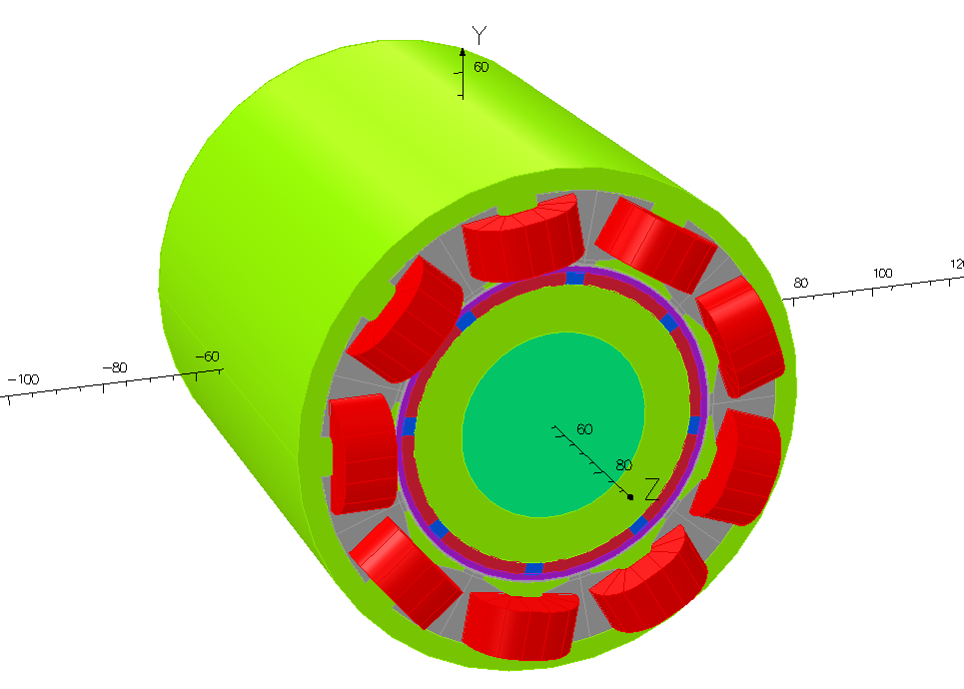
Figure 5.5 Three-dimensional finite element model for the reference machine design
In order to provide a more direct comparison with the analytical model, the nonlinearity of the core material was not included in the finite element model. Moreover, since only the eddy current induced by the armature field is accounted for in the analytical model, the remanence properties of rotor magnets were not included from the finite model, i.e. the magnets are treated purely as bulk conductors with magnetic properties only slightly different from air (i.e. with no remanence and a recoil permeability of 1.05). In the finite element model, the interface between the Inconel sleeve and the series of magnet poles was set as an insulating boundary in order to replicate the properties assumed case in the analytical model.
Table 5.3 shows a series of three-dimensional magnetic field and eddy current distributions predicted by analytical model and finite element model. The distributions are plotted at one instantaneous rotor position during the operation, which is 50° mechanical angular displacement from the starting point, and in the middle of each layer covering the entire circumferential and axial range.

Table 5.3 Comparison of three-dimensional field and eddy current distributions predicted by analytical and finite element results at 50° mechanical angular displacement from the starting point of operation
Analytical results | FE results
Radial flux density
Magnet
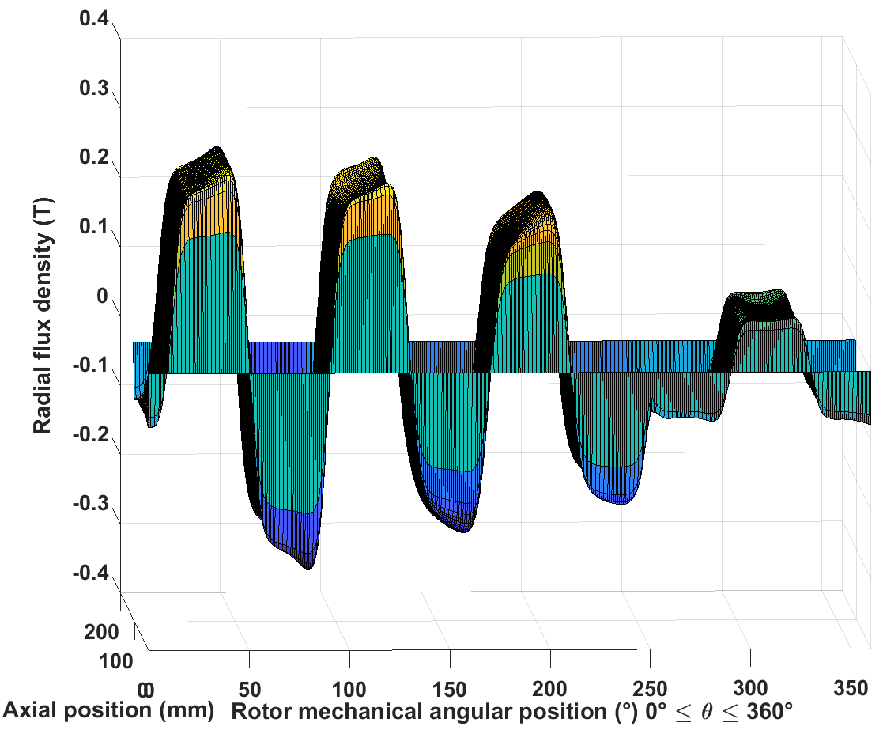 | 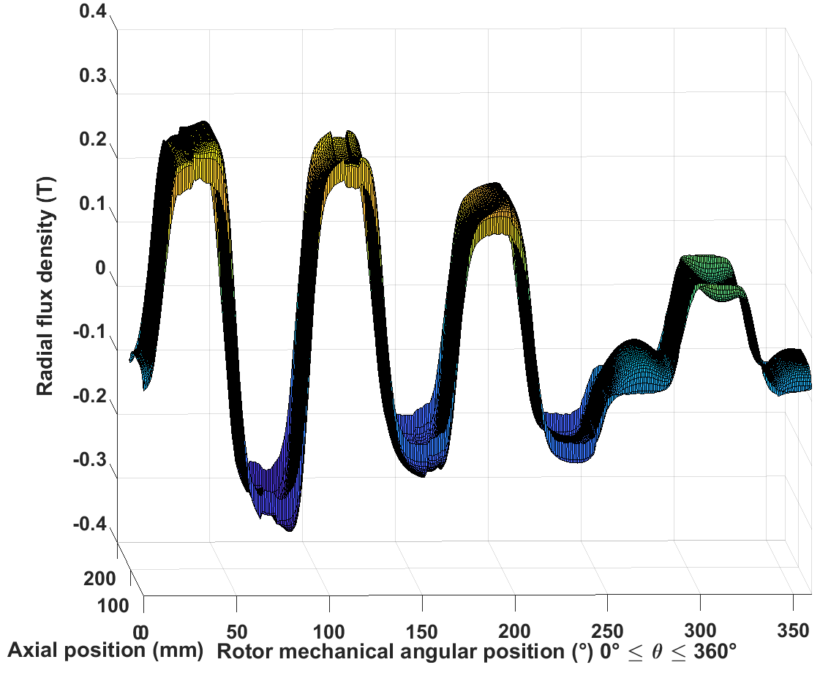
Inconel sleeve
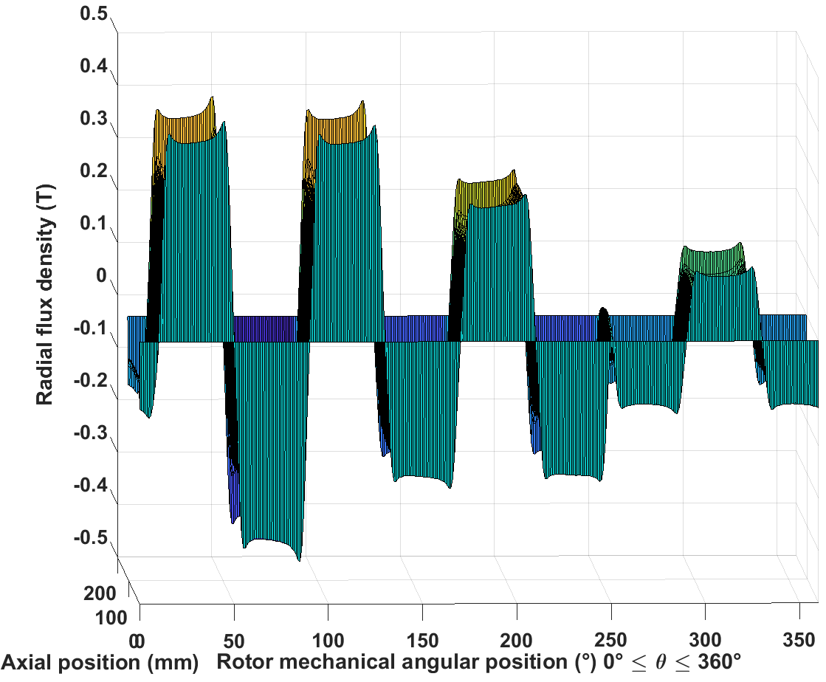 | 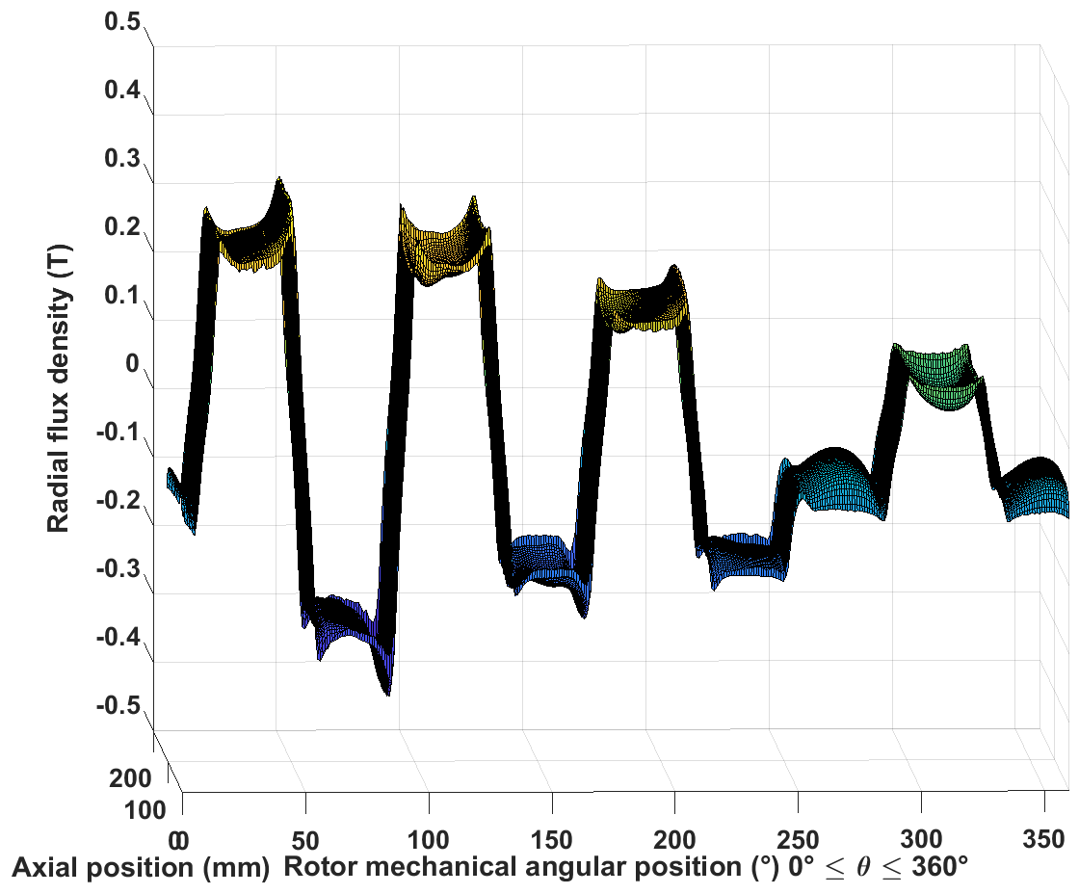
Airgap
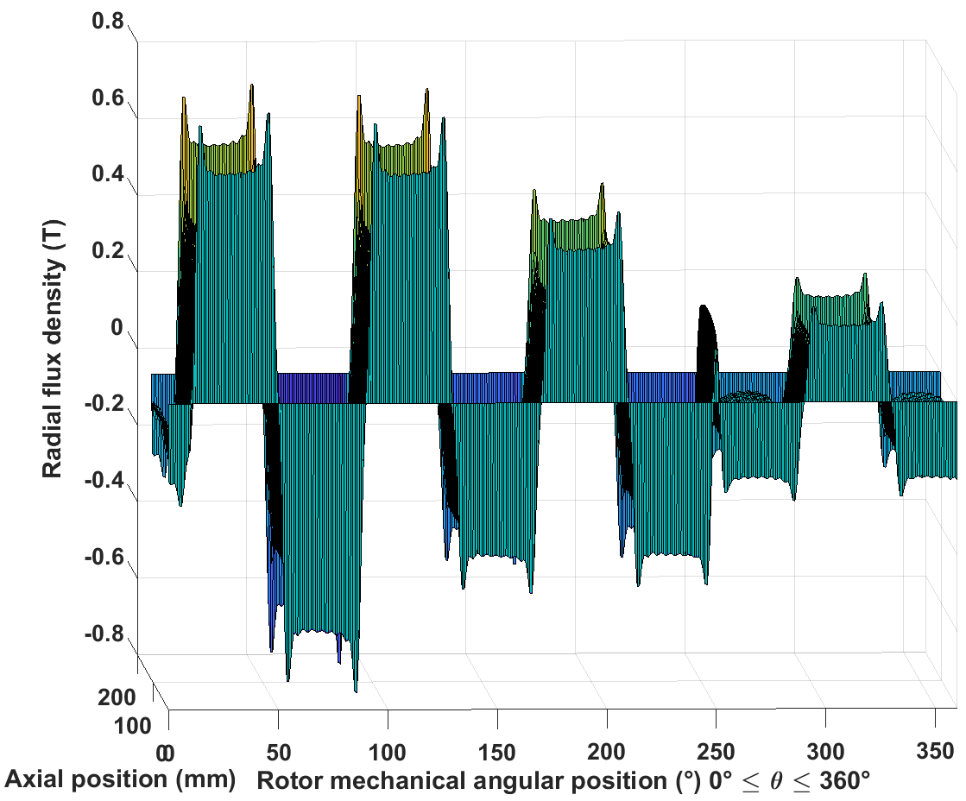 | 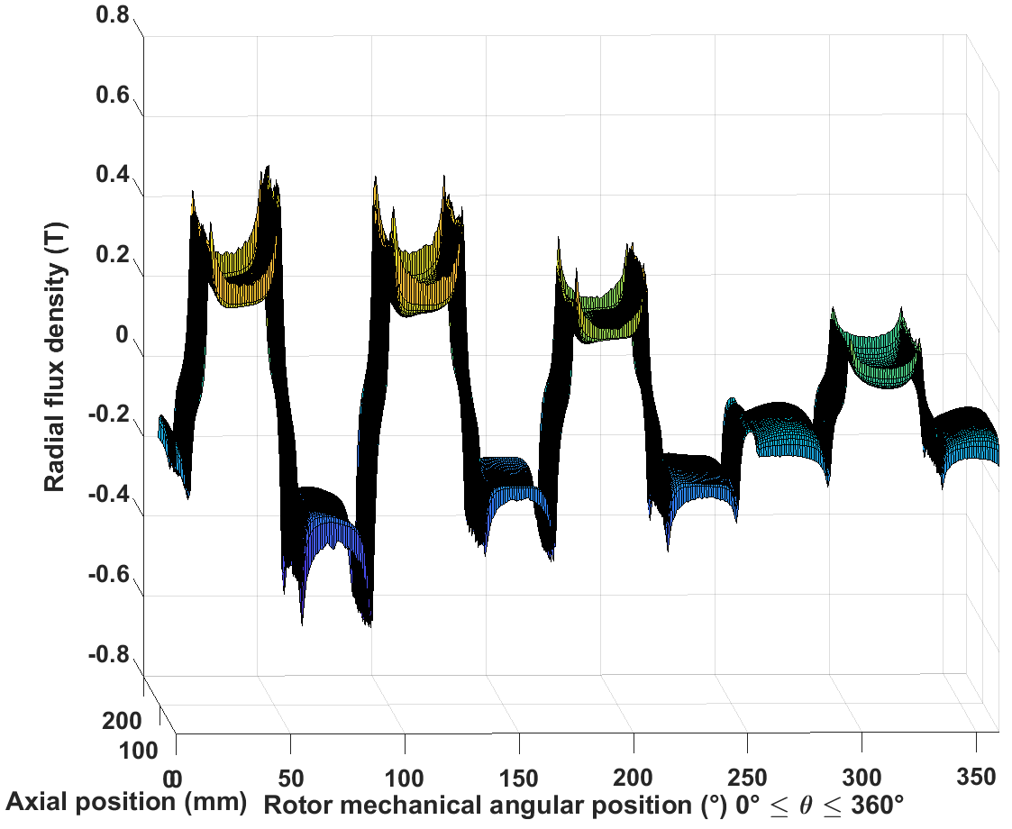
Tangential field strength
Magnet
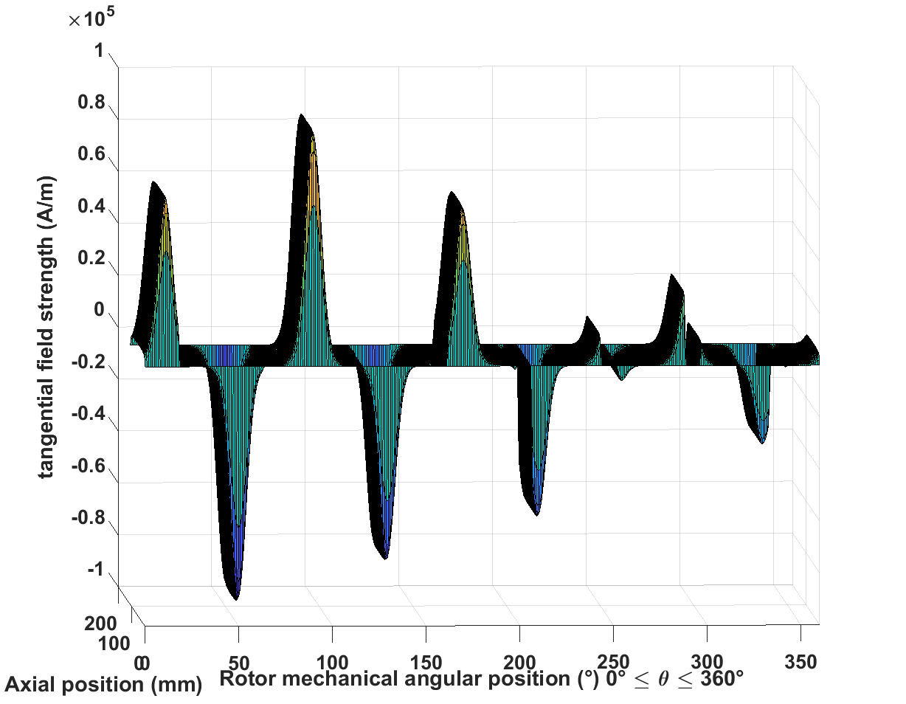 | 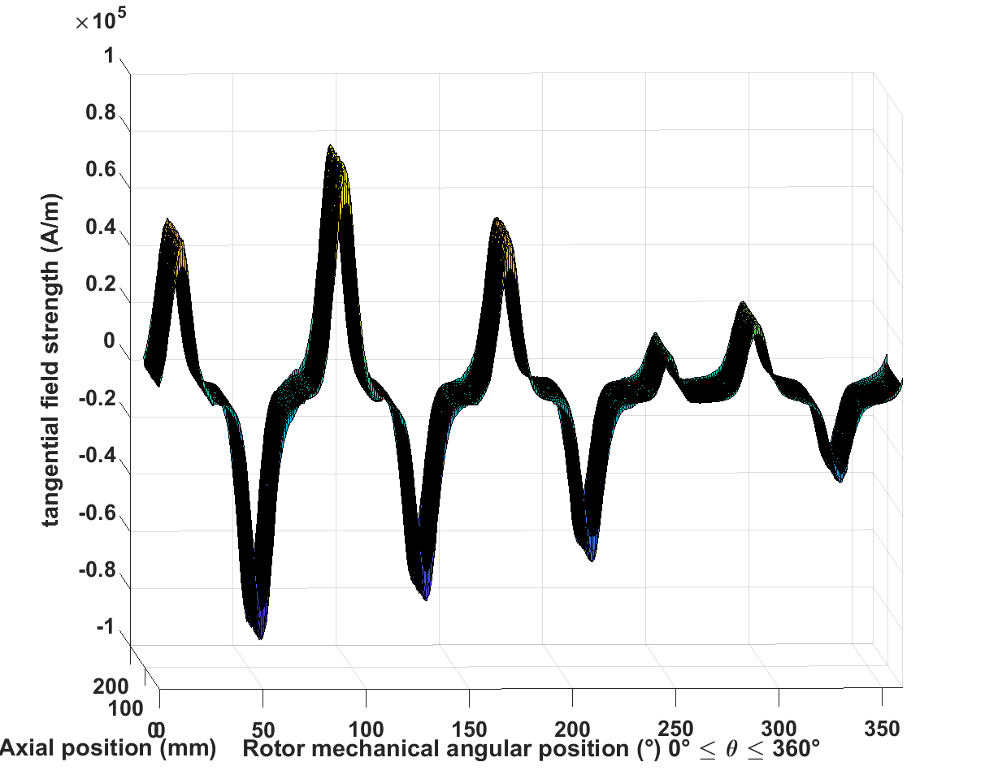
Inconel sleeve
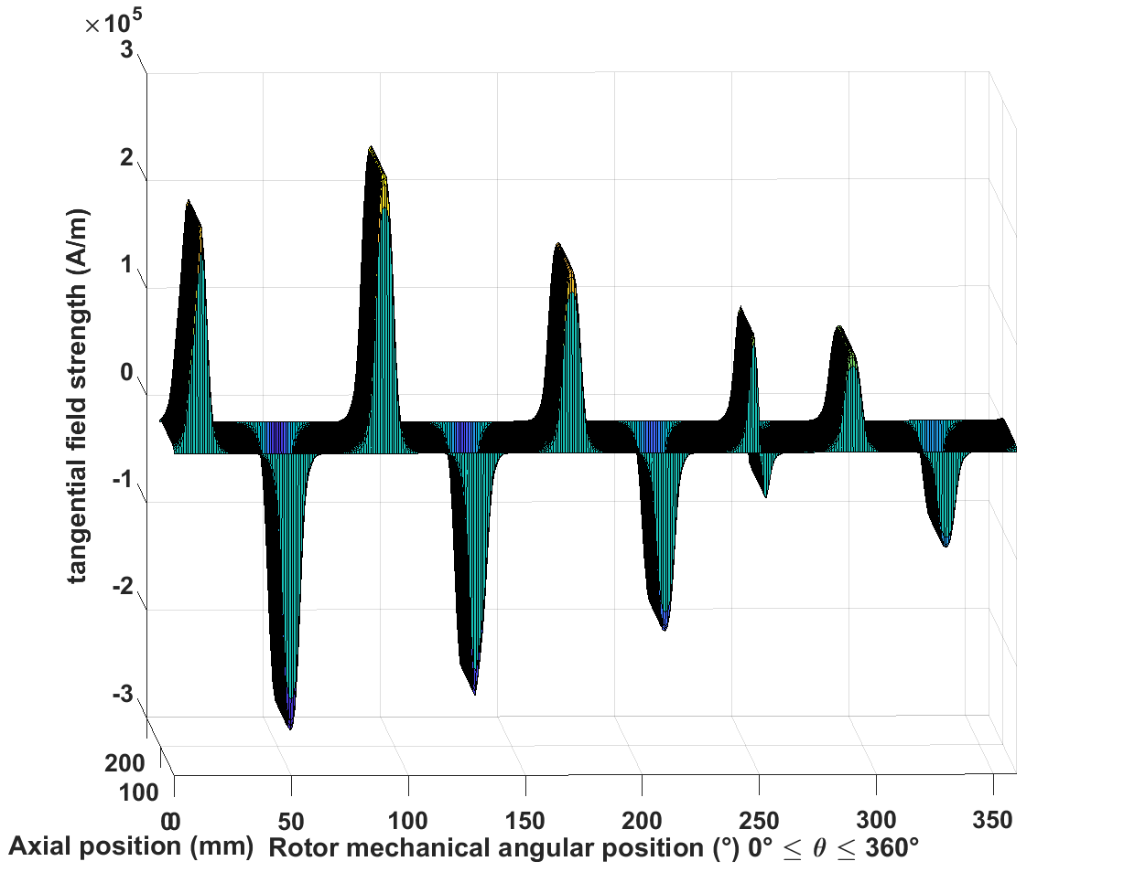 | 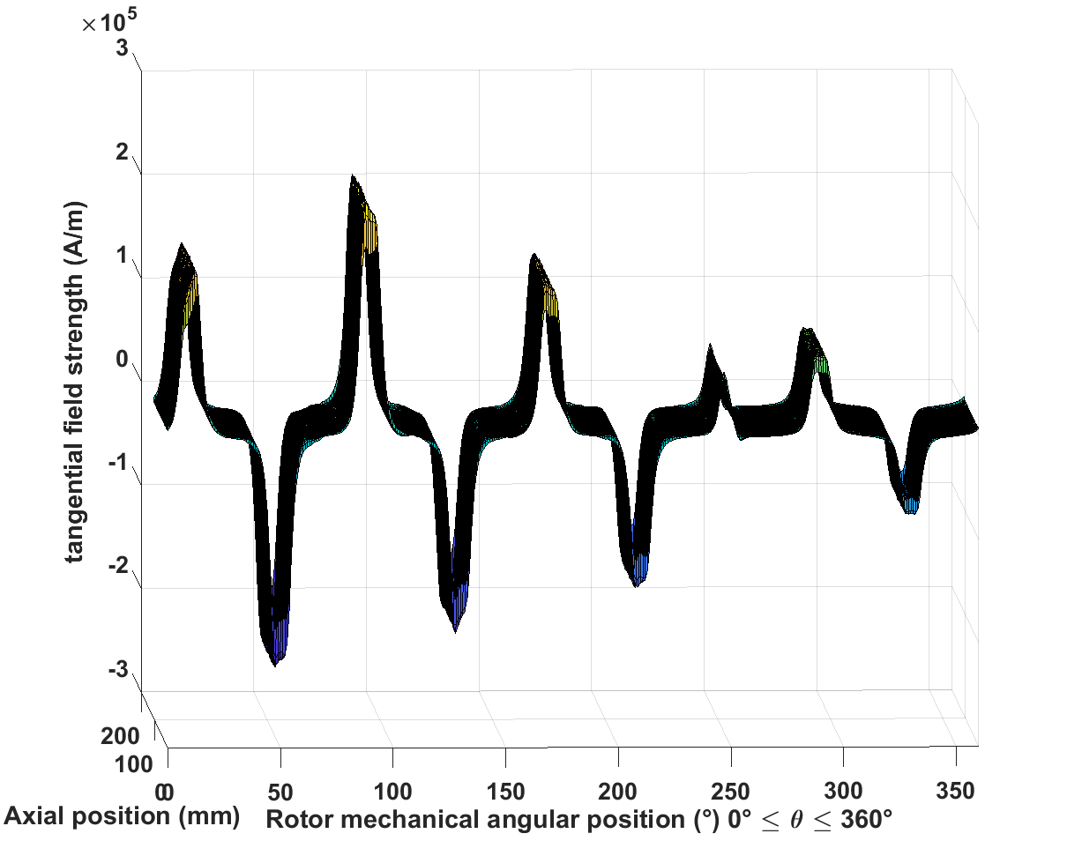
Airgap
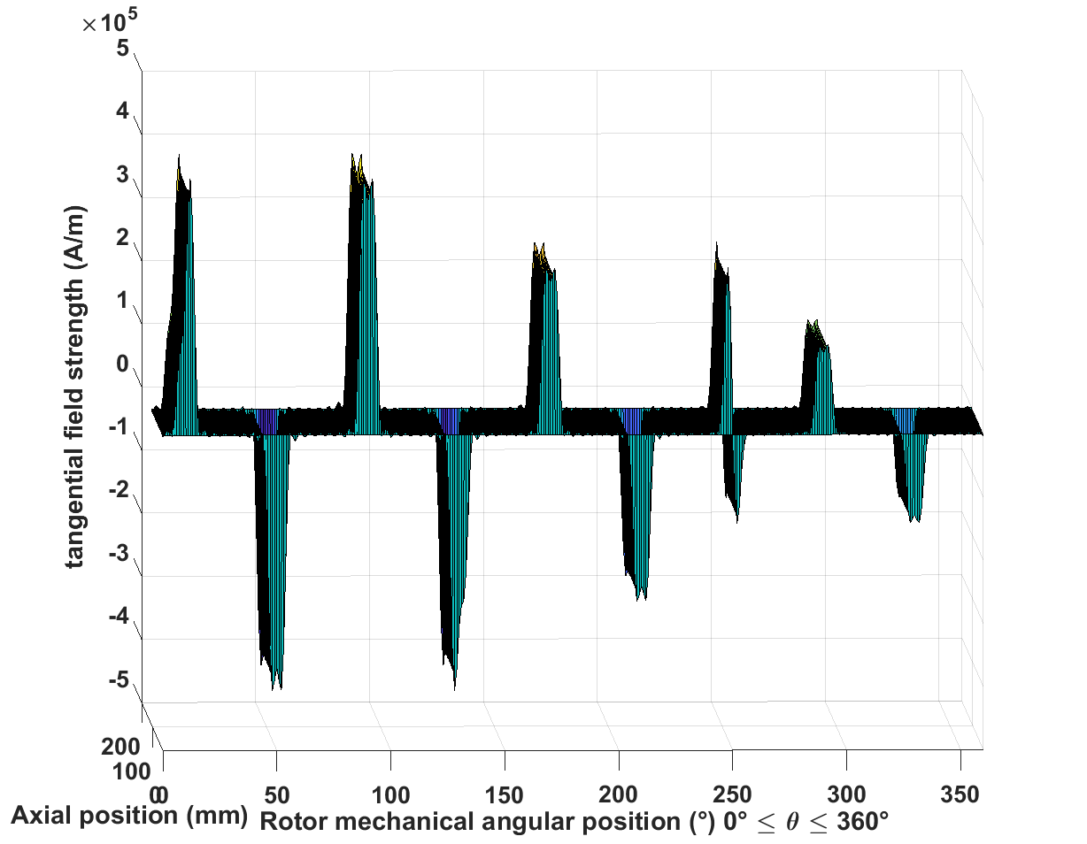 | 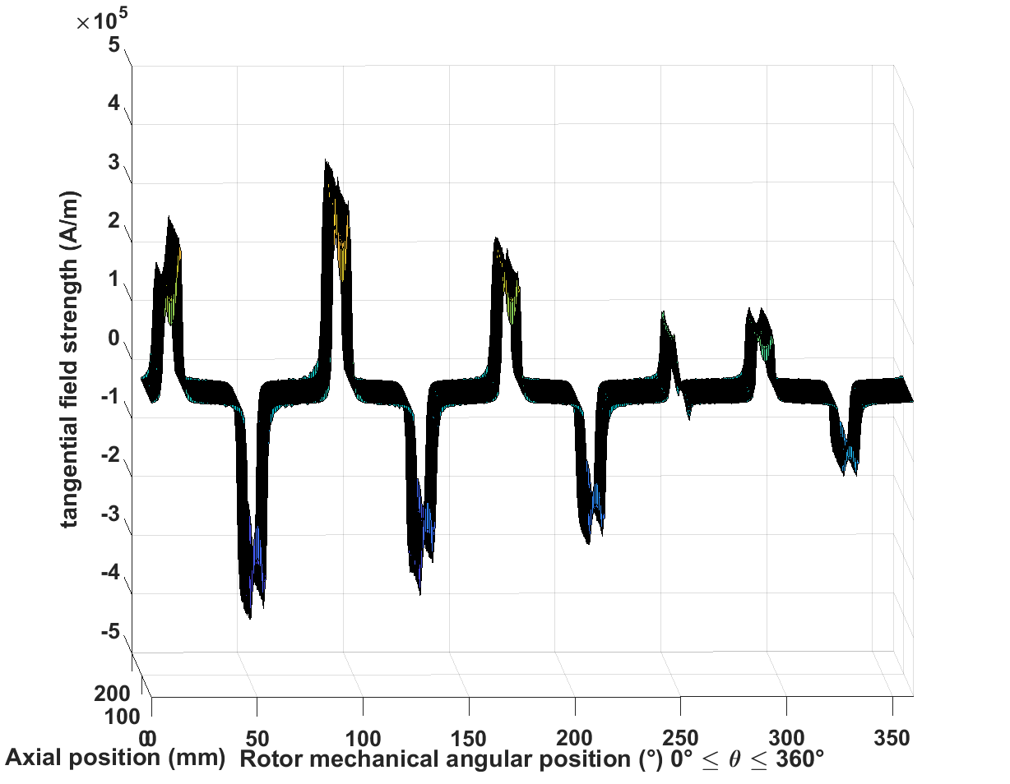
Axial eddy current
Magnet
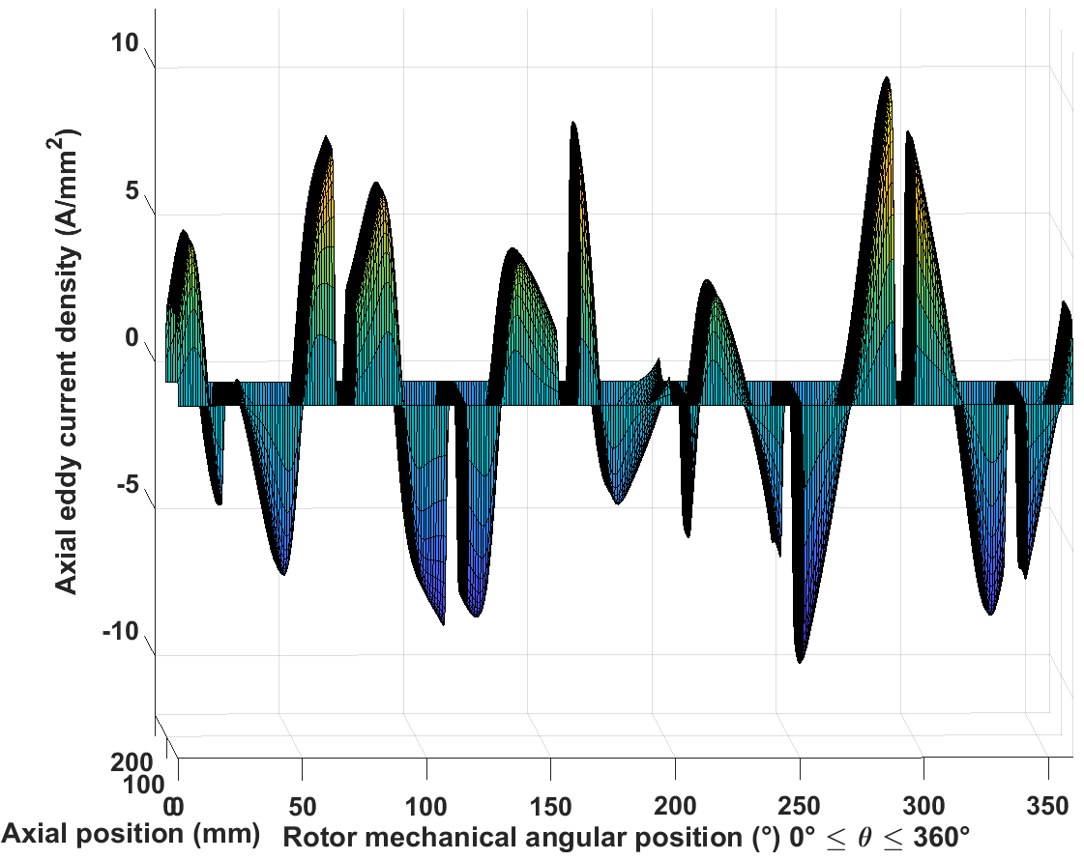 | 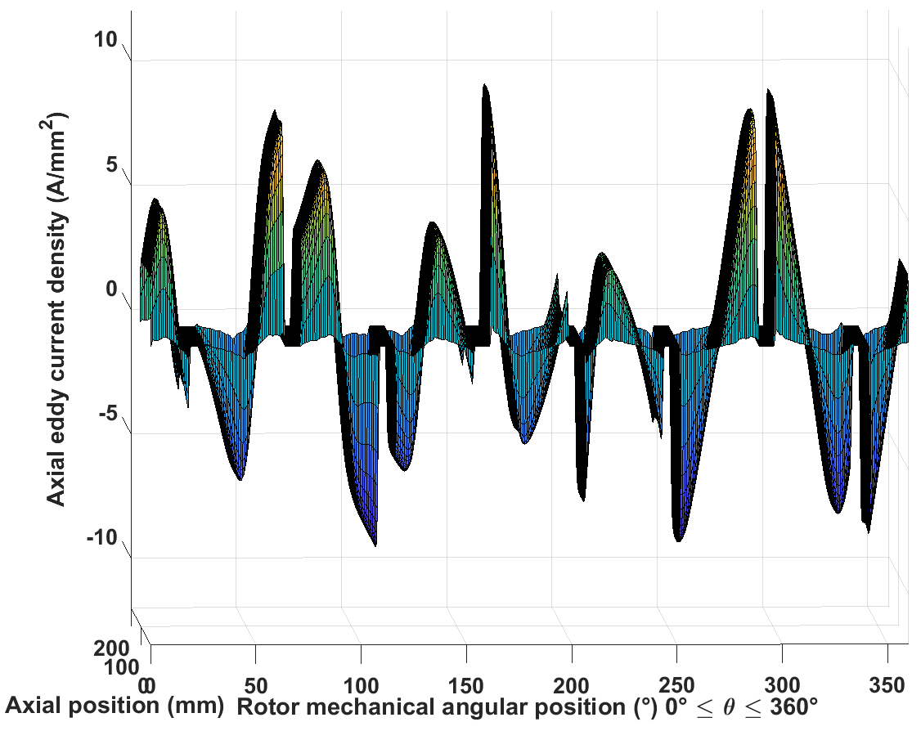
Inconel sleeve
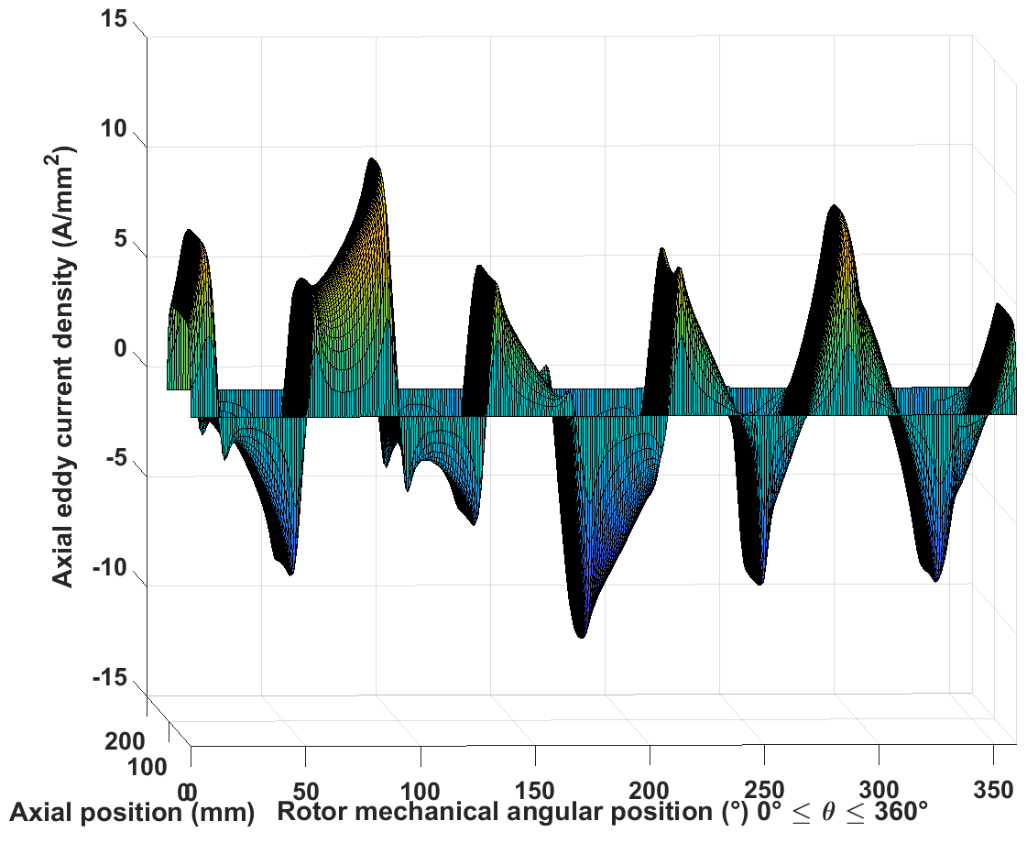 | 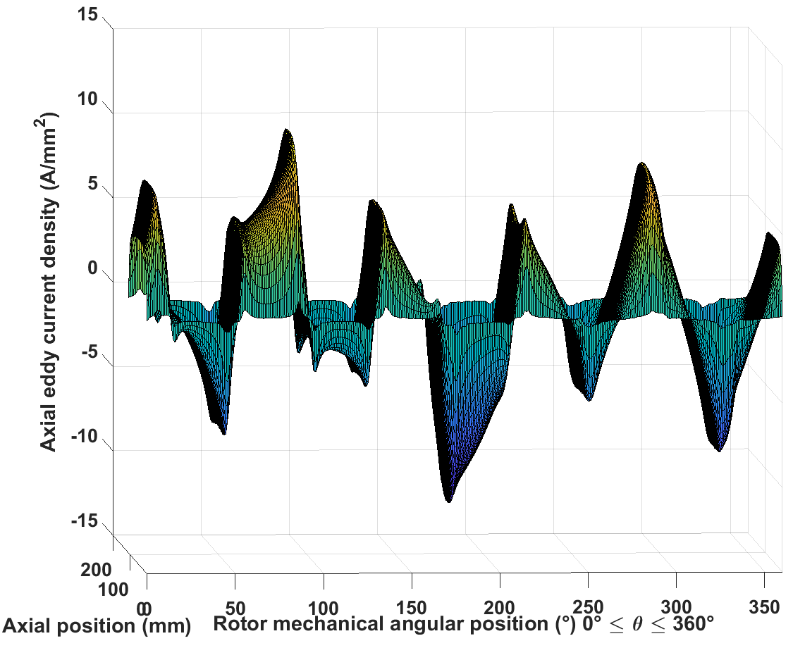
Circumferential eddy current
Magnet
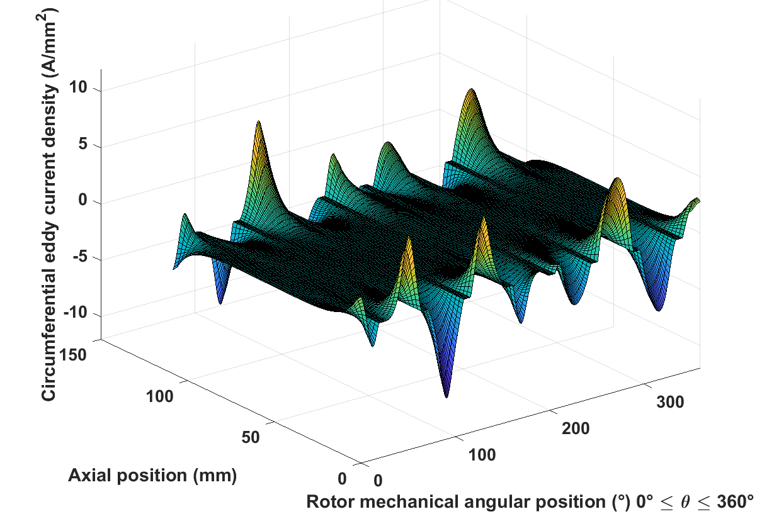 | 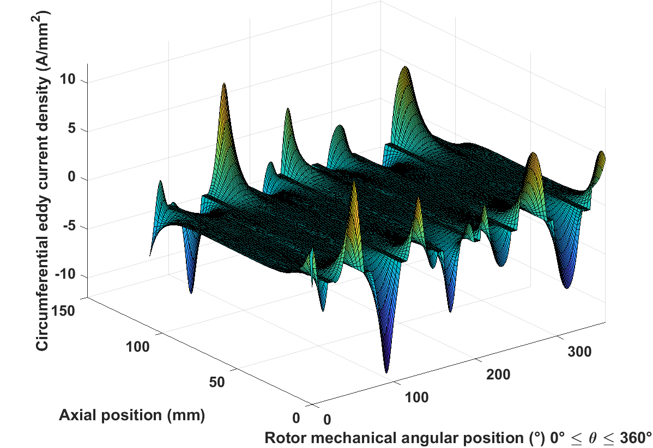
Inconel sleeve
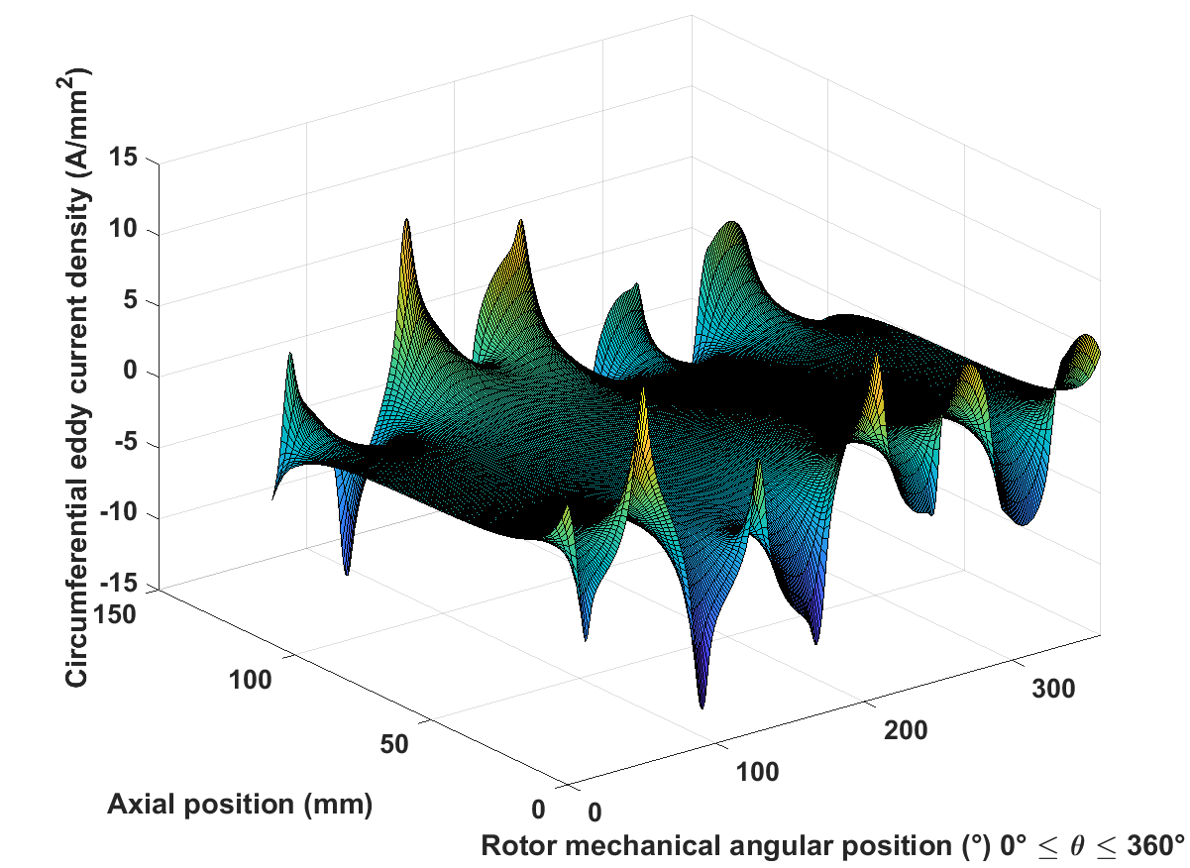 | 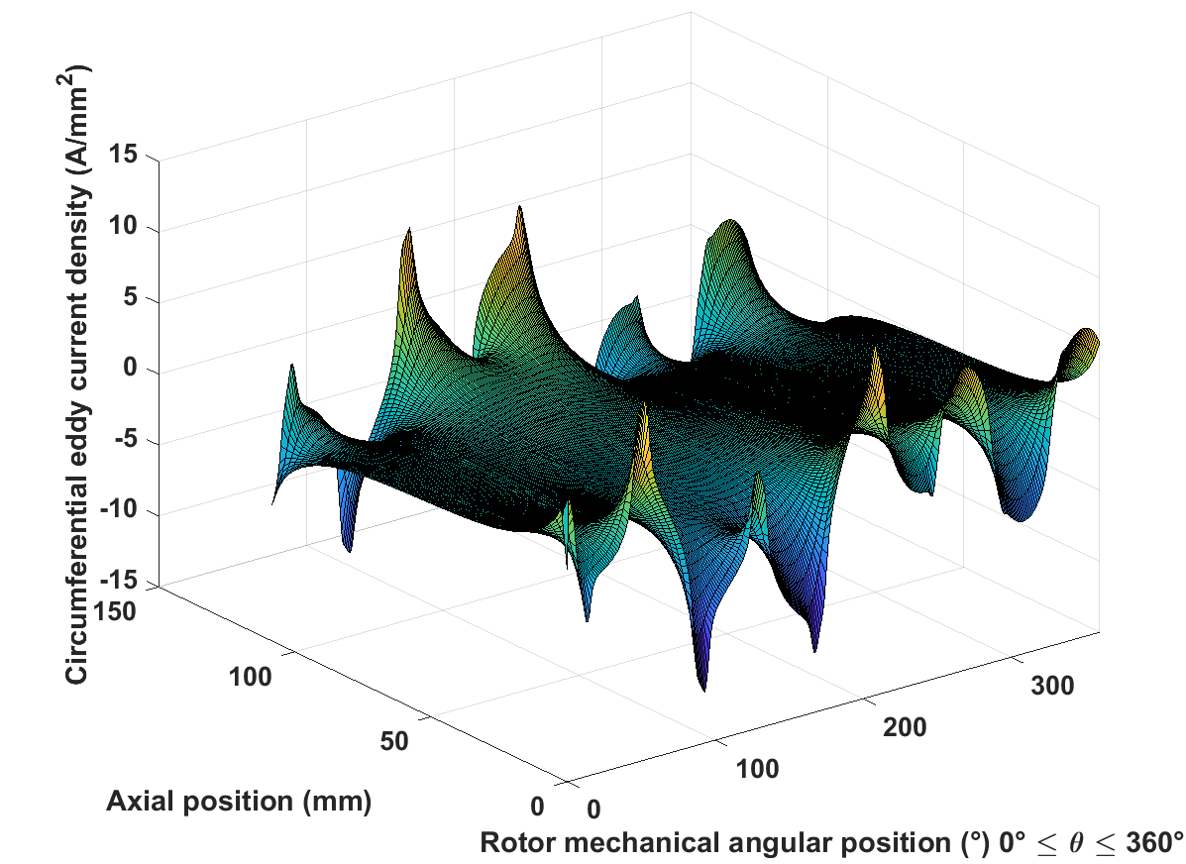
As will be apparent, there is generally good agreement between the two models. However, for more direct comparison between the two sets of results, two particular axial positions were selected and two-dimensional curves for magnetic fields and eddy currents along the entire circumference at those particular axial positions were extracted from the three-dimensional plots in Table 5.3.
Figure 5.6 shows the selected two axial positions for the two-dimensional plots. The majority of the two-dimensional are for position 1 in Figure 5.6. Since the circumferential eddy currents are more concentrated at the edges of the rotor, another axial position, position 2 in Figure 5.6, was selected for two-dimensional plots of the circumferential eddy currents. Table 5.4 shows the two-dimensional plots for different field and eddy current components. As will be apparent, generally good agreement is obtained between the analytical and FE results.
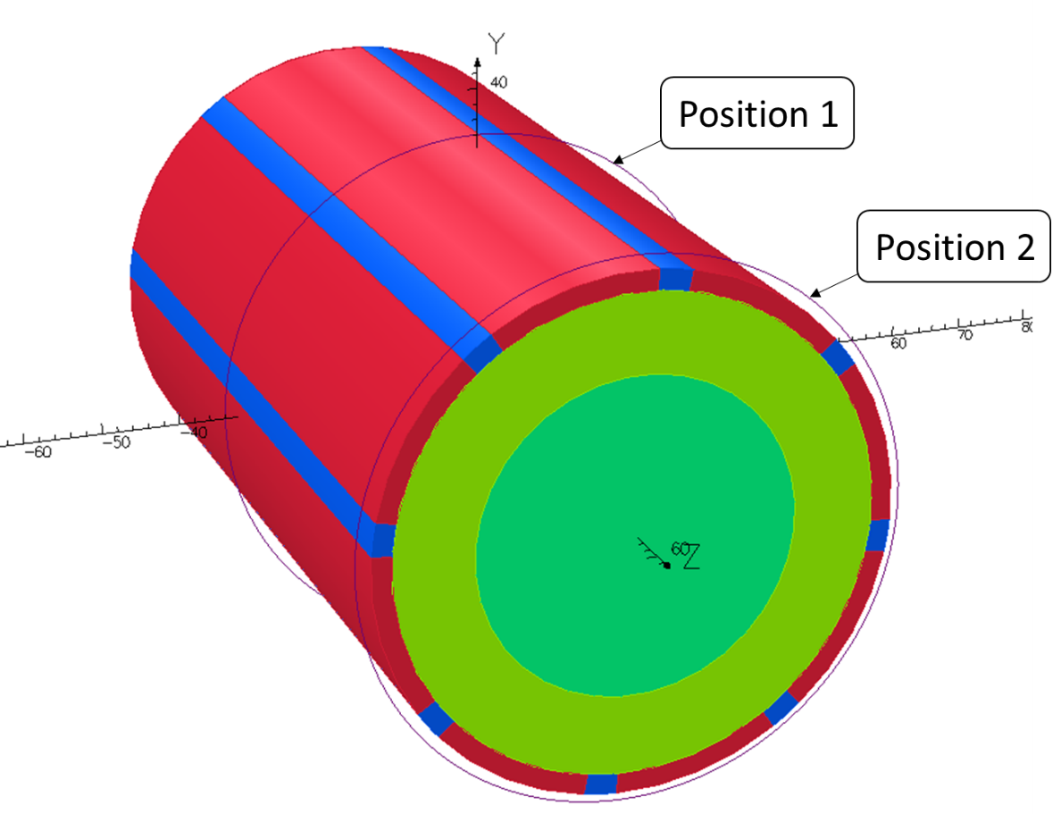
Figure 5.6 Axial positions for 2D plots

Table 5.4 2D field and eddy current distribution along the whole circumference at a certain axial position
Radial flux density
Magnet | 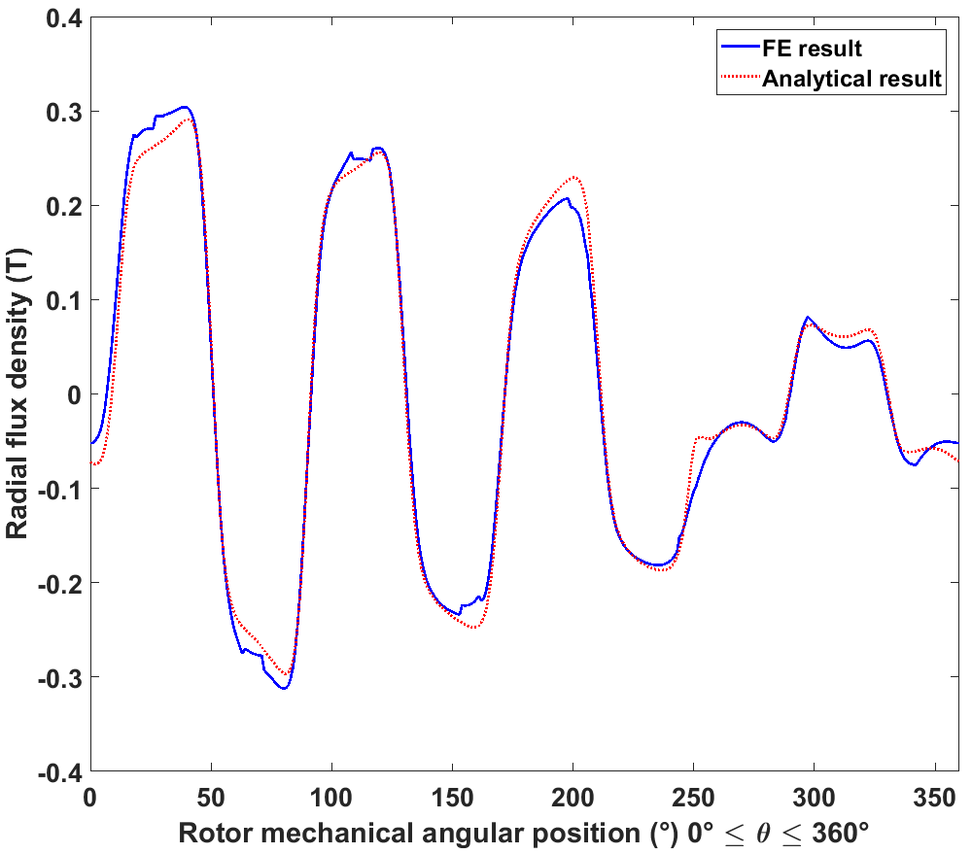
Inconel sleeve | 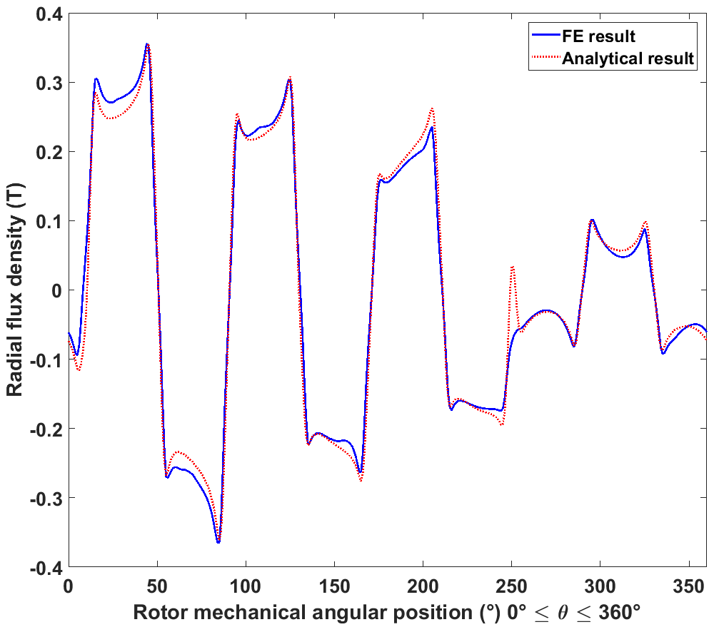
Airgap | 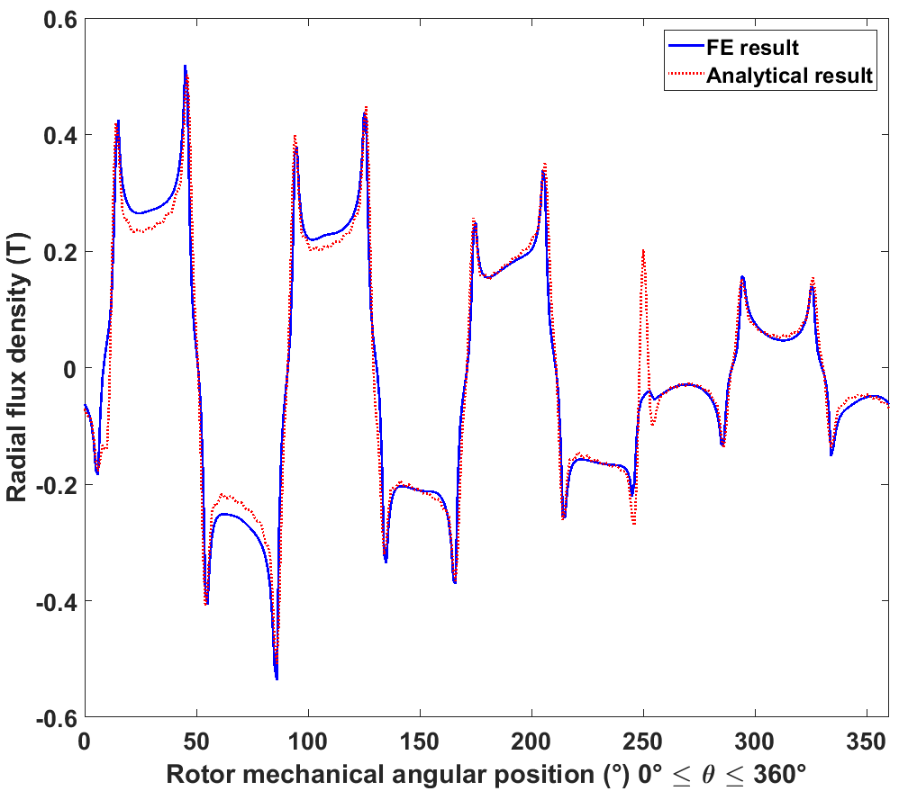
Tangential field strength
Magnet | 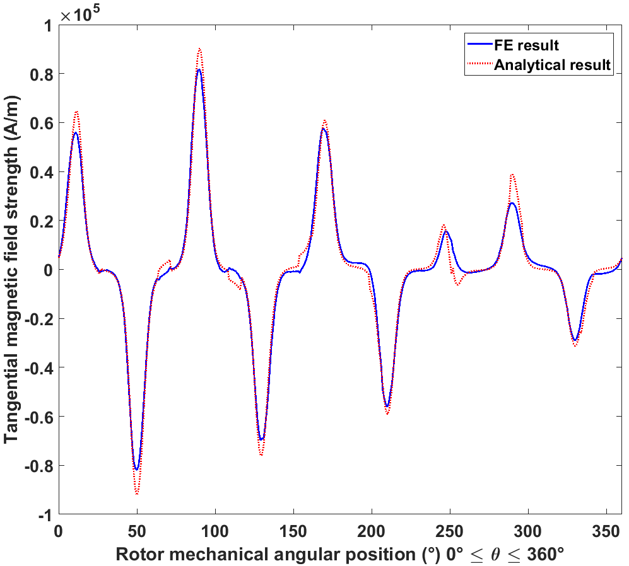
Inconel sleeve | 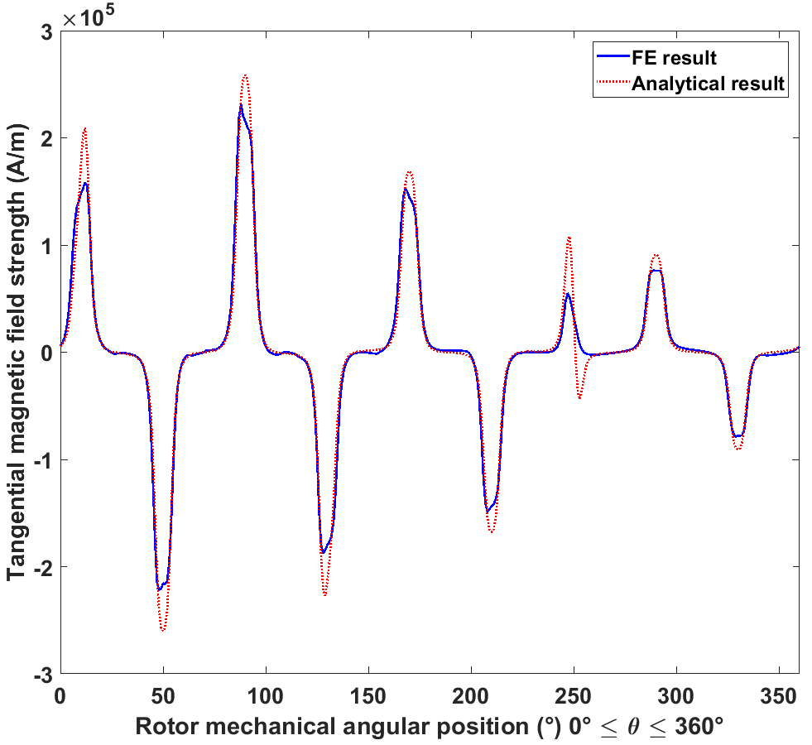
Airgap | 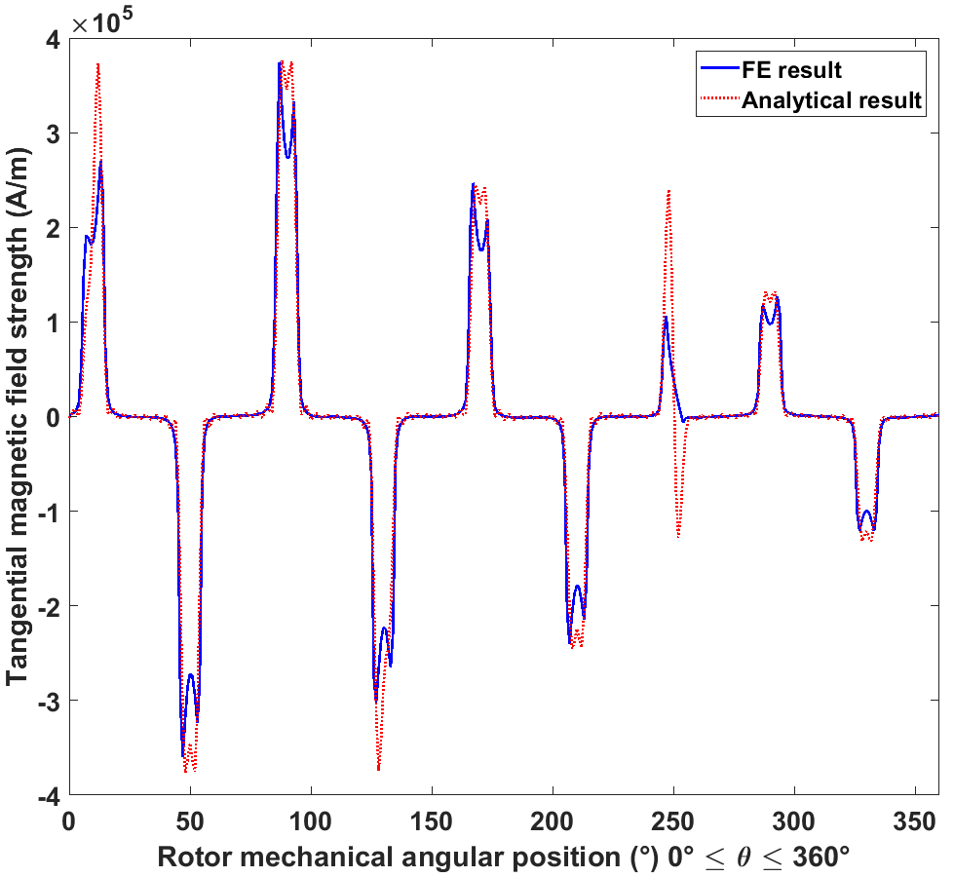
Axial eddy current
Magnet | 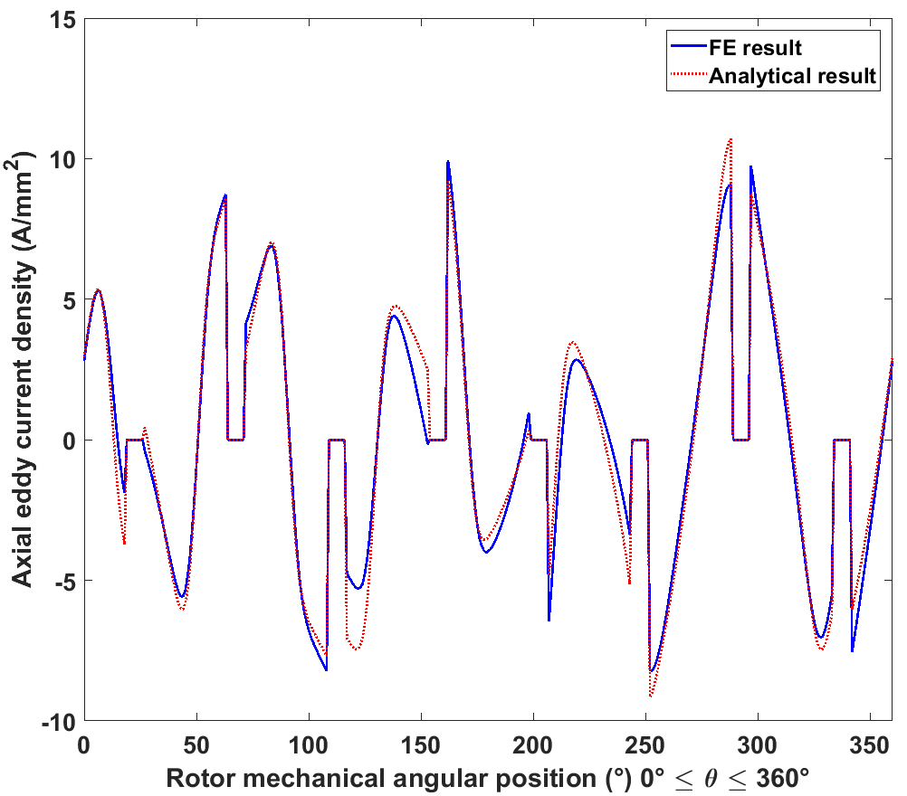
Inconel sleeve | 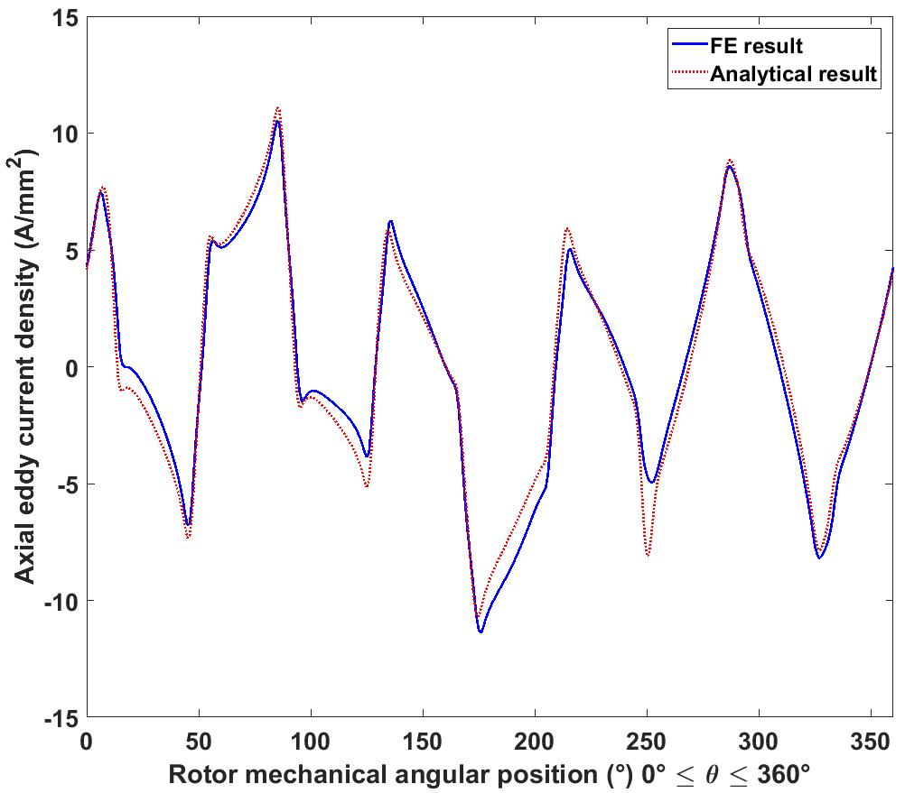
Circumferential eddy current
Magnet | 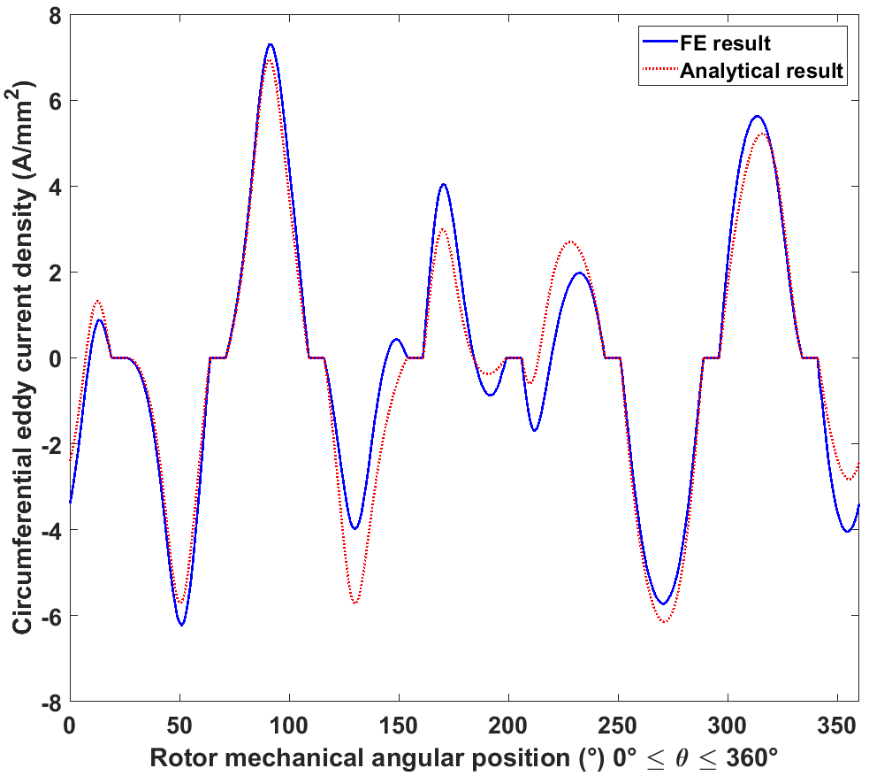
Inconel sleeve | 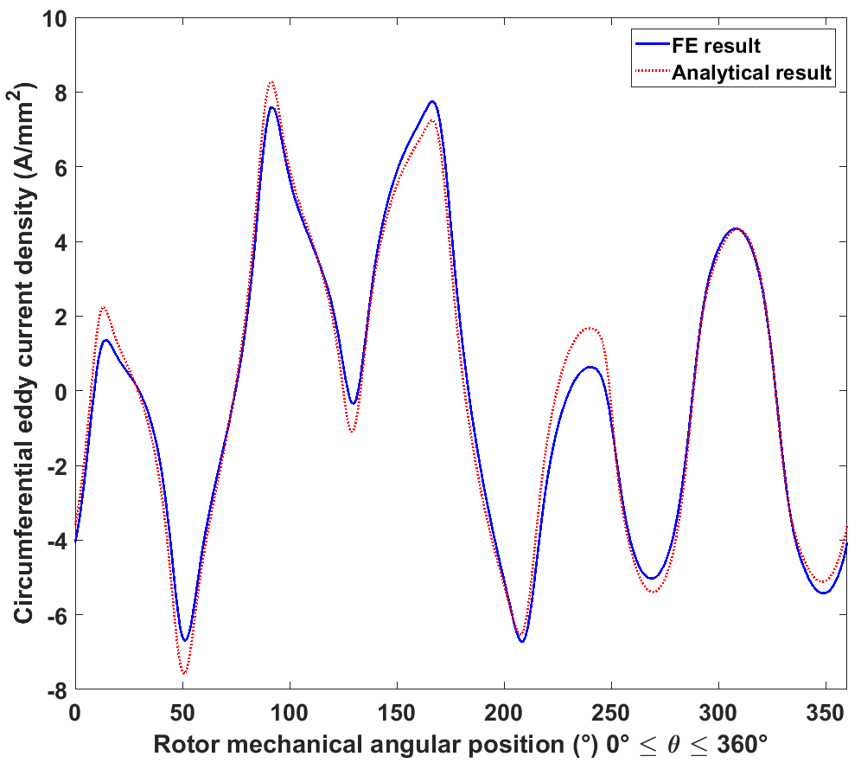

As can be seen from Table 5.3 and Table 5.4, although good agreement is obtained between the analytical results and finite element results, that there are some abrupt peaks in the distributions of radial flux density and tangential field strength predicted by the analytical model which do not appear in the FE results. By way of example, there are significant discrepancies at 250° in the radial flux density in the Inconel sleeve. Indeed, at this particular rotor angular position, many of these abrupt peaks are located around 250°.
Figure 5.7 shows the Fourier reconstruction of the distribution of the stator current sheet, which incorporates both the time and spatial harmonics, at the same instant at which the field and eddy current distributions are plotted. The pattern is plotted in the stator reference frame, which, according to the relationship (5.20), has 50° mechanical angular shift with the rotor reference system, i.e. the 250° position in the rotor reference system corresponds to 300° position in stator reference system. Hence, combining the 2D distributions of field components in Table 5.4, it can be seen that the sharp deviation between the analytical and FE results in radial flux density and tangential field coincides with the sharp transition in the current sheet distribution edge between phase C and phase A. Since the current sheet representation of stator excitation is idealized one-dimensional representation, which only represents the circumferential spatial harmonics information for stator currents, it cannot describe the effect of slot openings on airgap permeance variation. In practice, the effect of the slotting on the airgap field will be rather smoother than the sharp transition in the one-dimensional current sheet.
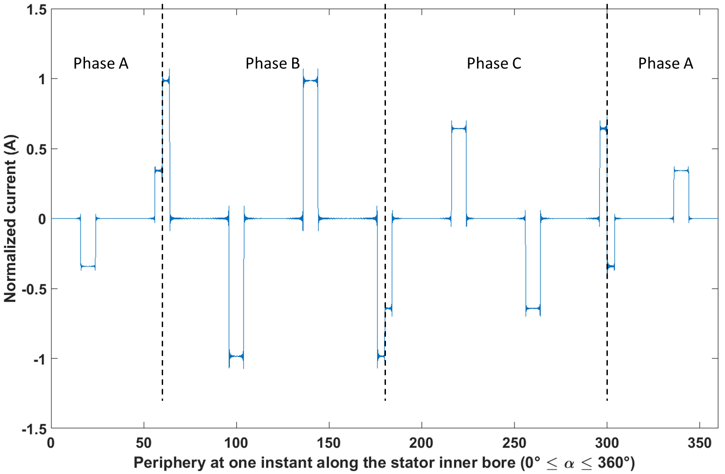
Figure 5.7 Stator current sheet distribution at the time instant where the field and current distributions are plotted

Calculation of the loss
In the previous section, several three- and two-dimensional distributions of the field and eddy current in various regions of the machine domain were plotted for both analytical and finite element methods. In this section, the various expressions for calculating the resulting eddy current loss in both Inconel sleeve and magnets are derived.
There are two means of calculating the average power of eddy current loss in conducting rotor structures [33]. Firstly, the loss can be calculated via Joule’s law, which is based on calculating the volume integral of the average power of Joule loss over the studied conducting region:
$$P=\frac{1}{T}\int_{0}^{T}{\left\{\frac{1}{σ}\iiint_{V}{{\left|\vec{J}\right|}^{2}dV}\right\}dt}$$ | (5.245)
for real functions and
$$P=\frac{1}{2σ}\iiint_{V}{{\left|\vec{J}\right|}^{2}dV}$$ | (5.246)
for complex functions.
Alternatively, the loss can be calculated using Poynting’s theory, which considers the net energy flowing into the conducting region equal as being the energy consumed within the region by Joule effect. This is formulated as the following integral:
$$P=-\oint{\left(\vec{E}×\vec{H}\right)⋅d\vec{S}}$$ | (5.247)
The two methods have their own merits. The Joule approach is a straightforward method of calculating the eddy current loss, and is used in many finite element software packages by replacing the volume integral with volume summation of the Joule loss in each finite element. It can be used regardless of the detailed geometry of the conducting area. However, in many analytical models using cylindrical coordinate systems, this method is not always straightforward to apply since the radial integration involves Bessel functions, whose integral is connected with generalized hypergeometric function and generalized Meijer G function and would become very complicated especially in the complex computation [34][35].
In contrast, the Poynting approach is less computationally demanding since in the studied machine environment, the surfaces surrounding metallic sleeve and rotor magnets are complete cylinders, i.e. uniform radial dimension, and if using Poynting’s theory, the integration in radial direction could be avoided and the eddy current loss in rotor magnets could be calculated by net energy flowing into the cylindrical surface surrounding the magnets, while the eddy current loss in metallic sleeve could be calculated by the net energy flowing into the surface surrounding the sleeve minus the energy flowing into the surface surrounding the magnets. This method has been used by authors in [4] for calculating eddy current losses, achieving good results. However, in this analytical model, due to the presence of inter-pole regions, there are two circumstances happening at the surface surrounding the magnets. At the parts of surface touching the magnets, there are eddy currents flowing and hence the electrical field in Poynting vector could be simply obtained by the Ohm’s law. However, at the parts of surface in contact with the inter-pole regions, the induced electrical field is no longer easy to obtain since there is no eddy current flowing and the field is described by vector potential. Hence, in this model, the first method is utilized for calculating the eddy current losses, and the difficulties encountered in calculating the integration in radial direction is solved with the assistance of numerical computation.
In the Inconel sleeve, the eddy current loss is calculated as follows
$$P_{II}=\frac{1}{2σ_{sl}}\iiint_{V}{\left({\left|J_{zII}\right|}^{2}+{\left|J_{θII}\right|}^{2}\right)dV}$$ | (5.248)
Substituting the expressions (5.204) and (5.213) into (5.248) yields
$$P_{II}=\frac{1}{2σ_{sl}}\iiint_{V}{\left\{\sum_{m=0}^{∞}{\sum_{l=0}^{∞}{\left\{\left[A_{mzIISeg}I_{m}\left(\sqrt{{μ_{1}}^{'}}r\right)+B_{mzIISeg}K_{m}\left(\sqrt{{μ_{1}}^{'}}r\right)\right]\left(C_{mzII}e^{jmθ}+D_{mzII}e^{-jmθ}\right)+\left[\left(A_{mzIISeg}-A_{mzIIdif}\right)I_{m}\left(\sqrt{{μ_{1}}^{'}}r\right)+\left(B_{mzIISeg}-B_{mzIIdif}\right)K_{m}\left(\sqrt{{μ_{1}}^{'}}r\right)\right]\left(A_{mcp}e^{jmθ}+A_{-mcp}e^{-jmθ}\right)\right\}E_{lzII}\sin\left(\frac{lπ}{L_{a}}z\right)\left\{{\left[A_{mzIISeg}I_{m}\left(\sqrt{{μ_{1}}^{'}}r\right)+B_{mzIISeg}K_{m}\left(\sqrt{{μ_{1}}^{'}}r\right)\right]}^{*}\left({C_{mzII}}^{*}e^{-jmθ}+{D_{mzII}}^{*}e^{jmθ}\right)+{\left[\left(A_{mzIISeg}-A_{mzIIdif}\right)I_{m}\left(\sqrt{{μ_{1}}^{'}}r\right)+\left(B_{mzIISeg}-B_{mzIIdif}\right)K_{m}\left(\sqrt{{μ_{1}}^{'}}r\right)\right]}^{*}\left({A_{mcp}}^{*}e^{-jmθ}+{A_{-mcp}}^{*}e^{jmθ}\right)\right\}E_{lzII}\sin\left(\frac{lπ}{L_{a}}z\right)}}+\sum_{m=0}^{∞}{\sum_{l=0}^{∞}{\left\{\left[rA_{mzIISeg}I_{m}\left(\sqrt{{μ_{1}}^{'}}r\right)+rB_{mzIISeg}K_{m}\left(\sqrt{{μ_{1}}^{'}}r\right)\right]\left(\frac{j}{m}C_{mzII}e^{jmθ}-\frac{j}{m}D_{mzII}e^{-jmθ}\right)+\left[r\left(A_{mzIISeg}-A_{mzIIdif}\right)I_{m}\left(\sqrt{{μ_{1}}^{'}}r\right)+r\left(B_{mzIISeg}-B_{mzIIdif}\right)K_{m}\left(\sqrt{{μ_{1}}^{'}}r\right)\right]\left(\frac{j}{m}A_{mcp}e^{jmθ}-\frac{j}{m}A_{-mcp}e^{-jmθ}\right)\right\}\left(\frac{lπ}{L_{a}}\right)E_{lzII}\cos\left(\frac{lπ}{L_{a}}z\right)\left\{{\left[rA_{mzIISeg}I_{m}\left(\sqrt{{μ_{1}}^{'}}r\right)+rB_{mzIISeg}K_{m}\left(\sqrt{{μ_{1}}^{'}}r\right)\right]}^{*}\left(-\frac{j}{m}{C_{mzII}}^{*}e^{-jmθ}+\frac{j}{m}{D_{mzII}}^{*}e^{jmθ}\right)+{\left[r\left(A_{mzIISeg}-A_{mzIIdif}\right)I_{m}\left(\sqrt{{μ_{1}}^{'}}r\right)+r\left(B_{mzIISeg}-B_{mzIIdif}\right)K_{m}\left(\sqrt{{μ_{1}}^{'}}r\right)\right]}^{*}\left(-\frac{j}{m}{A_{mcp}}^{*}e^{-jmθ}+\frac{j}{m}{A_{-mcp}}^{*}e^{jmθ}\right)\right\}\left(\frac{lπ}{L_{a}}\right)E_{lzII}\cos\left(\frac{lπ}{L_{a}}z\right)}}\right\}dV}$$ | (5.249)
As can be seen, the volume integral (5.249) can be separated into small independent integrals in three dimensions. Finishing the integrals, the final result for (5.249) can be obtained as
$$P_{II}=\frac{π}{2σ_{sl}}\sum_{m=0}^{∞}{\sum_{l=0}^{∞}{{E_{lzII}}^{2}L_{a}\left\{\left({\left|C_{mzII}\right|}^{2}+{\left|D_{mzII}\right|}^{2}\right)\int_{R_{m}}^{R_{sl}}{\left[A_{mzIISeg}I_{m}\left(\sqrt{{μ_{1}}^{'}}r\right)+B_{mzIISeg}K_{m}\left(\sqrt{{μ_{1}}^{'}}r\right)\right]{\left[A_{mzIISeg}I_{m}\left(\sqrt{{μ_{1}}^{'}}r\right)+B_{mzIISeg}K_{m}\left(\sqrt{{μ_{1}}^{'}}r\right)\right]}^{*}r\left[1+{\left(\frac{lπ}{mL_{a}}\right)}^{2}r^{2}\right]dr}+\left(C_{mzII}{A_{mcp}}^{*}+D_{mzII}{A_{-mcp}}^{*}\right)\int_{R_{m}}^{R_{sl}}{\left[A_{mzIISeg}I_{m}\left(\sqrt{{μ_{1}}^{'}}r\right)+B_{mzIISeg}K_{m}\left(\sqrt{{μ_{1}}^{'}}r\right)\right]{\left[\left(A_{mzIISeg}-A_{mzIIdif}\right)I_{m}\left(\sqrt{{μ_{1}}^{'}}r\right)+\left(B_{mzIISeg}-B_{mzIIdif}\right)K_{m}\left(\sqrt{{μ_{1}}^{'}}r\right)\right]}^{*}r\left[1+{\left(\frac{lπ}{mL_{a}}\right)}^{2}r^{2}\right]dr}+\left(A_{mcp}{C_{mzII}}^{*}+A_{-mcp}{D_{mzII}}^{*}\right)\int_{R_{m}}^{R_{sl}}{\left[\left(A_{mzIISeg}-A_{mzIIdif}\right)I_{m}\left(\sqrt{{μ_{1}}^{'}}r\right)+\left(B_{mzIISeg}-B_{mzIIdif}\right)K_{m}\left(\sqrt{{μ_{1}}^{'}}r\right)\right]{\left[A_{mzIISeg}I_{m}\left(\sqrt{{μ_{1}}^{'}}r\right)+B_{mzIISeg}K_{m}\left(\sqrt{{μ_{1}}^{'}}r\right)\right]}^{*}r\left[1+{\left(\frac{lπ}{mL_{a}}\right)}^{2}r^{2}\right]dr}+\left({\left|A_{mcp}\right|}^{2}+{\left|A_{-mcp}\right|}^{2}\right)\int_{R_{m}}^{R_{sl}}{\left[\left(A_{mzIISeg}-A_{mzIIdif}\right)I_{m}\left(\sqrt{{μ_{1}}^{'}}r\right)+\left(B_{mzIISeg}-B_{mzIIdif}\right)K_{m}\left(\sqrt{{μ_{1}}^{'}}r\right)\right]{\left[\left(A_{mzIISeg}-A_{mzIIdif}\right)I_{m}\left(\sqrt{{μ_{1}}^{'}}r\right)+\left(B_{mzIISeg}-B_{mzIIdif}\right)K_{m}\left(\sqrt{{μ_{1}}^{'}}r\right)\right]}^{*}r\left[1+{\left(\frac{lπ}{mL_{a}}\right)}^{2}r^{2}\right]dr}\right\}}}$$ | (5.250)
As mentioned previously, numerical computation is used to accommodate the integrals the include the Bessel functions. The unsolved definite integrals in radial direction in (5.250) are calculated by the built-in integration function inside MATLAB. Since the integration is along the real axis in the complex domain, there is no need to set the middle points to define a path for the integration, and the radial integrals can be carried out in the same way with the real function integral. The accuracy of the numerical integration in MATLAB is controlled by tolerance settings in the built-in integration function with the following criterion [36]
$$\left|q-Q\right|≤\max\left(AbsTol, RelTol×\left|q\right|\right)$$ | (5.251)
where $q$ is the integration result provided by the numerical computation, and $Q$ is the exact integral. There are two error tolerance parameters in the built-in MATLAB function that control accuracy, one being the absolute error tolerance $AbsTol$, indicating an absolute convergence level, with the following expression
$$AbsTol=\left|q-Q\right|$$ | (5.252)
and the other being the relative error tolerance $RelTol$, indicating a convergence as a percentage of the attempted integration result, with the following expression
$$RelTol=\frac{\left|q-Q\right|}{\left|Q\right|}$$ | (5.253)
The criteria (5.251) indicates the accuracy of the numerical integration is controlled by parameter that provides loose limits. Usually, the relative error tolerance is the controlling parameter. However, if the result of the original integral is sufficiently small or the relative error tolerance is set to be much smaller than the absolute tolerance, then the absolute tolerance would take precedence. When setting the two parameters, a trade-off between the precision of the results and the computational time needs to be considered. In this analytical model, the default settings inside MATLAB, viz. $1×{10}^{-10}$ for the $AbsTol$ and $1×{10}^{-6}$ for the $RelTol$ were applied for the accuracy control. However, further reductions in the two parameters can also be applied to further increase accuracy.
In substituting the particular solutions (5.204) and (5.213) for eddy currents into (5.248), only the conjugate product of harmonics with itself is considered. While this is the widely used method for dealing with harmonics in final loss calculation, this might introduce inaccuracy into the final loss result since the interaction terms between currents induced by different harmonics are excluded for the integral. In each magnet pole, the eddy current loss is calculated using:
$$P_{III}=\frac{1}{2σ_{m}}\iiint_{V}{\left({\left|J_{zIII}\right|}^{2}+{\left|J_{θIII}\right|}^{2}\right)dV}$$ | (5.254)
where the integration volume $V$ in (5.254) is the envelope enclosed by each pole. The expressions (5.195) and (5.219) are substituted into (5.254) to calculate the conjugate product for eddy current components $J_{zIII}$ and $J_{θIII}$, respectively. Following substitution, and still neglecting the interactions between different harmonics, the integral (5.254) can be transformed into:
$$P_{III}=\frac{1}{2σ_{m}}\iiint_{V}{\left\{\sum_{m=0}^{∞}{\sum_{l=0}^{∞}{\left[A_{mzIIISeg}I_{m}\left(\sqrt{{μ_{2}}^{'}}r\right)+B_{mzIIISeg}K_{m}\left(\sqrt{{μ_{2}}^{'}}r\right)\right]\left(C_{mzIII}e^{jmθ}+D_{mzIII}e^{-jmθ}+C_{comp}\right)\left[E_{lzIII}\sin\left(\frac{lπ}{L_{a}}z\right)\right]{\left[A_{mzIIISeg}I_{m}\left(\sqrt{{μ_{2}}^{'}}r\right)+B_{mzIIISeg}K_{m}\left(\sqrt{{μ_{2}}^{'}}r\right)\right]}^{*}\left({C_{mzIII}}^{*}e^{-jmθ}+{D_{mzIII}}^{*}e^{jmθ}+{C_{comp}}^{*}\right)\left[E_{lzIII}\sin\left(\frac{lπ}{L_{a}}z\right)\right]}}+\sum_{m=0}^{∞}{\sum_{l=0}^{∞}{\left[rA_{mzIIISeg}I_{m}\left(\sqrt{{μ_{2}}^{'}}r\right)+rB_{mzIIISeg}K_{m}\left(\sqrt{{μ_{2}}^{'}}r\right)\right]{\left[rA_{mzIIISeg}I_{m}\left(\sqrt{{μ_{2}}^{'}}r\right)+rB_{mzIIISeg}K_{m}\left(\sqrt{{μ_{2}}^{'}}r\right)\right]}^{*}\left[\frac{j}{m}C_{mzIII}e^{jmθ}-\frac{j}{m}D_{mzIII}e^{-jmθ}-C_{comp}θ+C_{boun}\right]\left[\frac{-j}{m}{C_{mzIII}}^{*}e^{-jmθ}+\frac{j}{m}{D_{mzIII}}^{*}e^{jmθ}-{C_{comp}}^{*}θ+{C_{boun}}^{*}\right]\left[{\left(\frac{lπ}{L_{a}}\right)}^{2}{E_{lzIII}}^{2}\cos^{2}\left(\frac{lπ}{L_{a}}z\right)\right]}}\right\}dV}$$ | (5.255)
Similar to the integration for $P_{II}$, the integral (5.255) can also be split into several independent integrals in three dimensions. The final result for magnet pole $k$ is
$$P_{III}=\frac{1}{2σ_{m}}\sum_{m=0}^{∞}{\sum_{l=0}^{∞}{\int_{R_{r}}^{R_{m}}{\left[A_{mzIIISeg}I_{m}\left(\sqrt{{μ_{2}}^{'}}r\right)+B_{mzIIISeg}K_{m}\left(\sqrt{{μ_{2}}^{'}}r\right)\right]{\left[A_{mzIIISeg}I_{m}\left(\sqrt{{μ_{2}}^{'}}r\right)+B_{mzIIISeg}K_{m}\left(\sqrt{{μ_{2}}^{'}}r\right)\right]}^{*}rdr}\left\{\left({\left|C_{mzIII}\right|}^{2}+{\left|D_{mzIII}\right|}^{2}+{\left|C_{comp}\right|}^{2}\right)α_{p}+\frac{1}{j2m}\left(e^{jmα_{p}}-e^{-jmα_{p}}\right)\left(C_{mzIII}{D_{mzIII}}^{*}e^{j2mkλ_{p}}+D_{mzIII}{C_{mzIII}}^{*}e^{-j2mkλ_{p}}\right)+\frac{1}{jm}\left(e^{jm\frac{1}{2}α_{p}}-e^{-jm\frac{1}{2}α_{p}}\right)\left[\left(C_{mzIII}{C_{comp}}^{*}+C_{comp}{D_{mzIII}}^{*}\right)e^{jmkλ_{p}}+\left(D_{mzIII}{C_{comp}}^{*}+C_{comp}{C_{mzIII}}^{*}\right)e^{-jmkλ_{p}}\right]\right\}\frac{1}{2}{E_{lzIII}}^{2}L_{a}}}+\frac{1}{2σ_{m}}\sum_{m=0}^{∞}{\sum_{l=0}^{∞}{\int_{R_{r}}^{R_{m}}{\left[A_{mzIIISeg}I_{m}\left(\sqrt{{μ_{2}}^{'}}r\right)+B_{mzIIISeg}K_{m}\left(\sqrt{{μ_{2}}^{'}}r\right)\right]{\left[A_{mzIIISeg}I_{m}\left(\sqrt{{μ_{2}}^{'}}r\right)+B_{mzIIISeg}K_{m}\left(\sqrt{{μ_{2}}^{'}}r\right)\right]}^{*}r^{3}dr}\left\{\left(\frac{1}{m^{2}}{\left|C_{mzIII}\right|}^{2}+\frac{1}{m^{2}}{\left|D_{mzIII}\right|}^{2}\right)α_{p}-\frac{1}{j2m^{3}}\left(e^{jmα_{p}}-e^{-jmα_{p}}\right)\left(C_{mzIII}{D_{mzIII}}^{*}e^{j2mkλ_{p}}+D_{mzIII}{C_{mzIII}}^{*}e^{-j2mkλ_{p}}\right)-\frac{1}{m^{2}}\left\{\left(C_{mzIII}{C_{comp}}^{*}+C_{comp}{D_{mzIII}}^{*}\right)e^{jmkλ_{p}}\left[\left(kλ_{p}+\frac{1}{2}α_{p}-\frac{1}{jm}\right)e^{jm\frac{1}{2}α_{p}}-\left(kλ_{p}-\frac{1}{2}α_{p}-\frac{1}{jm}\right)e^{-jm\frac{1}{2}α_{p}}\right]+\left(D_{mzIII}{C_{comp}}^{*}+C_{comp}{C_{mzIII}}^{*}\right)e^{-jmkλ_{p}}\left[\left(kλ_{p}+\frac{1}{2}α_{p}+\frac{1}{jm}\right)e^{-jm\frac{1}{2}α_{p}}-\left(kλ_{p}-\frac{1}{2}α_{p}+\frac{1}{jm}\right)e^{jm\frac{1}{2}α_{p}}\right]-\left[\left(C_{mzIII}{C_{boun}}^{*}+C_{boun}{D_{mzIII}}^{*}\right)e^{jmkλ_{p}}-\left(D_{mzIII}{C_{boun}}^{*}+C_{boun}{C_{mzIII}}^{*}\right)e^{-jmkλ_{p}}\right]\left(e^{jm\frac{1}{2}α_{p}}-e^{-jm\frac{1}{2}α_{p}}\right)\right\}+\frac{1}{3}{\left|C_{comp}\right|}^{2}α_{p}\left[3{\left(kλ_{p}\right)}^{2}+\frac{1}{4}{α_{p}}^{2}\right]-\left(C_{comp}{C_{boun}}^{*}+C_{boun}{C_{comp}}^{*}\right)kλ_{p}α_{p}+{\left|C_{boun}\right|}^{2}α_{p}\right\}\frac{1}{2}{\left(\frac{lπ}{L_{a}}\right)}^{2}{E_{lzIII}}^{2}L_{a}}}$$ | (5.256)
Similarly, the integration in radial direction is also numerically computed within MATLAB using the same set of convergence settings. The total eddy current loss in magnet layer can then be obtained by summing the loss in each magnet pole.
For the three-dimensional finite element model, the eddy current loss is calculated via the built-in ENERGY function in Opera 3D software, which also uses the Joule’s law for computation [37]. Table 5.5 shows the final calculated eddy current losses in the rotor conducting regions from both analytical and FE models, together with the relative difference. As will be apparent, there is good agreement between the models at this particular operating point.
Table 5.5 Final eddy current loss results from analytical and finite element methods
 | Average eddy current loss (W)
 | Inconel sleeve | Rotor magnets | Total rotor loss
Analytical result | 837 | 740 | 1577
FE result | 817 | 788 | 1605
Relative difference | 2.47% | -6.40% | -1.78%

Influence of rotational speed on rotor eddy current loss
Up to this point, the emphasis has been on the development and validation of the analytical rotor eddy current loss model. In this section, the analytical model is used to explore the influence of rotational speed points on eddy current losses in rotor conducting regions. Loss predictions from three-dimensional finite element analysis are also generated for comparison.
A further 2 speeds of 5000rpm and 24000rpm were selected for investigation for the machine used for validation whose leading dimensions were shown in Table 5.1. Again, a particular instant in time was selected to compare the localised variations in both the magnetic field and eddy currents. Since this analysis was performed on the same machine running at different speeds, the rotating magnetic fields within the different layers formed by interaction between time and spatial harmonics are not changed in pattern, but only rotate at different speed. Hence, at the same instant of time and rotor angular position the different speed cases should exhibit similar distributions, but different amplitudes. Figure 5.8 shows a snapshot of instantaneous axial eddy current in the Inconel sleeve for rotation at 5000rpm at an instant which corresponds to a 50° mechanical rotation position, i.e. the same rotor angle as that used in the 8000rpm case detailed in sections 5.3 .
In order to further validate the analytical model, two other instants were selected for the two new operating speeds to plot the distributions, which are 70° mechanical rotation position selected as the transient moment to plot the distributions at 5000rpm, and 60° mechanical rotation position selected for 24000rpm operating condition. In a similar manner to previously, during this validation purely sinusoidal currents were fed into the three phases synchronised to the two additional speeds. As a consequence, there are no time harmonics in the excitation, although as noted earlier, the analytical model is capable of accommodating higher order harmonics. Table 5.6 and Table 5.7 show the three-dimensional field and eddy current distributions, using the results from both methods. A sub-set of this data set is plotted at a fixed axial position as two-dimensional curves in Table 5.8 and Table 5.9.
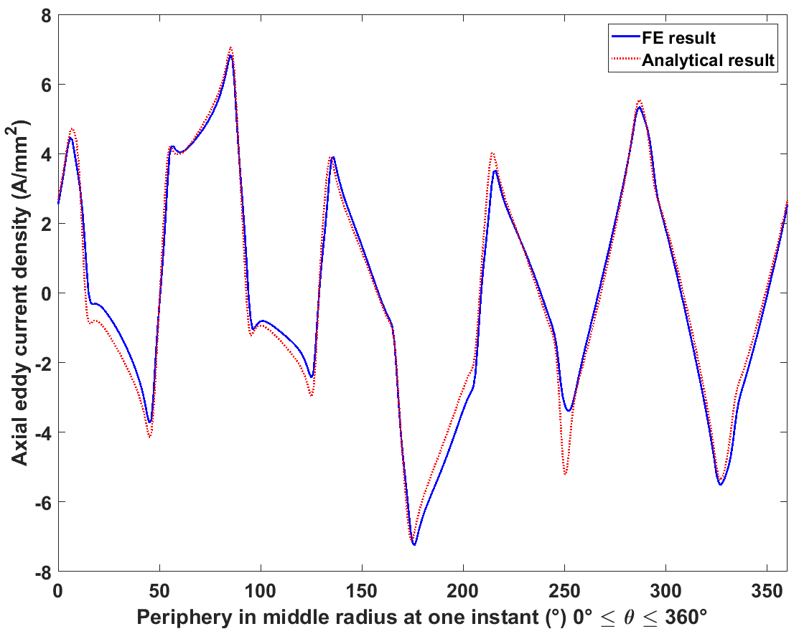
Figure 5.8 Instantaneous axial eddy current distribution in Inconel sleeve at 50° rotation displacement and 5000rpm

Table 5.6 3D field and eddy current distributions for 5000rpm from the two methods
Analytical results | FE results
Radial flux density
Magnet
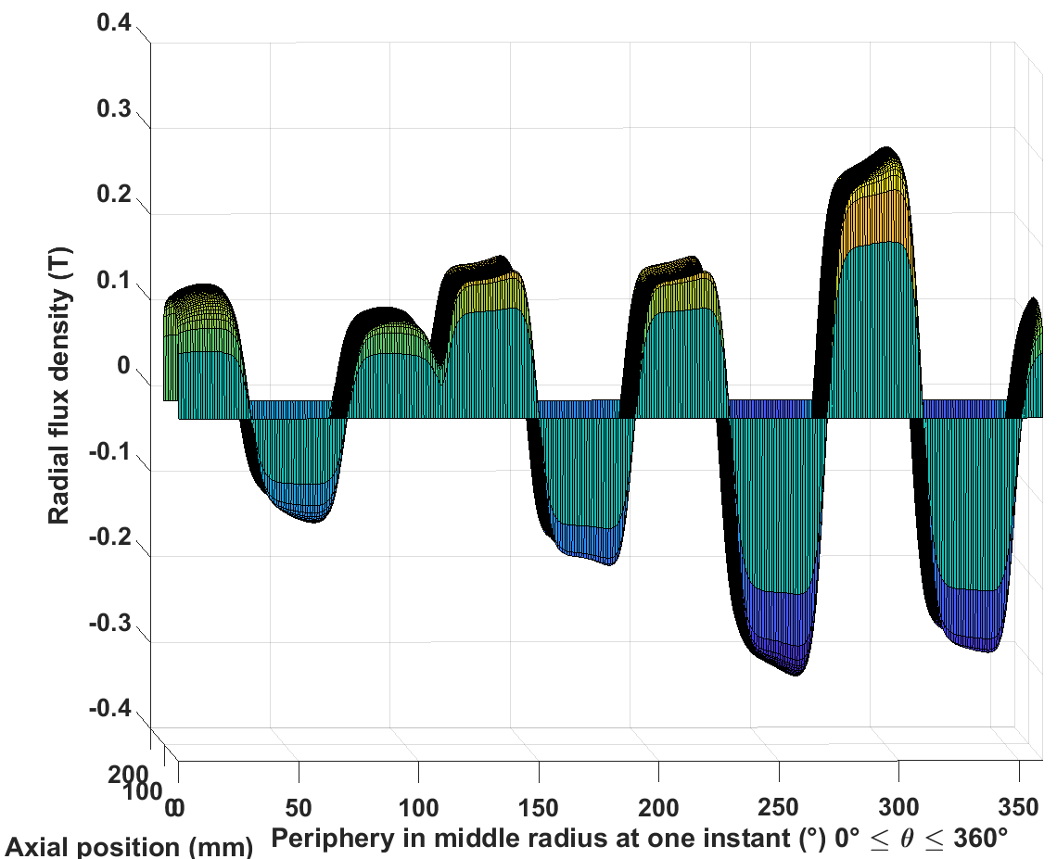 | 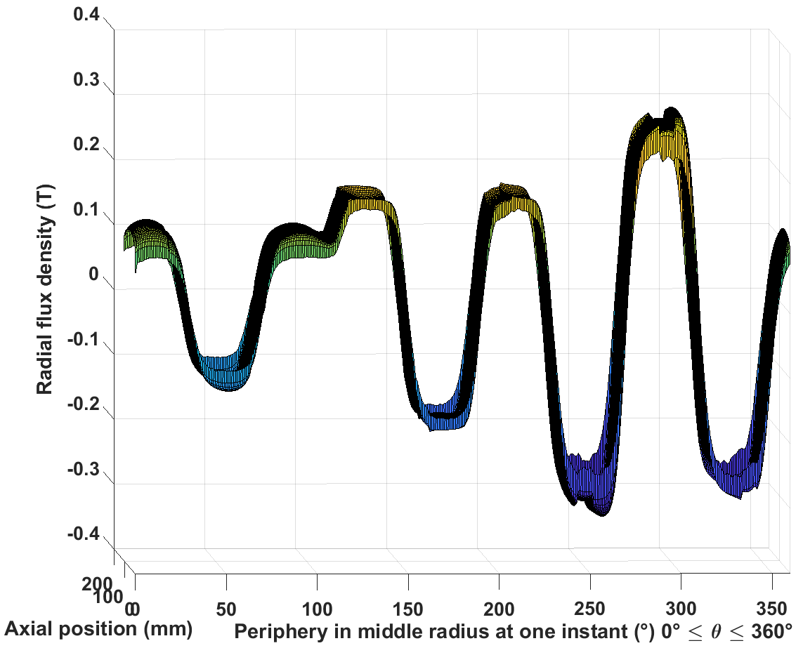
Inconel sleeve
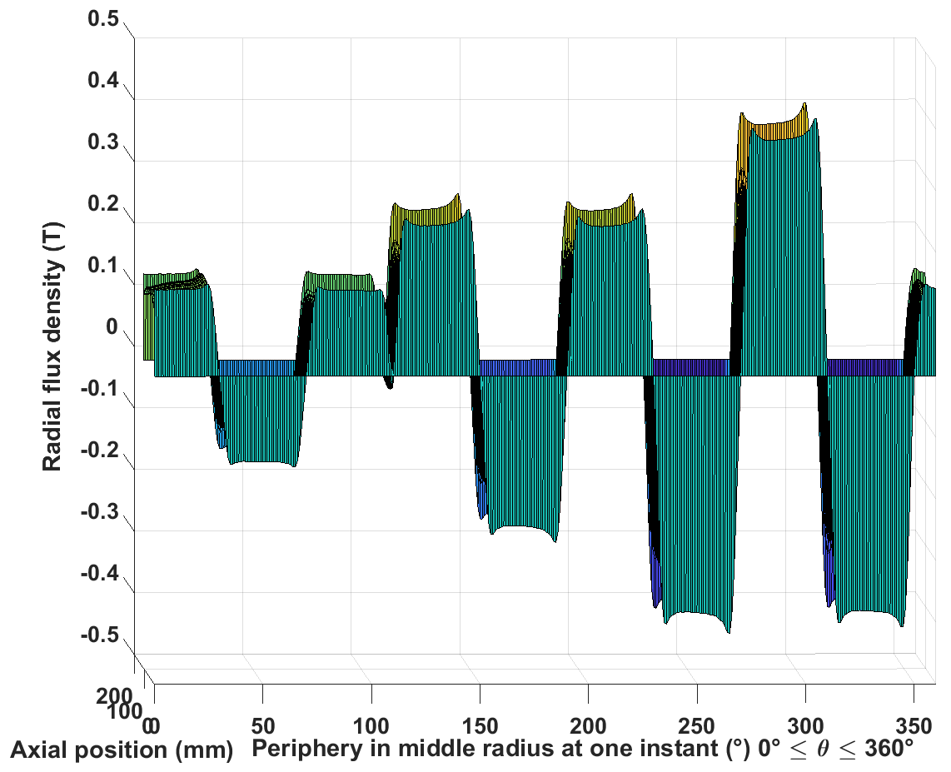 | 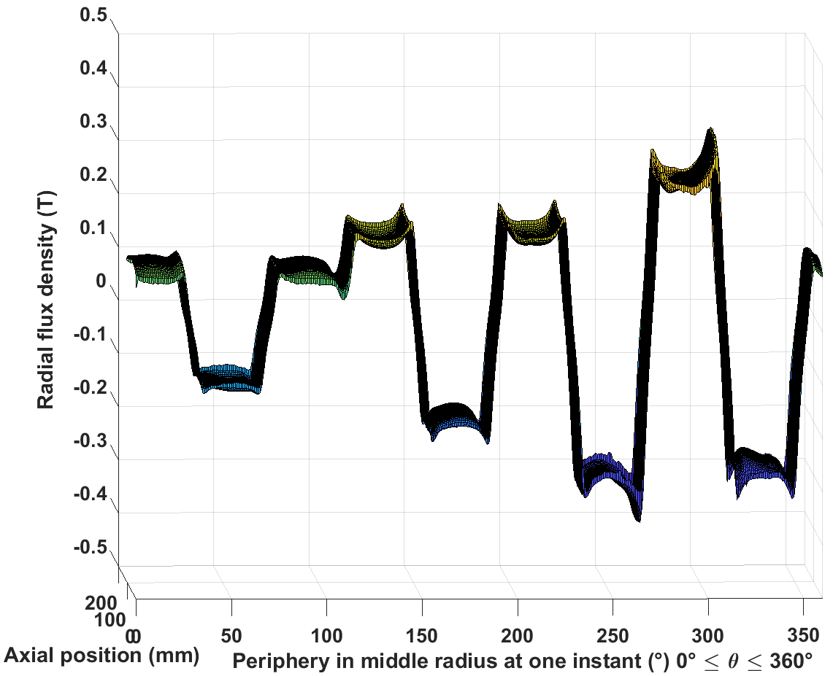
Airgap
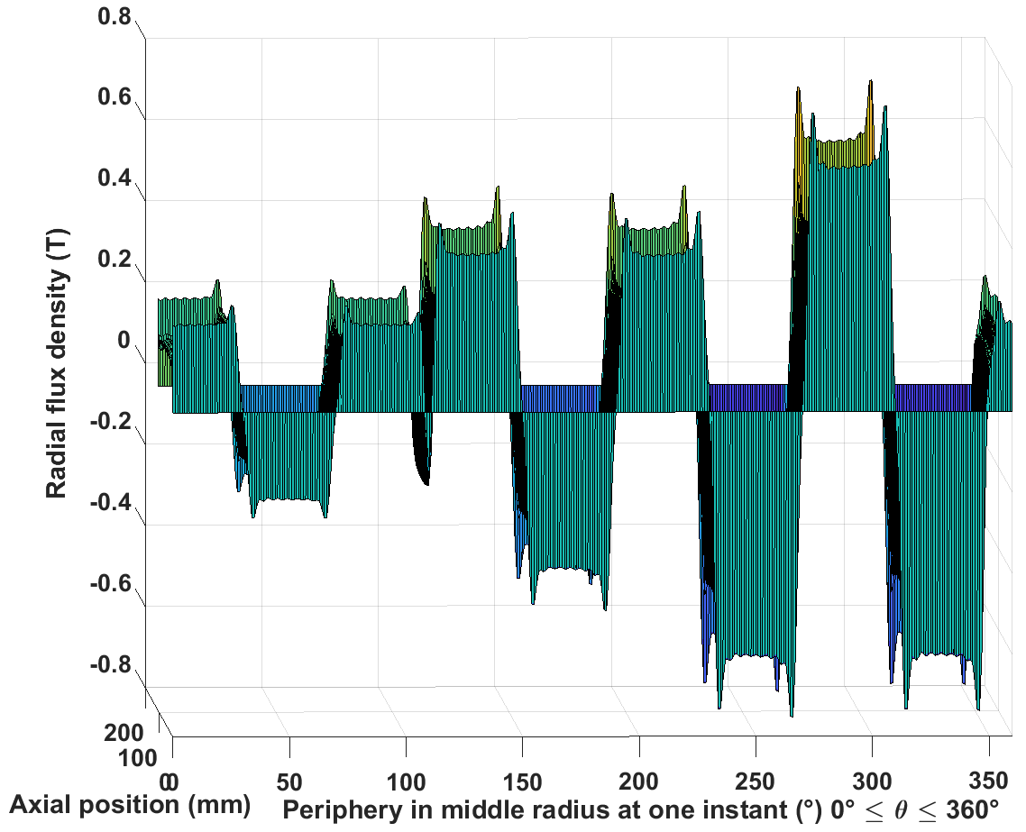 | 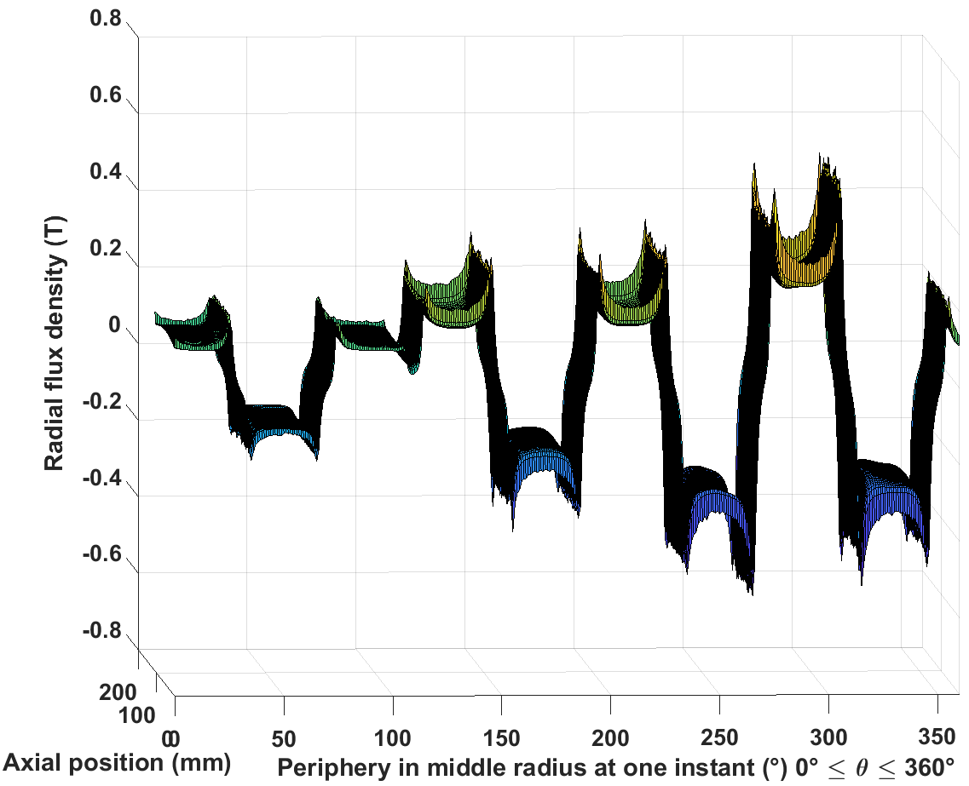
Tangential field strength
Magnet
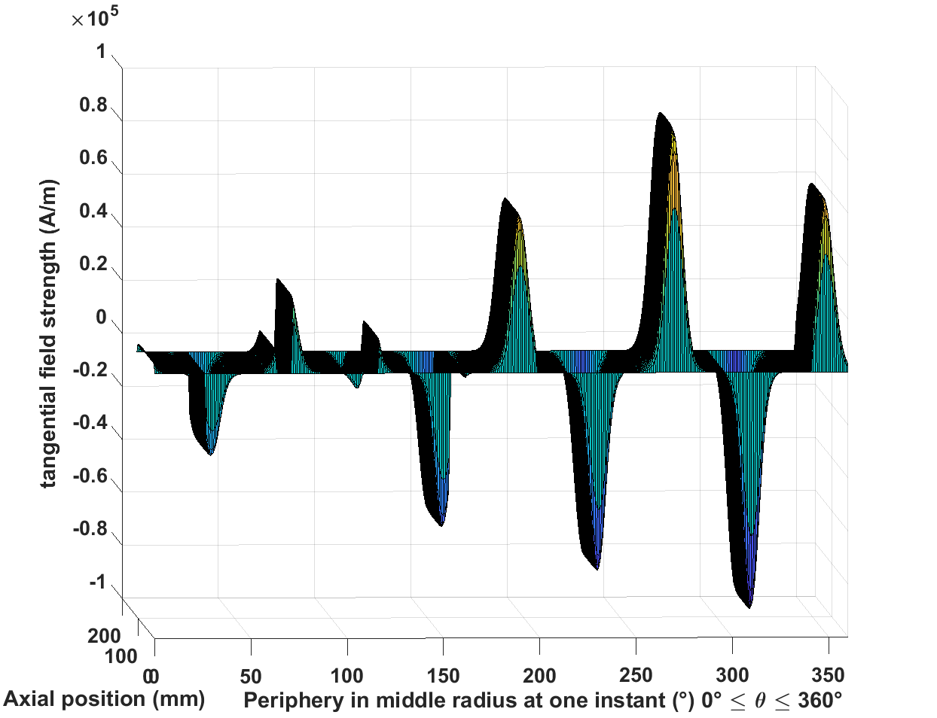 | 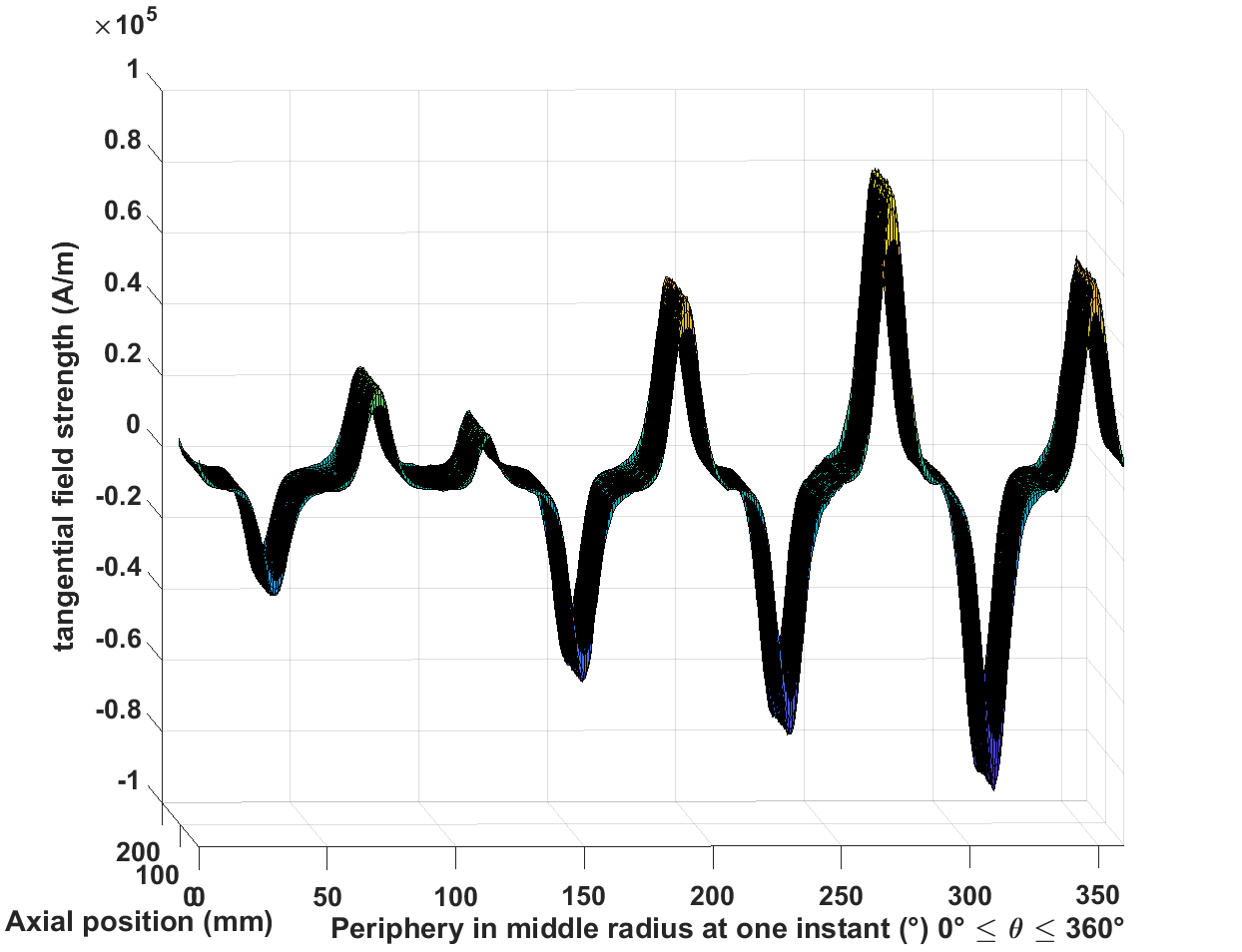
Inconel sleeve
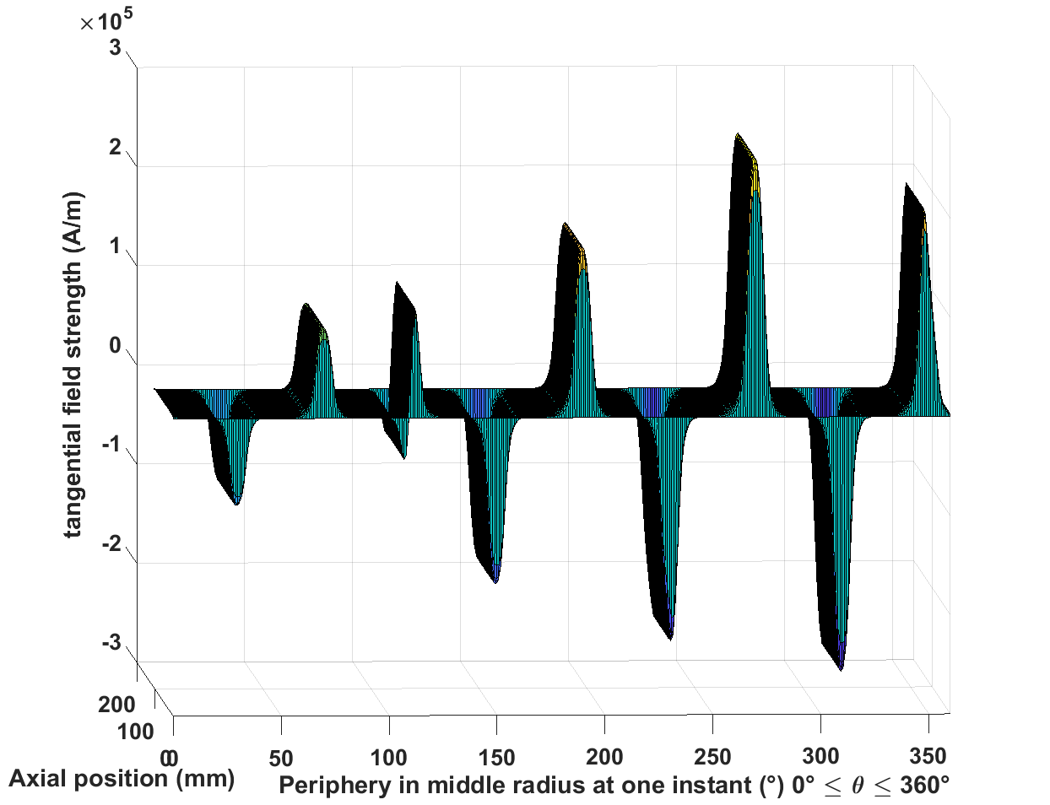 | 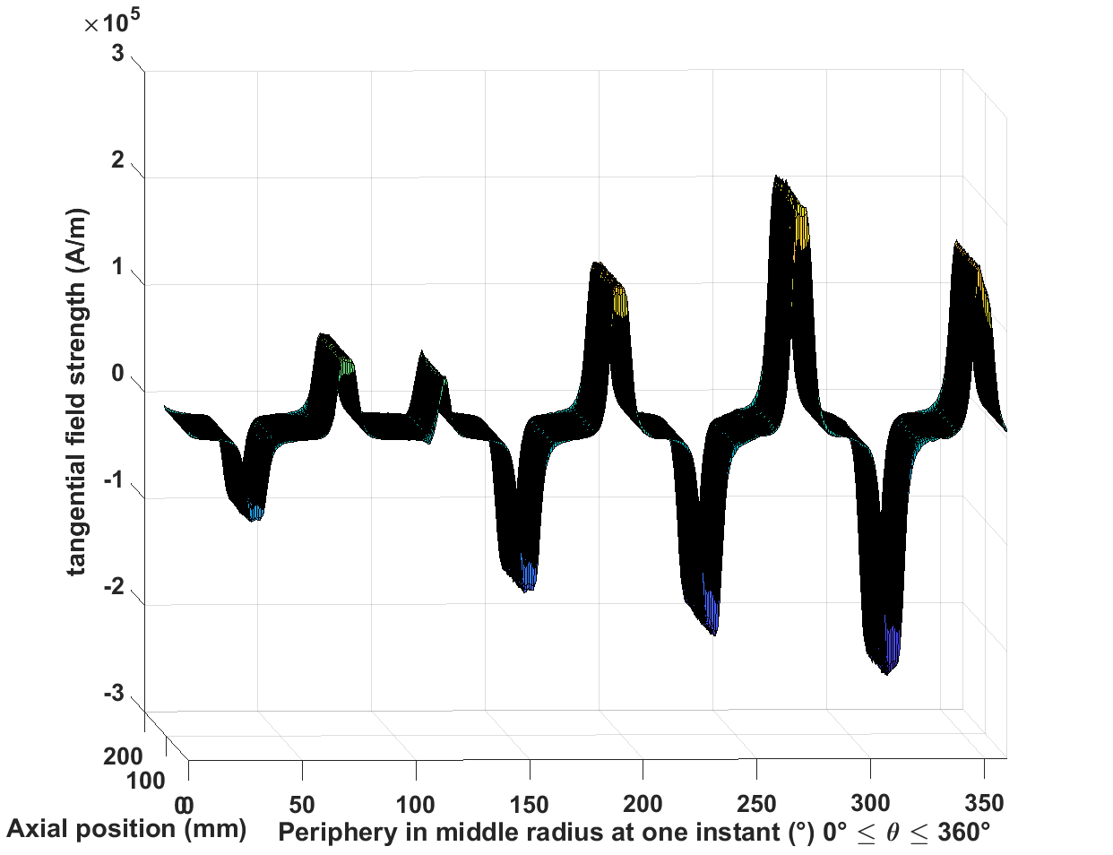
Airgap
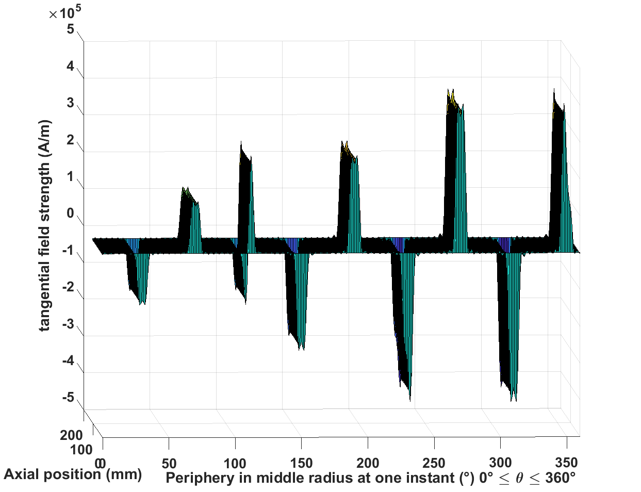 | 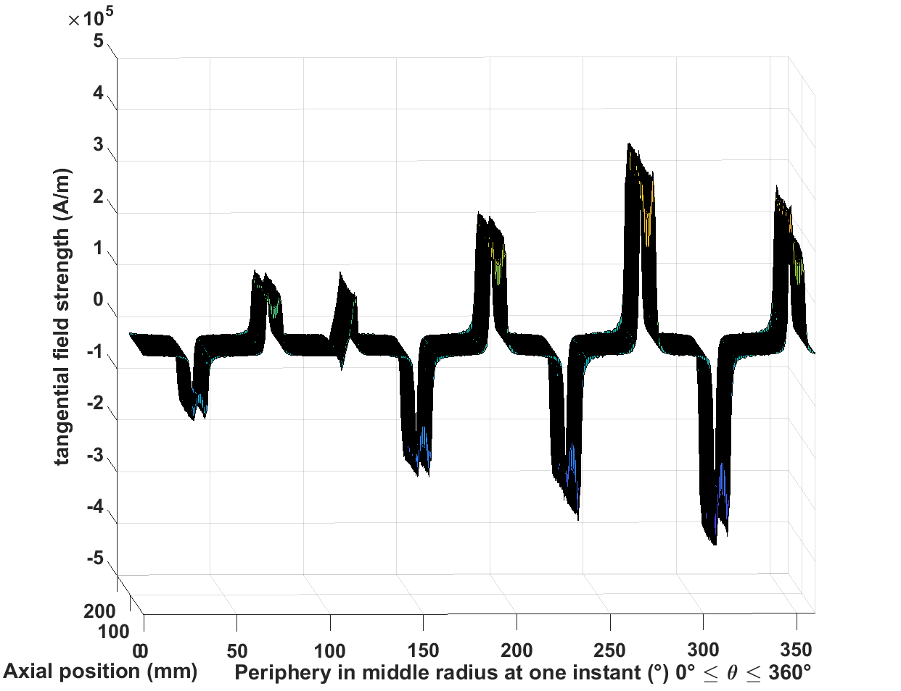
Axial eddy current
Magnet
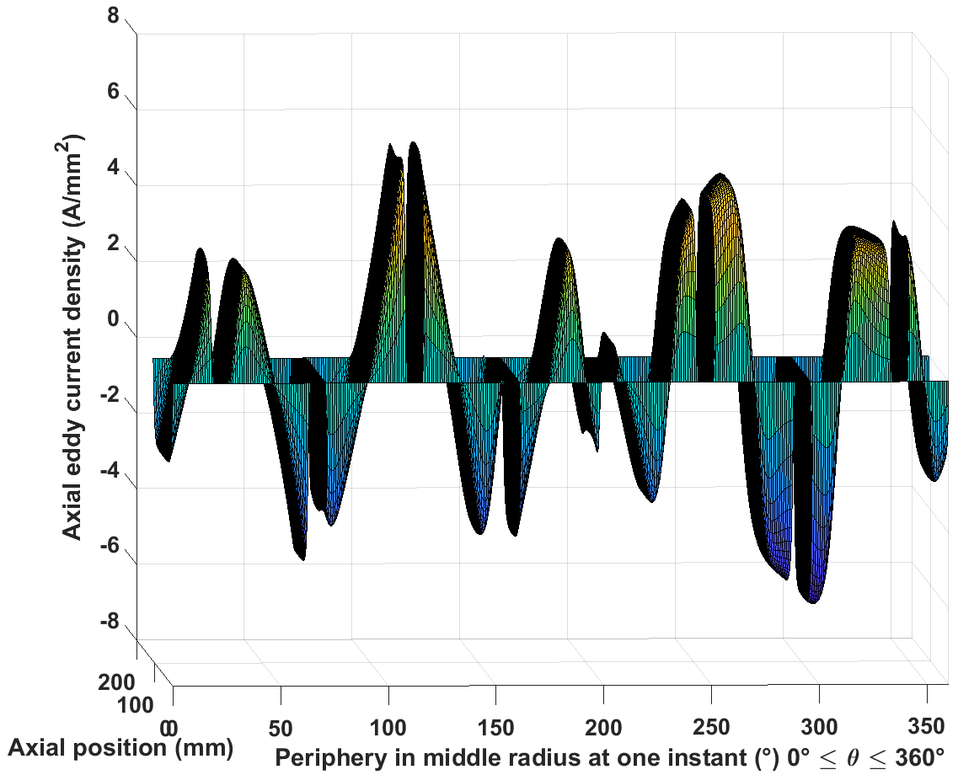 | 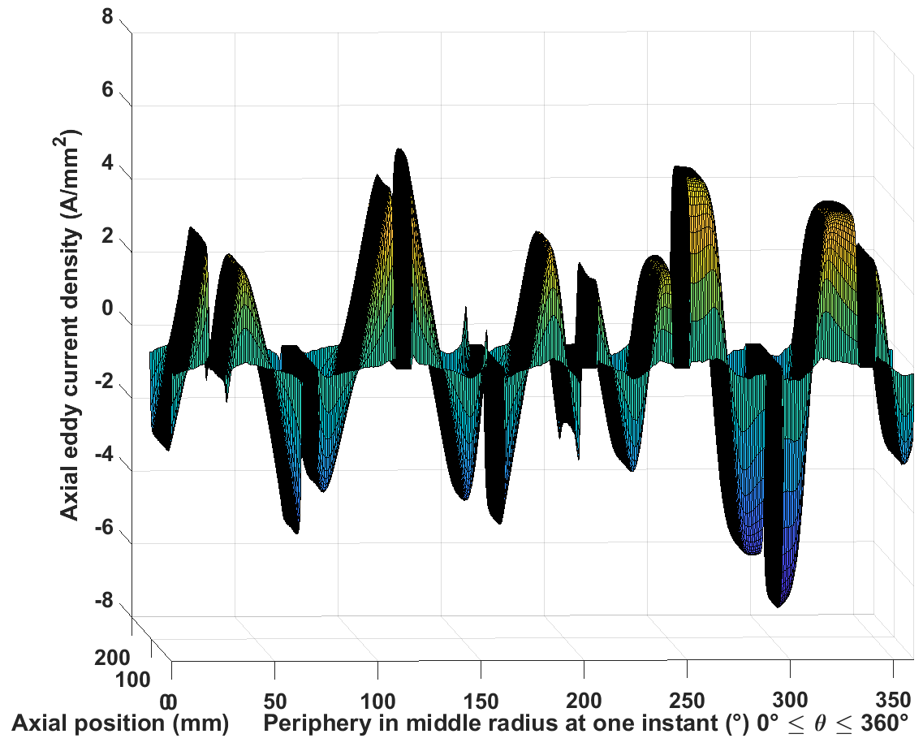
Inconel sleeve
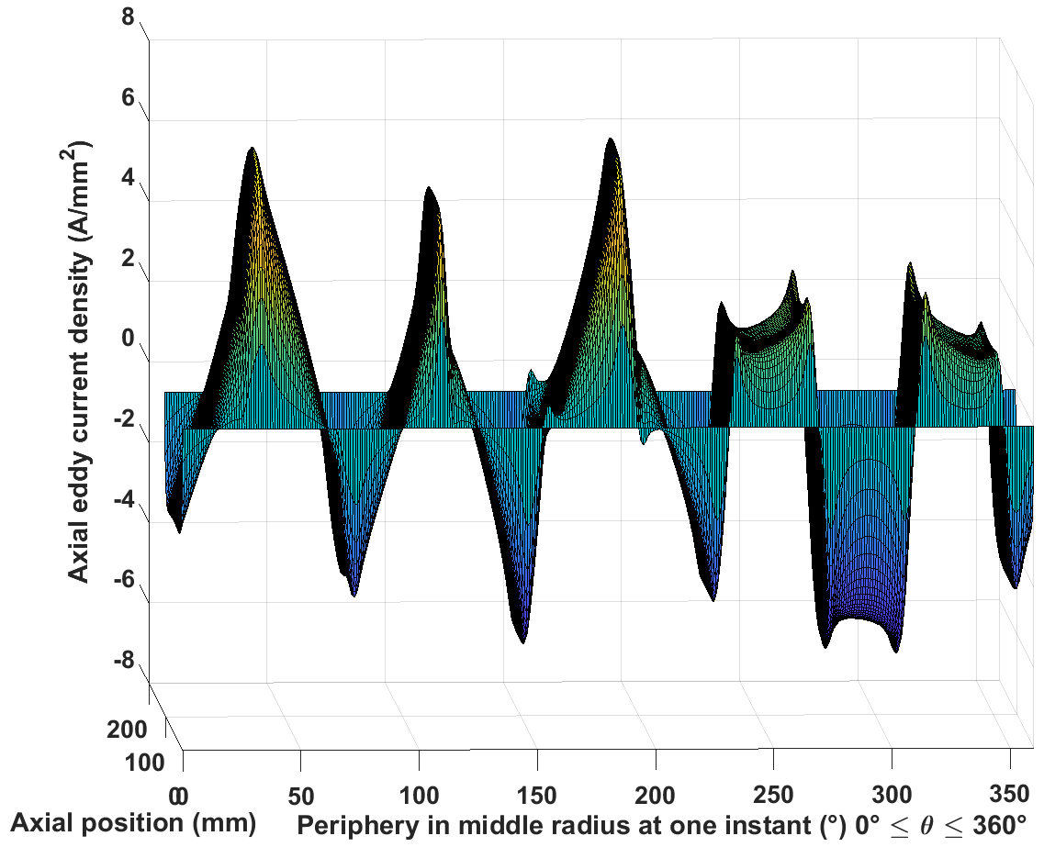 | 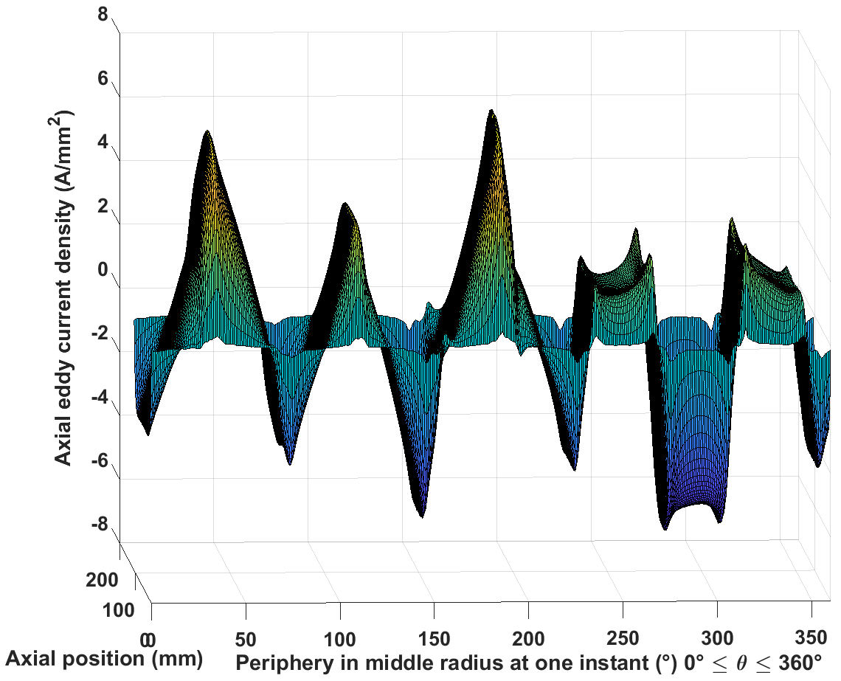
Circumferential eddy current
Magnet
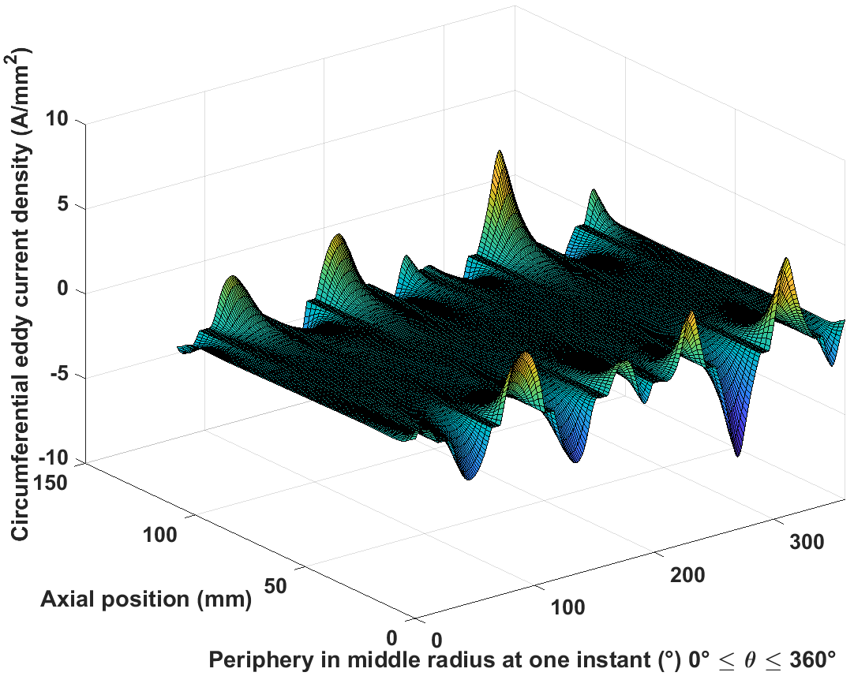 | 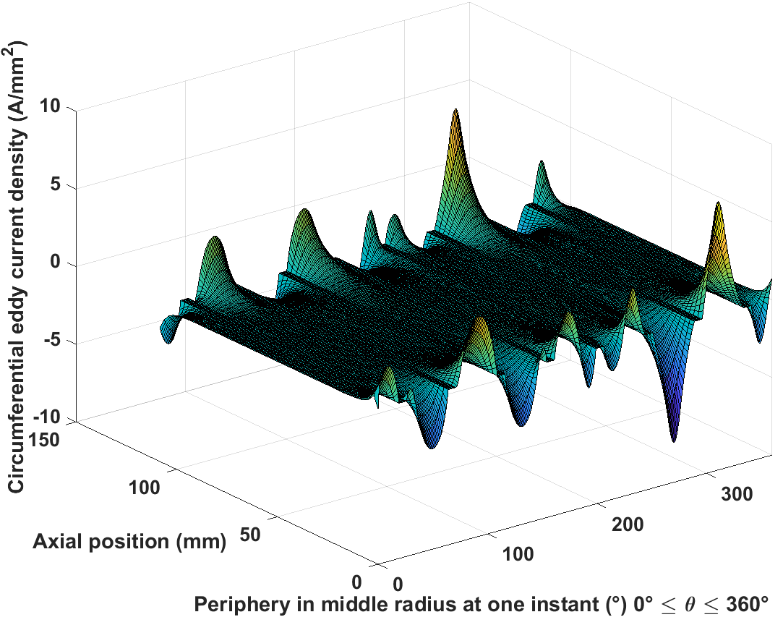
Inconel sleeve
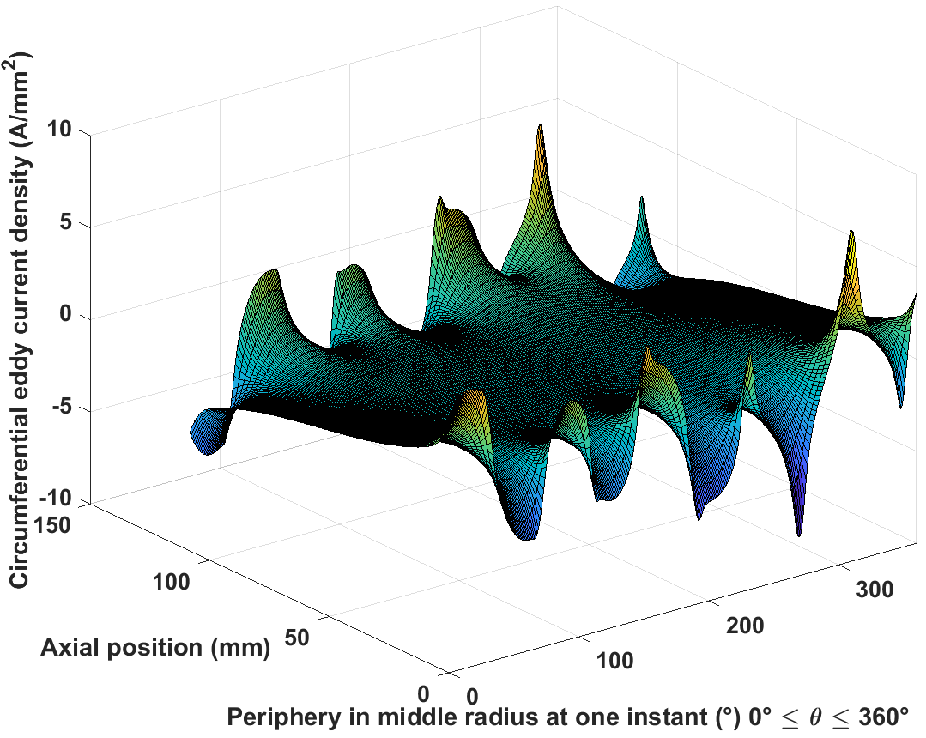 | 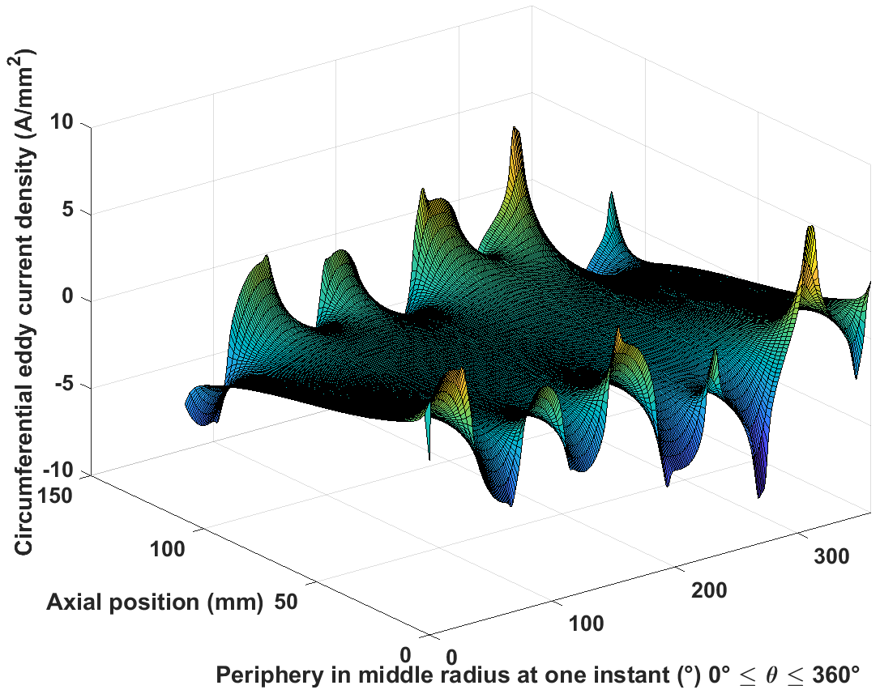

Table 5.7 3D field and eddy current distributions for 24000rpm from the two methods
Analytical results | FE results
Radial flux density
Magnet
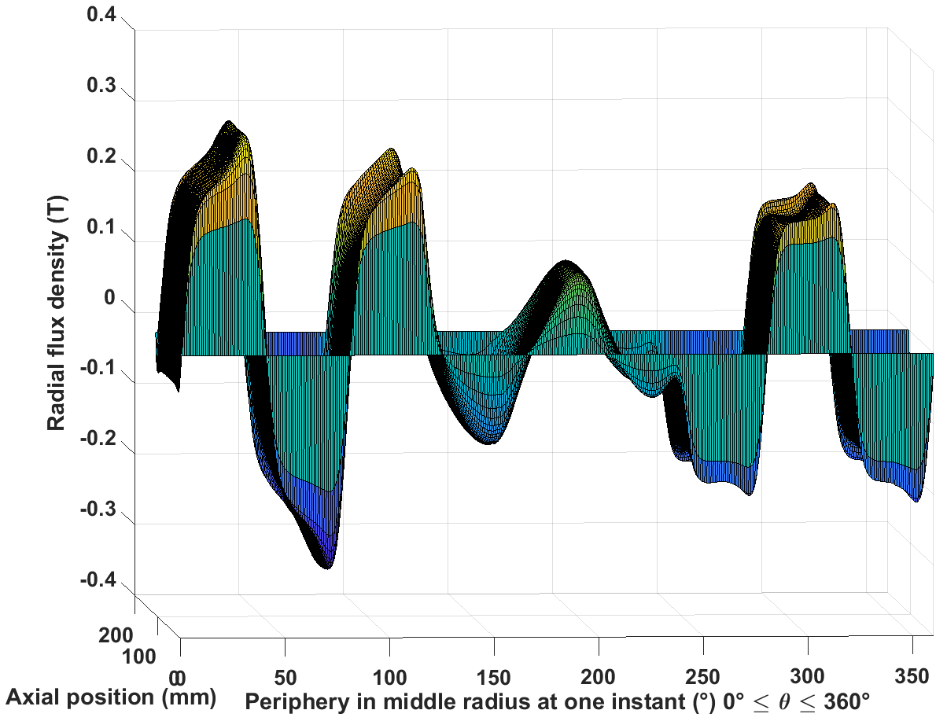 | 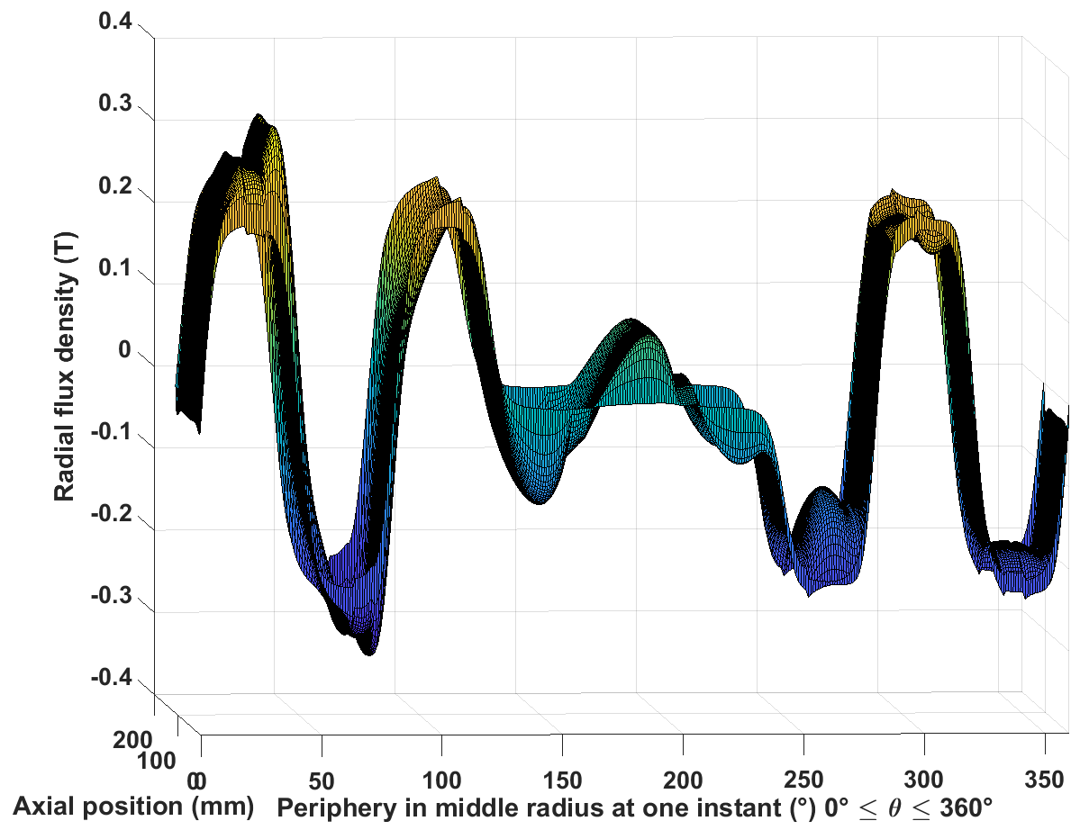
Inconel sleeve
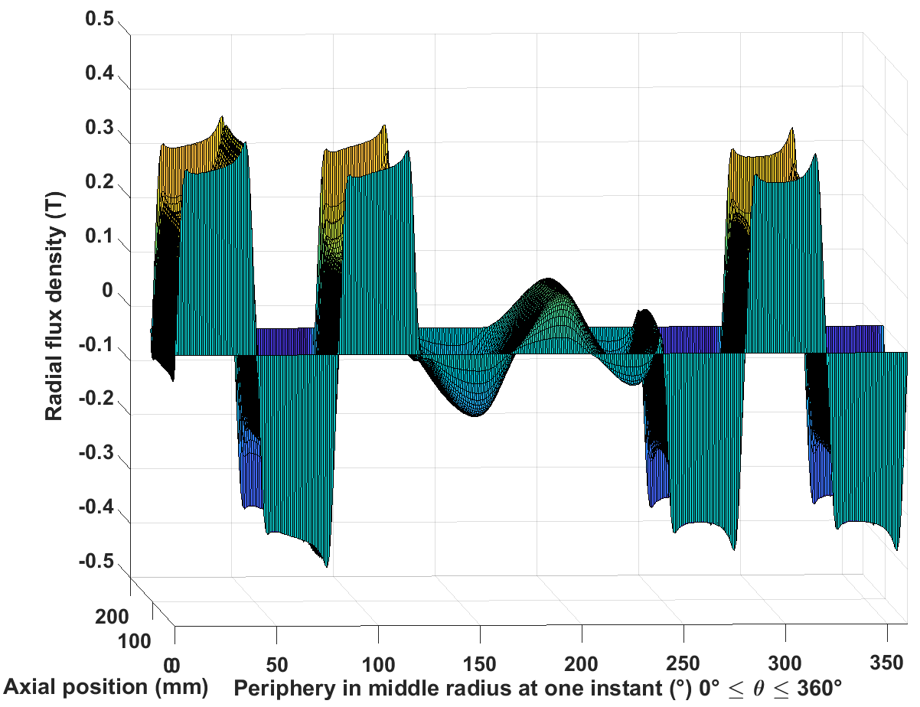 | 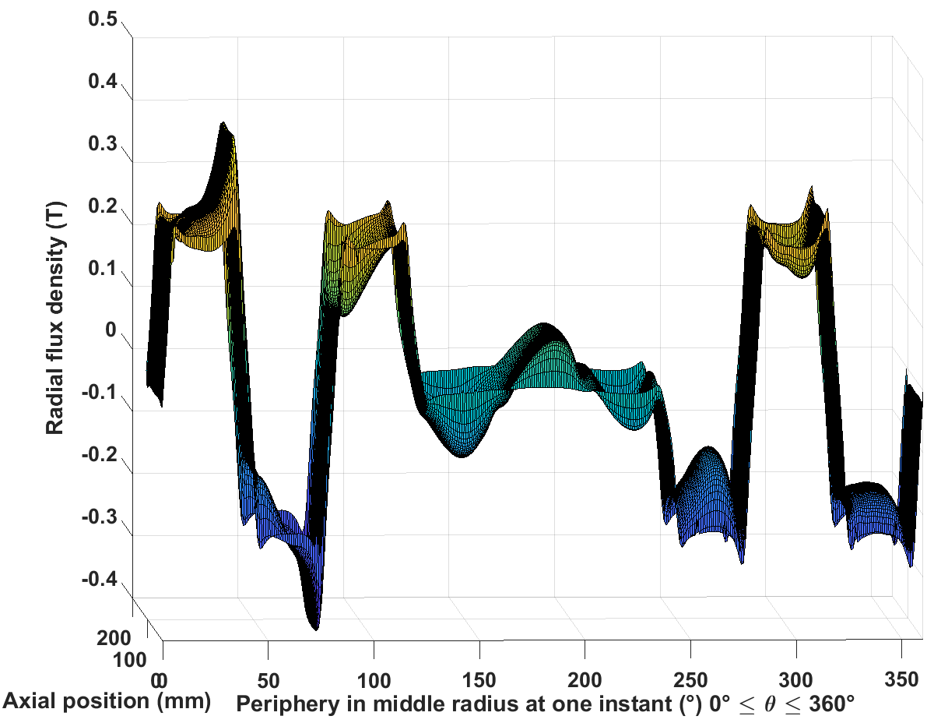
Airgap
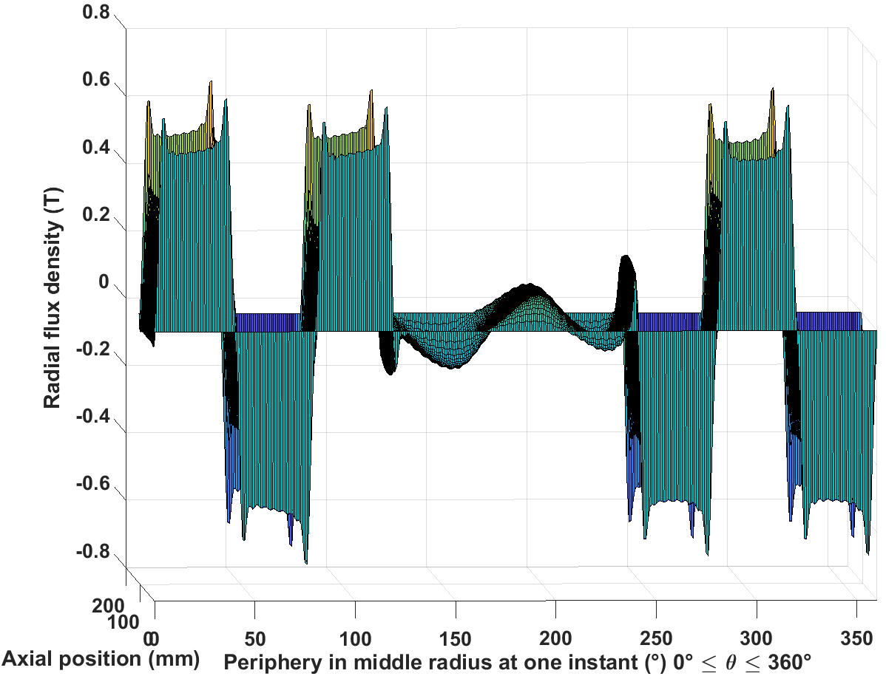 | 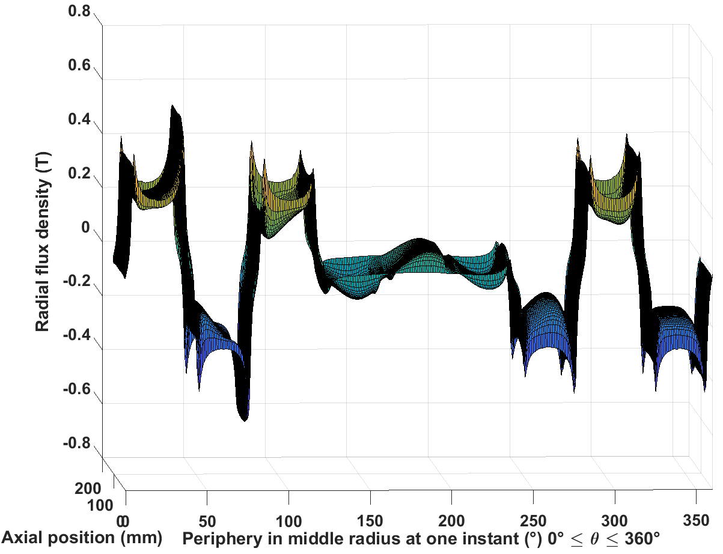
Tangential field strength
Magnet
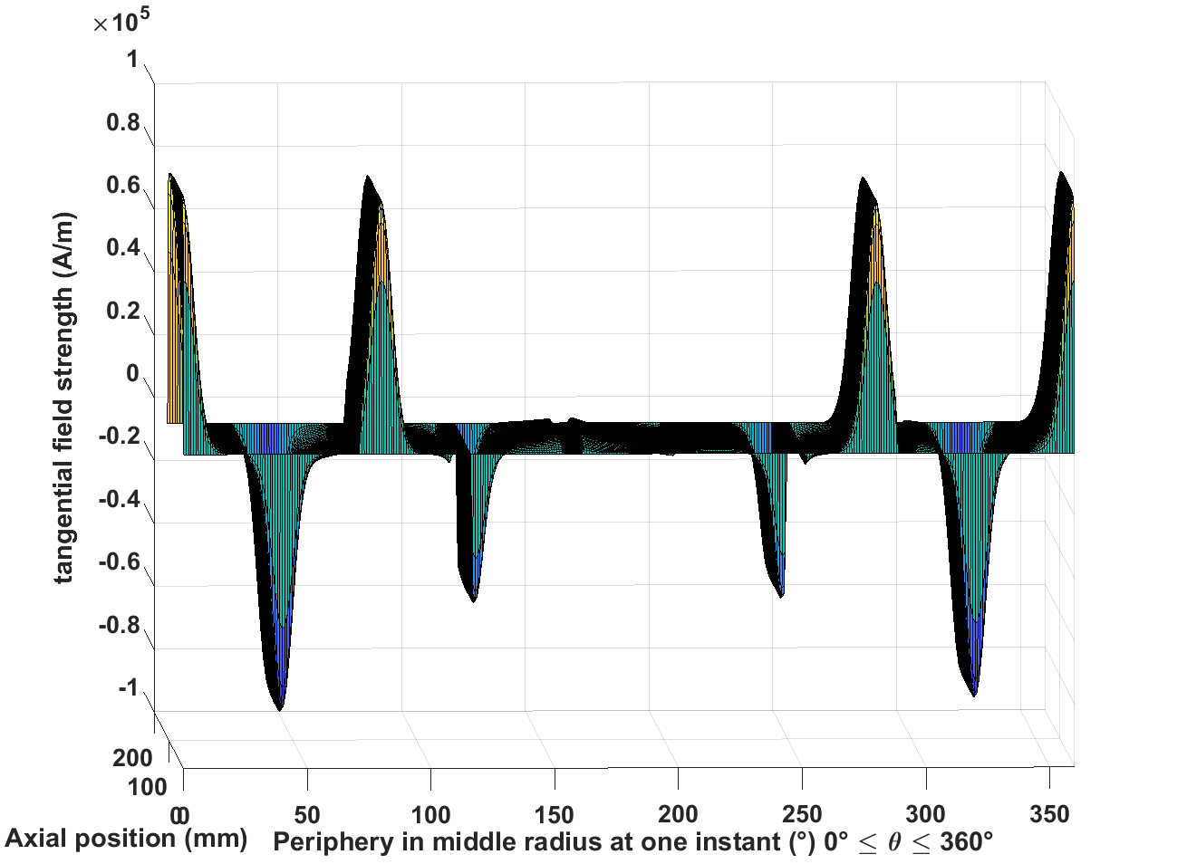 | 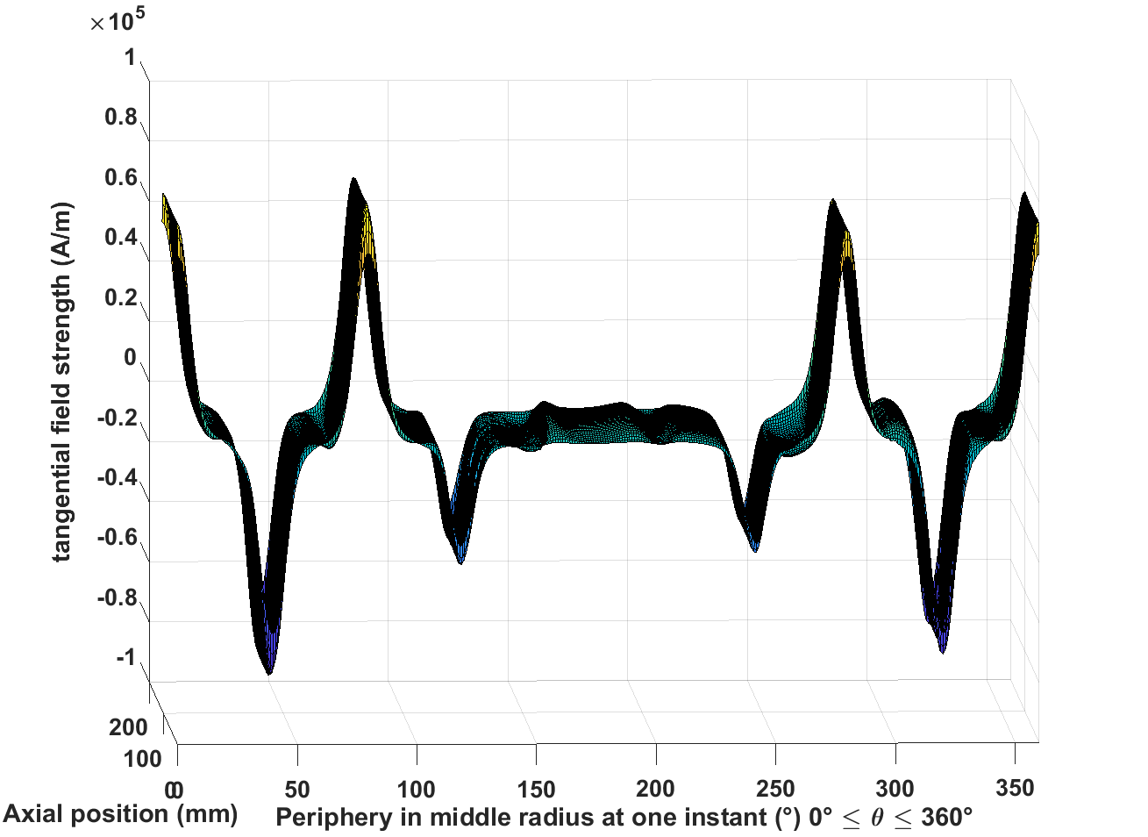
Inconel sleeve
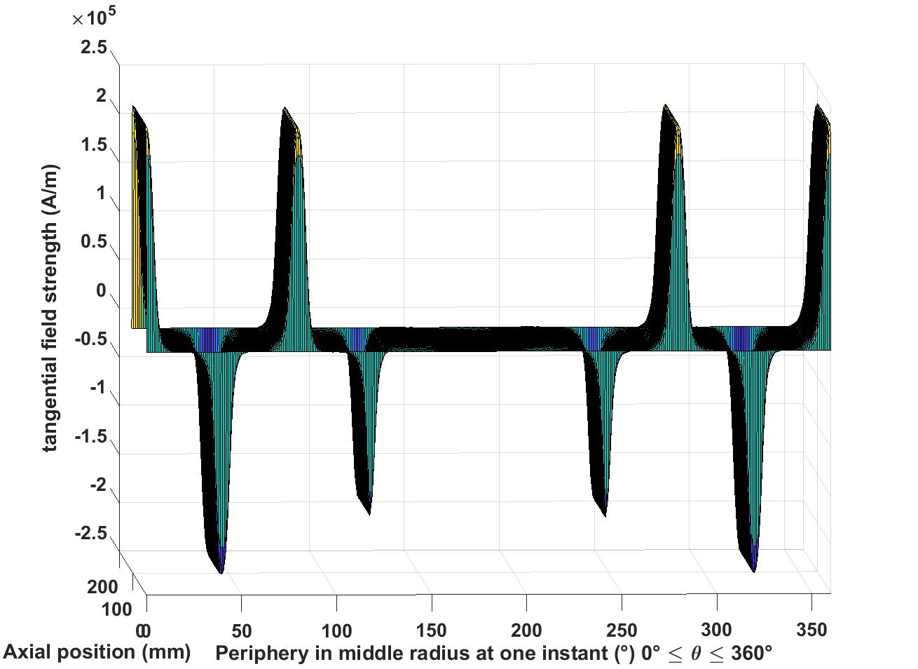 | 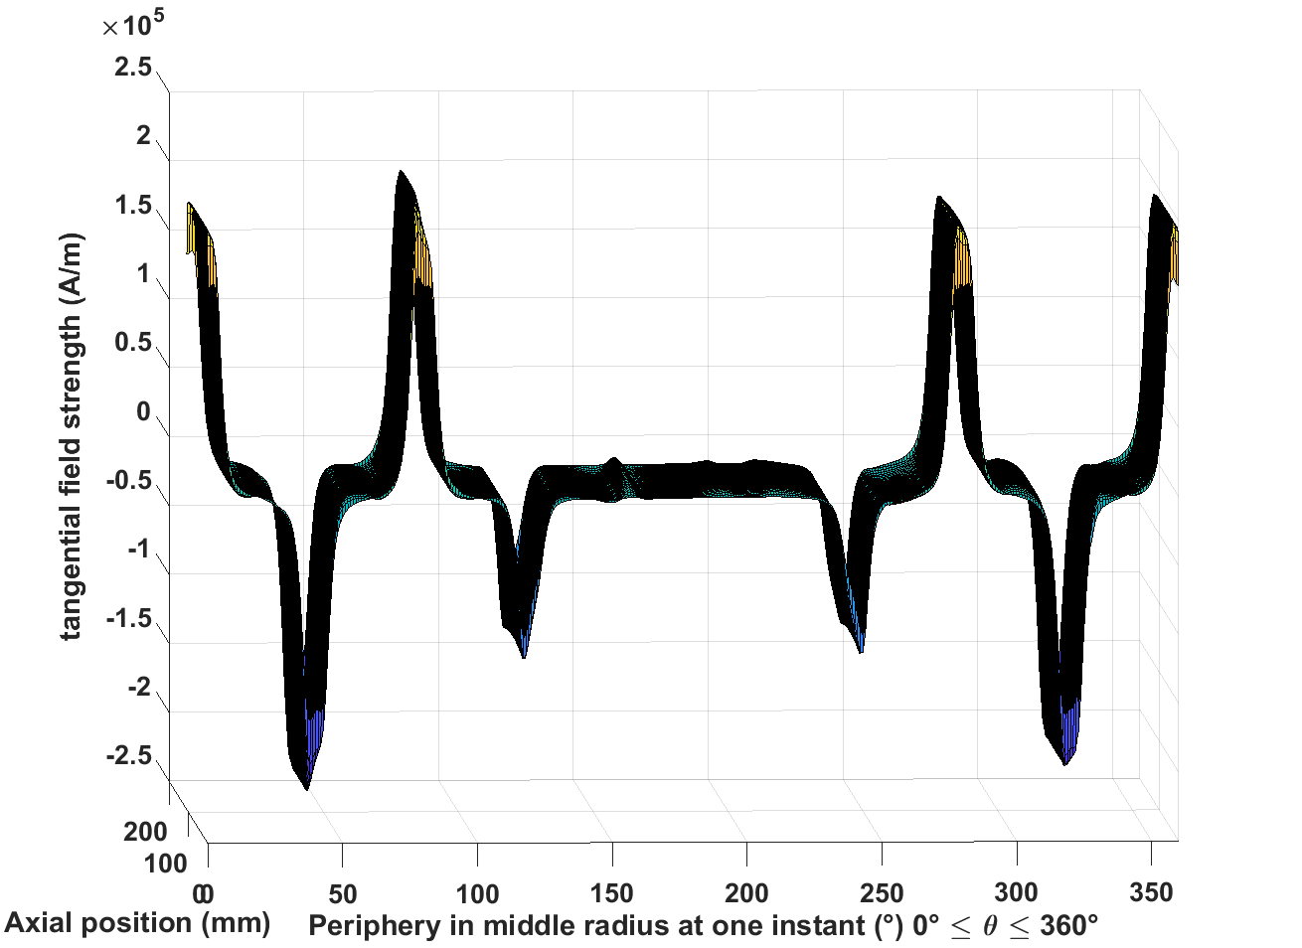
Airgap
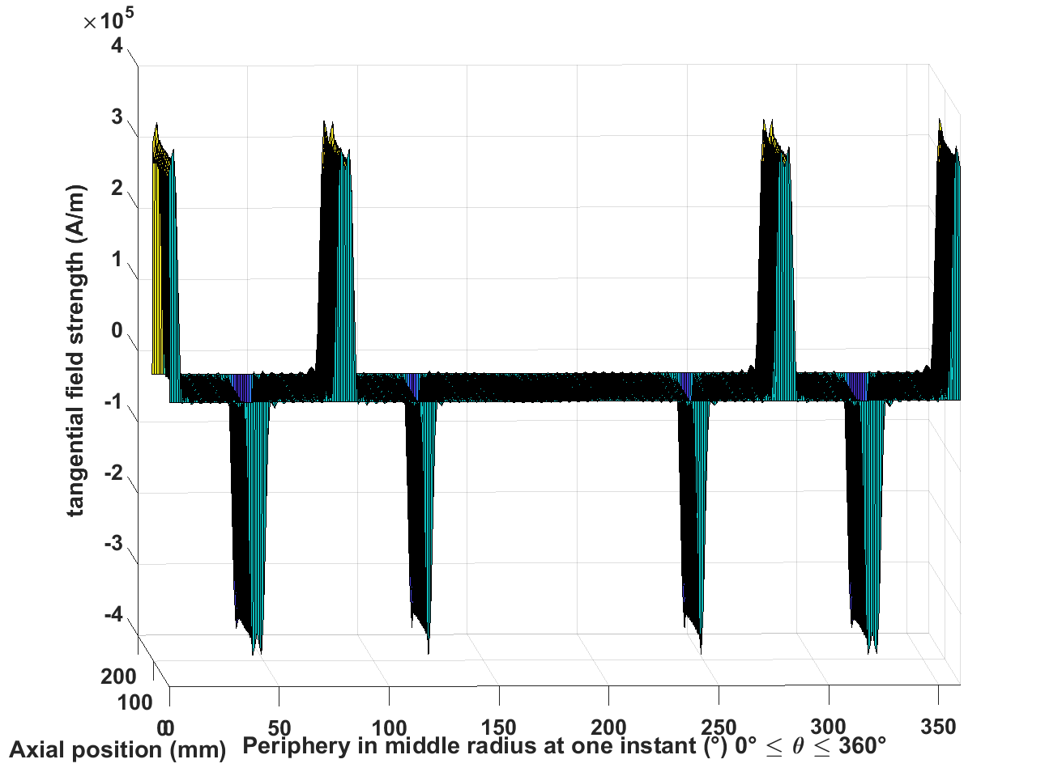 | 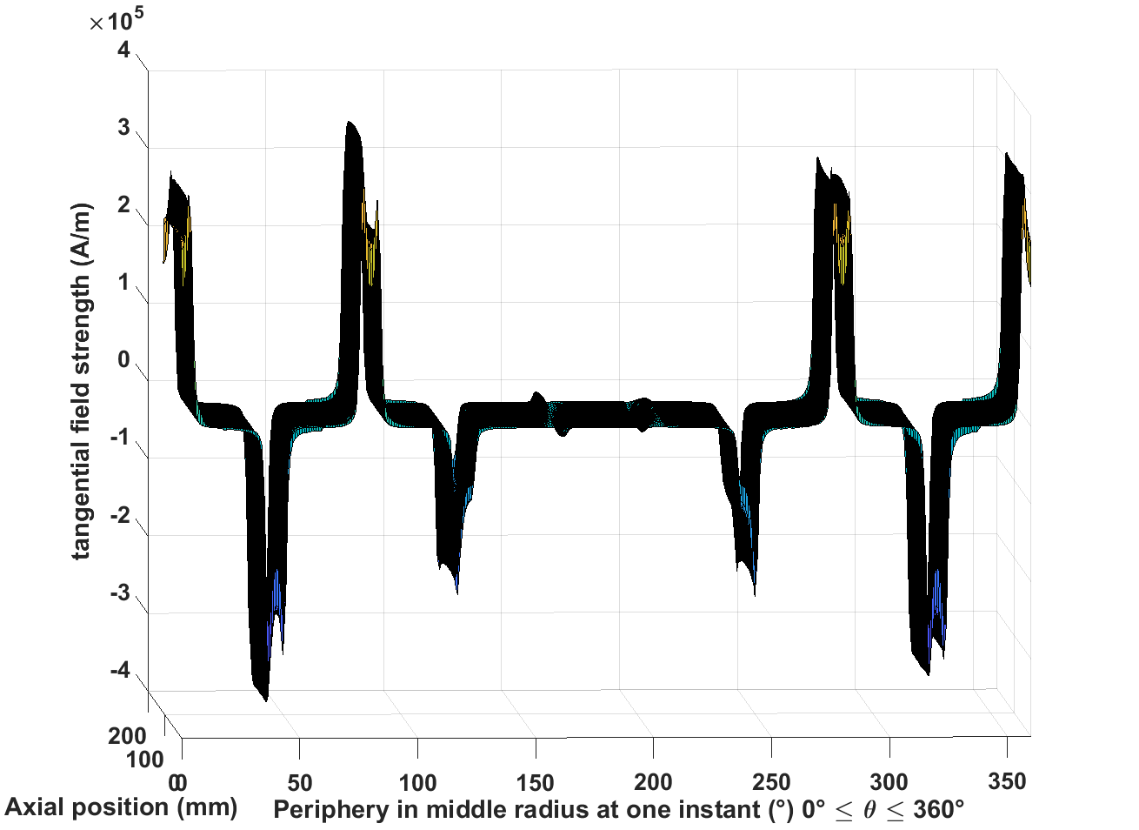
Axial eddy current
Magnet
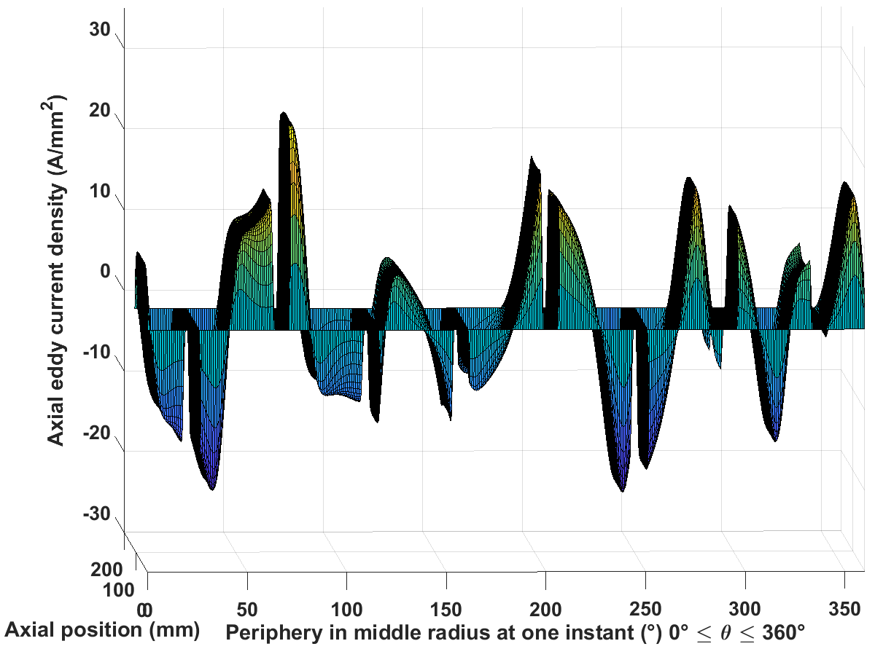 | 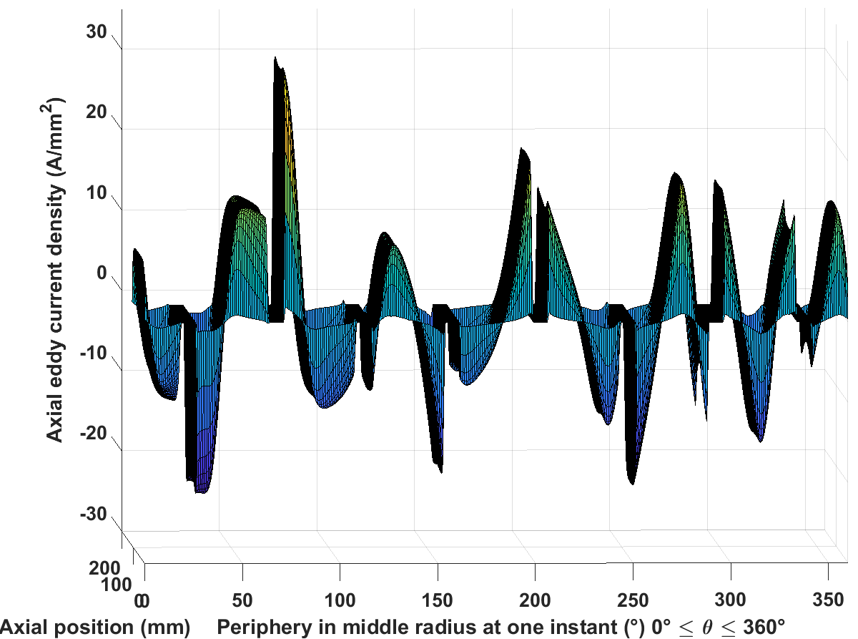
Inconel sleeve
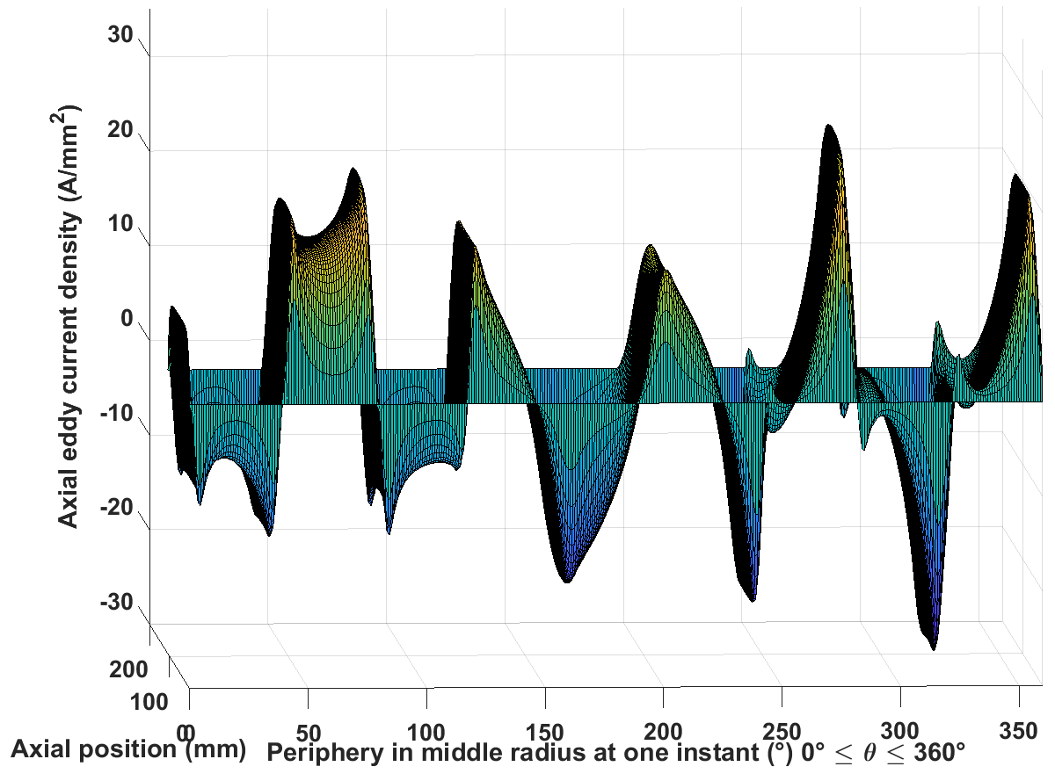 | 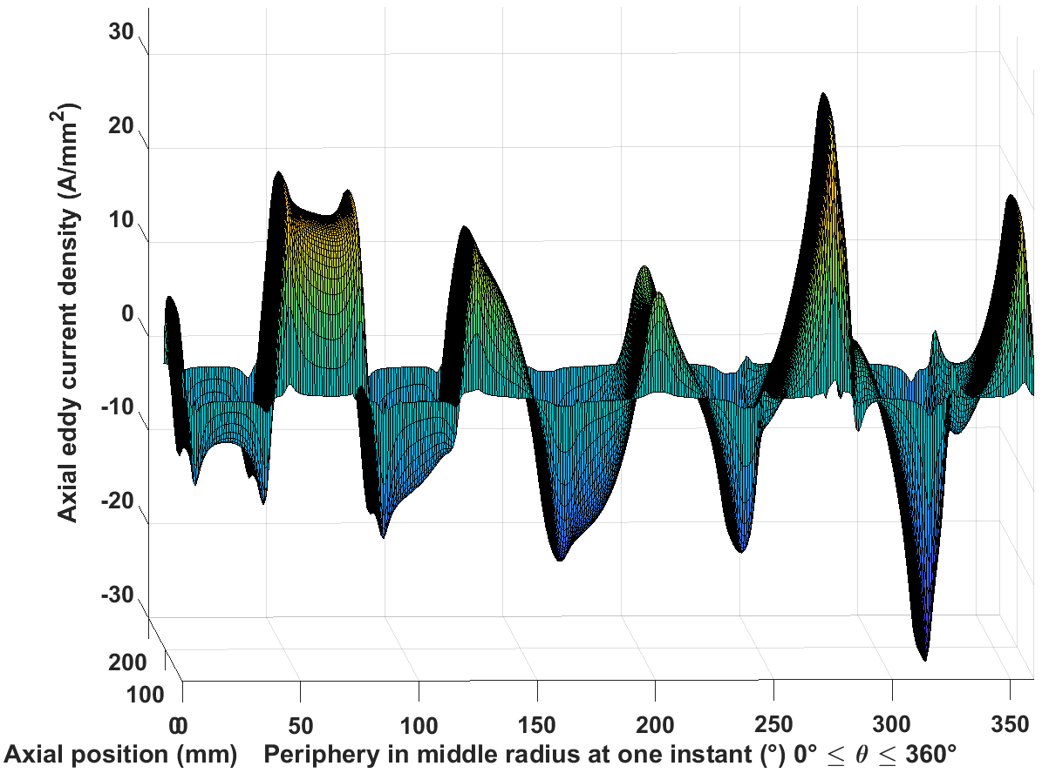
Circumferential eddy current
Magnet
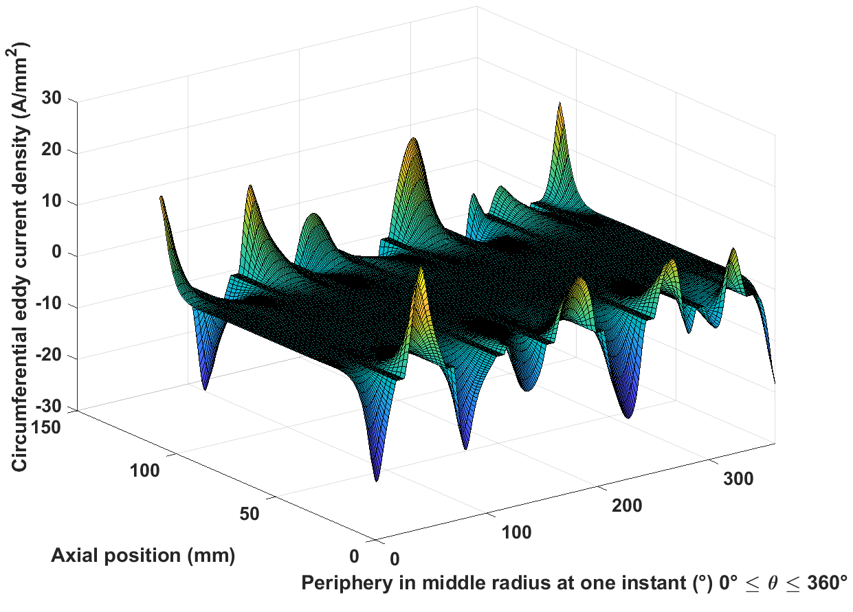 | 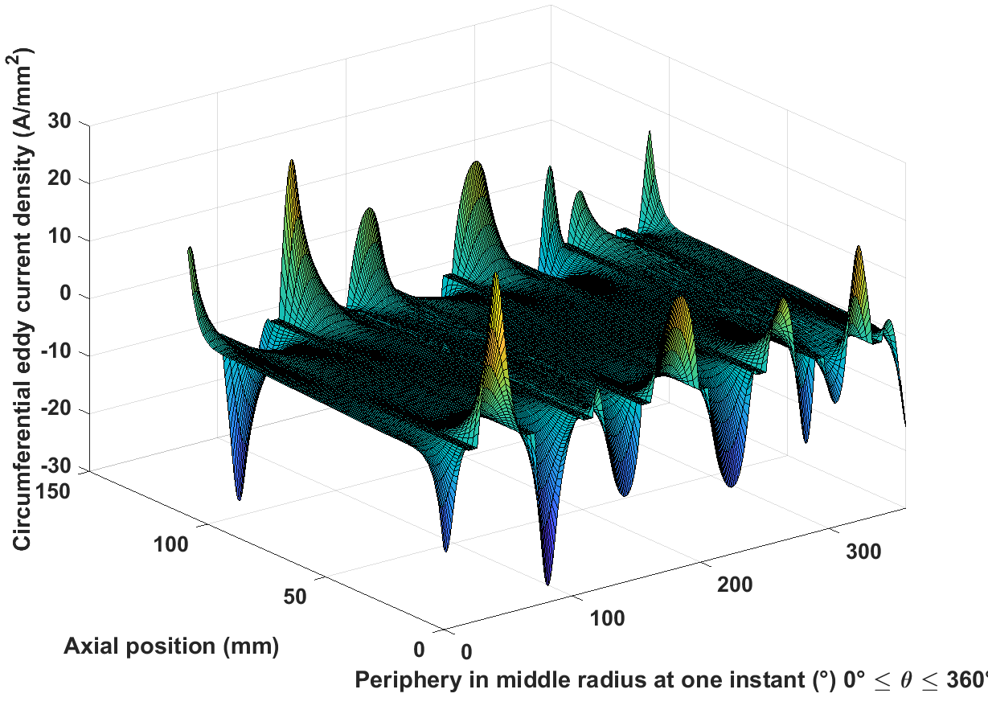
Inconel sleeve
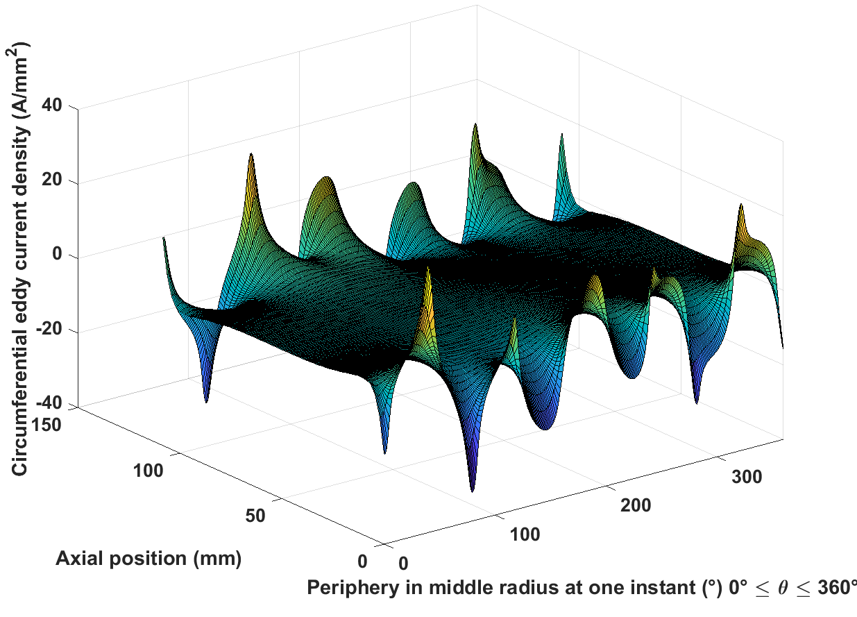 | 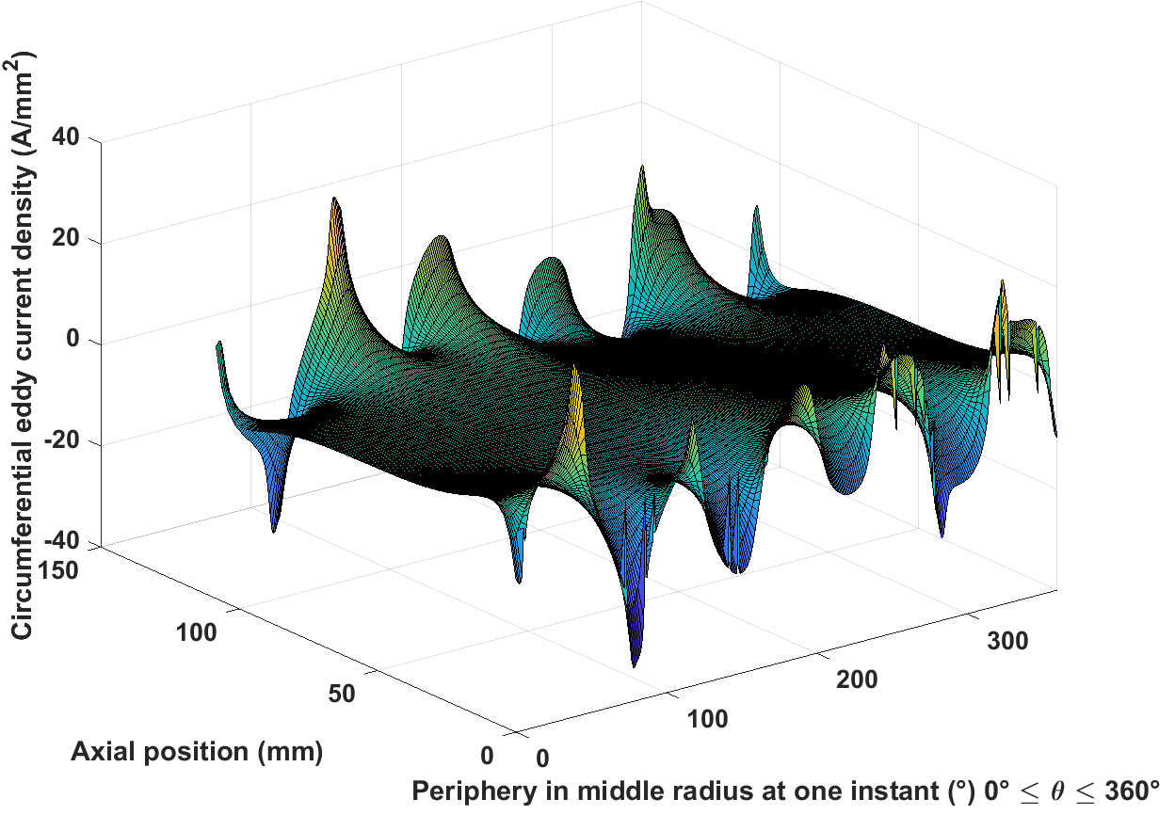

Table 5.8 2D field and eddy current distribution for 5000rpm from the two methods
Radial flux density
Magnet | 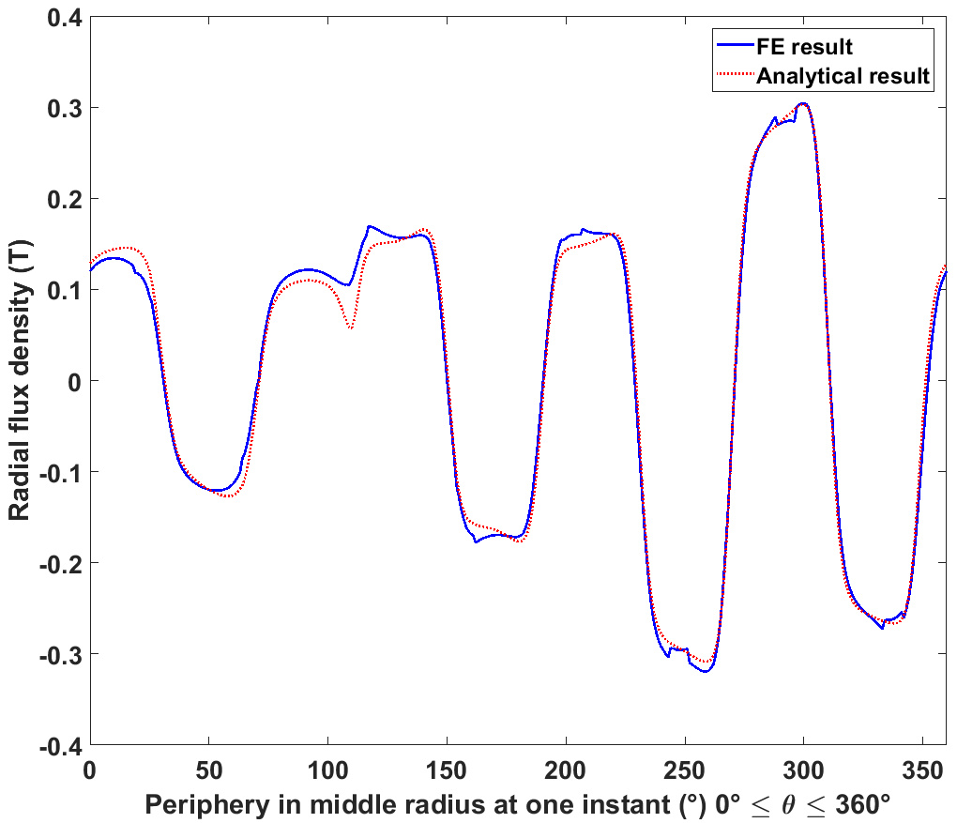
Inconel sleeve | 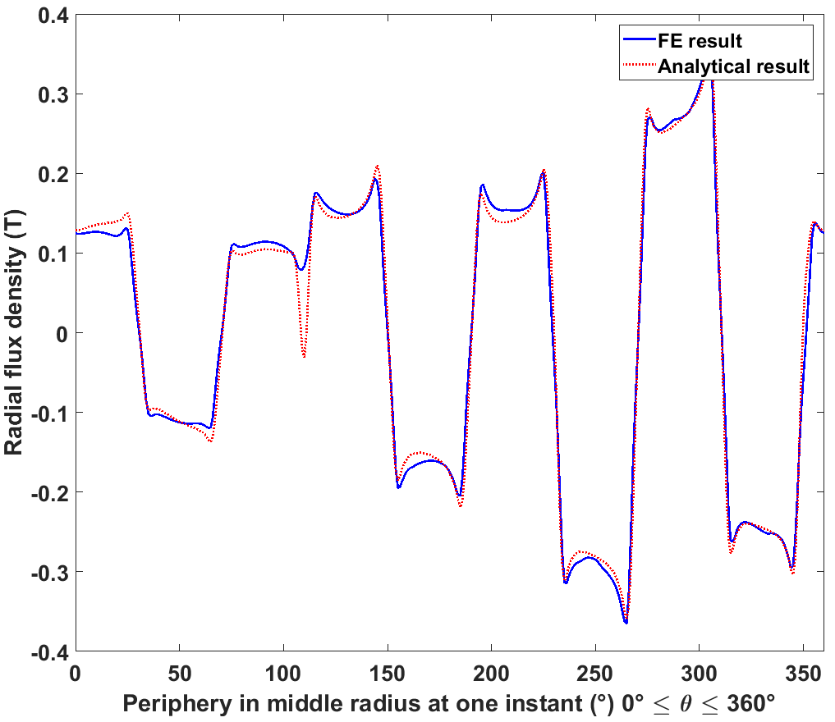
Airgap | 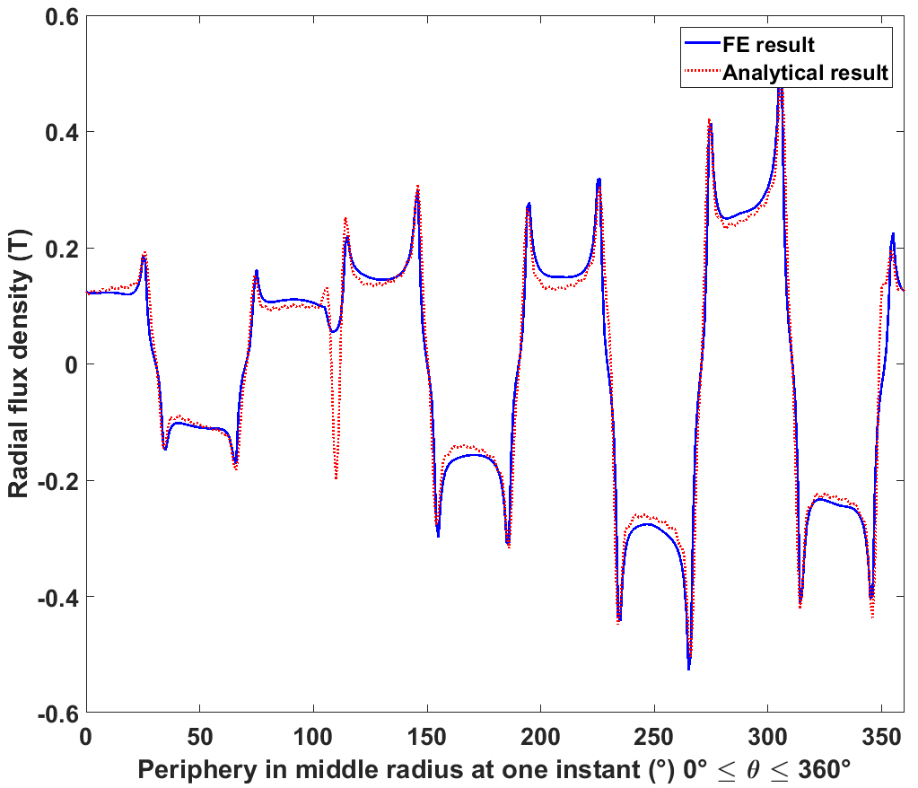
Tangential field strength
Magnet | 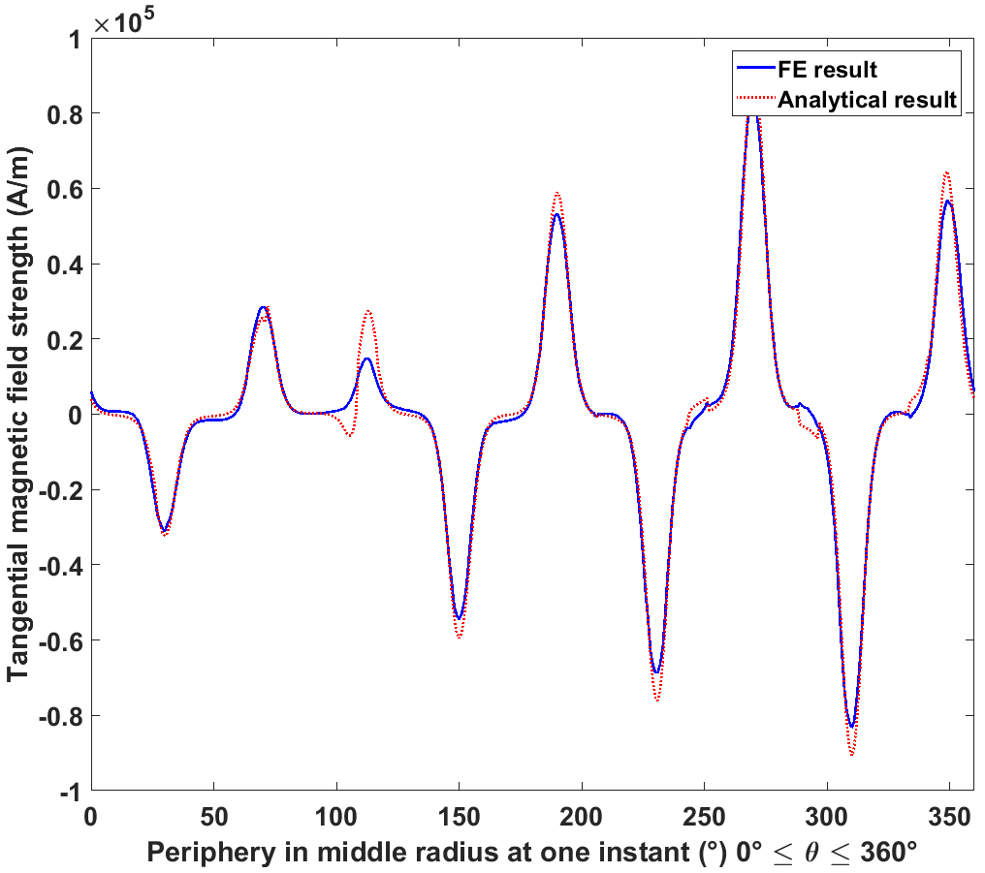
Inconel sleeve | 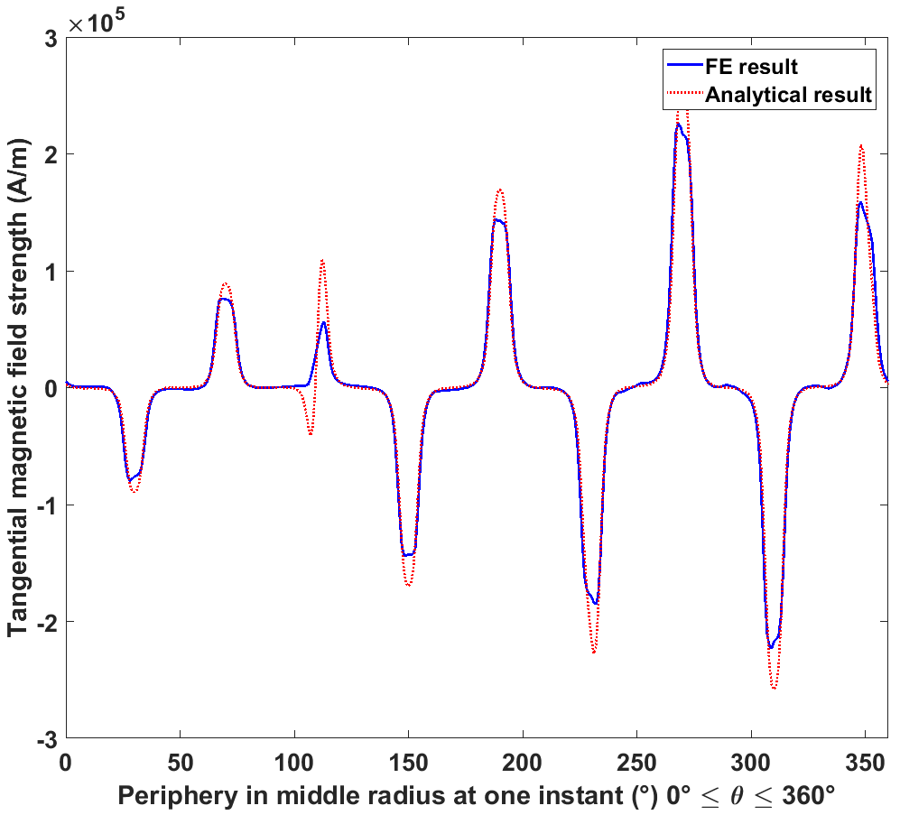
Airgap | 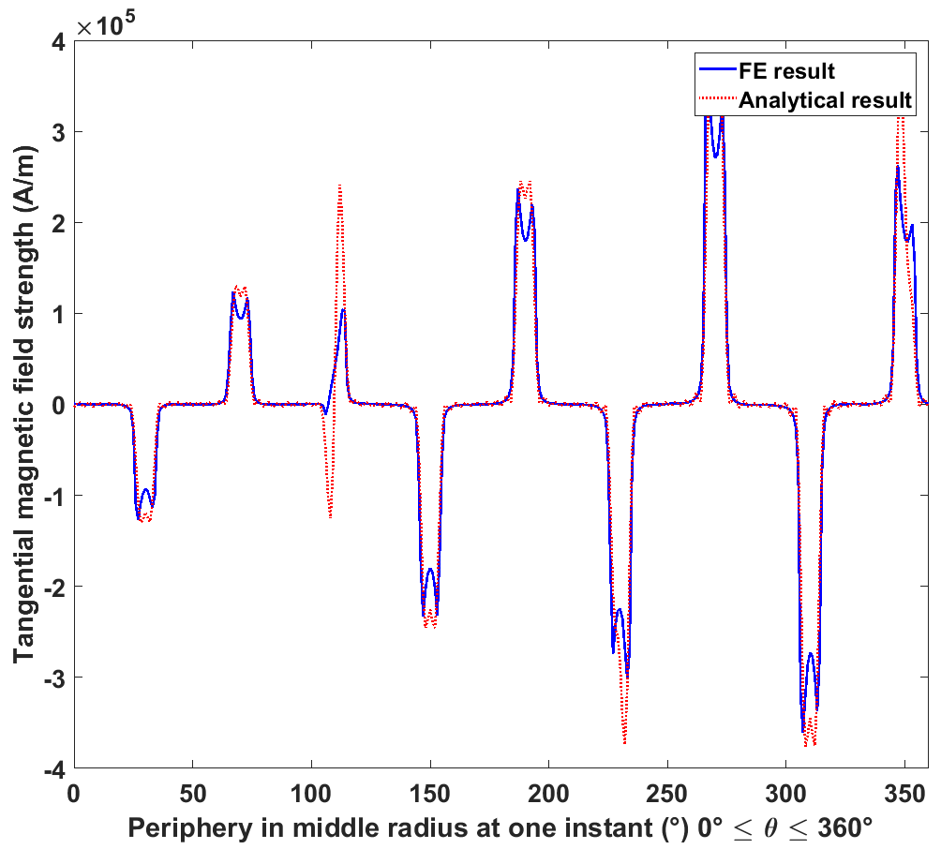
Axial eddy current
Magnet | 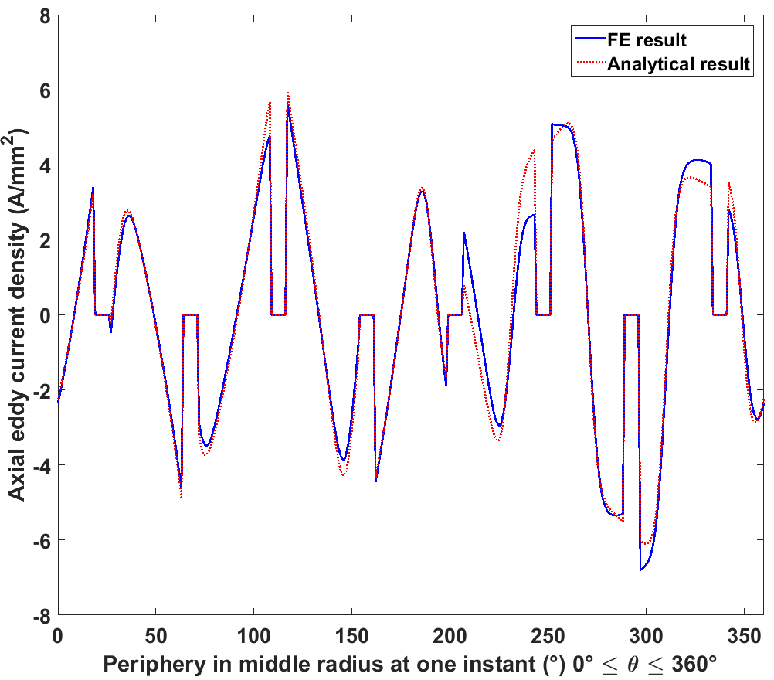
Inconel sleeve | 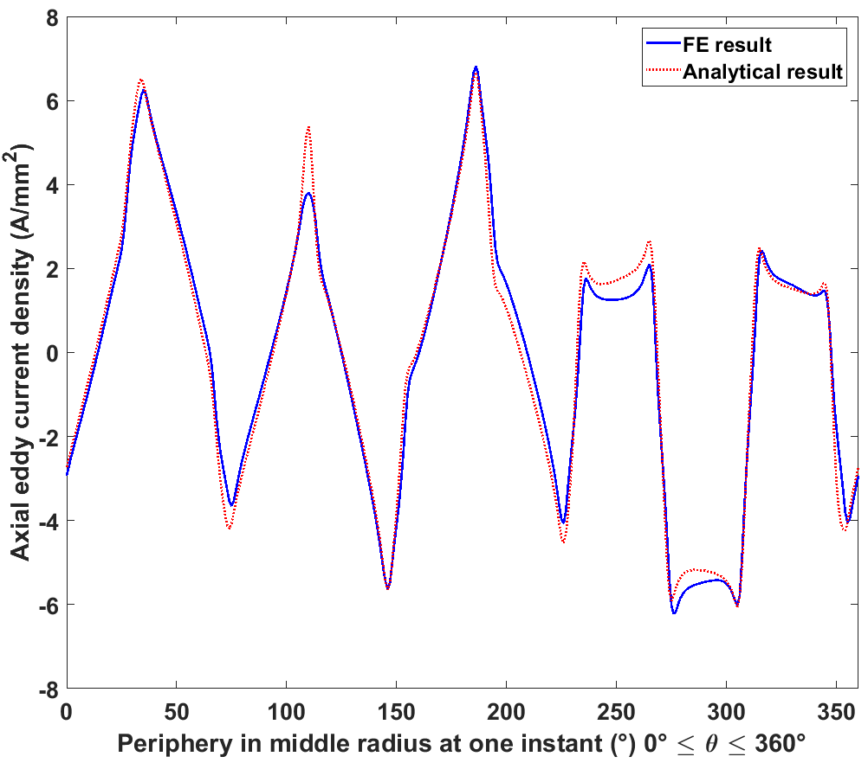
Circumferential eddy current
Magnet | 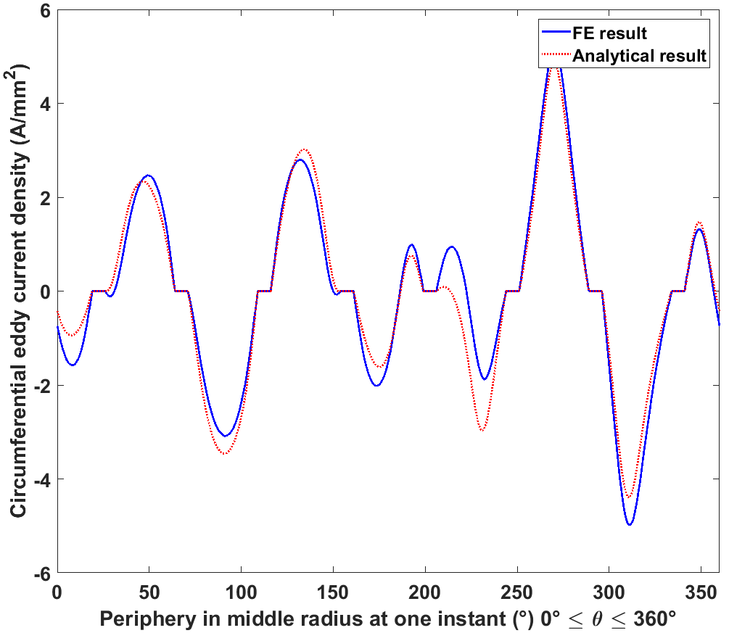
Inconel sleeve | 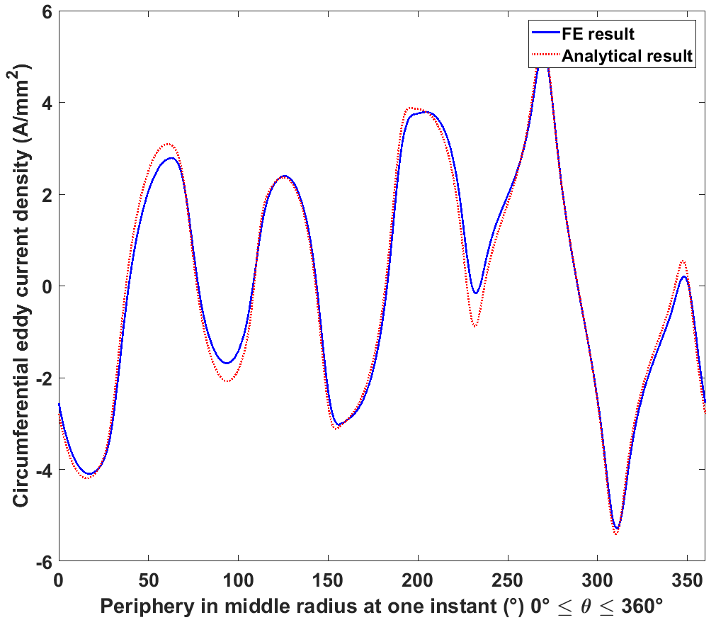
Table 5.9 2D field and eddy current distribution for 24000rpm from the two methods
Radial flux density
Magnet | 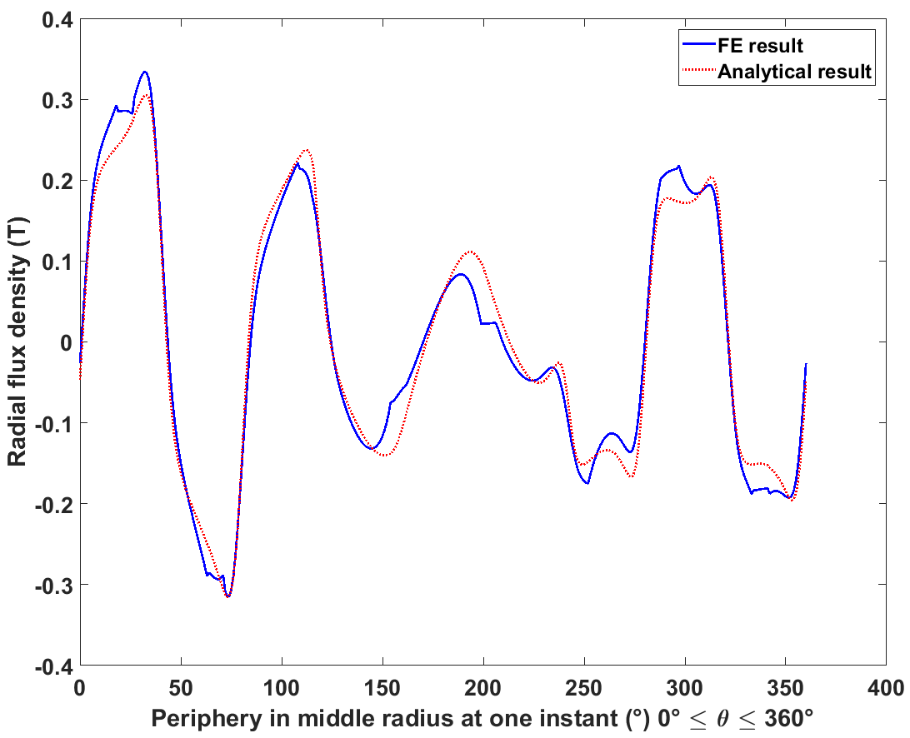
Inconel sleeve | 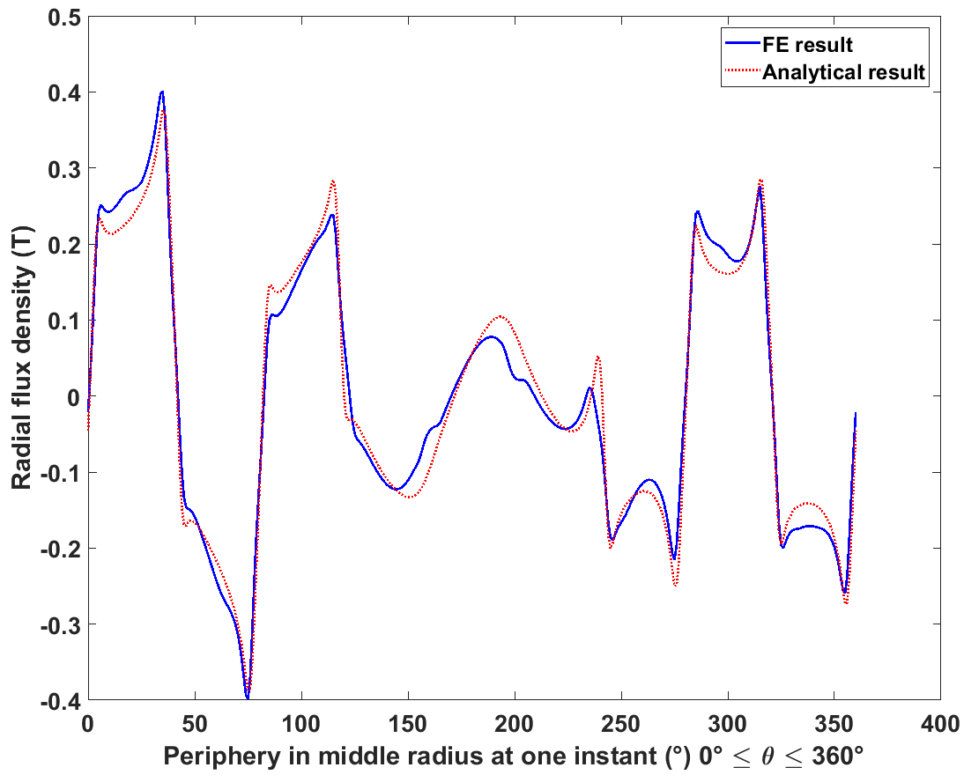
Airgap | 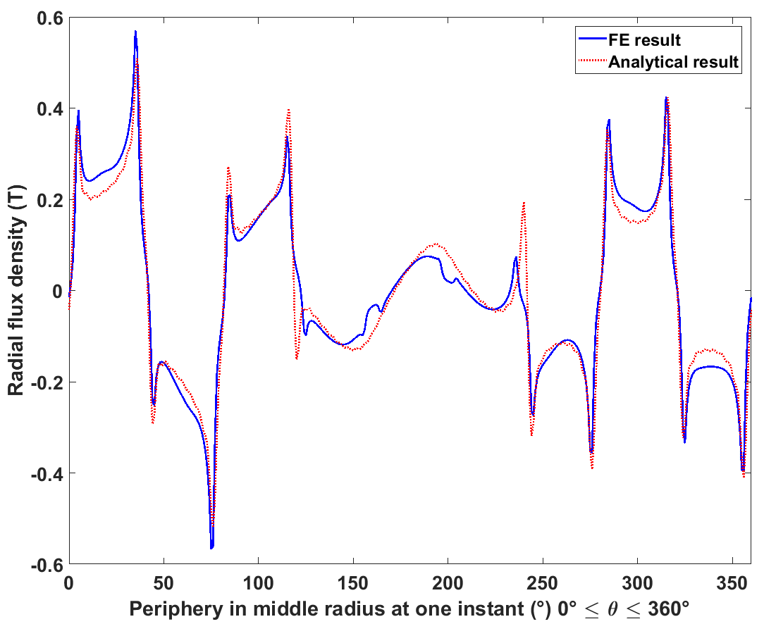
Tangential field strength
Magnet | 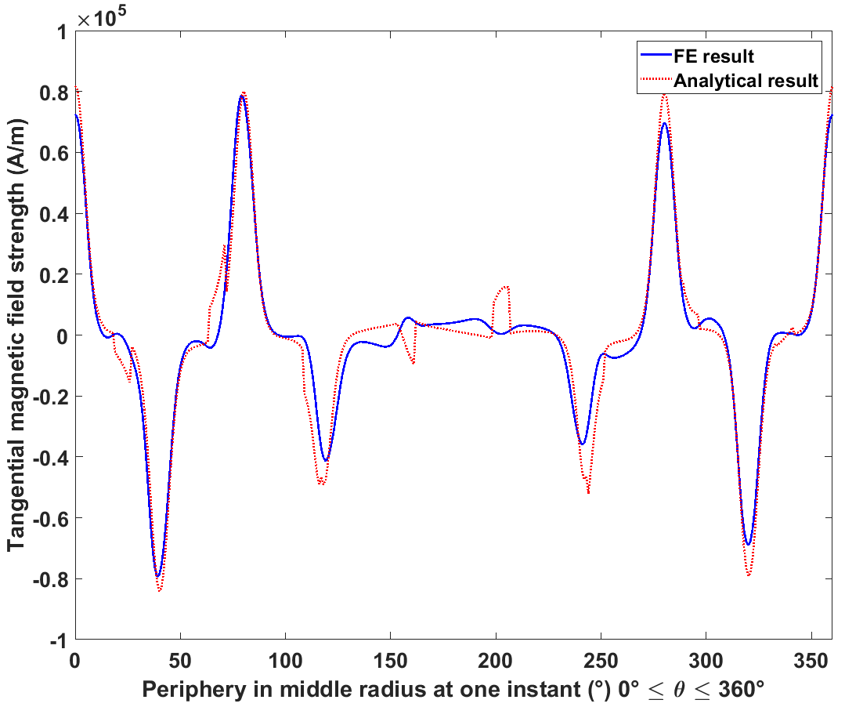
Inconel sleeve | 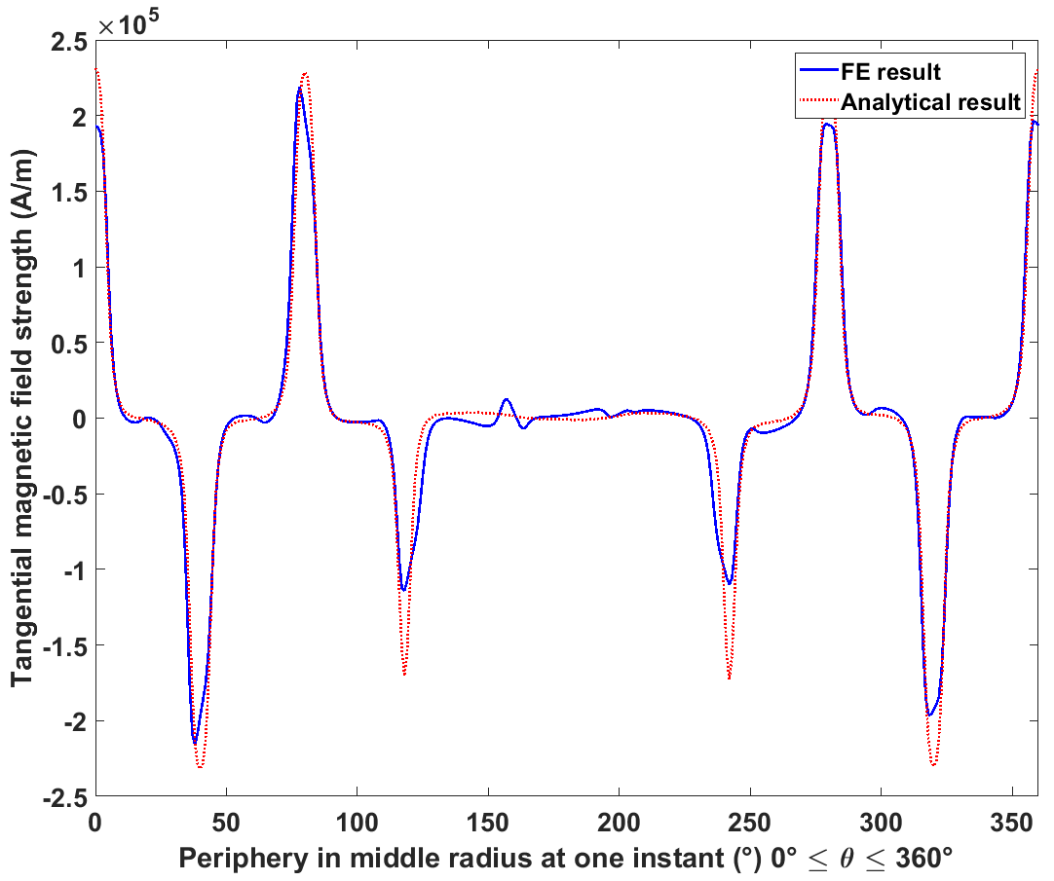
Airgap | 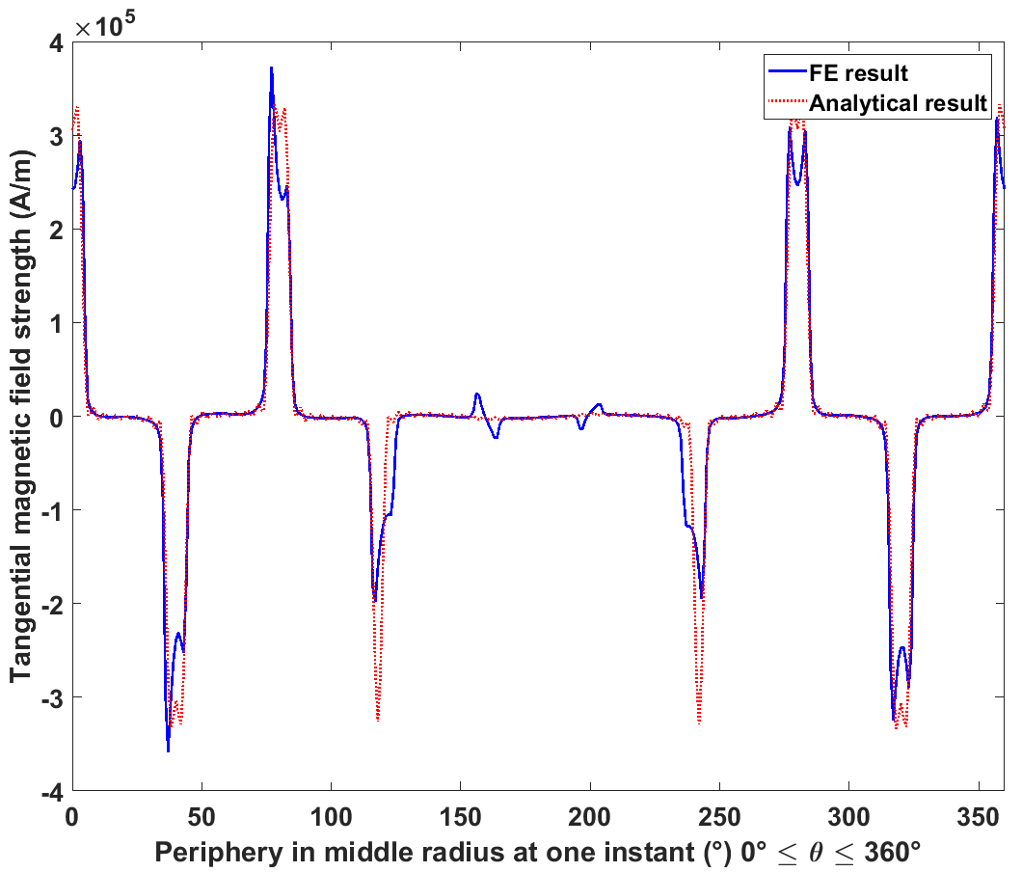
Axial eddy current
Magnet | 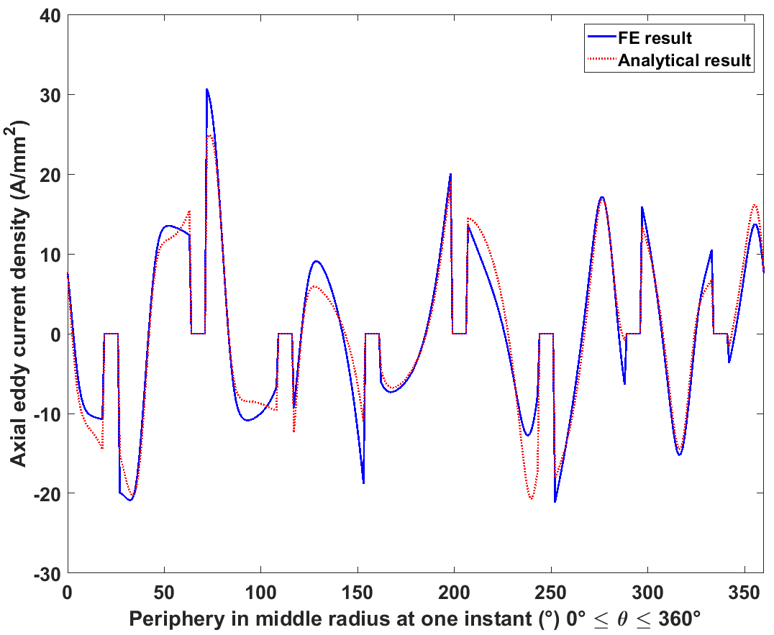
Inconel sleeve | 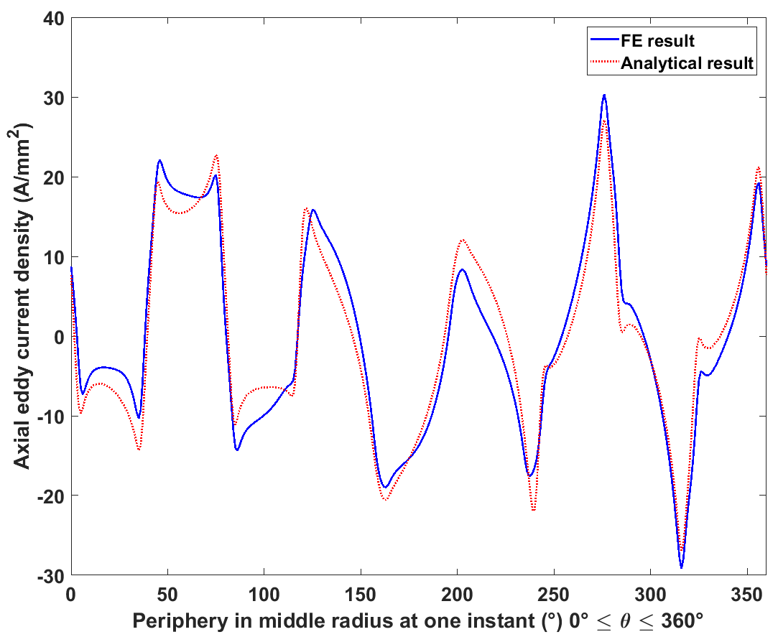
Circumferential eddy current
Magnet | 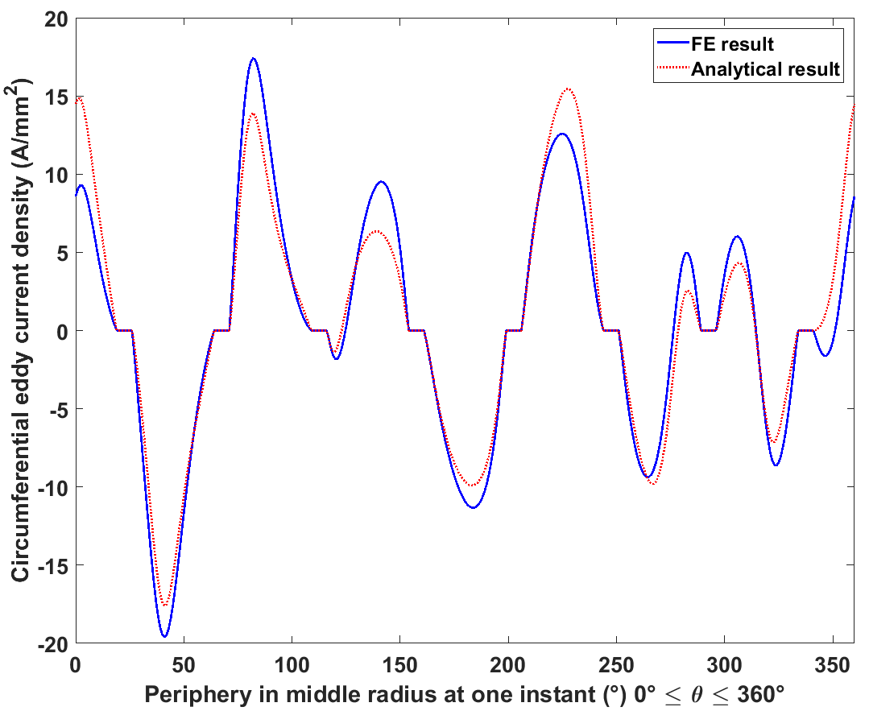
Inconel sleeve | 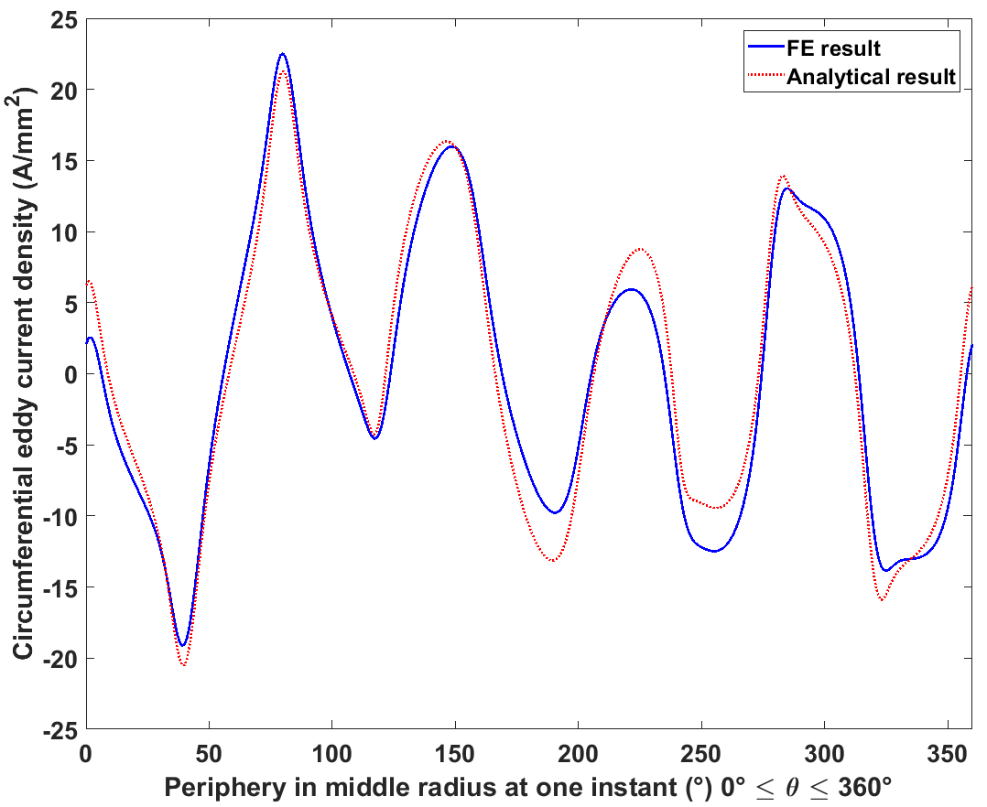

As can be seen from Table 5.6 to Table 5.9, good agreement is achieved between analytical and finite element results at the 5000rpm low speed operating, but the discrepancies increase at the high-speed operating point of 24000rpm. It can be clearly seen that, as would be expected, the magnitude of the generated eddy currents increase with machine operating speed. However, the effect of the eddy current reaction field, i.e. the skin effect increasingly plays a role at the rotational speed and hence the fundamental electrical frequency increases. This is illustrated for example in that the eddy currents at 24000rpm (which is three times the speed of the 8000rpm case used in the validation of section 5.3 ) do not increase by a factor of three compared to the 8000rpm case and the corresponding losses do not increase by a factor of 9 as would be expected with straightforward resistance-limited eddy currents [1].
Table 5.10 summarises the final loss results from both analytical and FE methods for the two new speeds. Since it is relatively quick process to calculate loss from the analytical model, a sweep through a speed range of 1000rpm to 35000rpm, with 1000rpm increment, was carried out using the analytical method. Figure 5.9 and Figure 5.10 plot the variation in Inconel sleeve and magnets, respectively, together with calculated with losses predicted by finite element analysis, albeit at many fewer speeds. In order to appreciate the departure from resistance-limited behaviour over much of the speed range, a quadratic extrapolation which is fitted from the first six points of the analytical curve in each figure. This fitting assumes that the eddy current reaction effect is not significant at this lower end of the speed range. Hence the quadratic curve fit provides a useful indication of the likely loss prediction from resistance limited eddy current calculation model.
As would be expected, Figure 5.9 and Figure 5.10 show that as speed increases, the difference between resistance limited prediction and inductance limited prediction becomes more and more significant. However, it can also be seen from Table 5.10 that difference of greater than 10% exists in the eddy current loss result in magnets between predicted loss from the analytical and finite element methods at 24000rpm. Possible reason for this discrepancy are:
- The size of the individual elements in finite element model of the magnet region may not be small enough to fully capture the gradient of the eddy current in the radial direction, leading to the calculated results from finite element tending slightly towards resistance limited predictions. The limitations of standard finite element methods with extreme levels of skin-effect is well-recognised and has led to the developments of special element types in extreme cases, such as surface impedance methods [38]-[41].
- At high speed, the interactions between different harmonics are not considered in the analytical modes integrals for loss results, might become significant, leading to increased inaccuracies to the final loss calculation.
Considering there is also increased deviation in field and eddy current distributions between analytical and FE results at high speed compared to low speeds, as indicated in Table 5.8 and Table 5.9, further research of the loss mechanism and improvement of the analytical method may still be required.
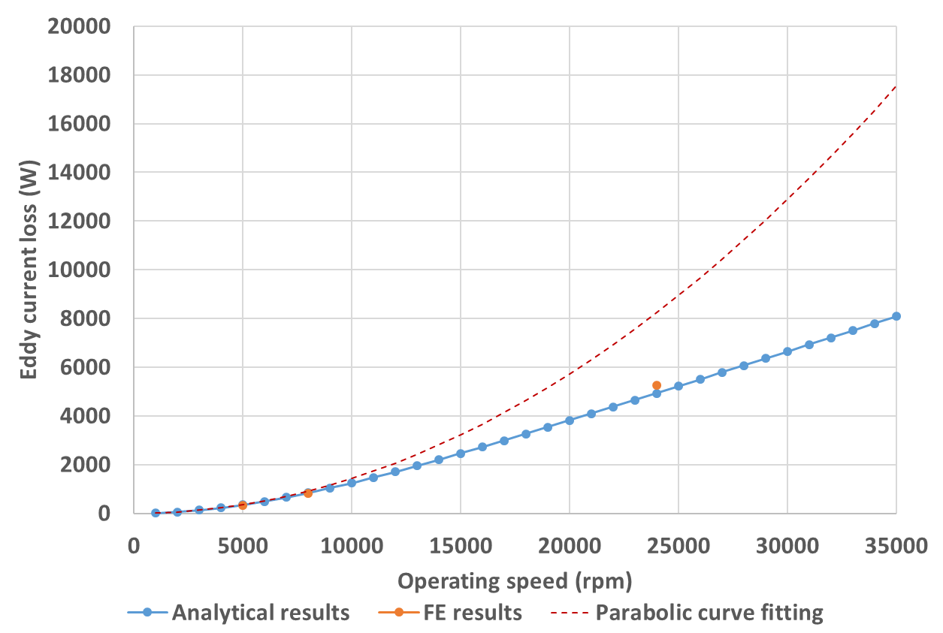
Figure 5.9 Eddy current loss variation with machine operating speed in Inconel sleeve
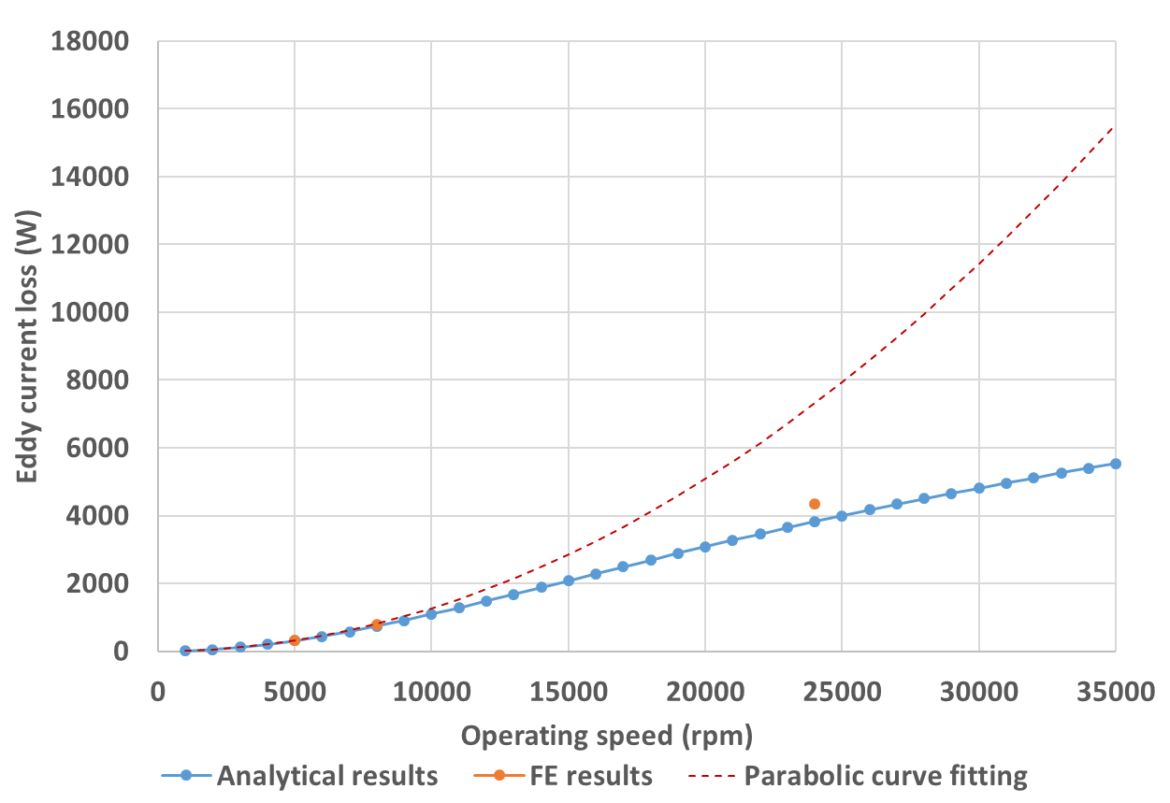
Figure 5.10 Eddy current loss variation with machine operating speed in magnets
Table 5.10 Final loss results for the two new speeds from the two methods
 | Average eddy current loss (W)
 | Inconel sleeve | Rotor magnets
5000rpm
Analytical result | 349 | 310
FE result | 336 | 331
Relative difference | 3.92% | -6.78%
24000rpm
Analytical result | 4931 | 3825
FE result | 5242 | 4348
Relative difference | -6.29% | -13.67%

Effect of circumferential segmentation on eddy current loss
As stated previously, the insulating regions between adjacent magnet poles interrupt the circulating paths of many eddy current harmonics which would otherwise exist in a complete conducting cylinder, hence eliminating the loss contribution from the corresponding harmonics contents in magnet poles. This behaviour provides a practical means of reducing the eddy current loss in conducting regions by segmenting the magnets in circumferential or axial directions. The insulating boundaries introduced will interrupt circulating paths for eddy current, resulting in more harmonics no longer generating eddy current in magnet regions. In this section, circumferential segmentation and its effect on eddy current loss in magnet poles will be investigated.
Up to this point, the analytical model is only capable of dealing with complete magnet poles. Hence, generalization is needed for the model to incorporate the ability to accommodate any number of segmentation in circumferential direction. In the previous development, the influence of circumferential insulation boundaries on axial eddy current distribution was achieved by introducing a compensation constant to each magnet pole. Similarly, when each magnet pole is further segmented into several segments, compensation constants could be introduced into segments to account for the additional insulation boundaries due to segmentation. Suppose each magnet pole is circumferentially segmented into $N_{C}$ pieces, then each segment would occupy an arc of ${α_{p}}/{N_{C}}$, the compensation constant is introduced into segment $ξ$ in pole $k$ so that for the axial eddy current in that segment, the following integration is satisfied
$$\int_{kλ_{p}-\frac{1}{2}α_{p}+\left(ξ-1\right)\frac{α_{p}}{N_{C}}}^{kλ_{p}-\frac{1}{2}α_{p}+ξ\frac{α_{p}}{N_{C}}}{J_{zIII}dθ}=0$$ | (5.257)
where $ξ$ can be valued in the following range
$$1≤ξ≤N_{C}$$ | (5.258)
In addition to the general denotation $C_{comp}$ for compensation constants in (5.195), for better fluency in the derivation the compensation constant in segment $ξ$ of pole $k$ is denoted as $C_{\left(k,ξ\right)cp}$. Substituting the particular solution (5.195) into (5.257) yields:
$$\sum_{m=0}^{∞}{\sum_{l=0}^{∞}{\left[A_{mzIIISeg}I_{m}\left(\sqrt{{μ_{2}}^{'}}r\right)+B_{mzIIISeg}K_{m}\left(\sqrt{{μ_{2}}^{'}}r\right)\right]\int_{kλ_{p}-\frac{1}{2}α_{p}+\left(ξ-1\right)\frac{α_{p}}{N_{C}}}^{kλ_{p}-\frac{1}{2}α_{p}+ξ\frac{α_{p}}{N_{C}}}{\left(C_{mzIII}e^{jmθ}+D_{mzIII}e^{-jmθ}+C_{\left(k,ξ\right)cp}\right)dθ}\left[E_{lzIII}\sin\left(\frac{lπ}{L_{a}}z\right)\right]}}=0$$
The condition for the above equation to always exist is that for each harmonics order,
$$\int_{kλ_{p}-\frac{1}{2}α_{p}+\left(ξ-1\right)\frac{α_{p}}{N_{C}}}^{kλ_{p}-\frac{1}{2}α_{p}+ξ\frac{α_{p}}{N_{C}}}{\left(C_{mzIII}e^{jmθ}+D_{mzIII}e^{-jmθ}+C_{\left(k,ξ\right)cp}\right)dθ}=0$$ | (5.259)
Completing the integral, the expression for the compensation constant can be obtained
$$C_{\left(k,ξ\right)cp}=-\frac{N_{C}}{jmα_{p}}\left[C_{mzIII}e^{jm\left(kλ_{p}-\frac{1}{2}α_{p}+ξ\frac{α_{p}}{N_{C}}\right)}\left(1-e^{-jm\frac{α_{p}}{N_{C}}}\right)-D_{mzIII}e^{-jm\left(kλ_{p}-\frac{1}{2}α_{p}+ξ\frac{α_{p}}{N_{C}}\right)}\left(1-e^{jm\frac{α_{p}}{N_{C}}}\right)\right]$$ | (5.260)
It is clear that by setting $N_{C}=1$, the expression (5.260) would become equivalent to (5.197), for the non-segmented case. In the same manner as previously, with segmentation of individual poles, the detailed information for the harmonics from stator excitation that no longer generate eddy current in magnets due to circumferential insulation, and the harmonics generated during reshaping of the eddy current flow, can be identified by applying Fourier expansion to the compensation constants for each harmonics order expressed by (5.260), using the same set of series with the circumferential spatial harmonics in stator current:
$$C_{comp}=\sum_{m=-∞}^{+∞}{A_{mcpξ}e^{jmθ}}$$ | (5.261)
The Fourier coefficient
$$A_{mcpξ}=\frac{1}{2π}\int_{0}^{2π}{C_{comp}e^{-jmθ}dθ}=\frac{1}{2π}\sum_{k=0}^{N_{p}-1}{\sum_{ξ=1}^{N_{c}}{\int_{kλ_{p}-\frac{1}{2}α_{p}+\left(ξ-1\right)\frac{α_{p}}{N_{C}}}^{kλ_{p}-\frac{1}{2}α_{p}+ξ\frac{α_{p}}{N_{C}}}{C_{\left(k,ξ\right)cp}e^{-jmθ}dθ}}}=\frac{1}{2π}\sum_{k=0}^{N_{p}-1}{\sum_{ξ=1}^{N_{c}}{C_{\left(k,ξ\right)cp}\left(-\frac{1}{jm}\right)\left\{e^{-jm\left(kλ_{p}-\frac{1}{2}α_{p}+ξ\frac{α_{p}}{N_{C}}\right)}-e^{-jm\left[kλ_{p}-\frac{1}{2}α_{p}+\left(ξ-1\right)\frac{α_{p}}{N_{C}}\right]}\right\}}}=\frac{1}{2π}\sum_{k=0}^{N_{p}-1}{\sum_{ξ=1}^{N_{c}}{C_{\left(k,ξ\right)cp}\left(-\frac{1}{jm}\right)e^{-jm\left(kλ_{p}-\frac{1}{2}α_{p}+ξ\frac{α_{p}}{N_{C}}\right)}\left(1-e^{jm\frac{α_{p}}{N_{C}}}\right)}}$$ | (5.262)
As was the case previously, the compensation constants in different magnet segments are also complex numbers, and hence the Fourier coefficients of the minus orders in (5.261) are not conjugate of the coefficients of the positive orders, although the series (5.261) can still be reformulated into a similar form with the series describing the circumferential distribution of the stator current:
$$C_{comp}=\sum_{m=1}^{+∞}{\left(A_{mcpξ}e^{jmθ}+A_{-mcpξ}e^{-jmθ}\right)}$$ | (5.263)
The full harmonics information comprising the compensation constants are included in (5.263), from which the harmonics transduced from the stator excitation can be obtained by removing the summation in (5.263), leaving only the harmonics which have the same order as the left-hand side constant. As previously, the real information of harmonics from stator excitation should be the opposite of that obtained from (5.263), i.e.
$$-A_{mcpξ}e^{jmθ}-A_{-mcpξ}e^{-jmθ}$$ | (5.264)
The harmonics generated in eddy current reshaping due to the circumferential insulation are those remaining in (5.263) after the harmonics from stator current have been extracted.
In this way, the harmonic composition for a particular segmented case can be identified. The previously obtained particular solutions for field and eddy current components are still valid for the segmented condition. However, the circumferential coefficients for the harmonics contents from stator current that no longer generate eddy current in magnets, viz. $A_{mcp}$ and $A_{-mcp}$, need to be replaced by $A_{mcpξ}$ and $A_{-mcpξ}$ to include the segmentation effect for circumferential eddy currents in magnets, the new insulation boundary conditions introduced by segmentation also need to be satisfied:
$$\left\{\begin{aligned}{\left.J_{θIII}\right|}_{θ=kλ_{p}-\frac{1}{2}α_{p}+\left(ξ-1\right)\frac{α_{p}}{N_{C}}}=0 \\ {\left.J_{θIII}\right|}_{θ=kλ_{p}-\frac{1}{2}α_{p}+ξ\frac{α_{p}}{N_{C}}}=0 \end{aligned}\right.$$ | (5.265)
A similar derivation process can be carried out as before to prove that the two boundary conditions in (5.265) are equivalent, and only one condition needs to be considered. Substituting the particular solution (5.219) for $J_{θIII}$ into the first condition in (5.265), the expression for the integration constant under segmented condition can be obtained as follows:
$$C_{intJIII}=-\frac{j}{m}C_{mzIII}e^{jm\left[kλ_{p}-\frac{1}{2}α_{p}+\left(ξ-1\right)\frac{α_{p}}{N_{C}}\right]}+\frac{j}{m}D_{mzIII}e^{-jm\left[kλ_{p}-\frac{1}{2}α_{p}+\left(ξ-1\right)\frac{α_{p}}{N_{C}}\right]}+C_{comp}\left[kλ_{p}-\frac{1}{2}α_{p}+\left(ξ-1\right)\frac{α_{p}}{N_{C}}\right]$$ | (5.266)
For the final eddy current loss results, the expression (5.250) for loss in Inconel sleeve is still valid if $A_{mcp}$ and $A_{-mcp}$ are replaced by $A_{mcpξ}$ and $A_{-mcpξ}$, respectively. In each magnet segment, the eddy current loss can be calculated by (5.254), with the integration space $V$ being the space enclosed by the segment. The detailed integration process is not included in the thesis since it is similar to the process for (5.255). The final result for eddy loss in magnet segment $ξ$ in pole $k$ is:
$$P_{III}=\frac{1}{2σ_{m}}\sum_{m=0}^{∞}{\sum_{l=0}^{∞}{\int_{R_{r}}^{R_{m}}{\left[A_{mzIIISeg}I_{m}\left(\sqrt{{μ_{2}}^{'}}r\right)+B_{mzIIISeg}K_{m}\left(\sqrt{{μ_{2}}^{'}}r\right)\right]{\left[A_{mzIIISeg}I_{m}\left(\sqrt{{μ_{2}}^{'}}r\right)+B_{mzIIISeg}K_{m}\left(\sqrt{{μ_{2}}^{'}}r\right)\right]}^{*}rdr}\left\{\left({\left|C_{mzIII}\right|}^{2}+{\left|D_{mzIII}\right|}^{2}+{\left|C_{comp}\right|}^{2}\right)\frac{α_{p}}{N_{C}}+\frac{1}{j2m}\left[C_{mzIII}{D_{mzIII}}^{*}e^{j2m\left(kλ_{p}-\frac{1}{2}α_{p}+ξ\frac{α_{p}}{N_{C}}\right)}\left(1-e^{-j2m\frac{α_{p}}{N_{C}}}\right)-D_{mzIII}{C_{mzIII}}^{*}e^{-j2m\left(kλ_{p}-\frac{1}{2}α_{p}+ξ\frac{α_{p}}{N_{C}}\right)}\left(1-e^{j2m\frac{α_{p}}{N_{C}}}\right)\right]+\frac{1}{jm}\left[\left(C_{mzIII}{C_{comp}}^{*}+C_{comp}{D_{mzIII}}^{*}\right)e^{jm\left(kλ_{p}-\frac{1}{2}α_{p}+ξ\frac{α_{p}}{N_{C}}\right)}\left(1-e^{-jm\frac{α_{p}}{N_{C}}}\right)-\left(D_{mzIII}{C_{comp}}^{*}+C_{comp}{C_{mzIII}}^{*}\right)e^{-jm\left(kλ_{p}-\frac{1}{2}α_{p}+ξ\frac{α_{p}}{N_{C}}\right)}\left(1-e^{jm\frac{α_{p}}{N_{C}}}\right)\right]\right\}\frac{1}{2}{E_{lzIII}}^{2}L_{a}}}$$ | (5.267)
$$+\frac{1}{2σ_{m}}\sum_{m=0}^{∞}{\sum_{l=0}^{∞}{\int_{R_{r}}^{R_{m}}{\left[A_{mzIIISeg}I_{m}\left(\sqrt{{μ_{2}}^{'}}r\right)+B_{mzIIISeg}K_{m}\left(\sqrt{{μ_{2}}^{'}}r\right)\right]{\left[A_{mzIIISeg}I_{m}\left(\sqrt{{μ_{2}}^{'}}r\right)+B_{mzIIISeg}K_{m}\left(\sqrt{{μ_{2}}^{'}}r\right)\right]}^{*}r^{3}dr}\left\{\left(\frac{1}{m^{2}}{\left|C_{mzIII}\right|}^{2}+\frac{1}{m^{2}}{\left|D_{mzIII}\right|}^{2}\right)\frac{α_{p}}{N_{C}}-\frac{1}{j2m^{3}}\left[C_{mzIII}{D_{mzIII}}^{*}e^{j2m\left(kλ_{p}-\frac{1}{2}α_{p}+ξ\frac{α_{p}}{N_{C}}\right)}\left(1-e^{-j2m\frac{α_{p}}{N_{C}}}\right)-D_{mzIII}{C_{mzIII}}^{*}e^{-j2m\left(kλ_{p}-\frac{1}{2}α_{p}+ξ\frac{α_{p}}{N_{C}}\right)}\left(1-e^{j2m\frac{α_{p}}{N_{C}}}\right)\right]-\frac{1}{m^{2}}\left\{\left(C_{mzIII}{C_{comp}}^{*}+C_{comp}{D_{mzIII}}^{*}\right)e^{jm\left(kλ_{p}-\frac{1}{2}α_{p}+ξ\frac{α_{p}}{N_{C}}\right)}\left[\left(kλ_{p}-\frac{1}{2}α_{p}+ξ\frac{α_{p}}{N_{C}}\right)\left(1-e^{-jm\frac{α_{p}}{N_{C}}}\right)+\frac{α_{p}}{N_{C}}e^{-jm\frac{α_{p}}{N_{C}}}-\frac{1}{jm}\left(1-e^{-jm\frac{α_{p}}{N_{C}}}\right)\right]+\left(D_{mzIII}{C_{comp}}^{*}+C_{comp}{C_{mzIII}}^{*}\right)e^{-jm\left(kλ_{p}-\frac{1}{2}α_{p}+ξ\frac{α_{p}}{N_{C}}\right)}\left[\left(kλ_{p}-\frac{1}{2}α_{p}+ξ\frac{α_{p}}{N_{C}}\right)\left(1-e^{jm\frac{α_{p}}{N_{C}}}\right)+\frac{α_{p}}{N_{C}}e^{jm\frac{α_{p}}{N_{C}}}+\frac{1}{jm}\left(1-e^{jm\frac{α_{p}}{N_{C}}}\right)\right]-\left(C_{mzIII}{C_{boun}}^{*}+C_{boun}{D_{mzIII}}^{*}\right)e^{jm\left(kλ_{p}-\frac{1}{2}α_{p}+ξ\frac{α_{p}}{N_{C}}\right)}\left(1-e^{-jm\frac{α_{p}}{N_{C}}}\right)-\left(D_{mzIII}{C_{boun}}^{*}+C_{boun}{C_{mzIII}}^{*}\right)e^{-jm\left(kλ_{p}-\frac{1}{2}α_{p}+ξ\frac{α_{p}}{N_{C}}\right)}\left(1-e^{jm\frac{α_{p}}{N_{C}}}\right)\right\}+\frac{α_{p}}{N_{C}}\left\{\frac{1}{3}{\left|C_{comp}\right|}^{2}\left[{3\left(kλ_{p}-\frac{1}{2}α_{p}+ξ\frac{α_{p}}{N_{C}}\right)}^{2}-3\frac{α_{p}}{N_{C}}\left(kλ_{p}-\frac{1}{2}α_{p}+ξ\frac{α_{p}}{N_{C}}\right)+{\left(\frac{α_{p}}{N_{C}}\right)}^{2}\right]-\frac{1}{2}\left(C_{comp}{C_{boun}}^{*}+C_{boun}{C_{comp}}^{*}\right)\left[2\left(kλ_{p}-\frac{1}{2}α_{p}+ξ\frac{α_{p}}{N_{C}}\right)-\frac{α_{p}}{N_{C}}\right]+{\left|C_{boun}\right|}^{2}\right\}\right\}\frac{1}{2}{\left(\frac{lπ}{L_{a}}\right)}^{2}{E_{lzIII}}^{2}L_{a}}}$$ | (5.267)
For validation of the generalized analytical model for segmentation, the magnets in the corresponding FE model were also segmented circumferentially. In this validation, the segmentation number was set to 4 for each magnet pole. Figure 5.11 illustrates the segmentation in magnet poles in the FE model, where red and orange blocks correspond to different magnet segments (of the same magnetic polarity), and purple blocks correspond to the inter-pole regions.
Table 5.11 and Table 5.12 show the plots of the magnetic field and eddy current distributions for a segmented rotor of the same machine design as that considered for the non-segmented case and again at 8000rpm. The magnetic field and eddy current distributions are shown using the same time snapshots, viz. 50° mechanical rotation displacement, as the non-segmented 8000rpm case. The resulting the final eddy loss results are shown Table 5.13 for the case of purely sinusoidal currents fed into the three phases.
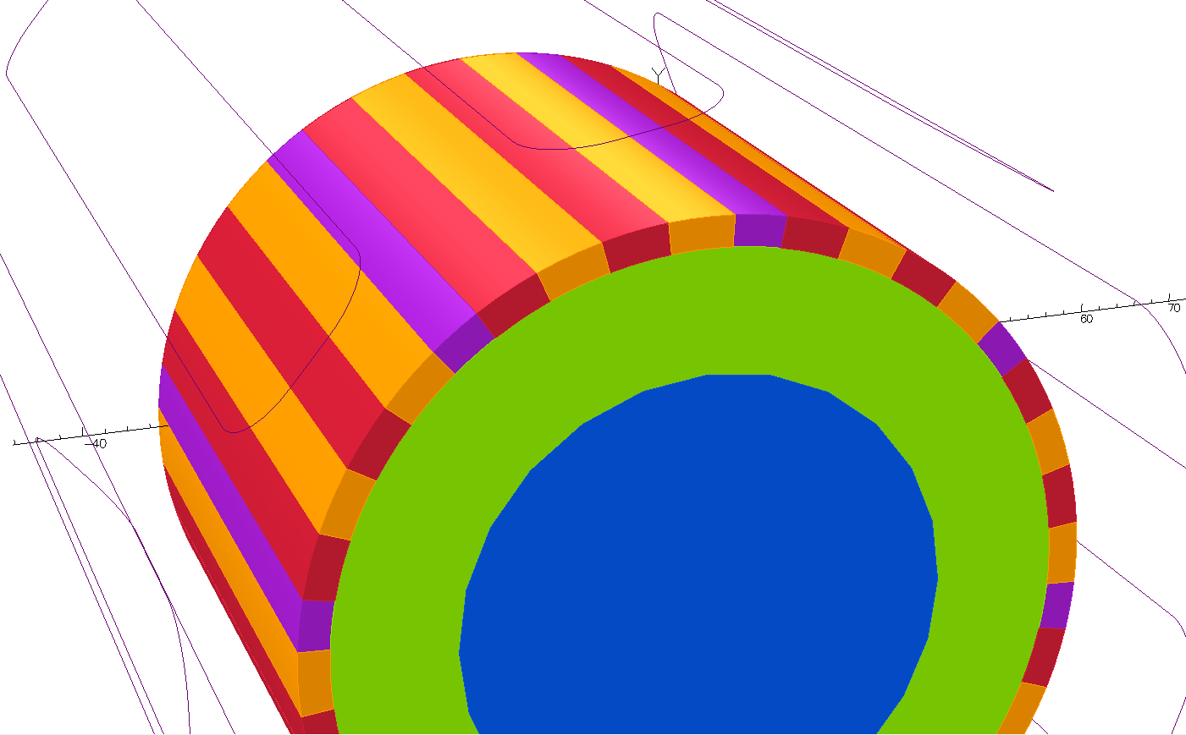
Figure 5.11 Illustration of the circumferential segmentation of magnet poles

Table 5.11 3D field and eddy current distributions under magnet segmentation using results from two methods
Analytical results | FE results
Radial flux density
Magnet
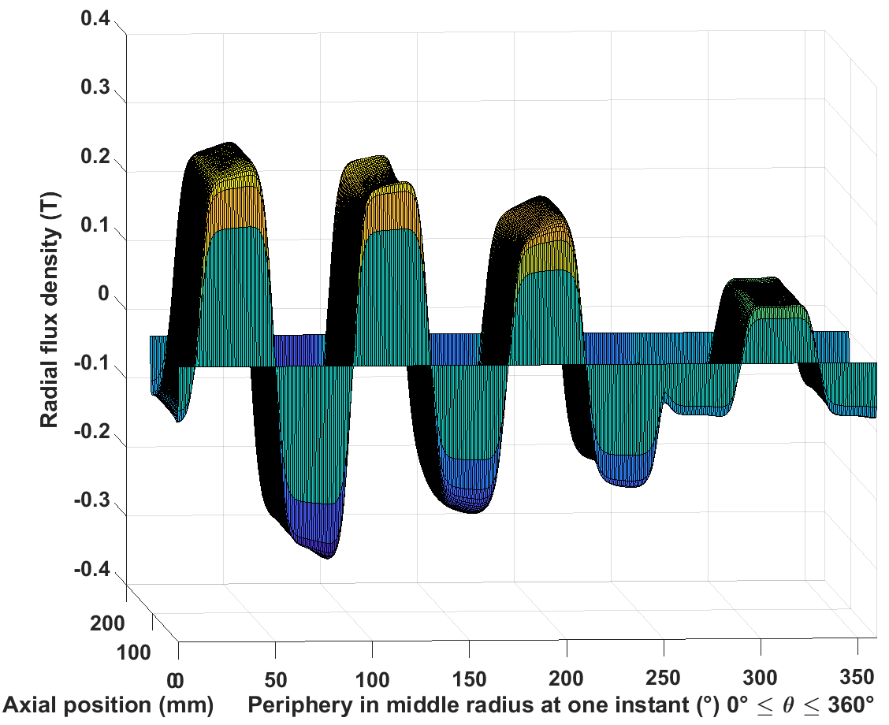 | 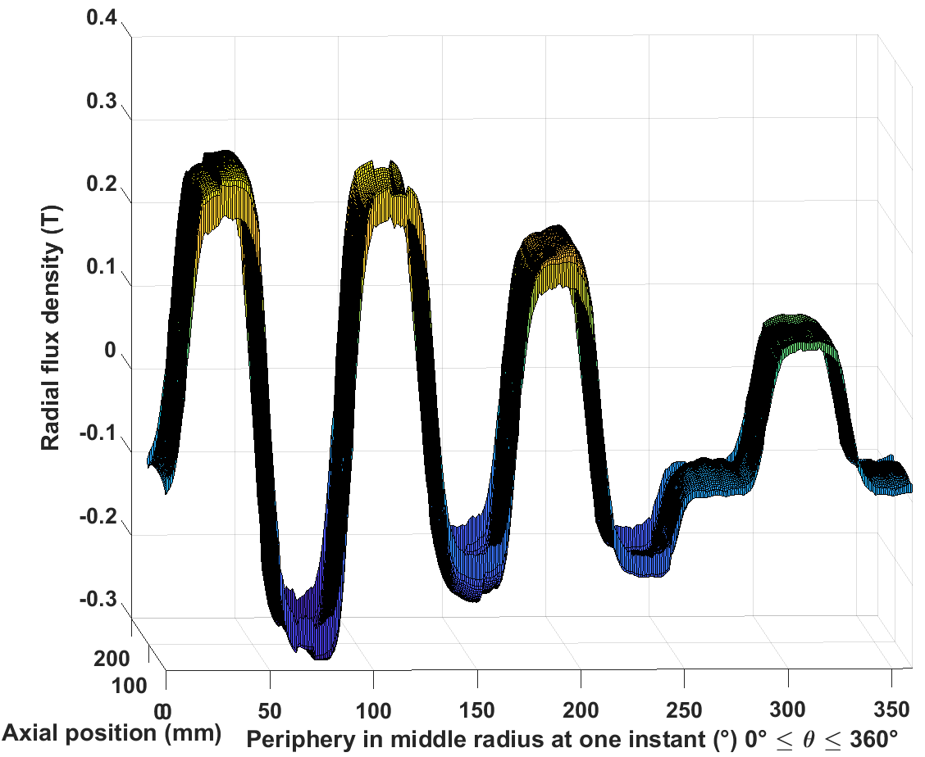
Inconel sleeve
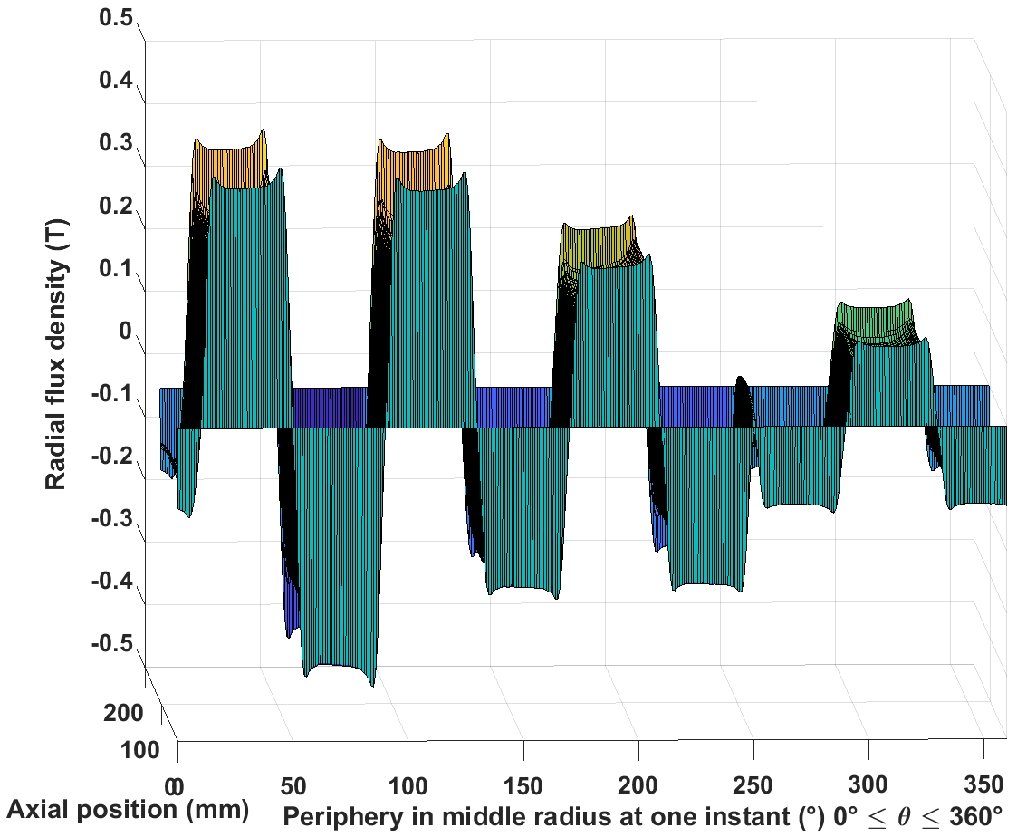 | 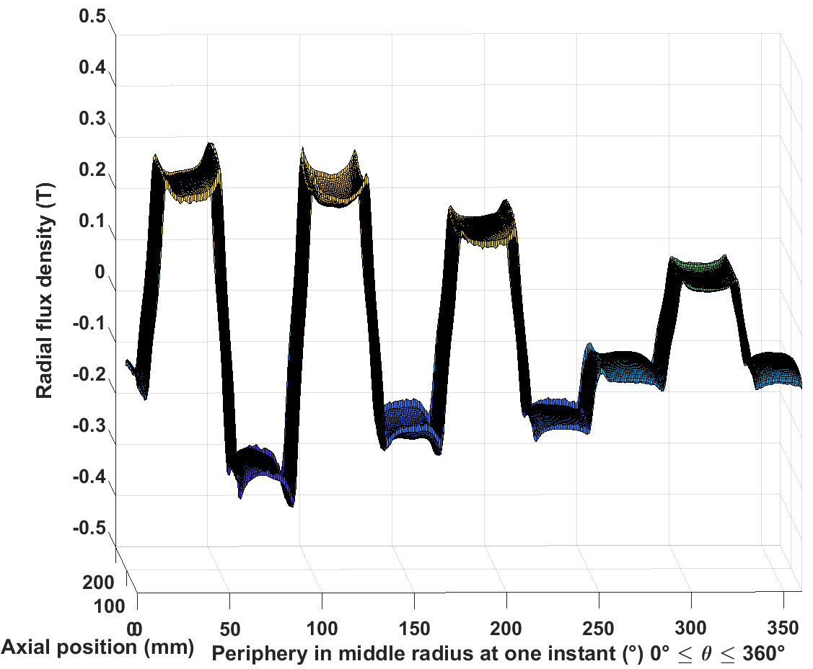
Airgap
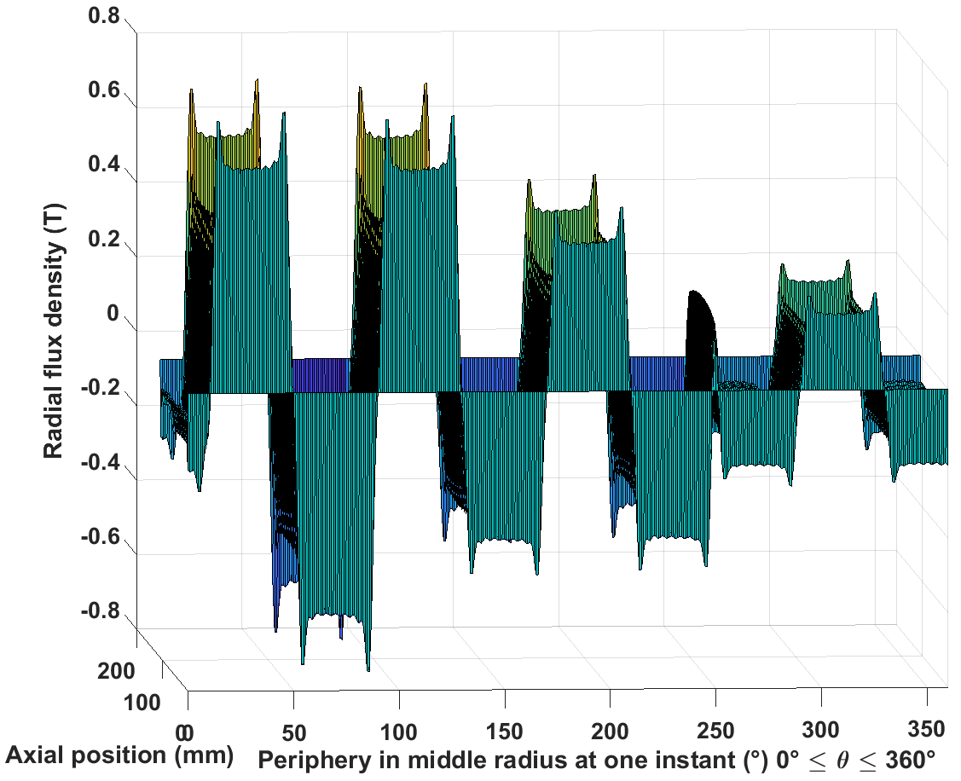 | 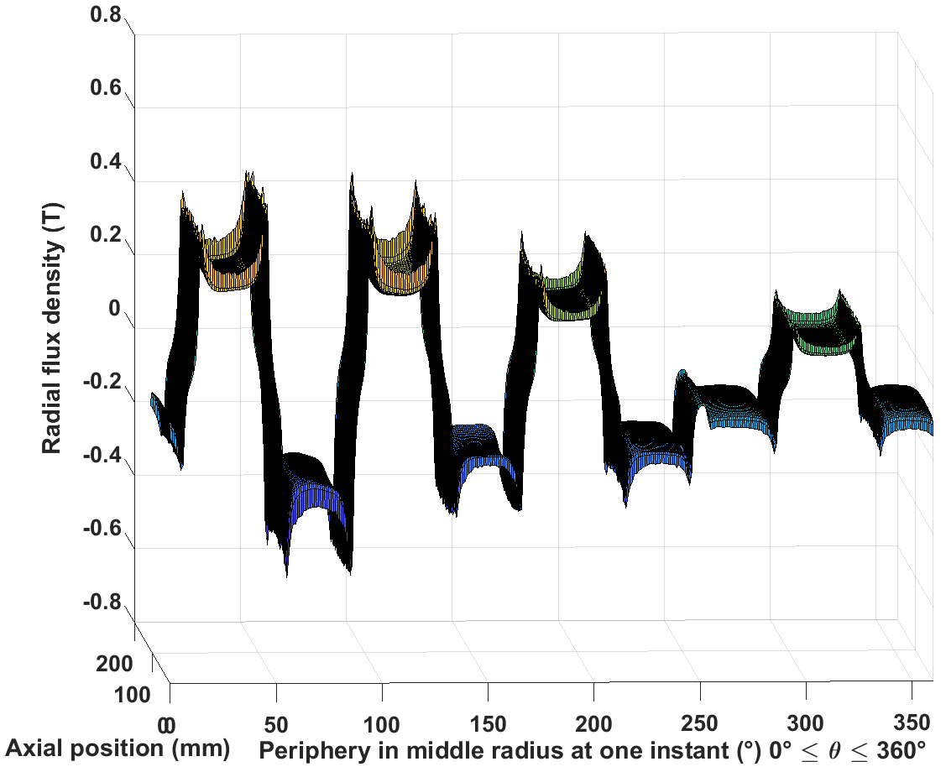
Tangential field strength
Magnet
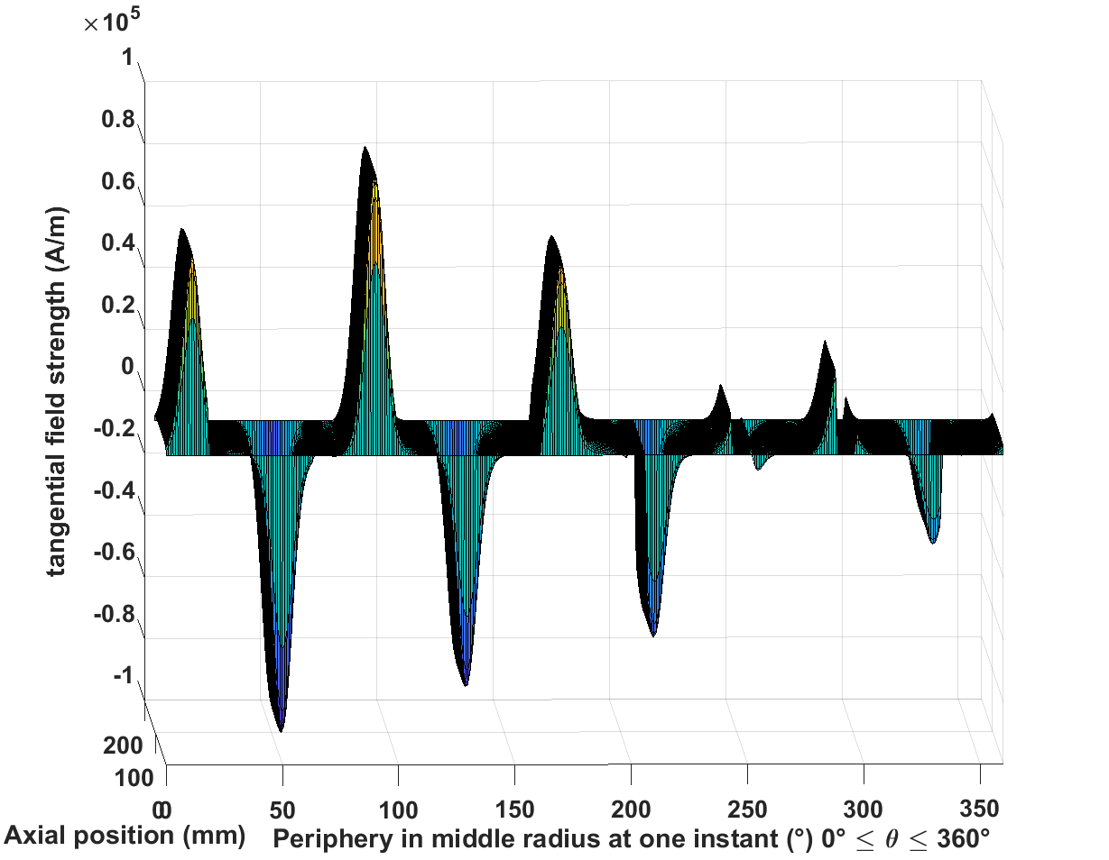 | 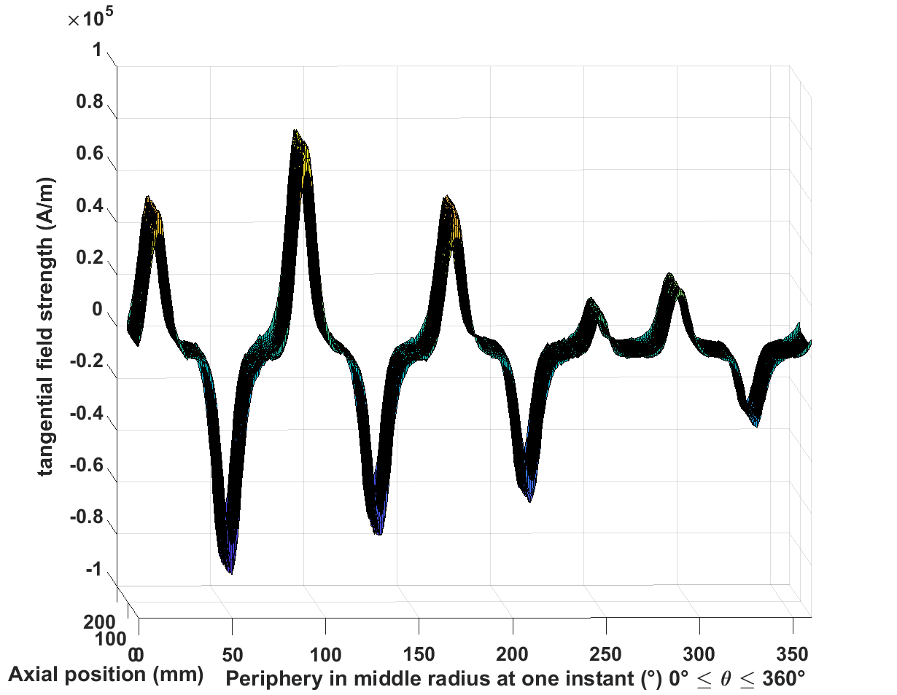
Inconel sleeve
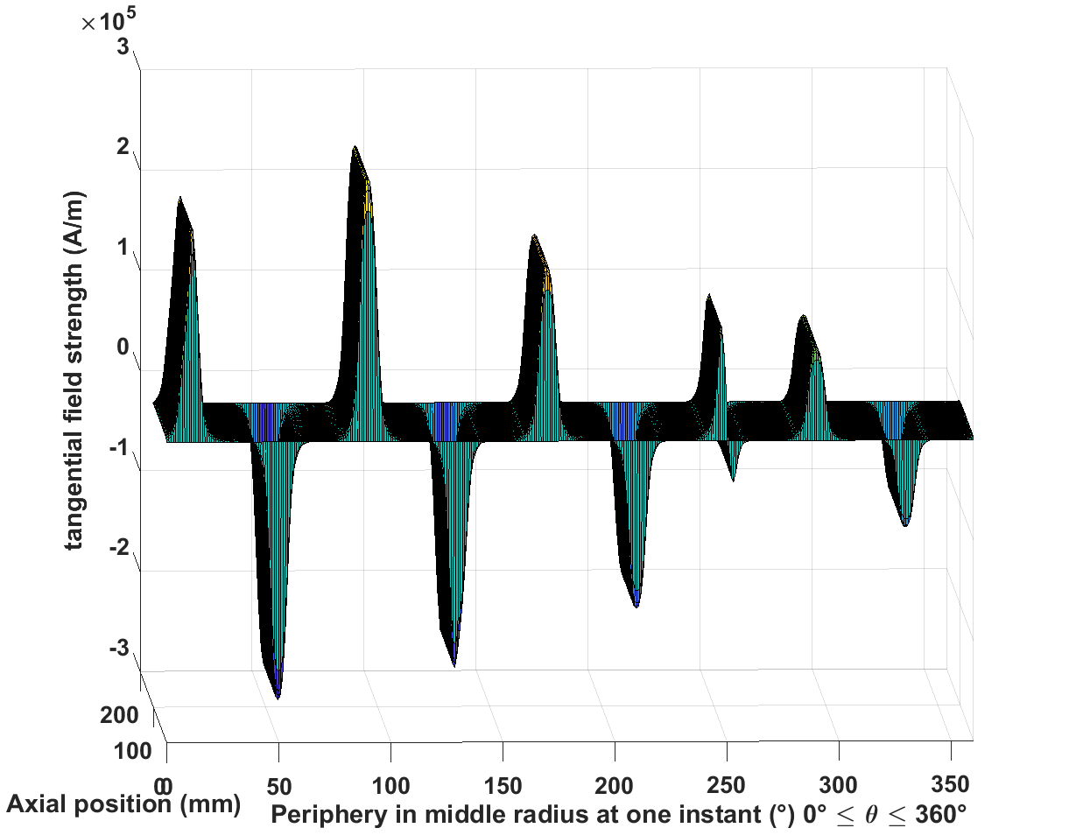 | 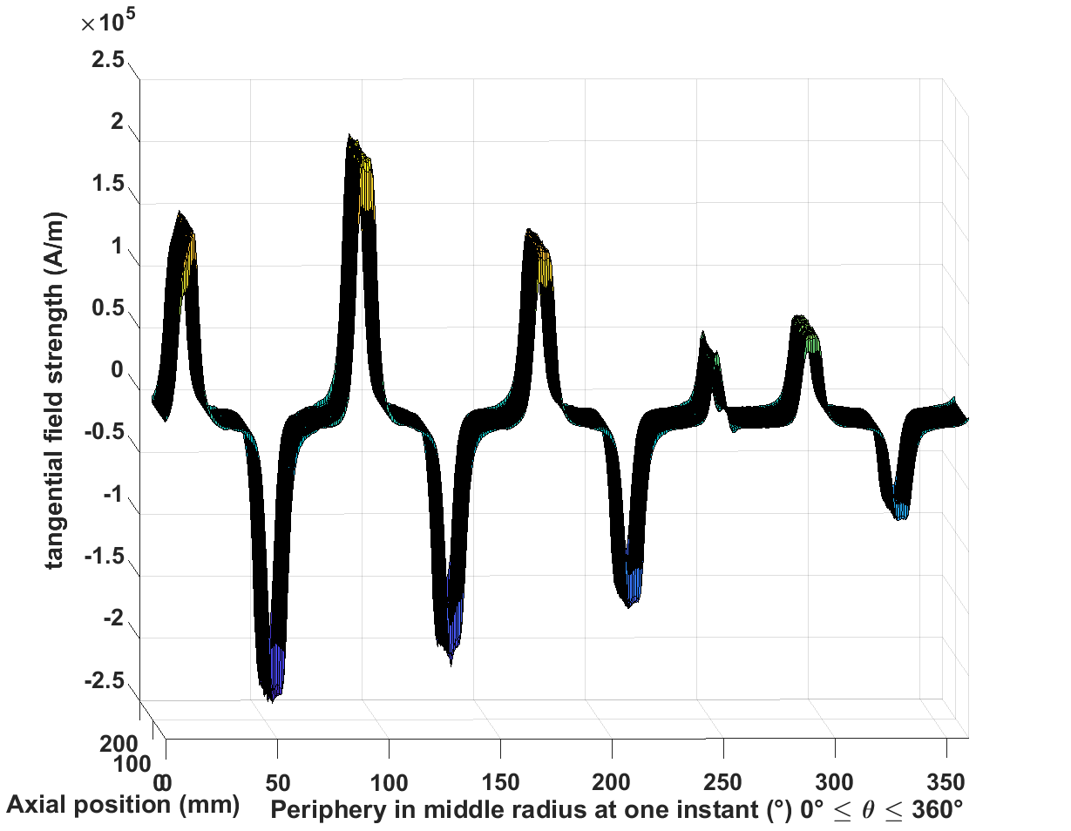
Airgap
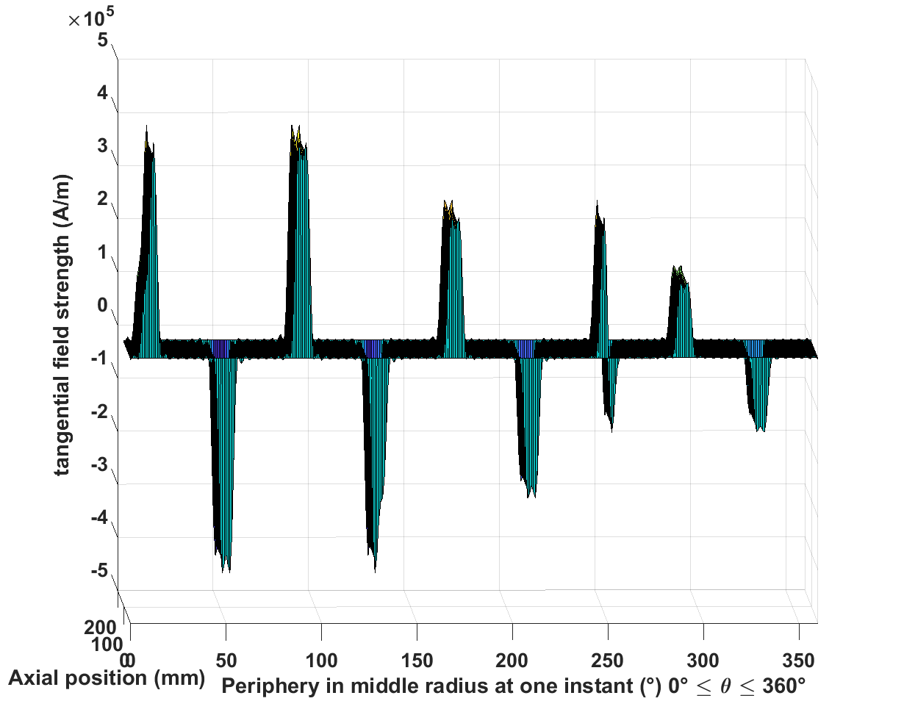 | 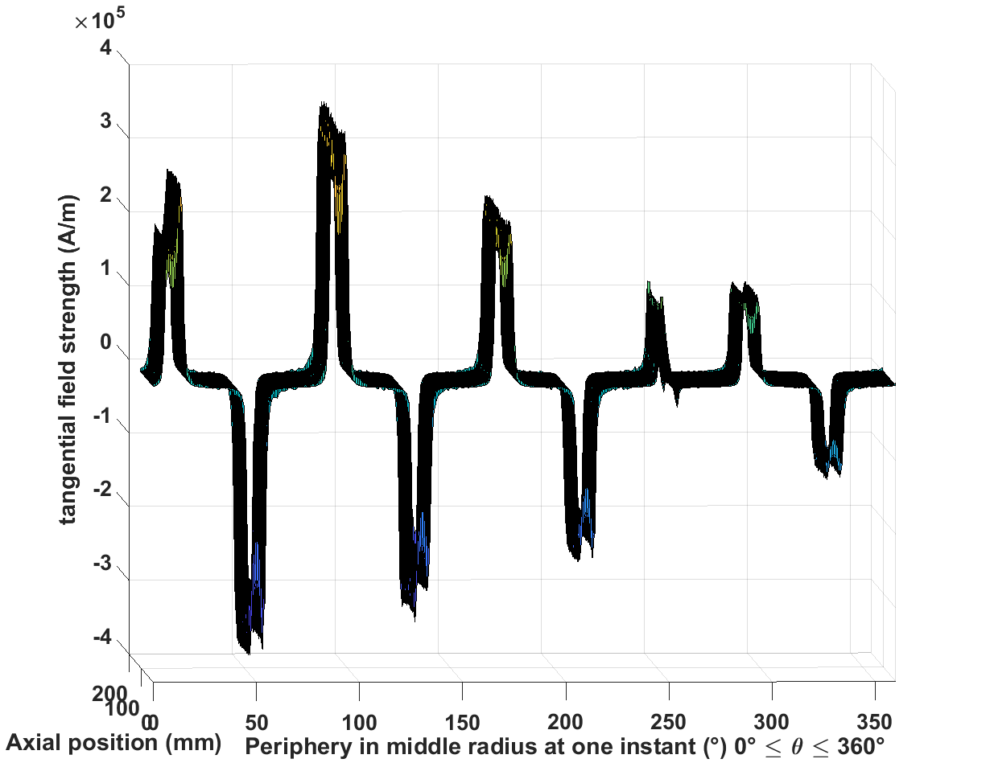
Axial eddy current
Magnet
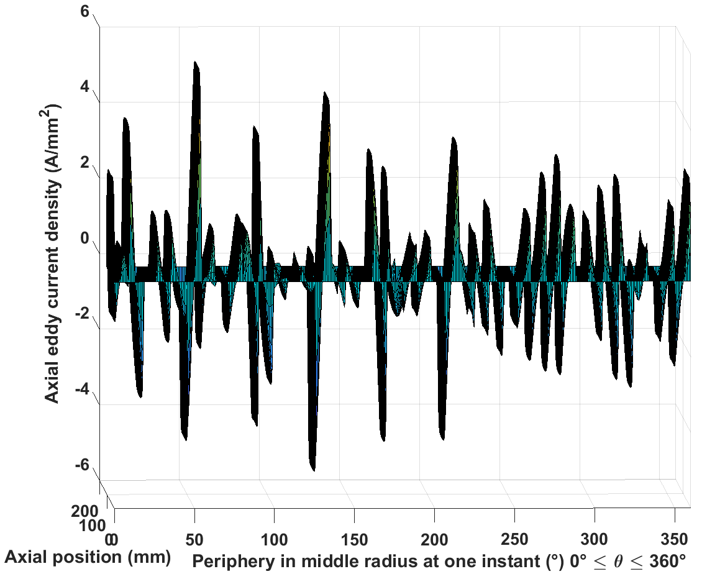 | 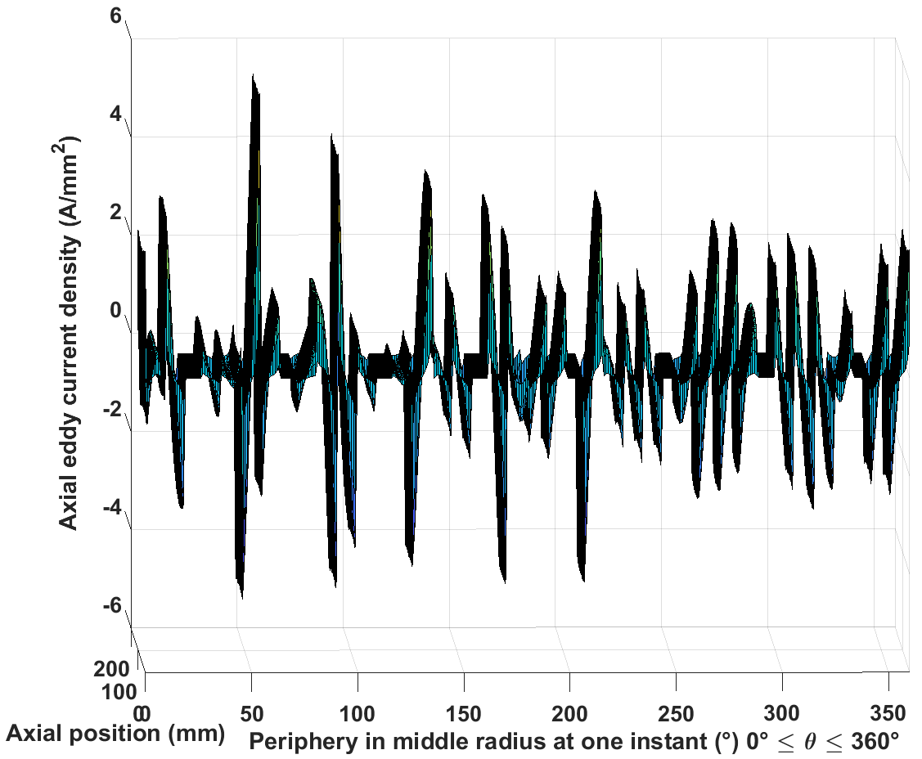
Inconel sleeve
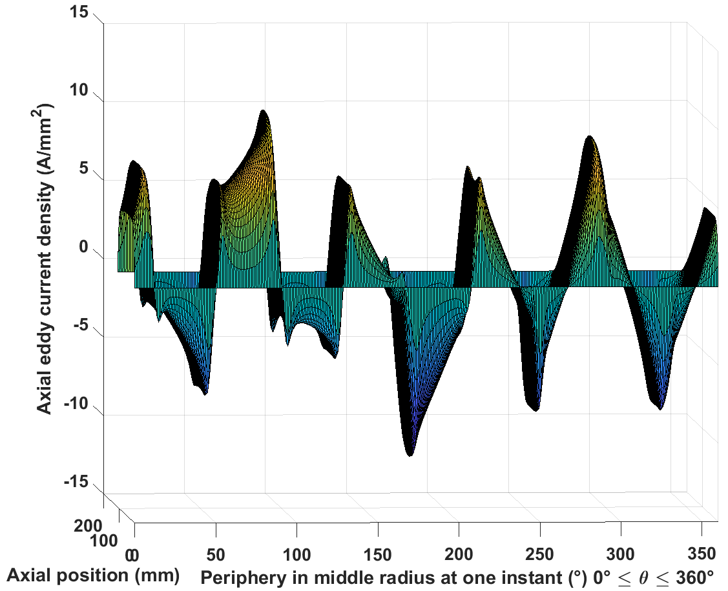 | 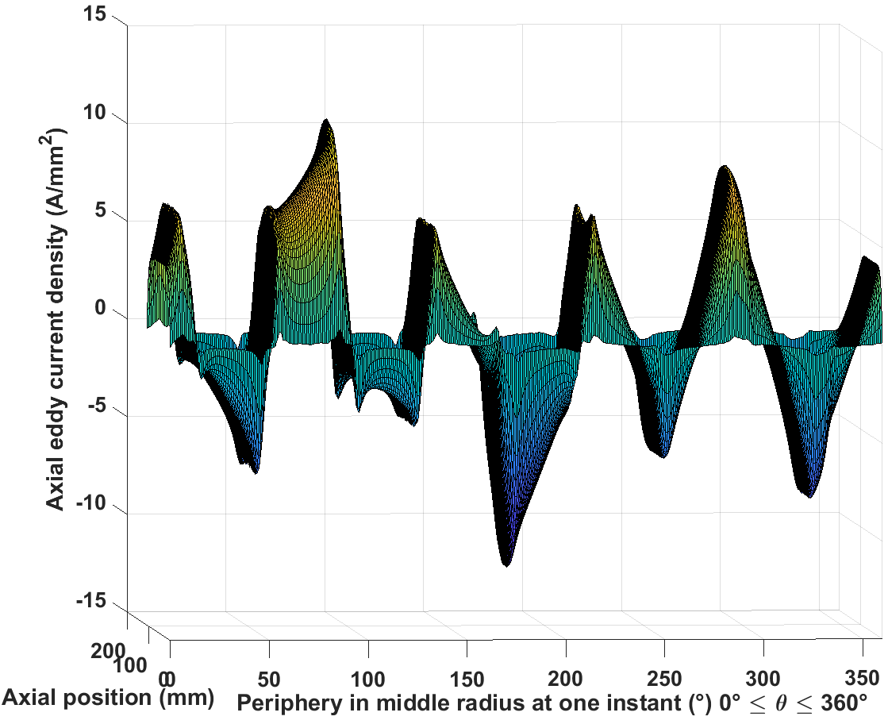
Circumferential eddy current
Magnet
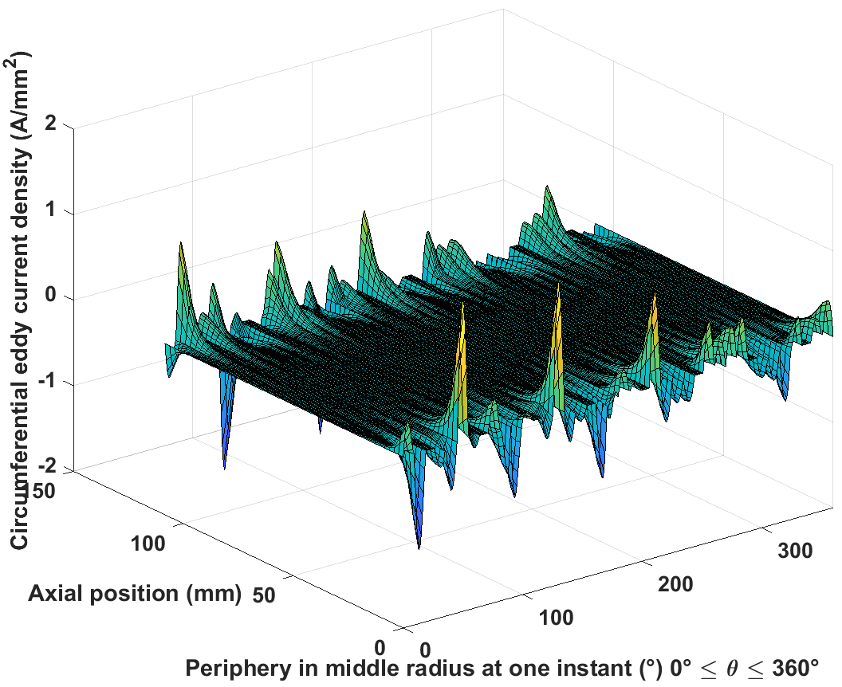 | 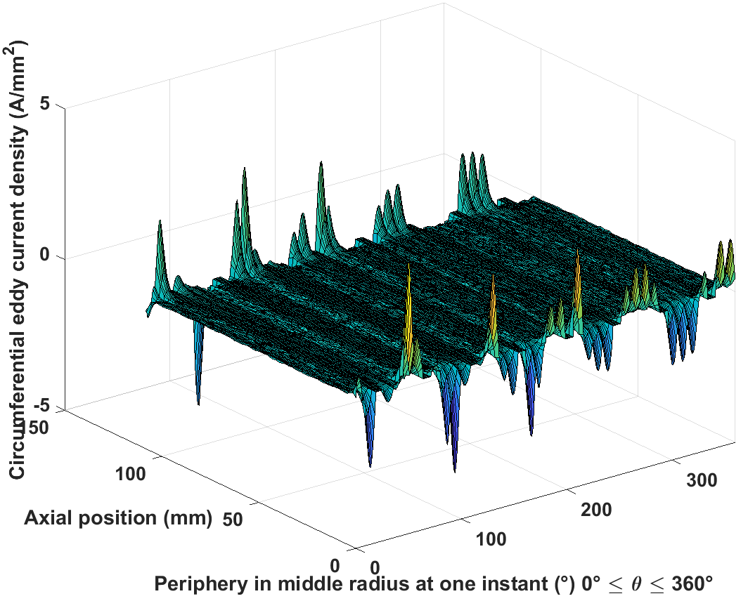
Inconel sleeve
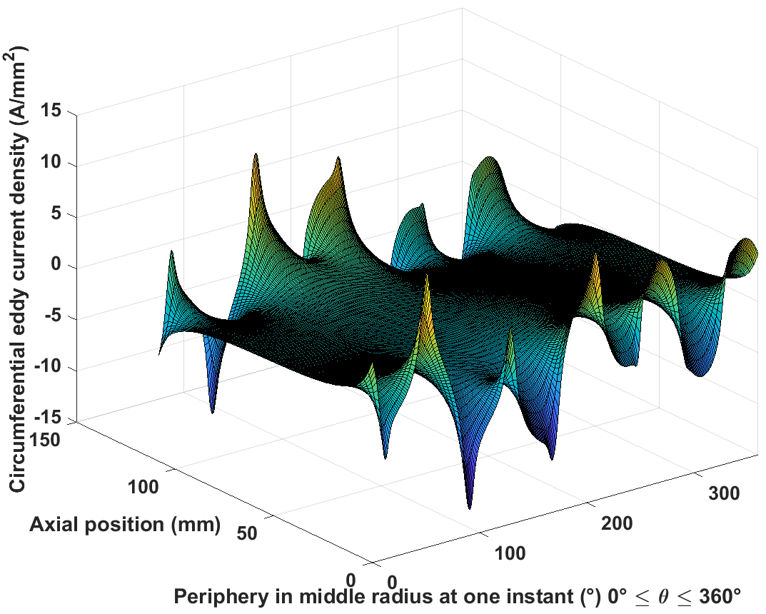 | 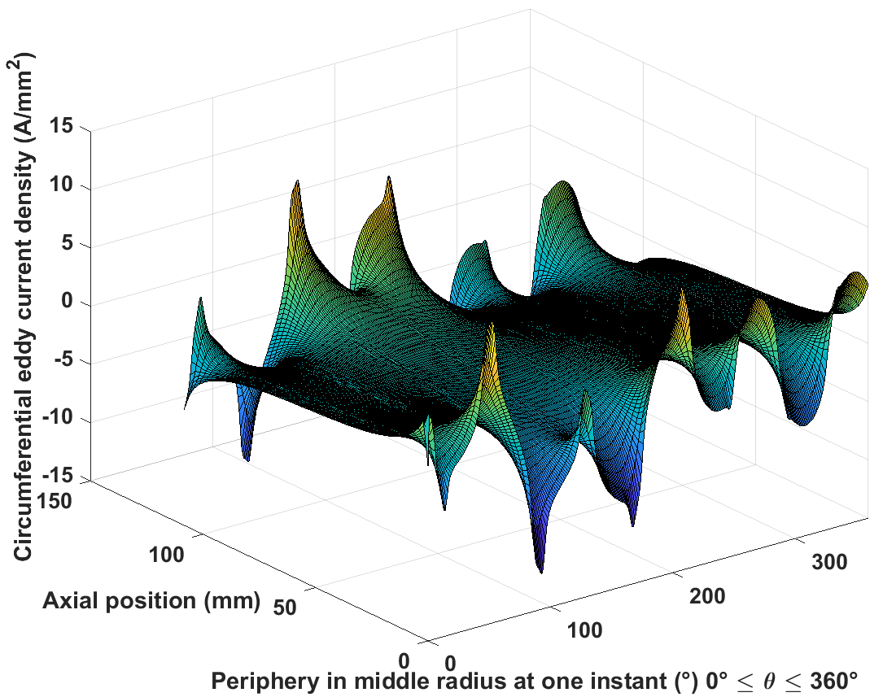

Table 5.12 2D field and eddy current distributions under magnet segmentation
Radial flux density
Magnet | 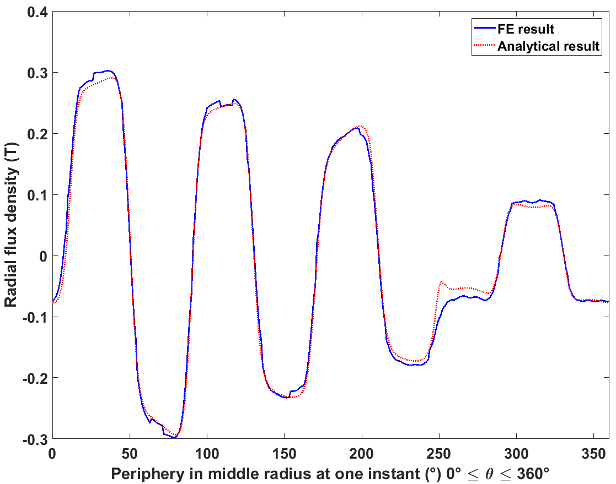
Inconel sleeve | 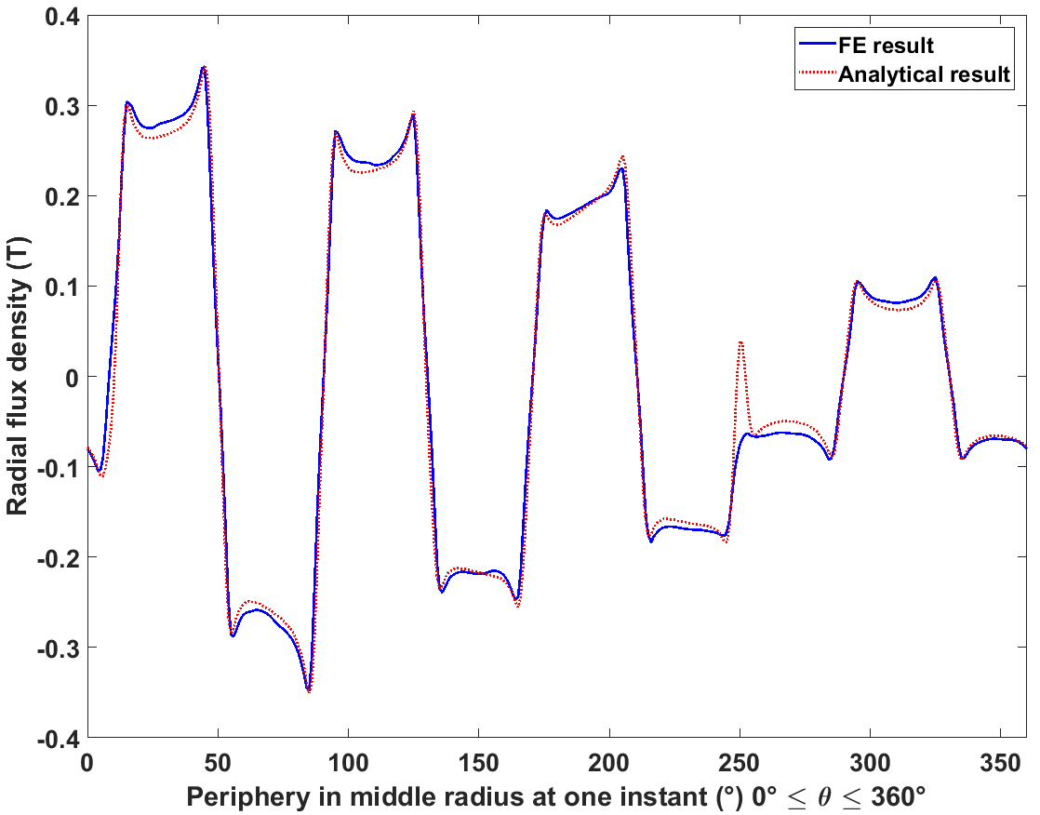
Airgap | 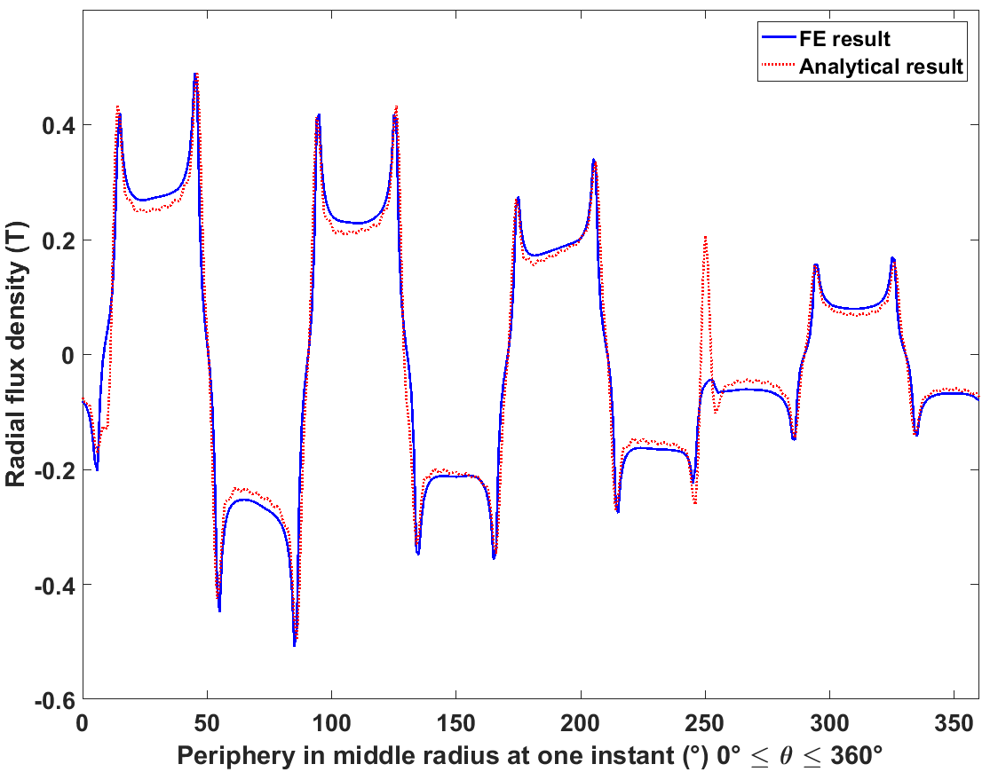
Tangential field strength
Magnet | 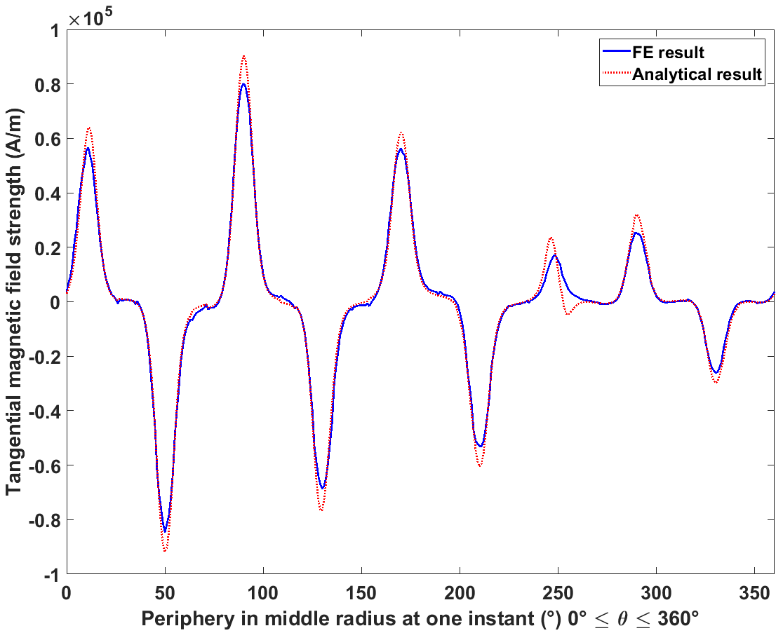
Inconel sleeve | 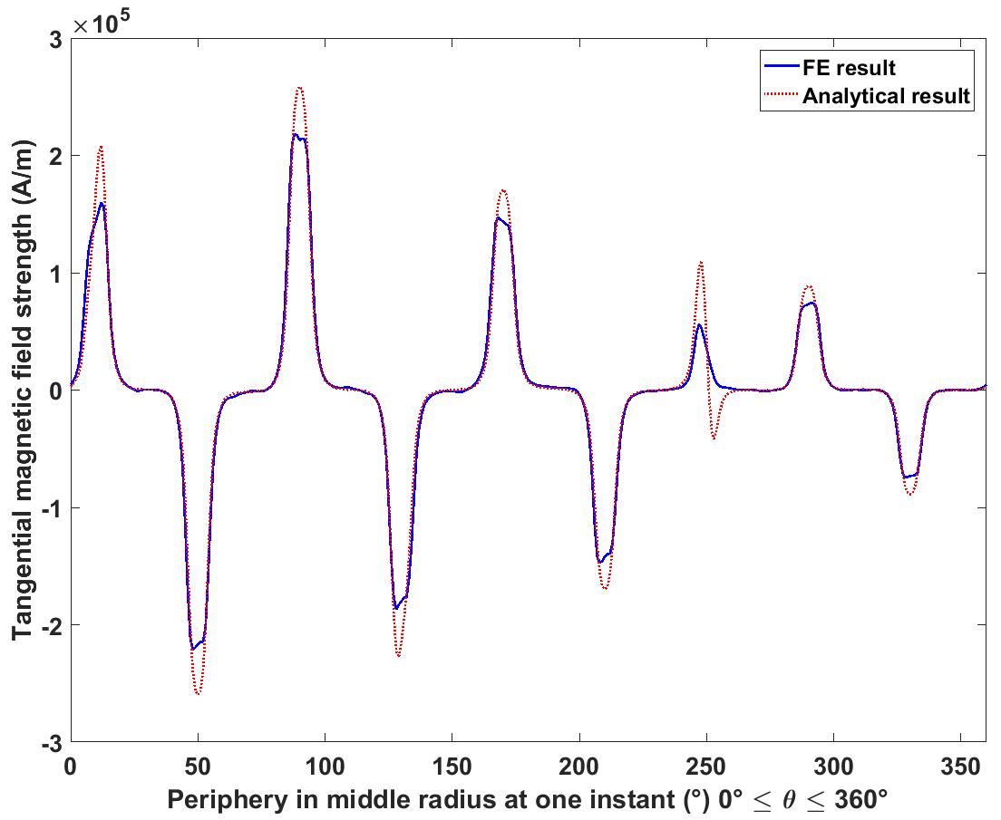
Airgap | 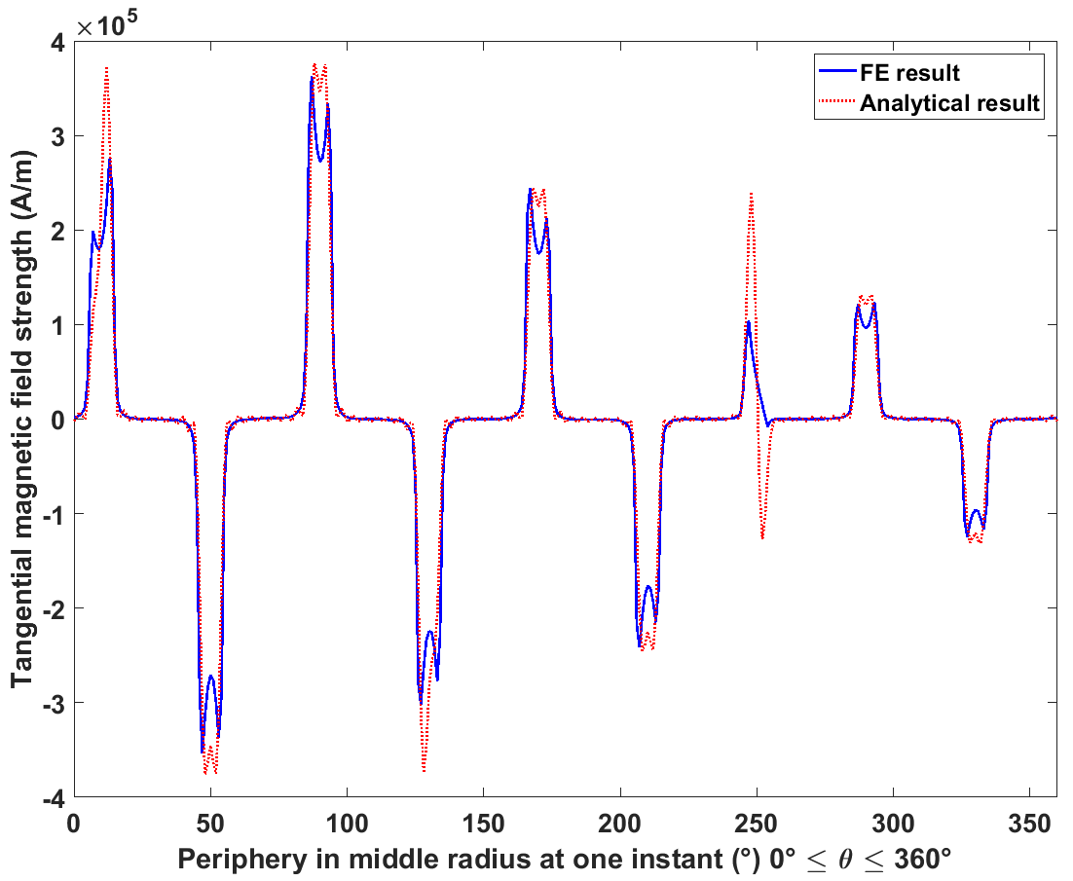
Axial eddy current
Magnet | 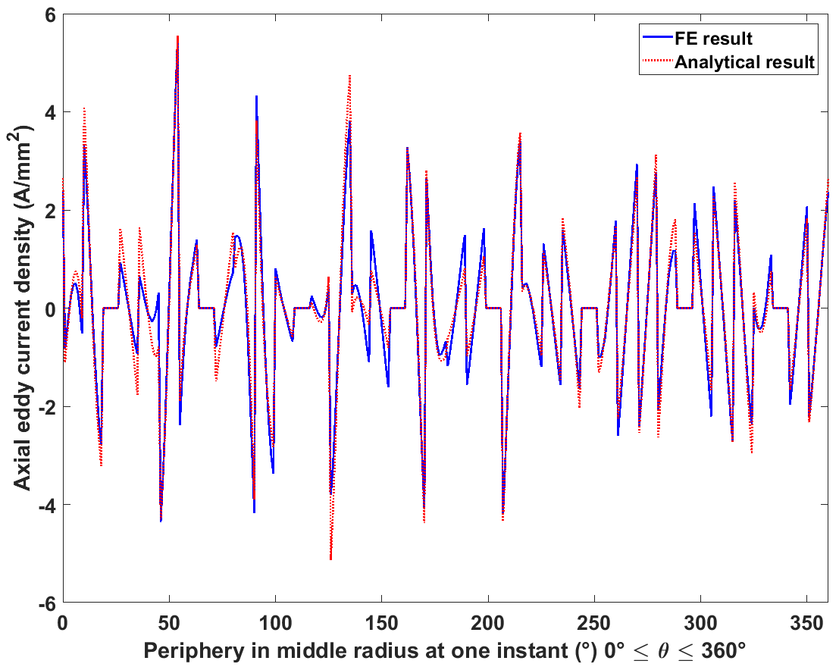
Inconel sleeve | 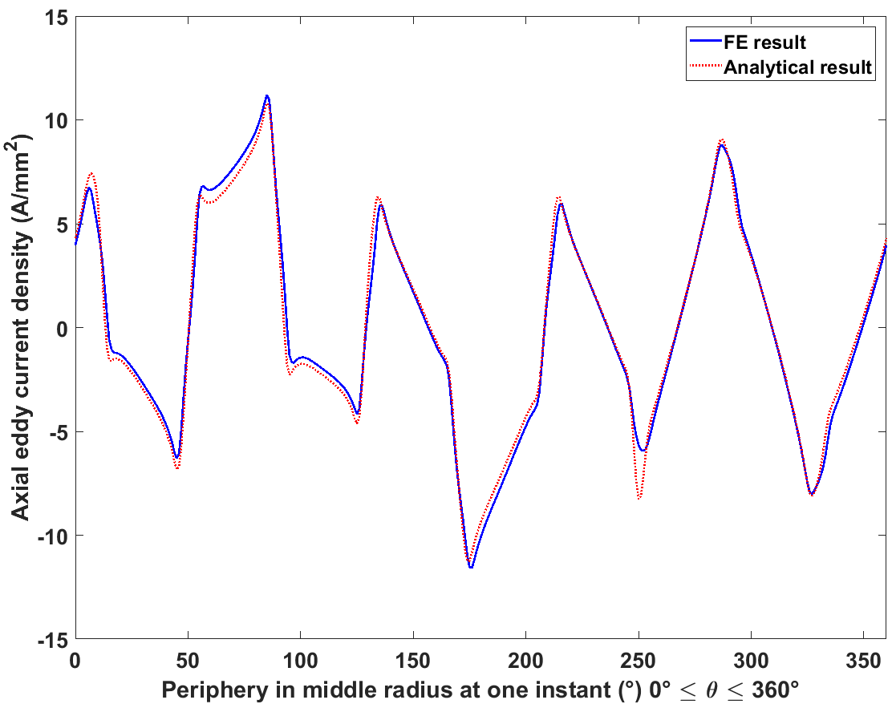
Circumferential eddy current
Magnet | 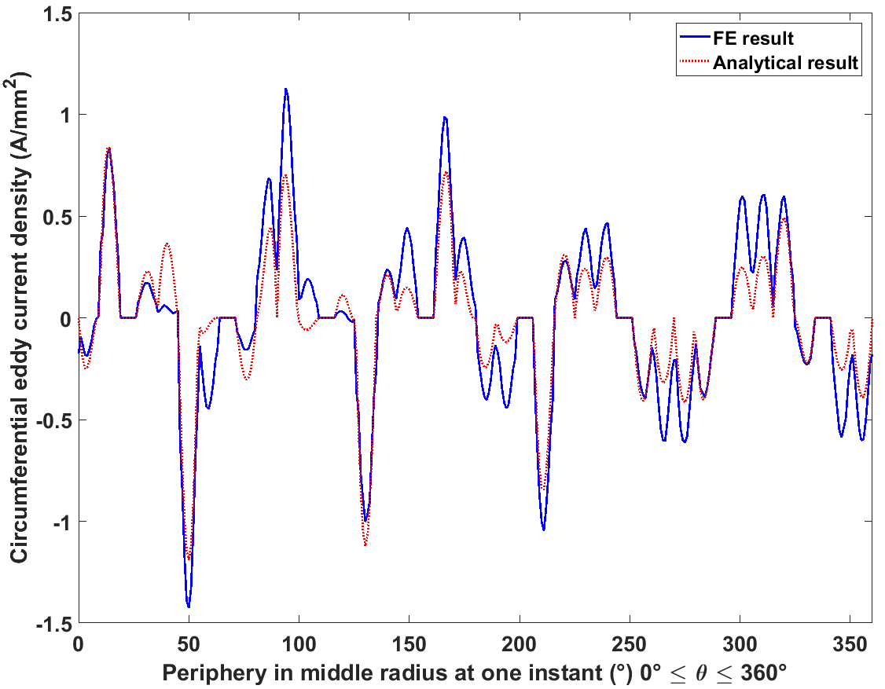
Inconel sleeve | 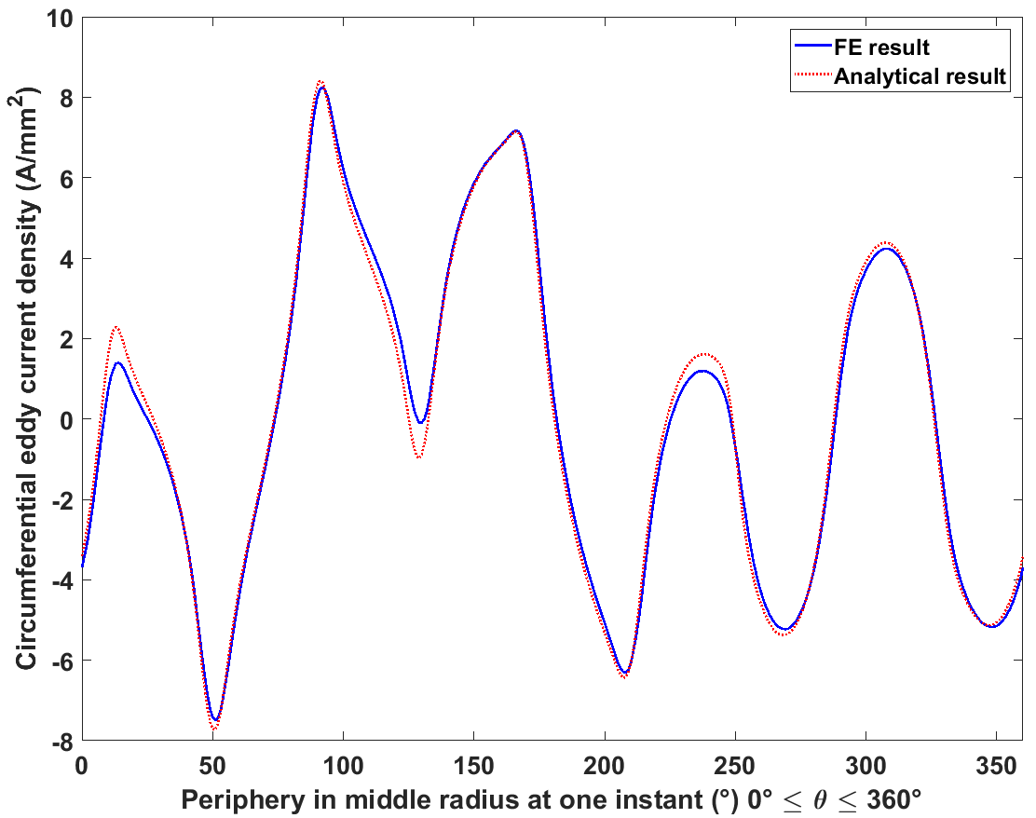
As can be seen from Table 5.11 and Table 5.12, compared to the non-segmented 8000rpm case, the eddy currents in magnet poles are further confined within individual segments, and even better agreement between analytical and FE results is achieved in both the magnetic fields and eddy current distributions in the airgap and Inconel sleeve. From the two-dimensional plots, it can be seen that good agreement is achieved for axial eddy currents in magnet segments between the two methods. However, for circumferential eddy currents in segments, significant differences exist. Also, it can be seen from the 3D plots that approaching the two axial edges, the circumferential eddy currents in segments predicted by analytical methods rise at earlier positions than the corresponding currents predicted by FE, but have shallower slopes and reach lower peaks. In other words, the circumferential eddy currents predicted by the analytical method are more distributed along the axial direction, while the currents from the FE are much more concentrated on the edges. Correspondingly, the axial eddy currents in segments from analytical method would start to diminish at earlier axial positions than the axial component of current predicted by finite element analysis.
Figure 5.12 and Figure 5.13 show the axial spatial distribution of axial and circumferential eddy currents at a particular circumferential position of one segment. This difference in eddy current behaviours in two methods will introduce differences in the final eddy loss results in magnets, as can be seen from Table 5.13. It can also be seen from Figure 5.12 and Figure 5.13 that along the axial direction, the eddy current distributions from finite element analysis have many small ripples compared to analytical method. Interestingly, this ripple is not present in the non-segmented case. The most likely reason for this is that since each magnet pole are further segmented into four pieces, for a given mesh size, the number available elements for each segment are reduced. The discretisation of elements can have a significant impact on the eddy current distribution given that the gradients of eddy currents will be much higher in a segmented magnet pole. The analytical method does not suffer from discretisation problems.
Although the deviation on loss results in magnets between the two methods remain large (order of 25%), the same trend is observed, viz. segmentation significantly reduces the eddy current loss in magnets. Figure 5.14 and Figure 5.15 show the eddy current loss variation with segmentation number in Inconel sleeve and magnets, respectively. It can be seen that the eddy current loss in magnets reduces dramatically in the first few levels of segmentation, but starts to level off for segmentation beyond 5 pieces per pole. As would be expected, the eddy current loss in Inconel sleeve increases slightly with increased with segmentation level, as shown in results from both methods in Table 5.13, and Figure 5.14. This is a consequence of there being a reduced screening eddy current reaction field from the magnet layer due to segmentation and hence the time varying elements of the magnetic field from stator excitation have greater penetration of the Inconel sleeve, in turn causing increased eddy current loss.
Table 5.13 Final eddy loss results under segmented condition
 | Average eddy current loss (W)
 | Inconel sleeve | Magnet segments
Analytical result | 861 | 80
FE result | 855 | 100
Relative difference | 0.72% | -25.09%
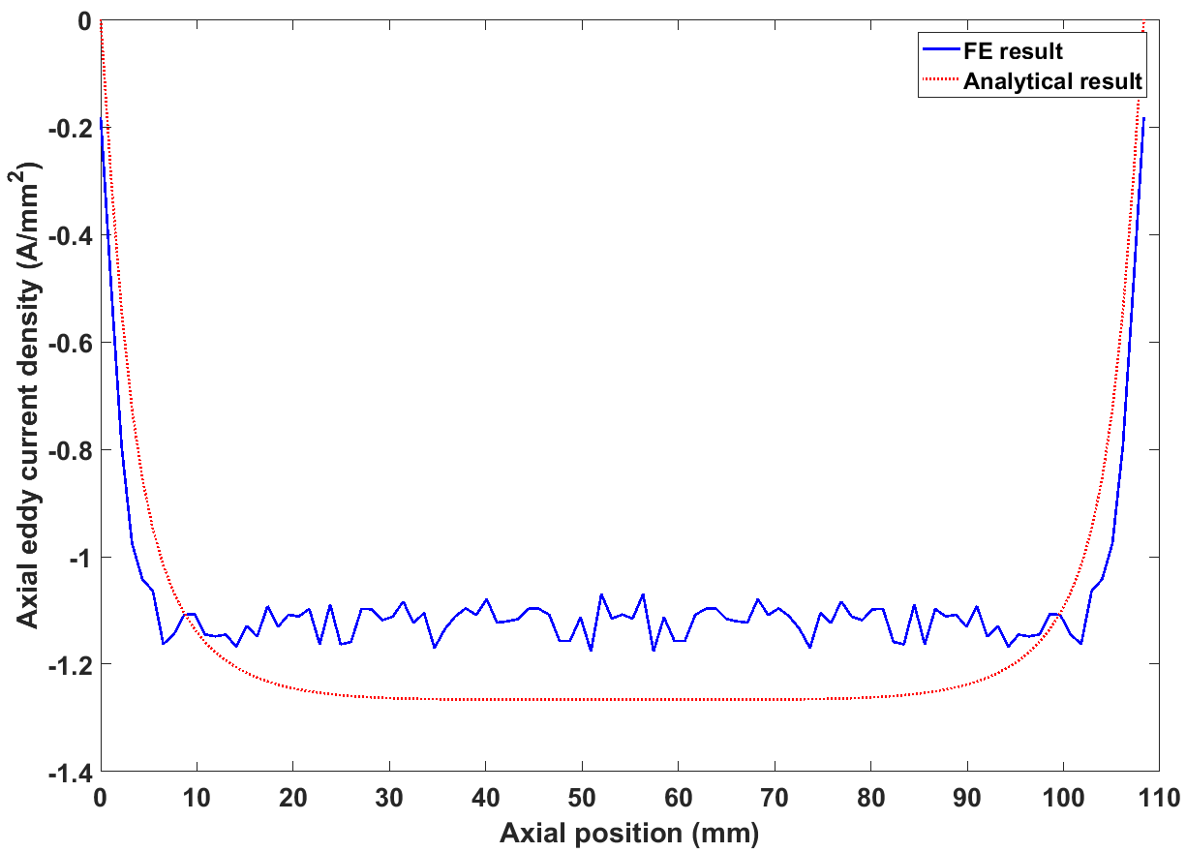
Figure 5.12 Axial distribution of axial eddy current at a particular circumferential position in one segment
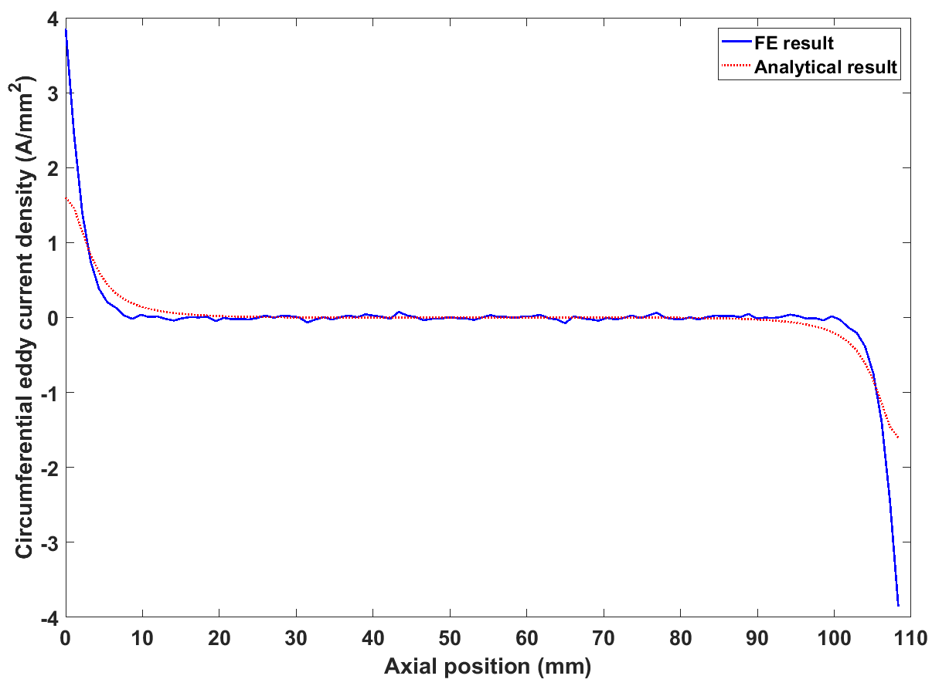
Figure 5.13 Axial distribution of circumferential eddy current at a particular circumferential position in one segment
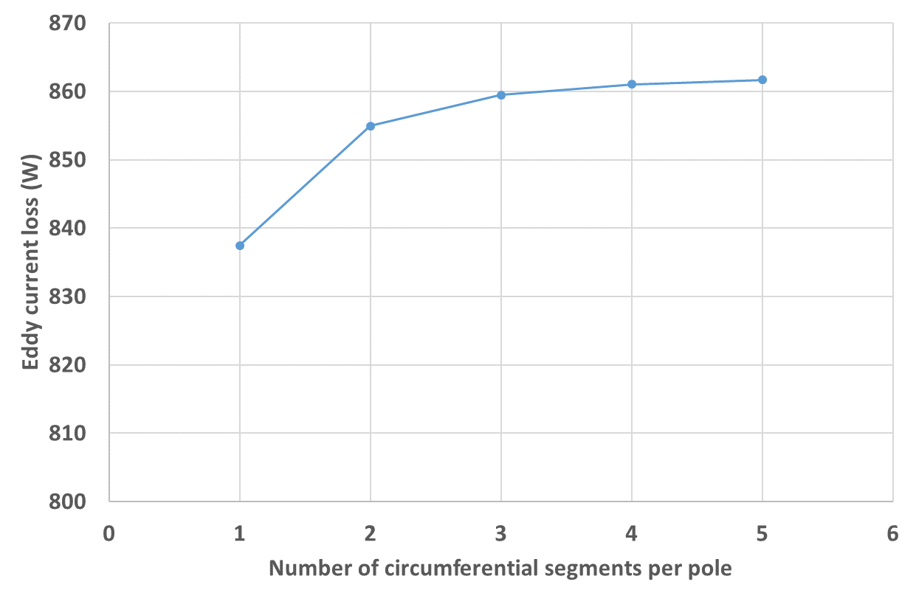
Figure 5.14 Eddy current loss variation with circumferential segmentation number in Inconel sleeve
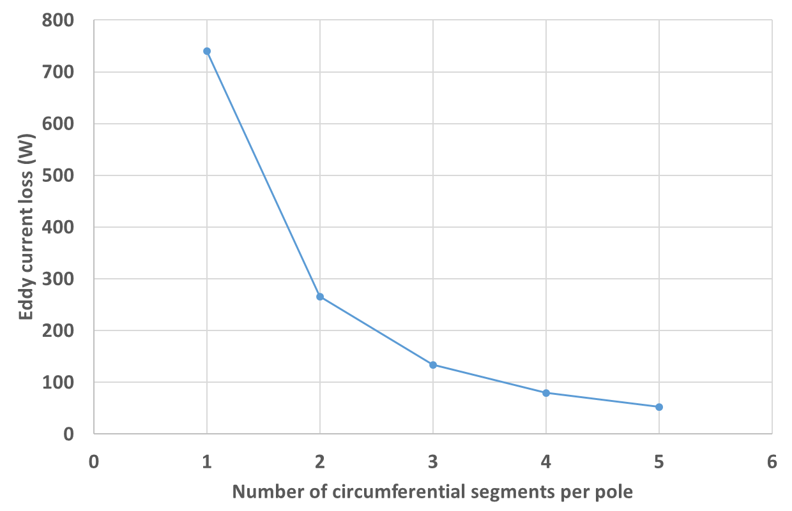
Figure 5.15 Eddy current loss variation with circumferential segmentation number in magnets

Limitations of the analytical method and ongoing work
The developed analytical model has been validated by comparison with finite element analysis at different speeds and with varying levels of magnet segmentation, with generally good agreement having been achieved. However, at the high speed of 24000rpm, and at the axial edges of magnet segments when extensive segmentation has been applied, large deviation (>10% and up to 25%) between analytical results and FE results still exists. Despite the inevitable errors introduced into the finite element model from finite mesh size, the loss mechanism inside the magnet poles also needs to be further investigated. By comparing the eddy current distribution inside Inconel sleeve, where the current flow is not restricted by circumferential insulations, and the eddy current distributions in magnets, where circumferential boundaries would confine the flow of eddy current, interesting phenomenon can be observed under the same stator excitation, the circumferential eddy currents in the magnets exhibit a larger zone with zero circumferential eddy currents at the mid-point of the axial direction than the circumferential eddy current in Inconel sleeve. In other words, the circumferential eddy currents in the magnets are squeezed onto the axial edges due to reduced freedom in circumferential direction. This difference has been explained physically and mathematically by the additional harmonics existing only inside magnets, which are not from stator excitation, but introduced in the process of current flow reshaping inside magnets due to circumferential insulations. However, these harmonics might not be able to fully describe the additional concentration of circumferential currents towards the axial edges when the magnets are further segmented into very thin pieces, and the circumferential eddy currents are further squeezed onto the axial edges. Whether this additional concentration is due to the existence of additional harmonics only in the magnets, which are generated around the axial edges of segments contributing to the additional concentration and are not included in the analytical model, or this is due to the machine end effect, which is present in the finite element model but not accounted for in the analytical method, still needs to be investigated. In addition, the mesh size in the FE model also need to be refined to minimise the discretization and increase the quality of current description around the thin areas near the edges. This would inevitably increase the time consumption for FE simulation. Some further work to investigate these effects is described in the future work section of the conclusions in chapter 6.

Eddy current loss under open circuit condition
In the absence of slot openings, there should be no eddy current loss in rotor structures under open circuit condition, since the magnet remanence field is static relative to the rotor reference system. However, with the presence of stator slot openings, the magnet working point fluctuates during rotation due to non-uniform permeance. The permeance modulation effect will therefore generate eddy current loss w even under open circuit condition. Since neither the magnet remanence field nor slot openings are included in the analytical method or in the finite element models used in sections 5.3 and 5.5 , a further finite element is required to investigate the eddy current loss due to magnet working point variations under open circuit conditions.
The same machine selected for validation in previous sections was again used to calculate the open-circuit rotor magnet loss at an operating speed at 8000rpm. The same finite element model was used for the simulation but with the remanence field turned on inside each magnet, and no phase currents applied. Table 5.14 shows the instantaneous three-dimensional distributions of magnetic field and eddy currents in the mid radial positions of different layers, at an instant of time that corresponds to 50° mechanical displacement under the same stator and rotor reference system.

Table 5.14 Three-dimensional distributions of the field and eddy current under open circuit condition from FE analysis
 | FE results
 | Radial flux density
Magnet | 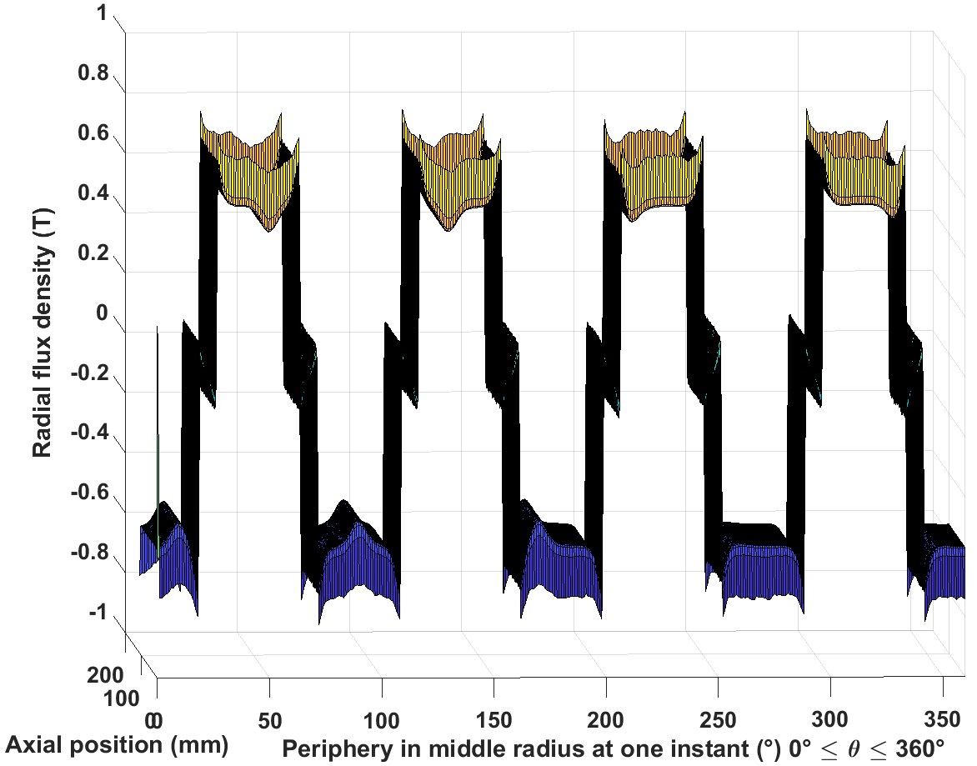
Inconel sleeve | 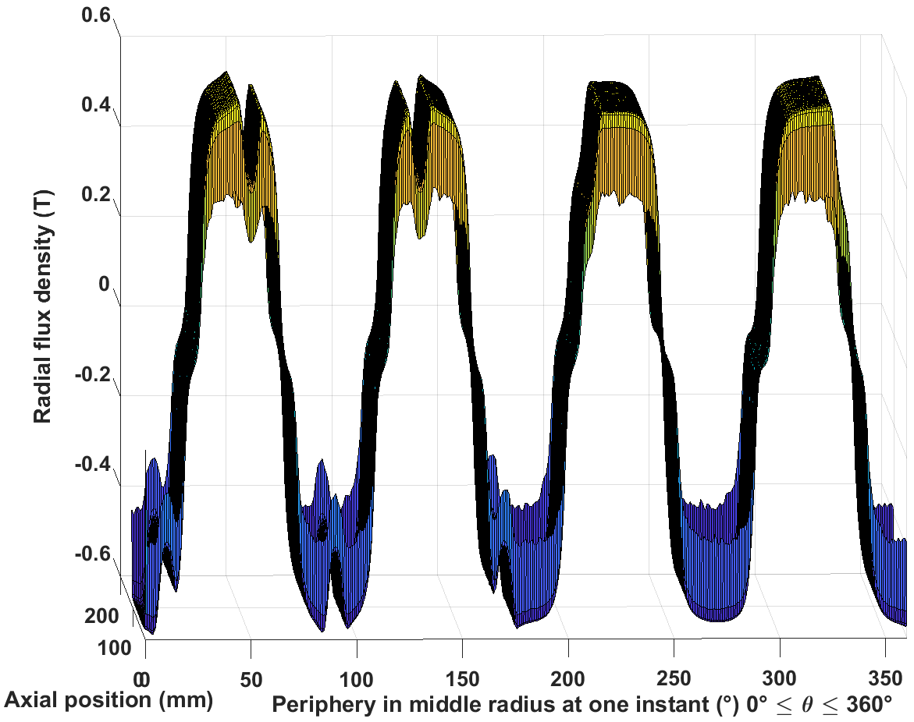
Airgap | 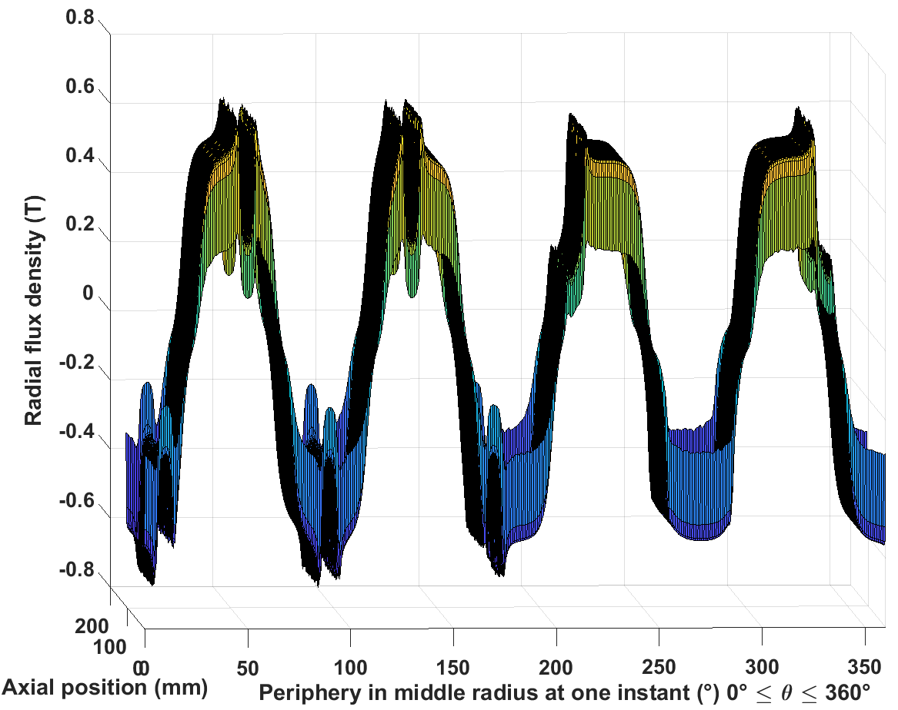
 | Tangential field strength
Magnet | 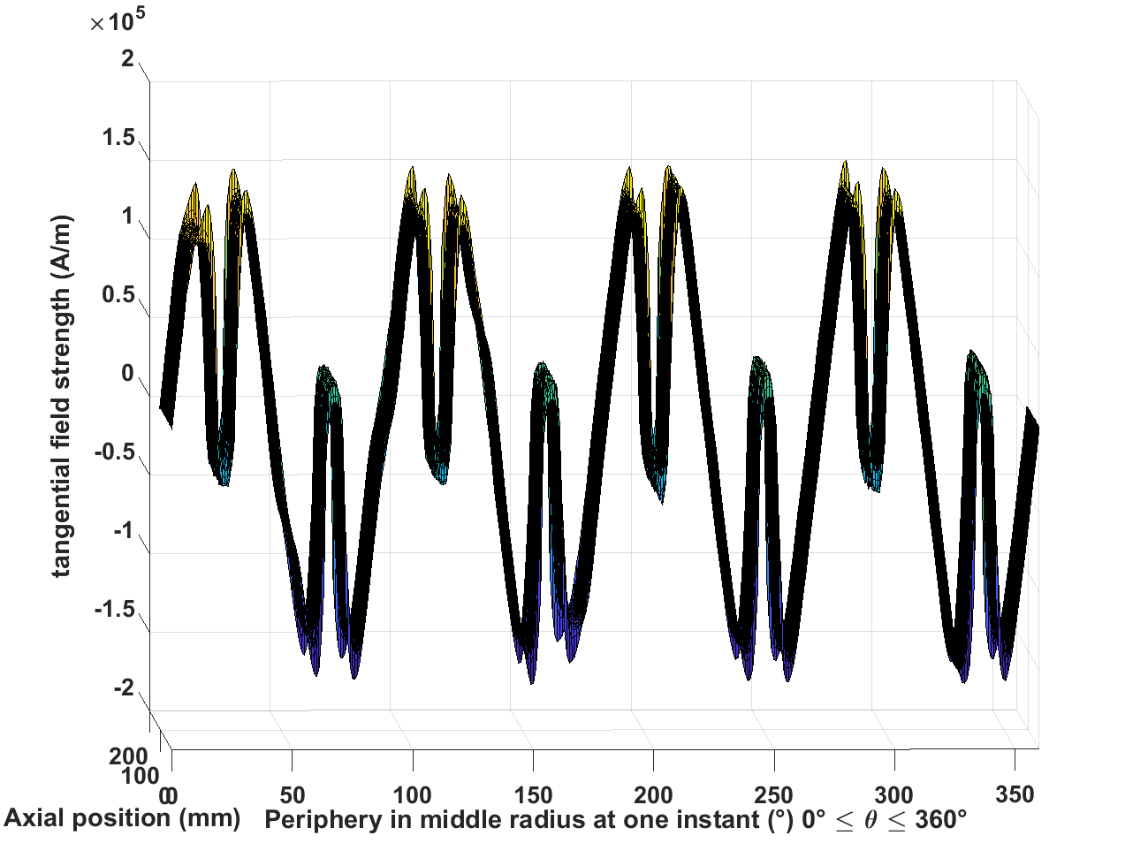
Inconel sleeve | 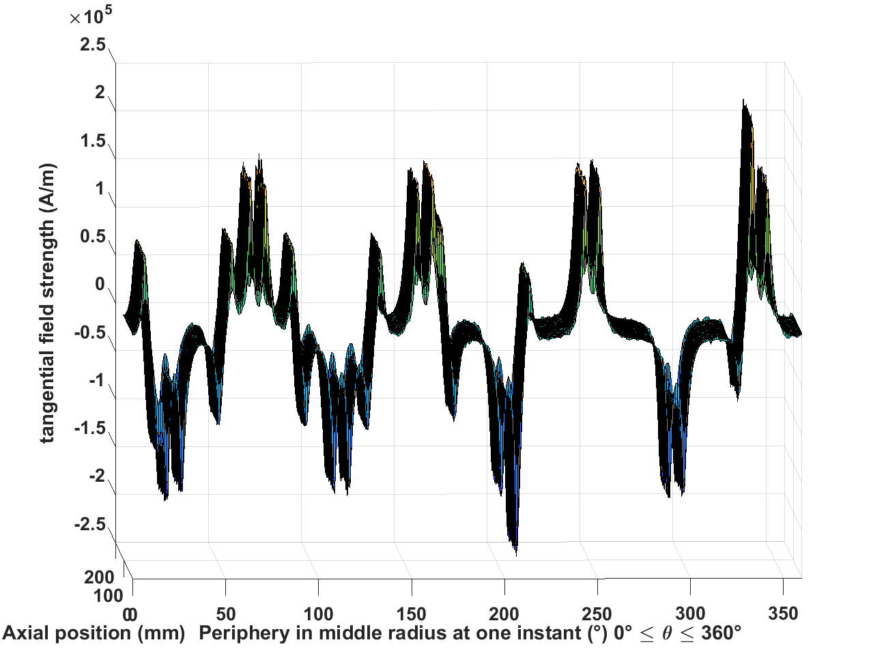
Airgap | 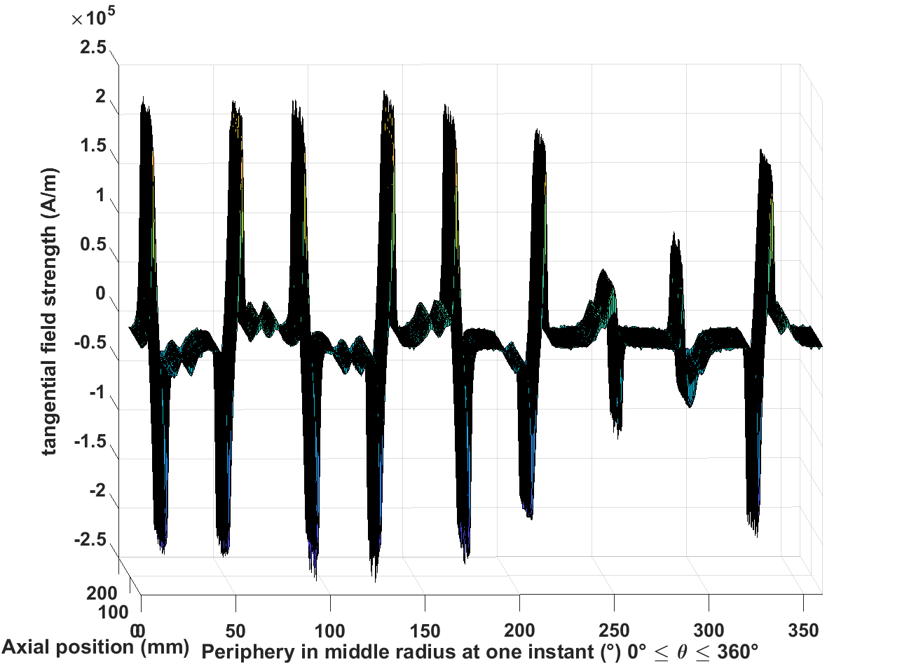
 | Axial eddy current
Magnet | 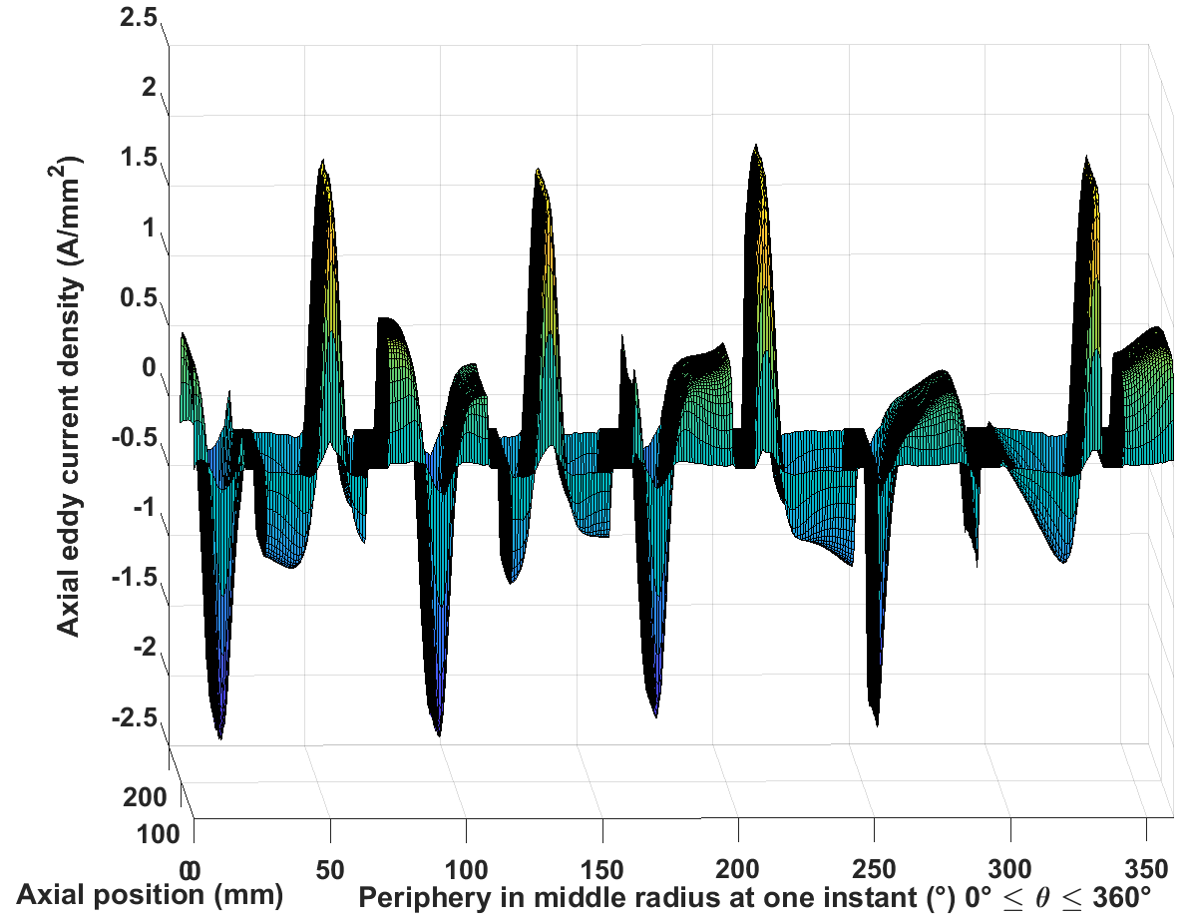
Inconel sleeve | 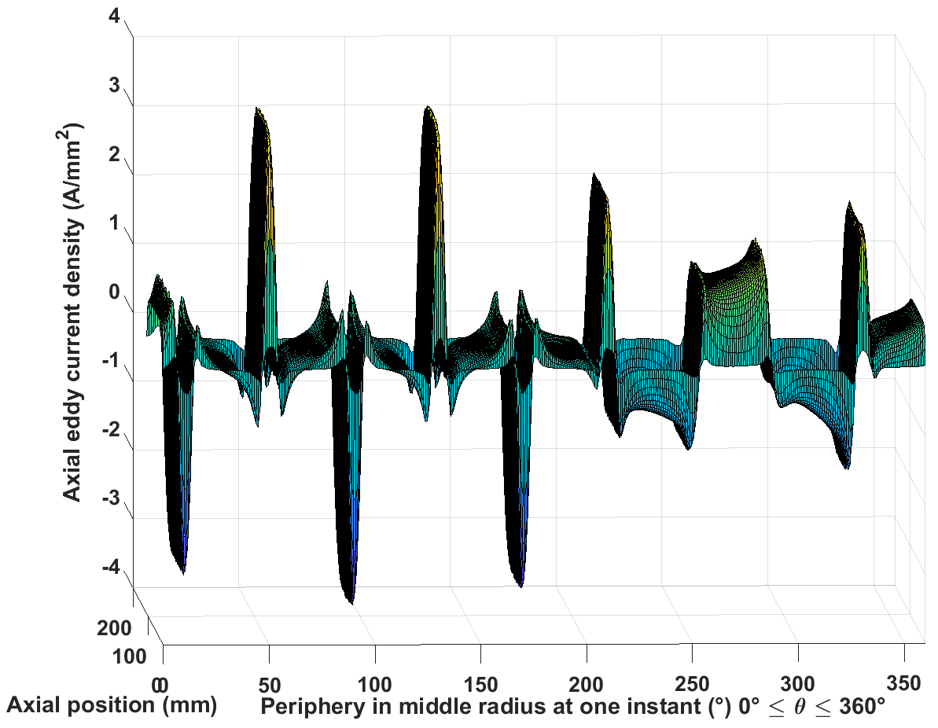
 | Circumferential eddy current
Magnet | 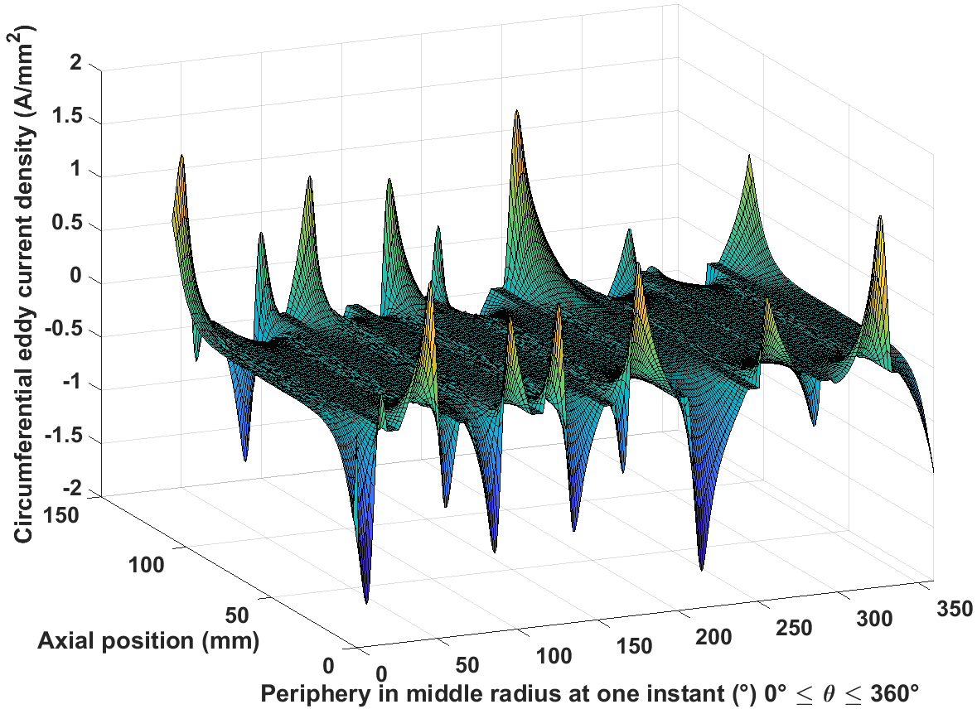
Inconel sleeve | 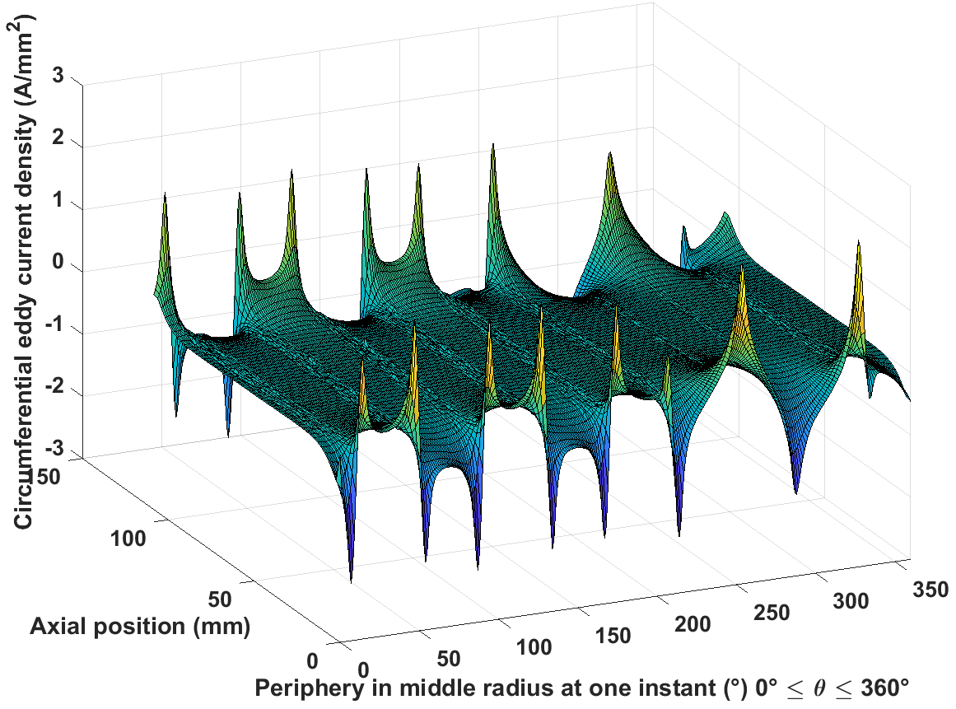
The field and eddy current distributions in Table 5.14 clearly demonstrated the effect of slot openings in the radial field distributions in the airgap and Inconel sleeve, which have exhibit sudden drops in magnitude at the positions beneath the slot openings, and the magnet working point change at those positions as well. Compared to the eddy currents induced by stator armature flux in Inconel sleeve and magnets, the eddy currents and losses induced by magnet working point change is significantly smaller, and largely concentrated in some sharp peaks.

Table 5.15 Final eddy current loss results under open circuit condition
 | Inconel sleeve | Magnets
Eddy current loss (W) | 46.7 | 29.6

Conclusion
In this chapter, the following studies are carried out:
- The eddy current loss in rotor metallic structures, including the metallic sleeve and the magnet poles, are studied, and for the fractional slot machine, big eddy current loss is observed when the magnets are not segmented due to rich airgap spatial harmonics.
- A 3D analytical model, which considers the eddy current reaction effect, curvature effect, full stator harmonics, and finite axial machine length, is developed to calculate field and eddy current distribution in both metallic sleeve and magnets, as well as the losses
- The model is validated at different operating speed and with magnet segmentation. Good agreement is achieved with the 3D FE analysis, in terms of both field and eddy current distribution and loss results. However, under some conditions, deviation still exists.
- The eddy current loss caused by slot opening modulation under open circuit condition is also studied by FE. Much smaller losses are observed.
- Future work includes further development and generalization of the analytical model to include the slot opening modulation and the magnet remanence field, and to accommodate any slot-pole combinations.

References
[1] K. Atallah, D. Howe, P. H. Mellor, and D. A. Stone, "Rotor loss in permanent-magnet brushless AC machines," Industry Applications, IEEE Transactions on, vol. 36, pp. 1612-1618, 2000.
[2] H. Toda, X. Zhenping, W. Jiabin, K. Atallah, and D. Howe, "Rotor eddy-current loss in permanent magnet brushless machines," Magnetics, IEEE Transactions on, vol. 40, pp. 2104-2106, 2004.
[3] D. Ishak, Z. Q. Zhu, and D. Howe, "Eddy-current loss in the rotor magnets of permanent-magnet brushless machines having a fractional number of slots per pole," Magnetics, IEEE Transactions on, vol. 41, pp. 2462-2469, 2005.
[4] Z. Q. Zhu, K. Ng, N. Schofield, and D. Howe, "Improved analytical modelling of rotor eddy current loss in brushless machines equipped with surface-mounted permanent magnets," Electric Power Applications, IEE Proceedings -, vol. 151, pp. 641-650, 2004.
[5] A. M. EL-Refaie, "Fractional-Slot Concentrated-Windings Synchronous Permanent Magnet Machines: Opportunities and Challenges," in IEEE Transactions on Industrial Electronics, vol. 57, no. 1, pp. 107-121, Jan. 2010.
[6] J. Wang, K. Atallah, R. Chin, W. M. Arshad, and H. Lendenmann, "Rotor Eddy-Current Loss in Permanent-Magnet Brushless AC Machines," IEEE Transactions on Magnetics, vol. 46, pp. 2701-2707, 2010.
[7] A. K. Nagarkatti, O. A. Mohammed, and N. A. Demerdash, "Special Losses in Rotors of Electronically Commutated Brushless DC Motors Induced by Non-Uniformly Rotating Armature MMFS," Power Engineering Review, IEEE, vol. PER-2, pp. 33-33, 1982.
[8] D. Fang, "Commutation-caused eddy-current losses in permanent-magnet brushless DC motors," Magnetics, IEEE Transactions on, vol. 33, pp. 4310-4318, 1997.
[9] D. Fang, "Improved analytical modeling of commutation losses including space harmonic effects in permanent magnet brushless DC motors," in Conference Record of 1998 IEEE Industry Applications Conference. Thirty-Third IAS Annual Meeting (Cat. No.98CH36242), 1998, pp. 380-386 vol.1.
[10] D. Fang and T. W. Nehl, "Analytical modeling of eddy-current losses caused by pulse-width-modulation switching in permanent-magnet brushless direct-current motors," IEEE Transactions on Magnetics, vol. 34, pp. 3728-3736, 1998.
[11] M. Mirzaei, A. Binder, and C. Deak, "3D analysis of circumferential and axial segmentation effect on magnet eddy current losses in permanent magnet synchronous machines with concentrated windings," in The XIX International Conference on Electrical Machines - ICEM 2010, 2010, pp. 1-6.
[12] M. Mirzaei, A. Binder, B. Funieru, and M. Susic, "Analytical Calculations of Induced Eddy Currents Losses in the Magnets of Surface Mounted PM Machines With Consideration of Circumferential and Axial Segmentation Effects," IEEE Transactions on Magnetics, vol. 48, pp. 4831-4841, 2012.
[13] H. Polinder and M. Hoeijmakers, "Eddy-current losses in the permanent magnets of a PM machine," 1997.
[14] J. L. F. Van der Veen, L. J. J. Offringa, and A. J. A. Vandenput, "Minimising rotor losses in high-speed high-power permanent magnet synchronous generators with rectifier load," Electric Power Applications, IEE Proceedings -, vol. 144, pp. 331-337, 1997.
[15] J. D. Ede, K. Atallah, W. Jiabin, and D. Howe, "Effect of optimal torque control on rotor loss of fault-tolerant permanent-magnet brushless machines," IEEE Transactions on Magnetics, vol. 38, pp. 3291-3293, 2002.
[16] J. D. Ede, K. Atallah, G. W. Jewell, J. B. Wang, and D. Howe, "Effect of Axial Segmentation of Permanent Magnets on Rotor Loss in Modular Permanent-Magnet Brushless Machines," Industry Applications, IEEE Transactions on, vol. 43, pp. 1207-1213, 2007.
[17] K. Yamazaki and A. Abe, "Loss Analysis of Interior Permanent Magnet Motors Considering Carrier Harmonics and Magnet Eddy Currents Using 3-D FEM," in 2007 IEEE International Electric Machines & Drives Conference, 2007, pp. 904-909.
[18] L. Chen, J. Wang, and S. S. Nair, "An Analytical Method for Predicting 3-D Eddy Current Loss in Permanent Magnet Machines Based on Generalized Image Theory," IEEE Transactions on Magnetics, vol. 52, pp. 1-11, 2016.
[19] S. S. Nair, J. Wang, L. Chen, R. Chin, I. Manolas, and D. Svechkarenko, "Prediction of 3-D High-Frequency Eddy Current Loss in Rotor Magnets of SPM Machines," IEEE Transactions on Magnetics, vol. 52, pp. 1-10, 2016.
[20] K. Ng, Z. Q. Zhu, and D. Howe, "Open-circuit field distribution in a brushless motor with diametrically magnetised PM rotor, accounting for slotting and eddy current effects," IEEE Transactions on Magnetics, vol. 32, pp. 5070-5072, 1996.
[21] S. M. Sharkh, M. R. Harris, and N. T. Irenji, "Calculation of rotor eddy-current loss in high-speed PM alternators," in 1997 Eighth International Conference on Electrical Machines and Drives (Conf. Publ. No. 444), 1997, pp. 170-174.
[22] Z. Q. Zhu, D. Howe, E. Bolte, and B. Ackermann, "Instantaneous magnetic field distribution in brushless permanent magnet DC motors. I. Open-circuit field," IEEE Transactions on Magnetics, vol. 29, pp. 124-135, 1993.
[23] Z. Q. Zhu and D. Howe, "Instantaneous magnetic field distribution in brushless permanent magnet DC motors. II. Armature-reaction field," IEEE Transactions on Magnetics, vol. 29, pp. 136-142, 1993.
[24] Z. Q. Zhu and D. Howe, "Instantaneous magnetic field distribution in brushless permanent magnet DC motors. III. Effect of stator slotting," IEEE Transactions on Magnetics, vol. 29, pp. 143-151, 1993.
[25] Z. Q. Zhu and D. Howe, "Instantaneous magnetic field distribution in permanent magnet brushless DC motors. IV. Magnetic field on load," IEEE Transactions on Magnetics, vol. 29, pp. 152-158, 1993.
[26] Z. Q. Zhu, D. Howe, and C. C. Chan, "Improved analytical model for predicting the magnetic field distribution in brushless permanent-magnet machines," Magnetics, IEEE Transactions on, vol. 38, pp. 229-238, 2002.
[27] P. D. Pfister and Y. Perriard, "Slotless Permanent-Magnet Machines: General Analytical Magnetic Field Calculation," IEEE Transactions on Magnetics, vol. 47, pp. 1739-1752, 2011.
[28] P. D. Pfister, X. Yin, and Y. Fang, "Slotted Permanent-Magnet Machines: General Analytical Model of Magnetic Fields, Torque, Eddy Currents, and Permanent-Magnet Power Losses Including the Diffusion Effect," IEEE Transactions on Magnetics, vol. 52, pp. 1-13, 2016.
[29] L. J. Wu, Z. Q. Zhu, D. Staton, M. Popescu, and D. Hawkins, "Analytical prediction of electromagnetic performance of surface-mounted PM machines based on subdomain model accounting for tooth-tips," IET Electric Power Applications, vol. 5, pp. 597-609, 2011.
[30] Z. Q. Zhu, L. J. Wu, and Z. P. Xia, "An Accurate Subdomain Model for Magnetic Field Computation in Slotted Surface-Mounted Permanent-Magnet Machines," IEEE Transactions on Magnetics, vol. 46, pp. 1100-1115, 2010.
[31] B. Hannon, P. Sergeant, and L. Dupré, "2-D Analytical Subdomain Model of a Slotted PMSM With Shielding Cylinder," IEEE Transactions on Magnetics, vol. 50, pp. 1-10, 2014.
[32] S. S. Nair, L. Chen, J. Wang, R. Chin, I. Manolas, and D. Svechkarenko, "Computationally efficient 3D analytical magnet loss prediction in surface mounted permanent magnet machines," IET Electric Power Applications, vol. 11, pp. 9-18, 2017.
[33] R. L. Stoll, The analysis of eddy currents: Clarendon Press, 1974.
[34] Wolfram Research, Inc., ‘Modified Bessel function of the first kind: Integration’, Wolfram Research, Inc., Editor. 2002, http://functions.wolfram.com/Bessel-TypeFunctions/BesselI/21/ShowAll.html
[35] Wolfram Research, Inc., ‘Modified Bessel function of the second kind: Integration’, Wolfram Research, Inc., Editor. 2002, http://functions.wolfram.com/Bessel-TypeFunctions/BesselK/21/ShowAll.html
[36] The MathWorks Inc., ‘MATLAB documentation: integral’, The MathWorks Inc., Editor. 2017, https://uk.mathworks.com/help/matlab/ref/integral.html?s_tid=doc_ta
[37] Cobham Technical Services, ‘Opera-3d Reference Manual,’ Version 18R1, Nov. 2015
[38] A. Desmoort, Z. D. Gréve, P. Dular, C. Geuzaine, and O. Deblecker, "Surface Impedance Boundary Condition With Circuit Coupling for the 3-D Finite-Element Modeling of Wireless Power Transfer," IEEE Transactions on Magnetics, vol. 53, pp. 1-4, 2017.
[39] J. Gyselinck, P. Dular, C. Geuzaine, and R. V. Sabariego, "Combining surface impedance boundary conditions with volume discretisation in time-domain finite-element modeling," in Digests of the 2010 14th Biennial IEEE Conference on Electromagnetic Field Computation, 2010, pp. 1-1.
[40] J. Gyselinck, P. Dular, C. Geuzaine, and R. V. Sabariego, "Surface-Impedance Boundary Conditions in Time-Domain Finite-Element Calculations Using the Magnetic-Vector-Potential Formulation," IEEE Transactions on Magnetics, vol. 45, pp. 1280-1283, 2009.
[41] R. V. Sabariego, C. Geuzaine, P. Dular, and J. Gyselinck, "Time-Domain Surface Impedance Boundary Conditions Enhanced by Coarse Volume Finite-Element Discretisation," IEEE Transactions on Magnetics, vol. 48, pp. 631-634, 2012.

Conclusion

This programme of research reported in this thesis has focused on the design and analysis of high speed permanent magnet machine, and was structured into a series chapters which dealt with separate, but complementary topics, viz. electromagnetic design and performance analysis under ideal excitations, implementation of current control strategy and ripple impact study, iron loss analysis including a new post-processing method, and a full three-dimensional analytical solution of rotor eddy current loss. The main conclusions drawn in each chapter are as follows:
Chapter 1 provided a general introduction of the high speed electrical machines and identified brushless permanent magnet machines based on Sm₂Co₁₇ magnets as the preferred machine type for high power and high speed aerospace applications.
Chapter 2 demonstrated quantitatively that as expected, there is progressive fall off in torque density with increasing speed. The nature of the fall-off was dependant on the constraints applied in the design, being most pronounced in the cases of a constant heat flux constraints as this penalises more directly in the increased core loss seen at high speeds. The design studies also demonstrated the key role that the containment sleeve has on torque density, demonstrating that in large high speed machines, there are significant benefits to be gained by operating sleeves at the maximum possible stress (and hence with minimum thickness for a given combination of speed and magnet mass). This demonstrates the critical importance of having a detailed understanding of the containment sleeve properties, including ageing effects, since an overly conservative design safety factor on the stress limit could have a marked effect on overall torque density, incurring punitive weight penalties.
Chapter 3 tackled the issue of converter switching, and demonstrated that low switching frequencies (in terms of the number of switching events per cycle of the fundamental) although leading to highly distorted waveforms incurred little meaningful penalty in terms of average torque or copper loss. It was also shown that complex interactions resulting from the electrical coupling of the phases through the neutral point resulted in improved waveforms compared to those that might be anticipated when considering the operation of an isolated phase.
Chapter 4 continued with an investigation of the impact of ripple current on machine performance, specifically in terms of stator core loss. A novel post-processing method was developed for use in combination with finite element analysis to provide a means of sampling high frequency current ripple to a sufficient fidelity to reliably predict iron. It was demonstrated through a combination of simulations and analytical analysis that additional iron loss produced by switching events is largely unaffected by the specific switching pattern used, but rather is determined by steady-state quantities, viz. supply voltage, phase back-EMF, and phase inductance. The results from the novel post-processing method were compared with the results from an already developed conventional post-processing method at several sampling rates and under different operating speeds, with good agreement demonstrated.
The findings from chapter 4 in combination with chapter 3 offers the scope to reduce switching losses to lower than what might normally be thought to be desirable since, from a machine perspective at least, a large ripple component in the current incurs little penalty in terms of electromagnetic torque, copper loss and perhaps most surprisingly in terms of received wisdom, in iron loss.
Chapter 5 focused on calculation of eddy current loss in rotor magnets and electrically conducting containment sleeve. Although these losses tend to be parasitic losses and are quite small in comparison, they can cause disproportionate impact on the machine design due to direct heating of the magnets. A novel three-dimensional analytical model was developed for a 9-slot-8-pole topology to describe the field and eddy current distribution and calculate the eddy current losses in rotor conducting structures. This is major advance on any published models in literature and good agreement was achieved with several comparisons from three-dimensional finite element simulations. The analytical model was used at different speeds and with magnet segmentation, demonstrating reasonable agreement with finite element models, but with a major advantage in terms of computational and date entry time. Despite these good results, these are some residual issues that would warrant further work.
Since the aerospace applications provide harsh operation environment, e.g. high ambient temperature, and require very high reliability, high power density and good performance, it is usually very challenging for machine designs for those applications, and yet a good design guideline as well as accurate prediction and evaluation of different aspects of machine performance in the design stage is of vital importance. The findings in chapter 2 provides a very good outline in terms of optimal operating speed for power density under different design conditions, and the findings in chapter 3 and 4 provides good trade-off judgement in the design of the power electronics controller to further enhance the reliability without sacrificing much performance. The models developed in chapter 4 and 5 provide fast and accurate ways of evaluating machine performances, which is especially beneficial in the design stage.
The following comprise some suggestions for future research to extend and enhance the research reported in this thesis:
Generalisation of design guidelines for torque density variation with speed
- The findings reported in chapter 2 provide a wealth of information on the nature of design trade-offs with increasing speed. Generalising these beyond the 9 slot, 8 pole combination and providing approximate methods of estimating optimal speeds would be a very useful addition to high speed machine design practice.
Enhancements to the analytical eddy current loss model
- At present, the model only considers the effect of stator armature field for a specific slot/pole combination, viz. 9 slots and 8 poles. The generalisation of this to all combinations of slot and pole would significantly enhance the utility of the tool for design purposes. This is not as straightforward as it seems as it would require a systematic means of identifying the number and nature of the compensation constants required for each combination.
- It would also be useful to extend the analytical model to cater for the fluctuations caused by changes in the magnet operating point due to permeance variations which would allow the inclusion of this component in the loss, recognising that it is usually small in comparison to the loss produced by the armature field.
- As was shown in section 5.3, the rectangular one-dimensional distribution of stator MMF at the slot openings yield some very abrupt changes in flux density near specific slot openings that are not present to the same degree in the corresponding finite element predicted fields. As noted at the time, it would be useful to modify this simple current distribution to more accurately reflect the intricate detail of the magnetic field strength in the slot region, e.g. using a conformal mapping method or a sub-domain model.
A further investigation of behaviour at the very highest frequencies considered in this thesis could shed some light on whether the differences observed are due to limitations of the analytical model or the inherent challenges of reliably modelling skin depth in finite element models.

Appendix I Tables for the detailed data in Chapter 3
- The calculated electrical properties for each machine in two machine series
Table I.1 Calculated number of turns per phase (rounded to lower multiple of 3) and the corresponding electrical properties for machine series with a fixed electromagnetic split ratio
Machine number | Finally determined $N_{ph}$ | Phase resistance (m$Ω$) | Phase self-inductance ($μH$) | Phase mutual inductance ($μH$) | Rated rms. phase current (A) | Phase rms. back-EMF (V)
1 | 18 | 2.34 | 316.82 | 19.81 | 1200.00 | 89.90
2 | 12 | 1.49 | 122.28 | 7.59 | 1256.25 | 82.65
3 | 12 | 1.45 | 113.69 | 6.87 | 1020.00 | 98.01
4 | 9 | 1.00 | 64.02 | 3.68 | 1195.00 | 82.87
5 | 9 | 0.96 | 62.69 | 3.57 | 1086.67 | 89.84
6 | 9 | 0.90 | 62.84 | 3.50 | 1015.00 | 94.73
7 | 6 | 0.54 | 28.77 | 1.56 | 1465.00 | 65.63
8 | 6 | 0.57 | 26.89 | 1.49 | 1372.50 | 66.34
9 | 6 | 0.50 | 28.43 | 1.52 | 1377.50 | 67.06
10 | 3 | 0.19 | 7.98 | 0.41 | 2895.00 | 33.48
12 | 3 | 0.13 | 8.84 | 0.44 | 3185.00 | 30.48
Table I.2 Calculated number of turns per phase (rounded to lower multiple of 3) and the corresponding electrical properties for machine series with a fixed mechanical split ratio
Machine number | Finally determined $N_{ph}$ | Phase resistance (m$Ω$) | Phase self-inductance ($μH$) | Phase mutual inductance ($μH$) | Rated rms. phase current (A) | Phase rms. back-EMF (V)
1 | 18 | 2.27 | 316.82 | 19.81 | 1222.50 | 90.48
2 | 12 | 1.46 | 122.68 | 7.61 | 1271.25 | 82.29
3 | 12 | 1.48 | 108.49 | 6.79 | 1023.75 | 95.64
4 | 12 | 1.40 | 103.14 | 6.44 | 910.00 | 108.12
5 | 9 | 1.02 | 55.65 | 3.46 | 1098.33 | 86.70
6 | 9 | 0.96 | 54.86 | 3.38 | 1035.00 | 91.63
7 | 9 | 0.90 | 54.67 | 3.32 | 988.33 | 94.85
8 | 6 | 0.56 | 24.56 | 1.46 | 1437.50 | 64.59
9 | 6 | 0.55 | 23.41 | 1.43 | 1405.00 | 65.09
10 | 6 | 0.50 | 24.11 | 1.44 | 1392.50 | 65.03
11 | 6 | 0.48 | 23.21 | 1.42 | 1392.50 | 64.30
12 | 6 | 0.40 | 24.61 | 1.46 | 1437.50 | 63.24
14 | 3 | 0.17 | 5.80 | 0.37 | 3055.00 | 29.02

- FE predicted average output torque for each machine under ideal three phase currents and hysteresis generated three phase currents with different levels of ripples
Table I.3 Average torque for machine series using electromagnetic split ratio
Machine speed rating | Average torque (Nm)
Machine speed rating | Ideal sinusoidal | 5kHz | 10kHz | 15kHz | 20kHz
1000 | 2375.51 | 2369.86 | 2370.53 | 2370.83 | 2370.85
2000 | 1229.90 | 1225.91 | 1227.65 | 1227.89 | 1228.09
3000 | 813.52 | 811.11 | 811.98 | 812.40 | 812.50
4000 | 607.63 | 604.73 | 605.05 | 606.45 | 606.49
5000 | 486.68 | 484.20 | 485.34 | 485.34 | 485.32
6000 | 403.52 | 401.94 | 402.63 | 402.98 | 402.96
7000 | 347.31 | 344.76 | 345.54 | 345.91 | 346.21
8000 | 297.42 | 294.87 | 295.64 | 296.15 | 296.54
9000 | 266.78 | 264.42 | 265.22 | 265.89 | 266.08
10000 | 244.84 | 236.62 | 242.18 | 243.72 | 243.64
12000 | 199.38 | 198.39 | 198.64 | 198.72 | 198.80
Table I.4 Average torque for machine series using mechanical split ratio
Machine speed rating | Average torque (Nm)
Machine speed rating | Ideal sinusoidal | 5kHz | 10kHz | 15kHz | 20kHz
1000 | 2408.95 | 2405.45 | 2406.38 | 2406.57 | 2406.64
2000 | 1230.65 | 1226.31 | 1228.58 | 1229.00 | 1229.11
3000 | 803.52 | 801.54 | 801.73 | 802.44 | 802.51
4000 | 617.47 | 614.57 | 615.65 | 615.83 | 616.12
5000 | 485.83 | 482.59 | 483.55 | 484.78 | 484.78
6000 | 407.98 | 406.40 | 407.48 | 407.15 | 407.04
7000 | 348.95 | 348.06 | 347.88 | 348.13 | 348.25
8000 | 303.85 | 300.46 | 302.05 | 302.55 | 302.81
9000 | 270.90 | 267.84 | 268.43 | 269.60 | 269.70
10000 | 241.40 | 240.09 | 240.44 | 240.42 | 240.50
11000 | 219.88 | 217.23 | 217.81 | 219.21 | 218.89
12000 | 203.63 | 202.38 | 203.07 | 203.88 | 203.38
14000 | 173.74 | 176.56 | 171.59 | 173.35 | 172.81

- Total harmonics distortion for each machine in the two series
Table I.5 THD for machine series using electromagnetic split ratio
Machine speed rating | Total harmonics distortion (%)
Machine speed rating | 5kHz | 10kHz | 15kHz | 20kHz
1000 | 0.71 | 0.48 | 0.43 | 0.41
2000 | 2.54 | 1.79 | 1.67 | 1.60
3000 | 2.49 | 1.86 | 1.67 | 1.60
4000 | 3.47 | 2.55 | 2.11 | 1.84
5000 | 5.66 | 4.18 | 4.01 | 3.95
6000 | 3.55 | 2.29 | 1.88 | 1.71
7000 | 6.12 | 3.53 | 2.94 | 2.43
8000 | 7.82 | 3.87 | 3.30 | 2.89
9000 | 8.35 | 6.16 | 5.61 | 5.24
10000 | 12.82 | 7.79 | 5.82 | 4.90
12000 | 7.96 | 5.31 | 3.38 | 2.98
Table I.6 THD for machine series using mechanical split ratio
Machine speed rating | Total harmonics distortion (%)
Machine speed rating | 5kHz | 10kHz | 15kHz | 20kHz
1000 | 0.72 | 0.47 | 0.43 | 0.41
2000 | 2.56 | 1.80 | 1.65 | 1.59
3000 | 2.87 | 1.90 | 1.71 | 1.61
4000 | 2.84 | 1.91 | 1.70 | 1.60
5000 | 5.54 | 4.62 | 4.27 | 4.03
6000 | 4.89 | 2.69 | 2.14 | 1.91
7000 | 4.02 | 2.59 | 1.99 | 1.86
8000 | 8.17 | 4.46 | 3.34 | 2.75
9000 | 9.88 | 6.52 | 5.78 | 5.86
10000 | 8.05 | 5.07 | 4.84 | 4.35
11000 | 12.67 | 11.64 | 11.35 | 11.17
12000 | 6.35 | 3.21 | 2.67 | 1.95
14000 | 12.10 | 8.82 | 6.00 | 4.87
- rms. torque ripple for each machine in the two series
Table I.7 rms. torque ripple for machine series using electromagnetic split ratio
Machine speed rating | rms. torque ripple (%)
Machine speed rating | 5kHz | 10kHz | 15kHz | 20kHz
1000 | 0.27 | 0.15 | 0.12 | 0.11
2000 | 0.90 | 0.42 | 0.30 | 0.22
3000 | 1.06 | 0.58 | 0.41 | 0.33
4000 | 1.66 | 1.09 | 0.70 | 0.52
5000 | 2.02 | 0.92 | 0.71 | 0.58
6000 | 1.67 | 0.94 | 0.63 | 0.49
7000 | 3.24 | 1.75 | 1.38 | 1.13
8000 | 4.32 | 2.19 | 1.72 | 1.37
9000 | 3.15 | 1.84 | 1.40 | 0.83
10000 | 6.89 | 3.53 | 2.01 | 1.48
12000 | 2.24 | 1.70 | 1.16 | 0.97
Table I.8 rms. torque ripple for machine series using mechanical split ratio
Machine speed rating | rms. torque ripple (%)
Machine speed rating | 5kHz | 10kHz | 15kHz | 20kHz
1000 | 0.27 | 0.15 | 0.12 | 0.11
2000 | 0.92 | 0.42 | 0.30 | 0.22
3000 | 1.18 | 0.61 | 0.41 | 0.31
4000 | 1.28 | 0.63 | 0.47 | 0.37
5000 | 2.44 | 1.31 | 0.94 | 0.63
6000 | 2.50 | 1.19 | 0.84 | 0.67
7000 | 2.15 | 1.13 | 0.79 | 0.63
8000 | 4.52 | 2.41 | 1.77 | 1.47
9000 | 5.46 | 2.80 | 1.78 | 1.56
10000 | 3.50 | 2.00 | 1.42 | 1.20
11000 | 3.92 | 2.38 | 1.64 | 1.49
12000 | 3.84 | 1.57 | 1.29 | 0.86
14000 | 6.46 | 5.51 | 3.90 | 2.93

Appendix II Ripple current waveforms generated from hysteresis control for FE calculation and corresponding torque waveforms
- Ripple current waveforms generated from Hysteresis control for FE analysis (only waveforms for representative machines in the two series are shown)
Table II.1 Sampled current waveforms for each switching frequency for representative machines in machine series with electromagnetic split ratio
Machine 2 (base speed rating 2000rpm)
5kHz | 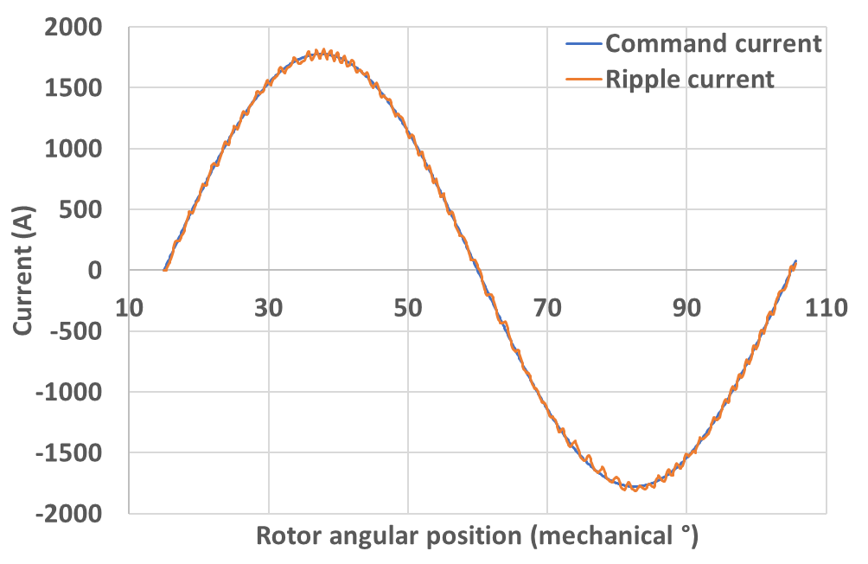
10kHz | 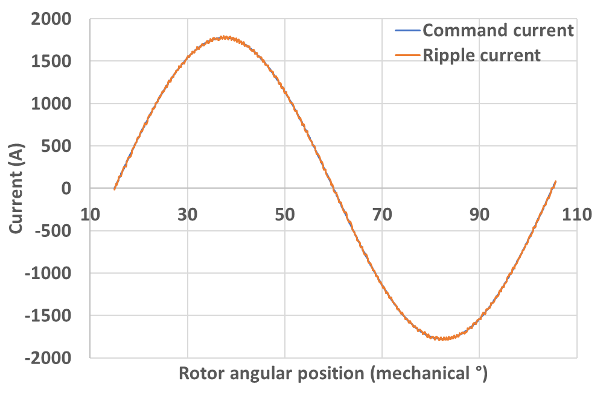
15kHz | 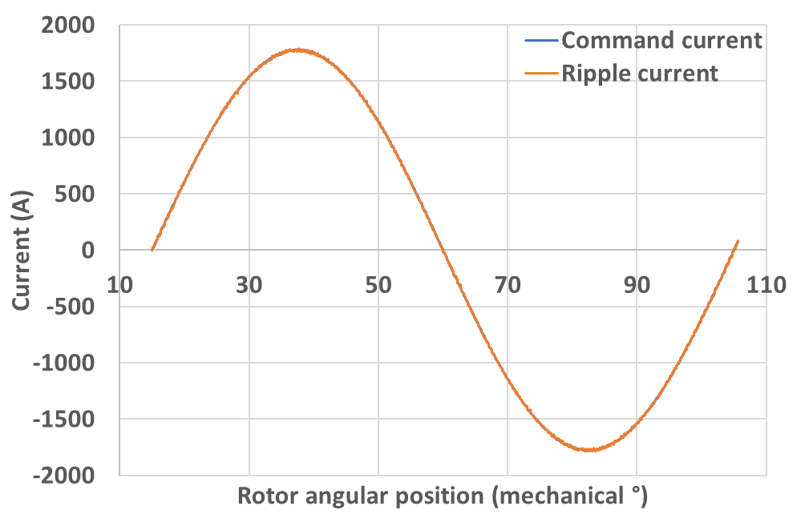
20kHz | 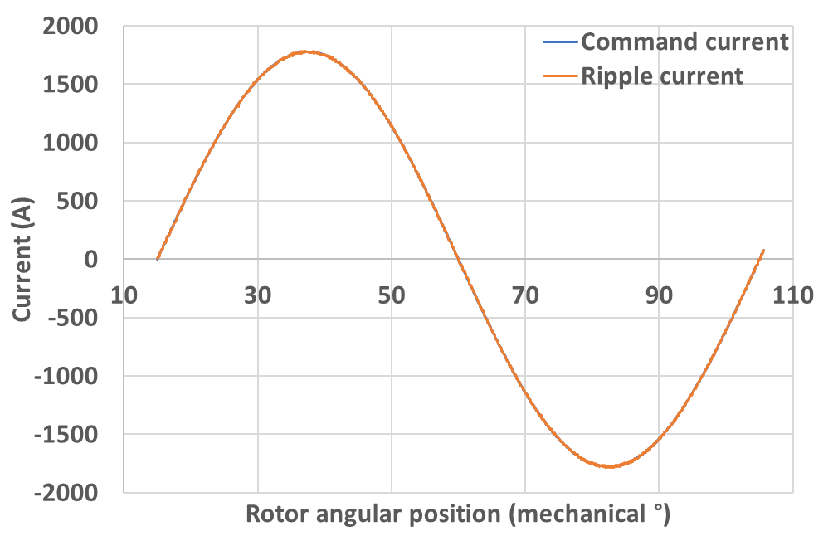
Machine 5 (base speed rating 5000rpm)
5kHz | 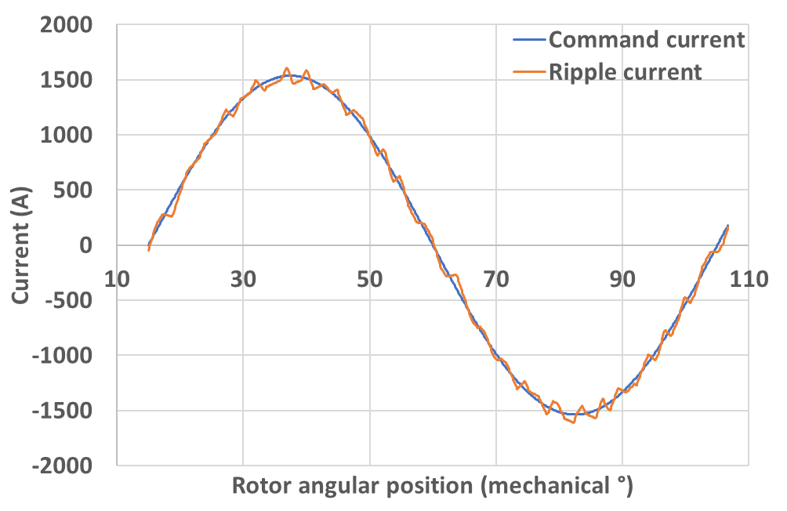
10kHz | 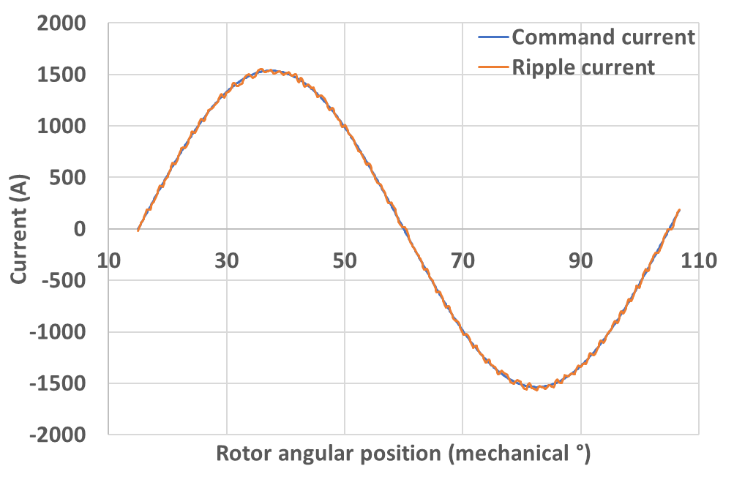
15kHz | 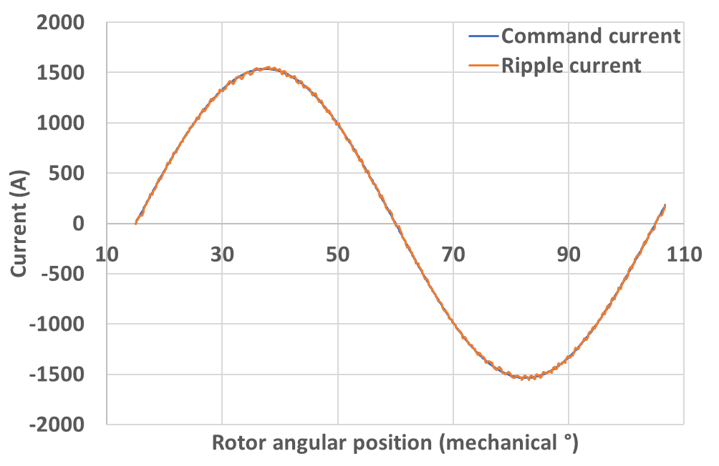
20kHz | 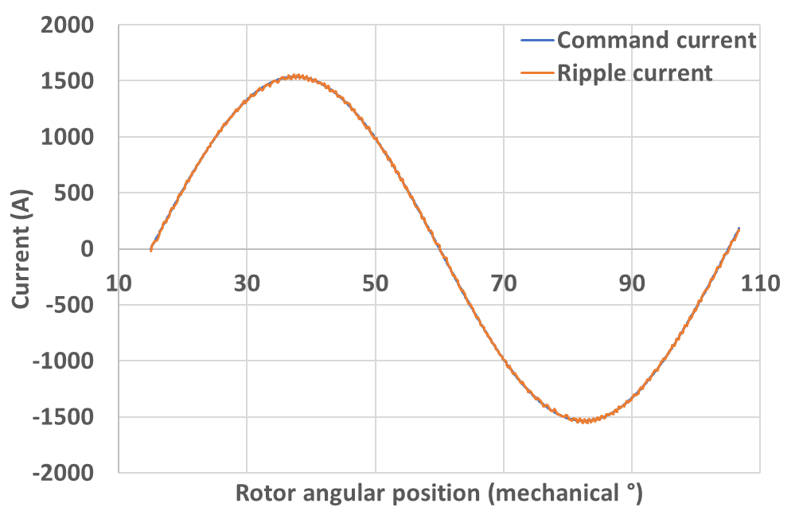
Machine 8 (base speed rating 8000rpm)
5kHz | 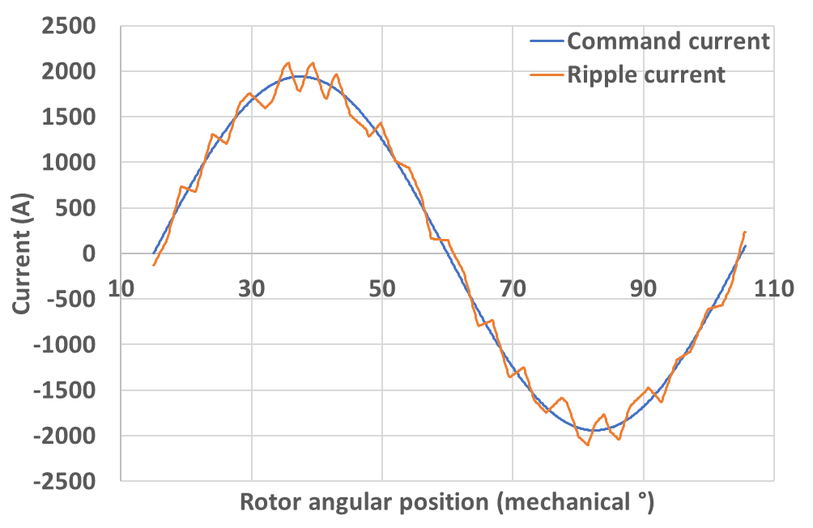
10kHz | 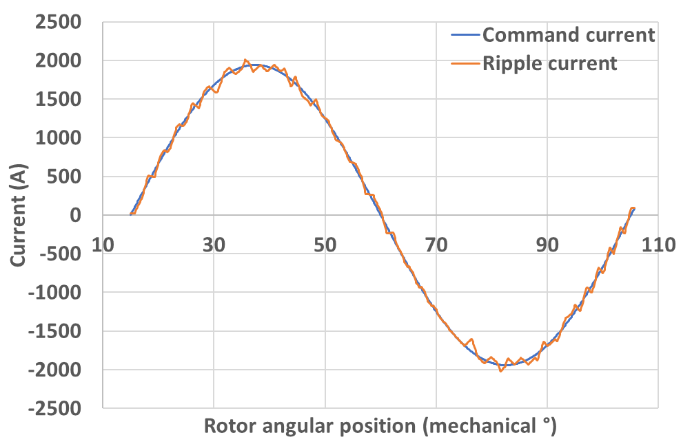
15kHz | 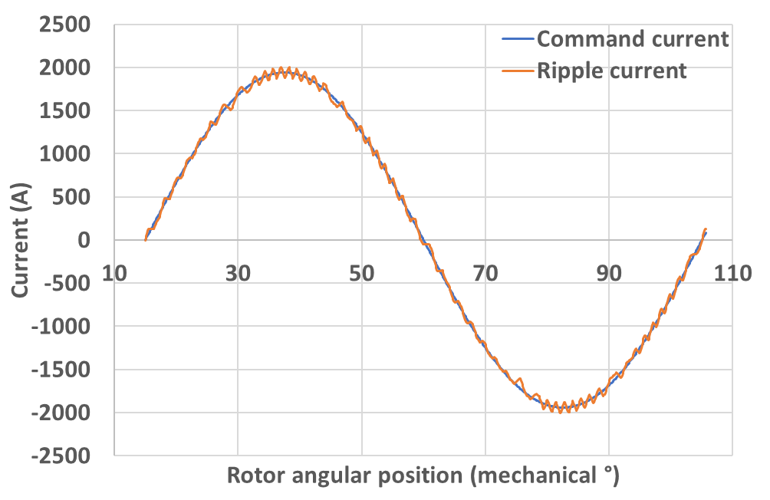
20kHz | 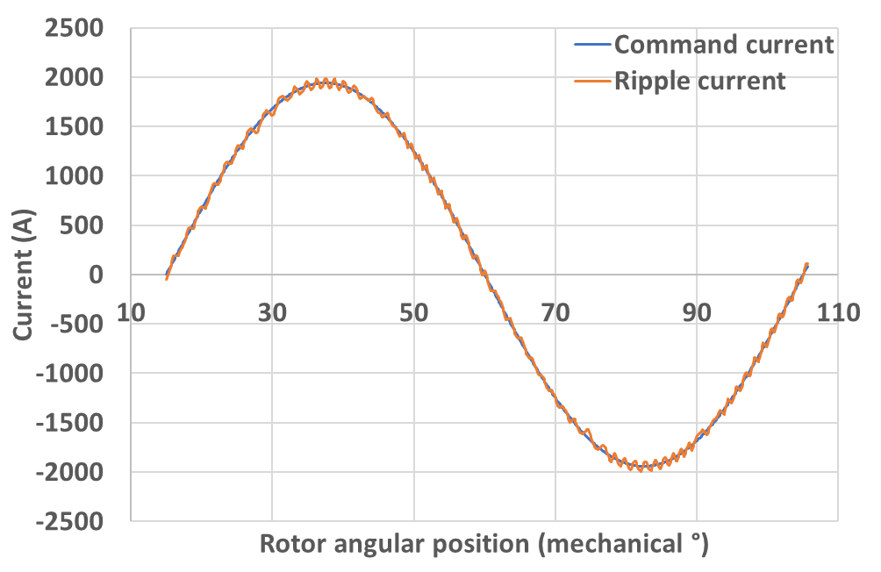
Machine 10 (base speed rating 10000rpm)
5kHz | 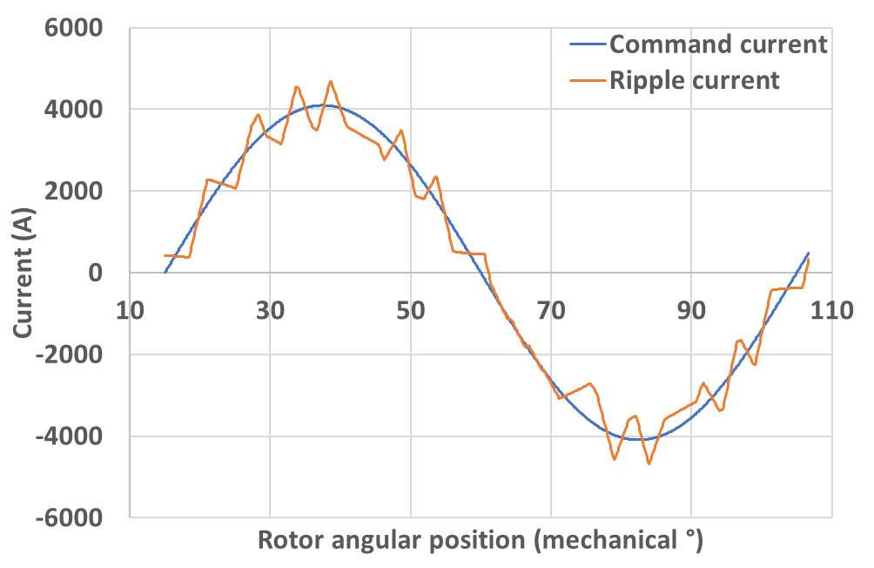
10kHz | 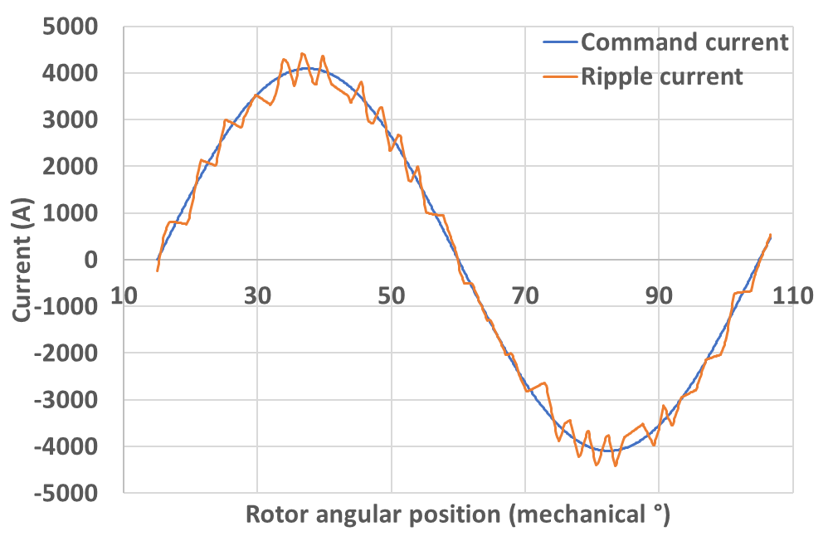
15kHz | 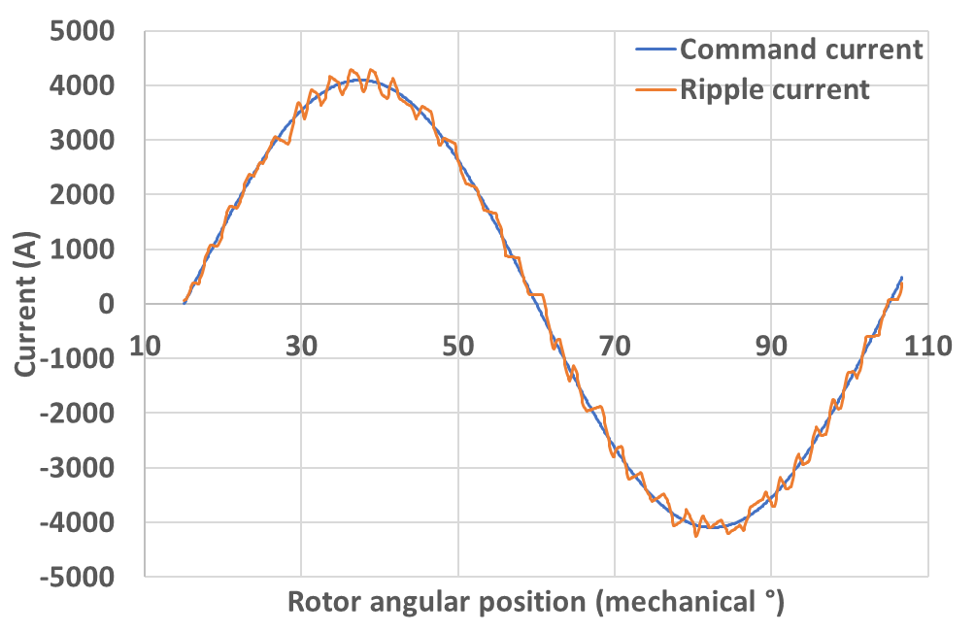
20kHz | 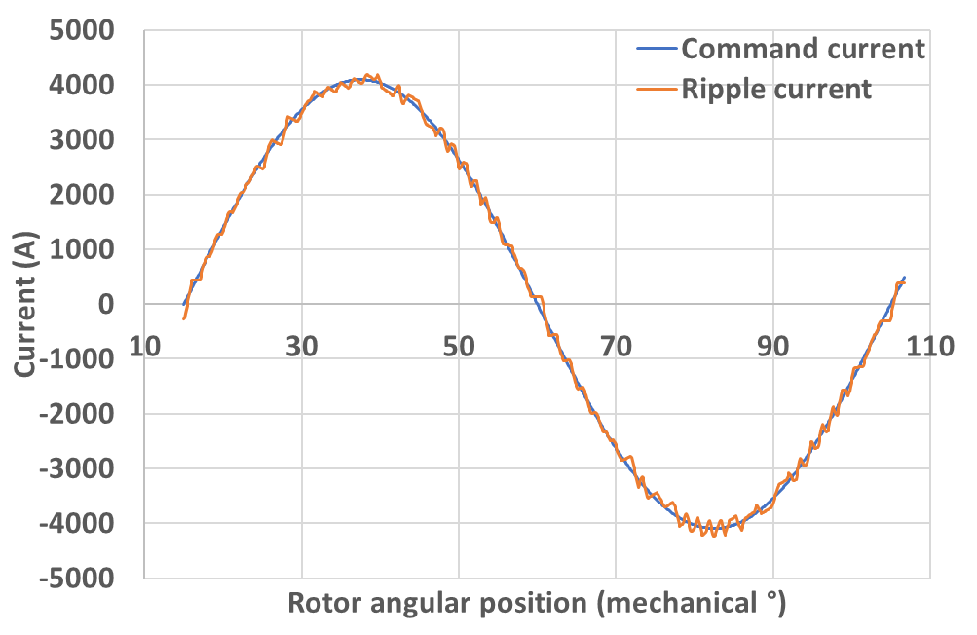
Table II.2 Sampled current waveforms for each switching frequency for representative machines in machine series with mechanical split ratio
Machine 1 (base speed rating 1000rpm)
5kHz | 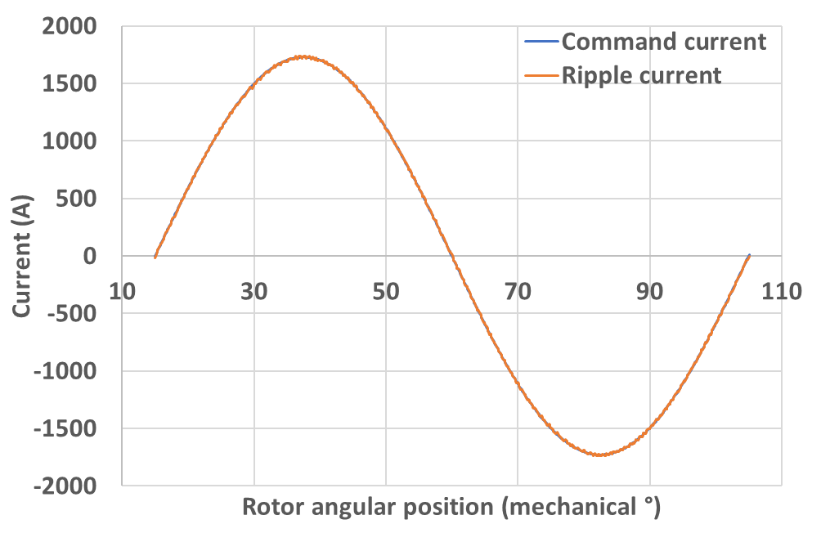
10kHz | 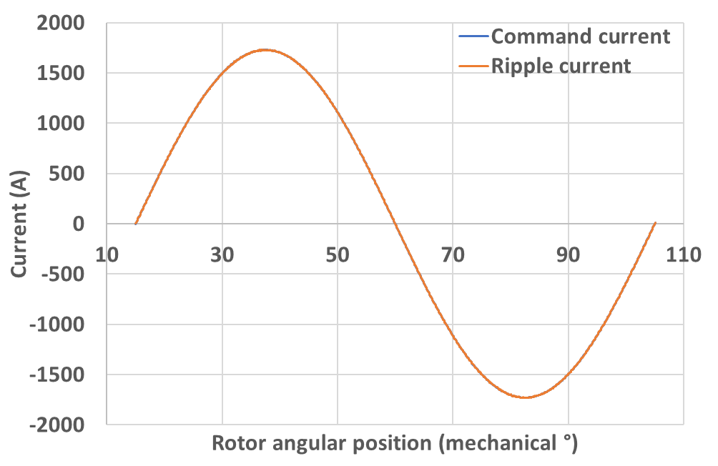
15kHz | 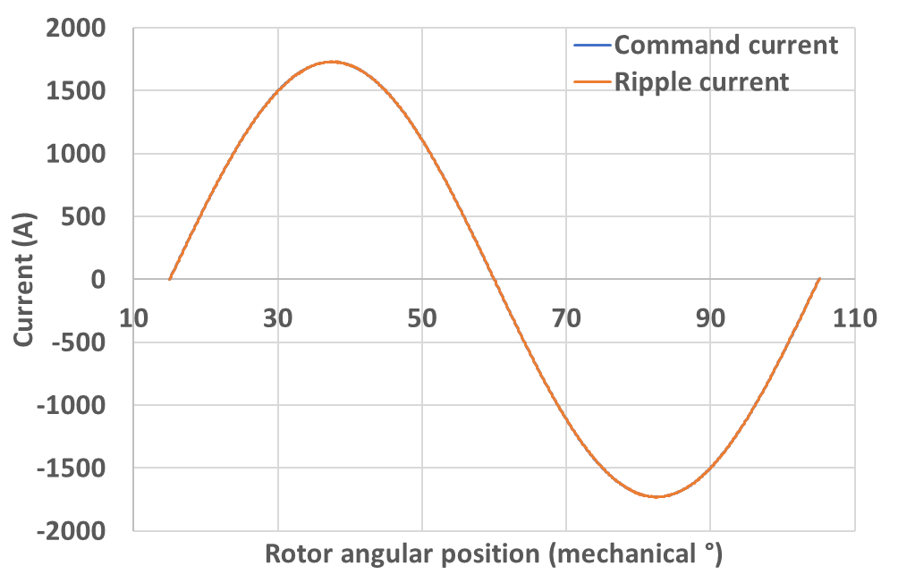
20kHz | 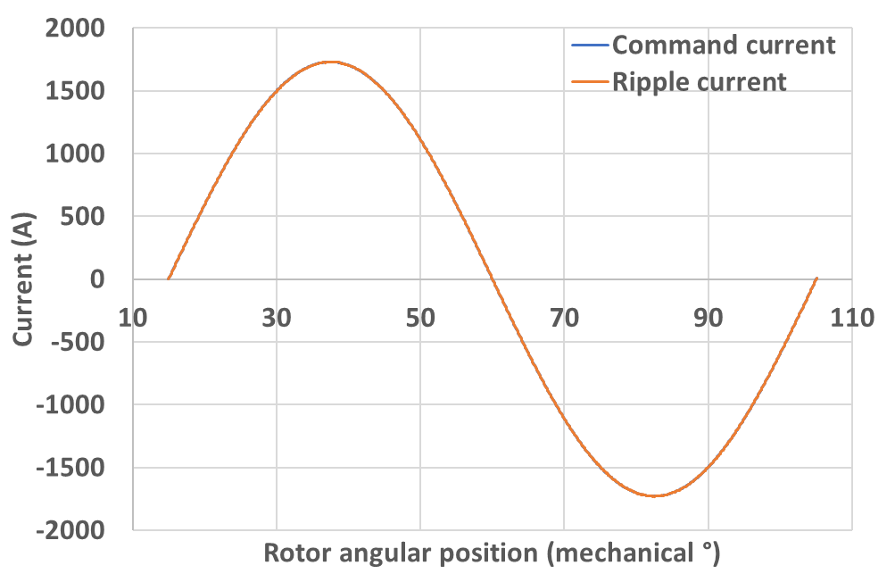
Machine 2 (base speed rating 2000rpm)
5kHz | 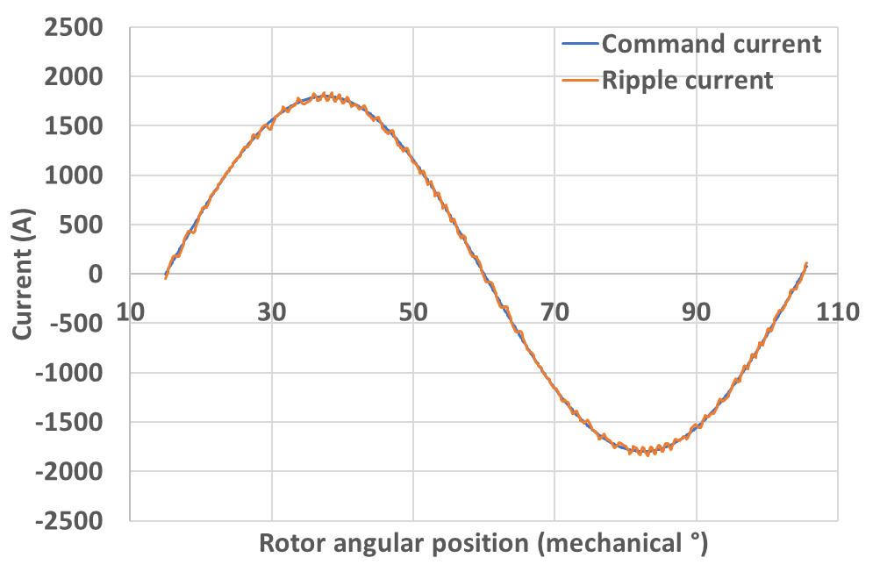
10kHz | 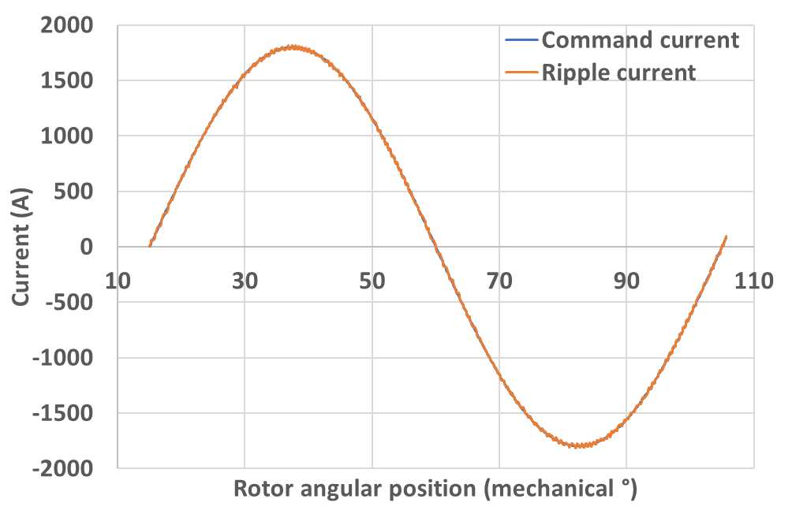
15kHz | 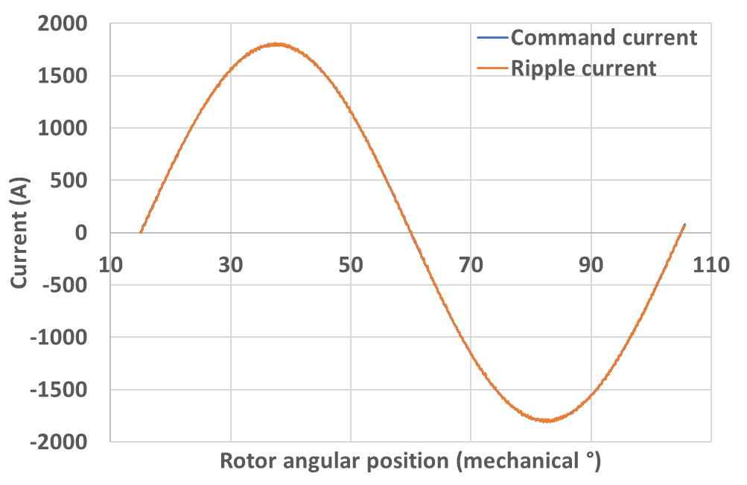
20kHz | 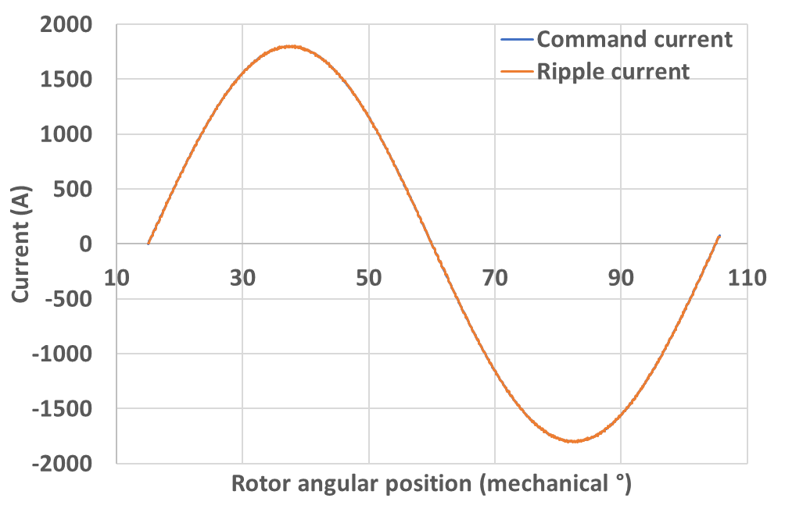
Machine 6 (base speed rating 6000rpm)
5kHz | 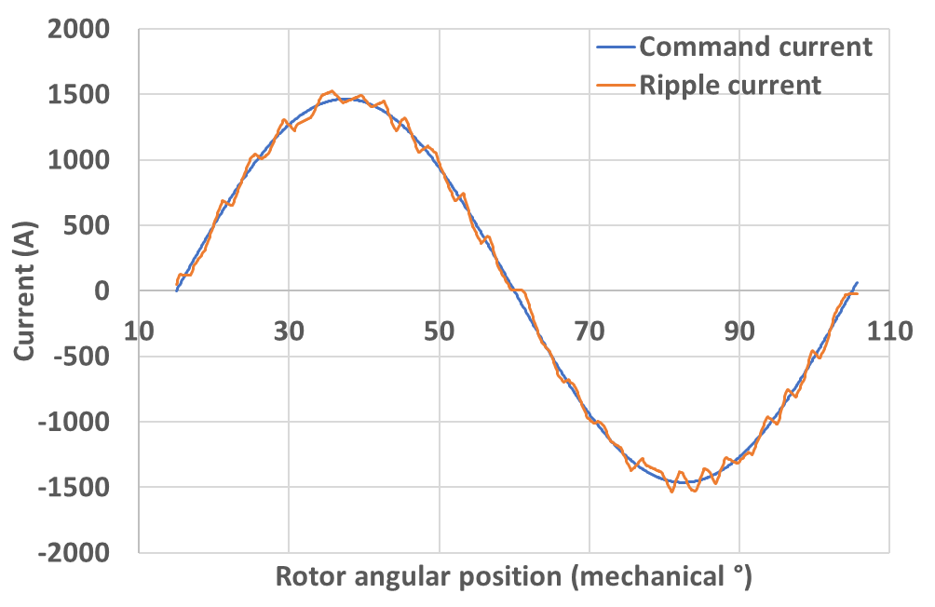
10kHz | 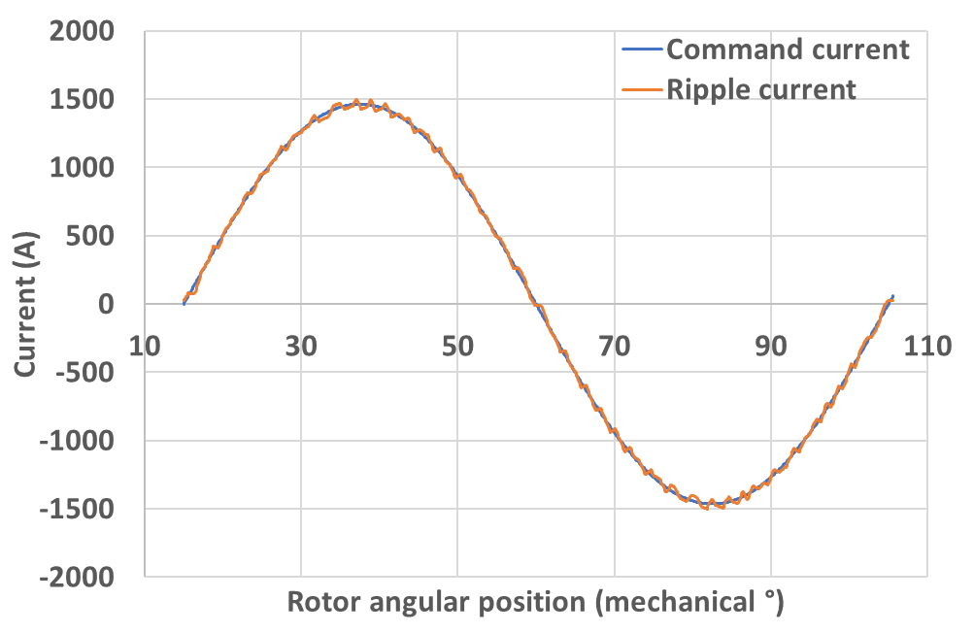
15kHz | 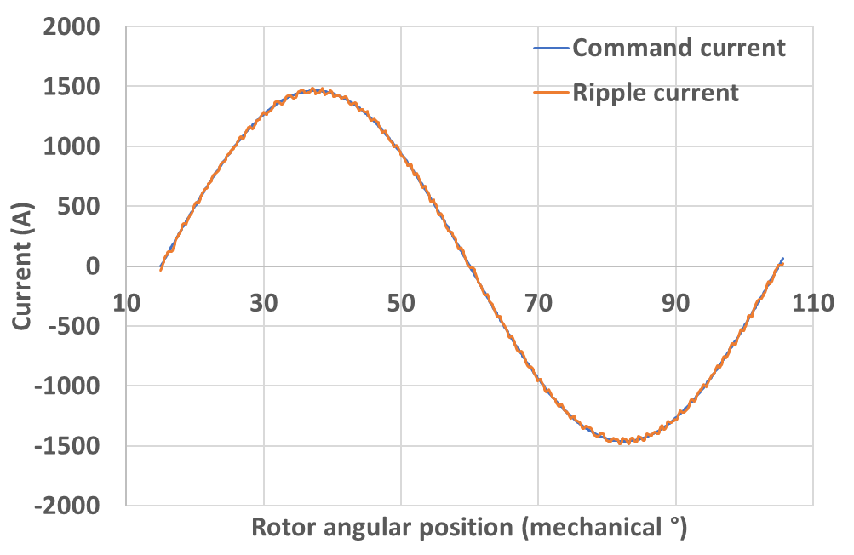
20kHz | 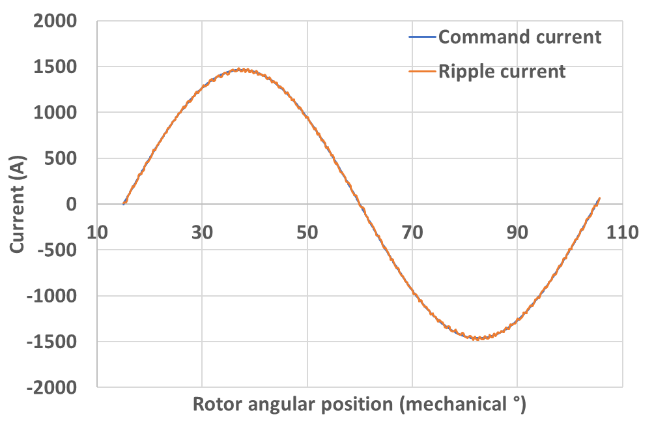
Machine 9 (base speed rating 9000rpm)
5kHz | 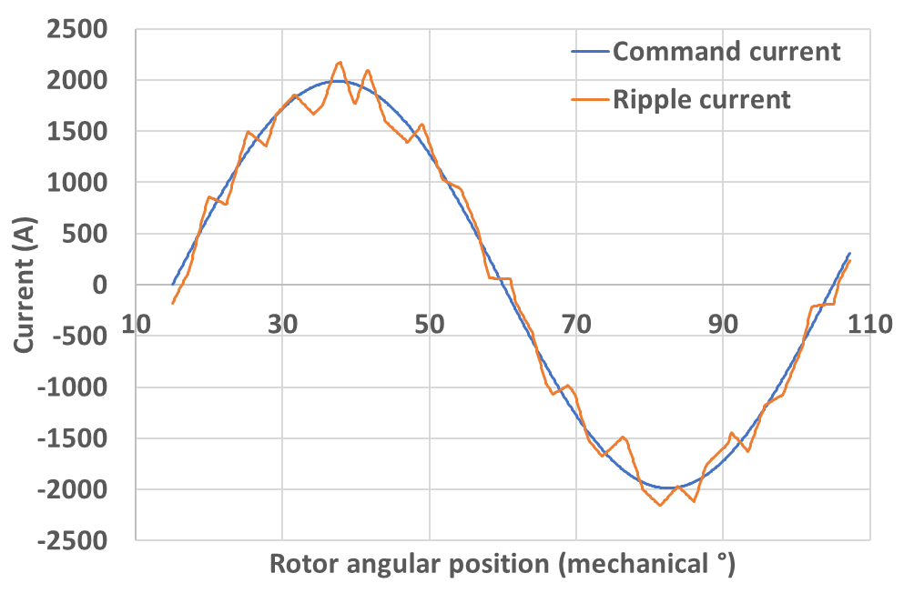
10kHz | 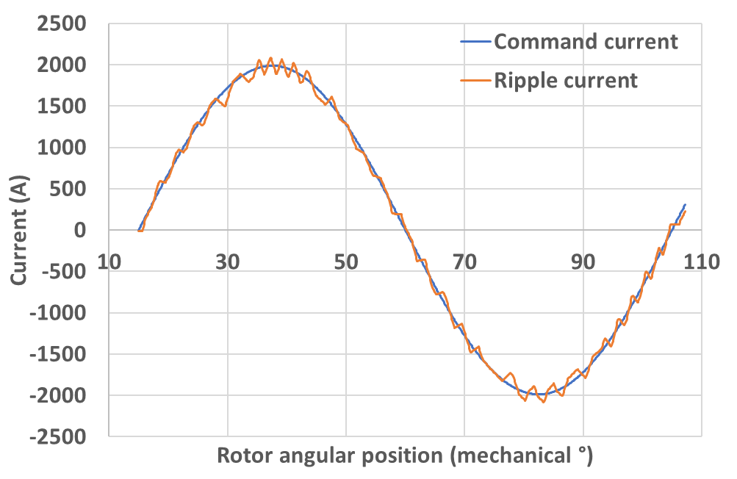
15kHz | 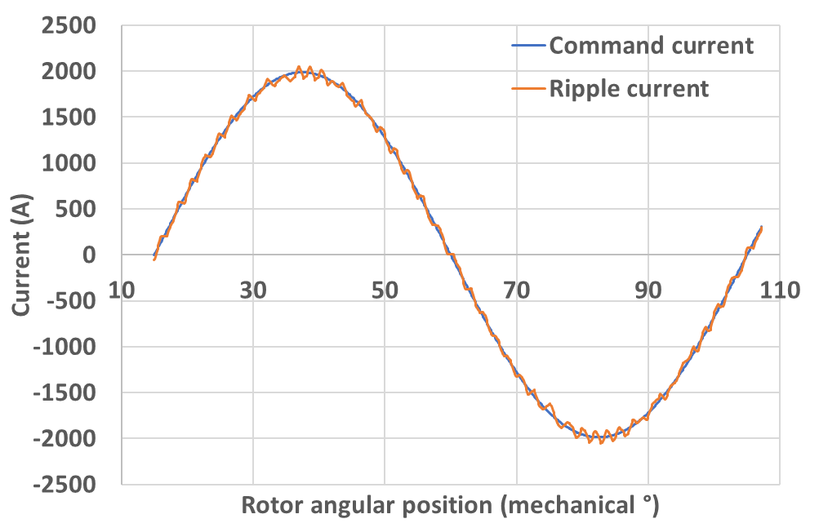
20kHz | 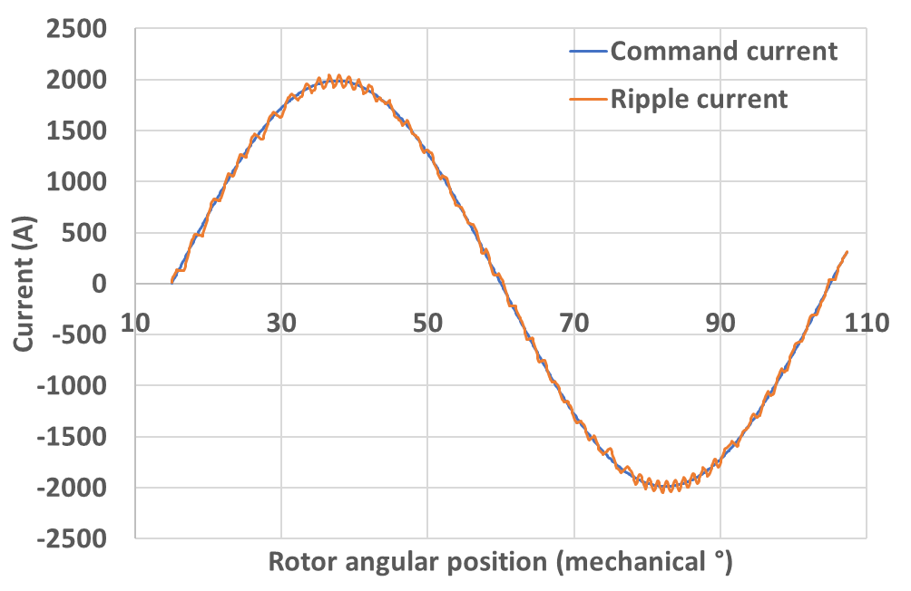
Machine 14 (base speed rating 14000)
5kHz | 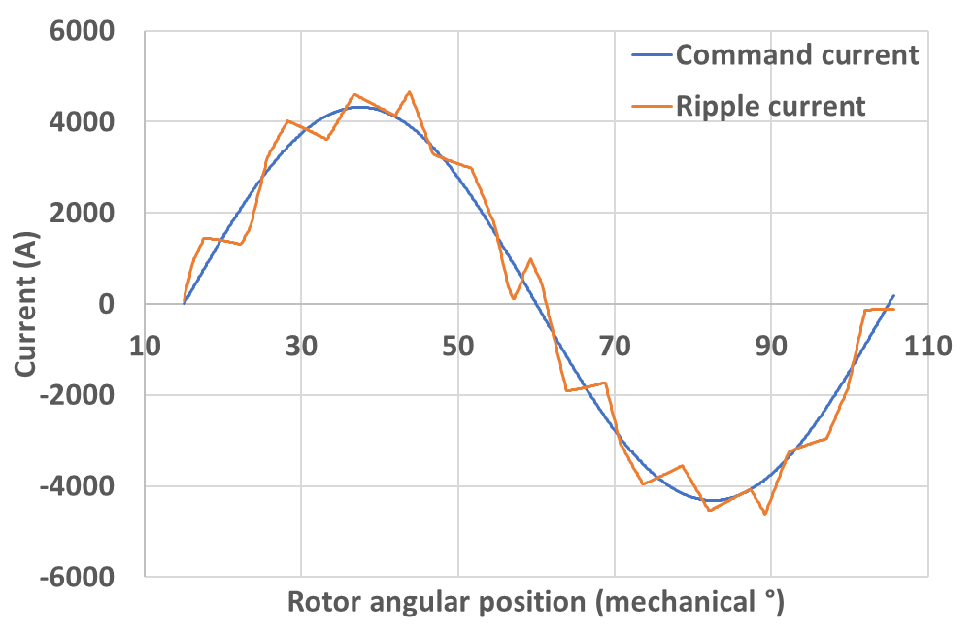
10kHz | 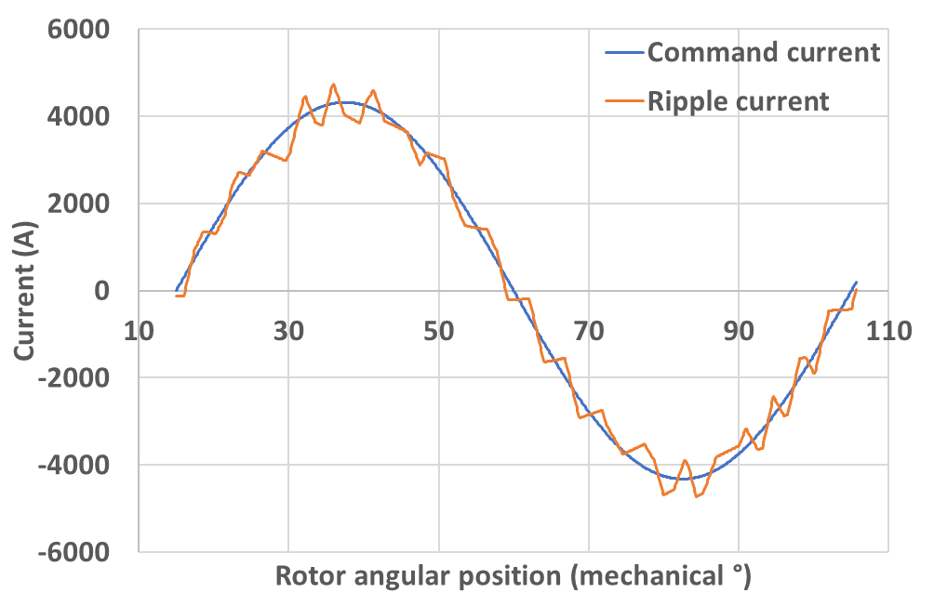
15kHz | 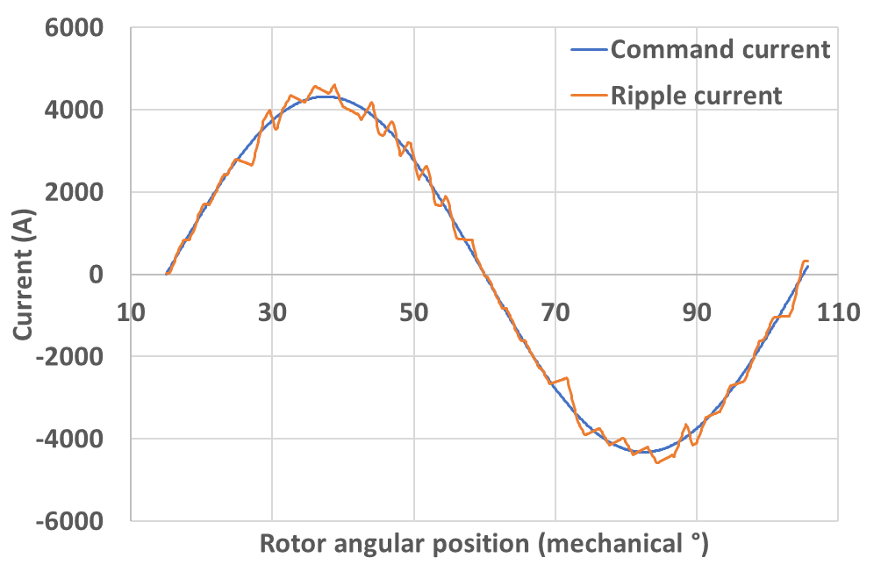
20kHz | 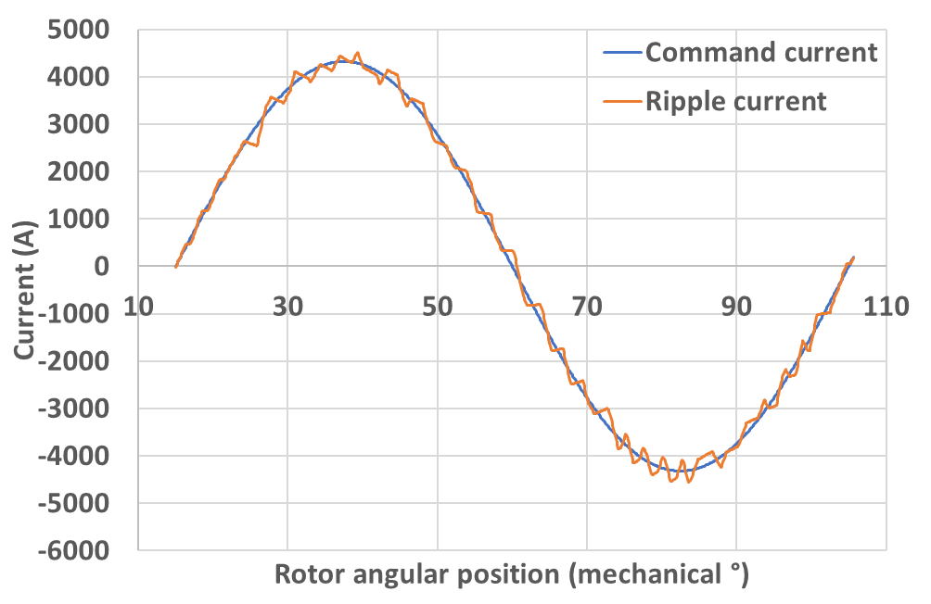

- Torque waveforms generated from FE analysis based on the current waveforms in Table II.1 and Table II.2
Table II.3 Torque waveform generated hysteresis ripple current for machine series with electromagnetic split ratio
Machine 2 (base speed rating 2000rpm)
5kHz | 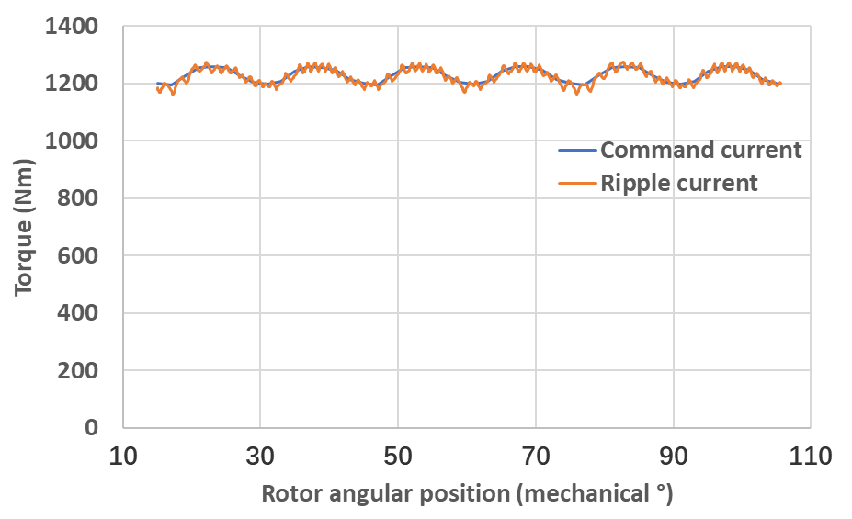
10kHz | 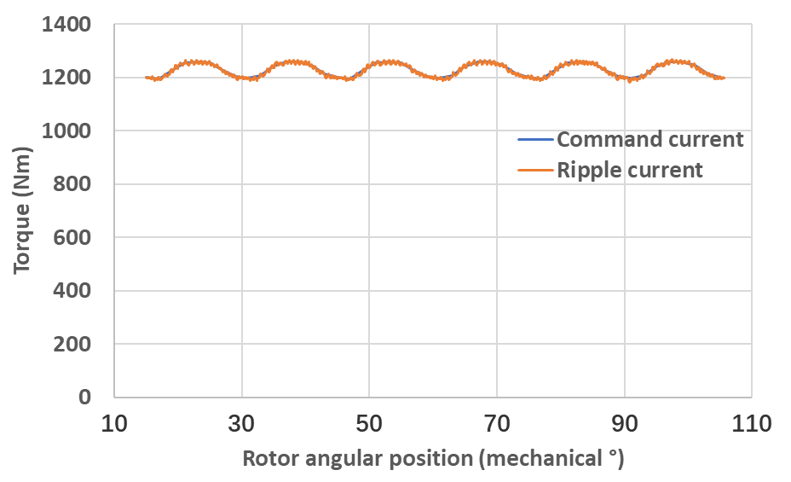
15kHz | 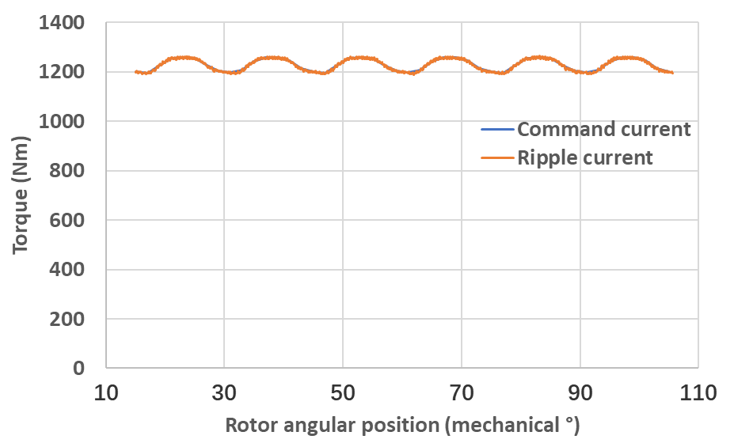
20kHz | 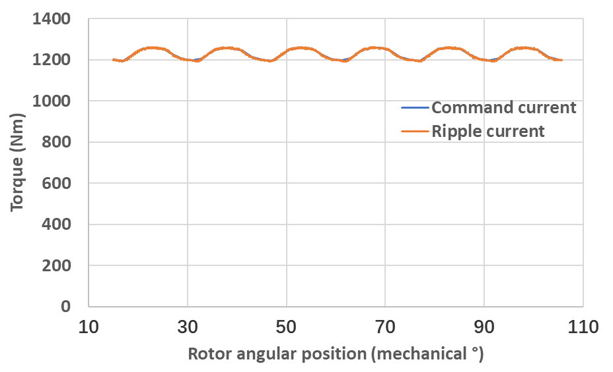
Machine 5 (base speed rating 5000rpm)
5kHz | 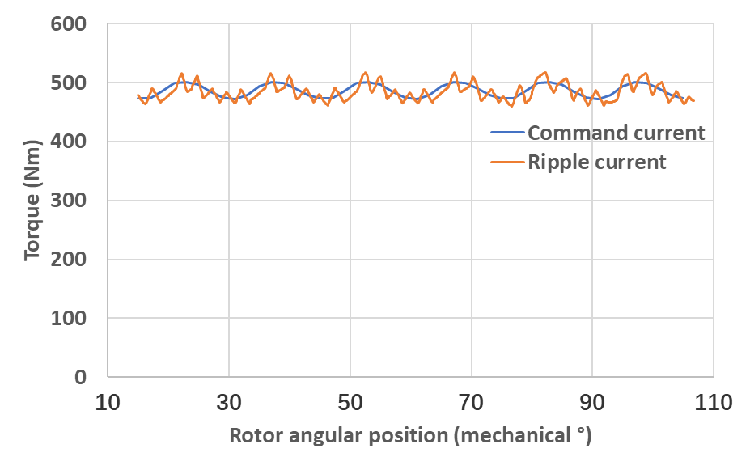
10kHz | 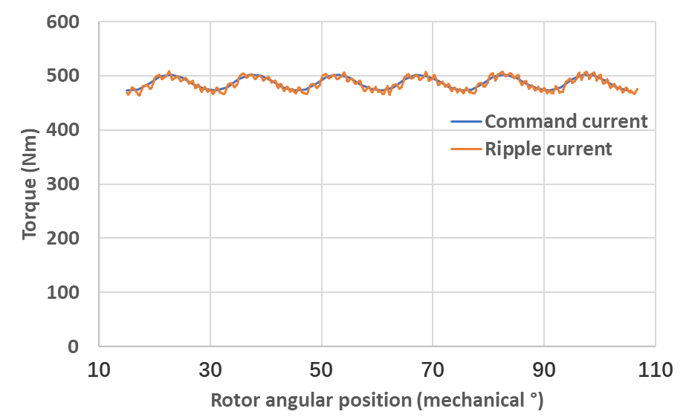
15kHz | 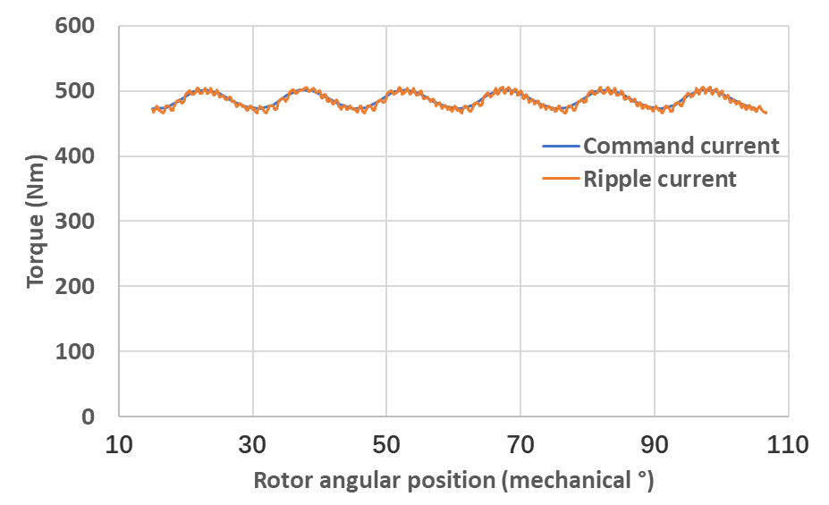
20kHz | 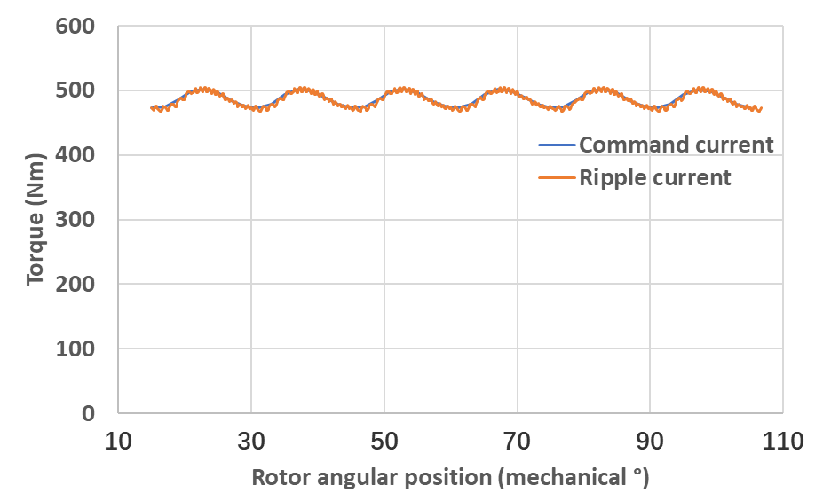
Machine 8 (base speed rating 8000rpm)
5kHz | 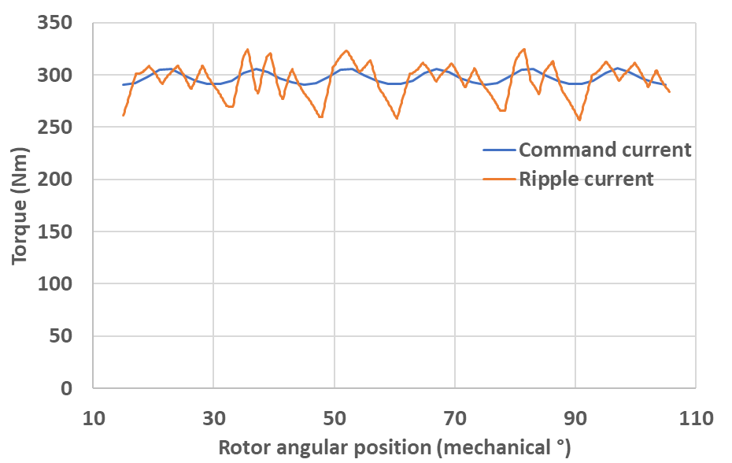
10kHz | 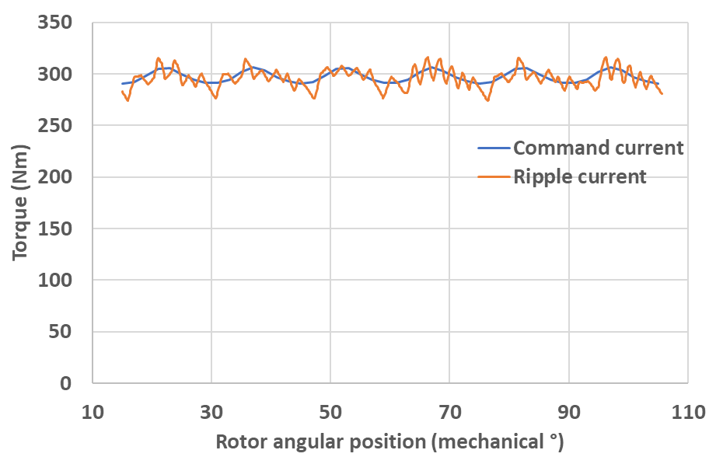
15kHz | 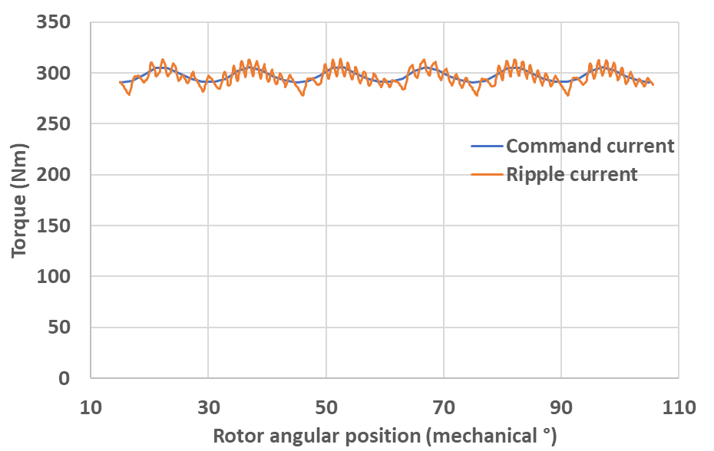
20kHz | 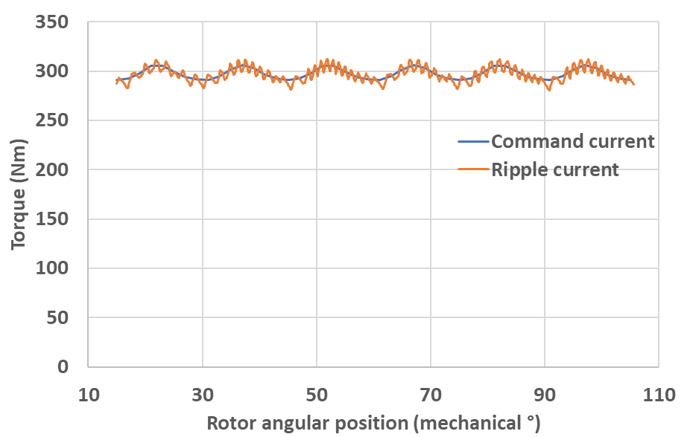
Machine 10 (base speed rating 10000rpm)
5kHz | 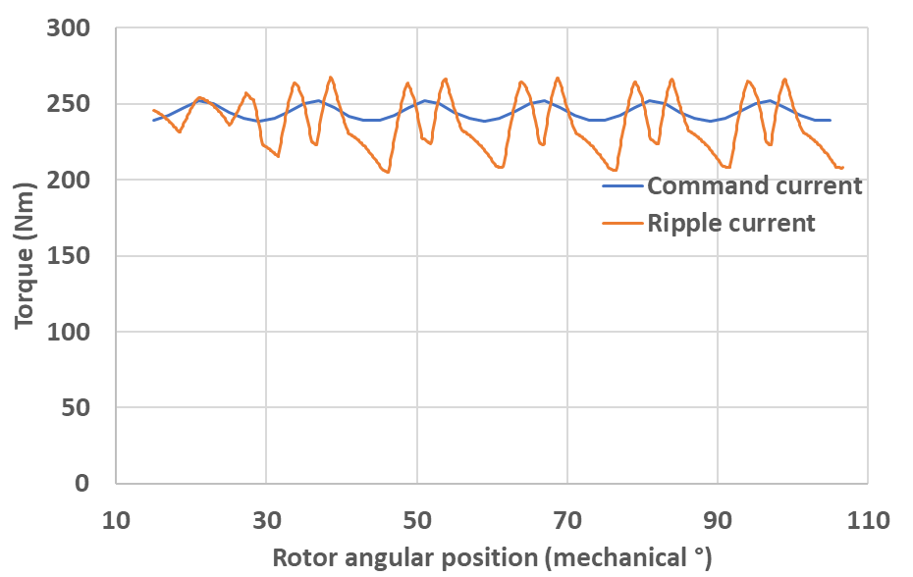
10kHz | 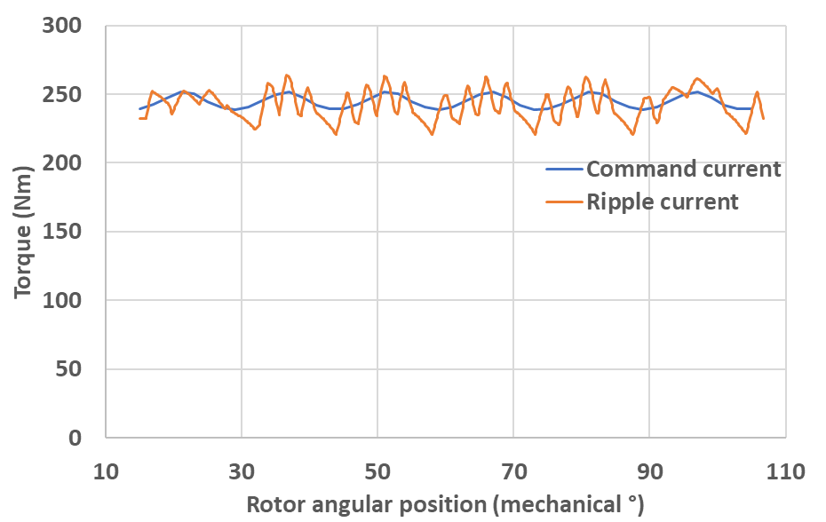
15kHz | 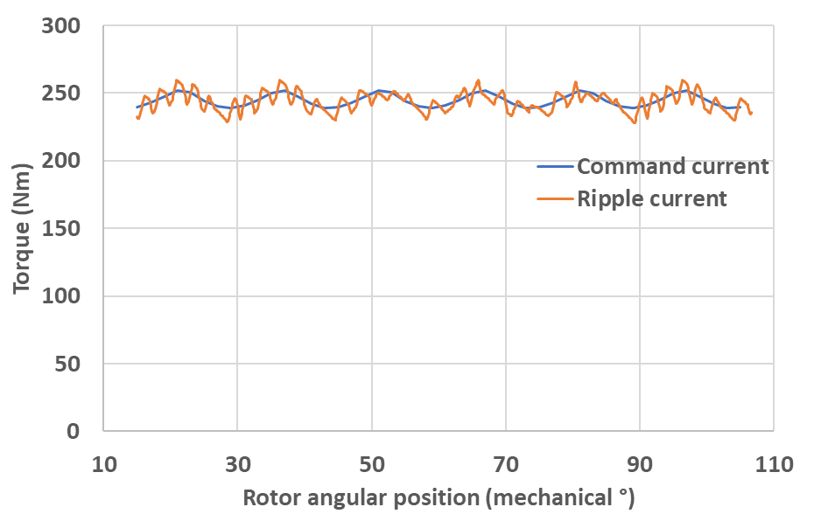
20kHz | 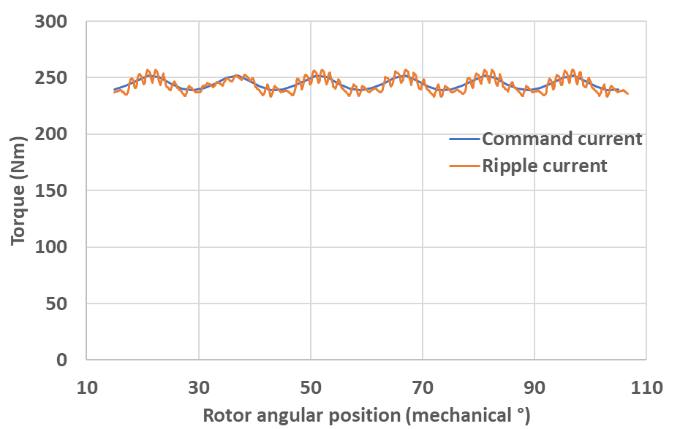
Table II.4 Torque waveform generated from hysteresis ripple current for machine series with mechanical split ratio
Machine 1 (base speed rating 1000rpm)
5kHz | 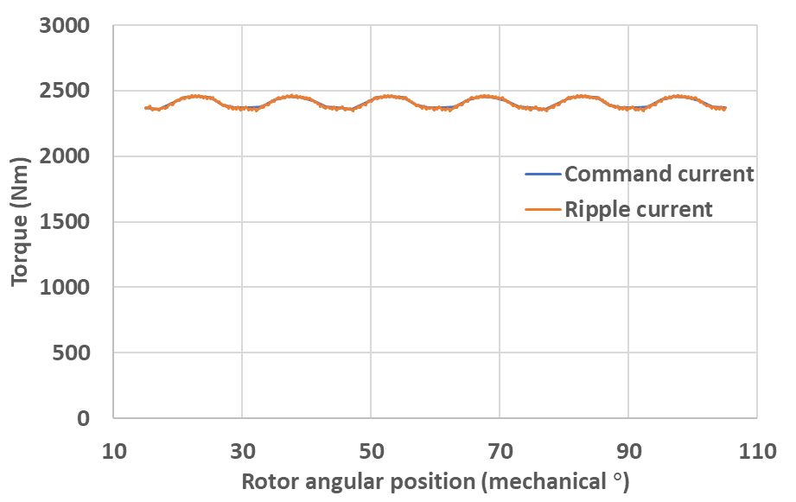
10kHz | 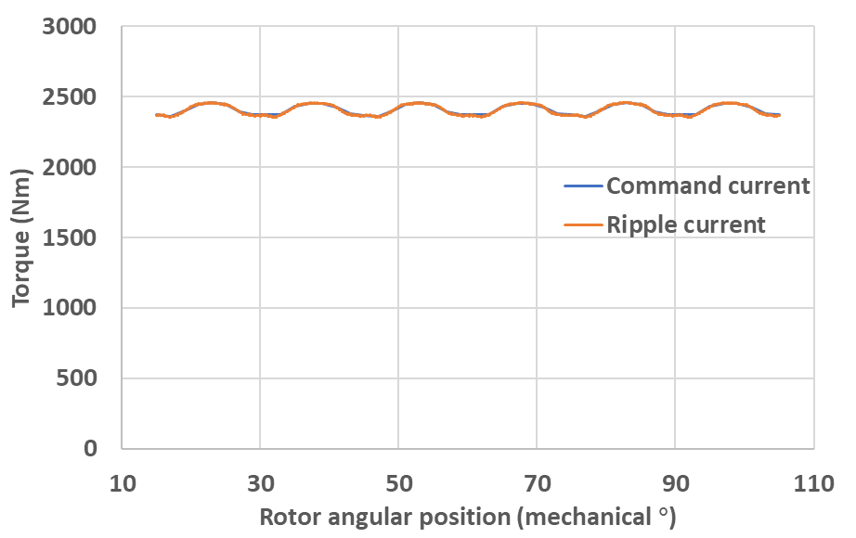
15kHz | 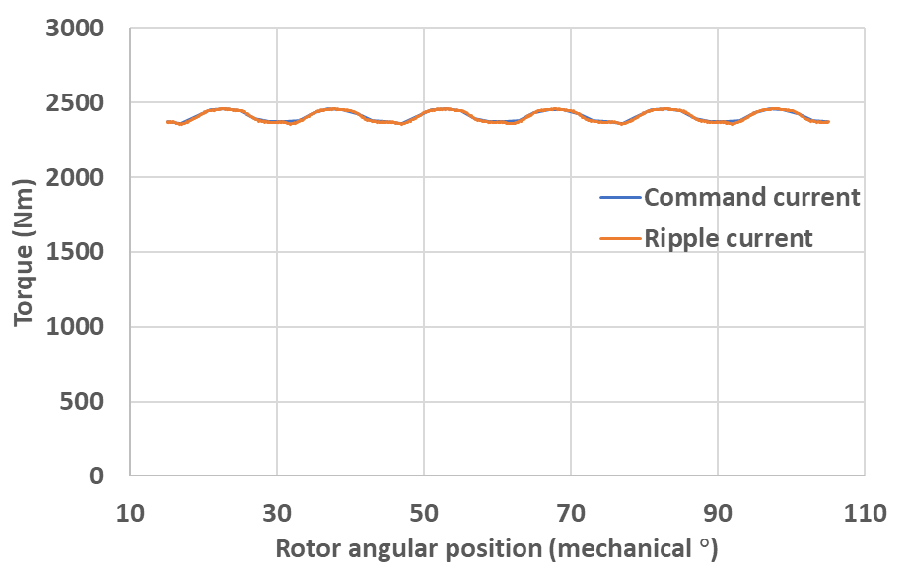
20kHz | 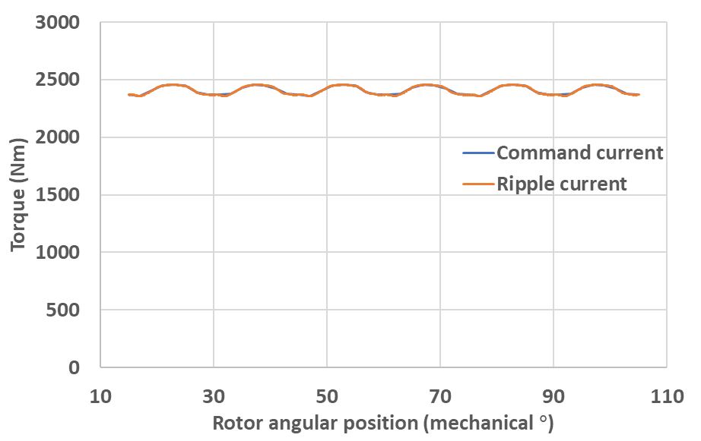
Machine 2 (base speed rating 2000rpm)
5kHz | 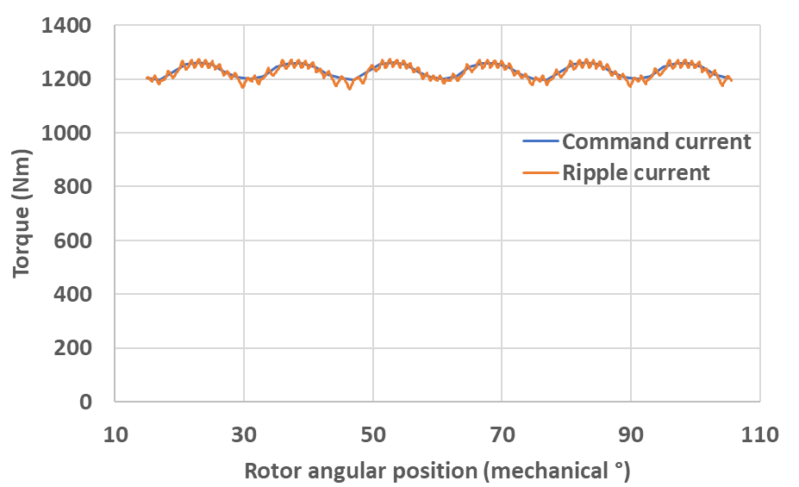
10kHz | 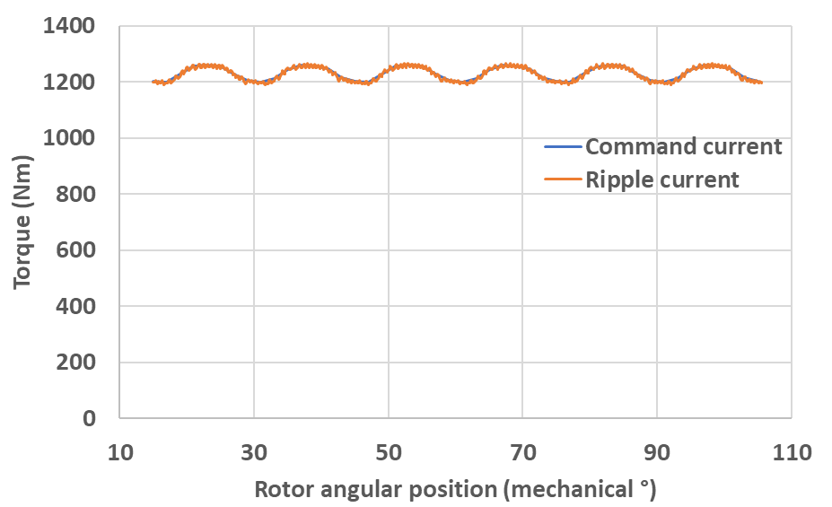
15kHz | 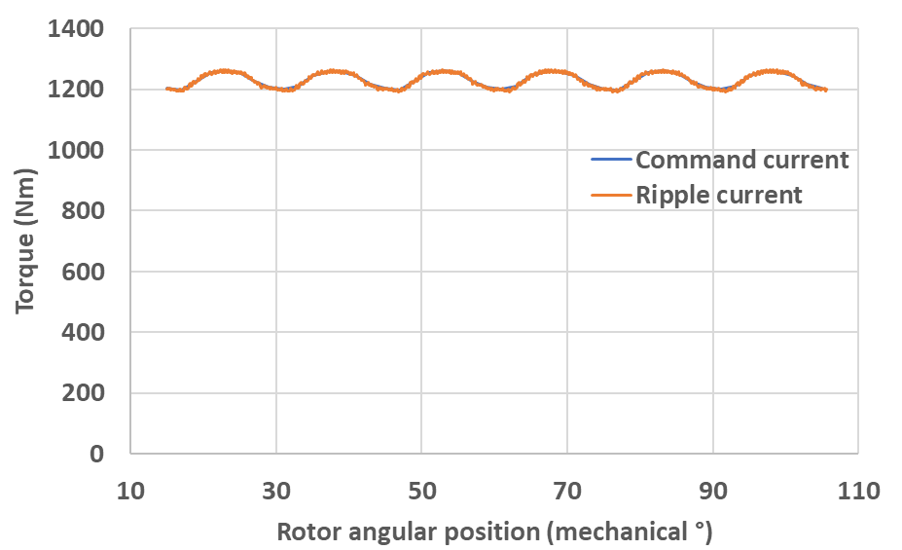
20kHz | 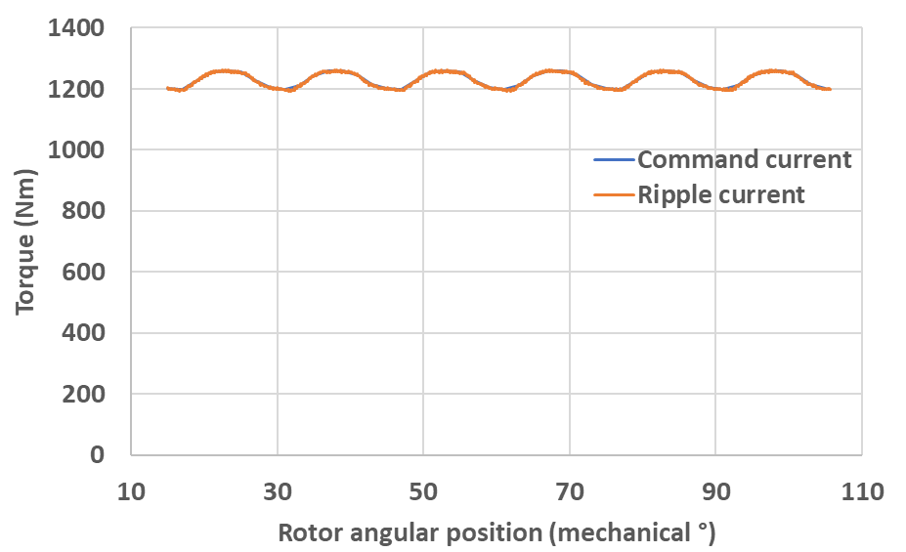
Machine 6 (base speed rating 6000rpm)
5kHz | 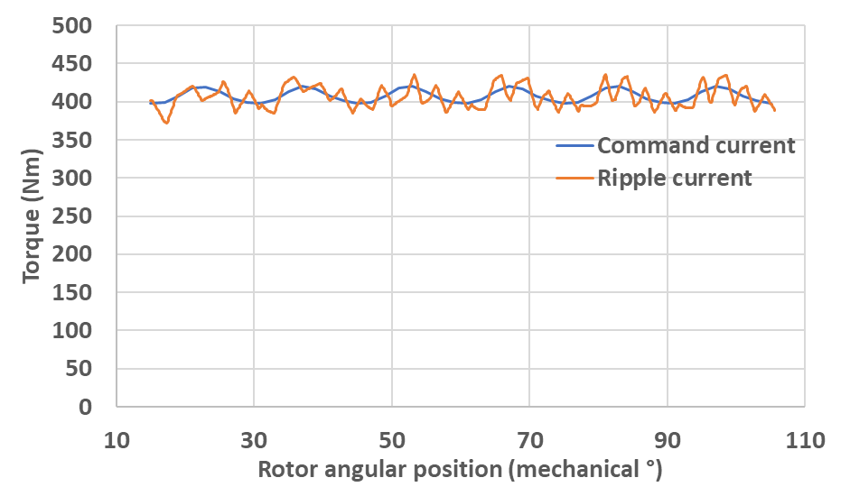
10kHz | 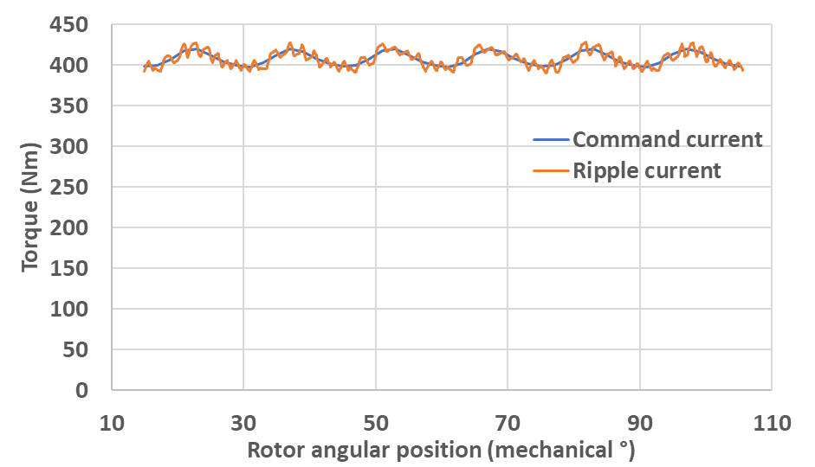
15kHz | 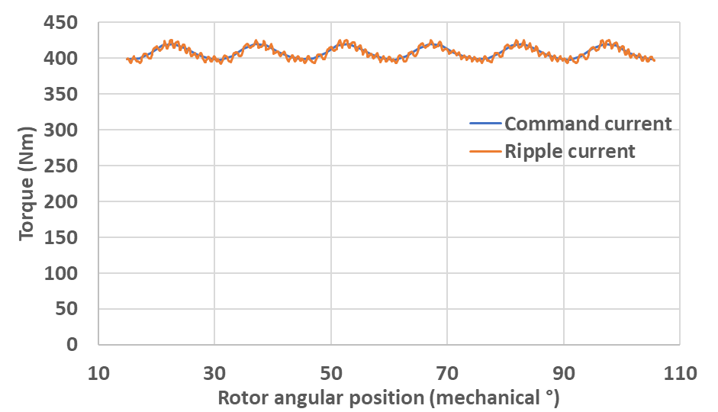
20kHz | 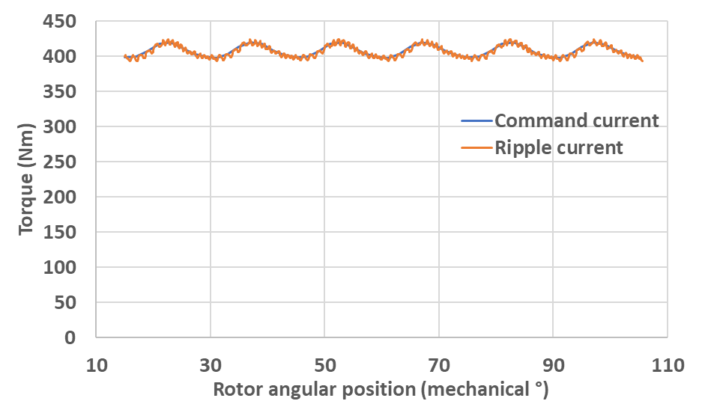
Machine 9 (base speed rating 9000rpm)
5kHz | 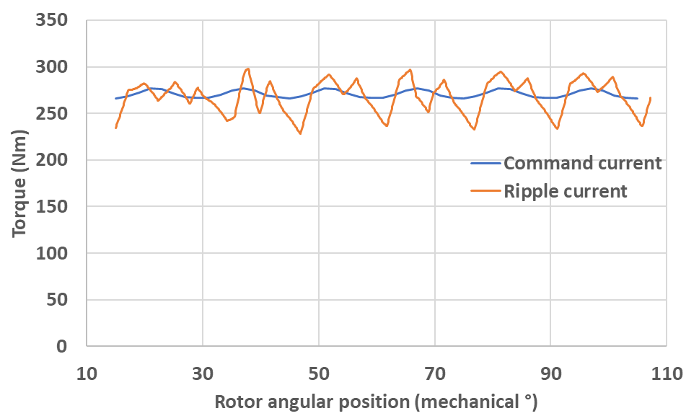
10kHz | 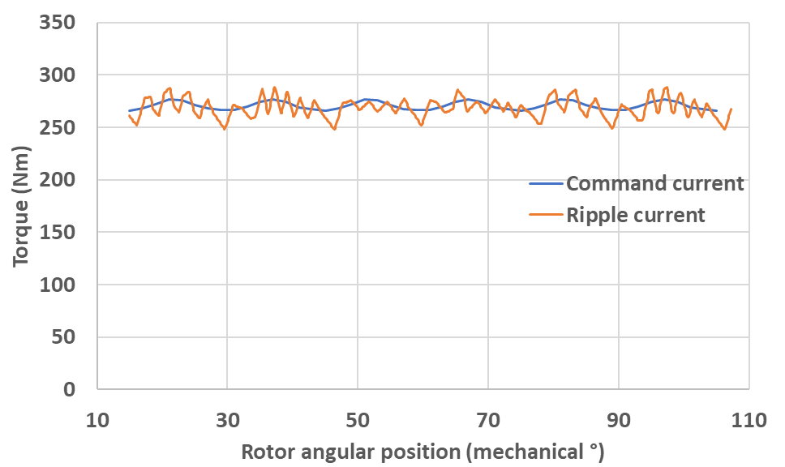
15kHz | 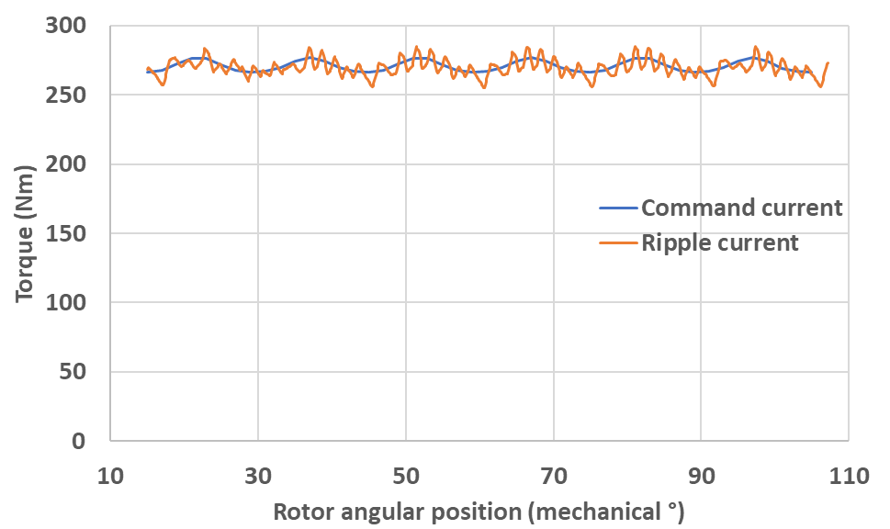
20kHz | 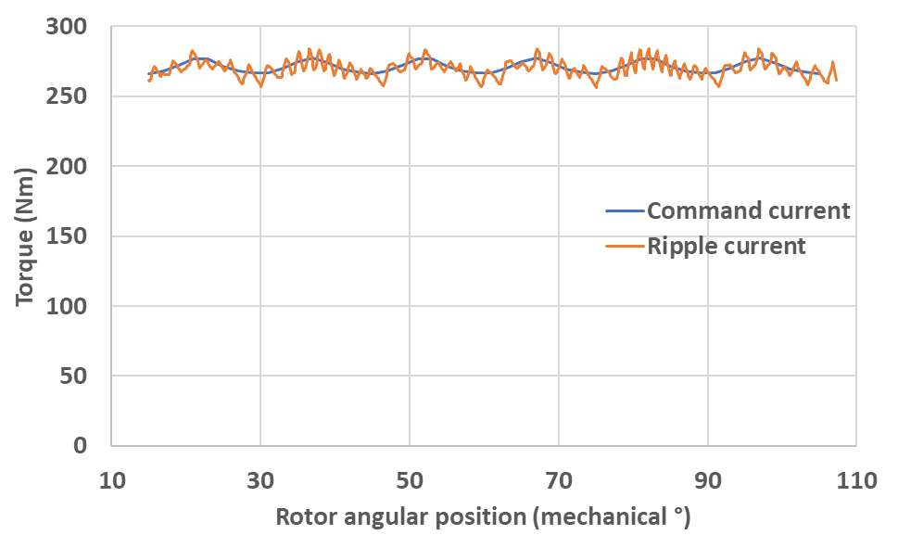
Machine 14 (base speed rating 14000rpm)
5kHz | 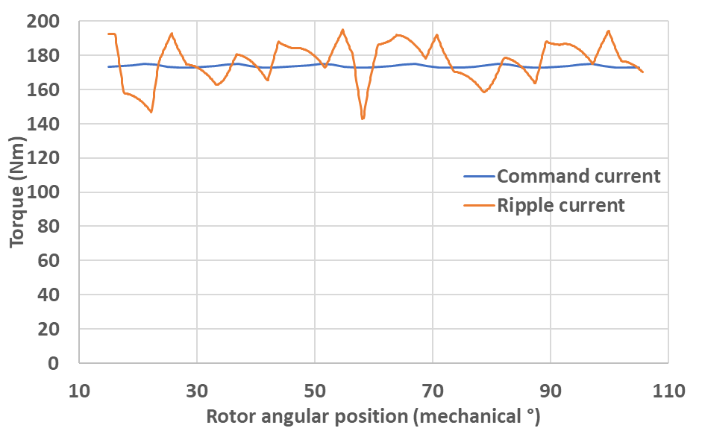
10kHz | 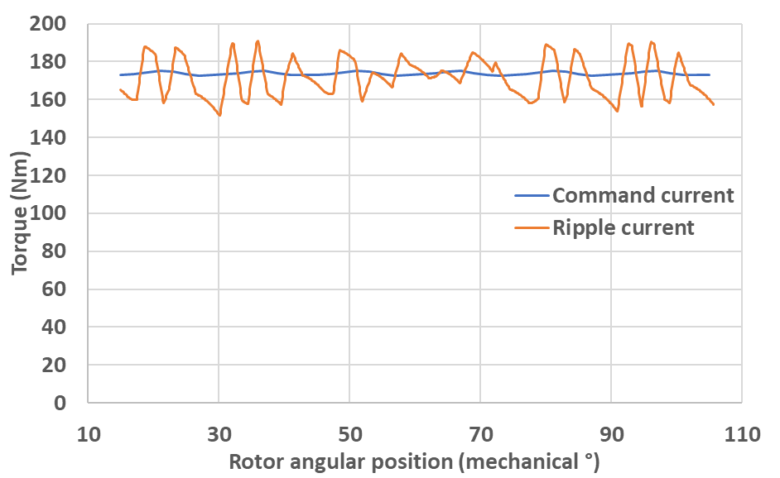
15kHz | 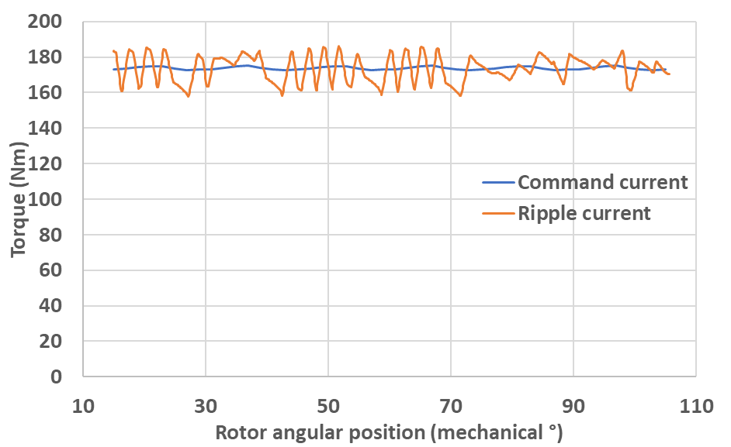
20kHz | 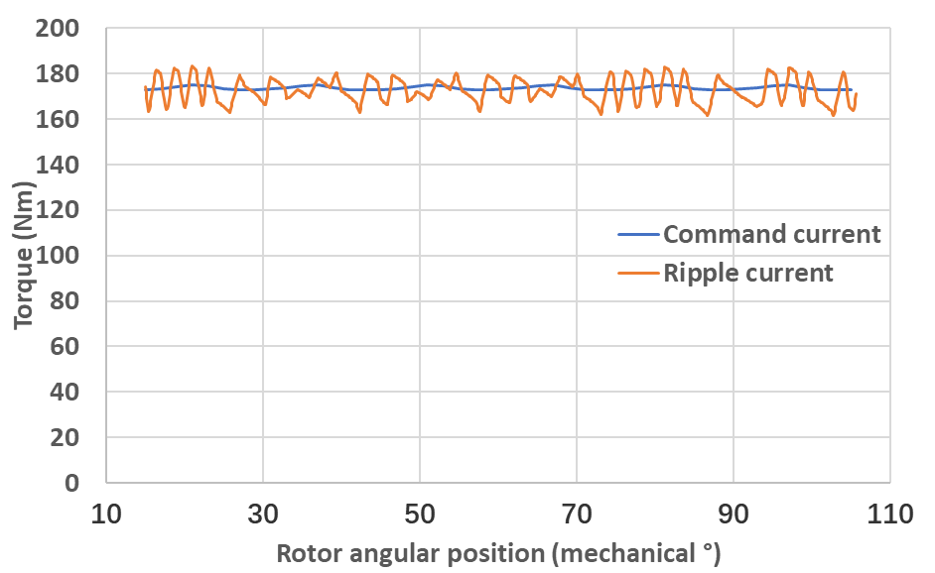

Appendix III Predicted iron loss results from conventional and new developed post processing methods
- Predicted iron losses from both conventional and new developed post-processing methods for machine 8 operating at 8000rpm under star connected and isolated three phases
Table III.1 Final iron loss results for the two models with star-connected three phase currents under different hysteresis band
Hysteresis band (A) | Major loop loss (W) | Minor loop loss (W) | Total hysteresis loss (W) | Eddy current loss (W) | Excess loss (W) | Total iron loss (W)
750 data points per electrical cycle
Conventional post-processing method
0 | 561 | 17 | 578 | 535 | 50 | 1163
±10 | 568 | 112 | 679 | 576 | 52 | 1307
±100 | 581 | 192 | 773 | 1011 | 77 | 1860
±200 | 585 | 182 | 767 | 1018 | 77 | 1861
±300 | 599 | 206 | 806 | 991 | 76 | 1872
±400 | 612 | 115 | 727 | 1048 | 77 | 1852
New post-processing method
0 | 566 | 16 | 583 | 538 | 50 | 1171
±10 | 568 | 29 | 597 | 579 | 52 | 1228
±100 | 583 | 192 | 774 | 1016 | 77 | 1867
±200 | 596 | 191 | 787 | 1029 | 77 | 1894
±300 | 622 | 193 | 815 | 1018 | 77 | 1910
±400 | 644 | 152 | 796 | 1137 | 82 | 2015
2000 data points per electrical cycle
Conventional post-processing method
0 | 562 | 29 | 591 | 536 | 50 | 1177
±10 | 567 | 183 | 750 | 858 | 70 | 1677
±100 | 580 | 209 | 789 | 1054 | 79 | 1921
±200 | 584 | 195 | 779 | 1036 | 78 | 1892
±300 | 599 | 208 | 807 | 1004 | 76 | 1887
±400 | 611 | 119 | 730 | 1060 | 78 | 1868
New post-processing method
0 | 566 | 16 | 583 | 538 | 50 | 1171
±10 | 568 | 160 | 728 | 856 | 70 | 1654
±100 | 584 | 210 | 794 | 1055 | 79 | 1927
±200 | 597 | 203 | 800 | 1045 | 78 | 1923
±300 | 623 | 201 | 824 | 1028 | 78 | 1930
±400 | 645 | 158 | 803 | 1144 | 82 | 2030
5000 data points per electrical cycle
Conventional post-processing method
0 | 557 | 34 | 592 | 537 | 50 | 1179
±10 | 561 | 262 | 823 | 1031 | 80 | 1933
±100 | 574 | 213 | 787 | 1077 | 79 | 1943
±200 | 578 | 199 | 778 | 1035 | 77 | 1890
±300 | 593 | 210 | 803 | 1019 | 76 | 1897
±400 | 605 | 122 | 727 | 1083 | 79 | 1889
New post-processing method
0 | 566 | 17 | 583 | 539 | 50 | 1172
±10 | 568 | 255 | 823 | 1011 | 79 | 1913
±100 | 584 | 219 | 803 | 1063 | 79 | 1946
±200 | 597 | 208 | 805 | 1041 | 78 | 1924
±300 | 624 | 205 | 829 | 1022 | 77 | 1929
±400 | 646 | 166 | 811 | 1156 | 83 | 2050
Table III.2 Final iron loss results for the two models with isolated three-phase currents under different hysteresis band
Hysteresis band (A) | Major loop loss (W) | Minor loop loss (W) | Total hysteresis loss (W) | Eddy current loss (W) | Excess loss (W) | Total iron loss (W)
750 data points per electrical cycle
Conventional post-processing method
0 | 561 | 17 | 578 | 535 | 50 | 1163
±10 | 567 | 106 | 674 | 578 | 52 | 1304
±100 | 583 | 496 | 1079 | 1295 | 102 | 2475
±200 | 596 | 538 | 1134 | 1362 | 106 | 2601
±300 | 607 | 511 | 1118 | 1365 | 106 | 2590
±400 | 616 | 532 | 1147 | 1349 | 105 | 2601
New post-processing method
0 | 566 | 16 | 583 | 538 | 50 | 1171
±10 | 568 | 34 | 602 | 579 | 52 | 1233
±100 | 585 | 495 | 1080 | 1297 | 102 | 2479
±200 | 606 | 540 | 1146 | 1382 | 107 | 2635
±300 | 632 | 544 | 1176 | 1402 | 108 | 2687
±400 | 653 | 561 | 1214 | 1467 | 111 | 2792
2000 data points per electrical cycle
Conventional post-processing method
0 | 562 | 29 | 591 | 536 | 50 | 1177
±10 | 567 | 260 | 827 | 912 | 75 | 1814
±100 | 582 | 556 | 1138 | 1392 | 108 | 2637
±200 | 595 | 564 | 1159 | 1412 | 109 | 2680
±300 | 606 | 542 | 1148 | 1398 | 108 | 2654
±400 | 615 | 541 | 1156 | 1373 | 107 | 2636
New post-processing method
0 | 566 | 16 | 583 | 538 | 50 | 1171
±10 | 568 | 252 | 820 | 905 | 75 | 1800
±100 | 586 | 556 | 1142 | 1389 | 108 | 2638
±200 | 607 | 575 | 1183 | 1429 | 110 | 2722
±300 | 633 | 566 | 1199 | 1432 | 110 | 2741
±400 | 655 | 581 | 1236 | 1490 | 112 | 2838
5000 data points per electrical cycle
Conventional post-processing method
0 | 557 | 34 | 592 | 537 | 50 | 1179
±10 | 561 | 457 | 1018 | 1239 | 97 | 2354
±100 | 576 | 571 | 1147 | 1434 | 110 | 2691
±200 | 589 | 574 | 1163 | 1439 | 110 | 2712
±300 | 600 | 558 | 1158 | 1421 | 109 | 2688
±400 | 608 | 542 | 1151 | 1390 | 107 | 2647
New post-processing method
0 | 566 | 17 | 583 | 539 | 50 | 1172
±10 | 568 | 458 | 1027 | 1217 | 96 | 2340
±100 | 586 | 582 | 1168 | 1423 | 110 | 2701
±200 | 608 | 598 | 1206 | 1446 | 111 | 2763
±300 | 634 | 577 | 1210 | 1444 | 111 | 2766
±400 | 656 | 598 | 1254 | 1498 | 113 | 2864

- Predicted iron losses from both conventional and new developed post-processing methods for machine 8 operating at 8000rpm under star connected and isolated three phases
Table III.3 Final iron loss predictions for the two models with star-connected three phase currents under different hysteresis bands in 1000rpm operation
Hysteresis band (A) | Major loop loss (W) | Minor loop loss (W) | total hysteresis loss (W) | Eddy current loss (W) | Excess loss (W) | Total iron loss (W)
2500 data points per electrical cycle
Conventional post-processing method
0 | 71 | 2 | 73 | 8 | 2 | 83
±10 | 71 | 83 | 154 | 21 | 4 | 180
±100 | 73 | 979 | 1052 | 1005 | 82 | 2139
±200 | 75 | 1112 | 1187 | 1224 | 96 | 2506
±300 | 77 | 1161 | 1237 | 1282 | 100 | 2619
±400 | 78 | 1180 | 1259 | 1305 | 101 | 2665
New post-processing method
0 | 71 | 2 | 73 | 8 | 2 | 83
±10 | 71 | 26 | 97 | 21 | 4 | 122
±100 | 73 | 980 | 1053 | 1009 | 83 | 2145
±200 | 76 | 1122 | 1198 | 1232 | 96 | 2526
±300 | 79 | 1183 | 1263 | 1297 | 100 | 2660
±400 | 84 | 1225 | 1309 | 1330 | 103 | 2742
5000 data points per electrical cycle
Conventional post-processing method
0 | 71 | 2 | 73 | 8 | 2 | 83
±10 | 71 | 185 | 256 | 61 | 10 | 327
±100 | 73 | 1104 | 1177 | 1229 | 96 | 2501
±200 | 75 | 1168 | 1243 | 1322 | 102 | 2667
±300 | 77 | 1199 | 1276 | 1349 | 104 | 2728
±400 | 78 | 1209 | 1288 | 1355 | 104 | 2747
New post-processing method
0 | 71 | 2 | 73 | 8 | 2 | 83
±10 | 71 | 110 | 181 | 61 | 10 | 251
±100 | 73 | 1106 | 1180 | 1232 | 96 | 2508
±200 | 76 | 1179 | 1256 | 1328 | 102 | 2686
±300 | 80 | 1224 | 1304 | 1361 | 104 | 2770
±400 | 84 | 1257 | 1341 | 1379 | 106 | 2826
7500 data points per electrical cycle
Conventional post-processing method
0 | 71 | 2 | 73 | 8 | 2 | 83
±10 | 71 | 404 | 475 | 31 | 5 | 512
±100 | 73 | 1141 | 1214 | 1294 | 100 | 2608
±200 | 75 | 1187 | 1262 | 1355 | 104 | 2721
±300 | 77 | 1212 | 1289 | 1371 | 105 | 2764
±400 | 78 | 1217 | 1295 | 1371 | 105 | 2771
New post-processing method
0 | 71 | 2 | 73 | 8 | 2 | 83
10 | 71 | 40 | 111 | 31 | 5 | 147
100 | 73 | 1144 | 1218 | 1297 | 100 | 2615
200 | 76 | 1199 | 1275 | 1360 | 104 | 2740
300 | 80 | 1238 | 1318 | 1383 | 106 | 2806
400 | 84 | 1268 | 1352 | 1394 | 106 | 2853
Table III.4 Final iron loss results for the two models with isolated three-phase currents under different hysteresis bands in 1000rpm operation
HB | Major loop loss | Minor loop loss | total hysteresis loss | Eddy current loss | Excess loss | Total iron loss
2500 data points per electrical cycle
Conventional post-processing method
0 | 71 | 2 | 73 | 8 | 2 | 83
±10 | 71 | 63 | 134 | 12 | 3 | 149
±100 | 73 | 896 | 969 | 922 | 76 | 1966
±200 | 75 | 1094 | 1169 | 1172 | 94 | 2435
±300 | 76 | 1163 | 1239 | 1258 | 99 | 2597
±400 | 78 | 1194 | 1271 | 1283 | 101 | 2655
New post-processing method
0 | 71 | 2 | 73 | 8 | 2 | 83
±10 | 71 | 12 | 83 | 12 | 3 | 98
±100 | 73 | 901 | 974 | 925 | 76 | 1975
±200 | 76 | 1109 | 1185 | 1178 | 94 | 2457
±300 | 80 | 1195 | 1274 | 1270 | 100 | 2645
±400 | 85 | 1254 | 1338 | 1302 | 103 | 2743
5000 data points per electrical cycle
Conventional post-processing method
0 | 71 | 2 | 73 | 8 | 2 | 83
±10 | 71 | 165 | 236 | 62 | 10 | 309
±100 | 73 | 1093 | 1166 | 1210 | 95 | 2471
±200 | 75 | 1188 | 1263 | 1313 | 103 | 2679
±300 | 76 | 1227 | 1303 | 1352 | 106 | 2761
±400 | 78 | 1241 | 1318 | 1352 | 106 | 2776
New post-processing method
0 | 71 | 2 | 73 | 8 | 2 | 83
±10 | 71 | 113 | 184 | 62 | 10 | 256
±100 | 73 | 1096 | 1169 | 1210 | 95 | 2475
±200 | 76 | 1202 | 1279 | 1318 | 103 | 2700
±300 | 80 | 1262 | 1342 | 1363 | 107 | 2812
±400 | 85 | 1305 | 1390 | 1372 | 107 | 2870
7500 data points per electrical cycle
Conventional post-processing method
0 | 71 | 2 | 73 | 8 | 2 | 83
±10 | 71 | 257 | 328 | 14 | 3 | 344
±100 | 73 | 1157 | 1230 | 1305 | 102 | 2637
±200 | 75 | 1219 | 1294 | 1360 | 106 | 2760
±300 | 76 | 1248 | 1324 | 1383 | 108 | 2816
±400 | 78 | 1256 | 1334 | 1375 | 107 | 2816
New post-processing method
0 | 71 | 2 | 73 | 8 | 2 | 83
±10 | 71 | 20 | 91 | 13 | 3 | 108
±100 | 73 | 1160 | 1233 | 1305 | 102 | 2640
±200 | 76 | 1233 | 1309 | 1364 | 107 | 2780
±300 | 80 | 1283 | 1363 | 1394 | 109 | 2865
±400 | 85 | 1321 | 1406 | 1396 | 109 | 2911

