Tablet mechanical and dissolution properties:
A comparison of melt granulation techniques



Zhiyu Wang
In partial fulfilment of the requirements of the degree of Doctor of Philosophy in Chemical Engineering

January 2018

Department of Chemical and Biological Engineering
The University of Sheffield

Abstract
Granulation is a process of size enlargement of primary particles which aims to improve their properties such as flowability and compressibility. For decades of development, the granulation has been widely used in many industries such as food and pharmaceutical.
Melt granulation has received more attention from industries due to its unique advantages in recent years. In this research, the melt granulation experiments were performed on high shear mixer (HSM) and fluidized bed granulator (FBG) to produce granules and then processed into tablets. The experiments were carried out with different combinations of process and formulation variables, such as impeller speed, liquid to solid ratio in HSM; and air velocity and liquid to solid ratio in FBG.
The product properties such as granule size, strength, dissolution, and tablet strength, hardness and dissolution were intensively studied, along with the granule and tablet surface studies with scanning electron microscope (SEM).
It was found that the properties of HSM granules were mainly determined by the impeller speed, while the air velocity also plays an important role in affecting FBG granule properties. In terms of tablet properties such as strength, porosity and dissolution time, it was noticed that during tabletting, the compression force was the most dominant variable, as the effects of other variables could be minimized when the tablets were compressed with high compression force.
After the experimental data was analysed, the data were used to build models to predict both granule (strength, dissolution and porosity) and tablet properties (strength, dissolution, hardness and porosity) of both equipment by design of experiment (DoE) and artificial neural networks (ANN). The input variables for modelling were corresponded to different product properties. Then the predicted values of both models were compared to the actual data, in order to find which model was more suitable to provide accurate predictions.
The models will give an opportunity to predict product properties without doing a large number of experiments which saves time.

AckNowledgements
My overseas life started as a MSc student in Environment Energy and Engineering (EEE) in September 2011. At the end of the study, I did my final research project with Prof.A.D.Salman titled “Tablet Recycling”. By working on this project, I have learned something which was really appealing so that I’ve decided to become a PhD student of Prof A.D.Salman in the Department of Chemical and Biological Engineering (CBE) to continue the research of granulation with primary powder.
In the four years of PhD life, I’ve learnt both knowledge of granulation and other life skills. However, the life at the beginning of PhD was difficult since I had little relevant knowledge in this field. However, with the help of both my supervisor and colleagues from the prestigious Particle Products Group (PPG), I’ve gradually developed my skills.
When someone who has less knowledge of granulation and asks me what it is about, I always explain it as follows:
“Well, in my opinion, I think granulation is more like cooking. Whenever you want to cook something, all you need to do is prepare the right raw material and amount of spices. Once you start cooking, you need to choose the right power for heating and the sequence of putting spices. The same principle goes with granulation”.
Upon finishing my studies, I’d give my utmost gratitude to Prof A.D.Salman, who’s always giving me advice on improving my work. During the PhD time, we had weekly meetings every Friday morning, and I want to say I have benefited a lot from these meetings, as my questions of experimental work were sorted out on time. He was very responsible of his students and strict in teaching.
In terms of my colleagues, I’d give my sincere thanks to Mr Chalak Omar and Mr Riyadh Al-Asady, who’s been helping me throughout the entire PhD on all aspects; to Dr Dhenge, who’s always listen to my enquiries and seeking for solutions of my confusions; to Mr Syed Islam, who’s helping me scan samples by X-ray tomography and checking for grammatical errors; to Mr Menan B, who’s providing knowledge of basic scientific in granulation which was very useful; to Dr Kate Pitt, who’s always fixing my grammar in all writings.
Also, I give my utmost thanks to Ms Arthi Rajkumar and Mrs Sushma Lute. Since they joined the PPG family, they have made loads of delicious food for us to enjoy. It was them that invented the PPGs birthday tradition and thus made everyone feel at home. I was really impressed by their amazing cooking skills, and I think I will be missing these cuisines in the future.
Also I’m giving my utmost thanks to the workshop regarding their support on high shear mixer (HSM) and fluidized bed granulator (FBG). These friendly technicians have helped me through lots of troubles I encountered: Mr Richards Stuart, Mr Andrew Patrick, Mr Adrian Lumby, Mr Mark McIntosh, Mr Usman Younis, Mr Horace McFarlane, and Mr Elliot Gurnard. Again special thanks to their support as this research wouldn’t be presented in its current shape without it.
Special thanks to Dr Chirangano Mangwandi from the School of Chemistry and Chemical Engineering, Queen's University, Belfast for his assistance in modelling of the study.
I’m also very grateful to my parents who encouraged me moving forward all the time. It is them who give me the chance to study abroad, and it is them who always give me motivation and hope to move on achieving a PhD.
Again, I’m giving my sincere thanks to all of you. This work would have never been accomplished without your help.

ZHIYU WANG

To my family and friends

Contents
Abstract II
AckNowledgements III
Contents VI
List of tables XI
List of figures XVI
Nomenclatueres XXIV
CHAPTER 1 Introduction 1
1.1 Introduction of granulation 1
1.2 Wet granulation (WG) 1
1.3 Melt granulation (MG) 2
1.3.1 Melt granulation in a high shear mixer 3
1.3.2 Melt granulation in a fluidized bed granulator 4
1.4 Mechanisms of wet and melt granulation 7
1.4.1 Wetting and nucleation 7
1.4.2 Coalescence and consolidation 8
1.4.3 Breakage and Attrition 9
1.5 Tabletting 10
1.6 Modelling of the study 11
1.7 Aim of the work 11
1.8 Overview of the thesis 11
CHAPTER 2 Literature review 13
2.1 Introduction 13
2.2 High shear granulation 13
2.2.1 Melt granulation in HSM 14
2.2.2 Wet granulation in HSM 17
2.2.3 Tabletting of HSM granules 21
2.3 Fluidized bed granulation 22
2.3.1 Types of FBG and mechanisms 22
2.3.2 Melt granulation in FBG 23
2.3.3 Wet granulation in FBG 25
2.3.4 Tabletting of FBG granules 26
2.4 Results in the literature 27
2.5 Comparison of product properties produced by HSM and FBG 31
2.5.1 Product properties of HSM and FBG in MG 31
2.5.2 Product properties of HSM and FBG in WG 31
2.6 Theoretical modelling in granulation 34
CHAPTER 3 Materials and methodologies 39
3.1 Introduction 39
3.2 Materials 39
3.2.1 Primary powder 39
3.2.2 Binder preparation 40
3.3 Experimental set-up of high shear mixer 42
3.4 Experimental set-up of fluidized bed granulator 44
3.5 Granule size analysis 49
3.6 Granule strength test 49
3.7 Granule dissolution test 50
3.8 Granule porosity 51
3.9 Production of tablets 52
3.10 Tablet characterization 53
3.10.1 Tablet strength test 53
3.10.2 Tablet dissolution test 53
3.10.3 Tablet hardness test 54
3.11 X-ray tomography 55
CHAPTER 4 Effects of process and formulation variables on properties of granules and tablets produced using high shear mixer 56
4.1 Introduction 56
4.2 Experiment 56
4.3 Results and discussion 57
4.3.1 Effect of flake size of binder on granule size distribution (GSD) 57
4.3.2 Effect of impeller speed and L/S ratio on GSD 60
4.3.3 Granule strength at varied impeller speed and L/S ratios 63
4.3.4 Binder distribution of HSM granules 65
4.3.5 Tablet strength at varied binder amount and compression force 67
4.4 Conclusion 77
CHAPTER 5 effects of process and formulation variables on properties of granules and tablets produced using fluidized bed granulator 78
5.1 Introduction 78
5.2 Experiment 78
5.3 Results and discussion 79
5.3.1 Granule size distribution at 0.73, 0.97 and 1.21 m/s at different L/S ratios 79
5.3.2 Bulk granule strength at varied binder amount in FBG 80
5.3.3 Binder distribution of FBG granules 83
5.3.4 Tablet strength at varied binder amount and compression force in FBG 85
5.4 Conclusion 96
CHAPTER 6 Tablet hardness measuremenT of HSM and FBG 97
6.1 Introduction 97
6.2 Experiment 97
6.3 Results and discussion 97
6.3.1 Tablet hardness of HSM 97
6.3.2 Tablet hardness in FBG 105
6.4 Conclusion 112
CHAPTER 7 dissolution of granules and tablets of high shear mixer and fluidized bed granulator 114
7.1 Introduction 114
7.2 Experiment 114
7.3 Results and discussion 115
7.3.1 Dissolution of granules produced by HSM 115
7.3.2 Dissolution of HSM tablets at different compression forces 116
7.3.3 Dissolution of granules produced by FBG 119
7.3.4 Dissolution of FBG tablets at different compression forces 119
7.4 Conclusion 122
CHAPTER 8 Modelling of experimental results with Design of experiment and artificial neural networks 123
8.1 Introduction 123
8.2 Experiments 126
8.3 Results and discussion 127
8.3.1 Modelling of HSM granule and tablet properties 127
8.3.2 Modelling of FBG granule and tablet properties 144
8.4 Conclusion 163
CHAPTER 9 Conclusion and future work 165
9.1 Conclusion 165
9.2 Recommendations for future work 166
Bibliography 168
Appendix A 173
A.1: Effect of impeller speed on granule properties in HSM (MG) 173
A.2: Effect of binder amount on granules in HSM (MG) 174
A.3: Effect of impeller speed on granule properties in HSM (WG) 175
A.4: Effect of binder amount on granules in HSM (WG) 177
A.5: Effect of binder amount on granule properties in FBG (MG) 179
A.6: Effect of air velocity on granule properties in FBG (MG) 181
A.7: Effect of air velocity on granule properties in FBG (WG) 181
Appendix B 182
B.1: Tablet hardness of HSM 400, 600 and 800 rpm at 1 KN 182
B.2: Tablet hardness of HSM 400, 600 and 800 rpm at 5 KN 183
B.3: Tablet hardness of HSM 400, 600 and 800 rpm at 15 KN 184
B.4: Tablet hardness of HSM 400, 600 and 800 rpm at 29 KN 184
B.5: Tablet hardness of FBG 0.73, 0.97 and 1.21 m/s at 1 kN 186
B.6: Tablet hardness of FBG 0.73, 0.97 and 1.21 m/s at 5 kN 187
B.7: Tablet hardness of FBG 0.73, 0.97 and 1.21 m/s at 15 kN 188
B.8: Tablet hardness of FBG 0.73, 0.97 and 1.21 m/s at 29 kN 189
B.9: T₅₀ of granule dissolution of HSM 400, 600 and 800 rpm at different size classes, L/S=0.13 190
B.10: T₅₀ of granule dissolution of FBG 0.73, 0.97 and 1.21 m/s at different size classes, L/S=0.13 191
B.11: T₉₀ of tablet dissolution of HSM 400, 600 and 800 rpm at different size classes, L/S=0.13, 1 kN 192
B.12: T₉₀ of tablet dissolution of HSM 400, 600 and 800 rpm at different size classes, L/S=0.13, 5 kN 193
B.13: T₉₀ of tablet dissolution of HSM 400, 600 and 800 rpm at different size classes, L/S=0.13, 15 kN 194
B.14: T₉₀ of tablet dissolution of HSM 400, 600 and 800 rpm at different size classes, L/S=0.13, 29 kN 195
B.15: T₉₀ of tablet dissolution of FBG 0.73, 0.97 and 1.21 m/s at different size classes, L/S=0.13, 1 kN 196
B.16: T₉₀ of tablet dissolution of FBG 0.73, 0.97 and 1.21 m/s at different size classes, L/S=0.13, 5 kN 197
B.17: T₉₀ of tablet dissolution of FBG 0.73, 0.97 and 1.21 m/s at different size classes, L/S=0.13, 15 kN 198
B.18: T₉₀ of tablet dissolution of FBG 0.73, 0.97 and 1.21 m/s at different size classes, L/S=0.13, 29 kN 199
B.19: Granules of HSM 400, 600 and 800 rpm, L/S=0.13 200
B.20: Tablets of HSM 400,600,800 rpm-1KN, L/S=0.13 201
B.21: Tablets of HSM 400,600,800 rpm-5 KN, L/S=0.13 204
B.22: Tablets of HSM 400,600,800 rpm-15 KN, L/S=0.13 205
B.23: Tablets of HSM 400,600,800 rpm-29 KN, L/S=0.13 206
B.24: Granule porosity of HSM 207
B.25: Granule porosity of FBG 208
B.26: Tablet porosity of HSM 209
B.27: Tablet porosity of FBG 210
B.28: Keyence microscope 3D imaging 211
B.29: 3D imaging of HSM 400 rpm tablet surface at 1 KN 212
B.30: 3D imaging of HSM 400 rpm tablet surface at 5 KN 213
B.31: 3D imaging of HSM 400 rpm tablet surface at 15 KN 214
B.32: 3D imaging of HSM 400 rpm tablet surface at 29 KN 215
B.33: 3D imaging of tablet surface roughness at 1 KN 216
B.34: 3D imaging of tablet surface roughness at 5 KN 216
B.35: 3D imaging of tablet surface roughness at 15 KN 216
B.36: 3D imaging of tablet surface roughness at 29 KN 217
B.37: XRT images 217

List of tables
Table ‎2-1: Effect of impeller speed on granule properties in HSM (MG) 27
Table ‎2-2: Effect of binder amount on granule properties in HSM (MG) 27
Table ‎2-3: Effect of impeller speed on granule properties in HSM (WG) 28
Table ‎2-4: Effect of binder amount on granule properties in HSM (WG) 28
Table ‎2-5: Effect of air velocity on granule properties in FBG (MG) 29
Table ‎2-6: Effect of binder amount on granule properties in FBG (MG) 29
Table ‎2-7: Effect of air velocity on granule properties in FBG (WG) 30
Table ‎2-8: Effect of binder amount on granule properties in FBG (WG) 30
Table ‎3-1: Particle size distribution of calcium carbonate. 40
Table ‎3-2: Physical properties of Polyethylene glycol 1000 (Sigma-Aldrich, 2016) 40
Table ‎3-3: Single PEG 1000 flake mass of width diameter 1.5 cm (unit: gram) 41
Table ‎3-4: Viscosity of molten PEG 1000 at different temperatures 41
Table ‎3-5: Summary of granulation conditions used during production of granules in HSM 44
Table ‎3-6: Values of factors in Equation 3-1 45
Table ‎3-7: Summary of granulation conditions used during production of granules in FBG 47
Table ‎8-1: Details of models of HSM granule and tablet properties 127
Table ‎8-2: Details of models of FBG granule and tablet properties 127
Table ‎8-3: DoE of granule dissolution MDT of HSM 128
Table ‎8-4: DoE of tablet MDT of HSM 130
Table ‎8-5: DoE of granule strength of HSM 132
Table ‎8-6: DoE of tablet strength in HSM 135
Table ‎8-7: DoE of tablet hardness of HSM 137
Table ‎8-8: DoE of granule porosity of HSM 140
Table ‎8-9: DoE of tablet porosity of HSM 142
Table ‎8-10: DoE of granule MDT of FBG 144
Table ‎8-11: DoE model of tablet MDT in FBG 147
Table ‎8-12: DoE of granule strength of FBG 149
Table ‎8-13: DoE of tablet strength of FBG 152
Table ‎8-14: DoE of tablet hardness of FBG 155
Table ‎8-15: DoE of granule porosity of FBG 158
Table ‎8-16: DoE of tablet porosity of FBG 160
Table ‎8-17: The R² values of both DoE and ANN models for HSM and FBG 164

Table B-1: Tablet hardness of HSM 400 rpm at 1 KN at three L/S ratios, with three size classes. 182
Table B-2: Tablet hardness of HSM 600 rpm at 1 KN at three L/S ratios, with three size classes. 182
Table B-3: Tablet hardness of HSM 800 rpm at 1 KN at three L/S ratios, with three size classes. 182
Table B-4: Tablet hardness of HSM 400 rpm at 5 KN at three L/S ratios, with three size classes. 183
Table B-5: Tablet hardness of HSM 600 rpm at 5 KN at three L/S ratios, with three size classes. 183
Table B-6: Tablet hardness of HSM 800 rpm at 5 KN at three L/S ratios, with three size classes. 183
Table B-7: Tablet hardness of HSM 400 rpm at 15 KN at three L/S ratios, with three size classes. 184
Table B-8: Tablet hardness of HSM 600 rpm at 15 KN at three L/S ratios, with three size classes. 184
Table B-9: Tablet hardness of HSM 800 rpm at 15 KN at three L/S ratios, with three size classes. 184
Table B-10: Tablet hardness of HSM 400 rpm at 29 KN at three L/S ratios, with three size classes. 184
Table B-11: Tablet hardness of HSM 600 rpm at 29 KN at three L/S ratios, with three size classes. 185
Table B-12: Tablet hardness of HSM 800 rpm at 29 KN at three L/S ratios, with three size classes. 185
Table B-13: Tablet hardness of FBG 0.73 m/s at 1 kN at three L/S ratios, with three size classes. 186
Table B-14: Tablet hardness of FBG 0.97 m/s at 1 kN at three L/S ratios, with three size classes. 186
Table B-15: Tablet hardness of FBG 1.21 m/s at 1 kN at three L/S ratios, with three size classes. 186
Table B-16: Tablet hardness of FBG 0.73 m/s at 5 kN at three L/S ratios, with three size classes. 187
Table B-17: Tablet hardness of FBG 0.97 m/s at 5 kN at three L/S ratios, with three size classes. 187
Table B-18: Tablet hardness of FBG 1.21 m/s at 5 kN at three L/S ratios, with three size classes. 187
Table B-19: Tablet hardness of FBG 0.73 m/s at 15 kN at three L/S ratios, with three size classes. 188
Table B-20: Tablet hardness of FBG 0.97 m/s at 15 kN at three L/S ratios, with three size classes. 188
Table B-21: Tablet hardness of FBG 1.21 m/s at 15 kN at three L/S ratios, with three size classes. 188
Table B-22: Tablet hardness of FBG 0.73 m/s at 29 kN at three L/S ratios, with three size classes. 189
Table B-23: Tablet hardness of FBG 0.97 m/s at 29 kN at three L/S ratios, with three size classes. 189
Table B-24: Tablet hardness of FBG 1.21 m/s at 29 kN at three L/S ratios, with three size classes. 189
Table B-25: T₅₀ of granule dissolution of HSM 400 rpm at different size classes, L/S=0.13 190
Table B-26: T₅₀ of granule dissolution of HSM 600 rpm at different size classes, L/S=0.13 190
Table B-27: T₅₀ of granule dissolution of HSM 800 rpm at different size classes, L/S=0.13 190
Table B-28: T₅₀ of granule dissolution of FBG 0.73 m/s at different size classes, L/S=0.13 191
Table B-29: T₅₀ of granule dissolution of FBG 0.97 m/s at different size classes, L/S=0.13 191
Table B-30: T₅₀ of granule dissolution of FBG 1.21 m/s at different size classes, L/S=0.13 191
Table B-31: T₉₀ of tablet dissolution of HSM 400 rpm at different size classes, L/S=0.13, 1 kN 192
Table B-32: T₉₀ of tablet dissolution of HSM 600 rpm at different size classes, L/S=0.13, 1 kN 192
Table B-33: T₉₀ of tablet dissolution of HSM 800 rpm at different size classes, L/S=0.13, 1 kN 192
Table B-34: T₉₀ of tablet dissolution of HSM 400 rpm at different size classes, L/S=0.13, 5 kN 193
Table B-35: T₉₀ of tablet dissolution of HSM 600 rpm at different size classes, L/S=0.13, 5 kN 193
Table B-36: T₉₀ of tablet dissolution of HSM 800 rpm at different size classes, L/S=0.13, 5 kN 193
Table B-37: T₉₀ of tablet dissolution of HSM 400 rpm at different size classes, L/S=0.13, 15 kN 194
Table B-38: T₉₀ of tablet dissolution of HSM 600 rpm at different size classes, L/S=0.13, 15 kN 194
Table B-39: T₉₀ of tablet dissolution of HSM 800 rpm at different size classes, L/S=0.13, 15 kN 194
Table B-40: T₉₀ of tablet dissolution of HSM 400 rpm at different size classes, L/S=0.13, 29 kN 195
Table B-41: T₉₀ of tablet dissolution of HSM 600 rpm at different size classes, L/S=0.13, 29 kN 195
Table B-42: T₉₀ of tablet dissolution of HSM 800 rpm at different size classes, L/S=0.13, 29 kN 195
Table B-43: T₉₀ of tablet dissolution of FBG 0.73 m/s at different size classes, L/S=0.13, 1 kN 196
Table B-44: T₉₀ of tablet dissolution of FBG 0.97 m/s at different size classes, L/S=0.13, 5 kN 196
Table B-45: T₉₀ of tablet dissolution of FBG 1.21 m/s at different size classes, L/S=0.13, 1 kN 196
Table B-46: T₉₀ of tablet dissolution of FBG 0.73 m/s at different size classes, L/S=0.13, 5 kN 197
Table B-47: T₉₀ of tablet dissolution of FBG 0.97 m/s at different size classes, L/S=0.13, 5 kN 197
Table B-48: T₉₀ of tablet dissolution of FBG 1.21 m/s at different size classes, L/S=0.13, 5 kN 197
Table B-49: T₉₀ of tablet dissolution of FBG 0.73 m/s at different size classes, L/S=0.13, 15 kN 198
Table B-50: T₉₀ of tablet dissolution of FBG 0.97 m/s at different size classes, L/S=0.13, 15 kN 198
Table B-51: T₉₀ of tablet dissolution of FBG 1.21 m/s at different size classes, L/S=0.13, 15 kN 198
Table B-52: T₉₀ of tablet dissolution of FBG 0.73 m/s at different size classes, L/S=0.13, 29 kN 199
Table B-53: T₉₀ of tablet dissolution of FBG 0.97 m/s at different size classes, L/S=0.13, 29 kN 199
Table B-54: T₉₀ of tablet dissolution of FBG 1.21 m/s at different size classes, L/S=0.13, 29 kN 199
Table B-55: Tablet surface area and volume of observation area at 400 rpm, L/S=0.13 at 1 KN with three size classes 216
Table B-56: Tablet surface area and volume of observation area at 400 rpm, L/S=0.13 at 5 KN with three size classes 216
Table B-57: Tablet surface area and volume of observation area at 400 rpm, L/S=0.13 at 15 KN with three size classes 216
Table B-58: Tablet surface area and volume of observation area at 400 rpm, L/S=0.13 at 29 KN with three size classes 217

List of figures
Figure ‎1-1: Diagram of the wet granulation process (Iveson et al., 2001). 2
Figure ‎1-2: Schematic of binder distribution and immersion (Iveson et al., 2001). 4
Figure ‎1-3: Sequence of events during fluidized bed melt granulation using the spray-on method and following the distribution mechanism of agglomerate formation (Tan et al., 2006). 5
Figure ‎1-4: Agglomerate formation and growth mechanisms in fluidised bed melt agglomeration at (a) high binder viscosity and (b) low binder viscosity (Seo et al., 2002). 6
Figure ‎1-5: Schematic of wet granulation processes (a) traditional and (b) modern approach (Iveson et al., 2001). 7
Figure ‎1-6: (a) Consolidation (Vonk et al., 1997) and (b) coalescence in wet granulation (Iveson et al., 2001). 9
Figure ‎1-7: Breakage and attrition in wet granulation (Vonk et al., 1997) 9
Figure ‎2-1: Effect of impeller speed on the granule size and distribution (Eliasen et al., 1998). 15
Figure ‎2-2: Mean particle size distributions for the three different types of particles versus the number of impeller revolutions: (a) ratio of liquid to solid ratio was set to 0.3; (b) ratio of liquid to solid ratio was set to 0.4 (Cheng et al., 2011). 17
Figure ‎2-3: The mean granule size at varied impeller speed with the same L/S ratio (Tu et al., 2009). 18
Figure ‎2-4: Effect of impeller speed on granule porosity for granules in the size range 1.0–1.18mm. (a) Low viscosity system, (b) high viscosity system (Mangwandi et al., 2010). 19
Figure ‎2-5: Effect of impeller speed on the granule strength for granules in the size range 1.0–1.18mm. (a) Low viscosity system, (b) high viscosity system (Mangwandi et al., 2010). 20
Figure ‎2-6: Effect of impeller speed on Mean Dissolution time for granules in the size range 1.0–1.18mm. (a) Low viscosity system, (b) high viscosity system (Mangwandi et al., 2010). 20
Figure ‎2-7: Correlation between the mean dissolution time and the strength of the tablets (Mangwandi et al., 2014). 22
Figure ‎2-8: Schemes of different fluidized bed spray granulator configurations: (a) top spray granulator, (b) bottom spray granulator, (c) Wurster-coater, (d) rotor granulator and (e) spouted bed granulator (Fries et al., 2011). 23
Figure ‎2-9: Granules growth at different fluidising air velocities (Tan et al., 2006). 24
Figure ‎2-10: Mean particle diameter with different granulation time at different PEG binder amount (Walker et al., 2005). 25
Figure ‎2-11: Effect of air velocity on granule size (Behzadi et al., 2005). 25
Figure ‎2-12: Granule size distributions at different binder concentrations (Chen et al., 2009). 26
Figure ‎2-13: Mean tablet breakage strength versus feed PEG content for tablets pressed from granules of different size ranges (Walker et al., 2005). 27
Figure ‎2-14: (A) Dissolution profiles of pure ibuprofen and of FB and HSM granules and (B) Dissolution profiles of pure ketoprofen and of FB and HSM granules (Passerini et al., 2010). 31
Figure ‎2-15: (a) Tablet porosity at different compaction forces and (b) tablet strength as a function of tablet porosity (Pawar et al., 2016). 33
Figure ‎2-16: Comparative dissolution profiles of wet granulation tablets manufactured with the fluid bed technique and the high shear granulation method (Gao et al., 2002). 34
Figure ‎2-17: Granule mass median diameter at various agitator rotational speeds and air flow velocities (Watano et al., 1997). 35
Figure ‎2-18: The integrated network: the predicted (*) and the experimental (−-) distributions for the size, binder content and porosity (a) using impeller speed=2000 rpm, L/S ratio (w/w)= 14% and granulation time = 10 min, (b) using impeller speed = 6000 rpm, L/S ratio (w/w)= 15% and granulation time = 15 min (AlAlaween et al., 2016). 36
Figure ‎2-19: Effect of process variables on the granule strength in FBG (Mangwandi et al., 2015). 37
Figure ‎2-20: Mean granule size of (a) experimental, (b) ANNs estimated and (c) regression model estimated (Murtoniemi et al., 1994) 37
Figure ‎3-1: SEM image of calcium carbonate powder. 39
Figure ‎3-2: Schematic of mesh used in the study. 41
Figure ‎3-3: Image of Roto Junior high shear mixer. 42
Figure ‎3-4: Schematic diagram of 10L Zanchetta high shear mixer. 43
Figure ‎3-5: Image of FBG used in the study (left) and schematic (right). 46
Figure ‎3-6: Image of PEG control unit (binder heating system). 47
Figure ‎3-7: Working principle of binder heating system of FBG. 48
Figure ‎3-8: Schematic of nozzle used for the FBG binder spray (Lechler Ltd, Sheffield). 48
Figure ‎3-9: Force-displacement curves of Zwick/Roell 0.5 test machine. 50
Figure ‎3-10: Set-up of granule dissolution test. 51
Figure ‎3-11: Schematic diagram of tablet production with Instron. 53
Figure ‎3-12: Set-up of tablet dissolution test. 54
Figure ‎3-13: Indentation of tablet for hardness test. 55
Figure ‎4-1: Granule size distribution of HSM 400 rpm with PEG 1000 flakes of three diameters. 58
Figure ‎4-2: Images of HSM 400 rpm tablets produced by three sizes of flake binder: PEG 0.5 cm (a) top and (b) bottom; PEG 1.0 cm (c) top and (d) bottom, and PEG 2.0 cm (e) top and (f) bottom, L/S=0.13 at 1 KN 59
Figure ‎4-3: GSD of HSM 400 rpm at three L/S ratios 60
Figure ‎4-4: GSD of HSM 600 rpm at three L/S ratios 61
Figure ‎4-5: GSD of HSM 800 rpm at three L/S ratios 61
Figure ‎4-6: Effect of impeller speed on granule size distribution at L/S=0.12 62
Figure ‎4-7: Effect of impeller speed on granule size distribution at L/S=0.13 63
Figure ‎4-8: Effect of impeller speed on granule size distribution at L/S=0.145 63
Figure ‎4-9: Bulk granule strength of HSM 400 rpm at three L/S ratios, with three size classes. 64
Figure ‎4-10: Bulk granule strength of HSM 600 rpm at three L/S ratios, with three size classes. 64
Figure ‎4-11: Bulk granule strength of HSM 800 rpm at three L/S ratios, with three size classes. 65
Figure ‎4-12: Binder amount test of HSM 400 rpm granules at three L/S ratios, with three size classes at each L/S 66
Figure ‎4-13: Binder amount test of HSM 600 rpm granules at three L/S ratios, with three size classes at each L/S 66
Figure ‎4-14: Binder amount test of HSM 800 rpm granules at three L/S ratios, with three size classes at each L/S 66
Figure ‎4-15: Tablet strength of HSM 400 rpm at three L/S ratios at 1 kN 68
Figure ‎4-16: Tablet strength of HSM 600 rpm at three L/S ratios at 1 kN 68
Figure ‎4-17: Tablet strength of HSM 800 rpm at three L/S ratios at 1 kN 68
Figure ‎4-18: SEM images of HSM 400 rpm tablets compressed at 1 kN (a) 0.18-0.425 mm, (b) 0.71-0.85 mm and (c) 1.18-1.4 mm, L/S=0.13. 69
Figure ‎4-19: Tablet strength of HSM 400 rpm at three L/S ratios at 5 kN 70
Figure ‎4-20: Tablet strength of HSM 600 rpm at three L/S ratios at 5 kN 70
Figure ‎4-21: Tablet strength of HSM 800 rpm at three L/S ratios at 5 kN 71
Figure ‎4-22: SEM images of HSM 400 rpm tablets compressed at 5 kN (a) 0.18-0.425 mm, (b) 0.71-0.85 mm and (c) 1.18-1.4 mm, L/S=0.13. 71
Figure ‎4-23: Tablet strength of HSM 400 rpm at three L/S ratios at 15 kN 73
Figure ‎4-24: Tablet strength of HSM 600 rpm at three L/S ratios at 15 kN 73
Figure ‎4-25: Tablet strength of HSM 800 rpm at three L/S ratios at 15 kN 73
Figure ‎4-26: SEM images of HSM 400 rpm tablets compressed at 15 kN (a) 0.18-0.425 mm, (b) 0.71-0.85 mm and (c) 1.18-1.4 mm, L/S=0.13. 74
Figure ‎4-27: Tablet strength of HSM 400 rpm at three L/S ratios at 29 KN 75
Figure ‎4-28: Tablet strength of HSM 600 rpm at three L/S ratios at 29 KN 75
Figure ‎4-29: Tablet strength of HSM 800 rpm at three L/S ratios at 29 KN 75
Figure ‎4-30: SEM images of HSM 400 rpm tablets compressed at 29 kN (a) 0.18-0.425 mm, (b) 0.71-0.85 mm and (c) 1.18-1.4 mm, L/S=0.13. 76
Figure ‎5-1: GSD of FBG AV=0.73 m/s at different L/S ratios 79
Figure ‎5-2: GSD of FBG AV=0.97 m/s at different L/S ratios 80
Figure ‎5-3: GSD of FBG AV=1.21 m/s at different L/S ratios 80
Figure ‎5-4: Bulk granule strength of FBG 0.73 m/s at different L/S ratios, with three size classes at each L/S 82
Figure ‎5-5: Bulk granule strength of FBG 0.97 m/s at different L/S ratios, with three size classes at each L/S 82
Figure ‎5-6: Bulk granule strength of FBG 1.21 m/s at different L/S ratios, with three size classes at each L/S 82
Figure ‎5-7: Binder amount test of FBG 0.73 m/s granules at three L/S ratios, with three size classes at each L/S. 84
Figure ‎5-8: Binder amount test of FBG 0.97 m/s granules at three L/S ratios, with three size classes at each L/S. 84
Figure ‎5-9: Binder amount test of FBG 1.21 m/ granules at three L/S ratios, with three size classes at each L/S. 84
Figure ‎5-10: Tablet strength of FBG at three L/S ratios at 1 kN, AV=0.73 m/s. 86
Figure ‎5-11: Tablet strength of FBG at three L/S ratios at 1 kN, AV=0.97 m/s. 86
Figure ‎5-12: Tablet strength of FBG at three L/S ratios at 1 kN, AV=1.21 m/s. 86
Figure ‎5-13: SEM images of FBG AV=0.97 m/s tablets compressed at 1 kN (a) 0.18-0.425 mm, (b) 0.71-0.85 mm and (c) 1.18-1.4 mm, L/S=0.13. 87
Figure ‎5-14: Tablet strength of FBG at three L/S ratios at 5 kN, AV=0.73 m/s. 88
Figure ‎5-15: Tablet strength of FBG at three L/S ratios at 5 kN, AV=0.97 m/s. 89
Figure ‎5-16: Tablet strength of FBG at three L/S ratios at 5 kN, AV=1.21 m/s. 89
Figure ‎5-17: SEM images of FBG AV=0.97 m/s tablets compressed at 5 kN (a) 0.18-0.425 mm, (b) 0.71-0.85 mm and (c) 1.18-1.4 mm, L/S=0.13. 90
Figure ‎5-18: Tablet strength of FBG at three L/S ratios at 15 kN, AV=0.73 m/s. 91
Figure ‎5-19: Tablet strength of FBG at three L/S ratios at 15 kN, AV=0.97 m/s. 91
Figure ‎5-20: Tablet strength of FBG at three L/S ratios at 15 kN, AV=1.21 m/s. 92
Figure ‎5-21: SEM images of FBG AV=0.97 m/s tablets compressed at 15 kN (a) 0.18-0.425 mm, (b) 0.71-0.85 mm and (c) 1.18-1.4 mm. 92
Figure ‎5-22: Tablet strength of FBG at three L/S ratios at 29 kN, AV=0.73 m/s. 94
Figure ‎5-23: Tablet strength of FBG at three L/S ratios at 29 kN, AV=0.97 m/s. 94
Figure ‎5-24: Tablet strength of FBG at three L/S ratios at 29 kN, AV=1.21 m/s. 95
Figure ‎5-25: SEM images of FBG AV=0.97 m/s tablets compressed at 29 kN (a) 0.18-0.425 mm, (b) 0.71-0.85 mm and (c) 1.18-1.4 mm. 95
Figure ‎6-1: Tablet hardness of HSM 400 rpm at 1 kN of three L/S ratios, with three size classes. 98
Figure ‎6-2: Tablet hardness of HSM 600 rpm at 1 kN of three L/S ratios, with three size classes. 99
Figure ‎6-3: Tablet hardness of HSM 800 rpm at 1 kN of three L/S ratios, with three size classes. 99
Figure ‎6-4: Tablet hardness of HSM 400 rpm at 5 kN of three L/S ratios, with three size classes. 100
Figure ‎6-5: Tablet hardness of HSM 600 rpm at 5 kN of three L/S ratios, with three size classes. 100
Figure ‎6-6: Tablet hardness of HSM 800 rpm at 5 kN of three L/S ratios, with three size classes. 101
Figure ‎6-7: Tablet hardness of HSM 400 rpm at 15 kN of three L/S ratios, with three size classes. 102
Figure ‎6-8: Tablet hardness of HSM 600 rpm at 15 kN of three L/S ratios, with three size classes. 102
Figure ‎6-9: Tablet hardness of HSM 800 rpm at 15 kN of three L/S ratios, with three size classes. 102
Figure ‎6-10: Tablet hardness of HSM 400 rpm at 29 kN of three L/S ratios, with three size classes. 104
Figure ‎6-11: Tablet hardness of HSM 600 rpm at 29 kN of three L/S ratios, with three size classes. 104
Figure ‎6-12: Tablet hardness of HSM 800 rpm at 29 kN of three L/S ratios, with three size classes. 104
Figure ‎6-13: Tablet hardness of FBG 0.73 m/s at 1 kN of different L/S ratios with different size classes. 106
Figure ‎6-14: Tablet hardness of FBG 0.97 m/s at 1 kN of different L/S ratios with different size classes. 106
Figure ‎6-15: Tablet hardness of FBG 1.21 m/s at 1 kN of different L/S ratios with different size classes. 106
Figure ‎6-16: Tablet hardness of FBG 0.73 m/s at 5 kN of different L/S ratios with different size classes. 108
Figure ‎6-17: Tablet hardness of FBG 0.97 m/s at 5 kN of different L/S ratios with different size classes. 108
Figure ‎6-18: Tablet hardness of FBG 1.21 m/s at 5 kN of different L/S ratios with different size classes. 109
Figure ‎6-19: Tablet hardness of FBG 0.73 m/s at 15 kN of different L/S ratios with different size classes. 110
Figure ‎6-20: Tablet hardness of FBG 0.97 m/s at 15 kN of different L/S ratios with different size classes. 110
Figure ‎6-21: Tablet hardness of FBG 1.21 m/s at 15 kN of different L/S ratios with different size classes. 110
Figure ‎6-22: Tablet hardness of FBG 0.73 m/s at 29 kN of different L/S ratios with different size classes. 111
Figure ‎6-23: Tablet hardness of FBG 0.97 m/s at 29 kN of different L/S ratios with different size classes. 112
Figure ‎6-24: Tablet hardness of FBG 1.21 m/s at 29 kN of different L/S ratios with different size classes. 112
Figure ‎7-1: Mean dissolution time of HSM granules produced at 400, 600 and 800 rpm, L/S=0.13. 116
Figure ‎7-2: Mean dissolution time of tablets produced by 1, 15 and 29 kN using different size classes of granules, 400 rpm, L/S=0.13. 118
Figure ‎7-3: Mean dissolution time of tablets produced by 1, 15 and 29 kN using different size classes of granules, 600 rpm, L/S=0.13. 118
Figure ‎7-4: Mean dissolution time of tablets produced by 1, 15 and 29 kN using different size classes of granules, 800 rpm, L/S=0.13. 118
Figure ‎7-5: Mean dissolution time of FBG granules produced at 0.73, 0.97 and 1.21 m/s, L/S=0.13. 119
Figure ‎7-6: Mean dissolution time of tablets produced by 1, 15 and 29 kN using different size classes of granules, air velocity=0.73 m/s, L/S=0.13. 121
Figure ‎7-7: Mean dissolution time of tablets produced by 1, 15 and 29 kN using different size classes of granules, air velocity=0.97 m/s, L/S=0.13 121
Figure ‎7-8: Mean dissolution time of tablets produced by 1, 15 and 29 kN using different size classes of granules, air velocity=1.21 m/s, L/S=0.13 121
Figure ‎8-1: Typical artificial neural network of a three layer network (Bezerra et al., 2008) 125
Figure ‎8-2: DoE modelling of experimental and predicted MDT of granule dissolution in HSM. 129
Figure ‎8-3: ANN modelling of experimental and predicted MDT of granule dissolution in HSM. 130
Figure ‎8-4: DoE modelling of experimental and predicted tablet MDT in HSM. 131
Figure ‎8-5: ANN modelling of experimental and predicted tablet MDT in HSM. 132
Figure ‎8-6: DoE modelling of experimental and predicted granule strength in HSM. 133
Figure ‎8-7: ANN modelling of experimental and predicted granule strength in HSM. 134
Figure ‎8-8: DoE modelling of experimental and predicted tablet strength in HSM. 136
Figure ‎8-9: ANN modelling of experimental and predicted tablet strength in HSM. 137
Figure ‎8-10: DoE modelling of experimental and predicted tablet hardness in HSM. 138
Figure ‎8-11: ANN modelling of experimental and predicted tablet hardness in HSM. 139
Figure ‎8-12: DoE modelling of experimental and predicted granule porosity in HSM. 140
Figure ‎8-13: ANN modelling of experimental and predicted granule porosity in HSM. 141
Figure ‎8-14: DoE modelling of experimental and predicted tablet porosity in HSM. 143
Figure ‎8-15: ANN modelling of experimental and predicted tablet porosity in HSM. 144
Figure ‎8-16: DoE modelling of experimental and predicted granule MDT in FBG. 145
Figure ‎8-17: ANN modelling of experimental and predicted granule MDT in FBG. 146
Figure ‎8-18: DoE modelling of experimental and predicted tablet MDT in FBG. 148
Figure ‎8-19: ANN modelling of experimental and predicted tablet MDT in FBG. 149
Figure ‎8-20: DoE modelling of experimental and predicted granule strength in FBG. 151
Figure ‎8-21: ANN modelling of experimental and predicted granule strength in FBG. 152
Figure ‎8-22: DoE modelling of experimental and predicted tablet strength in FBG. 154
Figure ‎8-23: ANN modelling of experimental and predicted tablet strength in FBG. 155
Figure ‎8-24: DoE modelling of experimental and predicted tablet hardness in FBG. 156
Figure ‎8-25: ANN modelling of experimental and predicted tablet hardness in FBG. 157
Figure ‎8-26: DoE modelling of experimental and predicted granule porosity in FBG. 159
Figure ‎8-27: ANN modelling of experimental and predicted granule porosity in FBG. 160
Figure ‎8-28: DoE modelling of experimental and predicted tablet porosity in FBG. 162
Figure ‎8-29: ANN modelling of experimental and predicted tablet porosity in FBG. 163

Nomenclatueres
Roman Symbols
c | a constant which determines the slope of the sigmoid function in Equation 8-5 | -
D | diameter of tablet in Equation ‎3-11 | mm
f | transfer function that is necessary to transform the weighted sum of all the signals connecting with neurons in Equation 8-4 | -
F_{com} | maximum force in Equation ‎3-11 | N
F_{dis} | force at the maximum displacement in Equation ‎3-12 | N
g | acceleration of gravity in Equation 3-1 | m/s²
h_{o} | original bed height in Equation ‎3-6 | mm
h_{f} | final bed height in Equation ‎3-6 | mm
H | tablet thickness in Equation ‎3-11 | mm
k | number of variables in Equation 8-2 | -
m_{G} | mass of granules in Equation ‎3-9 | g
P | applied pressure in Equation ‎3-5 | Pa
r | radius of the base in Equation ‎3-13 | mm
S | area correspond to the depth of the indentation in Equation ‎3-12 | mm²
$${\hat{t}}_{j}$$ | time midpoint between time interval ${\hat{t}}_{j}$ and ${\hat{t}}_{j-1}$ in $REF _Ref500630372 \backslash h$Equation ‎7-1 | s
V_{G} | volume of granules in Equation ‎3-9 | mm³
u | air viscosity in Equation 3-1 | Pa.s
U_{mf} | minimum air velocity in Equation 3-1 | m/s
x | conductivity in Equation ‎3-7 | µS/m
x_{i} | variable in the analysis in Equation 8-2 | -
x_{max} | maximum conductivity in Equation ‎3-7 | µS/m
x_{min} | minimum conductivity in Equation ‎3-7 | µS/m
x_{p} | particle size in Equation 3-1 | mm

Greek Symbols
$$α$$ | a constant related to friction in Equation ‎3-5 | -
$$β_{0}$$ | constant term in Equation 8-2 | -
$$β_{ij}$$ | coefficient of interaction parameter in Equation 8-3 | -
$$ε$$ | residual associated to the experiment in Equation 8-2 | -
$$ε_{n}$$ | natural strain in Equation ‎3-5 | -
$$ρ_{f}$$ | air density in Equation 3-1 | kg/m³
$$ρ_{p}$$ | particle density in Equation 3-1 | kg/m³
$$ρ_{Ga}$$ | apparent granule density in Equation ‎3-8 | kg/m³
$$ρ_{Gt}$$ | true granule density in Equation ‎3-8 | kg/m³
$$ρ_{L}$$ | density of the liquid in Equation ‎3-10 | kg/m³
$$ρ_{S}$$ | density of the solid in Equation ‎3-10 | kg/m³
$$φ_{L}$$ | liquid mass fraction in Equation ‎3-10 | -
$$φ_{S}$$ | solid mass fraction in Equation ‎3-10 | -
$$∆M$$ | amount of drug dissolve between time ${\hat{t}}_{j}$ and ${\hat{t}}_{j-1}$ | -
$$σ$$ | tablet strength in Equation ‎3-11 | Pa
$$τ$$ | average agglomerate strength in Equation ‎3-5 | Pa

Introduction

Introduction of granulation
Granulation is a process of size enlargement of primary particles to improve their properties such as flowability and compressibility. It is widely and extensively used in a broad range of industries, such as pharmaceutical, food, agricultural, homecare and fine chemicals, producing final products for consumers of different demands. Granules are formed by binding many small primary particles together; therefore it is considered as a size enlargement process, converting fine powdery particles into large multi-particle entities of granules. Compared to fine powder, granules have number of advantages, such as improved compaction properties, prevention of dust formation and better flowability etc.
Generally, granules are produced by dry, wet or melt granulation involve one or combination of the following inter-particle forces (J.Rhodes, 2008):
- Attractive forces between solid particles, such as Van der Waals and electrostatic forces;
- Adhesion, cohesion and interfacial forces due to the presence of liquid;
- Solid bridges from hardening of binder, partial melting or crystallisation of dissolved materials;
- Mechanical interlocking between pores or irregularities of particle surfaces
- Liquid bridge created between particles

Wet granulation (WG)
Wet granulation is a process where the powders are mixed with liquid binder to form granules. The liquid binders can be either aqueous or solvent based, and they work as a bridge or bonding between particles. WG is used in both batch (high shear mixer and fluidized bed granulator) and continuous (twin screw extruder) granulator.
In wet granulation, the liquid binder is added to primary particles (Figure ‎1-1). During this process, the binder droplet size is normally added continuously by spraying, as this binder addition method is of higher stability and gives a constant adding rate. The uniformity of binder dispersion is of significance, as it determines the granule growth which results in an influence on granule size distribution (Iveson et al., 2001).

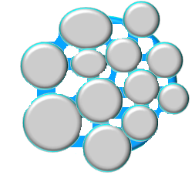

Liquid binder
Primary particles
Wetting
Solid bridges
Drying

Figure ‎1-1: Diagram of the wet granulation process (Iveson et al., 2001).

Melt granulation (MG)
Melt granulation (also defined as thermoplastic granulation) operates via similar principles as wet granulation but uses a molten binder as the granulation liquid to establish liquid bridges between particles in a heated powder bed (Vervaet and Remon, 2005). The granules produced and consolidated from melt granulation are usually given sufficient time to be cooled and solidified at room temperature so that the bridges between particles could be formed and thus, produce a product with a granular structure.
Melt granulation has held its popularity for decades in many industries due to several advantages over the traditional wet granulation (Vervaet and Remon, 2005), such as:
- Being convenient for drying as there is no solvent (water, alcohol and organic solvent) are used during this process. As a result, the cost of granulation is relatively reduced, compared to the conventional wet granulation which often involves a drying process with equipment such as fluidized bed granulator, which requires high energy consumption.
- Short process time.
- Moisture-sensitive materials can be agglomerated without organic solvents, resulting in an environmentally friendly process.
- The amount of liquid (in melting phase) added during granulation is carefully controlled to ensure a consistent granule quality, since uncontrolled solvent evaporation during agglomeration will not occur.
- The processes (mixing, agglomeration, formation of solid bridges) take place in the same equipment, offering a safe and simple single-pot process with minimal loss during material transfer.
However, these advantages must be balanced against the risk of thermal degradation of the active ingredient at higher process temperature (Vervaet and Remon, 2005). In addition, the number of binders used in melt granulation in pharmaceutical industry is limited due to some considerations of safety issues from a toxicological perspective, and the binders with melting point above 90°C are seldom used to avoid thermal degradation of the active ingredient during processing as well as to limit process time and energy consumption (Vervaet and Remon, 2005).

Melt granulation in a high shear mixer
The high shear mixer has been one of the most suitable equipment which is frequently applied in many industries for melt granulation purposes. Numbers of studies have been carried out on investigating the effects of binder content, binder type, binder particle size, binder rheology, powder cohesiveness, product temperature, jacket temperature, mixing time, impeller speed, design of impeller blades, properties of solid non-meltable particles as critical variables and a basis to identify the fundamentals of agglomerate formation and growth during melt processing in a high shear mixer (Vervaet and Remon, 2005, Schæfer and Mathiesen, 1996a, Schæfer and Mathiesen, 1996b, Eliasen et al., 1999, Eliasen et al., 1998, Johansen and Schæfer, 2001).
Granule formation during melt granulation can occur via two mechanisms: distribution or immersion (Schæfer, 2001). In the distribution mechanism, the molten binder is distributed on the surface of the primary particles, and nuclei are formed via coalescence of primary particles (Vervaet and Remon, 2005). Agglomerate growth further occurs via coalescence of nuclei provided that liquid saturation is sufficient (Schæfer, 2001). For immersion, nuclei are formed when the initial solid particles become immersed in the surface of the molten binder (Figure ‎1-2). During the melt granulation process, it is possible for both mechanisms take place at the same time; however, it is reckoned that one of them will be dominant with process time. Generally, the distribution mechanism is promoted when the binder droplet size is smaller than the solid non-meltable primary particles, while immersion dominates when droplet size exceeds the solid particle size (Schæfer and Mathiesen, 1996a, Schæfer, 2001).
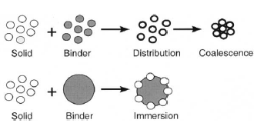
Figure ‎1-2: Schematic of binder distribution and immersion (Iveson et al., 2001).

Once the nucleation of the primary particles via either distribution or immersion happens, the agglomerates start growing via coalescence. The growth continues until a critical size is obtained, after which the size distribution of the agglomerates is controlled via an equilibrium between material consolidation, growth and breakage (Vervaet and Remon, 2005, Schæfer, 2001). Size reduction via breakage beyond the critical size depends on granule strength and disruptive shear forces, factors being determined by the viscous forces of the liquid bridge, granule densification, primary particle size and impeller speed.

Melt granulation in a fluidized bed granulator
Despite the advantages of HSM in melt granulation, the fluidized hot melt granulation (FHMG) is becoming more popular since it offers more accurate temperature control, which proves to be one of the most important features in hot melt granulation. In high shear mixer melt granulation, the change in temperature is mainly determined by the rotation of impeller, which provides energy input for the system. In a fluidized bed granulator melt granulation, the energy input is mainly controlled by the temperature of the inlet fluidizing air.
It is concluded in the literatures that the most critical variables which determine the particle size and quality during FHMG are primary particle size, binder concentration, binder viscosity, spray rate, droplet size of the binder, bed temperature, inlet air velocity and atomization pressure for spray (Walker et al., 2005, Walker et al., 2007, Walker et al., 2006).
In terms of binder addition method, the HSM is suitable for pour-on, spray-on and melt-in method, while the FHMG binder addition is limited to the first two methods, as the binder distribution solid. Another reason is that the dispersive forces in a FHMG are too low to shear a volume of binder poured into the granulator into droplets of suitable size for controlled agglomeration.

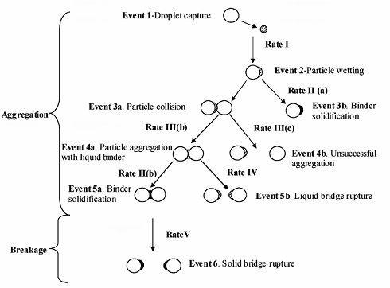
Figure ‎1-3: Sequence of events during fluidized bed melt granulation using the spray-on method and following the distribution mechanism of agglomerate formation (Tan et al., 2006).

The granule growth behaviour in a FHMG is reported to be determined by the relation between the sizes of primary solid and binder (Tan et al., 2006), which is shown in Figure ‎1-3. Despite the influence of binder droplet size on granule growth, the binder viscosity is also considered as an essential factor, as it determines the extent of binder droplet (Figure ‎1-4). The binder of low viscosity allows it to drain from the inside of the agglomerate towards the surface because of the capillary action, which allowing further growth by coalescence once all the primary particles have been captured (Vervaet and Remon, 2005). When the viscosity of binder is high, the granule growth will be difficult as the viscous binder is incorporated in the nuclei as the binder cannot spread to the surface of the nuclei. As a result, a large quantity of oversized agglomerates will occur.
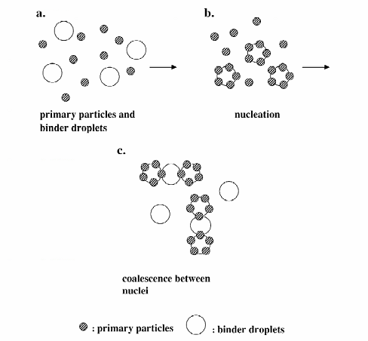
(a)

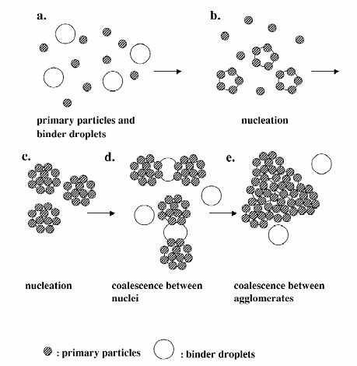
(b)
Figure ‎1-4: Agglomerate formation and growth mechanisms in fluidised bed melt agglomeration at (a) high binder viscosity and (b) low binder viscosity (Seo et al., 2002).

Mechanisms of wet and melt granulation
Traditionally, granulation processes have been described in several distinct elementary mechanisms in Figure ‎1-5 (a), namely nucleation, layering or snowballing, coalescence, abrasion transfer, and crushing and layering (Capes and Danckwerts, 1981). In recent years, the processes are divided into three main and competing steps which have been widely accepted in modern granulation in Figure ‎1-5 (b): wetting and nucleation, consolidation and coalescence, and attrition and breakage (Iveson et al., 2001).
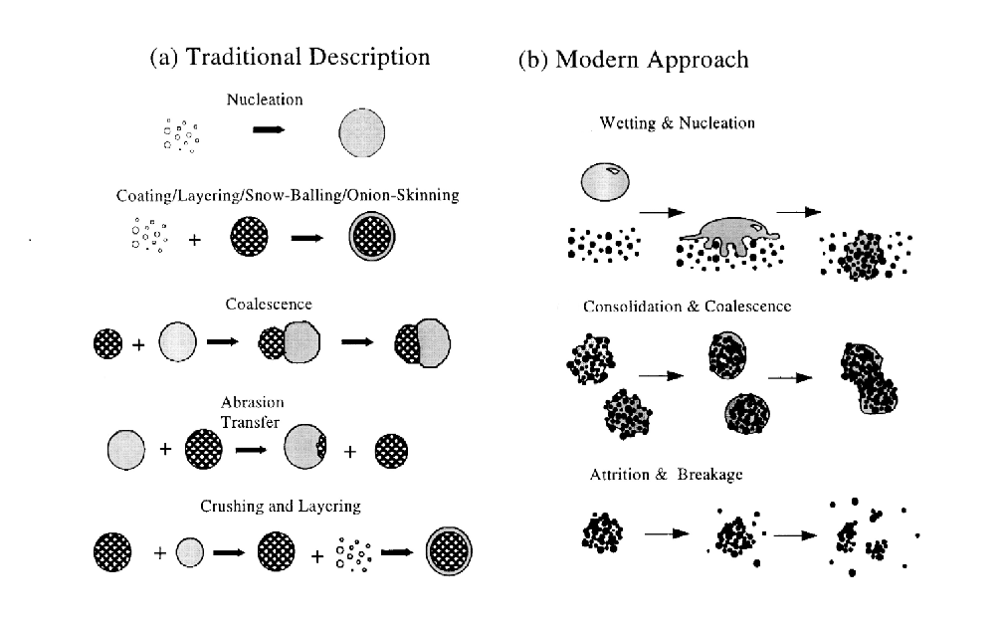
Figure ‎1-5: Schematic of wet granulation processes (a) traditional and (b) modern approach (Iveson et al., 2001).

Wetting and nucleation
Wetting and nucleation occurs when the liquid binders are added onto the powder and form nuclei. It is the first stage of the granulation process as the liquid binder is contacted with the primary powder and which then forms the initial nuclei with a broad size distribution. This process is mainly determined by wetting thermodynamics and wetting kinetics. Based on the principle of the process, it is expected that the nuclei produced are of two types, which is linked to the relation between the size of the binder droplets and primary particles (Schæfer and Mathiesen, 1996a). If the drop size is smaller, the binder is more likely to be distributed on the particle surfaces, allowing more particles to stick to each other once the surface is sufficiently wetted. On the other hand, if the binder droplet size is larger, the immersion mechanism is likely to take place, where the small primary particles are immersed in the drop which results in nuclei with saturated pores.

Coalescence and consolidation
The second stage during wet granulation is coalescence and consolidation. In this stage, the granule density has a significant increase due to a higher closer packing of granules, as the entrapped air and liquid in the granule body is squeezed out to the surface, which eventually lead to growth of granules with specific size and strength. At the beginning of the process, a liquid film is produced and is covered on the surface of powders. The bridge strength is generated at the point that the solid and liquid phase contact (Iveson et al., 2001). As more liquid content saturates the powders, the voids inside the granules are filled and thus the capillary pressure and interfacial forces will hold the particles during this process and the strength is also increased (Iveson et al., 2003). Consolidation is a process that reduces the air content in granules and even squeezes liquid binder to the granule surface (Iveson et al., 2001). It may also reduce the granule porosity. Moreover, the value of consolidation rate is used to characterize the speed of the process, and it is measured by the reduction in granule porosity per unit mixing time. Holm et al. (1985) found that the porosity initially decreased quickly and then levelled off to a stable equilibrium value, indicating that the consolidation rate is quick at the early stage of the process and gradually becomes zero.
Furthermore, Iveson et al. (2001) pointed out that coalescence mainly depends on the binder properties such as viscosity, as low viscosity binders would lead to an increase of consolidation rate during granulation. When the viscosity of the binder is high, the binder would act as lubricant which could reduce the friction and enhance consolidation (Tu et al., 2009).
Growth happens when the granules are sufficiently deformable, as the binder inside the granules will start to migrate to the surface so that they can coalesce without water on the surface or after granule consolidation (Iveson et al., 2001). Growth is affected by the bond strength, as the granule would be impeded through the interaction including subsequent collisions when growing. The processes of coalescence and consolidation are shown in Figure ‎1-6 (a) and (b).
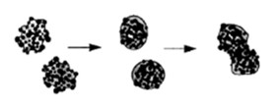
(a)

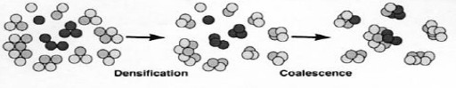
(b)
Figure ‎1-6: (a) Consolidation (Vonk et al., 1997) and (b) coalescence in wet granulation (Iveson et al., 2001).

Breakage and Attrition
The last stage in wet granulation is breakage and attrition (Figure ‎1-7). This process has a significant influence on the final product size distribution. The batch homogeneity is also highly dependent on the breakage behaviour, as it refers to uniform distribution of liquid binder in granules produced from the same binder.
Many researches have been carried out previously to investigate which factors are dominating breakage and attrition (Vonk et al., 1997, Ramaker et al., 1998, Knight et al., 1998). Generally, it was found that the extent of breakage is related to granule size and intensity of agitation. As a conclusion, it is found that larger granules with shorter granulation time break easier as the bonding force between granules are not strong enough to resist the separating forces in the granulator (Chan et al., 2013).

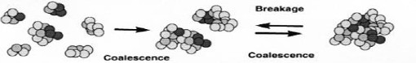
Figure ‎1-7: Breakage and attrition in wet granulation (Vonk et al., 1997)

Generally, the granules are considered to have broken apart into numbers of smaller fractures when breakage occurs, with a notable decrease in both size and strength. However, Vonk et al. (1997) concluded that the proposed mechanism is not a step-wise process, but a combination of all different sub-mechanisms which occur at the same time.

Tabletting
In order to provide a dosage form with a precise amount of APIs in pharmaceutical industry, the granules are usually processed into tablets, capsules, suspensions and emulsions. According to the United State Pharmacopoeia (USP), a tablet is defined as “solid dosage form containing medicinal substances with or without suitable diluents and they may be prepared by compression or moulding”. Although there are a number of dosage forms in industry, the tablets have the following advantages (Mangwandi et al., 2010):
- The tablets offer better dose precession compared to other forms. Each tablet represents a unit dosage form in which one usual dose of the drug has been accurately placed.
- The tablets are cheap and quicker to produce as a huge number of tablets can be produced in a short time.
- The tablets are essential tamperproof dosage forms.
- Being convenient for transportation purposes when a large quantity needs to be moved.
For a single tablet, it should have the following properties:
- It should have good strength to withstand the severity of mechanical shock during transport and packing.
- It should be able to release the drug in an appropriate and reproducible manner.
- It should be free from any process defects such as chips, cracks, discoloration and contamination.
- It should be chemically and physically stable to maintain the drug stability over the time.

Modelling of the study
Despite the pioneering contribution to investigate and predict the granule and tablet properties, the granulation is still an art more than science. For this reason, understanding the effects of different parameters on the quality of granules could help build a model that can be used to predict different granule properties.
Different studies have been focusing on modelling of granulation process, but most of the models are empirical (4). The development of computing software makes it easy model with granulation process, and to find a correlation between the input and output parameters of the granulation and tableting processes (10). Among these software, the Design of Experiment (DoE) and Artificial Neural Network (ANN) have been used in the previous studies and showed a precise prediction of the granule quality (13-16).

Aim of the work
The aim of the work is to compare the product properties by melt granulation on high shear mixer and fluidized bed granulator. Granules will be firstly produced by both equipment and their properties such as granule size, strength, porosity and dissolution will be investigated. Then the granules will be compressed into tablets, and the tablet properties such as tablet strength, hardness, porosity and dissolution will be investigated. For both HSM and FBG, the granule and tablet properties will be compared and correlated to the different mechanisms in each piece of equipment.
The experimental data will be used to build a model to predict the product properties, and it is expected that better predictions of both granule and tablet properties could be made based on the given designated conditions, and thus reduce the time and cost of the actual experiments.

Overview of the thesis
- Chapter 1 gives a brief introduction of granulation.
- Chapter 2 presents a literature review of the relevant research and knowledge required for this study.
- Chapter 3 shows the experimental conditions in the research, including materials used, variables of equipment and analysis techniques involved.
- Chapter 4-8 presents the core results of the research. Chapter 4 shows the influence of process and formulation variables on granule and tablet properties in high shear mixer; Chapter 5 shows the effect of process and formulation variables granule and tablet properties in FBG; Chapter 6 presents the results of tablet hardness of HSM and FBG; Chapter 7 shows the granule and tablet dissolution behaviours at different compression forces and liquid to solid ratios of both equipment; Chapter 8 shows different modelling outcomes of HSM and FBG products; Chapter 9 is the conclusion of this study and relevant future work.

Literature review

Introduction
This chapter describes the researches in the fields of wet and melt granulation, including the works related to the influences of binder addition methods, material deformation mechanisms, the process and formulation variables such as impeller speed and binder amount in HSM; while the influences of air velocity and binder amount in FBG.
The chapter also includes the tableting process, and describes the relevant works done in the literature, including the effect of compression force on tablet properties such as strength, hardness, porosity and dissolution, as they were mainly affected by the compression force in this study.
Different models of wet and melt granulation products were compared, especially for those who used DoE (design of experiment) and ANN (artificial neural network). These models of certain input variables related to this work were reviewed to compare the accuracy of the models of this work.

High shear granulation
High shear mixer (HSM) granulation is mainly used in food, pharmaceutical and detergent industries. High shear mixers such as the Diosna, Lodige, Fielder, Zanchetta and Moritz are widely used in the detergent and pharmaceutical industries, along with extensive literatures. Compared with other wet granulation equipment, the HSM has many advantages as listed below (Hoornaert et al., 1998, Plank et al., 2003, Iveson et al., 2001, Kristensen, 1996):
- HSM can produce very dense granules due to the mechanical compactions during granulation
- The granulation time is short
- Can tackle highly viscous mixtures because of strong agitation
- Good containment of dust and aerosols
The HSM is usually employed before tabletting in the pharmaceutical industry, as it provides a uniform distribution of the active drug components in the final product. HSM can be subdivided into two categories based on the position of the impeller shaft inside the mixing chamber (Knight et al., 1998, Iveson et al., 2001): horizontal (e.g. Lodige and plough-share mixers) and vertical shaft (Zanchetta, Fielder and Diosna mixers).
As the horizontal and vertical high shear mixers are operating with different mechanisms, it is reasonable to assume that the dynamics of these two systems are different. In one of the previous studies carried out by Schaefer, it was found that the horizontal high shear mixers produce slightly denser granules than the vertical counterparts (Schaefer et al., 1986).

Melt granulation in HSM

Effect of impeller speed on granule properties
Impeller speed is one of the most important process variables that affects the properties of the granules produced in HSM.
Eliasen et al. (1999) found that the granule size distribution was affected by the impeller speed (Figure ‎2-1). In the study, it was found that the content of agglomerates within 1000-1200 µm increased when the impeller speed rose from 200 to 400 rpm, which indicates an increase in growth rate. However, the increase in impeller speed to 1200 rpm, the content of agglomerates below 500 µm decreased, which means that the breakage of the agglomerates is more dominant at high impeller speeds. Similar conclusions have been made by Schæfer et al. (1993), as in the study it was found that the mean granule size increased with an increase in impeller speed, and it decreased when the impeller speed was very high (Figure A 1).

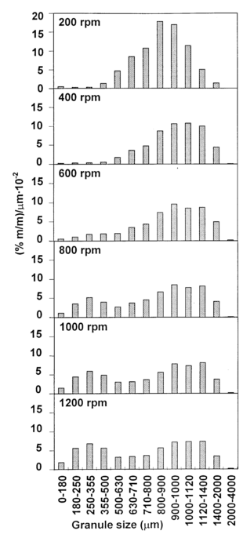
Figure ‎2-1: Effect of impeller speed on the granule size and distribution (Eliasen et al., 1998).
Schæfer (2001) also studied the effect of impeller speed on granule size and distribution. Generally, it was found that the mean granule size was larger at high impeller speed (Figure A 2). In addition, it was found that at higher L/S ratio, the effect of impeller speed became more obvious compared to lower L/S ratio. Based on the results, he concluded that the deformability at collisions between agglomerates becomes more pronounced at the higher L/S ratio.
Schæfer et al. (1993) also studied the effect of impeller speed on the intragranular porosity in HSM. In the study, the granules were produced at 600, 800 and 1200 rpm, respectively; and from the results, it was seen that the intragranular porosity generally decreased when the impeller speed increased from 600 and 1200 rpm (Figure A 3).

Effect of binder amount on granule properties
A study of binder amount on granule size has been carried out by Cheng et al. (2011). As shown in Figure ‎2-2, three types of materials were used: calcium carbonate, calcium sulfate and sodium carbonate, produced at L/S=0.3 and L/S=0.4. At L/S=0.3, they found that the calcium carbonate granules size decrease slightly before 600 impeller revolutions, and increased rapidly after 600 impeller revolutions due to coalescence, while the calcium sulfate granule size decreased with impeller revolution at all impeller revolutions, and the sodium carbonate granule size decreased with impeller revolution and increased slightly after approximately 10000 impeller revolutions (Cheng et al., 2011). At L/S=0.4, they found that the size enlargement of calcium carbonate and calcium sulfate became very more obvious at low impeller revolutions, compared to that of L/S=0.3, indicating that the greater the granulation in the liquid content, the shorter the induction behaviour. Similar result of the effect of binder amount on granule size is also studied by Tu et al. (2008) as shown in Figure A 4.
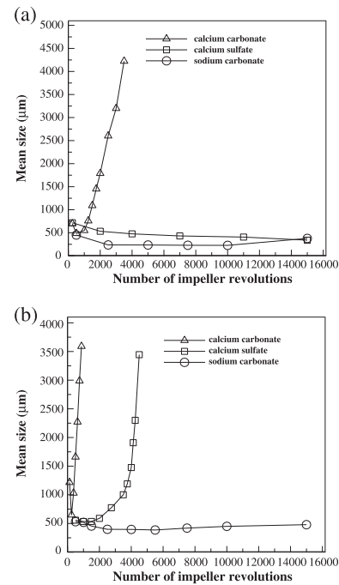
Figure ‎2-2: Mean particle size distributions for the three different types of particles versus the number of impeller revolutions: (a) ratio of liquid to solid ratio was set to 0.3; (b) ratio of liquid to solid ratio was set to 0.4 (Cheng et al., 2011).

Wet granulation in HSM

Effect of impeller speed on granule properties:
In the study done by Mangwandi et al. (2010), two types of binder were used to produced granules in HSM: the distilled water and hydroxypropyl cellulose (HPC), which were defined as low and high viscosity system, respectively. The powder used was a mixture of lactose monohydrate and potato starch. Regarding the influence of impeller speed on mean granule size, they found that the mean granule size decreased with impeller speed in low viscosity system; while the mean granule size increased with impeller speed in high viscosity system (Figure A 5). The result of impeller speed on mean granule size with viscous binder was also supported by the study carried out by Reynolds et al. (2005) (Figure A 6), where the mean granule size increased with impeller speed, and decreased when the impeller speed was very high.
Another study of the influence of impeller speed on granule size in HSM was carried out by Tu et al. (2009). The granules in this study were produced at 300, 450 and 600 rpm at varied L/S ratios (with tip speed of 1.88, 2.83 and 3.77 m/s), and it was found that at the same L/S ratio, the mean granule size produced with higher impeller speed was larger (Figure ‎2-3). Moreover, it was noticed that the growth in granule size was not largely affected by the impeller speed at low L/S ratios, whereas the influence was significant at high L/S ratios (Tu et al., 2009). This implied the mean granule size was more sensitive to the changes of binder amount at high impeller speed, as the saturation was low when the granules were produced with less binder amount, which resulted in a limited growth in size where the low impeller speed did not compensate the lack of binder, which is shown in Figure A 7.
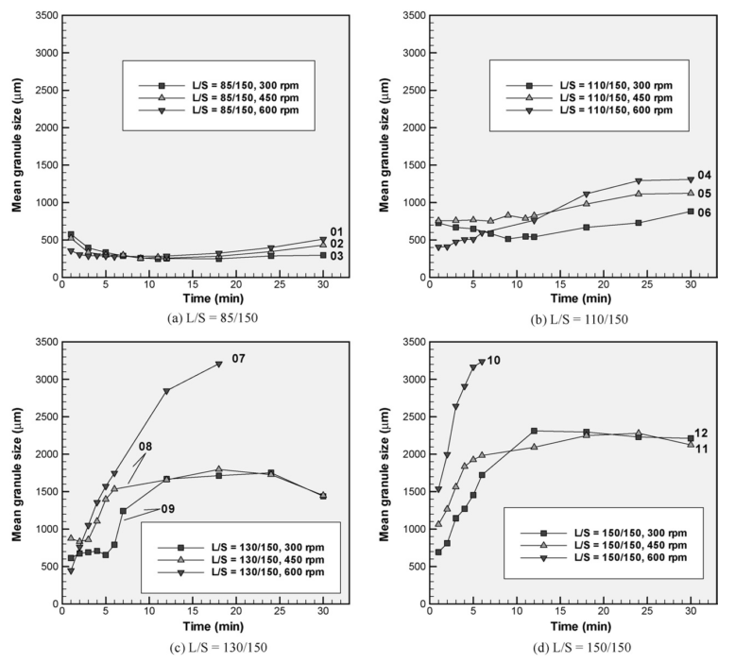
Figure ‎2-3: The mean granule size at varied impeller speed with the same L/S ratio (Tu et al., 2009).
The impeller speed was also found to have an effect on the granule porosity. In a study done by Benali et al. (2009), it found that there was a significant decrease in granule porosity when the impeller speed increased from 40 to 300 rpm; where the reduction of granule porosity was 60 to 12% (Benali et al., 2009). However, no significant change in granule porosity was observed when the impeller speed increased to 400 rpm and onwards.
Mangwandi et al. (2010) studied the effect of impeller speed on granule porosity in HSM. The experiments were carried out in two types of systems, namely low and high viscosity, where water and 10% HMPC were used as binder, respectively (Mangwandi et al., 2010). From the results in Figure ‎2-4(a), it is seen that the granule porosity decreased when the impeller speed increased from 100 to 200 rpm and then increased with further increase in the impeller speed in low viscosity system; whereas the granule porosity decreased with increasing the impeller speed in the high viscosity system which is shown in Figure ‎2-4(b).
In the same study, Mangwandi et al. (2010) also studied the effect of impeller speed on granule strength (Figure ‎2-5) and mean granule dissolution time in HSM (Figure ‎2-6). From the results in Figure ‎2-5, it is seen, in the low viscosity system that the bulk granule strength increased with increasing the impeller speed from 150 to 250 rpm and decreased with further increase in the impeller speed. In the high viscosity system, the bulk granule strength increased with increasing impeller. The reason was attributed to the fact that at low viscosity system, the liquid bridges created between particles were weak so that the granules formed have higher chances to break when collide with other granules at high impeller speed; however, when the liquid bridges were created by the viscous binder, the strength of the liquid bridges were strong enough to withstand the high impeller speed so that the granule strength was increased.
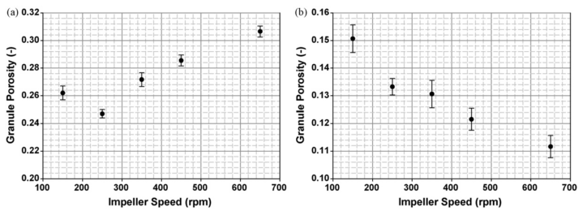
Figure ‎2-4: Effect of impeller speed on granule porosity for granules in the size range 1.0–1.18mm. (a) Low viscosity system, (b) high viscosity system (Mangwandi et al., 2010).
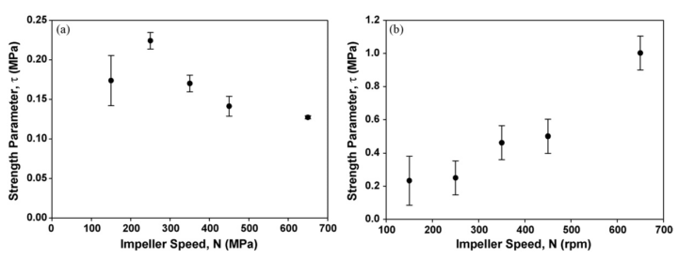
Figure ‎2-5: Effect of impeller speed on the granule strength for granules in the size range 1.0–1.18mm. (a) Low viscosity system, (b) high viscosity system (Mangwandi et al., 2010).
In Figure ‎2-6, it is found that the mean dissolution time of granules produced by using HSM at low viscosity system increased from impeller speed 150 to 250 rpm, and decreased with impeller speed after 250 rpm; whereas the mean dissolution time of granules generally increased with impeller speed at high viscosity system (Mangwandi et al., 2010). This result can be related to the correlation of bulk granule strength and impeller speed in the two systems, as the strong granules in HSM have a longer dissolution time due to slow saturation.
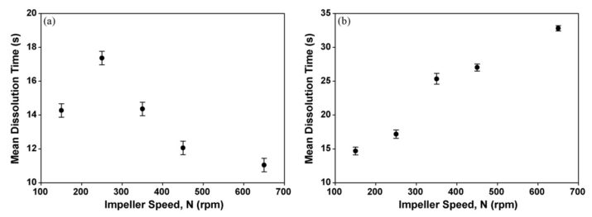
Figure ‎2-6: Effect of impeller speed on Mean Dissolution time for granules in the size range 1.0–1.18mm. (a) Low viscosity system, (b) high viscosity system (Mangwandi et al., 2010).

Effect of binder amount of granule properties
The effect of binder amount is one of the most important parameter which is affecting the granule properties. In the previous studies, it was found that increasing the binder amount has increased the granule size (Müller et al., 2015, Smirani-Khayati et al., 2009, Walker et al., 2006, Chitu et al., 2011) and strength (Monteyne et al., 2016, Žižek et al., 2014) due to higher coalescence and consolidation. These conclusions were also supported by Iveson et al. (2001), Žižek et al. (2014) and Franceschinis et al. (2014), which are shown in Figure A 8, Figure A 9 and Figure A 10, respectively.

Tabletting of HSM granules
The tablet strength was found to be determined by the compression force (Wikberg and Alderborn, 1990). In general, it was found that the tablet strength increased with compression force (Pawar et al., 2016, Gong et al., 2015, Juban et al., 2015, Johansson and Alderborn, 2001, Monteyne et al., 2016), as the air trapped in the tablet was squeezed so that the volume of air has decreased, resulting a tablet denser surface and a rigid structure (Narang et al., 2010). Similar observations were also seen in the study carried out by Nguyen et al. (2013), as the tablet strength increased as a function of compression pressure.
Mangwandi et al. (2014) studied the correlation between the fill factor variation and tablet strength. In the study, they defined the fill factor as the ratio of volume of wet powder material to vessel volume of the granulator, which was used as an indication of batch size, and they found that while the granule strength increased with fill factor Figure A 11(a), the tablet strength decreased with fill factor Figure A 11(b), respectively. Moreover, they noticed that the tablet strength decreased with an increase in granule strength in HSM (Mangwandi et al., 2014). In this study, they also investigated the correlation between tablet dissolution and tablet strength, which is shown in Figure ‎2-7. As the results shown, it is see that the strong tablets require longer dissolution time than those of weak tablets, which is considered to have related to higher degrees of compression.

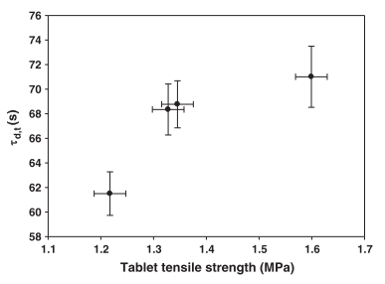
Figure ‎2-7: Correlation between the mean dissolution time and the strength of the tablets (Mangwandi et al., 2014).

Fluidized bed granulation

Types of FBG and mechanisms
Based on different working mechanisms, the fluidized bed granulators can be categorized into five different configurations which is shown in Figure ‎2-8 (Fries et al., 2011):
- Top spray: It is the type of FBG which is commonly used; the nozzle is usually located above the powder bed so that the binder droplet could be sprayed onto it.
- Bottom spray: The nozzle is usually located in the centre of the bottom section of the FBG, where the binder is sprayed.
- Wurster-coater: It is a kind of bottom spray granulator that contains a draft tube which creates a circulating flow pattern.
- Rotating fluidized bed: A rotor at the bottom of the FBG rotates while air is fed through a gap between the rotor and the wall; and the binder is sprayed onto the powder bed by using a nozzle.
- Spouted bed: The fluidization air is coming from the bottom via adjustable cylinders. The powder is supplied by a spout in the centre of FBG and the binder is injected from a nozzle located at the bottom.
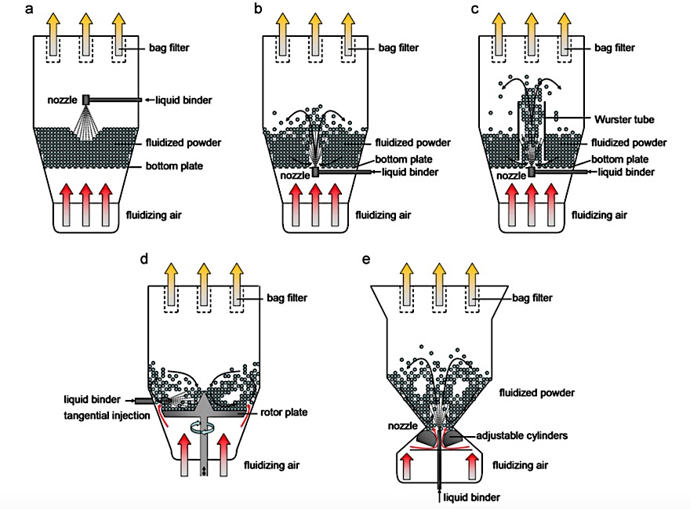
Figure ‎2-8: Schemes of different fluidized bed spray granulator configurations: (a) top spray granulator, (b) bottom spray granulator, (c) Wurster-coater, (d) rotor granulator and (e) spouted bed granulator (Fries et al., 2011).

Melt granulation in FBG

Effect of air velocity
Tan et al. (2006) studied the effect of process variables on granules in FBG. In the study, the granules were produced by using glass ballotini and PEG 1500. It is seen in Figure ‎2-9 that at low B/P, the mean granule size at low inlet air velocity was larger than those at high velocity. However, the mean granule size does not show a clear trend at B/P.
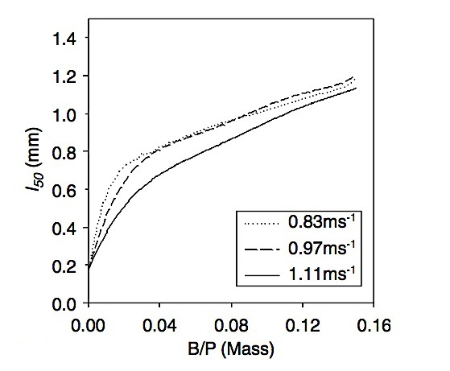
Figure ‎2-9: Granules growth at different fluidising air velocities (Tan et al., 2006).

Mangwandi et al. (2015) investigated the influence of process variables on granule properties in FBG. In the study, they used lactose monohydrate and PEG 1500 to produced granules. From the result in Figure A 16, it is seen that the mean granule size generally decreased with an increase in inlet air velocity; meanwhile the granule strength increased with the inlet air velocity, too.

Effect of binder amount on granule properties
Walker et al. (2005) used lactose monohydrate and PEG 6000 to produce granules in FBG. In the experiments, they produced granules with varied binder amount, and it was found that the mean granule diameter increased with an increase in binder amount (Figure ‎2-10). The result is also supported by Tan et al. (2005) and Zhai et al. (2009), which showed the granule size increased steadily when more binder was added (shown in Figure A 12 and Figure A 13).
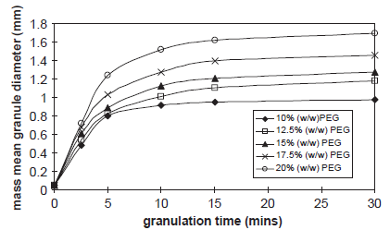
Figure ‎2-10: Mean particle diameter with different granulation time at different PEG binder amount (Walker et al., 2005).
Walker et al. (2006) studied the effect of binder amount on the mean granule diameter in FHMG. As a result, it was found that mean granule diameter increased with an increase in binder amount. (shown in Figure A 14and Figure A 15).

Wet granulation in FBG

Effect of inlet fluidizing air velocity
Behzadi et al. (2005) studied the effect of air velocity on granule properties on (Figure ‎2-11). From the result, it is found that the mean granule size increases with an increase in air velocity. The result is supported by Hemati et al. (2003) and Watano et al. (1997), which are shown in Figure A 17 and Figure A 18.
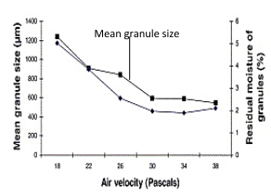
Figure ‎2-11: Effect of air velocity on granule size (Behzadi et al., 2005).

Effect of binder amount on granule properties
The studies conducted by Chen et al. (2009) investigated the effect of binder amount on the granule size. In the study, the granules were produced with varied binder amount, and it was found that the percentage of larger sizes granules increased when the binder content increases (Figure ‎2-12), although the granule size distribution was not obvious above the binder weight ratio of 4.0 (Chen et al., 2009). From the result, it is assumed that the increase in granule size is proportional to the amount of binder; as the higher the binder amount, the stronger the adhesion force, which resulted in larger granules. Similar results were found by Miwa et al. (2008) and Behzadi et al. (2005).
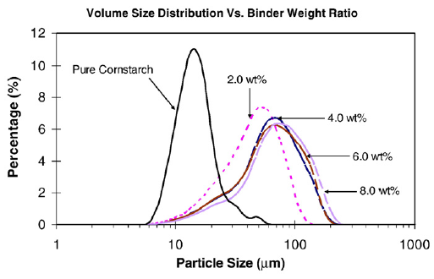
Figure ‎2-12: Granule size distributions at different binder concentrations (Chen et al., 2009).

Tabletting of FBG granules
Walker et al. (2005) measured the tablet strength at different binder amount and sizes of granules. As shown in Figure ‎2-13, it is seen that the tablet with higher strength are produced with high amount of binder. Moreover, it is also noticed that the tablets produced by smaller size of granules are stronger than that produced of larger size of granules, as the deformation of granules is higher for the small sizes of granules than the large sizes of granules, which resulted in a tablet with higher compaction.
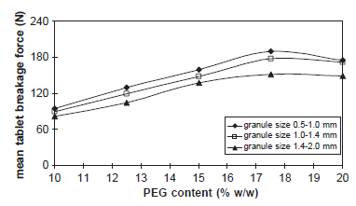
Figure ‎2-13: Mean tablet breakage strength versus feed PEG content for tablets pressed from granules of different size ranges (Walker et al., 2005).

Results in the literature
Table ‎2-1: Effect of impeller speed on granule properties in HSM (MG)
Author | Result
Effect of impeller speed on granule properties in HSM (MG)
(Eliasen et al., 1998) | An increase in impeller speed increased the mean granule size.
(Schæfer et al., 1993) | An increase in impeller speed increased the mean granule size, while reduce the intragranular porosity.
(Schæfer, 2001) | An increase in impeller speed increased the mean granule size.

Table ‎2-2: Effect of binder amount on granule properties in HSM (MG)
Author | Result
Effect of binder amount on granule properties in HSM (MG)
(Cheng et al., 2011) | An increase in binder amount increased the mean granule size.

Table ‎2-3: Effect of impeller speed on granule properties in HSM (WG)
Author | Result
Effect of impeller speed on granule properties in HSM (WG)
(Mangwandi et al., 2010) | The mean granule size decreased with impeller speed in low viscosity system; while increased in high viscosity system.
(Reynolds et al., 2005) | The mean granule size increased with impeller speed, and decreased when the impeller speed was very high.
(Tu et al., 2009) | The mean granule size increased with impeller speed. Also, the size increase is more obvious and fast at high L/S ratio.
(Benali et al., 2009) | The granule porosity was reduced with an increase in impeller speed, and the change was not obvious at very high impeller speed.

Table ‎2-4: Effect of binder amount on granule properties in HSM (WG)
Author | Result
Effect of binder amount on granule properties in HSM (MG)
(Walker et al., 2006) | An increase in binder amount increased the mean granule size.
(Chitu et al., 2011) | An increase in binder amount increased the mean granule size..
(Iveson et al., 2001) | The granule dissolution time was higher at high L/S ratio.
(Žižek et al., 2014) | The granule dissolution time was higher at high L/S ratio..
(Franceschinis et al., 2014) | The granule dissolution time was higher at high L/S ratio.

Table ‎2-5: Effect of air velocity on granule properties in FBG (MG)
Author | Result
Effect of air velocity on granule properties in FBG (MG)
(Mangwandi et al., 2015) | The mean granule size decreased with an increase in air velocity.
(Tan et al., 2006) | The mean granule size decreased with an increase in air velocity.

Table ‎2-6: Effect of binder amount on granule properties in FBG (MG)
Author | Result
Effect of binder amount on granule properties in FBG (MG)
(Walker et al., 2005) | The mean granule size increased with an increase in binder amount.
(Walker et al., 2006) | The mean granule size increased with an increase in binder amount.
(Tan et al., 2005) | The mean granule size increased with an increase in binder amount.
(Zhai et al., 2009) | The mean granule size increased with an increase in binder amount.

Table ‎2-7: Effect of air velocity on granule properties in FBG (WG)
Author | Result
Effect of air velocity on granule properties in FBG (WG)
(Hemati et al., 2003) | The mean granule size decreased with an increase in air velocity.
(Watano et al., 1997) | The mean granule size increased with air velocity, and decreased when the air velocity was high.
(Behzadi et al., 2005) | The mean granule size decreased with an increase in air velocity.

Table ‎2-8: Effect of binder amount on granule properties in FBG (WG)
Author | Result
Effect of binder amount on granule properties in FBG (WG)
(Chen et al., 2009) | An increase in binder amount increased the mean granule size.
(Miwa et al., 2008) | An increase in binder amount increased the mean granule size.
(Behzadi et al., 2005) | An increase in binder amount increased the mean granule size.

Comparison of product properties produced by HSM and FBG

Product properties of HSM and FBG in MG
Passerini et al. (2010) studied the process of HSM and FBG, and made a comparison of pharmaceutical powder by melt granulation of these two pieces of equipment. In the work, they found that in terms of granule size distribution, the FBG is larger than the HSM, and the granules produced by FBG has a faster dissolution than the HSM, which is shown in Figure ‎2-14. The reason was considered as due to the different mechanisms of equipment, as the granules produced by using HSM was denser than the ones produced by using FBG.
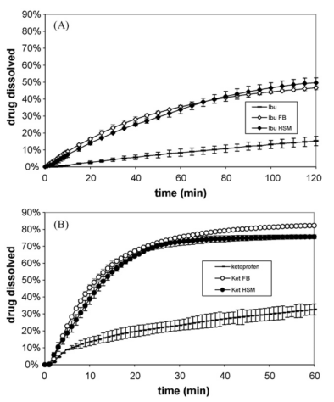
Figure ‎2-14: (A) Dissolution profiles of pure ibuprofen and of FB and HSM granules and (B) Dissolution profiles of pure ketoprofen and of FB and HSM granules (Passerini et al., 2010).

Product properties of HSM and FBG in WG
Järvinen et al. (2015) carried out a study of comparing a continuous ring layer wet granulation process with HSM and FBG processes. In the study, they found that the mean granule size was dependent on the granulation temperature, and the dependence between the granule size and the granulation temperature is non-linear for the applied temperature range and. In the same study, they also found that the tablets produced from HSM were weaker than those of FBG, as the granules produced by HSM were denser than the FBG.
Tablet porosity is basically linked with the extent of compaction of the granules in a tablet shown in Figure ‎2-15 (a). The effect of compression force on tablet porosity has been investigated by (Pawar et al., 2016, Johansson and Alderborn, 2001, Monteyne et al., 2016), and it was found that the tablet porosity decreased with an increase in compression force, as the more deformation of granules occurred during compression so that the gaps between granules have been reduced. However, when the compression force went beyond a certain value, it was found that there was no significant change in tablet porosity as the degree of compression of the tablets has reached its upper limit (Johansson and Alderborn, 2001). Also, it is seen that the weak tablets have higher tablet porosity than the strong tablets, which is shown in Figure ‎2-15 (b).

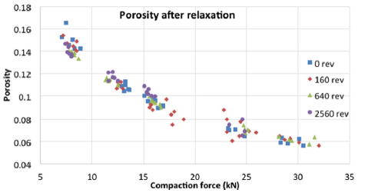
(a)
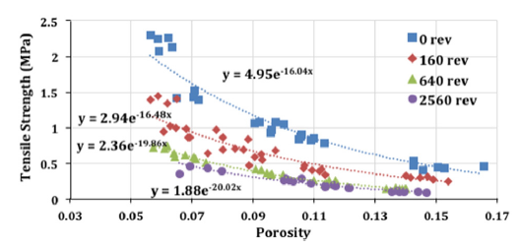
(b)
Figure ‎2-15: (a) Tablet porosity at different compaction forces and (b) tablet strength as a function of tablet porosity (Pawar et al., 2016).
Gao et al. (2002) carried out a study on comparing the processes of both HSM and FBG. In this study, they used the micronized drug substance as primary powder, and an aqueous solution of cellulose was used as binder to granulate the dry powder. The granules produced by using each piece of equipment were compressed into tablets after dried, and the result is shown in Figure ‎2-16. It is seen in Figure ‎2-16 that the in general, the tablets produced by FBG have a slower dissolution than those produced by HSM. The reason was attributed to the granule strength, as they found that the granules produced by using FBG were more porous and thus weaker than those of HSM.
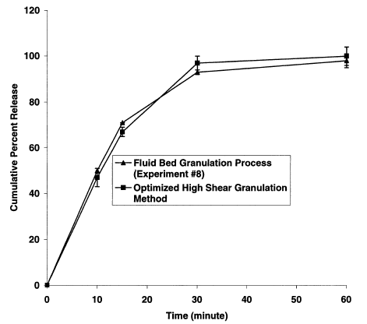
Figure ‎2-16: Comparative dissolution profiles of wet granulation tablets manufactured with the fluid bed technique and the high shear granulation method (Gao et al., 2002).

Theoretical modelling in granulation
Watano et al. (1997) modelled the effect of air velocity on mean granule size in FBG by using artificial neural networks (ANN). In the modelling, the inlet air velocity, diameter of the granulator, density of the raw material and the experimental mean granule size were used as the inputs. From the results shown in Figure ‎2-17, it is found that close agreement between the predicted and experimental data was obtained. The mass median diameter of both the predicted and the experimental data decreased with an increase in agitator rotational speed, while both variables increased with an increase in air velocity.
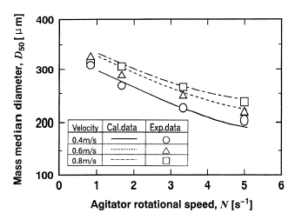
Figure ‎2-17: Granule mass median diameter at various agitator rotational speeds and air flow velocities (Watano et al., 1997).

AlAlaween et al. (2016) carried out a study of the output for high shear granulation by using ANNs. The experimental data was obtained from a high shear Eirich mixer, with calcium carbonate and PEG 1000 used as powder and binder, respectively. The inputs of the modelling include impeller speed, granulation time, L/S ratio and impeller shape; while the outputs include granule size, binder content and porosity. The outcome of the modelling is shown in Figure ‎2-18.

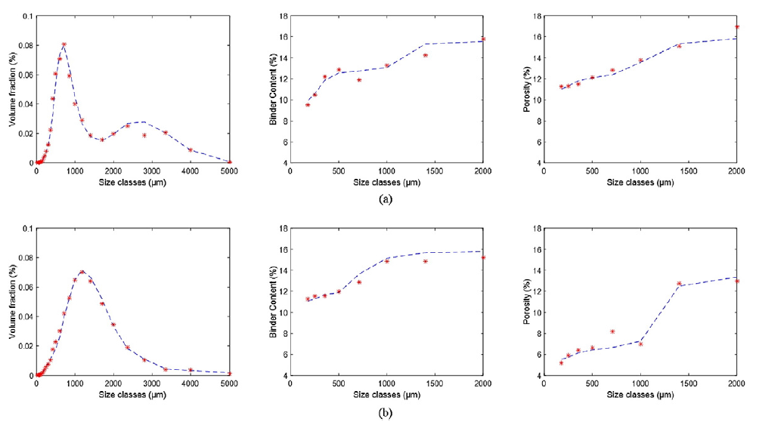
Figure ‎2-18: The integrated network: the predicted (*) and the experimental (−-) distributions for the size, binder content and porosity (a) using impeller speed=2000 rpm, L/S ratio (w/w)= 14% and granulation time = 10 min, (b) using impeller speed = 6000 rpm, L/S ratio (w/w)= 15% and granulation time = 15 min (AlAlaween et al., 2016).
From the result in Figure ‎2-18, it is seen that the curves of both experimental and predicted data are very close, indicating that the model has a high accuracy in predicting the designated output. By comparing the certain output the model predicts, it is found that the ANNs model is more accurate in predicting the granule size distribution at high impeller speed than low impeller speed; whereas the prediction of output is more accurate in predicting the binder amount and granule porosity at lower L/S ratio and longer granulation time (AlAlaween et al., 2016).
Mangwandi et al. (2015) used design of experiment (DoE) to model the effect of process variables on granule properties in FBG. In their DoE model, the inputs used are temperature, air velocity, granule size and strength. The R2 value (defined as the coefficient of accuracy of the model. The closer the value to 1, the accurate the model in predicting the outcome values) of the model is 0.98, indicating that the model can give accurate prediction of designated outcomes (Figure ‎2-19).
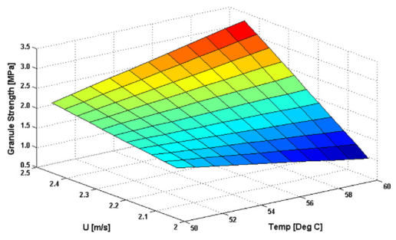
Figure ‎2-19: Effect of process variables on the granule strength in FBG (Mangwandi et al., 2015).
In an early modelling work carried out by Murtoniemi et al. (1994) in FBG, two types of models were used to estimate the mean granule size, namely ANN model and regression model (REG). The inputs used in the modelling were inlet air temperature, atomizing air pressure and binder solution amount, to predict the output mean granule size. The outcome of the modelling is shown in Figure ‎2-20. It is found that both models have underestimated the mean granule size. Moreover, the predicted granule size in ANN model is closer to the experimental values, indicating that the ANN model is more accurate in predicting the outcome of the mean granule size in FBG.
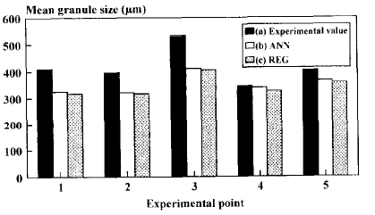
Figure ‎2-20: Mean granule size of (a) experimental, (b) ANNs estimated and (c) regression model estimated (Murtoniemi et al., 1994)

Behzadi et al., (2004) carried out a number of experiments with fluid bed granulation, and their results were validated by using a generalized regression neural network (GRNN). They have concluded that the most important parameters affecting the particle size enlargement were air velocity and spray rate. From their report, it was seen that the prediction of these parameters have a high accuracy of 91.1%.
c. (Tan, 2006)

Tablet strength was predicted by Juban et al., (2015). In their study, they have purposed a new approach defined as simplified model to predict the tablet strength. From their results, they concluded that this model was proved predictable with tablet hardness rather than using tablet porosity as the main input variable.
Tablet dissolution time is another important parameter as it will specify the areas that the tablets could be used. To achieve this goal, researchers (Pawar et al., 2016, Yekpe et al., 2015, Hernandez et al., 2016) have suggested that using near infrared (NIR) could be an efficient way, as it is simple, fast and non-destructive analytical technique. Also, more information of sample status will can be acquired by this method (Smetisko and Miljanic, 2017).

Materials and methodologies

Introduction
In this chapter, the experimental design and methodologies of both HSM and FBG are illustrated, including the details of experimental setup and supporting techniques, and a description of the method used to analyse the product.

Materials

Primary powder
Figure ‎3-1 showed the SEM image of the calcium carbonate (Superlon L200, with d₅₀ of 17.5 µm) used in both HSM and FBG experiment, supplied by Longcliffe Quarries Ltd., Derby, with a true density of 2.9 g/cm³ (as supplied by the manufacturer). From the image, it is seen that the calcium carbonate particles have very small size and irregular shape.
For each experiment, the amount of CaCO₃ used was 1.5 kg, and the powder was pre-heated in an oven at 50°C before used for granulation. The particle size distribution of calcium carbonate is shown in Table ‎3-1 (supplied by manufacturer).
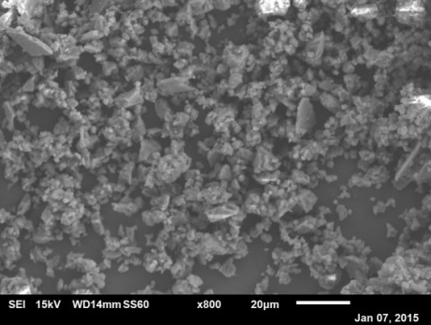
Figure ‎3-1: SEM image of calcium carbonate powder.
x [µm] at Q3=10.0 % | 4.6 µm
x [µm] at Q3=50.0 % | 17.5 µm
x [µm] at Q3=90.0 % | 69.3 µm
Q3 (SPHT=0.9) [%] | 51.4 µm
Q3 (b/l=0.9) [%] | 77.1
Mean value SPHT3 | 0.859
Table ‎3-1: Particle size distribution of calcium carbonate.

Binder preparation
Polyethylene glycol 1000 (PEG 1000) was used as binder in both HSM and FBG experiments. It is a water-soluble, waxy polymer, and it is a Newtonian fluid when melts into liquid (Ascanio et al., 2004). In this study, the binder used was polyethylene glycol 1000 (PEG 1000), and the properties of PEG 1000 is shown in Table ‎3-2 (Sigma-Aldrich, 2016).
Molecular weight | 950-1050 g/mol
Melting point | 35-40°C
Colour | Semi-transparent
Physical state at room temp. | Solid
Density | 1.15-1.21(g/cm³)
Table ‎3-2: Physical properties of Polyethylene glycol 1000 (Sigma-Aldrich, 2016)

Binder preparation in the study was done with the processes as below:
- HSM granulation: the binder was prepared in solid flake form. A mesh with holes of three diameters was used to manually produce the PEG 1000 flakes as shown in Figure ‎3-2. In this study, the flakes were mainly produced by using the mesh with a diameter of 1.5 cm. The average mass of a single PEG 1000 flake with a sieve diameter 1.5 cm was obtained from 20 measurements and results are presented in Table ‎3-3. The flakes were stored in fridge before granulation, ensuring that the flakes were in good shape when added to mixer with the powder.
- FBG granulation: the binder was prepared in liquid form. The solid PEG 1000 was placed in a beaker and then stored in an oven until entirely melted into liquid.

0.5 cm

1.5 cm

2.0 cm

Figure ‎3-2: Schematic of mesh used in the study.
The viscosity of melt binder was measured by using a Rheometer Kinexus (Malvern Instruments Ltd) with the cone and plate geometry as a function of temperature. The plate was continuously heated to prevent liquid PEG 1000 solidifying during the measurement. The viscosity of PEG 1000 at different temperatures is presented in Table ‎3-4, and it is seen that the viscosities of melting PEG 1000 decreases with an increase in temperature.
Table ‎3-3: Single PEG 1000 flake mass of width diameter 1.5 cm (unit: gram)
0.08 | 0.09 | 0.08 | 0.10
0.09 | 0.09 | 0.08 | 0.21
0.09 | 0.12 | 0.14 | 0.09
0.13 | 0.15 | 0.07 | 0.10
0.14 | 0.14 | 0.15 | 0.16
Average: 0.115±0.036 g

Temperature (°C) | 50 | 52 | 54 | 56 | 58
Viscosity (mPa.s) | 57.9 | 57.0 | 55.1 | 49.4 | 47.5
Table ‎3-4: Viscosity of molten PEG 1000 at different temperatures

Experimental set-up of high shear mixer
The equipment used in this research was a Zanchetta Roto Junior 10 L vertical axis cylindrical high shear mixer (Figure ‎3-3). The mixer bowl has a diameter of 0.285 m and a height of 0.18 m, with a maximum bed load of approximately 3 kg in a batch. A discharge chute for the removal of product is attached at the bottom corner. The impeller in the centre of the mixer bowl can rotate from 5 to 800 rpm (Figure ‎3-4), corresponding to a tip speed of 0.07-11.9 m/s. The impeller used in the research had three blades, with an inclination angle of 45 degrees. A cap was used to stabilize the impeller and the lid of the bowl needs remained sealed during granulation. The process parameters during granulation in HSM are shown in Table 3-5.
Preliminary experiments which were done to find the experimental design space showed that at the impeller speeds lower than 400 rpm, the product was undesirable, as the batch contained lots of oversized granules (lumps). The minimum L/S ratio was found to be 0.12, as below this value the batch was too dry with lots of fines; while above 0.145 the batch was too wet which led to paste formation. Earlier experiments also showed that the optimum mixing time was 20 minutes, after which time no significant changes were noticed in the product.
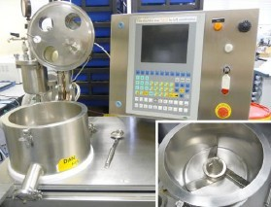
Lid
Jacket
Discharge
Control panel
Impeller
Figure ‎3-3: Image of Roto Junior high shear mixer.
The vessel of the mixer bowl was equipped with a hot jacket which was heated by a hot water bath to 50°C in order to keep a suitable ambient for PEG 1000, as it was completely in melting state at that temperature. The temperature of the jacket rose from 20 to 50°C in approximately 15 minutes once the water bath was turned on. Besides the heating system, the vessel was also equipped with a cooling system, which aimed to cool down the granules at the end of granulation. The hot water circulated in the jacket when it was heated, and when the granulation finished, it was replaced by cold tap water so that the system temperature dropped down and the granules solidified.

Cap
0.18 m
Wall heated by temperature jacket
Chopper
Impeller blade
Lid
0.285 m
Discharge chute
Figure ‎3-4: Schematic diagram of 10L Zanchetta high shear mixer.
For vessel temperature, the reason why it was set at 50 ºC is because of the PEG 1000 has a melting point of 35-40 ºC, so at this temperature the PEG flakes can be entirely melted.
The HSM experimental protocol is shown as below:
- The mixer jacket was preheated to 50°C.
- An amount of 1.5 kg of feed powder calcium carbonate was weighed and added to the mixer bowl.
- The PEG 1000 flakes were added to the powder bed manually. The solid binder was evenly distributed, ensuring a good size distribution of granules.
- After the powder and binder were mixed for 30 seconds at 50 rpm, the impeller was adjusted to the experimental speed, which was defined as t=0.

Table ‎3-5: Summary of granulation conditions used during production of granules in HSM
Variables | Values
Impeller speed (rpm) | 400, 600, 800
Batch size (kg) | 1.5
Vessel temperature (ºC) | 50
Liquid to solid ratio | 0.12, 0.13, 0.145
Granulation time (min) | 20

The batches of granules produced by different binder addition were cooled down at room temperature for 24 hours before analysis. However, as the PEG 1000 is easily solidified at room temperature, the granules are distributed as a thin layer in order to prevent the caking.
The dried granules were then sieved into 12 size classes (Retsch Technologies, Germany). The sieving time was 7 minutes and the amplitude was 1.0 mm. Granules of 0.18-0.425 mm, 0.71-0.85 mm and 1.18-1.4 mm were used for characterization. The same method was used for FBG granule.

Experimental set-up of fluidized bed granulator
The granulator used in this research was a Glatt AG Schweiz top-spray fluidized bed granulator (Figure ‎3-5). It consists three parts, namely the upper part (where the filter bag is installed to prevent fines escape), middle part (where the liquid binder is transported through a pipe and sprayed from the center) and bottom part (where the primary powder is placed on).
Based on the primary particle size in Table ‎3-1, the minimum air velocity in this fluidized bed granulator is considered to be calculated by Equation ‎3-1 (Rhodes, 1998), as the mean particle size used in this research was smaller than 100 µm. Details of the factors in Equation ‎3-1 can be found in Table ‎3-6.

$$U_{mf}=\frac{{(ρ_{p}-ρ_{f})}^{0.934}*g^{0.934}{x_{p}}^{1.8}}{1110*μ^{0.87}*{ρ_{f}}^{0.066}}$$
Equation ‎3-1
where $ρ_{p}$ is particle density, $ρ_{f}$ is air density, $g$ is acceleration of gravity, $x_{p}$ is particle size, $μ$ is air viscosity.
Table ‎3-6: Values of factors in Equation 3-1
$$ρ_{f}$$ | 1.225 kg/m³
$$g$$ | 9.8 m/s²
$$u$$ | 1.81×10⁻⁵ Pa.s

The $U_{mf}$was found approximately 2.2 ×10⁻⁴ m/s after calculation by Equation ‎3-1. However, this value was not applicable since lots of granules larger than this size were produced during fluidization. Therefore, this $U_{mf}$ was not sufficient to maintain a proper fluidization in FBG. In this case, another approach which was correlated to Reynolds number for fluidization ($R_{efm}$) and Archimedes number (Ar) was applied, which is shown in Equation ‎3-2 and Equation ‎3-3 (Rhodes, 1998).
$$R_{efm}=\frac{U_{mf}*ρ_{f}*d_{p}}{μ}$$
Equation ‎3-2
where $d_{p}$ is granule diameter (as the largest size of granules used in this study was 1.4 mm, hereby this value equals to 1.4 mm).
$$A_{r}=\frac{x_{p}^{3}*ρ_{f}*\left(ρ_{p}-ρ_{f}\right)*g}{μ^{2}}$$
Equation ‎3-3

And the relation between $R_{efm}$ and Ar is shown in Equation ‎3-4 (Rhodes, 1998).
$$A_{r}=1650R_{efm}+24.5{R_{efm}}^{2}$$
Equation ‎3-4
After calculation, the $U_{mf}$ was found approximately 0.50 m/s in the FBG of this study.

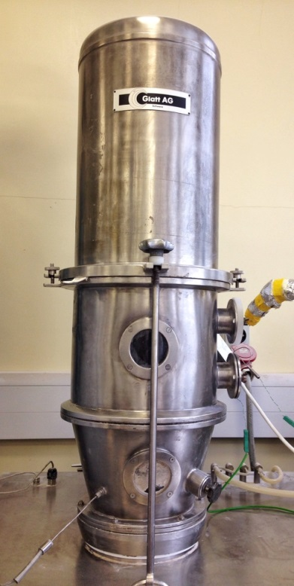
0.20 m
0.26 m
Sample collector
0.30 m
0.20 m
Air in
Air out
Bottom section
Filter bag
Top section
Middle section
Figure ‎3-5: Image of FBG used in the study (left) and schematic (right).
As mentioned previously, PEG 1000 is easily solidified at room temperature so that the nozzle used in the study should be kept heated during fluidization. In this case, an external heating apparatus (PEG control unit) was built and used to keep the nozzle heated, and thus, enabled the nozzle to spray fine binder droplet. The details can be found in Figure ‎3-6 and a summary of the granulation conditions used in FBG is shown in Table ‎3-7.
Based on the calculation of $U_{mf}$, the lowest air velocity used in this study was selected at 0.73 m/s, and highest velocity was 1.21 m/s since above this value, most of the powder was lost due to entrainment before formation of agglomerates. Hence air velocity values shown in Table ‎3-7 were used for rest of the experiments. The same L/S ratios used in the high shear granulation experiments were used for the fluidized bed granulation experiments to allow comparison between the properties of granules obtained from the two units.

Table ‎3-7: Summary of granulation conditions used during production of granules in FBG
Variables | Values
Air velocity (m/s) | 0.73, 0.97, 1.21
Bed load (kg) | 1.5
Bed temperautre (ºC) | 50
Liquid to solid ratio | 0.12, 0.13, 0.145
Granulation time (min) | 40

Both the working principles of PEG control unit and nozzle heating unit are shown in Figure 3-7. As seen in the figure, the liquid PEG was placed in a beaker and heated by a hot plate. The heated PEG was then transported by the heated pipe which connected to the nozzle (Lechler Ltd, Sheffield); meanwhile the nozzle was heated by a cord which was connected to the temperature control unit. The nozzle used in this study was stabilized in the center of the middle cylindrical and heated to 50°C. The pipe connected to the nozzle was isolated to prevent heat loss during the binder transportation, as a decrease in temperature of the pipe resulted in PEG 1000 solidification, which ultimately blocked the nozzle and stopped binder spray. In this case, the nozzle and the pipes should be heated to their optimal temperature before the experiment begins.
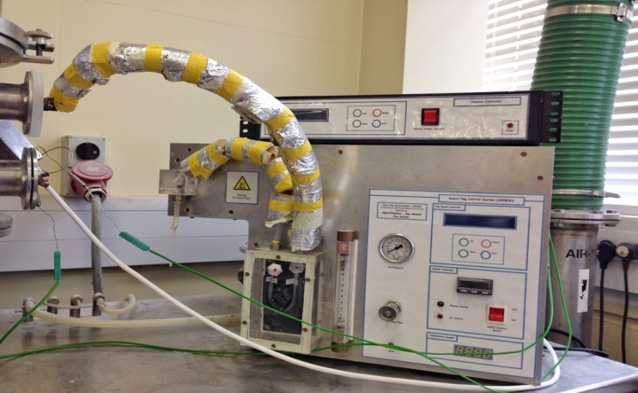
Temperature control box for nozzle
Insulated tube
Atomizing pressure meter
PEG control unit
Binder inlet
Figure ‎3-6: Image of PEG control unit (binder heating system).

Temperature control box for nozzle
PEG control unit
Heated cord
Pump
Nozzle
Hot plate
Binder
Heated pipe
11
Figure ‎3-7: Working principle of binder heating system of FBG.
The molten PEG 1000 was stored in a beaker, and then placed on a lab scale hot plate beneath the binder inlet pipe and kept heated before the experiment started. The molten PEG was transported by a peristaltic pump and pipe. The pipe was heated up to 70°C, ensuring the molten PEG stayed in liquid form at all times. The nozzle has an orifice of 0.25 mm and the atomizing pressure for binder spray was 1.5 bars (Figure ‎3-8).

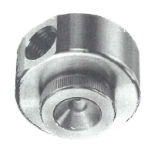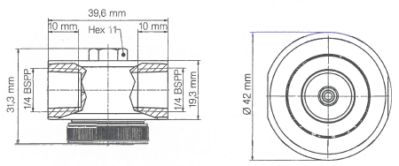
Nozzle type: 136.316.35. A2
Figure ‎3-8: Schematic of nozzle used for the FBG binder spray (Lechler Ltd, Sheffield).

Granule size analysis
The granule size distribution (GSD) is considered as an important parameter in characterizing the homogeneity of granules, as it is a reflection of how the binder is distributed. The GSD is affected by both process and formulation variables.
Camsizer P4 (Retch Technology, Haan, Germany) was used to determine the GSD. It is a digital image system equipped with two cameras. For each test, the mass of granules used was 500 g. The granules were firstly added through the hopper, and then dispersed by a vibratory funnel before falling in front of the cameras. Compared to the other size imaging analysis apparatus, the advantage of Camsizer was that the sample could be recollected after the measurement, which allows the samples to be re-analysed.

Granule strength test
In this study, the bulk granule strength was determined by using a Zwick/Roell 0.5 materials testing machine (Zwick GmbH and Co., Ulm, Germany). The load cell has a maximum force of 500 N and an accuracy of 0.001 N. An amount of 1.0 gram of granules was used for each test. The granules were compressed in a 10 mm die, using 450 N as compression force and 10 mm/min as test speed. The force and displacement during compression were recorded (Figure ‎3-9) and used later to determine the average granule strength. Adam’s Equation ( Equation ‎3-5) was used to determine the bulk granule strength using the force-displacement data which was obtained from the Zwick/Roell (Adams et al., 1994).
$$\ln{P}=\ln\left[\frac{τ}{α}\right]+αε_{n}+\ln{(1-e^{-αε_{n}})}$$
Equation ‎3-5
where P is the applied pressure, $τ$ is the average agglomerate strength, $α$ is a constant related to friction, and $ε_{n}$ is the natural strain.
The compression force data was transformed into compression pressure by dividing the force by the bed cross-sectional area. The natural strain was obtained by taking the natural logarithm of the ratio between the initial ($h_{0}$) and final bed height ($h$) which is shown in Equation ‎3-6 (Adams et al., 1994);

$ε_{n}=\ln\left[\frac{h_{0}}{h}\right]$
Equation ‎3-6
The average strength, τ and parameter α were obtained through non-linear regression on the ln P and natural strain data using SigmaPlot 12 (Systat Softwar Inc. US).
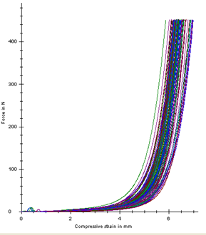
Force (N)

Displacement (mm)

Figure ‎3-9: Force-displacement curves of Zwick/Roell 0.5 test machine.

Granule dissolution test
A conductivity technique was used to determine the dissolution rate of the granules. Conductivity is an indication of dissolution as a fast increase in conductivity refers to a faster dissolution of the sample, and vice versa. In the granule dissolution test, the conductivity was measured by the JENWAY Model 4520 test machine (Figure 3-10). For each test, 1 gram of granules was dissolved in 500 ml distilled water in a 1 litre beaker, which was heated on a hot plate. The test was started at temperature of 30±0.5 °C and stirrer speed was 400 rpm, and heating was stopped once the water temperature reached the experimental value. A probe was used to measure both temperature and conductivity. The distilled water in the beaker was agitated by the impeller which was driven by a motor. The granule dissolution time was 10 minutes for each test.

Conductivity probe

Granules
Conductivity meter
Magnetic stirrer

Figure ‎3-10: Set-up of granule dissolution test.
For both granule and tablet dissolution tests, the dissolution rate was determined by Equation ‎3-7 (Dévay et al., 2006).
Percentage of dissolution= ( $\frac{x-x_{min}}{x_{max}-x_{min}})∙100\%$
Equation ‎3-7
where x is conductivity, x_{min} is minimum conductivity, x_{max} is maximum conductivity
In the test, the x_{min} was the initial reading of the distilled water conductivity; while x_{max} is the maximum reading of the distilled water conductivity when it reached a constant reading, indicating total dissolution of the granules.

Granule porosity
Porosity is considered as one of the most important parameters characterizing the granule internal structure. It can also provide valuable information regarding the role of porosity in the trade-off between granule strength and dissolution (Gabbott, 2007). For both HSM and FBG granule porosity tests, the liquid displacement method was used to determine the granule internal porosity. In this test, kerosene was used as the liquid to replace the pores of granules. The method was applicable to the calcium carbonate and PEG 1000 granules, as the liquid density needs to be lower than the granule density, otherwise the granules will float on the surface of the liquid.
A pycnometer of 10 ml was used for the test. Prior to measurements, the pycnometer was filled up with kerosene in order to calculate its density at room temperature. For each test, 2 grams of granules from different process/formulation variables was used.
The total mass of pycnometer with full kerosene is: $\overline{m}$= 8.307 g with a standard deviation 0.029 and the density of kerosene is: $ρ_{K}$= 0.8307 g/ml.
The granule porosity is calculated by using Equation ‎3-8 (Iveson et al., 1996):
$Porosity=1-\frac{ρ_{Ga}}{ρ_{Gt}}$
Equation ‎3-8
where $ρ_{Ga}$ is the apparent granule density, $ρ_{Gt}$ is the true granule density.
The apparent granule density is calculated by using Equation ‎3-9 (Iveson et al., 1996):
$ρ_{Ga}=\frac{m_{G}}{V_{G}}$
Equation ‎3-9
where $m_{G}$ is the mass of granules, $V_{G}$ is the volume of granules (measured by liquid displacement of kerosene).
The true density of the granules was calculated by using the measured binder mass fraction by using Equation ‎3-10 (Iveson et al., 1996).
$ρ_{Gt}=\frac{ρ_{S}ρ_{L}}{φ_{S}*ρ_{L}+φ_{S}*ρ_{S}}$
Equation ‎3-10
where $ρ_{S}$ is the density of the solid, $ρ_{L}$ is the density of the liquid, $φ_{L}$is the liquid mass fraction and, $φ_{S}$ is the solid mass fraction.

Production of tablets
Tablets were produced by Instron testing machine (Instron 3367–USA). The Instron provides a force load from 1 kN up to 30 kN, and for the tests in this study, five force loads were used to produce tablets, which were 1, 5, 10, 15 and 29 kN. For each force load, three size classes of granules were used and the amount of granules used for a single tablet was 1 g. The die used in the test had a diameter of 12 mm and was 10 mm in depth (Figure ‎3-11). Magnesium sterate was used as lubricant powder to protect the die and enable tablet rejection at high compression forces. The speed for all tests was kept constant at 10 mm/min.
Base
F (force)
Punch
Cylindrical die
Bed of granules
Figure ‎3-11: Schematic diagram of tablet production with Instron.

Tablet characterization

Tablet strength test
The tablet strength was determined by Zwick/Roell 0.5 material test machine. Before the test started, the testing machine was calibrated. The compression force from the movable platen was 450 N, and the test speed was 10 mm/min. The curve of force and displacement was recorded so that the maximum force the tablet could withstand (crushing force F) was recorded. The tablet diameter (D) and height/thickness (H) were measured by caliper; the tablet strength was then determined by Equation ‎3-11 (Newton, 1971).
$δ=\frac{2F_{com}}{πDH}$
Equation ‎3-11
where $σ$ is tablet strength, F_{com} is maximum force withstand, D is diameter of tablet, H is height/thickness of tablet.

Tablet dissolution test
Similar to the granule dissolution test, the study of tablet dissolution also used a JENWAY Model 4520 machine. In the test, a tablet of 1 gram in mass was located in a stainless basket with a mesh of 500 μm, which was hung on the edge of the beaker (Figure ‎3-12). For each test, 600 ml of distilled water at 30°C was used. A magnetic stirrer rotated at 400 rpm was used during the test to help tablet dissolve. A schematic of the test is shown in Figure ‎3-12.
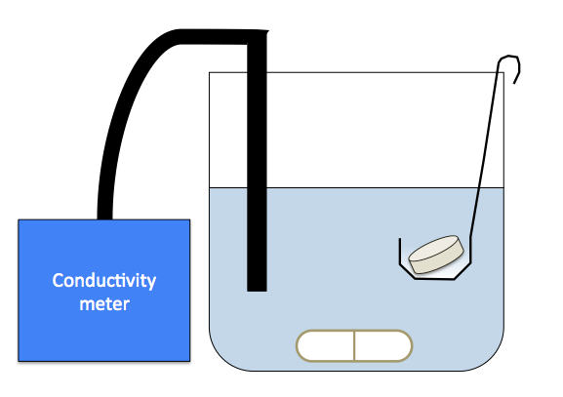
Conductivity probe
Sample tablet in a small basket
Magnetic stirrer
Figure ‎3-12: Set-up of tablet dissolution test.

Tablet hardness test
Tablet hardness testing was carried out by using a Zwick/Roell 0.5 test machine, modified by using an indenter attached to the punch to penetrate the tablet for a certain depth. An indenter with a sharp tip was used for all tests to determine the tablet hardness (Figure ‎3-13), with a test speed of 1 mm/min. The curves of force-displacement were recorded by the PC, and the tablet hardness in this study was calculated using Equation ‎3-12.
$Tablet hardness=\frac{F_{dis}}{S}$
Equation ‎3-12
where F_{dis} is Force at the maximum displacement; S is area correspond to the depth of the indentation.
The lateral surface was then calculated using Equation ‎3-13.
$S=πr\sqrt{r^{2}+h^{2}}$
Equation ‎3-13
where r is radius of the base and h is penetrated height (0.5 mm for all tablets).
60°
6.3 mm
Force
Tablet
Indenter
Zwick/Roell connected to PC
Figure ‎3-13: Indentation of tablet for hardness test.

X-ray tomography
X-ray Desktop come beam microCT was used to scan the samples in this study. It is a non-destructive technique which allows the internal microstructure of a sample to be seen, which in turn helps in understanding the internal structure, from which about how the granule was formed and the distribution of pores. This is achieved through a series of projections which are taken as the sample is rotated between the X-ray source and detector.
For granule scanning, an amount of 0.5 gram granules from a certain condition was gently poured into the sample holder. The x-ray sample holder operated at a voltage of 70 kV, a current of 114 µA and a power of 8W. The voxel size used was 3.5 µm.
The tablets used in the measurement were produced by the Instron, with a diameter approximately 12 mm. For a sample holder, the length of it allows maximum five tablets to be scanned in one measurement.
In addition, when the measurements were finished, the images acquired from the X-ray μCT were analysed using Image J software to determine the porosity of the samples. For the X-ray images, the black pixels in the images were used as an indication of the air (pores) and the white pixels were used as an indication of the powder. By calculating the ratio of the number of black pixels over the total number of pixels, the porosity of the sample for each slice was then obtained.

Effects of process and formulation variables on properties of granules and tablets produced using high shear mixer

Introduction
In this study, the effects of impeller speed and binder amount on granule properties were investigated. The granules were produced in HSM by using melt granulation, with calcium carbonate and PEG 1000 as powder and binder, respectively.
The influence of the size of binder flakes was also studied, as it may affect the final product properties. In this study, three binder sizes (0.5, 1.0 and 2.0 cm in equivalent diameter) were used to produce granules in HSM at 400 rpm.
The granules produced were compressed into tablets at different forces, and the strength of tablets produced by different granule sizes and L/S ratios were measured and compared, which aimed to investigate the significance of the process variables affecting the tablet strength.

Experiment
The experiments were conducted in Roto Junior high shear mixer. For each experiment, the powder used was 1.5 kg and the binder amounts were 180, 195 and 217.5 gram, corresponded to L/S ratios of 0.12, 0.13 and 0.145, respectively. Granules were produced by using three different impeller speeds of 400, 600 and 800 rpm, with tip speed of 5.97, 8.95 and 11.9 m/s, respectively.
The granules were then sieved to different size classes and three size classes (0.18-0.425mm, 0.71-0.85 mm and 1.18-1.4 mm) were chosen to further analyse the granules. The strength of the granules was measured by the Zwick/Roell 0.5 materials testing machine. In the test, a mass of 1.0 gram of granules of the same size class was compressed in a 10 mm die as described in Section ‎3.6. Tests were done individually and repeated for 10 times.
Tablets were produced by the Instron machine at different compression forces of 1, 5, 15 and 29 kN. For each tablet, same mass of granules were used (1.0 gram). During the production of tablet, magnesium stearate was used to lubricate the die to ensure easy ejection of the tablet, especially at high compression forces. The tablets were compressed at a test speed of 10 mm/min. The tensile strength of the tablets was measured by using Zwick/Roell, as described in Section ‎3.10.1. For each individual data point in the diagrams, average of 5 repeats was used.

Results and discussion

Effect of flake size of binder on granule size distribution (GSD)
During the melt granulation in the HSM, the binder was added as solid flakes. One idea was to investigate the effect of the flake size of the binder on the granule properties. The experiments were carried out at an impeller speed of 400 rpm, with 1.5 kg of powder as bed load and L/S=0.13. The PEG 1000 flakes were produced at three diameters: 0.5, 1.0 and 2.0 cm. The binder was added after the bowl temperature reached 50°C, with granulation time of 20 minutes. Here, the width diameter of PEG flake is defined as the width of minimum square aperture, through which the flakes will pass.
The GSD of the batches produced by using different binder sizes is shown in Figure ‎4-1. The q3%/mm in the figure is defined as the volume frequency percentage. From the figure, it can be seen that there is not a significant difference among the batches regarding the size distribution, as a bimodal distribution is found in all of them and the granules produced at all batches are approximately below 2 mm.

Figure ‎4-1: Granule size distribution of HSM 400 rpm with PEG 1000 flakes of three diameters.

The granules produced by using different flake size were compressed into tablets at 1 kN, and the surface feature of the tablets were investigated by using SEM. Figure ‎4-2 shows the surface of tablets produced at 1 kN compression force from granules produced by using different flake sizes. It can be seen that there is no significant difference in the tablet surface features, either the top or bottom of the tablets.
The high similarity of GSD and tablet surface features for all batches is believed to due to the long granulation time (20 minutes), which resulted in entirely melting the binder regardless the size of the flakes.

PEG 0.5 cm:
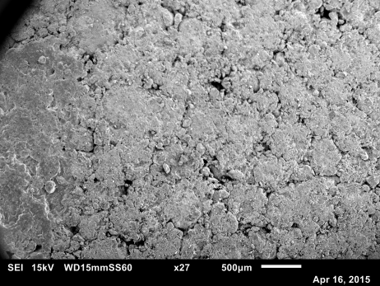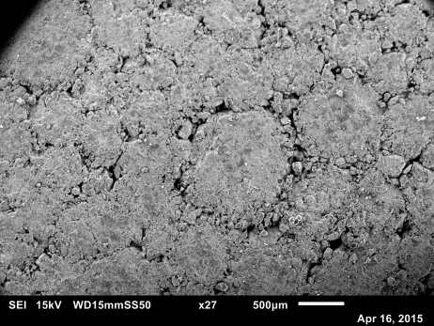
(a) (b)
PEG 1.0 cm:
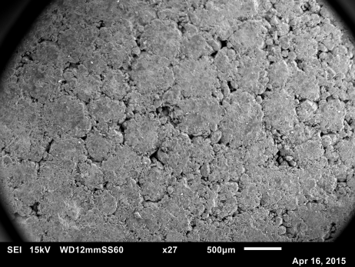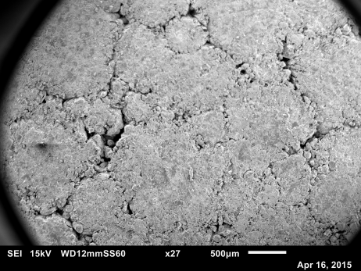
(c) (d)
PEG 2.0 cm:
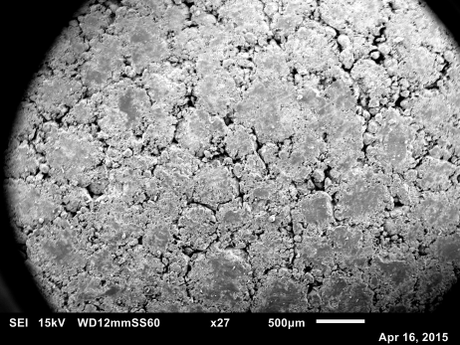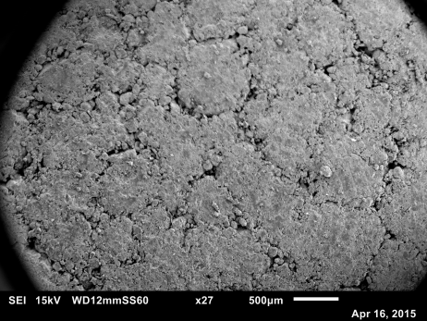
(e) (f)

Figure ‎4-2: Images of HSM 400 rpm tablets produced by three sizes of flake binder: PEG 0.5 cm (a) top and (b) bottom; PEG 1.0 cm (c) top and (d) bottom, and PEG 2.0 cm (e) top and (f) bottom, L/S=0.13 at 1 KN

Effect of impeller speed and L/S ratio on GSD
To investigate the effect of impeller speed and L/S ratio on GSD, three impeller speeds (400, 600 and 800 rpm) and three L/S ratios (0.12, 0.13 and 0.145) were used.
The size distribution of granules produced in HSM at 400 rpm is shown in Figure ‎4-3. It can be noted in Figure ‎4-3 that the maximum granule size in a batch was below 3 mm. At L/S=0.12 and 0.13, most of the granules are in the range of 0.2-1.7 mm, while for L/S=0.145, the curve shifted to the right, indicating larger granules which were in the range of 0.5-2.0 mm. This means that the granule size increased with an increase in L/S ratio (the amount of binder). At this impeller speed (400 rpm), it is believed the granule size is more likely dominated by the binder amount.
The size distribution of granules produced at 600 rpm in HSM is displayed in Figure ‎4-4. It can be seen that the increase in L/S ratio resulted in a significant increase in granule size, which evidenced by the shift of the curves from left to right in Figure 4-4. The increase in the granule size with increasing L/S ratio was more obvious when 600 rpm (compared to 400 rpm) is used. This indicates that at 600 rpm, the influence of impeller speed was more dominant than the influence of the amount of binder.

Figure ‎4-3: GSD of HSM 400 rpm at three L/S ratios

Figure ‎4-4: GSD of HSM 600 rpm at three L/S ratios

Figure ‎4-5: GSD of HSM 800 rpm at three L/S ratios
The size distribution of granules produced at 800 rpm in HSM is shown in Figure ‎4-5. Figure ‎4-5 shows that for all L/S ratios, the size distribution becomes broader and migrated towards a range of more size classes. The most obvious change is noticed at L/S=0.12, as the first data point appears at approximately 0.4 mm on the GSD, which indicates that the amount of small granules and fines is reduced and converted into granules of moderate sizes when L/S ratio increased.
Moreover, it is seen that the granules produced by L/S=0.12 has a bimodal distribution at impeller speed 400 and 600 rpm, while at 800 rpm the GSD becomes monomodal. This is believed to be due to the fact that the amount of binder at L/S=0.12 is insufficient, which makes it difficult for the whole batch to grow at 400 and 600 rpm. Therefore, it resulted in producing a bimodal GSD. At 800 rpm, although the binder amount is the same, the impeller speed was high enough to distribute the binder evenly and thus produced a monomodal GSD. However, using the L/S ratio of 0.13 and 0.145 resulted in a monomodal GSD at all impeller speeds used. This indicates that the amount of binder was sufficient and the particles have enough chances to coalescence and form relatively larger granules and monomodal GSD.
The effect of impeller speed on granule size distribution at different L/S ratios is shown in Figure ‎4-6, Figure ‎4-7 and Figure ‎4-8. Generally, it is found that at the same L/S ratio, the batch produced using the highest impeller speed contains higher amount of large granules, evidenced from the shift of curves from left to right in all figures. Increasing the impeller speed increases the changes of granules collision, and thus increases the granule size. The results were consistent with previous studies (Lee et al., 2013, Mangwandi et al., 2010, Wade et al., 2015, Chitu et al., 2011).

Figure ‎4-6: Effect of impeller speed on granule size distribution at L/S=0.12

Figure ‎4-7: Effect of impeller speed on granule size distribution at L/S=0.13

Figure ‎4-8: Effect of impeller speed on granule size distribution at L/S=0.145

Granule strength at varied impeller speed and L/S ratios
The granule strength is measured by Zwick/Roell test machine as described in Section ‎3.6. The strength of granule produced at 400, 600 and 800 rpm are shown in Figure ‎4-9, Figure ‎4-10 and Figure ‎4-11, respectively. It can be seen from the figure that increasing the impeller speed causes an increase in the granule strength. This is due to the fact that increasing the impeller speed results in better binder distribution. It also causes more consolidation and higher stress to be applied on the granules, which squeezes out more binder from the inside of granules to the granule surface. This results in a higher compaction of granules, and consequently, increases the granule strength.
The results in the figures also show that at all impeller speeds, the granules produced with higher L/S ratio are stronger than those produced with lower L/S ratio. This is because more binder means more areas of particle surface will be wetted (or covered) by the binder, and this creates more liquid bridges between the particles, which leads to a higher granule strength.
It can also be seen in the figures that at all impeller speeds, the granules of large size class are always stronger than those of small size class. This is due to the higher amount of binder which is expected to exist in the large granules, which resulted in more liquid bridges and results in stronger granules.

Figure ‎4-9: Bulk granule strength of HSM 400 rpm at three L/S ratios, with three size classes.

Figure ‎4-10: Bulk granule strength of HSM 600 rpm at three L/S ratios, with three size classes.

Figure ‎4-11: Bulk granule strength of HSM 800 rpm at three L/S ratios, with three size classes.

Binder distribution of HSM granules
The amount of binder in the granules of different size classes was measured by heating the granules in a furnace and measuring the weight before and after. In the test, a mass of 1 gram (marked as m₁) of granules from the same size class was weighted and placed in a ceramic crucible, which was heated in a furnace at 500°C for approximately 1 hour to burn the PEG 1000 inside the granules. When the test is finished, the residues in the crucible are weighted again (marked as m₂). The loss in mass is considered to be the mass of PEG 1000, and it is calculated by:
Mass of polyethylene glycol = m₁-m₂
Figure ‎4-12 shows the mass of PEG 1000 in each size class of granules produced using 400 rpm. Generally, it was found that for the same size class, the granules produced at the lowest L/S ratio contain the lowest amount of binder. With regard to the granule size, it was found that the granules of large sizes have a higher loss in mass, indicating that the amount of binder was higher than the small size of granules. Similar trend was also observed when higher impeller speed was used, as shown in Figure ‎4-13 and Figure ‎4-14.

Figure ‎4-12: Binder amount test of HSM 400 rpm granules at three L/S ratios, with three size classes at each L/S

Figure ‎4-13: Binder amount test of HSM 600 rpm granules at three L/S ratios, with three size classes at each L/S

Figure ‎4-14: Binder amount test of HSM 800 rpm granules at three L/S ratios, with three size classes at each L/S

Tablet strength at varied binder amount and compression force
The strength of tablets produced at 1 kN from granules produced at 400, 600 and 800 rpm with different granule sizes and binder amount are shown in Figure ‎4-15, Figure ‎4-16 and Figure ‎4-17, respectively. From the figures, it can be seen that the tablets made of large granules were generally weaker than those made of small granules. The tablets of the highest strength are the ones made from the size range of 0.18-0.425 mm. The smaller the granule, the higher the surface area, which is increases the bonding between the granules. This means that larger granules will have less contact points in comparison to the smaller size. Therefore, the tablets are weaker.
It can be seen from the figures that at all size classes and all impeller speeds, increasing the L/S ratio during granulation increases the final tablet tensile strength. The strongest tablets were for granules produced from the L/S ratio of 0.145. This indicates that at low compression force during tabletting (1 kN), the tablet tensile strength is dominant by the L/S ratio. The low compression force 1 kN caused limited breakage and deformation of the granules during tableting regardless the size of the granules, as can be seen in the SEM images in Figure ‎4-18. The figure is showing the SEM images of tablet compressed at 1 kN from granules produced at 400 rpm and L/S=0.13. It is seen in these images that at this compression force, the tablet surfaces made of different sizes of granules are still distinguishable. It can also be noticed that the gaps between granules on the tablet surface are larger when compressing the large granules, which made the tablets weaker.
The impeller speed is shown to have an insignificant effect on the tablet tensile strength when compressing at 1 kN.

Figure ‎4-15: Tablet strength of HSM 400 rpm at three L/S ratios at 1 kN

Figure ‎4-16: Tablet strength of HSM 600 rpm at three L/S ratios at 1 kN

Figure ‎4-17: Tablet strength of HSM 800 rpm at three L/S ratios at 1 kN
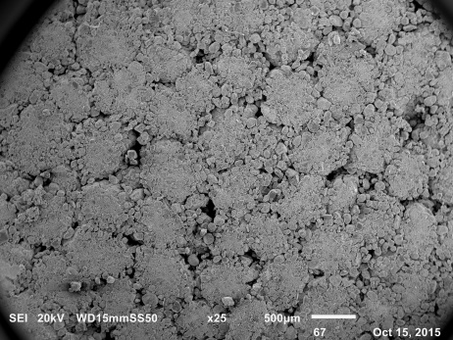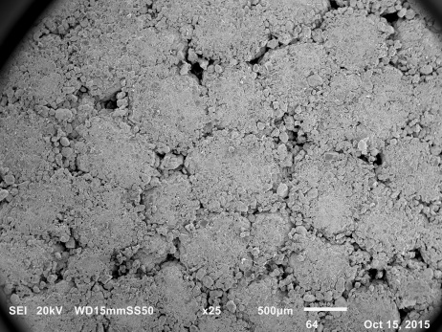
(a) (b)
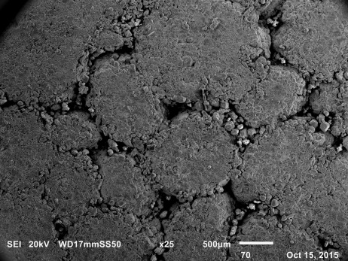
(c)
Figure ‎4-18: SEM images of HSM 400 rpm tablets compressed at 1 kN (a) 0.18-0.425 mm, (b) 0.71-0.85 mm and (c) 1.18-1.4 mm, L/S=0.13.
Figure ‎4-19, Figure ‎4-20 and Figure ‎4-21 show the tensile strength of tablet compressed at 5 kN from granules produced at different impeller speeds. The tensile strength of tablet has increased by approximately 50% at 5 kN compared to that compressed at 1 kN.
By comparing the results of tablet strength at 5 kN, it is found that although the tablets are getting stronger, the trend of tablet strength with different L/S ratios has become different. At the same granule size class, it is seen that the tablets produced by L/S=0.12 are always stronger than those produced by L/S=0.13 and 0.145. At this compression force, the strength of the granules will play an important role. It was found in Section ‎4.3.3 that increasing the L/S ratio increases the granule strength. This will have an effect on the tablet strength as weaker granules will show more breakage and therefore, higher surface area for bonding consequently for strong tablets.
The effect of granule size at 5 kN is similar to that of 1 kN, which is shown in the figures as the larger the granule size, the lower the tablet strength.
The SEM images of tablets compressed at 5 kN are shown in Figure ‎4-22 (a), (b) and (c), with an impeller speed of 400 rpm and L/S=0.13. Compared to the images in Figure ‎4-18, it is found that the tablets compressed at 5 kN have smoother surfaces, evident that the total area of gaps between granules have reduced. In Figure ‎4-22 (a) and (b), it is found that the edges of granules of 0.18-0.425 mm and 0.71-0.85 mm have become unclear; while the edges of granules of 1.18-1.4 mm partially remain. The reason of this is attributed to the granule strength, as the large granules are able to withstand higher compression forces before they lose their granule structure.

Figure ‎4-19: Tablet strength of HSM 400 rpm at three L/S ratios at 5 kN

Figure ‎4-20: Tablet strength of HSM 600 rpm at three L/S ratios at 5 kN

Figure ‎4-21: Tablet strength of HSM 800 rpm at three L/S ratios at 5 kN

- (b)
(c)
Figure ‎4-22: SEM images of HSM 400 rpm tablets compressed at 5 kN (a) 0.18-0.425 mm, (b) 0.71-0.85 mm and (c) 1.18-1.4 mm, L/S=0.13.
Figure ‎4-23, Figure ‎4-24 and Figure ‎4-25 show the tensile strength of tablet compressed at 15 kN from granules produced at different impeller speeds. At this compression force, the tablet strength of all conditions has increased compared to 1 and 5 kN. The most significant increase in tablet strength is found at 400 rpm with the granule size class of 0.18-0.425 mm, where the tablet strength increased from 0.31 MPa when compressed at 5 kN, to 0.56 MPa when compressed at 15 kN. The effects of binder amount and granule size on tablet strength are identical to that at 5 kN. Tablets made of small sizes of granules and low binder amount have higher strength than those made of large sizes of granules and high binder amount due to greater granule deformation and breakage of granules, resulting the formation of strong tablets.
In addition, the effect of granule strength has become obvious in affecting the tablet strength, as in most cases the trend of tablet strength at different conditions can be explained by the trend of granule strength at different conditions (Section ‎4.3.3).
The SEM images of HSM tablets compressed at 15 kN are shown in Figure ‎4-26 (a), (b) and (c), with an impeller speed of 400 rpm and L/S=0.13. From the images, it is found that the differences of tablet surfaces of different granule size classes have been minimized; as the tablet surfaces at all conditions become smoother than those of 5 kN. While for the tablet surfaces made of granule size classes of 0.18-0.425 mm and 0.71-0.85 mm showing no significant difference, the tablet surface made of granule size class of 1.18-1.4 mm is still found to have some tiny black dots distributed, which is believed to be the remaining gaps between granules. This indicates that the large granules are not entirely broken into fractures when compressed at high compression forces, and thus their tablet strength is lower due to lower degree of compression than the tablets made of small granules.

Figure ‎4-23: Tablet strength of HSM 400 rpm at three L/S ratios at 15 kN

Figure ‎4-24: Tablet strength of HSM 600 rpm at three L/S ratios at 15 kN

Figure ‎4-25: Tablet strength of HSM 800 rpm at three L/S ratios at 15 kN

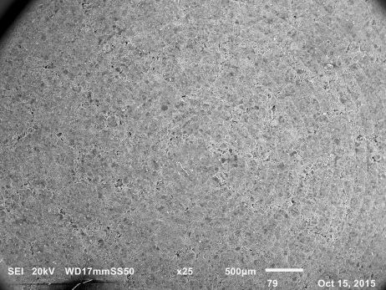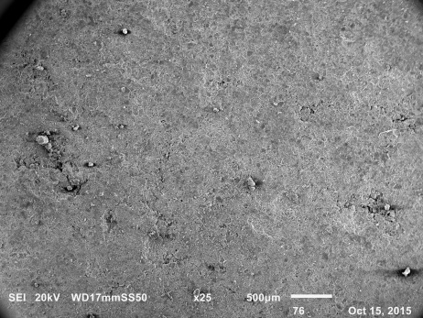
(a) (b)
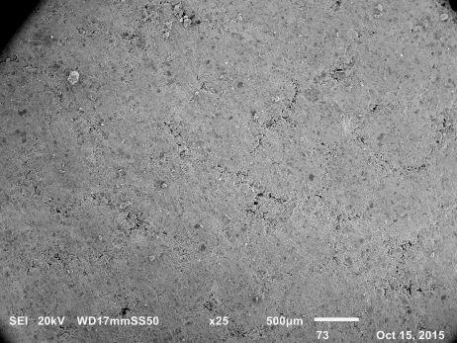
(c)
Figure ‎4-26: SEM images of HSM 400 rpm tablets compressed at 15 kN (a) 0.18-0.425 mm, (b) 0.71-0.85 mm and (c) 1.18-1.4 mm, L/S=0.13.
Figure ‎4-27, Figure ‎4-28 and Figure ‎4-29 show the tensile strength of tablet compressed at 29 kN from granules produced at different impeller speeds. It is seen that the tablet strength has further increased compared to that compressed at 15 kN. However, the increase is limited as in Figure ‎4-27, the highest tablet strength is obtained at the size class of 0.18-0.425 mm at L/S=0.12, with a value of 0.63 MPa, which is slightly higher than that of the same condition compressed at 15 kN, 0.56 MPa. This indicates that the compressibility of the granules produced by using HSM has almost reached the maximum, supported by that the values of tablet strength of different granule size classes are getting closer.

Figure ‎4-27: Tablet strength of HSM 400 rpm at three L/S ratios at 29 KN

Figure ‎4-28: Tablet strength of HSM 600 rpm at three L/S ratios at 29 KN

Figure ‎4-29: Tablet strength of HSM 800 rpm at three L/S ratios at 29 KN

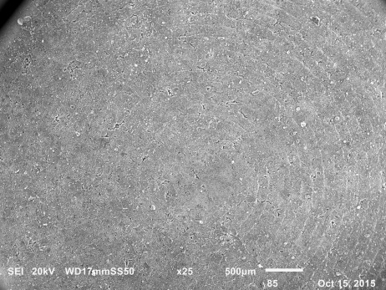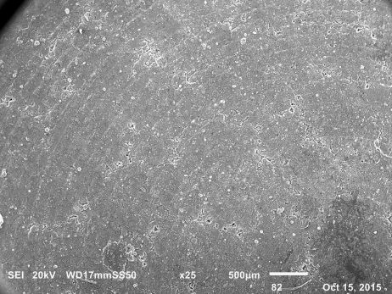
(a) (b)
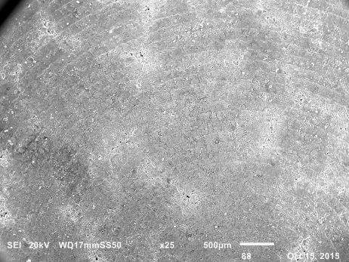
(c)
Figure ‎4-30: SEM images of HSM 400 rpm tablets compressed at 29 kN (a) 0.18-0.425 mm, (b) 0.71-0.85 mm and (c) 1.18-1.4 mm, L/S=0.13.
At high compression force of 29 kN, the tensile strength of the tablets is affected by the strength of the granules. Increasing the liquid to solid ratio during the granulation resulted in stronger granules as see in Section ‎4.3.3. Compressing the weak granule results in more breakage and deformation during tableting, which produces strong tablets.
The SEM images of HSM tablets compressed at 29 kN are shown in Figure ‎4-30 (a), (b) and (c), with an impeller speed of 400 rpm and L/S=0.13. From the images, it is seen that there is no apparent difference of the tablet surfaces of different granule size classes. At this compression force, the granules from all size classes have broken into fractures, so that the tablets of all conditions are highly compacted and the tablet surface is very dense.
In addition, it is worth mentioning that during the compression of granules at high force (29 kN), a phenomenon defined as “binder movement” in this study, was observed as the solid binder was squeezed as liquid from both the top and bottom surfaces of tablets; whereas this was not seen during the tabletting at lower compression forces.

Conclusion
In this chapter, the effects of process and formulation parameters on granule and tablet properties in HSM have been investigated. Granules at different binder flake size, impeller speed, L/S ratio were produced and then compressed into tablets at different compression forces.
It was found that the binder flake size has no effect on the granule properties, as the granulation time was relatively long. For the effect of impeller speed, it was found that the granules produced by high impeller speed were larger and stronger than those produced by low impeller speed. The strength of granules was also found to be affected by the size of the granules, as the strength of large sizes granules was higher than those of small sizes. The granule size and strength was also found to be affected by the L/S ratio, as an increase in the L/S ratio increases the size and strength of the granules.
Increasing the compression force during tableting increases the tablet tensile strength. It was found that at low compression force, the tablet strength was determined by the L/S ratio which was used during granulation. However, at high compression force, the tablet strength was found to be determined by the granule strength, as the higher the granule strength, the weaker the tablet strength. At very high compression force of 29 kN, a phenomenon called “binder movement” was observed during tableting, where the binder was squeezed out from the inside of the tablets to their outer surface. This phenomenon was considered to have attributed to the binder content inside tablets, as it was more likely to be observed during tablet compression at high L/S ratios.

effects of process and formulation variables on properties of granules and tablets produced using fluidized bed granulator

Introduction
In this study, the effects of air velocity and binder amount on granule properties were investigated. The granules were produced in FBG by using melt granulation at varied air velocity (0.73, 0.97 and 1.21 m/s) and L/S ratios (0.12, 0.13 and 0.145), with calcium carbonate and PEG 1000 as powder and binder.
The granules were sieved into different size classes and three size classes were chosen for further analysis. The strength of granule of different size classes was measured by using the Zwick/Roell 0.5 materials testing machine, as described in Section ‎3.6.
The tablets were made by compressing granules at different compression forces, and the strength of the tablet was measured as described in Section ‎3.10.1.

Experiment
Glatt AG Schweiz top-spray fluidized bed granulator was used for granulation. As the PEG 1000 flakes may not be fluidized properly in the bed, the binder addition method was selected as spray-on.
The powder was pre-heated inside the FBG at 50°C. During this process, the inlet air velocity was controlled to be at its minimum value (referred to the minimum velocity which was able to agitate the powder), as the primary powder was very fine. If the dry powder was over-fluidized, the chance of powder escape was likely to happen and as a result, the L/S ratio would be inaccurate.
The PEG 1000 was first melted using a hot plate and then transported to the FBG using a specially built control unit, as illustrated in Section ‎3.4. The unit heats up the pipes which connected to the pump to 50°C, ensuring no blockage occurred in the pipe during binder transportation.

Results and discussion

Granule size distribution at 0.73, 0.97 and 1.21 m/s at different L/S ratios
The GSD of FBG at air velocity of 0.73, 0.97 and 1.21 m/s is shown in Figure ‎5-1 Figure ‎5-2 and Figure ‎5-3, respectively. In Figure ‎5-1 and Figure ‎5-2, it is seen that the majority of the granules produced by air velocity 0.73 and 0.97 m/s are below 2 mm, while for air velocity 1.21 m/s, a notable amount of granules larger than 2 mm are produced. This indicates that an increase in air velocity has increased the granule growth, as the granules produced by using higher air velocity have a larger size than those produced by using lower air velocities, as the curves of size distribution shifted from left to right in all results.
The binder amount was found to have an effect on the granule size distribution. At the same air velocity, it is found that the granule size generally increased with an increase in binder amount. This means that the higher the binder amount, the more chances for the granules to adhere each other due to the existence of cohesive binder.

Figure ‎5-1: GSD of FBG AV=0.73 m/s at different L/S ratios

Figure ‎5-2: GSD of FBG AV=0.97 m/s at different L/S ratios

Figure ‎5-3: GSD of FBG AV=1.21 m/s at different L/S ratios

Bulk granule strength at varied binder amount in FBG
The strength of granules produced in the FBG at 0.73, 0.97 and 1.21 m/s is shown in Figure ‎5-4, Figure ‎5-5 and Figure ‎5-6, respectively. In terms of granule size, it is found that the granules produced at 1.18-1.4 mm are stronger than those produce at 0.18-0.425 mm. This means that the larger the granule size, the stronger the granules. This is similar to the conclusions of HSM granule strength (Section ‎4.3.3). This is due to the fact the large granules will have more binder content than the small granules, as will be seen in the next section.
From the results, it is seen that the granule strength increased with an increase in air velocity during granulation. As the formation of granules is mainly dependent on the extent of coalescence, it is then assumed that at high air velocity, the granules are close to the binder spray zone and this enables the granules to capture more fine binder droplets in FBG. As a result, the particles at high air velocity have a higher chance to coalesce to more particles, which as a result, forming a granule containing more particles and binder.
The strength of granule was found to increase with increasing in L/S ratio at all air velocities. This is because of the fact that an increase in L/S ratio increases the amount of binder which helps create more liquid bridges between particles. Therefore, the strength of granule has increased.
It is also noticed that the granules produced by FBG (as shown in Figure ‎5-4, Figure ‎5-5 and Figure ‎5-6) are weaker than those produced by HSM at the same L/S ratio (as shown in Figure ‎4-9, Figure ‎4-10 and Figure ‎4-11). The reason is attributed to the different mechanisms of two pieces of equipment. In HSM, the granules are densified by the agitation of impeller which ends up with high consolidated granules; whereas the granules in FBG are agitated and fluidized by the inlet air, and the formation of granules is dependent on the coalesce since there is no consolidation. In addition, during the granulation in FBG, there is a chance of binder loss due to the fluidizing air, which is not the case in HSM. As a result, the granules produced by using HSM are usually stronger than those produced by using FBG.

Figure ‎5-4: Bulk granule strength of FBG 0.73 m/s at different L/S ratios, with three size classes at each L/S

Figure ‎5-5: Bulk granule strength of FBG 0.97 m/s at different L/S ratios, with three size classes at each L/S

Figure ‎5-6: Bulk granule strength of FBG 1.21 m/s at different L/S ratios, with three size classes at each L/S

Binder distribution of FBG granules
The amount of binder in the granules of different size classes was measured by heating the granules in a furnace and measured the weight loss. The test is similar to the binder amount test in Section ‎4.3.4, as a mass of 1 gram (marked as m₁) of granules from the same size class was weighted and placed in a ceramic crucible, which was heated in a furnace at 500°C for approximately 2 hours to burn the PEG 1000 inside the granules. When the test is finished, the residues in the crucible are weighted again (marked as m₂). The loss in mass is considered to be the mass of PEG 1000, and it is calculated by:
Mass of polyethylene glycol = m₁-m₂
The PEG 1000 amount in each granule size class at varied L/S ratios and air velocities are shown in Figure ‎5-7, Figure ‎5-8 and Figure ‎5-9, respectively. From the results, it is seen that in most of the cases, the large granules have more binder content than the small granules, whilst the granules produced with high L/S ratio also contain more binder content.
By comparing the binder amount of the granules with the same size class and L/S ratio but at different air velocities, it is found that increasing the air velocity increases the amount of binder slightly. This supported the result of FBG granule strength in Section ‎5.3.2, as the granules at high air velocity were found to be stronger than those at low air velocity.
However, when comparing the results to the HSM granules (Section ‎4.3.4), it is seen that at the same granule size and L/S ratio, the HSM granules contain more binder than that of the FBG granules. This is attributed to the loss of binder during the fluidization in the FBG, as some binder escapes the system with the outlet air, which results in a reduction of binder amount in the granules.

Figure ‎5-7: Binder amount test of FBG 0.73 m/s granules at three L/S ratios, with three size classes at each L/S.

Figure ‎5-8: Binder amount test of FBG 0.97 m/s granules at three L/S ratios, with three size classes at each L/S.

Figure ‎5-9: Binder amount test of FBG 1.21 m/ granules at three L/S ratios, with three size classes at each L/S.

Tablet strength at varied binder amount and compression force in FBG
The tablet strength of FBG 0.73, 0.97 and 1.21 m/s at 1 kN with three L/S ratios is shown in Figure ‎5-10, Figure ‎5-11 and Figure ‎5-12. It is seen in these results that the tablet strength is generally lower than 0.2 MPa, indicating that the tablets are very weak at this compression force.
It is observed in the results that when the tablets are compressed at 1 kN, the tablet strength is determined by the L/S ratio used during the production of the granules in FBG, as the increase in the L/S ratio during granulation resulted in a slight increase in the tablet tensile strength.
Moreover, the tablet strength at this compression force is also found to have been slightly affected by the air velocity. As seen in Figure ‎5-10, Figure ‎5-11 and Figure ‎5-12, at the same L/S ratio and granule size class, the tablets made of granules of low air velocity have higher strength than those of high air velocity. This can be linked to the granule strength, as presented in Section ‎5.3.2 in that the granules produced by using low air velocity are weaker. Therefore, it will be compressed more during tabletting and results in stronger tablets.
It can be concluded that the tablet strength at 1 kN in FBG is showing a similar trend of the tablet strength in HSM at 1 kN, where the tablets were found to have a higher strength with more binder amount. This indicates that the tablet strength for HSM and FBG is dominated by the binder amount when the tablets are compressed by using low force.
The SEM images of FBG tablets compressed at 1 kN are shown in Figure ‎5-13 (a), (b) and (c), with an air velocity of 0.97 m/s and L/S=0.13. Compared to the SEM images of HSM tablets produced by using the same L/S ratio and compressed at the same comression force (Figure ‎4-18), it can be seen that tablets of FBG contains less pores compared to the HSM tablets. This indicated that more breakage occurred with FBG granules during tabletting as the granules were weaker compared to HSM.

Figure ‎5-10: Tablet strength of FBG at three L/S ratios at 1 kN, AV=0.73 m/s.

Figure ‎5-11: Tablet strength of FBG at three L/S ratios at 1 kN, AV=0.97 m/s.

Figure ‎5-12: Tablet strength of FBG at three L/S ratios at 1 kN, AV=1.21 m/s.

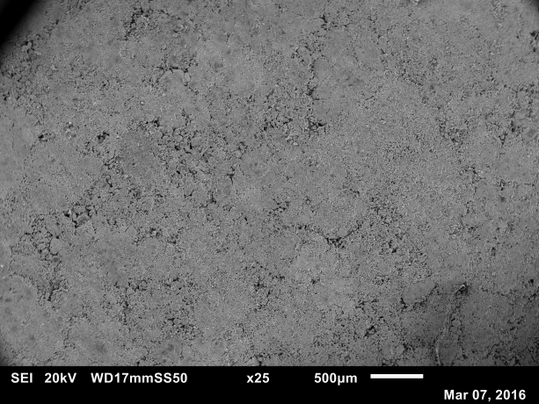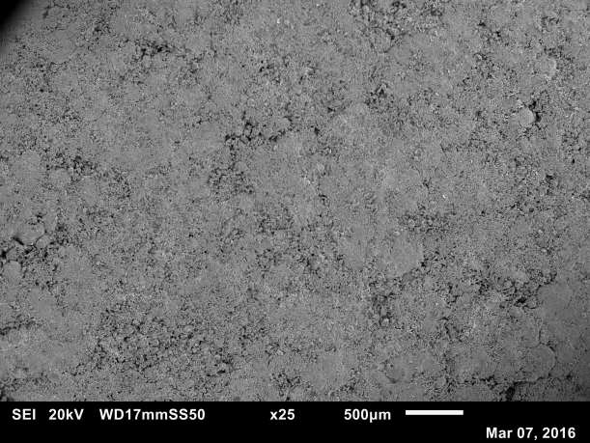
(a) (b)
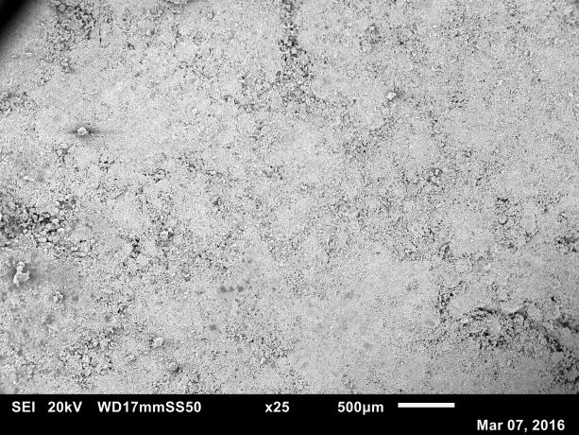
(c)
Figure ‎5-13: SEM images of FBG AV=0.97 m/s tablets compressed at 1 kN (a) 0.18-0.425 mm, (b) 0.71-0.85 mm and (c) 1.18-1.4 mm, L/S=0.13.
The tablet strength of FBG 0.73, 0.97 and 1.21 m/s at 5 kN with three L/S ratios is shown in Figure ‎5-14, Figure ‎5-15 and Figure ‎5-16. It is seen that compared to the tablets compressed at 1 kN, the tablet strength compressed at 5 kN has increased significantly at all size classes and air velocities.
At this compression force, it is found that the L/S ratio has a negative effect on the tablet strength, which is evident from the figures that at all air velocities; the tablets made of the granules with higher L/S ratio have lower strength than those with lower L/S ratios. The results are shown to be similar to those of HSM tablet strength at 5 kN (Figure ‎4-19, Figure ‎4-20 and Figure ‎4-21), as the tablet strength decreased with an increase in L/S ratio.
Granule size was also found to affect the tensile strength of the tablet. As seen in all figures, the tablets made of granule size class 1.18-1.4 mm are weaker than those of 0.18-0.425 mm and 0.71-0.85 mm. This is due to the difference in the granule strength as larger granules were stronger (Section ‎5.3.2) which would show less breakage during compression and resulted in weaker tablets.
The air velocity continues to have a limited influence on tablet strength when the tablets are produced by 5 kN, as it is seen in the figures that the tablet strength varied in a limited range.
By comparing the tablets of HSM and FBG compressed at 5 kN, it is found that there is a small difference regarding the tablet strength.
The SEM images of FBG tablets compressed at 5 kN are shown in Figure ‎5-17 (a), (b) and (c), with an air velocity of 0.97 m/s and L/S=0.13. Compared to the SEM images of HSM tablets produced by using the same L/S ratio and compressed at the force (Figure ‎4-22), it is noticed that the surface of tablets of FBG is smoother and contain less pores compared to those of HSM tablets. As shown in Figure ‎4-22 the edges of HSM granules are still visiable, indicating that the degree of fragmentation of granules of HSM is less than that of the FBG.

Figure ‎5-14: Tablet strength of FBG at three L/S ratios at 5 kN, AV=0.73 m/s.

Figure ‎5-15: Tablet strength of FBG at three L/S ratios at 5 kN, AV=0.97 m/s.

Figure ‎5-16: Tablet strength of FBG at three L/S ratios at 5 kN, AV=1.21 m/s.

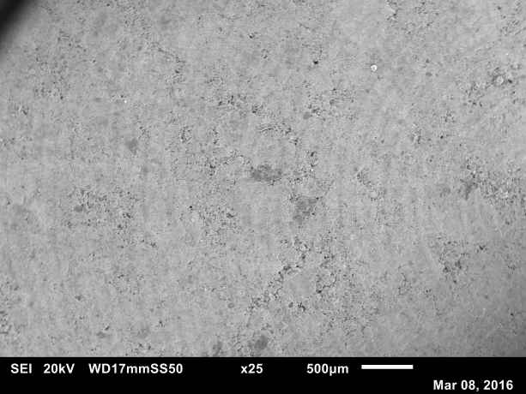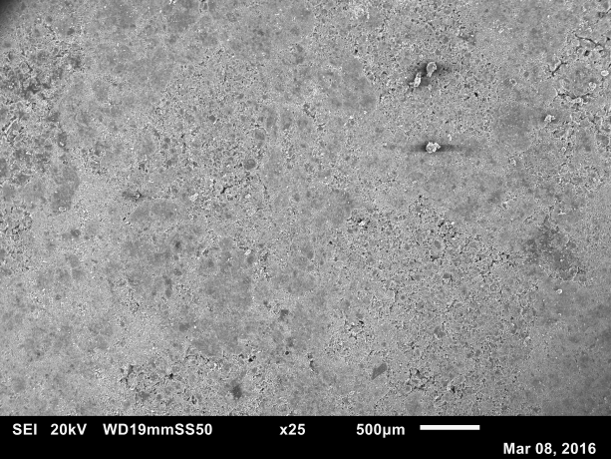
(a) (b)
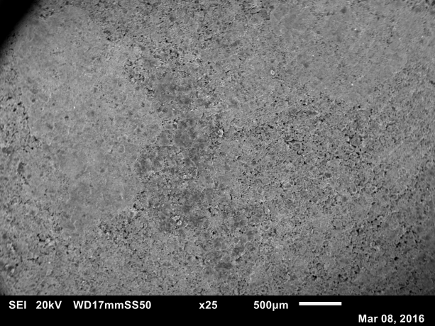
(c)
Figure ‎5-17: SEM images of FBG AV=0.97 m/s tablets compressed at 5 kN (a) 0.18-0.425 mm, (b) 0.71-0.85 mm and (c) 1.18-1.4 mm, L/S=0.13.
A remarkable increase in tablet strength was noticed when granules of FBG are compressed at 15 kN, which are shown in Figure ‎5-18, Figure ‎5-19 and Figure ‎5-20. Compared to the tablets produced at 5 kN, it is found that although the tablet strength has increased greatly, the trend of tablet strength with changing granule size and L/S ratio is still consistent with the trend of tablet strength at 5 kN.
The tablet tensile strength was found to decrease with increasing the air velocity during granulation. The strongest tablets were found to be for the granules produced at 0.73 m/s of air velocity. This again is due to the strength of granules, as air velocity of 0.73 m/s produced the weakest granules which would then undergo more breakage during compression. This will result in more surface area available for bonding between the fragments, which results in strong tablets.
Compared the tablets produced by using the granules in HSM at the same compression force, it is found that the FBG tablets are stronger. This again is linked to the correlation between granule strength and tablet strength, as the HSM granules are generally stronger than those produced by FBG so that the tablets of FBG are usually stronger than the HSM tablets at the same compression force due to higher degree of compression.
The SEM images of FBG tablets compressed at 15 kN are shown in Figure ‎5-21 (a), (b) and (c), with an air velocity of 0.97 m/s and L/S=0.13. Compared to the SEM images of HSM tablets at 15 kN (Figure ‎4-26), it is seen that the FBG tablet surfaces are smoother than the HSM tablet surfaces, as some dark dots (which is considered as the remained area of gaps between granules) in Figure ‎4-26 can still be distingushed; whereas the tablet surafaces of FBG are seen to be quite dense. At this compression force, it is estimated that the granules of FBG are all broken into fragments.

Figure ‎5-18: Tablet strength of FBG at three L/S ratios at 15 kN, AV=0.73 m/s.

Figure ‎5-19: Tablet strength of FBG at three L/S ratios at 15 kN, AV=0.97 m/s.

Figure ‎5-20: Tablet strength of FBG at three L/S ratios at 15 kN, AV=1.21 m/s.

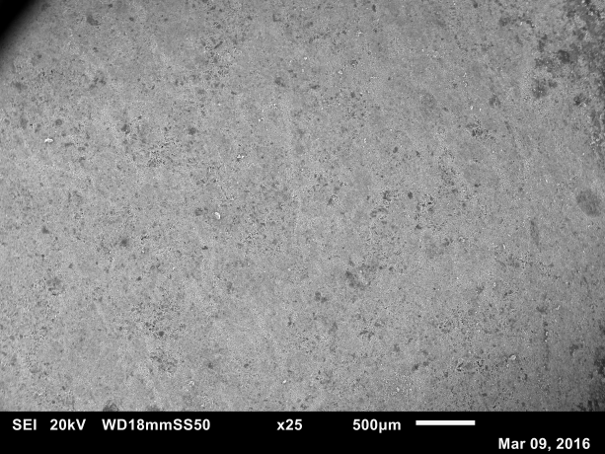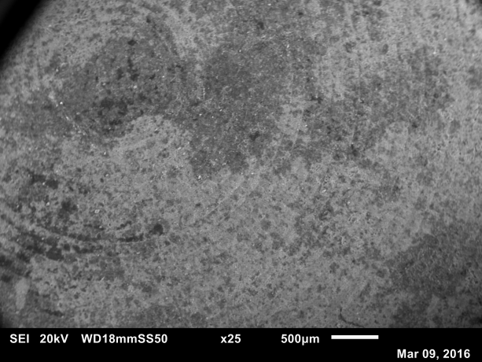
(a) (b)
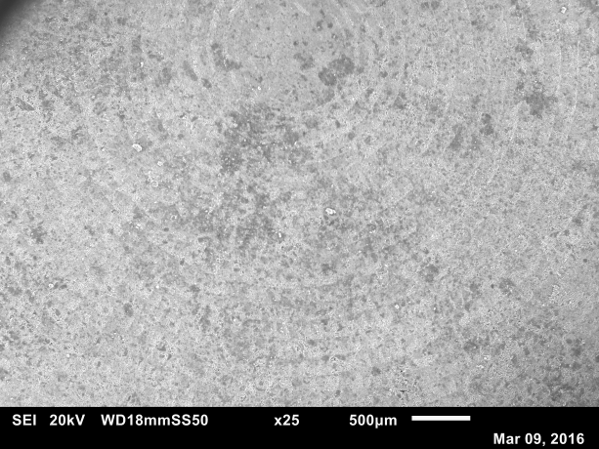
(c)
Figure ‎5-21: SEM images of FBG AV=0.97 m/s tablets compressed at 15 kN (a) 0.18-0.425 mm, (b) 0.71-0.85 mm and (c) 1.18-1.4 mm.
The tablet strength of FBG compressed at 29 kN is shown in Figure ‎5-22, Figure ‎5-23 and Figure ‎5-24. At this compression force, the highest tablet strength is approximately 1.17 MPa obtained at L/S=0.12 with size class of 0.18-0.425 mm at air velocity of 0.73 m/s.
The trend of tablet strength still follows the previous trends (at 5 and 15 kN), as the tablets produced by using the granules of low air velocity have higher strength than those produced by using the granules of high air velocity. In terms of the effect of L/S ratio and granule size, it is seen that the tablets produced by using the granules of low L/S ratio mostly have higher strength.
Though the tablet strength continues to increase when the compression force increases from 15 to 29 kN, it is noticed that the extent of increase is not as much as the tablets compressed from 5 to 15 kN, especially for the tablets produced by air velocity 0.73 m/s, which is showing a relatively limited increase in tablet strength compared to the tablets produced by the other two air velocities. This indicates that the tablets produced by air velocity 0.73 m/s have almost reached their maximum degree of compression.
As the tablets produced by FBG granules are shown to have much higher strength than those produced by HSM granules at high compression force, it is suggested that with a certain formulation of powder and binder, the HSM can be used to produce strong granules and weak tablets; while the FBG can be used to produced weak granules and strong tablets.
The SEM images of FBG tablets compressed at 29 kN are shown in Figure ‎5-25 (a), (b) and (c), with an air velocity of 0.97 m/s and L/S=0.13. Compared to the SEM images of HSM tablets at 29 kN (Figure ‎4-30), it is found that the tablet surfaces of both HSM and FBG are very smooth, indictaing that the granules of both pieces of equipment entirely broken into fragments. So it is concluded that at very high compression force, the tablet surafaces of HSM and FBG will be showing no significant difference, as the effects of other variables on tablet strength have been eliminated.
In addition, the phenomenon named “binder movement” (which is mentioned at the end of Section ‎4.3.5) was observed when the FBG granules were compressed into tablets at 29 kN. In order to investigate the its effect on tablet properties, the tablet hardness test is added to this study (Chapter 6), which is accomplished by using the Zwick/Roell material test machine, by adjusting an indenter to penetrate the centre of the tablets.

Figure ‎5-22: Tablet strength of FBG at three L/S ratios at 29 kN, AV=0.73 m/s.

Figure ‎5-23: Tablet strength of FBG at three L/S ratios at 29 kN, AV=0.97 m/s.

Figure ‎5-24: Tablet strength of FBG at three L/S ratios at 29 kN, AV=1.21 m/s.

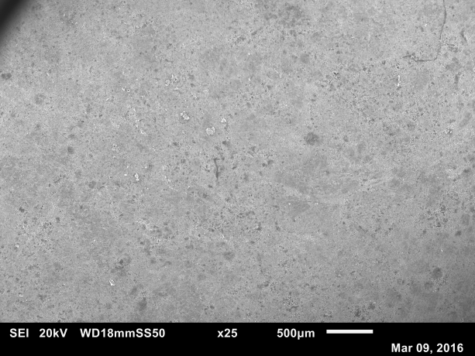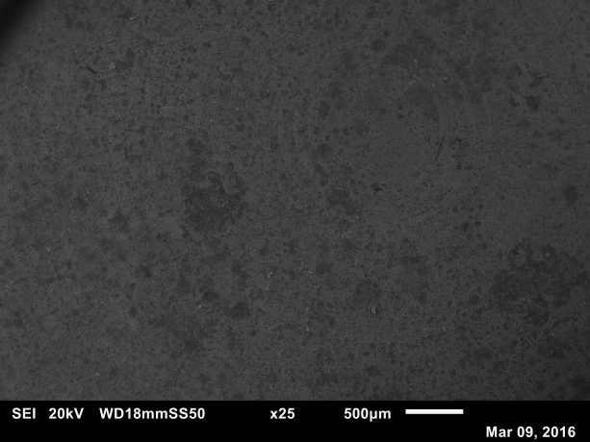
(a) (b)
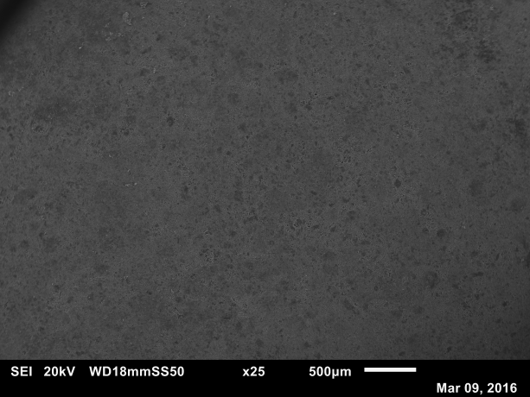
(c)
Figure ‎5-25: SEM images of FBG AV=0.97 m/s tablets compressed at 29 kN (a) 0.18-0.425 mm, (b) 0.71-0.85 mm and (c) 1.18-1.4 mm.

Conclusion
In this chapter, the effects of process and formulation parameters on granule and tablet properties in FBG have been investigated. Granules at different air velocities and L/S ratio were produced and then compressed into tablets at different compression forces.
It was found that the air velocity has a significant effect on the granule properties, as an increase in air velocity resulted in larger and stronger granules. Similar to HSM, the size of the granules of FBG was found to have a significant effect on the granule strength, as an increase in the granule size increases the strength of the granules. This was due to the higher amount of binder was found to be existed in the large granules.
The compression force was found to be the dominant parameter in determining the tablet tensile strength, as high compression force resulted in high tablet strength. At low compression force, the tablet strength was determined by the L/S ratio, which was similar to that of HSM. However, at high compression force, the tablet strength was determined by the granule strength, too.
In addition, the binder movement was also observed during tabletting of FBG granules compressed at 29 kN.

Tablet hardness measuremenT of HSM and FBG

Introduction
As mentioned in the previous chapter, a phenomenon called “binder movement” has appeared when the granules were compressed at 29 kN. This means that the binder was squeezed out of the granules to the surface of tablet during compression. One idea was to examine the hardness of tablet to investigate the effect of binder movement.
Hardness is an indication of the strength of the material. In pharmaceutical industry, the tablet hardness is an important product property which gives information of tablet strength, and provides satisfactory disintegration and dissolution results. If the tablet hardness is very high, the tablets may not dissolve efficiently at a required time; on the other side, if the tablet hardness is very low, the tablets may break during transportation.

Experiment
Calcium carbonate was used as primary powder and PEG 1000 was used as binder. As demonstrated in Chapter 4 and 5, the granules of both HSM and FBG were produced at different conditions.
The granules were compressed into a tablet by the Instron at varied compression forces (1, 5, 15 and 29 kN). The indentation was done by using a cone indenter attached ti Zwick/Roell as shown in Figure ‎3-13. The indenter was landed slowly to the centre of the tablet and a minimum force of 0.01 N was used to detect the surface of the tablet.
Once the indentation started, the force kept increasing with the displacement. The test was stopped when the tablet was indented to a depth of 0.5 mm, and the maximum force at this depth was recorded and used to calculate the hardness of the tablet.

Results and discussion

Tablet hardness of HSM

Tablets hardness of HSM at 1 kN
The tablet hardness of HSM 400, 600 and 800 rpm compressed at 1 kN at three L/S ratios are shown in Figure ‎6-1, Figure ‎6-2 and Figure ‎6-3, respectively. In terms of granule size, it was found that the tablets made of large granules have slightly higher hardness than those made of small granules.
From the results presented above, it was found that the tablet hardness of 400 rpm was lower than 800 rpm. It is believed that the reason is attributed to the difference of granule strength. The tablet hardness is actually a measurement of localized strength, which means that the ultimate value was highly related to where the tip of indenter was going to penetrate. As shown in Section ‎4.3.3, it was found that the granules produced at high impeller speed were stronger than those produced at low speed, and likewise the size of granules, which showed that the larger the granule, the stronger it should be. Based on these assumptions, it was then estimated that in terms of difficulty of penetration, the granules with a higher strength were harder to be penetrated, and vice versa. This means that the tablet hardness will be determined by the strength of a single granule.
When investigating the influence of binder amount on tablet hardness, it was found that of the same granule size class, the tablets with more binder amount have a higher hardness. As shown in Chapter 4, the relation between tablet strength and binder amount could be linear, indicating that the tablets produced with high amount of binder were stronger, and as a result, made it more difficult for the indenter to penetrate due to higher resistance.

Figure ‎6-1: Tablet hardness of HSM 400 rpm at 1 kN of three L/S ratios, with three size classes.

Figure ‎6-2: Tablet hardness of HSM 600 rpm at 1 kN of three L/S ratios, with three size classes.

Figure ‎6-3: Tablet hardness of HSM 800 rpm at 1 kN of three L/S ratios, with three size classes.

Tablets hardness of HSM at 5 kN
The tablet hardness of HSM 400, 600 and 800 rpm at 5 kN are shown in Figure ‎6-4, Figure ‎6-5 and Figure ‎6-6, respectively. Although the tablets at all conditions have achieved a higher value of hardness, compared to those compressed at 1 kN, the trends of tablet hardness with changing granule size, impeller speed and L/S ratio are still similar to 1 kN.
As 5 kN is a higher force compared to 1 kN, it is believed that the granules show some extent of breakage and the tablet surface will be more compacted compared to that of 1k N. This is supported by the SEM images in Figure ‎4-22, which shows that the surface of the tablet is more compacted when compared to 1 kN in Figure ‎4-18. When indenting a tablet compressed at 5 kN, it is still indenting a granule on the tablet surface; however, the indentation will be harder compared to 1 kN as the area around the granule is filled with small fragments instead of air. This resulted in higher force required to indent a tablet of 5 kN to the same penetration depth. Therefore, the value of hardness is higher at 5 kN.

Figure ‎6-4: Tablet hardness of HSM 400 rpm at 5 kN of three L/S ratios, with three size classes.

Figure ‎6-5: Tablet hardness of HSM 600 rpm at 5 kN of three L/S ratios, with three size classes.

Figure ‎6-6: Tablet hardness of HSM 800 rpm at 5 kN of three L/S ratios, with three size classes.

Tablets hardness of HSM at 15 kN
The tablet hardness of HSM 400, 600 and 800 rpm compressed at 15 kN at three L/S ratios are shown in Figure ‎6-7, Figure ‎6-8 and Figure ‎6-9, respectively. At this compression force, a dramatic increase in tablet hardness was found. Compared to 5 kN, it was noticed that the tablet hardness at 15 kN was nearly doubled.
The trend kept being consisted with the previous results at lower compression forces, as the tablet hardness of large size of granules and high binder amount higher than those of small size and low binder amount.
As the results presented in Chapter 4, it was assumed that 15 kN was considered as a “critical point” in granule strength, as for both granule strength and tablet hardness, there was a significant increase compared to the lower compression forces. The term “critical point” was explained as the stage where major changes in product properties started to take place. As the results presented in the previous section, the tablet hardness has a less significant change when the compression force increased from 1 to 5 kN. Theses compression forces; however, were considered insufficient to cause a fundamental change inside the granular structure. Although the tablet hardness has increased, it was very limited as most of the granules were presumed to still be able to maintain their structure.

Figure ‎6-7: Tablet hardness of HSM 400 rpm at 15 kN of three L/S ratios, with three size classes.

Figure ‎6-8: Tablet hardness of HSM 600 rpm at 15 kN of three L/S ratios, with three size classes.

Figure ‎6-9: Tablet hardness of HSM 800 rpm at 15 kN of three L/S ratios, with three size classes.
However, when tablets were produced at 15 kN, it was found that almost the entire number of granules was broken during the compression, despite the effects of impeller speed, L/S ratio and granule size. The compression force; however, has become the dominating factor. As a result, the tablet surface could be very dense as the broken fragments were easier to be compacted than the granules. This is supported by the SEM images of tablets compressed at 15 kN in Figure ‎4-26. It can be seen that the tablet surface is more compacted and dense compared to those at low compression forces (1 and 5 kN).
As the tablet surface became very dense, it was found that the resistance for the indenter to penetrate was much higher as well. Consequently, the pressure generated on the tip of the indenter was relatively high and thus resulted in a higher hardness.
It was also found that the trend of tablet hardness at varied granule size and L/S ratios was clear, as the hardness of the tablets produced with larger sizes of granules and higher binder amount was higher than those of smaller sizes and less binder amount.

Tablets hardness of HSM at 29 kN
The tablet hardness of HSM 400, 600 and 800 rpm at 29 kN are shown in Figure ‎6-10, Figure ‎6-11 and Figure ‎6-12, respectively. Generally, the tablet hardness is expected to be higher when tablets are compressed with high compression forces. However, it can be seen from the figures that the hardness of tablet compressed at 29 kN is actually lower than those compressed at 15 kN. Moreover, it was also noticed that at 600 and 800 rpm, the trend of tablet hardness at varied conditions were not as obvious as 400 rpm.

Figure ‎6-10: Tablet hardness of HSM 400 rpm at 29 kN of three L/S ratios, with three size classes.

Figure ‎6-11: Tablet hardness of HSM 600 rpm at 29 kN of three L/S ratios, with three size classes.

Figure ‎6-12: Tablet hardness of HSM 800 rpm at 29 kN of three L/S ratios, with three size classes.
The hypothesis of why the tablet hardness at compression force of 29 kN was less than those produced at 15 kN was due to the binder movement. As discussed in Chapter 4, when the granules were compressed at high forces, the granule were entirely broken during compression. Increasing the compression force resulted in compacting calcium carbonate particles and separates the binder (PEG 1000). As the PEG 1000 is a waxy-like material, it started to be squeezed out and move to the surface of the tablet during compression. It was also found that at the end of tabletting; the tablet surface was sticky, indicating the existence of binder layer on the tablet surface. The existence of the waxy-like binder on the surface of the tablet also made the ejection of the tablet easier.
Once the squeezed binder solidified on the tablet surface, it would form a layer which covered the tablet surface as a film. During indentation and due to the maximum indentation depth of 0.5 mm, it is believed that the indenter travelled through this film of binder without reaching the solid surface. In this case, the 0.5 mm penetration depth is expected to be for the binder layer of the surface and the tablet solid surface, which means that the indenter was travelled less than 0.5 mm in the actual solid surface. This was the reason of lower hardness values of tablets compressed at 29 kN compared to those of 15 kN.

Tablet hardness in FBG

Tablet hardness in FBG at 1 kN
The results of tablet hardness of FBG at different air velocities which were compressed at 1 kN are shown in Figure ‎6-13, Figure ‎6-14 and Figure ‎6-15, respectively. Generally, it is found that at all air velocities, the tablet hardness increased with an increase in binder amount and granule size, which indicates that the tablets made of large granules and higher L/S ratio have higher hardness than those made of small granules and low L/S ratio. This trend is similar to the tablet hardness of HSM compressed at 1 kN at different impeller speed, which is found that at all impeller speeds used in this study, the tablet hardness increased with an increase in binder amount and size as seen in Section ‎6.3.1. Based on these conclusions, it is assumed that the tablet hardness is likely to have related to the granule strength. When the granules are compressed into tablets at 1 kN, it is estimated that the compression force is insufficient to cause a significant granule breakage and deformation. Therefore, the granules of both HSM and FBG are possibly to maintain their structure. Considering the indentation area in the hardness test (at the

Figure ‎6-13: Tablet hardness of FBG 0.73 m/s at 1 kN of different L/S ratios with different size classes.

Figure ‎6-14: Tablet hardness of FBG 0.97 m/s at 1 kN of different L/S ratios with different size classes.

Figure ‎6-15: Tablet hardness of FBG 1.21 m/s at 1 kN of different L/S ratios with different size classes.
centre of tablet), it is then assumed that the area where the indenter is to more likely to penetrate a granule. Based on the results of granule strength in Chapter 5, it is known that the granules of larger sizes are stronger than that of smaller sizes due to higher binder amount contained.
The effect of air velocity on tablet hardness is not showing a significant different at this compression force, as the tablets produced by using the granules from both the same size class and binder amount have a small difference in tablet hardness at different air velocities.

Tablet hardness in FBG at 5 kN
The results of tablet hardness of FBG at different air velocities which were compressed at 5 kN are shown in Figure ‎6-16, Figure ‎6-17 and Figure ‎6-18, respectively. Compared to the results of tablet hardness compressed at 1 kN, it is found that the tablet hardness of different air velocities have a notable increase. However, it is noticed that the trend of tablet hardness has changed, as the tablets produced by the smaller sizes of granules with low binder amount are shown to have higher hardness.
These results are different than those of HSM at the same compression force. The results of Figure ‎6-16, Figure ‎6-17 and Figure ‎6-18 are indicating that at this compression force, the tablet hardness is likely to have been determined by the tablet strength. As the results of tablet strength of FBG shown in Section 5.3.3, it is seen that in FBG, the tablet strength dcreased with an increase in size and binder amount, which is also similar to the trend of tablet hardness of FBG compressed at 5 kN.
Comparing to the results of tablet hardness of HSM compressed at 5 kN, it is found that the tablet hardness is still determined by the strength of granules, as the tablets produced with larger sizes of granules and higher amount of binder generally have higher tablet hardness, indicating that the deformation of granules in HSM at 5 kN is still limited, and the granules are seemed still be able to hold their sturctures.
However, for the FBG granules, it is esimated that at 5 kN the majority of granules are broken in fragments, evident from the results of Figure ‎6-16, Figure ‎6-17 and Figure ‎6-18. As many of the granules are having an obvious deformation in structure at this compression force, the tablet strength is then determined by the extent of granule deformation, which is shown in the granule strength of FBG in Section 5.3.2. As the granules of smaller sizes are easier to be compressed than those of larger sizes of granules, the strength of tablets made of smaller sizes of granules is higher than those made of larger sizes of granules due to higher degree of compression.
In addition, it is found that the tablets made of the granules produced by low air velocity have higher hardness than those made of high air velocity, which can be explained by the difference in granule strength as lower air velocity produces weaker granules. Therefore, the granules will show more degree of breakage during compression and resukted in a compacted surface, and thus a higher value of hardness.

Figure ‎6-16: Tablet hardness of FBG 0.73 m/s at 5 kN of different L/S ratios with different size classes.

Figure ‎6-17: Tablet hardness of FBG 0.97 m/s at 5 kN of different L/S ratios with different size classes.

Figure ‎6-18: Tablet hardness of FBG 1.21 m/s at 5 kN of different L/S ratios with different size classes.

Tablet hardness in FBG at 15 kN
The results of tablet hardness of FBG compressed at 15 kN are shown in Figure ‎6-19, Figure ‎6-20 and Figure ‎6-21, respectively. Following the trend of tablet hardness in Section 6.3.2.2, it is found that the tablet hardness at all air velocities are significantly increased.
As discussed in Section 6.3.1.3, the compression force of 15 kN is considered as a “critical point”, which is defined as the compression force to cause a major change in granule strength and deformation of granule structure. Compared to the increase in hardness of HSM tablets at 15 kN, it is seen that the FBG tablets are shown to have a greater increase in tablet hardness when the compression force increased fron 5 to 15 kN.
Comparing the hardness of the tablets produced at 15 kN of HSM and FBG, it is found that the tablets of FBG have higher tablet hardness than that of HSM on average. This is considered to have attributed to the surface of the tablets, as it is more compacted for the FBG tablets which is seen in Figure ‎5-21, compared to HSM tablets. This means the penetration of the indenter into the FBG tablet surface will be harder and thus requires more force than the HSM tablets

Figure ‎6-19: Tablet hardness of FBG 0.73 m/s at 15 kN of different L/S ratios with different size classes.

Figure ‎6-20: Tablet hardness of FBG 0.97 m/s at 15 kN of different L/S ratios with different size classes.

Figure ‎6-21: Tablet hardness of FBG 1.21 m/s at 15 kN of different L/S ratios with different size classes.

Tablet hardness in FBG at 29 kN
The results of tablet hardness of FBG compressed at 15 kN are shown in Figure ‎6-22, Figure ‎6-23 and Figure ‎6-24. From the results, it is noticed that a distinguishable decrease in tablet hardness when the tablets are compressed at 29 kN at all air velocities, granule sizes and binder amount.
This trend shared the similarity of the results of HSM tablet hardness of 29 kN in Section 6.3.1.4. As discussed in that section, the phenomenon of “tablet sweat” is assumed to have an effect on the indentation of the tablets. The same phenomenon is also found during the compression of FBG tablets at 29 kN, as the binder migrates from both top and bottom of the tablets. The binder layer is also existed on the tablet surface; however, no further investigation of the thickness of this layer on either HSM or FBG.

Figure ‎6-22: Tablet hardness of FBG 0.73 m/s at 29 kN of different L/S ratios with different size classes.

Figure ‎6-23: Tablet hardness of FBG 0.97 m/s at 29 kN of different L/S ratios with different size classes.

Figure ‎6-24: Tablet hardness of FBG 1.21 m/s at 29 kN of different L/S ratios with different size classes.

Conclusion
As a conclusion, it is found that in HSM, the tablet hardness seemed to be determined by the granule strength when the tablets are compressed below 15 kN, as the granules of HSM are having a limited deformation in granule structure. When the indenter penetrates the tablet surface, it is likely that the tip of indenter is going to penetrate a granule rather than the compacted granule fractures. The trend of tablet hardness becomes unclear when the tablets are compressed at 29 kN, and it assumed to have been affected by the formation of binder layer which is squeezed from the granules inside tablets and then solidified on the tablet surface. Also, it is found that the tablet hardness is higher when the tablets are compressed by using the granules of high impeller speed, as the granules are stronger due to higher densification by the impeller.
For FBG, the tablet hardness is found to have been determined by the granule strength at 1kN, as this compression force is insufficient to cause a major deformation of granule structure. When the compression force is in the range of 5 to 15 kN, it is found in the results that the tablet hardness began to be determined by the tablet strength. The tablet hardness is found to have decreased with an increase in air velocity, as the granules produced by high air velocity are stronger due to higher coalescence. The same phenomenon of “binder movement” is found of the FBG tablets compressed at 29 kN, and a layer of binder is also form during tableting, which as a result, causing a decreased in tablet hardness when the compression force increased from 15 to 29 kN.

dissolution of granules and tablets of high shear mixer and fluidized bed granulator

Introduction
Tablet dissolution time is considered as one of the most important parameters in pharmaceutical industry, as it determines how fast the material will dissolve. In pharmaceutical industry, this will control the active pharmaceutical ingredient (API) release.
The tablet dissolution time is determined by the tablet porosity, strength and the properties of primary material.

Experiment
The same materials that have been described in Section ‎3.2.1 and ‎3.2.2 were used as a primary powder and binder, respectively. For granule dissolution test, the granules used in the experiment were produced by HSM at impeller speeds of 400, 600 and 800 rpm, with L/S=0.13; while the granules of FBG were produced at air velocities of 0.73, 0.97 and 1.21 m/s, with L/S=0.13, too.
The tablets for dissolution tests were produced by compressing 1 gram of granules from the same size class at three compression forces, 1, 15 and 29 kN.
Before the test started, the distilled water in beaker was heated by the hot plate to 30°C (±1°C). For granule and tablet dissolution test, the amount of material used was 1 gram. For both granule and tablet dissolution tests, the sample was dissolved in 500 ml of distilled water. A magnetic stirrer (Dragon Lab, MS7-H550-Pro) was used to agitate and mix the material with distilled water with a speed of 300 rpm.
The conductivity meter (JENWAY Model 4520) was used to monitor both the temperature and the conductivity of the solution. The readings of conductivity were recorded automatically at 3 seconds intervals for a total measurement time of 10 minutes for granules. For the tablet dissolution test, the total time was 20 minutes. The measurement was completed when the reading of conductivity became steady state.
Based on the ingredient of tablets produced in this research, it was found that the tablet dissolution model behaviour was the first-order model, as the solvent concentration variation is proportional to the current concentration which is shown in Equation 7-1 (Cascone, 2017).
${ R}_{\%}=C_{2}*(1-exp(-C_{1}*t))$
Equation ‎7-1
where R% is the percentage release varying during the time t, $C_{1}$ and $C_{2}$ are the model parameter.
The mean dissolution time (MDT) is used to describe the granule and tablet dissolution. The MDT is a measure of the rate of dissolution process; the higher the MDT, the slower the release rate, and vice versa. The MDT was calculated by using Equation 7-2 (Costa and Sousa Lobo, 2001).
$MDT=\frac{\sum_{j=1}^{n}{\hat{t_{j}}}∆M}{\sum_{j=1}^{n}{∆M}}$
Equation ‎7-2
where ${\hat{t}}_{j}$ is the time midpoint between time interval ${\hat{t}}_{j}$ and ${\hat{t}}_{j-1}$, and is additional amount of sample dissolve between ${\hat{t}}_{j}$ and ${\hat{t}}_{j-1}$.

Results and discussion

Dissolution of granules produced by HSM
The mean dissolution time of HSM granules of varied sizes produced at 400, 600 and 800 rpm is shown in Figure ‎7-1, with L/S ratio=0.13. As the results shown in Figure ‎7-1, it can be seen that for all impeller speeds, the granules of the smallest size (0.18-0.425 mm) have the shortest MDT, followed by medium size (0.71-0.85 mm) and largest size (1.18-1.4 mm). The shortest MDT was seen in the 0.18-0.425 mm granules of 400 rpm (58.5 seconds), while the longest MDT was 84.1 seconds for 1.18-1.4 mm of 800 rpm. The reason of this trend could be related to the results of HSM bulk granule strength in Figure ‎4-9, Figure ‎4-10 and Figure ‎4-11, as the granules of smaller sizes were weaker than those of larger sizes due to differences in the binder amount. Also, it was found that at the same granule size class, the granules produced by higher impeller speed have longer MDT than those of lower impeller speed. As explained in the conclusion of Chapter 4, the granules produced at high impeller speed were considered to have higher consolidation during granulation, which resulted in higher granule strength, and therefore took longer time to completely dissolve in water.

Figure ‎7-1: Mean dissolution time of HSM granules produced at 400, 600 and 800 rpm, L/S=0.13.

Dissolution of HSM tablets at different compression forces
The dissolution profiles of HSM tablet MDT with varied impeller speeds, granule size and compression forces are shown in Figure ‎7-2, Figure ‎7-3 and Figure ‎7-4. In these 3D plot figures, the horizontal-axis is granule size; vertical-axis is mean dissolution time (MDT) of tablets and depth-axis is compression force.
From the results shown in Figure ‎7-2, it was found that no significant difference in tablet MDT was observed when the tablets were produced with 1 kN. As the results indicated, it was seen that the tablets produced with 1 kN have a MDT lower than 1 minute. The reason was believed that when both of large and small granules were compressed into tablets with 1 kN, the force applied was not sufficient to cause a significant granule deformation and breakage so that the tablets produced were still weak, and thus showing a less significant difference in tablet MDT. This conclusion could be drawn to the results of tablet MDT at 1 kN in Figure ‎7-3 and Figure ‎7-4. At this compression force, neither impeller speed nor granule size was shown to have a significant influence on tablet MDT.
However, the tablet MDT was found to have increased significantly when the tablets were produced with 15 kN. Compared with the tablet MDT of 1 kN, it was found that the tablet MDT of 15 kN is at least twice as high as that of 1 kN, with a value below 3 minute on average. Moreover, it was found that the tablets made of granules in the range of 0.18-0.425 mm had the longest mean dissolution time (3.23 minutes), followed by the ones produced with 0.71-0.85 mm (3.09 minutes) and 1.18-1.4 mm (2.96 minutes). This trend indicated that at this compression force, the effect of granule size has become obvious, since the tablets produced with smaller sizes of granules have longer MDT than those with larger sizes. The observation could be linked to the HSM tablet strength results in Figure ‎4-23, Figure ‎4-24 and Figure ‎4-25, as the results showed that the tablets produced with the smallest size of granules were the strongest, which resulted in longest tablet MDT. Moreover, the effect of impeller speed on tablet MDT was not clear, as the results did not show a clear trend with the variation of impeller speed.
A further increase in tablet MDT was found for the tablets produced with 29 kN. However, the increase in tablet MDT was limited as for most tablets the MDT was around 4 minutes, which has only been prolonged for approximately 1 minute compared to those of 15 kN. This was assumed to be related to limited increase in tablet strength, as the tablet strength had an obvious increase from 1 to 15 kN, and a less significant increase from 15 to 29 kN (Figure ‎4-27, Figure ‎4-28 and Figure ‎4-29), indicating that the tablets could have probably reached their maximum compressibility.
At 29 kN, it was found in all figures that neither the impeller speed nor granule size had a clear effect on the tablet MDT, as the results of tablet strength at 29 kN were scattered. What can be seen from the results was that the high compression force seemed to eliminate/minimize the effect of other variables. As a result, it can be concluded that the compression force was the most dominating variable at this compression force.

Figure ‎7-2: Mean dissolution time of tablets produced by 1, 15 and 29 kN using different size classes of granules, 400 rpm, L/S=0.13.

Figure ‎7-3: Mean dissolution time of tablets produced by 1, 15 and 29 kN using different size classes of granules, 600 rpm, L/S=0.13.

Figure ‎7-4: Mean dissolution time of tablets produced by 1, 15 and 29 kN using different size classes of granules, 800 rpm, L/S=0.13.

Dissolution of granules produced by FBG
The mean dissolution time of FBG granules of varied sizes produced at 0.73, 0.97 and 1.21 m/s at L/S=0.13 is shown in Figure ‎7-5, with L/S=0.13. As the result shown in Figure ‎7-5, it was found that at all air velocities, the granules of the smallest size (0.18-0.425 mm) have the shortest MDT, followed by medium size (0.71-0.85 mm) and largest size (1.18-1.4 mm). The shortest granule MDT was seen in the 0.18-0.425 mm of 0.73 m/s (49.5 seconds), while the longest granule MDT was seen in the 1.18-1.4 mm of 1.21 m/s (68.5 seconds). Also, it was noticed that at the same granule size class, the granules produced by higher air velocity have longer MDT. The trend could be related to the FBG bulk granule strength results in Figure ‎5-4, Figure ‎5-5 and Figure ‎5-6, as the results in these figures indicated that the granules of smaller sizes were weaker than those of larger sizes, while the granules of higher air velocity were assumed to have higher coalescence, which resulted in higher granule strength.

Figure ‎7-5: Mean dissolution time of FBG granules produced at 0.73, 0.97 and 1.21 m/s, L/S=0.13.

Dissolution of FBG tablets at different compression forces
The dissolution profiles of FBG tablet MDT with varied air velocities, granule size and compression forces are shown in Figure ‎7-6, Figure ‎7-7 and Figure ‎7-8. From the results in of these figures, it was found that at 1 kN, the tablet MDT of different size classes of granules was above 2 minutes. At this compression force, the correlations of both air velocity and granule size to tablet MDT were not clear, since the results of FBG tablet strength in Figure ‎5-10, Figure ‎5-11 and Figure ‎5-12 were scattered.
An obvious increase in tablet MDT in all figures was seen at 15 kN. For most of the tablets, the MDT was approximately above 3 minute, which was prolonged by 1 minute than those at 1 kN. At this compression force, the tablet MDT was seen to have a trend with the variation of granule size. As shown in Figure ‎7-6, the tablets produced with 0.18-0.425 mm have a MDT of 3.68 minutes, followed by 0.71-0.85 mm and 1.18-1.4 mm (3.49 and 3.21 minutes). This could be related to the results of FBG tablet strength at 15 kN in Figure ‎5-18, Figure ‎5-19 and Figure ‎5-20, as the tablet strength has a clear trend (smaller size of granules resulted in stronger tablets) with granule size. Similar trends were also found in Figure ‎7-7 and Figure ‎7-8, indicating that the effect of granule size on tablet MDT was obvious at 15 kN. However, the effect of air velocity affect tablet MDT remained unclear, as the data was not showing a clear trend with it.
A further increase in tablet MDT was found in all figures when the tablets were produced at 29 kN, especially for the tablets produced with air velocity of 0.73 m/s in Figure ‎7-6, where the change was the most obvious compared to the other two air velocities. In Figure ‎7-6, it was found that the average tablet MDT was approximately 5 minutes, where the same value was 4.0-4.4 minutes in Figure ‎7-7 and Figure ‎7-8.
From the results of FBG tablet strength at 29 kN in Figure ‎5-22, Figure ‎5-23 and Figure ‎5-24, it was found that the data was randomly scattered, which made it difficult to find either the effect of air velocity or granule size on tablet MDT. Here, it can be only concluded that at high compression force, the effects of all variables except compression force were minimized.

Figure ‎7-6: Mean dissolution time of tablets produced by 1, 15 and 29 kN using different size classes of granules, air velocity=0.73 m/s, L/S=0.13.

Figure ‎7-7: Mean dissolution time of tablets produced by 1, 15 and 29 kN using different size classes of granules, air velocity=0.97 m/s, L/S=0.13

Figure ‎7-8: Mean dissolution time of tablets produced by 1, 15 and 29 kN using different size classes of granules, air velocity=1.21 m/s, L/S=0.13

Conclusion
The MDT of granule and tablet of both HSM and FBG was measured and shown in this chapter. In general, it was found that the granule MDT increased with an increase in impeller speed in HSM, while it increased with an increase in air velocity in FBG. By comparing the granule MDT of both HSM and FBG, it was found that the HSM granule MDT was longer due to its higher bulk granule strength than that of FBG.
By investigating the effects of variables such as impeller speed/air velocity, granule size and compression force on tablet MDT of HSM/FBG, it was found that at 1 kN, none of these variables showed to have a clear influence on tablet MDT as the data was scattered. However, when the compression force rise to 15 kN, for both HSM and FBG, the tablet MDT was found to decrease with an increase in granule size. This was because for both equipment, the results of tablet strength profiles showed that tablet strength was in a reverse correlation to granule size. When the compression force reached 29 kN, the effects of all the other variables became less significant, since compression force was the most dominating variable at this stage.
By comparing the tablet MDT of both HSM and FBG at the same compression force, it was found that the later always has higher tablet MDT values. This was attributed to their higher tablet strength which could be evidenced by the relevant results in earlier chapters.
In addition, how the impeller speed and air velocity affect tablet MDT in HSM and FBG was still unknown, as the results shown in this chapter did not give clear trends. Hereby, it could only be assumed that these two variables may indirectly affect the tablet MDT.

Modelling of experimental results with Design of experiment and artificial neural networks

Introduction
The optimizing is a procedure aims to improve the performance of a system to obtain the maximum benefit from it. To study the influence of many factors in an experiment, one factor changes at a time while keeping other factors constant. This approach is called “one variable at a time”, and the influence of individual factor is intensively studied. However, there are several disadvantages of this technique, which are (Bezerra et al., 2008):
- The interactive effects among the variables are excluded
- Difficult to reveal the effects of variables on the response
- Relatively high cost as the time and expenses spent in optimization is high
To overcome these difficulties, the optimization has used multivariate statistical techniques. Among these techniques, the response surface methodology (RSM) is the most widely used (Bezerra et al., 2008).
The RSM is a collection of mathematical and statistical techniques to build an empirical model. It was firstly applied to model the experimental responses and then transferred to the models of numerical experiments. The objective of RSM is to optimize a response which is influenced by several input variables. In this way, it is possible to find out which input variables are responsible for the changes in the output response.
One of the most important applications of RSM optimization is to reduce the cost of data analysis methods and their numerical noise. In computer experiments, the numerical noise is defined as the incomplete convergence of continuous physical phenomena (Mangwandi et al., 2015).
Design of experiments (DoE) is served as a significant aspect of RSM. It is developed for both the fitting of physical and numerical experiments. This approach is designed to identify the importance of variables during the process, as some variables have more effect on the response while the others have little effect. These designs, by their definitions, are usually associated with the mathematical model of the processes. In this study, the program used for building up the DoE modelling was Design Expert 10 (Stat-Ease, Inc, US).
The simplest model which is commonly used in RSM is based on a linear function, and it should fit Equation ‎8-1 (Bezerra et al., 2008).
$y=β_{0}+\sum_{i=1}^{k}{β_{i}x_{i}+ε}$
Equation ‎8-1
where k is the number of variables, $β_{0}$ is the constant term,$β_{i}$ is the coefficient of the linear parameters, $x_{i}$ is the variable in the analysis and $ε$ is the residual associated to the experiments.
By using the simplest DoE, it is difficult to characterize the influence of interactive effects among the variables. So Equation 8-1 has been developed to Equation 8-2, a second-order interaction by adding additional terms (Bezerra et al., 2008).
$y=β_{0}+\sum_{i=1}^{k}{β_{i}x_{i}+\sum_{1≤i≤j}^{k}{β_{ij}x_{i}x_{j}+ε}}$
Equation ‎8-2
where $β_{ij}$ is the coefficient of interaction parameter.
If the model is to determine a critical point, it is necessary for the polynomial function to contain quadratic terms based on Equation 8-2 and Equation 8-3 becomes (Bezerra et al., 2008).
$y=β_{0}+\sum_{i=1}^{k}{β_{i}x_{i}+\sum_{i=1}^{k}{β_{ii}x_{i}^{2}+\sum_{1≤i≤j}^{k}{β_{ij}x_{i}x_{j}+ε}}}$
Equation ‎8-3
where $β_{ii}$ is the coefficient of the quadratic parameter.
The artificial neural network (ANN) is another alternative technique that providing non-linear modelling for response surfaces and optimization (Watano et al., 1997). It is mainly used to estimate or approximate functions that can depend on a large number of inputs that are generally unknown. The main body of ANN is consisted of groups of highly interconnected processing elements called neurons. In ANN, the neurons are arranged in different layers. For example, the layer of input neurons are used to represent the independent variables, and likewise, the layer of output neurons are used to represent dependent variables. In addition, there are also some other layers called “hidden”, playing an important role in the ANN as the input and output layers are associated by them as shown in Figure ‎8-1 (Bezerra et al., 2008).
Figure 8-1 shows the schematic representation of the architecture of the neural network that was employed in this research. After a number of trials it was found that one hidden layer and 10 neurons were adequate to give reasonable fitting with low generalisation error. One hidden layer was adequate since the task at hand was simple, introducing to many layers would result in over-fitting and high generalisation error (Geman et al., 1992).
The neurons in each layer are connected to one or more neurons in the other layer, and this pattern of interconnection is also called “architecture”, which specifies what variables are involved in the network and how they correlated to each other. After the architecture is formed, the input and output data can be trained.

Y₁
X₁
X₂
Y₂
X₃
Output layer
Hidden layer
Input layer

Figure ‎8-1: Typical artificial neural network of a three layer network (Bezerra et al., 2008)
In this study, the ANN network was trained with Levenberg-Marquardt backpropagation algorithm. The output values are compared with the correct answer to compute the value of some predefined error-function (Adeloye and Munari, 2005). In the training session, the algorithm adjusts the weights of neurons in order to reduce the value of the error function. By repeating this process for a good number of cycles, the network with a targeted function with network is built. In order to adjust the weights of neurons, a general method for non-linear optimization called gradient descent is introduced. In this way, the network can be used to calculate the derivative of the error function with respect to the network weights, and changes the weights such that the error decreases (Adeloye and Munari, 2005).
The purpose of data training is to adjust the strength of connections between neurons with the output of the whole network. In this case, the desired output or the sum of the training data in the network could be closer. During the training phase, the neurons of the input (x₁,x₂,x₃) layer receive signals and aggregate them by using the weights of the synapse (w_{ij}), and continued to transport the data as a function of the sum presented in Equation ‎8-4 (Miyamoto et al., 1997).
$y_{i}=f(\sum_{i=1}^{n}{x_{i}W_{ij}})$
Equation ‎8-4
where f is the transfer function that is necessary to transform the weighted sum of all the signals connecting with neurons.
In ANN analysis, the most widely transfer function is shown in Equation ‎8-5 (Murtoniemi et al., 1994).
$f=\frac{1}{1+e^{-cx}}$
Equation ‎8-5
where c is a constant which determines the slope of the sigmoid function.
The Design Expert could be used to show the importance of input variables in a system.
The term R² is the correlation coefficient which compares the experimental and predicted values. Theoretically, the higher the R² value, the better the prediction. The R² value is usally less than 1. After the input variables are analyzed, an equation of how these variables are linked and interacted is generated and shown in the report

Experiments
The process and formulation parameters that have been used for HSM and FBG experiments were linked to the quality of the granule and tablet. This includes parameters such as impeller speed in HSM and air velocity in FBG, along with L/S ratio and granule size. For tabletting, the compression force was also used as an input parameter. As output parameters, the strength, porosity, mean dissolution time and dissolution efficiency were considered for both granule and tablet. More details of the experimental conditions can be found in the experimental results of different chapters.
The tables below show the granule and tablet properties which have been modelled by using experimental data which can be found in corresponded sections for HSM and FBG.
Table ‎8-1: Details of models of HSM granule and tablet properties
Properties of granule/tablet modelled | Experimental data used in the modelling
Granule strength | Section 4.3.3
Granule mean dissolution time | Section 7.3.1
Granule porosity | Section 7.3.5
Tablet strength | Section 4.3.5
Tablet hardness | Section 6.3.1
Tablet mean dissolution time | Section 7.3.2
Tablet porosity | Section 7.3.6

Table ‎8-2: Details of models of FBG granule and tablet properties
Properties of granule/tablet modelled | Data used in this study
Granule strength | Section 5.3.2
Granule mean dissolution time | Section 7.3.3
Granule porosity | Section 7.3.5
Tablet strength | Section 5.3.4
Tablet hardness | Section 6.3.2
Tablet mean dissolution time | Section 7.3.4
Tablet porosity | Section 7.3.7

Results and discussion

Modelling of HSM granule and tablet properties

DoE and ANN models for granule MDT
In the DoE modelling, the p-value is used to determine how significant the input variables are; the input variables which have a p-value less than 0.05 would be considered to have a significant effect. The three inputs in this model were impeller speed, L/S ratio and granule size, defined as A, B and C, respectively. From Table ‎8-3 summarises the p-values of the input variables and the model, it can be noted that among these variables, the L/S ratio has the most significant influence affecting the granule dissolution MDT, followed by granule size and impeller speed. It is also noticed that the impeller speed has a minor effect compared to the other two variables, indicating that it plays a less important role in affecting the granule dissolution MDT.
Table ‎8-3: DoE of granule dissolution MDT of HSM
Parameter | p-value
Model | 0.0004
A-Impeller speed (rpm) | 0.0001
B-L/S ratio | 0.1377
C-Granule size (mm) | 0.0209

The R² value for the granule MDT is 0.7327, and the final equation to predict the granule dissolution MDT in terms of actual factors is shown in Equation ‎8-6:
MDT= +22.07649+0.036702*A+192.23379*B+7.9031*C
Equation ‎8-6
For HSM, the comparison of predicted values of granule MDT with the experimental values are shown in Figure ‎8-2. It can be seen from Figure ‎8-2 that the mean dissolution time ranges from about 58.4 to 95.6 s. The correlation between the predicted and the experimental value is linear with an R² value of about 0.54. This could be attributed to low large variance in the binder compostion of the granules.
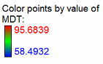
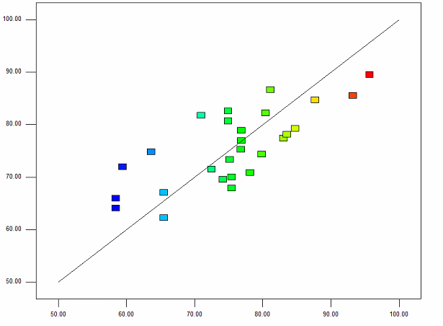
Experimental granule MDT (s)

Predicted granule MDT (s)

Figure ‎8-2: DoE modelling of experimental and predicted MDT of granule dissolution in HSM.
Artificial Neural Network tool in MATLAB (Version 2015b) was used to develop an ANN for prediction of MDT from the given input variables. Being similar to the input variables of DoE modelling, the inputs are impeller speed, liquid to solid ratio and granule size. The term of R² value is generated after the comparison was carried out. Since one of the aims in this study is to compare which type of modelling would be more effective in predicting the outcomes of the experiment, the R² value of each modelling was then used to compare the extent of fitting.
The prediction of ANN of granule MDT is shown in Figure ‎8-3. As shown in the figure, it is seen that the bias is on the single side of the line, indicating that the model was not able to give accurate predictions. On the overall, the DoE provides a better prediction of granule MDT data than ANN, as the R² value is 0.7327, which is higher than the same value of ANN (0.5684).

Figure ‎8-3: ANN modelling of experimental and predicted MDT of granule dissolution in HSM.

DoE and ANN models for tablet MDT
The input of tablet MDT models has three parameters: impeller speed, granule size and compression force, labelled as A, B and C. The p-values of these inputs are shown in Table ‎8-4. However, it is seen that although there are three input parameters for the modelling, there are only two parameters which are considered affecting the tablet MDT, indicating that the granule size is not considered as a significant parameter in affecting the tablet MDT of the modelling.

Table ‎8-4: DoE of tablet MDT of HSM
Parameter | p-value
Model | <0.0001
A-Impeller speed (rpm) | 0.0005
C-Granule size (mm) | <0.0005

The R² value for the tablet MDT is 0.8773, and the final equation to predict the tablet dissolution MDT in terms of actual factors is shown in Equation ‎8-7:

MDT= -0.75318+8.50272E-003*A+0.21567*C
-8.6376E-006*A²-3.81197E-003*C²
Equation ‎8-7
The experimental and predicted tablet dissolution MDT is shown in Figure ‎8-4.

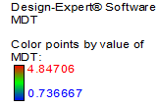
Experimental tablet MDT in HSM (minute)

Predicted tablet MDT in HSM (minute)

Figure ‎8-4: DoE modelling of experimental and predicted tablet MDT in HSM.
Same data base was analysed by the ANN and the result was presented in Figure ‎8-5. As seen in the diagram, it was found that the R² value was 0.9696 for tablet MDT, which was higher than the value in DoE, implying the ANN gave a better fitting of predicted values.

Figure ‎8-5: ANN modelling of experimental and predicted tablet MDT in HSM.

DoE and ANN models for granule strength
The inputs parameters of granule strength in HSM are shown in Table ‎8-5. In this model, three variables were used as inputs: impeller speed, L/S ratio and granule size, to predict the granule strength. As shown in the table, it is seen that all of the parameters are of significance in affecting the granule strength.

Table ‎8-5: DoE of granule strength of HSM
Parameter | p-value
Model | <0.0001
A-Impeller speed (rpm) | 0.0022
B-L/S ratio | <0.0001
C-Granule size (mm) | <0.0001

The R² value for the granule strength is 0.8594, and the final equation to predict the granule strength in terms of actual factors is shown in Equation ‎8-8:

Granule strength= -0.04072+2.09791E-005*A+0.45998*B+0.025301*C
Equation ‎8-8
In the range of impeller speeds use, the Equation 8-8 showed a positive correlation between the impeller speed and the granule strength which is in agreement with previous reports in literature (Mangwandi effect if impeller speed, Peter Knight 2000, Benali 2009). The equations also showed that increasing then the liquid to solid ratio increase the strength of the granule which is to be expected since more binder would be available for formation of strong bonds. Figure ‎8-6 shows comparison between the DoE predicted granule strength values versus experimental values. The strength values range from 0.03 to 0.07 MPa. It is clearly seen from the figure that a good correlation between the predicted values and experimental values.
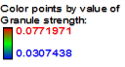
Predicted granule strength in HSM (MPa)
Experimental granule strength in HSM (MPa)

Figure ‎8-6: DoE modelling of experimental and predicted granule strength in HSM.
The result of ANN modelling of experimental and predicted granule strength in HSM was shown in Figure ‎8-7. As shown in the figure, it is found that the majority of data points are close to the trend line, indicating that the difference between the experimental and predicted values was small. However, it is seen that there are three data points which are scatted from the line, indicating that the predicting values are either over or under the experimental values. The same trend is also noticed to the data points beyond 0.07 MPa in Figure ‎8-6, where a less accurate prediction is observed.
It is found that the R² value in this ANN model is 0.9396, which is higher than that generated from DoE of 0.8594, meaning a better fitting of experimental to predicted values.

Figure ‎8-7: ANN modelling of experimental and predicted granule strength in HSM.

DoE and ANN models for tablet strength
In this part of modelling, four variables were used as inputs: impeller speed, liquid to solid ratio, granule size and compression force (Table ‎8-6); to generate one output, namely tablet strength. It is seen in the table that all of the input parameters are of significance in affecting the tablet strength in HSM.
Table ‎8-6: DoE of tablet strength in HSM
Parameter | p-value
Model | <0.0001
A-Impeller speed (rpm) | 0.0042
B-L/S ratio | <0.0001
C-Granule size (mm) | <0.0001
D-Compression force (kN) | <0.0001

The R² value for the tablet strength is 0.8152, and the final equation to predict the tablet strength in terms of actual factors is shown in Equation ‎8-9:

Tablet strength= -0.096521-1.13346E-004*A+2.67254*B-0.072017*C+0.011786*D
Equation ‎8-9
From Equation ‎8-9, it is seen that the impeller speed and granule size have negative correlation to the tablet strength; meaning if the other variables are kept constant, increasing these variables results in a reduction of tablet strength, and vice versa (Mangwandi et al., 2010, Knight et al., 2000). The reason of this trend has been explained in Chapter 4, as the large granules are stronger than the small ones, and when compressed into tablets, the tablets produced by former are difficult to be compressed into a rigid structure. Meanwhile, it is seen that L/S ratio and compression force have positive correlation to the tablet strength (Gong et al., 2015, Pawar et al., 2016, Nguyen et al., 2013), which indicates that the tablets made of granules of high binder amount will be stronger than those of low binder amount, and the tablets compressed with high force load are stronger, too.
Experimental tablet strength in HSM (MPa)

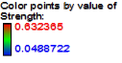
Predicted tablet strength in HSM (MPa)

Figure ‎8-8: DoE modelling of experimental and predicted tablet strength in HSM.
The DoE modelling of experimental and predicted tablet strength in HSM result was presented in Figure ‎8-8. It is seen that the tablet strength is in range of 0.04 to 0.63 MPa, and the wide range of tablet strength is due to both wide range of compression force used in the study (1 to 29 kN) and changes in formulation between batches. It can be seen that the data points are scattered from the line, indicating that the predicted values of tablet strength are either over or under estimated. On the overall, the purposed model is acceptable as a tool for predicting tablet strength.
The result of ANN modelling of experimental and predicted tablet strength in HSM was shown in Figure ‎8-9. The number of input was the same to the DoE. It was found that most of the data points were very close to the line, indicating that the predicted fitting values have a small difference than the actual values, despite several data points (marked as red in Figure ‎8-9) which are scatted from line. On the overall, the ANN performs well in predicting tablet strength than DoE.

Figure ‎8-9: ANN modelling of experimental and predicted tablet strength in HSM.

DoE and ANN models for tablet hardness
The same inputs parameters of tablet strength modelling are used in the tablet hardness, namely impeller speed, L/S ratio, granule size and compression force. It is seen in Table ‎8-7 that the L/S ratio, granule size and compression force are of significance in affecting the tablet hardness, while impeller speed is not a significant parameter.
Table ‎8-7: DoE of tablet hardness of HSM
Parameter | p-value
Model | <0.0001
A-Impeller speed (rpm) | 0.0322
B-L/S ratio | <0.0001
C-Granule size (mm) | <0.0051
D-Compression force (kN) | <0.0001

The R² value for the tablet hardness is 0.8682, and the final equation to predict the tablet hardness in terms of actual factors is shown in Equation ‎8-10:

Tablet hardness= -21.94293+5.76926E-003*A+115.78019*B+3.08431*C+2.94352*D+6.62502*B*D-0.10442*D²
Equation ‎8-10
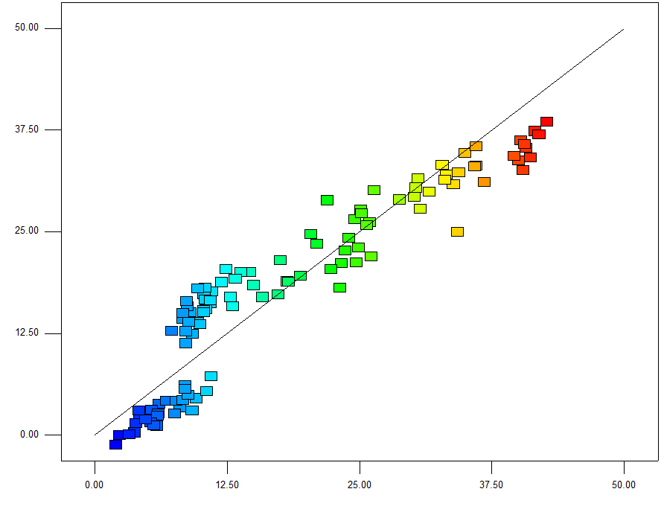
Experimental tablet hardness in HSM (MPa)

Predicted tablet hardness in HSM (MPa)
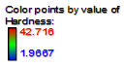
Figure ‎8-10: DoE modelling of experimental and predicted tablet hardness in HSM.
In Equation 8-10, it is noticed that the predicted tablet hardness is affected by not only single factor, but also the interaction/multiple of factors, especially the interaction between L/S ratio and compression force, which significantly determines the tablet hardness. From this equation, it is assumed that the tablet hardness is a value which is highly dependent on the interactions among both process and formulation variables.
Figure ‎8-11 showed the results of ANN modelling of experimental and predicted tablet hardness in HSM. As it is seen in the figure, it is found that the majority of the data points are close to the trend line, which is similar to the result of the DoE modelling. Also, it is seen that for both models, there are several data points fail to predict the tablet hardness, as the difference between the predicted and experimental values is not ignorable (marked with red circles). Despite this, when comparing the R² values of both models, it is seen that while the value of the DoE was 0.8682, the value of ANN is 0.9719, showing a more accurate prediction of tablet hardness would be generated by using ANN.

Figure ‎8-11: ANN modelling of experimental and predicted tablet hardness in HSM.

DoE and ANN models for granule porosity
The inputs of granule porosity in HSM are shown in Table ‎8-8, which are impeller speed, L/S ratio and granule size. From the table, it is seen that the modelling of granule porosity in HSM is mainly determined by granule size, as the other two parameters have no significant influence on it.

Table ‎8-8: DoE of granule porosity of HSM
Parameter | p-value
Model | 0.0004
A-Impeller speed (rpm) | 0.9799
B-L/S ratio | 0.0359
C-Granule size (mm) | 0.0531

The R² value for the granule porosity is 0.6861, and the final equation to predict the granule porosity in terms of actual factors is shown in Equation ‎8-11:

Granule porosity= 7.64-5.558E-008*A-0.23*B+0.45*C
Equation ‎8-11
The result of DoE modelling of experimental and predicted granule porosity in HSM was shown in Figure ‎8-12. By comparing the actual and predicted values, it was found that the data points were relatively scattered from the central trend line, indicating that the model may give a less accurate fitting.
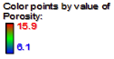
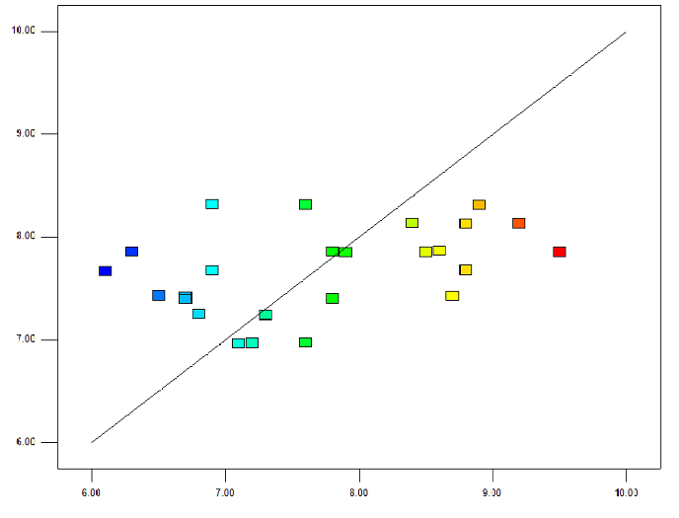
Experimental granule porosity in HSM

Predicted granule porosity in HSM
Figure ‎8-12: DoE modelling of experimental and predicted granule porosity in HSM.
Figure ‎8-13 showed the result of ANN modelling of experimental and predicted granule porosity in HSM and the R² value was 0.7009. Compared to the DoE model with the same data base, it is found that the prediction of granule porosity with neither modelling is good enough, as the R² values for each modelling was relatively low and the data points are scattered from the trend line. In this case, it was assumed that the granule porosity could be a result of multi-interactive variables, though the granule size was showed to be the most significant variable.

Figure ‎8-13: ANN modelling of experimental and predicted granule porosity in HSM.

DoE and ANNs models for tablet porosity
The input parameters of tablet porosity in HSM are shown in Table ‎8-9. From the table, it is seen that all the parameters are significantly affect the tablet porosity, which indicates that tablet porosity has a positive correlation with all the inputs variables.

Table ‎8-9: DoE of tablet porosity of HSM
Parameter | p-value
Model | <0.0001
A-Impeller speed (rpm) | 0.0027
B-L/S ratio | 0.0001
C-Granule size (mm) | <0.0001
D-Compression force (kN) | <0.0001

The R² value for the tablet porosity is 0.7617, and the final equation to predict the tablet porosity in terms of actual factors is shown in Equation ‎8-12:

Tablet porosity= 0.68664-5.66136E-004*A-3.16887*B+0.032542*C-0.014461*D+3.37985E-003*A*B+4.12895E-006*A*D+2.67334E-004*D²
Equation ‎8-12
The result of DoE modelling of experimental and predicted tablet porosity in HSM is shown in Figure 8-14. From the figure, it is found that the majority of data points are close to the line, indicating that most predicts of tablet porosity are accurate. The range of tablet porosity is seen to distribute from 4.7 to 30.2%, and it is noticed that the inaccurate predictions are those between 18%-22% (marked with red circle). As a result, it is concluded that Equation 8-12 is capable to make relatively accurate predictions of tablet porosity of either dense or porous tablets, while the value is underestimated for the tablets of that range.

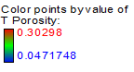
Experimental tablet porosity in HSM

Predicted tablet porosity in HSM

Figure ‎8-14: DoE modelling of experimental and predicted tablet porosity in HSM.
The result of ANN modelling of experimental and predicted tablet porosity in HSM is shown in Figure ‎8-15. From the figure, it is seen that the predicted values at low and high tablet porosity seemed to be more accurate than the tablets which have a moderate porosity, as most of the data points are very close to the central trend line. Although most of the predicted values are accurate, it is seen that there are several data points which went overestimated (marked with red circle). Compared to the DoE model of tablet porosity, it is found that the range of inaccurate predictions is approximately between 15-17%, which is narrower than that of DoE model (18-22%), indicating that the ANN model is of higher accuracy than that of DoE model, which is also evidenced by comparing the R² values of both models, where 0.9589 for ANN and 0.7617 for DoE. On the overall, it is concluded that both models are capable to make good predictions of tablet porosity, especially for the dense tablet, specifically.

Figure ‎8-15: ANN modelling of experimental and predicted tablet porosity in HSM.

Modelling of FBG granule and tablet properties

DoE and ANN models of granule MDT
In this model, three input parameters are used: air velocity, L/S ratio and granule size (Table ‎8-10). It is found that among these variables, the L/S ratio has the most significant influence affecting the granule dissolution MDT, followed by air velocity; and granule size.
Table ‎8-10: DoE of granule MDT of FBG
Parameter | p-value
Model | 0.0003
A-Air velocity (m/s) | 0.2008
B-L/S ratio | 0.3178
C-Granule size (mm) | 0.0001

The R² value for the granule MDT is 0.8062, and the final equation to predict the granule MDT in terms of actual factors is shown in Equation ‎8-13:
MDT= +66.80156-21.82191*A-96.64667*B+7.67589*C+158.082*A*B+2.21353*A*C-87.03613*B*C
Equation ‎8-13
From Equation 8-13, it is noticed that all the input variables have a positive correlation to the granule MDT in FBG, which means when increase these variables in experiment, the granule MDT will increase, too. In details, it could be figured out that among all these variables, the L/S shows to have the most significant influence on granule MDT.
The models of granule dissolution MDT in FBG is shown in Figure 8-16. From the figure, it can be seen that the granule MDT is in between 48.9 to 53.1 seconds, which means that the granules started to dissolve in distilled water as soon as the experiments commenced. This could be related to the results of bulk granule strength of FBG in Chapter 5, as the granules were weak so that a shorter MDT was expected.
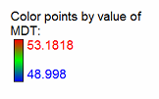
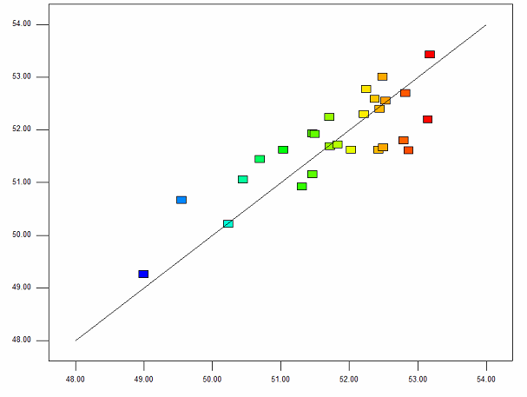
Experimental granule MDT (s)

Predicted granule MDT (s)

Figure ‎8-16: DoE modelling of experimental and predicted granule MDT in FBG.

Figure ‎8-17: ANN modelling of experimental and predicted granule MDT in FBG.
The ANN result of granule MDT is shown in Figure ‎8-17. It is seen in this figure that good predictions of granule MDT can be made in the range of approximately 49 to 51 seconds; whereas the model is likely to give overestimated predictions above this range. By comparing the predictions of both models, it is found that the DoE model can provide better predictions than ANN models, as the R² value of DoE and ANN models are 0.8062 and 0.6882.

DoE and ANN models of tablet MDT
The inputs parameters of tablet MDT are shown in Table ‎8-11. In this model, three variables are used as input: air velocity, L/S ratio and compression force. From this table, it is seen that the air velocity and compression force are more pronounced in affecting the tablet MDT, while the influence of L/S ratio is less pronounced.

Table ‎8-11: DoE model of tablet MDT in FBG
Parameter | p-value
Model | <0.0001
A-Air velocity (m/s) | <0.0001
B-L/S ratio | 0.2832
D-Compression force (kN) | <0.0001

The R² value for the tablet MDT is 0.9241, indicating the model is of relatively high reliability. The final equation to predict the tablet MDT in terms of actual factors is shown in Equation ‎8-14:
MDT= 2.30760+0.30125*A+0.11551*B+0.16042*D-0.34667*A*B-0.11130*A*D+7.52649-003*B*D
Equation ‎8-14
In Equation 8-14, it is noted that regarding the influence of single factor, all input variables are in a positive correlation to tablet MDT. Moreover, being different to the granule MDT in FBG, it is noticed that the predicted value is not only affected by single or multiple variable, but also the interaction between variables as well. In terms of the influence of variable interaction, it can be seen that the interactions between air velocity and L/S ratio, air velocity and compression force are shown to be negative, while the interaction between L/S ratio and compression force is found to be positive. In addition, the input variable C-granule size is shown to be a less significant factor by the model, so that this input is not presented in Table ‎8-11.
The DoE model of tablet MDT in FBG in shown in Figure ‎8-18. As the figure shows, the FBG tablets in this study have a MDT in between 1.7 to 4.5 minutes, which is almost double the value of HSM tablets (0.7 minute). The reason has been attributed to tablet strength, which has been explained in details in both Chapter 4 and 5. Also, it is seen in this figure that most of the data points are close to line (only several data points gave higher predicting values than actual), implying that the predictions can be accurate.
Experimental tablet MDT (minute)

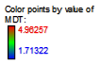
Predicted tablet MDT (minute)

Figure ‎8-18: DoE modelling of experimental and predicted tablet MDT in FBG.
The ANN model of tablet MDT in FBG is shown in Figure ‎8-19. Due to a high R² value of this model (0.9568), it is seen in this figure that only one data point fell out of accurate prediction of tablet MDT, whereas most of them are capable of giving predicting values which are very close to the actual values. By comparing these two models, it is found that both models can give relatively accurate predictions of tablet MDT; however, as the results presented in Figure ‎8-18 and Figure ‎8-19, it is noticed that the DoE model is unlikely to provide accurate predictions in the range of approximately 1.8 to 2.2 minutes, whereas the ANN model is of less capability beyond 4 minutes. But in general, the ANN model is seen to have a better performance than the DoE model in predicting tablet MDT in FBG in this study, as a higher R² value is achieved.

Figure ‎8-19: ANN modelling of experimental and predicted tablet MDT in FBG.

DoE and ANN models for granule strength
The input parameters of granule strength in FBG are shown in Table ‎8-12. In this part of modelling, three variables are used as inputs: air velocity, L/S ratio and granule size, to generate one output namely granule strength. It is seen in the table that all of the input parameters are of significance in affecting the granule strength.

Table ‎8-12: DoE of granule strength of FBG
Parameter | p-value
Model | <0.0001
A-Air velocity (m/s) | <0.0001
B-L/S ratio | <0.0001
C-Granule size (mm) | <0.0001

The R² value for the granule strength is 0.9420, and the final equation to predict the granule strength in terms of actual factors is shown in Equation ‎8-15:

Granule Strength=0.067152+0.010163*A+0.40986*B+0.10607*C+0.34270*A*B
+6.39507E-004*A*C+1.07519*B*C
Equation ‎8-15
As shown in Equation 8-15, it is seen that being different to the equation of granule strength predictions in HSM (Equation 8-8), the granule strength in FBG is affected by both single and multiple factors (interactions between variables), rather than single factors alone in HSM. This is assumed that during fluidization, the granule formation is a more complex process as the particles are strongly influenced by pneumatic. Based on the equation, it is found that the input variables and interactions between variables will prompt the granule strength.
The DoE modelling of experimental and predicted tablet strength in FBG result is presented in Figure ‎8-20. It is seen in the figure that the granule strength is in a range of 0.02 to 0.13 MPa. For the data points, most of them are shown to stay close to the line, except several of them which gave either over or underestimated values.

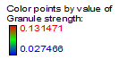
Experimental granule strength (MPa)

Predicted granule strength in FBG (MPa)

Figure ‎8-20: DoE modelling of experimental and predicted granule strength in FBG.
The ANN result of granule strength in FBG is shown in Figure ‎8-21. From the result, it is seen that experimental and predicted data points are generally close. The R² value of this model is 0.9679, indicating that the model can be used to predict the granule strength in FBG accurately.
Compared the DoE and ANN models of granule strength in FBG, it is found that both models can provide accurate predictions of granule strength, while the DoE model is less accurate as the R² value is 0.9420, to that 0.9679 to ANN model.

Figure ‎8-21: ANN modelling of experimental and predicted granule strength in FBG.

DoE and ANN models for tablet strength
The input parameters of tablet strength are shown in Table ‎8-13. In this part of modelling, four variables are used as inputs: air velocity, L/S ratio, granule size and compression force, to generate one output namely tablet strength. From the table, it is seen that all the parameters are of significance in affecting the tablet strength in FBG.
Table ‎8-13: DoE of tablet strength of FBG
Parameter | p-value
Model | <0.0001
A- Air velocity (m/s) | <0.0001
B-L/S ratio | <0.0001
C-Granule size (mm) | <0.0001
D-Compression force (kN) | <0.0001

The R² value for the tablet strength is 0.9671, and the final equation to predict the tablet strength in terms of actual factors is shown in Equation ‎8-16:

Tablet strength= +0.38997-0.29537*A+0.10469*B-0.20565*C+0.0655601*D
Equation ‎8-16
In Equation ‎8-16, it is seen that the effect of impeller speed and granule size are in a negative correlation to the tablet strength in FBG, while the effect of L/S ratio and compression force are shown to have the opposite performance. This has provided proof to support the theory that the granule size will increase with an increase in impeller speed, which result in a densification to the granules structure and increase their size, and thus producing weak tablets during tableting due to higher granule strength.
The DoE modelling of experimental and predicted tablet strength in FBG result is shown in Figure ‎8-22. From the figure, it is seen that the tablet strength of FBG is within a range of 0.03 to 1.17 MPa. The reason why there’s such a notable difference of tablet strength is that the FBG granule are weak and porous. Therefore, these granules are of high friability meaning that they are highly deformable and compressible, which is evidenced from the result of strength values. Data points in the figure indicate that the model is highly reliable as most of the data points are very close to the line, meaning the predicted values are close to the actual values, with only a few exceptional that overestimate the values (marked with red circle).

Experimental granule strength (MPa)

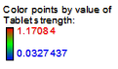
Predicted tablet strength in FBG (MPa)

Figure ‎8-22: DoE modelling of experimental and predicted tablet strength in FBG.
The ANN result of tablet strength in FBG is shown in Figure ‎8-23. It is seen from the figure that in general, the predicted and experimental data points are highly close to each other, with only one data point (marked with red fill) that underestimate the true value, indicating that the prediction of tablet strength could be very accurate, as the R² value is 0.9914.
Compared the ANN model with the DoE model of tablet strength in FBG, it is found that both models can provide very accurate results of FBG tablet strength; however, the ANN model is seen to provide the tablet strength prediction with high accuracy, as the R² value of ANN is higher than that of DoE of 0.9671.

Figure ‎8-23: ANN modelling of experimental and predicted tablet strength in FBG.

DoE and ANN models for tablet hardness
The input parameters of tablet hardness are shown in Table ‎8-14. In this part of modelling, four variables are used as inputs: air velocity, L/S ratio, granule size compression force, to generate one output namely tablet hardness. It is seen in the table that the L/S ratio and compression force are of significance affecting the tablet hardness, while the air velocity and granule size are not showing to have significant influence
Table ‎8-14: DoE of tablet hardness of FBG
Parameter | p-value
Model | <0.0001
A- Air velocity (m/s) | 0.1391
B-L/S ratio | 0.0026
C-Granule size (mm) | 0.0191
D-Compression force (kN) | <0.0001

The R² value for the tablet hardness is 0.8626, and the final equation to predict the tablet hardness in terms of actual factors is shown in Equation ‎8-17:

Tablet hardness=-270.32362+231.41867*A+2259.08784*B+5.34869*C+3.47476*D-92.33504*A*B-1.80536*A*C+0.16733*A*D+10.49584*B*C+6.56933*B*D+0.079123*C*D-111.07561*A²-7876.22266*B²-1.54476*C²-0.11815*D²
Equation ‎8-17
It is seen in Equation 8-17 that there are many factors involved in predicting tablet hardness of FBG, indicating that this value could be a function of complex interactions. A reasonable explanation is that the phenomenon “binder migration” (which has been stated in Chapter 6) could be existed in these FBG tablets, which increase the difficult and uncertainty in prediction. In general, it is seen that L/S acts as the most predominant factor in determining tablet hardness prediction.
Experimental tablet hardness in FBG (MPa)

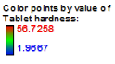
Predicted tablet hardness in FBG (MPa)

Figure ‎8-24: DoE modelling of experimental and predicted tablet hardness in FBG.
The DoE modelling of experimental and predicted tablet hardness in FBG result is presented in Figure ‎8-24. As the figure shows, it is seen that the tablet hardness varied from 1.96 to 56.72 MPa. This is corresponded to the tablet strength; however, it is also noticed that between the ranges of 5 to 20 MPa, the model is likely to give predicted values which are overestimated.
The ANN result of tablet hardness of FBG is shown in Figure ‎8-25. Generally, it is found that the predicted and experimental data points are very close to the trend line. The R² value of this model is 0.9815, means that accurate predictions of tablet hardness could be made by using this model.
Compared to the DoE model on tablet hardness in FBG, it is seen that the ANN is more suitable to make accurate predictions of tablet hardness, as the R² value is higher than that of DoE of 0.8626.

Figure ‎8-25: ANN modelling of experimental and predicted tablet hardness in FBG.

DoE and ANN models for granule porosity
The input parameters of granule porosity are shown in Table ‎8-15. In this part of modelling, three variables are used as inputs: impeller speed, L/S ratio and granule size, to generate one output namely granule porosity. From the table, it is seen that the granule size is of significance in affecting the granule porosity, while the impeller speed and L/S ratio are not shown to have significant influence.
Table ‎8-15: DoE of granule porosity of FBG
Parameter | p-value
Model | 0.0062
A-Air velocity (m/s) | 0.2705
B-L/S ratio | 0.1281
C-Granule size (mm) | 0.0020

The R² value for the granule porosity is 0.6096, and the final equation to predict the granule porosity in terms of actual factors is in Equation ‎8-18:

Granule porosity= 21.34704+1.45833*A-38.8889*B-21.8596*C
Equation ‎8-18
It is seen in Equation ‎8-18 that the air velocity is in a positive correlation with granule porosity, while L/S ratio and granule size are in a negative correlation with the same parameter. From this, it is assumed that the prediction of the granules which are of large size would not be very accurate, since the pores distribution inside granules is difficult to be predicted, especially for FBG granules as their size is a complex interaction between the effects of air velocity and binder amount.
The DoE modelling of experimental and predicted granule porosity in FBG result is presented in Figure ‎8-26. It is found that the data points are highly scattered from the line, meaning that the predicted values could be either over or under estimated. The granule porosity is in the range of 10.6 to 16.3%, which is almost double the value of HSM granules, indicating that the FBG granules are much weaker than HSM.

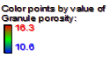
Experimental granule porosity in HSM

Predicted granule porosity in HSM

Figure ‎8-26: DoE modelling of experimental and predicted granule porosity in FBG.
The ANN result of granule porosity is shown in Figure ‎8-27. Being different to the DoE model of predicting the same value, it is found that the R² value of ANN model is 0.8395, implying that the predictions in this model could be acceptable. Although most of the data points are close to the line, it is difficult to define a range where accurate predictions can be ensured, as scattered data points exist throughout the entire range (marked with red fill). In general, it can be concluded that the inaccurate data points are mainly overestimating the granule porosity.

Figure ‎8-27: ANN modelling of experimental and predicted granule porosity in FBG.

DoE and ANN models for tablet porosity
The input parameters of tablet porosity are shown in
Table ‎8-16. In this part of modelling, four variables are used as inputs: air velocity, L/S ratio, granule size and compression force, to generate one output namely tablet porosity. It is seen in the table that the compression force is shown to be significant in affecting the tablet porosity, while the impeller speed, L/S ratio and granule size are not shown to have insignificant influence.
Table ‎8-16: DoE of tablet porosity of FBG
Parameter | p-value
Model | <0.0001
A-Air velocity (m/s) | 0.0288
B-L/S ratio | 0.0574
C-Granule size (mm) | 0.0083
D-Compression force (kN) | <0.0001
The R² value for the tablet porosity is 0.7102, and the final equation to predict the tablet porosity in terms of actual factors is shown in Equation ‎8-19:

Tablet porosity= 0.60603-0.64003*A+0.55640*B+0.11713*C-0.026586*D+2.84184*A*B-0.050091A*C+3.44903E-003*A*D+0.012643*B*D-2.54270E-004*C*D+0.10198*A²-17.72864*B²-0.0021573*C²+4.67779E-004*D²
Equation ‎8-19
In Equation ‎8-19, it is seen that the FBG tablet porosity is also a complex function of multiple factors and their interactions. Furthermore, it is to clear which factor or interaction plays the most important role in affecting tablet porosity prediction. As the FBG granules are produced via complicated processes, it is reasonable to say that the FBG tablet properties are difficult to be predicted as well.
The DoE modelling of experimental and predicted tablet porosity in FBG is presented in Figure ‎8-28. It is seen that the tablet porosity is in a range of 2.93 to 34.36%. From this it is clear that the FBG tablet is very porous when the granules are compressed with low force, and the tablet strength increased rapidly with further increase in compression force, evidenced from the final tablet porosity.
In addition, it is noticed that the ANN model is limited in predicting when the tablets are over 10% porosity, as many of the data points shown in figure go overestimated the actual value. Under this range, the model can be served as a tool to provide accurate predictions.
Another limit of this model is that when tablets are too porous, this model is of high possibility to give underestimated predictions.

Experimental tablet porosity in FBG

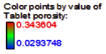
Predicted tablet porosity in FBG
Figure ‎8-28: DoE modelling of experimental and predicted tablet porosity in FBG.
The ANN result of tablet porosity in FBG is shown in Figure ‎8-29. It is noticed that the model can be used to give predictions of relatively high accuracy, as the R² value is 0.9718. In this case, the ANN model widens the range of FBG tablet porosity prediction, as many of the actual values between 10 to 30% are related with predicted values which are of minor deviation.
By comparing the DoE model of tablet porosity in FBG, it is found that the ANN model can provide better predictions as the R² value is higher than that of DoE of 0.7102. This implies that the ANN model is able to give more accurate predictions of tablet porosity than the DoE model.

Figure ‎8-29: ANN modelling of experimental and predicted tablet porosity in FBG.

Conclusion
In this chapter, the properties of granules and tablets were modelled with DoE and ANN by using the experimental data. This aims to predict the final granule and tablet properties by using the process and formulation parameters in HSM and FBG. The models were evaluated by comparing the correlation coefficient R² value. The higher the R² value, the better the prediction of the model.
Table ‎8-17 shows the comparison between DoE and ANN models for granule and tablet properties in HSM and FBG. It can be seen for most cases, the prediction of granule and tablet properties is more accurate using the ANN than the DoE (except for granule MDT predictions). Moreover, for some parameters such as tablet hardness and porosity, which are assumed to have been a function of complex multiple interactions, the ANN models are shown to be more suitable in prediction. This is due to the difference of model principles, as in ANN it allows multiple types of model to be trained and selected due to its flexibility, which as a result, potentially enables the most suitable model to be found. However, the DoE models are shown to be a simple and efficient approach to reveal the correlation between input variables, which is not practical in ANN modelling.
In addition, models of both types are believed to have better performance by increasing either the number specimen or input variables. The reasons that some models are shown to have relatively low R² values are assumed to be affected by other factors which are not included in this study. However, this hypothesis is yet to be validated.
Table ‎8-17: The R² values of both DoE and ANN models for HSM and FBG
Parameters which has been modelled | R² value
Parameters which has been modelled | HSM |  | FBG
Parameters which has been modelled | DoE | ANN | DoE | ANN
Granule MDT | 0.7327 | 0.5684 | 0.8062 | 0.6882
Tablet MDT | 0.8773 | 0.9696 | 0.9241 | 0.9568
Granule strength | 0.8594 | 0.9396 | 0.9420 | 0.9679
Tablet strength | 0.8152 | 0.9282 | 0.9671 | 0.9914
Tablet hardness | 0.8682 | 0.9719 | 0.8626 | 0.9815
Granule porosity | 0.6861 | 0.7009 | 0.6096 | 0.8395
Tablet porosity | 0.7617 | 0.9789 | 0.7102 | 0.9718

Conclusion and future work

Conclusion
In this study, a sufficient number of melt granulation experiments with calcium carbonate and polyethylene glycol have been carried out on both HSM and FBG. Though the granules were produced by different mechanisms; the formulation conditions were kept constant (L/S ratio), and thus enable a comparison of product properties of both equipment.
As the data shown in the previous chapters, under the same formulation conditions, it was found that the granules produced via high shear granulation were generally stronger than fluidized bed granulation. This was because the granules were consolidated during high shear granulation, which made the granules denser and compacted by mechanical agitation. While in FBG, the granule formation was dominated by the inlet air, which resulted in mainly coalescence. In this case, the HSM granules were of higher strength than FBG granules.
In this study, it was found that tablet tensile strength was mainly affected by granule size, strength and load applied to granules during tableting. At low compression force (1-5 kN), the tablets of both HSM and FBG showed a relatively low strength, as the load applied was insufficient to cause granule deformation/breakage so that the tablets were less compressed.
From the SEM images, it was noticed that at low compression forces, while the structures of granules could still be distinguished for both HSM and FBG tablets; the surfaces of FBG tablets were found to be relatively smooth due to reduction in voidages among granules, indicating that the FBG granules were easier to break than HSM granules due to lower granule strength.
As the tablet strength was found to be determined by the load applied (which relates to the voidages/free volume among granules), it was seen that with an increase in the force loaded (above 15 kN), the tablets produced by both HSM and FBG achieved higher strength. However, as the FBG granules were more deformable, the FBG tablets were found to be stronger than HSM tablets at the same applied force.

Binder migration was found happened to some tablets produced at 29 kN. This has resulted in some scattered data points. However, the reason of causing this event was not clear. According to the experimental conditions that have been used, it was possibly to correlate with high tablet compression force and friction between punch and tablet surface.
Regarding the tablet MDT, it was found that the tablet MDT was mainly affected by tablet compression force. As shown in the tablet MDT profiles, this value did not to vary significantly with changes in either impeller speed or air velocity. In other words, the tablet MDT was not showing a clear trend with these two process variables. Therefore, why they correlated with tablet MDT was still unknown.
Two models (DoE and ANN) have been used in this study. On one hand, it was purposed to provide a way which the granule/tablet properties of both HSM and FBG could be compared; while the models purposed could be possibly used as guidance for researchers in the relevant field, which as a result, saves time, cost and labour.
The results of both DoE and ANN modelling were shown and discussed in Chapter 8. Generally, it was found that the ANN models are more accurate in predicting the granule and tablet properties than the DoE models in all cases, as the R² values of ANN models are higher than that of DoE models in the majority of predictions. ANN was found to give better prediction to the experimental data due to the fact that it is more adaptable when compare other structured approaches of modelling. This was evidenced by the fact that when DoE was not capable to give accurate predictions of some tablet properties, the ANN was still able to give reasonable predictions. However, the DoE models were capable to show the importance of input variables (p-value) on the predicted value. By providing the final equations of actual factors, the DoE models were able to reveal the hidden correlation among input variables, too.

Recommendations for future work
- For tablet hardness, there is a need to reveal the fact why the tablets produced at 29 KN have a lower hardness than those produced at 15 KN. More details investigation of the binder migration phenomenon is needed.
- There is a need to investigate and identify in greater detail the physical and chemical attributes of the binder and primary powder particles that influence the final properties of the granules. The attributes can then be used to develop mechanistic model which can be transferred from one system to another.
- The current models are limited to the specific equipment and formulation that was used in this research. It would b be beneficial if the models could be transformed into more versatile form i.e. make the transferable from one granulation unit to another by modifying the input variables to dimensionless parameter. For instance, for the high shear granulator, instead of using impeller speed, Froude number of impeller tip-speed can be used. The formulation variables could be replaced with the physical or chemical properties of the binder or powder.
- During the modelling of tablet properties, the granule size was used as an input parameter. It is better to build a model which links the final properties of tablets to the primary powder and binder properties, as well as the process parameters.
- Solution binder could be used to extend the work, and increase the chances for the knowledge acquired from the model purposed in this study to be migrated.

Bibliography
ADAMS, M. J., MULLIER, M. A. & SEVILLE, J. P. K. 1994. Agglomerate strength measurement using a uniaxial confined compression test. Powder Technology, 78, 5-13.
ADELOYE, A.J., MUNARI. D. A. Artificial neural network based generalized storage-yield-reliability models using the Levenberg-Marquardt algorithm. Journal of Hydrology 362 (2006) 215-230.
ALALAWEEN, W. H., MAHFOUF, M. & SALMAN, A. D. 2016. Predictive modelling of the granulation process using a systems-engineering approach. Powder Technology, 302, 265-274.
ASCANIO, G., CARREAU, P. J., BRITO-DE LA FUENTE, E. & TANGUY, P. A. 2004. Fluid FlowForward Deformable Roll Coating at High Speed with Newtonian Fluids. Chemical Engineering Research and Design, 82, 390-397.
BEHZADI, S. S., KLOCKER, J., HÜTTLIN, H., WOLSCHANN, P. & VIERNSTEIN, H. 2005. Validation of fluid bed granulation utilizing artificial neural network. International Journal of Pharmaceutics, 291, 139-148.
BENALI, M., GERBAUD, V. & HEMATI, M. 2009. Effect of operating conditions and physico–chemical properties on the wet granulation kinetics in high shear mixer. Powder Technology, 190, 160-169.
BEZERRA, M. A., SANTELLI, R. E., OLIVEIRA, E. P., VILLAR, L. S. & ESCALEIRA, L. A. 2008. Response surface methodology (RSM) as a tool for optimization in analytical chemistry. Talanta, 76, 965-977.
CAPES, C. E. & DANCKWERTS, P. V. 1981. F2 - GRANULE FORMATION BY THE AGGLOMERATION OF DAMP POWDERS PART I: THE MECHANISM OF GRANULE GROWTH. Insights Into Chemical Engineering. Amsterdam: Pergamon.
CASCONE, S. 2017. Modeling and comparison of release profiles: Effect of the dissolution method. European Journal of Pharmaceutical Sciences, 106, 352-361.
CHAN, E. L., REYNOLDS, G. K., GURURAJAN, B., HOUNSLOW, M. J. & SALMAN, A. D. 2013. Blade–granule bed stress in a cylindrical high shear granulator: I—Online measurement and characterisation. Chemical Engineering Science, 86, 38-49.
CHEN, Y., YANG, J., DAVE, R. N. & PFEFFER, R. 2009. Granulation of cohesive Geldart group C powders in a Mini-Glatt fluidized bed by pre-coating with nanoparticles. Powder Technology, 191, 206-217.
CHENG, H. J., HSIAU, S. S. & LIAO, C. C. 2011. Influence of the interaction between binder and powders on melt agglomeration behavior in a high-shear mixer. Powder Technology, 211, 165-175.
CHITU, T. M., OULAHNA, D. & HEMATI, M. 2011. Wet granulation in laboratory-scale high shear mixers: Effect of chopper presence, design and impeller speed. Powder Technology, 206, 34-43.
COSTA, P. & SOUSA LOBO, J. M. 2001. Modeling and comparison of dissolution profiles. European Journal of Pharmaceutical Sciences, 13, 123-133.
DÉVAY, A., MAYER, K., PÁL, S. & ANTAL, I. 2006. Investigation on drug dissolution and particle characteristics of pellets related to manufacturing process variables of high-shear granulation. Journal of Biochemical and Biophysical Methods, 69, 197-205.
ELIASEN, H., KRISTENSEN, H. G. & SCHÆFER, T. 1999. Growth mechanisms in melt agglomeration with a low viscosity binder. International Journal of Pharmaceutics, 186, 149-159.
ELIASEN, H., SCHÆFER, T. & GJELSTRUP KRISTENSEN, H. 1998. Effects of binder rheology on melt agglomeration in a high shear mixer. International Journal of Pharmaceutics, 176, 73-83.
FRANCESCHINIS, E., SANTOMASO, A. C., TROTTER, A. & REALDON, N. 2014. High shear mixer granulation using food grade binders with different thickening power. Food Research International, 64, 711-717.
FRIES, L., ANTONYUK, S., HEINRICH, S. & PALZER, S. 2011. DEM–CFD modeling of a fluidized bed spray granulator. Chemical Engineering Science, 66, 2340-2355.
GAO, J. Z. H., JAIN, A., MOTHERAM, R., GRAY, D. B. & HUSSAIN, M. A. 2002. Fluid bed granulation of a poorly water soluble, low density, micronized drug: comparison with high shear granulation. International Journal of Pharmaceutics, 237, 1-14.
GONG, X., CHANG, S.-Y., OSEI-YEBOAH, F., PAUL, S., PERUMALLA, S. R., SHI, L., SUN, W.-J., ZHOU, Q. & SUN, C. C. 2015. Dependence of tablet brittleness on tensile strength and porosity. International Journal of Pharmaceutics, 493, 208-213.
HEMATI, M., CHERIF, R., SALEH, K. & PONT, V. 2003. Fluidized bed coating and granulation: influence of process-related variables and physicochemical properties on the growth kinetics. Powder Technology, 130, 18-34.
Hernandez, E., Pawar, P., Keyvan, G., Wang, Y., Velez, N., Callegari, G., Cuitono, A., Kohn, B., Muzzio, F., Romanach, R. Prediction of dissolution profiles by non-destructive near infrared spectroscopy in tablets subjected to different levels of strain. Journal of Pharmaceutical and Biomedical Analysis 117 (2016) 568–576.
HOLM, P., SCHAEFER, T. & KRISTENSEN, H. G. 1985. Granulation in high-speed mixers Part VI. Effects of process conditions on power consumption and granule growth. Powder Technology, 43, 225-233.
HOORNAERT, F., WAUTERS, P. A. L., MEESTERS, G. M. H., PRATSINIS, S. E. & SCARLETT, B. 1998. Agglomeration behaviour of powders in a Lödige mixer granulator. Powder Technology, 96, 116-128.
IVESON, S. M., LITSTER, J. D. & ENNIS, B. J. 1996. Fundamental studies of granule consolidation Part 1: Effects of binder content and binder viscosity. Powder Technology, 88, 15-20.
IVESON, S. M., LITSTER, J. D., HAPGOOD, K. & ENNIS, B. J. 2001. Nucleation, growth and breakage phenomena in agitated wet granulation processes: a review. Powder Technology, 117, 3-39.
IVESON, S. M., PAGE, N. W. & LITSTER, J. D. 2003. The importance of wet-powder dynamic mechanical properties in understanding granulation. Powder Technology, 130, 97-101.
J.RHODES, M. 2008. Introduction to Particle Technology 2nd Edition, New York, John Wiley&Sons.
JÄRVINEN, M. A., PAAVOLA, M., POUTIAINEN, S., ITKONEN, P., PASANEN, V., ULJAS, K., LEIVISKÄ, K., JUUTI, M., KETOLAINEN, J. & JÄRVINEN, K. 2015. Comparison of a continuous ring layer wet granulation process with batch high shear and fluidized bed granulation processes. Powder Technology, 275, 113-120.
JOHANSEN, A. & SCHÆFER, T. 2001. Effects of interactions between powder particle size and binder viscosity on agglomerate growth mechanisms in a high shear mixer. European Journal of Pharmaceutical Sciences, 12, 297-309.
JOHANSSON, B. & ALDERBORN, G. 2001. The effect of shape and porosity on the compression behaviour and tablet forming ability of granular materials formed from microcrystalline cellulose. European Journal of Pharmaceutics and Biopharmaceutics, 52, 347-357.
JUBAN, A., NOUGUIER-LEHON, C., BRIANCON, S., HOC, T. & PUEL, F. 2015. Predictive model for tensile strength of pharmaceutical tablets based on local hardness measurements. International Journal of Pharmaceutics, 490, 438-445.
KNIGHT, P. C., INSTONE, T., PEARSON, J. M. K. & HOUNSLOW, M. J. 1998. An investigation into the kinetics of liquid distribution and growth in high shear mixer agglomeration. Powder Technology, 97, 246-257.
KNIGHT, P. C., JOHANSEN, A., KRISTENSEN, H. G., SCHÆFER, T. & SEVILLE, J. P. K. 2000. An investigation of the effects on agglomeration of changing the speed of a mechanical mixer. Powder Technology, 110, 204-209.
KRISTENSEN, H. G. 1996. First International Particle Technology ForumParticle agglomeration in high shear mixers. Powder Technology, 88, 197-202.
LEE, K. T., INGRAM, A. & ROWSON, N. A. 2013. Comparison of granule properties produced using Twin Screw Extruder and High Shear Mixer: A step towards understanding the mechanism of twin screw wet granulation. Powder Technology, 238, 91-98.
MANGWANDI, C., ADAMS, M. J., HOUNSLOW, M. J. & SALMAN, A. D. 2010. Effect of impeller speed on mechanical and dissolution properties of high-shear granules. Chemical Engineering Journal, 164, 305-315.
MANGWANDI, C., ADAMS, M. J., HOUNSLOW, M. J. & SALMAN, A. D. 2014. Influence of fill factor variation in high shear granulation on the post granulation processes: Compression and tablet properties. Powder Technology, 263, 135-141.
MANGWANDI, C., ZAINAL, N. A., JIANGTAO, L., GLOCHEUX, Y. & ALBADARIN, A. B. 2015. Investigation of influence of process variables on mechanical strength, size and homogeneity of pharmaceutical granules produced by fluidised hot melt granulation. Powder Technology, 272, 173-180.
MIWA, A., YAJIMA, T., IKUTA, H. & MAKADO, K. 2008. Prediction of suitable amounts of water in fluidized bed granulation of pharmaceutical formulations using corresponding values of components. International Journal of Pharmaceutics, 352, 202-208.
MIYAMOTO, Y., OGAWA, S., MIYAJIMA, M., MATSUI, M., SATO, H., TAKAYAMA, K. & NAGAI, T. 1997. An application of the computer optimization technique to wet granulation process involving explosive growth of particles. International Journal of Pharmaceutics, 149, 25-36.
MONTEYNE, T., VANCOILLIE, J., REMON, J.-P., VERVAET, C. & DE BEER, T. 2016. Continuous melt granulation: Influence of process and formulation parameters upon granule and tablet properties. European Journal of Pharmaceutics and Biopharmaceutics, 107, 249-262.
MÜLLER, P., RUSSELL, A. & TOMAS, J. 2015. Influence of binder and moisture content on the strength of zeolite 4A granules. Chemical Engineering Science, 126, 204-215.
MURTONIEMI, E., YLIRUUSI, J., KINNUNEN, P., MERKKU, P. & LEIVISKÄ, K. 1994. The advantages by the use of neural networks in modelling the fluidized bed granulation process. International Journal of Pharmaceutics, 108, 155-164.
NARANG, A. S., RAO, V. M., GUO, H., LU, J. & DESAI, D. S. 2010. Effect of force feeder on tablet strength during compression. International Journal of Pharmaceutics, 401, 7-15.
NEWTON, J. M., ET AL., 1971. Computer analysis of the relation between tablet strength and compaction pressure. J.Pharm.Pharmacol, 195S-201S, 23.
NGUYEN, T. H., MORTON, D. A. V. & HAPGOOD, K. P. 2013. Application of the unified compaction curve to link wet granulation and tablet compaction behaviour. Powder Technology, 240, 103-115.
PASSERINI, N., CALOGERÀ, G., ALBERTINI, B. & RODRIGUEZ, L. 2010. Melt granulation of pharmaceutical powders: A comparison of high-shear mixer and fluidised bed processes. International Journal of Pharmaceutics, 391, 177-186.
PAWAR, P., JOO, H., CALLEGARI, G., DRAZER, G., CUITINO, A. M. & MUZZIO, F. J. 2016. The effect of mechanical strain on properties of lubricated tablets compacted at different pressures. Powder Technology, 301, 657-664.
PAWAR, P., WANG, Y., KEYVAN, G., CALLEGARI, G., CUITINO, A. MUZZIO, F. Enabling real time release testing by NIR prediction of dissolution of tablets made by continuous direct compression (CDC). International Journal of Pharmaceutics 512 (2016) 96–107.
PLANK, R., DIEHL, B., GRINSTEAD, H. & ZEGA, J. 2003. Quantifying liquid coverage and powder flux in high-shear granulators. Powder Technology, 134, 223-234.
RAMAKER, J. S., JELGERSMA, M. A., VONK, P. & KOSSEN, N. W. F. 1998. Scale-down of a high-shear pelletisation process: Flow profile and growth kinetics. International Journal of Pharmaceutics, 166, 89-97.
REYNOLDS, G. K., FU, J. S., CHEONG, Y. S., HOUNSLOW, M. J. & SALMAN, A. D. 2005. Breakage in granulation: A review. Chemical Engineering Science, 60, 3969-3992.

SCHÆFER, T. 2001. Growth mechanisms in melt agglomeration in high shear mixers. Powder Technology, 117, 68-82.
SCHÆFER, T. & MATHIESEN, C. 1996a. Melt pelletization in a high shear mixer. IX. Effects of binder particle size. International Journal of Pharmaceutics, 139, 139-148.
SCHÆFER, T. & MATHIESEN, C. 1996b. Melt pelletization in a high shear mixer. VIII. Effects of binder viscosity. International Journal of Pharmaceutics, 139, 125-138.
SCHÆFER, T., TAAGEGAARD, B., THOMSEN, L. J. & GJELSTRUP KRISTENSEN, H. 1993. Melt pelletization in a high shear mixer. V. Effects of apparatus variables. European Journal of Pharmaceutical Sciences, 1, 133-141.
SEO, A., HOLM, P. & SCHÆFER, T. 2002. Effects of droplet size and type of binder on the agglomerate growth mechanisms by melt agglomeration in a fluidised bed. European Journal of Pharmaceutical Sciences, 16, 95-105.
SIGMA-ALDRICH. 2016. Poly(ethylene glycol) [Online]. Available: http://www.sigmaaldrich.com/catalog/product/sial/81190?lang=en&region=GB.
SMETISKO, JELENA., MILJANIC, SNEZANA. Dissolution assessment of allopurinol immediate release tablets by near infrared spectroscopy. Journal of Pharmaceutical and Biomedical Analysis 145 (2017) 322–330
SMIRANI-KHAYATI, N., FALK, V., BARDIN-MONNIER, N. & MARCHAL-HEUSSLER, L. 2009. Binder liquid distribution during granulation process and its relationship to granule size distribution. Powder Technology, 195, 105-112.
TAN, H. S., SALMAN, A. D. & HOUNSLOW, M. J. 2005. Kinetics of fluidised bed melt granulation III: Tracer studies. Chemical Engineering Science, 60, 3835-3845.
TAN, H. S., SALMAN, A. D. & HOUNSLOW, M. J. 2006. Kinetics of fluidised bed melt granulation I: The effect of process variables. Chemical Engineering Science, 61, 1585-1601.
TU, W.-D., HSIAU, S.-S., INGRAM, A. & SEVILLE, J. 2008. The effect of powder size on induction behaviour and binder distribution during high shear melt agglomeration of calcium carbonate. Powder Technology, 184, 298-312.
TU, W.-D., INGRAM, A., SEVILLE, J. & HSIAU, S.-S. 2009. Exploring the regime map for high-shear mixer granulation. Chemical Engineering Journal, 145, 505-513.
VERVAET, C. & REMON, J. P. 2005. Continuous granulation in the pharmaceutical industry. Chemical Engineering Science, 60, 3949-3957.
VONK, P., GUILLAUME, C. P. F., RAMAKER, J. S., VROMANS, H. & KOSSEN, N. W. F. 1997. Growth mechanisms of high-shear pelletisation. International Journal of Pharmaceutics, 157, 93-102.
WADE, J. B., MARTIN, G. P. & LONG, D. F. 2015. Controlling granule size through breakage in a novel reverse-phase wet granulation process; the effect of impeller speed and binder liquid viscosity. International Journal of Pharmaceutics, 478, 439-446.
WALKER, G., BELL, S., VANN, M., ZHAI, H., JONES, D. & ANDREWS, G. 2007. Pharmaceutically Engineering Powders Using FHMG: The Effects of Process Parameters and Formulation Variables. Chemical Engineering Research and Design, 85, 981-986.
WALKER, G. M., ANDREWS, G. & JONES, D. 2006. Effect of process parameters on the melt granulation of pharmaceutical powders. Powder Technology, 165, 161-166.
WALKER, G. M., HOLLAND, C. R., AHMAD, M. M. N. & CRAIG, D. Q. M. 2005. Influence of process parameters on fluidised hot-melt granulation and tablet pressing of pharmaceutical powders. Chemical Engineering Science, 60, 3867-3877.
WATANO, S., SATO, Y. & MIYANAMI, K. 1997. Application of a neural network to granulation scale-up. Powder Technology, 90, 153-159.
WIKBERG, M. & ALDERBORN, G. 1990. Compression characteristics of granulated materials II. Evaluation of granule fragmentation during compression by tablet permeability and porosity measurements. International Journal of Pharmaceutics, 62, 229-241.
YEKPE, K., ABATZOGLOU, N., BATAILLE, B., GOSSELIN, R., SHARKAWI, T., SIMARD, J., COURNOYER, A. Predicting the dissolution behavior of pharmaceutical tablets with NIR
chemical imaging. International Journal of Pharmaceutics 486 (2015) 242–251.
ZHAI, H., LI, S., ANDREWS, G., JONES, D., BELL, S. & WALKER, G. 2009. Nucleation and growth in fluidised hot melt granulation. Powder Technology, 189, 230-237.
ŽIŽEK, K., HRASTE, M. & GOMZI, Z. 2014. High shear granulation of dolomite – II: Effect of amount of binder liquid on process kinetics. Chemical Engineering Research and Design, 92, 1091-1106.

Appendix A

A.1: Effect of impeller speed on granule properties in HSM (MG)
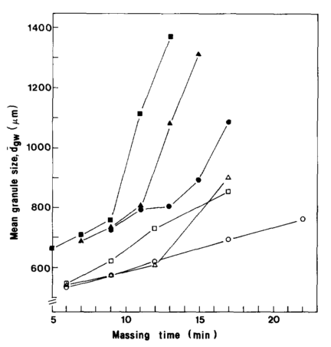
Figure A 1: Effect of mixer scale and impeller speed on the mean granule size during massing. Mixer scale: 8 litre (○，△，□), 50 litre (●，▲，■). Impeller speed: 500 rpm (●), 600 rpm (▲), 700 rpm (■), 800 rpm (○), 1000 rpm (△), 1200 rpm (□) (Schæfer et al., 1993).
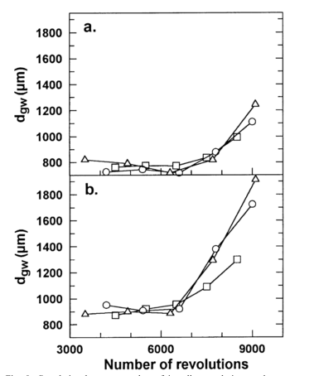
Figure A 2: Correlation between number of impeller revolutions and mean granule size in melt agglomeration experiments (a) L/S=0.22 and (b) L/S=0.24, impeller speed: 500 (□), rpm 600 rpm (○) and 700 rpm (△) (Schæfer, 2001).

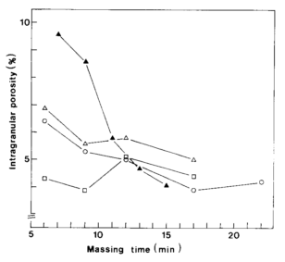
Figure A 3: Effect of mixer scale, impeller blades and impeller speed on the intragranular porosity. Impeller speed: 600 rpm (▲), 800 rpm (○), 1200 rpm (△,□).

A.2: Effect of binder amount on granules in HSM (MG)
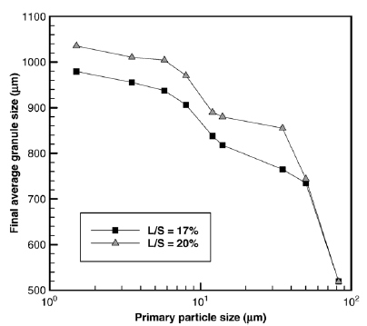
Figure A 4: Comparison of final average granule size with different L/S ratio (Tu et al., 2008).

A.3: Effect of impeller speed on granule properties in HSM (WG)
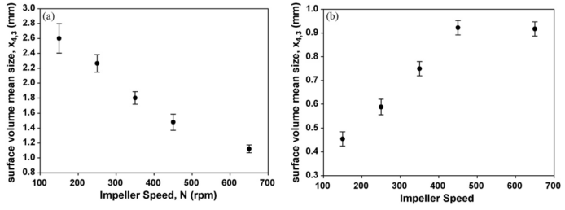
Figure A 5: Effect of impeller speed on average granule sizes. (a) Low viscosity system, (b) high viscosity system (Mangwandi et al., 2010).
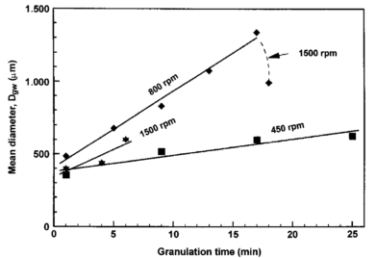
Figure A 6: Mean granule size on granulation time at impeller speeds of 450, 800 and 1500 rpm in HSM (Reynolds et al., 2005).
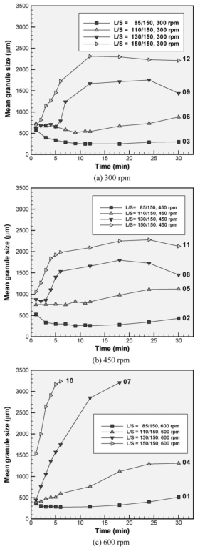
Figure A 7: The mean granule size at the same impeller speed with varied L/S ratio (Tu et al., 2009).

A.4: Effect of binder amount on granules in HSM (WG)
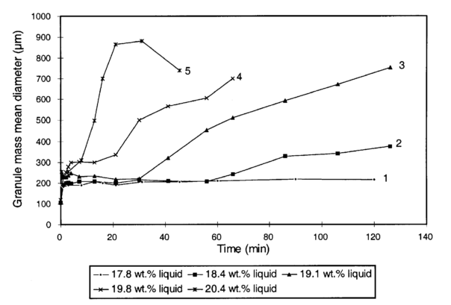
Figure A 8: Effect of liquid content on the growth behaviour of sodium sulphate and cellulose mixtures during batch granulation in HSM: (1) Nucleation only; (2-4) Induction time followed by rapid growth (5) rapid growth followed by breakage (Iveson et al., 2001).

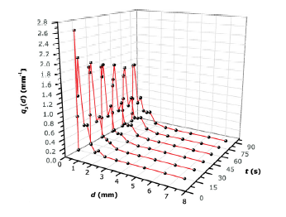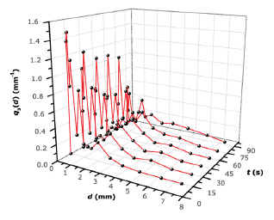
(a)
(b)
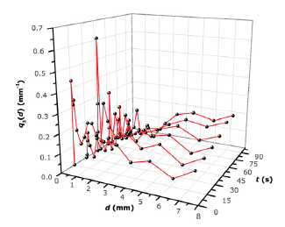
(c)

Figure A 9: Effect of L/S ratio on experimental GSD; high shear granulation runs at 300 rpm impeller speed and granulation time: (a) 15 s, (b) 45 s, (c) 60 s (Žižek et al., 2014).
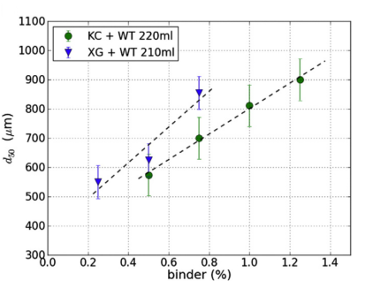
Figure A 10: Effect of binder amount on mean granule size (Franceschinis et al., 2014).
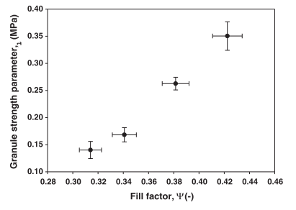
(a)
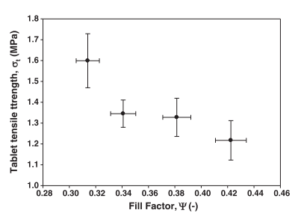
(b)
Figure A 11: (a) Bulk granule strength as a function of fill factor and (b) tablet strength as a function of fill factor (Mangwandi et al., 2014).

A.5: Effect of binder amount on granule properties in FBG (MG)
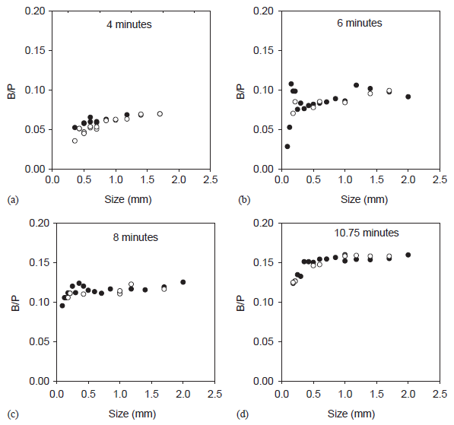
Figure A 12: Binder to particle ratio in granules of different size classes at different times (Tan et al., 2005).
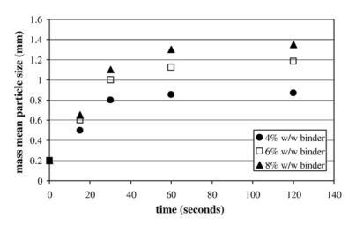
Figure A 13: Mean particle diameter versus granulation time for granules manufactured using variation in binder (Zhai et al., 2009).

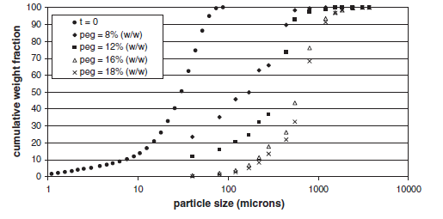
Figure A 14: Cumulative weight fraction versus particle size with respect to binder content (Walker et al., 2006).

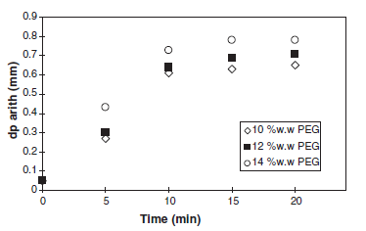
Figure A 15: Mean particle diameter with different binder amount versus time (Walker et al., 2006).

A.6: Effect of air velocity on granule properties in FBG (MG)
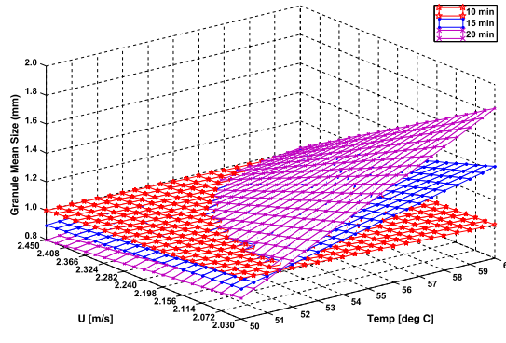
Figure A 16: Surface plot showing effect of fluidizing air velocity and fluidized bed temperature on the mean granule size for different granulation times (Mangwandi et al., 2015).

A.7: Effect of air velocity on granule properties in FBG (WG)
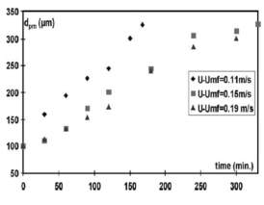
Figure A 17: Effect of air velocity on mean granule size (Hemati et al., 2003).
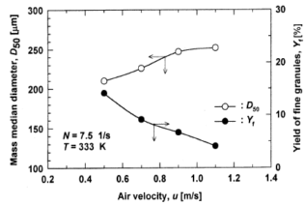
Figure A 18: Effect of fluidizing air velocity on mean granule size (Watano et al., 1997).

Appendix B

B.1: Tablet hardness of HSM 400, 600 and 800 rpm at 1 KN
Table B-1: Tablet hardness of HSM 400 rpm at 1 KN at three L/S ratios, with three size classes.
L/S ratio/ Granule size | 0.18-0.425 mm | 0.71-0.85 mm | 1.18-1.4 mm
L/S=0.12 | 1.96 | 3.73 | 4.21
L/S=0.13 | 3.27 | 5.30 | 5.38
L/S=0.145 | 4.76 | 8.05 | 8.80

Table B-2: Tablet hardness of HSM 600 rpm at 1 KN at three L/S ratios, with three size classes.
L/S ratio/ Granule size | 0.18-0.425 mm | 0.71-0.85 mm | 1.18-1.4 mm
L/S=0.12 | 2.36 | 3.89 | 4.18
L/S=0.13 | 5.57 | 7.56 | 8.28
L/S=0.145 | 8.55 | 9.19 | 9.55

Table B-3: Tablet hardness of HSM 800 rpm at 1 KN at three L/S ratios, with three size classes.
L/S ratio/ Granule size | 0.18-0.425 mm | 0.71-0.85 mm | 1.18-1.4 mm
L/S=0.12 | 5.87 | 5.96 | 6.75
L/S=0.13 | 5.94 | 6.04 | 10.57
L/S=0.145 | 7.66 | 8.50 | 10.98

B.2: Tablet hardness of HSM 400, 600 and 800 rpm at 5 KN
Table B-4: Tablet hardness of HSM 400 rpm at 5 KN at three L/S ratios, with three size classes.
L/S ratio/ Granule size | 0.18-0.425 mm | 0.71-0.85 mm | 1.18-1.4 mm
L/S=0.12 | 7.24 | 8.27 | 8.68
L/S=0.13 | 8.27 | 8.58 | 8.72
L/S=0.145 | 8.56 | 8.67 | 9.69

Table B-5: Tablet hardness of HSM 600 rpm at 5 KN at three L/S ratios, with three size classes.
L/S ratio/ Granule size | 0.18-0.425 mm | 0.71-0.85 mm | 1.18-1.4 mm
L/S=0.12 | 9.22 | 9.74 | 10.51
L/S=0.13 | 8.87 | 10.26 | 12.81
L/S=0.145 | 10.89 | 11.08 | 13.27

Table B-6: Tablet hardness of HSM 800 rpm at 5 KN at three L/S ratios, with three size classes.
L/S ratio/ Granule size | 0.18-0.425 mm | 0.71-0.85 mm | 1.18-1.4 mm
L/S=0.12 | 9.00 | 9.95 | 10.41
L/S=0.13 | 10.29 | 10.44 | 10.93
L/S=0.145 | 10.31 | 11.94 | 12.36

B.3: Tablet hardness of HSM 400, 600 and 800 rpm at 15 KN
Table B-7: Tablet hardness of HSM 400 rpm at 15 KN at three L/S ratios, with three size classes.
L/S ratio/ Granule size | 0.18-0.425 mm | 0.71-0.85 mm | 1.18-1.4 mm
L/S=0.12 | 30.77 | 30.16 | 33.88
L/S=0.13 | 31.63 | 33.10 | 35.91
L/S=0.145 | 32.83 | 34.97 | 40.26

Table B-8: Tablet hardness of HSM 600 rpm at 15 KN at three L/S ratios, with three size classes.
L/S ratio/ Granule size | 0.18-0.425 mm | 0.71-0.85 mm | 1.18-1.4 mm
L/S=0.12 | 28.77 | 30.32 | 33.20
L/S=0.13 | 39.60 | 40.44 | 41.18
L/S=0.145 | 36.81 | 40.62 | 41.56

Table B-9: Tablet hardness of HSM 800 rpm at 15 KN at three L/S ratios, with three size classes.
L/S ratio/ Granule size | 0.18-0.425 mm | 0.71-0.85 mm | 1.18-1.4 mm
L/S=0.12 | 26.37 | 30.54 | 36.01
L/S=0.13 | 34.37 | 40.05 | 40.76
L/S=0.145 | 36.03 | 41.97 | 42.71

B.4: Tablet hardness of HSM 400, 600 and 800 rpm at 29 KN
Table B-10: Tablet hardness of HSM 400 rpm at 29 KN at three L/S ratios, with three size classes.
L/S ratio/ Granule size | 0.18-0.425 mm | 0.71-0.85 mm | 1.18-1.4 mm
L/S=0.12 | 13.03 | 17.32 | 18.31
L/S=0.13 | 18.13 | 22.30 | 26.14
L/S=0.145 | 20.96 | 24.58 | 34.30

Table B-11: Tablet hardness of HSM 600 rpm at 29 KN at three L/S ratios, with three size classes.
L/S ratio/ Granule size | 0.18-0.425 mm | 0.71-0.85 mm | 1.18-1.4 mm
L/S=0.12 | 15.85 | 15.02 | 14.67
L/S=0.13 | 13.77 | 17.50 | 24.89
L/S=0.145 | 20.44 | 25.98 | 25.15

Table B-12: Tablet hardness of HSM 800 rpm at 29 KN at three L/S ratios, with three size classes.
L/S ratio/ Granule size | 0.18-0.425 mm | 0.71-0.85 mm | 1.18-1.4 mm
L/S=0.12 | 23.16 | 19.42 | 23.26
L/S=0.13 | 24.73 | 23.64 | 23.99
L/S=0.145 | 21.70 | 25.20 | 25.96

B.5: Tablet hardness of FBG 0.73, 0.97 and 1.21 m/s at 1 kN
Table B-13: Tablet hardness of FBG 0.73 m/s at 1 kN at three L/S ratios, with three size classes.
L/S ratio/ Granule size | 0.18-0.425 mm | 0.71-0.85 mm | 1.18-1.4 mm
L/S=0.12 | 1.97 | 3.73 | 4.21
L/S=0.13 | 3.27 | 5.31 | 5.38
L/S=0.145 | 4.76 | 8.05 | 8.80

Table B-14: Tablet hardness of FBG 0.97 m/s at 1 kN at three L/S ratios, with three size classes.
L/S ratio/ Granule size | 0.18-0.425 mm | 0.71-0.85 mm | 1.18-1.4 mm
L/S=0.12 | 2.04 | 3.15 | 3.70
L/S=0.13 | 4.25 | 4.72 | 5.53
L/S=0.145 | 6.83 | 7.19 | 7.18

Table B-15: Tablet hardness of FBG 1.21 m/s at 1 kN at three L/S ratios, with three size classes.
L/S ratio/ Granule size | 0.18-0.425 mm | 0.71-0.85 mm | 1.18-1.4 mm
L/S=0.12 | 3.52 | 4.47 | 5.42
L/S=0.13 | 4.74 | 5.02 | 6.89
L/S=0.145 | 5.29 | 7.00 | 7.89

B.6: Tablet hardness of FBG 0.73, 0.97 and 1.21 m/s at 5 kN
Table B-16: Tablet hardness of FBG 0.73 m/s at 5 kN at three L/S ratios, with three size classes.
L/S ratio/ Granule size | 0.18-0.425 mm | 0.71-0.85 mm | 1.18-1.4 mm
L/S=0.12 | 8.56 | 8.58 | 8.68
L/S=0.13 | 7.24 | 8.28 | 8.72
L/S=0.145 | 8.28 | 8.67 | 9.69

Table B-17: Tablet hardness of FBG 0.97 m/s at 5 kN at three L/S ratios, with three size classes.
L/S ratio/ Granule size | 0.18-0.425 mm | 0.71-0.85 mm | 1.18-1.4 mm
L/S=0.12 | 9.22 | 9.74 | 10.51
L/S=0.13 | 8.88 | 10.26 | 12.82
L/S=0.145 | 10.90 | 11.09 | 13.28

Table B-18: Tablet hardness of FBG 1.21 m/s at 5 kN at three L/S ratios, with three size classes.
L/S ratio/ Granule size | 0.18-0.425 mm | 0.71-0.85 mm | 1.18-1.4 mm
L/S=0.12 | 7.32 | 7.57 | 8.35
L/S=0.13 | 8.26 | 8.89 | 7.41
L/S=0.145 | 8.33 | 8.70 | 7.50

B.7: Tablet hardness of FBG 0.73, 0.97 and 1.21 m/s at 15 kN
Table B-19: Tablet hardness of FBG 0.73 m/s at 15 kN at three L/S ratios, with three size classes.
L/S ratio/ Granule size | 0.18-0.425 mm | 0.71-0.85 mm | 1.18-1.4 mm
L/S=0.12 | 30.77 | 30.17 | 33.88
L/S=0.13 | 31.63 | 33.11 | 35.91
L/S=0.145 | 32.83 | 34.98 | 40.27

Table B-20: Tablet hardness of FBG 0.97 m/s at 15 kN at three L/S ratios, with three size classes.
L/S ratio/ Granule size | 0.18-0.425 mm | 0.71-0.85 mm | 1.18-1.4 mm
L/S=0.12 | 45.14 | 46.11 | 55.68
L/S=0.13 | 45.44 | 50.29 | 56.52
L/S=0.145 | 48.63 | 51.60 | 56.73

Table B-21: Tablet hardness of FBG 1.21 m/s at 15 kN at three L/S ratios, with three size classes.
L/S ratio/ Granule size | 0.18-0.425 mm | 0.71-0.85 mm | 1.18-1.4 mm
L/S=0.12 | 30.82 | 34.53 | 40.23
L/S=0.13 | 36.72 | 44.61 | 45.16
L/S=0.145 | 40.37 | 48.10 | 47.37

B.8: Tablet hardness of FBG 0.73, 0.97 and 1.21 m/s at 29 kN
Table B-22: Tablet hardness of FBG 0.73 m/s at 29 kN at three L/S ratios, with three size classes.
L/S ratio/ Granule size | 0.18-0.425 mm | 0.71-0.85 mm | 1.18-1.4 mm
L/S=0.12 | 13.04 | 17.32 | 18.32
L/S=0.13 | 18.13 | 22.30 | 26.14
L/S=0.145 | 20.97 | 34.30 | 24.59

Table B-23: Tablet hardness of FBG 0.97 m/s at 29 kN at three L/S ratios, with three size classes.
L/S ratio/ Granule size | 0.18-0.425 mm | 0.71-0.85 mm | 1.18-1.4 mm
L/S=0.12 | 24.90 | 29.60 | 35.24
L/S=0.13 | 38.40 | 35.35 | 40.82
L/S=0.145 | 33.27 | 41.95 | 39.08

Table B-24: Tablet hardness of FBG 1.21 m/s at 29 kN at three L/S ratios, with three size classes.
L/S ratio/ Granule size | 0.18-0.425 mm | 0.71-0.85 mm | 1.18-1.4 mm
L/S=0.12 | 26.93 | 21.66 | 22.21
L/S=0.13 | 28.79 | 29.23 | 26.49
L/S=0.145 | 23.67 | 27.23 | 27.40

B.9: T₅₀ of granule dissolution of HSM 400, 600 and 800 rpm at different size classes, L/S=0.13

Table B-25: T₅₀ of granule dissolution of HSM 400 rpm at different size classes, L/S=0.13
Granule size class (mm) | T₅₀ (s)
0.18-0.425 | 36.70
0.71-0.85 | 44.30
1.18-1.4 | 63.44

Table B-26: T₅₀ of granule dissolution of HSM 600 rpm at different size classes, L/S=0.13
Granule size class (mm) | T₅₀ (s)
0.18-0.425 | 45.90
0.71-0.85 | 65.29
1.18-1.4 | 68.75

Table B-27: T₅₀ of granule dissolution of HSM 800 rpm at different size classes, L/S=0.13
Granule size class (mm) | T₅₀ (s)
0.18-0.425 | 47.20
0.71-0.85 | 69.36
1.18-1.4 | 79.92

B.10: T₅₀ of granule dissolution of FBG 0.73, 0.97 and 1.21 m/s at different size classes, L/S=0.13
Table B-28: T₅₀ of granule dissolution of FBG 0.73 m/s at different size classes, L/S=0.13
Granule size class (mm) | T₅₀ (s)
0.18-0.425 | 12
0.71-0.85 | 15
1.18-1.4 | 22

Table B-29: T₅₀ of granule dissolution of FBG 0.97 m/s at different size classes, L/S=0.13
Granule size class (mm) | T₅₀ (s)
0.18-0.425 | 15
0.71-0.85 | 18
1.18-1.4 | 24

Table B-30: T₅₀ of granule dissolution of FBG 1.21 m/s at different size classes, L/S=0.13
Granule size class (mm) | T₅₀ (s)
0.18-0.425 | 17
0.71-0.85 | 23
1.18-1.4 | 25

B.11: T₉₀ of tablet dissolution of HSM 400, 600 and 800 rpm at different size classes, L/S=0.13, 1 kN

Table B-31: T₉₀ of tablet dissolution of HSM 400 rpm at different size classes, L/S=0.13, 1 kN
Granule size class (mm) | T₉₀ (min)
0.18-0.425 | 7.1
0.71-0.85 | 6.3
1.18-1.4 | 5.0

Table B-32: T₉₀ of tablet dissolution of HSM 600 rpm at different size classes, L/S=0.13, 1 kN
Granule size class (mm) | T₉₀ (min)
0.18-0.425 | 6.1
0.71-0.85 | 5.4
1.18-1.4 | 5.1

Table B-33: T₉₀ of tablet dissolution of HSM 800 rpm at different size classes, L/S=0.13, 1 kN
Granule size class (mm) | T₉₀ (min)
0.18-0.425 | 4.2
0.71-0.85 | 4.1
1.18-1.4 | 3.9

B.12: T₉₀ of tablet dissolution of HSM 400, 600 and 800 rpm at different size classes, L/S=0.13, 5 kN

Table B-34: T₉₀ of tablet dissolution of HSM 400 rpm at different size classes, L/S=0.13, 5 kN
Granule size class (mm) | T₉₀ (min)
0.18-0.425 | 9.6
0.71-0.85 | 7.7
1.18-1.4 | 6.7

Table B-35: T₉₀ of tablet dissolution of HSM 600 rpm at different size classes, L/S=0.13, 5 kN
Granule size class (mm) | T₉₀ (min)
0.18-0.425 | 7.5
0.71-0.85 | 7.1
1.18-1.4 | 5.0

Table B-36: T₉₀ of tablet dissolution of HSM 800 rpm at different size classes, L/S=0.13, 5 kN
Granule size class (mm) | T₉₀ (min)
0.18-0.425 | 7.4
0.71-0.85 | 6.9
1.18-1.4 | 4.6

B.13: T₉₀ of tablet dissolution of HSM 400, 600 and 800 rpm at different size classes, L/S=0.13, 15 kN

Table B-37: T₉₀ of tablet dissolution of HSM 400 rpm at different size classes, L/S=0.13, 15 kN
Granule size class (mm) | T₉₀ (min)
0.18-0.425 | 15.2
0.71-0.85 | 13.0
1.18-1.4 | 12.0

Table B-38: T₉₀ of tablet dissolution of HSM 600 rpm at different size classes, L/S=0.13, 15 kN
Granule size class (mm) | T₉₀ (min)
0.18-0.425 | 13.3
0.71-0.85 | 12.0
1.18-1.4 | 8.8

Table B-39: T₉₀ of tablet dissolution of HSM 800 rpm at different size classes, L/S=0.13, 15 kN
Granule size class (mm) | T₉₀ (min)
0.18-0.425 | 10.2
0.71-0.85 | 7.7
1.18-1.4 | 7.3

B.14: T₉₀ of tablet dissolution of HSM 400, 600 and 800 rpm at different size classes, L/S=0.13, 29 kN

Table B-40: T₉₀ of tablet dissolution of HSM 400 rpm at different size classes, L/S=0.13, 29 kN
Granule size class (mm) | T₉₀ (min)
0.18-0.425 | 12.3
0.71-0.85 | 10.2
1.18-1.4 | 9.8

Table B-41: T₉₀ of tablet dissolution of HSM 600 rpm at different size classes, L/S=0.13, 29 kN
Granule size class (mm) | T₉₀ (min)
0.18-0.425 | 14.2
0.71-0.85 | 11.4
1.18-1.4 | 11.8

Table B-42: T₉₀ of tablet dissolution of HSM 800 rpm at different size classes, L/S=0.13, 29 kN
Granule size class (mm) | T₉₀ (min)
0.18-0.425 | 12.6
0.71-0.85 | 11.9
1.18-1.4 | 12.0

B.15: T₉₀ of tablet dissolution of FBG 0.73, 0.97 and 1.21 m/s at different size classes, L/S=0.13, 1 kN
Table B-43: T₉₀ of tablet dissolution of FBG 0.73 m/s at different size classes, L/S=0.13, 1 kN
Granule size class (mm) | T₉₀ (min)
0.18-0.425 | 6.4
0.71-0.85 | 6.1
1.18-1.4 | 5.9

Table B-44: T₉₀ of tablet dissolution of FBG 0.97 m/s at different size classes, L/S=0.13, 5 kN
Granule size class (mm) | T₉₀ (min)
0.18-0.425 | 6.7
0.71-0.85 | 5.8
1.18-1.4 | 4.5

Table B-45: T₉₀ of tablet dissolution of FBG 1.21 m/s at different size classes, L/S=0.13, 1 kN
Granule size class (mm) | T₉₀ (min)
0.18-0.425 | 6.5
0.71-0.85 | 5.7
1.18-1.4 | 4.2

B.16: T₉₀ of tablet dissolution of FBG 0.73, 0.97 and 1.21 m/s at different size classes, L/S=0.13, 5 kN
Table B-46: T₉₀ of tablet dissolution of FBG 0.73 m/s at different size classes, L/S=0.13, 5 kN
Granule size class (mm) | T₉₀ (min)
0.18-0.425 | 6.9
0.71-0.85 | 6.8
1.18-1.4 | 6.8

Table B-47: T₉₀ of tablet dissolution of FBG 0.97 m/s at different size classes, L/S=0.13, 5 kN
Granule size class (mm) | T₉₀ (min)
0.18-0.425 | 7.0
0.71-0.85 | 6.7
1.18-1.4 | 6.7

Table B-48: T₉₀ of tablet dissolution of FBG 1.21 m/s at different size classes, L/S=0.13, 5 kN
Granule size class (mm) | T₉₀ (min)
0.18-0.425 | 6.5
0.71-0.85 | 5.7
1.18-1.4 | 4.2

B.17: T₉₀ of tablet dissolution of FBG 0.73, 0.97 and 1.21 m/s at different size classes, L/S=0.13, 15 kN
Table B-49: T₉₀ of tablet dissolution of FBG 0.73 m/s at different size classes, L/S=0.13, 15 kN
Granule size class (mm) | T₉₀ (min)
0.18-0.425 | 18.0
0.71-0.85 | 17.0
1.18-1.4 | 12.1

Table B-50: T₉₀ of tablet dissolution of FBG 0.97 m/s at different size classes, L/S=0.13, 15 kN
Granule size class (mm) | T₉₀ (min)
0.18-0.425 | 17.1
0.71-0.85 | 13.0
1.18-1.4 | 12.0

Table B-51: T₉₀ of tablet dissolution of FBG 1.21 m/s at different size classes, L/S=0.13, 15 kN
Granule size class (mm) | T₉₀ (min)
0.18-0.425 | 14.0
0.71-0.85 | 11.1
1.18-1.4 | 9.5

B.18: T₉₀ of tablet dissolution of FBG 0.73, 0.97 and 1.21 m/s at different size classes, L/S=0.13, 29 kN
Table B-52: T₉₀ of tablet dissolution of FBG 0.73 m/s at different size classes, L/S=0.13, 29 kN
Granule size class (mm) | T₉₀ (min)
0.18-0.425 | 11.2
0.71-0.85 | 10.6
1.18-1.4 | 9.7

Table B-53: T₉₀ of tablet dissolution of FBG 0.97 m/s at different size classes, L/S=0.13, 29 kN
Granule size class (mm) | T₉₀ (min)
0.18-0.425 | 14.3
0.71-0.85 | 12.2
1.18-1.4 | 10.1

Table B-54: T₉₀ of tablet dissolution of FBG 1.21 m/s at different size classes, L/S=0.13, 29 kN
Granule size class (mm) | T₉₀ (min)
0.18-0.425 | 13.1
0.71-0.85 | 12.1
1.18-1.4 | 7.1

B.19: Granules of HSM 400, 600 and 800 rpm, L/S=0.13
The images showed in Figure B-1 are HSM 400, 600 and 800 rpm at L/S=0.13, with three size classes, namely 0.18-0.425, 0.71-0.85 and 1.18-1.4 mm. Regarding the granule circularity, it is found that the granules of smaller sizes are generally in irregular shapes, whereas the granules of larger sizes are more rounded and spherical. This is believed to be as a function of the centrifugal force inside the mixer bowl, as the granules are experiencing the same extent of forces from all directions, therefore, creating a uniform spherical shape of granules, which increases size with time.
It is also noticed that in Figure B-1 (h) and (i) that the surfaces of the granules produced at 800 rpm seemed to be much smoother than the ones produced at lower impeller speed. The reason is assumed that at very high impeller speed, the shear force provided by the impeller was sufficient to squeeze the binder in granules from inside to surface (defined as migration of binder from core to surface), which eventually caused high consolidation. Compared to the granule surfaces made of the same size class of granules (b) and (c) at 400 rpm, and (e) and (f) at 600 rpm, it is found that these surfaces contained a fairly high number of small fines, which indicates that the granule surface was saturated and cohesive to stick more particles, leading to an increase the granule size. As explained in Chapter 4 and 5, the squeezed binder from the granules would form a liquid layer, allowing the particles to immerge. As a result, the granule surface becomes smooth.

0.18-0.425 mm
0.71-0.85 mm
1.18-1.4 mm
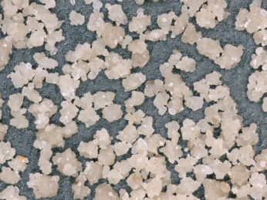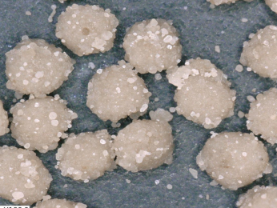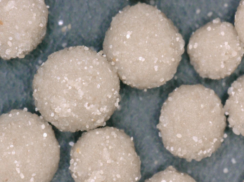
400 rpm
(a) (b) (c)

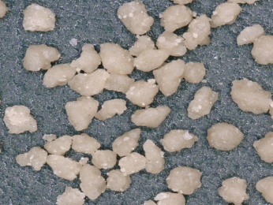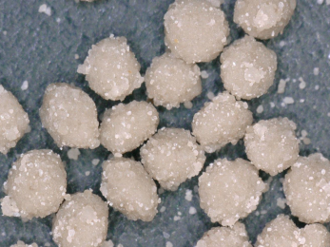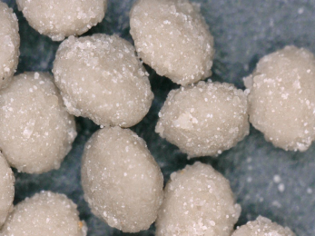
600 rpm
(d) (e) (f)

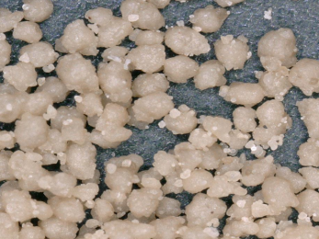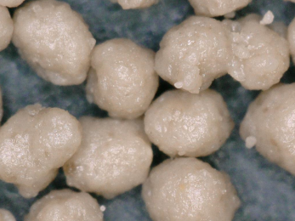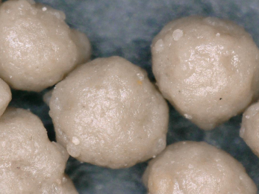
800 rpm
(g) (h) (i)

Figure B-1: Images of granules produced by HSM at different size classes at 400, 600 and 800 rpm, L/S=0.13.

B.20: Tablets of HSM 400,600,800 rpm-1KN, L/S=0.13
The images in Figure B-2 to Figure B-5 are taken by the Keyence microscope, with a magnification 20x each. It is clearly seen in the images of tablets compressed at 1 KN that the edges of unbroken granules, which were showing as dark brown colour on the tablet surfaces. The area of the edges; however, was related to the gaps between granules, which was also defined as free volumes between granules. Based on this conclusion, it was estimated that the tablets produced at 1 KN at all impeller speeds could be very weak, as the dark brown area was seen to distribute on the tablet surface, especially for those produced by large size of granules. Additionally, it was also found that at the same size class, the tablets produced with the least binder amount have flattest surface, indicating that the granular strength was too low to survive during the tablet compression.
The tablet surface started to become smoother when the compression force increased to 5 KN (Figure B-3). Although the dark zones on the tablet surfaces started to disappear, it was evident that the gaps were still partially visible, especially for the tablets made of large granules. When the force was further increased to 15 KN (Figure B-4), the specific features of tablets began to lose, as most of the granules were unable to survive at this stage of compressing, and finally, when the force reached 29 KN (Figure B-5), there was almost no apparent difference between tablets from different conditions, as no granule was able to hold it structure. The broken granule fractures; however, filled up the gaps between the original granules, and because of the extremely high compression force, the binder remained within the fragments were expected to be squeezed and then functions as solid binder, connecting the other broken fragments and reduce the air volume trapped in the tablets, and thus form a stronger tablet. As this force load was so high that the effects of other factors such as impeller speed, granule size and binder amount were minor and even eliminated.

1.18-1.4 mm
0.71-0.85 mm
0.18-0.425 mm
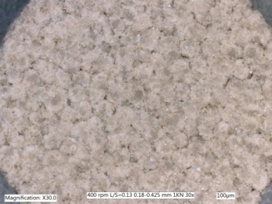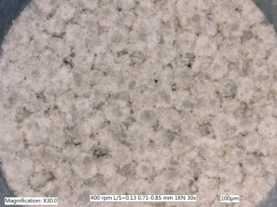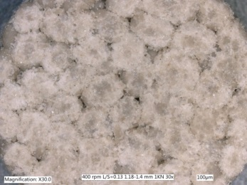
400 rpm
(a) (b) (c)

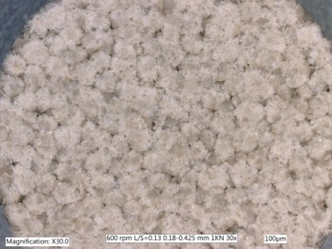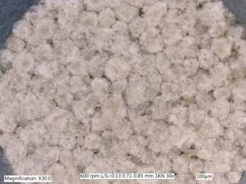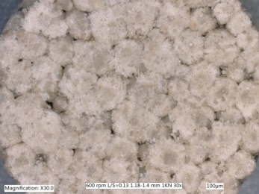
600 rpm
(d) (e) (f)

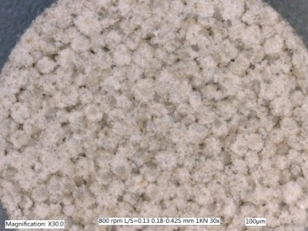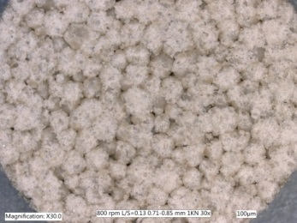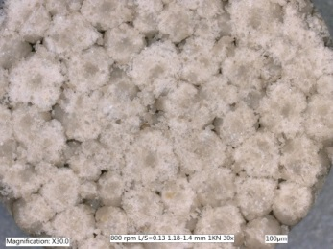
800 rpm
(g) (h) (i)

Figure B-2: Images of tablet surface produced from HSM at different size classes and impeller speed, L/S=0.13, compression at 1 KN

B.21: Tablets of HSM 400,600,800 rpm-5 KN, L/S=0.13
0.18-0.425 mm
0.71-0.85 mm
1.18-1.4 mm
400 rpm
600 rpm
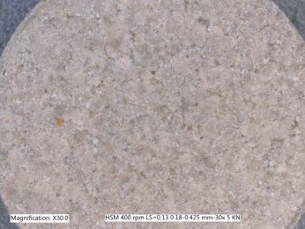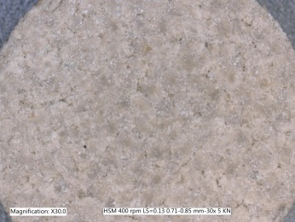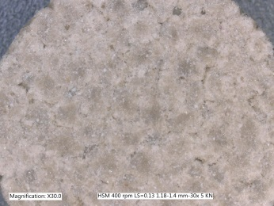
(a) (b) (c)

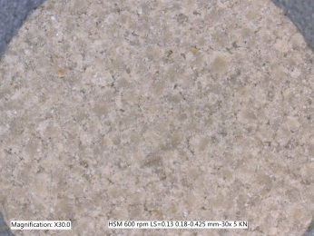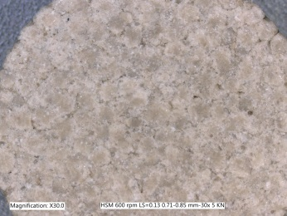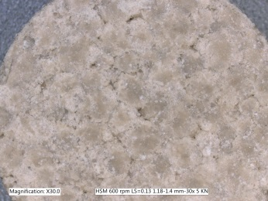
(d) (e) (f)

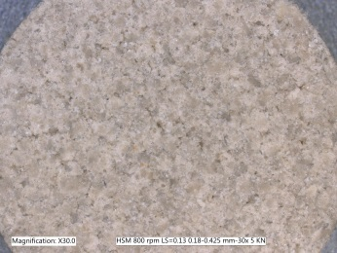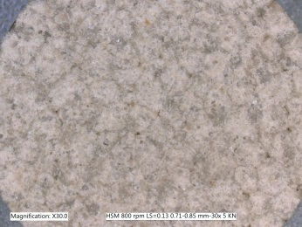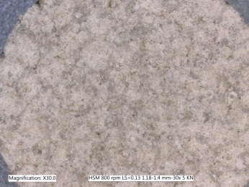
800 rpm
(g) (h) (i)

Figure B-3: Images of tablet surface produced from HSM at different size classes and impeller speed, L/S-0.13, compressed at 5 KN.

B.22: Tablets of HSM 400,600,800 rpm-15 KN, L/S=0.13
0.18-0.425 mm
0.71-0.85 mm
1.18-1.4 mm
400 rpm
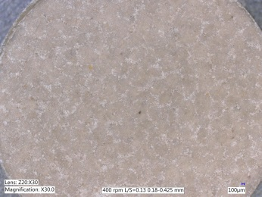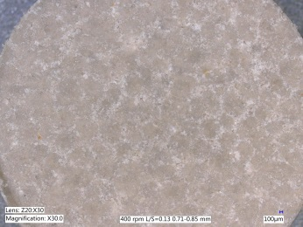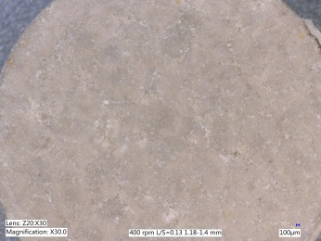
(a) (b) (c)

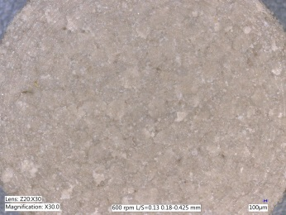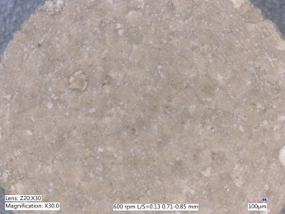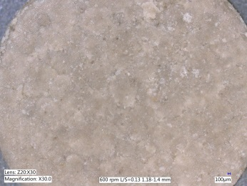
600 rpm
(d) (e) (f)

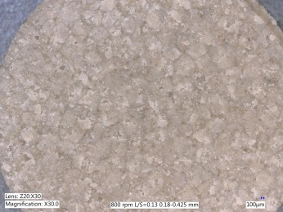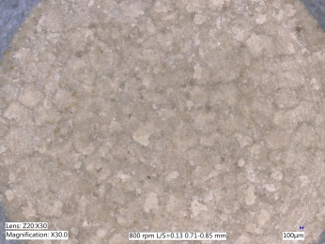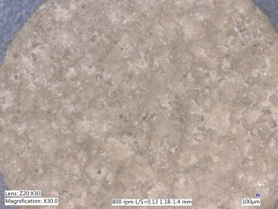
800 rpm
(g) (h) (i)

Figure B-4: Image of tablet surface produced from HSM at different size classes and impeller speed, L/S=0.13, compressed at 15 KN.

B.23: Tablets of HSM 400,600,800 rpm-29 KN, L/S=0.13
400 rpm
1.18-1.4 mm
0.71-0.85 mm
0.18-0.425 mm
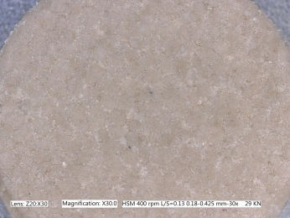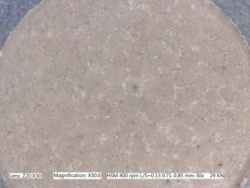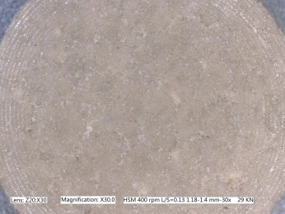
(a) (b) (c)

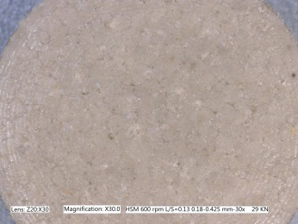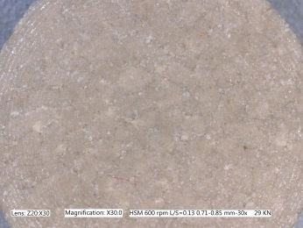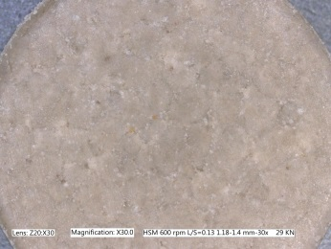
600 rpm
(d) (e) (f)

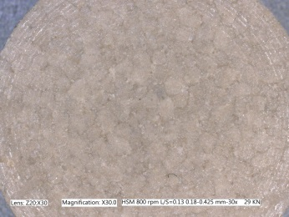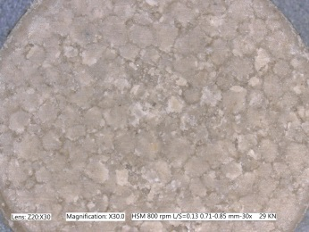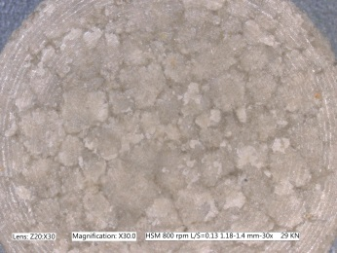
800 rpm
(g) (h) (i)

Figure B-5: Image of tablet surface produced from HSM at different size classes and impeller speed, L/S=0.13, compressed at 29 KN.

B.24: Granule porosity of HSM

Figure B-6: Granule porosity measurement of HSM 400 rpm at three L/S ratios.

Figure B-7: Granule porosity measurement of HSM 600 rpm at three L/S ratios.

Figure B-8: Granule porosity measurement of HSM 800 rpm at three L/S ratios.

B.25: Granule porosity of FBG

Figure B-9: Granule porosity measurement of FBG AV=0.73 m/s at three L/S ratios.

Figure B-10: Granule porosity measurement of FBG AV=0.97 m/s at three L/S ratios.

Figure B-11: Granule porosity measurement of FBG AV=1.21 m/s at three L/S ratios.

B.26: Tablet porosity of HSM

Figure B-12: Tablet porosity of HSM 400 rpm with three size classes at force compression forces, L/S=0.13.

Figure B-13: Tablet porosity of HSM 600 rpm with three size classes at force compression forces, L/S=0.13.

Figure B-14: Tablet porosity of HSM 800 rpm with three size classes at force compression forces, L/S=0.13.

B.27: Tablet porosity of FBG

Figure B-15: Tablet porosity of FBG 0.73 m/s with three size classes at force compression forces, L/S=0.13.

Figure B-16: Tablet porosity of FBG 0.97 m/s with three size classes at force compression forces, L/S=0.13.

Figure B-17: Tablet porosity of FBG 1.21 m/s with three size classes at force compression forces, L/S=0.13.

B.28: Keyence microscope 3D imaging
The colour on the images indicated the roughness of the tablet surfaces. While the dark colour implied that the tablet surface was relatively smooth, the bright colour implied that the tablet surface was relatively rough. The 3D images were taken and constructed by the Keyence microscope, with an observation area of 4000x2000 um.
The data in Figure B-18 to Figure B-21 showed the images of tablet surfaces produced by three size classes at 400 rpm in HSM, with L/S=0.13 at 1, 5, 15 and 29 KN, respectively. The reason was presumed to have related to the granule strength, as the deformation of weak granules was higher than that of strong granules. Once the granules were broken into fragments, the gaps between granules were filled up with these fractures and thus increase the tablet surface area.
Being opposite to the trend of tablet surface, the volume of the target tablet has decreased with an increase in compression forces, which was expected as a consequence. In addition, it was also noticed that the volume of the tablets made of 1.18-1.4 mm was generally higher than the other size classes, indicating that the tablet volume at varied compression forces was partially determined by the bulk granule strength as well.

B.29: 3D imaging of HSM 400 rpm tablet surface at 1 KN
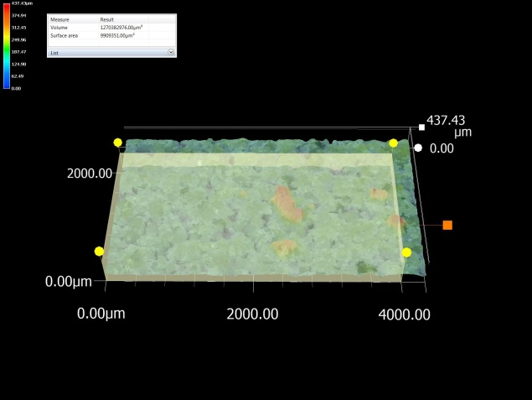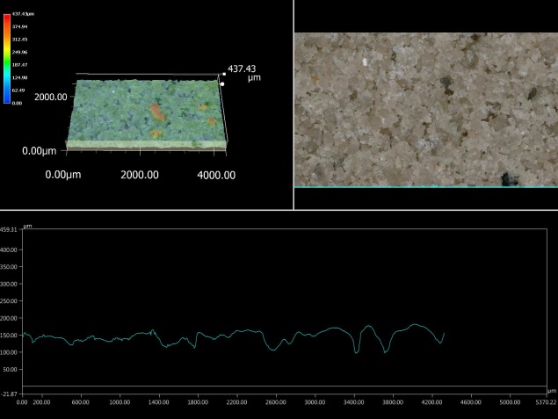
(a) (b)

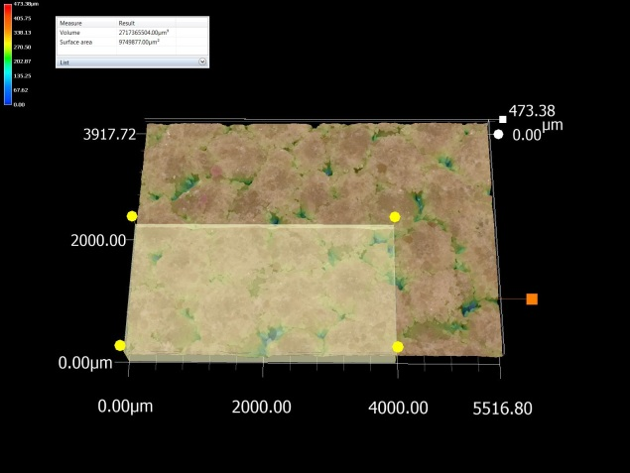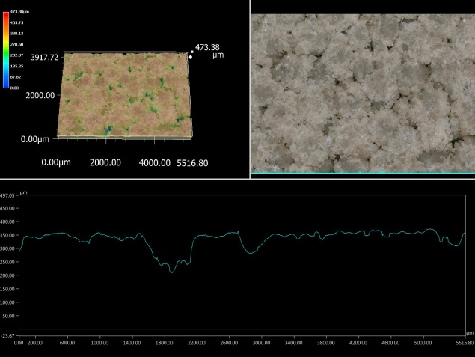
(c) (d)

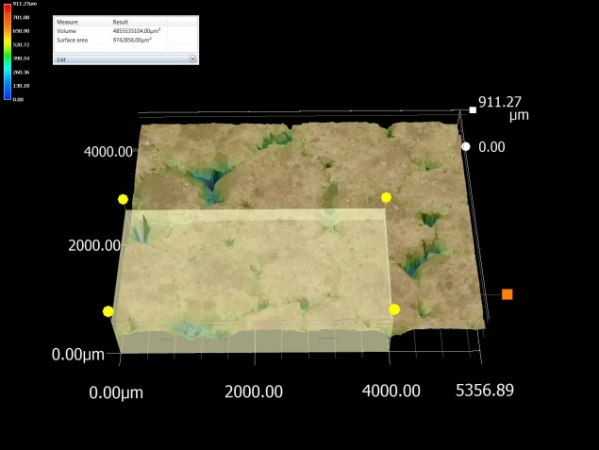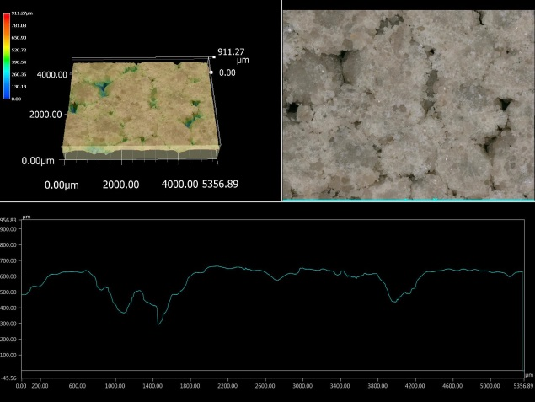
(e) (f)

Figure B-18: 3D imaging of HSM 400 rpm tablet surface: (a) 0.18-0.425 mm and surface profile (b); (c) 0.71-0.85 mm and surface profile (d); and (e) 1.18-1.4 mm and surface profile (f), L/S=0.13 at 1 KN.

B.30: 3D imaging of HSM 400 rpm tablet surface at 5 KN
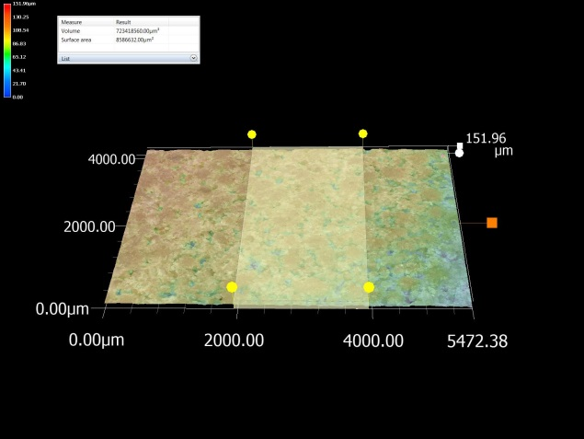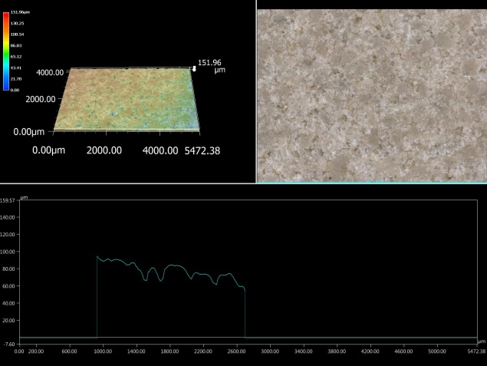
(a) (b)

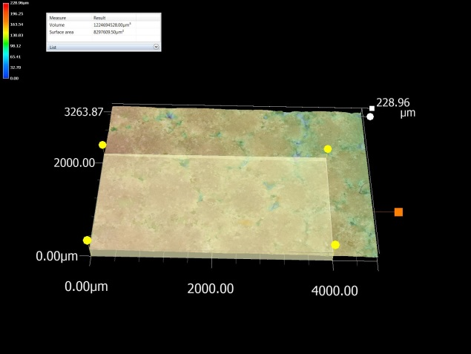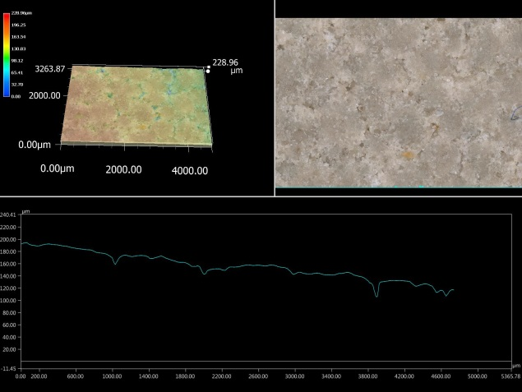
(c) (d)

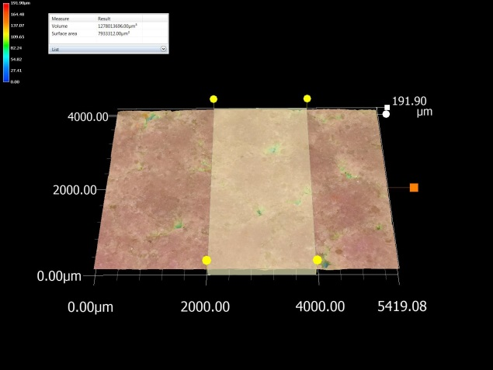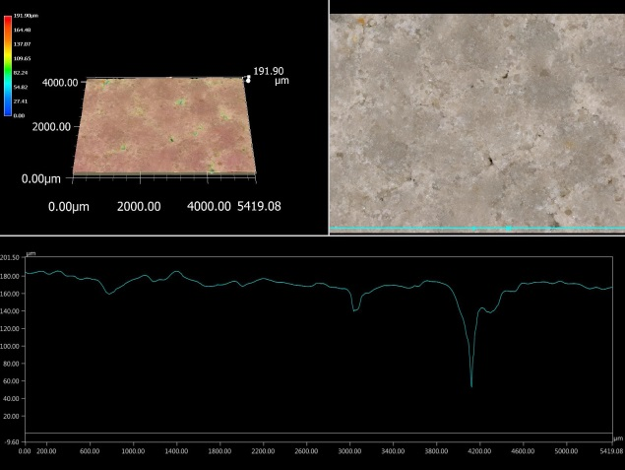
(e) (f)

Figure B-19: 3D imaging of HSM 400 rpm tablet surface: (a) 0.18-0.425 mm and surface profile (b); (c) 0.71-0.85 mm and surface profile (d); and (e) 1.18-1.4 mm and surface profile (f), L/S=0.13 at 5 KN.

B.31: 3D imaging of HSM 400 rpm tablet surface at 15 KN
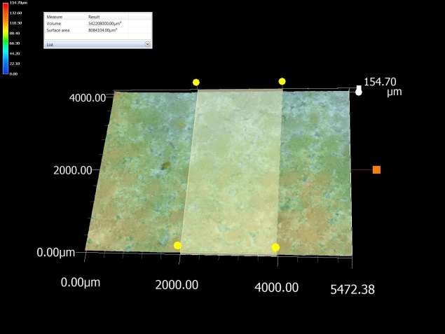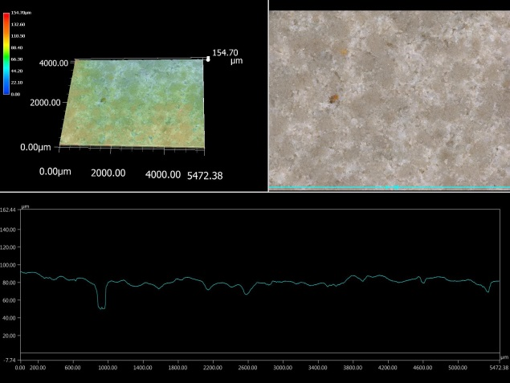
(a) (b)
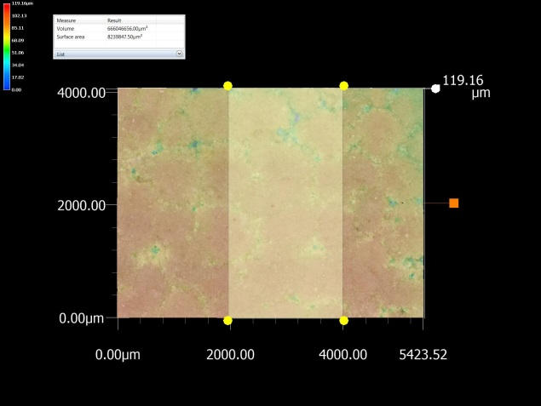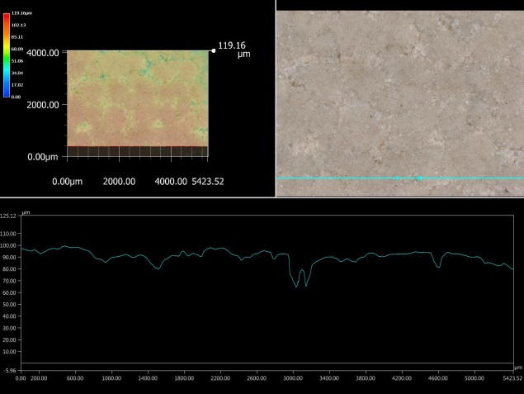
(c) (d)

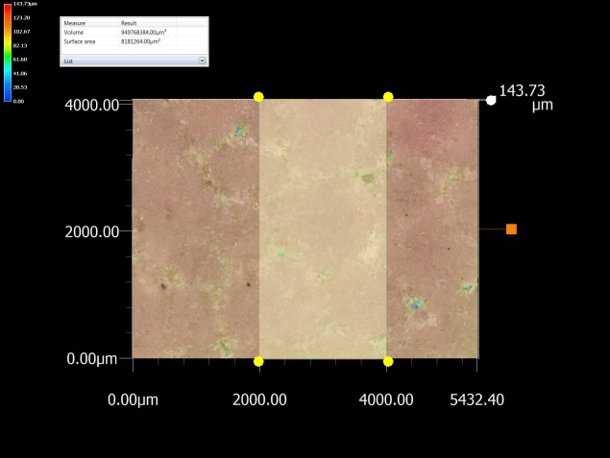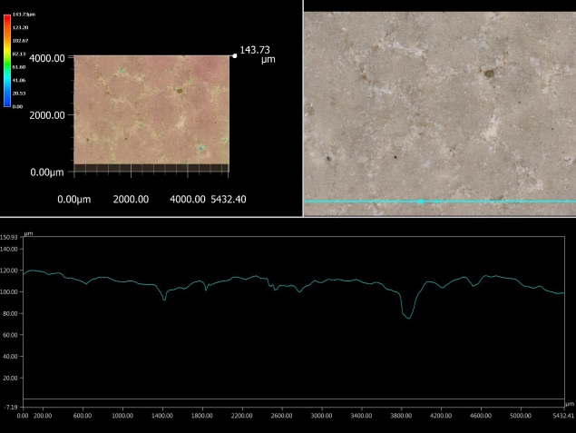
(e) (f)

Figure B-20: 3D imaging of HSM 400 rpm tablet surface: (a) 0.18-0.425 mm and surface profile (b); (c) 0.71-0.85 mm and surface profile (d); and (e) 1.18-1.4 mm and surface profile (f), L/S=0.13 at 15 KN.

B.32: 3D imaging of HSM 400 rpm tablet surface at 29 KN
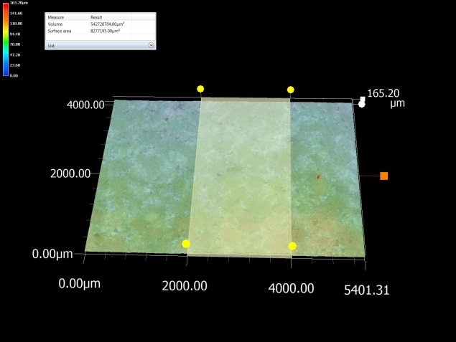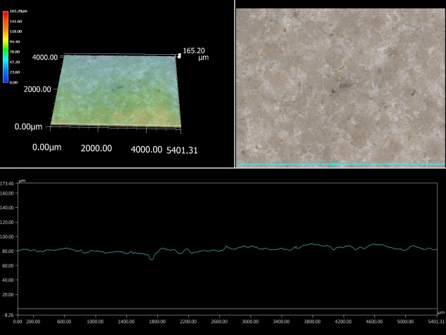
(a) (b)

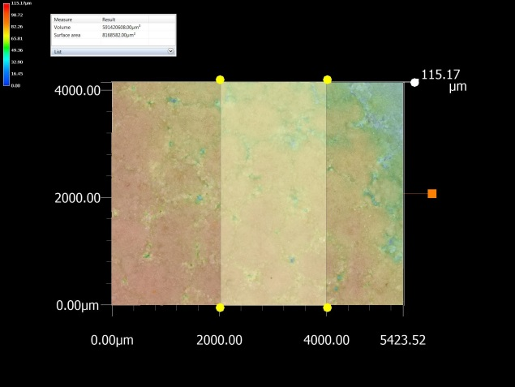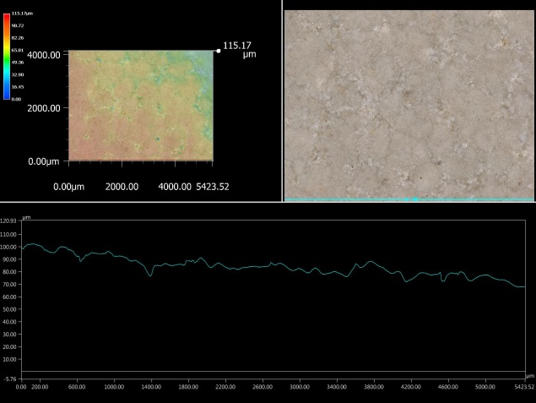
(c) (d)

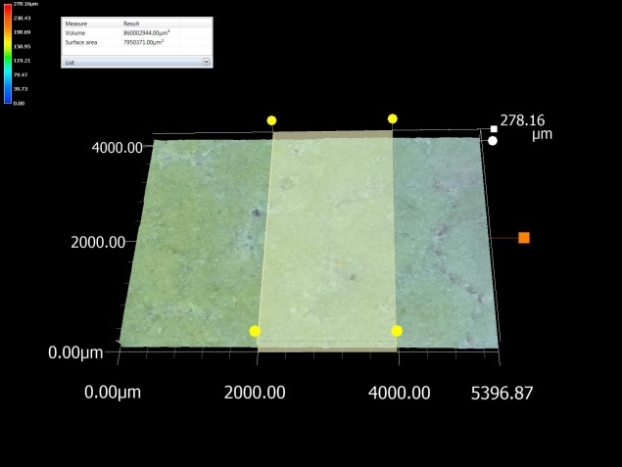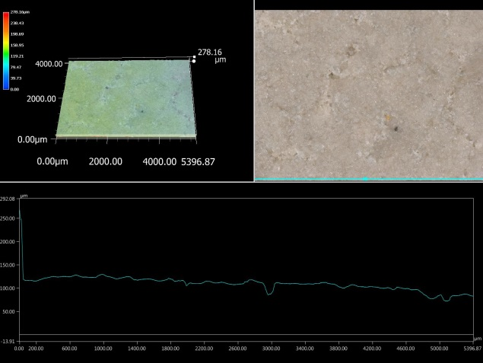
(e) (f)

Figure B-21: 3D imaging of HSM 400 rpm tablet surface: (a) 0.18-0.425 mm and surface profile (b); (c) 0.71-0.85 mm and surface profile (d); and (e) 1.18-1.4 mm and surface profile (f), L/S=0.13 at 29 KN.

B.33: 3D imaging of tablet surface roughness at 1 KN
Table B-55: Tablet surface area and volume of observation area at 400 rpm, L/S=0.13 at 1 KN with three size classes
HSM 400 rpm | 1 KN | L/S=0.13
Size Class | Surface area (mm²) | Volume (mm³)
0.18-0.425 mm | 9.91 | 1.62
0.71-0.85 mm | 9.84 | 3.04
1.18-1.4 mm | 9.29 | 4.92

B.34: 3D imaging of tablet surface roughness at 5 KN
Table B-56: Tablet surface area and volume of observation area at 400 rpm, L/S=0.13 at 5 KN with three size classes
HSM 400 rpm | 5 KN | L/S=0.13
Size Class | Surface area (mm²) | Volume (mm³)
0.18-0.425 mm | 8.58 | 0.72
0.71-0.85 mm | 8.29 | 1.22
1.18-1.4 mm | 7.93 | 1.27

B.35: 3D imaging of tablet surface roughness at 15 KN
Table B-57: Tablet surface area and volume of observation area at 400 rpm, L/S=0.13 at 15 KN with three size classes
HSM 400 rpm | 15 KN | L/S=0.13
Size Class | Surface area (mm²) | Volume (mm³)
0.18-0.425 mm | 8.08 | 0.54
0.71-0.85 mm | 8.23 | 0.66
1.18-1.4 mm | 8.18 | 0.94

B.36: 3D imaging of tablet surface roughness at 29 KN
Table B-58: Tablet surface area and volume of observation area at 400 rpm, L/S=0.13 at 29 KN with three size classes
HSM 400 rpm | 29 KN | L/S=0.13
Size Class | Surface area (mm²) | Volume (mm³)
0.18-0.425 mm | 8.27 | 0.54
0.71-0.85 mm | 8.16 | 0.59
1.18-1.4 mm | 7.95 | 0.86

B.37: XRT images
Figure B-22 shows the X-ray images of HSM (a-i) and FBG (j-l) granules. As described in Section 3.11, an amount of 1 gram of granules of varied sizes was placed in a sample holder for X-ray scanning. The scanning time for each measurement was set at 2 hours, with 256 slices of each sample and then re-constructed by using Image J.
The granule porosity of both HSM and FBG is shown in
Figure B-22: XRT images of HSM and FBG granules at varied conditions at L/S=0.13: HSM 400 rpm (a) 0.18-0.425 mm, (b) 0.71-0.85 mm and (c) 1.18-1.4 mm; HSM 600 rpm (d) 0.18-0.425 mm, (e) 0.71-0.85 mm and (f) 1.18-1.4 mm; HSM 800 rpm (g) 0.18-0.425 mm, (h) 0.71-0.85 mm and (i) 1.18-1.4 mm; FBG 0.97m/s (j) 0.18-0.425 mm, (k) 0.71-0.85 mm and (l) 1.18-1.4 mm.
. It is found that for HSM granules, the distribution of pores of granules was partially determined by the granule size, as at 0.18-0.425 mm of (a), (d) and (g), the granules were more porous at the edges than the centre, where was dense due to higher consolidation; however, when comparing to the sizes of 0.71-0.85 mm of (b), (e) and (h), and 1.18-1.4 mm of (c), (f) and (i), it was found that the edges of granules were denser than the centre, which was believed to be due to the influence of impeller speed on the granule size enlargement.
At low impeller speed, the rotation of impeller generally prompts the granule growth by coalesce; however, when the impeller speed was high, some of the granules were firstly broken into fragments, and then the fragments started to stick to each other and as a result, forming a new granule. This explained when the granules of large sizes were porous in the centre in HSM.
Compared to the porosity of HSM granules, the images of FBG granules at L/S=0.13 of three size classes in
Figure B-22: XRT images of HSM and FBG granules at varied conditions at L/S=0.13: HSM 400 rpm (a) 0.18-0.425 mm, (b) 0.71-0.85 mm and (c) 1.18-1.4 mm; HSM 600 rpm (d) 0.18-0.425 mm, (e) 0.71-0.85 mm and (f) 1.18-1.4 mm; HSM 800 rpm (g) 0.18-0.425 mm, (h) 0.71-0.85 mm and (i) 1.18-1.4 mm; FBG 0.97m/s (j) 0.18-0.425 mm, (k) 0.71-0.85 mm and (l) 1.18-1.4 mm.
(j), (k) and (l) showed that the porosity was much higher. The pores were distributed on both the edge and centre of the granules, indicating that the FBG granule strength was much lower than the HSM granules.
(a) (b)

(c) (d)
(e) (f)

(g) (h)

(i) (j)

(k) (l)

Figure B-22: XRT images of HSM and FBG granules at varied conditions at L/S=0.13: HSM 400 rpm (a) 0.18-0.425 mm, (b) 0.71-0.85 mm and (c) 1.18-1.4 mm; HSM 600 rpm (d) 0.18-0.425 mm, (e) 0.71-0.85 mm and (f) 1.18-1.4 mm; HSM 800 rpm (g) 0.18-0.425 mm, (h) 0.71-0.85 mm and (i) 1.18-1.4 mm; FBG 0.97m/s (j) 0.18-0.425 mm, (k) 0.71-0.85 mm and (l) 1.18-1.4 mm.

