

The role of neutrophil-derived microvesicles in the focal nature of atherosclerosis: mechanisms of interaction and uptake.

Ben Ward

A thesis submitted in partial fulfilment of the requirements for the degree of Doctor of Philosophy

Department of Infection, Immunity and Cardiovascular Disease
School of Medicine
The University of Sheffield

November 2017
Acknowledgements

I would like to express my deepest gratitude to my supervisor Dr. Vikki Ridger. Your support throughout the project has been incredible; with any other supervisor I am sure I would not have made it to this point. Importantly, I must also thank you for your love of international conferences, as I am certainly far better travelled thanks to the PhD. This gratitude is also extended to Professor Paul Evans; your guidance during group meetings was invaluable and I owe much of my development as a ‘scientist’ to you (I hope someone in the office can fill the chewing gum sized void I am going to leave you).

I must also thank Dr. Ingrid Gomez for helping out from time to time…. (A joke of course, I couldn’t have done it without you and I look forward to seeing you progress into what I am sure will be a very successful academic career). To all our collaborators at UCL, Maastricht and Loughborough Universities I must thank you for your generosity and support of my project. I hope lots of grants and papers blossom from these partnerships. And to everyone in the lab/office, thank you for allowing me to ‘borrow’ your PBS and for believing that ‘I will make you a new bottle up tomorrow I promise’ would ever happen (in particular Giannis, Jack, Neil, Jess, Marwa, Celine and Yang who all directly helped with teaching me techniques).

Importantly, a huge thanks to all of my family (in particular my Mum and Dad, of course). I know I was a bit of a nightmare at times, especially financially. One day when I actually have some money of my own I promise to return the generosity you have shown throughout. I look forward to hearing your page-by-page critiques as proof you have actually read it though. And to Fred and Margaret, and Nana and Grandad; I will always appreciate your amazing hospitality (in particular your laundrettes) whenever I could come up. Sorry it wasn’t more often. I love you all.

I must finally thank all of my friends, new and old (there are too many to name you all individually, but I hope you know who you are). To people from Brighton and Loughborough, I am sorry for how terrible I have been in keeping in contact, but I promise to get drunk and soppy with you soon to try make up for it. To everyone in Sheffield, I have made some life-long pals here and without you I almost certainly would have given up by now. Some of you are going to make amazing doctors, and some of you I hope I never have to come across in a professional setting. To all of the 451 pudding club members (regulars and guests), wherever everyone ends up, count this as an open invite for dinner at ‘Wardys’. And finally thank you Lilly, Josh and Wiff for letting me use the mattress in the dungeon for the last few months, it was the best bedroom I ever had!!!!

And as promised, congratulations Dr. Rob Causer and Dr. Thomas Charrin for each winning a 451 pub quiz. I will have your copies of the thesis posted to you for you both to cherish forever.

I <3 microvesicles

Thesis Summary

Atherosclerosis is an inflammatory disease of arteries that develops at focal regions of the vasculature. At these sites, disturbed flow results in elevated adhesion molecule expression that facilitates inflammatory cell transmigration into the vessel wall. Although neutrophil depletion is associated with reduced lesion progression, neutrophils are seldom found within developing plaques and the mechanism by which they contribute to the atherogenic process remains unclarified. Upon activation, neutrophils release microvesicles (MVs) that are able to interact with and activate the endothelium. Here we tested the hypothesis that a pro-atherogenic diet can alter the number and function of neutrophil microvesicles, which preferentially interact with and are internalised by endothelial cells at sites of disturbed flow, contributing to the focal nature of atherogenesis.
In the current study, a number of in vitro techniques were used to investigate microvesicle interactions with endothelial cells. Neutrophils were isolated from human peripheral blood, stimulated to produce microvesicles with fMLP. Commercially available human coronary artery endothelial cells (HCAECs) were used in order to model interactions with adult arterial endothelium. These cells were subject to physiologically relevant patterns and magnitudes of shear stress using a parallel plate flow chamber system throughout.
Key findings -
- Neutrophil microvesicles are produced in vivo in response to the pro-atherogenic stimulus of high fat over-feeding.

- Neutrophil microvesicles produced following high fat over-feeding have a greater propensity to drive inflammation in HCAECs.

- Neutrophil microvesicles preferentially interact with endothelial cells exposed to disturbed flow in an ICAM-1 dependant manner.

- Neutrophil microvesicles are internalised by HCAECs via a clathrin-independent, dynamin dependant endocytic pathway, which closely resembles previously described ICAM-1 mediated endocytosis.

- Neutrophil microvesicles exacerbate endothelial cell activation, ultimately increasing monocyte adhesion to HCAECs cultured under disturbed flow patterns.

The current study highlights the significant roles of known risk factors, high fat overfeeding and shear stress in exacerbating atherogenic processes via neutrophil-derived microvesicles. Our improved understanding of how microvesicles harness endothelial cell adhesion molecule expression at disturbed flow sites, as well endocytic pathways, to deliver their content is important for our understanding of the aetiology of atherosclerosis. Furthermore, these findings have the potential to improve future attempts to deliver therapies utilising these pathways. In conclusion, neutrophil microvesicles are produced in vivo in response to high fat feeding and are able to augment inflammation in endothelial cells in a shear stress dependant manner. These finding implicate neutrophil microvesicles in the focal nature of atherosclerosis.
Awards and Prizes:
- International Society for Extracellular Vesicles (ISEV) Conference, 2016. Rotterdam, The Netherlands. Best Poster Prize ‘Neutrophil Microvesicles Preferentially Adhere to Endothelium Exposed to Low Oscillatory Wall Shear Stress.’

- UK Extracellular Vesicle Forum, 2016. Oxford, UK Poster Prize ‘Neutrophil Microvesicle Internalisation by Coronary Artery Endothelial Cells is via a Clathrin-Independent, Dynamin-Dependent Endocytic Pathway.’

- European Atherosclerosis Society Young Investigator Fellowship 2017 – ‘Neutrophil Microvesicles are Increased by High-Fat Over-Feeding and Enhance Monocyte Recruitment to Endothelial Cells Under Disturbed Flow.’

Table of Content

Chapter 1 - Introduction 1
1.1 - Cardiovascular disease 1
1.2 - Atherosclerosis and inflammation 1
1.3 - Pathophysiology of atherosclerosis 2
1.4 - Shear stress and atherosclerosis 6
1.5 - Focal nature of atherosclerosis 8
1.6 - Mechanisms of flow-induced atherogenesis 8
1.7 - Endothelial cell activation in response to shear stress 11
1.8 - Adhesion molecules in Atherosclerosis: The leukocyte adhesion cascade 14
1.9 - The selectins 16
1.10- The Integrins 17
1.11 - The Immunoglobulin superfamily 17
1.12- Shear stress regulation of leukocyte-endothelial cell interactions 18
1.13 - Neutrophils 20
1.14 - Neutrophils in atherosclerosis 20
1.15 - Microvesicles 22
1.16 - Neutrophil-derived microvesicles biogenesis 25
1.17 - Neutrophil microvesicle cargo 27
1.18 - Delivery of neutrophil-microvesicle content 28
1.19 - Summary 29

Chapter 2 - Materials and methods 30
2.1 Material and suppliers 30
2.2 - Participant information and research ethics 33
2.3 - Neutrophil-derived microvesicle isolation and quantification 33
2.4 - Characterisation of neutrophil-derived microvesicles 38
2.5 - Monocyte isolation and labelling 41
2.6 - Microvesicles in the murine aorta 42
2.7 - Endothelial cell culture and in vitro flow chamber system 42
2.8 - Ibidi flow chamber system – microvesicle adhesion 44
2.9 - Analysis of HCAECs by flow cytometry 46
2.10 - Analysis of cell surface protein expression on MVs 47
2.11 - Analysis of MV internalisation by HCAECs 47
2.12 - ICAM-1 in MV internalisation 48
2.13 - Live-cell imaging of MV internalisation 49
2.14 - Quantification and analysis of gene expression by qPCR 49
2.15 - Quantification and analysis of HCAEC secretion by Enzyme Linked Immunosorbent Assay (ELISA) 53
2.16 - Human high fat feeding and neutrophil microvesicles 54
2.17 - Statistical analysis 55

Chapter 3 – High-fat overfeeding and production of microvesicles 56
3.1.1 - Introduction 56
3.1.2 - Hypothesis and Aims 57
3.2 - Methods 58
3.2 - Results 62
3.2.1 Post prandial triglyceride and glucose responses to high-fat feeding 62
3.2.2 Plasma microvesicle levels in-vivo following 7-day high fat overfeeding 64
3.2.3 Ex vivo production of microvesicles in response to high-fat feeding plasma 66
3.2.4 Analysis of coronary artery endothelial cell activation by microvesicles from resting neutrophils post high-fat feeding 68
3.2.5 Analysis of coronary artery endothelial cell activation by microvesicles from stimulated neutrophils post high-fat feeding 70
3.3.1 - Conclusions 74
3.3.2 - Discussion 74

Chapter 4 –Shear stress and microvesicle interactions with endothelial cells 83
4.1.1 - Introduction 83
4.2 - Methods 85
4.2.1 Microvesicle interactions with endothelial cells in vivo - 85
4.2.2 Microvesicle adhesion in vitro - 85
4.3 Results 90
4.3.1 Microvesicle interactions with the murine aorta 90
4.3.2 Microvesicle accumulation in the murine aorta 92
4.3.3 In vitro model of microvesicle interactions with endothelial cells at disturbed flow sites 94
4.3.4 Microvesicle interactions with endothelial cells pre-conditioned under flow (phenotypic changes in endothelial cells) 96
4.2.5 Characterisation of adhesion molecule expression on neutrophil microvesicles 98
4.3.6 Optimisation of antibody/protein saturating concentrations on HCAECs 100
4.2.7 Functional inhibition of adhesion molecules expressed on endothelial cells 102
4.2.9 Antibody blockade of ICAM-1 on HCAECs cultured under flow 106
4.2.10 Delivery of microvesicles to endothelial cells under flow 108
4.2.11The effect of shear stress on microvesicle interactions with endothelial cells 110
4.2.12 Cell free model of microvesicle interactions with specific adhesion molecule 112
4.3. Conclusions 114
4.4 Discussion 114

Chapter 5 – Microvesicle induced activation of endothelial cells cultured under flow 119
5.1.1 Introduction 119
5.1.2 Hypothesis and aims 120
5.2 Methods 121
5.3 Results 123
5.3.1 Flow regulated expression of inflammatory targets by endothelial cells 123
5.3.2 Analysis of viability and cell death in endothelial cells incubated with microvesicles 125
5.3.2 Analysis of mRNA expression in endothelial cells cultured under disturbed flow, with and without MVs 127
5.3.3 Protein expression by HCAECs cultured under disturbed flow in response to incubation with MVs 129
5.3.4 Monocyte recruitment to endothelial cells exposed to disturbed flow in the presence of MVs 132
5.4 Conclusions 134
5.5 Discussion 134

Chapter 6 – Mechanisms of microvesicle internalisation by human coronary artery endothelial cells 140
6.1.1 Introduction 140
6.1.2 Hypothesis and aims 143
6.2 Methods 144
6.3 Results 146
6.3.1 Live cell imaging of microvesicle internalisation 146
6.3.2 Development of flow cytometry assay of internalisation – fluorescence quenching 148
6.3.4 Time, number and temperature dependence of MV internalisation 150
6.3.5 Optimisation of the dose of pathway-specific inhibitors of internalisation - HCAEC viability following treatment with monodansylcadaverine, genistein or EIPA 152
6.3.6 Optimisation of the dose of pathway-specific inhibitors of internalisation –positive controls for specific pathway inhibition 154
6.3.7 Inhibition of microvesicle internalisation by pathway specific inhibitors 156
6.3.8 Optimisation of the dose of pathway-specific inhibitors of internalisation - HCAEC viability following treatment with Dynasore or Wortmannin 158
6.3.9 Optimisation of the dose of pathway-specific inhibitors of internalisation –positive controls for macropinocytosis and CAM-mediated pathway inhibition 160
6.3.10 Inhibition of microvesicle internalisation by Dynasore and Wortmannin 162
6.3.11 The role of F-actin in microvesicle internalisation 164
6.3.12 Internalisation of microvesicles by HCAECS pre-conditioned under flow 167
6.3.13 The role of ICAM-1 internalisation in the internalisation of microvesicles by HCAECS – extracellular domain 169
6.3.14Optimisation of transfection of Chinese hamster ovarian cells - viability and GFP uptake using different transfection methods 171
6.3.15 The role of ICAM-1 internalisation in the internalisation of microvesicles by HCAECS – intracellular domain 173
6.3.16 Microvesicle delivery of neutrophil-derived miR-155 to HCAECs 176
6.3 Conclusions 178
6.4 Discussion 179

Chapter 7 – General discussion 56
7.1 Study summary 188
7.2 Wider implications and future work 189
7.3 Conclusions 192

Chapter 8 - Bibliography 195

List of Figures
Figure 1.1 - Aetiology of Atherosclerosis 5
Figure 1.2 - Composition and structure of conduit arteries 7
Figure 1.3 - Endothelial cell mechanotransduction of shear stress 10
Figure 1.4 - Endothelial responses to different patterns of shear stress 13
Figure 1.5 - The leukocyte adhesion cascade 15
Figure 1.6 - Classifications of extracellular vesicles 24
Figure 1.7 - Microvesicle formation and composition 26
Figure 2.1 – Neutrophil and microvesicle isolation protocol 34
Figure 2.2 - Flow cytometry set-up and analysis - 37
Figure 2.3 - Tuneable resistive pulse sensing (qNANO) 39
Figure 2.4 - Nanoparticle tracking (Zetaview) 40
Figure 3.1 - Experimental summary of HFD study 61
Figure 3.2 – Acute plasma glucose and triglyceride responses to high fat over-feeding 63
Figure 3.3 – Plasma microvesicle concentrations in response to high fat over-feeding: 65
Figure 3.4 – Production of microvesicles from neutrophils stimulated with human plasma following high-fat overfeeding 67
Figure 3.5 – qPCR analysis of HCAEC activation by microvesicles from unstimulated neutrophils isolated pre and post high fat over-feeding 69
Figure 3.6 – qPCR analysis of HCAEC activation by microvesicles from fMLP stimulated neutrophils pre and post high fat over-feeding 72
Figure 3.7 – Analysis of changes in protein expression on HCAECs by microvesicles from fMLP stimulated neutrophils pre and post high fat over-feeding 73
Figure 3.8 – Microvesicle production in response to high-fat feeding and activation with fMLP: 80
Figure 3.9 – Working hypothesis - High-fat diet and MV production 82
Figure 4.1 – Experimental summary of MV interactions in-vivo 86
Figure 4.2 – Ibidi flow chamber system 87
Figure 4.3 – Atheroprotective and atheroprone flow parameters 88
Figure 4.4 – Flow conditioning and delivery assays 89
Figure 4.5 – Microvesicle interactions with the murine aorta 91
Figure 4.6 – Microvesicle accumulation in murine aortic plaques 93
Figure 4.7 – Full in vitro model of microvesicle interactions with HCAECs 95
Figure 4.8 – Microvesicle interactions with HCAECs pre-conditioned under flow 97
Figure 4.9 – Expression of adhesion molecule on neutrophil microvesicles 99
Figure 4.10 – Optimisation of antibody/protein saturating concentrations on HCAECs 101
Figure 4.12 – Functional inhibition of adhesion molecules expressed on endothelial cells 103
Figure 4.12 – Adhesion molecule expression on HCAECs preconditioned under flow 105
Figure 4.13 – Antibody blockade of ICAM-1 on HCAECs pre-conditioned under flow 107
Figure 4.14 – Delivery of microvesicles to HCAECs under flow 109
Figure 4.15 – The effect of shear stress on microvesicle interactions with HCAECs delivered under flow 111
Figure 4.16 – Cell free model of MV adhesion under flow 113
Figure 4.16 – Working hypothesis - MV interactions with HCAECs at sites of disturbed flow 118
Figure 5.1 – Schematic of experiments performed in chapter 5 122
Figure 5.2 Flow regulated gene targets expressed in HCAECs pre-conditioned under flow 124
Figure 5.3 Analysis of cell viability, apoptosis and necrosis following incubation with microvesicles 126
Figure 5.5 – Cytokine and chemoattractant expression in HCAECs cultured under low oscillatory wall shear stress in the presence of MVs 130
Figure 5.6 – Cell surface expression of adhesion molecules on HCAECs cultured under low oscillatory wall shear stress in the presence of MVs 131
Figure 5.7 – Monocyte adhesion to HCAECs cultured under low oscillatory wall shear stress in the presence of MVs 133
Figure 5.8 – Working hypothesis - MV activation of HCAECs exposed to disturbed flow 139
Figure 6.1 Endocytosis pathways in cells 142
Figure 6.2 Endocytosis pathways in HCAECs 145
Figure 6.2 – Live cell imaging of microvesicle internalisation by HCAECs 147
Figure 6.5 – Time, number and temperature dependant nature of microvesicle internalisation 151
Figure 6.6 – HCAEC viability following treatment with pathway-specific inhibitors of internalisation 153
Figure 6.7 – Positive/negative controls of pathway specific inhibitors of internalisation 155
Figure 6.8 – Inhibition of microvesicle internalisation by pathway specific inhibitors 157
Figure 6.9 – HCAEC viability following treatment with chemical inhibitors of internalisation 159
Figure 6.10 – Positive controls of chemical inhibitors of internalisation 161
Figure 6.11 – Inhibition of microvesicle internalisation by chemical inhibitors 163
Figure 6.12 – The role of F-actin polymerisation in MV internalisation 165
Figure 6.13 Live-cell imaging of co-localisation of microvesicles with F-actin 166
Figure 6.14 – Internalisation of microvesicles by HCAECs pre-conditioned under flow: 168
Figure 6.15 – The role of interactions with ICAM-1 in the internalisation of MVs by HCAECs 170
Figure 6.16 CHO cell viability and GFP uptake using different transfection methods 172
Figure 6.17 – The role of the intracellular domain of ICAM-1 in internalisation of microvesicles by Chinese Hamster Ovarian cells 174
Figure 6.18 – The role of ICAM-1 signalling on microvesicle internalisation by HCAECs 175
Figure 6.19 Microvesicle delivery of neutrophil-derived miR-155 to HCAECs 177
Figure 6.20 – Working hypothesis – MV internalisation by HCAECs 187
Figure 7.1 – Working hypothesis – Neutrophil-derived MVs and the activation of endothelial cells at sites of disturbed flow 193

List of Tables
Table 2.1 List of material and suppliers 30
Table 2.2 List of antibodies and clones 32
Table 2.4 – MV2 HCAEC media constituents 43
Table 2.5 - Thermal cycling profile: cDNA synthesis 51
Table 2.6 - Thermal cycling profile: qRT-PCR 51
Table 3.1 - Participant demographics from high-fat overfeeding experiments 59
Table 3.2 Representative example of daily food intake for human high-fat overfeeding studies 60

List of abbreviations
ApoE - Apolipoprotein E
CANTOS - Canakinumab Anti-Inflammatory Thrombosis Outcomes Study
CHO – Chinese hamster ovary cells
CRP – C-reactive protein
CVD – Cardiovascular disease
EV – Extracellular vesicles
fMLP - N-Formylmethionine-leucyl-phenylalanine
HCAEC – Human coronary artery endothelial cells
HFD – High fat diet
HSS- High unidirectional wall shear stress
HUVEC – Human umbilical cord vein endothelial cells
ICAM-1 – Intracellular adhesion molecule 1
IL-1β – Interleukin 1 beta
KLF2 – Krupples-like factor 2
LDL – Low density lipoprotein
MMP – Matrix metalloproteinases
MPO – Myeloperoxidases
MV – Microvesicles
NF-κB – Nuclear factor-kappa-B
NGAL - Neutrophil gelatinase associate lipocalin
NO – Nitric oxide
OSS – Low oscillatory wall shear stress
PECAM-1 – Platelet endothelial cell adhesion molecule 1
PSGL-1 – P-selectin glycoprotein ligand 1
qPCR – quantitative polymerase chain reaction
ROS – Reactive oxygen species
TNF-α – Tumour necrosis factor alpha
VCAM-1 – Vascular endothelial cell adhesion molecule 1
eNOS – endothelial nitric oxide synthase
GFP – green fluorescent protein

Chapter 1 - Introduction

1.1 - Cardiovascular disease
Cardiovascular disease (CVD), in particular coronary heart disease, remains the single largest cause of death in both the UK (British Heart Foundation., 2012) and across Europe, accounting for 1 in 5 of all European deaths (Nichols et al., 2014). Large epidemiological studies have enabled the clarification of a number of the key risk factors in CVD development; primary factors such as age (Jousilahti et al., 1999), sex (Lloyd-Jones et al., 1999, Mikhail, 2005), ethnicity (Yusuf et al., 2001) and hypertension (Oyama et al., 2008) are all heavily implicated in susceptibility to CVD. Important to the continuing rise in CVD disease mortality is a global rise in life expectancy. Indeed, lowered rates of infant mortality and wider access to advancements in healthcare have resulted in a greater proportion of the world population living to ages associated with elevated risk of CVD-associated mortality. Additionally, the role of significant environmental and lifestyle factors is also well documented. Smoking status (Poredos et al., 1999), physical inactivity (Paffenbarger et al., 2001) and nutrient-rich Western diets (Fung et al., 2001) are all directly associated with increased risk. The increasing exposure of emerging nations to Westernised diets, lifestyles and health care is furthering the rise in global prevalence and burden of CVD. Data from the World Health Organisation predicts a two-fold increase in CVD associated mortality between 1990 and 2030. Despite our ever-increasing understanding of the major risk factors of CVD progression, greater understanding of the cellular and molecular mechanisms in the disease’s progression is essential. Advances in our understanding of the disease will assist in identification of novel therapeutic targets for primary prevention in an effort to thwart the current global projections.

1.2 - Atherosclerosis and inflammation
Atherosclerosis, the infiltration of lipids, leukocytes and fibrous elements into the tunica intima, is a key pathophysiological component in the aetiology of both coronary and peripheral vascular disease. Atherosclerosis is characterised by the gradual narrowing of the vascular lumen of the major arteries, which can ultimately result in tissue infarction due to the physical obstruction of flow or plaque rupture. Traditional models of atherosclerosis have focused on the roles of dyslipidaemia and lipid handling by both the liver and immune cells, with these processes directly implicated in the progression of atherosclerosis (reviewed by; Garg et al., 2015). This has led to the wide spread use of statins and other LDL lowering drugs as important preventative therapies in populations at risk of CVD (O’keeffe et al., 2016). An interesting outcome of the widespread use of statins has been the effect of these therapies on systemic inflammation. In these important studies, not only did statins reduce circulating low-density lipoproteins (LDL) in patients, but also reduced circulating levels of C-reactive protein (CRP), a high-sensitivity marker of systemic inflammation, ultimately reducing the relative risk of CVD mortality (Ridker et al., 1999). Correlations between CRP and risk of CVD disease mortality have previously been well described (Harb et al., 2002), and as such the casual role of inflammation in atherosclerosis had been only inferred. The breakthrough study in the field of inflammation biology in atherosclerosis was however completed in 2017 (Ridker et al., 2017). The Canakinnumab Anti-inflammatory Thrombosis Outcomes Study (CANTOS) causally implicated inflammation in the disease’s progression, through identification of reduced risk of CVD mortality in patients treated with an interleukin-1β (IL-β) antagonist, Canakinnumab. The key development of this study was that the drug was found to reduce markers of inflammation and ultimately, mortality, while having no effect on the blood lipid profiles of individuals in the trial. These findings highlight the significance of inflammatory and immune cell driven process in the onset and progression of atherosclerosis.

1.3 - Pathophysiology of atherosclerosis
Despite typical clinical manifestations occurring during late adulthood, asymptomatic development of atherosclerosis often occurs from infancy (Matturri et al., 2005, Milei et al., 2008). In an important study to our understanding of the time course of atherosclerosis, it was observed that 70% of soldiers fighting in the Vietnamese army during the Vietnam War had evidence of atherosclerosis in their coronary vessels, despite an average age of just 22 years (Judson et al., 1971). The initiation of atherosclerosis during childhood occurs when factors including hyperlipidaemia (Reviewed by; Nelson, 2013), ROS (Reviewed by; He and Zuo, 2015) and alterations in the pattern of blood flow due to the complex nature of the vessel geometry (see section 1.2) contribute to dysfunctional or activated endothelium at specific regions of the vasculature susceptible to disease. These sites, typically branches, bends and bifurcations of the blood vessel, are characterised by a reduction in the bioavailability of nitric oxide (NO). Additionally, increased permeability to macromolecules such as low-density lipoproteins (LDLs) and increased expression of adhesion and chemotactic molecules, facilitate a greater proportion of endothelial cell and leukocyte interactions (reviewed by; Chien., 2008). Monocytes in the circulation are attracted to the vessel wall by chemokines expressed on the endothelial cells, and encouraged to adhere to and consequently transmigrate across the luminal endothelium. Once within the sub-intimal space, modified LDLs, tumour necrosis factor-α (TNF-α) and interferon-γ produced by inflammatory cells in the vessel wall trigger the phenotypic differentiation of monocytes to macrophages (Ley et al., 2007). Macrophages from a number of different subsets have been identified within diseased aortas of LDL^{-/-} knockout mice. Importantly, the traditionally ‘pro-inflammatory’ M1 subsets accounted for largest proportion (Gleissner et al., 2010). As potent producers of inflammatory and cytokines, the differentiation of monocytes to macrophages in the vessel wall is a key feature of atherosclerosis aetiology (see Figure 1.1.2).
Hypercholesterolemia has been heavily implicated in early atherogenesis, as changes in endothelial permeability at atheroprone sites results in the intimal accumulation of LDL (Holvoet et al., 1998). Movement of LDL into the intima is gradient dependant, and is directly proportional to the serum concentrations of LDL (Wiklund et al., 1985). As such westernised/cholesterol rich diets during development are significantly associated with future disease risk. Once inside the vessel wall, LDL is more rapidly oxidised than when in the circulation. Oxidation of LDL via lipid peroxidation is an important factor that drives disease progression. In their oxidised form, LDLs act as chemotactic agents, recruiting a greater number of monocytes and T-lymphocytes to the endothelium (Kreuzer et al., 1996). Additionally, sub-endothelial macrophages express increased levels of scavenger receptors in response to colony-stimulating factor present in the vessel wall (Devilliers et al., 1994). Scavenger receptors enable the uptake of oxidised LDL by macrophages, and the accumulation of which, results in the formation of lipid-laden foam cells. Foam cells are active producers of pro-inflammatory cytokines, superoxide anions (Rajagopalan et al., 1996) and matrix metalloproteinases (MMPs; Galis et al., 1995), driving a positive feedback mechanism that ultimately results in further endothelial cell activation, exacerbated immune cell migration and vascular cell remodelling (reviewed by; Galis and Khatri, 2002), see Figure 1.1.3.
The pathophysiology of foam cell formation produces the first visual sign of atherosclerosis; these are referred to as ‘fatty streaks’. Within the fatty streak, cytokines including interleukin-1β (IL-β) and interferon-γ, upregulate the expression of integrins on smooth muscle cells, facilitating their migration into the vascular intima (Itoh et al., 1997). Smooth muscle cells then begin to deposit abundant amounts of the extracellular matrix protein collagen, forming a hard, fibrous cap over the fatty streak (see Figure 1.1.4). Over time, collagen-rich caps can result in the formation of significant stenosis of the vessel, narrowing the vessel lumen and reducing oxygenation of downstream tissues. Vessel stenosis by stable plaques is a clinical feature in many cases of myocardial infarction (Jondeau et al., 1994) and stroke (den Hartog et al., 2013) . Alternatively, atherosclerotic vessels may become susceptible to rupture. Under inflammatory conditions, cytokines and growth factors result in the over expression of MMPs by macrophages, lymphocytes and connective tissue, that result in matrix remodelling through the degradation of abundant extracellular matrix (Reviewed by; Newby, 2005). Of particular significance to atherosclerosis are MMP-2 and MMP-9. Studies have identified a direct correlation between their expression levels and plaque stability (Heo et al., 2011), and their increased activity was associated with macrophage and lymphocyte content of developing plaque (Gough et al., 2006). When MMP expression in the plaque is high, the fibrous cap that once covered the plaque becomes weakened, producing voids in the plaque that allow blood flow to enter the plaque and drive its rupture. The transition of stable into vulnerable/rupture prone plaques is considered the most significant cause of acute myocardial infarction and sudden cardiac death.
Atherosclerosis has a complex, multifaceted aetiology, in which a series of inflammatory processes drives the exacerbated dysfunction and permeability of the endothelium at sites of the vasculature exposed to disturbed flow. Despite extensive knowledge of the roles of inflammatory cells and lipid metabolism in the progression of atherosclerosis, our understanding of how haemodynamic properties of blood flow directly contributes to the initiation of these processes remains incompletely understood.

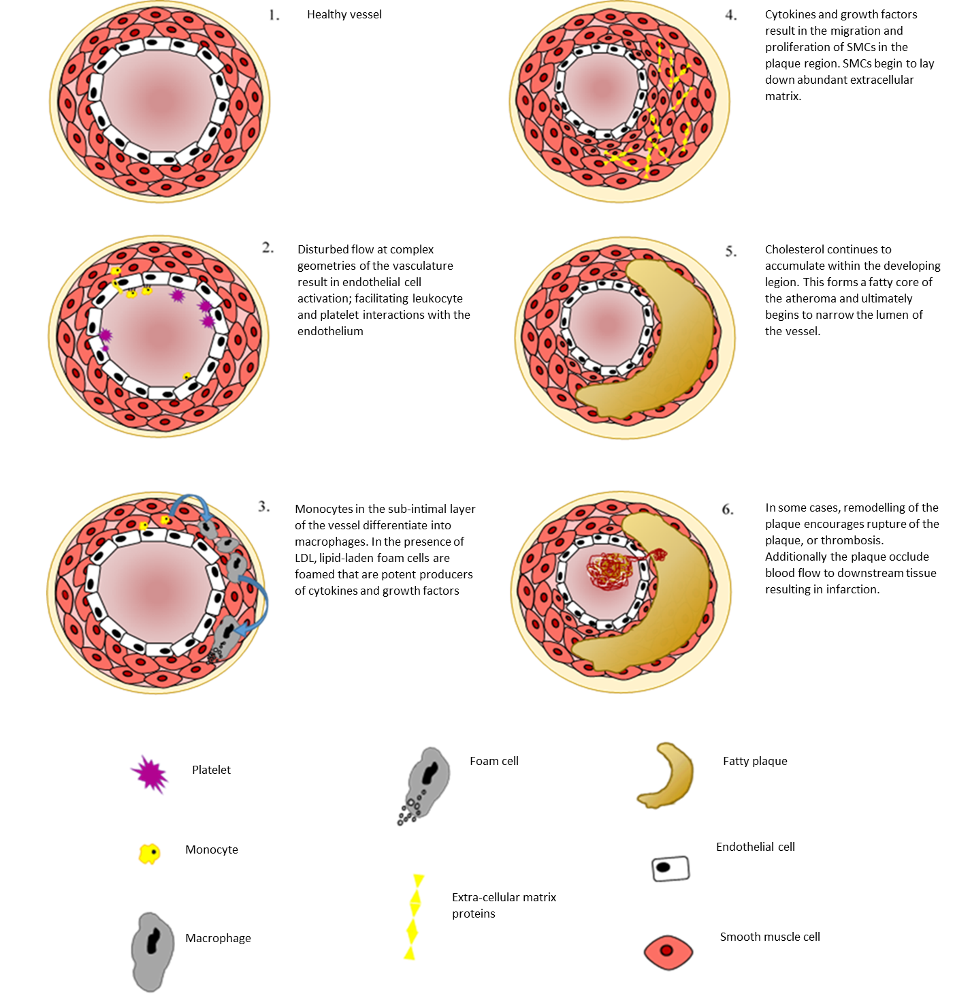
Figure 1.1 - Aetiology of Atherosclerosis: atherosclerosis is an inflammatory driven disease characterised by the infiltration of lipids and leukocytes in response to vascular injury. The disease is exacerbated by production of inflammatory cytokines and chemokines that form a positive feedback pathway to exaggerate the leukocyte infiltration further. Inside the vessel wall the accumulation of LDL encourages macrophages to uptake these particles forming foam cells, this eventually forms a lipid rich core and stenosis of the vessel. A weak, fibrous cap forms over the developed plaque, however these caps are susceptible to rupture. When rupture occurs the vessel can become partially or wholly occluded, ultimately resulting in morbidity as a result of myocardial infarction or stroke.

1.4 - Shear stress and atherosclerosis
Arteries are complex cylindrical tubes, comprised of three distinct layers, each with their own role in the control of pressure and flow through the vascular system (see Figure 1.2). Arteries are highly adapted to respond to changes in biomechanical and biochemical stimuli, propagating the pulsatile pressures produced by the ejection of blood, a viscous fluid, from the heart during the cardiac cycle. Blood flow exerts both circumferential and longitudinal forces on the arterial wall (Bergel, 1961). Wall shear stress is the frictional or drag force (measured in dyn/cm² or N/m² – 1 N/m² = 10 dynes/cm²) produced by blood flowing in proximity to the endothelium. Shear stress is dependent on the blood flow rate and blood viscosity, as well as the radius (volume) of the vessel cubed;
$$Shear stress= \frac{4QV}{πR^{3}}$$
As such, the level of wall shear stress is greatly affected by small changes in the vessel diameter (Pirofsky, 1953). Shear stress is a vital factor in the control of vascular homeostasis (Chen et al., 2010). Exposure of the vascular endothelium to elevated levels of wall shear stress is associated with the up-regulation of endothelial-derived NO and vasodilatory prostaclyins (Laughlin et al., 2008). Importantly, under physiological conditions this allows the vessel to rapidly regulate luminal pressure, preventing thrombosis, endothelial cell activation and immune cell migration.

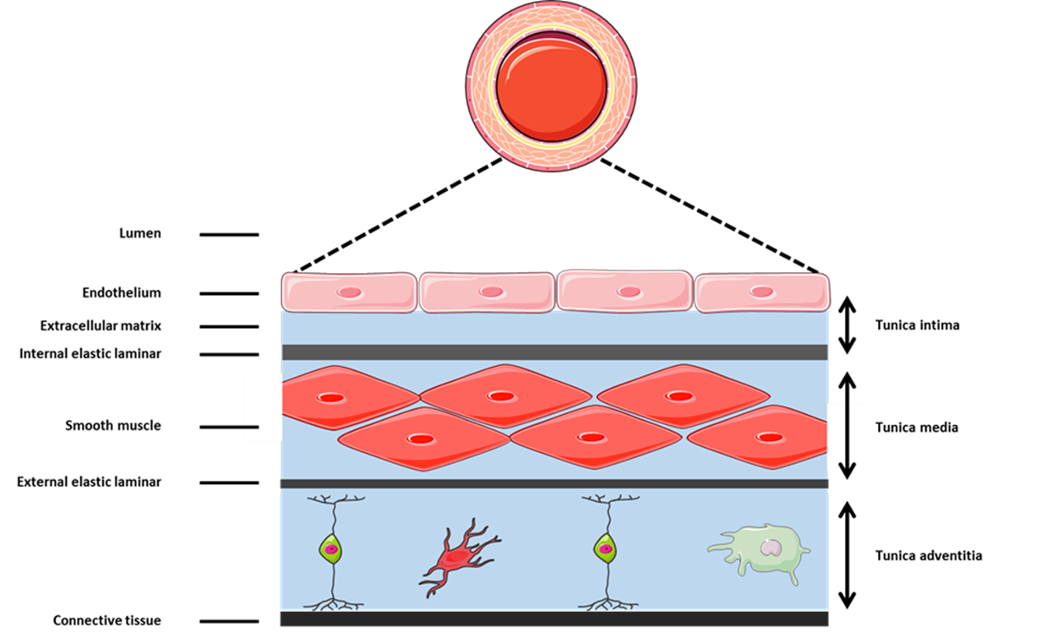
Figure 1.2 - Composition and structure of conduit arteries: Large arteries are comprised of three distinct layers. The inner most and thinnest layer of the vessel, the tunica intima, is comprised of a single-cell thick layer of endothelial cells and structural supported by polysaccharide rich extracellular matrix. The intima is separated from the tunica media by a thin layer of connective tissue called the internal elastic laminar. The tunica media is largely comprised of vascular smooth muscle, muscle distinct from skeletal muscle because of its autonomic control and non-striated fibres. Again, the media is distinct from the final layer of the vessel by the external elastic laminar. The tunica adventitia is crucial for the structural support of the vessel with collagen fibres anchoring the vessel to the adjacent tissue. In large arteries the adventitia contains vaso-vasorum, small vessels that deliver nutrients to the vessel. The collagen-rich extracellular matrix of the adventitia is rich in myofibroblast and progenitor cells primed to respond to vascular injury.

1.5 - Focal nature of atherosclerosis
Despite its crucial role in the maintenance of luminal pressure and tissue perfusion, shear stress is directly implicated in the spatial distribution of atherosclerotic plaque. Early autopsy studies were the first to identify that wall shear stress at sites of bifurcations were lower than that in straight regions of the vasculature, a factor found to directly correlate with regions prone to atherosclerotic development (Caro et al., 1971). It is now well established that atherosclerosis is a focal disease that develops almost exclusively at sites of the vasculature with complex geometry. At these sites, which include branches, bifurcations and arches of arteries (Malek et al., 1999), the magnitude and directionality of flow becomes disturbed, resulting in low, oscillating and turbulent shear patterns that result in the activation of the adjacent endothelium (Libby, 2002, Warboys et al., 2011, Chien, 2008).
Modelling of murine aortas has helped emphasise the correlation between localised endothelial dysfunction and the profile of wall shear stress in the same area of the vessel (Doriot et al., 2000). Despite overall shear stress values in murine models being approximately one order of magnitude higher than in human aortas, the focal pattern and distribution of sclerotic development is similar (Zhang et al., 2001) suggesting that the relative change and pattern of wall shear stress are the significant factors in disease susceptibility, rather than the overall magnitude of shear. Despite a growing body of evidence to suggest correlations between low and disturbed flow regions and atherosclerosis, causality had yet to be determined. A crucial study by Cheng et al., (2005), developed the shear stress modifying cast model for the murine carotid artery. In this study, placement of a cast on the carotid artery tapered the lumen, producing a ‘cone-shaped’ lumen. This produced an area of high wall shear stress region within the carotid cast, while also producing a low flow region up-stream and low/disturbed shear stress region down-stream of the invention. eNOS-GFP fusion protein transgenic mice were used in the study and a 3-fold decrease in eNOS gene expression was observed at sites of disturbed flow, while no change occurred at high shear sites compared to the control vessel. 6-weeks of cast insertion resulted in vascular inflammation, as well as the development of sclerotic plaque in the low shear stress regions. Both the high shear stress region and contralateral carotid control were absent of disease. The findings of this breakthrough study directly implicate haemodynamic profiles in the development of atherosclerotic plaque.

1.6 - Mechanisms of flow-induced atherogenesis
Early theories of how blood flow influenced the spatial distribution of atherogenesis focused largely on ‘mass transportation theory’ as a mechanism for the accumulation of material in the vessel wall. Pioneering work by Caro et al., (1966) suggested that at regions of low wall shear stress there was increased facilitation of macronutrients across the endothelium. Briefly, an increase in the transit time across the proximal endothelium for pro-atherogenic molecules and inflammatory cells meant greater potential for activation of the endothelium at low and disturbed flow sites. In pioneering studies designed to investigate these affects, Evans-blue dye labelled albumin, fibrinogen and cholesterol were found to readily accumulate at atherosclerosis prone areas of blood vessels in pigs (Bell et al., 1975). Although it is established that mass-transport theory is a contributing factor to the focal nature of atherosclerosis, the discovery that endothelial cell phenotype was directly regulated by their ability to sense and then transduce force into a biochemical signal, has been a key finding for our understanding of the diseases mechanism. This is referred to as ‘the shear stress theory’ of atherosclerosis.
Advances in our understanding of endothelial cell biology have identified the ability of endothelial cells to sense changes in both the magnitude and directionality of shear stress and consequently alter their morphology and function (Ando and Yamamoto, 2010). Mechanosensitive protein complexes found on the luminal surface of the endothelial cell sense mechanical signals exerted on them by flow. A number of different ‘mechano sensors’ have been identified, these include the glycocalyx (Pahakis et al., 2007), cation channels such as Piezo1 (Ranade et al., 2014), caveolae (Rizzo et al., 1998) and adhesion molecules such as platelet endothelial cell adhesion molecule-1 (PECAM-1; Tzima et al., 2005). Importantly, despite our incomplete understanding of how endothelial cells sense changes in the pattern or magnitude of flow, many of the signalling pathways and their effects on cellular phenotype have been well defined. As such, contributing to our understanding shear stress contributes to the focal nature of atherosclerosis (Davies., 1995; Liu et al., 2002; Zhou et al., 2013; see Figure 1.3).

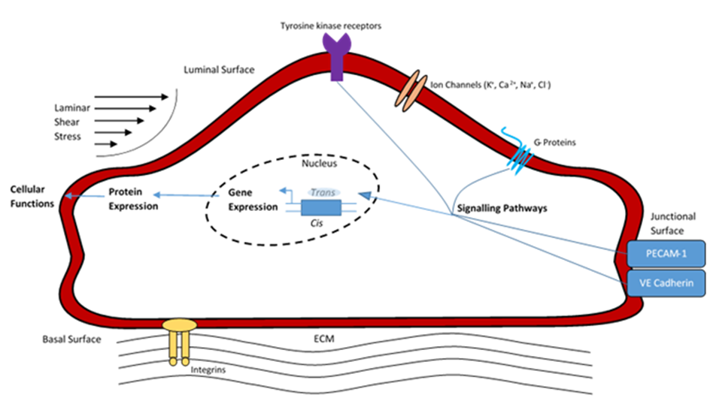
Figure 1.3 - Endothelial cell mechanotransduction of shear stress: Local shear stress is detected by luminal mechanosensory molecules. Mechanosensors simultaneously activate a number of signalling pathways within the cell, which leads to the phosphorylation of a number of transcription factors. Transcription factors bind positive or negative shear response elements at the appropriate cis element in the promotor region of the mechanosensitive genes, including or suppressing the expression of proteins, therefore modulating cell morphology and function.

1.7 - Endothelial cell activation in response to shear stress
Activated endothelium undergoes a number of physiological changes that prime that region of the vasculature to become disposed to atherogenesis. Key functional changes of activated endothelial cells include increased permeability, changes in cell morphology, increased cell proliferation and a reduction in cell migration (Chien, 2008). Importantly, the activated endothelium disproportionally expresses a number of cellular adhesion molecules and chemokines, which ultimately assist in the capture and transmigration of monocytes from the circulation. Adhesion molecules such as vascular cell adhesion molecule-1 (VCAM-1; (Poston and Hussain, 1993, Dansky et al., 2001, Walpola et al., 1995), intracellular adhesion molecule-1 (ICAM-1) and P-selectin (Cybulsky and Gimbrone, 1991) are highly expressed adjacent to developing lesions, whereas as regions of the vasculature that is typical unaffected by atherosclerosis express these molecules in significantly lower concentrations. Importantly, the findings of adhesion molecule expression around atherosclerotic loci can be directly related to the local mechanical stimuli of shear stress. Suo et al., (2007) identified using micro-computational tomography and immunocytochemistry that the special distribution of ICAM-1 in the murine aorta was shear dependant. These findings are supported by studies of cultured endothelial cells, which have identified the down regulation of VCAM-1 and E-selectin when exposed to unidirectional wall shear stress (Nagel et al., 1994) while oscillatory wall stress promoted inflammatory gene expression and ultimately the monocyte adhesion to endothelial cells (Chappell et al., 1998).
Several laboratories, including our own, have investigated the underlying mechanisms by which shear stress regulates endothelial cell phenotype under different flow environments. It has been identified that there are a number of signalling pathways that differentially regulated by the local blood patterns at specific regions of a vessel (Zakkar et al., 2008, Cuhlmann et al., 2011, Zakkar et al., 2009). Passerini et al., (2004) identified that members of the nuclear factor-kappa-B (NF-κB) pathway, a pro-inflammatory transcription factor that directly regulates a number of inflammatory genes on endothelial cells, were up regulated at areas of the porcine aorta exposed to disturbed flow. Additionally, mitogen activated protein kinase (MAP kinase) signalling has been implicated in the activation of endothelial cells at atheroprone sites. The activation of MAP kinase signalling by shear stress was found to up-regulate the expression of RelA and subsequently the expression of VCAM-1 (Cuhlmann et al., 2011). Interestingly, Zakkar et al., (2008) found that atheroprotected regions of the mouse aorta expressed significantly higher levels of the MAPK inhibitor, MAP kinase phosphatase (MKP-1). Genetic deletion models of MKP-1 resulted in greater activation of the MAPK signalling, resulting in the up-regulation of inflammatory gene targets. While krupples-like factor-2 (KLF2) expression at high shear stress regions protected against inflammation by preventing NF-κB binding to its transcriptional co-activator (SenBanerjoo et al., 2004). As such, the ability of endothelial cells to sense both the magnitude and directionality of shear stress has direct implications on the gene transcription and ultimately in the inflammatory phenotype of cells in a given region of the vessel. The implications of differentially regulated pathways have direct consequences how endothelial cells at these sites interact with leukocytes in the circulation.

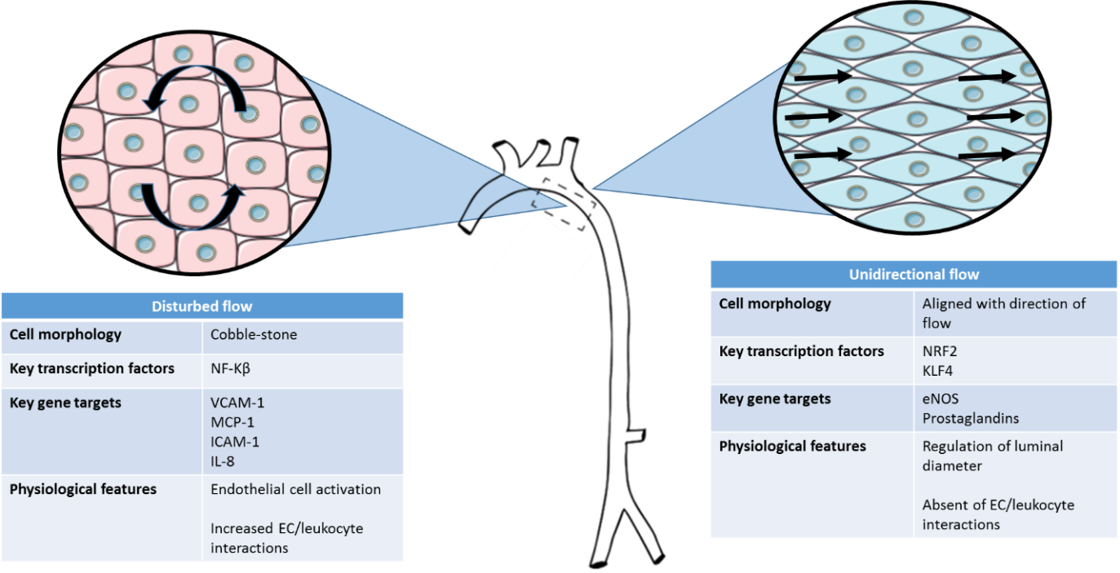
Figure 1.4 - Endothelial responses to different patterns of shear stress: Endothelial cells poses the ability to sense differences in the pattern and magnitude of shear stress. At sites of disturbed flow, such as the inner curvature of the mouse aorta, shear stress is low and multidirectional. At these sites, cells take a cobble-stone morphology and increase the expression of a range of inflammatory molecules including VCAM-1 and MCP-1 that facilitate interactions with leukocytes. Conversely at sites of high and unidirectional shear stress, such as the outer curvature of the mouse aorta, cells begin to align with the directionality of flow. At these sites, increased eNOS expression allows for the vessel to rapidly regulate vessel diameter for the maintenance of luminal pressure and interactions with leukocytes are typical absent.

1.8 - Adhesion molecules in Atherosclerosis: The leukocyte adhesion cascade
Leukocyte-endothelial cell interactions are crucial in the physiological response to tissue injury or infectious challenge. The movement of inflammatory cells into the vascular intima is controlled by the highly regulated process known as the leukocyte adhesion cascade (see Figure 1.5), in which a series of interactions between adhesion molecules expressed on both leukocytes and the endothelium facilitate the capture, rolling and subsequent transmigration of immune cells. Without these mechanisms, as in the case of the disease leukocyte adhesion deficiency-1, our ability to fight infections is dramatically impaired and life expectancy reduced (Kishimoto et al., 1987). However when the process of leukocyte migration becomes dysregulated, as in atherosclerosis, the infiltration of inflammatory cells into the tunica intima results in a pro-atherogenic and pro-thrombotic blood vessel that ultimately exacerbates disease progression.

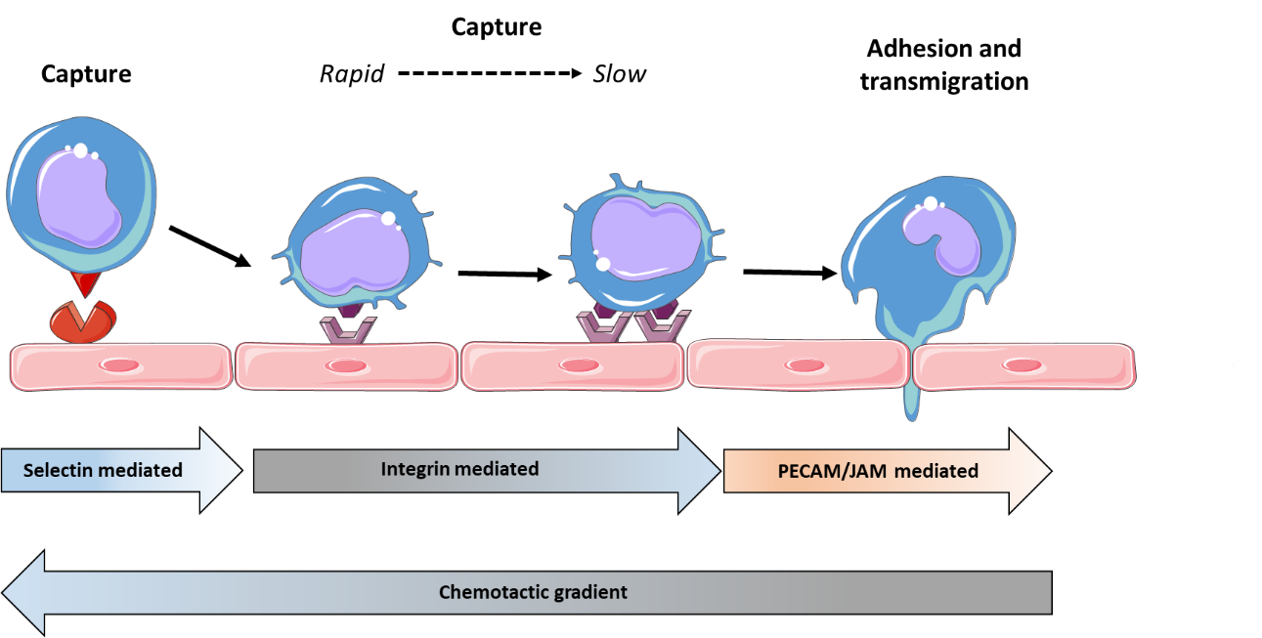

Figure 1.5 - The leukocyte adhesion cascade: Circulating leukocytes are captured by the vascular endothelium via selectin-mediated binding. During the capture stage leukocytes remain moving at a high velocity, and must be slowed for transmigration to occur. Leukocyte rolling slows the captured leukocyte via integrin-mediated binding with ligands ICAM-1 and VCAM-1 expressed on the endothelium. Once cessation of rolling occurs the leukocyte is then adhered, PECAM-1 and JAM molecules are responsible for the diapedesis of the cell into the subendothelial space. The process is controlled via the up-regulation of chemotaxis molecules at the inflammatory site, which facilitate the movement, capture and transmigration of the leukocyte.

1.9 - The selectins
The initial stage of leukocyte-endothelial interactions requires the expression of chemokines on the inflamed endothelium. Chemokines are small (6-14 kDa) secreted proteins, with tissue-bed specific combinations of these molecules initiating the recruitment of different leukocyte populations (Comerford and McColl, 2011). Typically, heparin-binding sites on the chemokine bind proteoglycans on the endothelial cell (Tanaka et al., 1993), producing a chemotactic gradient that promote the immune cells to migrate towards the inflamed tissue.
The capture of leukocytes from the circulation requires selectin-mediated interactions with the endothelium. The selectins are a distinct family of three glycoproteins, capable of binding sulfated, sialylated and fucosylated carbohydrate ligands in a calcium-dependant manner. The selectins are differentially expressed on leukocytes, platelets and endothelial cells. Upon activation endothelial cells up-regulate E-selectin expression. P-selectin is stored in Weibel-Palade bodies, and when the endothelium is activated the transport from these bodies to the cell membrane results in the rapid increase in cell surface expression (Kiskin et al., 2010). P-selectin binds P-selectin glycoprotein ligand 1 (PSGL-1) that is expressed ubiquitously on leukocytes, and is the primary interaction required for the capture and initiation of rolling. Studies using antibody blockade of PSGL-1 found a significant reduction in monocyte rolling and adhesion to murine carotid endothelium (Ramos et al., 1999). In the absence of P-selectin, L-selectin mediated rolling is crucial in the capture of flowing leukocytes. Evidence suggests that the efficacy of P- and L-selectin in capturing flowing neutrophils is velocity dependant, with a reliance of L-selectin mediated capture at velocities greater than 50 µm/s (Jung et al., 1996). Typical velocity of rolling in wild type mice is between 20 and 70 µm/s and as such these two vital selectins play a synergistic role under physiological conditions.
E-selectin plays a major role in transition from slow rolling to firm adhesion leukocytes to the endothelium. In the absence of E-selectin efficiency of leukocyte firm adhesion to the endothelial is diminished (Ley et al., 1998). Interstingly, the engagement of E-selectin is associated with the redistribution of PSGL-1 and L-selectin to the trailing edge of the neutrophil, a factor that provides a platform for the firm adhesion of the neutrophil (Schaff et al., 2008). The expression of selectins is closely regulated by inflammatory and flow iduceable pathways. E-selectin is typically absent from unactivated endothelium, undergoing rapid de novo synthesis in response to NF-κB signalling (Schindler and Baichwal, 1994), stimulation with TNF-α (Wyble et al., 1997) and IL-1β (Smolen et al., 2000). The significance of the selectin family members in disease progression has been investigated in a number of murine models. E-selectin, P-selectin and APOE^{-/-} triple knockout, is associated an 80% reduction in total plaque area during the onset of atherogenesis (Dong et al., 1998).

1.10- The Integrins
Once rolling has slowed, firm adhesion and arrest require the activation of integrins expressed on the rolling cell. Integrins are a large family of heterodimeric proteins, consisting of non-covalently linked α and β subunit. Integrins are not constitutively active and as such require activation by chemokines presented on the endothelial cells. Specifically, lipids, complement fragments and chemokines form a chemotactic gradient that recruits leukocytes to the inflamed or infected tissue. The glycocalyx, a glycoprotein-polysaccharide network protruding from the endothelium that acts a physical barrier to leukocyte adhesion under physiological conditions, is remodelled (Mulivor and Lipowsky, 2002), exposing adhesion molecules on the endothelium to stimulated leukocytes in the circulation. Inside-out signalling regulates a conformational switch in the extracellular domain of the integrin and clustering of integrins on the leukocyte membrane rapidly results in increased affinity for their endothelial ligands, ICAM-1 and VCAM-1 (Luo et al., 2007). Takagi et al., (2002) showed that integrin activation occurs via a ‘switch-blade’ like opening to an extended structure of the hybrid domain that encourages ligand binding.
Subunits β2 (CD18) and α4 (CD49d)-integrins are crucial in leukocyte trafficking. CD18 is critical in neutrophil firm adhesion via the binding ICAM-1 on the endothelium. CD18 knockout mice exhibit a 10-fold increase in the number of circulating neutrophils. The study identified that without CD18, neutrophils were unable to effectively migrate from the circulation into the damaged tissue highlighting a key role of CD18 in the emigration of immune cells to inflammation (Walzog et al., 1999). Concurrent antibody blockade with CD18 antibodies results in complete ablation of neutrophil transmigration (Furie et al., 1991). The role of CD18 in atherosclerosis has been investigated in a number of studies. Functional mutations of CD18 resulted in a 60% reduction in the fatty streak area compared to C57Bl/6 controls (Nageh et al., 1997). Additionally, Merched et al., (2010) identified that in addition to CD18^{-/-} mice displaying reduced fatty streak formation, mice that had been pre-fed for 10 weeks in order to develop mature lesions before bone marrow transplantation with CD18^{-/-} bone marrow also displayed a significant reduction in further plaque developing. These findings emphasis that CD18 plays an important role in disease progression across all stages of atherosclerosis development.

1.11 - The Immunoglobulin superfamily
The immunoglobulin superfamily is a large group of cell surface and soluble proteins, associated with adhesion, binding and recognition processes in cells. Of these family members, ICAM-1, ICAM-2 and PECAM-1 are constitutively expressed on endothelial cells and as such are important in the recruitment of monocytes and neutrophils to inflamed tissues. High fat feeding, and the subsequent intimal accumulation of cholesterol is associated with the induction VCAM-1 and ICAM-1 on endothelial cells in vivo (Cybulsky and Gimbrone, 1991).
The significance of VCAM-1 and ICAM-1 in atherosclerosis is supported by consistent findings of elevated expression on and around sclerotic loci in ApoE^{-/-} mice (DeGraba et al., 1998). Nakashima et al., (1998) found that ICAM-1 was highly regulated at atheroprone sites of the vasculature, however was expression was observed to be abundant in these regions in both ApoE^{-/-} and wild type mice. These findings suggest that disturbed flow conditions at atheroprone sites are capable of driving the regional distribution of ICAM-1, without the requirement of additional inflammatory stimuli. Due to the embryonic lethality of a VCAM-1 knockout, Cybulsky et al (2001) developed a transgenic line with disruptions in the fourth VCAM-1 domain, which was then crossed with an LDL^{-/-} mouse. These mice demonstrated a large reduction in the total plaque area as well as in the macrophage content of the developing plaque. These data support findings by Obrien et al (1996) who reported that the expression of VCAM-1 in atherosclerosis was directly related to the regulation of the macrophage density of the early lesion.

1.12- Shear stress regulation of leukocyte-endothelial cell interactions
Wall shear stress regulates a number of processes that are directly involved in the transmigration of leukocytes. Critical to this, is regulation of adhesion molecule density on the vascular endothelium. It is well established that leukocyte interactions with endothelial cells correlates with adhesion molecule expression at a given site. In a rabbit angioplasty model, the expression of E-selectin, P-selectin and VCAM-1 were associated with the enhanced leukocyte adhesion following injury to the vessel wall (Kennedy et al., 2000). While Levin et al., (2004), identified that E-selectin density on endothelial cells stimulated with IL-1β, was the critical factor in the adhesive probability of the cell. In vitro models of high shear stress consistently demonstrate a suppression of adhesion molecules, including VCAM-1, on endothelial cells exposed to prolonged high shear (Zakkar et al., 2008, Zakkar et al., 2009). Importantly, these findings are associated with a reduction in leukocyte adhesion following exposure to high unidirectional shear (Nagel et al., 1994, Sampath et al., 1995). Furthermore, preconditioning endothelial cells under high shear stress suppresses monocyte adhesion to endothelial cells when stimulated with TNF-α (Sheikh et al., 2003) and IL-1β compared to statically cultured endothelial cells (Sheikh et al., 2005). A mechanism for these findings was provided by Partridge et al. (2007) who identified that exposure to laminar shear stress reduced the expression of pro-inflammatory transcripts (including VCAM-1 and E-selectin) in cells treated with TNF-α, by suppressing and modulating the function of NF-κB signalling pathways. These findings support that high stress suppresses inflammation in endothelial cells, protecting high shear regions of the vessel from dysregulated leukocyte transmigration observed in atherosclerosis. Conversely, extended exposure to low and oscillating wall shear stress in in vitro models induces the expression of adhesion molecules E-selectin and ICAM-1 on endothelial cells (Cuhlmann et al., 2011). Through this induction, the density of these molecules on the cells surface increases, functionally increasing the adhesion of THP-1 cells to pre-conditioned endothelial cells (Chappell et al., 1998).
It is well established that interactions between leukocytes and endothelial cells are dependent upon adhesion molecule density and clustering of molecules on the cell surface, factors highly regulated by flow. However interactions between adhesion molecules and their ligands are also regulated by these forces. It has been shown that optimal selectin-dependent rolling of leukocytes require shear stress to be acting upon the cell (Paschall and Lawrence, 2008). Finger et al (1996) used a parallel plate flow system coated with selectin Fc chimeras to determine the effect of shear stress on neutrophil tethering and rolling. The study identified that the selectins (specifically L- and P-selectin) require shear forces to reach a threshold in order to support optimal strength of tethering, with maximal strength of bonds occurring at been 0.8-1.2 dyn/cm². The shear-dependant nature of neutrophil rolling is highlighted by the significant reduction in selectin mediated rolling both above and below this shear rate threshold. In these studies, neutrophil tethering and rolling on P-selectin occurred up until a shear stress of 5 dyn/cm². A number of mechanisms have been proposed to explain the paradoxical finding that increased shear increases strength of ligand interactions. Firstly, shear stress increases the rolling velocity of the cell, resulting in a greater number of ligand interactions being able to occur for a given period of time; via outside-in signalling, this results in recruitment of more selectins to the cell surface and increasing adhesive strength (Finger et al., 1996). Secondly, force on the cell may alter its cell surface area, increasing the number of possible ligand interactions at any one time (Lawrence et al., 1997). A final hypothesis, proposed in a recent study found that the bonds formed between L- and P-selectin with PSGL-1 are ‘catch bonds’. This specific type of bonds act in a manner that means up until an optimal force, the bond is strengthened by any additional force, as the molecules are pulled closer together by the increased force, ultimately strengthening the adhesion. The second type of bond, ‘slip bonds’ are observed in E-selectin binding. These bonds decrease in strength when an increase in force is observed across all shear stress. It is therefore the transition of L- and P-selectin from ‘catch bonds’ to ‘slip bonds’ as the shear stress increases that ultimately decreases their ability to maintain interactions with the cell as the shear stress increases (Marshall et al., 2003). Importantly, the existence of a shear stress threshold of selectin binding is supported in vivo. In an interesting study, Lawrence et al (1997) used a range of venule diameters, as such corresponding to varying shear stress, and examined leukocyte rolling by intravital microscopy. The study identified that, as in the flow chamber model, leukocyte rolling was inhibited both above and below an optimal flow rate, supporting the hypothesis that leukocyte adhesion via selectins is physically regulated by level of shear stress in the vessel. As such neutrophil, and other leukocyte, interactions with endothelial cells are highly regulated by shear stress. Atherosclerosis is characterised by the dysregulated migration of immune cells across the vessel wall, therefore better understanding how these interactions may be regulated at sites of disturbed is critical to our understanding of disease aetiology.

1.13 - Neutrophils
Neutrophils are the most abundant leukocyte in the circulation (approximately 60-75%), and as such form the main cellular component of the innate immune system with both inflammatory and anti-infectious capabilities (Mantovani et al., 2011). Produced in the bone marrow and derived from myeloid stem cells, neutrophils are characterised by their multilobulated nucleus and high granular content. Neutrophils in the circulation are readily activated and attracted to sites of infection or inflammation via a chemotactic gradient. Chemokine and chemoattractant receptors on the cell surface membrane trigger G-protein coupled pathways within the cell, up-regulating β2-integrins, and encouraging neutrophil diapedesis (Raghuwanshi et al., 2012). Once within the tissue neutrophils destroy pathogens by exposing engulfed phagosomes to antimicrobial enzymes. In addition to roles within the innate response, neutrophils also transport antigens to antigen-presenting dendritic cells, making them an important factor in T-cell acquired immunity (Megiovanni et al., 2006). As such neutrophils are a highly active and vital component of host defence. However, when homeostatic function is disturbed, they can also form a major component in inflammatory disease.

1.14 - Neutrophils in atherosclerosis
Generally, neutrophils have been associated with plaque instability and rupture rather than in the initiation and progression of plaque growth. Kostis et al., (1984) demonstrated an association between plaque progression and circulating leukocyte count; however as the cohort of patients had existing CAD, this meant suggesting casual links between the factors remained tenuous. The role of neutrophils in the end-stage of atherosclerosis is however recognised. Narauko et al., (2002) found neutrophil infiltration was a key feature of postmortem specimens of ruptured plaques but absent in cases of non-CVD death. These findings were supported by Ionita et al., (2010) who found a positive association between intraplaque neutrophil content and key features of rupture prone plaque including lipid-rich core and high macrophage content. Elevated IL-8 concentrations at sites of rupture-prone plaque have also been observed. IL-8 is a known neutrophil chemoattractant secreted by activated macrophages, T-cells and endothelial cells (Hammond et al., 1995), and therefore may provide a mechanism for the rapid infiltration of neutrophils. Regular observations of neutrophil granular content, including MMP-9 (Ionita et al., 2010) and neutrophil elastases (Larionov et al., 2007) in the late stages of sclerotic development further support the role of neutrophils in divergence to symptomatic, rupture-prone plaque plaque.
Hyperlipidaemia, specifically hypercholesterolemia, is a well-accepted independent risk factor for atherosclerotic development (Thomas et al., 1966). Drechsler et al., (2010) identified that hyperlipidaemia in ApoE^{-/-} mice induced myeloid cell production in the bone marrow and release of neutrophils into the circulation. The study investigated the prevalence of neutrophils in the mice aortae at intervals following the initiation of a high fat diet. The neutrophil content was significantly increased at week 4, before reducing until the week 16 time point. This was shown to correlate with the lesion area, concluding that the role of neutrophils in atherosclerosis might be facilitated and exacerbated in the presence of a primary risk factor of the disease. Importantly however, the neutrophil number, despite elevation, was significantly lower than that of monocytes in the developing lesion. Additional to the consequence on neutrophil egress from the bone marrow, hyperlipidaemia may be an important factor in the activation and priming of neutrophils. Araujo et al., (1995) showed that neutrophil expression of CD11b and neutrophil-derived reactive oxygen species release is increased in patients with hypercholesterolemia. Interestingly the level of expression correlated closely with the severity of the condition. As such, it appears that hyperlipidaemia may be a crucial factor in the increasing in number, priming of and phenotypic changes of neutrophils during early atherogenesis, and as such exacerbating their potential to facilitate the movement of inflammatory cells into the developing lesion.
A breakthrough study in the role of neutrophils in atherosclerosis demonstrated that diet-induced atherogenesis could be ameliorated through neutrophil depletion (Zernecke et al., 2008). The model used ApoE deficient mice fed on a high fat diet for 4 weeks to induce atherogenesis within the mice. Over the 4 week period, mice were injected with anti-neutrophil-antibody, removing neutrophils from the circulation with no effect on the mean number of circulating monocytes. In the ApoE^{-/-} mice, neutrophil depletion was associated with significantly reduced fatty streak formation at 4 weeks. A key finding of the study was that macrophage content in the developing plaque was also significantly reduced, substantiating the notion that a primary role of neutrophils in atherosclerosis is the facilitation of inflammatory cell migration. Interestingly, if neutrophils are selectively depleted at various time points following the initiation of high fat feeding, only depletion in the early stage (0-4 weeks) is associated with a reduction in lesion area (Drechsler et al., 2010). This was supported by a significant reduction in inflammatory monocytes and macrophages within the developing plaque only at this time point.
Despite evidence to suggest that neutrophils are influential in both the onset and late-stages of atherosclerosis, neutrophils remain seldom detected in developing plaque. As mentioned previously, when activated neutrophils secrete granular proteins as a mechanism of their crude anti-microbial defence. Myeloperoxidase (MPO), azurocidin (Chertov et al., 1997), neutrophil gelatinase-associated lipocalin (NGAL) (Hemdahl et al., 2006) have all been identified to colocalise with macrophages and endothelial cells around human atherosclerotic lesions. Neutrophil-derived granular proteins are implicated in the up-regulation of adhesion molecules, increases in endothelial permeability and reducing the bioavailability of NO (Soehnlein, 2012). MPO contributes to ox-LDL formation and plasma concentrations closely correlate with heart disease risk (Zhang et al., 2001). In addition to granular content, markers of neutrophil cell-membranes, including CD66b have been identified in developing plaques (Soehnlein, 2012). The seldom observations of neutrophils within the plaque may be a result of rapid removal by macrophages, phenotypic plasticity that allows neutrophils to express antigen presenting cell markers and lack of specificity in methods of identification (particularly in murine models). However, an ever-growing body of evidence supports the notion that the transfer of neutrophil-derived material into the vessel wall is an important factor in early disease progression. The discovery that upon activation, neutrophils release microvesicles (MVs), small membrane-bound vesicles containing the phospholipid and cytoplasmic contents of their parent cell, may provide a novel insight into to neutrophil-endothelial interactions during the progression of atherosclerosis.

1.15 - Microvesicles
Originally believed to be particles of cellular debris, it is becoming evidently clearer that MVs play crucial roles in cell-to-cell interactions of both physiological and pathophysiological function (Morel et al., 2011). MVs are defined as small (0.1 -1 μm in diameter), cell-derived vesicles, comprised of a negatively charged phospholipid bilayer, surface proteins and cytoplasmic content reflective of the cell from which it is derived. Typically differentiated by size, MVs are biologically distinct population of extracellular vesicles (EVs). Whereas MVs are formed as a result of direct blebbing of the cell membrane, exosomes (typically 50-120 nm in diameter) are packaged in multivesicular endosomes that later fuse with plasma membrane for release. In addition to the MV and exosome populations of EVs, larger membrane bound vesicles known as apoptotic bodies (typically 0.8-2 µm in diameter; see Figure 1.6), are produced during programmed cell death.
The physiological roles of MVs from a number of different sources have been described in studies of healthy individuals. MVs have been shown to be involved in processes such as tube cell formation in endothelial cells and driving cell proliferation during tissue repair (Berckmans et al., 2001). Interestingly, interactions between P-selectin and PSGL-1 on platelets in the circulation have been shown to produce tissue-factor expressing MVs that are capable of reducing the time taken for blood clotting and therefore reduce the risk of excessive bleeding (del Conde et al., 2005). Beyond this, immune cell MVs have been identified in breast milk where they are involved in developing the innate immune system of the new-born (Kosaka et al., 2010). Despite the physiological benefits of the cross-talk system, a growing body of evidence supports the significance of MVs in the pathogenesis of a number of disease states. In cancer, tumour-derived MVs have been observed to trigger epithelial-to-mesenchymal transition, and as such drive the cancers malignancy (Aga et al., 2014). Evidence from a number of disease models, including acute vasculitis (Nieuwland et al., 2000) and sepsis (Daniel et al., 2006), have identified dramatically increased MV contents in the inflammatory exudate in these patients. These factors have to an ever growing body of research highlighting MVs as an important biomarker for many disease (reviewed by; (Colombo et al., 2012, Muralidharan-Chari et al., 2010, Porro et al., 2015). The intercellular exchange of MVs therefore has emerged as a biological relevant phenomenon, particularly during pathological conditions. Despite this, studies continue to report large heterogeneity in the ability of MVs to interact with, and ultimately exert biological influence on, recipient cells. As such, there is an increasing need to study the effect of specific MV populations on pathologically relevant recipient cells, which will aid in our understanding of how these complex communication mechanisms are contributing to disease.

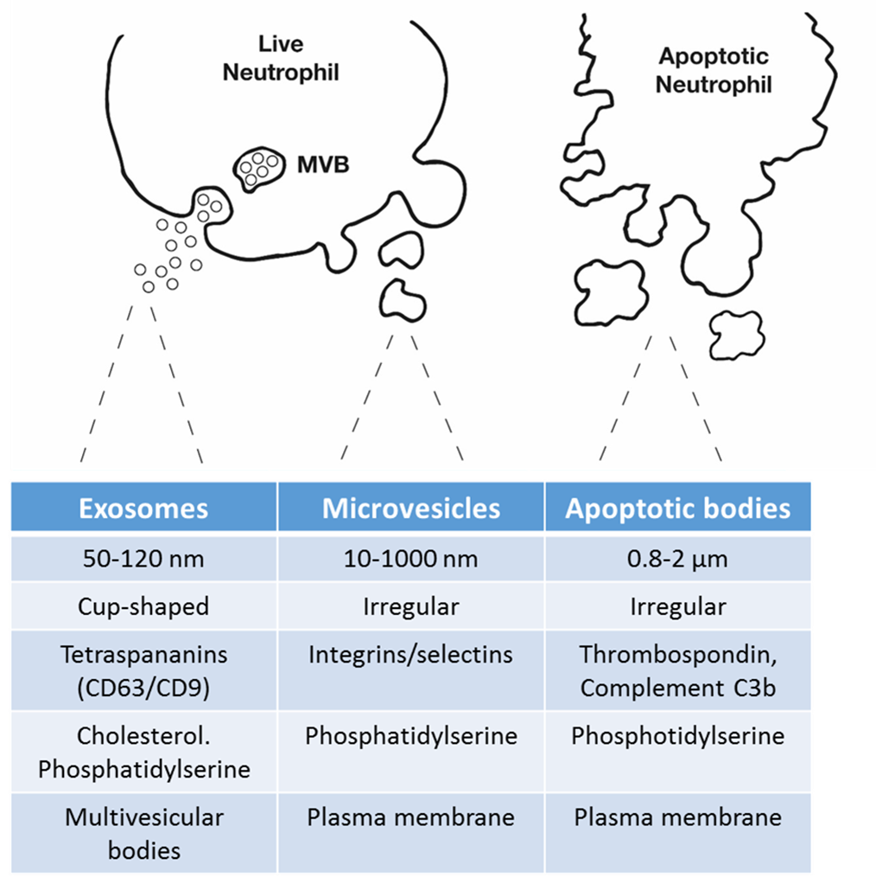

Figure 1.6 - Classifications of extracellular vesicles: Extracellular vesicle is the umbrella term used to describe the range of membrane bound vesicles produced by cells. Exosomes, refer to sub <100 nm vesicles that have been produced within multivesicular bodies in the cells cytoplasm. Microvesicles, are larger vesicles (between 100 nm and 1 µm) that are blebbed directly from the cell membrane, generally a phosphatidylserine switch in the cell membrane means they are negatively charged and express adhesion molecules that allow them to interact with other cells. Finally apoptotic bodies are produced upon cell death. These vesicles are often larger >1 µm. They also have blebbed from the membrane however express many markers of apoptosis and necrosis to aid in being engulfed by phagocytic cells.

1.16 - Neutrophil-derived microvesicles biogenesis
The neutrophil cell membrane is an asymmetrical bilayer structure comprised of phospholipids and protein. Typically, under resting conditions, the cell membrane is positively charged with molecules including as phosphatidylcholine and sphingomyelin forming the outer leaflet of the membrane. Under inflammatory or infectious challenge, the negatively charged phosphatidylethanolamine and phosphatidylserine molecules of the neutrophil inner leaflet are rearranged into the outer leaflet of the membrane. This produces a negatively charged neutrophil expressing cell surface antigens on its outer leaflet (VanWijk et al., 2002). Dependent on on the mechanism of neutrophil stimulation, the number and expression profile of the MV can vary greatly, this was identified by Dalli et al., (2013) demonstrating that the protein composition of neutrophil MVs varied depending on the neutrophils activation state. As mentioned previously, the production of MVs from the cell membrane can occur via both activated neutrophils and as consequence of a apoptotic cell death. The current project will focus solely on MV production via the activation pathway.

Formation of MVs requires the breakdown of the neutrophil cytoskeleton (see Figure 1.7), comprised of intracellular proteins actin and talin. Actin polymerisation is critical in MV shedding. Headland et al (2014) found that inhibition of actin polymerisation by cytochalasin D resulted in increased membrane fluidity and greater subsequent MV production. Conversely, promoting polymerisation was associated with MV blebbing inhibition. In addition to the involvement of cytoskeletal disruption, MV formation is calcium dependant. Calpain, a calcium-dependent protease, involved in the degradation of talin (Miyoshi et al., 1996), becomes activated when calcium influxes the neutrophil upon stimulation by specific agonists. Miyoshi et al., (1996) blocked calcium channel function with chelator EGTA, preventing cytosolic increases in calcium and preventing calpain dependant membrane blebbing. A number of different stimuli for the release of neutrophil-derived MVs have been investigated, these include acLDL (Nolan et al., 2008), TNF-α (Johnson et al., 2013), L-Nam e (Nolan et al., 2008) and PMA (Timar et al., 2013). The current project will focus on the stimulation of neutrophils using formyl-methionyl-leucyl-phenylalanine (fMLP). fMLP is a highly chemotactic short peptide sequence released from bacteria during infection of the host. Stimulation of neutrophils with fMLP promotes calcium influx via G-coupled receptors (Gierschik and Jakobs, 1987) and is therefore is a potent agonist for MV production.

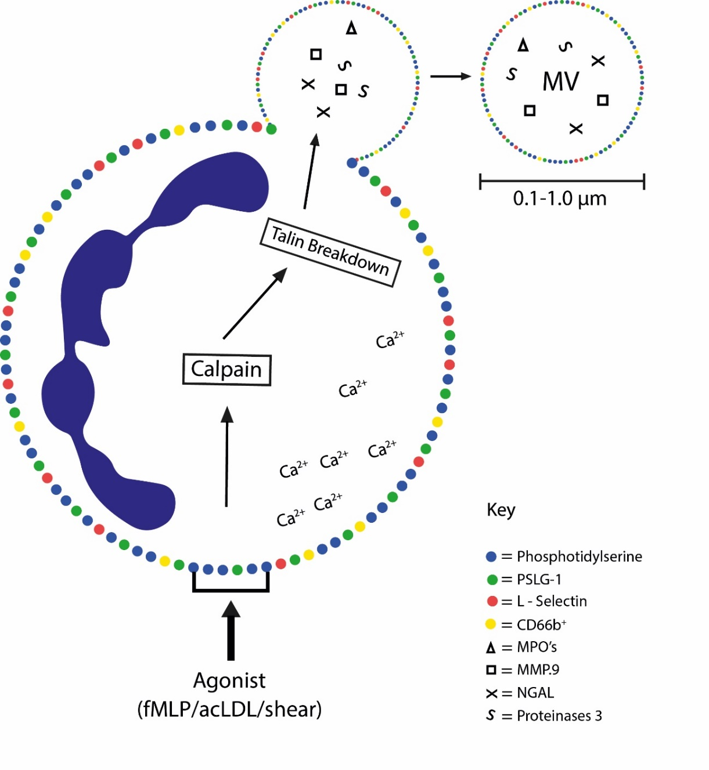

Figure 1.7 - Microvesicle formation and composition: Agonist activation causes an influx of Ca2+ to enter the neutrophil; the Ca2+ dependant enzyme Calpain degrades the cytoskeletal protein talin, weakening the cytoskeleton encouraging vesicle formation. Little is known about the biogenesis of MVs, however many suspect that there is some form of active packaging of the vesicle that occurs dependent upon the activation status of the neutrophil.

1.17 - Neutrophil microvesicle cargo
The production of MVs from activated neutrophils signifies a potential cellular cross-talk pathway between neutrophils and the endothelium. Delivery of bioactive molecules in the form of phospholipid-bound vesicles has a number of benefits as mechanism of communication. The signal or message can be targeted to a specific cell type or tissue and the intended message do not get lost due to dilution in the circulation, highlighting that this mechanism of cell-to-cell interactions is capable of communication over long distances (Dalli et al., 2013). Evidence suggests that MVs express a range of cytoplasmic content, including cytokines, mRNA and microRNA, while also expressing adhesion molecules and receptors that allow direct interactions with target cells. Recent studies have identified that activation by different stimulus effects both the proteomic content and the functional capacity of the MV, however how this occurs remains unclear. Evidence from MVs produced by tumour cells suggests that a number of proteins may be preferentially targeted to MVs by specialist endosomal recycling (Donaldson, 2003). Using an immortal cancer cell line model, it was identified that certain cellular proteins, including major histocompatibility complex class I and β1-integrins, were selectively packaged into tumour MVs via ARF-6-dependent endosomal recycling (Muralidharan-Chari et al., 2009). Interestingly the study concluded that this packaging was selective, when it was observed that transferrin receptor, a molecule also trafficked by ARF-6 dependant mechanisms and found abundantly on and around the cell surface, was not incorporated into MVs (Steffen et al., 2008). Currently there is little or no evidence for the selective packing of proteins into neutrophil MVs, and it remains universally undefined across all cell types how soluble cystolic proteins and nucleic acids are being targeted to the cell surface for incorporation in to MVs.

Despite a need for greater understanding of the molecular mechanisms that result in MV packaging, key studies have identified the proteomic consequences of activating neutrophils under varying conditions. Dalli et al, (2013) performed an important proteomic analysis of MVs from neutrophils stimulated both in a fluid suspension and while adhered to a HUVEC monolayer. Stimulation in these conditions resulted in two heterogeneous pools of MVs, each with 30% of their proteins unique to the method of stimulation. The proteomic analysis of the MV subpopulations revealed distinct immune-modulatory characteristics of sets of MVs, differentially expressing proteins involved in integrin signalling, cytokine-mediated inflammation and ROS production (Dalli et al., 2013). Interestingly the authors identified that the content of MVs when adherent to endothelial cells was associated with an increased propensity to induce inflammatory pathways in endothelial cells. Importantly however, αM-Integrins and β2-integrins were identified on the MV surface in both populations (Dalli et al., 2013). This supports findings from Pluskota et al., (2008) who found activated neutrophils expressed a functionally active CD18 on their vesicle surface. Upon neutrophil activation, active forms of the integrin are translocated to lipid raft regions of the membrane, and these lipid rich areas of membrane are subsequently blebbed to form MVs (del Conde et al., 2005). As a result of this mechanism, only very low levels of active CD18 are expressed on MVs released from resting neutrophils. The expression of integrins on the surface of neutrophils MVs infers an important ability to be able to interact with endothelial cells. Evidence that MVs are abundant with neutrophil content, including MPOs, cytokines and microRNAs (Hulsmans and Holvoet, 2013) highlights that the delivery of vesicular content may be an important factor in the modulation of inflammation during atherogenesis.

1.18 - Delivery of neutrophil-microvesicle content
It is generally accepted that EVs exert their biological effects through the delivery of their donor cells material encapsulated within the vesicle. MVs from a number of donor cells have been shown to be internalised by their recipient cell (Faille et al., 2012, Franzen et al., 2014, Kawamoto et al., 2012) MV internalisation has been visualised using lipid-membrane intercalating dyes and cytosolic dyes (Mulachy et al., 2014), however direct evidence that the delivery of content is crucial for their function requires the development of bioluminescent reporter assays. Lai et al., (2015) tracked in real-time the uptake of tumour derived exosomes. They identified that within just 1-hour post exposure to the EVs, exosomal mRNA resulted in translation regulation in the recipient cell, as determined by the activation of bioluminescent GlucB reporter. Interestingly the authors did not address how the content of exosome had entered the cytosol. Many of the studies that have investigated the delivery of EV content have focused primarily on exosome delivery. Montecalvo et al., (2012) identified that delivery of exosome content to dendritic cells occurred primarily through fusion of the exosome with the cell membrane, incorporating its content into the recipient cell. Interestingly, not all exosomes released their content in this manner and the authors observed a large proportion of exosomes were internalised via an endocytic/phagocytic mechanism. It remains unclarified how vesicles that have entered the cell along these pathways deliver their content to the cytosol. Many of the studies investigating the effect of MV delivery have taken place in an in vitro setting, and validation that cargo delivery content occurs in vivo requires further investigation. Importantly, Zomer et al., (2016) developed validation that this process is important in a murine model. The authors utilised a cre-loxP reporter system, to identify that cre⁺ mammary cancer cell MVs were internalised by lung epithelial cells and resulted in transcriptional changes in these cells in vivo (identifiable by the switching on of transcription of fluorescently-tagged proteins in these cells). Together these findings suggest that delivery of MV content to recipient cells is the driving factor that modulates MVs biology effects. However, as with packaging of MV content, little direct evidence is available regarding the pathways and mechanisms involved in the delivery of neutrophil content by MVs.

The delivery of neutrophil-derived MV content can be observed indirectly through the consequences of MV incubation with endothelial cells. Mesri and Altieri (1998) showed that MVs were capable of activating endothelial cells to produce pro-inflammatory cytokines in vitro. The study observed a pronounced up-regulation of IL-6 and IL-8 in HUVECs incubated for 10 hours with MVs. Further investigation determined that activation of endothelial cells occurred through the targeting of JNK signalling pathways (Mesri and Altieri, 1998). Pitanga (2014) showed that MPO delivered to endothelial cells in neutrophil-derived MVs, resulted in endothelial cell injury within 30 minutes of incubation. Evidence from our own lab found that just 2 hour incubation of neutrophil-derived MVs with HCAECs is associated with up-regulation of NF-κB and the modulation of down stream targets ICAM-1 and VCAM-1. Activation of this pathway was associated with increased monocyte chemoattractant CCL2 and neutrophil chemoattractant CXCL8 release from HCAEC cultured under static conditions. These data indiciate that neutrophil content delivered to the endothelium results in regulation of a number of inflammatory processes. Further investigation is required to better understand how the transfer of the MV content occurs in endothelial cells. In particular, we must investigate whether these interactions, that ultimately result in the transfer vesicular content occur under physiologically releveant flow conditions. These important studies will improve our undertanding of how neutrophil microvesicles may contribute to the focal nature of atherogenesis.

1.19 - Summary
There is now convincing evidence for the casual contribution of neutrophils in the pathogenesis of atherosclerosis. Despite this, the presence of neutrophils in early and developing stages of plaque formation remains seldom detected. The discovery that upon activation neutrophils release small, biologically active vesicles, capable of delivering cellular constituents to endothelium, may provide an explanation for this anomaly.
Here we will investigate the production of MVs in vivo in response to a known atherogenic risk factor (high-fat overfeeding), and investigate the role of these neutrophil MVs in the focal interactions with endothelial cells that are exposed to atherogenic flow conditions. Ultimately with the objective of determining whether interactions between MVs and endothelial cells may be an important stimulus in the exacerbated inflammation at sites of disturbed flow.

Chapter 2 - Materials and methods

2.1 Material and suppliers

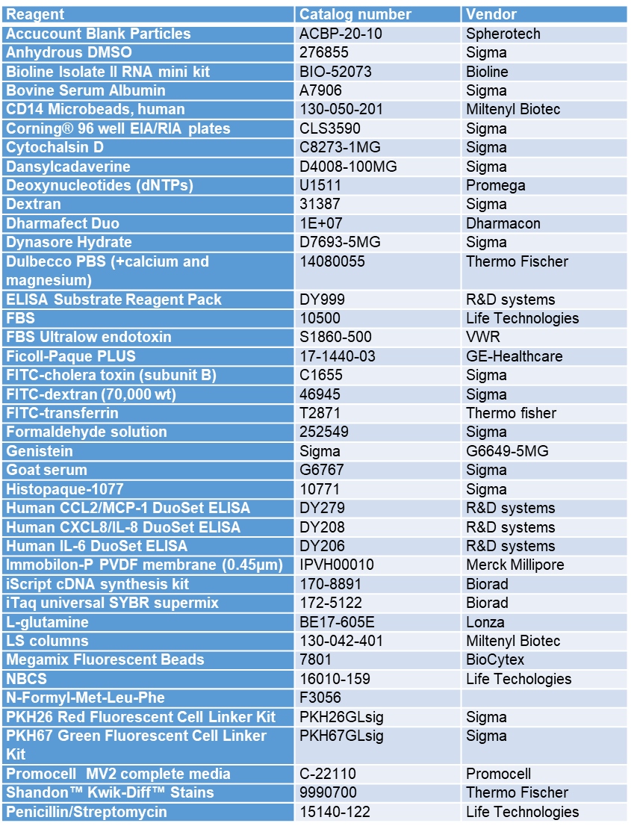
  - Table 2.1 List of material and suppliers

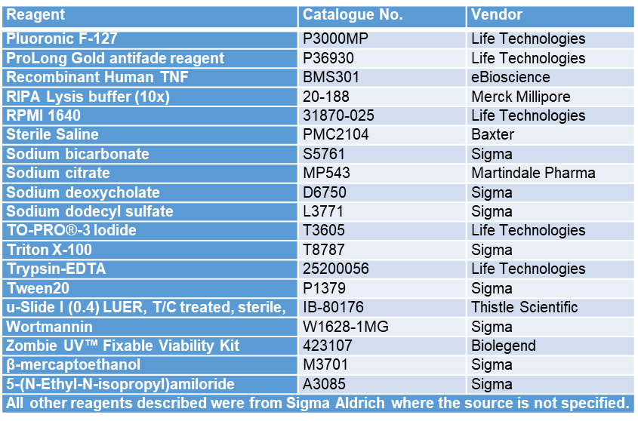

  - Table 2.2 List of antibodies and clones
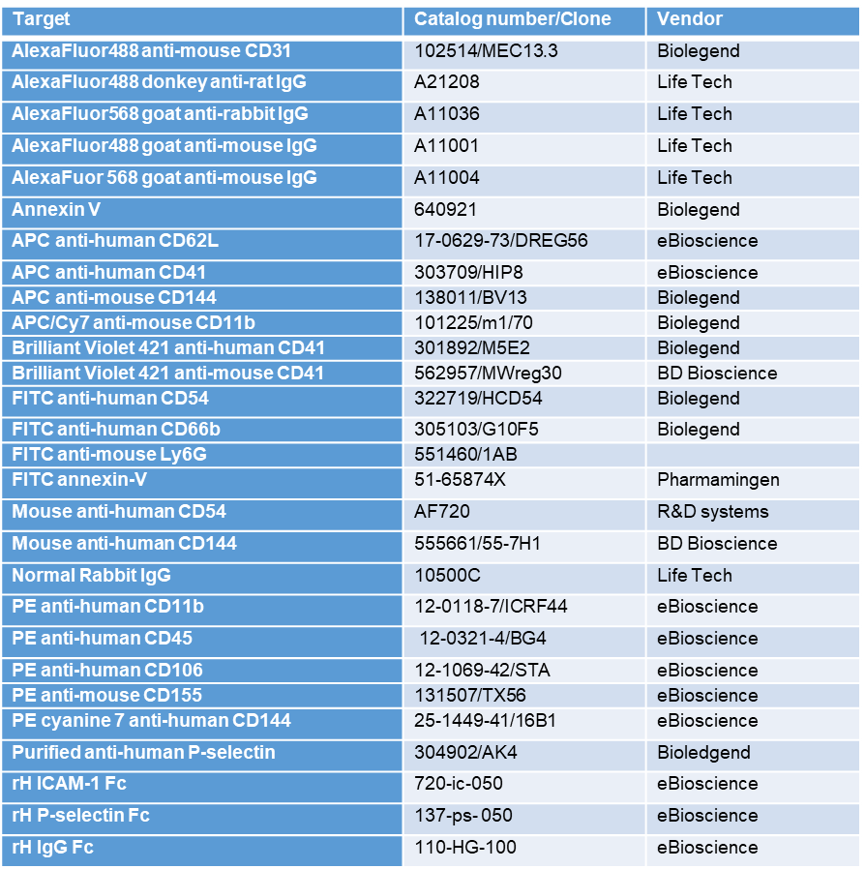

2.2 - Participant information and research ethics
Healthy volunteers aged 18-65 were recruited to participate in the project. The volunteers were absent of any known chronic or acute medical conditions and not currently taking any medication that may alter platelet or leukocyte function. Volunteers were informed of the rationale, risks and procedures of the project, before providing written informed consent. The project was approved by the University of Sheffield Ethics Committee (reference number: SMBRER310).

2.3 - Neutrophil-derived microvesicle isolation and quantification
Neutrophil isolation –
9 ml venous blood samples were collected from the median cubital or cephalic vein and transferred immediately to tubes containing 1 ml of sodium citrate (38mg/ml; Martindale Pharmaceuticals, Essex, UK). The samples were centrifuged at 260g for 20 minutes (acceleration 5 and brake 0) at room temperature. The platelet-rich plasma was discarded. 1.5 ml of a sterile dextran solution (6 % w/v, Sigma-Aldrich, Denmark) was added to the remaining cellular component. The solution was diluted to a final volume of 10 ml using sterile saline (Baxter, Switzerland) before being gently inverted to ensure adequate mixture of the solutions. All bubbles were removed using a Pasteur pipette and new lids placed on the tube prevent contamination with components of whole blood. The dextran-blood cell solution was left to sediment for 30 minutes. The leukocyte-rich upper layer was transferred into a new falcon tube, and diluted to a volume of 6 ml using sterile saline. The leukocyte-rich solution was gently layered over 4ml of Histopaque 1077 (Poole, England). Both the sample and Histopaque 1077 were at room temperature and mixing of the liquids at the solution interface was prevented to ensure optimal neutrophil isolation. The sample was centrifuged at 400 g for 25 min (acceleration 3 and brake 0) at room temperature (see monocyte isolation). The remaining granulocyte pellet (mostly neutrophils) suspended in 5 ml of hypotonic, 0.2% NaCl, solution for 30 seconds in order to lysis the residual red blood cells. Physiological osmolarity was restored by the addition of a 1.6% NaCl solution. The sample was centrifuged at 250 g for 7 minutes (acceleration 5 and brake 3) at room temperature. The supernatant was then removed and the neutrophil pellet was re-suspended in 10 ml RPMI (Lonza Biowhittaker, Basel, Switzerland). 10 µl of the RPMI-cell suspension was removed for counting using a manual haemocytometer.

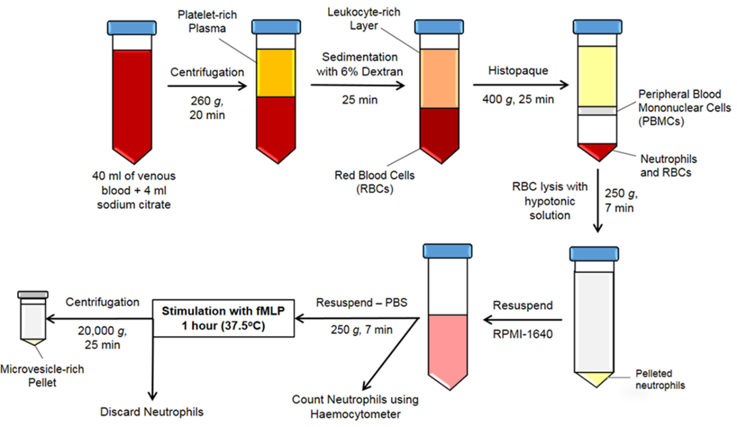
Figure 2.1 – Neutrophil and microvesicle isolation protocol: Whole was blood was centrifuged and the platelet rich plasma removed. The remaining layer was incubated with dextran in order to sediment red blood cells, leaving a leukocyte-rich layer. This then gently layered on histopaque before further centrifugation. Following centrifugation, the peripheral blood mononuclear cells were removed (see section 2.5). The pelleted neutrophil layer, which often contained a small number of red blood cells, was re-suspended in a hypotonic solution to lyse remaining red blood cells. Osmolality was restored and the cells counted. Neutrophils were finally incubated in PBS containing calcium and magnesium, and fMLP to produce MVs.

Purity of isolated neutrophil preparations –
To analyse the purity of each neutrophil sample, approximately 1 x 10⁵ neutrophils were suspended in 100 µl of PBS containing 0.1% w/v BSA. The cytospin apparatus was assembled and the 100 µl sample added to the inlet. The sample was centrifuged at 90-g for 6 minutes at room temperature. The slides were allowed to air-dry before staining using a Kwik-Diff Romanowsky stain. Slides were then imaged using a 40 x objective on a light microscope, and the different leukocyte subsets determined. Neutrophils were identified by the appearance of a densely stained, multilobular nucleus. Purity was determined to be between 96-99%.
Preparation of MVs from isolated neutrophil samples –
MV samples were prepared on the day of each experiment. 1 x 10⁷ neutrophils were incubated with 1 ml Dulbecco Phosphate Buffered Saline with calcium and magnesium (GIBCO, New York, USA) and fMLP (5 x 10⁻³ M; Poole, England) for 1 hour at 37ºC and 5% CO₂. The cells were gently inverted at 10 minute intervals throughout the incubation to ensure that the neutrophils remained in suspension. Following the incubation the cells were centrifuged at 500g for 5 minutes at 4ºC, the supernatant transferred to a new eppendorf and the neutrophil pellet stored at -20ºC. This stage was repeated to ensure there was not neutrophil contamination. The MV-rich supernatant was next centrifuged at 20,000-g for 30 minutes. The supernatant was removed and placed in a new eppendorf and stored at -80ºC. The MV pellet was re-suspended in 1 ml of sterile phosphate buffered solution (PBS; Ca/Mg+ free) 20 µl was then removed and added to 270 µl PBS for flow cytometric analysis.
Fluorescent labelling of MVs (PKH26 and PKH67) –
MVs were pelleted, as above, and resuspended in 200 µl of Diluent C. In a new Eppendorf, 2 µl of PKH26/67 dye was combined with 200 µ l of Diluent C. The diluent C-dye solution was immediately transferred into the tube containing the MV solution. The solution was continually re-suspended for the first minute of the incubation. After 3 minutes, the reaction was stopped by adding 1 ml of PBS containing 1% w/v bovine serum albumin. The MVs were pelleted before washing once in PBS.
Quantification of microvesicles –
Samples were analysed using an LSRII flow cytometer (BD Biosciences, Oxford, UK). Flow cytometer settings were calibrated using MegaMix fluorescent beads (BioCytex, Marseille, France; see Figure 2.1). Briefly, the MegaMix reagent containing fluorescent beads of 0.5 µm, 0.9 µm and 3 µm in diameter, allowed accurate gating of microvesicles samples around the 0.9 µm bead population. Events lower than 0.9 μm in diameter on the forward scatter area (FSC-A) and forward scatter width (FSC-W) parameters were plotted on logarithmic scales allowing discrimination of doublet particles, as well as removal of cellular debris and apoptotic bodies from the quantification.
To each MV sample (270 µl PBS + 20 µl MV sample, as described above) 10 µl of Sphero AccuCount blank particles (~10,000 2.04 µm beads; Saxon Europe, England) were added. The bead population was gated out of the quantification of total MV number due to bead diameter. PKH26/67 positive MVs were identified on a logarithmic scale, with a negative sample absent of dye allowing for accurate gating of positive events.
Quantification of MV number per sample was calculated using the equation;

$\frac{No. of MV events }{No. of counting beads events \left(1000\right)}$X $\frac{Total No. of counting beads in tests sample (10,000)}{Final volume used for analysis (300 µl)}$

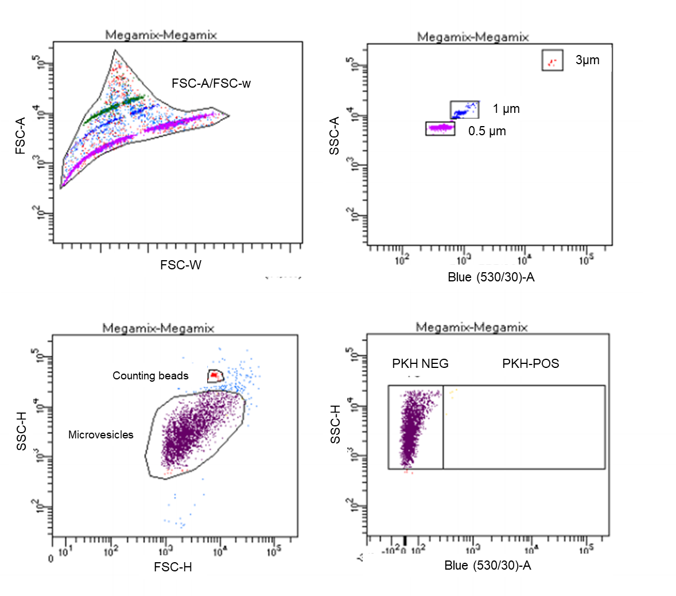
Figure 2.2 - Flow cytometry set-up and analysis - Commercially available Megamix beads sizes (3µm, 1µm and 0.5µm) were used to calibrate the LSRII flow cytometer. This determined appropriate laser intensities for MVs in this sizes range. FSC-A vs. FSC-W was used to determine the singlet, doublet and debris populations; only singlet populations were used for the identification of MVs. Counting bead and microvesicle populations were determined using a SSC-H and FSC-H gate. Finally, PKH67 positive and negative MVs were identified using the blue laser and 530/30 detector.

2.4 - Characterisation of neutrophil-derived microvesicles
Tuneable pulse sensing (qNano) –
Particle size was measured by tuneable pulse sensing using a qNano instrument (iZON Science Ltd). An NP400 nanopore was stretched at 45 mm, with an applied voltage of 0.34 V and pressure of 5 mbar. Samples were calibrated against SKP400E particles of known size (mode diameter 340 nm) and concentration (7.5 x10¹¹ particles per ml). Data was calibrated and histograms produced using iZON Control Suite software (version 3.2.2.251). Using this method, it was determined whether the diameter of MVs varied dependent upon the mechanism of activation. Neutrophils were stimulated to produce MVs in, MVs only, fMLP and acLDL.
Nanoparticle tracking (Zetaview) –
Particle size was measured using the Zetaview PMX110 Nanoparticle Tracker Analyzer (Particle Metrix, Germany). The device tracks Brownian motion of laser-beam illuminated MVs in order to determine particle size. MV samples were suspended in sterile-filtered water to a known concentration (2 x 10⁶/ml). Videos were recorded from 11 fixed positions and repeated over 3 cycles, before the median diameter and range determined. The Temperature was automatically maintained at 21ºC. Using this method it was determined whether labelling of MVs with PKH67 dye, resulted in the production of dye aggregates that may influence functional assays, or changed the diameter of MVs that may influence their function.

(A)
(B)
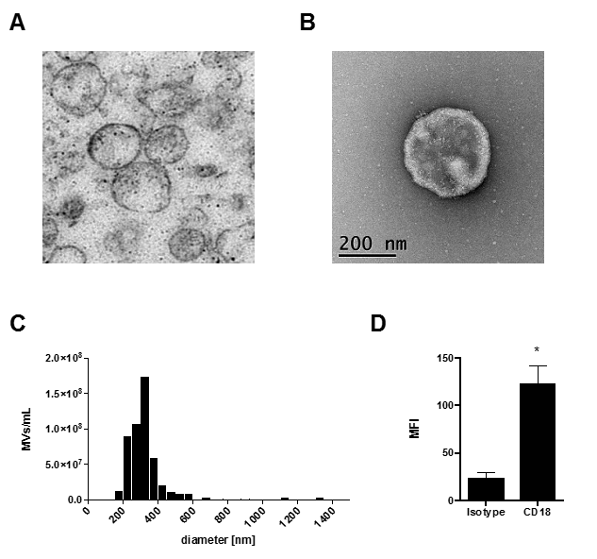
MV diameter (nm)
MV/ml

Figure 2.3 - Tuneable resistive pulse sensing (qNANO): Turnable resistive pulse sensing measurements were performed on an Izon qNANO device. MV samples were analysed using a NP400 nanopore at a pressure of 10 mbar, calibrated against 340nm polystyrene beads. For each MV test, 500 MVs were recorded. (A) Representative histogram of MV diameter from fMLP stimulated neutrophils. (B) Quantification of MV diameter from neutrophils stimulated to produce MVs by different stimulus. Data are presented as mode ± SEM (n=3) and analysed for statistical significance by one-way ANOVA with Tukeys test for multiple comparisons.

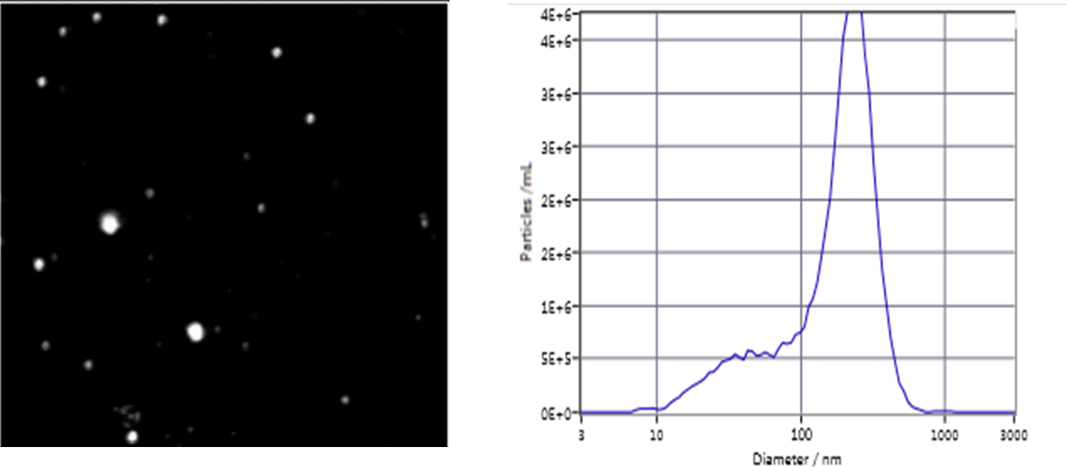
(D)
(C)
(B)
(A)
MV diameter (nm)
Particles/ml
Diameter - labelled vs. unlabelled
Concentration - labelled vs. unlabelled

Figure 2.4 - Nanoparticle tracking (Zetaview): Nanoparticle tracking measurements were performed on an ParticleMetrix Zetaview device. MV diameter and concentration was normalised to uniform polystyrene particles of 100, 200 and 400 nm. All measurements were performed in Milli-Q water. The mode diameter and concentration was determined as an average of 9 individual frames per sample. (A) Representative image of MVs from fMLP stimulated neutrophils. (B) Representative histogram of MV diameter and concentration from fMLP stimulated neutrophils. (C, D) MVs (1 x 107) were labelled with or without PKH67 dye. The concentration of MVs (C) and the mode diameter of the MVs (D) was determined with and without labelling. Data are presented as mode ± SEM (n=3) and analysed for statistical significance by paired t-test, *p<0.05.

2.5 - Monocyte isolation and labelling
PBMC isolation –
In parallel with the neutrophil isolation from whole blood, primary human monocyte isolations were performed. The protocols were performed in parallel however diverged following the 400g spin (25 minutes) with leukocyte rich solution layered on histopaque (see neutrophil isolation). Peripheral blood mononuclear cells (PBMC) were isolated from the histopaque gradient using a sterile Pasteur pipette. Cells were transferred to a fresh falcon tube containing 10 ml of PBS containing EDTA (PBSE; 2mM) and the falcon tube topped up to 50 ml. PBMCs were centrifuged at 400 g for 5 minutes (Acceleration 5, brake 3). The cell pellet was resuspended in 10 ml of red blood cell lysis buffer (155mM NH4Cl, 10mM KHCO₃, and 0.1mM EDTA in 100 ml H2O) for 5 minutes. The cell suspension was topped up to 50 ml and centrifuged at 400g for 5 minutes. The supernatant was removed, resuspended in PBSSE and 10 μl removed for counting by a manual haemocytometer.
Monocyte isolation –
Monocyte isolation was performed by negative selection according to the manufacturer’s instructions (Monocyte isolation Kit II, Miltenyl Biotec, United Kingdom). Pelleted PBMCs were resuspended in 300 μl (per 100 million PBMCs) of magnetic cell sorting (MACS) buffer (PBS, 2% w/v low endotoxin BSA, 2mM EDTA). The cell suspension was incubated for 1 minute at 4ºC with 100 μl FcγR blocking reagent, followed by 15 minutes incubation at 4ºC with 100 μl of non-monocyte depleting antibody cocktail. Following the incubation, 300 μl of MACS buffer was added to the solution, and 200 μl of anti-biotin microbeads. The solution was mixed and incubated for 15 minutes at 4ºC. PMBCs were washed in 2 ml of MACS buffer and cells centrifuged at 400 for 5 minutes. Cells were resuspended in 500 ml of cold MACS buffer for magnetic separation. An LS column (Miltently Biotech) was placed in the magnetic field of a MACS separator, rinsed with cold MACS buffer and the PBMC sampled added. The column was washed 3 times with MACS buffer and the monocyte rich population collected. Monocyte were counted and the purity was determined by the assessment of CD4 positivity by flow cytometry.
Monocyte labelling (PKH26) –
1 x 10⁷ monocytes were pelleted, as above, and resuspended in 1 ml of diluent C. In a new 15 ml falcon tube, 1 ml of diluent C was combined with 4 μl of PKH26 dye. The diluent C-dye solution was immediately transferred into a the tube containing the monocyte solution. The solution was continually re-suspended for the first minute of the incubation. After 3 minutes, the reaction was stopped by adding 1 ml of PBS containing 1% w/v BSA. Monocytes were pelleted and washed twice in PBS.

2.6 - Microvesicles in the murine aorta
Adhesion of PKH67 labelled MVs –
To assess MV adhesion, MVs were isolated from PKH26-labeled neutrophils and 4 x 10⁶ injected i.v. into 15 week old ApoE-/- mice fed on chow. After 2 h vessels were prepared for immunostaining; endothelial cells were stained with Alexa 488 conjugated anti-CD31 (Biolegend, UK) and nuclei identified using a DNA-binding probe with TO-PRO-3 Iodide (Life Technologies, CA). Vessels were then opened en face, mounted using Prolong gold anti-fade mountant (Life Technologies, CA) and imaged using laser scanning confocal microscopy (Zeiss LSM510 NLO inverted microscope).
Accumulation of microvesicles in murine aortic plaques –
To assess whether MVs from a number of different cell types accumulate in the developing plaques, plaques were isolated from the aorta of APOE^{-/-} mice feed on a wester diet for 6 and 20 weeks. These experiments were performed based on those previously described by Rautou et al., (2011). Briefly, the vessels were rinsed in cold DMEM media. The lesion was then separated from the healthy tissue. Each piece of tissue was then cut thoroughly using a fine pair of scissors. Once homogenised the samples were centrifuged at 400 g for 5 minutes, to pellet whole cells. Once completed, the supernatant removed and centrifuged at 5000 g for 5 minutes to remove cellular debris. Finally the remaining supernatant was centrifuged at 20,000 g for 30 minutes, to isolate the MV population. Following isolation of the MV population from the plaque, the samples were stored at -20ºC before analysis by flow cytometry (see section 2.10).

2.7 - Endothelial cell culture and in vitro flow chamber system
Human coronary artery endothelial cells (HCAECs) were purchased from Promocell (Heidelberg, Germany). The primary cell lines, isolated from a single donor, were harvest from both the left, right and circumflex branches of the coronary arteries. Cryopreserved cells were delivered on dry ice, and immediately transferred to liquid nitrogen (-170ºC) stores upon arrival. Cells there then defrosted following the suppliers instructions. Briefly, cells were removed from liquid nitrogen and transported to the laboratory using a Cryo-Pod Carrier (FluidX, United Kingdom). Samples were immediately submerged in a water bath at 37ºC and gently agitated. Once loose, the vial was transferred to a laminar flow hood, and emptied into a pre-warmed T-75 flask containing 15 ml of MV2 complete growth media. The cells were placed in an incubator (37ºC, 5% CO₂), the media changed after 24 hours and allowed to reach 90% confluence before sub cultivation.

  - Table 2.4 – MV2 HCAEC media constituents
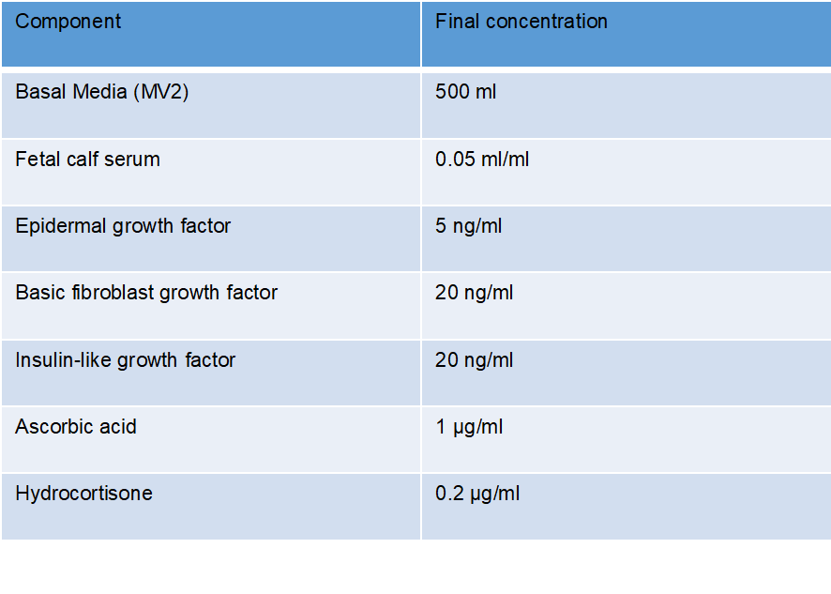

Sub-cultivation of HCAECs –
Cell sub-cultivation was performed under aseptic conditions under a laminar flow hood. In order to detach cells, a Detach Kit (Promocell, Germany) containing trypsin/EDTA solution was warmed to room temperature. The cell media was aspirated and the cells washed twice using 7.5 ml of Hepes BSS solution (Promocell, Germany). 1ml of trypsin/EDTA solution was added to the cell monolayer and placed in an incubator at 37ºC, 5% CO₂ for 3-5 minutes. Once the cells had detached, as determined by light microscopy, a trypsin neutralising solution was added. The cells were transferred to a 50 ml falcon, and centrifuged at 220 g for 5 minutes at room temperature. The cell pellet was then resupended in 3 ml of MV2 media, and transferred into 3 T75 flasks containing 10ml of pre-warmed MV2 media. HCAECs were used for experimentation between passages 4-7.

2.8 - Ibidi flow chamber system – microvesicle adhesion
Flow experiments were performed using a parallel plate system, commercially available from Ibidi (Ibidi GmbH, Munich, Germany). Prior to each experiment the silicone tubing of each perfusion set was replaced with new biocompatible silicone tubing (VWR, England), autoclaved and left to dry in a dry in a heating cabinet. HCAECs were harvested from a T75 flask were seeded onto pre-gelatinised (0.1 % w/v gelatine; 1.7 x 10⁵ HCAECs in 150 µl of MV2 media) 0.4 µm deep flow chambers (Ibidi µ-slide 10.4- Luer) on the day prior to each experiment. At least 4 hours prior to each experiment, ibidi flow units were placed into an incubator at 37ºC, 5% CO₂ to equilibrate. HCAECs were then connected to the ibidi flow units containing 12 ml of MV2 media.
Shear stress conditions –
HCAECs were cultured under physiologically relevant shear patterns and magnitudes of shear stress. High unidirectional shear stress (13 dyn/cm²) was considered representative of atheroprotected regions and, low oscillating shear stress (0 ± 4 dyn/cm², 1 Hz) representative of atheroprone regions of the vasculature (Serbanovic-Canic et al. 2016). During all pre-conditioning experiments, cells were cultured under the above flow conditions for 72 hours.
Endothelial cell pre-conditioning and microvesicle adhesion –
To determine the role of pre-conditioning ion MV interactions with HCAECS, cells were cultured under shear stress conditions (as above) for 72 hours. Following the cessation of flow, pre-conditioned HCAECs were incubated with fluorescently labelled MVs (2 x 10⁶/ml) under static conditions for 2 hours. The cells were gently washed in PBS and fixed in paraformaldehyde (4%).

Delivery of MVs under flow conditions –
To determine the role of delivering MVs under flow conditions, HCAECs were either cultured under shear stress conditions (as above) for 72 hours, or under static conditions. Fluorescently labelled MVs were added to 12 ml of MV2 media (2 x 10⁶/ml) and placed in to the ibidi flow units. The perfusion of MVs to HCAECs pre-conditioned under flow were performed under the same flow parameters as their conditioning, while that over statically cultured cells was performed for the both the atheroprotective and atheroprone flow patterns outlined above (for summary see Figure 5.4). In addition, adhesion to statically cultured cells were tested at a range of physiologically relevant shear stress (2-18 dyn/cm²). Following incubation with MVs under flow conditions for 2 hours, the cells were gently washed in PBS and fixed in paraformaldehyde (4%).
Antibody inhibition of adhesion molecules –
The role of specific adhesion molecules in MV-HCAEC interactions was assessed by antibody blockade of adhesion molecules expressed on HCAECs. Cells were cultured under static conditions before treatment with functional blocking antibodies/proteins against ICAM-1 (10 ug/ml), P-selectin (1 ug/ml) and Annexin V (20 mg/ml; see antibody section for suppliers) for 40 minutes at 37ºC, 5% CO2. The cells were washed to remove residual antibody, before incubation with fluorescently labelled MVs under static conditions for 2 hours. The cells were washed in PBS and fixed in PFA (4%). These experiments were repeated with the antibody blockade of ICAM-1 following pre-conditioning of HCAECs under flow.
Fluorescent immunocytochemistry -
HCAECs were fixed by adding 150 µl of PFA (4 % w/v) and incubated at room temperature for 15 minutes. The cells were washed three times with PBS. 150 µl of triton-x100 (0.1%) was added for 15 minutes in order to permeabilise the cell membranes. The cell nucleus was stained by adding 150 µl of To-pro-3 Iodide (Life Technologies, Paisley, UK) at 1 µg/ml; the cells were incubated for 10 minutes at room temperature. Non-specific binding was blocked by adding 20% goat serum for 30 minutes at room temperature. The goat serum was removed and the cells were washed. Mouse anti-human VE Cadherin antibody (CD144; Life Technologies, Paisley, UK) was suspended in 5% goat serum to further reduce non-specific binding. 150 µl of the primary antibody was added to the endothelial monolayer at 1 µg/ml and incubated for a minimum of 12 hours at 4ºC. The cells were then washed in PBS to remove unbound primary antibody and the cells incubated on a rocker with the secondary anti-bodies goat anti-mouse AlexaflourTM 568 (Life technologies, Paisley UK) or goat anti-mouse AlexaflourTM 488 (Life Technologies, Paisley, UK) at 4 µg/ml for 2 hours at room temperature. The cells were then washed with PBS three times at 5 minute intervals. The slides were stored at 4ºC until analysis.
Monocyte adhesion under flow –
HCAECs were pre-conditioned under low oscillating shear stress, as above, for 72 hours. During the final 0, 2 or 4 hours of the preconditioning period MVs (2 x 10⁶/ml) were added to each ibidi unit. At 72 hours, the media was removed (and stored at -20^{O}C) and changed for media containing PKH26 labelled monocytes (1 x 10⁶). Monocytes were incubated with HCAECs for 2 hours under low oscillating wall shear stress conditions. Following incubation, the flow was stopped, slides washed gently to remove non-adherent monocytes and fixed in PFA (4% w/v). The slides were stored at 4ºC until analysis.
Determination of adhesion –
Phase-contrast and fluorescent images were taken using the 10x (monocyte experiments) 20x (MV experiments) objective of a wide-field microscope (Leica, DM14000B). Images were taken at uniform intervals along the homogenous shear stress region of the ibidi µ-slide. An average of 6 images (MV experiments) or 15 images (monocyte experiments) were analysed and used to calculate the number of adhered MVs/monocytes field of view.

2.9 - Analysis of HCAECs by flow cytometry
Analysis of Adhesion molecule expression on HCAECs –
Flow cytometry was performed in several experiments in order to determine the cell surface expression of adhesion molecules expressed on HCAECs. Preparation of samples for analysis follows the below basic protocol unless where stated.
At the end of each experiment, cells were washed in PBS and detached from their respective slide/well. The trypsin solution was diluted 1:5 to avoid damage to epitopes of the adhesion molecules of interest. Cells were placed on ice, before being centrifugation at 260 g for 5 minutes at 4ºC and washed in cold PBS. The cells were then counted and separated into Eppendorfs containing 150,000 cells per condition. The cells were centrifuged, again at 260 g for 5 minutes at 4ºC. The cells of each experimental condition were re-suspended in 500 µl of cold PBS and the respective test concentration of fluorescently conjugated antibody added (see table 2.2). The cells were placed on ice and gently shaken on a rocker for 40 minutes. The cells were washed twice in PBS and taken for analysis.

2.10 - Analysis of cell surface protein expression on MVs
Ex vivo produced neutrophil microvesicles-
Microvesicles were isolated from human neutrophil as previously described. MVs were quantified and 5 x 10⁶ were suspended in 100 µl of cold PBS. Fluorescently conjugated antibodies against neutrophil specific markers and adhesion molecules (see table 2.2), or their respective isotype controls, were added at their respective test concentration. The cells were placed on ice and gently shaken on a rocker for 40 minutes. The cells were washed once in PBS and taken for analysis.
Human plasma samples (High-fat feeding) –
50 µl of human plasma samples (pre and post diet, see section xx) were added to 200 µl of cold sterile PBS and kept on ice. Fluorescently conjugated antibodies against neutrophil, platelet, endothelial and monocyte specific makers were added to each sample. Flows minus one (FMO) and single antibody stain corrections were used for compensation of the multiple fluorophores in the experimental samples. Briefly, the FMO controls, containing each of the fluorophores in the panel minus a single fluorophore; were normalised to a sample containing only the single stain of interest in order to control for spectral overlap. Once the antibodies were added, the cells were gently shaken on a rocker for 45 minutes. The cells were centrifuged at 20,000 g for 30 minutes to pellet the entire population of circulating MVs, and re-suspended in 490 µl of FACS buffer with 10 µl of Sphero AccuCount blank particles (Saxon Europe, England).

2.11 - Analysis of MV internalisation by HCAECs
Flow cytometry was performed to determine to determine the internalisation of MVs by HCAECs in multiple experiments, outlined below is the basic outline of this protocol.
HCAECs were incubated with fluorescently labelled microvesicles (2 x 10⁶, see specific experiments for more details). The cells were washed in PBS to remove excess MVs and lifted from their respective slide/well using a trypsin/EDTA solution. The cells were placed on ice and centrifuged at 260 g for 5 minutes at 4ºC. The cells were washed once in PBS and suspended in 300 µl of FACS buffer for analysis. Immediately prior to analysis, trypan blue (1 mg/ml) was added to each sample in order quench fluorescence of residual surface bound MVs (see Nuutila and Lilius, 2005), ensuring fluorescent signal detecting was from internalised MVs only.
Acquisition of flow cytometry data –
Data were acquired using an LSRII flow cytometer (BD Biosciences, Oxford, UK), equipped with FACSDiva acquisition software (BD Biosciences, Oxford, UK. The system was equipped for excitation by 4 lasers (blue 480nm, red 633nm, violet 355nm, UV 325 nm) and detection of emissions by 13 detectors. Linear amplification of particle size (forward scatter; FSC) and granularity (Side scatter; SSC) were continually recorded to determine populations of interest. Cells were recorded until a minimum of 3000 gated endothelial cell events.
Analysis of flow cytometry data -
Analysis was performed off line using FlowJo (version 10.2). For each event, detected density plots were constructed to gate for size and granularity. Gates were placed around regions of interest in order to exclude cellular debris. Histograms were employed in order to gate cells/MVs that exhibited a fluorescent profile. The percentage positive and/or mean fluorescence intensities were then determined for each population based on gating in the specific fluorescent-light filter for each fluorophore/dye.
Pharmaceutical inhibition of internalisation -
To delineate the pathway of MV internalisation by HCAECs, pharmacological inhibitors of endocytosis were used to inhibit specific cellular processes and pathways. HCAECs were cultured under static conditions and were pre-treated for 1 hour at 37ºC, 5% CO2 in the presence of one of the following agents; Monodansylcadaverine (50 µM), Genistein (50 µM), 5-(N-Ethyl-N-isopropyl)amiloride (20 µM), Dynasore (100 µM), Wortmannin (1 µM), Y-27632 (10 µM), Cytochalsin D (500 µM; see table 6.1 for details of each inhibitor), or 0.1 % DMSO control. Trypan blue exclusion experiments were performed in order to determine cell viability across for a range of concentrations for each agent. In order to determine the efficacy of inhibition, fluorescein isothiocyanate-dextran (70,000 Kd; Sigma-Aldrich, Denmark), fluorescein-conjugated transferrin (Lorne laboratories, United Kingdom) and fluorescein-conjugated cholera-toxin B subunit (Sigma –Aldrich, Denmark) were used as positive controls of specific pathways. Internalisation experiments were performed as above.

2.12 - ICAM-1 in MV internalisation
Penetratin-ICAM-1 and internalisation -
Penetratin peptides consisted of 16 residues of the penetratin sequence (RQIKIWFQNRRMKWKK). The 13 C-terminal amino acids of human or rat ICAM-1 were synthesised and linked to the penetratin peptides. Peptides were HPLC purified before use. Sequences used were hICAM-1 (icp1 - QRKIKKYRLQQAQ), rICAM-1 (icp2 -QRKIRIYKLQKAQ), and an irrelevant sequence from the soluble part of rat rod opsin (CKPMSNFRFGENH). HCAECs were cultured under static conditions and were pre-treated with penetratin-linked peptides for 1 hour at 37ºC, 5% CO₂. Internalisation experiments were performed as above. Penetratin linked peptides were kindly provided by Dr. Patric Turowski, and have previously been published by Greenwood et al., (2003)
Chinese Hamster Ovarian cell transfection of wild type and mutant ICAM-1 -
Chinese Hamster Ovarian cells (CHO) were cultured in 24 well plates until a monolayer was formed. Cells were then transfected with plasmids containing human wild type and human truncated ICAM-1 using the commercial available Dharmafect reagents (Dharmacon, Colorado, USA). Plasmids were provided by Dr Patric Turowski, and have been previously published as above. 5 µM plasmid solutions (control plasmid, and both ICAM-1 containing plasmids) were prepared and up to 10 µl in serum-free media. In a second tube, Dharmafect reagent was incubated again with serum-free media. These tubes were combined, creating a 20 µl volume, these were then allowed to incubate at room temperature for 20 minutes. Finally anti-biotic free complete media was added to create a volume of 100 µl and added to the cells to incubate for 24 hours. This produced a final plasmid concentration of 25 nM. The cell surface expression of ICAM-1 was determined by flow cytometry.

2.13 - Live-cell imaging of MV internalisation
HCAEC cells were seeded on glass bottomed µ-slides (ibidi) and cultured for 24h. SiR-Actin (Spirochrome, Switzerland) and Hoechst (ThermoFisher Scientific, MA) staining was performed to detect F-actin and nuclei in living cells respectively. Cells were then incubated with PKH67-labeled MVs and confocal live cell imaging performed on a Leica TCS SP8 imaging platform (Leica, Germany) equipped with an incubator, allowing live cell imaging at 37°C and at 5% C_{O}2. Samples were observed using a 100X oil immersion objective (HCX PL APO 100X/1,40 oil) and exited using sequential scanning, first at 405 nm and 652 nm for Hoechst and SiR-actin, respectively and at 490 nm for PKH67. HyD hybrid detectors were used to detect three spectral regions : 415-496 nm (Hoechst), 662-749 nm (SiR-actin), and 500-550 nm (PKH67). Z-stacks were performed with a z-step size of 0.20 µm. Images were analysed using ImageJ (1.49V, NIH) and Amira 6 software (ThermoFisher Scientific, MA).

2.14 - Quantification and analysis of gene expression by qPCR
Total RNA extraction and purification was performed following ISOLATE II RNA mini kit (Bioline, USA) following manufacturer’s instructions. Briefly, cells on cultured on ibidi slides were washed twice in cold PBS (stored at 4ºC). 150 μl of Lysis Buffer RLY, containing 1.5 µl of β-mercaptoehtanol, was added to each slide. The cell lysate was homogenised by passing the cell suspension through a 21 gauge needle and 1 ml syringe. An ISOLATE II extraction filter was placed inside a 2 ml collection tube, the lysate loaded and centrifuged at 11,000 g for 1 min. The ISOLATE II filter was discarded and 350 μl of ethanol (70%) was added to each tube and mixed by pipetting up and down 5-times in order to precipitate the nucleic acid. Each sample is then centrifuged at 11,000 g for 1 minute in a spin column containing a silica membrane to which RNA binds. DNase1 was added to each sample to remove genomic DNA from the membrane. The membrane was washed and the RNA eluted into RNase-free water. Extracted RNA was stored on ice. 1 μl of sample was added to a Nano-Drop ND-1000 (Life technologies, Carlsbad, USA) to determine the concentration and purity of the RNA in each sample, analysis was performed using ND-100 v 3.7.0 software.

Quantification of gene expression using qRT-PCR –
Complementary deoxyribonucleic acid (cDNA) synthesis was performed using the iScriptTM cDNA synthesis kit and 200 ng of isolated RNA sample. The constituent components of the kit were combined; 5 μl of 5xiScript reaction mix, 1 µl of iScriptTM reverse transcriptase, RNA template mix (x μl for a final concentration of 200 ng), and the required volume of nuclease-free water to provide a final total volume of 25 μl. The sample was transferred to a thermal cycler (see table 2.5) for cDNA synthesis.
The cDNA mix was diluted 1:100. A qRT-PCR master mix was produced using a KAPA SYBR® green detection kit following the manufacturer’s instructions. The constituent components of the kit were combined; 5 µl KAPA SYBR FAST qPCR master mix ABI primers (1x), 0.3 µl of forward and reverse primers per gene of interest (200 nM), 4.4 μl of cDNA template (2 ng), added to each well of a 384 well plate. Each gene of interest was loaded in triplicate. The plate was sealed and centrifuged at 1200 rpm for 1 minute to ensure even mixing of the well constituents. The sample was transferred to a CFX384TM real-time PCR machine (see table 2.6). Primer sequences are listed in table 2.7.

  - Table 2.5 - Thermal cycling profile: cDNA synthesis
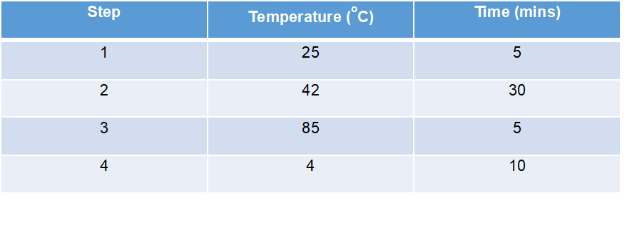
  - Table 2.6 - Thermal cycling profile: qRT-PCR
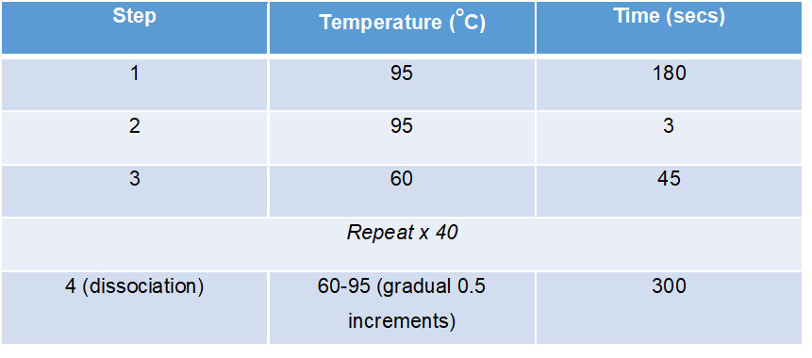

Table 2.7 - Human primer sequences
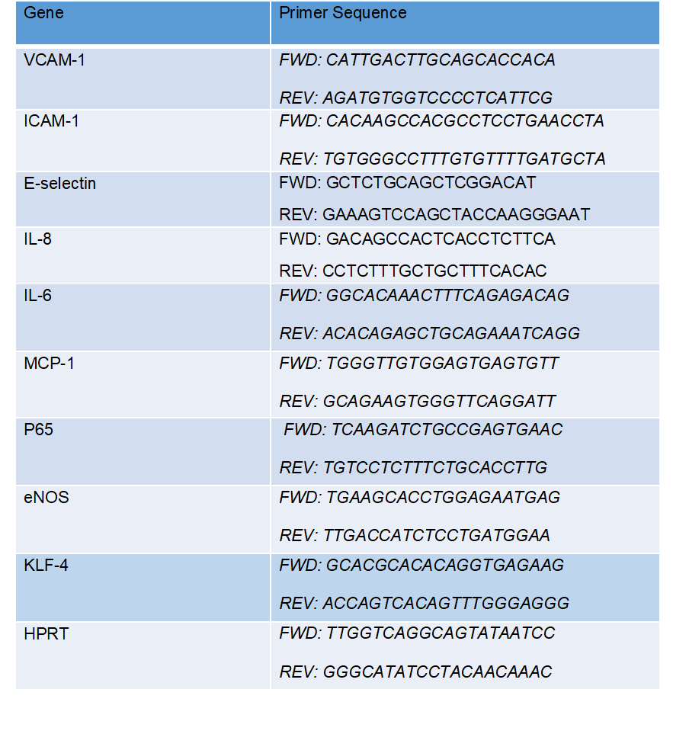

Analysis of qRT-PCR data –
qRT-PCR data was analysed using BIO-RAD CFX manager 3.0 software. For each gene of interest the threshold cycle (CT) was determined. The CT value was compared against a ‘housekeeping’ gene, generating the ΔCT value. The ΔΔCT for each gene of interest was then calculated by subtracting the average ΔCT of the 2 and 4 hour MV samples from the ΔCT of the oscillatory alone sample, and then subtracting the average ΔCT from the oscillatory alone sample from itself. 2-ΔΔCT calculations were performed to produce the relative mRNA relative fold change. Genes of interest were determined to be up regulated by MVs if the relative change was greater 1.

2.15 - Quantification and analysis of HCAEC secretion by Enzyme Linked Immunosorbent Assay (ELISA)
Human CXCL8/IL-8, CCL2/MCP-1 and IL-6 Duoset ELISA kits (R&D systems) were used to determine the protein secretion from HCAECs cultured with MVs. ELISAs were performed according to the manufactures instructions. All washing steps were performed using a Geneflow ELx50 plate washer (Biotek Instruments, USA).
A 96-well microplate plate was coated with the target capture antibody a minimum of 15 hours prior to the ELISA. On the morning of experiment, unbound sites on plate were blocked by 2 hour incubation with a blocking buffer (PBS containing 1 % w/v BSA). An 8-point standard curve was produced by serial dilution of the standard stock solutions in reagent diluent. 100 µl of media was added in duplicate and incubated at room temperature for 2 hours. The wells were washed and detection antibody added before incubation for a further 2 hours. Once washed, 100 µl of Streptavidin conjugated to horseradish peroxide (HRP) was added to each well and incubated in subdued light for 20 minutes. The wells were then washed and 100 µl of substrate solution added for a further 20 minutes. 50 µl of stop solution was added to each well. The optical density was measured using a microplate reader at 450 nm, a second reading at 540 nm was performed to correct for optical imperfections on the plate. The concentration of the target protein was based on the duplicate of each sample, in relation to standard curve that had been normalised to the optical density of the blank standard.

2.16 - Human high fat feeding and neutrophil microvesicles
Participant inclusion/exclusion criteria -
15 healthy individual volunteers were recruited from the student population at the University of Loughborough. Exclusion criteria required the participants to regularly participate in physical activity (exercising at least 2 times per week), non-smokers, free of cardiovascular/metabolic diseases, weight stable for at least 6 months, and with a normal body mass index (BMI; 18.5-24.9 kg/m2-). Due to the nature of the intervention, vegetarians and vegans were excluded from the study.
Diet records, analysis and compliance during overfeeding -
Subjects were asked to complete a food log over a 3-day period during the pre-experimental period. During this period, using standardised forms and digital scales provided, food intake was weighed and recorded. Training and guidance was provided to the participants in order to ensure food intake was recorded adequately. These records were then used in the assessment of their habitual energy intake so that individualised diets could be planned and prepared for the 7-day overfeeding period. All assessment of dietary requirements was performed using WISP V4.0 (Tinuvel Software, Anglesey, UK). Participants were required to complete 7 days of increased energy intake (50% overfeeding based on habitual food intake), consisting predominantly of foods containing high fat contents (65% of energy consumed – see table 3.2 for typical day). All food was purchased and prepared by research staff at the Loughborough University. Subjects were instructed to all food that was provided, to avoid consumption of food items outside of the feeding protocol, however to return any uneaten food for weighing. If this occurred then diets were adjusted accordingly.
Blood collection -
For the collection of both pre and post high fat feeding samples participants were required to arrive at the laboratory between 7-9 am. Participants were asked to have fasted for at least 10 hours prior to attending the laboratory. Blood was drawn from the antecubital vein (as above). 20 ml of whole blood samples was transferred into a fresh flacon tube containing 2.2 ml of sodium citrate. The samples were then then either used for the isolation of human neutrophils and stimulated for MV production (as in section 2.2), or centrifuged at 2,300 g for 20 minutes in order to produce platelet poor plasma. Following completion of the MV isolation or plasma collection, samples were stored at -20oC until analysis.

Acute plasma triglyceride and glucose responses to high-fat food consumption -
5 healthy volunteers attended the lab following a 10 hour fast. Participants were asked to consume breakfast, lunch and snack typical of high fat overfeeding diet. Resting/fasted blood samples were obtained 30 minutes prior to ‘breakfast’. Once breakfast was completed the postprandial timer started and blood drawn at 30 minute intervals. ‘Lunch’ was prescribed immediately after the 240 minute blood draw, and a ‘snack’ prescribed immediately following the 300 minute blood draw. Blood samples were drawn until 480 min following the completion of breakfast. Blood samples were analysed for the concentration of glucose and triglyceride using commercially available spectrometer kits.

2.17 - Statistical analysis
Data is provided in text, tables and figures presented as mean values and standard error of the means (± SEM). Statistical analyses were performed using GraphPad Instat version 7.01 (Graphpad Software, San Diego, USA). Where applicable, comparisons of mean values were performed using the appropriate parametric test. All significant F ratios were subsequently assessed using the appropriate post-hoc test applied to control family wise error of the P-value. p<0.05 were considered to be statistically significant. Where data was not deemed statistically significant, post-hoc effect size calculations were performed using the Cohen’s d method (Becker, 2000). This provides a quantification for the difference between two means in standard deviation units, and as such does not incur bias due to sample size. Small effect sizes were considered to be 0.2-0.4, medium effect sizes 0.4-0.7 and large effect sizes >0.7.

Chapter 3 - High-fat overfeeding and the production of microvesicles

3.1.1 - Introduction
Western diets, associated with high calorific intake and unbalanced macronutrient contents, are well established as one of the leading modifiable causes of atherosclerosis (Fung et al., 2001). Hypertriglyceridemia is defined as having plasma triglycerides levels over 1.5 mmol/L, and is well recognised as an independent risk factor of disease susceptibility (Reviewed by; Talyaro and Sacks, 2011). In cross-sectional studies of the United States, population prevalence of hypertriglyceridemia was observed to have risen from levels of 31% in 1999 (NCEP, 2002) to 33% of the population in 2009 (Ford et al., 2009). Given the modifiable nature of diet-induced processes in atherosclerosis, greater understanding is needed as to how high-fat overfeeding can influence disease initiation and progression.
Triglycerides, consumed as part of a balanced diet, are cleared from the circulation by the liver, where they are metabolised for use in a number of physiological processes. Following the consumption of high-fat meals or prolonged periods of over-feeding, the ability of the liver to clear plasma triglycerides is impeded and levels in the circulation rise. A growing body of evidence implicates this rise in triglyceride levels with the systemic inflammation and endothelial cell activation, that are both critical in the aetiology of atherosclerosis (Ladeia et al., 2006, Wegge et al., 2004, Rubin et al., 2008). A number of mechanisms through which triglycerides may be implicated in disease processes have been identified. Importantly, a number of studies have observed a link between triglycerides and endothelial cell activation, identifying increased production of inflammatory factors such as ICAM-1 and VCAM-1 by endothelial cells in response to hypertriglyceridemia (Norata et al., 2006, Norata and Catapano, 2007).
Additionally, triglycerides may also contribute to disease progression through alterations in the number and phenotype of circulating leukocytes. The relationship between circulating leukocyte counts and CVD is recognised as a valuable predictor of cardiac associated mortality (Madjid et al., 2004) and circulating leukocyte counts and ratios are commonly measured in a clinical setting (Madjid and Fatemi, 2013). Importantly, a number of studies in both human and murine models have identified high-fat diet induced leucocytosis. (Alipour et al., 2008, Dreschler et al., 2010). Interestingly, in human studies of these effects, increased levels of triglycerides were found to impede peripheral vascular function (Van Oostrom et al., 2003), highlighting the ability of high-fat feeding to induce physiological changes in the blood vessel that are directly implicated in atherosclerotic development.
Diet-induced hypertriglyceridemia is an independent risk factor of atherosclerotic development, which induces systemic inflammation through the activation of endothelial cells and leukocytes. As such, Western diets that are associated with high calorie and high fat intake increase the pro-inflammatory and pro-adhesive properties of both endothelial cells and the leukocytes, facilitating greater interactions between these cell types that are critical in aetiology of atherogenesis. Despite evidence of pro-inflammatory changes in both these cell types, only a hand-full of studies have determined how the stimulus of high-fat, overfeeding influences the production and function of MVs. Given the significance of the donor cell activation in their production, as well as the importance of adhesion molecule expression in regulating their interactions with their recipient cells, important gaps in our understanding remain regarding how diet influences MV biogenesis.

3.1.2 - Hypothesis and Aims
High fat diet leads to elevated numbers of circulating activated neutrophils, resulting in an increase in the production and pro-inflammatory capacity of neutrophil-derived MVs.
Aim 1 – To determine whether high-fat feeding in humans increases the number of circulating MVs produced from neutrophils and other circulating cell types.
Aim 2 – To determine whether human plasma following high-fat feeding is a stimulus for neutrophil MV production ex-vivo.
Aim 3 – To determine whether MVs produced from neutrophils following high-fat feeding have different functional consequences on the activation of human coronary artery endothelial cells.

3.2 - Methods
In order to determine the effects of high-fat overfeeding on the production and function of MVs, 15 healthy human participants (demographics summarised in table 3.1) were provided a diet consisting of a 50% increase in their typical isocalorific intake, with 65% of the calories in the diet provided from fats. The diets components changed each day to reduce the risk of non-compliance, a ‘typical’ days food in summarised in table 3.2.
The human plasma collected from participants’ pre and post HFD were analysed for the number of MVs from different cell types by flow cytometry (Figure 3.4). Additionally, this plasma was incubated with human neutrophils from healthy volunteers and the number of MVs produced in response to this stimulus determined by flow cytometry (Figure 3.5). These procedures are summarised in Figure 3.2a.
To assess the effects of MVs produced from neutrophils on HCAECs. Whole blood collected from patient’s pre and post high fat diet was collected and MVs produced from either stimulated or unstimulated neutrophils (as described above). The MVs pre and post diet, with and without stimulation, were incubated with HCAECs for 4 hours. The HCAECs from all conditions were then collected and either analysed by qPCR to determine changes in mRNA expression, the supernatants collected for analysis by ELISA or, whole cells collected for analysis of adhesion molecule expression on their cell surface. These procedures are summarised in Figure 3.2b.

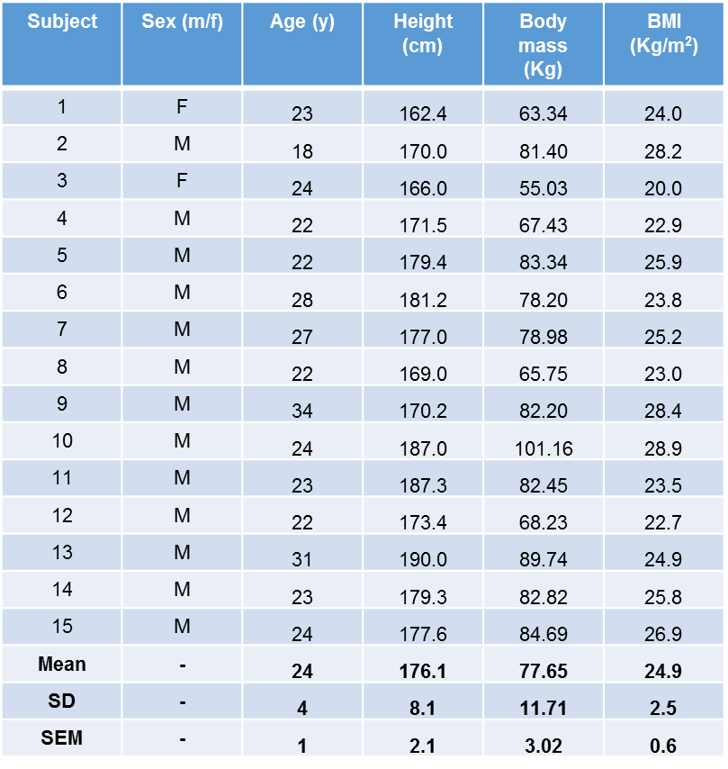
  - Table 3.1 - Participant demographics from high-fat overfeeding experiments

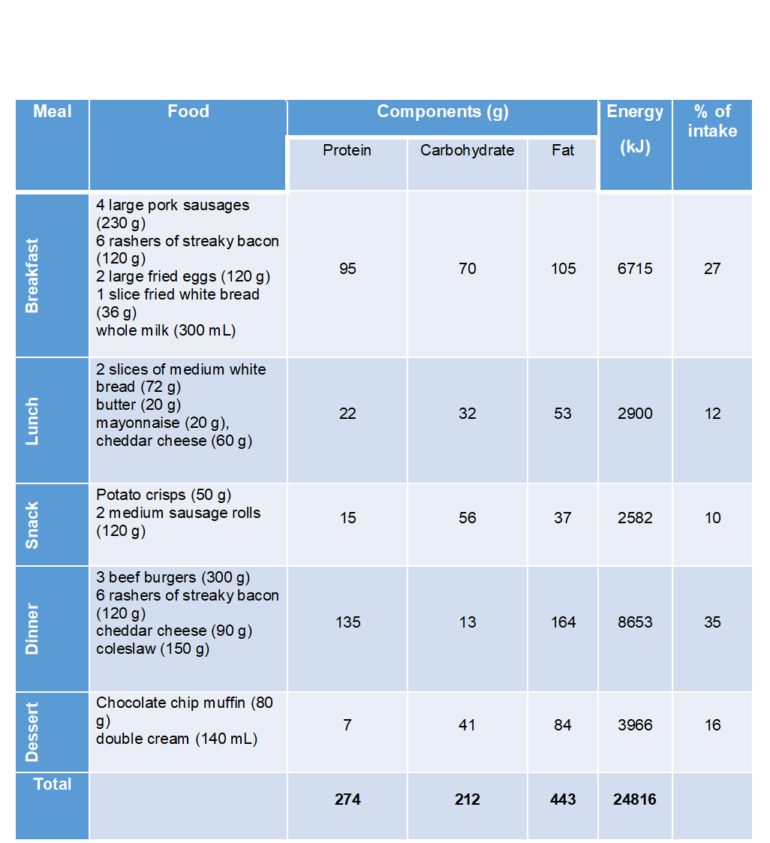
  - Table 3.2 Representative example of daily food intake for human high-fat overfeeding studies

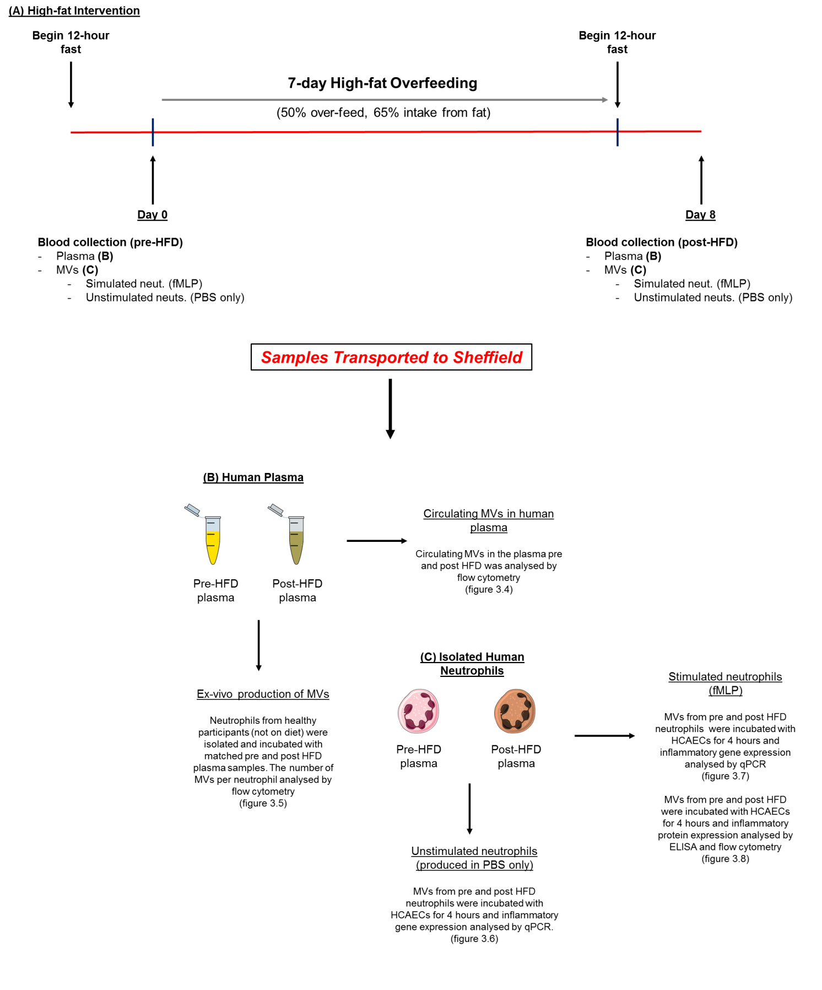
Figure 3.1 - Experimental summary of HFD study: All human feeding was performed at Loughborough University. Participants were fed a high fat diet for 7 days. Plasma was collected following a 12 hour fast on day one and day 8 of the study. Additionally, on some occasions whole blood was collected to perform neutrophil and MV isolations. The plasma was used to determine the number of circulating MVs and the isolated MVs to determine the functional effects of the MVs following the intervention.

3.2 - Results

3.2.1 Post prandial triglyceride and glucose responses to high-fat feeding
Postprandial hypertriglyceridemia is associated with an increase in the mobilisation and activation of neutrophils. I therefore aimed to determine whether the protocol of high-fat overfeeding, as designed by Hulston et al., (2015), resulted in significant alterations in the participants’ plasma triglyceride profiles in the 8 hours following the initiation of the diet.
Measurement of plasma glucose levels demonstrated that levels were significantly reduced between 90 and 180 minutes following the consumption of the high-fat breakfast (Figure 3.2 A). Plasma glucose levels were not significantly elevated at any time point throughout the follow up. Plasma triglyceride increased immediately following the high fat breakfast, participants remained in a state of postprandial hypertriglyceridemia between 30 and 210 minutes (Figure 3.2 B). As such participants were unable to clear plasma triglyceride from their circulation between initial high-fat challenge and lunch. At no point during the 8 hour follow up did the circulating level of plasma triglyceride return to that at baseline.
These data indicate that diet designed by Hulston et al., (2015) results in elevated plasma triglycerides and postprandial lipeamia that is associated with increased CVD disease risk.

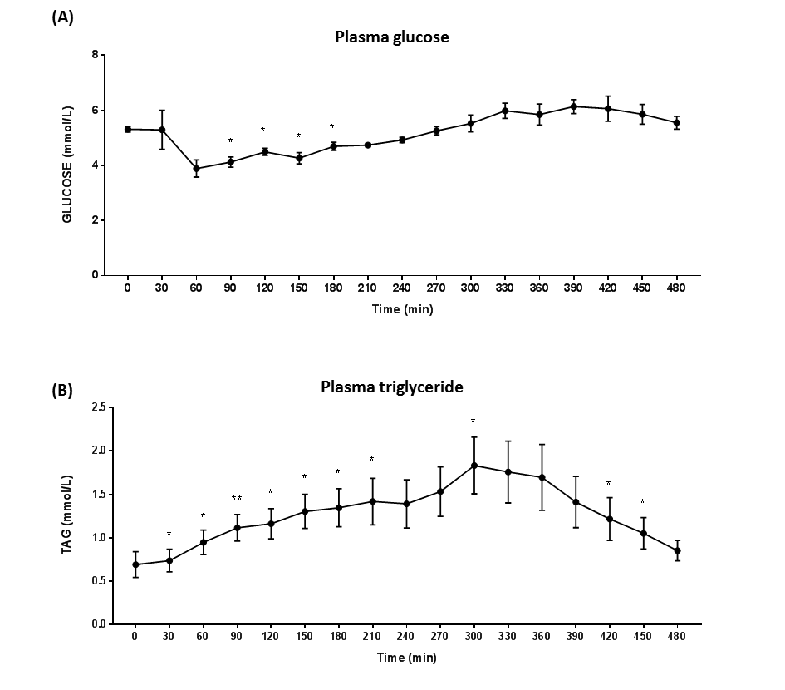
Figure 3.2 – Acute plasma glucose and triglyceride responses to high fat over-feeding: Healthy human participants were fed breakfast, lunch and snacks as provided in the 7-day high fat feeding protocol. Metabolic responses, including plasma glucose (A) and plasma triglyceride were measured for a total of 8 hours. Data are presented as mean ± SEM (n=5) and statistical significance analysed by one-way ANOVA with Dunnetts test for multiple comparisons comparing all time points to 0, *p<0.05, **p<0.01 (Data kindly collected by Dr. Hulston at Loughborough University).

3.2.2 Plasma microvesicle levels in-vivo following 7-day high fat overfeeding
MV production has been observed from a number of different cell types in response to different stimulus, and therefore we wanted to determine the effect of high-fat overfeeding on the production of MVs from neutrophils, but also monocyte, platelets, and endothelial cells in-vivo.
Figure 3.3 summarises the MV numbers and changes in response to 7-day high-fat overfeeding. Healthy human volunteers were fed on a high-fat (65%), overfeeding (+50%) diet for 7 days (n=15). The energy intake and diet composition is summarised in table 3.1. Plasma samples were collected pre and post feeding and MV numbers analysed using a 4-colour panel by flow cytometry. These findings revealed that the total number of circulating MVs increased by 39.9% in the post-HFD samples compared to pre-HFD samples. MVs produced specifically from neutrophils, also demonstrated a significant increase of 26.8% in the post-HFD samples. Additionally, the number of circulating MVs from both platelets and monocytes increased by 73.0% and 21.2%, respectively. The production of MVs from the endothelial cell population was observed to rise by 27.1%, however these findings were not deemed statistically significant. Platelet derived MVs accounted for the largest proportion of the circulating MVs and were also the population that increased the most in response to high-fat overfeeding. Data are presented as the percentage change and absolute MV numbers.
These data indicate that MVs from different cell types are produced in vivo in response to high-fat overfeeding.

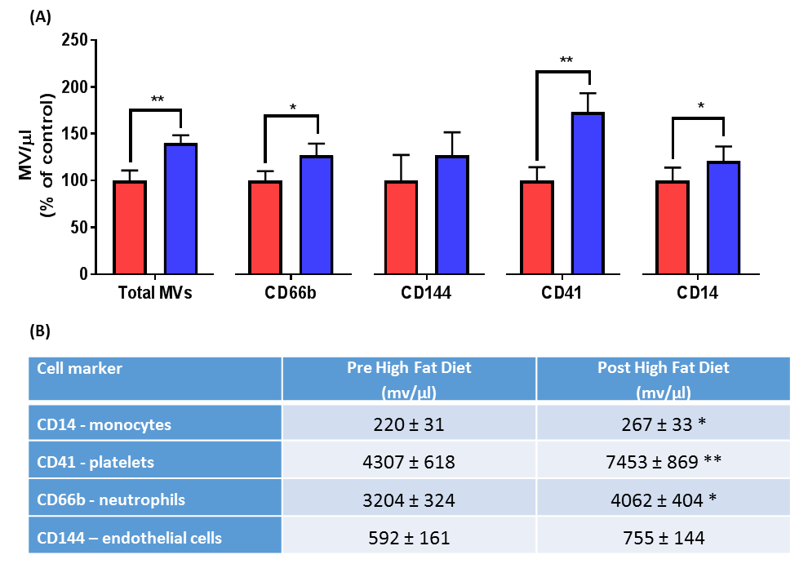
Figure 3.3 – Plasma microvesicle concentrations in response to high fat over-feeding: Healthy human participants were fed on a high-fat diet for 7 days. Plasma samples were collected pre and post feeding and MVs analysed by flow cytometry. MVs were incubated with fluorescent antibodies to identify MVs from specific cell types. (A) Percentage change in the number of total, neutrophil, endothelial cell, platelet and monocyte MVs between pre and post HFD. (B) Table containing the MV numbers pre and post HFD. Data are presented as mean ± SEM (n=15) and statistical significance analysed by paired t-test, *p<0.05, **p<0.01.

3.2.3 Ex vivo production of microvesicles in response to high-fat feeding plasma
A number of studies have utilised several stimuli for producing MVs ex vivo. These have been associated with differences in the number of MVs per and also alterations in their biological functions. We aimed to determine whether plasma from post-HFD samples would stimulate increased MV production from neutrophils ex vivo compared to plasma taken before the diet began.
Figure 3.4 shows the production of MVs by neutrophils in response to incubation with human plasma collected pre and post HFD. Isolated human neutrophils were stimulated to produce MVs in PBS only, or in exosome and microvesicle depleted plasma from participants pre and post intervention. Both the pre-HFD plasma and post-HFD plasma increased MV production above that in PBS only, however post-HFD plasma accounted for a 2-fold increase in the number of MVs per neutrophil when compared to the pre-HFD plasma.
These data indicate that human plasma following exposure to 7-days of high-fat overfeeding possess a greater propensity to induce the production of MVs from neutrophils.

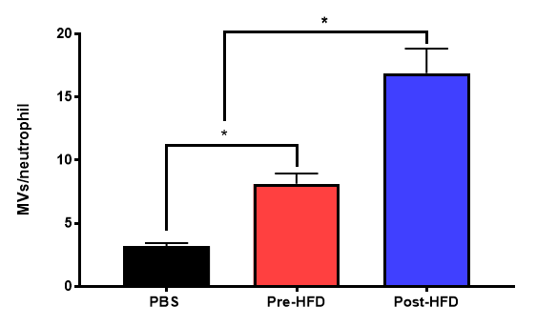
Figure 3.4 – Production of microvesicles from neutrophils stimulated with human plasma following high-fat overfeeding: Neutrophils (5 x 10⁶) were incubated with with MV/exosome depleted plasma collected from human participants’ pre and post 7-day high-fat overfeeding. Neutrophils were incubated with each stimulus for 1 hour at 37ºc. MVs per neutrophil were determined by flow cytometry. Data are presented as mean ± SEM (n=4) and statistical significance analysed by one-way ANOVA with Tukey’s T-test for multiple comparisons, *p<0.05.

3.2.4 Analysis of coronary artery endothelial cell activation by microvesicles from resting neutrophils post high-fat feeding
In these studies we aimed to determine whether 7-days of HFD could enhance the ability of NMVs to induce inflammatory activation of arterial endothelial cells. Pre and post-HFD MVs were incubated with HCAECs for 4 hours and the relative gene expression of a number of key inflammatory targets was analysed by qPCR.
Figure 3.5 summaries the gene expression of HCAECs following incubation with MVs produced from unstimulated neutrophils. The expression of adhesion molecules ICAM-1, VCAM-1 and E-selectin were not significantly altered by MVs released from neutrophils post-HFD compared to pre-HFD. Additionally, we determined the expression of cytokines and chemoattractant, IL-6 and IL-8, and observed no change in their expression by HCAECs. Additionally, the expression of transcription p65 was not changed between the pre and post-HFD MVs produced from unstimulated neutrophils.
These data highlight that there are no functional differences, in their ability to induce inflammation in HCAECS, between MVs produced by unstimulated neutrophils following 7-day exposure to high-fat overfeeding.

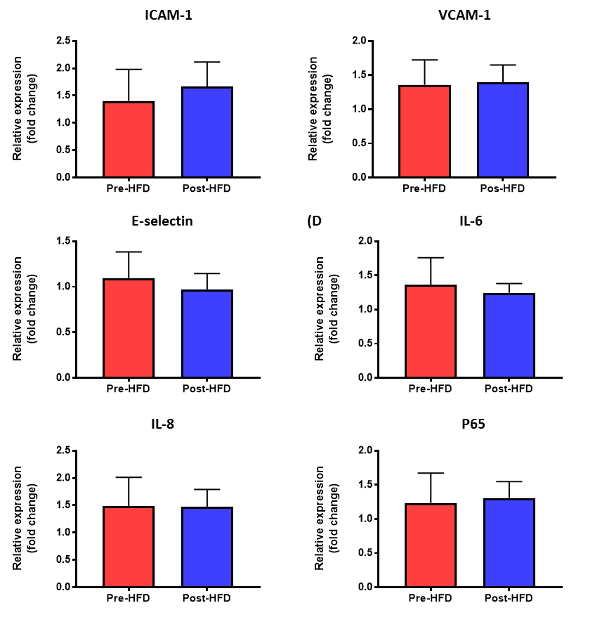

Figure 3.5 – qPCR analysis of HCAEC activation by microvesicles from unstimulated neutrophils isolated pre and post high fat over-feeding: Healthy human participants were fed a high-fat diet for 7 days. Neutrophils were isolated from each volunteer pre and post HFD, and incubated to produce MVs in PBS only for 1 hour. MVs (2 x 10³/μl) from unstimulated neutrophils pre and post HFD were incubated with HCAECs for 4 hours and the HCAECs collected for analysis of inflammatory genes by qPCR. Data are presented as mean ± SEM (n=4) relative gene expression and statistical significance analysed by paired t-test.

3.2.5 Analysis of coronary artery endothelial cell activation by microvesicles from stimulated neutrophils post high-fat feeding
Having determined that NMVs released from unstimulated neutrophils isolated from blood taken 7 days post HFD, the effect of NMVs released from stimulated neutrophils on endothelial cell activation was investigated. Pre and post-HFD MVs released from stimulated neutrophils were incubated with HCAECs and the relative gene expression of key inflammatory targets analysed by qPCR (see Figure 3.1).
Figure 3.6 summaries the gene expression of HCAECs following incubation with MVs produced from stimulated neutrophils. The relative gene expression of adhesion molecules ICAM-1 and VCAM-1were increased in HCAECs exposed to MVs from stimulated neutrophils produced post-HFD compared to pre-HFD. These increases were 187.5% and 93.9% respectively, however, were not deemed to be statistically significant. Post-hoc effect size calculations revealed effect sizes of 0.33 and 0.44 suggesting ‘medium’ effects of MVs on these factors. The expression of E-selectin in HCAECs was increased significantly by MVs from stimulated neutrophils produced after high-fat feeding compared to baseline. The expression of IL-6, IL-8 and MCP-1 were all found to be increased in HCAECs by MVs from neutrophils stimulated neutrophils post high-fat feeding, these were increase by 48.3%, 77.9% And 102.2%. However, the induction of the pro-inflammatory transcription factor p65 was not significantly different between the pre and post HFD MVs.
These data indicate that MVs produced from stimulated neutrophils following 7-day exposure to high-fat overfeeding have increased propensity to induce changes in inflammatory gene expression in HCAECs.
Having discovered that gene expression was altered, we next aimed to determine whether neutrophils stimulated to produce MVs following 7 days of HFD would have an enhanced ability to increase protein expression in HCAECs. Pre and post-HFD MVs were incubated with HCAECs and the secretion of cytokines and chemoattractants (IL-6 and IL-8, Figure 3.7A and 3.7B) were analysed by ELISA and the cell-surface expression of adhesion molecule (VCAM-1, Figure 3.7C) determined by flow cytometry.
Figure 3.6 summarises protein expression on HCAECs in response to incubation with MVs produced from stimulated neutrophils pre and post high fat diet. The secretion of IL-8 was found to be significantly increased by HCAECs incubated with post-HFD MVs. Secretion of monocyte chemoattractant MCP-1 also increased with post-HFD MVs compared to those produced pre-HFD. Finally, the cell surface expression of VCAM-1 on HCAECs was induced by incubation with MVs produced post-HFD compared to pre-HFD, however this was not deemed to be statistically significant. Post-hoc effect size calculations revealed an effect size of 0.71 suggesting a large effect of MVs on cell the surface expression of VCAM-1 exists.
These data indicate that neutrophils produced from neutrophils stimulated with fMLP following 7-day exposure to high-fat overfeeding have increased propensity to induce changes in the expression of proteins that are functionally significant in the homing and transmigration of monocytes during atherogenesis.

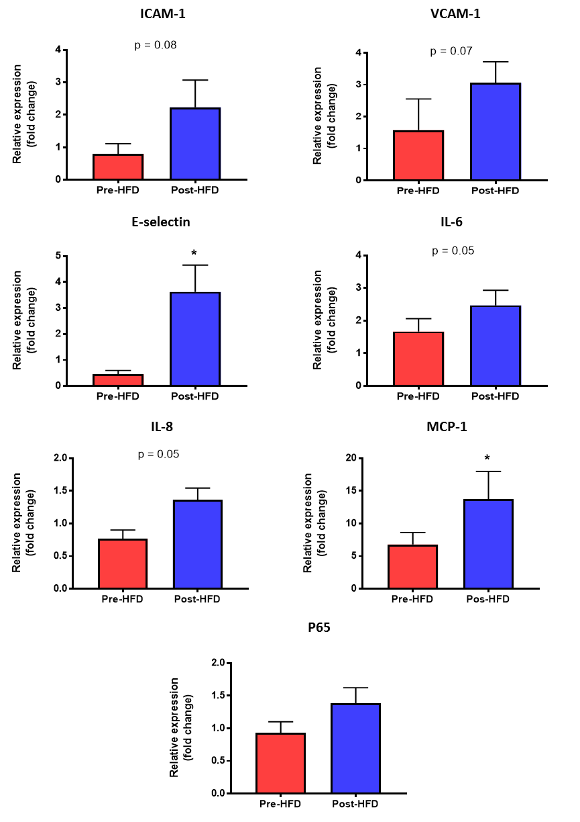

Figure 3.6 – qPCR analysis of HCAEC activation by microvesicles from fMLP stimulated neutrophils pre and post high fat over-feeding: Healthy human participants were fed on a high-fat diet for 7 days. Neutrophils were isolated from each participant pre and post HFD, and stimulated to produce MVs by fMLP for 1 hour. MVs (2 x 10³/μl) from neutrophils pre and post HFD were incubated with HCAECs for 4 hours and the HCAECs collected for analysis of inflammatory genes by qPCR. Data are presented as mean ± SEM (n=5) relative fold change of gene expression and statistical significance analysed by paired t-test.
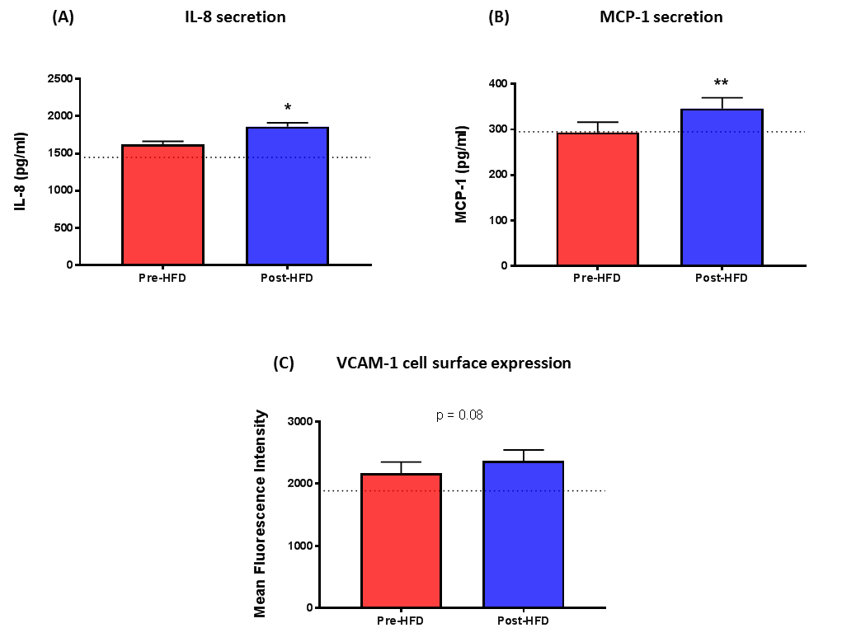
Figure 3.7 – Analysis of changes in protein expression on HCAECs by microvesicles from fMLP stimulated neutrophils pre and post high fat over-feeding: Healthy human participants were fed on a high-fat diet for 7 days. Neutrophils were isolated from each participant pre and post HFD, and stimulated to produce MVs with fMLP for 1 hour. MVs (2 x 10³/μl) from neutrophils pre and post HFD were incubated with HCAECs for 4 hours. The media was collected was the secretion of IL-8 (A) and MCP-1 (B) analysed by ELISA. (C) The cells were lifted and the cell surface expression of VCAM-1 analysed by flow cytometry. Data are presented as mean ± SEM (n=3) and statistical significance analysed by paired t-test. *p<0.05, **p<0.01.

3.3.1 - Conclusions
1 – 7-day high-fat overfeeding increases the total number of circulating MVs in-vivo; this is contributed to by an increase in neutrophil, platelet and monocyte derived MVs.
2 – Human plasma is a potent stimulus for the production of neutrophil-derived MVs ex-vivo; with plasma from participants post-HFD increasing MV production above that from plasma collected at baseline.
3 – MVs produced from stimulated neutrophils post-HFD possess a greater propensity to induce activation in HCAEC than before feeding; however, HFD alone is not sufficient to produce pro-inflammatory MVs.

3.3.2 - Discussion
The current study is the first of its kind to investigate, in healthy human participants, the effect of 7-day high-fat overfeeding on the production and function of MVs. These experiments have shown for the first time that a 7-day intervention with a known, modifiable risk factor for developing atherosclerosis, increases the number of circulating MVs. Additionally, neutrophils stimulated to produce MVs following this intervention exacerbate the induction of inflammation in HCAECs to a greater extent, than those stimulated to do so prior to the HFD.
High-fat overfeeding and MV production
A number of important observational studies performed in human populations have identified augmented levels of circulating MVs in patients with increased risk of CVD, like those with type II diabetes (Jansen et al., 2016) and in patients with known CVD (Boulanger et al., 2017). Despite this, few studies have investigated the mechanisms or factors that may induce these changes in the numbers of circulating MVs. Given the significance of diet in atherosclerosis and CVD progression, we aimed to investigate whether a high-fat, over-feeding protocol, previously designed and described by Hulston et al., (2015), would result in increased biogenesis of MVs in vivo. To date only a handful of studies have examined the influence of high-fat feeding on the production of microvesicles in humans (Ferreira et al., 2004, Tushuizen et al., 2007, Harrison et al., 2009). Typically, these studies have focused on the effects of a single high fat challenge and neglected MV production from leukocytes and platelets, studying only the total number and endothelial derived MVs. In these studies, a single high fat meal resulted in small increases in the number of circulating endothelial cells derived MVs in both healthy individuals (Ferreira et al., 2004) and patients with type II diabetes (Tushuizen et al., 2007). Despite these interesting findings, that infer the potentially significant role of fat ingestion on MV production, understanding how longer exposure to dietary fats and investigating the source of the MVs that are produced is required to better inform us of their significance to disease.
The current study identified that the number of circulating MVs was significantly increased following the 7-day high-fat overfeeding protocol. Importantly we identified that these were derived from specifically from neutrophils, as determined by the expression of CD66b, but also from platelet and monocyte populations. These data supports findings from a recent study that utilised a rat model of obesity to determine the effect of diet on MVs. The study identified a 13-fold increase in the number of circulating MVs in rats fed a HFD for 20 weeks. The study also identified an increase in MV numbers from leukocyte, endothelial and platelet cells, however the study did not break down the specific sub-populations of leukocytes from which these MVs were derived (Heinrich et al., 2015). These findings and data presented in Figure 3.3 suggest that some factor inflammatory factor associated to the high-fat, over-feeding protocol increases the number of MVs that are produced in the human circulation.
We propose that a combination of two key factors; an increase in inflammatory stimuli in the plasma following HFD that stimulate the increased production of MVs, and or; an increase in the number of circulating neutrophils in response to HFD, account for the observed increases.
Data in Figure 3.4 highlights that MV/exosome depleted plasma from post-HFD significantly increased the number of MVs that were produced by isolated neutrophils, compared to those produced in the pre-HFD plasma. These data support the hypothesis that some factor in the post-HFD plasma stimulates increased MV production from neutrophils. A number of studies have investigated the direct role of triglycerides in leukocyte activation, and identified that exposure to triglyceride rich lipoproteins resulted in increased expression of adhesion molecules on these cells as a result of the up-regulation of the pro-inflammatory transcription factor NF-κB (Alipour et al., 2008, van Oostrom et al., 2003, van Oostrom et al., 2004). We therefore hypothesised that an increase in MVs in the post-HFD samples may occur because of increased triglyceride levels in the post-HFD plasma, that activate neutrophils to produce more MVs. However, it is important to note that despite observing dramatic postprandial changes in plasma triglycerides in participants in the diet (Figure 3.2), we did observe not observe significant increases in the levels of plasma triglyceride in the participants in the blood samples taken pre or post HFD (12 hour fasted samples). Participants in the study were asked to attend the laboratory fasted (at least 12 hours) prior to blood collections pre and post intervention. This procedure was implemented to control for the potential confounding effects of acute postprandial lipeamia at baseline and following the intervention. Typically, healthy individuals are able to clear plasma triglycerides following an extremely high-fat challenge within 6-8 hours (Larsen et al., 2015), and as such clearance following their final meal of the protocol likely explains the lack of change in the levels of triglycerides in the sample pre and post intervention. Importantly, these findings mean that activation of neutrophils by plasma triglycerides does not account for the increased MV production from neutrophils incubated with post-HFD plasma ex-vivo (Figure 3.3).
As a result of the above findings, we hypothesise that high fat diet activates a number of cell types in the vessel, resulting in increased production of pro-inflammatory factors that are secreted into the circulation, producing a pro-inflammatory environment that is still present in the individual’s plasma despite the 12 hour fasting period. Importantly, despite no overall change in the triglyceride levels between pre and post HFD, post-prandially (following each high-fat meal or snack) the circulating levels of triglycerides increased (Figure 3.2). This means that during the 7-day protocol the individuals did have elevated triglyceride levels, however due to the ability of healthy individuals that participated in the studies, this was cleared following the 12-hour fast period at the end of the diet. Previous studies have identified that triglycerides in the circulation can stimulate endothelial cells (Norata and Catapano, 2007) and macrophages (Feingold et al., 2012), resulting in activation of pro-inflammatory pathways. These studies have identified increased secretion of cytokines including IL-1β, IL-6 and TNF-α, that have previously been shown to induce the production of MVs from neutrophils (Headland et al., 2014) and other leukocytes (Akuthota et al., 2017). Additionally, Erridge et al., (2007) identified the presence of low-grade endotoxemia in the circulation for 2 hours following the ingestion of a high fat meal. The levels of endotoxemia in the study were sufficient to induce E-selectin expression on endothelial cells in vitro (Erridge et al., 2007), and as such may contribute to the secretion of pro-inflammatory molecules into the circulation by endothelial cells during the diet protocol. Given the rapid clearance of microvesicles from the circulation (Rautou and Mackman, 2012) and the relatively short lifespan of circulating neutrophils (Simon and Kim, 2010) the findings of the current study of increased MVs in the circulation in the post-HFD samples 12-hours post consumption of the final high fat challenge, are likely to be explained by the induction of systemic inflammation by the high fat diet that drives MV production even though there are still no longer raised levels of plasma triglycerides in the post-HFD diet plasma samples.
Additionally, increased neutrophil counts in the individuals on diet may have contributed to increased production of MVs. A key limitation of these studies was that circulating leukocyte counts in response to the feeding protocol were not analysed. These data were not collected due the availability of equipment during collection of these samples, however would have provided valuable insight into whether the diet induced leucocytosis may also be a factor in the increased number of circulating MVs. Data from a number of human (van Oostrom et al., 2003, van Oostrom et al., 2004) and murine (Zernecke et al., 2008, Drechsler et al., 2010) studies have identified increased neutrophil mobilisation in response to both acute and chronic exposure to high fat feeding. We therefore propose that increased numbers of circulating neutrophils, is likely also to be an explanation for increased circulating MVs following a high fat diet.
Activation of endothelial cells by MVs produced post high-fat overfeeding
The current study has identified that microvesicles produced from isolated human neutrophils that are then stimulated ex vivo possess a greater propensity to induce inflammation in HCAECs than neutrophils stimulated to produce MVs in the same manner prior to the intervention (Figure 3.6-7). These MVs resulted in the up-regulation of mRNA and proteins (including IL-8 and MCP-1) that are associated with leukocyte homing to and transmigration across endothelial cells during atherosclerosis. These findings are supported by Heinrich et al., (2015) who isolated rat MVs following 20 weeks of HFD. In this model they found that MVs from rats fed on a HFD dramatically increased VCAM-1 expression on endothelial cells, the rise in expression was comparable to that induced by LPS stimulation of the cells. In this study, MVs were isolated directly from the rat plasma and as such they were not isolated ex-vivo. This does not allow us to determine specific contribution of certain subsets to the inflammation, however does support the findings that MVs that are produced in-vivo mimic those that are produced from stimulated neutrophils ex-vivo, given their capacity to induce inflammation. Previous experiments have identified the ability of high-fat feeding to activate neutrophils (Alipour et al., 2008, van Oostrom et al., 2004) and endothelial cells (Norata et al., 2006, Norata and Catapano, 2007).These studies report increased adhesion molecule expression and increased production of pro-inflammatory cytokines that likely contribute to a level of systemic inflammation in the circulation. Importantly, studies of activated and resting neutrophils have identified the up-regulation of a number of miRNAs that are heavily implicated in vascular inflammation (Larsen et al., 2012). These findings support the hypothesis that high-fat overfeeding is associated with heightened activation of neutrophils in the circulation. These neutrophils, post-HFD, have increase expression levels of pro-inflammatory factors, including miRNAs, that are in important factor in the greater activation of HCAECs.
Interestingly however, we observed that neutrophils that were unstimulated, and therefore left to spontaneously produce MVs in PBS only, did not induce different effects in HCAECs regardless of whether they were collected pre or post the high-fat intervention (Figure 3.5). We hypothesise that MVs that are produced ex vivo require a stimulus in order to induce the production of packaged MVs that have pro-inflammatory functions. This may occur because upon stimulation, currently unknown pathways within the neutrophil, result in the selective packaging of the MV, moving pro-inflammatory content to membrane for incorporation. This proposed pathway may explain the lack of observed differences between the pre and post HFD MVs that were produced from un-stimulated neutrophils. As, independent of the activation status or gene expression of the neutrophil following the diet, MVs produced ex-vivo require stimulation to traffic inflammatory material (including cytokines and miRNAs) to the plasma membrane for incorporation into the vesicle. Typically, these products are not found abundantly co-localised with the plasma membrane, and therefore in neutrophils that are not stimulated to produce MVs, these molecules are not incorporated and the MV produced is not reflective of the overall activation status of the neutrophil. This hypothesis is summarised in Figure 3.8.
Relatively little is understood about the molecular mechanism of MV formation and only a very few studies have addressed the mechanisms through which the content of the MV may be ‘selectively packaged’ into the blebbing membrane. However, what little evidence that is available supports the hypothesis that certain proteins and inflammatory content can be selectively incorporated into the cells MVs. Studies that have attempted to address this area have largely focused on tumour cell line-derived MVs, and have suggested a potential role of ARF-6 endosomal trafficking in the incorporation of specific proteins (MHCII and β1-Integrin) into MVs from stimulated cells (Muralidharan-Chari et al., 2009, Donaldson, 2003). An important finding of these studies was that despite being trafficked by similar ARF-6 dependant pathways, and co-localising with the plasma membrane, transferrin receptor was not found to be enriched within the produced MVs. The authors suggest that this is evidence of some mechanism through which the content of the MVs is regulated by the cell.
Despite our lack of understanding in regards to how MV content is controlled, a growing body of evidence resides that suggests distinct proteomic and miRNA profiles can exist as a result of the method of MV production or donor cell activation. In a study of the proteomic composition of neutrophil derived MVs, Dalli et al., (2013) stimulated neutrophils to produce MVs either in suspension or adherent to an endothelial monolayer. The study identified that 30% of the proteome was unique to the method of production. These were found to induce functionally distinct pathways of activation when incubated with endothelial cells, with those produced in the presence of an endothelial monolayer possessing a greater ability to induce a pro-inflammatory phenotype in the cells (Dalli et al., 2013). Interestingly, the protocol used in this study was to incubate the neutrophils either in suspension or adherent to an endothelial cell monolayer for 20 minutes, before then adding fMLP to the cells for 20 minutes in order to induce MV production. This protocol fits with the current hypothesis, as it was the difference in the activation status of the neutrophil caused by the incubation conditions prior to the addition of the fMLP, which resulted in functionally distinct populations of MVs. The study however did not assess the proteomic profile of cells that were left to spontaneously produce MVs.
Neutrophils are a highly active immune cell and the isolation process of these cells is associated with exposure to chemicals and centrifugation that are able to alter their adhesive properties and inflammatory gene expression (Freltas et al., 2008) Kuhns et al., 2015). Literature regarding the lifespan of neutrophils, which previously relied on the isolation and re-introduction of labelled neutrophils, regularly cites that the isolation procedure is inherently associated with activated neutrophils at the end of collection that made interpretation of this literature difficult (Simon and Kim, 2010). Given that neutrophils are therefore likely to be activated as a result of the isolation procedure alone, it would be likely that these cells express pro-inflammatory molecules following isolation that could induce inflammation in HCAECs. Given that MVs produced by unstimulated neutrophils are unable to induce activation in endothelial cells, the lack of ability to package content may explain this. It is hypothesised that potentially differential mechanisms in MV biogenesis, dependent upon the presence of a factor to stimulate production (that is present both in vivo and when cells are activated with fMLP ex vivo), may provide an explanation as to why only the fMLP stimulated neutrophils post-HFD (and not un-stimulated neutrophils post-HFD) induce greater inflammation in HCAECs than those produced pre-HFD (see Figure 3.8).

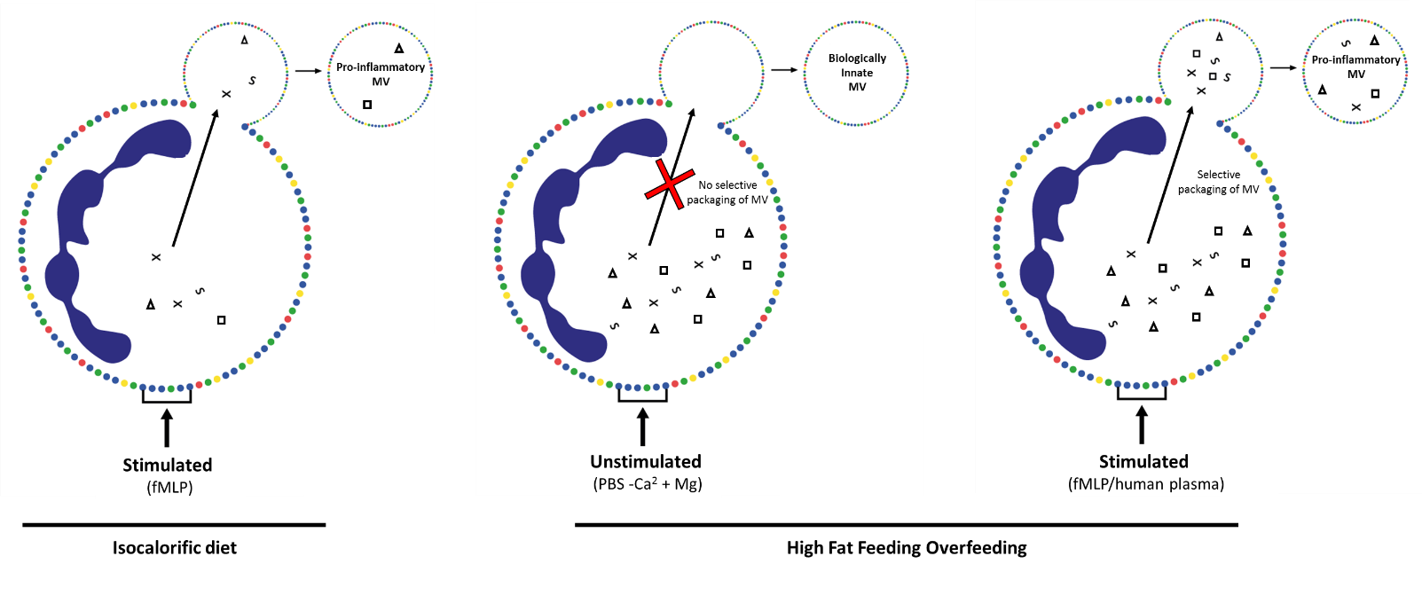
Figure 3.8 – Microvesicle production in response to high-fat feeding and activation with fMLP: In the presence of an inflammatory stimulus (fMLP/acLDL), content for MVs is shuttled to the plasma membrane for incorporation into MVs. In the presence of a high-fat diet, neutrophils become activated and up-regulate a number of factors including microRNAs. However when neutrophils are isolated to produce MVs ex-vivo, without a secondary inflammatory stimulus (fMLP/acLDL) the content of the MVs is innate as the selective packaging does not occur. We hypothesise that in MVs produced in-vivo both of these stages of activation occur and increase the propensity of MVs produced in-vivo to induce inflammation.
Future studies
A number of important future studies are required in order to confirm these preliminary hypotheses. Future studies from our group, should aim to determine the changes in the levels of circulating factors that may drive MV biogenesis in human plasma. These studies would involve determining the levels of known pro-inflammatory molecules such TNF-α and IL-6 in pre and post feeding plasma, that may contribute to the increased level of circulating MVs post intervention in-vivo and from isolated neutrophils ex-vivo. Importantly these studies would improve our understanding of the physiologically relevant stimuli that may be present in the blood of high-risk individuals, and present new targets for preventing the production of pro-inflammatory MVs in these individuals.
Additionally, we propose that future studies of high-fat overfeeding, should perform both proteomic and miRNA analysis of neutrophils and MVs both pre and post HFD, but also with and without stimulation. These studies will allow us to infer whether the diet induces gene expression changes in the neutrophil, but also how this then relates to the MV content. Proteomic and miRNA analysis will help identify key molecules that may be enriched in MVs that contribute to plaque development in response to high fat diet. It may also be of interest to perform this experiments using calorie restriction based interventions, given the growing evidence that calorie restriction is associated with increased longevity (Willcox and Willcox, 2014). Currently no studies have determined the effect of these diets on MV production. In order to help determine the processes involved in MV biogenesis, a number of important studies in cancer cell lines should be performed. These cells are easily genetically and structurally manipulated so will help to infer the machinery and cytoskeletal mechanisms that result in MV formation in response to stimulation, and provide better understanding as to whether different pathways exist for the production of MVs in stimulated and unstimulated cells.
A key limitation of these studies is the requirement to produce neutrophil MVs from isolated neutrophils ex vivo. This is likely to have profound effects on their inflammatory status and thus their effects on HCAECs. Future technologies that enable us to directly isolate specific MVs from human plasma will be extremely important to understanding their functions in vivo. Currently, no specific marker of neutrophil-derived MVs is available that would allow for the sorting of neutrophil MVs by FACS or MACS methods. Data from our own lab has identified that neutrophil specific makers such as CD66b, are only expressed on a small population of neutrophil-derived MVs and as such sorting using the currently available markers would incur significant bias in the populations of MVs isolated. In addition to the lack of markers to utilise these methods, these methods currently would not allow for effective sorting due to the size of the vesicles and therefore would only produce very small yields that are not compatible with functional assays.

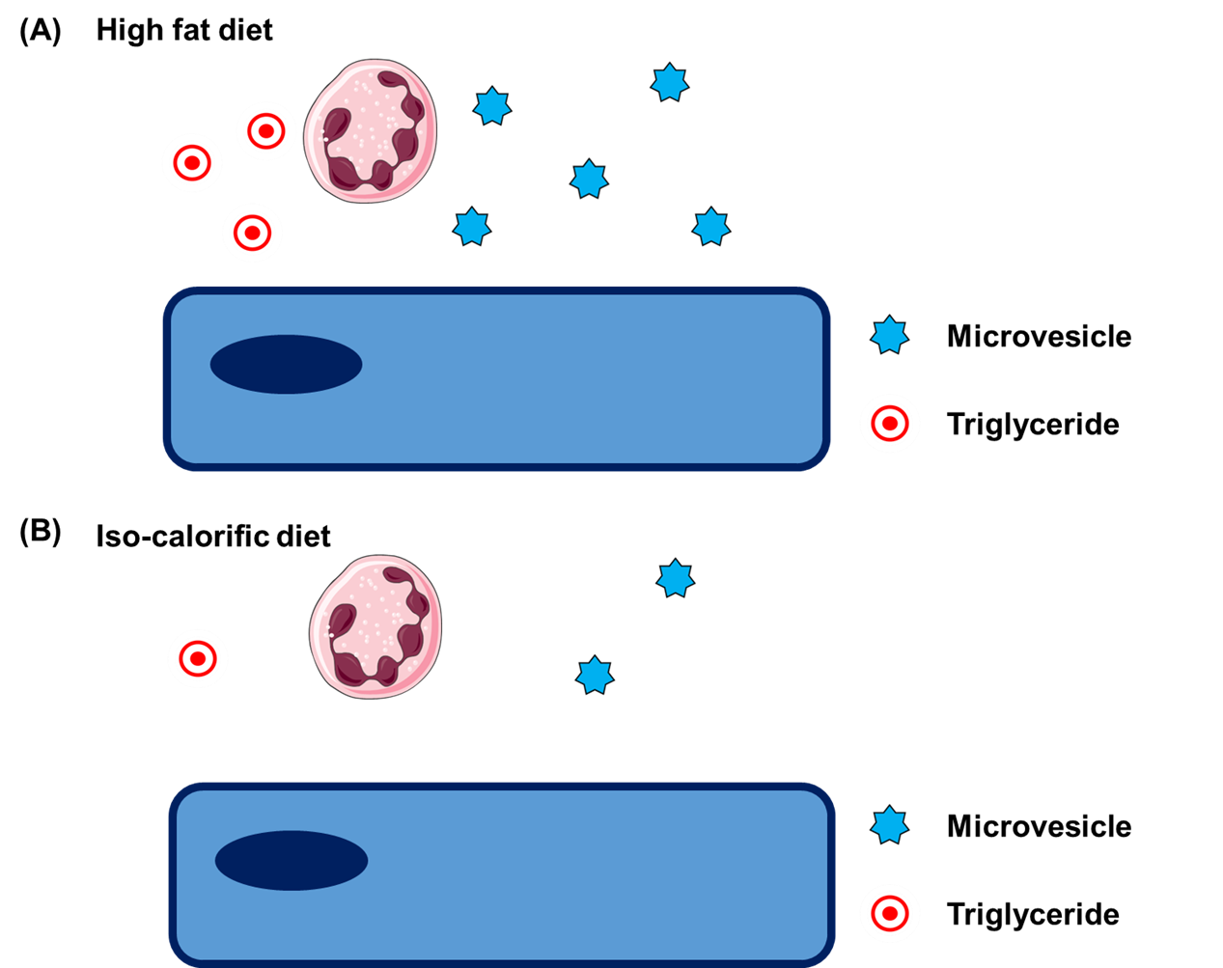

Figure 3.9 – Working hypothesis - High-fat diet and MV production: High-fat overfeeding induces a state of postprandial lipeamia, characterised by elevated levels of blood triglycerides. Triglycerides in the circulation can activate neutrophils, monocytes and endothelial cells resulting in an inflammatory environment in the blood vessel. This exacerbates the production of neutrophil-derived MVs into the circulation.

Chapter 4 - Shear stress and microvesicle interactions with endothelial cells

4.1.1 - Introduction
Atherosclerosis is a focal disease, occurring almost exclusively at complex regions of the vasculature where the patterns of blood flow become disturbed. The changes in the haemodynamic properties in these regions of the vessel encourage the accumulation of inflammatory mediators and cells, including lipids and leukocytes, in the tunica intima that drive the diseases progression. These processes occur due to multiple flow-dependent mechanisms including mass transport effects (Reviewed by; Tarbell, 2003) as well as endothelial cell activation in response to flow (Reviewed by; Chien, 2008)). Importantly, disturbed or complex patterns of shear stress are associated with disproportional expression of adhesion molecules and chemoattractants compared to high shear stress regions of the vessel (Cybulsky and Gimbrone, 1991, Cybulsky et al., 2001, Dansky et al., 2001), ultimately facilitating the dysregulated immune migration at these sites (Languino et al., 1995) . Increased adhesion molecule expression and around atheroprone regions of the vasculature is a key feature of both early and developed plaques (Cybulsky and Gimbrone, 1991, Walpola et al., 1995, Ley et al., 1998).
Although MVs are present in the circulation of healthy individuals (Berckmans et al., 2001) these numbers are elevated in patients at high-risk of CVD (Chironi et al., 2006). MVs have been identified within developing lesions, and that MVs taken from the plaques are able to induce inflammation in endothelial cells ex-vivo (Loyer et al 2007); as such mv production by neutrophils may provide a mechanism for transfer of neutrophil content to the plaque, without ever leaving the systemic circulation. Interestingly, however, little is known about how MVs from specific populations of cells, interact with and contribute to atherosclerosis. Importantly, NMVs express the machinery required to interact with endothelial cells, including adhesion molecule PSGL-1, CD18 (Pluskota et al., 2008) and L-selectin (Nolan et al., 2008, Dalli et al., 2013) that are all important to the physiological capture and adhesion of flowing neutrophils to endothelial cells during inflammation.
Despite our ever-developing understanding of the pathways that regulate endothelial cell activation in response to exposure to shear stress, the functional consequences of these in the regulation of MV interactions with endothelial cells is yet to be determined. Given the well-established role of adhesion molecules in atherosclerosis, and the growing body of evidence emphasising the role of MVs in disease aetiology, important gaps in our knowledge remain regarding if and how shear stress may regulate MV and endothelial cells interactions during disease initiation.
4.1.2 - Hypothesis and Aims
As NMVs have been detected in atherosclerotic plaques and express adhesion molecules on their surface it was hypothesised that they preferentially interact with endothelial cells under atheroprone flow conditions.
Aim 1 – To determine whether NMVs preferentially interact with disturbed flow regions in vivo and to endothelial cells exposed to these same patterns in vitro.
Aim 2 – To determine whether changes in the phenotype of endothelial cells by disturbed flow regulates interactions between NMVs and endothelial cells.
Aim 3 – To determine how the delivery of NMVs under different magnitudes and directions of flow regulates their interaction with endothelial cells.

4.2 - Methods

4.2.1 Microvesicle interactions with endothelial cells in vivo -
To assess MV adhesion, MVs were isolated from PKH26-labeled neutrophils and 2 x 10⁶ injected i.v. into 12 week old ApoE^{-/-} mice fed on chow. After 2 h vessels were prepared for immunostaining; endothelial cells were stained with Alexa 488 conjugated anti-CD31 (Biolegend, UK) and nuclei identified using a DNA-binding probe, TO-PRO-3 Iodide (Life Technologies, CA). Vessels were then opened en face, mounted using Prolong gold anti-fade mountant (Life Technologies, CA) and imaged using laser scanning confocal microscopy (Zeiss LSM510 NLO inverted microscope)

4.2.2 Microvesicle adhesion in vitro -
To assess MV adhesion to flow conditioned cells in vitro, we utilised the ibidi flow chamber system. HCAECs were cultured on 0.4 µm deep Ibidi µ-slides. Two flow conditions, high unidirectional wall shear stress (13 dyne/cm²) and low oscillating wall shear stress (4 dyne/cm² – 1 Hz) were selected to represent flow typically present in atheroprotected and atheroprone regions of the vasculature, respectively (see Figure 4.2; Serbanovic-Canic et al 2016). To assess the role of endothelial cell preconditioning in regulating MV interactions, cells were cultured under these atheroprotective and atheroprone flow patterns for 72 hours, before the addition of fluorescently labelled MVs under static conditions. Additionally, to assess the role of delivering MVs to endothelial cells under flow conditions, cells were cultured under static conditions, before the addition of fluorescently labelled MVs that were delivered under atheroprotective and atheroprone flow patterns. Each of the performed experiments using these flow patterns are summarised in Figure 4.3.

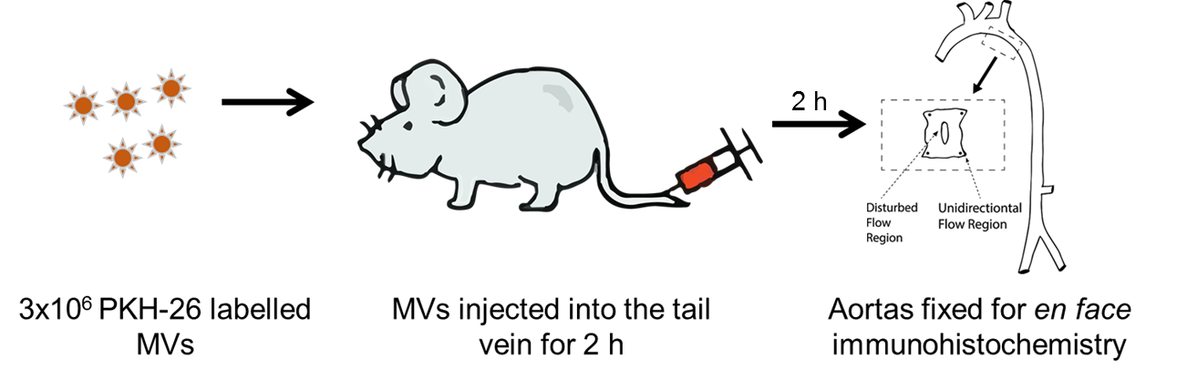
2 x 10⁶ PKH26 labelled MVs
Injected into the tail vein of ApoE^{-/-} mice
Perfusion fixed aorta for en face staining
Figure 4.1 – Experimental summary of MV interactions in-vivo: to determine the binding of MVs to specific regions of the mouse aorta we injected labelled vesicles into APOE^{-/-} mice. We then used en face fluorescent staining to identify where in the vessel MVs interacted.

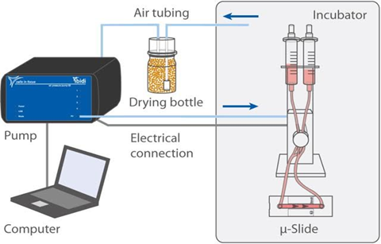

Figure 4.2 – Ibidi flow chamber system: Schematic of the Ibidi flow chamber system. In the system, air is forced into syringes containing cell media. This forces the media to perfuse over the cells that are cultured in the Ibidi µ-slide, and the air pressure allows the magnitude of shear stress to be altered. Using a series of valves located in the Ibidi unit, the directionality of flow can be altered, creating unidirectional or oscillating flow patterns in the chamber.

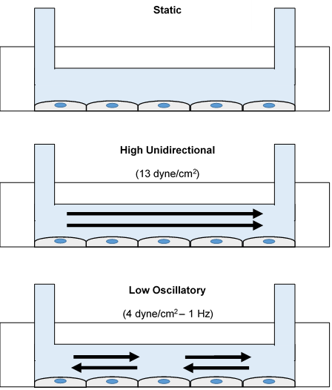

Figure 4.3 – Atheroprotective and atheroprone flow parameters: HCAECs were cultured in 0.4 µm µ-slides 24 hours prior to each flow experiment. The confluent monolayers were then connected to the Ibidi pump for flow experiments, or left for static based experiments. When cultured under static conditions the media on the cells was changed every 24 hours. Two main flow parameters were used throughout these studies, high unidirectional shear stress (13 dyne/cm²) this was reflective of the flow patterns in atheroprotected regions of the vessel; and low oscillatory wall shear stress (4 dyne/cm² – 1 Hz) this was reflective of flow patterns at atheroprone regions of the vessel.

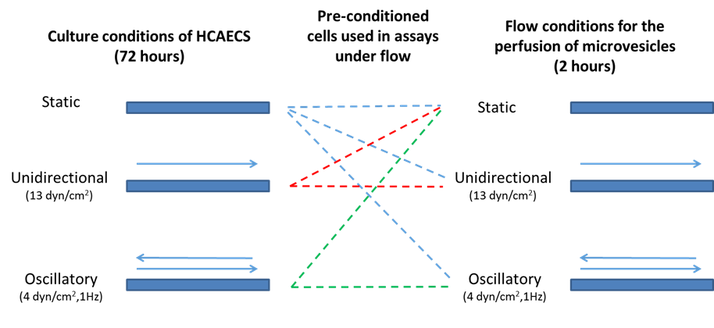
Figure 4.4 – Flow conditioning and delivery assays: Schematic diagram of the flow based experiments performed in chapter 4. Experiments cultured under flow for 72 hours were performed in order to assay the effects of endothelial cell pre-conditioning; and experiments performed with MVs being delivered to endothelial cells under flow to assess the mass transport effect of flow on MV interactions. All appropriate connotations of these experiments were performed.

4.3 Results

4.3.1 Microvesicle interactions with the murine aorta
Given the significance of disturbed flow patterns in the diseases focal nature, we aimed to determine whether MVs preferentially interact with disturbed flow regions of the mouse aorta.
The results summarised in Figure 4.5 show representative images of MV interactions and quantification of these interactions in the murine aorta. Disturbed flow regions were identified by the morphology of the endothelial cells in the region. High shear regions (outer curvature – Figure 4.5a) were identified by the presence of elongated endothelial cells that align with the directionality of flow. Low shear regions (inner curvature – Figure 4.5b) were identified by the presence of cobble-stoned endothelial cells that lack alignment. The findings in this figure identify that neutrophil MVs adhered almost exclusively to the inner curvature (atheroprone region) of the murine aorta.
These data indicate that MVs are able to interact with endothelial cells in vivo and that this occurs preferentially at atheroprone sites under hypercholesteraemic conditions.

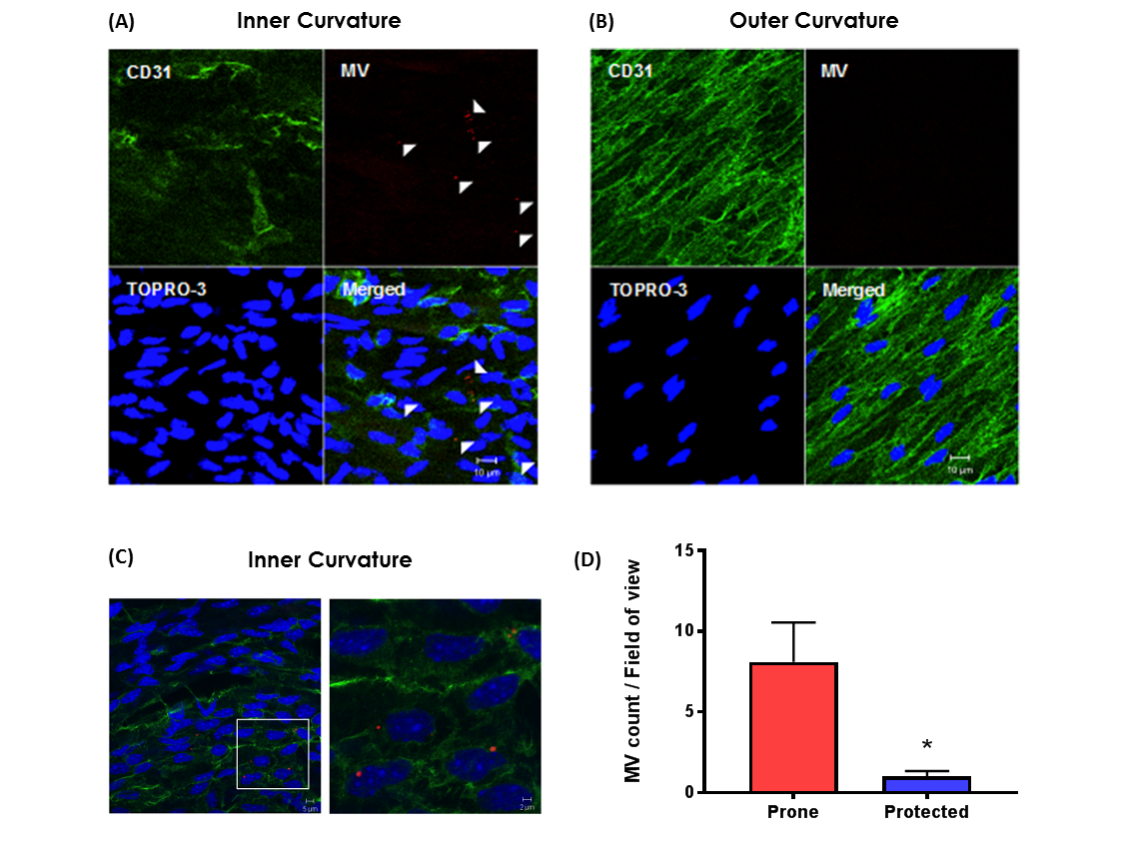
Figure 4.5 – Microvesicle interactions with the murine aorta: PKH26-labelled MVs were injected into the tail vein of ApoE^{-/-} mice. After 2 h aortae were isolated for en face staining. (A,B) Representative en face images of PKH26 labeled MV (red) adhesion in atheroprone (A; inner curvature) and protected (B; outer curvature) regions of the aorta, visualised by confocal fluorescence microscopy. Endothelial cells were identified by co-staining with anti-CD31 antibody (green) and cell nuclei were identified using TO-PRO Iodide (blue). Scale bar = 10 µm. Outer and inner curvature of the ascending aorta were characterised by the phenotype of endothelial cells; outer curvature were aligned, elongated and uniform – a characteristic of cells under high shear, whereas cells in the inner curvature had a disorganized appearance. Arrowheads highlight examples of adherent MVs. (D) Quantification of MV adhesion presented as mean ± SEM (n = 4) and analysed for statistical significance using a paired t-test, * P < 0.05, ** P < 0.01. (En-face imaging was kindly performed by Dr. Marwa Mahmoud).

4.3.2 Microvesicle accumulation in the murine aorta
Fluorescently labelled MVs injected into APOE^{-/-} were found to interact with endothelial cells at atheroprone regions of the vasculature. I wanted therefore to determine whether MVs that had been produced in vivo were also capable of interacting with these regions and entering the developing plaque. In order to determine these effects, mice were fed on a western (high-fat) diet for 6 or 20 weeks, the plaques were then isolated, homogenised and the MV content of the plaque determined.
The results summarised in figure 4.6 show the numbers and percentage changes in MVs present with the aortic plaques of mice fed of a western diet for 6 and 20 weeks. These findings revealed that the total number of plaque-derived MVs increased by 385% between the 6 and 20 week time points. Importantly, we observed a significant increase in the number of neutrophil-derived MVs within the plaque at 20 weeks, the increase in MVs from this cell type was 129%. MVs from monocytes, granulocytes and platelets were all shown to increase within the later plaques.
These findings suggest that MVs produced in vivo accumulate within the developing plaque. Importantly, these findings further support the ability of MVs to interact with endothelial cells at sites of disturbed in vivo.

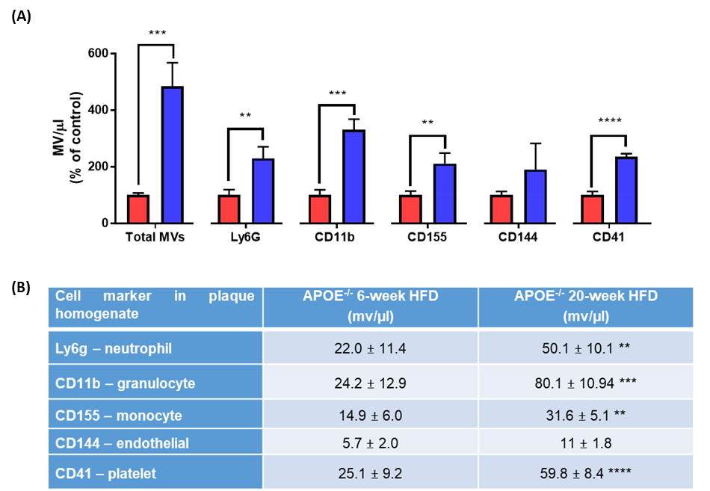
Figure 4.6 – Microvesicle accumulation in murine aortic plaques: Aortic plaques were isolated and homogenised from APOE^{-/-} mice fed on a western/high-fat diet for 6 and 20 weeks. The homogenised plaques were centrifuged to remove cells and debris and then centrifuged to isolate MVs from the plaque. MVs from the aortic plaques were incubated with fluorescent antibodies to identify MVs from specific cell types. (A) Percentage change in the total number, neutrophil, granulocyte, monocyte, endothelial cell and platelet MVs at 6-week (Red) and 20-week (blue) following the initiation of high-fat feeding. Data are represented as mean ± SEM (n = 4-7) and statistical significance analysed by un-paired t-test, **p< 0.01, ***p<0.001, ****p,0.0001. (Vessel and plaque isolation was kindly performed by Dr. Celine Souilhol)

4.3.3 In vitro model of microvesicle interactions with endothelial cells at disturbed flow sites
MVs preferentially interact with the inner curvature of the murine aorta. In order to elucidate the mechanisms involved in this interaction, we chose a minimalist in vitro approach using primary cultures of human coronary endothelial cells. We first determined whether the in vivo findings could be mimicked in our in vitro flow model. The model employed mimicked both the preconditioning effects and delivery effects that may contribute to these observed findings in vivo
The data summarised in Figure 4.7 shows representative images of MV interactions and quantification of these interactions with HCAECs. Figures 4.2a and 4.2b highlight that the typical morphology, as observed in the in vivo model occurred in response to 72 hours of pre-conditioning under flow. Cells in the low oscillating wall shear stress condition (4.7a) possessed a cobble-stone like morphology (Warboys et al., 2014), while those subject to high unidirectional wall shear stress (4.7b) aligned with the directionality of flow. The quantification of these findings identify a significantly greater proportion of adhesion to HCAECs exposed to the low oscillating wall shear stress conditions, compared to those exposed to high unidirectional wall shear stress. The zoom image (4.6c) shows that interactions occur on endothelial cells, and not areas between cells.
These findings highlight that the pattern of adhesion to HCAECs in an in vitro flow model, closely mimic those observed in vivo, suggesting this model is appropriate to determine the mechanisms by which flow regulates MV and endothelial cell interactions. We observed increased adhesion in the low oscillatory wall shear stress supporting the hypothesis that these effects are flow regulated.

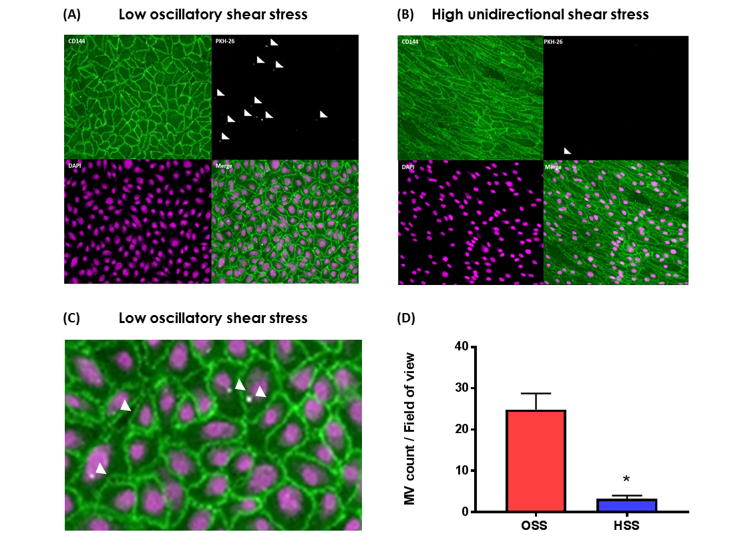
Figure 4.7 – Full in vitro model of microvesicle interactions with HCAECs: HCAECs were cultured under low oscillating wall shear stress or high unidirectional shear stress in an Ibidi flow chamber system. Following 72 hours culture under flow, the media was changed to media containing PKH26-labelled MVs (1 x 10³/µl) under the same flow conditions for a further 2 hours. Following incubation with MVs under flow, the cells were washed in PBS and fixed for immunocytochemistry. Endothelial cells were identified by co-staining with anti-CD144 antibody (green) and the cell nuclei using TO-PRO Iodide (purple). Representative images of MV adhesion to OSS (A) and HSS (B) cultured HCAECs. (C) Zoom image of MV adhesion to HCAECs cultured under OSS. (D) Quantification of MV adhesion presented at mean ± SEM (n=3) and analysed for statistical significance using a paired t-test, *p<0.05.

4.3.4 Microvesicle interactions with endothelial cells pre-conditioned under flow (phenotypic changes in endothelial cells)
In the circulation, alterations in adhesion molecule expression on endothelial cells, as well as the effect of being delivered under different flow rates and patterns are likely to influence MV interactions with endothelial cells. We therefore aimed to determine whether preconditioning of endothelial cells under these flow patterns influenced MV interactions with HCAECs.
The data summarised in Figure 4.8 shows representative images of MV interactions and quantification of these interactions to HCAECs. As in Figure 4.7, the response of these cells to flow conditions was determined by the cell morphology. In addition to conditioning under both flow parameters for 72 hours, cells were also incubated under static conditions for the same period. The quantification of these findings revealed that MV interactions with cells cultured under unidirectional wall shear stress were significantly reduced compared to both statically cultured HCAECs and those under low oscillating wall shear stress.
These findings highlight that culturing endothelial cells under disturbed flow alters their ability to interact with MVs.
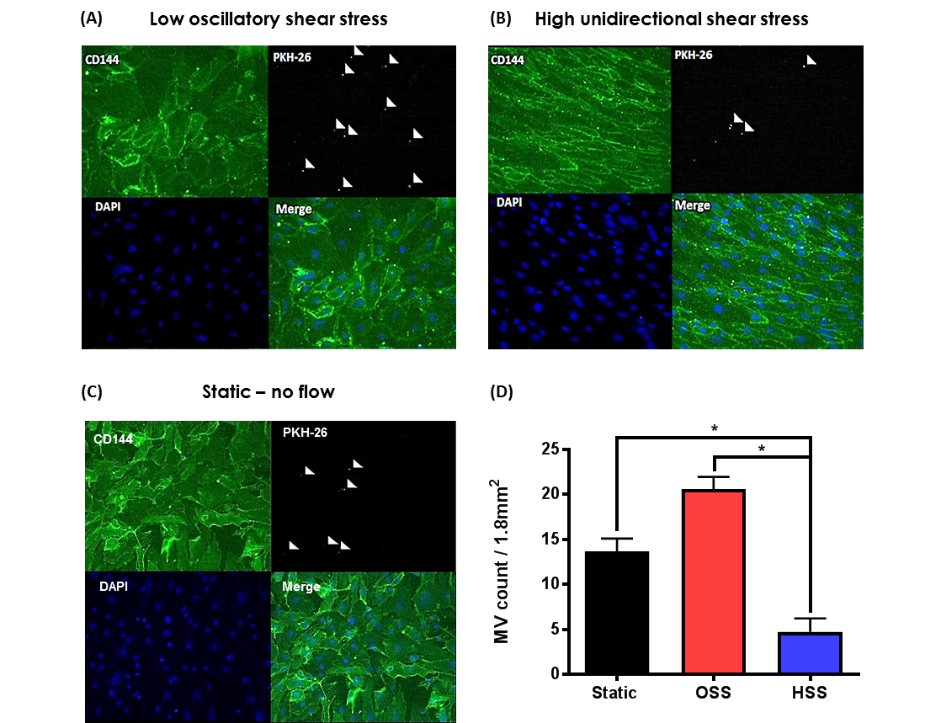
Figure 4.8 – Microvesicle interactions with HCAECs pre-conditioned under flow:
HCAECs were cultured under low oscillating wall shear stress or high unidirectional shear stress for 72 hours in an Ibidi flow chamber system or under static condition. Following culture under flow or static conditions the media was changed to media containing PKH26-labelled MVs (1 x 10³/ml) and incubated under static conditions for 2 hours. Following incubation with MVs under static conditions, the cells were washed in PBS and fixed for immunocytochemistry. Endothelial cells were identified co-staining with anti-CD144 antibody (green) and the cell nuclei using TO-PRO Iodide (purple). Representative images of MV adhesion to OSS (A), HSS (B) or static (C) cultured HCAECs. (D) Quantification of MV adhesion presented at mean ± SEM (n = 3) and analysed for statistical significance by one-way ANOVA with Tukey’s test for multiple comparisons, *p<0.05.

4.2.5 Characterisation of adhesion molecule expression on neutrophil microvesicles
A number of previous studies have identified the expression on donor cell specific adhesion molecules on microvesicles. The expression of these molecules suggests that MVs may utilise this machine in their interactions with recipient cells. We therefore aimed to determine whether adhesion molecules that are critical to interactions between neutrophils and endothelial cells from the circulation are expressed on isolated MVs.
The results summarised in Figure 4.9 shows the mean fluorescence intensity of adhesion molecules expressed on neutrophil-MVs compared to isotype controls. We identified that integrins CD18 and CD11b were expressed 25.7 (± 3.7%) and 13.1% (± 3.1 %), respectively. Additionally, we observed the expression of P-selectin ligand PSGL-1 on the surface of MVs, PSGL-1 was expressed on 29.4% (± 10.1%) of vesicles. And finally we observed expression of L-selectin on 31.2% (± 3.8%) of isolated MVs.
These findings highlight that neutrophil-derived MVs express the machinery required to interact with adhesion molecules expressed on endothelial cells that a critical to neutrophil diapedesis.

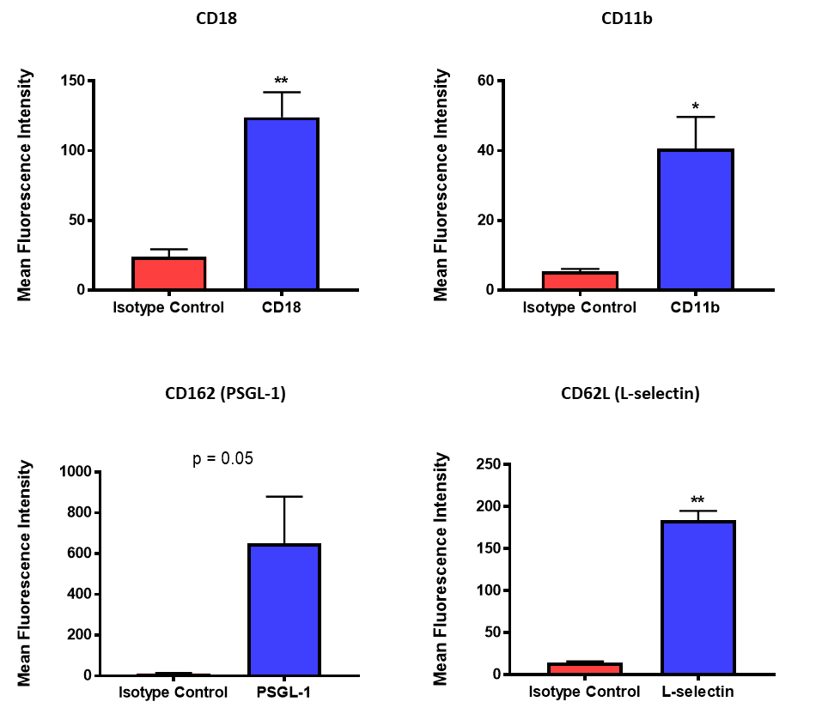

Figure 4.9 – Expression of adhesion molecule on neutrophil microvesicles: Neutrophil derived MVs were isolated from healthy human volunteers. In order to determine the expression of adhesion molecules on their cell surface MVs were incubated with fluorescently labelled antibodies. The expression of CD18, CD11b, PSGL-1 and L-selectin were determined using flow cytometry. Quantification of expression is presented as mean ± SEM (n = 3-4), and analysed for statistical significance by paired t-test, *p<0.05, **p<0.01

4.3.6 Optimisation of antibody/protein saturating concentrations on HCAECs
In order to assess the significance of specific adhesion molecules in the adhesion of MVs to HCAECs, we used functionally inhibiting antibodies against these molecules. In addition to antibodies against ICAM-1 and P-selectin on HCAECs, we inhibited phosphatidylserine on MVs using Annexin-V. Although not specifically an adhesion molecule, negatively charged phosphatidylserine has been shown to support adhesion of MVs to endothelial cells previously (Wei et al., 2016). Prior to performing these experiments, the saturating concentration of each antibody was determined.
The results summarised in Figure 4.10 shows the mean fluorescence intensity across increasing concentrations of each antibody/protein. We identified that the saturating concentration for ICAM-1, and as such the concentration used in future experiments, was 10 µg/ml. Experiments using antibodies against P-selectin were performed using a concentration of 30 µg/ml; and those to block Annexin-V on endothelial cells were performed using concentrations of 20 µg/ml.

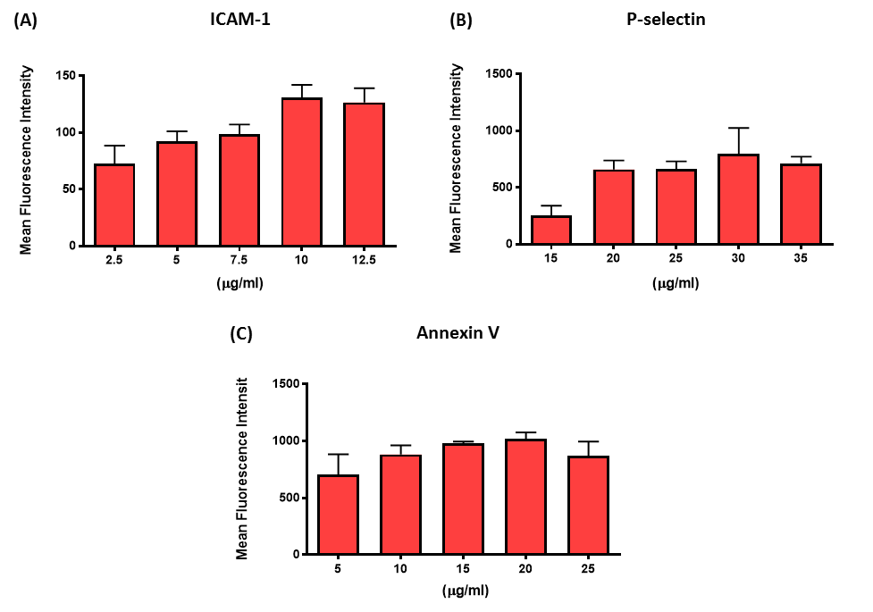
Figure 4.10 – Optimisation of antibody/protein saturating concentrations on HCAECs: HCAECs were incubated with increasing concentrations of anti-ICAM-1 (A), anti-P-selectin (B) and Annexin-V (C) for 1 hour. The cells were washed in PBS and re-suspended in FACS buffer. The cell surface expression was quantified by flow cytometry and the saturating concentration of antibody/protein determined. Results are presented as mean ± SEM (n=2).

4.2.7 Functional inhibition of adhesion molecules expressed on endothelial cells
Previous studies of extracellular vesicles, and data collected from our own lab, has identified a number of receptor-ligand interactions that play important roles in MV interactions with recipient cells. Additionally, study of extracellular vesicle populations has implicated Annexin (I and V)-dependant binding as a potential mechanism for interactions (Wei et al., 2016). Given these findings, but also the significance of P-selectin and ICAM-1 in the capture and adhesion of neutrophils during transmigration, we aimed to functionally inhibit these factors to determine which may be significant to MV interactions with HCAECs. Following inhibition of each of these molecules, HCAECs were incubated with fluorescently labelled MVs, and adhesion determined by fluorescence microscopy.
The data summarised in Figure 4.11 show representative images of MV adhesion to HCAECs following functional inhibition of each molecule and the quantification of these findings. Inhibition of both P-selectin and ICAM-1 reduced the total amount of MV adhesion to HCAECs. ICAM-1 appeared to have the biggest effect of these two molecules, inhibiting interactions by 50% in statically cultured cells. Interestingly, inhibition of Annexin-V appeared to have no effect on the number of adherent MVs.
These findings highlight that adhesion molecules involved in the adhesion and transmigration of neutrophils from the circulation, may also contribute interactions between MVs and endothelial cells. Specifically, ICAM-1 appears to be an important molecule in the regulation of these interactions.
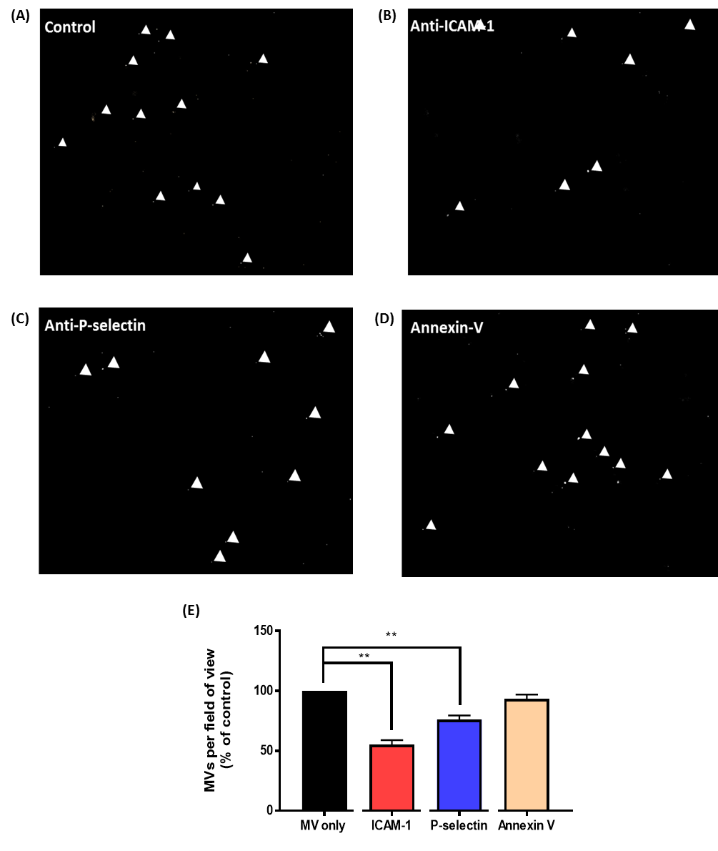
Figure 4.12 – Functional inhibition of adhesion molecules expressed on endothelial cells: HCAECs were incubated with blocking antibodies/protein against ICAM-1, P-selectin, or Annexin-V for 1 hour. The cells were washed in PBS and the media changed to media containing PKH67-labelled MVs (1 x 10³/ml) and incubated for 2 hours. Following incubation with MVs the cells were washed in PBS and fixed for immunocytochemistry. (A, B, C, D) Representative images of MV adhesion to MV only (A), anti-ICAM-1 (B), anti-P-selectin (C) and Annexin-V (D) treated cells. (E) Quantification of MV adhesion to HCAECs presented at mean ± SEM (n = 4) and analysed for statistical significance against their own MV/isotype control by paired t-test, **p<0.01.
4.2.9 Shear stress regulated expression of adhesion molecules on endothelial cells
Previous studies have identified that a number of adhesion molecules expressed on endothelial cells are flow sensitive, and as such are up-regulated at sites of disturbed flow. Given the significance of P-selectin and ICAM-1 in the adhesion of MVs to endothelial cells, we aimed to determine whether the expression of these adhesion molecules was regulated by shear stress. HCAECs were therefore cultured under flow or static conditions and cell surface expression determined by flow cytometry.
These data summarised in Figure 4.13 show the cell surface expression of adhesion molecules following exposure to 72 hours of different flow parameters. We observed a significant reduction in the expression of ICAM-1 on endothelial cells cultured under high unidirectional wall shear stress, compared to both low oscillatory wall shear stress and statically cultured endothelial cells. No difference was observed between static and low oscillatory flow on the expression of ICAM-1. Interestingly, the expression of ICAM-1 on HCAECs closely correlated (r = 0.88, p < 0.01) with adhesion of MVs to endothelial cells cultured under different flow parameters (Figure 4.5). No differences between any of the flow parameters was observed for the expression of P-selectin.
These data indicate that the expression of ICAM-1 on endothelial cells is regulated by shear stress in our in vitro model. Correlation between ICAM-1 and MV adhesion suggest that ICAM-1 is a significant factor in the differences in the adhesion of MVs following pre-conditioning under flow.

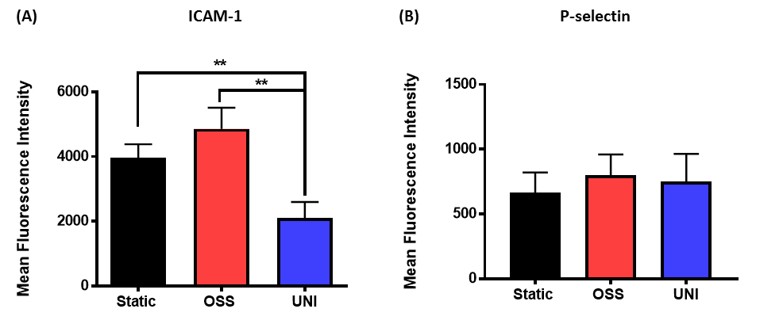
Figure 4.12 – Adhesion molecule expression on HCAECs preconditioned under flow: HCAECs were cultured under low oscillating wall shear stress or high unidirectional shear stress or static conditions for 72 hours. Following the culture under flow or static conditions the cells were lifted by trypsinisation (1:5 dilution) and HCAECs (1.5 x 10⁵) were incubated with fluorescent antibodies against ICAM-1 (A) and P-selectin (B) for 1 hour. The cells were washed in PBS, re-suspended in FACS buffer and the cell surface expression of adhesion molecules were analysed by flow cytometry. Data are presented as mean ± SEM (n=3-5) and analysed for statistical significance by one-way ANOVA with Tukeys test for multiple comparisons, **p<0.01.

4.2.9 Antibody blockade of ICAM-1 on HCAECs cultured under flow
MV adhesion to HCAECs closely correlated with the expression of ICAM-1 on flow conditioned endothelial cells. Additionally, blocking ICAM-1 in statically cultured cells inhibited adhesion. We therefore aimed to confirm importance of ICAM-1 in flow conditioned endothelial cells. To confirm this hypothesis, cells were cultured under low oscillating wall shear stress or high unidirectional wall shear stress for 72 hours before incubation with a function inhibiting antibody against ICAM-1 or its appropriate isotype control.
Figure 4.13 summarises the findings of blocking ICAM-1 and the effect on MV adhesion on flow conditioned HCAECs. We observed a 50% inhibition of interactions with endothelial cells cultured under low oscillating wall shear stress when cells were treated with ICAM-1 blocking antibody, compared to those treated with isotype control. In cells cultured under high unidirectional wall shear, adhesion was almost entirely inhibited by incubation with the ICAM-1 blocking antibody.
These findings confirm that inhibition of ICAM-1 on the cell surface of flow cultured endothelial cells, reduces the ability of MVs to interact with endothelial cells, supporting the hypothesis that MV interactions with endothelial cells are, at least in part, regulated by an ICAM-1 dependant mechanism.

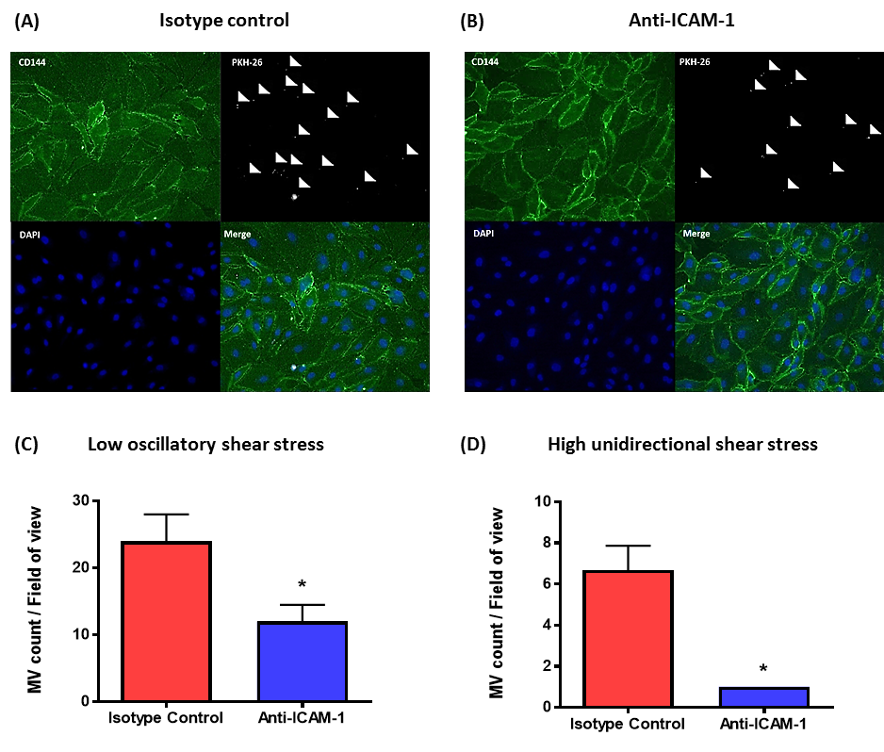
Figure 4.13 – Antibody blockade of ICAM-1 on HCAECs pre-conditioned under flow: HCAECs were cultured under low oscillating wall shear stress or high unidirectional shear stress for 72 hours in an Ibidi flow chamber system. Following preconditioning under flow, the cells were incubated with a blocking antibody against ICAM-1 or isotype control for 1 hour. The cells were washed in PBS and the media changed to media containing PKH67-labelled MVs (1 x 10³/µl) and incubated for 2 hours, the cells were washed in PBS and fixed for immunocytochemistry. (A, B) Representative images of MV adhesion to HCAECs cultured under low oscillatory wall shear stress treated with anti-ICAM-1 (A) and isotype control (B). Endothelial cells were identified co-staining with anti-CD144 antibody (green) and the cell nuclei using TO-PRO Iodide (purple). (C) Quantification of MV adhesion to low oscillatory wall shear stress cultured endothelial cells with blocking anti-body against ICAM-1 or isotype control. (D) Quantification of MV adhesion to high shear stress cultured endothelial cells with blocking anti-body against ICAM-1 or isotype control. Data are presented as mean ± SEM (n=3-5) and analysed for statistical significance by paired t-test, *p<0.05.

4.2.10 Delivery of microvesicles to endothelial cells under flow
In vivo, MV interactions with endothelial cells are likely to be regulated not only by the adhesion molecule expression of the endothelial cell, but also mass transport effects. These include increased transit time proximal to the endothelial cells at lower shear stress s, but also the physical ability to form and maintain bonds at different rates of shear stress. We therefore aimed to determine whether the delivery of MVs to the endothelial cells under different flow conditions influenced the ability of MVs to interact with endothelial cells.
Figure 4.14 summarises the effect of delivering MVs to endothelial cells under shear stress. We observed a significant reduction in the number of MVs that interacted with HCAECs when delivered under high unidirectional wall shear stress, compared to delivery under low oscillating wall shear stress. Additionally, we wanted to determine whether the low shear stress or the oscillatory nature of the shear stress were responsible for the increased adhesion in the low oscillating wall shear stress condition. We therefore delivered MVs to statically cultured HCAECs under low unidirectional and low oscillating wall shear stress. We identified no difference in the number of adherent MVs if the MVs were delivered under low unidirectional wall shear stress or low oscillating wall shear stress.
These findings suggest that delivery of MVs to HCAECs under increased shear stress s inhibits the ability of MVs to interact with endothelial cells.

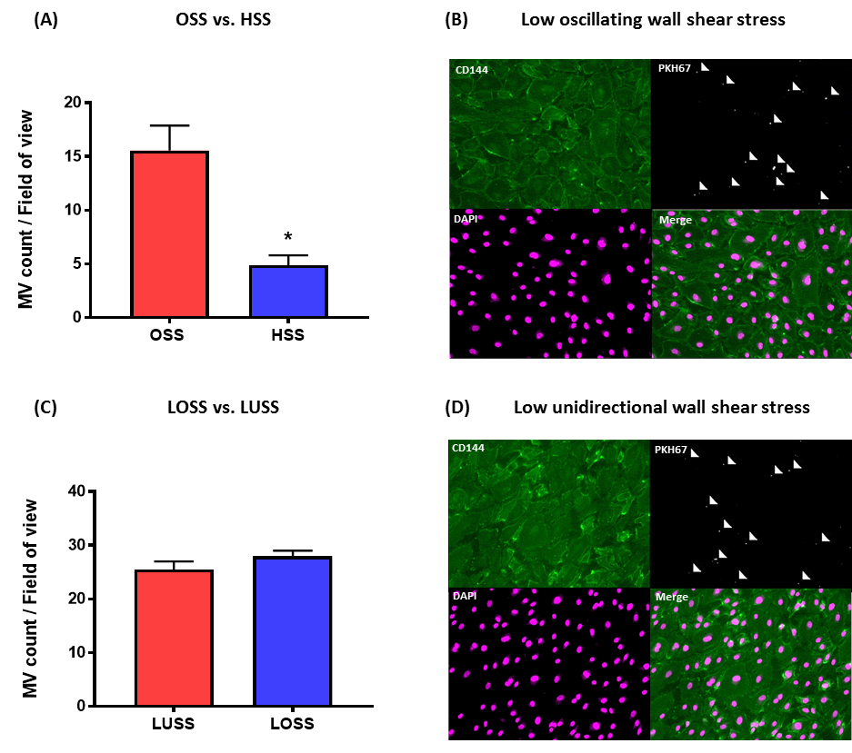
Figure 4.14 – Delivery of microvesicles to HCAECs under flow: HCAECs were cultured under static conditions. The media was changed to media containing PKH67-labelled MVs (1 x 10³/µl) and incubated under either low oscillating wall shear stress of high unidirectional wall shear stress conditions for 2 hours in an Ibidi flow chamber system (A). Additionally, HCAECs cultured under static conditions were incubated with PKH67-labelled MVs (1 x 10³/µl) under low oscillating wall shear stress or low unidirectional wall shear stress for 2 hours in the Ibidi flow chamber system (B) Following incubation with MVs under flow, the cells were washed in PBS and fixed for immunocytochemistry. Representative images of MV adhesion to HCAECs when delivered under LOSS (C) or LUSS (D) conditions. (C) Quantification of MV adhesion presented as mean ± SEM (n = 2-3) and analysed for statistical significance using a paired t-test, *p<0.05.

4.2.11The effect of shear stress on microvesicle interactions with endothelial cells
MVs delivered under flow preferentially interact with endothelial cells at 4 dyne/cm² compared to when delivered at 13 dyne/cm². These findings suggest that the rate of shear stress may be a limiting factor in the ability of MVs to form bonds with endothelial cells. We aimed to determine the threshold shear stress beyond which NMVs could no longer interact with endothelial cells. To investigate this, statically cultured cells were incubated with fluorescently labelled MVs at increasing shear stress, and adhesion determined by fluorescence microscopy.
Figure 4.15 summarises the effect of increasing shear stress and the ability of MVs to adhere to endothelial cells under flow. We observed that microvesicle adhesion began to reduce beyond 6 dyne/cm², however the reduction in adhesion was not deemed statistically significant until 14 dyne/cm². At 18 dyne/cm², the adhesion of MVs to endothelial cells was almost entirely inhibited.
These findings highlight that increasing shear stress inhibits the ability of microvesicles to interact with endothelial cells. This may occur due to a reduced ability to form bonds at increasing shear stress.

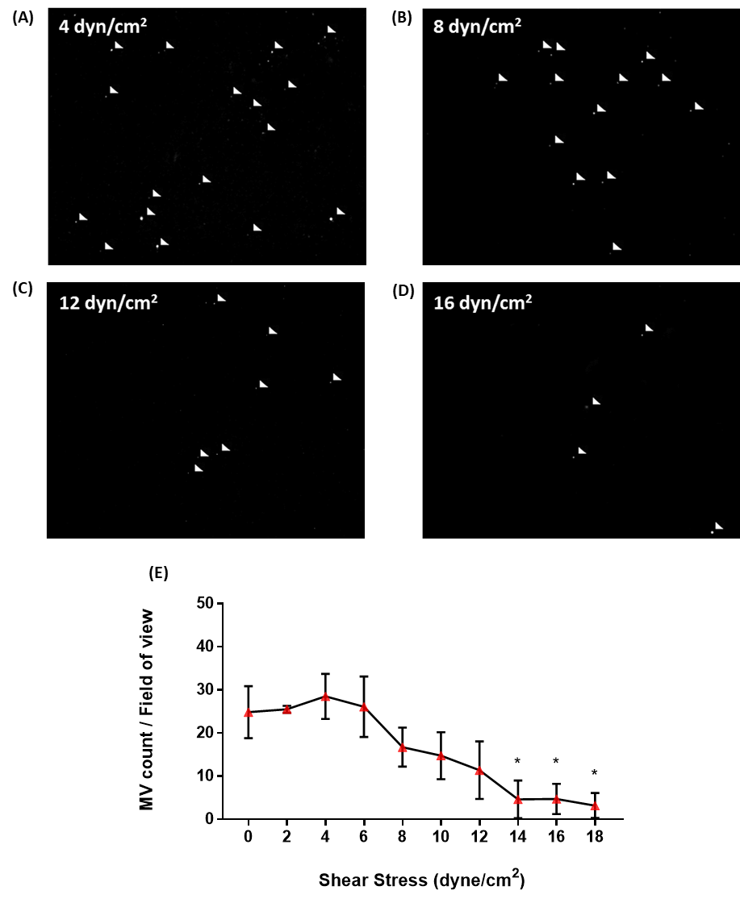
Figure 4.15 – The effect of shear stress on microvesicle interactions with HCAECs delivered under flow: HCAECs were cultured under static conditions and incubated with media containing PKH67-labelled MVs (1 x 10³/µl) under unidirectional shear stress for 2 hours in an Ibidi flow chamber system. We repeated this procedure 9 times at shear stress increasing by 2 dyn/cm². Cells were washed and fixed for immunocytochemistry. (A - D) Representative images of MV adhesion to HCAECs following delivery at a shear stress of 4 dyne//cm² (A), 8 dyne/cm² (B), 12 dyne/cm² (C) and 16 dyne/cm² (D). Quantification of MV adhesion presented as mean ± SEM (n = 3) and analysed for statistical significance by one-way ANOVA with Dunnett’s test for multiple comparisons (all data compared to MV adhesion at 2 dyne/cm²), *p<0.05.

4.2.12 Cell free model of microvesicle interactions with specific adhesion molecule
Inhibition of both ICAM-1 and P-selectin in statically cultured cells reduced MV adhesion. During neutrophil capture and adhesion under flow, selectins are required for the capture of neutrophils, while ICAM-1 is associated with the firm adhesion of cells. Without P-selectin, cells are unable to be captured from the circulation and no interactions between these cells take place (Zarbock and Ley, 2009). The molecular mechanisms of MV capture and adhesion under flow were investigated. In addition it was determined whether ICAM-1 could act independently in the capture of flowing MVs. Ibidi µ-slides were coated with Fc-chimeras of the adhesion molecules and NMV interactions determined by videos captured in real time in order that the contribution of individual adhesion molecules could be investigated.
Figure 4.16 summarises the results of flowing microvesicles over Ibidi slides coated with the Fc-chimera portion of human ICAM-1, P-selectin and IgG control. We observed that coating Ibidi µ-slides with ICAM-1 and P-selectin produced similar levels of coverage as determined by mean fluorescence intensity (31.5 vs 30, respectively). However, the coating with ICAM-1 appeared more clustered than the coverage of P-selectin. In control experiments (see Video 1) neutrophils were flowed over the coated slides at 4 dyne/cm². Neutrophils were found to only roll on P-selectin and were unable to interact with ICAM-1 coated slides. Interestingly neutrophils left to adhere under static conditions were able to bind ICAM-1, confirming coated slides were functionally capable of adhering neutrophils.
When MVs were flowed over the slides at 4 dyne/cm², a greater number of MVs were found to adhere to ICAM-1 than both the IgG control and the P-selectin coated slides. These data however were not deemed to be statistically significant. At 13 dyne/cm², NMVs only appeared to be able to interact with ICAM-1; however these experiments were only performed once and more repeats are required to confirm these findings.
These findings suggest that a cell free model is an appropriate method for determining the molecular mechanisms of interactions between MVs and adhesion molecules. Interestingly, unlike neutrophils, ICAM-1 alone is able to capture flowing MVs without the MVs rolling, supporting the hypothesis that ICAM-1 is the significant factor related to MV adhesion to atheroprone and atheroprotected sites.

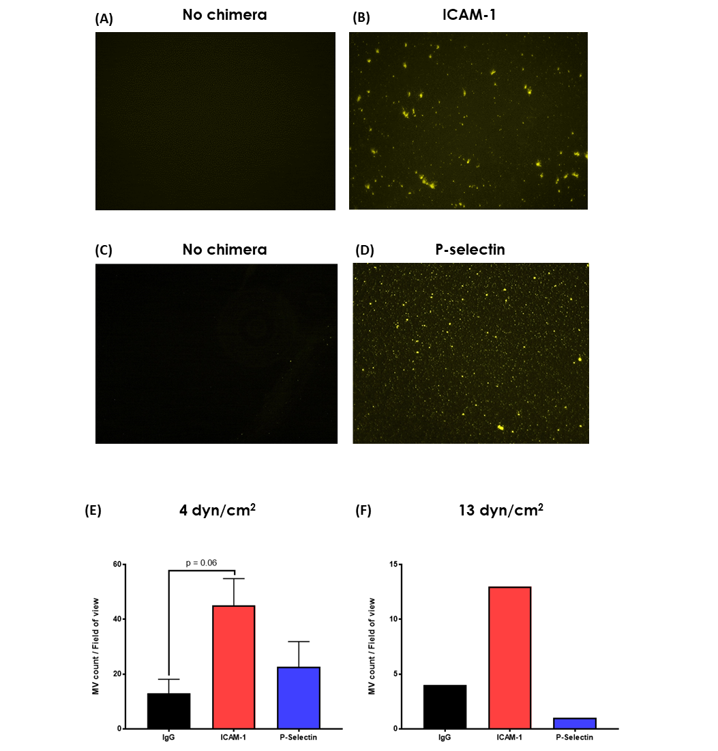
Figure 4.16 – Cell free model of MV adhesion under flow: Hydrophobic Ibidi µ-slides were coated with ICAM-1, P-selectin or IgG Fc-Chimeras. (A - D) Representative images of ICAM-1 and P-selectin coating of µ-slides as determined by fluorescence microscopy. (E, F)
PKH26-labelled microvesicles were flowed over the Fc-chimera coated µ-slides at 4 dyne/cm² (E) and 13 dyne/cm² (F). Quantification of MV adhesion presented as mean ± SEM (n = 1-3) and analysed for statistical significance by one-way ANOVA with Dunnett’s test for multiple comparisons compared to. (Data collected by Ashley Money, under my day-to-day supervision)

4.3. Conclusions
1 – MVs preferentially interact with endothelial cells at atheroprone regions of the vasculature in vivo.
2 – MVs preferentially interact with human coronary artery endothelial cells subject to low oscillatory wall shear stress in an ICAM-1 dependant manner.
3 – MVs delivery to endothelial cells under flow is inhibited at increased shear stress, however ICAM-1 is able to capture flowing MVs at both 4 and 13 dyne/cm².

4.4 Discussion
The current study is the first of its kind to implicate neutrophil MVs in the focal nature of atherosclerosis through preferentially interacting with endothelial cells that are exposed to low or disturbed patterns of blood flow. We identified that both the preconditioning of endothelial cells and the shear stress during delivery can effect interactions between MVs and HCAECs, these mechanisms both depend on the expression of ICAM-1.
Microvesicle interactions with disturbed flow sites in vivo
Here we showed that fluorescently-labelled neutrophil MVs injected into hypercholesteraemic mice preferentially interact with endothelial cells at regions of the vasculature prone to atherosclerosis. These findings are of particular significance, as after only a single injection of labelled vesicles, we were able to observe the accumulation of vesicles within the disturbed flow regions. MVs are present in the circulation of healthy individuals (Berckmans et al., 2001), however a growing body of evidence, including that presented in chapter 3, highlight that both the number of MVs (Chironi et al., 2006) and the ability of the MVs to induce inflammation (Heinrich et al., 2015), increase following exposure to known risk factors of disease (e.g. high fat feeding). As such, in individuals at high risk of developing atherosclerosis, like individuals with systemic inflammation, MVs from activated neutrophils are likely to be being continually produced in greater numbers. Although many of these MVs may be rapidly cleared from the circulation, these findings from a single bolus of MVs, suggest that chronic exposure to increased levels of MVs may dramatically exacerbate the accumulation of MVs at disturbed flow sites. An important limitation of these experiments is the requirement to isolate neutrophil MVs ex vivo, label with a membrane intercalating dye and re-introduce these to the circulation. Although this method ensures that we are observing the interactions of only neutrophil-derived MVs (due to the isolation of pure neutrophil populations and centrifugation to exclude exosomes and other EV populations), these dyes incorporate into the membrane of the vesicle and therefore may alter some function or adhesive property of the MV. However, in addition to these experiments with PKH26 as the primary label, these experiments were repeated with the membrane permeable, cytosolic dye, CFDA-SE (data not shown). The pattern of interactions observed in these experiments closely matched those observed those presented in this study, and as such we do not believe that the method of dye used is a major factor in altering the MVs functions. The ability of MVs to interact with atheroprone regions is supported by figure 4.6. In these experiments it was identified that MVs from a number of cell types, and importantly neutrophils, accumulate in the vessel wall as the lesion develops. Importantly these findings suggest that MV uptake into the vessel wall is an important feature in the aetiology of atherosclerosis.
Microvesicle interactions with endothelial cells exposed to low oscillatory wall shear stress in vitro
Given that MVs preferentially interact with disturbed flow sites in vivo, we aimed to further investigate these effects using an in vitro flow model and using a cell type relevant to human atherosclerosis. It was found that differences in the cell surface expression of ICAM-1 are an important factor in regulating NMV interactions between cells exposed to low oscillatory wall shear stress and high unidirectional wall shear stress. Importantly, the elevated expression of ICAM-1 on endothelial cells exposed to disturbed flow is well described in both in vitro and in vivo models. Chappell et al.,(1998) identified an 11-fold increase in the expression of ICAM-1 following 24 hours exposure to low oscillatory wall shear stress. This increase occurs in an NF-κB dependant manner, as the transcription factor translocated from the cytosol into the nucleus in response to flow, increasing its transcriptional activity (Mohan et al., 1997). These findings are maintained in vivo. Suo et al., (2005) identified that the regional distribution of ICAM-1 in the murine aorta was dependent upon the shear stress in that region of the vessel; and ICAM-1 is consistently up-regulated on or around atherosclerotic loci (Cybulsky et al., 2001). These findings support the hypothesis and in vitro experiments, that ICAM-1 is a critical factor in the disproportional interactions with MVs at disturbed flow sites. Future studies may investigate this relationship further, repeating the performed in vivo experiments in an endothelial specific ICAM-1 knockout.
The expression of adhesion molecules on NMVs has previously been described; Hong et al., (2012) identified that CD11b/CD18 heterodimers were expressed on neutrophil MVs. Importantly when MVs were produced from TNF-α primed or activated neutrophils, these adhesion molecules were expressed in their active confirmation. Given our findings of significantly greater expression of ICAM-1 on the cell surface of HCAECs exposed to disturbed flow, we hypothesised that neutrophil MV binding to endothelial cells was likely regulated, at least in part, by CD18-ICAM-1. These findings were confirmed in both statically cultured and flow conditioned cells using antibody blockade of ICAM-1, in which we observed a 50% reduction in adherent NMVs. Inhibition of P-selectin also reduced the number of adherent MVs. However, the expression of this molecule on HCAEC was not regulated by flow in our system. The expression of P-selectin however has been observed overlaying atherosclerotic plaques, often co-localised with the expression of ICAM-1 (Johnsontidey et al., 1994). Given the significance of P-selectin to atherosclerosis therefore, we cannot rule out that P-selectin is not involved in the capture of MVs in vivo or that it is not significant to MV capture during later time points of disease progression.
The current studies utilised the commercially available Ibidi flow chamber system, in which both the magnitude and directionality of shear stress can be manipulated, producing disease relevant flow conditions inside the chamber. An important feature of this system was that it allowed us to both culture endothelial cells for prolonged periods, inducing phenotypic changes within the endothelial cells typical of those observed at disturbed flow regions, but then also introduce MVs for them to be delivered to the cell under these matched conditions. The ability to manipulate both of these factors is unique to the flow chamber system. Previous studies from our group have utilised the orbital shaker method to subject cells to shear stress. In this system, the cells on the exterior portion of the well are exposed to high, pulsatile shear stresses, while those at the centre are subject to low and disturbed patterns, inducing inflammatory activation in the centre of the well that matches changes observed in vivo (Cuhlmann et al., 2011, Mahmoud et al., 2016). Importantly however, in this model the same media is circulated over the cells in both regions of the well. This feature of the system produces limitations in the ability to interpret data on the delivery of MVs under flow, as a number of important issues about how MVs behave in this system (for example; are they dispersed evenly throughout the media at different shear stress; or do they accumulate on the outer portion of the well due to centrifugal forces?) are unknown. Importantly, the flow chamber system employed in the current study induced the appropriate inflammatory activation of the cells under each condition (see Figure 5.1) and the pattern of interactions between MVs and endothelial cells in the two models were closely correlated. We therefore propose that the model of shear stress employed in these studies is an appropriate model for investigating the mechanisms and consequences of these interactions.
Cell-free model of microvesicle interactions with adhesion molecules
In addition to these findings, those from the cell free model of MV adhesion also highlights the significant role of ICAM-1 in these processes. We observed that ICAM-1 was able to capture flowing MVs in our in vitro system, and able to capture flowing vesicles at shear stress relevant to the findings presented in this thesis. Typically, neutrophils are initially captured from the circulation by selectin mediated binding, and neutrophils then roll along the endothelial surface (see Figure 1.5; Ley et al., 2007). The role of ICAM-1 however is in the slowing and eventual firm adhesion of the already rolling neutrophil. These almost paradoxical findings however suggest that ICAM-1 alone is able to initiate the capture of flowing MVs. Evidence in 4.14, comparing capture via ICAM-1 and P-selectin, suggests that the capture by ICAM-1 is more effective than that by P-selectin. The molecular or biophysical explanation for these findings are unknown, however the reduced surface area of MV may enable it to resist the shear forces acting upon it, allowing it to bind to and maintain stronger bonds with the molecule of ICAM-1 than would be possible with the larger neutrophil. Additionally, given that there appeared to be larger clusters of chimera on the ICAM-1 coated slides, these regions of increased receptor density may have contributed to efficiency of capturing flowing MVs. Although it may be possible to computationally model these interactions, CD18 expression on MVs is highly heterogeneous and determining the density of CD18 on a MV (due to their size and heterogeneity) is difficult. Future projects in the group should use this cell free model further to investigate how the shear stress effects the ability of ICAM-1 to capture MVs (as performed in the cell-based model in Figure 4.13). Data from both the cell-free and HCAEC models support the finding that ICAM-1 is able to capture flowing as high as 13 dyne/cm². These experiments were only performed once due to time restraints of the project. However they may begin to help explain why adhesion of MVs under flow (Figure 4.12) are still observed at shear stress that typically would not facilitate neutrophil adhesion to endothelial cells.
Future work
In order to confirm the findings observed in the antibody blockade experiments, gene silencing approaches could have been utilised. However, despite the advantages of using arterial endothelial cells in the ability to interpret data in the context of arterial disease, HCAEC are challenging to transfect using electroporation or lipofectamine based method, and as such using potentially powerful tools such as knocking-down ICAM-1 or knocking-in truncated forms of ICAM-1 (for example; a form lacking the extracellular domain) to confirm these effects were not possible. Future work may attempt to use lentiviral delivery of short hairpin RNAs to induce knockdown of these molecules, as these techniques are associated with less cell death and may allow for efficient transfection.

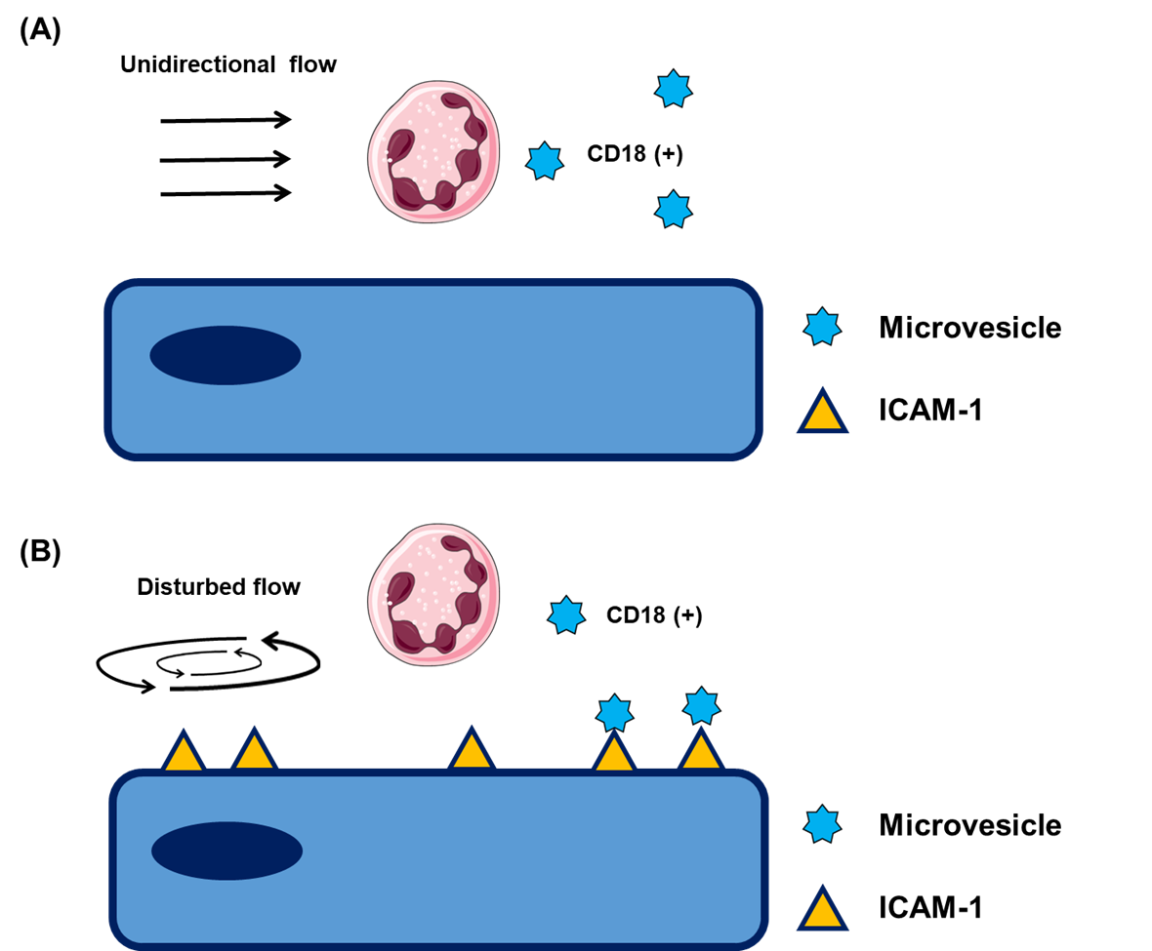

Figure 4.16 – Working hypothesis - MV interactions with HCAECs at sites of disturbed flow: ICAM-1 is disproportional expressed on cells exposed to low oscillatory wall shear stress. MVs are able to interact with endothelial cells via CD18-ICAM-1 interactions. This therefore increases the number of interactions that occur between MVs and endothelial cells at sites of disturbed flow in vivo. In addition to the effects of disturbed flow on adhesion molecule density, high-shear stresses inhibit the ability of MVs to capture flowing MVs.

Chapter 5 - Microvesicle induced activation of endothelial cells cultured under flow

5.1.1 Introduction
Inflammation of endothelial cells at sites of disturbed flow is recognised as a critical factor in the initiation of atherogenic processes. Changes in the cell surface expression of adhesion molecules, as well as chemokines and chemoattractants presented on the cells glycocaylx facilitate the homing and transmigration of immune cells that drive the diseases progression from within the vessel wall.
As demonstrated in Chapters 3 and 4, neutrophil MVs preferentially interact with cells at sites of disturbed flow and with cells conditioned under low oscillatory wall shear stress. The mechanism of this was partially associated with the increased expression of adhesion molecules, importantly ICAM-1 on endothelial cells exposed to these flow parameters. The expression of ICAM-1, along with other adhesion molecules and many chemoattractants, is regulated by the highly flow sensitive transcription factor NF- κB. Tzima et al.,(2005) observed that both the total expression and activation of this pathway was elevated at atheroprone regions of the vasculature, compared to those regions of the vessel exposed to unidirectional shear. These findings of increased NF-κB activity closely correlated with expression of pro-inflammatory molecules in these regions of the vessel. In-vitro experiments further support the role of low and disturbed flow as a mechanism of endothelial cell activation, with adhesion molecules such as E-selectin and VCAM-1 (Walpola et al., 1995), and potent chemoattractants, such as MCP-1 (Hsiai et al., 2003) highly regulated by flow dependant mechanisms. It is widely accepted that these NF-κB regulated molecules contribute significant roles in the development of atherogenesis, ultimately increasing the ability of endothelial cells to interact with monocyte at regions of disturbed flow (Weber et al., 1999, Hsiai et al., 2003).
Neutrophil-derived MVs are produced from activated neutrophils, and have been identified to express and contain a number of pro-inflammatory factors, capable of inducing inflammation within recipient cells (Dalli et al., 2013). Mesri and Altieri (1998) determined that IL-6 and IL-8 secretion from human aortic endothelial cells was significantly increased through incubation with MVs. Therefore, neutrophil-derived MVs possess the ability to activate endothelial cells. Importantly for the current study, endothelial cells exposed to disturbed flow, have a heightened state of activation, which ultimately increases their ability to interact with and capture neutrophil-derived MVs. Given these overlapping factors, greater understanding of whether these interactions under disturbed flow conditions can further exacerbate these inflammatory processes is crucial to expanding understanding of the focal nature of atherogenesis.

5.1.2 Hypothesis and aims
Neutrophil-derived MVs will induce pro-inflammatory gene express ion of HCAECs cultured under disturbed flow; and these changes in cell phenotype will facilitate monocyte interactions with endothelial cells under flow conditions relevant to atherosclerosis.
Aim 1 – To determine whether incubating HCAECs that have been exposed to low oscillatory wall shear stress with MVs alters the gene expression of HCAECs compared to those conditioned under low oscillatory wall shear stress alone.
Aim 2 – To determine whether these changes in gene expression result in changes in the expression of proteins that may influence monocyte interactions with HCAECs.
Aim 3 – To determine whether changes in the inflammatory status of the cell as a result of incubation with MVs, influences monocyte adhesion to endothelial cells under atheroprone flow conditions.

5.2 Methods
In order to determine the effects of MVs on the inflammatory activation of HCAECs that have been exposed to disturbed flow we utilised the Ibibi flow chamber system, as previously described (see chapter 2.8). For further experiments, given the lack of MV interactions with HCAECs cultured under high unidirectional wall shear stress or; in atheroprotected regions of the murine aorta (chapter 4), we focused on the low oscillatory wall shear stress condition as it is the most pertinent flow condition to lesion development during atherosclerosis. Endothelial cells were cultured under low oscillatory wall shear stress (4 dyne/cm² – 1 Hz) for 72 h. MVs were added to the flow chamber system for 0, 2 or 4 h.
Cells were removed from the slide for analysis by qPCR or the cell surface expression analysed by flow cytometry. Additionally, the media was kept for analysis of protein secretion by ELISA.
In the final set of experiments, following the 72-h period the media from each chamber was removed and replaced with media containing fluorescently labelled monocytes (isolated from the same participant as the MVs). These were allowed to flow over the endothelial cells under the same low oscillatory wall shear stress conditions for 2 h before analysis of adhesion by fluorescence microscopy.
These experiments are summarised in Figure 5.1.

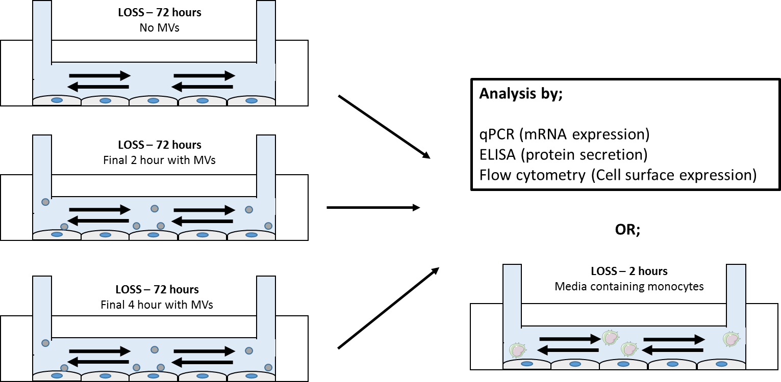

Figure 5.1 – Schematic of experiments performed in chapter 5: HCAECs were cultured under low oscillatory wall shear stress for 72 hours. For the final 0, 2 or 4 hours MVs were added to each flow chamber, and flowed over endothelial cells under the same low oscillatory wall shear stress. Upon completion of the time, the cells were collected for analysis by qPCR or flow cytometry and the media collected for the analysis by ELISA. In addition to this, in experiments to determine how this affected monocyte interactions, the media was removed and replaced with media containing PKH26 labelled monocytes (1 x 10⁶/ml). These were flowed over the cells for a further 2 hours, before the cells were washed, fixed and adhesion quantified by fluorescent microscopy.

5.3 Results

5.3.1 Flow regulated expression of inflammatory targets by endothelial cells
A number of genes have been identified as being highly-flow regulated in in vitro systems. The current study aimed to utilise an adult arterial cell type, making this the most relevant cell type for the study of atherosclerosis. We therefore aimed to determine whether these genes that have been previously described in vitro (Mahmoud et al., 2016) and in vivo (Tzima et al., 2005) were regulated by these flow conditions in our system.
Figure 5.2 summarises the relative gene expression of known flow-regulated targets in cells cultured under low oscillatory wall shear stress and high unidirectional wall shear stress for 72 h. We observed significant increases in the expression of MCP-1 and E-selectin in cells exposed to low oscillatory wall shear stress. Additionally, the expression the atheroprotective vasodilator, eNOS, was significantly increased in HCAECs exposed to high unidirectional wall shear stress. The expression of atheroprotective transcription factor, KLF-4, was induced 13-fold in HCAECs exposed to high unidirectional compared to low oscillatory wall shear stress, however these results were not deemed statistically significant. Post-hoc effect size calculations revealed an effect size of 0.72, suggesting a ‘large’ effect of flow on this transcription factor.
These data indicate that HCAECs conditioned in the current system, reflect those of both HUVECs cultured in this system, but also gene expression changes that occur at disturbed flow regions in vivo.

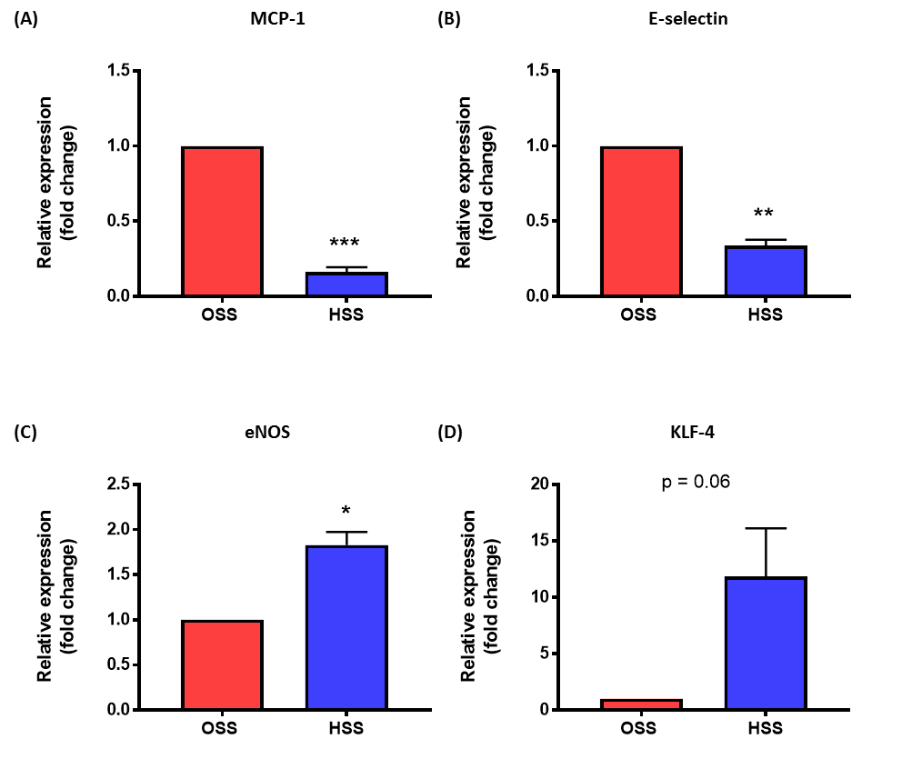
Figure 5.2 Flow regulated gene targets expressed in HCAECs pre-conditioned under flow: HCAECs were cultured under low oscillatory wall shear stress or high unidirectional shear stress for 72 h in an Ibidi flow chamber system. Flow conditioned HCAECs were collected for analysis of known flow regulated genes by qPCR. Relative fold change between OSS and HSS cultured cells was determined for MCP-1 (A), E-selectin (B), eNOS (C), KLF-4 (D). Data are presented as mean ± SEM (n = 3) and analysed for statistical significance using a paired t-test, *p<0.05, **p<0.01, ***p<0.001.

5.3.2 Analysis of viability and cell death in endothelial cells incubated with microvesicles
Prior to determining the effects of MVs on the inflammatory profiles of HCAECs, we first aimed to determine whether MVs in this system resulted in the induction of apoptosis or necrosis. Given the ability of apoptotic processes to induce the expression of adhesion molecule and cytokines (Rock and Kono, 2008) we wanted to ensure that these factors would not influence our findings.
Figure 5.3 summaries the percentage of live, apoptotic and necrotic cells in response to incubation with and without MVs (2 and 4 h). We identified that in cells without MV incubation, 92.9% (± 2.5%) of the cells in culture were live cells, and this was not significantly altered by incubation with MVs. Additionally we observed no differences in the level of apoptosis or necrosis in cells incubated with MVs. Although we observed large variability in the necrosis samples, we believe that this was due to low levels of necrosis in the population.
This data indicate that MVs do not influence the inflammatory status of HCAECs by inducing apoptosis when incubated with these cells.

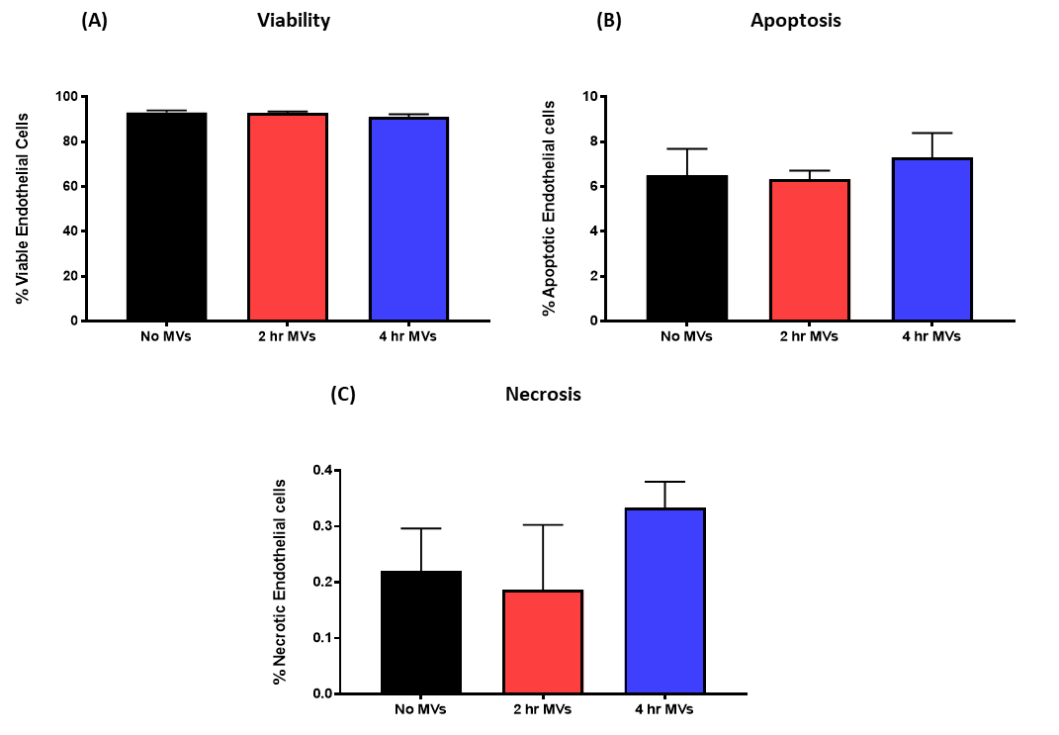

Figure 5.3 Analysis of cell viability, apoptosis and necrosis following incubation with microvesicles: HCAECs were cultured in a 24 well plate. MVs were added to the cells for 0, 2 or 4 h. The cells were lifted and incubated with Annexin binding buffer before, FITC labelled Annexin-V and propridium iodide were added at room temperature for 5 minutes. Viability (A), apoptosis (B) and necrosis (C) were determined by flow cytometry. Data are presented as mean ± SEM (n = 4) and analysed for statistical significance using a one-way ANOVA.

5.3.2 Analysis of mRNA expression in endothelial cells cultured under disturbed flow, with and without MVs
Given the ability of MVs to activate endothelial cells under static conditions (Deregibus et al., 2007, Wang et al., 2011), we aimed to determine whether MVs were able to activate HCAECs cultured under atheroprone flow to a greater extent than low oscillatory flow alone. These findings would therefore support that microvesicles could drive inflammation at atheroprone regions of the vasculature.
Figure 5.4 summarises the mRNA expression of key inflammatory mediators at 0, 2and 4 h post the addition of MVs to the flow chamber system. We observed that the expression of adhesion molecules, ICAM-1 and VCAM-1 were both increased at 2 and 4 h incubation with MVs. Despite this, only VCAM-1 was found to be a statistically significant increases. Post-hoc effect calculations revealed an effect size of 0.49, suggesting a ‘medium’ effect of MVs in inducing the expression of ICAM-1 at 4 h, beyond that in cells exposed to disturbed flow only. Additionally, IL-6 and IL-8 expression were induced 1.5 and 2-fold, respectively, after 4-h incubation with MVs. The level of expression in the cells appeared to follow a stepwise pattern, between low oscillatory flow only, 2 h exposure and 4 h exposure. Only the expression of IL-8 however was deemed statistically significant. Post-hoc effect calculations comparing IL-6 expression at 4 h compared to low oscillatory wall shear stress only revealed an effect size of 0.49, suggesting a ‘medium’ effect of MVs on this chemokine. The expression of MCP-1 in HCAECs was found to not significantly increase in the cells exposed to MVs, analysis of effect sizes revealed a ‘small’ effect sizes of 0.31 for this factor. Additionally, the expression of P65 in these cells was not observed to increase, however post hoc effect size analysis revealed a ‘medium’ effect size of 0.42.
These data indicate that MVs delivered to endothelial cells under atheroprone flow conditions induce greater levels of activation than endothelial cells exposed to disturbed flow alone.

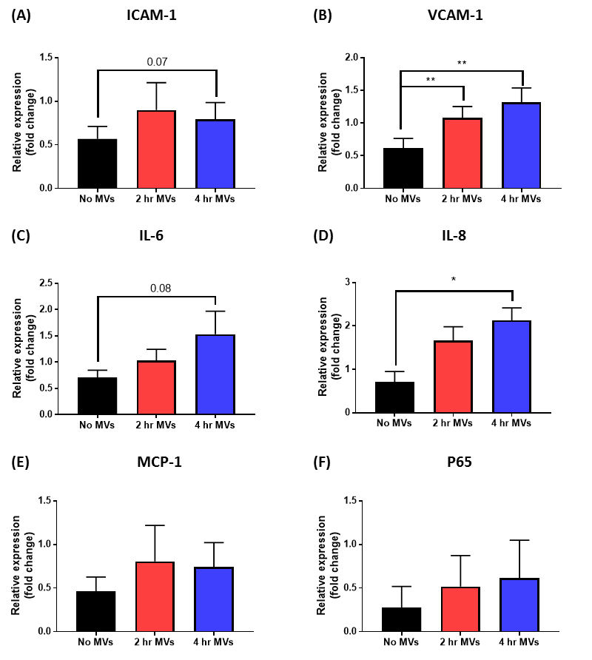
Figure 5.4 – qPCR analysis of inflammatory gene expression in HCAECs cultured under low oscillatory wall shear stress in the presence of MVs: HCAECs were cultured under low oscillatory wall shear stress 72 h in an Ibidi flow chamber system. For the final 0, 2 or 4 h of the culture under flow, the media was changed to media containing MVs (2 x 10³/µl). Cells were washed in PBS and HCAECs collected for analysis of inflammatory genes by qPCR. Relative fold change between no MVs, 2-h exposure to MVs and 4-h exposure to MVs was determined for ICAM-1 (A), VCAM-1 (B), IL-6 (C), IL-8 (D), MCP-1 (E), P65 (F). Data are presented as mean ± SEM (n=5) and analysed for statistical significance by one-way ANOVA and Tukeys test for multiple comparisons, *p<0.05, **p<0.01.

5.3.3 Protein expression by HCAECs cultured under disturbed flow in response to incubation with MVs
Given that incubation with MVs appear to increase the mRNA expression of some important inflammatory targets, we aimed to investigate whether these increases resulted in changes in the expression of these molecules at the protein level.
Figure 5.5 summarises the effect of MVs on secreted proteins IL-8, IL-6 and MCP-1 as determined by ELISA. We observed significant increases in secretion of IL-8 and IL-6 from HCAECs when incubated with MVs under low oscillatory flow conditions for 4 h compared to low oscillatory shear stress alone. For neither molecule did we observe an increase in the expression at the 2-h time point. The expression of MCP-1 was not increased above that in oscillatory flow alone at either 2 or 4 h.
Additionally, Figure 5.6 summarises the effect of MVs on the cell surface expression of adhesion molecules ICAM-1 and VCAM-1 on cells cultured under disturbed flow. The cell surface expression of VCAM-1 was significantly induced by the exposure to 72 h of flow when compared to that on statically cultured cells. The expression of VCAM-1 was also increased when the cells were incubated with MVs for 4 h. The expression of ICAM-1 however was unaltered by incubation with MVs.
These data indicate that the expression of important molecules to leukocyte recruitment during atherogenesis, including IL-6, IL-8 and VCAM-1 are expressed in greater quantities in the presence of MVs compared to when they are subject to atheroprone flow alone. This suggests that MVs may act as a stimulus to exacerbate inflammation at disturbed flow regions.

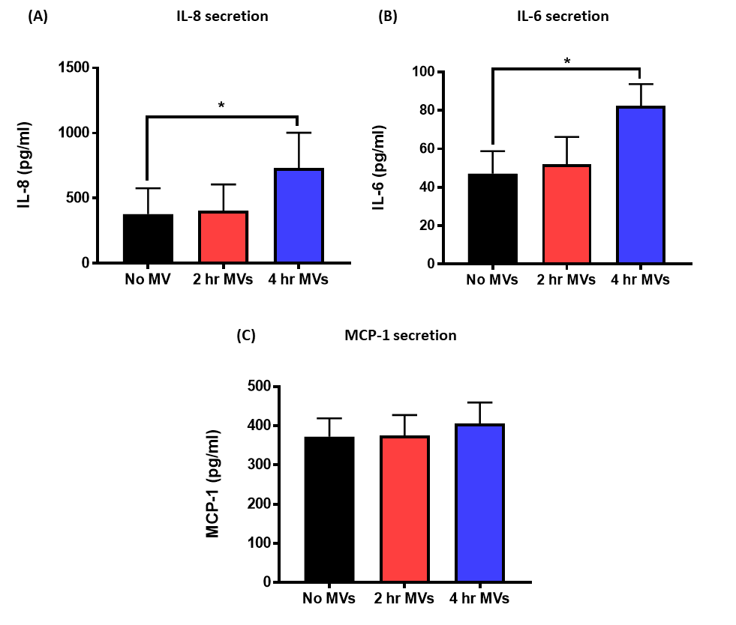
Figure 5.5 – Cytokine and chemoattractant expression in HCAECs cultured under low oscillatory wall shear stress in the presence of MVs: HCAECs were cultured under low oscillatory wall shear stress 72 h in an Ibidi flow chamber system. For the final 0, 2 or 4 h of the culture under flow, the media was changed to media containing MVs (1 x 10³/µl). The media from each unit was collected and analysed for the secretion IL-8 (A), IL-6 (B) and MCP-1 (C) by HCAECs. Data are presented as mean ± SEM (n=3) and analysed for statistical significance by one-way ANOVA and Tukey’s test for multiple comparisons, *p<0.05.

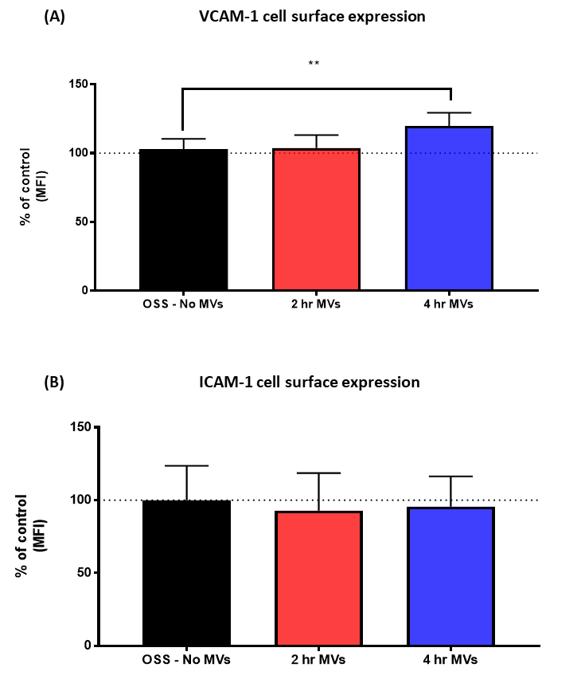

Figure 5.6 – Cell surface expression of adhesion molecules on HCAECs cultured under low oscillatory wall shear stress in the presence of MVs: HCAECs were cultured under low oscillatory wall shear stress 72 h in an Ibidi flow chamber system or static conditions. For the final 0, 2 or 4 h of the culture under flow, the media was changed in the unit to media containing 2 x 10⁶ MV/ml. HCAECs were lifted by trypsinisation (1:5 dilution) and the cell surface expression of VCAM-1 (A) and ICAM-1 (B) was determined by flow cytometry. Data are presented as mean ± SEM (n = 4) and analysed for statistical significance by one-way ANOVA and Tukey’s test for multiple comparisons, *p<0.05, **p<0.01.

5.3.4 Monocyte recruitment to endothelial cells exposed to disturbed flow in the presence of MVs
Given an increase in factors that regulate leukocyte interactions with endothelial when cells are incubated with MVs under flow, we aimed to determine whether these findings had functional consequences on monocyte interactions with HCAECs.
Figure 5.7 summarises the effect of MVs delivered to endothelial cells preconditioned under low oscillatory wall shear stress on monocyte adhesion to the cells under these same flow conditions. We observed a basal level of adhesion to endothelial cells cultured under low oscillatory wall shear stress only. This was significantly increased when HCAEC were incubated with MVs for 4 h prior to the addition of monocytes.
These findings suggest that monocytes interaction with arterial endothelial cells exposed to patterns and magnitudes of flow observed at atheroprone regions. The number of interactions is increased by prior incubation with MVs, suggesting activation of endothelial cells under these flow conditions may contribute to the focal nature of the disease.

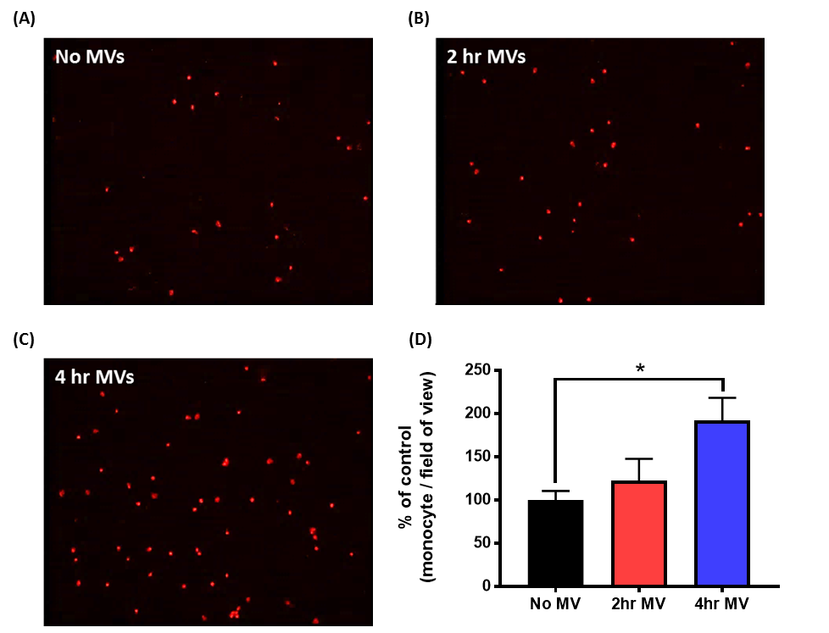
Figure 5.7 – Monocyte adhesion to HCAECs cultured under low oscillatory wall shear stress in the presence of MVs: HCAECs were cultured under low oscillatory wall shear stress 72 h in an Ibidi flow chamber system. For the final 0, 2 or 4 h of the culture under flow, the media was changed in the unit to media containing MVs (2 x 10³/µl). The media was then changed again to media containing PKH26-labelled primary human monocytes (1 x 10⁶/ml), and these monocytes were flowed over the HCAECs under low oscillatory wall shear stress for 2-h. Following the incubation, the cells were washed in PBS and fixed for immunocytochemistry. (A - C) Representative images of monocyte adhesion to HCAECs with no MVs (A), 2 h exposure to MVs (B) and 4 h exposure to MVs (C). (D) Quantification of monocyte adhesion, presented as the percentage of control (no MVs). Data are presented as mean ± SEM (n = 5) and analysed for statistical significance by one-way ANOVA and Tukeys test for multiple comparisons, *p<0.05, **p<0.01.

5.4 Conclusions
1 – HCAECs cultured in our in vitro flow chamber system have distinct inflammatory profiles that are typical of those at disturbed flow regions in vivo.
2 –Neutrophil MVs induce HCAEC inflammatory activation at both the mRNA and protein level.
3 – MVs facilitate monocyte endothelial cell interactions in vitro under flow conditions that mimic atheroprone regions of the vasculature in vivo.

5.5 Discussion
The current study is the first of its kind to show that neutrophil MVs exacerbate inflammation in endothelial cells that have been pre-conditioned under low oscillatory wall shear stress. Subsequently this led to an increase in monocyte adhesion. Given the significance of endothelial cell activation and subsequent leukocyte transmigration across the endothelium at disturbed flow sites, these findings highlight that neutrophil MVs may contribute to the focal nature of atherosclerosis through facilitating leukocyte migration.
Activation of endothelial cells by low and oscillatory wall shear stress and microvesicles
Initial experiments were performed to determine whether a number of known flow responsive genes were regulated in our in vitro flow system. Previous data from our lab has utilised this flow system (Hsiao et al., 2016, Mahmoud et al., 2016, Chen et al., 2009, Serbanovic-Canic et al., 2017), however this is the first study from the lab to use an adult, arterial cell line within the Ibidi flow system. These previous studies using the Ibidi flow chamber system identified a number of flow response targets that correlate with both findings in vivo (Cuhlmann et al., 2011), and with those obtained in other flow systems including the orbital shaker (Mahmoud et al., 2017). Importantly, in our model, we observed the regulation of a number of highly flow-sensitive gene targets, as previously described in other models and cell types (Figure 5.2). Given these findings that low oscillatory wall shear stress resulted in a state of heightened endothelial activation reflective of disturbed flow regions of the vessel, and the lack of MV interactions with HCAECs cultured under high unidirectional wall shear stress or; in atheroprotected regions of the murine aorta (chapter 4), we focused on the low oscillatory wall shear stress condition as it is the most pertinent flow condition to lesion development during atherosclerosis.
The current findings identified that incubation with neutrophil MVs during the final 4 h of preconditioning HCAECs under low oscillatory flow resulted in exacerbated inflammation in these cells. Previous experiments of cell activation by MVs have generally utilised static assays to perform these effects, and have observed inflammation within 2 h of incubation (Deregibus et al., 2007, Wang et al., 2011). We believe that a major strength of the current model is both the preconditioning, but also the delivery of MVs under atheroprone flow conditions, as this combination of factors more closely mimic how these interactions occur in vivo. Importantly, in these experiments only MVs that express the machinery to interact with and be captured by endothelial cells contribute to the activation in this model, and the contribution from passive interactions that may occur in static experiments are negated. Despite the benefits of this model, these experiments require specialist equipment and training, and increased time requirements reduced the throughput of the assay. Further investigation into the mechanisms by which neutrophil MVs induce HCAEC activation are required to give greater insight into the role of these MVs in atherosclerosis. In addition, more intricate intravital microscopy assays, such as that used by (van Zandvoort et al., 2004), would enable direct visualisation of MV interactions with atheroprone regions or plaques in vivo.
Adhesion molecules expressed on endothelial cells on cells exposed to disturbed flow are crucial regulators of immune cell interactions in disease. Of particular relevance to monocyte interactions is VCAM-1 (Walpola et al., 1995, Cybulsky et al., 2001). Here we observed a significant increase in the level of VCAM-1, importantly this included an increase in the cell surface expression. The significance of these findings is supported by observational studies that regularly identify the abundant expression of VCAM-1, on and around atherosclerotic loci (Obrien et al., 1996, Cybulsky et al., 2001). Experimental evidence for the role of VCAM-1 was identified by Cybulsky et al (2001). In these studies, transgenic mice containing disruptions in the 4th domain of VCAM-1 (these mice lack the functional ability to interact with ligand VLA-4 present on the surface of leukocytes), were found to have significantly reduced plaque area and reduced immune cell infiltration during early time points of atherogenesis. These studies highlighted how increases in VCAM-1 during the initiation of atherogenesis can drive lesion development. Additionally we examined the effect of MVs on ICAM-1 expression. Despite observing a 2-fold increase in the mRNA expression of this molecule at both the 2 and 4 h time points, no change was observed in the level of cell surface expression as measured by flow cytometry. Interestingly, it has previously been described that an ICAM-1 dependant mechanism of internalising anti-ICAM-1 coated beads exists in endothelial cells (Muro et al., 2003). Given the significance of ICAM-1 in the adhesion and preferential interactions with cells at disturbed flow sites, the discrepancy between the message and protein expression may be explained by MVs utilising this pathway to be internalised by HCAECs, effectively reducing the surface expression detectable by flow cytometry. Future studies may use alternative methods to determine the expression of ICAM-1 at the protein level; total expression as determined by western blot for example may provide interesting information about whether HCAECs are utilising this pathway for the uptake of MVs.
Although adhesion molecules are critical to the capture and adhesion of flowing monocytes, chemokines expressed by endothelial cells at disturbed flow sites regulate the migration of immune cells from the circulation into the vessel wall. Here we show that IL-8 was significantly upregulated, again at both the mRNA and protein level. The importance of IL-8 in the capture of flowing monocytes has also been described. A study by Gerszten et al., (Gerszten et al., 1999) showed that MCP-1 (a previously well described chemoattractant of monocytes), but also IL-8 were involved in interactions between monocytes and endothelial cells under flow. The study showed that IL-8 contributed to firm arrest by blocking IL-8 receptors expressed on monocytes, preventing interactions with endothelial cells. Interestingly however, we observed no change in the expression of MCP-1 by endothelial cells when incubated with MVs compared to low oscillatory shear stress alone. This is contradictory to previous studies by Mesri and Altieri et al., (1999), who identified an increase in MCP-1 by incubation with MVs when incubated under static conditions. MCP-1 is highly flow regulated, and levels are rapidly up-regulated in response to acute and prolonged exposure to flow. Using the cuff model of shear manipulation, Cheng et al., (2005) identified that the expression of MCP-1 was substantially expressed by cells in the low and disturbed flow region of the cuff. Increased expression of MCP-1 under disturbed flow is also observed in vitro, where increased expression has been shown to impact subsequent monocyte arrest (Matlung et al., 2012). As such, the highly abundant nature of the molecule in cells exposed to disturbed flow, may limit further increases in the level expression.
We also observed that at the protein level, that secretion of IL-6 was increased at 4 h in the presence of MVs. An increase in the secretion of IL-6 is of particular importance to current model. IL-6 has been shown to activate endothelial cells, regulating the production of adhesion molecules and IL-8 secretion by endothelial cells (Romano et al., 1997). This suggests that MVs may induce further activation of local endothelial cells in a paracrine manner. In addition to the effect on endothelial cells, IL-6 receptor signalling in monocytes drives the NF-κB activation of monocytes. This has been associated with increased expression of adhesion molecules including CD11b (Tieu et al., 2009), which is involved in monocyte adhesion. These findings show that monocytes can increase the adhesive properties of monocytes increasing their potential to interact with HCAECs.
Monocyte recruitment to endothelial cells in response to microvesicles
Given these findings that key modulators of monocyte recruitment and transmigration were upregulated by MVs in our model, we investigated whether these translated to monocyte adhesion under our disease relevant flow conditions. Few studies have investigated the interactions that occur between monocytes and endothelial cells in flow conditions relevant to atherosclerosis. Typical models of monocyte interactions with endothelial cells focus on flow conditions that mimic those observed in the microvasculature where, during infectious challenge, monocytes typically transmigrate into the surrounding tissue. These models generally perform monocyte adhesion assays under unidirectional and very low (1-2 dyn/cm²) shear stress (Gerszten et al., 1999, Gerszten et al., 2001, Ito et al., 2014). An important study by Hsiai et al (2003) did however analyse the interactions between monocytes and endothelial cells under oscillatory flow in real time. The authors observed that monocytes were able to undergo rolling, tethering and firm adhesion under oscillatory shear conditions. However this occurred in a ‘to-and-fro’ motion until firm adhesion occurred (Hsiai et al., 2003). We determined whether MVs were able to augment monocyte-endothelial cell interactions. We observed that, in the absence of MVs, monocytes were capable of interaction with endothelial cells under low oscillatory flow. Moreover, when HCAECs were incubated with MVs for 4 h, a significant increase in the number of adherent monocytes was observed. These findings fit with the previously presented inflammatory data, in which significant increases in the release or expression of inflammatory targets were only observed in this 4 h condition. Based on these findings, we believe that MVs have a significant role in the induction of inflammation and subsequent monocyte recruitment to disturbed flow sites. Given that these effects did not occur within 2 h, we hypothesise that this may occur via the internalisation and delivery of content that regulate inflammatory gene expression and we have investigated this further in Chapter 6.
NF-κB signalling in microvesicle activation of endothelial cells
Interestingly in the current model we did not see a significant increase in the total levels of NF-κB (as determined by p65 mRNA expression) between cells cultured with or without MVs. The levels of p65 mRNA, although increased, was highly variable between experimental repeats (the largest variation was observed at 4 h). As such, the heteroscedasticity (i.e. variable variability) across the conditions and low number of samples are likely to reduce the ability of these findings to observe meaningful changes in the pathways expression. Additionally, all experiments were performed at the single time point of 72 h preconditioning under flow. Given this, it is important to note that NF-κB expression is cyclical in nature and can dramatically oscillates over time (Nelson et al., 2004). This occurs because NF-κB transcribes for many of the inhibitory molecules of its own pathway (such as IκBα), and as such the pathway has an intrinsic negative feedback loop that inhibits excessive activation (Nelson et al., 2004). This may infer an important source of variation in NF-κB expression across experiments in the current model, and future experiments may utilise different time points to better understand the response of this molecule. However, from the findings presented, we are unable to conclude that MVs increase or upregulate the expression of NF-κB in endothelial cells pre-conditioned under disturbed flow. Given that a number of important gene targets of NF-κB, including VCAM-1 and IL-8, appear to be highly regulated by MVs in the assay, we hypothesise that this may occur through the activation of this pathway. Activation of the NF-κB pathway occurs when inhibitors are modified in the cell cytoplasm, allowing p65 to rapidly translocate to the cell nucleus. Future studies could confirm this hypothesis through the use of fluorescent microscopy techniques. These would include imaging the co-localisation of NF-κB with and without MVs, a shift from cytoplasmic, to nuclear expression suggesting pathway activation. Importantly, these processes may be regulated by microRNAs, delivered to the endothelial cell by MVs. How this process may occur will be addressed further in Chapter 6. Briefly, we propose that MVs deliver neutrophil-derived content, including microRNAs, to endothelial cells. These microRNAs are able to induce post-transcriptional modification of negative regulators or inhibitors of the NF-κB pathway, including BCL-6 and IκBα (Ma, 2011), allowing NF-κB translocation, and ultimately increased endothelial cell activation.

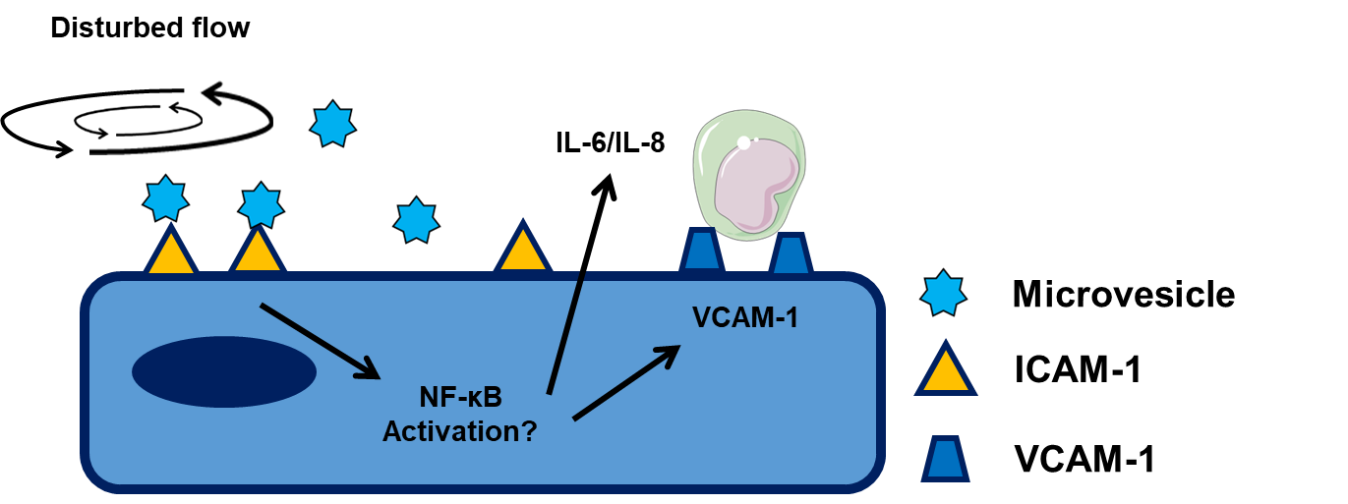

Figure 5.8 – Working hypothesis - MV activation of HCAECs exposed to disturbed flow: MVs preferentially interact with endothelial cells at sites of disturbed. Once interactions occur, endothelial cells become activated. This results in the increased secretion of IL-6 and IL-8 as well the cell surface expression of VCAM-1. Ultimately this heightened state of endothelial cells activation increases the number of monocyte interactions that occur at sites of disturbed flow, a key feature in the aetiology of atherosclerosis.

Chapter 6 - Mechanisms of microvesicle internalisation by human coronary artery endothelial cells

6.1.1 Introduction
We have previously identified the ability of neutrophil-derived MVs to interact with and induce inflammatory activation in human coronary artery endothelial cells. Despite these findings, little is known about how these interactions drive changes in endothelial activation. Although cell-to-cell communication can occur via several mechanisms, these include chemical-receptor mediated events or direct cell-to-cell contact (Reviewed by; Oktay et al., 2015), a growing body of evidence implicates MVs as alternative mechanism through which cells can interact. Packaged within membrane bound vesicles, cellular content can be delivered to a recipient cell, where the vesicle is internalised and its content released to impart its biological effects (Valadi et al., 2007). Given the intriguing ability of MVs to be internalised by many cell types, further understanding of the mechanisms of uptake are critical to uncovering the potential role of MVs in disease.
Direct evidence for the role of MV-mediated delivery of content include the delivery of murine-derived proteins to human cells in culture (Valadi et al., 2007) and through the siRNA-dependent knock down of specific gene targets following their delivery by exosomes (Alvarez-Erviti et al., 2011, Zhou et al., 2016). These studies highlight that not only are the extracellular vesicles being internalised by the recipient cell, but the delivery of their content can directly influence cell function. Beyond these important experiments, a number of different studies have identified the internalisation of MVs by donor cells using a range of membrane and cytosolic fluorescent dyes. These include the uptake of inflammation inducing platelet-derived MVs by microvascular endothelial cells (Faille et al., 2012), and the internalisation of tumour-derived MVs that drive a proangiogenic phenotype in the developing tumour by endothelial cells (Kawamoto et al., 2012). In these studies, the use of fluorescent dyes allow the quantification of MV uptake by microscopy and flow cytometry, enabling us to begin to understand the mechanism by which MVs are internalised. Importantly, it is becoming increasingly evident that the mode of internalisation is vastly heterogeneous across donor and recipient cell types. Factors including MV size, protein expression on the surface of the MV and the physiological functions of the recipient cell all heavily influence the mechanisms by which MVs are internalised (reviewed by; Mulcahy et al., 2014). A number of endocytotic pathways have been described to explain the uptake and release of MV content, these include macropinocytosis (Faille et al., 2012), clathrin-mediated (Tian et al., 2014) and caveolin-mediated (Svensson et al., 2013) endocytosis and direct fusion of extracellular vesicles with the plasma membrane (Prada and Meldolesi, 2016) – see Figure 6.1). As such, no single pathway for the internalisation of MVs exists.
Previously we identified the role of ICAM-1/CD18 interactions in the capture and adhesion of neutrophil-derived MVs by HCAECs. A number of studies have implicated receptor-ligand interactions as an important factor in facilitating subsequent internalisation. Antibody blockade of adhesion molecules including CD11b (Zech et al., 2012) and LFA-1 (Xie et al., 2013) have been shown to significantly reduce binding, and as such reduce the uptake of extracellular vesicles. Importantly, a previous study of the uptake of MVs by dendritic cells found that extracellular blockade of ICAM-1 on the recipient cell reduced the internalisation of MVs delivered to these cells (Morelli et al., 2004). These experiments would suggest reducing the number of interactions between the MVs and recipient cells reduces the level of internalisation i.e. that internalisation is dependent on initial adhesion via ICAM-1. A crucial series of studies may infer a direct role of ICAM-1 receptor recycling in the internalisation of neutrophil-derived MVs. Muro et al., (2003) identified that nanobeads, between 100-300 nm, coated with antibodies against ICAM-1 are internalised by endothelial cells via a novel ICAM-1 dependant pathway. Characteristics of this pathway, including being clathrin-independent, requiring functional Na⁺/H⁺ exchanger proteins on the endothelial cells and the involvement of cleavage protein dynamin-2 (Stan, 2006), mean that this previously undescribed endocytic pathway may be a crucial mechanism through which CD18 positive MVs can enter endothelial cells (see Figure 6.1).
Currently, the mechanism by which neutrophil-derived MVs are internalised by endothelial cells is unknown. We have identified the ability of MVs to specifically interact with endothelial cells at sites of disturbed flow, where they are capable of driving inflammation and monocyte requirement. Given these findings, it is imperative that we understand the mechanisms by which MVs are internalised by endothelial cells; with the aim of providing valuable insight to how these pathways can be utilised for the delivery of therapeutic targets to endothelial cells at sites of disturbed flow.

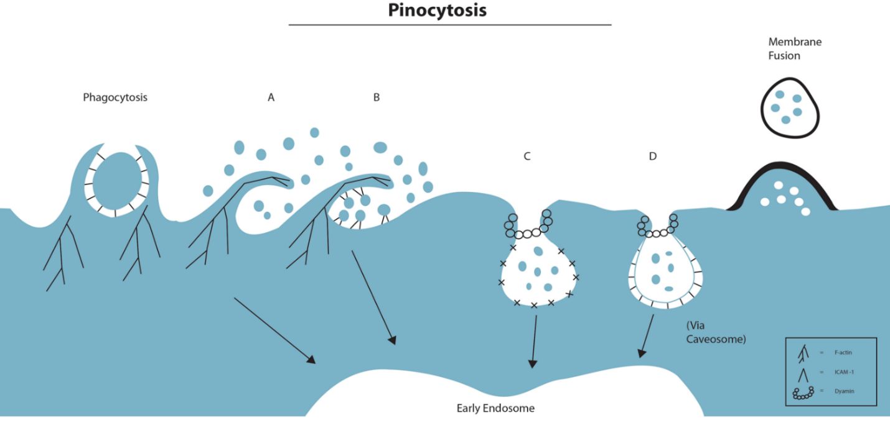

Figure 6.1 Endocytosis pathways in cells: Endocytosis is crucial to the movement of macronutrients across the cell membrane. These processes can be split into two broad categories ‘phagocytosis’ and ‘pinocytosis’. These are loosely translated to ‘cell-eating’ and ‘cell-drinking’, respectively. Typically however, phagocytosis is reserved for specialist phagocytic cells (Van Furth et al., 1972). This chapter will focus primarily on pinocytosis mechanisms of entry, as these are well described processes that occur in endothelial cells (Conner and Schmid, 2003). An important mechanism of macromolecule uptake is macropinocytosis (A). These processes occur in most cells and are involved in the recycling of fluid around the plasma membrane. Briefly, membrane ruffling engulfs large volumes of fluid around the plasma membrane, which is then transitioned into endosomal compartments (called macropinsomes) for recycling (Lim and Gleeson, 2011). Importantly these processes do not require receptor bindings and as such are non-discriminative. Of the remaining mechanisms identified, receptor-ligand interactions are critical to their function. Firstly, ICAM-1 or CAM-mediated endocytosis was described by Muro et al., (2004; B). This involved cross-linking ICAM-1 and subsequent internalisation via ENaC dependant processes. Currently this pathway has only been described for the internalisation of 100-300 nm polystyrene nanoparticles. Additionally, clathrin (C) and caveolae (D) mediated endocytosis pathways both commonly occur in endothelial cells, and both involve the formation of coated pit and the cleavage of the invagination by the molecule dynamin-2. Clathrin-mediated processes are well described and have been shown to be critical in the internalisation of LDL particles and transferrin (Alberts et al., 2002). Caveolae-mediated endocytosis occurs typically at lipid-raft domains of the membrane, and has been shown to be an important mechanism in the internalisation of cholera toxin, human growth hormone and IL-2 receptor (Reviewed by; Nabi et al., 2003).

6.1.2 Hypothesis and aims

Neutrophil-derived MVs are internalised by HCAECs via processes dependent on ICAM-1/CD18 interactions, a pathway previously described by Muro et al., (2005).
Aim 1 – To determine that neutrophil-derived MVs are internalised by HCAECs using real-time, live cell imaging.
Aim 2 – To develop a flow cytometry based assay for the quantification of MVs by HCAECs and, using a range of chemical and pharmacological inhibitors, to determine the key molecular features of this pathway.
Aim 3 – To determine the specific role of ICAM-1 in the process of MV internalisation, determining the significance of ICAM-1 signalling and specifically the functions of the intracellular and extracellular domain of the ICAM-1 molecule in this process.

6.2 Methods
In order to determine the molecular mechanisms by which neutrophil-derived MVs are internalised by HCAECs we first developed a flow cytometry based assay for the quantification of internalisation. Briefly, cells were incubated with PKH67 labelled MVs for 2 h. The cells were then detached from a 24 well plate by trypsinisation. Immediately prior to analysis by flow cytometry, Trypan Blue was added to each tube in order to quench surface fluorescence, ensuring only the signal of internalised MVs was measured. In order to delineate the pathways involved in internalisation, we employed a chemical inhibitor based approach. Inhibitors were selected based on specificity to the pathways and mechanism of action, these decisions were informed by a review of ICAM-1 mediated endocytosis (Stan 2007). All inhibitors considered are summarised in table 6.1. Additionally, we followed a specific work flow, see Figure 6.2, in order to help identify the pathways involved in internalisation. These experiments are described in further detail in chapter 2.11-2.13.

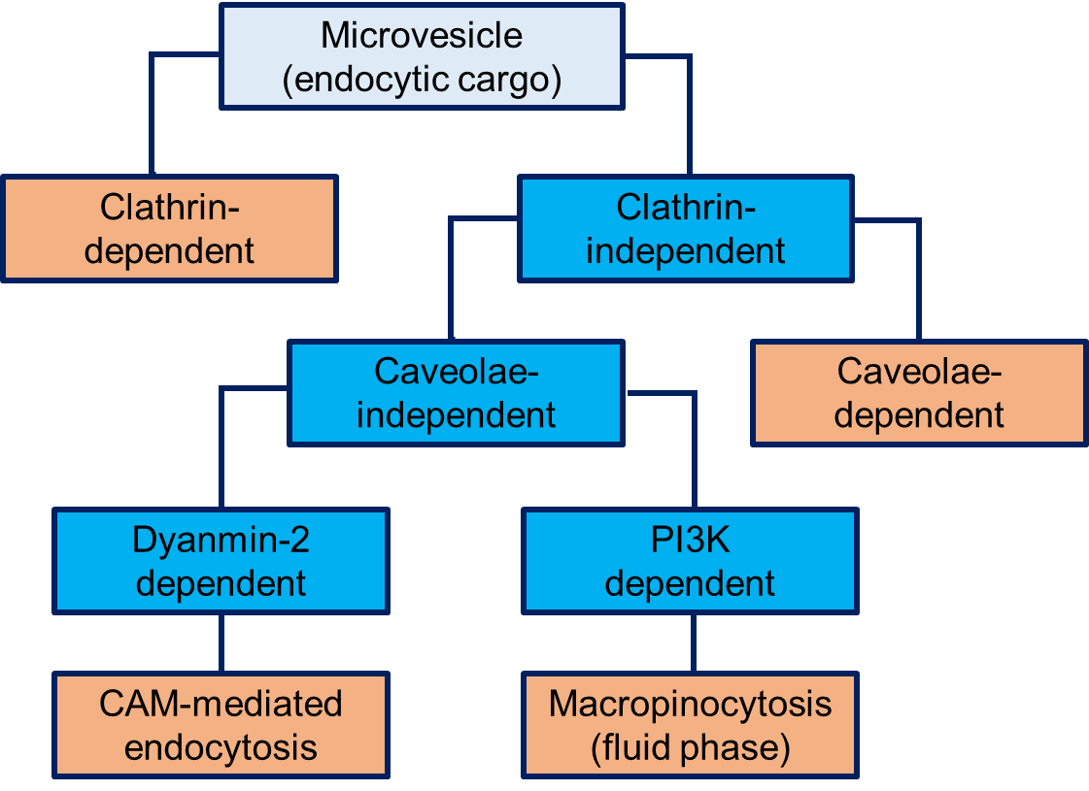

Figure 6.2 Endocytosis pathways in HCAECs: Endocytosis in endothelial cells can occur via number of distinct mechanisms. In order to determine the pathways involved in the internalisation of MVs, a work-flow was developed through which the major pathways that have been described in endothelial cells could be investigated. The first step was to determine whether MV internalisation was dependent upon clathrin-mediated endocytosis, as this is a major mechanism utilised by these cells in the internalisation of a number of molecules (Conner and Schmid, 2003). If clathrin-mediated processes were not involved, another major pathway that has been described in endothelial endocytosis is caveolae-dependent processes (Mulachy et al., 2014). If neither of these processes were identified to be involved, clathrin and caveolae independent mechanisms can be split into macropinocytosis and CAM-mediated endocytosis. These pathways both require functional sodium proton channels on the cell surface (Muro et al., 2003), however CAM-mediated endocytosis is dependent on the cleavage protein dynamin-2 for internalisation to occur (Stan 2006). As such, inhibiting dynamin-2 on the surface of HCAECs will help determine whether CAM-mediated processes or macropinocytic processes are involved in internalisation.

6.3 Results

6.3.1 Live cell imaging of microvesicle internalisation
Many studies of MV internalisation rely on the fixation of cells following incubation with MVs before imaging. Here we employed live-cell staining techniques to image the interaction between MVs and HCAECs in real-time.
The results summarise in Figure 6.2 and video 6.1 (CD 1) highlight that MVs are internalised by HCAECs. Still image in Figure 6.2A correspond to a single frame of real-time video (CD 1), while Figure 6.2B is the maximal intensity projection of Z-stack images following the completion of a real-time video.
The data indicate that MVs are internalised by HCAECs, with individual cell capable of internalising multiple vesicles.

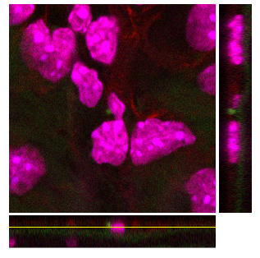
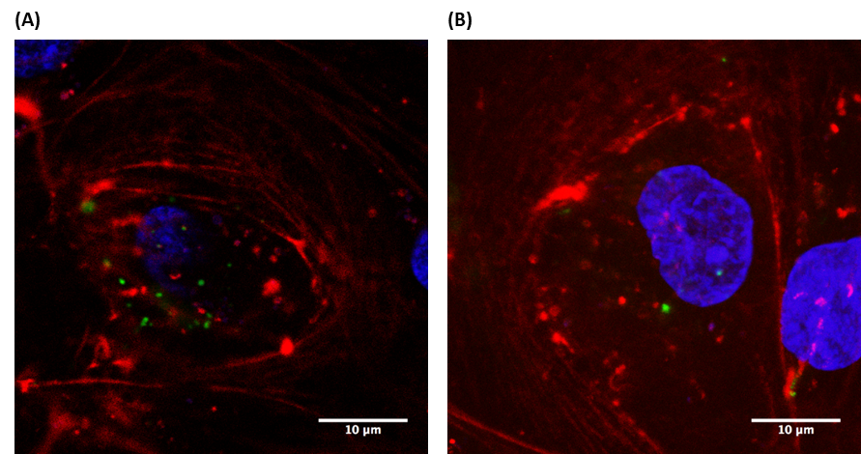
C)

Figure 6.2 – Live cell imaging of microvesicle internalisation by HCAECs: HCAECs were cultured on glass bottom Ibidi µ-chambers. Live HCAECs were stained with SiR-Actin (live F-actin label; Red) and Hoechst 33342 (live nuclear label; blue) and incubated with PKH67-labelled MVs. Images of MV internalisation were acquired in real time (see video 6.1). (A) Still confocal frame from real time video of MV internalisation. (B) Z-stack maximal intensity projection of living HCAECs (x100 magnification). (C) Side view of MV internalisation by HCAECs (x100 magnification).

6.3.2 Development of flow cytometry assay of internalisation – fluorescence quenching
In order to develop a flow cytometry based system to quantify MV internalisation, it was necessary to ensure that MVs that may be adherent to the HCAEC were not quantified in the analysis. A Trypan Blue method of fluorescence quenching, as previously described by Amersfoort and Van Strijp (1994), was utilised.
The data summarised in Figure 6.3 show the quantification of mean fluorescence intensity of MVs (A) and HCAECS (C), prior to and following fluorescence quenching using the Trypan Blue based method. Almost complete abrogation of fluorescent signal from MVs that had been quenched, while observing a 73% reduction in the level of fluorescence from PKH67 labelled HCAECs. These findings are in keeping with those observed by Amersfoort and Van Strijp (1994) when performing Trypan Blue based quenching.
The findings indicate that the surface fluorescence of any MVs that remained adherent to endothelial cells prior to analysis by flow cytometry, would not be quantified for analysis. This method was therefore employed prior to all flow cytometry based experiments of internalisation.

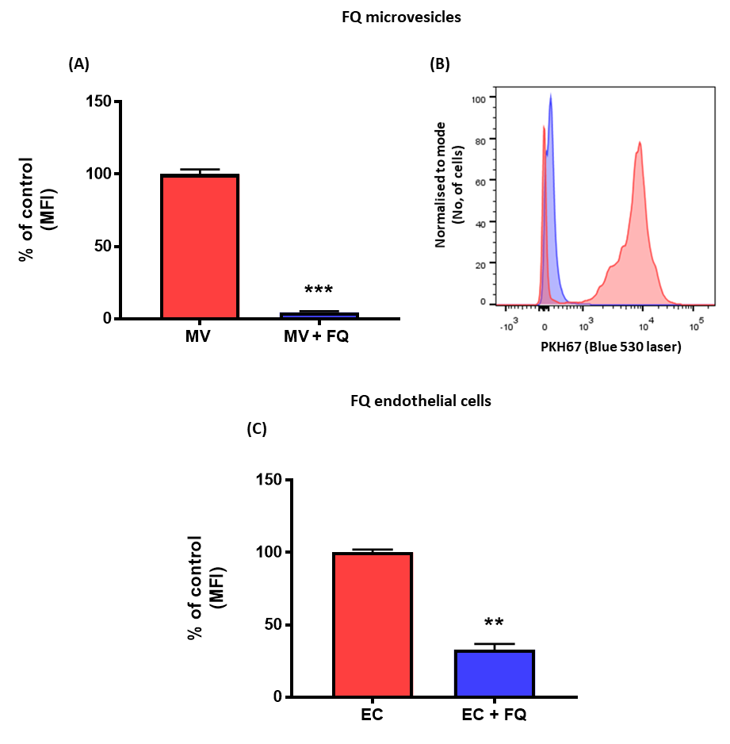
Figure 6.3 – Fluorescence quenching of MV and HCAEC surface fluorescence: HCAECs and MVs were labelled with the green membrane intercalating dye PKH67, and the fluorescence of the HCAECs and MVs was determined by flow cytometry. Following analysis, Trypan Blue was added to each tube for 1 minute prior to further analysis. The fluorescence intensity of the quenched samples was again analysed by flow cytometry. (A) Quantification of MV fluorescence pre (+FQ) and post quenching. (B) Representative histogram of the reduction in fluorescence (blue – quenched MVs, red – non-quenched MVs). (C) Quantification of HCAEC fluorescence pre and post quenching. Data are presented as mean ± SEM (n=3) and analysed for statistical significance by paired t-test, **p<0.01, ***p<0.001.

6.3.4 Time, number and temperature dependence of MV internalisation
Previous studies of MV internalisation have identified that these processes occur via rapid (Montecalvo et al., 2012), but, importantly, active (Faille et al., 2012) mechanisms. The time course and dependency on number and temperature (an indication of whether or not the process is active) were therefore determined.
The data summarised in Figure 6.5 shows the effects of number, time and temperature on MV internalised. Internalisation was dependent on the number of MVs used in the assay. In fact internalisation did not reach a plateau with the numbers used in these experiments, suggesting that HCAECs have a high capacity for taking up MVs (Figure 6.5A). In Figure 3.3 we identified 4062 neutrophil-derived MVs per µl following exposure to HFD, given this data and the data presented in 6.5A, 2000 MVs/µl were used in future experiments of internalisation. Figure 6.5B demonstrates that MV internalisation was significantly increased when incubation was performed at 37ºC compared to room temperature and 4ºC, suggesting that these processes are part of an active pathway. Finally, the temporal analysis shown in Figure 6.5C shows MV internalisation occurred rapidly; internalisation was observed 15 min following the initiation of incubation.
These findings highlight that neutrophil-derived MV internalisation occurs via active processes and that HCAECs can internalise MVs rapidly.

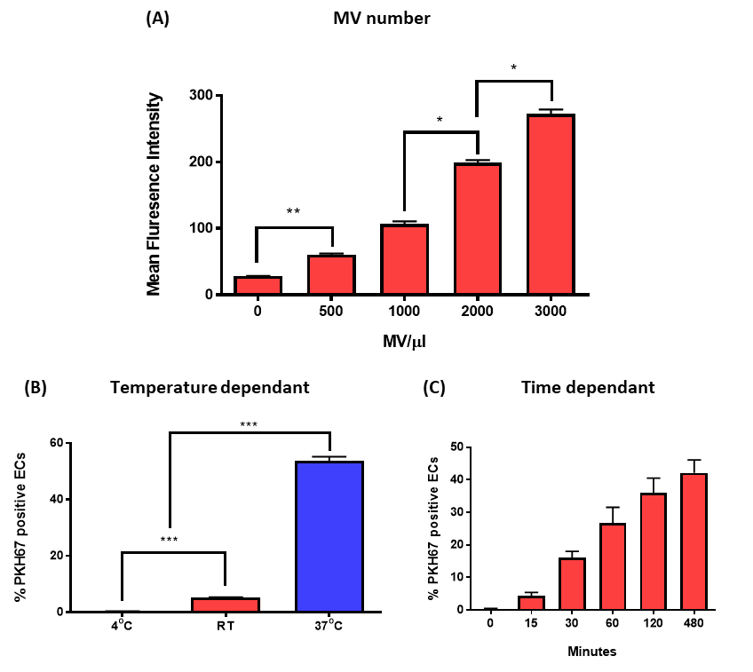
Figure 6.5 – Time, number and temperature dependant nature of microvesicle internalisation: HCAECs were cultured in a 24 well plate. Internalisation of PKH67-labelled MVs was determined using flow cytometry. Fluorescence of adherent MVs was quenched with trypan blue. (A) Quantification of the effect of number on MV internalisation, incrementally increasing MVs were incubated with HCAECs for 2 h. (B) Quantification of effect of temperature on MV internalisation. MVs (2 x 10³/µl) were incubated with HCAECs at 4ºC, room temperature and 37ºC (5% CO₂) for 2 h. (C) Analysis of internalisation time course. MVs (2 x 10³/µl) were incubated with HCAECs at time intervals between 0 - 480 min. Data is presented as mean ± SEM (n=3) and analysed for statistical significance by one way ANOVA with Tukey’s test for multiple comparisons, *p<0.05, ***p<0.001

6.3.5 Optimisation of the dose of pathway-specific inhibitors of internalisation - HCAEC viability following treatment with monodansylcadaverine, genistein or EIPA
A number of different pathways for the internalisation of MVs by donor cells have been identified. The most commonly cited mechanisms include clathrin-mediated endocytosis, caveolin-mediated endocytosis and macropinocytosis. In order to determine whether these pathways were involved in the internalisation of neutrophil-derived MVs by HCAECs, we adopted a chemical inhibitor based approach. We therefore wanted to determine cell viability in response to each inhibitor.
The data summarised in Figure 6.6 show the level of cell viability following incubation with chemical inhibitors across a range of concentrations. Cell viability of greater 90% was considered appropriate for future assays. The optimal concentration of inhibitors to be used in subsequent experiments was found to be: monodansylcadaverine (inhibitor of clathrin-mediated endocytosis) 50 μg/ml (Figure 6.6A), genistein (caveolin-mediated endocytosis) 50 μg/ml (Figure 6.6B); EIPA 25 μg/ml (Figure 6.6C).

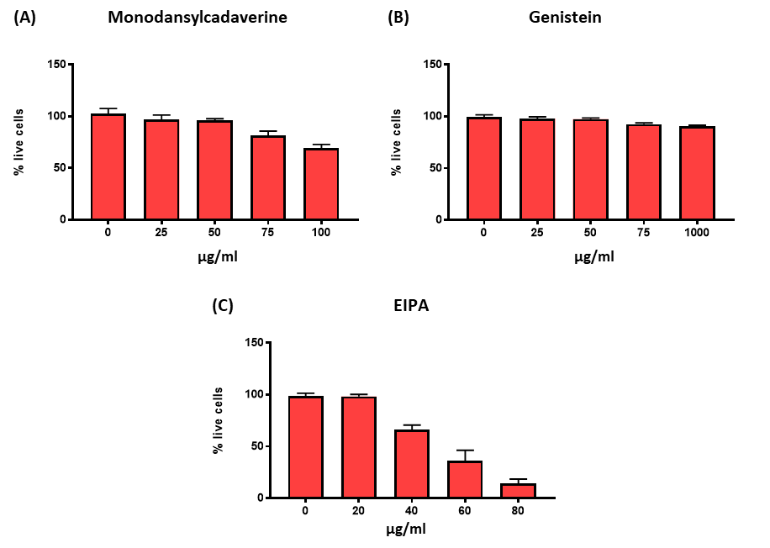
Figure 6.6 – HCAEC viability following treatment with pathway-specific inhibitors of internalisation: HCAECs were cultured in a 24 well plate. HCAECs were incubated with increasing concentration of pharmacological/chemical inhibitors of internalisation for 1 h at 37ºC. Cell viability was determined using the trypan blue exclusion method. Quantification of HCAEC viability treated with monodansylcadaverine (A), genistein (B), EIPA (C). Data are presented as mean ± SEM (n=3), greater than 90% cell viability was determined as tolerated by HCAECs.

6.3.6 Optimisation of the dose of pathway-specific inhibitors of internalisation –positive controls for specific pathway inhibition
In order to determine whether the selected inhibitors specifically inhibited the pathways intended, FITC-labelled positive controls of the pathways were analysed. Positive controls were identified from the literature. Transferrin is internalised by clathrin-mediated endocytosis (Lakadamyali et al., 2006), while Cholera-toxin (subunit B) is internalised by caveolin-mediated endocytosis (Torgersen et al., 2001) and Dextran (70,000 MW) is internalised by macropinocytosis (Muro et al., 2006).
The data summarised in Figure 6.8 show the incubation of each positive control with the inhibitor representative of each pathway. Monodansylcadaverine (50 µg/ml) significantly inhibited the internalisation of FITC-transferrin (Figure 6.8A), genistein (50 µg/ml) significantly inhibited FITC-cholera toxin internalisation (Figure 6.8B), and EIPA (25 µg/ml) significantly inhibited FITC-dextran internalisation (Figure 6.8C). Additionally when each inhibitor was incubated with the negative controls (controls of other pathways) no significant reductions in the level of internalisation were observed.
These data demonstrate that each of the inhibitors have pathway specific effects and were appropriate to use to investigate the mechanisms of MV internalisation by HCAEC.

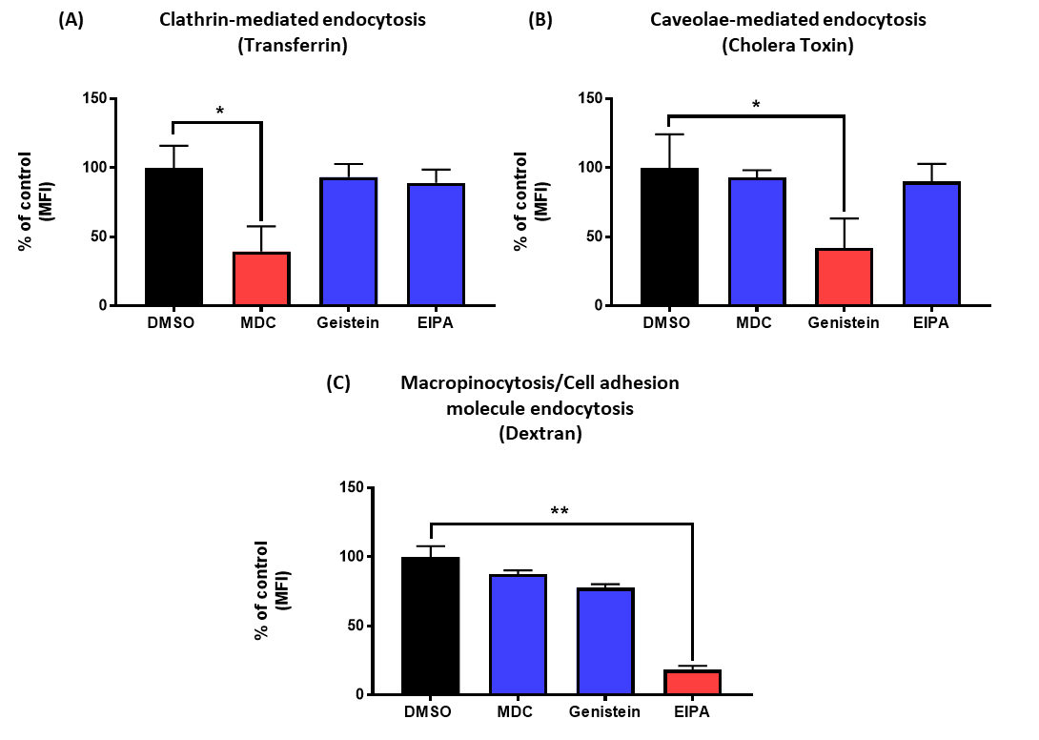
Figure 6.7 – Positive/negative controls of pathway specific inhibitors of internalisation: HCAECs were cultured in a 24 well plate. HCAECs were treated with chemical inhibitors of clathrin-dependent endocytosis (monodansylcadaverine), caveolin-dependent endocytosis (genistein) and macropinocytosis (EIPA) for 1 h. Cells were washed in PBS and then incubated with their appropriate controls, FITC-labelled transferrin (A), FITC-labelled cholera toxin subunit-b (B), FITC-labelled dextran (C) for 2 h. Fluorescence of any adherent controls was quenched with trypan blue. Quantification of internalisation was determined by mean fluorescence intensity and results normalised to the percentage of -untreated control. Positive controls for each specific pathway are in red, the negative controls for this pathways are in blue. Data are presented as mean ± SEM (n=3) and analysed for statistical significance by one way ANOVA with Tukey’s test for multiple comparisons, *p<0.05, **p<0.01.

6.3.7 Inhibition of microvesicle internalisation by pathway specific inhibitors
Having established the ability of the selected inhibitors to reduce internalisation via specific pathways, the role of these endocytic pathways in the internalisation of neutrophil-derived MVs was investigated.
The data summarised in Figure 6.8 show the quantification of MV internalisation by HCAECs treated with pathway specific inhibitors. Monodansylcadaverine and genistein had no effect on MV internalisation compared to concentration matched DMSO control. These findings highlight that clathrin or caveolin-mediated endocytosis pathways are not involved in the internalisation of neutrophil-derived MVs. Interestingly, we identified that treatment of HCAECs with EIPA, reduced internalisation by 73% compared to DMSO matched controls.
These findings indicate that epithelial sodium channel inhibitor, EIPA, can reduce MV internalisation by HCAECs, suggestive that macropinocytosis and/or cell adhesion molecule mediated endocytosis (CAM-endocytosis) may be involved in MV internalisation.

Figure 6.8 – Inhibition of microvesicle internalisation by pathway specific inhibitors: HCAECs were cultured in a 24 well plate. HCAECs were treated with chemical inhibitors of clathrin-dependent endocytosis (monodansylcadaverine), caveolin-dependent endocytosis (genistein) and macropinocytosis (EIPA) for 1 h. The cells were washed with PBS and incubated with PKH67-labelled MVs (2 x 10³/µl) for 2 h. Internalisation of MVs was determined using flow cytometry. Fluorescence of any adherent MVs was quenched with trypan blue. (A) Quantification of MV internalisation determined by mean fluorescence intensity, results are normalised to the percentage of DMSO control. Data are presented as mean ± SEM (n=3) and analysed for statistical significance by one way ANOVA with Dunnetts test for multiple comparisons, *p<0.05.

6.3.8 Optimisation of the dose of pathway-specific inhibitors of internalisation - HCAEC viability following treatment with Dynasore or Wortmannin
EIPA is associated with the inhibition of macropinocytosis. In addition to this, Muro et al (2003, 2006) identified that EIPA was also associated with inhibiting internalisation of nanobeads via an ICAM-1 dependant, cell adhesion molecule mediated endocytosis. As such, to further delineate the specific pathway involved in MV internalisation, inhibitors that are capable of blocking specific elements of these two different pathways were identified. Dynasore is a selective inhibitor of the membrane cleavage protein dynamin-2, although this protein is involved in both clathrin and Caveolae-mediated endocytosis, it is involved in CAM-mediated endocytosis but not macropinocytosis. Wortmannin is a selective inhibitor of PI3K. PI3K is involved in the regulation of internalisation in clathrin and caveolin-mediated endocytosis; however additionally these molecules are involved in the regulation of ruffle formation during macropinocytosis, but are not involved in CAM-mediated endocytosis. As with previous experiments, it was first determined that each of these inhibitors did not affect the viability of HCAECs.
The data summarised in Figure 6.9 show the level of cell viability following incubation with Dynasore (dynamin-2 inhibitor; Figure 6.9A) or Wortmannin (PI3K inhibitor; Figure 6.9B) across a range of concentrations. Cell viability greater than 90% was considered appropriate for future assays. We identified that the optimal concentration to ensure cell ability in our assays were 100 μg/ml for Dynasore and 1 μg/ml for Wortmannin.

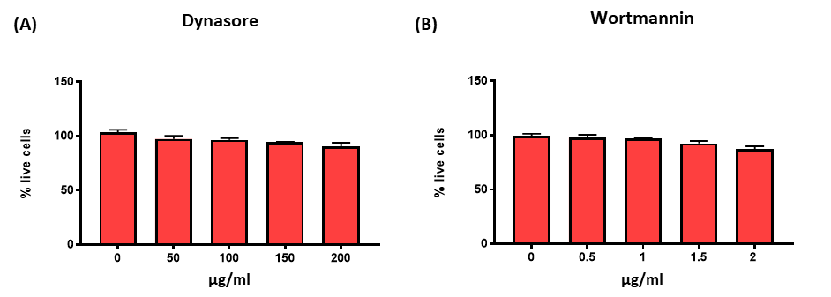
Figure 6.9 – HCAEC viability following treatment with chemical inhibitors of internalisation: HCAECs were cultured in a 24 well plate. HCAECs were incubated with increasing concentration of pharmacological/chemical inhibitors of internalisation for 1 h at 37ºC. Cell viability was determined using the trypan blue exclusion method and quantified after treatment with dynasore (A) and wortmannin (B). Data are presented as mean ± SEM (n=3), greater than 90% cell viability was determined as tolerated by HCAECs.

6.3.9 Optimisation of the dose of pathway-specific inhibitors of internalisation –positive controls for macropinocytosis and CAM-mediated pathway inhibition
Having established an optimal concentration for dynasore and wortmannin with respect to HCAEC viability, control experiments were performed to identify that these inhibitors could prevent internalisation. These were performed using FITC-transferrin. Transferrin is internalised by a clathrin-dependant, dynmin-2 dependant and PI3K dependant pathway and as such should be inhibited by both dynasore and wortmannin.
The data summarised in Figure 6.10 show the quantification of each inhibitor with a positive control specific to this pathway. We identified that both dynasore (Figure 6.10A) and wortmannin (Figure 6.10B) inhibited the internalisation of FITC-transferrin compared to a DMSO control.
These data highlight that both Dynasore and Wortmannin can inhibit internalisation of positive controls by HCAECs at the concentrations used in the current assay.

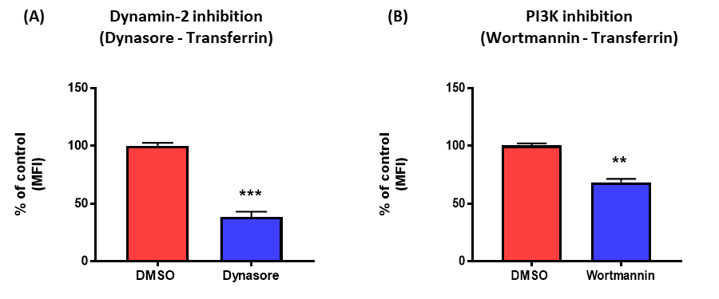

Figure 6.10 – Positive controls of chemical inhibitors of internalisation: HCAECs were cultured in a 24 well plate. HCAECs were treated with Dynasore (A) and Wortmannin (B)
for 1 hour. The cells were washed with PBS and incubated with FITC-labelled transferrin for 2 hours. Internalisation of MVs was determined using flow cytometry. Fluorescence of any adherent MVs was quenched with trypan blue. (A) Quantification of FITC-transferrin internalisation following treatment with dynasore. (B) Quantification of FITC-transferrin internalisation following treatment with wortmannin. Internalisation was determined by mean fluorescence intensity, results are normalised to the percentage of untreated control. Data are presented as mean ± SEM (n=3) and analysed for statistical significance by paired t-test, **p<0.01. ***p<0.001

6.3.10 Inhibition of microvesicle internalisation by Dynasore and Wortmannin
The involvement of macropinocytosis or CAM-mediated endocytosis in the internalisation of neutrophil-derived MVs was determined.
The data summarised in Figure 6.11 show the quantification of MV internalisation by HCAECs treated with Dynasore (Figure 6.11A) and Wortmannin (Figure 6.11B). We identified that Dynasore inhibited the internalisation of neutrophil-derived MVs by 58% compared to DMSO control. Additionally, Wortmannin was found to reduce internalisation of neutrophil-derived MVs by 35% in comparison to a DMSO matched control.
These findings indicate that either neutrophil-derived MVs are internalised by a previously undescribed mechanism that involves epithelial sodium channels, dynamin-2 and PI3K in its molecular mechanism; or that both macropinocytosis and CAM-mediated endocytosis are involved in the internalisation of neutrophil-derived MVs.

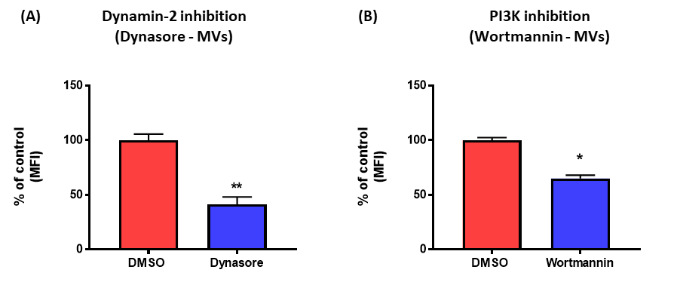

Figure 6.11 – Inhibition of microvesicle internalisation by chemical inhibitors: HCAECs were cultured in a 24 well plate. HCAECs were treated with chemical inhibitors of dynamin-2 (A; dynasore) and PI3K (B; wortmannin) for 1 h. The cells were washed with PBS and incubated with PKH67-labelled MVs (2 x 10³/µl) for 2 h. Internalisation of MVs was determined using flow cytometry. Fluorescence of any adherent MVs was quenched with trypan blue. Quantification of MV internalisation determined by mean fluorescence intensity, results are normalised to the percentage of DMSO control. Data are presented as mean ± SEM (n=3) and analysed by paired t-test, *p<0.05, ***p<0.001

6.3.11 The role of F-actin in microvesicle internalisation
Actin polymerisation is an important feature of most endocytotic pathways. In almost all endocytic pathways, RhoA dependant reorganisation of the cells actin cytoskeleton is a critical factor in allowing internalisation. Interestingly, despite the involvement of actin polymerisation in both macropinocytosis and CAM-mediated endocytosis, the formation of actin cups around the engulfed endocytic cargo, only occurs when macropinocytosis was the mechanism of uptake. Therefore the involvement of actin polymerisation in the process of MV uptake was assessed.
The data summarised in Figure 6.12A show the quantification of cell viability following incubation with cytochalasin D across a range of concentrations. Cell viability greater than 90% was considered appropriate for future assays. The optimal concentration to ensure cell viability was 100 μg/ml.
Additionally, as summarised in Figure 6.12B MV internalisation by HCAECs treated with cytochalsin D was quantified. It was found that cytochalasin D inhibited the internalisation of neutrophil-derived MVs by 50%.
These findings confirm the role of actin polymerisation in the internalisation of neutrophil-derived MVs by HCAECs.

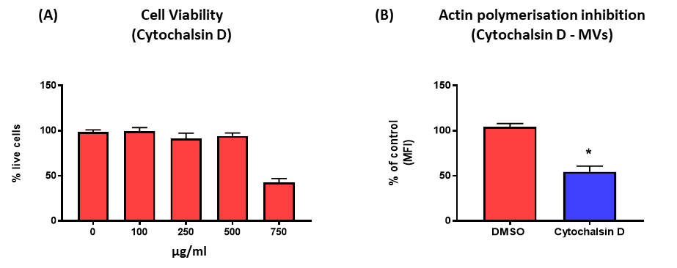
Figure 6.12 – The role of F-actin polymerisation in MV internalisation: To determine cell viability (A), cells were cultured in a 24 well plate. HCAECs were incubated with increasing concentration of cytochalasin D for 1 h at 37ºC. (A) Quantification of HCAEC viability. HCAECs were incubated with increasing concentration of cytochalasin D for 1 h at 37ºC. Cell viability was determined using the trypan blue exclusion method. To determine MV internalisation (B), HCAECs were cultured in a 24 well plate. HCAECs were treated with Cytochalasin D for 1 h. The cells were washed with PBS and incubated with PKH67-labelled MVs (2 x 10³/µl) for 2 h. Internalisation of MVs was determined using flow cytometry. Fluorescence of any adherent MVs was quenched with trypan blue. (B) Quantification of MV internalisation determined by mean fluorescence intensity, results are normalised to the percentage of DMSO control. Data are presented as mean ± SEM (n=3) and analysed by paired t-test, *p<0.05,

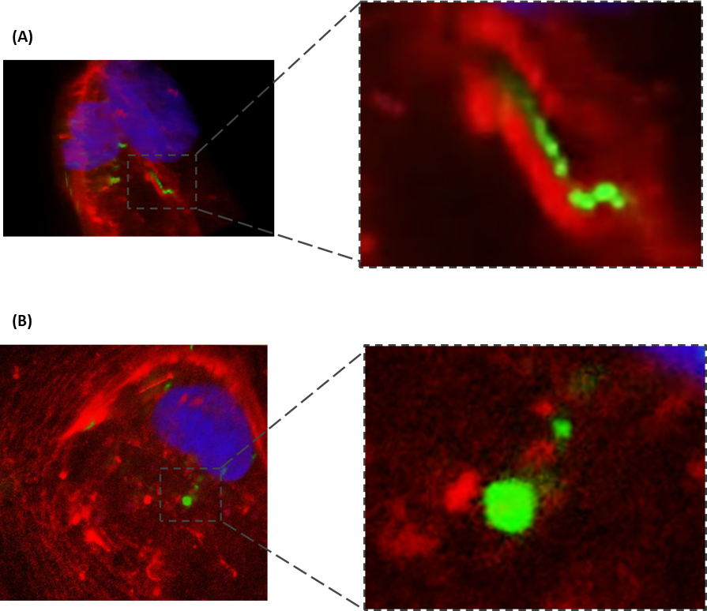

Figure 6.13 Live-cell imaging of co-localisation of microvesicles with F-actin: HCAECs were cultured on glass bottom Ibidi µ-chambers. Live HCAECs were stained with SiR-Actin (live F-actin label; Red) and Hoechst 33342 (live nuclear label; blue) and incubated with PKH67-labelled MVs. Images of MV internalisation were acquired in real time at x100 magnification. An additional 15x zoom was performed during image analysis.

6.3.12 Internalisation of microvesicles by HCAECS pre-conditioned under flow
MVs preferentially interact with endothelial cells exposed to low oscillatory wall shear stress. A limitation of the experiments in chapter 4 is that microscopy based techniques could not distinguish adhesion from internalisation. Therefore this flow cytometry based internalisation assay was utilised to determine whether preferential interaction resulted in greater levels of internalisation by HCAECs.
The data summarised in Figure 6.14 show representative histograms (Figure 6.14A) and quantification (Figure 6.14B) of MV internalisation by cells conditioned static, low oscillatory and high unidirectional wall shear stresses. The quantification of these findings revealed that MV internalisation closely correlated to levels of interaction observed in Figure 4.6. MV internalisation by cells cultured under high unidirectional wall shear stress were significantly reduced compared to both statically cultured HCAECs and those cultured under low oscillatory wall shear stress.
These findings highlight that MVs both preferentially interact with, but also are internalised by endothelial cells that are cultured under low oscillatory wall shear stress. Given the significance of ICAM-1 in adhesion of MVs, these findings may highlight a significant role of ICAM-1 also in internalisation by HCAECs.

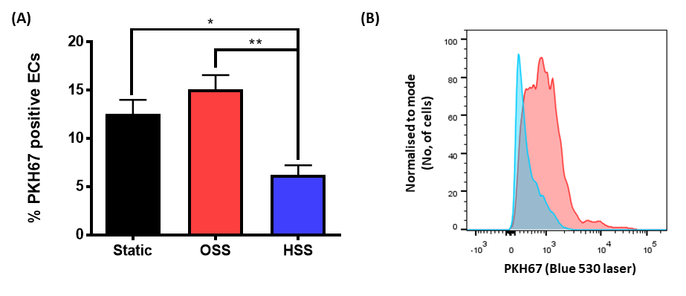
Figure 6.14 – Internalisation of microvesicles by HCAECs pre-conditioned under flow: HCAECs were cultured under low oscillating wall shear stress or high unidirectional shear stress or static conditions for 72 h. Following culture under flow or static conditions the media was changed to media containing PKH67-labelled MVs (1 x 10³/µl) and incubated under static conditions for 2 h. Following incubation, the cells were washed in PBS and detached by trypsinisation. Internalisation of MVs by HCAECs was determined by flow cytometry. (A) Quantification of MV internalisation presented as the percentage of HCAECs positive for internalised MVs. (B) Representative histogram of internalisation by OSS (red) and HSS (blue) cultured HCAECs. Data are presented at mean ± SEM (n=3) and analysed for statistical significance by one-way ANOVA with Tukey’s test for multiple comparisons, *p<0.05, **p<0.01.

6.3.13 The role of ICAM-1 internalisation in the internalisation of microvesicles by HCAECS – extracellular domain
Experiments using chemical inhibitors infer the possible use of an ICAM-1 dependant endocytic pathway in the internalisation of neutrophil-derived MVs. In order to address this possibility further, the effect of inhibiting receptor-ligand interactions with ICAM-1 on the uptake of MVs by HCAECs was determined. HCAECs were incubated with antibodies blocking the adhesive functions of the extracellular domain of ICAM-1 before incubation with MVs. In addition we incubated cells with TNF-α, as this is a known agonist of the NF-κB pathway through which ICAM-1 expression is regulated; and also with EDTA, a chelator of extracellular calcium, as cross-linking ICAM-1 and the subsequent cytoskeleton rearrangements during lymphocyte transmigration is dependent upon calcium signalling (Etienne-Manneville et al., 2000).

The data summarised in Figure 6.15 shows the quantification of internalisation following treatment with antibodies against ICAM-1, TNF-α and EDTA. Anti-ICAM-1 and EDTA inhibited the internalisation of MVs by 29% and 53.7%, respectively. Despite an increase of 31% on the level internalisation by HCAECs, TNF-α did not have a significant effect on internalisation. Post-hoc effect size calculations comparing TNF-α to control releveled an effect size of 0.44 suggesting a ‘medium’ effect on MV uptake by HCAECs. These findings are likely due by the level of donor variability in the response to treatment with TNF-α, with the standard error of the mean increasing from 0.58 to 35.65 between control and TNF-α groups, respectively.
The data indicate that blocking the extracellular functions of ICAM-1 inhibit the ability of MVs to be internalised by ICAM-1.

Figure 6.15 – The role of interactions with ICAM-1 in the internalisation of MVs by HCAECs: HCAECs were cultured in a 24 well plate and incubated with or without TNF-α, a blocking antibody against ICAM-1, or EDTA for 1 h. The cells were washed with PBS and incubated with 2 x 10³ PKH67-labelled MVs/µl for 2 h. Internalisation of MVs was determined using flow cytometry. Fluorescence of adherent MVs was quenched with trypan blue. (A) Quantification of MV internalisation determined by mean fluorescence, results are normalised to the percentage of untreated control. Data are presented as mean ± SEM (n=4) and analysed for statistical significance by one way ANOVA with Dunnetts test comparing all samples to control, *p<0.05, **p<0.01.

6.3.14Optimisation of transfection of Chinese hamster ovarian cells - viability and GFP uptake using different transfection methods
In order to further assess the role of ICAM-1 in the internalisation of neutrophil-derived MVs, a CHO cell model was used to determine the role of the intracellular domain of ICAM-1 in internalisation. CHO cells do not express ICAM-1, and were transfected with wild-type ICAM-1 molecules, a truncated ICAM-1 molecule which did not have an intracellular domain and an ICAM-1 molecule lacking the ability to signal despite still having an intracellular domain. To perform these experiments the most efficient method of transfection of CHO cells was identified.
The data summarised in Figure 6.16 shows the CHO cell viability and GFP uptake following transfection using lipofectamine 3000, Polyfect, and Dharmafect methods. Dharmafect was the most efficient transfection method for transfecting GFP. In addition the optimal concentration of plasmid, as determined by the cell viability was 5µM of plasmid per well.. .
These data that Dharmafect was the most efficient method for the transfection of CHO cells and would be used in future experiments for the transfection of ICAM-1 molecules.

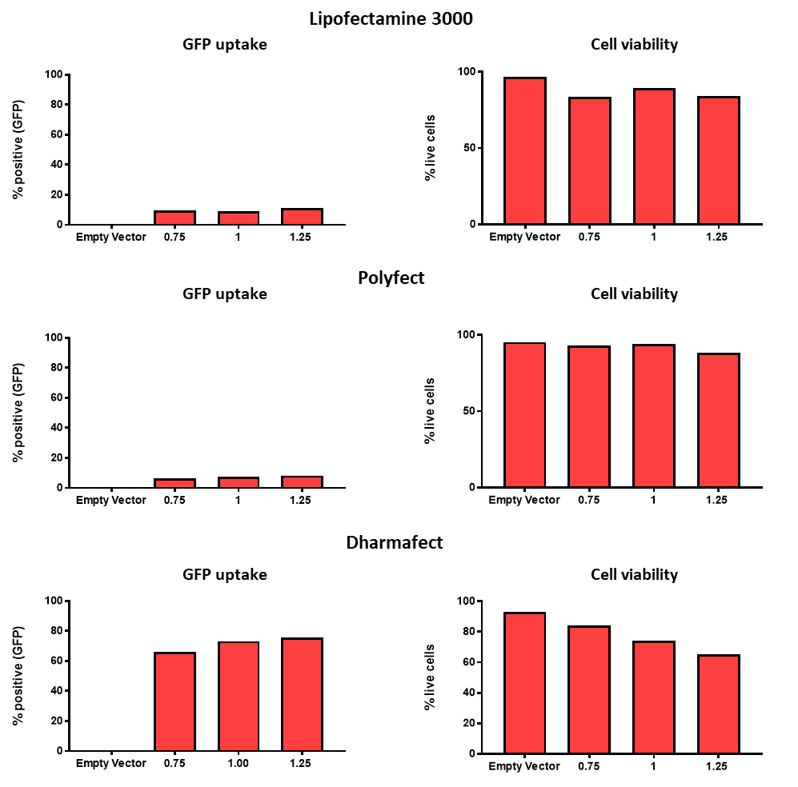

Figure 6.16 CHO cell viability and GFP uptake using different transfection methods: CHO cells were cultured in 24 well plates before transfection of GFP using 3 methods of transfection. Each was performed following the manufactures guidelines, with three different concentrations of plasmids (2.5 µM, 5 µM and 7.5 µM per well). Cell viability was determined using TO-PRO-3 iodide and the level of GFP uptake used to determine transfection efficiency (n = 1).

6.3.15 The role of ICAM-1 internalisation in the internalisation of microvesicles by HCAECS – intracellular domain
The Dharmafect method of transfection was used to insert wild type ICAM-1 (expressing all domains), a truncated version of ICAM-1 (lacking the intracellular domain), and an ICAM-1 molecule unable to signal due to the phosphorylation of a tyrosine residue into CHO cells. In order to determine the effect of this on internalisation, the cell surface expression of ICAM-1 using a fluorescent extracellular antibody or incubated the cells with MVs was assessed.
The data summarised in Figure 6.17 show both the extracellular expression of ICAM-1 (Figure 6.17B) and the MV internalisation normalised to the level extracellular ICAM-1 expression (Figure 6.17C). We identified no difference in the level of internalisation between the three transfected molecules of ICAM-1.
These data indicate either that the intracellular domain of ICAM-1/ICAM-1 signalling is not crucial to the internalisation of neutrophil-derived MVs; or that this CHO cell model may not be an appropriate model for determining the mechanisms of MV internalisation by HCAECs. The literature regarding the internalisation of MVs highlights a large level of heterogeneity in the method of uptake dependent upon the donor and recipient cells. Therefore penetratin-linked peptides that inhibited the intracellular domain of ICAM-1 in HCAECs were used. Penetratin is a short peptide that allows uptake into the cell, allowing the delivery of blocking peptides to intracellular molecules. These peptides were kindly provided by Dr. Patric Turowski (University College London).
The data summarised in Figure 6.18 show the effect of penetratin-linked peptides targeting the intracellular domain of ICAM-1 (ICP-1 and ICP-2), an irrelevant penetratin linked peptide and a DMSO control on MV internalisation. All penetratin-linked peptides appeared to reduce the level of internalisation compared to the DMSO only control. Despite not being statistically significant we observed a reduction in the level of internalisation by 42.5% and 22.0% when HCAECs were incubated with ICAM-1 ICP-1 and ICP-1 compared to the irrelevant peptide control.

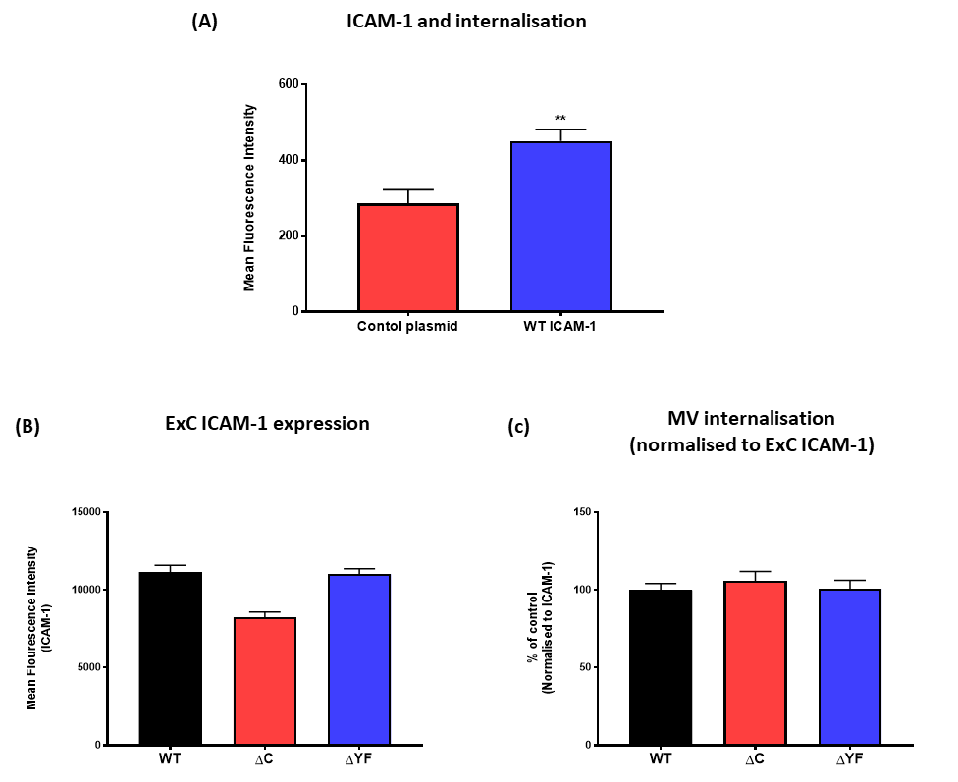
Figure 6.17 – The role of the intracellular domain of ICAM-1 in internalisation of microvesicles by Chinese Hamster Ovarian cells: CHO cells were cultured in a 24 well plate. Plasmids containing wild type ICAM-1, ICAM-1 lacking the cytosolic domain and ICAM-1 lacking the ability to signal via its cytosolic domain were incubated with Dharmafect reagent. CHO cells were incubated with the plasmids for 24 h. The cells were washed with PBS and incubated with PKH67-labelled MV (2 x 10³/µl) for 2 h. The cells were detached by trypsinisation (1:5 dilution), and then incubated with fluorescently labelled ICAM-1 antibody targeted to the extracellular domain. WT-ICAM-1 was compared to a control plasmid in the uptake of MVS (A), additionally the total ICAM-1 expression (B) and internalisation of MVs with all three ICAM-1 molecules (B) was determined using flow cytometry. Data are presented as mean ± SEM (n=4) and analysed for statistical significance by one way ANOVA with Dunnetts test comparing all samples to control.

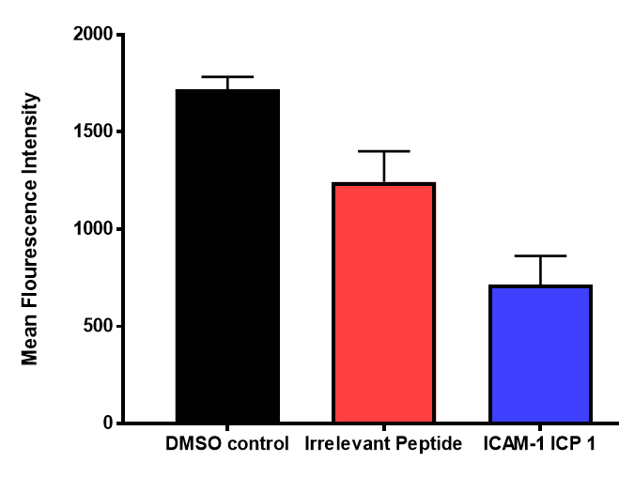
Figure 6.18 – The role of ICAM-1 signalling on microvesicle internalisation by HCAECs: HCAECs were cultured in a 24 well plate. HCAECs were treated with or without a penetratin-linked blocking antibody targeting the cytosolic domain of ICAM-1 (ICP 1) or with an irrelevant peptide. The cells were washed with PBS and incubated with PKH67-labelled MV (2 x 10³/µl) for 2 h. Internalisation of MVs was determined using flow cytometry. Fluorescence of any adherent MVs was quenched with trypan blue. Internalisation was determined by mean fluorescence intensity, results are normalised to the percentage of untreated control. Data are presented as mean ± SEM (n=4) and analysed for statistical significance by one way ANOVA with Dunnetts test comparing all samples to irrelevant peptide control.

6.3.16 Microvesicle delivery of neutrophil-derived miR-155 to HCAECs

In Figure 3.7 it was identified that MVs produced following HFD had an increased propensity to induce inflammation in HCAECs. Given the ability of HCAECs to internalise MVs (as described above), it was hypothesised that that this increased level of activation may be a result of increased delivery of content to these cells. A number of studies have identified that the delivery of extracellular content to recipient cell is an important mechanism through which they impart their biological effects (Valadi et al., 2007, Alvarez-Erviti et al., 2011, Zhou et al., 2016) One mechanism through which this may occur is through the delivery of miRs. Upon activation, neutrophils up-regulate a number of miRs, importantly this includes miR-155 (Hessam et al., 2017). MiR-155 has been heavily implicated in vascular inflammation (Guedes et al., 2014, Barker et al., 2017) and has previously been identified in circulating MVs of patients with acute coronary syndrome (Diehl et al., 2012). In order to determine whether miRs may be delivered to HCAECs in this model, the level of miR-155 in plasma MVs pre and post HFD were determined. Following this, MVs isolated from neutrophils were incubated with HCAECs to determine whether mir-155 may be transferred to these cells.

The data summarised in Figure 6.19A show the effect of HFD on the level of miR-155 expression in circulating plasma MVs. We observed a 0.9 fold increase in the expression of miR-155 in circulating plasma MVs following HFD. Next, MVs were isolated from neutrophils pre and post HFD and incubated with HCAECs. We observed that both pre and post HFD MVs increased the expression of miR-155 in HCAECs. Importantly, HFD was associated with almost 6.2 fold increase in the level of miR-155 in these cells, compared to MVs pre-HFD.

These data indicate that more miR-155 is present in MVs post-HFD, this was also associated with increased expression of miR-155 in HCAECs that had been incubated with MVs produced the high-fat intervention. Although these data are suggestive that miR delivery may be a mechanism, induction of this miR within the endothelial cells may also contribute to the observed increase. Further investigation using antago-miRs to inhibit endogenous production of miR-155 are required to show that delivery is the important factor.

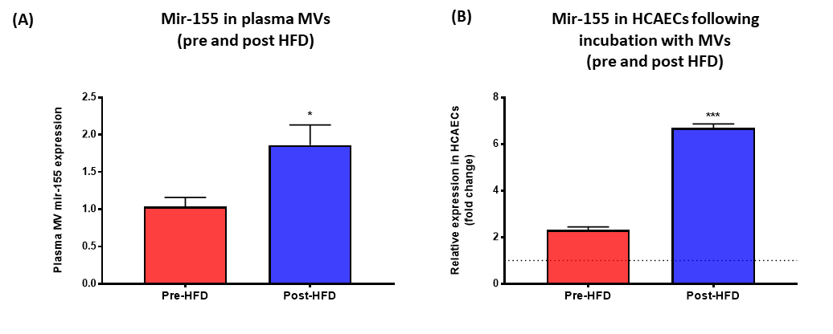
Figure 6.19 Microvesicle delivery of neutrophil-derived miR-155 to HCAECs: Healthy human participants were fed on a high-fat diet for 7 days. (A) Plasma was collected from each participant pre and post HFD, and MVs isolated by centrifugation at 20,000 for 30 minutes. The expression of mir-155 in the total circulating MVs was then determined using qPCR. (B) Additionally, neutrophils were isolated from each participant pre and post HFD, and stimulated to produce MVs with fMLP for 1 hour. MVs (2 x 10³/μl) from neutrophils pre and post HFD were incubated with HCAECs for 4 hours. The cells were collected and miR-155 expression in the HCAECs was determined using qPCR. Data was normalised to the level of mir-155 in HCAECs only (dashed line). Data are presented as mean ± SEM (n=3-5) and statistical significance analysed by paired t-test. *p<0.05, ***p<0.001. (qPCR of microRNAs were kindly performed by Dr. Jessica Johnson).

6.3 Conclusions
1 – MVs are internalised by HCAECs via active processes.
2 – Multiple mechanisms are involved in the internalisation of MVs and these appear to be primarily dependent upon macropinocytosis and CAM-endocytosis.
3 – ICAM-1 may have a direct role in the internalisation of MVs.
4 – Internalisation may result in the transfer of neutrophil-derived miR-155 to HCAECS.

6.4 Discussion
The current study is the first of its kind to attempt to determine the molecular mechanisms/endocytic pathways through which neutrophil-derived MVs are internalised by endothelial cells. MV internalisation is likely to occur via multiple mechanisms, including macropinocytosis but also CAM-mediated endocytosis that may be dependent upon the expression of ICAM-1. Given the focal distribution of ICAM-1 at sites of disturbed flow, the ability of these cells to utilise an ICAM-1 dependant mechanism for MV internalisation, may provide a valuable target for future delivery of therapeutics specifically to these regions.
Microvesicle internalisation by endothelial cells
In order to determine whether neutrophil-derived MVs were internalised by HCAECs, I collaborated with experts at the University of Maastricht to perform live-cell staining of HCAECs to observe interactions occurring in real-time. This technique allowed visualisation of both the time course of internalisation, quantification of internalised MVs and observation of localisation within the cell. Although these mechanisms provide a useful tool to confirm that MVs are internalised by HCAECs, accurate quantification that is reflective of the whole population using this method is difficult, due to limitations of the number of cells (3-5 cells) per incubation. A flow cytometry based method was developed to allow accurate quantification of the level of internalisation by endothelial cells. The assay developed was adapted from phagocytosis assays that use this technique to quantify uptake (Lehmann et al., 2000). An important feature of this assay was to ensure that the signal detected came only from internalised MVs. In order to prevent signal from MVs that may be adherent to endothelial cells following lifting from the plate, the cells were treated with trypan blue to quench external fluorescence.
Endocytic mechanisms of microvesicle internalisation
Endocytosis is a critical process of living cells and is required for the uptake of nutrients, regulation of cell volume and the regulation of receptor mediated signalling on the cell membrane. In the current model, I propose that neutrophil-derived MVs utilise endocytic pathways for internalisation by HCAECs. This results in the delivery of their content including mRNA, proteins and microRNAs that drive inflammation in the endothelium. Traditionally, internalisation of macromolecules occurs via two main mechanisms; phagocytosis and pinocytosis (see Figure 6.1). Phagocytosis however is generally associated with engulfment of large (> 1 µM) bodies, including bacteria, during host defence, and is generally reserved for use by specialist phagocytic cells. Using both tuneable pulse sensing and nanoparticle tracking analysis the modal diameters of neutrophil MVs was determined to be between 200-250 nm (see Figure 2.3-4). Given these factors pinocytosis mechanisms of uptake were focussed on as they are likely to be the most significant mechanisms of MV internalisation. Pinocytosis refers to fluid-phase uptake of molecules, and can occur via both adsorptive pinocytosis, this is known as macropinocytosis and is non-discriminative of the endocytotic cargo; or via receptor-mediated pinocytosis pathways, that require receptor-ligand interactions to initiate internalisation. Receptor mediated endocytosis can be split further into a number of different pathways; traditionally clathrin and caveolea mediated endocytosis are well described mechanisms of uptake by endothelial cells. A previous study looking at the effects of size on the mechanism of internalisation of latex beads identified that a shift on the reliance of clathrin to caveolea based pathways occurred as the latex beads increase in size from <200 nm to 500nm (Rejman et al., 2004). In addition to these receptor mediated pathways, Muro et al., (2005) identified the existence of ICAM-1 and PECAM-1 (Garnacho et al., 2008) dependent CAM-mediated endocytic pathways. Interestingly these pathways were associated with the internalisation of antibody coated polystyrene beads between 100-300 nm in diameter. Given the sizes of the MVs described in the current study, it was important to determine whether any or all of these major pathways could be involved in the internalisation of MVs by HCAECs.
The current study employed a chemical inhibitor approach to assess the roles of specific pathways and specific features of these pathways where required. Chemical inhibitor based system have a number of benefits that make them useful tools for the study of internalisation. Firstly, the inhibitor is incubated with the cells dispersed in the cells media and as such, the effects of the inhibitor should result in uniform inhibition across the whole population of cells. In addition to this, the viability of the cells can be closely controlled by titration of the chemical to ensure it is not affecting apoptotic processes in the cell. The initiation of apoptosis heavily influences actin remodelling as well as membrane permeability, and as such these processes may bias the findings. Also, unlike methods for the study of internalisation such as siRNA knockdown of molecules in a given pathway, the immediate incubation of the inhibitor with cells prior to the incubation with MVs means that the cells are unlikely to develop compensatory mechanisms to account for the redundancy of a molecule in the silenced pathway. This may reduce the ability of knockdown based models to observe true physiological effects in the assay. Despite these benefits for the use of inhibitors, it is important to note the limitations of inhibitor based models. Chemical inhibitors are often associated with off target or whole cell effects that can reduce their specificity to a pathway. Where possible, inhibitors selected were selected based on their potential off-target effects or being cited as highly specific to a single pathway (see table 6.1). In order to corroborate findings of the current study, a combination of inhibitor and siRNA knockdown techniques should be performed. However, as discussed in Chapter 4, the use of HCAEC prevents using transfection techniques such as electroporation, as these techniques are associated with high levels of apoptosis and necrosis in this cell type. Although these experiments could be performed in HUVECs, a cell type that is more easily transfected, the highly heterogeneous nature of the pathways that utilised to uptake MVs (Mulachy et al., 2014), mean that findings from these experiments may not directly translate to those observed in the adult, arterial and disease relevant cell type used in the current model.
Initial experiments were aimed to determine whether the major pathways of internalisation by endothelial cells, clathrin-mediated, caveolin mediated endocytosis or macropinocytosis were involved in the uptake of neutrophil-derived MVs (see Figure 6.2). In order to perform these experiments, the inhibitors genistein (for caveolea-mediated endocytosis), monodansylcadaverine (for clathrin-mediated endocytosis) and EIPA (for macropinocytosis and CAM-mediated endocytosis) were utilised. Genistein is a tyrosine kinase inhibitor that is able to block caveolea-mediated endocytosis that occurs specifically around cholesterol-rich lipid rafts (Puri et al., 2001, dos Santos et al., 2011). In addition to genistein, many studies have also utilised the polyene antibiotic, nystatin (Dobrinskikh et al., 2014, Singh et al., 2003, Chen et al., 2011), to inhibit this pathway. Interestingly however, when cells were treated with this inhibitor, high levels of cell death were observed and, without optimisation of the protocol, no reduction in the uptake of cholera toxin was observed. Following a further review of the literature, we identified that the mechanism of action of this inhibitor involve sequestering cholesterol from the lipid-rich domains of membrane (Chen et al., 2011). A limitation of this inhibitor is that it may also effect cholesterol levels throughout the membrane, and therefore affect membrane integrity and permeability. Given this, and the ability of genistein to specifically inhibit cholera toxin uptake, only on genistein was used as an inhibitor of caveolea-mediated endocytosis. Monodansylcadaverine is a highly cited inhibitor of clathrin-mediated endocytosis (Chen et al., 2009, Schlegel et al., 1982) and works through the stabilisation of clathrin-pits that engulf the endocytic cargo. Importantly, very few studies have identified inhibitory effects on the controls of either caveolea-mediated or macropinocytosis pathways (Ivanov 2008). This inhibitor was identified to efficiently block the internalisation of transferrin in our model, and as such was determined as a specific inhibitor of this pathway. The final inhibitor used in these initial experiments was the epithelial sodium channel inhibitors EIPA. Interestingly, despite being one of the oldest and best described mechanisms of entry in to a cell, few specific inhibitors of macropinocytosis have been identified. Amiloride, and derivatives of this molecule (that include EIPA), work through the inhibition of sodium-proton exchange channels expressed on endothelial cells, and have been traditionally used as inhibitors of micropinocytosis (Falcone et al., 2006). Of importance to the current study, is the growing body of literature that also implicate these channels in CAM-mediated processes (Garnacho et al., 2008, Muro et al., 2003, Muro et al., 2006, Stan, 2006). This chemical was therefore employed as an inhibitor of both these endocytic pathways. When incubated with dextran (70,000 MW), a significant reduction in the uptake of this molecule was observed, suggesting that this inhibitor was able to selectively inhibit the uptake of molecules known to be internalised by macropinocytosis (Muro et al., 2003, Muro et al., 2006).
The role of ICAM-1 in microvesicle internalisation by endothelial cells
The only inhibitor to reduce MV internalisation was EIPA. From this, it can be inferred that the mechanism of internalisation is independent of both clathrin and caveolea mediated mechanisms. Given the ability of EIPA to inhibit internalisation, further analysis of the pathway was required as the role of sodium epithelial channels has been described as a feature of both macropinocytosis and CAM-mediated endocytosis (see Figure 6.1). In order to distinguish between these pathways, the inhibitors Dynasore and Wortmannin were identified. Dynasore is a specific inhibitor of the cleavage protein dynamin-2. The role of dynamin-2 is in regulating the formation of endocytic vesicles, through fission of the membrane at the trailing edges of the vesicle (Grassart et al., 2014). Although this is a key feature of both clathrin and caveloe mediated endocytosis, the dependence on dynamin-2 is also observed in CAM-mediated endocytosis, but no macropinocytosis. When dynamin-2 was inhibited in HCAECs, we observed a 56% reduction in the internalisation of MVs, suggesting that MV internalisation occurred, at least in part, via a clathrin-independent, dynamin-2 dependant internalisation pathway. Despite these data suggesting the involvement of CAM-mediated endocytosis in MV uptake, this pathway appeared to not account for all MV internalisation. Therefore the PI3K inhibitor, Wortmannin, was used to further investigate the processes involved. Localised PI3K activation is known to drive Akt signalling that results in the arrest of macropinsome formation (Falcone et al., 2006), despite playing no role in the endocytosis by CAM-mediated process (Stan, 2006). Endothelial cells were therefore treated with wortmannin, and a 35% reduction was observed in the level of the MV internalisation, highlighting that macropinocytic pathways may also be occurring within the endothelial cells.
These findings from the inhibitor based experiments identified that multiple, independently contributing pathways may be involved in MV internalisation. Despite this, these results require further confirmation to determine conclusively that these pathways work simultaneously in the uptake of MVs. An important finding was that internalisation of MVs is inhibited by cytochalasin D, highlighting that actin polymerisation and cytoskeletal remodelling are important processes to internalisation. Importantly however, the role of actin is divergent across these two pathways. During macropinocytosis the endocytic cargo co-localises with actin, producing an actin cup around the vesicle, a process that does not occur in CAM-mediated endocytosis. As such, we aimed to detect this co-localisation in HCAECs. Interestingly, as can be seen in Figure 6.13, we did detect examples of co-localisation of MVs with F-actin. Despite this, these events were often difficult to distinguish, and super-resolution techniques such a stimulated emission depletion microscopy may be utilised in future experiments to increase the spatial resolution of the images obtained. Importantly, not all vesicles were observed to co-localisation with F-actin. A major benefit of imaging internalisation in real-time was that fixed time points were not required, which would make distinguishing whether MVs had ever co-localised with actin not possible.
Although these inhibitor based experiments suggest a number of similarities between MV internalisation and the pathways described by Muro et al (2003) for the uptake ICAM-1 coated immunobeads, further evidence is required to directly implicate ICAM-1 in the process of internalisation. To address the hypothesis that ICAM-1 may directly regulate MV internalisation it was determined whether blocking receptor-ligand interactions reduced internalisation. As can be seen in Figure 6.14, treatment with a blocking antibody against ICAM-1 reduced the level of MV internalisation. Interestingly, both preconditioning with low oscillatory wall shear stress and incubation with TNF-α increase the uptake of neutrophil-derived MVs. As identified in chapter 4, low oscillatory flow increased the expression of ICAM-1 and as such may be an important factor in the increased internalisation. In addition to this, although not reaching statistical significance, the treatment of endothelial cells with TNF-α (a known regulator of ICAM-expression) appeared to increase the level of internalisation in these cells, providing further evidence that ICAM-1 is an important factor to MV internalisation. Despite this indirect evidence, it is important to note that both flow and TNF-α are associated with actin cytoskeleton reorganisation (Peppelenbosch et al., 1999), and as such the increased uptake may not all be attributable to increased ICAM-1 expression. Despite these experiments supporting the role of ICAM-1 in internalisation, studies inhibiting extracellular domain or increasing the cell surface expression do not provide information about the pathway by which they are ultimately internalised, only that increased adhesion via this ligand means subsequent uptake is greater.
Given these findings it was determined whether the intracellular domain that regulates signalling via ICAM-1 played a significant role in MV internalisation. To develop these experiments, we collaborated with Dr Patric Turowski at University College London, whom kindly provided us with viral plasmids containing wild-type ICAM-1, truncated ICAM-1 that does not have an intracellular domain, and an ICAM-1 molecule with a phosphorylated tyrosine residue in the intracellular domain that therefore has reduced ability to signal. These were then transfected into CHO cells, a cell type that does not constitutively express ICAM-1. This model has been previously employed to determine the role of the ICAM-1 intracellular domain on the transmigration of lymphocytes through endothelial cells; the authors of this paper showed that each of the mutant molecules reduces ICAM-1 dependant RhoA signalling (Etienne-Manneville et al., 2000, Greenwood et al., 2003). In the current model it was observed that WT ICAM-1 increased the level of uptake compared to cells transfected with an empty plasmid (Figure 6.16a). However, when MV internalisation was normalised to level of extracellular ICAM-1 expression no difference between wild type and mutant ICAM-1 was identified (Figure 6.16c). It remains unclear by what pathway CHO cells use to internalise the neutrophil-derived-MVs. However Figure 16.6a highlights that a low level of uptake can occur. Interestingly this may suggest that the adhesion of MVs to the extracellular domain of ICAM-1 may increase the number vesicles that are internalised by non-discriminate pathways such as macropinocytosis. This may occur due to adhesion via ICAM-1 ensuring that more MVs are on and around the membrane when the membrane and surrounding fluid is recycled during macropinocytosis. Ultimately, although these experiments do not support the role of ICAM-1 signalling in MV uptake, it remains unknown whether CHO cells express the intracellular machinery required to internalise MVs via these mechanisms. Further experimentation to assess that the cells express this machinery, and can signal in response to binding CD18 on the MVs, is required to determine the functionality of this assay. These findings may infer that the current model was not appropriate for study of ICAM-1 mediated endocytosis.
Given the negative findings of the CHO based model of ICAM-1 endocytosis, the intracellular domain on ICAM-1 in HCAECs was inhibited. In order to perform these experiments, peptide inhibitors of the intracellular domain of ICAM-1 were linked to a penetratin sequence (or irrelevant rat peptide control). Penetratin sequences are able to effectively translocate across cell membranes and are able to act as a carrier of peptides into the cell (Greenwood et al., 2003). Interestingly, peptide inhibitors of intracellular ICAM-1 linked to penetratin have been previously shown to block lymphocyte transmigration (Greenwood et al., 2003). Here we showed that although not statistically significant, a 42% reduction in the level of internalisation was observed in the cells treated with the ICAM-1 peptide compared to the irrelevant rat peptide control. These experiments are limited by a relatively sample small size, and future experiments with greater numbers of HCAEC donors are required to confirm these findings. Additionally, future experiments should determine the effect of the peptides on RhoA signalling, in order to establish whether ICAM-1 signalling is essential for internalisation. Despite this, these experiments provide intriguing data that suggests the direct involved of ICAM-1 mediated process in MV internalisation.
Application to microvesicle internalisation in vivo
These data presented suggest, for the first time, that two distinct pathways may be utilised by endothelial cells during the internalisation of MVs. Despite this however, these findings pose important questions about how these relate to the internalisation of MVs in an in vivo setting. Crucially, as addressed in Chapters 4 and 5, the capture of flowing MVs is ligand dependant and therefore only MVs that express the machinery to be captured from the circulation can interact with endothelial cells. In the current chapter, experiments were performed under static conditions, allowing MVs to sediment and interact with the recipient cells. As discussed, macropinocytosis is a non-discriminate pathway for internalisation of large volumes of fluid on and around its membrane and, as such, these experiments may infer a potentially greater role of these non-discriminate processes in MV internalisation than does occur in vivo. Further experimentation is required to determine the contribution of these two pathways under flowing condition. Despite the limitations of the static model employed, Bhowmick et al (Bhowmick et al., 2012) identified that ICAM-1 mediated endocytosis of nanobeads could occur under flow conditions. This was confirmed in both in vitro flow systems and an in vivo mode. The authors identified that the level of uptake occurred more readily in vessels with lower flow conditions, but also that whole-body LPS stimulation of the animal increased the level of uptake. Given these findings that nanobeads delivered under flow could be internalisation and that increased levels of systemic inflammation increased the rate of uptake, these findings directly support the hypothesis that neutrophil-derived MVs may utilise this ICAM-1 dependant mechanism in the delivery of their inflammatory content to atheroprone regions.
Microvesicle delivery of neutrophil-derived content and future work
Another consideration of these data is that it remains unclear is whether MV-derived content is delivered in the cell. In these experiments it was identified that MVs produced post-HFD had increased expression of miR-155, and that this was also increased in HCAECs following incubation with MVs produce following the intervention. From these findings cannot definitively suggest that MV-derived miRs have been developed to the endothelial cells, as endogenous induction of miR-155 expression could occur in response to MV internalisation. Additionally, the levels of miR-155 were analysed from a population of all MVs, so therefore we cannot determine that the increase in expression was solely because of up-regulation in neutrophil-derived MVs. However, these findings do support the requirement for further investigation into delivery of micro-RNA. These could involve the use of antago-miRs to inhibit the production of this miR in the endothelial cells, allowing the determination of delivery in the increase of miR-155 observed in these experiments. These experiments do, however, require transfection of the endothelial cells, and as such until methods for transfecting HCAECs without significant cell apoptosis have been developed, these should be performed in alternative cells.
Although these experiments were unable to definitively identify the transfer of miR-155 to endothelial cells, evidence from reporter and luciferase based assays have shown directly the regulation of gene and protein expression in response to treatment with MVs (Xin et al., 2012). Importantly, these experiments infer that not only are MVs internalised but their contents must escape the MVs membrane, no study has yet shown the release of this content into the recipient cell. Interestingly, Muro et al., (2006) identified that 80% of nanobeads internalised via an ICAM-1 mediated endocytosis were found to co-localise with early endosomal antigen-1 (EEA-1) before transportation into lysosomes. Although we believe neutrophil-derived MVs enter this same endosomal pathway, the current evidence for this is unsubstantiated and requires further investigation. An intriguing idea for how this may occur comes from the study of exosome internalisation. A number of authors speculate that exosome content is delivered to the cell via ‘back fusion’ events with the early and late endosome during which the MV membrane fuses with the membrane of the endosomal compartment (Abrami et al., 2013, Nour and Modis, 2014). Despite these studies proposing this interesting mechanism through which they may deliver content, no direct evidence of this currently exists. Given that many of these experiments to identify these mechanisms were performed in exosomes, which at <100 nm can be close to the diffraction limit of light, the study of these events in MVs with ultimately larger volumes of content may be feasible. One technique that could be utilised is expansion microscopy. This uses re-hydration of polymers that are cross-linked across the cell to uniformly expand a cell or tissue, increasing the spatial resolution that can obtained from 60nm to 240nm. Determining the mechanism of MV-derived content release into a recipient cell will be a major breakthrough in the study of extracellular vesicles. Future collaborations with the Maastricht University should aim to utilise dual labelling, membrane and nucleic content, with the aim of determining where in this endocytic process content release occurs.

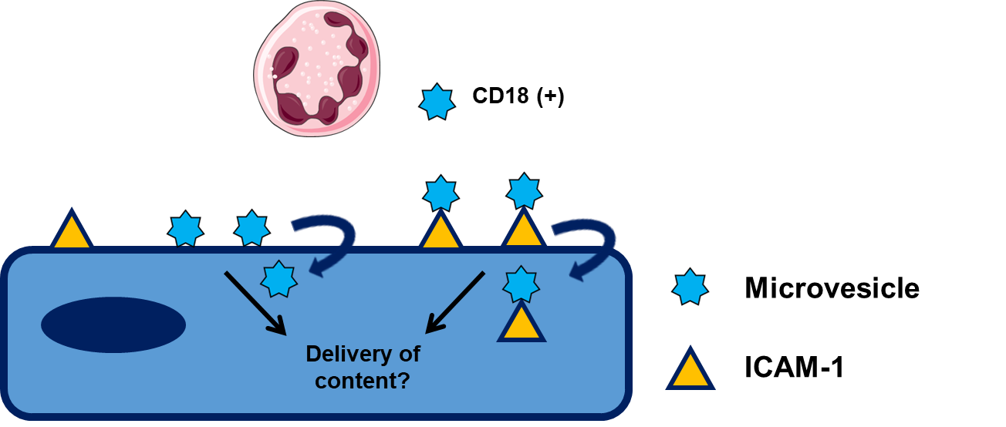
Figure 6.20 – Working hypothesis – MV internalisation by HCAECs: MVs interact with endothelial cells, in part via ICAM-1 dependent mechanisms. MVs can then be internalised by HCAECs via active processes that are dependent upon function ENaC channels expressed on the cell surface. Internalisation occurs via two distinct, independently functioning pathways, macropinocytosis and CAM-mediated endocytosis. Once internalised by HCAECs, it is hypothesised that MVs deliver their content, including microRNAs to the cell that induce the activation described in chapter 5.

Chapter 7 - General discussion

7.1 Study summary

The role of neutrophils in atherosclerosis had been largely overlooked. Typically, this oversight is credited to the lack of observational evidence of neutrophil infiltration during plaque development. Despite this, a breakthrough study in our understanding of neutrophils in atherosclerosis identified that neutrophil depletion from the circulation during the early stages of lesion development reduced both the total plaque area and the macrophage content of the developing plaque (Zernecke et al., 2008). This indicated that neutrophils must be contributing to lesion formation without entering the plaque. Although it remains unclear what inhibitory factors prevent whole neutrophils from leaving the circulation and entering plaque, the identification that neutrophils release membrane bound MVs that express the machinery required to interact with endothelial cells, poses an intriguing mechanism through which neutrophils may influence the progression of disease. The aim of the studies presented in this thesis was to contribute to a better understanding of the role of neutrophils in the focal nature of atherogenesis. It was hypothesised that MVs produced by activated neutrophils could interact with endothelial cells and result in inflammatory activation of these cells. A number of major outcomes were identified;
- MVs are produced in vivo in response to high fat overfeeding, increasing both the total number and ability to induce inflammation in HCAECs.

- Neutrophils-derived MVs preferentially interact with endothelial cells exposed to low and disturbed patterns of flow in vivo and in vitro. This occurs in an ICAM-1 dependant manner.

- MVs interaction with HCAEC results in inflammatory activation of endothelial cells, resulting in changes in cell surface expression of adhesion molecules, the secretion of cytokines and chemoattractants and, subsequently, increased monocyte interactions with endothelial cells under disturbed flow.

- MVs are internalised by HCAECs. This occurs via multiple, independently functioning pathways that include macropinocytosis and ICAM-1-mediated endocytosis.

7.2 Wider implications and future work
Biogenesis of microvesicles
The data presented within this thesis demonstrate that neutrophil-derived MVs are produced in vivo in response to high-fat overfeeding. In addition to changes in the number, it was identified alterations in the function of MVs isolated post HFD. MVs produced from activated neutrophils ex vivo, showed a greater propensity to induce inflammation in HCAECs than those produced prior to feeding. Little is known about the biogenesis of MVs, however these findings pose intriguing questions about how the content of MV may be differentially packaged in response to a range of different stimuli. Future studies may look at both neutrophil and MV content after exposure to different stimuli at the proteomic and microRNA level. This will provide valuable information about how the activation status or requirement for a secondary stimulus influence the MV content (discussed in Chapter 3). Additionally, a mechanistic study using siRNA knockdown and overexpression could be performed in immortalised cell lines to aid in the identification of key trafficking and endocytotic compartments that are involved in the packaging of MVs.
The effect of diet on the production of microvesicles
The findings presented here may have wider implications to our understanding of diet in other chronic diseases. Given the ability of high fat feeding to induce changes in the production of MVs from a number of cell types, determining the consequences of these changes in other diseases is of particular importance. For example, MVs have been heavily implicated in the crosstalk and progression of many cancers (Azmi et al., 2014), while high fat feeding has been shown to increase the rate of cancer metastasis (Pascual et al., 2017). Given the known involvement of tumour-derived MV is these metastatic processes (Martins et al., 2013), determining whether diet may affect either the MVs produced by, or delivered to tumours may be an important avenue for understanding how diet and MVs contribute to these effects. Additionally, more understanding is required concerning different diets in the production and function of MVs. It was identified that high fat overfeeding increases the production and inflammatory capacity of neutrophil-derived MVs posing the question whether diets that involve calorie restriction, which is associated with reduced both cardiovascular (Fontana et al., 2004) and cancer (Longo and Fontana, 2010) mortality can also alter the numbers or inflammatory function of MVs. Therefore, further research into how major changes in diet affect the contribution of neutrophil-derived MVs to diseases are required. An important feature of this future research will be to identify the factors in plasma following high-fat diets that induces MV production, as this may provide interesting new avenues for therapeutic targets to inhibit the production of proinflammatory MVs.

Utilising ICAM-1 crosslinking as a mechanism for the uptake of therapeutics
It is well recognised that atherosclerosis is a focal disease, occurring almost exclusively at sites of the vasculature exposed to disturbed flow. As such, for changes in the number of MVs produced in response to HFD to be relevant to disease, it was important to identify whether MVs preferentially interact with cells at atheroprone regions. These experiments identified that, both in vivo and in vitro, MV interactions with endothelial cells are dramatically augmented in low and disturbed flow conditions. Importantly, in adult arterial cells, isolated from a pathologically relevant vascular bed, it was shown that both preconditioning of endothelial cells and the mass transport effects of delivery under flow contribute to this discrepancy. Critical to both the adhesion and internalisation of MVs was the expression of ICAM-1 on these endothelial cells. Interestingly, ICAM-1 has been described as a potential mechanism through which targeted delivery of therapeutics could be performed. A growing body of research is attempting to utilise these pathways through encapsulation of therapies in ‘nanoparticles’ that can deliver to specific sites (De Jong and Borm, 2008, Sun et al., 2016, Rashid et al., 2016). These systems allow for targeted delivery using tissue specific antibodies, allowing for the reduction in off-target effects of the therapies and lower concentrations required than through systemic administration (Reviewed by; (Vader et al., 2016). Kolhar et al., (2013) identified that ICAM-1 coated nanoparticles, 200 nms in diameter, coated with anti-ICAM-1 antibodies were found to readily accumulate in the lung liver and brain endothelium following administration in mice, suggesting that these could therefore be used in the delivery of therapies to these significant sites of disease. Importantly, this thesis has identified a naturally occurring mechanism through which MVs preferentially interact with a site where a disease develops. Once adherent, these MVs are internalised and induce biological effects. Utilisation of these mechanisms could have direct implications on informing both the production and specifications of these artificially produced nanoparticles for therapies in the treatment of atherosclerosis. Examples from this research that could already be used to inform these processes are the identification of MV diameter. We utilised multiple mechanisms, including tuneable pulse sensing and nanoparticle tracking (see Figure 2.2-3) to determine vesicle size and found that MVs produced by neutrophils ex vivo had a modal diameter of 232 nm. As such, future research with the aim of utilising ICAM-1 crosslinking as a mechanism of uptake of therapeutics, may aim to achieve vesicle production in this range to improve efficiency of uptake.
In vivo and 3-D cell culture models of microvesicle interactions with endothelial cells under flow
A number of highly flow sensitive genes identified from in vivo studies were found to be regulated by the flow parameters used in this study. Although the flow chamber system utilised in this model allowed for (i) manipulation of the pattern and magnitude of shear stress, (ii) use of inhibitors within the system and (iii) determination of gene expression changes in endothelial cells following exposure to flow, the in vivo environment is significantly more complex. Future studies using 3-D cell culture system or in vivo methods should aim to validate these findings. These could include the development of biocompatible, polydimethylsiloxane (PDMS) models of complex geometries (bifurcations or arches). These could then be seeded with endothelial cells, and using a commercially available flow system could recapitulate the complex flow environment observed in vivo (as described by; Mannino et al., 2015). The use of PDMS in this system would allow for the imaging of these interactions in real time and allow for better interpretation of specific regions of the vasculature where interactions may occur. Additionally, in vivo models that utilise intravital microscopy of the mouse carotid artery could help confirm the findings presented in these studies (van Zandvoort et al., 2004). Although this would allow for imaging of MV interactions with endothelial cells in real-time and at a disease relevant vascular bed, the rapid clearance of MVs from the circulation following injection may limit the number of observed interactions (Ayers et al., 2015). Alternatively therefore, ex vivo techniques, in which small sections of atheroprone and atheroprotected regions of the vessel could be removed and attached to a closed loop flow system, may be utilised. These would allow for the study of a number of different complex geometries, confirming the findings in the current study. In addition to these biological models, the development of in silico techniques to model these interactions would allow us to understand more about these interactions in vivo. These models would allow us to quickly manipulate flow rates, angle of bifurcations and changes in the number MVs without having to build or develop new biological systems.
MicroRNA content of MVs and the delivery to endothelial cells in atherosclerosis
Although inflammation has for a long time been suspected to be causal in atherosclerosis, effective inhibitors of inflammation on disease outcomes remained elusive. A major breakthrough in this area was achieved this year when the CANTOS study was completed (Ridker et al., 2017, Libby, 2017). The study identified that IL-1β antagonist, Canakinnumab, was able to reduce the risk of cardiac event risk through the reduction of inflammation, importantly this was observed independently of alterations in blood lipid levels. This major breakthrough for the first time causally implicated inflammation in atherosclerosis. Given the growing recognition of inflammation as a driving factor behind atherosclerosis, the mechanism of inflammatory induction by MVs presented in the present study highlight an interesting new target through which inflammatory and immune cell driven processes interact during disease. Discussed in chapter 5 and 6, it is hypothesised that MV delivery of encapsulated microRNAs is a critical factor in the induction of inflammation in the recipient cell. A number of microRNAs that are rapidly up-regulated during neutrophil activation, these include miR155 (Guedes et al., 2014) and miR223 (Hessam et al., 2017)have identified in MVs and implicated in vascular inflammation (Barker et al., 2017). In chapter 6 it was identified that the expression of miR-155 was increased in plasma MVs following HFD and that neutrophil-derived MVs following inflammation resulted in significantly greater levels of this miR in endothelial cells. Although these findings infer the ability of MVs to delivery this miR, confirmation of delivery to endothelial cells during atherosclerosis is required. These experiments can be performed through silencing endogenous miRs through the use of a miR-155 specific antago-miR, which inhibits the ability of the miR to bind to an mRNA molecule. Importantly these studies have only investigated a single miR in this process, however a number of miRs encapsulated in MVs have been implicated in the development of atherosclerosis (Reviewed by; Hulsmans and Holvoet, 2013). Further study therefore is required to identify the range of miRs that are expressed in neutrophil-derived MVs, understand how this profile of miRs may change with inflammatory stimulus such as high-fat overfeeding, and ultimately understand how these miRs contribute to inflammation. MiRs have become an increasingly promising therapeutic target, with a number of preliminary studies looking into the efficacy of anti-microRNA treatments being performed in the field of oncology (Rupaimoole and Slack, 2017), making these future studies critical in the development of the new wave of inflammatory inhibitors, that target specific microRNAs that are inducing inflammation at these disturbed flow regions.

7.3 Conclusions
The work presented in this thesis demonstrates that MVs preferentially interact with endothelial cells exposed to disturbed flow. Given the focal nature of atherosclerosis, the ability of these vesicles to interact with specific regions and exacerbate inflammation beyond that caused by disturbed flow alone, highlight an important mechanism through which MVs may alter the activation status of endothelial cells at these sites. Importantly it was observed that this increase in activation, resulted in monocyte interactions with cells under disturbed flow. Monocyte interactions with dysfunctional arterial endothelial cells are critical in both the initiation and progression of atherosclerosis. Therefore neutrophil-derived MVs may be important to this disease process through the facilitation of immune cell migration at disturbed flow sites (See Figure 7.1).

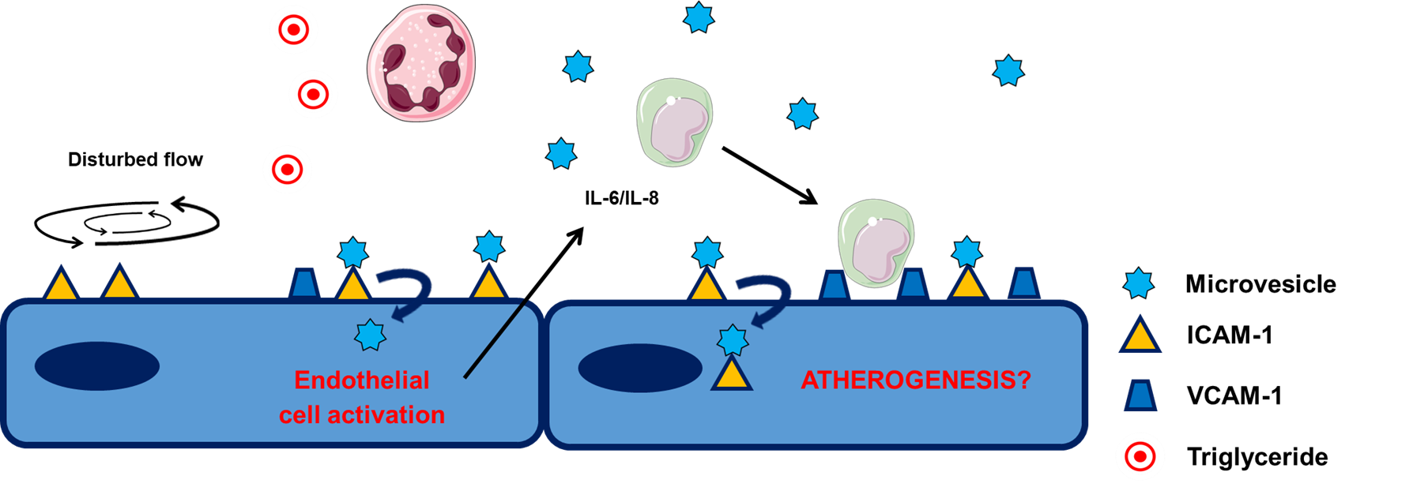
Figure 7.1 – Working hypothesis – Neutrophil-derived MVs and the activation of endothelial cells at sites of disturbed flow: MVs are produced by activated neutrophils in the circulation. The production of MVs is increased by the state of low-grade inflammation induced by high-fat overfeeding. Sites of disturbed flow are characterised by flow induced expression of ICAM-1 on these cells, via which MVs are able to interact with endothelial cells. This results in elevated interactions with cells at disturbed flow sites. Importantly, MVs that interact with endothelial cells are subsequently internalised, where it is suspected they deliver their content (including microRNAs) that induce inflammation in these cells. This includes the secretion of cytokines and chemoattractants but also increases adhesion molecule expression on the cells that facilitate exacerbated monocyte interactions at sites of disturbed flow. These findings implicate neutrophil-derived MVs in the focal nature of atherosclerosis.

Chapter 8 – Bibliography

ABRAMI, L., BRANDI, L., MOAYERI, M., BROWN, M. J., KRANTZ, B. A., LEPPLA, S. H. & VAN DER GOOT, F. G. 2013. Hijacking Multivesicular Bodies Enables Long-Term and Exosome-Mediated Long-Distance Action of Anthrax Toxin. Cell Reports, 5, 986-996.
AGA, M., BENTZ, G. L., RAFFA, S., TORRISI, M. R., KONDO, S., WAKISAKA, N., YOSHIZAKI, T., PAGANO, J. S. & SHACKELFORD, J. 2014. Exosomal HIF1 alpha supports invasive potential of nasopharyngeal carcinoma-associated LMP1-positive exosomes. Oncogene, 33, 4613-4622.
ALIPOUR, A., VAN OOSTROM, A., IZRAELJAN, A., VERSEYDEN, C., COLLINS, J. M., FRAYN, K. N., PLOKKER, T. W. M., ELTE, J. W. F. & CABEZAS, M. C. 2008. Leukocyte activation by triglyceride-rich lipoproteins. Arteriosclerosis Thrombosis and Vascular Biology, 28, 792-797.
ALVAREZ-ERVITI, L., SEOW, Y. Q., YIN, H. F., BETTS, C., LAKHAL, S. & WOOD, M. J. A. 2011. Delivery of siRNA to the mouse brain by systemic injection of targeted exosomes. Nature Biotechnology, 29, 341-U179.
ANDO, J. & YAMAMOTO, K. 2010. Shear-stress-sensing and response mechanisms in vascular endothelial cells. Interface Oral Health Science 2009, 3-+.
ARAUJO, F. B., BARBOSA, D. S., HSIN, C. Y., MARANHAO, R. C. & ABDALLA, D. S. 1995. Evaluation of oxidative stress in patients with hyperlipidemia. Atherosclerosis, 117, 61-71.
BARKER, K. R., LU, Z. Y., KIM, H., ZHENG, Y., CHEN, J. M., CONROY, A. L., HAWKES, M., CHENG, H. S., NJOCK, M. S., FISH, J. E., HARLAN, J. M., LOPEZ, J. A., LILES, W. C. & KAIN, K. C. 2017. miR-155 Modifies Inflammation, Endothelial Activation and Blood-Brain Barrier Dysfunction in Cerebral Malaria. Molecular Medicine, 23.
BERCKMANS, R., NIEUWLAND, R., BOING, A., ROMIJN, F., HACK, E. & STURK, A. 2001. Cell-derived microparticles circulate in healthy humans and support low grade thrombin generation. Clinical Chemistry and Laboratory Medicine, 39, S267.
BERGEL, D. H. 1961. STATIC ELASTIC PROPERTIES OF ARTERIAL WALL. Journal of Physiology-London, 156, 445-&.
BHOWMICK, T., BERK, E., CUI, X. M., MUZYKANTOV, V. R. & MURO, S. 2012. Effect of flow on endothelial endocytosis of nanocarriers targeted to ICAM-1. Journal of Controlled Release, 157, 485-492.
BOULANGER, C. M., LOYER, X., RAUTOU, P. E. & AMABILE, N. 2017. Extracellular vesicles in coronary artery disease. Nature Reviews Cardiology, 14, 259-272.
CARO, C. G. 1966. DISPERSION OF INDICATOR FLOWING THROUGH SIMPLIFIED MODELS OF CIRCULATION AND ITS RELEVANCE TO VELOCITY PROFILE IN BLOOD VESSELS. Journal of Physiology-London, 185, 501-&.
CARO, C. G., FITZGERA.JM & SCHROTER, R. C. 1971. ATHEROMA AND ARTERIAL WALL SHEAR - OBSERVATION, CORRELATION AND PROPOSAL OF A SHEAR DEPENDENT MASS TRANSFER MECHANISM FOR ALTHEROGENESIS. Proceedings of the Royal Society Series B-Biological Sciences, 177, 109-+.
CHAPPELL, D. C., VARNER, S. E., NEREM, R. M., MEDFORD, R. M. & ALEXANDER, R. W. 1998. Oscillatory shear stress stimulates adhesion molecule expression in cultured human endothelium. Circulation Research, 82, 532-539.
CHEN, C. L., HOU, W. H., LIU, I. H., HSIAO, G., HUANG, S. S. & HUANG, J. S. 2009. Inhibitors of clathrin-dependent endocytosis enhance TGF beta signaling and responses. Journal of Cell Science, 122, 1863-1871.
CHEN, Y., WANG, S., LU, X. N., ZHANG, H. R., FU, Y. & LUO, Y. Z. 2011. Cholesterol sequestration by nystatin enhances the uptake and activity of endostatin in endothelium via regulating distinct endocytic pathways. Blood, 117, 6392-6403.
CHEN, Z., PENG, I. C., CUI, X., LI, Y.-S., CHIEN, S. & SHYY, J. Y. J. 2010. Shear stress, SIRT1, and vascular homeostasis. Proceedings of the National Academy of Sciences of the United States of America, 107, 10268-73.
CHENG, C., VAN HAPEREN, R., DE WAARD, M., VAN DAMME, L. C. A., TEMPEL, D., HANEMAAIJER, L., VAN CAPPELLEN, G. W. A., BOS, J., SLAGER, C. J., DUNCKER, D. J., VAN DER STEEN, A. F. W., DE CROM, R. & KRAMS, R. 2005. Shear stress affects the intracellular distribution of eNOS: direct demonstration by a novel in vivo technique. Blood, 106, 3691-3698.
CHERTOV, O., UEDA, H., XU, L. L., TANI, K., MURPHY, W. J., WANG, J. M., HOWARD, O. M. Z., SAYERS, T. J. & OPPENHEIM, J. J. 1997. Identification of human neutrophil-derived cathepsin G and azurocidin/CAP37 as chemoattractants for mononuclear cells and neutrophils. Journal of Experimental Medicine, 186, 739-747.
CHIEN, S. 2008. Effects of Disturbed Flow on Endothelial cells. Annals of biomedical engineering.
CHIRONI, G., SIMON, A., HUGEL, B., DEL PINO, M., GARIEPY, J., FREYSSINET, J. M. & TEDGUI, A. 2006. Circulating leukocyte-derived microparticles predict subclinical atherosclerosis burden in asymptomatic subjects. Arteriosclerosis Thrombosis and Vascular Biology, 26, 2775-2780.
COLOMBO, E., BORGIANI, B., VERDERIO, C. & FURLAN, R. 2012. Microvesicles: novel biomarkers for neurological disorders. Frontiers in Physiology, 3.
COMERFORD, I. & MCCOLL, S. R. 2011. Mini-review series: focus on chemokines. Immunology and Cell Biology, 89, 183-184.
CONNER, S. D. & SCHMID, S. L. 2003. Regulated portals of entry into the cell. Nature, 422, 37-44.
CUHLMANN, S., VAN DER HEIDEN, K., SALIBA, D., TREMOLEDA, J. L., KHALIL, M., ZAKKAR, M., CHAUDHURY, H., LE ANH, L., MASON, J. C., UDALOVA, I., GSELL, W., JONES, H., HASKARD, D. O., KRAMS, R. & EVANS, P. C. 2011. Disturbed Blood Flow Induces RelA Expression via c-Jun N-Terminal Kinase 1 A Novel Mode of NF-kappa B Regulation That Promotes Arterial Inflammation. Circulation Research, 108, 950-959.
CYBULSKY, M. I. & GIMBRONE, M. A. 1991. ENDOTHELIAL EXPRESSION OF A MONONUCLEAR LEUKOCYTE ADHESION MOLECULE DURING ATHEROGENESIS. Science, 251, 788-791.
CYBULSKY, M. I., IIYAMA, K., LI, H., ZHU, S., CHEN, M., IIYAMA, M., DAVIS, V., GUTIERREZ-RAMOS, J. C., CONNELLY, P. W. & MILSTONE, D. S. 2001. A major role for VCAM-1, but not ICAM-1, in early atherosclerosis. J Clin Invest, 107, 1255-62.
DALLI, J., MONTERO-MELENDEZ, T., NORLING, L. V., YIN, X. K., HINDS, C., HASKARD, D., MAYR, M. & PERRETTI, M. 2013. Heterogeneity in Neutrophil Microparticles Reveals Distinct Proteome and Functional Properties. Molecular & Cellular Proteomics, 12, 2205-2219.
DANESH, J., WHINCUP, P., WALKER, M., LENNON, L., THOMSON, A., APPLEBY, P., GALLIMORE, J. R. & PEPYS, M. B. 2000. Low grade inflammation and coronary heart disease: prospective study and updated meta-analyses. British Medical Journal, 321, 199-204.
DANIEL, L., FAKHOURI, F., JOLY, D., MOUTHON, L., NUSBAUM, P., GRUNFELD, J. P., SCHIFFERLI, J., GUILLEVIN, L., LESAVRE, P. & HALBWACHS-MECARELLI, L. 2006. Increase of circulating neutrophil and platelet microparticles during acute vasculitis and hemodialysis. Kidney International, 69, 1416-1423.
DANSKY, H. M., BARLOW, C. B., LOMINSKA, C., SIKES, J. L., KAO, C., WEINSAFT, J., CYBULSKY, M. I. & SMITH, J. D. 2001. Adhesion of monocytes to arterial endothelium and initiation of atherosclerosis are critically dependent on vascular cell adhesion molecule-1 gene dosage. Arteriosclerosis Thrombosis and Vascular Biology, 21, 1662-1667.
DE JONG, W. H. & BORM, P. J. A. 2008. Drug delivery and nanoparticles: Applications and hazards. International Journal of Nanomedicine, 3, 133-149.
DEGRABA, T. J., SIREN, A. L., PENIX, L., MCCARRON, R. M., HARGRAVES, R., SOOD, S., PETTIGREW, K. D. & HALLENBECK, J. M. 1998. Increased endothelial expression of intercellular adhesion molecule-1 in symptomatic versus asymptomatic human carotid atherosclerotic plaque. Stroke, 29, 1405-1410.
DEL CONDE, I., SHRIMPTON, C. N., THIAGARAJAN, P. & LOPEZ, J. A. 2005. Tissue-factor-bearing microvesicles arise from lipid rafts and fuse with activated platelets to initiate coagulation. Blood, 106, 1604-1611.
DEN HARTOG, A. G., ACHTERBERG, S., MOLL, F. L., KAPPELLE, L. J., VISSEREN, F. L. J., VAN DER GRAAF, Y., ALGRA, A., DE BORST, G. J. & GRP, S. S. 2013. Asymptomatic Carotid Artery Stenosis and the Risk of Ischemic Stroke According to Subtype in Patients With Clinical Manifest Arterial Disease. Stroke, 44, 1002-1007.
DEREGIBUS, M. C., CANTALUPPI, V., CALOGERO, R., LO IACONO, M., TETTA, C., BIANCONE, L., BRUNO, S., BUSSOLATI, B. & CAMUSSI, G. 2007. Endothelial progenitor cell-derived microvesicles activate an angiogenic program in endothelial cells by a horizontal transfer of mRNA. Blood, 110, 2440-2448.
DEVILLIERS, W. J. S., FRASER, I. P., HUGHES, D. A., DOYLE, A. G. & GORDON, S. 1994. MACROPHAGE-COLONY-STIMULATING FACTOR SELECTIVELY ENHANCES MACROPHAGE SCAVENGER RECEPTOR EXPRESSION AND FUNCTION. Journal of Experimental Medicine, 180, 705-709.
DIEHL, P., FRICKE, A., SANDER, L., STAMM, J., BASSLER, N., HTUN, N., ZIEMANN, M., HELBING, T., EL-OSTA, A., JOWETT, J. B. & PETER, K. 2012. Microparticles: major transport vehicles for distinct microRNAs in circulation. Cardiovascular Research, 93, 633-644.
DOBRINSKIKH, E., OKAMURA, K., KOPP, J. B., DOCTOR, R. B. & BLAINE, J. 2014. Human podocytes perform polarized, caveolae-dependent albumin endocytosis. American Journal of Physiology-Renal Physiology, 306, F941-F951.
DONALDSON, J. G. 2003. Multiple roles for Arf6: Sorting, structuring, and signaling at the plasma membrane. Journal of Biological Chemistry, 278, 41573-41576.
DONG, Z. M., CHAPMAN, S. M., BROWN, A. A., FRENETTE, P. S., HYNES, R. O. & WAGNER, D. D. 1998. Combined role of P- and E-selectins in atherosclerosis. Journal of Clinical Investigation, 102, 145-152.
DORIOT, P. A., DORSAZ, P. A., DORSAZ, L., DE BENEDETTI, E., CHATELAIN, P. & DELAFONTAINE, P. 2000. In-vivo measurements of wall shear stress in human coronary arteries. Coronary Artery Disease, 11, 495-502.
DOS SANTOS, T., VARELA, J., LYNCH, I., SALVATI, A. & DAWSON, K. A. 2011. Effects of Transport Inhibitors on the Cellular Uptake of Carboxylated Polystyrene Nanoparticles in Different Cell Lines. Plos One, 6.
DRECHSLER, M., MEGENS, R. T. A., VAN ZANDVOORT, M., WEBER, C. & SOEHNLEIN, O. 2010. Hyperlipidemia-Triggered Neutrophilia Promotes Early Atherosclerosis. Circulation, 122, 1837-+.
ERRIDGE, C., ATTINA, T., SPICKETT, C. M. & WEBB, D. J. 2007. A high-fat meal induces low-grade endotoxemia: evidence of a novel mechanism of postprandial inflammation. American Journal of Clinical Nutrition, 86, 1286-1292.
ETIENNE-MANNEVILLE, S., MANNEVILLE, J. B., ADAMSON, P., WILBOURN, B., GREENWOOD, J. & COURAUD, P. O. 2000. ICAM-1-coupled cytoskeletal rearrangements and transendothelial lymphocyte migration involve intracellular calcium signaling in brain endothelial cell lines. Journal of Immunology, 165, 3375-3383.
FAILLE, D., EL-ASSAAD, F., MITCHELL, A. J., ALESSI, M. C., CHIMINI, G., FUSAI, T., GRAU, G. E. & COMBES, V. 2012. Endocytosis and intracellular processing of platelet microparticles by brain endothelial cells. Journal of Cellular and Molecular Medicine, 16, 1731-1738.
FALCONE, S., COCUCCI, E., PODINI, P., KIRCHHAUSEN, T., CLEMENTI, E. & MELDOLESI, J. 2006. Macropinocytosis: regulated coordination of endocytic and exocytic membrane traffic events. Journal of Cell Science, 119, 4758-4769.
FEINGOLD, K. R., SHIGENAGA, J. K., KAZEMI, M. R., MCDONALD, C. M., PATZEK, S. M., CROSS, A. S., MOSER, A. & GRUNFELD, C. 2012. Mechanisms of triglyceride accumulation in activated macrophages. Journal of Leukocyte Biology, 92, 829-839.
FERREIRA, A. C., PETER, A. A., MENDEZ, A. J., JIMENEZ, J. J., MAURO, L. M., CHIRINOS, J. A., GHANY, R., VIRANI, S., GARCIA, S., HORSTMAN, L. L., PUROW, J., JY, W., AHN, Y. S. & DE MARCHENA, E. 2004. Postprandial hypertriglyceridemia increases circulating levels of endothelial cell microparticles. Circulation, 110, 3599-3603.
FINGER, E. B., PURI, K. D., ALON, R., LAWRENCE, M. B., VONANDRIAN, U. H. & SPRINGER, T. A. 1996. Adhesion through L-selectin requires a threshold hydrodynamic shear. Nature, 379, 266-269.
FONTANA, L., MEYER, T. E., KLEIN, S. & HOLLOSZY, J. O. 2004. Long-term calorie restriction is highly effective in reducing the risk for atherosclerosis in humans. Proceedings of the National Academy of Sciences of the United States of America, 101, 6659-6663.
FORD, E. S., LI, C. Y., PEARSON, W. S. & MOKDAD, A. H. 2009. Hypertriglyceridemia and Its Pharmacologic Treatment Among US Adults. Archives of Internal Medicine, 169, 572-578.
FRANZEN, C. A., SIMMS, P. E., VAN HUIS, A. F., FOREMAN, K. E., KUO, P. C. & GUPTA, G. N. 2014. Characterization of Uptake and Internalization of Exosomes by Bladder Cancer Cells. Biomed Research International.
FRELTAS, M., PORTO, G., LIMA, J. & FEMANDES, E. 2008. Isolation and activation of human neutrophils in vitro. The importance of the anticoagulant used during blood collection. Clinical Biochemistry, 41, 570-575.
FUNG, T. T., RIMM, E. B., SPIEGELMAN, D., RIFAI, N., TOFLER, G. H., WILLETT, W. C. & HU, F. B. 2001. Association between dietary patterns and plasma biomarkers of obesity and cardiovascular disease risk. American Journal of Clinical Nutrition, 73, 61-67.
FURIE, M. B., TANCINCO, M. C. A. & SMITH, C. W. 1991. MONOCLONAL-ANTIBODIES TO LEUKOCYTE INTEGRIN-CD11A CD18 AND INTEGRIN-CD11B CD18 OR INTERCELLULAR-ADHESION MOLECULE-1 INHIBIT CHEMOATTRACTANT-STIMULATED NEUTROPHIL TRANSENDOTHELIAL MIGRATION INVITRO. Blood, 78, 2089-2097.
GALIS, Z. S. & KHATRI, J. J. 2002. Matrix metalloproteinases in vascular remodeling and atherogenesis: the good, the bad, and the ugly. Circ Res, 90, 251-62.
GALIS, Z. S., SUKHOVA, G. K., KRANZHOFER, R., CLARK, S. & LIBBY, P. 1995. MACROPHAGE FOAM CELLS FROM EXPERIMENTAL ATHEROMA CONSTITUTIVELY PRODUCE MATRIX-DEGRADING PROTEINASES. Proceedings of the National Academy of Sciences of the United States of America, 92, 402-406.
GARNACHO, C., SHUVAEV, V., THOMAS, A., MCKENNA, L., SUN, J., KOVAL, M., ALBELDA, S., MUZYKANTOV, V. & MURO, S. 2008. RhoA activation and actin reorganization involved in endothelial CAM-mediated endocytosis of anti-PECAM carriers: critical role for tyrosine 686 in the cytoplasmic tail of PECAM-1. Blood, 111, 3024-3033.
GEORGIEVA, A. M., TEN CATE, H., KEULEN, E. T. P., VAN OERLE, R., GOVERS-RIEMSLAG, J. W. P., HAMULYAK, K., VAN DER KALLEN, C. J. H., VAN GREEVENBROEK, M. M. J. & DE BRUIN, T. W. A. 2004. Prothrombotic markers in familial combined hyperlipidemia evidence of endothelial cell activation and relation to metabolic syndrome. Atherosclerosis, 175, 345-351.
GERSZTEN, R. E., FRIEDRICH, E. B., MATSUI, T., HUNG, R. R., LI, L., FORCE, T. & ROSENZWEIG, A. 2001. Role of phosphoinositide 3-kinase in monocyte recruitment under flow conditions. Journal of Biological Chemistry, 276, 26846-26851.
GERSZTEN, R. E., GARCIA-ZEPEDA, E. A., LIM, Y. C., YOSHIDA, M., DING, H. A., GIMBRONE, M. A., LUSTER, A. D., LUSCINSKAS, F. W. & ROSENZWEIG, A. 1999. MCP-1 and IL-8 trigger firm adhesion of monocytes to vascular endothelium under flow conditions. Nature, 398, 718-723.
GIERSCHIK, P. & JAKOBS, K. H. 1987. RECEPTOR-MEDIATED ADP-RIBOSYLATION OF A PHOSPHOLIPASE C-STIMULATING G-PROTEIN. Febs Letters, 224, 219-223.
GLEISSNER, C. A., SHAKED, I., LITTLE, K. M. & LEY, K. 2010. CXC Chemokine Ligand 4 Induces a Unique Transcriptome in Monocyte-Derived Macrophages. Journal of Immunology, 184, 4810-4818.
GOUGH, P. J., GOMEZ, I. G., WILLE, P. T. & RAINES, E. W. 2006. Macrophage expression of active MMP-9 induces acute plaque disruption in apoE-deficient mice. Journal of Clinical Investigation, 116, 59-69.
GREENWOOD, J., AMOS, C. L., WALTERS, C. E., COURAUD, P. O., LYCK, R., ENGELHARDT, B. & ADAMSON, P. 2003. Intracellular domain of brain endothelial intercellular adhesion molecule-1 is essential for T lymphocyte-mediated signaling and migration. Journal of Immunology, 171, 2099-2108.
GUEDES, J. R., CUSTODIA, C. M., SILVA, R. J., DE ALMEIDA, L. P., DE LIMA, M. C. P. & CARDOSO, A. L. 2014. Early miR-155 upregulation contributes to neuroinflammation in Alzheimer's disease triple transgenic mouse model. Human Molecular Genetics, 23, 6286-6301.
HAMMOND, M. E. W., LAPOINTE, G. R., FEUCHT, P. H., HILT, S., GALLEGOS, C. A., GORDON, C. A., GIEDLIN, M. A., MULLENBACH, G. & TEKAMPOLSON, P. 1995. IL-8 INDUCES NEUTROPHIL CHEMOTAXIS PREDOMINANTLY VIA TYPE-I IL-8 RECEPTORS. Journal of Immunology, 155, 1428-1433.
HARB, T. S., ZAREBA, W., MOSS, A. J., RIDKER, P. M., MARDER, V. J., RIFAI, N., WATELET, L. F. M., ARORA, R., BROWN, M. W., CASE, R. B., DWYER, E. M., GILLESPIE, J. A., GOLDSTEIN, R. E., GREENBERG, H., HOCHMAN, J., KRONE, R. J., LIANG, C. S., LICHSTEIN, E., LITTLE, W., MARCUS, F. I., OAKES, D., SPARKS, C. E., VANVOORHEES, L. & INVESTIGATORS, T. 2002. Association of C-reactive protein and serum amyloid A with recurrent coronary events in stable patients after healing of acute myocardial infarction. American Journal of Cardiology, 89, 216-+.
HARRISON, M., MURPHY, R. P., O'CONNOR, P. L., O'GORMAN, D. J., MCCAFFREY, N., CUMMINS, P. M. & MOYNA, N. M. 2009. The endothelial microparticle response to a high fat meal is not attenuated by prior exercise. European Journal of Applied Physiology, 106, 555-562.
HE, F. & ZUO, L. 2015. Redox Roles of Reactive Oxygen Species in Cardiovascular Diseases. International Journal of Molecular Sciences, 16, 27770-27780.
HEADLAND, S. E., JONES, H. R., D'SA, A. S. V., PERRETTI, M. & NORLING, L. V. 2014. Cutting-Edge Analysis of Extracellular Microparticles using ImageStream(X) Imaging Flow Cytometry. Scientific Reports, 4, 10.
HEINRICH, L. F., ANDERSEN, D. K., CLEASBY, M. E. & LAWSON, C. 2015. Long-term high fat feeding of rats results in increased numbers of circulating microvesicles with pro-inflammatory effects on endothelial cells. British Journal of Nutrition, 113, 1704-1711.
HEMDAHL, A. L., GABRIELSEN, A., ZHU, C. Y., ERIKSSON, P., HEDIN, U., KASTRUP, J., THOREN, P. & HANSSON, G. K. 2006. Expression of neutrophil gelatinase-associated lipocalin in atherosclerosis and myocardial infarction. Arteriosclerosis Thrombosis and Vascular Biology, 26, 136-142.
HESSAM, S., SAND, M., SKRYGAN, M., GAMBICHLER, T. & BECHARA, F. G. 2017. Expression of miRNA-155, miRNA-223, miRNA-31, miRNA-21, miRNA-125b, and miRNA-146a in the Inflammatory Pathway of Hidradenitis Suppurativa. Inflammation, 40, 464-472.
HOLVOET, P., THEILMEIER, G., SHIVALKAR, B., FLAMENG, W. & COLLEN, D. 1998. LDL hypercholesterolemia is associated with accumulation of oxidized LDL, atherosclerotic plaque growth, and compensatory vessel enlargement in coronary arteries of miniature pigs. Arteriosclerosis Thrombosis and Vascular Biology, 18, 415-422.
HONG, Y., ELEFTHERIOU, D., HUSSAIN, A. A. K., PRICE-KUEHNE, F. E., SAVAGE, C. O., JAYNE, D., LITTLE, M. A., SALAMA, A. D., KLEIN, N. J. & BROGAN, P. A. 2012. Anti-Neutrophil Cytoplasmic Antibodies Stimulate Release of Neutrophil Microparticles. Journal of the American Society of Nephrology, 23, 49-62.
HSIAI, T. K., CHO, S. K., WONG, P. K., ING, M., SALAZAR, A., SEVANIAN, A., NAVAB, M., DEMER, L. L. & HO, C. M. 2003. Monocyte recruitment to endothelial cells in response to oscillatory shear stress. Faseb Journal, 17, 1648-1657.
HSIAO, S. T., SPENCER, T., BOLDOCK, L., PROSSEDA, S. D., XANTHIS, I., TOVAR-LOPEZ, F. J., VAN BEUSEKOM, H. M. M., KHAMIS, R. Y., FOIN, N., BOWDEN, N., HUSSAIN, A., ROTHMAN, A., RIDGER, V., HALLIDAY, I., PERRAULT, C., GUNN, J. & EVANS, P. C. 2016. Endothelial repair in stented arteries is accelerated by inhibition of Rho-associated protein kinase. Cardiovascular Research, 112, 689-701.
HULSMANS, M. & HOLVOET, P. 2013. MicroRNA-containing microvesicles regulating inflammation in association with atherosclerotic disease. Cardiovascular Research, 100, 7-18.
HULSTON, C. J., CHURNSIDE, A. A. & VENABLES, M. C. 2015. Probiotic supplementation prevents high-fat, overfeeding-induced insulin resistance in human subjects. British Journal of Nutrition, 113, 596-602.
IONITA, M. G., VAN DEN BORNE, P., CATANZARITI, L. M., MOLL, F. L., DE VRIES, J., PASTERKAMP, G., VINK, A. & DE KLEIJN, D. P. V. 2010. High Neutrophil Numbers in Human Carotid Atherosclerotic Plaques Are Associated With Characteristics of Rupture-Prone Lesions. Arteriosclerosis Thrombosis and Vascular Biology, 30, 1842-U374.
ITO, F., TATSUMI, H., MORI, T., SUGANUMA, I., TANAKA, Y., SASAKI, A., MATSUO, S., IWASA, K. & KITAWAKI, J. 2014. Medroxyprogesterone Acetate Enhances Monocyte-Endothelial Interaction Under Flow Conditions by Stimulating the Expression of Cell Adhesion Molecules. Journal of Clinical Endocrinology & Metabolism, 99, 2188-2197.
ITOH, H., NELSON, P. R., MUREEBE, L., HOROWITZ, A. & KENT, K. C. 1997. The role of integrins in saphenous vein vascular smooth muscle cell migration. Journal of Vascular Surgery, 25, 1061-1069.
JANSEN, F., WANG, H., PRZYBILLA, D., FRANKLIN, B. S., DOLF, A., PFEIFER, P., SCHMITZ, T., FLENDER, A., ENDL, E., NICKENIG, G. & WERNER, N. 2016. Vascular endothelial microparticles-incorporated microRNAs are altered in patients with diabetes mellitus. Cardiovascular Diabetology, 15.
JOHNSON, B. L., III, GOETZMAN, H. S., PRAKASH, P. S. & CALDWELL, C. C. 2013. Mechanisms underlying mouse TNF-alpha stimulated neutrophil derived microparticle generation. Biochemical and Biophysical Research Communications, 437, 591-596.
JOHNSONTIDEY, R. R., MCGREGOR, J. L., TAYLOR, P. R. & POSTON, R. N. 1994. INCREASE IN THE ADHESION MOLECULE P-SELECTIN IN ENDOTHELIUM OVERLYING ATHEROSCLEROTIC PLAQUES - COEXPRESSION WITH INTERCELLULAR-ADHESION MOLECULE-1. American Journal of Pathology, 144, 952-961.
JONDEAU, G., DUBOURG, O., PARTOVIAN, C., DIB, J. C., LACOMBE, P., CHIKLI, F. & BOURDARIAS, J. P. 1994. ACUTE MYOCARDIAL-INFARCTION IN A PATIENT WITH SEVERE AORTIC-STENOSIS AND NORMAL CORONARY-ARTERIES. European Heart Journal, 15, 715-717.
JOUSILAHTI, P., VARTIAINEN, E., TUOMILEHTO, J. & PUSKA, P. 1999. Sex, age, cardiovascular risk factors, and coronary heart disease - A prospective follow-up study of 14 786 middle-aged men and women in Finland. Circulation, 99, 1165-1172.
JUDSON, J. J., MOLOT, M. A., STREMPLE, J. F. & CUTTING, R. T. 1971. CORONARY ARTERY DISEASE IN COMBAT CASUALTIES IN VIETNAM. Journal of the American Medical Association, 216, 1185-&.
JUNG, U., BULLARD, D. C., TEDDER, T. F. & LEY, K. 1996. Velocity differences between L- and P-selectin-dependent neutrophil rolling in venules of mouse cremaster muscle in vivo. American Journal of Physiology-Heart and Circulatory Physiology, 271, H2740-H2747.
KAWAMOTO, T., OHGA, N., AKIYAMA, K., HIRATA, N., MAISHI, N., OSAWA, T., YAMAMOTO, K., KONDOH, M., SHINDOH, M., HIDA, Y. & HIDA, K. 2012. Tumor-derived microvesicles induce proangiogenic phenotype in endothelial cells via endocytosis. Cancer Research, 72.
KENNEDY, S., MCPHADEN, A. R., WADSWORTH, R. M. & WAINWRIGHT, C. L. 2000. Correlation of leukocyte adhesiveness, adhesion molecule expression and leukocyte-induced contraction following balloon angioplasty. British Journal of Pharmacology, 130, 95-103.
KISHIMOTO, T. K., HOLLANDER, N., ROBERTS, T. M., ANDERSON, D. C. & SPRINGER, T. A. 1987. HETEROGENEOUS MUTATIONS IN THE BETA-SUBUNIT COMMON TO THE LFA-1, MAC-1, AND P150,95 GLYCOPROTEINS CAUSE LEUKOCYTE ADHESION DEFICIENCY. Cell, 50, 193-202.
KISKIN, N. I., HELLEN, N., BABICH, V., HEWLETT, L., KNIPE, L., HANNAH, M. J. & CARTER, T. 2010. Protein mobilities and P-selectin storage in Weibel-Palade bodies. Journal of Cell Science, 123, 2964-2975.
KOLHAR, P., ANSELMO, A. C., GUPTA, V., PANT, K., PRABHAKARPANDIAN, B., RUOSLAHTI, E. & MITRAGOTRI, S. 2013. Using shape effects to target antibody-coated nanoparticles to lung and brain endothelium. Proceedings of the National Academy of Sciences of the United States of America, 110, 10753-10758.
KOSTIS, J. B., TURKEVICH, D. & SHARP, J. 1984. ASSOCIATION BETWEEN LEUKOCYTE COUNT AND THE PRESENCE AND EXTENT OF CORONARY ATHEROSCLEROSIS AS DETERMINED BY CORONARY ARTERIOGRAPHY. American Journal of Cardiology, 53, 997-999.
KREUZER, J., DENGER, S., JAHN, L., BADER, J., RITTER, K., VONHODENBERG, E. & KUBLER, W. 1996. LDL stimulates chemotaxis of human monocytes through a cyclooxygenase-dependent pathway. Arteriosclerosis Thrombosis and Vascular Biology, 16, 1481-1487.
LADEIA, A. M., STEFANELLI, E., LADEIA-FROTA, C., MOREIRA, A., HILTNER, A. & ADAN, L. 2006. Association between elevated serum C-reactive protein and triglyceride levels in young subjects with type 1 diabetes. Diabetes Care, 29, 424-426.
LAKADAMYALI, M., RUST, M. J. & ZHUANG, X. W. 2006. Ligands for clathrin-mediated endocytosis are differentially sorted into distinct populations of early endosomes. Cell, 124, 997-1009.
LANGUINO, L. R., DUPERRAY, A., JOGANIC, K. J., FORNARO, M., THORNTON, G. B. & ALTIERI, D. C. 1995. REGULATION OF LEUKOCYTE-ENDOTHELIUM INTERACTION AND LEUKOCYTE TRANSENDOTHELIAL MIGRATION BY INTERCELLULAR-ADHESION MOLECULE 1-FIBRINOGEN RECOGNITION. Proceedings of the National Academy of Sciences of the United States of America, 92, 1505-1509.
LARIONOV, S., DEDECK, O., BIRKENMEIER, G. & THAL, D. R. 2007. Expression of alpha(2)-macroglobulin, neutrophil elastase, and interleukin-1 alpha differs in early-stage and late-stage atherosclerotic lesions in the arteries of the circle of Willis. Acta Neuropathologica, 113, 33-43.
LARSEN, M. A., GOLL, R., LEKAHL, S., MOEN, O. S. & FLORHOLMEN, J. 2015. Delayed clearance of triglyceride-rich lipoproteins in young, healthy obese subjects. Clinical Obesity, 5, 349-357.
LARSEN, M. T., HOTHER, C., HAGER, M., PEDERSEN, C. C., JACOBSEN, L., BORREGAARD, N. & COWLAND, J. B. 2012. miRNA Profiling in Human Granulopoiesis and in Activated Neutrophils From Skin Window. Blood, 120.
LAUGHLIN, M. H., NEWCOMER, S. C. & BENDER, S. B. 2008. Importance of hemodynamic forces as signals for exercise-induced changes in endothelial cell phenotype. Journal of Applied Physiology, 104, 588-600.
LAWRENCE, M. B., KANSAS, G. S., KUNKEL, E. J. & LEY, K. 1997. Threshold levels of fluid shear promote leukocyte adhesion through selectins (CD62L,P,E). Journal of Cell Biology, 136, 717-727.
LEHMANN, A. K., SORNES, S. & HALSTENSEN, A. 2000. Phagocytosis: measurement by flow cytometry. Journal of Immunological Methods, 243, 229-242.
LEY, K., ALLIETTA, M., BULLARD, D. C. & MORGAN, S. 1998. Importance of E-selectin for firm leukocyte adhesion in vivo. Circulation Research, 83, 287-294.
LEY, K., LAUDANNA, C., CYBULSKY, M. I. & NOURSHARGH, S. 2007. Getting to the site of inflammation: the leukocyte adhesion cascade updated. Nature Reviews Immunology, 7, 678-689.
LIBBY, P. 2002. Inflammation and Atherosclerosis. Circulation: Circulation.
LIBBY, P. 2017. Interleukin-1 Beta as a Target for Atherosclerosis Therapy Biological Basis of CANTOS and Beyond. Journal of the American College of Cardiology, 70, 2278-2289.
LIM, J. P. & GLEESON, P. A. 2011. Macropinocytosis: an endocytic pathway for internalising large gulps. Immunology and Cell Biology, 89, 836-843.
LLOYD-JONES, D. M., LARSON, M. G., BEISER, A. & LEVY, D. 1999. Lifetime risk of developing coronary heart disease. Lancet, 353, 89-92.
LONGO, V. D. & FONTANA, L. 2010. Calorie restriction and cancer prevention: metabolic and molecular mechanisms. Trends in Pharmacological Sciences, 31, 89-98.
LUO, B.-H., CARMAN, C. V. & SPRINGER, T. A. 2007. Structural basis of integrin regulation and signaling. Annual Review of Immunology, 25, 619-647.
MADJID, M., AWAN, I., WILLERSON, J. T. & CASSCELLS, S. W. 2004. Leukocyte count and coronary heart disease - Implications for risk assessment. Journal of the American College of Cardiology, 44, 1945-1956.
MADJID, M. & FATEMI, O. 2013. Components of the Complete Blood Count as Risk Predictors for Coronary Heart Disease In-Depth Review and Update. Texas Heart Institute Journal, 40, 17-29.
MAHMOUD, M. M., KIM, H. R., XING, R. Y., HSIAO, S., MAMMOTO, A., CHEN, J., SERBANOVIC-CANIC, J., FENG, S., BOWDEN, N. P., MAGUIRE, R., ARIAANS, M., FRANCIS, S. E., WEINBERG, P. D., VAN DER HEIDEN, K., JONES, E. A., CHICO, T. J. A., RIDGER, V. & EVANS, P. C. 2016. TWIST1 Integrates Endothelial Responses to Flow in Vascular Dysfunction and Atherosclerosis. Circulation Research, 119, 450-+.
MALEK, A. M., IZUMO, S. & ALPER, S. L. 1999. Modulation by pathophysiological stimuli of the shear stress-induced up-regulation of endothelial nitric oxide synthase expression in endothelial cells. Neurosurgery, 45, 334-344.
MANNINO, R. G., MYERS, D. R., AHN, B., WANG, Y. C., ROLLINS, M., GOLE, H., LIN, A. S., GULDBERG, R. E., GIDDENS, D. P., TIMMINS, L. H. & LAM, W. A. 2015. "Do-it-yourself in vitro vasculature that recapitulates in vivo geometries for investigating endothelial-blood cell interactions". Scientific Reports, 5.
MANTOVANI, A., CASSATELLA, M. A., COSTANTINI, C. & JAILLON, S. 2011. Neutrophils in the activation and regulation of innate and adaptive immunity. Nature Reviews Immunology, 11, 519-531.
MARSHALL, B. T., LONG, M., PIPER, J. W., YAGO, T., MCEVER, R. P. & ZHU, C. 2003. Direct observation of catch bonds involving cell-adhesion molecules. Nature, 423, 190-193.
MARTINS, V. R., DIAS, M. S. & HAINAUT, P. 2013. Tumor-cell-derived microvesicles as carriers of molecular information in cancer. Current Opinion in Oncology, 25, 66-75.
MATLUNG, H. L., NEELE, A. E., GROEN, H. C., VAN GAALEN, K., TUNA, B. G., VAN WEERT, A., DE VOS, J., WENTZEL, J. J., HOOGENBOEZEM, M., VAN BUUL, J. D., VANBAVEL, E. & BAKKER, E. 2012. Transglutaminase activity regulates atherosclerotic plaque composition at locations exposed to oscillatory shear stress. Atherosclerosis, 224, 355-362.
MATTURRI, L., OTTAVIANI, G., LAVEZZI, A. M., GRANA, D. R. & MILEI, J. 2005. Immunotypification of perinatal and infant early atherosclerotic coronary lesions. European Heart Journal, 26, 11-11.
MEGIOVANNI, A. M., SANCHEZ, F., ROBLEDO-SARMIENTO, M., MOREL, C., GLUCKMAN, J. C. & BOUDALY, S. 2006. Polymorphonuclear neutrophils deliver activation signals and antigenic molecules to dendritic cells: a new link between leukocytes upstream of T lymphocytes. Journal of Leukocyte Biology, 79, 977-988.
MERCHED, A., TOLLEFSON, K. & CHAN, L. 2010. beta 2 integrins modulate the initiation and progression of atherosclerosis in low-density lipoprotein receptor knockout mice. Cardiovascular Research, 85, 853-863.
MESRI, M. & ALTIERI, D. C. 1998. Endothelial cell activation by leukocyte microparticles. J Immunol, 161, 4382-7.
MIKHAIL, G. W. 2005. Coronary heart disease in women - Is underdiagnosed, undertreated, and under-researched. British Medical Journal, 331, 467-468.
MILEI, J., OTTAVIANI, G., LAVEZZI, A. M., GRANA, D. R., STELLA, I. & MATTURRI, L. 2008. Perinatal and infant early atherosclerotic coronary lesions. Canadian Journal of Cardiology, 24, 137-141.
MIYOSHI, H., UMESHITA, K., SAKON, M., OHMI, S. I., FUJITANI, K., GOTOH, M., OIKI, E., KAMBAYASHI, J. I. & MONDEN, M. 1996. Calpain activation in plasma membrane bleb formation during tert-butyl hydroperoxide-induced rat hepatocyte injury (vol 110, pg 1897, 1996). Gastroenterology, 111, 1402-1402.
MOHAN ET AL. 1997. Differential activation of NF-B in human aortic endothelial cells conditioned to specific flow environment. Am. J. Physiol.
MONTECALVO, A., LARREGINA, A. T., SHUFESKY, W. J., STOLZ, D. B., SULLIVAN, M. L. G., KARLSSON, J. M., BATY, C. J., GIBSON, G. A., ERDOS, G., WANG, Z. L., MILOSEVIC, J., TKACHEVA, O. A., DIVITO, S. J., JORDAN, R., LYONS-WEILER, J., WATKINS, S. C. & MORELLI, A. E. 2012. Mechanism of transfer of functional microRNAs between mouse dendritic cells via exosomes. Blood, 119, 756-766.
MOREL, O., JESEL, L., FREYSSINET, J. M. & TOTI, F. 2011. Cellular Mechanisms Underlying the Formation of Circulating Microparticles. Arteriosclerosis Thrombosis and Vascular Biology, 31, 15-26.
MORELLI, A. E., LARREGINA, A. T., SHUFESKY, W. J., SULLIVAN, M. L. G., STOLZ, D. B., PAPWORTH, G. D., ZAHORCHAK, A. F., LOGAR, A. J., WANG, Z. L., WATKINS, S. C., FALO, L. D. & THOMSON, A. W. 2004. Endocytosis, intracellular sorting, and processing of exosomes by dendritic cells. Blood, 104, 3257-3266.
MULIVOR, A. W. & LIPOWSKY, H. H. 2002. Role of glycocalyx in leukocyte-endothelial cell adhesion. American Journal of Physiology-Heart and Circulatory Physiology, 283, H1282-H1291.
MURALIDHARAN-CHARI, V., CLANCY, J. W., SEDGWICK, A. & D'SOUZA-SCHOREY, C. 2010. Microvesicles: mediators of extracellular communication during cancer progression. Journal of Cell Science, 123, 1603-1611.
MURALIDHARAN-CHARI, V., HOOVER, H., CLANCY, J., SCHWEITZER, J., SUCKOW, M. A., SCHROEDER, V., CASTELLINO, F. J., SCHOREY, J. S. & D'SOUZA-SCHOREY, C. 2009. ADP-Ribosylation Factor 6 Regulates Tumorigenic and Invasive Properties In vivo. Cancer Research, 69, 2201-2209.
MURO ET AL. 2003. A novel endocytic pathway induced by clustering endothelial ICAM-1 or PECAM-1. J Cell Sci. .
MURO, S., MATEESCU, M., GAJEWSKI, C., ROBINSON, M., MUZYKANTOV, V. R. & KOVAL, M. 2006. Control of intracellular trafficking of ICAM-1-targeted nanocarriers by endothelial Na+/H+ exchanger proteins. American Journal of Physiology-Lung Cellular and Molecular Physiology, 290, L809-L817.
NAGEH, M. F., SANDBERG, E. T., MAROTTI, K. R., LIN, A. H., MELCHIOR, E. P., BULLARD, D. C. & BEAUDET, A. L. 1997. Deficiency of inflammatory cell adhesion molecules protects against atherosclerosis in mice. Arteriosclerosis Thrombosis and Vascular Biology, 17, 1517-1520.
NAGEL, T., RESNICK, N., ATKINSON, W. J., DEWEY, C. F. & GIMBRONE, M. A. 1994. SHEER STRESS SELECTIVELY UP-REGULATES INTERCELLULAR-ADHESION MOLECULE-1 EXPRESSION IN CULTURED HUMAN VASCULAR ENDOTHELIAL-CELLS. Journal of Clinical Investigation, 94, 885-891.
NAKASHIMA, Y., RAINES, E. W., PLUMP, A. S., BRESLOW, J. L. & ROSS, R. 1998. Upregulation of VCAM-1 and ICAM-1 at atherosclerosis-prone sites on the endothelium in the ApoE-deficient mouse. Arteriosclerosis Thrombosis and Vascular Biology, 18, 842-851.
NELSON, D. E., IHEKWABA, A. E. C., ELLIOTT, M., JOHNSON, J. R., GIBNEY, C. A., FOREMAN, B. E., NELSON, G., SEE, V., HORTON, C. A., SPILLER, D. G., EDWARDS, S. W., MCDOWELL, H. P., UNITT, J. F., SULLIVAN, E., GRIMLEY, R., BENSON, N., BROOMHEAD, D., KELL, D. B. & WHITE, M. R. H. 2004. Oscillations in NF-kappa B signaling control the dynamics of gene expression. Science, 306, 704-708.
NELSON, R. H. 2013. Hyperlipidemia as a Risk Factor for Cardiovascular Disease. Clinics in Perinatology, 40, 195-+.
NEWBY, A. C. 2005. Dual role of matrix metalloproteinases (matrixins) in intimal thickening and atherosclerotic plaque rupture. Physiological Reviews, 85, 1-31.
NICHOLS, M., TOWNSEND, N., SCARBOROUGH, P. & RAYNER, M. 2014. Cardiovascular disease in Europe 2014: epidemiological update. European Heart Journal, 35, 2950-2959.
NIEUWLAND, R., BERCKMANS, R. J., MCGREGOR, S., BOING, A. N., ROMIJN, F., WESTENDORP, R. G. J., HACK, C. E. & STURK, A. 2000. Cellular origin and procoagulant properties of microparticles in meningococcal sepsis. Blood, 95, 930-935.
NOLAN, S., DIXON, R., NORMAN, K., HELLEWELL, P. & RIDGER, V. 2008. Nitric Oxide Regulates Neutrophil Migration through Microparticle Formation. The American Journal of Pathology, 172, 265-273.
NORATA, G. D. & CATAPANO, A. L. 2007. Triglyceride-rich lipoproteins from normotrygliceridemic subjects and hyperlipidemic patients differently affect endothelial cell activation and gene expression patterns. Circulation Research, 100, E81-E81.
NORATA, G. D., GRIGORE, L., RASELLI, S., SECCOMANDI, P. M., HAMSTEN, A., MAGGI, F. M., ERIKSSON, P. & CATAPANO, A. L. 2006. Triglyceride-rich lipoproteins from hypertriglyceridemic subjects induce a pro-inflammatory response in the endothelium: Molecular mechanisms and gene expression studies. Journal of Molecular and Cellular Cardiology, 40, 484-494.
NOUR, A. M. & MODIS, Y. 2014. Endosomal vesicles as vehicles for viral genomes. Trends in Cell Biology, 24, 449-454.
OBRIEN, K. D., MCDONALD, T. O., CHAIT, A., ALLEN, M. D. & ALPERS, C. E. 1996. Neovascular expression of E-selectin, intercellular adhesion molecule-1, and vascular cell adhesion molecule-1 in human atherosclerosis and their relation to intimal leukocyte content. Circulation, 93, 672-682.
OYAMA, N., GONA, P., SALTON, C. J., CHUANG, M. L., JHAVERI, R. R., BLEASE, S. J., MANNING, A. R., LAHIRI, M., BOTNAR, R. M., LEVY, D., LARSON, M. G., O'DONNELL, C. J. & MANNING, W. J. 2008. Differential impact of age, sex, and hypertension on aortic atherosclerosis - The Framingham Heart Study. Arteriosclerosis Thrombosis and Vascular Biology, 28, 155-159.
PAFFENBARGER, R. S., BLAIR, S. N. & LEE, I. M. 2001. A history of physical activity, cardiovascular health and longevity: the scientific contributions of Jeremy N Morris, DSc, DPH, FRCP. International Journal of Epidemiology, 30, 1184-1192.
PAHAKIS, M. Y., KOSKY, J. R., DULL, R. O. & TARBELL, J. M. 2007. The role of endothelial glycocalyx components in mechanotransduction of fluid shear stress. Biochemical and Biophysical Research Communications, 355, 228-233.
PARTRIDGE, J., CARLSEN, H., ENESA, K., CHAUDHURY, H., ZAKKAR, M., LUONG, L., KINDERLERER, A., JOHNS, M., BLOMHOFF, R., MASON, J. C., HASKARD, D. O. & EVANS, P. C. 2007. Laminar shear stress acts as a switch to regulate divergent functions of NF-kappa B in endothelial cells. Faseb Journal, 21, 3553-3561.
PASCHALL, C. D. & LAWRENCE, M. B. 2008. L-selectin shear thresholding modulates leukocyte secondary capture. Annals of Biomedical Engineering, 36, 622-631.
PASCUAL, G., AVGUSTINOVA, A., MEJETTA, S., MARTIN, M., CASTELLANOS, A., ATTOLINI, C. S. O., BERENGUER, A., PRATS, N., TOLL, A., HUETO, J. A., BESCOS, C., DI CROCE, L. & BENITAH, S. A. 2017. Targeting metastasis-initiating cells through the fatty acid receptor CD36. Nature, 541, 41-+.
PASSERINI, A. G., POLACEK, D. C., SHI, C. Z., FRANCESCO, N. M., MANDUCHI, E., GRANT, G. R., PRITCHARD, W. F., POWELL, S., CHANG, G. Y., STOECKERT, C. J. & DAVIES, P. F. 2004. Coexisting proinflammatory and antioxidative endothelial transcription profiles in a disturbed flow region of the adult porcine aorta. Proceedings of the National Academy of Sciences of the United States of America, 101, 2482-2487.
PEPPELENBOSCH, M., BOONE, E., JONES, G. E., VAN DEVENTER, S. J. H., HAEGEMAN, G., FIERS, W., GROOTEN, J. & RIDLEY, A. J. 1999. Multiple signal transduction pathways regulate TNF-induced actin reorganization in macrophages: Inhibition of Cdc42-mediated filopodium formation by TNF. Journal of Immunology, 162, 837-845.
PIROFSKY, B. 1953. THE DETERMINATION OF BLOOD VISCOSITY IN MAN BY A METHOD BASED ON POISEUILLES LAW. Journal of Clinical Investigation, 32, 292-298.
PITANGA, T. N., FRANCA, L. D. A., JUNQUEIRA ROCHA, V. C., MEIRELLES, T., BORGES, V. M., GONCALVES, M. S., PONTES-DE-CARVALHO, L. C., NORONHA-DUTRA, A. A. & CONRADO DOS-SANTOS, W. L. 2014. Neutrophil-derived microparticles induce myeloperoxidase-mediated damage of vascular endothelial cells. Bmc Cell Biology, 15.
PLUSKOTA, E., WOODY, N. M., SZPAK, D., BALLANTYNE, C. M., SOLOVIEV, D. A., SIMON, D. I. & PLOW, E. F. 2008. Expression, activation, and function of integrin alpha(M)beta(2) (Mac-1) on neutrophil-derived microparticles. Blood, 112, 2327-2335.
POREDOS, P., OREHEK, M. & TRATNIK, E. 1999. Smoking is associated with dose-related increase of intima-media thickness and endothelial dysfunction. Angiology, 50, 201-208.
PORRO, C., TROTTA, T. & PANARO, M. A. 2015. Microvesicles in the brain: Biomarker, messenger or mediator? Journal of Neuroimmunology, 288, 70-78.
POSTON, R. N. & HUSSAIN, I. F. 1993. THE IMMUNOHISTOCHEMICAL HETEROGENEITY OF ATHEROMA MACROPHAGES - COMPARISON WITH LYMPHOID-TISSUES SUGGESTS THAT RECENTLY BLOOD-DERIVED MACROPHAGES CAN BE DISTINGUISHED FROM LONGER-RESIDENT CELLS. Journal of Histochemistry & Cytochemistry, 41, 1503-1512.
PRADA, I. & MELDOLESI, J. 2016. Binding and Fusion of Extracellular Vesicles to the Plasma Membrane of Their Cell Targets. International Journal of Molecular Sciences, 17.
PURI, V., WATANABE, R., SINGH, R. D., DOMINGUEZ, M., BROWN, J. C., WHEATLEY, C. L., MARKS, D. L. & PAGANO, R. E. 2001. Clathrin-dependent and -independent internalization of plasma membrane sphingolipids initiates two Golgi targeting pathways. Journal of Cell Biology, 154, 535-547.
RAGHUWANSHI, S. K., SU, Y. J., SINGH, V., HAYNES, K., RICHMOND, A. & RICHARDSON, R. M. 2012. The Chemokine Receptors CXCR1 and CXCR2 Couple to Distinct G Protein-Coupled Receptor Kinases To Mediate and Regulate Leukocyte Functions. Journal of Immunology, 189, 2824-2832.
RAJAGOPALAN, S., MENG, X. P., RAMASAMY, S., HARRISON, D. G. & GALIS, Z. S. 1996. Reactive oxygen species produced by macrophage-derived foam cells regulate the activity of vascular matrix metalloproteinases in vitro - Implications for atherosclerotic plaque stability. Journal of Clinical Investigation, 98, 2572-2579.
RAMOS, C. L., HUO, Y. Q., JUNG, U. S., GHOSH, S., MANKA, D. R., SAREMBOCK, I. J. & LEY, K. 1999. Direct demonstration of P-selectin- and VCAM-1-dependent mononuclear cell rolling in early atherosclerotic lesions of apolipoprotein E-deficient mice. Circulation Research, 84, 1237-1244.
RANADE, S. S., QIU, Z. Z., WOO, S. H., HUR, S. S., MURTHY, S. E., CAHALAN, S. M., XU, J., MATHUR, J., BANDELL, M., COSTE, B., LI, Y. S. J., CHIEN, S. & PATAPOUTIAN, A. 2014. Piezo1, a mechanically activated ion channel, is required for vascular development in mice. Proceedings of the National Academy of Sciences of the United States of America, 111, 10347-10352.
RASHID, M. M. O., FERDOUS, J., BANIK, S., ISLAM, M. R., UDDIN, A. & ROBEL, F. N. 2016. Anthelmintic activity of silver-extract nanoparticles synthesized from the combination of silver nanoparticles and M. charantia fruit extract. Bmc Complementary and Alternative Medicine, 16.
RAUTOU, P. E. & MACKMAN, N. 2012. Del-etion of Microvesicles From the Circulation. Circulation, 125, 1601-1604.
REJMAN, J., OBERLE, V., ZUHORN, I. S. & HOEKSTRA, D. 2004. Size-dependent internalization of particles via the pathways of clathrin-and caveolae-mediated endocytosis. Biochemical Journal, 377, 159-169.
RIDKER, P. M., MACFADYEN, J. G., THUREN, T., EVERETT, B. M., LIBBY, P., GLYNN, R. J. & GRP, C. T. 2017. Effect of interleukin-1 beta inhibition with canakinumab on incident lung cancer in patients with atherosclerosis: exploratory results from a randomised, double-blind, placebo-controlled trial. Lancet, 390, 1833-1842.
RIZZO, V., MCINTOSH, D. P., OH, P. & SCHNITZER, J. E. 1998. In situ flow activates endothelial nitric oxide synthase in luminal caveolae of endothelium with rapid caveolin dissociation and calmodulin association. Journal of Biological Chemistry, 273, 34724-34729.
ROCK, K. L. & KONO, H. 2008. The inflammatory response to cell death. Annual Review of Pathology-Mechanisms of Disease, 3, 99-126.
ROMANO, M., SIRONI, M., TONIATTI, C., POLENTARUTTI, N., FRUSCELLA, P., GHEZZI, P., FAGGIONI, R., LUINI, W., VANHINSBERGH, V., SOZZANI, S., BUSSOLINO, F., POLI, V., CILIBERTO, G. & MANTOVANI, A. 1997. Role of IL-6 and its soluble receptor in induction of chemokines and leukocyte recruitment. Immunity, 6, 315-325.
ROSS, R., GLOMSET, J. & HARKER, L. 1977. RESPONSE TO INJURY AND ATHEROGENESIS. American Journal of Pathology, 86, 675-684.
RUBIN, D., CLAAS, S., PFEUFFER, M., NOTHNAGEL, M., FOELSCH, U. R. & SCHREZENMEIR, J. 2008. S-ICAM-1 and s-VCAM-1 in healthy men are strongly associated with traits of the metabolic syndrome, becoming evident in the postprandial response to a lipid-rich meal. Lipids in Health and Disease, 7.
RUPAIMOOLE, R. & SLACK, F. J. 2017. MicroRNA therapeutics: towards a new era for the management of cancer and other diseases. Nature Reviews Drug Discovery, 16, 203-221.
SAMPATH, R., KUKIELKA, G. L., SMITH, C. W., ESKIN, S. G. & MCINTIRE, L. V. 1995. SHEAR STRESS-MEDIATED CHANGES IN THE EXPRESSION OF LEUKOCYTE ADHESION RECEPTORS ON HUMAN UMBILICAL VEIN ENDOTHELIAL-CELLS IN-VITRO. Annals of Biomedical Engineering, 23, 247-256.
SCHAFF, U., MATTILA, P. E., SIMON, S. I. & WALCHECK, B. 2008. Neutrophil adhesion to E-selectin under shear promotes the redistribution and co-clustering of ADAM17 and its proteolytic substrate L-selectin. Journal of Leukocyte Biology, 83, 99-105.
SCHINDLER, U. & BAICHWAL, V. R. 1994. Three NF-kappa B binding sites in the human E-selectin gene required for maximal tumor necrosis factor alpha-induced expression. Mol Cell Biol, 14, 5820-31.
SCHLEGEL, R., DICKSON, R. B., WILLINGHAM, M. C. & PASTAN, I. H. 1982. AMANTADINE AND DANSYLCADAVERINE INHIBIT VESICULAR STOMATITIS-VIRUS UPTAKE AND RECEPTOR-MEDIATED ENDOCYTOSIS OF ALPHA-2-MACROGLOBULIN. Proceedings of the National Academy of Sciences of the United States of America-Biological Sciences, 79, 2291-2295.
SERBANOVIC-CANIC, J., DE LUCA, A., WARBOYS, C., FERREIRA, P. F., LUONG, L. A., HSIAO, S., GAUCI, I., MAHMOUD, M., FENG, S., SOUILHOL, C., BOWDEN, N., ASHTON, J. P., WALCZAK, H., FIRMIN, D., KRAMS, R., MASON, J. C., HASKARD, D. O., SHERWIN, S., RIDGER, V., CHICO, T. J. A. & EVANS, P. C. 2017. Zebrafish Model for Functional Screening of Flow-Responsive Genes. Arteriosclerosis Thrombosis and Vascular Biology, 37, 130-+.
SHEIKH, S., RAHMAN, M., GALE, Z., LUU, N. T., STONE, P. C. W., MATHARU, N. M., RAINGER, G. E. L. & NASH, G. B. 2005. Differing mechanisms of leukocyte recruitment and sensitivity to conditioning by shear stress for endothelial cells treated with tumour necrosis factor-alpha or interleukin-1 beta. British Journal of Pharmacology, 145, 1052-1061.
SHEIKH, S., RAINGER, G. E., GALE, Z., RAHMAN, M. & NASH, G. B. 2003. Exposure to fluid shear stress modulates the ability of endothelial cells to recruit neutrophils in response to tumor necrosis factor-alpha: a basis for local variations in vascular sensitivity to inflammation. Blood, 102, 2828-2834.
SIMON, S. I. & KIM, M. H. 2010. A day (or 5) in a neutrophil's life. Blood, 116, 511-512.
SINGH, R. D., PURI, V., VALIYAVEETTIL, J. T., MARKS, D. L., BITTMAN, R. & PAGANO, R. E. 2003. Selective caveolin-1-dependent endocytosis of glycosphingolipids. Molecular Biology of the Cell, 14, 3254-3265.
SKALEN, K., GUSTAFSSON, M., RYDBERG, E. K., HULTEN, L. M., WIKLUND, O., INNERARITY, T. L. & BOREN, J. 2002. Subendothelial retention of atherogenic lipoproteins in early atherosclerosis. Nature, 417, 750-754.
SMOLEN, J. E., PETERSEN, T. K., KOCH, C., O'KEEFE, S. J., HANLON, W. A., SEO, S., PEARSON, D., FOSSETT, M. C. & SIMON, S. I. 2000. L-selectin signaling of neutrophil adhesion and degranulation involves p38 mitogen-activated protein kinase. Journal of Biological Chemistry, 275, 15876-15884.
SOEHNLEIN, O. 2012. Multiple Roles for Neutrophils in Atherosclerosis. Circulation Research, 110, 875-888.
STAN, R. V. 2006. Endocytosis pathways in endothelium: how many? American Journal of Physiology-Lung Cellular and Molecular Physiology, 290, L806-L808.
STEFFEN, A., LE DEZ, G., POINCLOUX, R., RECCHI, C., NASSOY, P., ROTTNER, K., GALLI, T. & CHAVRIER, P. 2008. MT1-MMP-dependent invasion is regulated by TI-VAMP/VAMP7. Current Biology, 18, 926-931.
SUN, Y., KANG, C., LIU, F. & SONG, L. 2016. Delivery of Antipsychotics with Nanoparticles. Drug Development Research, 77, 393-399.
SUO, J., FERRARA, D. E., SORESCU, D., GULDBERG, R. E., TAYLOR, W. R. & GIDDENS, D. P. 2007. Hemodynamic shear stresses in mouse aortas - Implications for atherogenesis. Arteriosclerosis Thrombosis and Vascular Biology, 27, 346-351.
SVENSSON, K. J., CHRISTIANSON, H. C., WITTRUP, A., BOURSEAU-GUILMAIN, E., LINDQVIST, E., SVENSSON, L. M., MORGELIN, M. & BELTING, M. 2013. Exosome Uptake Depends on ERK1/2-Heat Shock Protein 27 Signaling and Lipid Raft-mediated Endocytosis Negatively Regulated by Caveolin-1. Journal of Biological Chemistry, 288, 17713-17724.
TAKAGI, J., PETRE, B. M., WALZ, T. & SPRINGER, T. A. 2002. Global conformational rearrangements in integrin extracellular domains in outside-in and inside-out signaling. Cell, 110, 599-611.
TANAKA, Y., ADAMS, D. H. & SHAW, S. 1993. Regulation of leukocyte recruitment by proadhesive cytokines immobilized on endothelial proteoglycan. Current topics in microbiology and immunology, 184, 99-106.
TARBELL, J. M. 2003. Mass transport in arteries and the localization of atherosclerosis. Annual Review of Biomedical Engineering, 5, 79-118.
THOMAS, H. E., KANNEL, W. B., DAWBER, T. R. & MCNAMARA, P. M. 1966. CHOLESTEROL-PHOSPHOLIPID RATIO IN PREDICTION OF CORONARY HEART DISEASE. New England Journal of Medicine, 274, 701-&.
TIAN, T., ZHU, Y. L., ZHOU, Y. Y., LIANG, G. F., WANG, Y. Y., HU, F. H. & XIAO, Z. D. 2014. Exosome Uptake through Clathrin-mediated Endocytosis and Macropinocytosis and Mediating miR-21 Delivery. Journal of Biological Chemistry, 289, 22258-22267.
TIEU, B. C., LEE, C., SUN, H., LEJEUNE, W., RECINOS, A., JU, X. X., SPRATT, H., GUO, D. C., MILEWICZ, D., TILTON, R. G. & BRASIER, A. R. 2009. An adventitial IL-6/MCP1 amplification loop accelerates macrophage-mediated vascular inflammation leading to aortic dissection in mice. Journal of Clinical Investigation, 119, 3637-3651.
TORGERSEN, M. L., SKRETTING, G., VAN DEURS, B. & SANDVIG, K. 2001. Internalization of cholera toxin by different endocytic mechanisms. Journal of Cell Science, 114, 3737-3747.
TUSHUIZEN, M. E., NIEUWLAND, R., RUSTEMEIJER, C., HENSGENS, B. E., STURK, A., HEINE, R. J. & DIAMANT, M. 2007. Elevated endothelial microparticles following consecutive meals are associated with vascular endothelial dysfunction in type 2 diabetes. Diabetes Care, 30, 728-730.
TZIMA, E., IRANI-TEHRANI, M., KIOSSES, W. B., DEJANA, E., SCHULTZ, D. A., ENGELHARDT, B., CAO, G. Y., DELISSER, H. & SCHWARTZ, M. A. 2005. A mechanosensory complex that mediates the endothelial cell response to fluid shear stress. Nature, 437, 426-431.
VADER, P., MOL, E. A., PASTERKAMP, G. & SCHIFFELERS, R. M. 2016. Extracellular vesicles for drug delivery. Advanced Drug Delivery Reviews, 106, 148-156.
VALADI, H., EKSTROM, K., BOSSIOS, A., SJOSTRAND, M., LEE, J. J. & LOTVALL, J. O. 2007. Exosome-mediated transfer of mRNAs and microRNAs is a novel mechanism of genetic exchange between cells. Nature Cell Biology, 9, 654-U72.
VAN OOSTROM, A., RABELINK, T. J., VERSEYDEN, C., SIJMONSMA, T., PLOKKER, H. W. M., DE JAEGERE, P. P. T. & CABEZAS, M. C. 2004. Activation of leukocytes by postprandial lipemia in healthy volunteers. Atherosclerosis, 177, 175-182.
VAN OOSTROM, A., SIJMONSMA, T. P., RABELINK, T. J., VAN ASBECK, B. S. & CABEZAS, M. C. 2003. Postprandial leukocyte increase in healthy subjects. Metabolism-Clinical and Experimental, 52, 199-202.
VAN ZANDVOORT, M., ENGELS, W., DOUMA, K., BECKERS, L., EGBRINK, M. O., DAEMEN, M. & SLAAF, D. W. 2004. Two-photon microscopy for imaging of the (atherosclerotic) vascular wall: A proof of concept study. Journal of Vascular Research, 41, 54-63.
VANAMERSFOORT, E. S. & VANSTRIJP, J. A. G. 1994. EVALUATION OF A FLOW CYTOMETRIC FLUORESCENCE QUENCHING ASSAY OF PHAGOCYTOSIS OF SENSITIZED SHEEP ERYTHROCYTES BY POLYMORPHONUCLEAR LEUKOCYTES. Cytometry, 17, 294-301.
VANWIJK, M. J., NIEUWLAND, R., BOER, K., VAN DER POST, J. A. M., VANBAVEL, E. & STURK, A. 2002. Microparticle subpopulations are increased in preeclampsia: Possible involvement in vascular dysfunction? American Journal of Obstetrics and Gynecology, 187, 450-456.
WALPOLA, P. L., GOTLIEB, A. I., CYBULSKY, M. I. & LANGILLE, B. L. 1995. EXPRESSION OF ICAM-1 AND VCAM-1 AND MONOCYTE ADHERENCE IN ARTERIES EXPOSED TO ALTERED SHEAR-STRESS. Arteriosclerosis Thrombosis and Vascular Biology, 15, 2-10.
WALZOG, B., SCHARFFETTER-KOCHANEK, K. & GAEHTGENS, P. 1999. Impairment of neutrophil emigration in CD18-null mice. American Journal of Physiology-Gastrointestinal and Liver Physiology, 276, G1125-G1130.
WANG, J. G., WILLIAMS, J. C., DAVIS, B. K., JACOBSON, K., DOERSCHUK, C. M., TING, J. P. Y. & MACKMAN, N. 2011. Monocytic microparticles activate endothelial cells in an IL-1 beta-dependent manner. Blood, 118, 2366-2374.
WARBOYS, C. M., AMINI, N., DE LUCA, A. & EVANS, P. C. 2011. The role of blood flow in determining the sites of atherosclerotic plaques. F1000 medicine reports, 3, 5-5.
WEBER, K. S. C., DRAUDE, G., ERL, W., DE MARTIN, R. & WEBER, C. 1999. Monocyte arrest and transmigration on inflamed endothelium in shear flow is inhibited by adenovirus-mediated gene transfer of I kappa B-alpha. Blood, 93, 3685-3693.
WEGGE, J. K., ROBERTS, C. K., NGO, T. H. & BARNARD, R. J. 2004. Effect of diet and exercise intervention on inflammatory and adhesion molecules in postmenopausal women on hormone replacement therapy and at risk for coronary artery disease. Metabolism-Clinical and Experimental, 53, 377-381.
WEI, X. J., LIU, C. Z., WANG, H. X., WANG, L. S., XIAO, F. J., GUO, Z. K. & ZHANG, H. C. 2016. Surface Phosphatidylserine Is Responsible for the Internalization on Microvesicles Derived from Hypoxia-Induced Human Bone Marrow Mesenchymal Stem Cells into Human Endothelial Cells. Plos One, 11.
WIKLUND, O., CAREW, T. E. & STEINBERG, D. 1985. ROLE OF THE LOW-DENSITY LIPOPROTEIN RECEPTOR IN PENETRATION OF LOW-DENSITY LIPOPROTEIN INTO RABBIT AORTIC-WALL. Arteriosclerosis, 5, 135-141.
WILLCOX, B. J. & WILLCOX, D. C. 2014. Caloric restriction, caloric restriction mimetics, and healthy aging in Okinawa: controversies and clinical implications. Current Opinion in Clinical Nutrition and Metabolic Care, 17, 51-58.
WYBLE, C. W., HYNES, K. L., KUCHIBHOTLA, J., MARCUS, B. C., HALLAHAN, D. & GEWERTZ, B. L. 1997. TNF-alpha and IL-1 upregulate membrane-bound and soluble E-selectin through a common pathway. Journal of Surgical Research, 73, 107-112.
XIE, X., WU, X. K., CUI, J. H., LI, H. M. & YAN, X. R. 2013. Increase ICAM-1 and LFA-1 expression by cerebrospinal fluid of subarachnoid hemorrhage patients: Involvement of TNF-alpha. Brain Research, 1512, 89-96.
YUSUF, S., REDDY, S., OUNPUU, S. & ANAND, S. 2001. Global burden of cardiovascular diseases - Part II: Variations in cardiovascular disease by specific ethnic groups and geographic regions and prevention strategies. Circulation, 104, 2855-2864.
ZAKKAR, M., CHAUDHURY, H., SANDVIK, G., ENESA, K., LUONG, L. A., CUHLMANN, S., MASON, J. C., KRAMS, R., CLARK, A. R., HASKARD, D. O. & EVANS, P. C. 2008. Increased endothelial mitogen-activated protein kinase phosphatase-1 expression suppresses proinflammatory activation at sites that are resistant to atherosclerosis. Circulation Research, 103, 726-732.
ZAKKAR, M., VAN DER HEIDEN, K., LUONG, L. A., CHAUDHURY, H., CUHLMANN, S., HAMDULAY, S. S., KRAMS, R., EDIRISINGHE, I., RAHMAN, I., CARLSEN, H., HASKARD, D. O., MASON, J. C. & EVANS, P. C. 2009. Activation of Nrf2 in Endothelial Cells Protects Arteries From Exhibiting a Proinflammatory State. Arteriosclerosis Thrombosis and Vascular Biology, 29, 1851-U353.
ZARBOCK, A. & LEY, K. 2009. Neutrophil Adhesion and Activation under Flow. Microcirculation, 16, 31-42.
ZECH, D., RANA, S., BUCHLER, M. W. & ZOLLER, M. 2012. Tumor-exosomes and leukocyte activation: an ambivalent crosstalk. Cell Communication and Signaling, 10.
ZERNECKE, A., BOT, I., DJALALI-TALAB, Y., SHAGDARSUREN, E., BIDZHEKOV, K., MEILER, S., KROHN, R., SCHOBER, A., SPERANDIO, M., SOEHNLEIN, O., BORNEMANN, J., TACKE, F., BIESSEN, E. A. & WEBER, C. 2008. Protective role of CXC receptor 4/CXC ligand 12 unveils the importance of neutrophils in atherosclerosis. Circulation Research, 102, 209-217.
ZHANG, Z. L., BRENNAN, M. L., FU, X. M., AVILES, R. J., PEARCE, G. L., PENN, M. S., TOPOL, E. J., SPRECHER, D. L. & HAZEN, S. L. 2001. Association between myeloperoxidase levels and risk of coronary artery disease. Jama-Journal of the American Medical Association, 286, 2136-2142.
ZHOU, Y., ZHOU, G. Y., TIAN, C. F., JIANG, W. E., JIN, L., ZHANG, C. Y. & CHEN, X. 2016. Exosome-mediated small RNA delivery for gene therapy. Wiley Interdisciplinary Reviews-Rna, 7, 758-771.
ZOMER, A., STEENBEEK, S. C., MAYNARD, C. & VAN RHEENEN, J. 2016. Studying extracellular vesicle transfer by a Cre-loxP method. Nature Protocols, 11, 87-101.

