***REVISED DRAFT***

**Histopathology Report: SW16-2951**

**Author**

Maria Bates, DVM, MS

**Seventh Wave Completion Date**

**Performing Laboratory**

Seventh Wave Laboratories LLC

19 Worthington Access Drive

Maryland Heights, MO 63043

**Sponsor**

Pfizer PGRD

610 Main Street

Cambridge, MA 02139

SIGNATURE OF APPROVAL

**Seventh Wave Study Number:** SW16-2951

The results presented in this subreport accurately reflect the data generated by Seventh Wave in support of this study.

Maria Bates, DVM, MS Date

Study Pathologist

Seventh Wave, Maryland Heights, MO

TABLE OF CONTENTS

**Section Page**

TITLE PAGE 1

SIGNATURE OF APPROVAL 2

TABLE OF CONTENTS 3

1.0 STATEMENT OF COMPLIANCE 4

2.0 GENERAL INFORMATION 4

3.0 METHODS 4

3.1 Histopathology 4

3.2 Collagen I Immunostaining 5

4.0 RESULTS 5

4.1 Histopathology 5

4.2 Collagen I Immunohistochemistry 6

5.0 CONCLUSION 6

6.0 ARCHIVES 7

Table 1. Individual Histopathology Data 8

Table 2. Collagen Immunohistochemistry 9

APPENDIX 1: PHOTOMICROGRAPHS 10

# STATEMENT OF COMPLIANCE

This nonclinical laboratory study was exploratory in nature and was not conducted in accordance with the principles set forth in the United States Food and Drug Administration (FDA) Good Laboratory Practice (GLP) Regulations, 21 Code of Federal Regulations (CFR) Part 58.

# GENERAL INFORMATION

The purpose of this study was to evaluate the effect of prophylactic and therapeutic intervention compared to controls in a nephrectomized STZ DN Model.

Tissue processing for histologic examination was provided by Seventh Wave, Maryland Heights, MO under the supervision of Kim Shevlin. The histopathology evaluation was conducted by Dr. Maria Bates of Seventh Wave. Results of the histopathology microscopic evaluation were entered directly into an Excel 2010 spreadsheet for this report.

The histologic tissue processing and histopathology evaluation were conducted according to the study instructions provided by the client and applicable Standard Operating Procedures of Seventh Wave Laboratories LLC.

**Study Design:**

|  |  |  |  |
| --- | --- | --- | --- |
| **Group** | **Treatment** | **Kidney Samples Received** | |
| 1 | Control | TSO/ Right Kidney | TSO Term KID/ Left Kidney |
| 2 | Prophylaxis | TSO/ Right Kidney | TSO Term KID/ Left Kidney |
| 3 | Treatment | TSO/ Right Kidney | TSO Term KID/ Left Kidney |

# METHODS

## Histopathology

Information provided by the Sponsor indicated samples were from both right and left rat kidneys. The right kidneys were removed at the beginning of the study whereas the left kidneys were removed at the end of the study (i.e. eight months later). According to the information provided, the kidneys were cut along their sagittal and transverse planes to produce four quadrants. One quadrant was fixed in 10% formalin, processed, and mounted in wax. The blocks were shipped to Seventh Wave.

The kidney blocks were received by Seventh Wave in poor condition. The blocks were re-embedded in paraffin, sectioned, and stained with hematoxylin and eosin (H&E), Masson’s Trichrome, and PAS stains.

Both kidneys were scored for the following parameters: interstitial inflammation, cortical/medullary tubular dilation, tubular epithelial degeneration/regeneration, tubular basement membrane change (thickening, splitting/reduplication of basement membranes), glomerular change (thickened capillary basement membranes/walls, increased mesangium), interstitial fibrosis and glomerular fibrosis. Tubular basement membrane changes and glomerular changes were evaluated from the PAS stain. Fibrosis was evaluated by examination of the Trichrome stain. The changes were scored according to the following:   
0-normal, 1-minimal detectable change, 2- mild change, 3- moderate change, 4- severe change. For glomeruli, mild changes tended to be segmental within the glomeruli, moderate changes were mostly segmental but some glomeruli exhibited global changes, and 4 would have been used for mostly global changes within the glomeruli.

## Collagen I Immunostaining

The blocks were sectioned and stained to detect Collagen I by immunohistochemistry. (Abcam Anti-Collagen 1 antibody, ab34710). This antibody is reported by the manufacturer to cross react with Mouse, Rat, Goat, Horse, Cow, Human, Pig, and Marmoset collagen I. Three sections from each block were obtained and stained with serial dilutions of 1:1500, 1:2000, and 1:2500. The extent of positively staining collagen was evaluated for the renal interstitium and glomeruli separately. For the interstitium, positive staining was scored according to the following:   
0-normal, 1-minimally increased collagen within the interstitium (rare fields with multiple or contiguous regions of increased collagen), 2- mildly increased collagen within the interstitium (most fields with multiple or contiguous regions of increased collagen),   
3- moderately increased collagen (thicker bands of collagen with frequent capsular contraction), 4- severe change. Glomerular collagen increases were scored according to the following: 1-minimal detectable increase, 2- mild increase, 3- moderate increase, 4- severe increase. For glomeruli, mild changes tended to be segmental within the glomeruli, moderate changes were mostly segmental but some glomeruli exhibited global changes, and 4 would have been used for mostly global changes within the glomeruli.

# RESULTS

## Histopathology

A summary of histopathology observations is shown in Table 1. Illustrative images are presented in Appendix 1. In the right kidneys (removed at the beginning of the study), there was no evidence of tubular, glomerular or interstitial change. In the left kidneys (removed eight months after surgery and initiation of the model), the most severe changes across all parameters were identified in Group 1, Animal number 4. The left kidney from this animal exhibited mild interstitial inflammation and moderate tubular dilation, tubular degeneration/regeneration, glomerular change, tubular basement membrane thickening and interstitial fibrosis. A slight decrease in interstitial fibrosis in prophylaxis and treatment animals, compared to control animals, was suggested by one animal in each group (14, 20) exhibiting minimal fibrosis compared to both animals in the control group with mild to moderate fibrosis. Similarly, Animal 17 (treatment group) exhibited only minimal tubular degeneration/regeneration and Animal 20 (treatment group) exhibited only minimal tubular dilation compared to mild to moderate changes identified in the control animals. Overall, however, there were no substantial differences in scoring between groups and the low number of animals in each group limited meaningful interpretation.

## Collagen I Immunohistochemistry

Results of collagen immunohistochemical staining of kidneys are presented in Table 2. Illustrative images are presented in Appendix 1. There was some variability in Collagen   
I-specific staining among kidneys at any given antibody dilution. This variability may be related to the poor condition in which the blocks were received. For each animal, all three serial dilutions were examined and slides were chosen for evaluation based the relative presence of the least amount of background stain and a positive collagen signal. In the right kidneys (removed at the beginning of the study), there was no evidence of increased tubular, glomerular or interstitial collagen. In the left kidneys (removed eight months after surgery and initiation of the model), the most severe increases in interstitial collagen was identified in Group 1, Animal number 4. The left kidney from this animal exhibited moderate increases in interstitial collagen and mild increases in glomerular collagen. A slight decrease in interstitial fibrosis in the prophylaxis group was suggested by one animal in the group (14) exhibiting minimally increased interstitial collagen compared to both animals in the control group with mild to moderate increases in interstitial collagen. A slight decrease in glomerular collagen in prophylaxis and treatment animals was suggested by all animals in each group (10, 14, 17 and 20) exhibiting minimally increased glomerular collagen staining compared to both animals in the control group with mildly increased glomerular collagen staining. However, as with the histopathology evaluation, the low number of animals in each group limited interpretation.

# CONCLUSION

Based on H&E, PAS and Trichrome stain evaluation, as well as immunohistochemistry for Collagen I, the same general categories of findings were present in the left kidneys (removed eight months after surgery and initiation of the model) from the control group and those from the prophylaxis and treatment groups. There were some small differences in severity scores for these findings among animals. These differences in scores were largely due to the presence of more severe disease in the left kidney of one control animal. Interpretation of a potential decrease in the severity of findings in the prophylaxis and treatment groups was limited by the small number of animals in each group.

Although there were slight differences in the scoring of collagen/fibrosis with Trichrome or Collagen IHC staining, both methods resulted in similar findings. One animal (20) had a slightly higher score (2 versus 1) for interstitial Collagen 1 versus trichrome fibrosis and one animal (13) had a slightly higher score (2 versus 1) for glomerular Collagen 1 versus trichrome fibrosis.

# ARCHIVES

The original final pathology report, associated raw data, and remaining specimens will be shipped to the Sponsor following issuance of the final pathology report.

Table 1. Individual Histopathology Data





Scoring: 0=normal; 1=minimal; 2=mild; 3=moderate; 4=severe

Table 2. Collagen Immunohistochemistry



Scoring: 0=normal; 1=minimal; 2=mild; 3=moderate; 4=severe

APPENDIX 1: PHOTOMICROGRAPHS

**Figure 1.** Right kidney, Group 1, Animal 4 (Control) - H&E stain. Illustrative image of right kidney with 2 glomeruli (G) surrounded by cortical tubules. There is no inflammation, tubular dilatation, or fibrosis present. The right kidneys from Groups 2 (Prophylaxis) and 3 (Treatment) were similar in appearance.

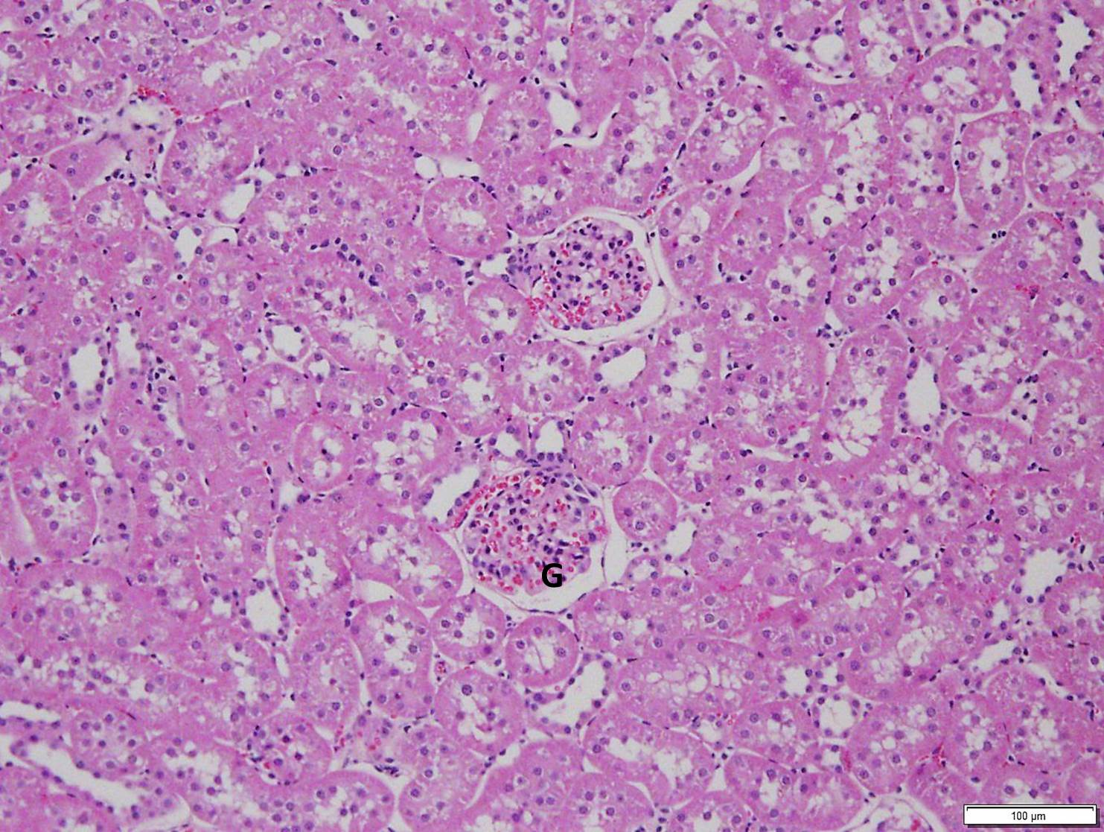

**Figure 2.** . Left kidney, Group 1 (Control), Animal 4– H &E stain. Illustrative image of a region of moderate interstitial fibrosis and mild inflammation surrounding moderate tubular dilatation (TD) (upper right). Degenerating/regenerating tubules are smaller, with darker epithelial cells and small to absent lumens (arrowheads). The glomerular tufts (G) are thickened, with portions adhered to regions of thickened Bowman's capsule (arrows).

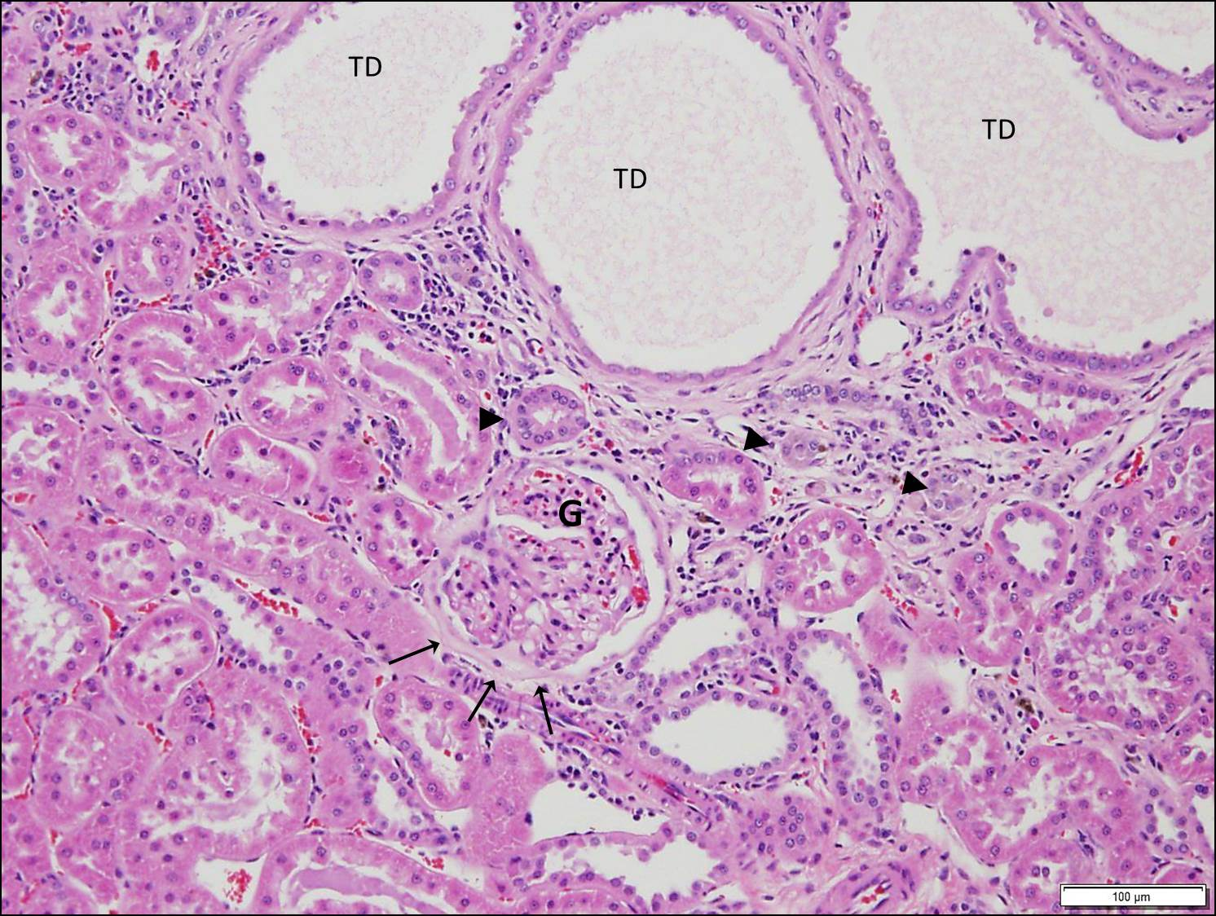

**Figure 3.** Left kidney, Group 2 (Prophylaxis), Animal 14 )– H&E stain. Illustrative image of minimal inflammation with small, infrequent clusters of inflammatory cells within the interstitum (arrows), and mild tubular dilation (TD).

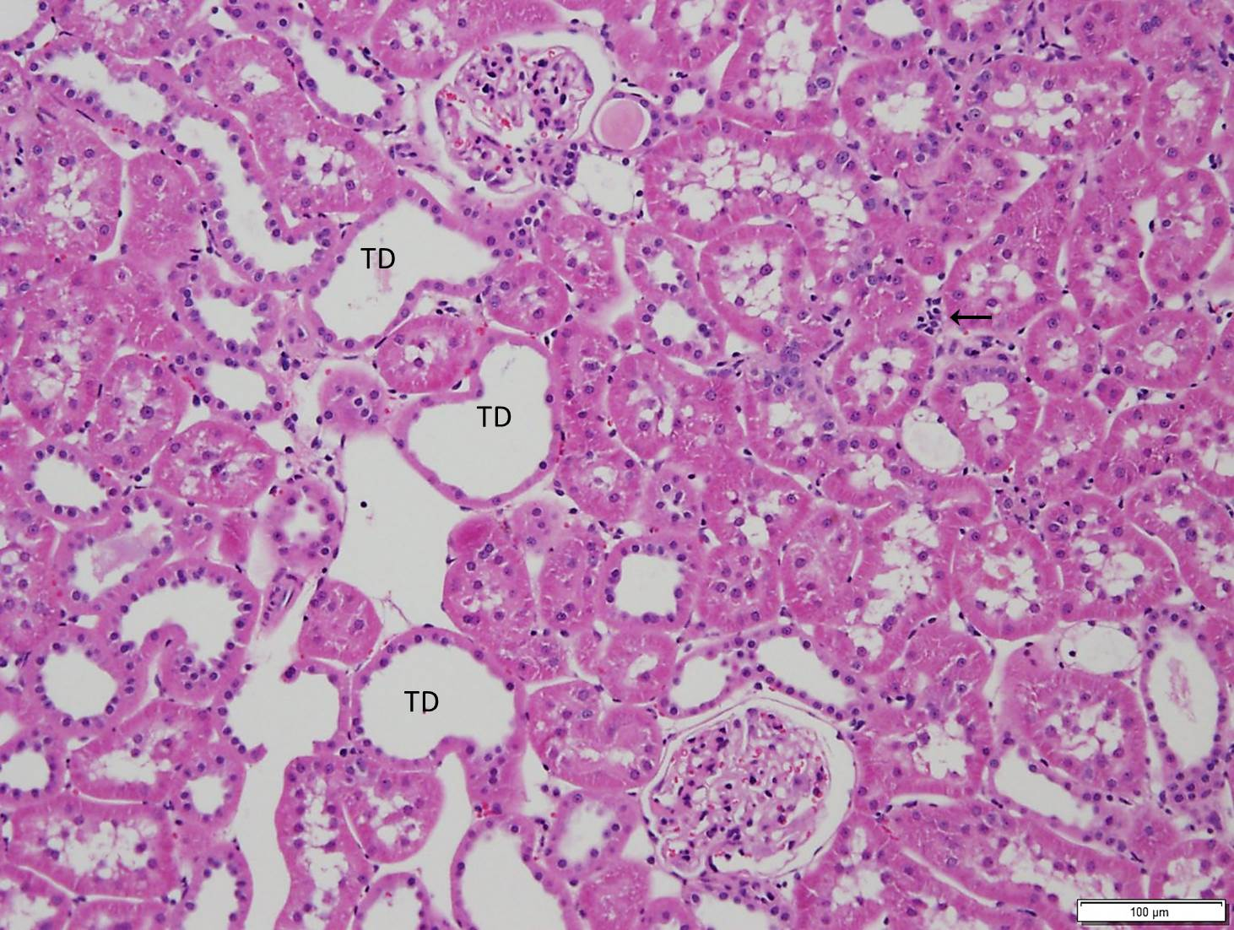

**Figure 4.** Left kidney, Group 3 (Treatment), Animal 20 – H&E stain. Illustrative image of minimal tubular dilation (TD) and mild tubular degeneration/regeneration (arrrow).

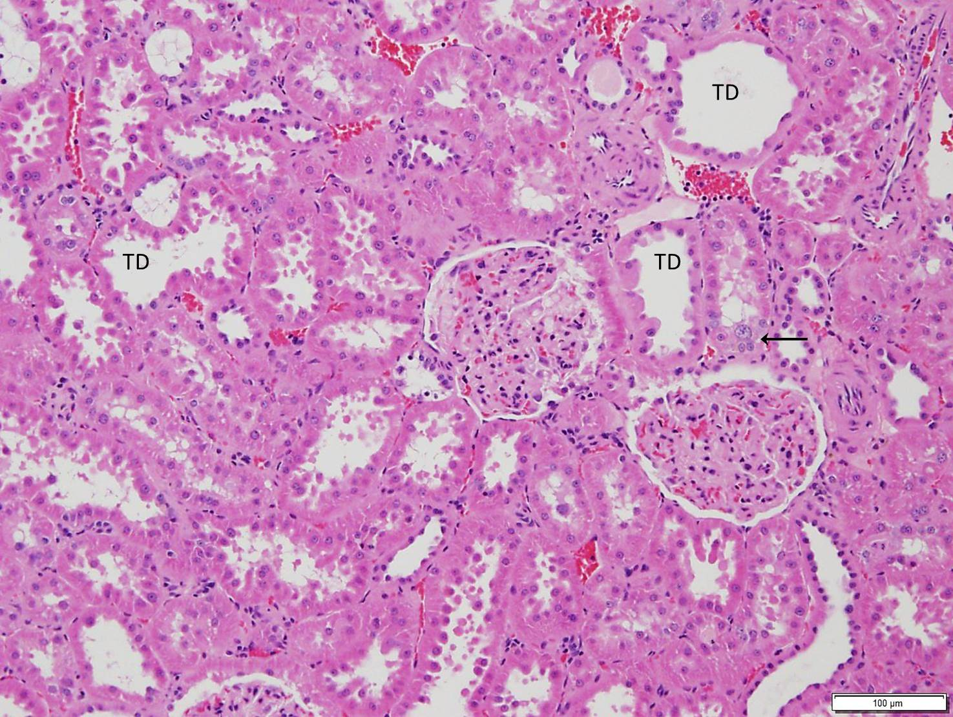

**Figure 5.** Right kidney, Group 1, Animal 4 (Control) - PAS stain. Illustrative image of right kidney with 5 glomeruli (G) surrounded by cortical tubules and blood vessels (BV). Tubular and glomerular capillary basement membranes, and Bowman's capsules are thin. The right kidneys from Groups 2 (Prophylaxis) and 3 (Treatment) were similar in appearance.

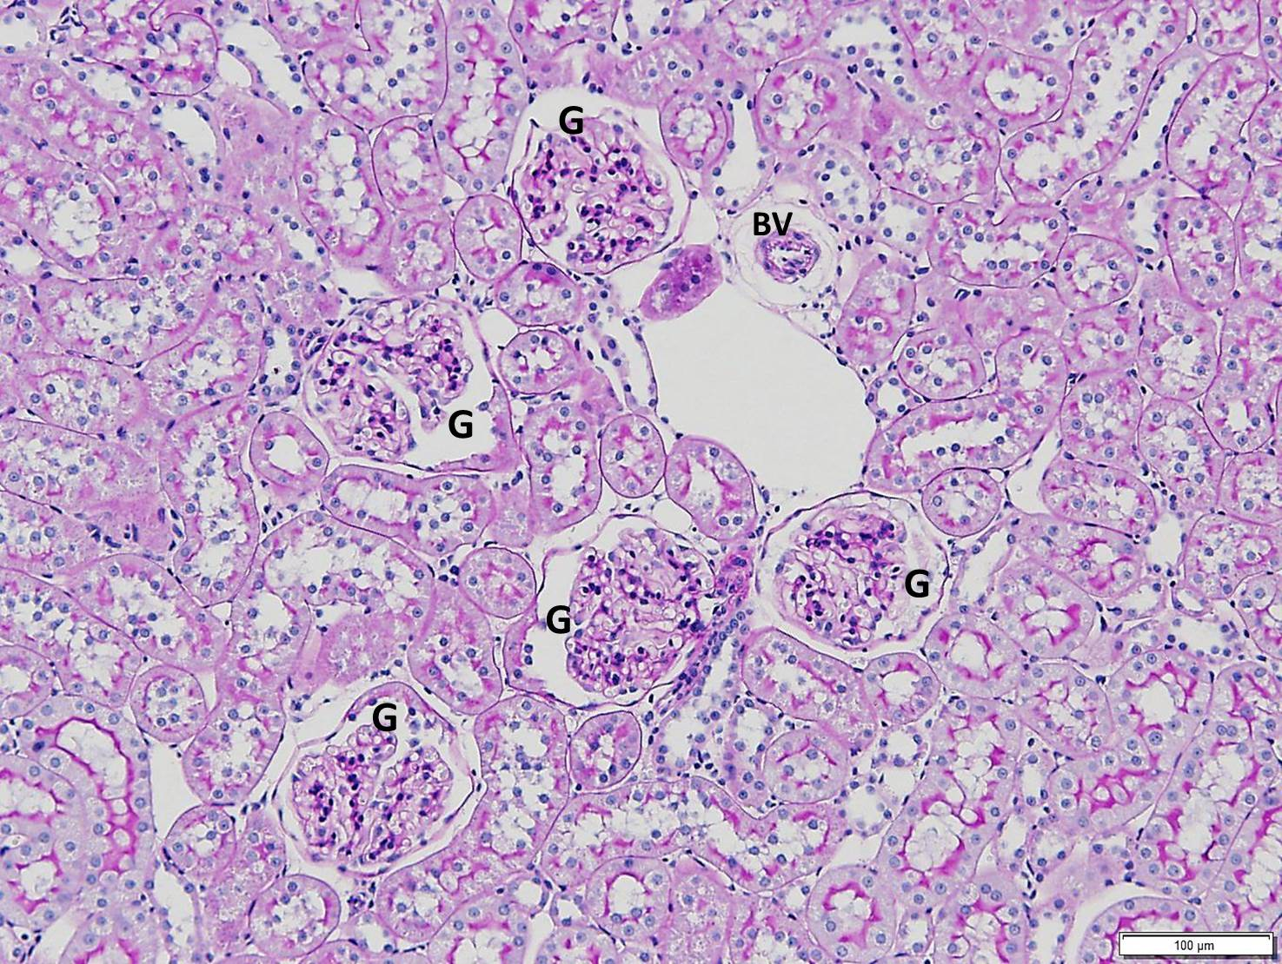

**Figure 6.** Left kidney, Group 1 (Control), Animal 4 – PAS stain. Illustrative image of moderately thickened tubular basement membranes (arrows), and moderate glomerular change. One glomerulus (asterisk) exhibits nearly global glomerular change and the other exhibits segmental glomerular change (star).

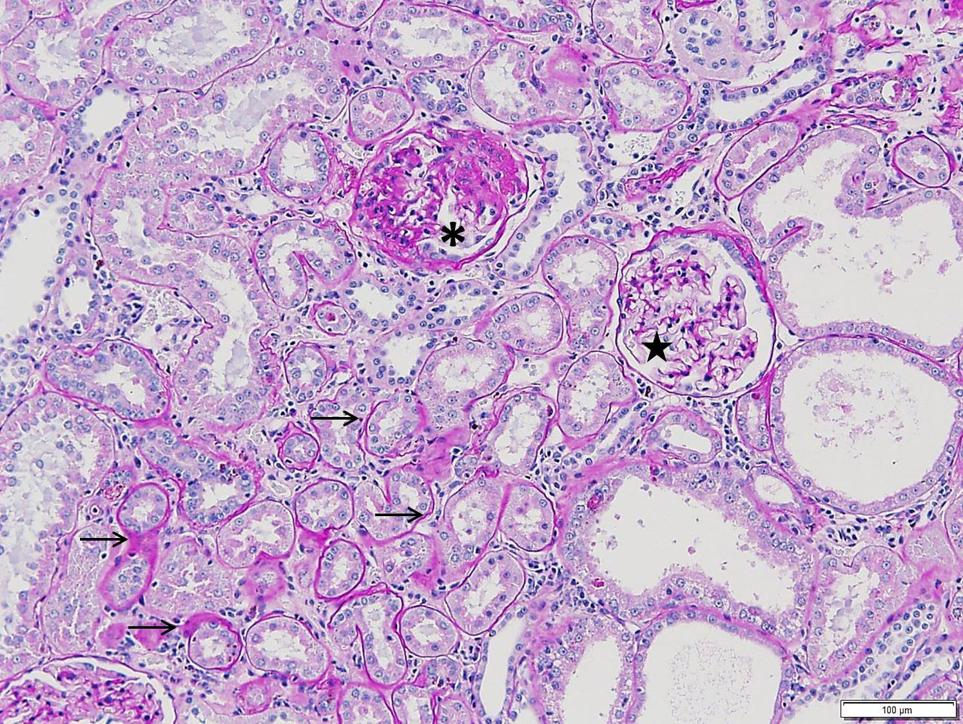

**Figure 7.** Left kidney, Group 2 (Prophylaxis), Animal 14 - PAS stain. Illustrative image of minimal tubular basement membrane change and mild (segmental) glomerular change (arrows).

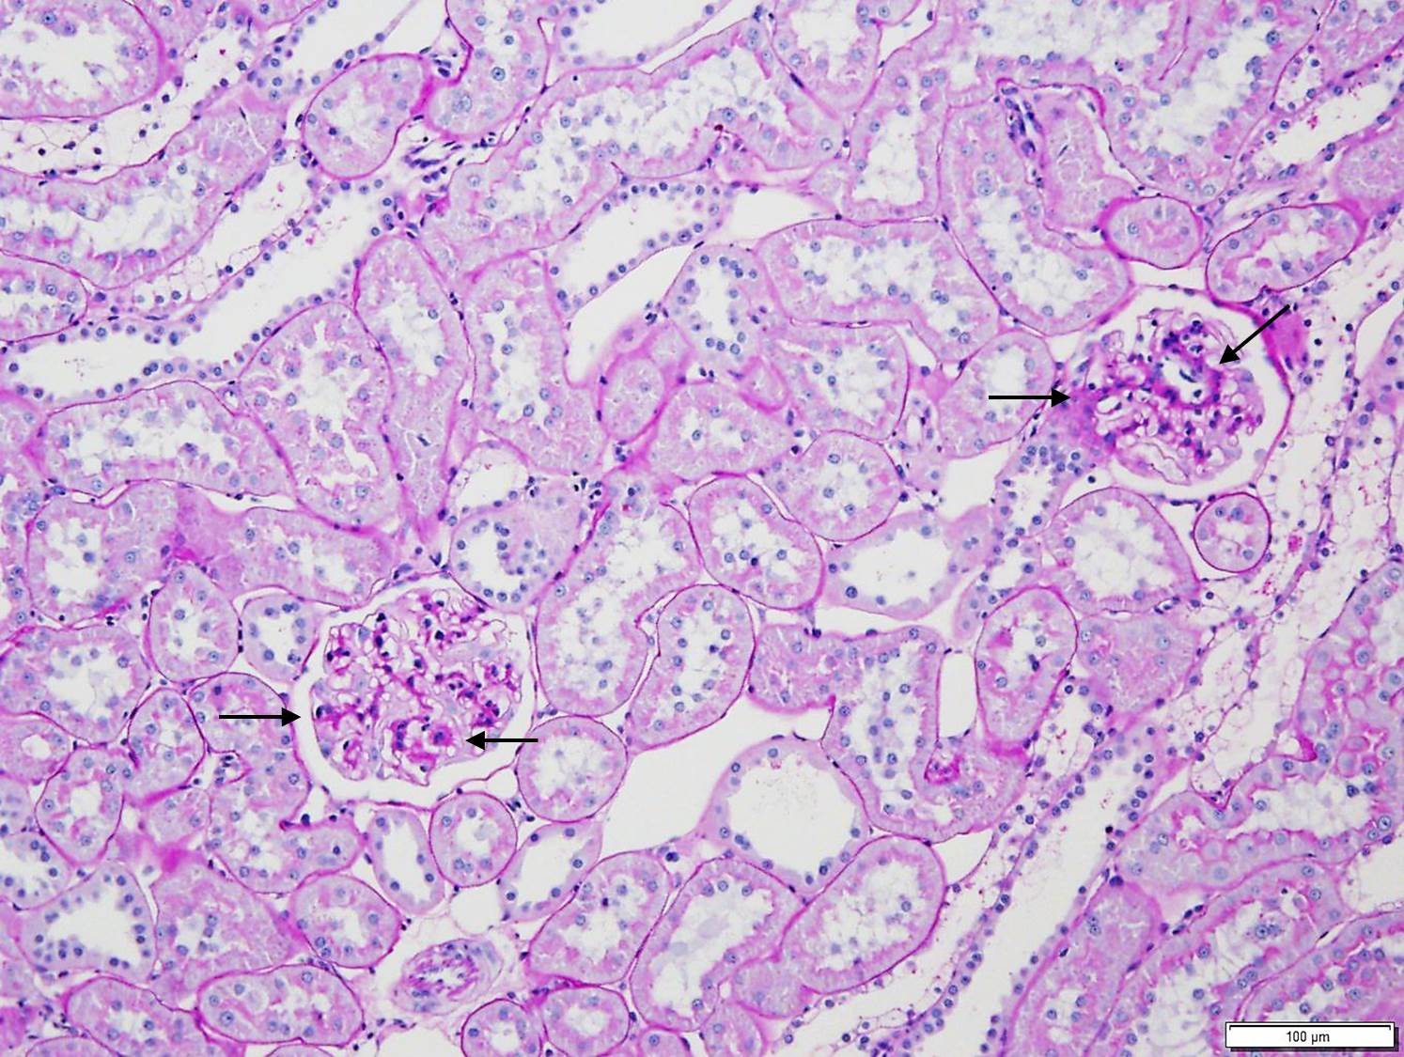

**Figure 8.** Right kidney, Group 1, Animal 4 (Control): Illustrative image of right kidney with Glomerulus (G) surrounded by tubules and blood vessels (BV). Note small amounts of normal collagen (staining blue) within interstitium and surrounding blood vessels.

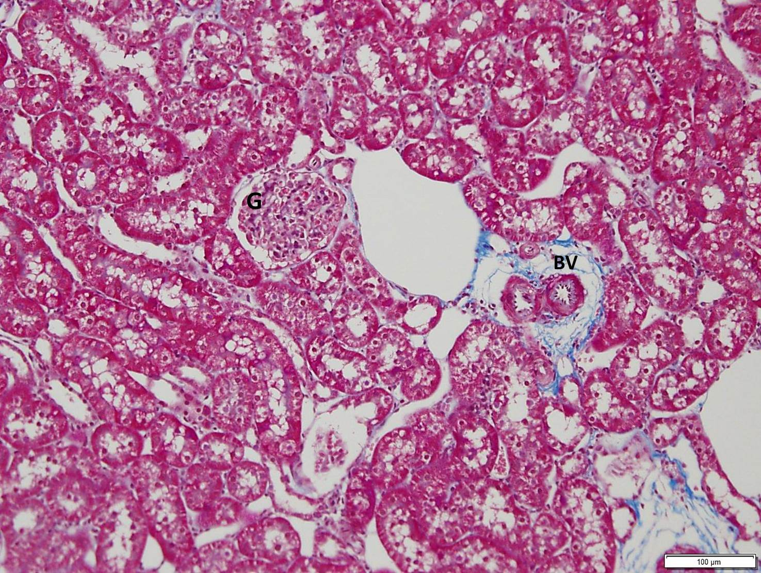

**Figure 9.** Left kidney, Group 1 (Control), Animal 4 -Trichrome stain. Illustrative image of moderate interstitial fibrosis and mild glomerular fibrosis indicated by increased blue staining between tubules as well as surrounding and within glomeruli.

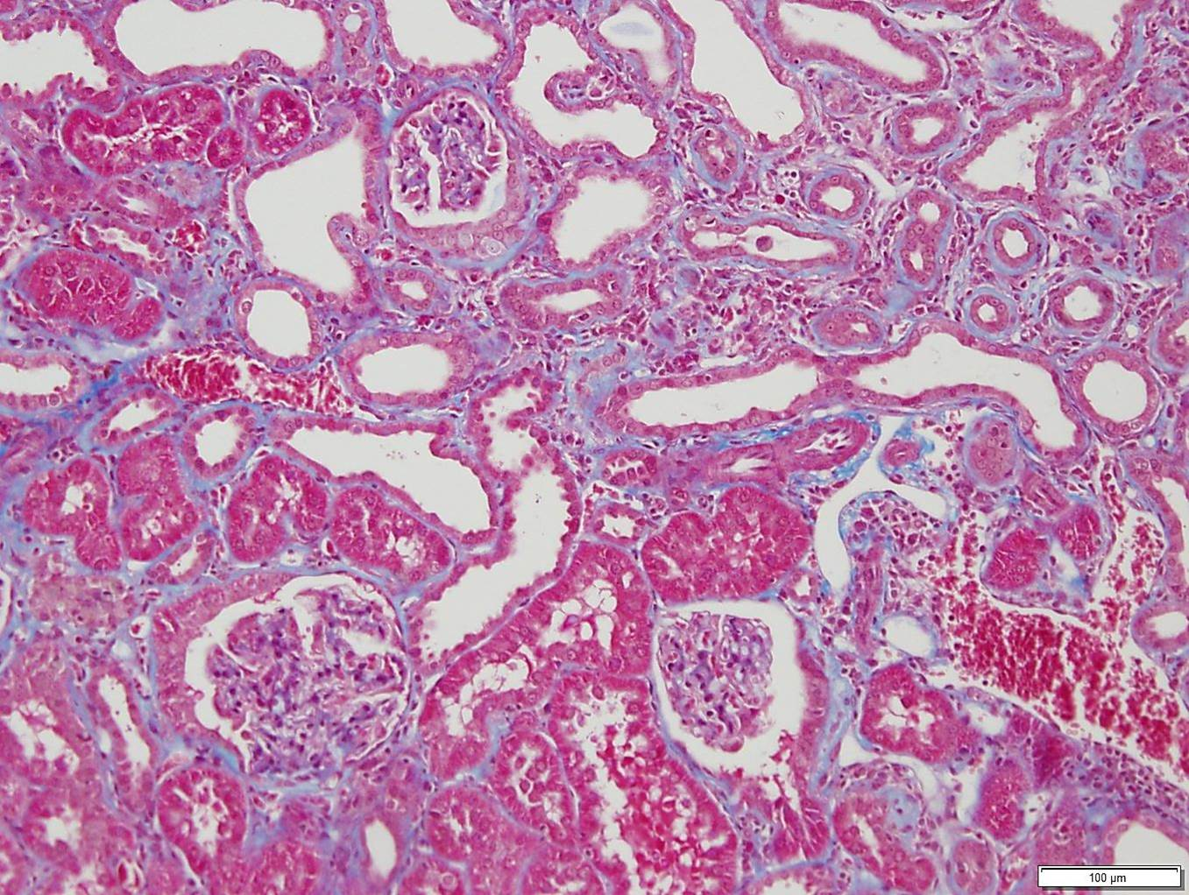

**Figure 10.** Left Kidney, Group 2 (Prophylaxis), Animal 14- Trichrome Stain. Illustrative image of minimal interstitial and glomerular fibrosis. Note slightly increased interstitial and segmental glomerular (arrows) collagen as compared to the Right Kidney (Figure 8) but less than the left kidney from Animal 4, Group 1 (Figure 9).

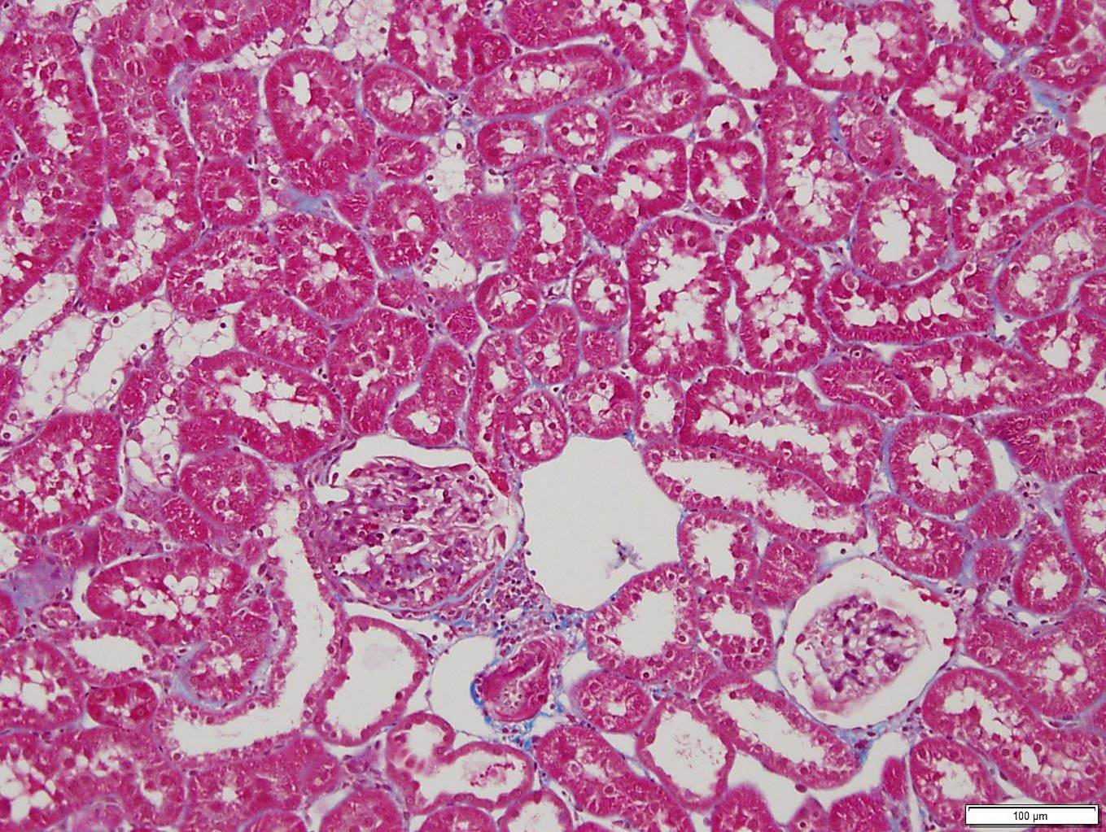

**Figure 11.** Left Kidney, Group 3 (Treatment), Animal 17 -Trichrome Stain. Illustrative image of mild interstitial fibrosis. Note similar thickness but less extensive of interstitial (arrowheads) collagen compared to the left kidney from Animal 4, Group 1 (Figure 9).

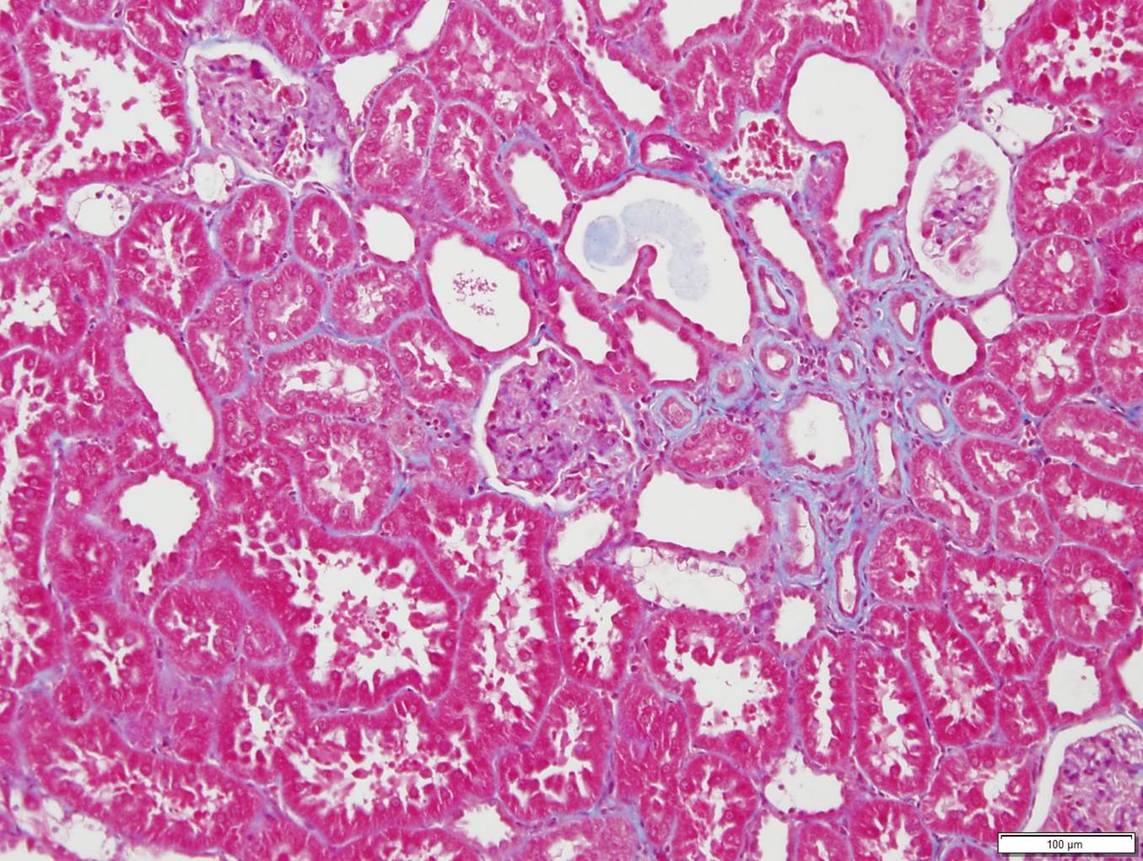

**Figure 12.** Right kidney Group 1 (Control), Animal 4 –Collagen I IHC: Illustrative image demonstrating normal supportive collagen (staining dark brown) stroma surrounding tubules, within the interstium and within glomeruli. Glomerulus (G), Blood vessel (BV).

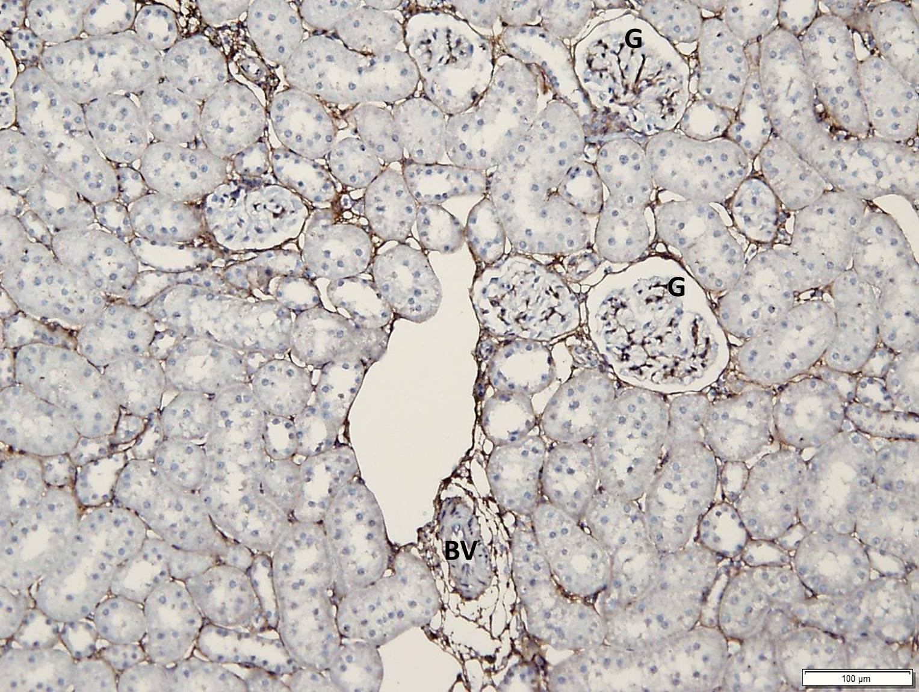

**Figure 13.** Left kidney, Group 1 (Control), Animal 4. Illustrative image of moderately increased interstitial and glomerular collagen (fibrosis) indicated by strands of collagen staining dark brown. Collagen I IHC.

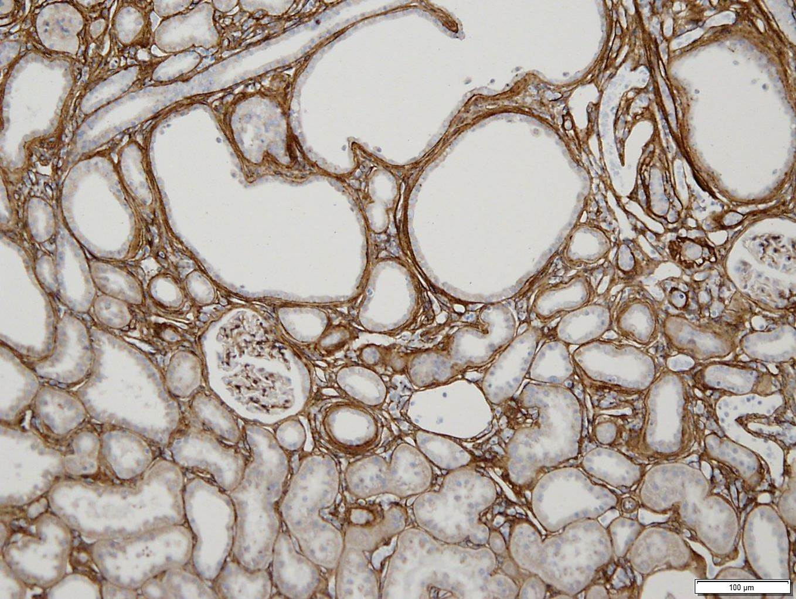

**Figure 14.** Left kidney, Group 1 (Control), Animal 4 - Collagen I IHC. Illustrative image of moderately increased interstitial collagen (fibrosis) indicated by strands of collagen staining dark brown.

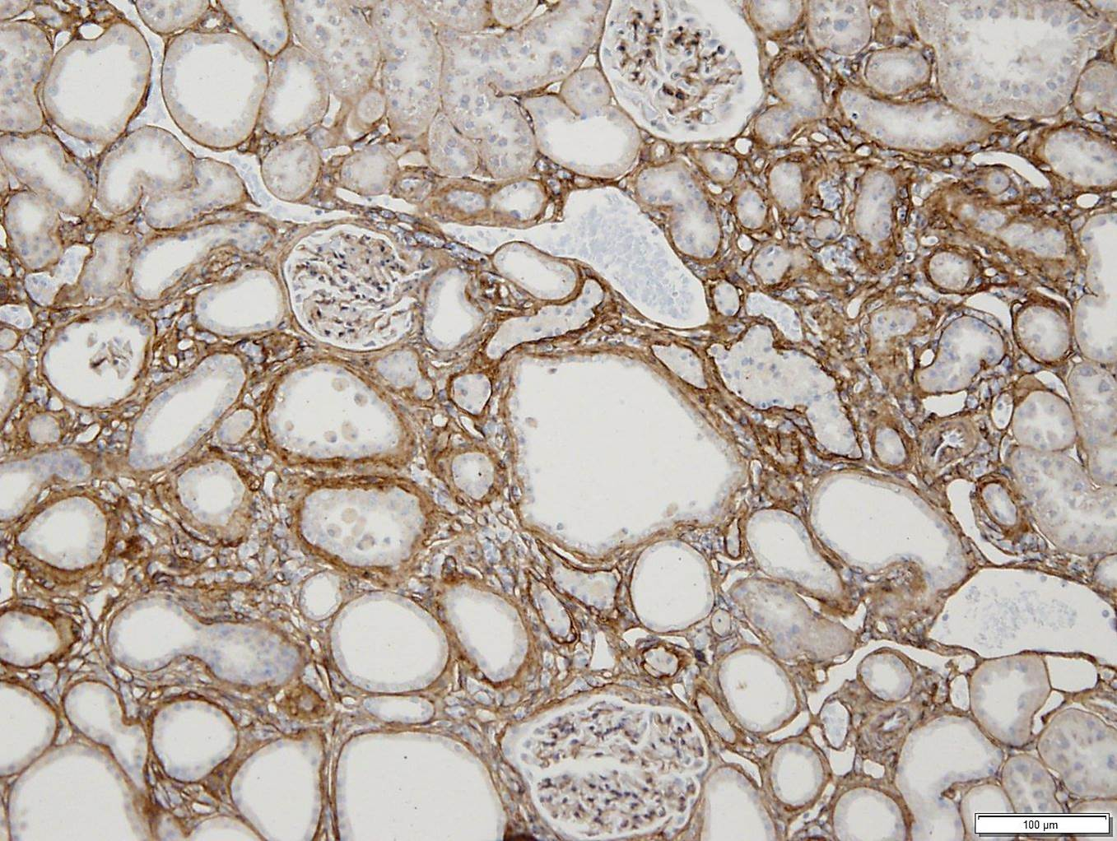

**Figure 15.** Left kidney, Group 1 (Control), Animal 4: Detail of glomerulus illustrating mildly increased, segmental glomerular collagen (arrows).

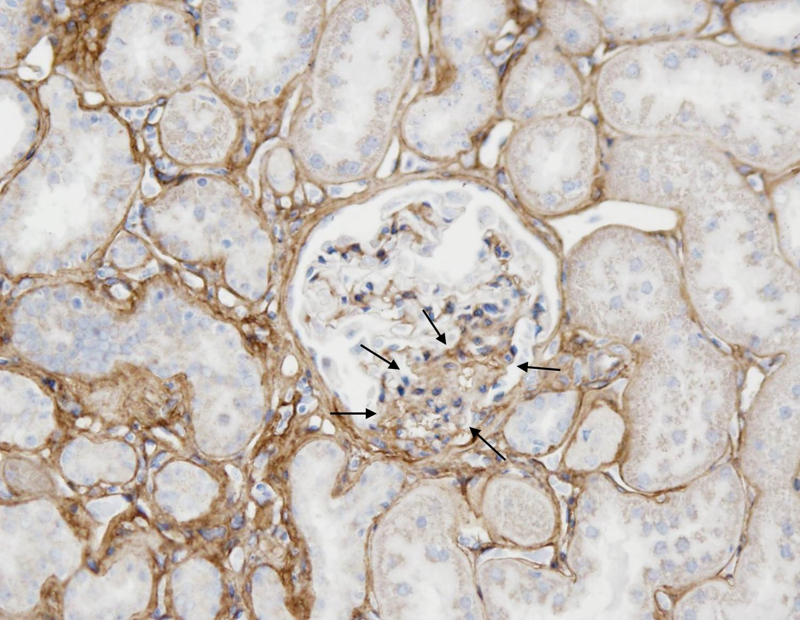

**Figure 16.** Left kidney, Group 2 (Prophylaxis), Animal 14-Collagen I IHC. Illustrative image of minimal increases in interstitial collagen (arrows).

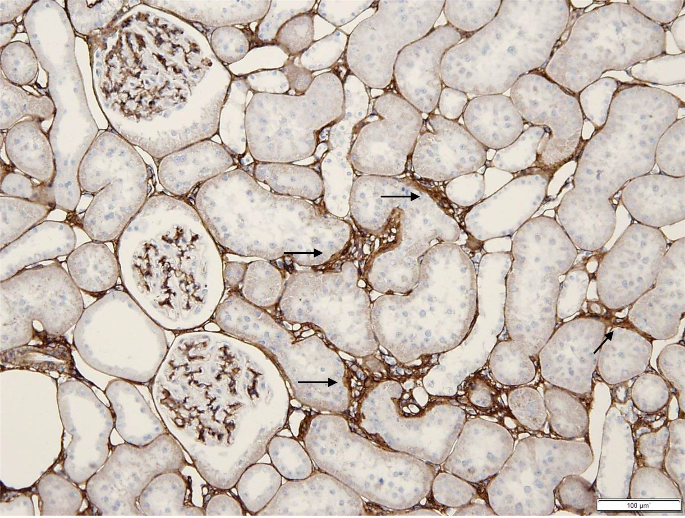

**Figure 17.** Left kidney, Group 3 (Treatment), Animal 20 - Collagen I IHC. Illustrative image of mildly increased interstitial collagen indicated by strands of collagen staining dark brown. Areas of increased collagen were smaller and less frequent compared to Group 2, Animal 4 (Figures 13 and 14 ).

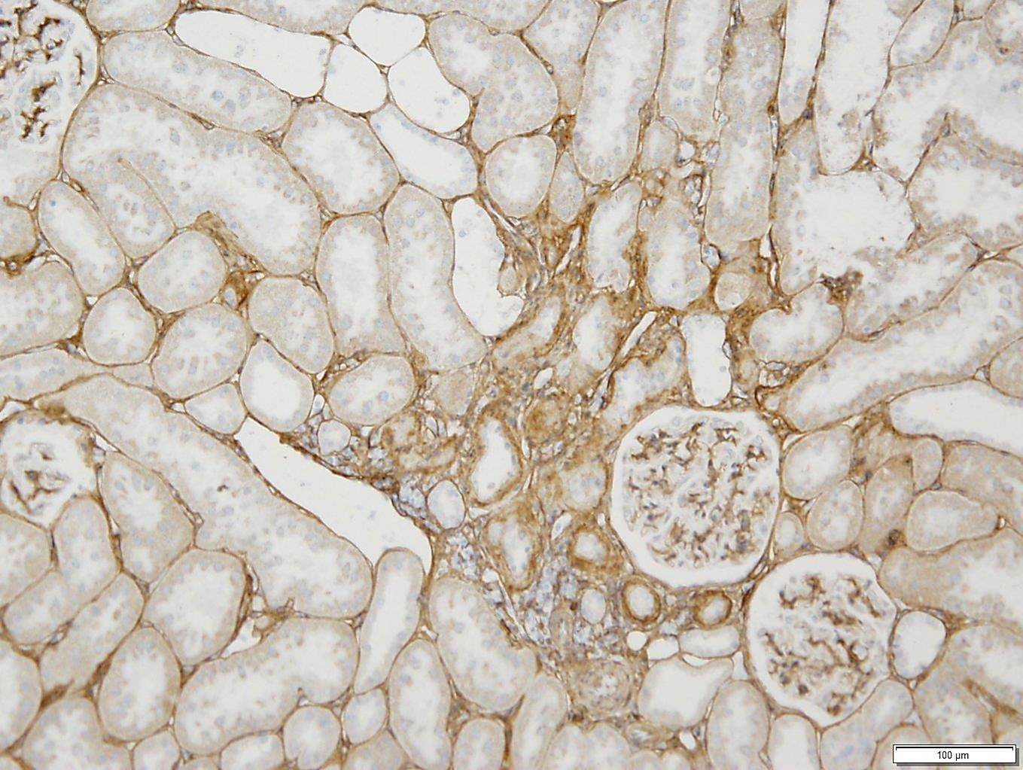

**Figure 18.** Collagen IHC negative control-kidney.

