Use of the spastin mouse model to suggest novel approaches for the treatment of hereditary spastic paraplegia

by

Khlood Mehdar
(BSc, MS)

Submitted for the degree of Doctor of Philosophy (PhD)

Sheffield Institute for Translational Neuroscience

University of Sheffield



November-2017

ABSTRACT
Hereditary spastic paraplegias (HSPs) are a heterogeneous group of inherited neurological disorders that are characterised by lower limb spasticity and weakness. Their clinical pathophysiology is degeneration of the corticospinal tract. The most common HSP gene is spastin (SPAST). SPAST encodes a microtubule severing protein. Mutations in SPAST cause reductions in axonal transport that lead to axonal swellings in the corticospinal tract with mitochondrial accumulation. Finding a therapy for HSP is challenging. In this thesis I tested different therapeutic approaches using a spastin mouse model.
To alleviate symptoms of HSP, physicians recommend taking a low level of regular exercise, but these recommendations are not based on any formal evidence. Therefore, I used the spastin mouse to investigate whether or not regular exercise on a home cage running wheel modifies the development of progressive gait defects. I found that exercise reduced the progression of the gait defect and also reduced the number of axonal swellings in the spinal cord.
Microtubule acetylation has been shown to regulate axonal transport. Increased acetylation by chemical inhibition of histone deacetylase 6 (HDAC6) has been shown to be neuroprotective. I used a combination of pharmacological and genetic inhibition of HDAC6 in a spastin mutant mouse model to determine whether HDAC6 is a valid target for therapeutic intervention in HSP. My results suggest HDAC6 inhibition may be useful in alleviating pathological axonal swellings, but had no beneficial effect on gait.
Microtubule stabilising agents are another approach for the treatment of neurodegenerative disease, since these have been shown to modify axonal transport defects. Among MTs stabilisers, Epothilone D (EpoD) which is able to penetrate the blood brain barrier. Treating spastin mice with EpoD showed no beneficial effect on gait, and in fact tended to worsen the axonal swelling pathology.
Although neither the reduction nor increase in the number of axonal swellings modified the gait defect. We concluded that there is no relationship between the axonal swellings in the spinal cord and the gait defect in spastin mouse model of HSP.

ACKNOWLEDGMENTS
First and most of all, I would like to thank the almighty Allah, the most gracious, the most merciful, for giving me this chance to step forward to achieve my dream. My sincere gratitude is due to my parents who have overwhelmed me with their unconditional support, love and precious prayers to enable me to fulfil my dream. I am forever thankful and appreciative to my husband Mohammad for his endless encouragement, support and patience, and for making this journey easier by his huge sacrifices. You have stolen a dream from my eyes to create it into a thought, an effort and a reward.
Secondly, my endless appreciation goes to my supervisor, Dr. Andrew Grierson for his invaluable support, inspiring guidance and scientific input. Thank you for the knowledge I gained from you during the course of this PhD, which has helped me develop scientifically and academically. Also, I would like to thank my co-supervisor Dr Kurt De Vos for his academic support and guidance. My special thanks go to Gary Shaw for his tremendous technical support with in vivo work. Special thanks also to Ian Coldicott for his patience and help in injecting the mice for the in vivo work. Also, I would like to thanks Emma Smith for teaching me western blotting and being there for all my questions. Special thanks to Lynn Baxter for helping me in immunohistochemistry, and Daniel Fillingham for scanning my histology slides.
My kids Feras, Wabel, Kinaz and Kenda, thank you for being at my side during the most stressful, as well as the most exciting periods during my PhD. You were my comfort zone in the toughest moments and in your lovely eyes I felt the warmth even in the coldest nights.
Finally, I would like to thank Najran University, which has supported the work described in this thesis, through the Royal Embassy of Saudi Arabia’s Cultural Bureau in London.

This thesis is dedicated to my loving husband
Mohammad Sindy

CONTRIBUTIONS
- Poster presentation, Centre of Membrane Interaction and Dynamics (CMIAD) meeting, Sheffield, UK, January 2015.
- Poster presentation, British Neuropathological Society (BNA) meeting, Edinburgh, UK, April 2015.
- Poster presentation, 15th Annual Medical School Research Day, Sheffield, UK, June 2015.
- Poster presentation, SiTraN Neuroscience Annual Research Day, Sheffield, UK, October 2015.
- Poster presentation, 9th Saudi Student Conference, Birmingham, UK, February 2016.
- Poster presentation, 16th Annual Medical School Research Day, Sheffield, UK, June 2016.

AWARDS AND PRIZES
1st prize for poster presentation, SiTraN Neuroscience Annual Research Day, Sheffield, UK, October 2015

TABLE OF CONTENTS
ABSTRACT i
ACKNOWLEDGMENTS ii
CONTRIBUTIONS iv
AWARDS AND PRIZES iv
TABLE OF CONTENTS v
LIST OF FIGURES xi
LIST OF TABLES xiv
TABLE OF ABBREVIATIONS xv
Chapter 1: Introduction 1
1.1 Biology of the motor system 2
1.2 Hereditary spastic paraplegia 2
1.2.1 Classification of HSP 3
1.2.2 The Genetic subtypes of HSP 4
1.2.3 Cellular pathogenesis of HSP 4
1.2.3.1 Myelination 7
1.2.3.2 Mitochondrial function 8
1.2.3.3 Vesicular trafficking and signalling 10
1.3 Spastin gene 11
1.3.1 Spastin structure 11
1.4 Spastin’s role in various cellular processes 14
1.4.1 Spastin’s role in MT severing 14
1.4.2 Spastin’s role in the formation of Endoplasmic reticulum (ER) 14
1.4.3 The endosomal role of Spastin 15
1.4.4 Cytokinesis 17
1.5 Spastin mutants in SPG4 patients 18
1.5.1 Truncating spastin mutations 18
1.5.2 Missense SPG4 mutations 19
1.6 Spastin localisation 19
1.7 Insight into the function of spastin using animal and cellular models 21
1.7.1 Cellular models 21
1.7.2 Drosophila models 22
1.7.3 Zebrafish models 23
1.7.4 Mouse models 23
1.8 The role of microtubules in neurodegenerative diseases 28
1.9 Therapeutic approaches towards hereditary spastic paraplegia 29
1.9.1 Current therapeutic approaches 29
1.9.1.1 Physiotherapy and antispastic drugs 29
1.9.2 Therapeutic areas under development 31
1.9.2.1 Microtubule targeting drugs 31
1.9.2.1.1 Microtubule destabilising drugs 32
1.9.2.1.2 Microtubule stabilising drugs 34
1.9.2.2 Histone deacetylases (HDACs) as a therapeutic target in HSP 34
1.9.2.3 Histone deacetylase 6 (HDAC6) as a potential therapeutic target for HSP 38
1.9.2.3.1 Chemical inhibition of histone deacetylase HDAC6 39
1.9.2.3.2 Genetic inhibition of histone deacetylase HDAC6 41
1.10 Behavioural assessment in a mouse model 41
1.10.1 Motor function assessment 42
1.10.2 Gait assessment 43
1.11 Project aims 44
Chapter 2: Material and Methods 46
2.1 Materials 47
2.1.1 Equipment 47
2.1.2 Reagents and chemicals 48
2.1.3 Solutions 49
2.1.3.1 Gel Electrophoresis solution 49
2.1.3.2 Tissue lysis solutions 49
2.1.3.3 Washing reagents 50
2.1.3.4 Western blotting solutions 50
2.1.3.5 Immunohistochemistry solutions 52
2.1.4 Antibodies 54
2.2 Methods 55
2.2.1 Ethics statement 55
2.2.2 Housing 55
2.2.3 Mouse models used in this thesis 55
2.2.4 Breeding scheme for SPAST^{+/ΔE7}mice and HDAC6 mice: 56
2.2.4.1 Generation of SPAST^{ΔE7 /ΔE7} mice 56
2.2.5 Genotyping SPAST^{ΔE7} mice by PCR restriction fragment length polymorphism analysis 58
2.2.5.1 DNA extraction 58
2.2.5.2 PCR amplification of the SPAST^{ΔE7} mutations 58
2.2.5.3 Restriction digests 59
2.2.6 Genotyping HDAC6 mice 61
2.2.6.1 PCR for HDAC6 mice 61
2.2.6.2 Agarose gel electrophoresis 62
2.2.7 Extraction of RNA 64
2.2.7.1 Measuring RNA concentration 65
2.2.8 cDNA synthesis 65
2.2.9 Reverse Transcription PCR (RT-PCR) 66
2.2.10 Analysis of proteins from mouse tissue 68
2.2.10.1 Sample preparation (protein extraction from tissues) 68
2.2.10.2 Protein determination – Bradford assay 68
2.2.10.3 SDS-PAGE gel 70
2.2.10.4 Immunoblotting 70
2.2.10.5 Imaging immunoblots 71
2.2.11 ENU spastin mouse-phenotypic analysis 72
2.2.11.1 Standard cage 72
2.2.11.2 Home-cage wheel running 72
2.2.11.3 Epothilone D (EpoD) housing 73
2.2.11.4 CatWalk gait analysis 74
2.2.12 Immunocytochemistry (IHC) in mouse tissue 76
2.2.12.1 Mouse tissue preparation 76
2.2.12.2 IHC for formalin fixed, paraffin-embedded tissue (FFPE) 76
2.2.13 Quantification of axonal swellings 78
2.2.14 Data analysis and statistical methods 79
Chapter 3: Effects of exercise on the HSP phenotype 80
3.1 Aims 81
3.2 Introduction 81
3.3 Results 83
3.3.1 Experimental design 83
3.3.2 Housing conditions 83
3.3.3 Running wheel activity in spastin mutant mice 83
3.3.3.1 Characterisation of running activity 83
3.3.3.2 Spastin mutation does not affect overall running activities 86
3.3.4 No effects of voluntary exercise on mice body weight 88
3.3.5 The beneficial effects of voluntary exercise on hind limb gait in spastin mice 90
3.3.5.1 Gait Analysis of spastin mouse model using the CatWalk automated system 90
3.3.5.2 Hind limb BOS 92
3.3.6 Analysis of additional gait parameters 95
3.3.6.1 Longitudinal analysis of other gait parameters 95
3.3.6.2 Examination of additional gait defects identified in this study 100
3.3.7 Effect of exercise on axonal swelling pathology in the spastin mouse model of HSP 102
3.4 Discussion 111
3.4.1 Effect of spastin mutation on voluntary wheel running 111
3.4.2 Running wheel did not alter the weight gain 112
3.4.3 Effect of voluntary wheel running on spastin mice hind limb gait 112
3.4.4 Additional parameters 115
3.4.5 Exercise reduced the number of axonal swellings in the LCST 115
3.4.6 Potential mechanisms underlining the beneficial effect of exercise on the HSP phenotype 117
3.5 Summary 118
Chapter4: Pharmacological inhibition of HDAC6 119
4.1 Aims 120
4.2 Introduction 120
4.3 Results 122
4.3.1 Determination of α-tubulin acetylation level in the SPAST mouse model of HSP 122
4.3.2 Effects of HDAC6 inhibitors on the level of α-tubulin acetylation in the spastin mouse model 126
4.3.3 ACY-738 is brain penetrant 127
4.3.4 Experimental design 133
4.3.5 Housing conditions and cage enrichments 133
4.3.6 Symptomatic treatment with HDAC6 inhibitor (ACY-738) 134
4.3.6.1 Determination of the level of acetylated tubulin after ACY-738 administration 134
4.3.6.2 Effect of symptomatic treatment with ACY-738 on the gait defects of spastin mouse model of HSP 137
4.3.6.3 No effect of symptomatic treatment with ACY-738 on spastin mouse body weight 140
4.3.6.4 Effect of symptomatic treatment with ACY-738 on axonal swelling pathology in the spastin mouse model of HSP 141
4.3.7 Presymptomatic treatment with HDAC6 inhibitor (ACY-738) 146
4.3.7.1 The effects of presymptomatic treatment with ACY-728 on gait defects in the spastin mouse model of HSP 146
4.3.7.2 Effect of presymptomatic treatment with ACY-738 on mice body weight 148
4.3.7.3 Effect of presymptomatic treatment with ACY-738 on axonal swelling pathology in the spastin mouse model of HSP 149
4.4 Discussion 153
4.4.1 Neither symptomatic nor presymptomatic treatment with ACY-738 modified the HSP gait 155
4.4.2 Spastin mutation and ACY-738 have no effect on body weight 160
4.5 Summary 160
Chapter 5: Genetic deletionof HDAC6 162
5.1 Aim 163
5.2 Introduction 163
5.3 Results 167
5.3.1 Breeding strategy for SPAST^{ΔE7} and HDAC6 crosses 167
5.3.2 Investigation of the genetic interaction between spastin and HDAC6 172
5.4 Further evidence for gender-specific genetic interactions: Crossing SPAST^{ΔE7} with the C57BL/6J-OlaHsd sub-strain 174
5.4.1 Determination of α-tubulin acetylation level in the C57BL/6J-OlaHsd 174
5.4.2 Determination of the level of endogenous HDAC6 in the C57BL/6J-OlaHsd brain 176
5.4.3 Sequence analysis of HDAC6 in C57BL/6J-OlaHsd sub-strain 177
5.5 Discussion 180
5.5.1 In vivo investigations of HDAC6 and SPAST double mutants 181
5.5.1.1 Assessment of viability of double mutants 181
5.5.1.2 Pathology 181
5.5.1.3 Protein mechanism 182
5.5.1.4 Hydrocephalus 184
5.5.2 C57BL/6J-OlaHsd sub-strain 186
5.6 Summary 188
Chapter 6: Effects of microtubule stabilising agent EpoD on the HSP phenotype 189
6.1 Aims 190
6.2 Introduction 190
6.3 Results 194
6.3.1 EpoD dosing 194
6.3.2 Experimental design 195
6.3.3 Housing conditions 195
6.3.4 Effect of EpoD on gait defects in the spastin mouse model of HSP 195
6.3.4.1 The effects of treatment with EpoD on gait defects in the symptomatic spastin mouse model of HSP in vivo. 196
6.3.4.2 Effect of treatment with EpoD on gait defects in a presymptomatic spastin mouse model of HSP in vivo. 199
6.3.5 Effect of spastin mutation and EpoD treatment on body weight 201
6.3.6 Effect of presymptomatic treatment with EpoD on axonal swelling pathology in the spastin mouse model of HSP 202
6.4 Discussion 207
6.4.1 Symptomatic test of EpoD in vivo 208
6.4.2 EpoD increased the number of axonal swellings in the spinal cord 209
6.4.3 A possible therapeutic target in the treatment of HSP 212
6.5 Summary 214
Chapter 7: General discussion 215
7.1 Effect of exercise on the HSP mouse model 216
7.2 Effect of chemical inhibition of HDAC6 on the HSP mouse model 218
7.3 Novel genetic interaction between SPAST and HDAC6 222
7.4 Effect of a MT-stabilising drug on the HSP mouse model 223
7.5 The onset of the gait defect in the spastin mouse model 226
7.6 There is no relationship between axonal swellings and gait defect in the spastin mouse model of HSP 226
7.7 Future work 228
BIBLIOGRAPHY 229

LIST OF FIGURES
Figure1.1 | Functional classification of the genes causing HSP | 6
Figure 1.2 | A diagram of the structure of the spastin protein with its functional domains and isoforms | 13
Figure 1.3 | Transverse section of the lumbar region of the spinal cord | 26
Figure 1.4 | The classification of HDACs and structure of m-RNA of HDAC6 | 36
Figure 1.5 | The mechanism of HAT/ HDAC balance in the regulation the gene expression | 37
Figure 2.1 | Crossing SPAST ^{+/ΔE7} female with SPAST ^{+/ΔE7} male | 57
Figure 2.2 | Primers design to create a mismatch for genotyping of spastin mice | 60
Figure 2.3 | Result of the spastin mice genotyping | 63
Figure 2.4 | Result of the HDAC6 mice genotyping | 63
Figure 2.5 | Running wheel home cage | 73
Figure 2.6 | CatWalk system (Noldus Information Technology) | 75
Figure 3.1 | Running wheel activity fluctuates | 85
Figure 3.2 | Weekly measurements of four running wheel activities from 14 to 75 weeks old | 87
Figure 3.3 | The effect of voluntary exercise on body weight | 89
Figure 3.4 | Gait defect of spastin mice analysed by CatWalk automated system at 12 months old | 91
Figure 3.5 | Effects of voluntary exercise on gait deficits of the HSP mouse model | 94
Figure 3.6 | Gait parameters that provided by catwalk automated system | 96
Figure 3.7 | CatWalk automated gait analysis for four different parameters | 101
Figure 3.8 | Diagram illustrating mouse motor neuron fibres | 103
Figure 3.9 | Spinal cord anatomy | 104
Figure 3.10 | Representative images for axonal swellings in the spinal cord | 106
Figure 3.11 | Frequency of axonal swellings per micron at the cervical level of the spinal cord after 14 months of exercise | 108
Figure 3.12 | Frequency of axonal swellings per micron at the lumbar level of the spinal cord after 14 months of exercise | 110
Figure 4.1 | The level of acetylated tubulin in the brains of six weeks old SPAST^{+/+}, SPAST^{+/ΔE7} and SPAST^{ΔE7/ΔE7} mice | 124
Figure 4.2 | The level of acetylated tubulin in the brains of 16 months old SPAST^{+/+} and SPAST^{ΔE7/ΔE7} mice | 125
Figure 4.3 | ACY-748 Chemical structure | 127
Figure 4.4 | The level of acetylated tubulin in the brain following a week of ACY-738 administration | 129
Figure 4.5 | The level of acetylated tubulin in the spinal cord following a week of ACY-738 administration | 130
Figure 4.6 | The level of acetylated tubulin in the liver following a week of ACY-738 administration | 131
Figure 4.7 | The level of acetylated tubulin in the kidney following a week of ACY-738 administration | 132
Figure 4.8 | The level of acetylated tubulin in the brains of SPAST^{+/+} ACY-738 and SPAST^{+/+} placebo mice (symptomatic treatment) | 135
Figure 4.9 | The level of acetylated tubulin in the brains of SPAST^{ΔE7/ΔE7} ACY-738 treated and SPAST^{ΔE7/ΔE7}placebo mice (symptomatic treatment) | 136
Figure 4.10 | CatWalk gait analysis of spastin mice after ACY-738 administration (symptomatic treatment) | 139
Figure 4.11 | The effect of symptomatic treatment with ACY-738 on spastin mice body weight | 140
Figure 4.12 | Frequency of axonal swellings per micron at the cervical level of the spinal cord following ACY-738 symptomatic treatment (16 months old) | 143
Figure 4.13 | Frequency of axonal swellings per micron at the lumbar level of the spinal cord following ACY-738 symptomatic treatment (16 months old) | 145
Figure 4.14 | CatWalk gait analysis of spastin mice after ACY-738 administration (presymptomatic study) | 147
Figure 4.15 | The effect of treatment with ACY-738 on the body weight of presymptomatic spastin mice | 148
Figure 4.16 | Frequency of axonal swellings per micron at the cervical level of the spinal cord following presymptomatic ACY-738 treatment (6 months old) | 150
Figure 4.17 | Frequency of axonal swellings per micron at the lumbar level of the spinal cord following presymptomatic ACY-738 treatment (6 months old) | 152
Figure 4.18 | The coefficient of variation of males, females and mixed group BOS (mm) in wildtype spastin mice | 156
Figure 5.1 | The role of HDAC6 in aggresome formation | 166
Figure 5.2 | Crossbreeding spastin and HDAC6 mice | 167
Figure 5.3 | Crossing double mutant mice | 168
Figure 5.4 | Effect of SPAST and HDAC6 double mutation on brain histology | 173
Figure 5.5 | The level of α-tubulin acetylation in the brain of C57BL/6J-OlaHsd and C57BL/6J mice at six weeks old | 175
Figure 5.6 | Level of HDAC6 in C57BL/6J and C57BL/6J-OlaHsd sub-strains | 176
Figure 5.7 | Sequencing of cDNA obtained from the PCR amplified from C57BL/6J-OlaHsd and C57BL/6Jax sub-strains | 178
Figure 5.8 | Alignment of predicted C57BL/J-OlaHsd HDAC6 and C57BL/J-Jax HDAC6 protein based on sequence of cDNA | 179
Figure 6.1 | Epothilone D chemical structure | 193
Figure 6.2 | CatWalk gait analysis of spastin mice, after the treatment with microtubule stabilising drug Epothilone D (symptomatic study) | 198
Figure 6.3 | CatWalk gait analysis of spastin mice BOS after the treatment with microtubule stabilising drug Epothilone D (presymptomatic study) | 200
Figure 6.4 | Effect of EpoD treatment on mice body weight (presymptomatic study) | 201
Figure 6.5 | Frequency of axonal swellings per micron at the cervical level of the spinal cord following presymptomatic EpoD treatment (6 months old) | 204
Figure 6.6 | Frequency of axonal swellings per micron at the lumbar level of the spinal cord following presymptomatic EpoD treatment (6 months old) | 206
Figure 6.7 | Effects of spastin mutation and MT- stabiliser on MT stability | 211
Figure 6.8 | Diagram of proposed mechanism of MT severing in both HSP and AD | 213

LIST OF TABLES
Table1.1 | Known HSP gene, divided according to the inheritance mode | 5
Table 1.2 | Genetically modified spastin HSP mouse models. | 28
Table 2.1 | List of equipment used | 47
Table 2.2 | List of general chemicals and hardware used | 48
Table 2.3 | List of chemicals and hardware used in immunohistochemistry | 48
Table 2.4 | List of chemicals and hardware used in western blotting | 49
Table 2.5 | List of primary antibodies used in western blotting | 54
Table 2.6 | List of secondary antibodies used in western blotting | 54
Table 2.7 | List of primers used for RT- PCR | 67
Table 3.1 | The definition of the static gait parameters | 97
Table 3.2 | Analysis of gait parameters. | 99
Table 3.3 | Post-hoc power calculation to demonstrate base of support changes in HSP mice | 114
Table 5.1 | The expected and observed ratio of offspring after crossing spastin with HDAC6 double mutant mice (one month old). | 170
Table 5.2 | The expected and observed ratio of offspring after crossing spastin with HDAC6 double mutant mice (postnatal day one) | 171
Table 7.1 | The effect of HDAC6 inhibitors/ HDAC6 knockout in different neurodegenerative disease models | 221
Table 7.2 | The effect of MT- targeting agents in different neurodegenerative disease models | 225

TABLE OF ABBREVIATIONS
AAA | ATPase associated with diverse cellular activity
Ab | Antibody
AD | Alzheimer’s disease
AD-HSP | Autosomal dominant- hereditary spastic paraplegia
ALS | Amyotrophic lateral sclerosis
ANOVA | Analysis of Variance
APP | Amyloid precursor protein
APS | Ammonium persulphate
AR-HSP | Autosomal recessive- hereditary spastic paraplegia
ASPA | Animals (Scientific Procedures) Act 1986
ATP | Adenosine Triphosphate
BBB | Blood brain barrier
BDNF | Brain-derived neurotrophic factor
BMP | Bone Morphogenetic Protein
BOS | Base of support
bp | Base pair
BSA | Bovine serum albumin
°C | Degree celcius
cDNA | Complementary DNA
CMT | Charcot-Marie-Tooth disease
CNS | Central nervous system
CP | Choroid plexus
CST | Corticospinal tract
C-terminal | Carboxy-Terminal
DAB | 3,3 -diaminobenzidine peroxidase substrate
DMSO | Dimethyl Sulfoxide
DNA | Deoxyribonucleic acid
D-spastin | Drosophila spastin
EDTA | Ethylenediaminetetraacetic acid
EGTA | Ethylene glycol-bis(β-aminoethyl ether)-N,N,N',N'-tetraacetic acid
ENU | N-ethyl-N-nitrosourea
EpoD | Epothilone D
ER | Endoplasmic reticulum
ESCRT | Endosomal sorting complexes required for transport
EZ-ECL | Enhanced Chemiluminescence Detection Kit for HRP
FDA | Food and Drug Administration
FFPE | Formalin fixed, paraffin-embedded tissue
GABA | Gamma-amino butyric acid
GAPDH | Glyceraldehyde 3-phosphate dehydrogenase
GDP | Guanosine diphosphate
GFP | Green fluorescent protein
GTP | Guanosine-5’-triphosphate
HAT | Histone acetyl transferase
HD | Hydrophobic domain
HD | Huntington’s disease
HDAC | Histone Deacetylase
Hela | Henrietta Lacks
hESCs | Human embryonic stem cells
hr | Hour
HRP | Horseradish Peroxidase
hrs | Hours
HSP | Hereditary spastic paraplegia
Hsp60 | Heat shock protein 60
IBA1 | Ionized calcium-binding adapter molecule 1
Ig | Immunoglobulin
IP | Intraperitoneal
iPSCs | Induced pluripotent stem cells
KD | Kilodalton
Kg | Kilogram
Km | Kilometre
KO | Knockout
Kb | Kilobase
L1CAM | L1 Neural cell adhesion molecule
LCST | Lateral corticospinal tract
LMN | Lower motor neuron
MAP | Microtubule associated protein
MBD | Microtubule binding domain
mg | Milligram
MGI | Magnetic resonance imaging
MIT | Microtubule-interaction and trafficking domain
µl | Microletter
μM | Micromolar
µm | Micrometre
mm | Millimetre
MT | Microtubule
MTBD | microtubule-binding domain
MTOC | Microtubule organising centre
MVB | Multivascular
NAD | Nicotinamide Adenine Dinucleotide
NDs | Neurodegenerative diseases
NF | Nuclease free
NIH | National Institutes of Health
NIPA1 | Non -imprinted in Prader-Willi/Angelman syndrome
nM | Nanomolar
NMJ | Neuromuscular junction
ns | Not significant
N-terminal | Amino-Terminal
ONS | Olfactory nasal stem cells
PCR | Polymerase Chain Reaction
PD | Parkinson’s disease
PFA | Para-formaldehyde
Pi | Hydrolysed phosphate
PLP1 | Proteolipid protein
PNS | Peripheral nervous system
REEP-1 | Receptor expression enhancing protein-1
RNA | Ribonucleic acid
RT-PCR | Reverse Transcription Polymerase Chain Reaction
RW | Running wheel
S | Second
SBMA | Spinal and bulbar muscular atrophy
SD | Standard deviation
SDS-PAGE | Sodium dodecyl sulphate polyacrylamide gel electrophoresis
SE | Standard error
SMA | Spinal muscular atrophy
Snca | Alph-synuclein
SOD1 | Superoxide dismutase 1
SPAST | Spastin
SPG | Spastic paraplegia gene
TAE | Tris-acetate-EDTA
TBST | Tris-Buffered Saline + 0.1 Tween 20
TEMED | Tetramethylethylenediamine
Tg | Transgenic
TM | Tramsmembrane domain
TMD | Transmembrane domain
Tris | Trisaminomethane
TSA | Trichostatin-A
UTR | Untranslated region
UMN | Upper motor neuron
VF | Ventral funiculus
VLF | Ventrolateral funiculus
Vs | Versus
WT | Wild type
ZF | Zebrafish

Chapter 1: Introduction

Chapter 1: Introduction

1.1 Biology of the motor system
The motor system is the part of the central nervous system that controls voluntary movement (Blackstone, 2012). Skeletal muscles are innervated by motor fibres that can be classified into three types: myelinated alpha large fibres, myelinated beta small fibres and unmyelinated fine fibres (Snell, 2010). The neurons within these fibres that descend from the motor area in the cerebral cortex via the corticospinal tract to the grey matter in the spinal cord are called upper motor neurons (UMN), whereas the motor neurons within fibres that occupy the grey matter ventral column of the spinal cord, and which project to the muscles at neuromuscular junctions, are called lower motor neurons (LMN) (Snell, 2010). Dysfunction within any component of the motor system might lead to the development of a neurological disorder (Talbot, 2002). There are a large number of diseases which involve motor neurons, such as amyotrophic lateral sclerosis (Ferreirinha et al., 2004), spinal muscular atrophy (Coovert et al., 1997), spinal and bulbar muscular atrophy (SBMA) (Igarashi et al., 1992) and hereditary spastic paraplegia HSP (Harding, 1984).

1.2 Hereditary spastic paraplegia
Hereditary spastic paraplegias (HSPs) are a heterogeneous group of inherited neurological conditions including 30 disorders characterised by progressive weakness and spasticity of the lower extremities (Harding, 1984). The first description of HSP was in 1880 by Strumpell (Hourani et al., 2009). The clinical and pathological characteristics of HSP are caused by degeneration of the corticospinal tracts and dorsal column of the spinal cord (Harding, 1984, Fink, 2003b) and, to a lesser degree, by degeneration of the spinocerebral tract (Harding, 1984). Furthermore magnetic resonance imaging (MRI) of patients with HSP has shown atrophy of the corpus callosum, high signal intensity in the posterior limb of the internal capsule, and atrophy in the spinal cord (Harding, 1984). The symptoms of HSP may become apparent at any age. If symptoms become clear during adolescence, however, an insidious spastic gait develops over several years, and as a consequence, the affected person may require a wheelchair, cane or walker. On the other hand, if symptoms start in infancy, the deterioration may be less pronounced (Fink, 2003a).

1.2.1 Classification of HSP
The clinical sub-classification of HSP is based on the presence or absence of other rare neurological conditions, in addition to spastic paraplegia. It can be classified into two types: pure and complicated (Harding, 1984).
Pure HSP is limited to abnormalities in the lower extremities and occasional urinary symptoms (Harding, 1981). Since HSP affects the UMNs, it might also involve mild sensory abnormalities in the lower limbs (Fink, 2003a). The age at onset of pure HSP varies from infancy to over 70 years’ old (De Bot et al., 2010).
Complicated HSP includes a large number of rare neurological disorders. In addition to weakness and spasticity, patients have features such as ataxia, dementia, epilepsy, pigmentary retinopathy and mental retardation (Harding, 1981). Most often, the age at onset of complicated HSP is between 10 and 42 years (De Bono et al., 2006).

1.2.2 The Genetic subtypes of HSP
Mutations in many different genes have been found in families with HSP. Various studies have mapped nearly 73 spastic paraplegia gene loci, and mutations in 55 genes associated with HSP have been identified (Timmerman et al., 2012). HSP has been classified genetically, according to the mode of inheritance, into: autosomal dominant (AD), autosomal recessive (AR), X-linked and mitochondrial (Lena et al., 2016), and these classifications have been described for both pure and complicated forms of HSP (Harding, 1984).
The most common pattern of inheritance is AD, accounting for approximately 70% of cases, while the AR inheritance pattern is responsible for about 20% of cases (Harding, 1984). The most common genetic forms are briefly discussed below, and some known genetic subset of HSP are summarised in Table 1.1.

1.2.3 Cellular pathogenesis of HSP
HSP is a disease that principally affects the UMNs (McDermott et al., 2006). The mechanism of HSP is still unknown, however. Studying the normal and mutant functions of related proteins provides a great advantage in terms of understanding the disease at the cellular level and gives insight into disease mechanisms. To identify the most common genes that contribute in HSP’s molecular pathways, we grouped them into three functional groups, namely: myelination, mitochondrial function and vesicular trafficking/signalling. The most common genes in each functional group are discussed below (Figure 1.1).

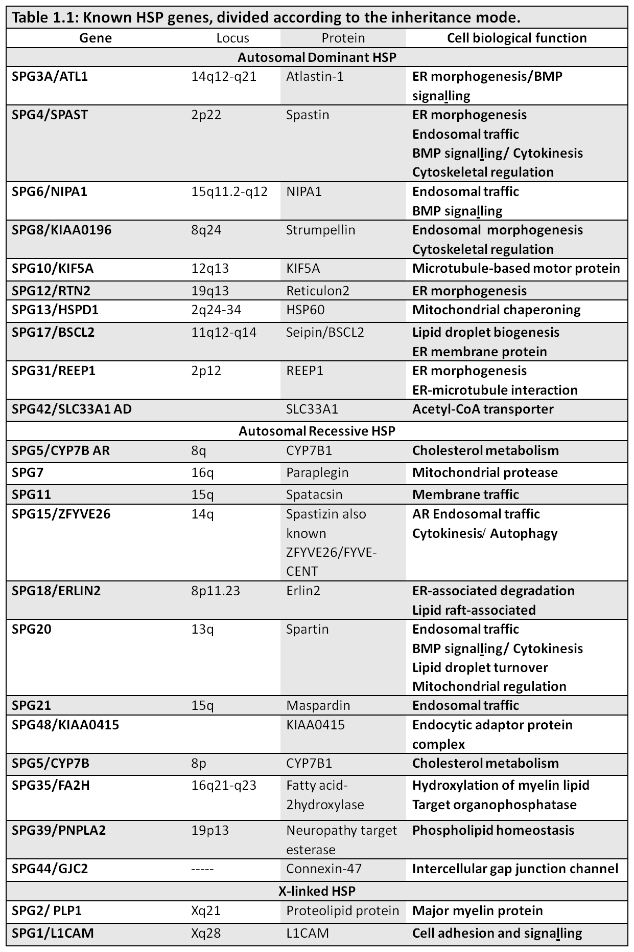

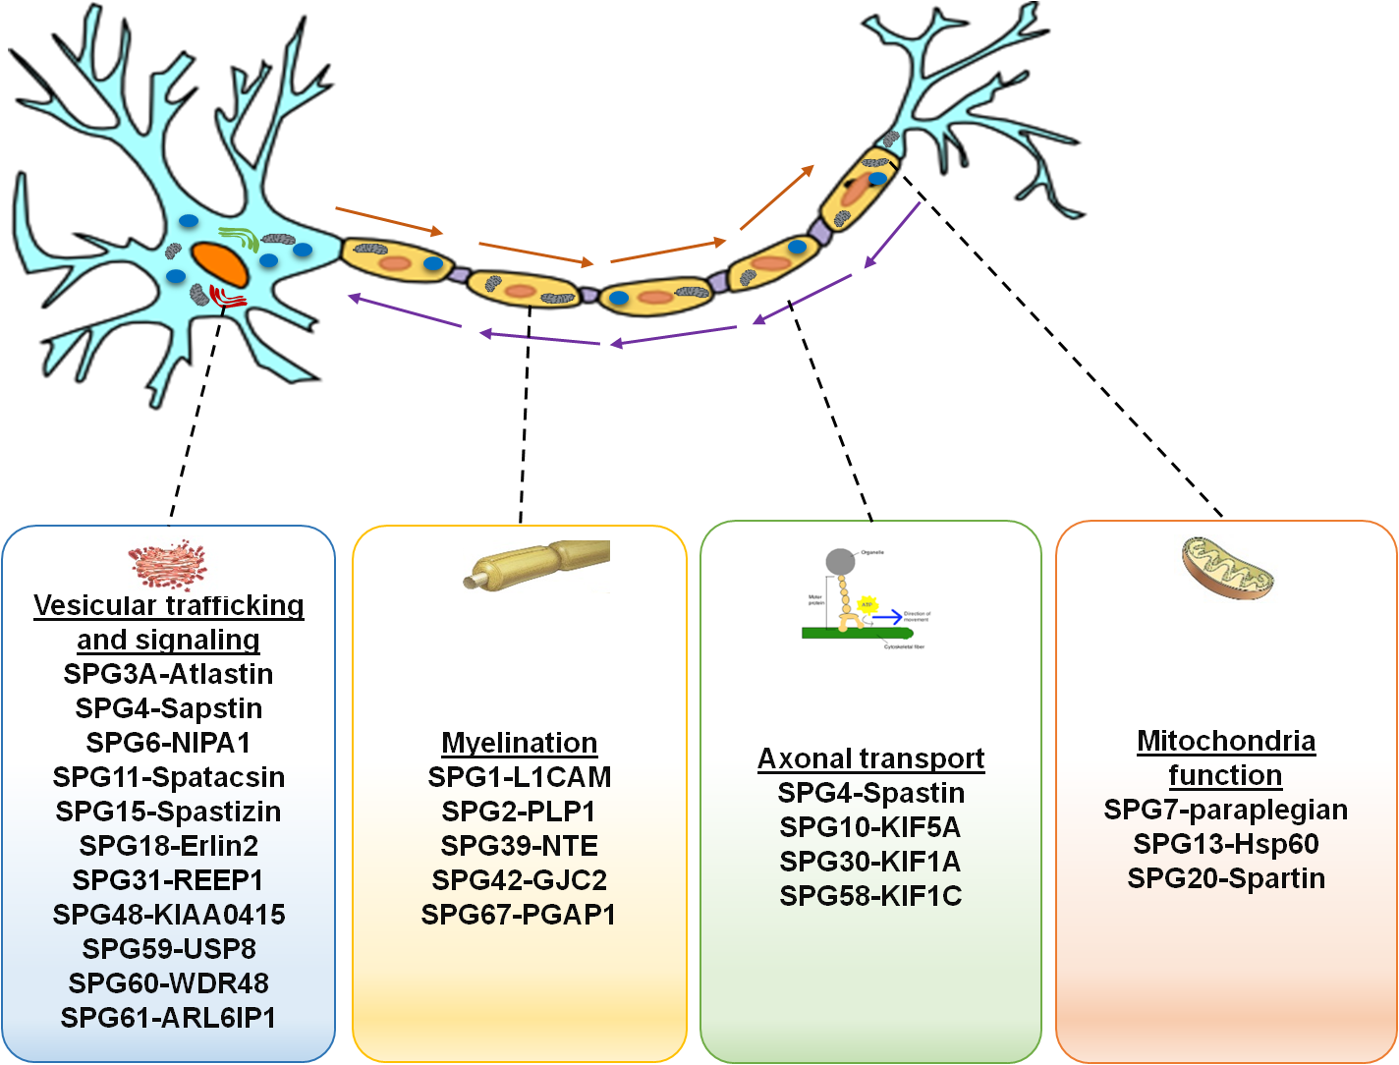
Figure 1.1: Functional classification of the genes causing HSP.

1.2.3.1 Myelination

SPG1-L1CAM
Various X-linked neurological diseases can be caused by mutation in the neural cell adhesion gene L1CAM, such as complex gait shuffling, MASH syndrome and hereditary spastic paraplegia (Fransen et al., 1997). L1CAM is a member of the immunoglobulin family that can mediate cell-to-cell adhesion (Jouet et al., 1994).
L1CAM is composed of more than 1200 amino acids, with the extracellular part being the largest domain (Jouet et al., 1994), since it contains six immunoglobulin (Ig) domains, five fibronectin domains and a transmembrane domain (TMD) (Fransen et al., 1997). L1 protein is found in the CNS and involved in the formation of the myelin sheath (Wood et al., 1990), therefore it contributes to the development of the brain, neurite outgrowth, nerve survival and cell migration.
A lack of L1CAM in mice is linked to the impairment of axonal generation. Since the axons of the developing corticospinal tract within the spinal cord fail to cross contralaterally, these mice present with a weakness in the hind limbs (Dahme et al., 1997). Mutations can occur at any site of the gene, leading to the SPG1 form of HSP (Saugier-Veber et al., 1994); this form of complicated HSP can be characterised by hydrocephalus, leg spasticity, mental retardation and adducted thumbs (Jouet et al., 1994).

SPG2-PLP1
The myelin sheath is important for the transmission of electrical impulses along axons. Myelin in the peripheral nervous system is provided by Schwann cells, while myelin in the CNS is provided by oligodendrocytes. Proteolipid protein gene (PLP1) and DM20 isoforms are fundamental components of CNS myelin, playing a necessary role in neural maturation (Yool et al., 2000). The DM20 spliced isoform, which accounts for 50% of CNS myelin, is involved in the differentiation and survival of oligodendrocytes (Yang and Skoff, 1997). The PLP1 gene, meanwhile, encodes the tetraspan integral membrane proteolipid protein, which is associated with the pure and complex SPG2 form of HSP (Inoue, 2005). PLP1 mutations are diverse, ranging from deletion, missense to duplication of the gene, and can cause axonal degeneration (Yool et al., 2000). A study of SPG2 patients using magnetic resonance imaging showed abnormalities in the white matter associated with demyelinated cases (Cambi, 1995). Mice with null mutations in PLP1 develop impaired motor function and axonal degeneration (Edgar et al., 2004). Characterisation of these mice revealed abnormal accumulations of organelles forming axonal swellings, which were associated with an axonal transport defect (Edgar et al., 2004). This accumulation might contribute to the spastic paraplegia phenotype.

1.2.3.2 Mitochondrial function

SPG7-paraplegin
There are two HSP genes that are known to be directly involved in mitochondrial functions, namely, paraplegin (SPG7) and HSP60 (SPG13), both of which are involved in chaperone activity (De Michele, 1998). The SPG7 locus encodes paraplegin, which is an m-AAA metalloprotease of the inner membrane of the mitochondria. It has a role in protein quality control and ribosomal assembly (Casari et al., 1998). Mutations associated with this gene can cause an autosomal recessive form of HSP that can be both complicated and pure. Some patients with the complicated HSP form of SPG7 display pale optic discs, cerebral signs and peripheral neuropathy (De Michele, 1998). This mutation also leads to impairment of mitochondrial oxidative phosphorylation (Casari et al., 1998). Furthermore, in animal models with SPG7 knock out, defects in axonal transport and accumulation of mitochondria in presynaptic terminals are evident, and these mice show impairment in rotarod performance at 6 months old, which deteriorates further with age. They also display axonopathy, with axonal swellings within the spinal cord and periphery (Ferreirinha et al., 2004).

SPG13-HSP60
Heat shock proteins 60 are also called molecular chaperones, and can be divided into two subgroups; 1) chaperonin I is mitochondrial HSP60, which can be found in the cytosol and organelles, for example mitochondria, 2) chaperonin II is located in the eukaryotic cytosol (Horwich et al., 2007). Mitochondrial HSP60, in coordination with other co-chaperonins, assists the assembly and folding of mitochondrial proteins (Dahme et al., 1997). A mutation has been identified in the HSPD1 gene which encodes the HSP60 protein that triggers the autosomal dominant form of HSP (SPG13), which is characterised by spasticity and weakness in the hind limbs (Hansen, 1992), and is associated with dysfunction of mitochondrial quality control (Shimazaki et al., 2012). It is likely that HSP60 and paraplegian mutations both affect mitochondrial function, leading to HSP.

1.2.3.3 Vesicular trafficking and signalling

SPG3-Atlastin
One of the most common forms of the autosomal dominant pure HSP related to trafficking is SPG3A, caused by mutations in Atlastin (Namekawa et al., 2006). Atlastin is a member of the large Guanosine-5’-triphosphate (GTPase) dynamin superfamily (Zhu et al., 2006). Atlastin mutations account for 10% of HSP cases, and typically show earlier onset, often before 10 years of age (Fink, 1996). Atlastin is mainly expressed in the brain, particularly in the corticospinal neurons, and the localisation of Atlastin-1 in endoplasmic reticulum (ER) and Golgi apparatus implies a possible role of Atlastin in vesicle transport, secretion and trafficking (Zhu et al., 2006). Mutation in the GTPase domain in Atlastin interrupts the maturation of the Golgi apparatus and affects cell morphology (Namekawa et al., 2007), although it does not show any effect on the secretory pathway (Rismanchi et al., 2008).

SPG6-NIPA1
Another HSP gene involved in trafficking is NIPA1 (non-imprinted in Prader-Willi/Angelman syndrome) which is responsible for the SPG6 severe autosomal dominant form of uncomplicated HSP (Rainier et al., 2003). This gene encodes polypeptides with nine transmembrane domains (TMDs) that are conserved during evolution in vertebrates and are expressed in the human CNS (Chai et al., 2003). An in vitro study has shown that NIPA1 encodes a magnesium transporter protein, and the same study, using immunofluorescence to investigate the endogenous NIPA1 in neuronal and epithelial cells, showed that NIPA1 is localised at the cell surface and on endosomes (Goytain et al., 2007). Meanwhile, a study of Tg rats with the NIPA1 mutation revealed a degeneration not only in the CNS but also in the PNS, characterised by accumulation of vesicular organelles beginning at the terminals of axons and dendrites (Watanabe et al., 2013).

SPG4-Spastin
In this thesis we focus mainly on therapeutic approaches to HSP caused by spastin mutations (SPG4). In the following section, therefore, the spastin gene is discussed in detail.

1.3 Spastin gene
The SPG4 locus on chromosome 2p22-p23 is associated with the most common type of AD-HSP (40% of patients) (Hazan et al., 1994). This locus contains the SPAST gene that encodes the spastin protein. The main phenotype of spastin HSP patients is gradual spasticity of the lower extremities (Fink, 1996). As the condition progresses, it may include upper limb hyper-reflexia, reduction in the sense of vibration and atrophy in the lower limbs. Even though the majority of SPG4 pedigrees have pure HSP, some families have been reported with complex phenotypes (McDermott et al., 2006).

1.3.1 Spastin structure
Spastin is a large gene composed of 17 exons spanning a region of 90 kb (Hazan et al., 1994) with a transcript length of 5212bp. The open reading frame of spastin has 1848 base pairs with two initiation codons flanked by 5’UTR and 3’UTR that is translated into two major protein isoforms (Claudiani et al., 2005). The two initiation codons give rise to polypeptides called M1 and M87.
M1 is the full-length isoform (616 amino acids) which is 68KD in size, while M87, the short isoform (i.e. lacking the first 86 amino acids), is 60KD in size (Solowska et al., 2008). In human adults, the M87 short form is expressed in the brain and spinal cord, however the M1 longer isoform is expressed significantly more in the spinal cord (Solowska et al., 2008). In rodents, the prevalent isoform is the shorter one, as it is expressed in all tissues at all developmental stages, while the longer isoform is only found in adult spinal cord (Solowska et al., 2008).
Spastin is a member of the AAA family (ATPases associated with diverse cellular activities) similar to the paraplegin gene. The domain structure is illustrated in Figure 1.2. The AAA domain is located at the C-terminus of the protein between amino acids 342 and 599. AAA domain containing-proteins have important functions such as the biogenesis of organelles, regulation of the cell cycle, and assembly of the mitochondrial ribosomes (Patel and Latterich, 1998, Lupas and Martin, 2002).
There are three conserved domains located in the AAA cassette; Walker motif A (p-loop) lies at 382–389, Walker motif B lies at 437–442 and the ATPase domain lies at 480–498 (Walker et al., 1982). The AAA domain is homologous to katanin, another MT severing protein that has been suggested to have a similar function (Solowska et al., 2008). Another domain that has been identified in the spastin protein is the microtubule-binding domain (MTBD), which is located between residues 270–328. This domain, together with the AAA domain, are important for protein interaction and the severing activity of spastin (White et al., 2007). At the N-terminal spastin has a microtubule-interaction and trafficking (MIT) domain situated between residues 116–194 (Errico et al., 2002). In addition it has a long hydrophobic domain which is also called the transmembrane domain, located between residues 49 and 80. (Salinas et al., 2005).

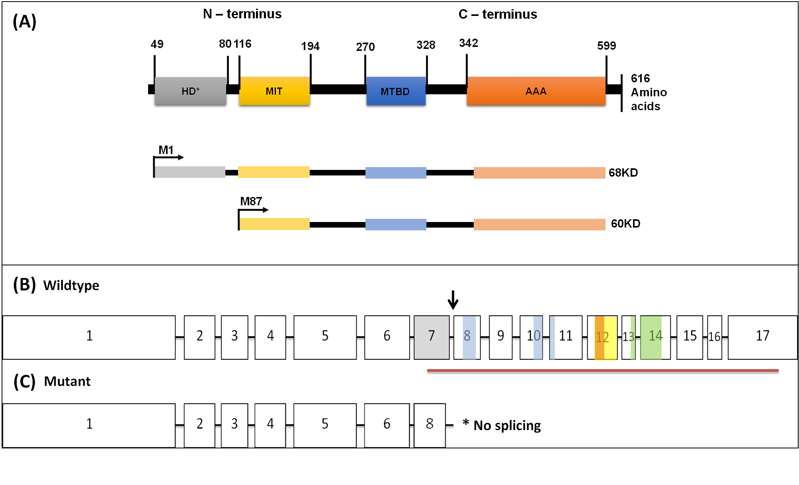

Figure 1.2: A diagram of spastin structure with its functional domains and isoforms.
(A) Spastin is composed of 616 amino acids. It has four functional domains: the N-terminus has the hydrophobic domain (HD) *called the trans-membrane domain TM, the microtubule interaction and trafficking domain MIT. C-terminus has the microtubule binding domain MTBD, and the AAA ATPase associated with diverse cellular activities domain. M1 is a full length isoform of spastin and M87 is the short isoform. (B)The m-RNA of wildtype spastin, and the horizontal red line indicates the AAA cassette encoding region of the gene. The AAA cassette conserved domains indicated by different colours: Walker motif A, ATP binding site and walker motif B (blue), the AAA minimal consensus (yellow), helix loop helix dimenrisation domain (orange), the leucine-zipper motif (green). The location of splice site mutation (exon7, exon-intron 7-8) found in (spastin mouse model) indicated by arrow and the exon skipped as a results of splice site mutation is shaded by gray. (C) The m-RNA of mutant spastin shows exon 7 skipped as a result of splice site mutation, and exon 6 spliced out to exon 8.

1.4 Spastin’s role in various cellular processes

1.4.1 Spastin’s role in MT severing
Spastin is considered to be a MT severing enzyme (Solowska et al., 2008). It plays a major role in cutting microtubules into smaller forms so as to regulate MT dynamics on the plus-end (Errico et al., 2002). It is presumed that severing MTs requires spastin to bind ATP and assemble on the MT in a hexameric shape, with a projected central pore that is positively charged and which attaches to and pulls the C-terminus of tubulin, which is negatively charged, thereby cleaving the MT into smaller pieces (White et al., 2007). The mechanical forces that are applied by spastin on the tubulin C-terminus serve to disrupt the interactions of (tubulin to tubulin) on MT (White et al., 2007, Roll-Mecak and McNally, 2010). The most important domains of SPAST are AAA and MTBD, the MTBD domain binds to MT (White et al., 2007). To sever MTs, ATP hydrolysis is required, and this is catalysed by the AAA ATPase domain (Lumb et al., 2012). This severing activity of spastin is supported by a study which transfected wildtype spastin into neuronal and non-neuronal cells to show that spastin leads to the disassembly of MTs (Errico et al., 2002).

1.4.2 Spastin’s role in the formation of Endoplasmic reticulum (ER)
As mentioned above, spastin has two isoforms. M1 is the longer isoform which has an HD on the N-terminal, and is localised to the secretory pathway of ER (Sanderson et al., 2006). The HD region has been suggested as forming a hairpin loop domain, which is inserted into the bi-layer lipid membrane, i.e. endoplasmic reticulum (Sanderson et al., 2006). The same hairpin loop was found in REEP-1 (receptor expression enhancing protein-1), reticulon and Atlastin, which can interact with the hairpin loop in spastin (Sanderson et al., 2006). REEP-1 is an ER morphogen that binds the ER membrane to MT (Beetz et al., 2008). It has also been reported that spastin interacts with reticulon (an ER shaping protein) (Mannan et al., 2006). Atlastin-1 mediates the fusion of ER tubules (Zhu et al., 2006). The exact role of spastin in ER shaping is not yet resolved, however. Taken together, these investigations suggest that the interaction of the spastin HD domain with ER portions is important for ER morphology and shaping (Park et al., 2010).

1.4.3 The endosomal role of Spastin
Spastin is a cytoplasmic protein with an MIT domain, suggesting that it might be involved in intracellular membrane trafficking events (Patel and Latterich, 1998). Intracellular trafficking includes both secretory and an endocytic pathway. The endocytic system is composed of early endosomes, multivascular bodies (MVB), late endosomes and lysosomes (Seaman, 2008). Its function is largely for recycling cargoes. These cargoes are sent to the early endosome, which has a tubulo-vesicular shape located in the periphery of the cell, and contains internalised molecules from the plasma membrane and transmembrane proteins, as those proteins can be sent back to be recycled to the cell surface (Lemmon and Traub, 2000). The late endosome is formed from the early endosome, trans-Golgi network and phagosomes, and then these cargoes are trafficked away from the cell surface for degradation in the lysosome; specifically, the cellular waste, proteins, carbohydrate and lipid are degraded and returned to the cytoplasm as new material (Lemmon and Traub, 2000). The endosome has several physiological functions, including absorbing nutrients, signal transduction, antigen production, migration, polarity and cytokinesis (Seaman, 2008).
Spastin is involved in the regulation of endosomal tubulation, and in the sorting and recycling of cargoes (Allison et al., 2013). Spastin has two isoforms, the long M1 and short M87 (Lumb et al., 2012). The M1 isoform contains a hydrophobic domain that is localised to the lipid bilayer of ER and is involved in ER morphogenesis (Connell et al., 2009). M87, however, is present in cytosol and can be recruited to the endosomes by the MIT domain (Connell et al., 2009). The MIT domain can interact with members of the endosomal sorting complexes required for transport III (ESCRT-III) family of proteins namely; CHMP1B and increased sodium tolerance 1 (IST1) (Blackstone et al., 2011). Recruiting spastin stimulates fission and recycling of tubules from the endosome (Blackstone et al., 2011, Allison et al., 2013) Cells which lack spastin show an increase in endosomal tubulation and have an associated sorting and recycling defect (Allison et al., 2013), In addition spastin depletion in zebrafish embryos showed increases in tubular complex structure in endosomes (Allison et al., 2013), together suggesting that this phenotype is associated fundamentally with axonal degeneration in HSP caused by SPAST mutation.

1.4.4 Cytokinesis
Cytokinesis is the last stage of mitotic division, when two daughter cells separate from each other. A ring constriction forms and a bridge (called a midbody or abscission bridge) builds between the two cells (Barr and Gruneberg, 2007). Several studies have shown that this event is regulated by the endosomal trafficking and secretory machinery (Barr and Gruneberg, 2007). CHMP1B is a member of the ESCRT-III family that has an important role in membrane remodelling and cell division during cytokinesis (Carlton and Martin-Serrano, 2007). CHMP1B localises to the midbody and recruits spastin by MIT domain dependent manner to sever the MT at the abscission bridge (Yang et al., 2008), thereby completing the process of separating the two daughter cells. Hela cells depleted in spastin showed a delay in abscission (Connell et al., 2009), however this process might be compensated for by another protein, as spastin depletion does not result in cell division defects.

1.5 Spastin mutants in SPG4 patients
Different mutations have been identified within the spastin coding sequence, including large deletions, frameshift, missense, and nonsense and splice-site mutations (Hazan et al., 1994, Fonknechten et al., 2000, Namekawa et al., 2007). Most of these spastin mutations affect the AAA domain (Walker et al., 1982, Errico et al., 2002, Solowska et al., 2010). The majority of SPG4 mutations are believed to decrease the amount of spastin in the cell, leading to haploinsufficiency (Lumb et al., 2012).

1.5.1 Truncating spastin mutations
SPG4 encodes a member of the AAA family, which is responsible for the most common AD-HSP (Hazan et al., 1999). A total of 39 mutations have been reported in SPG4, scattered along the coding region of the gene (Hazan et al., 1999). An unstable abnormal transcript is a consequence of deletion, splice site mutation and protein truncation, and such abnormalities might cause a reduction in spastin. Protein truncation is the most frequent among the 39 known mutations in SPG4 (Burger et al., 2000). A study that used high performance denaturing liquid chromatography to screen the SPG4 gene mutations in Italian HSP patients revealed 50% of mutations resulted in a truncated protein (Magariello et al., 2006). In addition, another study that used PCR amplification and sequence analysis to screen SPG4 mutations across all 17 exons in 70 unlinked AD-HSP families and 17 linked families revealed that 50% mutations resulted in a truncated protein (Hazan et al., 1999). This suggests that a truncated protein is the most common mutation in AD-HSP patients. However, truncating mutation may not be translated into a shorter protein. In fact, in the SPAST mouse and pluripotent stem cells derived from HSP patients there was no truncated spastin protein detected (Tarrade et al., 2006, Kasher et al., 2009, Denton et al., 2014).
Suggesting the truncating mRNA is degraded leading to loss of spastin. Also, there is no evidence suggested that there are neurotoxic effects of truncated spastin, as there was a lack of the detection of truncated spastin protein in the mouse model of HSP -SPG4 (Tarrade et al., 2006, Kasher et al., 2009, Fassier, 2013), and pluripotent stem cells derived from HSP patients (Denton et al., 2014). This reveals that truncating mutation causes a loss of function due to haploinsufficiency but do not lead to neurotoxicity of a truncated spastin protein.

1.5.2 Missense SPG4 mutations
Neurotoxicity is a hallmark of many neurodegenerative diseases. Spastin neurotoxicity is not well studied. although it is known that most spastin mutations are expressed at lower levels (Burger et al., 2000). Spastin missense mutations are postulated to act in a dominant negative manner, interfering with the function of the wildtype spastin allele. Missense mutations in the AAA domain in spastin have been identified in patients, and when exogenously expressed in cells these induce the formation of MT perinuclear bundles. In vitro, these mutations interfere with ATP binding or hydrolysis (Errico et al., 2002). In addition, missense spastin mutations lead to abnormal spastin interaction with MT and disruption of axonal transport in dendrites (McDermott et al., 2003).

1.6 Spastin localisation
Consistent with its MT severing function and role in trafficking, spastin is located in the cytoplasm (McDermott et al., 2003), although some research has suggested that spastin is located in the nucleus (Charvin et al., 2003).
During the development of neurons, spastin transcripts are ubiquitously expressed in both CNS and non-CNS tissues (Hazan et al., 1994). Detection of the spastin protein in adult and embryonic mice has revealed that spastin is localised in most CNS regions in the cell body (cytoplasm, synapse, dendrites and nucleus) in both humans and mice (McDermott et al., 2003, Kasher et al., 2009). An immunochemistry study to investigate the native localisation of spastin, has reported that spastin proteins were localised to the nucleus only (Charvin et al., 2003). On the other hand, another study using specific spastin antibodies revealed that spastin is localised in the perinuclear cytoplasm as well as the nucleus (Beetz et al., 2008). This result was confirmed by a study that showed epitope-tagged spastin and spastin–GFP fusions localising to the cytoplasm in perinuclear compartments (Errico et al., 2002), and it is also enriched in the axons and neuromuscular junctions at presynaptic terminals (Trotta et al., 2004), where it once again controls the MT severing activity. In the long axons, spastin is required to sever MT into small pieces to allow MT transport along the axon. Also, in Hela cells when using antibodies against α-tubulin, a punctate pattern is exhibited around the nucleus, suggesting that spastin is partially co-localised with α-tubulin (Beetz et al., 2008). This variety of locations recognised for spastin suggests that spastin is involved in diverse functional roles.

1.7 Insight into the function of spastin using animal and cellular models
To understand the function of spastin, different cellular and animal models have been used to investigate the effects of pathogenic mutations.

1.7.1 Cellular models
Patient-derived stem cell models are a new technology to understand the mechanism of disease-associated mutations. These cells can be generated from a biopsy extracted from the olfactory nasal mucosa and grown in specific media and culture conditions to produce multipotent neuronal progenitors for use in experimental studies (Matigian et al., 2010). Olfactory nasal mucosa derived neuronal cells from HSP patients with spastin mutations, exhibited a 50% reduction in spastin protein and also a 50% reduction in α-tubulin acetylation, with slower moving peroxisomes and mitochondria (Abrahamsen et al., 2013). Furthermore, fibroblasts can be reprogrammed to generate induced pluripotent stem cells (iPSCs). This recently introduced technology has many advantages for researchers seeking to understand neurodegenerative disorders such as amyotrophic lateral sclerosis (Weimann et al., 1999, Ferreirinha et al., 2004), and Alzheimer’s disease (AD) (Zhang et al., 2014a). iPSCs bearing spastin mutations were generated from an SPG4 patient’s dermal fibroblasts. These cells differentiated into neurons with long processes, and showed a significant increase in axonal swellings containing mitochondria, which is one of the hallmarks of axonal transport defects in HSP in vitro (Denton et al., 2014).

1.7.2 Drosophila models
Drosophila have been widely used to study functional genetics because of their low cost and ease of genetic manipulation (Penny and McCabe, 2005). Drosophila have a highly conserved spastin homologue, D-spastin (Kammermeier et al., 2003), which is expressed in fly CNS neurons (Sherwood et al., 2004). Homozygous mutant flies showed an increase in pre-synaptic buttons at their neuromuscular junctions (NMJs) compared with their wildtype equivalents. Furthermore, null-spastin adult flies revealed movement defects, since they do not jump or climb (Sherwood et al., 2004). Null-spastin flies that lack just the first exon of spastin, however, demonstrated less severe locomotion defects and normal hatching frequencies in comparison to those where spastin had been completely deleted (Sherwood et al., 2004). In another study, spastin depletion in newly hatched flies was associated with a rapid deterioration of their locomotion performance, indicating a degeneration of the CNS, even though the anatomical and histological aspects of their brains remained normal (Orso et al., 2005). It has been reported that D-spastin over-expression, reduced the stability of MTs at the NMJ, but that reduction of D-spastin restored this stability (Trotta et al., 2004). Spastin is therefore crucial for regulating synaptic structure and function, and for controlling the stability of synaptic MTs (Sherwood et al., 2004, Trotta et al., 2004). Interestingly, loss of function due to D-spastin mutations in Drosophila also led to a reduction in lifespan (Sherwood et al., 2004, Orso et al., 2005).

1.7.3 Zebrafish models
Striking functional conservation of human neurodegeneration genes has been identified in zebrafish (ZF). Because of the transparency of ZF, it is easy to monitor their CNS during embryogenesis. ZF produce many embryos and the manipulation of gene expression in ZF is technically straightforward. ZF have therefore become a powerful experimental tool for the study of vertebrate development and disease (Bandmann and Burton, 2010). A spastin HSP ZF model has been generated (Wood et al., 2006). The ZF spastin gene is composed of 17 exons, similar to humans, and the spastin gene has MIT and AAA domains that are highly conserved (Wood et al., 2006). Antisense morpholino oligonucleotides were used to transiently knockdown the spastin mRNA, and block spastin function. Knockdown of spastin significantly impaired motor neuron outgrowth and was associated with impairment in the axonal development of the motor neurons associated with abnormal swimming behaviour (Wood et al., 2006). Therefore, in fish model, spastin is important for axonal outgrowth during development, presumably via a critical role in MT dynamics.

1.7.4 Mouse models
To evaluate the significance of spastin mutation in mammals, three studies have generated and analysed spastin mouse models (Tarrade et al., 2006, Kasher et al., 2009, Connell et al., 2016).(Table 1.2). The first study generated a mouse model of HSP with disruption of spastin between exons 5-7, using homologous recombination in murine embryonic stem cells (Tarrade et al., 2006). Heterozygous and homozygous mice had a deletion in exons 5-7. When maintained on the C57BL6/Jax genetic background, the mice provided the expected ratio of 50% heterozygous and 25% homozygous mutants. Although this mutation disrupts the AAA cassette of spastin, since the predicted spastin truncated protein was not found in the homozygous mice, this allele is likely to give rise a loss of function rather than a truncated protein (Tarrade et al., 2006). This study demonstrated CNS axonal swellings within the spinal cord tracts of 4 and 12 month old mice. At four months old a section from the spinal cord proved the presence of axonal swellings in the white matter in the mutant mice at the lumbar region (number of axonal swellings/spinal cord section+ standard error SE) (1+0.7). Moreover, the number of these swellings increased dramatically at 12 months old (7.3+1.7). The axonal swellings occurred in the region containing motor fibres (Figure 1.3). By 24 months, disorganisation was detected in cytoskeletal structures within the corticospinal tracts. When these swellings were examined using electron microscopy, accumulations of cargoes were revealed, including mitochondria, lysosomes, peroxisomes and neurofilaments in the distal axon (Tarrade et al., 2006).
The second study (Kasher et al., 2009), generated spastin mutant mice by deletion of the exon 7 splice donor site. This mutation was identified by screening exon 7 as it is located in the AAA domain of spastin gene, where most of the human mutations occurred. A substitution of T→G was identified the intron-exon boundary of exon 7 and intron 7-8 at splice donor site in the EMRC/36.5c mouse line (c.1092+2T>G) (Kasher et al., 2009). This predicted to disturb correct splicing of the SPAST mRNA, since it modifies the consensus splice donor site. Kasher confirmed that the mouse mutation led to a novel transcript encoding a truncated Spast protein with 50 novel C-terminal amino acids followed by a stop codon. Importantly, this mutation mimics at least one human pathogenic mutation in spastin gene that found in HSP patient, this mutation located in exon 7 splice donor site at the +1G position (1223+1G>T) (Fonknechten et al., 2000). The mutation reported by Fonknechten was identified using DNA sequencing in two affected HSP patients from a single family. The splice site mutations, results in unstable aberrant transcript and that leads to decrease spastin causing (haploinsufficiency) (Fonknechten et al., 2000).
Sperm from the spastin male mice was collected and microinjected into the oocytes of the C57BL6/Jax genetic background in order to maintain the mutation. By testing the offspring, the expected Mendelian ratios were observed. Evaluation of gait defects in these mice revealed that the mutant mice developed a hind limb gait defect that was characterised by a wider base-of-support (BOS) at 7 and 12 months old. Progressive gait defects are also a feature of human HSP patients (Klebe et al., 2004).

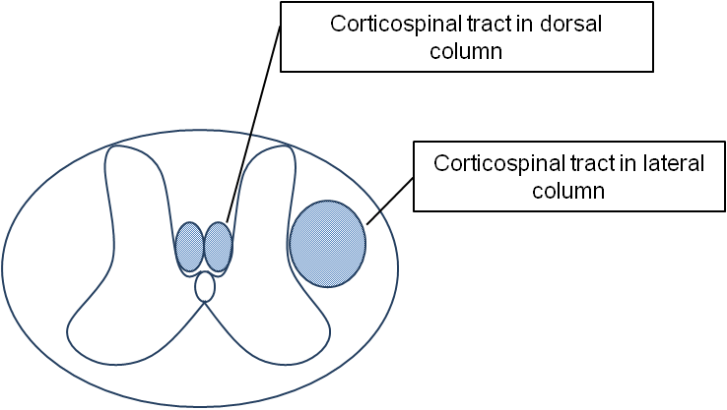
Figure 1.3: Transverse section of the lumbar region of the spinal cord. Shows the UMN passing through corticospinal tracts (indicated by blue circles) as they descend from the brain and relay to LMN to supply the voluntary muscles via NMJ.

An in vitro study was carried out to investigate fast axonal transport in primary cortical neurons from these mice using time-lapse microscopy. Quantification of the anterograde and retrograde transport of two cargoes revealed that the anterograde transport of the mitochondria was reduced by 25% in Spast^{ΔE7/+} and Spast^{ΔE7/ΔE7}. There was no effect on retrograde transport of mitochondria. Axonal swellings were detected in these in vitro cultures as well as adult spinal cords of Spast^{ΔE7/ΔE7} mice. Interestingly the swellings found in cultured neurons were distributed randomly along the axon compartment (Kasher et al., 2009), which is in contrast to the other model, where swellings were only found in the distal axon (Tarrade et al., 2006). This may reflect the difference in culture conditions and imaging approaches used in the different laboratories.
The third mouse model was generated by a gene targeting approach to knock-in a dominant negative missense mutation (1152C>A) in exon 8, that encodes N384K. This mutation almost completely blocks ATP hydrolysis in the AAA domian (Roll-Mecak and McNally, 2010). These mice also develop a significant number of axonal swellings in spastin^{N384K/N384K} primary neuronal cultures. In this study an alternative methodological approach has confirmed the effect of spastin dysfunction on gait defects. The gait analysis involved in this study was a motorised treadmill based digital analysis system. Different parameters were analysed at four months old, showing that stride length, stride duration and step length were significantly increased in spastin^{N384K/N384K} compared with the spastin^{wt/wt}.
Taking all this together, none of these studies revealed developmental phenotypes, although cultured embryonic neurons have early defects in axonal transport and pathology. The homozygous mutant mouse models exhibited a mild gait defect, but the heterozygous mice did not show any gait defects. In the N384K mutant, this suggests spastin mutation acts by loss of function. In this thesis, we are using the HSP mouse model with spastin mutation generated by (Kasher et al., 2009), because the spastin mutation mimics at least one human mutation and they exhibit a clear gait defect.

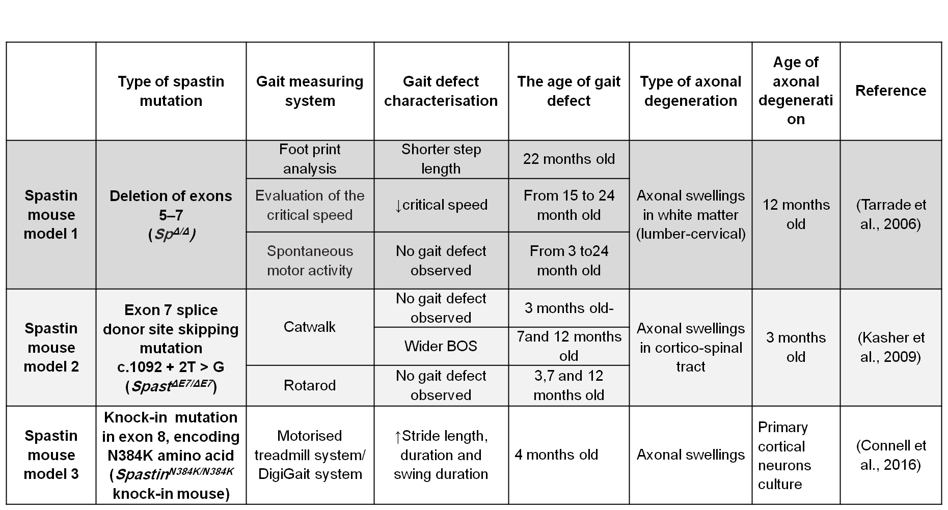
Table 1.2: Genetically modified spastin HSP mouse models.

1.8 The role of microtubules in neurodegenerative diseases
MTs are the tracks used to transport cargoes along the axon in the CNS (Goldstein and Yang, 2000). They are composed of α and β tubulin heterodimers, that are arranged along the axon with their minus ends close to the soma, and their plus ends located more distally (Goldstein and Yang, 2000). Alpha-tubulin undergoes acetylation, which is thought to regulate axonal transport. Acetylation of α-tubulin increases the binding of the kinesin-1 motor protein to MT and this enhances axonal transport (Dompierre et al., 2007, D'Ydewalle et al., 2011, Li et al., 2013).
As discussed in the previous section, the spastin gene encodes a microtubule severing ATPase protein that has several cellular activities. The major function of spastin is severing microtubules (Khan et al., 2008) into small pieces, thereby controlling the mobility, number and distribution of MT plus-ends (Errico et al., 2002). Severing MTs is important for neurons, since cutting long MTs into smaller fragments allows faster movement of cargoes along the axons (Wang and Brown, 2002). In axonpathies, without this severing activity MTs become disorganised (Sherwood et al., 2004).
Mutations in spastin therefore lead to abnormal alterations of MT dynamics and networks along the corticospinal tact within the spinal cord (Kasher et al., 2009). This disturbance of MT organisation leads to defective axonal transport, which is characterised by swellings along the axon, and abnormal accumulations of cargoes in cortical neurons (Tarrade et al., 2006, Kasher et al., 2009). This conclusion is also supported by a study performed in Drosophila, where knocking out D-spastin increases the stability of the MT network (see section 1.7.2).

1.9 Therapeutic approaches towards hereditary spastic paraplegia
There is currently no effective treatment to prevent or slow the progression of HSP. Symptomatic treatment, such as physiotherapy, is recommended to help prevent the deterioration of the disease (Harding, 1984). The development of therapeutic approaches is therefore a priority in HSP research.

1.9.1 Current therapeutic approaches

1.9.1.1 Physiotherapy and antispastic drugs
Because there is no existing cure for HSP, the treatment of HSP is directed primarily at reducing muscle spasticity through two approaches, depending on patient condition: exercise and medication.
Physicians recommend that HSP patients participate in physiotherapy, or an appropriate exercise programme, at daily intervals for various reasons, including to increase muscle strength, improve the range of motion, maintain the reflex of walking and improve general fitness (Fink, 2003a). Hydrotherapy is one of the oldest treatment methods designed to reduce the symptoms of HSP, aiming to use exercise in water to increase locomotion. Patients with multiple sclerosis (Gehlsen et al., 1984) and spinal cord injury (Kesiktas et al., 2004), have reported positive effects on muscular strength, and reduced fatigue following hydrotherapy. Also, patients with late onset HSP have shown a significant increase in waking speed, step length and enhanced hip internal rotation after hydrotherapy courses (Zhang et al., 2014b). Another study has highlighted the effectiveness of an intensive rehabilitation programme (Asir John et al., 2013). In this study, two patients underwent an 8-week long planned programme targeted at improving many functions including balance and walking for HSP patients. The programme showed improvements in walking speed and a reduced risk of falls (Asir John et al., 2013),
Many studies have sought to test the effects of exercise in animal models of neurodegenerative disease, with several such studies suggesting that voluntary training is effective in improving motor performance. For instance, voluntary running activity using a home-cage running wheel for SOD1^{G93A} (ALS model) mice significantly improved the motor function of these mice (Bennett et al., 2014). Hence, exercise could also be beneficial to reduce the HSP phenotype. The effects of voluntary activity on an HSP mouse model with spastin mutation are investigated in this thesis.
Medications, such as muscle relaxation drugs, are another potential symptomatic treatment for lower limb spasticity. Antispastic drugs, such as clonidine, dantrolene, tizanidine, botulinum toxin, benzodiazepines and baclofen, have been used to increase the flexibility of muscles (Fink, 2003a). Some patients have reported greater mobility and increased muscle tone as result of using these antispastic drugs (Harding, 1984). Although these drugs are commonly used for the treatment of spastic or over active muscles, their efficacy, toxicity and safety are a source of concern. Also, most of these drugs are non-selective, and therefore may cause some adverse effects (Khorzad et al., 2012). For example, baclofen is one of the most commonly used medications to reduce muscle tightness and cramping (Margetis et al., 2014). It is a selective GABA-B receptor agonist, can be given orally, and has been associated with improvements in walking performance and lower limb coordination in HSP patients (Margetis et al., 2014). Baclofen, however, has many side effects, such as sleepiness, sedation and tiredness. Moreover, oral administration of as little as 2g of baclofen can lead to coma and hypoventilation side effects (Gerkin et al., 1986). Hence, intrathecal administration is considered by means of a pump implanted into the subarachnoid space in the spinal cord, allowing the drug to be delivered directly to the intended site of action at high concentrations and with limited side effects (Margetis et al., 2014). A disadvantage of this method, however, is the risk of infection. Overall, therefore, identifying appropriate novel therapies is necessary for HSP.

1.9.2 Therapeutic areas under development

1.9.2.1 Microtubule targeting drugs
MTs are non-covalently bonded polymers of tubulin found in all eukaryotic cells. They have a highly dynamic structure that allows stretching, pausing and shrinking of the filament using energy obtained from GTP hydrolysis. MTs are typically composed of 13 aligned protofilaments (the basic unit that forms MTs), the later is formed by repeating α and β tubulin heterodimers (Chrétien et al., 1992). The polarity of MTs is important for their biological processes. By tubulin polymerisation α-tubulin is bound to the β-tubulin heterodimer, and consequently the proto-filaments are arranged parallel forming two ends, with β-subunits exposed at the plus ends, and α-subunits exposed at the minus ends, meaning that MT assembly or disassembly can occur at both ends (Walker et al., 1988).
During MT polymerisation the α/β tubulin sub-units bind to two guanosine-5'-triphosphates (GTP), and GTP hydrolysis allows dynamic instability (Kirschner and Mitchison, 1986). GTP hydrolyses when tubulin is added to MT and releases hydrolysed phosphate (Pi) to became Guanosine diphosphate (GDP).
During MT depolymerisation, the tubulin binds to GDP, which acts as a protective cap to prevent tubulin from polymerisation (Mollinedo and Gajate, 2003). A variety of drugs have been identified that bind to tubulin and modulate MT assembly by affecting the polymerisation and depolymerisation activity of MT.
MT targeting agents have been strongly suggested as pharmacological approaches to modify the effects of mutant spastin on MTs. MT targeting drugs can be classified as having microtubule-destabilising or microtubule-stabilising activity.

1.9.2.1.1 Microtubule destabilising drugs
MT can be destabilised by pausing the polymerisation of tubulin within the MT so that there will be no tubulin added to the MT (Toso et al., 1993). The first identified destabilisers are Vinca and Colchicines. For example Vinca, can bind to tubulin and form a wedge between two tubulin heterodimers that prevents assembly of tubulin to MT (Gigant et al., 2005).
Vinblastine is an MT destabilising drug that has been proven to help prevent, reduce or slow the progression of the phenotype of a HSP cell model at low doses. In a study conducted on SPG4 patient-specific stem cells and spastin-knockout human embryonic stem cells (hESCs) that were differentiated into forebrain projection neurons in order to generate a model of HSP (Denton et al., 2014), both cell lines exhibited a significant increase in the number of axonal swellings, with a reduction in retrograde mitochondrial mobility. Treating SPG4 iPSC and spastin knockout hESC neurons at week 8 with 10nM vinblastine for 24 hours significantly reduced the number of axonal swellings (Denton et al., 2014). This preventative effect of vinblastine was also tested on human spastin knockout neurons after 10 weeks, with similar effects being observed on SPG4 iPSC and spastin knockout hESC neurons. In a study carried out on human patient-derived olfactory nasal stem cells (ONS), spastin mutations showed a 50% lower level of acetylated α-tubulin in comparison with control cells (Abrahamsen et al., 2013). These cells also exhibited a slower peroxisome trafficking speed. Treating spastin mutant ONS with selective doses of the tubulin binding drug vinblastine restored the peroxisome trafficking defects to the control speed, while also increasing the acetylation of the α-tubulin level to that of the control cells (Fan et al., 2014). The long term use of vinblastine in human cancer patients, however, has been shown to cause striking side effects, including neurotoxicity which may itself cause axonal degeneration (Hansen, 1992). Clearly, it is not ideal to give HSP patients drugs that might have neurotoxic effects leading to the degeneration of neurons. Also, neurons are unlikely to benefit in the long term from a drug that causes neurotoxicity.

1.9.2.1.2 Microtubule stabilising drugs
The stabilisation of MT dynamics can be improved by blocking the GDP cap on tubulin (at the MT tip), to stop disassembly. This helps the MT maintain its rigidity, as it stops shrinking or growing (Mollinedo and Gajate, 2003). Examples of MT stabilising drugs are Taxol (paclitaxel) and nocodazole. Taxol is able to bind with tubulin dimer in microtubules and cause microtubule hyper-stabilisation. Taxol suppress MT dynamics differently according to dose. In vitro dose <100-1000nM selectively suppresses shortening at plus end. Between 100-1000nM inhibits plus and minus end lengthening and shortening. At >1µM dynamics are almost completely suppressed (Derry et al., 1995).
In stem cell cultures derived from the olfactory mucosa from HSP patients, an ultra-low dose of Taxol (0.1 nM) restored the acetylation of α-tubulin (which is a marker of microtubule stability) to levels found in similar cells from healthy controls (Abrahamsen et al., 2013). In another study on cortical neuron cultures from mutant spastin mice, nocodazole was successfully used to reduce the number of axonal swellings without affecting neuronal survival or the density of neurites (Fassier, 2013). Another example of an MT stabilising drug is Epothilone D (EpoD). This drug is able to penetrate the BBB, and has been tested in phase I clinical trials to treat patients with Alzheimer’s disease. EpoD is discussed in detail in Chapter 6. Thus, MT stabilising drugs could be a promising therapy for HSP.

1.9.2.2 Histone deacetylases (HDACs) as a therapeutic target in HSP
Histone deacetylases (HDACs) are a class of enzymes that eliminate acetyl groups from the lysine amino acid of histone (Xu et al., 2007). Eighteen HDACs have been identified in mammals, which can be divided into four main classes depending on their homology to yeast enzymes (Gregoretti et al., 2004). Class I HDACs are located in the nucleus and comprise four enzymes HDAC1, HDAC2, HDAC3 and HDAC8 (Gregoretti et al., 2004), whereas class II is composed of six enzymes (Mai et al., 2005). Depending on sequence homology and domain organisation, class II can be further subdivided into two sub-classes, namely, class IIa, which is composed of HDAC4, 5, 7 and 9, and class IIb, which is composed of two non-histone proteins, HDAC6 and HDAC10 (Mai et al., 2005). Both class I and II HDACs are zinc-dependent catalytic domains and are homologous to yeast Rpd3 and Hda1. Class III is homologous to Sirt2, but it has a different mechanism as it requires the cofactor NAD (Finkel et al., 2009). Class IV, meanwhile, (HDAC11) has one member which is also Zn²⁺ dependent but its sequence is not similar to other HDACs (Mai et al., 2005) (Figure 1.4).
HDACs oppose the function of histone acetyl transferases (HAT) (Mekada et al., 2009). The balance between HDACs/HATs is also important for the regulation of gene expression (Saha and Pahan, 2006). Acetylation of histone increases local transcription activity because acetylation removes the positive charge on histones and consequently reduces the binding of the N-terminus of histone to negatively charged phosphates on DNA duplexes. When HDACs are inhibited, the bond of histones to the DNA is loosened and the mRNA can be exposed to the transcriptional factors leads to gene expression (Figure 1.5).

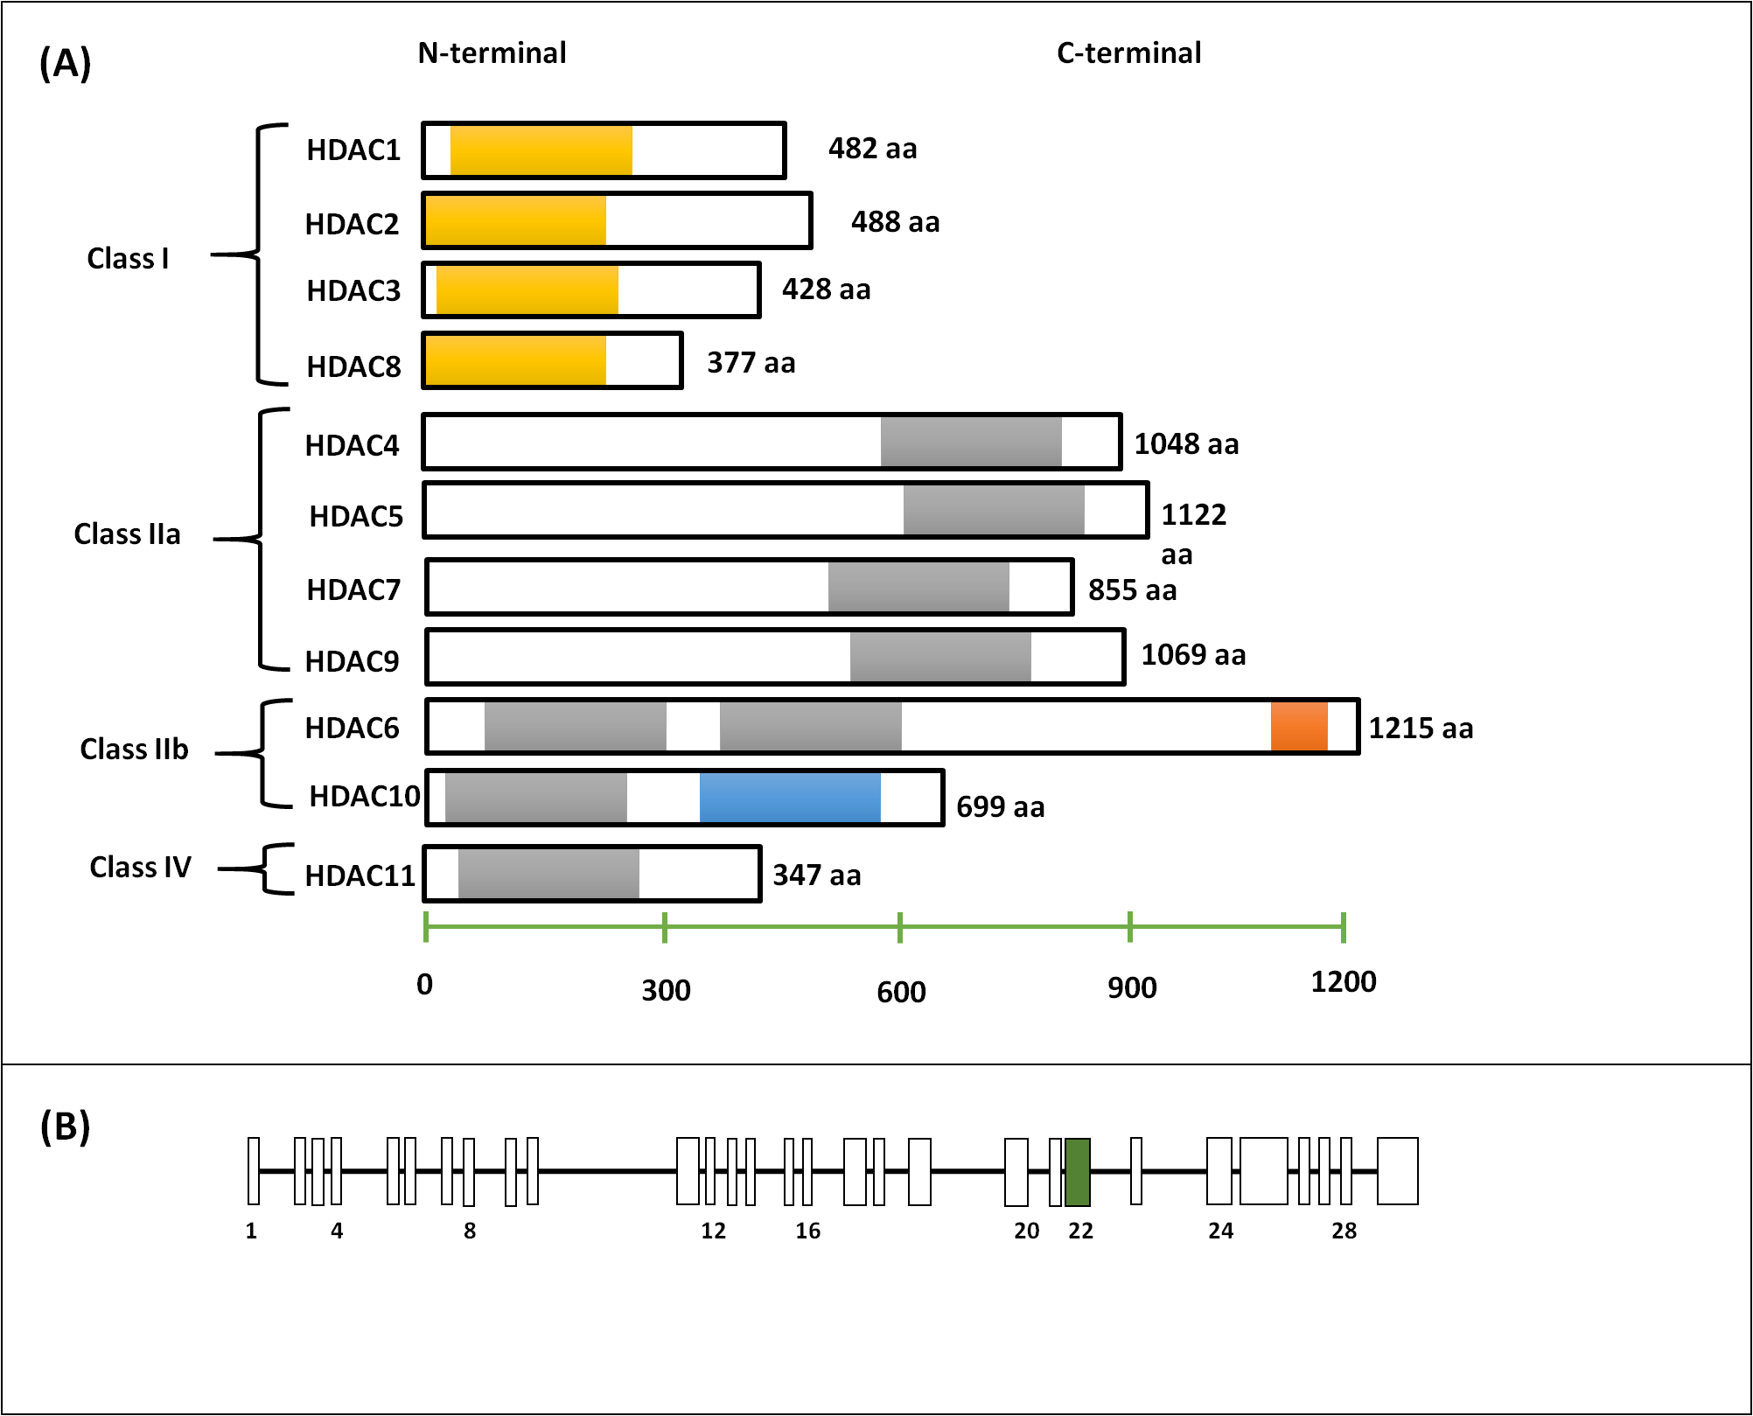

Figure 1.4: The classification of HDACs and structure m-RNA of HDAC6.
(A) All the HDACs presented in the figure are Zn⁺² dependent according to their homology to yeast. The yellow domain is the catalytic domain for class I, the grey domain is the catalytic domain for class II, the orange domain is the ubiquitin binding domain and the blue domain is an inactive domain (aa= amino acid). HDAC6 is the only HDAC that has two catalytic domains and the ubiquitin binding domain. (B) m-RNA structure of HDAC6, exon 22 is shaded by green.

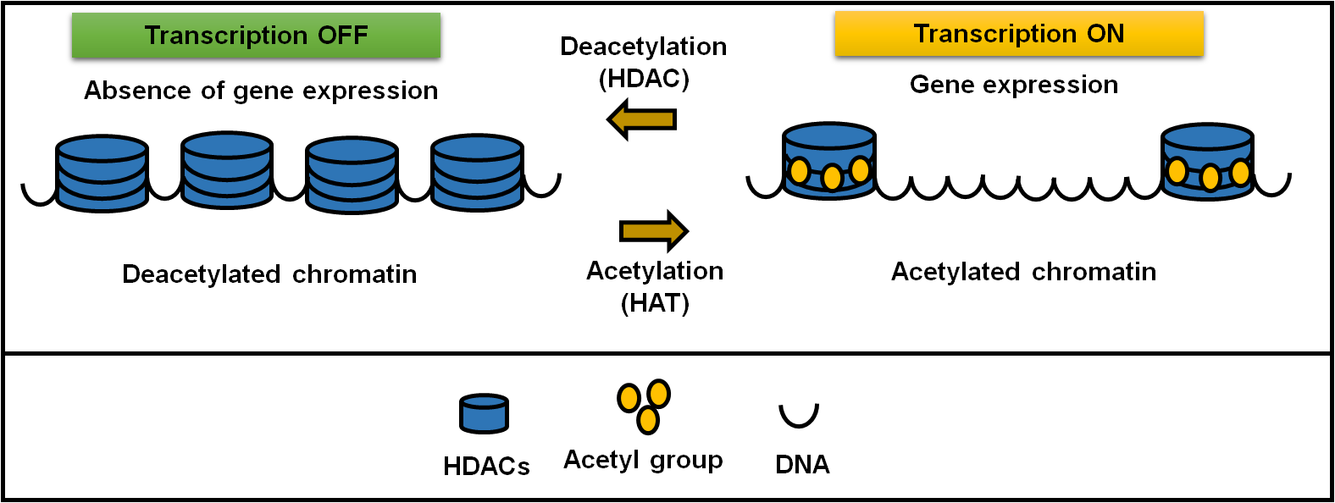

Figure 1.5: The mechanism of HAT/ HDAC balance in the regulation the gene expression.

1.9.2.3 Histone deacetylase 6 (HDAC6) as a potential therapeutic target for HSP
HDAC6 is part of the class IIb HDAC family. The structure of HDAC6 is considered to be unique because it is the only HDAC that has two active deacetylase domains and a ubiquitin binding domain on a C- terminus (Seigneurin-Berny et al., 2001). HDAC6 has many substrates, and can modulate the cell’s protective responses to the accumulation of misfolded proteins (Cabrero et al., 2006). Also, because it can regulate axonal transport and mediate protein aggregation, it has a role in neurodegenerative diseases (Simões-pires et al., 2013). HDAC6 has been shown to deacetylate many cellular proteins such as α-tubulin, cortactin and heat shock protein 90 (HSP90) (Bertos, 2004). For example, overexpression of HDAC6 can reduce α-tubulin acetylation specifically. Acetylation is an important post-transitional modification that regulates the MT network (Iwata et al., 2005). Also, HDAC6 involved in the clearance of misfolded ubiquitinated proteins by stimulate the accumulation of proteins in aggresome so that protects the cell from apoptosis (Iwata et al., 2005). Another function of HDAC6 is to support the growth and survival of cancer cells (Lee et al., 2008). For instance, overexpression of HDAC6 leads to increased motility of tumour cells (Inoue et al., 2002). Inhibition of HDAC6 causes a delay in the cell cycle, and therefore HDAC6 inhibitors are under development as anti-tumour treatments (Wickstrom et al., 2010).
Since HDAC6 is a multifunctional enzyme, its inhibition might be expected to have a harmful effect, however HDAC6 knockout mice appear normal (Zhang et al., 2008). Genetic and chemical studies have shown a neuroprotective effect in many diseases such as CMT and HD by increasing the acetylation of α-tubulin and upregulating intercellular transport (Reed et al., 2006, Dompierre et al., 2007, D'Ydewalle et al., 2011). Thus, HDAC6 inhibitors are a promising treatment for neurodegenerative diseases.

1.9.2.3.1 Chemical inhibition of histone deacetylase HDAC6
A range of non-selective and selective HDAC inhibitors have been developed. Treatment with broad-spectrum inhibitors of class I and II HDACs can cause neurotoxic side effects; these often occur in cancer patients who receive HDAC inhibitors as a treatment for malignancy (Langley et al., 2008). Long term treatment with high doses of HDAC inhibitors can also cause toxicity and neural death (Jeong et al., 2003). Non-selective inhibitors inhibit most zinc-dependent HDACs, including HDAC6, by binding to the active site and preventing enzyme activity, such as suberoylanilide hydroxamic acid (SAHA) and trichostatin-A (TSA) (Hubbert et al., 2002).
Some HDAC inhibitors, however, are highly selective in inhibiting only a particular HDAC at a certain dose. Among many types of selective HDAC inhibitors is tubacin, which targets HDAC6, and binds to the catalytic domain governing tubulin deacetylase activity (Haggarty et al., 2003). Treatment of cells with tubacin has been shown not to affect the total histone acetylation, gene expression or MT stability, but does affect MT motility (Haggarty et al., 2003). It has been reported that treatment with tubacin in primary neuronal culture prevents axonal degeneration and improves axonal transport (Chen and Cepko, 2009). This has been suggested, therefore, as a potential therapeutic approach to address reduced acetylation of tubulin and axonal transport defects.
Another example of a highly selective HDAC6 inhibitor is tubastatin-A. This is a lipophilic drug which has a limited brain distribution (Jochems et al., 2014), however it is effective in the peripheral nervous system of murine model of Charcot Marie Tooth disease (D'Ydewalle et al., 2011). Additionally, it has been shown to improve mitochondrial transport by increasing the acetylation of α-tubulin in the same mouse model (D'Ydewalle et al., 2011). In this model, reduction of α-tubulin acetylation was associated with defects in axonal transport and these deficits were reversed by restoring tubulin acetylation (D'Ydewalle et al., 2011)(Lumb, 2012 #85). In addition, treating CMT2 mice with tubastatin-A for 3 weeks, at a dose of 25 mg/kg, has been shown to lead to an increase in the acetylated tubulin in the sciatic nerve (D'Ydewalle et al., 2011).
In conclusion, HDAC6 inhibition increases the binding of both kinesin-1 and dynein to microtubules (Reed et al., 2006), and promotes the intracellular transport of cargoes because it increases the acetylation of tubulin and facilitates axonal transport. It has been suggested that the inhibition of HDAC6 could be beneficial in other models of neurodegeneration that are related to defects in axonal transport (Simões-pires et al., 2013).

1.9.2.3.2 Genetic inhibition of histone deacetylase HDAC6
Genetic knockout of HDAC6 has been shown to slow the progression of motor neuron degeneration, and significantly increase the level of acetylation of tubulin in the spinal cord and brain of a mouse model of amyotrophic lateral sclerosis (Taes et al., 2013). HDAC6 knockout in a mouse model of severe amyloid pathology of Alzheimer’s disease ameliorated tubulin K40 acetylation and spatial memory formation (Govindarajan et al., 2013). These findings suggest that knockout of HDAC6 might also be a useful therapeutic strategy in hereditary spastic axonopathy (Li et al., 2013). To confirm the role of HDAC6 in the progression of neurodegenerative disease, a mouse model of Huntington’s disease (HD) R6/2 was crossed with HDAC6 knockout mice to produce double mutant mice (Bobrowska et al., 2011). Although these mice had hyper-acetylation of tubulin in different brain regions (cortex, cerebellum and striatum), they did not show any improvement in motor function. This suggests that a loss of HDAC6 might be compensated for by other deacetylases.

1.10 Behavioural assessment in a mouse model
Behavioural assessment is important for screening phenotypic variation between animals (Hickey et al., 2005) in vivo, in order to investigate the effect of a mutation on their normal performance, or to assess the effects of a drug on the disease onset and phenotype. Several tests can be performed to understand the mechanism of a disease, for example comprehensive phenotype assessment, motor function assessment and gait assessment (Hickey et al., 2005).

1.10.1 Motor function assessment
Of all the behavioural tests, the rotarod is one of the most reliable and efficient devices to assess the motor performance of rodents (Dunham and Miya, 1957, Hamm et al., 1994), comprises a cylindrical solid motor wheel that is covered with smooth rubber so as to prevent the mice from adhering to the axis (Hockly et al., 2002). The motor cylinder can be accelerated until the animal falls off, and thus the latency of the fall recorded (Jones and Roberts, 1968). It is used to measure balance and muscle coordination (Hickey et al., 2005). The motor performance on rotarod can be affected by several factors such as learning, motor coordination and cardiopulmonary stamina.
The rotarod can be used to detect the motor coordination in mouse models of neurodegenerative diseases. For instance, in a mouse model of Huntington’s disease, at four weeks of age mice did not show any difference in their performance on the rotarod compared with the wildtype. By eight weeks, however, the transgenic mice revealed a dramatic reduction in latency of to fall (Hickey et al., 2005).
The rotarod has also been used to detect the onset of motor neuron disease. For example, in a transgenic mouse model of amyotrophic lateral sclerosis with SOD1^{G93A} mutation, those mice displaying hind limb tremors at 12 weeks were compared with non-transgenic mice (Weydt et al., 2003). The wildtype mice were able to stay on the rod longer than the SOD1^{G93A} mice; furthermore, the performance of the SOD1^{G93A} mice reduced steadily such that by 14 weeks latency to fall was statistically significantly lower than that of the non-transgenic mice. At 20 weeks SOD1^{G93A} mice failed to stay on rotarod while the non-transgenic remained at an optimal level (Weydt et al., 2003). Despite the gait defect in spastin mouse model, they did not show any changes in their rotarod performance (Kasher et al., 2009).

1.10.2 Gait assessment
Previously gait was analysed by allowing a rodent to walk on plain paper after dipping their paws in ink. This technique provided insight into static gait parameters such as stride length, distance, hind and front base of support (i.e. the distance between right and left paws) (Carter et al., 1999). Several devices have now been introduced for automated quantitative gait analysis in rodents. For example, one gait analysis device is composed of a treadmill with a digital video camera beneath it to allow a video recording of the rodent’s paw to be captured. The camera output is sent directly to a computer for analysis and can provide different parameters such as stride, stance and swing time (Wooley et al., 2005). The treadmill locomotion device has been used to compare the gait of C57BL/6J with B6.SOD1 carrying G93A mutation (ALS mouse model), showing that at eight weeks B6.SOD1 mice had a significantly longer stride and stance times than the controls (Wooley et al., 2005).
Another example is the CatWalk automated gait analysis system. This system is considered to be a comprehensive method to measure static and dynamic gait parameters simultaneously. It consists of a corridor with a glass plate that allows the mouse to run along it, and a camera beneath the glass to video record the mouse’s paws (Hamers et al., 2001). The glass has a internally reflected green light that is scattered when mouse paws touch it (Hamers et al., 2001). A range of quantifiable assessments can be made using the CatWalk software, such as swing duration, stride length, swing speed, paw print area and base of support BOS (the distance between the hind limbs or fore limbs). Measuring the BOS of a spastin mouse model of HSP with the CatWalk system reveals that the BOS is significantly wider in spastin mutant mice compared with wildtype mice at seven and twelve months of age. The same study showed that spastin mice had no defect on rotarod (Kasher et al., 2009). This is consistent with the results from HSP patients, who also exhibit striking alterations in gait (Klebe et al., 2004). CatWalk is therefore considered to be a reliable and subtle gait analysis system to show the phenotype of motor neuron disease in rodents.
A motorised treadmill system has also been used to evaluate the gait defects of a spastin mouse model of HSP. The mice were placed on a transparent treadmill with a high speed video camera positioned beneath it providing a movie that can be analysed. The system can calculate stride, stance and swing duration (Connell et al., 2016) In this study, the stride length was found to be significantly higher in the mutant mice compared with wildtype mice at four months old (Connell et al., 2016). This suggested the effectiveness of the treadmill motorized system in the quantitative analysis of gait within a mouse model of HSP.

1.11 Project aims
Hereditary spastic paraplegias (HSPs) are a heterogeneous group of inherited neurological disorders that are characterised by lower limb spasticity and weakness. The clinical pathophysiology is degeneration of axons in the corticospinal tract. The most common gene, which is responsible for 40% of HSP, is spastin (SPAST). SPAST encodes a microtubule-binding protein that has several important roles in the cell, including vesicle trafficking and microtubule severing. Mutations in SPAST cause reductions in axonal transport that lead to mitochondrial accumulation in axonal swellings in the corticospinal tract. So far no cure exists for HSP, although lower limb muscle spasticity can be reduced by the use of muscle relaxation drugs.
In order to try and establish new therapeutic approaches for HSP this project used mutant spastin mice carrying a mutation which mimics a human HSP mutation. Four different approaches were applied to investigate potential therapies for HSP in vivo and in vitro.
- Firstly, the effect of wheel-running (voluntary exercise) on gait impairment and spinal cord axonal swelling pathology was determined in SPAST^{ΔE7/ΔE7} mice.
- Secondly, the effect on gait impairment and spinal cord axonal swelling pathology was investigated in SPAST^{ΔE7/ΔE7} mice following chemical inhibition of HDAC6 using ACY-738.
- Thirdly, the effect of genetic inhibition of HDAC6 by crossing HDAC6 knockout mice with spastin mice to produce double mutant mice was investigated.
- Fourthly, the effect of the microtubule stabilising agent Epothilone D on gait impairment and spinal cord axonal swelling pathology was investigated in SPAST^{ΔE7/ΔE7} mice.

Chapter 2: Material and Methods

Chapter 2: Materials and Methods

2.1 Materials

2.1.1 Equipment
The main pieces of equipment that were used in this project are listed in (Table 2.1).

Table 2.1: List of equipment used.
Equipment |  | Manufacturer
G-Box gel imaging system |  | Syngene, Synoptics Ltd. UK.
GENi imaging machine |  | Syngene, Synoptics Ltd. UK.
FLUOstar Omega plate reader |  | BMG Labtech Ltd.
Nikon microscope |  | Nikon Instruments Inc.
CFX96 Touch Real-time PCR detection system |  | Bio-Rad Laboratories, Inc.
MX3000-P Real-time PCR system |  | Bio-Rad Laboratories, Inc.
Catwalk-Version 7.1. |  | Noldus Information Technology
Centrifuge |  | Eppendorf AG.
Sigma 2-6E/2-6 Centrifuge |  | SciQuip, Ltd. UK.
Western blot equipment (Electrophoresis chambers, power supply, combs, cassettes, glass plates) |  | Bio-Rad Laboratories, Inc.
Electrophoresis |  | Bio-Rad Laboratories, Inc.
Dri-Block heaters |  | Bibby Scientific Limited, UK.
Mini See-Saw Rockers |  | Bibby Scientific Limited, UK.
Tube rollers |  | Bibby Scientific Limited, UK.
G-STORM PCR machine |  | GRI, Essex, UK.

2.1.2 Reagents and chemicals
Commonly used chemicals were purchased from Thermo Fisher Scientific Inc. (Fisher Scientific, Loughborough, UK) or Sigma-Aldrich (Poole, UK).

Table 2.2: List of general chemicals and hardware used.
Item | Supplier
Analytical grade solvents including ethanol, methanol, formaldehyde and xylene | Fisher Scientific, UK
Pipette tips | Fisher Scientific, UK
Nuclease free water | Ambion, USA

Table 2.3: List of chemicals and hardware used in immunohistochemistry
Commonly used items | Supplier
Immunohistochemistry Vectastain Elite ABC kits for mouse IgG and rabbit IgG, peroxidase substrate kit and alkaline phosphatase substrate kit | Vector Laboratories, UK
Slides, coverslips and mounting media (DPX) | CellPath Ltd, UK.
Nano-zoomer- Digital slide scanner | Hamamatsu Photonics K.K.
IntelliPATH Automated Staining Instrument | Biocare Medical, LLC.
Semi-enclosed Benchtop Tissue Processor | Leica Biosystems Nussloch GmbH.
Pathology Embedding System | Leica Biosystems Nussloch GmbH
“820” Spencer Microtome | Optech-Instruments, Oxfordshire, UK
Microwave oven | Panasonic

Table 2.4: List of chemicals and hardware used in western blotting.
Commonly used items | Supplier
Tissue homogeniser | Anachem, UK
Protein standards | Thermo Scientific, UK
Sodium dodecyl sulphate polyacrylamide gel (SDS-PAGE) | Melford Laboratories, UK
Ammonium persulphate (APS) | Sigma, UK
Proto Gel 30% (w/v) acrylamide: 0.8% (w/v) (BisAcryl-amide stock solution 37:5.1) | National Diagnostics, UK
Tetramethylethylenediamine (TEMED) | Melford Laboratories, UK
Filter papers | Whatman Laboratories, UK
Enhanced chemiluminescence (ECL) kit | Biological Industries, UK
Nitrocellulose transfer membrane | Millipore Life Science, Germany

2.1.3 Solutions

2.1.3.1 Gel Electrophoresis solution

Tris Acetate-EDTA buffer (TAE)
50x TAE stock, 2M Tris-acetate, 5.71% v/v acetic acid, 0.05 M (EDTA) pH 8.0, made to volume with deionised water.

2.1.3.2 Tissue lysis solutions

Brinkley Reassembly Buffer (BRB80)
80 mM PIPES pH 6.8, 1 mM MgCl₂, 1mM EGTA (ethylene glycol tetraacetic acid), 1% Triton-X-100 supplemented with 1% protease inhibitor cocktail (Roche Diagnostics), and made up to volume with deionised water and stored at 4 °C.

RIPA buffer
50 mM Tris-HCl pH 6.8, 150 mM NaCl, 2mM EDTA (ethylenediaminetetraacetic acid, Melford), 2mM EGTA, 1% Triton-X-100 or 1% NP40, 0.1% sodium dodecyl sulphate (SDS) (Sigma) and 0.5% sodium deoxycholate, supplemented with 1% protase inhibitor cocktail (Roche Diagnostics) and made up to volume with deionised water and stored at 4 °C.

2.1.3.3 Washing reagents

Phosphate buffered saline (PBS)
3.2 mM Na₂HPO₄
0.5 mM KH₂PO₄
1.3 mM KCl
135 mM NaCl, pH 7.4

50 mM Tris-buffered saline (TBS)
50 mM Tris
150 mM NaCl, pH 7.6

TSB-Tween (TBST)
0.1% (v/v) Tween in 50 mM TBS

2.1.3.4 Western blotting solutions

10% Sodium Dodecyl Sulphate (SDS)
10% (w/v) SDS in deionised water

Running buffer (1x)
25 mM Tris, 192 mM glycine, 0.1% SDS made up to volume with deionised water.

Transfer buffer (1x)
25 mM Tris, 192 mM glycine, 10% methanol, made up to volume with deionised water.

For 4x 1mm thick 10% polyacrylamide resolving gel, pH 8.8
30% (w/v) Acrylamide solution- 8.33 ml
1.5M Tris-HCl pH 8.8 - 6.25 ml
10% (w/v) Sodium dodecyl sulphate SDS- 250 µl
10% (w/v) Ammonium persulphate (APS)- 250 µl
H₂O 10 ml
N,N,N’,N’ tetramethylethylenediamine (TEMED) 25 µl

For 4x 1mm thick 6% polyacrylamide stacking gel, pH6.8
30% (w/v) Acrylamide solution- 1 ml
0.5M Tris-HCl PH6.8 - 1.25 ml
10% (w/v) Sodium dodecyl sulphate SDS- 50 µl
10% (w/v) Ammonium persulphate (APS)- 30 µl
H₂O 3 ml
TEMED 15 µl

Ammonium Persulphate (APS)
0.9g APS in 9 ml deionised water, (10% w/v final concentration)

Laemmli sample buffer (5x)
160 mM Tris (pH6.8)
25% v/v glycerol
2% SDS
0.1% w/v bromophenol blue (Fisher Scientific)
14.4 mM 2-mercaptoethanol, made up to volume with deionised water

Blocking buffer
5% (w/v) powdered milk in PBS-Tween (0.05%).
Or 5% (w/v) BSA ( Bovine Serum Albumin) in PBS-Tween (0.05%).

Ponceau S Staining Solution
0.2% w/v Ponceau S, 5% acetic acid made to volume with deionised water.

2.1.3.5 Immunohistochemistry solutions

Antigen retrieval/ trisodium citrate buffer (TSC)
0.01M trisodium citrate, pH 6.5.

Scott’s tap water
0.2% (w/v) potassium bicarbonate, 2% (w/v) magnesium sulphate, made up to volume with distilled water.

Blocking solution
1.5% (v/v) normal goat serum or 1.5% (v/v) normal horse serum (Vector Laboratories, UK) in 50 mM TBST.

Peroxidase blocking solution
1% (v/v) Hydrogen peroxide (H₂O₂) in 50 mM methanol.

IHC antibody incubation solution
The required calculated concentration of the Ab diluted in 1.5% blocking solution.

Avidin-biotin peroxidase complex (ABC)
0.5% secondary in 1.5% blocking solution (TBS)

DAB (3,3 -diaminobenzidine peroxidase substrate) solution
84 µl of buffer stock solution, to 0.5 ml of distilled water, 100 µl of DAB stock solution, 8 µl hydrogen peroxide (H₂O₂).

2.1.4 Antibodies

Table 2.5: List of primary antibodies used in western blotting.
Target Protein | Species | Dilution | Catalogue number | Supplier
Anti-α-tubulin (DM1A) | Mouse monoclonal | 1:10000 | T9026 | Sigma-Aldrich, Inc.
Anti-acetylated tubulin,clone 6-11B-1 | Mouse monoclonal | 1:5000 | T7451 | Sigma-Aldrich, Inc.
GAPDH (14C10) | Rabbit monoclonal | 1:2000 | 2118S | Cell Signalling Technology, USA
HDAC6 (histone deacetylase 6) | Rabbit monoclonal | 1:200 | 12-303 | Millipore, USA

Table 2.6: List of secondary antibodies used in western blotting.
Target protein | Dilution | Catalogue number | Supplier
Goat Anti-Mouse IgG (HRP) | 1:5000 | ab97023 | Abcam plc.
Goat Anti-Rabbit Polyclonal IgG (HRP) | 1:5000 | D 0487 | Dako Denmark

2.2 Methods

2.2.1 Ethics statement
The use of animals in experiments and testing is regulated under the Animals
(Scientific Procedures) Act 1986 (ASPA). Studies in this project were conducted under Project License 40/3089, with approval from the University of Sheffield Ethical Review Sub-Committee, and the UK Animal Procedures Committee (London, UK).

2.2.2 Housing
Mice were obtained and bred under specified pathogen free or conventional conditions under a 12 hrs light /dark cycle at a standardised room temperature of 21 ºC at the animal facilities of the University of Sheffield. Experimental mice were singly housed with free access to rodent diet pellets, Teklad (Envego, USA) and water. Cages were lined with sawdust (ecopure chips premium) and paper wool bedding material (Datesand, UK) was used in each cage.

2.2.3 Mouse models used in this thesis
The mouse models used in this project were SPAST^{ΔE7} and HDAC6 null mice. SPAST^{ΔE7} mice were ENU mutagenised mice carrying the c.1092 +2T> G mutation and were originally obtained from MRC Harwell. They were back crossed with C57/Bl6J Jax for more than ten generations to maintain the colony (Kasher et al., 2009). HDAC6 null mice, generated by homologous recombination as described in (Gao et al., 2007), were obtained from Professor Ludo Van Den Bosch (Leuven), and bred with C57/BL6J Jax for maintenance.

2.2.4 Breeding scheme for SPAST^{+/ΔE7}mice and HDAC6 mice:

2.2.4.1 Generation of SPAST^{ΔE7 /ΔE7} mice
To investigate the improvement of gait impairment in SPAST^{ΔE7/ΔE7} (null mutant) mice, SPAST^{ΔE7/ΔE7} mice were obtained by crossing SPAST^{+/ΔE7} mice together (Figure 2.1). Consequently, the offspring were 25% SPAST^{+/+} wildtype, 50% SASPT^{+/ΔE7} heterozygous and 25% SPAST^{ΔE7/ΔE7} mutant. The mutations were identified by PCR and restriction digests with BslI (see section 2.2.5). All the SPAST^{+/ΔE7} mice were culled, while the SPAST^{+/+} wildtype male mice were used as a control group and the SPAST^{ΔE7/ΔE7} null mutant male mice were used to receive HDAC6 inhibitor compounds. The SPAST^{ΔE7/ΔE7} null mutant female mice were used to receive the microtubule stabilising agent and to test the effect of exercise on the HSP phenotype.

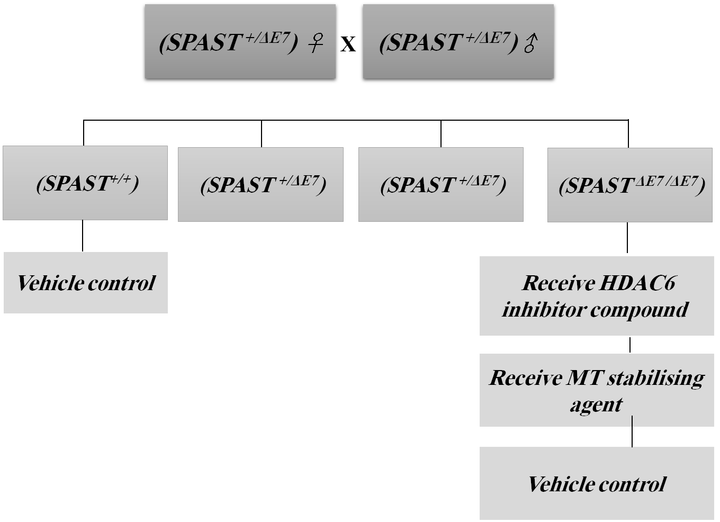

Figure 2.1: Crossing SPAST ^{+/ΔE7} female with SPAST ^{+/ΔE7} male.
Offspring from this crossing were SPAST^{+/+} wildtype 25%, SPAST^{+/ΔE7} heterozygous 50% and SPAST^{ΔE7 /ΔE7} null mutant 25%.

2.2.5 Genotyping SPAST^{ΔE7} mice by PCR restriction fragment length polymorphism analysis
Genotyping for HDAC6 mice and SPAST^{ΔE7} mice was performed according to the following steps:

2.2.5.1 DNA extraction
Mouse ear clips were obtained by Biological Services staff, and placed in 30 µl QuickExtract Solution (Epicentre, UK). After vortexing, the samples were incubated at 65 ºC for 15 minutes and then at 98 ºC for 2 minutes in order to terminate the reaction. DNA extracts were stored at 4 ºC.

2.2.5.2 PCR amplification of the SPAST^{ΔE7} mutations
The PCR mix was prepared using SPAST_BslI forward primer (MSPG4_7 forward: 5’-CTTCCTTCTCTGCCGCCTGA) and SPAST_BslI reverse primer (MSPG4_7 reverse: 5’-CCATCTCCAGGCTTCAATGT) (both synthesised by SIGMA Genosys, UK). Those primers were designed to generate a single-base mismatch into the sequence, in order to create a BslI restriction enzyme site to distinguish between wildtype WT (SPAST) and c.1092+2T>G spastin mutants. A 10 µl reaction contained 1µM of SPAST_BslI forward and reverse primers and FirePol Taq DNA polymerase mix (Solis Biodyne) and 1 µl of DNA extract. PCR amplification was performed for the following cycling conditions in a G-STORM PCR (GRI, Essex, UK):
Lid temperature 100 ºC
Block temperature 98 ºC for 30 seconds
40 cycles of:
Block temperature 92 ºC for 2 seconds (Denaturing)
Block temperature 54 ºC for 15 seconds (Annealing)
End of the cycle
Block temperature 54 ºC for 2 minutes (Elongation)
Block temperature 15 ºC hold

2.2.5.3 Restriction digests
Once the PCR was complete, the products were digested with the restriction enzyme BslI which cleaves only the mutant sequence by virtue of a single-base mismatch introduced into the sequence in the forward primer (Kasher et al., 2009) (Figure 2.1). A master mix for the restriction enzyme digest was prepared by adding 2 µl of NEB buffer 3, 7.5 µl of deionised H₂O and 0.5 µl BslI to 2 µl of the PCR product. The digest performed at 55 ºC for 12 hours in a PCR machine.

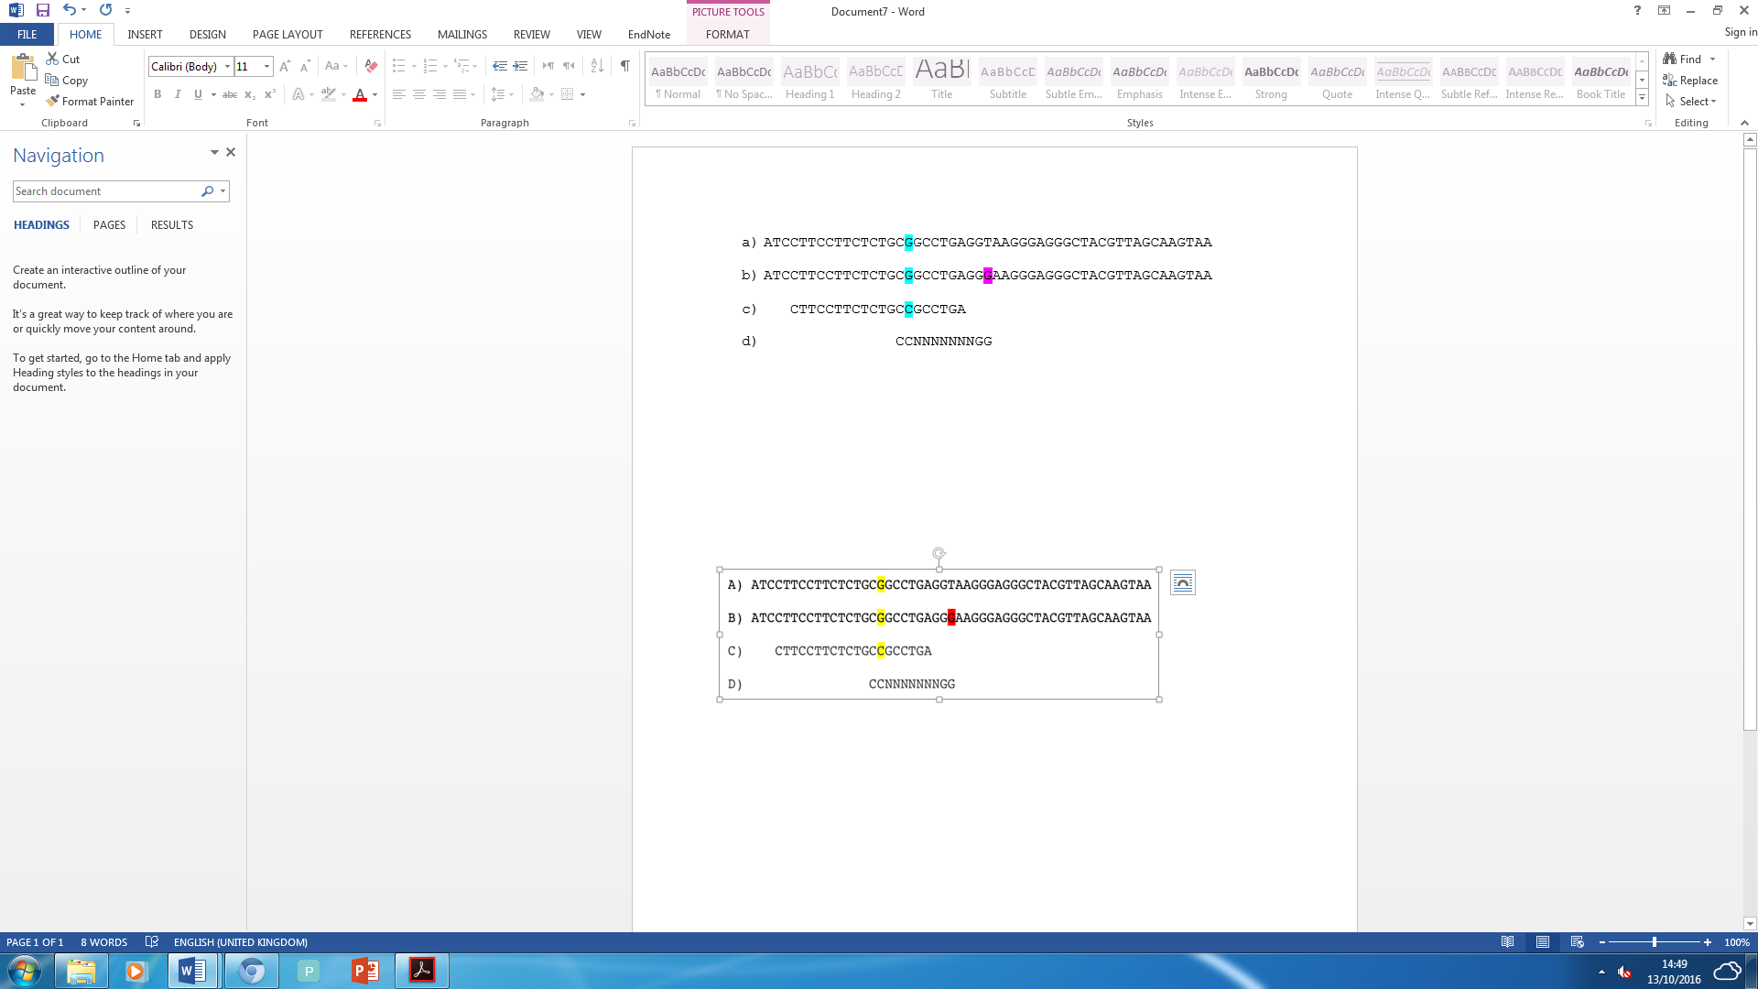
Figure 2.2: The primers design to create a mismatch for genotyping of spastin mice. A) Wildtype exon 7-intron 7-8 sequence. B) Mice with a mutation (c.1092+2T>G) sequence presenting (T-G) ENU mutation in pink colour. C) Forward primer (spas_BslI) sequence presenting the (G-C) mismatch in blue colour. D) in the presence of the mismatch BslI restriction site sequence generated C and mutant G allele in the mutants’ spastin (c.1092+2T>G) allele but not the wildtype (Kasher et al., 2009).

2.2.6 Genotyping HDAC6 mice

2.2.6.1 PCR for HDAC6 mice
The HDAC6 gene is located on the X chromosome. Males carrying the HDAC6 null allele are therefore considered a knockout because they have one X chromosome. The PCR mix was prepared using four primers, namely:
- (EXO-10: 5’- GTGGACCAGTTAGAAGCC)
- (INT-9: 5’ CTGGTTCGTCTGAAGACA)
- (ZEO-1: 5’ CCATGACCGAGATCGGCGAGCA)
- (ZEO-3: 5’ CGTGAATTCCGATCATATTCAAT).
ZEO-1 and ZEO-3 are targeting construct primers, which only generate a PCR product for the null allele, sized 250bp. INT-9 and EXO-10 amplify endogenous HDAC6 between intron 9 and exon 10, generating a PCR product of size 300bp. As a result, male carriers only have the ZEO band as they have no endogenous HDAC6. Female carriers, however, have both the ZEO and endogenous HDAC6 PCR products. Wildtype mice only have a product for endogenous HDAC6. 15 µl reactions were performed containing 1 µM of each primer, FirePol taq polymerase (Solis Biodyne) and 1 µl of extracted DNA. The PCR cycle was run according to the following thermal cycle conditions:
Lid temperature 110 ºC
Block temperature 94 ºC for 5 minutes
Touchdown from 65 ºC to 50 ºC - 15 Cycles
25 cycles of:
Block temperature 94 ºC for 30 seconds (Denaturing)
Block temperature 58 ºC for 45 seconds (Annealing)
Block temperature 72 ºC for 90 seconds (Elongation)
End cycle
Block temperature 72 ºC for 10 minutes
Temperature 4 ºC hold

2.2.6.2 Agarose gel electrophoresis
To identify SPAST mutants, the digested PCR products were loaded on a 3% agarose gel (Melford, UK) with 0.02 mg of Ethidium Bromide (EtBr) per 100 ml of 1 x TAE buffer (section 2.1.3.1) (Figure 2.3). To identify HDAC6 mice the PCR products were separated on a 2% agarose gel (Figure 2.4). Hyperladder IV or V (Bioline, UK) was also loaded on the same gels and used to identify the PCR product sizes. The gels were run at 120V in a DNA electrophoresis tank (Geneflow, UK) in 1 x TAE buffer until the PCR products were resolved. DNA fragments were visualised using a gel imaging system (Geni, Syngene,UK).

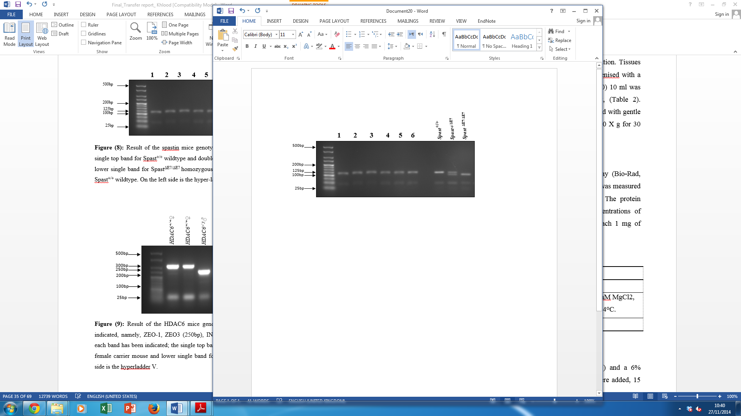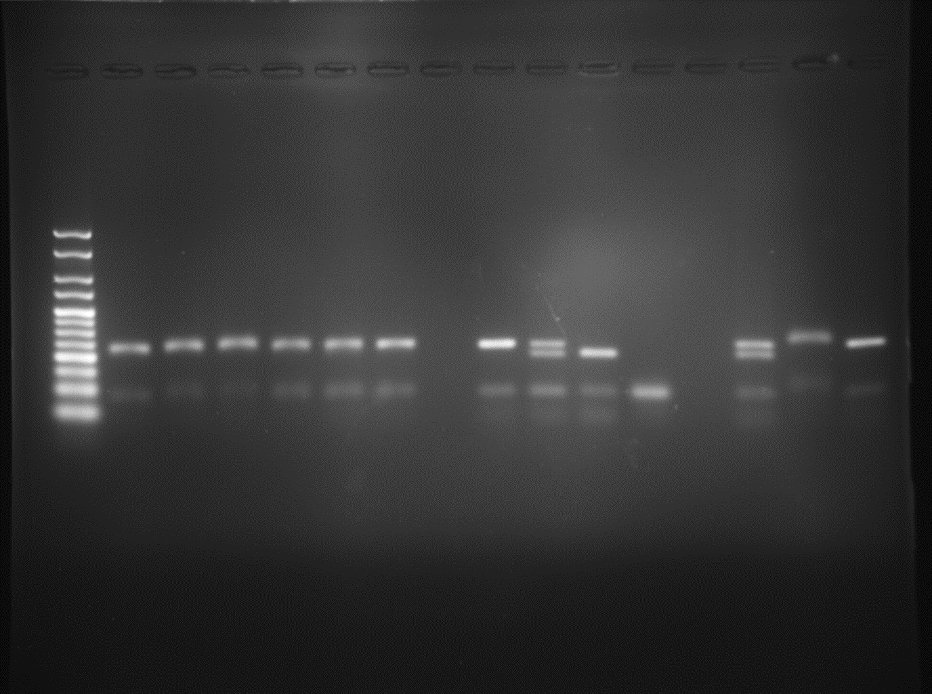
SPAST^{+/+}
SPAST^{+/ΔE7}
SPAST ^{ΔE7/ΔE7}
NTC
Figure 2.3: Result of the spastin mice genotyping. On the right side the control bands show the single top band for the SPAST^{+/+} wildtype and double bands for a SPAST^{+/ΔE7} heterozygous mouse and a lower single band for a SPAST^{ΔE7/ΔE7} homozygous mouse. In this example, the samples 1-6 are all SPAST^{+/+} wildtype. The left side shows the hyper-ladder IV.

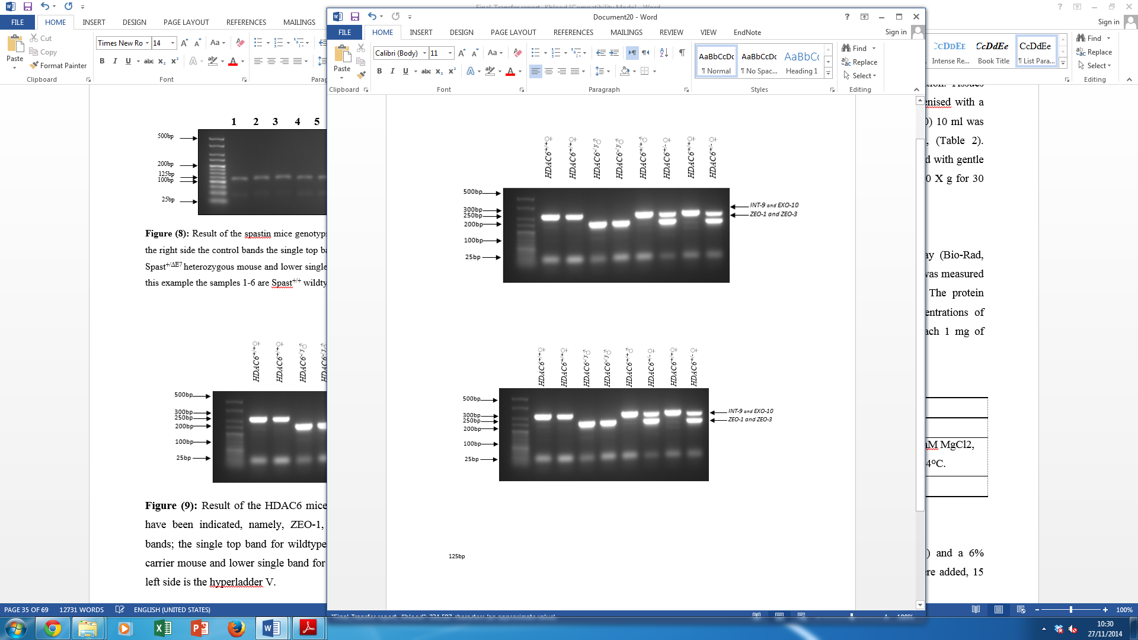
Figure 2.4: Result of the HDAC6 mice genotyping. The level of the primer products has been indicated, namely, ZEO-1, ZEO3 (250bp), INT-9 and EXO-10 (300bp). The genotype for each band is indicated; the single top band is for the wildtype and the double bands are for a HDAC6 female carrier mouse and the lower single band for a HDAC6 male knockout mouse. On the left side is hyper-ladder V.

2.2.7 Extraction of RNA
Brains dissected from spastin heterozygous mice were cut in half along the midline. One half was weighed and placed in a clean plate before chopping with a clean razor. Then, the chopped brain was placed in a tissue homogeniser and 1 ml of Trizol (Invitrogen) was added for each 50 mg of tissue. After homogenisation, the sample was transferred to a clean 1.5 ml Eppendorf tube and incubated for 5 minutes at room temperature (RT), to ensure the nucleoprotein complexes were totally dissociated. After that 200 µl of chloroform was added for each 1 ml Trizol, the tube was shaken by hand for 15 seconds. Following incubation for 2-3 minutes at RT, samples were centrifuged at 12,000 × g for 15 minutes at 4 ºC. After centrifugation, the mixture separated into a clear upper aqueous phase (containing RNA) and a lower red phenol-chloroform phase with an interphase between them. The upper aqueous phase was gently removed and placed in a clean 1.5 ml Eppendorf tube. The RNA was precipitated by the addition of 500 µl isopropanol for each 1 ml Trizol and incubating for 10 minutes at RT, followed by centrifugation at 12,000 × g for 10 minutes at 4 ºC. After the centrifugation, the RNA formed a gel-like pellet at the bottom of the tube, and the supernatant was carefully removed. To wash the pellet 1 ml of 75% ethanol was added and the tube was vortexed prior to centrifugation at 7,500 × g for 5 minutes at 4 ºC. At the end of centrifugation, the supernatant was again removed and the RNA pellet was air-dried. Finally, the RNA was dissolved in nuclease free water (NF-water).

2.2.7.1 Measuring RNA concentration
The RNA concentration was determined using a nano-drop Spectrophotometer (Labtech International).

2.2.8 cDNA synthesis
cDNA was synthesised from 1 μg RNA. To remove contaminating DNA, 1 μl of 10x DNase buffer (Invitrogen, UK) and 1 μl NEB DNase were added to the RNA sample in a sterile 0.2 ml Eppendorf, made up to 10 μl with NF-water. Samples were incubated for 10 minutes at 37 ºC. 1 μl of 25 mM EDTA was added and the sample incubated for 10 minutes at 75 ºC to terminate the reaction and inactivate the DNase. Following this step, 1 μl of 10 mM random hexamers (Amersham, UK) or 1 μl of 0.5 μg/μl oligo dT (Thermo Scientific) were added to RNA, and 1 μl of 10 mM deoxyribonucleotide mix (dNTPs; Promega, UK) was also added. The samples were then incubated for 5 minutes at 65 ºC. Then, the samples were chilled on ice and spun down to break the secondary folded structure and allow primer annealing. Following that, 4 μl of 5x reverse transcriptase buffer (Invitrogen, UK) and 2 μl of 0.1 M dithiothreitol DTT (Invitrogen, UK) were added and samples were incubated for 5 minutes at 25 ºC. At this temperature, 0.5 μl of Superscript III reverse transcriptase (Invitrogen, UK) was added. Samples were incubated at 50 ºC for 1 hour, followed by 15 minutes at 70 ºC. cDNA was stored at -20 ºC until required.

2.2.9 Reverse Transcription PCR (RT-PCR)
Pairs of RT-PCR primers were designed (Table 2.7). 10 µl reactions were made up by adding the following: 0.1 µl of each primer (100 µM stock solution, 2 µl of FirePol taq polymerase mix (Solis Biodyne), 6.8 µl RNase free water and 1 µl of (1:5) diluted cDNA in RNase free water. Reactions were performed using these thermal cycler conditions:
Lid temperature 110 ºC
Block temperature 94 ºC for 3 minutes
Touchdown 65- 50 ºC 15 cycles
Start cycle 30 times
Block temperature 94 ºC for 30 seconds (Denaturation)
Block temperature 58 ºC for 45 seconds (Annealing)
Block temperature 72 ºC for 1 minute (Elongation)
End of the cycle
Block temperature 72 ºC for 10 minutes (Elongation)
Block temperature 10 ºC hold
5 µl PCR products were loaded on a 1% agarose gel (Melford, UK) with 0.02 mg of Ethidium Bromide (EtBr) per 100 ml of 1x TAE buffer (section 2.1.3.1). Hyperladder IV or I (Bioline, UK) was also loaded on the same gels and used to identify the PCR product sizes. The gels were run at 100V in a DNA electrophoresis tank (Geneflow, UK) in 1 x TAE buffer until the PCR products were resolved for 1 hour. DNA fragments were visualised using a gel imaging system (Geni, Syngene, UK).

Table 2.7: List of primers used for RT- PCR.
Oligo name | Position | Sequence (5’-3’)
HDAC6_e1F | Forward | TCTGGGGAAATAGGCTGAAG
HDAC6_e1R | Reverse | TCCTGGTCGAAGATGAACTG
HDAC6_e2F | Forward | TGTTCAACCATCTGGCTGTG
HDAC6_e2R | Reverse | GGTGATGATTGTCCCAGAGG
HDAC6_e3F | Forward | ACTGCACTGCCCATGGATAC
HDAC6_e3R | Reverse | GCATAACCCTCCGGTGTTAC
HDAC6_e4F | Forward | TCGTCTGGTACTTCCCATCG
HDAC6_e4R | Reverse | GCTCCAAAGTGCTGAGAACC
HDAC6_e5F | Forward | CTCCAGCCTCGCATACAAAC
HDAC6_e5R | Reverse | TCAGCTCCTTCCTAGGGCTAC
HDAC6_e22F | Forward | TGTAAAACGACGGCAGTG-TGGATTGGGATGTTCATCATGG
HDAC6_e22R | Reverse | GCAGCCAGGTAATCAGCATC
HDAC6_e23F | Forward | TGTAAAACGACGGCCAGTAT-CTCAGTCGGCTTTGATGC
HDAC6_e24F | Forward | TGTAAAACGACGGCCAGTTC-TGAGTCTATGGCTGCCTG
HDAC6_e24R | Reverse | GCCAGTATTTGCGATGGACT

2.2.10 Analysis of proteins from mouse tissue

2.2.10.1 Sample preparation (protein extraction from tissues)
Mice were terminally anesthetised and sacrificed by cervical dislocation. Tissues (brain, spinal cord, liver and kidney) were dissected and collected in 1.5 ml Eppendorf tubes then homogenised with a hand held homogeniser in 250 µl of lysis buffer, BRB80 or RIPA buffer (section 2.1.3.2). At this stage, both buffers were made up without triton so as to avoid producing foam during homogenisation. After the tissue was homogenised, DNA was sheared by pipetting up and down 15 times using a 1000 µl pipette tip. This step was followed by added 250 µl of the same buffer made up with 2x the concentration of triton.
Homogenised tissues were mixed with 500 µl BRB80 buffer or RIPA buffer and incubated with gentle shaking at 4°C for 30 minutes. Samples were spun down in centrifuge (Eppendorf AG.) at 10,000 X g for 30 minutes at 4 ºC. The supernatant was taken and protein concentration was determined using a Bradford assay.

2.2.10.2 Protein determination – Bradford assay
Protein concentrations were determined using the Bradford assay (Bio-Rad, USA) following the manufacturer’s protocol. Protein concentration was calculated by comparison with known concentrations (250, 500, 750 and 1500 µg/ml) of bovine serum albumin (BSA). In each case, two measurements were taken to make the concentration estimates more reliable. 2 µl of each protein sample were added to a 96 well-plate (Costar, USA). Then 50 µl of Coomassie Plus Bradford reagent (Bio-Rad Laboratories, Inc.) were added to each well. Coomassie binds protein and absorbs light at a wavelength of 595nm, thus the change in absorbance is proportional to the amount of protein bound. The 96 well-plate was placed in a plate-reader (BMG-LabTech) and absorbance readings were taken at 595 nm. The absorbance readings of the BSA protein standards were used to create a standard curve, and then compared with the mean values of protein samples to determine the concentration in µg/µl. Before blotting, each sample was diluted with an appropriate volume 5x laemmli buffer (see section 2.1.3.4) and water to ensure that equal amounts of protein were loaded.

2.2.10.3 SDS-PAGE gel
Samples were heated for 5 minutes at 95 ºC to allow denaturation of proteins. Then, samples were centrifuged and left to cool to room temperature. 10% polyacrylamide resolving gels (see section 2.1.3.4) were prepared in a volume that was sufficient for 4 gels and poured in a 1 mm spacer glass casting plate (Bio-Rad Laboratories, Inc.). 50 µl of ethanol was added at the top of the gel to remove the air bubbles and make the gel edges level. After the gel had polymerised, ethanol was removed by flushing twice with water and drying with a small piece of filter paper. A 6% stack gel was prepared (see section 2.1.3.4) and poured on top of the resolving gel. A suitable well comb was inserted and the gel was allowed to polymerise. Equal amounts of protein were loaded into each well and the gel was electrophoresed (Bio-Rad Laboratories, Inc.) at 100V for 2 hours, or until the dye front reached to the bottom edge of the glass plates.

2.2.10.4 Immunoblotting
Proteins were then transferred onto a nitrocellulose membrane. The gel was put in a transfer cassette which included two sponges, four 3 mm filter papers (Whatman Laboratories, UK) and a nitrocellulose membrane (Millipore Life Science, Germany). The cassette was then placed in the transfer tank (Bio-Rad, criterion blotter), which was filled with 500 ml transfer buffer (see section 2.1.3.4) and transferred for half an hour at 100V on ice to ensure the samples were kept chilled.
The membrane was stained briefly with Ponceau Red (to show the protein bands on the membrane) (see section 2.1.3.4) for 3 minutes, washed with water and cut according to the level of the size markers. Membranes were blocked with a blocking buffer (see section 2.1.3.4) at 4 ºC overnight to prevent non-specific binding of the primary antibody. The following day, membranes were incubated with the primary antibody (see table 2.5) in blocking buffer for 1 hour at RT with gentle shaking. Prior to adding the secondary antibody, membranes were washed 3 times for 10 minutes each with TBST (see section 2.1.3.3). After washing, membranes were incubated with the secondary antibodies (see table 2.6) for 1 hour at room temperature before being washed again three times with TBST (as before). Secondary antibodies were detected using enhanced chemiluminescence (ECL; Thermo scientific, USA) by mixing equal amounts of EZ-ECLA and EZ-ECLB reagents and putting them on the membrane. The substrate in reagent B reacts with HRP in the secondary antibody to produce a detectable chemiluminescence, which can be visualised using the G-Box (Syngene).

2.2.10.5 Imaging immunoblots
Membrane ECL signals were captured using a G-box (Syngene). Quantification of protein bands was carried out using image-J software (NIH, USA). Band intensities were normalised to the loading control.

2.2.11 ENU spastin mouse-phenotypic analysis

2.2.11.1 Standard cage
Mice were singly housed in the Field Laboratories at the University of Sheffield at temperature 21±1ºC, humidity 50±5%, and a regular 12 hr light: 12 hr dark cycle. Mice were given free access to water and standard rodent chow pellets Teklad (Envego, USA).

2.2.11.2 Home-cage wheel running
Following the recommended published experiment design principles (Festing et al., 2002) we performed power calculations using base of support (BOS) data from wild type C57BL6J mice previously obtained in the lab (Bennett et al., 2014) including Bennett’s unpublished observations. Groups of eight female mice gave 80% power to detect a 50% change in hindlimb BOS. The study was designed by sequentially assigning mice to four groups. Each mouse was individually housed in 21 cm wide x 36 cm long x 18.5 cm high cages. The first group was SPAST^{+/+} housed with a Fast Trac running wheel (LBS Biotech, UK) fitted on the underside with a 10 x 5 mm magnet and fixed on a lubricated axle (4 cm in height) at an angle of 25º degree below the horizontal (Figure 2.5). The second group, SPAST ^{+/+}, were housed in the same cages, but with a Fast Trac wheel that did not rotate. In the third group, SPAST^{ΔE7/ΔE7} were housed with running wheels, and in the fourth group SPAST^{ΔE7/ΔE7} were housed with non-rotating running wheels. Running wheel activity was monitored using a magnetic reed switch attached to a digital odometer (Bennett et al., 2014). Four parameters of running wheel activity were recorded daily and analysed, namely average speed, total time spent running, total distance run, and maximum speed. All the mice were also assessed monthly on the CatWalk system (Noldus Information Technology, Wageningen, Netherlands) for gait analysis.

2.2.11.3 Epothilone D (EpoD) housing
Because of the toxic properties of EpoD all the mice were singly housed in cages fitted with an air filter, and all the cages placed behind a barrier in the Field Laboratories at the University of Sheffield. For housing conditions (see section 2.2.2).

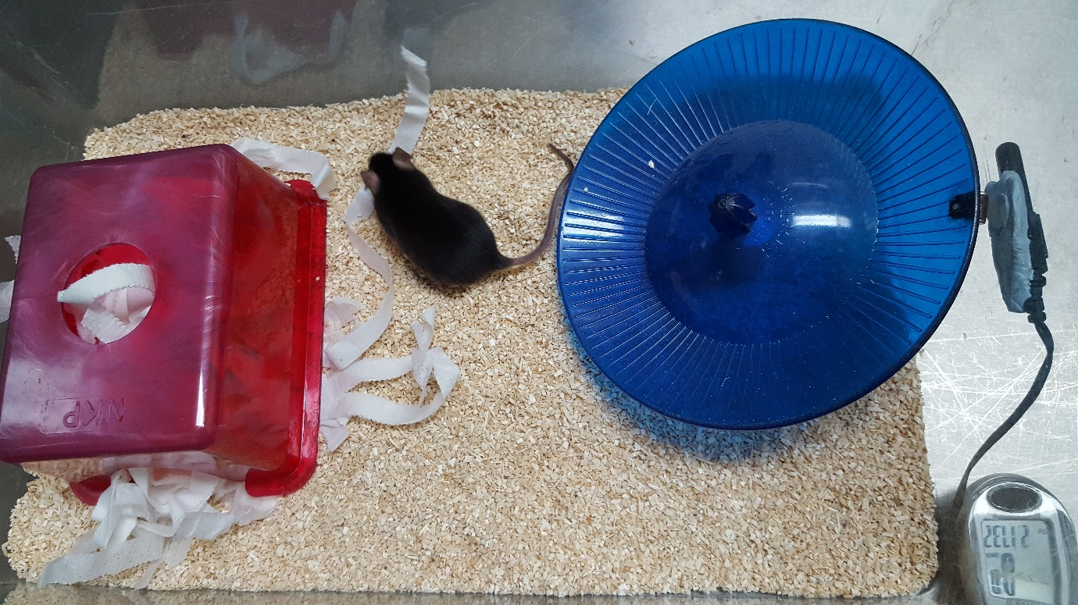
Figure 2.5: Running wheel home cage.
Parts indicated are 1: Fast Trac running wheel, 2: magnetic switch, 3: digital odometer.

2
3
1

2.2.11.4 CatWalk gait analysis
The CatWalk system (Noldus Information Technology) (Figure 2.6) is composed of an enclosed corridor equipped with a glass walkway to allow rodents to walk upon it. Beneath the walkway, a green LED light is radiated along the glass. The LED will illuminate any part of the animal in contact with the glass, typically the rodent’s paws. Underneath the walkway, there is a camera, which captures these illuminated areas and sends the information to the computer that runs the CatWalk software. The software calculates a wide range of parameters such as stand time, stride length, base of support, and the time-based relationship between footprints, toe spread, and paw angle. Because SPAST^{ΔE7} mice have a broader hind limb gait (the distance between the two hind limbs are wider than the SPAST^{+/+}) (Kasher et al., 2009), the parameter that we want to determine is the hind limb base-of-support BOS (the distance between the two hind limbs). Six runs in the CatWalk were recorded for each mouse. Sometimes the mice did not walk continuously along the platform, and any runs involving pausing or turning were excluded from analysis. On this basis, the three best runs were selected for the analysis.
All paw prints in each video were manually labelled (i.e. right front, left front for fore limbs and right hind, left hind for hind limbs) using CatWalk software version 7.1. By the end of the labelling, the mean BOS value of all hind limb paw prints is given in pixels. After that, BOS values were taken from the three runs, averaged and converted from pixels to mm, so as to allow a graph to be created comparing mutant with control mice. We also collected and analysed the following parameters; swing duration, swing length, swing speed, stand and duty cycle.

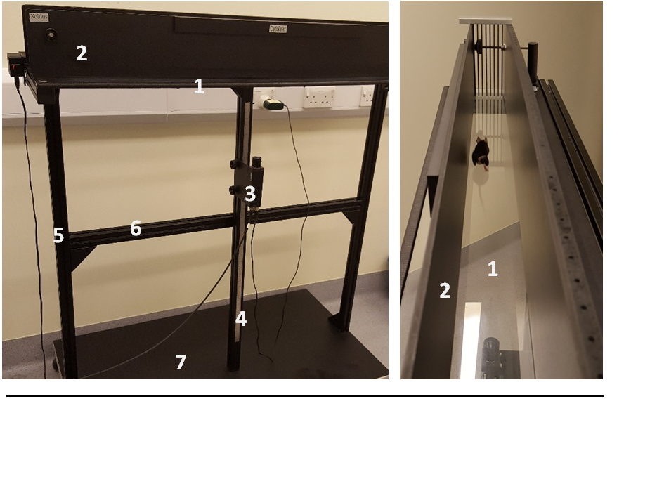
1

5
3
6
1
7
Figure 2.6: CatWalk system (Noldus Information Technology).
Parts indicated are 1: walkway, 2: corridor, 3: camera, 4: camera rail, 5: vertical profile, 6: horizontal profile and 7: basic frame

2.2.12 Immunocytochemistry (IHC) in mouse tissue

2.2.12.1 Mouse tissue preparation
The mice used were terminally anaesthetised, the chest was opened and the left ventricle of the heart was injected with 10-20 ml of PBS after snipping the upper right ventricle to remove the blood, followed by perfusion with 4% paraformaldehyde (PFA) in PBS (pH 7) (see section 2.1.3.3) until the mouse was perfused. As an indication of perfusion, we monitored rigidity of the body and the changing colour of the liver. The brain and complete spinal cord were dissected and immersed in 4% PFA for 24 hours and then placed in PBS until used. The spinal cord was cut into cervical, thoracic and lumbar regions and placed into tissue processing cassettes. All cassettes were immersed in ethanol before tissue processing was performed. The Neuropathology Core Facility (University of Sheffield), embedded the processed tissues in paraffin. About 500 µm of the frontal part of the tissue was cut using a microtome (Optech Instruments, Oxfordshire, UK) to remove tissue which may have been damaged during processing. Then 5 or 10 µm serial sections were cut as a ribbon and placed in a water bath at 37 ºC, and individual sections was transferred onto four slides in such a way that the four sections on each slide were sequentially 20 or 40 µm apart. The slides were dried overnight at 37 ºC in an oven prior to staining.

2.2.12.2 IHC for formalin fixed, paraffin-embedded tissue (FFPE)
To investigate the axonal swelling pathology we stained sections with antibodies labelling proteins that were previously observed to accumulate in swellings in mutant spastin mice and HSP patients with spastin mutations (Kasher et al., 2009). The following protocol was performed on spinal cord sections. Sections were dewaxed and placed in two changes of xylene for five minutes for each. To hydrate the tissue, sections were immersed in descending concentrations of ethanol (100%, 95% and 70% EtOH) for five minutes each, following by rinse in water. Endogenous peroxidase activity was quenched by incubating sections in 3% H₂O₂/methanol for 20 minutes at RT. Sections were then rinsed with distilled water (d.H₂O), and antigen retrieval was performed by placing the tissue in a microwave for 10 minutes with trisodium citrate buffer (see section 2.1.3.5). This step is important in order to remove the polymer clusters that are potentially formed on the tissue antigen-binding sites by formalin treatment. Insufficient antigen retrieval will prevent antibodies from binding at the antigen binding site. The sections were then rinsed with water and washed with TBS (see section 2.1.3.3) before being blocked with normal horse serum (Vectastain Universal Elite ABC kit, Vector, California, USA) for 30 minutes at RT by adding three drops of normal horse serum per 10 ml of TBS. Subsequently, sections were incubated in an optimal concentration of primary antibody APP amyloid precursor protein (Abcam, UK) in a normal horse serum (1:2000) for an hour at RT. Then, sections were washed three times with TBS, followed by incubation with a biotinylated secondary antibody from the Vectastain ABC kit (rabbit IgG) for 30 minutes at RT (three drops of normal horse serum, one drop biotinylated secondary antibody, 10 ml TBS were added). The sections were then incubated in avidin-biotin complex solution (ABC) (Vectastain) (see section 2.1.3.5) for 30 minutes at RT, and washed with TBS two times for five minutes. Labelled antigens were visualised by incubated the sections in diaminobenzidine (DAB, Vector, California, USA) (two drops of buffer, four drops DAB, two drops hydrogen peroxide solution and 5 ml dH2O). The H₂O₂ in the ABC reacts with the H₂O₂ in the DAB solution to form a brown insoluble product at the antigen site. Sections were washed with dH₂O followed by tap water for five minutes. The nuclei were counterstained by immersing sections in Gills haematoxylin for 30-60 seconds, and then washed with tap water. After that, sections were incubated in Scott’s tap water (see section 2.1.3.5) for one minute to give the nuclei a blue colour. After washing in tap water, sections were dehydrated in ascending concentrations of ethanol (70%, 95% and 100% EtOH), and cleared in xylene, before mounting with DPX.

2.2.13 Quantification of axonal swellings
To determine the number of axonal swellings in the spinal cord of spastin mice APP stained spinal cord sections from both cervical and lumbar regions were scanned using a slide scanner (Visiopharm, Denmark). The slides were viewed and the area of swellings measured using NDP view2 software. The position of the swellings was determined relative to the region of the motor tracts, which are located in the lateral column of the corticospinal tract. The number and the sizes of the swellings were quantified and numbers were normalised to the sections taken. The mean number of swellings was quantified per region. Finally, all data were analysed in GraphPad Prism version 7 and statistical analysis performed using one-way ANOVA with Bonferroni's multiple comparison test.

2.2.14 Data analysis and statistical methods
The number of mice used on each experiments were chosen based on the power calculation that was conducted using G*Power (3.1) software. The effect size was interpreted according to (Cohen, 1988). Power calculated according to t- test with two independent means.
Base of support data in this project was measured using Catwalk automated system (Catwalk software version 7.1). Six runs per mouse were recorded and the best three runs were chosen to be included in the quantification based on the criteria on section (2.2.11.4) to obtain the average of three runs per mouse per month. This step followed by quantifying the average of the BOS per group per month. The statistical analysis involved was two-way ANOVA followed by Bonferroni multiple comparison test.
Axonal swellings quantification was performed on 20 sections per mouse, poor quality sections excluded from the quantification. The sections were 20 or 40µm apart. The average of axonal swellings in each region per group was quantified. Then the number of axonal swellings normalised to the distance between the sections taken (20 or 40µm). The statistical analysis involved was one-way ANOVA followed by Bonferroni multiple comparison test. All statistical analyses were conducted using GraphPad Prism 7 (Graph Pad Software, San Diego, CA).

.

Chapter 3: Effects of exercise on the HSP phenotype

Chapter 3: Effects of exercise on the HSP phenotype

3.1 Aims
This research presented in this chapter had three aims. Firstly, we wished to determine whether the gait defect in Spastin mutant mice led to any alteration in voluntary motor activity. Secondly we wished to determine if voluntary exercise modified the gait phenotype in spastin mice. Lastly we wished to investigate the effect of voluntary exercise on the pathological axonal swellings found in the spinal cord of mutant spastin mice.
Home cage running wheels were used, and the daily voluntary running performance of each mouse was recorded. In addition, behavioural testing was carried out every month to investigate the effect of the voluntary exercise on the gait of spastin mice and wild type littermates. At the end of the study, we investigated the effect of voluntary exercise on the axonal swelling pathology in the spinal cord.

3.2 Introduction
The principal defect in the spastin mouse model is a significant progressive increase in hind limb base-of-support (BOS) the distance between the two hindlimbs (Kasher et al., 2009). We have previously showed that Fast Trac home cage running wheels can be used for early and sensitive detection of progressive loss of motor function in a mouse model of motor neurone disease (Bennett et al., 2014). We therefore wished to investigate the voluntary running behaviour of mutant spastin mice using Fast Trac running wheels.
Presently, treatment options for HSP are limited, but physicians may recommend low impact regular exercise and muscle relaxation medication such as Tizanidine, Botox and Dantrolene in order to reduce the spasticity of the lower limb muscles (Fink, 2003a). Much evidence has suggested that lifestyle changes play a major role in delaying aging-related diseases, alleviating depression and potentially lowering the threat of neurodegeneration. Exercise is one factor that could have a direct effect on general brain health. It is known that exercise is an important factor to improve general human health. Regular exercise contributes to reduce the risk of diseases such as cardiovascular disease (Tanasescu et al., 2002) and osteoporosis (Kemmler et al., 2004).
In a previous experiment in our laboratory (Bennett et al., 2014), we noted that voluntary home-cage running wheel activity significantly improved the performance of a mouse model of motor neuron disease on the rotarod test. Another example of the positive effects of a home-cage running wheel on NDs is a study on a mouse model of Huntington's disease (HD). The authors showed that mice that exercised prior to the onset of symptoms on a running wheel showed reduced motor deficits (Van Dellen et al., 2000). This suggested that exercise on running wheels is beneficial in rodent models of human neurodegenerative disease, and therefore might also have a beneficial effect on gait/motor dysfunction in an HSP mouse model.
Despite the general advice from physicians that moderate exercise may be beneficial in HSP, there is no formal evidence to support this. We therefore wished to investigate the effect of exercise on gait defects in the spastin mouse model systematically and furthermore to investigate whether exercise altered axonal pathology in the spinal cord of these mice.

3.3 Results

3.3.1 Experimental design
This study was composed of four groups of female mice, namely, SPAST^{+/+} with and without running wheel (+RW and -RW) and SPAST^{ΔE7/ΔE7} +RW and –RW. Based on power analysis of previous data (Kasher, unpublished) eight mice were randomly assigned per group before three months of age.

3.3.2 Housing conditions
All the mice were singly housed in identical large cages with and without a fast trac running wheel. For housing conditions (see section 2.2.11.2).

3.3.3 Running wheel activity in spastin mutant mice

3.3.3.1 Characterisation of running activity
From 90 days of age onwards Fast Trac running wheel activity was recorded daily. The following parameters were measured: time spent running, distance run, average speed and maximum speed. Female mice provided with home-cage running wheels spent up to 5 hours (hrs) running, approximately 15 km/night. The running wheel activity of SPAST^{+/+} and SPAST^{ΔE7/ΔE7} female mice across all four measurements was highly variable and also fluctuated over time. Figure 3.1-A shows a graph for time spent running per night for a pair of mice for the entire duration of the study. It reveals the great variability in this parameter over the period of the study. Figure 3.1 B-C & D show examples of time spent running for three wildtype mice over a three-week period. As can be seen, the time spent running reached a peak every three to five days, with periods of reduced running between the peaks. Since all the mice in this study are females, it is likely that this cyclic fluctuation in activity is linked to the estrus cycle (Kopp et al., 2006, Basterfield et al., 2009). To minimise the effect of this confounding variability, in all experiments the maximum daily running per week was taken and the average per group calculated for 75 weeks so as to produce the graphs shown in Figure 3.2.

Figure 3.1: Running wheel activity fluctuates. (A) The daily time spent running for a pair of SPAST^{+/+} and SPAST^{ΔE7/ΔE7} mice. (B, C and D) Examples of time spent running from 110 to 130 days old.

3.3.3.2 Spastin mutation does not affect overall running activities
Four running parameters were recorded via the home cage running wheel, namely: time, distance, average speed and maximum speed. Figure 3.2-A shows the longest time spent running per week. Initially, there is a small difference in the longest time spent running between SPAST^{+/+} and SPAST^{ΔE7/ΔE7}. By 14 weeks old, SPAST^{+/+} spent at most 5+1.5 hrs running and the SPAST^{ΔE7/ΔE7} group spent approximately 22% less, running 4+1 hrs. This small reduction in activity in the spastin group at the initial time point was not statistically significant. After this the time spent running reduced gradually and reached 2+0.5 hrs for wildtype mice and 2+1.2 hrs for spastin mutant mice at 75 weeks old.
Similarly, Figure 3.2-B shows the highest distance run per week. At the starting point, SPAST^{+/+} ran 11+6 km and SPAST^{ΔE7/ΔE7} ran 9+6 km; therefore, the mutant group ran 23% less than the wildtype mice. Following this time point the distance in both SPAST^{+/+} and SPAST^{ΔE7/ΔE7} groups increased, until 22 weeks old and then it gradually declined. By 75 weeks old, SPAST^{+/+} ran 3.2+2 km while SPAST^{ΔE7/ΔE7}ran 4+1 km. The highest average speed per week is presented in Figure 3.2-C. We did not notice any difference at the initial time point at 14 weeks old, with the wildtype group running 2.3+0.6 km/hr and the spastin mutant group running 2.1+0.5 km/hr. There was a steady reduction in the highest average speed in both groups. By week 75, the average speed of the SPAST^{+/+} and SPAST^{ΔE7/ΔE7} mice was 1.4+0.4 and 1.6+0.1 km/hr respectively. Figure 3.2-D shows the maximum recorded running speed per week. There were no significant differences between genotypes applying two-way ANOVA, however it can be seen that variation in maximum speed was higher in the SPAST^{ΔE7/ΔE7} mice than the wildtype littermates.

Figure 3.2: Weekly measurements of four running wheel activities from 14 to 75 weeks old. (A) Longest time spent running per week. (B) Longest distance travelled per week. (C) Highest average speed per week. (D) Highest maximum speed per week. All graphs show no statistically significant difference between the SPAST^{+/+} and SPAST^{ΔE7/ΔE7} over time. Statistical analysis involved two-way ANOVA followed by Bonferroni's multiple comparisons test. Error bars are standard deviation.

3.3.4 No effects of voluntary exercise on mice body weight
Voluntary exercise has beneficial effects in humans (Björntorp et al., 1972) and rodents (Crews et al., 1969). There is a great deal of evidence suggesting that long-term exercise slows the process of aging and prevents diseases associated with aging (Kent, 1982). Also, voluntary training such as walking, jogging or doing moderate-intensity aerobic exercise reduced the risk of many chronic diseases, improved personal fitness and prevented weight gain (Haskell et al., 2007). In mice, voluntary training on running-wheels is widely used to investigate adaptation to exercise (Allen et al., 2001).
Here we investigated the effects of running-wheel activity on the body weight of SPAST^{+/+} and SPAST^{ΔE7/ΔE7} mice. Figure 3.3 shows the body weight data for all four groups of mice, from 3 to 17 months of age. Mice gained weight throughout the period of the study. At four months of age, the mice in all four groups weighed approximately 20 g. By month 12, however, it can be seen that the weight of the SPAST^{+/+} mice had reduced by 10% in the exercised group, although this difference between the groups was not statistically significant (p=0.8995) using two-way ANOVA. Likewise, there was a small but statistically non-significant effect of exercise on body weight in SPAST^{ΔE7/ΔE7} mice. Generally, the SPAST^{ΔE7/ΔE7} mice were lighter than SPAST^{+/+} mice, although, again, this effect was not statistically significant.

Figure 3.3: The effect of voluntary exercise on body weight.
The body weight of mice was recorded monthly from 4 to 17 months old. There was no statistically significant difference between the groups throughout the period of study. Statistical analysis involved two-way ANOVA followed by Bonferroni's multiple comparisons test. Error bars represent standard deviation.

3.3.5 The beneficial effects of voluntary exercise on hind limb gait in spastin mice

3.3.5.1 Gait Analysis of spastin mouse model using the CatWalk automated system
Motor deficits are a common feature of many neurological diseases, including Parkinson’s disease (PD) and ataxia. Similarly, HSP patients have a gait defect which is characterised by spasticity of the lower limbs (Klebe et al., 2004). The spastin mouse model of HSP also develops progressive gait defects characterised by wider hind limb base-of-support (BOS) (Kasher et al., 2009).
To evaluate the effects of exercise on gait defects we used the automated CatWalk system (see section 2.2.11.4). This system permits an objective quantification of various gait parameters, and is therefore a useful tool to analyse gait impairment in animal models of neurological disease (Vandeputte et al., 2010). Figure 3.4 displays profiles of the footprints from the automated CatWalk software of female mice at 12 months old illustrating both the narrower wildtype BOS (Figure 3.4-A) and the wider homozygous BOS (Figure 3.4-B). Figure 3.4-C shows that there is a significant difference between SPAST^{+/+} and SPAST^{ΔE7/ΔE7} at this age.

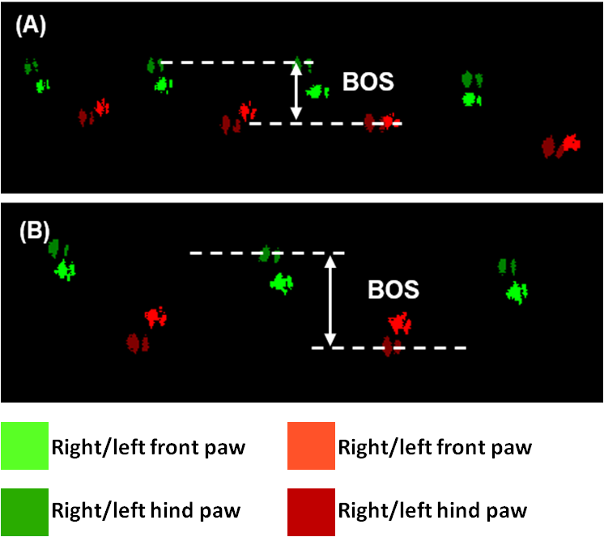

Figure 3.4: Gait defect of spastin mice analysed by CatWalk automated system at 12 months old. (A) Displaying the footprints of the SPAST^{+/+} showing narrower base-of-support (BOS). (B) Displaying footprints of gait defects of SPAST^{ΔE7/ΔE7} showing wider (BOS). (C) Comparing the BOS of SPAST^{+/+} and SPAST^{ΔE7/ΔE7} revealed a significant difference based on two-way ANOVA (eight mice per group).

3.3.5.2 Hind limb BOS
To assess the effects of exercise on the walking pattern of a spastin mouse model of HSP we used a CatWalk automated gait analysis system (see section 2.2.11.4) at monthly intervals in the four groups, from 3 to 17 months old (Figure 3.5). The graph illustrates the effects of voluntary exercise on BOS. The control group used were the SPAST^{+/+} (+RW) and (-RW) and the Y axis is the BOS in mm. Data at each time point is an average of eight mice (using three runs per mouse to generate an average BOS for each animal). For quality control, each run had to follow specific criteria (see section 2.2.11.4). The statistical analysis involved two-way ANOVA followed by Bonferroni's multiple comparisons test.
Overall, statistical analysis of the graph shows no significant differences between the groups (p= 0.3760). The statistical analysis between the SPAST^{+/+} and SPAST^{ΔE7/ΔE7} groups did reveal a significant difference, however (p= 0.0012). Also, there were no significant differences detected between SPAST^{+/+} (+RW) vs (-RW) or SPAST^{ΔE7/ΔE7} (+RW) vs (-RW) (p = 0.8079 and 0.9299), respectively.
It can be seen from the graph that the BOS of SPAST^{+/+} mice was not influenced by wheel running, nor was it affected by increasing age, as it remained between 11.0 and 12.6 mm. The BOS in both SPAST^{ΔE7/ΔE7} (+RW) and (-RW) increased dramatically, however. At the first time point, three months of age, there was a slight difference between spastin mutants and controls, as the SPAST^{+/+} (-RW) was (mean +SD) 11.4 +1 mm, SPAST^{+/+} (+RW) 11 +1.3 mm, SPAST^{ΔE7/ΔE7} (-RW) 12.5 +1.2 mm and SPAST^{ΔE7/ΔE7} (+RW) 12.5 +1 mm. These differences were not statistically significant, however. The differences between the spastin and wildtype groups increased over time as the BOS of SPAST^{ΔE7/ΔE7} (-RW) and (+RW) groups became wider than SPAST^{+/+} (+RW) and (-RW).
By four months old, the BOS of SPAST^{+/+} (-RW) was 11+1 mm and SPAST^{ΔE7/ΔE7} (-RW) 13.7 + 1.2 mm, and this was significantly different (p<0.05). At five months old, the BOS of the spastin mutant group had increased, as the difference between the SPAST^{+/+} (-RW) and SPAST^{ΔE7/ΔE7} (-RW) groups was about 25%; this difference was also statistically significant (p= 0.0024). The BOS of SPAST^{+/+} (-RW) increased until nine months old to 12+1 mm, and then remained relatively constant until 17 months old. In comparison with SPAST^{+/+} (-RW) at nine months old, the SPAST^{ΔE7/ΔE7} (-RW) BOS was 17+1 mm, a highly significant increase of 40% (p<0.0001). After exercise, the BOS of SPAST^{ΔE7/ΔE7} +RW became significantly different from SPAST^{ΔE7/ΔE7} (-RW) at three time points: 9, 13 and 15 months old.
At the end time point of the study, when the mice were 17 months old, the SPAST^{ΔE7/ΔE7} (-RW) group had a 34% increase in BOS compared to SPAST^{+/+} (-RW) (p<0.0001). At this age the SPAST^{ΔE7/ΔE7} (-RW) mice had a 25% increase in BOS compared to SPAST^{ΔE7/ΔE7} (+RW), although this was not statistically significant (p=0.3975).

Age | SPAST^{+/+} - RW  Vs  SPAST^{ΔE7/ΔE7} - RW | SPAST^{+/+} + RW  Vs  SPAST^{ΔE7/ΔE7} + RW | SPAST^{ΔE7/ΔE7} - RW  Vs  SPAST^{ΔE7/ΔE7} + RW | SPAST^{+/+} - RW  Vs  SPAST^{+/+} + RW
Month 3 | ns | ns | ns | ns
Month 4 | * | ns | ns | ns
Month 5 | ** | ** | ns | ns
Month 6 | **** | ns | ns | ns
Month 7 | ** | ns | ns | ns
Month 8 | ** | ns | ns | ns
Month 9 | **** | ** | * | ns
Month 10 | **** | ** | ns | ns
Month 11 | **** | ** | ns | ns
Month 12 | **** | ** | ns | ns
Month 13 | **** | ** | * | ns
Month 14 | **** | ** | ns | ns
Month 15 | **** | ** | ** | ns
Month 16 | **** | **** | ns | ns
Month 17 | **** | * | ns | ns

Figure 3.5: Effects of voluntary exercise on gait deficits of the HSP mouse model. (A) Gait was measured and analysed using the CatWalk automated system. (B) Statistical analysis involved two-way ANOVA followed by Bonferroni's multiple comparisons test (**** p<0.0001, *** p<0.001, ** p<0.01, *p<0.05 & ns >0.05). Error bars represent standard deviation SD.

3.3.6 Analysis of additional gait parameters

3.3.6.1 Longitudinal analysis of other gait parameters
To identify the full gait profile in the spastin mouse model of HSP, we analysed several gait parameters involving the step cycle phases and paw dimensions. Because the major defects previously reported in spastin mouse models affected hind limbs (Tarrade et al., 2006, Kasher et al., 2009), we analysed a number of different parameters of hind limb gait.
For illustration of the gait parameters, the step cycle has two phases, swing and stance. Each of these can be measured as a period of time, and swing can also be measured as a distance travelled, and thus a swing speed can be obtained (Figure 3.6-A). The different gait parameters involved in the step cycle are swing duration in seconds (s), swing length (pixels), swing speed (pixels/second), stand (s) and duty cycle (%) (Figure 3.6-A). Other parameters that were analysed included paw dimensions, maximum area (pixels), print area (mm²), print length (mm), print width (mm), paw angle (degree), max contact (s), max contact (%), intensity (1-255) and initial contact (s), (Figure 3.6-B). For a definition of each parameter see Table 3.1.

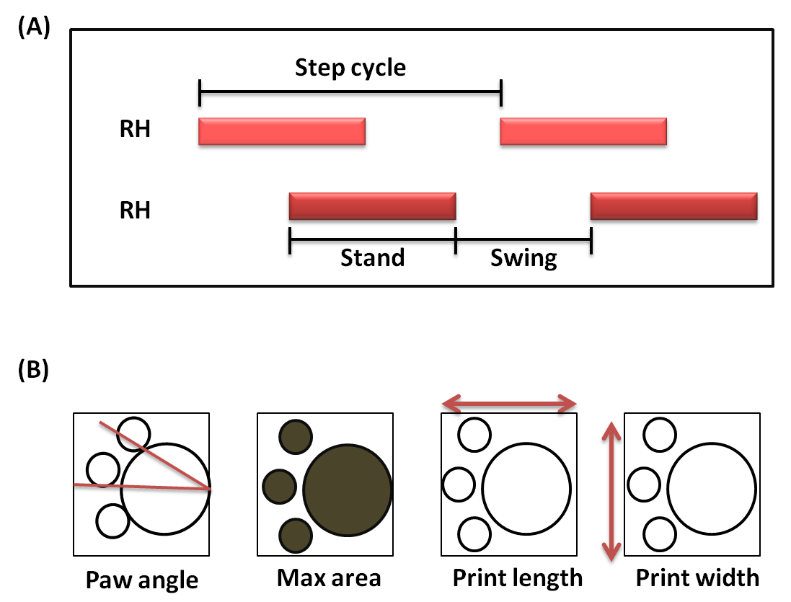

Figure 3.6: Gait parameters measured by the catwalk automated system.
(A) Step cycle for the (RH) right hind paw which is divided into stand and swing. The dark red line shows the standing phase of the step cycle (when the paw is in contact with the glass plate) and the area between two dark red lines is the swing phase of the step cycle (when the paw is not in contact with the glass plate) . (B) Paw dimensions including (paw angle, max are, print length and print width).

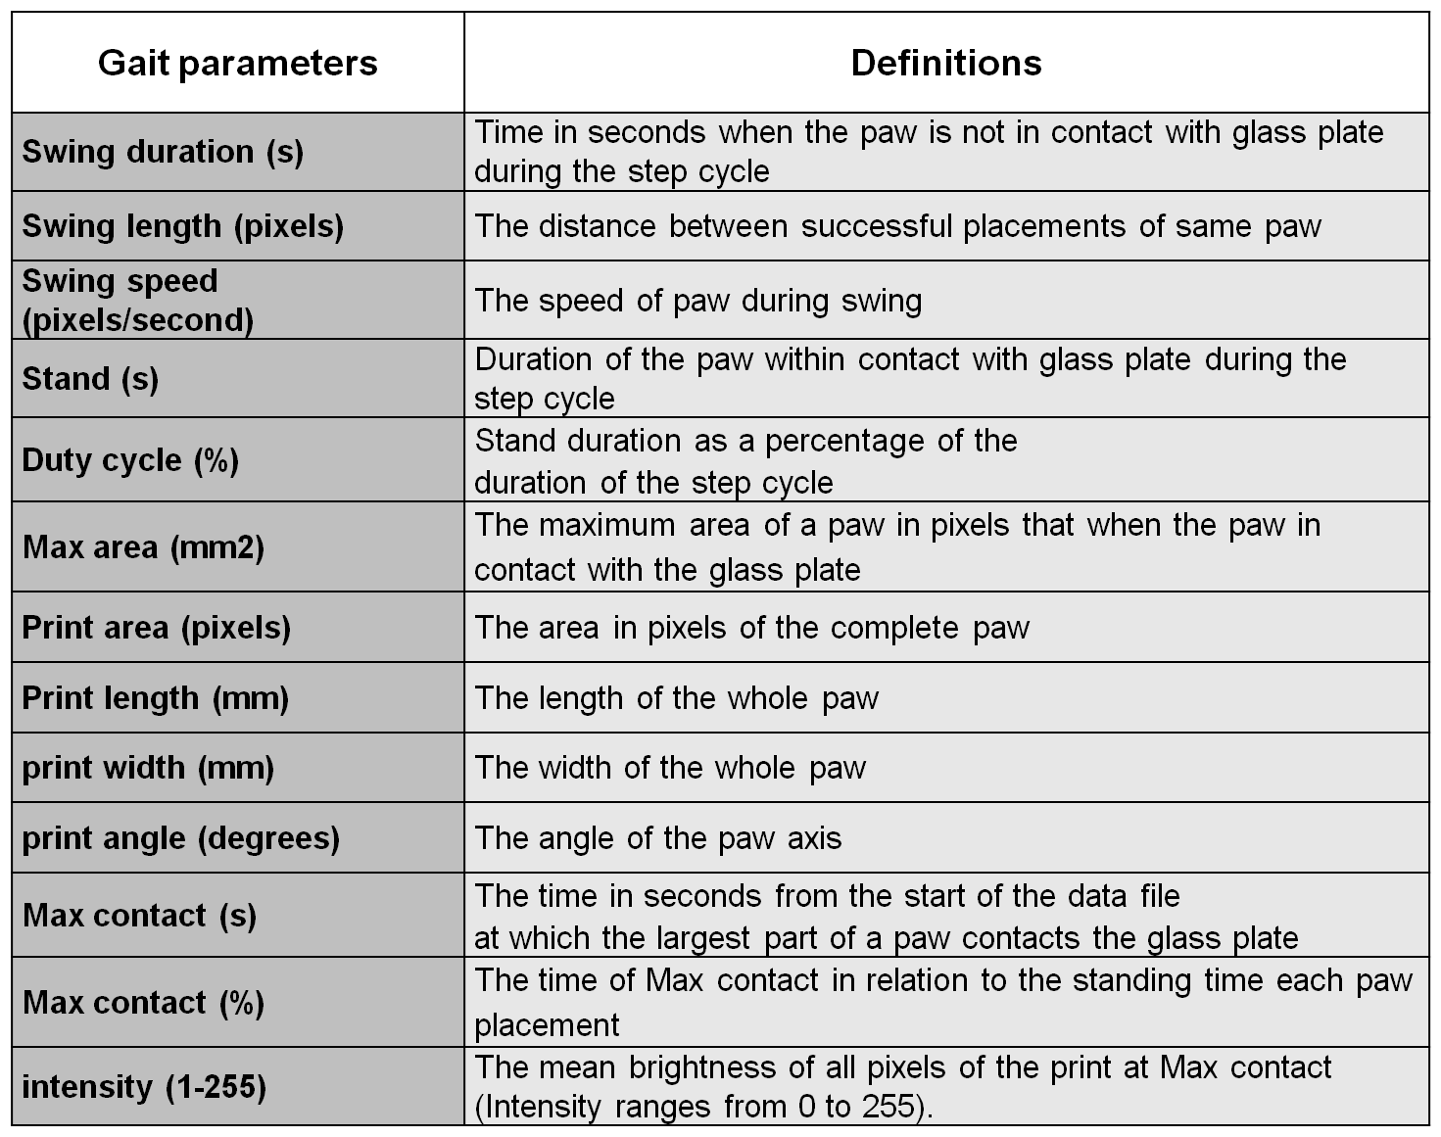
Table 3.1: The definition of the static gait parameters

To give an overview of any differences at any parameter, we chose to present the p-value of the difference between groups after applying two-way ANOVA followed by Bonferroni's multiple Comparisons test. Table 3.2 shows the comparison between different experimental groups, i.e. SPAST^{+/+} (-RW) vs SPAST^{ΔE7/ΔE7} (-RW), SPAST^{+/+} (-RW) vs SPAST^{+/+} (+RW) and SPAST^{ΔE7/ΔE7} (-RW) vs SPAST^{ΔE7/ΔE7}(+RW). We assessed the gait parameters at 3, 6, 9, 11, 13, 15 and 17 months.
Comparison of the non-exercise groups of SPAST^{+/+} and SPAST^{ΔE7/ΔE7} showed that some additional gait parameters might be altered in the model. It is of potential relevance to HSP phenotypes in patients that the swing speed (pixels/second), which means the speed of the paw during its swing, was significantly reduced in the SPAST^{ΔE7/ΔE7} group at three of the time points, specifically, 6, 9 and 13 months old. The swing duration and length was not affected in the spastin mutant group. We also noted a significant difference in maximum contact (%). This parameter is defined as the proportion of the stand cycle where the paw is making maximal contact with the glass plate. This difference was observed at 3, 9, 15 and 17 months old. There were no significant differences observed in other parameters related to the step cycle or paw dimensions, however. It is notable that the comparison between SPAST^{+/+} (-RW) vs SPAST^{+/+} (+RW) did not show any significant differences in any of the assessed parameters. Likewise, the comparison of SPAST^{ΔE7/ΔE7} (-RW) and SPAST^{ΔE7/ΔE7} (+RW) only showed sporadic effects of exercise that were not found at more than one-time point, and are therefore likely to reflect the phenotype inheriting variation.
In conclusion, exercise did not significantly modify any additional gait parameters in wildtype or SPAST^{ΔE7/ΔE7} mice. In the non-exercised mice, however, SPAST^{ΔE7/ΔE7} showed deficits in swing speed and max contact % compared with SPAST^{+/+}.

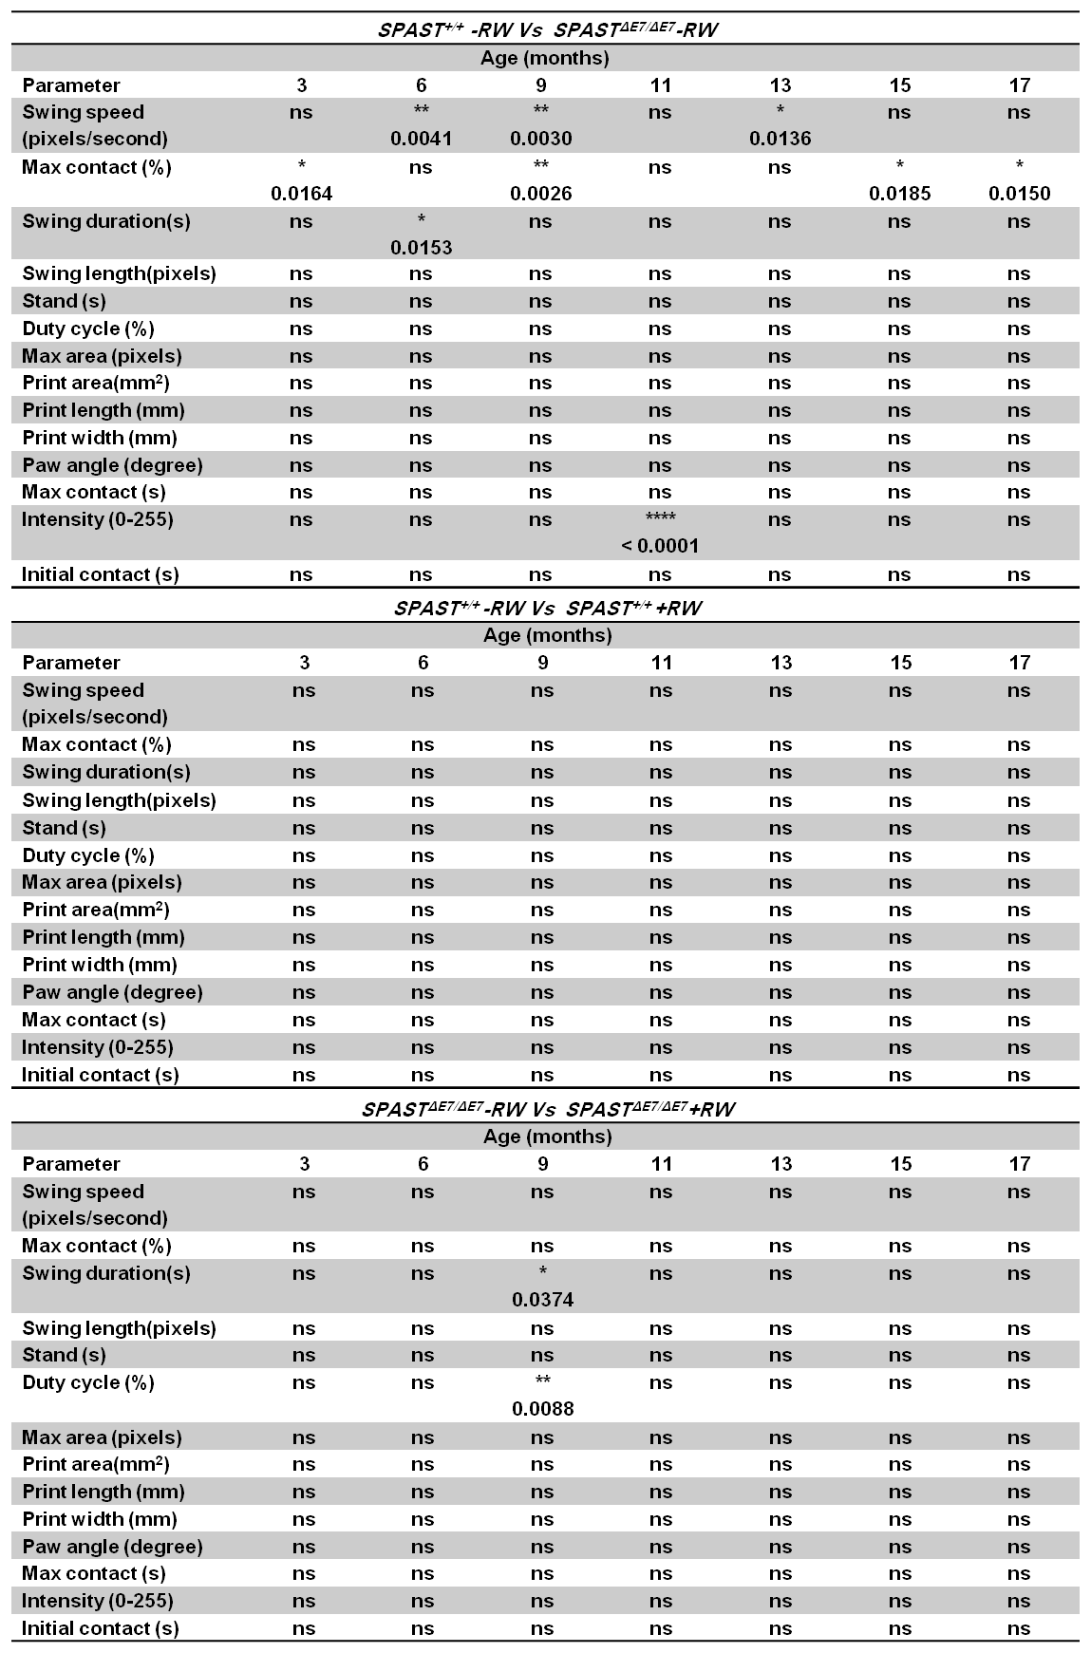
Table 3.2: Analysis of gait parameters.

Gait parameters were compared using two-way ANOVA followed by Bonferroni's multiple comparison test. Statistically significant effects are indicated in the table.

3.3.6.2 Examination of additional gait defects identified in this study
Exercise does not seem to have affected the parameters related to the step cycle when we compared the running wheel wildtype and spastin groups. A statistically significant difference was noted, however, between the SPAST^{+/+} and SPAST^{ΔE7/ΔE7} (-RW) groups in some parameters such as swing speed (pixel/second) and maximum contact (%). Since we want to investigate the gait defect in an HSP mouse model, different step cycle parameters have been analysed and presented in (Figure 3.7). It can be seen in Figure 3.7-A that the spastin group spent longer in the swing phase compared with the wildtype, but this difference was not statistically significant, except on one occasion at six months old (p= 0.0153). In Figure 3.7-B the swing length, which is the distance between the same paw placements, was not affected during the study period. As Figure 3.7-C shows, however, the swing speed (pixels/second) was lower in the SPAST^{ΔE7/ΔE7} group compared to SPAST^{+/+} at the 6, 9 and 13 month time points comparison to the SPAST^{+/+} group (Figure 3.7-D).

Figure 3.7: CatWalk automated gait analysis for four different parameters.
(A) Swing duration (s), (B) Swing length (mm), (C) Swing speed (pixels/seconds), (C) Maximum contact (%). Error bars represent standard deviation SD.

3.3.7 Effect of exercise on axonal swelling pathology in the spastin mouse model of HSP
Experimental analysis of the effects of voluntary exercise in mouse models of disease may provide a better understanding of the underlying protective molecular mechanisms associated with the positive effects of exercise training. Understanding such mechanisms could facilitate the treatment of disease (De Bono et al., 2006). Exercise is important for brain function as it enhances memory and learning, and decreases mental decline and age related brain diseases (Colcombe and Kramer, 2003). Exercise has been shown to be beneficial for different animal models of NDs, such as AD, HD and PD. For example, it delayed the onset of HD in mouse (Pang et al., 2006), and improved spatial memory formation in an AD mouse model and also reduced the formation of β-amyloid plaques in the brain (Adlard et al., 2005). At the molecular level, voluntary exercise increased the levels of the synaptic proteins synapsin I and synaptophysin neurotransmitters that regulate the release of synaptic vesicles (Vaynman et al., 2006).
Because of the moderately beneficial effects of exercise on gait, we aimed to investigate whether this was associated with a reduction in the axonal swellings in the spinal cord. We therefore quantified the number of axonal swellings in the UMN that relay to the LMN to innervate the lower extremities. The UMN at the cervical level is composed of long and short axon fibres that supply the upper body parts; at the lumbar level, however, it is composed of the longest axon fibres that supply the lower body parts (Figure 3.8).

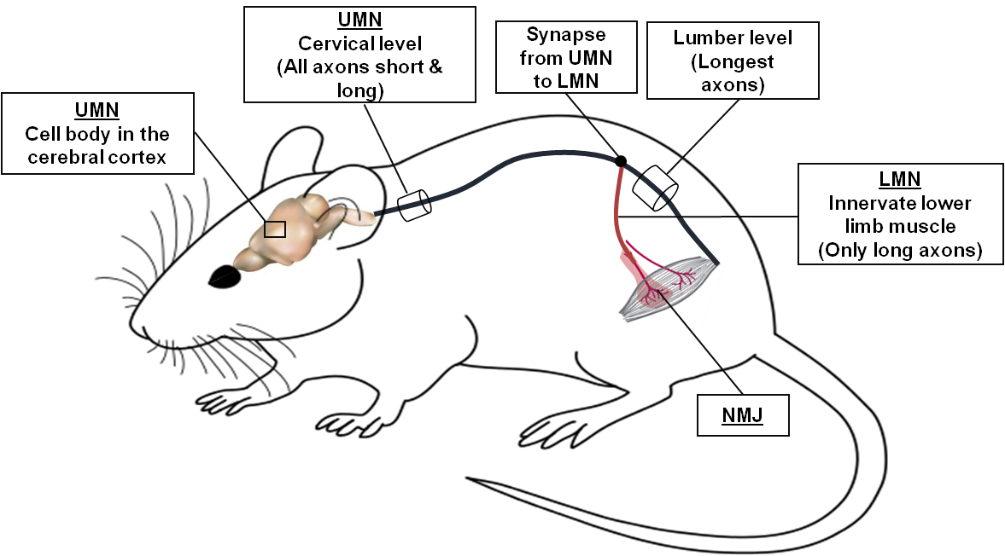

Figure 3.8: Diagram illustrating mouse motor neuron fibres.
The upper motor neuron (UMN) composed of long and short fibres. The longest fibres only synapse to the lower motor neuron (LMN) and supply different body parts including lower limb muscle via neuromuscular junctions (NMJ).

We also determined the anatomical distribution of axonal swellings in the white matter of the spinal cord, namely the lateral corticospinal tract (LCST) and corticospinal tract (CST), which are composed of the motor fibres (Hsu et al., 2006). Also, the anatomical distribution has been determined for the cervical and lumbar spinal cords. The areas that have mixed fibres (motor and sensory) namely; ventrolateral funiculus (VLF) and ventral funiculus (VF) (Fuller and Gates, 2016) (Figure 3.9).

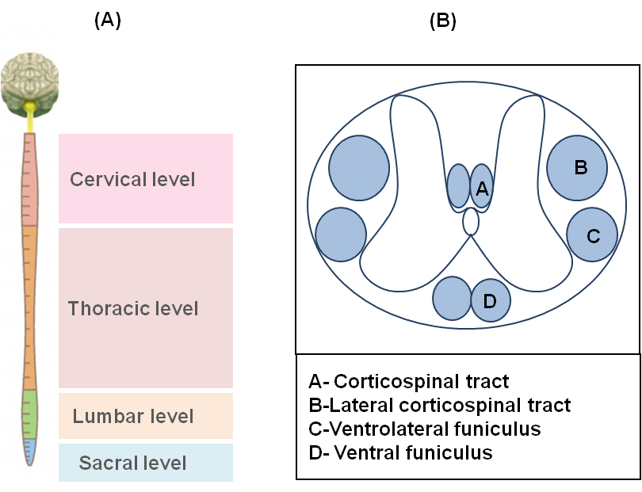

Figure 3.9: Spinal cord anatomy. (A) Levels of the spinal cord. (B) A diagram of the horizontal section of the spinal cord showing the regions in which axonal swellings occur.

The spinal cords from three mice per group were cut into 5µm thick transverse sections (see section 2.2.13). Sixteen sections were taken at 20µm intervals from each region per mouse. To detect and quantify swellings in this study we used an antibody recognising the vesicular amyloid precursor protein (APP) (Abcam, UK) (Figure 3.10). Any poor quality sections were removed from the quantification.
After all the slides from wild type and mutant mice spinal cords had been stained with the APP antibody, we noticed that there were some smaller swelling-like structures present in the wild type sections. To differentiate between these and the large swellings found in mutant spastin mice we determined the relative frequency of swelling sizes in wild type and mutant mice. We found that most of the swellings in the mutant mice were bigger than 20µm², whereas most of the swellings in the wild types were smaller than 20µm², and occasionally bigger than 20µm². Based on this outcome, we chose a threshold of 20µm² to distinguish axonal swellings.

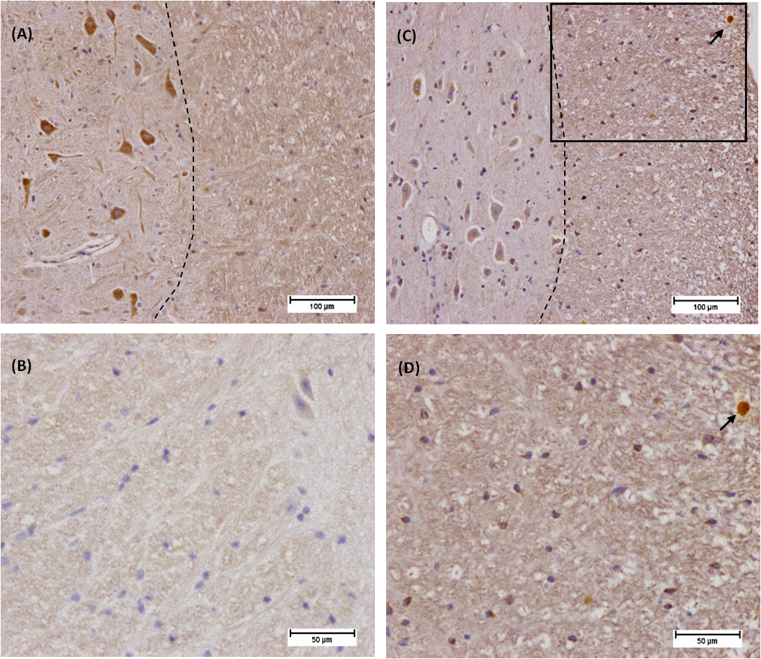

Figure 3.10: Representative images for axonal swellings in the spinal cord.
(A and B) section from SPAST^{+/+} in different scales. (C and D) sections from SPAST^{ΔE7/ΔE7} in different scales, the black box in C is enlarged in D. Dash line separated between gray and white matter. Axonal swellings stained against (APP) antibody (Abcam, UK) indicated by arrows.

Cervical cord
The axonal swelling was quantified and the number of swellings per micron is presented in Figures 3.11 and 3.12. It is notable that the number of axonal swellings above 20 µm² is higher in the SPAST^{ΔE7/ΔE7} (-RW) compared to all other groups in all regions of the spinal cord, based on one-way ANOVA statistical analysis. Also, we detected only rare swellings in wildtype mice; hence the frequency of swellings in these groups is close to zero.
In the CST and LCST, which are composed of the motor fibres, the axonal swellings per micron were significantly higher in SPAST^{ΔE7/ΔE7} (-RW) compared with SPAST^{+/+} (-RW) as the p-values were 0.0182 and 0.0002 respectively. Similarly, in the VLF region, the axonal swellings were more numerous in the mutant mice compared with the wildtype (p=0.0029). Interestingly, the number of swellings in the LCST of the spastin mutant group was significantly reduced after exercise (p= 0.0011).

Figure 3.11: Frequency of axonal swellings per micron at the cervical level of the spinal cord after 14 months of exercise (A) Corticospinal tract and (B) lateral corticospinal tract are regions with motor fibres. (C) Ventrolateral funiculus and (D) ventral funiculus are the regions with mixed fibres including motor and sensory fibres. Statistical analysis was by one-way ANOVA. (**** p<0.0001, *** p<0.001, ** p <0.01, *p<0.05 & ns >0.05). Error bars represent standard deviation. (Section thickness= 5µm) (three mice per group).

Lumbar cord
The bar charts in Figure 3.12 show the number of axonal swellings per micron in the same spinal cord axon tracts at the lumbar level. The descending motor fibres at the lumbar level are by definition “long axons” since they have cell bodies projecting axons from the motor cortex. It is notable from the graphs that the number of swellings per micron was reduced in all four tracts after exercise, but this reduction was not statistically significant. Also, it is evident that the number of swellings in the mutant groups was higher than in wildtypes, but again this difference is not statistically significant. Error bars indicate significant variability within each group.

Figure 3.12: Frequency of axonal swellings per micron at the lumbar level of the spinal cord after 14 months of exercise. (A) Corticospinal tract and (B) lateral corticospinal tract are regions with motor fibres. (C) Ventrolateral funiculus and (D) ventral funiculus are the regions with mixed fibres including motor and sensory fibres. Statistical analysis was by one-way ANOVA. (**** p<0.0001, *** p<0.001, ** p <0.01, & ns >0.05). Error bars represent standard deviation. (section thickness= 5µm) (three mice per group).

3.4 Discussion
In this Chapter we set out to investigate whether spastin gait defects affected voluntary wheel running in mutant spastin mice, and to determine whether voluntary exercise modified the gait defect in these mice.

3.4.1 Effect of spastin mutation on voluntary wheel running
We know from a previous study of this mouse model of HSP that significant gait defects in the form of a wider BOS were noticed at 7 and 12 months old (Kasher et al., 2009); thus, we commenced the experiment at an earlier point, before the disease onset, at three months old. Mice were assigned to the experiment earlier than three months of age to acclimatise them to the running wheel. Females were chosen in this study because they run further than males, with laboratory studies revealing that they run about 15 km/night (De Bono et al., 2006). This meant that they should demonstrate any effects of exercise on the gait defects more readily than male mice.
The running wheel cages were provided with an odometer to record the running activities (time, distance, average speed and maximum speed). Surprisingly, we noticed that all the running wheel activities were highly variable, with the data fluctuating over time to reach a peak every four to five days. We propose that these regular fluctuations may represent variation associated with mouse female estrous cycle, which has four stages, repeating every four to five days (Byers et al., 2012). The highest reading per week has therefore plotted over the period of the study (Figure 4.2). After an initial period of “training” where mice steadily improved their running, we noted that running time, distance and average speed in SPAST^{+/+} and SPAST^{ΔE7/ΔE7} dropped gradually over time. Because the decline over time was similar in wild type mice and spastin mutants it does not appear that home cage running wheel activity is a suitable way to measure disease onset and progression in this HSP model.

3.4.2 Running wheel did not alter the weight gain
Weight loss is achieving by improving personal fitness by physical exercise and reducing unhealthy food consumption (Haskell et al., 2007). In a different animal model of motor neuron disease, voluntary exercise did not affect the weight gain during the study period (Bennett et al., 2014). Similarly, our mice did not show any significant reduction associated with exercise, since all the female mice in all groups gained weight gradually.

3.4.3 Effect of voluntary wheel running on spastin mice hind limb gait
Various environmental changes can have beneficial effects in mouse models of neurodegenerative disease, such as a slowing in the progression of motor defects and a delay in the onset of disease {van Dellen, 2000, Delaying the onset of Huntington&`#039`;s in mice}(Hockly et al., 2002). Exercise on running wheels is one such change that has shown beneficial effects in a mouse model with gait defects (Van Dellen et al., 2000). HSP is one of the motor neuron diseases that is characterised by lower limb weakness and spasticity (Klebe et al., 2004). To date, there is no cure for the HSP phenotype, except temporary symptomatic relief using muscle relaxation medications, with some patients reporting greater mobility and increased muscle tone as result of using antispastic drugs such as intrathecal baclofen (Dan et al., 2000), Dantrolene, Tizanidine and Botox (Harding, 1993, Fink, 2003a). In addition, physicians have recommended adopting a regime of regular low impact exercise to reduce the spasticity and improve gait (Fink, 2003a). This notion, however, is based on clinical experience rather than a statistically significant intervention-based study. In the present study, therefore, we investigation the beneficial effects of voluntary exercise on a running wheel on gait defects of an HSP mouse model with spastin mutation.
Spastin mice do not show any defects in rotarod performance, which indicates that the muscle coordination and strength are not impaired (Tarrade et al., 2006, Kasher et al., 2009). We therefore used the automated CatWalk gait analysis system to determine the effects of voluntary exercise on the HSP phenotype in this mouse model. The CatWalk system permits the quantitative analysis of many gait parameters including BOS. It is widely used to evaluate NDs in animal models (Vandeputte et al., 2010). Moreover, CatWalk can also analyse several other gait parameters and potentially give more detailed information about the gait phenotype in spastin mice. CatWalk was used in a previous study to investigate the gait defect in the spastin mouse model (Kasher et al., 2009). In Kasher’s study BOS was measured at three time points: 3, 7 and 12 months old, with the results revealing that spastin mice have a gait defect which is characterised by a significant increase in the hind limb BOS at 7 and 12 months old (Kasher et al., 2009). That investigation, therefore, indicated that the gait defect developed at some point between three and seven months old. Consistent with the previous finding, we did not see any difference between SPAST^{+/+} and SPAST^{ΔE7/ΔE7} (p>0.9999) at three months old. Interestingly we discovered that gait was significantly impaired as early as four months of age (p<0.05), and progressively widened to 17 months old.
Although the overall effect of exercise measured using two-way ANOVA was not statistically significant (p= 0.3760), there was significant improvement at three time points in the SPAST^{ΔE7/ΔE7} exercised group compared with the non-exercised group: specifically, at 9, 13 and 15 months old. Voluntary exercise decreased the BOS of SPAST^{ΔE7/ΔE7} mice by approximately 12% at these three time points. Our findings are supported by a study in a Huntington’s disease model which showed that physical activity at a presymptomatic stage contributed positively in delaying the motor defects associated with the disease (Van Dellen et al., 2000). In addition, a study in SOD1^{G93A} mice showed improvement in rotarod performance with access to a running wheel (Bennett et al., 2014). We did not notice a statistical improvement in other time points because one problem related to this experiment is the small group size. To address the limitations of our study we have performed a post-hoc power calculation to determine the group sizes of mice required in order to obtain a statistically significant improvement in gait (Table 3.3).
Table 4.4: Post-hoc power calculation to demonstrate HSP mice base of support changes.

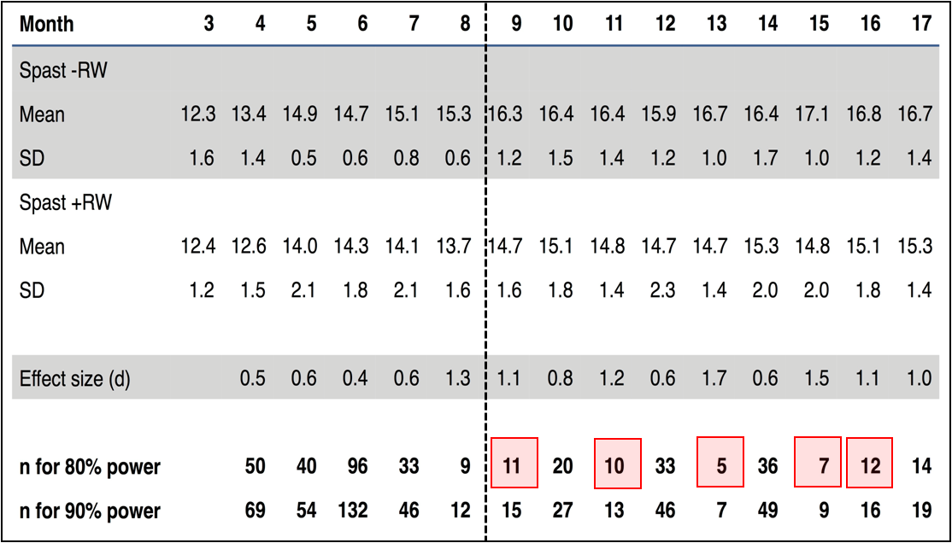
Table 3.3: Post-hoc power calculation to demonstrate HSP mice base of support changes.

The size of the groups which would provide a statistical significant result, less than 12 mice, after month eight is indicated in the red boxes.
Based on the effect size calculated for exercise, and the variation observed within groups, we conclude that 12 mice per group would be likely to provide statistically significant results for the majority of time points after month eight. Although we showed that exercise had beneficial effects on mutant mice at certain time points, exercise did not affect the BOS of wildtype mice. The improvement in gait defects we noticed in SPAST^{ΔE7/ΔE7} mice therefore provides an insight into the potential effect of exercise on HSP, at least in a mouse model of disease.

3.4.4 Additional parameters
Because the CatWalk system collects a wide range of gait parameters, we also investigated whether any of these were altered in spastin mice, or by exercise. Changes in swing speed (pixels/second) and maximum contact (%) were detected between SPAST^{+/+} and SPAST^{ΔE7/ΔE7}. Swing speed was significantly reduced in spastin mutant mice at six months (p=0.0014), nine months (p=0.0030) and 13 months (p=0.0136). Two quantitative studies are in line with this finding; Klebe (2004) found that the velocity of HSP patients, which correlates with swing speed in our study, was significantly lower than healthy controls. The cadence (step rhythm) was also lower in patients compared with controls. Another study revealed that HSP patients have a shorter swing duration, which affects the gait speed (Serrao et al., 2016). Both studies reported that patients with HSP have a shorter stride length and a reduction in the range of motion of the knee because of spasticity (Klebe et al., 2004, Serrao et al., 2016).

3.4.5 Exercise reduced the number of axonal swellings in the LCST
Pathological changes could provide a clue as to the mechanisms of the disease, and clues towards better treatments. One major pathology of HSP is axonal swellings, which are likely to arise as a result of axonal transport defects (Kasher et al., 2009). It has also been suggested that axonal swellings are a consequence of impaired MT dynamics (Fassier, 2013). Here we investigated the indirect effects of voluntary exercise on axonal swellings in vivo. Several studies have reported the effects of exercise on the brain, such as reducing amyloid load in a mouse model of Alzheimer’s disease (Adlard et al., 2005). A previous study in our laboratory demonstrated that axonal swellings could be detected in spinal cord sections from spastin mutant mice using an anti-APP antibody (Kasher et al., 2009), as this protein accumulates in the event of axonal blockage. In our study, the cervical and lumbar levels of three spinal cords were examined from each mouse in each group. We noted that the frequency of axonal swellings at the lumbar level was higher than at the cervical level, but this difference was not statistically significant, although this is likely to be due to the small number of samples analysed in each group. All UMN axons pass through the cervical level of the spinal cord; in other words, it contains both long and short motor axons. The UMN axons present in the lumbar region, however, are by definition “long”, and so the increase in axonal swellings at this level of the spinal cord is consistent with the idea that spastin mutation causes a length-dependent axonal disorder. Future studies with a larger number of pathological specimens will allow us to obtain statistically significant data.
Consistent with Kasher’s 2009 study, at the cervical level we found a higher number of axonal swellings in the white matter of the spinal cord of SPAST^{ΔE7/ΔE7} (-RW) in the LCST, CST and VF compared with the wildtype. Interestingly, the number of LCST swellings was significantly reduced in the SPAST^{ΔE7/ΔE7} (+RW). The LCST contains motor axons, suggesting that exercise is sufficient to modulate gait and axonal swelling pathology in this mouse model.
Other axon tracts also showed reduced swellings in the exercise group, but did not reach statistical significance. Again this is likely to be due to small sample sizes, so we are currently repeating the experiment using more mice, allowing a larger number of pathological specimens to be obtained. In the lumbar region the variability in the number of axonal swellings between specimens was very high, which precluded any statistically significant findings.

3.4.6 Potential mechanisms underlining the beneficial effect of exercise on the HSP phenotype
A large body of evidence has showed the beneficial effects of exercise on neuronal health. Perhaps some of this evidence could identify mechanism underling the delayed gait defect in the spastin mouse model and the reduction in the HSP phenotype. Several studies have claimed that exercise can modulate NDs by affecting the physiological and pathological processes in the brain (Svensson et al., 2015). Voluntary activity was shown to stimulate the neurogenesis in the adult hippocampus (Van Praag et al., 1999). In addition, physical activity was revealed to induce the expression of neurotrophic factors, such as brain-derived neurotrophic factor (BDNF), which helps to support neural survival (Rangasamy et al., 2010), and is suggested to have a role in neuromuscular maintenance and plasticity (Gomez-Pinilla et al., 2001). Suggested that the lack of BDNF is linked to neurodegenerative disease (Svensson et al., 2015), and induce this factor by exercise might have a beneficial effect on the disease phenotype.
In a MPTP mouse model of PD, running on a treadmill daily for 18 weeks increased the amount of BDNF in the substantia nigra, as well as reducing motor impairment (Lau et al., 2011). Some studies, however, have revealed that even without affecting the level of BDFN, exercise still has neuroprotective effects. For example, in HD Tg mice that have an abnormal accumulation of BNDF, exercise on a running wheel reduced the cognitive deficits and delayed the onset of rear-paw clasping onset even though the level of BDNF in the substantia nigra was not affected (Pang et al., 2006). To address this in a spastin mouse model, the level of neurotrophins in the brain needs to be measured before and after the exercise regime.
Furthermore, exercise can alter axonal transport; for instance, in a study conducted on the sciatic nerve of rats to investigate the effect of a 10-12 week progressive running-training programme on fast axonal transport of a radio-labelled protein, revealed that exercise significantly increased the velocity of fast axonal transport compared with control sedentary rats (Jasmin et al., 1988). The present study showed that daily training on a running wheel reduced axonal swellings which could rise as a consequence of an increase in axonal transport velocity. The fact that spastin mutation inhibits Bone Morphogenetic Protein (BMP) signalling suggests that it might have a role in axonopathy leading to axonal swellings (Tsang et al., 2009). This is also an aspect that can be addressed in the future in the spastin mouse model to determine the effect of physical activity in modulating BMP signalling.

3.5 Summary
To sum up, in this study we investigated the onset of HSP gait defect in the spastin mouse model, which occurs at four months old. In addition, we noted other gait parameter defects in spastin mouse such as in swing speed and maximum contact. Physical exercise had a positive effect on the BOS of the spastin mice and thus delayed the progression of the disease. Exercise also reduced the number of axonal swellings in regions of the spinal cord containing motor axons, although the mechanism for this is unknown, the molecular mechanism underlining the effect of exercise in reducing axonal swellings therefore needs to be investigated further.

Chapter4: Pharmacological inhibition of HDAC6

Chapter 4: Pharmacological inhibition of HDAC6

4.1 Aims
This chapter aims to investigate the effect of using a selective brain penetrant HDAC6 inhibitor, ACY-738, for the pharmacological inhibition of HDAC6, on axonal swelling pathology and gait defects in the spastin HSP mouse model. To confirm that ACY-738 is able to penetrate the blood brain barrier (BBB) and inhibits HDAC6, we measured the acetylation of α-tubulin in the central nervous system (CNS) and peripheral tissues. Behavioural tests were carried out every month to investigate the effect of ACY-738 on gait defects. Pathological investigations to quantify axonal swellings were performed in vehicle or ACY-738 treatment group.

4.2 Introduction
HSP is a motor neuron disorder with predominant manifestation of lower limb spasticity (Harding, 1984). Spastin mutations are the most common genetic cause of HSP (Hazan et al., 1994), and many studies have highlighted that mutations in spastin lead to the degeneration of CNS neurons, characterised by axonal swellings associated with accumulation of organelles inside these swellings (Tarrade et al., 2006, Kasher et al., 2009, Denton et al., 2014). Alteration of microtubule dynamics is likely to underlie these swellings (Fassier, 2013).
Microtubules have a heterogeneous and highly dynamic structure. Their function can be controlled by depolymerisation and polymerisation (Desai and Mitchison, 1997). Also, the dynamics of MTs can be modulated by interaction with motor and non-motor proteins; the latter are called microtubule associated proteins (MAPs). The two families of motor proteins are kinesin (Reed et al., 2006) and dynein (Hirokawa, 1998), which interact with MTs to induce axonal transport. Two other groups of non-motor proteins are also involved in MT dynamics: MT stabilising proteins (Tau, MAP1 and MAP2) and MT severing proteins (spastin and katanin) (Roll-Mecak and McNally, 2010).
Moreover, MT dynamics are potentially controlled by post-translational modifications (PTMs) of tubulin subunits α and β (Brunden et al., 2010). Both are subjected to a variety of modifications such as glutamylation, detyrosination, polyglutamylation, polyglycylation and acetylation (Janke and Bulinski, 2011). Alpha-tubulin acetylation on lysine 40 (K40) is associated with stable MT populations. This residue is located on the luminal face of MTs (Nogales et al., 1999). The exact roles of α-tubulin acetylation in the regulation of MTs have not been completely resolved, however it is known that acetylated K40 causes Kinesin-1 to bind to MTs and thus increases axonal transport (Dompierre et al., 2007).
Alterations in tubulin acetylation may affect the expression of genes
implicated in apoptosis and neuroprotection, and is thus associated with many neurological disorders (Saha and Pahan, 2006). Some neurological diseases have lower levels of acetylated tubulin (Dompierre et al., 2007, Abrahamsen et al., 2013). In this chapter we investigated the level of acetylated tubulin in the brain and spinal cord of spastin mice, and the effects on the HSP phenotype of increasing acetylation of α-tubulin.

4.3 Results

4.3.1 Determination of α-tubulin acetylation level in the SPAST mouse model of HSP
Several studies that have been conducted on NDs have reported reduced levels of acetylated tubulin. In one example there was a reduction in the level of tubulin acetylation in HSP patient-derived stem cells with the spastin mutation compared with controls (Abrahamsen et al., 2013). To investigate this in a spastin mouse model carrying the c.1092+2T>G mutation, we measured the acetylation of α-tubulin in the brain and spinal cord. Four mice were selected from each genotype (SPAST^{+/+}, SPAST ^{+/ΔE7} and SPAST^{ΔE7/ΔE7}) and sacrificed at six weeks old. Brain tissue was collected for western blot analysis. Acetylated tubulin and total tubulin were detected using specific antibodies, while GAPDH was used as a loading control.
As shown in Figure 4.1 A-B, total tubulin and acetylated tubulin were detected in all three genotypes. Densitometry readings from each nitrocellulose membrane were normalised to the loading control GAPDH, and then normalised acetylated tubulin was compared to normalised total tubulin in order to quantify the relative level of acetylated tubulin in each tissue (Figure 4.1-C). This demonstrated that there were no significant differences in the levels of acetylated tubulin between the different genotypes (p=0.0560) using one-way ANOVA. It is possible that we may expect to find changes in older mice. Thus, western blots were also performed on brain lysates from four SPAST^{+/+} and four SPAST^{ΔE7/ΔE7} mice at 16 months old to detect levels of total and acetylated α-tubulin (Figure 4.2). As can be seen, there were again no significant differences between the wildtype and spastin mutant mice in tubulin acetylation (p=0.3869) using a t-test. We conclude, therefore, that spastin mutation does not affect overall levels of tubulin acetylation in mouse brains.
It has been reported that increasing the acetylation of α-tubulin via HDAC6 inhibition is beneficial even without any disease-associated reduction in the level of acetylation (Taes et al., 2013). Inhibition of HDAC6 has also been shown significantly to restore deficiencies in axonal transport (Jochems et al., 2014). Based on this prior work, we anticipated that if the level of acetylated α-tubulin in spastin mice was increased by chemical inhibition of HDAC6, then this could be sufficient to rescue axonal transport defect and reduce the axonal swellings in the corticospinal tract. In addition, any effects on the gait defect in spastin mice would be determined.
In this way we aimed to determine the relationship between axonal transport, pathological axonal swellings, and gait defects in the spastin mouse model.
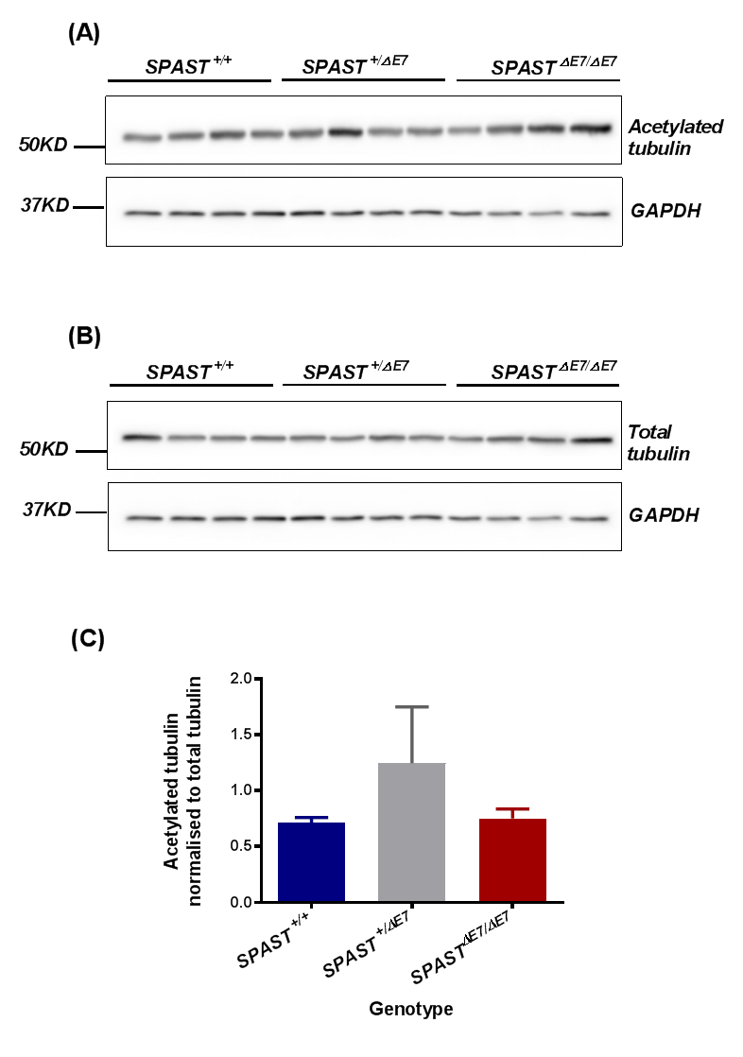

Figure 4.1: The level of acetylated tubulin in the brains of six weeks old SPAST^{+/+}, SPAST ^{+/ΔE7} and SPAST^{ΔE7/ΔE7} mice
Western blot analysis of 10 μg total brain protein from SPAST^{+/+}, SPAST ^{+/ΔE7} and SPAST^{ΔE7/ΔE7}mice. (A) Anti-acetylated tubulin monoclonal antibody. (B) DM1A mouse monoclonal antibody (for total tubulin), and anti-GAPDH used for both as a loading control. (C) Acetylated tubulin normalised to total tubulin. The statistical analysis involved is one-way ANOVA. Error bars represent standard deviation.

.

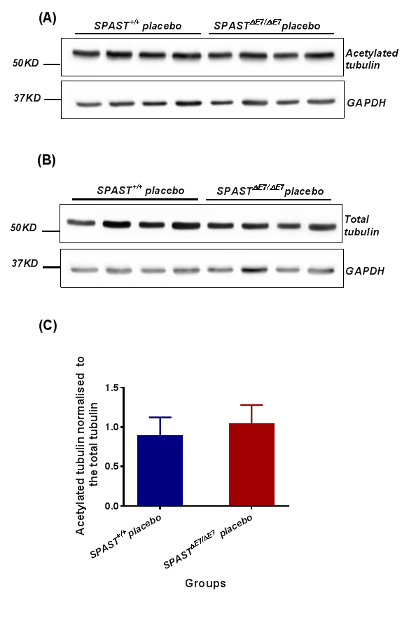
Figure 4.2: The level of acetylated tubulin in the brains of 16 month old SPAST^{+/+} and SPAST^{ΔE7/ΔE7} mice.
Western blot analysis of 10 μg total brain protein from SPAST^{+/+}, SPAST ^{+/ΔE7} and SPAST^{ΔE7/ΔE7}mice. (A) Anti-acetylated tubulin monoclonal antibody. (B) DM1A mouse monoclonal antibody (for total tubulin), and anti-GAPDH used for both as a loading control. (C) Acetylated tubulin normalised to total tubulin. The statistical analysis involved is the t-test. Error bars represent standard deviation.

4.3.2 Effects of HDAC6 inhibitors on the level of α-tubulin acetylation in the spastin mouse model
Since the discovery of tubulin acetylation, two tubulin deacetylase enzymes have been found: Sirtuin 2 (Sirt2) (North et al., 2003), and histone deacetylase 6 (HDAC6). HDAC6 is a member of a family of histone deacetylase enzymes. It has a unique structure and function and is predominantly located in the cytoplasm (Verdel et al., 2000). It plays crucial roles in many cellular processes. For instance, it is involved in the degradation of misfolded proteins, a process which plays a contributing role in NDs (Kawaguchi, 2003). It also binds to ubiquitinated proteins and dynactin to promote the transport of ubiquitinated proteins to the microtubule-organising centre (MTOC), forming aggresomes that are degraded via autophagy (Kawaguchi, 2003).
The important functions of HDAC6 in neurons have made it a potential therapeutic target in NDs. A number of studies have revealed that using pharmacological HDAC6 inhibitors can increase α-tubulin acetylation and diminish axonal transport defects in NDs. For example, treating neurons isolated from the HSPB1^{S135F} mouse model of CMT with the selective HDAC6 inhibitors tubacin and tubastatin A, restored the number of moving mitochondria (D'Ydewalle et al., 2011). One problem with these HDAC6 inhibitors, however, is their limited bioavailability in the brain (Jochems et al., 2014). To address this, Acetylon Pharmaceuticals (Massachusetts USA) has introduced new selective HDAC6 inhibitors that cross the BBB, namely ACY-738 and ACY-775. In a previous study, both of these HDAC6 inhibitors have been tested and have been shown to lead to considerable increases in α-tubulin acetylation in the brain has been associated with an antidepressant effect (Jochems et al., 2014).
Before commencing preclinical experiments, we chose to confirm the effectiveness of the HDAC6 inhibitor ACY-738 in crossing the BBB and increasing α-tubulin acetylation in the CNS.

4.3.3 ACY-738 is brain penetrant
In order to investigate the efficiency of ACY-738 and tubastatin-A both in penetrating the BBB and in eliciting changes in tubulin acetylation compared with a vehicle control, we selected three groups of C57BL6/Jax mice, each composed of three mice at six weeks of age. The first group was given free access to a chow–based formulation containing 0.625g/kg ACY-738. This dose was based on extensive pharmacokinetic studies performed in rats (Majid et al., 2015). Mice weighing 25g were reported to consume on average 4 g of chow per day, equivalent to a dose of 2.5mg per mouse per day, or 100 mg/kg/day (Majid et al., 2015). This dose has been shown to lead to a significant increase in the level of acetylated α-tubulin in peripheral nerves without affecting the abundance of overall tubulin (Jochems et al., 2014). ACY-738 chemical structure is presented in Figure (4.3).
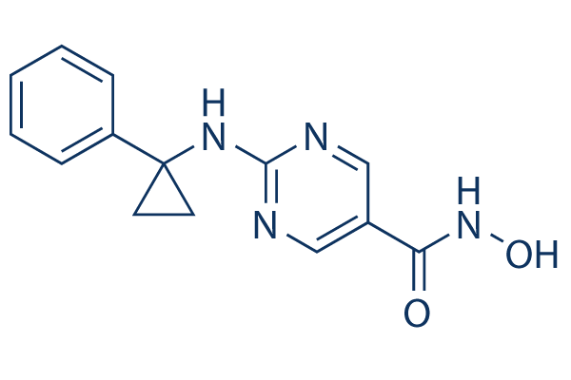

Figure 4.3: ACY-738 chemical structure (Jochems et al., 2014).

The second group were treated daily with tubastatin-A at 50 mg/kg/day via intraperitoneal injection. Tubastatin-A was dissolved in DMSO and diluted to a final concentration of 0.75% in 0.9% saline and administered at a volume of 10 ml/kg (Jochems et al., 2014). The third group comprised the untreated control mice. All the mice were euthanised after seven days; tissues were harvested and rapidly frozen and stored at -80 °C. The levels of total tubulin and acetylated α-tubulin were assayed using western blot analysis for brain tissue (Figure 4.4), spinal cord (Figure 4.5), liver (Figure 4.6) and kidney (Figure 4.7).
The data in Figures 4.3 and 4.4 show that ACY-738 increased the acetylation of α-tubulin in the CNS (brain and spinal cord) to a similar extent as was seen in HDAC6 knockout mice. In comparison, tubastatin-A did not show any increase in α-tubulin acetylation in CNS tissues at this time point.
We therefore investigated the systemic effect of both treatments in two non-CNS tissues: liver (Figure 4.6) and kidney (Figure 4.7). We again found that ACY-738 markedly enhanced the acetylation of α-tubulin and that tubastatin-A still did not significantly alter α-tubulin acetylation, either systemically or in the CNS.
In conclusion, ACY-738 penetrates the BBB and increases the acetylation of α-tubulin in both CNS and non-CNS tissues. We have therefore determined that ACY-738, delivered at 100 mg/kg/day, in chow is a good candidate to test the hypothesis that HDAC6 inhibition will be beneficial in a spastin HSP model in vivo.

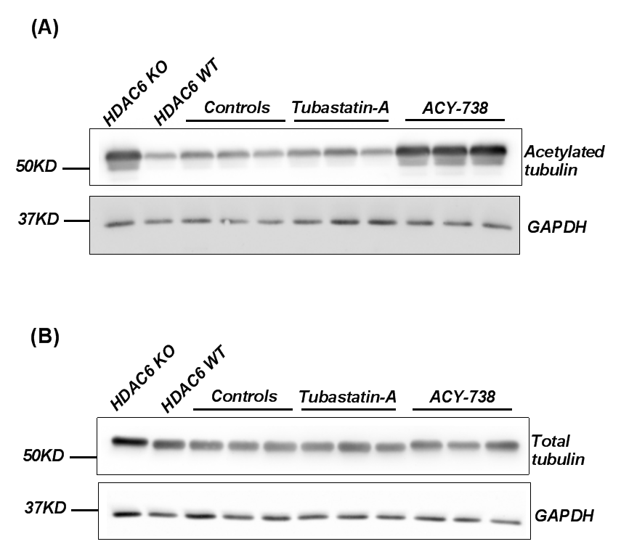
Figure 4.4: The level of acetylated tubulin in the brain following a week of ACY-738 administration.
Western blot analysis of 10 μg total brain protein from C57BL/6Jax mice. The first lane on the left side is from an HDAC6 knockout mouse and the second lane from the left is from an HDAC6 wildtype mouse, both used as controls. C57BL/6Jax mice treated with tubastatin-A (50 mg/kg/day), ACY-738 (100 mg/kg/day) and on the left untreated (control) as indicated. (A) Anti-acetylated tubulin, using mouse monoclonal antibody (Sigma) (for acetylated α-tubulin). (B) DM1A mouse monoclonal antibody (Sigma) (for total tubulin), with anti-GAPDH (Cell Signalling Technology, USA) used for both as a loading control.

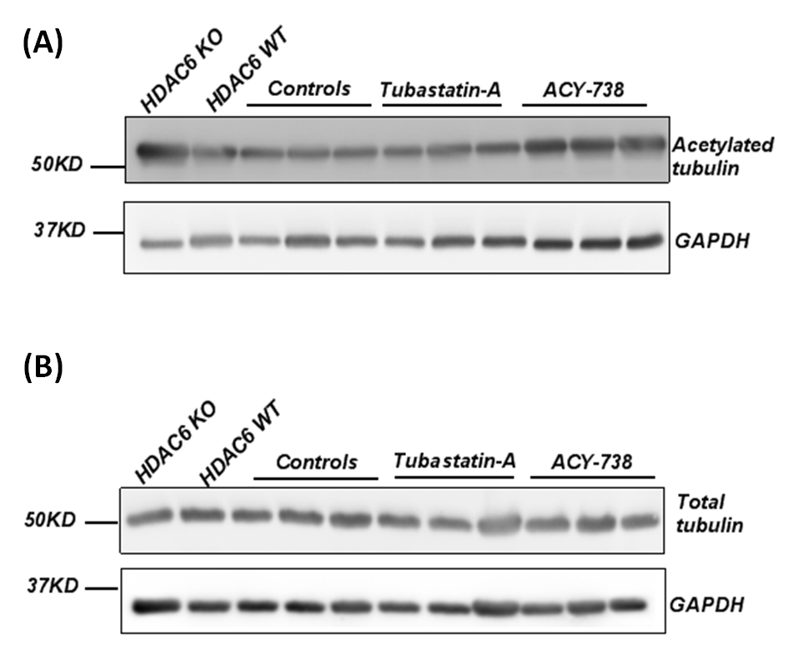

Figure 4.5: The level of acetylated tubulin in the spinal cord following a week of ACY-738 administration.
Western blot analysis of 10 μg total spinal cord protein from C57BL/6Jax mice. The first lane on the left side is from an HDAC6 knockout mouse and the second lane from the left is from an HDAC6 wildtype mouse, both used as controls. C57BL/6Jax mice treated with tubastatin-A (50 mg/kg/day), ACY-738 (100 mg/kg/day) and on the left untreated (control) as indicated. (A) Anti-acetylated tubulin, using mouse monoclonal antibody (Sigma) (for acetylated α-tubulin). (B) DM1A mouse monoclonal antibody (Sigma) (for total tubulin), with anti-GAPDH (Cell Signalling Technology, USA) used for both as a loading control.

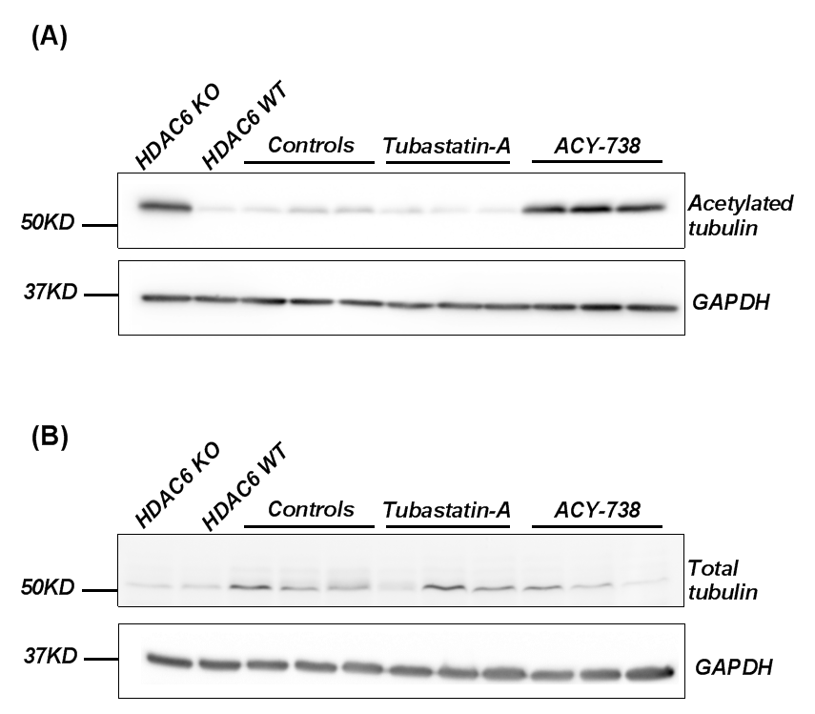
Figure 4.6: The level of acetylated tubulin in the liver following a week of ACY-738 administration.
Western blot analysis of 10 μg total liver protein from C57BL/6Jax mice. The first lane on the left side is from an HDAC6 knockout mouse and the second lane from the left is from an HDAC6 wildtype mouse, both used as controls. C57BL/6Jax mice treated with tubastatin-A (50 mg/kg/day), ACY-738 (100 mg/kg/day) and on the left untreated (control) as indicated. (A) Anti-acetylated tubulin, using mouse monoclonal antibody (Sigma) (for acetylated α-tubulin). (B) DM1A mouse monoclonal antibody (Sigma) (for total tubulin), with anti-GAPDH (Cell Signalling Technology, USA) used for both as a loading control.

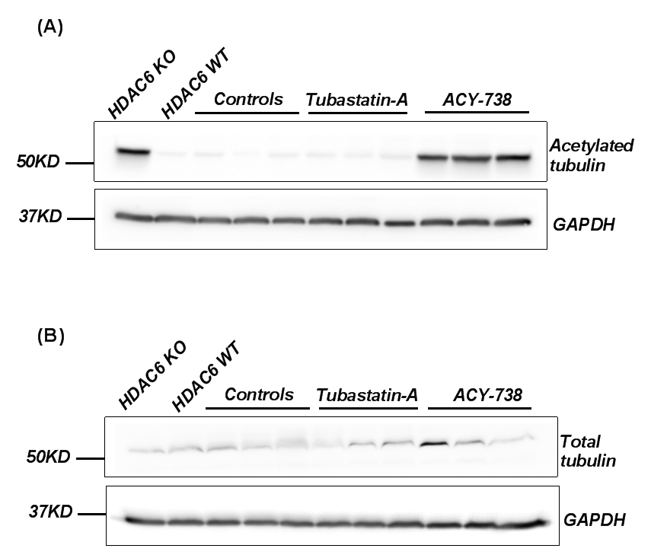

Figure 4.7: The level of acetylated tubulin in the kidney following a week of ACY-738 administration.
Western blot analysis of 10 μg total kidney protein from C57BL/6Jax mice. The first lane on the left side is from an HDAC6 knockout mouse and the second lane from the left is from an HDAC6 wildtype mouse, both used as controls. C57BL/6Jax mice treated with tubastatin-A (50 mg/kg/day), ACY-738 (100 mg/kg/day) and on the left untreated (control) as indicated. (A) Anti-acetylated tubulin, using mouse monoclonal antibody (Sigma) (for acetylated α-tubulin). (B) DM1A mouse monoclonal antibody (Sigma) (for total tubulin), with anti-GAPDH (Cell Signalling Technology, USA) used for both as a loading control.

4.3.4 Experimental design
To investigate the effect of ACY-738 on a spastin mouse model of HSP, we used mice carrying the c.1092+2T>G mutation (Kasher et al., 2009). Two types of studies were conducted: 1) A symptomatic study with treatment starting after the mice have developed profound gait defects at nine months old, 2) a presymptomatic study with treatment starting before the onset of gait defects, at one month old. Four groups of male mice were selected, namely, SPAST^{+/+} and SPAST^{ΔE7/ΔE7} (ACY-738 treated and placebo). The selection of mice for placebo or treatment groups was performed randomly by coin toss.

4.3.5 Housing conditions and cage enrichments
Mice were singly housed in the Field Laboratories at the University of Sheffield (see section 2.2.2), at a temperature of 21±1 °C, humidity 50±5 %, and a regular 12 hr light: 12 hr dark cycle. They were given free access to water and either standard rodent chow pellets Teklad (Envego, USA) or ACY-738 chow pellets ad libitum. Cage enrichment was implemented in the cages with older mice (i.e. in the symptomatic study) to try to reduce anxiety (Van Dellen et al., 2000). One of the cage enrichments was provided every week on Monday and another on Wednesday. The enrichments used were shredded paper (10 g), marbles, cardboard tubes, red plastic tubes, a bundle of straw, small squares of shredded paper (10 g) or a trapeze.

4.3.6 Symptomatic treatment with HDAC6 inhibitor (ACY-738)

4.3.6.1 Determination of the level of acetylated tubulin after ACY-738 administration
ACY-738 is a potent and selective HDAC6 inhibitor with good brain penetrance (see section 4.3.3) (Jochems et al., 2014). Commencing at nine months of age, SPAST^{+/+} and SPAST^{ΔE7/ΔE7} mice were fed ACY-738 in chow. After seven months of ACY-738 administration, four mice from each group were sacrificed in order to investigate the level of α-tubulin acetylation in the brain using western blot analysis. A comparison was performed between SPAST^{+/+} ACY-738 vs SPAST^{+/+} placebo and SPAST^{ΔE7/ΔE7} ACY-738 vs SPAST^{ΔE7/ΔE7} placebo. The SPAST^{+/+} ACY-738 treated group had a significantly higher level of acetylated α-tubulin compared with the placebo group applying the t-test (p=0.0011) (Figure 4.8). Similarly, the SPAST^{ΔE7/ΔE7} ACY-738 treated group had a marked increase in the level of acetylated α-tubulin in the brain when we compared it with the SPAST^{ΔE7/ΔE7} placebo group (p=0.0088) (Figure 4.9).
In conclusion, these data show that ACY-738 effectively increased tubulin acetylation in vivo, allowing us to investigate the clinical benefits of this therapy on the gait of these mice. To address this, gait assessment was performed monthly to measure the base of support (BOS).

Figure 4.8: The level of acetylated tubulin in the brains of SPAST^{+/+} ACY-738 and SPAST^{+/+} placebo mice (symptomatic treatment).
Western blot analysis of 10 μg total brain protein. (A) Anti-acetylated tubulin, mouse monoclonal antibody. (B) DM1A mouse monoclonal antibody for total tubulin. Anti-GAPDH was used for both as a loading control. (C) The level of acetylated tubulin normalised to the level of total tubulin. The t-test was used for statistical analysis and error bars represent the standard deviation.

Figure 4.9: The level of acetylated tubulin in the brains of SPAST^{ΔE7/ΔE7}ACY-738 treated and SPAST^{ΔE7/ΔE7}placebo mice (symptomatic treatment).
Western blot analysis of 10 μg total brain protein. (A) Anti-acetylated tubulin, mouse monoclonal antibody. (B) DM1A mouse monoclonal antibody for total tubulin. Anti-GAPDH was used for both as a loading control. (C) The level of acetylated tubulin normalised to the level of total tubulin. The t-test was used for statistical analysis and error bars represent the standard deviation.

4.3.6.2 Effect of symptomatic treatment with ACY-738 on the gait defects of spastin mouse model of HSP
The major manifestation of the HSP mouse model with spastin mutation is a wider base-of-support BOS (a wider distance between the hind limbs) (Kasher et al., 2009). In this symptomatic study all four groups of mice were subjected to the CatWalk analysis monthly so as to measure the hind limb BOS. The graph in Figure 4.10-A illustrates the mean BOS +/- standard deviation from four months of age. The BOS was monitored every month (±4 days) for each mouse. Each mouse was recorded for three runs, and the average was calculated. The data presented in this graph are the average of the BOS measurements for eight mice in each group.
It can be seen from Figure 4.10-A that at four and five months old, before starting treatment there was a slight statistically significant difference between the average BOS of the SPAST^{ΔE7/ΔE7} placebo group and the SPAST^{ΔE7/ΔE7} ACY-738 group: (p=0.0022) and (p=0.0248) at four and five months old respectively applying two-way ANOVA. There was then no statistical significant difference observed between them up to 13 months old, at which point a significant difference reappeared (p=0.04). Both the wildtype ACY-738 and placebo groups had a BOS of about 12 mm throughout the period of the study. In this symptomatic study we started the treatment at nine months of age, at least five months after the gait defect was detected.
At the end of the study we did not notice any statistically significant difference between the treated and untreated groups from both genotypes. Since the SPAST^{ΔE7/ΔE7} treated and placebo groups at 16 months old had a BOS of 17+ 1.7 mm and 16+ 1.9 mm, respectively. Furthermore, the wildtype groups (treated and placebo) followed the same trend, as they did not show any changes in gait during the period of the experiment.
In Figure 4.10-B, the BOS data is normalised within each group to the mean value at nine months old to show the effect of ACY-738 on the HSP mouse model gait defect. All four groups fluctuated between 0.9 and 1.1, without showing any effect of treatment.
To conclude, after six months of treatment with the HDAC6 inhibitor ACY-738 there appeared to be no statistically significant beneficial effect on gait defects as measured by BOS.

Age | SPAST^{+/+}placebo  vs  SPAST^{ΔE7/ΔE7} placebo | SPAST^{+/+}ACY-738 treated  vs  SPAST^{+/+}placebo | SPAST^{ΔE7/ΔE7} ACY-738 treated  vs  SPAST^{ΔE7/ΔE7} placebo
month 4 | ** | ns | ns
month 5 | * | ns | ns
month 6 | ns | ns | ns
month 7 | ns | ns | ns
month 8 | ns | ns | ns
month 9 | ns | ns | ns
month 10 | ns | ns | ns
month 11 | ns | ns | ns
month 12 | ns | ns | ns
month 13 | * | ns | ns
Figure 4.10: CatWalk gait analysis of spastin mice after ACY-738 administration (symptomatic treatment). (A) Hind limb BOS was measured using the CatWalk system. (B) BOS data normalised to the mean values for each group at the onset of the treatment, to show the effect of ACY-738 on gait defects. (C) Table shows results of statistical analysis using two-way ANOVA followed by Bonferroni's multiple comparisons test. (**** p<0.0001, *** p<0.001, ** p <0.01, *p<0.05 & ns > 0.05). The start of the treatment indicated by (*), error bars represent the standard deviation.

4.3.6.3 No effect of symptomatic treatment with ACY-738 on spastin mouse body weight
Weight monitoring is important in order to determine if there were adverse effects of the drug on mice. To monitor the effect of spastin mutation and ACY-738 on body weight, the weight of the mice was recorded weekly and the average weight per month was calculated for each group. As shown in Figure 4.11, although all the mice in all groups gained weight gradually throughout the study, it appears that the SPAST^{ΔE7/ΔE7} mice were lighter than their SPAST^{+/+} littermates. Although non-significant, both genotypes plateaued at a slightly reduced body weight when fed ACY-738 in chow.

Figure 4.11: The effect of symptomatic treatment with ACY-738 on spastin mice body weight. Statistical analysis was by two-way ANOVA followed by Bonferroni's multiple comparisons test. Error bars represent the standard deviation.

4.3.6.4 Effect of symptomatic treatment with ACY-738 on axonal swelling pathology in the spastin mouse model of HSP
Aggregation and misfolding of proteins, which accumulate both in extracellular and intracellular spaces in the CNS, is considered to be a pathological theme in most NDs (Roy et al., 2005). A common pathological hallmark of spastin mutation is the presence of axonal swellings (Tarrade et al., 2006, Kasher et al., 2009). Restoring axonal transport defects has therefore been suggested as a potential therapeutic approach in many NDs. It is thought that increasing the acetylation of α-tubulin by inhibition of HDAC6 will reduce axonal transport defects. HDAC6 is the major enzyme with α-tubulin deacetylase activity (Hubbert et al., 2002), and can regulate mitochondrial transport in hippocampal neuronal cultures (Chen and Cepko, 2009). Since axonal swellings have been identified in transverse sections in the spinal cord from 12 month old spastin mutant mice (Tarrade et al., 2006), we wished to investigate the ability of ACY-738 treatment to modulate the number of axonal swellings in vivo. Previously, it has been reported that an HSP patient bearing a frameshift mutation in spastin had axonal swellings in the lateral column of the spinal cord (Kasher et al., 2009). This is the region that contains descending motor axons projecting from motor neuron cell bodies located in the motor cortex. Even though many of the dystrophic axonal features observed in the neuropathology of NDs are considered to be hallmarks of particular diseases, it is not clear whether these aggregations have a direct contribution to the onset or progression of disease.
In order to investigate the effects of HDAC6 inhibition on the axonal swelling pathology in spastin HSP, at 16 months old, after seven months of ACY-738 treatment, three mice from each group were sacrificed and perfused, and transverse sections of the cervical and lumbar spinal cord were prepared for immunohistochemistry, with the aim of quantifying the number of axonal swellings from the cervical and lumbar regions. For more detail about the quantification of swellings see section 2.2.13.

Cervical cord
Figure 4.12 shows the quantification of the number of axonal swellings in the cervical region of the spinal cord. The cervical region includes both long and short motor axons descending from the motor cortex. Axonal pathology in diseases affecting upper motor neurons is mainly found in the lateral corticospinal tract area, which contains the longest motor axons (Yamanaka et al., 2006). We were therefore particularly interested in quantifying axonal swellings in regions of the spinal cord that have motor fibres, namely the CST and LCST.
Figure 4.12-A shows there were (mean± SD) 0.1±0.1 swellings in the CST of SPAST^{ΔE7/ΔE7}untreated mice, whereas the number of swellings was reduced to 0.02±0.03 swellings/µm in the ACY-738 treated group. In the LCST, the number of swellings was reduced from 0.1±0.1 swellings/µm in the SPAST^{ΔE7/ΔE7} untreated group to 0.02±0.2 swellings/µm in the ACY-738 treated group. This difference was not statistically significant (p>0.9999) when one-way ANOVA was applied. When we quantified the areas containing mixed sensory and motor fibres (Figure 4.12 C-D) VLF and VF, we also found a higher number of swellings in the untreated mutant mice compared with ACY-738 treated animals.
Even though the number of axonal swellings in the SPAST^{ΔE7/ΔE7} mice was higher than wild type littermates in all regions of the spinal cord, the difference was not statistically significant, due to the high variability in the number of swellings found in individual mice within each group.

Figure 4.12: Frequency of axonal swellings per micron at the cervical level of the spinal cord following ACY-738 symptomatic treatment (16 month old). (A) Corticospinal tract and (B) lateral corticospinal tract are regions with motor fibres. (C) Ventrolateral funiculus and (D) ventral funiculus are regions with mixed fibres including sensory fibres. Statistical analysis entailed one-way ANOVA. Error bars represent the standard deviation SD (section thickness= 5µm) (three mice per group).

Lumbar cord
Figure 4.13 shows the quantification of the number of axonal swellings per micron of the spinal cord in the lumbar region. The lumbar spinal cord only contains the axons of the very long upper motor neurons descending from the motor cortex, meaning that the lumbar CST and LCST regions are where we may expect to see axonal length-dependent effects of spastin mutation in upper motor neurons. There were higher numbers of axonal swellings in the SPAST^{ΔE7/ΔE7}placebo group compared with the SPAST^{+/+} littermate controls in all regions (CST, LCST, VLF and VF), but these differences only reached significance in the LCST (p=0.0432) using one-way ANOVA (Figure 4.13-B). Although the number of axonal swellings in these two regions reduced after ACY-738 treatment, this reduction was not statistically significant. Also, there was a reduction in the number of the swellings in the VLF and VF areas within the SPAST^{ΔE7/ΔE7} group after ACY-738 administration, which was significant in VF (p=0.0200).
To sum up, the HDAC6 inhibitor did reduce the number of axonal swellings but this reduction was not statistically significant in the cervical region. The fact that it reduced the axonal swellings in the VF area in the lumbar region, however, might be consistent with the protective role of HDAC6 inhibitor in axonal transport disorders.

Figure 4.13: Frequency of axonal swellings per micron at the lumbar level of the spinal cord following ACY-738 symptomatic treatment (16 month old). (A) Corticospinal tract and (B) lateral corticospinal tract are regions with motor fibres. (C) Ventrolateral funiculus and (D) ventral funiculus are regions with mixed fibres including sensory fibres. Statistical analysis was by one-way ANOVA. Error bars represent the standard deviation (section thickness= 5µm) (three mice per group).

4.3.7 Presymptomatic treatment with HDAC6 inhibitor (ACY-738)

4.3.7.1 The effects of presymptomatic treatment with ACY-728 on gait defects in the spastin mouse model of HSP
Since treatment with ACY-738 at the symptomatic stage did not have any effect on the gait defect, we wanted to investigate whether there was any beneficial effect if the treatment was started before disease onset (Figure 4.14). We therefore started the treatment at one month of age in four groups of mice, eight mice per group, namely; SPAST^{ΔE7/ΔE7} and SPAST^{+/+}, which received ACY-738 or placebo. The four experimental groups were behaviourally tested using the CatWalk automated system to measure the BOS at monthly intervals. Statistical analysis was conducted by two-way ANOVA.
Generally, the BOS increased steadily throughout the study in all groups. We noted at the first time point that there was a slight difference between the SPAST^{ΔE7/ΔE7} placebo, which was 11.6+0.9 mm and the SPAST^{+/+} placebo, which was 11+ 1.2 mm, but this difference (about 4.4%) was not statistically significant at this point, although it became statistically significant at three months old (p=0.0309). After six months of treatment with ACY-738, the gait defect had not improved in the SPAST^{ΔE7/ΔE7} group, since the BOS of the spastin mutant placebo group was 15+ 1 mm, while the treated group was 15+ 2 mm. ACY-738, therefore, did not have any effect on the gait of SPAST^{ΔE7}mice. In addition, the difference between the SPAST^{ΔE7/ΔE7} and SPAST^{+/+} placebo groups remained significant from three to six months old (Figure 4.14).

Age | SPAST^{+/+} placebo  Vs  SPAST^{ΔE7/ΔE7} placebo | SPAST^{+/+} placebo  Vs  SPAST^{+/+} ACY-738 treated | SPAST^{ΔE7/ΔE7} placebo  Vs  SPAST^{ΔE7/ΔE7} ACY-738 treated
Month 1 | ns | ns | ns
Month 2 | ns | ns | ns
Month 3 | * | ns | ns
Month 4 | * | ns | ns
Month 5 | *** | ns | ns
Month 6 | ** | ns | ns

Figure 4.14: CatWalk gait analysis of spastin mice after ACY-738 administration (presymptomatic study). (A) Hind limb BOS was measured using the CatWalk system. (B) Table shows results of statistical analysis using two-way ANOVA followed by Bonferroni's multiple comparisons test. (**** p<0.0001, *** p<0.001, ** p <0.01, *p<0.05 & ns > 0.05). Error bars represent the standard deviation.

4.3.7.2 Effect of presymptomatic treatment with ACY-738 on mice body weight
Figure 4.15 presents the average body weight in each group per month. It is notable from the graph that the spastin mutant placebo group weighed less than the wildtype placebo group at one and two months old, and that this difference was statistically significant when two-way ANOVA was applied, with p-values of 0.0164 and 0.0258, respectively. From months three to six, however, there were no significant differences detected between the groups, as all the mice gained weight gradually.

Figure 4.15: The effect of treatment with ACY-738 on the body weight of presymptomatic spastin mice. Error bars represent the standard deviation.

4.3.7.3 Effect of presymptomatic treatment with ACY-738 on axonal swelling pathology in the spastin mouse model of HSP
Treatment with ACY-738 at the symptomatic stage did not show any effects on the gait defects exhibited in the spastin mouse model of HSP, although the number of the swellings per section in the VF (which contains mixed fibres) was reduced by ACY-738 treatment in the lumbar region (Figure 4.13). Our previous investigation used three mice per group, but it became clear that this was insufficient to reach significance since the data was highly variable. Here, therefore, we analysed five spinal cords per mouse. Figures 4.16 and 4.17 were produced following the same protocol of swelling quantification as in section 2.2.13.

Cervical cord
Figure 4.16 illustrates the number of swellings per micron in the cervical region. Overall, it can be seen that the number of axonal swellings in the SPAST^{ΔE7/ΔE7} placebo group was higher than in the other groups. In the LCST, VLF and VF, the number of swellings/µm was significantly more than in the SPAST^{+/+} placebo group (p=0.0026, 0.0156 and 0.0040, respectively). The frequency of swellings was reduced in these three areas in the SPAST^{ΔE7/ΔE7} group after treatment with HDAC6 inhibitor, but this reduction was not statistically significant. Wildtype mice contained none, or very few, axonal swellings at this age (Figure 4.16).

Figure 4.16: Frequency of axonal swellings per micron at the cervical level of the spinal cord following presymptomatic ACY-738 treatment (6 months old). (A) Corticospinal tract and (B) lateral corticospinal tract are regions with motor fibres. (C) Ventrolateral funiculus and (D) ventral funiculus are regions with mixed fibres, including sensory fibres. There were a significant differences between mutant treated mice in both the lateral corticospinal tract and ventral funiculus. The statistical analysis was by one-way ANOVA. Error bars represent standard deviation (section thickness= 10µm) (five mice per group).

Lumbar cord
Figure 4.17 presents the number of axonal swellings per micron in the lumbar region. It can be seen from the figure that there were no swellings observed in all four areas within the spinal cord in the SPAST^{+/+} placebo and treated groups. The area with the most swellings in the SPAST^{ΔE7/ΔE7} placebo was the VLF (0.04+0.05); this area has a mix of sensory and motor fibres (Figure 4.17- C). These reduced after HDAC6 inhibitor treatment to (0.02+ 0.03), but this reduction was not statistically significant since the variation between the numbers of the swellings within the group was very high. In addition, no difference was observed between the SPAST^{ΔE7/ΔE7} placebo and the treated group in the other areas. In the LCST, the number of swellings per section was significantly higher in the SPAST^{ΔE7/ΔE7} placebo compared with the SPAST^{+/+} placebo, but this number was not modulated by the treatment with HDAC6 inhibitor (Figure 4.17 B).

Figure 4.17: Frequency of axonal swellings per micron at the in the lumbar level of the spinal cord following presymptomatic ACY-738 treatment (6 months old). (A) Corticospinal tract and (B) lateral corticospinal tract are regions with motor fibres. (C) Ventrolateral funiculus and (D) ventral funiculus are the regions with mixed fibres including sensory fibres. There was a significant difference between mutant treated mice in both the lateral corticospinal tract and ventral funiculus. The statistical analysis was by one-way ANOVA. Error bars represent standard deviation (section thickness= 10µm) (five mice per group).

4.4 Discussion
The objective of this study was to determine the effects of a brain-penetrant HDAC6 inhibitor on the spastin mouse model of HSP. Human patients with HSP have a gait defect that is characterised by spasticity and weakness in the hind limbs (Klebe et al. 2004), while the HSP mouse model has a gait defect which is characterised by a broader base of support (Kasher et al., 2009). In vitro, the major phenotype of the spastin mouse model of HSP is axonal transport defects (Kasher et al., 2009), which is reflected in swellings and accumulation of cargoes along the axon in the corticospinal tract in the spinal cord in vivo (Tarrade et al., 2006).
Acetylation stimulates motor proteins to bind with MTs, increases transport along microtubules, and thus reduces the axonal transport defects (Dompierre et al., 2007). Reduced levels of acetylated tubulin are associated with many neurological disorders. For example, measurements of the level of acetylated α-tubulin from the brains of post-mortem striatal Huntington's disease (HD) patients have revealed that there is a significant reduction in acetylated α-tubulin in HD patients compared with controls (Dompierre et al., 2007). Supporting this notion, patient-derived olfactory nasal stem (ONS) cells with spastin mutation showed lower levels of α-tubulin acetylation in comparison with control-derived ONS cells (Abrahamsen et al., 2013). Also, in an Alzheimer’s disease (AD) mouse model (APPPS1-21), there was a diminished level of α-tubulin K40 acetylation in the hippocampus compared to wildtype mice (Govindarajan et al., 2013). A CMT mouse model carrying an HSPB1 mutation, meanwhile, showed a significant reduction in acetylated α-tubulin in peripheral nerves, which was related to axonal transport defects (D'Ydewalle et al., 2011). Based on our observations, however, we did not see any alteration in the level of tubulin acetylation in either old or young spastin mouse brains. This raises the possibility that the acetylation in the whole brain lysate is different from that in isolated cells, since the acetylation might be compensated for by other proteins. Also, the reduction in tubulin acetylation could be only present in small part of brain therefore we did not see a lack of acetylation in a whole brain lysate. Furthermore, it is possible that the axonal transport defect in spastin models is not caused by reduced acetylation of tubulin. Since transport defects and axonal swellings have been detected in the spastin mouse model (Kasher et al., 2009), we hypothesised that increasing the acetylation of tubulin should restore axonal transport and improve the HSP gait phenotype. In order to achieve this increase in tubulin acetylation we used a brain penetrant HDAC6 inhibitor. HDAC6 inhibitors have been suggested as promising therapeutic targets for many neurological disorders (D'Ydewalle et al., 2011, Fassier, 2013). A number of HDAC6 inhibitors are available, although very few are reported to be brain penetrant, and therefore likely to be suitable for treatment of HSP, a disorder of the upper motor neurons. Tubastatin A is a highly selective inhibitor of HDAC6 but with only limited brain bioavailability (Jochems et al., 2014); a finding confirmed by our own work in section 4.3.3, where tubastatin A was shown not to have penetrated the BBB and to have no effect on the level of α-tubulin acetylation in the CNS and peripheral tissues. Although this was a single dose, single time point assay, it raises the possibility that tubastatin-A does not lead to lasting effects on tubulin acetylation in the CNS.
ACY-738 and ACY-775 are also highly selective HDAC6 inhibitors (Jochems et al., 2014), and both have been tested and have shown markedly increased α-tubulin acetylation in the brain (Cook et al., 2014, Jochems et al., 2014). Our results (see section 4.4.1) supported these findings, showing that ACY-738 formulated in chow is able to penetrate the BBB and increase the acetylation of α-tubulin levels in the CNS and peripheral tissues. Similar evidence has been reported in a study carried out by administering 50 mg/kg of ACY-738 to male Swiss mice by intraperitoneal injection, which led to an increase in the acetylation of α-tubulin in the brain (Jochems et al., 2014). Moreover, a reduction in HDAC6 has been shown to lead to a striking increase in tubulin acetylation throughout the brain (Bobrowska et al., 2011). We therefore tested the effects of ACY-738 at both symptomatic and presymptomatic stages.

4.4.1 Neither symptomatic nor presymptomatic treatment with ACY-738 modified the HSP gait
Based on a power calculation (see section 3.4.3) using data from a previous study (Kasher et al., 2009), groups of eight male mice were used. We conducted this study using single-sex cohorts because the hind limb BOS of male mice is much larger than that of females (Figure 4.18). Using a mixed sex cohort would have necessitated the use of a larger cohort to achieve the same statistical power.

Age | SPAST^{+/+} Females | SPAST^{+/+} Males | SPAST^{+/+} Males+Females
Month4 | 0.102699 | 0.060268 | 0.111136
Month5 | 0.081068 | 0.082633 | 0.108364
Month6 | 0.086282 | 0.092176 | 0.143772

Figure 4.18: The coefficient of variation of males, females and mixed group BOS (mm) in wildtype spastin mice.
A) BOS (mm) of male, female and mixed group. B) Shown higher coefficient of variation of the BOS in the mixed group of mice. The statistical test involved is two-way ANOVA (** p <0.01) (eight mice per group).

We initially carried out the treatment only at the symptomatic stage based on a previous study that suggested that treating primary neuronal cultures from symptomatic HSPB1^{S135F} mice with a selective HDAC6 inhibitor increased the number of total axonal mitochondria, as well as restoring the number of motile mitochondria (D'Ydewalle et al., 2011). Also, based on a previous experiment conducted in our lab, we know that the HSP mouse model with spastin mutation has gait defects at seven months of age (Kasher et al., 2009). We therefore started the treatment after the mice had an observable profound gait defect (nine months old). We noted a slight difference between the treated and placebo homozygous groups, probably because we assigned the mice to the study randomly by coin toss. After seven months of treatment with the HDAC6 inhibitor we did not see positive effects on the gait defect phenotype of the spastin mouse. A similar finding has been reported in a study on an HD mouse model (R6/2 Mouse), which has a progressive gait defects: knocking out HDAC6 did not modify the overall performance of the mice (Bobrowska et al., 2011).
It is possible that HDAC6 inhibition needs to occur at a presymptomatic stage in order to see an effect on gait. In a second study, therefore, we performed a similar experiment beginning at one month of age. We noted that the gait defect in SPAST^{ΔE7/ΔE7} mice became significantly larger than wildtype siblings at three months old. Even though the treatment started before this time, no improvement in gait defects was observed.
Although we did not notice any changes in gait in the symptomatic and presymptomatic treatment with ACY-738, we asked whether the HDAC6 inhibitor showed any effect at the molecular level in terms of modulating the number of axonal swellings in the spinal cord. We looked at serial sections from cervical and lumbar regions of the spinal cord after both symptomatic and presymptomatic ACY-738 treatment. Generally, the number of swellings in the cervical region was higher than in the lumbar region, presumably because there are more axon fibres passing through the cervical region before they branch out of the spinal cord, meaning that the number of axon fibres at the lumbar level is lower. The higher number of axon fibres in the cervical region gives a chance of seeing more swellings in the cervical than the lumbar region.
Also, the number of axonal swellings per micron was higher in older mice than younger mice in both the cervical and lumbar regions. Probably because the disease had progressed further in the older mice and thus had produced more swellings. Spastin mutant mice have a higher number of axonal swellings compared with wildtype mice. Specifically, in the LCST, which has the motor fibres, the swellings were significantly higher in the lumbar region of both older and younger mice. This suggests that axonal swellings in the motor axons underlie the gait defect in the HSP mouse model.
In the symptomatic study, we observed that the number of the swellings/µm was reduced in the homozygous ACY-738 treated group compared with the placebo. This reduction did not reach significance, even though we analysed three mice per group, since the variability within each group was very high. In the lumbar region, the number of swellings in the ventral funiculus was significantly reduced after symptomatic treatment with ACY-738 in the SPAST^{ΔE7/ΔE7} compared with the placebo. This supports the idea of using an HDAC6 inhibitor to restore the axonal transport defects and alleviate axonal pathology (D'Ydewalle et al., 2011).
In the presymptomatic treatment, on account of the variability within each group, we tested five spinal cords per group. Interestingly, in cervical spinal cord we noticed a significantly higher number of axonal swellings/µm in the spastin mutant placebo group compared with the wildtype placebo in the LCST, VLF and VF. In the cervical region of the spinal cord, the number of axonal swellings in SPAST^{ΔE7/ΔE7} mice was reduced in all areas in the ACY-78 treated group. Despite analysing five spinal cords per group the difference was not significant. In the lumbar region, although the axonal swellings reduced after ACY-738 treatment, no statistically significant difference was detected.
Although the ACY-78 HDAC6 inhibitor mitigates the axonal swellings, this did not lead to any alteration in the gait defect in the spastin mouse model. Potentially, the axonal swellings and gait defect are not associated with each other. This suggests that, although defective axonal transport underpins the pathology of HSP, it probably is not sufficient to cause the gait defect. It may also be that there is something else contributing to the gait defect, for example, endosomal defects. Spastin is known to be involved in endosomal pathways (Yang et al., 2008), mutation in spastin increases endosome tubulation and impaired tubules sorting and fission (Allison et al., 2013). In this case increased acetylation is not the proper target to restore the function of spastin.
Axonal abnormality is also linked to Bone Morphogenetic Protein (BMP) signalling dysregulation which is important for the endocytic process (Polo and Di Fiore, 2006). The four HSP endosomal proteins, i.e. atlastin-1, spastin, spartin and NIPA1, are inhibitors of BMP signalling (Tsang et al., 2009). In Drosophila, alterations in BMP signalling have been shown to result in axon transport defects (Wang et al., 2007). In Drosophila, spichthyin is homologous to NIPA1 in mammals, inhibiting BMP signalling, and binding with BMP receptor II to promote internalisation from the plasma membrane to the endosytic compartment (early endosome) (Tsang et al., 2009). Spastin localises endosomes and is important for MT severing, remodelling and for the trafficking of the endosomal compartment (Connell et al., 2009). The function of endosomes in controlling the BMP signalling is therefore critical in the corticospinal tract, specifically in the long axons. Probably, spastin mutation affects BMP signalling and therefore treatment with an HDAC6 inhibitor is not sufficient to modify the HSP gait defect in mice, since it does not target the critical disease pathway.

4.4.2 Spastin mutation and ACY-738 have no effect on body weight
To test the effect of spastin mutation and HDAC6 inhibitor drugs on the mice, their weight was monitored weekly. As we know from previous studies using a different HSP mouse model with a different gene mutation (paraplegin knockout mice), Spg7^{-/-}, homozygous mice have an impairment of motor function and a statistically significant reduction in body weight compared with heterozygous littermates (Ferreirinha et al., 2004). Although we noticed that spastin mutant mice were lighter in both symptomatic and presymptomatic studies than their wildtype counterparts, this was not statistically significant. Also, mice treated with ACY-738 were lighter than the untreated controls, but again the difference was not significant as all the mice gained weight gradually throughout the period of study. This was similar to male NIH Swiss mice, who also did not show any difference in body weight when treated with ACY-738 at six weeks old, for four weeks (Jochems et al., 2014).

4.5 Summary
To sum up, in this study ACY-738 appeared to be brain penetrant and to increase the acetylation of α-tubulin in both CNS and peripheral tissues with no unwanted side effects on the mice. ACY-738 treatment also led to a reduction in the number of axonal swellings in the lumbar region in the spinal cord following symptomatic treatment. Neither symptomatic nor presymptomatic treatment with ACY-738 modified the gait defect in the spastin model, however, suggesting that axonal swellings are not causally linked to gait defects in this model of HSP, and therefore that alternative disease-modifying strategies need to be explored.

Chapter 5: Genetic deletionof HDAC6

Chapter 5: Genetic deletion of HDAC6

5.1 Aim
As an alternative strategy to investigate the potential beneficial effect of HDAC6 inhibition in HSP, we used a genetic approach. By crossing SPAST mutant mice with HDAC6 knockout mice we wished to generate double mutant mice. In this way we hoped to compare littermates that were homozygous for mutant SPAST and either carrying the wildtype or a knockout allele of HDAC6. Specifically, we wished to determine the effects of genetic silencing of HDAC6 on gait defects and axonal swellings in vivo.

5.2 Introduction
Compared to the other HDAC enzymes, HDAC6 is unique since it has two HDAC catalytic domains (Khan et al., 2008). It mainly appears in the cytoplasm where it deacetylates α-tubulin (Khan et al., 2008), cortactin and Hsp90 (Zhang et al., 2003). Through this deacetylation activity and together with its ubiquitin binding activity HDAC6 plays an important role in limiting misfolded protein toxicity in cells, and it has been demonstrated that it also plays a role in aggresome formation (Kawaguchi, 2003).

Equilibrium between protein synthesis and protein degradation is important in cells. As imbalance between these two processes leads to aggregation of misfolded proteins and that can be a result of many NDs. Also, misfolded proteins caused by of impairment in synthesis, folding machinery or mutations that leads to proteins cannot be folded properly and abnormally gathering (Hartl and Hayer-Hartl, 2002). These protein aggregates (misfolded and ubiquitin proteins) can be identified by a group of proteins and sent to be degraded in the proteasome (Kopito, 2000). Failure in the aggresome pathway is a contributory factor in NDs. (Kopito, 2000).
HDAC6 has a C-terminal ubiquitin-binding domain, which is suggested to be involved in aggresome formation and degradation. Aggresomes are unique organelles located near to the MTOC (Microtubule organisation centre) (Johnston et al., 2002), MTs are required for transport of misfolded proteins to the aggresomes in order to be degraded. HDAC6 binds with ubiquitinated misfolded proteins through its ubiquitin binding domain, and facilitates the loading of ubiquitinated misfolded proteins to cytoplasmic dynein (Kawaguchi, 2003). This complex is transported to the aggresome by microtubule-dependent transport where it is degraded in proteasome (Kawaguchi, 2003) (Figure 5.1). Loss of HDAC6 therefore perturbs the clearance of misfolded proteins in the cytoplasm and this may lead to apoptosis (Kawaguchi, 2003) (Figure 5.1).
HDAC6 deacetylases many proteins, one of the best characterised substrates is α-tubulin, by deacetylasting α-tubulin HDAC6 regulates MT function (Zhang et al., 2015). Inhibition of HDAC6, increases the acetylation of α-tubulin and mitigates the axonal transport defects observed in cellular models of NDs (Zhang et al., 2003, Dompierre et al., 2007, D'Ydewalle et al., 2011, Majid et al., 2015).
Studies in mice have shown that spastin mutation produces axonal degeneration characterised by axonal swellings in the spinal cord along with impaired axonal transport (Tarrade et al., 2006, Kasher et al., 2009). Based on previous studies of NDs where HDAC6 inhibitors have mitigated axonal transport defects (Zhang et al., 2003, D'Ydewalle et al., 2011), and based on the observation that axonal swellings were reduced after HDAC6 inhibitor administration (Chapter 4 of this thesis), we expected that if we were to completely inhibit HDAC6 using a genetic approach there would be a beneficial effect on axonal swelling phenotype which might reduce the axonal transport defects and improve the gait phenotype of these mice.
To this end, we crossed HDAC6 null mice (Zhang et al., 2008), with mutant spastin mice to generate double mutants that would permit us to consider the effect of genetic silencing of HDAC6 on gait defects in these spastin mutant mice in vivo and on axonal swellings in vitro.

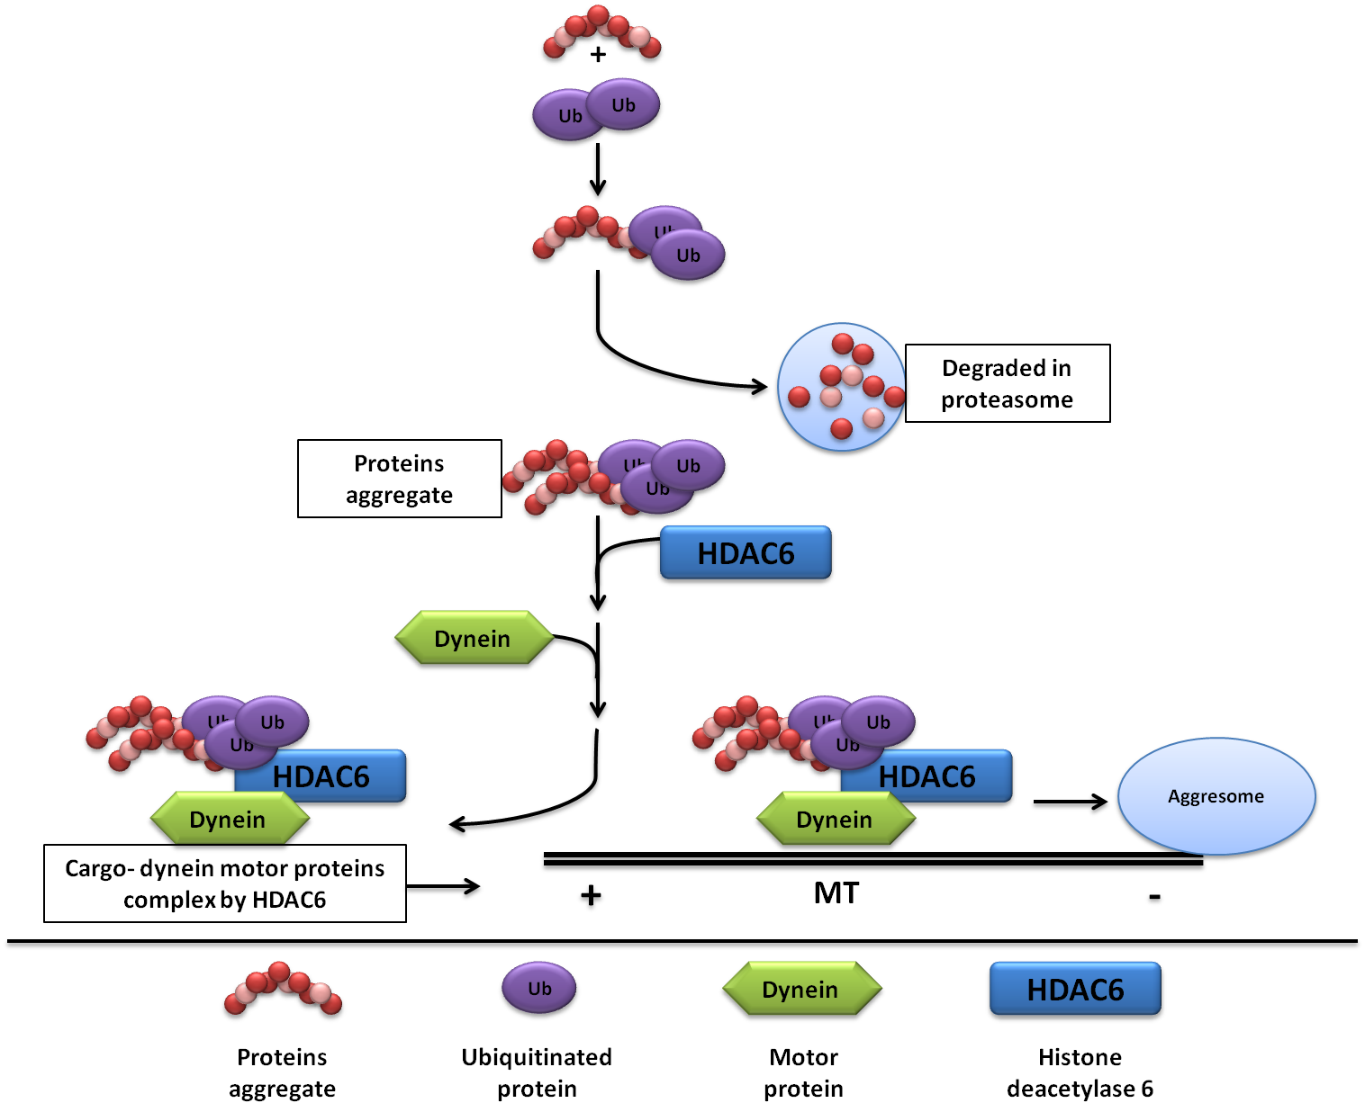

Figure 5.1: The role of HDAC6 in aggresome formation.

5.3 Results

5.3.1 Breeding strategy for SPAST^{ΔE7} and HDAC6 crosses
In order to investigate the beneficial effect of the deletion of HDAC6 in spastin mice, SPAST^{+/+} wildtype/ HDAC6^{+/-} female carrier mice were crossbred with SPAST^{+/ΔE7} heterozygous/ HDAC6^{+/y} wildtype male mice (Figure 5.2). Since HDAC6 is located on the X-chromosome, males carrying the mutant allele are genetically null. This meant that our crossbreeding strategy resulted in approximately 50% of the littermates being SPAST ^{+/+} wildtype/ HDAC6^{+/+} wildtype females and males, 25% being SPAST^{+/ΔE7}/ HDAC6^{-/y} knockout males and 25% SPAST ^{+/ΔE7}/ HDAC6^{+/-} female carriers.

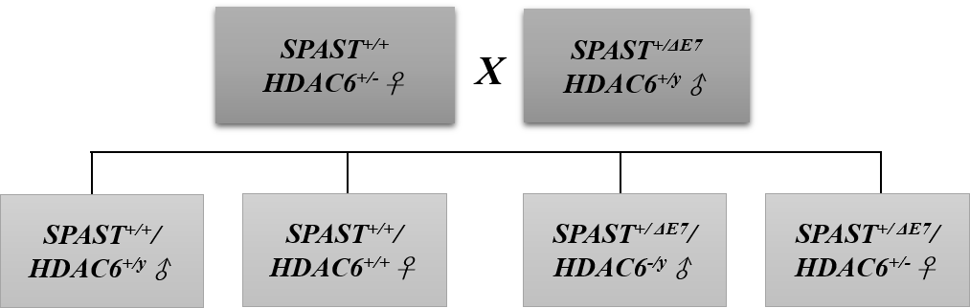

Figure 5.2: Crossbreeding spastin and HDAC6 mice. This step was to produce SPAST^{+/ΔE7} heterozygous/ HDAC6^{+/-} female carriers and SPAST^{+/ΔE7} heterozygous/ HDAC6^{-/y} male knockout mice.

This first stage of crossbreeding was followed by a further stage of crossing double mutant mice in order to generate HDAC6 knockout mice in spastin null mice. To achieve this, we crossed SPAST^{+/ΔE7} heterozygous/ HDAC6^{+/-} female carrier mice with SPAST^{+/ΔE7} heterozygous/ HDAC6^{+/y} males (Figure 5.3). The male offspring of this cross therefore fell into four groups: SPAST^{+/+} wildtype / HDAC6^{+/y} wildtype mice, which were used as a control group; SPAST^{+/+} wildtype / HDAC6^{-/y} knockout mice, which were used to detect whether the HDAC6 knockout had any effect on gait; SPAST^{ΔE7/ΔE7} null mutant / HDAC6^{+/y} wildtype mice, which were used to confirm the gait defect phenotype of the spastin mouse model; and, finally, SPAST^{ΔE7/ΔE7} null mutant / HDAC6^{-/y} knockout mice, which were used to determine the effect of the HDAC6^{-/y} knockout in mitigating the SPAST^{ΔE7/ΔE7} null mutant phenotype.
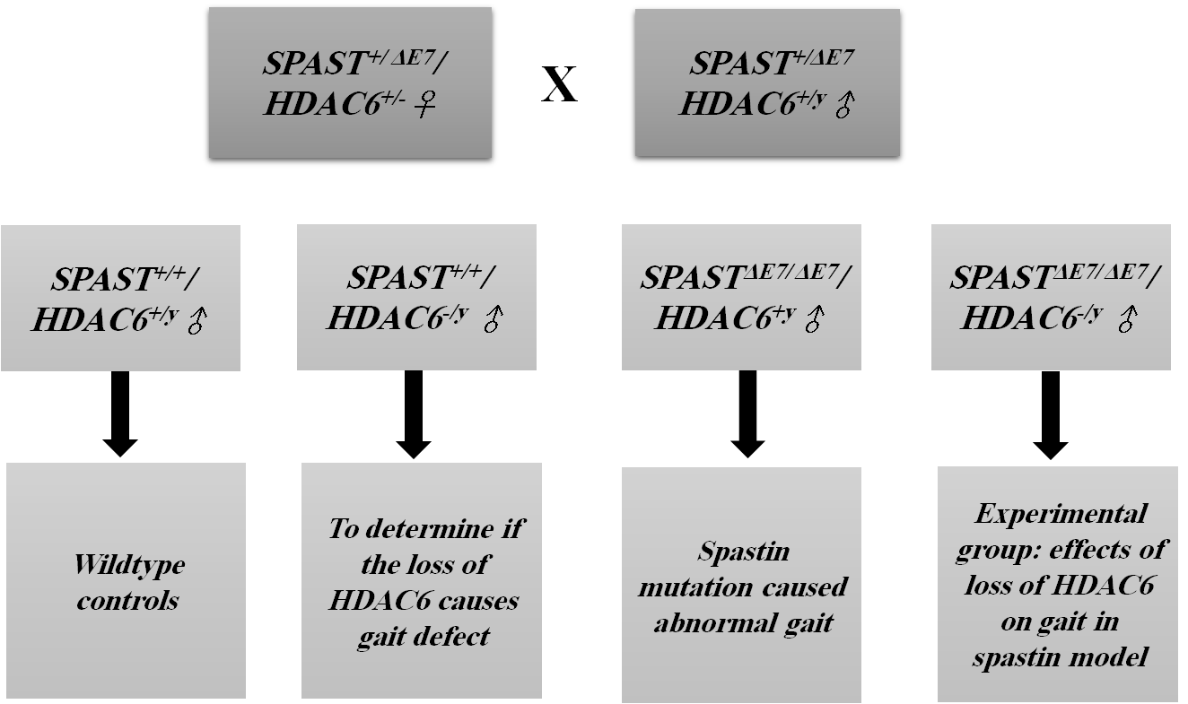

Figure 5.3: Crossing double mutant mice.
Male offspring from this cross were used as indicated in the final row of the flow diagram.

We know that these HDAC6 knockout mice have a very high level of acetylated tubulin in the CNS and peripheral tissue (see section 4.3.3). Tubulin acetylation increases MT-dependent axonal transport, suggesting that in this genetic background there might be an improvement in the axonal transport defects usually observed in the HSP mouse model. Crossing SPAST with HDAC6 mice was performed to obtain double mutant mice, as indicated in Table 5.1. Surprisingly, from the crosses that were made, we did not obtain the expected frequency of each genotype. For example, whereas we would have expected 13 HDAC6^{-/y} null /SPAST^{ΔE7/ΔE7} males (0.25% of all offspring), we only observed four mice actually had this genotype. The surviving mice with this genotype were very small in size compared with other mice, or were born with hydrocephalus. This hydrocephalus outcome was also observed in SPAST^{+/ΔE7}/ HDAC6^{-/y}, and again the number of this genotype was less than expected, since 27 mice were expected and we observed only nine (Table 5.1). Also, we noticed the opposite effect in the HDAC6^{+/y} /SPAST^{+/+} offspring, the expected number is 13 mice, but we observed 23 mice. This suggested a novel genetic interaction between spastin and HDAC6 or gender-specific lethality and since we failed to obtain sufficient numbers of double mutants, we did not continue with this experiment. The result of the crossbreeding, however, led us to try to investigate the potential reasons for not obtaining the expected ratio of double mutant offspring.
To make sure that there was no developmental problem associated with the crossing of spastin with HDAC6 mice, the number of the offspring at postnatal day one was quantified as indicated in the Table 5.2, to compare them with the number of the offspring after weaning in Table 5.1. It can be seen from Table 5.2 that the observed number of mice in the SPAST^{+/ΔE7}/ HDAC6^{-/y} and SPAST ^{ΔE7/ΔE7}/ HDAC6^{-/y} was again less than the expected in the same way as within the older mice. Also, in the genotype the HDAC6^{+/y} /SPAST^{+/+}, expected number was 2.5, but we observed double that number. This suggested there is a problem affecting the generation of the double mutant mice at the embryonic stage.

Table 5.1: The expected and observed ratio of offspring after crossing spastin with HDAC6 double mutant mice (one month old).
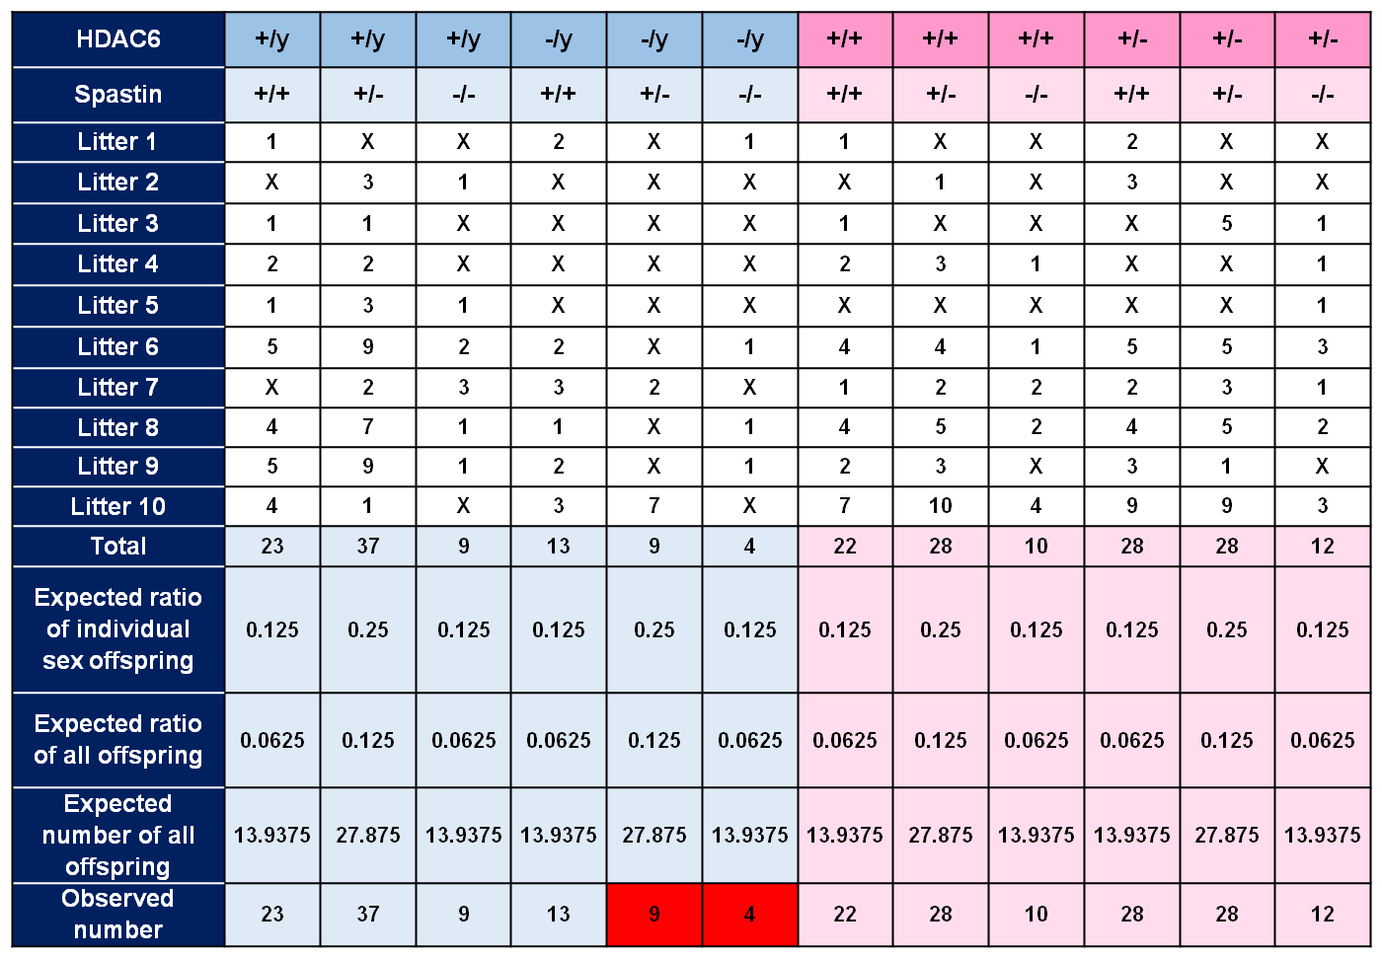

Spastin mice were crossed with HDAC6 mice to generate double mutant mice. The number of male (blue boxes) and female (pink boxes) offspring was calculated according the expected ratio, with the offspring confirmed by genotyping. The red box indicated those groups with an unexpected number of mice.

Table 5.2: The expected and observed ratio of offspring after crossing spastin with HDAC6 double mutant mice (postnatal day one).
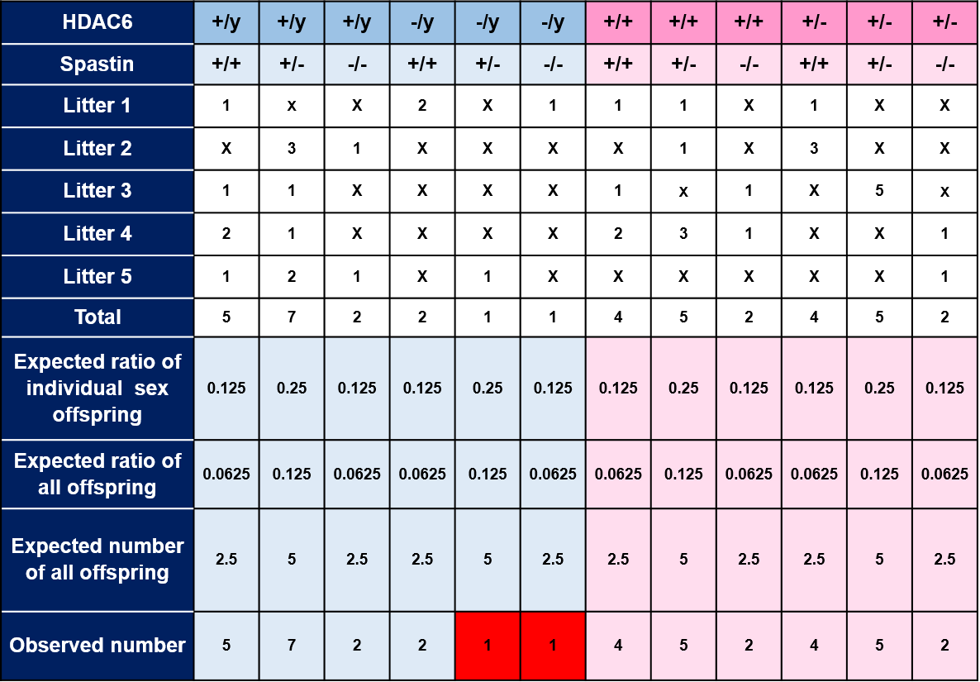

Spastin mice were crossed with HDAC6 mice to generate double mutant mice. The number of male (blue boxes) and female (pink boxes) offspring was calculated according the expected ratio, with the offspring confirmed by genotyping. The red box indicated those groups with an unexpected number of mice.

5.3.2 Investigation of the genetic interaction between spastin and HDAC6
To look for clues about the genetic interaction between spastin and HDAC6 we undertook a pathological investigation. Sections were taken from the brains of the double mutant male mice at one month old, so as to look for hallmarks of degeneration. Three different markers were used to look for alterations in microglia (IBA1), astrocytes (GFAP) and neurons (SMI31A).
Preliminary data was collected from the brain histology (Figure 5.4). It can be seen in the figure that different features were detected in different parts of the brain for the wildtype mice in the left column and the double mutant SPAST ^{ΔE7/ΔE7} /HDAC6^{-/y} in the right column. For example, A-B shows that there were more amoeboid microglia in the double mutant mice than in the SPAST^{+/+}/HDAC6^{+/y} brain in the corpus callousm. In C-D the SMI31A detected numbers of axonal thickening in both SPAST^{+/+}/HDAC6^{+/y} and SPAST ^{ΔE7/ΔE7}/HDAC6^{-/y} in the cortex area. In E-F brain sections the SPAST^{ΔE7/ΔE7} /HDAC6^{-/y} mice had higher numbers GFAP protein astroglia in the cerebral cortex layer IV, indicated by arrows however this pattern was not observed in the wildtype.

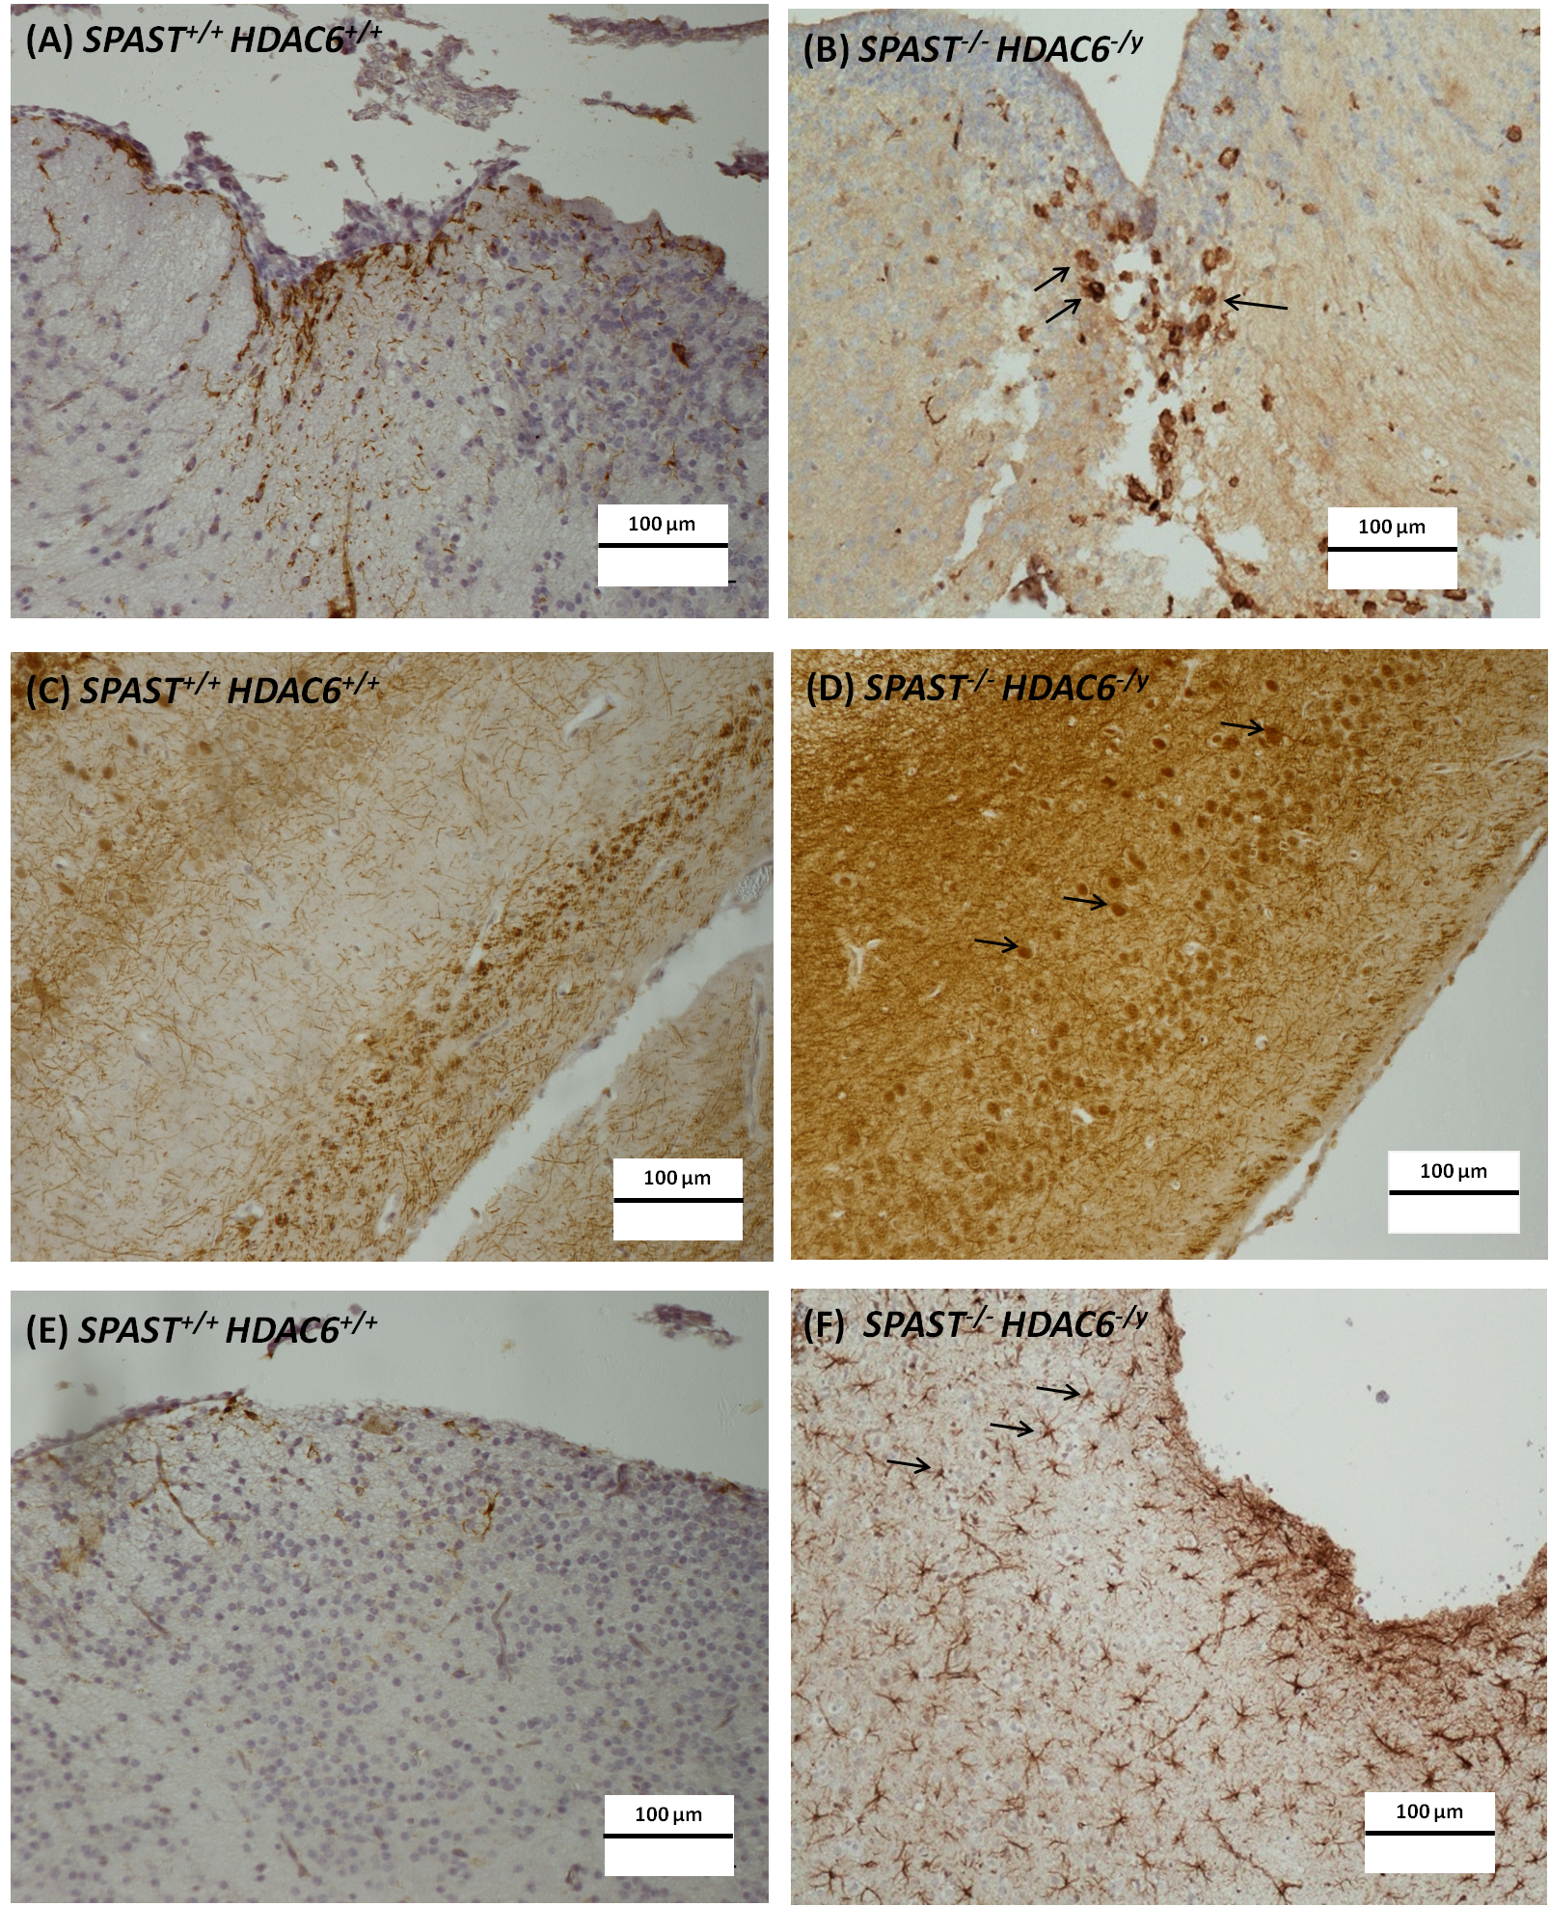

Figure 5.4: Effect of SPAST and HDAC6 double mutation on mice brain histology.
(A-B)The Iba1 marker showed amoeboid microglia (corpus callous). (C-D) SMI31A marker showed axonal thickening indicated by arrows (cortex). (E-F) The GFAP marker showed an increase in the gliosis type pattern indicated by arrows in (cerebral cortex layer IV).

5.4 Further evidence for gender-specific genetic interactions: Crossing SPAST^{ΔE7} with the C57BL/6J-OlaHsd sub-strain
At a later stage of the project we experienced a similar gender-specific lethal interaction between SPAST^{ΔE7/ΔE7} and an uncharacterised gene. SPAST^{+/ΔE7} mice were being in-crossed to generate progeny for the investigations in Chapter 6, Again we noticed an absence of SPAST^{ΔE7/ΔE7} male mice. After further investigation we determined that spastin mice that were normally maintained by back-crossing with the C57BL/6Jax sub-strain mice had instead been back-crossed with the C57BL/6J-OlaHsd strain by mistake. This led us to believe that OlaHsd carries a genetic variant that imparts a gender-specific effect of the OlaHsd sub-strain in SPAST^{ΔE7/ΔE7} mice. Given the similarity of the effect in OlaHad to the HDAC6 in-cross, we initially explored this possibility by measuring the level of acetylated tubulin in brain tissues of each C57BL/6J sub-strain.

5.4.1 Determination of α-tubulin acetylation level in the C57BL/6J-OlaHsd
We sought to determine the level of acetylated tubulin in the brain lysate of both strains of mice (the C57BL/6Jax and the C57BL/6J-OlaHsd sub-strains) (Figure 5.5). It can be seen from the figure that the level of acetylated tubulin in the C57BL/6J-OlaHsd strain was higher than that in the C57BL/6Jax sub-strain, but not statistically significant when applying one-way ANOVA, although it did not reach the level of the HDAC6 knockout.
The higher level of acetylated tubulin found in the C57BL/6J-OlaHsd strain is consistent with reduced HDAC6 activity in the brain. We therefore measured the level of HDAC6 in brain samples of both sub-strains.

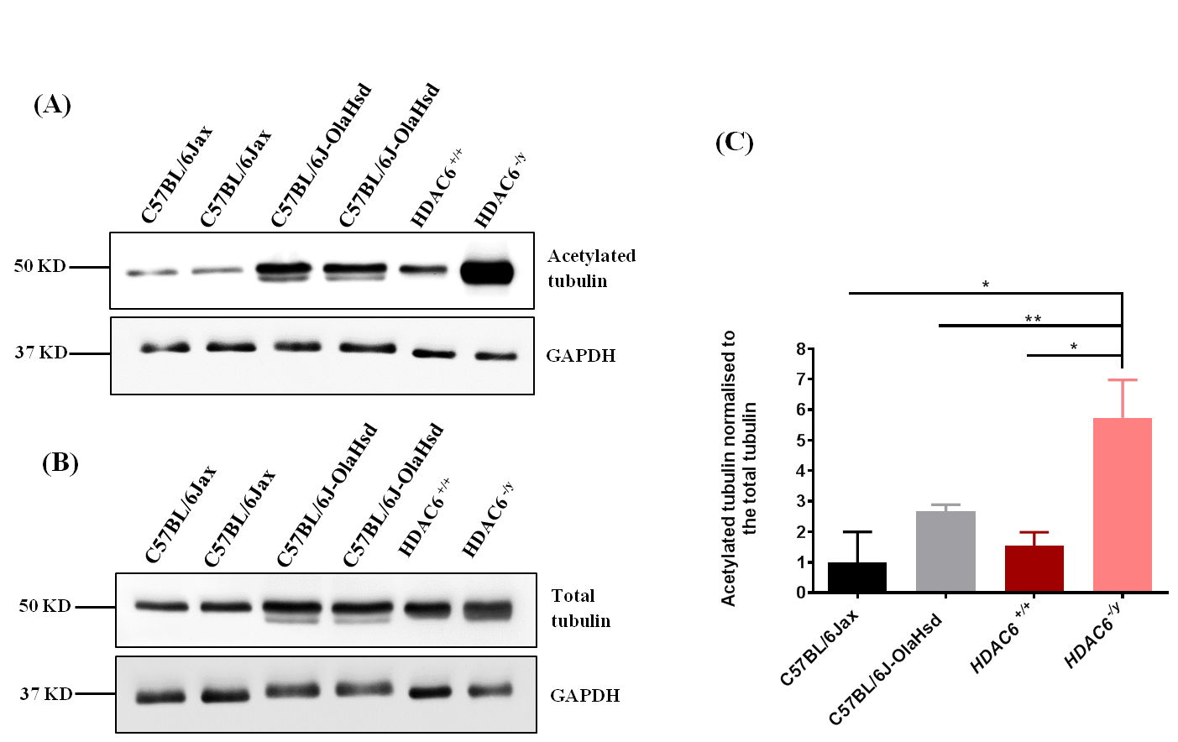

Figure 5.5: The level of α-tubulin acetylation in the brain of C57BL/6J-OlaHsd and C57BL/6J mice at six weeks old.
Western blot analysis of 15 μg total brain protein from C57BL/6J-OlaHsd and C57BL/6Jax sub-strains. (A) Anti-acetylated tubulin monoclonal antibody. (B) DM1A mouse monoclonal antibody (for total tubulin), and anti-GAPDH used for both as a loading control. (C) Acetylated tubulin normalised to total tubulin (two replicates). Statistical analysis involved is one-way ANOVA, error bars represent standard deviation.

5.4.2 Determination of the level of endogenous HDAC6 in the C57BL/6J-OlaHsd brain
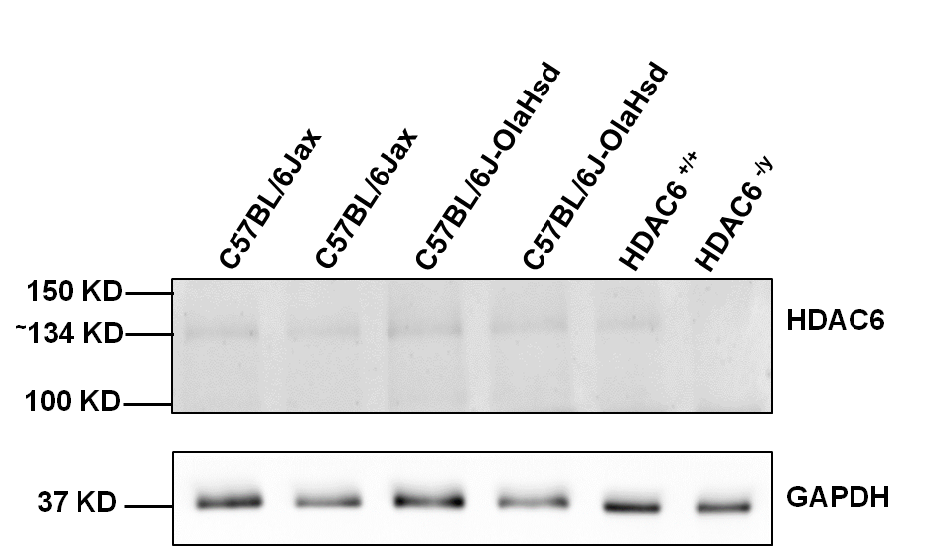
We quantified the level of HDAC6 in brain lysates from two mice in each sub-strain: C57BL/6J-OlaHsd and C57BL/6Jax (Figure 5.6). The molecular weight of HDAC6 is 131 kD, and we detected a band of endogenous HDAC6 at ~134kD in mice from the C57BL/6J-OlaHsd sub-strain. There was no detectable HDAC6 protein in HDAC6^{-/y} lysate. This demonstrates that the OlaHsd mice were not a complete null for HDAC6, which suggests they may contain a missense mutation.

Figure 5.6: Level of HDAC6 in C57BL/6Jax and C57BL/6J-OlaHsd sub-strains. Western blot analysis of 15 μg total brain protein from C57BL/6J-OlaHsd and C57BL/6Jax sub-strains. HDAC6 rabbit polyclonal antibody was used to detect endogenous HDAC6. Anti-GAPDH was used as the loading control.

5.4.3 Sequence analysis of HDAC6 in C57BL/6J-OlaHsd sub-strain
Since we found no evidence for an HDAC6 null allele at the protein level, we decided to look for missense mutations or alterations in splicing. HDAC6 is large gene, we therefore chose to sequence cDNA obtained from RT-PCR of brain mRNA. Five overlapping fragments of 600-700bp were amplified from OlaHsd and Jax sub-strain mice. Four of the amplicons showed no sequence difference; however, the amplicon including exon 22 showed mixed sequences reads (Figure 5.7). Closer inspection of the chromatograms showed that the double sequence reads represented two transcripts either including or excluding exon 22 (Figure 5.7). The transcript lacking exon 22 was not found in the Ensembl genome database, suggesting that it may result from a splicing defect in the OlaHsd mice (Figure 5.8). Splicing defects commonly arise due to mutations at intron-exon boundaries. No sequence alterations were found in OlaHsd cDNA in this region; therefore, we also investigated the intronic sequences flanking exon 22. We found no sequence changes in OlaHsd. The effect of omitting exon 22 is to produce frameshift in the open reading frame of the protein and the inclusion of a premature stop codon. This is likely to lead to degradation of the aberrant cDNA, or to production of a truncated protein. The HDAC6 antibody we use has an epitope located on the C-terminal of the frameshift found in OldHsd show as the yellow box in (Figure 5.8). Therefore, it was not possible to detect the aberrant HDAC6 protein

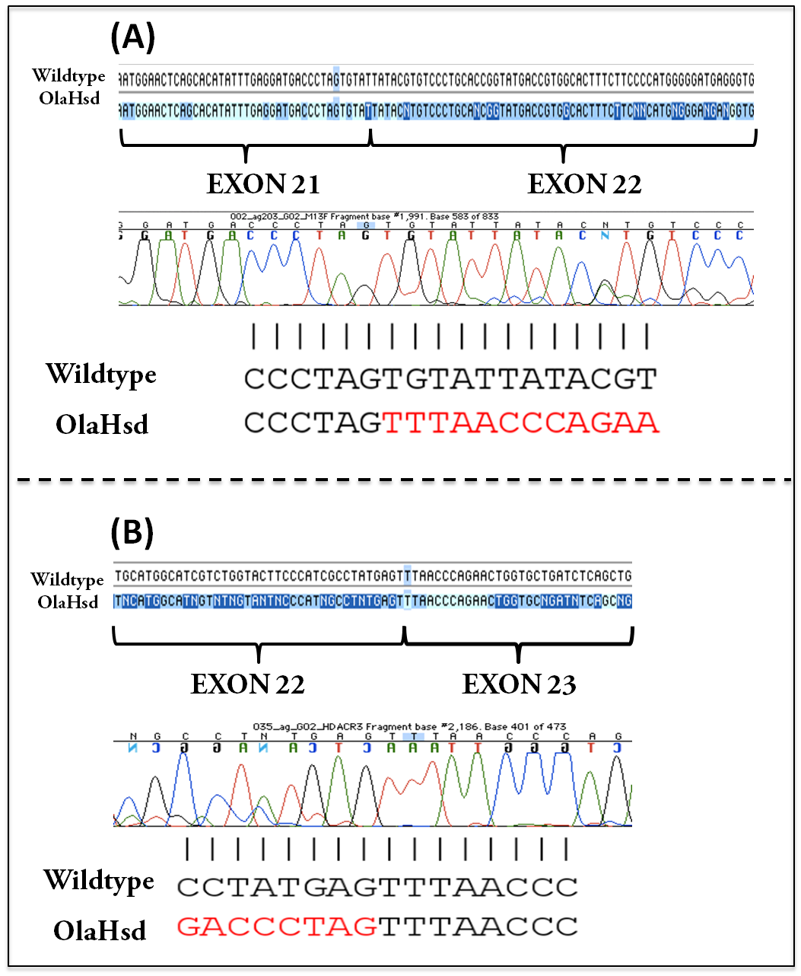

Figure 5.7: Sequencing of cDNA obtained from the PCR amplified from C57BL/6J-OlaHsd and C57BL/6Jax sub-strains. The figure shows the chromatogram for C57BL/6J-OlaHsd. PCR products were sequenced and a mix read was revealed in the region sequencing of exon 21-23 in C57BL/6J-OlaHsd. (A) Exon 21-22 junction, OlaHsd in red shows exon 23 in place of exon 22. (B) Exon 22-23 junction, OlaHsd in red shows exon 21 in place of exon 22.

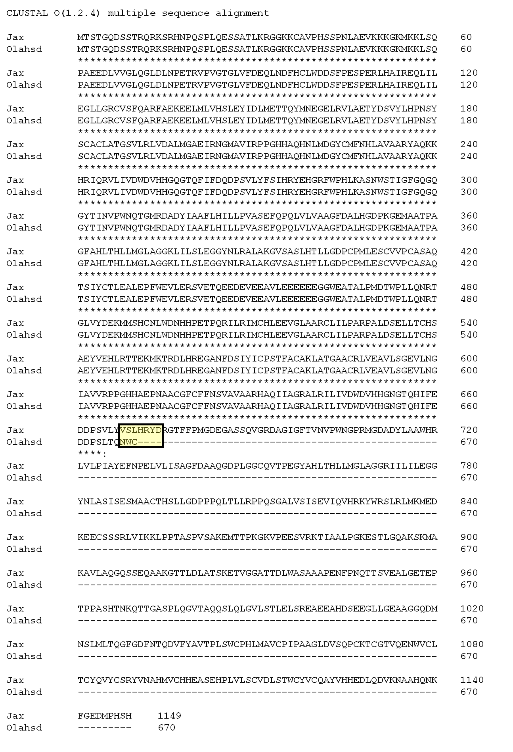

Figure 5.8: Alignment of predicted C57BL/J-OlaHsd and C57BL/J-Jax HDAC6 protein based on sequence of cDNA. HDAC6 protein sequence was obtained from Ensembl. To detect the effects of excluding exon 22, we translated the aberrant cDNA sequence in Silico. This revealed a frameshift leading to identified 6 amino acids followed by a premature stop codon. HDAC6 antibody binding site is indicated by the yellow box.

5.5 Discussion
The main goal of this study was to investigate any beneficial effect of HDAC6 knockout in the spastin mutant mouse model of HSP. HDAC6 has become an attractive target in many neurodegenerative diseases since it has been linked to an increase in the acetylation of the lysine of α-tubulin at position 40, which stimulates the recruitment of motor proteins, kinesin and cytoplasmic dynein, to facilitate axonal transport (Reed et al., 2006, Dompierre et al., 2007) The pathogenesis of several neurodegenerative diseases is associated with impairment of axonal transport. One way to improve this defect is by increasing the acetylation of tubulin by inhibiting HDAC6 genetically or pharmacologically (Dompierre et al., 2007, D'Ydewalle et al., 2011). Several HDAC6 inhibitors have been tested and have been shown to be able to mitigate the axonal transport defect and alleviate the tubulin acetylation (Jochems et al., 2014). Also, a small molecule of HDAC6 has been shown to increase the innervations of neuromuscular junctions and improve the conduction of motor and sensory nerves (Benoy et al., 2016). Since there is no current treatment for HSP, and based on the pathological defect in the HSP mouse model with spastin mutation (Kasher et al., 2009), these findings strongly suggest that HDAC6 inhibition should modify the progression of the HSP mouse model with spastin mutation.
We therefore aimed to crossbreed the HDAC6 knock-out mice with the spastin mice in order to investigate the effect of ablating HDAC6 on spastin mutation. Since HDAC6 is located in the X-chromosome, mutant males will be HDAC6 null mice (Mahlknecht et al., 2001). HDAC6 null mice that were generated with homologous recombination in embryonic stem cells, are viable, and have a very high level of α-tubulin acetylation in all organs, especially in the testes, without affecting fertility (Zhang et al., 2008). Surprisingly however, our findings showed that we did not get the expected ratios of double mutant offspring from in-crossing HDAC6 and spastin lines, so we were unable to conduct the experiment. Of the few double mutant mice that were observed, we noted the presence of hydrocephalus.

5.5.1 In vivo investigations of HDAC6 and SPAST double mutants

5.5.1.1 Assessment of viability of double mutants
One possibility is that the double mutant mice died during the embryonic stage as they did not express HDAC6, and that this affected the generation of these mice. Although HDAC6 knockout mice develop normally without any phenotype (Zhang et al., 2008), knockout of HDAC6 and spastin might interfere in several developmental pathways. To investigate the effect of HDAC6 and spastin double mutant mice on the development of the correct ratio from each genotype, we quantified the ratio of the offspring from each genotype after the mice were weaned (at one month old). We noticed that there was a lower number on the SPAST^{+/ΔE7}/ HDAC6^{-/y} and SPAST ^{ΔE7/ΔE7}/ HDAC6^{-/y} genotypes. It was not clear at which stage double mutants were non-viable. For this reason we quantified the ratio of mice form each genotype at postnatal day one, to compare them with the ratio after weaned (one month old). We also found again at this age we did not get the expected number of the SPAST^{+/ΔE7}/ HDAC6^{-/y} and SPAST^{ΔE7/ΔE7}/ HDAC6^{-/y} genotypes. This suggested that there was a problem that impaired the generation of these mice at the embryonic stage.

5.5.1.2 Pathology
Different markers have been used to investigate the brain pathology differences between double mutant mice with the wildtype, such as IBA1for microgla, GFAP for astrocytes and SM31A for neurons. The data collected from this study was preliminary data, showed increased in gliosis pattern, amoeboid microglia and axonal thickening in double mutant mice. Further investigations in brain pathology in double mutant mice are required.

5.5.1.3 Protein mechanism
A pathway that might affected by HDAC6 and spastin knockout is autophagy, HDAC6 is crucial for the autophagic pathway, as it associates with motor protein (dynein) and the recruitment of ubiquitinated proteins to dynein, thus helping to retrograde transport of aggregates to the perinuclear region (Kawaguchi, 2003). Increases in ubiquitin positive aggregates have been shown in mouse fibroblasts as a result of the HDAC6 knockout, since HDAC6 inhibition stopped the proteasome activity (Martin et al., 1999). Moreover, aggresome degradation has been shown to be induced by HDAC6, leading to an increase in aggregate load in knock-down HDAC6 cell cultures (Iwata et al., 2005). In our study, there may be unknown interactions between HDAC6 and the spastin gene that affected this pathway and consequently perturbed the development of the double mutant mice. This was not the case in R6/2 mice, however, which are a model of Huntington disease, since they showed that the autophagy process is not affected by the knocking out of HDAC6 (Bobrowska et al., 2011). Also, we observed in Chapter 4 that the HDAC6 inhibitor does not have a lethal effect on spastin mice, since this inhibitor only affects the deacetylase domain, not other HDAC6 domains. This suggests that what we observed in this genetic study is more likely to be due to loss of non-deacetylase functions. Formally, that could be tested by feeding pregnant spastin mice with HDAC6 inhibitor to investigating the effect of loss of deacetylase activity on the development of spastin mutant offsprings.

Another pathway might be affected by spastin/HDAC6 null is endocytosis, both spastin and HDAC6 are involved in endocytic pathway, we suggest that the knockout of spastin and HDAC6 affects this process causing embryonic lethality. Endocytosis is a process that delivers cargos form endosomal compartment to be recycled or degraded in the lysosome. It has been mentioned previously that spastin involve in endocytic process by controlling endosome tubulation, cells lack in spastin have tubules sorting and recycling deficiency (see section 1.4.3). Certain receptors provide a specific signal to be recycled to plasma membrane through endosome tubules. Tubules sorting and fission deficiency can be resulting in receptor mistrafficking (Traer et al., 2007).
In regard to HDAC6 role in endocytosis, epidermal growth factor receptor (EGFR) is one of the cargos that can be transported to the endosome and recycled to the cell surface or degraded. EGFR is crucial for tissue homeostasis up or down-regulation of this receptor causing several diseases such as Alzheimer disease and cancer (Lee and Threadgill, 2009).Transit of cargos from early endosomes to late endosomes requires MT. Inhibition of HDAC6 leads to increase the acetylation of MT and that causes to increase the flux of cargos from early endosomes to late endosomes and then to lysosomes (Brown et al., 2005). By inhibition of HDAC6, some crucial cargos degraded before it sorted or recycled in late endosomes, one of these cargos is EGFR-bearing vesicles. It has been reported that lack of HDAC6 accelerates the delivery of EGFR-bearing vesicles from early endosomes to be degraded in lysosomes by increasing the movement of these vesicles via MT (Gao et al., 2010). Degradation of these EGFR-bearing vesicles, reduces EGFR signaling and that causing lethality of prenatal and postnatal mice because of undeveloped placenta (Dackor et al., 2007, Lee and Threadgill, 2009)
These data suggests that both knockouts (spastin and HDAC6) would lead to increased degradation of EGFR, and EGFR knockouts are embryonic lethal, which is consistent with SPAST/HDAC6 null effect being embryonic.

5.5.1.4 Hydrocephalus
Hydrocephalus is a pathological condition which is a result of the accumulation of cerebrospinal fluid CSF in the brain ventricles (Bruni et al., 1985). CSF is produced by the choroid plexus (CP), which is located in the lateral third and fourth ventricles in the brain and is part of the neuroepithelium. Motile cilia present on the ependymal cells lining the ventricles and interventricular spaces are responsible for circulating the CSF through the ventricles (Ibanez-Tallon et al., 2004). The CSF thus circulates between the brain ventricles and is absorbed by blood vessels and the lymphoid system (Weller et al., 1992). The observation of hydrocephalus in double mutant mice suggests that the equilibrium between the secretion, cilia-mediated flow, and absorbance of CSF may be defective.
The exact mechanisms leading to hydrocephalus in double mutant mice is unknown, although one potential route is dysfunctional cilia (Ibanez-Tallon et al., 2004). Cilia are a cytoskeleton-enriched structure comprising axonemes, composed of nine outer MT doublets surrounded by a ciliary membrane. The motile cilia are composed of a central doublet of MT with outer and inner dynein arms 1-3 (Ishikawa and Marshall, 2011). HDAC6 plays a crucial role in several cellular processes, including the disassembly of cilia (Li et al., 2010, Dere et al., 2015). The assembly and disassembly of cilia is regulated by many ciliary proteins, including HDAC6. HDAC6-mediated deacetylation of cortactin and α-tubulin leads to ciliary disassembly by stimulating cell motility (Ran et al., 2015) .
Axonemes in the cilia contain highly acetylated α-tubulin that stabilises the MT, in keeping with the role of HDAC6 deacetylation which reduces the MT stability and stimulates cortactin binding with F-actin in the cilia, consequently speeding up the polymerisation of actin and causing a ciliary response (Ran et al., 2015).
Homeostasis in ciliary assembly/disassembly is important for cilia motility. Overexpression of HDAC6 shifts the balance towards disassembly, suggesting that knocking out HDAC6 would shift the balance towards stability. According to our findings from multiple crosses we found a case of a SPAST^{ΔE7/ΔE7}/ HDAC6^{-/y} and SPAST^{+/ΔE7}/ HDAC6^{-/y} mice born with hydrocephalus. Perhaps HDAC6 knockout increased the acetylation of α-tubulin and stabilised the axonal MT, and then knocking out spastin has an additional stabilising effect of MT. Perhaps this combination of ciliary MT-stabilising effects causes a loss of cilia motility. We could further test this possibility by dissecting postnatal brains and using live microscopy to image motile cilia in the ventricles. On the other hand since these potential effects are all mediated by the deacetylase activity of HDAC6, and we saw no effect of long-term HDAC6 deacetylase inhibition using chemical inhibitors, other mechanisms may also need to be considered.

5.5.2 C57BL/6J-OlaHsd sub-strain
C57BL/6Jax and C57BL/6N are the most commonly characterised sub-strains (Rendina-Ruedy et al., 2015). The C57BL/6Jax black sub-strain was first characterised in 1948 at Jackson Laboratory, and in 1951 they were passed to National Institutes of Health (NIH) (Mekada et al., 2009). Several C57BL sub-strain mice have been generated by selective in-breeding in different laboratories, with one of the most frequently used being the C57BL/6J-OlaHsd sub-strain. This sub-strain has a deletion in α-synuclein (Snca) and multimerin-1 (Mmrn1) genes which was established at 1998 (Specht and Schoepfer, 2001). Genetic deletion in Snca is associated with Parkinson's disease in humans (Kruger et al., 1998), while Mmrn1 deletion is associated with platelet degradation causing bleeding disorders in humans (Reheman et al., 2010). Although the C57BL/6J-OlaHsd sub-strain has a deletion in both Snca and Mmrn1 genes, no significant notable phenotypes have been observed in respect to these sub-strains (Specht and Schoepfer, 2004), and they have been used as wildtype mice in thousands of laboratories. However, recently, a comparative study between the C57BL/6J-OlaHsd and C57/BL6Jax mice showed that Mmr1 plays a major role in bone remodelling (Liron et al., 2017) and that C57BL/6J-OlaHsd mice demonstrated a significant reduction in trabecular bone mass in comparison with C57/BL6Jax (Liron et al., 2017). This finding suggests that crossing spastin onto different sub-strains might cause a novel interaction between spastin and the genetic background. This is consistent with our findings, in that the crossing error that occurred in our colony was that one of the C57BL/6J-OlaHsd mice had been used for breeding with the SPAST ^{ΔE7} mice. This led to a complete failure to generate SPAST^{ΔE7/ΔE7} male mice, consistent with gender-specific effects we had previously observed in the HDAC6 crosses with SPAST ^{ΔE7} mice.
We suggest that HDAC6 is affected in OlaHsd mice; therefore, we measured the level of acetylated tubulin in both sub-strains. Consistent with this we found a higher level of tubulin acetylation in C57BL/6J-OlaHsd compared with C57BL/6J-Jax, but this level did not reach the HDAC6 knockout level. This suggested that there is a partial reduction of HDAC6 function. Because HDAC6 is a large gene we decided to sequence cDNA by RT-PCR of mRNA from the mice brain. Although we found that there were no missense or nonsense mutations, there was an omission of exon 22 which suggested that there is a splicing defect in OlaHsd. Sequencing of genomic DNA failed to identify an alteration in this region in OlaHsd, which suggested that there is an intronic change. Sequencing of intron failed to identify any mutations in OlaHsd. The reason for the exon 22 being omitted remains unknown.

5.6 Summary
To sum up, although we know that HDAC6 null mice developed normally, in-crossing HDAC6 mice with SPAST ^{ΔE7} mice affected the generation of male double mutant mice. This suggested that there were unknown genetic interactions between spastin and HDAC6 that had a lethal effect on male mice and that need further investigation. The fact that two of the double mutant mice showed signs of hydrocephalus supports a model where spastin and HDAC6 mutations converge on cilia motility in the ependymal cells lining the ventricles. Our findings in OlaHsd mice are consistent with OlaHsd carrying an uncharacterised HDAC6 allele that affects the splicing of exon 22 and leads to partial loss of HDAC6 function.

Chapter 6: Effects of microtubule stabilising agent EpoD on the HSP phenotype

Chapter 6: Microtubule stabilising agent (Epothilone D)

6.1 Aims
This chapter aims to investigate the effects of a microtubule stabilising compound, Epothilone D (EpoD), on the HSP phenotype of a spastin mouse model. We determined the effects of EpoD in vivo by injecting the mice with EpoD weekly, followed by behavioural assessments at monthly intervals to confirm the effects of EpoD on gait. At the conclusion of the in vivo, study investigations were undertaken on serial sections from the spinal cord in order to determine the effects of the drug on the axonal swelling pathology observed in the HSP mouse model.

6.2 Introduction
Microtubules are fundamental structures in the process of building the cytoskeleton of eukaryotic cells. They are also highly dynamic, and composed of α- and β-tubulin heterodimers, which are oriented with an α-tubulin monomer pointing towards the faster growing plus end, and an α-tubulin homodimer exposed at the slower growing minus end (Desai and Mitchison, 1997). The assembly of tubulin heterodimers occurs at the microtubule organisation centre (MTOC) (Stiess et al., 2010). MTs demonstrate a process called “dynamic instability” with GTP-dependent growth or depolymerisation occurring at the plus ends (Desai and Mitchison, 1997). The plus end of microtubules is stabilised by the presence of a tubulin GTP-cap, as well as a number of end-binding proteins (Mitchison and Kirschner, 1984).
MTs are required to mediate the transport of vital cellular components along the axons. MTs themselves need to be transported the entire length of an axon (up to 1 m in humans) and, to facilitate this, MTs are cut into small pieces with multiple plus and minus ends, allowing motor proteins to efficiently transport tubulin, along with other cargos, along the axon (Hirokawa and Noda, 2008). MTs in neurons exhibit more stability than other cells because of the abundant microtubule associated proteins (MAPs) that bind to MTs and play an essential stabilising role (Pryer et al., 1992). Impairment in MT stability because of altered binding of MAPs is linked to the development of neurological disorders. For example, Tau is thought to be critical for MT stabilisation since it plays an important role in the engagement of kinesin (motor protein) to the MT, and thus regulates axonal transport (Drechsel, 1992). In taupathies, Tau becomes hyperphosphorylated leading to a reduction in tau to MTs, which reduces the stability of the MTs (Baudier and Cole, 1987). Opposing these stabilising effects is spastin, which severs MTs and reduces MT stability so as to facilitate axonal transport. The absence of spastin is therefore suggested to increase MT stability by stopping severing activity and thus causing NDs, including HSP.
Although spastin mutation stabilises the MTs, the use of MT stabilising agents linked to an improvement in axonal transport in neuropathology (Abrahamsen et al., 2013). Also in fibroblasts, using lower concentrations of MT stabilisers is linked to increases in acetylation and increase severing by katanin (Sudo and Baas, 2010). An example of an MT stabilising agent is Taxol. Taxol is able to bind to polymeric MTs and reduce the rate of depolymerisation of α and β tubulin, therefore enhancing the stability of MTs (Schiff and Horwitz, 1981). Using Taxol is problematic, however, because it is associated with many serious side effects arising from its complex chemical structure and insoluble properties (Bollag et al., 1995). Different drugs have therefore been screened to find an improved compound that mimics Taxol’s mechanism of action; one of these compounds is EpoD.
EpoD is a microtubule-stabilising drug (Lou et al., 2014). Its structure is presented in Figure 6.1 (Lou et al., 2014), and it shares the same binding site on MTs as Paclitaxel (a version of Taxol) (Bollag et al., 1995). Since both EpoD and Taxol share the same binding site on β-tubulin, they each stimulate the polymerisation, assembly and bundling of MTs (Amos, 2011). Several MT binding drugs, such as Taxol (paclitaxel) and vinblastine, have been tested in vitro on both HSP patient-derived and control olfactory nasal stem cells (ONS), and have shown an ability to improve the level of α-tubulin acetylation, which is associated with MT stability (Abrahamsen et al., 2013). Also, a pilot study testing the effectiveness of a range of doses (0.5 nM, 1 nM, 5 nM) of EpoD on the patient-derived stem cell model of HSP revealed that EpoD increased the level of acetylation in a dose-dependent manner at these very low concentrations (Fan et al., 2014). Based on dose response curves, a dose of 2 nM has been chosen to treat HSP patient-derived cells and this was sufficient to restore the acetylated α-tubulin to the control level and rescue proxisome trafficking (Fan et al., 2014).
Many MT stabilising agents have been tested and revealed not to be suitable for human patients due to poor penetration to the CNS (Brunden et al., 2011). EpoD, however, has been shown to penetrate the brain in a mouse model of schizophrenia (Andrieux et al., 2006). A pharmacokinetic analysis for the concentration of EpoD in brain and plasma has been conducted on a group of three mice that received EpoD at 3 mg/kg, before being euthanised 4, 6 and 10 days following the IP injection. EpoD concentration was higher in the brain compared to plasma at all-time points. This prolonged persistence in the brain is suggested to be preferable in that it allows the CNS to be exposed to the drug for longer, stabilising the MT and minimising the exposure of the peripheral tissue to the drug Also, it has been shown to clear out from the body slowly (Brunden et al., 2011). EpoD is therefore a preferable MT stabilising compound as it penetrates the BBB with no side effects reported (Brunden et al., 2010).
Since all the data so far relating to EpoD in HSP has been related to in vitro studies, we wished to explore its potential in vivo in a mouse model. Specifically, we wished to determine whether EpoD treatment had a beneficial effect on the typical gait defect and axonal swelling pathology shown in our spastin mouse model of HSP.

Figure 6.1: Epothilone D chemical structure (Lou et al., 2014).

6.3 Results

6.3.1 EpoD dosing
Many studies have tested EpoD in vivo, for example, a study which was performed on a transgenic mouse model of tau pathology, tested weekly intraperitoneal injections of different concentrations of EpoD, namely 1 mg/kg and 3 mg/kg, for a period of three months. This investigation revealed that EpoD stayed in the brain for more than a week after administration of a single weekly dose (Brunden et al., 2011). 3 mg/kg EpoD showed improvement in MT density and axonal integrity in the CNS without any intolerable side effects (Brunden et al., 2011). Also, this dose matched the dose used in clinical human phase II trials for cancer treatment (Beer et al., 2007). Another study revealed that repeated injections of 1 and 10 mg/kg restored MT dynamics to the normal level in a transgenic tau mouse model, without any toxic effect on the animal (Barten et al., 2012). In vivo, treatment of an MPTP-mice model of Parkinson’s disease with EpoD (1 or 3 mg/kg) revealed neuroprotective effects in the system of dopaminergic nigrostriatal and increased the mass of MTs in the substantia nigra, however, the motor performance did not show any improvement and the body weight was not affected (Daniele et al., 2013). Despite this finding we expected that if we used MT stabilising agents there would be some amelioration of axonal transport defects and improvement in gait defects in the mouse model of HSP.
Based on these studies, and the advice of Dr Barten at Bristol Myers Squib (who generously provided the compound), we treated the spastin mouse model with EpoD at 1 mg/kg. To solubilise the drug we made up a stock solution of 1 mg EpoD in 1 ml of ethanol. This stock was refreshed each month. Mice were injected weekly by IP injection after diluting the stock solution 1:10 in water. The dose was adjusted to 1 mg/kg according to the weight of individual mice. The control mice were injected with a 1:10 dilution of ethanol in water.

6.3.2 Experimental design
In this experiment we used six mice in each group. We ran two experiments; symptomatic and presymptomatic. Also, to avoid variability in the data arising from mixed gender experiments (given that male mice have a wider BOS compared to females of the same age, see section 4.4.1, Figure 4.17), we only used female mice in this study.

6.3.3 Housing conditions
Mice were singly housed in large cages fitted with air filteres, and all the cages placed behind the barrier in the Field Laboratories at the University of Sheffield. For more details, see section 2.2.11.3.

6.3.4 Effect of EpoD on gait defects in the spastin mouse model of HSP
The spastin mouse model of HSP has a gait defect related to spasticity and weakness in the hind limbs (Kasher et al., 2009). Here we investigated the effect of the MT stabilising agent EpoD in vivo, hypothesising that if the MTs are stabilised by EpoD this would alleviate the axonal swelling phenotype, as was reported in vitro in patient-derived ONS cells (Fan et al., 2014). If this hypothesis is correct, we would expect to see loss of axonal swellings and an improvement in HSP gait defects in vivo. We therefore conducted two studies: 1) a symptomatic study when spastin mice had already developed a gait defect, and 2) a presymptomatic study before the onset of the disease. To determine the effects of the drug on gait, the mice were tested on the CatWalk gait-analysis system at monthly intervals.

6.3.4.1 The effects of treatment with EpoD on gait defects in the symptomatic spastin mouse model of HSP in vivo.
We started the treatment of spastin mice with EpoD MT stabilising agent. First, we aged the wildtype and spastin mice until they clearly exhibited profound gait defects at 13 months of age (p<0.0001) (as shown in Figure 6.2-A). Then, we randomly assigned SPAST^{+/+} and SPAST^{ΔE7/ΔE7} mice to treatment and vehicle groups. On account of the random assignment to groups, our groups were not well matched by gait (Figure 6.2-A), although the difference between the two SPAST groups did not reach overall significance (Figure 6.2-C). We therefore present the raw data and the gait for each group after normalisation to its respective baseline value at 13 months (Figure 6.2-B).
Figure 6.2-A shows the BOS of the four groups of mice, namely, SPAST^{+/+} placebo, SPAST^{+/+} EpoD treated, SPAST^{ΔE7/ΔE7} placebo, SPAST ^{ΔE7/ΔE7} EpoD treated. In Figure 6.2-A the Y axis shows the BOS in mm. Data at each time point is an average of six mice (using three runs per mouse to generate an average BOS for each animal). For quality control, each run had to follow specific criteria (see section 2.2.11.4). It can be seen from the graph that, at four months old, the BOS differed by 21% between SPAST^{+/+} placebo (12+0.6 mm, mean +SD) and SPAST^{ΔE7/ΔE7} placebo (14.8+0.8 mm). This difference reduced marginally as the BOS of both groups followed the same increasing trend over the time period of the study. It is notable that at 11 months old, the BOS of the EpoD treated homozygous mice had risen considerably to 17.2+1.2 mm and that it remained between 17 mm and 17.4 mm through to the end of the study. Furthermore, the BOS of the SPAST^{ΔE7/ΔE7} placebo group showed a similar trend as it climbed to 16.6+1 mm one month after the start of the study and that decreased to (16.3+1.3) at the end point. In contrast, both wildtype groups (placebo and treated) had a narrower BOS compared with the homozygous groups, being 12.6+0.8 mm and 13.7+1.7 mm, at 13 months of age. Because of the effects of age, the BOS became wider at 17 months old (SPAST^{+/+} placebo, 14+0.9; EpoD treated, 14.8+1.5).
In Figure 6.2-B the BOS data for each group is normalised to the mean value for that group at 13 months old to better represent the overall change from baseline gait after EpoD treatment. It can be seen from the graph that there were no improvement in BOS in SPAST^{ΔE7/ΔE7} mice receiving EpoD. It must be concluded, therefore, that we did not see any beneficial effects of EpoD on gait defects in the Spastin mouse model. This may have been because the drug treatment was started at 13 months of age, when the gait defect was already well-established. We therefore ran another study to investigate the effects of EpoD when mice were treated from a presymptomatic stage.

Age | SPAST^{+/+} placebo  Vs  SPAST^{ΔE7/ΔE7} placebo | SPAST^{+/+} placebo  Vs  SPAST^{+/+} EpoD treated | SPAST^{ΔE7/ΔE7} placebo  Vs  SPAST^{ΔE7/ΔE7} EpoD treated
Month 13 | **** | ns | *
Month 14 | **** | ns | ns
Month 15 | *** | ns | ns
Month 16 | ** | ns | ns
Month 17 | ** | ns | ns
Figure 6.2: CatWalk gait analysis of spastin mice, after the treatment with microtubule stabilising drug Epothilone D (symptomatic study).
(A) Hind limb base of support (BOS): the distance between the hind paws was measured using the CatWalk system. (B) BOS data normalised to the mean value prior to the first point of the treatment (13 months of age) to show the effects of EpoD on the gait defects. (C) Table shows results of statistical analyses using two-way ANOVA followed by Bonferroni's multiple comparisons test (**** p<0.0001, *** p<0.001, ** p <0.01, *p<0.05 & ns > 0.05). The start of the treatment indicated by (*), error bars represent the standard deviation.

6.3.4.2 Effect of treatment with EpoD on gait defects in a presymptomatic spastin mouse model of HSP in vivo.
Treating spastin mice with an MT stabilising drug (EpoD) from 13 months old did not show any beneficial effects on gait defects. This raises the possibility that the treatment was started too late to have an effect on the already established gait defects. We therefore performed a similar study using presymptomatic mice (treated from one month old) to determine the effects of EpoD on gait defects before the onset of symptoms. To study the effect of EpoD on the gait of the HSP mouse model, BOS was assessed at monthly intervals in the four groups (Figure 6.3). The line graph shows analysis of the BOS after the treatment with EpoD from one month to six months of age. The graph demonstrates that EpoD had no effect on BOS in wildtype or SPAST^{ΔE7/ΔE7} mice. The statistical analysis involved two-way ANOVA followed by Bonferroni's multiple comparisons test.
Generally, in all the groups, the BOS became wider as the mice got older, and the BOS of the SPAST^{ΔE7/ΔE7} groups (treated and placebo) were wider than SPAST^{+/+} groups. Statistical analysis of the results showed no significant differences between the SPAST^{ΔE7/ΔE7} and SPAST^{+/+} (p= 0.4584).
At the first time point, the difference between the SPAST^{+/+} and SPAST^{ΔE7/ΔE7} was 13%, but the BOS of the mutant placebo mice became wider than the wildtype placebo at four months old, with a statistically significant difference (p= 0.0445), and this difference was also significant at six months old (p= 0.0002). There were no significant differences detected between treated and placebo groups for either genotype.

Age | SPAST^{+/+} placebo  Vs  SPAST^{ΔE7/ΔE7} placebo | SPAST^{+/+} placebo  Vs  SPAST^{+/+} EpoD treated | SPAST^{ΔE7/ΔE7} placebo  Vs  SPAST^{ΔE7/ΔE7} EpoD treated
Month 1 | ns | ns | ns
Month 2 | ns | ns | ns
Month 3 | ns | ns | ns
Month 4 | * | ns | ns
Month 5 | ns | ns | ns
Month 6 | *** | ns | ns

Figure 6.3: CatWalk gait analysis of spastin mice BOS after the treatment with microtubule stabilising drug Epothilone D (presymptomatic study).
Hind limb base of support (BOS) measured by CatWalk automated system. Error bars represent the standard deviation SD. Statistical analyses involved two-way ANOVA followed by Bonferroni's multiple comparisons test. (**** p<0.0001, *** p<0.001, ** p <0.01, *p<0.05 & ns > 0.05).

6.3.5 Effect of spastin mutation and EpoD treatment on body weight
To monitor the effect of EpoD on body weight, the weight of the mice was recorded weekly and the average weight per month was calculated for each group. As shown in Figure 6.4, all the mice in all groups gained weight gradually throughout the study. Although the spastin mutant treated with EpoD weighed less than the vehicle group, no statistically significant difference was observed between them at each time point.

Figure 6.4: Effect of EpoD treatment on mice body weight (presymptomatic study). Statistical analyses using two-way ANOVA followed by Bonferroni's multiple comparisons.

6.3.6 Effect of presymptomatic treatment with EpoD on axonal swelling pathology in the spastin mouse model of HSP
The study reported in Chapter 3 showed that quantification of the axonal swellings from three mice per group was not sufficient to reach statistical significance, since there was a high degree of variability in the number of swellings in the mice in each group. Here, therefore, we analysed five spinal cords per group. Also, to investigate the axonal swellings in the spinal cord, 10 µm thick transverse sections were cut from the cervical and lumbar levels (see section 2.2.13). Swellings were detected by immunostaining using an antibody against amyloid precursor protein (APP) (see section 3.3.7, Figure 3.10). We analysed four different regions in the spinal cord (see section 3.3.7, Figure 3.9 for more details about the regions).

Cervical cord
The cervical region of the spinal cord is the area that contains all the fibres descending from the motor cortex of the brain before they synapse with the lower motor neurons. The corticospinal tract (CST) and lateral corticospinal tract (LCST) are the regions in the spinal cord containing the motor fibres and thus provide an opportunity to investigate axonal defects in the upper motor neurons. Also, to determine the effects of the EpoD on other axon fibres, we studied the other fibre tracts in the spinal cord, namely the ventral funiculus (VF) and ventrolateral funiculus (VLF), which contain mixed motor and sensory fibres. The statistical analysis test used in this experiment was one-way ANOVA.
Figure 6.5 shows the mean number of axonal swellings per micron in the four examined regions of the spinal cord (CST, LCST, VLF and VF). Error bars indicate significant variability within each group. There were no swellings detected in the CST and VF in the wildtype placebo and treated groups. In the LCST and VLF of the wildtype placebo group, however, a very low frequency of swellings was discernible.
At this age, six months old, there was not a significant increase in the axonal swellings in the SPAST^{ΔE7/ΔE7} vehicle group compared with SPAST^{+/+} treated and placebo. It is notable from the graph that the SPAST^{ΔE7/ΔE7} EpoD treated group had the highest number of axonal swellings in all four regions in the cervical spinal cord. Thus the treatment with EpoD has increased the axonal swellings/µm in the SPAST^{ΔE7/ΔE7} significantly compared with SPAST^{+/+} EpoD treated in all four areas; CST, LCST, VLF and VF (p= 0.0015, 0.0481, 0.0062 and 0.0156) respectively. In other words, treatment with EpoD acts specifically with SPAST^{ΔE7/ΔE7} to significantly increase the amount of axonal swellings in mouse spinal cord.
There was no significant change in the frequency of LCST and VLF swellings in the SPAST^{+/+} mice treated with EpoD (Figure 6.5 B & C). Although the mean number of axonal swellings per micron was always higher in the SPAST^{ΔE7/ΔE7} EpoD treated mice compared to SPAST^{ΔE7/ΔE7} placebo, this difference only reached significance in the CST (p=0.0229) (Figure 6.5-A).

Figure 6.5: Frequency of axonal swellings per micron at the cervical level of the spinal cord following presymptomatic EpoD treatment (6 months old). (A) Corticospinal tract and (B) lateral corticospinal tract are regions with motor fibres. (C) Ventrolateral funiculus and (D) ventral funiculus are regions with mixed motor and sensory fibres. Statistical analysis was by one-way ANOVA. (**** p<0.0001, *** p<0.001, ** p <0.01, *p<0.05 & ns >0.05). Error bars represent standard deviation (section thickness= 10µm) (five mice per group).

Lumbar cord
The lumbar region contains the longest UMN axons originating from cell bodies in the motor cortex of the brain and the brain stem. These axons carry the information from the UMN to the LMN and control movement of the lower limbs. Studying the axonal swellings in this region helps to provide a better understanding of the relationship between axon length and disease.
Figure 6.6 shows that the number of axonal swellings/µm in the SPAST^{ΔE7/ΔE7} placebo was higher than in the SPAST^{+/+} placebo in the LCST,VLF and VF, however the different was not statistically significant, except in the VLF region were (p=0.0071) (Figure 6.6-C). Treating SPAST^{ΔE7/ΔE7} with EpoD increased the number of axonal swellings in three regions of the spinal cord: CST, LCST and VF, compared with the SPAST^{ΔE7/ΔE7} vehicle control group, but this difference was not statistically significant (Figure 6.6 A, B & D).
Also, there were fewer axonal swellings detected in the CST in the wildtype placebo but, again, this was not statistically significant in comparison with the EpoD treated group (p>0.9990) (Figure 6.6-A). Similarly, in the VLF and VF there were no significant differences detected in both areas between the wildtype treated and untreated (Figure 6.6 C & D).

Figure 6.6: Frequency of axonal swellings per micron at the lumbar level of the spinal cord following presymptomatic EpoD treatment (6 months old). (A) Corticospinal tract and (B) lateral corticospinal tract are regions with motor fibres. (C) Ventrolateral funiculus and (D) ventral funiculus are regions with mixed motor and sensory fibres. Statistical analysis was by one-way ANOVA. (**** p<0.0001, *** p<0.001, ** p<0.01, *p<0.05 & ns p>0.05). Error bars represent standard deviation SD (section thickness= 10µm) (five mice per group).

6.4 Discussion
Protein accumulation is a hallmark of many neurodegenerative diseases that manifest with progressive motor impairment. In terms of hereditary spastic paraplegia, aggregates of protein have been found in the spinal cord in the spastin mouse models and HSP patients (Tarrade et al., 2006, Kasher et al., 2009). Spastin is a MT severing enzyme, and loss of function mutations in spastin reduce this severing activity, leading to alterations in axonal transport and the accumulation of cargoes along the axon (Kasher et al., 2009). Furthermore, it has been suggested that axonal swellings might be associated with the significant gait impairment that is characterised by a wider BOS in spastin mutant mice (Kasher et al., 2009). In vitro studies have showed that using a MT stabilising agents has a beneficial effect in terms of mitigating the axonal transport defect (Abrahamsen et al., 2013, Fan et al., 2014). In order to test the provenance of this therapeutic rationale in vivo, we investigated the effects of MT stabilising agent on the clinical and pathological phenotype of the spastin mouse model.
Many well-known MT stabilising drugs, such as Paclitaxel, provide a therapeutic benefit in vitro, but are not suitable for use in vivo because of their poor CNS penetration properties and potentially serious side effects (Fellner et al., 2002)(Fellner, 2002, Transport of paclitaxel ( taxol across the blood- brain barrier in vitro and in vivo;Fellner, 2002 /381). Several criteria are therefore required for a drug that can be used in vivo, such as BBB permeability and no/minimal side effects. A limited number of MT stabilisers have been tested in vivo; therefore more studies are required to test different stabilising agents.
EpoD however, has been reported as being BBB permeable. This is supported by the U.S. Food and Drug Administration (FDA), which approved Epothilones as MT stabilising agents that are permeable to the BBB (Ballatore et al., 2012). Teating AD mouse model with EpoD, did not show any intolerable side effect (Brunden et al., 2010). Also, it has been used in phase I clinical trial for AD patients (https://clinicaltrials.gov/ct2/show/NCT01492374). Overall, therefore, these criteria make it an attractive candidate to treat neurodegenerative diseases, including HSP.
Several studies have tested EpoD in vivo, for example, weekly intra-peritoneal (IP) injections of EpoD (1 mg/kg) were found to be sufficient to cross the BBB and significantly increase the level of tubulin acetylation in the brain (Brunden et al., 2011). Also, treating Tg mice with tau pathology with 1 mg/kg EpoD restored MT dynamics to the control level (Barten et al., 2012). Using this previous work as a foundation, we injected HSP mice with weekly intraperitoneal injections of 1 mg/kg EpoD to test the effect of the drug on gait defects and axonal swellings in vivo.

6.4.1 Symptomatic test of EpoD in vivo
We investigated the effect of EpoD on the female spastin mouse model of HSP beginning treatment at 13 months old, when the mice were already exhibiting a profound gait defect. This type of study is more representative of treatment of symptomatic HSP patients in the clinic. After four months of the treatment (when the mice were 17 months old), the BOS in all four groups had not changed significantly compared to the baseline value at 13 months. EpoD, therefore, did not lead to any improvement in respect to the gait defect in the homozygous group despite using established dose and route of administration (Brunden et al., 2011). One issue we had with this study was the decision to randomly assign mice to treatment or vehicle groups. This led to a difference in the baseline BOS readings at 13 months, which must reflect the inherent variation present in the phenotype.
In terms of the lack of efficacy, we treated the mice after disease progression, when the axonal transport issues already existed. Unfortunately, we could not carry on the experiment since by 17 months the SPAST^{ΔE7/ΔE7} groups of mice were experiencing many problems such as loss of fur, eye problems and long teeth, which prevented them from eating. Overall, because we did not find any changes in the gait defect in these mice after the treatment it may be that starting the treatment at 13 months old was too late. Furthermore, since EpoD improved the cognitive performance and axonal transport deficits in tau pathology mice when they were treated with EpoD presymtomatically (Zhang et al., 2012), we also decided to test the effect of treatment before disease onset. We noticed from the previous experiment that the progressive gait defect had already begun by four months of age (see Chapter 3). Based on that, we started the treatment at an earlier age, after the mice were weaned at one month old. It was surmised that if the treatment were started before the onset of HSP disease, it might help to improve the axonal transport defects and reduce the axonal swelling pathology, which would then be reflected as an improvement in gait.
As we expected, based on our observation on the gait defect the disease onset in Chapter 3, the gait defect started at four months of age, with this difference in onset between the wildtype and spastin mutant placebo mice being (p<0.05) (two-way ANOVA) significant. EpoD treatment showed no significant effect on gait of SPAST^{+/+} or SPAST^{ΔE7/ΔE7} mice. Moreover, the mice were monitored to ensure that drug toxicity did not affect their weight; hence, weight was measured weekly and indicated that the mice gained weight steadily. This observation is in line with a previous study carried out on Tg mice treated with EpoD which shown no toxicity associated with the drug and normal weight gain among the treated mice (Zhang et al., 2012).

6.4.2 EpoD increased the number of axonal swellings in the spinal cord
Abrahamsen (2013) developed stem cells derived from an HSP patient with an autosomal dominant spastin mutation. These cells have lower levels of α-tubulin acetylation and peroxisome trafficking defects (Abrahamsen et al., 2013). Low levels of tubulin binding drugs, such as Taxol, Vinblastine, Epothilone D and Noscapine were shown to restore the patient-derived cells’ peroxisome trafficking without affecting cell proliferation (Fan et al., 2014). Various studies have confirmed the effect of EpoD on MT stability, in particular in compensating for loss of function in mouse model with tau pathology. EpoD also reduced axonal dystrophy, tau neuropathology and hippocampal neuron loss in this model (Brunden et al., 2010).
To test for the effects of EpoD on pathology, sections from the spinal cord of five mice per group were used to count axonal swellings in the spastin HSP model. EpoD shares the tau binding site on MT and enhances the ability of motor proteins to bind with MT, thus mitigating axonal transport defects (Zhang et al., 2012). Our finding in axon tracts in the cervical region of the spinal cord however shows that treating spastin mutant mice with EpoD before the onset of HSP phenotype actually increases the formation of axonal swellings in spastin mutant mice without affecting wildtype mice.
We do not think this increase in the number of axonal swellings occurred because the dose of EpoD was toxic or the long duration of the treatment, as our mice appeared healthy and gained weight normally.
Furthermore, the number of swellings in the wildtype groups was not affected after presymptomatic treatment with the MT stabilising drug. Thus the pathology is consistent with synergy between spastin mutation and MT stabilisation. As loss of spastin has MT stabilising effect on MT (Lou et al., 2014) and adding EpoD also stabilises MT (Zempel and Mandelkow, 2015), we hypothesise that both effect together to cause more stabilisation of MT which worsens the HSP phenotype selectively in the spastin mouse model (Figure 6.7). It is interesting to note that despite an increase in swellings in EpoD treated SPAST^{ΔE7/ΔE7} mice; there was no association of worsening pathology with worsening gait.

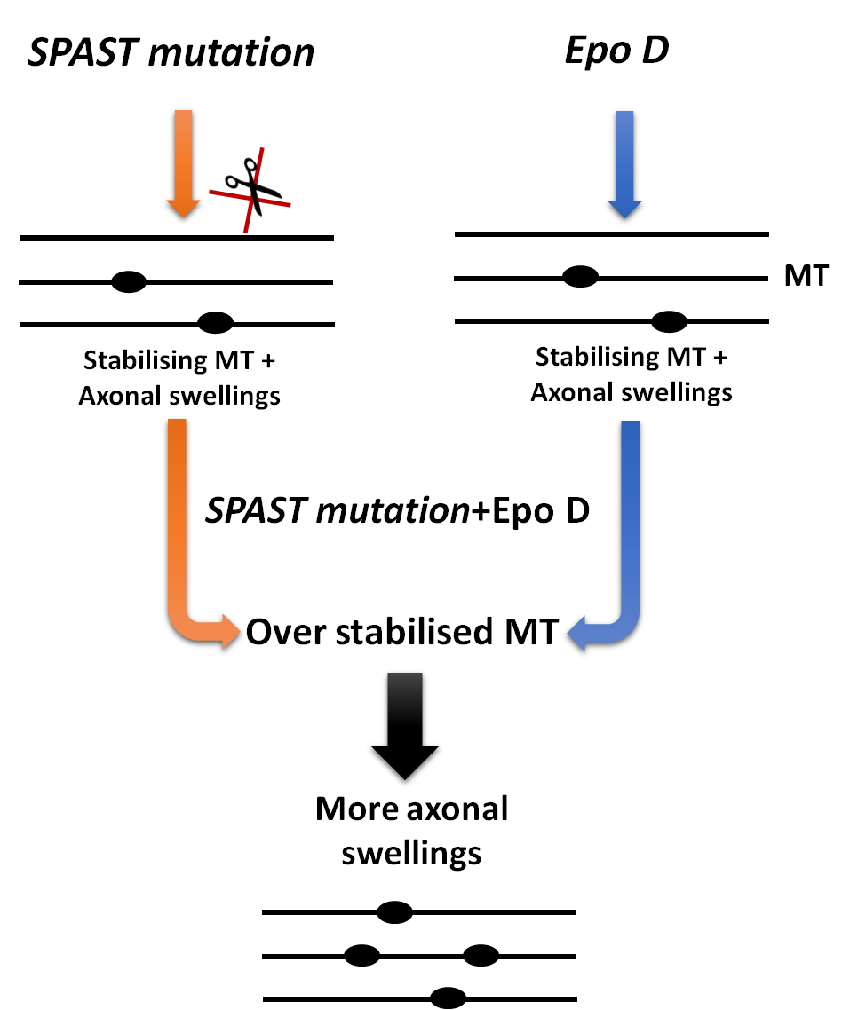

Figure 6.7: Effects of spastin mutation and MT- stabiliser on MT stability.
Both the MT stabilising effect of spastin and EpoD, worsens the HSP phenotype in spastin mouse model, and together they lead to increased swellings pathology.

6.4.3 A possible therapeutic target in the treatment of HSP
In a model of AD, exposing cultured neurons to Aβ causes, tau to be mislocalised from the soma to dendrites where it induces TTLL6 (Tubulin-Tyrosin-Ligase-Like 6) to the dendrites. The latter polyglutamylates the MT and recruits spastin to initiate the severing of MT in the dendrites. This leads spastin to breakdown MT in dendrites causing MT decay (Zempel and Mandelkow, 2015). In the case of AD, stabilising the MT is a good target to reduce MT loss. Also, inhibition of spastin activity could be beneficial in AD (Figure 6.8).
In HSP the opposite of the previous mechanism would be beneficial as tau is important to recruit spastin to sever MT by recruiting TTLL6, to glutamylate MTs, which is appears to mediate the activation of spastin (Lacroix et al., 2010). Therefore targeting tubulin with polyglutamylation by adding TTLL6 to induce the severing activity of spastin would be a therapeutic approach in an HSP mouse model with spastin mutation, rather than seeking to stabilise MTs. However, in SPAST^{ΔE7/ΔE7} mice this approach would only work in heterozygotes since homozygous mutant mice have no spastin protein.

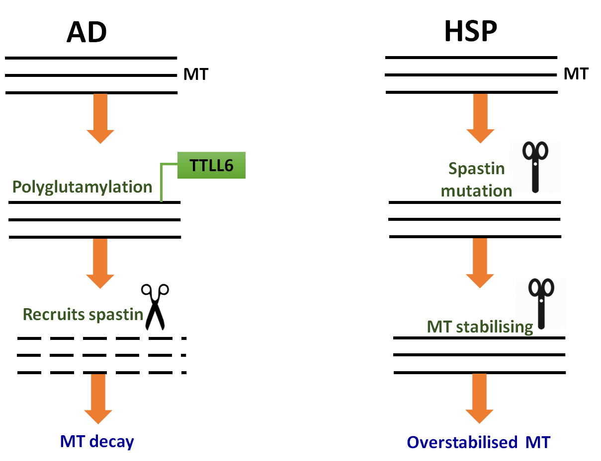

Figure 6.8: Diagram of proposed mechanism of MT severing in both HSP and AD.
In Alzheimer disease (AD) tau misslocalises to dendrites and induces TTLL6 that polyglutamylates MT. TTLL6 recruits spastin leading to over breakdown of MT in dendrites. In HSP, spastin mutation stops the severing activity of MTs, causing MT overstabilising.

6.5 Summary
In this study we investigated the effect of EpoD in vivo on the HSP phenotype. In both symptomatic and presymptomatic treatment, EpoD did not show any improvement in the hind limb BOS. In the spinal cord, of mutant spastin mice but not wildtype controls, EpoD did slightly increase the number of axonal swellings in the cervical region and lumbar region. This increase reached significance in the cervical region. Our data suggests that EpoD, a microtubule stabilising agent that others have reported to be beneficial in vitro in HSP models (Fan et al., 2014), in fact did not show any benefits in an in vivo system. This may be linked to the fact that both loss of function mutations in spastin and EpoD cause stabilisation of MTs. Our findings suggested other therapeutic targets that might alleviate the HSP phenotype. In addition they raise questions about the validity of using axonal swellings as a predictive tool for selecting drugs for preclinical testing in HSP.

Chapter 7: General discussion

Chapter 7: General discussion
HSP is a motor neuron disease characterised by lower limb weakness and spasticity (Klebe et al., 2004). It can occur during any stage of life (Fink, 2003a). According to many studies, SPG4 is considered as the most common cause of HSP (Hazan et al., 1999, Fonknechten et al., 2000). Currently, there is no treatment for HSP except for using anti-spastic drugs to reduce lower limb muscle spasticity (Margetis et al., 2014). More research is therefore required to investigate potential therapeutic approaches in HSP.
Thus, several mouse models of HSP with spastin mutation have been generated (Tarrade et al., 2006, Kasher et al., 2009, Connell et al., 2016) (Chapter 1, Table 1.2). In one of these models SPAST^{ΔE7}, the mice have a mutation which mimics the human c.1092+2T>G mutation, and these mice accordingly exhibit an HSP phenotype, revealed in a wider hindlimb BOS in vivo, and also in vitro in axonal swellings in the spinal cord (Kasher et al., 2009).
Treatment for HSP is challenging, and therefore, in this project we aimed to test different therapeutic approaches using SPAST^{ΔE7} mouse model.

7.1 Effect of exercise on the HSP mouse model
Based on physicians’ recommendations, one of the approaches to reduce the HSP phenotype in humans is exercise; however, this recommendation is not based on any statistically significant evidence. Also, exercise is known to have a preventative effect in relation to many neurodegenerative diseases (Hamer and Chida, 2009). It has been suggested that this beneficial effect on brain health is linked to exercise’s ability to increase blood flow and oxygen to the brain, specifically, it has been reported that voluntary exercise reduces the risk of Alzheimer’s disease by 45% and dementia by 28% (Hamer and Chida, 2009). Also, walking for 1.5 hours in a week is associated with better cognitive performance (Weuve et al., 2004).
We therefore sought to study the effect of exercise on the HSP mouse model in vivo using home cages equipped with running wheels, with the aim ultimately of translating findings to clinical recommendations. The data in Chapter 3 confirms that exercise has an effect in delaying the progression of the disease but it did not show a statistically significant alleviation of symptoms. This was probably due to the small size of the group, since we used just eight mice per group. Applying a post-hoc power calculation, however, it was revealed that at least twelve mice were required to reach statistical significance at most time points. Nonetheless, this finding of the beneficial effect of exercise supports clinical case reports that show a beneficial effect on the functional abilities of HSP patients after physical therapy (Asir John et al., 2013).
Exercise also reduced the number of axonal swellings in the spastin spinal cord, and the effect was significant in the LCST. This finding suggested that voluntary exercise has an indirect effect in terms of reducing axonal swelling. Several studies have shown that exercise benefits neuronal function (Fabel et al., 2009, Kobilo et al., 2011). Voluntary exercise can improve neuronal morphology by increasing synaptic density (Dietrich et al., 2008). The most common pathway that can be modulated by exercise is Brain-derived neurotrophic factor (BDNF). BDNF has a crucial role in synaptic plasticity (Patterson et al., 1996). It has been shown that an increase of BDNF protects neurons against amyloid-beta (Aβ) protein accumulation which induces cell death (Kitiyanant et al., 2012). BDNF supports cytoskeletal changes (Rex et al., 2007), and helps in neurotransmitter release (Bekinschtein et al., 2007). To confirm this in our mouse model, however, we need to measure the level of this neurotrophic factor in spastin mice brain before and after exercise.
Different mouse strains can run different distances per day. Female mice of the BALB/c strain can run 5 km/night (Goh and Ladiges, 2013). In our study, in agreement with previous work, we found that C57BL/Jax female mice can run 15 km/night (De Bono et al., 2006), thus giving a better chance to see the effect of exercise on the gait defect. In humans active people can walk approximately 11km/day (Levine et al., 2008). In the mouse model there are many measurable parameters that can be obtained using the CatWalk system to identify the defect in gait, and to investigate the effect of exercise on gait such as swing duration, swing speed and swing length (Bennett et al., 2014). To translate this to the treatment of humans; patients with HSP should be exposed to a well-designed exercise programme. This could be followed by measuring different gait parameters using an eSHOE (a wearable gait monitoring system). This system targets two main goals, 1) fall prevention and, 2) assistance for diagnosis and rehabilitation treatment. It provides long term analysis of all important gait parameters such as stance time, swing time and double limb support (Jagos and Oberzaucher, 2008). This wearable system offers a new contribution in the understanding of the gait defect and pathological changes in human ambulation, and could be used to investigate HSP patients exercise and gait.

7.2 Effect of chemical inhibition of HDAC6 on the HSP mouse model
Alteration of the level of acetylated α-tubulin is associated with many NDs (Dompierre et al., 2007). Increasing the acetylation of tubulin is therefore a potential therapy for several NDs. One way to increase the acetylation of tubulin is by inhibiting HDAC6, the main Histone deacetylase enzyme (Kawaguchi, 2003). HDAC6 has become an attractive candidate in the treatment of NDs, because of its essential role in a variety of cellular processes (Kawaguchi, 2003).
Table 7.1 summarises some examples of the beneficial effect of inhibiting HDAC6 chemically and genetically. One example is a study into hereditary axonopathies, and with a mouse model of mutant HSPB1 induced CMT, inhibition of HDAC6 restored the acetylated tubulin, and alleviated the axonal transport defects, especially in terms of mitochondria transport; ultimately leading to improved motor function (Benoy et al., 2016). The use of some HDAC6 inhibitors, such as Tubastatin A, is problematic, however because of their limited brain potency; as is shown in Table 7.1 it increased the acetylated tubulin in peripheral nerve but not in the spinal cord (D'Ydewalle et al., 2011). This aligns with our findings on testing Tubastatin A on C56BL/Jax mice as we did not observe any changes in the level of acetylated tubulin in the CNS.
ACY-738 is a highly selective and effective HDAC6 inhibitor (Perez et al., 2009). An in vitro assay of ACY-738 showed that it inhibits the C-terminal deacetylase of HDAC6 which leads to increase acetylation of α-tubulin (Jochems et al., 2014). Many studies have reported a significant increase in the level of acetylated tubulin after ACY-738 administration (Cook et al., 2014, Majid et al., 2015, Benoy et al., 2016) (Table 7.1).
We used ACY-738 treatment at symptomatic and presymptomatic stages. Although ACY-738 increased the level of acetylated tubulin in both SPAST^{+/+} and SPAST^{ΔE7/ΔE7} and in both older and young mice, it did not modify the gait defect. In neuronal cultures, the inhibition of HDAC6 has led to an increase in the acetylation of tubulin as well as mitigation of the axonal transport defect (D'Ydewalle et al., 2011, Benoy et al., 2016). This mitigatory effect occurred in isolated cells, however, which conceivably behave differently from a whole animal model.

Both HDAC6 knockout mouse and flies are viable and develop normally (Zhang et al., 2008, Du et al., 2010), which means genetic approaches are feasible. In Drosophila, crossing null mutant HDAC6 with tau overexpressing flies (a taupathology model) showed improvement in MT defects in muscles and neurons (Xiong et al., 2013). Also, in a mouse model of ALS, HDAC6 knockout has been shown to maintain axon integrity (Taes et al., 2013), while in an amyloid mouse model it mitigated memory defects (Majid et al., 2015).
In the spastin mouse model of HSP the pharmacological inhibition of HDAC6 through ACY-738 had no beneficial effect on gait, suggesting that increases in tubulin acetylation is not a target in the regulation of the MT severing activity of spastin in HSP. This is supported by a study which shows that polyglutamylation rather than acetylation is the modulator for spastin activity (Valenstein and Roll-Mecak, 2016). However, in our SPAST^{ΔE7} mouse model there is no spastin protein, suggesting this mechanism might only be functional in HSP patients as they typically carrying a single functional spastin allele. Another possible pathway that can be targeted in HSP is endosomal trafficking. It has been reported that spastin is involved in the sorting and recycling of endosomal cargoes, as cells lacking spastin showed an increase in endosomal tubulation and defects in the sorting/recycling of cargoes (Allison et al., 2013). In this model loss of spastin leads to an increase in sorting cargos to late endosomes, this is possibly linked to the axonal degeneration in the HSP phenotype of our spastin mouse model. The treatment with M1 spastin is a possible therapy for HSP since M1 has the hydrophobic domain which is localised to the bilayer lipid membrane of ER and involved in ER morphogenesis (Sanderson et al., 2006), also it recruits to the endosome as that might help in sorting and recycling cargoes and possibly reducing axonal swellings in the spinal cord. Thus, gene therapy, by replacing spastin, particularly M1 that can binds and sever MT is a potential therapy for HSP.
Table 7.1: The effect of HDAC6 inhibitors/ HDAC6 knockout in different neurodegenerative disease models.
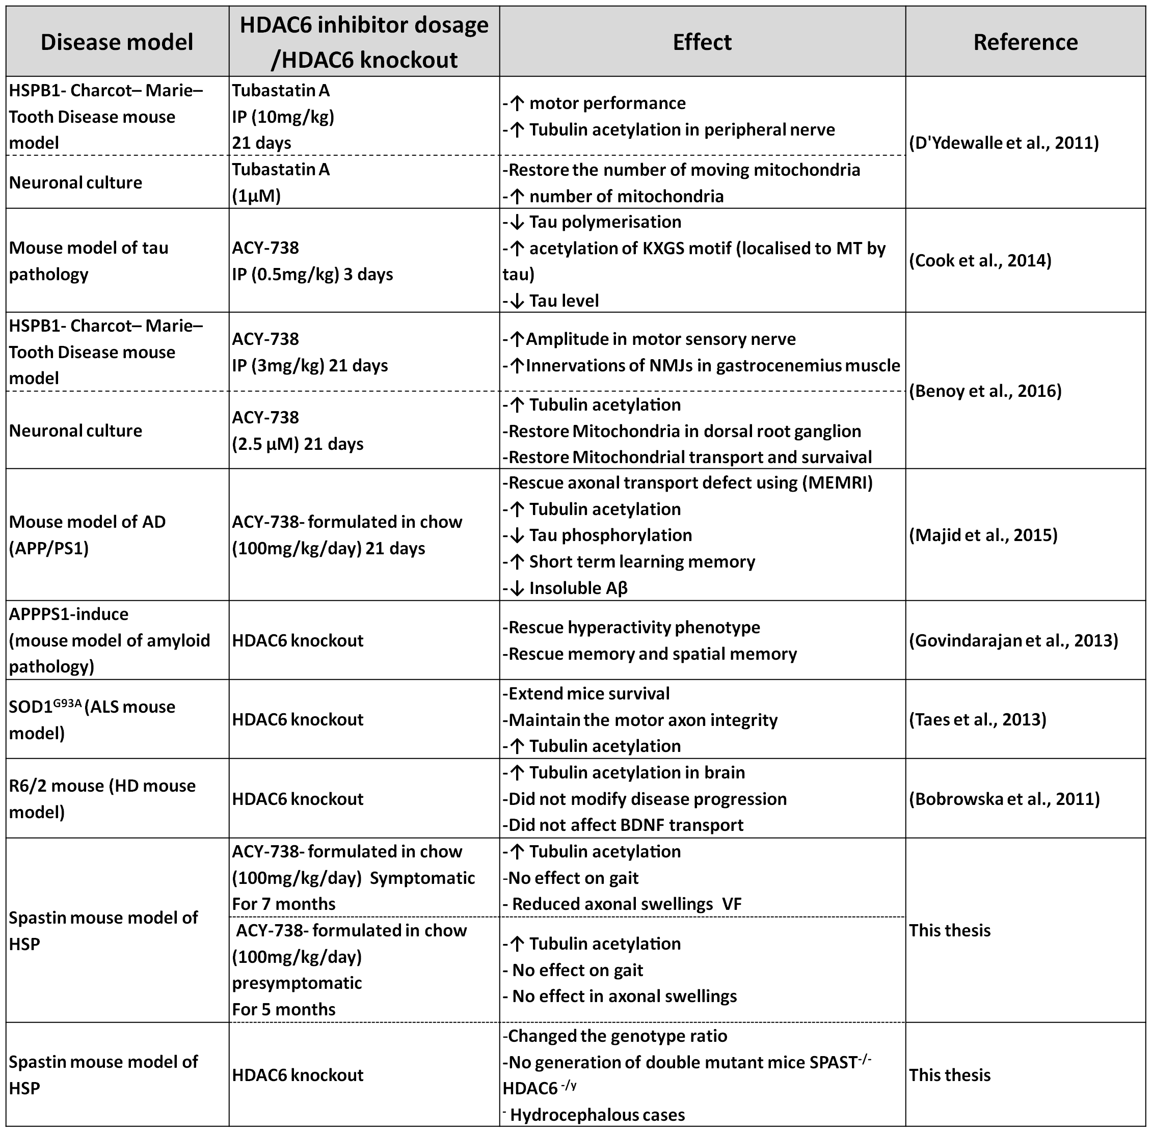

7.3 Novel genetic interaction between SPAST and HDAC6
A significantly higher level of acetylation has been reported in the HDAC6 null mice used in our study, revealing hyperacetylation in the peripheral tissue (Zhang et al., 2003), the cerebellar cortex and striatum (Bobrowska et al., 2011). These findings suggest that the crossing of HDAC6 null mice with spastin mutant mice would have a beneficial effect on the HSP phenotype by increasing axonal transport. In practice, after crossing HDAC6 with SPAST mice, we observed a correct ratio of HDAC6^{+/-} / SPAST^{ΔE7/ΔE7} genotype, but there were 50% fewer than expected HDAC6^{-/y}/ SPAST^{ΔE7/+} and almost no double mutant mice HDAC6^{-/y}/ SPAST^{ΔE7/ΔE7}, we therefore did not conduct the planned experiment.
Because HDAC6^{+/-}/SPAST^{ΔE7/ΔE7} were born at normal ratio, whereas HDAC6^{-/y}/ SPAST^{ΔE7/+} and HDAC6^{-/y}/ SPAST^{ΔE7/ΔE7} were non-viable we believe that the spastin mutation sensitises to HDAC6 deficiency, rather than HDAC6 sensitising to spastin deficiency. This is consistent with spastin regulating HDAC6 function rather than HDAC6 regulating spastin. The mechanism behind this effect is unknown. Considering the function of each gene, however, we anticipate a few pathways that might lead to this phenomenon. Firstly, we know that both genes are involved in MT modification by severing- spastin, and deacetylation- HDAC6. There is no evidence, however, to show that acetylation of tubulin can modulate the severing. Rather it is known that glutamylation of tubulin modulates severing (Lacroix et al., 2010). Secondly, we found that the double mutant mice are likely to be embryonic lethal since the percentage of male double mutant mice at postnatal day one were 70% less than the expected ratio. Although we did not observe any side effects of pharmacological HDAC6 inhibition on spastin mice, we suggest that there was probably a deleterious effect of inhibiting HDAC6 during embryonic development. Thirdly, we observed one case of hydrocephalus among the double mutant mice and another in the SPAST^{ΔE7/+}/ HDAC6^{-/y} group. This suggested that there is another candidate mechanism; ciliary dysfunction. It has been reported that HDAC6 controls cilia motility inside the brain ventricles, (Li et al., 2010). Homeostasis of assembled cilia helps to maintain the flow of the CSF and maintains equilibrium in the brain (Ran et al., 2015). Knockout of HDAC6 might disturb this process in the brain leads to disassembly of motile cilia and thus hydrocephalus. To test this we need to measure the size of the ventricles during the embryonic stage or the flow of CSF and thus to look for the effect of HDAC6 knockout on the cilia that line the ventricles. We also need to determine the effect of spastin mutation on cilia.

7.4 Effect of a MT-stabilising drug on the HSP mouse model
Several MT stabilising drugs have been tested in vivo but have shown only limited brain bio-viability. EpoD, however, has been shown to be able to cross the BBB and to increase the acetylation of tubulin in the brains of mice when administered at 1 mg/kg for seven days (Brunden et al., 2011). This concentration was therefore used to test our hypothesis that using MT stabilising agent would reduce axonal swellings in vivo and rescue HSP gait defects. Although it has been reported that EpoD has a beneficial effect in several NDs models (Table 7.2), in our study we showed that EpoD neither modified the gait defect nor reduced the axonal swellings. Indeed, opposite to the previous finding which shown that EpoD rescued axonal transport defect in ONS cells derived from HSP patients (Fan et al., 2014), we showed that the number of axonal swellings actually tended to increase with EpoD. This finding is consistent with the contention that spastin mutation has a stabilising effect on MT, thus producing axonal swellings (Fassier, 2013). By adding EpoD MT-stabiliser, the MTs may become over-stabilised therefore, worsening the phenotype. Many studies reported beneficial effects of MT- destabilising agents (Table 7.2). One example is a study that showed that using Vinblastin and Nacodazole (MT- destabilising drugs) in primary neuronal culture from knockdown spastin mice, reduced axonal swellings significantly (Fassier, 2013). We might therefore need to test a destabilising agent on spastin mutant mice. Table 7.2 summarises some examples of the beneficial effect of MT stabilising and destabilising agents on different NDs.
Table 7.2: The effect of MT- targeting agents in different neurodegenerative disease models.

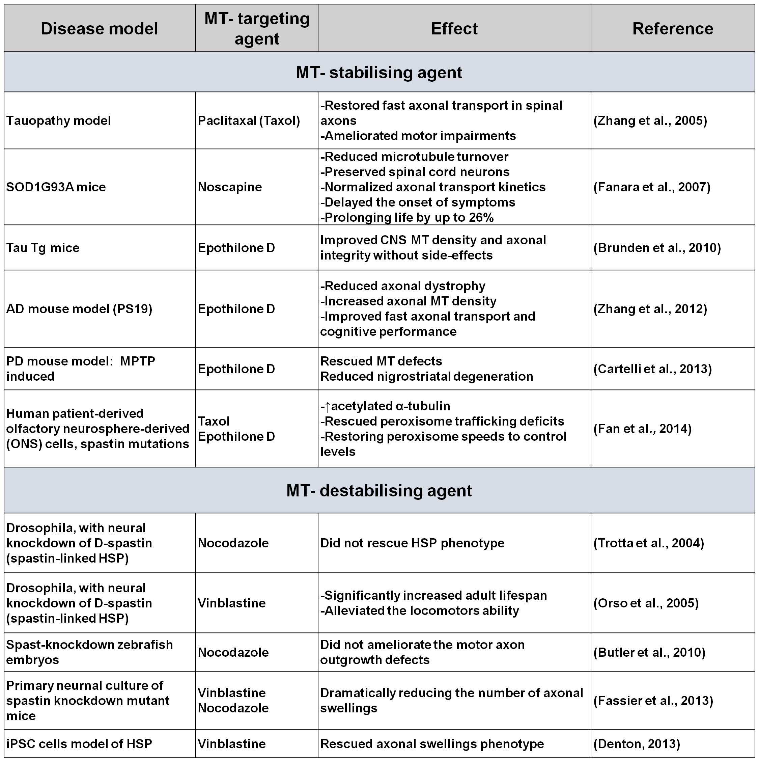

7.5 The onset of the gait defect in the spastin mouse model
The BOS of the HSP model which carries the c.1092+2T>G mutation has been measured previously at 3, 7 and 12 months old (Kasher et al., 2009). The fact that the gait defect was observed at seven months old suggested that it must occur at some stage between three and seven months, since no measurement was taken during this period of time. Here, therefore, we measured the gait defect in separate experiments for males and females from one month onwards. Overall, we found that the gait defect started at 4 months old, with a significant difference between male wildtype vs male mutant and female wildtype vs female mutant.

7.6 There is no relationship between axonal swellings and gait defect in the spastin mouse model of HSP
The precise relationship between axonal swellings and gait impairment in the spastin mouse model of HSP is not yet fully understood. It has previously been suggested that there is a correlation between the HSP disease phenotype and axonal degeneration, characterised by axonal swelling caused by accumulation of cargoes inside the axons (Tarrade et al., 2006). In our study, however, we observed that the gait defect developed in SPAST^{ΔE7/ΔE7} at four months old. In terms of axonal swellings, spastin mice showed the gait defect before the appearance of axonal swellings in the spinal cord, since spinal cord sections from six months old spastin mice did not reveal a significant increase in the number of axonal swellings compared with the wildtype. This evident that there is no correlation between axonal swelling and the gait defect; i.e. that axonal swellings are not the main cause of the HSP phenotype. It does not, however, rule out axonal transport defects as caused in HSP.
Investigating the axonal swellings after chemically inhibiting HDAC6 we found that the number of axonal swellings reduced, although not significantly, but that using the MT-stabiliser EpoD worsened the axonal swellings. The gait defect did not change in either case, however. This again supports the contention that there no relationship between the gait defect and axonal swellings. In the exercise study, however, we noticed that a reduction in the number of axonal swellings appeared to be associated with a delay in the progression of the gait defect. It may be, therefore, that exercise targets a different pathway in the disease leading to broader modifications in the HSP phenotype. Further investigation is therefore required to identify the pathways targeted by exercise in the HSP mouse model.

7.7 Future work
There are several points that need further investigation based upon these studies. Although we showed a reduction in the axonal swellings following exercise and modification of the gait defect, the questions that need to be addressed is whether there is a relationship between the axonal swellings and the gait defect. What mechanism does exercise reduces the number of axonal swellings? Also, since we observed that the HDAC6 inhibitor reduced the axonal swellings but did not modify the gait defect, we need to know if increasing the acetylation of tubulin is a good target to alleviate the HSP phenotype in vivo? It has been reported that another post-translational modification (glutamylation) targets spastin to MTs and this finding also needs further investigation in terms of HSP therapy development.
Also, another area that needs to be addressed is that, given that inhibition of HDAC6 reduces the number of axonal swellings in the spinal cord, but when HDAC6 is inhibited genetically it has a lethal effect on male double mutant mice. What is the genetic basis of the lethal interaction between HDAC6 and spastin? We suggests endosomal trafficking and cilia are two relevant areas for future investigation. We also showed that a MT stabiliser drug EpoD worsened both gait and axonal swelling. We suggest an alternative strategy is to use MT destabilising drugs.

BIBLIOGRAPHY

Abrahamsen G, Fan Y, Matigian N, Wali G, Bellette B, Sutharsan R, Raju J, Wood SA, Veivers D, Sue CM, Mackay-Sim A (2013) A patient-derived stem cell model of hereditary spastic paraplegia with SPAST mutations. Disease Models and Mechanisms 6:489-502.

Adlard PA, Perreau VM, Pop V, Cotman CW (2005) Voluntary exercise decreases amyloid load in a transgenic model of Alzheimer's disease. The Journal of neuroscience : the official journal of the Society for Neuroscience 25:4217.

Allen DL, Harrison BC, Maass A, Bell ML, Byrnes WC, Leinwand LA (2001) Cardiac and skeletal muscle adaptations to voluntary wheel running in the mouse. Journal of applied physiology 90:1900.

Allison R, Lumb JH, Fassier C, Connell JW, Ten Martin D, Seaman MN, Hazan J, Reid E (2013) An ESCRT-spastin interaction promotes fission of recycling tubules from the endosome. TheJournal of Cell Biology 202:527-543.

Amos LA (2011) What tubulin drugs tell us about microtubule structure and dynamics. Seminars in Cell and Developmental Biology 22:916-926.

Andrieux A, Salin P, Schweitzer A, Bégou M, Pachoud B, Brun P, Gory-Fauré S, Kujala P, Suaud-Chagny M-F, Höfle G, Job D (2006) Microtubule Stabilizer Ameliorates Synaptic Function and Behavior in a Mouse Model for Schizophrenia. Biological Psychiatry 60:1224-1230.

Asir John S, Vencita Priyanka A, Trapthi K, Monika P (2013) Physical therapy intervention for the patients with heredity spastic paraparesis- an exploratory case report. International Journal of Physiotherapy and Research 1:110-113.

Ballatore C, Brunden KR, Huryn DM, Trojanowski JQ, Lee VM, Smith AB, 3rd (2012) Microtubule stabilizing agents as potential treatment for Alzheimers disease and related neurodegenerative tauopathies. Journal of Medicinal Chemistry 55:8979-8996.

Bandmann O, Burton EA (2010) Genetic zebrafish models of neurodegenerative diseases. Neurobiology of disease 40:58-65.

Barr FA, Gruneberg U (2007) Cytokinesis: Placing and making the final cut. Cell 131:847-860.

Barten DM, Fanara P, Andorfer C, Hoque N, Wong PYA, Husted KH, Cadelina GW, DeCarr LB, Yang L, Liu V, Fessler C, Protassio J, Riff T, Turner H, Janus CG, Sankaranarayanan S, Polson C, Meredith JE, Gray G, Hanna A, Olson RE, Kim SH, Vite GD, Lee FY, Albright CF (2012) Hyperdynamic Microtubules, Cognitive Deficits, and Pathology Are Improved in Tau Transgenic Mice with Low Doses of the Microtubule-Stabilizing Agent BMS-241027. Journal of Neuroscience 32:7137-7145.

Basterfield L, Lumley LK, Mathers JC (2009) Wheel running in female C57BL/6J mice: impact of oestrus and dietary fat and effects on sleep and body mass. International Journal of Obesity 33:212-218.

Baudier J, Cole RD (1987) Phosphorylation of tau proteins to a state like that in Alzheimer's brain is catalyzed by a calcium/calmodulin-dependent kinase and modulated by phospholipids. The Journal of Biological Chemistry 262:17577-17583.

Beer T, Higano C, Saleh M, Dreicer R, Hudes G, Picus J, Rarick M, Fehrenbacher L, Hannah A (2007) Phase II study of KOS- 862 in patients with metastatic androgen independent prostate cancer previously treated with docetaxel. Investigational New Drugs 25:565-570.

Beetz C, Schule R, Deconinck T, Tran-Viet KN, Zhu H, Kremer BPH, Frints SGM, van Zelst-Stams WAG, Byrne P, Otto S, Nygren AOH, Baets J, Smets K, Ceulemans B, Dan B, Nagan N, Kassubek J, Klimpe S, Klopstock T, Stolze H, Smeets HJM, Schrander-Stumpel C, Hutchinson M, van de Warrenburg BP, Braastad C, Deufel T, Pericak-Vance M, Schols L, de Jonghe P, Zuchner S (2008) REEP1 mutation spectrum and genotype/ phenotype correlation in hereditary spastic paraplegia type 31. Brain 131:1078-1086.

Bekinschtein P, Cammarota M, Igaz LM, Bevilaqua LR, Izquierdo I, Medina JH (2007) Persistence of long-term memory storage requires a late protein synthesis- and BDNF- dependent phase in the hippocampus. Neuron 53:261-277.

Bennett EJ, Mead RJ, Azzouz M, Shaw PJ, Grierson AJ (2014) Early detection of motor dysfunction in the SOD1 G93A mouse model of amyotrophic lateral sclerosis (ALS) using home cage running wheels. PLoS ONE 9.

Benoy V, Vanden Berghe P, Jarpe M, van Damme P, Robberecht W, Van Den Bosch L (2016) Development of Improved HDAC6 Inhibitors as Pharmacological Therapy for Axonal Charcot– Marie– Tooth Disease. Neurotherapeutics 14:1-12.

Bertos NR (2004) Role of the tetradecapeptide repeat domain of human histone deacetylase 6 in cytoplasmic retention. The Journal of Biological Chemistry 279:48246.

Björntorp P, Fahlén M, Grimby G, Gustafson A, Holm J, Renström P, Scherstén T (1972) Carbohydrate and lipid metabolism in middle- aged, physically well- trained men. Metabolism 21:1037-1044.

Blackstone C (2012) Cellular pathways of hereditary spastic paraplegia. Annual Review of Neuroscience 35:25.

Blackstone C, O'Kane CJ, Reid E (2011) Hereditary spastic paraplegias: membrane traffic and the motor pathway. Nature Reviews Neuroscience 12:31-42.

Bobrowska A, Paganetti P, Matthias P, Bates GP, Iijima KM (2011) Hdac6 Knock- Out Increases Tubulin Acetylation but Does Not Modify Disease Progression in the R6/ 2 Mouse Model of Huntingtons Disease. PLoS ONE 6.

Bollag DM, McQueney PA, Zhu J, Hensens O, Koupal L, Liesch J, Goetz M, Lazarides E, Woods CM (1995) Epothilones, a new class of microtubule- stabilizing agents with a taxol- like mechanism of action. Cancer research 55:2325.

Brown CL, Maier KC, Stauber T, Ginkel LM, Wordeman L, Vernos I, Schroer TA (2005) Kinesin-2 is a motor for late endosomes and lysosomes. Traffic 6:1114-1124.

Brunden KR, Yao Y, Potuzak JS, Ferrer NI, Ballatore C, James MJ, Hogan A-ML, Trojanowski JQ, Smith AB, Lee VMY (2011) The characterization of microtubule- stabilizing drugs as possible therapeutic agents for Alzheimer's disease and related tauopathies. Pharmacological Research 63:341-351.

Brunden KR, Zhang B, Carroll J, Yao Y, Potuzak JS, Hogan A-ML, Iba M, James MJ, Xie SX, Ballatore C, Smith AB, Lee VMY, Trojanowski JQ (2010) Epothilone D improves microtubule density, axonal integrity, and cognition in a transgenic mouse model of tauopathy. Journal of Neuroscience 30:13861-13866.

Bruni JE, Delbigio MR, Clattenburg RE (1985) Ependyma - Normal and Pathological - a Review of the Literature. Brain Research Reviews 9:1-19.

Burger JJ, Fonknechten N, Hoeltzenbein M, Neumann L, Hazan J, Reis A (2000) Hereditary spastic paraplegia caused by mutations in the SPG4 gene. American Journal of Human Genetics 67:372-372.

Byers SL, Wiles MV, Dunn SL, Taft RA (2012) Mouse Estrous Cycle Identification Tool and Images. PLoS One 7.

Cabrero JR, Serrador JM, Barreiro O, Mittelbrunn M, Naranjo-Suarez S, Martin-Cofreces N, Vicente-Manzanares M, Mazitschek R, Bradner JE, Avila J, Valenzuela-Fernandez A, Sanchez-Madrid F (2006) Lymphocyte chemotaxis is regulated by histone deacetylase 6, independently of its deacetylase activity. Molecular Biology of the Cell 17:3435-3445.

Cambi F (1995) X- linked pure familial spastic paraparesis. Characterization of a large kindred with magnetic resonance imaging studies. Archives of neurology 52:665.

Carlton JG, Martin-Serrano J (2007) Parallels between cytokinesis and retroviral budding: a role for the ESCRT machinery. Science 316:1908-1912.

Carter RJ, Lione LA, Humby T, Mangiarini L, Mahal A, Bates GP, Dunnett SB, Morton AJ (1999) Characterization of progressive motor deficits in mice transgenic for the human Huntingtons disease mutation. Journal of neuroscience: the official journal of the Society for Neuroscience 19:3248.

Casari G, De Fusco M, Ciarmatori S, Zeviani M, Mora M, Fernandez P, De Michele G, Filla A, Cocozza S, Marconi R, Dürr A, Fontaine B, Ballabio A (1998) Spastic Paraplegia and OXPHOS Impairment Caused by Mutations in Paraplegin, a Nuclear- Encoded Mitochondrial Metalloprotease. Cell 93:973-983.

Chai JH, Locke DP, Greally JM, Knoll JHM, Ohta T, Dunai J, Yavor A, Eichler EE, Nicholls RD (2003) Identification of Four Highly Conserved Genes between Breakpoint Hotspots BP1 and BP2 of the Prader-Willi/Angelman Syndromes Deletion Region That Have Undergone Evolutionary Transposition Mediated by Flanking Duplicons. American Journal of Human Genetics 73:898-925.

Charvin D, Cifuentes-Diaz C, Fonknechten N, Joshi V, Hazan J, Melki J, Betuing S (2003) Mutations of SPG4 are responsible for a loss of function of spastin, an abundant neuronal protein localized in the nucleus. Journal of Human Molecular Genetics 12:71-78.

Chen B, Cepko CL (2009) HDAC4 Regulates Neuronal Survival in Normal and Diseased Retinas. Science 323:256-259.

Chrétien D, Metoz F, Verde F, Karsenti E, Wade RH (1992) Lattice defects in microtubules: protofilament numbers vary within individual microtubules. Journal of Cell Biology 117:1031-1040.

Claudiani P, Riano E, Errico A, Andolfi G, Rugarli EI (2005) Spastin subcellular localization is regulated through usage of different translation start sites and active export from the nucleus. Experimental Cell Research 309:358-369.

Colcombe S, Kramer A (2003) Fitness effects on the cognitive function of older adults: a meta- analytic study. Psychological science 14:125-130.

Connell JW, Allison R, Reid E (2016) Quantitative Gait Analysis Using a Motorized Treadmill System Sensitively Detects Motor Abnormalities in Mice Expressing ATPase Defective Spastin. PLoS ONE 11:e0152413.

Connell JW, Lindon C, Luzio JP, Reid E (2009) Spastin couples microtubule severing to membrane traffic in completion of cytokinesis and secretion. Traffic 10:42-56.

Cook C, Carlomagno Y, Gendron TF, Dunmore J, Scheffel K, Stetler C, Davis M, Dickson D, Jarpe M, DeTure M, Petrucelli L (2014) Acetylation of the KXGS motifs in tau is a critical determinant in modulation of tau aggregation and clearance. Human molecular Genetics 23:104-116.

Coovert DD, Le TT, McAndrew PE, Strasswimmer J, Crawford TO, Mendell JR, Coulson SE, Androphy EJ, Prior TW, Burghes AH (1997) The survival motor neuron protein in spinal muscular atrophy. Human Molecular Genetics 6:1205-1214.

Crews EL, Fuge KW, Oscai LB, Holloszy JO, Shank RE (1969) Weight, food intake, and body composition: effects of exercise and of protein deficiency. The American journal of physiology 216:359.

D'Ydewalle C, Krishnan J, Chiheb DM, Van Damme P, Irobi J, Kozikowski AP, Vanden Berghe P, Timmerman V, Robberecht W, Van Den Bosch L (2011) HDAC6 inhibitors reverse axonal loss in a mouse model of mutant HSPB1- induced Charcot- Marie- Tooth disease. Nature Medicine 17:968-U986.

Dackor J, Strunk KE, Wehmeyer MM, Threadgill DW (2007) Altered trophoblast proliferation is insufficient to account for placental dysfunction in Egfr null embryos. Placenta 28:1211-1218.

Dahme M, Udo B, Rudolf M, Brigitte A, Melitta S, Ned M (1997) Disruption of the mouse L1 gene leads to malformations of the nervous system. Nature Genetics 17:346.

Dan B, Bouillot E, Bengoetxea A, Cheron G (2000) Effect of intrathecal baclofen on gait control in human hereditary spastic paraparesis. Neuroscience Letters 280:175-178.

Daniele C, Francesca C, Carla Letizia B, Domenico B, Gemma M, Anna T, Daniele P, Erminio G, Gianni P, Giuseppe B, Graziella C (2013) Microtubule Alterations Occur Early in Experimental Parkinsonism and The Microtubule Stabilizer Epothilone D Is Neuroprotective. Scientific Reports 3.

De Bono JP, Adlam D, Paterson D, Channon K (2006) Novel quantitative phenotypes of exercise training in mouse models. American Journal Of Physiology-Regulatory Integrative and Comparative Physiology 290:R926-R934.

De Bot ST, van de Warrenburg BP, Kremer HP, Willemsen MA (2010) Child neurology: hereditary spastic paraplegia in children. Neurology 75:e75-79.

De Michele G (1998) A new locus for autosomal recessive hereditary spastic paraplegia maps to chromosome 16q24.3. American Journal of Human Genetics 63:135.

Denton KR, Lei L, Grenier J, Rodionov V, Blackstone C, Li XJ (2014) Loss of spastin function results in disease-specific axonal defects in human pluripotent stem cell-based models of hereditary spastic paraplegia. Stem Cells 32:414-423.

Dere R, Perkins AL, Bawa-Khalfe T, Jonasch D, Walker CL (2015) beta-Catenin Links von Hippel-Lindau to AuroraKinase A and Loss of Primary Cilia in Renal Cell Carcinoma. Journal of The American Society of Nephrology 26:553-564.

Derry WB, Wilson L, Jordan MA (1995) Substoichiometric Binding of Taxol Suppresses Microtubule Dynamics. Journal of Biochemistry 34:2203-2211.

Desai A, Mitchison TJ (1997) Microtubule polymerization dynamics. Annual review of cell and developmental biology 13:83-117.

Dietrich MO, Andrews ZB, Horvath TL (2008) Exercise-induced synaptogenesis in the hippocampus is dependent on UCP2-regulated mitochondrial adaptation. Journal of Neuroscience 28:10766-10771.

Dompierre JP, Godin JD, Charrin BC, Cordelieres FP, King SJ, Humbert S, Saudou F (2007) Histone deacetylase 6 inhibition compensates for the transport deficit in Huntington's disease by increasing tubulin acetylation. Journal of Neuroscience 27:3571-3583.

Drechsel DN, Hyman A. A, Cobb M. H, Kirschner M (1992) Modulation of the dynamic instability of tubulin assembly by the microtubule-associated protein tau. Molecular and Cellular Biology 3:1141-1154.

Du G, Liu X, Chen X, Song M, Yan Y, Jiao R, Wang CC (2010) Drosophila histone deacetylase 6 protects dopaminergic neurons against {alpha}-synuclein toxicity by promoting inclusion formation. Molecular and Cellular Biology 21:2128-2137.

Dunham NW, Miya TS (1957) A note on a simple apparatus for detecting neurological deficit in rats and mice. Journal of the American Pharmaceutical Association 46:208-209.

Edgar JM, McLaughlin M, Yool D, Zhang SC, Fowler JH, Montague P, Barrie JA, McCulloch MC, Duncan ID, Garbern J, Nave KA, Griffiths IR (2004) Oligodendroglial modulation of fast axonal transport in a mouse model of hereditary spastic paraplegia. Journal of Cell Biology 166:121-131.

Errico A, Ballabio A, Rugarli EI (2002) Spastin, the protein mutated in autosomal dominant hereditary spastic paraplegia, is involved in microtubule dynamics. The Journal of Human Molecular Genetics 11:153-163.

Fabel K, Wolf SA, Ehninger D, Babu H, Leal-Galicia P, Kempermann G (2009) Additive effects of physical exercise and environmental enrichment on adult hippocampal neurogenesis in mice. Frontiers in neuroscience 3:50.

Fan Y, Wali G, Sutharsan R, Bellette B, Crane DI, Sue CM, Mackay-Sim A (2014) Low dose tubulin-binding drugs rescue peroxisome trafficking deficit in patient-derived stem cells in Hereditary Spastic Paraplegia. Biology open 3:494-502.

Fassier C, Tarrade A, Peris L, Courageot S, Mailly P, Dalard C, Delga S, Roblot N, Lefevre J, Job D, Hazan J (2013) Microtubule- targeting drugs rescue axonal swellings in cortical neurons from spastin knockout mice. Disease Models and Mechanisms 6:72.

Fellner S, Bauer B, Miller DS, Schaffrik M, Fankhänel M, Spruß T, Bernhardt G, Graeff C, Färber L, Gschaidmeier H, Buschauer A, Fricker G (2002) Transport of paclitaxel ( taxol) across the blood- brain barrier in vitro and in vivo. Journal of Clinical Investigation 110:1309-1318.

Ferreirinha F, Quattrini A, Pirozzi M, Valsecchi V, Dina G, Broccoli V, Auricchio A, Piemonte F, Tozzi G, Gaeta L, Casari G, Ballabio A, Rugarli EI (2004) Axonal degeneration in paraplegin-deficient mice is associated with abnormal mitochondria and impairment of axonal transport. Journal of Clinical Investigation 113:231-242.

Festing MF, Overend P, Das R, Borja M, Berdoy M (2002) The design of animal experiments: reducing the use of animals in research through better experimental design. London: The Royal Society of Medicine Press Limited.

Fink JK (1996) Hereditary spastic paraplegia: advances in genetic research. Neurology 46:1507.

Fink JK (2003a) Advances in the hereditary spastic paraplegias. Experimental Neurology 184:S106-S110.

Fink JK (2003b) The Hereditary Spastic ParaplegiasNine Genes and Counting. Archives of neurology 60:1045-1049.

Finkel T, Deng CX, Mostoslavsky R (2009) Recent progress in the biology and physiology of sirtuins. Nature 460:587-591.

Fonknechten N, Mavel D, Byrne P, Davoine CS, Cruaud C, Bonsch D, Samson D, Coutinho P, Hutchinson M, McMonagle P, Burgunder JM, Tartaglione A, Heinzlef O, Feki I, Deufel T, Parfrey N, Brice A, Fontaine B, Prud'homme JF, Weissenbach J, Durr A, Hazan J (2000) Spectrum of SPG4 mutations in autosomal dominant spastic paraplegia. The Journal of Human Molecular Genetics 9:637-644.

Fransen E, Vancamp G, Vits L, Willems P (1997) L1- associated diseases: clinical geneticists divide, molecular geneticists unite. The Journal of Human Molecular Genetics 6:1625-1632.

Fuller H, Gates M (2016) Recovery of Motor Function Following Spinal Cord Injury. InTech 3-35.

Gao YS, Hubbert CC, Lu J, Lee YS, Lee JY, Yao TP (2007) Histone deacetylase 6 regulates growth factor-induced actin remodeling and endocytosis. Molecular and Cellular Biology 27:8637-8647.

Gao YS, Hubbert CC, Yao TP (2010) The microtubule-associated histone deacetylase 6 (HDAC6) regulates epidermal growth factor receptor (EGFR) endocytic trafficking and degradation. The Journal of Biological Chemistry 285:11219-11226.

Gehlsen GM, Grigsby SA, Winant DM (1984) Effects of an aquatic fitness program on the muscular strength and endurance of patients with multiple sclerosis. Physical Therapy Journal 64:653-657.

Gerkin R, Curry SC, Vance MV, Sankowski PW, Meinhart RD (1986) First- order elimination kinetics following baclofen overdose. Annals of Emergency Medicine 15:843-846.

Gigant B, Wang C, Ravelli RB, Roussi F, Steinmetz MO, Curmi PA, Sobel A, Knossow M (2005) Structural basis for the regulation of tubulin by vinblastine. Nature 435:519-522.

Goh J, Ladiges WC (2013) A novel long term short interval physical activity regime improves body composition in mice. BioMedCentral Research Notes 6:66.

Goldstein LS, Yang Z (2000) Microtubule-based transport systems in neurons: the roles of kinesins and dyneins. Annual Review of Neuroscience 23:39-71.

Gomez-Pinilla F, Ying Z, Opazo P, Roy RR, Edgerton VR (2001) Differential regulation by exercise of BDNF and NT-3 in rat spinal cord and skeletal muscle. European Journal of Neuroscience 13:1078-1084.

Govindarajan N, Rao P, Burkhardt S, Sananbenesi F, Schluter OM, Bradke F, Lu JR, Fischer A (2013) Reducing HDAC6 ameliorates cognitive deficits in a mouse model for Alzheimer's disease. EMBO Molecular Medicine 5:52-63.

Goytain A, Hines RM, El-Husseini A, Quamme GA (2007) NIPA1(SPG6), the basis for autosomal dominant form of hereditary spastic paraplegia, encodes a functional Mg2+ transporter. The Journal of Biological Chemistry 282:8060-8068.

Gregoretti IV, Lee YM, Goodson HV (2004) Molecular evolution of the histone deacetylase family: functional implications of phylogenetic analysis. Journal of molecular biology 338:17-31.

Haggarty SJ, Koeller KM, Wong JC, Grozinger CM, Schreiber SL (2003) Domain- selective small- molecule inhibitor of histone deacetylase 6 (HDAC6)-mediated tubulin deacetylation. Proceedings of the National Academy of Sciences USA 100:4389-4394.

Hamer M, Chida Y (2009) Physical activity and risk of neurodegenerative disease: a systematic review of prospective evidence. Psychological medicine 39:3-11.

Hamers FP, Lankhorst AJ, van Laar TJ, Veldhuis WB, Gispen WH (2001) Automated quantitative gait analysis during overground locomotion in the rat: its application to spinal cord contusion and transection injuries. Journal of Neurotrauma 18:187-201.

Hamm RJ, Pike BR, O'Dell DM, Lyeth BG, Jenkins LW (1994) The rotarod test: an evaluation of its effectiveness in assessing motor deficits following traumatic brain injury. The Journal of Neurotrauma 11:187-196.

Hansen SW (1992) Late-effects after treatment for germ-cell cancer with cisplatin, vinblastine, and bleomycin. Danish medical bulletin 39:391-399.

Harding AE (1981) Hereditary spastic paraplegia: a clinical and genetic study of 22 families. The Lancet 44.10:871-883.

Harding AE (1984) The hereditary ataxias and related disorders: Churchill Livingstone.

Harding AE (1993) Hereditary spastic paraplegias. Semin Neurol 13:333-336.

Hartl FU, Hayer-Hartl M (2002) Molecular chaperones in the cytosol: from nascent chain to folded protein. Science 295:1852-1858.

Haskell WL, Lee IM, Pate RR, Powell KE, Blair SN, Franklin BA, Macera CA, Heath GW, Thompson PD, Bauman A (2007) Physical activity and public health: updated recommendation for adults from the American College of Sports Medicine and the American Heart Association. Medicine and Science in Sports and Exercise 39:1423-1434.

Hazan J, Fonknechten N, Mavel D, Paternotte C, Samson D, Artiguenave F, Davoine CS, Cruaud C, Durr A, Wincker P, Brottier P, Cattolico L, Barbe V, Burgunder JM, Prud'homme JF, Brice A, Fontaine B, Heilig B, Weissenbach J (1999) Spastin, a new AAA protein, is altered in the most frequent form of autosomal dominant spastic paraplegia. Nature Genetics 23:296-303.

Hazan J, Fontaine B, Bruyn RP, Lamy C, van Deutekom JC, Rime CS, Durr A, Melki J, Lyon-Caen O, Agid Y, et al. (1994) Linkage of a new locus for autosomal dominant familial spastic paraplegia to chromosome 2p. Journal of Human Molecular Genetics 3:1569-1573.

Hickey MA, Gallant K, Gross GG, Levine MS, Chesselet MF (2005) Early behavioral deficits in R6/2 mice suitable for use in preclinical drug testing. Neurobiology of disease 20:1-11.

Hirokawa N (1998) Kinesin and dynein superfamily proteins and the mechanism of organelle transport. Science 279:519-526.

Hirokawa N, Noda Y (2008) Intracellular Transport and Kinesin Superfamily Proteins, KIFs: Structure, Function, and Dynamics. Physiological Reviews 88:1089-1118.

Hockly E, Cordery PM, Woodman B, Mahal A, Van Dellen A, Blakemore C, Lewis CM, Hannan AJ, Bates GP (2002) Environmental enrichment slows disease progression in R6/ 2 Huntingtons disease mice. Annuals of Neurology 51:235-242.

Horwich AL, Fenton WA, Chapman E, Farr GW (2007) Two families of chaperonin: physiology and mechanism. Annual review of cell and developmental biology 23:115-145.

Hourani R, El-Hajj T, Barada WH, Hourani M, Yamout BI (2009) MR imaging findings in autosomal recessive hereditary spastic paraplegia. American Journal of Neuroradiology 30:936-940.

Hsu JY, Stein SA, Xu XM (2006) Development of the corticospinal tract in the mouse spinal cord: a quantitative ultrastructural analysis. Brain Research 1084:16-27.

Hubbert C, Guardiola A, Shao R, Kawaguchi Y, Ito A, Nixon A, Yoshida M, Wang XF, Yao TP (2002) HDAC6 is a microtubule- associated deacetylase. Nature 417:455-458.

Ibanez-Tallon I, Pagenstecher A, Fliegauf M, Olbrich H, Kispert A, Ketelsen UP, North A, Heintz N, Omran H (2004) Dysfunction of axonemal dynein heavy chain Mdnah5 inhibits ependymal flow and reveals a novel mechanism for hydrocephalus formation. Human molecular genetics 13:2133-2141.

Igarashi S, Tanno Y, Onodera O, Yamazaki M, Sato S, Ishikawa A, Miyatani N, Nagashima M, Ishikawa Y, Sahashi K, Ibi T, Miyatake T, Tsuji S (1992) Strong Correlation between the Number of Cag Repeats in Androgen Receptor Genes and the Clinical Onset of Features of Spinal and Bulbar Muscular-Atrophy. Neurology 42:2300-2302.

Inoue A, Yoshida N, Omoto Y, Oguchi S, Yamori T, Kiyama R, Hayashi S (2002) Development of cDNA microarray for expression profiling of estrogen-responsive genes. Journal of Molecular Endocrinology 29.2:175-192.

Inoue K (2005) PLP1-related inherited dysmyelinating disorders: Pelizaeus-Merzbacher disease and spastic paraplegia type 2. Neurogenetics 6:1-16.

Ishikawa H, Marshall WF (2011) Ciliogenesis: building the cell's antenna. Nature Reviews Molecular Cell Biology 12:222-234.

Iwata A, Riley BE, Johnston JA, Kopito RR (2005) HDAC6 and microtubules are required for autophagic degradation of aggregated huntingtin. Journal of Biological Chemistry 280:40282-40292.

Jagos H, Oberzaucher J (2008) Development of a wearable measurement system to identify characteristics in human gait - eSHOE. Computers Helping People with Special Needs Proceedings 5105:1301-1304.

Janke, Bulinski (2011) Post- translational regulation of the microtubule cytoskeleton: mechanisms and functions. Nature Reviews Molecular Cell Biology 12:773.

Jasmin BJ, Lavoie PA, Gardiner PF (1988) Fast axonal transport of labeled proteins in motoneurons of exercise-trained rats. American Journal of Physiology 255:731-736.

Jeong MR, Hashimoto R, Senatorov VV, Fujimaki K, Ren M, Lee MS, Chuang DM (2003) Valproic acid, a mood stabilizer and anticonvulsant, protects rat cerebral cortical neurons from spontaneous cell death: a role of histone deacetylase inhibition. FEBS Letter 542:74-78.

Jochems J, Boulden J, Lee BG, Blendy JA, Jarpe M, Mazitschek R, Van Duzer JH, Jones S, Berton O (2014) Antidepressant- like properties of novel HDAC6- selective inhibitors with improved brain bioavailability. Neuropsychopharmacology 39:389-400.

Johnston JA, Illing ME, Kopito RR (2002) Cytoplasmic dynein/dynactin mediates the assembly of aggresomes. Cytoskeleton 53:26-38.

Jones BJ, Roberts DJ (1968) A rotarod suitable for quantitative measurements of motor incoordination in naive mice. Naunyn Schmiedebergs Arch Exp Patholology Pharmacology 259:211.

Jouet M, Rosenthal A, Armstrong G, Macfarlane J, Stevenson R, Paterson J, Metzenberg A, Ionasescu V, Temple K, Kenwrick S (1994) X−linked spastic paraplegia (SPG1), MASA syndrome and X−linked hydrocephalus result from mutations in the L1 gene. Nature Genetics 7:402-407.

Kammermeier L, Spring J, Stierwald M, Burgunder JM, Reichert H (2003) Identification of the Drosophila melanogaster homolog of the human spastin gene. Development Genes and Evolution 213:412-415.

Kasher PR, De Vos KJ, Wharton SB, Manser C, Bennett EJ, Bingley M, Wood JD, Milner R, McDermott CJ, Miller CCJ, Shaw PJ, Grierson AJ (2009) Direct evidence for axonal transport defects in a novel mouse model of mutant spastin- induced hereditary spastic paraplegia ( HSP) and human HSP patients. The Journal of Neurochemistry 110:34-44.

Kawaguchi Y (2003) The deacetylase HDAC6 regulates aggresome formation and cell viability in response to misfolded protein stress. Cell 115:727.

Kent (1982) Exercise and aging. Geriatrics 37:132-135.

Kesiktas N, Paker N, Erdogan N, Gulsen G, Bicki D, Yilmaz H (2004) The use of hydrotherapy for the management of spasticity. Neurorehabilitation and neural repair 18:268-273.

Khan N, Jeffers M, Kumar S, Hackett C, Boldog F, Khramtsov N, Qian XZ, Mills E, Berghs SC, Carey N, Finn PW, Collins LS, Tumber A, Ritchie JW, Jensen PB, Lichenstein HS, Sehested M (2008) Determination of the class and isoform selectivity of small-molecule histone deacetylase inhibitors. Biochemical Journal 409:581-589.

Khorzad R, Lee JA, Whelan M, Brutlag AG, Martin EP, Miyahara LT, Hovda LR (2012) Baclofen toxicosis in dogs and cats: 145 cases (2004-2010). Javma Journal of the American Veterinary Medical Association 241:1059-1064.

Kirschner M, Mitchison T (1986) Beyond self-assembly: From microtubules to morphogenesis. Cell 45:329-342.

Kitiyanant N, Kitiyanant Y, Svendsen CN, Thangnipon W (2012) BDNF-, IGF-1- and GDNF-secreting human neural progenitor cells rescue amyloid beta-induced toxicity in cultured rat septal neurons. Neurochemical research 37:143-152.

Klebe S, Stolze H, Kopper F, Lorenz D, Wenzelburger R, Volkmann J, Porschke H, Deuschl G (2004) Gait analysis of sporadic and hereditary spastic paraplegia. Journal of Neurology 251:571-578.

Kobilo T, Liu QR, Gandhi K, Mughal M, Shaham Y, van Praag H (2011) Running is the neurogenic and neurotrophic stimulus in environmental enrichment. Learning and Memory 18:605-609.

Kopito RR (2000) Aggresomes, inclusion bodies and protein aggregation. Trends Cell Biology 10:524-530.

Kopp C, Ressel V, Wigger E, Tobler I (2006) Influence of estrus cycle and ageing on activity patterns in two inbred mouse strains. Behavioural brain research 167:165-174.

Kruger R, Kuhn W, Muller T, Woitalla D, Graeber M, Kosel S, Przuntek H, Epplen JT, Schols L, Riess O (1998) Ala30Pro mutation in the gene encoding alpha-synuclein in Parkinson's disease. Nature Genetics 18:106-108.

Lacroix B, van Dijk J, Gold ND, Guizetti J, Aldrian-Herrada G, Rogowski K, Gerlich DW, Janke C (2010) Tubulin polyglutamylation stimulates spastin-mediated microtubule severing. Journal of Cell Biology 189:945-954.

Langley B, Annibale MA, Suh K, Ayoub I, Tolhurst A, Bastan B, Yang L, Ko B, Fisher M, Cho S, Beal MF, Ratan RR (2008) Pulse inhibition of histone deacetylases induces complete resistance to oxidative death in cortical neurons without toxicity and reveals a role for cytoplasmic p21(waf1/cip1) in cell cycle-independent neuroprotection. Journal of Neuroscience 28:163-176.

Lau YS, Patki G, Das-Panja K, Le WD, Ahmad SO (2011) Neuroprotective effects and mechanisms of exercise in a chronic mouse model of Parkinson's disease with moderate neurodegeneration. European Journal of Neuroscience 33:1264-1274.

Lee TC, Threadgill DW (2009) Generation and validation of mice carrying a conditional allele of the epidermal growth factor receptor. Genesis 47:85-92.

Lee YS, Lim KH, Guo X, Kawaguchi Y, Gao YS, Barrientos T, Ordentlich P, Wang XF, Counter CM, Yao TP (2008) The cytoplasmic deacetylase HDAC6 is required for efficient oncogenic tumorigenesis. Cancer Research 68:7561-7569.

Lemmon SK, Traub LM (2000) Sorting in the endosomal system in yeast and animal cells. Current opinion in cell biology 12:457-466.

Lena W, Raul H, Katrin H, Haicui W, Thomas V, Eric PH, Sebahattin C (2016) Homozygous mutation in Atlastin GTPase 1 causes recessive hereditary spastic paraplegia. Journal of Human Genetics 61:571-573.

Levine JA, McCrady SK, Lanningham-Foster LM, Kane PH, Foster RC, Manohar CU (2008) The role of free-living daily walking in human weight gain and obesity. Diabetes 57:548-554.

Li Y, Shin D, Kwon SH (2013) Histone deacetylase 6 plays a role as a distinct regulator of diverse cellular processes. In: FEBS Journal, vol. 280, pp 775-793.

Li YJ, Wei Q, Zhang YX, Ling K, Hu JH (2010) The small GTPases ARL-13 and ARL-3 coordinate intraflagellar transport and ciliogenesis. Journal of Cell Biology 189:1039-1051.

Liron T, Raphael B, Hiram-Bab S, Bab IA, Gabet Y (2017) Bone Loss in C57BL/6J-OlaHsd Mice, a Substrain of C57BL/6J Carrying Mutated Alpha-Synuclein and Multimerin-1 Genes: Snca and Mmrn1- related bone loss in OLA mice. Journal of Cellular Physiology 233:371-377.

Lou K, Yao Y, Hoye AT, James MJ, Cornec A-S, Hyde E, Gay B, Lee VMY, Trojanowski JQ, Smith AB, Brunden KR, Ballatore C (2014) Brain- penetrant, orally bioavailable microtubule- stabilizing small molecules are potential candidate therapeutics for Alzheimer's disease and related tauopathies. Journal of medicinal chemistry 57:6116.

Lumb JH, Connell JW, Allison R, Reid E (2012) The AAA ATPase spastin links microtubule severing to membrane modelling. Biochimica Et Biophysica Acta-Molecular Cell Research 1823:192-197.

Lupas AN, Martin J (2002) AAA proteins. Current Opinion in Structural Biology 12:746-753.

Magariello A, Muglia M, Patitucci A, Mazzei R, Conforti FL, Gabriele AL, Sprovieri T, Ungaro C, Gambardella A, Mancuso M, Siciliano G, Branca D, Aguglia U, de Angelis MV, Longo K, Quattrone A (2006) Novel spastin (SPG4) mutations in Italian patients with hereditary spastic paraplegia. Neuromuscular Disorders 16:387-390.

Mahlknecht U, Schnittger S, Landgraf F, Schoch C, Ottmann OG, Hiddemann W, Hoelzer D (2001) Assignment of the human histone deacetylase 6 gene (HDAC6) to X chromosome p11.23 by in situ hybridization. Cytogenet Cell Genet 93:135-136.

Mai A, Massa S, Pezzi R, Simeoni S, Rotili D, Nebbioso A, Scognamiglio A, Altucci L, Loidl P, Brosch G (2005) Class II ( IIa)-selective histone deacetylase inhibitors. 1. Synthesis and biological evaluation of novel ( aryloxopropenyl) pyrrolyl hydroxyamides. Journal of Medicinal Chemistry 48:3344-3353.

Majid T, Griffin D, Criss Z, Jarpe M, Pautler RG (2015) Pharmocologic treatment with histone deacetylase 6 inhibitor (ACY-738) recovers Alzheimer's disease phenotype in amyloid precursor protein/presenilin 1 (APP/PS1) mice. Alzheimer's & Dementia: Translational Research & Clinical Interventions 1:170-181.

Mannan AU, Boehm J, Sauter SM, Rauber A, Byrne PC, Neesen J, Engel W (2006) Spastin, the most commonly mutated protein in hereditary spastic paraplegia interacts with Reticulon 1 an endoplasmic reticulum protein. Neurogenetics 7:93-103.

Margetis K, Papageorgiou G, Gatzonis S, Politis K, Siatouni A, Sakas D (2014) Intrathecal baclofen improves psychiatric symptoms in spasticity patients. Journal of Clinical Psychopharmacology 34:374-379.

Martin EJ, Kim M, Velier J, Sapp E, Lee HS, Laforet G, Won L, Chase K, Bhide PG, Heller A, Aronin N, Difiglia M (1999) Analysis of Huntingtin-associated protein 1 in mouse brain and immortalized striatal neurons. Journal of Comparative Neurology 403:421-430.

Matigian N, Abrahamsen G, Sutharsan R, Cook AL, Vitale AM, Nouwens A, Bellette B, An J, Anderson M, Beckhouse AG, Bennebroek M, Cecil R, Chalk AM, Cochrane J, Fan Y, Feron F, McCurdy R, McGrath JJ, Murrell W, Perry C, Raju J, Ravishankar S, Silburn PA, Sutherland GT, Mahler S, Mellick GD, Wood SA, Sue CM, Wells CA, Mackay-Sim A (2010) Disease-specific, neurosphere-derived cells as models for brain disorders. Disease Models and Mechanisms 3:785-798.

McDermott CJ, Burness CE, Kirby J, Cox LE, Rao DG, Hewamadduma C, Sharrack B, Hadjivassiliou M, Chinnery PF, Dalton A, Shaw PJ (2006) Clinical features of hereditary spastic paraplegia due to spastin mutation. Neurology 67:45.

McDermott CJ, Grierson AJ, Wood JD, Bingley M, Wharton SB, Bushby KMD, Shaw PJ (2003) Hereditary spastic paraparesis: Disrupted intracellular transport associated with spastin mutation. Annals Neurology Journal 54:748-759.

Mekada K, Abe K, Murakami A, Nakamura S, Nakata H, Moriwaki K, Obata Y, Yoshiki A (2009) Genetic differences among C57BL/ 6 substrains. Experimental animals 58:141.

Mitchison T, Kirschner M (1984) Dynamic Instability of Microtubule Growth. Nature 312:237-242.

Mollinedo F, Gajate C (2003) Microtubules, microtubule-interfering agents and apoptosis. Apoptosis 8:413-450.

Namekawa M, Muriel MP, Janer A, Latouche M, Dauphin A, Debeir T, Martin E, Duyckaerts C, Prigent A, Depienne C, Sittler A, Brice A, Ruberg M (2007) Mutations in the SPG3A gene encoding the GTPase atlastin interfere with vesicle trafficking in the ER/Golgi interface and Golgi morphogenesis. Molecular and Cellular Neuroscience 35:1-13.

Namekawa M, Ribai P, Nelson I, Forlani S, Fellmann F, Goizet C, Depienne C, Stevanin G, Ruberg M, Durr A, Brice A (2006) SPG3A is the most frequent cause of hereditary spastic paraplegia with onset before age 10 years. Neurology 66:112-114.

Nogales E, Whittaker M, Milligan RA, Downing KH (1999) High-Resolution Model of the Microtubule. Cell 96:79-88.

North BJ, Marshall BL, Borra MT, Denu JM, Verdin E (2003) The Human Sir2 Ortholog, SIRT2, Is an NAD+-Dependent Tubulin Deacetylase. Molecular Cell 11:437-444.

Orso G, Martinuzzi A, Rossetto MG, Sartori E, Feany M, Daga A (2005) Disease-related phenotypes in a Drosophila model of hereditary spastic paraplegia are ameliorated by treatment with vinblastine. Journal of Clinical Investigation 115:3026-3034.

Pang TYC, Stam NC, Nithianantharajah J, Howard ML, Hannan AJ (2006) Differential effects of voluntary physical exercise on behavioral and brain-derived neurotrophic factor expression deficits in huntington’s disease transgenic mice. Neuroscience 141:569-584.

Park SH, Zhu PP, Parker RL, Blackstone C (2010) Hereditary spastic paraplegia proteins REEP1, spastin, and atlastin- 1 coordinate microtubule interactions with the tubular ER network. Journal of Clinical Investigation 120:1097-1110.

Patel S, Latterich M (1998) The AAA team: related ATPases with diverse functions. Trends Cell Biology 8:65-71.

Patterson SL, Abel T, Deuel TA, Martin KC, Rose JC, Kandel ER (1996) Recombinant BDNF rescues deficits in basal synaptic transmission and hippocampal LTP in BDNF knockout mice. Neuron 16:1137-1145.

Penny EB, McCabe BD (2005) All neuropathies great and small. Journal of Clinical Investigation 115:2968-2971.

Perez M, Santa-Maria I, Gomez de Barreda E, Zhu X, Cuadros R, Cabrero JR, Sanchez-Madrid F, Dawson HN, Vitek MP, Perry G, Smith MA, Avila J (2009) Tau-an inhibitor of deacetylase HDAC6 function. Journal of Neurochemistry 109:1756-1766.

Polo S, Di Fiore PP (2006) Endocytosis conducts the cell signaling orchestra. Cell 124:897-900.

Pryer NK, Walker RA, Skeen VP, Bourns BD, Soboeiro MF, Salmon ED (1992) Brain microtubule-associated proteins modulate microtubule dynamic instability in vitro. Real-time observations using video microscopy. Journal Cell Science 103:965-976.

Rainier S, Chai JH, Tokarz D, Nicholls RD, Fink JK (2003) NIPA1 gene mutations cause autosomal dominant hereditary spastic paraplegia ( SPG6). American Journal of Human Genetics 73:967-971.

Ran J, Yang YF, Li DW, Liu M, Zhou J (2015) Deacetylation of alpha-tubulin and cortactin is required for HDAC6 to trigger ciliary disassembly. Scientific Reports 5:12917.

Rangasamy SB, Soderstrom K, Bakay RA, Kordower JH (2010) Neurotrophic factor therapy for Parkinson's disease. Progress in brain research 184:237-264.

Reed NA, Cai D, Blasius TL, Jih GT, Meyhofer E, Gaertig J, Verhey KJ (2006) Microtubule Acetylation Promotes Kinesin-1 Binding and Transport. Current biology 16:2166-2172.

Reheman A, Tasneem S, Ni H, Hayward CPM (2010) Mice with deleted multimerin 1 and α- synuclein genes have impaired platelet adhesion and impaired thrombus formation that is corrected by multimerin 1. Thrombosis Research 125:e177-e183.

Rendina-Ruedy E, Hembree KD, Sasaki A, Davis MR, Lightfoot SA, Clarke SL, Lucas EA, Smith BJ (2015) A Comparative Study of the Metabolic and Skeletal Response of C57BL/ 6J and C57BL/ 6N Mice in a Diet- Induced Model of Type 2 Diabetes. Journal of Nutrition and Metabolism 2015.

Rex CS, Lin CY, Kramar EA, Chen LY, Gall CM, Lynch G (2007) Brain-derived neurotrophic factor promotes long-term potentiation-related cytoskeletal changes in adult hippocampus. Journal of Neuroscience 27:3017-3029.

Rismanchi N, Soderblom C, Stadler J, Zhu PP, Blackstone C (2008) Atlastin GTPases are required for Golgi apparatus and ER morphogenesis. The Journal of Human Molecular Genetics 17:1591-1604.

Roll-Mecak A, McNally FJ (2010) Microtubule- severing enzymes. Current opinion in cell biology 22:96-103.

Roy S, Zhang B, Lee VMY, Trojanowski JQ (2005) Axonal transport defects: a common theme in neurodegenerative diseases. Acta neuropathologica 109:5-13.

Saha RN, Pahan K (2006) HATs and HDACs in neurodegeneration: a tale of disconcerted acetylation homeostasis. Cell death and differentiation 13:539-550.

Salinas S, Carazo-Salas RE, Proukakis C, Cooper JM, Weston AE, Schiavo G, Warner TT (2005) Human spastin has multiple microtubule-related functions. The Journal of Neurochemistry 95:1411-1420.

Sanderson CM, Connell JW, Bright NA, Duley S, Thompson A, Luzio JP, Reid E (2006) Spastin and atlastin, two proteins mutated in autosomal- dominant hereditary spastic paraplegia, are binding partners. Journal of Human Molecular Genetics 15:307-318.

Saugier-Veber P, Munnich A, Bonneau D, Rozet J, Le Merrer M, Gil R, Boespflug O-T (1994) X-linked spastic paraplegia and Pelizaeus-Merzbacher disease are allelic disorders at the proteolipid protein locus. Nature Genetics 6:257-262.

Schiff, Horwitz S (1981) Taxol assembles tubulin in the absence of exogenous guanosine 5'-triphosphate or microtubule-associated proteins. Biochemistry 20:3247.

Seaman MN (2008) Endosome protein sorting: motifs and machinery. Cellular and Molecular Life Sciences 65:2842-2858.

Seigneurin-Berny D, Verdel A, Curtet S, Lemercier C, Garin J, Rousseaux S, Khochbin S (2001) Identification of components of the murine histone deacetylase 6 complex: Link between acetylation and ubiquitination signaling pathways. Molecular Biology of the Cell 21:8035-8044.

Serrao M, Rinaldi M, Ranavolo A, Lacquaniti F, Martino G, Leonardi L, Conte C, Varrecchia T, Draicchio F, Coppola G, Casali C, Pierelli F (2016) Gait Patterns in Patients with Hereditary Spastic Paraparesis. PLoS One 11:e0164623.

Sherwood NT, Sun Q, Xue M, Zhang B, Zinn K (2004) Drosophila spastin regulates synaptic microtubule networks and is required for normal motor function. PLoS Biology 2:e429.

Shimazaki H, Takiyama Y, Ishiura H, Sakai C, Matsushima Y, Hatakeyama H, Honda J, Sakoe K, Naoi T, Namekawa M, Fukuda Y, Takahashi Y, Goto J, Tsuji S, Goto Y-I, Nakano I (2012) A homozygous mutation of C12orf65 causes spastic paraplegia with optic atrophy and neuropathy (SPG55). Journal of Medical Genetics 49:777.

Simões-pires C, Zwick V, Nurisso A, Schenker E, Carrupt P-a, Cuendet M, Simões-Pires C, Carrupt P-A (2013) HDAC6 as a target for neurodegenerative diseases: what makes it different from the other HDACs? Molecular neurodegeneration 8:7.

Snell RS (2010) Clinical neuroanatomy: Lippincott Williams & Wilkins.

Solowska J, Garbern J, Baas P (2010) Evaluation of loss of function as an explanation for SPG4- based hereditary spastic paraplegia. The Journal of Human Molecular Genetics 19:2767-2779.

Solowska JM, Morfini G, Falnikar A, Himes BT, Brady ST, Huang D, Baas PW (2008) Quantitative and functional analyses of spastin in the nervous system: implications for hereditary spastic paraplegia. Journal of Neuroscience 28:2147-2157.

Specht CG, Schoepfer R (2001) Deletion of the alpha-synuclein locus in a subpopulation of C57BL/6J inbred mice. BioMedCentral Neuroscience Journal 2:11.

Specht CG, Schoepfer R (2004) Deletion of multimerin-1 in alpha-synuclein-deficient mice. Genomics 83:1176-1178.

Stiess M, Maghelli N, Kapitein LC, Gomis-Rüth S, Wilsch-Bräuninger M, Hoogenraad CC, Tolić-Nørrelykke IM, Bradke F (2010) Axon extension occurs independently of centrosomal microtubule nucleation. Science 327:704.

Sudo H, Baas PW (2010) Acetylation of microtubules influences their sensitivity to severing by katanin in neurons and fibroblasts. Journal of Neuroscience 30:7215-7226.

Svensson M, Lexell J, Deierborg T (2015) Effects of Physical Exercise on Neuroinflammation, Neuroplasticity, Neurodegeneration, and Behavior: What We Can Learn From Animal Models in Clinical Settings. Neurorehabilitation and neural repair 29:577-589.

Taes I, Timmers M, Hersmus N, Bento-Abreu A, Van Den bosch L, Van damme P, Auwerx J, Robberecht W (2013) Hdac6 deletion delays disease progression in the sod1 g93a mouse model of als. Human molecular genetics 22:1783-1790.

Talbot K (2002) Motor neurone disease. Postgraduate Medical Journal 78:513-519.

Tarrade A, Fassier C, Charvin D, Vitte J, Peris L, Thorel A, Mouisel E, Fonknechten N, Roblot N, Seilhean D, Dierich A, Hauw JJ, Melki J (2006) A mutation of spastin is responsible for swellings and impairment of transport in a region of axon characterized by changes in microtubule composition. Human Molecular Genetics 15:3544-3558.

Timmerman V, Clowes VE, Reid E (2012) Overlapping molecular pathological themes link Charcot- Marie- Tooth neuropathies and hereditary spastic paraplegias. Experimental Neurology 246:14-25.

Toso RJ, Jordan MA, Farrell KW, Matsumoto B, Wilson L (1993) Kinetic stabilization of microtubule dynamic instability in vitro by vinblastine. Journal of Biochemistry 32:1285-1293.

Traer CJ, Rutherford AC, Palmer KJ, Wassmer T, Oakley J, Attar N, Carlton JG, Kremerskothen J, Stephens DJ, Cullen PJ (2007) SNX4 coordinates endosomal sorting of TfnR with dynein-mediated transport into the endocytic recycling compartment. Nature cell biology 9:1370-1380.

Trotta N, Orso G, Rossetto MG, Daga A, Broadie K (2004) The hereditary spastic paraplegia gene, spastin, regulates microtubule stability to modulate synaptic structure and function. Current Biology 14:1135-1147.

Tsang HTH, Edwards TL, Wang X, Connell JW, Davies RJ, Durrington HJ, kane CJ, Luzio JP, Reid E, Kane CJ (2009) The hereditary spastic paraplegia proteins NIPA1, spastin and spartin are inhibitors of mammalian BMP signalling. The Journal of Human Molecular Genetics 18:3805-3821.

Valenstein ML, Roll-Mecak A (2016) Graded Control of Microtubule Severing by Tubulin Glutamylation. Cell 164:911-921.

Van Dellen A, Blakemore C, Deacon R, York D, Hannan AJ (2000) Delaying the onset of Huntington's in mice. Nature 404:721-722.

Van Praag H, Kempermann G, Gage FH (1999) Running increases cell proliferation and neurogenesis in the adult mouse dentate gyrus. Nature Neuroscience 2:266-270.

Vandeputte C, Taymans J-M, Casteels C, Coun F, Ni Y, Van Laere K, Baekelandt V (2010) Automated quantitative gait analysis in animal models of movement disorders. BMC neuroscience 11:92.

Vaynman SS, Ying Z, Yin D, Gomez-Pinilla F (2006) Exercise differentially regulates synaptic proteins associated to the function of BDNF. Brain Research 1070:124-130.

Verdel A, Curtet S, Brocard M-P, Rousseaux S, Lemercier C, Yoshida M, Khochbin S (2000) Active maintenance of mHDA2/mHDAC6 histone-deacetylase in the cytoplasm. Current biology 10:747-749.

Walker JE, Saraste M, Runswick MJ, Gay NJ (1982) Distantly Related Sequences in the Alpha-Subunits and Beta-Subunits of Atp Synthase, Myosin, Kinases and Other Atp-Requiring Enzymes and a Common Nucleotide Binding Fold. The Journal of European Molecular Biology Organization 1:945-951.

Walker RA, Brien ET, Pryer NK, Soboeiro MF, Voter WA, Erickson HP, Salmon ED (1988) Dynamic instability of individual microtubules analyzed by video light microscopy: rate constants and transition frequencies. Journal of Cell Biology 107:1437-1448.
Wang L, Brown A (2002) Rapid Movement of Microtubules in Axons. Current biology 12:1496-1501.

Wang X, Shaw R, Tsang H, Reid E, 'Kane C (2007) Drosophila spichthyin inhibits BMP signaling and regulates synaptic growth and axonal microtubules. Nature Neuroscience 10:177-185.

Watanabe DF, Arnold EW, Hammer YR, Ghodsizadeh YO, Moti YH, Schumer YM, Hashmi YA, Hernandez YA, Sneh YA, Sahenk YZ, Kisanuki YY (2013) Pathogenesis of Autosomal Dominant Hereditary Spastic Paraplegia (SPG6) Revealed by a Rat Model. Journal of Neuropathology and Experimental Neurology 72:1016-1028.

Weimann JM, Zhang YA, Levin ME, Devine WP, Brulet P, McConnell SK (1999) Cortical neurons require Otx1 for the refinement of exuberant axonal projections to subcortical targets. Neuron 24:819-831.

Weller RO, Kida S, Zhang ET (1992) Pathways of Fluid Drainage from the Brain - Morphological Aspects and Immunological Significance in Rat and Man. Journal of Brain Pathology 2:277-284.

Weuve J, Kang JH, Manson JE, Breteler MM, Ware JH, Grodstein F (2004) Physical activity, including walking, and cognitive function in older women. JAMA- Journal of American Medical Association 292:1454-1461.

Weydt P, Hong SY, Kliot M, Moller T (2003) Assessing disease onset and progression in the SOD1 mouse model of ALS. Neuroreport 14:1051-1054.

White SR, Evans KJ, Lary J, Cole JL, Lauring B (2007) Recognition of C- terminal amino acids in tubulin by pore loops in Spastin is important for microtubule severing. The Journal of Cell Biology 176:995-1005.

Wickstrom SA, Masoumi KC, Khochbin S, Fassler R, Massoumi R (2010) CYLD negatively regulates cell- cycle progression by inactivating HDAC6 and increasing the levels of acetylated tubulin. European Molecular Biology Organization 29:131-144.

Wood JD, Landers JA, Bingley M, McDermott CJ, Thomas-McArthur V, Gleadall LJ, Shaw PJ, Cunliffe VT (2006) The microtubule- severing protein Spastin is essential for axon outgrowth in the zebrafish embryo. Journal of Human Molecular Genetics 15:2763-2771.

Wood PM, Schachner M, Bunge RP (1990) Inhibition of Schwann cell myelination in vitro by antibody to the L1 adhesion molecule. Journal of Neuroscience 10:3635-3645.

Wooley CM, Sher RB, Kale A, Frankel WN, Cox GA, Seburn KL (2005) Gait analysis detects early changes in transgenic SOD1(G93A) mice. Muscle and Nerve 32:43-50.

Xiong Y, Zhao K, Wu J, Xu Z, Jin S, Zhang YQ (2013) HDAC6 mutations rescue human tau-induced microtubule defects in Drosophila. Proceedings of the National Academy of Sciences USA 110:4604-4609.

Xu S, Parmigiani RB, Marks PA (2007) Histone deacetylase inhibitors: molecular mechanisms of action. Oncogene 26:5541-5552.

Yamanaka K, Miller TM, McAlonis-Downes M, Chun SJ, Cleveland DW (2006) Progressive spinal axonal degeneration and slowness in ALS2-deficient mice. Annual Neurology 60:95-104.

Yang D, Rismanchi N, Renvoise B, Lippincott-Schwartz J, Blackstone C, Hurley JH (2008) Structural basis for midbody targeting of spastin by the ESCRT-III protein CHMP1B. Nature structural and molecular biology 15:1278-1286.

Yang XY, Skoff RP (1997) Proteolipid protein regulates the survival and differentiation of oligodendrocytes. Journal of Neuroscience 17:2056-2070.

Yool DA, Edgar JM, Montague P, Malcolm S (2000) The proteolipid protein gene and myelin disorders in man and animal models. Journal of Human Molecular Genetics 9:987-992.

Zempel H, Mandelkow EM (2015) Tau missorting and spastin-induced microtubule disruption in neurodegeneration: Alzheimer Disease and Hereditary Spastic Paraplegia. Molecular Neurodegeneration 10:68.

Zhang B, Carroll J, Trojanowski JQ, Yao YM, Iba M, Potuzak JS, Hogan AML, Xie SX, Ballatore C, Smith AB, Lee VMY, Brunden KR (2012) The Microtubule-Stabilizing Agent, Epothilone D, Reduces Axonal Dysfunction, Neurotoxicity, Cognitive Deficits, and Alzheimer-Like Pathology in an Interventional Study with Aged Tau Transgenic Mice. Journal of Neuroscience 32:3601-3611.

Zhang L, Liu C, Wu J, Tao J-J, Sui X-L, Yao Z-G, Xu Y-F, Huang L, Zhu H, Sheng S-L, Qin C (2014a) Tubastatin A/ ACY- 1215 improves cognition in Alzheimer's disease transgenic mice. Journal of Alzheimer's disease 41:1193.

Zhang L, Liu S, Liu N, Zhang Y, Liu M, Li D, Seto E, Yao TP, Shui W, Zhou J (2015) Proteomic identification and functional characterization of MYH9, Hsc70, and DNAJA1 as novel substrates of HDAC6 deacetylase activity. Protein & cell 6:42-54.

Zhang Y, Kwon S, Yamaguchi T, Cubizolles F, Rousseaux S, Kneissel M, Cao C, Li N, Cheng HL, Chua K, Lombard D, Mizeracki A, Matthias G, Alt FW, Khochbin S, Matthias P (2008) Mice lacking histone deacetylase 6 have hyperacetylated tubulin but are viable and develop normally. Molecular Biology of the Cell 28:1688-1701.

Zhang Y, Li N, Caron C, Matthias G, Hess D, Khochbin S, Matthias P (2003) HDAC-6 interacts with and deacetylates tubulin and microtubules in vivo. Journal of European Molecular Biology Organization 22:1168-1179.

Zhang Y, Roxburgh R, Huang L, Parsons J, Davies TC (2014b) The effect of hydrotherapy treatment on gait characteristics of hereditary spastic paraparesis patients. Gait & posture 39:1074-1079.

Zhu PP, Soderblom C, Tao-Cheng JH, Stadler J, Blackstone C (2006) SPG3A protein atlastin- 1 is enriched in growth cones and promotes axon elongation during neuronal development. Human Molecular Genetic 15:1343-1353.

