Design Study on Fully Integrated Surface-mounted Permanent Magnet Self-bearing Machines

by
Chenyu Nie

A thesis submitted in fulfilment of the requirements for the degree of
Doctor of Philosophy

Department of Electronic and Electrical Engineering
Faulty of Engineering
The University of Sheffield

September 2017

Abstract
Self-bearing permanent magnet machines, in which the stator windings produce both torque and radial levitation forces, offer many advantage over conventional machines with mechanical bearings, e.g. maintenance free, low friction losses, free rotor movement and suitability for clean and vacuum environment. In this thesis, a comprehensive research study, which encompasses topology selection, dimension optimisation, control system development and practical performance validation, is undertaken on a surface-mounted permanent magnet self-bearing machine with five degrees of freedom of motion.
A machine with 9 stator slots and 6 magnet poles is selected due to its relative uniform force capability in any arbitrary direction at all rotor angular positions. An analytical force model is developed and validated by comparison with finite element analysis. During optimisation of the design, particular attention is paid to the selection of magnet thickness and tooth body width for achieving best trade-off between motoring and bearing performance.
In order to improve the copper utilisation and machine efficiency, both the demand torque and bearing forces are produced by a single set of windings based on concentrated coils. A constrained optimisation method is developed and implemented in the control system and demonstrated in both simulations and experimental measurements.
The target performance (motoring and bearing) of the proposed self-bearing machine is estimated in the first instance by a system level simulation model which consists of an analytical force model, a mechanical dynamic model and a model of the control system.
A prototype machine is constructed and tested in both static and dynamic experiments. The static experimental rig employs rotor lift-off tests for validating the force model. In a series of dynamic experiments, a bearing stiffness of 1000N/mm is measured, which agrees with the stiffness predicted by the simulation. However, the motoring performance realised is a modest output power of 1.57kW (10Nm at 1500rpm), which is considerably lower than the target performance (which is ~6.9kW with torque rating of 22Nm at 3000rpm). The challenges and problems encountered are analysed, and several potential solutions as identified for future work.

Acknowledgements
First of all, the most I wish to thank is my supervisor, Professor Geraint Jewell. Thanks for trusting me and offering the PhD opportunity. These years he unreservedly passed his invaluable knowledge, support and guidance for helping me pursue my PhD. I extremely appreciate his patience and supervision when I was struggling with the experiment in the lab. Because of him, my PhD journey is full of excitement and hopefulness.
Many thanks to EEE department for providing the financial support with the tuition fee waiver and the world-class academic and research support. I am proud to be the student of it.
I would also like to express my gratitude to my friends in the UTC room and EMD group for the best working environment they created and the in-depth technical assistance they provided. Because of them, my PhD journey is full of friendship and joyfulness.
Last but not the least, sincere gratitude to my parents for raising me up, my wife, Lan Yao and my daughter, Yinuo (Eno) Nie, for the unwavering support. Because of them, the journey is full of care and love.

Contents
Abstract ………………………………….……………………………………………..i
Acknowledgements .ii
Contents ………………………………………………………………………………iii
Nomenclature ………………………………………………………………………..viii
CHAPTER 1 Introduction 1
1.1 General background of self-bearing machines 1
1.2 Scope of this thesis 4
CHAPTER 2 A review of electrical self-bearing machines 6
2.1 Introduction 6
2.2 Induction self-bearing machines 6
2.3 Switch reluctance self-bearing machines 9
2.4 Self-bearing Surface-mounted permanent magnet (SPM) machines 13
2.4.1 Slotted type Self-bearing SPM machines 13
2.4.2 Slotless type self-bearing SPM machines 18
2.5 Additional PM type self-bearing machines 21
2.5.1 Consequent-pole type self-bearing machines 21
2.5.2 Inset permanent magnet self-bearing machines 22
2.5.3 Interior permanent magnet (IPM) self-bearing machine 23
2.6 Other self-bearing motor technologies 27
2.6.1 Three Degrees of Freedom (DOF) self-bearing machines 27
2.6.2 Five DOF self-bearing machines 28
2.6.3 6-DOF self-bearing machines 29
2.7 Development trends 30
CHAPTER 3 Analytical force model development and machine topology design 32
3.1 Analytical force model 32
3.2 Identification of preferred number rotor pole and stator tooth 37
3.3 Machine design optimization 45
3.3.1 Optimal magnet thickness 45
3.3.2 Rotor core thickness 64
3.3.3 Containment thickness 66
3.3.4 Stator tooth body width 67
3.4 Control system development 71
3.5 Validation by finite element analysis 73
CHAPTER 4 Simulation model development and machine performance prediction 92
4.1 System level simulation model 92
4.1.1 Analytical force model 93
4.1.2 Mechanical Model 94
4.1.3 Control strategy and algorithm model 97
4.2 Machine performance analysis 99
4.2.1 Static levitation performance 100
4.2.2 Static stiffness and dynamic stiffness 104
4.2.3 Dynamic performance prediction 110
CHAPTER 5 Build and commissioning of the self-bearing machine and power amplifiers ……………………………………………………………………………..122
5.1 Introduction 122
5.2 Rotor construction 122
5.3 Stator construction 125
5.4 Experimental rig construction 128
5.4.1 Power supply 128
5.4.2 Precise displacement sensor 129
5.4.3 Rotary encoder 131
5.4.4 Axial movement stopper 132
5.4.5 Power amplifiers 133
CHAPTER 6 Static Experimental Rig Design and Machine force Experimental Results Analysis and Validation 150
6.1 Introduction 150
6.2 Experiment rig using Dual-axis radial force sensors 151
6.2.1 The selection of force transducer 151
6.2.2 Sensor measuring system design 154
6.2.3 Test-rig construction and operation 158
6.2.4 Limitations of test-rig 160
6.3 Machine force validation using open-loop lift-off experiments 164
6.3.1 Static rotor lifting analysis at fixed angular position (10˚ mech) and a range of Y-direction eccentricities 167
6.3.2 Absolute excitation force validation using additional prescribed masses ($εy=-0.25mm and θr=10°$) 170
6.3.3 Static rotor lifting analysis at fixed Y-direction eccentricity (-0.25mm) and various angular positions 175
6.4 Conclusion 177
CHAPTER 7 Dynamic Experimental performance assessment 179
7.1 Introduction 179
7.2 Static levitating measurement at fixed rotor angle ($θr=10°$) 179
7.2.1 Y-direction static lift-off measurement from back-up bearing position 181
7.2.2 Single-axis PID controller tuning and levitation trail 186
7.2.3 Dual-axis PID controller tuning and levitating performance analysis 198
7.3 Dynamic levitation with continuous rotation 215
7.3.1 No-load rotation test 215
7.3.2 Rotation on load testing 225
7.4 Conclusion 232
CHAPTER 8 Conclusion 234
8.1 Contribution of this thesis 234
8.2 Future work 236
8.2.1 Alternative static experimental rig design using Dual-axis radial force sensors 236
8.2.2 Mass imbalance compensation 236
REFERENCE ……………………………………………………………………....237
Appendix A: Derivation of analytical force equations using Fourier series 245
Appendix B: The system level simulation model established in MATLAB/Simulink environment ………………………………………………………………………...252
Appendix C: Rotor balancing report 253
Appendix D: Redesigned force measurement test rig 254
Appendix E: Analytical current waveforms 260

Nomenclature
Symbol | Definition | Unit
$$A$$ | Area | m²
$$a_{xj}$$ | X direction force constant of Phase j | N/A
$$a_{yj}$$ | Y direction force constant of Phase j | N/A
$$a_{Tj}$$ | Torque constant of Phase j | Nm/A
$$B_{g}$$ | Airgap flux density | T
$$B_{g_max}$$ | Peak airgap flux density of PM field | T
$$B_{g,PM}$$ | Permanent magnet field airgap flux density | T
$$B_{g_{rotor}}$$ | Rotor core flux density | T
$$B_{g, W}$$ | Stator field airgap flux density | T
$$B_{r}$$ | Magnet remanence | T
$$B_{tooth}$$ | Tooth body flux density | T
$$B_{X(Y)}$$ | Peak airgap flux density of X- or Y-axis bearing field | T
$$D_{ro}$$ | Rotor outer diameter | mm
e | Back EMF | V
F | Force | N
$$F_{r}$$ | Radial force | N
$$F_{rel}$$ | Reluctance force | N
$$G$$ | Gravity | N
I | Current | A
$$I_{out}$$ | Output current | A
$$I_{ref}$$ | demand current | A
$$i_{j}$$ | Current of Phase j | A
$$K_{ax}$$ | Lamination stacking factor
$$K_{D}$$ | Derivative gain | N·s/m
$$K_{I}$$ | Integral gain | N/m·s
$$K_{s}$$ | Mechanical stiffness | N/mm
$$K_{un}$$ | Negative stiffness of unbalance magnetic pull | N/mm
$$K_{l}$$ | Flux leakage factor
$$K_{P}$$ | Proportional gain | N/m
$$K_{x}$$ | Local X directional force constant | N/A
$$K_{y}$$ | Local Y directional force constant | N/A
$$L_{ax}$$ | Axial length of rotor stack | mm
lg | Airgap thickness | mm
lm | Magnet thickness | mm
$$M_{b}$$ | Pole pairs of bearing winding
$$M_{r}$$ | Pole pairs of rotor magnets
$$N_{ph}$$ | Number of stator phases
N | Number of coil truns
$$N_{s}$$ | Number of slots
$$N_{rx}$$ | X-direction bearing winding
$$N_{ry}$$ | Y-direction bearing winding
r | Radius of magnet outer diameter | mm
T | Torque | Nm
$$W_{rc}$$ | Rotor core thickness | mm
$$W_{t}$$ | Tooth body width | mm
ω | Machine rotational speed | rad/s
$$ρ$$ | Copper resistivity | Ω·m
$$ε$$ | Rotor eccentricity | mm
$$μ_{0}$$ | Permeability of free space | N/A²
$$μ_{r}$$ | Relative permeability | H/m
$$λ$$ | Flux linkage | Wb
$$λ_{t}$$ | Tooth arc | rads
$$θ_{r}$$ | Mechanical rotor angular position | °
$$θ_{e}$$ | Electrical rotor angular position | °
$$∅_{e}$$ | Force direction error | °

Introduction

General background of self-bearing machines
The concept of the so-called ‘self-bearing’ machine, which is also commonly referred to as ‘bearingless’ machine, was firstly proposed in the late 1980s for AC motor drives [1]. A self-bearing applications machine has no mechanical bearings or separate magnetic bearings and produces electromagnetic forces to simultaneously levitate the rotor and produce torque.
There are many well-recognised benefits of magnetic bearings, which are also applicable to self-bearing machines, including elimination of mechanical frication, reduced maintenance, elimination of lubricants and the scope to actively manipulate stiffness and damping. The absence of mechanical bearings and bearing lubrication means that self-bearing machines are also suitable for environments with very demanding cleanliness requirements or high vacuum, e.g. food and medicine production and outer space. The absence of friction losses makes self-bearing machines or machines with separate magnetic bearings well suited to high-speed applications, including energy storage or machines connected to high-speed turbines.
This thesis is concerned with a fully integrated self-bearing machine in which both motoring and bearing functionality is achieved by driving unbalanced currents into a single set of coils. This is arguably a more challenging option compared to a stators equipped with separate motoring and bearing coils. In order to achieve self-bearing operation of a rotating rotor, it is necessary to control all the degrees-of-freedom of motion of the rotor and not just the radial displacement. Figure 1-1 shows a schematic of a rotor from a radial field electrical machine. The rotor has six degrees of freedom of motion, three translational and three rotational as shown. Rotation around the z-axis is the desired rotation to produce output power. In order to exercise control over rotation around the x and y axes, it is necessary to split the machine stator into two separate sections which are independently controlled to introduce the ability to produce torque around the x and y axes. It is also necessary to introduce some form of axial force capability, i.e. to control translational motion along the z-axis of Figure 1-1. These requirements result in the configurations for a self-bearing machine and a conventional magnetic bearing arranged machine with axial magnetic bearings shown in Figure 1-2(a) and Figure 1-2(b) respectively.
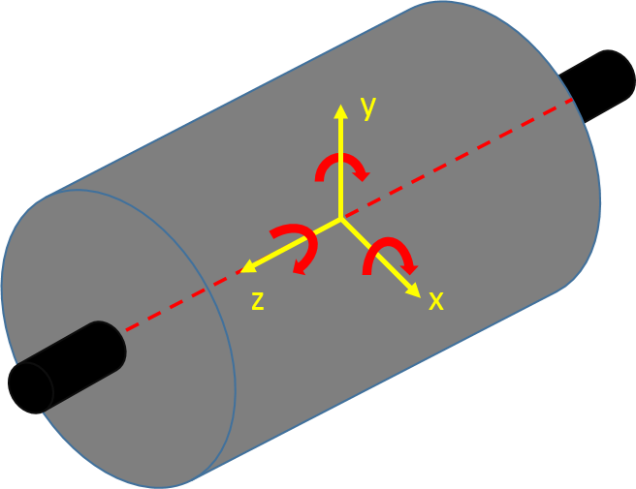
Figure 1-1 Schematic representation of the six degrees of freedom of a machine rotor motion
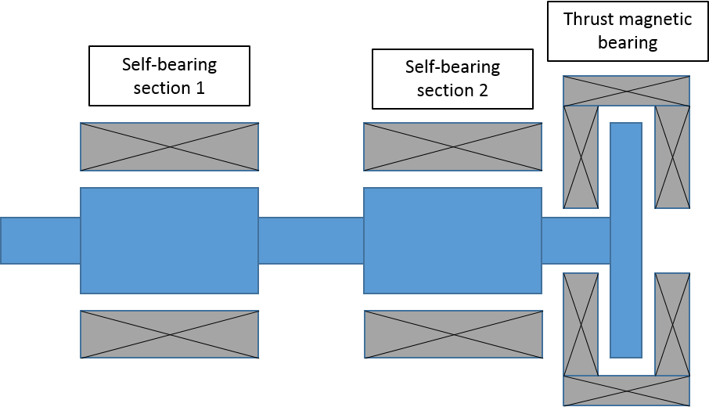
- Self-bearing machine

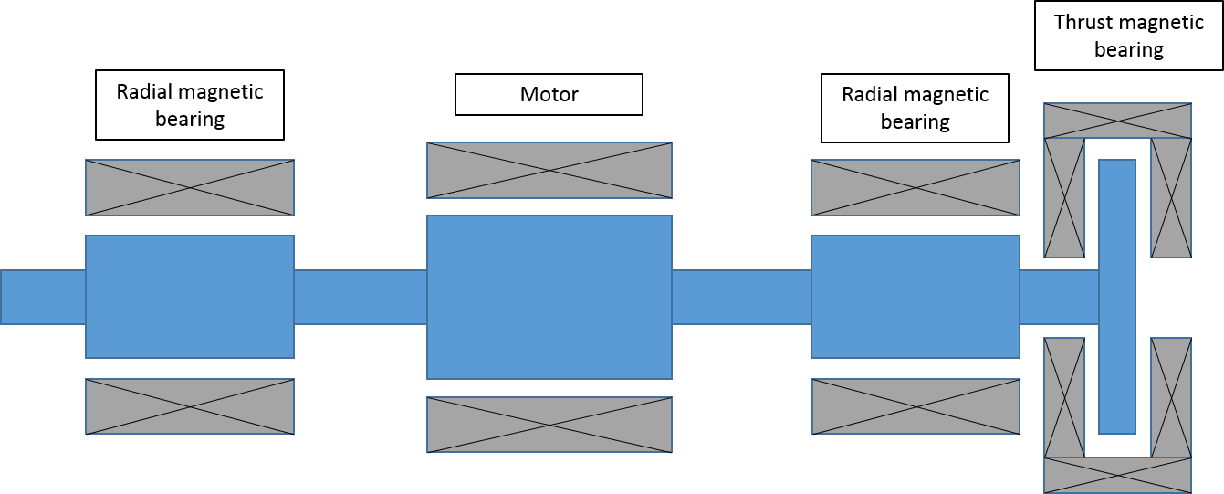
- Conventional arrangement of a motor with magnetic bearings
Figure 1-2 Different configurations of machines with magnetic bearing action
By comparing these two self-bearing technologies, it is worth noting that the fully magnetically integrated self-bearing machine of Figure 1-2(a) has the advantage of structure simplicity and reduced control system requirements. Ultimately a self-bearing machine is not necessarily more power dense than a machine with separate magnetic bearings, as the latter has the advantage that the different system components can be optimised to perform just one function. It is likely that the best solution will be application and specification dependant.
During the past 20 years or so, various types of self-bearing machines have been studied in Japan, Switzerland, Germany, Austria, China and USA, such as induction type [2-9], switch reluctance type [10-18], and permanent magnet type self-bearing machines. Due to the development of high performance permanent magnet materials, permanent magnet self-bearing machines offer the potential for high efficiency and compact size compared to others types. As a consequence, they have attracted particular attention in recent years. Depending on the rotor structure, permanent magnet self-bearing machines can be categorised as surface-mounted permanent magnet machines [19-24], inset type permanent magnet machines [25-27], interior permanent magnet machines [28-33], and consequent-pole machines [34-40]. The key developments in the technology of self-bearing machines is described in CHAPTER 2.

Scope of this thesis
This thesis is focused on the design and control of a fully integrated surface-mounted permanent magnet self-bearing machine. The scope of this thesis is described below:
CHAPTER 2 reviews literature on technology of several types of self-bearing machines. The merits of several machine types are reviewed according to the detailed discussion.
CHAPTER 3 describes the detailed design of a surface-mounted self-bearing machine. An analytical force model is developed which is used to identify a preferred stator slot and rotor pole combination and predict motoring and bearing performance. Further design optimization is described, focussing on magnet thickness and tooth body width. In order to meet a given combination of a force and torque demands, a novel control algorithm is developed to minimise copper losses. Finally, the various analytical models and design features are validated by finite element analysis.
CHAPTER 4 describes the development of a system level simulation model to predict the full mechanical dynamics of the machine. The static and dynamic performance of the proposed self-bearing machine are predicted.
CHAPTER 5 describes the design and manufacture of the machine hardware components and the experimental test rig. The systematic tuning of the power amplifiers to maximise performance is described in detail.
CHAPTER 6 describes two approaches to measure the force capability of the manufactured self-bearing machine. A direct force measurement rig is described, but due to the challenges of realising sufficient stiffness, an alternative but much simpler approach using static lift-off testing is described. The experimental results derived from a series of lift-off tests are discussed, with a focus on validating the analytical model and non-linear finite element predictions of force capability.
CHAPTER 7 designes a practical approach for effectively achieving stable levitated rotor system according to the in-depth understanding of PID parameter selection. The prototype self-bearing machine with five degrees of freedom was performed. The bearing and motoring performance were analysed under no-load and load conditions.
CHAPTER 8 concludes the thesis, drawing together a series of conclusions from the research undertaken and identifies several topics for future work on this type of self-bearing machine.

A review of electrical self-bearing machines

Introduction
Although this thesis is concerned specifically with permanent magnet self-bearing machines, it is useful to consider the full range of machine concepts that have been proposed for self-bearing operation. There are many cases where electromagnetic and control features developed for other machine types can have some read-across to permanent magnet machines.

Induction self-bearing machines
Historically induction machines played an important role in the development of self-bearing machines. Compared to other types of electrical machines, they have advantages of robustness, low cost, simple structure and easy maintenance. Induction type self-bearing machines, therefore, are one of the earliest machine types studied comprehensively [7].
The conventional approach to realising self-bearing induction machines is based on two separate sets of functional windings on the stator as shown in Figure 2-1. One winding set is known as the ‘motoring’ windings that produces torque while the other set of winding is referred to as the ‘bearing’ windings and these provide the main controllable bearing forces. This type of machine with separate motoring and bearing windings operate on the simple principle of producing controllable bearing forces by adding an asymmetrical component to airgap flux distribution using bearing windings. As can be seen from Figure 2-1, by adding current into windings${ N}_{rx}$, the symmetry of motoring magnetic field produced by the motoring windings is disturbed. According to the right-hand screw rule, the airgap flux density on the left hand side of the motor increases with an accompanying decrease in the airgap flux density on the right hand side of motor airgap. The resultant flux imbalance produces a radial force directed in this case towards the left hand side of motor. This method allows the magnitudes and directions of radial force on the rotor controlled by applying suitable bearing currents into the bearing windings.
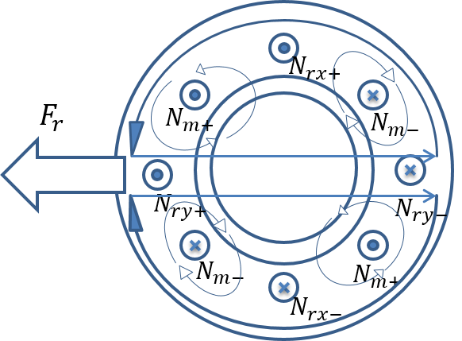
Figure 2-1 Principle of radial bearing force production [7]
Conventional squirrel-cage type induction machines consist of stator circuit and a shorted rotor circuit. The squirrel cage consists of a series of solid bars that fill the rotor slots and a connecting end ring at each end. These are usually cast in-situ with Aluminium as a single piece component although in higher performance machine, copper is sometime used as the conductor and the squirrel-cage is manufactured by sliding copper bars into the slots and brazing each bar to a copper end-ring. The net torque is produced by the interaction between rotating magnetic field produced by the stator and the field produced by the induced current in rotor circuit. As currents in rotor circuits can only be induced when the rotor rotating speed is not synchronous with the speed of revolving magnetic field, there is a speed difference between the rotating field and the rotor mechanical rotation, which leads to induction machines being known as asynchronous machines. Similarly, an induced current in rotor circuits according to the sudden change of bearing winding flux also exists for producing bearing forces, which can results in errors and losses in generating bearing force thereby significantly affecting the bearing performance [41].
Chiba and Fukao [8] proposed new optimal rotor circuits designs. As an example of an induction rotor with 16 rotor bars, successive sets of four bars are grouped together and shorted by 45°arc end conductors, to produce four isolated rotor circuits. Instead of using a standard squirrel cage structure of rotor in which 16 rotor bars are parallel connected by two ring end conductors, this novel rotor design eliminates the induced rotor current caused by the bearing function windings.
In terms of control strategy improvement, Hiromi and Katou [2] improved the analysis model of rotor circuits to accurately predict the lag in the suspension force caused by induced rotor currents and proposed a new control system with suspension force compensation to overcome the influence of induced current in a squirrel-cage rotor. The corresponding simulation and experiment results shown an effective improvement in rotor levitating performance.
Furthermore, in order to reduce power loss, cost and winding layout complexity, a stator with two sets of winding is replace by one single set of winding as proposed by Salazar [4]. In this so-called split winding, the stator is wound by six concentrated coils with a common ground connection. By applying a suitable control strategy [4], the stator coils operate as two sets of three phases with a phase shift of 180° as shown schematically in Figure 2-2. Unbalanced airgap flux density for the production of bearing force in phase-a direction is created by inserting a same amount of additional currents $∆i$ with opposite polarities as shown in Figure 2-2.
Another single set of winding using multiphase motor technology also has successfully applied for a 6-phase bearingless induction motor [5] and a 5-phase bearingless induction motor [6]. By converting the multiphase windings with several d-q planes, one of them is selected to achieve motoring ability and the others can be used to generate bearing force.
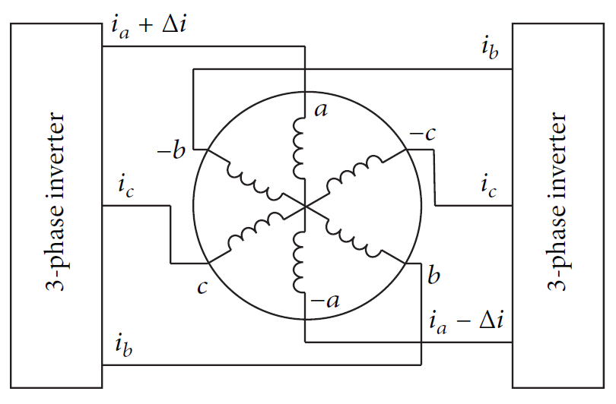
Figure 2-2 Winding layout and control strategy of proposed split-phase three-phase induction machine (Source: [4])

Switch reluctance self-bearing machines
Switch reluctance machines (SRM) are well known with a doubly salient structure, with salient poles on both the stator and rotor. Compared to induction machines and permanent magnet machines, SRM rotor has no rotor winding or permanent magnets on the rotor. SRMs, therefore, have the advantage of simply structure, low cost, robustness, and ability to working in harsh environment [10]. The doubly salient geometry cause the rotor pole to align with the energized stator teeth. By successive switching of the stator currents, with the commutation pattern set by an angular position encoder, the rotor is able to rotate at specific speed.
In order to achieve competitive torque densities, SRMs must have a small radial airgap, with 0.1 to 0.25mm being a typical range used in conventional (i.e. non self-bearing) high performance machine. SRMs are able to produce very high attractive radial forces.
M. Takemoto et al [42] proposed a 12/8 pole self-bearing SRM with two sets of windings as shown in Figure 2-3. The main winding is a three-phase motoring winding and the auxiliary winding is used to produce bearing force. With a comprehensive analysis of radial force and torque production in the absence of magnetic saturation [13, 43] and with magnetic saturation [44], stable operating performance was realised. As can be seen from Figure 2-4, positive torque is produced in the region of increasing inductance, i.e., rotor poles moving from unaligned positions to aligned positions.
The radial force in SRMs is a pure reluctance force which is unidirectional, and is only produced to any meaningful extent near the aligned rotor position. Therefore, the overlap region for producing useful torque and radial force is limited for the prototype machine shown in Figure 2-3 [12]. The coupling between motoring windings and bearing windings requires a compromise between producing torque and radial force simultaneously, which results in poor copper utilisation.
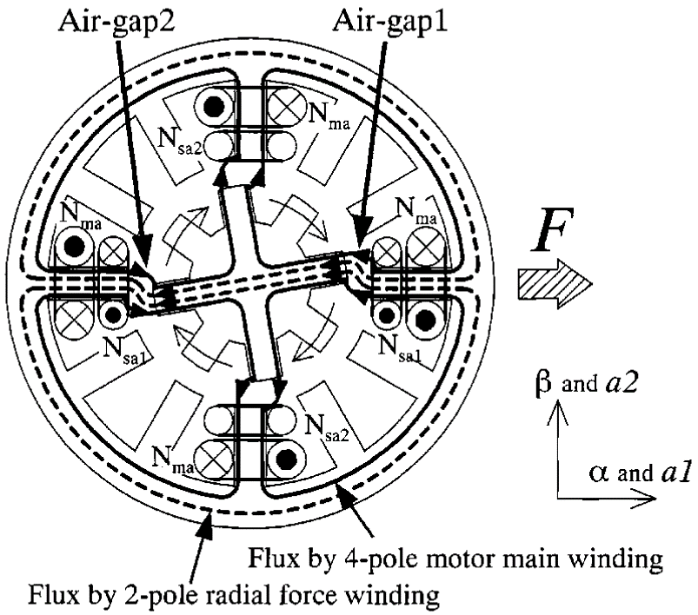
Figure 2-3 Schematic of a 12/8 self-bearing switched reluctance machine (Source: [12])
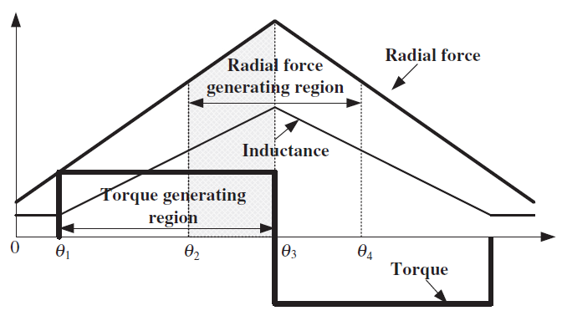
Figure 2-4 Torque and radial force excitation regions of a general self-bearing switched reluctance machine (Source: [12])
In order to overcome the problems caused by the coupling of torque and radial force production, Wang et al [12] [45] proposed a new stator structure with hybrid poles, shown in Figure 2-5, which comprises individually controlled motoring poles to produce torque and bearing poles to produce radial force. Morrison [46] proposed a hybrid rotor structure which consists of salient pole rotor section and circular rotor section as shown in Figure 2-6. Both of these hybrid designs provide some decoupling of torque and force production. Moreover, only a single set of concentrated windings is required, resulting in a relative simply winding configuration and control algorithm compared to the previous self-bearing SR machine designs.
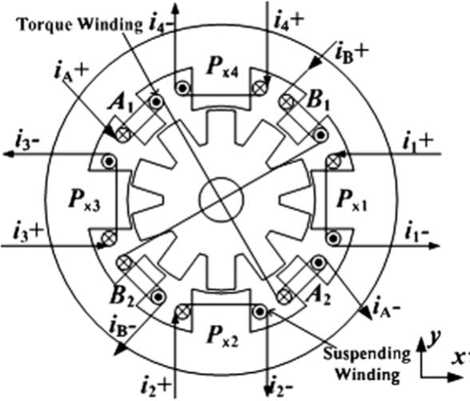
Figure 2-5 Hybrid stator structure (Source: [45])
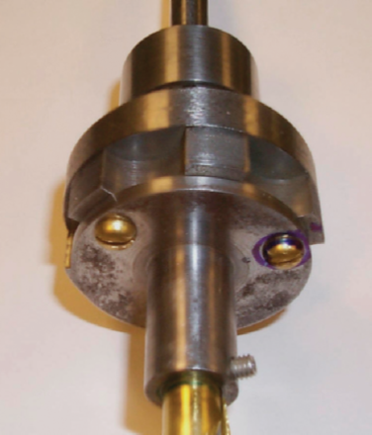
Figure 2-6 Hybrid rotor structure (Source: [46])
Apart from the improved machine structures, significant effort has been directed to control strategies to overcome the undesirable coupling problems. In the traditional approach to the control of 12/8 bearingless SRMs with both motoring and bearing winding proposed by M. Takemoto [43], each phase of the three-phase motoring winding is energized for one third of an electrical revolution, i.e., 15 mechanical degrees for a 12/8 SRM. An advance angle $θ_{m}$ is introduced to determine the width of position torque and negative torque thereby regulating average torque production.
Cao et al [17] proposed a new control strategy in which during one third of electrical revolution, two motoring windings and one bearing winding are energised. One energised motoring winding is tasked with producing torque while the other motoring winding is controlled to compensate undesirable negative torque associated to the energized bearing winding. Therefore, independent control of both average torque and bearing force is effectively achieved, although with some compromise in the torque capability.
Special control strategies have been applied for 8/6 bearingless SRMs [47] [48] with a single set of windings for the production of motoring torque and bearing force. . During each communication period, three or four specific stator poles are energized with different combination of currents according to the demand torque and force signals.
All of these developments in both machine topology and control methods are focussed on the challenge of coupling between motoring and bearing functions. Although this problem is particularly pronounced in SR machines, it is one of the main challenges in realising self-bearing machines compared to separate motoring sections and magnetic bearings.

Self-bearing Surface-mounted permanent magnet (SPM) machines

Slotted type Self-bearing SPM machines
Conventional SPM machines with slotted stators have permanent magnets mounted on a laminated rotor core and produce electromagnetic torque due to the interaction between PM field and armature field in rotational direction. In the most SPMs, there is negligible saliency torque. This type of machine when equipped with conventional mechanical bearings has the well-recognised advantages of high torque density, high efficiency and good torque linearity performance and hence relatively straightforward control[49]. For self-bearing SPMs, it is desirable to ensure that bearing force is dominated by the excitation force due to the interaction between PM field and armature field in radial direction rather than reluctance forces.
There are two different approaches to producing self-bearing operation in SPMs:
- Build in separate motoring and bearing windings and control these separately.
- Employ a single winding that performs both motoring and bearing functions.
Separate motoring and bearing windings - The concept of a self-bearing SPM with two independent sets of winding is similar to induction machines described previously in section 2.2. The bearing force is produced by creating an unbalanced airgap in the controlling axes using bearing windings.
By taking the general consideration of slotted type self-bearing machine with rotor pole pairs of $M_{r}$ and stator bearing pole pairs of $M_{b}$, the bearing force produced in X- or Y-axis is given as below [50]:
 | $$F_{X(Y)}=\frac{B_{g_max}B_{X(Y)}rL_{ax}}{4μ_{0}}\int_{0}^{2π}{\left\{\cos\left[\left(M_{r}-M_{b}-1\right)θ\right]+\cos\left[\left(M_{r}-M_{b}+1\right)θ\right]\right\}}dθ$$ | (1)
where
 | $B_{g_max}$ = Peak airgap flux density of PM field
 | $B_{X(Y)}$ = Peak airgap flux density of X- or Y-axis bearing field
 | r = radius of magnet outer diameter
 | L_{ax} = axial length of rotor stack
It is worth noting that the same force capability at any arbitrary angular positions is achieved when${ M}_{r}-M_{b}=±1$. To this end, Okada et al [50] proposed the P±2 pole algorithm for the selection of magnetic poles and bearing winding poles as shown in Figure 2-7 and Figure 2-8. Furthermore, since the resultant torque due to the influence of bearing winding currents sums to zero, independent control between bearing force and torque is also realized by adopting the P±2 pole method.
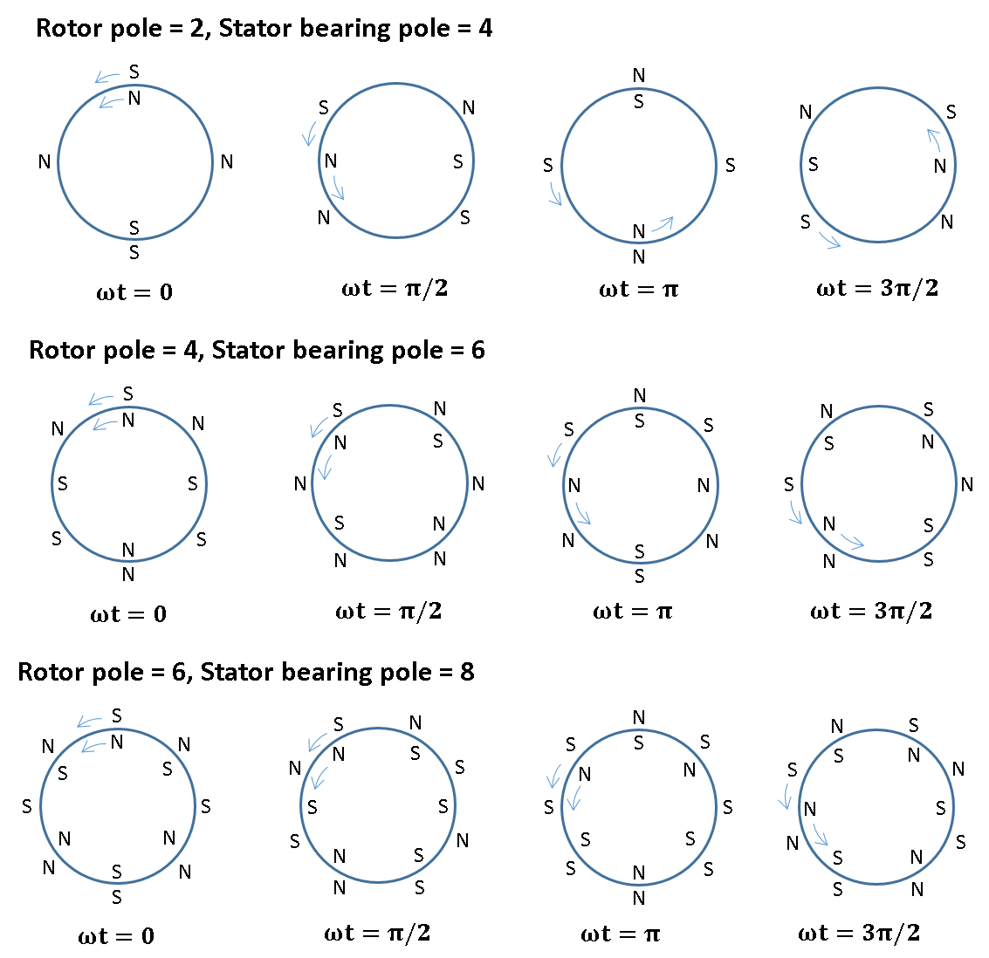
Figure 2-7 Arrangement of rotor poles and stator bearing poles based on P+2 pole method [50]
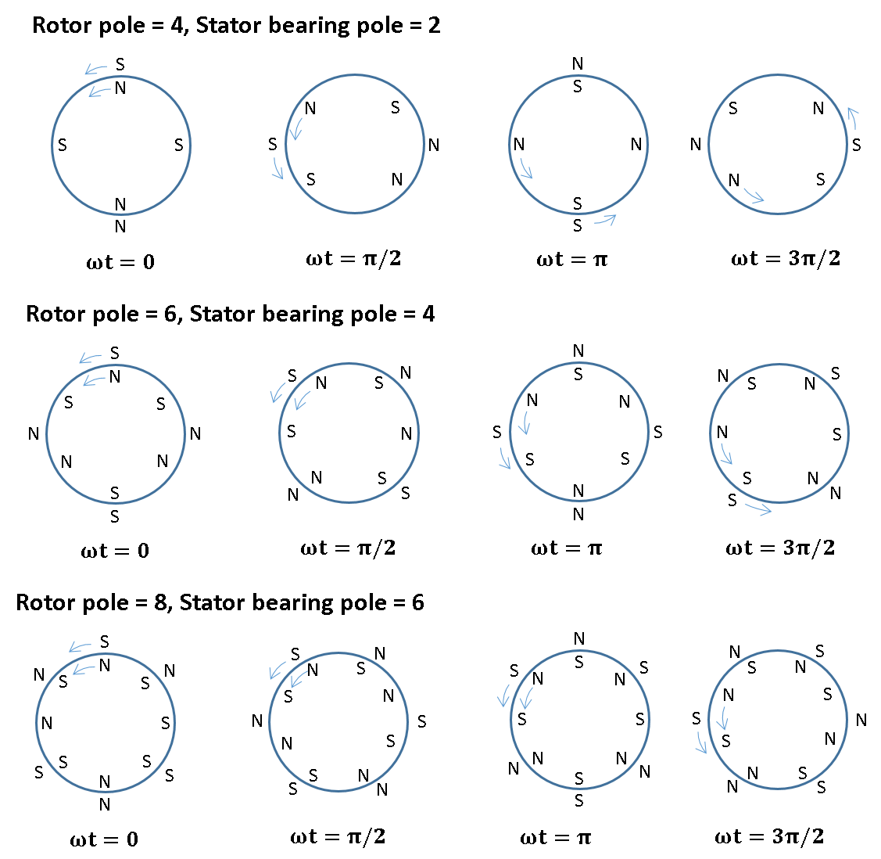
Figure 2-8 Arrangement of rotor poles and stator bearing poles based on P-2 pole method [50]
In [50], this criteria for pole number selection was confirmed by practical experiments using slotted self-bearing SPM machines with three different combinations of rotor poles and bearing poles. Even though experimental results indicated different machine performance due to the selection of rotor poles and bearing poles, constant force capability and independent bearing force and torque control were successfully demonstrated as expected.
Combined motoring and bearing winding - Using the same on this P±2 pole approach, Yang [51] introduced a 6/4 slotted-type self-bearing SPM machine with a single set of concentrated windings to perform both motoring and bearing functions, as shown in Figure 2-9 (b). This combined winding will tend to improve the copper utilisation in the machine. The control method with a single set of windings is achieve by using P±2 pole algorithm to calculate the demand motoring current and bearing current in the first instance, and then calculate the combination of coil currents of the single set winding for the same flux distribution of two sets of windings as shown in Figure 2-9 (a). The machine featured in [51] had a modest power rating of 90 Watts and the control system with a relative high operation frequency of 18.4 kHz (i.e. the sampling frequency of various measurements for the digital control systems and demands generated by the control systems). Even though the results presents that this machine exhibited reasonable performance, the observed rotor displacement at 1500rpm was ~0.2mm.
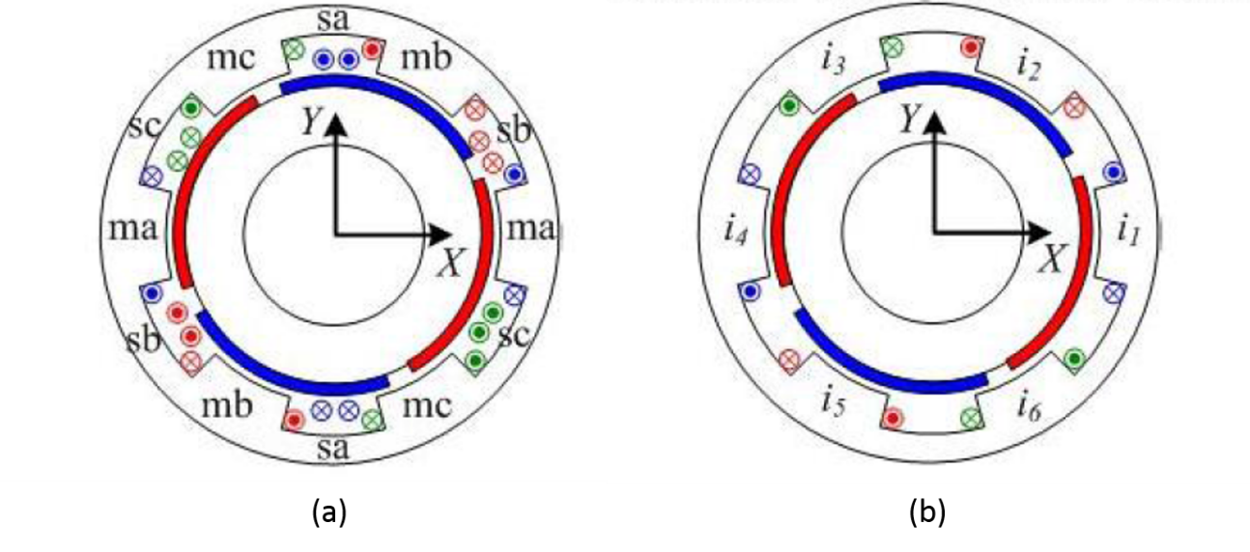
Figure 2-9 (a) Winding layout with two sets of winding (b) proposed single set winding layout (Source: [51] )
It has been demonstrated that the desirable feature of independent control of bearing force and torque production can be achieved by using the proposed P±2 pole selection criterion. However, having selected a pole number, the careful optimization of bearing and motoring performance is equally vital to achieve acceptable performance. Ooshima and Chiba [52] and Amrhein et al [53] investigated the influence of magnet thickness on radial force using Virtual Displacement Method (VDW) [9]. An inductance matrix was established for VDW by predicting the self-inductance and mutual inductance of motoring windings and bearing windings. The results presented in [52, 53] illustrated that thin magnets (in comparison with thickness usually used in SPM machines) are preferable for a high bearing forces, with values comparable to the airgap being typical. However, thicker rotor magnets result in increased torque, albeit with diminishing return. It is clear that there is a trade-off between bearing force and torque capability. Moreover, because of the slotted nature of the stator, cogging torque and open-circuit unbalanced magnetic pull are two undesirable features, which must be accounted for and are important features to consider during the machine design and the development of control strategies.

Slotless type self-bearing SPM machines
Slotless type SPM machines are featured with surface-mounted PM rotors and stator core without salient teeth. The windings are usually attached directly to a non-slotted stator core (often a simple plain soft magnet ring acting as a core-back) although in principle, machines can be manufactured without a stator core at all, but at the expense of a significant drop in torque capability.
The absence of slots means that cogging torque is eliminated and the large magnetic airgap between the magnets and the stator core-back means that the open-circuit unbalance magnetic pull is significantly reduced compared to a more conventional machine with a slotted stator.
Bearing force and torque production of slotless type self-bearing SPM machines are all related to a so-called Lorentz or BIL type force, which is produced by the interaction between PM field and conducting coils. Therefore, slotless type self-bearing SPM machines are also sometimes referred to as Lorentz-type self-bearing machines. The principle of bearing force and torque generation are illustrated in Figure 2-10 [54]. Since Lorentz-type force on rotor acts in a tangential direction, the corresponding bearing force and torque are produced by control the vector sum of Lorentz force on stator conductors as illustrated. It is apparent that both torque and bearing functions can be achieved by using a single set of windings [54].
As can be seen from the fundamental expression of Lorentz force in equation (2), the magnitude of Lorentz-type force is proportional to the magnitude of PM field to which the coil is exposed and the coil current. Therefore, the inherent trade-off between bearing force and torque generation is eliminated in the slotless self-bearing machines. This feature is regarded as the main advantage compared to the slotted type self-bearing machines. It should be noted, however, that the torque capability of a slotless machine is well acknowledged to be significant lower than its slotted counterpart:
 | $$F=BIL$$ | (2)
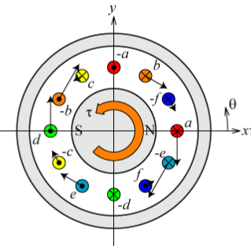
- Torque generation
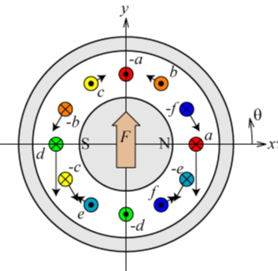
- Bearing force generation
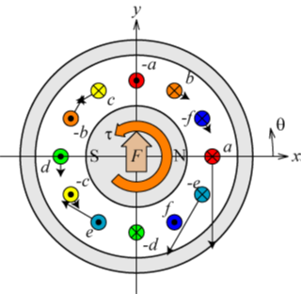
- Torque and bearing force generation
Figure 2-10 Principle of bearing force and torque generation of Slotless type self-bearing SPM machines (Source: [54])
In [55], T. Tokumoto et al compared the performance of slotless type and slotted type self-bearing SPM machine from the aspect of bearing force, torque, maximum speed and motor efficiency of no-load condition. With slotless machines, because of the absence of stator teeth, eddy current losses and iron losses were significantly reduced, and the maximum motor efficiency measured in the free rotational test (air friction only) was ~89%, which proved in this case to be much higher than the slotted type (max. 58%). Furthermore, as the self-inductance of stator coils of slotless type was significant lower, with the winding designs selected and for a supply voltage of 80V, the maximum rotational speed of slotless type machines is 5500rpm, higher than slotted type machines (2200rpm).
When assessing the bearing force and torque generation, it was noted in [55] that both machine types exhibited a desirable linear relationship with current which is useful from a control point of view. However, the maximum bearing force and torque produced by slotted machine was almost three times higher than its slotless equivalent when stator coils carried the same currents. Even though the analysis of machine efficiency under load condition is not presented in [55], a higher machine efficiency would be expected with the slotted self-bearing machine compared to the slotless machine.
As a conclusion, slotless machine are likely to be suitable for applications requiring high speed but low torque and bearing forces demand, whilst slotted machines are likely to be preferred in applications with demands for high bearing loads and torque density but low speed. Baumgarner and Kolar [56] successfully designed a 300W slotless type self-bearing SPM machine with the maximum measured speed of 500,000 rpm, which is known as the fastest machine using magnetic levitation technology.

Additional PM type self-bearing machines

Consequent-pole type self-bearing machines
Consequent-pole self-bearing machines, of the type shown in Figure 2-11, are another alternative for eliminating the trade-off between bearing force and torque production. The rotor features a combination of PM poles and salient iron poles. Since PM poles with the same magnetic polarities are inserted or buried between the gaps of adjacent salient iron poles, the salient iron poles are consequently magnetized with the opposite polarity to the PM poles. This has the advantage that a significant proportion of the rotor periphery has a small effective airgap, which is useful for producing high levels of normal reluctance force for bearing action. The magnitudes and directions of resultant bearing force are controlled by the DC current in bearing windings. The principle of bearing force generation is shown in Figure 2-11 (a).
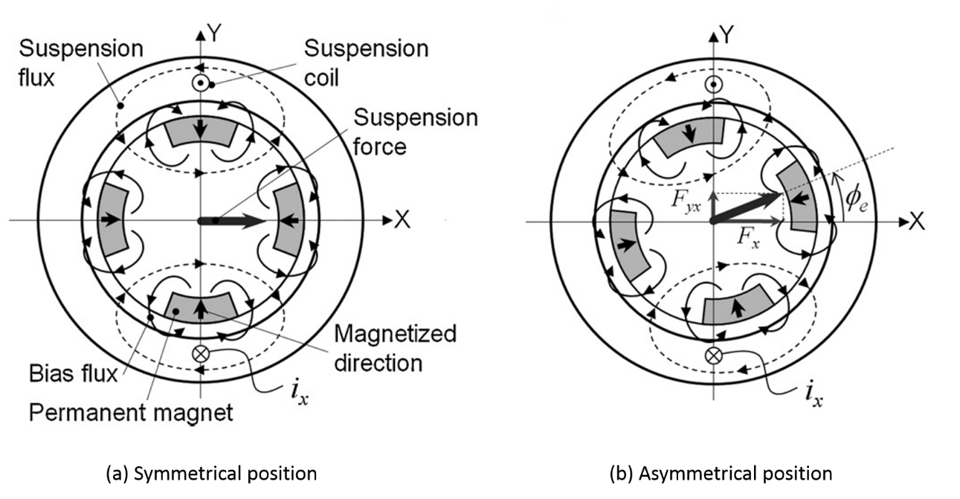
Figure 2-11 Principle of bearing force generation of consequent-pole self-bearing PM machines (Source: [57])
Since the bearing force are controlled by DC currents, feedback of the rotor angular position, which is essential to other types of self-bearing PM machines, is not required for consequent-pole self-bearing machines.
However, undesirable cross coupling of bearing forces exists between the X- and Y- direction. As can be seen from Figure 2-11 (a), at the symmetrical orientation, a bearing force in X-direction is produced by a dc bearing current${ i}_{x}$. In contrast, when the rotor is at an asymmetrical orientation as shown in Figure 2-11 (b), a force is generated in Y-direction due to the X-direction controlling DC current$i_{x}$. Therefore, a force direction error,$∅_{e}$, appears when rotor at asymmetrical positions. In order to mitigate this problem, the influence of bearing winding arrangements was investigated in [57] and [36].
Takenaga [36] compared three different bearing-winding arrangements for a 24/8 consequent-pole self-bearing machine. According to the results presented, 3-phase bearing winding arrangement result in a significant reduction in $∅_{e}$ down to 3°. However, this study may well have produced outcomes that were specific to the slot-pole combinations studied. Asama el ta [57] proposed a new bearing winding configuration for a 12/8 consequent-pole type machine, since a three-phase bearing-winding arrangement [36] resulted in around 10° force direction error. To reduce this cross-coupling, a new and complex bearing winding layout was proposed in [57], which resulting in a remarkable reduction by 90%. However, the new winding layout is very complicated, consists of main coils and sub-coils with different numbers of turns.

Inset permanent magnet self-bearing machines
So-called inset permanent magnet rotors are used in many conventional PM machines. The rotor structure is similar to those of the consequent-pole machines discussed previously, expected that the magnet polarity alternate around the rotor periphery. The rotor structure and the basis for producing bearing force using two sets of windings is shown in Figure 2-12. Due to the presence of salient iron poles on rotor, additional reluctance force is produced at particular rotor angular positions, which can enhance bearing force [58].
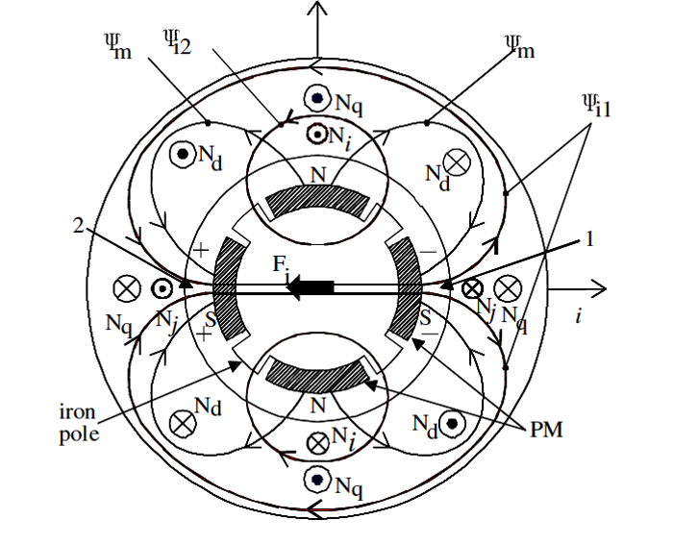
Figure 2-12 Rotor structure and force principle of 4-pole inset permanent magnet self-bearing machines (Source: [26])
In [25], inset PM self-bearing machines and SPM self-bearing machines were compared in terms of bearing and motoring performance in the context of high power and high speed applications. Both of these two types of machines shows a very similar variation of mean bearing force with only the bearing windings excited. However, cross-coupling of forces was present in the inset PM machines when the motoring winding was excited. The capability for independent force and torque control achieved in SPM machines using P±2 pole algorithm is considered as one of challenges for inset-type PM machines. Furthermore, an increased torque ripple caused by bearing winding current was observed in inset-type PM machines. In contrast, the torque ripple of SPM machine proved to be significant smaller. The cross-coupling of forces and increased torque ripple, requires a more challenging control strategy for inset PM self-bearing machines.

Interior permanent magnet (IPM) self-bearing machine
The structure and force producing mechanism of a 4-pole IPM self-bearing machine with two sets of windings (motoring and bearing) is shown in Figure 2-13. Compared to SPM machines and inset PM machines, the rotor of IPM machines have permanent magnets buried inside the rotor core, and in some literature is referred to as a buried magnet rotor. This topology has the following claimed advantages listed below:
- Enhanced bearing force capability. IPM machines have relative small airgap compared to SPM machines, which is a desirable feature for achieving an enhanced bearing force.
- Resistance to PM demagnetization. The rotor iron provides alternative paths for the armature flux and hence provide some degree of protection from irreversible demagnetized.
- Suitable for high-speed applications. Since the permanent magnets are secured and contained by rotor core, additional rotor containments for preventing centrifugal forces in SPM machines may not be necessary for some applications. However, for extreme levels of mechanical loading additional containment such as a carbon sleeve is likely to be necessary.
- Various rotor structures. Various different PM arrangements in IPM rotors are shown in Figure 2-14. In the case of machines with the deeply buried magnets, IPM machines will exhibit better field weakening capability, making them a good option for applications in which the machine operates over a wide speed range [49].
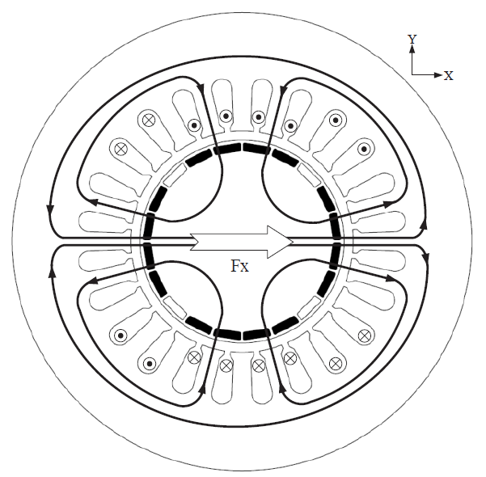
Figure 2-13 Typical structure and bearing force principle of buried PM self-bearing machine (Source: [29])
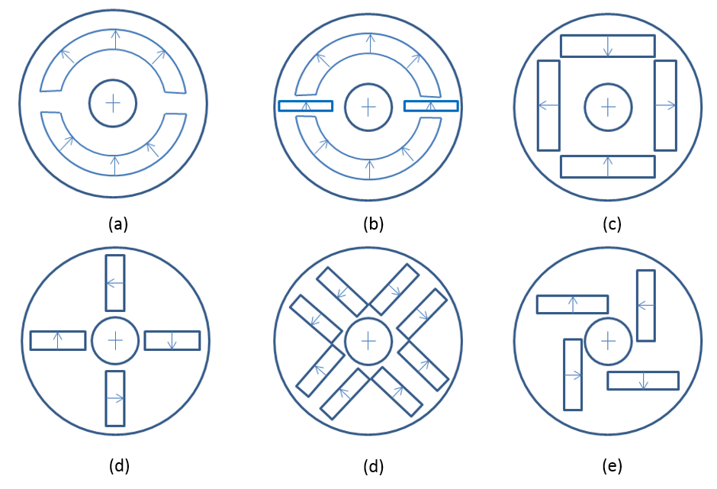
Figure 2-14 Topologies of deeply buried permanent magnet rotors

In [59], the bearing force produced by the IPM self-bearing machine shown in Figure 2-13 and a deeply buried IPM self-bearing machine of the type as shown in Figure 2-14(c) were calculated and compared to a four-pole SPM self-bearing machine. The force variation and specification of these three machines are contained in Figure 2-15 and Table 2-1.
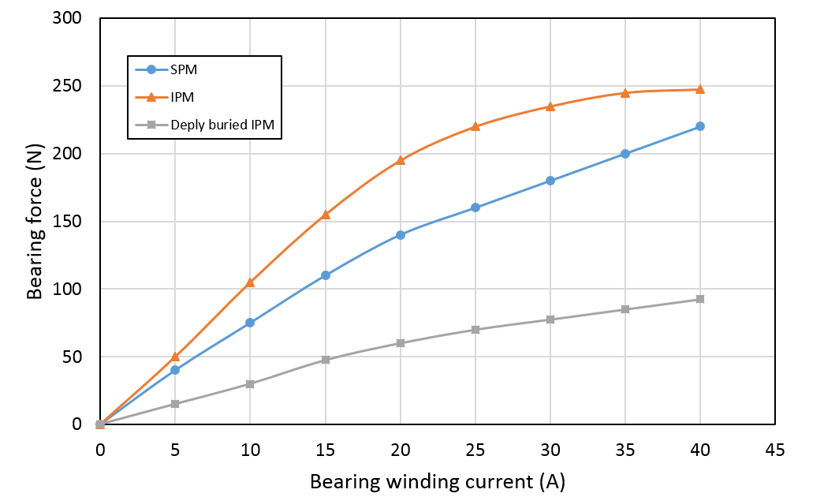
Figure 2-15 Bearing force comparison of SPM type self-bearing machines, IPM type self-bearing machines and deeply buried IPM type self-bearing machines [59]

Table 2-1 Machine specifications for the bearing force comparison shown in Figure 2-15 (Source:[59])
 | SPM | IPM | Deeply buried IPM
Rotor outer diameter (mm) | 48 | 49 | 49.2
Airgap (mm) | 1 | 0.5 | 0.4
PM thickness (mm) | 1 | 1 | 3
Force/current (N/A) | 7.5 | 11 | 3
It is clear from these predicted forces, that the rotor with deeply buried permanent magnet is not competitive for self-bearing operation as it exhibits the lowest bearing force capability due to significant internal flux leakage inside the rotor core. In contrast, since its airgap in the IPM type rotor was only half of the airgap in SPM machines as given in Table 2-1, it produced the highest bearing force of the three machines.
It is worth noting that the IPM self-bearing machines exhibits a non-linear force versus current character while SPM self-bearing machines exhibits a more linear characteristic. This arises because IPM machines are more prone to some degree of partial magnetic saturation in stator teeth due to the much reduced effective magnetic airgap for the armature field [59]. The force capability, therefore, is limited due to the higher bearing winding current as shown in Figure 2-15. Moreover, the influence of partial magnetic saturation is more significant under high torque condition.
Fujie et al [60, 61] studied the influence of magnet saturation and derived FE estimated variations of bearing force as a function of bearing winding current and motoring winding current in IPM machines. By employing the predicted bearing force waveform within the controller, the effect of magnetic saturation was compensated thereby enhancing the controller performance.

Other self-bearing motor technologies

Three Degrees of Freedom (DOF) self-bearing machines
The preceding sections have largely discussed control in the x-y plane. However, in the last two decades, self-bearing machines with 3-DOF, which includes 2-DOF rotor levitating displacements (x and y axes) and 1-DOF rotational displacement (z axis), are widely used as prototype structure for laboratory purpose. The constructed prototype machines and corresponding experimental results can be found for induction self-bearing machines[2, 3, 8], switch reluctance self-bearing machines[11, 12, 16], slotted-type self-bearing SPM machines[19, 20, 23], slotless-type self-bearing SPM machines[62, 63], consequent-pole type self-bearing machine [36], inset PM self-bearing machines[26] and IPM self-bearing machines[33]. According to the previous publications, the prototype machines with 3-DOF include vertical set-up [16] and horizontal set-up [64] with one rotor-end connected to load machines using universal joint or mechanical ball bearing. Because of its simplicity of mechanical dynamics, 3-DOF experimental rigs mainly used to validate FE and theoretical results of novel machine structures and control strategies.

Five DOF self-bearing machines
5-DOF self-bearing machines have four actively controlled axes and one rotational axis. The structures consist of two identical self-bearing units [65] as shown in Figure 2-16 or a hybrid structure [66] which includes one self-bearing unit and one active magnetic bearing unit as shown in Figure 2-17. Since a 5-DOF self-bearing machine have two magnetic levitated rotor ends, it can test in no-load conditions without any mechanical connection, thus a more reliable results of bearing and rotational performance can be achieved.
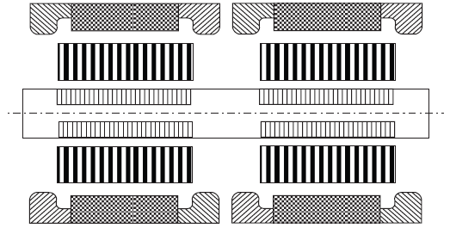
Figure 2-16 5-DOF self-bearing machines with two identical self-bearing units (Source: [9])
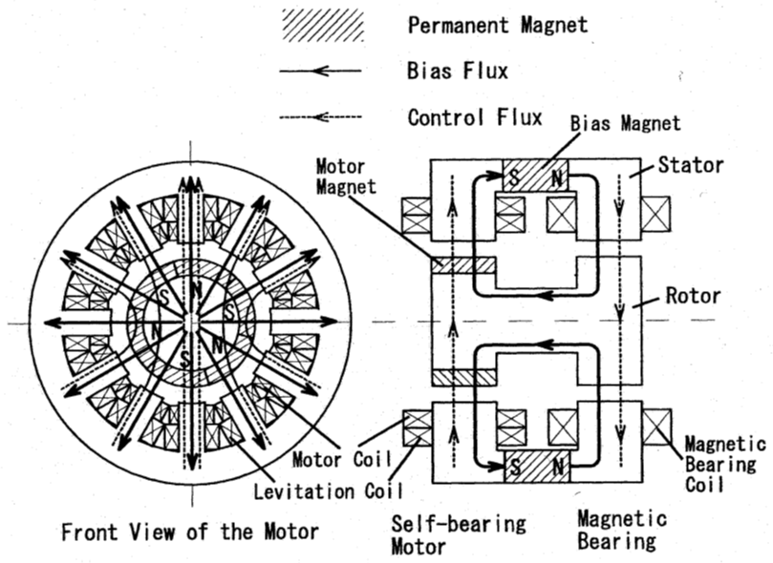
Figure 2-17 A hybrid structure of 5-DOF self-bearing machines (Source: [66])

6-DOF self-bearing machines
Compared to 5-DOF self-bearing machines, axial displacement in a 6-DOF self-bearing machine is actively controlled by a magnetic bearing located at the rotor-end as shown in Figure 2-18 or in the middle of two rotor units as shown in Figure 2-19. Compare these two structures, a self-bearing machine with an axial bearing at one end of the rotor results in an asymmetrical rotor structure and a relatively longer axial length. Because of mechanical tolerance, in an asymmetrical rotor it is more different to estimate the accurate centre of rotor gravity, which is vital to decouple rotor displacement to the middle positions of each self-bearing unit according to the measured displacement at target rotor positions. Therefore, the symmetrical structure, as shown in Figure 2-19, with an independent axial AMB at the centre of the rotor is often preferred.
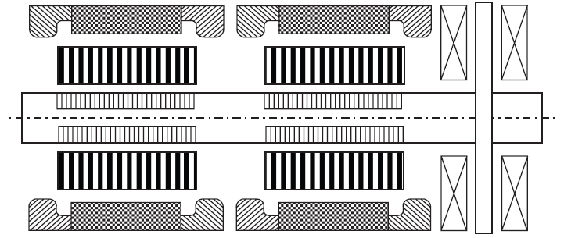
Figure 2-18 6-DOF self-bearing machines with an axial AMB at one rotor-end (Source: [9])
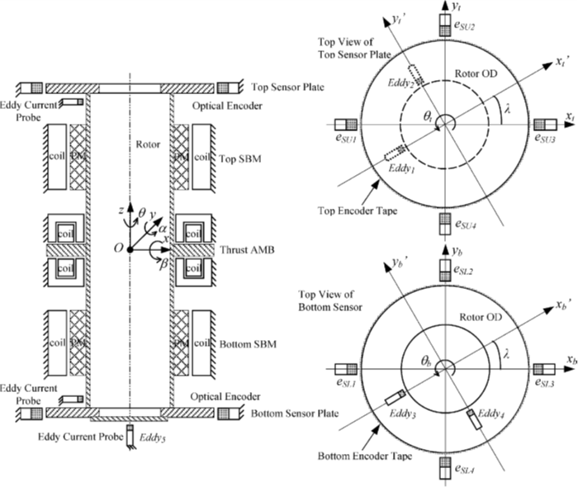
Figure 2-19 6-DOF self-bearing machines with an axial AMB in the middle of two rotor units (Source: [67])

Development trends
High power and high efficiency self-bearing machines: As discussed previously, many of self-bearing machines reported in the literature are small size prototypes for research purposes. Therefore, self-bearing machines attracted significant interest for high-tech small motor markets, such as centrifugal blood pumps [68], rotary artificial hearts [69], small axial pump [70] and high-speed miniature spindles [71].
More recently, Munteanu et al successfully designed and tested a 40kW SPM self-bearing machine with the maximum machine speed of 40,000rpm for turbo vacuum pumps [21, 72]. The losses of this proposed machine were comprehensively measured in a wide range of machine speed from 6,000rpm to 30,000rpm. The motor efficiency at different speeds was maintained at ~93% [73]. This machine was featured with six degrees of freedom control using two magnetic bearings and one self-bearing unit with the conventional two set of winding layout (motoring and bearing).
In a separate development, Jastrzebski et al [25, 28] reported a detailed design analysis of SPM, IPM and inset PM self-bearing machines with 100kW mechanical output power at 30,000rpm. Although these efforts were limited to early design studies, it does indicate that self-bearing technology is being considered for application in the high power and high speed motor market.
The research reported in this thesis, although not focussing specifically on high-speed operation, is targeted at increasing the power range of practical demonstrators into the kW range.

Analytical force model development and machine topology design

Analytical force model
The magnitude and direction of the controllable forces that can be applied to a rotor to achieve self-bearing operation can be estimated using a simplified representation of the machine geometry and the principles of superposition. However, it is important to recognize that great care must be taken in applying the principle of superposition directly to the various contributors to the controllable forces, i.e. the excitation forces produced through the interaction of the rotor magnet field and the stator currents and the reluctance force produced through the interaction of the rotor core and the stator currents. In the machine, there is also an uncontrollable component of force from any net unbalanced magnetic pull produced through the interaction of the rotor magnets and the stator core. This difficulty is compounded if there is appreciable saturation of the stator or rotor cores. Under such circumstances, even the field itself cannot be strictly calculated from the principles of superposition.
Despite these inherent limitations of superposition as a means of calculating net forces from individual components of force, for those cases where it can be reasonable employed, it is an extremely powerful and flexible approach. The alternative of predicting force from a finite element model for all possible combinations of rotor angular positions, eccentricities and coil currents would yield an unmanageable number of degrees of freedom and hence field calculations. The degree to which forces can be reasonably calculated by superposition depends on the interaction between the fields produced by currents in the individual phases, particularly in the working airgap region. These considerations are somewhat different from the conventional concept of mutual coupling which is usually regarded in terms of flux linkage rather than localized fields in the airgap.
This model is based on the assumption that the forces produced from the interaction of the permanent magnet field and the stator field are dominant in comparison with the corresponding reluctance forces produced by the interaction of rotor core and stator currents. Clearly, the extent to which this assumption is reasonable is governed by various design features, most notably the magnet and containment radial thicknesses which determine the effective magnetic airgap between the stator and rotor cores. However, as will be demonstrated in this paper, this assumption remains reasonable for many practical designs of small to medium power machines. This said, it is important to recognize this limitation when considering the extent to which this behaviour scales with increasing machine rating. Larger machines tend to operate at increased electrical loading and since the reluctance torque increases approximately with the square of the stator electric loading while the permanent magnet component of force increases approximately linearly, then inevitably this assumption will become increasingly in error with larger machines.
Another key assumption is that the eccentric displacement of the rotor relative to the stator bore is, when suitably controlled, significantly smaller than the effective magnetic airgap. Hence, the controllable electromagnetic forces can be calculated on the basis of a concentric rotor with no requirement to account for eccentricity.
Figure 3-1 shows a simplified schematic section of a permanent magnet machine which has p rotor pole pairs and $N_{ph}$ phases. The rotor angular displacement, θ_{r}, is defined relative to the centre of one specific rotor pole as shown in Figure 3-1. A first-order estimate of the airgap flux density produced by the rotor magnets in the airgap is given by:
 | $$B_{g}=K_{l}\frac{B_{r}}{\left(1+\frac{μ_{r}l_{g}}{l_{m}}\right)}$$ | (3)
Where $K_{l}$ is known as leakage factor to compensate magnet flux leakage between adjacent rotor magnets. For a surface-mounted permanent magnet rotor, this value tends to lie in range of $0.9≤K_{l}≤1.0$ [74]
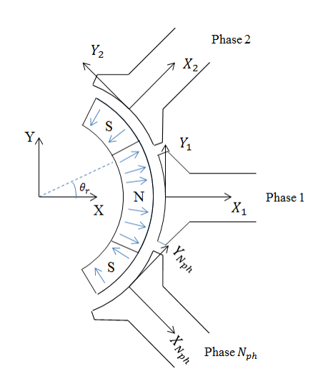
Figure 3-1 Simplified representation of an $N_{ph}$ surface-mounted permanent magnet self-bearing machine
The forces produced by the interaction of the mmf in a single tooth and the adjacent rotor magnet can be readily calculated in terms of components that are normal (radial) and tangential to the tooth face. However, it is well known that the normal component force tends to be much greater that the tangential component of force in a machine airgap. Hence, in order to account for the contribution of the normal component of force produced by phase 1 to the y-direction force, it is necessary to account for the curvature of the tooth when resolving these forces into x and y components within the stator reference frame. Even in cases where the arc subtended by a stator tooth is relatively small.
Assuming that the current in phase 1 has a polarity such that it produces a force of attraction at θ_{r} = 0°, then the component of force produced by phase 1 in the x-direction of its localized reference frame will remain almost constant when it is entirely exposed to rotor pole of one polarity. It then gradually diminishes as the opposite polarity pole moves beneath the tooth. As shown in Figure 3-2, the variation in the x component of force with rotor angular displacement can be reasonably simplified as being trapezoidal with the width of the flat-top region being equal to the difference between the arc of the rotor pole and that subtended by the given phase.
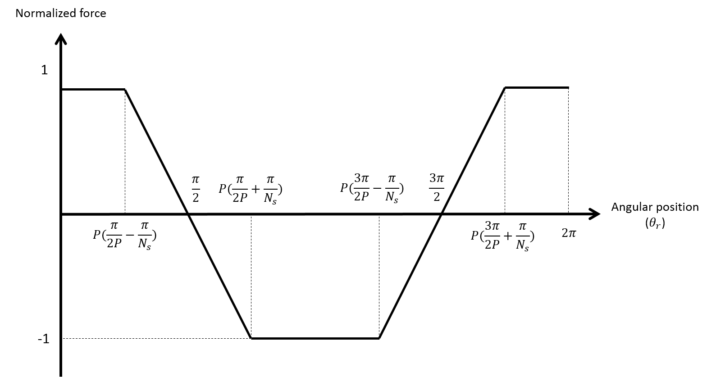
Figure 3-2 Electromagnetic force variation in local X direction over one electrical cycle
It is worth noting that due to the curvature of the tooth, a small proportion of the tangential force produced by phase 1 will contribute to the force in the x-direction. However, since this contribution is very small in comparison to that of the radial force, and hence it is reasonable to neglect its contribution given the approximate nature of the force calculation. Adopting these simplifying assumptions, and recalling that the variation in force with angular displacement has a trapezoidal form, the variation in the local x component of the force produced by phase 1 is given by the following Fourier series (the detail of force equation derivation is provided in Appendix A):
 | $$F_{x1}=\frac{4K_{l}K_{x}I_{1}}{πPβ_{x}}\sum_{N=1,3,5…}^{∞}{\frac{{\left(-1\right)}^{\frac{n-1}{2}}}{n^{2}}\sin\left(nPβ_{x}\right)\cos\left(nθ\right)}$$ | (4)
where
 | $$K_{x}=\frac{-2B_{r}μ_{r}πDL_{ax}\sin\left(\frac{λ_{t}}{2}\right)}{λ_{t}N_{t}l_{m}{\left(1+\frac{μ_{r}l_{g}}{l_{m}}\right)}^{2}}$$ | (5)
 | $$β_{x}=\frac{π}{N_{s}}$$ | (6)
The variation in the local y component of force produced by phase 1 with rotor angular displacement can be similarly derived from a simplified consideration of the relative proportions of the rotor poles which occupy the airgap region adjacent to the stator tooth of phase 1. However, in this case, the circumferential component of force (which corresponds to the torque-producing component) can be reasonably approximated as being constant as the pole transition passes beneath phase 1 as shown in Figure 3-3. As would be expected, this simplified variation has the same form as an idealised back-EMF waveform for a brushless DC machine equipped with 1.5 slots per pole.
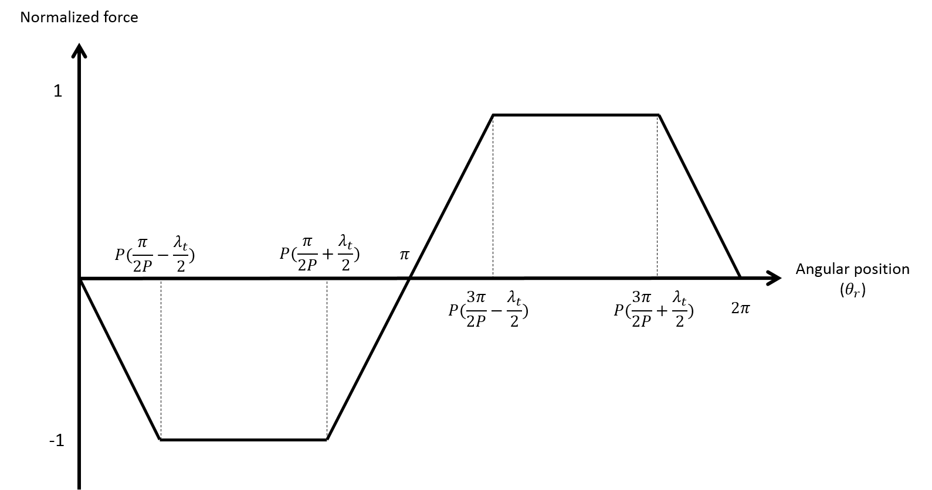
Figure 3-3 Electromagnetic circumferential force variation over one electrical cycle
In contrast to the calculation of the local x-component of force for phase 1, it is necessary to account for the contribution from the normal (radial) component of force that arises from the curvature of the stator teeth. Hence, the variation in the local y component of force with rotor angular displacement can be approximated by the following Fourier series (the detail of force equation derivation is provided in Appendix A):
 | $$F_{y1}=-\frac{4K_{l}K_{y}I_{1}}{πPβ_{y}}\sum_{N=1,3,5…}^{∞}{\frac{{\left(-1\right)}^{\frac{n-1}{2}}}{n^{2}}\cos\left(nP\frac{πλ_{t}}{2}\right)sin⁡(nθ)}$$ | (7)
where
 | $$K_{y}=\frac{4L_{ax}B_{r}}{λ_{t}\left(1+\frac{μ_{r}l_{g}}{l_{m}}\right)}\sin\left(\frac{λ_{t}}{2}\right)-\frac{2B_{r}μ_{r}πDL_{ax}}{λ_{t}N_{t}l_{m}{\left(1+\frac{μ_{r}l_{g}}{l_{m}}\right)}^{2}}(1-\cos{\frac{λ_{t}}{2}})$$ | (8)
 | $$β_{y}=\frac{π}{2P}-\frac{λ_{t}}{2}$$ | (9)
It is important to note that since this model is based on the excitation component of force only, the direction of a given net force produced by a phase can be reversed by 180º by simply changing the current polarity in that phase. In practice, a contribution from the normal reluctance force produced by the interaction of the stator current and the rotor core will always produce an attractive force irrespective of current polarity. When combined, this additional reluctance force, even if it is only modest in comparison to the excitation force will cause some asymmetry in the force waveforms.

Identification of preferred number rotor pole and stator tooth
The selection of appropriate combinations of rotor poles, stator teeth (and by implication stator phases) is fundamental to the feasibility of realizing self-bearing operation. The analytical force model described above provides a quantitative means of assessing self-bearing capability while at the same time providing considerable insight into the underlying requirements for a favourable orientation of individual force contribution from each phase.
The utility of this model in identifying rotor pole and stator phase combinations that are well suited to self-bearing operation can be illustrated by considering the case of a permanent magnet machine with the leading design parameters listed in Figure 3-1. As will be evident, although this is comparatively small machine, it has a comparatively large effective airgap of 3mm, which consists of the 2mm thick permanent magnet and a mechanical clearance of 1mm. It is also important to note that the magnet thickness is only twice the effective magnetic airgap, a ratio which is towards the lower end of that which is considered suitable in normal machine design guidelines for achieving a useful level of airgap field. As a consequence, the ratio of magnet flux leakage between adjacent magnets will be greater than machine designs that employ thicker magnets, and the flux leakage factor $K_{l}$ was assumed to be 0.9 in this case. The analytical expressions for the force constants $K_{x}$and $K_{y}$ yield values of 0.986(2×0.493) N/A and 0.118(2×0.055) N/A for phase 1 in Figure 3-4 and Figure 3-5 respectively for this particular set of design parameters.
Table 3-1Leading parameters of reference machine design
Parameter | Value
Total stator axial length | 200mm (2×100mm sections)
Stator core inner diameter | 64.0mm
Ratio of stator tooth pitch to pole pitch | 0.8
Rotor core outer diameter | 58.0mm
Magnet outer diameter $D_{ro}$ | 62.0mm
Magnet pole arc | 180°elec
Magnet remanence | 1.10T
Magnet relative recoil permeability | 1.05
Current density (rms) | $$4 A/{mm}^{2}$$
Direction of magnetization | Parallel
In order to provide a consistent basis for comparing performance of different combinations, the total stator mmf is fixed at 2250A and uniformly distributed amongst the stator phases, i.e. a fixed DC level of 250A in each phase of the two 9-slot stator sections. The variation in the predicted force produced by a given phase over one electrical cycle of the machine can then be calculated. By way of example, Figure 3-4 and Figure 3-5 show the predicted variations with rotor angular displacement of the forces $F_{x}$ and $F_{y}$ for a machine with 6 rotor poles and 9 stator teeth configured as 9 separately controlled phases, each of which has a fixed mmf of 250A.
As will be apparent from Figure 3-4 and Figure 3-5, the forces produced by the individual stator phases for this particular combination are reasonably well spread over one electrical cycle. This is a desirable feature for efficient self-bearing operation since it will ensure that at any rotor angular displacement there will be several phases which are favourably oriented to produce the desired restoring force. A useful quantitative assessment of this behaviour can be obtained from a summation of the absolute values of the forces in Figure 3-4 and Figure 3-5. This constructive superposition could be achieved in practice by injecting the appropriate polarity of current at a given rotor angular position. The x and y components of force derived from such summations are shown in Figure 3-6, which demonstrates that for this particular combination, relatively uniform forces can produced in both the x and y directions at any rotor angular displacement. A useful figure of merit is the ratio of the maximum to minimum force, which in the particular case shown is 1.03 and 1.04 for the x and y components respectively.
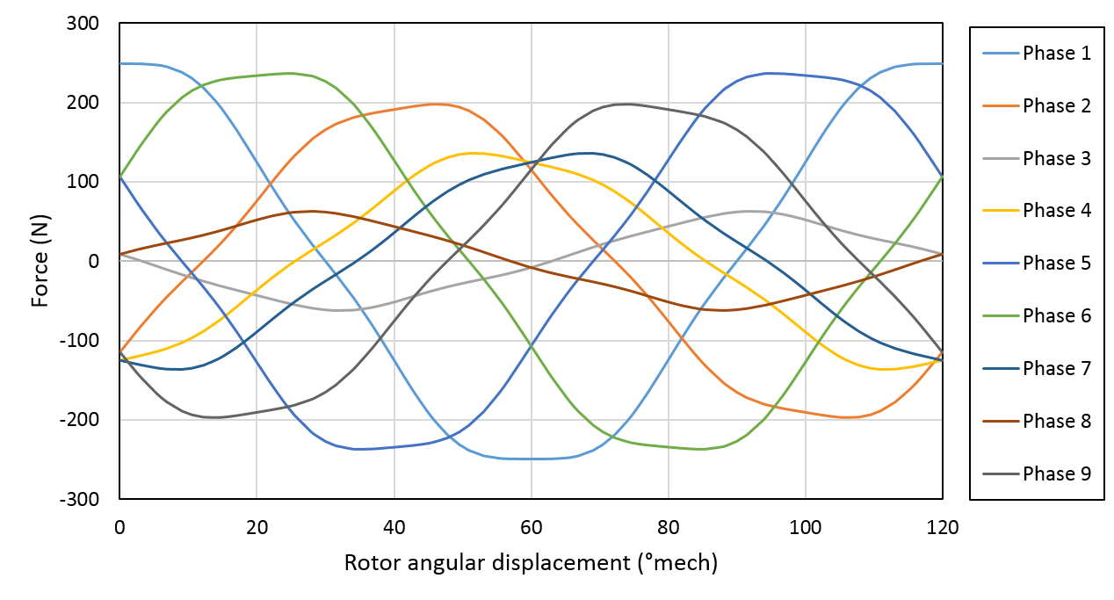
Figure 3-4 Predicted variation in the x-direction forces (with respect to the stator reference frame) produced by each phase of machine with 9 phase and 6 rotor poles
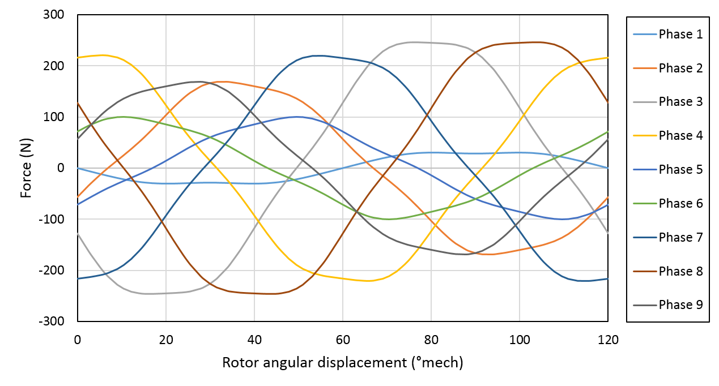
Figure 3-5 Predicted variations in the y-direction forces (with respect to the stator reference frame) produced by each phase of a machine with 9 phases and 6 rotor poles
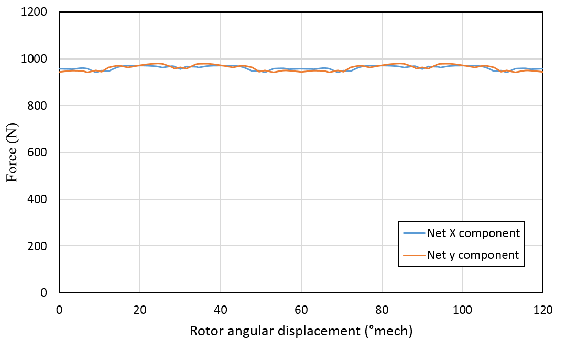
Figure 3-6 Summation of the magnitudes of the forces produced by all phases as a function of rotor angular displacement for a machine with 9 stator phases and 6 rotor poles
A series of these calculations was performed for four different combinations of stator phases and rotor poles in order to provide an indication of their self-bearing capability. In each case, the fixed set of design parameters shown previously in Table 3-1 was used, while a fixed overall stator mmf of 2250A was equally divided between the stator phases. The values of the x and y force coefficients derived from equations (5) and (8) for the four different combinations considered are shown in Table 3-2 together with the stator mmf per tooth.
The resulting maximum and minimum values of the x and y forces are shown in Table 3-3, which demonstrate that some combinations, viz. 9-6, 12-8 and to a lesser extent 9-8, are well suited to self-bearing operation, since they are capable of producing relatively uniform forces at any given rotor angle. The remaining combinations of 8-6 have very high ratios of maximum to minimum forces. Hence, they are likely to require higher stator currents in order to respond to control systems demands at rotor angular displacements that correspond to the rotor being unfavourably oriented.
Table 3-2 MMF per stator tooth and Force constant
Stator phases | Rotor poles | Mmf per stator tooth (A) | $$K_{x}$$  (N/A) | $$K_{y}$$  (N/A)
8 | 6 | 281 | -1.105 | 0.080
9 | 6 | 250 | -0.986 | 0.118
9 | 8 | 250 | -0.986 | 0.118
12 | 8 | 187 | -0.753 | 0.180

Table 3-3 predicted force characteristics
Stator phases | Rotor poles | x-component of force (N) |  |  | y-component of force (N)
 |  | Max | Min | Ratio | Max | Min | Ratio
8 | 6 | 1349 | 539 | 2.50 | 1349 | 539 | 2.50
9 | 6 | 972 | 942 | 1.03 | 979 | 941 | 1.04
9 | 8 | 835 | 771 | 1.08 | 840 | 786 | 1.07
12 | 8 | 843 | 616 | 1.37 | 843 | 616 | 1.37
The case of a machine with 8 stator phases and 6 rotor poles provides an interesting example of the limitations of published design guidelines that are based purely on a first order consideration of the orientation of forces. Although such approaches provide a useful starting point, it is important to consider the magnitude of the forces that can be produced and not simply their orientation. Furthermore, the span of rotor angular displacements over which a given phase produces useful force often departs significantly from simplified consideration and hence some the ‘gaps’ in the force capability are compensated for by overlap of contributions from other phases.
As indicated in Table 3-3, a machine with 8 stator phases and 6 rotor poles produces a high ratio of maximum to minimum force, which would suggest that it is not well suited to self-bearing operation. The variations in the x- and y-components of force produced by the individual stator teeth are shown in Figure 3-7 and Figure 3-8, while the resulting net force derived from a summation of the absolute magnitudes of each individual contribution is shown in Figure 3-9. As will be apparent, the distribution of forces over one electrical are not favourably distributed for the effective and efficient production of force at all angular displacements, with difficulties in the x- and y-directions for rotor angular displacements of 30º and 60º respectively. It is worth noting that even the maximum forces produced in the x and y directions of 1349N are significantly higher than those produced by the equivalent machine with 6 rotor poles and 9 stator phases, which produces corresponding forces of 972N and 979N respectively. Hence, the penalty of adopting this combination is not necessarily overwhelming when viewed in the context of other design criteria despite it not being generally regarded as a suitable combination.
In comparing the relative merits of various combinations, it is worth noting that an increase in the rotor pole number may provide some scope to reduce the stator back-iron thickness, and hence increase the slot area and the mmf per phase which can be accommodated. Thus, the comparison drawn on the basis of a fixed mmf which is independent of pole number does tend to favour high pole number machines.
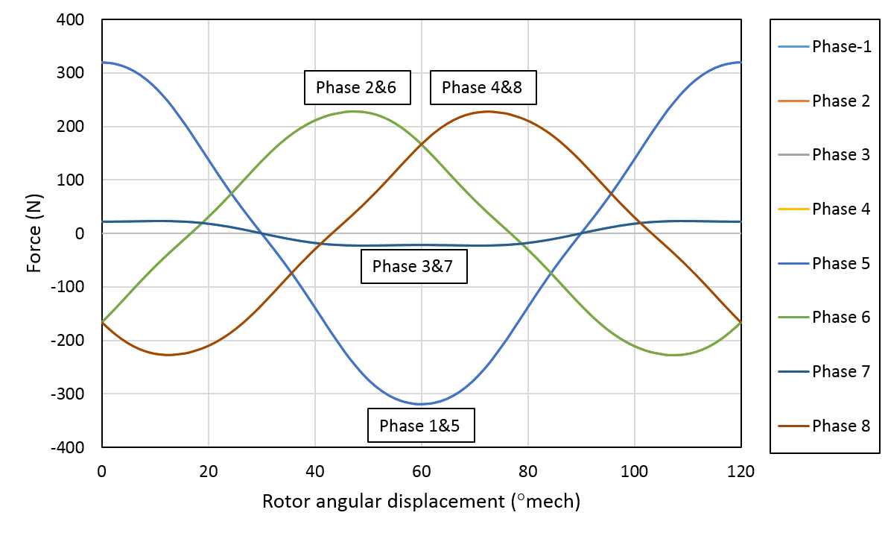
Figure 3-7 Predicted variations in the x-direction force (with respect to the stator reference frame) produced by each phase of a machine with 8 phases and 4 rotor poles
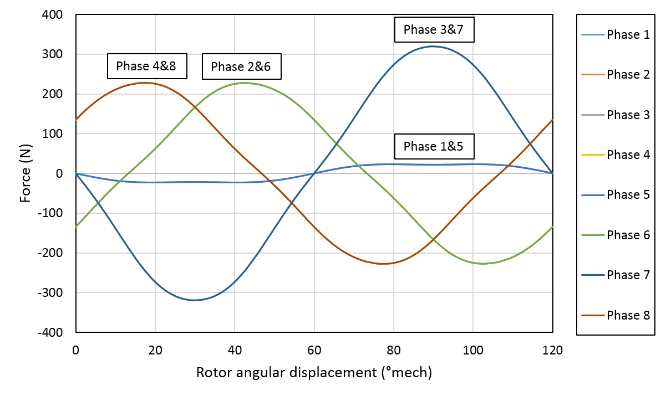
Figure 3-8 Predicted variations in the y-direction force (with respect to the stator reference frame) produced by each phase of a machine with 8 phases and 4 rotor poles
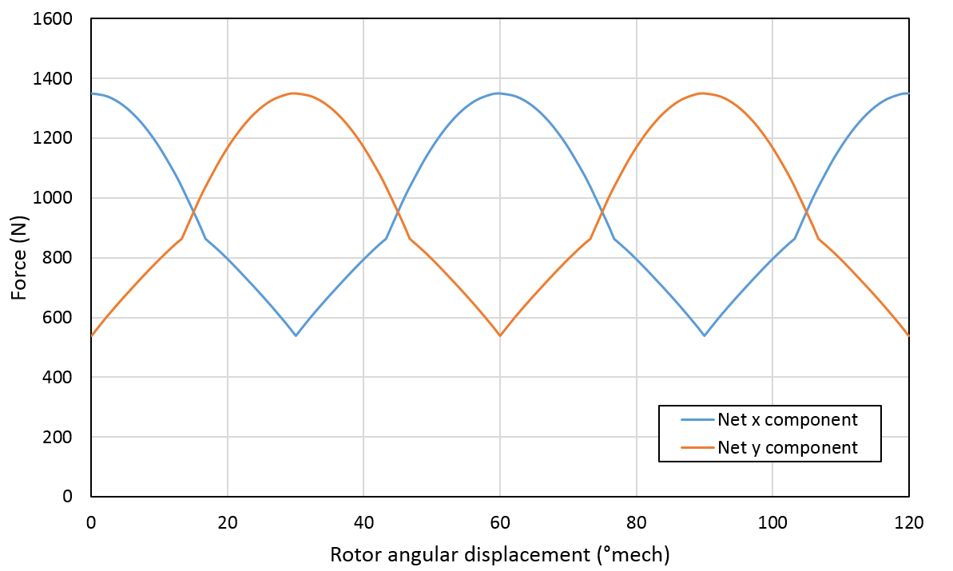
Figure 3-9 Summation of the magnitudes of the forces produced by all phases as a function of rotor angular displacement for a machine with 6 stator phases and 4 rotor poles

Machine design optimization
Section 3.2 has provided a useful basis for selecting a preferred slot/pole combination of 9 slots and 6 poles. The optimisation of a machine with this slot and pole combination is more complicated than the conventional machines due to the need to consider both bearing and motoring functions, which may have conflicting requirements. In this section, the process of the optimising the design of the rotor and stator are described. The optimal value of magnet thickness and tooth body width are selected to provide an acceptable trade-off between motoring and self-bearing capability.

Optimal magnet thickness

Bearing performance consideration
Achieving the desired controllable force capability of a self-bearing machine is a prerequisite condition for providing adequate bearing performance for the machine to run, and hence this aspect was prioritised for investigating the influence of magnet thickness. When the machine is analysed in the on-load condition and by using the principle of superposition, the resultant airgap flux density $B_{g,load}$ is equal to the sum of permanent magnet field and the stator field.
 | $$B_{g,load}(r,θ)=B_{g,PM}(r,θ)+B_{g, W}(r,θ)$$ | (10)
By substituting equation (10) to the general Maxwell-type force equation for normal forces (11), the resultant forces can be concluded as comprising three contributions as shown in equation (12).
 | $$F=\frac{{B_{g, load}(r,θ)}^{2}}{2μ_{0}}\int{rL_{ax}dθ_{r}}$$ | (11)
 | $$F=\frac{{B_{g,PM}(r,θ)}^{2}}{2μ_{0}}\int{rL_{ax}dθ_{r}}+\frac{{B_{g, W}(r,θ)}^{2}}{2μ_{0}}\int{rL_{ax}dθ_{r}}+\frac{B_{g,PM}(r,θ)*B_{g,W}(r,θ)}{μ_{0}}\int{rL_{ax}dθ_{r}}$$ | (12)
- Controllable excitation force FE prediction with a series of different PM thickness
For self-bearing machines, the main contribution to the bearing force is also known as Maxwell normal force due to the interaction between PM field and armature winding field in the airgap region. The magnitude of resultant bearing force represents the fundamental capability of magnetic bearing performance in terms of maintaining rotor position and avoiding the physical contact between rotor and stator.
By keeping a constant armature winding field (mmf equals to 250A) in phase 1 of the leading design listed in Table 3-1, the magnitude of force variation (two-section combined value) with respect to magnet thicknesses in local x- and y-direction predicted from two-dimensional, non-linear finite element calculations is shown in Figure 3-10.
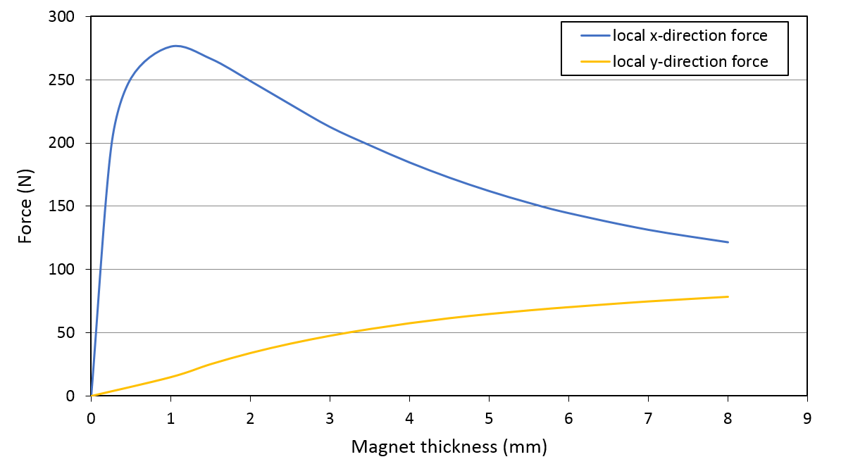
Figure 3-10 Finite element predicted magnitude of phase-1 force variation with various magnet thickness ($l_{m})$ in local x- and y-direction.
As would be expected for phase 1, which is aligned along the x-axis, the local x-component of force dominates over the y-component and is the main contributor to the bearing function, especially for small values of magnetic thickness. It is worth noting that the polarity of current in the stator produces an attractive force towards phase 1, i.e. it adds to the attractive force produced by the reluctance force produced by the interaction of the rotor core and the stator winding.
As will be apparent from Figure 3-10, the local x-component force exhibits a maximum magnitude with relative thin magnets (1mm), and then rapidly drops off with thicker magnets. In order to explain the variation in the local x-component force, it is useful to introduce the fundamental definition of radial force in equation (13), in which the magnitude is proportional to the derivative of magnetic energy stored in permanent magnet and stator winding with respect to the airgap in radial direction.
 | $$F_{r}=\frac{P_{m}dt}{dl_{g}}=\frac{eidt}{dl_{g}}$$ | (13)
As the induced back-EMF, e, and flux linkage, λ are expressed as:
 | $$e=\frac{dλ}{dt}$$ | (14)
 | $$λ=NB_{g}A_{g}$$ | (15)
By substituting equations (14) and (15) to equation (13), the radial force is obtained as:
 | $$F_{r}=A_{g}\frac{dB_{g}}{dl_{g}}Ni$$ | (16)
As the local x-component force represents the total x-component of radial force acting on the curvature of tooth 1, the magnitude of local x-component is proportional to the rate of change of airgap flux density in radial direction as derived in equation (16).
A useful indication of this rate of change can be established from a standard and widely used plot shown in Figure 3-11, which shows the relationship between normalized airgap flux density ${B_{g}}/{B_{r}}$ and the ratio of magnet thickness and airgap. This diminishing return relationship is often used in preliminary design of all types of permanent magnet devices to establish a reasonable trade-off between increasing magnet thickness (and hence cost) and the airgap flux density. In many machine designs, a ratio of around 2-5 is often used unless the magnet is going to be subjected to very strong demagnetisation fields.
In the context of self-bearing machines, this classical design plot is useful to gauge the rate of change airgap flux density for a given magnet thickness as the radial airgap is varied. The slope of this curve has a maximum value for a ratio of ${l_{m}}/{l_{g}}$ of ~1, and decreases significantly when $l_{m}≫l_{g}$ . Hence, a thin magnet, possibly as thin as 1mm for the 1mm airgap in Table 3-1 is likely to yield the maximum magnitude of controllable local x-component force for a given stator current. It is perhaps a little surprising that increasing the amount of permanent magnet on the rotor would reduce this component of force, but as will be demonstrated in later sections, this behaviour is verified by FE analysis.
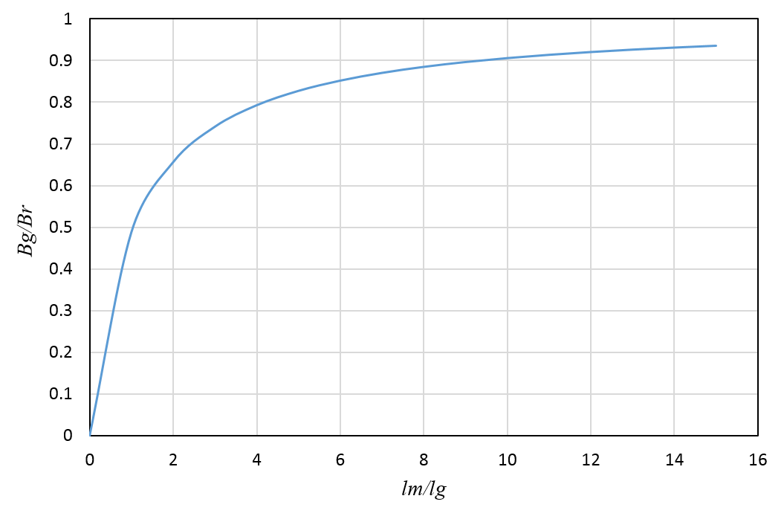
Figure 3-11 analytically calculated relationship between normalized airgap flux density and the ratio of magnet thickness to airgap from a simple one-dimensional magnetic circuit model
The same conclusion can also derived from equation (5) of the analytical force model. By representing equation (5) using the ratio of $r_{c}={l_{m}}/{l_{g}}$, it can be rewritten as:
 | $$K_{x}=\frac{-2B_{r}μ_{r}πDL_{ax}\sin\left(\frac{λ_{t}}{2}\right)}{λ_{t}N_{t}l_{g}(r_{c}+\frac{{μ_{r}}^{2}}{r_{c}}+2μ_{r})}$$ | (17)
For the maximum value of local x-component force, it is achieved by minimizing the part of$r_{c}+\frac{{μ_{r}}^{2}}{r_{c}}$. Accordingly, the ratio of ${l_{m}}/{l_{g}}$ should be 1.05, i.e., $l_{m}=1.05mm$ which shows good agreement to previous analysis and FE predicted magnitude of local x-component force in phase 1.
- Influence of magnet radial thickness of reluctance force
As noted above, there will be a potentially large component of reluctance force due to the interaction between armature winding field and rotor core. As also noted above, this will always be a force of attraction and is proportional to the square of the stator current magnitude if there is no significant magnetic saturation. It is also worth noting that the magnitude of this attractive reluctance force for a given mmf will be approximately inversely proportional to the square of the airgap length. In a self-bearing machine, from the perspective of the airgap flux density produced by the stator coil, the permanent magnet acts in effect as additional airgap (µr is typically 1.05 or so). Hence, a design with a thin magnet is likely to generate a larger magnitude of attractive reluctance force than a thicker magnet. For the surface-mounted PM self-bearing machine design whose main parameters were listed previously in Table 3-1, the controllable excitation force and the attractive reluctance forces were calculated for a series of different magnet thicknesses using finite element analysis. The finite element model can only calculate the net force and hence the following procedure, which is based on an assumption that superposition is reasonable, was used for each magnet thickness in turn:
- The magnetisation of the magnet was removed and the force calculated at the rated current. This provides a value of the attractive reluctance force alone
- The magnetisation of the magnet was re-instated and the force calculated at the rated current. This provides a value that is the sum of the attractive reluctance and the controllable excitation force if the current polarity is set so that both of these act in the same direction.
- A reasonable approximation of the controllable excitation force was then derived from the difference between these two force calculations.
Figure 3-12 shows the resulting reluctance and excitation forces as a function of magnet thickness for a nominal airgap of 1mm for a fixed mmf of 250A in phase 1. Figure 3-13 shows the ratio of the excitation force to the reluctance force as a function of magnet thickness.

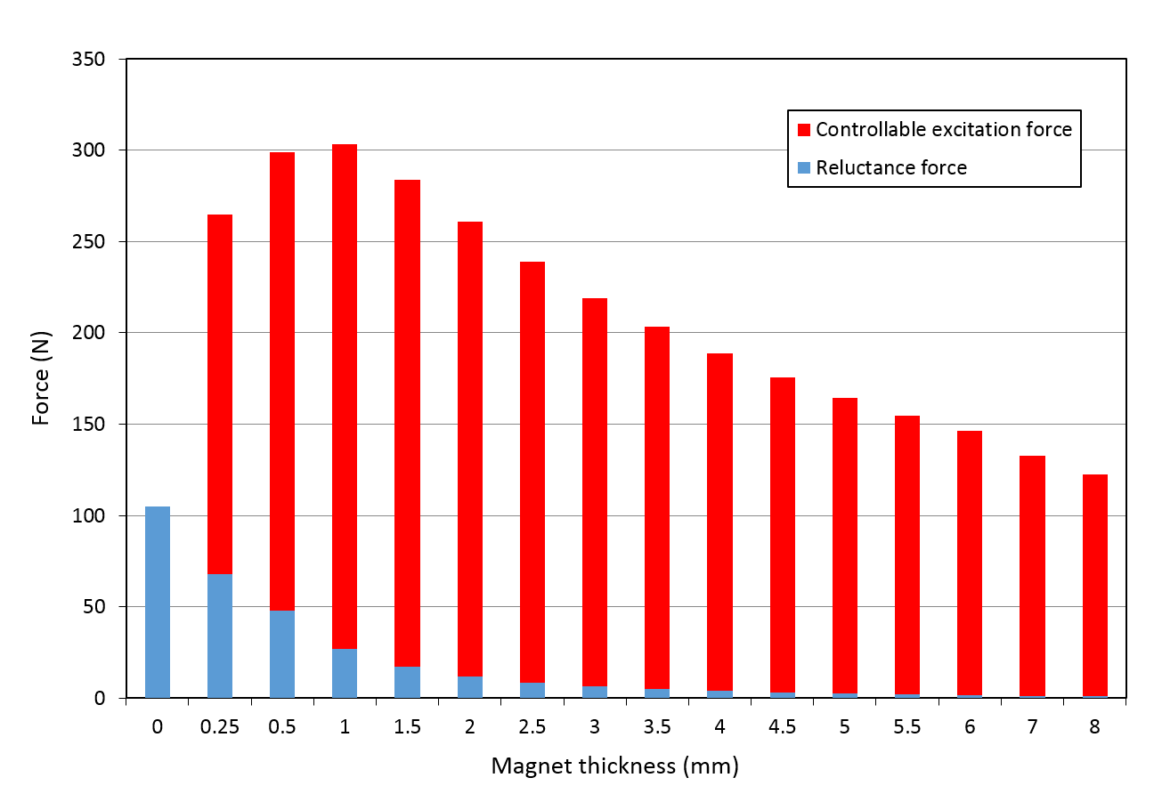
Figure 3-12 Finite element predicted excitation force and reluctance force with different magnet thickness at a constant mmf 250A on phase 1
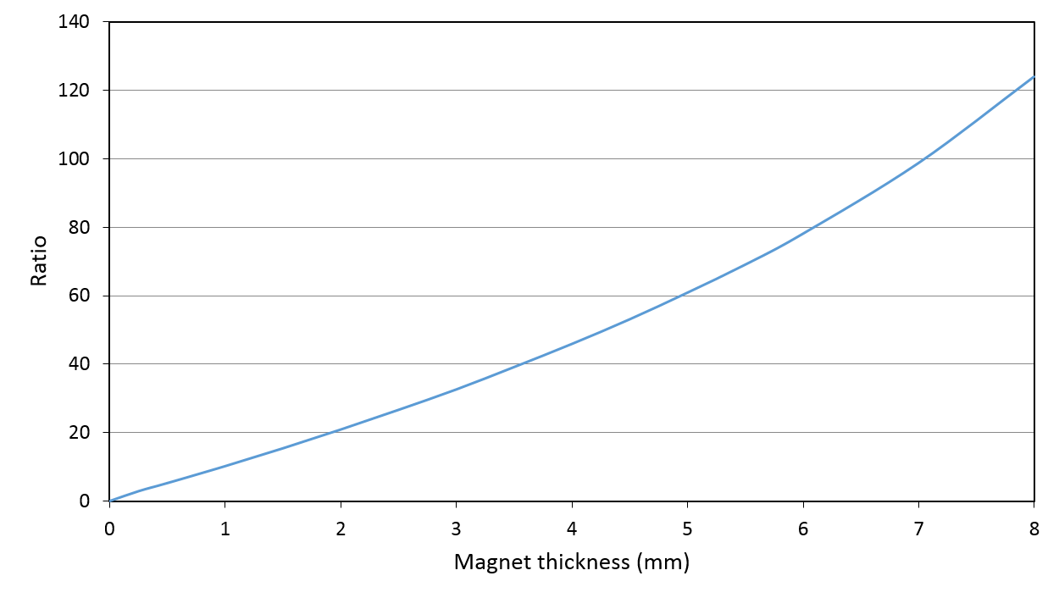
Figure 3-13 Ratio of finite element predicted excitation force and reluctance force produced by phase-1 with a constant mmf of 250A
- Finite Element predicted unbalance magnet pull (UMP) with different magnet thickness in open-circuit
The unbalanced magnetic pull (UMP) is present even in the absence of stator currents. It is a result of the high normal forces of attraction between the rotor magnets and stator core. In a fully symmetrical case, the various contributions around the rotor periphery cancel each other out and there is not net pull. However, any unbalanced conditions, which can be caused by rotor eccentricities and/or motor slot/pole geometries, will give rise to a net unbalanced force on the rotor. This UMP acts as a negative stiffness, i.e. the force displacing the rotor increases as the displacement increases. UMP therefore acts as a significant and uncontrolled disturbance force that acts against the ‘positive’ stiffness of the bearing action. It is therefore important to minimise the magnitude of the UMP in a self-bearing machine, although of course there must be some trade-off with features that affect the controllable force.
Figure 3-14 and Figure 3-15 show FE predicted results of the variation of UMP over one electrical revolution for 9-slot 8-pole and 9-slot 6-pole machines respectively in both cases with no rotor eccentricity. By rotating these two motors over one electrical revolution with no rotor eccentricities, the magnitude of UMP is governed by the symmetry of the rotor and stator geometry. As will be apparent, the unsymmetrical motor slot/pole topology of 9-slot 8-pole machine produces an UMP of ~37 N. In contrast, the preferred topology of a 9-slot 6-pole SPM machine has a symmetrical configuration and as a result, the magnitude of unbalanced magnetic force shown in Figure 3-15 is negligible and being only ~0.015N that may well be an artefact of the finite element mesh and integration procedures within the finite element package. This illustrates one of the reasons that 9-slot 8-pole permanent magnet machine is not as well suited as a 9 slot, 6 pole machine, even though the controllable force capability of the 9-8 magnet machine on both X and Y components are competitive with those of a 9-6 SPM self-bearing machine as shown previously in Table 3-3.
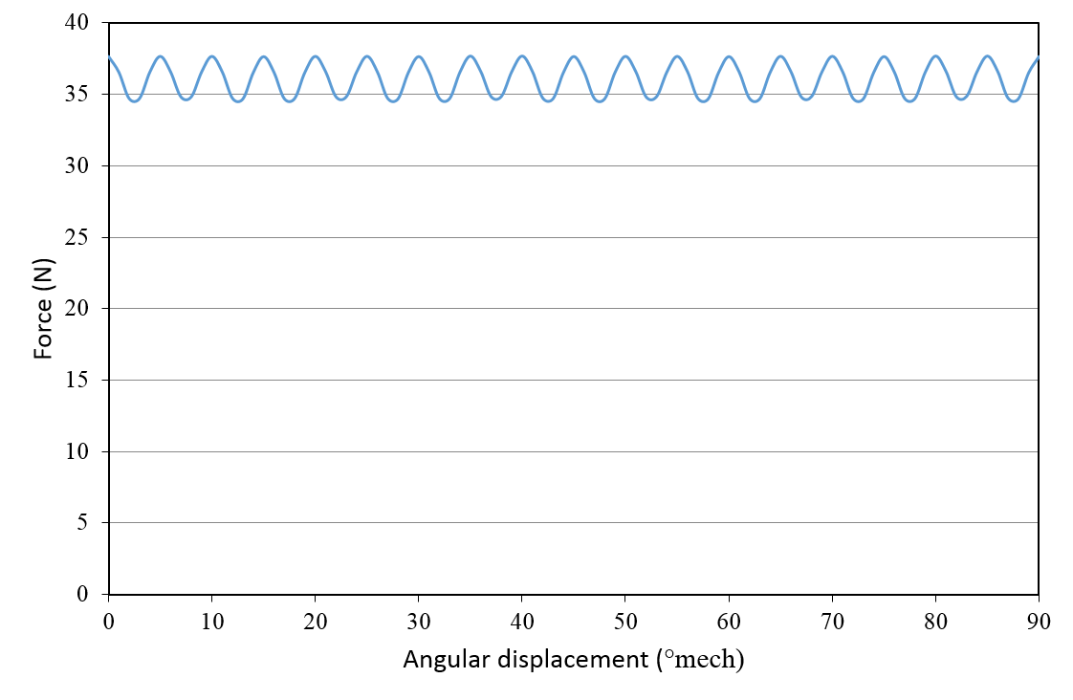
Figure 3-14 Finite element predicted UMP of a 9-slot 8-pole SPM self-bearing machine over one electrical revolution at centralised position (no rotor eccentricity)
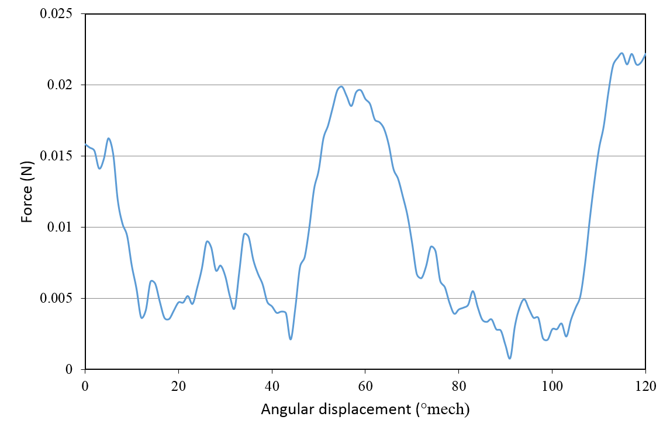
Figure 3-15 Finite element predicted UMP of 9-slot 6-pole SPM self-bearing machines over one electrical revolution at centralized position (no rotor eccentricity)
Figure 3-16 shows the finite element predicted variation in the UMP for the case of a 9-6 machine with 2mm thick magnet in which the eccentricity is along the x-axis. As will be apparent, the magnitude of UMP is linearly proportional to the rotor eccentricity. For these 2mm thick magnets, the effective stiffness of the UMP is ~1200 N/mm of one section. In terms of the direction of the UMP, because the resultant UMP of this 9-slot 6-pole topology at centralized position is negligible, i.e. there is no contribution from slot pole asymmetry, then the net direction of the UMP should be largely in the same direction as the eccentric displacement. This was demonstrated with a series of finite element models with displacements in various directions and calculating the net force directions. As shown by Figure 3-17, the force is in the same as the direction of the eccentricity.
Therefore, the resultant UMP can be expressed as a linear dependency with rotor eccentricities:
 | $${\vec{F}}_{un}=K_{un}\vec{ε}$$ | (18)
Where ${\vec{F}}_{un}$ and $\vec{ε}$ are two vectors representing unbalance magnetic pull and rotor eccentricities respectively.
The unbalanced behaviour of a machine with 2mm thick magnets is summarised by Figure 3-18 which shows the x and y component of the UMP for four different magnitudes of eccentricity and 20° increments in the direction of the eccentric displacement.

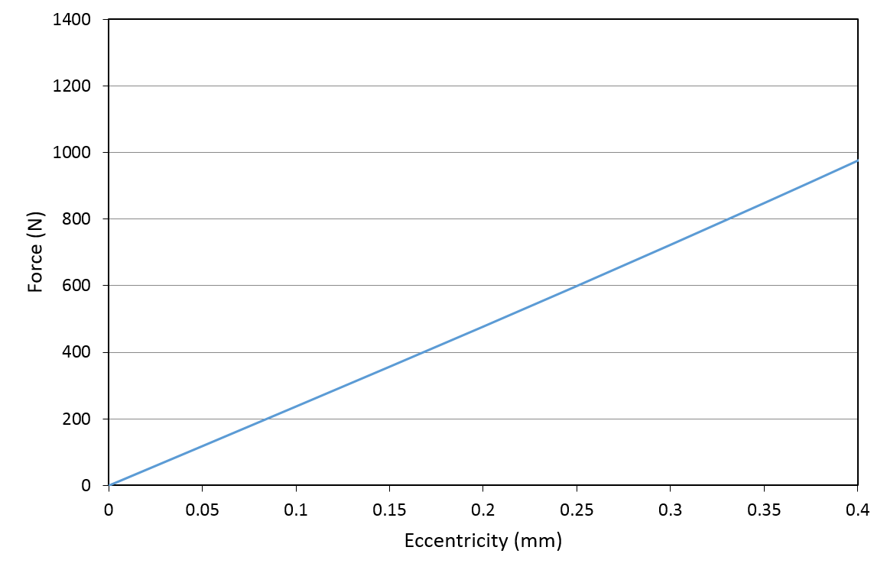
Figure 3-16 Finite element predicted variation in unbalanced force magnitude with rotor eccentricity for a 9-6 machine with 2mm thick magnets (value shown is combined force for both stator units).
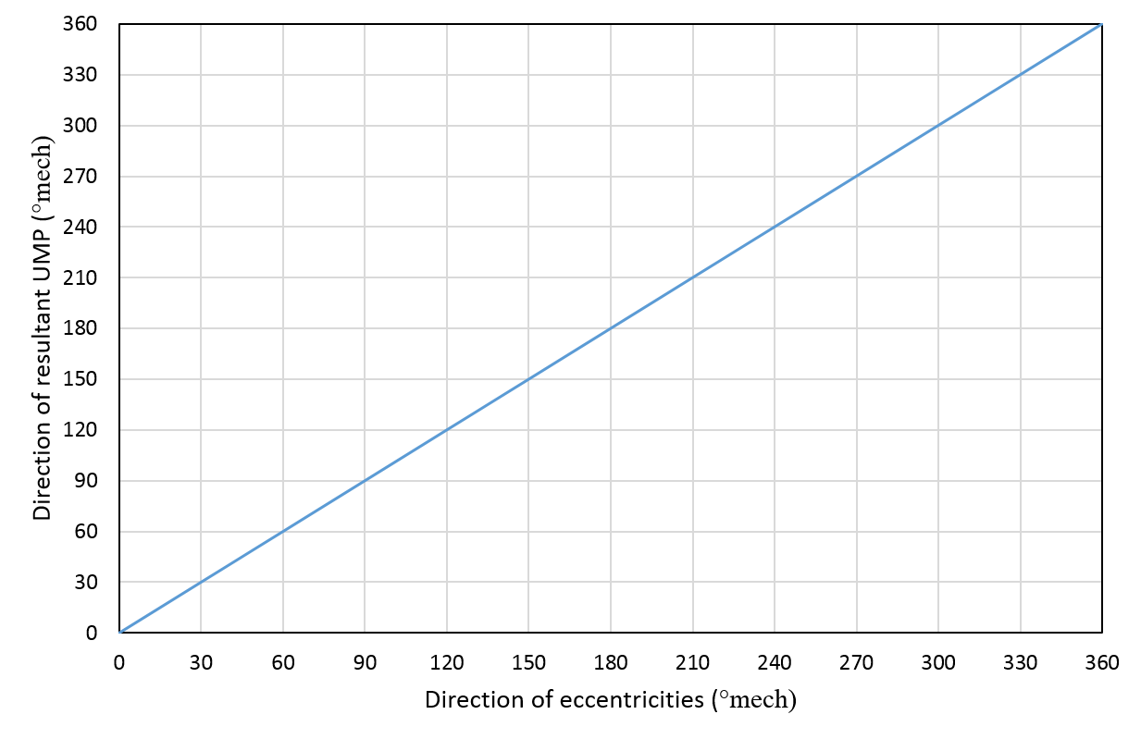
Figure 3-17 Finite element predicted variation direction of UMP force as a function of the direction of eccentricity (0.4mm eccentric displacement in all cases)
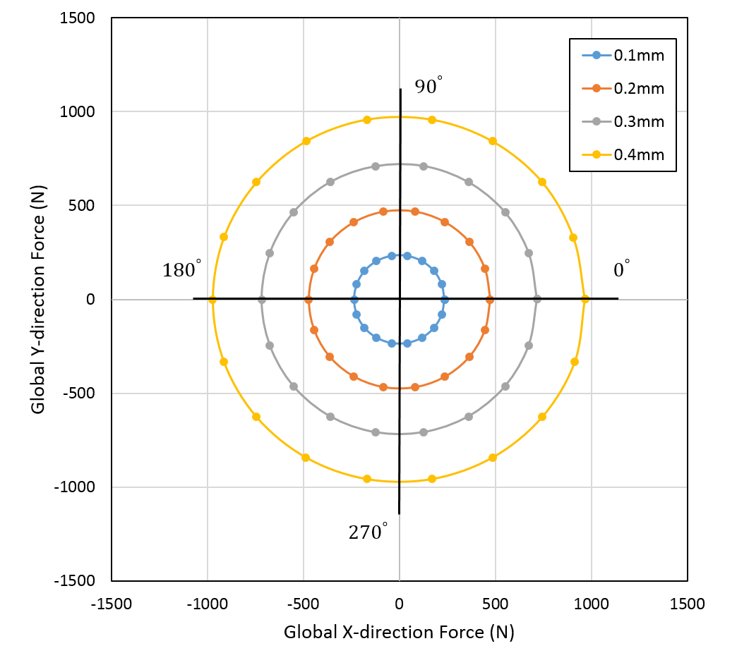
Figure 3-18 Resultant magnitude and direction of UMP plot due to rotor eccentricities for a machine with 2mm thick magnets (force values shown are total for two stator sections)
The UMP results up to this point have been focussed on a machine with 2mm thick rotor magnets, which yielded an UMP force constant $K_{un}$ of ~2400N/mm (total for both stator sections). The variation in the magnitude of the UMP force produced by both stator sections as function of rotor magnet thickness is shown in Figure 3-19.
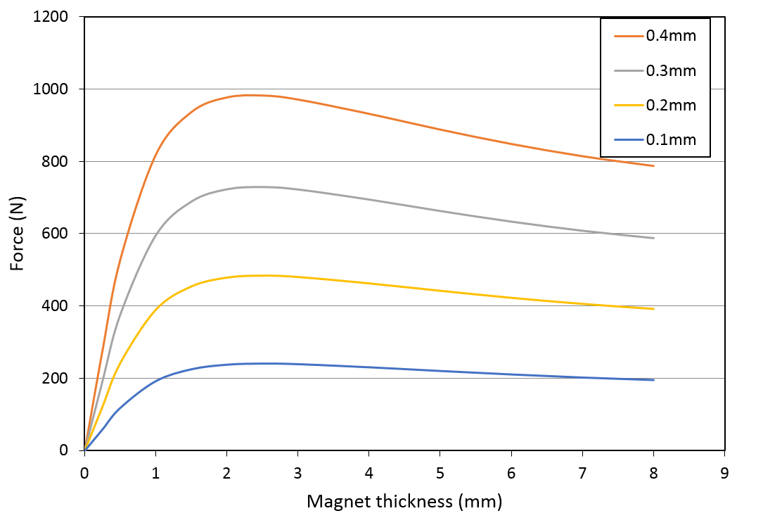
Figure 3-19 Finite element predicted magnitude of UMP as a function of magnet thickness and rotor eccentricities.
As can be seen from Figure 3-19, the magnitude of UMP reaches a maximum value with relative thin rotor magnets (2mm), which would tend to favour thicker magnets. However, the drop off in UMP with increasing magnet thickness is not particularly pronounced, falls by 19.4% between 2mm and 8mm thick magnets for the maximum eccentricity of 0.4mm in Figure 3-19. This is a much lower reduction than the corresponding reduction in the controllable excitation force (shown previously in Figure 3-10) which suggests that thin magnets are likely to provide the best trade-off in terms of controllability.
In the consideration of the operating process of this self-bearing machine, rotor is initially levitated from back-up bearing positions, in which case rotor levitate from a larger rotor eccentricity (0.4mm). Therefore, the selection of magnet thickness determine the requirement of initial bearing force to overcome unbalance magnet pull. As listed in Table 3-4, a useful quantitative assessment of initial levitating behaviour can be obtained from the absolute ratio of bearing force produced by phase 1 with a constant mmf of 250A and unbalance magnet pull due to eccentricities in Global X-direction at back-up bearing position ($ε_{x}=0.4mm)$.
Table 3-4 the ratio of bearing force produced by phase 1 and UMP in Global X-direction under specified mmf (250A) and rotor eccentricity (0.4mm)
$$l_{m} (mm)$$ | $$K_{un}(\frac{N}{mm})$$ | Bearing force $F_{b} (N)$ on Phase 1  $$(mmf=250A)$$ | $$F_{un}\left(N\right)$$  $$\left(ε_{x}=0.4mm\right)$$ | Ratio of  $F_{b}/F_{un}$
1 | 2116 | 276 | 846 | 0.33
2 | 2480 | 251 | 992 | 0.25
3 | 2447 | 213 | 978 | 0.22
4 | 2340 | 185 | 936 | 0.20
5 | 2227 | 162 | 891 | 0.18
6 | 2125 | 145 | 850 | 0.17
7 | 2040 | 131 | 816 | 0.16
8 | 1913 | 122 | 765 | 0.16
Evidently, higher ratios in Table 3-4 are desirable for controllability. Setting aside at this point, without consideration of motoring performance and demagnetization, magnets which are only 1mm magnet thick would seem to offer the best bearing performance. It is however important to recognise that this may be insufficient to produce competitive torque densities in the machine. This conflicting requirement is investigated in the next section.

Consideration of motoring performance
In the same manner to bearing force analysis, motoring performance can also be analysed based from consideration of a single phase. The finite element predicted variations of the excitation torque with an mmf of 250A in phase 1 is shown in Figure 3-20. Increasing the rotor magnet thickness gradually increases the torque produced by phase 1, but in a non-linear manner as shown in Figure 3-20. This behaviour can be more straightforwardly seen from the torque constants for each magnet thickness as shown in Figure 3-21. As will be apparent, and is well known in electrical machine design, thicker magnets shows significant advantage in terms of higher torque constant, although with diminishing return. For a specified torque rating, the higher torque constant results in lower copper loss and thereby a higher machine efficiency.
As for the conventional low-speed SPM machine assembled with mechanical ball bearings, the selection of magnet thickness mainly depends on the torque rating. Magnet thickness between 4mm to 6mm which equivalent to four to six permeance coefficient range is a typical value in many motor applications [74].
However, the magnitude of cogging torque is another aspect of performance that is sometimes an important consideration in standard SPM type machines. Although cogging torque does not diminish the average torque, it can result in significant torque ripple, especially when machine is operating at a low torque load condition. Figure 3-22 shows the finite element predicted cogging torque as function of magnet thickness for the reference stator design (values quoted are the total for the two stator sections). The significance of cogging torque compared to the excitation torque can be illustrated by considering the example of phase-1 excitation torque (Figure 3-20) required to overcome the peak cogging torque (Figure 3-22) at 27°. For this particular rotor angular displacement, a net positive torque is produced only when the magnet thickness is 1mm. For a constant mmf 250A in phase 1, the increment of cogging torque is larger than the excitation torque and this performance can be described as the ratio of phase-1 excitation torque and cogging torque shown in Table 3-5. Therefore, lower value of magnet thickness is preferred as the torque ripple due to cogging torque is less significant compared to the machine with thicker magnets.
According to the leading machine parameters listed in Table 3-1, torque rating of this medium sized machine is calculated in the range of 15Nm to 29Nm with different magnet thickness. Therefore, the torque ripple caused by the cogging torque is as considerable large as 10~15% of the torque rating.
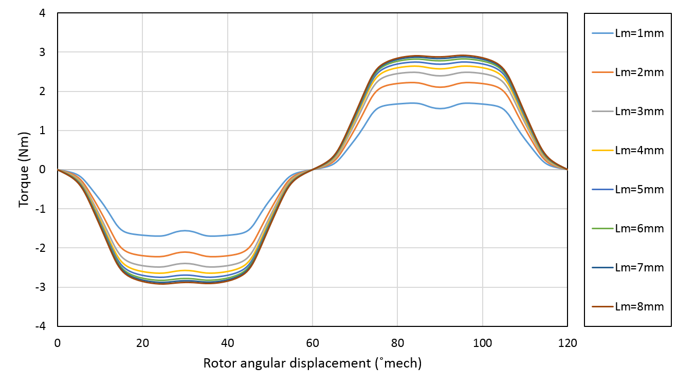
Figure 3-20 Finite element predicted variations of phase-1 excitation torque with an mmf of 250A for a range of different magnet thicknesses (values quoted are the total for the two stator sections)
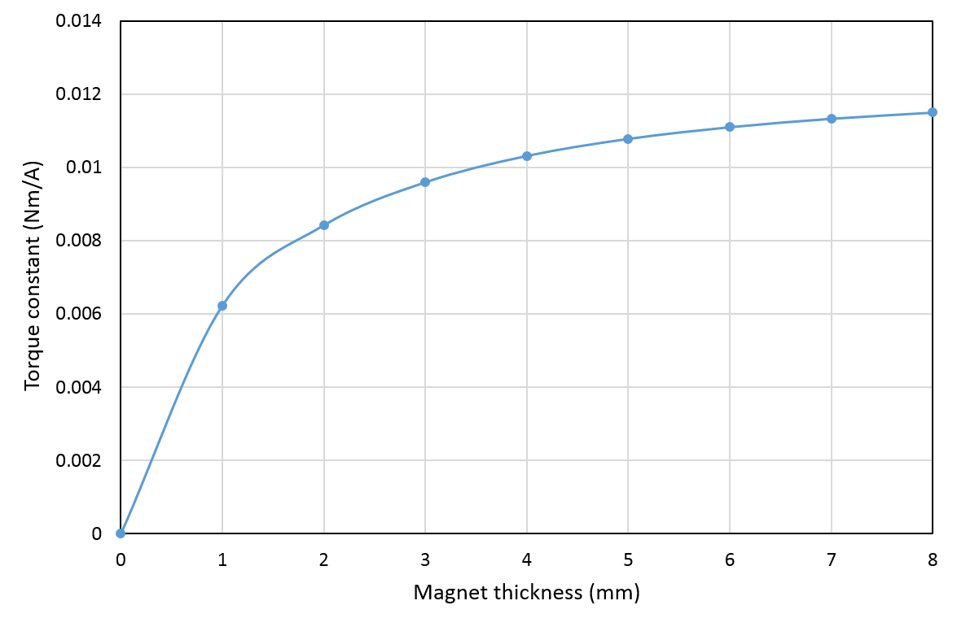
Figure 3-21 Finite element predicted variation in torque constant of Phase 1 with different magnet thickness (values quoted are the total for the two stator sections)
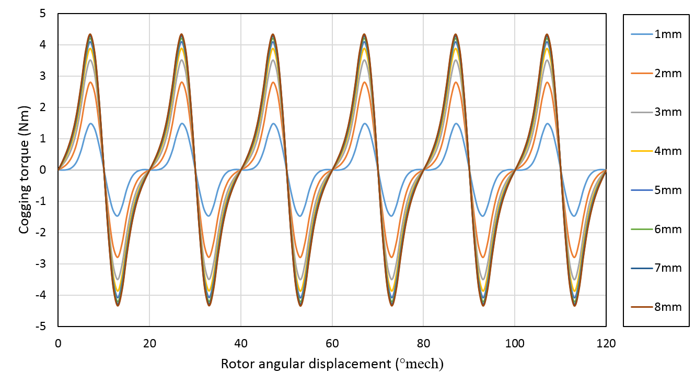
Figure 3-22 Finite element predicted cogging torque variation with magnet thickness (values quoted are the total for the two stator sections).

Table 3-5 Finite element predicted ratio of Phase-1 excitation torque to cogging torque with different magnet thickness
Magnet thickness  $$l_{m}$$ | 1mm | 2mm | 3mm | 4mm | 5mm | 6mm | 7mm | 8mm
Ratio of  $${T_{excitation}}/{T_{cogging}}$$ | 1.05 | 0.75 | 0.68 | 0.66 | 0.66 | 0.66 | 0.66 | 0.66

Consideration of irreversible demagnetization
Although thinner magnets often advantages in terms of bearing performance and some benefits with reduced eddy currents, they are more susceptible to irreversible demagnetisation. The minimum magnet thickness required to withstand a given stator mmf is given by [75]:
 | $$l_{m(min)}=-\frac{N_{s}N_{coil}I_{peak}}{4PH_{lim}}×\frac{α}{π} -\frac{B_{r}l_{g}A_{m}}{μ_{0}H_{lim}A_{g}}-μ_{r}l_{g}\frac{A_{m}}{A_{g}}$$ | (19)
where the signs of $N_{s}$, $N_{coil}$ and $I_{peak}$ represent the number of slots, number of coil turns and peak current respectively, and $α$ is the arc of permanent magnets in electrical degrees. The value of $H_{lim}$represents the magnetic field strength at the so-called ‘knee’ point of the demagnetisation characteristic at the operating temperature shown in Figure 3-23.
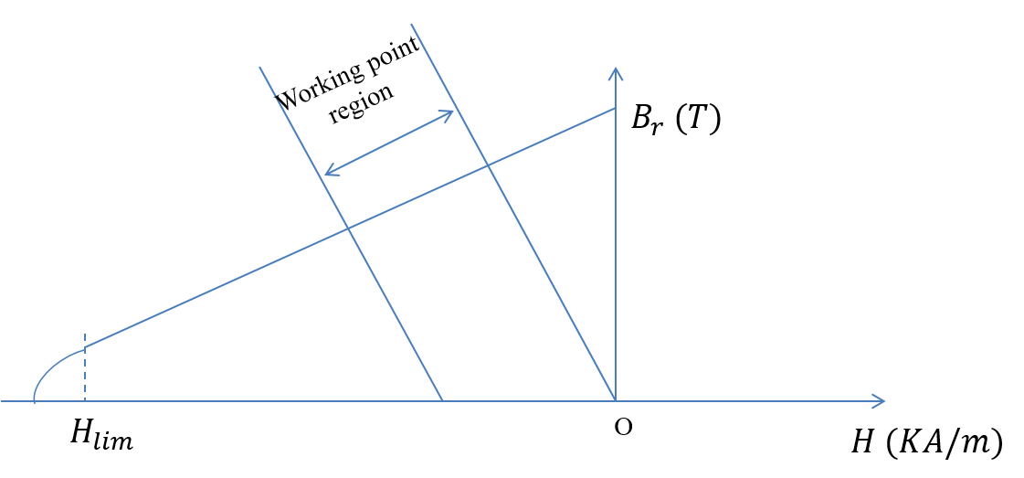
Figure 3-23 Schematic representation of a typical permanent magnet demagnetization characteristic
Since the arc of magnets is 180° (elec), the ratio of magnet surface area and airgap surface area $\frac{A_{m}}{A_{g}}$ is reasonably assumed to unity.
Table 3-6 Permanent magnet material specifications
Material | Grade | $$B_{r}$$ | $$H_{lim}$$ | Density | Max. working temperature
$$Nd_{2}{Fe}_{14}B$$ | 30H | 1.12T | -851 ${KA}/m$ | 7500 ${kg}/{{cm}^{3}}$ | 120 ˚C
For a maximum demand phase mmf is 1000A, the minimum required magnet thickness is 0.88 mm according to equation (19) and Table 3-6.

Selection of finial magnet thickness
As will be apparent, there are various trade-offs when selecting a suitable thickness of rotor magnets. In order to avoid irreversible demagnetization, the magnet thickness must greater than 1mm. Moreover, magnet thickness greater than 4mm leads to a significant reduction in bearing force shown previously in Figure 3-10 and the consideration of magnet cost and torque constant increment shown in Figure 3-21.
For this design study and prototype, a magnet thickness between 1mm and 4mm is likely to offer a good compromise. Table 3-7, summarises key indicators of bearing and motoring performance.
On the basis of the performance indicators in Table 3-7, a magnet thickness of 2mm was selected as this offers the best compromise between bearing and motoring performance.
Table 3-7 Bearing and motoring performance comparison for rotor magnets from 1mm to 4mm thick
Magnet thickness  $$l_{m}$$ | Ratio of Phase-1 bearing force and reluctance force  $${F_{b}}/{F_{r}}$$ | Ratio of Phase-1 bearing force and UMP  $${F_{b}}/{F_{un}}$$ | The ratio of Phase-1 excitation torque and cogging torque  ${T_{excitation}}/{T_{cogging}}$ | Single phase torque constant  $$K_{T} ({Nm}/A)$$
1mm | 10.2 | 0.33 | 1.05 | 6×10⁻³
2mm | 20.9 | 0.25 | 0.75 | 8×10⁻³
3mm | 32.61 | 0.22 | 0.68 | 9×10⁻³
4mm | 45.9 | 0.20 | 0.66 | 10×10⁻³

Rotor core thickness
In contrast to the multiple trade-offs in the selection of magnet thickness, the key criterion for the selection of rotor core thickness is solely the magnetic saturation level under on-load condition. As any core saturation directly influences the linearity of force and torque capability the minimum rotor core thickness was calculated for the case of a maximum phase mmf (1000A).
Under on-load condition, airgap flux density combination of the PM flux density $B_{g,PM}$and armature winding flux density$B_{g, W}$.The maximum airgap flux density is given by:
 | $$B_{g}=B_{g,PM}+B_{g, W}$$ | (20)
Where
 | $$B_{g,PM}=\frac{B_{r}}{\left(1+\frac{μ_{r}l_{g}}{l_{m}}\right)}$$ | (21)
 | $$B_{g, W}=\frac{μ_{0}NI}{l_{eff}}$$ | (22)
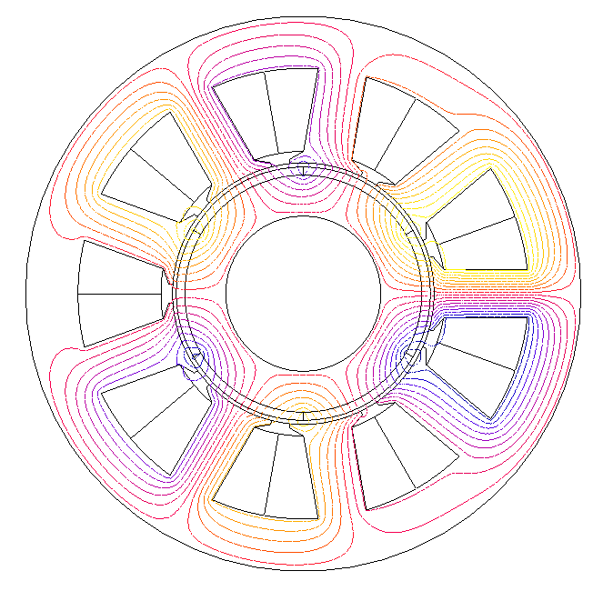
Figure 3-24 Flux distribution of 9-slot 6-pole permanent magnet machine with a maximum mmf 1000A on phase-1 at rotor angular position $θ_{r}=0°$
As can been seen from the finite element predicted magnetic flux distribution shown in Figure 3-24, the maximum flux crossing the airgap is produced when the PM flux and winding flux add constructively. Approximately half of the total airgap flux returns via the rotor core. Hence the peak flux density in the rotor core is given to a reasonable approximation by [74]:
 | $$B_{g_{rotor}}=\frac{B_{g}πD_{ro}}{4{dW}_{rc}{PK}_{ax}}$$ | (23)
where $K_{ax}$is as the rotor core lamination stacking factor and corresponds and typically takes values of 0.95 or to.
For the Silicon iron V300 selected for rotor core, the saturation flux density is 1.6T. Therefore, the minimum thickness of rotor core to avoid saturation was set to 10mm.

Containment thickness
For the high-speed SPM machines, a non-magnetic containment layer is usually wrapped over the rotor to prevent magnet displacement under the influence of centrifugal loading. This containment layer is usually manufactured using a carbon-fibre composite. The need for containment depends on the rotational speed, rotor size, magnet thickness etc.
For the given parameters of rotor geometry shown in Table 3-1 and magnet material data in Table 3-6, the containment thickness for a worst case estimate of $180°elec$magnet pole arc can be calculated by applying the equation of the peak hoop stress given in [76] and the representative carbon fibre composite properties in Table 3-8 [76].
Table 3-8 Typical properties of carbon-fibre composite sleeve (data sourced from [76])
Containment material | Young’s modulus  ($GPa$) | Density  ($kg/m^{3}$) | Ultimate  Tensile  Strength  ($MPa$) | Poisson’s  ratio | Thermal  Expansion  (${μm}/m.k$)
Carbon Fibre | 162 | 1661 | 2138 | 0.3 | 0.1
Using this method, the required containment thickness calculated for this rotor with the outer diameter of 62mm rotating at max 3500rpm is only ~0.014mm. This calculation is based on a worst-case estimate which neglects the magnetic attraction force and the contribution to magnet retention from the adhesive. These worst-case estimates are reasonable for containment thicknesses in the mm range, but these inherent retention forces may be comparable to the contribution from a ~0.014mm thick sleeve. However, rather than dispense with the sleeve completely, it was decided to use minimal containment in the prototype, i.e. two layers of filament wound fibre. The key factor in the design, is that this very thin containment is small in comparison to the mechanical airgap of 1mm and hence does not require iteration of the magnet and containment thickness during the design, as is often the case where the containment is comparable with, or greater than, the mechanical clearance. For the purposes of this design study, the containment thickness was simply absorbed into the 1mm mechanical clearance, resulting in a fixed magnetic airgap of 1mm.

Stator tooth body width
In terms of the selection of tooth body width, a wider tooth body offers potential for improved linearity in force and torque capability in practical machine, while a tooth that is too narrow to carry on the on-load flux will cause a drop in the torque and force constant of the machine. Under open circuit conditions, the minimum tooth body width to avoid significant saturation can be calculated by:
 | $$W_{t}=\frac{πD_{ro}B_{g,PM}}{N_{s}K_{ax}B_{tooth}}$$ | (24)
In the case of the baseline design, the minimum width of tooth body required is 8.3mm for a peak open-circuit flux density of 1.6T.
Table 3-9 shows finite element predicted values of local x-component force produced by phase 1 as a function of tooth body widths between 12mm and 15mm. As will be apparent, a tooth body width of 15mm exhibits shows a higher force constant compared to 12mm tooth body width at all phase mmfs up to 1000A.

Table 3-9 Finite element predicted values of local x-component force produced by phase 1 as a function of tooth body width between 12mm and 15mm
$$W_{t}$$ | Force constant | Winding current mmf
 |  | 50A | 100A | 150A | 200A | 300A | 400A | 500A | 750A | 1000A
12mm | $$K_{x}$$ | 1.004 | 1.005 | 1.005 | 1.004 | 1.001 | 0.996 | 0.987 | 0.944 | 0.885
15mm |  | 1.025 | 1.025 | 1.025 | 1.025 | 1.024 | 1.022 | 1.020 | 1.000 | 0.976
Although a wider tooth body leads to higher torque and force constants for a given mmf, it also leads to a reduced stator slot area. In order to produce a given torque with smaller slot area, a higher current density is required, which will tend to lead to the increased copper loss. Hence, it is necessary to account for the copper losses when selecting the value of tooth body width. The copper loss of single coil is given by:
 | $$P_{copper loss}=I^{2}\frac{N^{2}ρl}{A_{copper}}$$ |  |  | (25)
 |  | $$P_{copper loss}=\frac{{(NI)}^{2}ρl}{A_{copper}}=\frac{2{(NI)}^{2}ρl}{A_{slot}K_{cp}}$$ | (26)
where
$$l=the length of one single turn of stator coil (m)$$
$$ρ=copper resistivity=1.67×{10}^{-8}Ω∙m$$
$$A_{slot}=slot area (m^{2})$$
$$A_{copper}=copper cross section area \left(m^{2}\right)=0.5*A_{slot}*K_{cp}$$
$$K_{cp}=packing factor=0.45$$
The relationship between the copper loss and tooth body width for the case of a torque of 22Nm is shown Figure 3-25 (where the values quoted are totals for the two stator sections).
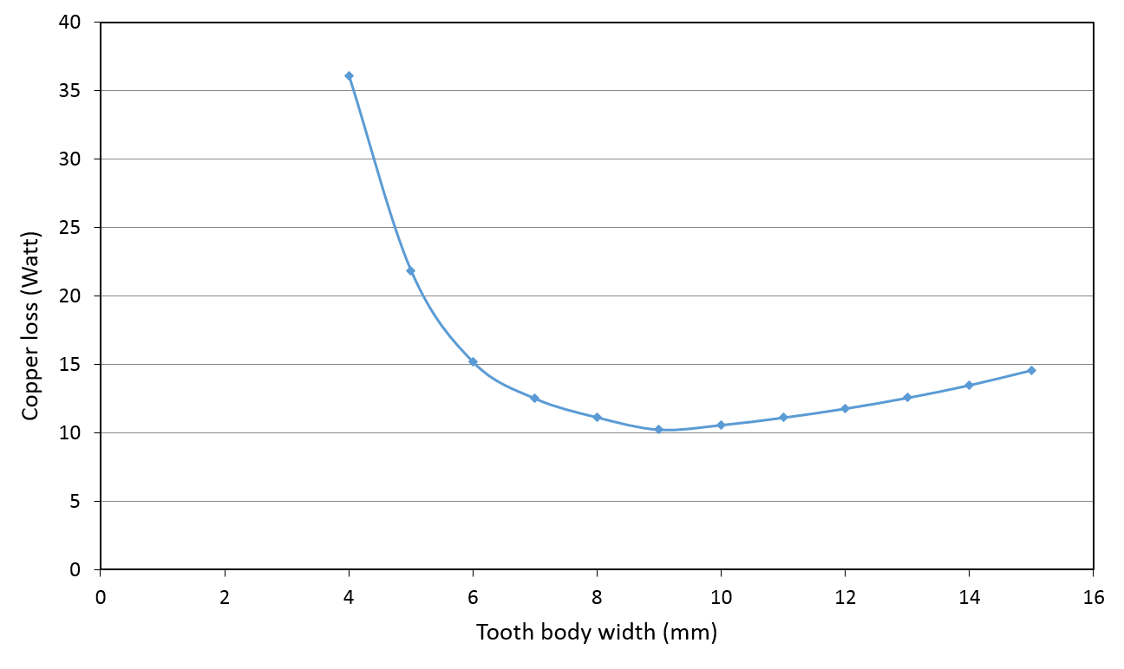
Figure 3-25 Finite element predicted copper loss constant of this prototype machine as a function of tooth body width for the torque rating of 22Nm
As will be evident from Figure 3-25, a tooth body width of 9mm results in the lowest copper losses when the machine is operating at the rated torque of 22Nm. For the tooth bodies narrower than 9mm, the effect of magnetic saturation is more pronounced than the benefits of increased slot area. For tooth bodies wider than 9mm, the benefits of alleviating magnetic saturation are marginal, and outweighed by the reducing slot area and hence increased.
The optimum magnet thickness of 9mm for minimum copper loss is specific to the rated torque of 22Nm. In order to establish the degree to which this optimum varies with torque rating, a series of further finite element calculations were performed. Figure 3-26 shows finite element predicted variation in copper-loss for three different tooth body widths as a function of torque rating. The intersection points of the curves in Figure 3-26 provide the cross-over between different tooth body widths being the preferred option, i.e. for torque ratings up to 42Nm a 9mm tooth would be preferred, between 42Nm and 52Nm a 12mm wide tooth offers the best performance, while for torque ratings greater than 52Nm, a 15mm tooth body is desirable.
This medium sized machine, whose leading dimensions are listed in Table 3-1, was designed to operate at relative low current density of$4 A/{{mm}^{2}(rms)}$ at the rated torque of 22Nm.
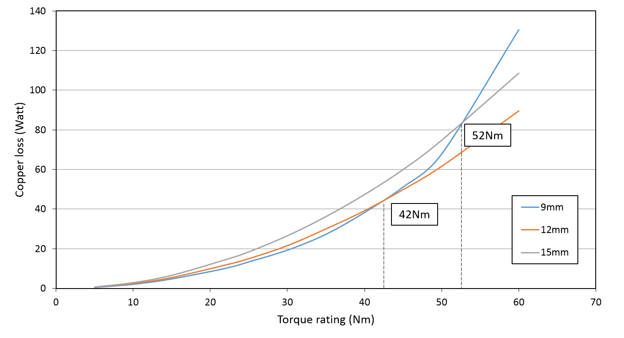
Figure 3-26 Finite element predicted copper losses of the prototype machine as a function of torque rating with three different tooth body width
Based on the analysis of Figure 3-25, it is clear that the machine with tooth body width of 9mm produces the lowest copper losses when the torque rating is 22Nm. However, the difference in copper loss between 9mm and 12mm tooth body shown in Figure 3-26 is relatively small. Moreover, the wider tooth body of 12mm provides some overhead in flux carrying capability for bearing performance.
Hence, the width of tooth body at 12mm was selected as offering the best overall bearing and motoring performance. As was the case with the selection of magnet thickness the selected value is not the optimal value for both motoring and bearing performance, but it arguably provides the best trade-off.

Control system development
The analytical force model described in section 3.1 can be employed in control schemes for self-bearing operation as it provides a convenient means of identifying the optimal combination of phase currents which can be used to meet a particular demanded force. In this regard, it is important to recognise that although a relatively uniform force can be produced over one complete revolution in some machines by employing the same magnitude of current in each phase, as shown previously in Figure 3-6, this will generally not yield the most efficient means of meeting a given force demand. By way of example, consider the force characteristics shown previously in Figure 3-4. In order to produce a component of force in the positive x direction for a rotor angular displacement of 45º, it would be more productive to inject current into phases 1 to 6, rather than phases 7,8 or 9. However, it is also necessary to account for cross-coupling between the x and y axes, since selecting an apparently favorable combination of currents to produce force in the x-direction could produce an undesirable component of force in the y-direction and vice-versa.
In all cases, there are likely to be several phase current combinations that could produce a particular demand force. However, there will generally be a preferred combination in terms of meeting a specified performance criterion. By way of example, the combination of phase currents that yields minimum copper loss can be established using a similar optimization approach to that employed to optimize current waveforms in the remaining healthy phases of a faulted permanent magnet machines [77].
The selection of an optimal combination of phase currents must take account of the required torque producing currents in each phase at that instant, since the loss is proportional to the square of the total phase current and hence torque production and bearing action cannot be decoupled in terms of minimizing loss. For a rotor angular displacement of θ_{r}, the net restoring forces, the torque and the copper loss are given by:
 | $$F_{x}=\sum_{j=1}^{N_{ph}}{a_{xj}(θ_{r})}i_{j}$$ | (27)
 | $$F_{y}=\sum_{j=1}^{N_{ph}}{a_{yj}(θ_{r})}i_{j}$$ | (28)
 | $$T=\sum_{j=1}^{N_{ph}}{a_{Tj}(θ_{r})}i_{j}$$ | (29)
 | $$Copper loss=R\sum_{j=1}^{N_{ph}}{{i_{j}}^{2}}$$ | (30)
The force coefficients, for every phase at a given rotor angle can be readily calculated from the analytical force model. Similarly, the torque coefficients for each phase can be calculated either form an analytical expression such as a Fourier series approach adopted for the x and y direction forces, or a look up table based on finite element predictions or actual measurements.
Having calculated the force and torque coefficients, i.e. $a_{xj},a_{yj}{,a}_{Tj},$ at the particular rotor angle being considered for each phase, the combination of phase currents that yields the lowest instantaneous copper loss can be determined by minimizing the augmented objective function below, using 3 Lagrange multipliers ε, δ, τ.
 | $$A\left(i_{j},ε,σ,τ\right)=R\sum_{j=1}^{N_{ph}}{{i_{j}}^{2}}+ε\left[F_{xdemand}-\sum_{j=1}^{N_{ph}}{a_{xj}\left(θ_{r}\right)}i_{j}\right]+δ\left[F_{ydemand}-\sum_{j=1}^{N_{ph}}{a_{yj}\left(θ_{r}\right)}i_{j}\right]+τ\left[T_{demand}-\sum_{j=1}^{N_{ph}}{a_{Tj}\left(θ_{r}\right)}i_{j}\right]$$ | (31)
This function can be sequentially differentiated with respect to the j^{th} phase current and the 3 Lagrange multipliers to yield a series of (N_{ph}+3) linear equations, the solutions to which yield the optimal combination of currents:
 | $$\frac{∂A}{∂i_{j}}=2Ri_{j}-τa_{Tj}-εa_{xj}-δa_{yj}=0$$ | (32)
 | $$\frac{∂A}{∂τ}=T_{demand}-\sum_{j=1}^{N_{ph}}{a_{Tj}\left(θ_{r}\right)}i_{j}$$ | (33)
 | $$\frac{∂A}{∂ε}=F_{xdemand}-\sum_{j=1}^{N_{ph}}{a_{xj}\left(θ_{r}\right)}i_{j}$$ | (34)
 | $$\frac{∂A}{∂δ}=F_{ydemand}-\sum_{j=1}^{N_{ph}}{a_{yj}\left(θ_{r}\right)}i_{j}$$ | (35)
It is important to recognize that this optimization process does not account for the dynamic limitations of a practical system, i.e., no account is taken of whether a given rate of change of current can be achieved within the constraints of the maximum DC link voltage.

Validation by finite element analysis
As discussed previously, the analytical model is based on several simplifying assumptions, most notably the superposition of forces rather than the superposition of magnetic fields and one-dimensional calculations of the airgap flux density. In order to establish the degree to which the behaviour of a practical machine design can be reliably predicted from this straightforward analytical model, a finite element investigation was performed on the design of a self-bearing machine shown in Figure 3-27. A summary of the key dimensions and features of this design, which are based on the same design parameters as shown previously in Table 3-1, is contained in Table 3-10. A cross-section of this machine design is shown in Figure 3-27. The machine has an overall active length of 200mm, which consists of two independently controlled 9-phase stators, each 100mm long. As noted previously in chapter 1 , it is necessary that self-bearing machines to sub-divide the stators in this way in order to exercise control over all the possible degrees of freedom of the rotor motion. However, for the purposes of this investigation, the values of forces and torques quoted for this machine refer to the entire 200mm axial length. The gravitational force on the 7.8kg rotor, which must be counteracted by the bearing action of the machine, is 76.4N.
.
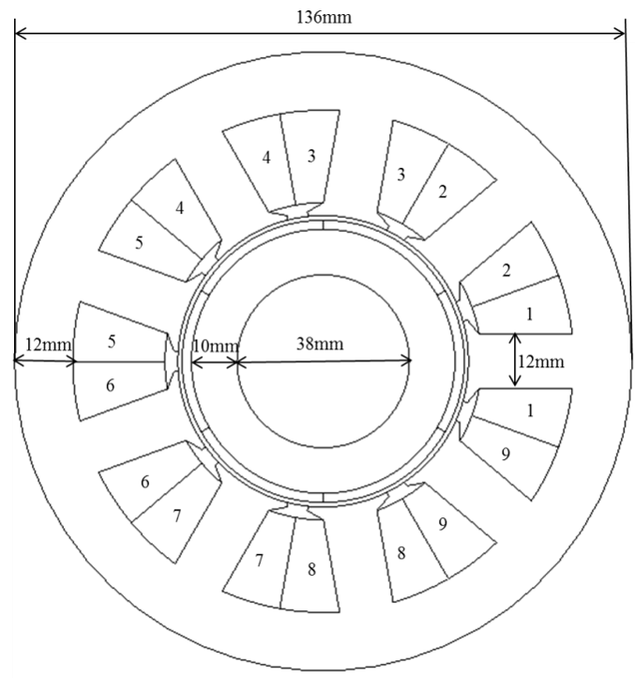
Figure 3-27 Cross-section through the reference design
Table 3-10 Machine parameters of 9-slot 6-pole SPM self-bearing machine
9-slot, 6-pole | Symbol | Description | Value | Unit
Motor topology | P | Number of poles | 6 | -
 | σ | Pole arc | 180 | ° (elec)
 | $$N_{s} (N_{ph})$$ | Number of slots (Phases) | 9 | -
 | $$θ_{th}$$ | Tooth arc | 32 | ° (mech)
Motor dimensions | $$L_{ax}$$ | Stator axial length | 200 (2×100) | mm
 | $$l_{g}$$ | Airgap length | 1 | mm
 | $$l_{m}$$ | Magnet thickness | 2 | mm
 | $$D_{so}$$ | Stator outer diameter | 136 | mm
 | $$D_{si}$$ | Stator inner diameter | 64 | mm
 | $$D_{ro}$$ | Rotor outer diameter | 62 | mm
 | $$d_{r}$$ | Rotor core thickness | 10 | mm
 | $$W_{t}$$ | Tooth body width | 12 | mm
 | $$W_{sc}$$ | Stator core thickness | 12 | mm
 | $$W_{rc}$$ | Rotor core thickness | 10 | mm
 | $$d_{t}$$ | Tooth tip edge thickness | 1.0 | mm
 | $$d_{s}$$ | Slot depth | 20.5 | mm
The predicted variation in the open-circuit flux density along a path at the mean radius of the airgap is shown in Figure 3-28, for the particular case of a rotor angular displacement of 0º. The mean value of the flux density under the tooth of phase 1 is 0.69T, a value which in reasonable agreement with the 0.65T predicted by equation (3) which forms the basis of the analytical force constant calculations.
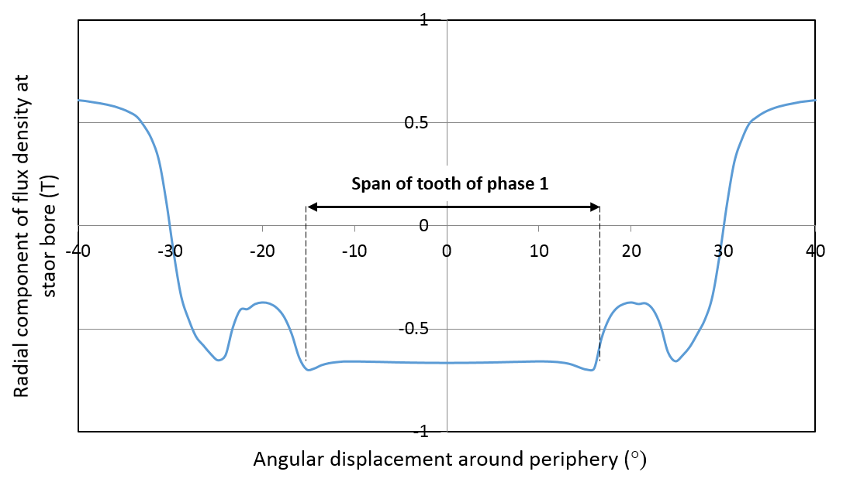
Figure 3-28 Finite element predicted airgap flux density profile on the stator bore in the vicinity of phase 1
In characterising the force and torque capability of this machines design, it is important to consider the magnitudes of bearing currents that would be practically sustained in comparison with the main torque producing current. For a copper packing factor of 45%, the net cross-sectional area of a stator coil in this machine design is 92mm². For a naturally ventilated machine, a typical continuous current density would be ~4A/mm² rms, which corresponds to an rms phase mmf of 368A rms.
Clearly, it would undesirable in terms of machine efficiency if the currents required to realize self-bearing operation were comparable with, or even exceeded, those required to produce rated torque. Nevertheless, in terms of accommodating very brief and occasional disturbances, it may be necessary to employ very high currents for bearing action, although this clearly has an impact on the current rating of the converter. With this in mind, peak phase mmfs up to a maximum of 1000A are likely to be typical of the upper limit on the transient overload that might be deemed viable in a practical system. However, it should be recognized that efficiency and temperature rise considerations dictate that a bearing phase mmf of 1000A could only be sustained for brief and infrequent overload conditions, as might be encountered for example on a moving platform application such as an aircraft or a road vehicle. For the vast majority of operating conditions, it would be desirable if the appropriate bearing action, which might need to accommodate, for example, rotor imbalances and minor disturbances from aerodynamic loads in a compressor, could be achieved with mmfs that are considerably lower than the torque producing components.
Figure 3-29 and Figure 3-30 show finite element predicted variations in the force produced by a phase 1 as a function of rotor angular displacement for stator mmfs between -1000A and +1000A (in 250A increments).
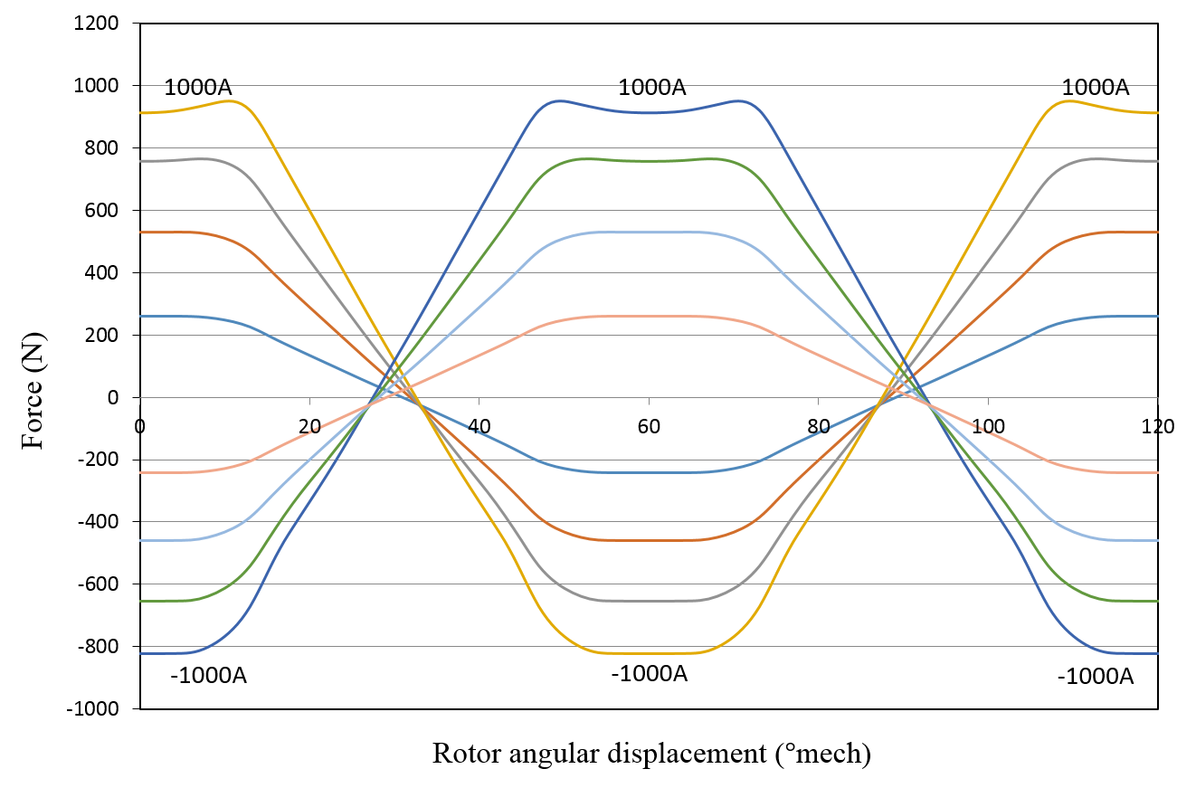
Figure 3-29 Finite element predicted force in the x-direction produced by phase 1 for phase mmfs between -1000A to +1000A

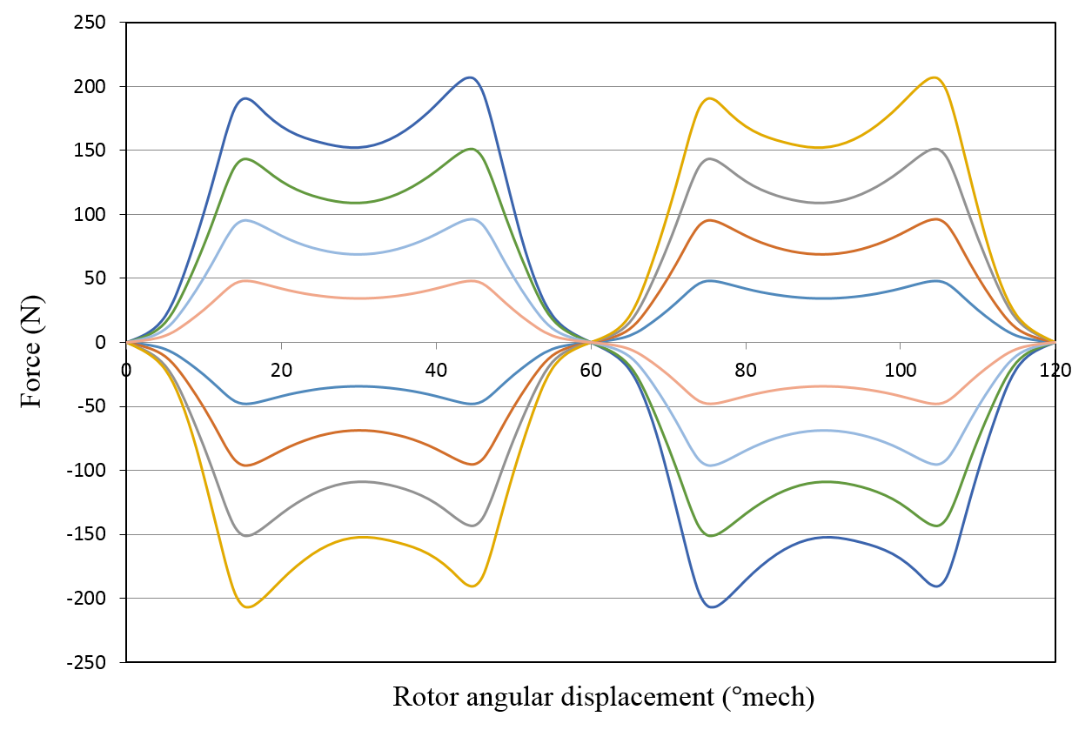
Figure 3-30 Finite element predicted force in the y-direction produced by phase 1 for phase mmfs between -1000A and +1000A
The contribution to the net force from the attractive reluctance force is evident as a minor asymmetry in the x-component force characteristics of Figure 3-29. At the lowest mmf of 250A, the net attraction and repulsion forces are 261N and 240N respectively. Assuming that the contribution from the reluctance force is approximately the same for both polarities of current, an assumption which is again based on the application of the principles of superposition, the reluctance force generated at 250A is 10.5N. Subtraction of this inferred reluctance force yields an estimate of the excitation force constant, K_{x} of 1.002 N/A at an mmf of 250A, a value which is in good agreement with that of 0.986 N/A predicted using the analytical expression in equation (4). Applying the same procedure to the finite predicted force characteristic at 1000A yields a reluctance force of 62.5N, which is ~7% of the corresponding excitation force, and a reduced value of K_{x} of 0.810 N/A. This reduction in the excitation component of force can be attributed to the onset of magnet saturation in the stator core, although this phase-by-phase finite element model is not fully representative in terms core saturation. As will be evident, the contribution of the reluctance components of forces to the overall force are relatively small in this particular machine, being 4.2% and 7.0% of the corresponding excitation forces for mmfs of 250A and 1000A respectively. This is despite the fact that the rotor magnets are comparatively thin at only 2mm.
The merits of inferring the reluctance component of force from asymmetry in the net force characteristics was investigated using a magneto-static finite element model of the machine in which the rotor magnets were replaced with regions of air with zero magnetization. The finite element calculated force on the rotor iron in this model was 11.9N and 189.7N for mmfs of 250A and 1000A respectively. As will be evident, the force at 250A is in reasonable agreement with the value of 10.5N inferred from the force characteristics and the theoretical reluctance force results of 11.9N calculated by equation (36). In contrast, the values at 1000A exhibit a significant difference, albeit that within the context of the overall levels of force at 1000A. This illustrates one of the deficiencies of superposition in that at the higher mmf of 1000A, the saturation levels encountered in the stator core are significantly different for models with and without rotor magnets.
 | $$F_{rel}=\frac{{\left(B_{g, W}\right)}^{2}A_{s}}{2μ_{0}}$$ | (36)
where
 | $$B_{g, W}=\frac{μ_{0}NI}{l_{eff}}$$ | (37)
 | $$l_{eff}=\frac{N_{ph}+1}{N_{ph}}(l_{g}+l_{m})$$ | (38)

Table 3-11 Comparison of reluctance force among three models
MMF | FE model with PM | FE model without PM | Theoretical results
250A | 10.5N | 11.9N | 11.93N
1000A | 62.5N | 189.7N | 190.8N
The values of the excitation force constant for phase 1 in the y-direction of the stator reference frame, $K_{y}$, obtained from for mmfs of 250A and 1000A at 30˚mech are 0.136 N/A and 0.121 N/A respectively, these values which are in reasonable agreement with the 0.132 N/A derived from equation (7). However, whereas equation (7) predicts a flat top region for the force displacement characteristics, the corresponding finite element predicted characteristics contain noticeable peaks and some variation between the peaks in the FE results. There are the significant peaks in Figure 3-30 at 14˚, 46˚, 74˚ and 106˚ that are due to a combination of inter-polar flux linkage and slotting effects. Except at these four rotor position the majority of the two-dimensional finite element predicted y-direction force have a reasonable agreement to the analytical model results.
The finite element predicted variation of the open-circuit cogging torque with angular displacement is shown in Figure 3-31, together with the corresponding variation in the excitation torque produced by phase with an mmf of 250A in phase 1 only. The variation in the excitation torque was derived indirectly by subtracting the open-circuit cogging torque from the net torque obtained with an mmf in phase 1 only.
.
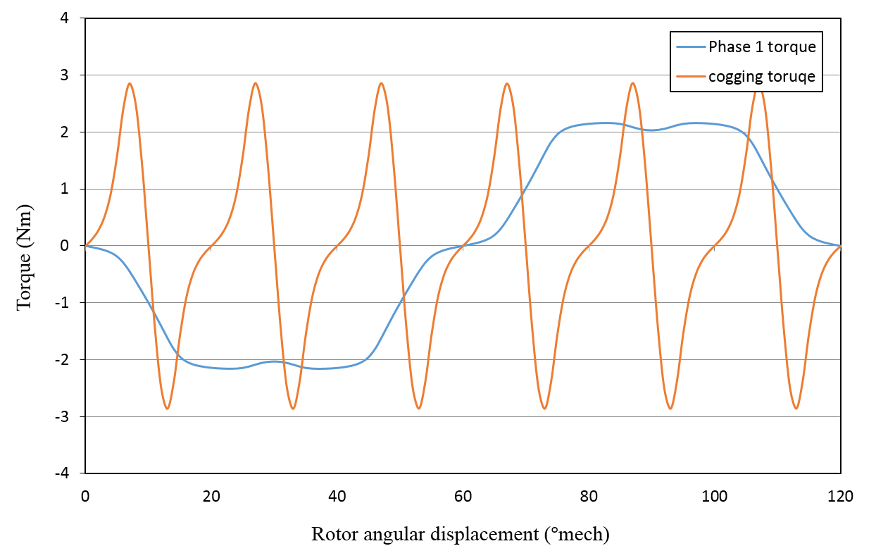
Figure 3-31 Finite element predicted excitation and cogging torque
The finite elements variations in the x and y components for force (relative to the stator reference frame) in each phase of for a phase mmf of 250A are shown in Figure 3-32 and Figure 3-33 respectively. These compare well in terms of form and relative magnitudes with their analytically predicted counterparts shown previously in Figure 3-4 and Figure 3-5, although, as would be expected, there are minor differences due to factors such leakage flux around pole transitions and the effect of stator slotting etc.
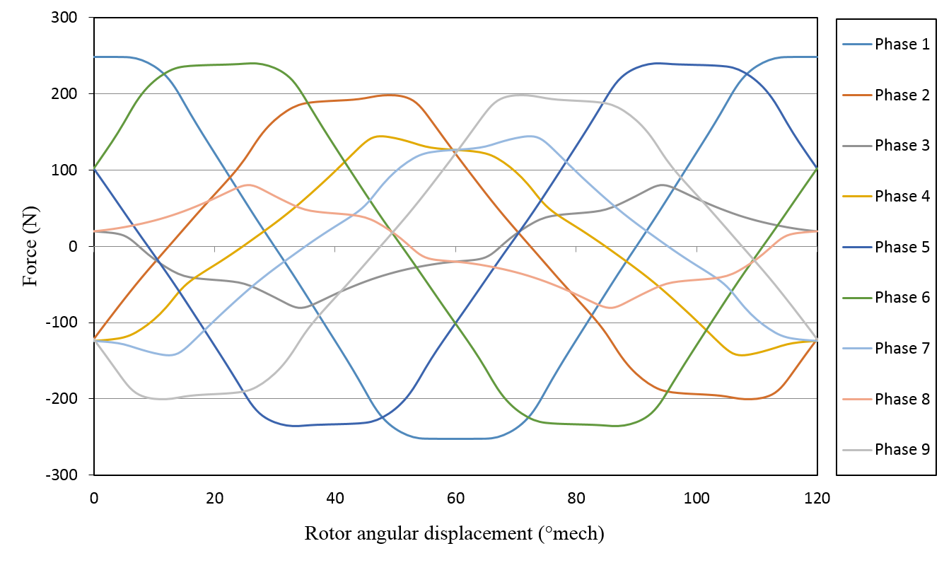
Figure 3-32 Finite element predicted variation with angular displacement of the x component of force (with respect to stator reference frame) for each phase with an mmf of 250A
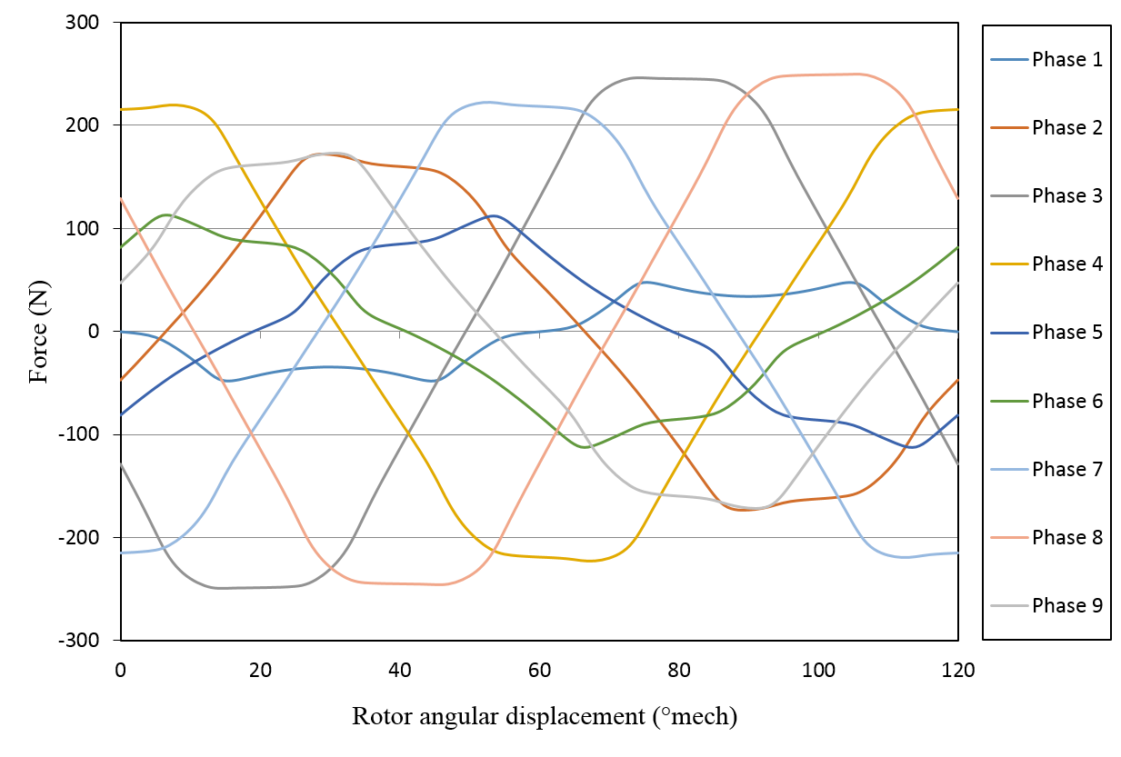
Figure 3-33 Finite element predicted variation with angular displacement of the y component of force (with respect to stator reference frame) for each phase with an mmf 250A
Figure 3-34 shows a summation of the absolute magnitudes of the finite element predicted. This illustrates that, as predicted by the analytical model, this particular combination of stator phases and rotor poles is capable of producing a relatively uniform magnitude of both x and y components of force over one cycle. In this case, the ratios of the maximum to minimum forces in the x and y direction are 1.06 and 1.11 respectively.
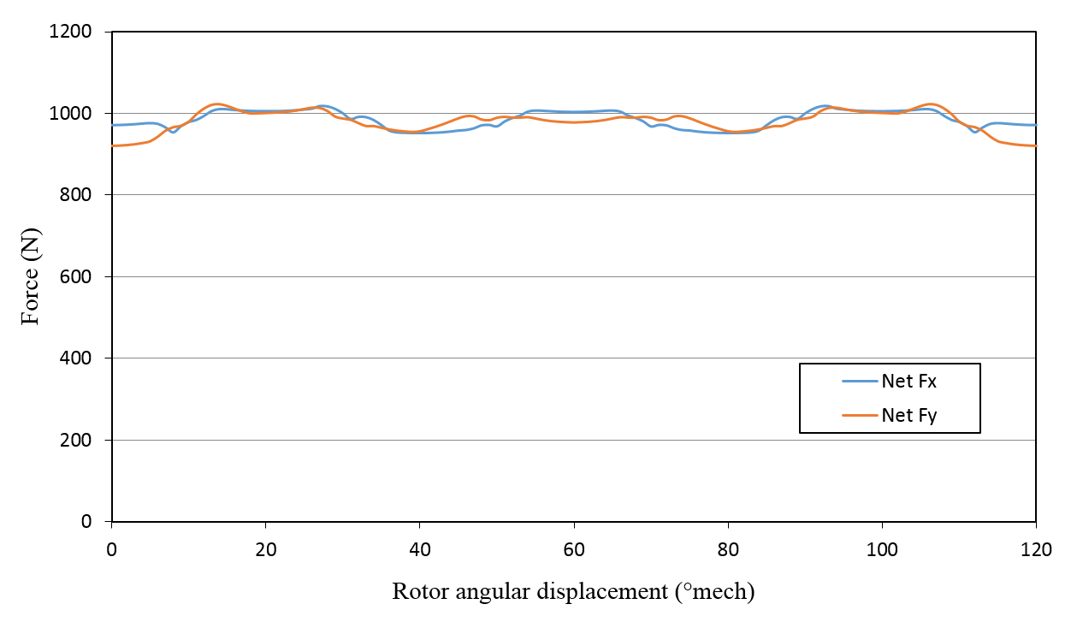
Figure 3-34 Summation of the magnitudes of the absolute values of forces produced by all phases as function of rotor angular displacement
It is important to note that although good agreement has been obtained between the analytical and finite element force characteristics of a single stator tooth, this in itself is insufficient to validate the superposition approach to the calculation of forces. This requires comparisons under operating conditions with representative bearing action and torque producing currents present in all phases. The full validation of the force model can be performed in combination with the validation of the optimal current allocation strategy by specifying a series of different operating points.
Initially, five different force and torque demands were considered at a fixed rotor angular displacement of 30º. This particular angular displacement was selected since it corresponds to a position of zero cogging torque and hence provides a basis for a more direct comparison in terms of bearing forces and the torque at this angular displacement is due solely to excitation torque. Table 3-12 lists the values of force coefficients calculated using the analytical force model for each phase at a rotor angular displacement of 30º and a phase mmf of 250A. Also shown in Table 3-12 are the corresponding torque coefficients, which in this case derived from the finite element excitation torque characteristic of Figure 3-31.
Table 3-12 Analytically calculated force per unit current and finite element derives torque per unit current for a rotor angular displacement of 30°
Phase number | $$a_{xj} (N/A)$$ | $$a_{yj} (N/A)$$ | $$a_{Tj} ({Nm}/A)$$
1 | 0.000 | -0.114 | -8.184×10⁻³
2 | 0.661 | 0.666 | 4.444×10⁻³
3 | -0.246 | -0.906 | 3.656×10⁻³
4 | 0.099 | 0.057 | -8.184×10⁻³
5 | -0.907 | 0.240 | 4.444×10⁻³
6 | -0.907 | 0.240 | 3.656×10⁻³
7 | -0.099 | 0.057 | -8.184×10⁻³
8 | 0.246 | -0.906 | 4.444×10⁻³
9 | -0.661 | 0.666 | 3.656×10⁻³
For this fixed rotor angular displacement, the current optimization method was applied to the five different operating points shown in Table 3-13. The resulting mmf distributions in the 9 phases are also shown in Table 3-13.

Table 3-13 Calculated MMF disturbances at rotor angular displacement of 30° for 5 torque and force demands
 | Condition 1 | Condition 2 | Condition 3 | Condition 4 | Condition 5
Phase | T: 0Nm  Fx: 240N  Fy: 360N | T: 5Nm  Fx: 240N  Fy: 360N | T: 10Nm  Fx: 480N  Fy: 720N | T: 5Nm  Fx: 600N  Fy: -180N | T: 10Nm  Fx: -1600N  Fy: 1600N
$$i_{1}(A)$$ | -17.8 | -153.3 | -306.7 | 127.7 | -348.4
$$i_{2}(A)$$ | 149.6 | 223.6 | 447.1 | -175.9 | 158.3
$$i_{3}(A)$$ | -144.7 | -83.83 | -167.7 | -64.59 | -267.1
$$i_{4}(A)$$ | 18.4 | -117.9 | -235.7 | 115.9 | -300.3
$$i_{5}(A)$$ | -50.6 | 23.41 | 46.82 | 146.1 | 831.9
$$i_{6}(A)$$ | 113 | 173.9 | 347.7 | -249.8 | -284.9
$$i_{7}(A)$$ | -1.321 | -137.6 | -275.2 | 165.2 | -168.9
$$i_{8}(A)$$ | -98.95 | -24.94 | -49.88 | -192.2 | -546.1
$$i_{9}(A)$$ | 31.75 | 92.65 | 185.3 | 131.7 | 917.3
$$\sum_{j=1}^{9}{{i_{j}}^{2}}(A)$$ | 70104 | 153355 | 613288 | 230175 | 2249381
The sums of the squares of the phase mmfs, which provide a useful indication of the instantaneous losses, are also shown in Table 3-13. The corresponding values for torques of 5Nm and 10Nm with no bearing action are 83288 A² and 333152 A² respectively. Hence, in the most extreme case shown in Table 3-13, in which forces of 1600N are required in both the x and y directions, the instantaneous losses generated are some seven times larger than those at the same torque but with no bearing force demand.
The mmf distributions shown in Table 3-13 were each applied in turn to a non-linear finite element model of the machine. The resulting predicted forces and torques for the five operating conditions are shown in Table 3-14. As will be evident, there is a good agreement between the force demands and the finite element predicted forces generated by the optimal current distribution, which was arrived with the analytical model.
As will be evident from the first two examples considered, which have the same bearing force demands, there is a re-distribution in the phase currents as the magnitude of the excitation torque is increased. This demonstrates the need to couple the control of torque and restoring forces if the overall losses are to be minimised. As would be expected given the tendency of reluctance forces to increase with the square of the stator mmf, the correlation between demand and finite element predicted forces does diminish at high force levels as the reluctance force beings to make a discernible contribution. In the case of the particular machine considered, the difference is 8% for demands of 1600N. This illustrates that despite the many simplifying assumptions in the force model, notably that it neglects reluctance forces, it provides acceptable levels of accuracy from a practical design point of view for demands up to at least an order of magnitude greater than the gravitational force on a representative rotor.
Selecting the particular case of a rotor angular displacement of 30º proved useful in terms of eliminating the contribution of the cogging torque and hence allowing a direct comparison of the excitation torque to be drawn. However, since a self-bearing machine inherently operates with unbalanced currents, there is likely to be some scope to actively cancel the effect of cogging torque, such that a uniform smooth torque is produced.

Table 3-14 Finite element calculated forces and torque at rotor angular displacement of 30°
 | T: 0Nm  Fx: 240N  Fy: 360N | T: 5Nm  Fx: 240N  Fy: 360N | T: 10Nm  Fx: 480N  Fy: 720N | T: 5Nm  Fx: 600N  Fy: 180N | T: 10Nm  Fx: -1600N  Fy: 1600N
$$T(Nm)$$ | 0 | 5.1 | 10.2 | 5.1 | 9.8
$$Finite element calculated F_{x}(N)$$ | 246 | 248 | 492 | 604 | -1466
$$Finite element calculated F_{y}(N)$$ | 370 | 370 | 741 | -192 | 1456
The flexibility of analytical force model and the current optimisation scheme can be demonstrated by considering a case in which the reference machine design is required to produce the following combination of controlled forces and torque over one revolution:
- A restoring force to counteract a synchronous rotating radial force of magnitude 150N with a phase advance of +30° relative to the angular displacement reference frame. This type of force variation is typical of a simple out of balance force.
- A permanent vertical force of 76N (assumed to be in the y-direction of the stator reference frame) to counteract the gravitational force on the rotor.
- A smooth output torque of 10Nm in which the torque ripple generated by the cogging torque is fully compensated for by active control
Figure 3-35 shows the current waveforms calculated for each phase in order to satisfy the particular force and torque demands while also minimizing the instantaneous copper loss. The rms and peak values of the waveforms of Figure 3-35 are summarised in Table 3-15. The phase to phase differences in the rms and peak values of mmf are largely a consequence of the asymmetry in the mechanical loading which is introduced by the gravitational force and the relative phasing of the rotating out of balance force with respect to the torque producing currents. As would be expected the rms and peak currents required for combined motoring and bearing action are higher than those required for production of 10Nm of torque alone. For the case of a smooth 10Nm in which the cogging torque is fully compensated, the rms mmf per phase is 178A with a peak of 298A, while for the case of a constant excitation torque requirement of 10Nm ( i.e. the torque ripple due to cogging remains present in the net torque) the corresponding values are 176A and 267A.
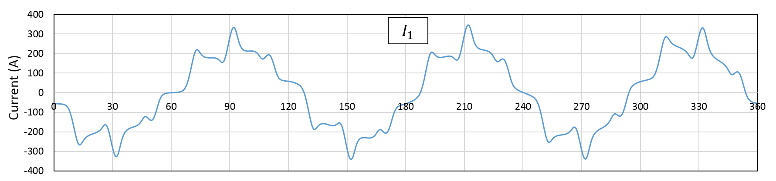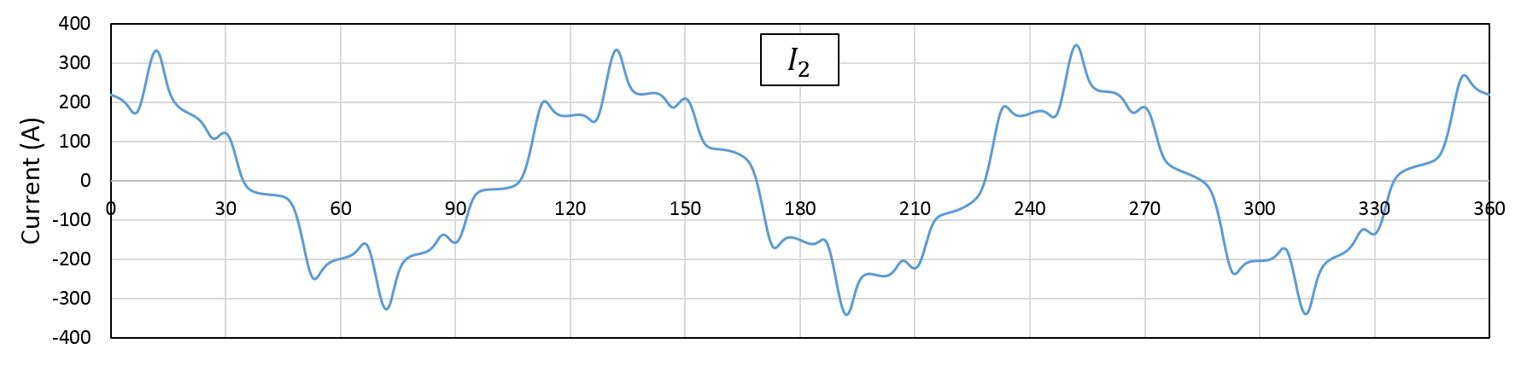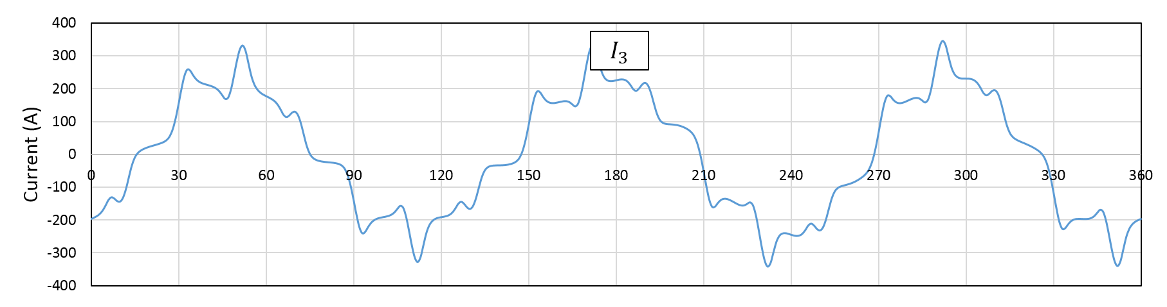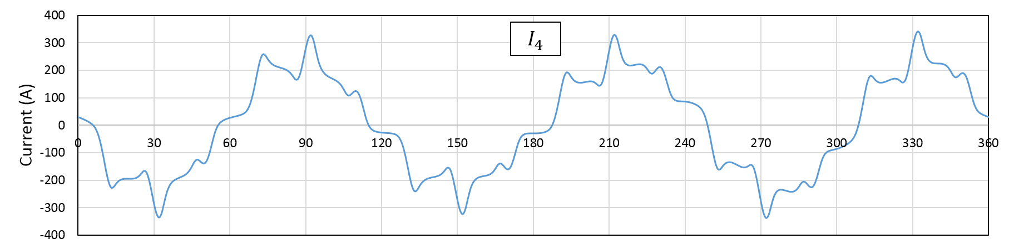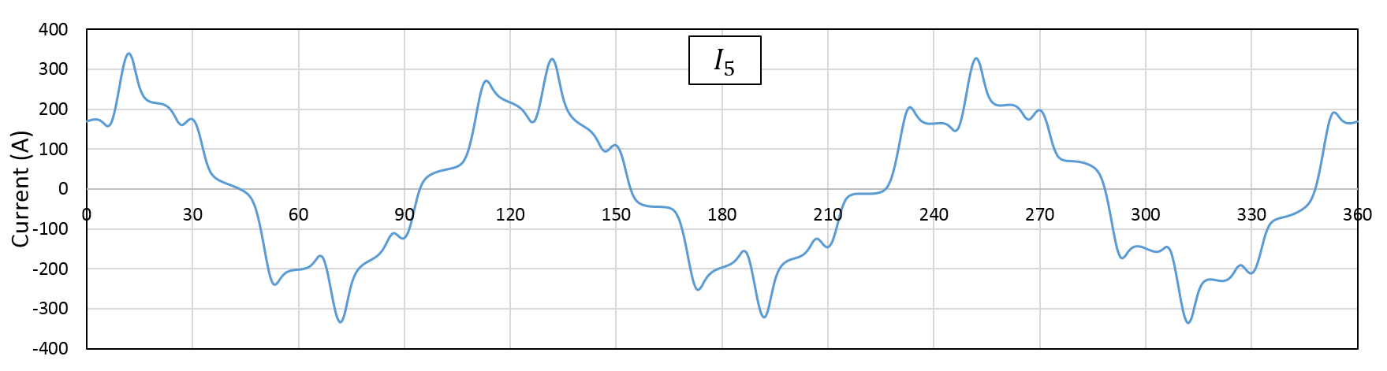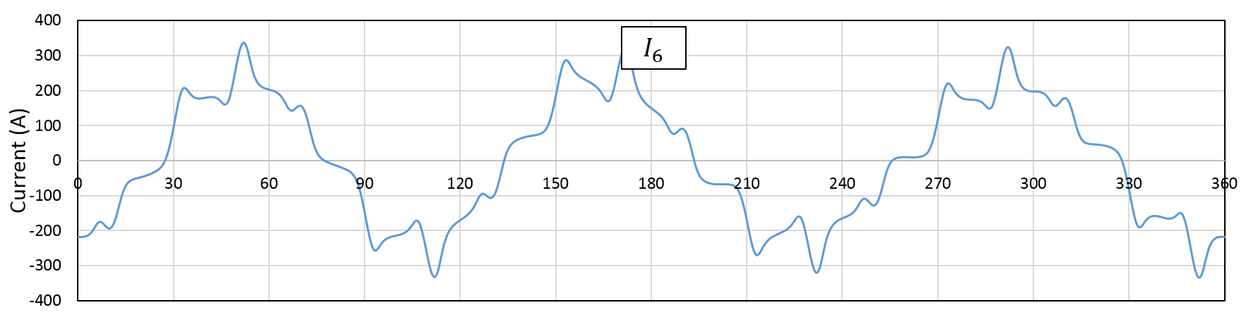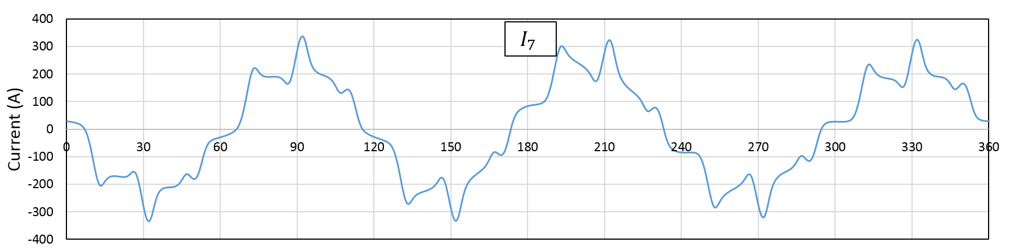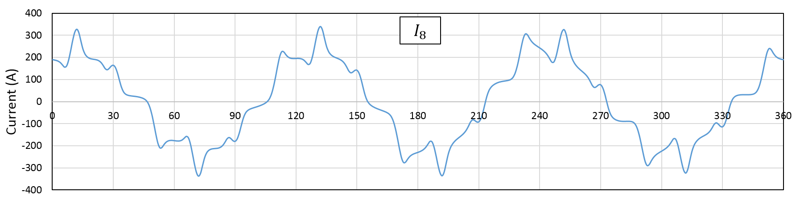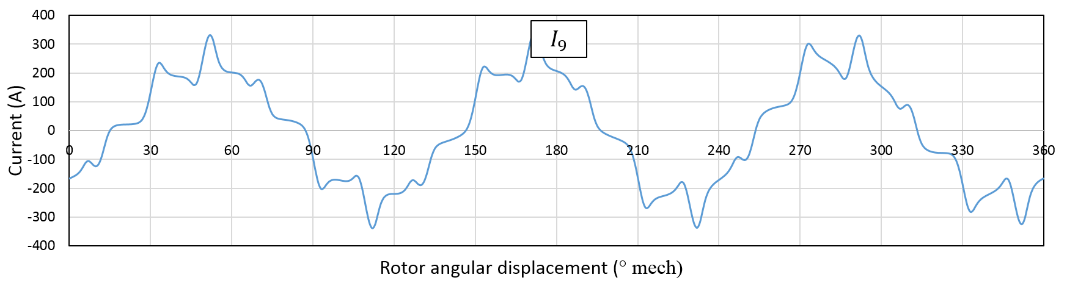
Figure 3-35 Optimized current waveform for producing 10Nm of smooth torque and to counteract a 150N synchronously rotating force and a fixed gravitational force of 76.4N

Table 3-15 RMS and peak values of mmf for the waveforms in Figure 3-35
Phase | RMS mmf (A) | Peak mmf (A)
1 | 179.9 | 345.6
2 | 180.2 | 346.3
3 | 179.1 | 344.8
4 | 176.4 | 342.2
5 | 174.2 | 339.3
6 | 174.3 | 337.4
7 | 176.2 | 337.9
8 | 178.8 | 340.0
9 | 179.9 | 342.9
The current waveforms of Figure 3-35, which were calculated with the analytical model, were employed in a series of magneto static finite element models spanning one mechanical revolution of the rotor (in 1º mech increments). The resulting finite element predicted forces are shown in Figure 3-36 together with the corresponding demand forces which were used as the input to the analytical force model and the current optimization procedure. Figure 3-37 shows the corresponding variation in the finite element calculated torque.
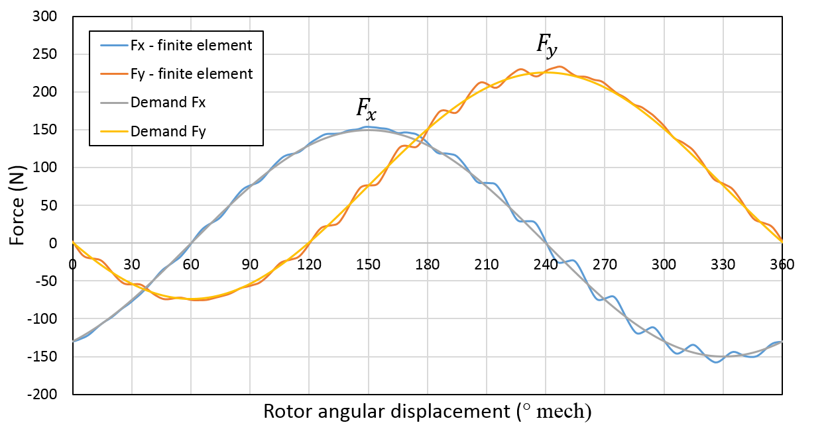
Figure 3-36 Comparison of finite element predicted forces produced by the current waveforms of Figure 3-35 and the demand force used as the input to the analytical model
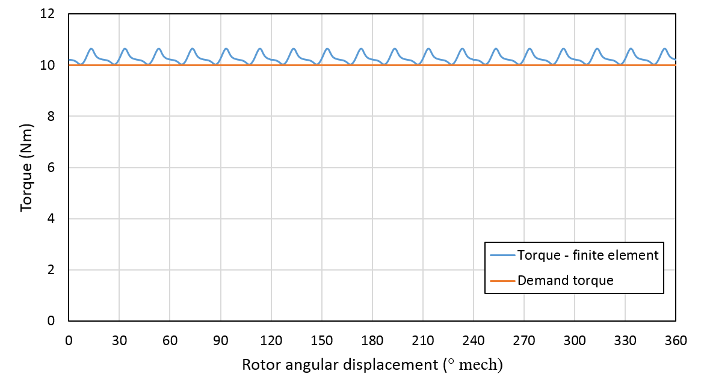
Figure 3-37 Finite element predicted variation in torque for the optimized current waveform of Figure 3-35
As will be apparent, there is a good agreement between the finite element predicted forces produced by the optimized current waveforms and the demand forces. The only significant discrepancy is the inability of the analytical models to fully account for the influence of the cogging torque, which manifests itself as a small ripple in the force variations. The torque waveform of Figure 3-37 demonstrates that the combination of the force models and the current optimization is effective in terms of substantially reducing the torque ripple, with the residual ripple being ~20% of the open-circuit cogging torque.
In addition to the above FE performance verification, it is also worth noting that the ability of producing accurate demand current waveform is believed to be the prerequisite to achieve a precise performance control in practical test. The high frequency current ripples, which are apparent in Figure 3-35, are usually recognised as difficulties for the current control to follow with. In order to identify the source of these current ripple, different combinations of current waveforms according to conditions of torque only, force only and torque force (without cogging torque) are calculated and shown in Appendix E. Moreover, the bandwidth of current control loop is maximized to 500Hz in section 5.4.5.3 to accommodate operation with high frequency current ripples.

Simulation model development and machine performance prediction

System level simulation model
The prototype 9-slot 6-pole SPM self-bearing machine is made of two separate stator sections with one rigid rotor in order to achieve control over five degrees of freedom, i.e translational motion in the X and Y directions and the three rotational degrees of freedom shown in Figure 4-1. In this machine, there is no axial bearing to provide direct control over motion in the Z –direction. However, it is worth noting that there is a degree of axial stiffness introduced by the reluctance force which results in a tendency of the rotors to remain with the stator core. This axial stiffness is passive (i.e., cannot be controlled) and may be insufficient to allow reliable rotation. Therefore, additional mechanical support is introduced in section 5.4.4 to limit the axial movement.
Each stator-rotor section has an axial length of 100mm. Precision eddy current displacement sensors are applied at shaft ends to measure translational movements in X- and Y-direction respectively thereby estimating tilting displacements in α- and β-direction (or Y-Z and X-Z planes). The configuration of the machine and axis identifications are shown in Figure 4-1.
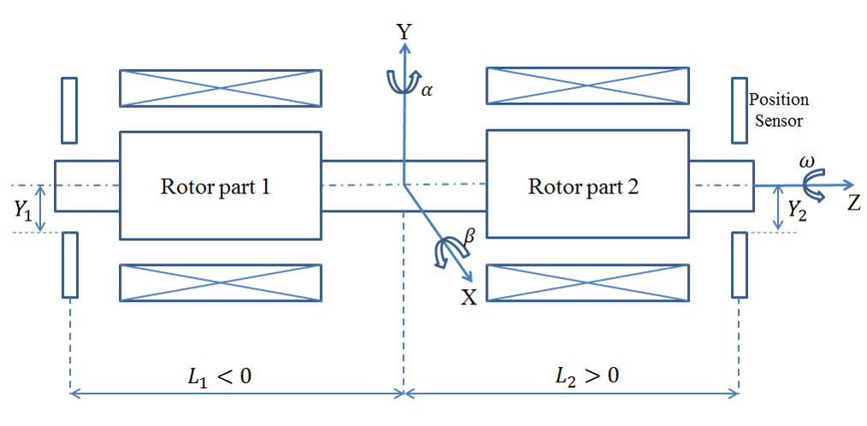
Figure 4-1 Layout of this prototype SPM self-bearing machine for control of five degrees of freedom
A system level simulation model of the prototype self-bearing machine was established in the MATLAB/Simulink environment. Given the number of degrees of freedom in the force and torque calculation and the likely need to run the simulation model many times, for example to tune control parameters. An analytical force model and torque versus angle look-up table (derived from finite element analysis for the specific case of a concentric rotor) was used. The block diagram of simulation model that is assumed with an ideal current control is shown in Figure 4-2.
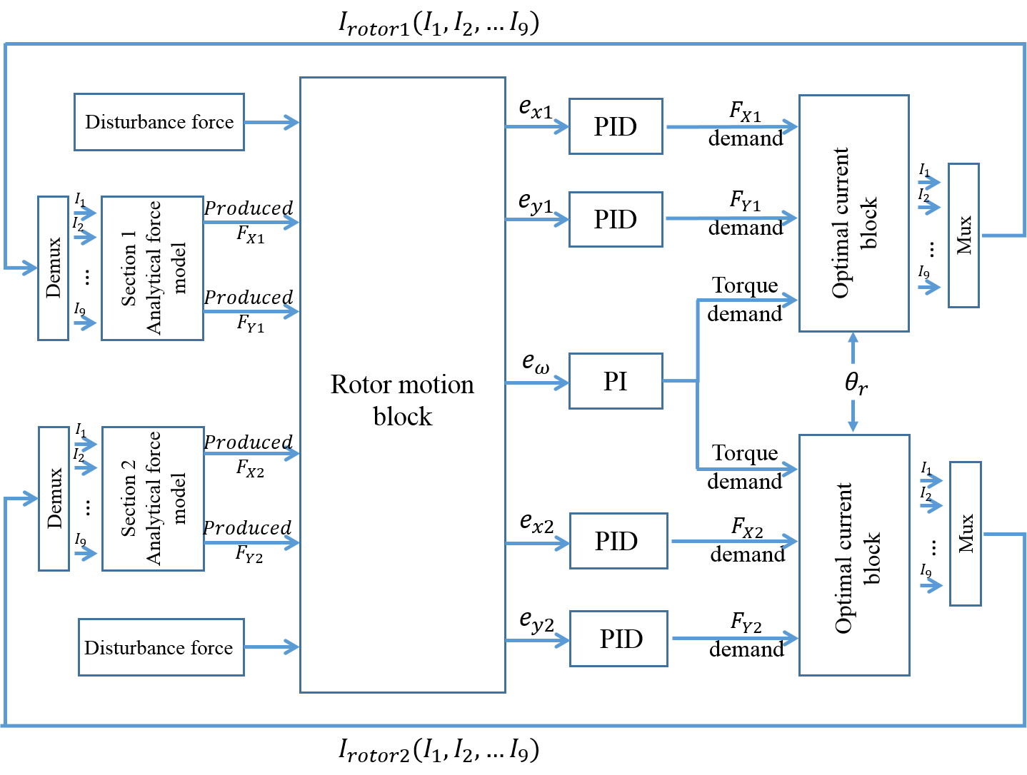
Figure 4-2 a schematic of function blocks comprised in this system level simulation model

Analytical force model
The analytical force model is based around equations (4) and (7) for a single phase. By taking appropriate angular offsets for the 9-slot machine, the total force in global X- and Y-direction can calculated. As this machine has two individually controlled rotor-stator sections, each with nine phases, two identical force models are employed to predict the resultant bearing forces for the entire machine as shown in Figure 4-3.
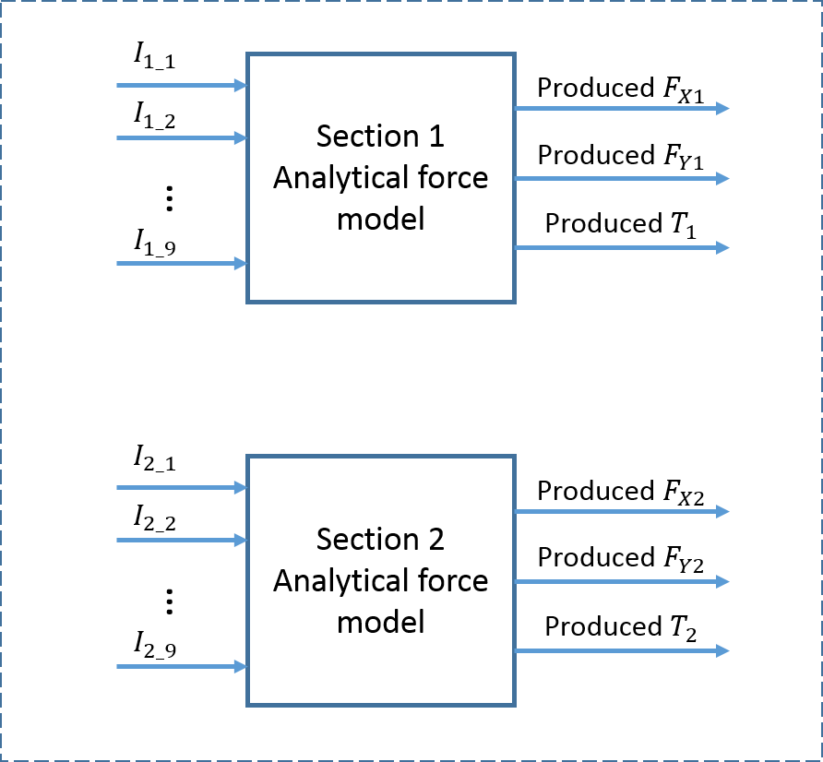
Figure 4-3 Analytical force model of this prototype machine

Mechanical Model
For this system level simulation model, a mechanical model, or plant is required to predict rotor motion in all five degrees of freedom which results from the force and torque predicted by analytical force model shown in Figure 4-3. As mentioned previously, five degrees of freedom movements of this prototype machine includes X- and Y-direction translational movements, α- and β-direction tilting movements and the desired rotation of the rotor.
The rotation is controlled by a traditional speed feedback closed-loop based on a PI controller. Since the rotor of self-bearing machine is magnetically levitated, the friction coefficient is assumed negligible compared to conventional machines which employ mechanical bearings. The simplified model for rotation about the shaft axis is shown in Figure 4-4.
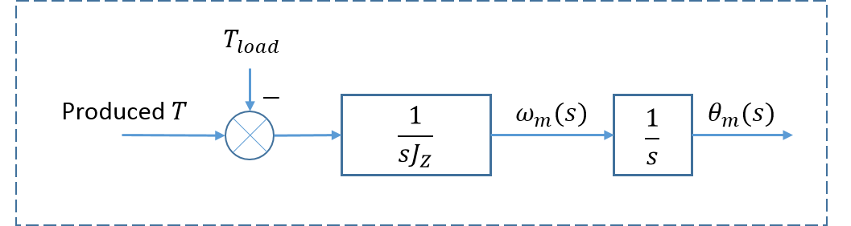
Figure 4-4 Angular position prediction in mechanical plant model
The prediction of rotor translational and tilting displacements is more complicated than the normal rotational movement due to the influence of cross coupling between two sections of this rigid rotor. Moreover, it is worth noting that tilting displacements is related to machine due to gyroscopic effects, especially high-speed applications. A block diagram of the mechanical model for the translational and tilting degree of freedom is shown in Figure 4-5.
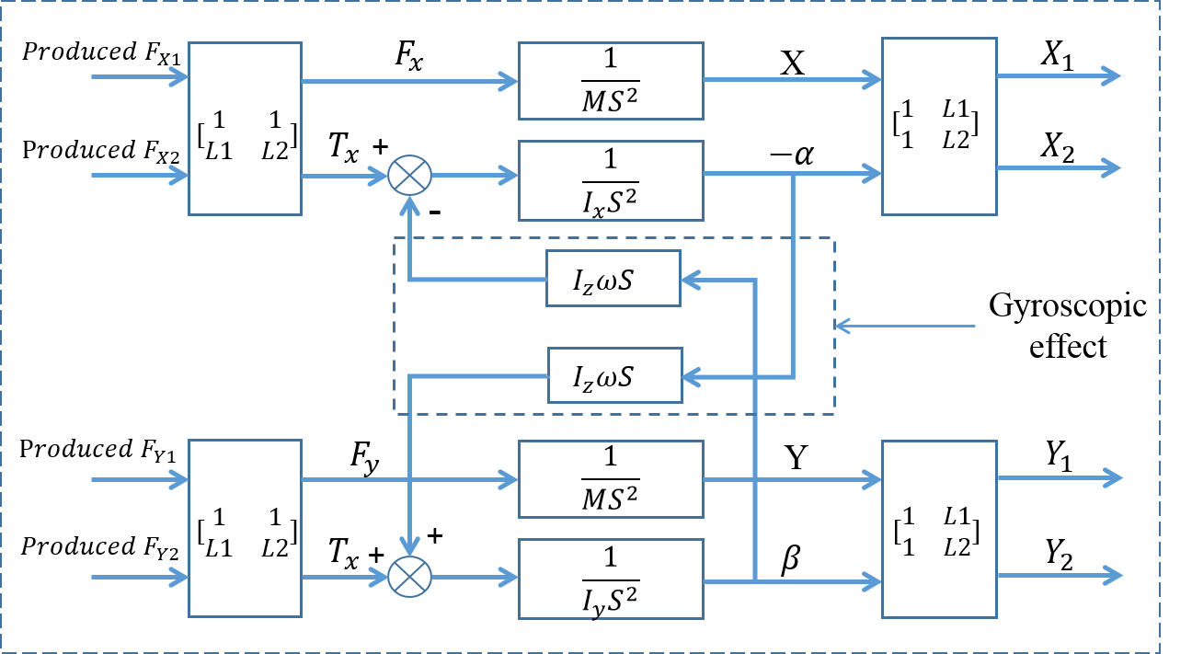
Figure 4-5 Rotor translational and tilting motion model
In developing the rotor dynamic model shown in Figure 4-5, a useful starting point is the fundamental equation of rotor movement derived from the Lagrange’s equation (39) using the coordinate of gravity centre [78]. The term q is a matrix that represents the translational displacement (X and Y) and tilting displacement (α and β) at the gravity centre. M and G are two matrices describing general motor motion and gyroscopic effect respectively.
 | $$Mq^{''}+Gq^{'}=F$$ | (39)
where | $$M=\left[\begin{matrix}I_{x} & 0 & 0 & 0 \\ 0 & m & 0 & 0 \\ 0 & 0 & I_{y} & 0 \\ 0 & 0 & 0 & m\end{matrix}\right]$$
 | $$G=I_{z}ω\left[\begin{matrix}0 & 0 & 1 & 0 \\ 0 & 0 & 0 & 0 \\ -1 & 0 & 0 & 0 \\ 0 & 0 & 0 & 0\end{matrix}\right]$$
Based on the direction of rotor coordinate defined in Figure 4-1, the displacement matrix is given by:
 | $$q={\left[-α, X, β, Y\right]}^{T}$$ | (40)
As can be seen from Figure 4-5 and Equation (39), the gyroscopic matrix G is a skew-symmetrical matrix and characterized by the cross coupling between α- and β- tilting displacements. Since its magnitude is proportional to rotational speed$ω$, the effect of gyroscopic forces becomes more significant in high-speed machines.
The resultant bearing force F on the right side of equation (39) is written as
 | $$F=\left[\begin{matrix}T_{α} \\ F_{X} \\ T_{β} \\ F_{Y}\end{matrix}\right]=\left[\begin{matrix}L_{1} & L_{2} & 0 & 0 \\ 1 & 1 & 0 & 0 \\ 0 & 0 & L_{1} & L_{2} \\ 0 & 0 & 1 & 1\end{matrix}\right]\left[\begin{matrix}F_{x1} \\ F_{x2} \\ F_{y1} \\ F_{y2}\end{matrix}\right]$$ | (41)
The symbols of $T_{α},T_{β}$and $F_{X},F_{Y}$ are referred to as tilting torques in α- and β-direction and translational forces in X- and Y-direction of gravity centre coordinate respectively.
According to the rotor motion analysis represented in equations (39), (40) and (41) using gravity centre coordinate, the coupled tilting and translational movements of this rigid rotor are represented by X- and Y-directional force produced by each machine section. Equations (42) and (44) express tilting movement in α- and β-direction, and equations (43) and (45) describe translational movement in X- and Y-direction.
 | $$I_{α}\left(-α^{''}\right)+I_{z}ωβ^{'}=L_{1}F_{x1}+L_{2}F_{x2}$$ | (42)
 | $$mX^{''}=F_{x1}+F_{x2}$$ | (43)
 | $$I_{β}β^{''}+I_{z}ωα^{'}=L_{1}F_{y1}+L_{2}F_{y2}$$ | (44)
 | $$mY^{''}=F_{y1}+F_{y2}$$ | (45)
By assuming a rigid cylindrical rotor with a symmetrical layout, the rotational inertia of rotor axis is given as [78]
 | $$I_{z}=\frac{mr^{2}}{2}$$ | (46)
and the inertia $I_{α}$in X-Z plane and $I_{β}$ in Y-Z plane have the same expression as equation (47) [78].
 | $$I_{α}=I_{β}=\frac{1}{12}m(3r^{2}+{L_{ax}}^{2})$$ | (47)
where R and L represent the radius and the axial length of rotor respectively.

Control strategy and algorithm model
For a symmetrical rigid rotor, the control strategy applied in this project is the decentralized control using four PID controllers to individually control X and Y displacements in both sections. In this control approach, each PID controller is directly responding to the error of measured rotor positions. The selection of proportional and derivative gains is analogous to selecting bearing stiffness and damping coefficient of a spring-damper system.
The algorithm for establishing the combination of phase currents using Lagrange multipliers and constraint functions was described previously in detail in section 3.4. The combination of phase current is calculated according to the PID predicted demand forces arising from the position errors and the PI predicted demand torque resulting from the speed errors as shown in Figure 4-6.
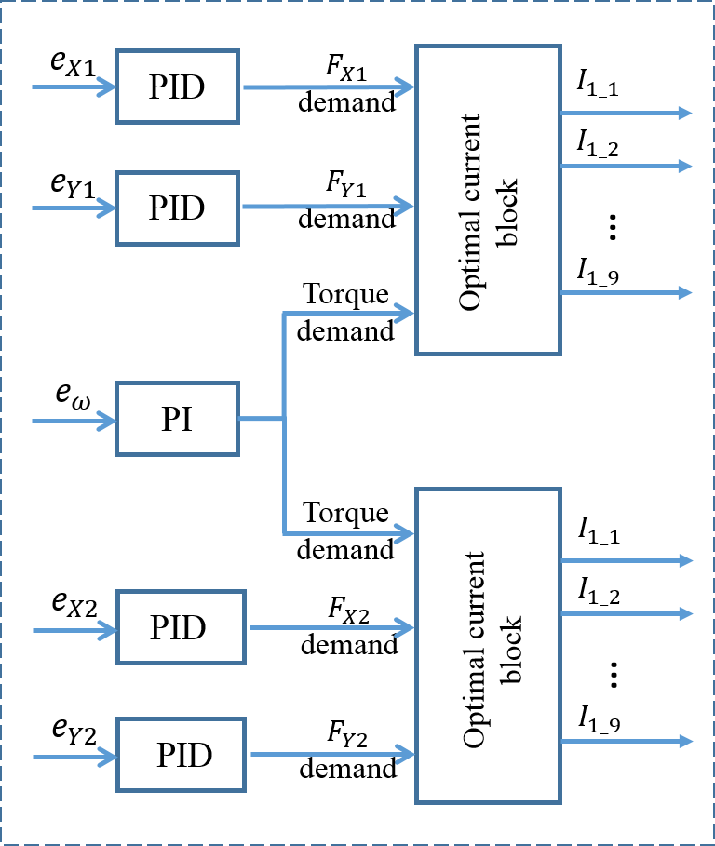
Figure 4-6 Decentralized control for this prototype machine
In the prototype system, the current demand is translated into a physical current via 18 power amplifiers, each operating in closed-loop current mode. The amplifiers selected for the hardware demonstration are AZ20A8 manufactured by Advanced Motion Control [79]. The leading specifications for this amplifier is summarised in Table 4-1. These power amplifiers are represented in the simulation model by the equivalent transfer function that was estimated from the experimental data of amplifier bode diagram.
Table 4-1 Specifications of selected power amplifiers AZ20A8 [79]
Symbol | Description | Unit | Value
$$V_{dc}$$ | Supply voltage | V | 10-80
$$I_{peak}$$ | Peak output current | A | 20
$$I_{cont}$$ | Max. continuous current | Arms | 12
Note: Peak current rating for durations <2s.

Machine performance analysis
The starting point for any operation of the machine is the magnetic levitation of the rotor from the back-up bearing positions to a stable central position before rotation. In this section, the simulation model is designed to operate with the operating schedule detailed in Table 4-2.
In the static levitation stage, this prototype machine is effectively being controlled in four-degrees of freedom. Static stiffness and dynamic stiffness are predicted according to the relation between predicted rotor displacement and applied force disturbance, which are two important parameters for bearing performance evaluation.
During motoring, five-degree of freedom operation was achieved by this proposed machine. With the selected power amplifier (AMC AZ20A8) and its specification given in Table 4-1, the analysis will focus on the determination of machine rated torque, rated speed, coil turns and maximum bearing force capability.
For this self-bearing machine, simulation model is one of the most efficient way to predict machine performance systematically. During dynamic experiments described in CHAPTER 7, it is intensively used to enhance the understanding of control influence in physical and mechanical consideration thereby effectively reducing the chance of experimental failure. In this section, simulation model was used to predicting bearing and motoring performance with selected PID parameters. By applying design constrains, machine operating specifications are determined at last.
Table 4-2 Standard profile of rotor movement
1 | Lift from X=0mm, Y =-0.4mm at t=0 following a ramp position demand for X=Y = 0mm at t = 0.1s
2 | Hold phase from 0.1s to 0.5s (X = 0mm; Y = 0mm demand)
3 | A speed profile from 0 to 3000rpm by a speed loop following a ramped speed demand of 3000rpm at t = 1.5s
4 | A ramped torque demand at rate of 22Nm/s initiated at t=2.0s for the maximum demand torque 22Nm at t=3.0s
5 | Ramped downward load at rate of 5000N/s initiated at t = 3.5s

Static levitation performance
Static levitation includes two levitating steps, the start-up rotor levitation and a stable hold phase. In line with step 1 listed in Table 4-2, both rotor sections were levitated from an identical back-up bearing position of X=0mm and Y=-0.4mm. The simulation was performed with no external disturbance. The start-up rotor levitation predicted by the simulation model is shown in Figure 4-7 and Figure 4-9, in this case for a PID position controller with gains given in Table 4-3. As will be apparent, with this somewhat idealised model, there is no discernible error in the x-direction and hence Figure 4-9 only shows Y-direction start-up levitation in the time domain.
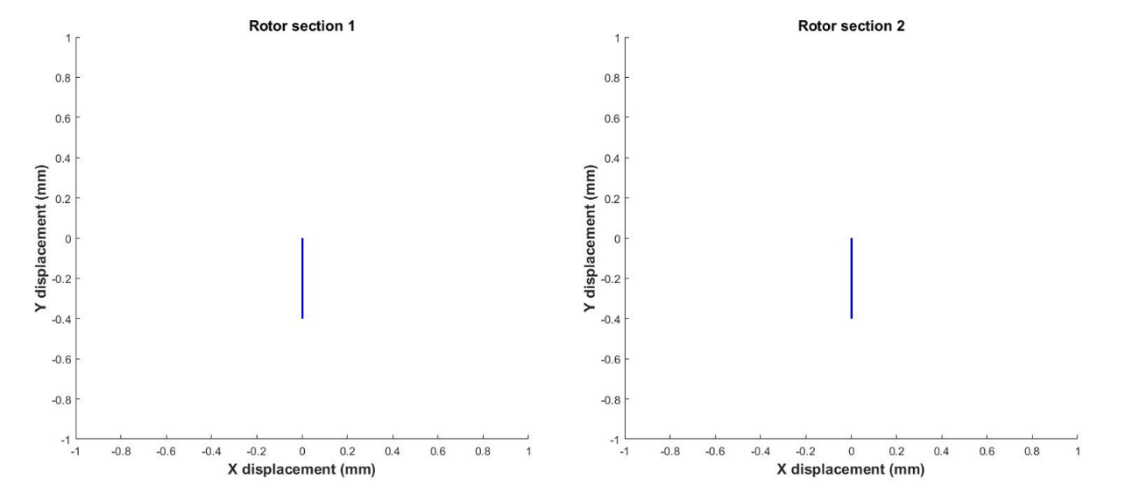
Figure 4-7 Initial rotor levitation from back-up bearing position of X=0mm and Y=-0.4mm at t=0 following a ramp position demand to X=Y = 0mm at t = 0.1s
The UMP that present during the start-up levitation can be regarded as a downward load with a magnitude proportional to the rotor eccentricities and is most significant when rotors are located on the back-up bearings.
Although there is a fixed gravitational force of 76.4N to overcome, the dominant force on the rotor when it rests on its back-up bearings is the UMP. Whereas a straightforward PID controller of the form shown in Figure 4-8a can overcome the predictable nature of the UMP, lends itself to a compensation strategy. A block diagram of the UMP compensation strategy considered is shown in Figure 4-8b.
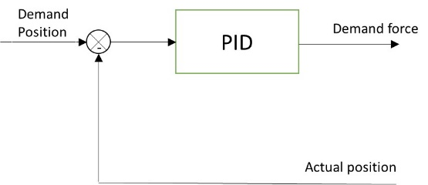 | 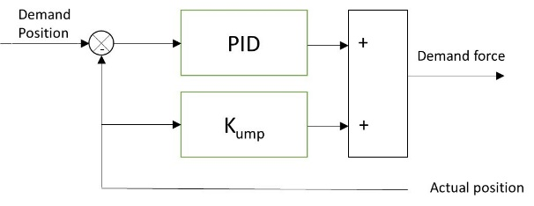
a) Simple PID control scheme | b) UMP compensation control scheme
Figure 4-8 Alternative control schemes for initial levitation
The demand force in both cases is used as the basis for the phase current optimisation described previously in section 3.4. It is worth noting that step change in reference position and immediate application of UMP compensating signals are avoided during start-up levitation in order to provide smoother motion of the rotor. Therefore, a ramping demand position is applied, ramping up to $X=Y=0$ at t=0.1s while the UMP compensator is applied with a ramped rate at acceleration of $17000N/{s^{2}}$ at t=0.0s for the maximum rate of $1700N/s$ at t=0.1s
The controller gains adopted for the two control strategies are listed in Table 4-3. These combinations of gains provide essentially identical levitation motion as shown in Figure 4-9. For the PID controller, the position dependant UMP is dynamically compensated for by the PID controlled closed-loop system. However, this performance is achieved with gains that are significantly higher than the PID controller which is used in tandem with the UMP compensator. This is a drawback for a practical implementation since higher PID gains will inevitably lead to higher sensitivity to system noise. Hence, the system with actively cancelled UMP is likely to be better suited to practical implementation.
Since both rotor sections in this simulation shows identical levitating movement, predicted phase currents and demand force signals for only one stator section are shown in Figure 4-10 and Figure 4-11 respectively. Due to the presence of the rotor gravitational force, only small amounts of phase currents are required to produce a constant upward force at the stable holding phase.
In this chapter, the use of the simulation model is focussed on the prediction of machine performance according to this prototype machine design. The detailed analysis of PID gain selection is presented in for the experimental cases in CHAPTER 7.
Table 4-3 Summary of controller gains
 | Proportional gain | Integral gain | Derivative gain
Active cancelled UMP | 1,000,000 N/m | 1,080,000 N/m·s | 6,000 N·s/m
PID control only | 2,240,000 N/m | 3,500,000 N/m·s | 10,000 N·s/m
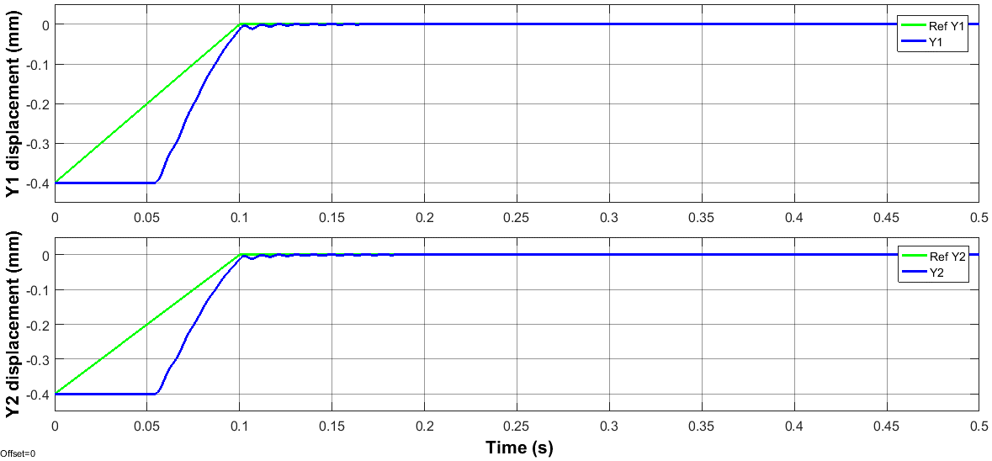
- Actively cancelled UMP (K_{P}=1,000,000 K_{I}=1,080,000 K_{D}=6,000)
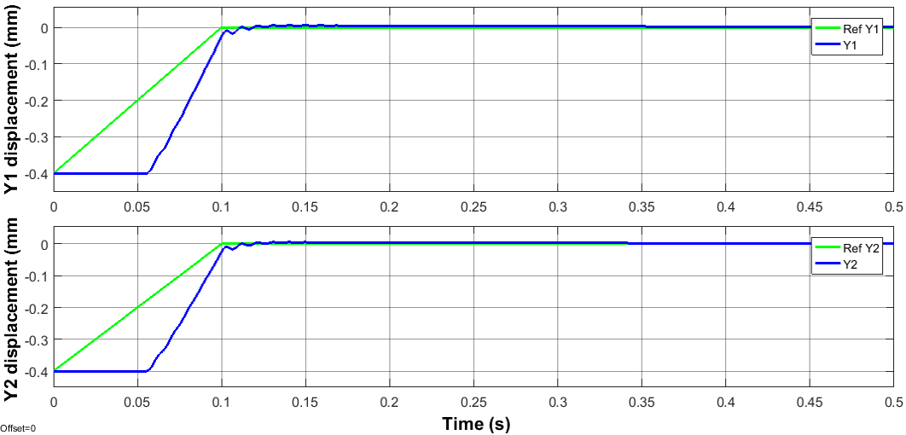
- PID control only (K_{P} =2,240,000 K_{I} =3,500,000 K_{D} =10,000)
Figure 4-9 Predicted levitation response for the two control schemes

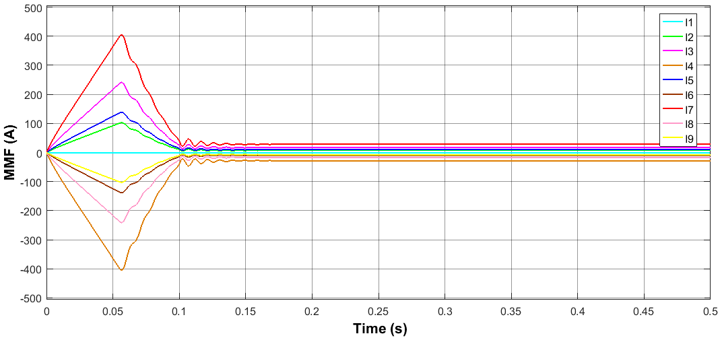
Figure 4-10 Phase currents in one stator section during initial levitation and holding steps
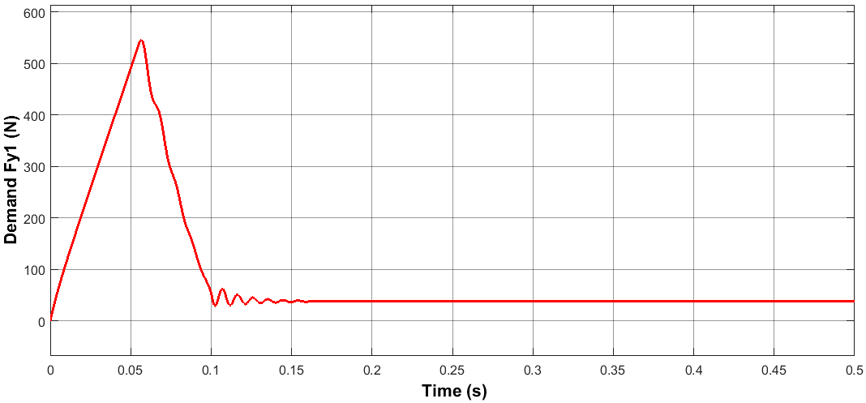
Figure 4-11 Predicted vertical component of force during initial levitation and holding steps

Static stiffness and dynamic stiffness

Static stiffness analysis
When the proposed self-bearing machine is simply being levitated prior to the application of a torque, it is possible to determine both the static and dynamic stiffnesses. These are the two most important parameters for evaluating the rotor reaction to disturbance forces.
In Figure 4-12, identical static disturbances with different magnitudes were applied simultaneously to both bearing units. By virtue of being a simulation, idealised square wave disturbances can be applied. Since the response of both stator sections will be identical (there are no differences in the design or control system settings), only the rotor displacement of section 1 is shown in Figure 4-12.
Static stiffness represents the ratio of applied static force to the corresponding rotor displacement. Using the simulated responses in Figure 4-12 and Figure 4-13, the resulting predicted static stiffness for the case of a controller with actively cancelled UMP and the PID gains summarised previously in Table 4-3 is shown in Figure 4-14.
As illustrated previously in Figure 4-6, traditional decentralized control strategy used in this simulation model has two independent PID controllers controlling X- and Y-axis for each bearing unit. The PID predicted Y-directional demand force of one bearing unit, therefore, is given as:
 | $${demand F}_{X\left(Y\right)}\left(t\right)=K_{P}e_{X\left(Y\right)}\left(t\right)+K_{I}\int_{0}^{t}{e_{X\left(Y\right)}(τ)d(τ)}+K_{D}\frac{de_{X\left(Y\right)}(t)}{dt}$$ | (48)
Take the example of Y-directional force, the corresponding net force for a single unit on Y-direction with the consideration of UMP and rotor gravity G is given by:
 | $$Net machine force F_{y}={demand F}_{X\left(Y\right)}\left(t\right)-K_{un}e_{X\left(Y\right)}-G$$ | (49)
where | $$K_{un}\left(known as negative stiffness\right)=\sim -1200N/mm$$
By substituting equation (48) into (49), the theoretical static stiffness of this analytical model is equal to $K_{P}+K_{UN}$.
As discussed above in section 4.2.1, system with actively cancelled UMP shown advantages of low demand proportional gain, i.e. reduced sensitivity to system noise in a practical implementation. Assuming ideal UMP and rotor gravity compensation, the net produced machine force of equation (49) is equal to predicted demand force of equation (48). Therefore, static stiffness is simply equal to the value of selected proportional gain (K_{P}=1,000,000 N/m).
As can be seen from Figure 4-14, the static stiffness derived from the simulation is 1,000 N/mm which is in good agreement with the theoretical value (1,000,000 N/m).
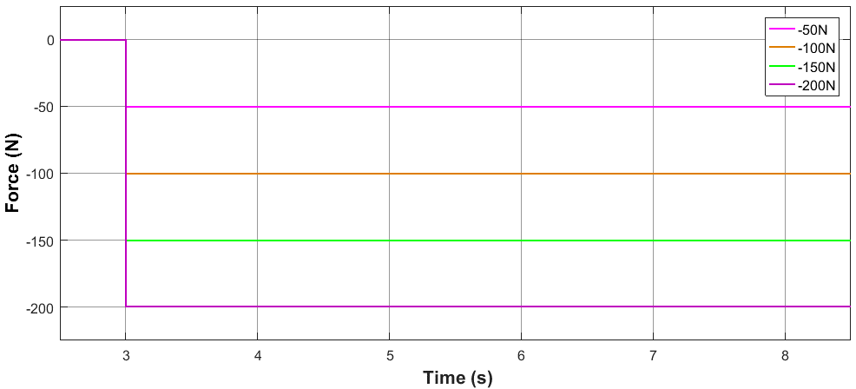
Figure 4-12 Static force disturbance (-50N, -100N, -150N and -200N respectively)
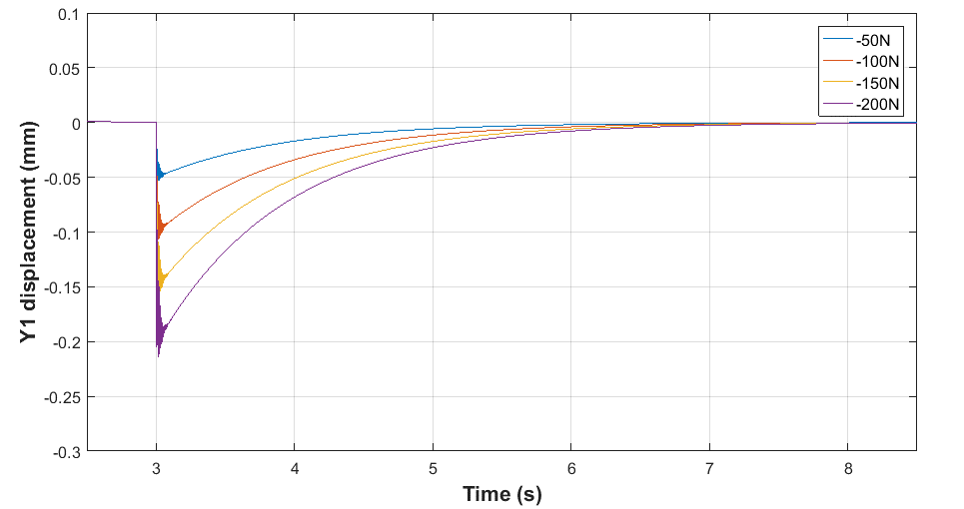
Figure 4-13 Simulation model predicted reaction of rotor displacement responding to static force disturbances (Figure 4-12) with actively cancelled UMP
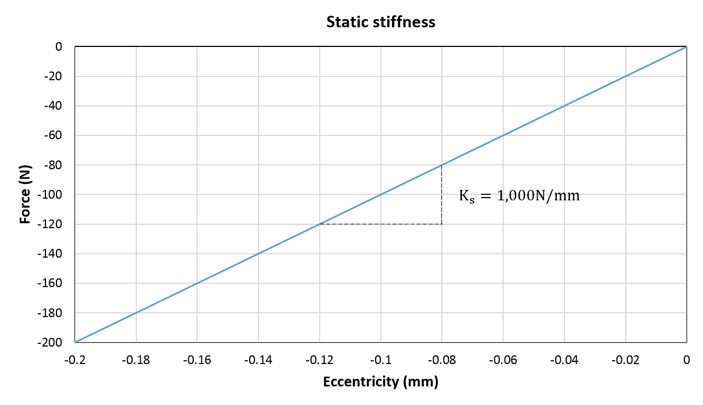
Figure 4-14 Simulation model predicted static stiffness of bearing unit using the results in Figure 4-12 and Figure 4-13
During the static hold phase, the maximum bearing capability for counteracting external static force load is determined by the static stiffness and allowable displacement. With the application of an ideal UMP compensator, the static stiffness is equivalent to the selected proportional gain. Moreover, the maximum allowable displacement is ultimately limited by the back-up bearing which is incorporated to avoid physical contact between rotor magnets and stator inner surface. In this case, the clearance is designed to be ~0.4mm.
Therefore, with the selected proportional gain for the case using UMP compensator, the maximum bearing capability of each bearing unit is 400N, i.e. the product of the static stiffness and the maximum allowable displacement. Hence, any external static forces greater than 400N could result in the rotor impacting on the back-up bearing. . In comparison to conventional mechanical bearings, self-bearing machines and indeed active magnetic bearing have rather limited static stiffness and bearing capability.

Dynamic compliance analysis
Dynamic compliance provides an indication of the rotor displacement resulting from a harmonic force load in the frequency domain [80]. It is often represented by a bode diagram.
In a practical system, harmonic and periodic force load are of significant interest, especially for rotational applications. The most common periodic disturbance force in an electrical machine is the mass imbalance force, which has a frequency that is synchronous with rotation of the rotor. Moreover, harmonic disturbance can also be recognized as high frequency noise on the rotor displacement sensor, which directly leads to disturbance force signals of self-bearing machines. Therefore, dynamic compliance is useful for predicting rotor displacement at different speeds and assessing system capability for accommodating high frequency noise.
In order to obtain the dynamic compliance of the system using the simulation model, periodic force waveforms with constant magnitude and various frequencies were applied and the resulting rotor displacements recorded. Figure 4-15 shows examples of force waveforms with an identical magnitude of 50N at four different frequencies (10Hz, 50Hz, 100Hz and 200Hz). The corresponding rotor displacements are shown in Figure 4-16.
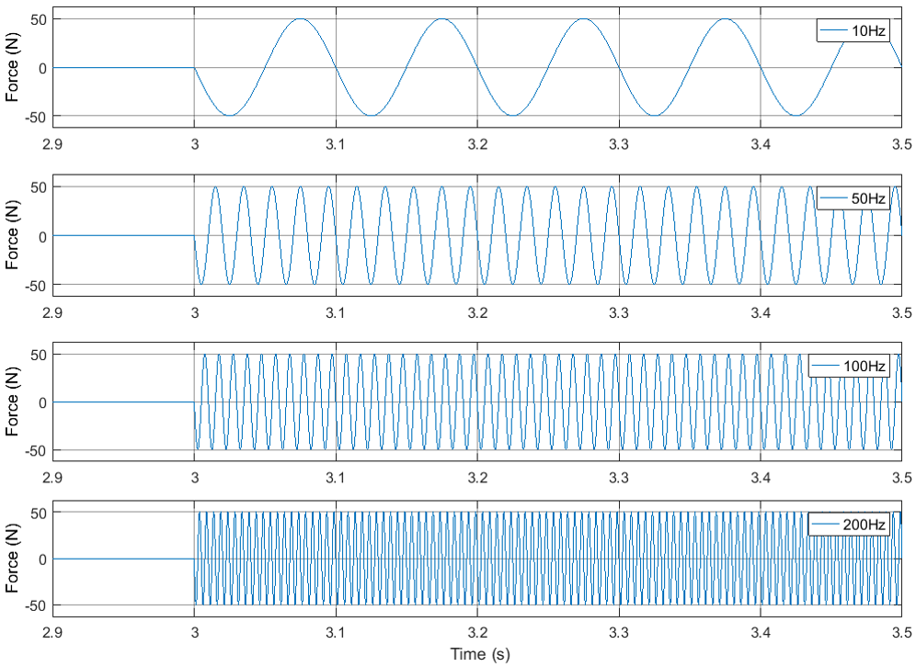
Figure 4-15 Harmonic force disturbances with same magnitude of 50N at different frequencies (10Hz, 50Hz, 100Hz and 200Hz respectively)
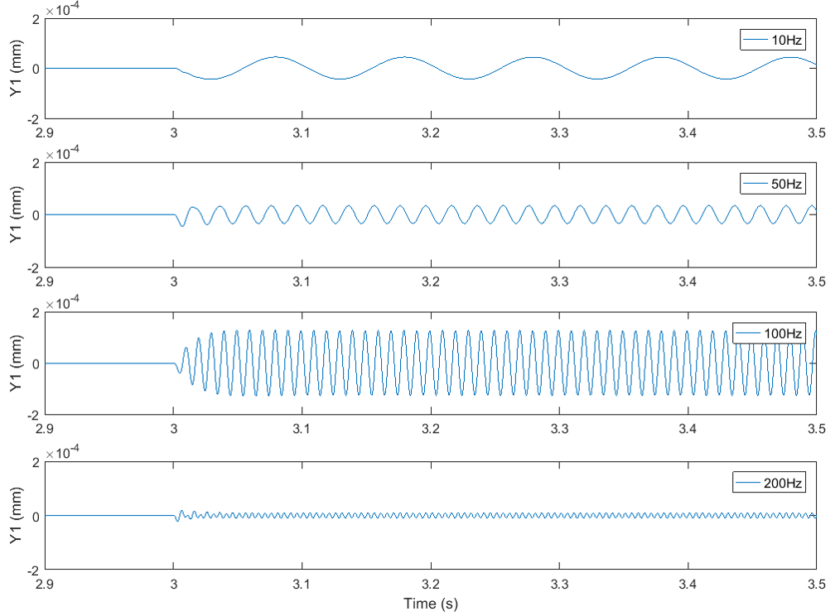
Figure 4-16 Simulation model predicted rotor displacement responding to harmonic force disturbances (Figure 4-15) with actively cancelled UMP and PID gains of Table 4-3
As would be expected, the magnitude of rotor displacement is a function of forcing frequency. As can be seen from Figure 4-16, rotor displacements with low frequency force disturbance (10Hz and 50Hz) displayed an identical magnitude of rotor oscillation. However, a significant displacement ripple was excited when force frequency increase to 100Hz in which the magnitude is almost three times greater than the case of 10Hz and 50Hz. In contrary of periodic force load with 200Hz, a negligible rotor oscillation was shown in Figure 4-16.
By applying a series of force load over a range of frequencies, the frequency response was derived. The resulting Bode diagram of dynamic compliance is shown in Figure 4-17. The magnitude axis of the Bode diagram represents the magnitude ratio of rotor displacement to force load. It is worth noting that the maximum ratio, i.e., maximum rotor displacement, occurs when phase shift between rotor displacement and force is 90°. The corresponding frequency is known as natural resonance frequency, which is determined by rotor shape and its physical dimensions. and results in the greatest sensitivity of rotor oscillation to harmonic and periodic disturbance. Rotor resonance can be observed with great dynamic oscillation and loud noise when the applied frequency of disturbance force is the same as rotor resonance frequency. For this system, the resonant frequency estimated from the Bode diagram is ~120Hz. In terms of rotational speed and the influence of mass imbalance, the corresponding resonance speed of this proposed machine is ~7200rpm.
Furthermore, as the phase shift between applied force load and corresponding rotor displacement was constant at -180° for frequencies above 200Hz, this simulation model implies a good suppression capability for system noise components above 200Hz.
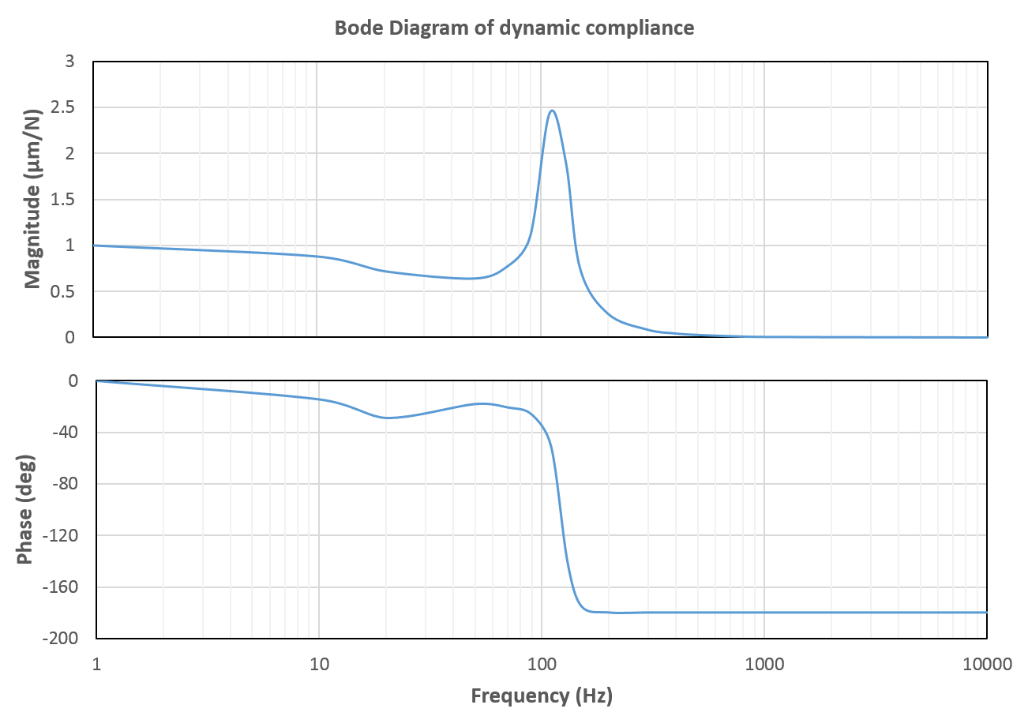
Figure 4-17 Simulation model predicted dynamic compliance of bearing units with the selected PID parameters (K_{P}=1,000,000 K_{I}=1,080,000 K_{D}=6,000) and UMP compensation

Dynamic performance prediction
Up to this point, machine dimensions were optimized in section 3.3 on the basis of static electromagnetic considerations. The resulting dimensions were previously summarised in Table 3-10. In section 4.1, a system level simulation model was developed for predicting rotor dynamic movement of the proposed machine design. The corresponding static stiffness and dynamic compliance were obtained in section 4.2.2 when the machine was assumed to be operating with static levitation. In this section, dynamic performance of this proposed self-bearing machine with a fully levitated rotating rotor is analysed and discussed.

Torque rating
Subject to a specified current density of $4 {A(rms)}/{{mm}^{2}}$ and a coil packing factor of 0.45 identified in Table 3-1 and the optimized machine dimension listed in Table 3-10 were established. The torque rating of this proposed self-bearing machine can be readily calculated. For this slotted stator, the start slot area $A_{s}$ is calculated in a value of $\sim 409{mm}^{2}$.
Therefore, the corresponding rms value of MMF for motoring capability is$\sim 368A$per slot. As mentioned previously, this proposed self-bearing machine with an appropriate control is expected to operate as a conventional three-phase SPM machine with small deviations from its concentric reference rotor position. The rated torque for this proposed machine was estimated with three-phase AC currents using a two-dimensional, magneto-static finite element model. For the rated stator slot rms MMF, the finite element predicted torque rating is$\sim 22.0Nm$.

Bearing capability at full torque load condition
During static levitation and with the gain settings defined previously in Table 4-3 with UMP compensation, the bearing force of static capability is of 400N (as determined in section 4.2.2.1).
At the full torque condition (22Nm), the calculation of the residual bearing capability is of crucial interest. As compared to the determination during static levitation, the bearing capability when rotating at full torque is predominantly limited by the specification of the selected power amplifier, details of which were summarised previously in Table 4-1. Therefore, the constraints for the determination of bearing capability at full torque load condition are:
- Max. Rotor eccentricity ($≤0.4mm$): Avoiding mechanical contact with the back-up bearing during rotation is a priority for self-bearing applications. The mechanical clearance limited by back-up bearing is 0.4mm.
- Max. Phase MMF ($≤1000A$): In order to maintain good linearity in the excitation force capability, it is desirable to keep the maximum MMF below 1000A in each phase.
- Rotational induced back-EMF (50V): When compared to conventional machines, in self-bearing machines, an additional voltage overhead is essential to realise the bearing function not unduly affect its dynamic capability [81]. In order to provide sufficient bearing dynamic capability, motoring back-EMF is limited to 50V which is considerably below the amplifier supply voltage of 80V. It is recognised that at this point, this specification is empirical, but is necessary in order to progress the design, with potential for future iterations so as to ensure maximum use of the available amplifier voltage rating.
- Peak current limited to 20A: Peak current represents the maximum instantaneous current limit of power amplifier during the more extreme operating condition, such as a step change of load on the bearing. According to the power amplifier specification listed in Table 4-1, the peak current of this selected amplifier is limited to 20A. In addition, it is worth noting that the maximum operating duration at this peak current is a mere 2 seconds.
- Continuous current (12A (rms) / 17A (peak)): This rating is the steady-state current and is often limited by thermal considerations. According to the specifications listed in Table 4-1, the continuous current of this selected power amplifier is limited at 12A (rms). For a sinusoidal AC operation, the equivalent peak value of continuous AC current is ~17A.
- Equivalent phase voltage ($≤80V$): In the proposed demonstrator configuration, each phase is powered by a power amplifier operating in current control mode with a supply voltage rating of 80V as shown in Table 4-1. Therefore, the equivalent phase voltage is estimated using a phasor diagram according to equation (50).
 | $$V_{i}=e_{i}+R_{i}I_{i}+{\frac{3}{2}L}_{i}\frac{dI_{i}}{dt}$$ | (50)
At any specific operational condition, each of the six constrain detailed above must be satisfied by each controlled phase, including at full load conditions. These constraints provide the basis for selecting the number of turns on each coil.

Selection of number of turns in each coil
It is possible to simulate the performance of a machine without selecting the number of turns in each coil in the first instance. In this case, the machine model is fed by an mmf from the control system that is effectively a single turn model. This offers a means of establishing the peak mmf required for typical operating conditions. This in turn allows the number of turns that produces the required MMF within the maximum current rating to be calculated. However, this model would not capture the amplifier dynamics, and indeed it may prove that a change of the number of turns is necessary to ensure some of the voltage constraints are not exceeded.
A series of simulations were performed, in which the machine was simulated with one turn per coil for the following operating profile:
- Initial static levitation and hold for a duration of 1s
- An accelerating period with a duration of 1s in which the rotor accelerates from standstill to a steady-state maximum speed (limited by the back-EMF of 50V).
- The ramping up of load torque from 0Nm to 22Nm over a duration of 1s
- Following these stages, the machine is exposed to a step load of external force disturbance at 3.5s in the Y-direction.
A useful reference is the variation in phase MMFs for the case of zero external disturbance, i.e. other than the initial levitation, the mmfs produce only torque with no bearing action other than supporting the gravitational load of the rotor. The predicted MMF variations of section-1 in the absence external force load are shown Figure 4-18. As can be seen, the magnitude of MMF at steady state operation condition of 22Nm is ~600A.turns. Since this is a continuous condition for motoring, this means that the minimum number of turns is at least 36 in order to remain within the 17A (peak) continuous rating. It is therefore likely that more than 36 turns will be required to provide useful bearing capability.
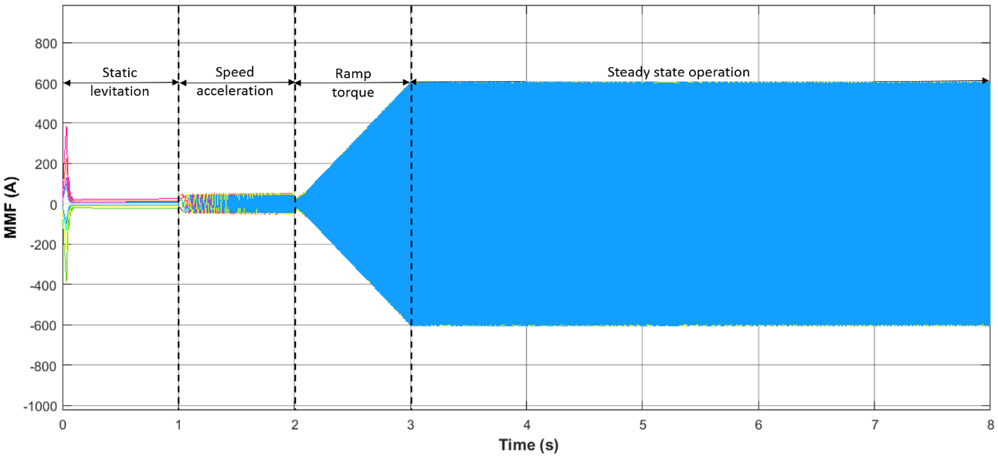
Figure 4-18 Simulation predicted MMF variation of section-1 without force load
The first step-change force considered was a -200N external disturbance at t=3.5s. The predicted variations in MMF and displacement with this step load are shown in Figure 4-19. The maximum MMF required to accommodate this disturbance increases to 840A.turns. The rotor displacement given the initial response to the step change, is governed by the static stiffness.
In order to remain within the peak amplifier current rating of the 20A, requires 42 turns per coil. This estimate of 42 turns yields the reactance, emf and applied voltage requirements that are listed in Table 4-4. For the maximum back-EMF (50v), the maximum speed of the machine is limited to 2775rpm. However, of greater concern is that with the calculated impedance, the voltage required in phases 7 and 8 (which contribute the most to the force disturbance rejection) exceed 80V.
In order to meet all the constraints on the machine and amplifier, the force disturbance needs to be reduced. By iteration, it was established that a -170N force disturbance can be accommodated with a single coil design that meets all the constraints. The predicted variations in MMF and displacement with this reduced step load are shown in Figure 4-20. In order to remain within the current limit of the amplifier, the number of turns can be reduced to 37. For a 37-turn design, the predicted machine parameters and a summary of key performance predictions are shown in Table 4-4.

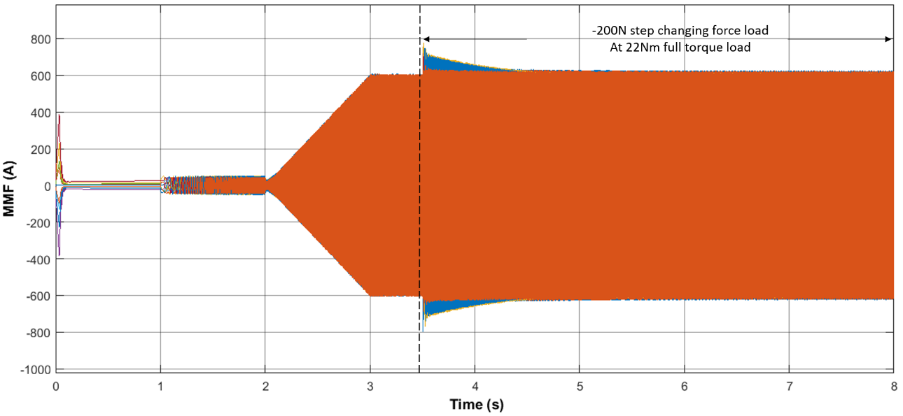
(a)
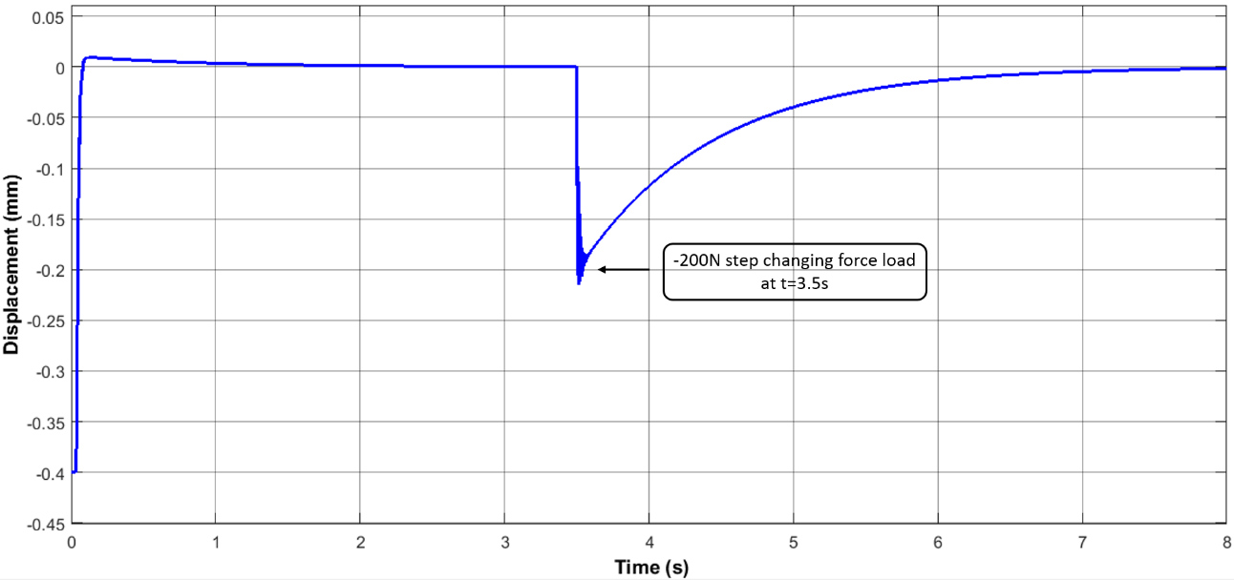
(b)
Figure 4-19 Simulation predicted section-1 MMF variation (a) and rotor displacement (b) due to -200N step changing force load at t=3.5s
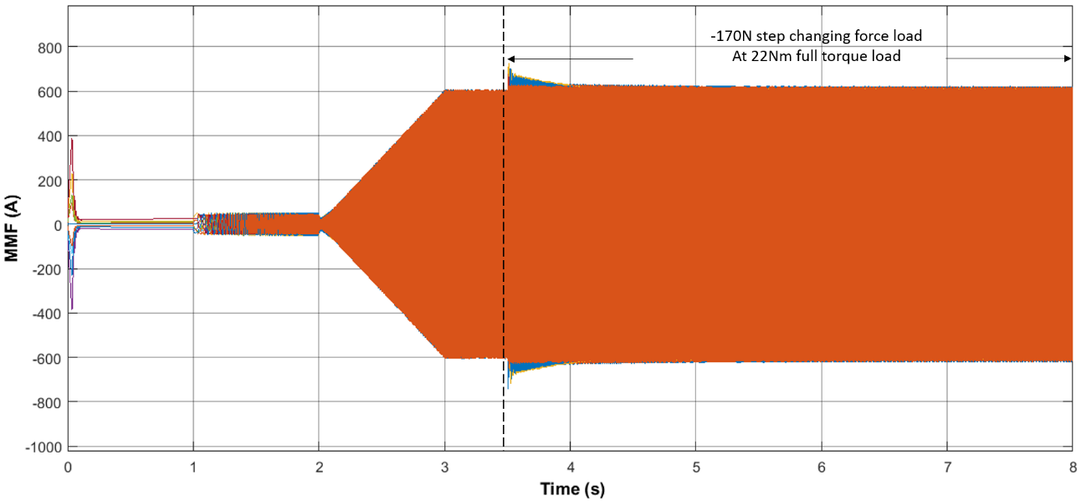
(a)
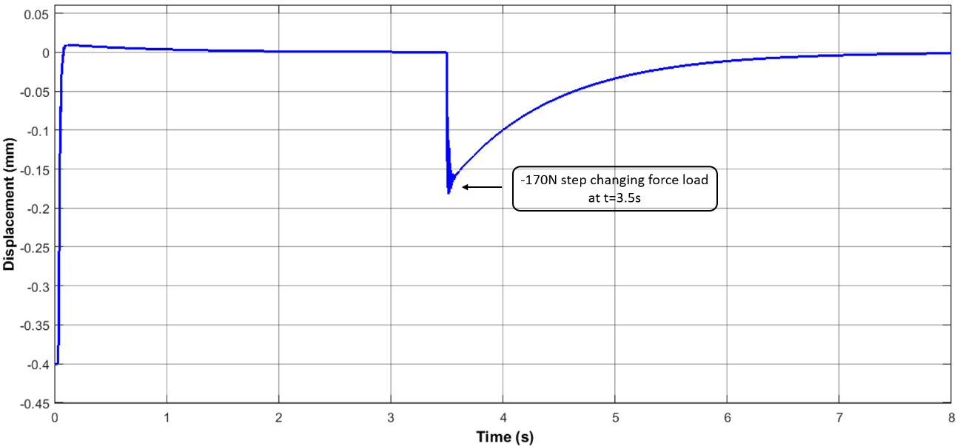
(b)
Figure 4-20 Simulated section-1 MMF variation (a) and rotor displacement (b) due to -170N step changing force load at t=3.5s
Table 4-4 Summary for bearing capability analysis at 22Nm full torque load condition
 | Magnitude of disturbance force
 | -200N | -170N
Max. eccentricity ($ε_{Y1})$ | -0.20mm | -0.17mm
Max. MMF | 800A | 740A
Peak current (amplifier) | 20A | 20A
Min. number of coil turns | 40 | 37
Back-EMF | 50V | 50V
Rotational speed ($v_{max}$) | 2775rpm | 3000rpm
Self-inductance (L) | 1.66mH | 1.42mH
Magnetising inductance($\frac{3}{2}L)$ | 2.49mH | 2.13mH
Resistance | 0.117Ω | 0.100Ω
Continues MMF | 625A(peak) | 620A(peak)
Phase voltage over 80V | Phase 7 & Phase 8 | None
Whereas the coil designs to accommodate both -200N and -170N force disturbances meet the constraint over current, mmf and displacement, it is not possible to meet all the voltage constraints if the machine is to reject a -200N disturbance at a full rated torque of 22Nm. The equivalent phase voltages were estimated according to the phasor diagram using equation (50). It is worth noting that the symbol of $L_{i}$ represents the synchronous inductance of the equivalent single phase circuit for an AC operation. Its value, therefore, is ~1.5 times the self-inductance, L, due to the nature and magnitudes of mutual inductance in this type of machine. By applying the appropriate values of inductance, resistance and machine speed listed in Table 4-4, the corresponding phase voltages were predicted using the simulation models. Figure 4-21 shows the variation in voltage of phases 7 and 8 from which it is apparent that in the case of -200N force load, Phase 7 and phase 8 required voltages higher than 80V for realizing the required bearing capability. In contrast to a disturbance of -170N, equivalent voltages of all phases were controlled below 80V, and, therefore, satisfies the constraint on the voltage limit of the selected power amplifiers.
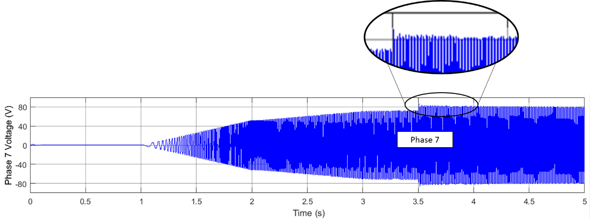
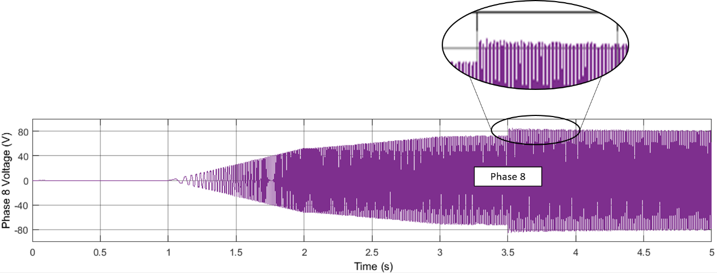
- -200N step force load at 3.5s (full torque load condition)
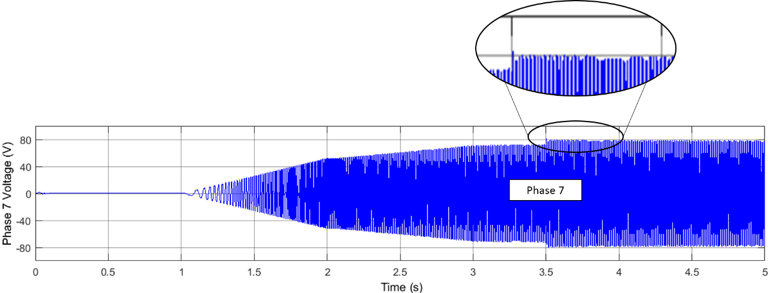
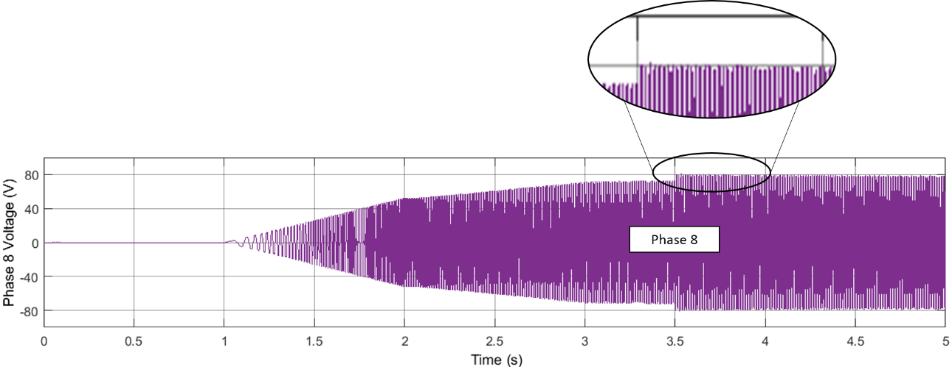
- -170N step load at 3.5s (full load condition)
Figure 4-21 Voltage comparison of phase 7 and phase 8 with step force load of -200N (a) and -170N (b) at full torque load condition
The above comparative analysis, and in particular the need to meet the six constrains, provides a basis to rate the bearing capability at full load torque and set the number of turns on each coil. On the basis of compliance with the constraints, which are summarised in Table 4-5, a step force of 170N was set at the maximum bearing capability at a 22Nm full torque load condition. Hence, the number of coil turns and machine speed rating were determined to be 37 and 3000rpm respectively.
The final specification of the prototype self-bearing machine derived from a combination of the electromagnetic design in CHAPTER 3 and the dynamic simulations in this chapter is summarised in Table 4-6.
It is worth noting that the machine only failed to meet the 200N step change bearing capability within the amplifier constraints because of the rated torque. This bearing capability could be met at a lower torque. Figure 4-22 shows the calculated trade-off between torque rating and force capability with the specified amplifiers.
Table 4-5 Analysis of proposed constrains for the determination of bearing capability at 22Nm full torque load condition
Quantity | Disturbance force at 22Nm
 | -200N | -170N
Rotor eccentricity ($≤0.4mm)$ | √ | √
Phase MMF ($≤1000A$) | √ | √
Peak current ($≤20A$) | √ | √
Continuous current ($≤17A(peak)$) | √ | √
Equivalent phase voltage ($≤80V$) | $$×$$ | √

Table 4-6 Specifications of the proposed SPM self-bearing machine
Description | Symbol | Value | Unit
Power rating  (Total of two sections) | P | ~6.9 | kW
Torque rating  (Total of two sections) | T | ~22 | Nm
Max. Speed | $$v_{max}$$ | ~3000 | rpm
Max. step changing force load  (single section) | $$F_{load}$$ | ~170 | N
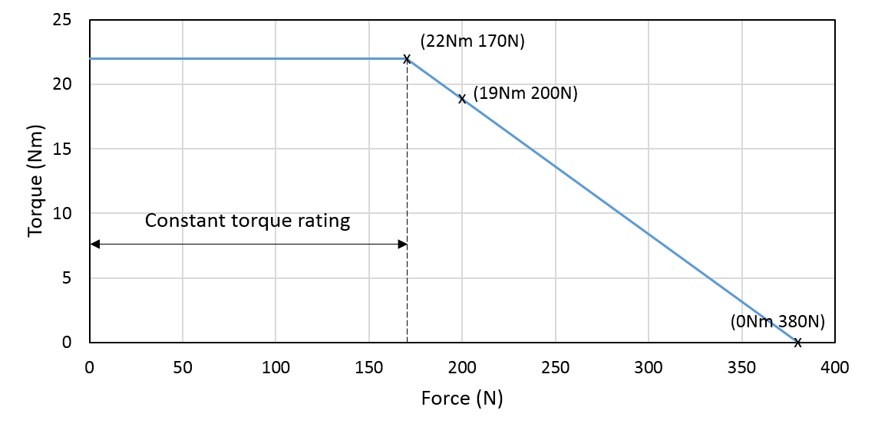
Figure 4-22 Relationship between torque rating and maximum bearing capability

Build and commissioning of the self-bearing machine and power amplifiers

Introduction
This chapter describes the manufacture of the prototype self-bearing SPM machine whose design was optimised in section 3.3, an experimental test rig and a custom 18-channel power amplifier.

Rotor construction
The rotor of the prototype self-bearing machine comprises two separate sections of rotor core, both of which are made up from stacks of Silicon Iron laminations. As shown in Figure 5-1, both of these two core sections are assembled on to one single mild-steel shaft. A 6-pole arrangement of NdFeB magnets is attached to each core (the properties of the NdFeB was shown previously in Table 3-6). The 100mm axial length of magnets is made up from four 25mm long pieces, resulting in a total of 24 magnet pieces per section, i.e. 48 magnet pieces in the full machine.
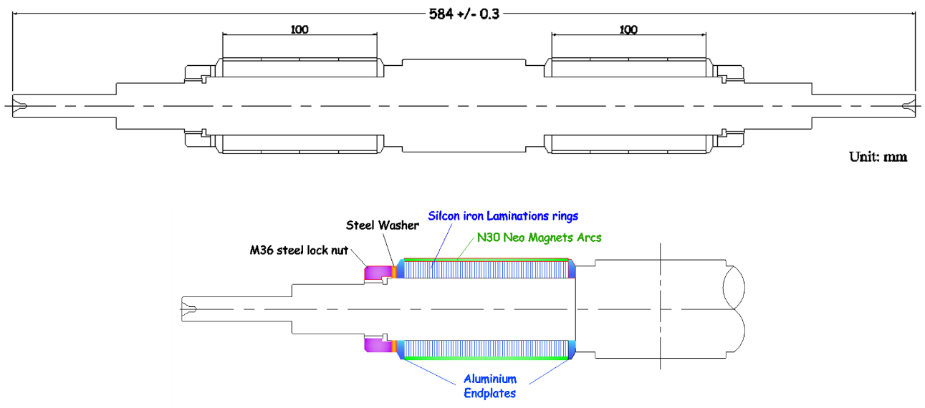
Figure 5-1 Schematic drawing of prototype machine rotor
During the attachments of the magnets to the rotor cores, the custom built jig shown in Figure 5-2 (a) was used to precisely located and hold the magnets in place during the curing of the adhesive (LOCTITE 638) was used for securing the mounting on the laminated rotor core. Figure 5-2 (b) shows the jig being used to attach the magnets.
As discussed in section 3.3.3, the rotor magnet sleeve required for this prototype machine is extremely thin that has no direct influence on machine electromagnetic optimization. For this practical machine, a carbon fibre containment with only two layers of fibre (~0.4mm thick) was applied to each rotor section by in-situ filament winding and curing a carbon-fibre and epoxy composite over-wrap. The finished prototype rotor is shown in Figure 5-3.
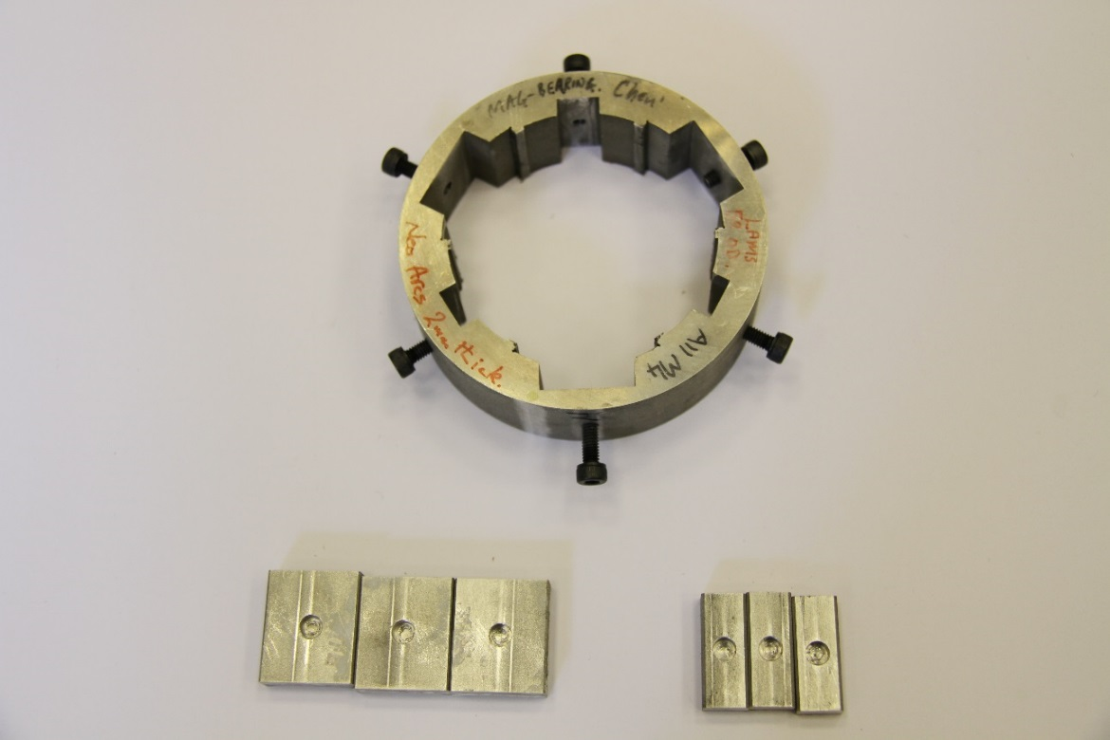
- Custom built alignment and retention jig
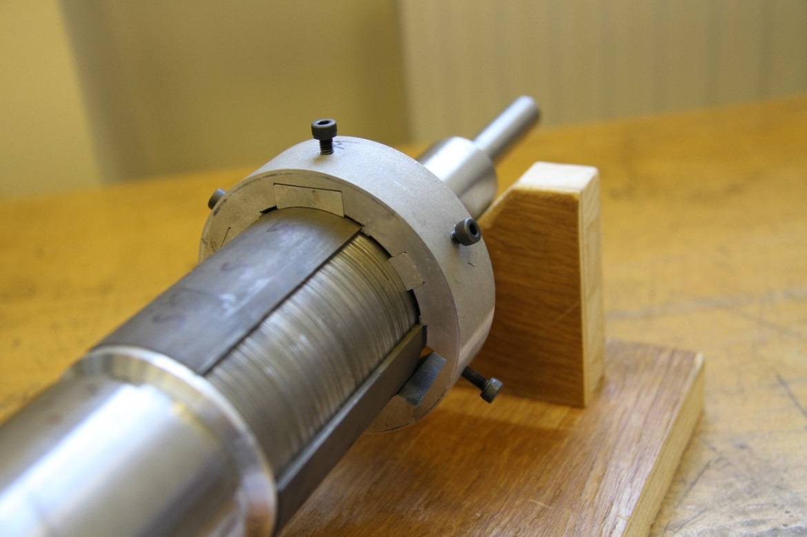
- Attachment in progress
Figure 5-2 Details of magnet attachment progress
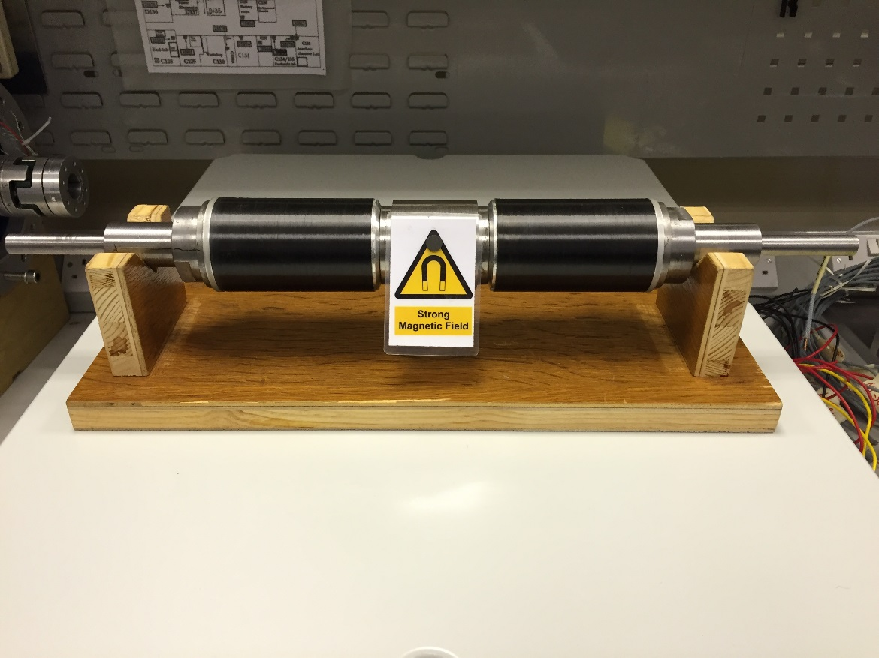
Figure 5-3 Finished SPM rotor with carbon fibre containment

Stator construction
The stator cores of the prototype machine consists of two separate stacks of 0.3mm thick Silicon Iron laminations, each with an axial length shown of 100mm. These two stator cores are contained with an Aluminium casing as shown in Figure 5-4.
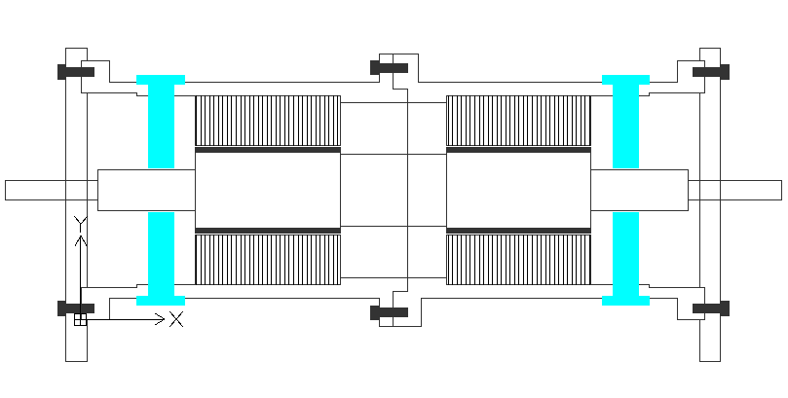
Figure 5-4 Schematic cross-section of prototype stator
Each stator lamination stack was inserted into the stator casing before coil winding. Nine concentrated coils were hand-wound into each section, as shown in Figure 5-5. Each coil had 37 turns of 3 strings of 0.8mm diameter wire, resulting in an effective slot packing factor of 0.45.
The rotor was inserted into the stator using the precision jig shown in Figure 5-6 to align the shaft with the back-up bearing and resist the UMP generated by the permanent magnets. Since each of the 18 concentrated stator coils is independently powered by a power amplifier, all the coil leads were extended through the casing as shown from a fully constructed machine in Figure 5-7.
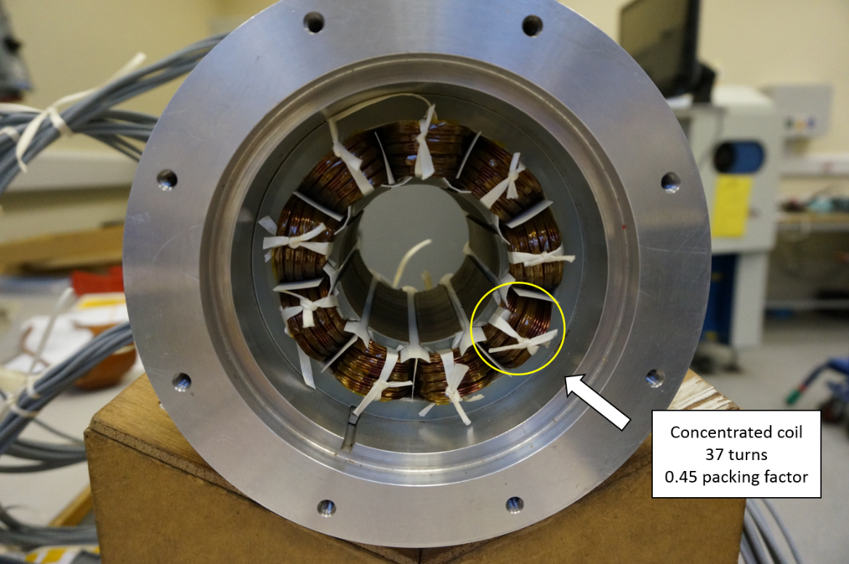
Figure 5-5 Demonstration of one stator section with 9 concentrated hand-wound coils
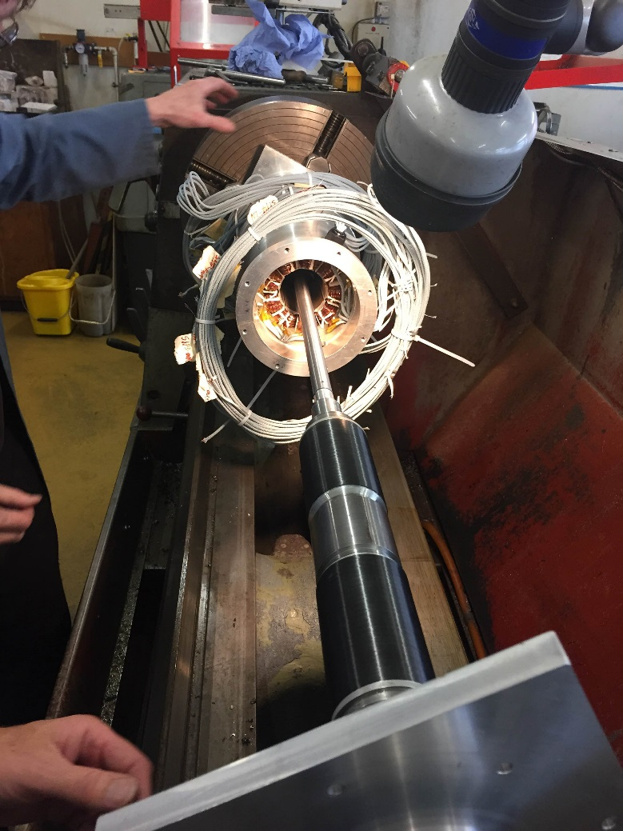
Figure 5-6 Assembly of the prototype self-bearing machine
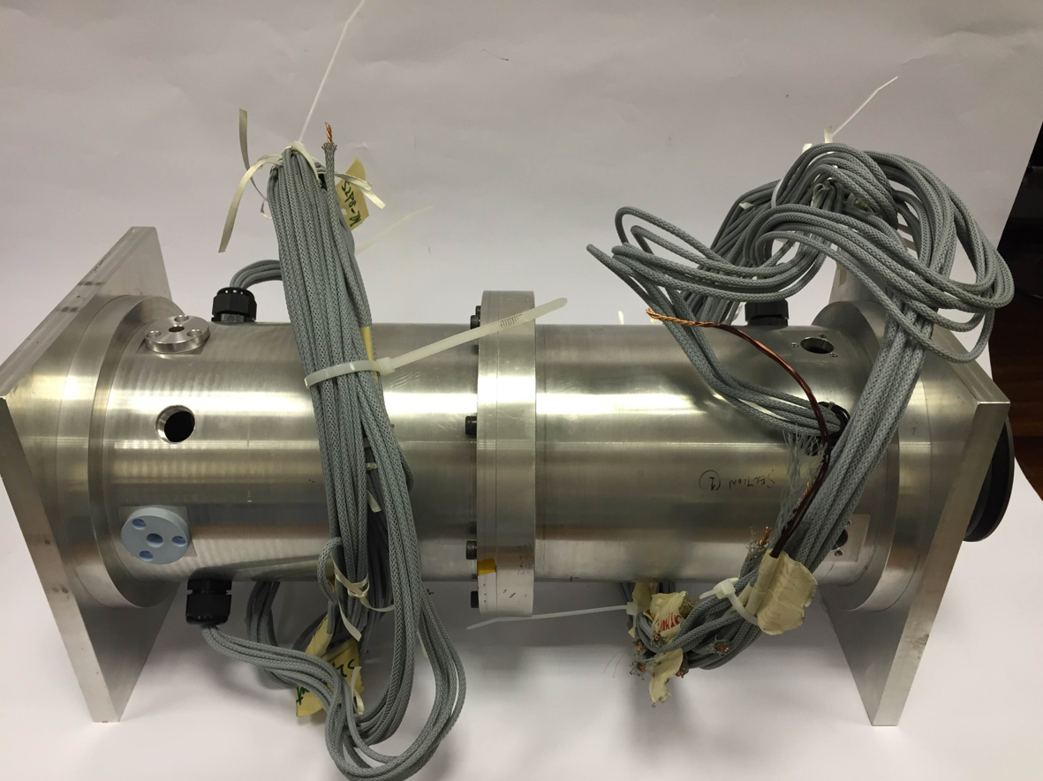
Figure 5-7 the fully constructed prototype self-bearing SPM machine

Experimental rig construction
General configuration of the main system elements and the various interconnections is shown in Figure 5-8.
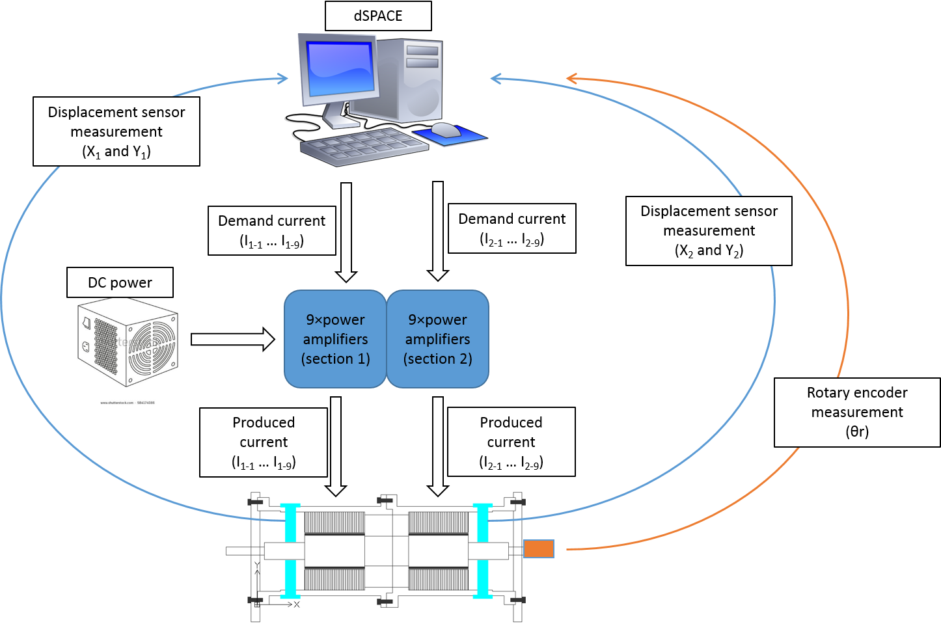
Figure 5-8 Block diagram of dSPACE, power amplifiers, position sensor, rotary encoder, DC power supply and the prototype self-bearing machine

Power supply
For the experimental rig, the 18 power amplifiers were parallel connected across a single DC regulated power supply which is shown in Figure 5-9. This 30kW DC power supply has a voltage rating of 100V and current rating of 300A [82].
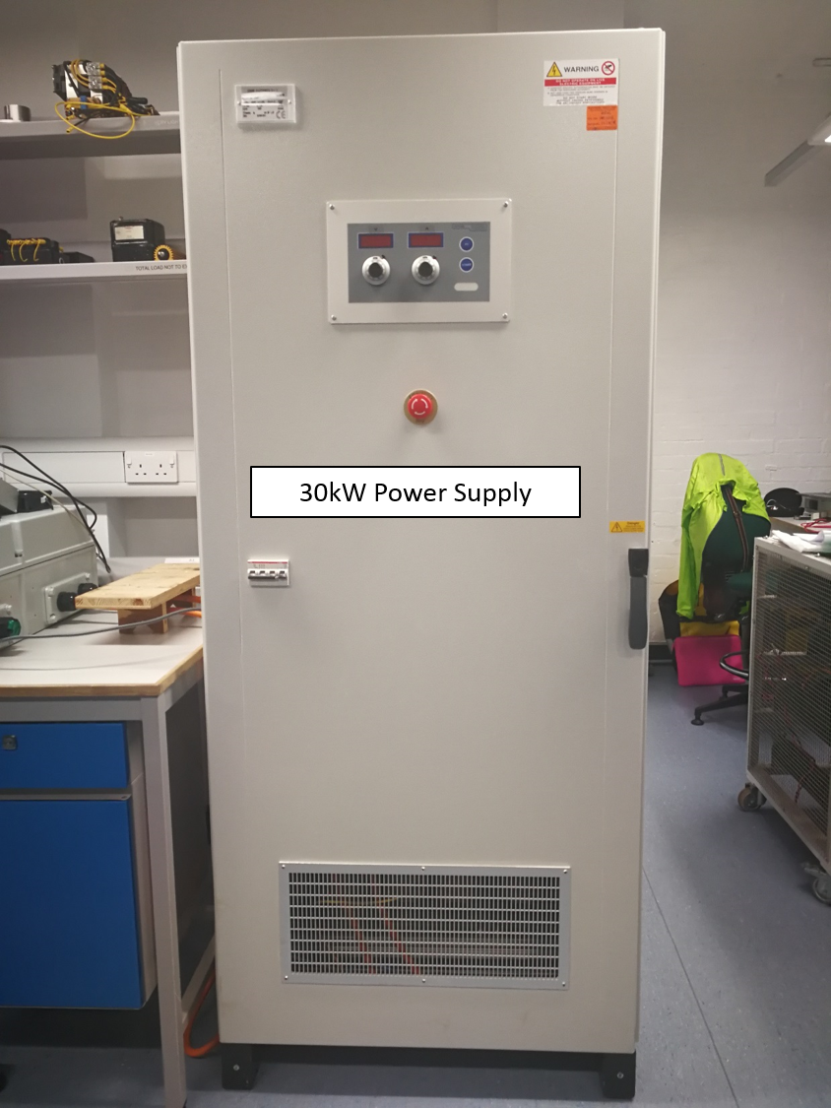
Figure 5-9 DC power supply

Precise displacement sensor
The rotor displacement is measured at each end of the rotor shaft using four precision eddy current ‘gap’ sensors. The sensor head (HA-80S), which are shown mounted in a Tufset plastic holder in Figure 5-10, are connected to four sensor controllers (LS-5OO DC-type). The general requirements for displacement measurement are high frequency response, low noise, good linearity and high resolution [83]. The selected sensor head (HA-80S) have a measuring range of 0mm~2mm with a corresponding analogue output 0~2V produced by the sensor controller and the selected sensor controller (LS-500 DC-type) is provide a 10kHZ bandwidth with a high resolution of 0.3μm [84].
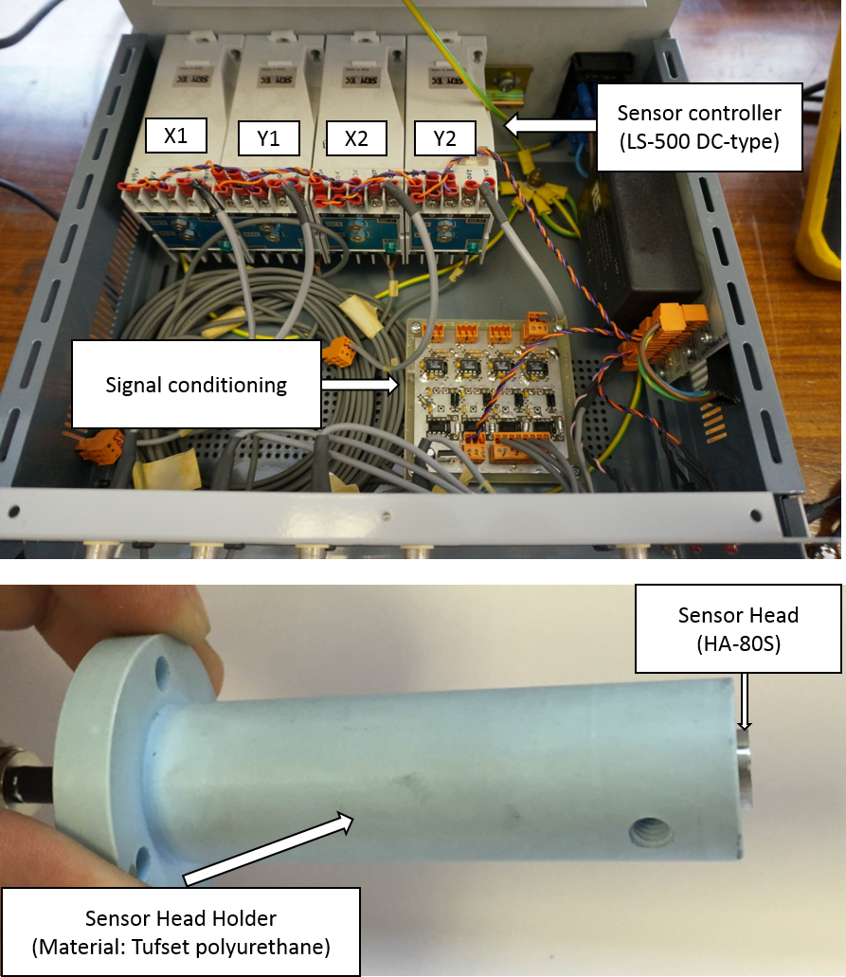
Figure 5-10 Essential components of rotor displacement measuring system (includes: sensor controllers (LS-500 DC-type), sensor head (HA-80s), sensor head holder and signal conditioning)
A custom built signal conditioning board was designed and manufactured to scale the displacement analogue signal to the range of ±10V in order to fully utilise the input voltage range of the dSPACE A/D board used in the system controller.

Rotary encoder
For this prototype self-bearing machine, angular positions were measured by a low-cost commercial rotary encoder (AEAT-601B). This is an incremental magnetic encoder based on contactless sensing technology. The stationary element and the magnetic head which attached to the rotor is shown in Figure 5-11. It has good angular resolution (0.35°) and by virtue of being contactless allows some relative movement between the magnetic head and the stationary part [85].
The completed assembly is shown in Figure 5-12. It is worth noting that the sensor housing was attached to an adjustable bracket which assist with alignment of the sensor housing and magnetic head for the optimum measurement. The inner diameter of the magnetic head was only 6mm, and hence shaft extension was manufacture to adapt the magnetic head as shown in Figure 5-12.
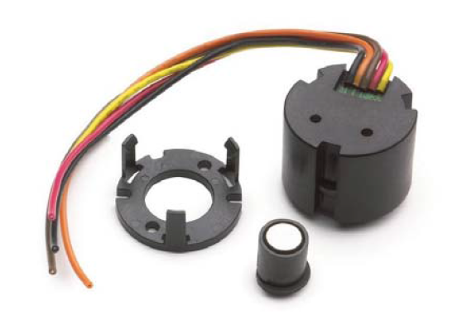
Figure 5-11 Contactless incremental magnetic encoder (AEAT-601B) (Source: [85])
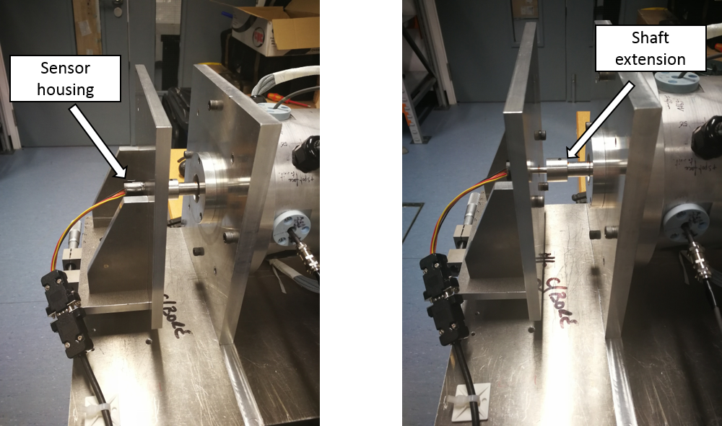
Figure 5-12 Completed assembly of the contactless rotary encoder

Axial movement stopper
As mentioned previously in section Figure 4-1, the research in this thesis is focussed on X- and Y-axis translational and tilting movement of a self-bearing machine. The control of translational movement in Z-axis (rotor shaft axis) is largely independent of the other controlling axes, although there is a small degree of cross-coupling. As discussed in section 4.1, there is a reasonable degree of axial stiffness because of the tendency of the rotor magnets to align with the stator core and resist axial displacement from this minimum reluctance position. However, whereas this might reduce the force rating of an axial thrust bearing, an actively controlled axial thrust bearing is likely to be required in many applications.
In order to ensure that reliable means axial location could be achieved the prototype machine without incorporating a magnetic axial thrust bearing, two plastic elements were fitted adjacent to one end of the shaft with a small clearance, as shown in Figure 5-13. These elements prevent excessive axial movement, although this is achieved by mechanical contact. However, they do not contribute in any meaningful sense to the bearing action in the other five degrees of freedom.
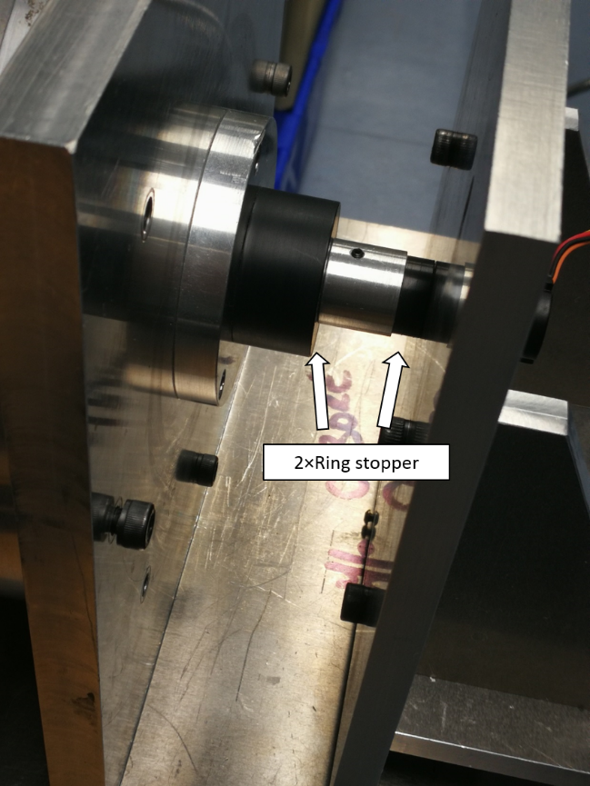
Figure 5-13 Additional ring stopper for mechanical constraining of Z-axis displacement

Power amplifiers

Amplifier arrangement
For this control system described previously in section 3.4, each of 18 concentrated stator coils is considered as a single phase and is driven by independent power amplifier. The amplifiers used are AZ20A8 from AMC, the specification for which is summarised in Table 4-1.
All 18 amplifiers were placed in one large plastic enclosure arranged as with two separate groups of 9 amplifiers for each individual controlled stator as shown in Figure 5-14. In order to maximize the cooling ability, six fans were incorporated into the enclosure lid as shown in Figure 5-15, with 3 extracting and 3 forcing air into the enclosure. Each power amplifier was attached to a custom designed printed circuit board to allow various power and control connections to be made.
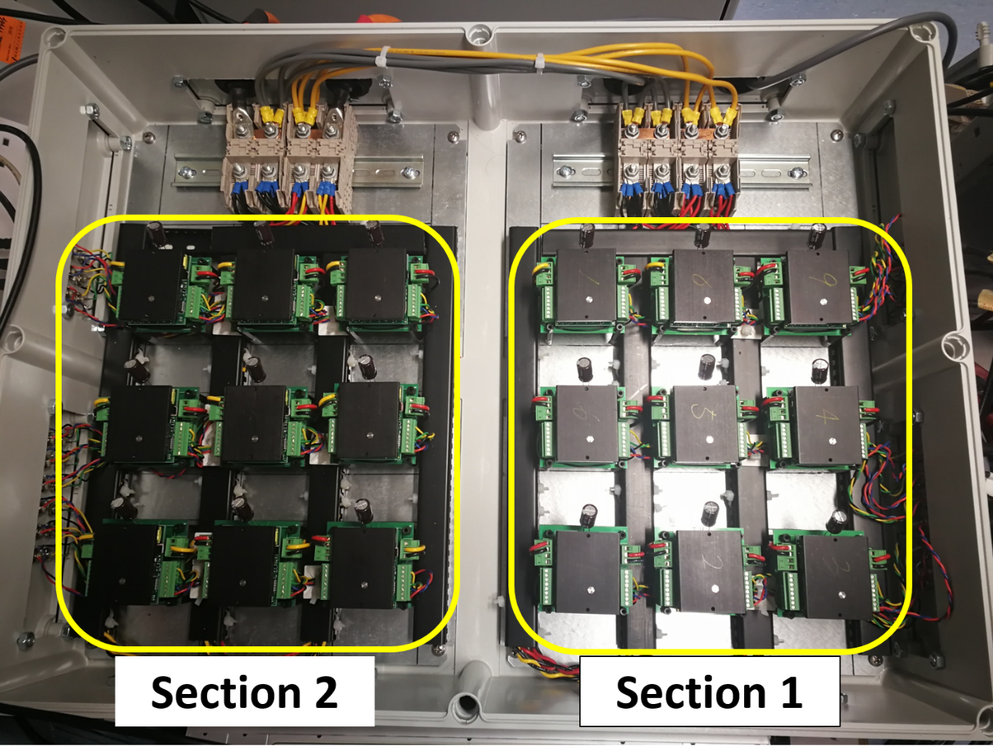
Figure 5-14 Power amplifier arrangement inside enclosure (lid removed)
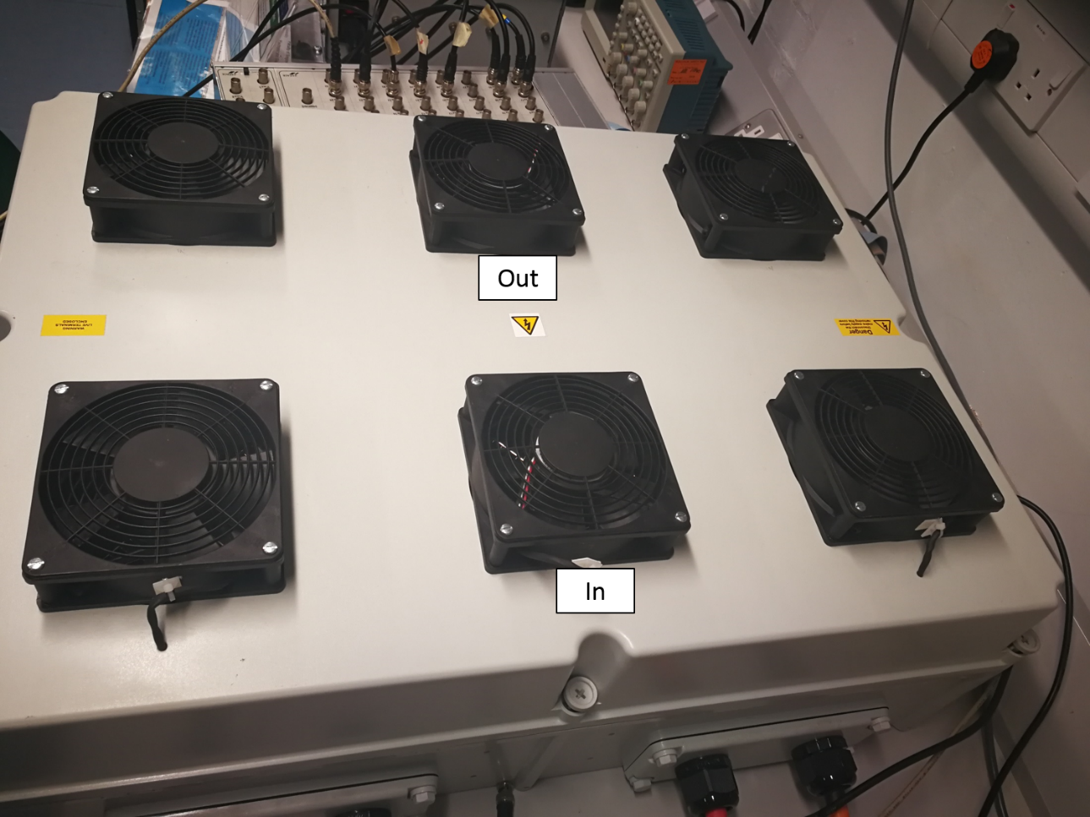
Figure 5-15 Cooling fan arrangement

Amplifier performance analysis
The specification of selected power amplifiers was summarised previously in Table 4-1 in section 4.2.3. For ideal amplifier operation, the amplifier would precisely reproduce the demand current. However, the performance of any practical power amplifier is limited by its operating bandwidth and the available supply voltage. The dynamic performance of the power amplifiers with the default manufacturer gains settings was experimentally measured to produce frequency domain Bode diagrams. These measurements were performed with a single amplifier connected to one phase of the machine but with the rotor locked in position to prevent both rotation and eccentric displacement.
Due to the absence of a machine back-EMF during the bench testing of amplifier performance, the DC supply voltage for the amplifier test was reduced to 60V instead of the maximum 80V rating. This value of 60V was derived using the phasor diagram of Figure 5-16 for motoring operation. According to the calculation of equivalent phase voltage using equation (50), when machine is at full speed (3000rpm), the voltage drop due to coil resistance (max. of ~2V) can be reasonably neglected when compared to the induced back-EMF and inductive voltage drop. For maximum value torque per ampere, the coil current is aligned with the induced back-EMF. Since the back-EMF at full speed operation is ~50V as discussed in section 4.2.3, the maximum value of inductive voltage due to dynamic current is ~60V. Hence, in order to test the power amplifier performance with a purely inductive load, a supply voltage of 60V is representative of normal motoring operation.
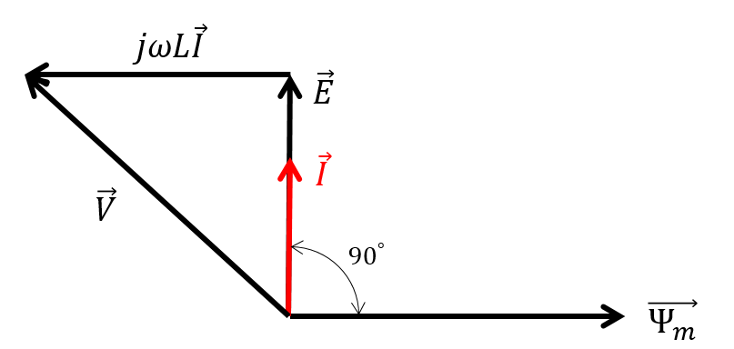
Figure 5-16 Simplified phasor diagram
The fundamental frequency for this 6-pole machine at full load and 3000rpm is 150Hz. Hence, the power amplifiers are required to produce rated current up to at least 150Hz. Furthermore, high frequency and small magnitude rotor oscillations are likely to be encountered during static levitation[20]. In order to accommodate this high frequency bearing requirement, the maximum frequency at which current is required was assumed to be ~ 500Hz, although this would be at a considerably reduced current rating. This broad-brush performance formed the initial specification for tuning the amplifiers.
Initially the manufacturer set default gain values were used. The resulting Bode diagrams at 3 different current levels is shown in Figure 5-17. For the case of the maximum continuous current rating (~17A (peak)), the output current waveforms produced by the default amplifier gains settings are shown in Figure 5-18 for sinusoidal demand waveforms with frequencies of 100Hz, 150Hz and 300Hz.
In the Bode diagrams of Figure 5-17, the amplifier performance was compared with three current levels. As will be apparent the DC supply voltage limit of 60V results in different dynamic performance for the frequency higher than 300Hz. It is apparent that acceptable current control is realised up to ~100Hz, with the measured output current exhibiting good agreement with the reference current signal as shown in Figure 5-18 (a).
However, as shown in Figure 5-18 (b) and (c), there is increasing attenuation of the output current at 150Hz and 300Hz, and a very significant phase shift at 300Hz. These results indicate that some further amplifier tuning of control gains is necessary to achieve good control of the self-beating machine bearing action.
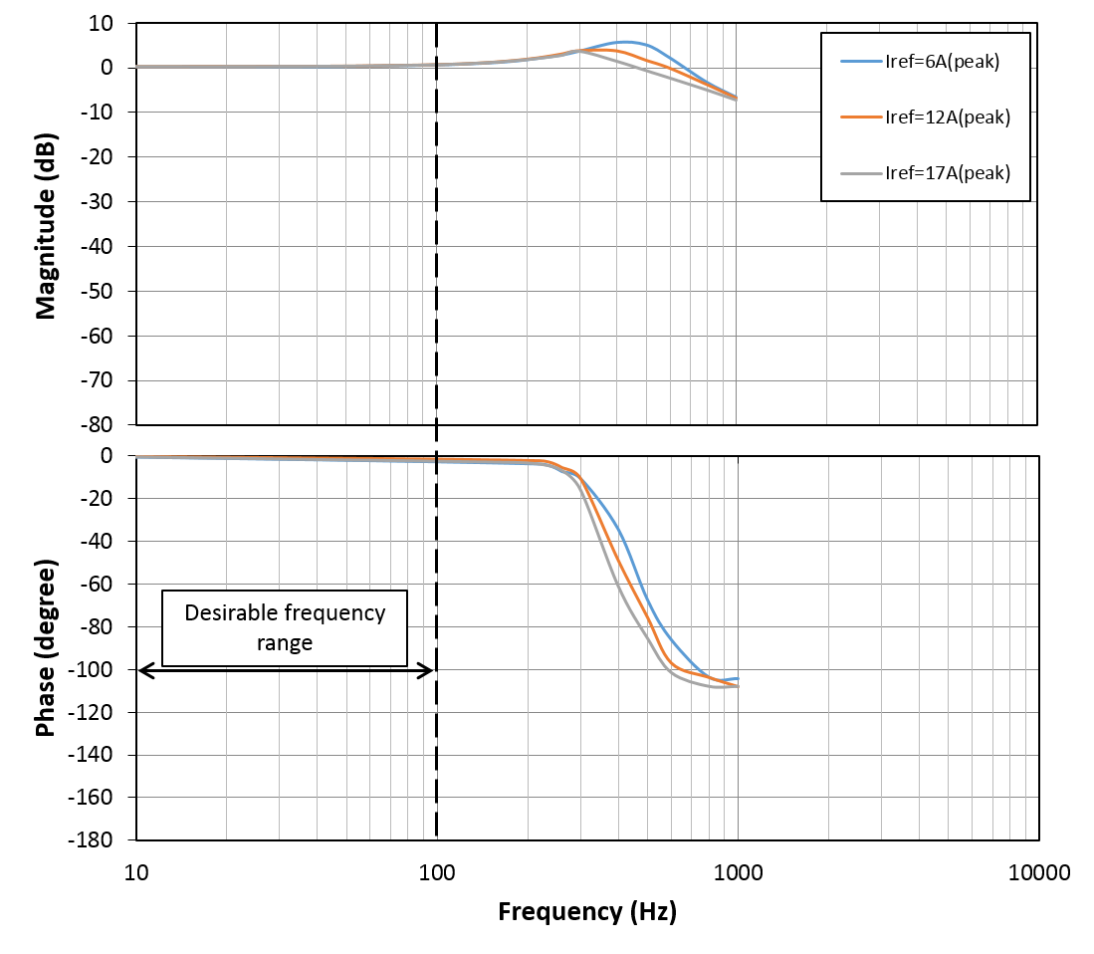
Figure 5-17 Experimental measured Bode diagram of the AZ20A8 power amplifier with manufacturer default gain settings
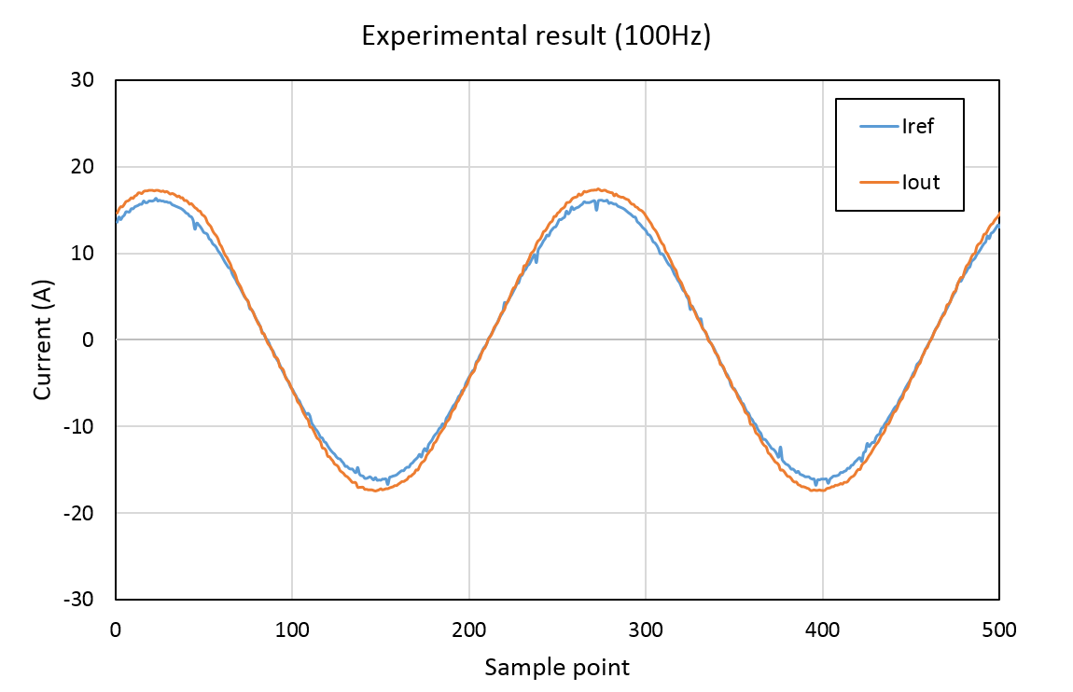
(a)
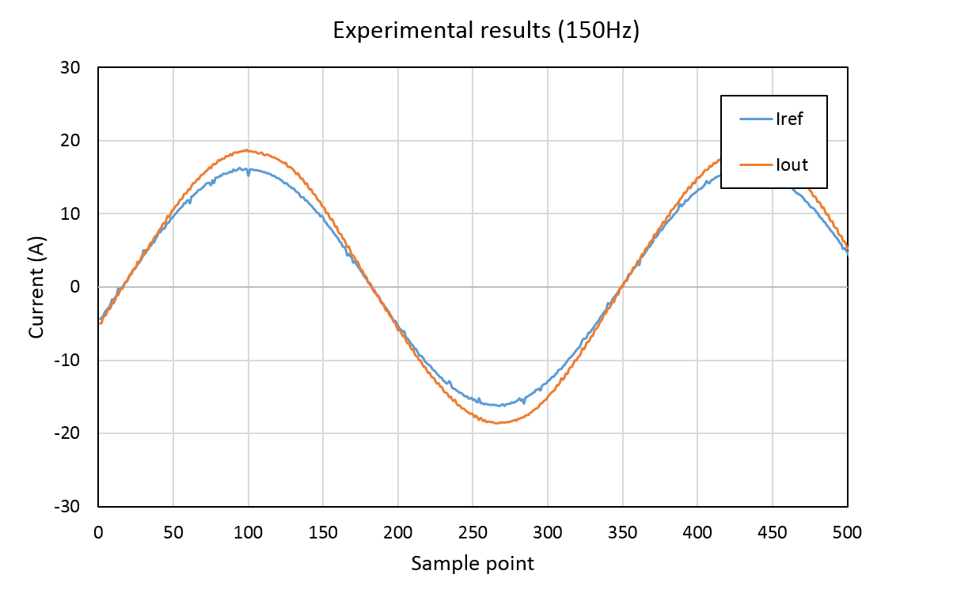
(b)
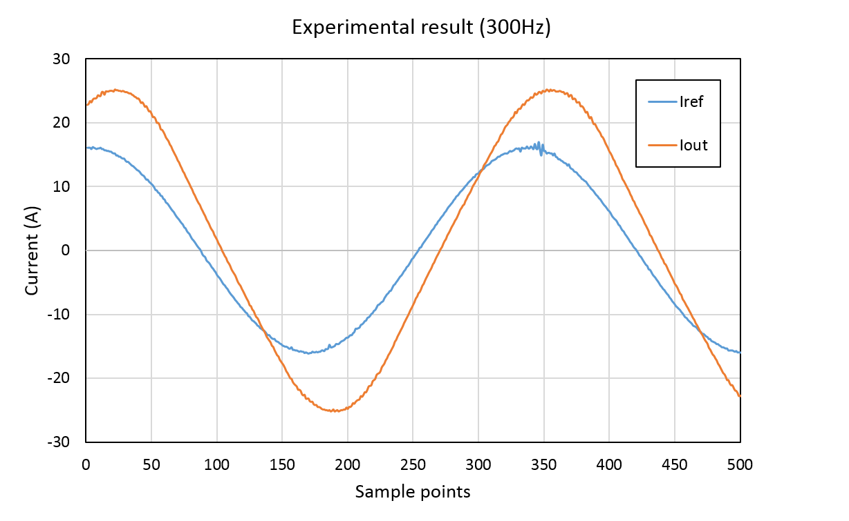
(c)
Figure 5-18 Measured comparison of reference current $I_{ref}$ and output current $I_{out}$ at frequencies of 100Hz, 150Hz and 300Hz

Amplifier performance optimisation
The selected amplifiers have internal closed loop current control based on an analogue PI controller. According to the manufacturer’s manual [86, 87], the operating frequency range can be extended by increasing the value of gain resistor and integral capacitor shown in Figure 5-19. However, the scope for extending the full current frequency range beyond 100Hz is quite limited and requires a significant increase in the gain, which could lead to problems with high sensitivity to system noise.
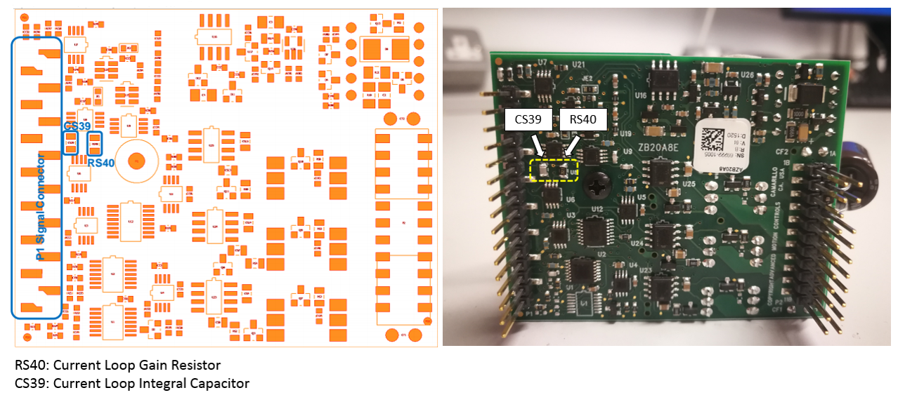
Figure 5-19 Locations of current loop gain resistor and integral capacitor
As a first step to enhancing the frequency response, the gain resistor was increased by a factor of five to improve the performance at 150Hz. The high frequency performance at low current rating can be enhanced by an additional compensator to reduce undesirable attenuation and phase shift. The optimisation of the gains was undertaken in 3 steps.
Step 1: Gain resistor and integral capacitor tuning
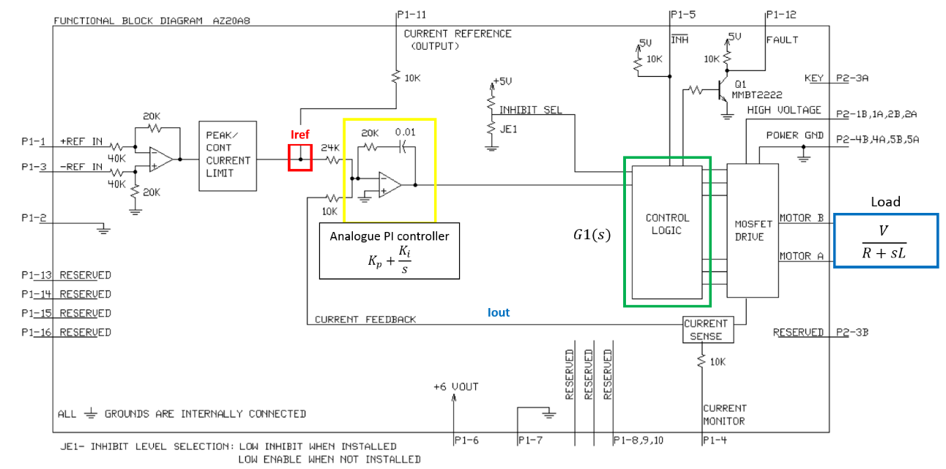
Figure 5-20 Circuit block diagram of the selected power amplifier AZ20A8 [79]
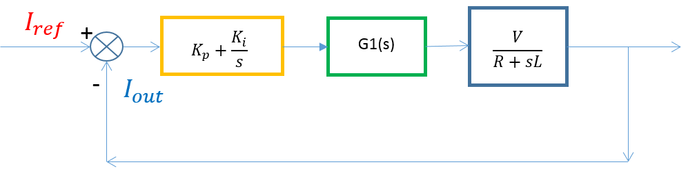
Figure 5-21 Transfer function representation of AZ20A8 closed current control loop with PI controller
Starting from the block diagram of amplifier circuit shown in Figure 5-20, the corresponding block diagram of the closed-loop transfer function is shown in Figure 5-21. In order to improve the tuning efficiency, the amplifier transfer function of equation (51) was established from the experimental results by a fitting process. The corresponding Bode diagram generated by equation (51) is compared with the experimental results in Figure 5-22, from which it can be seen that there is reasonable correlation.
 | $$G\left(s\right)=\frac{I_{out}}{I_{ref}}=\frac{8.496e12*s+2.333e16}{s^{4}+1.209e5*s^{3}+4.672e9*s^{2}+9.619e12*s+2.456e16}=\frac{C11*s+C12}{C21*s^{4}+C22*s^{3}+C23*s^{2}+C24*s+C25}$$ | (51)
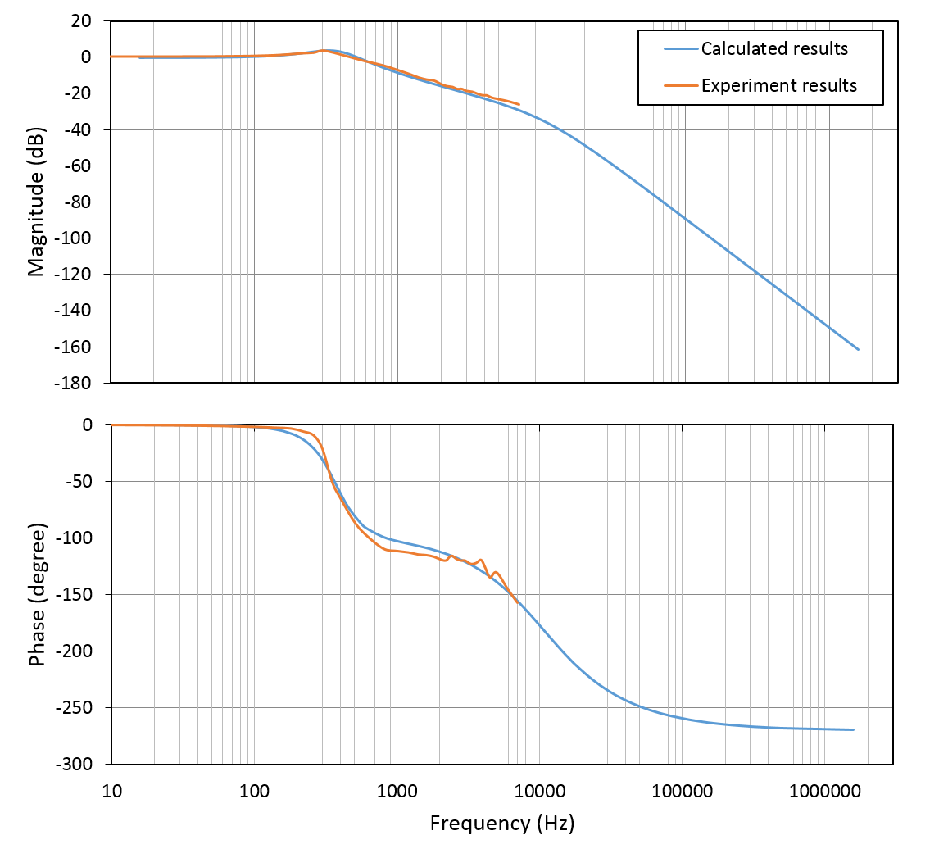
Figure 5-22 Comparison of Bode diagrams generated by equation (51) and experimental results
By developing a simulation model with three distinct transfer functions as shown in Figure 5-21, the amplifier performance with different combinations of $K_{p}$ and $K_{i}$ can be straightforwardly evaluated in the first instance by simulation. In order to improve the amplifier performance of the full current rating operation at 150Hz, values of ${5K}_{p}$ and ${2.13K}_{i}$ were selected according to the simulation result. The difference in the amplifier bode diagram with these increased gains is shown in Figure 5-23.
It is apparent that the full current frequency range was extended to ~150Hz following loop tuning, especially from the point of view of magnitude. The resulting measured and simulation current waveforms are shown in Figure 5-24 (a) and Figure 5-24 (b) respectively. As shown, there is a good agreement between the simulated and measured current waveforms. Overall, the performance requirement of full current operation at 150Hz was successfully achieved by selecting suitable values of gain resistor and integral capacitor.
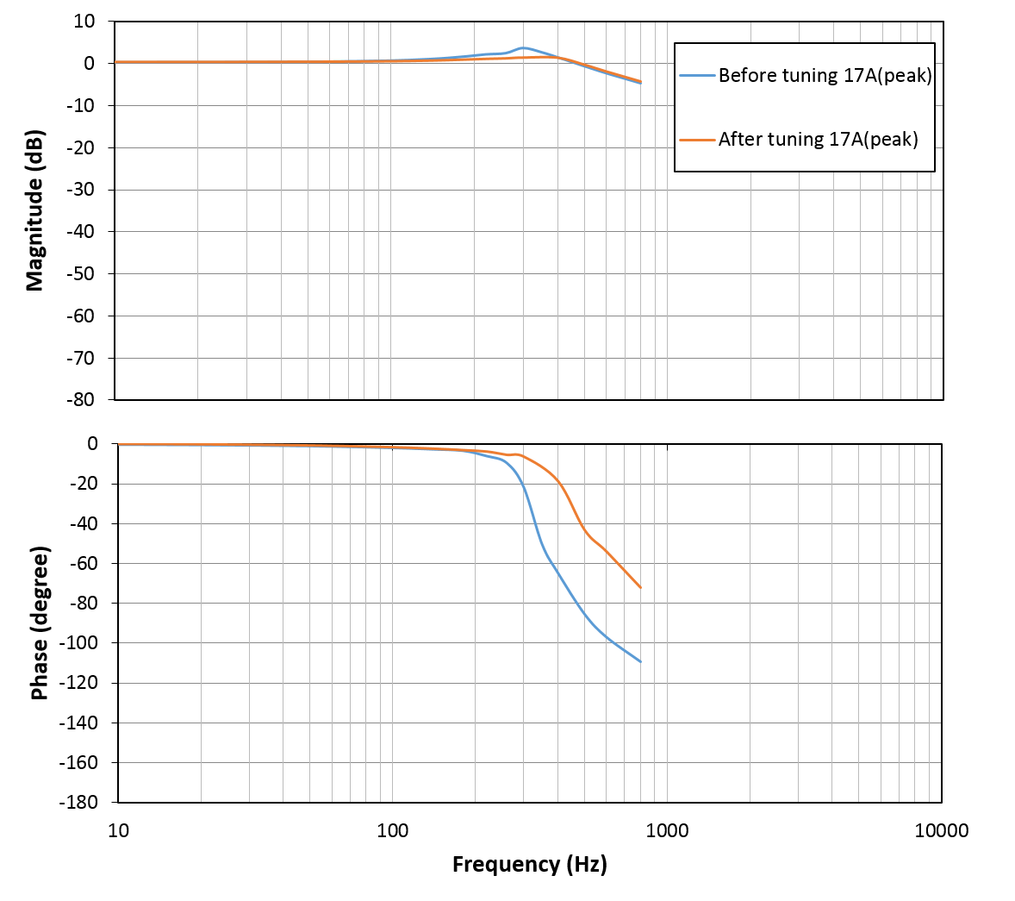
Figure 5-23 Experimental bode diagram comparison of before (with manufacturer default gains) and after loop tuning (5K_{p} and 2.13 K_{i})

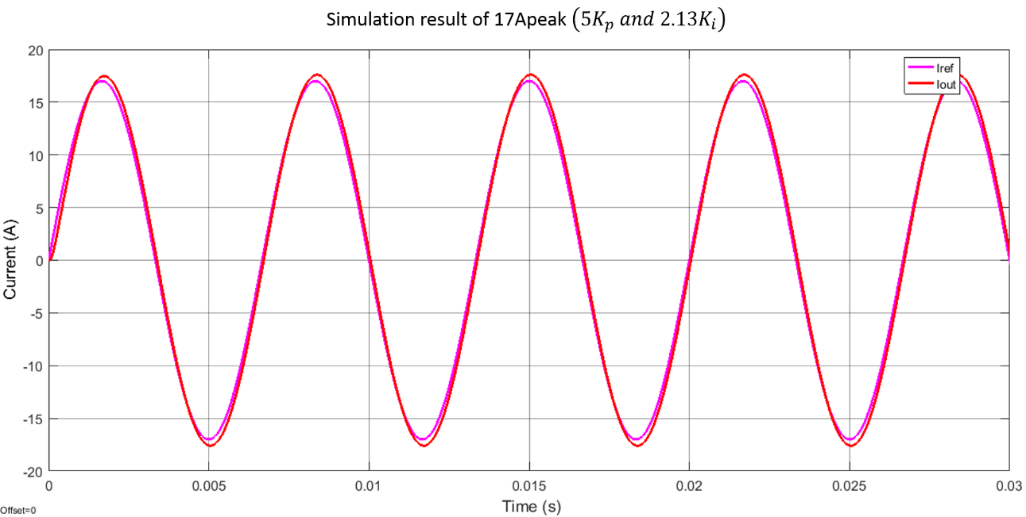
(a)
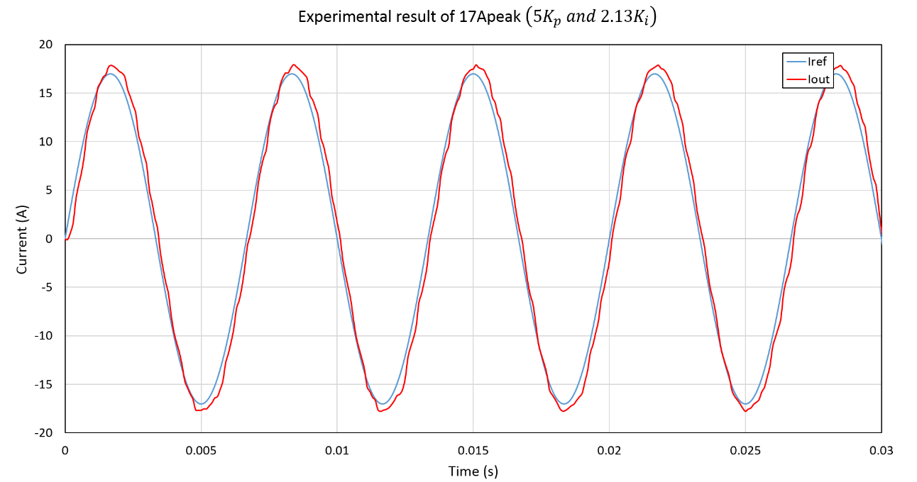
(b)
Figure 5-24 Simulation (a) and experimental (b) current waveforms at 150Hz comparison after loop tuning (5K_{p} and 2.13K_{i})
Step 2: Inclusion of performance compensator
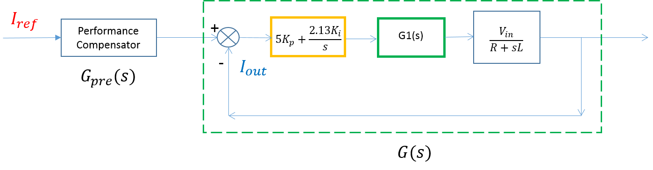
Figure 5-25 Transfer function representation of AZ20A8 closed current control loop with additional performance compensator
As discussed previously, a performance compensator was incorporated to improve low current and high frequency operation, this being important for dynamic performance of the bearing action. The additional performance compensator is shown as in Figure 5-25. The transfer function of performance compensator was estimated and applied before the current control loop $G(s)$. The performance compensator needs to satisfy the following requirements:
- $G_{pre}\left(s\right)G\left(s\right)=1$ over selected frequency range (DC ~ 500Hz). Amplifier performance at low current rating and high frequency is vital for the dynamic bearing control. A maximum dynamic frequency of 500Hz was specified.
- Identical number of poles and zeros. It is worth noting the applied transfer function of performance compensator, $G_{pre}\left(s\right)$ , is equal to the reverse of current loop transfer function $G(s)$ at the selected frequency range. Therefore, the transfer function $G_{pre}\left(s\right)$ was obtained by estimating new $G(s)_500Hz$ of the selected frequency range (DC ~ 500Hz) using experimental bode diagram in Figure 5-26. For a transfer function, it is a necessary condition that numerator order must be smaller or equal to denominator order, i.e., the number of zeros must be less or equal to the number of poles. Because of the transfer function reversal, an identical number of poles and zeros of $G(s)_500Hz$ is desirable. Otherwise, an additional low pass filter would be necessary.
- Negative zeros of$G(s)_500Hz$. Since the reverse of current loop transfer function $G(s)_500Hz$ is used as the transfer function of the compensator, $G_{pre}\left(s\right)$, the zeros in $G(s)_500Hz$ will be the pole of $G_{pre}\left(s\right)$. Since it is necessary condition that all the poles must be in the left plane of the complex plane, i.e., negative poles, for a stable system, the estimated $G(s)_500Hz$ must have all the zeros, i.e., poles of $G_{pre}\left(s\right)$, in the left plane.
As can be seen from Figure 5-26, the Bode diagram with low current rating of 8A (peak) shows near ideal requirement over the frequency range from DC to 500Hz. The measured data in this range was used to estimate transfer function of $G_{pre}\left(s\right)$. According to the transfer function requirements described above, the transfer function of performance compensator, $G_{pre}\left(s\right)$, with 2-pole and 2-zore was selected and is given by:
 | $$G_{pre}\left(s\right)=\frac{1}{G(s)_500Hz}=\frac{s^{2}+4714s+2.314E7}{{0.2888s}^{2}+4073s+2.438E7}$$ | (52)
It is worth noting that the selected frequency range is an overlap range for the Bode diagram with current rating less than 8A (peak), such as 4A (peak) bode diagram shown in Figure 5-26. The estimated transfer function $G_{pre}\left(s\right)$ is therefore able to compensate and hence improve performance for lower current ($<8A(peak)$) in the frequency range DC to 500Hz. Furthermore, the selected 500Hz range partly overlaps the Bode diagram result with higher current rating. For example, the estimated transfer function of $G_{pre}\left(s\right)$ is able to compensate undesirable performance of full current (17A (peak)) operation in the range of DC to 300Hz. This means that the frequency range with good performance at full current is further extended from 150Hz to 300Hz due to the inclusion of the performance compensator. The overall operating range shown in Figure 5-27 is significantly extended compared to the original default setting performance.

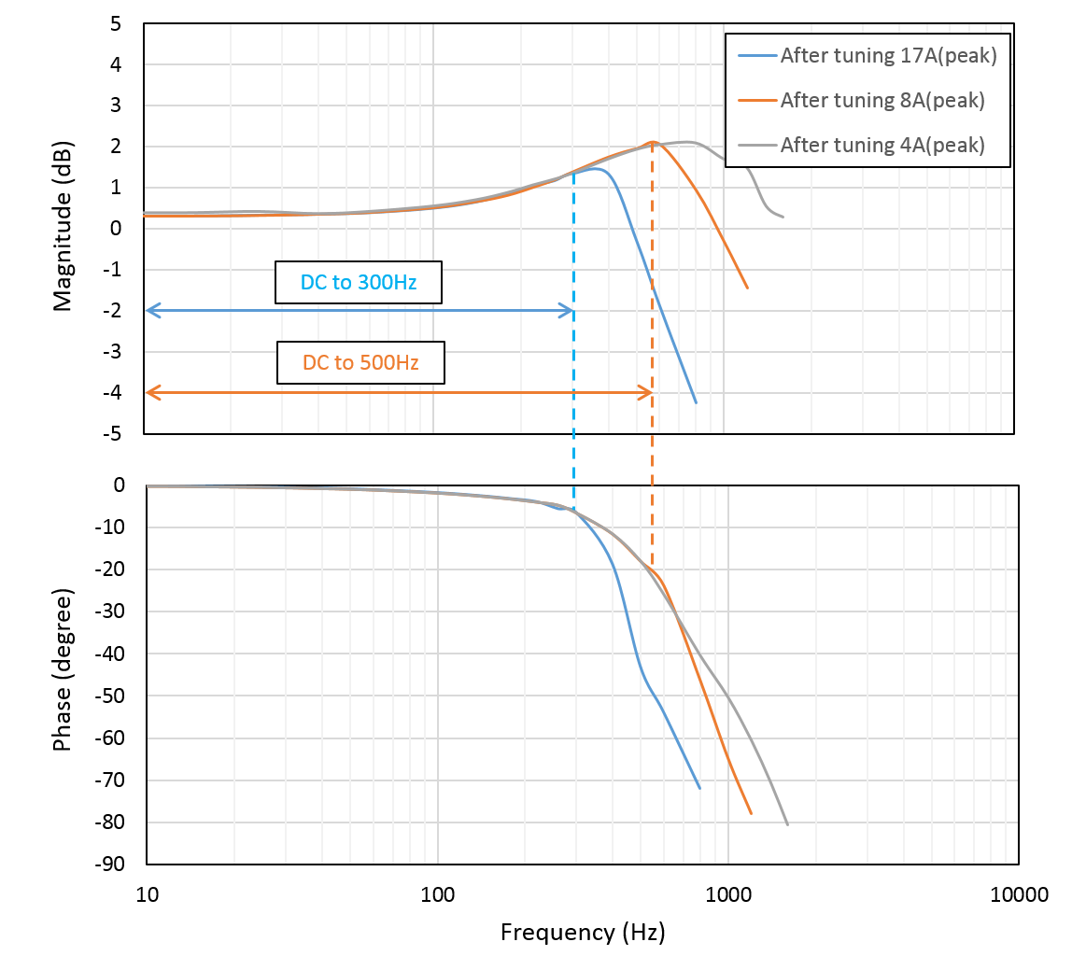
Figure 5-26 Experimental bode diagram after loop tuning
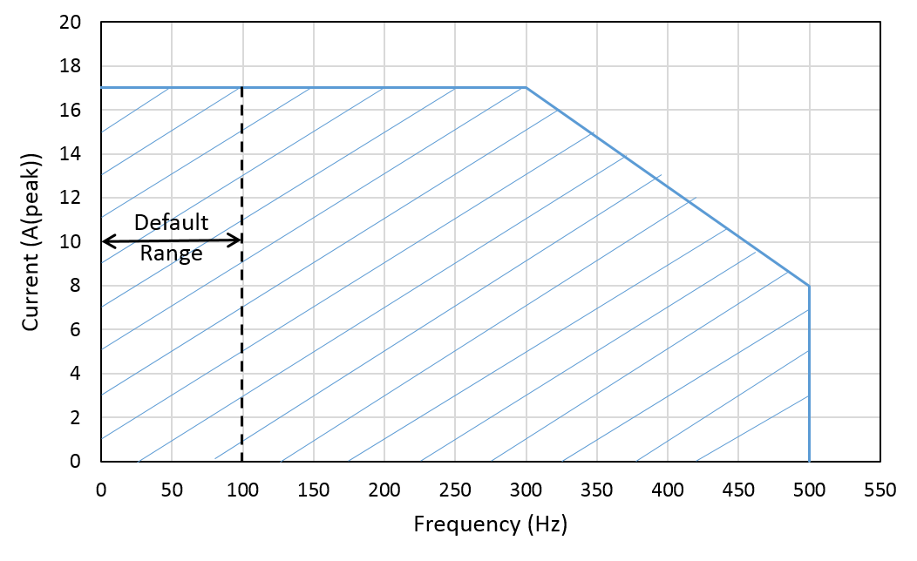
Figure 5-27 improved operating range following loop tuning and performance compensator

Step3: Performance validation
Prior to loop tuning, the amplifier with the default gain settings exhibited good performance to a maximum of 100Hz, as shown previously in Figure 5-18 (a). After tuning the proportional gain to $5K_{p}$ and integral gain to $2.13K_{i}$, good performance was realised at 150Hz with full current operation as shown in Figure 5-24. The inclusion of a compensator enabled the full current rating to be extended to 300Hz and shown in Figure 5-28. The doubling of the range was achieved without increasing the main current controller gains and hence was achieved without increasing the sensitivity to system noise.
Compensator also improved the performance up to 500Hz, although this was for less than full rated current. Figure 5-29 shows representative measured (I probe) and reference current waveforms for the maximum 500Hz operating conditions with various combination of tuned and compensated controllers. As will be apparent, although there remains some attenuation and phase shifts, the amplifier exhibits acceptable performance across its full design envelope.
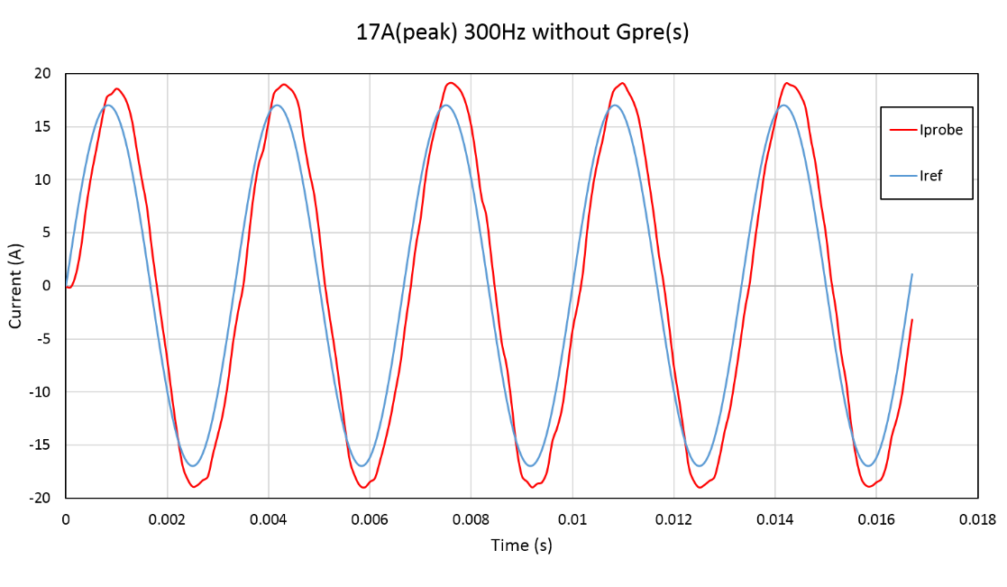
(a)
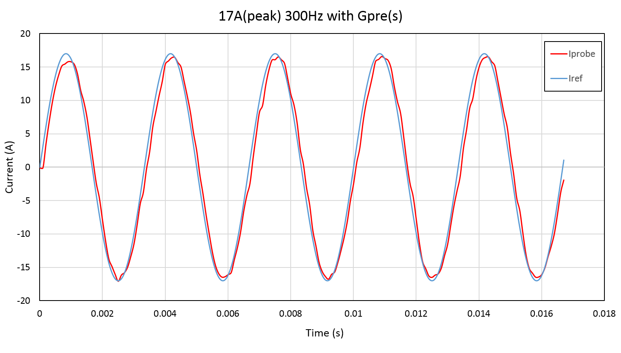
(b)
Figure 5-28 Experimental result comparison (17A (peak) 300Hz) of current control loop using $G_{pre}\left(s\right)$ (b) and without $G_{pre}\left(s\right)$ (a)
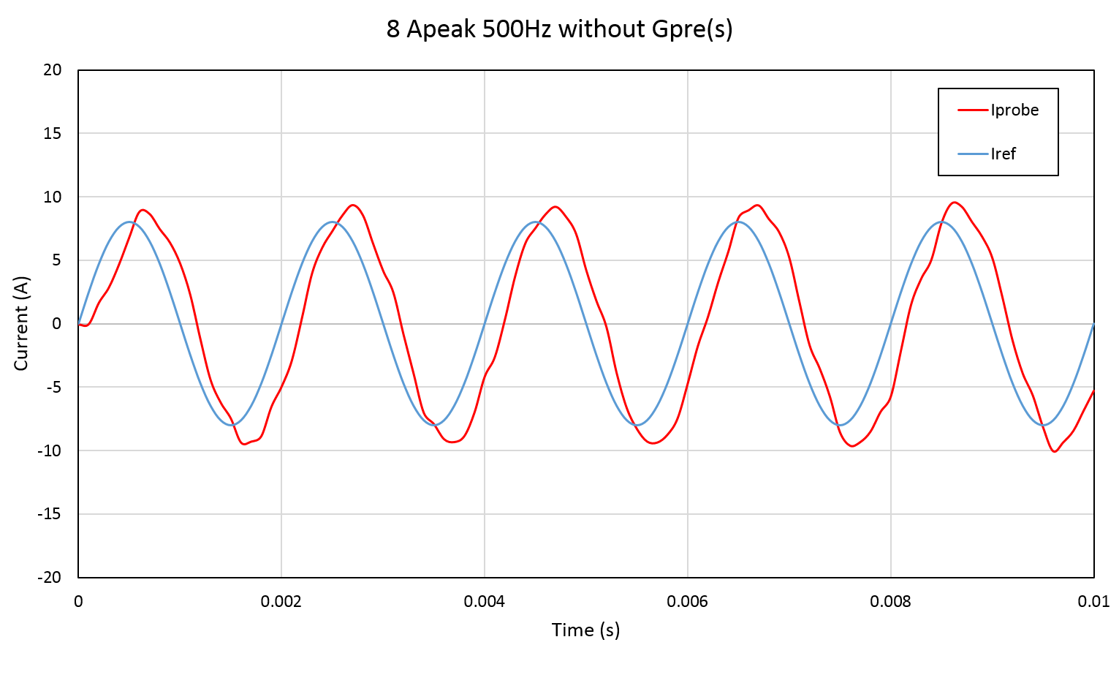
(a)
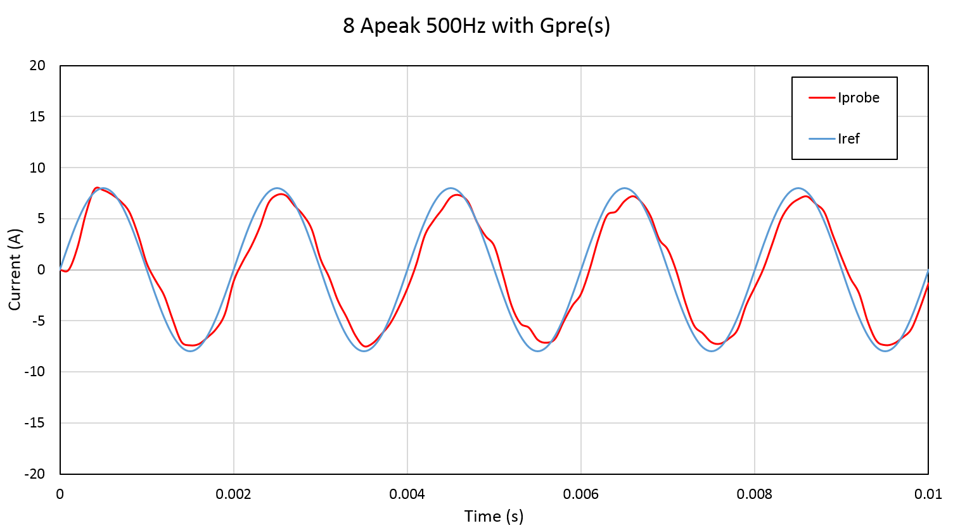
(b)
Figure 5-29 Experimental result comparison (8A (peak) 500Hz) of current control loop using $G_{pre}\left(s\right)$ (b) and without $G_{pre}\left(s\right)$ (a)

Static Experimental Rig Design and Machine force Experimental Results Analysis and Validation

Introduction
The magnitude of electromagnetic force produced by the prototype machine can be either measured directly with a force sensor or inferred from known increments in gravitational force produced by prescribed mass. In order to characterise the force behaviour, the verification of each separately controlled rotor section is necessary to comprise rotor angular position, $θ_{r}$ and eccentricities in X- and Y- direction, $ε_{x} and ε_{y}$ respectively.
The challenge of a static experimental rig is to measure the force in the X- and Y- directions simultaneously while having the ability to precisely set the rotor angular position and eccentricity. The original design of the experimental rig for force measurement has a sophisticated force sensor measuring system for the directly measuring ability with freedom of rational movement and translational X-axis movement. However, the force measuring performance is reliant on the system mechanical stiffness. The relatively long axial rotor length, the large unbalance magnetic pull, the number of hardware components and small mechanical clearance are all the limitations that resulted in the failure of this original design. Therefore, another two alternative plan were proposed in detail in this section. According to the mechanical analysis of the original experimental rig, the first alternative plan is improved by halving the axial length thereby halving the applied force and significantly increasing rotor stiffness. The other alternative plan is to measure the force indirectly by comparing to existing mass. The strategy of existing mass comparison is simply and effective. More importantly, it can accurately indicate the existing mass thereby validating the force capability. On the contrary, Force sensors require a more intricate and precise mechanical structure for connecting and holding rotor at different specific positions. Even though it can provide the most straightforward and consistent comparison to the theoretical and FE results, the stiffness of this measuring system for holding the rotor standstill is the biggest challenge and provide an uncertainty of the accuracy of the measuring results.

Experiment rig using Dual-axis radial force sensors
Commercially available dual-axis radial force sensors can simultaneously measure the force at X- and Y-axis. Additional sensor holder are specially designed to achieve the freedom of rotational and translational movements. Design details are presented in the following sections.

The selection of force transducer
The most commonly used types of force transducers are strain gauges and piezoelectric sensors. They exhibit different behaviour and are hence suited to particular applications. General considerations in the selection of the most appropriate sensor include static monitoring, dynamic measurement, accuracy requirement, operating environment, etc [88] [89].
In order to perform force measurement on the experimental machine, it is desirable for the force transducer to have the ability to measure force in both directions for both the X- and Y-axes. Most commercial strain gauge based load cells can measure one or two directions by detecting compression only or compression and tension. Piezoelectric based load cell can only detect compression by measuring the voltage change when deformed. However, most of them are manufactured in a large size and at least two strain gauges or four piezoelectric sensor are needed to fulfil the requirement of machine force measurement in this case. Therefore, a compact design of force transducer is preferred.
For this prototype surface-mounted PM machine, the net force of the rotor comprises PM unbalance magnetic pull with high negative stiffness,$K_{un}$, (approx. -1200N/mm each section) and additional electromagnetic forces produced by the stator winding when excited. High stiffness in force transducers is desirable in order to minimize the effect of elastic deformation while a force is exerted on the transducer. It is worth noting that piezoelectric based load cells usually have extremely high stiffness which result in microscopically small elastic deformation, e.g. 2600N/µm in the case of press force sensor (Model: 9343A) produced by KISTLER. The advantage of small deformation is high frequency response, which makes piezoelectric based load cells favourable for dynamic force measurement. In the case of strain gauge based load cells, the stiffness is governed by the load cell load bearing material and structure.
Since unbalanced magnetic pull is a position dependant force (corresponds to a negative stiffness of -1200N/mm), any load cell deflection or rotor bending that cannot be measured by position sensors will effectively affect the measured value. Therefore, it is crucial that the magnitude of load cell deflection is minimized for increasing measuring accuracy.
As can be seen from equation (53), the magnitude of force transducer deformation,$ε_{d}$, is proportional to the measuring force, $F_{m}$ and the stiffness of selected force sensor,$K_{s}$. Therefore, the maximum measuring range need to be identified when selecting the suitable stiffness of force transducer.
 | $$ε_{d}=\frac{F_{m}}{K_{s}+K_{un}}$$ | (53)
In this prototype self-bearing machine, the mechanical clearance between the rotor surface and the stator bore when they are in concentric (defined as$l_{g,mech}$) is ~0.6mm. The maximum allowable rotor eccentricity is limited by the back-up bearing clearance to ~0.4mm. At this maximum eccentricity, the PM unbalance magnetic pull on each rotor section is ~480N. In order to provide a consistent basis for comparing the experiment results with the analytical and FE models, an MMF of 250A for each testing phase was used. On the basis of the FE modelling presented in section 3.5, the estimated force produced with an mmf of 250A per phase at geometric centre is 125N per phase. Assuming an idealised case of infinite rotor structural stiffness, the maximum force measured by force transducer will be of the order of 605N (i.e. 480N of unbalanced force + 125N in the same direction when the appropriate polarity of the current).
On the basis of above consideration, such as the size, the stiffness and measuring range, RFS150-XY radial force sensors with 2-measuring axes were selected [90]. A scale drawing of the sensor, summary of dimension and technical data are shown in Figure 6-1, Table 6-1 and Table 6-2 respectively [90].

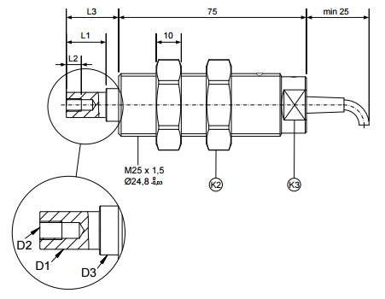
Figure 6-1 Scale drawing of the selected RFS150-XY radial force sensor (source: [90])

Table 6-1 Summary of dimensions
D1 | L1 | D2 | L2 | D3 | L3 | K2 | K3
10 | 19.9 | M5 | 8 | 11 | 20.9 | WAF 32 | WAF 19
All dimension in mm
WAF: width across flats
Table 6-2 Technical data
Rated measuring range ($F_{N}$) | N | 0 to 1000
Rated output tolerance | % | $$<±0.2$$
Reference excitation voltage | V | 10
Rated temperature range | ˚C | -10 to 50
Reference temperature | ˚C | 23
Overload protected | $$\%F_{N}$$ | 400...800
Deflection at nominal force | mm | 0.07$±$20%

The RFS150-XY radial force sensor has the following features which it make it suitable for this application:
- X- and Y- vertically measuring axis
- Compact size and easy installation
- High overload protection
- High stiffness
It is worth noting that the load cell stiffness is not given in the data sheet, per se, but can be inferred from the value of deflection at the nominal 1000N force rating. The resulting inferred stiffness of the sensor along both measuring axes is 14286 N/mm ($±$20%). In the case of the maximum force of ~600N established previously, the corresponding sensor deformation,$ε_{d}$, is ~46µm.

Sensor measuring system design
The magnitude and direction of measured machine force is a function of both rotor eccentricity and angular position. In order to vary these two variables systematically and accurately to characterise the force capability of this machine, it is desirable to provide freedom for precise rotational and translational registration of the rotor. This was achieved in the test-rig through a combination of a micro-translational stage for a continuous control of accurate translational position and a disk equipped with a series of precisely located through holes. The hardware components are shown in Figure 6-2.
In order to provide sufficient experimental data, two offset series of reamed holes incorporated into the disk (each individually set with 3° angular increments between centres). In combination, these two series of holes provide 1.5 ° angular resolution one electrical revolution, i.e., 120 mechanical degree. The shoulder bolt shown in Figure 6-2 (b) is used to align the reamed clearance hole on angular disk and front plate thereby securing the angular position with minimised mechanical tolerance. Compared to the use of threaded hole, it normally have $±50μm$ mechanical tolerance.
In addition, the holed disk is also designed to locate the dual-axis force sensor at its geometric centre. The enforced alignment of the flats on the sensor with the corresponding flats in the central hole of the disk ensures that the sensor measurement axes are aligned with a specific hole setting position and hence a defined rotor angular reference position.

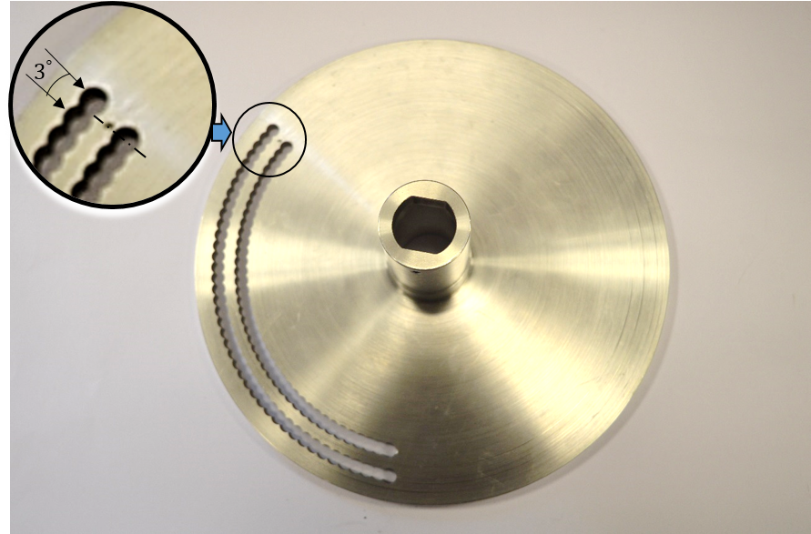
- Reamed-hole disk
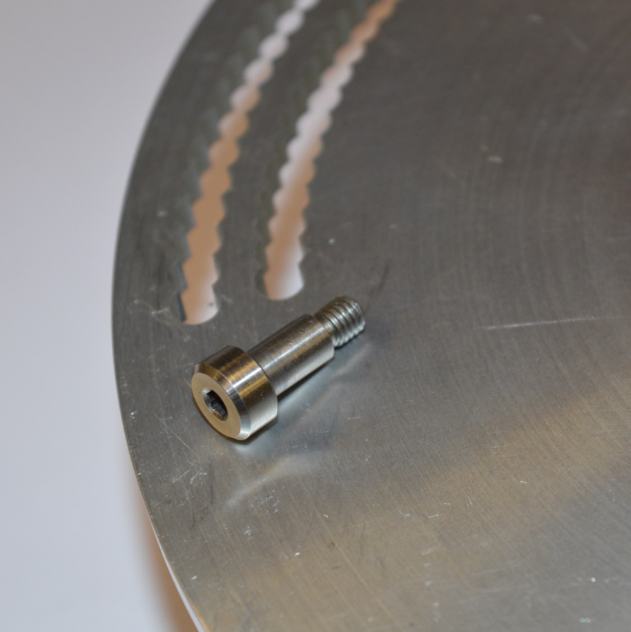
- M5 (6mm) × 10mm Socket Shoulder Screw

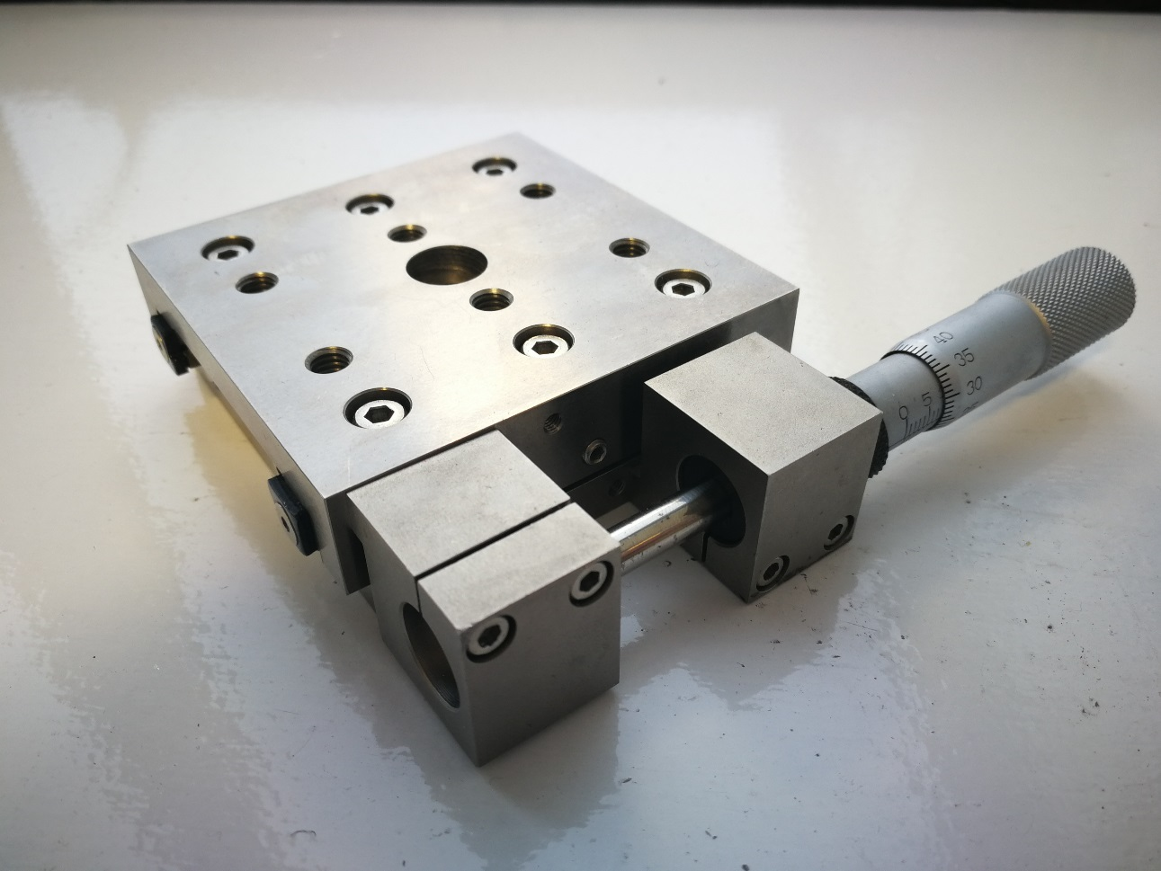
- Micrometer moving stage
Figure 6-2 Angular disk and moving stage

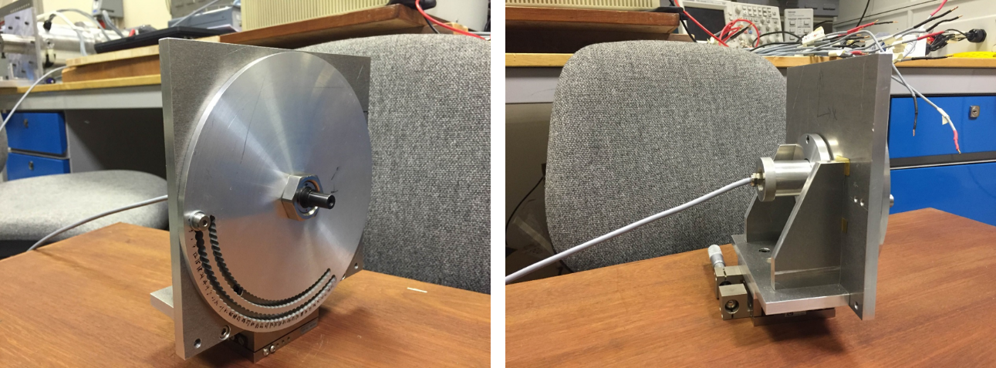
Figure 6-3 Sensor measuring system
By connecting the micro-translational stage and through-hole disk to an “L” shape supporting bracket, the assembly of sensor measuring system was completed as shown in Figure 6-3.
In order to complete the experimental rig, the force sensor and prototype machine rotor were connected through an aluminium split coupling. Additional reinforced components shown in Figure 6-4 were machined and added to enhance the overall rig stiffness.
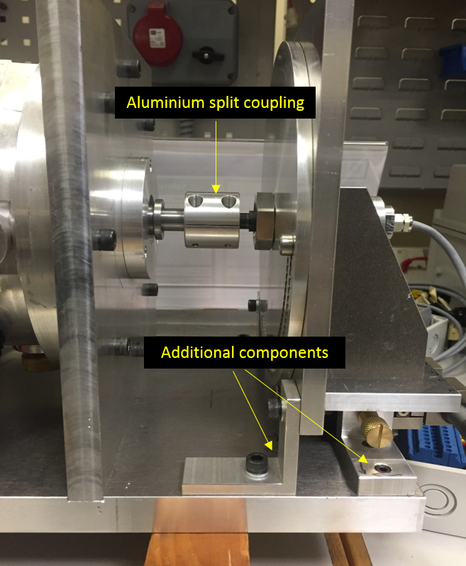
Figure 6-4 Original assembly of static experiment rig using aluminium split coupling and additional reinforced components

Test-rig construction and operation
To connect the rotor ends to the torque sensor, the rotor was positioned using four adjustable supporting pillars at either ends. A close-up of supporting pillar arrangement is shown in Figure 6-5.
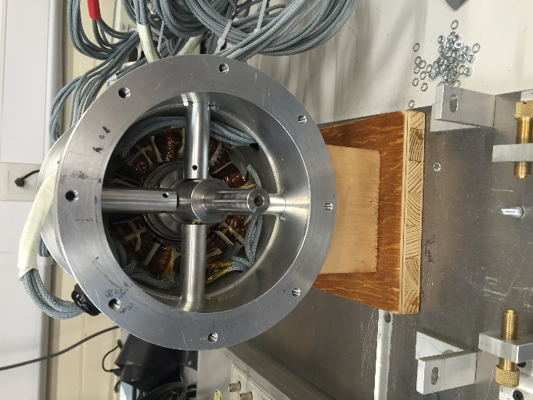
Figure 6-5 Inner view of supporting pillar arrangement at one rotor end
To measure the force at adjustable translational and rotational positions, supporting pillars for constructed purpose were completely released. As shown in Figure 6-6, the machine rotor has a total length of 558mm with the two 100mm long rotor sections separated by 80mm. When the supporting pillars removed, the rotor is supported solely by the dual-axis force sensors at either end. In this static experiment, each rotor section that can produce a maximum of 605N of unbalanced electromagnetic force will be tested under different current and position conditions.
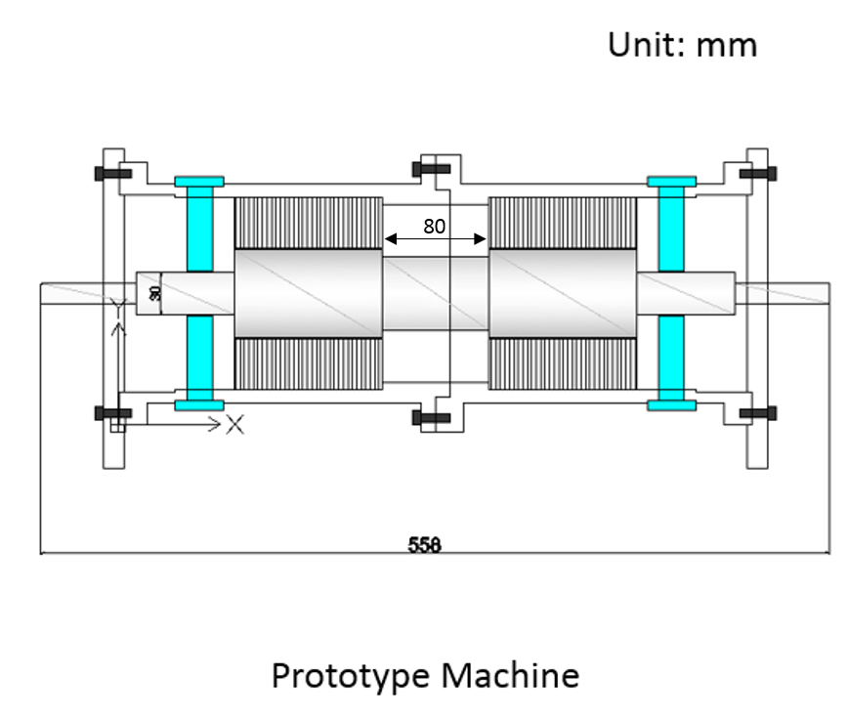
Figure 6-6 Schematic cross-section drawing of prototype machine

Limitations of test-rig
Even though the original static experimental rig was designed with recognition of the need for high stiffness, an attempt to measure the force led to difficulties with the mechanical stiffness. When the position of the rotor was set and the support pillars were retracted as described above, the rotor moved away from the set position due to PM unbalance magnetic pull causing a combination of rotor bending and test-rig deflection.
Table 6-3Measurement of component movement using mechanical dial indicator
Sensor  Supporting Plate | 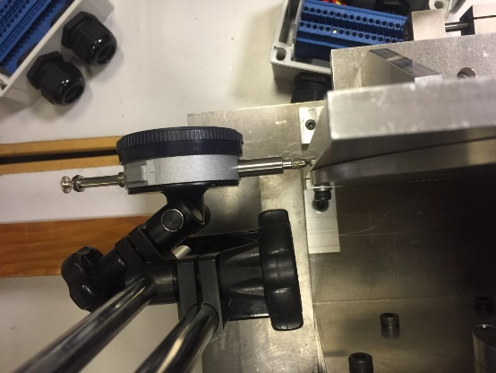 | 20μm
Sensor  Locking Nut | 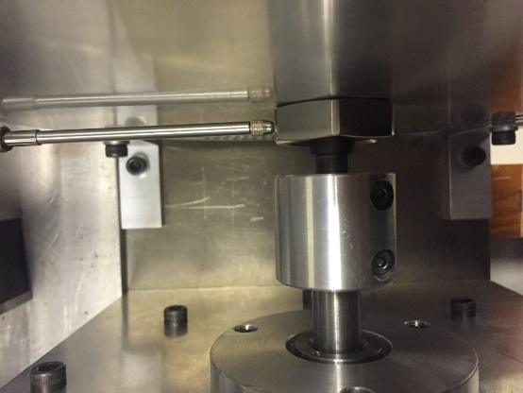 | 50μm
Sensor  Bearing Journal | 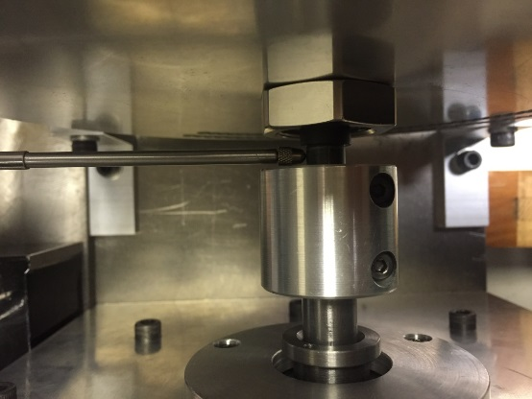 | 100μm
Split coupling | 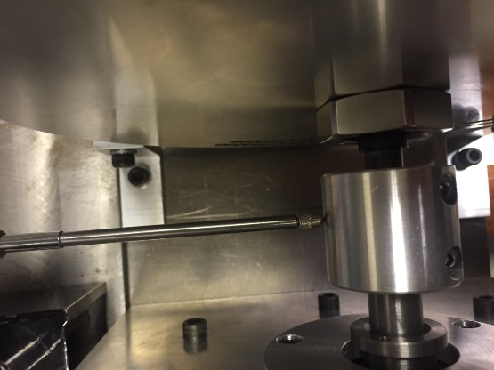 | 200μm
Rotor shaft | 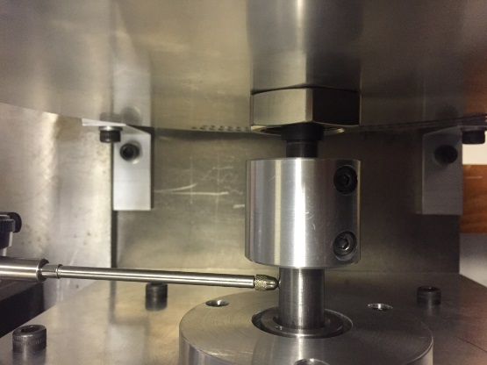 | 270μm
As will be apparent from the measured data displacements in Table 6-3, the displacement increases progressively from sensor supporting plate to rotor shaft. Figure 6-7 shows a schematic top view of rotor-sensor connection at one end of the rotor. Once the supporting pillars are released, the split coupling for connecting the rotor shaft to the sensor shaft is the most compliant element and hence it will contribute significantly to the bending.
In an attempt to remedy the issues with rotor bending, modifications were made to the original test-rig design. Firstly, a much stiffer mild steel split coupling was manufactured to replace the originally used Aluminium coupling. As can be seen from Figure 6-8 and Figure 6-9, this mild steel split coupling has an increased diameter of 40mm compared to the 25mm diameter of the original Aluminium part. Moreover, the length was increased to encompass the entire smaller section region of rotor shaft to improve stiffness. The complete assembly of static experimental rig using the mild steel split coupling is shown in Figure 6-10.
Even though the stiffness at the joint location was improved by replacing the coupling with a stiffer coupling, the experimental rig still exhibited insufficient stiffness to maintain the rotor position when the supporting pillars were released. Indeed, the rotor was stuck to the stator bore, indicating a bending of at least 0.4mm (i.e. the clearance imposed at either end by the back-up bearings).
Having encountered several difficulties with the measurement of force on the full prototype machine, a new approach of a dedicated force rig with a single rotor section was proposed. This is described in detail in section 8.2.1. In order to validate the force model, an alternative approach was adopted based on the current required to initiate lift-off from the back-up bearing. The methodology and results are presented in the next section.

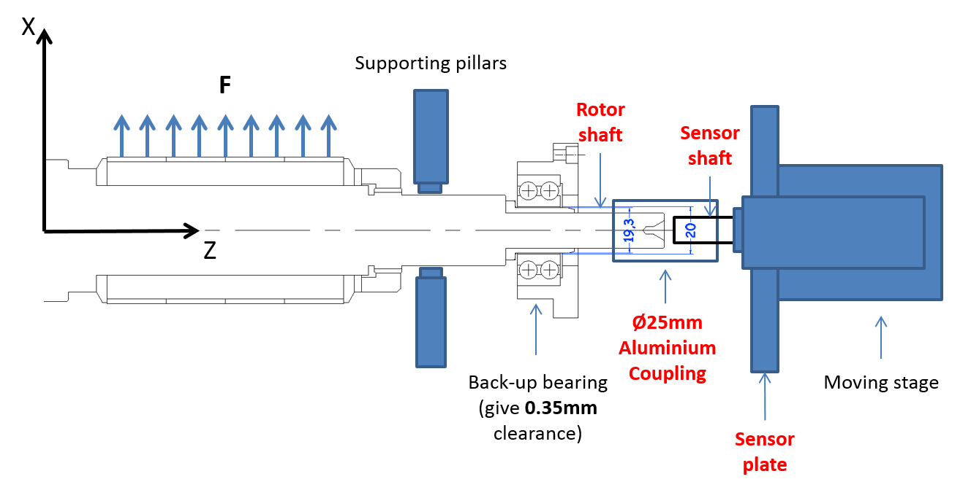
Figure 6-7 Schematic demonstration of rotor-sensor connection using aluminium split coupling
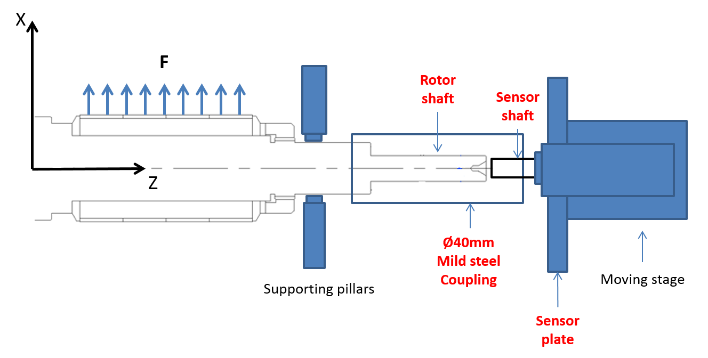
Figure 6-8 Schematic demonstration of rotor-sensor connection using mild steel split coupling
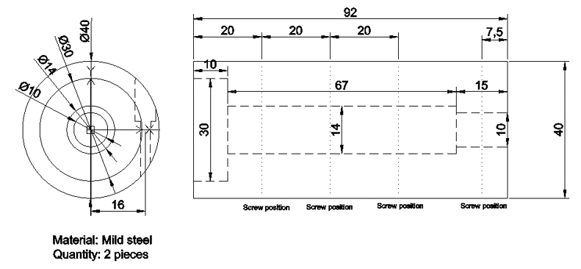
Figure 6-9 Scale drawing of mild steel split coupling
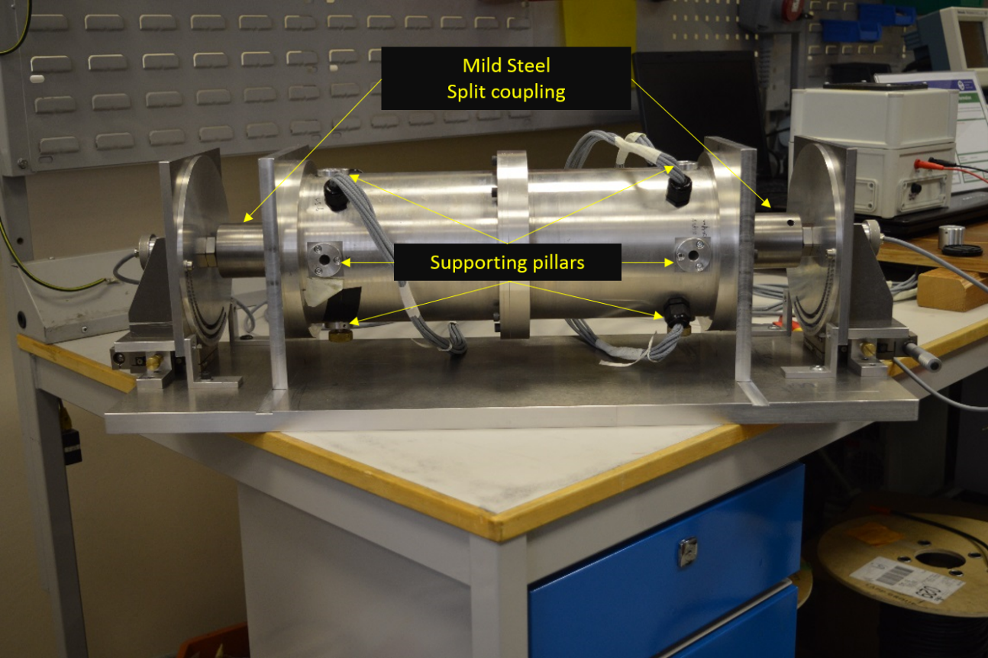
Figure 6-10 Assembly of static experimental rig using mild steel split coupling

Machine force validation using open-loop lift-off experiments
Given the difficulties associated with direct force measurements, a much simpler process was adopted for inferring force using a method which was not reliant on force sensors. Lift off of the rotor under open-loop static conditions provides a straightforward and useful means of inferring force capability from the rotor static lifting performance. Open-loop experimental measurements were performed using the full machine set-up. This comprises the prototype 9-6 self-bearing SPM machine, dSPACE real-time DSP processor, high precise displacement sensor system, machine drives and power supply. This configuration of the test-rig does not include the force sensors. The general set-up of this experimental system is shown in Figure 6-11.
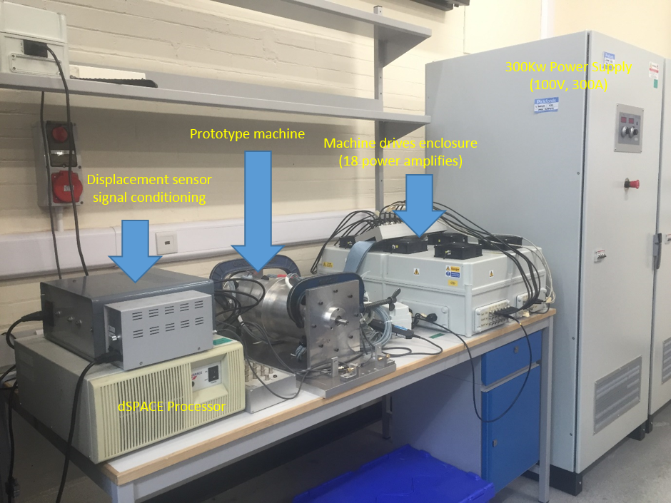
Figure 6-11 Experimental rig set-up for open-loop lift-off experiments
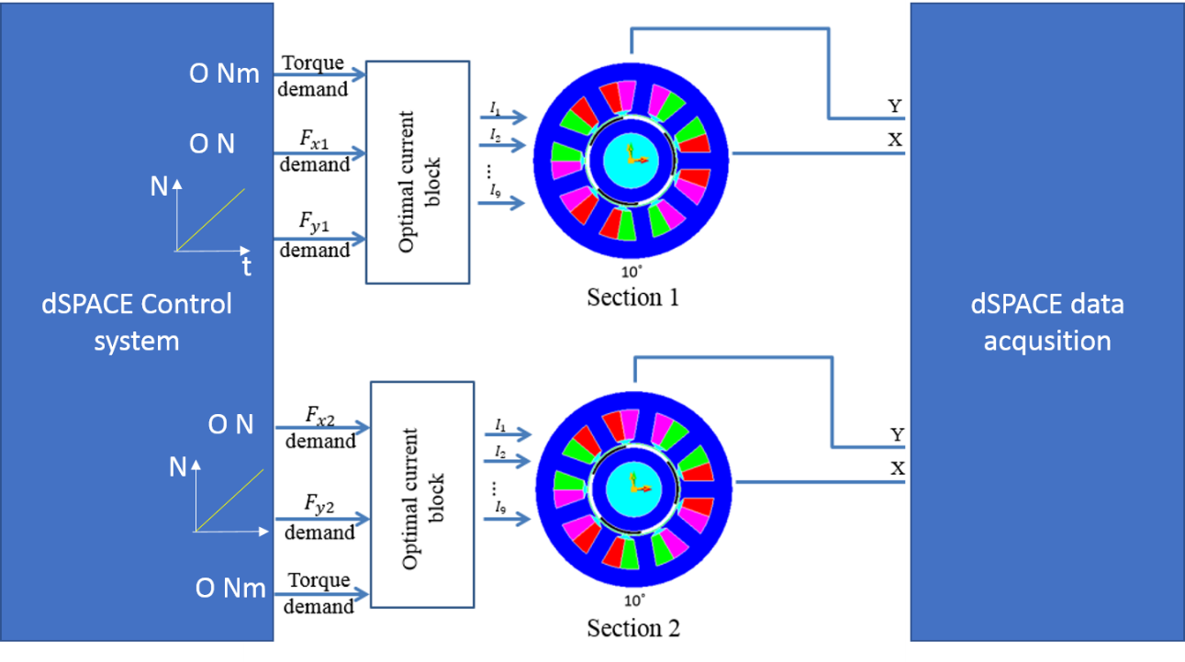
Figure 6-12 Schematic open-loop system for lift-off measurement
The method is based on detecting lift-off of the rotor from a pre-determined offset starting position by means of monitoring rotor displacement. The basis of this open-loop experiment is shown in Figure 6-12. By supplying the slowly ramping force demand to the y-axis (rates typically 900N/s) using dSPACE, the corresponding phase current combinations for both sections are calculated according to the FE current optimization block, and then produced by the group of power amplifiers. For each new measurement, both rotor sections were lowered onto the back-bearing. Upward movement is initiated, and detected, when the excitation force is greater than PM unbalance magnetic pull and rotor gravitational force.
The overall self-bearing machine comprises two identical sections to produce independently controlled restoring force for controlling the tilting movement. In this series of tests, the excitation force produced is estimated from the measured rotor movement. Therefore, it is necessary to be aware of the potential cross coupling of movement in this two-section rotor structure. In order to minimize the effects of cross coupling, identical lifting conditions were imposed, i.e. same starting rotor eccentricities, rotor angular position and ramped demand force input.
It is worth noting that although the rotor was designed with a ~0.4mm moving clearance at either end by using the back-up bearings, the two locations of the geometric centres of the back-up bearings are not perfectly aligned due to the cumulative effect of manufacturing tolerance on the many parts which connect them. Therefore, unequal rotor eccentricities were observed when rotor was sitting on the bottom of the back-up bearings. As shown in Figure 6-5, four supporting pillars with threaded screws were used to precisely adjust the overall rotor to prescribed positions thereby achieving a near identical initial lifting condition for both sections.
Furthermore, the rotor movement is also cross-coupled between X- and Y- axis. In the following series of experiments, the rotor was mechanical constrained to move at a fixed value of X displacement using the support pillars. The fixed X position, which was chosen to be the nominal central position of the X-axis excursion allowed by the back-up bearing. As a result of the constraining action of the pillars the cross coupling influence was minimized with only free movement on the Y axis being allowed.
In order to infer force magnitudes from a series of lift-off tests, the following sets of experimental measurements were performed:
1: Static rotor lifting analysis at fixed angular position (10˚ mech) and various pre-demined Y-direction eccentricities (-0.25mm, -0.20mm, -0.15mm and -0.10mm ).
2: Absolute excitation force measurement using additional prescribed masses at the fixed angular position (10˚ mech) and fixed Y-direction eccentricity (-0.25mm).
3: Static rotor lifting analysis at fixed Y-direction eccentricity (-0.25mm) and various angular positions. Because of the nature of cogging torque for this slotted 9-6 SPM machines as shown in Figure 3-31, the rotor tends to settle every 20° mechanical angle from 10°. In this series of the measurements, lift-off performance was analysed at six rotor angles of one electrical revolution (10°, 30°, 50°, 70°, 90° and 110° respectively).

Static rotor lifting analysis at fixed angular position (10˚ mech) and a range of Y-direction eccentricities
Figure 6-13 shows the measured rotor movement of both sections from an identical initial position (-0.25mm and 10°). In this test example, the rotor was located with a start eccentricity of -0.250mm using supporting pillars. A ramping force demand with the rate of +900N/s (up to a maximum of 450N) was applied to both stator sections in Y-direction. The force demand for the x-direction was set to zero as was the torque demand.

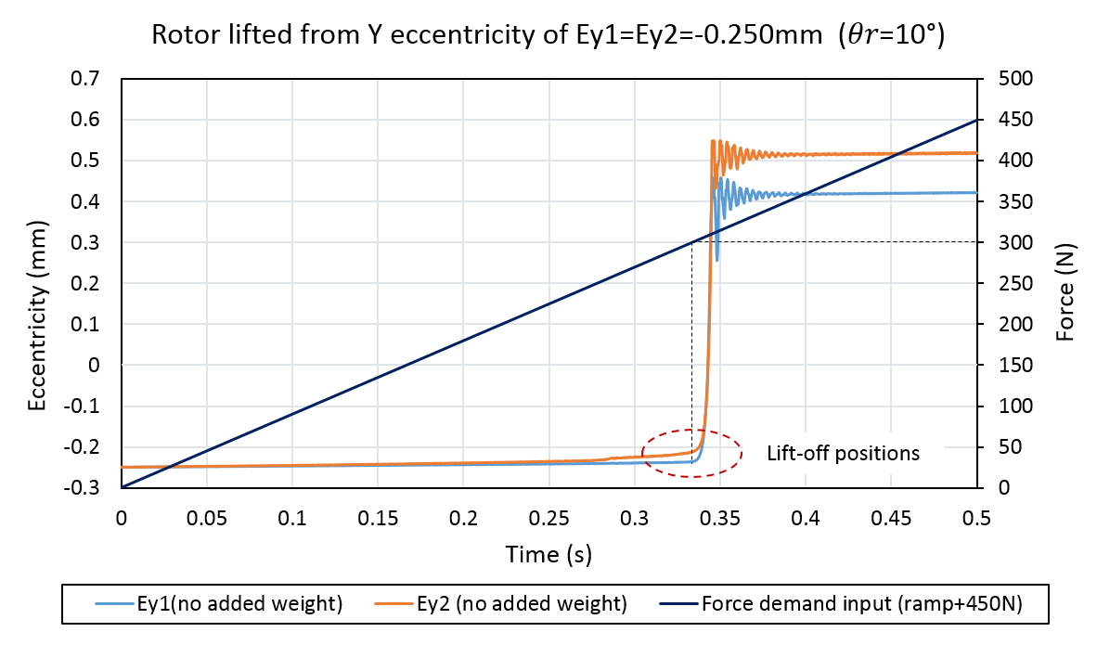
Figure 6-13 Experimental measurements of rotor displacement with a ramping force demand with rate of +900N/s (up to a maximum of 450N) (initial conditions: $ε_{y1}=ε_{y2}=-0.250mm and θ_{r}={10}^{°}$)
As shown in Figure 6-13, there is some minor displacement of the rotors before they accelerate rapidly towards the top back-up bearing. This is due to some correction of the bending caused by the unbalanced magnetic force and gravitational force. The Y direction eccentricities in the two sections when lift-off occurs are -0.236mm and -0.212mm for sections 1 and 2 respectively. With only a 24μm difference, it is reasonable to assume the same force capability of these two sections. At these lift-off eccentricities, the two-dimensional finite element predicted unbalanced magnetic pull (UMP) is -275.4N and -249.3N for section 1 and 2 respectively, i.e. a total of 524.7N downwards. When combined with the rotor gravitational force of -76.0N, the overall downward force on the rotor is estimated to be 600.7N. As will be apparent from Figure 6-13, the rotor begins to accelerate towards the upper back bearing at a force demand of 300N per section. This total of 600N of demand force is in good agreement with the 600.7N from the combination of the finite element predicted total unbalanced magnetic pull and gravitational force at the lift-off position. This provides some reassurance regarding consistency between the force controllers and calculated unbalanced magnetic pull, but not necessarily full validation.
The demand current combination obtained at lift-off position was used to separately calculate the Y-direction force using the analytical force model derived in section 3.1 and a two-dimensional non-linear finite element model in FLUX2D. The corresponding theoretical results and non-linear FE predicted results were summarised in Table 6-4 along with the values inferred from the lift-off measurements. As will be apparent there is good agreement between the various values of force. It is particularly important to note that both the in-built force model in the dSPACE controller and the analytical force model are based on the assumption of force superposition, i.e., the assumed linear force model. The level of reasonably using force superposition was evaluated by comparing to the results predicted by the non-linear finite element model. Given the level of agreement in Table 6-4 it would seem that the assumption is reasonable under these representative conditions.
Table 6-4 Experimental data derived from Figure 6-13
 | Section 1 | Section 2 | Total
Initial $ε_{y}$ | -0.250mm | -0.250mm
Lift-off $ε_{y}$ | -0.236mm | -0.212mm
Y demand force signal at lift-off position | 300.0N | 300.0N | 600.0N
FE estimated $UMP+mg$ | 313.4N | 287.3N | 600.7N
Non-linear FE estimated force at release position | 298.6N | 298.6N | 597.2N
Analytical model estimated force at release position | 300.3 | 300.3 | 600.6N
A further series of tests were performed with the rotor lifting off from initial eccentricities of -0.200mm, -0.150mm and -0.100mm. At the lift-off position, the combined values of demand force signal, unbalance magnetic pull and gravitational force ($UMP+mg$), non-linear FE estimated force and analytical model estimated force were obtained and compared in Figure 6-14. Again, good agreement among the various calculated force values were observed at the various initial eccentricities.
However, measurements of this type do not unequivocally verify that the force controller (which incorporates the current distribution algorithm) produces the correct physical force. In order to provide enhanced validation in terms of absolute force, a series of further measurements were performed with known additional mass hung from the rotor.
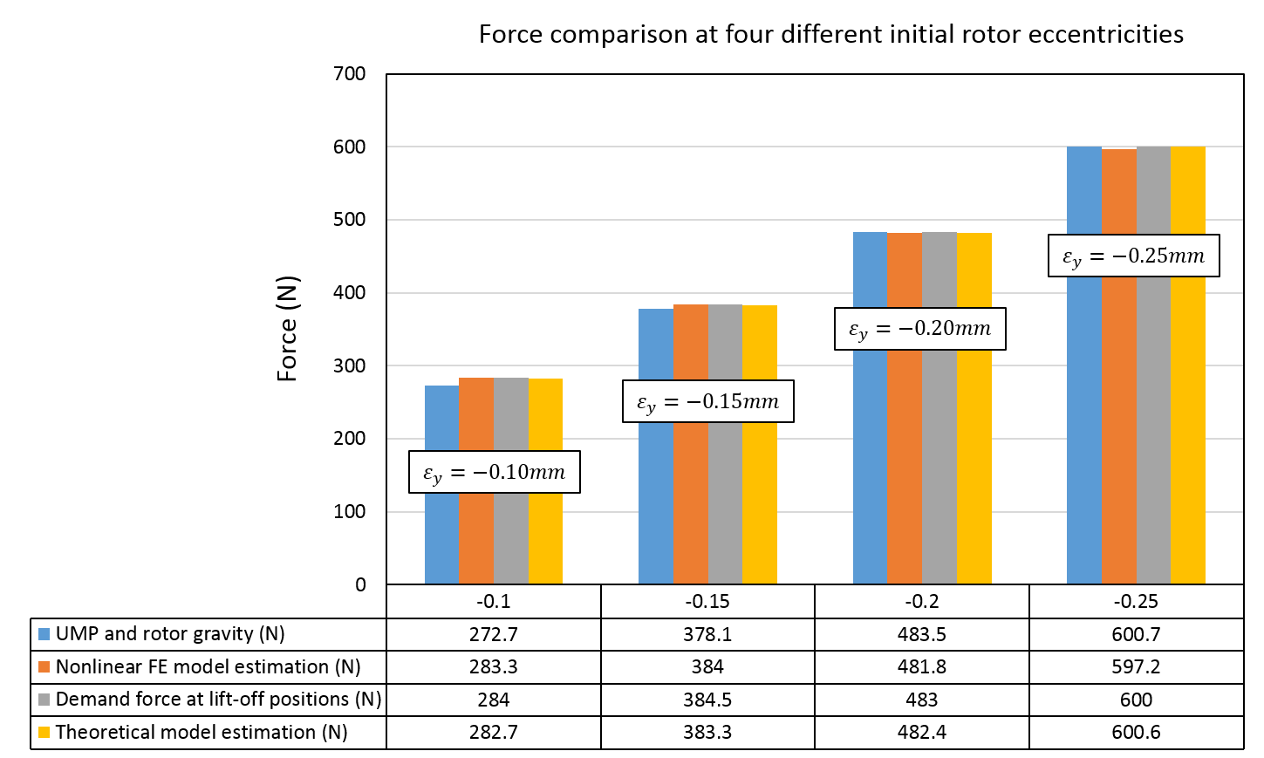
Figure 6-14 Comparison of the total $UMP+mg$, demand force signal, non-linear FE estimated and analytical estimated lifting force at rotor angle of ${ θ}_{r}={10}^{°}$.

Absolute excitation force validation using additional prescribed masses ($ε_{y}=-0.25mm and θ_{r}=10°$)
It is worth noting that the excitation force for achieving the rotor movement shown in Figure 6-13 is reliant on the currents on either section and hence there is some scope for a self-consistency in the measurements reported above. In order to produce an unequivocal force verification, it is necessary to obtain the relationship between the known levels of gravitational force and phase current combinations. Figure 6-15 shows the rig set-up with the additional prescribed mass shown in Figure 6-16.
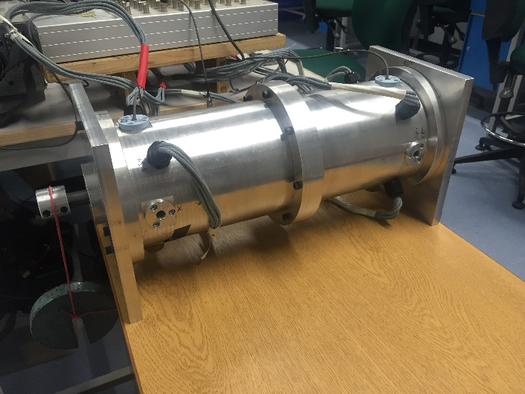
Figure 6-15 Machine set-up with additional weight for second step of open-loop static experiment
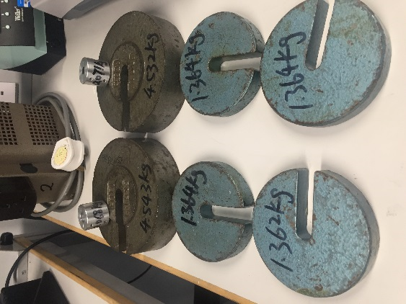
Figure 6-16 prescribed mass used for force validation test
In Figure 6-17, rotor movements of the repeatable lift-off test (with start position of $ε_{y}=-0.25mm and θ_{r}=10°$) were shown for different values of additional mass (1.364Kg, 2.728Kg and 4.543Kg) which were equally added on either rotor ends. The combined value of demand force signal and $UMP+mg$ for two sections at lift-off positions were given in Table 6-5. As only Y-direction demand force was applied to the force controller, the force magnitude is proportional to the absolute magnitude of current combination, i.e., $F_{y}=K\sum_{j=1}^{N_{ph}}{a_{yj}(θ_{r})}i_{j}$ (where K represents the absolute magnitude). In this case, phase 7 current of section 1 was measured as shown in Figure 6-18 and the values at lift-off positions were given in Table 6-5.
It is clear that, in Table 6-5, the data of demand force at lift-off position shown a good agreement with the combined value of unbalance magnetic pull and gravitational force (rotor mass and prescribed mass). The difference between the demand forces of two compared tests accurately inferred the gravitational force of the added prescribed mass. As a result, a proportional increment of phase 7 current at lift-off position was measured in Figure 6-18. Moreover, with the optimized power amplifier introduced in section 5.4.5, the measured current of phase 7 in section 1 shows a good agreement with the demand current in Figure 6-19. Therefore, it is reasonable to use demand force to refer the produced excitation force. The experimental validation of machine force capability was effectively achieved by using the proposed static lift-off experiment with the additional prescribed mass.
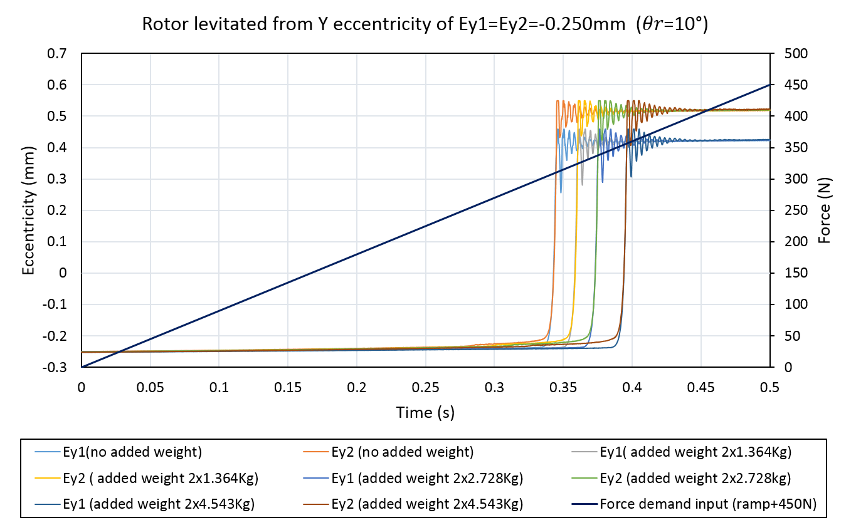
Figure 6-17 Experimental results of rotor movement with respect to the +450N ramp Y demand force signal and added weight 2×1.364kg, 2×2.728kg and 2×4.543kg (initial conditions: $ε_{y1}=ε_{y2}=-0.250mm and θ_{r}={10}^{°}$)
Table 6-5 Experimental data achieved from Figure 6-17
 | No additional weight | Additional prescribed mass
 |  | 2×1.364kg  (26.7N) | 2×2.728kg  (53.5N) | 2×4.543kg  (89.0N)
Total value of demand force signal at released position | 599.2N | 627.1N | 653.8N | 691.2N
$$UMP+mg$$ | 600.7N | 627.4N | 654.2N | 689.7N
Measured phase 7 current of section 1 | 4.98A | 5.21A | 5.44A | 5.76A
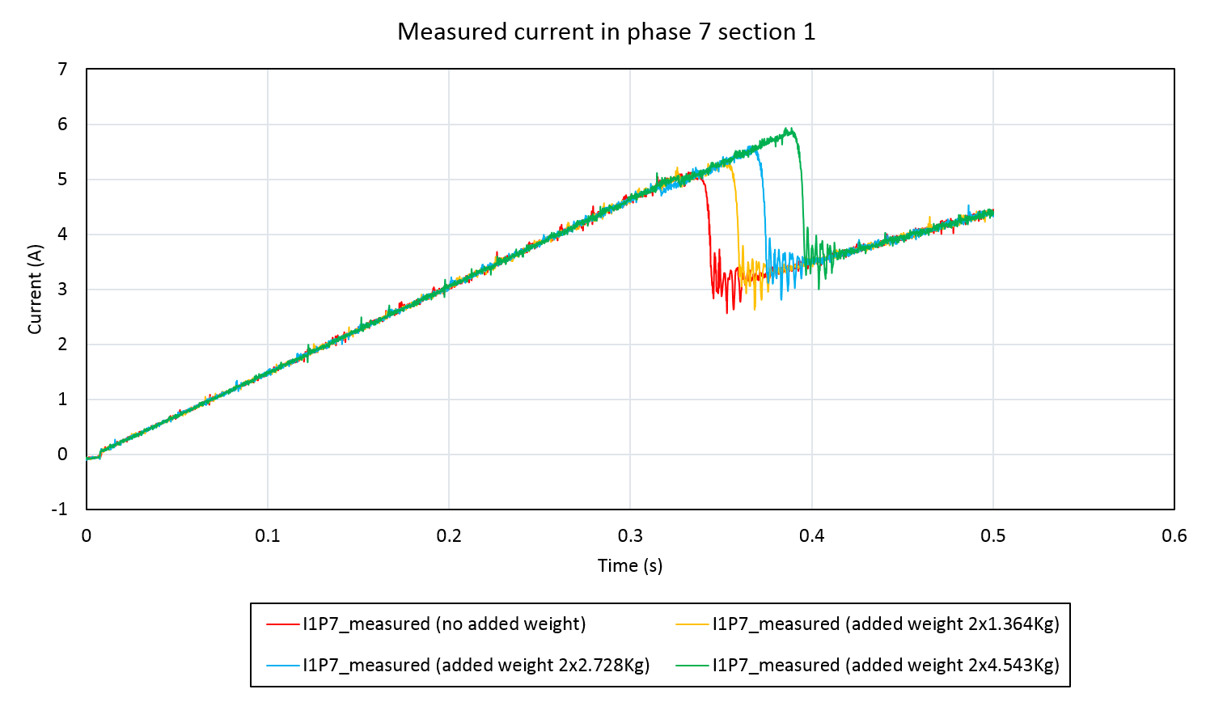
Figure 6-18 Current probe measured phase 7 current in section 1 for the lift-off experiment with different additional mass of 2×1.364kg, 2×2.728kg and 2×4.543kg (initial conditions:${ ε}_{y1}=ε_{y2}=-0.250mm and θ_{r}={10}^{°}$)
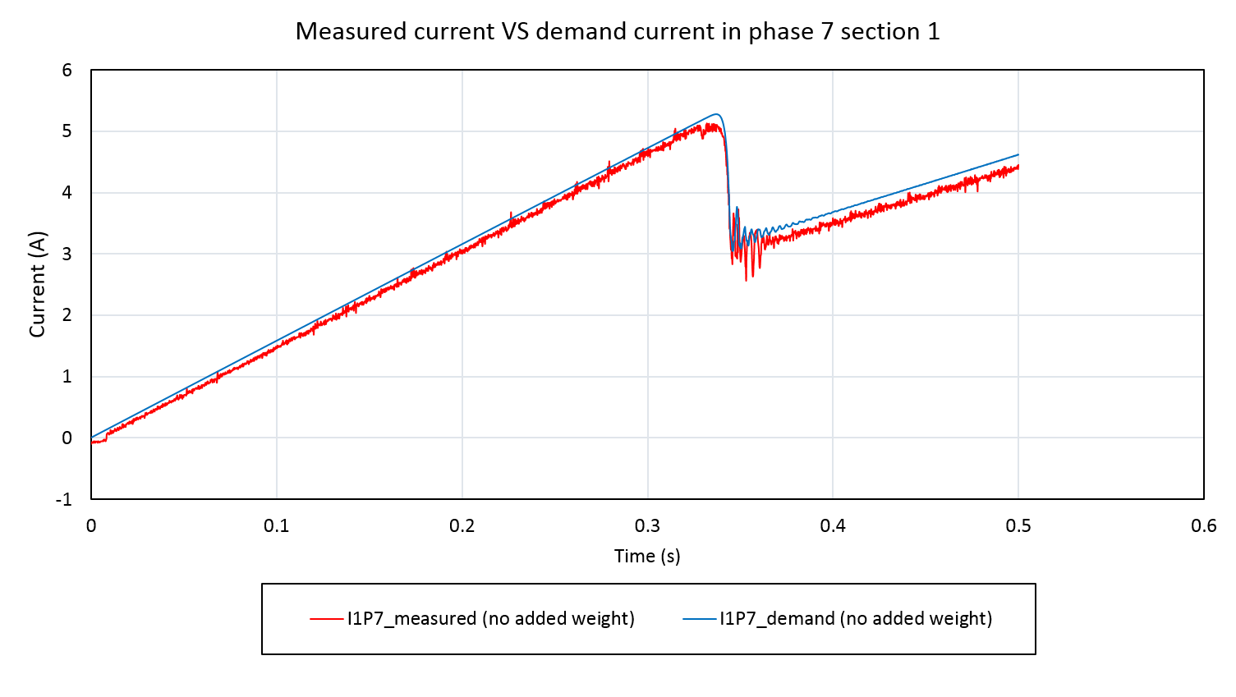
Figure 6-19 Comparison of demand current and measured current of phase 7 in section 1 for the lift-off experiment with additional weight of 2×4.543kg (initial conditions:$ε_{y1}=ε_{y2}=-0.250mm and θ_{r}={10}^{°}$)

Static rotor lifting analysis at fixed Y-direction eccentricity (-0.25mm) and various angular positions
In the static lift-off tests of section 6.3.1, the rotor was lifted at a same specific angular position, i.e. $θ_{r}=10°$. For this prototype SPM self-bearing machine, the calculation of phase current is specific to the angular position. Therefore, it is important to measure the consistency of force capability at different angular positions. By lifting the rotor from the same pre-specified Y-direction eccentricity (-0.25mm), the same excitation force demand at the lift-off position was expected, but with different phase current combinations due to varying rotor angle.
It is important to note that rotor eccentricity is estimated by comparing the measured distance between sensor head and the target shaft to the pre-determined reference distance ($d_{centre}$) when the rotor was assumed to be central within the stator bore. The constructed rotor, however, is not perfectly centralized due to mechanical tolerance, which results in a varying value of $d_{centre}$ at different rotor angles. Therefore, Table 6-6 lists the values of $d_{centre}$ at the given rotor angles. As shown in Table 6-6, the difference between the maximum and minimum measured value is only $45μm$ in section 1 and 36um in section 2 respectively. However, the difference reflected on the demand force signal would be as significant as 52.7N in section 1 and 42.2N in section 2 respectively due to the sensitivity of unbalance magnetic pull.
Table 6-6 Measured distance of centre position at rotor angular position from ${10}^{°}$ to ${110}^{°}$
Test rotor angle $θ_{r}$ | $$Y1 d_{centre}$$  $$(mm)$$ | $$Y2 d_{centre}$$  $$(mm)$$
$${10}^{°}$$ | 0.644 | 0.797
$${30}^{°}$$ | 0.648 | 0.782
$${50}^{°}$$ | 0.627 | 0.802
$${70}^{°}$$ | 0.653 | 0.783
$${90}^{°}$$ | 0.672 | 0.804
$${110}^{°}$$ | 0.667 | 0.818
A series of lift-off test were performed for eccentricities of $E_{y1}=E_{y2}=-0.250mm$ at rotor angles of 10˚, 30˚, 50˚, 70˚, 90˚ and 110˚ respectively. Figure 6-20 shows the resulting comparison of demand force signal,$UMP+mg$, non-linear FE estimated force and analytical estimated force at the lift-off position. As expected, all the force values at the release position exhibit good consistency at all tested rotor angles.
Furthermore, the distribution of currents between the phases depends on the rotor angular position was shown in Table 6-7. The phases with maximum and minimum current are highlighted in red and green respectively.
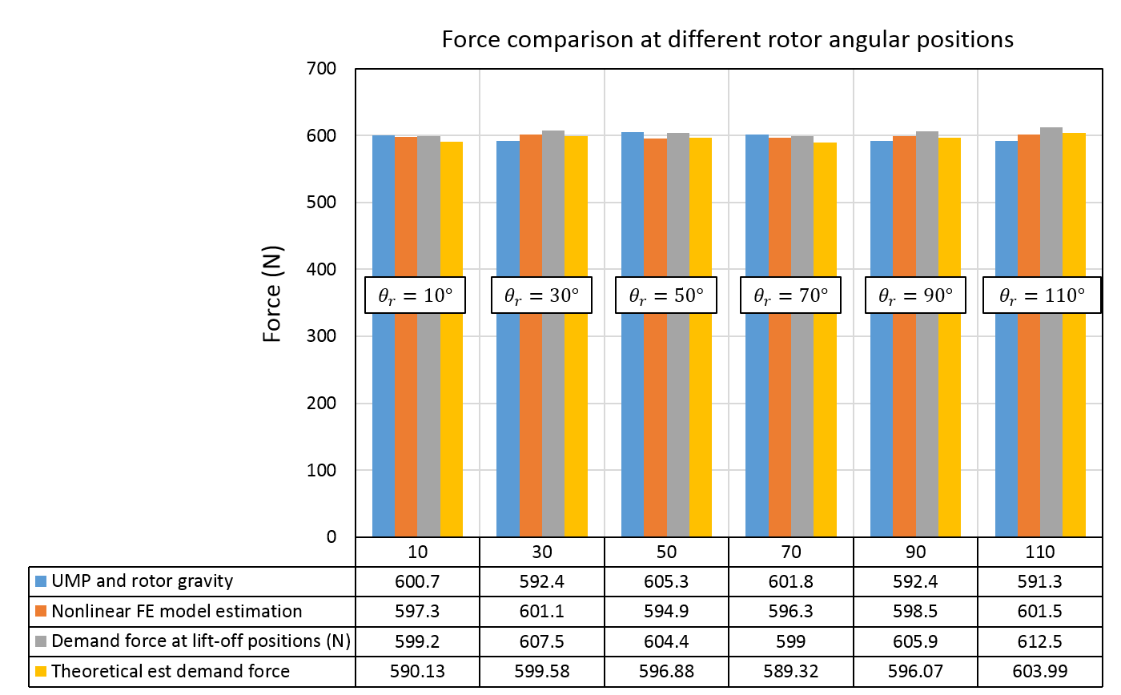
Figure 6-20 Comparison of $F_{un}(FE)+G$, total demand force signal, FE and analytical estimated demand force with rotor lift off from $ε_{y1}=ε_{y2}=-0.250mm$at rotor angles from 10˚ to 110˚.
Table 6-7 Combination of phase current at release position for lift-off of the rotor from $ε_{y1}=ε_{y2}=-0.250mm$ (All currents shown are in unit of A)
Phase Current |  | I1 | I2 | I3 | I4 | I5 | I6 | I7 | I8 | I9
$${10}^{°}$$ | S1 | 0.87 | -0.68 | 5.10 | -4.83 | 0.75 | -2.46 | 5.23 | -0.14 | -3.82
 | S2 | 0.85 | -0.68 | 5.17 | -4.87 | 0.75 | -2.46 | 5.17 | -0.13 | -3.75
$${30}^{°}$$ | S1 | 0.82 | -3.99 | 4.75 | -0.42 | -0.82 | -1.92 | -0.30 | 5.95 | -4.00
 | S2 | 0.82 | -4.00 | 4.82 | -0.42 | -0.82 | -1.92 | -0.30 | 5.95 | -4.00
$${50}^{°}$$ | S1 | 0.31 | -2.36 | -0.18 | 3.76 | -2.34 | 0.67 | -5.11 | 5.83 | -0.55
 | S2 | 0.33 | -2.44 | -0.18 | 3.85 | -2.37 | 0.68 | -5.16 | 5.86 | -0.56
$${70}^{°}$$ | S1 | -0.88 | 0.69 | -5.10 | 4.85 | -0.75 | 2.46 | -5.25 | 0.13 | 3.83
 | S2 | -0.85 | 0.68 | -5.11 | 4.85 | -0.75 | 2.45 | -5.16 | 0.14 | 3.74
$${90}^{°}$$ | S1 | -0.83 | 3.99 | -4.72 | 0.42 | 0.83 | 1.90 | 0.31 | -5.95 | 3.98
 | S2 | -0.82 | 3.97 | -4.73 | 0.42 | 0.86 | 1.86 | 0.32 | -5.88 | 3.97
$${110}^{°}$$ | S1 | -0.32 | 2.44 | 0.18 | -3.82 | 2.38 | -0.69 | 5.19 | -5.96 | 0.57
 | S2 | -0.34 | 2.48 | 0.18 | -3.86 | 2.38 | -0.69 | 5.18 | -5.93 | 0.57

Conclusion
In this chapter, two approaches to the experimental force measurement were described. The original proposal described in section 6.2, was based on direct static force measurements on the full machine. Although the use of force transducers provides a direct two-axis measurement, the test-rig suffered significant challenges due to inadequate stiffness
An alternative approach based on the analysis of lift-off experiments provides a comprehensive and effective force verification, particularly with the application of known additional gravitational force. These lift-off tests showed a remarkable level of consistency and agreement, which demonstrates the utility of the analytical force calculation method.

Dynamic Experimental performance assessment

Introduction
The experimental assessment of dynamic performance that is described in this chapter was aimed at realising full bearing and motoring functions using the control algorithm described in section 3.4.
In order to gradually build up the experiment testing to the full multi-axis control required for both bearing and motoring features, the experimental characterisation was initially focussed on single-axis rotor levitation using support pillars to constrain motion. This chapter explores the influence of PID control parameters with the assistance of the simulation model developed in CHAPTER 4.
For a fully functional self-bearing machine, the static stiffness and dynamic stiffness need to be measured and validated by comparing to the simulated values established in section 4.2.2. Finally, to conclude the testing, full dynamic operation (including speed control) is described for both no-load and on-load conditions.

Static levitating measurement at fixed rotor angle ($θ_{r}=10°$)
Static levitation following initial lift-off from the back-up bearing is an important step in the sequence of operations required for self-bearing operation. During static levitation, the prototype rotor is actively controlled to remain at a reference position. In order to achieve control over the five degrees of freedom, four PID controllers are deployed for position control and one PI controller for the speed control.
The closed-loop control system is shown in Figure 7-1. By comparing the measured signals to the reference values, the resultant error signal of translational position and rotational speed are calculated and fed to the corresponding PID and PI controllers for establishing the demand restoring force and motoring torque respectively.
Before appropriate PID control parameters are selected, the unsuitably controlled rotor shown a full clearance oscillation and intensive physical contact between back-up bearing and rotor shaft.
Due to the unbalanced magnetic pull which is present in the absence of stator current (equivalent to a negative stiffness ~-1200N per mm of eccentricity each section), the uncontrolled force when rotor impact the back-up bearing at an eccentricity of ~0.4mm, is at least 480N at either end (without the consideration of additional rotor bending).
In order to initially reduce the experimental complexity which involves X- and Y- translational control in both section and one-axis rotational control, the rotor was constrained by the support pillar to only move in the Y-direction. This allowed the controller development to focus on single-axis control in Y direction. This involves tuning two PID controllers which near identical behaviour. Since both sections of the machines are nominally identical, in the first instance the Y-direction PID controllers can be tuned with a same set of gains. The detailed procedure employed in static levitation experiments is described in Table 7-1.
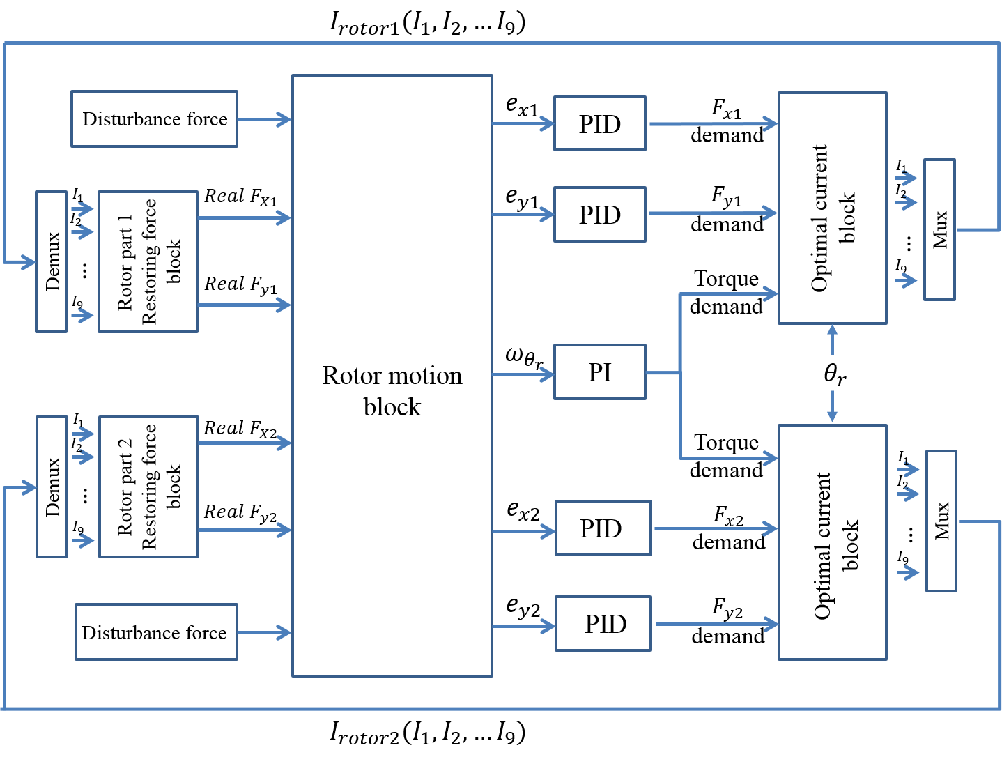
Figure 7-1 Schematic closed-loop control system of 9-6 prototype self-bearing machine
Table 7-1 Static levitating experiment procedure at the fixed rotor angle of 10°
Step 1 | Y-direction static lift-off experimental measurement from the bottom of back-up bearing position for estimating minimum proportional gain
Step 2 | Single-axis (Y-direction) PID controller tuning and levitation experiment
Step 3 | Dual-axis PID tuning and levitation experiment

Y-direction static lift-off measurement from back-up bearing position
It was demonstrated in section 6.3 that the finite element predicted forces show excellent agreement with the experimental results using static uncontrolled lift-off experiments. The simulation results presented previously in section 4.2.1 demonstrated that significant improvements in performance for a given combination of control gains could be achieved by incorporating UMP compensation into the control scheme, in particular the ability to maintain performance with significantly reduced controller gains and hence increased reliance to noise.
Hence, for the controller used in the experimental testing of levitation, a look-up table of finite element estimated open-circuit unbalance magnetic pull (UMP) was added into the closed-loop system to compensate for the effect of UMP.
Static lift-off is achieved in the Y-direction from the back-up bearing position designed as the first step has two major purpose:
- Identifying the maximum moving clearance, i.e., maximum rotor eccentricities from back-up bearing position at either end. Due to the mechanical tolerance for constructing back-up bearings, the rotor eccentricities at lift-off positions are different as shown in Figure 7-2 and Figure 7-3. The corresponding eccentricity values represents the maximum moving clearance at either end of this constructed prototype machine.
- Determining the minimum value of proportional gain for single-axis (Y-direction) levitation. According to the well-established tuning strategy for PID controllers, proportional gain is usually the first value determined for starting with a marginally stable rotor movement (which means that the rotor is expected to continuously oscillate with a proportional only controller). A higher proportional gain results in increased oscillation frequency, which is unnecessary until an asymptotically stable system achieved. On the other hand, insufficient proportional gain is unable to provide sufficient control action to levitate rotor from back-up bearing position. By using the results from lift-off experiments, the force error at lift-off position can be estimated accurately thereby providing a means to determine the minimum required proportional gain.

Y-direction static lift-off measurements for identifying release eccentricities at both sections
For identifying the release eccentricities for both sections, the rotor was lifted from the bottom position of back-up bearing by applying a ramp force demand with rate of +1000N/s (up to a maximum of 500N) to both sections as shown in Figure 7-2.
As can be seen from Figure 7-2, the lift-off of rotor sections 1 and 2 occurred at -0.326mm and -0.344mm respectively as summarised in Table 7-2. Due to the various mechanical and electromagnetic tolerances, the value eccentricity at lift-off with nominally the same current was $\sim 180μm$ smaller than the value of rotor section 2. By applying identical ramping force demands to both sections, rotor section 1 was more likely to lift-off earlier than rotor section 2 due to the smaller eccentricity which results in a lower UMP in section1. According to the data obtained in Table 7-2, rotor eccentricities at lift-off positions, i.e., after the correction of rotor bending caused by the unbalanced magnetic force and gravitational force, are -0.238mm at section 1 and -0.298mm at section 2 respectively.
It is worth noting that the lift-off experiment from the bottom of the back-up bearing has unequal starting positions due to mechanical tolerance. This means that the lift-off performance is cross-coupled between these two sections. Therefore, the force estimating approach used in section 6.3 that required an identical starting condition is not applicable in this case. Hence, the minimum proportional gain which is reliant on an accurate estimated force at the lift-off position cannot be determined in this case.
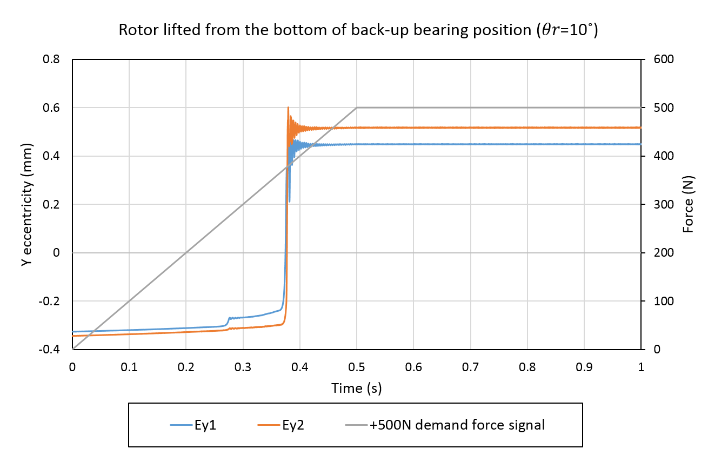
Figure 7-2 Rotor lifted from bottom back-up position with +500N ramp demand signal for both sections (Initial condition:$θ_{r}={10}^{°})$
Table 7-2 Rotor lift-off experimental data obtained from Figure 7-2
 | Section 1 | Section 2
Initial eccentricity $E_{y}$ | -0.326mm | -0.344mm
$E_{y}$ at lift-off positions | -0.238mm | -0.298mm

Y-direction lift-off measurements for selecting the minimum proportional gain
In order to minimise the coupling effect between the two sections due to unequal starting rotor positions, the identical ramping force demand applied to both sections which resulted in the response of Figure 7-2 was replaced by two independently defined ramping force demands. Taking into account the rotor eccentricities in Table 7-2 at which lift-off occurred, a ramped force demand with the rate of +792N/s (up to a maximum of 396N) was selected for section 1, and a ramping force demand with the rate of +968N/s (up to a maximum of 484N) was selected for section 2.
As can be seen in Figure 7-3, with these modified ramp rates, both sections begin to accelerate towards the top position at the same time. The eccentricities at lift-off positions shown in Table 7-3 are in good agreement with the previous lift-off measurements in Table 7-2. However, the force value at lift-off positions estimated in this test are likely to be more reliable and consistent. At the lift-off position, the force error between demand force and the sum of the finite element predicted unbalanced magnetic pull and the gravitational force on the rotor used for estimating the minimum proportional gain were +11.9N in section 1 and +26.3N in section 2 respectively.
For a reference Y position of zero eccentricity at both ends, the maximum positional error for section 1 and 2, are 0.242mm and 0.293mm respectively. In order for this error to generate sufficient force to initiate lift-off, the proportional gains for each section shown in Table 7-3 are required, as a minimum, for a controller reliant only on proportional action. Gain values of less than these minima will result in insufficient force being produced to overcome the combination of UMP and gravitational force.
Even though the minimum proportional gains were estimated to be slightly different for both sections, a value of 90000 N/m was selected for both sections, as confirmed in Table 7-3. This provides some margin for both sections.

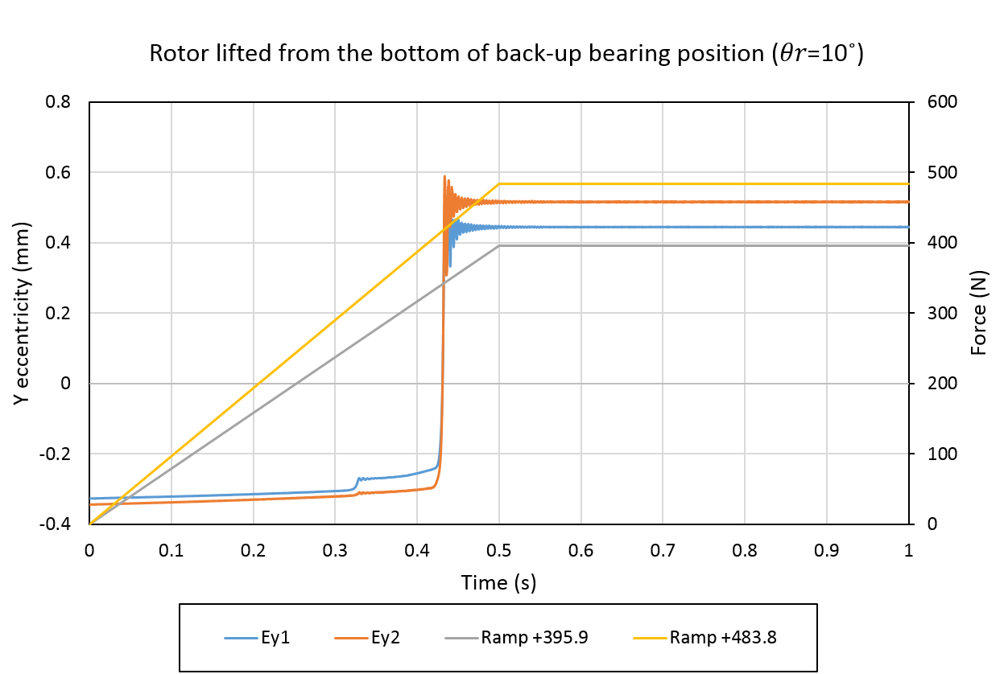
Figure 7-3 Rotor lift-off from back-up position with +395.9N and +483.8N ramp demand signal for rotor section 1 and section 2 respectively. (Initial condition:$θ_{r}={10}^{°}$)
Table 7-3 Rotor lift-off measured data obtained from Figure 7-3
 | Section 1 | Section 2
Initial eccentricity $ε_{y}$ | -0.326mm | -0.344mm
$ε_{y}$ at lift-off positions | -0.242mm | -0.293mm
Y-direction demand force at lift-off positions | 333.3N | 407.4N
$UMP+mg$ at lift-off positions | 321.4N | 381.1N
Force error between demand and $UMP+mg$ at lift-off positions | +11.9N | +26.3N
Minimum proportional gain at lift-off positions (N/m) | 49,174 | 89,761
Selected proportional gain for the single-axis levitation (N/m) | 90,000

Single-axis PID controller tuning and levitation trail
The proportional gain of 90,000 N/m established from the measurements of section 7.2.1, provides a useful first step in tuning the gains of the entire PID controller. The second step described in this section has an actively controlled rotor levitating in Y-direction only. Single-axis static levitation, with the X-direction constrained mechanically, eliminates the coupling effect between X- and Y-direction displacements, thereby allowing the basic single-input-single-output (SISO) control strategy at either section. This in turn allows a much simplified evaluation of static levitation performance.
Even though single-axis static levitation observations provide a straightforward means for establishing the effects of selected PID parameters, it cannot replace the dual-axis static levitating testing, which is a multiple-input-multiple-output (MIMO) control strategy for selecting the optimal PID parameters. The purpose of the single-axis levitating testing is to achieve basic levitation performance and to establish a practical understanding of the merits of using a P controller, a PD controller or a PID controller.

Comparison of P, PD and PID controller for self-bearing operation
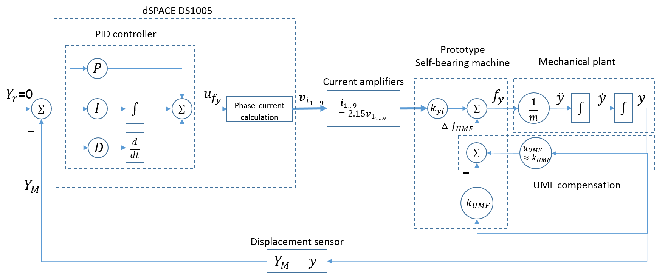
Figure 7-4 Block diagram of Y-axis PID controlled SISO closed-loop system for static levitation testing
As can be seen from Figure 7-4, the completed Y-axis experimental closed-loop system comprise dSPACE DS1005 processor with a PID controller, current amplifiers, an UMP compensator which draws on finite element results, rotor movement plant and prototype self-bearing machine with the linear force model.
In order to describe the behaviour of each control action within the PID controllers, theoretical equations were derived to determine the stability of a system when controlled by a P controller, a PD controller and finally a PID controller. Using the simulation model introduced in CHAPTER 4, the corresponding effects on rotor displacement were explored. This provides fundamental knowledge for analysing and evaluating the experimental results.
The simulation model has several simplifications notably ideal current amplifiers, perfectly concentric alignment of sections 1 and 2, ideal position sensors, perfectly compensated unbalance magnetic pull, i.e., $Δf_{UMF}$ is equal to zero in Figure 7-4. Therefore, the block diagram of Figure 7-4 can be simplified to Figure 7-5 and Figure 7-8 for the systems based on P only and PD controllers respectively.
  - Closed-loop system with a proportional term only controller (no external disturbance and system error)
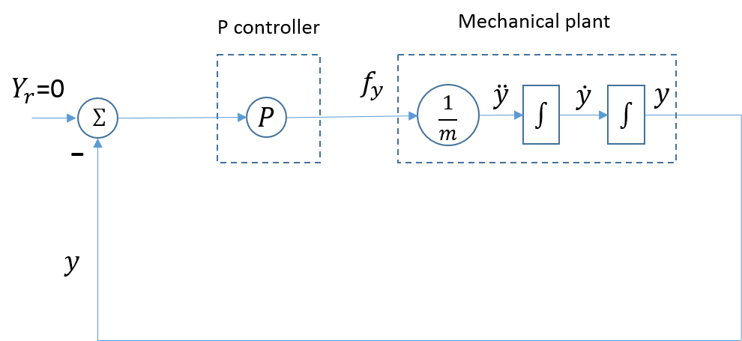
Figure 7-5 Simplified block diagram of Y-axis closed-loop system using P controlled
The application of Newton’s second law of motion leads to:
 | $$m\ddot{y(t)}=f_{y}(t)$$ | (54)
The demand force for a P term controller is:
 | $$f_{y}(t)=-K_{P}y(t)$$ | (55)
where $K_{P}$ is the value of proportional gain.
By substituting equation (54) into (55), the differential equation of the proportional P closed-loop system and the corresponding characteristic polynomial are derived as equation (56) and (57) respectively.
 | $$m\ddot{y(t)}+K_{P}y(t)=0$$ | (56)
 | $$mλ^{2}+K_{P}=0$$ | (57)
As the eigenvalues $λ_{1}$and${ λ}_{2}$ of equation (57) are conjugate complex numbers with only imaginary part, the corresponding homogeneous solution of Y-axis displacement in the time domain can be obtained as an complex exponential function of equation (60) . According to Euler’s formula, its exponential function is then converted to trigonometric function of equation (61). Figure 7-6 shows the positions of eigenvalue in the complex plane, which assist in identifying system stability simply from eigenvalue locations.
 | $$λ_{1}=λ_{2}=±jω$$ | (58)
where | $$ω= \sqrt{\frac{K_{p}}{m}}$$ | (59)
 | $$y\left(t\right)=A_{1}e^{jωt}+A_{2}e^{-jωt}$$ | (60)
 | $$y\left(t\right)=B_{1}\cos\left(ωt\right)+B_{2}\sin\left(ωt\right)$$ | (61)
Where | $$B_{1}=A_{1}+A_{2}$$ | (62)
 | $$B_{2}=j(A_{1}-A_{2})$$ | (63)
As can be seen from equation (59), the value of proportional gain determines the frequency of rotor displacement and its frequency is proportional to square root of $K_{P}$. Therefore, it is clear that higher proportional gain result in higher oscillation frequency as shown in Figure 7-7. Moreover, due of the absence of real part, there is no displacement attenuation and simulation result of rotor displacements shows an oscillation with constant magnitude and frequency which determined by start rotor position and proportional gain. This rotor performance is defined as marginal stable. In terms of the eigenvalue locations in the complex plane as shown in Figure 7-6, a closed-loop system with marginal stability has two distinct eigenvalues on imaginary axis [80].
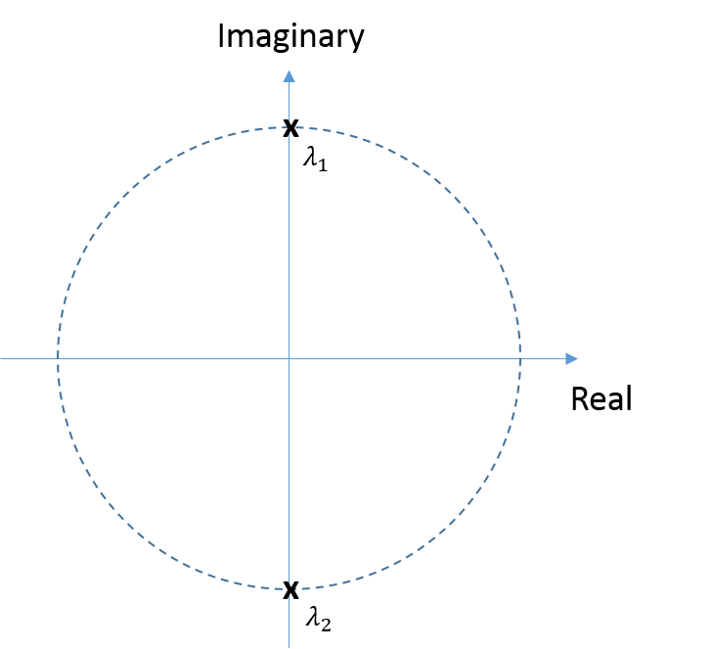
Figure 7-6 Eigenvalue locations of closed-loop system using a P controller
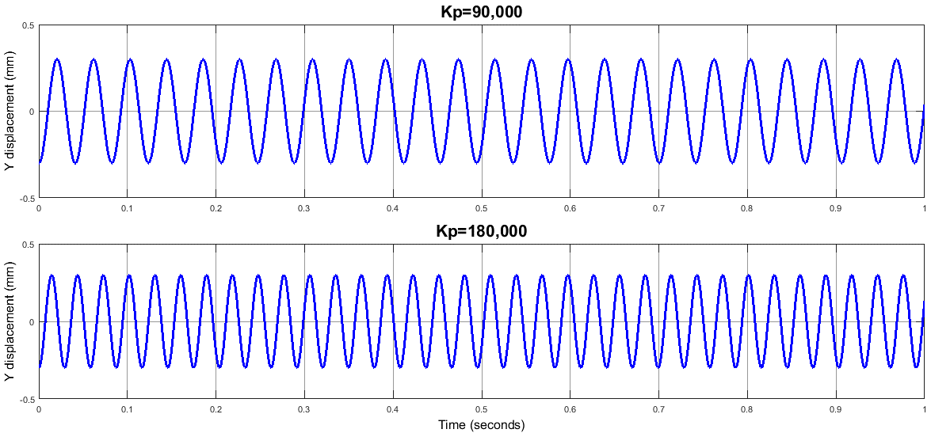
Figure 7-7 Simulation Y direction displacement using closed-loop system with a proportional only (P) controller (frequencies of rotor oscillation are 24.3Hz for $K_{P}=90,000 N/m$ and 34.4Hz for $K_{P}=180,000 N/m$).
  - Closed-loop system with a PD controller (no external disturbance and system error):
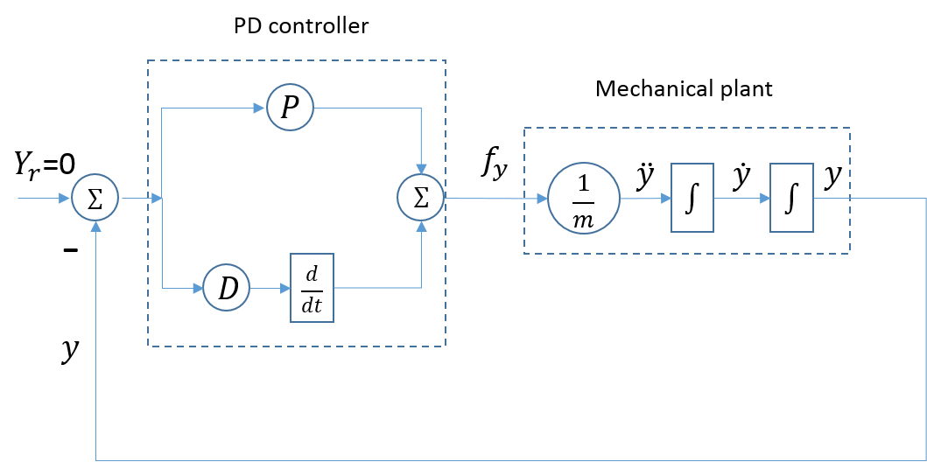
Figure 7-8 Schematic block diagram representation of Y -axis PD controller SISO closed-loop system for the static levitation
With the application of a PD controller as shown in Figure 7-8, the PD controller predicted restoring force is:
$$f_{y}(t)=-K_{P}y(t)-K_{D}\dot{y(t)}$$
Where $K_{d}$ is the value of derivative gain.
Accordingly, the differential equation and corresponding characteristic polynomial are given by:
 | $$m\ddot{y(t)}+K_{D}\dot{y(t)}+K_{P}y(t)=0$$ | (64)
 | $$mλ^{2}+K_{D}λ+K_{P}=0$$ | (65)
With this additional derivative gain, the solution of eigenvalues $λ_{1}$and${ λ}_{2}$ are conjugate complex numbers comprising of a real part σ and an imaginary part ω as given by equation (66). The general solution of rotor displacement $y(t)$ in trigonometric function is derived as in equation (69).
 | $$λ_{1}=λ_{2}=σ±jω$$ | (66)
where | $$σ=\frac{-K_{D}}{2m}$$ | (67)
 | $$ω= \sqrt{\frac{K_{P}}{m}-\frac{{K_{D}}^{2}}{4m^{2}}}$$ | (68)
 | $$y\left(t\right)=e^{σt}(B_{1}\cos\left(ωt\right)+B_{2}\sin\left(ωt\right))$$ | (69)
As can be seen from equation (67), the negative value of real part σ of eigenvalues result in displacement attenuation according to equation (69). Simulation results shown in Figure 7-10 is consistent with this theoretical analysis with an attenuated rotor displacement, in this case for values of K_{D} of 100 N·s/m and 1000 N·s/m. Since no external disturbance and system error are presented in this analysis, rotor position settles on the reference zero position due to no steady state error. More importantly, the higher value of $K_{D}$ leads to a shorter attenuation period and a smaller oscillation frequency for a given${ K}_{P}$.
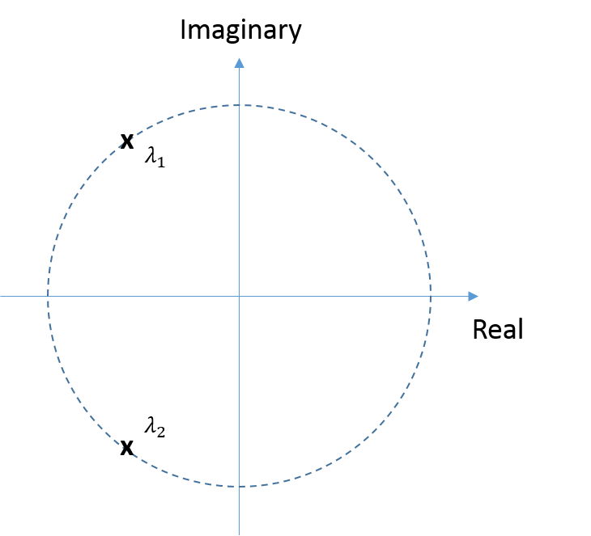
Figure 7-9 Pole locations of ideal closed-loop system with the PD controller
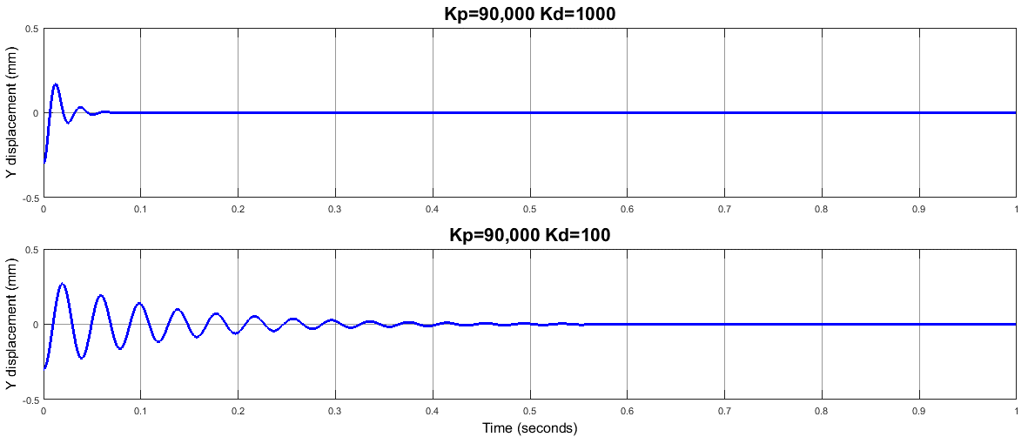
Figure 7-10 Simulated Y directional displacement during levitation using closed-loop system with the PD controller.
  - Closed-loop system with PID controller (10N external disturbance)
In practical applications, a closed-loop system needs to have the ability to accommodate external disturbances and undesirable system tolerance. Figure 7-11 shows the response with a PD controller to a 10N external disturbance, which is initiated at t=0s and remains present throughout the period shown. As will be apparent, this external disturbance, results in a steady-state displacement error. In order to ensure that the rotor remains at the reference position with no steady-state error, integral action is necessary. The corresponding displacement waveform for the same external disturbance of 10N but with integral action (K_{I} = 100,000 N/m·s) is shown in Figure 7-12. As this action is equal to the value of integral gain multiplies the accumulated previous position error, the higher integral gain means a quicker respond to steady state error.
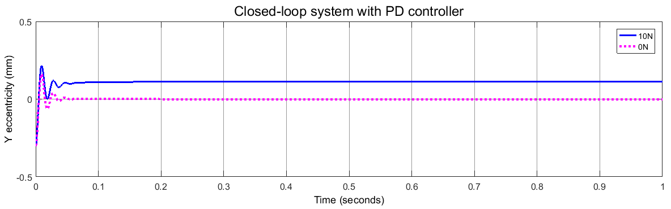
Figure 7-11 Simulation displacement with a 10N external disturbance applied to system equipped with a PD controller
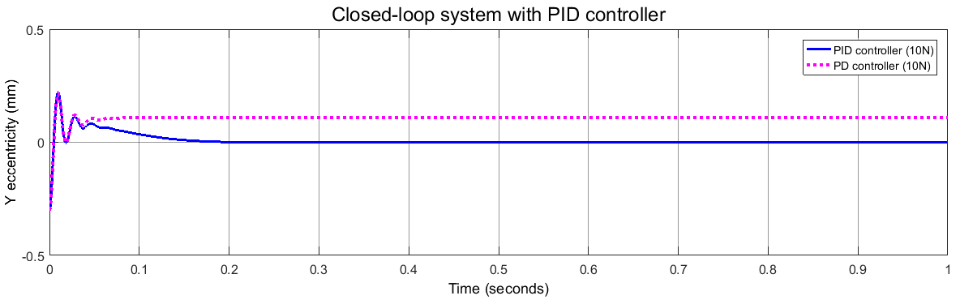
Figure 7-12 Comparison of simulated displacement for a 10N external disturbance with PD and PID controller

Y-axis experimental PID controller tuning and levitating performance analysis
Section 7.2.2.1 described the use of the simulation model of the system to explore the benefits of different control structures (P, PD and PID) and to tune the various controller gains. This section describes the same tuning approach applied experimentally on the prototype machine and controller. As was the case the experimental results presented in Table 7-1, the experimental measurements were performed initially on the Y-axis only with displacement in the X-direction prevented by the support pillars.
As a starting point for the experimental tuning, the case of a proportional term only controller was considered. The proportional gain of 90,000 N/m that was established in section 7.2.1 was used in the initial measurements. The resulting levitation performance with a proportional gain of 90,000 N/m is shown in Figure 7-13.
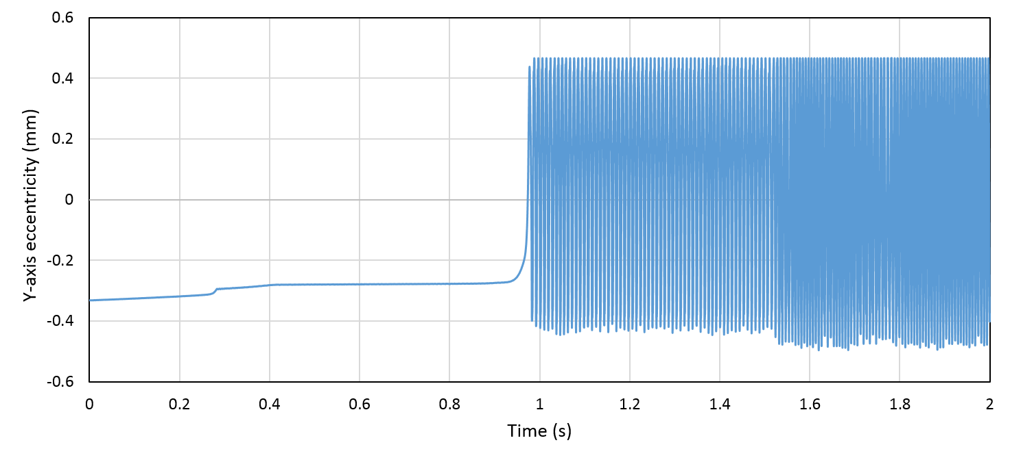
Figure 7-13 Measured directional rotor section-1 displacement using closed-loop system with P controller (K_{P}=90,000N/m). (The resultant magnitude and frequency of rotor oscillation are 0.45mm and 112.5Hz respectively)
According to the mathematical analysis for this system with a P controller, the eigenvalue of its differential equation is a pair of distinct poles on the imaginary axis, which result in marginally stable of the system. The magnitude and frequency of this oscillation, which are determined by the initial position and the value of proportional gain, i.e., -0.3mm and 90,000 N/m.
As can be seen from the experimental measurement of displacement in Figure 7-13, the rotor displacement shows the expected continuous oscillation, but with a considerable larger oscillated magnitude and frequency compared to the simulation analysis. Since a marginally stable system has no stability margin, any external disturbance or system error can leads to an unstable system performance. The experimental results in Figure 7-13 suggest that with this controller, the system was acting an unstable levitation performance.
For this signal-axis static levitating experiment, friction force between rotor shaft and supporting pillar was assumed negligible. As no significant external disturbance force is present, it is reasonable to assume that internal system errors, such as position sensor errors, current amplifier offset or distortion or non-linearity in the electromagnetic performance of the machine are the main contributors to the large oscillation performance observed.
As noted for the simulations but even more evident from the experimental performance, internal system errors cannot be completely avoided in practical system and hence closed-loop system with P controller is insufficient in order to provide stable performance. Therefore, additional derivative action is necessary to provide additional displacement attenuation. The selection of derivative gain can be interpreted as the selection of damping for a spring-damper system.
The classical theory of damping selection starts with establishing a characteristic polynomial (65) to calculate the corresponding eigenvalue of closed-loop system with PD controller. The same issues as those considered for the simulation based tuning apply to the experimental tuning. Figure 7-9 shows that the closed-loop system with PD controller has a pair of complex poles with negative real part located in left half plane (LHP) thereby resulting in an asymptotic stable system. As can be seen from equation (67) and (68), a larger derivative gain results in a larger eigendamping of$σ$ and a smaller eigenfrequency of $ω$. Therefore, the value of real part $σ$ and imaginary part $ω$ are also interpreted as the decay rate and pseudo frequency of rotor displacement [80] as shown in Figure 7-10. It is worth noting that critical damping happens when the selected derivative gain $K_{D}$ is equal to $2\sqrt{K_{P}m}$, i.e., eigenfrequency$ω$ becomes zero. In this case, the transient respond shows a creeping towards zero.
In establishing a suitable value of derivation gain for the Instead of gradually increasing the derivative gain, the derivative gain was first selected to be greater than$2\sqrt{K_{P}m}$ in order to avoid excessive rotor oscillation. Since the proportional gain applied is 90,000 N/m, the theoretical critical damping is calculated as 1179 N s/m. In order to accommodate some inevitable internal system errors, a slightly larger value of 1600 N·s/m was selected for the first iteration of a PD controller.
The resulting measured displacement is shown in Figure 7-14 along with the ramped position demand. As will be apparent, although oscillations are avoided, the rotor settles at a stable Y-axis displacement of -0.200mm. By comparing the steady state position shown in Figure 7-14 to the lift-off eccentricity ($ε_{y1}=-0.242mm$) given in Table 7-3, the rotor was successfully levitated with a non-oscillation levitating performance at a steady state of 0.200mm. It is evident that the selected derivative gain (K_{D}=1600 N·s/m) result in an overdamped closed-loop machine system with rotor section-1 only be levitated ~$40μm$ away from the lift-off position. By reducing the damping coefficient to 1000 N·s/m, a more dynamic levitating performance is achieved as shown in Figure 7-15. In this case, the steady-state error is reduced to $80μm$ but with significant oscillation.
The reason of this behaviour can be explained from the eigenvalue positions in the complex plane shown previously in Figure 7-9. The smaller derivative gain results in a smaller real part in the left half plane, with the eigenvalue position getting closer to imaginary axis. Therefore, the rotor levitation performance is more sensitive to various system errors. The performance can be improved by minimizing the system tolerance and increasing system dynamic capability. A more detailed discussion is presented in the dual-axis levitation experiments for achieving optimal bearing performance in section 7.2.3.
On the basis of the steady state error shown in Figure 7-14 and Figure 7-15, a contribution from integral gain $K_{I}$ is required to eliminate steady state error. As discussed previously, the integral gain determines the restoring time of the closed-loop system. Figure 7-16 shows the rotor displacement shown obtained with integral gains of 2400 N/m·s and 14400 N/m·s, in both cases with a derivative term gain of 1000. Both of these measured waveforms were recorded over the same time interval following successful levitation to the reference position. As would be expected, the response with larger integral gain shows a more rapid action approaching to the reference zero position. It is recognised that for most practical PID controlled SBM applications, a higher integral gain is required if improved restoring respond is desired [80].
However, there are important considerations when selecting the most appropriate integral gain:
- The integral action only compensates steady state error, i.e. harmonic disturbances cannot be compensated by integral gain.
- The limited restoring force capability of this prototype machine may limit the effectiveness of the integral term.
- The derivative action contributes a phase lead to the control action. The phase lag introduced by integral action offsets the capability of the damping coefficient. Hence, a large integral gain that is too large may adversely affect the dynamic bearing performance [80].
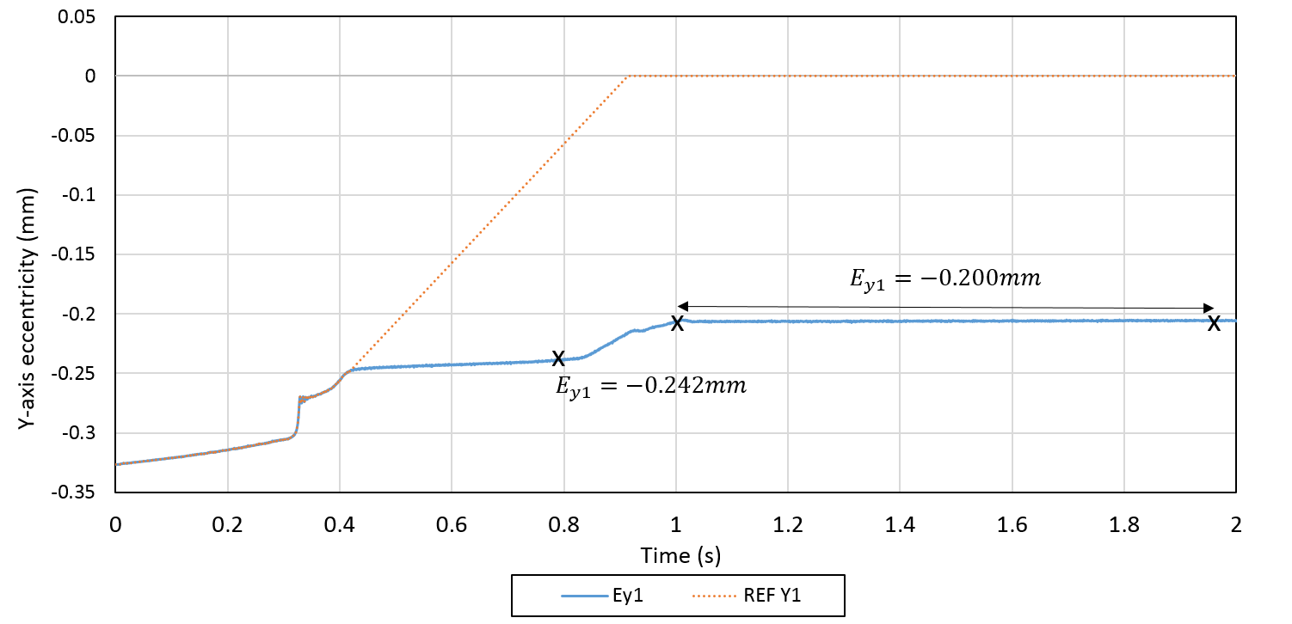
Figure 7-14 Experimental results of Y directional rotor section-1 displacement using closed-loop system with PD controller (K_{P}=90,000 N/m and K_{D}=1600 N·s/m)
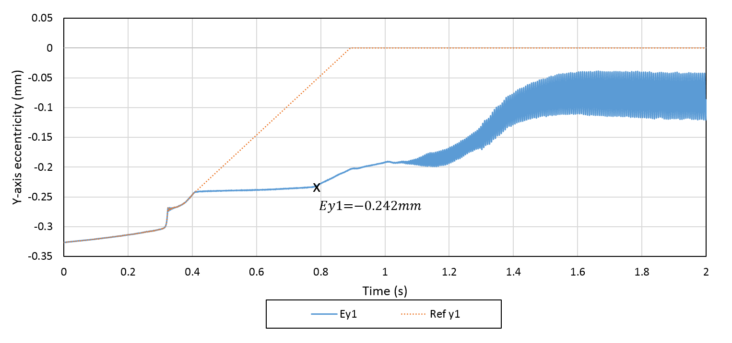
Figure 7-15 Experimental results of Y directional rotor section-1 displacement using closed-loop system with PD controller (K_{P}=90,000 N/m and K_{D}=1000 N·s/m)
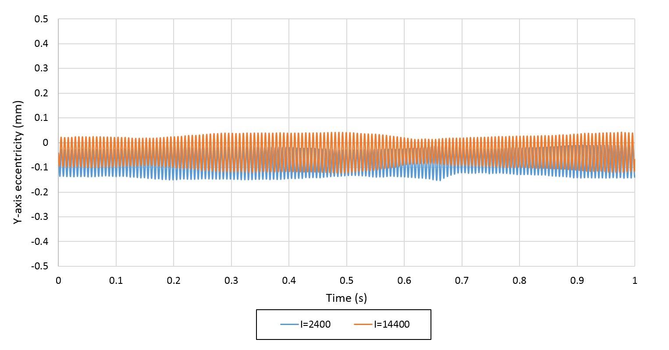
Figure 7-16 Measured Y directional rotor section-1 displacement for closed-loop PID controlled system (K_{P}=90,000 N/m and K_{D}=1000 N·s/m, K_{I}=2400 N/m·s and 14400 N/m·s)

Dual-axis PID controller tuning and levitating performance analysis
In this section, rotor movement in X- and Y-direction are simultaneously controlled in both section-1 and section-2. The dual-axis PID controllers described in this section are required to achieve control over four degrees of freedom, i.e., translational displacements, X and Y, and tilting displacements, α and β.
As the rotor movement in X and Y directions are controlled with independent PID controllers, this control strategy is called decentralized control which provide the most straightforward case for the selection of PID parameters [80]. As mentioned previously, this decentralized controlled system is regarded in essence as a spring-damper system using excitation force as the suspension force. The selection of proportional gain and derivative gain determine the effective stiffness and damping of this controlled system. The highest levels of stiffness and damping is desirable in this prototype in order to realise optimal system stiffness. At the end of this section, bearing performance will be evaluated from the point of views of static stiffness and dynamic stiffness for the system with the selected optimal PID parameters.

The choice of motion coordinate system
According to the results of single-axis levitation experiments, rotor performance can be improved by minimizing the internal signal error and maximizing system dynamic stiffness. Since the input to the controller is necessarily provided by the feedback position signals, then it is necessary to account for the various coordinate frames when estimating the magnitude and direction of demand bearing force.
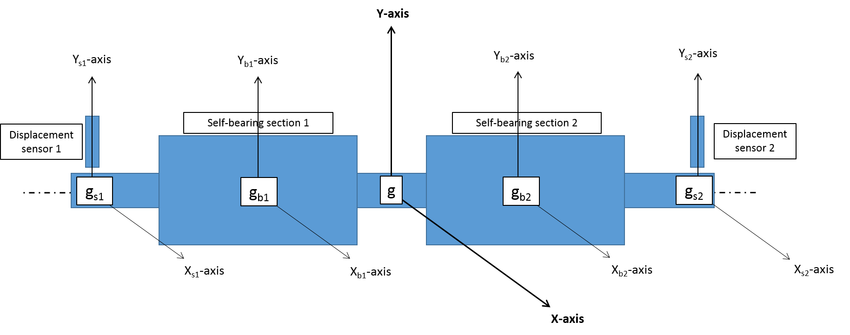
Figure 7-17 Schematic of structure arrangement of this prototye self-bearing machine
It is worth noting that the sensor-measuring locations are remote from the axis on which force is exerted. This axial offset from the sensing plane and the positions at which force is produced is typical of the situation in most of SBM and AMB applications except self-sensing and bearing-sensor applications. This proposed arrangement as shown in Figure 7-17 results in three alternative coordinate systems, i.e. a global motion coordinate system, g, at the gravity centre of rotor, local motion coordinate system, g_{b,} at the centre of each self-bearing section and sensor-measuring coordinate system, g_{s,} at each rotor end.
The effect of selecting coordinate systems of g_{b} and g_{s} for estimating the demand force can be illustrated by reference to Figure 7-18 which show side and top views of the machine. In the particular case shown, the X-axis position sensor near section 2 measures a maximum X direction displacement (X_{s2}) while the sensor near section 1 measures a maximum Y direction displacement (Y_{s1}).

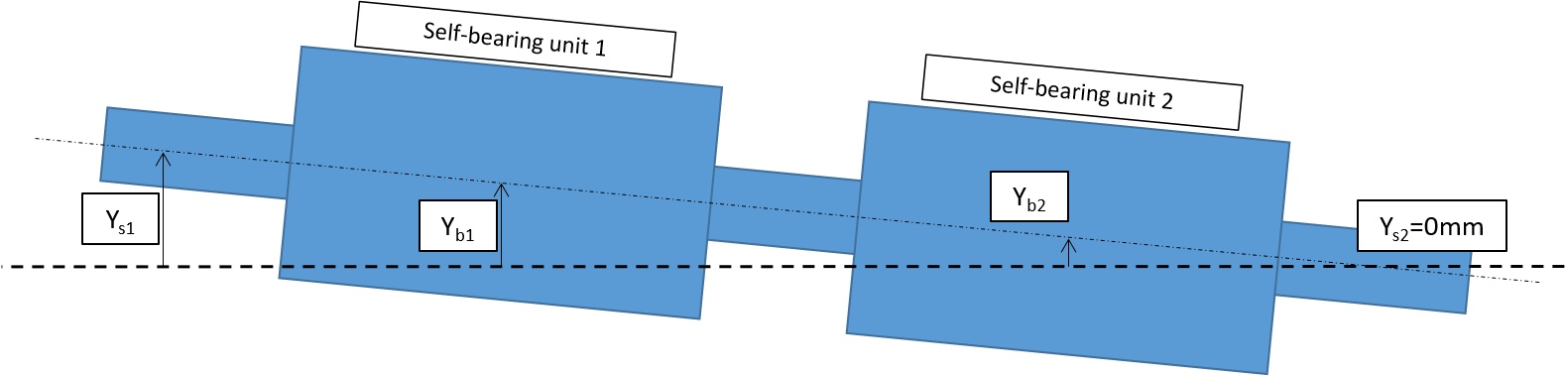
- Side view
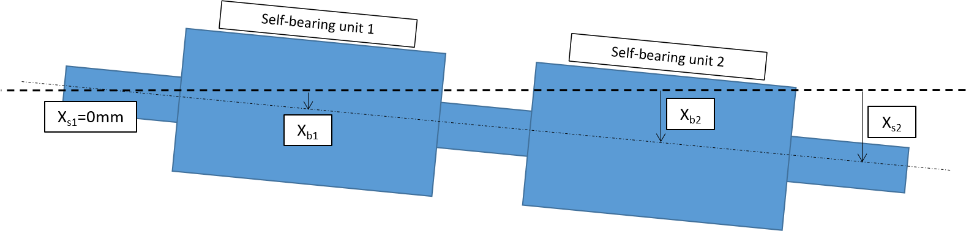
- Top view
Figure 7-18 Side and top views of the rotor displacement of self-bearing unit 1 at maximum Y_{s1} and self-bearing unit 2 at maximum X_{s2} (Note – rotations exaggerated to aid clarity compared to rotations expected in practice)
In order to compare the magnitude and direction of the demand radial bearing force estimated using different coordinate systems of of g_{b} and g_{s}.
It is useful to represent the rotor displacement conditions of Figure 7-18 using radial coordinate in the end-on view of Figure 7-19. The corresponding radial displacement of coordinate systems of of g_{b} and g_{s} are simply calculated according to equation (70) and (71) respectively.
 | $$r_{s}=\sqrt{{X_{s}}^{2}+{Y_{s}}^{2}}$$ | (70)
 | $$r_{b}=\sqrt{{X_{b}}^{2}+{Y_{b}}^{2}}$$ | (71)
As a result, the corresponding estimated radial force, $F_{r_{s1}}$ and $F_{r_{s2}}$, using sensor-measuring coordinate system, g_{s}, are directed in the negative Y and X direction respectively with the maximum value. However, the axial separation between the sensor position and the bearing unit centre, which is just under one third of the total axial length, will results in a significant force error occurs when compared to the actual required force, $F_{r_{b1}}$ and${ F}_{r_{b2}}$, in terms of both magnitude and in particular direction. For such a case, a control system which produced force demands based on displacement in the sensor coordinate system coordinate will generate force of excessive magnitude and, more crucially, which is not in the correct direction. In order to produce a suitable force at the centres of section 1 and 2 which are in the right direction to correct the measured displacement, it is preferable to convert the sensor-measuring coordinate g_{s} to local rotor motion coordinate g_{b} by transforming them to the global motion coordinate g using equations (72) to (74).
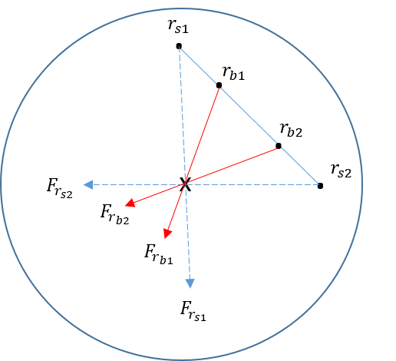
Figure 7-19 Schematic drawing of sensor and rotor positions in the side view from back-up bearing at rotor section 1. Magnitudes and directions of restoring force is estimated respect to each position.
 | $$g_{s}=\left[\begin{aligned}x_{s1} \\ x_{s2} \\ y_{s1} \\ y_{s2}\end{aligned}\right]=\left[\begin{matrix}\begin{aligned}\begin{matrix}c & 1\end{matrix} \\ \begin{matrix}d & 1\end{matrix} \\ \begin{matrix}0 & 0\end{matrix} \\ \begin{matrix}0 & 0\end{matrix}\end{aligned} & \begin{aligned}\begin{matrix}0 & 0\end{matrix} \\ \begin{matrix}0 & 0\end{matrix} \\ \begin{matrix}c & 1\end{matrix} \\ \begin{matrix}d & 1\end{matrix}\end{aligned}\end{matrix}\right]\left[\begin{aligned}β \\ x \\ -α \\ y\end{aligned}\right]=C_{g_{s}}g$$ | (72)
 | $$g_{b}=\left[\begin{aligned}x_{b1} \\ x_{b2} \\ y_{b1} \\ y_{b2}\end{aligned}\right]=\left[\begin{matrix}\begin{aligned}\begin{matrix}a & 1\end{matrix} \\ \begin{matrix}b & 1\end{matrix} \\ \begin{matrix}0 & 0\end{matrix} \\ \begin{matrix}0 & 0\end{matrix}\end{aligned} & \begin{aligned}\begin{matrix}0 & 0\end{matrix} \\ \begin{matrix}0 & 0\end{matrix} \\ \begin{matrix}a & 1\end{matrix} \\ \begin{matrix}b & 1\end{matrix}\end{aligned}\end{matrix}\right]\left[\begin{aligned}β \\ x \\ -α \\ y\end{aligned}\right]=C_{g_{b}}g$$ | (73)
 | $$g_{b}=C_{g_{b}}{C_{g_{s}}}^{-1}g_{s}$$ | (74)

Guideline for selecting PID parameters
For this prototype machine, the highest stiffness and damping are desirable to achieve the optimal bearing performance. Essential guidelines are concluded to identify the limitation for selecting high PID parameters.
- High proportional gain
According to equation (68) provided in 7.2.2.1, high proportional gain results in high eigenfrequency. Therefore, high demand of system bandwidth is necessary to provide sufficient dynamic responds. In practical system, operating bandwidth is determined by the lowest bandwidth of hardware comprised in the closed-loop system. For this prototype machine system, it includes DSP processor DS1005, position sensor SENTEC LS-500 and Current amplifier AZ20A8. Even though the bandwidth of current amplifier is significant extended to 800Hz by using pre-compensation method introduced in section 5.4.5, it is still regarded as the lowest bandwidth compared to the others, which are 10 KHz for DSP processor (sampling frequency) and 5 KHz for the precise position sensor.
- High derivative gain
In order to provide sufficient attenuation of rotor oscillation and fast derivative time, the corresponding high derivative gain is necessary to system with high proportional gain. However, a high derivative gain leads to a high sensitivity to system noise. It is because the velocity feedback intend to generate greater feedback signal than position feedback. It is also the reason that a low pass filter is desirable to utilize in series with derivative gain.
- High integral gain
For rotor position control, integral gain is the last parameter to be determined but essential to eliminate steady state error in which it is impossible to avoid by PD controller. Integral action has the ability to compensate steady state error by multiplying with the accumulated position error from passed signal, thus the larger integral gain leads to a quicker restoring time. As discussed in section 7.2.2.2, a higher integral gain is preferred as long as good bearing performance can be preserved.

Optimal PID parameters selection
According to the guideline for selecting PID parameters, optimal bearing performance is achieved by establishing the highest suitable value of proportional gain and derivative gain, which are limited by system operational bandwidth and system noise level.
Starting with a combination of PD parameters of K_{P}=110,000 N/m and K_{D}=3000 N·s/m, successful levitating performance with dual-axis control was achieved as shown in Figure 7-20. It is clear that the unexpected rotor oscillation observed in the single-axis static levitation experiments is no longer present in Figure 7-20. This can be attributed to the transformation of the sensor-measured motion to rotor centre-axis motion. However, as a relative low proportional gain of 110,000 N/m was used, the steady state error remains significant, especially on Y direction. In order to enhance the system stiffness and damping coefficient, both proportional gain and derivative gain were progressively increased.
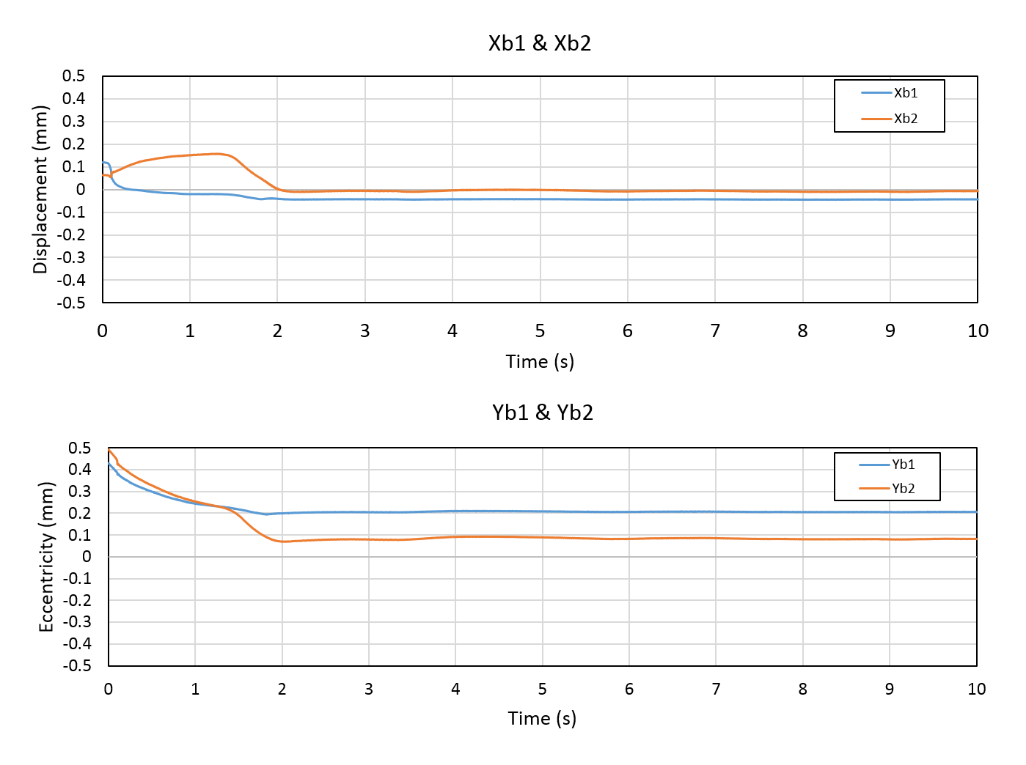
Figure 7-20 Dual-axis static levitating performance of rotor section-1 and section-2 implemented with same PD controller (K_{P}=110,000 N/m, K_{D}=3000 N·s/m)

By increasing the proportional gain and derivative gain to 1,000,000 N/m and 6000 N·s/m respectively, a reduced steady state error is expected as shown in Figure 7-21.
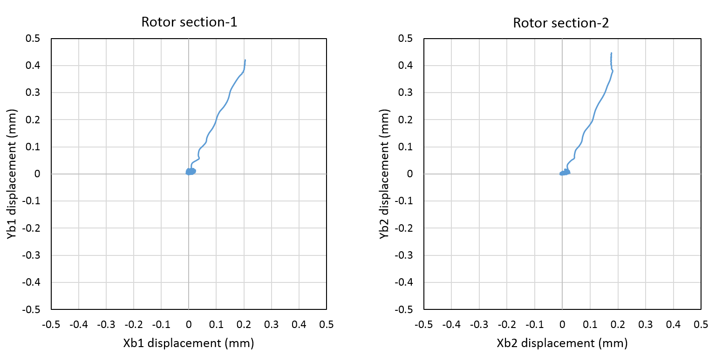
Figure 7-21 Rotor tracks of rotor section-1 and section-2 implemented with same PD controller (K_{P}=1,000,000 N/m, K_{D}=6000 N·s/m)
In principle, the oscillation amplitude can be reduced by increasing the damping coefficient until such point as there is excessive amplification of the system noise. Figure 7-22 shows the trajectory of rotor sections 1 and 2 from the back-up bearing, when the derivative gain was increased to 8000 N·s/m. As will be apparent, the amplitude of rotor displacements were almost doubled in both rotor section-1 and section-2 compared to with the case of a derivative gain of 6000 N·s/m. This is indicative of the system becoming too sensitive to system noise. Hence, a derivative gain value of 6000 N·s/m was selected as the upper limit for this system. Correspondingly, the proportional gain was limited to 1,000,000 N/m since a higher proportional gain of 1,200,000 N/m results in larger rotor oscillation as shown in Figure 7-23.
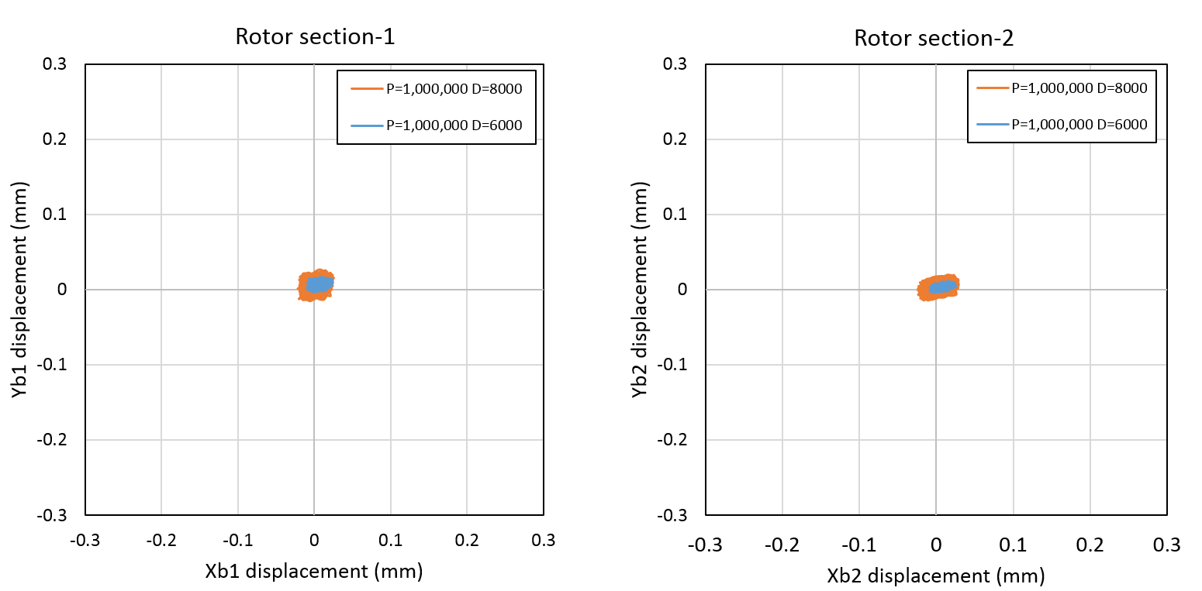
Figure 7-22 Comparison of measured rotor oscillation around reference point in section-1 and section-2 with same proportional gain (K_{P}=1,000,000 N/m) but different derivative gain (K_{D}=6000 N·s/m and 8000 N·s/m)
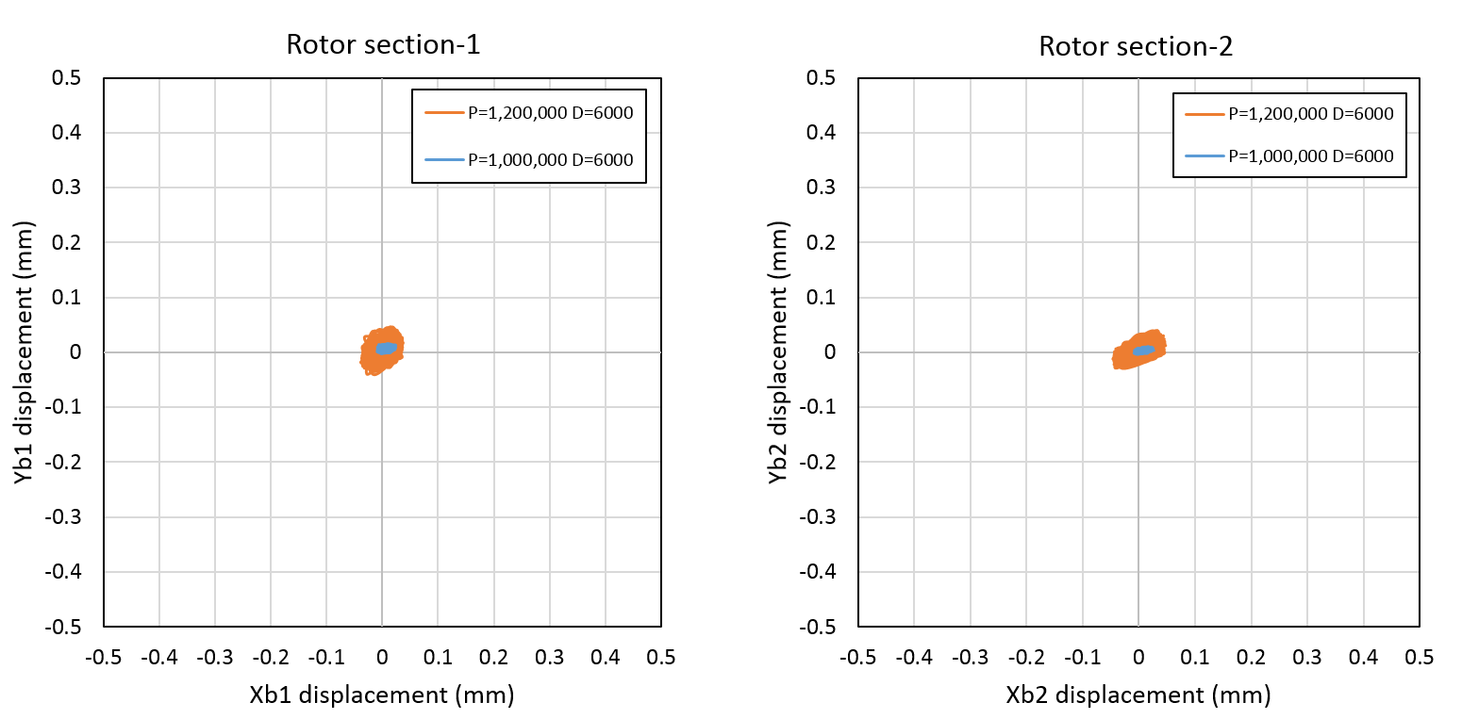
Figure 7-23 Comparison of measured rotor displacement in section-1 and section-2 implemented with same derivative gain (K_{D}=6000 N·s/N) but different proportional gain (K_{P}=1,000,000 N/m and 1,200,000 N/m)
Finally, integral action was incorporated to eliminate the steady state error. By progressively increasing the integral gain, a value of 1,080,000 N/m·s was selected. The selected PID parameters established from these dual-axis levitation experiments are summarised in Table 7-4 while Figure 7-24 shows the resulting levitation performance. It is worth noting that since both sections shows very similar performance with the selected PID parameters, only the performance of rotor section-1 is evaluated in details in the following sections.
As can be seen in Figure 7-24, rotor section-1 was successfully levitated and stabilized at reference zero in 0.13s. The corresponding combination of demand phase current and demand bearing forces are shown in Figure 7-25 (a) and Figure 7-26 respectively. Taking the example of the current measured in phase 7 in rotor section 1, the actual measured current was in excellent agreement with the demand current signal in Figure 7-25 (b). Since all 18 amplifiers were modified and tested in the same manner and showed essentially identical performance, only the current in phase 7 in rotor section 1 was measured to evaluate the machine performance.
As will be apparent in steady-state levitation, the magnitude of rotor displacements on both X- and Y-axis are controlled well within a 20μm band. As will be apparent the Y-axis demand force waveform for section 1 in Figure 7-26, there is net force demand for section 1 of 38N due to the rotor weight (i.e. half the total gravitational force of the entire rotor). It is also worth noting the significant x-axis force demand which is required to counteract coupling between axes and between sections.
Table 7-4 Selected optimal parameters of PID controller
Proportional gain $K_{P}$ | Integral gain $K_{I}$ | Derivative gain $K_{D}$
1,000,000 N/m | 1,080,000 N/m·s | 6000 N·s/m
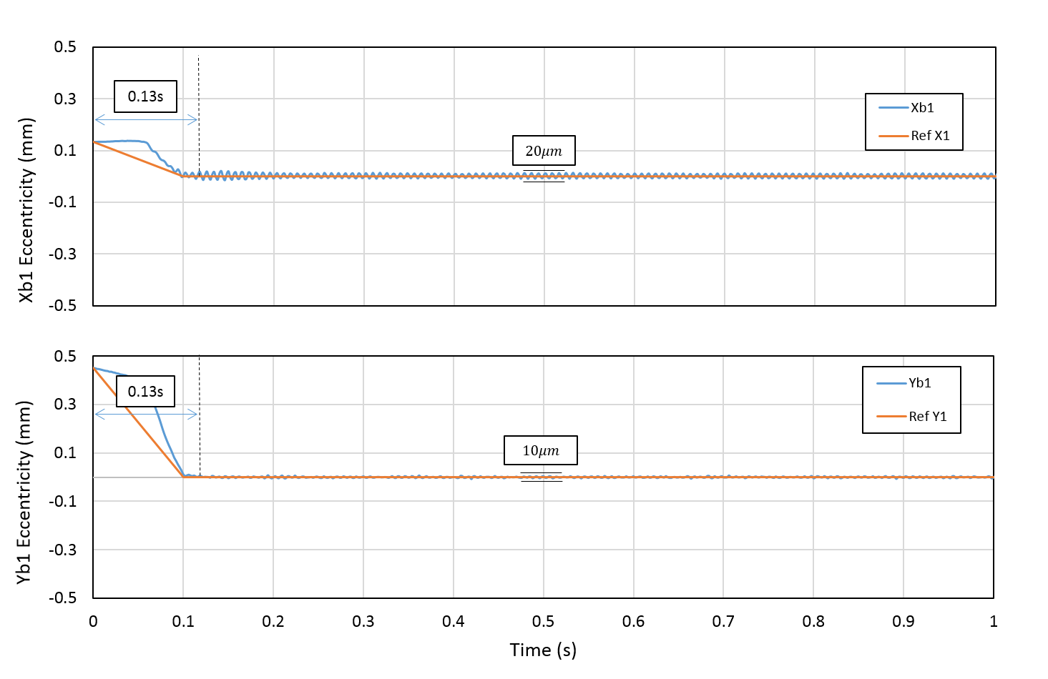
Figure 7-24 Dual-axis rotor levitation performance using the final PID selection (K_{P}=1,000,000 N/m, K_{I}=1,080,000 N/m·s and K_{D}=6000 N·s/m)
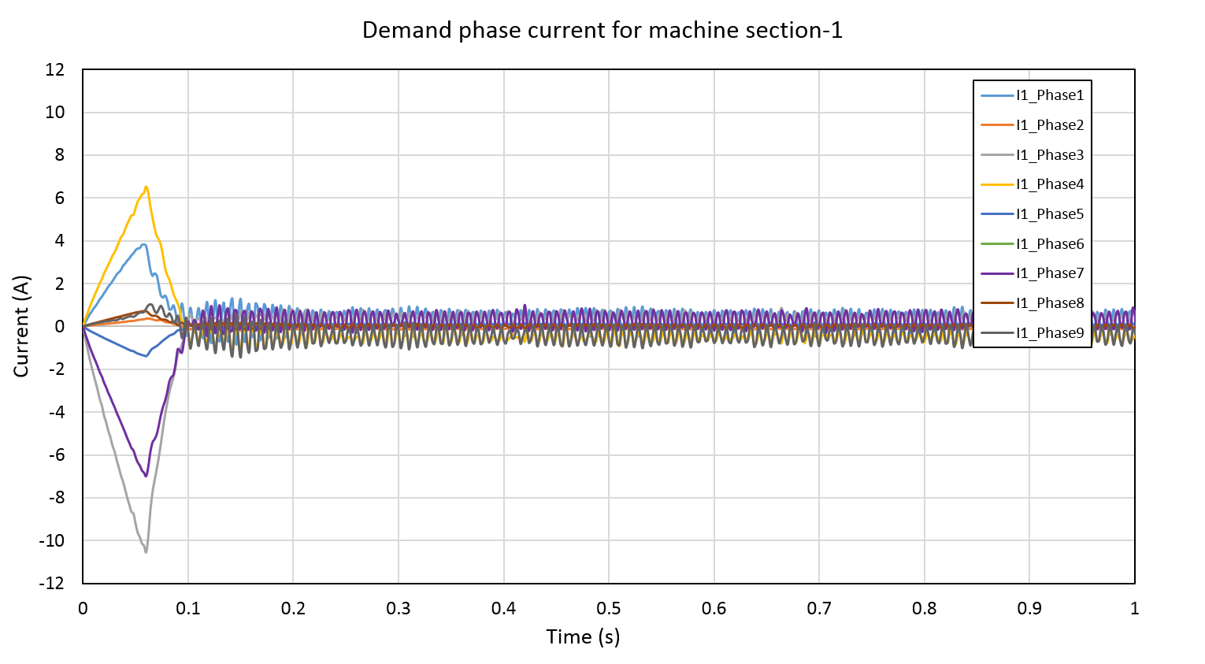
- Demand combination of phase current in section 1
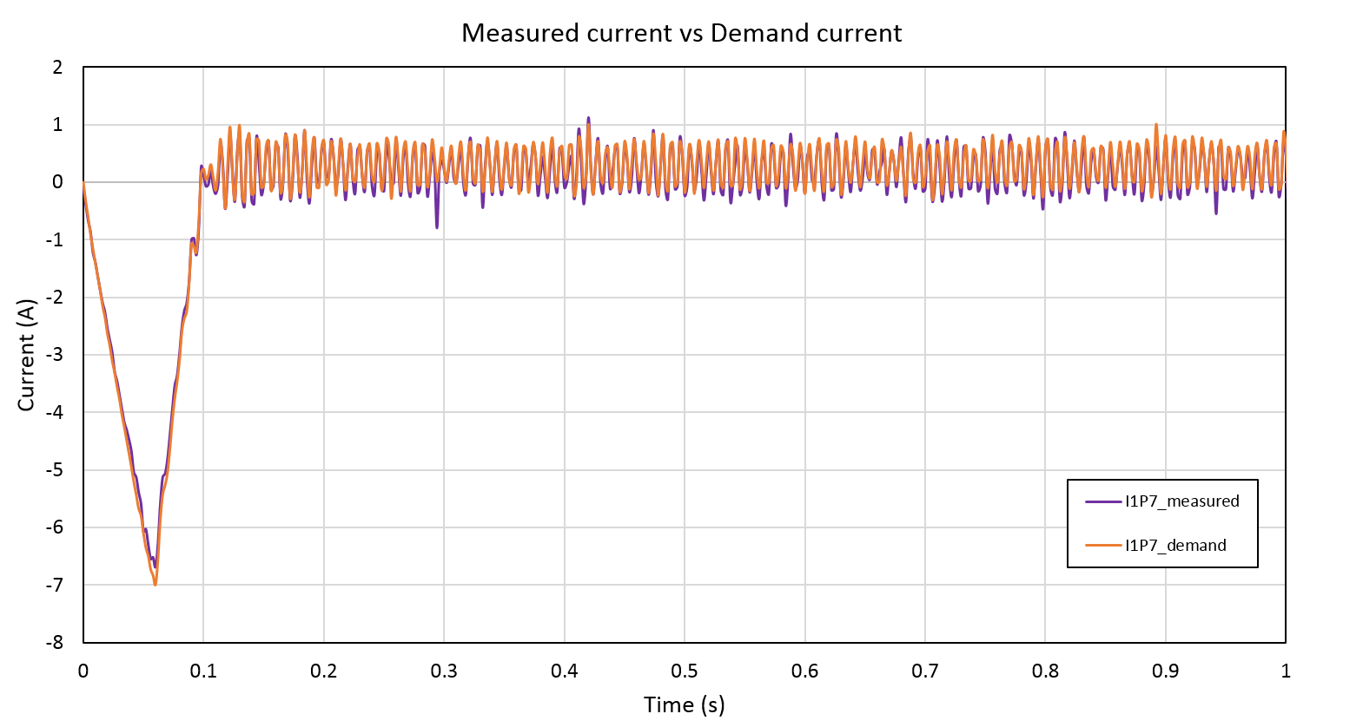
- Comparison of measured and demand current waveforms for phase 7 during levitation
Figure 7-25 Phase current response during lift-off and steady-state levitation

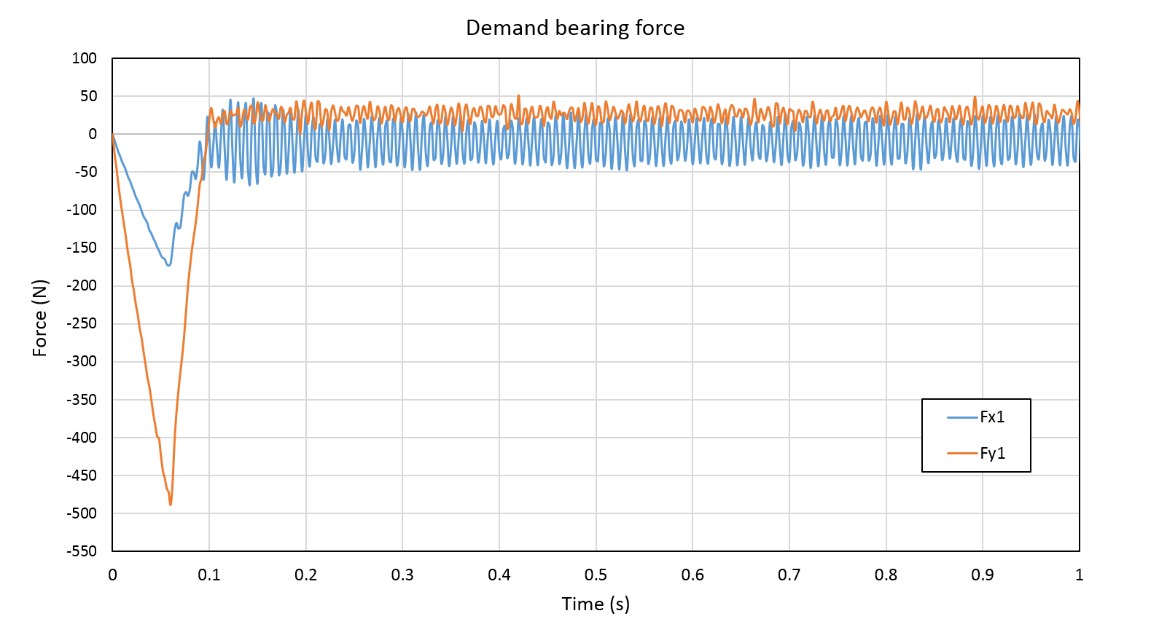
Figure 7-26 Demand signal for bearing force in rotor section-1

Bearing performance analysis
With the selected PID parameters listed in Table 7-4, bearing performance of the self-bearing machine was evaluated from the points of static stiffness and dynamic stiffness respectively. The experimental results, which were at this stage with a fixed rotor angular position, 10°, can be compared to the simulation results presented in section 4.2.2 as a means of validating the simulation.
- Static stiffness
As discussed previously in section 4.2.2, since the UMP is compensated by a pre-defined compensator, the static stiffness is nominally equal to the value of proportional gain, i.e., 1000N/mm. However, this is based on perfect compensation of the UMP and ideal amplifier and rotor position sensor behaviour. A series of experimental tests were performed in order to experimental measure the static stiffness. In order to replicate the step changes in load used in the simulations of CHAPTER 4, an additional external force was added at the input to the current optimisation controller as shown in the block diagram of Figure 7-27. This step change in force on the Y-axis is counteracted by the PID controller.
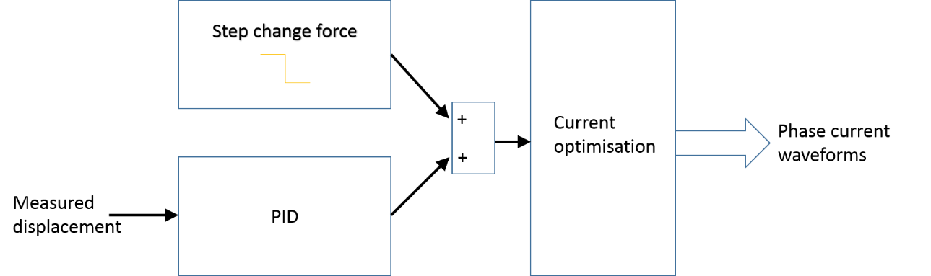
Figure 7-27 Block diagram of control scheme for Y-axis measuring static stiffness
External disturbance force signal with various magnitudes (-50N, -100N, -150N and -200N respectively) were applied using the approach shown in Figure 7-27 to both sections at a specified instant. The resulting measured response for a proportional gain of 1,000,000 N/m is shown in Figure 7-28. As will be apparent, the slew rate of the amplifier is apparent in the slope of the nominal ‘step-change’. A similar set of measurements were performed for a reduced proportional gain of 500,000 N/m. A comparison between measured and predicted static stiffness is shown in Figure 7-29.
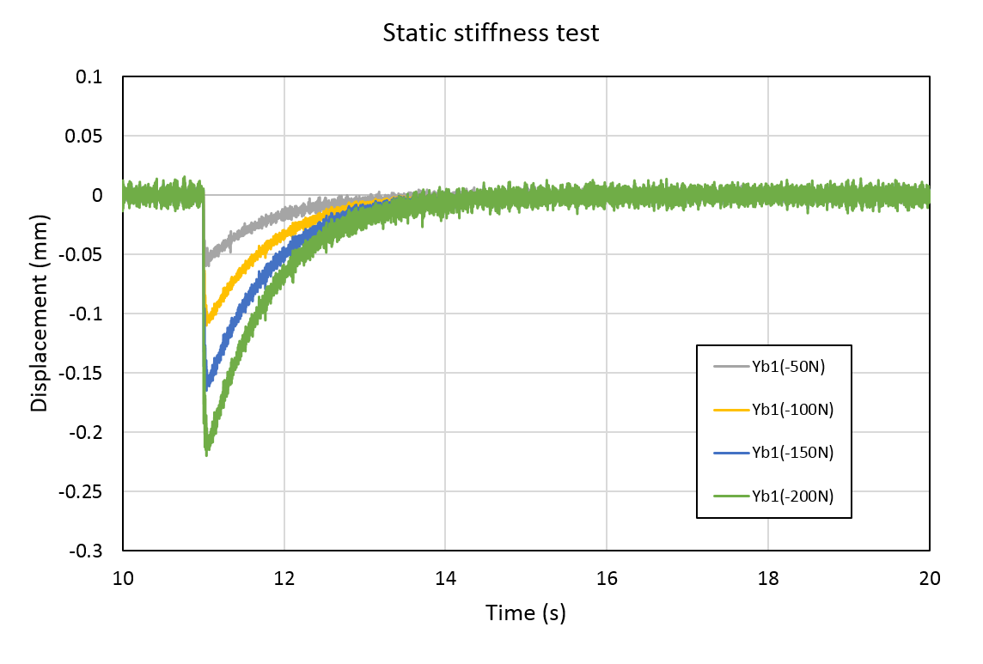
Figure 7-28 Measured rotor displacements with disturbance force signals of magnitudes of -50N, -100N, -150N and -200N equally applied to both sections at the specific time of 11s. The proportional gain used in this case was 1,000,000 N/m, i.e., 1000 N/mm.
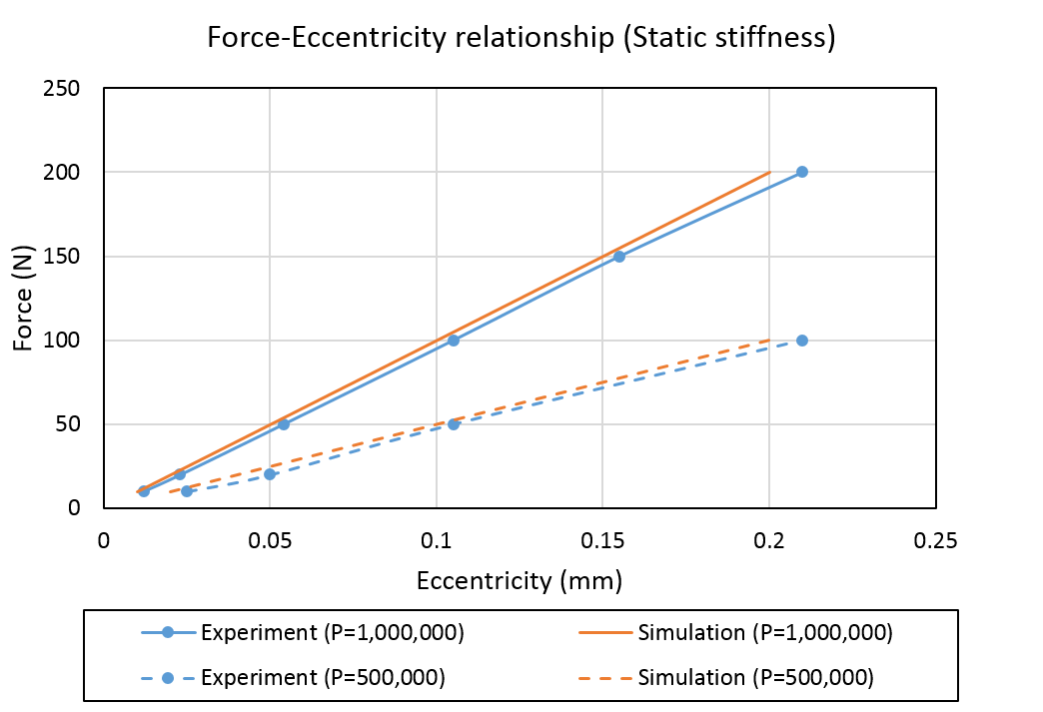
Figure 7-29 Comparison of Force-eccentricity relationship (static stiffness) between ideal system and practical system with the selected PID controller.
As can be seen from Figure 7-29, the experimental and simulation results are in good agreement for both values of proportional gain. The slope of each line represents the static stiffness (in N/mm) and are summarised in Table 7-5. As would be expected, the measured static stiffnesses slightly smaller than the simulation values due to the non-ideal behaviour of amplifiers and the likely limitations of the UMP compensator (which is based on two-dimensional finite element calculations). For the selected optimal proportional gain ($K_{P}=1,000,000 N/m$), the results in Figure 7-29 demonstrate that the system can successfully accommodate an 200N step downward force without contact being made with the back-up bearing, i.e., $Δε_{y1}≤-0.242mm$ obtained in Table 7-3.
Table 7-5 Static stiffness comparison between experimental and simulation results using for two values of proportional gain, 1,000,000 N/m and 500,000 N/m
Static stiffness (N/mm)
 | K_{P}=1,000,000 N/m | K_{P}=500,000 N/m
Experiment | 945 | 475
Simulation | 1000 | 500
- Dynamic stiffness
In addition to static stiffness, the rotor displacement response to harmonic excitation is another vital criterion to evaluate bearing performance for active magnetic bearing (AMB) applications. This aspect of performance is denoted as dynamic compliance in ISO standard [91].
The test involves recording rotor displacement in response to harmonic disturbance signal. The resulting measured force-eccentricity relationship can be represented in the frequency domain using the Bode diagram shown in Figure 7-30. In order to provide a consistent comparison with the simulation results obtained in section 4.2.2, a same harmonic disturbance with a magnitude of 50N was applied.
As can be seen from Figure 7-30, the experimental results exhibit good agreement with the simulation results. The resonant frequency of this combination of machine and controller was ~110Hz in both experimental and simulation results. The corresponding dynamic compliance magnitude of 2.5μm/N is useful for assessing the system bearing capability when machine is operating at its resonant frequency. Hence, the maximum magnitude of harmonic disturbance at resonance frequency is ~97N which corresponds to a displacement of ~0.24mm.
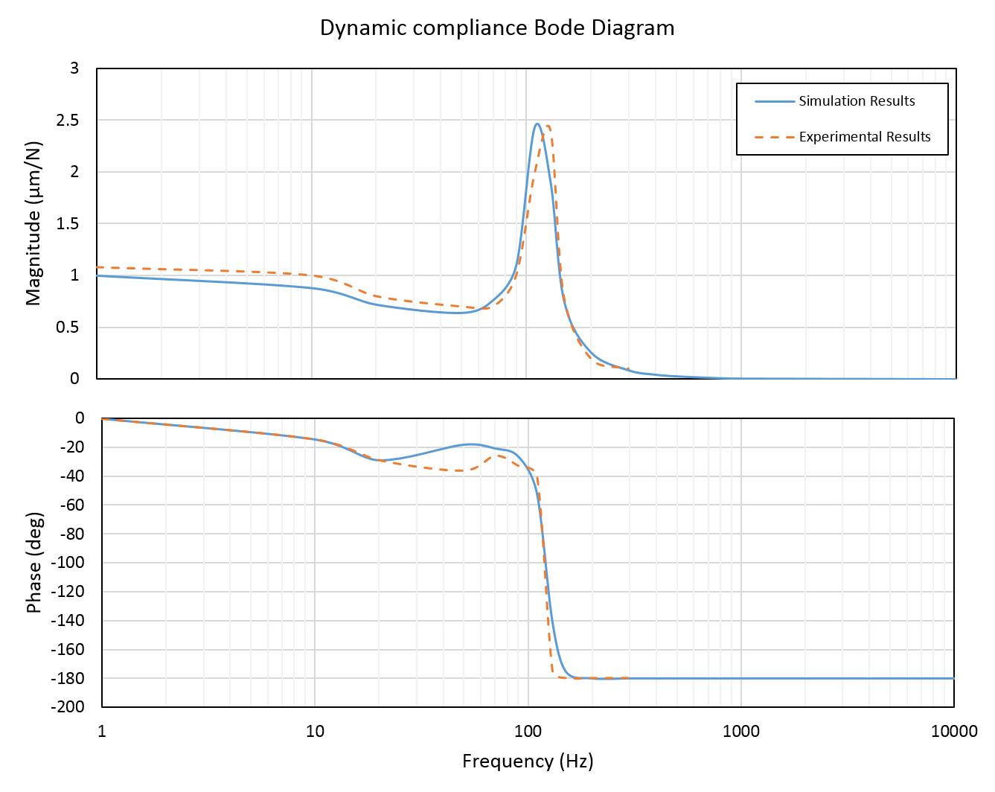
Figure 7-30 Measured and simulated Bode diagram for establishing dynamic compliance
- The influence of rotor angular position error on bearing performance
The final bearing action analysis considered in this section is the influence of angular position error on rotor displacement. The experimental assessments performed up to this point have been at a fixed angular position of 10°, a value which corresponds to a zero cogging torque of the finite element predicted cogging torque waveform shown previously in Figure 3-31. As well as physically fixing the rotor at this angular position, the control system was supplied with this as a precisely known angular position. In a practical machine, there may well be some uncertainty in the exact rotor position which may affect levitation performance. Such errors could be a result of limitations in an angular encoder or the effect of discrete sampling at the controller input. By deliberately applying prescribed angular errors onto the known rotor position (10°) as input to the control system, the sensitivity of levitation performance can be measured. A useful indicator in this regard is the magnitude of rotor oscillation.
Angular position errors between -2.0° to +2.0° were applied to a levitated rotor system at a fixed actual angular position of 10°. The variation in the measured magnitudes of X and Y direction oscillations with angular positional error are summarised Table 7-6. As expected, there is an increasing oscillation with increasing angular position error. With the maximum position error considered of${ ±2.0}^{°}$, the magnitude of rotor displacement increases to ~50μm in X direction and ~90μm in Y direction.
Table 7-6 Summary of levitation performance analysis with a range of angular position errors
Rotor fixed at $θ_{r}=10°$
Error | $$-2.0°$$ | $$-1.5°$$ | $$-1.0°$$ | $$-0.5°$$ | $$0.0°$$ | $$+0.5°$$ | $$+1.0°$$ | $$+1.5°$$ | $$+2.0°$$
$$X_{1}displacement$$  $$(μm)$$ | 50 | 40 | 30 | 25 | 20 | 25 | 20 | 30 | 40
$$Y_{1}displacement$$  $$(μm)$$ | 45 | 35 | 25 | 20 | 10 | 35 | 45 | 65 | 90

Dynamic levitation with continuous rotation
In the preceding section, the rotor was levitated at fixed angular positions of 10°. In this section, the machine is equipped with an angular encoder and allowed to rotate. The rotating levitation performance was tested under no-load conditions in the first instance, and then under load by means of a commercial DC machine.

No-load rotation test
The selected rotary encoder, AEAT-601B is a magnetic incremental encoder with an angular resolution of $0.35 {mech}^{°}$ . Encoder A, B and Z signals are continuously fed into dSPACE and decoded by a DS3001 incremental encoder interface board to provide updated rotor angular position and rotating speed values for each execution cycle of the controller. Therefore, a levitating rotor is able to rotate in response to feedback of angular position and could operate in speed control or torque control modes.
In a similar manner to that used for compensation of UMP compensator, a cogging torque (CT) compensator was implemented in the rotational tests thereby achieving smoother rotational movement. The first test involved simply rotating the rotor by hand.
Stable rotor levitation was achieved at all angles as is evident in the measured X and Y displacement traces in Figure 7-31. Since both sections exhibited similar performance, Figure 7-31 only shows the rotor displacement of rotor section 1. Figure 7-32 shows the corresponding measured rotational speed and angular position during the manual rotation.
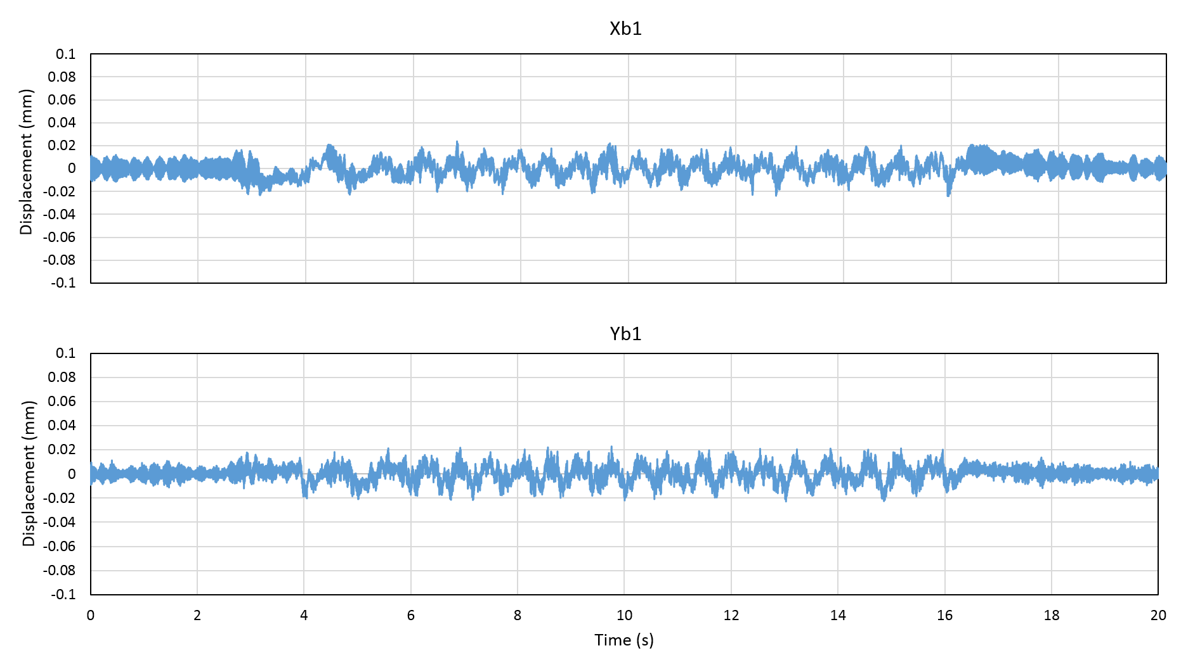
Figure 7-31 Measured rotor displacement of rotor section 1 in X- and Y-direction when manually rotated
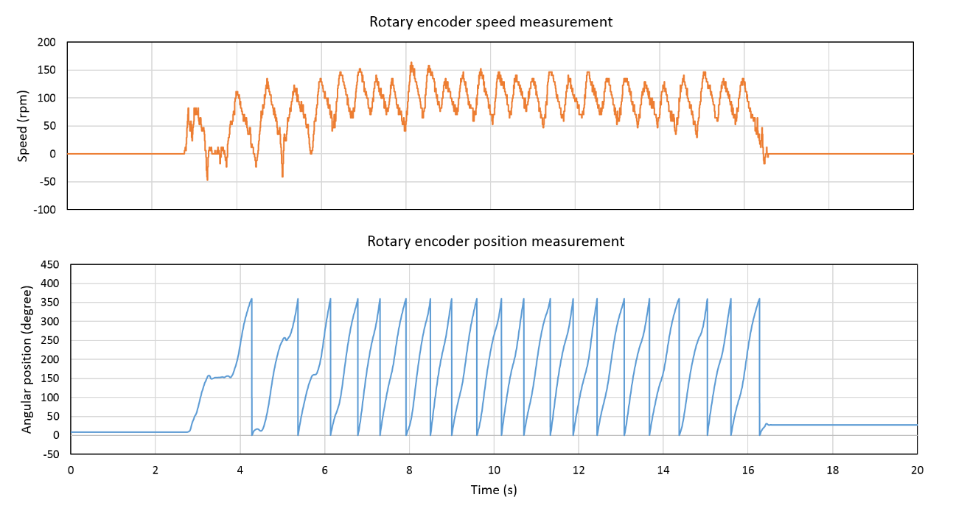
Figure 7-32 Rotary encoder measured position and speed feedback for the manual rotation test
The influence of rotational speed on rotor levitation is key point of interest. The centrifugal force due to mass imbalance and the tolerance of angular position feedback are both features that are likely to degrade performance with increasing speed.
It is well recognised that rotor mass imbalance results in a synchronous centrifugal force of a magnitude that is proportional to the square of its instantaneous speed, i.e., $ω^{2}$. Although this rigid symmetrical rotor was balanced to a balance quality grade of G2.5 in accordance with ISO 1940/1, it nevertheless still exhibits residual imbalance of 15.56gmm at angle of 209° and 23.38gmm at angle of 108° at either rotor end according to the balancing report contained in Appendix C.
Furthermore, since this real-time controller system is operating with a fixed execution cycle of 0.1ms, i.e., sampling at 10kHz, higher operating speeds will result in a larger angular uncertainty between successive execution cycles steps, i.e., 1.8° at rated speed of 3000rpm. According to the angular tolerance measurement shown previously in Table 7-6, a 1.8° angular tolerance is sufficient to markedly affect levitation performance under no-load condition.
Closed-loop speed control was implemented within the dSPACE control system using PI controller with the parameters shown in Table 7-7.
Table 7-7 PI controller for closed-loop speed control
Proportional gain | Integral gain
0.01 | 0.01
Figure 7-33 and Figure 7-34 shows a series of measurements taken at the initial test point of 100rpm, specifically rotational speed, no-load torque, rotor displacements and corresponding phase-current demands. As can be seen in Figure 7-33 (a), the measured machine speed shown an excellent agreement to the 100rpm reference speed. Due to the action of the cogging torque compensator, the no-load running torque demand is as shown in Figure 7-33 (b). There average torque at the 100rpm steady-state is a modest ~0.1Nm, for this no-load operating point. However, the torque demand during the accelerating period is significant higher than the no-load running torque, reaching a value of ~1.4Nm.
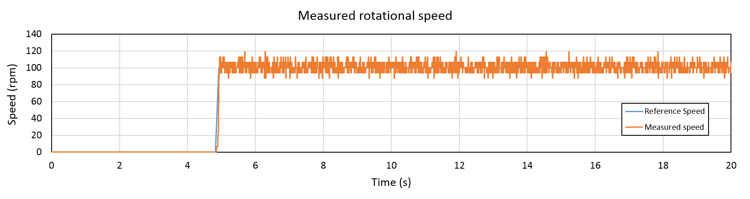
- Measured rotational speed
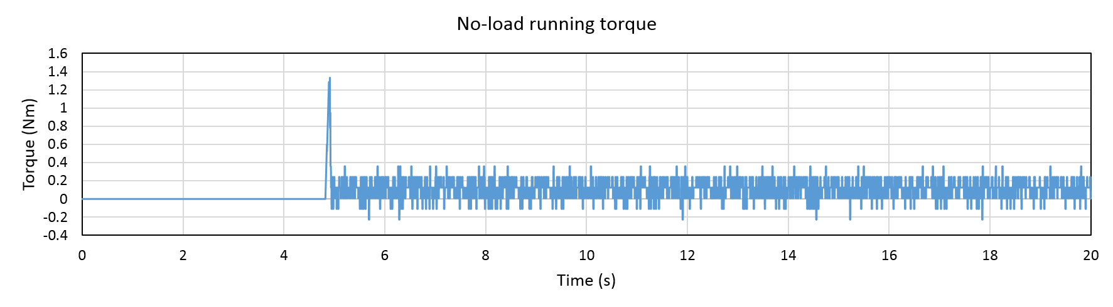
- Demand no-load running torque
Figure 7-33(a) Rotary encoder measured rotational speed compared to the demand speed signal (up to 100rpm) (b) Demand signal of no-load running torque
In Figure 7-34 (a) and (b), periodic oscillation of rotor displacements exist in both rotor sections when rotor started spinning at$t=5s$. The oscillations of either section have the same oscillating frequency of 1.67Hz, which is synchronous with the machine rotating frequency, and different oscillating magnitudes. The magnitudes of the oscillation are 50μm in rotor section-1 and 80μm in rotor section.
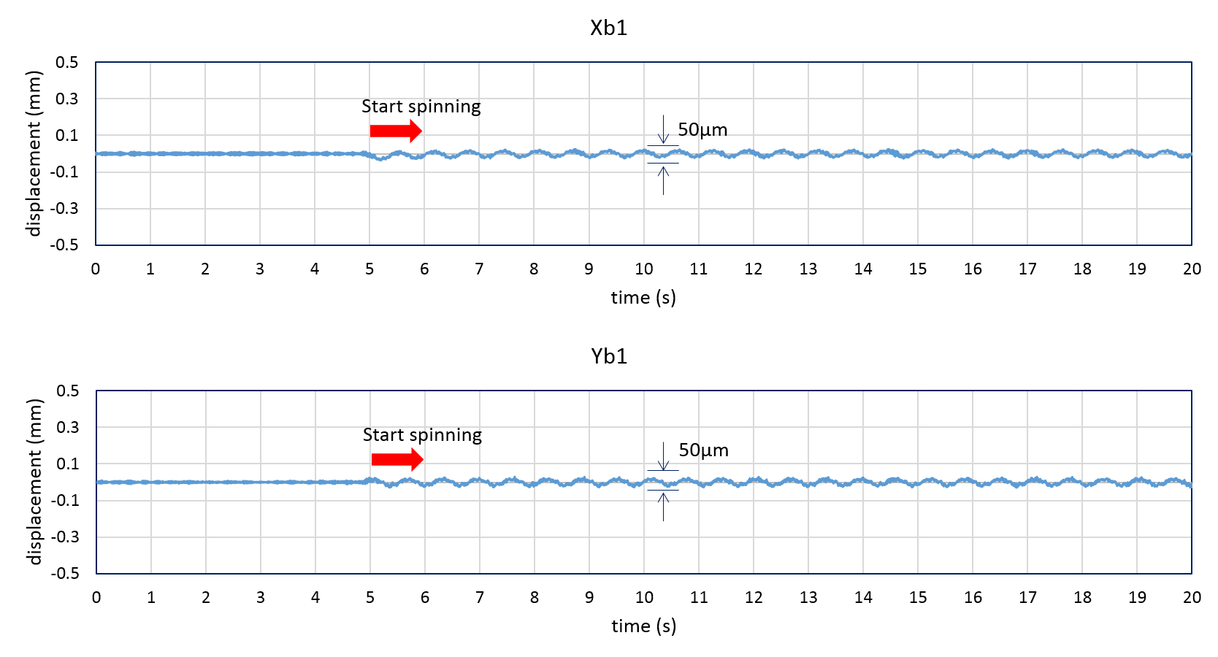
- Measured rotor section 1 displacement
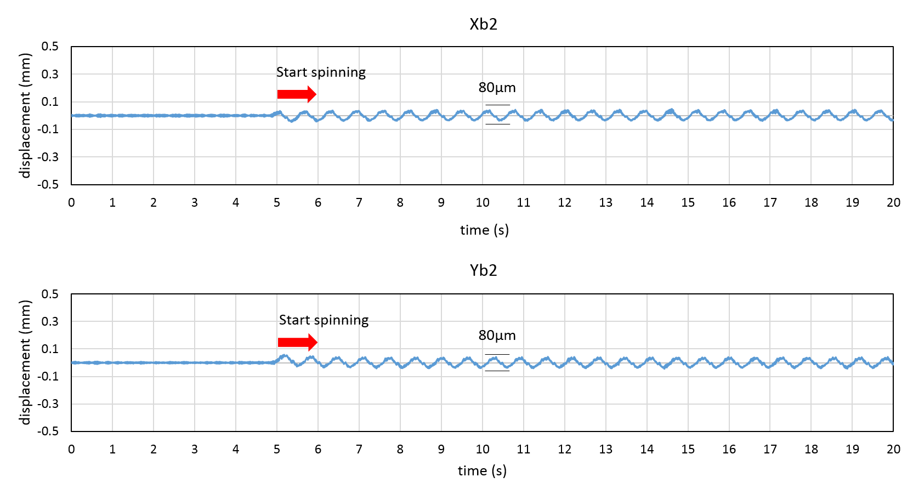
- Measured rotor section 2 displacement
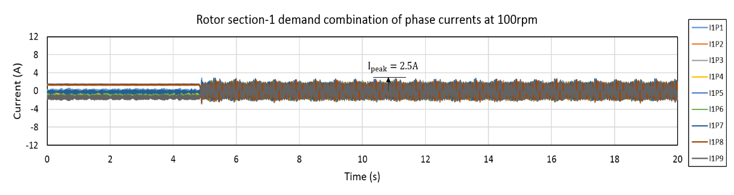
- Measured phase current combinations section 1
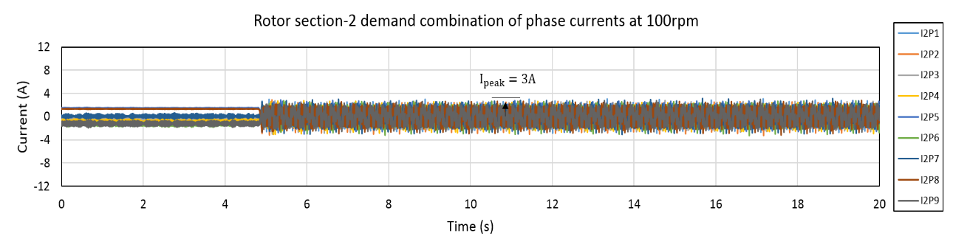
- Measured phase current combinations section 2
Figure 7-34 Prototype machine performance of rotor section 1 and 2 displacement (a) and (b), and corresponding current combinations (c) and (d)
As the machine is running at a modest speed of 100rpm, the angular error introduced by sampling was only ±0.06 mechanical degrees, a value that is negligible in the context of affecting rotor displacement. The speed dependant mass imbalance was regarded as the main reason causing the periodic oscillation.
By transforming rotor displacement of X and Y directions to the radial direction, the rotor displacement can be described by radial displacement as shown in Figure 7-35 and the corresponding equation of radial displacement can be represented as:
 | $$R_{b1}(θ_{r})=A_{b1}∠(θ_{r}+∆θ_{r_{b1}-r})$$ | (75)
 | $$R_{b2}(θ_{r})=A_{b2}∠(θ_{r}+∆θ_{r_{b2}-r})$$ | (76)
where $A_{b1}$ and $A_{b2}$ represent the magnitude of resultant radial displacement on rotor section-1 and rotor section-2. The direction of rotor displacement in both section are equal to the summation of rotor angular position $θ_{r}$ and the angular offset ($∆θ_{r_{b1}-r}$ of rotor section-1 and $∆θ_{r_{b2}-r}$ of rotor section-2) between the angle of radial displacements ($θ_{rb1}$ of section 1 and $θ_{rb2}$ of section 2 respectively) and rotor angular position.
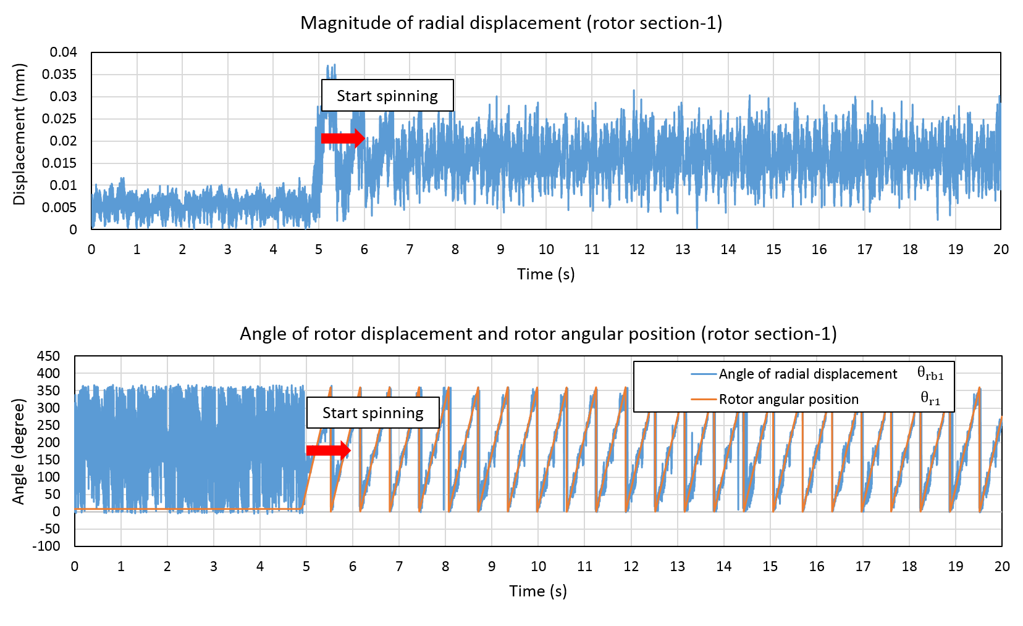
- Radial displacement of rotor section 1
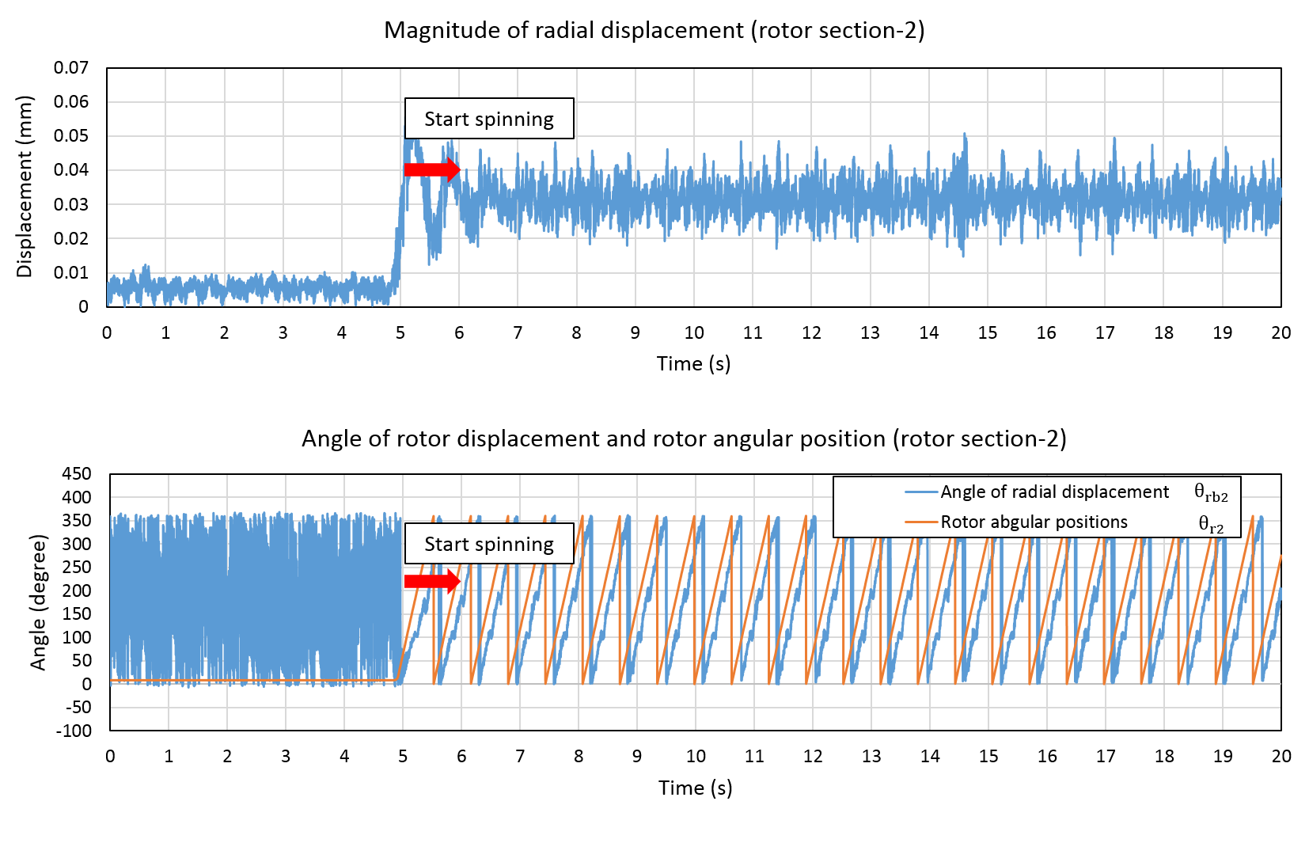
- Radial displacement of rotor section 2
Figure 7-35 Radial displacement of rotor section 1 (a) and section 2 (b)
It is worth noting that the amplitude and direction of radial displacements varies with rotational speed due to the changing resultant imbalance force and rotor angle tolerance. The angular tolerance at 1700rpm is ~-1.0°. According to the effect of angular tolerance shown previously in Table 7-5, the resultant rotor displacement with -1.0° error at static levitation was expected to be only a slightly larger rotor displacement, i.e., approximately a 10μm larger rotor oscillation. For this rotational test at speed of 100rpm, pre-defined angle errors (between -2.0° and 2.0°) were applied and no discernible difference in rotor displacement was observed.
However, Figure 7-36 shows the measured displacement at 1700rpm, from which it is clear that the displacements are significant larger than at 100rpm in both sections. It is therefore reasonable to conclude that at 1700rpm, the resultant imbalance force remains the dominant disturbance source causing increased rotor oscillation.
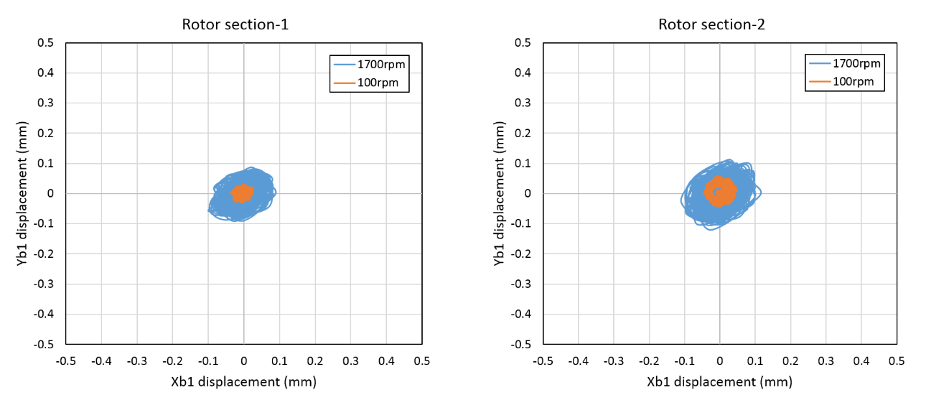
Figure 7-36 Comparison of rotor displacement operating at 100rpm and 1700rpm on no-load
As a conclusion, even though the rotor was previously balanced to grade G2.5, the resultant imbalance force still significantly affects the bearing performance and leads to a growing rotor displacement with increased rotational speed. Correspondingly, larger phase currents are required for the higher speed operation in order to produce sufficient excitation force to counteract the increased imbalance force, although it is recognised that the load on the rotor in this nominal no-load test will increase with speed.
Therefore, the power consumption to realise stable bearing performance is larger at higher operating speeds in the prototype machine, and this will inevitably results in a reduction of mechanical output power that can be delivered. This is discussed in more detail in the next section.

Mass imbalance compensation
Further improvements with regard to improving the robustness to mass-imbalance is discussed in this section.
The compensation of mass imbalance can be achieved with additions to the control system. In order to evaluate the resultant force of mass imbalance, it is convenient to transform the rotor displacements from the X- and Y-directions into a magnitude and direction of radial displacement as shown in Figure 7-35. The resulting expression for the centrifugal force$F_{MI}$ is given by equation (77) and (78) for rotor section-1 and section-2 respectively.
 | $$F_{{MI}_{1}}(θ_{r})=K_{{MI}_{1}}ω^{2}∠(θ_{r}+Δθ_{rb1-r}-Δθ_{rb1-MI1})$$ | (77)
 | $$F_{{MI}_{2}}(θ_{r})=K_{{MI}_{2}}ω^{2}∠(θ_{r}+Δθ_{rb2-r}-Δθ_{rb2-MI2})$$ | (78)
where $K_{MI1}$ and $K_{MI2}$ represent the force constant of resultant centrifugal force on rotor section-1 and rotor section-2 respectively. The direction of resultant centrifugal force is determined by the following factors:
- Rotor angular position $θ_{r}$: measured by rotary encoder.
- Angular offset $Δθ_{rb-r}$ between the resultant displacement direction $θ_{rb}$ and rotor angular position $θ_{r}$: obtained from resultant radial displacement of Figure 7-35.
- Angular offset $Δθ_{rb-MI}$ between the resultant displacement direction $θ_{rb}$ and resultant centrifugal force direction $θ_{MI}$: obtained from Bode diagram of dynamic compliance of Figure 7-30.
As the method for calculating force constant and constant angular difference for both sections are the same other than an offset angle, only the calculation of rotor section-2 is described in detail when machine was operating at 100rpm.
The angular difference ($Δθ_{rb2-r}$) between the direction of radial displacement and rotor angular position, which can be directly determined from Figure 7-35(b) for rotor section-2 is -84°. In addition, as the effect of mass imbalance is regarded as a harmonic disturbance with a periodic frequency which is synchronous with machine rotational frequency, then $Δθ_{rb2-MI2}$ is a frequency dependent value that represents the phase shift between radial displacement and mass imbalance. The value obtained from Figure 7-30 at 1.7Hz (i.e., 100rpm) is -2.3°.
In terms of the calculation of force constant, $K_{{MI}_{2}}$, of rotor section-2, the magnitude of Bode diagram of dynamic compliance at 1.7Hz is ~$0.98μm/N$. Since the magnitude of radial displacement on rotor section-2 is ~30μm, the corresponding magnitude of resultant centrifugal force is calculated to 30.6N. Therefore, $K_{{MI}_{2}}$ at the speed of 100rpm is equal to
 | $$K_{{MI}_{2}}=\frac{\left|F_{{MI}_{2}}\right|}{ω^{2}}=\frac{30.6}{110}=0.278 N/{rad}^{2}$$ | (79)
By substituting the above values of $K_{{MI}_{2}}$, $Δθ_{rb2-r}$ and $Δθ_{rb2-MI2}$ into equation (77), the expressions for resultant centrifugal force $F_{{MI}_{2}}(θ_{r})$ for section-2 is given by equation (81). Likewise, the resultant centrifugal force for section-1 is given by equation (80).
 | $$F_{{MI}_{1}}(θ_{r})=0.163ω^{2}∠(θ_{r}+2.3°)$$ | (80)
 | $$F_{{MI}_{2}}(θ_{r})=0.278ω^{2}∠(θ_{r}-81.3°)$$ | (81)
In order to eliminate the influence of the mass imbalance (predicted above for the case of roation at 100rpm), a mass imbalance compensation feature was added at the input to the current optimisation controller as shown in the block diagram of Figure 7-37. The resulting imporvement in the measured rotor oscillations in rotor section-1 and section-2 are shown in Figure 7-38.
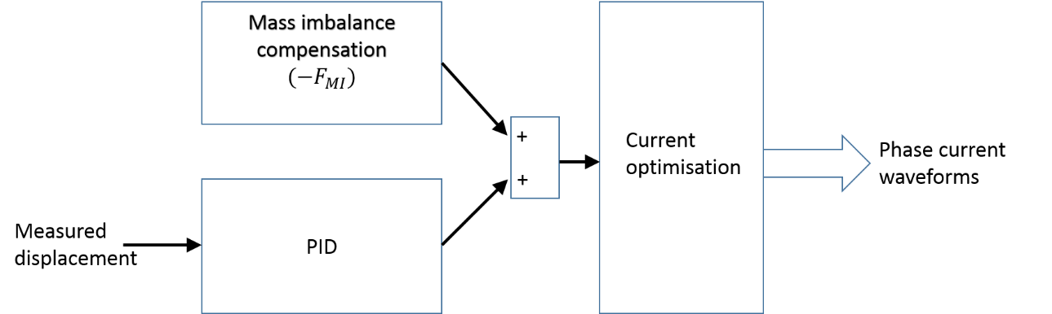
Figure 7-37 Block diagram of control scheme for mass imbalance compensation
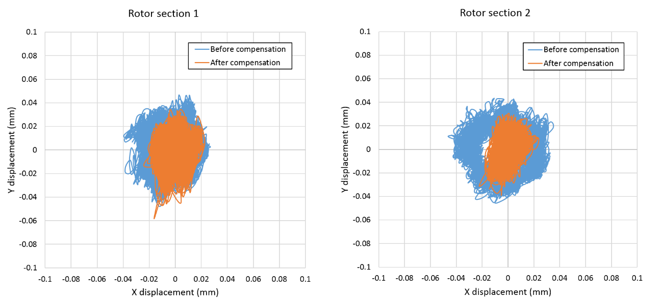
Figure 7-38 Comparison of measured rotor oscillation around reference point in rotor section-1 and section-2 with the compensation of mass imbalance effect at 100rpm
As will apparent in Figure 7-38, considerable reduction of rotor oscillation was observed after the application of mass imbalance. However, it is worth noting that the magnitude and offset angle for the estimated resultant effect of mass imbalance will be various at different speed thus an individual analysis of the above estimation process is necessary for each operation speed. An alternative effective way to identify the influence of mass imbalance is using traditional dynamic balancing approach to calculate the equivalent demand balancing force at each rotor section, and using the compensating control scheme to improve rotor levitation performance.

Rotation on load testing
For the dynamic test with torque load, the SBM prototype was coupled to a wound-field DC machine by means of a flexible coupling as shown in Figure 7-39.
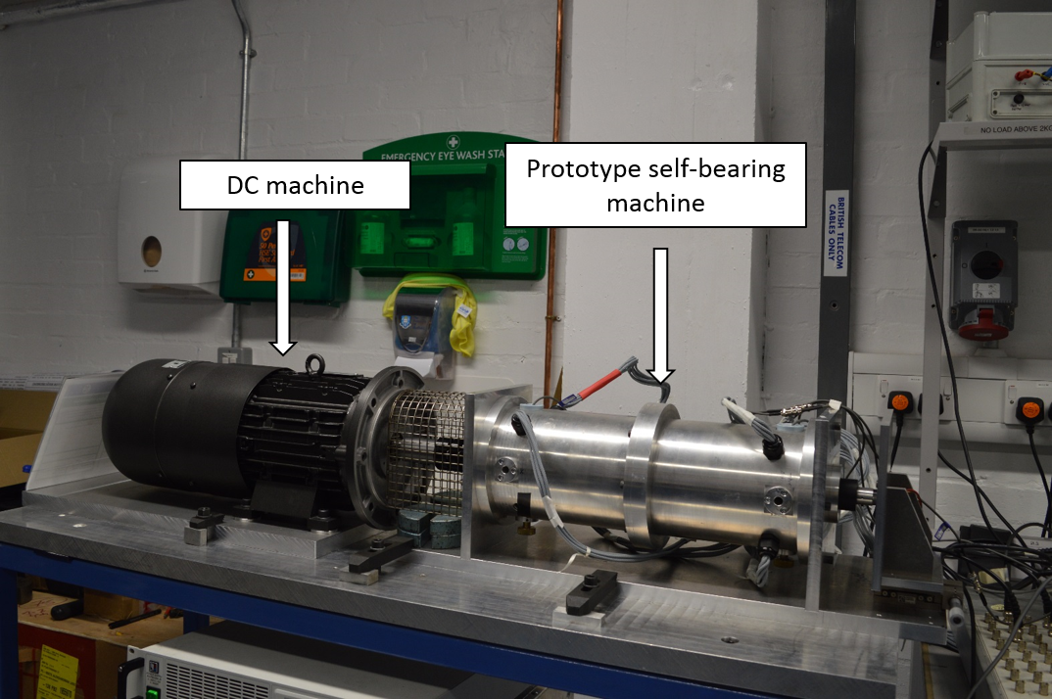
Figure 7-39 Experimental loading rig of the prototype self-bearing machine connected to a DC generator for the production of torque resistance
The selected DC machine is a wound field separately excited DC machine with the specification listed in Table 7-8. The induced back-EMF of the armature winding was characterised in terms of the field winding current and machine speed.
The prototype self-bearing machine was used to drive this DC machine on open-circuit in order to measure the induced armature winding back-EMF. The resulting variation in the back-EMF as a function of speed for three distinct field currents is shown in Figure 7-40. The correspond relationship between back-EMF constant $K_{e}$ and field winding current $I_{f}$ is shown in Figure 7-41.
It is well known that the value of back-EMF constant is equivalent to the torque constant in SI units, i.e., $K_{e}\left(\frac{V}{{rad}/s}\right)=K_{t}(\frac{Nm}{A})$. With the value of torque constant set by the field current, the load torque is directly proportional to the armature current, $I_{a}$ as shown in equation (82). A series of combinations of the load resistor $R_{load}$ were series connected to the armature winding terminals to adjust the desirable armature winding current in accordance with equation (83).
 | $$T_{load}=\frac{e_{a}∙I_{a}}{ω}=K_{e}I_{a}=K_{t}I_{a}$$ | (82)
 | $$I_{a}=\frac{e_{a}}{R_{load}+R_{a}}$$ | (83)
By substituting equation (83) to (82), the expression of torque load is also obtained as
 | $$T_{load}=\frac{{I_{a}}^{2}(R_{load}+R_{a})}{ω}$$ | (84)
where $R_{a}$ is the resistance of armature winding, which is 1.6Ω of this DC machine.
Rather than using a torque transducer to measure the value of torque load directly, it was inferred from the measured armature current $I_{a}$ and equation (84).
In order to illustrate the influence of load torque on machine performance, test were performed at load torques of 5.6Nm and 10Nm. Since the rated speed of this DC machine is limited to 1500rpm and the influence of machine speeds was assessed on no-load in the last section, measured results at a fixed speed of f 1500rpm are presented in this section.
Table 7-8 Specification of wound field DC machine
Output power | Rated speed | Armature winding rated current ($I_{a}$) | Field winding rated current ($I_{f}$)
2.2kW | 1500rpm | 16.3A | 0.48A
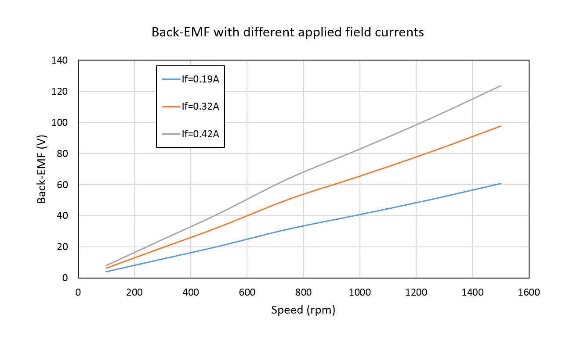
Figure 7-40 Measured induced back-EMF of the wound field DC load machine
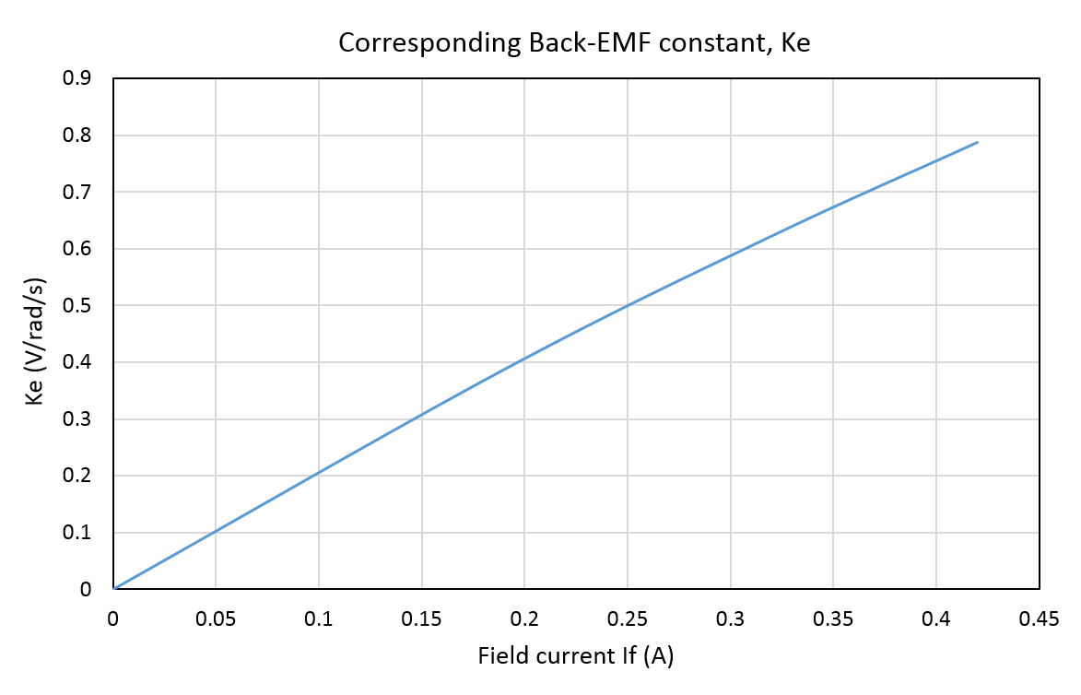
Figure 7-41 Relationship between back-EMF constant $K_{e}$ and field winding current $I_{f}$
Since the prototype self-bearing machine is coupled to the DC machine, the rotating inertia no-load losses are increased, while there may be some residual magnetisation in the DC machine at zero field current. Hence, the no-load accelerating and steady-state running torque for this rig was increased from that for the self-bearing machine alone as shown in Figure 7-42. For a speed demand ramp rate of 1000rpm per second, the torque demand increased to 3.2Nm during acceleration state and 0.9Nm at a steady state 1500rpm. Both of these two values are significant larger than on no-load conditions encountered without the DC machine, i.e. 1.4Nm and 0.1Nm respectively.
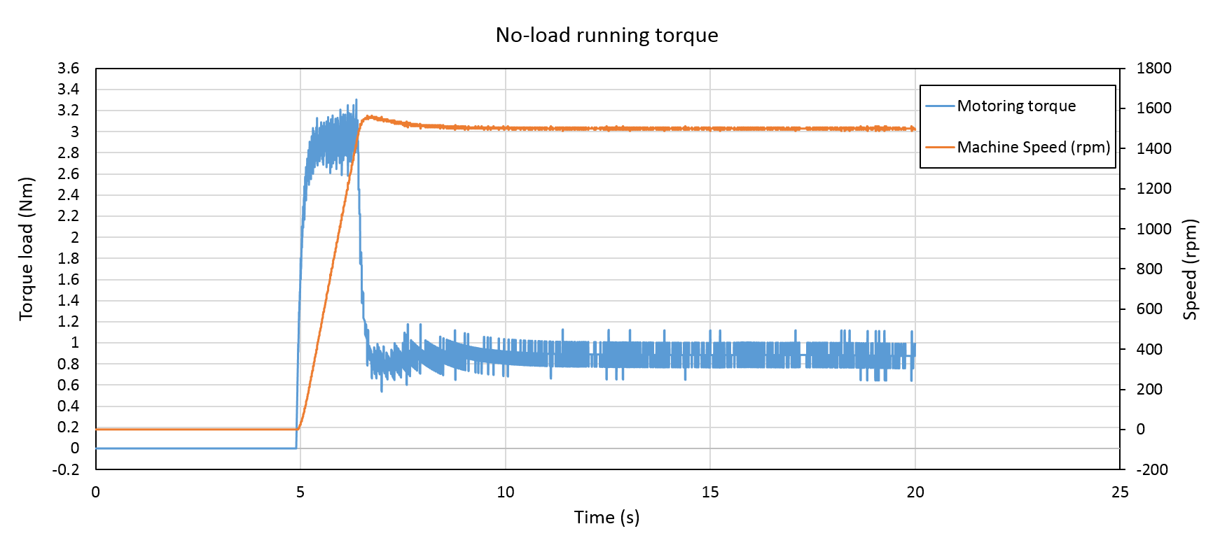
Figure 7-42 No-load running measured machine speed and torque inferred from measured armature current for the experimental rig of Figure 7-39
Figure 7-43 shows measured armature current waveforms for load resistors of 10.4Ω and 17.8Ω at rotational speed of 1500rpm. According to equation (84), these conditions correspond to torque values of 5.6Nm and 10Nm respectively.
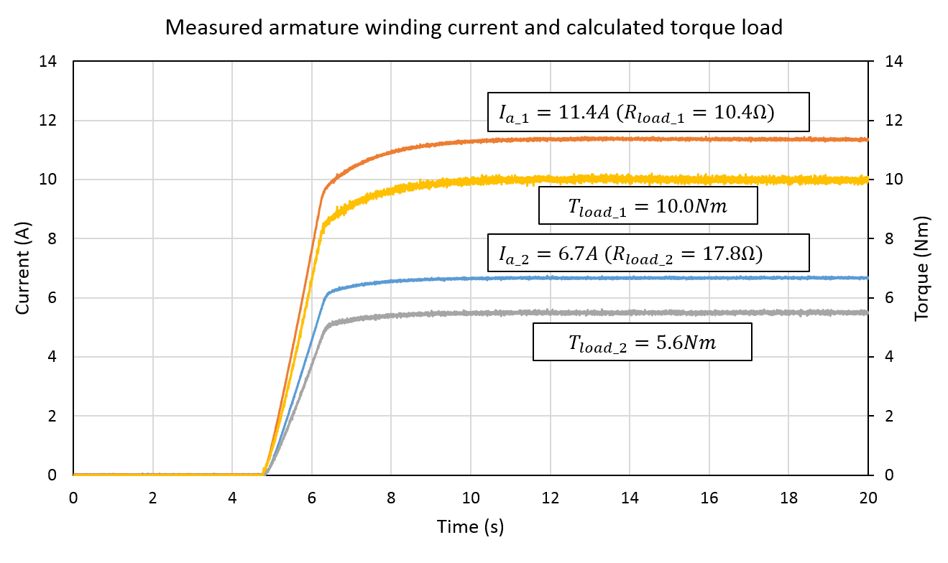
Figure 7-43 Measured variation in armature winding current (6.7A and 11.4A) and inferred torque load (5.6Nm and 10Nm)
For a given magnitude of field current, the load torque is proportional to machine speed. For the lower load resistor, i.e. higher load torque, a longer acceleration interval was required in order to reach steady state of 1500rpm. The measured speed versus time variations for no-load, 5.6Nm and 10Nm load torque are shown in Figure 7-44.
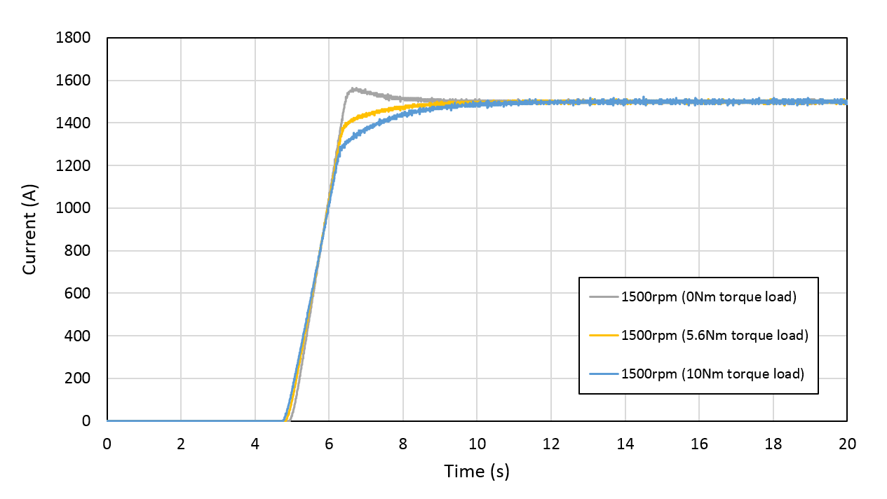
Figure 7-44 Measured variation in speed with the self-bearing machine machine operating at load torques of 0Nm, 5.6Nm and 10Nm
Figure 7-45 shows the measured rotor displacement at no-load, 5.6Nm and 10Nm. As will be apparent the higher torque load resulted in larger rotor oscillations in both rotor sections. This behaviour can be explained as a combination result of two factors:
- In section 6.3, the force capability was validated from lift-off tests for the entire section. This validated vector sum of excitation forces produced by all the excited phase but not necessarily the forces produced by the individual phases. Due to the original static experimental rig described in section 6.2 having insufficient stiffness, it proved not possible to measure the force producing capability each phase. The accumulation of mechanical and electrical tolerances is likely to result in some additional unbalanced forces from the components of current which are input to produce the demand torque. These disturbance forces, which must be counteracted by the closed loop bearing action controllers, will increase in magnitude with increasing torque.
- The higher current required for motoring function will lead to a reduction in the current slew rate that can be achieved within the voltage limit of the power amplified, resulting in a reduction in bearing action dynamic capability
As can be seen from the measured current waveforms of Figure 7-46, when rotor was operating with 10Nm torque load, the peak current magnitude approached the limit of the individual power amplifiers. This is a consequence of the additional current required to counteract the greater rotor displacement due to the increased torque load. Therefore, the increased bearing power demand leads to a reduction of mechanical output power. As a consequent, the maximum mechanical out power achieved with this machine was ~1.57kW at 1500rpm
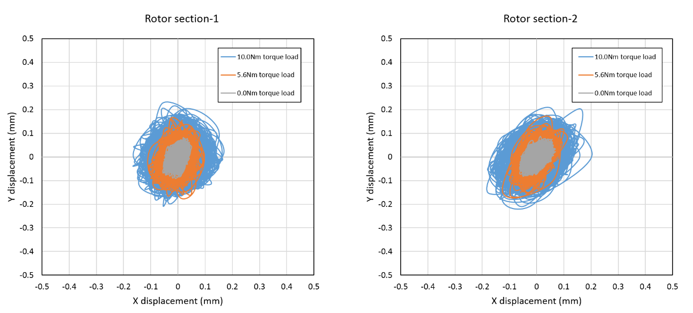
Figure 7-45 Measured rotor displacement with load torque of 0Nm, 5.6Nm and 10Nm at 1500rpm
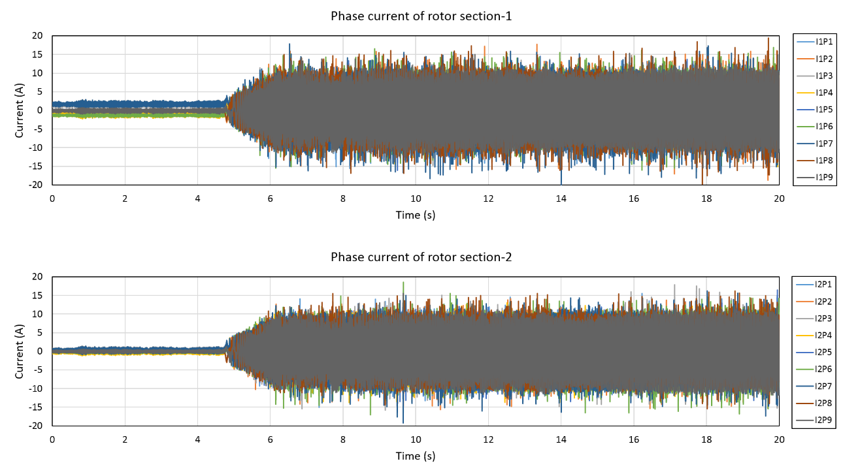
Figure 7-46 Demand current combinations of rotor section 1 and 2 with machine operating at torque load of 10Nm

Conclusion
In this chapter, the prototype self-bearing SPM machine was extensively tested in terms of static levitation performance (bearing function only) and levitation with rotation performance (bearing and motoring functions). The details of an effective PID tuning approach using practical experiments assisted by theoretical and simulation results was described. This approach provides a comprehensive evaluation of the practical levitation performance response to the PID parameters. With the selected PID parameters, static stiffness and dynamic of the prototype machine was measured and showed a good agreement with the simulation results presented previously in section 4.2.2.
For simultaneous bearing and motoring operation, a contactless incremental rotary encoder was incorporated in order to realise five degrees of freedom. In order to evaluate the bearing and motoring functions simultaneously, the influence of machine speed and torque load were discussed. Due to mass imbalance, a gradually increasing rotor displacement was observed with increasing rotational speed. Moreover, the increasing load torque also resulted in more pronounced rotor oscillation. As a consequence of this undesirable rotor displacement due to increased machine speed and load torque, additional bearing power was required. This in turn results in a reduced power capability which in the series of tests performed, achieved maximum output power of 1.57kW at the rated speed and torque of 1500rpm and 10Nm respectively.

Conclusion

Contribution of this thesis
This thesis has reported on a comprehensive study into several aspects of surface-mounted permanent magnet self-bearing machines. For laboratory purpose, the majority of existing self-bearing machines have two degrees of freedom. In order to achieve a more reliable result with a fully levitated rotor for the engineering purpose, the prototype self-bearing machine designed in this thesis has five degrees of freedom as described in section 4.1.2.
Some key fundamental and generic contributions have been made in the electromagnetic design of self-bearing machines. A key performance criterion for realising useful bearing action is the ability to produce a demanded restoring force on the rotor in any arbitrary direction at all rotor angular positions. Meeting this criterion has a major influence on the selection of the number of stator teeth and rotor poles, since some combinations are far better suited to self-bearing operation. An analytical force was proposed in in section 3.1, which is useful for identifying likely combinations of slot and pole numbers. This led to a combination of 9-slot and 6-pole being selected for the demonstrator machine which was designed during this programme of research.
The design of the demonstrator machine in CHAPTER 3 illustrated that some design trade-offs are different in machines which are required to be self-bearing compared to more conventional machines. As an example, the selection of the optimum magnet thickness involves a balance between torque capability and radial force capability. As a result, the magnet is thin in comparison to conventional machines.
As noted in the literature review in CHAPTER 2, many existing designs have two separately controlled ‘motoring’ and ‘bearing’ windings. Whereas this separates out the functions which may simplify control, there may well be magnetic coupling between the function. Furthermore, separate winding can lead to poor utilisation of the available slot area since the windings are dimensioned separately for the worst-case conditions. The alternative novel approach which is developed in this thesis is to produce both torque and bearing force with a single set of windings. By controlling each concentrated coil individually, a current optimisation algorithm has been developed which both meets a given force and torque demand while also minimising the copper losses. The accompanying analytical force model, which is relatively straightforward to implement in real time if required, was successfully validated by finite element analysis using CEDRAT FLUX2D.
In order to model the five degrees of freedom rotor dynamics, a system level simulation model was established and this was able to effectively predict the static and dynamic performance of the optimised machine design. Particular attention was paid to the selection of coil turns due to the dynamic constraints of power amplifier. This is another feature of design which sets self-bearing machines apart from more conventional machines in which the considerations are usually limited to matching the back-emf to the converter voltage.
The importance of optimising the power amplifiers to realise the full potential of the machine was illustrated in CHAPTER 5. By combining loop tuning and performance compensation, the operating range was extended from 100Hz to 800Hz without excessive increases in the gain of the internal current control loop
In order to validate the force capability of the practical prototype machine, two approaches were investigated. In the first direct measurements with a force transducer were attempted but proved unsuccessful due to the limited stiffness of the rotor and the supporting structure. This would have allowed full force characterisation on a coil-by-coil basis. Having failed to construct a test-rig of sufficient stiffness despite several design revisions, an alternative approach using static lift-off provided an effective means of validating the force model by establishing the additional current required to lift-off additional known masses added to the rotor. The resultant experimental inferred force capability showed good agreement with the results predicted by the analytical force model and non-linear finite element model, although the validation was for net force produced by a number of coils rather than validation on a coil-by-coil basis.
It was demonstrated in this thesis the uncontrolled unbalanced magnetic pull which arises as a result of the normal component of reluctance force between the rotor magnets and the stator core is a major challenge in terms of producing stable levitation of the rotor since it introduces as a very significant negative stiffness. It is also problematic as a significant force to overcome during initial levitation from the back-up bearing. In CHAPTER 7, an efficient and effective PID tuning approach was described with three key steps. Progressive levitating performance was achieved from single-axis levitating control and dual-axis levitating control. With the selected PID parameters given in Table 7-4, the static stiffness of 1000N/m and rotor resonance frequency of 110Hz was confirmed for this prototype self-bearing machine. Furthermore, the full dynamic performance with a rotating rotor was tested under no-load and load conditions, and at various speeds.
Overall, this thesis has described several innovative aspects of self-bearing machine electromagnetic design and control and demonstrated the results on a prototype.

Future work

Alternative static experimental rig design using Dual-axis radial force sensors
As discussed in CHAPTER 6, the original static experimental rig that aimed to realise direct measurement of force using transducers came up against many difficulties associated with the test-rig having insufficient mechanical stiffness. Therefore, an alternative design of static experimental rig using radial force sensors is necessary. Preliminary work on a revised rig is shown in Appendix D. The construction of this rig would allow more comprehensive and direct validation of the force model to be performed.

Mass imbalance compensation
During the no-load testing of section 7.3.1, the magnitude of rotor oscillation was influenced by the machine speed due to mass imbalance despite the fact that the prototype rotor was pre-balanced to the grade of G2.5. Since achieving a finer level of balance is both difficult and potential expensive, the development of compensating control scheme for mass imbalance would make a useful contribution to future work that would improve machine performance. Although this was addressed at a single speed in CHAPTER 7, there is scope to more fully explore this aspect of behaviour.

REFERENCE

[1] T. Fukao and A. Chiba, "1 - Introduction," in Magnetic Bearings and Bearingless DrivesOxford: Newnes, 2005, pp. 1-15.
[2] T. Hiromi, T. Katou, A. Chiba, M. Azizur Rahman, and T. Fukao, "A novel magnetic suspension force compensation in a bearingless induction motor with a squirrel cage rotor," in Industry Applications Conference, 2005. Fourtieth IAS Annual Meeting. Conference Record of the 2005, 2005, vol. 3, pp. 1561-1566 Vol. 3.
[3] A. Chiba and J. A. Santisteban, "A PWM harmonics elimination method in simultaneous estimation of magnetic field and displacements in bearingless induction motors," in 2011 IEEE International Electric Machines & Drives Conference (IEMDC), 2011, pp. 1042-1047.
[4] R. L. A. Ribeiro, F. E. F. Castro, A. O. Salazar, and A. L. Maitelli, "A Suitable Current Control Strategy for Split-Phase Bearingless Three-Phase Induction Machine," in 2005 IEEE 36th Power Electronics Specialists Conference, 2005, pp. 701-706.
[5] K. Min, H. Jin, Y. Jia-qiang, and J. Hai-bo, "Analysis and experiment of a 6-phase bearingless induction motor," in Electrical Machines and Systems, 2008. ICEMS 2008. International Conference on, 2008, pp. 990-994.
[6] K. M. HUANG Jin, YANG Jia-qiang, "Analysis of a new 5-phase bearingless induction motor," Journal of Zhejiang University SCIENCE pp. 1311-1319, 2007.
[7] A. Chiba, D. T. Power, and M. A. Rahman, "Characteristics of a bearingless induction motor," Magnetics, IEEE Transactions on, vol. 27, no. 6, pp. 5199-5201, 1991.
[8] A. Chiba and T. Fukao, "Optimal design of rotor circuits in induction type bearingless motors," IEEE Transactions on Magnetics, vol. 34, no. 4, pp. 2108-2110, 1998.
[9] L. C. Xiaodong Sun, Zebin Yang, "Overview of Bearingless Induction Motors," Mathematical Problems in Engineering, vol. 2014 (2014), p. 10, 2014.
[10] M. N. Anwar, I. Husain, and A. V. Radun, "A comprehensive design methodology for switched reluctance machines," IEEE Transactions on Industry Applications, vol. 37, no. 6, pp. 1684-1692, 2001.
[11] L. Chen and W. Hofmann, "Speed Regulation Technique of One Bearingless 8/6 Switched Reluctance Motor With Simpler Single Winding Structure," IEEE Transactions on Industrial Electronics, vol. 59, no. 6, pp. 2592-2600, 2012.
[12] H. Wang, Y. Wang, X. Liu, and J. W. Ahn, "Design of novel bearingless switched reluctance motor," IET Electric Power Applications, vol. 6, no. 2, pp. 73-81, 2012.
[13] M. Takemoto, H. Suzuki, A. Chiba, T. Fukao, and M. A. Rahman, "Improved analysis of a bearingless switched reluctance motor," IEEE Transactions on Industry Applications, vol. 37, no. 1, pp. 26-34, 2001.
[14] K. Yang, Z. Zhu, and Y. Sun, "Decoupling control of single winding bearingless switched reluctance motors based on support vector machine inverse system," in 2014 17th International Conference on Electrical Machines and Systems (ICEMS), 2014, pp. 1829-1833.
[15] P. Wei, Z. Fengge, and A. Jin-Woo, "Design and control of a novel bearingless SRM with double stator," in 2012 IEEE International Symposium on Industrial Electronics, 2012, pp. 1928-1933.
[16] F. C. Lin and S. M. Yang, "An Approach to Producing Controlled Radial Force in a Switched Reluctance Motor," IEEE Transactions on Industrial Electronics, vol. 54, no. 4, pp. 2137-2146, 2007.
[17] X. Cao, Z. Deng, G. Yang, and X. Wang, "Independent Control of Average Torque and Radial Force in Bearingless Switched-Reluctance Motors With Hybrid Excitations," IEEE Transactions on Power Electronics, vol. 24, no. 5, pp. 1376-1385, 2009.
[18] J. Zhou, Z. Deng, X. Cao, C. Liu, and C. Liu, "Decoupling mechanism of torque and levitation-force control for 12/4 dual-winding bearingless switched reluctance motor," in 2016 19th International Conference on Electrical Machines and Systems (ICEMS), 2016, pp. 1-6.
[19] Z. Qiu, J. Dai, J. Yang, X. Zhou, and Y. Zhang, "Research on Rotor Eccentricity Compensation Control for Bearingless Surface-Mounted Permanent-Magnet Motors Based on an Exact Analytical Method," IEEE Transactions on Magnetics, vol. 51, no. 11, pp. 1-4, 2015.
[20] J. Asama, T. Oi, T. Oiwa, and A. Chiba, "Investigation of integrated winding configuration for a two-DOF controlled bearingless PM motor using one three-phase inverter," in 2017 IEEE International Electric Machines and Drives Conference (IEMDC), 2017, pp. 1-6.
[21] A. B. G. Munteanu, T. Schneider, "Development and test of high-speed bearingless PM synchronous machines," Springer, vol. 128, no. 3, pp. 75-80, 2011.
[22] M. Sawada et al., "A study on a bearingless drive of a surface permanent magnet synchronous motor," in 2012 15th International Conference on Electrical Machines and Systems (ICEMS), 2012, pp. 1-4.
[23] M. Henzel and K. Falkowski, "The analysis of the bearingless electric motor with surface-mounted permanent magnets," in Proceedings of the 13th International Carpathian Control Conference (ICCC), 2012, pp. 215-220.
[24] X. D. Sun et al., "Modeling and finite element analysis of suspension force for a bearingless permanent magnet synchronous motor," in 2015 IEEE International Conference on Applied Superconductivity and Electromagnetic Devices (ASEMD), 2015, pp. 535-536.
[25] R. P. Jastrzebski, P. Jaatinen, O. Pyrhönen, and A. Chiba, "Design of 6-slot inset PM bearingless motor for high-speed and higher than 100kW applications," in 2017 IEEE International Electric Machines and Drives Conference (IEMDC), 2017, pp. 1-6.
[26] A. Chiba, T. Fukao, and M. A. Rahman, "Performance characteristics and parameter identification for inset type permanent magnet bearingless motor drive," in Power Engineering Society General Meeting, 2004. IEEE, 2004, pp. 1268-1271 Vol.2.
[27] K. Inagaki, A. Chiba, M. A. Rahman, and T. Fukao, "Performance characteristics of inset-type permanent magnet bearingless motor drives," in Power Engineering Society Winter Meeting, 2000. IEEE, 2000, vol. 1, pp. 202-207 vol.1.
[28] R. P. Jastrzebski, P. Jaatinen, H. Sugimoto, O. Pyrhönen, and A. Chiba, "Design of a bearingless 100 kW electric motor for high-speed applications," in 2015 18th International Conference on Electrical Machines and Systems (ICEMS), 2015, pp. 2008-2014.
[29] P. Jaatinen, R. P. Jastrzebski, H. Sugimoto, O. Pyrhönen, and A. Chiba, "Optimization of the rotor geometry of a high-speed interior permanent magnet bearingless motor with segmented magnets," in 2015 18th International Conference on Electrical Machines and Systems (ICEMS), 2015, pp. 962-967.
[30] P. Jaatinen, R. P. Jastrzebski, and O. Pyrhönen, "Comparison of winding arrangements of a high-speed interior permanent magnet bearingless machine," in 2016 19th International Conference on Electrical Machines and Systems (ICEMS), 2016, pp. 1-6.
[31] T. Matsuzaki, M. Takemoto, S. Ogasawara, S. Ota, K. Oi, and D. Matsuhashi, "Rotor structure suppressing suspension force ripple in an IPM type bearingless motor with 2-pole motor windings and 4-pole suspension windings," in 2012 XXth International Conference on Electrical Machines, 2012, pp. 744-750.
[32] T. Matsuzaki, M. Takemoto, S. Ogasawara, S. Ota, K. Oi, and D. Matsuhashi, "Operational characteristics of an IPM-type bearingless motor with 2-pole motor windings and 4-pole suspension windings," in 2015 IEEE Energy Conversion Congress and Exposition (ECCE), 2015, pp. 3886-3894.
[33] Y. Okada, S. Miyamoto, and T. Ohishi, "Levitation and torque control of internal permanent magnet type bearingless motor," Control Systems Technology, IEEE Transactions on, vol. 4, no. 5, pp. 565-571, 1996.
[34] J. Asama et al., "Evaluation of a Bearingless PM Motor With Wide Magnetic Gaps," IEEE Transactions on Energy Conversion, vol. 25, no. 4, pp. 957-964, 2010.
[35] J. Asama, R. Kawata, T. Tamura, T. Oiwa, and A. Chiba, "Reduction of force interference and performance improvement of a consequent-pole bearingless motor," Precision Engineering, vol. 36, no. 1, pp. 10-18, 2012/01/01/ 2012.
[36] Y. K. TOMOHIRO TAKENAGA, AKIRA CHIBA, TADASHI FUKAO, "A Principle and Winding Design of Consequent-pole Bearingless Motors," JSME International Journal, vol. 46, pp. 363-369, 2003.
[37] J. Amemiya, A. Chiba, D. G. Dorrell, and T. Fukao, "Basic characteristics of a consequent-pole-type bearingless motor," IEEE Transactions on Magnetics, vol. 41, no. 1, pp. 82-89, 2005.
[38] H. Sugimoto, K. Kamiya, R. Nakamura, J. Asama, A. Chiba, and T. Fukao, "Design and Basic Characteristics of Multi-Consequent-Pole Bearingless Motor With Bi-Tooth Main Poles," IEEE Transactions on Magnetics, vol. 45, no. 6, pp. 2791-2794, 2009.
[39] Y. Asano et al., "Development of a Four-Axis Actively Controlled Consequent-Pole-Type Bearingless Motor," IEEE Transactions on Industry Applications, vol. 45, no. 4, pp. 1378-1386, 2009.
[40] J. Asama, M. Amada, M. Takemoto, A. Chiba, T. Fukao, and A. Rahman, "Voltage Characteristics of a Consequent-Pole Bearingless PM Motor With Concentrated Windings," Magnetics, IEEE Transactions on, vol. 45, no. 6, pp. 2823-2826, 2009.
[41] R. H. Tsuyoshi Fujishiro, Yuuji Sakata, Akira Chiba, Tadashi Fukao, "An Analysis of an Induction Bearingless Motor with a Squirrel Cage Rotor," presented at the 8th International Symposium on Magnetic Bearings, Japan, 8.26-28, 2002.
[42] M. Takemoto, Shimada, K., Chiba, A., Fukao, T., "A design and characteristics of switched reluctance type bearingless motors," presented at the Fourth International Symposium on Magnetic Suspension Technology, Japan, May 01, 1998, 1998.
[43] M. Takemoto, A. Chiba, and T. Fukao, "A method of determining the advanced angle of square-wave currents in a bearingless switched reluctance motor," IEEE Transactions on Industry Applications, vol. 37, no. 6, pp. 1702-1709, 2001.
[44] M. Takemoto, A. Chiba, H. Akagi, and T. Fukao, "Radial force and torque of a bearingless switched reluctance motor operating in a region of magnetic saturation," IEEE Transactions on Industry Applications, vol. 40, no. 1, pp. 103-112, 2004.
[45] H. Wang, D.-H. Lee, T.-H. Park, and J.-W. Ahn, "Hybrid stator-pole switched reluctance motor to improve radial force for bearingless application," Energy Conversion and Management, vol. 52, no. 2, pp. 1371-1376, 2011/02/01/ 2011.
[46] C. R. Morrison, "Bearingless switched reluctance motor," USA Patent US 6,727,618 B1, 2002.
[47] C. Li and W. Hofmann, "Analytically Computing Winding Currents to Generate Torque and Levitation Force of a New Bearingless Switched Reluctance Motor," in 2006 12th International Power Electronics and Motion Control Conference, 2006, pp. 1058-1063.
[48] L. Chen and W. Hofmann, "Modelling and control of one bearingless 8&#x2013;6 switched reluctance motor with single layer of winding structure," in Proceedings of the 2011 14th European Conference on Power Electronics and Applications, 2011, pp. 1-9.
[49] X. Chen, "Modelling and Design of Permanent-magnet Machines for Electric Vehicle Traction," PhD, Electronic and Electrical Engineering, The University of Sheffield, 2015.
[50] Y. Okada, K. Dejima, and T. Ohishi, "Analysis and comparison of PM synchronous motor and induction motor type magnetic bearings," IEEE Transactions on Industry Applications, vol. 31, no. 5, pp. 1047-1053, 1995.
[51] Y. Sheng-Ming and L. Cheng-Liang, "Levitation and Torque Control of a PM Synchronous Self-Bearing Motor with a Single Set of Windings," in Industrial Electronics Society, 2007. IECON 2007. 33rd Annual Conference of the IEEE, 2007, pp. 1033-1037.
[52] M. Ooshima, A. Chiba, T. Fukao, and M. A. Rahman, "Design and analysis of permanent magnet-type bearingless motors," Industrial Electronics, IEEE Transactions on, vol. 43, no. 2, pp. 292-299, 1996.
[53] W. Amrhein, S. Silber, and K. Nenninger, "Levitation forces in bearingless permanent magnet motors," Magnetics, IEEE Transactions on, vol. 35, no. 5, pp. 4052-4054, 1999.
[54] S. Ueno and T. Kato, "A novel design of a Lorentz-force-type small self-bearing motor," in Power Electronics and Drive Systems, 2009. PEDS 2009. International Conference on, 2009, pp. 926-931.
[55] D. T. Takahito Tokumoto, Hideki Kanebako, Ken-ichi Matsuda, Yohji Okada, "Development of Lorentz Force Type Self-bearing Motor," 8th International Symposium on Magnetic Bearing, pp. 59-64, August 26-28 2002.
[56] T. Baumgartner and J. W. Kolar, "Multivariable State Feedback Control of a 500 000-r/min Self-Bearing Permanent-Magnet Motor," IEEE/ASME Transactions on Mechatronics, vol. 20, no. 3, pp. 1149-1159, 2015.
[57] J. Aasama, T. Oiwa, and A. Chiba, "Radial force investigation of a bearingless PM motor considering spatial harmonics of magnetic flux distribution," in 2016 19th International Conference on Electrical Machines and Systems (ICEMS), 2016, pp. 1-5.
[58] M. Oshima, "10 - Inset types of permanent magnet bearingless motor," in Magnetic Bearings and Bearingless DrivesOxford: Newnes, 2005, pp. 220-228.
[59] M. Oshima, "11 - Buried permanent magnet bearingless motors," in Magnetic Bearings and Bearingless DrivesOxford: Newnes, 2005, pp. 229-237.
[60] R. Y. N. Fujie, A. Chiba, M. Ooshima, M. A. Rahman and T. Fukao, "A Decoupling Control Method of Buried Permanent Magnet Bearingless Motors Considering Magnetic Saturation," presented at the Proceedings of IPEC-Tokyo 2000, Tokyo, 2000.
[61] R. Y. N. Fujie, A. Chiba, M. Ooshima, and T. Fukao, "Influence of Magnetic Saturation on Armature Reaction Flux in Buried Permanent Magnet Type Bearingless Motors," presented at the Technical Meeting on Linear Drives, Japan, 1999.
[62] S. Ueno and T. Kato, "A novel design of a Lorentz-force-type small self-bearing motor," in 2009 International Conference on Power Electronics and Drive Systems (PEDS), 2009, pp. 926-931.
[63] L. S. Stephens and K. Dae-Gon, "Force and torque characteristics for a slotless Lorentz self-bearing servomotor," Magnetics, IEEE Transactions on, vol. 38, no. 4, pp. 1764-1773, 2002.
[64] L. S. Stephens and D. G. Kim, "Dynamic Modeling and Validation of a Lorentz, Self-Bearing Motor Test Rig," Journal of Engineering for Gas Turbines and Power, vol. 125, no. 1, pp. 156-166, 2002.
[65] A. Chiba, D. Akamatsu, T. Fukao, and M. A. Rahman, "An Improved Rotor Resistance Identification Method for Magnetic Field Regulation in Bearingless Induction Motor Drives," IEEE Transactions on Industrial Electronics, vol. 55, no. 2, pp. 852-860, 2008.
[66] H. Kanebako and Y. Okada, "New design of hybrid-type self-bearing motor for small, high-speed spindle," IEEE/ASME Transactions on Mechatronics, vol. 8, no. 1, pp. 111-119, 2003.
[67] R. Zhaohui and L. S. Stephens, "Closed-loop performance of a six degree-of-freedom precision magnetic actuator," Mechatronics, IEEE/ASME Transactions on, vol. 10, no. 6, pp. 666-674, 2005.
[68] T. M. Hiroyuki Onuma, Ken-ichi Matsuda, Yohji Okada, "Magnetically Levitated Centrifugal Blood Pump With Radially Suspended Self-bearing Motor," 8th International Symposium on Magnetic Bearing pp. 3-8, August 26-28 2002.
[69] T. M. Tsuyoshi Kato, Yohji Okada, "Magnetically Levitated Rotary Artificial Heart with Axial Suspension Motor," 8th International Symposium on Magnetic Bearing pp. 9-14, August 26-28 2002.
[70] S.-J. K. Kunihiro Ohmori, Totu Masuzawa, Yohji Okada, "Design of an Axial-type Self-bearing Motor for Small Axial Pump," 8th International Symposium on Magnetic Bearing pp. 15-20, August 26-28 2002.
[71] Y. O. Hideki Kanebako, "New Design of Hybrid Type Self-Bearing Motor For High-Speed Miniature Spindle," 8th International Symposium on Magnetic Bearing, pp. 65-70, August 26-28 2002.
[72] G. Munteanu, A. Binder, T. Schneider, and B. Funieru, "No-load tests of a 40 kW high-speed bearingless permanent magnet synchronous motor," in SPEEDAM 2010, 2010, pp. 1460-1465.
[73] G. Munteanu, A. Binder, and T. Schneider, "Loss measurement of a 40 kW high-speed bearingless PM synchronous motor," in 2011 IEEE Energy Conversion Congress and Exposition, 2011, pp. 722-729.
[74] D. Hanselman, Brushless permanent magnet motor design, Second Edition ed. USA: Magna Physics Publishing, 2006.
[75] L. Son, "Design Study on a High Speed Permanent Magnet Brushless DC Motor for High Temperature Environments," Master, Electronic and Electrical Engineering, the University of Sheffield, 2011.
[76] J. J. H. Paulides, "High Performance 1.5MW 20,000rpm Permanent Magnet Generator with Uncontrolled Rectifier for ‘More-Electric’ Ship Applications," PhD, Electronic and Electrical Engineering, The University of Sheffield, 2005.
[77] K. A. Jason D. Ede, Jiabin Wang, and David Howe, "Effect of Optimal Torque Control on Rotor Loss of Fault-Tolerant Permanent-Magnet Brushless Machines," IEEE Transactions on Magnetics, vol. 38, no. 5, pp. 3291 - 3293, 10 December 2002.
[78] G. F. Michel Lalanne, Rotordynamics Prediction in Engineering, 2nd Edition ed. Wiley-Blackwell, 1997, p. 266.
[79] A. M. CONTROLS, "Analog Servo Drive AZ20A8," Data Sheet 2013.
[80] G. S. H. Bleuler, Eric H. Maslen, Magnetic Bearings: Theory, Design, and Application to Rotating Machinery, 2009 edition ed. Springer, 2010, p. 552.
[81] S. Silber, W. Amrhein, P. Bosch, R. Schob, and N. Barletta, "Design aspects of bearingless slice motors," IEEE/ASME Transactions on Mechatronics, vol. 10, no. 6, pp. 611-617, 2005.
[82] Z. P. E. T. EQUIPMENTS, "Power supply AL3000R 100V300A_600A CP - 30KW," 2014.
[83] A. Chiba, "18 - Displacement sensors and sensorless operation," in Magnetic Bearings and Bearingless DrivesOxford: Newnes, 2005, pp. 329-343.
[84] SENTEC, "High Precision Displacement Sensor LS-500 series," 2007.
[85] "AEAT-601B Incremental Magnetic Encoder," Data Sheet 2009.
[86] A. M. CONTROLS, "AZ20A8 Tuning Modifications," Instruction Manual 2013.
[87] A. M. CONTROLS, "Current Loop Tuning Procedure," Instruction Manual 2013.
[88] HBM. Piezoelectric or Strain Gauge Based Force Transducers [Online]. Available: https://www.hbm.com/en/3719/piezoelectric-or-strain-gauge-based-force-transducers/
[89] A. e. a. Hunt, Guide to the Measurement of Force. London: the Institute of Measurement and Control, 1998.
[90] HONIGMANN. (12 May 2017). Double Axis Radial Force Sensor RFS150XY. Available: http://honigmann.com/i456&lang=2
[91] I. 14839-3, Mechanical vibration - vibration of roating machinery equipped with active magnetic bearings. International Organization for Standardization ISO, 2006.

Appendix A: Derivation of analytical force equations using Fourier series
This Appendix describes the derivation of the analytical force equations (4) and (7) presented earlier in CHAPTER 3 using Fourier series. There are three main steps in the derivation:
- Second derivative method to establish the impulse signal of the normalized force variation and calculate the corresponding Fourier cosine component ${a_{n}}^{''}$ and Fourier sine component${b_{n}}^{''}$.
- Representation of the Fourier series of the normalized force variation using the Fourier components of ${a_{n}}^{''}$ and ${b_{n}}^{''}$.
- Resolve the force magnitude into local X- and Y- coordinates.
Following this methodology, the Fourier series of the local X component force is derived as the first instance. The local X component force variation, the form of which was described earlier in section 3.1, is shown in Figure A-1 along with the corresponding first and second derivative waveforms.
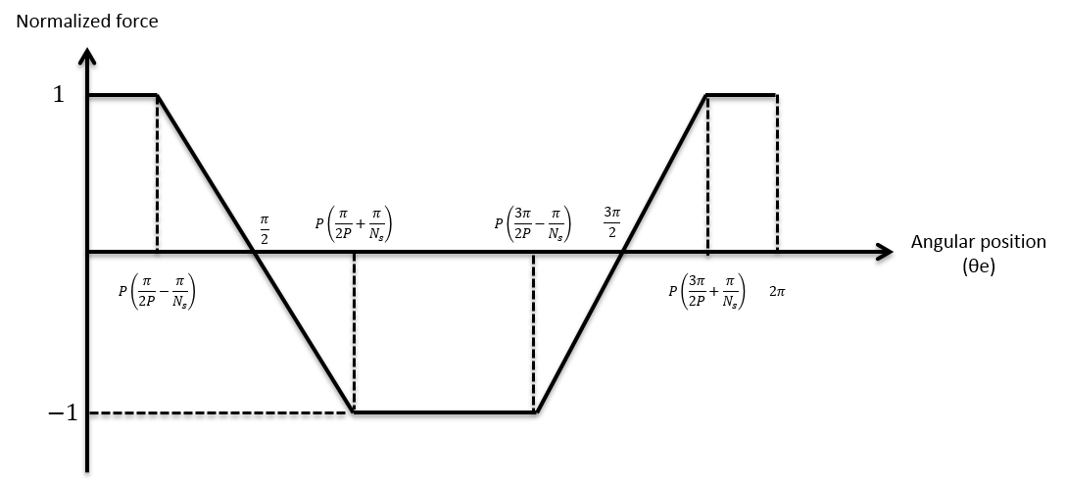
- Local X directional force variation over one electrical cycle
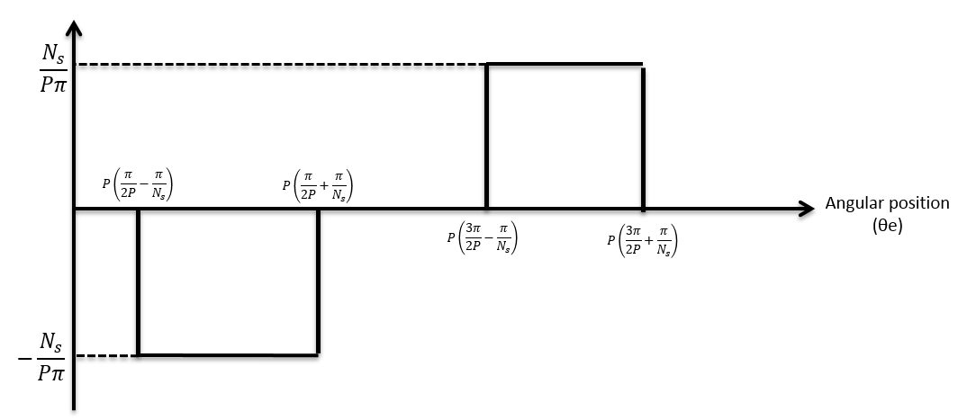
- First derivative of force variation
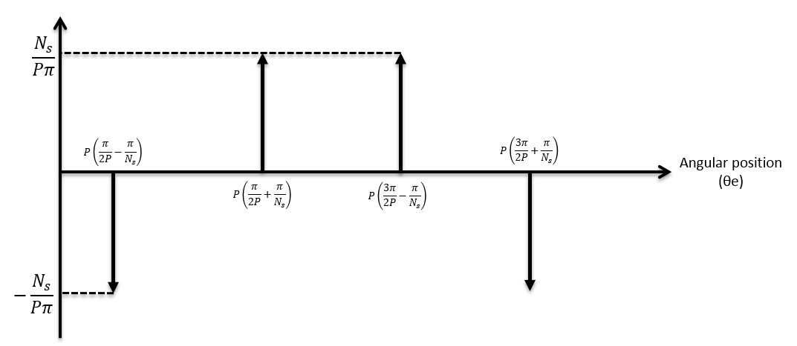
- Second derivative of force variation
Figure A-0-1 electromagnetic force variation in local X direction of a single phase
Since the force variation in local X direction is an even function, the corresponding Fourier components of ${a_{n}}^{''}$ and ${b_{n}}^{''}$ of the impulse signal (Figure A-1(c)) are given by:
 | $${a_{n}}^{''}=\frac{4}{2π}\int_{0}^{π}{\left\{-\frac{N_{s}}{Pπ}δ\left[θ_{e}-P\left(\frac{π}{2P}-\frac{π}{N_{s}}\right)\right]+\frac{N_{s}}{Pπ}δ\left[θ_{e}-P\left(\frac{π}{2P}+\frac{π}{N_{s}}\right)\right]\right\}\cos\left(nθ_{e}\right)dθ_{e}}$$ | (85)
 | $${b_{n}}^{''}=0$$ | (86)
Because of:
 | $$\cos{α}-\cos{β}=-2\sin{\frac{1}{2}\left(α+β\right)}\sin{\frac{1}{2}\left(α-β\right)}$$ | (87)
 | $$a_{n}=-\frac{{a_{n}}^{''}}{n^{2}}$$ | (88)
 | $a_{0}=0$ (the average area of the fundamental waveform) | (89)
Therefore, the variation of local X component of force is given by the following Fourier series:
 | $$f_{x}\left(θ_{e}\right)=a_{0}+\sum_{n=1}^{∞}{a_{n}\cos{(nθ_{e})}}=\frac{4}{πPβ_{x}}\sum_{n=1,3,5…}^{∞}{\frac{{\left(-1\right)}^{\frac{n-1}{2}}}{n^{2}}\sin\left(nP\frac{π}{N_{s}}\right)\cos\left(nθ_{e}\right)}$$ | (90)
In terms of the force magnitude of local X component A_{X}, the derivation is given as below:
Since
 | $$A_{X}=K_{x}I_{1}=\int_{-\frac{λ_{t}}{2}}^{\frac{λ_{t}}{2}}{\frac{F_{radial}}{λ_{t}}\cos{θ}dθ}$$ | (91)
 | $$F_{radial}=\frac{P_{m}}{\frac{dl_{g}}{dt}}=\frac{dφ}{dr}I_{1}$$ | (92)
 | $$\frac{dφ}{dr}=\frac{-B_{r}μ_{r}πDL_{ax}}{N_{t}l_{m}{\left(1+\frac{μ_{r}l_{g}}{l_{m}}\right)}^{2}}$$ | (93)
Therefore, A_{X} is equal to
 | $$A_{X}=\frac{-2B_{r}μ_{r}πDL_{ax}\sin\left(\frac{λ_{t}}{2}\right)}{λ_{t}N_{t}l_{m}{\left(1+\frac{μ_{r}l_{g}}{l_{m}}\right)}^{2}}I_{1}$$ | (94)
In conclusion, the Fourier series of local X component force is obtained as equation (95).
 | $$F_{x}=\frac{4K_{l}K_{x}I_{1}}{πPβ_{x}}\sum_{N=1,3,5…}^{∞}{\frac{{\left(-1\right)}^{\frac{n-1}{2}}}{n^{2}}\sin\left(nPβ_{x}\right)\cos\left(nθ_{e}\right)}$$ | (95)
where | $$K_{x}=\frac{-2B_{r}μ_{r}πDL_{ax}\sin\left(\frac{λ_{t}}{2}\right)}{λ_{t}N_{t}l_{m}{\left(1+\frac{μ_{r}l_{g}}{l_{m}}\right)}^{2}}$$
 | $$β_{x}=\frac{π}{N_{s}}$$
The same procedure can applied to derive the corresponding expression for the derivation of local Y component of force. Figure A-2 shows the force variation described in section 3.1 together with its corresponding derivative waveforms.
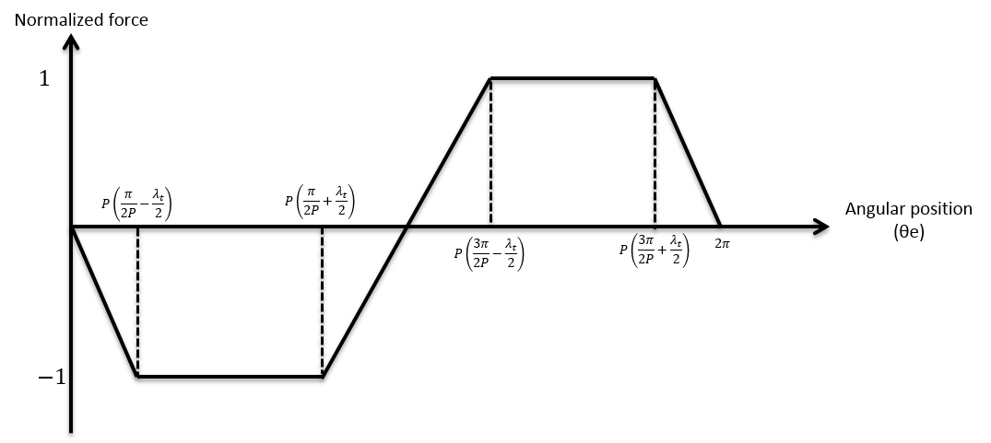
- Local Y directional force variation over one electrical cycle
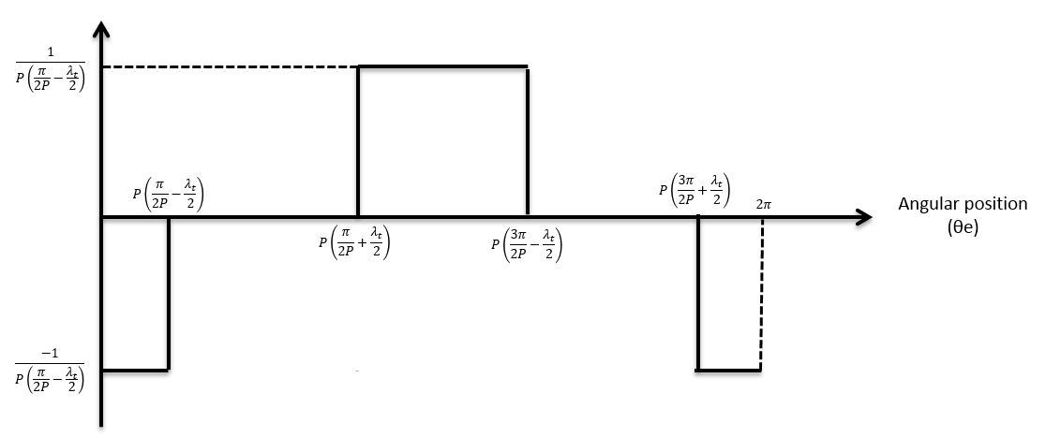
- First derivative of force variation
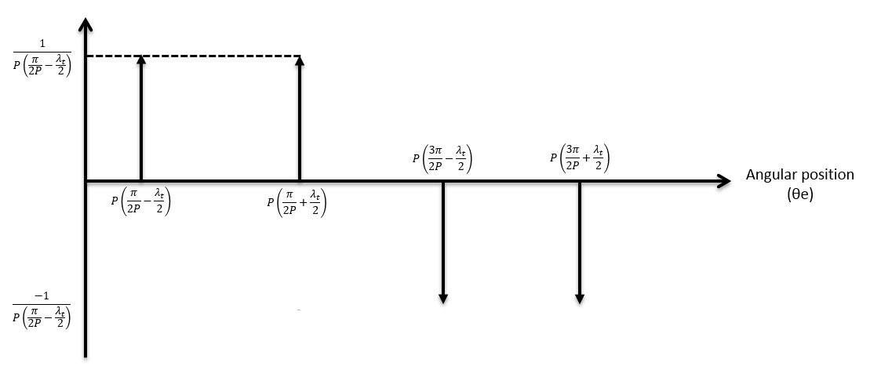
- Second derivative of force variation
Figure A-0-2 Electromagnetic force variation in local Y direction of a single phase
Since the force variation in local Y direction is an odd function, the corresponding Fourier components of ${a_{n}}^{''}$ and ${b_{n}}^{''}$ of the impulse signal (Figure A-2(c)) is given by:
 | $${a_{n}}^{''}=0$$ | (96)
 | $${b_{n}}^{''}=\frac{2}{π}\int_{o}^{π}{\left\{kδ\left[θ_{e}-\left(\frac{π}{2}-\frac{Pλ_{t}}{2}\right)\right]+kδ\left[θ_{e}-\left(\frac{π}{2}+\frac{Pλ_{t}}{2}\right)\right]\right\}}\sin\left(nθ_{e}\right)dθ_{e}$$ | (97)
where | $$k=\frac{1}{\frac{π}{2}-\frac{Pλ_{t}}{2}}$$ | (98)
Because of:
 | $$\sin{α}+\sin{β}=2\sin{\frac{1}{2}\left(α+β\right)}\cos{\frac{1}{2}\left(α-β\right)}$$ | (99)
 | $$b_{n}=-\frac{{b_{n}}^{''}}{n^{2}}$$ | (100)
 | $a_{0}=0$ (the average area of the fundamental waveform) | (101)
Therefore, the force variation of local Y component given by Fourier series is
 | $$f_{y}\left(θ_{e}\right)=a_{0}+\sum_{n=1}^{∞}{b_{n}\sin{(nθ_{e})}}=\frac{-4}{πPβ_{y}}\sum_{N=1,3,5…}^{∞}{\frac{{\left(-1\right)}^{\frac{n-1}{2}}}{n^{2}}\cos\left(nP\frac{λ_{t}}{2}\right)\sin\left(nθ_{e}\right)}$$ | (102)
As mentioned in section 3.1, it is necessary to account for the contribution to the local Y component force from the radial component of force. Therefore, the expression for the magnitude of force is made up of two parts:
Part 1: Local Y component force from radial force
 | $$A_{y1}=2\int_{0}^{\frac{λ_{t}}{2}}{\frac{F_{radial}}{λ_{t}}\sin{θ}dθ}=\frac{-2B_{r}μ_{r}πDL_{ax}}{λ_{t}N_{t}l_{m}{\left(1+\frac{μ_{r}l_{g}}{l_{m}}\right)}^{2}}(1-\cos{\frac{λ_{t}}{2}})I_{1}$$ | (103)
Part 2: Local Y component force due to exited tangential force
 | $$A_{y2}=\int_{-\frac{λ_{t}}{2}}^{\frac{λ_{t}}{2}}{\frac{F_{t}}{λ_{t}}\cos{θ}dθ}=\frac{8πL_{ax}B_{r}}{{λ_{t}}^{2}N_{t}\left(1+\frac{μ_{r}l_{g}}{l_{m}}\right)}sin⁡(\frac{λ_{t}}{2})I_{1}$$ | (104)
Since | $$λ_{t}*N_{t}≈2π$$
Therefore,
 | $$A_{y2}=\frac{4L_{ax}B_{r}}{λ_{t}\left(1+\frac{μ_{r}l_{g}}{l_{m}}\right)}sin⁡(\frac{λ_{t}}{2}) I_{1}$$ | (105)
As a conclusion, the Fourier series of local X component force is obtained as:
 | $$F_{y}=-\frac{4K_{y}I_{1}}{πPβ_{y}}\sum_{N=1,3,5…}^{∞}{\frac{{\left(-1\right)}^{\frac{n-1}{2}}}{n^{2}}\cos\left(nP\frac{πλ_{t}}{2}\right)sin⁡(nθ)}$$ | (106)
where | $$K_{y}=\frac{4L_{ax}B_{r}}{λ_{t}\left(1+\frac{μ_{r}l_{g}}{l_{m}}\right)}\sin\left(\frac{λ_{t}}{2}\right)-\frac{2B_{r}μ_{r}πDL_{ax}}{λ_{t}N_{t}l_{m}{\left(1+\frac{μ_{r}l_{g}}{l_{m}}\right)}^{2}}(1-\cos{\frac{λ_{t}}{2}})$$
 | $$β_{y}=\frac{π}{2P}-\frac{λ_{t}}{2}$$

Appendix B: The system level simulation model established in MATLAB/Simulink environment
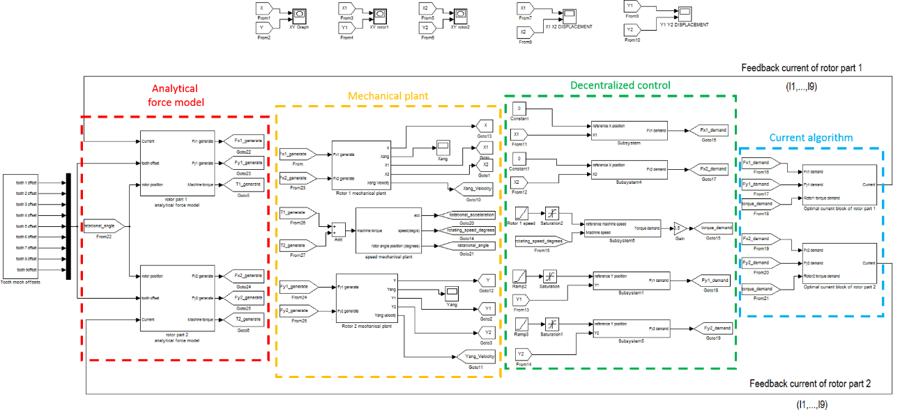

Appendix C: Rotor balancing report
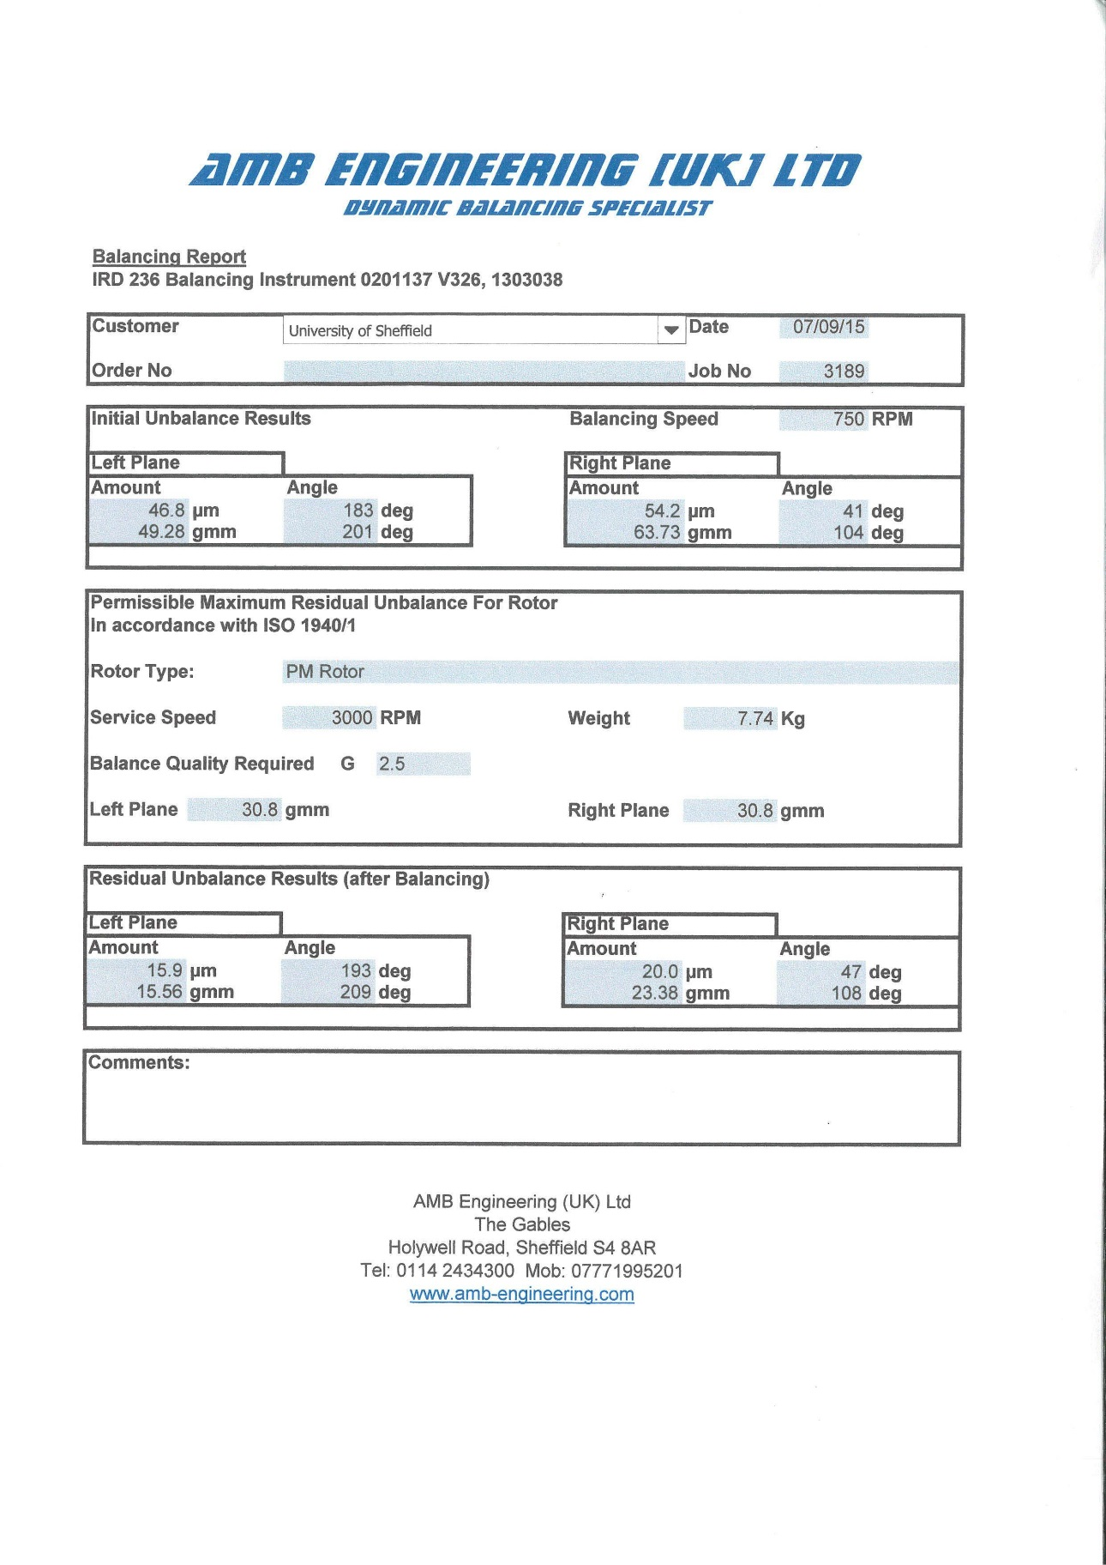

Appendix D: Redesigned force measurement test rig
As discussed in CHAPTER 6, the original static experiment rig using direct measurement of force transducer have the ability to evaluate the force capability of each controlling phase thereby minimizing the tolerance of produced net force and torque which were calculated based on the assumption of identical phase ability. However, the original design shown difficulties due to insufficient system stiffness. Therefore, an alternative design of static experimental rig using radial force sensors is necessary and the single-phase performance test is regarded as the future work in this thesis.
According to the original static experiment rig proposed in section 6.2, a large number of hardware components are used to achieve translational and rotational movement, which results in a relative wicker system robustness as a compromise. One of the solutions for improving the experiment rig robustness is to reduce the number of hardware components of force measuring system. Furthermore, the original static experimental rig has a larger axial length with sensitive unbalance magnetic pull acting on the middle section of the rotor, which is analysed as one of the main reason for the requirement of high stiffness rig. Therefore, reducing the axial length of the rig thereby reducing the acting force is another effective solution.
In the new static experimental rig, the constructed machine stator can be separated and tested individually. As a consequence, a new purposed-made rotor and a casing extension are required for the assembly of these new static test rigs as shown in Figure D-1.
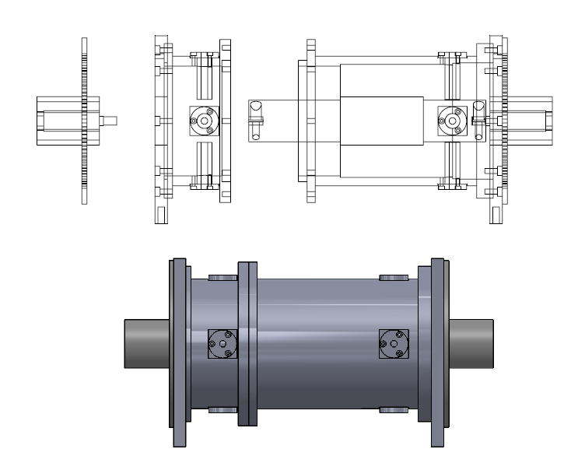
Figure D-0-1 Assembly of new static experimental rig
By halving the machine length, the force acting on the measuring system is halved. Moreover, the number of hardware components for the sensor measuring system is significantly reduced to two pieces as shown in Figure D-2. The ream-hole angular disk is kept and made to mount on the machine end plate for minimizing axial length of the rig. However, the micro-translational moving stage in the original design is removed and replaced by a couple of fixed off-centre sensor housing to provide constant rotor eccentricity during the test. Thus, the freedom of translational movement is abandoned as a compromise for the higher robustness.
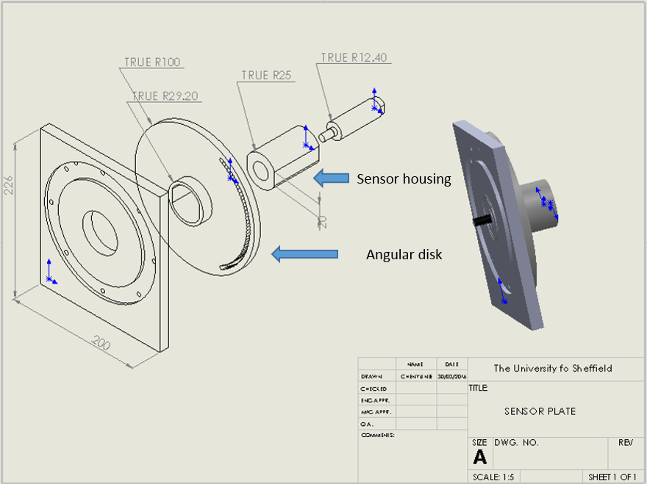
Figure D-0-2 New sensor measuring system
The new rotor that is made of mild steel with shorter axial length and larger shaft diameter is one of the major differences compared to the original design. The dimensional comparison of this new purposed-made rotor and the prototype machine rotor is described in Table D-1. It is worth noting that the rotor core of this purposed-made new rotor is made from the same piece of mild steel as the shaft instead of silicon iron lamination used in the prototype machine rotor. As can be seen from Figure D-4, FE estimated force produced by phase 1 shown a good agreement between these two materials. Even though the laminated rotor core using silicon iron has three times higher relative permeability for reducing the iron losses, it has no influence on machine force production. Moreover, the stiffness of this purposed-made rotor was significantly improved according to the bending analysis estimated by Opera shown in Figure D-5. The halved applied force and increased stiffness result in a negligible rotor bending at $0.8μm$when 500N force acting on the purposed-made new rotor, i.e., resultant rotor stiffness of 625,000 N/mm. In contrary, the original machine rotor has a maximum $77.3μm$ rotor bending when 500N force applied on both rotor sections, i.e., resultant rotor stiffness of 6,468 N/mm.
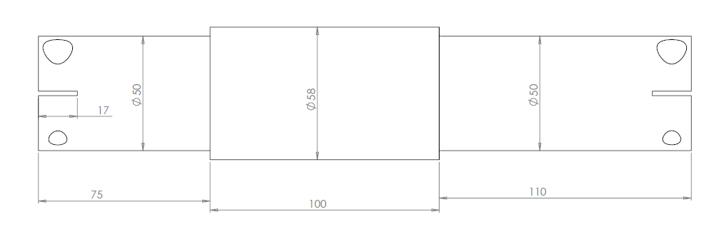
Figure D-0-3 Purposed-made new rotor
Table D-1 Comparison of the purposed-made new rotor and prototype machine rotor (Unit: mm)
 | Purpose-made new rotor | Prototype machine rotor
Material | Mild Steel | Silicon Iron
Axial length | 285 | 588
Shaft outer diameter | 50 | 14
Rotor outer diameter | 58 | 58
Permanent magnet thickness | 2 | 2
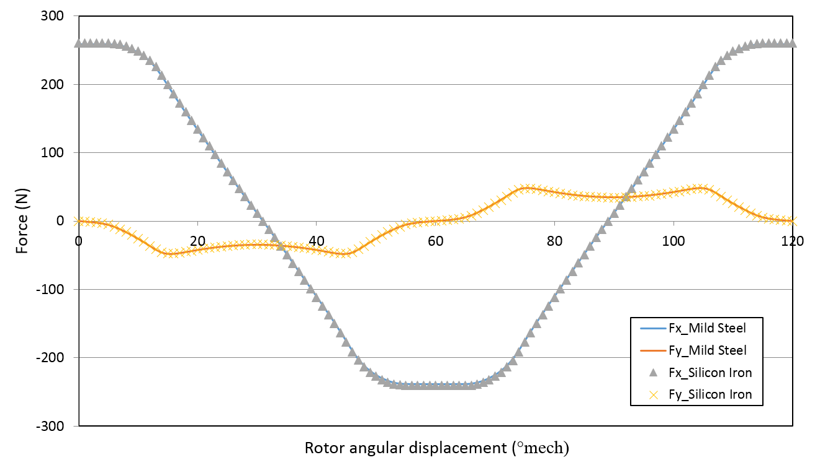
Figure D-0-4 Phase 1 produced force of the rotor using the material of mild steel and silicon iron (finite element predicted results of the two section combined machine)
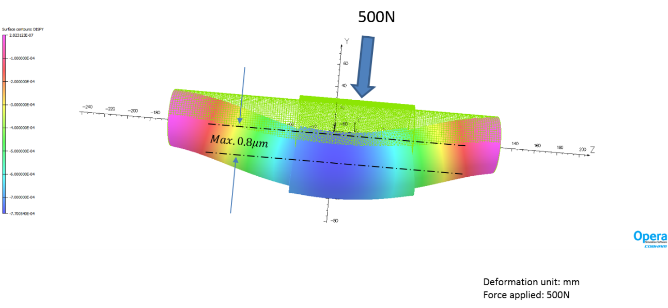
- purpose-made new rotor
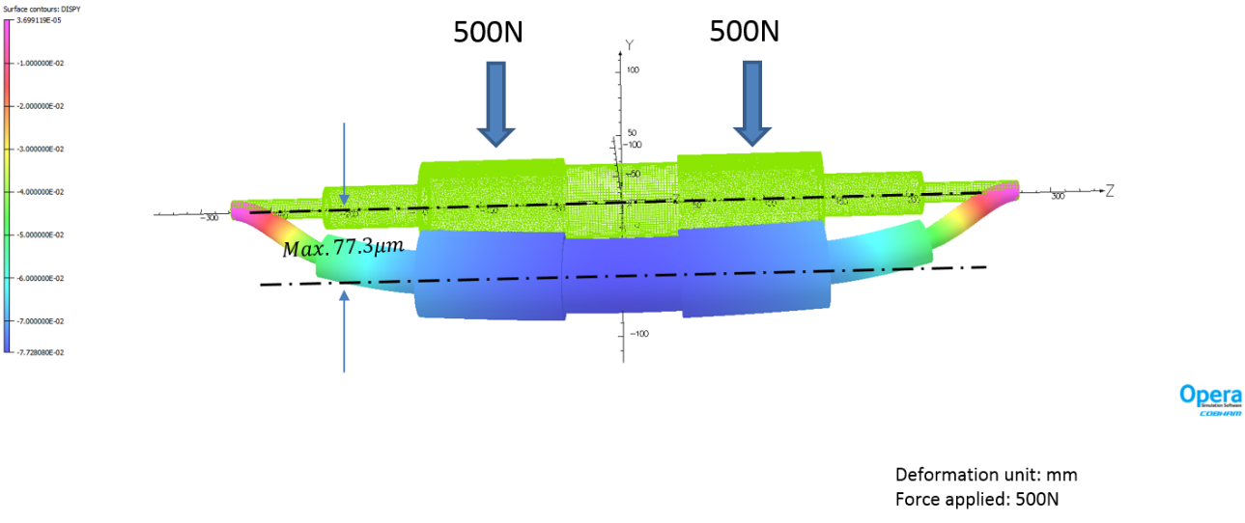
- Prototype machine rotor
Figure D-0-5 Bending analysis
Table D-2 Magnetic properties of mild steel and Silicon iron 300-35A
Material | Mild steel | Silicon Iron 300-35A
Relative permeability | 1000 | 3000
Saturation magnetization  (T) | 1.6 | 1.6
Knee adjusting coefficient | 0.5 | 0.5

Appendix E: Analytical current waveforms
Referring to the discussion of current ripples shown in Figure 3-35, current waveforms according to the condition of torque only, force only and torque and force (without cogging torque) are displayed for identifying the cause of current ripple.
- Torque only (without cogging torque and bearing force)
- A smooth torque demand of 10N
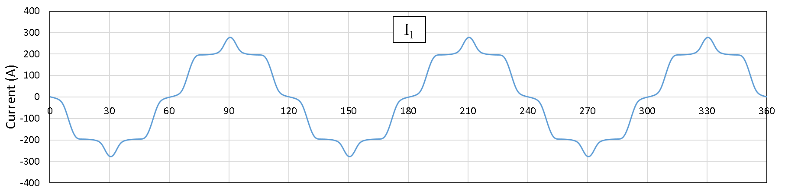
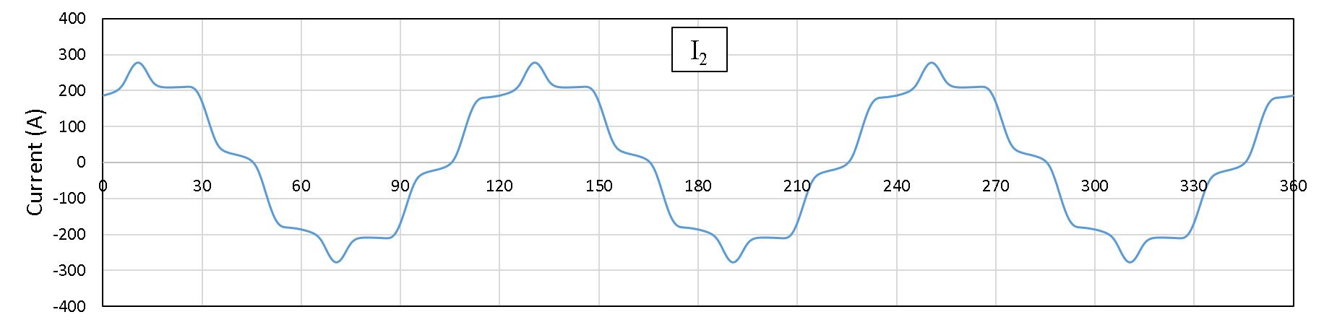
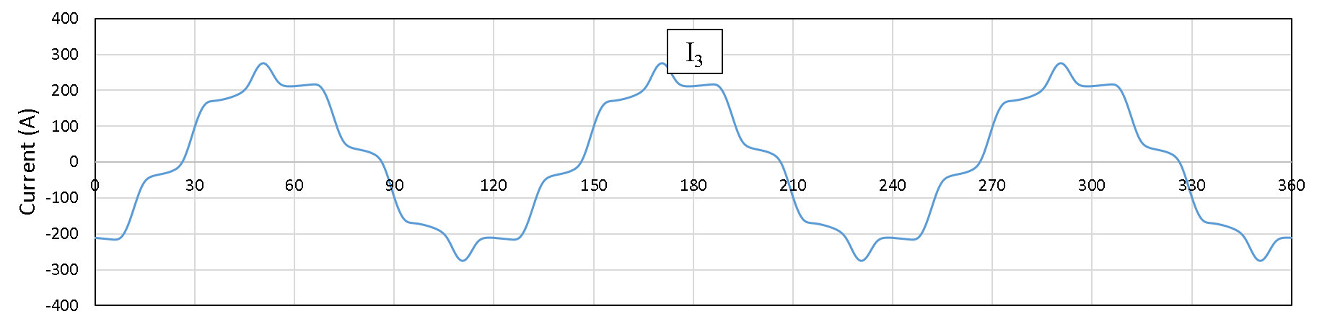
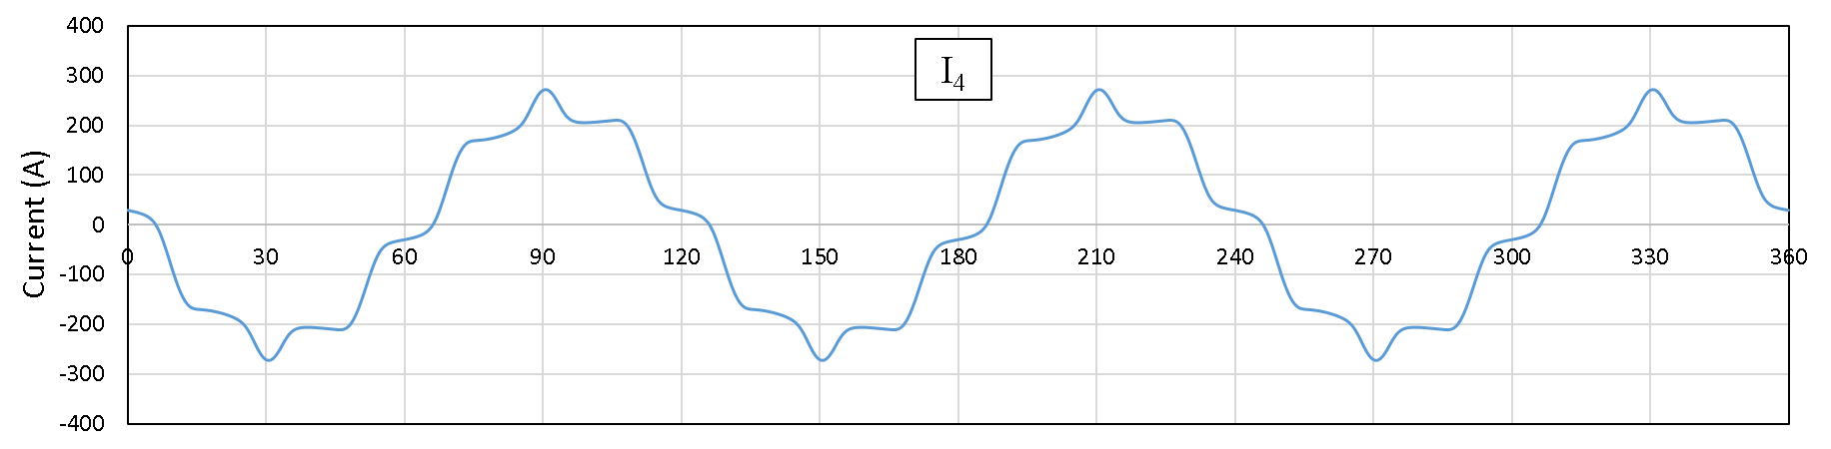
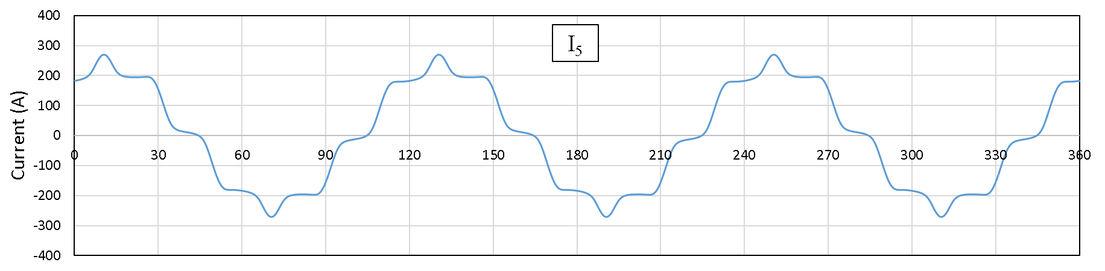
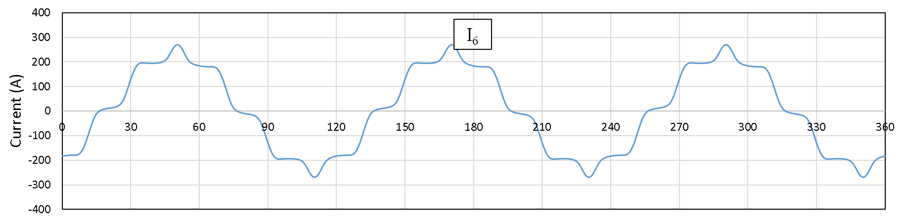
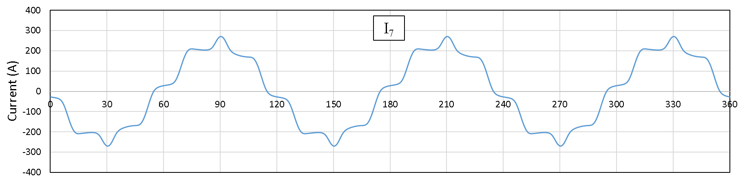
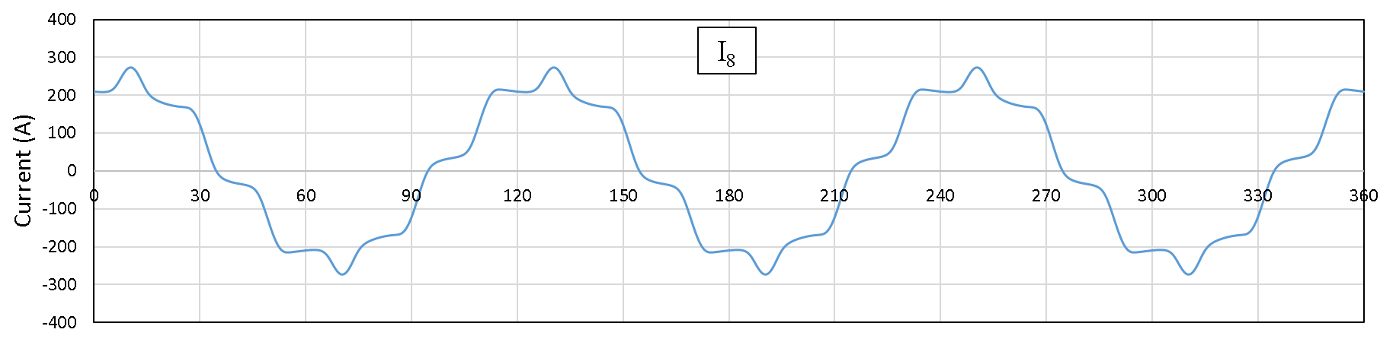
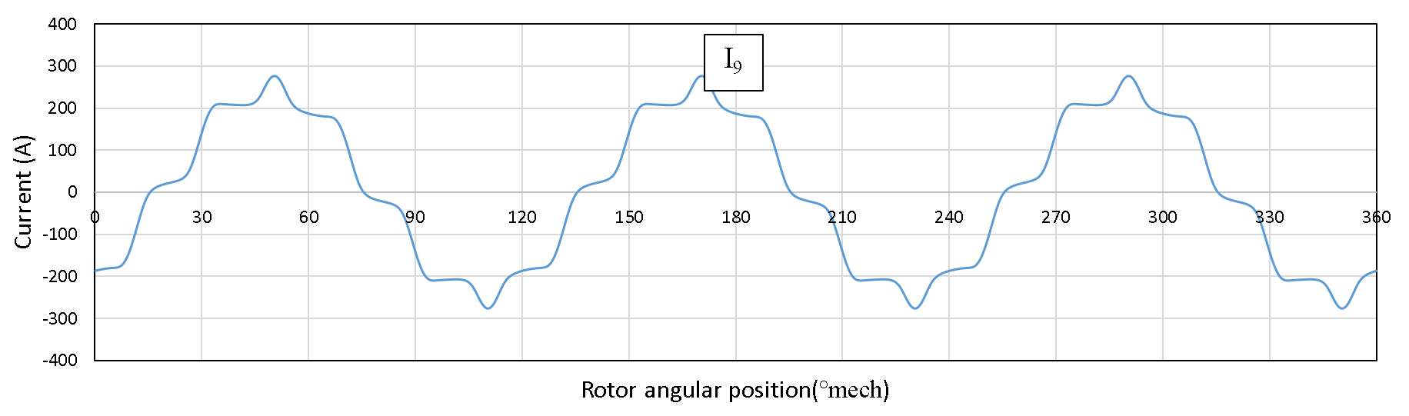
Figure E-1 Optimized current waveform for producing 10Nm of demand torque only without cogging torque
- Force only (without torque and cogging torque)
- A restoring force to counteract a synchronous rotating radial force of magnitude 150N with a phase of +30° relative to the angular displacement reference frame.
- A permanent vertical force of 76N (assumed to be in the y-direction of the stator reference frame) to counteract the gravitational force on the rotor.
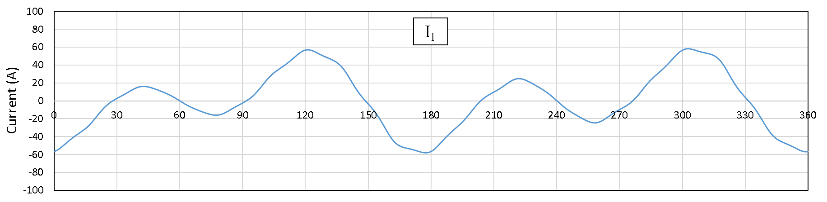
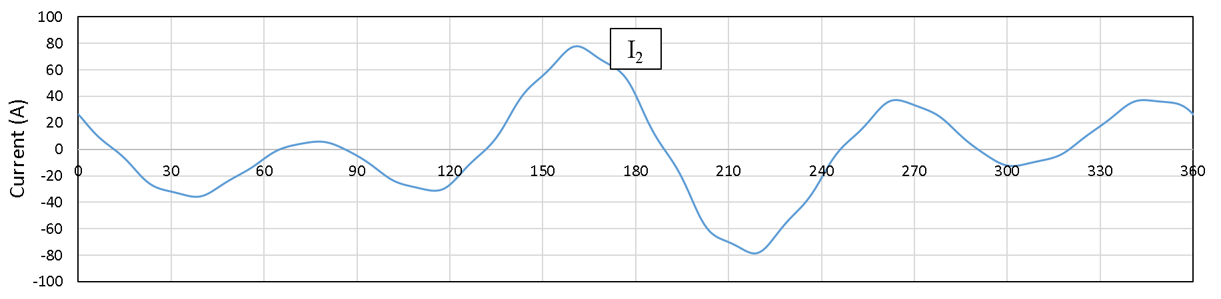
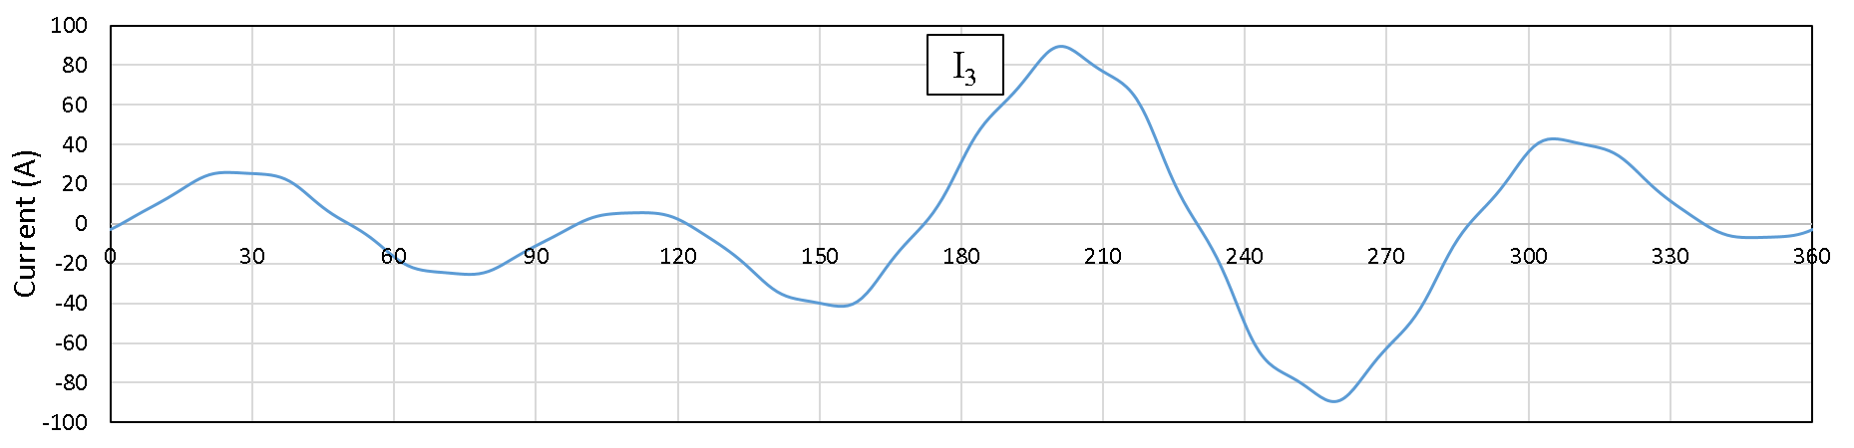
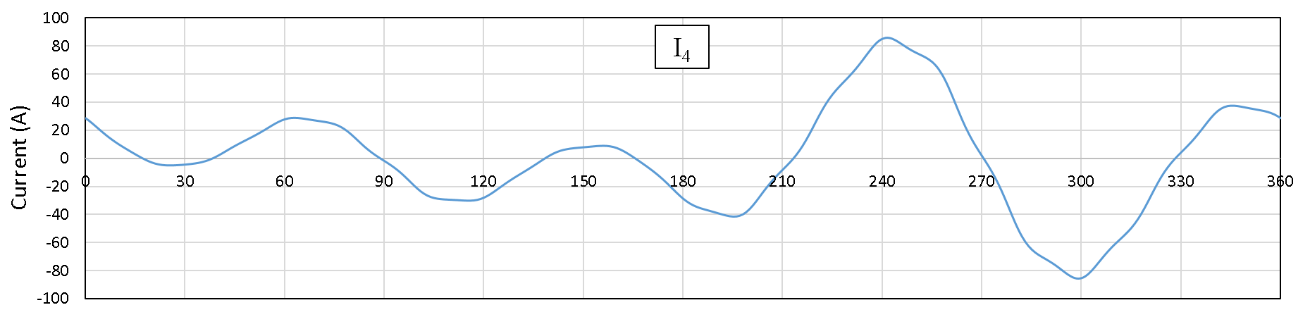
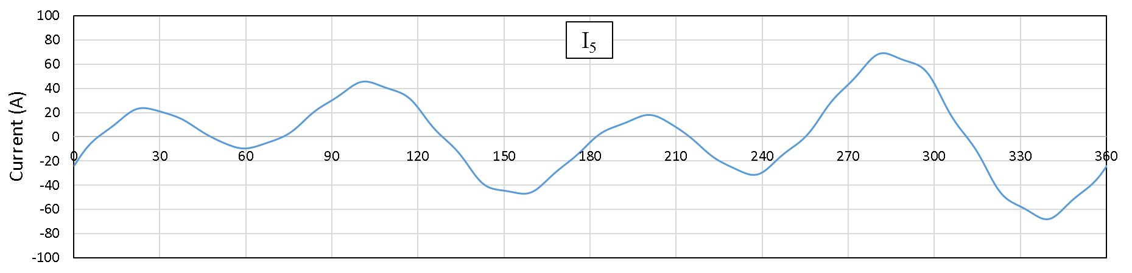
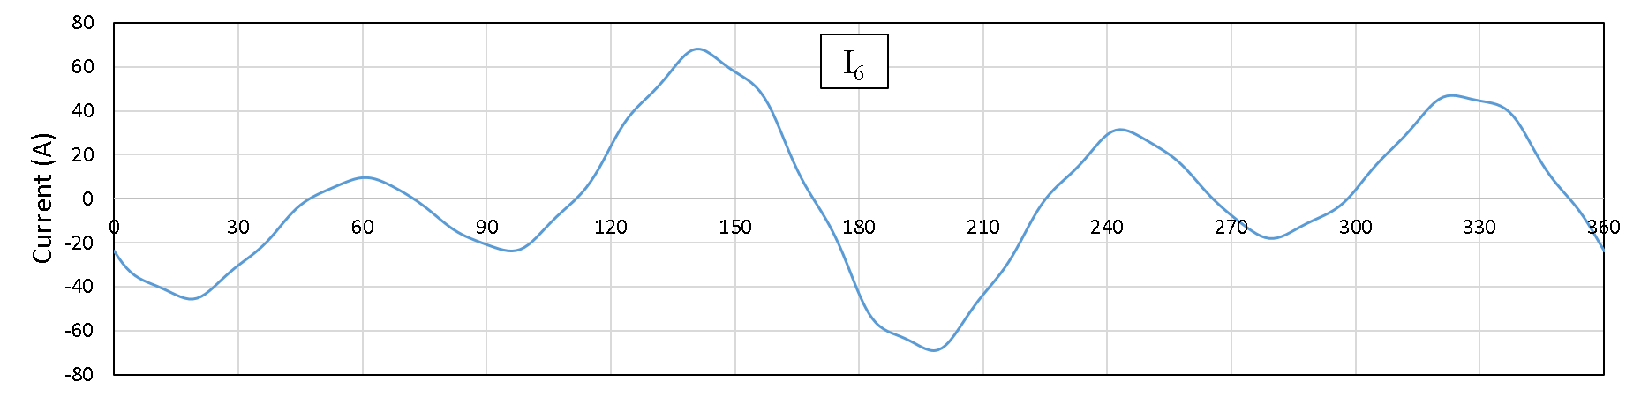
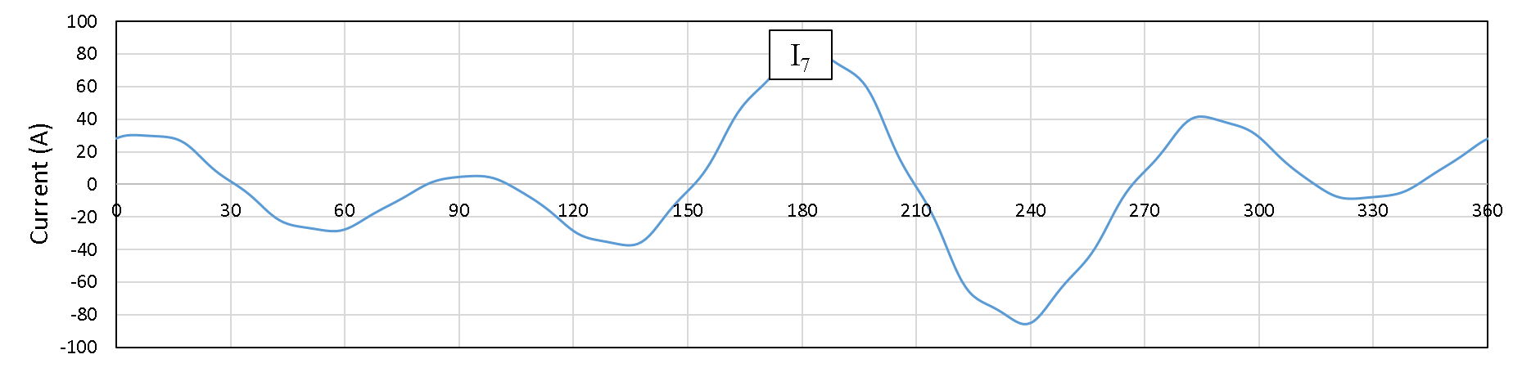
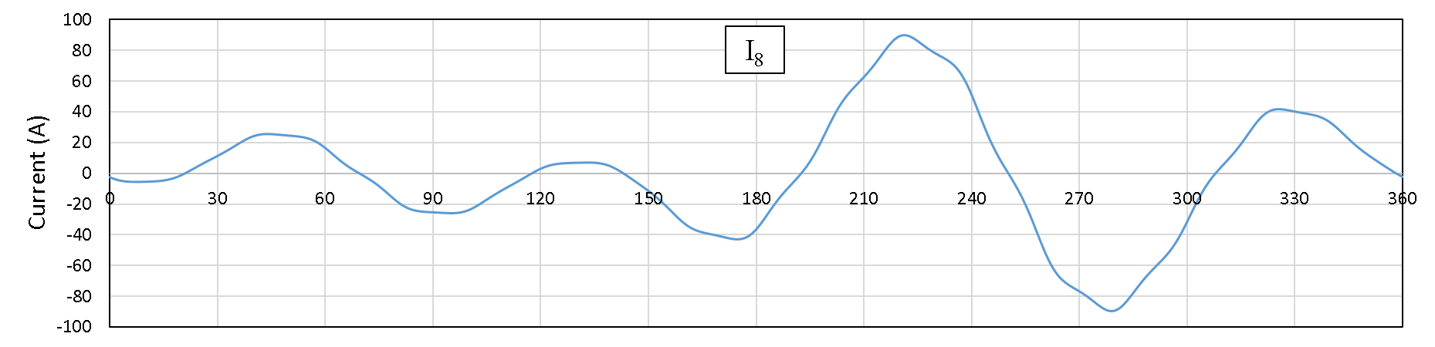
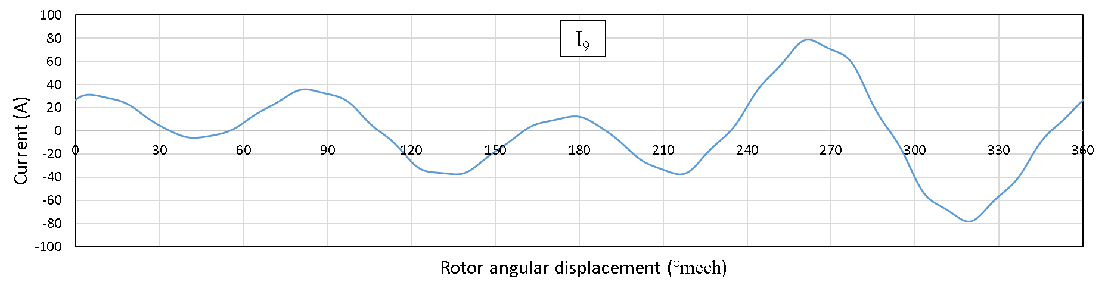
Figure E-2 Optimized current waveform for counteracting a 150N synchronously rotating force and a fixed gravitational force of 76N
- Torque and force (without cogging torque)
- A torque demand of 10N
- A restoring force to counteract a synchronous rotating radial force of magnitude 150N with a phase of +30° relative to the angular displacement reference frame.
- A permanent vertical force of 76N (assumed to be in the y-direction of the stator reference frame) to counteract the gravitational force on the rotor.
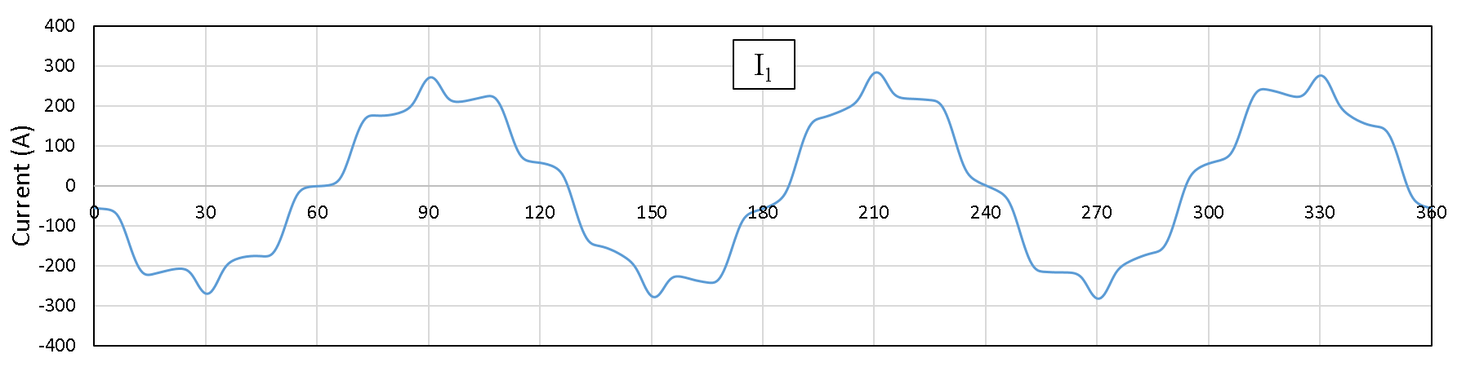
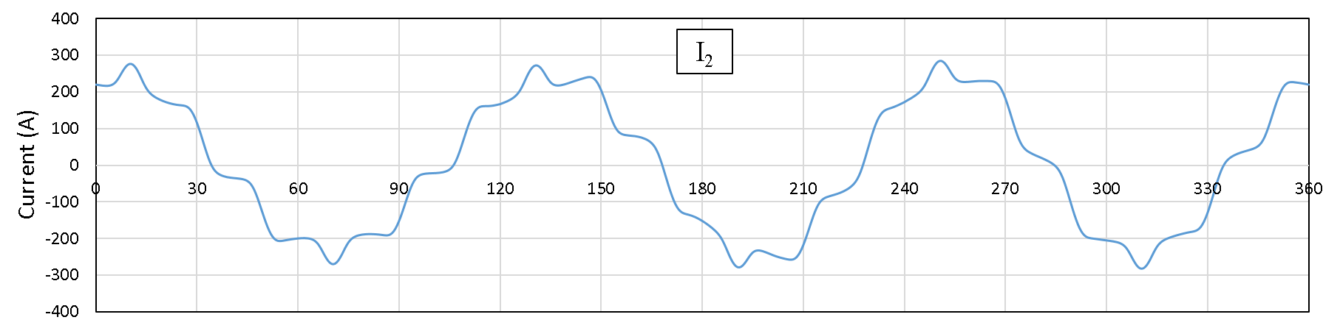
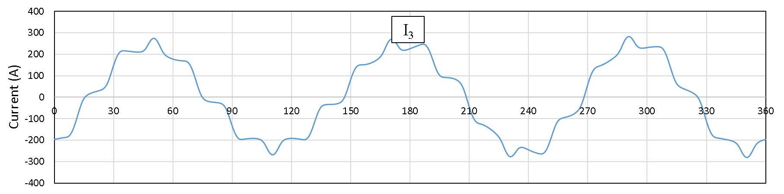
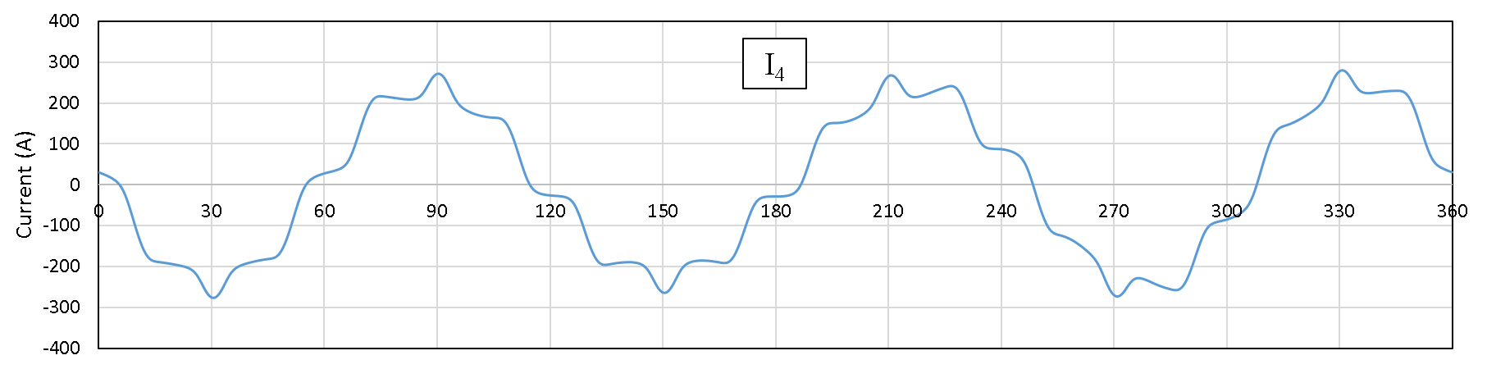
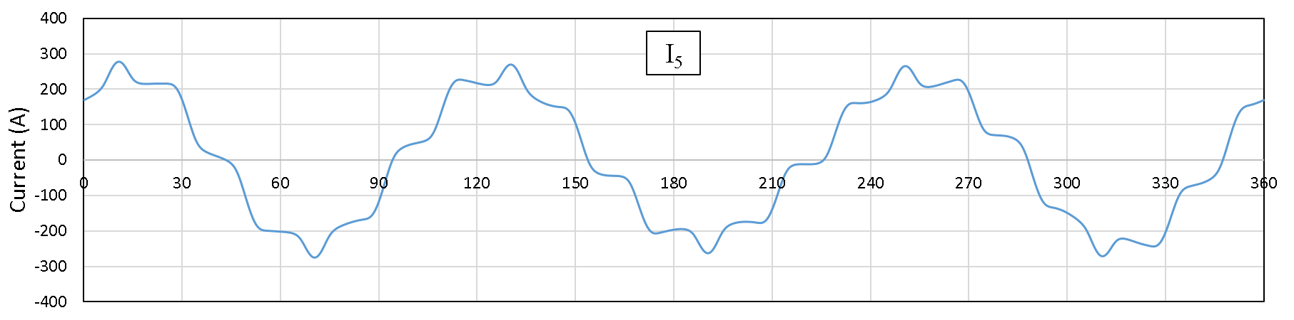
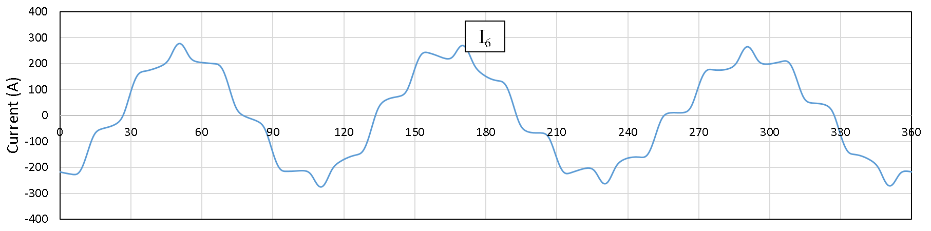
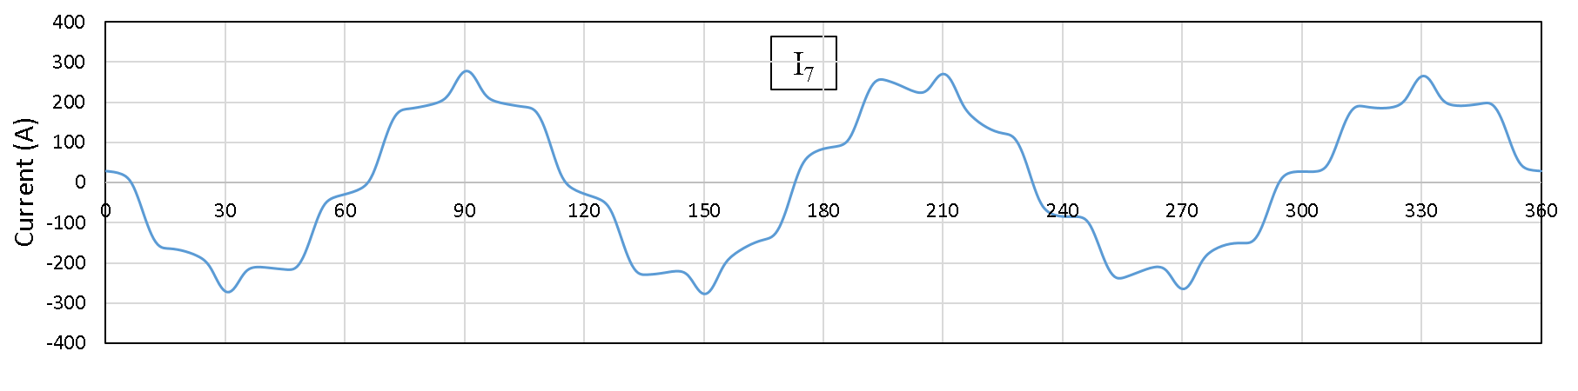
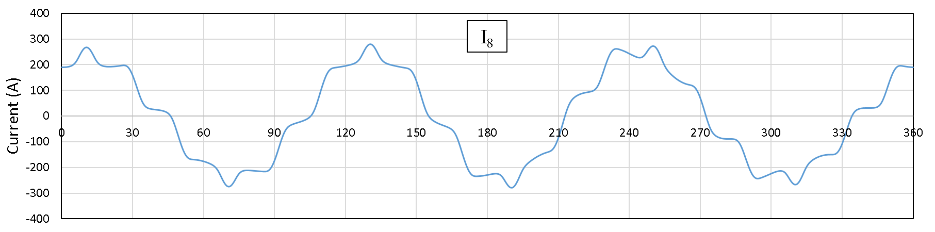
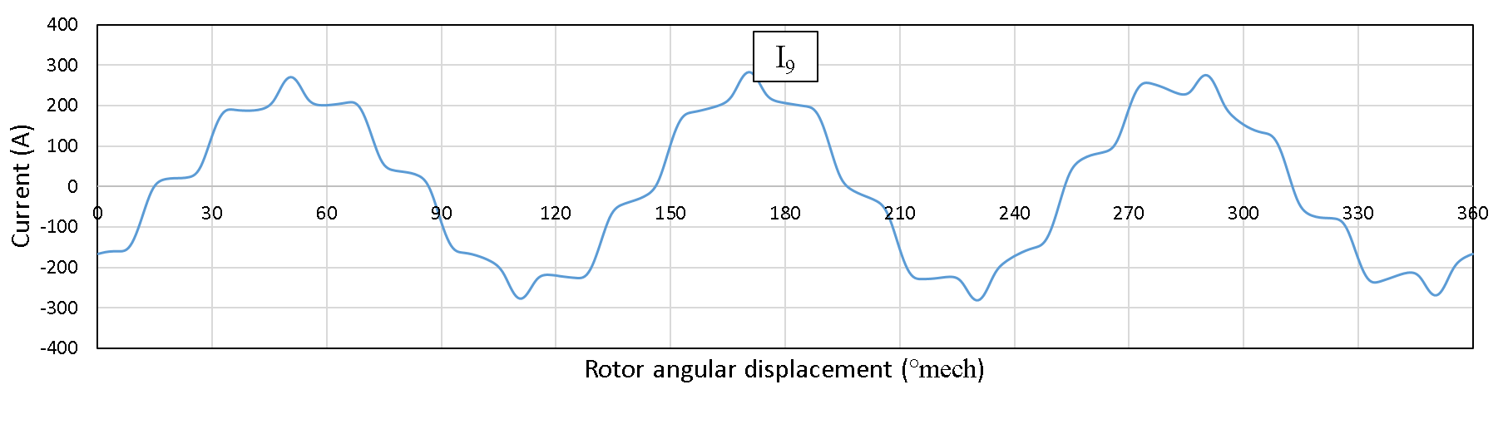
Figure E-3 Optimized current waveform for producing both demand torque and restoring force without the effect of cogging torque
As will be apparent, all these three operating scenarios presented in this appendix has eliminate the effect of cogging torque for calculating the combination of phase current. By comparing the optimized current waveform of Figure E-1 and Figure E-3 to Figure 3-35, the undesirable current ripple with high frequency are effectively removed in Figure E-1 and Figure E-3. Moreover, with the inability of analytical model to fully compensate the effect of cogging torque manifested in Figure 3-37, a minimized cogging torque will be beneficial to this proposed self-bearing machine for producing a smoother torque and providing a better current control ability.

