Imaging-Based Fault Detection of Wind Turbines

Mr. Songyang Yu

Combustion and Flow Diagnostics Research Group

Department of Mechanical Engineering

This thesis is submitted to the University of Sheffield for the degree of Doctor of Philosophy

2018 March

Declaration

I declare that this thesis has been composed solely by myself and that it has not been submitted, in whole or in part, in any previous application for a degree at the University of Sheffield or any other university or institution. Except where states otherwise by reference or acknowledgment, the work presented is entirely my own.

Acknowledgements

I would first express my sincere appreciation to my supervisor, Prof. Zhang Yang, who encouraged and guided me continuously in the last years. I am extremely grateful for the thing he taught me not only for the research, but also for the life.
Second, I would acknowledge my second supervisor, Dr. Jem Rongong, and all the staffs in University of Sheffield, who gave many suggestions for my work.
Then I would like to thank the members in my research group, Dr. Jiansheng Yang, Dr. Hussain Saeed, Dr. Paco Carranza Ch, Dr. Zhen Ma, Mr. Shuida Ji, Mrs. Lukai Zheng, Miss. Yiran Wang, Mr. Hangxu Zhou, Mr. Houshi Jiang, Mr. Yufeng Lai and Mr. Xiao Wang. for their helpful comments on my research.
Also, I would like to thank MIT Computer Science and Artificial Intelligence Lab, European Wind Energy Association, Chaiwopu Windfarm (Xinjiang, China), Dongyang Windfarm (Zhejiang, China), Guanyin Windfarm (Taiwan), who provide the support for the experimental data collection and analysis.
Finally, I would like to appreciate my family and all friends. Without their support, I cannot achieve this thesis.

Abstract

With the development of renewable energy, the wind-energy generation is no longer a brand-new field. Considering the complex work environment and huge maintenance fee, windmill detection plays a significant role in the wind industry. Therefore, combining with the application of digital image technology in windmill in recent years, the thesis proposes a new non-destructive detection method based on digital image process algorithms, including Optical Intensity for frequency and cycle time measurement, Frame Difference for motion tracking, and EVM (Eulerian Video Magnification) for invisible motion enhancement.
The feasibility of new detection method is verified both in the laboratory and in the windfarm. In the lab case, the thesis distinguishes rotation behaviours (frequencies and cycle time) between undamaged and damaged blades, and vibration behaviours (frequencies and amplitude) between different damaged level towers. In the windfarm case, working data of three different windmills (Nordtank NTW300, Goldwind S50/750, and General Electric GE 1.5sl) is collected to analyse the rotation and tower vibration behaviours. Also, the thesis finds two windmill failure cases on the Internet to monitor the motion variation before the windmill finally collapse. The final results demonstrate that imaging-based monitoring can be a powerful methodology if combined with effective algorithms.
The imaging-based detection method uses camera and digital images or videos as data carriers. It extracts quantitative data from a sequence of images, also it can make invisible motion visible by selective image sequence enhancement. The main advantage of the detection method is “All in one go”, which means many useful parameters can be derived from a single image sequence and multiple turbines or components can be monitored by a single camera. Compared to the tradition monitoring methods, the facilities of the imaging-based detection method are simpler. In theory, it only need a single camera to collect data and a computer to process the data, and no any other sensors are required in the monitoring process. Therefore, the main contribution of the research is to make the windmill detection more efficient and economical.

Abbreviation

Abbreviation | Definition
AE | Acoustic Emission
BEM | Blade Element
CCD | Charge Coupled Device
CMS | Condition Monitoring System
DCT | Discrete Cosine Transform
DIC | Digital Image Correlation
ESPI | Electronic Speckle Pattern Interferometry
EVM | Eulerian Video Magnification
FBG | Fiber Bragg Grating
FFT | Fast Fourier Transform
fps | Frames Per Second
HPF | High-Pass Filtering
LiDAR | Light Detection and Ranging
LPF | Low-Pass Filtering
NDT | Non-Destructive Testing
PIC | Proportional Integral Controller
RGB | Red, Green and Blue
RLE | Run-Length Encoded
RPAS | Remotely Piloted Aircraft Systems
SHM | Structural Health Monitoring
SNR | Signal to Noise Ratio
TIR | Total Internal Reflection
VLSI | Very Large-Scale Integration
WT | Wavelet Transform

Symbol

Symbol | Definition | Unit
$$α$$ | Angle of Attack (Windmill) | Degree
$$α$$ | Amplification Factor (EVM) | Times
$$β$$ | Pitch Angle | Degree
$λ$ | Tip Speed Ratio(Windmill) | None
$λ$ | Wavelength(EVM) | m
$$ρ$$ | Density | kg/m³
$$ω$$ | Rotation Angular Speed(Windmill)/ | rad/s
$$ω$$ | Spatial Frequency(EVM) | Hz
c | Chord Length | k
$$C_{D}$$ | Drag Coefficient | None
$$C_{L}$$ | Lift Coefficient | None
$$C_{p}$$ | Power Coefficient | None
E | Kinetic Energy | J
E | Young Modulus | Pa
F | Force | N
I | Rotational Inertia | kg·m²
M | Torque | N·m
$$P$$ | Power | kw
R | Radius | m
S | Area | m²
$$t$$ | Time | s
$$V$$ | Speed | m/s

Contents

Declaration I
Acknowledgements II
Abstract III
Abbreviation V
Symbol VII
Contents IX
List of Figures XIV
List of Tables XXI

1. INTRODUCTION 1
1.1 Motivation 1
1.2 Objective 3
1.3 Outline of The Thesis 5

2. LITERATURE REVIEW 8
2.1 Introduction 8
2.2 Wind Turbine System 9
2.2.1 Wind Energy In EU 9
2.2.2 Wind Turbine Structure 11
2.2.3 Wind Turbine Working Principle 14
2.2.3.1 Wind Turbine Power 14
2.2.3.2. Aerodynamic of Windmill Blades 17
2.3 Wind Turbine Monitoring 21
2.3.1 Wind Turbine Damage 21
2.3.1.1 Blades Damage 25
2.3.1.2 Towers Damage 28
2.3.2 Windmill Monitoring System 32
2.3.2.1 Modal-based Approaches 32
2.3.2.2 AE (Acoustic Emission) Monitoring Methods 34
2.3.2.3 Ultrasonic Methods 37
2.3.2.4 Thermal Imaging Method 39
2.3.2.5 Fiber Optics Method 41
2.4 Monitoring Methods Based on Image Processing 44
2.4.1 View of Image Processing 44
2.4.2 DIC Techniques 48
2.4.2 ESPI Techniques 53
2.4.3 Digital Images Application in Windmill Industry 57
2.5 Summary of Literature View 62

3. METHODOLOGY 65
3.1 Introduction 65
3.2 Pre-Processing 67
3.2.1 Gray Processing 68
3.2.2 Image Segmentation 71
3.3 Eulerian Video Magnification 74
3.3.1 Principle of EVM 74
3.3.1.1 Spatial Filtering 76
3.3.1.2 Temporal Filtering 77
3.3.1.3 Magnification 78
3.3.2 Cases of EVM 81
3.3.2.1 Colour Enhancement 81
3.3.2.2 Movement Enhancement 83
3.3.3 Discussion of EVM 84
3.3.3.1 Error Analysis 84
3.3.3.2 Comparison between EVM and LaGrange Processing 87
3.3.3.3 Improved EVM 89
3.4 Motion Parameters Calculation 93
3.4.1 Optical Intensity Method 93
3.4.1.1 Frequency Calculation 94
3.4.1.2 Cycle Time Calculation 95
3.4.2 Motion Tracking (Frame Difference) 96
3.4.2.1 Principle of Frame Difference 97
3.4.2.2 Process of Frame Difference 98
3.5 Summary 101

4. BLADES AND TOWERS MOTION DETECTION OF WINDMILL MODELS IN LABORATORY 103
4.1 Introduction 103
4.2 Undamaged and Damaged Windmill Model Blades Rotation Detection 106
4.2.1 Blades Damages Definition 107
4.2.2 Rotation Frequencies Detection of Undamaged and Damaged Blades in Different Windmill Models 112
4.2.3 Cycle Time Detection of Undamaged and Damaged Blades in Single Windmill Model 115
4.2.4 Summary and Analysis Results 120
4.3 Undamaged and Damaged Windmill Model Towers Vibration Detection 123
4.3.1 Definition of Towers Damages 124
4.3.2 Experiment Tower Detection 125
4.3.3 Summary and Analysis 130
4.4 Conclusion 134

5. APPLICATION OF IMAGE-BASED DETECTION METHOD ON REAL WINDMILLS 136
5.1 Introduction 136
5.2 Blades and Towers Motion Detection Under Normal Operating Conditions 138
5.2.1 Rotation Speed Detection 138
5.2.1.1 Rotation Speed Measurement in Different Wind Speed 139
5.2.1.2 Compared Practical Measured Value of Rotation Speed with Theoretical Value 141
5.2.3 Vibration Detection of Blades Tip (Each Blade Cycle Time Measurement) 146
5.2.3 Tower Vibration Detection (Vibration Frequency Measurement) 149
5.2.3.1 Natural Frequency of Real Windmill Tower 151
5.2.3.2 Tower Vibration Frequencies Measurement in Different Wind Speed 153
5.3 Windmill Fault Detections Before Destruction Using Video Clips Available on Internet 160
5.3.1 Rotation Speed Detection Before Windmill Blades Destruction 160
5.3.2 Tower Vibration Detection Before Windmill Towers Destruction 163
5.4 Conclusion 168

6. SUMMARY AND FUTURE WORK 171
6.1 Summary 171
6.1.1 Summary of Windmill Models Detection in Lab 171
6.1.2 Summary of Real Windmills Detection in Wind Farms 173
6.2 Limitation and Future Work 176

REFERENCE 182
APPENDIX 1: Human Eyes Color Sensitivity 195
APPENDIX 2: The Error of LaGrange Motion Magnification 196
APPENDIX 3: Basic Parameters of Three Windmill Styles Tested in Thesis 199

List of Figures
Figure 1. 1: Subjects of The Thesis 5

Figure 2. 1: a. Annual Onshore and Offshore Wind Installations In EU, b. Cumulative Power Capacity in EU 2005-2016 (EWEA, 2016) 10
Figure 2. 2: Share in Installed Capacity In 2005 and 2016 (EWEA, 2016) 11
Figure 2. 3: Main Structure of Wind Turbine 12
Figure 2. 4: One Example between Actual and Ideal Power Curve 16
Figure 2. 5: Size Evolution of Wind Turbines Over Time (EWEA, 2016) 17
Figure 2. 6: Stresses Condition on Blade-Element 18
Figure 2. 7: Lift and Drag in Different Angle of Attack 20
Figure 2. 8: Reference Curve of Lift Coefficient, Drag Coefficient and Their Ratio Per Angle of Attack (Koay and Tan, 2010) 20
Figure 2. 9: Wind Turbine Accidents Statistical Data (CWIF, 2018) 22
Figure 2. 10: Share of Components in the Windmill Failures from 2001 to 2016 in EU (EWEA, 2016) 23
Figure 2. 11: Cost Share of Main Components in WT2000-D110 24
Figure 2. 12: Downtime and Repair Cost Share of Main Components in WT2000-D110 25
Figure 2. 13: Main Structure of Wind Turbine Blades 26
Figure 2. 14: Sketch Illustrating of Wind Turbine Blades Damaged Types (Sørensen, 2009) 27
Figure 2. 15: Length of a 2MW Wind Turbine (Ecotècnia ECO 80) 29
Figure 2. 16: Lattice Truss Wind Turbine Tower 31
Figure 2. 17: Guy Wire Erectable Poles Wind Turbine Tower 31
Figure 2. 18: Principle of Strain Gauges 33
Figure 2. 19: Structure of AE Technique 35
Figure 2. 20: Relationship between Cumulative AE Energy and Load (Schulz and Sundaresan, 2006) 36
Figure 2. 21: AE Sensor and Its Schematic 37
Figure 2. 22: Principle of Ultrasonic Flaw Detection 38
Figure 2. 23: Thermal Imaging of Wind Turbine Blades 40
Figure 2. 24: Principle of Total Internal Reflection (TIR) 42
Figure 2. 25: Structure of Optical Fibers 42
Figure 2. 26: Relation between optical power, crack density and strain of a composite specimen (Takeda, 2002) 43
Figure 2. 27: Key Stages of Digital Image Processing 47
Figure 2. 28: Laser Speckle Image 49
Figure 2. 29: Tracking the Subset Before and After Deformation 49
Figure 2. 30: Comparison of Subset Before and After Deformation 51
Figure 2. 31: Comparison of Subset Before and After Deformation 51
Figure 2. 32: Typical ESPI Beam Path of Measurement 54
Figure 2. 33: ESPI Setups for Displacement Measurement (Dantecdynamics.com, 2015) 56
Figure 2. 34: Measurement Range of ESPI and DIC (Qu et al., 2013) 57
Figure 2. 35: Windmill Blades Inspection Based on Drones 58
Figure 2. 36: Estimated Share of Windmill Inspection Methodologies by Percepto 59
Figure 2. 37: Basic Framework of Image Processing Methods to Detect Windmill (Lakshmi and Sujatha, 2016) 64

Figure 3. 1: Composition of RGB from 3 Colour Channels 67
Figure 3. 2: FFT Results and Processing Time for RGB and Grayscale Images in Matlab (Sampling Frequency $Fs$=500Hz, Sampling Points N=512) 70
Figure 3. 3: Gray Values Fluctuation in Both Lab and Real Windmill 72
Figure 3. 4: Image Segmentation Based on Global Thresholding 73
Figure 3. 5: Framework of Eulerian Video Magnification Method 75
Figure 3. 6: Band-pass Filter 77
Figure 3. 7: Temporal Filtering Can Approximate Spatial Translation 79
Figure 3. 8: Bounds of Amplification Factor α 81
Figure 3. 9: Four Frames of Face from the Original and EVM Video Sequence 82
Figure 3. 10: FFT Results of Original and EVM Faces Videos (Sampling Frequency $Fs$=30Hz, Sampling Points N=128) 82
Figure 3. 11: Three Frames of Camera Motion from the Original and EVM Videos 83
Figure 3. 12: FFT Results of Original and EVM Camera Videos (Sampling Frequency $Fs$=300Hz, Sampling Points N=256) 84
Figure 3. 13: Structure of Lagrange Processing (Liu et al 2005) 88
Figure 3. 14: Frames of Camera Motion from the Original and Improved EVM 91
Figure 3. 15: FFT Results of Original and Improved EVM Camera Videos (Sampling Frequency $Fs$=300Hz, Sampling Points N=256) 92
Figure 3. 16: An Example of FFT Result of Windmill Rotation Frequencies Calculation (Sampling Frequency $Fs$= 500Hz, Sampling Points N = 512) 94
Figure 3. 17: An Example of Single Blade Cycle Time Calculation (a. Gray Values of the Typical Point in Image Sequence, b. Image for Measurement) 96
Figure 3. 18: Framework of Frame Difference Method 98
Figure 3. 19: Application of Frame Difference Method on Tower Vibration Tracking 99
Figure 3. 20: Errors of Frame Difference Method on Tower Vibration Tracking 100
Figure 3. 21: Main Flow Chart of New Image Processing Based Detection Method 102

Figure 4. 1: Experimental Facility 104
Figure 4. 2: Main Structure of Experiment 105
Figure 4. 3: Features of Experiment Blades 106
Figure 4. 4: Blades Damage Types in Experiments 107
Figure 4. 5: Crakes Shapes 108
Figure 4. 6: Crakes Sketch 108
Figure 4. 7: Solar Power Windmill Model to Test Damage Blades 109
Figure 4. 8: Cycle Time Fluctuations of Different Position and Length Damage 110
Figure 4. 9: Testing of Two Wind Turbines 113
Figure 4. 10: Results of Two Wind Turbines Rotation Frequencies 114
Figure 4. 11: Testing of Single Wind Turbine 116
Figure 4. 12: The Impact Result of EVM on Blades Rotation 117
Figure 4. 13: Cycle Time for Each Blade in Four Wind Turbines 119
Figure 4. 14: Vibration Sketch for Damaged and Undamaged Blades after EVM 121
Figure 4. 15: FFT Results for Damaged and Undamaged Blade Motion after EVM (Sampling Frequency $Fs$= 500Hz, Sampling Points N = 256) 122
Figure 4. 16: EVM to Magnify Motion of Tower 124
Figure 4. 17: Tower Model in Experiment 125
Figure 4. 18: Windmill Models of Tower Testing 126
Figure 4. 19: Motion Result of Three Model Towers after EVM 127
Figure 4. 20: FFT Result of Three Model Towers after EVM 128
Figure 4. 21: Motion Displacement of Three Model Towers 129
Figure 4. 22: Sketch of Model Windmill Tower Displacement Structure 131

Figure 5. 1: Three Windmill Styles Tested in Thesis 137
Figure 5. 2: Rotation-Wind Speed Curve and Power Curve of Three Wind Turbines 140
Figure 5. 3: Tip Speed Ratio λ- Power Coefficient $Cp$ Curve (Suvire, 2011) 142
Figure 5. 4: Ideal Rotation-Wind Speed Curve in Real Windmill 143
Figure 5. 5: Nordtank NTK300 Windmill Blades Cycle Time after EVM 147
Figure 5. 6: Comparison of Three Types Windmill Blades Cycle Time after EVM in Wind Speed 13m/s 148
Figure 5. 7: Stress Condition of Windmill Tower 150
Figure 5. 8: Vibration Modes of Each Order 153
Figure 5. 9: EVM Results of Top and Bottom Tower Vibration 154
Figure 5. 10: FFT Results of Top and Bottom Tower Vibration after EVM (Sampling Frequency $Fs$=30Hz, Sampling Points N=256) 155
Figure 5. 11: FFT Results of Nordtank NTK300 Top Tower Vibration after EVM in Wind Speed 6m/s, 13m/s and 23m/s (Sampling Frequency $Fs$=30Hz, Sampling Points N=256) 159
Figure 5. 12: Nordtank NTK300 Windmill Fail of Pitch System (Hornslet, Denmark) 161
Figure 5. 13: Nordtank NTK300 Windmill Cycle Time of Each Blade before Collapse 162
Figure 5. 14: Nordtank NTK300 Windmill Tower Fail (Shangdong, China) 164
Figure 5. 15: FFT Results of Nordtank NTK300 Rotation Frequency in Wind Speed 16m/s before Destruction 164
Figure 5. 16: FFT Results of Nordtank NTK300 Top Tower Vibration Frequency in Wind Speed 16m/s before Destruction 165
Figure 5. 17: Situation of Nordtank NTK300 Collapse in Abaqus (Varadharajan, 2015) 167
Figure 5. 18: Ansys Deformation Situation of Nordtank NTK300 in Different Rotation Speed 167

Figure 6. 1: Output Result Example of Unsuitable α and Frequency Band Range of EVM 178

List of Tables
Table 2. 1: Wind Turbine Components 12
Table 2. 2: Possible Wind Turbine Damage (Arabian-Hoseynabadi, Oraee and Tavner, 2010) 23
Table 2. 3: Types of Wind Turbine Blades Damage 27
Table 2. 4: Common Image Processing Methods 45

Table 3. 1: Main Processing Methods Applied in Thesis 65
Table 3. 2: Main Achievement Methods of Gray Processing 68
Table 3. 3: The Main Differences between Original and Improved EVM 93

Table 4. 1: Description of Experiments Facility 104
Table 4. 2: Natural Frequencies of Three Model Towers 133

Table 5. 1: Main Characteristics of Three Windmill Styles 137
Table 5. 2: Main Size Parameters of Nordtank NTK300 151
Table 5. 3: Calculation Methods of Prestresses in Nordtank NTK300 Tower 151
Table 5. 4: Natural Frequencies of Nordtank NTK300 Towers in Rated Wind Speed 13m/s 153
Table 5. 5: Natural Frequencies of Nordtank NTK300 Towers in Wind Speed 6m/s and 23m/s 157
Table 5. 6: Natural Frequencies of Nordtank NTK300 Towers in Wind Speed 16m/s 163

1

INTRODUCTION

1.1 Motivation
Wind energy is a kind of renewable energy produced by air flow, and windmill is a power machinery to collect wind energy. The history of windmill can be traced back to about 4000 years, the people in the Mesopotamia constructed the first windmill in the human history. In the 17th century, the windmill reached the climax of development. However, earlier the windmills were mainly used to irrigate farmland or grind flour. In 1887, the Scottish professor James Blyth created a windmill to charge accumulators, which was the first wind turbine for generating electricity. Although the windmill has a long history, it was appreciated again in the 1970s because of the two energy crises. Since then, windmills began their high-speed development. In the 1980s, commercialisation large wind turbines began. After more than 40 years of development, horizontal axis windmills with three blades became the absolute mainstream of commercial application. This thesis research is based on this kind of wind turbine.
The current trend in wind turbines’ design is to be gigantic, since larger sized blades and higher towers are more efficient in harvesting wind energy (Hau, 2013). However, considering that windmills face a harsh and complex working environment, the damage and maintenance are unavoidable. Sørensen (2002) compared the total operation cost of 2MW windmills with and without condition monitoring system (CMS), and the results illustrated that although the installation of detection sensors and devices used more money, the detection system extended working time and service life of wind turbine by early warning of growing damages. In other words, the monitoring system is cost-effective in the long-term.
The investigations of windmill failures demonstrate that the large wind turbines face damage more frequently, therefore, they require more monitoring and maintenance (García Márquez et al., 2012). In modern wind industry, different principles of detection methods are applied on windmills (details will be introduced in Section 2.3); however, the subjects of modern monitoring are sensors installed in different components of the wind turbines. To collect more information about the working of the windmills, number of sensors are embedded, which also impose load of windmills and increases the monitoring costs. Also, in windmills, especially the offshore windmills, the positioning and deployment of sensors are complex (Fu et al., 2014). Therefore, reducing the number of sensors has been mentioned constantly, which is regarded as one of the improvements to enhance the economic effectiveness of windmill detection (Yang et al., 2010). Also, fewer sensors are the basic conditions of the new detection method in this thesis.
To decrease the number of sensors, a new information carrier of windmill working must be selected. Since the 1960s, the digital image processing technique has emerged with the development of computer technology and VLSI (Very Large-Scale Integration). As the vision is the most important means of perception, and image is the basis of vision, the image has been perceived as a new information carrier. In the recent years, the digital image processing technique has been applied in many fields, like industrial detection (some examples will be introduced in Section 2.4). Non-destructive and economic are the most significant advantages of imaging-based detection methods. Therefore, combining the detection method with image processing technique is an effective method to improve windmill monitoring system.

1.2 Objective
The main objective of this thesis is to design a new detection method based on image processing, and prove the feasibility, from the detection results of windmill models in lab and real wind turbines in windmill farms. It has been further divided into three parts.
Image Process Algorithms
The thesis designed the image process algorithms to detect windmill operation condition, which mainly includes Optical Intensity for frequency measurement, Frame Difference for motion tracking and EVM (Eulerian Video Magnification) for motion enhancement.
Windmill Models Detection
The thesis will use the detection method to analyse some working parameters of both undamaged and damaged windmill models in a lab, including:
- Comparing rotation frequency between undamaged windmill models and windmill models with damaged blades.
- Comparing rotation speed between undamaged and damaged blades in same wind turbine model.
- Detecting the tower vibration behaviours (frequencies and amplitude) when the wind turbine models are working. Then comparing the behaviours with different damaged degrees of towers.
Real Windmill Detection
The thesis also applied the detection method on some types of real windmills, which include the following:
- Using the new method to measure the rotation speed in different wind speeds, then plotting the rotation-wind speed curve per result. And comparing it with theoretical value.
- Comparing rotation speed between each blade in same windmill at different wind speeds.
- Detecting the tower vibration frequencies and comparing them with tower natural frequencies to ensure the security of tower.
- Using windmill collapse videos on the Internet as sources, the thesis will analyse the blades rotation and tower vibration situation before the total collapse of a windmill.

1.3 Outline of The Thesis
The main subjects of thesis can be divided into three parts: the image process algorithms, the windmill models’ detection in lab and the real windmills detection in windmill farms. Figure 1.1 shows the main subjects of the thesis.
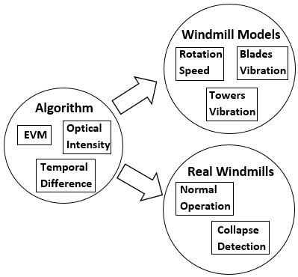
Figure 1. 1: Subjects of The Thesis
The thesis consists of six chapters, and the reference have been listed in the end of thesis.
Chapter 1: It introduces the motivation of the thesis and enumerate the objectives of the thesis. Also, it outlines the structure of the thesis.
Chapter 2: It is the literature review, which comprises of three selections. First it introduces the windmill system, including current situation of wind energy in EU, the structure and principle of windmills. Second, it reviews the windmill monitoring system in modern wind industry. Third, some new monitoring methods based on image processing have been addressed.
Chapter 3: It introduces the image process algorithms used in the thesis, including Pre-processing, Optical Intensity, Frame Difference and EVM. As the core technology of the imaging-based detection method is EVM, this chapter highlights the principle, working examples, improvement and the advantages of EVM.
Chapter 4: It demonstrates the results of new detection methods applied on windmill models in the lab. Some motion characteristics have been measured in this chapter, including rotation speed (frequencies), blades vibration and towers vibration. To verify the effect of the new method, undamaged windmill models and models of different damaged levels on blades or towers have been provided in the experiment.
Chapter 5: It investigates the new detection methods on real windmills. The chapter is divided into two parts, one is for the normal operation windmills, and the other is for the windmill collapse. In the normal operation part, the thesis collects the working data of three different types of windmills in the field and measures some blades’ and towers’ motion characteristics by the new methods. In the windmill collapse part, the thesis uses windmill collapse videos researched about on the Internet as data and analyses the motion behaviours of blades or towers before the complete collapse of the windmill.
Chapter 6: The conclusions and limitations are stated in this chapter. And with respect to the limitation of the method, scope of future work has been introduced.

2

LITERATURE REVIEW

2.1 Introduction
As the research of thesis focuses on wind turbine and image processing, this chapter consists of three sections to introduce the development status of wind turbine system, wind turbine monitoring and image processing in monitoring. The first section introduces the development status of wind energy, structure and working principle of wind turbine. The second section explains the windmill monitoring system in modern wind industrial, including the wind turbine damage and some of the common detection methods at present. The main point of these two sections is to help the reader realise the research object of the thesis. The third section is mainly about application of image processing in monitoring, which introduces some detection methods based on image processing. The aim of this part is to provide sufficient background and knowledge to understand the advantages of the research methodology of the thesis, compared with other image processing detection methods.

2.2 Wind Turbine System
With the energy crisis and the greenhouse effect receiving significant attention from people, renewable energy sources have been a global problem. From all the renewable energy possibilities, wind power technology, because of its reliability and productivity, is becoming increasingly popular. Today’s wind energy development not only results from wind energy’s new-found cost-effectiveness, but certain nations have even made renewable energy their priority (Zhang, 2013).

2.2.1 Wind Energy In EU
The latest statistical data from the European Wind Energy Association (EWEA) shows the current situation of wind power in Europe. Figure 2.1.a shows the annual wind power installations in EU, which in the past 11 years have increased steadily from 6.6 GW in 2005 to 12.5 GW in 2014, with a maximum level of 12.8 GW in 2015. By doing a horizontal comparison with other sources of energy, Figures 2.2 shows the cumulative power capacity in the European Union 2005–2016. In 2007, wind power overtook fuel oil as the 5th largest form of power generation capacity (point 1 in figure 2.1.b); in 2013, wind power surpassed nuclear as the 4th largest form of power generation capacity (point 2 in figure 2.2); in 2015, wind power overtook hydro as the 3rd largest form of power generation capacity (point 3 in figure 2.1.b); and in 2016, wind power exceeded coals as the 2nd largest form of power generation
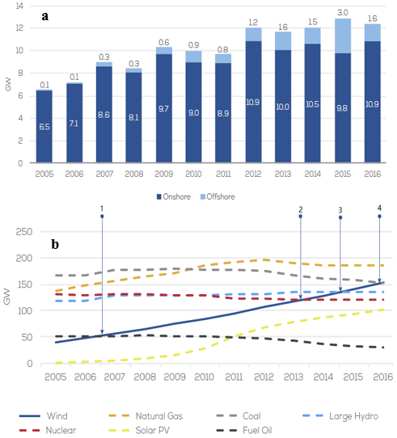
Figure 2. 1: a. Annual Onshore and Offshore Wind Installations In EU, b. Cumulative Power Capacity in EU 2005-2016 (EWEA, 2016)
capacity (point 4 in figure 2.1.b). For details, figure 2.2 shows the percentage of installed capacity in 2005 and 2016 in EU – wind power’s share of the total power generation capacity has increased more than two-fold since 2005; from 6.0%(41GW) in 2000 to 16.7%(154GW) in 2015. These data indicate that nowadays wind turbines are widely used in the global energy industry.
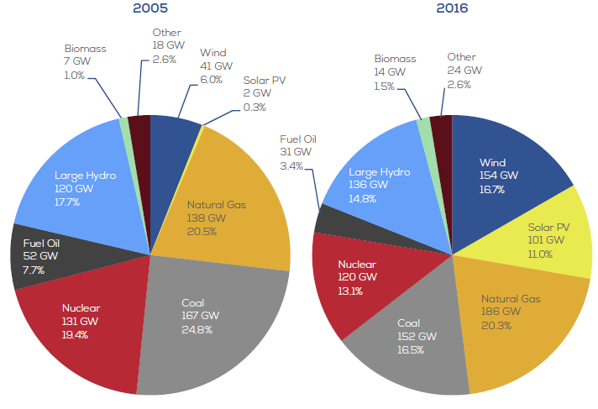
Figure 2. 2: Share in Installed Capacity In 2005 and 2016 (EWEA, 2016)

2.2.2 Wind Turbine Structure
Wind turbines harness the power of the wind and use it to generate electricity. Simply stated, the kinetic energy of air flow turns the blades around a rotor, the rotor spins a generator, which drives the system to create electricity. The wind turbine implements the energy translation from kinetic energy of air to mechanical energy of rotor rotation, to electric energy finally (Al-Bahadly, 2011). Figure 2.3 is the main structure of most wind turbine types; these components have been described in table 2.1 with respect to their functions. In fact, considering the working condition and manufacturing costs, not all wind turbines are constructed with the structures shown in figure 2.3, For example, for some types of windmills, the gearbox and pitch system are removed to reduce the operating and maintenance costs.
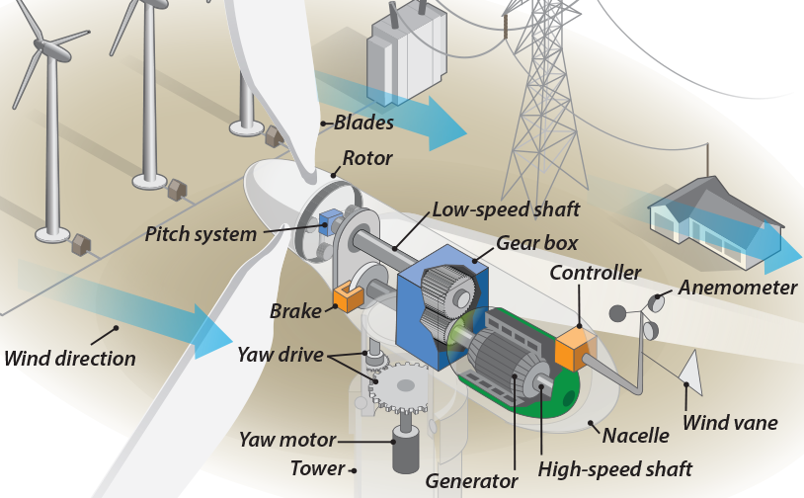
Figure 2. 3: Main Structure of Wind Turbine
Table 2. 1: Wind Turbine Components
Component | Function and Description
Blades | It is the structure to convert wind energy into mechanical energy, most turbines have either two or three blades. General, three blades impeller can provide the best efficiency, which is 2–3% efficiency higher than two blades impeller. Also, three blades impeller is more balance and artistic, it is more common in modern society.
Rotor | Blades and hub together form the rotor, and the rotor relates to shaft to spin a generator.
Low-speed Shaft | The speed of low-speed shaft is about 30–60 rpm, connected to the rotor directly.
Gear Box | The gear box connects low-speed shaft to high-speed shaft, increases the rotation speed from 30–60 rpm to 1000–1800 rpm, which is required by the generator to produce electricity. General, Large-scale wind turbine always uses planet gearbox, and for some types of wind turbines, the generator will be ‘direct-drive’, which can operate in lower rotation speed and need no gear box.
High-speed Shaft | The speed of low-speed shaft is about 1000–1800 rpm to drive the generator
Generator | The generator converts mechanical energy into electric energy and produces 60-cycle AC electricity. The rated power output is usually 500 to 2000 kw. The largest installed capacity can be 10MW
Controller | A computer monitors working condition of wind turbines constantly, and controls yaw device. It starts up the wind turbine at cut-in wind speed (usually 3–5m/s) and shuts off the machine at cut-off wind speed (usually more than 25m/s) to protect it from breakdown in high winds.
Anemometer | The anemometer measures the wind speed and transmits wind speed data to the controller.
Wind Vane | It measures wind direction and the data will help controller to control the yaw drive.
Yaw Drive | To orients the wind turbine to keep it facing the wind direction, make full use of wind energy and improve the efficiency of the wind turbine.
Yaw Motor | It provides power to yaw drive
Brake | It can stop the wind turbine in in emergencies. According its working principle, it can be divided into mechanical brake, electrical brake and hydraulic brake.
Pitch System | It pitches the angle between the blade and the wind to control the rotor speed, it keeps the generator at a constant rotation speed when the wind speed changes.
Nacelle | The nacelle is containing the key component of wind turbine, including gear box, low- and high-speed shafts, generator, controller, and brake. Maintenance personnel can enter the nacelle from the tower.
Tower | Because the wind speed will increase with height, the taller tower will have advantage to collect more wind energy and produce more electric energy. Nowadays the tower of 6MW wind turbine can be 100–120m. Usually the material of tower is steel-concrete or steel-lattice.

2.2.3 Wind Turbine Working Principle

2.2.3.1 Wind Turbine Power
When the wind turbine is manufactured, its rated power is already determined, which will never change due to the work environment of the wind turbine. The actual output power of the wind turbine is intimately associated with wind speed. Generally, the relationship between actual output power P and wind speed V can be formulated using formula 2.1 (Su, Jin and Fu, 2012).
$$P=\left\{\begin{aligned}0 (V<V_{ci},V≥V_{co}) \\ \frac{V^{3}-V_{ci}^{3}}{V_{r}^{3}-V_{ci}^{3}}P_{r} (V_{ci}≤V<V_{r}) \\ P_{r} (V_{r}≤V<V_{co})\end{aligned}\right. (2.1)$$
where $P_{r}$ is rated power, $V_{r}$ is rated wind speed, $V_{ci}$ and $V_{co}$ respectively represent the cut-in and cut-out wind speed. When the wind speed is $V_{r}$ and $V_{co}$, the pitch system will change the angle between the blade and the wind to remain the rotor speed, so that the output power will be steady. Considering the instability of the wind speed, the actual power curve will have slight difference with the ideal power curve in practical application, which is indicated in figure 2.4.
As it has already been discussed, wind turbine is a kind of facility to convert wind energy into electric energy; to continuously increase output power is the aim of wind turbine system development. Assuming the wind speed is V, the wind flow area is S, air density is ρ, the air mass $M$ that passes through the blades in t (time) will be:
$$M=VtSρ (2.2)$$
Put formula 2.2 into Kinetic Energy Formula $E=\frac{1}{2}MV^{2}$, the wind energy captured by wind turbine in time t will be (Ackermann and Soder, 2000)
$$E=\frac{1}{2}SρtV^{3} (2.3)$$
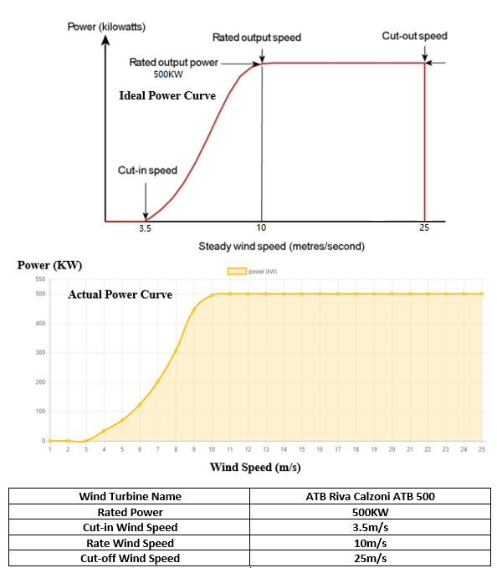
Figure 2. 4: One Example between Actual and Ideal Power Curve
From formula 2.3, it is easy to analyse that wind energy is mainly related to wind speed, the area of the wind flows and the air density. For details, wind speed is the biggest factors of windmill output power, because wind energy is directly proportional to the cubic of wind speed. Also, since wind speed increases with height, the taller tower has the advantage to collect more wind energy. The wind flows area in wind turbine is 1/4πD², therefore, the rotor diameter D becomes another determinant of wind energy. That is the reason why the larger installed capacity wind turbine has taller tower and longer blades. Figure 2.5 depicts that in the last 30 years, wind turbine capacity has increased by more than 160 times, and the size of wind turbine increased by more than 10 times (European Wind Energy Association, 2016). Nowadays, the U.S wind turbine company American Superconductors (AMSC) manufactures the 10MW wind turbine SeaTitan, whose rotor diameter is 190m and hub height is 125m.
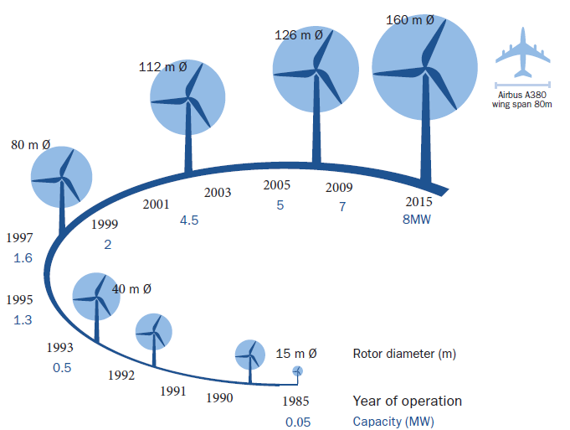
Figure 2. 5: Size Evolution of Wind Turbines Over Time (EWEA, 2016)

2.2.3.2. Aerodynamic of Windmill Blades
In a modern windmill, the blade is the most complicated force-summing element. Because of the instability and randomness of wind speed, the stress condition of blades changes constantly during the rotation. As a kind of typical aerodynamic component, the stresses on blades can be simplified into gravity, centrifugal force and aerodynamic force. In this section, the thesis uses BEM (Blade-element) theory to analyse the aerodynamic force on the blades.
The blade can be divided into many differential segments (ignore the thickness) along chord line, and each segment is called BEM. Therefore, the aerodynamic force on all the blades is the sum of stresses on each BEM (Liang and Zhang, 2015). Figure 2.6 shows the stresses condition on a blade-element.
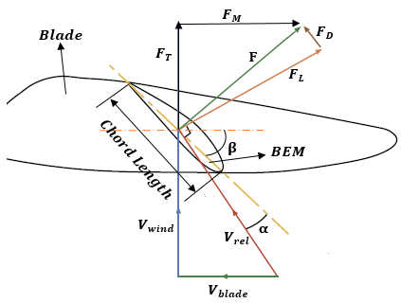
Figure 2. 6: Stresses Condition on Blade-Element
$V_{blade}$ is the blades speed, $V_{wind}$ is the true wind speed, and$V_{rel}$ is the relative wind speed. The net aerodynamic force on blade F is consisted of lift $F_{L}$ and drag $F_{D}$. Also, the F can be resolved into tangential force $F_{M}$ and normal force $F_{T}$. $F_{M}$ is the force caused by lift and produce torque to make the blades rotation; $F_{T}$ is the thrust caused by drag, it is a kind of resisting force and have no positive on generating electricity. $α$ is angle of attack, which is the angle between chord line and relative wind speed direction. $β$ is the pitch angle, which is angle between chord line and rotation plane. According to Chen’s (2013) book, the relationship between each component force as formula 2.4 illustrates. Where $C_{D}$ and $C_{L}$ is drag coefficient and lift coefficient; $C_{n}$ and $C_{t}$ is normal force coefficient and tangential force coefficient; c is the chord length of blade-element.
$$\left\{\begin{aligned}{F_{D}=\frac{1}{2}ρcV_{rel}^{2}C_{D} \atop F_{L}=\frac{1}{2}ρcV_{rel}^{2}C_{L}} \\ {F_{T}=\frac{1}{2}ρcV_{rel}^{2}C_{n} \atop F_{M}=\frac{1}{2}ρcV_{rel}^{2}C_{t}}\end{aligned}\right. (2.4)$$
From formula 2.4, when the wind speed is stable, the lift and drag are determined by lift coefficient and drag coefficient. To all air foil profiles, the $C_{D}$ and $C_{L}$ is varied with the angle of attack $α$. The lift will increase with the increasing angle of attack. When the angle of attack reaches a critical value, the lift deduces, which lead blades to stall (Koay and Tan, 2010). Therefore, the critical value of angle of attack is called stalling angle, and the lift reaches peak in this moment. However, as the drag will also increase dramatically in stalling angle, the optimum angle of attack will be less than the stalling angle, which achieve the maximum lift-to-drag ratio in the practical application. Figure 2.7 is an example of the relationship between lift, drag and angle of attack; also, figure 2.8 is the reference curve of $C_{D}-C_{L}-α$. The ideal operating value of $α$ is in region I. The lift-drag ratio and the stalling angle are two most significant factors of blade quality. The max lift-drag ratio of a high quality can be more than 60. Another influence factor of blades aerodynamic characteristics is Reynolds number. In a blade, the high Reynolds number leads to high stall angle, high lift coefficient and low drag coefficient.
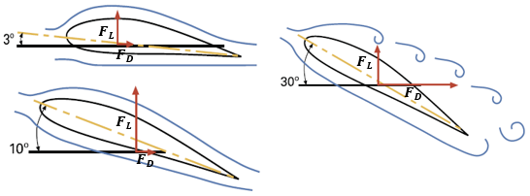
Figure 2. 7: Lift and Drag in Different Angle of Attack
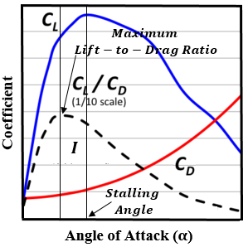
Figure 2. 8: Reference Curve of Lift Coefficient, Drag Coefficient and Their Ratio Per Angle of Attack (Koay and Tan, 2010)
Besides, to keep the windmill operations stable and efficient, pitch control is a common method in modern wind industry. The system stable generates power by changing the angle of attack or pitch angle when the wind speed is higher than rated speed (Dai et al., 2010). More details have been discussed in Section 5.2.

2.3 Wind Turbine Monitoring
As it has been mentioned, the size of wind turbines has increased rapidly in last 30 years to harvest wind energy more efficiently. However, this development makes the maintenance and repair more and more difficult. Therefore, considering the security and economic benefit, the wind turbine must be monitored from time to time to ensure that they are in good condition.

2.3.1 Wind Turbine Damage
By 2004, the installed capacity of the mainstream commercial wind turbine had reached MW (more than 1000KW), and the number of wind turbine kept increasing every year. This situation led to a trend– more windmills are built, more accidents occur. Figure 2.9 depicts the statistical data collected by Caithness Windfarm Information Forum (CWIF) in the UK, per wind turbine related accidents and incidents, which could be found and confirmed through press reports or official information in last 20 years. However, the RenewableUK confirmed that there had been about 1500 wind turbine accidents from 2006 to 2011 in the UK (Daily Telegraph reported in 2011 Dec 11). Figure 2.9 only reports 760 UK wind turbine accidents from 2006 to 2011, which is 50.7% of the reality. Therefore, the data in figure 2.9 represents only a portion of actual accidents.
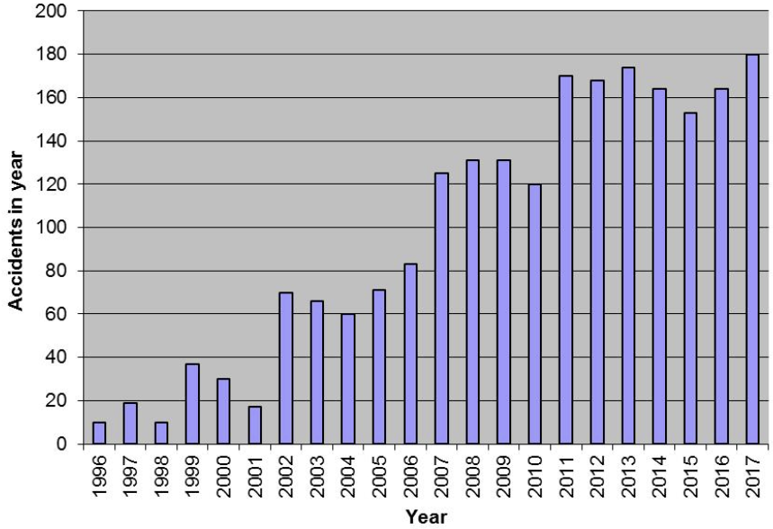
Figure 2. 9: Wind Turbine Accidents Statistical Data (CWIF, 2018)
Compared with small size wind turbine, the large-scale unit will support more complex load, damage will occur at any component or part of the wind turbine by many reasons (such as extreme weather, excessive wear, corrosion, etc.). The possible defect types of wind turbine component or part are tabulated in table 2.2 (Arabian-Hoseynabadi, Oraee and Tavner, 2010). Also, a research about wind turbine components failure rate had been done in EWEA. They collected about 15850 wind turbine accident cases in last 15 years to calculate the percentage of each component failure. Figure 2.10 shows the result, which includes both electrical components and mechanical components. Compared with other mechanical components, the blade is at high risk relatively, and this is one of the main objective of this thesis. In a wind turbine, the most common structural damage type is blade damage and tower damage, which are mainly discussed in this thesis.
Table 2. 2: Possible Wind Turbine Damage (Arabian-Hoseynabadi, Oraee and Tavner, 2010)
Components or parts of wind turbine | Possible defect
Blade | Surface Damage, Cracks, Structural Discontinuities, Freeze
Drive Train | Leakages, Corrosion
Hydraulic System,  Nacelle | Corrosion, Cracks
Pneumatic System,  Tower and Foundation | Leakages, Corrosion
Brake System,  Sensor,  Yaw System | Wear, Damage
Control System,  Electrical System | Circuit Aging, Bad Contact, Function Error, Corrosion, Dirt

Figure 2. 10: Share of Components in the Windmill Failures from 2001 to 2016 in EU (EWEA, 2016)
Figure 2.11 is the cost breakdown of a typical 2MW wind turbine (CSR WT2000-D110, a manufacturer from China), the blades is the most expensive part of a wind turbine. In other types of wind turbines, the blades can account for 15–20% of total wind turbine cost. Besides, the CSR Zhuzhou Locomotive Research Institute Co. Ltd, the manufacturer of WT2000-D110, surveyed about 600 WT2000-D110 wind turbines in China from 2013 to 2016 and collected their downtime and maintenance charge of main wind turbine components. The statistical data is shown in Figure 2.12. It has been indicated that the blade damage is one of the most expensive type to repair and takes the greatest maintenance time. Furthermore, if the prompt repair is not taken, minor blade damage will cause serious harm to the entire wind turbine because of rotating mass unbalance; it can even result in the collapse of the wind turbine.

Figure 2. 11: Cost Share of Main Components in WT2000-D110
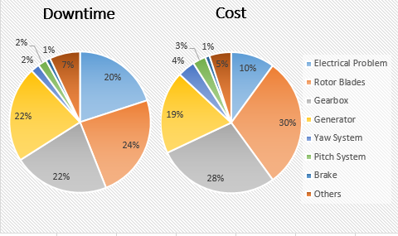
Figure 2. 12: Downtime and Repair Cost Share of Main Components in WT2000-D110

2.3.1.1 Blades Damage
To understand the blade damage, the structure of blades should be noticed first. Figure 2.13 shows the main element of mainstream blades in modern industry (McGugan et al., 2015). Considering the complexity of the working environment and economic efficiency in large-scale wind turbine, the material of the blades is always reinforced composites, called Glass Fiber Reinforced Plastics (GFRP), including: resin (epoxy, unsaturated polyester, etc.), fiber (glass fiber, carbon fiber, bamboo fiber, etc.), adhesive (Epoxy adhesive, vinyl ester adhesives, etc.), core material (Balsa, PVC foam, etc.), coating (PU, fluorocarbon, etc.); besides these, it will have some auxiliary materials and metal.
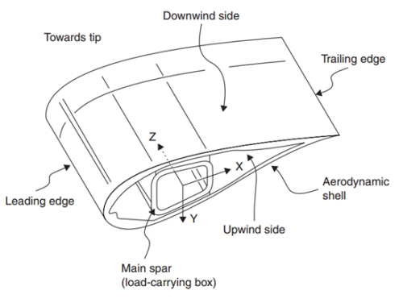
Figure 2. 13: Main Structure of Wind Turbine Blades
The damage can be regarded as the variation of materials or structural geometrical performance. When the wind turbine is in the normal working condition, the blades is the component that suffer wind loads, which drives the wind turbine rotation. Over time, this cycling load leads to fatigue-induced degradation, which causes cracks in the blades. The crack rapidly develops and results in the failure of wind turbine, if no maintenance is done. However, this is not the only way of damage, in practice, extreme weather, like typhoon, lighting and hail, or even the birds’ collisions can be responsible for the blades’ damage. As per the research of Ciang, Lee and Bang (2008) and Sørensen (2009), the wind turbine’s damaged blades could be generalised as seven types, which are shown in table 2.3. Figure 2.14 is a sketch illustration of types of damaged wind turbine blades.
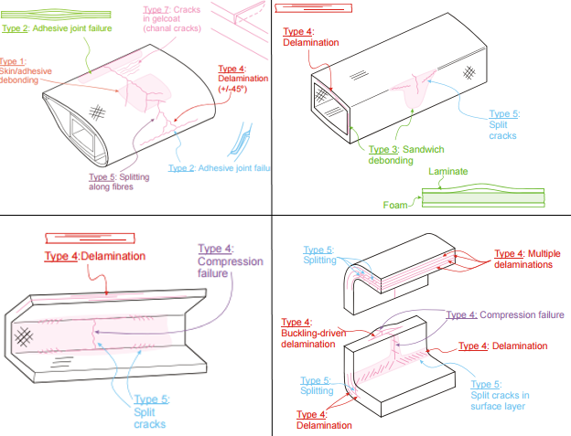
Figure 2. 14: Sketch Illustrating of Wind Turbine Blades Damaged Types (Sørensen, 2009)
Table 2. 3: Types of Wind Turbine Blades Damage
Type | Damage Description | Damage Example
Type 1 | Damage formation and growth in the adhesive layer joining skin and main spar flanges. | Skin/adhesive debonding,  Main spar/adhesive layer debonding.
Type 2 | Damage formation and growth in the adhesive layer joining the up- and downwind skins along leading and/or trailing edges | Adhesive joint failure between skins.
Type 3 | Damage formation and growth at the interface between face and core in sandwich panels in skins and main spar web | Sandwich panel face/core debonding.
Type 4 | Internal damage formation and growth in laminates in skin and/or main spar flanges, under a tensile or compression load. | Delamination driven by a tensional or a buckling load.
Type 5 | Splitting and fracture of separate fibers in laminates of the skin and main spar | Fiber failure in tension,  Laminate failure in compression.
Type 6 | Buckling of the skin due to damage formation and growth in the bond between skin and main spar under compressive load | Skin/adhesive debonding induced by buckling, a specific type 1 case
Type 7 | Formation and growth of cracks in the gel-coat. | Gel-coat cracking,  Gel-coat/skin debonding

2.3.1.2 Towers Damage
Tower is another important component, which bears the weight of blades and nacelle. As the component, whose length is about two-thirds of the total wind turbine, like figure 2.15 shows, the tower design largely determines the life of the wind turbine. There are several kinds of materials and ways to construct a wind turbine tower in the modern industry.
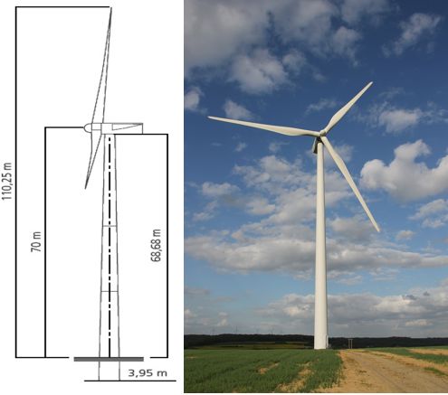
Figure 2. 15: Length of a 2MW Wind Turbine (Ecotècnia ECO 80)
Most of the modern wind turbines use tubular cylindrical pole towers, which are manufactured in several welded sections (Negm and Maalawi, 2000). Each section is 20–30m long and is bolted on site. In figure 2.15, the Ecotècnia ECO 80 tower is composed of three conical sections. The tower base is designed wider than the top, which gains the tower strength, as well as saves construction material. The material of this type is tapered steel or concrete, compared to steel, the concrete tower will suffer from thermal constraints, which may vary the natural frequency and reduce tower stiffness properties. However, when the height of a tower exceeds 85m, the steel tower will lose balance in the vibration excitation, the concrete tower will be more suitable in this condition (Harte and Van Zijl, 2007).
Another kind of tower of wind turbine is lattice truss tower, shown in figure 2.16. The Lattice tower uses connected steel beams construction, and this lattice truss framework permits the wind flow, so that the wind load on tower reduces. Therefore, for the same tower stiffness, the material cost for lattice tower is only half of that of a tubular tower, in other words, a lattice tower is much cheaper than a tubular tower (Gencturk, Attar and Tort, 2012). However, this does not mean that a lattice tower is stronger than a tubular tower; in fact, too many connections make the tower much easier to wear and corrode, also the weak diagonals are sensitive of wind excitation (Blandford, 1997). Besides, from vision and aesthetics perspective the lattice tower has a low experience. Despite their advantages, the lattice tower is less common in the modern industry, especially in the EU.
In small wind turbines, usually the installed capacity is several kilowatts, there is another type of tower called guy wire erectable poles, shown in figure 2.17. The most important feature for this framework is guy wires, which are cables fastened on towers from the ground. As the tower of this framework is steel pipe or tube, the guy wires help the tower to be stable under windy situations. The guy wires reduce the tower vibration, while the tower still shakes to a certain extent when the wind turbine works. Lower security makes this framework impossible to be mainstream in wind turbine farm, although it is simple and cheaper (Pipe, 2004).
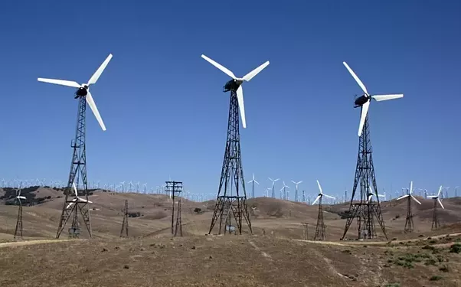
Figure 2. 16: Lattice Truss Wind Turbine Tower
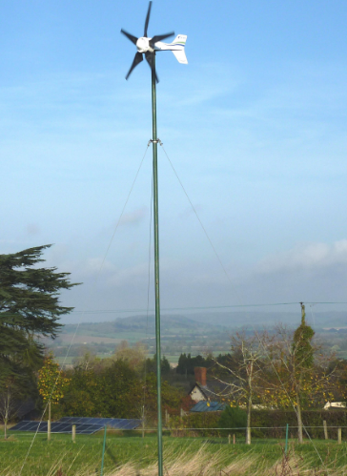
Figure 2. 17: Guy Wire Erectable Poles Wind Turbine Tower
As the main problems faced by tower are the varied wind load and weather environment, the most common damage for the towers is cracking caused by corrosion and fatigue, which changes the natural frequency and reduces the stiffness properties. Small cracks have little influence on wind turbine working in a general condition. However, if the tower is lack of maintenance, the cracks will expand, the tower will collapse at last. The data of Caithness Windfarm Information Forum (CWIF) obtains the third most common accident in the UK since 2000 is tower and foundation collapse. In these accidents, the main concern is storm damage, which is difficult to avoid. However, poor quality control and lack of maintenance can also be responsible, indicated by CWIF.

2.3.2 Windmill Monitoring System
The essence wind turbine condition monitoring system (CMS) or wind turbine structural health monitoring (SHM) is to analyse the data collected from wind turbine (Lee et al., 2015). To an ideal and typically monitoring system, it consists of two major parts: the sensors to obtain response measurements, and a software or algorithm to interpret the measured data (Drewry and Georgiou, 2007). With development of technology, nowadays, many newly detection methods have been emerged. In this section, some mainstream detection technology will be introduced.

2.3.2.1 Modal-based Approaches
Modal-based approaches are one of the earliest and the most common monitoring methods, not only because of its simple principle, but its adaptability to any structures. When a modality is produced, its modal parameters will be determined, such as natural frequency, modal shapes and modal damping. These characters will only be related to the physical properties of structures, such as mass, damping and stiffness. Therefore, when the structural damaged occurs, these physical properties will be changed (like the cracks will reduce the stiffness of structures), which will lead to the detectable change in the modal properties. In wind turbine monitoring system, different sensors, like shakers, actuators, strain gauges, piezoceramics or accelerometers, are installed on to monitor the structural dynamic responses. Although different sensors measure different data, the operate modes are similar. Using Strain gauges as an example.
Strain gauges or resistance strain gauges are widely used at present. Strain foils are attached to the surface of the material with prescribed direction, in this method, the strain in the structure will be transferred into the electrical resistance variety of strain foils. Using the electrical resistance change to calculate the strain value of material. The change in electrical resistance will be measured by “a locally connected data acquisition system, like Wheatstone bridge” (Li et al., 2015). Figure 2.18 is the simple principle of strain gauges.
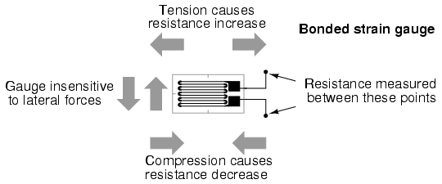
Figure 2. 18: Principle of Strain Gauges

For wind turbine, especial for blades, using cyanoacrylate as adhesive to bond the strain foils on the blades. To wind turbine with 25m length blades (rated power is about 150KW), more than one hundred strain gauges are installed on one blade to detect the axial stain. Considering the low-cost of strain-gauges, the strain-gauges is an inexpensive monitoring method, this is one reason why this method is widely used. However, as the strain gauges are smaller than a postage stamp, this kind of sensors is prone to break down on long term. Also, the sensors are sensitive to electrical disturbances, like lightning, because of its copper wiring; and they are sensitive with ambient noise disturbances. And also, the strain gauges on the blades cannot indicate the damage type of blades accurately unless the skin buckled (Schulz and Sundaresan, 2006).

2.3.2.2 AE (Acoustic Emission) Monitoring Methods
When the solid material structures are damaged, such as cracking, deformation, fractures, delamination, impacts, crushing and others, the elastic energy stored in the material will have transient release. The energy will transmit in form of stress wave. Although this kind of wave is so weak that it cannot be directly heard by human ears, it still can be detected by sensitive electronic equipment. This technology is called acoustic emission technique. Therefore, this technology is used to do real-time dynamic monitoring detection. Various materials acoustic emission signal frequency range is very wide, from infra-acoustic frequency, which is a few Hz, to ultrasonic frequency (MHz). Also, the amplitude range of the acoustic emission signal is also very high, from 10m (a micro dislocation movement) to 1m (the order of magnitude of seismic waves).
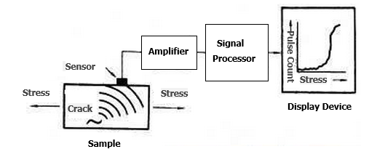
Figure 2. 19: Structure of AE Technique
Figure 2.19 shows the mode of AE technique, the AE sensors record the AE signals, which exceed a certain threshold. These signals then are analysed with different characters, such as frequency, amplitude, period, energy, etc. One of the AE method advantages is to determine the location of damage, which is based on the arrival time of AE wave. And another thing is the AE method can detect the damage level though “accumulated energy absorbed by the AE sensors over time”. Schulz and Sundaresan (2006) did a destructive test of a wind turbine blade to prove that as more damage occurs to the blade, more acoustic energy accumulates at the sensors. (figure 2.20)
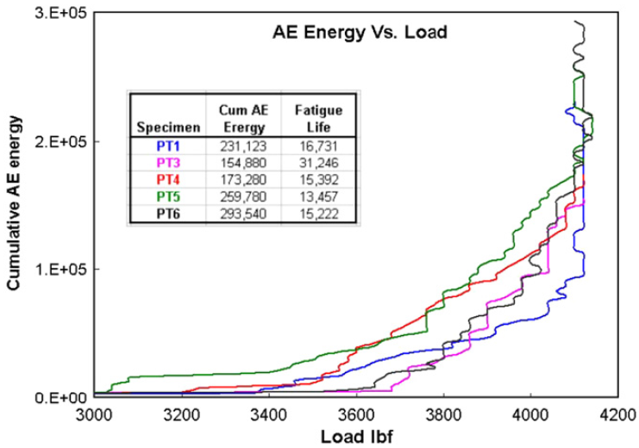
Figure 2. 20: Relationship between Cumulative AE Energy and Load (Schulz and Sundaresan, 2006)
The AE sensors is the element to convert the stress waves into electrical signals with the same frequency, because of the piezoelectric element in sensors (figure 2.21). The thickness and diameter of the piezoelectric element influences on the performance of AE sensors. The thickness determines the highest electrical output frequency; the diameter defines surface motion area. Different kinds of AE sensor are used in modern society, the most common one is Resonant AE Sensor. This sensor to assumption the AE wave is a kind of damped sine wave and it will transmit in constant speed. In fact, in most of the engineering application materials, the AE transmission is not a single mode, therefore, to acquire high accuracy of damage evaluation, the number of AE sensors must be increased and subsequently the number of data output to the signal processing system also increased (Ciang, Lee and Bang, 2008). This situation leads the variability in their outcomes, therefore, AE can be disturbed by many other elements, such as noise and specific environmental conditions (Gan et al., 2012).
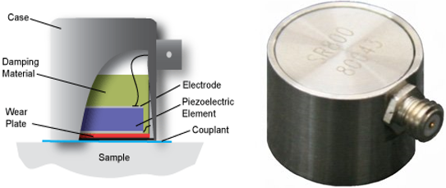
Figure 2. 21: AE Sensor and Its Schematic

2.3.2.3 Ultrasonic Methods
Ultrasound is a very suitable method to investigating the inner structures of solid subjects. The basic principle of this technique is based on the exploitation of ultrasonic guided waves. An ultrasonic wave is passed through the material and is then reflected by a defect. For example, if the object has defects, a boundary will be formed between the defects and the material. Since the acoustic impedance is different in the two sides of the boundary, the ultrasound will be reflected. In addition, this reflected wave will be picked up by a receiver, as figure 2.22 shows.
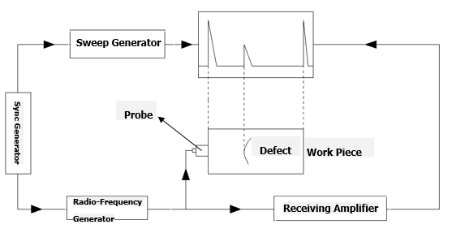
Figure 2. 22: Principle of Ultrasonic Flaw Detection
The core part of the ultrasonic method is the probe, which is used to achieve the emission and reception of ultrasonic. To determine the position and severity of the defect, the ultrasound transmit time and amplitude will be detected. Different position of transducers will react the ultrasonic transmit time to determine the defect location, while the amplitude can relative to the defect severity, even the damage length is as small as a few millimetres can be monitored.
Since the 1950s, British Glasgow doctor Donald discovered that ultrasound could be used to detect fatal conditions in pregnant women, the ultrasound testing has already proved its effectiveness. Also, in the last 10 years, more and more ultrasound tests have been applied in wind turbine monitoring. Jasiūnienė and his partners (2008) chose ultrasonic contact pulse-echo immersion testing with moving water in a container to inspect a wind turbine blade. That was because this form of inspection could be performed with access from one side of the wind turbine blade. Furthermore, Juengert and Grosse (2009) showed the best result, which used a method combining different ultrasonic techniques. They used two non-destructive testing techniques, ultrasonic and sonic, to monitor damages in wind turbine blades. The signals can visualise the inner structure of a wind turbine blade to determine damage locations. They found that neither technique had a harmful impact on the blades.
However, as with the AE technology, the ultrasound technique is not a perfect method for wind turbine monitoring. This is because the ultrasound signal will have interference from the outside environment (such as temperature, humidity, altitude, airflow and so on). Moreover, to keep the high accuracy of the detection, the detection distance should not be too far, however the actual wind energy plants are not able to provide short distance inspection. In another word, to use the ultrasound technique to monitor wind turbines, the accuracy would be a significant problem.

2.3.2.4 Thermal Imaging Method
Infrared radiation is one of the most common electromagnetic waves in nature. All the objects in the nature, whose temperatures are above absolute zero (-273.16℃), can radiate infrared. That is because the infrared radiation of objects is based on their own molecules and atomic random movements, when the object temperature is higher, the movements are more serious, the energy of infrared radiation is stronger. Use this principle, the thermal imaging technology has been widely used in daily life, figure 2.23 is the thermal imaging of wind turbine (FLIR, 2012).
Figure 2. 23: Thermal Imaging of Wind Turbine Blades
In wind turbine monitoring, the thermal imaging method can be a subsurface defects or anomalies detection method to monitor some surfaces, such as blades. Krstulović-Opara, Klarin and Domazet (2009) performed an experimental evaluation to show the stress distribution on a wind turbine blade. The method they used was based on thermal stress analysis. The blade was exposed to a simple oscillating movement, like the real one. The blade was then mounted on a wind turbine rotor. Energy dissipation caused by elastic stresses in the structure was detected with an infrared thermal image camera.
The thermal imaging method has been proved in the test, however, consider the limitation of its equipment and strict requirements of environment, the thermal method to detect structural health “is not a standard methodology amongst wind turbine operators, it is often used to detect often used for monitoring electronic components failure” (García Márquez et al., 2012) in practical application. In other words, although the technology has developed rapidly, it is still not sufficiently mature to be used in actual wind turbine systems.

2.3.2.5 Fiber Optics Method
Optical fiber is a kind of light transmission tool, which is manufactured with glasses or plastics, the principle of its transmission is total internal reflection (TIR) of the light (figure 2.24) (Lopez-Higuera et al., 2011), n₁ is optically denser medium, and n₂ is optically thinner medium, when the incident angle Θ₁ increases to a certain situation, the refracted angle Θ₂ will be 90°. In this situation, the incident angle will be called the critical angle Θ_{c}. If the incident angle Θ₁ is greater than the critical angle Θ_{c}, no refraction is existed, all the light is back to n₁, this phenomenon is called Total Internal Reflection.
The structure of Optical Fibers is to achieve the TIR (figure 2.25). The Core is the centre of optical fibers, in where the light transmits. It is optically denser medium. The Cladding is optically thinner medium to help light back into core. And the coating is usually plastics to protect the fibers. The transmission loss of light in optical fiber is much lower than that of electricity in the wire, and it is immune to electromagnetic interference, therefore the optical fiber is used for long-distance information transmission (Thyagarajan and Ghatak, 2007).
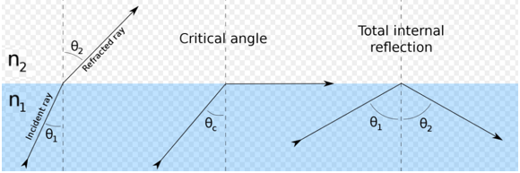
Figure 2. 24: Principle of Total Internal Reflection (TIR)
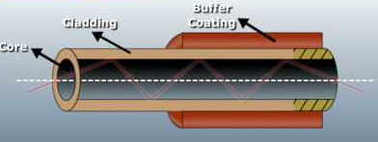
Figure 2. 25: Structure of Optical Fibers
In the real application, the optical properties of light (Such as intensity, wavelength, frequency, phase, polarization, etc) will be changed with the variation of optics fibers. For example, “the optical power of a light source will reduce when it goes through an optical fiber. The reduction depends on the strain of the optical fiber. (Ciang, Lee and Bang, 2008)” Using this character, Takeda (2002) did the test, the light from emitting diode went through an optical fiber, which is attached to a structure. Using a photo detector and optical power meter to measure the optical power. The strain of optical fiber increased with the crack density, which leaded to the reduction of measure optical power. Figure 2.26 is the relationship between crack density, strain and optical power in Takeda’s test.
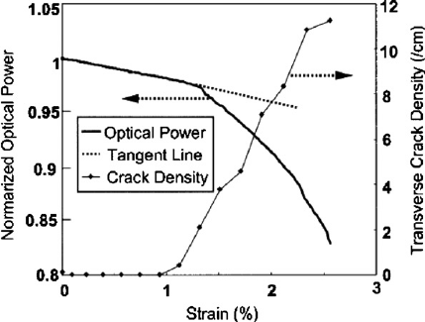
Figure 2. 26: Relation between optical power, crack density and strain of a composite specimen (Takeda, 2002)
Although the potential of optical fiber in wind turbine monitoring application is not unleashed fully, it still demonstrates its great prospects to replace the tradition sensors for long term damage detection. Nowadays, two kinds of fiber optic sensors, namely the Fiber Bragg Grating (FBG) sensor and optic fiber micro-bend displacement sensor, have already been applied in damage detection of turbine blades (Li et al., 2015). However, the prohibitive cost and bulky interrogation equipment will be the main obstacle, which prevent them to be the mainstream in wind turbine monitoring application.

2.4 Monitoring Methods Based on Image Processing
With the development of computer technology and VLSI (Very Large-Scale Integration) in 1960s, the image processing has been a kind of emerging technologies. Since 1990s, the image processing had been improved and enhanced, the application of image processing has been extended. At the same time, considering some factors, such as accuracy, complexity and cost, the NDT (Non-Destructive Testing) has become the mainstream in monitoring methods. The combination of the two technologies created NDT based on image processing.

2.4.1 View of Image Processing
Image processing or computer image processing, is a technology of image analysis with computers. Nowadays the image processing main means digital image processing, that is because the computers used in modern society mostly are digital computers, which can only process digital signals; and the digital image is a kind of two-dimensional array, which can convert image signals into digital signals (Unger Holtz, 2007). In this way, the computers can process the images, and extracts the data or the information needed. The table 2.4 is some main processing methods. And figure 2.27 is the key stages of digital image processing.

Table 2. 4: Common Image Processing Methods
Method | Description | Example
Image Transformation | The image array is large, if it is processed directly in the space domain, it involves a large amount of computation. Therefore, the image transformation converts spatial domain into a transform domain, which can reduce computation and increase efficiency. Such as | Fourier Transform,  Walsh Transform,  DCT (Discrete Cosine Transform),  WT (Wavelet Transform).
Image Coding Compression | As there are many redundancies in the data, the digital image can be compressed by removing these redundancies, which can save the image transmission time or processing time and reduce the memory capacity. | RLE (Run-Length Encoded),  Entropy Encoding,  Transform Coding.
Image Enhancement | The essence of image enhancement is to emphasise certain features which are interested in or inhibit the characteristics which are not interested in. The ultimate purpose is to improve image quality for the analysis. | LPF (Low-pass Filtering),  HPF (High-Pass Filtering),  Median Filtering,  Mean Filtering.
Image Restoration | Various factors, such as sensor noise, atmosphere turbulence, optical aberration and so on, will affect the imaging system, which leads to the degradation of image quality. This phenomenon is called image degradation. The image restoration is the processing to restore the original information of the degraded image. | Wiener filtering,  Regularised Filtering,  Lucy-Richardson Algorithm,  Blind Deconvolution.
Image Segmentation | Image segmentation is a process to divide the image into several specific, unique areas; and extract the features which is interested in. It is the basis for further image recognition, analysis and understanding. | Threshold Segmentation,  Region Segmentation,  Edge Segmentation.
Image Description & Representation | Using external characteristic (Boundary) or internal characteristic (pixel) to descript and represent the image region after image segmentation. | Moment Descriptor,  Fourier  Descriptor.
Image Recognition | It is a kind of Pattern Recognition. Generally, it is a classificatory decision of images, which are pre-processed (enhanced, restored, compressed), segmented and feature extracted. | Laplace Operator,  Bessel Operator.

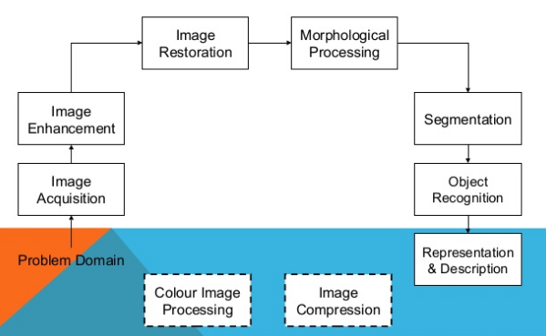
Figure 2. 27: Key Stages of Digital Image Processing
Per the different image processing methods, the purpose of image processing can be divided into five groups (Jain, 2010):
(a) Observe the objects that are not visible;
(b) Create a better image;
(c) Seek for the image of interest;
(d) Measures various objects in an image;
(e) Distinguish the objects in an image.
These purposes make the image processing apply in many field, such as satellite remote sensing, medical detection, face detection, environmental monitoring and so on. Also, some image processing-based method, such as DIC or ESPI, have already been applied to measure or detect the object motion, like vibration, deformation or swing (Wang, Hwang and Lin, 1996).

2.4.2 DIC Techniques
DIC (Digital Image Correlation) or DSC (Digital Speckle Correlation) is a kind of image measurement method, which use the computer visual technology, to detect the dynamics of materials. It combines with photoelectric technology, image processing and computer technology. Since it had been discovered in 1982, it has already developed as a pretty mature technology in last 35 years. Therefore, the DIC technique is a representative application of image processing in SHM.
The laser beam is irradiated on the surface of the object with diffuse properties, according to the Huygens Principle, each point can be seen as a light source. The light reflected from the object surface will be coherently superimposed and interfered in space, which result in the formation of random distribution of bright and dark spots. This phenomenon is known as laser speckle, as figure 2.28 shows. The DIC is based on these speckle images. It uses the speckles as feature points, pixel as coordinates and gray scale as the information carrier. First, selecting a square image subset as object, whose centre is the pixel of interest. Then, Using the relevant algorithm to calculate the displacement vector of the subset in the process of image moving or deforming, by tracking the subset position variation (figure 2.29). Finally, analysing multiple subset in image to constitute the displacement field of the whole analysis area (Bornert et al., 2008).
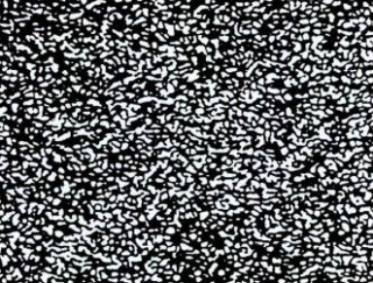
Figure 2. 28: Laser Speckle Image
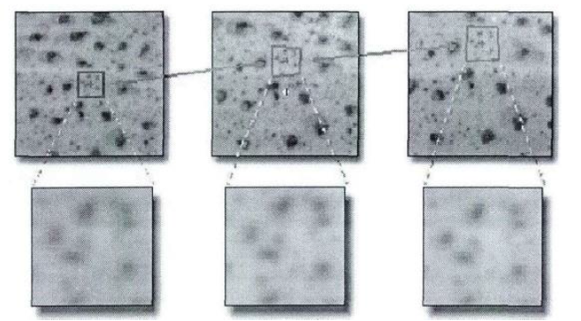
Figure 2. 29: Tracking the Subset Before and After Deformation
For more details, like in figure 2.30, the central point $P\left(x_{0}, y_{0}\right)$ and one neighbouring point $Q\left(x_{i}, y_{i}\right)$ in reference subset will become $P^{'}\left(x_{0}^{'}, y_{0}^{'}\right)$ and $Q^{'}\left(x_{i}^{'}, y_{i}^{'}\right)$ in target subset after deformation. Considering the continuity of deformation, the Q’ in target subset is still the neighbouring point around the central. According to the displacement analysis diagram (figure 2.31), the P’ can be expressed as formula 2.4, u and v is displacement component in x-axis and y-axis of P’.
$$P^{'}\left(x_{0}^{'}, y_{0}^{'}\right)=\left\{\begin{aligned}x_{0}^{'}=x_{0}+u \\ y_{0}^{'}=y_{0}+v\end{aligned}\right. (2.5)$$
The Q’ can be expressed as formula 2.5, $u_{Q}$ and $v_{Q}$ is displacement component in x-axis and y-axis of Q’.
$$Q^{'}\left(x_{i}^{'}, y_{i}^{'}\right)=\left\{\begin{aligned}x_{i}^{'}=x_{i}+u_{Q} \\ y_{i}^{'}=y_{i}+v_{Q}\end{aligned}\right. (2.6)$$
Assuming formula 2.6 holds, $u_{x}$, $u_{y}$ and $v_{x}$, $v_{y}$ represent displacement gradient of subset
$$u_{Q}=u+u_{x}∆x+u_{y}∆y; v_{Q}=v+v_{x}∆x+v_{y}∆y$$
$$u_{x}=\frac{∂u}{∂x}; u_{y}=\frac{∂u}{∂y}; v_{x}=\frac{∂v}{∂x}; v_{y}=\frac{∂v}{∂y} (2.7)$$
$$∆x=x_{i}-x_{0}; ∆y=y_{i}-y_{0}$$
Combining formula 2.5, 2.7 and 2.6 to formula 2.8.$$Q^{'}\left(x_{i}^{'}, y_{i}^{'}\right)=\left\{\begin{aligned}x_{i}^{'}=x_{0}+∆x+u+u_{x}∆x+u_{y}∆y \\ y_{i}^{'}=y_{0}+∆y+v+v_{x}∆x+v_{y}∆y\end{aligned}\right. (2.8)$$
In the formula, $u$, $u_{x}$, $u_{y}$ and $v$, $v_{x}$, $v_{y}$ are unknown vectors, including displacement variable.
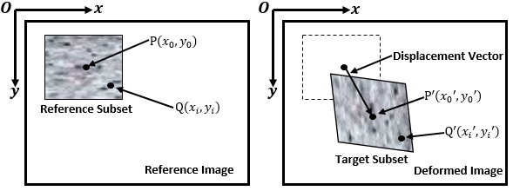
Figure 2. 30: Comparison of Subset Before and After Deformation
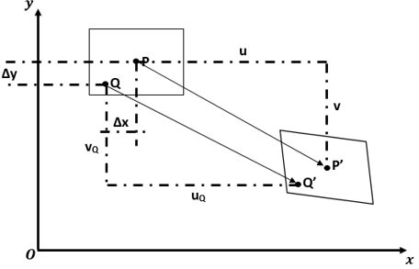
Figure 2. 31: Comparison of Subset Before and After Deformation
To determine the displacement vector accurately, introducing the correlation coefficient C, which can reflect the similarity degree between reference subset and target subset. Assuming the gray scale of Q and Q’ is formula 2.9, f and g is the gray distribution of Q and Q’.
$$Gray=\left\{\begin{aligned}f\left(Q\right)=f(x_{i}, y_{i}) \\ g(Q')=g(x_{i}', y_{i}')\end{aligned}\right. (2.9)$$
The correlation coefficient C is the function of f and g, like formula 2.10.
$$C\left(f, g\right)=C\left(x_{i},{ y}_{i},{ x}_{i}^{'},{ y}_{i}^{'}\right)=\frac{\sum{f\left(x_{i}, y_{i}\right)∙g\left(x_{i}^{'}, y_{i}^{'}\right)}}{\sqrt{\sum{f^{2}}\left(x_{i}, y_{i}\right)∙\sum{g^{2}\left(x_{i}^{'}, y_{i}^{'}\right)}}}$$
$$(2.10)$$
The selection criteria of correlation coefficient determine the accuracy and speed of DIC, formula 2.10 is only one of example to calculate the correlation coefficient. Using iteration, pixel search and subpixel search to calculate $u$, $u_{x}$, $u_{y}$, $v$, $v_{x}$ and $v_{y}$ repeatedly to confirm the extremum of correlation coefficient (whether maximum or minimum depends on the formula of correlation coefficient). When the same subset is determined in reference and deformed image, the deformation can be extracted.
Since 1980s, Yamaguchi, from Japan, Peter and Ranson, from the University of Southern Carolina proposed a concept of DIC simultaneously, the research of DIC has never been stopped. Cintrón and Saouma (2008) used DIC to measure the strain of aluminium and clay brick and compared the results with theoretical strain value. Finally, they found the DIC results of clay brick was almost the same with theoretical value, but that of aluminium is little higher. Savic, Hector Jr and Fekete (2008) applied DIC in the plastic deformation and fracture of fully martensitic steels, analysed the stress distribution of this steel during stretching. Ahn and Nutt (2009) measured the strain mapping of Al-Mg alloy in deformation at microscale and proved the DIC could observe the micro-strain range from 10⁻⁴ to 10⁻⁶.
Compared with other NDT (Non-Destructive Testing) or optical measurement methods, such as laser shearography and speckle interferometry, the DIC is much cheaper, stronger applicability and no special requirements of measurement environment. Especially for large civil engineering structures, such as high buildings and bridge, “the key to long term cost-effective management of these structures is to use low-cost measurement techniques that can be cheaply deployed, and are suitably accurate” (McCormick and Lord, 2010). Therefore, the DIC is used in these structures.

2.4.2 ESPI Techniques
ESPI (Electronic Speckle Pattern Interferometry) is another detecting method which is based on image processing. The DIC method introduced, when the laser beam is irradiated on the diffuse properties surface, it will produce speckles. Like the DIC method, the ESPI also is based on the speckles, the difference is the research object of ESPI is the interference fringe in the speckle field (Lokberg, 1984). Figure 2.32 is a typical ESPI beam path. The laser beam is divided into reference beam and object beam though the beam splitter 1. The object beam will illuminate on the object surface though the Mirror 1 reflection and Lens 1 expansion. Finally, the reference beam and the object beam will be interfered in the beam splitter 2 and recorded by CCD camera. The research emphasis of ESPI is the interference fringe in BS2 (Sun, Wang and Zhang, 2003).
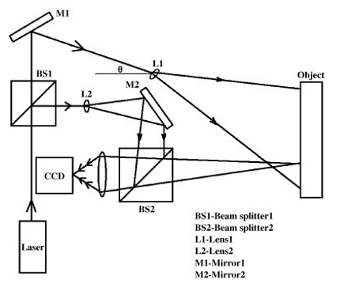
Figure 2. 32: Typical ESPI Beam Path of Measurement
Assuming the complex amplitude of object beam and reference beam as formula 2.11 shows, $U_{O}\left(r\right)$ and $ϕ_{O}\left(r\right)$ are the amplitude and phase of object beam; $U_{R}\left(r\right)$ and $ϕ_{R}\left(r\right)$ are the amplitude and phase of reference beam.
$$Amplitude=\left\{\begin{aligned}U_{O}\left(r\right)=u_{O}\left(r\right)∙exp ϕ_{O}\left(r\right) \\ U_{R}\left(r\right)=u_{R}\left(r\right)∙\exp{ϕ_{R}\left(r\right)}\end{aligned}\right. (2.11)$$
The CCD camera records the light intensity in BS2, where the object beam and reference beam are interfered in, is as follow,
$$I\left(r\right)=u_{O}^{2}\left(r\right)+u_{R}^{2}\left(r\right)+2u_{O}\left(r\right)u_{R}\left(r\right)cos\left[ϕ_{O}\left(r\right)-ϕ_{R}\left(r\right)\right]$$
$$(2.12)$$
When the object has deformation, the amplitude of object beam $U_{O}\left(r\right)$ is essentially constant, however, the phase has changed into $ϕ_{O}\left(r\right)-Δϕ\left(r\right)$. Therefore, the complex amplitude of object beams has been varied into formula 2.13
$${U'}_{O}\left(r\right)=u_{O}\left(r\right)∙exp \left[ϕ_{O}\left(r\right)-Δϕ\left(r\right)\right] (2.13)$$
As the reference beam is not changed, the synthesised light intensity in BS2 after deformation is formula 2.14
$$I'\left(r\right)=u_{O}^{2}\left(r\right)+u_{R}^{2}\left(r\right)+2u_{O}\left(r\right)u_{R}\left(r\right)cos{[ϕ_{O}\left(r\right)-ϕ_{R}\left(r\right)-Δϕ\left(r\right)]}$$
$$(2.14)$$
Using formula 2.14 and 2.12 to calculate the fringe expression, which is relative to the deformation field (formula 2.15), $sin\frac{Δϕ\left(r\right)}{2}$ is the low-frequencies fringe in the phase transformation field.
$$I={\left[I^{'}\left(r\right)-I\left(r\right)\right]}^{2}$$
$$={\left\{4u_{O}\left(r\right)u_{R}\left(r\right)sin\left[ϕ_{O}\left(r\right)-ϕ_{R}\left(r\right)+\frac{Δϕ\left(r\right)}{2}\right]sin\frac{Δϕ\left(r\right)}{2}\right\}}^{2}$$
$$(2.15)$$
It is obvious to obtain the fringe is relative to the phase variation of object beam, while the relationship between the phase variation $Δϕ$ and the object deformation can be expressed in formula 2.16, w is the out-of-plane displacement of object deformation, u is the in-plane displacement of object deformation, λ is the wavelength of laser, and θ is the incident angle of the object beam (in figure 2.32). Figure 2.33 is the measurement mode of out-of-plane displacement and in-plane displacement (Dantecdynamics.com, 2015).
$$Δϕ=\frac{2π}{λ}\left[w\left(1+cosθ\right)+usinθ\right] (2.16)$$
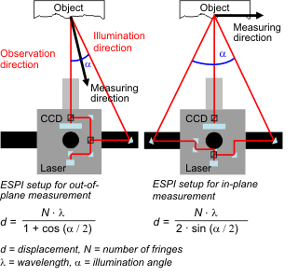
Figure 2. 33: ESPI Setups for Displacement Measurement (Dantecdynamics.com, 2015)
Form 1970, Leendertz proposed a concept of speckle interferometry, to 1987, Wykes realised ESPI by using low power laser and semiconductor laser, the speckle interferometry technology had developed gallopingly in less than 20 years (Zheng, 2002). In recent years, with the improvement of ESPI system, the range of ESPI application extended. For example, Arena and his partners (2015) used the ESPI to analyse the hidden defects of an original XVI century painting on wood. The group of Moothanchery (2016) determined the displacement in acrylamide-based photopolymer layer during holographic recording by ESPI.
Compared with DIC, the ESPI has the higher sensitivity, it can detect the tiny deformation accurately. However, the DIC is more suitable for the large deformation or even the plastic deformation. Figure 2.34 is the measurement range of ESPI and DIC. In the same measurement range, the ESPI can measure the displacement from 0. 001 to 10 μm with high sensitivity, and the measurement range of DIC will increase with the length of fields measured (Qu et al., 2013).
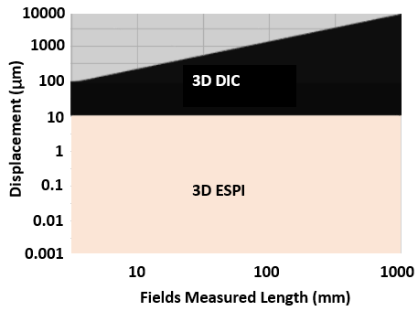
Figure 2. 34: Measurement Range of ESPI and DIC (Qu et al., 2013)

2.4.3 Digital Images Application in Windmill Industry
As the development of image processing and camera technology, digital images are accepted as a kind of information carriers. Similarity with other fields, in recent years, the digital images technology in windmill industry has been researched, and several achievements have been obtained. Among these achievements, the new inspection techniques based on digital images has been already in practical application: high-definition cameras and autonomous drone.
The tradition manual inspection (climbing up to wind turbine blades) is dangerous and time-consuming. Sometimes it spends months to inspect the entire windmill farm by manual work. However, the drone technology turns the complex inspection into a safer and more effective process. Figure 2.35 shows the situation of drone inspection. According to data provided by SkySpecs, which is the famous autonomous drone company in US, the drone takes less than 15 minutes to inspect one windmill once, and one drone can manage as many as 17 inspections in one day (Dvorak, 2017). Pappot and Boer (2015) considered using RPAS (Remotely Piloted Aircraft Systems) to inspect windmill blades and towers represents the general trend.
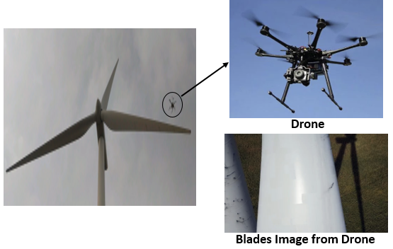
Figure 2. 35: Windmill Blades Inspection Based on Drones
However, Gallacher (2016) considered there were no obvious cost advantages of drone compared with manual inspection. Therefore, some windmill farms use a third inspection method: high-definition cameras based on ground. The equipment of this method including a camera with a telephoto lens and a tripod, and a laptop to store and analyse data. Compared with drone, although the ground-based cameras method cannot provide the local details images as clear as drone, it is much simpler: no need to pilot and maintain drone. Also, as the method only needs one camera to inspect all blades, it only costs 20% and 25% of the manual inspection cost, according the data found by EDF Renewable Energy. Another drone company in Israel, Percepto, estimated the windmill inspection methodologies share in EU (figure 2.36). Although the manual labour still holds a dominant position in modern windmill inspection, the new image-based inspection methods are developing (Jason, 2016).
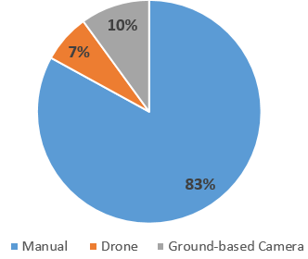
Figure 2. 36: Estimated Share of Windmill Inspection Methodologies by Percepto
No matter the drone or the ground-based cameras, they are both the most direct methods to inspect the windmill. They can make the external damage of windmill blades and tower visual but cannot detect the internal structure. In fact, the most significant function of digital image was data collection of windmill and provided the feasibility for the further analysis (Swytink-Binnema and Johnson, 2014).
In recent years, many images processing algorithms are attempted to measure and detect the windmill components from the digital image, including the two methods mentioned in the thesis: DIC and ESPI. For example, Winstroth et al. (2014) used two cameras to detect the blade torsion and bending of a 3.2MW wind turbine by the DIC method. And, he also compared the results to the aeroelastic simulations of a multi-megawatt wind turbine. The comparison demonstrated feasibility of DIC method to detect the blades change during the windmill operation. Baqersad et al. (2012) also applied the DIC method of measuring the natural frequencies and mode shape of windmill blades with two high speed cameras in lab. After comparing the results with finite element modelling, his research illustrated the capability of DIC in low-frequency vibration measurement. Also, Zrida et al. (2012) used ESPI to research the cracks initiation and displacement distribution of composites NCFs (Non-Crimp Fabrics), which was used in windmill blades.
Besides DIC and ESPI, Zhang and Jackman (2013) combined the optical inspection method with detection of windmill blades surface crack. They utilised a climbing rotor with camera, image line detection method and image edge detection method to analyse blades surface crack. The research considered the line detection was suitable for crack quick scan, which can identify the exist of crack; and the edge detection provides more information of crack, such as the size, direction and depth of crack. Gonzalez, Sanchez and Calvo (2010) also applied several image processing methods to measure the angular frequency of windmill from a windmill video, including histogram adjustment, image segmentation, image erosion and so on. All these previous researches manifest the feasibility of image processing in windmill detection field.
However, although the image-based windmill detection methods have been researched, they are still in the exploration stage. The methods presented at the present stage, have many limitations (Tekalp, 2015). For example, Winstroth’s method needs a Light Detection and Ranging (LiDAR) system as an assistant measuring tool; Zhang and Jackman’s method only can identify the crack on surface and the images of windmill must be shot at very close range; The accuracy of Gonzalez, Sanchez and Calvo’s method calculation method is not high; and other methods mentioned above are just in experimental phase, no practice applications are tested.

2.5 Summary of Literature View
The literature view introduces the wind turbines’ current situation, damages, monitoring and image processing with the technical maturity of wind turbines. The wind energy has already become a kind of a normal energy. The installed capacity even exceeded many conventional energy resources, such as coal and nuclear. In 2016, the wind energy surpassed only by natural gas, and the market of wind energy hasn’t obtained saturation for there is still a gap in the present market.
The heavy demand of wind energy leads to the increase of wind turbine size, which can collect wind power more efficiently. However, because of the complex working environment of a wind turbine, the damages of wind turbines are inescapable, especially for blades and towers. Considering the high maintenance fee and the economic losses of wind turbine downtime, wind turbine monitoring has become a significant research subject, which ensures that wind turbine components are in good condition.
Although the methods of wind turbine condition monitoring or wind turbine structural health monitoring are varied in modern industry, the cores of systems are sensors. Ciang, Lee and Bang (2008) in their paper noticed ‘adding sensors to wind turbine structure may adversely affect the performance of the turbine’. Therefore, the number and the location of sensors are important issues of wind turbine monitoring. In the recent years, the objects of wind turbine monitoring research are reducing the sensors’ number to ensure accuracy. In other words, the NDT (Non-Destructive Testing) is the trend of wind turbine monitoring.
As an emerging technology, image processing has already been a kind of NDT theoretical basis since the 1960s. And based on this, the derived technology, Non-contact optical measurement technology, such as DIC and ESPI, had already applied on many monitoring fields. In recent years, drones and cameras have already been applied as a new windmill inspection method to detect the obvious damaged and collect windmill image data. At the same time, more and more image algorithms have been explored to measure and detect the dynamic parameters of windmill operation from the image data. However, considering the monitoring accuracy and monitoring costs, no impeccable monitoring method based on image processing has been researched.
Lakshmi and Sujatha (2016) regarded that the critical points of image processing for monitoring windmills is to extract the feature of ROI (Region of Interest) in image. He plotted the main frame for detecting windmill by using image processing method as figure 2.37 shows. Therefore, as per the results of the current research, the thesis proposes a new image-based detection method based on this frame in next chapters, which has better adaptability and economic efficiency.
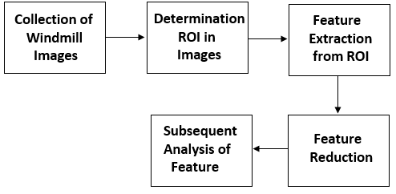
Figure 2. 37: Basic Framework of Image Processing Methods to Detect Windmill (Lakshmi and Sujatha, 2016)

3

METHODOLOGY

3.1 Introduction
Chang (2009) indicated in his book, ‘Structural Health Monitoring’, that the one of the main factors of modern industrial monitoring system is the monitoring cost. Although many emerging monitoring methods are accurate and non-destructive, they are still impossible to completely replace the traditional monitoring methods in the modern industry, because of their high-cost for equipment and maintenance. However, considering the limitation of traditional monitoring methods (some have already introduced in Chapter 2), the research of new detection methods never ceases.
The summary of Chapter 2, mentions the detection methods based on image processing have been increasingly concerned and applied in some industrial fields. Therefore, the thesis focuses on a new monitoring method of windmill detection based on image processing. Table 3.1 is the list of the main processing methods applied in the thesis, including image processing methods and signal processing methods. Each one will be explained in detail in this chapter.
Table 3. 1: Main Processing Methods Applied in Thesis
Processing Methods | Description
Pre-Processing | Some pre-processing methods are used to simplify image information, such as Gray Processing and Image Segmentation (Binarization). They transform RGB images to gray images or binary images, which facilitate further processing.
EVM | Eulerian Video Magnification, a new magnification method to enhance the small movement in the videos or photos, which cannot be found by the naked eye directly. And it is the core technology of the new detection method.
Optical Intensity | It is the measurement method to calculate some motion parameters in the image sequences, such as motion frequency and motion time. The method is based on FFT (Fast Fourier Transformation), an efficient algorithm for DFT (Discrete Fourier Transformation) to transform the sign from time domain to frequency domain.
Motion Tracking | The thesis uses Frame Difference method to do motion tracking. It can track the motion objects positions in the image sequences. And per the position, the motion trail of movement objects can be determined.

Pre-Processing
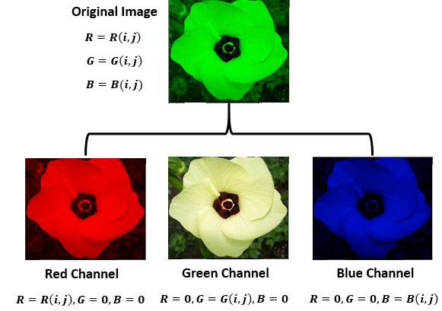
Figure 3. 1: Composition of RGB from 3 Colour Channels
Most colour images in modern society are in RGB mode, like figure 3.1 shows, which display the image through the variation and superposition of three colour-channels: Red(R), Green(G) and Blue(B). The essence of image processing is to change the three colour-channels. However, a lot of information in RGB images always make the processing procedure tedious and complex. RGB does not reflect the morphological features of the image, it just does colour blending in optical principle (Sonka, Hlavac and Boyle, 2015). In other words, in many RGB images, the colour provides little key information of the images. In some experiments in the thesis, for example, using FFT to analyse the motion characteristic of windmills is essentially colour-unrelated; what really focus on in images, are the gradients or edges of windmill. Therefore, deleting the colour information of RGB images has little influence on some finally experiment results, but can improve the processing speed greatly. In the image processing technology, gray processing and binarization are the most common methods to achieve the aim.

3.2.1 Gray Processing
The RGB images use three values (Red, Green and Blue) to express images, when the three values are the same, the colour will represent a gray (Azzopardi, 2015). The value of R = B = G is called gray value. Therefore, grayscale images need only one byte to store gray values for each pixel. The principle of gray processing is to determine one similar value (gray value) for each pixel with some functional methods. In practical application, there are four common methods of transferring colour to greyscale images: component method, maximum value method, mean value method and weighted average method (table 3.2) (Welsh, Ashikhmin and Mueller, 2002).
Table 3. 2: Main Achievement Methods of Gray Processing
Methods | Computational Formula
Original Images | $R=R\left(i, j\right)$, $G=G\left(i, j\right)$, $B=B(i, j)$
Component | $$Gray=R=G=B=R\left(i, j\right) or G\left(i, j\right) or B(i, j)$$
Maximum Value | $$Gray=R=G=B=Max(R\left(i, j\right),G\left(i, j\right),B(i, j))$$
Mean Value | $$Gray=R=G=B=(R\left(i, j\right)+G\left(i, j\right)+B(i, j))/3$$
Weighted Average | $$Gray=R=G=B$$  $$=0.30×R\left(i,j\right)+0.59×G\left(i,j\right)+0.11×B(i,j)$$
Grayscale images are not true sense of black-and-white images, the gray value can be changed between 0 to 255 (0 represents black, 255 represents white), which implies the brightness distinguish (Ĉadík, 2008). The finally grayscales of each gray processing method have some difference. However, as the human eyes has the highest sensitivities to green but lowest sensitivities to blue (can find in Appendix 1), the weighted average method use a very famous psychological formula to calculate the gray value (Wyszecki and Stiles, 2001). Therefore, the grayscale image of weighted average methods is more reasonable and comfortable to human senses. The thesis uses gray processing program in Matlab, rgb2gray (), which also applies this method to do gray processing for convenience.
As it has already been discussed above, the aim of gray processing is to speed up some subsequent processing and analysis. The FFT processing time of wind turbine tower vibration, for example, is a strong evidence to demonstrate the functioning of gray processing. Figure 3.2 lists the windmill tower vibration FFT results and processing time for both RGB and grayscale images in Matlab. The processing objects are the same image series (512 images), the processing method is Optical Intensity (which will be introduced in Section 3.3.3) and the processing time is calculated by ‘Tic and Toc’ program in Matlab.
In figure 3.2, the FFT results of RGB and grayscale images are almost the same, the frequencies of wave crests in the two FFT images are uniform (the meaning of this FFT image will be introduced in Section 4.3.2), only have
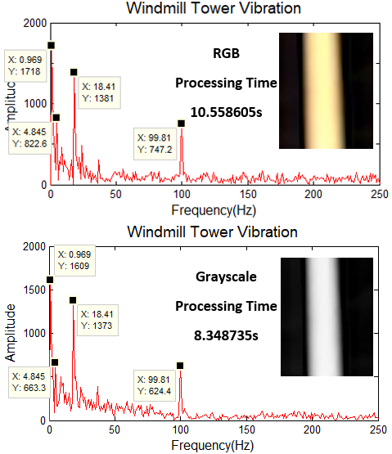
Figure 3. 2: FFT Results and Processing Time for RGB and Grayscale Images in Matlab (Sampling Frequency $F_{s}$=500Hz, Sampling Points N=512)
slight difference in amplitude. That illustrates that the gray processing has little influence on the final results of the experiment in windmill tower vibration. However, significant difference exists in the processing time of two kinds of images, and this time difference will increase with the quantity of processing images. As in the further windmill experiments, the processing images can be more than 2000, the gray processing is a significant method to save time and improve efficiency.

3.2.2 Image Segmentation
In the lab, the environment of photography is stable. Light sources and background are both under control. Therefore, before the image processing analysis, only need gray processing to simplify. However, to real windmill, both light sources and background are uncontrollable. Dynamic environment variation will influence on the final results. For example, when using Optical Intensity method to calculate the rotation frequencies of windmill, the thesis assumes that the grayscale will be stable or change a little until one blade pass through the marked points (In lab, the gray values will not exceed 5). While this assumption is false in real windmill situation, as the variation natural illumination source and interferent in background, even no blades transit the marked points, the fluctuation of grayscale can be more than 20 (figure 3.3). This fluctuation will be reflected in finally FFT results and effect the correct results. Therefore, before the Optical Intensity, some pre-processing methods are necessary to suppress the interference.
The method to realise the objective is Image Segmentation (details in table 2.4), which divides the image into several areas and extracts the interesting features. To simplify calculation process, the thesis uses threshold method to do image segmentation. Assuming the gray value function of a grey-scale is $f(i, j)$, and transfer the function as formula 3.1, where T is the threshold. Therefore, after processing, the gray value of object will be 1, while the background will be 0.
$$g\left(i,j\right)=\left\{\begin{aligned}1 f(i,j)≥T \\ 0 f(i,j)<T\end{aligned}\right. (3.1)$$
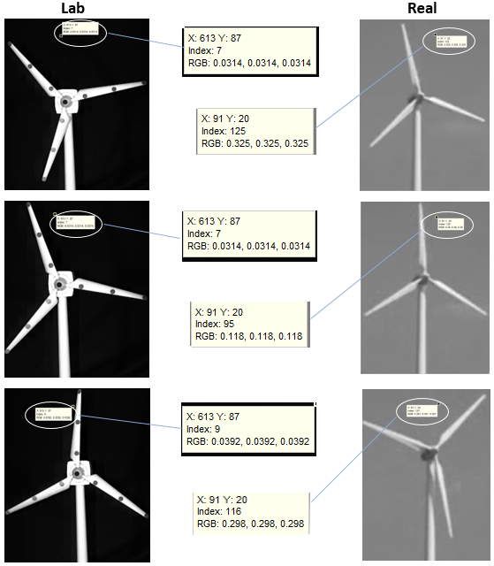
Figure 3. 3: Gray Values Fluctuation in Both Lab and Real Windmill
In the real windmill in figure 3.3, for example, although grayscales of background are varied, all the values are under 150; however, for the blades, all the grayscales are more than 180. Based on threshold method, using 160 as the threshold to do the transformation, the results as figure 3.4 shows. Although the profile of whole windmill has some lack, the blades are extracted completely. In other words, the processed image is suitable for windmill blades motion detection. Similarly, changing the threshold value can divide the windmill tower to do motion analysis. As the method is using one determined threshold to process the whole image, it is called global thresholding.
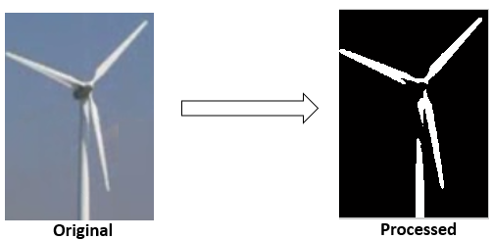
Figure 3. 4: Image Segmentation Based on Global Thresholding
However, considering the complex working condition of windmill, it is possible to have some images, in which the windmills cannot be segmented by a single threshold. In this situation, the adaptive thresholding should be applied. The adaptive thresholding is a kind of local methods. It determines the threshold based on the neighbourhood of each pixel. If the gray value of a pixel is very different from its local average gray value, it will be separated as an outlier during the thresholding process. In fact, as there is a clear contrast between the background and the windmills, the global thresholding is suitable in most windmill images.

3.3 Eulerian Video Magnification
Without any enhancement, from the windmill images, only blades rotation can be discovered by naked eyes. However, the motion of windmill is complex, considering of the complicated loads. To analyse the motion of a windmill, a magnified method is required to enhance the tiny movement. The method in this work is known as Eulerian Video Magnification. The EVM is an enhancement technology to observe invisible motion. The thesis will improve and develop the method to fit the windmill detection.

3.3.1 Principle of EVM
Figure 3.5 shows the main framework of Eulerian Video Magnification. In fact, EVM processes the video frame by frame, and every frame is an image. Therefore, EVM also can be seen as a form of digital image processing.
EVM has four steps (Wu et al., 2012).
(a) Spatial Filtering: Decomposing the standard video sequence into different spatial frequency bands.
(b) Temporal Filtering: Performing the temporal processing on each spatial band, to obtain the relevant frequency band.
(c) Magnification: Employing a magnification factor (determining as α) to multiply the extracted band-pass signal.
(d) Compos graph: Reconstructing the signal after magnification.
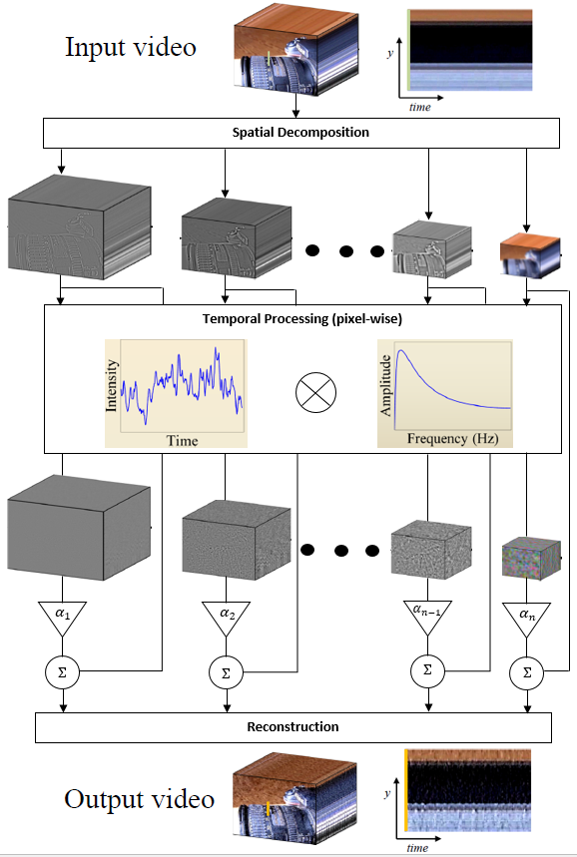
Figure 3. 5: Framework of Eulerian Video Magnification Method

3.3.1.1 Spatial Filtering
The first step of EVM is the spatial filtering for the video sequence to determine the baseband with different spatial frequencies. This is because:
1.Noise reduction: The image will have different SNR (Signal to Noise Ratio) in the different spatial frequencies. In general, the lower spatial frequency will have the higher SNR. Therefore, to prevent image distortion, these basebands should use different magnification. The top image, which means lowest spatial frequency and highest SNR should use the largest magnification. Then the magnification of the next layer should be decreased in turn.
2.Image signal approximation: The image with high spatial frequency (like the original video image) is difficult to approach by the Taylor series expansion. Therefore, it is necessary to decompose the original video to obtain the baseband which is easy to approach.
The purpose of the spatial filtering is to put the multiple adjacent pixels together, therefore, the low pass filter can be chosen, and to speed up the operation, the sampling operation can be used. The low pass filter and sampling operation, in image processing, can be combined as a “pyramid”. In fact, EVM does the multiresolution decomposition with Laplacian pyramid or Gaussian pyramid.

3.3.1.2 Temporal Filtering
Having obtained the baseband of different spatial frequency, the band pass filter on the time domain for each baseband will be done. The purpose is to extract the signal of interest. For example, if the aim is to magnify the heart rate signal, band pass filter with 0.4 ~ 4 Hz (24 ~ 240 BPM) would be chosen as this, is the heart rate range of a human.
However, there are many kinds of band pass filter, ideal band-pass filter, Butterworth band-pass filter and Gaussian band-pass filter are all widely used. The filter choice depends on the purpose of the amplification If the need is to do a time-frequency analysis to enhance the result (e.g. to extract the heart rate), the narrow band pass filter should be chosen as an ideal band-pass filter (He, Goubran and Liu, 2014). This kind of filter can intercept frequency, which is needed directly, and avoid enlarging other frequencies, as Figure 3.6(a) shows. Other choices might be the wide band-pass filter, such as a Butterworth band-pass filter, because this kind of filter can better reduce the Ringing Artifacts, as Figure 3.6(b) shows.
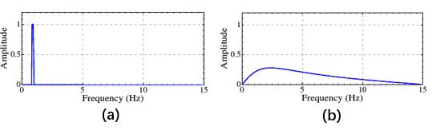
Figure 3. 6: Band-pass Filter
(a. Ideal Band-pass Filter 0.8-1Hz; b. Butterworth Band-pass Filter 3.6-6.2Hz)

3.3.1.3 Magnification
After the Spatial Filtering and Temporal Filtering, the part of interest is obtained. The problem then is how to amplify this part. The amplification of a one-dimensional signal can be used as an example. Assume there is a signal $I\left(x,t\right)$, at any time t, it will be
$$I\left(x,t\right)=f\left(x+δ\left(t\right)\right) t>0$$
$$I\left(x,0\right)=f\left(x\right) t=0 (3.2)$$
$δ(t)$ is the signal for changing, which the method is interested in. In the example, it is a displacement function. Amplifying the change α times, the result will be
$\hat{I} \left(x,t\right)=f\left(x+(1+α)δ\left(t\right)\right)$ $(3.3)$
In order to separate the change part, using the first order Taylor series expansion to approach formula 3.2, obtains the result
$$I\left(x,t\right)≈f\left(x\right)+δ(t)\frac{∂f(x)}{∂x} (3.4)$$
The blue part is the change. If the frequency range of the changing signal $δ(t)$ is the same as the band-pass filter chosen in step 2 (Temporal Filtering), the result of band-pass filtering $B\left(x,t\right)$ should be equal the blue part in formula 3.4.
$$B\left(x,t\right)=δ\left(t\right)\frac{∂f\left(x\right)}{∂x} (3.5)$$
Amplifying the change α times, and adding it into the original signal as per formulas 3.4 and 3.5. The final signal required is as formula 3.6
$$\overline{I}\left(x,t\right)=I\left(x,t\right)+αB\left(x,t\right)≈f\left(x\right)+\left(1+α\right)δ\left(t\right)\frac{∂f\left(x\right)}{∂x}$$
$$(3.6)$$
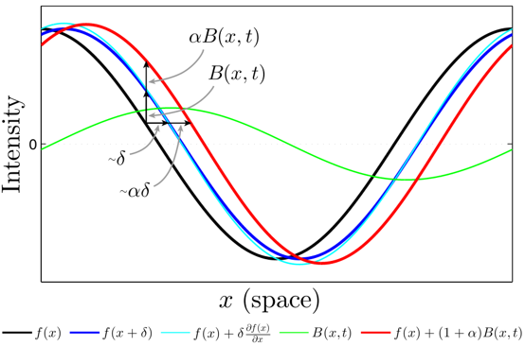
Figure 3. 7: Temporal Filtering Can Approximate Spatial Translation
Figure 3.7 shows the result of amplifying the cosine wave α times, and two-time instants of input signal are also shown in figure: the black curve is the original signal at time t: $I\left(x,t\right)=f\left(x\right)$, and the blue curve is the signal at time t+1: $I\left(x,t+1\right)=f\left(x+δ\right)$. The cyan curve is the Taylor series approximation for the input signal$I\left(x,t+1\right)=f\left(x+δ\right)≈f\left(x\right)+δ(t)\frac{∂f(x)}{∂x}$. The green curve is the change, which has been separated $B\left(x,t\right)$. The red curve is the signal after magnification $f\left(x\right)+(1+α)B\left(x,t\right)$. The $α=1$, which enhancing the motion by 100% (Wadhwa et al., 2016).
In the EVM, when amplifying the change part, the noise will be enhanced in the same time. Therefore, setting reasonable magnification restrictions is avoid too much distortion and achieve $\hat{I} \left(x,t\right)≈\overline{I}(x,t)$. Using cosine wave as an example, $f\left(x\right)=cos(ωx)$, $ω$ for spatial frequency. Denote β=1+α, put them in formula 3.11 and formula 3.14. According to the addition law for cosines, the result can be as formula 3.7.
$$cos\left(ωx\right)-βωδ\left(t\right)sin\left(ωx\right)≈cos\left(ωx+βωδ\left(t\right)\right)$$
$=cos⁡(ωx) cos⁡(βωδ(t))-sin⁡(ωx)sin⁡(βωδ(t))$ $(3.7)$
Therefore, to make formula 3.7 correct, two prerequisites are as follow:
$$cos\left(βωδ\left(t\right)\right)≈1$$
$$sin(βωδ\left(t\right))≈βωδ\left(t\right) (3.8)$$
When the angle is small, formula 3.8 can be approximated. As sine function is a kind of increasing function, and $\sin{\frac{π}{4}}=0.9∙\frac{π}{4}$, it must hold the $βωδ\left(t\right)≤\frac{π}{4}$ to make the error within 10%. Assuming the space wavelength of the signal is λ=2π/ω, it will obtain the result
$$\left(1+α\right)δ\left(t\right)<\frac{λ}{8} (3.9)$$
Formula 3.9 is the limitation of magnification. When beyond the border, α will remain at a boundary value, as Figure 3.8 shows.
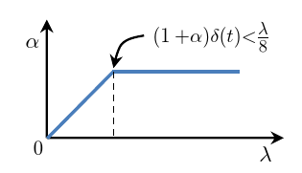
Figure 3. 8: Bounds of Amplification Factor α

3.3.2 Cases of EVM
The function of EVM is to enhance the tiny change in video, the objects can be colours or motions. Some small cases are taken to test whether EVM works, including both colour and motion enhancement.

3.3.2.1 Colour Enhancement
To a human, for example, the skin colour varies slightly, because of the blood circulation. This invisible change can be observed directly by naked eye after EVM (figure 3.9). In the EVM video illustrates the colour of face skin have a periodic conversion between light and dark.
Using the Optical Intensity method to do FFT test of both input and output videos, the signal magnification will be much clearer (figure 3.10 for 30Hz Sampling Frequency and 128 Sampling points). As an Ideal Band-pass Filter 0.8-2Hz is applied on this EVM case, from the FFT result, the frequency of 1.406Hz is enhanced, which is the colour change frequency. The heart rate for a healthy adult is 60-100 times per minute, in other word, the frequency is 1-1.67Hz. The 1.406Hz is the available result. In fact, using a medical heartbeat measurement instrument, heart rate of the author is 84 times/min, almost the same as the FFT result.
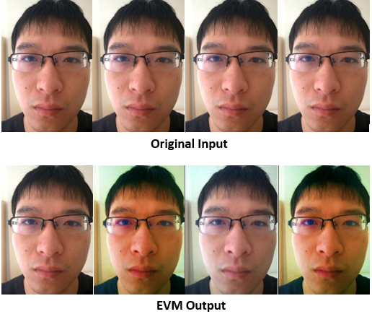
Figure 3. 9: Four Frames of Face from the Original and EVM Video Sequence
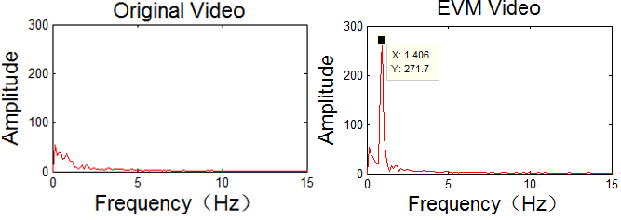
Figure 3. 10: FFT Results of Original and EVM Faces Videos (Sampling Frequency $F_{s}$=30Hz, Sampling Points N=128)

3.3.2.2 Movement Enhancement
For example, the working camera in tripod is considered as stationary, as the function of tripod is to stabilise camera when shooting. That, however, is not the case. Although the shake of camera is too tiny to be found by naked eye, it cannot be avoided. This motion can be magnified by EVM as figure 3.11 shows. The second frame in EVM output has apparent displacement compared with the other two frames; this phenomenon is invisible in original input.
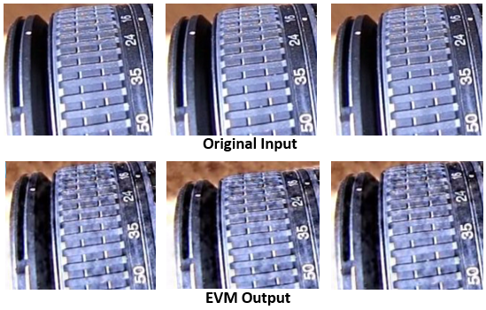
Figure 3. 11: Three Frames of Camera Motion from the Original and EVM Videos
Also using the Optical Intensity method to do FFT analysis of original and EVM videos, the results are more persuasive (figure 3.12 for 300Hz Sampling Frequency and 256 Sampling points). The signal fluctuations are rarely detected in original FFT images. However, to the EVM output, a Butterworth Band-pass Filter 10–40Hz is applied. Figure 3.6(b) indicates that although the filter will enhance all frequencies in different extent compared with original signal, the magnification emphasis is frequency band of 10–40Hz. And as the main camera shake frequency is in this magnification frequency band, it outstands in FFT result, which is 17.58Hz.
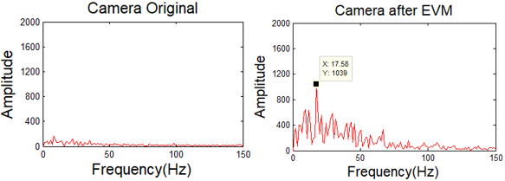
Figure 3. 12: FFT Results of Original and EVM Camera Videos (Sampling Frequency $F_{s}$=300Hz, Sampling Points N=256)

3.3.3 Discussion of EVM

3.3.3.1 Error Analysis
The error of EVM is main determined by the motion estimation, and it is influenced by noise in original signal. Also using a 1D signal as an example for simplicity and analyse the error without noise first. Per formula 3.2, the original input signal and the theoretically magnified output signal are
$$Input:I\left(x,t\right)=f(x+δ\left(t\right),0)$$
$$Output:\hat{I}\left(x,t\right)=f\left(x+\left(1+α\right)δ\left(t\right)\right)=I\left(x+\left(1+α\right)δ\left(t\right), 0\right) (3.10)$$
Applying second-order term of Taylor expansion to input signal in formula 3.10
$$I\left(x,t\right)=I\left(x+δ\left(t\right),0\right)≈I\left(x,0\right)+δ\left(t\right)I_{x}+\frac{1}{2}δ^{2}\left(t\right)I_{xx} (3.11)$$
where $I_{x}=∂I(x,t)/∂x$, and $I_{xx}=∂I_{x}/∂x$. Assuming $I_{t}=I(x,t)-I(x,0)$, formula 3.11 can deduce
$$\frac{I_{t}}{I_{x}}≈δ\left(t\right)+\frac{1}{2}δ^{2}\left(t\right)I_{xx} (3.12)$$
Also applying second-order term of Taylor expansion to output signal in formula 3.10.
$$\hat{I}\left(x,t\right)≈I\left(x,0\right)+\left(1+α\right)δ\left(t\right)I_{x}+\frac{1}{2}{{\left(1+α\right)}^{2}δ}^{2}\left(t\right)I_{xx} (3.13)$$
Putting formula 3.12 into formula 3.13.
$$\hat{I}\left(x,t\right)≈I\left(x,0\right)+\left(1+α\right)\left(I_{t}-\frac{1}{2}δ^{2}\left(t\right)I_{xx}I_{x}\right)+\frac{1}{2}{{\left(1+α\right)}^{2}δ}^{2}\left(t\right)I_{xx}$$
$$=I\left(x,0\right)+\left(1+α\right)I_{t}-\frac{1}{2}{\left(1+α\right)δ}^{2}\left(t\right)I_{xx}I_{x}+\frac{1}{2}{{\left(1+α\right)}^{2}δ}^{2}\left(t\right)I_{xx}$$
$$(3.14)$$
In the EVM, per formula 3.2 and 3.6, the practical output signal after magnification is formula 3.23
$$\overline{I}\left(x,t\right)=I\left(x,t\right)+αB\left(x,t\right)$$
$=I\left(x,t\right)+α\left[I\left(x,t\right)-I\left(x,0\right)\right]=I\left(x,0\right)+(1+α)I_{t}$ $(3.15)$
Therefore, the error for EVM without noise is the absolute value of difference between formula 3.15 and 3.14.
$$Ε=\left|\hat{I}\left(x,t\right)-\overline{I}\left(x,t\right)\right|$$
$$≈\left|\frac{1}{2}{{\left(1+α\right)}^{2}δ}^{2}\left(t\right)I_{xx}-\frac{1}{2}{\left(1+α\right)δ}^{2}\left(t\right)I_{xx}I_{x}\right| (3.16)$$
The situation discussed above is the ideal conditions, which has no noise in signal. However, each practical signal always has its own noises. To analyse the error of EVM with noise, the original sign is translated to $I_{n}\left(x,t\right)=I\left(x,t\right)+n\left(x,t\right)$, which is added a noise signal $n(x,t)$. Considering $n_{t}=n(x,t)-n(x,0)$. Therefore, the practical output signal after EVM magnification (formula 3.15) is translated as
$${\overline{I}}_{n}\left(x,t\right)=I_{n}\left(x,t\right)+α\left[I_{n}\left(x,t\right)-I_{n}\left(x,0\right)\right]$$
$=I(x,t)+n(x,t)+α\left[I\left(x,t\right)+n\left(x,t\right)-I\left(x,0\right)-n(x,0)\right]$
$$=I\left(x,0\right)+\left(1+α\right)I_{t}+αn_{t}+n\left(x,t\right)$$
$$=\overline{I}\left(x,t\right)+αn_{t}+n\left(x,t\right) (3.17)$$
As the theoretically magnified output signal $\hat{I}\left(x,t\right)$ will not be changed by noise, the error for EVM with noise is
$$Ε_{n}=\left|\hat{I}\left(x,t\right)-{\overline{I}}_{n}\left(x,t\right)\right|=\left|Ε+αn_{t}+n\left(x,t\right)\right|$$
$$≈\left|\frac{1}{2}{{\left(1+α\right)}^{2}δ}^{2}\left(t\right)I_{xx}-\frac{1}{2}{\left(1+α\right)δ}^{2}\left(t\right)I_{xx}I_{x}+αn_{t}+n\left(x,t\right)\right| (3.18)$$
Formula 3.18 illustrates, although EVM takes some measures to reduce the noise influence on final results, the noise interference is inevitable. And the error will be higher with the increase of amplification factor $α$ and the range of temporal filtering frequency bands. That is the reason for so many noisy points of EVM results in figure 3.11, which are invisible in input videos.

3.3.3.2 Comparison between EVM and LaGrange Processing
In 2005, Liu et al. presented a video enchantment method called Lagrange Processing Method. The core concept of the method is to track the feature points in the video – the motion is expressed by trajectories of feature points – and group the pixels based on similar position, colour and motion. Figure 3.13 shows the structure of Lagrange Processing (Liu et al., 2005).
As the Lagrange Processing is based on trajectories of feature points, it has distinct disadvantages compared with EVM. For examples:
- To achieve the accurate tracking and estimation of trajectories, a mass of feature points need to be analysed and clustered. More computational resources are required.
- As the trajectories tracking is independent, which is out of the overall consideration of the images. The output video will always be exaggerated.
- The magnification of motion is to vary the feature points trajectories. As the positions of feature points are changed, it need background painting on the original positions. (figure 3.13 (d) and (e)). This operation increases the complexity of algorithm.
However, the perspective of EVM is not limited to the motion, it is aimed at the whole image. Assuming the whole image is changed, the only differences between each variation signal of image are characters (such as frequencies and amplitude). The magnification processing is to separate and enhance the frequency band, which people are interested in. Therefore, the EVM results are smoother and suitable for further analysis.
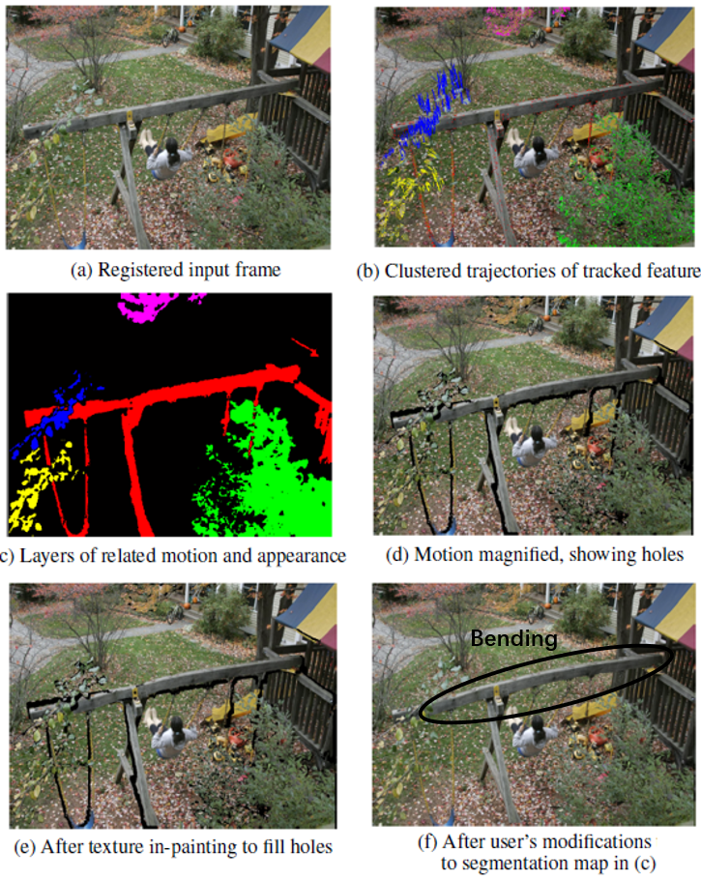
Figure 3. 13: Structure of Lagrange Processing (Liu et al 2005)
In the Appendix 2, the thesis calculates error of Lagrange Processing with noise, as formula 3.19 shows, where $n_{x}=∂n(x,t)/∂x$. Compared formula 3.19 and the EVM error with noise formula 3.18, both two methods are sensitive to the $n_{t}$, which is the temporal characteristics of noise. However, the Lagrange Processing also be impacted by the spatial characteristics of the noise $n_{x}$. Besides, formula 3.14 illustrates the real output results of EVM increases quadratically with amplification factor $α$. This means the EVM is more suitable to the small motion and high noise level amplification compared with Lagrange Processing.
$$Ε_{n}\left(L\right)≈\left|\left(1+α\right)n_{t}-\left(1+α\right)δ\left(t\right)n_{x}-\frac{1}{2}{\left(1+α\right)δ}^{2}\left(t\right)I_{xx}n_{x}+{\frac{1}{2}{\left(1+α\right)δ}^{2}\left(t\right)I_{xx}I}_{x}+n\left(x,t\right)\right| (3.19)$$

3.3.3.3 Improved EVM
According to the EVM error discussion, the original EVM has the limitation to enhance the signal, because of the noise interference. Therefore, it needs several times to determine the suitable amplification factor $α$ and temporal filtering frequency bands to realise a distinct output signal (Liu et al., 2014). If the motion frequencies of enhancement objects are unknown, the high workload and low work efficiency will be the fatal weaknesses of EVM. Considering the complex and varied environment of windmill working, improving the EVM to fit the windmill detection by reducing the noise interference is necessary.
As it has discussed in Section 3.3.1.3, original EVM uses Taylor series to approach the final signal, which is a kind of polynomial expansion. This approximation enhances the motion signal and the noise at the same time. To reduce the noise interference the EVM, the thesis uses Fourier series to approach the final signal instead. As the Fourier series is a kind of special trigonometric expansion or exponential expansion, the noise will be translated after enhancement. The amplification process is as follow. Using Fourier series, the original signal, Formula 3.2 is translated into
$I\left(x,t\right)=f\left(x+δ\left(t\right)\right)=\sum_{ω=-∞}^{∞}{A_{ω}e^{iω\left(x+δ\left(t\right)\right)}} (3.20)$
where $ω$ is a frequency corresponds to each band after spatial filtering. Therefore, in each band, the original signal become a kind of complex sinusoid.
$$I_{ω}\left(x,t\right)=A_{ω}e^{iω\left(x+δ\left(t\right)\right)} (3.21)$$
The phase $ω\left(x+δ\left(t\right)\right)$ contains movement information of original signal, therefore, the significant manipulation is to modify the phase. To separate the motion from the phase, a DC balanced filter is applied, whose only function is remove the DC component of phase ($ωx$). The phase will be formula 3.22.
$P_{ω}\left(x,t\right)=ωδ\left(t\right) (3.22)$
Amplifying the $P_{ω}\left(x,t\right)$ $α$ times and putting it into sub-band original signal $I_{ω}\left(x,t\right)$ to realise the motion magnification in sub-band.
$\hat{I_{ω}}\left(x,t\right)=I_{ω}\left(x,t\right)e^{iαP_{ω}\left(x,t\right)}=A_{ω}e^{iω\left(x+(1+α)δ\left(t\right)\right)} (3.23)$
Reconstructing the signal by summing all the $\hat{I_{ω}}\left(x,t\right)$ in sub-bands to get the finally output sequence $f\left(x+(1+α)δ\left(t\right)\right)$.
The most important advantage of this improved method is its excellent anti-noise-interference ability. Assuming the noise signal $n(x,t)$ exists. The original signal in sub-band $ω$ is
$${I_{nω}\left(x,t\right)=I}_{ω}\left(x,t\right)+n_{ω}\left(x,t\right)=A_{ω}e^{iω\left(x+δ\left(t\right)\right)}+n_{ω}\left(x,t\right)$$
$(3.24)$
Then same as formula 3.23, carrying $αP_{ω}\left(x,t\right)$ into $I_{nω}\left(x,t\right)$ to amplify the motion, the output signal of sub-band is
$$\hat{I_{nω}}\left(x,t\right)=I_{nω}\left(x,t\right)e^{iαP_{ω}\left(x,t\right)}$$
$$=A_{ω}e^{iω\left(x+\left(1+α\right)δ\left(t\right)\right)}+e^{iαωδ\left(t\right)}n_{ω}\left(x,t\right)$$
$(3.25)$
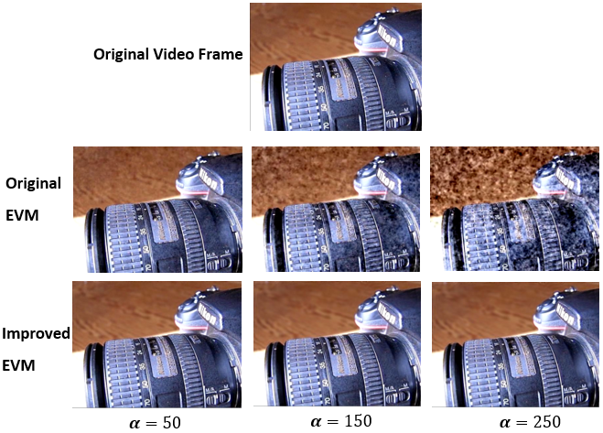
Figure 3. 14: Frames of Camera Motion from the Original and Improved EVM
To the noise signal, the only variation is a phase shift after amplifying, and when finally signal reconstructs, this phase shift is a kind of noise translation. In other words, the improved EVM will translate the noise rather than enhance it after processing. Also, using the working camera as an example case to compare both EVM method in anti-noise-interference ability. The 6 images in figure 3.14 are the frames of both EVM in different magnification times. For original EVM the quantity of noisy points increases with the magnification factor $α$. However, there is few noisy points in improved EVM frame, which is similarly with original input video frame. And this situation remains stable with the increase of magnification times.
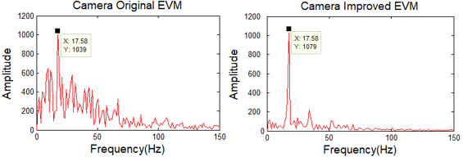
Figure 3. 15: FFT Results of Original and Improved EVM Camera Videos (Sampling Frequency $F_{s}$=300Hz, Sampling Points N=256)
To analyse more details, Optical Intensity method is applied on camera input after both EVM processing (figure 3.15). In terms of motion enhancement, both the EVM methods can extract the frequency of camera shake. As the improved EVM translates the noise, the magnification is focused on the camera shake frequency, however the original method amplifies the noise at same time. Therefore, the main difference between the original and improved EVM methods are the performance on anti-noise-interference (table 3.3).
Table 3. 3: The Main Differences between Original and Improved EVM
 | Original | Improved
Approximation Method | Taylor Series (Linear) | Fourier Series (Sinusoids)
Noise | Magnified | Translated

3.4 Motion Parameters Calculation
The final step of the detection method is the parameter analysis of windmill motion, in other words, using some calculation methods to extract quantitative data from a sequence of images after the EVM processing. The main parameters analysed in the thesis are rotation frequency, cycle time of blades, vibration frequency and amplitude of towers. Therefore, the thesis chose Optical Intensity method to measure the frequency and Frame Difference method to do the motion tracking.

3.4.1 Optical Intensity Method
The images are generated by the combination of pixel, which is a kind of ‘illumination’ source. Human can receive information from an image because pixels have different intensities. To the continuous series images of dynamic object, the intensity variation of a typical pixel was the reflection of object motion, which was the basic principle of Optical Intensity measure method (Lim, 1990).
The main technology to calculate the motion frequency of Optical Intensity method is FFT (Fast Fourier Transform), which is a most significant tool to transform the signal from time domain to frequency domain. The object of FFT is the finite length sequences, therefore, the Optical Intensity is the method to extract the sequences from series images of dynamic windmills. To grayscale images, the pixel intensity is the gray value in this pixel point; however, to RGB images, the intensity is the function computed result of R, G, and B three values. This is the reason why the grayscale images have higher processing speed in FFT analysis, which introduces in Section 3.2.1.

3.4.1.1 Frequency Calculation
For example, to calculate the windmill blades rotation frequency one typical point will be selected in the image sequence. when the blades pass this point, the gray value of this point will be changed a lot. However, when the blades do not pass, the gray value of this point will be stable (like figure 3.17 (a)). Therefore, extracting the gray values of the same point in image series as sequences, and doing FFT to the sequences will show the frequency of rotation of the wind turbine. Figure 3.16 shows one FFT result of calculating windmill blades rotation frequency
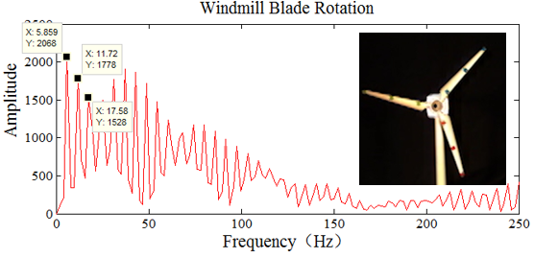
Figure 3. 16: An Example of FFT Result of Windmill Rotation Frequencies Calculation (Sampling Frequency $F_{s}$= 500Hz, Sampling Points N = 512)
As the rotation is a kind of periodic reciprocation, the period can be described as T, 2T, 3T…, therefore, there are more than one wave crest in figure 3.16 and interval between each crest is the same. However, the interval of each crest 5.86Hz is still not the true frequency of the rotation. In practice, a complete cycle means the same blade passes the same point, while in Optical Intensity method, each blade passes the typical point will be recorded as one gray value variation, even the blades are not same. Considering the wind turbine has three blades, the true frequency of the wind turbine is 5.859/3Hz, which is 1.953Hz.
This method also can be applied to calculate the windmill tower vibration frequency (the FFT result as figure 3.2 and figure 4.20), and Section 4.3.2 introduces more details about tower vibration.

3.4.1.2 Cycle Time Calculation
Also, the method can calculate the single blade cycle time. The three blades will have interaction effect on single blade cycle time calculation, therefore, before the measurement, using some image processing means to cover up the other two blades (figure 3.17 (b)). As the typical point is always chosen close to the blade tip, which has the more violent vibration compared with blades root, the tips of two other blades must be concealed. As figure 3.17 (a) shows, the gray values of the typical point in image sequence are extracted, and three cycles are recorded. (Sampling Frequency $F_{s}$=500Hz, Sampling Points N=1024).
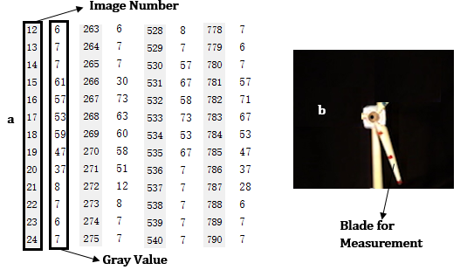
Figure 3. 17: An Example of Single Blade Cycle Time Calculation (a. Gray Values of the Typical Point in Image Sequence, b. Image for Measurement)
In figure 3.17(a), the gray values change rapidly in image 15, 266, 530 and 781. The sampling frequency $F_{s}$ is 500Hz, which means the time interval between each image is 1/500 second, therefore, the three cycles time in figure 3.17(a) respectively are (266-15)/500=0.502s, (530-266)/500=0.508s, and (781-530)/500=0.502s. As the vibration exists in the blades tip, each cycle time of same blade has some difference, more details will be discussed in Section 4.2.3.

3.4.2 Motion Tracking (Frame Difference)
To do further analysis of windmill tower motion after EVM, moving target tracking method is essential. Considering the background of windmill tower is immobile, to achieve efficient motion tracking, Frame Difference is applied in the thesis.

3.4.2.1 Principle of Frame Difference
The video sequence captured by the camera has the characteristic of continuity. When the background is static, if a motion target exists in the video, significant change of pixel gray level will be occurred in frame stack. The Frame Difference method is based on above-mentioned theory (Qiu et al., 2009). Differentiate operation is applied on the two or three consecutive frames, the absolute value of the gray difference of corresponding pixels in different frames will be obtained. When the absolute value exceeds a predetermined threshold, the area is determined as motion target (Guo et al., 2017). Figure 3.18 is the flow diagram of Frame Difference.
Assuming the gray values of each pixel in frame n and frame n+1 are $F_{n}(x,y)=f_{n}(x,y)$ and $F_{n+1}(x,y)=f_{n+1}(x,y)$, the difference image $D_{n}(x,y)=\left|f_{n}\left(x,y\right)-f_{n+1}(x,y)\right|$. Using a threshold T to do binarization processing, and transfer $D_{n}$ into binary image $R_{n}^{'}$ (formula 3.26). The points, whose gray value is 255 is considered as motion points, and the others are regarded as background. Finally, the connectivity analysis of $R_{n}^{'}$ can obtain the image $R_{n}$ with the complete moving target (Singla, 2014).
$${R^{'}}_{n}(x,y)=\left\{\begin{aligned}255, D_{n}\left(x,y\right)>T \\ \\ 0, else\end{aligned} (3.26)\right.$$
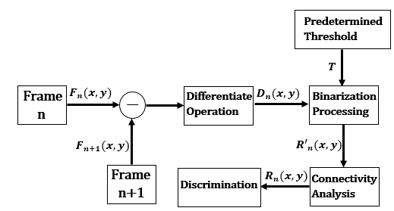
Figure 3. 18: Framework of Frame Difference Method

3.4.2.2 Process of Frame Difference
The application of Frame Difference is to track the windmill motion. To describe tower vibration, for example, the Optical Intensity is to illustrate the frequencies of tower vibration, while the Frame Difference is applied on the amplitude of this motion. Figure 3.19 is the flow diagram of tower vibration tracking with Frame Difference.
As the tower vibration is a kind of reciprocating motion, the manifestation form of the motion in difference image $D_{n}(x,y)$ is the gray difference in the edge of tower. As figure 3.19(c) and 3.19(f) indicates, only in the edge of tower produces the bright specks. The gray values of the tower edge are all higher than 10 (figure 3.19(f)), while in the other area, the gray values are almost 0, therefore, using the Global Thresholding (thesis sets 5 as the threshold) to process binarization (figure 3.19(d)). Then, the Matlab will mark the centre point of motion area based on the binary image $R_{n}^{'}$ and record the coordinate of center point (figure 3.19(e)). Finally, plotting all the centre points into original video and getting the result (figure 3.19(g)). The changing situation of centre points coordinates can reflect the vibration amplitude of tower.
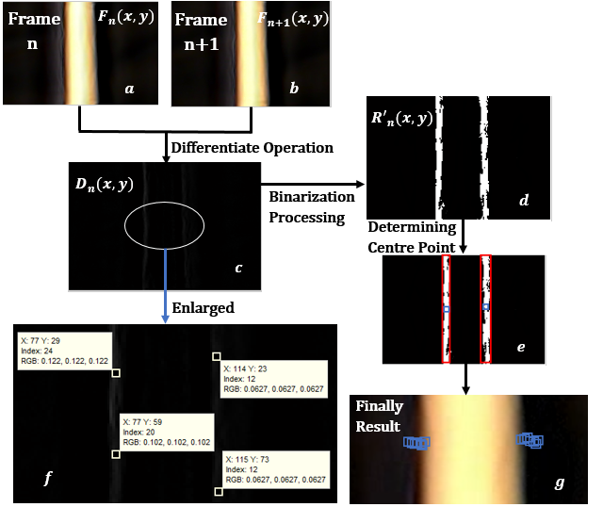
Figure 3. 19: Application of Frame Difference Method on Tower Vibration Tracking
However, some errors analysis of the method still need be discussed:
- Although the tower vibration is a kind of reciprocating motion, the amplitude is not stable. The condition will lead the variation of gray value difference between two adjacent frames. In other word, the gray value difference will be high in some difference images, while it will be tiny, or even inexistence. Therefore, not all difference images can be marked out centre points, as figure 3.20(a) and (b) shows.
- The tower vibration is also not same in different regions of tower. In general, the vibration will be more violent in top of tower. This situation leads the tower edge cannot be displayed completely in binary image (figure 3.20(c) and (d)). Under the circumstances, the marked centre point will be not in the middle of tower edge, it will have axial offsets.
- Other noises, such as light source or EVM processing error, will also affect the results. Therefore, to determine a suitable threshold can reduce the noise interference.
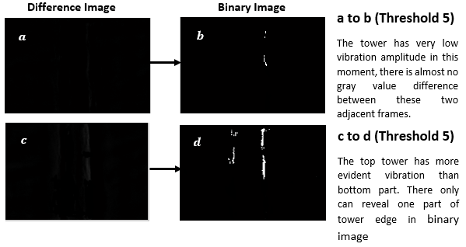
Figure 3. 20: Errors of Frame Difference Method on Tower Vibration Tracking
Per the above discussion, the Frame Difference can not react the tower vibration perfectly, especially in axial vibration. However, what the thesis need is the lateral displacement of tower vibration. In this aspect, the Frame Difference method has an acceptable behaviour. Besides, on the premise of real-time capability, compared with other motion tracking method, such as option flows method, the Frame Difference method has simpler arithmetic and faster response time (Gao and Fan, 2014). Therefore, the thesis chooses Frame Difference as the motion tracking method.

3.5 Summary
EVM is the new video amplification technology, which is used to enhance the windmill motion in the thesis. Optical Intensity is a measuring method to detect the motion speed and frequencies of windmill blades and towers, which is based on gray value variation and FFT. Also, according to the gray value variation, a simple motion tracking method, Frame Difference is applied to measure the tower motion displacement and trajectory in the thesis. Therefore, EVM, Optical Intensity and Frame Difference are the main data processing algorithms used in the thesis. However, of these algorithms, the EVM is nucleus, all the further analysis and calculation are based on the output of EVM. Therefore, the results of EVM influence the finally detection consequence directly. Figure 3.21 the main flow chart of new detection method.
Compared with other tradition detection methods, the new method is simpler in the equipment, especially in the processing of original data extraction. Using a single camera to replace the sensors, this variation makes the cost of detection reduce greatly. Also, it is also a kind of optical non-intrusive monitoring method, which has no non-destructive to the detection target. Compared with other NDT (Non-Destructive Testing) or optical measurement methods introduced in Chapter 2, such as DIC or ESPI, the new method has relatively fast response and strong ability of interference. If the new method has well performance on windmill motion detection, it has the potential to be a powerful monitoring methodology.
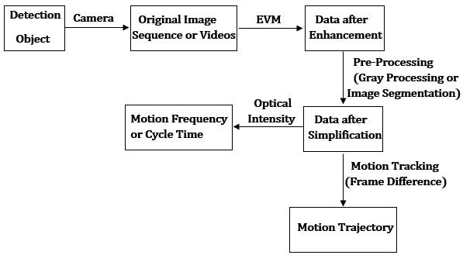
Figure 3. 21: Main Flow Chart of New Image Processing Based Detection Method
Therefore, in the next two chapters, the thesis will apply the new detection method on both windmill models in lab and real windmill in windmill farm. The detection results will be analysed and compared with tradition monitoring results.

4

BLADES AND TOWERS MOTION DETECTION OF WINDMILL MODELS IN LABORATORY

4.1 Introduction
As it is discussed in Literature Review, the foremost features of modern wind turbine detection are low-cost and non-destructive, obviously, some detection methods based on image processing introduced in Chapter 3 are consistent with the features. However, to verify the detection methods need experiments. As two of commonest damaged components of wind turbine, when the blades and towers are broken, they should have some different motion behaviours compared with the undamaged ones (Ruan et al., 2014). Using some detection method mentioned in Chapter 3 to find the distinction is the main object of the research in this thesis. Figure 4.1 and table 4.1 below shows the main experimental apparatus in the research. And The structure of experiments is as figure 4.2 shows. As it has been already introduced in Chapter 2, the most vulnerable structures are blades and towers, the testing in lab is divided into blades detection and towers detection. In blades detection, the thesis will compare rotation behaviours of undamaged blades and damaged blades both in different windmill model and same windmill model. In tower detection, the thesis will research the influence of damaged on tower motion. The operating steps for the experiments are simple, the wind turbine will rotate at the different wind speed and record the movement of each wind turbine by camera; then calculated some dynamic parameters of wind turbine movement from the recorded images or video, such as rotation speed, tower vibration amplitude and tower vibration frequencies; finally compare these parameters and summarise some conclusion.
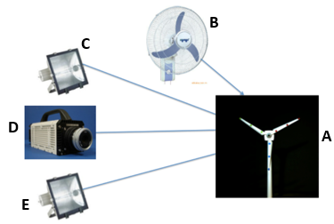
Figure 4. 1: Experimental Facility
Table 4. 1: Description of Experiments Facility
Serial Number | Facility | Description
A | Model of Wind Turbine | A kind of ABS (Acrylonitrile Butadiene Styrene) windmill models. Each model of the wind turbine has three blades, and one tower. Each blade and tower can be dismantled, to distinguish these blades, each blade was marked with different colours, red, blue and green. In experiment, several damaged blades and towers are prepared.
B | Fan | The fan is to provide the wind source, it has three level for the fan speed, level 1, is the slowest (800rpm), level 2 (1000rpm), and level 3, the fastest (1200rpm).
C, E | Light Sources | As it used high-speed camera in the experiment, which had a very short exposure time. To make the photo clear and accurate, it needed a bright environment.
D | Camera | As the frequencies measured in the experiment were between 0-30 Hz, which was smaller than the maximum record rate of common camera (the record rate of camera in iPhone can be 60 fps), the common camera can be worked in the experiment.

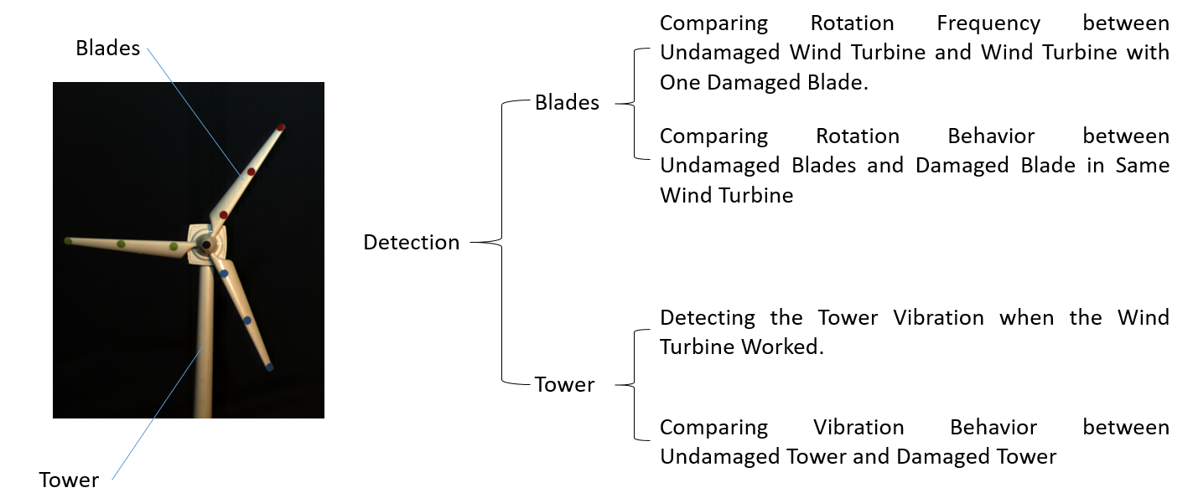
Figure 4. 2: Main Structure of Experiment

4.2 Undamaged and Damaged Windmill Model Blades Rotation Detection
Figure 4.3 is the front and back features of blades, which are used in the experiments. The area A is the installation area, which is connected to the rotor. Therefore, the area A is not included in total length of blades L. D and d is the widest and narrowest parts of blades. From figure 4.2, the experiments of wind turbine blades testing are divided into two parts, one is focus on the comparison of different wind turbines, another emphasised the damaged blades in one wind turbine. To detect the rotation behaviours of wind turbine, the thesis calculates the wing turbine rotation frequencies with the image processing methods of Optical Intensity, FFT, EVM, motion tracking, etc. (All those methods are introduced in Chapter 3)
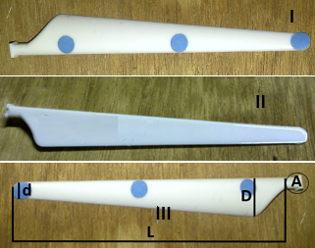
Figure 4. 3: Features of Experiment Blades
(Ⅰ. Front of Blades; Ⅱ. Back of Blades; Ⅲ. Some Parameters of Blades, L=12cm, D=17mm, d=7mm)

4.2.1 Blades Damages Definition
As the blades damages are artificial, to make the experiment data and result convincing, it is necessary to define the damages standard before experiment. To define the damage, some parameters of damage should be confirmed, including damage styles, damage position and damage sizes. Because of the size of blades, it is impossible to change too much on damage style, the thesis uses 0.4mm art knife to carve cracks on blades, the crack is about 1mm deep, as figure 4.4 shows.
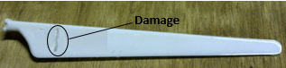
Figure 4. 4: Blades Damage Types in Experiments
In fact, Ge and An (2008) had already did the research on the influence of crack types on blades motion. They discussed three different crack shapes, rectangle tip, triangular tip and circular arc tip (as figure 4.5 shows). They put these blades on rotating platform to analyse the motion parameters, including natural frequencies rotation frequencies, vibration amplitude, motion trail, etc. And finally, they considered three different damage styles almost have the same motion parameters. The main reason for this result is the different crack tip type influences local stress in crack tip, however the area of this influence is small, in another word, it changes little on the quality and rigidity of damage blades. Therefore, damage style has little influence on the blades motion. Therefore, the damages shape is not a meaningful variable in damages definition.
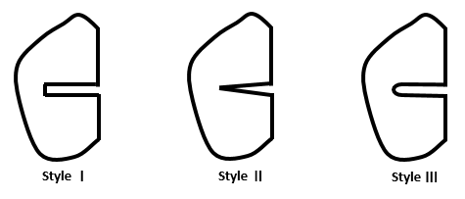
Figure 4. 5: Crakes Shapes
(Style Ⅰ. Rectangle Tip; Style Ⅱ. Triangular Tip; Style Ⅲ. Circular Arc Tip)
Zhao and Shang (2011) also analysed the motion characteristics of rotation blades with cracks, they confirmed the determining factors of motion characteristics are the position and the sizes of cracks. Therefore, to the experiments in thesis, these two parameters should be determined. The crack size is determined by the damage length and the position is indicated as the distance from damage to blade root, as figure 4.6 shows.
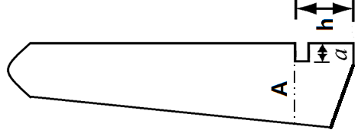
Figure 4. 6: Crakes Sketch
(a is the crack length; h is distance to blade root; A is the blade width of crack position)
As the total length of blade is 12cm, carve the crack from h=1cm to 10cm, and chose centimetre as the minimum unit (the top of blade is too thin to carve cracks). Because of the width of blades is not same in different position, using relative length of cracks a/A=0.2, 0.4, 0.6, 0.8, 1 as the definition of crack size. Rotating these total 50 kinds of wind turbine blades on a solar power windmill model singly in the 400w photography luminaire (as figure 4.7 shows).
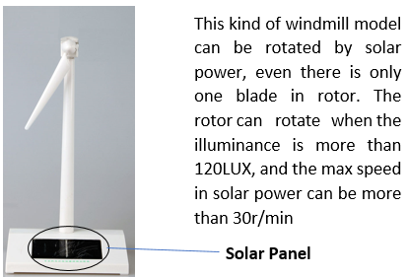
Figure 4. 7: Solar Power Windmill Model to Test Damage Blades
In the testing, the one cycle time of rotor without any blades stabilised at 1.5s. Considering the interference factors of air friction, blade gravity, blade vibration and so on, the one cycle time of one blade is not stable. Therefore, to compare the distinction of damage blades in rotation behaviour, the thesis used Optical Intensity to record 10 cycles time of each blade. Because the mean cycle time of each blade is around 1.5s, which has little difference, to analyse the volatility of different damage blades cycle times, their standard deviations are calculated. The results are in figure 4.8. In figure 4.8, the X-axis is the position of damage, which means h in figure 4.6. And the Y-axis is standard deviation of blades cycle time, which is calculated by each cycle time of blades and mean cycle time 1.5s. For example, the 10 cycles time of a blade are $t_{1},t_{2},t_{3}⋯t_{9},t_{10}$, the standard deviation of this blade cycle time is defined by $σ=\sqrt{\frac{1}{10}\sum_{i=1}^{10}{{(t_{i}-1.5)}^{2}}}$. The higher standard deviation means more unstable cycle time.
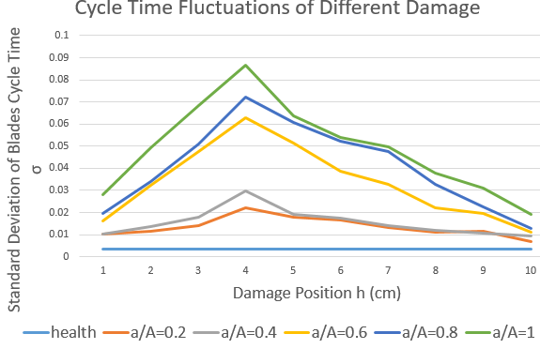
Figure 4. 8: Cycle Time Fluctuations of Different Position and Length Damage
From figure 4.8, some conclusion can be indicated.
- As it is discussed before experiment, although the mean rotation cycle time for each blade is around 1.5s, each cycle time is indeterminate, even for the health blades. Different damage blades have different fluctuations in each cycle time.
- The fluctuations of blade rotation behaviour increased with the crack length. However, this growth is non-linear. In the early crack extension time, it is not serious; when the relative length of cracks exceeds 0.5, it will be a significant changed; and finally, the increase will tend to be stable when the crack continues to extend.
- The crack position will influence on the blade rotation behaviour. The most maximum effect position of damage is in 1/3 of totally blade length. This result is very similar with Zhao and Shang’s (2011) research, who did rotation test on the rotation blades, and considered the crack had the greatly impacts on the 36% of totally blade length. However, when the crack is small, the crack position influence on blade rotation behaviour is not obvious.
In fact, the result of the stress simulation investigation in windmill blades shows that the section near the blade root has the higher fatigue stress compared to the tip of blade (KONG et al., 2006). One reason for this situation is the existence of root-joint in the blade root, which is used to combine the blades and rotor (Shokrieh and Rafiee, 2006). Therefore, the cracks near the blades root will has the obvious influence on dynamic characteristics of blades. Besides the position, the relative depth of crack in blade (the ratio between crack depth and blades thickness) also has enormous influence on blades motion (Fan et al., 2015). Fan’s paper indicates higher crack relative depth decreases the structural stiffness and increases local flexibility of blades.
To the experiment of blades damages definition in thesis, each crack depth is same, while the blades thickness in different position is not uniform. The maximum thickness of blade is in the root, and minimum is in the tip. Therefore, although the position near the root has the higher stress, the relative depth of crack is smaller. Combining the two factors of crack position and crack relative depth, the position has most impact on blades motion is not the root, but the position in 1/3 of totally blade length.
In the case of experiment in thesis, only consider about the blade rotation behaviour and chose one crack, which has the maximum distinction with health blade. Therefore, per figure 4.8 and figure 4.6, defining the crack as h=4cm and a/A=1 (A=a=15mm).

4.2.2 Rotation Frequencies Detection of Undamaged and Damaged Blades in Different Windmill Models
Two wind turbines will be detected together in this testing. One is the wind turbine with one damage blade and the other is undamaged. It is significant to compare the rotation behaviour of both wind turbine in different wind power. Besides the rotation speed of fan, the distance of fan is another factor, which influence on the wind power accepted by windmill. Therefore, to make the result convincing, three kinds of fan distance are provided in the testing, 50cm, 100cm and 150cm. The basic framework of testing is as figure 4.9 shows. A is the wind turbine with one damage blade and two undamaged blades; B is the wind turbine with three undamaged blades; D is the distance from fan to wind turbine, three distances are tested, 50cm, 100cm and 150cm
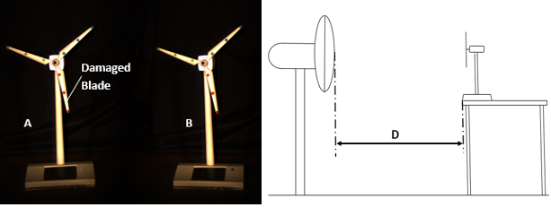
Figure 4. 9: Testing of Two Wind Turbines
Recording the windmill 10s with the record rate of 120fps. As the rotation frequency of wind turbine is between 1-6Hz, the 10 seconds’ recording minimum includes 10 cycles, which are enough to calculate the wind turbines rotation frequencies. The method of FFT to calculate the windmill rotation frequency is introduced in Chapter 3. And the final results are indicated in figure 4.10.
It is obvious to draw the following conclusions from figure 4.10:
- As the rotation speed of fan increases linearly in different speed level, the undamaged windmill maintains the rule. When the fan at a certain distance, the rotation frequencies will be almost into a linear growth with increase of fan speed level.
- Although the damaged windmill rotation frequencies present an increasing trend with the fan speed level, this growth is a kind of irregular variety.
- As the variation rule of damaged windmill rotation cannot be found. It is unable to determine whose rotation frequency is higher between the two windmills in the same wind condition.
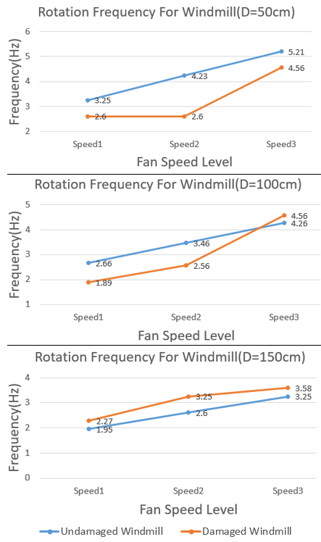
Figure 4. 10: Results of Two Wind Turbines Rotation Frequencies

4.2.3 Cycle Time Detection of Undamaged and Damaged Blades in Single Windmill Model
Ibrahim, Tautz-Weinert and Watson (2016) had applied the neural networks on the wind turbine fault detection and found the rotation frequency of damaged wind turbine is different with the undamaged one in the same wind condition, and this phenomenon was also proved in the two wind turbines testing. However, as TPMS indicates, a kind of Tire Pressure Monitoring System to detect the tire pressure indicates, the damaged tires will have different rotation speed even compared with the other tire in the same suspension (Zhao et al., 2016), Ibrahim considered even in the same wind turbine, damaged blades might have different rotation speed compared with undamaged ones.
To verify this assumption, choosing three kinds of damaged wind turbine: B with one damaged blade (marked as red), and two undamaged blades (marked as green and blue); C with two damaged blades (marked as red), and one undamaged blades (marked as blue); D with three damaged blades (marked as red) as the experiment models. Also, as a reference, a wind turbine A with three undamaged blades is added, which is as figure 4.11 shows.
In practical application, no matter using Optical Intensity method to detect cycle time or calculate frequencies of each blades directly in the same wind turbine, the rotation distinction is too tiny to be indicated. However, it does not mean the three blades are stable. To analyse the rotation difference of three blades in same windmill, before calculating the rotation parameters, EVM is processed to enhance the motion of each blades, so that the differences are magnified. Like figure 4.12 shows, to explain the impact of EVM, intercepting three blades motion trail of windmill B in a ¼ cycle and overlap each other by Abode Pro CC (a video processing software). Before the EVM the three trails are almost the same, which cannot be distinguished by naked eyes. However, when the trails after EVM, it began to appear speed difference with time.
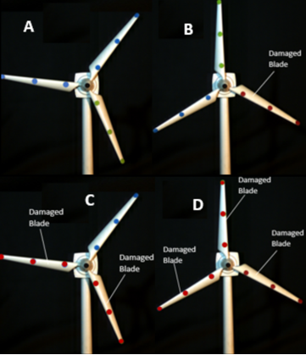
Figure 4. 11: Testing of Single Wind Turbine
(Only the red blade is damaged, the other five blades marked as blue and green are undamaged)
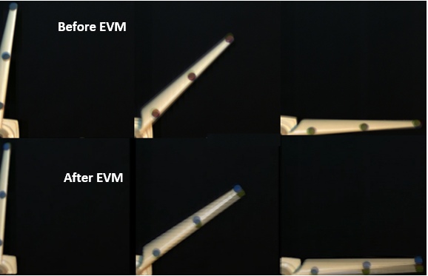
Figure 4. 12: The Impact Result of EVM on Blades Rotation
In the EVM trails of figure 4.12, the position of the red one (damaged one) is in the lead, and the other two undamaged blades are still coincident. This phenomenon is also can be found in windmill C and D, while, it does not exist in the windmill A with three undamaged blades. For windmill A, the motion trails of each blades are indistinguishable, even after EVM processing. Therefore, the EVM result is a visualisation evidence to prove the assumption that damaged blades have different rotation speed compared with undamaged ones in same windmill. For more details, using Optical Intensity method to calculate 10 cycle times and mean rotation frequencies of each blades of all windmills A, B, C and D after EVM processing (amplification factor 20 times). The summary is in figure 4.13. The data is recorded in the wind condition of fan speed level 3 and fan distance is 50cm, and to analyse more details use record rate of camera at 2000fps.
Figure 4.13 and the data illustrate:
- To different windmills, different blades health conditions lead to different rotation cycle time. This is the further evidence that the damaged windmill and undamaged windmill have different rotation speed.
- To healthy windmill, the rotation behaviours of three blades are stable and slightly different. Each blade rotation condition can react the rotation behaviour of whole wind.
- To damaged windmill, the rotation behaviour of each blade is also different. Undamaged blades still show the stability even in damaged windmill. However, the damaged blades appear volatility, even in the same windmill and same cycle. More specifically, per the data in figure 4.13, the range of undamaged blades is between 0.001s to 0.0025s, which are all less than 1%(the max is 0.7% of the mean cycle time) of mean cycle time. While the deviation of damage blades in different cycles are from 0.0395s to 0.0690s, occupies 9.5%-15.2% of mean cycle time.
- The data in figure 4.13 are not real data for windmill, that is because all the data are recorded after EVM processing, which has already been enhanced. In fact, the behaviour distinction of each blade in same windmill is not as wide as the data shows. This reflects feasibility of EVM in wind turbine detection from another sides.
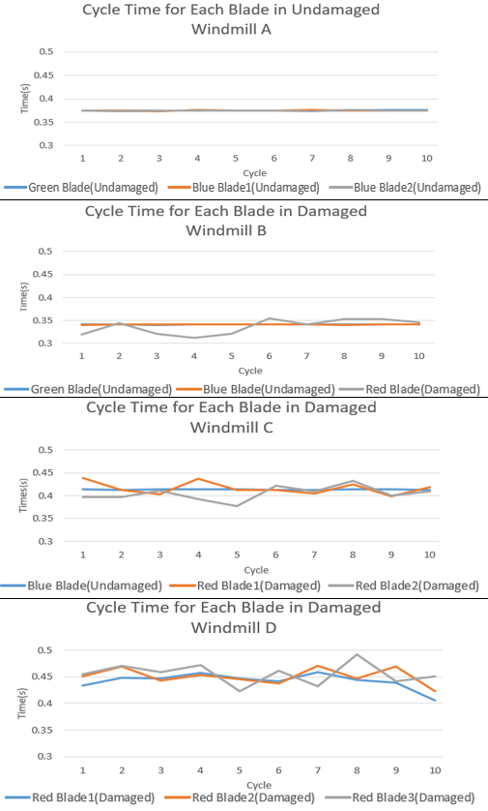
Figure 4. 13: Cycle Time for Each Blade in Four Wind Turbines

4.2.4 Summary and Analysis Results
According to the lab data of wind turbine blades testing, the biggest difference between damaged and undamaged blades on rotation behaviour is stability. The undamaged windmills have stable rotation parameters, no matter on frequencies, cycle times or growth law with wind speed. However, the damaged blades show the diversity no matter on the crosswise comparison (compared with other blades in same time) or the longitudinal comparison (compared with themselves in different time). Various cycle time and irregular frequencies change are the main features of damaged blades.
This phenomenon is generated by blades motion and image processing method. In fact, the forms of blades motion are not only rotation when they are in normal operation (Jureczko, Pawlak and Mężyk, 2005). And Hansen (2015) in his book considered at least four kinds of vibration also exists when the blades are rotation, including: blade tangential bending vibration, blade axial bending vibration, torsional vibration and compound vibration. These vibrations will more obvious with the increase of blades size. In the experiment, although the blades size of windmill model is small, the vibrations are still existential. Using EVM can enhance the vibrations and observe directly in image, especial for damaged blades. like figure 4.14, which uses windmill B in figure 4.11 as example.
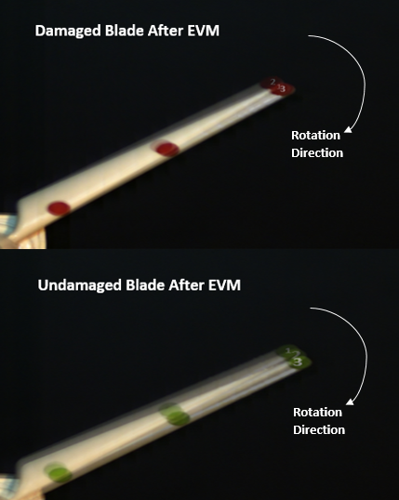
Figure 4. 14: Vibration Sketch for Damaged and Undamaged Blades after EVM
Each imaged is overlapped with three blades video snapshot of blades rotation after EVM, and marked as 1, 2, and 3. The time interval of each video snapshot is 1/60s, the snapshot 1 is the earliest and 3 is the latest. The enhance factors of EVM is 20 times. It can be found in figure 4.14, although enhanced by EVM, the vibration of undamaged blades is still inconspicuous, at least cannot be observed directly in figure. However, to damaged blade, the position of blades is deviation. The later snapshot 2 appeared in earlier position, and the snapshot 1 and 3 are in the similar position. This is the features and evidence of vibration. (the vibration is indicated more obvious in video.) Besides, the blades vibration will be also distinct in FFT results (figure 4.15). Expecting the same frequency 1.95Hz, which is the mean rotation frequency, the damaged blade has a different frequency, of 27.34Hz. This is the vibration frequency of blades.
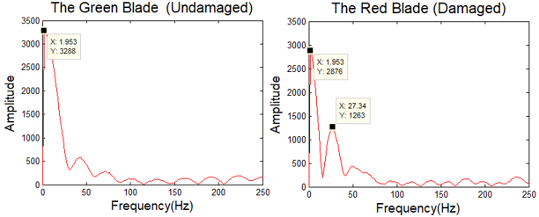
Figure 4. 15: FFT Results for Damaged and Undamaged Blade Motion after EVM (Sampling Frequency $F_{s}$= 500Hz, Sampling Points N = 256)
The image processing methods to calculated blades rotation parameters in this experiment are based on point. For example, the object of FFT is not whole image, it is one chosen point in the image; also, the defined of one cycle time in this experiment is the time interval of assigned point in blade to pass the same position. Therefore, for damaged blades, the existence of vibration leads to unstable of the cycle time and frequencies, while the vibration is too tiny to impact rotation parameters in undamaged blades.

4.3 Undamaged and Damaged Windmill Model Towers Vibration Detection
In the Chapter 2, the thesis has already discussed the stress condition of wind turbine tower and consider the main risky load of tower is the downwind thrust, which will lead the tower displacement or even lateral oscillation. Although to proper functioning wind turbine, this motion is inevitable and will increase with wind speed and tower size, the amplitude or displacement is too small to destroy the tower (Lavassas et al., 2003). Polyzois, Raftoyiannis and Ungkurapinan (2009) did the testing of a windmill model with 4.88m-height tower and measured the maximum tolerable displacement of tower tip is 76.90mm. It is only about 1.6% of total tower height. To the windmill model in this thesis, whose tower height is 22cm, this motion cannot be found by the naked eye directly. However, it is possible to observe, analyse and compared this oscillation between damaged and undamaged tower after EVM processing.
Figure 4.16 shows an example of undamaged windmill model tower vibration, after EVM processing. The record rate is 120fps, the EVM amplification factor is 50 times, and 1, 2, 3 are all video snapshots with chronological order. The time interval of each snapshot is 1/2 seconds. The tower has obvious displacement after enhancement by EVM.
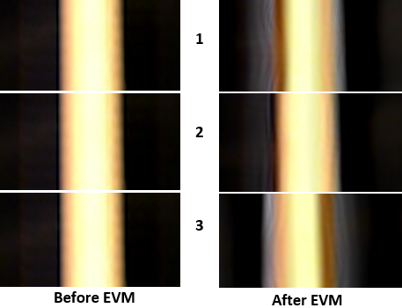
Figure 4. 16: EVM to Magnify Motion of Tower

4.3.1 Definition of Towers Damages
Figure 4.17(a) is the size data of model tower in thesis, because of the shape and the size of tower, transverse cracks is not easy to create for art knife. Therefore, longitudinal crack is suitable in this testing. To define longitudinal crack, the crack position and the crack length are the significant parameters. Kenna and Basu (2015) used finite element model and discrete wavelet transform to measure strain of windmill tower with different kinds damaged. They illustrated the most impact of crack length was much stronger than the damage position when the tower is not high, and if the crack was more than ¼ of the tower length, the variation strain of tower was serious.
The tower tip sustains the higher wind speed and bears the gravity of blades and nacelle at the same time. That is why the oscillation or vibration of tower is more serious in the tip of tower. However, the testing is focus on the influence of crack on wind thrust, to eliminate other force as far as possible and consider the research of Kenna, the thesis chose 70mm length, 0.4mm width and 1mm depth crack in the middle part of tower, as figure 4.17(b) shows. And figure 4.17(c) is the close-up view of this part.
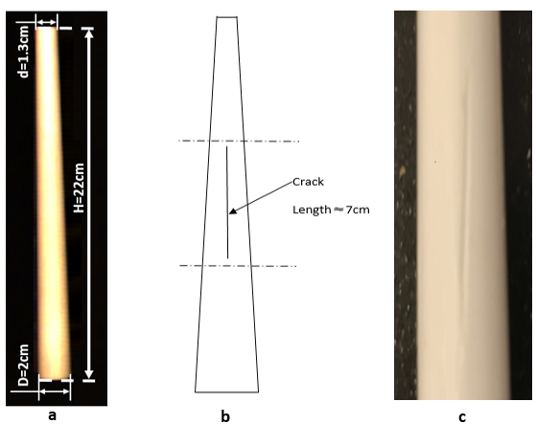
Figure 4. 17: Tower Model in Experiment

4.3.2 Experiment Tower Detection
As it has ready introduced, the main research object is the damage influence on tower motion, therefore, the only variable in the experiment is the number of crack. Chosen three kinds of wind turbine to do the tower detection, one is wind turbine B with a single crack tower, one is C with three cracks on tower, and the other is a healthy wind turbine A as a reference (figure 4.18). And per Lavassas’ opinion, to obtain the distinct tower oscillation, higher wind speed is essential condition. Recording each middle range of tower, where cracks on, in the wind condition of fan speed 3 and fan distance 50cm. The EVM amplification factor for each windmill is 50. The video snapshots result of each blade are in figure 4.19, the record rate is 120fps and 1, 2, 3 are all video snapshots with chronological order. The time interval of each snapshot is 1/2 seconds.
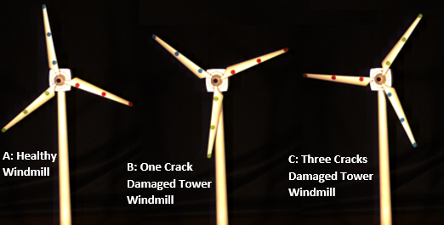
Figure 4. 18: Windmill Models of Tower Testing
Qualitative analysis of the EVM video results are as follow:
- The tower oscillation is subsistent, no matter to undamaged windmill or damaged windmill.
- Different windmills have different oscillation. Generally, in the same enlargement factor, more cracks lead to more serious the tower oscillation. And this accord with Kenna’s research.
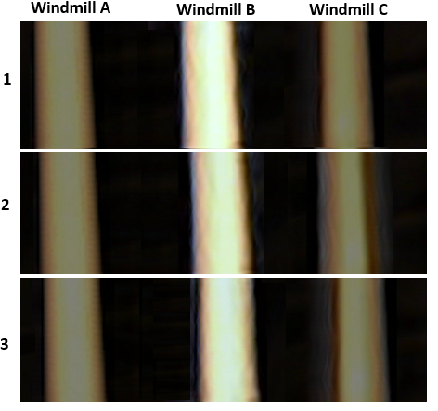
Figure 4. 19: Motion Result of Three Model Towers after EVM
To do quantitative analysis of tower vibration, two parameters should be calculated, one is the frequency and the other is the amplitude or displacement. The frequency calculated principle is the same as calculation of blades rotation frequency, using the point FFT to get the frequency of tower vibration (introduced in Chapter 3), which as figure 4.20 indicates.
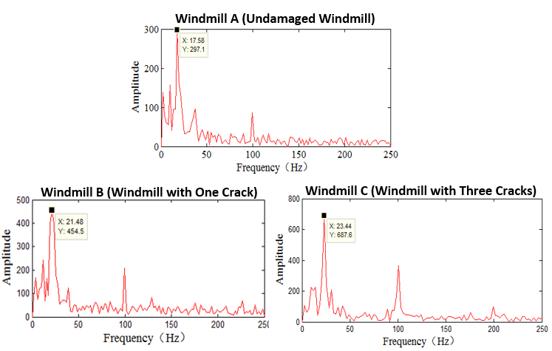
Figure 4. 20: FFT Result of Three Model Towers after EVM
Some conclusion can be summarised in figure 4.20.
- As there is not only one wave crest in FFT figure, the movement of tower is not a kind of simple harmonic vibration, it is a kind of compound vibration with several frequencies. The frequencies are mainly concentrate on the range of 0-50Hz. The frequency around 100Hz, which appears in all three figures is the frequency of light, and the frequencies marked in figure 4.20 is the main frequency of oscillation.
- In the same circumstances, the number of wave crest in the FFT figure increases with the number of cracks. That means the damaged towers have more complex motion situation. Also, the more tower cracks windmill has, the higher main frequency it emerges. These two points are the mainly reasons for why the more cracks windmill have more serious tower oscillation in EVM video.
To analyse the vibration amplitude, the motion tracking method (Frame Difference) is used to plot the motion trail of tower vibration. The first path point will be marked as the original position (mark displacement as 0), then calculate the lateral displacement difference between each path point and original one. The position to the right of original point is plus and to the left is minus. The thesis records 31 path points and calculate 30 lateral coordinate differences. Figure 4.21 charts all these differences. Actually, the lateral coordinate difference between each path point only indicates the motion tendency of tower vibration, rather than the real vibration amplitude.
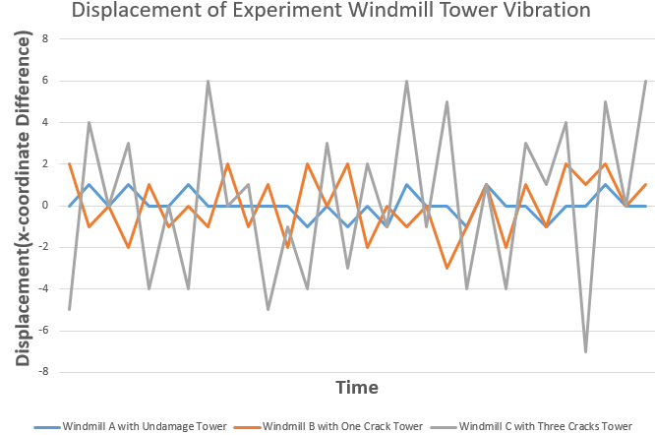
Figure 4. 21: Motion Displacement of Three Model Towers
Explanation of figure 4.21 is as follow:
- The displacements of all windmill tower in each cycle are unstable and difference, even for the healthy windmill tower. It is further supports the viewpoint that the movement of tower is not simple harmonic vibration, it is a kind of compound vibration.
- The opinion that more cracks leads to more serious tower oscillation is also further proved in figure 4.21. Although the displacements of all windmill towers are various, the rangeability of each tower is distinguishing. The variation amplitude of healthy windmill tower A is between -1mm and 1mm; that for windmill tower B with one cracks is from -3mm to 3mm; and for windmill tower C with three cracks, the range is between -7mm to 7mm. It is obvious to find the vibration displacement will become larger with the increase of crack.
- The displacement unit measured in experiment is mm. However, this is not the actual displacement, the data is calculated in the videos and images after EVM processing, also local enlarged image processing is provided to the tower. Although different EVM amplification factor and enlarged section of tower will generate different displacement numerical value, the relative variation tendency of displacement will be not changed.

4.3.3 Summary and Analysis
The above discussion concludes the more damaged windmill tower have stronger tower oscillation when it is working. Using mathematical formulas to analyse and verify this deduction. According to the tower force analysis in Chapter 2, the tower tip is forced by wind thrust, torque caused by wind lift force and the gravity of blades and nacelle. Simplifying the windmill models tower in experiment as follows:
- The mass of blades and nacelle is only about 70g, and the centre of gravity is almost on the longitudinal centre line of tower. Therefore, the thesis assumes the lateral displacement caused by gravity can be ignored.
- The width of tower is far less than its height, the thesis regards the tower model as a kind of pole.
- In theory, the wind thrust will be different along the tower. However, as the model tower is too short, which is only about 1/4 of the fan diameter, the thesis assumes the wind thrust on model tower is uniform.
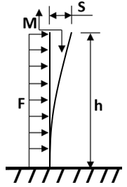
Figure 4. 22: Sketch of Model Windmill Tower Displacement Structure
Then the experiment tower displacement can be converted to physical model as figure 4.22 shows (Du, Feng and He, 2011), in where h is tower height, F is wind thrust, M is wind lift force torque and S is tower displacement. The displacement is divided into two parts, wind thrust F and lift torque M. These two displacements can calculate as formulas 4.1. E is the MOE (Modulus of Elasticity) and I is rotational inertia, which regarding tower neutral axis.
E only relatives to the material, and I is combined with geometrical shape and mass of tower. Generally, the cracks in tower will not change the MOE, while the geometrical and mass will be varied (Davis, 2004). Ostachowicz and Krawczuk (1991) did the research on the natural frequencies of a cantilever beam with cracks, they considered the rotational inertia was reduced by cracks to the same rotation axis, compared with healthy beam. The conclusion equally applies to the situation here, from formulas 4.1, the more cracks towers have lower rotational inertia, which leads the higher displacement. It corresponds with experiment data results.
$$S=\left\{\begin{aligned}S_{F}=\frac{Fh^{3}}{3EI} \\ S_{M}=\frac{Mh^{2}}{2EI}\end{aligned}\right. (4.1)$$
Although the tower cracks intensify the tower vibration in the experiment, they do not affect the normal operation of windmill in experiment. To analyse this situation, the natural frequencies of three model towers are calculated in Solidworks. Per the tower and cracks size in figure 4.17 to model the tower in solidworks. Then add constraints (immobilise the bottom and a mass block of 0.045kg in the top) and material (ABS plastic, E=2.2GPa, ρ=1020kg/m³, Poisson Ratio=0.394) to calculate their first four order natural frequencies, the results in table 4.2. In fact, solving the problem of natural frequencies and vibration mode can reduce to evaluate the eigenvalue and eigenvector of vibration equation. As the characteristic equation of axial symmetric structure has multiple roots, the natural frequencies of towers will have same solution (Efraim and Eisenberger, 2006). Therefore, in the table 4.2, the first-order and second-order natural frequencies are basically the same, so as the third-order and fourth-order.
Table 4. 2: Natural Frequencies of Three Model Towers
Windmill  Tower  Natural  Frequencies | Windmill Tower A  (Healthy) | Windmill Tower B  (One Crack) | Windmill Tower C  (Three Cracks)
First-order | 45.63Hz | 47.75Hz | 49.12Hz
Second-order | 45.65Hz | 47.81Hz | 49.99Hz
Third-order | 173.99Hz | 178.15Hz | 183.82Hz
Fourth-order | 174.23Hz | 179.71Hz | 184.08Hz

The tower vibration is a kind of forced oscillation, the vibration frequencies is the expression of driving force frequencies. When the driving force frequencies reach or approach the tower natural frequencies, resonance will generate. Because of the maximum amplitude of vibration, the towers face the greatest risk of damage in the situation of resonance. However, from the table 4.2 and figure 4.20, all the tower vibration frequencies are far lower than the natural frequencies. Therefore, these tiny displacements are in the acceptable scope and have little impact on windmill normal operation.

4.4 Conclusion
Per the data recorded from the windmill model experiment in lab and discussion above, some conclusion can be considered.
To windmill blades, the damaged and undamaged windmill blades have different rotation behaviours, which are particularly reflected in rotation speed. For details, the rotation speed of undamaged blades is stable compared with that of undamaged ones. Even in the same wind condition and same windmill, the instability of damaged blades rotation speed can be distinguished by some image processing.
After some image enhancement processing methods, such as EVM, the thesis indicates the blades are vibrating when they are in normal rotation. Although the vibrations are too weak to observe directly, they are reality, and will be stronger with the increase of blades damaged level. It is the main reason for rotation speed distinction between damaged and undamaged blades in EVM results.
The windmill towers have the similar situation, because of the wind thrust, wind lift force and the gravity of blades and nacelle, when the windmills are in normal operation, the towers are doing tiny vibration. Using EVM to analyse the tower motion, the thesis illustrates the vibration is inevitable and more cracks in tower lead more serious tower oscillation. However, as the cracks in experiment are not destructive, all oscillation frequencies of model towers are far less than the natural frequencies of model towers. Therefore, the tower vibration has little influence on windmill proper functioning in experiment.
From the experiment, the thesis proved the new windmill detection methods based on image processing can be worked, at least to the windmill models, the monitoring methods are feasible in detecting the operating state of blades and tower. However, in the lab, many factors are simplified or even ignored; considering the materials, operating environment, variable load and other uncertain factors, the real wind turbine is more complex. The detection methods need more application in real windmill cases to verify its performability.

5

APPLICATION OF IMAGE-BASED DETECTION METHOD ON REAL WINDMILLS

5.1 Introduction
Hills (1996) mentioned the working environment of real windmill system is complex and volatile, including weather, wind speed and direction, air temperature, humidity and other uncertain factors. Therefore, although the feasibility of new image processing detection methods has been proved in lab, considering of the more complex structure and working condition of real windmill system, they need more testing and debugging to be suitable for real windmill system. The real windmill detection in the thesis consists of two parts: routine detection and fault detection of blades and towers.
In routine detection selection, three different windmill styles (figure 5.1), whose main characteristics are introduced in table 5.1, will be monitored. Similar with windmill model cases in lab, several motion parameters will be measured, such as rotation frequency, blades tip shake and tower vibration. The detection results of new method will be compared with data of traditional detection method to analyse whether the new method is suitable for real windmill system.
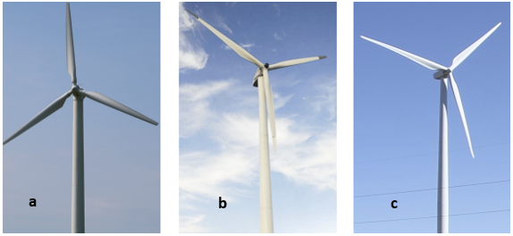
Figure 5. 1: Three Windmill Styles Tested in Thesis
Table 5. 1: Main Characteristics of Three Windmill Styles
Serial | Type | Rated Power | Spot for Photography | Basic Parameter
a | Nordtank NTW300 | 300KW | Sandager Windfarm,  Denmark (Grassland);  Chaiwopu Windfarm,  China (Grassland) | Appendix 3
b | Goldwind S50/750 | 750KW | Dongyang Windfarm,  China (Mountain) | Appendix 3
c | General Electric GE 1.5sl | 1.5MW | Guanyin Windfarm,  Taiwan (Seaside) | Appendix 3

For the windmill will be halted and troubleshooted in most windmill films, when it has tiny abnormity, it is difficult to shoot the video or images of windmill breakdown moments in field study. Therefore, contrary to routine detection, the data to process in fault detection comes from the Internet rather than on-site shooting. The thesis will determine the new method effect on windmill fault detection by analysing the motion behaviour of windmill during the breakdown moment.

5.2 Blades and Towers Motion Detection Under Normal Operating Conditions
Considering the complicated mechanical structure and changeable working environment, the motion of real windmill is more complex than the models in lab. Therefore, real windmill monitoring system includes the lots of detection items, the blades and towers motion are regarded as the most basic ones, because of their visibility (Shen et al., 2011). The normal operation windmills should have the motion parameters within normal range. For example, the rotation speed cannot exceed the maximum speed limit, otherwise, the windmill will be faced with risks. Any components of windmill have problem will affect these parameters. In this selection, to verify the feasibility of new image processing-based detection method, the thesis will monitor blades and towers motion parameters of three different types windmills in different wind condition and compared the results with the theoretical value.

5.2.1 Rotation Speed Detection
Unlike laboratory simulation, the wind power of real windmill is dynamic, which leads to the unstable power output. To attenuate or even avoid this phenomenon, the many kinds real windmill blades uses pitch system to control rotation speed. In other words, although the rotation behaviours are changed with wind speed, it is not a kind of linear relation, which is similar with windmill models in lab. The thesis will monitor all three wind turbines rotation speed in different wind speed and try to plot the rotation-wind speed curve.

5.2.1.1 Rotation Speed Measurement in Different Wind Speed
The wind speed is measured from the district, which is far away from the windmill and in the same height with windmill top. To reduce the error, the thesis detects the rotation in the time quantum with wind velocity different less than 0.5m/s. Optical intensity method is used to measure the rotation speed and transfer the rotation frequencies into rotation per minute. Figure 5.2 shows the rotation-wind speed curve per the processing results and compare it with output power curve of this style wind turbine.
From figure 5.2, some details are indicated:
- No matter what kinds of windmills, the rotation speed always reaches max speed before the rated wind speed.
- The rotation speed curve is separated into several stages with wind speed increase and has some distinction between different windmill styles.
- The rotation speed has some relationship with output power.
What is most different from of windmill models in lab, with the increase of wind speed, the growth trend of real windmill rotation speed is not monotonous. More details for this phenomenon will be discussed in next selection
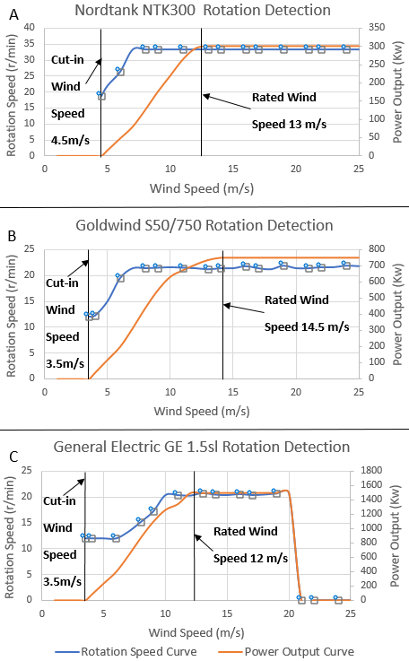
Figure 5. 2: Rotation-Wind Speed Curve and Power Curve of Three Wind Turbines

5.2.1.2 Compared Practical Measured Value of Rotation Speed with Theoretical Value
To explain the plotted curve, and checked whether the curve conforms to reality, more details will be analysed in below.
Formula 2.3 in Chapter 2 shows the wind energy captured by wind turbine in t time, however, the Betz Law illustrates the windmill unable to transfer all the wind power into mechanical energy, the max transfer efficiency of wind turbine is 16/27. Combining formula 2.3 and Betz Law, the real energy captured by windmill in unit time is formula 5.1, where $C_{p}$ is the power coefficient. Considering features of the ideal Betz windmills (no hub, infinite number of blades and no velocity decay before wind reach the turbine), the max power coefficient 16/27 is unreachable (Ragheb and Ragheb, 2011). The real power coefficient is lower than 0.5 in modern wind industry.
$$P=\frac{1}{2}SρV^{3}C_{p} (5.1)$$
Formula 5.1 indicated the power coefficient is depended on Tip Speed Ratio $λ$, blades quantity, blade shape and pitch angle $β$ (Çetin et al., 2005). Since three blades and blades shape in figure 2.13 have become the mainstream in modern wind industry, Tip Speed Ratio $λ$ and pitch angle $β$ are the determinants of power coefficient. Suvire (2011) in his book plotted the curve (figure 5.3) between tip speed ratio and power coefficient with different pitch angle for most modern wind turbine styles. To realise the optimal power coefficient in all working wind speed range, rotational speed control is inevitable.
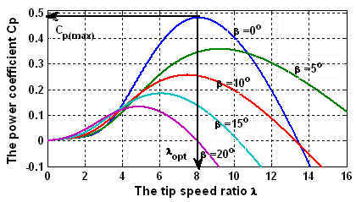
Figure 5. 3: Tip Speed Ratio λ- Power Coefficient $C_{p}$ Curve (Suvire, 2011)
Then analyse whether the rotation-wind speed curve in figure 5.2 is reasonable. When the wind speed is below the rated wind speed, the pitch angle is 0º, according to figure 5.3, the rotation angular speed $ω$ should meet the requirements of formula 5.2, where R is rotor radius and V is wind speed (Lim and Kim, 2012).
$$λ=λ_{opt}=\frac{ωR}{V}≈8 →ω=\frac{8V}{R} (5.2)$$
Formula 5.3 notices before rated wind speed, the relationship between rotation speed and wind speed is linearity. In fact, as the limitation of generator speed, this linearity only exists in a small wind speed range. Goldwind S50/750 (figure 5.2 B), for example, the generator speed is from 860 r/min to 1500 r/min, so the rotation speed range of rotor is 12.3r/min-21.4r/min. Using formula 5.3 to calculate the range of wind speed V is 4m/s-7m/s. However, the cut-in wind speed and rated wind speed is 3.5m/s and 14.5m/s, that means in wind range 3.5m/s to 4m/s, the rotor speed kept in minimum (12.3r/min), and in wind speed 7m/s to 14.5m/s, the rotor speed should be maximum (21.4r/min).
When the wind speed exceeds the rated wind speed, to guarantee output power of generator stable in rated power, according to formula 5.1, changed the power coefficient is necessary. Using the pitch system to vary the pitch angle to make the generator constant power operation. Therefore, the rotor speed will keep in max speed from rated wind speed to cut-off wind speed. Summarising the above discussion to inference the ideal relationship between rotation speed and power output is as figure 5.4 shows (Zhang et al., 2008).
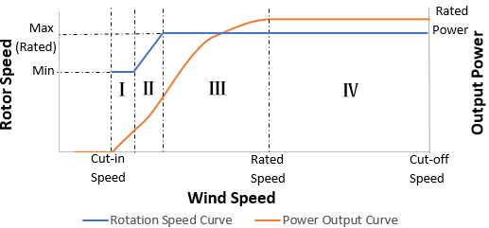
Figure 5. 4: Ideal Rotation-Wind Speed Curve in Real Windmill
Therefore, in theory, the real windmill rotation speed has four stages:
Ⅰ. Constant Min Rotation Speed:
In this stage, the rotation speed will remain at minimum rotor speed. And the power coefficient $C_{p}$ will increase until it reaches $C_{p(Max)}$. The output power keeps growing. The windmill uses PIC (Proportional Integral Controller) to keep the rotation speed stable (Iov and Blaabjerg, 2009).
Ⅱ. Variable-Speed Operation:
In this stage, the rotation speed has increased with wind speed until rated rotor speed, so that the power coefficient $C_{p}$ will keep at $C_{p(Max)}$. And per formula 5.3, the variation is linearity. The output power has kept growing. The windmill also uses PIC to adjust the rotation speed. However, in formula 5.3, the measured wind speed is unreliable, which leads to the rotation speed uncontrollable. To realise $C_{p}=C_{p(Max)}$, Per formula 5.2, 5.3 and $P=T∙ω$ , where T is the torque of rotor, formula 5.3 is applied on windmill. K is constant, and rotation speed $ω$ is measurable, torque T is controllable. Adjusting the torque T to realise $C_{p}=C_{p(Max)}$ (Muljadi and Butterfield, 2001).
$$T=\frac{P}{ω}=\frac{\frac{1}{2}SρV^{3}C_{p\left(Max\right)}}{ω}=\frac{\frac{1}{2}πR^{2}ρ{\left(\frac{ωR}{λ_{opt}}\right)}^{3}C_{p\left(Max\right)}}{ω}$$
$$=\left(\frac{1}{2}πR^{5}ρ\frac{C_{p\left(Max\right)}}{λ_{opt}}\right)ω^{2}=Kω^{2} (5.3)$$
Ⅲ. Constant Max Rotation Speed:
In this stage, rotation speed has remained at maximum rotor speed until the wind reaches rated speed. Although the power coefficient $C_{p}$ reduces, the power continued to increase to rated power. Similar with first stage, PIC is applied to maintain rotation speed.
Ⅳ. Constant Power Operation:
In this stage, the pitch system will be activated to change the pitch angle of each blade, which remains the output power and rotor speed at rated power with wind speed increases. power coefficient $C_{p}$ continues to decrease.
Compared the ideal curve with the plotted curve in figure 5.2, considering the error of measurement and calculation, it is obvious to find the actual measured curve is basically conformed to ideal one. Besides, some special circumstances should be explained.
- In figure 5.2(a), the rotor speed curve of Nordtank NTK300 has no first stage. That is because the windmill starts to operate in cut-in wind speed, the max power coefficient $C_{p(Max)}$ can be achieved. This situation makes the windmill rotor speed advanced into second stage directly.
- In figure 5.2(c), considering the complexity and variability of sea wind, the manager of the wind farm said they stipulated turning off the windmill when the wind speed exceeds 20m/s for protection, although the cut-off wind speed of General Electric GE 1.5sl is 25m/s. Therefore, no windmill data is collected after 20m/s wind speed.
The curve is plotted by smooth curve fitting. Regards limitation of data points quantity, the plotted curve exists some different with ideal curve. However, as these errors are between 0%-3%, it has still illustrated the feasibility of new image detection method in windmill blades rotation routine detection.

5.2.3 Vibration Detection of Blades Tip (Each Blade Cycle Time Measurement)
As it has been analysed in Section 4.2.4, the windmill blades have shaken when working. This phenomenon leads generate the time difference of cycle time for each blade. In the real windmill, the vibration also exists, especially in blades tip. Considering the lower rotation speed of real wind turbine, compared with the model in lab, the cycle time difference is inconspicuous. Similar with the lab case in 4.2.3, EVM is applied to enhance the rotation of blades. And the fluctuation of cycle time will reflect the vibration of windmill blades.
Recording three different stages of Nordtank NTK300 as an example. The wind speed is 6m/s, 10m/s and 15m/s, respectively. According to the plotted curve in figure 5.3, the rotation speed in these three wind levels is about 26r/min, 33r/min and 33r/min, respectively. The thesis has recorded 10 cycles time of each blade after EVM processing (enhance 5 times), the results are in figure 5.5.
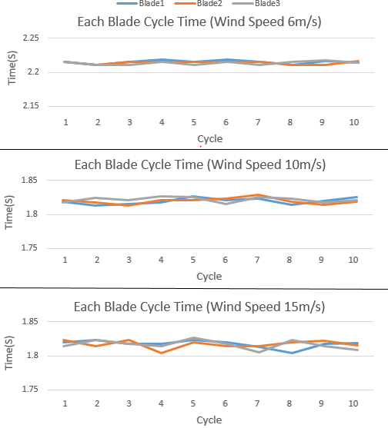
Figure 5. 5: Nordtank NTK300 Windmill Blades Cycle Time after EVM
Also, Schubel and Crossley (2012) considered the windmill blades vibration relates to blades size. In general, larger windmill will have more violent vibration, especially in the tip of blades. Therefore, the thesis measure 10 cycles time of Nordtank NTK300, Goldwind S50/750 and General Electric GE 1.5sl in the same wind speed 13m/s after EVM processing (enhance 5 times), to verify Schubel and Crossley’s viewpoint. All three types of windmills are in the max rotor speed in the wind speed 13m/s, and the results are in figure 5.6.
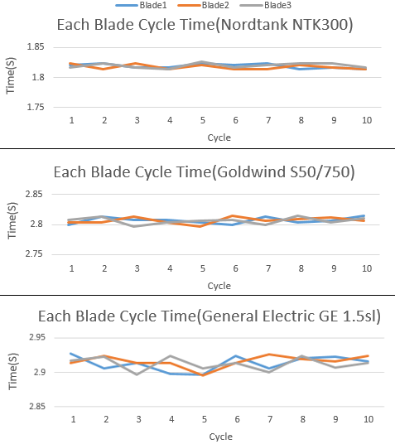
Figure 5. 6: Comparison of Three Types Windmill Blades Cycle Time after EVM in Wind Speed 13m/s
Some viewpoints are proved from figure 5.5 and 5.6:
- Each blade has different cycle time in different cycle, and even in the same cycle, the three blades also have cycle time difference. And the distinction will increase with wind speeds up. The phenomenon is the evidence to prove the existence of blade vibration.
- This kind of vibration relates to the wind speed and windmill size. To the same windmill, vibration will be stronger with the growth of wind speed. And in the same wind speed, the larger windmills have greater fluctuations of cycle times, conform to the opinion in Schubel and Crossley’s paper.
- Compared with the model data in Lab (figure 4.13), the real wind turbine blades vibrate sharply. For the healthy windmill model in lab, the blades vibration cannot react on cycle time in lab even use 40 times enhancement. However, 5 times magnification can be observed in real healthy windmill.
Also, in figure 5.5 and 5.6, all the time errors of each cycle time are tiny, which are no more than 0.04s. The relative error is only between 0% to 1.5%, compared with theoretical value of rotation speed in the same wind speed condition. In other words, as the rotor speed control, the healthy windmill motion keeps stable. Therefore, per the analysis of blades rotation and vibration monitoring, the new image processing detection method can react the blades motion.

5.2.3 Tower Vibration Detection (Vibration Frequency Measurement)
In Section 4.3, the thesis discussed and proved the vibration of windmill tower in operation. In the lab, because of the windmill size and materials, the thesis assumes tower vibrates only under the effect of wind force. However, to the real windmill, many other acting forces on tower cannot be ignored, such as gravity of blades, nacelle and tower. The stress condition of wind turbine tower into six styles (figure 5.7). $F_{R}$ is the rotor thrust, $M_{R}$ is the rotor torque, $q_{t}$ is the wind load on tower, $G_{T}$ is the gravity of tower, $G_{NR}$ is the gravity of nacelle and rotor, and $M_{NR}$ is the eccentric torque causes by $G_{NR}$ (Wu, Xu and Xu, 2014).
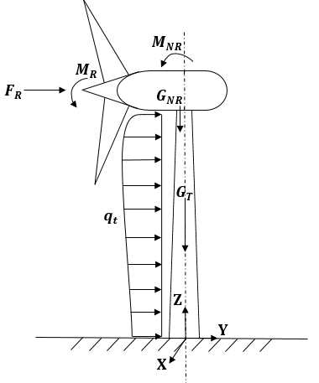
Figure 5. 7: Stress Condition of Windmill Tower
The main objective of tower detection is to guarantee the tower vibration frequencies are far away from its natural frequencies, which will avoid the resonance of tower and keep the stability of tower. The thesis selects Nordtank NTK300 as an example and analyses its tower vibration behaviours both in the condition of normal working and before collapse.

5.2.3.1 Natural Frequency of Real Windmill Tower
The thesis detected the tower of Nordtank NTK300 (Chaiwopu Windfarm in Xinjiang China) in the rated wind speed 13m/s, according to the size parameters (table 5.2), using Soildworks to simulate the working condition of windmill tower, and calculate the natural frequency of tower in the prestress of figure 5.7 (table 5.3) (Zhao, Cao and Chen, 2010).
Table 5. 2: Main Size Parameters of Nordtank NTK300
Tower Height | 35m | Nacelle Weight | 12.8t
Tower Bottom Diameter | 2.4m | Total Weight | 42t
Tower Top Diameter | 1.6m | Tower Materials | Q345E  (E=2.1GPa, ρ=7850kg/m³, Poisson Ratio=0.3)
Tower Wall Thickness | 10-16mm | Tower Materials | Q345E  (E=2.1GPa, ρ=7850kg/m³, Poisson Ratio=0.3)
Tower Weight | 22.8t | Tower Materials | Q345E  (E=2.1GPa, ρ=7850kg/m³, Poisson Ratio=0.3)
Blades Weight | 3*1.2t | Tower Materials | Q345E  (E=2.1GPa, ρ=7850kg/m³, Poisson Ratio=0.3)

Table 5. 3: Calculation Methods of Prestresses in Nordtank NTK300 Tower
Stress | Formula | Description
Rotor Thrust | $$F_{R}=C_{p}{∙V}^{2}∙S$$ | $C_{p}$is power coefficient;  V (m/s) is wind speed;  S (m²) is swept area
Rotor Torque | $$M_{R}=P/n$$ | P (kW) is output power;  n (rpm) is blade rotation speed
Gravity | $$G_{T}=m_{T}∙g$$ | $m_{T}$(kg) is the weight of tower
Gravity | $$G_{NR}=m_{NR}∙g$$ | $m_{NR}$ (kg) is the weight of blades and nacelle
Eccentric Torque | $$M_{NR}=G_{NR}∙e$$ | $e$ (m)is eccentric distance from mass centre of blades and nacelle to tower axle wire. To Nordtank NTK300, e=0.54m
Wind Load on Tower | $$q_{t}(z)=w_{k}(z)∙A$$  $$w_{k}(z)=β_{z}μ_{s}μ_{z}(z)w_{0}$$ | $w_{k}(z)$ (kN/m²) is the wind loading characteristic value of unit area in z height;  A is the projected area of tower in z height;  $β_{z}$ is wind fluttering factor in z height;  $μ_{s}$ is shape factor of wind load;  $μ_{z}(z)$ is height variation factor of wind pressure;  $w_{0}$ is reference wind pressure.

As the detected windmill in Xinjiang, China, all factors of wind load in table 5.3 can be searched in PRC National Standard GB50009-2012, “Load Code for The Design of Building Structures”. The final results of the windmill tower natural frequencies in rated wind speed 13m/s are listed in table 5.4, and the vibration modes are shown in figure 5.8. As it is discussed in Section 4.3.3, the tower natural frequencies have the same value because of the axial symmetry structure. However, the eigenvectors of characteristic equation are different, which means the vibration mode of each order is also different (Liu, Luo and Miao, 2012). Therefore, in the table 5.4, the fist and second order have the same natural frequencies, but different vibration modes.
Table 5. 4: Natural Frequencies of Nordtank NTK300 Towers in Rated Wind Speed 13m/s
Modality | Natural Frequency | Vibration Mode
First-order | 0.86884Hz | First-order bending vibration (along Z-axis)
Second-order | 0.86956Hz | First-order bending vibration (along X- axis)
Third-order | 7.65577Hz | Second-order bending vibration (along Z-axis)
Fourth-order | 7.67953Hz | Second-order bending vibration (along X- axis)

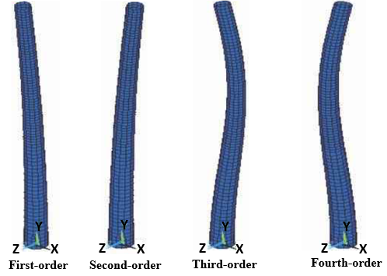
Figure 5. 8: Vibration Modes of Each Order

5.2.3.2 Tower Vibration Frequencies Measurement in Different Wind Speed
Different from other middle-large size windmill tower, the structure of Nordtank NTK300 tower is one-part steel tube rather than multi-parts tower (like figure 2.15). Therefore, the thesis selected the bottom of tower (from the 5m to about 10m) and the top of tower (from about 25m to 30m) as the testing object to detect the tower vibration. Using EVM to enhance the testing parts of tower both 5 times, and the results are shown in figure 5.9.
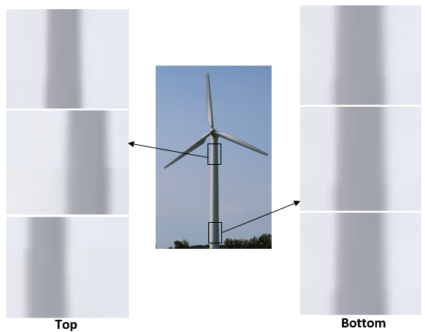
Figure 5. 9: EVM Results of Top and Bottom Tower Vibration
From the image, it is obvious to find the vibration of the top tower; however, the bottom tower vibration cannot be saw by naked eyes in the 5 magnification times in the final results. That is because the stress on top tower is more complex and variable than that of bottom tower. This conclusion was also proved in Bazeos and his partners’ research in 2002, who used several sensors on the different position of 450kW windmill tower to collect vibration signals. They considered the bottom of tower had almost no displacement, while the top and the mid of tower had evident movement. In some large-scale windmill, even without any enhancement method, the displacement of top tower can reach meter level.
To discuss more details, Optical Intensity method is applied to EVM processing result to analyse the frequency of tower vibration. Figure 5.9 and 5.10 illustrates Bazeos’ option, the top tower has more movement than bottom tower. Also, more details can be learned from this FFT image.
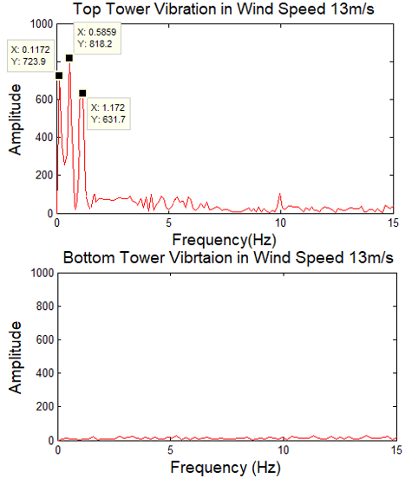
Figure 5. 10: FFT Results of Top and Bottom Tower Vibration after EVM (Sampling Frequency $F_{s}$=30Hz, Sampling Points N=256)
- Similar with the tower detection in lab (figure 4.20), the real windmill tower vibration is also a kind of complex vibration.
- No matter the vibration frequencies, 0.1172Hz, 0.5859Hz and 1.172Hz in figure 5.10; the rated rotation frequency of Nordtank NTK300, about 0.55Hz (33.4r/min), and 3 times of rotation frequency 0.55×3= 1.65Hz, are all quite different from the tower natural frequencies in table 5.4. As no resonance phenomenon will occur in rated wind speed, the windmill tower has stable operation in rate wind speed 13m/s.
To an established windmill, the gravity factors are determined, the main influence factor of tower vibration is wind speed (lliyasu et al., 2017), this also can be explained in figure 5.7. The wind speed will change the rotor thrust $F_{R}$, the rotor torque $M_{R}$, and the wind load on tower $q_{t}$. Therefore, with the variation of wind speed, the tower vibration condition and the tower natural frequency will be changed. It is necessary to detect the tower vibration in different wind speed to confirm whether the tower in normal operation in all working wind speed.
Per the rotation speed in figure 5.2 A, the thesis detects the tower vibration conditions in wind speed 6m/s and 23m/s, and compares them with that in rate wind speed 13m/s. As the change of wind speed, the stresses of tower are different form that in rated wind speed condition. This variation may lead to the deformation of tower structure. In other word, the natural frequency of windmill tower is changed. Table 5.5 lists the natural frequencies calculated by Solidworks in the pre-stress of wind speed 6m/s and 23m/s. However, to healthy windmill tower, the stresses caused by wind load and gravity has little influence on whole tower structural characteristics. Therefore, both natural frequencies and vibration modes results in table 5.4 and table 5.5 are almost the same.
Table 5. 5: Natural Frequencies of Nordtank NTK300 Towers in Wind Speed 6m/s and 23m/s
Wind Speed | Modality | Natural Frequency | Vibration Mode
6m/s | First-order | 0.85714Hz | First-order bending vibration (along Z-axis)
6m/s | Second-order | 0.85943Hz | First-order bending vibration (along X- axis)
6m/s | Third-order | 7.61438Hz | Second-order bending vibration (along Z-axis)
6m/s | Fourth-order | 7.62852Hz | Second-order bending vibration (along X- axis)
23m/s | First-order | 0.87537Hz | First-order bending vibration (along Z-axis)
23m/s | Second-order | 0.87916Hz | First-order bending vibration (along X- axis)
23m/s | Third-order | 7.67765Hz | Second-order bending vibration (along Z-axis)
23m/s | Fourth-order | 7.68746Hz | Second-order bending vibration (along X- axis)

And EVM (5 times enhancement) and Optical Intensity method are applied on the tower top to measure the vibration frequencies. Figure 5.11 is the FFT results of tower vibration image sequence of wind speed 6m/s and 23m/s after EVM processing, also the results in rate speed 13m/s are listed as the reference. The figure manifests:
- The wind speed has a significant effect on tower vibration. Generally, the higher wind speed will lead the more complex vibration and higher dominating vibration frequency. The results conform to lliyasu’s research (2017) and evaluation for undamaged windmill tower vibration in Nguyen, Huynh and Kim’s study (2015).
- In the wind speed 6m/s, the vibration frequencies, 0.5859Hz and 1.055Hz, blade rotation frequency, 0.438Hz(26.3r/min) and 3 times of rotation frequency 0.438×3= 1.315Hz, are all different from the tower natural frequencies in table 5.5. Also, in wind speed 23m/s, the vibration frequencies, 0.2344Hz, 0.4688Hz, 1.055Hz and 1.406Hz, blade rotation frequency, 0.55Hz (33.4r/min), and 3 times of rotation frequency 0.55×3= 1.65Hz, are all far away from the tower natural frequencies in table 5.5. Therefore, although the wind speed will lead the change of tower vibration behaviours, they keep in stable operation.
Per Bazeos’s paper in 2002, besides the low-frequency vibration, the tower also has some high-frequency vibration because of other components vibration, such as gear box and generators. These kinds of motion will transmit into the tower. And the frequencies of the vibration will always high, which can be more than 100Hz. Bazeos considered these vibrations are unavoidable and unharmful to tower. Therefore, in the thesis, to eliminate the interference of these kinds of vibration, 30fps record rated is applied to shoot the windmill, which can contain the low-frequency vibration of tower and reject the high-frequency vibration.
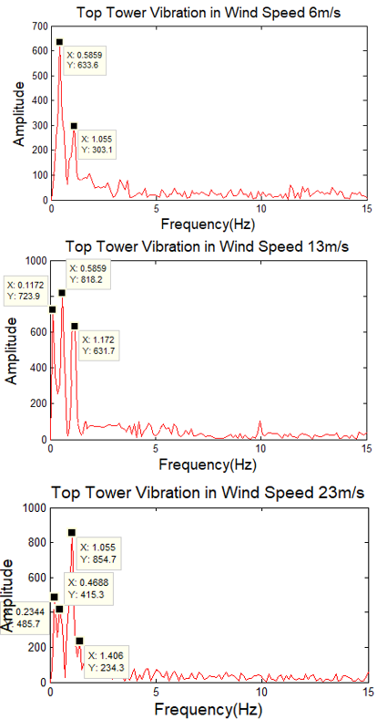
Figure 5. 11: FFT Results of Nordtank NTK300 Top Tower Vibration after EVM in Wind Speed 6m/s, 13m/s and 23m/s (Sampling Frequency $F_{s}$=30Hz, Sampling Points N=256)

5.3 Windmill Fault Detections Before Destruction Using Video Clips Available on Internet
In the windmill farm, all wind turbines are protected strongly, any windmills with abnormal working will be emergency stopped to prevent serious consequences (Redlinger, Andersen and Morthorst, 2002). It is difficult to collect the image data before windmill destruction in field sampling. Therefore, to analyse the motion behaviours of windmill before collapse and find further evidence to support the feasibility of new image processing-based detection method, the thesis searches two Nordtank NTK300 collapse videos on Internet as original data. The two destruction windmill examples including blades collapse and tower collapse, new detection method will be applied to measure some blades and tower motion parameters before it totally collapse. As the original data comes from Internet, the detection and measurement in this section are all off-line.

5.3.1 Rotation Speed Detection Before Windmill Blades Destruction
The blades rotation control in figure 5.4 is divided into two parts, low wind speed control (wind speed＜rated wind speed) and high wind speed control (wind speed ＞rated wind speed). The low wind speed control uses PIC (Proportional Integral Controller) to control adjust the rotation speed, and the high wind speed control uses pitch system to stable rotation speed.
In the low wind speed control, PIC is the main element. When the failure occurs in PIC system, the rotation speed will out of control. However, as the wind speed is low, discover the damage and stop the windmill in time will protect the blades. The thesis will main discuss the pitch system damaged in high wind speed, which will lead to the collapse of windmill.
Figure 5.12 is Nordtank NTK300 in Hornslet, Denmark (record rate 30fps), which was collapsed because of pitch system and brake broken. Per the broken information of video photographer in windmill farm, the windmill has worked in the strong gale (21m/s-23m/s), however, the primary cause of collapse is the damaged of pitch system and brake system, which leads the windmill out of control, and cannot be stopped. Rotor failed is happened in the high rotation speed and leads to avulsion of blades finally. Using EVM and Optical Intensity method to analyse the rotation behaviours in a few seconds before the windmill totally collapsed. Enhancing 11 cycles before the wind turbine collapse to calculate cycle time for each blade. The results are shown in figure 5.13.
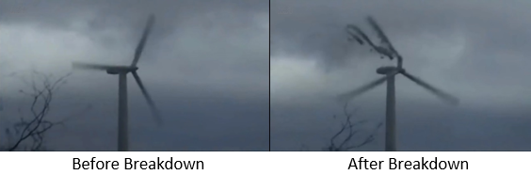
Figure 5. 12: Nordtank NTK300 Windmill Fail of Pitch System (Hornslet, Denmark)

Figure 5. 13: Nordtank NTK300 Windmill Cycle Time of Each Blade before Collapse
From the cycle time curve, some details can be illustrated:
- As the broken of pitch system, the max rotation speed will exceed 110r/min, which is far more than max rotor speed of normal Nordtank NTK300, 33.0r/min. The speed can be more than 3 times of max rotor speed.
- As the high rotation speed, the vibration of blades is much stronger than the healthy windmill in the same wind speed. In other word, the instability of cycle time is more distinct.
- Before the 6th cycle, the range of cycle time is between 0.5s and 0.7s. However, in the 7th cycle, the rotor has been damaged, which leads to rapid change of cycle time. After 7th cycle, the windmill blades are not collapsed immediately, they keep on rotating. However, as the rotor is broken, the rotation speed become more variable. And finally, the situation results in avulsion of blades and collapse of whole windmill.
Besides the strong blades vibration, the high rotation speed produces large centrifugal force, which will make the link between blades and rotor loose. This is another reason for the unstable cycle time of each blades. Combining the curve in figure 5.13 with the break information introduced above, the cycle time can demonstrate the damaged processing of windmill, to a certain extent.

5.3.2 Tower Vibration Detection Before Windmill Towers Destruction
The thesis also researched in Internet to find a video data about windmill collapse; and analysed the behaviour of tower vibration. Figure 5.14 is the Nordtank NTK300 windmill crash in Shangdong, China. In the video (record rated 60fps), wind speed is about 16m/s. As the stresses of tower are different form that in rated wind speed condition, the natural frequency of windmill tower was changed. Table 5.6 lists the natural frequencies and vibration mode calculated by Solidworks in the pre-stress of wind speed 16m/s. Also, compared with table 5.5 and 5.4, there is not much difference in the results.
Table 5. 6: Natural Frequencies of Nordtank NTK300 Towers in Wind Speed 16m/s
Modality | Natural Frequency | Vibration Mode
First-order | 0.87163Hz | First-order bending vibration (along Z-axis)
Second-order | 0.87214Hz | First-order bending vibration (along X- axis)
Third-order | 7.65853Hz | Second-order bending vibration (along Z-axis)
Fourth-order | 7.68201Hz | Second-order bending vibration (along X- axis)

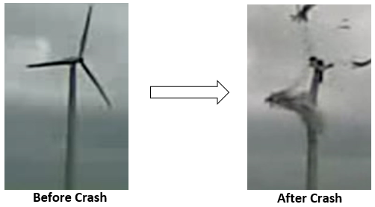
Figure 5. 14: Nordtank NTK300 Windmill Tower Fail (Shangdong, China)
EVM method and Optical Intensity method are applied to measure the rotation frequency (figure 5.15) and top tower vibration frequency (figure 5.16 b), also as a reference, the top tower vibration of normal operation Nordtank NTK300 in wind speed 16m/s will be measured (figure 5.16 a). Some significant deduction can be deduced as following:
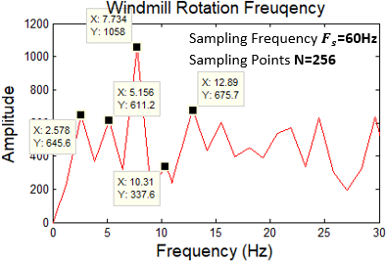
Figure 5. 15: FFT Results of Nordtank NTK300 Rotation Frequency in Wind Speed 16m/s before Destruction
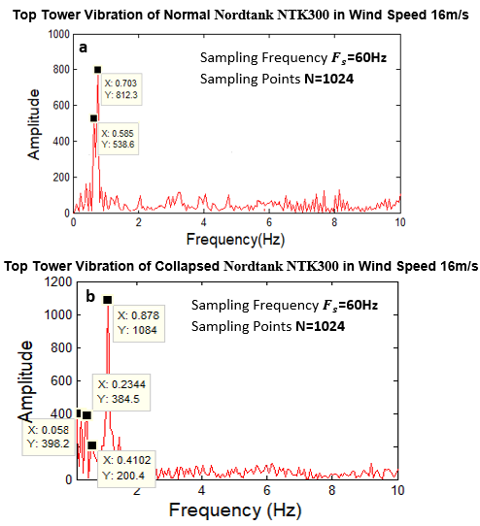
Figure 5. 16: FFT Results of Nordtank NTK300 Top Tower Vibration Frequency in Wind Speed 16m/s before Destruction
- As it is discussed in figure 3.16, figure 5.15 shows the frequency of windmill rotation. The frequency interval of each crest 2.578Hz is the three times of real windmill rotation frequency. Therefore, the true frequency of the wind turbine is 2.578/3Hz, which is 0.859Hz. The frequency is higher than the rated rotation frequency 0.55Hz, that means malfunction is occurred in the pitch system of the windmill, which leads the rotation speed out of control.
- Compared with normal operation windmill tower in wind speed 16m/s (figure 5.16 a), the top tower vibration under this circumstance is more complex, more than four kinds of vibration frequencies are presented in FFT results image (figure 5.16 b). And at the same time, different rotation speed between normal operation and unnormal one lead the variation of dominant frequency of vibration.
- The main top tower vibration frequency 0.878Hz, and the rotation frequency 0.859Hz are both very close to the first and second order natural frequency in table 5.5. That means the windmill tower has the resonance in such situation, which is one of reason for windmill crash finally. This opinion was also mentioned in Singh’s research (2007), who considered one of most significant targets of windmill tower concrete construction was to avoid resonance.
Varadharajan (2015) also used this video as example to simulation the destruction processing of windmill in Abaqus (figure 5.17). He finally considered the resonance makes the tower bend and deformity, but at the same time, the nacelle keeps stable. This situation causes the unbalance and uneven of the windmill, and finally leads the collapse.
Per the discussion above, no matter the tower collapse is also main caused by the uncontrollability of rotation speed. In fact, compared with normal operation, this uncontrollable rotation speed produces enormous bending and displacement of towers. Once the deformations are out of the material limit, collapse will occur. To make the conclusion more intuitive, the thesis uses Ansys to situation the deformation of tower with normal rotation speed and uncontrollable rotation speed. The windmill model is still the Nordtank NTK300, and in normal one the rotation speed will stable at rated speed 33r/min. However, for the uncontrollable one, the rotation speed will be changed between 70r/min and 100r/min. The results (figure 5.18) shows, for the normal windmill tower, the motion is mainly for shaking, deformation is not obvious; while in the uncontrollable rotation speed, the tower deformation is conspicuous, especially in the top of tower. This result conforms to the real detection results of new method.
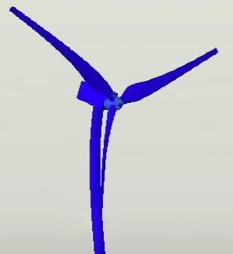
Figure 5. 17: Situation of Nordtank NTK300 Collapse in Abaqus (Varadharajan, 2015)
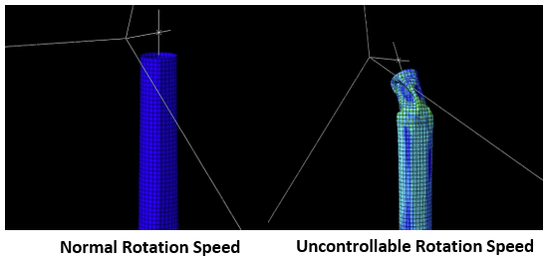
Figure 5. 18: Ansys Deformation Situation of Nordtank NTK300 in Different Rotation Speed

5.4 Conclusion
The above testing and discussion illustrate the feasibility of the new imaged-based detection method on real windmill industry. It can be summarised as two aspects: blades rotation and tower vibration.
For Blades Rotation Detection
- Like it is tested on the windmill models in lab, the new method can measure the rotation speed of the blades in term of wind speed variation correctly. Different from the rotation speed of windmill models, the real windmill speed is much lower than windmill models in lab and does not remain growing with the increase of wind speed. The rotation speed is controlled by other systems, such as PIC and pitch system, to be suitable for the wind speed and output power.
- Also, similar with the windmill models in lab, the real windmill blades have the vibration, especial, in blades’ tips, which can be detected by the form of blades cycle times. However, as the real wind turbine blades are much larger than the models in size, the vibration is much easier to be monitored. In the lab, 20 times amplification factor can be found the cycle time difference, while in real windmill cases, 5 times is available. (The more details of how the amplification factor to be determined will be discussed in the Section 6.2)
- If there is something wrong with the rotation speed control system, the blades rotation will be out of control. Especial in the gale weather, the rotation speed outdistances the blades max speed of normal operation condition. Also, because of the high speed, the volatility of blades cycle time presents violent, which may lead to the collapse of whole windmill.
For Towers Vibration Detection
- The real tower exists the vibration when the windmill works. However, as the real tower is much higher than the model in lab, the vibration of real tower has some distinctions in different selections of tower. The top tower vibration is more violent than the bottom part. Also, the vibration can be divided several motion frequencies after magnification.
- To guarantee windmill tower in a stable operation condition, all sub-vibration frequencies of tower and blades rotation frequencies should be far away from the tower natural frequencies. However, sometimes, the cracks of tower or the broken of rotation speed control system will make the sub-vibration frequencies of tower or blades rotation frequencies be similar with tower natural frequencies, which may lead resonance and windmill collapse finally.
No matter the blades rotation or the towers vibration, the detection results by the new imaged-based method, are similar to the practical situation and the data from other traditional detection methods. And, compared with other traditional detection methods, the greatest advantage of new image-based detection method is that, except image sensors, no any other sensors are used in the detection process. For the traditional method, large numbers of sensors are required to detect the large-scale windmill structure completely, such as blades or towers. And considering the wires to support each sensor, the whole detection system will be both expensive and less efficient (Owen, Inman and Dong, 2010). However, as the rotation frequencies and tower vibration frequencies are lower than 5Hz, only the common camera can do the detection, and the results are proved correct in the new method. This feature can reduce the monitoring cost and be non-destructive to windmills.
Morton in his paper mentions that the CMS (Condition Monitoring Systems) of windmill is not only for blades and tower, gearbox, generators, electronic system and other components should also be included. Because of research constraints, the thesis could only record the image or video data from outside of windmill, and only tower and blades detection of real windmill are discussed in the thesis. Although no information is collected from the inside of nacelle, other components detection will be still analysed in the next chapter of Future Work.

6

SUMMARY AND FUTURE WORK

6.1 Summary
The main objective of the thesis is to develop an innovative and non-intrusive wind turbine monitoring system based on the image processing method. And the philosophy of the detection method is ‘all-in-one-go’, which means many useful parameters can be derived from a video or a single image sequence. To verify whether the new detection method can be used in windmills, the thesis uses the windmill models in lab and real windmills data, which is shot on location or researched about on Internet, as the examples. Finally, some conclusions are summarised with calculation and comparison of some basic motion parameters of a windmill.

6.1.1 Summary of Windmill Models Detection in Lab
Blades Detection:
- The main research parameters of blades detection in lab windmill models are rotation frequencies and cycle time. Optical Intensity method is applied to calculate rotation speed in different wind speed level and blades health condition. The results illustrate that the rotation speed is related to wind speed and blades damage, if the windmills are rotated only by wind. Higher wind speed leads to higher rotation speed, which presents a kind of linear variation for the healthy windmill. While more damages on blades will lead to the variation of rotation speed irregularity.
- The blades exist vibration when it works, this circumstance is more obvious on tip of blades. Using the EVM method to make invisible blades vibration patterns visible. Considering the principle of Optical Intensity to measure rotation speed, the volatility of blades cycle time becomes one manifestation of blades vibration. This vibration is also related to the damaged level on blades. Compared with heathy blades, the damaged blades have more unstable cycle time, which means the blades vibration is more serious.
Towers Detection:
- The main research points of towers detection on windmill models are towers vibration dynamic parameters, including vibration frequencies and amplitudes (vibration displacement). Quantitative data of towers vibration in different towers damaged condition is extracted from a video or an image sequence after EVM processing. The results indicate that the windmill tower vibration is inevitable when the model works, it is a kind of compound motion, which can be divided into several vibrations with different frequencies.
- Also, the thesis considered the damaged condition will affect the tower vibration behaviours, after vibration frequencies were analysed by Optical Intensity method and vibration amplitude tracking by Frame Difference method. In general, in the same wind condition while ignoring the gravity, more damages in tower more vibration frequencies will exist, and the amplitude will be larger and more unstable. However, considering the material of windmill model, the man-made cracks on tower will not make the vibration frequencies or rotation frequencies similar with the tower natural frequencies. This situation leads the model tower stable operation with cracks.

6.1.2 Summary of Real Windmills Detection in Wind Farms
Blades Detection:
- Like the blades detection in lab, the main monitoring parameter is rotation speed. However, to achieve wind power coefficient maximisation, the real windmill controls the rotation speed by PIC (Proportional Integral Controller) or pitch system in different wind speed. That means, for a normal operation windmill, the rotation speed is not changed as linear variation with the increase of wind speed. The final results indicate that the rotation speed of a healthy windmill is divided into 4 stages: Constant Min Rotation Speed, Variable-Speed Operation, Constant Max Rotation Speed and Constant Power Operation (details in page). This result conforms to the windmill farm rotation data, which was collected by traditional detection methods.
- The same as windmill models in the lab, the real windmill blades also vibrated when they rotated. Compared with the windmill model, this vibration of real windmill blades is much easier to be found, because of blades size. Also, it becomes more severe due to the increase of wind speed. However, although the real blades vibration is more obvious than that of models, it has little effect on stability of windmill rotation speed, because the max rotation speed of real windmill in normal operation is always slow.
Towers Detection:
- The towers vibration is also inevitable in real windmill. After EVM enhancement and frequencies analysis by Optical Intensity method, the results illustrate, similar with tower motion in lab models, the real windmill tower vibration also a kind of compound motion. However, considering the length and material of real tower, the reason of real tower vibration is more complex. It is caused not only by wind force, but also by the gravity of some windmill components, such as blades, nacelle and tower itself. This leads the top part of tower had more violent vibration than the bottom part, in the same wind speed condition. The conclusion also accords with the data measures by sensors form other researchers.
- Besides, one of the tower design fundamental is to ensure that the tower vibration frequency is much different to the tower natural frequencies. After calculating the natural frequencies per the materials and size data of Nordtank NTK300 windmill tower, the thesis found that the tower vibration frequencies and tower natural frequencies are much different in windmill normal operation. The resonance can be avoided when the tower is in good working condition.
Collapse Detection:
As it is difficult to collect the data of windmill collapse timely, the thesis searched two videos of windmill collapse, as examples, on the Internet, which are caused by pitch system damage. After the EVM processing and kinematic analysis of blades and towers, some conclusions were summarised. Compared to normal operation of healthy windmill, the rotation speed of both windmills exceeds the maximum speed, because of pitch system malfunction, and this situation makes the blades vibration more violent and unstable. Before the windmill collapse, the rotation speed of blades faces drastic changes, and the frequencies of tower vibration close to the tower natural frequencies. These factors can trigger the windmill collapse.
6.1.3 Advantages of Imaging-Based Detection
The thesis demonstrates that imaging-based monitoring can be a powerful methodology if combined with effective algorithms. And compared with other monitoring methods, the new image-based detection method has several inimitable advantages
- It is a non-intrusive detection. Compared with other NDT (Non-Destructive Testing), the new method is also a kind of non-contact measurement. It will bring no harm and no interference to windmill itself.
- It is an economical detection method. Different form the other optical measurement mentioned in Section 2.4, the new method makes it possible to monitor multiple turbines, also components (such as blades, towers) with single common camera. All the experiments mentioned in the thesis can be completed by one single common camera and a normal computer. That means the cost of the new detection system is cheap. Also, abandonment of sensors and data transmission line not only reduces the load on windmill blades and towers, also decrease the maintenance cost of detection system.
- It is possible to have 24 hours monitoring. improving pre-processing of images or changing the shooting camera can eliminate interference of different working conditions. For example, an infrared imaging camera can be used for the night monitoring. This makes the method have the potential to offer all-weather monitoring.

6.2 Limitation and Future Work
From the above summary, the new detection method based on image processing has good performance on windmill basic parameters monitoring and measurement. On the visualisation side, the method can also make invisible vibration patterns visible by selective image sequence or video enhancement. Compared to tradition detection methods, the new methods use a single camera instead of sensors, and simplify the data acquisition process, which makes it possible to greatly reduce the cost of monitoring.
Although the method has tested some windmills in real, it is still a kind of immature technology. At the present stage, the new method has its own limitations.
Problem of Internal Components Detection
Only a few of windmill parameters can be detected. Because of the limitation of its conditions, the method can only measure and monitor some external basic parameters of windmills, such as rotation speed and tower vibration. However, the internal components of windmills are also significant objects of windmill detection, such as gear box, transmission shaft and generator (Hameed et al., 2009). Whether the method can be worked in these components is still in doubt.
Problem of EVM
The core of the new method is EVM, although the thesis improves the EVM to reduce the noise of the algorithm, it still has some unavoidable defects. The biggest problem is the selection of magnification factor $α$ and frequency band range of temporal filtering. Improper amplification factor and frequency band range will lead the output results obscure, as figure 6.1 shows. Too large magnification factor and frequency band range make the output distortion, while too small values lead to an unchanged output result. Unfortunately, at this moment, there is no quick and efficient method to find the suitable amplification factor and frequency band range for different windmills. The only method is to try different magnification factor $α$ and frequency band range.
For example, to enhance the tip vibration of blades, the thesis chooses magnification factor $α=20$ for the windmill model, and $α=5$ for the real windmills. The thesis determines the suitable magnification factor, after comparing the output results with magnification factor $α=1,5,10,15,20,25,30$. Also, to define the suitable frequency band range of temporal filtering, check reference to realize the approximate ranges of motion frequencies firstly. For example, the most tower vibration frequencies of normal windmills are between 0-5Hz (Shen, Ren and Wang, 2014). Therefore, to amplify tower vibration of Nordtank NTK300, the frequency band range of temporal filtering must contain the frequency band of 0-5Hz. The thesis tries the frequency band range of temporal filtering with 0-10Hz, 0-20Hz and 0-30Hz, and determines the frequency band range of 0-10Hz is suitable for the enhancement of Nordtank NTK300.

Figure 6. 1: Output Result Example of Unsuitable α and Frequency Band Range of EVM
Both the magnification factor α and frequency band range of temporal filtering are determined by multiple comparison. This disadvantage decreases the efficiency of the new method.
Problem of Real-time
The real windmill tests in the thesis are all off-line detection, and the processing time of the EVM is not short. For example, to a 20 seconds windmill rotation video, the Matlab will spend about 2 or 3 mins to produce the output result. This phenomenon makes the real-time capability of the new method to be a challenge.
Problem of Accuracy
Although the new method can distinguish the damaged and undamaged components of windmill, it is difficult to precise position in local region. For example, the method can detect the damaged blade, but it cannot determine which part of this blade is damaged. Therefore, to be a mature detection method, the accuracy must be improved.
The priority of future work is to improve the limitations, which are mentioned in Section 6.2. It can be divided into two parts, algorithm improvement and practical application.
Algorithm Improvement
The algorithm needs to be improved continuously. Especially, the optimum value of magnification factor $α$ and frequency band range in the EVM. In this moment, improving the temporal filtering and further reducing the interference of noise will be the focused work. As it is discussed, the frequency band range of temporal filtering should contain the notion frequency, and it is better to be as small as possible to attenuate the other jamming signals. However, if using a wide range of temporal filtering frequency band to scan the video and reducing the jamming signals with an additional program can be implemented, the workload will be greatly reduced.
For example, a motion object, whose frequency is a few tens of Hertz, need to be enhanced. As the exact value of motion frequency is unknown, several frequency bands of temporal filtering (such as 10-20Hz, 20-30Hz, 30-40Hz and so on) must be tried to find the optimal one. However, it only needs to attempt once, if the algorithm can use a wide frequency band range of temporal filtering (such as 10-99Hz) to apply the object and eliminate interference of noise by subsequent processing. The calculation is simplified greatly, compared with original one. At the same time, simplifying the algorithm to archive quick response is also an important point of real-time capability.
Practical Application
Although some real windmill cases have already be tested in the thesis, it still has a long way to apply the technology in the wind industry maturely. More real windmill cases need to be tested. For example, to detect and measure the working condition of internal components, mini-camera should be installed in the nacelle to collect the data of internal components.
Another significant point in practical application is the position of camera, because a fixed camera can only shoot one side of windmills. Two approaches to solve this problem of detecting the windmills in all directions, one is adding the number of cameras, and the other is making the camera movable (such as using drones or designing moving orbit for camera). However, both two approaches will undoubtedly increase the detection cost. Besides, how to keep the camera stable in different working conditions is also a problem. The severe weathers, such as heavy snow, hail and typhoon, will affect the shooting stability of the camera, the input videos or images may have interference because of weather, like camera shake, noisy point and so on. These problems will increase the difficulty of future-processing, sometimes they will lead to the detection of incorrect output. Therefore, how to ensure the stability and definition of input also needs to be considered in the future work.
The research of the thesis is focus on the algorithm, it is not limited in the wind industry. As the technology can monitor the motion of object, it can be applied in many areas theoretically. For example, it can detect the engine working condition by checking vibration of engine; it can detect the rhythm of the heart by checking the pulse beat. Therefore, the technology has potential applications in many fields, such as medicine, military, architecture and so on. Although, the thesis proved the possibility of new method on windmill detection, to apply the method in the wind industry or any other areas, more tests and improvements are inevitable.

REFERENCE
Ackermann, T. and Soder, L. (2000). Wind Energy Technology and Current Status: A Review. Renewable and Sustainable Energy Reviews, 21(4), pp.315-374.
Ahn, B. and Nutt, S. (2009). Strain Mapping of Al–Mg Alloy with Multi-Scale Grain Structure Using Digital Image Correlation Method. Experimental Mechanics, 50(1), pp.117-123.
Al-Bahadly, I. (2011). Wind turbines. Rijeka, Croatia: InTech, pp.373-402.
Arabian-Hoseynabadi, H., Oraee, H. and Tavner, P. (2010). Failure Modes and Effects Analysis (FMEA) for Wind Turbines. International Journal of Electrical Power & Energy Systems, 32(7), pp.817-824.
Arena, G., Paturzo, M., Fatigati, G., Grilli, M., Pezzati, L. and Ferraro, P. (2015). Non-Destructive Testing of An Original XVI Century Painting on Wood by ESPI System. Practical Holography XXIX: Materials and Applications, 93860W.
Azzopardi, G. (2015). Computer Analysis of Images and Patterns. Cham: Springer.
Thyagarajan, K. and Ghatak, A. (2007). The fiber optic essentials. [Piscataway, N.J.]: IEEE Press.
Baqersad, J., Carr, J., Lundstrom, T., Niezrecki, C., Avitabile, P. and Slattery, M. (2012). Dynamic Characteristics of a Wind Turbine Blade Using 3D Digital Image Correlation. In: Health Monitoring of Structural and Biological Systems 2012. San Diego.
Bazeos, N., Hatzigeorgiou, G., Hondros, I., Karamaneas, H., Karabalis, D. and Beskos, D. (2002). Static, Seismic and Stability Analyses of a Prototype Wind Turbine Steel Tower. Engineering Structures, 24(8), pp.1015-1025.
Blandford, G. (1997). Review of Progressive Failure Analyses for Truss Structures. Journal of Structural Engineering, 123(2), pp.122-129.
Bornert, M., Brémand, F., Doumalin, P., Dupré, J., Fazzini, M., Grédiac, M., Hild, F., Mistou, S., Molimard, J., Orteu, J., Robert, L., Surrel, Y., Vacher, P. and Wattrisse, B. (2008). Assessment of Digital Image Correlation Measurement Errors: Methodology and Results. Experimental Mechanics, 49(3), pp.353-370.
Ĉadík, M. (2008). Perceptual Evaluation of Color-to-Grayscale Image Conversions. Computer Graphics Forum, 27(7), pp.1745-1754.
Çetin, N., Yurdusev, M., Ata, R. and Özdamar, A. (2005). Assessment of Optimum Tip Speed Ratio of Wind Turbines. Mathematical and Computational Applications, 10(3), pp.147-154.
Chang, F. (2009). Structural Health Monitoring 2009. Lancaster, Pa.: DEStech Publications.
Chen, J. (2013). The Wind Turbine Airfoils and Blade Optimization Design Theory. Beijing: SciencePress.
Ciang, C., Lee, J. and Bang, H. (2008). Structural Health Monitoring for A Wind Turbine System: A Review of Damage Detection Methods. Measurement Science and Technology, 19(12), pp.310-330.
Cintrón, R. and Saouma, V. (2008). Strain Measurements with The Digital Image Correlation System Vic-2D. University of Colorado.
CWIF (2018). Summary of Wind Turbine Accident Data to 31 December 2017. Caithness Windfarm Information Forum.
Dai, J., Hu, Y., Liu, D. and Long, X. (2010). Torque Calculation and Characteristics Analysis of Blade for MW Adjustable-Pitch Wind Turbine. Acta Energiae Solaris Sinica, 31(8), pp.1030-1036.
Daily Telegraph (2011). 1,500 Accidents and Incidents on UK Wind Farms.
Dantecdynamics.com. (2015). Electronic Speckle Pattern Interferometry (ESPI). [online] Available at: https://www.dantecdynamics.com/measurement-principles-of-espi [Accessed 7 Apr. 2017].
Davis, J. (2004). Tensile testing, second edition. 2nd ed. Materials Park, Ohio: ASM International.
Drewry, M. and Georgiou, G. (2007). A Review of NDT Techniques for Wind Turbines. Insight - Non-Destructive Testing and Condition Monitoring, 49(3), pp.137-141.
Du, J., Feng, B. and He, Y. (2011). Analysis of Transverse Vibration for Wind Turbine Tower. Modern Manufacturing Engineering, (9), pp.116-118.
Dvorak, P. (2017). Self-flying Drones and Wind Turbine Blades: Inspections in About 15 Minutes. [online] Windpower Engineering & Development. Available at: https://www.windpowerengineering.com/tools-and-equipment/self-flying-drones-wind-turbine-blades-inspections-15-minutes/ [Accessed 12 Sep. 2017].
European Wind Energy Association (2016). Wind Energy Factsheets. European Wind Energy Association.
FLIR (2012). An Informative Guide for the Use of Thermal Imaging Cameras for Inspecting Buildings, Solar Panels and Windmills. Thermal Imaging Guidebook for Building and Renewable Energy Applications. FLIR.
Fu, Z., Zhao, M., Yuan, Y., Zhong, X. and Zhang, C. (2014). Construction Strategies for Offshore Wind Turbine Condition Monitoring System Based on Wireless Sensor Networks. Automation of Electric Power System, 38(7), pp.23-28.
Gallacher, D. (2016). Drones to Manage the Urban Environment: Risks, Rewards, Alternatives. Journal of Unmanned Vehicle Systems, 4(2), pp.115-124.
Gan, T., Soua, S., Dimlaye, V. and Burnham, K. (2012). Real-time Monitoring System for Defects Detection in Wind Turbine Structures and Rotating Components. In: 18th World Conference on Nondestructive Testing. Durban, South Africa.
Efraim, E. and Eisenberger, M. (2006). Exact Vibration Frequencies of Segmented Axisymmetric Shells. Thin-Walled Structures, 44(3), pp.281-289.
Fan, B., Zhang, Y., Wang, H., Xu, B. and Zhang, Y. (2015). Effect of Variation in Crack Parameters on the Characteristics of Blades Lower-order Flexural Vibration. Surface Technology, 44(9), pp.96-101.
Gao, T. and Fan, H. (2014). Trajectory Tracking of Moving Object Based on MATLAB. Industrial Control Computer, 27(8), pp.17-22.
García Márquez, F., Tobias, A., Pinar Pérez, J. and Papaelias, M. (2012). Condition Monitoring of Wind Turbines: Techniques and Methods. Renewable Energy, 46, pp.169-178.
Ge, Y. and An, L. (2008). Study of the Influence of Crack Parameters on the Blade Natural Frequencies. Journal of Power Engineering, 28(4), pp.519-522.
Gencturk, B., Attar, A. and Tort, C. (2012). Optimal Design of Lattice Wind Turbine Towers. In: 15th World Conference on Earthquake Engineering. Lisbon, Portugal, p.8.
Gipe, P. (1998). Overview of Worldwide Wind Generation. Renewable Energy, 15(1-4), pp.78-82.
Gipe, P. (2004). Wind Power. London: James and James.
Gonzalez, R., Sanchez, L. and Calvo, E. (2010). Angular Frequency Analysis of Wind Turbines by Means of Digital Image Processing. WSEAS International Conference on Energy and Environment, pp.229-233.
Guo, J., Wang, J., Bai, R., Zhang, Y. and Li, Y. (2017). A New Moving Object Detection Method Based on Frame-difference and Background Subtraction. IOP Conference Series: Materials Science and Engineering, 242, pp.112-115.
Hameed, Z., Hong, Y., Cho, Y., Ahn, S. and Song, C. (2009). Condition monitoring and fault detection of wind turbines and related algorithms: A review. Renewable and Sustainable Energy Reviews, 13(1), pp.1-39.
Hansen, M. (2015). Aerodynamics of Wind Turbines. 3rd ed. New York: Routledge.
Harte, R. and Van Zijl, G. (2007). Structural Stability of Concrete Wind Turbines and Solar Chimney Towers Exposed to Dynamic Wind Action. Journal of Wind Engineering and Industrial Aerodynamics, 95(9-11), pp.1079-1096.
Hau, E. (2013). Wind Turbines Fundamentals, Technologies, Application, Economics. Berlin: Springer.
He, X., Goubran, R. and Liu, X. (2014). Using Eulerian Video Magnification Framework to Measure Pulse Transit Time. IEEE International Symposium on Medical Measurements & Applications, 1(440), pp.1-4.
Hills, R. (1996). Power from Wind：A History of Windmill Technology. Cambridge: University Press.
Ibrahim, R., Tautz-Weinert, J. and Watson, S. (2016). Neural Networks for Wind Turbine Fault Detection via Current Signature Analysis. In: WindEurope Summit. Hamburg.
lliyasu, I., Iliyasu, I., Tanimu, I. and Obada, D. (2017). Preliminary Multi-Domain Modelling and Simulation Study of a Horizontal Axis Wind Turbine (HAWT) Tower Vibration. Nigerian Journal of Technology, 36(1), pp.127 – 131.
Iov, F. and Blaabjerg, F. (2009). Power Electronics and Control for Wind Power Systems. 2009 IEEE Power Electronics and Machines in Wind Applications, pp.1-16.
Jain, AK. (2010). Fundamentals of digital signal processing. Upper Saddle River, New Jersey: Prentice Hall.
Jasiūnienė, E., Raišutis, R., Šliteris, R., Voleišis, A. and Jakas, M. (2008). Ultrasonic NDT of Wind Turbine Blades Using Contact Pulse-Echo Immersion Testing with Moving Water Container. Ultragarsas, 63(3), pp.28-32.
Jason, D. (2016). Fully Automated Drones Could Double Wind Turbine Inspection Rates | New Energy Update. [online] Newenergyupdate.com. Available at: http://newenergyupdate.com/wind-energy-update/fully-automated-drones-could-double-wind-turbine-inspection-rates [Accessed 28 Jul. 2017].
Juengert, A. and Grosse, C. (2009). Inspection Techniques for Wind Turbine Blades Using Ultrasound and Sound Waves. In: Non-Destructive Testing in Civil Engineering. Nantes, France.
Jureczko, M., Pawlak, M. and Mężyk, A. (2005). Optimisation of Wind Turbine Blades. Journal of Materials Processing Technology, 167(2-3), pp.463-471.
Kenna, A. and Basu, B. (2015). Damage Detection in Wind Turbine Towers Using a Finite Element Model and Discrete Wavelet Transform of Strain Signals. 11th International Conference on Damage Assessment of Structures Journal of Physics: Conference Series, 628(1), pp.350-356.
Koay, K. and Tan, W. (2010). Computational Fluid Dynamics Study for Aerofoil. In: National Conference in Mechanical Engineering Research and Postgraduate Studies. Pahang: UMP Pekan, pp.739-746.
Kong, C., Kim, T., Han, D. and Sugiyama,Y. (2006). Investigation of Fatigue Life for A Medium Scale Composite Wind Turbine Blade. International Journal of Fatigue, 28(10), pp.1382-1388.
Krstulović-Opara, L., Klarin, B. and Domazet, Ž. (2009). A Non-Destructive Wind Turbine Blade Analysis Based on The Thermal Stress Analysis. International Symposium on Coupled Methods in Numerical Dynamics, 158(1-4), pp.273-279.
Lakshmi, B. and Sujatha, K. (2016). Image Processing for Monitoring Windmills. International Journal of Computer Technology and Applications, 9(4), pp.1941-1952.
Lavassas, I., Nikolaidis, G., Zervas, P., Efthimiou, E., Doudoumis, I. and Baniotopoulos, C. (2003). Analysis and Design of The Prototype of a Steel 1-MW Wind Turbine Tower. Engineering Structures, 25(8), pp.1097-1106.
Lee, J., Park, J., Oh, K., Ju, S. and Lee, J. (2015). Transformation algorithm of wind turbine blade moment signals for blade condition monitoring. Renewable Energy, 79, pp.209-218.
Li, D., Ho, S., Song, G., Ren, L. and Li, H. (2015). A Review of Damage Detection Methods for Wind Turbine Blades. Smart Materials and Structures, 24(3), pp.1-33.
Liang, Z. and Zhang, Y. (2015). Analysis of Wind Turbine Blade in Pitch Control Pattern. Machinery Design & Manufacture, 1(5), pp.156-163.
Lim, C. and Kim, S. (2012). Torque Control of Wind Turbine Using Nonlinear Parameter of Rotor Speed in the Region of Optimal Tip Speed Ratio. Journal of Fluid Machinery, 15(2), pp.30-35.
Lim, J. (1990). Two-dimensional signal and image processing. Upper Saddle River, N.J.: Prentice-Hall.
Liu, C., Torralba, A., Freeman, W., Durand, F. and Adelson, E. (2005). Motion Magnification. ACM Transactions on Graphics., 24(3), pp.519-526.
Liu, L., Lu, L., Luo, J., Zhang, J. and Chen, X. (2014). Enhanced Eulerian video magnification. 2014 7th International Congress on Image and Signal Processing, pp.50-54.
Liu, X., Luo, G. and Miao, Z. (2012). Ambient Vibration Test and Modal Analysis for MW-class Wind Tubine Tower. Wind Energy, 4(12), pp.78-81.
Lokberg, O. (1984). ESPI—The Ultimate Holographic Tool for Vibration Analysis. The Journal of the Acoustical Society of America, 75(6), pp.1783-1791.
Lopez-Higuera, J., Rodriguez Cobo, L., Quintela Incera, A. and Cobo, A. (2011). Fiber Optic Sensors in Structural Health Monitoring. Journal of Lightwave Technology, 29(4), pp.587-608.
McCormick, N. and Lord, J. (2010). Digital Image Correlation. Materials Today, 12(13), pp.52-54.
McGugan, M., Pereira, G., Sorensen, B., Toftegaard, H. and Branner, K. (2015). Damage tolerance and structural monitoring for wind turbine blades. Philosophical Transactions of the Royal Society A: Mathematical, Physical and Engineering Sciences, 373(2035), pp.77-93.
Moothanchery, M., Bavigadda, V., Upputuri, P., Pramanik, M., Toal, V. and Naydenova, I. (2016). Quantitative Measurement of Displacement in Photopolymer Layers During Holographic Recording Using Phase Shifting Electronic Speckle Pattern Interferometry. Quantitative Phase Imaging II, 1C(9718).
Muljadi, E. and Butterfield, C. (2001). Pitch-Controlled Variable-Speed Wind Turbine Generation. IEEE Transactions on Industry Applications, 37(1), pp.240-246.
Negm, H. and Maalawi, K. (2000). Structural Design Optimization of Wind Turbine Towers. Computers & Structures, 74(6), pp.649-666.
Nguyen, T., Huynh, T. and Kim, J. (2015). Numerical Evaluation for Vibration-Based Damage Detection in Wind Turbine Tower Structure. Wind and Structures, 21(6), pp.657-675.
Ostachowicz, W. and Krawczuk, M. (1991). Analysis of The Effect of Cracks on The Natural Frequencies of a Cantilever Beam. Journal of Sound and Vibration, 150(2), pp.191-201.
Owen, R., Inman, D. and Dong, S. (2010). A Multi-Mode Structural Health Monitoring System for Wind Turbine Blades and Components. In: Annual Conference of the Prognostics and Health Management Society. Portland, US.
Pappot, M. and Boer, R. (2015). The Integration of Drones in Today's Society. Procedia Engineering, 128(1), pp.54-63.
Pineda, I. and Tardieu, P. (2017). Wind in Power 2016 European Statistics. European Wind Energy Association.
Polyzois, D., Raftoyiannis, I. and Ungkurapinan, N. (2009). Static and Dynamic Characteristics of Multi-Cell Jointed GFRP Wind Turbine Towers. Composite Structures, 90(1), pp.34-42.
PRC National Standard (2012). Load Code for The Design of Building Structures. GB50009-2012.
Qiu, D., Zhang, W., Gu, B. and Liu, X. (2009). Application of Frame Difference Methods in Real-Time Moving Target Tracking. Journal of North China Institute of Water Conservancy and Hydroelectric Power, 30(3), pp.45-46.
Qu, B., Fu, X., He, J., Wei, H., Li, J., Zhang, Y. and Zhang, H. (2013). Research on Optical Non-Contact Strain Measurement. Metrology & Measurement Technology, 33(5), pp.10-15.
Ragheb, M. and Ragheb, A. (2011). Wind Turbines Theory - The Betz Equation and Optimal Rotor Tip Speed Ratio. INTECH Open Access Publisher.
Redlinger, R., Andersen, P. and Morthorst, P. (2002). Wind Energy in the 21st Century. New York: Palgrave.
Ruan, J., Michael Ho, S., Patil, D., Li, M. and Song, G. (2014). Wind Turbine Blade Damage Detection Using an Active Sensing Approach. Smart Materials and Structures, 23(10).
Savic, V., Hector Jr, L. and Fekete, J. (2008). Digital Image Correlation Study of Plastic Deformation and Fracture in Fully Martensitic Steels. Experimental Mechanics, 50(1), pp.99-110.
Schubel, P. and Crossley, R. (2012). Wind Turbine Blade Design. Energies, 5(12), pp.3425-3449.
Schulz, M. and Sundaresan, M. (2006). Smart Sensor System for Structural Condition Monitoring of Wind Turbines. USA: National Renewable Energy Laboratory.
Shen, J., Liu, Z., Guo, H. and Zheng, S. (2011). Detection of Wind Turbine Blade Speed Based on Image Processing. Heilongjiang Electric Power, 33(6), pp.401-413.
Shen, R., Ren, T. and Wang, Q. (2014). Study on Vibration Signal Detection System of Wind Turbine Tower. System Simulation Technology, 10(4), pp.309-312.
Shokrieh, M. and Rafiee, R. (2006). Simulation of Fatigue Failure in A Full Composite Wind Turbine Blade. Composite Structures, 74(3), pp.332-342.
Singh, A. (2007). Concrete Construction for Wind Energy Towers. The Indian Concrete Journal, 8, pp.43-49.
Singla, N. (2014). Motion Detection Based on Frame Difference Method. International Journal of Information & Computation Technology, 4(5), pp.1559-1565.
Sonka, M., Hlavac, V. and Boyle, R. (2015). Image processing, analysis, and machine vision. Stamford: Cengage Learning.
Sørensen, B.F. (2009). Materials and Structures for Wind Turbine Rotor Blades - An Overview. In: Proceedings of ICCM17. Edinburgh UK.
Sørensen, B., Lading, L., Sendrup, P., McGugan, M., Debel, C., Kristensen, O., Larsen, G., Hansen, A., Rheinländer, J., Rusborg, J. and Vestergaard,, J. (2002). Fundamentals for Remote Structural Health Monitoring of Wind Turbine Blades - A Preproject. Forskningscenter Risoe. Risoe-r. Denmark: National Laboratory.
Su, C., Jin, Q. and Fu, Y. (2012). Correlation Analysis for Wind Speed and Failure Rate of Wind Turbines Using Time Series Approach. Journal of Renewable and Sustainable Energy, 4(3), pp.1-13.
Sun, P., Wang, H. and Zhang, X. (2003). Study on Three-Dimensional ESPI and Its Application. ACTA OPTICA SINICA, 23(7), pp.840-844.
Suvire, G. (2011). Wind farm. Rijeka, Croatia: InTech.
Swytink-Binnema, N. and Johnson, D. (2014). Novel Image Analysis Method for Blade Aerodynamic Performance on Operational Turbine. Journal of Physics: Conference Series, 524(1).
Takeda, N. (2002). Characterization of Microscopic Damage in Composite Laminates and Real-Time Monitoring by Embedded Optical Fiber Sensors. International Journal of Fatigue, 24(2-4), pp.281-289.
Tekalp, A. (2015). Digital video processing. New Jersey: Prentice Hall.
Unger Holtz, T. (2007). Introductory Digital Image Processing: A Remote Sensing Perspective, Third Edition. Environmental and Engineering Geoscience, 13(1), pp.89-90.
Varadharajan, M. (2015). Mechanical Simulation of Wind Turbine Rotor Blades with Finite Element Method. Master. Ostwestfalen-Lippe University of Applied Sciences.
Wadhwa, N., Freeman, W., Durand, F., Wu, H., Davis, A., Rubinstein, M., Shih, E., Mysore, G., Chen, J., Buyukozturk, O. and Guttag, J. (2016). Eulerian Video Magnification and Analysis. Communications of the ACM, 60(1), pp.87-95.
Wang, W., Hwang, C. and Lin, S. (1996). Vibration Measurement by the Time-averaged Electronic Speckle Pattern Interferometry Methods. Applied Optics, 35(22), p.4502.
Welsh, T., Ashikhmin, M. and Mueller, K. (2002). Transferring Color to Greyscale Images. ACM Transactions on Graphics, 21(3), pp.277-280.
Winstroth, J., Schoen, L., Ernst, B. and Seume, J. (2014). Wind Turbine Rotor Blade Monitoring Using Digital Image Correlation: A Comparison to Aeroelastic Simulations of a Multi-Megawatt Wind Turbine. The Science of Making Torque from Wind 2014 Journal of Physics: Conference Series, 524, p.012064.
Wu, C., Xu, Y. and Xu, X. (2014). Modal Analysis Based on ANSYS Workbench for Wind Turbine Tower. Mechanical Engineering & Automation, 3, pp.18-20.
Wu, H., Rubinstein, M., Shih, E., Guttag, J., Durand, F. and Freeman, W. (2012). Eulerian Video Magnification for Revealing Subtle Changes in The World. ACM Transactions on Graphics, 31(4), pp.1-8.
Wyszecki, G. and Stiles, W. (2001). Color Science. New York: Wiley.
Yang, W., Tavner, P., Crabtree, C. and Wilkinson, M. (2010). Cost-Effective Condition Monitoring for Wind Turbines. IEEE Transactions on Industrial Electronics, 57(1), pp.263-271.
Zhang, H. and Jackman, J. (2013). A Feasibility Study of Wind Turbine Blade Surface Crack Detection Using an Optical Inspection Method. 2013 International Conference on Renewable Energy Research and Applications (ICRERA), pp.847-852.
Zhang, M. (2013). Wind Turbine Blades Vibration Analysis Using High-Speed Photography. MSc. University of Sheffield.
Zhang, J., Cheng, M., Chen, Z. and Fu, X. (2008). Pitch Angle Control for Variable Speed Wind Turbines. In: International Conference on Electric Utility Deregulation & Restructuring & Power Technologies. Nanjing China, pp.2691-2696.
Zhao, D. and Shang, X. (2011). Analysis of Vibration Characteristics of Rotating Blade with Cracks. Engineering Journal of Wuhan University, 44(4), pp.487-491.
Zhao, J., Su, J., Zhu, B. and Shan, J. (2016). An Indirect TPMS Algorithm Based on Tire Resonance Frequency Estimated by AR Model. SAE International Journal of Passenger Cars - Mechanical Systems, 9(1), pp.99-106.
Zhao, W., Cao, P. and Chen, F. (2010). The Research of Load Calculation Method and Loads Combination about Wind Turbine Tower. Special Structures, 27(4), pp.73-76.
Zheng, G. (2002). On Electronic Speckle Pattern Interferometry. Journal of Guangdong University of Technology, 19(3), pp.11-13.
Zrida, H., Giannadis, K., Varna, J. and Ayadi, |. (2012). The Effect of Mesostructure Heterogeneity on Cracks Initiation and The Displacement Distribution in NCF Composites. IOP Conference Series: Materials Science and Engineering, 31(1), pp.1-11.

APPENDIX 1: Human Eyes Color Sensitivity

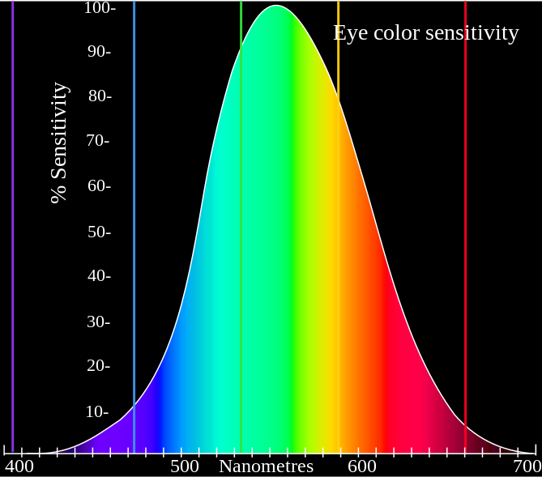

Color |  | Frequency | Wavelength
 | Violet | 668-789 THz | 380-450 nm
 | Blue | 631-668 THz | 450-475 nm
 | Cyan | 606-630 THz | 476-495 nm
 | Green | 526-606 THz | 495-570 nm
 | Yellow | 508-526 THz | 570-590 nm
 | Orange | 484-508 THz | 590-620 nm
 | Red | 400-484 THz | 620-750 nm

APPENDIX 2: The Error of LaGrange Motion Magnification
Like the EVM error analysis in thesis, using 1D signal to simplify operations. The original input signal and the theoretically magnified output signal are
(1)
$$Input:I\left(x,t\right)=f\left(x+δ\left(t\right)\right)=I\left(x+δ\left(t\right),0\right)$$
$$Output: \hat{I}\left(x,t\right)=f\left(x+(1+α)δ\left(t\right)\right)=I\left(x+(1+α)δ\left(t\right),0\right)$$
The $δ\left(t\right)$ is the motion signal, and $α$ is magnification factor. No matter LaGrange, EVM or any other enhancement method, the essence is using some arithmetic to approach the theoretically output in Eq.1. And the difference between actual and theoretically output is the error.
No Noise
As it is discussed in Chapter 3, the LaGrange method achieves the output by enhancing the estimated motion directly. Assuming the estimated motion in LaGrange is $\overline{δ}\left(t\right)$, the actual output of LaGrange method is
(2)
$$\overline{I}\left(x,t\right)=f\left(x+(1+α)\overline{δ}\left(t\right)\right)=I\left(x+(1+α)\overline{δ}\left(t\right),0\right)$$
In fact, per Liu’s paper (2005), the motion in LaGrange method is estimated as Eq.3, in which $I_{x}=∂I(x,t)/∂x$, and $I_{t}=I(x,t)-I(x,0)$.
(3)
$$\overline{δ}\left(t\right)=\frac{I\left(x,t\right)-I(x,0)}{∂I(x,t)/∂x}=\frac{I_{t}}{I_{x}}$$
Like the Eq. 3.19 and 3.20 in Chapter 3, applying second-order term of Taylor expansion to input signal, Eq. 4 can be obtained, where $I_{xx}=∂I_{x}/∂x$.
(4)
$$I\left(x,t\right)=I\left(x+δ\left(t\right),0\right)≈I\left(x,0\right)+δ\left(t\right)I_{x}+\frac{1}{2}δ^{2}\left(t\right)I_{xx}$$
$$\frac{I_{t}}{I_{x}}≈δ\left(t\right)+\frac{1}{2}δ^{2}\left(t\right)I_{xx}$$
Therefore, from Eq.3 and Eq. 4, the estimated motion in LaGrange is
(5)
$$\overline{δ}\left(t\right)≈δ\left(t\right)+\frac{1}{2}δ^{2}\left(t\right)I_{xx}$$
Putting Eq.5 into Eq. 2, the actual output of LaGrange method is
(6)
$$\overline{I}\left(x,t\right)≈I\left(x+\left(1+α\right)\left(δ\left(t\right)+\frac{1}{2}δ^{2}\left(t\right)I_{xx}\right),0\right)=I(x+\left(1+α\right)δ\left(t\right)+\frac{1}{2}\left(1+α\right)δ^{2}\left(t\right)I_{xx}, 0)$$
Expanding Eq.6 about $x+\left(1+α\right)δ\left(t\right)$ by first-order of Taylor expansion,
(7)
$$\overline{I}\left(x,t\right)≈I\left(x+\left(1+α\right)δ\left(t\right),0\right)+\frac{1}{2}\left(1+α\right)δ^{2}\left(t\right)I_{xx}I_{x}$$
Thus, the error of LaGrange Motion Magnification without noise is the difference value between Eq.7 and Eq.1.
(8)
$$Ε(L)=\left|\hat{I}\left(x,t\right)-\overline{I}\left(x,t\right)\right|≈\left|\frac{1}{2}\left(1+α\right)δ^{2}\left(t\right)I_{xx}I_{x}\right|$$
With Noise
Assuming there is a noise signal$n(x,t)$ in the origin signal, the the original sign is translated to $I(n)=I\left(x,t\right)+n\left(x,t\right)$ and the actual output of LaGrange method becomes Eq. 9 and the theoretically output is invariability, which is still Eq.1.
(9)
$$\overline{I}\left(n\right)=\overline{I}\left(x,t\right)+n\left(x,t\right)=I\left(x+\left(1+α\right)δ\left(t\right),0\right)+n(x,t)$$
Therefore, the Eq.3 about the estimated motion$\overline{δ}\left(t\right)$ is changed as Eq.10, in which $n_{x}=∂n(x,t)/∂x$ and $n_{t}=n(x,t)-n(x,0)$
(10)
$$\overline{δ}\left(t\right)=\frac{{I(n)}_{t}}{{I(n)}_{x}}=\frac{I_{t}+n_{t}}{I_{x}+n_{x}}$$
Expanding Eq.10 by using first-order of Taylor expansion on $(n_{t}, n_{x})$ in the point (0,0) (no noise), the estimated motion$\overline{δ}\left(t\right)$ can be
$$\overline{δ}\left(t\right)≈\frac{I_{t}}{I_{x}}+\frac{n_{t}}{I_{x}}-\frac{n_{x}I_{t}}{{(I_{x})}^{2}}$$
Putting Eq.4 into Eq. 11,
(11)
(12)
$$\overline{δ}\left(t\right)≈δ\left(t\right)+\frac{1}{2}δ^{2}\left(t\right)I_{xx}+\frac{n_{t}}{I_{x}}-\frac{n_{x}I_{t}}{{(I_{x})}^{2}}$$
Therefore, the actual output of LaGrange method in Eq.9 become
(13)
$$\overline{I}\left(n\right)≈I\left(x+\left(1+α\right)\left(δ\left(t\right)+\frac{1}{2}δ^{2}\left(t\right)I_{xx}+\frac{n_{t}}{I_{x}}-\frac{n_{x}I_{t}}{{I_{x}}^{2}}\right),0\right)+n(x,t)$$
$$=I(x+\left(1+α\right)δ\left(t\right)+\left(1+α\right)(\frac{1}{2}δ^{2}\left(t\right)I_{xx}+\frac{n_{t}}{I_{x}}-\frac{n_{x}I_{t}}{{I_{x}}^{2}}), 0)+n(x,t)$$
Expanding Eq.13 about $x+\left(1+α\right)δ\left(t\right)$ by first-order of Taylor expansion,
(14)
$$\overline{I}\left(n\right)≈I\left(x+\left(1+α\right)δ\left(t\right),0\right)+\left(1+α\right)(\frac{1}{2}δ^{2}\left(t\right)I_{xx}+\frac{n_{t}}{I_{x}}-\frac{n_{x}I_{t}}{{I_{x}}^{2}})I_{x}+n(x,t)$$
$$=I\left(x+\left(1+α\right)δ\left(t\right),0\right)+\left(1+α\right)n_{t}-\left(1+α\right)δ\left(t\right)n_{x}-\frac{1}{2}\left(1+α\right)δ^{2}\left(t\right){n_{x}I}_{xx}+\frac{1}{2}\left(1+α\right)δ^{2}\left(t\right)I_{xx}I_{x}+n(x,t)$$
Thus, the error of LaGrange Motion Magnification with noise is the difference value between Eq.14 and Eq.1.
(15)
$$Ε_{n}\left(L\right)≈\left|\left(1+α\right)n_{t}-\left(1+α\right)δ\left(t\right)n_{x}-\frac{1}{2}{\left(1+α\right)δ}^{2}\left(t\right)I_{xx}n_{x}+{\frac{1}{2}{\left(1+α\right)δ}^{2}\left(t\right)I_{xx}I}_{x}+n\left(x,t\right)\right|$$

APPENDIX 3: Basic Parameters of Three Windmill Styles Tested in Thesis

Basic Parameters of Nordtank NTK300
Nordtank NTK300 | Manufacturer | Vestas Wind Systems A/S
Nordtank NTK300 | Rated power | 300.0 kW
Nordtank NTK300 | Cut-in wind speed | 4.5 m/s
Nordtank NTK300 | Rated wind speed | 13.0 m/s
Nordtank NTK300 | Cut-out wind speed | 25.0 m/s
Nordtank NTK300 | Diameter | 31.0 m
Nordtank NTK300 | Rotor speed, max | 33.3 r/min
Nordtank NTK300 | Generator speed | 840 r/min-1500 r/min
Nordtank NTK300 | Gear box Ratio | 1:45
Nordtank NTK300 | Hub height | 35 m

Basic Parameters of Goldwind S50/750
Goldwind S50/750 | Manufacturer | Xinjiang Goldwind Science & Technology Co., Ltd.
Goldwind S50/750 | Rated power | 750.0 kW
Goldwind S50/750 | Cut-in wind speed | 3.5 m/s
Goldwind S50/750 | Rated wind speed | 14.5 m/s
Goldwind S50/750 | Cut-out wind speed | 25.0 m/s
Goldwind S50/750 | Diameter | 50.0 m
Goldwind S50/750 | Rotor speed, max | 21.4 r/min
Goldwind S50/750 | Generator speed | 860 r/min-1500r/min
Goldwind S50/750 | Gear box Ratio | 1:70
Goldwind S50/750 | Hub height | 60 m

Basic Parameters of General Electric GE 1.5sl
General Electric GE 1.5sl | Manufacturer | General Electric US
General Electric GE 1.5sl | Rated power | 1500.0 kW
General Electric GE 1.5sl | Cut-in wind speed | 3.5 m/s
General Electric GE 1.5sl | Rated wind speed | 12.0 m/s
General Electric GE 1.5sl | Cut-out wind speed | 25.0 m/s
General Electric GE 1.5sl | Diameter | 77.0 m
General Electric GE 1.5sl | Rotor speed, max | 20.5 r/min
General Electric GE 1.5sl | Generator speed | 875 r/min-1500r/min
General Electric GE 1.5sl | Gear box Ratio | 1:73
General Electric GE 1.5sl | Hub height | 80 m

