Organic Phosphorus (P) in Agricultural Soil and the Ability of Wheat
to Use this as a P Source

Ingrid Gabrielle Robertson

Thesis submitted for the degree of
Doctor of Philosophy

The University of Sheffield
Faculty of Science
Department of Animal and Plant Sciences

March 2018

Table of Contents

List of Figures viii
List of Tables x
Acknowledgements xi
Thesis Summary xii
1 Introduction: Organic Phosphorus in Agricultural Soil as a Potential Phosphorus Source for Crop Plants 1
1.1 Solution ³¹P Nuclear Magnetic Resonance Spectroscopy 2
1.1.1 Sample Preparation 3
1.1.2 Spectrometer Parameters 5
1.2 Using ³¹P NMR to Analyse Agricultural Soil P 6
1.2.1 P in Agricultural Soils 6
1.2.2 The Effect of Agriculture on Soil P Over Time 10
1.3 Plant P Uptake 11
1.3.1 Root System Structure 12
1.3.2 Root Phosphatase Enzymes and Organic Acid Exudation 13
1.4 Microorganisms 15
1.4.1 Mycorrhizas 15
1.4.2 Rhizobacteria 17
1.5 Aims 18
1.5.1 Measuring the Forms and Concentrations of P in Agricultural Soils 19
1.5.2 P Uptake from Organic Sources by Crop Plants, and Relationships with Root Traits 20
1.5.3 Influence of Mycorrhizas on Plant P Uptake from Organic P Sources and Root Traits 21
2 Development of Solution ³¹P NMR Spectroscopy Methodology for Assessment of Phosphorus in Arable Soil 22
2.1 Summary 22
2.2 Introduction 24
2.2.1 Principles of Nuclear Magnetic Resonance Spectroscopy 24
2.2.2 Current Uses from Literature 29
2.2.3 Sample Preparation 30
2.2.3.1 Soil Drying 31
2.2.3.2 Extraction Solution 32
2.2.3.3 Extraction Solution to Soil Ratio 32
2.2.3.4 Extraction Time 33
2.2.3.5 Re-dissolving Solution 34
2.2.4 Spectrometer Parameters 35
2.2.4.1 Delay Time 35
2.2.4.2 Pulse Angle 35
2.2.5 Aims and Hypotheses 37
2.3 Materials and Methods 38
2.3.1 Soil Sampling and Processing 38
2.3.2 Soil Extraction and NMR Sample Preparation 38
2.3.3 NMR Spectroscopy 39
2.4 Results 42
2.4.1 Degradation 42
2.4.2 Sample Concentration 43
2.4.3 Calculating T1 44
2.4.4 Delay Time 45
2.4.5 Pulse Program 47
2.4.6 Natural Calcareous Soil Optimisation 48
2.4.7 Variation in Soil Within and Between Samples 48
2.5 Discussion 51
2.5.1 Degradation 51
2.5.2 Sample Concentration 52
2.5.3 Calculating T1 53
2.5.4 Delay Time 55
2.5.5 Pulse Program 56
2.5.6 Natural Calcareous Soil Optimisation 57
2.5.7 Variation in Soil Within and Between Samples 57
2.6 Conclusion 59
3 Analysis of Phosphorus in Agricultural Soils by Solution ³¹P NMR Spectroscopy 61
3.1 Summary 61
3.2 Introduction 64
3.2.1 Types and Levels of P in Agricultural Soils 64
3.2.2 Effect of Agriculture on Organic P 65
3.2.3 Stability and Persistence of P Compounds in Soil 69
3.2.4 Aims and Hypotheses 71
3.3 Materials and Methods 73
3.3.1 Soil Sampling and Processing 73
3.3.1.1 Sites and Sampling 73
3.3.1.2 P in Different Agricultural Soils 74
3.3.1.3 Spring and Summer Variation of P in the Arable (ARA) Soil 75
3.3.1.4 Longer-term (4 year) Temporal Variation of P in the Arable (ARA) Soil 75
3.3.2 Soil Extraction and NMR Sample Preparation 77
3.3.3 NMR Spectroscopy 77
3.3.4 Statistical Analysis 78
3.4 Results 79
3.4.1 P in Different Agricultural Soils – Spen Farm 79
3.4.2 P in Different Agricultural Soils – Allerton Farm 84
3.4.3 Spring and Summer Variation of P in the Arable (ARA) Soil 87
3.4.4 Longer-term (4 year) Temporal Variation of P in the Arable (ARA) Soil 92
3.5 Discussion 97
3.5.1 P in Different Agricultural Soils 97
3.5.1.1 Spen Farm Soils 97
3.5.1.2 Allerton Farm Soil 103
3.5.2 Spring and Summer Variation of P in the Arable (ARA) Soil 104
3.5.3 Longer-term (4 year) Temporal Variation of P in the Arable (ARA) Soil 105
3.6 Conclusions 108
4 Phosphorus Uptake from Orthophosphate Monoesters and Orthophosphate by Wheat, and Relationships with Root Traits 110
4.1 Summary 110
4.2 Introduction 112
4.2.1 Important Root Traits for P Uptake 112
4.2.1.1 Root Structure 112
4.2.1.2 Phosphatase Enzyme Activity 114
4.2.1.3 Organic Acids Exudation 116
4.2.1.4 Combination Effects of Root Traits 117
4.2.2 Aims and Hypotheses 118
4.3 Materials and Methods 120
4.3.1 Plant Growth Conditions 120
4.3.2 Phosphorus Treatments 122
4.3.2.1 Radiolabelled Inositol Polyphosphate (IPP) Synthesis 123
4.3.3 Plant Harvest and Tissue Analysis for ³³P 123
4.3.4 Root Trait Analysis 124
4.3.4.1 Root Structure Analysis 124
4.3.4.2 Phosphatase Enzyme Activity Analysis 124
4.3.4.3 Organic Acid Exudation Analysis 126
4.3.5 Statistical Analysis 127
4.4 Results 128
4.4.1 ³³P Uptake from Organic and Inorganic Sources in Wheat Varieties 128
4.4.2 Root Traits and P Uptake 131
4.4.2.1 Phosphomonoesterase Activity 131
4.4.2.2 Phytase Activity 133
4.4.2.3 Root Structure 133
4.4.2.4 Organic Acid Exudation 139
4.5 Discussion 146
4.5.1 P Uptake in Varieties 146
4.5.2 Root Traits and P Uptake 147
4.5.2.1 Phosphomonoesterase Activity 147
4.5.2.2 Phytase Activity 148
4.5.2.3 Root Structure 149
4.5.2.4 Organic Acid Exudation 152
4.6 Conclusion 155
5 The Role of Mycorrhizas and Root Traits in Phosphorus Uptake from Organic Forms by Wheat 157
5.1 Summary 157
5.2 Introduction 159
5.2.1 Soil Microorganisms and Plant P Uptake 159
5.2.1.1 The Role of Mycorrhizas in Plant P Uptake 159
5.2.1.2 Influence of Mycorrhizas on Root Traits Involved in Plant P Uptake 161
5.2.1.3 Benefits and Costs of Mycorrhizas in Agriculture 163
5.2.1.4 The Role of Rhizobacteria in Plant P Uptake 164
5.2.2 Aims and Hypotheses 165
5.3 Materials and Methods 167
5.3.1 Plant Growth Conditions 167
5.3.2 Mycorrhizal Inoculation 168
5.3.3 Phosphorus Treatments 168
5.3.3.1 Radiolabelled Inositol Polyphosphate Synthesis 169
5.3.4 Plant Harvest and Tissue Analysis for ³³P 169
5.3.5 Root Trait Analysis 170
5.3.5.1 Root System Size 170
5.3.5.2 Phosphatase Enzyme Activity Analysis 170
5.3.5.3 Organic Acid Exudation Analysis 171
5.3.5.4 Mycorrhizal Colonisation Analysis 171
5.3.6 Statistical Analysis 172
5.4 Results 173
5.4.1 Mycorrhizal Colonisation in Wheat Varieties 173
5.4.2 P Uptake in Wheat Varieties with and without Mycorrhizal Inoculum 175
5.4.3 Correlations Between Mycorrhizal Colonisation, P Uptake and Root Traits 176
5.4.4 Root Traits which Facilitate P Uptake from Organic Forms 177
5.4.4.1 Total Root System Size and Phosphatase Enzyme Activity 177
5.4.4.2 Phosphatase Enzyme Activity and Organic Acid Exudation 179
5.4.4.3 Organic Acid Exudation and Total Root System Size 181
5.5 Discussion 182
5.5.1 Mycorrhizal Colonisation in Wheat Varieties 182
5.5.2 P Uptake in Wheat Varieties with and without Mycorrhizal Inoculum 185
5.5.3 Correlations between Mycorrhizal Colonisation, P Uptake and Root Traits 186
5.5.4 Root Traits which Facilitate P Uptake from Organic Forms 188
5.5.4.1 Total Root System Size and Phosphatase Enzyme Activity 188
5.5.4.2 Phosphatase Enzyme Activity and Organic Acid Exudation 188
5.5.4.3 Organic Acid Exudation and Total Root System Size 190
5.6 Conclusion 192
6 General Discussion 193
6.1 Solution ³¹P NMR Spectroscopy of Soil 194
6.1.1 Delay Times in ³¹P NMR Spectroscopy 195
6.1.2 Deconvolution in ³¹P NMR Spectroscopy 198
6.1.3 Extraction of Soil P Using NaOH/EDTA 201
6.2 Feasibility of Soil Organic P as a P Source 202
6.2.1 Concentrations of Monoester P in Arable soil in the Context of Fertilisers and Plant Requirements 203
6.2.2 Mineralisation of Monoester P in Arable Soil 204
6.2.3 Soil P Depletion 206
6.3 Root Traits in Crop Plants and P Uptake from an Organic P Source 207
6.3.1 Accessibility of Soil Organic P to Phosphatase Enzyme Activity 209
6.3.2 Solubilisation of Soil P by Organic Acids 212
6.3.3 Trade-offs 213
6.4 Microorganisms, Crop Plants and P Uptake from an Organic P Source 214
6.4.1 Mycorrhizas 215
6.4.2 Rhizobacteria and Combinations of Microorganisms 216
6.5 Applications for Agriculture and Future Directions 217
6.5.1 Gaps in Knowledge and Future Directions 219
6.6 Conclusion 222
References 224
Appendices 247
A. Development of Solution ³¹P NMR Spectroscopy Methodology for a Calcareous Grassland Soil 247
A.1 Materials and Methods 247
A.2 Results 248
A.3 Discussion 252
B. ³¹P NMR Spectra 253
C. Chemical Synthesis of ³³P Radiolabeled Inositol Polyphosphates (IPP) 258
C.1 Introduction 258
C.2 Materials 258
C.3 Method 259
C.4 Analysis of Synthesised Product by ³¹P NMR Spectroscopy 260
C.4.1 Materials and Methods 260
C.4.2 Results 261
D. Root Structure Correlation 263

List of Figures
1.1 | Phosphorus cycling in arable soil. | 7
1.2 | Chemical structure of inositol hexakisphosphates. | 8
1.3 | Washed three week old wheat root systems. | 13
2.1 | The precession of a nucleus (e.g. a phosphorus nucleus) when a strong magnetic field is applied. | 26
2.2 | Sample ³¹P NMR spectrum showing the main groups of P compounds found in soil. | 26
2.3 | Components of an NMR spectroscopy experiment. | 28
2.4 | Testing sample degradation during solution ³¹P NMR of an arable soil. | 43
2.5 | Testing the effect of sample concentration on spectral resolution in solution ³¹P NMR of an arable soil. | 44
2.6 | Testing the effect of several delay times on the solution ³¹P NMR signal produced by orthophosphate and phytate (myo-inositol hexakisphosphate) in arable soil. | 46
2.7 | Testing the effect of different pulse programs on spectral resolution in solution ³¹P NMR of an arable soil. | 48
2.8 | Testing variability in arable soil samples used for solution ³¹P NMR spectroscopy. | 50
3.1 | Spen Farm site and field crop history. | 76
3.2 | Absolute P levels of different P compounds in several agricultural soils with different historic uses. | 80-1
3.3 | Proportion of four groups of P compounds in agricultural soils taken from fields with different historic uses. | 83
3.4 | Relative levels of different P compounds in three different agricultural soils with different historic uses. | 85-6
3.5 | Absolute P levels of different P compounds in an arable soil (ARA) across six months in a growing season. | 88-89
3.6 | Proportion and total P of three groups of P compounds in an arable soil (ARA) across six months in a growing season. | 91
3.7 | Absolute P levels of different P compounds in an arable soil (ARA) across several years. | 94
3.8 | Proportion and total P of three groups of P compounds in an arable soil (ARA) across several years. | 96
4.1 | Rhizotron root growth box containing a single wheat plant and a plastic sheet with a radiolabelled ³³P source. | 122
4.2 | Phosphorus uptake from an orthophosphate or organic inositol polyphosphate (IPP) source in 21 different wheat varieties. | 129
4.3 | Phosphorus uptake and release date in 21 different wheat varieties supplied with radiolabelled orthophosphate or inositol polyphosphate (IPP). | 130
4.4 | Phosphorus uptake and phosphomonoesterase activity in 21 different wheat varieties supplied with radiolabelled orthophosphate or inositol polyphosphate (IPP). | 132
4.5 | Phosphorus uptake and root structural traits in 21 different wheat varieties supplied with radiolabelled orthophosphate or inositol polyphosphate (IPP). | 135-6
4.6 | Phosphomonoesterase activity and root structural traits in 21 different wheat varieties supplied with radiolabelled orthophosphate or inositol polyphosphate (IPP). | 138
4.7 | Organic acid exudation and phosphorus uptake in 21 different wheat varieties supplied with radiolabelled orthophosphate or inositol polyphosphate (IPP). | 140-1
4.8 | Organic acid exudation and PME-ase activity in 21 different wheat varieties supplied with radiolabelled orthophosphate or inositol polyphosphate (IPP). | 143
4.9 | Citric acid exudation and factors of root structure in 21 different wheat varieties supplied with radiolabelled orthophosphate or inositol polyphosphate (IPP). | 145
5.1 | Arbuscular colonisation in four wheat varieties given either a mycorrhizal (Myc) or non-mycorrhizal (NM) treatment and supplied with either orthophosphate or inositol polyphosphate (IPP). | 174
5.2 | P uptake in four wheat varieties given either a mycorrhizal (Myc) or non-mycorrhizal (NM) treatment and supplied with either orthophosphate or inositol polyphosphate (IPP). | 175
5.3 | Phosphatase enzyme activity and root dry weight in mycorrhizal (Myc) and non-mycorrhizal (NM) treated wheat plants supplied with either orthophosphate or inositol polyphosphate (IPP). | 178
5.4 | Malic and citric acid exudation and phosphatase enzyme activities in mycorrhizal (Myc) and non-mycorrhizal (NM) treated wheat plants supplied with either orthophosphate or inositol polyphosphate (IPP). | 180
5.5 | Malic and citric acid exudation and root dry weight in mycorrhizal (Myc) and non-mycorrhizal (NM) treated wheat plants supplied with either orthophosphate or inositol polyphosphate (IPP). | 181
6.1 | Result of a deconvolution procedure to fit the solution ³¹P NMR spectrum of a soil NaOH-EDTA extract. | 200
A.1 | Testing sample degradation during solution ³¹P NMR of a calcareous grassland soil. | 249
A.2 | Testing the effect of sample concentration on spectral resolution in solution ³¹P NMR of a calcareous grassland soil. | 250
A.3 | Testing the effect of different pulse programs on spectral resolution in solution ³¹P NMR of a calcareous grassland soil. | 251
B.1 | Overlaid ³¹P NMR spectra of six agricultural soil samples from Spen Farm. | 254
B.2 | Overlaid ³¹P NMR spectra of three agricultural soil samples from Allerton Farm. | 255
B.3 | Overlaid ³¹P NMR spectra of four seasonal soil samples from an arable field (ARA) at Spen Farm. | 256
B.4 | Overlaid ³¹P NMR spectra of three temporal soil samples from an arable field (ARA) at Spen Farm. | 257
C.1 | ³¹P NMR spectra of inositol synthesis product. | 262
D.1 | Total root dry weight and total root length in 21 wheat varieties. | 263

List of Tables

2.1 | Experiments run by ³¹P NMR spectroscopy and their parameters. | 40
2.2 | Measured T1s from the inversion-recovery null method and calculated delay times of P compounds in an arable soil. | 45
4.1 | Wheat varieties and release dates. | 120
6.1 | Orthophosphate in agricultural soil samples and delay times as presented in Stutter et al. (2015) with corrected values. | 198
A.1 | Measured T1 from the inversion-recovery null method and calculated delay time of orthophosphate in a calcareous grassland soil. | 251

Acknowledgements
Firstly I would like to thank my primary supervisor Gareth Phoenix for being a constant source of good advice, knowledge and for genuinely being a great supervisor. I would also like to thank my secondary supervisors Jeremy Craven and Duncan Cameron and my PhD supporter Jonathan Leake, all of whom imparted a wealth of expert knowledge.
I am grateful to have done my PhD in a supportive university and department, and would like to thank the many fantastic members of the C57 lab and the CMezz office including Emanga Alobwede, Katie Field, Dave Johnson, Emma Lewis, Ewan Marshall-Harries, Stephen Muddimer, Tom Thirkell and Steffi Tille for their help, Irene Johnson for countless instances of technical assistance, and Heather Walker and Gemma Newsome for organic acid sample analysis. Particular thanks go to Lizzy Parker who was the best technician anyone could ask for and a pretty great person too.
Andrea Hounslow patiently explained NMR spectroscopy to me and Jean-Olivier Zirimwabagabo patiently explained a chemical synthesis protocol to me, both of which were no mean feat.
I am grateful to my family and in particular to my wonderful sister Erika who has always supported me.
Finally a huge thank you to fellow PhD student Scott Davidson, without you my PhD would have been no fun. Thanks for being the Allison Janney to my Christine Baranski.

Thesis Summary
Phosphorus (P) fertilisers are a finite resource which are becoming increasingly expensive and cause water pollution. Agricultural soils are thought to contain reserves of organic P which are a potential P source for crops. However, there is little understanding of the ability of crops to use this P source. If they could it would reduce reliance on P fertilisers.
This thesis investigated the amount and identity of organic P in agricultural soils and the ability of wheat plants to access this P. To do this, solution ³¹P nuclear magnetic resonance spectroscopy was optimised and then used to analyse the forms and concentrations of P in several agricultural soils. Subsequently, the ability of a range of wheat varieties to access P in an abundant organic form (inositol phosphates) was assessed, both with and without mycorrhizal inoculation. This involved measuring P uptake from a radiolabelled organic P source, root traits which may facilitate P uptake and mycorrhizal colonisation.
The agricultural soils all contained a substantial reserve of organic P (>23% of total soil P). Furthermore, wheat plants were able to access P from inositol phosphates and their ability to do this was dependent on their phosphatase enzyme activity and organic acid exudation. However, root system size was negatively correlated with root exudates suggesting a cost trade-off. Low level mycorrhizal colonisation did not improve P uptake from inositol phosphates or alter P uptake root traits.
These findings suggest that the considerable pool of organic P in soil is a potential source for crops. The ability of wheat to access P in organic forms could be improved by enhancing their phosphatase enzyme activity and organic acid exudation. However, attention must be paid to cost trade-offs between root traits and, because of this, any negative effect that altering a trait has on other P uptake traits.

- Introduction: Organic Phosphorus in Agricultural Soil as a Potential Phosphorus Source for Crop Plants
Phosphorus (P) is an important nutrient for plant growth which, in agriculture, is supplied via fertilisers. As such, agriculture has become reliant on P fertilisers which are expensive and damaging to natural water systems. There is, however, organic P present in soil which crops are not able to access as a source of P. If crops could use these organic forms as a source of P this may reduce the reliance on fertilisers and contribute to more sustainable agriculture.
Phosphorus (P) is an essential macronutrient for plant growth due to it being a part of important cell components such as nucleic acids and phospholipids, and being essential to energy transfer via ATP. P compounds also play other varied roles such as signalling and stress tolerance (Valluru and Van den Ende, 2011). A plants P requirement is met by uptake from soil and, in agriculture, P is mostly supplied to plants as mineral fertilisers which are mined from phosphate rock.
Future food security is a major global concern due to the ever increasing global population (Gerland et al., 2014). From 1964 to 2014 the global population increased from 3.3 to 7.3 billion. So far this increasing population has been sustained by increases in food production, with the global production of wheat having increased from 269 to 729 million tonnes from 1964 to 2014 (FAOSTAT, 2017). This increase however, has largely not been due to increases in land use but to more productive farming: the harvested area of wheat has only increased slightly from 217 to 220 million ha over the same time.
A major factor in crop yield improvements has been the use of P fertilisers which have been estimated to contribute 30-50% of the yield increases seen (Stewart et al., 2005). The rock from which P fertilisers are mined are a finite resource which, in the past, was thought to be at risk of becoming depleted as future demand increased (Herring and Fantel, 1993). More recently, this has changed since larger reserves have been discovered (Edixhoven et al., 2014). Nonetheless, rock reserves are becoming harder to access and P fertilisers are becoming more expensive (Cordell et al., 2009; Cordell and White, 2011, 2015) which has and will continue to, restrict agriculture in low-income countries (Obersteiner et al., 2013). In addition to the economic cost of P fertilisers, leaching and erosion of P from soil can pollute water systems (Bennett et al., 2001; Carpenter, 2008; Li et al., 2015). Therefore, agricultural yields must increase to meet the demands of an increasing population whilst minimising the use of P fertilisers. This could be achieved by using P which is naturally present in agricultural soils. Accurate measurement of the forms and amounts of P in agricultural soils is therefore critical to achieving this.

  - Solution ³¹P Nuclear Magnetic Resonance Spectroscopy
Nuclear magnetic resonance spectroscopy was developed in the 1940s and has more recently been used to identify and quantify phosphorus compounds in soil (e.g. Turner et al., 2003b). Solution ³¹P nuclear magnetic resonance (NMR) spectroscopy of soil is unique in that it can determine forms and quantities of P compounds in a single assay. This technique is also different to others due to the determination of P compounds to a detailed level of chemical structure (Jarosch et al., 2015). This is particularly important for organic P which cannot be assessed directly and so can be overestimated by other techniques (Condron et al., 1990b; Turner et al., 2006).
In solution ³¹P NMR spectroscopy a strong magnetic field is applied to a sample containing P nuclei, and simultaneously radio frequency pulses are applied. The pulses cause the nuclei to emit a signal which is different depending on their chemical environment (Bovey, 1988). These different signals represent the different chemical structures of the compounds in which the P nuclei are contained. These signals are converted into a spectrum in which peaks represent different compounds and the area underneath the peaks represent the amount of that P compound (Claridge, 2016).
For solution ³¹P NMR spectroscopy of soil the P must be extracted from the soil, concentrated, re-solubilised and then analysed using a spectrometer. During sample preparation and analysis there are many factors which can affect the results.

    - Sample Preparation
To analyse a soil sample using NMR the soil is usually dried and stored before use. Drying can alter the P forms present in the soil sample and how these are subsequently extracted. The effect of this has not been investigated often, but when it has, the effect of drying is found to be inconsistent, with it being proposed that soil type alters the effect of drying (Cade-Menun and Liu, 2014).
The extraction solution used for NMR varies but is often a mixture of NaOH/EDTA. This is a strong alkali solution to maximise the P extracted, and the high pH causes good spectral resolution, peak separation and peak sharpness in the NMR spectra produced (Turner et al., 2005a). The high pH, however, can cause degradation of compounds (Turner et al., 2003b; Smernik et al., 2015). EDTA is included in extraction solutions to chelate metal ions which would otherwise bind to P and reduce the amount extracted from organic matter and reduce spectral resolution (Bowman and Moir, 1993; Turner et al., 2005a). The amount of extraction solution used relative to soil can also affect the amount of P extracted. A ratio of 1:20 (g of soil:mL of solution) is commonly used but higher or low ratios have been suggested depending on the soil analysed (Cade-Menun and Liu, 2014; McLaren et al., 2015b). Soils are extracted with solutions over long periods of time. This time can vary and, due to the strong alkali solution often used, P compound degradation can occur and varies with the length of the extraction (Turner, 2008).
After extraction the solution must be concentrated and then re-dissolved. Like the extraction solution, a mixture of NaOH/EDTA is often used for re-dissolving the dried sample. Again, the use of an alkali solution ensures good spectral resolution and EDTA chelates metal ions (Cade-Menun, 2005a). The amount of dried material re-dissolved should be maximised to maximise the signals from the sample but too much material can cause the sample to be too viscous.

    - Spectrometer Parameters
Several radiofrequency pulses are applied to samples to build up signal so that it can be detected above background noise. After each pulse, nuclei must be left to return to equilibrium so that all of the possible signal is obtained (Keeler, 2010). The time required to return to equilibrium is called the delay time and if it is too short the nuclei do not return to equilibrium and the signal obtained is not 100% quantitative. Due to different nuclei having different relaxation rates and, therefore requiring different delay times, different amounts of signal will be detected from different compounds if a delay time shorter than the longest delay time required for full relaxation is used. This can lead to relative under and overestimation of different compounds (Cade-Menun et al., 2002).
The delay time used will alter the total length of the NMR run and so it is advantageous to use as short as possible delay times to reduce the length and the cost of NMR spectrometer use. Alongside this, the longer an experiment is running the more time there is for degradation of compounds (Turner et al., 2003b). It is possible to calculate the required delay time for complete relaxation by measuring a constant of relaxation called the T1 (Bovey, 1988).
Another contributor to delay time is the pulse angle used. Pulse angle determines how far the nuclei are perturbed from their equilibrium and so the time for the nuclei to return to equilibrium. The greater the pulse angle the greater signal produced and so pulse angle also affects the amount of signal produced above background noise (Derome, 1987).
Many factors in sample preparation and spectrometer analysis can vary in the method used for solution ³¹P NMR spectroscopy. These differences can have effects on the qualitative and quantitative results and conclusions which can be drawn from these (Cade-Menun and Liu, 2014).

  - Using ³¹P NMR to Analyse Agricultural Soil P
Solution ³¹P NMR spectroscopy can be used to analyse the P in agricultural soil and, in determining the forms and amounts of the different P compounds, can be used to detect differences between soils with different historic uses and over time. This data would add understanding to the potential of using organic P as a P source for crops.

    - P in Agricultural Soils
The P requirement of crops is met using P fertilisers and modern agriculture has become dependent on this for high yields. Agriculture depends on over 40 million tonnes of mineral P fertilisers each year (FAOSTAT, 2017). Furthermore, crops are thought to have also become dependent on fertilisers (Lambers, 2006; Lynch, 2011). For example, crop breeding has resulted in modern varieties with lower root biomass which is thought to have been caused by selecting plants in conditions where nutrients are easily accessed from fertilisers (Waines and Ehdaie, 2007). Application of P fertiliser can cause build-up of P in soil as much of the P is fixed to soil and not taken up by plants (Chang and Chu, 1961; Hansen et al., 2002; Weil and Brady, 2016). Processing of P by microorganisms, plants and animals means it is deposited into soils in forms with diverse chemical structures (Magid et al., 1996) including organic P (Condron and Goh, 1989; McLaughlin et al., 2011) (Fig. 1.1). Consequently the reserves of organic P in soil can be large and account for 35-65% of the total P in agricultural soil (Condron et al., 2005).
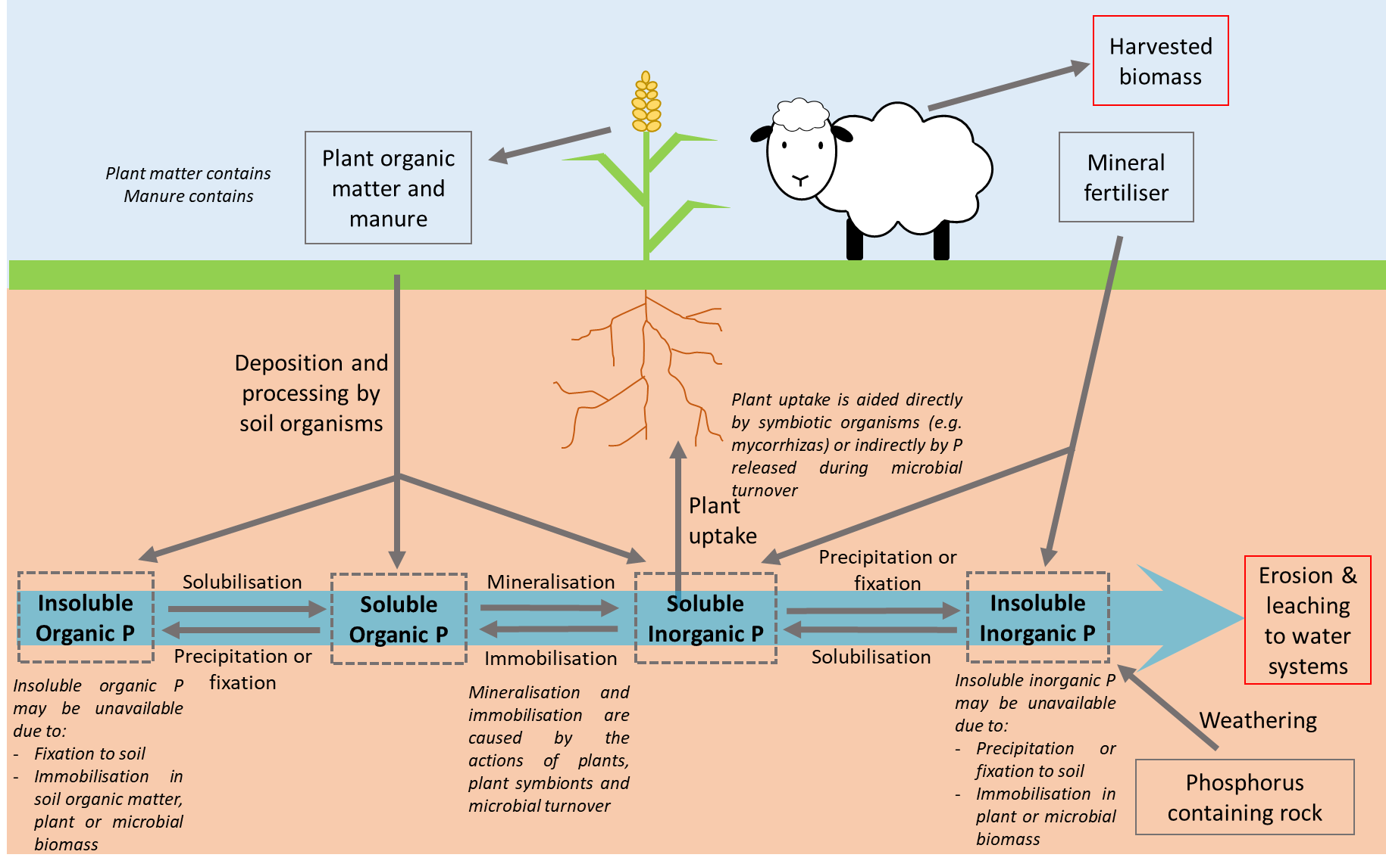
Fig 1.1: Phosphorus cycling in arable soil. Red boxes indicate P lost from the system, grey boxes indicate P added to or recycled in the system and dashed boxes indicate pools of soil P.

Organic P forms in soil are classified according to the way the P is attached to the compound. For example, orthophosphate monoesters contain a phosphate group attached via a single ester bond while orthophosphate diesters contain a phosphate group attached via two ester bonds (Turner et al., 2003b). The most abundant organic P forms are the inositol phosphates and in particular myo-inositol hexakisphosphate (Fig. 1.2). The inositol phosphates can differ in the orientation of their phosphate groups (different isomers). Although there are many potential orientations, only 4 isomers have been found in soil (myo, scyllo, neo and D-chiro (Turner et al., 2012)). Inositol phosphates can also differ in the number of phosphate groups attached to the carbon ring which can be between 1 and 6 (i.e. monokisphosphate to hexakisphosphate) (Turner et al., 2002b).
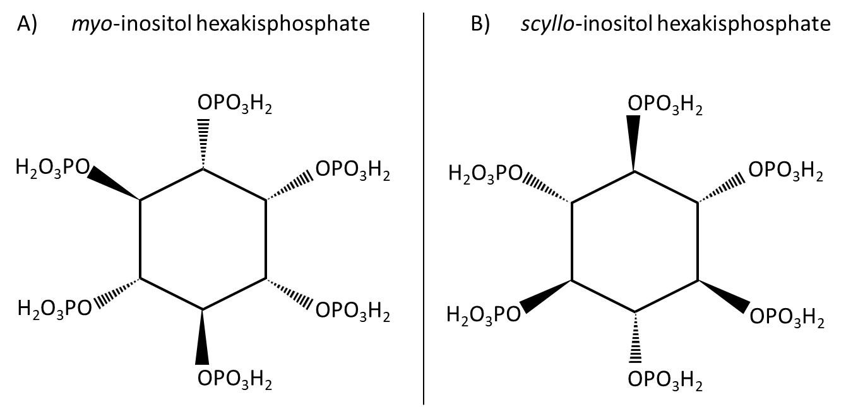

Fig. 1.2: Chemical structure of inositol hexakisphosphates. A) myo-inositol hexakisphosphate and B) scyllo-inositol hexakisphosphate. Inositol hexakisphosphates are composed of a carbon inositol ring with six phosphate groups attached. Isomers differ in the orientation of their phosphate groups: solid wedges indicate bonds which are orientated towards the viewer while dashed wedges indicate bonds which are orientated away from the viewer.

The cycling of P in soil is also greatly influenced by the microbial biomass (Hedley et al., 1982; Richardson and Simpson, 2011). The availability of P to plants can be both increased (via mineralisation) and decreased (via immobilisation) by microbes (Fig. 1.1). This can occur directly through symbiosis with a plant or indirectly through microbial turnover. The forms in which P is present in different pools or the conversion between forms alters the fate of P. Plants are the major producers of myo-inositol hexakisphosphate (myo-IHP) even though both plants and microorganisms produce it (Turner et al., 2002b). Consequently, a major input of orthophosphate monoesters to soil is via plants. Monoesters can also be a considerable component of manures (8-66% (Turner, 2004)), particularly swine and poultry which lack the ability to produce phytase which breaks down some monoesters but even in ruminants (cattle and sheep) which do have the ability, monoesters are still a considerable component (15-23%). However, most P in manure is usually present as orthophosphate (Barnett, 1994; Sharpley and Moyer, 2000; Turner, 2004). As discussed in more detail later in this thesis (section 3.2.2) microorganisms are thought to produce a diversity of P compounds some of which only they may be able to produce. This is true of scyllo-inositol hexakisphosphate (scyllo-IHP) (Turner and Richardson, 2004; Turner et al., 2005b) and pyrophosphate (specifically associated with fungi) (Makarov et al., 2005). Diesters in soil are also associated with microbial activity (Makarov et al., 2002a) and with a large component of the P in microbes being contained in nucleic acids (35-65% (Achat et al., 2010)) microbes are a substantial source of diesters to soil.

    - The Effect of Agriculture on Soil P Over Time
Agricultural soils can vary in the practices used to manage the soil. Practices such as tillage and application of fertilisers are usually detrimental to soils and influence the amount of organic P in soil (Magid et al., 1996; Wei et al., 2014a, 2014b). However, such practices will be used more in conventional soils but less in conservation or pasture soils (Hobbs, 2007). Tillage in conventional agriculture can be damaging to soil structure which is important to the normal function of soil and nutrient dynamics in soil (Elliott, 1986; Six et al., 2000; Zibilske et al., 2002; McLauchlan, 2006). On the other hand, conservation agriculture which may minimise or remove tillage completely can have an improved soil structure and nutrient dynamics (Zibilske et al., 2002; McLauchlan, 2006; Kihara et al., 2012; Wei et al., 2014a, 2014b; Dodd and Sharpley, 2015).
Although the use of tillage may differ greatly between conventional, conservation and pasture soils, all these soils may still rely on P fertilisers to some extent. P fertilisers can cause high levels of P in the soil and suppress symbiotic microorganisms in conventionally managed systems, while systems with lower or no input can have greater levels of soil symbiotic microorganisms (Mäder et al., 2000; Mackay et al., 2017). Since certain P compounds are associated with microorganisms in soil, practices which change the microbial community may also change the forms and amount of the P compounds present (Makarov et al., 2002a; Andraski et al., 2003; Bünemann et al., 2008b).
Soils in agriculture can often be used for a similar purpose for long periods of time i.e. cereal crops or pasture. On the other hand, occasionally the use of a soil may switch between different uses and this can affect the P compounds present (Brookes et al., 1984; Oliveira et al., 2015; Schneider et al., 2016; Margenot et al., 2017). The use of a soil for a similar purpose over time may cause little change in P compounds as the dynamics become stabilised and P becomes largely fixed to the soil (Condron and Goh, 1989; McKercher and Anderson, 1989; Berg and Joern, 2006) with only a small proportion cycling (Sharpley, 1985; Perrott et al., 1990). However, small changes may build in soils over time causing differences in the long term (Hawkes et al., 1984; Liu et al., 2015).
Since ³¹P NMR can assess the P forms in soil to a detailed chemical structural level and the quantity of these P forms, ³¹P NMR can also be used to investigate P dynamics in the rhizosphere of plants and how this relates to root traits (Cade-Menun, 2017). For example ³¹P NMR has been used to show the forms of organic P that are depleted in the rhizosphere of plants as a result of specific root traits (George et al., 2006; Giles et al., 2017a). This is particularly important to understanding root traits which may allow the plant access to P in different forms but, as yet, have unknown efficacy.

  - Plant P Uptake
Plants directly take up P in the form of orthophosphate and so the phosphate group from organic P compounds must be released for plants to take it up (Condron and Tiessen, 2005). To access this P, plants have root traits which facilitate P uptake. To find P sources in the soil, plants can increase their exploration of soil using root structural traits. When P is in the rhizosphere it still may be inaccessible to the plant if it is fixed to the soil. Therefore, plants have traits such as organic acid exudation to solubilise P compounds. When organic P compounds are solubilised the P is still bonded to the larger compound. Thus, plants produce phosphatase enzymes which can cleave the phosphate group from larger compounds (Vance et al., 2003).

    - Root System Structure
P is not homogenous in soil, often being found in pockets which contain higher P than the bulk soil. Therefore, plant roots can maximise the chance of finding P by having a large root system (Robinson, 1994). The importance of root system size can be seen in P efficient varieties which have a greater root to shoot biomass ratio (Nielsen et al., 2001) where the relatively larger root systems are able to take up more P. Further to this, when roots find a P source they must be able to exploit this and so roots with large surface area in contact with a pocket of P will be able to use it most efficiently (Hodge, 2004). Roots can vary in their overall size (Fig. 1.3) but also in their length to mass ratio. A measure of this is called the specific root length (SRL) and plants with higher SRL may explore the soil for P more efficiently (Miller et al., 2003). The efficiency of root systems finding and exploiting P is important because of the potentially high cost of root structures (Lynch et al., 2005; Lynch, 2013).
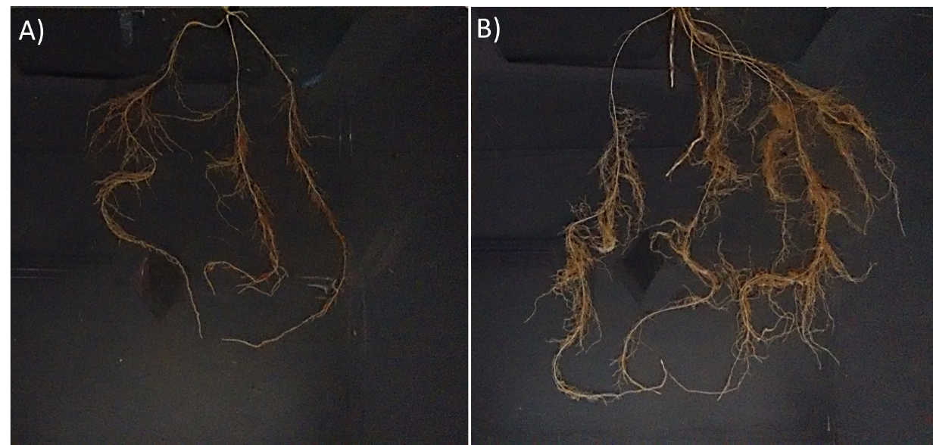
Root structural traits are important to P uptake primarily by increasing volume of soil explored but also have the potential to increase other root traits by increasing the size of the root system, for example a greater surface area for phosphatase enzymes activity and to exude organic acids (Gahoonia and Nielsen, 2004).
Figure 1.3: Washed three week old wheat root systems. A) the smaller root system of variety Rialto, B) the larger root system of variety Robigus.

    - Root Phosphatase Enzymes and Organic Acid Exudation
Plants are able to produce phosphatase enzymes which can cleave the phosphate group from organic forms of P. There are two main groups of phosphatases: phosphomonoesterases (PME-ases) and phytases which act on orthophosphate monoesters and phytase (respectively) (Hayes et al., 2000). Both enzymes are enhanced in plants experiencing low P conditions (Tadano and Sakai, 1991; Hayes et al., 1999) which suggests that plants use these enzymes to obtain P which is harder to access in soil when P is scarce. Although phosphatase enzyme activity is important to P uptake, some crop plants have been found to have low phosphatase activity particularly in comparison to other plants (Tadano and Sakai, 1991; Richardson et al., 2000). In addition to low activity, exuded phosphatase activity can be reduced by degradation or absorption to soil of the enzymes (George et al., 2005a; Menezes-Blackburn et al., 2013). On the other hand, transgenically increasing phosphatase activity has been shown to enhance a plants ability to uptake P from organic sources (e.g. Xiao et al., 2005; George et al., 2006).
Plant roots can exude organic acids which are implicated in solubilising soil P (Vance et al., 2003). Plants can exude several different organic acids but the most important appear to be malic and citric acid (Jones, 1998). Organic acid exudation plays a role in many plant functions such as microbial chemotaxis or metal detoxification as well as nutrient solubilisation (Ryan et al., 2001; Jones et al., 2003). Although organic acid exudation is important to P uptake, crops generally have a lower ability than some other plants (Jones et al., 2003; Shane and Lambers, 2005). The effect of organic acids can be reduced by degradation or absorption to the soil (Ström et al., 2001; Jones et al., 2003). However, enhancement of organic acid exudation from roots has been shown to improve P uptake (de la Fuente et al., 1997; López-Bucio et al., 2000).
Traits associated with P uptake could be enhanced in crop plants to improve P uptake from organic sources. Some studies have included looking at only one trait when investigating P uptake, for example phosphatase activity or organic acid exudation (e.g. López-Bucio et al., 2000; Xiao et al., 2006). However, more recently studies have investigated both (Giles et al., 2017b) due to their synergistic actions and this is likely to be the most successful method in the future to investigate and improve P uptake from organic sources in crops.
The forms of P accessed by plants in the rhizosphere and the dynamics of P which affect this are particularly important to understanding the effect of root traits when considering microorganisms. It has been suggested that microorganisms may play a strong intermediate role for plants to access organic P. For example, the action of microbial turnover in soil releases orthophosphate which plants access (Richardson and Simpson, 2011). ³¹P NMR can increase understanding of this especially when used to assess P over time and in different pools (e.g. bulk soils microbes in comparison to rhizosphere microbes) although instances of ³¹P NMR used in this way are few (Cade-Menun, 2017).

  - Microorganisms
Though plants have their own P uptake traits, microorganisms also influence P uptake in plants and can alter their root traits (Richardson et al., 2009a). This is particularly true for mycorrhizas which are thought to be important to P uptake from harder to access P forms (Bolan, 1991; Tarafdar and Marschner, 1994; Koide and Kabir, 2000). P in microbes can be an important source of P in natural soils (Achat et al., 2010; Turner et al., 2013). In agricultural soil the P in the microbial biomass may be lower than in natural soil (Brookes et al., 1984; Xu et al., 2013) but this may still be made available as microbes turnover. Microbial turnover can also protect the P from fixation to the soil (Richardson and Simpson, 2011) hence improving the availability to plants.

    - Mycorrhizas
Many crop plants form arbuscular mycorrhizal symbiosis with fungal partners, including some of the most abundant crop species like wheat, barley and maize (Wang and Qiu, 2006). Mycorrhizas can have a range of positive effects on the host plant including pathogen resistance (Graham, 2002), drought resistance (Augé, 2001), heavy metal detoxification (Hildebrandt et al., 2007) and nutrient uptake (Bolan, 1991). Mycorrhizas can increase a plant’s ability to access soil P by increasing the size of the root system via the hyphae, by turning over P and so making it available to the plant and by solubilising and mineralising P via phosphatase enzyme activity and organic acid exudation (Smith and Read, 2009). Accessing P from organic sources by mycorrhizas has been attributed to their phosphatase activity (Tarafdar and Marschner, 1994; Wang et al., 2017). In addition to this, transgenic expression of phytase activity in a plant from a fungus can increase P uptake from organic forms (George et al., 2004, 2005b; Giles et al., 2017a) suggesting the effectiveness of these fungal phytases. Hyphae can also directly increase P uptake in plants by providing a large surface area in contact with the soil and P sources. However, increased root surface area may also provide a larger surface area for root phosphatase enzyme activity and organic acid exudation.
P fertilisers and pesticides applied to agricultural soil can be inhibitory to the formation of mycorrhizas (Mäder et al., 2000; Ryan and Graham, 2002; Covacevich et al., 2007; Mackay et al., 2017) and it has been suggested that modern crop plants have lost some of their ability to benefit from mycorrhizal symbiosis (Zhu et al., 2001). These factors mean that the contribution of mycorrhizas to P uptake in modern agriculture is unclear. In fact, it has been suggested that mycorrhizas do not play a large role in modern agriculture (Ryan and Graham, 2002) and that this may be due to the high cost of mycorrhizal colonisation for the plant (Ryan et al., 2012).

    - Rhizobacteria
Similarly to mycorrhizas, rhizobacteria can have a range of positive effects on plants including pathogen resistance (Zehnder et al., 2001), metal detoxification (Burd et al., 2000) and nutrient uptake (Khan et al., 2009). Rhizobacteria can improve P uptake in plants via their phosphatase enzyme activity and organic acid exudation (Rodrı́guez and Fraga, 1999; Richardson and Simpson, 2011).
Both fungi and rhizobacteria have been shown to exhibit a great diversity in phosphatase enzyme activity (Lei et al., 2007; Menezes-Blackburn et al., 2013). This may mean that these microorganisms are able to access the P in different organic forms in soil and thus a larger proportion of the total soil P than plants can. Both fungi and bacteria could be used as inoculants applied to crops (Gentili and Jumpponen, 2006) to improve P uptake from organic P sources, or their traits could be genetically engineered into crop species (Brinch-Pedersen et al., 2002) to improve P uptake. Soil can contain thousands of species of microorganisms per gram (Torsvik and Øvreås, 2002; Schloss and Handelsman, 2006) which presumably leads to many interactions between the microorganisms. It is, therefore, not a surprise that the combination of rhizobacteria and mycorrhizas can be more influential to P uptake by plants than individually (Tarafdar and Marschner, 1995; Minaxi et al., 2013).

  - Aims
Organic phosphorus (P) is known to be present in soil but the size of this P source and the contribution of this source to the P nutrition of crop plants is unknown. This thesis aims to investigate the prevalence of organic P in soil and the ability of wheat plants to access the P from this organic source through the following research questions:

- What are the forms and concentrations of P present in agricultural soil and how is this affected by agricultural management?

- Can wheat plants access the P in organic forms in agricultural soil and, if so, which root traits facilitate this access?

- What role does mycorrhizal colonisation play in the ability of wheat plants to access the P in organic forms in agricultural soil and the plant root traits which facilitate this?

This thesis optimised and used solution ³¹P nuclear magnetic resonance spectroscopy (NMR) to determine the P forms and their concentrations in several agricultural soils. Following on from this, wheat growth experiments were conducted using one of the agricultural soils analysed using NMR. The wheat growth experiments determined P uptake using a ³³P radiolabelled organic P source meaning uptake could be measured directly. An overview and objectives for each research area are described in the following sections.

    - Measuring the Forms and Concentrations of P in Agricultural Soils
The use of solution ³¹P NMR spectroscopy for soil is a powerful tool as it can not only determine the different chemical forms of P in soil but it can also determine the concentrations of the different chemical forms. However, using NMR to measure soil P is still a relatively new technique and there are problems and limitations associated. It is important to fully understand the parameters used to obtain accurate quantitative data but studies in the past have not necessarily done this (Cade-Menun and Liu, 2014). This means the influence of issues such as under and overestimation of certain P compounds is uncertain (Cade-Menun et al., 2002; Doolette et al., 2011a; Doolette and Smernik, 2015).
The study described in Chapter 2 investigated and optimised the methodology required to determine the forms of P and their concentrations in an agricultural soil. This involved testing different spectrometer parameters and, in particular, those important to obtaining accurate quantitative data.
Organic P in soil is a potential P source for crop plants which could reduce the need for P fertiliser additions (Turner et al., 2002b; Stutter et al., 2012). It is important to know the size of this P reserve in agricultural soils to ascertain its feasibility as a source for crops. Furthermore, the current and historic use of a soil may influence the P forms present and so the size of the organic P pool (Chen et al., 2003; Zhang et al., 2012; Stutter et al., 2015).
The optimised method from Chapter 2 was then used in Chapter 3 to determine the forms of P and their concentrations in several agricultural soils including soils with different historic uses and in an arable soil over time. This allowed the relationships between historic use and the P compounds present in the soil to be elucidated, and hence determine the effect of historic use on the P compounds present.

    - P Uptake from Organic Sources by Crop Plants, and Relationships with Root Traits
Since plants only take up P in the form of orthophosphate, for organic P in soils to be a sources for crops plants the P must be accessible (Turner et al., 2002b). Plants have several root traits which could enable them to access P in soil but it is not clear what role these play in P uptake from organic forms. Plants can increase the surface area of soil they are in contact with to maximise P uptake or increase root exudates which solubilise and mineralise the P in the soil (Richardson et al., 2011).
The study described in Chapter 4 investigated P uptake from an organic source in a large range of wheat varieties grown in agricultural soil. Their P uptake root traits were also measured to determine correlations between these and P uptake, and between the various traits. This allowed the relationships between P uptake and the root traits of root structure, phosphatase enzyme activity and organic acid exudation to be examined, and hence determine which crop varieties and which traits were best suited for utilising inositol phosphates as a P source in soil.

    - Influence of Mycorrhizas on Plant P Uptake from Organic P Sources and Root Traits
The importance of microorganisms (Richardson, 2001) and specifically mycorrhizas (Smith and Read, 2009) to plant nutrition, and in particular P nutrition, are known. However, the specific role of mycorrhizas in enabling plants to access P in organic forms in soil remains unclear, especially in agricultural soils (Richardson et al., 2009b). Mycorrhizas may strongly influence the root traits of plants which facilitate P uptake from organic forms.
The study described in Chapter 5 investigated P uptake from an organic source in wheat varieties which were grown in agricultural soil and treated to be either mycorrhizal or non-mycorrhizal. Mycorrhizal colonisation and root traits which facilitate P uptake were also measured which allowed correlations between factors to be determined. This allowed the relationships between P uptake and mycorrhizal colonisation to be examined, as well as the influence of mycorrhizas on P uptake root traits.

Development of Solution ³¹P NMR Spectroscopy Methodology for Assessment of Phosphorus in Arable Soil

Summary
Quantifying different phosphorus (P) forms in soils is crucial to agriculture since crop yield depends on P supply. Nuclear Magnetic Resonance Spectroscopy (NMR) is used to assess P in soil and, although it has the potential to be quantitative as well as qualitative, previous research has not always assessed the suitability of the methodology required for quantification. Certain methods have been used for all soils even though soils are highly variable and, therefore, the method chosen may not be optimal.
In this chapter, factors of NMR methodology have been investigated to develop an optimal method for use on an arable soil. These factors consisted of spectrometer analysis time as a cause of degradation, the effect of sample concentration on spectral sharpness and resolution, calculation of T1, the delay time required for obtaining full signal, decoupling time in different pulse programs and variation of P within and between soil samples.
Although during a 48h period no variation was seen in the abundance of P compounds in the soil, experiments longer than 8h could cause degradation of some P compounds. In assessing sample concentration effects on peak sharpness it was found that a 200mg NMR sample produced a spectrum with broader peaks than 100mg, and this could cause loss of detail meaning that a 100mg sample is optimal. Measured T1s and subsequently calculated delay times were compared alongside a test of varying delay times. These showed that prohibitively long experiment times are required for full relaxation of the P compounds in this soil. This is reflected in the widespread use of short delay times in the literature and highlights that the use of short delay times may have previously caused overestimation in the amount of phytate in soil. This casts doubt on the widely held assumption that phytate makes up a large proportion of soil P. A pulse program with decoupling during the delay time and one without produced spectra which showed some differences and, therefore, decoupling should not be applied during the delay time. In a test of variation within and between soil core sample, P compounds varied more between different soil cores than between different samples within the same core. Consequently, soil from several cores should be homogenised to assess P at the field level.
Using the NMR methodology developed from this investigation of factors, the P content of agricultural soil can be investigated further in this thesis.

Introduction

Principles of Nuclear Magnetic Resonance Spectroscopy
Nuclear magnetic resonance spectroscopy was first developed in the 1940s and has since become a technique with many applications. Solution ³¹P NMR spectroscopy has relatively recently become a technique used to identify and quantify phosphorus compounds in soil (Turner et al., 2003c). Its advantage being that it allows detailed identification of P compounds and quantification of these in a single assay. However the methodology used to do this varies in the literature and it is important to understand the effect of methodology on results including quantification and identification of compounds. To understand this some basic knowledge of the principles of NMR spectroscopy is required. More complete explanations of NMR spectroscopy and NMR spectroscopy techniques are covered in more detail elsewhere (Bovey, 1988; Lens and Hemminga, 1998; Claridge, 2016) with some of the most important and relevant principles covered here.
In solution ³¹P NMR spectroscopy a sample containing P nuclei is placed in a strong magnetic field. The P nuclei align with or against the direction of the magnetic field but because the nuclei also have spin, they precess (Fig. 2.1) much like a gyroscope (Bovey, 1988). In pulse NMR, nuclei are exposed to a radio frequency pulse which perturbs the precession of the nuclei. As the nuclei move back towards their precession equilibrium the signal from this is detected by the spectrometer: this is called a free induction decay (FID). Nuclei do not just experience the applied magnetic field but experience a secondary field caused by the electrons around them (Lens and Hemminga, 1998). This field partially shields the nuclei from the applied magnetic field and, because the rate of precession depends on the magnetic field, nuclei with different arrangements of electrons around them are shielded differently and so precess at different speeds. Therefore nuclei with different chemical environments (i.e. nuclei within different compounds) will emit different FID signals. The FID containing the different signals is converted into a spectrum via Fourier transformation (Fig. 2.2). The x-axis of the spectrum shows chemical shift and a peak with a specific chemical shift represents one P nucleus environment. If a compound has more than one P nucleus and they are in different chemical environments, this compound will be represented by several peaks. The area under a peak (or group of peaks representing a compound) is called the intensity. This area is proportional to the number of that P nuclei and so to the amount of that P compound (Bovey, 1988; Claridge, 2016). When comparing a peak of the same compound between different spectra the height of the peaks can be used as a proxy for the amount of that compound if the width and overall shape are similar.

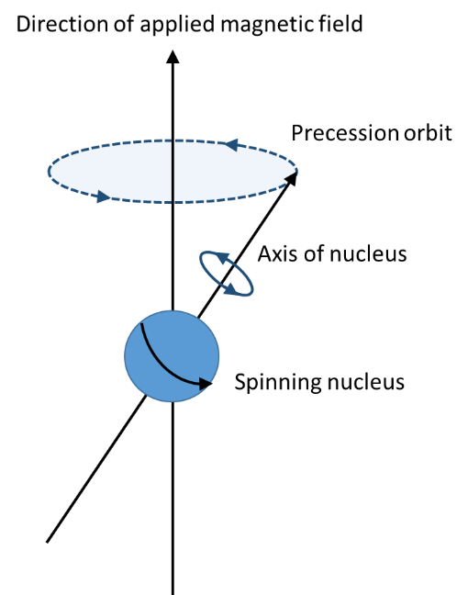
Fig. 2.1: The precession of a nucleus (e.g. a phosphorus nucleus) when a strong magnetic field is applied. The nucleus spins around its axis, but because of the applied magnetic field it also rotates around the precession orbit (dashed blue line).
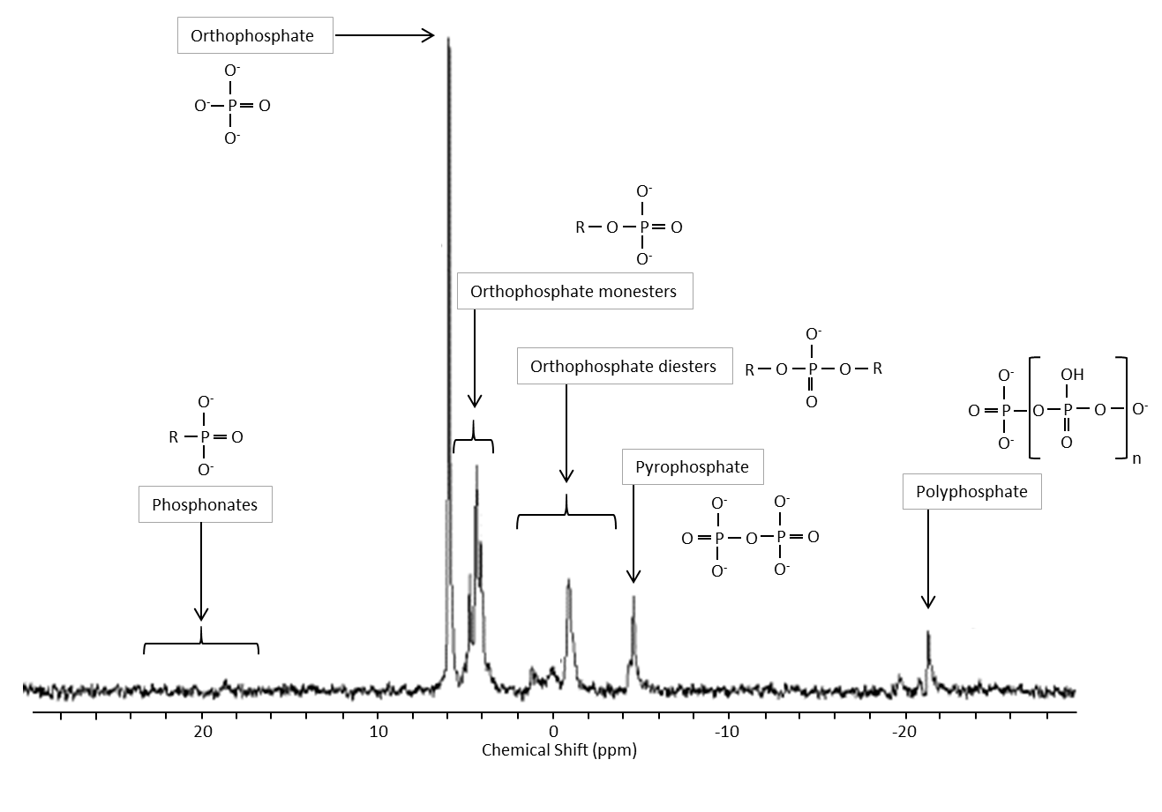
Fig. 2.2: Sample ³¹P NMR spectrum showing the main groups of P compounds found in soil. The x-axis shows chemical shift expressed in parts per million (ppm) and conventionally runs “backwards” (positive to negative values are left to right). The y-axis is generally not shown since it is signal intensity in arbitrary units. Adapted from Cade-Menun (2005).
In solution ³¹P NMR spectroscopy, samples are exposed to repeated radio frequency pulses due to the signal created from a single pulse not being strong enough to be seen above background noise. After each pulse the nuclei are left to relax back to equilibrium before the next pulse (Keeler, 2010)(Fig. 2.3). This time, in seconds, is called the delay time (relaxation delay) and would ideally be long enough for all nuclei to fully reach equilibrium again otherwise the signals obtained will not be 100% relative to the number of nuclei in the sample and so will not be 100% quantitative (Cade-Menun et al., 2002). This is true except where only one compound is being quantified between samples. For example even if the signal of compound A is only 95% of the maximum obtainable, every signal from this compound in different samples will be 95% (as long as samples are run using the same parameters). However, because different nuclei return to equilibrium at different rates, this would not be true if different compounds were being quantified. For example in the same sample, compound A may have a signal which is 95% of the total and compound B 90% of the total meaning more of compound A would be quantified.

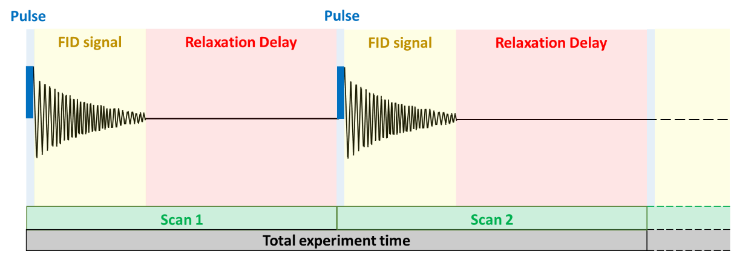
Fig. 2.3: Components of an NMR spectroscopy experiment. A radio frequency pulse causes nuclei to be perturbed from their state of equilibrium. This produces an FID signal which is converted into a spectrum. The FID signal is followed by a delay to allow nuclei to relax back to their state of equilibrium. Each pulse and delay is called a scan. The total number of scans and their duration determines the total duration of the experiment.

The delay time needed for nuclei to return to equilibrium is dependent on how far the nuclei have been perturbed. This is called the pulse angle and a pulse angle of 90° is commonly used. A smaller pulse angle will require a shorter delay time and a larger pulse angle a longer delay time for the nuclei to return to equilibrium. A smaller pulse angle will also produce less signal. The delay time needed for nuclei to return to equilibrium is also dependent on how quickly the nuclei relax. The action of nuclei returning to equilibrium in this way is called relaxation. The T1 is a time constant of relaxation and is the major factor in its determination and so is used to calculate the delay time. Larger molecules have shorter T1s because their relaxation is more efficient (Bovey, 1988).
Each pulse and subsequent delay is called a scan (Fig. 2.3) and the greater the number of scans the greater the signal obtained above background noise. However, because the background noise is random, the signal to noise ratio increases as the square root of the number of scans (Keeler, 2010) i.e. to double the signal to noise ratio the number of scans must be quadrupled.

The P nuclei in a sample undergo coupling to hydrogen nuclei: meaning that their signal is split into two smaller peaks rather than one larger peak. Split peaks are harder to identify than single peaks as the spectrum is more complicated (Cade-Menun and Liu, 2014). Samples are, therefore, run with decoupling pulse programs which stop the splitting of peaks so that single larger peaks are produced. The pulse program of an NMR experiment specifies when decoupling is applied during each scan. Decoupling, however, increases the temperature of a sample and it has been advised to not be used during the delay time after the pulse so as to minimise heating (Cade-Menun and Liu, 2014). An increase in temperature could increase degradation of a sample (Claridge, 2016). Decoupling can also cause the Nuclear Overhauser Effect (NOE) which can change the intensity of the P nuclei peaks due to the signal required to decouple the hydrogen nuclei from the P nuclei (Noggle, 1971).

Current Uses from Literature
Methodology in analysis of soil samples by ³¹P NMR varies in the literature with different experimental and spectroscopy parameters used by different research groups. Different sample preparations and experimental parameters in papers from 2005 to 2013 have been extensively reviewed (Cade-Menun and Liu, 2014) and show considerable variation. Variation can be found in sample preparation, parameters in spectroscopy (delay time and pulse angle) and how the spectroscopy results are analysed. Despite this variation there are certain steps in the methodology which are used more commonly and have been shown to have advantages over others. Some of the most important parameters are detailed in the following sections.

Sample Preparation
For the P in soil to be determined by solution ³¹P NMR spectroscopy the P must be extracted from the soil, concentrated and then re-solubilised. Typically, soil sample preparation involves using air dried soil and extraction solution in a ratio of 1:20 (g of soil:mL of extraction solution). The extraction solution is usually a mixture of 0.25M NaOH and 0.05M EDTA which is used for the reasons discussed below. The extraction process involves shaking the soil in extractant for 16h at room temperature, followed by centrifugation. The supernatant extract solution is then frozen and freeze dried. Freeze dried material is ground and 100mg dissolved in 0.9mL of 1M NaOH and 0.1M EDTA and 0.1mL of deuterium oxide (D₂O). This method was used in this chapter except where specified (for details see section 2.3 Materials and Methods). A major advantage of this methodology is that many of the steps are commonly used in the literature (e.g. the extraction solution of NaOH and EDTA being used in 63 of the 68 papers reviewed in (Cade-Menun and Liu, 2014)). This means that spectra are more likely to be comparable between papers (since differences in extraction method can change results) which is critical to the field and understanding the P composition of different soils (Cade-Menun, 2017). Furthermore, this also means peaks can be easily identified from published spectral assignments (Turner et al., 2003b; Cade-Menun, 2015). Conversely, although comparison is very important, if a step in the methodology clearly has advantages over alternatives this should not be disregarded just because others have not used it. This is especially true if different methodologies are better suited to certain soils. Some important factors in soil sample preparation for ³¹P NMR spectroscopy are detailed below.

Soil Drying
In sample preparation, the first factor to consider is the physical state of the soil. Since most soils have to be stored before use, soils are not often field moist but are either oven or (more commonly) air dried. Drying is thought to alter the P forms obtained by extraction but has not shown consistent differences when compared with undried soils. For example drying has been found to increase (Cade-Menun et al., 2005), not alter (Turner, 2008) and both increase and decrease the total P extracted (Turner et al., 2007b). Drying also had the effect of decreasing the pyrophosphate extracted (Cade-Menun et al., 2005), increasing the total organic P extracted (Turner, 2008) and increasing the DNA extracted (Turner et al., 2007b). These studies were done using different types of soils (marine, tropical and wetland respectively) and because the results are not consistent between the papers this suggests that the effect of drying is variable and dependent on the type of soil. Therefore the practicality of sample storage means that drying soils is preferential over running samples quickly or maintaining field moist soils. Using dried soil is the standard with solution ³¹P NMR, with most studies using dried soil (Cade-Menun and Liu, 2014), and allows comparisons between studies.

Extraction Solution
A solution of NaOH and EDTA is commonly used to extract soil P because it is thought to extract the majority of P from different types of soils and because the high pH is ideal for subsequent NMR spectroscopy (Turner et al., 2005a). The high pH ensures good spectral resolution, peak separation and peak sharpness (Cade-Menun, 2005b). The pK_{a} of orthophosphate is 12.65 and so a pH of ≈13 also insures that orthophosphate is fully deprotonated. This means that the orthophosphate peak has a consistent chemical shift (Carman et al., 2000) since differently deprotonated orthophosphates would have different charges and subsequently chemical shifts. EDTA is included to bind to metal ions and so prevent them from binding to P as this increases extraction from organic matter and increases spectral resolution (Bowman and Moir, 1993; Turner et al., 2005a). On the other hand the metal ions are still present in the solution which is advantageous because they decrease the required relaxation time (McDowell et al., 2006). The strong alkali solution, however, can cause hydrolysis of some compounds for example of phospholipids (Turner et al., 2003b; Doolette et al., 2009) and RNA (Turner et al., 2003b; Vestergren et al., 2012; Smernik et al., 2015). In this study, in order to minimise hydrolysis, samples were run immediately after they had been dissolved and NMR run times were kept as short as possible.

Extraction Solution to Soil Ratio
The ratio of soil to extraction solution determines the amount of phosphorus extracted. A ratio of 1:20 (g of soil:mL of solution) is commonly used (Cade-Menun and Liu, 2014) and this chapters work found this produced an amount of material which dissolved well and so was deemed suitable. It has been shown that a ratio of 1:40 increased the total phosphorus extracted and that this was due to an increase in orthophosphate, not organic P (Turner, 2008). In that study, however, they did not determine P by NMR spectroscopy and so it was not clear if the dried material could be dissolved without detrimentally affecting the spectra: a higher extraction solution to soil ratio will mean more NaOH and EDTA concentrated into the NMR sample in relation to P. The P signals from this sample would therefore be lower per gram of sample. Consequently more freeze dried material would be needed to obtain the same intensity of signal leading to the sample becoming more viscous (Cade-Menun and Liu, 2014) and potentially reduced spectral resolution by broadening peaks (Cade-Menun, 2005b).

Extraction Time
Extraction time plays a major role in hydrolysis of samples with longer extraction times increasing the chance of hydrolysis occurring (Cade-Menun and Liu, 2014). However longer extraction times also maximise the amount of P extracted from a soil and specifically a 16hr extraction time has been shown to obtain more inorganic P than shorter times (Turner, 2008). A 16hr extraction time is also the most commonly used in the literature but shorter extraction times have been suggested to minimise degradation (Cade-Menun and Liu, 2014). The degradation of some P compounds occurs fairly quickly: phosphatidylcholine (a phospholipid) showed degradation from 2hr (Turner et al., 2003b). This would suggest that reducing the extraction time to 8hr would not have a large impact on the amount of degradation since it would have already occurred and times shorter than 8hr would extract lesser amounts of P (Turner, 2008). Further to this, degradation of some P compounds occurs slowly: phosphatidylserine (a phospholipid) started to degrade after 24hr (Turner et al., 2003b) which is longer than the longest extraction time used in the literature (16hr)(Cade-Menun and Liu, 2014). The amount of degradation occurring during extraction is also likely to be less of a concern than during NMR analysis since the NaOH concentration is much lower (0.25M in the extraction solution compared to 1M in the NMR analysis solution).

Re-dissolving Solution
After the extraction solution is freeze dried it needs to be re-dissolved. Again a solution containing NaOH and EDTA is commonly used, with the EDTA binding metal ions and the high pH (as a result of the NaOH) being important to spectral resolution. A pH >12 ensures peaks are separated and sharp (Cade-Menun, 2005b) both of which mean that peaks are distinguishable from each other. A high pH also means that peaks have a consistent chemical shift (Carman et al., 2000). The amount of dried material dissolved is also important in that more will produce a larger signal but too much will cause the sample to become too viscous and reduce spectral resolution by broadening peaks (as mentioned previously).

Spectrometer Parameters

Delay Time
Delay times need to be long enough for spectra to be reliably quantitative but also should not be too long as this will increase experiment time. Long experiments are not only time consuming and expensive, but also increase the chances of hydrolysis and so the misidentification of breakdown products as components of soil when they are really just an artefact of the alkaline solution. Long spectrometer run times are inevitable to obtain spectra with adequate signal for soils samples and therefore so is some hydrolysis. It should be noted though, as previously mentioned, that some degradation which has been discussed in the literature occurs over longer periods of time (i.e. >24hr) which is longer than most samples are run. Delay times have been calculated in soil (McDowell et al., 2006) and vary according to the concentration of metals in the soil (Cade-Menun et al., 2002). Delay times can be calculated quite easily by the inversion-recovery null method (Bovey, 1988). This method measures the T1 (s) of a phosphorus compound and the delay time is recommended to be 3-5x this time (T1x5 for a 90° pulse angle) (McDowell et al., 2006). It is also recommended that the T1 for a soil is measured since they vary and should ideally be optimised for the specific soil used in an experiment (Cade-Menun et al., 2002). The longest T1 in a sample is always orthophosphate as this is the smallest compound and so relaxes slowest.

Pulse Angle
The delay time required is also dependent on the pulse angle used. The pulse angle determines how far the nuclei have been perturbed from their equilibrium and therefore how long it will take for the nuclei to return to equilibrium. A larger pulse angle will require a longer delay time, however it will produce a larger signal and so require less scans to produce the same amount of signal. The number of scans and their length (the major component of which is the delay time) determines the total length of the experiment. Pulse angles used in previous studies vary but 45° or 90° are commonly used (Cade-Menun and Liu, 2014). Nonetheless, it is more important to have the appropriate delay time for the pulse angle used since this affects the accuracy of quantification. In this study a pulse angle of 90° will be used.
As discussed above there are uncertainties in the methods used for ³¹P NMR spectroscopy and so it is necessary to vary the parameters used to analyse soil samples by ³¹P NMR to optimise the methodology. In this chapter optimisation was investigated in an agricultural soil. The factors investigated for optimisation were: spectrometer analysis time as a cause of degradation, the effect of sample concentration on spectral sharpness and resolution, calculation of T1, the delay time required for obtaining full signal and increased decoupling time with different pulse programs. Further to this, variation of P within and between core samples will be investigated in order to sample soil optimally to measure P at the field level.

Aims and Hypotheses
There are uncertainties in the methods used for ³¹P NMR spectroscopy and so it is necessary to vary the parameters used to analyse soil samples by ³¹P NMR to optimise the methodology.
In this chapter optimisation was investigated in an agricultural soil. The factors investigated for optimised were: spectrometer analysis time as a cause of degradation, the effect of sample concentration on spectral sharpness and resolution, calculation of T1, the delay time required for obtaining full signal and increased decoupling time with different pulse programs. Further to this, variation of P within and between core samples will be investigated in order to sample soil optimally in order to sample soil optimally to measure P at the field level.
It is hypothesised that all factors will have an influence on spectra and so affect identification or quantification of compounds. Specifically, it is hypothesised that degradation of certain compounds will occur over long run times, increasing NMR sample weight will produce more signal but this will cause peak broadening and loss of detail in the spectrum, calculating T1 will highlight the need for long delay times and possible errors in quantification in previous studies, and decoupling during the delay time will negatively affect the spectrum produced and will not be advisable. It is also hypothesised that P in soil samples will vary more between different core samples than within a core sample. Furthermore, the difference between cores will be greater the larger the distance between the samples.

Materials and Methods

Soil Sampling and Processing
Soil samples were taken from Spen Farm (near Tadcaster, West Yorkshire, UK [N 53°52’12.212”, W 1°19’45.055”]) in April 2014. This soil is classified as a Cambisol and the parent material mostly consists of dolostone (Google Maps, 2016). Soil was taken from Spen Farm because this location had fields with detailed records of agricultural use over the past 14 years. At the time of sampling the selected field (ARA field) was being used for arable agriculture and had been for at least 14 years. This field was chosen to represent an intensive agricultural soil. Soil was sampled using a corer which took approximately 10cm deep, 4cm diameter cores. This depth of core was used as it is the standard for testing agricultural soil P (Department for Environment, 2010). Six cores were taken from ARA field at increasing distances from each other so that the next core was double the space from the previous (distances 0, 4, 12, 28, 60 and 124cm from the origin). Cores were numbered 1 to 6 according to their distance apart (i.e. cores 1 and 2 were directly beside each other, while 1 and 6 were furthest apart). The location of the first core was random. This sampling meant the variation across the 1.3m sample length could be tested for. All soil samples were air dried for 7 days at room temperature and then sieved to 2mm, thoroughly homogenised and stored in plastic resealable bags at 4°C.

Soil Extraction and NMR Sample Preparation
For all soil samples 1g of air dried soil was put in a 40mL centrifuge tube with 20mL of 0.25M NaOH and 0.05M EDTA. This was shaken (140 strokes per min with a platform shaker) for 16hr at room temperature. The samples were then centrifuged at 5,000rpm for 30min. The supernatant was poured off, frozen and freeze dried until completely dried (approximately 5 days). The freeze dried material was then ground with a mortar and pestle to create a powder. A 100mg (except 200mg where stated) of the ground freeze dried material was dissolved in 0.9mL of 1M NaOH and 0.1M EDTA, and 0.1mL of D₂O (total 1mL) in an eppendorf, mixed briefly with a vortex mixer and left for 5min. This was then centrifuged at 9,000rpm for 5min and 0.5mL of the liquid transferred to a 5mm NMR tube ready for NMR spectroscopy. Samples were dissolved immediately (<1hr) before being run in the spectrometer to minimise degradation.

NMR Spectroscopy
All spectra were obtained on a Bruker Avance 500 Spectrometer (Bruker, Germany) operating at 202.456MHz with a 5mm broadband probe for ³¹P. D₂O is included in all samples as the signal lock. All samples were left for 5min in the spectrometer before analysis to allow the sample to reach the temperature of the spectrometer. Parameters which were constant through all experiments were as follows: acquisition time = 0.403s, pulse angle = 90° and probe temperature = 298K (≈25°C). Parameters that varied over experiments are shown in Table 2.1. All soil samples were from ARA field at Spen Farm. Chemical shifts were relative to an external standard of 85% H₃PO₄ which was used to set 0ppm. Peak assignments were determined in reference to reported assignments in the literature (Turner et al., 2003b; Doolette et al., 2009; Turner et al., 2012; Cade-Menun, 2015). Spectra were plotted using a line broadening of 2Hz. Signal to noise ratios were calculated and T1 measurements were made using the Bruker Topspin software. For signal to noise calculations the level of noise was taken from 20ppm to 10ppm in each spectrum and the monoester region was taken from 5.82ppm to 4.25ppm in each spectrum. Orthophosphate peaks were taken from a 0.08ppm width region centred on the orthophosphate peak and scyllo-inositol hexakisphosphate from a 0.07ppm width region centred on the scyllo-inositol hexakisphosphate peak.

Table 2.1: Experiments run by ³¹P NMR spectroscopy and their parameters. Experiments are named according to the figures in which they are presented below. Pulse program zgig only applies decoupling during the FID signal sampling and not during the delay while zgpg applies decoupling during the FID signal sampling and the delay.
 | Parameter
Figure | Delay time (s) | N° of scans | Decoupling during delay
2.4 | 1 | 20,000 | zgig
2.5 | 1 | 5,000 | zgig
2.6 | 1, 2, 5, 10, 20, 30, 40, 50 & 60 | 32 | zgig
2.7 | 2 | 15,000 | zgig & zgpg
2.8 | 1 | 20,000 | zgig

To test the degradation of a sample during its time in the spectrometer the same sample was analysed 6 times for 8hr each making a total time of 48hr. This experiment length was chosen since it covered the length of time that samples have been run in this study (8hr) and some of the longest times used in the literature (48hr) (Cade-Menun and Liu, 2014).To test if increasing the amount of freeze dried material dissolved into the NMR sample tube made the sample too viscous and caused line broadening, two identical runs using the same freeze dried soil sample were done except one had 100mg and the other had 200mg of freeze dried material. To estimate the delay time required for soil, a single T1 measurement was done for each of the following: phytate (myo-inositol hexakisphosphate) in solution, orthophosphate in solution, phytate spiked into soil and orthophosphate spiked into soil. The T1 times were measured using the inversion-recovery null method (Bovey, 1988). To further investigate the delay time required for phytate and orthophosphate a spiked soil sample was analysed in the spectrometer using varying delay times. Integration was done using the Topspin software and calibrated relative to the largest integral. To investigate the variation of phosphorus compounds in multiple samples from an arable soil, 6 cores from increasing distances were compared with samples from a single core (core number 5).

Results

Degradation
In an assessment of degradation the visual inspection of the spectra produced over time showed the spectra to be similar to each other. The scyllo-inositol hexakisphosphate peak did not appear to change over the time course (Fig. 2.4). The monoester peaks region however did seem to show some variation with peak area fluctuating between different time points. However it was not clear if any of these differences were consistent: peaks could not be seen to consistently increase or decrease with time.

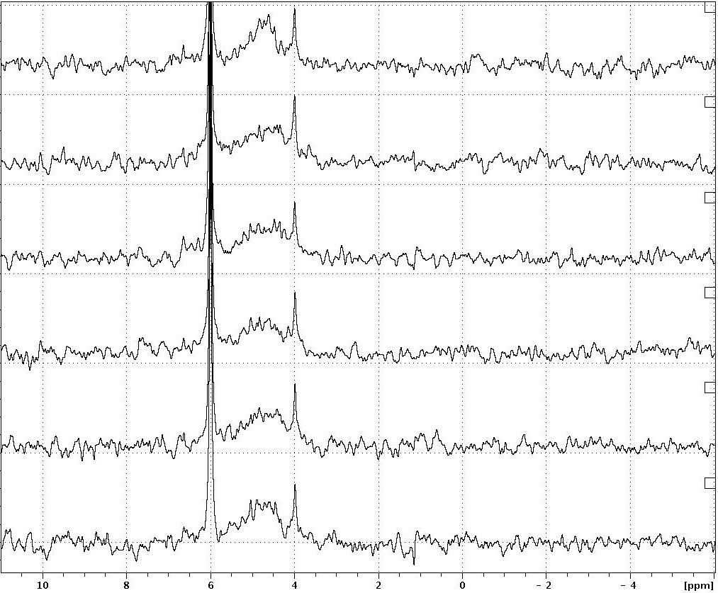
Fig. 2.4: Testing sample degradation during solution ³¹P NMR of an arable soil. Soil extract sample run for 48hr in 8hr increments: 8, 16, 24, 32, 40 & 48hr. The x-axis shows the chemical shift of 11 to -6ppm only as no peaks were seen outside this range.
Chemical shift (ppm)
8h
16h
24h
32h
40h
48h
Orthophosphate
Monoesters
Scyllo-inositol hexakisphosphate

Sample Concentration
When sample concentration was tested the spectrum with 200mg dissolved into 1mL of solution (Fig. 2.5; black spectrum) had broader peaks, some of which were also shifted, in comparison to 100mg dissolved into 1mL of solution (Fig. 2.5; red spectrum). This was most obvious in the orthophosphate and scyllo-inositol hexakisphosphate peaks. Peaks appeared shifted as different masses altered the pH of a sample, which in turn affected the chemical shifts of the peaks.
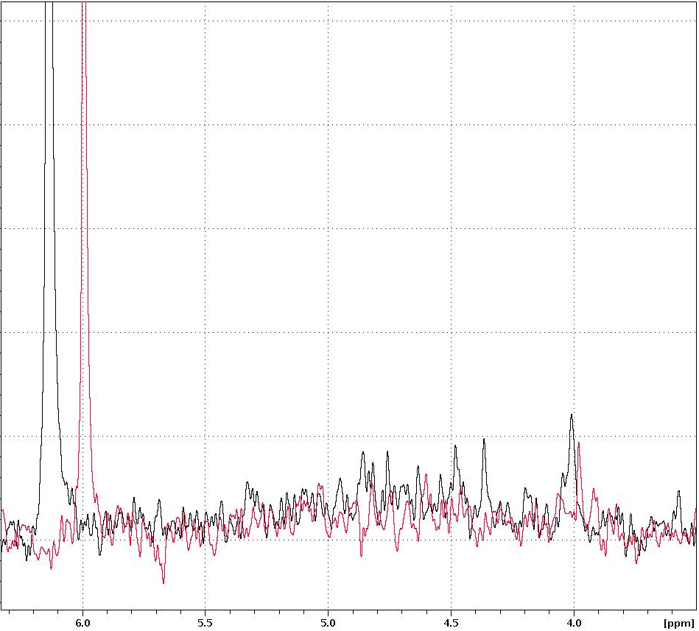
Chemical shift (ppm)
Orthophosphate
Scyllo-inositol hexakisphosphate
200mg
100mg
Monoesters
Fig. 2.5: Testing the effect of sample concentration on spectral resolution in solution ³¹P NMR of an arable soil. Red spectrum shows 100mg and black spectrum 200mg of freeze dried material dissolved into 1mL of which 0.5mL is in the NMR tube. The x-axis shows the chemical shift of 6.3 to 3.5ppm only as there were no peaks were seen outside this range.

Calculating T1
To estimate the delay time required for soil, T1 measurements were done for a solution of phytate (myo-inositol hexakisphosphate), a solution of orthophosphate, phytate spiked in soil and orthophosphate spiked in soil. The T1 for orthophosphate was much longer than for phytate (Table 2.2): both orthophosphate in solution and soil were ≈9 times longer than both phytate in solution and soil. For both compounds the T1s for solution and soil were similar with the spiked soil T1s being marginally shorter.

Table 2.2: Measured T1s from the inversion-recovery null method and calculated delay times of P compounds in an arable soil. The phytate (myo-inositol hexakisphosphate) and orthophosphate solutions were made to a final concentrations of 2.7mM and 21mM respectively. The spiked soil sample contained phytate and orthophosphate added to final concentrations of 0.7mM and 5.3mM respectively. Delay time was calculated as T1*5. Standard deviation of curve fitting was calculated by Topspin software.
Sample | T1 (s) | Standard deviation | Calculated delay time
Phytate spiked in soil | 0.96 | 3.218x10⁻² | 4.80
Phytate solution | 1.09 | 5.427x10⁻³ | 5.45
Orthophosphate spike in soil | 8.99 | 9.332x10⁻³ | 44.95
Orthophosphate solution | 9.04 | 5.427x10⁻³ | 45.20

Delay Time
An investigation into the delay time required for full relaxation of orthophosphate and phytate showed that for orthophosphate (Fig. 2.6a) the longer the delay time the larger the integral of the peak. This can also be seen, but less clearly, for phytate (Fig. 2.6b). The increase in integrals appears to plateau at 30s for orthophosphate and 5s for phytate. The trend in the orthophosphate integrals is clear but in the phytate integrals less so.
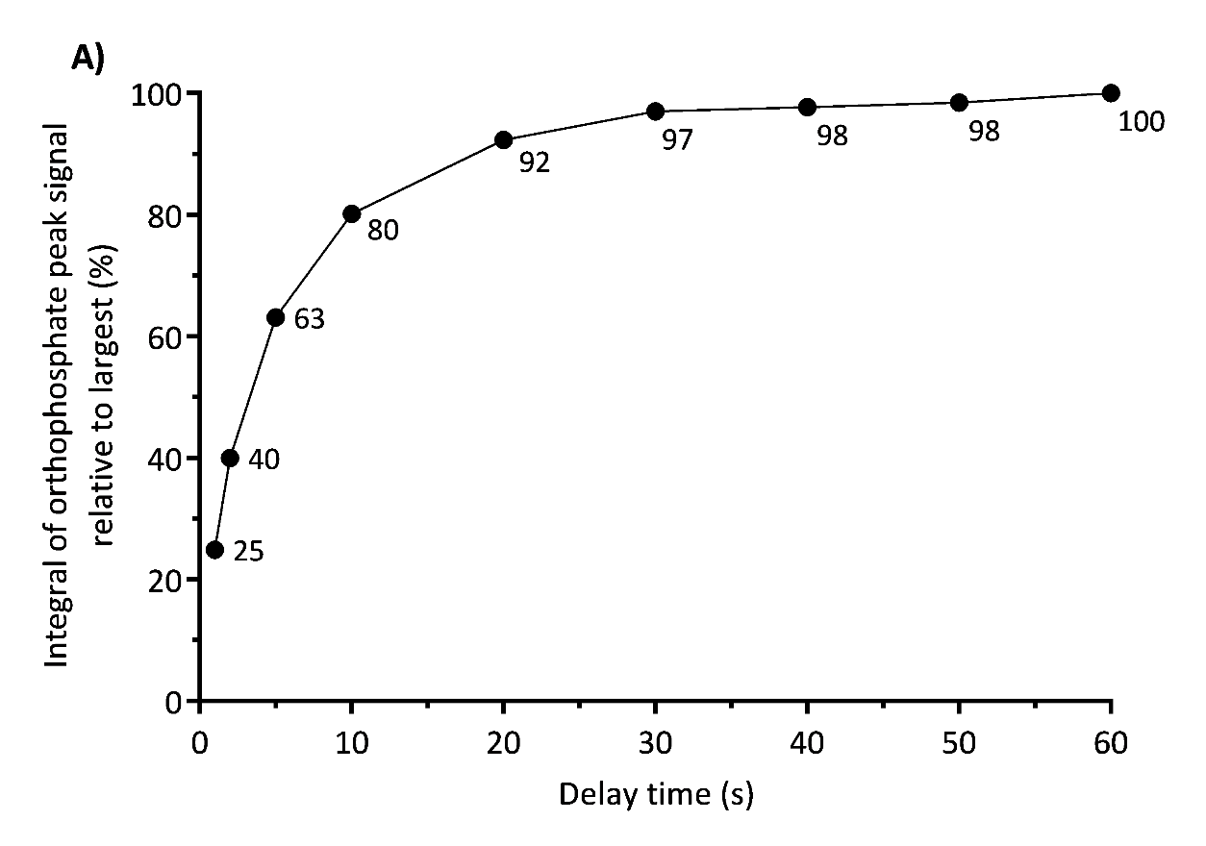
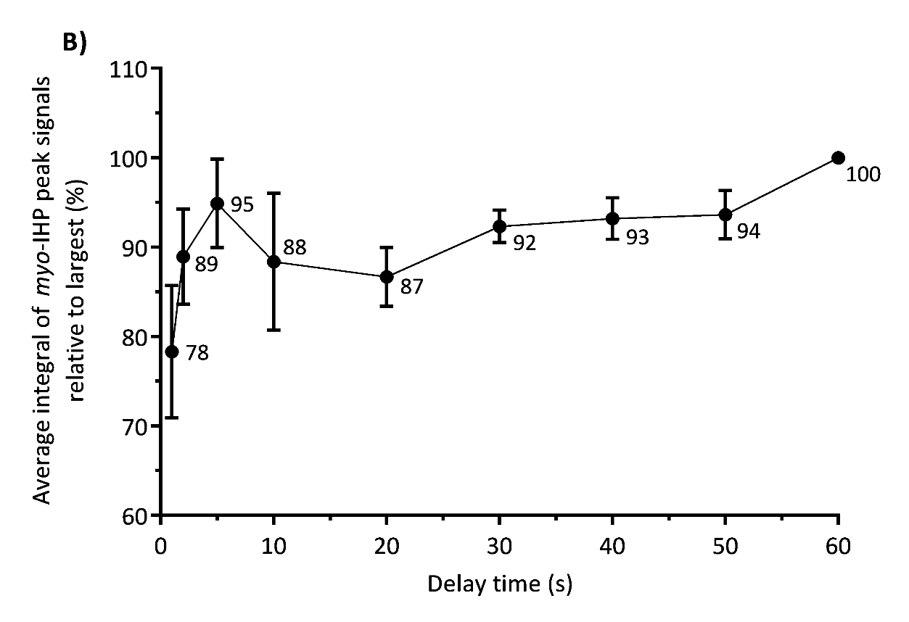
Fig. 2.6: Testing the effect of several delay times on the solution ³¹P NMR signal produced by orthophosphate and phytate (myo-inositol hexakisphosphate) in arable soil. In B error bars show standard error of the mean and replicates are from each of different phytate peaks (n=4). The delay time of 60s shows no error as each replicate was set to 100. The spiked soil sample contained phytate and orthophosphate added to final concentrations of 0.7mM and 5.3mM respectively.

Pulse Program
When the effect of increasing the decoupling time on a spectrum was investigated the two spectra produced peaks which had similar chemical shifts and areas (Fig. 2.7). The zgpg pulse program applied decoupling throughout (red spectrum). This can be seen to have similar peaks to the zgig pulse program which did not apply decoupling during the delay time (black spectrum). There was some peak variation in the monoester region with some of the larger peaks appearing smaller in the zgpg pulse program.

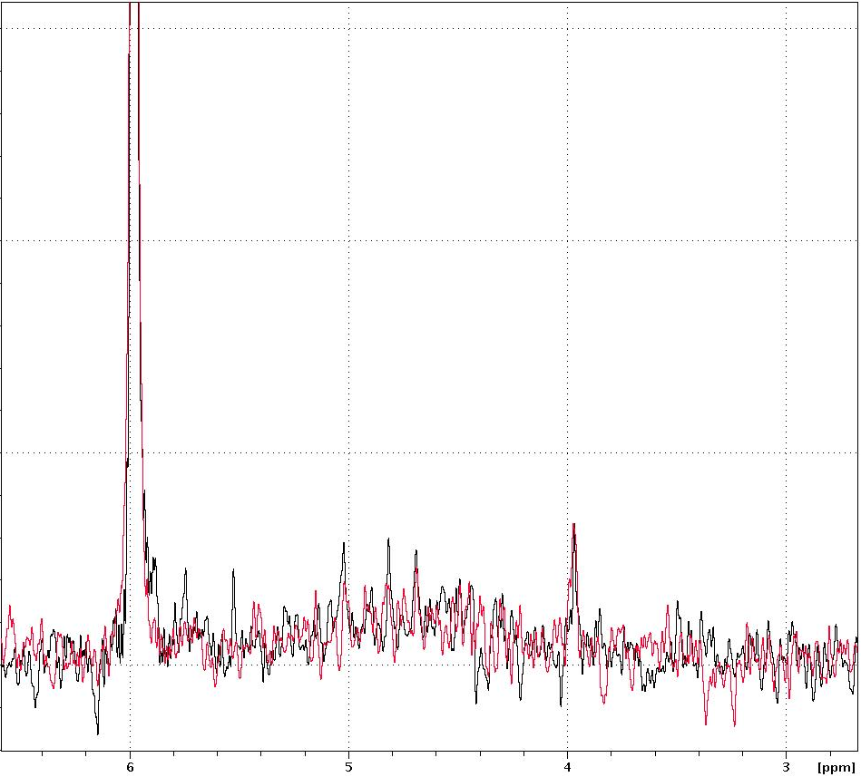
Fig. 2.7: Testing the effect of different pulse programs on spectral resolution in solution ³¹P NMR of an arable soil. The zgig pulse program did not apply decoupling during the delay (black spectrum) and the zgpg pulse program applied decoupling throughout (red spectrum).
Pulse Program
zgig: no decoupling during delay

zgpg: decoupling during delay
Monoesters
Scyllo-inositol hexakisphosphate
Orthophosphate
Chemical shift (ppm)

Natural Calcareous Soil Optimisation
Much of the optimisation in this chapter was also done on a natural calcareous (Rendzina) grassland soil. This work does not form part of subsequent thesis chapters, but results are discussed briefly in 2.5.6 and presented in Appendix A.

Variation in Soil Within and Between Samples
From an investigation into the variation of soil phosphorus within and between soil cores (Fig. 2.8) it was seen that the orthophosphate and scyllo-inositol hexakisphosphate peaks were more varied between spectra of soil samples from different cores (Fig. 2.8b and d) than in different samples from a single core (Fig. 2.8a and c). However this trend was not visible in the other peaks of the spectra which were in the monoester region (data not shown). In the monoester region the average signal to noise ratio was 7, whilst for orthophosphate it was 84 and scyllo-inositol hexakisphosphate it was 17. There was no pattern with core proximity e.g. core 1 and 2 were no more similar than core 1 and 6.

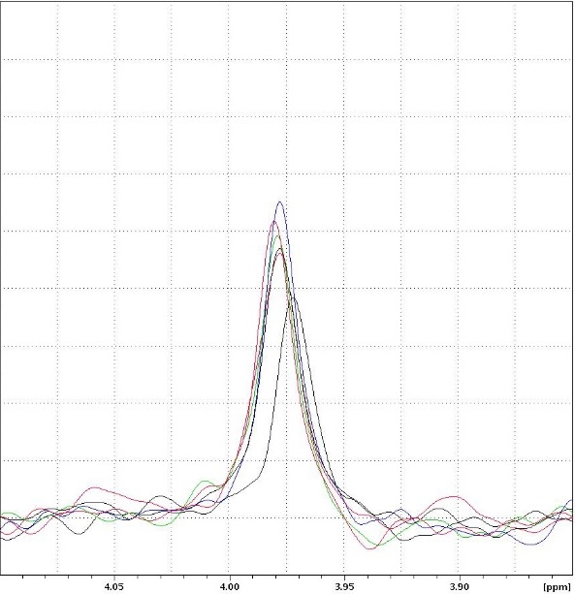
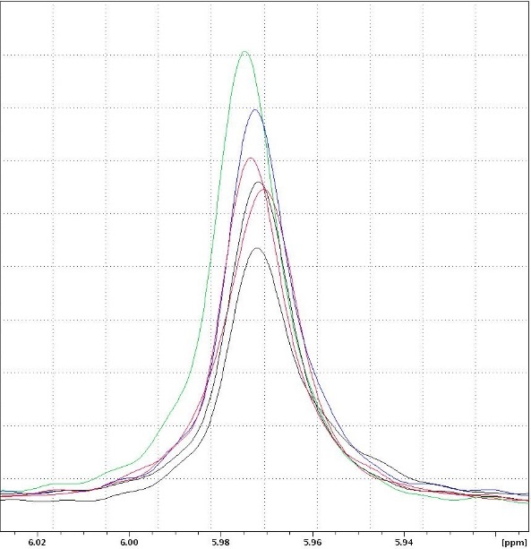
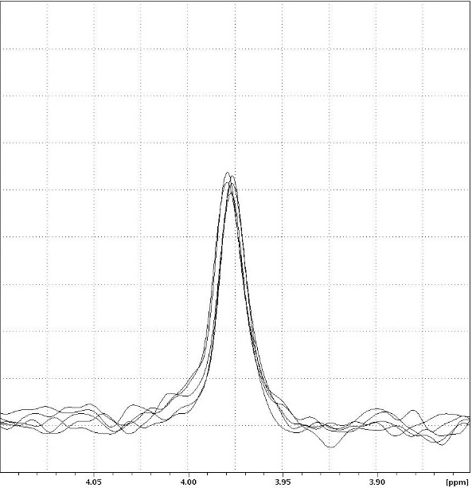
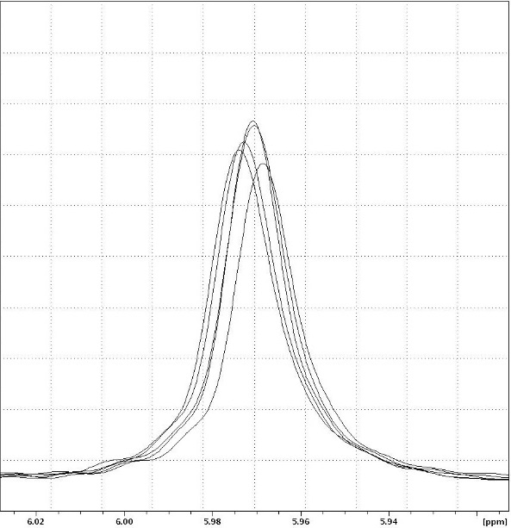
Fig. 2.8: Testing variability in arable soil samples used for solution ³¹P NMR spectroscopy. In panels A & C the overlaid spectra were from five different soil samples from the same soil core (core 5) whereas in B & D the overlaid spectra were from soil samples from six different cores. The cores were numbered according to distance apart (i.e. core 1 and 2 were directly beside each other, while 1 and 6 were furthest apart). A) & B) orthophosphate peak and C) & D) scyllo-inositol hexakisphosphate peak. Panels were scaled to best observe the peak in that section therefore peak areas are only comparable between the same compound (e.g. A & B) but not between different compounds (e.g. A & C).
1 core
6 cores
Chemical shift (ppm)
A)
B)
Chemical shift (ppm)
D)
C)
5 replicates of core 5
6
1
2
3
4
5
Orthophosphate
Scyllo-inositol hexakisphosphate
Chemical shift (ppm)
Chemical shift (ppm)
3
4
6
1
2
5

Discussion

Degradation
Over the course of a 48hr experiment it was not clear if degradation of P compounds could be seen in an arable soil. In previous studies, some phospholipids have been shown to degrade within the time used in this experiment (Turner et al., 2003b; Doolette et al., 2009; Vestergren et al., 2012). On the other hand DNA is thought to be stable (Turner et al., 2003b). The orthophosphate diesters which degrade quickly (e.g. some phospholipids which start degrading within 2hr (Turner et al., 2003b)) are inevitably missed by NMR spectroscopy and their degradation products recorded. This is unlikely to be preventable because run times longer than 2hr are generally required with soil samples to get an adequate signal to noise ratio. An overestimation of orthophosphate monoesters is known to occur as a consequence of degradation as the orthophosphate diesters breakdown and their degradation products add to the orthophosphate monoester peaks (Turner et al., 2003b; Doolette et al., 2009). Labile orthophosphate diesters may therefore be better measured by another technique while monoesters could be overestimated. In this study there were no orthophosphate diester peaks seen in the arable soil sample so no conclusions can be drawn about their stability in this soil. The scyllo-inositol hexakisphosphate peak did not change over the time course suggesting it was stable in the soil. Some of the other peaks in the monoester region did, however, show variation over the time course and so could have been undergoing degradation. However none of these peaks could be seen to consistently increase or decrease with time. Therefore, any differences seen may have been no greater than, and caused by, background noise. The possibility of identifying differences is also exacerbated by the fact that many peaks are crowded together in this region which makes identification complicated.
The conclusion from this work therefore is that most P compounds found in soil were stable over the typical time that NMR experiments are run, in agreement with previous studies (Turner et al., 2003b). Experiments with run times shorter than 8hr are unlikely to have enough signal to noise, however, run times greater than this could cause degradation of phosphorus compounds. Consequently a run time of 8hr provides the best compromise and will be used for future soil analysis in this thesis.

Sample Concentration
Doubling the weight of freeze dried extract dissolved into an NMR sample produced a solution which was more viscous and therefore resulted in a spectrum which had slightly broader peaks. Although the peaks in the larger 200mg sample produced larger peaks than those in the 100mg sample they appeared only slightly taller because the increase in area was spread over a broader peak. This means the peaks were more likely to overlap and detail could be lost in the more complicated orthophosphate monoester region. This confirms evidence from previous studies (Cade-Menun, 2005b; Cade-Menun and Liu, 2014) that suggest that greater levels of soil extract in an NMR sample will be detrimental to the spectral resolution, particularly in the already more complex regions. This however will depend on the soil used since soils may vary in their level of extractable material (not just P compounds) which will contribute to the overall viscosity of the samples and may include paramagnetic ions which can increase peak width. Similarly the amount of soil extract able to be dissolved into an NMR sample may also depend on the soil to extractant ratio used since a higher amount of extractant (i.e. NaOH and EDTA) that is freeze dried and then re-dissolved into the sample will contribute to overall viscosity.
From this experiment it was seen that 200mg produced a spectrum with broader peaks. A larger sample would require less time to produce the same amount of signal but a 100mg sample ensures detail is not lost and allows comparison with others work as this is commonly used in the literature. Therefore, a 100mg soil extract sample will be used for future soil analysis in this thesis.

Calculating T1
The T1 times of phytate and orthophosphate, both in solution and spiked in soil, were measured in this study. The T1 for orthophosphate was longer than phytate which agrees with the T1s measured previously (McDowell et al., 2006). This is because larger molecules (such as phytate) have more efficient relaxation. Whereas smaller molecules (such as orthophosphate) have less efficient relaxation (Bovey, 1988). The T1s of phytate and orthophosphate in soil were found to be slightly shorter than the compounds alone in solution. This is caused by paramagnetic ions (metal ions) which are found in soil and increase the relaxation of the P nuclei (Cade-Menun et al., 2002; McDowell et al., 2006). In principle, if spectra are to be quantified, a delay time of 5x the T1 (for a 90° pulse angle) should be used so that the nuclei are allowed to relax and therefore spectra are more accurately quantitative (Cade-Menun, 2005b; McDowell et al., 2006). From the T1 measured in this study for orthophosphate that would equate to a delay time of 45s (T1 in soil of 9s). The run time for a single sample with 20,000 scans (as was commonly used in this study) was ≈8hr (delay time = 1s) meaning that with a delay time of 45s an experiment would have a run time of ≈250hr (or over 10 days) for a single sample. However, with a longer delay more signal would be obtained and therefore 20,000 scans would not be needed. A single experiment would, nonetheless, run for days. Similarly phytate’s T1 of 0.96s would equate to a delay time of 4.8s. With 20,000 scans an experiment would have a run time of 26hr. For both orthophosphate and phytate this length of experiment would make it very expensive, time consuming and probably impossible to run experiments even with a relatively small number of samples. Further to this, the extremely long spectrometer times increase the chances of degradation.
Critically there are very few studies which have used delay times longer than 2s (Cade-Menun and Liu, 2014) and it would seem that many previous studies have used short delay times and have justified this by citing other papers, for instance the many papers citing Cade-Menun et al. (2002). However that paper did not properly address the delay time used (Cade-Menun and Liu, 2014) and in light of more recent measures of T1 (McDowell et al., 2006) and those in this study, the accuracy of quantifying data with a short delay time is not known. Accuracy of quantification is a problem when spectra have been quantified and detailed conclusions drawn from comparisons with other papers. However as previously discussed delay times long enough for full relaxation are not practical. With the accuracy of data in papers using short delay times being unknown, it is likely that understanding and assessments of error are important for future studies and to finding practical delay times which allow quantification.
Further to this it is important to understand that because the P compounds in a soil sample have different T1 times, different amounts of the total signal will be obtained from each of the different compounds. Therefore when a delay time shorter than the time required for orthophosphate to fully relax is used (almost always in the literature) this produces spectra which show more signal for compounds with shorter T1s. For example more signal will be shown for phytate (usually the shortest T1 in a sample) than orthophosphate (usually the longest T1 in a sample). This is likely to have contributed to an overestimation in the levels of phytate in soils in the literature, especially in comparison to orthophosphate.

Delay Time
When a range of increasing delay times were applied to orthophosphate and phytate spiked into soil it was seen that the integrals increased with increasing delay time. The size of the orthophosphate integral plateaued around 30s: slightly shorter than the delay time estimated from the T1 (45s). This suggests that, although a delay time of 45s should obtain the maximum orthophosphate signal, increasing the delay time above 30s has only a small contribution to the size of the signal. The size of the phytate integrals plateaued around 5s: approximately agreeing with the delay time estimated from the T1 (4.8s). The trend in the orthophosphate integrals is clear but in the phytate it is less clear with more variation. This could be due to the influence of background noise which is greater for the smaller phytate signals. Nevertheless these long delay times approximately confirm those calculated from the measured T1s, which in turn confirms the problem of the excessively long run times required for full relaxation. As delay times which allowed full relaxation are not practical a delay time of 1s will be used for future soil analysis in this thesis. This produces a run time of 8hr per sample (20,000 scans) which will allow for repeat samples to be run in manageable time scales. For this soil, absolute quantification (i.e. determining quantitative concentration values) directly from the NMR spectra is not possible, however, relative quantification (i.e. comparison between samples) can be used and give useful information in comparative studies. A delay time of 1s will, from the delay time data, obtain approximately 25% and 78% of the orthophosphate and phytate signals respectively (Fig 2.6a & b). Therefore, further to relative quantification this data will be used in the next chapter to estimate absolute P levels from soils. The difference in the percentage of signal obtained from orthophosphate and phytate demonstrates how short delay times can bias quantitative data and overestimate compounds with shorter relaxation times, particularly phytate.

Pulse Program
When different pulse programs were used to assess the effect of applying decoupling during the delay time it could be seen that the two spectra were similar. However, peaks appeared smaller in the monoester region when the pulse program which continually applies decoupling was used. This difference could be caused by the NOE or degradation caused by heating of the sample. On the other hand background noise could have an effect on the peaks in this region. This experiment suggests that decoupling during the delay time may affect the spectrum produced through degradation caused by heating or the NOE. Therefore, decoupling will not be run during the delay time for future soil analysis in this thesis.

Natural Calcareous Soil Optimisation
Much of the optimisation in this chapter was also done on Wardlow Hay Cop, a natural calcareous (Rendzina) grassland soil (Appendix A). The same results for optimisation can largely be seen in the natural soil as the arable soil but to a varying degree. In brief, the calcareous soil showed no degradation even in the small diester peak. This peak is therefore likely to be DNA as this is a stable diester. A sample weight of 100mg was again shown to be optimal. Peak broadening, in the 200mg sample compared with the 100mg, was more extreme than in the arable soil: probably due to the differences in composition of the soils. Decoupling during the delay did not change the spectrum produced. The most notable difference was in T1 time: this was much shorter. Again this is presumably due to the difference in composition of these very different soils. The calcareous soil may contain more paramagnetic ions which would broaden peaks and shorten the T1. Nonetheless this emphasises the importance of optimising NMR for different soils, particularly to aid in understanding the effect of delay time.

Variation in Soil Within and Between Samples
An assessment of P in the continuously arable soil of ARA field showed that the variation between 6 cores taken from a 1.3m transect was greater than the variation in a single core sample. This difference in variability between intra- and inter-core comparisons was not visible in the monoester region which was probably due to the peaks in this area being smaller and so background noise having a larger effect on these peaks. This could be seen in the smaller signal to noise ratio in the monoester region. The variation seen in soil is important to interpreting results because if this is not taken into account differences seen between samples cannot be said to be significant, especially as sample numbers are often low in NMR spectroscopy due to the cost and time required.
As a result of these findings, in further work in this thesis, several cores will be homogenised and the mix used to assess P. This will remove local variations in P allowing a more representative assessment of P at the field level.

Conclusion
Understanding and optimising the methodology used for ³¹P NMR spectroscopy of soil not only ensures that the spectra produced have good resolution which aids identification but also ensures that any quantification is accurate. In this study an assessment of degradation determined that preventable degradation may occur during long run times, but this may also be more of a concern in samples in which orthophosphate diesters are of particular interest. To increase the signal obtained from a sample the concentration of sample in the NMR tube could be increased. However, from a test of this, the optimal weight of sample which can be dissolved is 100mg since 200mg causes line broadening which may result in loss of detail in the spectrum. The delay times used in previous studies have often been short and the accuracy of quantification from this is unknown but is likely to have caused overestimation of phytate in comparison to orthophosphate. On the other hand, the long delay times required for full relaxation would make experiments prohibitively long. Further to this, the application of decoupling during the delay time may have changed the spectrum produced, as such, decoupling during the delay is not advisable.
When the developed methodology was used on an arable soil it was determined that soil P varied more between different cores taken from a 1.3m transect than from multiple samples within a single core. Subsequent samples will therefore be homogenised from several cores taken from a field to assess the soil P at this site. As a result of investigating the NMR methodology and factors in measuring P compounds, the analysis of the arable soils and a natural soil can be undertaken with the knowledge that degradation will not be occurring (at least not that which is preventable). The sample will also contain the ideal weight of material to produce spectra with defined peaks, and the effect of delay time on the spectra produced by this soil is now known. This ensures the spectra produced will have the best spectral resolution possible, that the spectra will be relatively quantifiable and that absolute quantification will be possible when a correction is made for the delay times used.
In this work a methodology has been developed to analyse soil P compounds by solution ³¹P NMR spectroscopy which could then be used for further work including the analysis and comparison of agricultural and natural soils as described in the next chapter.

Analysis of Phosphorus in Agricultural Soils by Solution ³¹P NMR Spectroscopy

Summary
Soil organic P is thought to be a potential but little or un-used source of P in soil for crops which, if utilised, could reduce reliance on mineral fertiliser P. The concentration of organic P in agricultural soil is important since if concentrations are too low then organic P cannot represent a significant P source.
Using solution ³¹P NMR spectroscopy the types and concentrations of different P compounds were assessed in a set of agricultural soils (Spen Farm, Tadcaster, West Yorkshire, UK) with different historic uses; an arable field, a hedgerow, a field once used for pasture and now arable, a field once used for arable and now pasture, and a pasture field. To complement this a second set of agricultural soils (Allerton Farm, Loddington, Leicestershire, UK) with different historic uses were also analysed; a conventionally managed arable field, a low till field and the hedgerow of the low till field. To gain understanding of temporal change, the types and amounts of P compounds were also assessed in the main arable soil over the course of a growing season, and annually in April/March over 4 years.
In all soils, monoesters made up approximately one third of the P. For Spen Farm, the arable soil contained less P and organic P than arable and pasture conversion soils, the pasture soil and the hedgerow soil. In particular the arable soil contained less other monoesters, scyllo-IHP and diesters which could be indicative of less organic matter and microbial activity, and may arise from detrimental agricultural practices in the arable soil (such as tillage). The pasture soil contained the most P in most forms which could be attributed to lower P output from the pasture soil than the arable soil and possibly high historic P input from manure additions. Soils which had been converted between arable and pasture use contained intermediate concentrations of many P compounds suggesting the detrimental effect of arable practices were lessened by their conversion to or from pasture.
For Allerton Farm, the two arable soils contained less P and organic P than the hedgerow soil. In particular less other monoesters, scyllo-IHP and diesters may indicate lower organic matter and microbial activity in the arable soils compared to the hedgerow caused by agricultural practices. The lack of difference between the conventionally managed soil and the low-till soil could suggest that the conservation agricultural practices have not had a beneficial effect, at least so far.
In the temporal analysis, a decrease in total monoesters across a growing season may indicate net mineralisation of the monoesters caused by increased plant and microbial P demand during the higher activity summer months. Over a period of four years increases in P concentrations were seen and may have been caused by differences in fertiliser application timing and its proximity to soil sampling.
Overall, although there were small changes in absolute concentrations, the relative proportions of P compounds remained fairly constant over time with total monoesters making up approximately a third of the total extractable P.
In summary, field historic use affected concentrations of P compounds, particularly conventional arable practices seemed to lower concentrations of all P compounds including organic P. Nonetheless, in different agricultural soils and in an arable soil over a growing season and over four years, total monoesters made up a third of total extractable P making them a considerable pool of P.

Introduction

Types and Levels of P in Agricultural Soils
It has been proposed that soil organic P could be an important P source for agricultural plants (Turner et al., 2002b; Stutter et al., 2012; Nash et al., 2014). Organic P makes up a large proportion of the total P in soils worldwide, and organic P is more abundant than inorganic P in some soils. For instance, monoester orthophosphates (monoesters) make up 24-59% of the total P in various arable and pasture soils (Stutter et al., 2012). If arable plants could access P from these organic compounds, it would reduce the need for P application through fertilisers, leading to more sustainable agriculture.
The vast majority of organic P is in the form of monoesters and of these the majority are thought to be phytates (Turner et al., 2002b). Phytates are composed of a six carbon ring, with each carbon having the possibility of being attached to a phosphate group. Phytates are present as different isomers (in which the phosphate groups have different orientations) and inositols phosphorylated with between one and six phosphate groups. Often the most abundant form is the fully phosphorylated myo isomer (myo-inositol hexakisphosphate or myo-IHP) (Turner et al., 2002b). In the UK context this has been shown to be the most abundant form in a range of arable (Stutter et al., 2015) and pasture soils (Turner et al., 2005b). Improvement in the identification of the scyllo isomer has shown that this is also an important component of soil organic P in UK pasture soils (Turner et al., 2005b). In fact, the phytase enzymes which hydrolyse phytate to release orthophosphate, can lack specificity and so can act on a range on p (Hayes et al., 2000). Specifically, histidine acid phytases show low substrate specificity and hydrolyses the less phosphorylated inositols (Oh et al., 2004). Therefore, it is proposed in this work that the orthophosphate monoesters represent a group of P compounds which can be accessed by plants via the same enzyme activity and so can be considered together as a P source.
As discussed in Chapter 2, some methods used for quantification of different P compounds from ³¹P NMR spectroscopy used in the literature are now thought to be inaccurate (Cade-Menun and Liu, 2014). Even though inaccurate quantification of monoesters and phytates in soils is likely to have caused overestimation, more recent papers have used more accurate measures for quantification and still show that monoesters and phytates make up a large proportion (9-50%) of total soil P in various arable and pasture soils (Cade-Menun et al., 2015; Stutter et al., 2015). Further to this, while organic P may increase in importance as a P source where it is in large quantities, it is still thought to be a source for plants and microorganisms even where it is in low concentrations (Romanyà and Rovira, 2009).

Effect of Agriculture on Organic P
Soil quality is generally considered to be the ability of a soil to function (Karlen et al., 1997). Therefore, in the case of agricultural soils this is also closely related to the productivity of the soil. More specifically, the ability of a soil to function depends on its organic matter levels (Wander, 2004), soil structure (Bronick and Lal, 2005), nutrients (including organic P) (Karlen et al., 1997) and microbial community (Doran and Zeiss, 2000). These are undoubtedly interlinked and affect each other as well as being affected by other biotic and abiotic factors (Kibblewhite et al., 2008). However, a major factor which affects these traits is agriculture and specifically tillage (Lal, 1993) and mineral fertilisation (Edmeades, 2003).
Conventional agriculture is considered to be detrimental to soils as it typically includes tillage and high fertiliser inputs which directly affect organic P in soil (Magid et al., 1996; Wei et al., 2014a, 2014b). In contrast, conservation agriculture which involves decreasing or not using such practices can alleviate the negative impacts (Hobbs, 2007).
Tillage in conventional arable systems damages soil structure by reducing the stability of macroaggregates (Elliott, 1986; Kravchenko et al., 2011; Abdollahi et al., 2014). The disruption of macroaggregates causes lower organic matter in these soils (Zibilske et al., 2002; McLauchlan, 2006), as microaggregates hold less organic carbon and organic P than macroaggregates, and these compounds are more easily mineralised (Elliott, 1986; Six et al., 2000; Garland et al., 2017). Conservation agriculture, and so lower or no-tillage, has been shown to have a positive effect on soil aggregation (Kihara et al., 2012) and organic matter, and this increase in organic matter can be very long lasting (hundreds of years) (McLauchlan, 2006). Additionally, macroaggregates can re-accumulate after conventional agriculture is stopped (McLauchlan, 2006). It would also follow that pasture soils, which do not experience the negative effects of tillage, may have higher levels of macroaggregates and organic matter compared to arable soils.
Tillage can also cause compaction of soil which disrupts the structure, for example, reducing pores and reducing the water holding capacity of the soil (Lal, 1993). Furthermore, tillage can disrupt mycorrhizas which hold soil together physically via hyphae or chemically via production of carbon compounds (Bronick and Lal, 2005).
Although tillage can be considered to have a negative effect on soil, there is some evidence to the contrary of this. In no-till agriculture, P is not mixed through the soil profile and becomes more stratified in comparison to conventional tillage (Cade-Menun et al., 2010; Abdi et al., 2014; Margenot et al., 2017). P accumulates and becomes saturated in the shallow layers of soil and is, therefore, more prone to leaching. In addition to this, organic matter added to soil in conservational agriculture is not mixed into the soil by tillage and so may accumulate on the soil surface and not be present in lower soil layers. Since organic matter is associated with organic P this would mean organic P is also stratified (Cade-Menun et al., 2010; Abdi et al., 2014).
Mineral fertilisers can negatively impact soil by reducing mycorrhizal growth (Treseder, 2004; Gryndler et al., 2006). On the other hand, fertilisers can sometimes improve soil structure (e.g. porosity (Marinari et al., 2000)) by improving plant growth and consequently the organic matter returned to the soil (Haynes and Naidu, 1998). Although this may suggest an increase in nutrients, organic matter and an enhancement of soil structure, these benefits may be minimised through the negative impact on mycorrhizas which in turn improve soil organic matter and structure. This is particularly true as mineral fertilisers are often used in combination with tillage (Benford, 2017).
Both pasture and arable soils can experience high levels of nutrient input including P. It has been shown that low input practices caused higher mycorrhizal colonisation in wheat compared to conventional agriculture and that the suppression of mycorrhizal colonisation in conventional agriculture is caused by a high level of soluble P (Mäder et al., 2000). When P is supplied in an easily accessible form, the ability of mycorrhizas to obtain P from less accessible sources is not required and since the symbiosis is costly, it is not initiated by the plant (Lynch et al., 2005). Mycorrhizas in turn enhance soil aggregate formation and so may increase organic P in soil through several mechanisms. Tillage has also been shown to affect mycorrhizal community structure in soil and, moreover, mycorrhizas are more abundant in no-till soil (Jansa et al., 2002; Säle et al., 2015).
Certain P compounds in soil are thought be to indicators of microorganisms as microorganisms are the sole producers of these compounds. This includes pyrophosphate (Dou et al., 2009; Cheesman et al., 2010) which is produced specifically by fungi (Makarov et al., 2005; Bünemann et al., 2008b). It is also thought that the phytate isomer scyllo-inositol hexakisphosphate (scyllo-IHP) is produced by microorganisms (Turner and Richardson, 2004; Turner et al., 2005b). Similarly, diester orthophosphates (diesters) are thought to be a sign of microbial activity (Makarov et al., 2002a). Arable soils have also been shown to have reduced organic P in comparison with a natural soil (Zibilske et al., 2002; Andraski et al., 2003; Oliveira et al., 2015) possibly partially as a result of reduced microbial activity. In support of this, where land was converted from grassland to arable after 20 years, organic P decreased by 50%. Similarly in land converted from arable to woodland, organic P doubled after 100 years (Brookes et al., 1984). P compounds, specifically monoesters, are known to associate with humic compounds in soil (He et al., 2006; McLaren et al., 2014, 2015a) and the levels of these humic associated monoesters may be an indicator of soil organic matter levels which are in part made of humic compounds (Schnitzer, 1978). Conservation agriculture has been shown to have a positive effect on soil P availability in comparison to conventional agriculture (Dodd and Sharpley, 2015; Margenot et al., 2017). Organically managed soil has also been shown to contain more organic P compared to conventionally managed soil (Schneider et al., 2016).
The positive effects of alternative management systems on agriculture soils and particularly on increasing organic P levels could indicate that organic P in agricultural soils will only increase in importance as a P source if these practices become more common. This is important since conservation agriculture is encouraged and expected to increase (Kassam et al., 2009). Moreover, the high levels of orthophosphate in soils may largely be due to the historic use of P fertilisers which have caused orthophosphate to build up (Bennett et al., 2001; Ahlgren et al., 2013; Liu et al., 2015), so this source may decline in its importance as a P source as soils are exposed to conservation agriculture. Overall, if soil management moves towards lower inputs of orthophosphate the proportion of organic P in soil may increase as orthophosphate decreases.

Stability and Persistence of P Compounds in Soil
The stability and persistence of P compounds in soil is dependent on their sorption by the soil and their ability to be mineralised. For phytates to be used as a P source by plants, they must be solubilised and then mineralised to release a phosphate group. Phytates can be stabilised in soil because of sorption to soil or metal complexes (Anderson et al., 1974; Condron and Goh, 1989; Jiang et al., 2015) which decreases mineralisation by enzymes (Greaves and Webley, 1969; McKercher and Anderson, 1989). It has been suggested that, for wheat, lack of utilisation of phytates as a P source is due to a lack of phytase enzyme production (Richardson et al., 2000). In Richardson et al. (2000), phytate P utilisation was improved by microbial inoculation, which in turn supports evidence that phytate can be mineralised in soil but that this is done by microorganisms more than plants (Dou et al., 2009; Doolette et al., 2010; Keller et al., 2012). Conversely, some suggest that enzyme activity is not the limiting step but that solubilisation is more important (Gerke, 2015). This is backed up by experiments that show that, in vitro but not in soil, phytate can be used as a source of P in tobacco and wheat (George et al., 2005b; Lung and Lim, 2006; George et al., 2008). This therefore suggests that sorption of phytate to soil limits its use as a source of P. It is probable that both solubilisation and mineralisation are important processes in accessing P in organic compounds, as has been shown in transgenic tobacco plants which could access organic P through expression of citrate which solubilises phytate and expression of phytase which mineralises phytate (Giles et al., 2017b). Additionally, a crop plant’s ability to use organic P as a source of P is likely to also depend on soil type as solubilisation and mineralisation are affected by soil type (Gerke, 2015).
The stability of organic P in soil will affect its concentration at different times of year as the presence and abundance of plants and microorganisms also vary. For example, if an organic P compound is labile its concentration may closely follow the P requirements of soil organisms which access it as a P source. In arable soil organic P has been shown to be present throughout the year but in higher concentrations in winter when there is less demand for P from growing plants and microbes than in spring (Sharpley, 1985; Magid and Nielsen, 1992). The same was found to be true for grassland (Chen et al., 2003) and pasture soil (Perrott et al., 1990). Inorganic P has been shown to be stable with the only difference being an increase after P fertilisers are added to the soil (Sharpley, 1985) or with a similar pattern to organic P: lower levels in winter (Magid and Nielsen, 1992).

Aims and Hypotheses
For organic P in arable soil to be a source of P for crop plants it must be present in soil and at concentrations which means it represents a significant P source compared to inorganic P. Further to this, the size of the organic P pool must be consistently present in the soil to be a reliable source of P.
In this chapter the types and concentrations of P compounds in two sets of agricultural soils will be investigated using the solution ³¹P NMR spectroscopy method developed in Chapter 2. Soil P will be analysed in an arable, hedgerow, arable to pasture conversion, pasture to arable conversion and pasture soil. Furthermore, in a separate set of soils, soil P will be analysed in a conventionally managed, low-till and hedgerow soil. The change in soil P over time will also be investigated in the arable soil over a growing season and over 4 years. With monoesters in soil being proposed as a pool of soil P that could be a source for crop plants, this chapter aims to confirm the presence, abundance and persistence of monoesters in an arable soil.
It is hypothesised that monoesters will be present in the soils and will make up a considerable proportion of the total extractable P. The concentration of monoesters will be consistent over time allowing them to represent a reliable source of P temporally. It is also hypothesised that concentrations of P compounds will be affected by soil historic use with arable soils containing less organic P, specifically organic P compounds associated with organic matter or microorganisms. While the hedgerow soil is hypothesised to contain the most organic P, the pasture soil less than the hedgerow, and the soils which have converted between arable and pasture will contain concentrations intermediate to the pasture and arable soil. The low-till soil will also show intermediate concentrations of P compounds relative to a hedgerow and conventionally managed soil.

Materials and Methods

Soil Sampling and Processing

Sites and Sampling
Soil samples were taken from Spen Farm ([53°51’59.0”N, 1°19’40.4”W] near Tadcaster, West Yorkshire, UK [Fig. 3.1a]). This soil is classified as a Cambisol and the parent material is dolostone (“UK Soil Observatory, NERC,” 2017). Soil was taken from Spen Farm because this location has fields with detailed records of different agricultural use over the past 17 years (Fig. 3.1b). Soil was sampled using a corer to take approximately 10cm deep, 4cm diameter cores. All soil samples were air dried for 7 days at room temperature and then sieved with a 2mm sieve. For each sampling site the six cores were thoroughly mixed to homogenise and stored in plastic resealable bags at 4°C. Four separate replicate samples were taken from this mixture for ³¹P NMR analysis.
A second set of soil samples were taken from Allerton Farm ([52°36’48.2”N, 0°50’03.0”W] near Loddington, Leicestershire, UK) in November 2013. This soil is classified as a Stagnosol and the parent material consists of mudstone, claystone and glacial till (UK Soil Observatory, NERC, 2017). Soil was taken from Allerton Farm because this location has field soils which have undergone low-till management practices which could be compared with a nearby conventinally managed field soil (52°37’55.0”N, 0°52’33.0”W). Low-till practices were initally introduced at Allerton Farm in 1997 and have gradually increase to no-till practices which are currently used. Soil was sampled with a spade as a single 20cm cube from each site. Soil samples were air dried before being sieved with a 2mm sieve. Four separate replicate samples were taken from this mixture for ³¹P NMR analysis.

P in Different Agricultural Soils
To assess the P compounds present and their levels in fields with different historic use five soils were sampled from Spen Farm. ARA field was chosen to represent an intensive agriculture soil as it had been used for arable crops for 14 years prior to sampling (Fig. 3.1b). The hedgerow of ARA field (HARA) was chosen to represent a natural soil without the direct influence of agriculture that could nonetheless be directly compared to ARA field due to its proximity. PtA field was chosen as a comparison of different historic use since it has recently (5 years previous to sampling) been arable but was previously pasture (for at least 9 years before conversion). AtP field has recently been used for pasture (4 years previous to sampling) but was arable (for 10 years before conversion). PAS field was chosen since it has always been used for pasture (at least 16 years prior to sampling). In April 2014, six cores were taken from each of the following sites: ARA (arable field), HARA (the hedgerow of ARA field) and PtA (once pasture, now arable field). In April 2016 six cores were taken from each of the following sites: ARA, AtP (once arable, now pasture field) and PAS (pasture field).
To compare a second set of soils with different historic use, soil was taken from each of the following sites at Allerton Farm: ARA2 (conventionally managed arable field), LTil (low-till arable field) and HLTil (hedgerow of LTil field). The hedgerow of LTil field was chosen to represent a natural soil without the direct influnce of arable practices that could nonetheless be directly compared to LTil field due to its proximity.

Spring and Summer Variation of P in the Arable (ARA) Soil
To assess the P compounds present, their levels and any change through a growing season, the arable field (ARA) was sampled throughout spring and summer. From February to August 2016 six cores were taken from ARA field every two months (February, April, June and August).

Longer-term (4 year) Temporal Variation of P in the Arable (ARA) Soil
To assess the P compounds present, their levels and any change across several years, the arable field (ARA) was sampled throughout four years. Soil cores were taken in April 2014, April 2016 and March 2017.

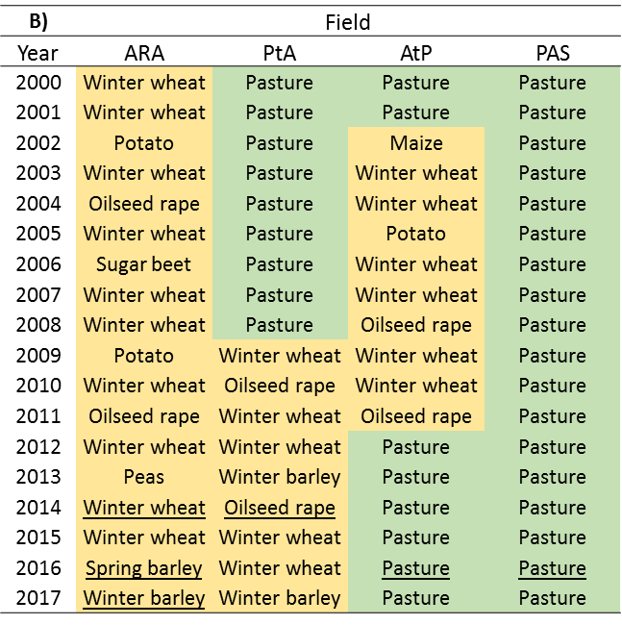
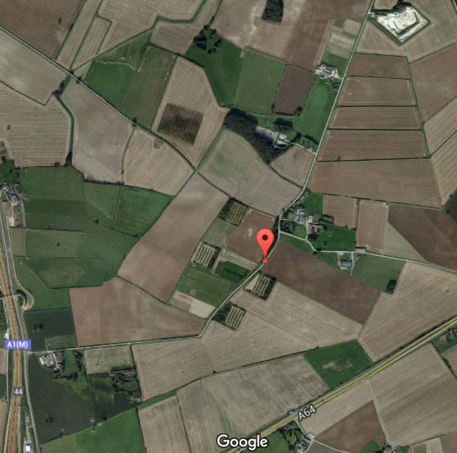
Fig. 3.1: Spen Farm site and field crop history. (A) Fields at Spen Farm from which soils were sampled. PtA = pasture to arable field, AtP = arable to pasture field, PAS = pasture field, ARA = arable field. Field borders are shown as coloured outlines (Google Maps, 2016) (B) Historic use of fields at Spen Farm. Yellow shaded cells indicate arable field use and green indicates pasture. Underlined crops show that soil was sampled from the field in this year.
53°51’59.0”N
1°19’40.4”W
ARA
A)
PtA
AtP
PAS

Soil Extraction and NMR Sample Preparation
Soil extraction and NMR sample preparation was undertaken as detailed in Chapter 2, section 2.3.2. The six replicate cores from each field (Spen Farm) or soil cube from each field (Allerton Farm) were thoroughly homogenised and four replicate sub-samples were taken for ³¹P NMR analysis. In brief, for all soil samples 1g of soil was extracted with 20mL of 0.25M NaOH and 0.05M EDTA by shaking (140 strokes per min with a platform shaker) for 16h at room temperature. The supernatant was then freeze dried and 100mg of the ground material redissolved in 0.9mL of 1M NaOH and 0.1M EDTA and 0.1mL of D₂0 for analysis by solution ³¹P NMR spectroscopy.

NMR Spectroscopy
NMR spectroscopy was undertaken as detailed in Chapter 2, section 2.3.3. All soil extracts were run with the following parameters: delay time = 1s, pulse angle = 90°, number of scans = 20,000 and pulse program = zgig. Signal areas were calculated by integration using the Bruker Topspin software. The proportion of a compound was determined from its signal area at a single chemical shift range except for the following: the proportion of myo-IHP was determined by multiplying the signal at approximately 5.75ppm by six (since this signal represents only one of the six phosphates on the molecule), the proportion of neo-IHP was determined by multiplying the signal at approximately 6.6pm by 1.5 (since this signal represents only four of the six phosphates on the molecule) and the proportion of D-chiro-IHP was determined by multiplying the signal at approximately 6.4 ppm by three (since this signal represents only two of the six phosphates on the molecule) (Turner et al., 2012). Total phytates was determined by summing the myo, scyllo, neo and D-chiro-IHP signals. Other monoesters was determined by subtracting total phytates from total monoesters. Other monoesters represents monoesters which cannot be categorically identified but is likely to be mostly compromised of less phosphorylated inositols and inositols associated with humic compounds. Total monoesters was determined by summing the signals between approximately 6.75 and 3.75ppm, excluding orthophosphate. MDP (methylene diphosphonic acid) was added to the Spen Farm samples as an internal reference but not to the Allerton Farm samples. Consequently, the Allerton Farm samples are presented as relative P level because absolute data could not be reliably obtained without an MDP standard. Absolute amounts of the P compounds were calculated from the integrated areas under the peaks. Integrated areas were calibrated to the MDP reference in each sample which was a known number of moles (4.5x10⁻⁷mol). As shown in Chapter 2, 78% of the phytate signal and 25% of the orthophosphate signal is obtained using the NMR parameters specified. Therefore, to calculate the absolute amounts of phytates and orthophosphate the integral was scaled accordingly to these percentages.

Statistical Analysis
Concentrations of the various P compounds were compared between fields using one-way ANOVA and between months and years (separately in the different parts of this work) using repeated measures ANOVA. Where significant ANOVA was followed by Tukey multiple comparisons test (alpha 0.05). Statistical analysis was conducted using Graphpad Prism software (7.02, La Jolla California USA).

Results

P in Different Agricultural Soils – Spen Farm
Each of the compounds analysed showed statistically significant differences between fields as determined by one-way ANOVA (Fig. 3.2). The pasture soil (PAS) had the greatest concentration of most forms of P, with between 2 and 5 times more compared to the arable soil (ARA) (Tukey p < 0.05 in all cases) which tended to have the lowest concentrations of P forms among all the soils. This pattern was less pronounced in compounds which are present in low concentrations (neo-IHP and D-chiro-IHP).
The exception to the pasture field containing the highest concentration of a P compound, is pyrophosphate. The pyrophosphate concentration was greatest in the hedgerow (HARA), pasture to arable (PtA) and pasture soil (PAS). The pyrophosphate concentration was intermediate in the arable to pasture soil (AtP) and lowest in the arable soils (ARA), significantly so when compared to all other soils (Tukey p < 0.05).
Further to this, the hedgerow (HARA) and pasture soils (AtP and PAS) contained more other monoesters, between 1.2 and 1.7 times more, and some diesters compared to the arable soils (ARA and PtA, Tukey p < 0.05). The two arable soils contained no diesters. The spectra from which P levels have been obtained by integration are shown in Appendix B (Fig. B.1). Observation of the areas under peaks shows similar patterns to and confirms the relative P level data (Fig. 3.2).
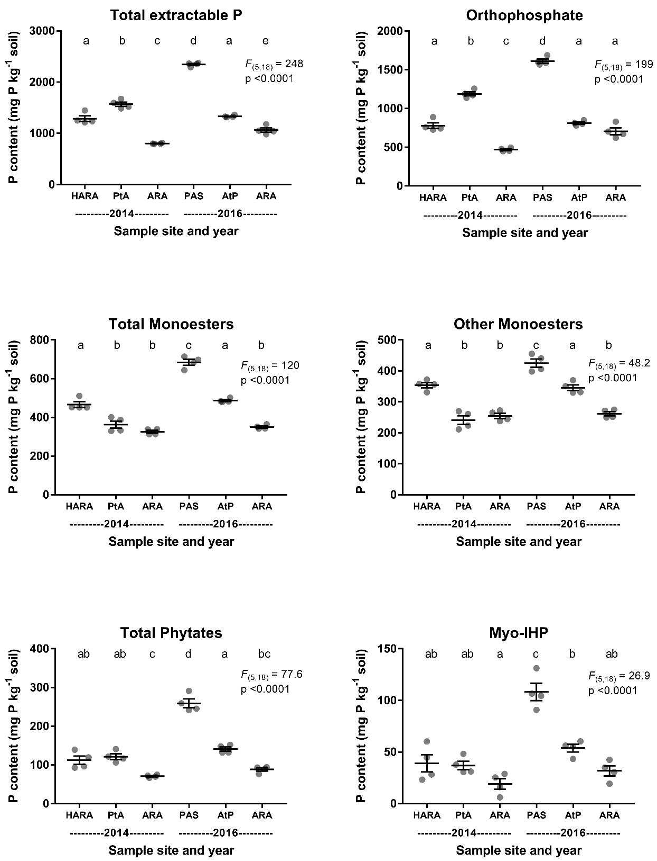

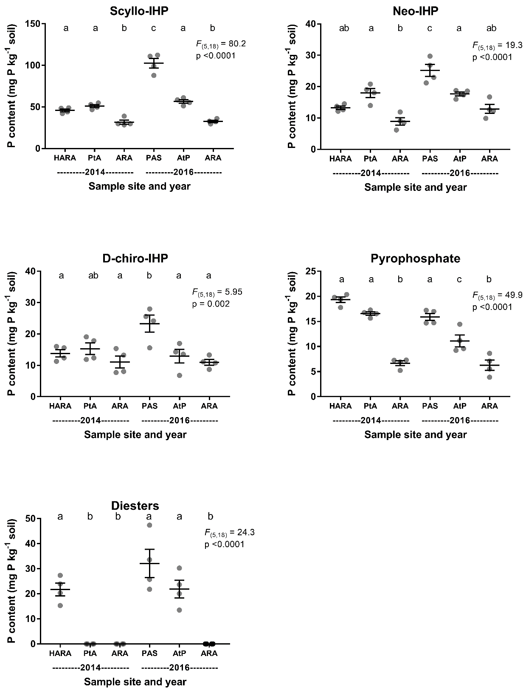
Fig.3.2: Absolute P levels of different P compounds in several agricultural soils with different historic uses. HARA = hedgerow of ARA field, PtA = pasture to arable conversion field, ARA = arable field, PAS = pasture field & AtP = arable to pasture conversion field. P content expressed per kg of soil dry weight. Points show individual data (n=4), horizontal bars show means and error bars show standard error of the mean. Results of one-way ANOVA are shown on graphs. Different letters above bars indicate significant differences between fields (Tukey multiple comparisons test, alpha = 0.05).

In terms of proportion of total extractable P detected by NMR, in each of the soils inorganic P was the most abundant form of P (59-76%) with this contribution increasing from lowest to highest with ARA (2014) < AtP < HARA < ARA (2016) < PAS < PtA (Fig. 3.3a). The absolute level of inorganic P content of the soils varied greatly (476-1628mg P kg⁻¹ soil) and in a different order to the proportional contribution of inorganic P from lowest to highest with ARA (2014) < ARA (2016) < HARA < AtP < PtA < PAS (Fig 3.3b). For inorganic P, PAS contained significantly more absolutely than the other soils but not proportionally (tukey p < 0.05) (Fig. 3.3). ARA (2014) contained significantly less absolutely than the other soils but not proportionally (tukey p < 0.05). Monoesters also made up a large proportion of the total extractable P in all soils (23-40%) with this contribution increasing from lowest to highest with PtA < PAS < ARA (2016) < AtP < HARA < ARA (2014) (Fig 3.3a). The absolute level of monoesters varied (241-425mg P kg⁻¹ soil) in a different order to the proportion of monoesters from lowest to highest with PtA < ARA (2014) < ARA (2016) < AtP < HARA < PAS (Fig. 3.3b). Similarly to inorganic P, other monoesters in PAS were significantly higher absolutely but not proportionally (Fig. 3.3). Monoesters come in many forms and the identified inositol hexakisphosphates (total phytates) made up a smaller proportion of the total extractable P (8-26%). There was no clear pattern between the proportion of P in different forms and field historic use (Fig. 3.3a).
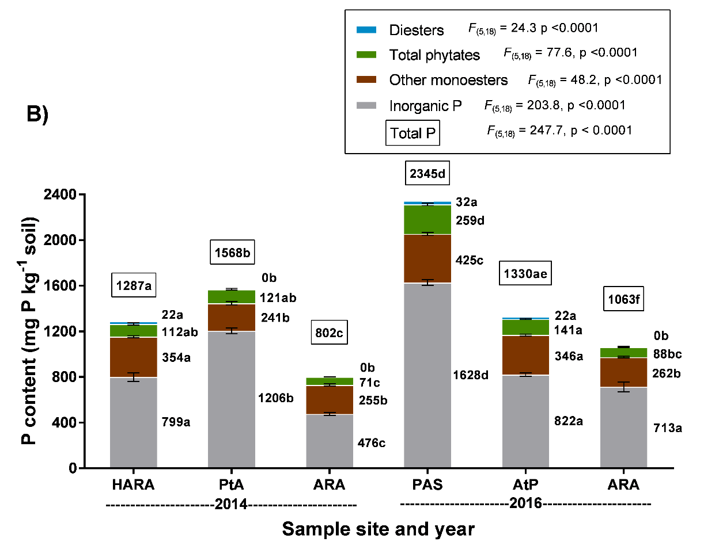
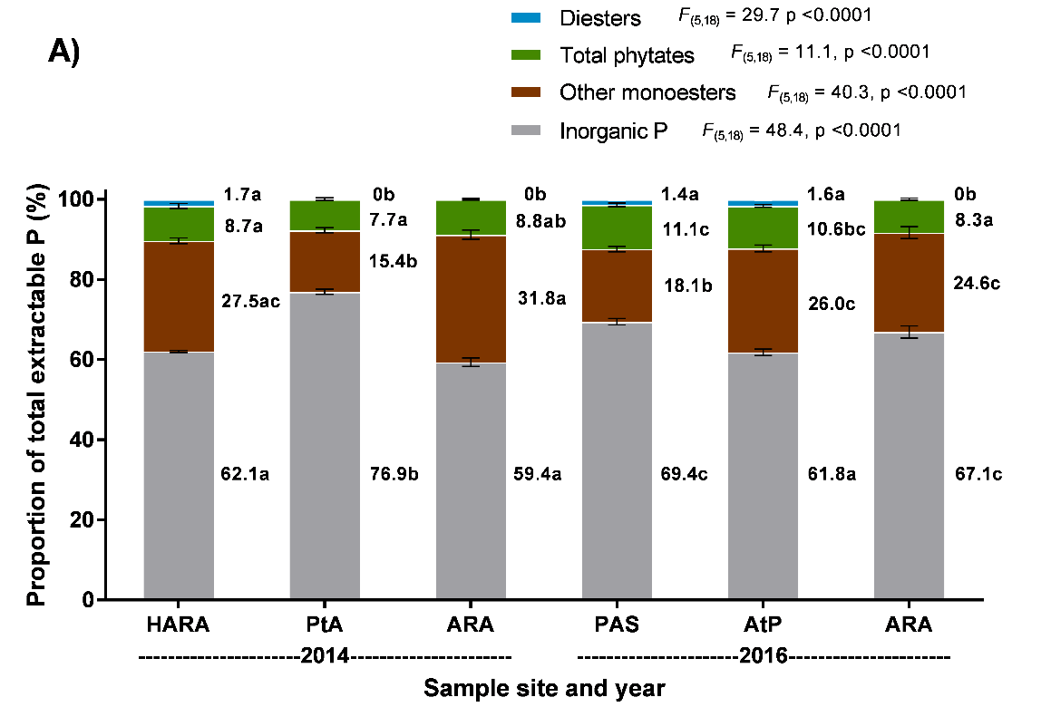
Fig 3.3: Proportions and total P of four groups of P compounds in agricultural soils with different historic uses. A) Proportions of P in different groups of compounds as a percentage of total P. B) Absolute P content in different groups of compounds. HARA = hedgerow of ARA field, PtA = pasture to arable conversion field, ARA = arable field, PAS = pasture field & AtP = arable to pasture conversion field. Total extractable P is indicated above the stacked bars with a box. Bars show means and error bars show standard error of the mean (n=4). Results of one-way ANOVA are shown on the graph. Different letters indicate significant differences between field soils for that group of P compounds (Tukey multiple comparisons test, alpha = 0.05). Inorganic P is the sum of orthophosphate and pyrophosphate. Total phytates is the sum of myo-IHP, scyllo-IHP, neo-IHP and D-chiro-IHP. Other monoesters equal total phytates subtracted from total monoesters.

P in Different Agricultural Soils – Allerton Farm
There was statistically significant differences between fields for all P compounds as determined by one-way ANOVA (Fig. 3.4). For most compounds the highest average level was in the hedgerow soil (HLTil) with the two arable soils (LTil and ARA2) having similar levels. The hedgerow soil contained approximately 2-3 times more of total extractable P, orthophosphate, total phytates, myo-IHP, scyllo-IHP, neo-IHP and D-chiro-IHP and 30-50% more total monoesters and other monoesters than the two arable soils. Further to this, only the hedgerow soil contained diesters. Pyrophosphate is the only compound for which the conventionally managed field soil (ARA2) has the highest level. The conventionally managed soil contained approximately 40% more than the LTil and HLTil soils.
The spectra from which P levels have been obtained by integration are shown in Appendix B (Fig. B.2). Observation of the areas under peaks shows similar patterns to and confirms the relative P level data (Fig. 3.4).
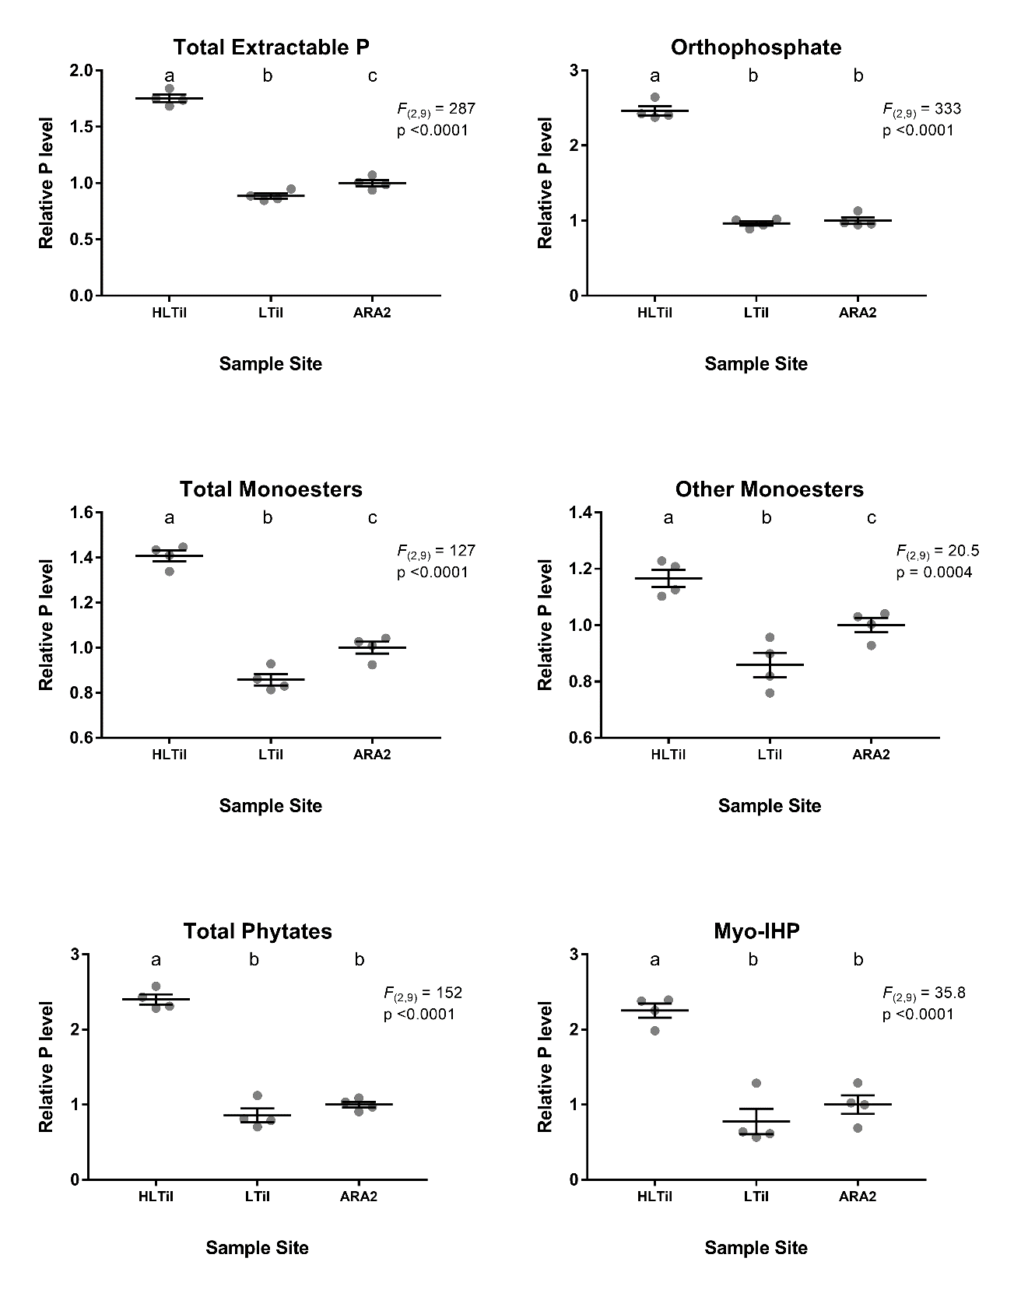

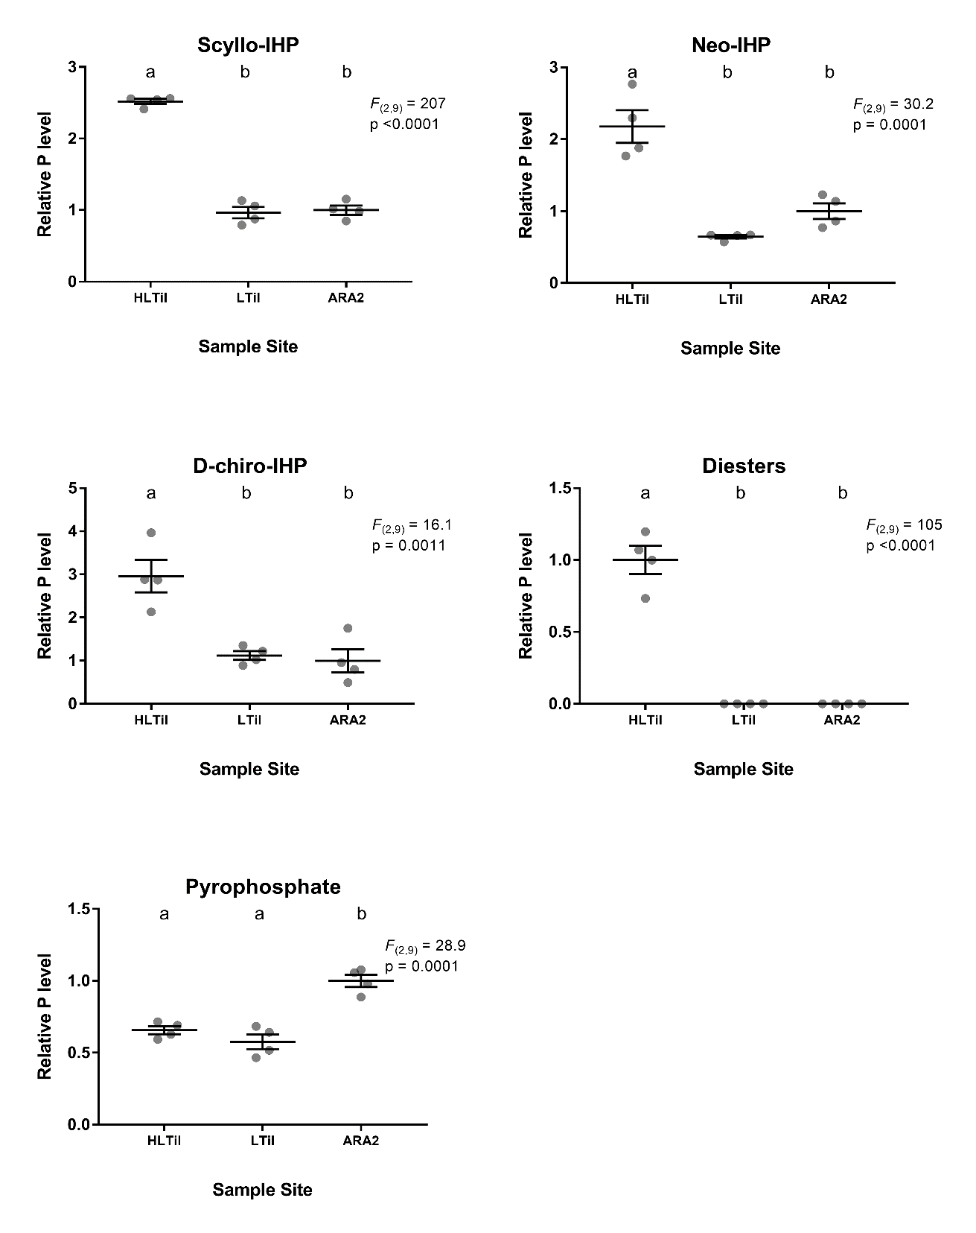
Fig. 3.4: Relative levels of different P compounds in three different agricultural soils with different historic uses. HTil = hedgerow of LTil field, LTil = low till arable field & ARA2 = conventionally managed arable field. For each graph, data points are shown normalised to the mean of ARA2 field, which is set to 1. Points show individual data (n=4), horizontal bars show means and error bars show standard error of the mean. Results of one-way ANOVA are shown on graphs. Different letters above bars indicated significant differences between fields (Tukey multiple comparisons test, alpha = 0.05).

Spring and Summer Variation of P in the Arable (ARA) Soil
Over four time points (February, April, June and August) in the spring and summer of 2016 the arable soil (ARA) showed no statistically significant differences between months in concentrations any of the P compounds (as determined by repeated measures ANOVA, alpha = 0.05) (Fig. 3.5). Although not statistically significant, there appears to be an increase in total extractable P and orthophosphate over the growing season, however this is caused by one large value in August. This increase from 600 to 1000mg P kg⁻¹ soil of orthophosphate from February to August is also responsible for a similar, and not significant, increase in total extractable P from approximately 900 to 1300mg P kg⁻¹ soil. Conversely, there appears to be a decline in total monoesters, total phytate and myo-IHP across the growing season, though, again none of these changes are statistically significant.
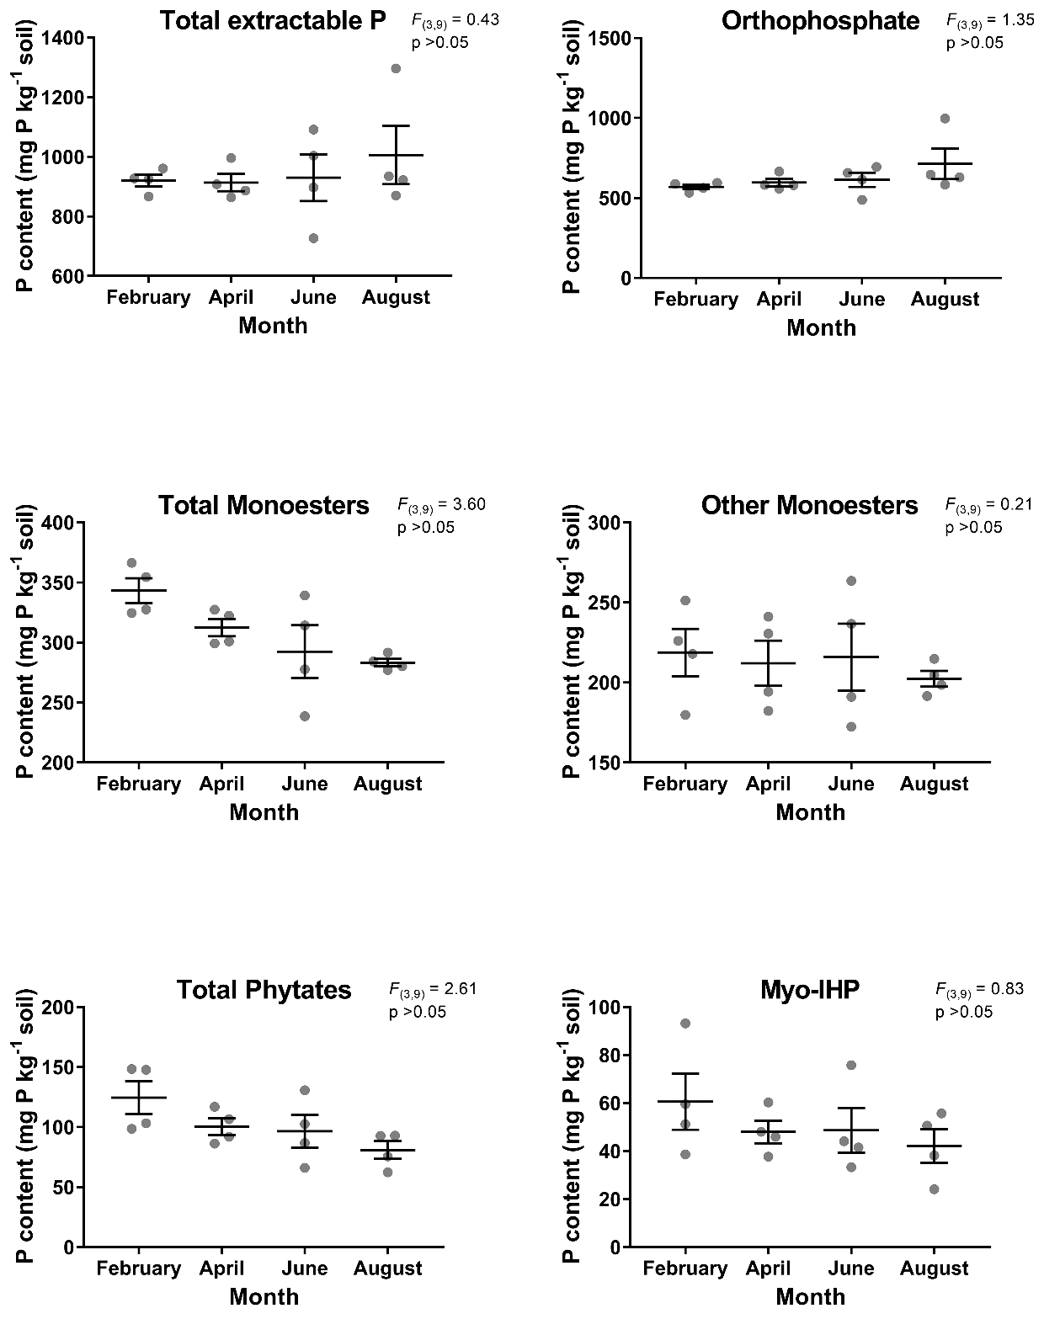
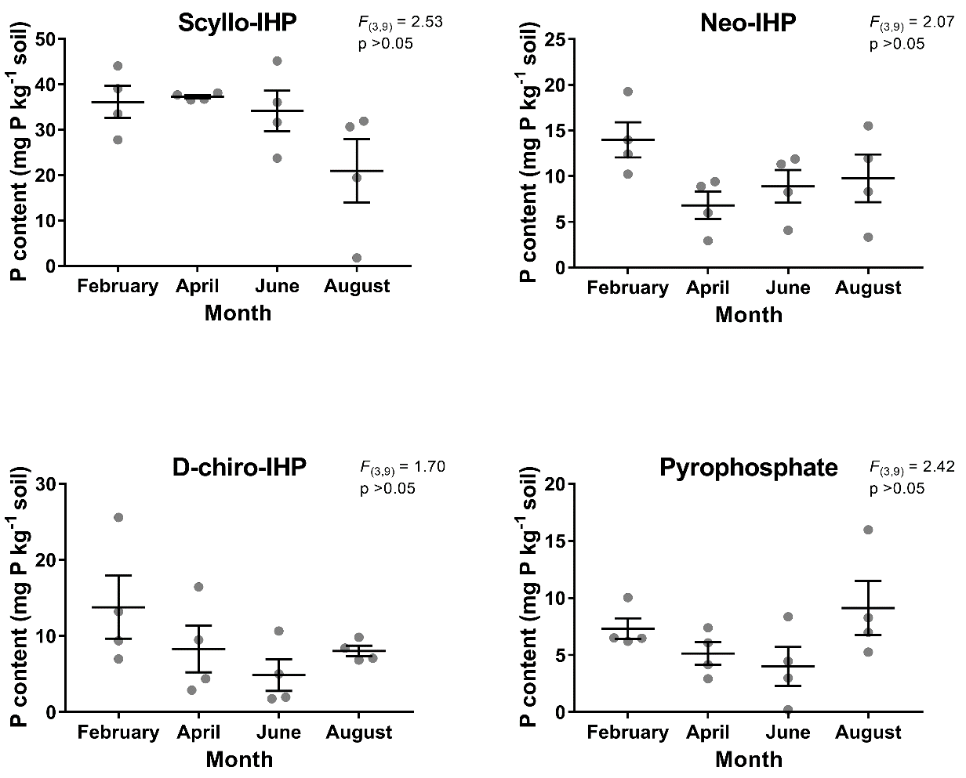
Fig. 3.5: Absolute P levels of different P compounds in an arable soil (ARA) across six months in a growing season. P content expressed per kg of soil dry weight. Points show individual data (n=4), horizontal bars show means and error bars show standard error of the mean. Results of repeated measures ANOVA are shown on graphs.

Throughout the time series orthophosphate was the most abundant form of P in terms of both the proportion of total extractable P that each group of compounds contributed (62.7-71.8%, Fig. 3.6a) and absolutely (577-723mg P kg⁻¹ soil, Fig. 3.6b). Monoesters also made up a large proportion of the total extractable P in each month (28.1-37.3%) (Fig. 3.6a). Overall, the proportion of different P forms stayed largely similar throughout the period. However, inorganic P showed a statistically significant increase from 62.7% in February to 71.8% in August (Tukey p < 0.01). This again, may have been caused by the large value in August. In contrast, total phytates showed a statistically significant decrease from 13.5% in February to 8.0% in August (Tukey p < 0.05). These patterns could also be seen in the absolute levels of the different P compounds, although this was not significant (Fig. 3.6b, tukey p > 0.05).
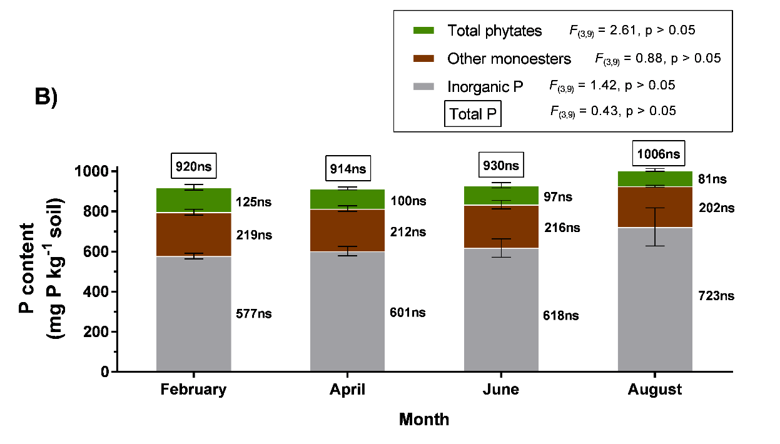
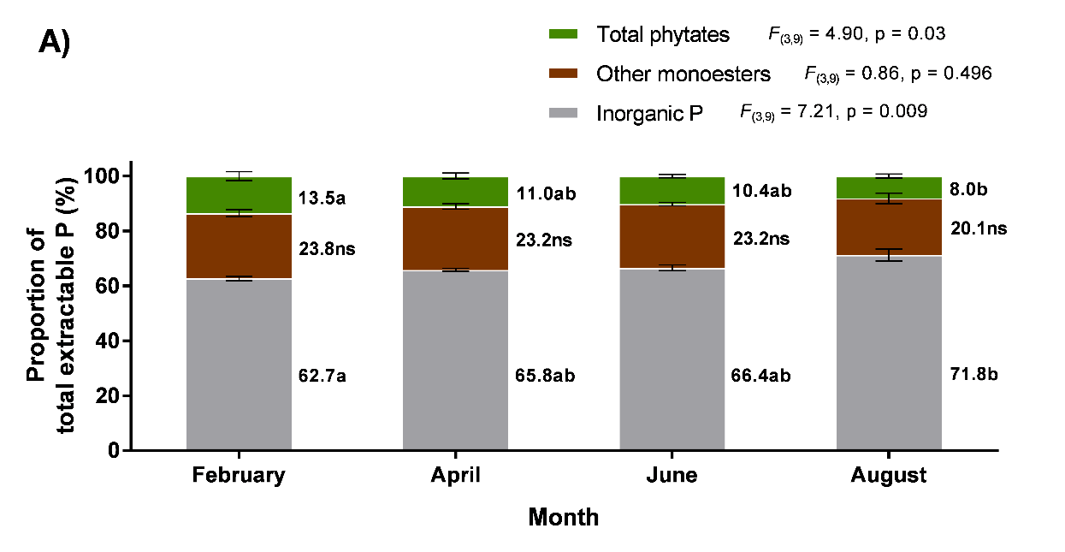
Fig 3.6: Proportion and total P of three groups of P compounds in an arable soil (ARA) across six months in a growing season. A) Proportions of P in different groups of compounds as a percentage of total P. B) Absolute P content in different groups of compounds. Total extractable P is indicated above the stacked bars with a box. Bars show means and error bars show standard error of the mean (n=4). Results of repeated measures ANOVA are shown on the graph. Different letters indicate significant differences between months for that group of P compounds and ns = not significant (Tukey multiple comparisons test, alpha = 0.05). Inorganic P is the sum of orthophosphate and pyrophosphate. Total phytates is the sum of myo-IHP, scyllo-IHP, neo-IHP and D-chiro-IHP. Other monoesters equal total phytates subtracted from total monoesters.

Longer-term (4 year) Temporal Variation of P in the Arable (ARA) Soil
When comparing the quantities of P compounds in the arable (ARA) soil in 2014, 2016 and 2017, there were no statistically significant differences between years for total monoesters, other monoesters, myo-IHP scyllo-IHP, neo-IHP, D-chiro-IHP and pyrophosphate (repeated measures ANOVA, alpha = 0.05) (Fig. 3.7). However, there was statistically significant differences between years for total extractable P, orthophosphate and total phytates (repeated measures ANOVA). Between years, (Tukey test) total extractable P was lower in 2014 than 2016 (p < 0.01) and 2017 (p < 0.001), orthophosphate was lower in 2014 than 2016 (p < 0.01) and 2017 (p < 0.01) and total phytates were lower in 2014 than 2016 (p < 0.01) and 2017 (p < 0.01). An increase in orthophosphate from approximately 500mg P kg⁻¹ soil in 2014 to 700mg P kg⁻¹ soil in 2016 and 2017 is responsible for a similar increase in total extractable P from 800 to 1000mg P kg⁻¹ soil. Likewise, an increase in myo-IHP from approximately 20 mg P kg⁻¹ soil in 2014 to 32 mg P kg⁻¹ soil in 2016 and 37 mg P kg⁻¹ soil 2017 of (although not significant, repeated measures ANOVA p > 0.05) is largely responsible for a similar increase in total phytates from 70 mg P kg⁻¹ soil in 2014 to 90 mg P kg⁻¹ soil in 2016 and 2017.
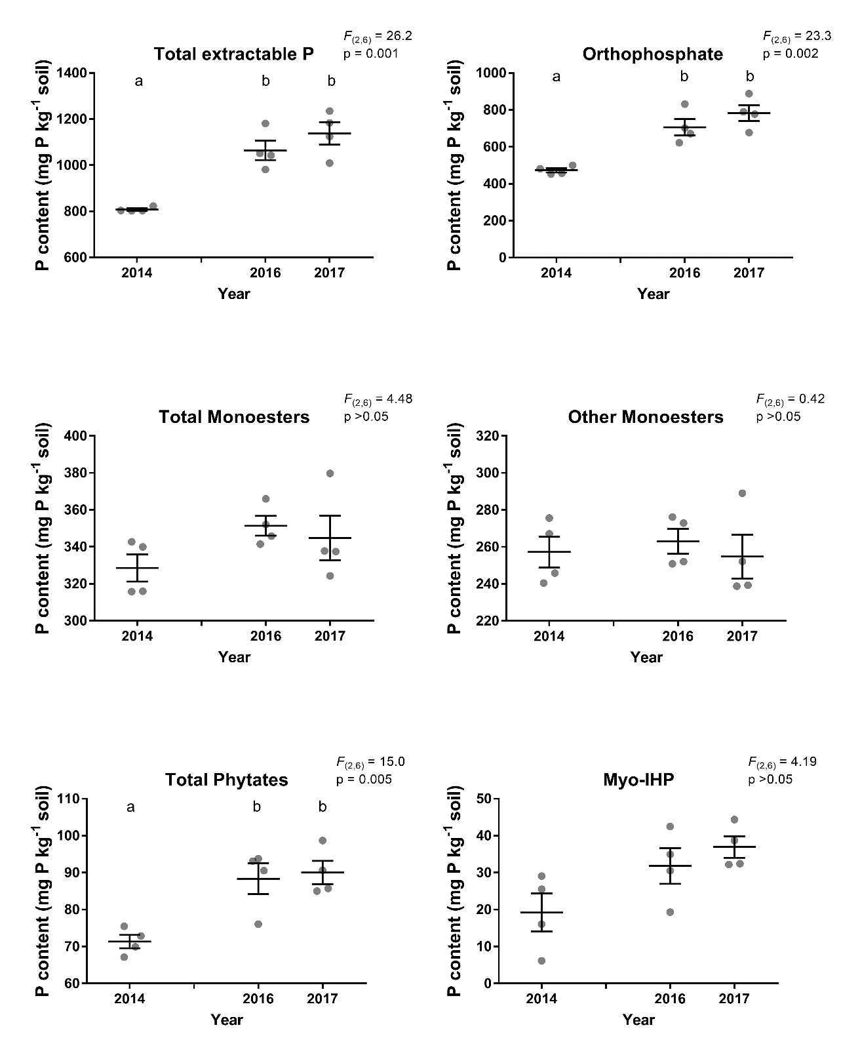
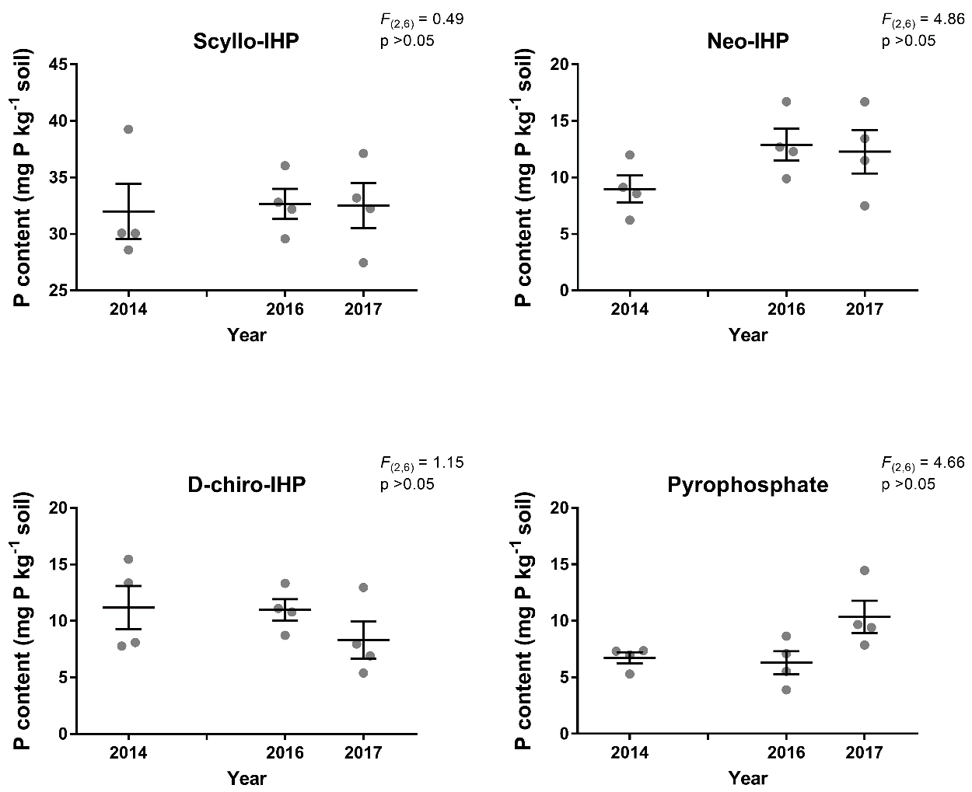
Fig.3.7: Absolute P levels of different P compounds in an arable soil (ARA) across several years. P content expressed per kg of soil dry weight. Points show individual data (n=4), horizontal bars show means and error bars show standard error of the mean. Results of repeated measures ANOVA are shown on graphs. Where the result of ANOVA was significant, different letters above bars indicate significant differences between years as determined by Tukey multiple comparisons test (alpha = 0.05).

In terms of the percentage that groups of P compounds made up of total extractable P Over the four year period studied, orthophosphate was the most abundant form of P in terms of both the proportion of total extractable P that each group of compounds contributed (59.3-69.7%, Fig. 3.8a) and absolutely (479-793mg P kg⁻¹ soil, Fig. 3.8b). Monoesters also made up a large proportion of the total extractable P in each month (30.3-40.6%) (Fig. 3.8a). Overall, while the proportion of different P forms stayed largely similar throughout the period there were statistically significant changes over time. Inorganic P showed a statistically significant increase from 59.3% in 2014 to 67.0% in 2016 and 69.7% in 2017 (as determined by Tukey multiple comparisons test, both p < 0.01). This pattern could also be seen in the absolute levels of inorganic P (Fig. 3.8b). In contrast, other monoesters showed a statistically significant decrease from 31.8% in 2014 to 24.7% in 2016 and 22.4% in 2017 (both p < 0.01, Fig. 3.8a).

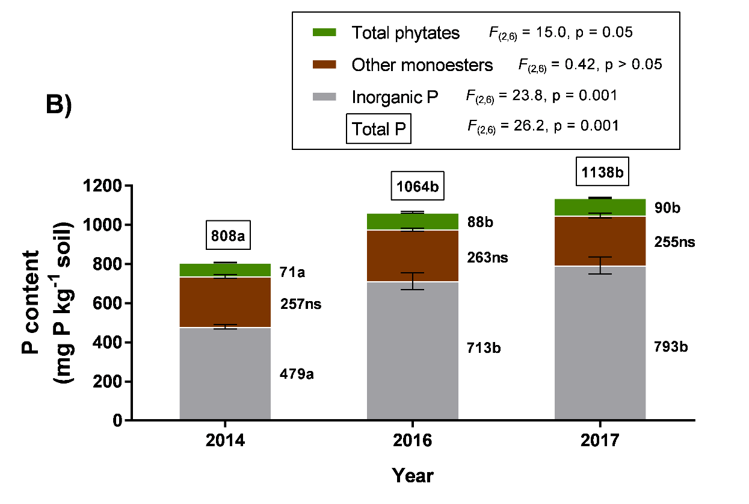
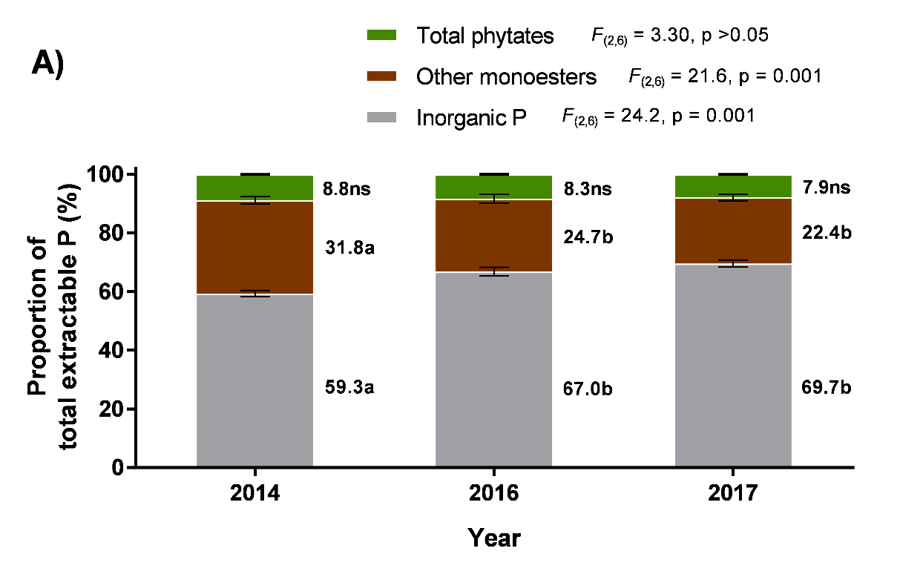
Fig 3.8: Proportion and total P of three groups of P compounds in an arable soil (ARA) across several years. A) Proportions of P in different groups of compounds as a percentage of total extractable P. B) Absolute P content in different groups of compounds. Total extractable P is indicated above the stacked bars with a box. Bars show means and error bars show standard error of the mean (n=4). Results of repeated measures ANOVA are shown on the graph. Different letters indicate significant differences between years for that group of P compounds and ns = not significant (Tukey multiple comparisons test, alpha = 0.05). Inorganic P is the sum of orthophosphate and pyrophosphate. Total phytates is the sum of myo-IHP, scyllo-IHP, neo-IHP and D-chiro-IHP. Other monoesters equal total phytates subtracted from total monoesters.

Discussion
This is the first study to assess the types, concentrations and proportions of P using ³¹P NMR spectroscopy in a set of agricultural soils from Spen Farm with different historic uses. This was complemented with an assessment of the changes in the types, concentrations and proportions of P compounds every two months over a growing season and annually over four years. Overall, this work has revealed that orthophosphate was the most abundant P compound, while monoesters made up approximately a third of the total extractable P in all soils. Further though, historic use of the soil does appear to affect the types and concentrations of P compounds in the soil, with these being lowest in the arable and highest in the pasture soil. In contrast, the work focussing on the temporal change over a season and over multiple years in the arable soil showed that the concentrations and proportions of P compounds did not vary greatly with time.

P in Different Agricultural Soils

Spen Farm Soils
Between soils from fields with different historic uses there was clear differences in the quantities of all P compounds present. The permanent pasture field (PAS) had the greatest level of most compounds with the permanently arable field (ARA) having the least. Greater overall P concentrations in the pasture field could be caused by higher P input and lower P output from this system compared to the arable fields. There is colloquial evidence that the pasture field has received long-term farmyard manure (FYM) input from the farm’s pig unit (Prof. J. R. Leake, personal communication, 2016) but any application rates are unknown. Long-term pig FYM input has been shown to increase P concentrations in several agricultural soils (Hountin et al., 1997; Liu et al., 2012; Zhang et al., 2014). Pig FYM contains P in both inorganic and organic forms (Gerritse and Zugec, 1977; Gerritse, 1981; Liu et al., 2012) and ³¹P NMR spectroscopy has shown many of these compounds to be the same as those found in soil, including monoesters, diesters and pyrophosphate (Leinweber et al., 1997; Mackay et al., 2017). Consequently, pig FYM additions have been shown to cause an increase in both inorganic and organic P forms in soil (Guardini et al., 2012). In the UK the average application rate of pig FYM to grazed grassland soil (38t ha⁻¹) and the total orthophosphate in pig FYM (6kg t⁻¹) would, theoretically, add approximately ten times more orthophosphate (228kg ha⁻¹) than the average field rate of orthophosphate fertilisers to grazed grassland (23kg ha⁻¹) (Benford, 2017). Exact pig FYM addition data was not available for this soil but pig FYM was added to another field soil in Spen Farm used to grow winter barley and was added at a lower rate (20t ha⁻¹) (Martin Leppage, farm records, personal communication, 2017). Assuming the rate of pig FYM added to the pasture soil (PAS) was the same, the resulting orthophosphate added to the PAS soil (120kg ha⁻¹) would have been approximately four times more than the average field rate of orthophosphate fertilisers to grazed grassland (23kg ha⁻¹). In summary, if additions of pig FYM were used in the pasture field it would have caused considerable input of P to the pasture soil as both inorganic and organic forms and could explain the concentrations of the P forms seen in the pasture soil. However, as there is uncertainty in the existence of such pig FYM additions and any application rates are unknown, it remains somewhat unclear why the level of P compounds are high in the pasture field.
Usually arable soils receive greater mineral fertiliser application than pasture soils, though for Spen Farm, data for the P input to the arable soils is incomplete. However, on average, winter cereal crop soils at Spen received 91kg ha⁻¹ of orthophosphate (although for some field soils in some years no P was added) (Martin Lappage, farm records, personal communication, 2017). That is potentially less P if the pig FYM inputs suggested above did actually occur. Nonetheless, whether or not the arable soil received less P input than the pasture soils, lower P concentrations in the permanently arable soil could still be, in part, explained by greater output of P from the soil than in pasture soil, as is often seen in UK soils (Tunney, 1990, 2002; Condron and Goh, 1989). In a typical cereal crop output of P from the soil is approximately 15-35kg ha⁻¹ (Smil, 2000), while in pasture systems this is lower at approximately 1-17kg ha⁻¹ (Haygarth et al., 1998).
Lower P concentrations in the permanently arable soil could also be caused, in part, by arable practices which cause soil degradation and lower P concentrations in the soil. This has been shown to be true of organic P compounds (Brookes et al., 1984; Zibilske et al., 2002; Andraski et al., 2003; Oliveira et al., 2015) and total P (Hedley et al., 1982) in arable soils when compared to pasture or natural soils. The detrimental effect of arable agriculture on the permanently arable soil compared to the pasture soil causing lower P concentrations is supported by the fact that soils which have undergone conversion between arable and pasture (AtP and PtA) contained intermediate concentrations of P compounds.
Greater concentrations of monoesters in the soils currently used for pasture (PAS and AtP) and the hedgerow soil (HARA) than in the soils currently used for arable (PtA and ARA) may suggest that these soils contained greater levels of organic matter and microbial activity. Less intensive agriculture and carbon additions to soil has been linked to greater organic matter levels and more monoesters in those soils (Bünemann et al., 2008a, 2008b). Additionally, the monoester scyllo-IHP, is thought to be produced by microorganisms and associated with their presence in soil (Turner and Richardson, 2004; Turner et al., 2005b). The relationship between soil historic use and scyllo-IHP concentration was less clear with the arable to pasture conversion soil (AtP) containing a similar concentration to the hedgerow and pasture to arable conversion soil (PtA). Nonetheless, the permanently arable soil contained the least scyllo-IHP and this may indicate lower microbial activity in the arable soil compared to all the other soils. Although other monoesters are a group of unidentified monoesters some of these are thought to be monoesters associated with humic compounds. This may, further, suggest a lower level of organic matter and P compounds associated with this organic matter in the arable soils (ARA and PtA) compared to the pasture soils (PAS and AtP) and hedgerow soil (HARA). Less organic matter in arable soils could be caused by tillage (Zibilske et al., 2002; McLauchlan, 2006) which disrupts macroaggregates (Elliott, 1986; Abdollahi et al., 2014). An intermediate concentration of monoesters in the pasture to arable conversion soil (AtP) may support the idea that the concentration of monoesters is affected by detrimental arable practices which reduce organic matter but that macroaggregates and organic matter can re-accumulate after conventional agriculture is stopped (McLauchlan, 2006).
The pasture soils (PAS and AtP) and hedgerow soil (HARA) were the only soils to contain diesters. Condron et al. (1990a) found similar results when studying cultivated soil, which did not contain diesters, in comparison to native soil, which contained diesters. Diesters are thought to be associated with microbial activity and so their presence in currently pasture soils and the hedgerow soil, may indicate higher microbial activity (Tate and Newman, 1982; Makarov et al., 2002a). Conversely the absence of diesters in the currently arable soils may indicate lower microbial activity in these soils. The link between microbial biomass and diesters has, however, been contested and caution urged in suggesting that a greater concentration of diesters is a sign of greater microbial activity (Makarov et al., 2005). The concentration of diesters in soil can also be related to precipitation (Tate and Newman, 1982) and soil pH (Bünemann et al., 2008b). Assuming that the five soils analysed in this chapter experienced the same precipitation because of their close proximity and have similar soil pHs, it could be proposed that the presence of diesters does indeed indicate higher microbial activity in pasture soils (PAS and AtP) and hedgerow soil (HARA) compared to the arable soils (ARA and PtA).
Pyrophosphate which is generally associated with fungi, and thought to indicate their presence (Makarov et al., 2005; Bünemann et al., 2008b) did not follow the same pattern between field soils as other compounds which are associated with microbes (monoesters, scyllo-IHP and diesters), with the hedgerow soil containing the most as opposed to the pasture soil. Nevertheless, the arable soil contained the lowest concentration of pyrophosphate compared to the other soils which would suggest the arable soil contained the lowest level of fungi compared to the other soils. Fungal mycorrhizal abundance is known to be in a negative relationship with increasing tillage (Jansa et al., 2002; Oehl et al., 2003; Säle et al., 2015). This could explain why the arable soil contained the least pyrophosphate an effect which may be exacerbated by mineral fertiliser input to the arable soil as fungal mycorrhizas are known to have a negative relationship with P input (Miranda and Harris, 1994; Mäder et al., 2000). As the conversion soils (AtP and PtA) will have historically received an intermediate level of tillage and P input this is then consistent with intermediate fungal activity and intermediate concentrations of pyrophosphate. This pattern for pyrophosphate is sustained in the hedgerow soil (HARA) which contained the highest concentration of pyrophosphate compared to the other soils.
Any patterns seen between historic field use and the amount of any P compound should only be taken cautiously as there is uncertainty in the literature, for example for diesters which can be associated with microbial activity but other factors may also be important (Tate and Newman, 1982; Makarov et al., 2002b, 2005; Bünemann et al., 2008b) which complicates the relationship.
The lack of a clear pattern between field historic use and the proportion that different groups of P compounds made up of the total extractable P is probably due to the fact that similar changes between field types in the concentration of P compounds are seen for most compounds. Orthophosphate was the largest component of P in the soils, making up approximately two thirds of the total extractable P regardless of the historic use of the soils. Meanwhile, monoesters made up approximately a third of the total extractable P regardless of the historic use of the soils. These proportions agree with previous studies which found that orthophosphate was the most abundant component of soil P and that monoesters made up approximately a third of soil P (Stutter et al., 2012; Stutter et al., 2015; Cade-Menun et al., 2015).

Allerton Farm Soil
Similarly to the Spen Farm soils, in the Allerton Farm soils there were clear differences in the concentrations of all P compounds present between the arable and hedgerow soils. Again, the greater concentrations of most P compounds in the hedgerow soil when compared to the arable field soils could have been caused by greater output of P and increased soil degradation in the arable soils compared to the hedgerow soil.
Similarly, the presence of diesters and the greater concentration of monoesters and scyllo-IHP in the hedgerow soil may indicate a higher microbial activity in the hedgerow soil than in the arable soils. Less pyrophosphate in the hedgerow and low-till soils surprisingly suggest less fungi in these soils compared to the conventionally managed arable soil. This, however, seems contrasting to the diesters, monoesters and scyllo-IHP concentration data which suggested greater presence of microbes in the hedgerow soil. Although there is contrasting evidence for microbial activity in the soils, it could be that the hedgerow and low-till soils had a greater level of non-fungi microbes while the arable soil had a greater level of fungi.
The lack of differences in P compound concentrations (except for pyrophosphate) between the low-till and conventionally managed arable soils suggests that low-till conservation agriculture has little impact on soil P. Low-till practices were in place for approximately 15 years prior to sampling but changes in soil organic P can occur over longer time scales than this (Tiessen et al., 1982; Sharpley and Smith, 1983; McLauchlan, 2006). On the other hand, in the Spen Farm soils, differences were seen in soils which had been converted only 5 years before sampling. However, analysis of soil P at other farms using low-till management would be needed before more general conclusions could be made on the effect of conservation agriculture for soil P.
Similarly to the Spen Farm soils, any patterns seen between field historic use and the amount of any P compound may be complicated by the uncertainty in these relationships and so any conclusions drawn are tentative.

Spring and Summer Variation of P in the Arable (ARA) Soil
A lack of statistically significant differences over the course of a growing season (February to August) in P compound concentrations suggests there was no net removal or addition to, or net conversion between the different P compounds in this arable soil. There was, however, a small increase in orthophosphate of approximately 100mg P kg⁻¹ soil which could be mostly accounted for by the decrease in total monoesters of approximately 60mg P kg⁻¹ soil and signify net mineralisation of total monoesters. This was coupled with a statistically significant increase in the proportion of inorganic P and decrease in the proportion of total monoesters.
A decrease in total monoesters through the growing season agrees with previous studies which found that organic P concentration was highest in winter (including February to April) and lowest in spring and summer (approximately May to August)) (Sharpley, 1985; Perrott et al., 1990; Magid and Nielsen, 1992; Chen et al., 2003) and could explain the decrease in total monoesters seen from February to August. A lower concentration of soil organic P in spring and a greater concentration in winter has been attributed to increased mineralisation and plant uptake during spring and lower microbial activities and mineralisation in winter (Perrott et al., 1990) along with increased organic matter input in winter (Chen et al., 2003). Therefore, from February to August, total monoesters may have decreased due to mineralisation which was driven by increased demand for P by the plants and microorganisms.
It is noted that the absolute changes seen through the growing season are not statistically significant and both the absolute and proportional changes were potentially skewed by a single large value for orthophosphate in August. These results are, therefore, not reliable evidence of net mineralisation but are at least consistent with patterns previously seen.
The minor seasonal variation in the concentrations of P forms in this soil shows that sampling soil in spring (as was done for other soil sampling in this chapter) was likely to have been roughly representative of the level in that field soil throughout the growing season and so was relevant when comparing years and fields.

Longer-term (4 year) Temporal Variation of P in the Arable (ARA) Soil
Over the course of four years (sampled in 2014, 2016 and 2017) in the arable field (ARA) there was an increase in total phytates (which was caused by an increase in myo-IHP) and orthophosphate. Both of these changes, therefore, also caused an increase in total extractable P. The increase in orthophosphate was so great that its proportion of the total extractable P also increased and caused the proportion of monoesters and phytates to decrease, even though they increased in absolute amounts.
No change in other monoesters and an increase in total phytates indicates there was no net mineralisation of organic P from 2014 to 2017 in this arable soil. The only statistically significant decrease was in the proportion that other monoesters made up of total extractable P. The absolute concentration of other monoesters stayed constant so the proportional decrease was caused by the increase in many of the other P compounds.
As previously discussed, continued cultivation can be damaging to soil and cause a decrease in organic P (Magid et al., 1996; Six et al., 2000; Andraski et al., 2003; Stutter et al., 2015). However, a decrease in organic P may only be seen in the long term (i.e. >50 years (Tiessen et al., 1982; Sharpley and Smith, 1983; McLauchlan, 2006)). Possible changes in organic P caused by agricultural practices were seen when comparing the permanently arable and pasture soils with the soils which had undergone conversions between arable and pasture. These field soils had undergone their respective conversion 6 (PtA) and 5 (AtP) years before samples were taken and showed intermediate concentrations of many P compounds compared to the permanently arable and pasture soils. This could suggest that changes in P concentrations may be seen in this time period or if these fields had undergone conversions between arable and pasture use in the longer-term (i.e. before the records available), their P concentrations may never have been as low as permanently arable soil or as great as permanent pasture soil.
Increasing P concentrations across the four year period could indicate greater or different P inputs to this arable soil (ARA) in 2016 and 2017 compared to 2014. In 2014 winter wheat was grown in the field, in 2016 spring barley and 2017 winter barley. In the UK the average field rate of P fertiliser application for winter wheat (59kg ha⁻¹) is greater than spring barley (50kg ha⁻¹) (Department for Environment, 2010) and slightly greater than winter barley (56kg ha⁻¹) (Benford, 2015, 2017). Hence greater input of P to the soil when used to grow spring and winter barley (2016 and 17, respectively) compared to winter wheat (2014) was unlikely and the increased concentration of P in this soil in 2016 and 2017 was unlikely to have been caused by this. P fertilisers are commonly applied to cereal crops in autumn and winter months (in September/October) or in spring months (in March/April) and are more likely to be applied in spring to spring sown crops (Benford, 2017). Soil sampled (in March/April) may have been recently fertilised in March/April (for spring barley in 2016) or approximately six months earlier in September/October (for winter wheat in 2014 and winter wheat 2017). Greater time since fertiliser application on the soil sampling under winter wheat (2014) compared to under spring barley (2016) might explain the increase in P between those two years. However, this does not explain the higher concentration of P in 2017 (March) when P fertiliser was known to be applied six months before (September 2016) (Martin Lappage, farm records, personal communication, 2017). As the farm records for fertiliser application are incomplete, unfortunately the exact reason behind any changes remain unknown.

Conclusions
Understanding the abundance and persistence of monoesters and phytates in soil is important to assessing their role as a pool of P and a potential P source in sustainable agriculture.
When compared with pasture soils and a natural hedgerow soils, arable soils showed potential signs of being detrimentally affected by agricultural practices. Arable soils contained less P, including organic P, than the pasture soils and natural hedgerow soils. In particular the lower concentrations of other monoesters, scyllo-IHP and absence of diesters (Spen and Allerton Farm) could suggest that the arable soils had lower organic matter and microbial activity since these compounds can be associated with organic matter or microorganisms. The greater concentrations of P compounds in the pasture soil may have been a consequence of historic high P input from pig FYM which may also have suppressed fungi in the soil as seen in the lower than expected concentration of pyrophosphate. A low-till soil did not show intermediate concentrations of P compounds relative to conventionally managed soil and hedgerow soils suggesting that conservation agriculture had no effect on the P compounds.
When the seasonal variation in the concentrations of P compounds was investigated total monoesters decreased from February to August, which may suggest minor progressive mineralisation occurred through the growing season by plants and/or microorganisms.
Over the course of four years in the arable soil total phytates, orthophosphate and so total extractable P increased. Although it is not clear why there was an increase, the P concentrations detected in the soil could have been caused by different P fertiliser application level or timing. The largely similar concentration of monoesters during a growing season and over four years confirms monoesters were a consistently present pool of P which made up approximately a third of the total extractable P in this arable soil. This was also true in several different agricultural soils and a hedgerow soil, where monoesters made up 23-41% of the total extractable P.
Having confirmed that monoesters are a considerable portion of the total extractable P in a set of agricultural soils and that the size of this pool of P was chiefly constant, this knowledge will be used in further chapters to determine if crop plants are able to use monoesters as a source of P and, if so, which root traits may facilitate this.

- Phosphorus Uptake from Orthophosphate Monoesters and Orthophosphate by Wheat, and Relationships with Root Traits

  - Summary
Soil phosphorus (P) in the form of orthophosphate monoesters is a potential source of P for crop plants which could reduce the need for fertilisers. It is not clear, however, how accessible this source is to crops and which root traits can increase their ability to access P in this organic form.
To assess the use of organic P, a range of 21 varieties of wheat with contrasting release dates were grown in arable soil for 3 weeks in greenhouse conditions. A range of release dates were used to determine whether newer varieties had reduced capacity to utilise organic P (i.e. had become more dependent on fertiliser P). The wheat plants were then supplied with radiolabelled ³³P in either the inorganic form of orthophosphate or in the organic form of inositol polyphosphates (IPP). P uptake from these sources was assessed as the amount of ³³P taken into shoot tissue, and was measured along with root traits important to P uptake: phosphomonoesterase (PME-ase) activity, phytase activity, root structure and organic acid exudation.
P uptake showed large variation among varieties, approximately 5 fold difference between the lowest and greatest uptake, but showed no relationship with variety release date.
PME-ase activity showed a positive correlation with P uptake which suggested this enzyme was important to P uptake from both sources.
Further to this, the negative correlation of root system size with P uptake showed that a larger root system was not beneficial to P uptake. Possibly, this is caused by a negative relationship between PME-ase activity and root system size, creating a carbon cost trade-off.
Although no correlations were seen for malic acid exudation and P uptake or other root traits, greater levels of citric acid exudation appeared beneficial to P uptake. This confirms the role of citric acid in solubilising P forms to facilitate uptake. This relationship appeared stronger for plants supplied with orthophosphate and may elude to organic acid exudation being more important to P uptake in plants supplied with orthophosphate, while PME-ase activity was more important in plants supplied with IPP.
In summary, the work in this chapter provides evidence that root system size is not a suitable target for enhancement of P uptake from organic P as the cost of a larger root system may reduce investment in other root traits by the plants. Alternatively, PME-ase activity and citric acid exudation appear more important to P uptake and so provide target traits for enhancement in wheat to improve P uptake from organic P.

  - Introduction
Naturally occurring organic P in soil may provide an important source of P for crops (Stutter et al., 2012; Nash et al., 2014) if it is bioavailable (Turner et al., 2002b) and in large enough quantities to at least partially meet crop demands. It was seen in Chapter 3 that phosphorus (P) in the organic form of orthophosphate monoesters (monoesters) made up approximately a third of the total P in agricultural soil and specifically in arable soil. While monoesters therefore make up a significant P pool (Stutter et al., 2015), it is important to assess if arable plants can access the P in this. Furthermore, if P can be acquired from orthophosphate monoesters, it is beneficial to determine which root traits facilitate access of this P so that recommendations can be made in the development of new crop varieties that can utilise this P source more. If arable plants can access P from soil monoesters or this can be enhanced, it would reduce the need for fertiliser P application leading to more sustainable agriculture.

    - Important Root Traits for P Uptake
      - Root Structure
Root structure is important to P uptake as P is often heterogeneous in soil and so plants must explore the soil volume to find P (Robinson, 1994; Fisher et al., 1998; Hodge, 2004). It follows that large root systems are beneficial to P uptake as they increase the opportunity for the plant to find soil P. Once a P source is located roots can proliferate to maximise the root surface area in contact with this (Drew and Saker, 1978; Hodge, 2004).
Although root large root systems can potentially increase P uptake, root structures have a considerable cost to the plant (Lynch et al., 2005). Specific root length (SRL) is a measure of the root mass per length or the root absorptive capacity relative to carbon investment (Ryser, 2006). It has accordingly been shown that roots with a greater SRL are less costly to the plant (Miller et al., 2003) and so are a more cost efficient method of exploring soil (Lynch et al., 2005).
Root hairs can also provide a method of exploring the soil for P which is less costly, in terms of energy, to the plant than larger root structures (Hetrick, 1991; Lynch, 2011) and directly takes up P (Gahoonia et al., 1997; Gahoonia and Nielsen, 1998). Furthermore, a greater abundance of root hairs in wheat has been shown to increase P uptake (Gahoonia et al., 1997). A specialist trait to increase P acquisition that some plants have are cluster roots (such as species in the Proteaceae, and similar dauciform roots in the Cyperaceae (Shane et al., 2006)). Cluster roots consist of short lengths of root with increased root branching which are beneficial to P uptake in low P conditions (Skene, 1998; Shane and Lambers, 2005). Therefore, introduction of cluster roots to crop plants has been proposed to increase P acquisition (Lambers, 2006).
In many respects, increasing root system size, enhancing root hairs or introducing cluster roots in to crop plants not only represents an increase in root contact with soil but may also increase other root traits beneficial for P uptake such as organic acid exudation and phosphatase enzyme activity (Jungk, 2001). It is through increases in organic acid exudation and phosphatase enzyme activity that larger root systems would be more able to access P, specifically, in organic forms as this P source must be solubilised and mineralised (Turner et al., 2002b). The importance of organic acid exudation and phosphatase enzyme activities explains why many studies, to understand and improve the use of organic P as a P source in plants, have focussed on these traits (López-Bucio et al., 2000; Richardson et al., 2000; Xiao et al., 2005; Lung and Lim, 2006; George et al., 2008; Ma et al., 2012; Giles et al., 2017b).

      - Phosphatase Enzyme Activity
As plants only take up P in the form of phosphate, the phosphate group must be cleaved from organic forms. This can be done by root phosphatase enzymes: phosphomonoesterases (PME-ases) and phytases. PME-ases are a group of enzymes which hydrolyse orthophosphate monoesters to release orthophosphate (Hayes et al., 2000). PME-ases may also have a role in P transportation into the root (Duff et al., 1994). This would result in PME-ase having a role in both cleaving orthophosphate from organic forms but also directly in orthophosphate uptake (Gahoonia and Nielsen, 2004). Phytases are a group of enzymes which specifically hydrolyse the inositol monoesters to less phosphorylated forms (Hayes et al., 2000). Phytases show varying substrate specificity but histidine acid phytases show broad specificity and produce inositol monokisphosphate as the final product (Oh et al., 2004). Phytases are more strongly inhibited and have lower activity than PME-ases, for example in pasture species (Hayes et al., 1999). Both enzymes, however, are often enhanced under low P conditions (Duff et al., 1994; Hayes et al., 1999). This could suggest that plants have the mechanisms to use organic forms of P but this is only triggered in low P conditions when easier to access P is scarce. In this chapter the source of organic P used was a mixture of inositol phosphates. This is relevant to arable soils which have been shown to contain a mixture of inositol phosphates, as demonstrated in Chapter 3, rather than a single form. Many studies, however, use a single P source which may be less relevant to conditions in soil. Further to this, it was shown in Giles et al., (2017a) that tobacco plants transgenic for phytase expression depleted other unidentified inositols but not myo-inositol hexakisphosphate (often referred to as phytate and commonly used as a P source in the literature). This highlights that understanding is needed in the activity of phytases but also that the inositol phosphates should be considered together rather than focusing on a single isomer.
There is evidence that wheat may not be able to use organic P as a P source and this may be caused by low phytase activity (Richardson et al., 2000). However, phytase extract preparations have been shown to hydrolyse most organic P extracted from soil (Hayes et al., 2000) suggesting that enhanced phytase activity in crops could confer the ability to access organic P as a P source. In fact, transgenic expression of phosphate cleaving enzymes has been shown to enable access to organic P as a P source in Arabidopsis (Xiao et al., 2005, 2006), white clover (Ma et al., 2009), subterranean clover (George et al., 2006) and alfalfa (Ma et al., 2012). Some plants (Tithonia and Crotalaria) with naturally greater phytase activity were shown to be also able to access soil organic P whereas maize, with lower enzyme activity, could not (George et al., 2006). Further to this, the endogenous phytase activity of oilseed rape, sunflower and soybean was suggested to be responsible for their ability to use phytate as a P source (Belinque et al., 2015).
Low endogenous activity is not the only limit on phytase activity. Different phytases have differing abilities to remain active once exuded into soil (George et al., 2007a). This is important to any future production of transgenic plants which can use organic P as the efficiency of phytase can be reduce by degradation or absorption to soil (George et al., 2005a; Menezes-Blackburn et al., 2013).

      - Organic Acids Exudation
For enzymes to cleave phosphate from organic P it must first be solubilised and so be accessible by the enzyme (Turner et al., 2002b). Solubilisation can be promoted by plant roots through exudation of organic acids (Vance et al., 2003). Increasing organic acid exudation in crop plants has been suggested to improve their ability to access P in an organic form. For example, transgenic tobacco plants with enhanced citrate synthase production were shown to produce more biomass in low P conditions and require less P fertilisers for optimal growth (López-Bucio et al., 2000). In fact, Gerke (2015) suggested that solubilisation is the limiting factor to phytate being used as a source of P by plants rather than enzyme activity. Wheat has been found to exude malic and lower levels of citric acid (Delhaize et al., 1993), whereas other crop species exude both at a similar level (Jones, 1998). While enhanced plant citrate synthesis has not always proved successful in increasing organic acid exudation (Delhaize et al., 2001; Ryan et al., 2014), de la Fuente et al. (1997) found that transgenic tobacco with increased citrate synthase expression and citric acid exudation had enhanced ability to access P in a low P soil.

      - Combination Effects of Root Traits
Although individual root traits may play greater or lesser roles in P uptake it is likely that P uptake is determined by the combination of traits. This can be seen in a study where a combination of transgenic citrate and phytase exudation in tobacco plants improved P acquisition and depletion of soil organic P (Giles et al., 2017b). This was also suggested in studies which found that the natural level of phytase activity in tobacco did not allow plants access to organic P absorbed to sand (Lung and Lim, 2006), that transgenic expression of phytate in clover could access phytate in vitro but not very well in soil (George et al., 2004), that transgenic expression of phytase in tobacco could only access phytate in soil with amendments to improve the availability of phytate (George et al., 2005b), and that organic P could be used as a P source in wheat in vitro but not in soil (George et al., 2008). These studies found that enhanced and even natural phytase activity levels can allow plants to access organic P but, in these cases, that access was still limited by the absorption/solubility of organic P.
Additive effects are likely to be important but, conversely, traits may also be in trade-offs with each other (Lynch, 2011) in that the cost of any trait may reduce the ability of the plant to invest in another trait. Root exudates and mycorrhizal symbiosis can have substantial carbon costs to plants (Ryan and Graham, 2002; Nguyen, 2003; Ryan et al., 2012) which may cause a trade-off as investment in one trait reduces a plants ability to invest in another.
As crops have been bred to suit modern agriculture, it is possible that they have lost traits which may be beneficial to P uptake. For example, as crops are supplied with easy to access fertiliser P, they may have less ability to access P in organic forms and lower levels of root traits which facilitate this compared to older varieties of crops. Although direct evidence of a decrease in P uptake from organic forms in wheat has not been seen, modern wheat varieties have been shown to have reduced dependency on mycorrhizas and lower mycorrhizal responsiveness (Hetrick et al., 1993; Zhu et al., 2001) with mycorrhizas being implicated in the ability of wheat to access P in organic forms (Bolan, 1991; Tarafdar and Marschner, 1994; Jansa et al., 2011).
In this chapter only the ability of the plant to access P was assessed. Microorganisms are known to be important to P uptake for plants particularly from forms which are harder to access and so these were investigated in the following chapter (Chapter 5) which focusses on the effect of mycorrhizas.

    - Aims and Hypotheses
For the organic P in arable soil to be used as a P source by crops plants the P must be bioavailable. Furthermore, to improve the ability of crop plants to access P in organic forms, the root traits which best facilitate this must be known. Improvement of those traits might then be the focus of future crop variety development.
In this chapter, P uptake by wheat varieties from an organic P source was investigated. With orthophosphate monoesters in soil making up a considerable proportion of the total extractable P, this chapter aimed to determine if wheat plants can use monoesters in the form of inositol polyphosphates (IPP) as a source of P and which root traits may facilitate this. This was achieved by growing plants in arable soil analysed for P content in Chapter 3, and introducing radiolabelled ³³P as either organic IPP or orthophosphate to determine P uptake from these sources. That uptake was then assessed against a number of root structural and physiological (enzyme and organic acid exudation) traits.
It is hypothesised that the wheat varieties will be able to use IPP as a P source but to varying degrees and to a lesser degree than orthophosphate. The variation in ability to use IPP as a P source will be related to root traits important in P uptake. Varieties with an older release date will be more able to use IPP as a P source than newer varieties and will have greater levels of root traits important to using organic P as a P source. Root structural traits which contribute to a larger root system and organic acid exudation will be correlated positively with P uptake from both an inorganic and organic P source but will be more important to P uptake from an organic P source. However, root phosphatase enzyme activities will only be correlated positively with P uptake from the organic P source.

  - Materials and Methods
Encompassing a range of release dates from 1844 to 2010, 21 wheat varieties were selected (Fig. 4.1). The selection of wheat varieties were grown for 3 weeks before being supplied with radiolabelled P as either orthophosphate or inositol polyphosphate (IPP) (4-6 replicates). Their ability to access these two sources was assessed by measuring P uptake along with relevant root traits: root structure, phosphatase enzyme activities and organic acid exudation.

Table 4.1: Wheat varieties and release dates. Varieties are ordered according to release date from oldest to newest.
Wheat Variety | Release Date | Wheat Variety | Release Date
Browick | 1844 | Apache | 1998
40885 | 1950 | Claire | 1999
Alcedo | 1974 | Option | 2001
Avalon | 1980 | Mercato | 2005
Soissons | 1987 | Robigus | 2005
Vivant | 1991 | Alchemy | 2007
Cadenza | 1992 | JB Diego | 2007
Consort | 1993 | Oakley | 2008
Rialto | 1993 | Beluga | 2010
Shango | 1994 | Tuxedo | 2010
Malacca | 1997

    - Plant Growth Conditions
Plants were grown in soil collected from Spen Farm (near Tadcaster, West Yorkshire, UK) from an arable field (ARA) which was analysed for P content in previous chapters. The soil was air dried, sieved to 2mm, homogenised and autoclaved twice to sterilise. Seeds were surface sterilised with 5% sodium hypochlorite and germinated under sterile conditions in petri dishes on wet filter paper. Seeds were germinated at room temperature in the dark for 5 days before being planted. Plants were grown under greenhouse conditions in The Arthur Willis Environment Centre (The University of Sheffield) with a 20°C day temperature and 15°C night temperature at ambient CO₂ and humidity. As well as natural light plants were supplemented with a 12h day light length.
Plants were grown in rhizotron boxes filled with sieved soil (Fig. 4.1) and watered with distilled water every two days. Rhizotrons were positioned at an approximately 30° angle from the vertical to encourage roots to grow towards the lid of the rhizotron (the downward facing side). Plants were grown for a total of 3 weeks before addition of a ³³P source.

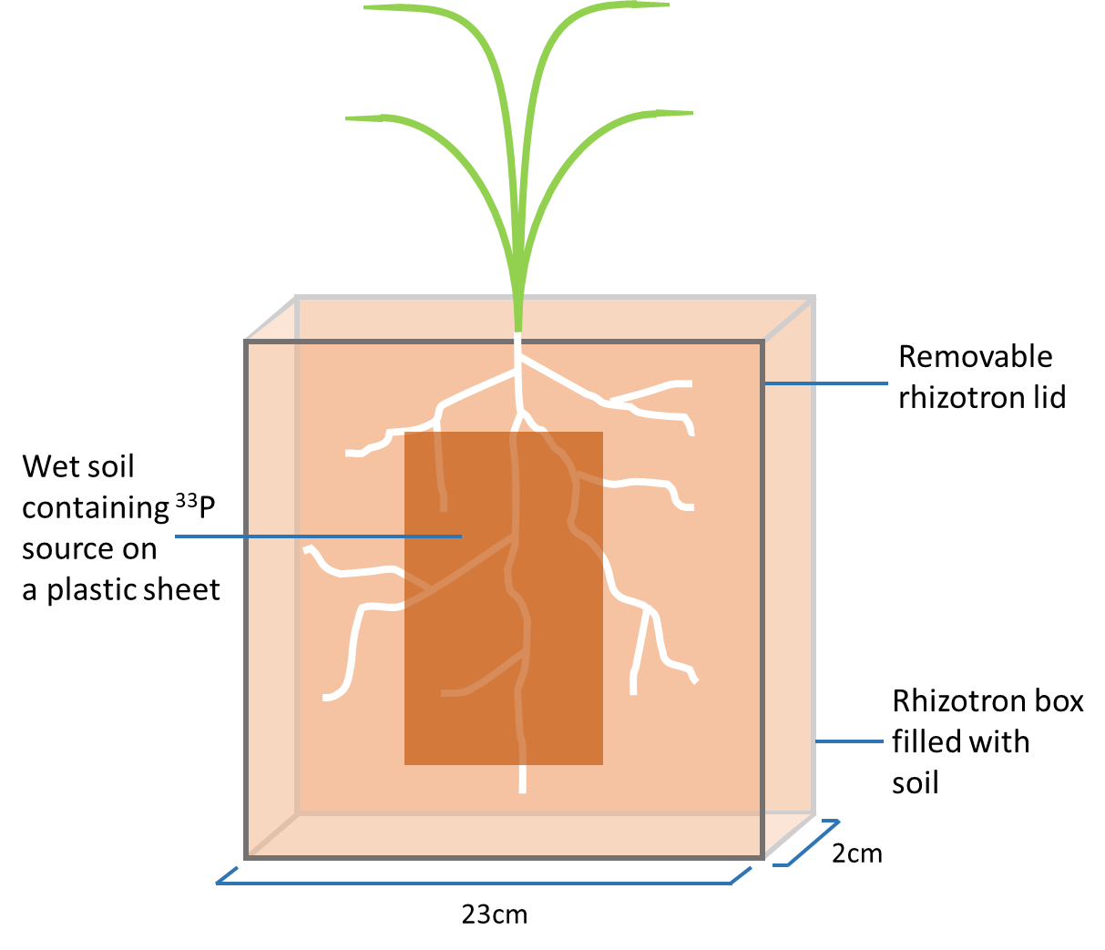
Fig. 4.1: Rhizotron root growth box containing a single wheat plant and a plastic sheet with a radiolabelled ³³P source. The rhizotron box (23cmx23cmx2cm) was filled with 2mm sieved soil. The darker grey line indicates the rhizotron lid which opens to allow addition of the P source which comes into direct contact with the soil and roots.

    - Phosphorus Treatments
Plants were supplied with P in the form of either ³³P radiolabelled orthophosphoric acid (Hartmann Analytic, Braunschweig, Germany) or ³³P radiolabelled mixed inositol polyphosphates (synthesis described briefly in section 4.3.2.1 and in detail in Appendix C). For both P sources, 0.25MBq were added to plants in a total of 2x10⁻⁴moles of P. The P source was added to rhizotrons as 10mL of the radiolabelled P source solution mixed with 15g of dried, 1mm sieved soil. This soil mixture was spread in 15x9cm rectangle area on a thin, flexible plastic sheet which was then added to the rhizotron with the soil mixture in direct contact with the rhizotron soil and roots (Fig. 4.1). The plastic sheets could be prepared before, allowing a known amount of soil P mix to be added in a reproducible way to each rhizotron. It also facilitated adding the soil P mix without spillage or disturbance to the rhizotron soil and root system. Because rhizotrons were positioned at a 30° angle, roots grew preferentially against the lid which ensured roots came into contact with the P source soil mix when it was added.

      - Radiolabelled Inositol Polyphosphate (IPP) Synthesis
Radiolabelled inositol polyphosphate synthesis was undertaken as detailed in Appendix C. Briefly, radiolabelled orthophosphoric acid (³³P) was refluxed at 200°C with myo-inositol to allow attachment of the radiolabelled phosphate group to the inositol ring. This mixture was then purified using an ion-exchange resin. The final product was a mixture of ³³P radiolabelled inositol polyphosphates (IPP, with approximately 20% orthophosphate).

    - Plant Harvest and Tissue Analysis for ³³P
Wheat plants were harvested two days after addition of the ³³P soil mix to the rhizotrons. Root and shoot material was separated, and shoot material was frozen (-20°C) and freeze dried (Modulyo freeze dryer, Edwards). Once dried, shoot material was weighed before being ground and homogenised in a mixer mill (CetriPrep 8000M, SPEX). For each plant, two 20-30mg samples were weighed out into boiling tubes. Each samples was digested with 1mL of concentrated sulphuric acid heated to 350°C for 15min. Once cooled, 200µL of hydrogen peroxide was added and the samples heated for a further 1min to produce a clear solution. This was diluted with 5mL of distilled water before a 2mL subsample was taken and mixed with 10mL of liquid scintillation cocktail (Emulsifier safe, Pelkin-Elmer, Beaconsfield, UK). This mixture was quantified for ³³P activity in a liquid scintillation counter (Packard Tri-Carb 31000TR, Isotech). P uptake was expressed in picograms of ³³P taken up per gram of shoot dried weight (pg P g⁻¹).
At harvest roots were washed of soil with water. Once roots were washed they were blotted dry on tissue paper before being weighed to measure fresh weight.

    - Root Trait Analysis
      - Root Structure Analysis
Washed roots were spread out in a thin layer of water in a flat tray in a light box and photographed. Photographs were edited using GIMP software (2.8.14, Berkeley, California, USA) to crop, enhance contrast (retinex filter) and remove background irregularities. Photographs were analysed with GiaRoots root imaging software (Galkovskyi et al., 2012) for total length, total surface area, total volume, specific root length (length to volume ratio), bushiness (branching) and average root width.

      - Phosphatase Enzyme Activity Analysis
After roots were photographed, surface phytase activity was determined using an adapted protocol from Lung and Lim (2006) and Ahmad-Ramli et al. (2013). Roots were incubated in 15mL tubes containing a phytate substrate solution in a 37°C shaking water bath. The substrate solution contained 1mM phytate in buffer (0.1M tris/ 0.1M maleate) adjusted to the pH of the autoclaved soil (pH 7.8) with 0.1M NaOH. Aliquots of 500µL were taken every 30min for a total of 120mins and each transferred to an eppendorf containing 1mL of terminating solution (0.4mM trichloroacetic acid). Eppendorfs were centrifuged for 10mins at 10,000g to remove precipitated proteins. Aliquots were then assayed for orthophosphate produced by the action of phytase on phytate using molybdate blue colourimetry (Murphy and Riley, 1962). Absorbance at 882nm was measured using a spectrophotometer (Cecil CE1020, Cambridge, UK). Concentrations of orthophosphate were determined from samples using a standard curve. Multiple time points were used to check that reaction rates were linear. Phytase activity was expressed in picomoles of P released per gram of root fresh weight per second (pmol P g⁻¹ s⁻¹).
Root surface phosphomonoesterase (PME-ase) activity was determined using an adapted protocol from Johnson et al. (1999) and Phoenix et al. (2003). Roots were incubated in 15mL tubes containing an artificial substrate solution of p-nitrophenol phosphate (p-NPP) in a 37°C shaking water bath. The substrate solution contained 4mM p-NPP in buffer (0.1M tris/ 0.1M maleate) adjusted to the pH of the soil (pH 7.8) with 0.1M NaOH. Aliquots of 200µL were taken every 30mins for a total of 120mins and each transferred to a cuvette containing terminating solution (0.1M Tris (hydroxymethyl) methylamine adjusted to pH 12 with NaOH). Aliquots were then assayed for p-NP (yellow) by the action of PME-ase on p-NPP (colourless). Absorbance at 410nm (A₄₁₀) was measured using a spectrophotometer. Concentrations were determined from samples using a standard curve. Multiple times points were used to check that reaction rates were linear. PME-ase activity was expressed in picomoles of p-NP released per gram of root fresh weight per second (pmol p-NP g⁻¹ s⁻¹).

      - Organic Acid Exudation Analysis
Due to the use of an incorrect incubation solution (buffer containing organic acid instead of water), organic acid exudation was not assessed in the same plants as the rest of the experiment. Instead a new set of plants were grown under the same greenhouse conditions in 12cm diameter, 7cm high cylindrical pots (plants were not supplied with a ³³P source). Root organic acid excretion was determined after 3 weeks growth using an adapted protocol from López-Bucio et al. (2000). After roots were washed of soil with water, roots were incubated in 15mL tubes containing sterilised, ultra-pure water (Elga PureLab, High Wycombe, UK) at room temperature for 16h before this solution was frozen. Subsamples of 0.5mL were assessed for citrate and malate, using a similar method to Lake et al. (2017) by Ultra Performance Liquid Chromotography-Mass Spectrometry (UPLC-MS; Water Acquity UPLC coupled to Water Synapt G2 Mass Spectrometer, Waters Ltd, Manchester, UK). Samples were not diluted before analysis and 10μl was injected into the UPLC. A standard curve was produced, with an R2 value >0.997, by serially diluting citrate and malate stock (Sigma-Aldrich, UK). All solvents used for the analysis were LC-MS Chromasolv Grade from Sigma and ultra-pure water. Organic acid exudation was expressed in picomoles of organic acid exuded per gram of root fresh weight per second (pmol g⁻¹ s⁻¹).
Other root traits such as root hairs were not assessed. This was simply due to time constraints in the processing of samples.

    - Statistical Analysis
The effect of wheat variety and P source on P uptake was investigated using a two-way ANOVA (alpha 0.05). The relationships between plant traits (P uptake, root phosphatase enzyme activities, root system size and root acid exudation) were assessed using Spearman’s rank order correlation (two tailed, alpha 0.05). Spearman’s rank order correlations were compared by converting the coefficient values (r_{s}) to z values using Fisher transformation (two-tailed, alpha 0.05) (Myers and Sirois, 2014). Statistical analysis was conducted using Graphpad Prism software (7.02, La Jolla, California, USA).

  - Results
    - ³³P Uptake from Organic and Inorganic Sources in Wheat Varieties
There was an overall statistically significant effect of wheat variety on P uptake (F_{(20,191)} = 3.33, p < 0.0001) (Fig. 4.2a), though there was no overall significant effect of P sources on P uptake (F_{(1,191)} = 0.698, p > 0.05) nor was there a significant interaction between variety and P source on ³³P uptake (F_{(20,191)} = 0.836, p > 0.05). Across varieties, P uptake ranged from less than 5pg P g⁻¹ in Cadenza for both P sources to over 10pg P g⁻¹ in Robigus for both P sources. Although not statistically significant overall (and no interaction between source and variety), there were notable possible differences in the P uptake from the different P sources. JB diego showed the largest difference between P uptake from the different P sources with less than half the concentration of P being taken up from the IPP source compared to the orthophosphate source. On the other hand, many varieties showed similar uptake from both P sources (Fig. 4.2a). To show the true nature of any relationships between factors data is presented both for P uptake expressed as ³³P accumulated per gram of shoot and as a total. When P uptake is expressed as total P accumulated into the shoot the results are largely the same as described above (Fig. 4.2b).
Spearman’s rank order correlation showed there was no statistically significant relationship between P uptake from either P source and variety release date whether P uptake was expressed per gram of shoot or as the total (Fig. 4.3, p > 0.05).

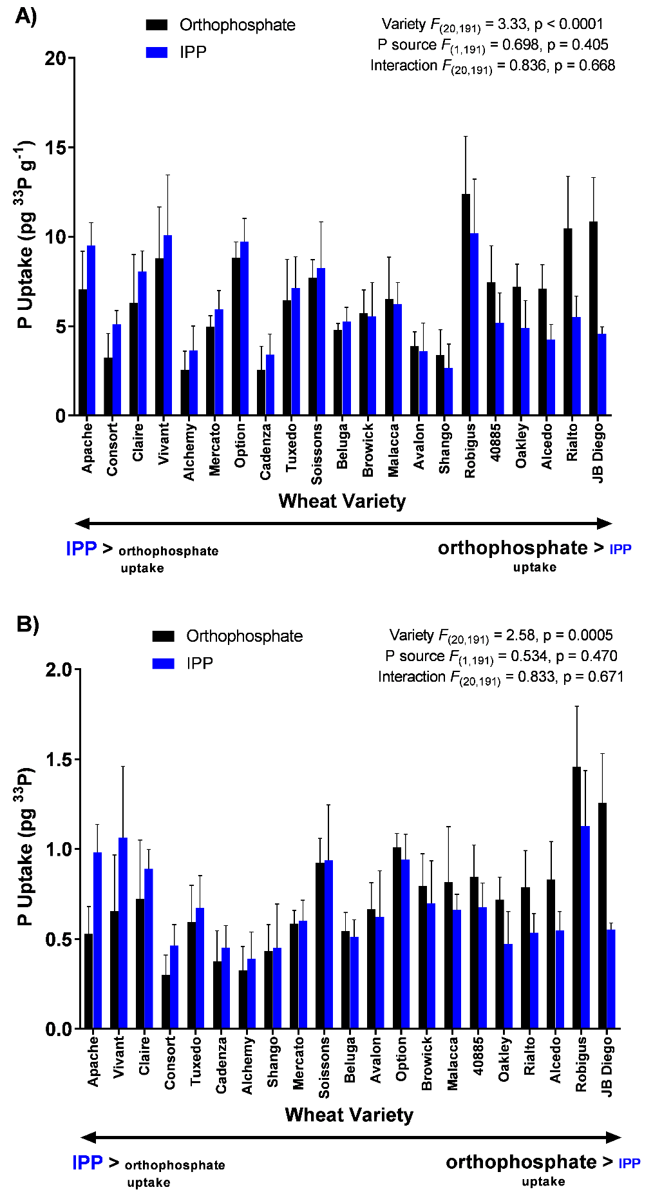
Fig. 4.2: Phosphorus uptake from an orthophosphate or organic inositol polyphosphate (IPP) source in 21 different wheat varieties. Bars show means and error bars show standard error of the mean (n=4-6). The results of a two way ANOVA are shown on the graph. Bars are ordered according to the difference between P uptake from the two different sources in each variety (IPP > orthophosphate on the left). A) P uptake expressed as picograms of ³³P per gram of dry shoot B) P uptake expressed as picograms of ³³P in whole shoot.

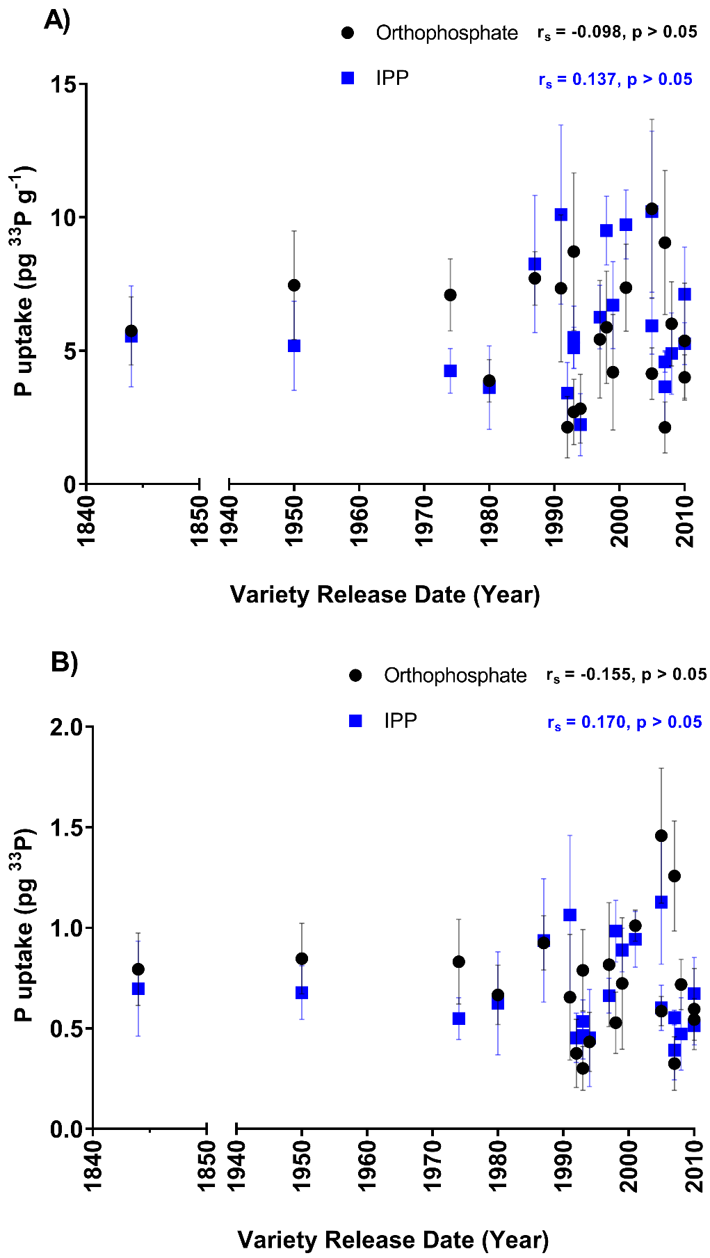
Fig. 4.3: Phosphorus uptake and release date in 21 different wheat varieties supplied with radiolabelled orthophosphate or inositol polyphosphate (IPP). Points show P uptake means of each variety and error bars show standard error of the mean (n=4-6). Results of Spearman’s rank order correlation are shown on the graph. Asterisks denote significance (alpha = 0.05). A) P uptake expressed as picograms of ³³P per gram of dry shoot B) P uptake expressed as picograms of ³³P in whole shoot.

    - Root Traits and P Uptake
      - Phosphomonoesterase Activity
In examining the relationship between P uptake and PME-ase activity, Spearman’s correlation showed that there was a statistically significant positive correlation in P uptake when expressed as ³³P per gram of shoot from both an orthophosphate (p < 0.05) and an IPP (p < 0.05) source with PME-ase activity (Fig. 4.4a). PME-ase activity was six fold greater in the variety with the highest activity (Apache, 3pmol p-NP g⁻¹ s⁻¹) compared to the variety with the lowest activity (Shango, 0.5pmol p-NP g⁻¹ s⁻¹). This increased with P uptake which was approximately 5 fold greater in the variety with the highest uptake (Robigus, 10pg P g⁻¹) compared to the variety with the lowest activity (Alchemy, 2pg P g⁻¹). However, when expressed as total ³³P accumulation in the shoot, Spearman’s correlation showed that there was no statistically significant correlation in P uptake from either an orthophosphate or IPP source (Fig. 4.4b). There were no statistically significant differences between correlations for each treatment when comparing Fisher z values (data not shown, p > 0.05).

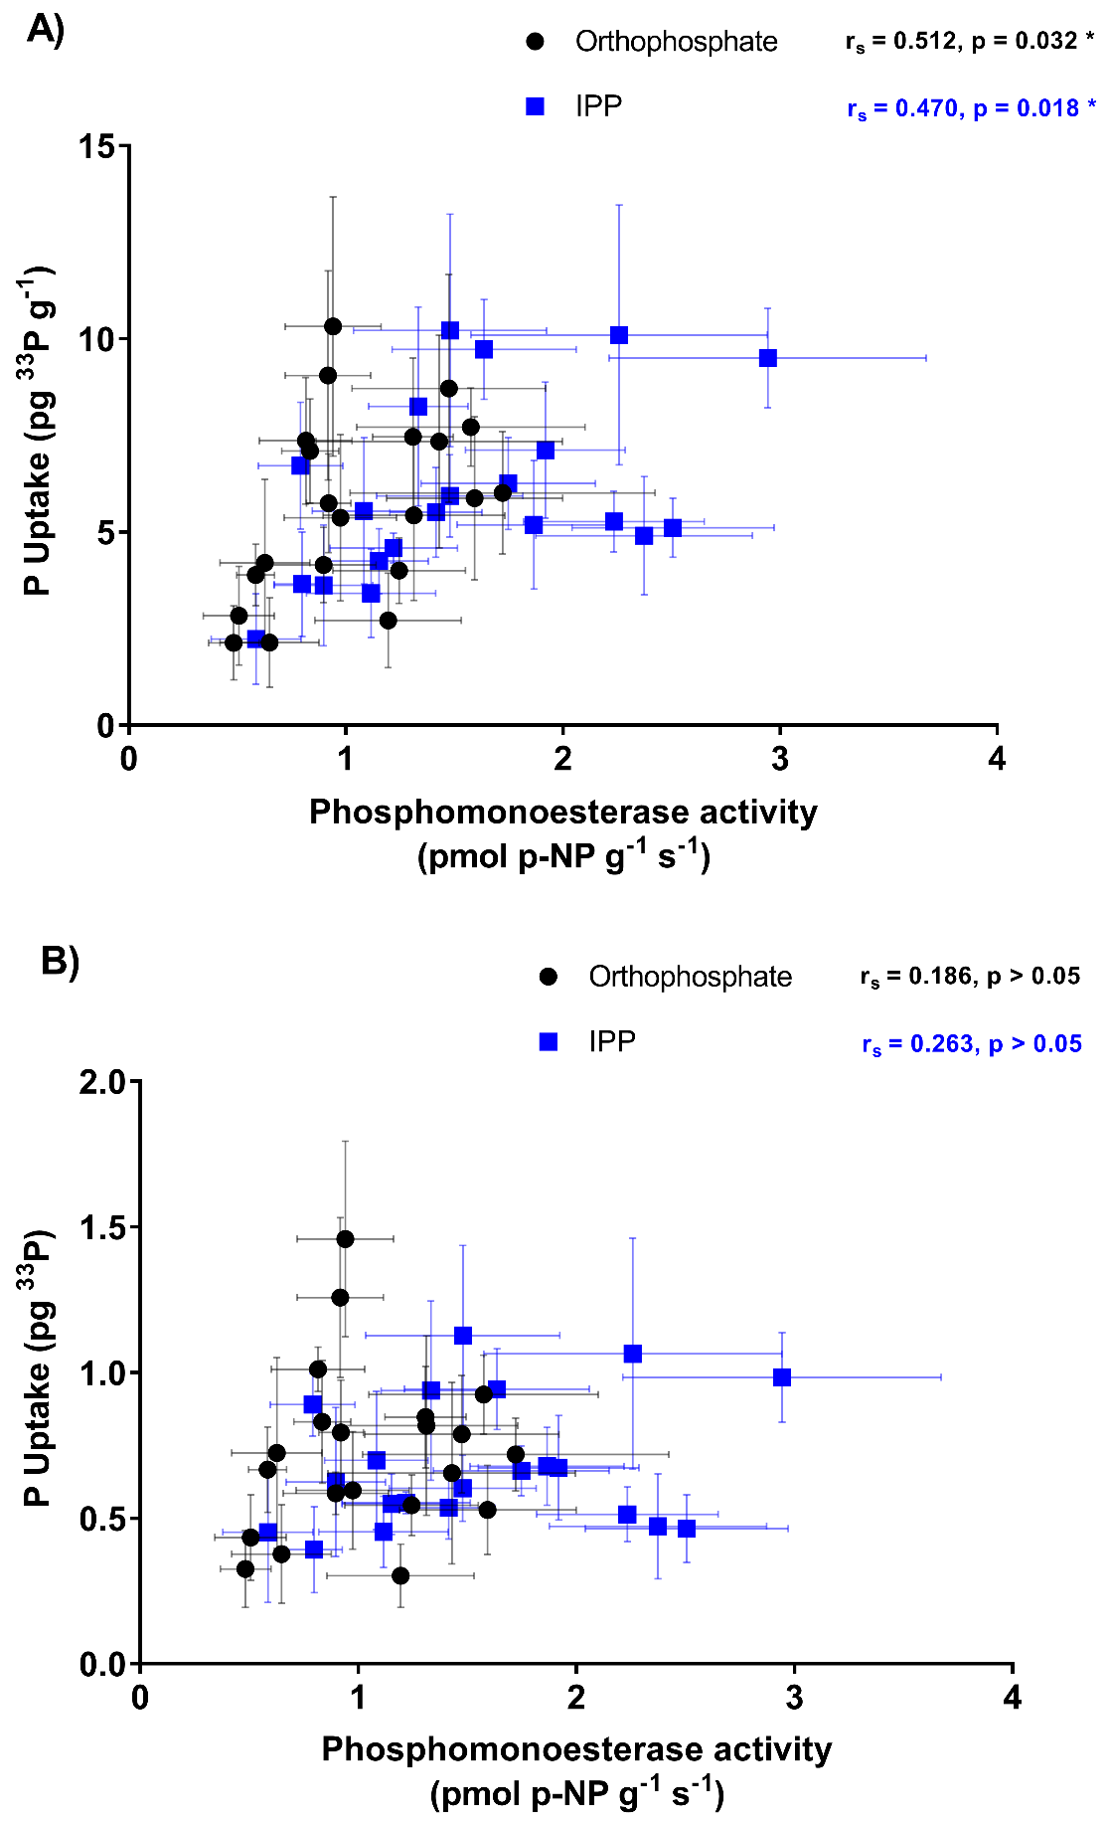
Fig. 4.4: Phosphorus uptake and phosphomonoesterase activity in 21 different wheat varieties supplied with radiolabelled orthophosphate or inositol polyphosphate (IPP). Points show means of each variety and error bars show standard error of the mean (n=4-6). Results of Spearman’s rank order correlation are shown on the graph. Asterisks denote significance (alpha = 0.05 A) P uptake expressed as picograms of ³³P per gram of dry shoot B) P uptake expressed as picograms of ³³P in whole shoot. Enzyme activity expressed as picomoles of p-NP released per gram of fresh root per second.

      - Phytase Activity
No phytase activity was detected in the wheat varieties in this experiment (data not shown). However phytase activity was found in the wheat varieties in Chapter 5.This suggests that an error may have occurred in the assessment of phytase activity. However, a subsequent re-run of samples showed that the samples had degraded and the reason for the absence of phytase activity in this chapter remains unknown.

      - Root Structure
Spearman’s correlation showed that there was a statistically significant negative correlation between P uptake and total root length from both an orthophosphate (p < 0.05) and an IPP (p < 0.01) source (Fig. 4.5a). With an approximately 2.5 fold increase in total root length (from 400 in the smallest variety, Apache, to 1000cm in the largest variety, Alchemy), P uptake decreased 5 fold (from 10 to 2pg P g⁻¹). Similar correlations with P uptake could be seen for root surface area (Fig. 4.5b) and root volume (Fig. 4.5c) for both orthophosphate (p < 0.05) and IPP (p < 0.01) P sources. In each of these cases the negative correlation was stronger in the plants supplied with IPP than orthophosphate with greater r values and smaller P values. However, this was not significant with no statistically significant differences between correlations for each treatment when comparing Fisher z values (data not shown, p > 0.05). When P uptake was expressed as total P accumulated in the shoot a statistically significant negative relationship could still be seen for root length, surface area and volume from a IPP P source (p < 0.05) but no longer for a orthophosphate source (p > 0.05) (Fig 4.5d, e & f).
Of the other root structure traits measured (average root width, bushiness and specific root length), none showed statistically significant correlation with either P source (data not shown, p > 0.05).

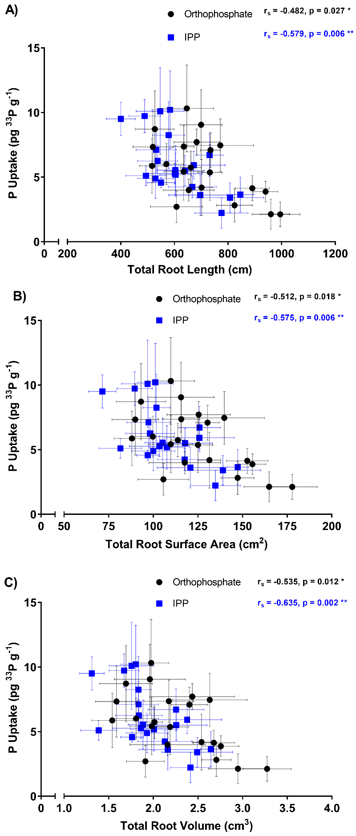
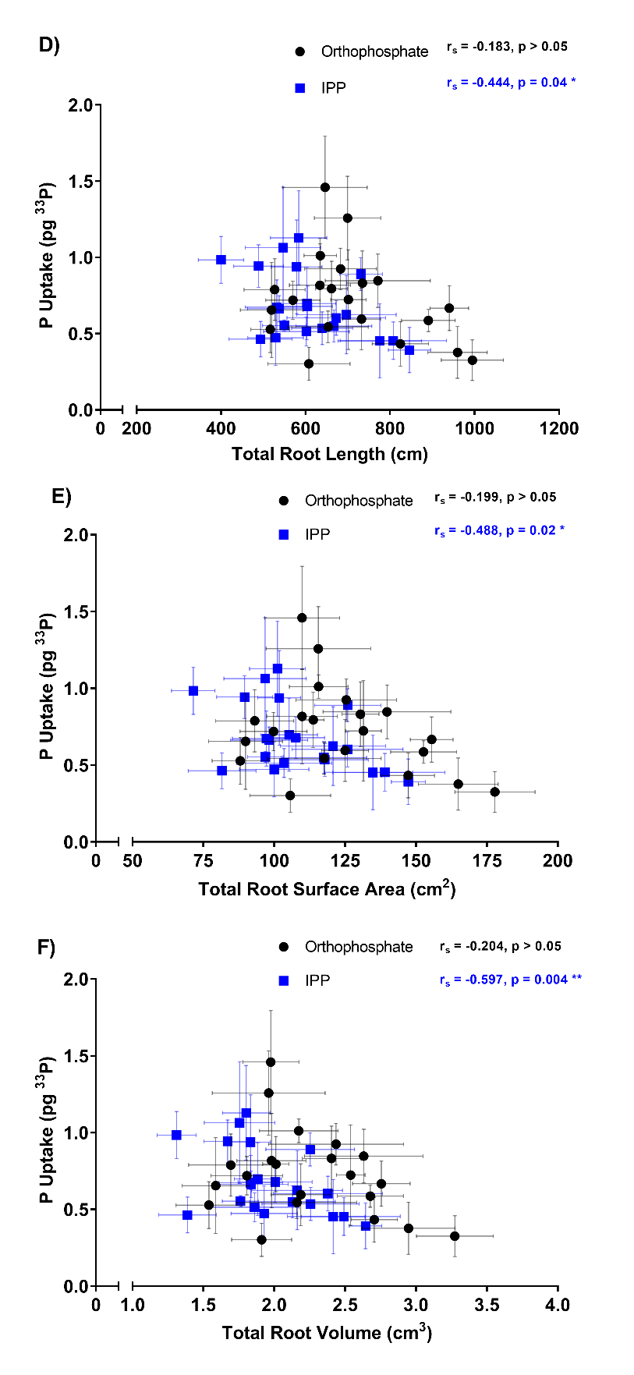
Fig. 4.5: Phosphorus uptake and root structural traits in 21 different wheat varieties supplied with radiolabelled orthophosphate or inositol polyphosphate (IPP). A) & D) total root length, B) & E) total root surface area and C) & F) total root volume. Points show means of each variety and error bars show standard error of the mean (n=4-6). Results of Spearman’s rank order correlation are shown on the graphs. Asterisks denote significance (alpha = 0.05). A), B) & C) P uptake expressed as picograms of ³³P per gram of dry shoot D), E) & F) P uptake expressed as picograms of ³³P in whole shoot.

In examining the relationship between PME-ase activity and total root length, Spearman’s rank order correlation showed that there was a statistically significant negative correlation from both an orthophosphate and an IPP source (Fig. 4.6a, p < 0.0001). With an approximately 2.5 fold increase in total root length (from 400 to 1000cm), PME-ase activity decreased 6 fold (from 3 to 0.5pmol p-NP g⁻¹ s⁻¹). Similar negative correlations with PME-ase activity could be seen for surface area (Fig. 4.6b) and volume (Fig. 4.6c) for both P sources (p < 0.0001). There was no statistically significant differences between correlations for each treatment when comparing Fisher z values (data not shown, p > 0.05). While average root width, bushiness and specific root length showed no significant correlation (data not shown, p > 0.05).
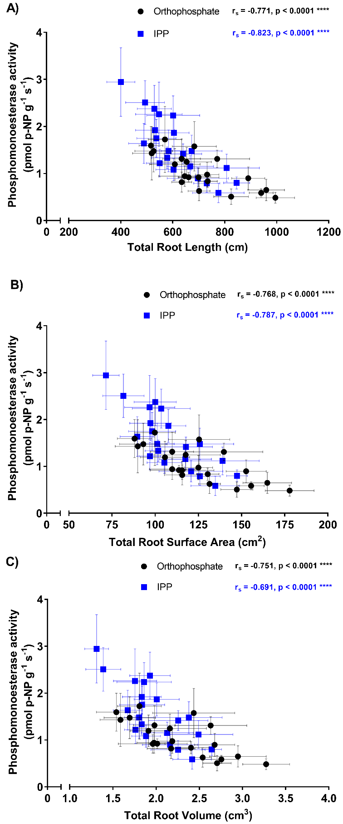
Fig. 4.6: Phosphomonoesterase activity and root structural traits in 21 different wheat varieties supplied with radiolabelled orthophosphate or inositol polyphosphate (IPP). (A) total root length, (B) total root surface area and (C) total root volume. Points show means of each variety and error bars show standard error of the mean (n=4-6). Results of Spearman’s rank order correlation are shown on the graphs. Asterisks denote significance (alpha = 0.05). Enzyme activity expressed as picomoles of p-NP released per gram of fresh root per second.

      - Organic Acid Exudation
Organic acid exudation was measured in a separate set of plants from those which were assessed for P uptake, PME-ase activity and root structure (see Methods section 4.3.4.3).
Spearman’s rank order correlation showed that there was no statistically significant correlation between malic acid exudation and P uptake in the varieties from either P source (Fig. 4.7a, p > 0.05). Citric acid exudation, however, showed a positive correlation with P uptake in the varieties (Fig. 4.7b) from both the orthophosphate (p < 0.01) and IPP sources (p < 0.05). With an increase in citric acid exudation from 1 to 16pmol g⁻¹ s⁻¹, P uptake increased 5 fold (from 10 to 2pg P g⁻¹). This correlation appeared to be stronger for orthophosphate (p < 0.01) than for IPP (p < 0.05), with a larger r value and smaller p value. However, this was not significant with no statistically significant differences between correlations for each treatment when comparing Fisher z values (data not shown, p > 0.05).
When P uptake was expressed as total ³³P accumulation there was again no statistically significant correlation with malic acid exudation (Fig. 4.7c, p > 0.05). For citric acid exudation there was a statistically significant correlation with P uptake from an orthophosphate P source (p < 0.05) but not for the IPP P source (p > 0.05).

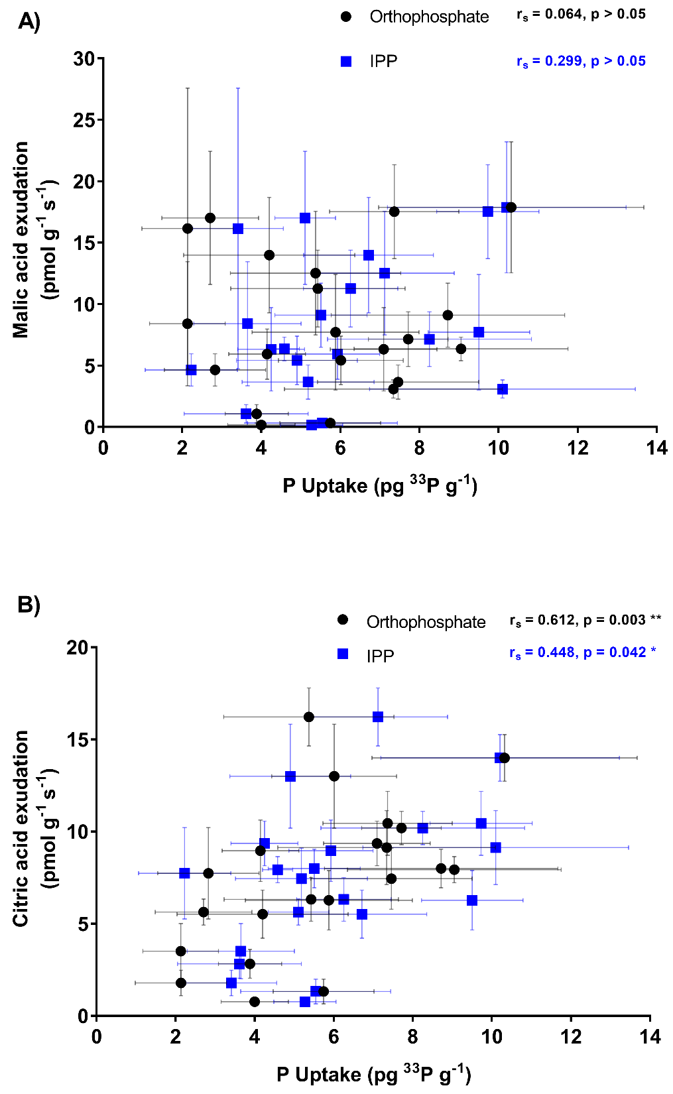
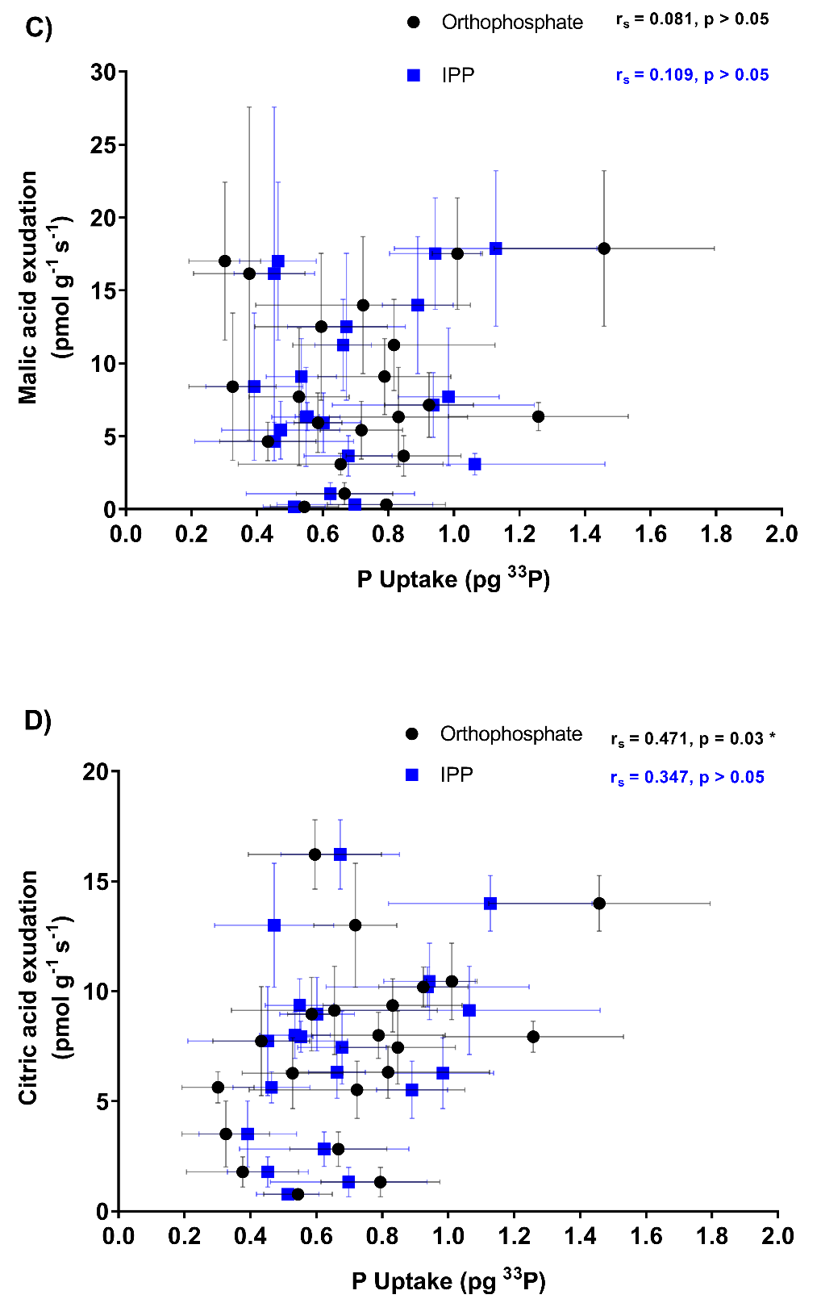
Fig. 4.7: Organic acid exudation and phosphorus uptake in 21 different wheat varieties supplied with radiolabelled orthophosphate or inositol polyphosphate (IPP). (A) malic acid exudation and (B) citric acid exudation. Points show means of each variety and error bars show standard error of the mean (n=4-6). Results of Spearman’s rank order correlation are shown on the graphs. Asterisks denote significance (alpha = 0.05). Acid exudation expressed as picomoles of acid released per gram of fresh root per second. A) & B) P uptake expressed as picograms of ³³P per gram of dry shoot c) & D) P uptake expressed as picograms of ³³P in whole shoot.

In investigating the relationship between PME-ase activity and organic acid exudation in the varieties, Spearman’s rank order correlation showed that there was no correlation between either malic acid (Fig. 4.8a, p > 0.05) or citric acid exudation (Fig. 4.8b, p > 0.05) for either P source.

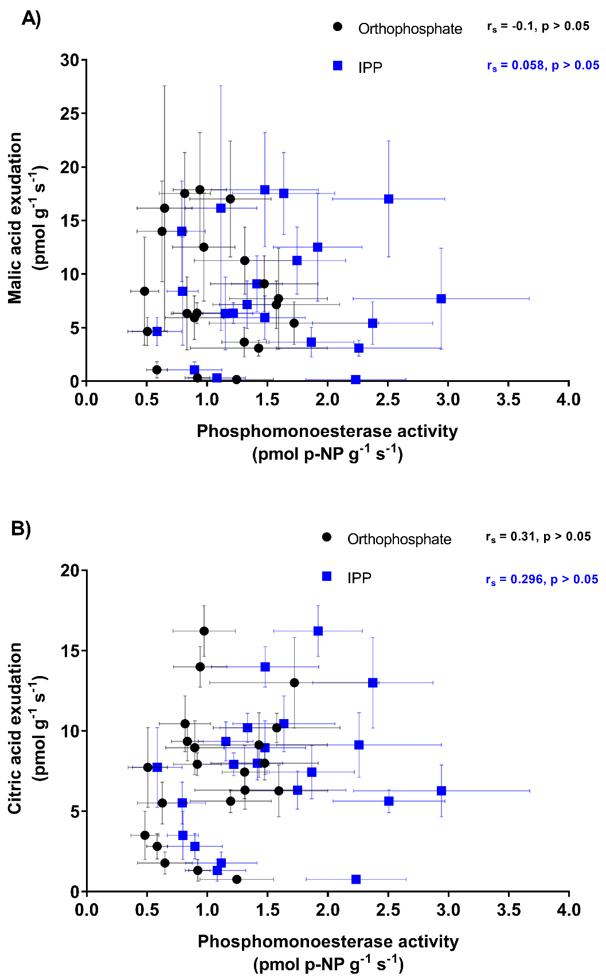
Fig. 4.8: Organic acid exudation and PME-ase activity in 21 different wheat varieties supplied with radiolabelled orthophosphate or inositol polyphosphate (IPP). (A) malic acid exudation and (B) citric acid exudation. Points show means of each variety and error bars show standard error of the mean (n=4-6). Results of Spearman’s rank order correlation are shown on the graphs (alpha = 0.05). Acid exudation expressed as picomoles of acid released per gram of fresh root per second. Enzyme activity expressed as picomoles of p-NP released per gram of fresh root per second.

Spearman’s correlation showed that total root length, surface area, volume and root bushiness did not show statistically significant correlations with either malic acid or citric acid exudation from either P source (data not shown, p > 0.05). However, when plotted against citric acid exudation, average root width (Fig. 4.9a) and specific root length (Fig. 4.9b) showed statistically significant correlations for plants supplied with IPP (p < 0.01) but not with orthophosphate (p > 0.05). Average root width showed a positive correlation with citric acid exudation: with an approximately 1.2 fold increase in average root width (from 0.052 to 0.061cm), citric acid exudation increased from 1 to 16pmol g⁻¹ s⁻¹. This was reflected in a statistically significant difference between the orthophosphate and IPP correlations (data not shown, p < 0.05). In contrast, specific root length showed a negative correlation with citric acid exudation: with an approximately 1.4 fold decrease in specific root length (from 380 to 275cm⁻²), citric acid exudation increased from 1 to 16pmol g⁻¹ s⁻¹. However, there was not a statistically significant difference between the orthophosphate and IPP correlation (data not shown, p < 0.05).

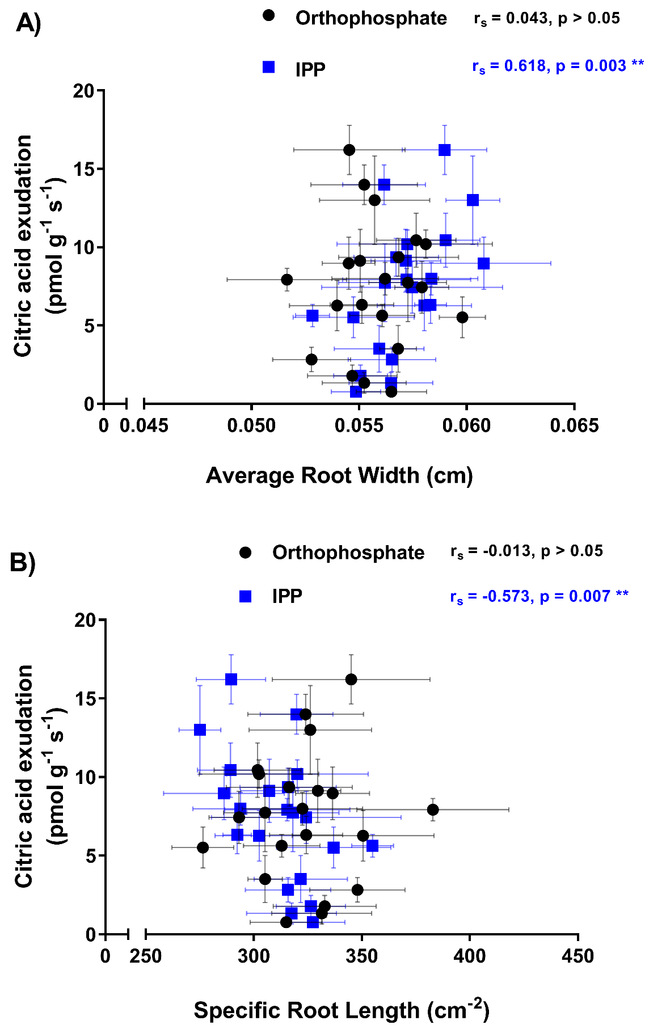
Fig. 4.9: Citric acid exudation and factors of root structure in 21 different wheat varieties supplied with radiolabelled orthophosphate or inositol polyphosphate (IPP). (A) malic acid exudation and (B) citric acid exudation. Points show means of each variety and error bars show standard deviation (n=4-6). Results of Spearman’s rank order correlation are shown on the graphs. Asterisks denote significance (alpha = 0.05). Acid exudation expressed as picomoles of acid released per gram of fresh root per second.

  - Discussion
This is the first study to assess radiolabelled ³³P uptake from both an orthophosphate and monoester (IPP) source in a range of wheat varieties, and also assess how root traits (phosphatase enzyme activity, root structure and organic acid exudation) relate to P uptake from the inorganic and organic sources. Overall, it revealed variation in the P uptake in the wheat varieties from the inorganic and organic sources. It also revealed that P uptake varied in the different varieties and that this may be explained by their root PME-ase activity. PME-ase activity was, however, in a trade-off with total root size in that larger root systems had lower PME-ase activity than smaller root systems.

    - P Uptake in Varieties
Different varieties of wheat showed statistically significant differences in ability to take up P. However, while there appeared to be variation in P uptake from the two P sources, with some varieties showing greater uptake from orthophosphate vs IPP (and vice versa), this was not statistically significant overall (no variety and P source interaction). Lack of significance may have been due to the IPP source being impure and containing 20% orthophosphate. This could have meant that the plants still took up orthophosphate when supplied with IPP and the effect of the IPP source was reduced. On the other hand, the effect of this is likely to only have been small since the varieties showed different P uptake from the two sources. Further, evidence from Chapter 5 (for which a purer form of ³³P IPP had been developed) supports the findings of this chapter.
The work in this chapter found no evidence of modern wheat varieties having reduced ability to uptake P from an organic P source compared to older varieties. A relationship may not have been found because of the relatively small number of varieties analysed (21) and the fact that few varieties had a release date before 1990.

    - Root Traits and P Uptake
      - Phosphomonoesterase Activity
It appeared that with greater PME-ase activity wheat varieties were able to take up more P from both sources. However, this relationship was not seen when looking at the total ³³P taken into the shoot (as opposed to the ³³P taken up per gram of shoot. This casts some doubt on the ability of the PME-ase activity in these plants to influence P uptake. Previous studies have shown that greater PME-ase activity contributes to P uptake from organic sources (Richardson et al., 2000; George et al., 2008; Ma et al., 2012). For an IPP source this is logical as this enzyme activity can cleave P from the IPP making it available for uptake (Hayes et al., 2000). For the orthophosphate source, PME-ase could not have played the same role since orthophosphate can be taken up directly by plants. However, PME-ase has been proposed to have a role in P transportation (Duff et al., 1994), in which case its activity would benefit uptake from both sources of P (Gahoonia and Nielsen, 2004). It should also be noted that the PME-ase assay measures broad phosphomonoesterase enzyme activity rather than the activity of any one specific enzyme (Nannipieri et al., 2011). This coupled with the lack of knowledge on the specific roles of PME-ase enzymes, except to hydrolyse monoesters, means that the role of PME-ase enzyme activity is unclear. Confirming the role of PME-ase in orthophosphate uptake is the fact that, although activity is upregulated in the presence of organic P, PME-ase is still active when the only P source is orthophosphate (Richardson et al., 2000).
The role of PME-ase in these wheat plants may not be solely to cleave orthophosphate from inositols but to transport P too, even so, it may be important to accessing P from IPP. Targeting PME-ase for improvement in crop species could, therefore, enhance their ability to use organic P sources but may also improve their ability to transport P and so improve P uptake regardless of the source. In these wheat plants the lack of effect of PME-ase activity in P uptake may be due to low activity and so improvement could be possible if the activity was enhanced. It has been suggested that enhanced phosphatase activity could improve P uptake from both organic P and orthophosphate (Gahoonia and Nielsen, 2004) which the evidence found in this chapter corroborates: greater PME-ase activity was associated with P uptake from both organic forms as well as orthophosphate. To improve the efficiency of P use in agricultural systems, it is likely that both orthophosphate and organic P need to be used more effectively (Stutter et al., 2015) and enhancing PME-ase activity could be a way to do this.

      - Phytase Activity
Wheat is known to have low levels of phytase activity (Richardson et al., 2000) and so the lack of detection of phytase in this chapter may not be surprising. Further to this, phytase activity is known to be triggered under low P conditions (Duff et al., 1994; Hayes et al., 1999). The experimental conditions in this chapter did not expose the plants to low P and, therefore, phytase activity may have not been triggered. However, the phytase activity detected in Chapter 5 suggests that an error may have occurred in the protocol meaning that phytase activity was present but undetected. Unfortunately it was not possible to draw any conclusions from this chapter regarding phytase activity, however, the phytase activity data from Chapter 5 can contribute to our understanding.

      - Root Structure
A negative relationship between P uptake, from both an orthophosphate and IPP source, and total root system length was also seen with surface area and volume. Total root system length, surface area and volume are closely related factors and all describe the overall root system size. A larger root system will be in contact with a larger volume of soil and should, presumably, be able to take up more P (Manske and Vlek, 2002). However, it could also be seen in this chapter that with increasing root system size the wheat varieties showed a decrease in PME-ase activity. Since the larger root systems had less PME-ase activity, and this was shown to be important to P uptake, the larger root systems had lower P uptake. In fact, PME-ase activity was lower in larger root systems, not only per gram of root fresh weight, as presented, but also as a total for the whole root system (data not shown, statistically significant for the IPP source p < 0.05, not statistically significant for the orthophosphate source p > 0.05). A stronger negative correlation between root system size and P uptake in plants supplied with IPP than those supplied with orthophosphate, although not statistically significant, could elude to the greater importance of PME-ase activity to uptake of P from IPP than orthophosphate. This is highlighted when presenting P uptake as total P in the shoot where a significant negative relationship was only seen for an IPP source.
The negative correlation between root system size and PME-ase activity suggests a trade-off between these two traits i.e. investing in a larger root system means the plants invest less in enzyme activity and vice versa. Investment in certain root structural traits has been shown to be detrimental to other root functions: production of shallower growing roots reduces the development of deeper growing roots and, though this was beneficial to P uptake (Lynch and Brown, 2001; Zhu et al., 2005), it was detrimental to water acquisition (Ho et al., 2005). Not only does this highlight that trade-offs can occur, it also highlights that root traits may need to be tailored to specific soils (Lynch, 2011). For example, shallow roots may be beneficial to P uptake and not have a detrimental effect on water acquisition in moist soils, whereas, shallow growing roots would not be ideal in dry soils. A trade-off between root system size and PME-ase activity has not been investigated before but due to the cost to the plant of root traits it is likely that trade-offs exist (Gahoonia and Nielsen, 2004; Lynch et al., 2005) and, in the case of the wheat plants in this chapter, the cost of larger root systems may have resulted in lower PME-ase activity.
Average root width, bushiness and specific root length showed no correlation with P uptake or PME-ase activity and so seemingly had no effect on these. This may have been due to the varieties not varying greatly for these traits; there was a 1.2, 1.4 and 1.3 fold increase from the lowest to the highest in average root width, specific root length and bushiness respectively, while other root traits increased at least 2.5 fold.
Root hairs are thought to be important to P uptake but were not investigated in this work. As root system size did not appear to present a target for improvement in wheat it may be that increased root hairs may have a similar negative relationship with P uptake. However, root hairs are often suggested to be low cost (Hetrick, 1991; Lynch et al., 2005) and so may not incur as large a cost to the plant as other root structures whilst still improving P uptake. Growth of root hairs is plastic and suppressed under high P conditions (Gahoonia et al., 1999; Gahoonia and Nielsen, 2003). The plasticity in root hairs may suggest that there is, although unknown, a cost of root hairs, either directly in the form of carbon cost, or indirectly such as increased susceptibility to root pathogens (Lynch and Brown, 2008). Certainly the importance of root hairs in P uptake from organic and inorganic P sources warrants further attention (Jungk, 2001).
Overall, this work cannot recommend larger root systems as a rational target for increasing the ability of wheat to access P in organic forms. In contrast, smaller root systems could be a target for increasing access to P in organic forms because of their potentially higher PME-ase activity. However, some caution is needed here without further study since smaller root systems will be in contact with a decreased volume of soil and this would presumably also reduce P uptake. This is a negative consequence that may not have been drawn out in this rhizotron study where the root system came into good contact with the supplied ³³P radiolabelled source. In contrast, in the field a large volume of soil needs to be explored by roots as P is heterogeneous in the soil, and so in the field environment a larger, more branching root system may be more beneficial than assessed in this rhizotron study.

      - Organic Acid Exudation
The organic acid exudation results were measured in a separate set of plants from the plants which were assess for P uptake, PME-ase activity and root structure. As these plants did not receive a P source and were not grown in the same containers as the original plants, it must be assumed the exudation measured was representative of the exudation in the original plants that were assessed for P uptake, PME-ase and root structure.
Malic acid exudation showed no correlation with P uptake or any root traits and this suggests it had little or no role in P uptake. On the other hand, citric acid did show correlation with P uptake from both the organic and inorganic P source, suggesting it is important in P uptake. The detection of exudation of both acids at approximately 1-20pmol g⁻¹ s⁻¹ is within the range detected in other crops at approximately 0.02-165 pmol g⁻¹ s⁻¹ (Jones, 1998)).
While P uptake from both sources increased with citric acid exudation, a stronger correlation with orthophosphate (although not statistically significant) may suggest that P uptake in plants supplied with orthophosphate was more dependent on citric acid solubilisation than in plants supplied with IPP. This was highlighted when P uptake presented as total P accumulation in the shoot only showed a statistically significant correlation for the orthophosphate P source. Alongside this, PME-ase showed no correlation with exudation of either organic acid in plants supplied with either P source. In the field this may limit the uptake of P from IPP in wheat plants with greater PME-ase activity if organic acid exudation did not solubilise the IPP. In this chapter the effect of this may not have been detected as the added P source would not have been as tightly bound to soil as it may be in a soil in the field (Turner et al., 2005a). The use of phytate as a P source by plants has previously been suggested to be limited by organic acid exudation rather than phosphatase enzyme activity (Gerke, 2015), and the importance of solubilisation has been shown in studies which found that the binding of organic P to soil substrate prevented its use as a P source while it was available as a P source in vitro (George et al., 2004, 2008).
Organic acid exudation did not increase with increasing root system size (i.e. length, surface area and volume). This may further explain why P uptake was not greater in larger root systems as lower acid exudation did not solubilise the P sources. However, both a positive correlation between average root width and citric acid exudation and a negative correlation between specific root length and citric acid exudation suggests that roots with a larger volume do exude more citric acid per gram of root fresh weight. The relationship between root volume and P uptake has rarely been investigated (Nielsen and Schjørring, 1983) and is, therefore, largely unknown. However, if the relationships seen in this chapter are accurate, roots with a larger volume may have more cellular resources and consequently a greater ability to exude organic acid. As there is known error in using image analysis to measure root width (Bouma et al., 2000) and the method used was high-throughput (Galkovskyi et al., 2012) the reliability of these results may be uncertain.
The evidence from other work for enhancement of organic acid exudation to improve use of organic P as a P source is inconsistent. Transgenically enhanced citrate synthase expression has been found to both improve P uptake from an organic source (de la Fuente et al., 1997) and have little or no effect (Delhaize et al., 2001; Ryan et al., 2014). This contradiction has cast some doubt over the usefulness of organic acid exudation as a target to improve use of organic P as a P source. (Gahoonia and Nielsen, 2004). Some of the variation in the effect of organic acid exudation on plant P uptake may be due to soil type (Oburger et al., 2011) or which organic acid is exuded (Khademi et al., 2009). Nevertheless, it has been suggested that enhanced organic acid exudation could improve P uptake from both organic P and orthophosphate. The evidence in this chapter corroborates this: greater citric acid exudation was associated with greater P uptake from both IPP and orthophosphate. To improve the efficiency of P use in agricultural systems, it is likely that both orthophosphate and organic P need to be used more effectively (Stutter et al., 2015) and enhancing organic acid exudation in combination with PME-ase activity could be a way to do this.

  - Conclusion
This work has shown that a range of wheat varieties were able to acquire P from orthophosphate or IPP sources in soil. This was not found to be relative to release date and therefore there is no evidence that modern wheat varieties have lost some ability to access P from organic sources. P uptake from both sources appeared to be dependent on root surface PME-ase activity which eludes to the role of PME-ase in both organic P mineralisation (which would only be required in the case of IPP) and orthophosphate transportation (required for both IPP and orthophosphate). However, PME-ase activity was found to decrease relative to root system size which suggests there may have been a trade-off between these two traits in terms of cost.
Greater levels of citric acid exudation were beneficial to P uptake and point to the importance of solubilisation in accessing P in organic forms. Similarly to PME-ase activity, citric acid exudation was not greater in larger root systems and this, again, suggests that larger root systems were not beneficial to P uptake.
Overall, given that this work demonstrates that wheat plants have some capacity to access P in inositols, and that PME-ase activity and organic acid exudation in the roots are important to facilitating this, this work recommends that simultaneously enhancing the PME-ase activity and organic acid exudation of wheat roots is a priority for developing wheat with greater ability to acquire P from the inositol, and ultimately become less reliant on fertiliser P inputs.
This chapter has investigated the ability of the wheat plants alone. However, soil microbes also play a key role in plant nutrition. Hence building on this chapter the next chapter investigates the influence of mycorrhizas on P uptake from an organic and inorganic P source.

- The Role of Mycorrhizas and Root Traits in Phosphorus Uptake from Organic Forms by Wheat

  - Summary
Organic forms of phosphorus (P) in soil are a potential source of P for crop plants which could reduce the need for fertiliser P. It is not clear, however, what role mycorrhizas in wheat plants play in P uptake from organic forms in agricultural soil or their effect on root traits that facilitate P uptake from organic forms.
To investigate the role of mycorrhizas in P uptake from an organic source, four varieties of wheat were grown in an arable soil. The varieties were selected to vary in their P uptake, root traits and mycorrhizal association. Plants were inoculated with or without active mycorrhizas and grown under greenhouse conditions for 6 weeks. These were then supplied with radiolabelled ³³P in either the inorganic form of orthophosphate or in the organic form of inositol polyphosphates. P uptake, mycorrhizal colonisation and root traits important to P uptake were then measured. Assessed root traits were root system size, phosphomonoesterase activity, phytase activity and organic acid exudation.
³³P uptake was very low in this work and showed no clear pattern with P source or mycorrhizal inoculation. Furthermore, while the mycorrhizal and non-mycorrhizal treatments did have significantly different colonisation levels, colonisation rates were low and probably limited the ability of this work to detect mycorrhizal effects.
The different mycorrhizal treatments had no effect on root traits and this was reflected in the absence of any relationships between level of mycorrhizal colonisation and other root traits. Nonetheless, there were clear negative correlations between phosphatase enzyme activities and both organic acid exudation and root system size that suggested that trade-offs existed between these. This supports the work of Chapter 4 which indicated that trade-offs may occur in allocating resources between different methods/adaptations for P acquisition. Again, larger root systems were shown to not possess greater root traits for acquisition of P.
In summary, the work in this chapter supplied further evidence (building on Chapter 4) that root system size is not a suitable target for enhancement of P uptake from organic P as this may prevent investment in other root traits that enhance P acquisition. Mycorrhizal colonisation did not confer any benefits to P uptake, though the low colonisation rates limit any conclusion that mycorrhizas are not beneficial in wheat. Nonetheless, phosphatase enzyme activity and organic acid exudation were shown to be important for P uptake from organic sources and so provide a target for trait enhancement in wheat. Any future studies where the importance of root trait/s to P uptake are studied should include assessment of a range of P uptake traits to ensure the effect of any trade-offs between traits are understood.

  - Introduction
In Chapter 4 root traits in wheat which improve P uptake from an organic P source were identified and these were then recommended as targets for enhancement in wheat to improve use of naturally occurring soil organic P. However, microorganisms are also known to be important to P uptake in plants and may also have a role in modifying some root traits that allow plants to access P. To better understand how wheat may be able to better utilise organic P in soil, the role of microorganisms in this needs elucidating.

    - Soil Microorganisms and Plant P Uptake
P in microbial biomass is an important source of P in natural systems (Achat et al., 2010; Tamburini et al., 2012; Turner et al., 2013). Although the proportion of P in the microbial biomass in agricultural systems may be low (3-24%, Brookes et al., (1984)), this may still be available to plants and represent a constant supply as microbes turnover. Although microbes have their own P requirements and therefore immobilise P in competition with plants, microbial biomass P is protected from reactions with the soil which would otherwise immobilise it (Richardson and Simpson, 2011).

      - The Role of Mycorrhizas in Plant P Uptake
Mycorrhizas can improve P uptake in their symbiotic plant partner by three mechanisms: 1) mycorrhizas increase the effective size of the root system length through the volume of soil in contact with the mycorrhizal hyphae, 2) mycorrhizas turnover P and so make it more accessible to plants, and 3) mycorrhizas solubilise and mineralise P sources i.e. by exudation of organic acids and phosphatase enzyme activity (Smith and Read, 2009). Mycorrhizas have been shown to improve the ability of plants, including wheat, to take up P from less available and organic P sources (Bolan, 1991; Tarafdar and Marschner, 1994, 1995; Koide and Kabir, 2000; Feng et al., 2003; Jansa et al., 2011). The ability of mycorrhizas to access P from organic sources is often attributed to mycorrhizal phosphatase activity (Dodd et al., 1987; Tarafdar and Marschner, 1994; Wang et al., 2017). Additionally, transgenic expression of fungal phytase in plants has been shown to increase a plant’s ability to access P from organic forms (George et al., 2004, 2005b; Giles et al., 2017a) which suggests that fungi and potentially mycorrhizas can facilitate access to P in organic forms and that transgenic expression of phosphatase activity in plants could increase their ability to use P in organic forms.
However, over time, the breeding of new varieties of crops may have reduced their effectiveness at forming mycorrhizal association as crops have become dependent on easily accessible fertiliser P (Hetrick et al., 1993). While this has been shown not to be true in maize (Chu et al., 2013) and in a meta-analysis of crop species (Lehmann et al., 2012) there is evidence that modern wheat varieties have lower mycorrhizal responsiveness (Zhu et al., 2001). As discussed in Chapter 3 (section 3.2.1.1) agricultural practices can negatively affect mycorrhizas in arable soil (Jansa et al., 2002; Oehl et al., 2003; Kabir, 2005; Säle et al., 2015). Likewise, greater soil P concentrations, which are often present in agriculture, can repress mycorrhizal fungi (Miranda and Harris, 1994; Li et al., 2006). Following this, low input agriculture has been shown to increase colonisation in wheat (Mäder et al., 2000). A move towards lower P input in agriculture (which may be inevitable with increasing prices of P fertilisers and since low P input is favoured in conservation agriculture) could therefore help promote mycorrhizal colonisation. This in turn could improve the crop plants’ ability to access P in organic forms.

      - Influence of Mycorrhizas on Root Traits Involved in Plant P Uptake
The increase in soil volume explored by hyphae in mycorrhizal plants is the most direct way that mycorrhizal colonisation effects P uptake (Richardson and Simpson, 2011). Hyphae are often thought of as playing a similar role to root hairs but are able to extend the effective root system size more than root hairs as they as can extend further than root hairs (Richardson et al., 2011). It follows that an increased surface area of root in mycorrhizal plants, via hyphae, not only provides a larger area for P uptake but also may represent an increased opportunity for phosphatase activity and organic acid exudation.
Contradicting evidence has been found for the effect of mycorrhizas on the phosphatase enzyme activity of wheat roots. Mycorrhizas have been found to increase the phosphatase activity of wheat roots (Dodd et al., 1987; Tarafdar and Marschner, 1995, 1994; Abdel-Fattah and Asrar, 2012), while they have also been found to have little or no effect (Joner and Jakobsen, 1995; Joner and Johansen, 2000). Low levels of phosphatase activity have, therefore, prompted suggestion that phosphatase enzyme release in plants and mycorrhizas is incidental and does not benefit the plants and mycorrhizas (Joner et al., 2000). Variation in effect of mycorrhizas on phosphatase activity has been attributed to the different plant variety/fungus species combinations (Joner and Jakobsen, 1995). Although there is some evidence for mycorrhizas not having an effect on phosphatase activity, the fungus Glomus intraradices, which is often used as the fungal inoculant in mycorrhizal studies and which was used in this chapter, has been found to have phosphatase activity (Joner and Johansen, 2000). Further to this, fungal phosphatases have been found to be more efficient than plant phosphatases at hydrolysing forms of organic P (Tarafdar et al., 2001). This contributes to the general assumption that mycorrhizas contribute to P uptake from organic forms and that phosphatase activity may mostly come from mycorrhizas rather than plants themselves (Richardson et al., 2009b).
Microorganisms can theoretically act as both a source and sink of organic acids and so the overall effect of mycorrhizas on exudation has not been fully elucidated yet (Jones et al., 2003). It is unsurprising, then, that mycorrhizal plants have been found to have both greater organic acid exudation (Tawaraya et al., 2006) and lower organic acid exudation compared to non-mycorrhizal plants (Nazeri et al., 2014). It is likely that growth conditions, plant species and mycorrhizal species influence the effect of mycorrhizas on organic acid exudation (Jones et al., 2004). For example, organic acid exudation which conferred aluminium tolerance only occurred in mycorrhizal associations with certain species of fungi (Klugh and Cumming, 2007). Although the exact relationships under different conditions are unclear, it has been suggested that mycorrhizas may play a more important role in organic acid exudation than plants themselves (Jones et al., 2003).

      - Benefits and Costs of Mycorrhizas in Agriculture
Mycorrhizal symbiosis can provide a range of benefits to host plants (Gosling et al., 2006) such as nutrient uptake including P (Bolan, 1991), pathogen resistance (Graham, 2002), drought resistance (Augé, 2001), heavy metal tolerance (Hildebrandt et al., 2007), and also provide benefits to soil conditions by improving soil aggregation (Rillig and Mummey, 2006), increasing soil organic matter (Godbold et al., 2006), and improving soil structural characteristics such as porosity and bulk density (Daynes et al., 2013).
Although mycorrhizas are often thought of as being universally beneficial, this is not always true. For example, mycorrhizal colonisation has been suggested to protect plants from pathogens (Newsham et al., 1994, 1995; Pozo and Azcón-Aguilar, 2007; Del Fabbro and Prati, 2014) but there is also evidence that mycorrhizal colonisation can make plants more susceptible to pathogens (Toth et al., 1990). As contrasting evidence has been found it is likely that the relationship between mycorrhizas, pathogens and plants is complex, variable and requires more research (Graham, 2002). As low input agricultural systems include minimising the use of pesticides, the role of mycorrhizas in protecting crops from pathogens may be of more importance than in higher input agricultural systems (Harrier and Watson, 2004).
While in non-mycorrhizal plants increasing organic acid exudation is a response to low P (Pearse et al., 2007), there is evidence that mycorrhizal plants decrease their organic acid exudation in response to low P (Nazeri et al., 2014). This could be a result of a trade-off between mycorrhizal colonisation and organic acid exudation as both have a high carbon cost (Ryan et al., 2012).
It has also been suggested that mycorrhizas do not play a role in agricultural soils due to the conditions in agricultural systems not being conducive to colonisation. For instance, fertiliser P and pesticides applied to the soil supress fungi and mycorrhizal colonisation (Ryan and Graham, 2002). Further to this, mycorrhizas are a cost to the plant (Lynch et al., 2005) and, although estimates of this in different plants vary, 4-20% of a plants carbon may be delivered to the fungus (Bago et al., 2000). Under certain conditions, the carbon cost of mycorrhizal colonisation is such that the symbiosis is not beneficial (Ryan et al., 2005). There is some evidence though, that the cost of mycorrhizas may only be detrimental to the plant temporarily but not in the long term (Li et al., 2005). As a consequence of the uncertainty in the benefit of mycorrhizas to agricultural crop plants, it has been suggested that increasing mycorrhizal colonisation in crops should only be carried out if the end result is truly beneficial to plants and soil (Ryan and Graham, 2002).

      - The Role of Rhizobacteria in Plant P Uptake
Soil bacteria, and in particular plant growth promoting rhizobacteria, can improve plants P acquisition by stimulating root growth, facilitating access to P through turnover and by solubilising and mineralising P through metabolic processes including organic acid exudation and phosphatase enzyme activity (Vessey, 2003). Inoculation of agricultural crops with bacteria may improve P acquisition from an organic source in plants (Richardson, 2001; Jorquera et al., 2008; Malboobi et al., 2009) especially in combination with other soil microorganisms including mycorrhizas (Tarafdar and Marschner, 1995; Khan et al., 2009; Nain et al., 2010; Minaxi et al., 2013). Inoculation with rhizobacteria may, however, not always be effective in improving the P nutrition in plants (Belinque et al., 2015). For example, in one study the use of inositol hexakisphosphate by pasture and legume species was improved with addition of bacteria but only at concentrations of inositol that were much greater than soil concentrations. However, when inoculated with a mixture of cultured soil microbes, the plants were able to use P from the inositol source at soil concentrations (Richardson et al., 2001). Interactions between rhizobacteria and plants are complex and further understanding is needed to ensure the effectiveness of rhizobacteria inoculation.

    - Aims and Hypotheses
For organic P in arable soil to be used as a P source by crop plants the P must be accessible. As microbes may have important roles in assisting plants to access P in organic forms, the influence of mycorrhizas on P uptake and root traits which facilitate this must be known.
In this chapter, P uptake by mycorrhizal and non-mycorrhizal inoculated wheat from an organic P source were investigated. With wheat varieties able to access P in organic forms (Chapter 4), this chapter aimed to determine: 1) the effect of mycorrhizas on P uptake from an IPP source and 2) the effect of mycorrhizas on the root traits which facilitate P uptake from IPP. To facilitate this understanding, a subset of wheat varieties used in Chapter 4 that differed in their root traits and level of mycorrhizal colonisation were used.
It was hypothesised that P uptake from IPP would be greater in plants with a mycorrhizal treatment compared to those with a non-mycorrhizal treatment. Varieties which had greater mycorrhizal colonisation would have greater P uptake from IPP compared to those with lower mycorrhizal colonisation. It was also hypothesised that both these patterns would also be true of an orthophosphate P source, but to a lesser degree (i.e. lesser importance of mycorrhizas in P uptake from orthophosphate compared to P uptake from IPP). It was further hypothesised that the greater P uptake in mycorrhizal plants would be associated with and caused by greater phosphatase enzyme activities and organic acid exudation. Similar to Chapter 4, root system size would have a negative association with P uptake and other root traits, and this negative association would be greater in mycorrhizal plants due to the cost of both mycorrhizas and root structures to the plant.

  - Materials and Methods
A selection of 4 wheat varieties (5-6 replicates) were either inoculated with a mycorrhizal treatment or a deactivated non-mycorrhizal treatment. These were grown for 46 days before being supplied with radiolabelled P as either orthophosphate or inositol polyphosphates (IPP). The plant’s ability to access these two sources was assessed by measuring ³³P uptake to shoots along with their mycorrhizal colonisation and relevant root traits: root system size, phosphatase enzyme activity and organic acid exudation.

    - Plant Growth Conditions
Plant growth conditions were as detailed in Chapter 4, section 4.3.1. A summary which highlights modifications is presented here. Plants were grown in rhizotrons in sterilised arable soil (Spen Farm, Tadcaster) mixed with sand (1:1). Wheat varieties were selected from those used in Chapter 4 to encompass a range of root PME-ase activity, root organic acid exudation, root length (from Chapter 4 data) and ability to form mycorrhizal symbiosis (Dr. B. Hughes, unpublished data). Seeds were surface sterilised and germinated for 5 days before being planted. Plants were grown under greenhouse conditions in rhizotrons and watered with sterilised distilled water every 2 days. At 3 weeks old, plants were each supplied with 10mL of 50% Long Ashton nutrient solution (2mM KNO₃, 2mM Ca(NO₃)₂.4H₂O, 0.59mM NaH₂PO₄.2H₂O, 0.75mM MgSO₄.7H₂O, 0.045mM FeNaEDTA, 5µM MnSO₄.4H₂O, 5µM ZnSO₄.7H₂O, 5µM CuSO₄.5H₂O, 25µM H₃BO₃, 0.25µM NaMoO₄.2H₂O and 50µM NaCl). Plants were grown for a total of 7 weeks in soil: 46 days before addition of a ³³P source and a subsequent 3 days with the ³³P source before being harvested.

    - Mycorrhizal Inoculation
Plants were grown for 2 days (2 days in soil and 1 week including germination) before being inoculated with Glomus intraradices. Glomus intraradices was grown aseptically in agar (on Ri-T-DNA transformed carrot roots) before, under sterile conditions, being homogenised with ultra-pure water to produce an inoculum solution. Inoculum solution (9mL) containing a total of approximately 3375 spores (375 spores/mL) was added to each plant at the top hole where the plants shoots protruded from the rhizotron. For non-mycorrhizal plants inoculum was autoclaved twice to de-activate mycorrhizae before being added to rhizotrons as the non-mycorrhizal treatment.

    - Phosphorus Treatments
Plants were supplied with P in the form of either ³³P radiolabelled orthophosphoric acid (Hartmann Analytic, Braunschweig, Germany) or ³³P radiolabelled mixed inositol polyphosphates (see section 5.3.3.1). For both sources, 0.2MBq were added to plants in a total of 2.2x10⁻⁴moles of P. The P source was added to rhizotrons as 10mL of the radiolabelled P source solution mixed with 15g of dried, sieved soil (1mm pore size) mixed with sand (1:1). This mixture was spread in 15x9cm rectangle shapes on plastic sheets which were added to rhizotrons with the mixture in direct contact with the soil and roots. Rhizotrons were positioned at a 30° angle so that roots grew preferentially against the lid (underside) which ensured roots came into contact with the P source when it was added.

      - Radiolabelled Inositol Polyphosphate Synthesis
Radiolabelled inositol polyphosphate synthesis was undertaken as detailed in Appendix C. Briefly, radiolabelled orthophosphoric acid (³³P) was refluxed at 200°C with myo-inositol to allow attachment of the radiolabelled phosphate group to the inositol ring. This mixture was then purified using an ion-exchange resin. The final product was a mixture of ³³P radiolabelled inositol polyphosphates (IPP, with approximately 8% orthophosphate). Although the IPP was not a pure source, the improved synthesis procedure, considerably reduced the orthophosphate content compared to the product in Chapter 4 (20% orthophosphate).

    - Plant Harvest and Tissue Analysis for ³³P
Plant harvest and tissue analysis for ³³P were undertaken as detailed in Chapter 4, section 4.3.3. A summary is presented here. At harvest root and shoot material were separated. Shoot material was frozen, freeze dried, weighed, ground and homogenised. Subsamples of this were acid digested and radioactivity detected with a liquid scintillation counter. At harvest roots were washed of soil with water, blotted dry and weighed to measure fresh weight. A small subsample of root was stored in ethanol to measure root length mycorrhizal colonisation. After fresh roots were assessed for phosphatase enzyme activities and organic acid exudation, roots were frozen, freeze dried and weighed.

    - Root Trait Analysis
      - Root System Size
In this chapter as the root systems were larger than in Chapter 4 and could not be analysed using the same method, so root structure was not analysed. Subsamples were not analysed as an alternative method since the root structure within a single plant can be heterogeneous and a subsample would not be a good representation of the whole system. Additionally, it would have been detrimental to the root exudate analyses to conduct these on a damaged and partial root system. However, dry root weight was shown to correlate well with total root system length in Chapter 4 (Appendix D), and so in this chapter, root weight was used as a proxy for total root system size.

      - Phosphatase Enzyme Activity Analysis
Phosphatase enzyme analyses were undertaken as detailed in Chapter 4, section 4.3.4.2. A summary which highlights modifications is present here. Root systems were incubated for enzyme activity in 50mL tubes to allow for the larger root systems and as the pH of the growth substrate was lower (pH 7.6), a 0.1M citric acid buffer adjusted to the soil pH with 0.1M NaOH was used. The whole root system was assessed for phosphomonoesterase (PME-ase) and phytase activity by incubating the roots in a p-nitrophenol phosphate (p-NPP) or phytate substrate, respectively. For PME-ase activity, p-nitrophenol released by the action of PME-ase was determined by colourimetry. For phytase activity, phosphate released by the action of phytase was determined by molybdate blue colourimetry.

      - Organic Acid Exudation Analysis
Organic acid analysis was undertaken as detailed in Chapter 4, section 4.3.4.3. A summary which highlights modifications is presented here. Root systems were incubated in 50mL tubes to allow for the larger root system. Whole root systems were assessed for organic acid exudation by incubating the roots in water at room temperature for 16h. A subsample of this was assessed for citrate and malate content by Ultra Performance Liquid Chromatography-Mass Spectrometry. In this chapter malic and citric acid exudation were subsequently added together for presentation rather than presented individually for simplicity since individual acid exudations showed the same correlations as total acid exudation.

      - Mycorrhizal Colonisation Analysis
Roots were stained for mycorrhizal colonisation with trypan blue according to Brundrett et al. (1994). Roots were cleared in KOH (10% w/v) by autoclaving, acidified in HCl (10% v/v), stained with trypan blue and de-stained in glycerol. Roots were then cut into approximately 1cm pieces and mounted in glycerol onto glass microscope slides. Mycorrhizal colonisation was assessed according to McGonigle et al. (1990) by the magnified intersections method which gives colonisation as a non-dimensional parameter expressed as a fraction rather than a percentage as in other methods. Arbuscular, vesicular and hyphal colonisation were all calculated but only arbuscular data is presented here because hyphae and vesicles can be formed by non-mycorrhizal fungi and so could be misrepresentative of mycorrhizal colonisation (McGonigle et al., 1990).

    - Statistical Analysis
The effect of wheat variety, mycorrhizal treatment and P source on arbuscular colonisation was investigated using a three-way ANOVA (alpha 0.05). Similarly, the effect of variety, mycorrhizal treatment and P source on P uptake was investigated using a three-way ANOVA (alpha 0.05). The relationship between plant traits (mycorrhizal colonisation, P uptake, phosphatase enzyme activities, root system size and organic acid exudation) were assessed using Spearman’s rank order correlations (two-tailed, alpha 0.05). Spearman’s rank order correlations were compared by converting the coefficient values (r_{s}) to z values using Fisher transformation (two-tailed, alpha 0.05) (Myers and Sirois, 2014). Statistical analysis was conducted using Graphpad Prism software (7.02, La Jolla, California, USA).

  - Results
    - Mycorrhizal Colonisation in Wheat Varieties
Overall, colonisation rates were low, with means ranging from 0.003 to 0.029 (Fig. 5.1). Nonetheless, the effect of mycorrhizal treatment on arbuscular colonisation was statistically significant (F_{(1,80)} = 9.236, p = 0.003) with arbuscular colonisation more than double in Myc treated plants (0.015 average) than in NM treated plants (0.006). Only Myc treated plants contained any vesicles, although they contained few (data not shown).
The effect of P source on arbuscular colonisation was statistically significant (F_{(1,80)} = 6.499, p = 0.013), with arbuscular colonisation two fold greater in plants supplied with orthophosphate (0.014) compared to those supplied with IPP (0.007). The effect of wheat variety on arbuscular colonisation was not statistically significant, neither were interactions of factors (p > 0.05).

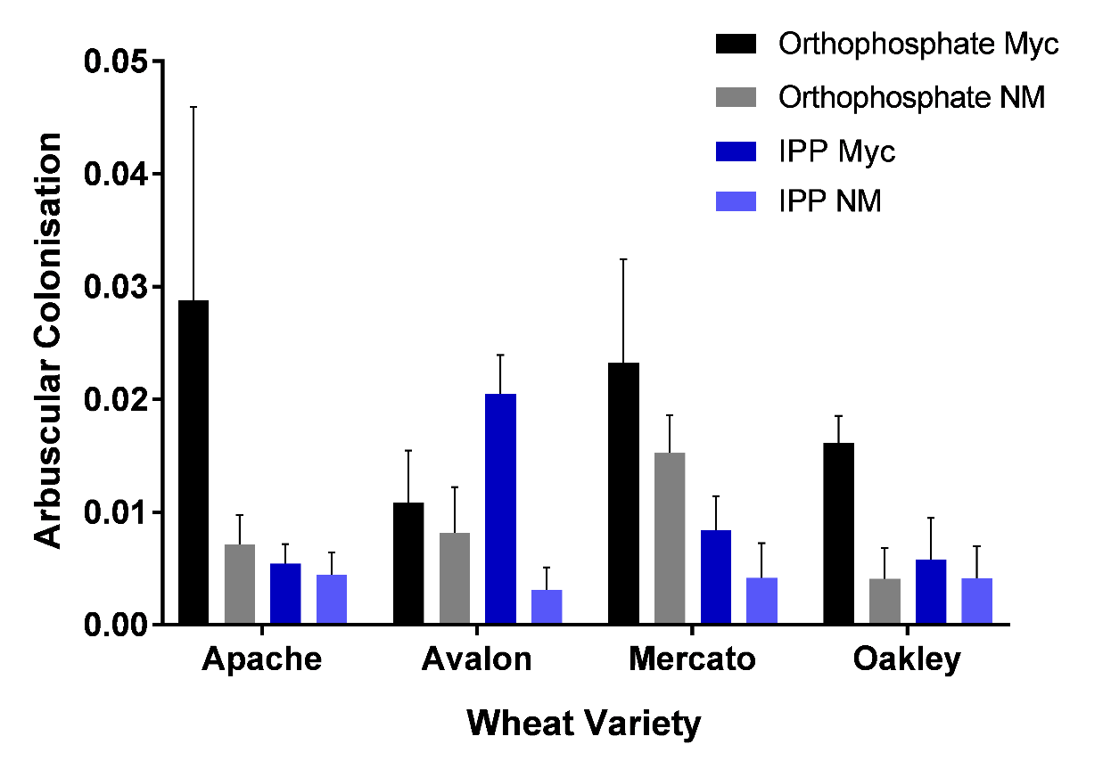
Fig 5.1: Arbuscular colonisation in four wheat varieties given either a mycorrhizal (Myc) or non-mycorrhizal (NM) treatment and supplied with either orthophosphate or inositol polyphosphate (IPP). Arbuscular colonisation determined according to McGonigle et al. (1990) and shown as a non-dimensional parameter expressed as a fraction rather than a percentage as in other methods. Bars show means and error bars show standard error of the mean (n=5-6).

    - P Uptake in Wheat Varieties with and without Mycorrhizal Inoculum
The effect of mycorrhizal treatment on P uptake was not statistically significant (p > 0.05) (Fig. 5.2). The effect of P source on P uptake was statistically significant (F_{(1,80)} = 21.29, p < 0.0001). Average P uptake in plants supplied with IPP (0.07pg ³³P g⁻¹) was 0.05pg ³³P g⁻¹ greater than average P uptake in plants supplied with orthophosphate (0.02pg ³³P g⁻¹). The effect of wheat variety on P uptake was not statistically significant, neither were interactions of factors (p > 0.05).
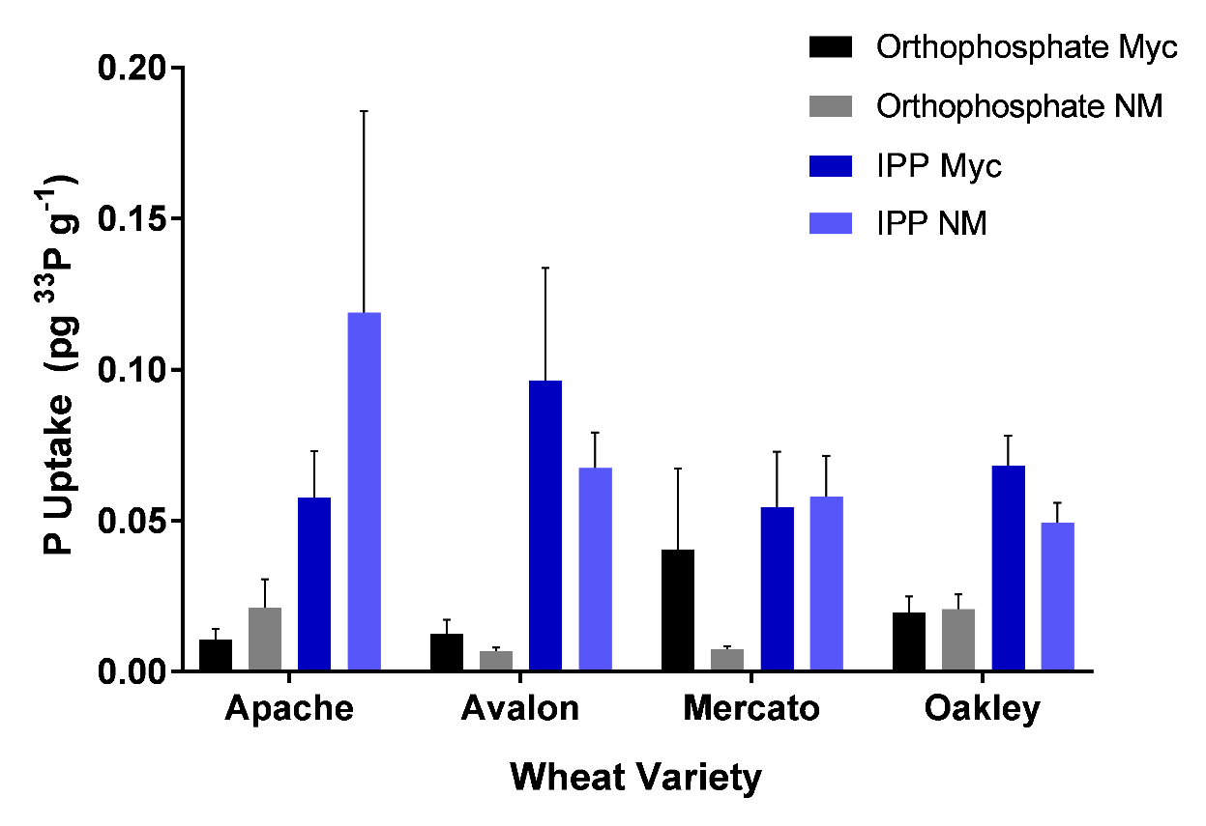
Fig. 5.2: P uptake in four wheat varieties given either a mycorrhizal (Myc) or non-mycorrhizal (NM) treatment and supplied with either orthophosphate or inositol polyphosphate (IPP). Bars show means and error bars show standard error of the mean (n=5-6). P uptake expressed as picograms of ³³P per gram of dry shoot.

    - Correlations Between Mycorrhizal Colonisation, P Uptake and Root Traits
Spearman’s correlation showed that there was no statistically significant correlations between level of arbuscular colonisation and P uptake from either P source treatment individually, or between level of arbuscular colonisation and any root trait (root system size, phosphatase enzyme activities and organic acid exudation) for either P source treatment individually (data not shown, p > 0.05).

Spearman’s correlation showed that there was no statistically significant correlations between P uptake and any root trait for each mycorrhizal and P source treatment individually (data not shown, p > 0.05).

    - Root Traits which Facilitate P Uptake from Organic Forms
      - Total Root System Size and Phosphatase Enzyme Activity
In examining the relationship between phosphatase enzyme activities and root dry weight, Spearman’s correlation showed that there was a statistically significant negative correlation between PME-ase activity and root dry weight (Fig. 5.3a) and phytase activity and root dry weight (Fig. 5.3b) for each mycorrhizal and P source treatment individually. Across all treatments, with an approximately 4 fold increase in root dry weight (from 0.25 to 0.9g), PME-ase activity decreased approximately 5 fold (from 1.1 to 0.2pmol p-NP g⁻¹ s⁻¹) (p < 0.0001). Similarly, with a 4 fold increase in root dry weight, phytase activity decreased from 19 to 1pmol P g⁻¹ s⁻¹ (p < 0.01). There were no statistically significant differences between correlations of each treatment when comparing Fisher z values (data not shown, p > 0.05).
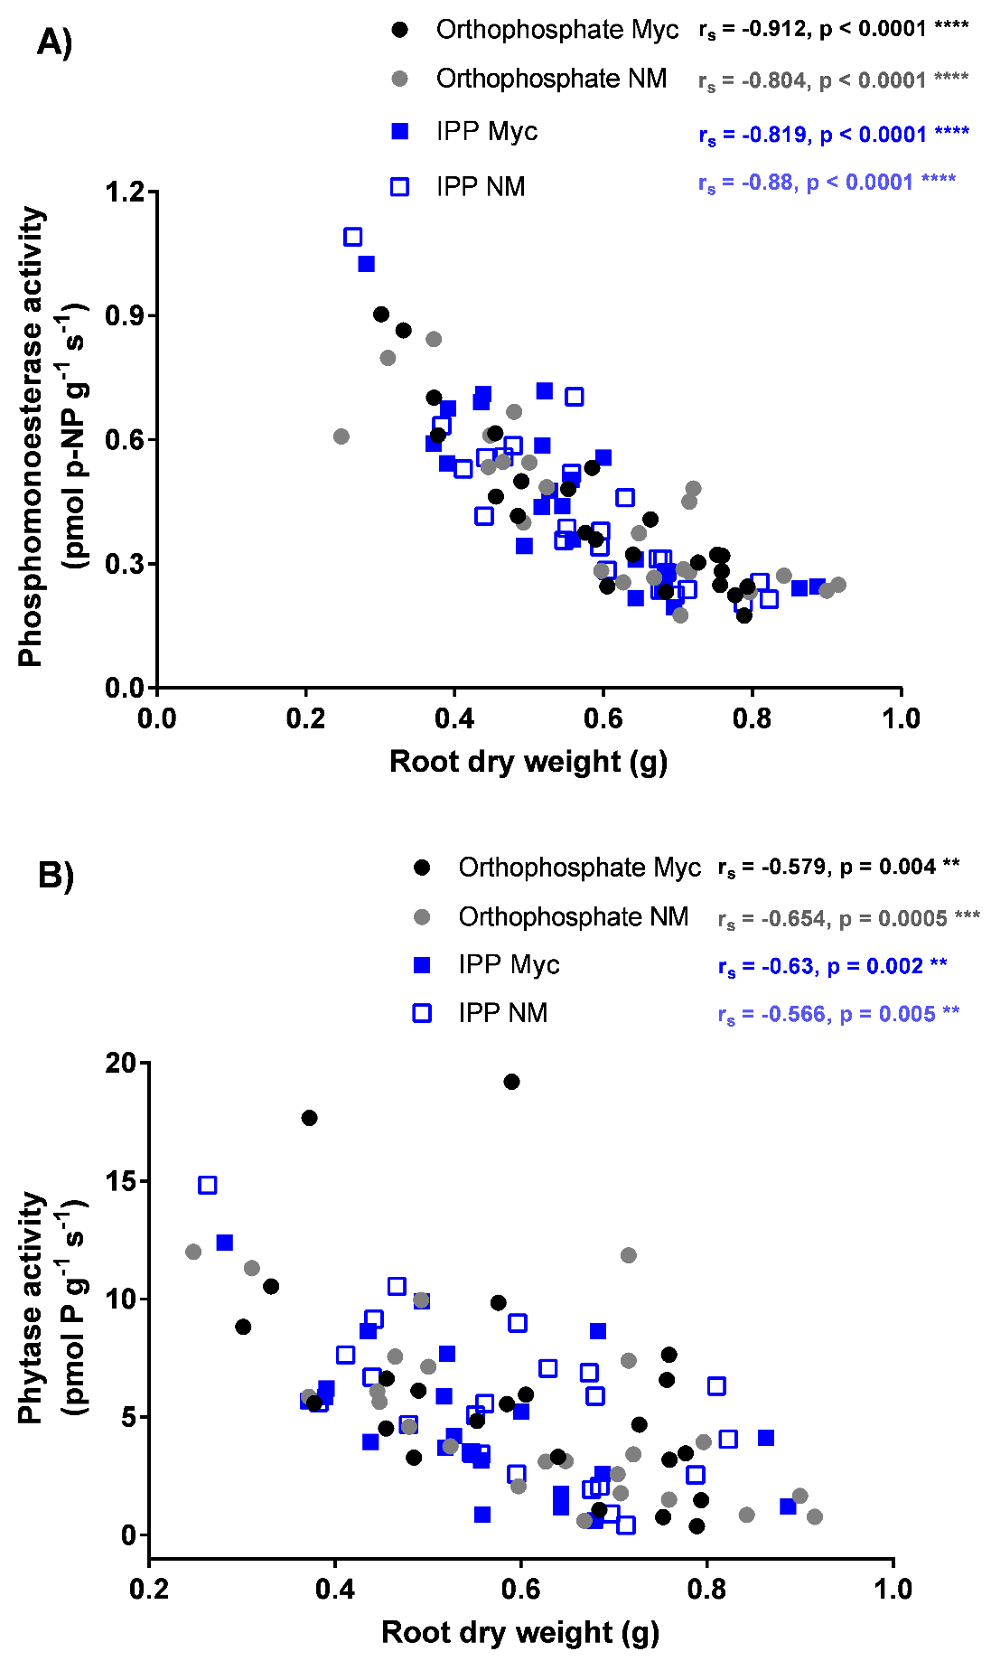
Fig 5.3: Phosphatase enzyme activity and root dry weight in mycorrhizal (Myc) and non-mycorrhizal (NM) treated wheat plants supplied with either orthophosphate or inositol polyphosphate (IPP). (A) phosphomonoesterase (PME-ase) activity and (B) phytase activity. Points show individual data. Results of Spearman’s rank order correlation are shown on the graph. Asterisks denote significance (alpha = 0.05). Enzyme activity expressed as picomoles of p-NP released per gram of fresh root per second.

      - Phosphatase Enzyme Activity and Organic Acid Exudation
Spearman’s correlation showed that there was a statistically significant negative correlation between malic and citric acid exudation and PME-ase activity for each mycorrhizal and P source treatment individually (Fig. 5.4a, p < 0.01). Spearman’s correlation also showed that there was a statistically significant negative correlation between malic and citric acid exudation and phytase activity for each mycorrhizal and P source treatment individually (Fig. 5.4b, p < 0.05 except for the orthophosphate mycorrhizal treatment which was negative but not significant, p > 0.05). Across all treatments, as acid exudation increased from approximately 0 to 22pmol g⁻¹ s⁻¹, PME-ase activity decreased 5 fold (from 1.1 to 0.2pmol p-NP g⁻¹ s⁻¹) and phytase activity decreased from 19 to 1 pmol P g⁻¹ s⁻¹. There were no statistically significant differences between correlations of each treatment when comparing Fisher z values (data not shown, p > 0.05).
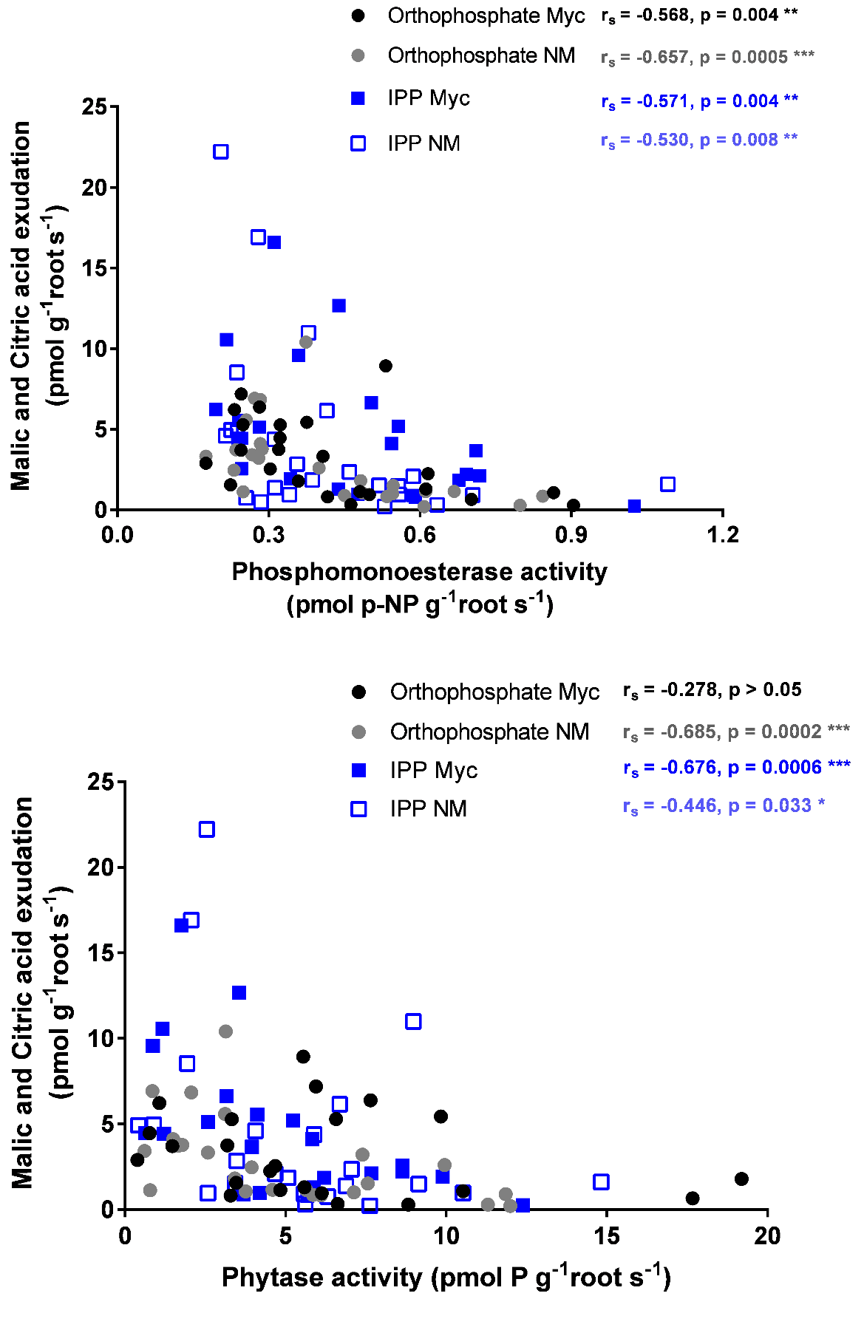
Fig. 5.4: Malic and citric acid exudation and phosphatase enzyme activities in mycorrhizal (Myc) and non-mycorrhizal (NM) treated wheat plants supplied with either orthophosphate or inositol polyphosphate (IPP). (A) phosphomonoesterase (PME-ase) and (B) phytase activity. Points show individual data. Results of Spearman’s rank order correlation are shown on the graph. Asterisks denote significance (alpha = 0.05). Acid exudation expressed as picomoles of acid released per gram of fresh root per second. Enzyme activity expressed as picomoles of p-NP released per gram of fresh root per second.

      - Organic Acid Exudation and Total Root System Size
When investigating the relationship between acid exudation and root dry weight, Spearman’s correlation showed that there was a positive correlation between malic and citric acid exudation and root dry weight for each mycorrhizal and P source treatment individually (Fig. 5.5, p < 0.05). Across all treatments, with an approximately 4 fold increase in root dry weight (from 0.25 to 0.9g), acid exudation increased from approximately 0 to 22pmol g⁻¹ s⁻¹. There were no statistically significant differences between correlations for each treatment when comparing Fisher z values (data not shown, p > 0.05).
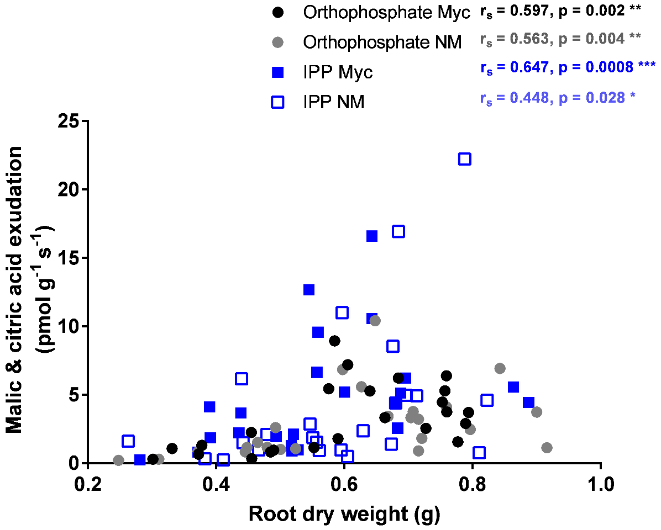
Fig. 5.5: Malic and citric acid exudation and root dry weight in mycorrhizal (Myc) and non-mycorrhizal (NM) treated wheat plants supplied with either orthophosphate or inositol polyphosphate (IPP). Points show individual data. Results of Spearman’s rank order correlation are shown on the graph. Asterisks denote significance (alpha = 0.05). Acid exudation expressed as picomoles of acid released per gram of fresh root per second.

  - Discussion
This is the first study to assess radiolabelled ³³P uptake from both an orthophosphate and monoester (IPP) source in wheat varieties with and without mycorrhizal inoculation, and also assess how root traits (phosphatase enzyme activity, root structure and organic acid exudation) relate to both P uptake and mycorrhizal colonisation. Overall, it revealed that low level mycorrhizal colonisation had no effect on P uptake or root traits associated with P uptake. However there are limitations on this work which have caused uncertainty and this would benefit from further work to better reveal the relationships between mycorrhizal colonisation, P uptake and root traits. This chapter also revealed a possible trade-off between phosphatase activities and organic acid exudation. A trade-off seen in Chapter 4 between root PME-ase activity and root system size was confirmed and a similar trade-off between phytase activity and root system size was also uncovered. These trade-offs in combination with a positive relationship between organic acid and root system size indicated a complex relationship between traits which should be considered when attempting to enhance the ability of crops to access P from organic sources.

    - Mycorrhizal Colonisation in Wheat Varieties
Plants inoculated with mycorrhizas showed greater arbuscular colonisation than the non-mycorrhizal plants. Further to this, only mycorrhizal treated plants contained any vesicles. The effect of colonisation is very likely to have been limited, though, as colonisation was low and the difference between the two mycorrhizal treatments was also low. The varieties chosen have previously been shown to have arbuscular colonisation of 1% Avalon, 40% Oakley, 48% Mercato and-67% Apache (Dr. B. Hughes, unpublished data) using a different method to assess colonisation than was used in this chapter. These percentage colonisation levels are similar to the colonisation seen in other studies for wheat grown in soil when measured and expressed using the same method (20-57% (Dekkers and van der Werff, 2001; Li et al., 2006)). However, the levels of arbuscular colonisation seen in this chapter, 0.005-0.028, are lower than the range of those seen for wheat grown in arable soil when measured and expressed using the same method, 0.08-0.4, (Brito et al., 2013).
Part of the reason for low colonisation and the lack of effect of mycorrhizal colonisation in the wheat plants could be that intensively managed agricultural soils are not conducive to mycorrhizal symbiosis. It has been found that wheat plants grown in soil from a low input agricultural soil were more able to initiate mycorrhizal symbiosis with or without additional mycorrhizal inoculation than plants grown in greater input soil (Mäder et al., 2000). Furthermore, mycorrhizas have been found to colonise crops at a greater rate when the previous year’s crop was mycorrhizal compared to non-mycorrhizal (Arihara and Karasawa, 2000). This emphasises the idea that increasing mycorrhizal colonisation may be more relevant and beneficial in lower intensity agricultural systems (Gosling et al., 2006) where use of mycorrhizal plants is more common, and that the use of an intensively managed agricultural soil in this chapter may have contributed to the lack of effect of the mycorrhizal treatment. The effect on mycorrhizal colonisation of using sand in a soil substrate has not been extensively studied but has been proposed to increase mycorrhizal colonisation (Zaller et al., 2011). Therefore, the use of sand in the growth substrate in this chapter is unlikely to have caused low colonisation.
Since the non-mycorrhizal treatment plants also exhibited mycorrhizal colonisation, the deactivating of the mycorrhizal inoculum to produce the non-mycorrhizal inoculum may not have been thorough enough. Sterilised mycorrhizal inoculum is a standard non-mycorrhizal treatment as this adds the exact same solution but without activate mycorrhiza (e.g. Feng et al., 2003; Chu et al., 2013; Daynes et al., 2013; Del Fabbro and Prati, 2014). On the other hand, mycorrhizas may have been present in the soil even after sterilisation, allowing colonisation in the non-mycorrhizal treated plants. Though, again, heat sterilisation of growth substrates is standard (e.g. Feng et al., 2003; Abdel-Fattah and Asrar, 2012; Daynes et al., 2013; Del Fabbro and Prati, 2014). Nonetheless, further work with higher levels of colonisation and a greater difference between the colonisation seen in the two mycorrhizal treatments is required to elucidate the effect of mycorrhizas.
Plants supplied with orthophosphate appeared to have greater arbuscular colonisation than plants supplied with IPP. While this seems contrary to the literature where greater orthophosphate concentrations suppress mycorrhizal colonisation (Miranda and Harris, 1994), the plants were only in the presence of the P source for 3 days before harvest so it seems unlikely that the P source could have an effect on colonisation in such a short time. Furthermore the low P uptake (as discussed in the next section 5.5.2), in addition to the low mycorrhizal colonisation, limits the conclusions that can be drawn from this data.
Another limitations to this work is the method of sterilising soil and adding inoculum without adding other microorganisms back into the soil. Mycorrhizas and other microbes in soil can have important effects on each other (Mar Vázquez et al., 2000) and the benefits of mycorrhizas are often enhanced or elicited in combination with other microbes (Tarafdar and Marschner, 1995; Khan et al., 2009; Minaxi et al., 2013). In the work in this chapter, the removal of all microorganisms by soil sterilisation may therefore have reduced the potential of the mycorrhizal inoculum to cause colonisation of the plants.

    - P Uptake in Wheat Varieties with and without Mycorrhizal Inoculum
P uptake in this chapter was approximately 100 times lower than P uptake in Chapter 4 (Fig. 4.2) even though the wheat plants in Chapter 4 were younger and, consequently, smaller. The substrate used in Chapter 4 was pure soil while in this chapter a soil and sand mix (1:1) was used. The soil/sand mix substrate may have had a greater ability to drain water and produced an overall drier substrate for the roots. Sandy soils are known to have a lower water holding capacity than soils with a higher organic matter content (Hudson, 1994). This may have resulted in the P source being less solubilised and so roots may have been less able to access either P source. It may have been expected that P uptake from the different sources should be similar to each other or greater for the orthophosphate source compared to the IPP source. The converse of this was seen with P uptake being greater from an IPP source. Although the contamination of inorganic P in the organic P treatment was lower in this chapter than Chapter 4, contamination may still have been a problem in this work and the inorganic P contaminant could have been taken up rather than the P from the organic source. This further invalidates the P uptake data.
Further to this it may be expected that P uptake would have been greater in the more mycorrhizal (Myc treatment) plants. This was not apparent with no pattern seen in P uptake in the different mycorrhizal treatments. This coupled with the fact that no correlations were seen between P uptake and any root traits means no conclusions can be made about the relationship between P uptake in the wheat varieties with and without mycorrhizal inoculation.

    - Correlations between Mycorrhizal Colonisation, P Uptake and Root Traits
The mycorrhizal treatment had no effect on root traits when compared to the non-mycorrhizal treatment. This was confirmed by lack of correlation between degree of arbuscular colonisation and root traits.
Straightforwardly, the difference in colonisation between the mycorrhizal and non-mycorrhizal treatments was not great and may have not been enough to have an effect on P uptake and root traits, especially given that the colonisation levels were also low. The levels of arbuscular colonisation seen in this chapter are lower than the range of those generally seen for wheat in the literature (Brito et al., 2013). On the other hand, the difference in mycorrhizal colonisation could have been enough to contribute to P uptake or root traits but not to increase these overall. This has been suggested in previous studies which found that mycorrhizas did contribute to P uptake but did not increase overall P uptake by the plant (Li et al., 2006). Mycorrhizas may also not be beneficial to P uptake in an agricultural soil where wheat plants may not form effective symbioses with mycorrhizas (Ryan and Graham, 2002) i.e. the soil conditions limit the level of colonisation or the effect of colonisation on P uptake.
Although conclusions cannot be reliably drawn from this chapter on the effect of mycorrhizal colonisation on P uptake and root traits (due to low colonisation rates), mycorrhizal colonisation is often thought to be beneficial to P uptake from organic forms with mycorrhizas enhancing phosphatase enzyme activity, organic acid exudation and increasing the soil volume explored (Bolan, 1991; Smith and Read, 2009). In fact, for phosphatase activity (Richardson et al., 2009b) and organic acid exudation (Jones et al., 2003), mycorrhizas and other soil microbes are thought to be the main producers rather than plants. Therefore further work with higher levels of colonisation is required to elucidate the effect of mycorrhizas on P uptake from organic sources.
Although breeding of modern wheat varieties may have selected for varieties which are dependent on easily accessible fertiliser P and are non-responsive to mycorrhizas, there is variation in mycorrhizal responsiveness in the literature (Hetrick et al., 1993) and so there is scope for re-selection of responsive varieties (Ryan and Graham, 2002). Further to this, evidence of lower mycorrhizal responsiveness in wheat varieties does not necessarily mean that improving colonisation is unsuitable to improve P uptake from organic P sources. Li et al. (2006) found that mycorrhizal colonisation of wheat contributed to P uptake but, with an equivalent decrease in P uptake by the plant, the overall P uptake did not increase compared to non-mycorrhizal plants. This supports the idea that in some cases mycorrhizas replace a function of the plant rather than add to it (Smith and Smith, 2011). Mycorrhizas, therefore, can still be a target for enhancement beyond their current effect on P uptake.

    - Root Traits which Facilitate P Uptake from Organic Forms
      - Total Root System Size and Phosphatase Enzyme Activity
In this chapter, larger root systems were seen to have lower PME-ase activity and phytase enzyme activity, compared to smaller root systems. The relationship suggests a trade-off may exist between root system size and enzyme activity. This agrees with the data in Chapter 4, which also found evidence of a trade-off between root system size and PME-ase activity.
While limitations of this chapter meant that impacts on P uptake were not detected, this trade-off still supports the Chapter 4 proposal that larger root systems are not a suitable target unless the trade-off with enzyme activity can be avoided.

      - Phosphatase Enzyme Activity and Organic Acid Exudation
Organic acid exudation showed a negative correlation with both PME-ase and phytase enzyme activity, again suggesting a trade-off. This could hinder P uptake by wheat plants in the field where P sources would be more tightly fixed to the soil (Turner et al., 2005a). In this case, lack of solubilisation by exuded acids could cause a P source to be unavailable to phosphatase enzymes and thus the P unavailable to the plant. Solubilisation has been suggested to limit access to P in organic forms in soil (George et al., 2004, 2005b; Lung and Lim, 2006; George et al., 2008). Though, solubilisation may not have been limiting in this chapter where the P source was likely to have been at least partially in solution.
Phosphatases exuded into the soil do not last forever as they can be degraded or absorbed by soil (George et al., 2005a, 2007a; Menezes-Blackburn et al., 2013). In fact, phytase activity in soil can decrease over the course of days but can be lost in as little as 10 min (George et al., 2005a). Consequently, it will constantly cost the plant to continue production of enzymes, although the cost of phosphatase enzyme production is not known (Lynch et al., 2005; Lynch, 2011). However, the fact that phosphatases are upregulated when plants are exposed to low P conditions (Richardson et al., 2011), may further suggest that their production does have a cost.
Since phytase activity was detected in the wheat roots used in this chapter, this suggests the lack of phytase activity in Chapter 4 may have been an error. However, the experimental conditions were also slightly different and, as phosphatase enzyme activities can vary according to plant and soil conditions (Oh et al., 2004; George et al., 2005a, 2007a; Menezes-Blackburn et al., 2013). The fact that the plants were older and the growth substrate different could have contributed to the difference seen. Richardson et al. (2000), who used a similar assay to assess enzyme activity found no phytase activity from intact wheat roots of a similar age (2 weeks) to those used in Chapter 4 (3 weeks old).
Although some varieties of wheat have lower root phosphatase activity, some varieties of wheat have greater activity (George et al., 2008) and so this may suggest there is scope to enhance endogenous phosphatase enzyme activities in wheat.

      - Organic Acid Exudation and Total Root System Size
The ability of larger root systems to exude more organic acid is in contrast to data in Chapter 4 which suggested that overall size was not important organic acid exudation but roots with a larger diameter / smaller specific root length did exude more citric acid. As the organic acid exudation data in Chapter 4 was measured as variety averages in a separate set of plants to those which were assessed for the other root traits, the data in Chapter 5 is a more accurate representation of the ability of the wheat plants to exude organic acid.
Like phosphatases, exuded organic acids are ephemeral and can be adsorbed by soil and used by microbes (Jones, 1998; Jones et al., 2003) lessening their efficacy. Conversely, organic acid can be added to the soil solution by desorption from soil and exudation by microbes and, therefore, the exact dynamics of organic acids in soil are not fully understood (Jones et al., 2003). Nevertheless, some plants have the ability to exude more organic acid from their roots than wheat and so this may suggest there is scope to enhance organic acid exudation in crops (Jones, 1998) including wheat.
The overall relationships between root traits suggest a trade-off between enzyme activity and root system size, plus another trade-off between enzyme activity and organic acid exudation. On the other hand, organic acid exudation and root system size were positively related. Since the three root traits are interconnected, one of the trade-off relationships may be indirect and a consequence of the others. No matter which trade-offs are direct and which are indirect, altering any of root system size, phosphatase enzyme activities or organic acid exudation may have a negative effect on the others. Although trade-offs between P uptake related traits have not often been investigated, it is likely that trade-offs exist due to the potentially high costs of traits (Lynch et al., 2005; Lynch, 2011; Richardson et al., 2011).
Although the effect of enhancing a certain root trait on other root traits due to trade-offs is unknown, it is suggested from this chapter that to increase the ability of wheat plants to access P in organic forms, phosphatase enzyme activities and organic acid exudation should be enhanced concurrently. Emphasising this, is the fact that organic acid exudation, as well as solubilising organic P, may prevent phosphatase enzyme absorption to soil (Huang et al., 2003). Studies which have enhanced both traits to improve P uptake from organic P (Giles et al., 2017b) should be built upon by assessing other P uptake associated root traits not enhanced to determine if they are negatively affected.

  - Conclusion
Plants have root traits which facilitate access to P in organic forms but it is not clear what role mycorrhizas play in agricultural systems in relations to these root traits and so how they could be used to improve P uptake from organic forms.
When wheat plants were treated with and without mycorrhizas, low level mycorrhizal colonisation showed no effect on root P uptake traits. This could be caused by the low ability of these wheat plants to form efficient symbiosis in agricultural soil, in which case enhancing mycorrhizal colonisation is not a suitable target to improve P uptake from organic P forms. However, colonisation in this chapter was lower than expected from previous experience of these varieties (i.e. low colonisation seemed not to be an inherent inability of the varieties themselves). Therefore, this work should be repeated once higher levels of mycorrhizal colonisation can be achieved.
This chapter, similarly to Chapter 4, found evidence of trade-offs between P uptake root traits. It is proposed that future work should include assessments of several P uptake root traits rather than just one. This would ensure any negative effects of altering one root trait on others are detected. Nonetheless, phosphatase enzyme activity and organic acid exudation are recommended as targets to simultaneously enhance uptake of P from organic sources.

- General Discussion
Even though organic phosphorus (P) in soil is a possible source of P in agriculture (Stutter et al., 2012), the concentration of organic P in agricultural soils and the means by which crops can access this source are not fully understood. This General Discussion chapter aims to bring together the findings from this thesis within the context of what is already known about organic phosphorus in soil and its use as a P source in agricultural systems.
This thesis identified gaps in current understanding and aimed to address to these through the following research questions:

- What forms of P are present in agricultural soils and at what concentrations? How does agricultural management affect these?

- Can wheat plants use P in organic forms and, if so, which root traits facilitate this?

- Does mycorrhizal colonisation play a role in the ability of wheat plants to use P in organic forms and how does colonisation affect the root traits which facilitate this?

Furthermore, methodological developments were made in quantifying soil organic P. When assessing organic P in agricultural soils, solution ³¹P nuclear magnetic resonance spectroscopy (NMR) is the preferred method and was used in this thesis. Due to the complex nature of NMR as a technique and the importance of obtaining accurate quantitative data, the methodology of ³¹P NMR for soil was investigated (Chapter 2). This allowed detailed assessment of the different chemical forms of P present in soil and their concentrations. This consequently allowed the forms of P in several agricultural soils and the effect of management practices to be investigated (Chapter 3). The uptake of P from an organic source by a range of wheat plants without the influence of microorganisms was assessed alongside root traits which are important to P uptake (Chapter 4). The influence of mycorrhizas on this was then examined by measuring the uptake of P from an organic source by wheat plants with and without mycorrhizal colonisation. This also included an assessment of root traits which are important to P uptake (Chapter 5). In Chapters 4 and 5, the use of a novel synthesis protocol to produce radiolabelled ³³P inositol polyphosphates allowed measurement of P uptake directly from an organic P form which was relevant to agricultural soil (Appendix C).
In the following sections the key findings of this thesis are discussed in the context of the literature with particular emphasis on the contribution to understanding the use of organic P as a P source in agricultural soils.

  - Solution ³¹P NMR Spectroscopy of Soil
In solution ³¹P NMR spectroscopy of soil, the method used is critically important to the accuracy of the quantitative data obtained and in turn affects the conclusions that can be drawn. Chapter 2 reviewed the information available on NMR methodology and optimised a method for an arable soil. In addition to optimising the NMR method for the specific arable soil used throughout this thesis, this work also highlighted the general need for optimisation and the errors which can occur without optimisation.
Chapter 2 revealed that preventable degradation may occur during long delay times, that increasing NMR sample size causes loss of detail in the spectrum, that application of decoupling during the delay time is not advisable, and that the variation of P in soil means that several samples should be homogenised to determine soil P at the field level. Chapter 2 also showed it was particularly important to measure T1 times and calculate delay times to ensure accurate quantification.

    - Delay Times in ³¹P NMR Spectroscopy
Delay times required for full relaxation of nuclei are long for small molecules. For example, it was calculated in Chapter 2 that a 45s delay time was required for full relaxation of orthophosphate in the arable soil analysed and this would result in a total run time of 50h per sample (4,000 scans). Consequently, Chapter 2 highlighted the need for measurements to assess delay times. This has also been discussed in the literature (McDowell et al., 2006; Cade-Menun and Liu, 2014) and has resulted in some recent papers using very long delay times to allow for full relaxation (average of 25s in Annaheim et al. (2015) and McLaren et al. (2017)). However, others still use delay times shorter than that which is required for full relaxation without accounting for the effect of this on the data obtained (5s in Schneider et al. (2016)). As shorter delay times are known to obtain more signal from larger molecules, these could be overestimated relative to smaller molecules (Cade-Menun et al., 2002; McDowell et al., 2006). The importance of publishing delay times is also stressed as these could contribute to databases and encourage new studies to calculate delay times (Cade-Menun and Liu, 2014) allowing the accuracy of published quantitative data to be known. Databases of T1s and delay times could eventually be used to eliminate the need to calculate T1 for every soil if delay times could be used based on other soil properties, such as metal ion content as was suggested in McDowell et al. (2006). However, direct measurement of delay time would always be preferable to ensure accurate quantification. Although some authors have emphasised the use of delay times which allow for full relaxation (Cade-Menun and Liu, 2014) this can often result in very long experiment run times which are expensive and do not allow for large sample numbers. For example, in McLaren et al. (2017) an average delay time of 25s resulted in an average run time of 26h per sample (approximately 4000 scans). Long experiments will not always be feasible and was not feasible for the work undertaken in Chapter 3. Therefore data in this chapter was scaled up according to the percentage of the signal seen with the used delay time as calculated in Chapter 2. This technique has not been used in previous studies but provides a novel method of accurate quantification that allows for the use of a short delay time.
To illustrate the inaccuracy in previous studies caused by the use of short delay times, Stutter et al. (2015) was re-analysed to correct for the underestimation of orthophosphate (Table 6.1). The difference between the delay times calculated and the delay times used presented in Stutter et al. (2015) was used to estimate the amount of orthophosphate. This study was used as an example of the use of delay times which are shorter than the delay times required to obtain 100% signal because this study included T1 measurements (supplementary information) and so corrected values could be calculated. As this study did not measure T1 times for monoesters, a correction for monoesters could not be calculated and the overestimation of monoesters relative to orthophosphate could not be estimated. However, from the work in Chapter 2, where 25% of the orthophosphate signal could be seen whereas 78% of the monoester signal could be seen, it can be seen that both compounds are underestimated but relatively orthophosphate is overestimated compared to monoesters. On the other hand, in papers that have used intermediate delay times (e.g. 5s in Schneider et al. (2016)) it is likely that monoesters are not underestimated while orthophosphate is still underestimated.
Overall, this recalculation highlights the importance of T1 measurements to accurate quantification and that some studies may have presented data which underestimated orthophosphate and overestimated monoesters relative to orthophosphate. This is further emphasised by the difference in delay times required for different soils. The delay time for orthophosphate in Tayport soil was 4.35s while Southlake south was 0.7s, approximately 6 times shorter (Fig. 6.1). This is such a large difference that the 1-2s delay time used would detect the full orthophosphate signal in the Southlake south soil but only 23-46% in the Tayport soil.

Table 6.1: Orthophosphate in agricultural soil samples and delay times as presented in Stutter et al. (2015) with corrected values calculated from the data in Chapter 2. Fraction of signal seen was calculated by assuming calculated delay time would detect 100% of the signal and the delay time used would detect a fraction of this according to a similarly shaped delay time curve as seen in Fig 2.6. Calculated delay time was determined by multiplying the published T1 by 5.
Site | Published value (mg P kg⁻¹ soil) | Calculated delay time (s) | Delay time used (s) | Fraction of signal seen (%) | Corrected value (mg P kg⁻¹)
Tayport | 765 | 4.35 | 1-2 | 23-46 | 1663-3326
Vealand improved | 700 | 3.6 | 1-2 | 28-56 | 1250-2500
Southlake South | 233 | 0.7 | 1-2 | 100 | n.a.

Solution state ³¹P NMR of soil will always have limitations and these can curb the conclusions made from NMR data. However with the issue of delay times and underestimation of certain P groups this thesis has contributed a method which can be used to improve accuracy of quantification whilst using shorter run times which are more feasible.

    - Deconvolution in ³¹P NMR Spectroscopy
The monoester region of a solution ³¹P NMR spectrum is busy and due to the sensitivity of P compounds to pH and ion concentration, the chemical shifts of these compounds can vary. This can lead to misidentification and overestimation of myo-IHP (Smernik and Dougherty, 2007; Doolette et al., 2009, 2011a). Deconvolution is often used to identify individual signals in the monoester region (Fig. 6.1). Deconvolution is also used to separate monoesters signals from each other and a broad humic signal which would otherwise cause further overestimation of phytate compounds (Doolette et al., 2010, 2011a; Doolette and Smernik, 2015). However, there are problems associated with deconvolution and the method used varies (Doolette and Smernik, 2015). In Chapter 3, deconvolution was not used to quantify peaks because all monoesters were considered together and individual signals were calculated from peaks which did not occur in the broad humic signal area. This avoided any issues associated with deconvolution and is suggested for work whilst detailed identification of peaks in the monoester region is not possible. However, further research to improve deconvolution methods and could make deconvolution more accurate in the future and aid detailed peak identification and quantification in the monoester region of the spectrum.

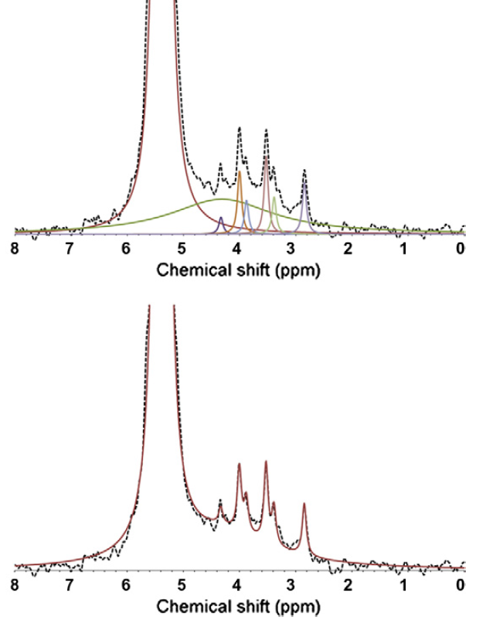
Fig. 6.1: Result of a deconvolution procedure to fit the solution ³¹P NMR spectrum of a soil NaOH-EDTA extract. (A) and (B) The broken line represents the actual spectrum. (A) Deconvolution fit shown as different coloured lines including seven sharp peaks and an additional broad peak (P compounds associated with humic compounds). (B) Sum of deconvolution fitted peaks shown as red line. Adapted from Doolette et al. (2011a).
A)
B)

    - Extraction of Soil P Using NaOH/EDTA
Since solution ³¹P NMR spectroscopy requires extraction of P compounds from soil, alkaline conditions and chelation of metal ions, a solution of NaOH/EDTA is commonly used (Turner et al., 2005a; Cade-Menun and Liu, 2014). Although the amount of P extracted by NaOH/EDTA can vary depending on the soil, NaOH/EDTA generally extracts more P than other extraction solutions used for solution ³¹P NMR spectroscopy (Cade-Menun and Preston, 1996; Cade-Menun et al., 2015). NaOH/EDTA has been found to extract 2-100% of the total soil P (Cade-Menun and Liu, 2014) with the lower extraction levels from calcareous soils (Turner et al., 2003a) and high mineral content soils where P is better extracted with acid rather than alkali (Turner et al., 2007a). For arable and pasture Cambisol soils in the UK, the average extraction efficiency is high at 74% (Stutter et al., 2015) and due to the soils in Chapter 3 being similar agricultural Cambisols it is suggested that the extraction efficiency was similarly high.
The NaOH/EDTA extraction is strong due to the alkali solution used (0.25M NaOH) and so it may be suggested that any P not extracted is strongly fixed and would not be accessible to organisms. Ultimately it is important to consider solution ³¹P NMR spectroscopy as a measurement of extractable rather than total soil P although a high level of the total P was likely to have been extracted in Chapter 3. Furthermore, since levels of P measured by solution ³¹P NMR spectroscopy are most accurately compared between soils with a similar composition (Cade-Menun and Liu, 2014), it is likely that the level of extraction would also be similar and so would not affect any comparative differences.
Ultimately solution ³¹P NMR spectroscopy of soil has limitations, including the degradation of diesters in the strong alkali solutions required. It is not likely that degradation of diesters can be avoided and so diesters may be better assessed by other methods. Another important limitation is the fact that extraction will often not extract all of the P in a soil but only a fraction. It is important therefore to remember that data presented does not represent total soil P but the fraction extraction by a specific extraction solution. The use of sequential extraction is a possible method to assess a larger proportion of the total soil P than just a single extraction solution (Condron et al., 1985, 1990a; Leinweber et al., 1997; McDowell and Stewart, 2006). The range of the total P extracted can be very large (e.g. 2-100% for NaOH/EDTA (Cade-Menun and Liu, 2014)) and so it is always best to use solution ³¹P NMR to assess P in a soil with an extraction method which is specific to obtain a large proportion of the total P in the soil (Condron et al., 1990b).

  - Feasibility of Soil Organic P as a P Source
For soil organic P to be a feasible source of P for crop plants in agricultural soil it must be present in substantial quantities. Chapter 3 measured the types and concentrations of the different P forms in several agricultural soils which revealed the effect of soil historic use and time on the P forms present.
When comparing soils, Chapter 3 revealed that arable soils showed signs of being detrimentally affected by agricultural practices, containing lower concentrations of organic P forms associated with organic matter and microorganisms. In contrast, the historic input of manure into a pasture soil may have caused the high concentration of P in this soil. Further, a largely constant concentration of organic P in the arable soil over time means organic P was a constantly present pool of P making up approximately a third of the total extractable soil P. This has been suggested to be true in previous studies (Condron et al., 2005) but with the work in Chapter 2 highlighting the possible inaccuracy of quantification of NMR, especially organic P, it was important to confirm the amount of the different P compounds in agricultural soil with the work in Chapter 3.

    - Concentrations of Monoester P in Arable soil in the Context of Fertilisers and Plant Requirements
Although there is evidence that overestimation of organic P in soils has occurred in the past (McDowell et al., 2006; Turner et al., 2006; Smernik and Dougherty, 2007; Doolette et al., 2011a), the concentrations of monoesters found in Chapter 3 (326 to 684mg P kg⁻¹) are similar to those found in other studies for UK agricultural soils (105 to 751mg P kg⁻¹) (Turner et al., 2003d; Stutter et al., 2015). Consequently monoesters make up a considerable proportion of the total soil P and are a potential source of P in agricultural soils. However, there are other factors which affect the feasibility of soil organic P as a P source in agricultural soils.
Fertiliser is added to winter wheat at Spen Farm at a rate of 40kg P ha⁻¹yr⁻¹ (91kg P₂O₅ ha⁻¹) (Martin Leppage, farm records, personal communication, 2017) and in the UK on average at a rate of 26kg P ha⁻¹ yr⁻¹ (60kg P₂O₅ ha⁻¹) (Benford, 2017). Assuming a soil bulk density of 1g cm⁻² and that fertilisers are distributed to a depth of 0.3m by plough and/or cultivator equipment, fertiliser is added at a rate of 13.33 mg P kg⁻¹ yr⁻¹ (from the Spen Farm application rate) or 8.67mg P kg⁻¹ yr⁻¹ (from the UK average application rate) to the soil. Therefore, fertilisers add a small fraction of P relative to the P already present in arable soil as monoesters (approximately only 2.7-4.1% of 326mg P kg⁻¹ yr⁻¹). Furthermore, the average P taken from an arable soil growing cereal is 8.33 mg P kg⁻¹ yr⁻¹ (Smil, 2000). This further confirms that the P requirement of wheat plants is small compared to the reserve of monoester P in soil. Consequently, monoesters are a potential and significant source of P in arable soils in terms of total amount and plant requirements.

    - Mineralisation of Monoester P in Arable Soil
Although monoester P may be a large reserve of P in soil this is only a feasible source for plants if it is available. P can be fixed to soil or metals in soil to form complexes but this is dependent on the soil’s chemical properties (Anderson et al., 1974; Shang et al., 1992; Jiang et al., 2015). Organic forms of P can have a high affinity for soil and so can be strongly fixed to the soil (Celi and Barberis, 2007; Stutter, 2015).
Mineralisation of organic P in soil can make P available to plants (Tiessen et al., 1984; Sharpley, 1985) and, although this is thought to rapidly turnover, mineralisation may only turnover a small proportion of the total organic P in soil (Stewart and Tiessen, 1987). Mineralisation rates are difficult to determine and so far measurements represent estimations rather than direct measurements (Frossard et al., 2000; Bünemann, 2015). Consequently, and due to the fact that mineralisation is context dependent, estimates of mineralisation have been found to vary. Gross mineralisation in arable soil has been estimated to be 20-74kg P ha⁻¹ yr⁻¹ and similar to the rate of fertiliser application (Sharpley, 1985). However, another study found lower gross mineralisation rates in arable soil, 1.4kg P ha⁻¹ yr⁻¹, (Chater and Mattingly, 1980) which would at most provide P equivalent to 5% of the P added in fertilisers (26kg P ha⁻¹ yr⁻¹). More recent estimations have suggested that net mineralisation of organic P was 0.03-3mg P kg⁻¹ day⁻¹ (Oehl et al., 2001; Oehl et al., 2004; Bünemann, 2015; Wyngaard et al., 2016) which if sustained over a year could provide approximately 11-1095mg P kg⁻¹ yr⁻¹. Despite the very large range, this mineralisation is clearly similar to or much greater than the estimated level of P added as fertilisers (8.67-13.33mg P kg⁻¹ yr⁻¹). It is likely that soil net mineralisation levels are overestimated (Bünemann et al., 2007; Bünemann, 2015) but these estimations still suggest that mineralisation of organic P in soil may contribute to plant P nutrition.
The work in Chapter 3 which assessed P in the soil during a growing season showed some evidence of minor mineralisation and therefore that this P may be available to the crops. Looking at seasonal changes in P is particularly important to understanding P dynamics in soil and the role of microbes to plant P uptake (Richardson and Simpson, 2011). This presents an area for further research where the use of ³¹P NMR will be particularly useful due to the ability of ³¹P NMR to identify specific chemical forms of P. However, further work and accurate measurement of organic P mineralisation rates are needed to increase understanding on the contribution of mineralisation to plant P requirements.

    - Soil P Depletion
If crop plants were able to efficiently access P in organic forms it may raise the problem of depletion of organic P from soil (Lynch, 2011; Richardson et al., 2011; Simpson et al., 2011). In the short term, soil P depletion is unlikely to be a problem in soils which have received high historic P inputs and have a high concentration of P. On the contrary, plants which are able to access more P would be beneficial as they may help to reduce the soil P reserves and so reduce the loss of P to water systems (Lynch, 1998). On the other hand, P depletion may be more of a problem in low P soils (Vance, 2001; Lynch, 2007; Richardson et al., 2011). Although crops which use P more efficiently would extract more P from the soil, they may still have some positive impact on the concentration of P in the soil (Lynch, 2007). For example, bean plants with roots that obtained more P from the soil also reduced P loss by soil erosion (Henry et al., 2010). Furthermore, more efficient use of the P present in soil could reduce the cost of P fertilisers meaning that inputs can be maintained in the long term (Lynch, 2007).
Although P fertiliser inputs need to be reduced, the widespread dependence on P fertilisers in agriculture (Cordell et al., 2009; Damon et al., 2014) means that the use of fertilisers will not suddenly stop but may be phased out. In a scenario where P fertiliser input to soil is reduced and replaced by other inputs (including organic P), the fact that improving organic P use by crops also improves inorganic P uptake (Gahoonia and Nielsen, 2004) is doubly beneficial as plants will be able to use P added in either inorganic or organic forms.
Ultimately, if P is removed from soil it must be added at the same level if depletion is a potential problem. Therefore, more efficient use of naturally present soil organic P is best combined with more sustainable P cycles (Henry et al., 2010; Richardson et al., 2011) which ensure soil P is maintained and depletion of soil organic P is prevented. Several practices can and should be employed to improve the sustainability of P in agriculture (Simpson et al., 2011; Faucon et al., 2015; Withers et al., 2014). Some of the most notable include reducing P lost to water systems by erosion and leaching (Carpenter, 2008), using precise addition of P to soils to prevent P accumulation in soil (Higgs et al., 2000) and recycling of P from waste back to soil (Elser and Bennett, 2011).

  - Root Traits in Crop Plants and P Uptake from an Organic P Source
For organic P forms to be a P source for plants, orthophosphate needs to be accessible from these complex forms to be directly taken up. Chapter 4 assessed P uptake from an organic P source and the plant root traits of PME-ase activity, organic acid exudation and root structure which may be important to this ability.
There were some limitations to the work in Chapter 4, firstly the orthophosphate contamination of the organic P source. This contamination does mean that P uptake from the organic source could also represent some uptake from orthophosphate. The effect of this is likely to be small however as the amount of orthophosphate was much smaller than the organic P (20%) and the uptake from the two sources was different. Another limitation was the low specific activity of the radiolabelled P sources. Measuring the radioactivity of shoot material and using this as a proxy for total P uptake assumes that the P taken up from the radiolabelled P source was the same proportionally as the non-radiolabelled component of the P source. This is likely to be true as the orthophosphate used to make the organic P and the orthophosphate supplied to the plants both contained the same ratio of non-radiolabelled to radiolabelled P and the orthophosphate should be incorporated into the organic P equally whether radiolabelled or not (Skoblov et al., 1995). Another limitation was the enzyme activity assay method which assessed the enzyme activity under artificial conditions. The measure of phytase activity could be inaccurate because of roots leaking or taking up orthophosphate during the assay. As Chapter 4 was looking at differences enzyme activity more than absolute activity the effect of any inaccuracy on the overall conclusions should be minimal. Nonetheless, it is important to remember that any measures of enzyme activity were of possible activity under experimental conditions rather and actual activity under soil conditions.
Chapter 4 showed that a range of wheat varieties varied in their ability to take P from an organic form of P and that both PME-ase activity and citric acid exudation were associated with this ability. These traits were also important to P uptake from an orthophosphate source. Larger root systems did not take up more P than smaller root systems and this could be explained by a trade-off between root system size and both PME-ase activity and citric acid exudation. Consequently, simultaneous enhancement of PME-ase activity and citric acid exudation are recommended to increase crop plants’ ability to access P in organic forms but trade-offs should be taken into account.

    - Accessibility of Soil Organic P to Phosphatase Enzyme Activity
To date research has focused on myo-inositol hexakisphosphate with some work on other inositol phosphates (Menezes-Blackburn et al., 2013). However, considering the myo isomer is only a small fraction of the total extractable soil P (approximately <10% in Chapter 3) whereas monoesters make up a larger proportion (approximately a third) it makes sense to widen research to include monoesters in general and enzymes which can hydrolyse this pool of P (Jarosch et al., 2015). Although some enzymes show narrow substrate specificity, others have shown broad substrate specificity (Oh et al., 2004; Lei et al., 2007). For example, a phosphatase has been found in a pathogenic bacteria which acts on both phytate and glucose-1-phosphate (Greiner, 2004). Such phosphatases could prove valuable in attempts to improve the ability of plants to access monoester P in soil. As well as single enzymes which have broad specificity, combinations of enzymes can act consecutively on inositols to remove more P than a single enzyme (Menezes-Blackburn et al., 2013) which may only, for example, hydrolyse inositol hexakisphosphate to pentakisphosphate. For instance, complementarity exists between phytase and PME-ase to remove more P from phytate than phytase would alone (Andlid et al., 2004). Combinations of enzymes can also obtain P from other forms of organic P other than monoesters. For instance, PME-ase and phosphodiesterase were shown to hydrolyse a much larger quantity of P than PME-ase alone in a pasture soil (Turner et al., 2002a). This combination would be useful in soil with high diester content such as soils with high microbial activity which can be found in pasture soils (Makarov et al., 2002a; Turner et al., 2002a). In testing of the quantity of extractable organic P which could be degraded by phosphatase enzymes, the proportion is generally high. Hayes et al. (2000) found that commercial preparations of enzymes could hydrolyse 79% of the citric acid extracted organic P, while a preparation more specific to phytate could hydrolyse 28-40% of the organic P. As the pool of organic P in soil (326 to 684mg P kg⁻¹) is much larger than the annual requirements of a typical crop (8-13mg P kg⁻¹) even if only the lower measured proportion of organic P was hydrolysable in soil (28%) this would still represent a large pool of P potentially accessible to plants that far exceeds the crops demand (91-192mg P kg⁻¹). In a meta-analysis, Bünemann (2008) found that the proportion of soil organic P that could be hydrolysed varied greatly (0-99%) and that some of this variation depended on the soil type.
Soil type can primarily affect phytase activity by the sorption of the enzyme to soil components. There are many examples of phosphatase enzymes losing activity due to sorption (George et al., 2007a; Menezes-Blackburn et al., 2013). However, some enzymes may maintain some activity (Menezes-Blackburn et al., 2013) or may have higher activity when complexed with clay than when free (Rosas et al., 2008) suggesting that enzymes may be protected from degradation by sorption in soil. There is a large variation in phosphatase enzyme activities and optima which makes selection of enzymes to have the best possible activity in the rhizosphere feasible. This could include plant enzyme activities tailored to soil conditions or selected for broad activities for wide-ranging conditions.
Chapter 4 & 5 found phosphatase enzyme activities of 0.2-3pmol p-NP g⁻¹ s⁻¹ and 1-22pmol P g⁻¹ s⁻¹ for PME-ase and phytase respectively. Assuming an average 4g root system fresh weight of a 7 week old plant and that this activity is an average of the activity over a 5 month growth period, the enzyme activities could theoretically (assuming no substrate limitation) liberate 1-15mg of P for PME-ase and 5-112mg of P for phytase as the plant grows. If such activity could be achieved in soil, then this could easily provide the 8-13mg P kg⁻¹ of P required by a typical crop. However, phosphatase enzyme activity assays are not accurate to the activity in soil (Nannipieri et al., 2011) as they are a measure of possible rather than actual activity (Bünemann, 2015).
To complement enzyme assay work, therefore, directly assessing P uptake from an organic source can help provide better understanding of a plants ability to liberate and acquire P from organic sources. Chapter 4 found a plant P uptake of 2-12pg ³³P g⁻¹ over 2 days in the wheat plants assayed. Assuming (i) an average 0.1g shoot dry weight of a 3 week old plant, (ii) that this uptake is an average of the uptake over a 5 month growth period, and that (iii) total P uptake could be calculated from ³³P uptake which was proportional to the amount of radiolabelled and non-radiolabelled P added, a plant could be expected to take up 1.5-9.1mg P as it grows. The P content of an 8week old soil grown wheat plant is approximately 2.4mg g⁻¹ dry weight (Nuruzzaman et al., 2005). Extrapolating this to 5 months would mean a P content of approximately 7.2mg g⁻¹ which is within the range predicted by extrapolation of the ³³P uptake data (1.5-9.1mg). The P uptake is towards the lower end or lower than the P expected to be liberated by the measured enzyme activities; 1-15 mg of P for PME-ase and 5-112 mg of P for phytase. Which is consistent with the measured enzyme activities being higher than those in the rhizosphere.

    - Solubilisation of Soil P by Organic Acids
Since soil organic P extracted with citric acid is more susceptible to enzyme activity, most phytases have acidic optima, and acidification of the rhizosphere improves both native soil phosphatase activity and plant phosphatase activity (Menezes-Blackburn et al., 2013), it is clear that solubilisation of organic P in the rhizosphere by exuded organic acids is an important mechanism to access P.
The organic acid exudation measured in Chapter 5 (0.2-22pmol g⁻¹ s⁻¹) is likely to be somewhat underestimated (Jones, 1998) as it was measured over whole root systems but malic acid exudation is thought to be localised to the root tip (Jones et al., 2004). This is confirmed in the slightly higher exudation previously measured for malic acid in wheat root tips (14-330pmol g⁻¹ s⁻¹), though the highest levels are likely caused by toxic aluminium concentrations which induce organic acid exudation (Delhaize et al., 1993).
Citric acid added to soil can greatly increase the P in solution (10-1000 times) and the solubilised P has been shown to persist in the soil solution for a long time (>10weeks) (Gerke, 1992). This, however, can require high concentrations of organic acids (>100µM citric acid and >1mM malic acid) which are up to 100 times greater than the typical soil solution concentration (10µM) (Jones, 1998). Furthermore, the solubilisation of P by organic acid exudation can be reduced by sorption to soil or biodegradation of organic acids (Jones et al., 2003). This is dependent on soil type and, although some recent work has suggested reasons for this, the mechanisms remain somewhat unknown (Jones et al., 2003; Oburger et al., 2011). Therefore, the degree to which organic acids solubilise P in an agricultural context remains unclear. Nevertheless, as plants do have some ability to exude organic acids and crops generally have a lower ability for this than other plant species (Jones, 1998; Shane and Lambers, 2005), it may be possible to enhance exudation to increase access to organic P in soil especially with further knowledge of the behaviour of organic acids in soils.

    - Trade-offs
As previously discussed certain plant traits for P uptake may have a high cost to the plant. For example, organic acid exudation, mycorrhizal colonisation and root structures are known to have a high cost (Lynch et al., 2005; Ryan et al., 2012). Although some P uptake traits are known to have high costs, little is known specifically about the costs and how this may affect the plant including trade-offs with other traits. Further to this, studies rarely include any attempt to measure costs (Lynch et al., 2005). Chapters 4 and 5 provided evidence for trade-off relationships between different P uptake traits and highlights the need for studies to assess the costs of traits to the plant. As genetic manipulation of crops may be more targeted than breeding methods (Gepts, 2002), it is possible that genetic manipulation may be more efficient to improve the ability of crop plants to access P in organic forms while avoiding trade-offs.

  - Microorganisms, Crop Plants and P Uptake from an Organic P Source
Mycorrhizas may be important to P uptake from an organic P source as they influence a plant’s ability to access orthophosphate from these complex forms. Chapter 5 assessed, in both mycorrhizal and non-mycorrhizal plants, P uptake from an organic P source and a set of P uptake root traits (phosphatase activity, organic acid exudation and root system size).
Chapter 5 revealed that low level mycorrhizal colonisation was not beneficial to root traits which facilitate P uptake. The low mycorrhizal colonisation in the wheat plants may indicate that they are not able to form extensive colonisation in agricultural soil (though see next section, 6.4.1 Mycorrhizas). However, the low mycorrhizal colonisation and the small difference between the colonisation in the mycorrhizal and non-mycorrhizal treatments do limit the conclusions that can be draw from Chapter 5.
Chapter 5 also confirmed the importance of phosphatase enzyme activities and organic acid exudation to P uptake and that trade-offs may exist between these traits and root system size, hence supporting the findings of Chapter 4.
As discussed previously (section 6.3) there are limitations in the methods used including uncertainty in the P uptake from the radiolabelled sources and inaccuracy in the enzyme assay methods. This means any conclusions drawn from this data must be treated cautiously.

    - Mycorrhizas
The mycorrhizal colonisation seen in Chapter 5 was lower than may have been expected from the literature (Brito et al., 2013) and since this low colonisation had no detectable impact on the plants it is proposed that experiments using higher mycorrhizal colonisation levels should be undertaken (assuming higher colonisation rates can be achieved with adjustment of the experimental approach). There has been some suggestion that modern crop varieties are not able to form effective mycorrhizal symbiosis (Zhu et al., 2001) especially in agricultural soil (Mäder et al., 2000; Ryan and Graham, 2002). However, higher colonisation has been achieved previously in the varieties used here (and in the same laboratory as this thesis’s work, Dr. B Hughes, unpublished data) so are possible. While the work of Chapter 5 cannot shed light on any benefit of mycorrhizas to wheat, it is reasonable to suggest that a move towards agriculture which promotes mycorrhizal colonisation may prove beneficial, especially in a system that seeks less reliance on fertiliser P input. For example, the use of rotations including only mycorrhizal crops can result in higher colonisation than rotations which included non-mycorrhizal crops (Arihara and Karasawa, 2000).
Without further research though, it may be premature to assume that greater mycorrhizal colonisation will benefit crops as there is evidence that mycorrhizal colonisation may not have a positive effect in agricultural systems (Ryan and Graham, 2002) and this may be driven by the high cost to the plant of mycorrhizal colonisation (Ryan et al., 2012).

    - Rhizobacteria and Combinations of Microorganisms
A factor which may alter the effect of mycorrhizas on crop plants in agricultural soil are other microorganisms. Microorganisms including rhizobacteria are often thought of as playing an important role in the P nutrition of plants (Vessey, 2003) and may be the major contributors of mechanisms which allow plants to access P in organic forms, such as phosphatase activity and organic acid exudation (Richardson et al., 2009a).
The diversity of microorganisms in soil is great, with a gram of soil potentially containing thousands of species (Torsvik and Øvreås, 2002; Schloss and Handelsman, 2006). Research so far has often investigated P dynamics in regards to a single species of microorganism but this presumably misses the interactive effects of microorganisms in soil (Richardson and Simpson, 2011). The diversity in phosphatase enzyme activity produced by bacteria and fungi appears to be great (Lei et al., 2007; Menezes-Blackburn et al., 2013). For example, a pathogenic bacteria was found to possess a phosphatase enzyme which degraded both the monoester glucose-1-phosphate and phytate (Greiner, 2004). This highlights that phosphatase enzymes with broad substrate specificity exist and if this activity could be used to help plants they may be able to access a larger proportion of the organic P in soil. Combinations of microorganisms could also provide combinations of enzyme activities which could potentially hydrolyse a large proportion of the soil organic P. However, phosphatase activity from microorganisms may still not fully be able to hydrolyse organic P due to its limited solubilisation (Hill and Richardson, 2007) as has been found in plants (Lung and Lim, 2006; George et al., 2008; Gerke, 2015). Thus investigations into the use of microorganisms to improve the ability of plants to access soil P in organic forms must still consider solubilisation of organic P.

  - Applications for Agriculture and Future Directions
The work in this thesis directly contributes to knowledge of organic P in arable soil and its use by wheat plants. Though this thesis has mostly focussed on arable soil the work is also highly relevant to other agricultural soils. For example, pasture soils were analysed in Chapter 3 and are often cited as being systems where organic P use by plants could be beneficial (Nash et al., 2014).
Regardless of the type of agricultural soil, enhancing root traits which facilitate access to the P in organic forms in crop plants is likely to also improve uptake of inorganic P (Gahoonia and Nielsen, 2004). Further to this, both inputs of inorganic P (Condron et al., 1985; Condron and Goh, 1989; George et al., 2007b) and organic P (Dao, 2004; Fuentes et al., 2006; Zhang et al., 2014) have been shown to increase soil organic P. This may fit in well with the future of agriculture as inorganic P is an important P form in soils and is likely to continue to be added as fertilisers even if they are reduced but in combination with organic P could provide P sources needed for sustainable agriculture.
Agriculture other than conventional systems may be particularly suited to the use of organic P as a P source. Mineralisation is generally lower in conventionally managed soils than in organic, conservation agriculture soils, pasture soils, soils which had been pasture previous to being arable and arable soils which received manure additions (Chater and Mattingly, 1980; Oehl et al., 2004; Bünemann, 2015), and microbial turnover is greater in soil amended with carbon (Oehl et al., 2004; Bünemann et al., 2007). Overall, microorganisms may more important to P dynamics in soil in non-conventionally managed agricultural systems (Oberson et al., 1996; Oehl et al., 2001). Moreover, addition of crop residues to soil increases soil organic P in aggregates (Wei et al., 2014b) and intercropping increases soil organic P (Garland et al., 2017). This means that organic P may not only be greater in non-conventionally managed soils but also may be more accessible. Crop residues added to soil are thought be bio-available to plants (Noack et al., 2012). Consequently, crop varieties and their root traits need to be tailored for non-conventional farming since so far varieties have been bred for conventional agriculture (Lammerts van Bueren et al., 2011).
Microorganisms could be applied to crops as inoculants to improve P uptake (Gentili and Jumpponen, 2006). On the other hand, traits from microorganisms could be genetically engineered into crop species to improve P uptake (Brinch-Pedersen et al., 2002). Introduction of plant root traits which enhance the ability of crops to access P in organic forms could be done via traditional crop breeding or, like traits from microorganisms, via genetic manipulation. However, genetic manipulation has both social (Frewer et al., 2013) and legal barriers (Abbott, 2015). Further to this, traits show wide ranging complexity of genetic control, for example mycorrhizal associations are thought to be controlled by many genes (Vance, 2001). On the other hand, other traits can be improved with smaller gene changes, for example phosphatase activity (Giles et al., 2017a) and organic acid exudation (López-Bucio et al., 2000). This suggests that genetic manipulation may be more useful, at least initially, in altering traits which are under simpler genetic control.
Crop breeding is generally slower and more costly that genetic methods but recent advances have improved the speed and cost of crop breeding (Araus and Cairns, 2014; He et al., 2014). Overall it is likely that both traditional crop breeding and genetic manipulation should be used to improve the ability of crops to access soil P in organic forms (Vance, 2001; Gahoonia and Nielsen, 2004). Of course, any efforts to improve the ability of crop plants to access P in organic forms may require research that addresses the most pressing gaps in knowledge.

    - Gaps in Knowledge and Future Directions
Despite the prevalence of organic P reserves in soils and the negative effects of P fertilisers, knowledge of the ability of crop plants to use organic P as a P source is incomplete. The work in this thesis has highlighted the potential of organic P as a P source for crop plants. However, this work has also highlighted the need for further research.
Research on soil P dynamics in agriculture thus far has often been conducted with Australian soils and in particular pasture soils (Doolette et al., 2011b; Nash et al., 2014; McLaren et al., 2015b, 2017). This is presumably due to the prevalence of low P in Australian soils in the past and large additions of fertiliser P recently (McLaughlin et al., 2011). Biases like this mean that there are gaps in knowledge for other areas (for example Africa) and agricultural systems (for example fruit crops) (Cade-Menun, 2017).
Another obvious area for further research is in the availability of organic P in soil which is determined by the immobilisation of organic P in soil and accessing P using organic acids and phosphatase enzymes. The amount, nature and accessibility of organic P associated with humic compounds is unknown but this may be a large proportion of the organic P in soil (McLaren et al., 2014, 2015a; Gerke, 2015). In Chapter 3, 15-32% of the total P in arable soils was found to be unidentifiable monoesters and much of this may be monoesters associated with humic compounds. Therefore future work should focus on this organic P form (Gerke, 2015).
Phosphatase enzymes which access the P in organic forms can be protected from microbial degradation and absorption to other soil components by absorption to organic matter (Naidja et al., 2000; Nannipieri et al., 2011). Therefore, enhancement of phosphatase enzyme activity in wheat plants may be more effective in soils which have higher levels of organic matter. This may be particularly important if conservation agriculture increases (Kassam et al., 2009) and produces agricultural soils with greater levels of organic matter (McLauchlan, 2006). Further to this, it seems likely that sorption of phosphatase enzymes will occur in soil and therefore future work should aim to identify enzymes which are protected by or can tolerate sorption.
Organic acids which solubilise soil P may function most efficiently in combination with other organic acids but, so far, research has only focussed on single acids (Oburger et al., 2009). It is possible that studies into the solubilisation of soil P have found a lack of solubilisation due to only assessing single organic acids. Therefore, future work should give attention to combinations of organic acids. Microorganisms may be particularly important to organic acid exudation since a symbiont could exude a different organic acid than a plant and the relationship may, therefore, provide a complementary combination of organic acids and greater solubilisation.
Inoculation of agricultural crops with bacteria may improve plant P acquisition from an organic source (Malboobi et al., 2009) especially in combination with other soil microorganisms including mycorrhizas (Tarafdar and Marschner, 1995; Khan et al., 2009; Nain et al., 2010; Minaxi et al., 2013). Evidentially, future studies could focus on mycorrhizas in combination with other microorganisms rather than single species. Microorganisms also may become more important in future agricultural if non-conventional systems are used where microorganisms may be more beneficial (Harrier and Watson, 2004; Gosling et al., 2006).
Any plant traits or relationships with microorganisms which are enhanced to improve the ability of crop plants to access P in organic forms may have a cost to the plant, as was suggested in this thesis. Future work should, therefore, also include assessments of any trade-offs and detrimental effects of P uptake trait alterations.
Any work which enhances a root trait to improve the plant’s ability to access P, particularly organic P, should be complemented with assessment of efficacy. ³¹P NMR of soil can contribute to this. For example the ability of phosphatse enzymes to deplete different forms of organic P in the rhizosphere soil has been assessed (George et al., 2006) and in some circumstances revealed that the expected form of organic P (myo-IHP) was not accessed but other, as yet unidentified, monoesters were (Giles et al., 2017a).
P recycling is needed in agricultural systems (Elser, 2012) to maintain soil P if P fertiliser inputs are reduced. Manure, which can often be high in phytate, could be added to soils to provide both a means of returning organic P to soil and to provide a form that may be more accessible to plants than those more strongly immobilised in the soil (Menezes-Blackburn et al., 2013). Ultimately, better use of P in organic forms from agricultural soil by crop plants should be coupled with P recycling. The effect of more sustainable P cycles in agriculture will reduce P loss from soil and the resulting P pollution of natural water systems. This may, however, be delayed due to the legacy P which has accumulated in soils over time and may continue to release P even though inputs have been reduced (Sharpley et al., 2013; Liu et al., 2015).

  - Conclusion
This thesis aimed to investigate the forms and quantity of organic P in agricultural soil, investigate if wheat plants could access this P, determine which plant root traits may facilitate this access and determine the role of mycorrhizas in both P uptake from organic forms and P uptake root traits.
By investigating the parameters of solution ³¹P NMR spectroscopy for soil P the methodology was optimised for an arable soil used throughout this thesis. This work emphasised the importance of delay times in obtaining accurate quantitative data and suggested a novel method to obtain accurate quantitative data with shorter delay times.
Using solution ³¹P NMR spectroscopy the types and concentrations of P compounds in soil could be measured in an arable soil and several other agricultural soils with different historic uses. Despite differences which related to soil historic use, monoesters made up a third of the total extractable P in all soils, making this a considerable pool of P whatever the historic use. This was true in the arable soil across a growing season and several years with the amount of monoesters remaining fairly constant.
P uptake from a ³³P radiolabelled organic P source in wheat plants showed that these varieties differed in their ability to access P in organic forms. This variation was related to both phosphatase enzyme activity and root system size. Although phosphatase enzyme activity had a positive effect on P uptake, enzyme activity appeared to be in a trade-off relationship with root system size. Any trade-offs may have been caused by the cost of root traits to the plant.
In investigating the effect of mycorrhizas, low level colonisation did not have an effect on plant P uptake or P uptake traits which could have been caused by the low ability of these wheat varieties to from mycorrhizas. The relationship between root traits was confirmed with phosphatase enzyme activities and organic acid exudation being in a cost trade-off with root system size. Overall this work suggested phosphatase enzyme activity and organic acid exudation should be targeted for enhancement to increase the ability of crop plants to access P in organic forms but the cost to the plant should also be considered.
These findings provide insight on the organic P present in agricultural soil and P uptake from these organic forms by wheat. Given the large quantities of organic P in soil and the problems associated with P fertilisers, this thesis contributes to the understanding required for more sustainable P use in agriculture.

References
Abbott, A., 2015. Europe’s genetically edited plants stuck in legal limbo. Nature 528, 319–320.
Abdel-Fattah, G.M., Asrar, A.-W.A., 2012. Arbuscular mycorrhizal fungal application to improve growth and tolerance of wheat (Triticum aestivum L.) plants grown in saline soil. Acta Physiol. Plant. 34, 267–277.
Abdi, D., Cade-Menun, B.J., Ziadi, N., Parent, L.E., 2014. Long-term impact of tillage practices and P fertilization on soil P forms as determined by 31P-NMR spectroscopy. J Env. Qual 43.
Abdollahi, L., Schjønning, P., Elmholt, S., Munkholm, L.J., 2014. The effects of organic matter application and intensive tillage and traffic on soil structure formation and stability. Soil Tillage Res. 136, 28–37.
Achat, D.L., Morel, C., Bakker, M.R., Augusto, L., Pellerin, S., Gallet-Budynek, A., Gonzalez, M., 2010. Assessing turnover of microbial biomass phosphorus: Combination of an isotopic dilution method with a mass balance model. Soil Biol. Biochem. 42, 2231–2240.
Ahlgren, J., Djodjic, F., Börjesson, G., Mattsson, L., 2013. Identification and quantification of organic phosphorus forms in soils from fertility experiments. Soil Use Manage 29.
Ahmad-Ramli, M.F., Cornulier, T., Johnson, D., 2013. Partitioning of soil phosphorus regulates competition between Vaccinium vitis-idaea and Deschampsia cespitosa. Ecol. Evol. 3, 4243–4252.
Anderson, G., Williams, E.G., Moir, J.O., 1974. A Comparison of the Sorption of Inorganic Orthophosphate and Inositol Hexakisphosphate by Six Acid Soils. J. Soil Sci. 25, 51–62.
Andlid, T.A., Veide, J., Sandberg, A.-S., 2004. Metabolism of extracellular inositol hexaphosphate (phytate) by Saccharomyces cerevisiae. Int. J. Food Microbiol. 97, 157–169.
Andraski, T.W., Bundy, L.G., Kilian, K.C., 2003. Manure History and Long-Term Tillage Effects on Soil Properties and Phosphorus Losses in Runoff. J. Environ. Qual. 32, 1782–1789.
Annaheim, K.E., Doolette, A.L., Smernik, R.J., Mayer, J., Oberson, A., Frossard, E., Bünemann, E.K., 2015. Long-term addition of organic fertilizers has little effect on soil organic phosphorus as characterized by 31P NMR spectroscopy and enzyme additions. Geoderma 257–258, 67–77.
Araus, J.L., Cairns, J.E., 2014. Field high-throughput phenotyping: the new crop breeding frontier. Trends Plant Sci. 19, 52–61.
Arihara, J., Karasawa, T., 2000. Effect of previous crops on arbuscular mycorrhizal formation and growth of succeeding maize. Soil Sci. Plant Nutr. 46, 43–51.
Augé, R.M., 2001. Water relations, drought and vesicular-arbuscular mycorrhizal symbiosis. Mycorrhiza 11, 3–42.
Bago, B., Pfeffer, P.E., Shachar-Hill, Y., 2000. Carbon Metabolism and Transport in Arbuscular Mycorrhizas. Plant Physiol. 124, 949.
Barnett, G.M., 1994. Phosphorus forms in animal manure. Bioresour. Technol. 49, 139–147.
Belinque, H., Pucheu, N., Kerber, N., Rubio, G., 2015. Utilization of organic phosphorus sources by oilseed rape, sunflower, and soybean. J. Plant Nutr. Soil Sci. 178, 339–344.
Benford, K., 2017. The British Survey of Fertiliser Practice: Fertiliser Use on Farm Crops for Crop Year 2016. GFK Kynetec : [distributor] Agricultural Industries Confederation Ltd, Newbury.
Benford, K., 2015. The British Survey of Fertiliser Practice 2014: Fertiliser Use on Farm Crops for Crop Year. GFK Kynetec : [distributor] Agricultural Industries Confederation Ltd, Newbury.
Bennett, E.M., Carpenter, S.R., Caraco, N.F., 2001. Human impact on erodable phosphorus and eutrophication: a global perspective. BioScience 51, 227–234.
Berg, A.S., Joern, B.C., 2006. Sorption Dynamics of Organic and Inorganic Phosphorus Compounds in Soil. J. Environ. Qual. 35, 1855–1862.
Bolan, N.S., 1991. A critical review on the role of mycorrhizal fungi in the uptake of phosphorus by plants. Plant Soil 134, 189–207.
Bouma, T.J., Nielsen, K.L., Koutstaal, B., 2000. Sample preparation and scanning protocol for computerised analysis of root length and diameter. Plant Soil 218, 185–196.
Bovey, F.A., 1988. Nuclear magnetic resonance spectroscopy, 2nd ed. Academic Press, San Diego.
Bowman, R.A., Moir, J.O., 1993. Basic EDTA as an extractant for soil organic phosphorus. Soil Sci Soc Am J 57.
Brinch-Pedersen, H., Sørensen, L.D., Holm, P.B., 2002. Engineering crop plants: getting a handle on phosphate. Trends Plant Sci. 7, 118–125.
Brito, I., Carvalho, M., Goss, M.J., 2013. Soil and weed management for enhancing arbuscular mycorrhiza colonization of wheat. Soil Use Manag. 29, 540–546.
Bronick, C.J., Lal, R., 2005. Soil structure and management: a review. Geoderma 124, 3–22.
Brookes, P.C., Powlson, D.S., Jenkinson, D.S., 1984. Phosphorus in the soil microbial biomass. Soil Biol. Biochem. 16, 169–175.
Brundrett, M., Melville, L., Peterson, L., 1994. Practical Methods in Mycorrhizal Research. Myocologue Publications, University of Guelph, Guelph, Ontario, Canada.
Bünemann, E.K., 2015. Assessment of gross and net mineralization rates of soil organic phosphorus – A review. Soil Biol. Biochem. 89, 82–98.
Bünemann, E.K., 2008. Enzyme additions as a tool to assess the potential bioavailability of organically bound nutrients. Spec. Sect. Enzym. Environ. 40, 2116–2129.
Bünemann, E.K., Marschner, P., Mcneill, A., Mclaughlin, M., 2007. Measuring rates of gross and net mineralisation of organic phosphorus in soils. Soil Biol. Biochem. 39, 900–913.
Bünemann, E.K., Marschner, P., Smernik, R.J., Conyers, M., McNeill, A.M., 2008a. Soil organic phosphorus and microbial community composition as affected by 26 years of different management strategies. Biol. Fertil. Soils 44, 717–726.
Bünemann, E.K., Smernik, R., Marschner, P., Mcneill, A., 2008b. Microbial synthesis of organic and condensed forms of phosphorus in acid and calcareous soils. Soil Biol. Biochem. 40, 932–946.
Burd, G.I., Dixon, D.G., Glick, B.R., 2000. Plant growth-promoting bacteria that decrease heavy metal toxicity in plants. Can. J. Microbiol. 46, 237–245.
Cade-Menun, B.J., 2017. Characterizing phosphorus forms in cropland soils with solution 31P-NMR: past studies and future research needs. Chem. Biol. Technol. Agric. 4, 19.
Cade-Menun, B.J., 2015. Improved peak identification in 31P-NMR spectra of environmental samples with a standardized method and peak library. Geoderma 257–258, 102–114.
Cade-Menun, B.J., 2005a. Using phosphorus-31 nuclear magnetic resonance spectroscopy to characterize phosphorus in environmental samples, in: Turner, B.L., Frossard, E., Baldwin, D. (Eds.), Organic Phosphorus in the Environment. CABI Publishing, Wallingford. https://doi.org/10.1079/9780851998220.0021
Cade-Menun, B.J., 2005b. Characterizing phosphorus in environmental and agricultural samples by 31P nuclear magnetic resonance spectroscopy. Talanta 66, 359–371.
Cade-Menun, B.J., Benitez-Nelson, C.R., Pellechia, P., Paytan, A., 2005. Refining 31P nuclear magnetic resonance spectroscopy for marine particulate samples: Storage conditions and extraction recovery. Mar. Chem. 97, 293–306.
Cade-Menun, B.J., Carter, M.R., James, D.C., Liu, C.W., 2010. Phosphorus Forms and Chemistry in the Soil Profile under Long-Term Conservation Tillage: A Phosphorus-31 Nuclear Magnetic Resonance Study. J. Environ. Qual. 39, 1647.
Cade-Menun, B.J., He, Z., Zhang, H., Endale, D.M., Schomberg, H.H., Liu, C.W., 2015. Stratification of Phosphorus Forms from Long-Term Conservation Tillage and Poultry Litter Application. Soil Sci. Soc. Am. J. 79, 504.
Cade-Menun, B.J., Liu, C.W., 2014. Solution Phosphorus-31 Nuclear Magnetic Resonance Spectroscopy of Soils from 2005 to 2013: A Review of Sample Preparation and Experimental Parameters. Soil Sci. Soc. Am. J. 78, 19–37.
Cade-Menun, B.J., Liu, C.W., Nunlist, R., McColl, J.G., 2002. Soil and litter phosphorus-31 nuclear magnetic resonance spectroscopy: extractants, metals, and phosphorus relaxation times. J. Environ. Qual. 31, 457–465.
Cade-Menun, B.J., Preston, C.M., 1996. A comparison of soil extraction procedures for 31P NMR spectroscopy. Soil Sci. 161, 770–785.
Carman, R., Edlund, G., Damberg, C., 2000. Distribution of organic and inorganic phosphorus compounds in marine and lacustrine sediments: a 31 NMR study. Chem. Geol. 163, 101–114.
Carpenter, S.R., 2008. Phosphorus control is critical to mitigating eutrophication. Proc. Natl. Acad. Sci. 105, 11039–11040.
Celi, L., Barberis, E., 2007. Abiotic Reactions of Inositol Phosphates in Soil, in: Turner, B.L., Richardson, A.E., Mullaney, E.J. (Eds.), Inositol Phosphates: Linking Agriculture and the Environment. CAB International, pp. 207–220.
Chang, S.C., Chu, W.K., 1961. The fate of soluble phosphate applied to soils. J. Soil Sci. 12, 286–293.
Chater, M., Mattingly, G.. E.G., 1980. Changes in organic phosphorus contents of soils from long-continued experiments at Rothamsted and Saxmundham. Rothamsted Exp. Stn. Rep. 2, 41–61.
Cheesman, A.W., Turner, B.L., Inglett, P.W., Reddy, K.R., 2010. Phosphorus Transformations during Decomposition of Wetland Macrophytes. Environ. Sci. Technol. 44, 9265–9271.
Chen, C.., Condron, L.., Davis, M.., Sherlock, R.., 2003. Seasonal changes in soil phosphorus and associated microbial properties under adjacent grassland and forest in New Zealand. For. Ecol. Manag. 177, 539–557.
Chu, Q., Wang, X., Yang, Y., Chen, F., Zhang, F., Feng, G., 2013. Mycorrhizal responsiveness of maize (Zea mays L.) genotypes as related to releasing date and available P content in soil. Mycorrhiza 23, 497–505.
Claridge, T.D.W., 2016. High-resolution NMR techniques in organic chemistry, 3rd ed. Elsevier, Amsterdam.
Condron, L.M., Frossard, E., Tiessen, H., Newman, R.H., Stewart, J.W.B., 1990a. Chemical nature of organic phosphorus in cultivated and uncultivated soils under different environmental conditions. J Soil Sci 41.
Condron, L.M., Goh, K.M., 1989. Effects of long-term phosphatic fertilizer applications on amounts and forms of phosphorus in soils under irrigated pasture in New Zealand. J. Soil Sci. 40, 383–395. https://doi.org/10.1111/j.1365-2389.1989.tb01282.x
Condron, L.M., Goh, K.M., Newman, R.H., 1985. Nature and distribution of soil phosphorus as revealed by a sequential extraction method followed by 31P nuclear magnetic resonance analysis. J. Soil Sci. 36, 199–207. https://doi.org/10.1111/j.1365-2389.1985.tb00324.x
Condron, L.M., Moir, J.O., Tiessen, H., Stewart, J.W.B., 1990b. Critical Evaluation of Methods for Determining Total Organic Phosphorus in Tropical Soils. Soil Sci. Soc. Am. J. 54, 1261–1266. https://doi.org/10.2136/sssaj1990.03615995005400050010x
Condron, L.M., Tiessen, H., 2005. Organic phosphorus in the environment. CABI Pub, Wallingford, UK ; Cambridge, MA.
Condron, L.M., Turner, B.L., Cade-Menun, B.J., 2005. Chemistry and dynamics of soil organic phosphorus, in: Sims, J.T., Sharpley, A.N. (Eds.), Phosphorus, Agriculture and the Environment. Monograph No 46. Soil Science Society of America, Madison.
Cordell, D., Drangert, J.-O., White, S., 2009. The story of phosphorus: Global food security and food for thought. Glob. Environ. Change 19, 292–305.
Cordell, D., White, S., 2015. Tracking phosphorus security: indicators of phosphorus vulnerability in the global food system. Food Secur. 7, 337–350.
Cordell, D., White, S., 2011. Peak Phosphorus: Clarifying the Key Issues of a Vigorous Debate about Long-Term Phosphorus Security. Sustainability 3, 2027–2049.
Covacevich, F., Echeverría, H.E., Aguirrezabal, L.A.N., 2007. Soil available phosphorus status determines indigenous mycorrhizal colonization of field and glasshouse-grown spring wheat from Argentina. Appl. Soil Ecol. 35, 1–9.
Damon, P.M., Bowden, B., Rose, T., Rengel, Z., 2014. Crop residue contributions to phosphorus pools in agricultural soils: A review. Soil Biol. Biochem. 74, 127–137.
Dao, T.H., 2004. Ligands and Phytase Hydrolysis of Organic Phosphorus in Soils Amended with Dairy Manure. Agron. J. 96, 1188–1195.
Daynes, C.N., Field, D.J., Saleeba, J.A., Cole, M.A., McGee, P.A., 2013. Development and stabilisation of soil structure via interactions between organic matter, arbuscular mycorrhizal fungi and plant roots. Soil Biol. Biochem. 57, 683–694.
de la Fuente, J.M., Ramirez-Rodriguez, V., Cabrera-Ponce, J.L., Herrera-Estrella, L., 1997. Aluminum Tolerance in Transgenic Plants by Alteration of Citrate Synthesis. Science 276, 1566–1568.
Dekkers, T.B.M., van der Werff, P.A., 2001. Mutualistic functioning of indigenous arbuscular mycorrhizae in spring barley and winter wheat after cessation of long-term phosphate fertilization. Mycorrhiza 10, 195–201.
Del Fabbro, C., Prati, D., 2014. Early responses of wild plant seedlings to arbuscular mycorrhizal fungi and pathogens. Basic Appl. Ecol. 15, 534–542.
Delhaize, E., Hebb, D.M., Ryan, P.R., 2001. Expression of a Pseudomonas aeruginosa citrate synthase gene in tobacco is not associated with either enhanced citrate accumulation or efflux. Plant Physiol. 125, 2059–2067.
Delhaize, E., Ryan, P.R., Randall, P.J., 1993. Aluminum tolerance in wheat (Triticum aestivum L.)(II. Aluminum-stimulated excretion of malic acid from root apices). Plant Physiol. 103, 695–702.
Department for Environment, F.& R.A., 2010. Fertiliser manual (RB209). TSO, Norwich.
Derome, A.E., 1987. Modern NMR techniques for chemistry research, 1st ed. ed, Organic chemistry series. Pergamon Press, Oxford [Oxfordshire] ; New York.
Dodd, J.C., Burton, C.C., Burns, R.G., Jeffries, P., 1987. Phosphatase Activity Associated with the Roots and the Rhizosphere of Plants Infected with Vesicular-Arbuscular Mycorrhizal Fungi. New Phytol. 107, 163–172.
Dodd, R.J., Sharpley, A.N., 2015. Recognizing the role of soil organic phosphorus in soil fertility and water quality. Resour Conserv Recycl 105B.
Doolette, A.L., Smernik, R.J., 2015. Quantitative analysis of ³¹ P NMR spectra of soil extracts - dealing with overlap of broad and sharp signals: Quantitative analysis of ³¹ P NMR soil spectra. Magn. Reson. Chem. 53, 679–685.
Doolette, A.L., Smernik, R.J., Dougherty, W.J., 2011a. Overestimation of the importance of phytate in NaOH–EDTA soil extracts as assessed by 31P NMR analyses. Org. Geochem. 42, 955–964.
Doolette, A.L., Smernik, R.J., Dougherty, W.J., 2011b. A quantitative assessment of phosphorus forms in some Australian soils. Soil Res 49.
Doolette, A.L., Smernik, R.J., Dougherty, W.J., 2010. Rapid decomposition of phytate applied to a calcareous soil demonstrated by a solution 31P NMR study. Eur. J. Soil Sci. 61, 563–575.
Doolette, A.L., Smernik, R.J., Dougherty, W.J., 2009. Spiking Improved Solution Phosphorus-31 Nuclear Magnetic Resonance Identification of Soil Phosphorus Compounds. Soil Sci. Soc. Am. J. 73, 919–927.
Doran, J.W., Zeiss, M.R., 2000. Soil health and sustainability: managing the biotic component of soil quality. Appl. Soil Ecol. 15, 3–11.
Dou, Z., Ramberg, C.F., Toth, J.D., Wang, Y., Sharpley, A.N., Boyd, S.E., Chen, C.R., Williams, D., Xu, Z.H., 2009. Phosphorus Speciation and Sorption-Desorption Characteristics in Heavily Manured Soils. Soil Sci. Soc. Am. J. 73, 93–101.
Drew, M.C., Saker, L.R., 1978. Nutrient supply and the growth of the seminal root system in barley III. Compensatory increases in growth of lateral roots, and in rates of phosphate uptake, in response to a localized supply of phosphate. J. Exp. Bot. 29, 435–451.
Duff, S.M.G., Sarath, G., Plaxton, W.C., 1994. The role of acid phosphatases in plant phosphorus metabolism. Physiol. Plant. 90, 791–800.
Edixhoven, J.D., Gupta, J., Savenije, H.H.G., 2014. Recent revisions of phosphate rock reserves and resources: a critique. Earth Syst. Dyn. 5, 491–507.
Edmeades, D.C., 2003. The long-term effects of manures and fertilisers on soil productivity and quality: a review. Nutr. Cycl. Agroecosystems 66, 165–180.
Elliott, E.T., 1986. Aggregate Structure and Carbon, Nitrogen, and Phosphorus in Native and Cultivated Soils. Soil Sci. Soc. Am. J. 50, 627–633.
Elser, J., Bennett, E., 2011. Phosphorus cycle: A broken biogeochemical cycle. Nature 478, 29–31.
Elser, J.J., 2012. Phosphorus: a limiting nutrient for humanity? Phosphorus Biotechnol. • Pharm. Biotechnol. 23, 833–838.
FAOSTAT [WWW Document], 2017. URL http://www.fao.org/faostat/en/#data (accessed 9.1.17).
Faucon, M.P., Houben, D., Reynoird, J.P., Mercadal-Dulaurent, A.M., Armand, R., Lambers, H., 2015. Advances and perspectives to improve the phosphorus availability in cropping systems for agroecological phosphorus management. Adv Agron 134.
Feng, G., Song, Y.., Li, X.., Christie, P., 2003. Contribution of arbuscular mycorrhizal fungi to utilization of organic sources of phosphorus by red clover in a calcareous soil. Appl. Soil Ecol. 22, 139–148.
Fisher, E., Thornton, B., Hudson, G., Edwards, A.C., 1998. The variability in total and extractable soil phosphorus under a grazed pasture. Plant Soil 203, 249–255.
Frewer, L.J., van der Lans, I.A., Fischer, A.R.H., Reinders, M.J., Menozzi, D., Zhang, X., van den Berg, I., Zimmermann, K.L., 2013. Public perceptions of agri-food applications of genetic modification – A systematic review and meta-analysis. Trends Food Sci. Technol. 30, 142–152.
Frossard, E., Condron, L.M., Oberson, A., Sinaj, S., Fardeau, J.C., 2000. Processes Governing Phosphorus Availability in Temperate Soils. J. Environ. Qual. 29, 15–23.
Fuentes, B., Bolan, N., Naidu, R., de la Luz Mora, M., 2006. Phosphorus in Organic Waste-Soil Systems. J. Soil Sci. Plant Nutr. 6, 64–83.
Gahoonia, T.S., Care, D., Nielsen, N.E., 1997. Root hairs and phosphorus acquisition of wheat and barley cultivars. Plant Soil 191, 181–188.
Gahoonia, T.S., Nielsen, N.E., 2004. Root traits as tools for creating phosphorus efficient crop varieties. Plant Soil 260, 47–57.
Gahoonia, T.S., Nielsen, N.E., 2003. Phosphorus (P) uptake and growth of a root hairless barley mutant (bald root barley, brb) and wild type in low- and high-P soils. Plant Cell Environ. 26, 1759–1766.
Gahoonia, T.S., Nielsen, N.E., 1998. Direct evidence on participation of root hairs in phosphorus (32P) uptake from soil. Plant Soil 198, 147–152.
Gahoonia, T.S., Nielsen, N.E., Lyshede, O.B., 1999. Phosphorus (P) acquisition of cereal cultivars in the field at three levels of P fertilization. Plant Soil 211, 269–281.
Galkovskyi, T., Mileyko, Y., Bucksch, A., Moore, B., Symonova, O., Price, C.A., Topp, C.N., Iyer-Pascuzzi, A.S., Zurek, P.R., Fang, S., Harer, J., Benfey, P.N., Weitz, J.S., 2012. GiA Roots: software for the high throughput analysis of plant root system architecture. BMC Plant Biol. 12, 116.
Garland, G., Bünemann, E.K., Oberson, A., Frossard, E., Six, 2017. Plant-mediated rhizospheric interactions in maize-pigeon pea intercropping enhance soil aggregation and organic phosphorus storage. Plant Soil 415, 37–55.
Gentili, F., Jumpponen, A., 2006. Potential and Possible Uses of Bacterial and Fungal Biofertilizers, in: Rai, M. (Ed.), Handbook of Microbial Biofertilizers. The Haworth Press, Binghampton, NY, pp. 1–18.
George, T.S., Gregory, P.J., Hocking, P., Richardson, A.E., 2008. Variation in root-associated phosphatase activities in wheat contributes to the utilization of organic P substrates in vitro, but does not explain differences in the P-nutrition of plants when grown in soils. Environ. Exp. Bot. 64, 239–249.
George, T.S., Richardson, A.E., Hadobas, P.A., Simpson, R.J., 2004. Characterization of transgenic Trifolium subterraneum L. which expresses phyA and releases extracellular phytase: growth and P nutrition in laboratory media and soil. Plant Cell Environ. 27, 1351–1361.
George, T.S., Richardson, A.E., Simpson, R.J., 2005a. Behaviour of plant‐derived extracellular phytase upon addition to soil. Soil Biol. Biochem. 37, 977–988.
George, T.S., Simpson, R.J., Gregory, P.J., Richardson, A.E., 2007a. Differential interaction of Aspergillus niger and Peniophora lycii phytases with soil particles affects the hydrolysis of inositol phosphates. Soil Biol. Biochem. 39, 793–803.
George, T.S., Simpson, R.J., Hadobas, P.A., Marshall, D.J., Richardson, A.E., 2007b. Accumulation and phosphatase-lability of organic phosphorus in fertilised pasture soils. Aust. J. Agric. Res. 58, 47.
George, T.S., Simpson, R.J., Hadobas, P.A., Richardson, A.E., 2005b. Expression of a fungal phytase gene in Nicotiana tabacum improves phosphorus nutrition of plants grown in amended soils: Phytase improves P nutrition of soil-grown plants. Plant Biotechnol. J. 3, 129–140.
George, T.S., Turner, B.L., Gregory, P.J., Cade-Menun, B.J., Richardson, A.E., 2006. Depletion of organic phosphorus from Oxisols in relation to phosphatase activities in the rhizosphere. Eur. J. Soil Sci. 57, 47–57.
Gepts, P., 2002. A comparison between crop domestication, classical plant breeding, and genetic engineering. Crop Sci. 42, 1780–1790.
Gerke, J., 2015. Phytate (Inositol Hexakisphosphate) in Soil and Phosphate Acquisition from Inositol Phosphates by Higher Plants. A Review. Plants 4, 253–266.
Gerke, J., 1992. Phosphate, aluminium and iron in the soil solution of three different soils in relation to varying concentrations of citric acid. Z. Für Pflanzenernähr. Bodenkd. 155, 339–343.
Gerland, P., Raftery, A.E., Ševčíková, H., Li, N., Gu, D., Spoorenberg, T., Alkema, L., Fosdick, B.K., Chunn, J., Lalic, N., Bay, G., Buettner, T., Heilig, G.K., Wilmoth, J., 2014. World population stabilization unlikely this century. Science 346, 234.
Gerritse, R.G., 1981. Mobility of phosphorus from pig slurry in soils, in: Phosphorus in Sewage Sludge and Animal Waste Slurries. Springer Netherlands, pp. 347–369.
Gerritse, R.G., Zugec, I., 1977. The phosphorus cycle in pig slurry measured from 32PO4 distribution rates. J. Agric. Sci. 88, 101.
Giles, C.D., George, T.S., Brown, L.K., Mezeli, M., Shand, C.A., Richardson, A.E., Mackay, R., Wendler, R., Darch, T., Menezes-Blackburn, D., Cooper, P., Stutter, M.I., Lumsdon, D.G., Blackwell, M.S.A., Wearing, C., Zhang, H., Haygarth, P.M., 2017a. Linking the depletion of rhizosphere phosphorus to the heterologous expression of a fungal phytase in Nicotiana tabacum as revealed by enzyme-labile P and solution 31P NMR spectroscopy. Rhizosphere 3, 82–91.
Giles, C.D., George, T.S., Brown, L.K., Mezeli, M.M., Richardson, A.E., Shand, C.A., Wendler, R., Darch, T., Menezes-Blackburn, D., Cooper, P., Stutter, M.I., Lumsdon, D.G., Blackwell, M.S.A., Wearing, C., Zhang, H., Haygarth, P.M., 2017b. Does the combination of citrate and phytase exudation in Nicotiana tabacum promote the acquisition of endogenous soil organic phosphorus? Plant Soil 412, 43–59.
Godbold, D.L., Hoosbeek, M.R., Lukac, M., Cotrufo, M.F., Janssens, I.A., Ceulemans, R., Polle, A., Velthorst, E.J., Scarascia-Mugnozza, G., De Angelis, P., Miglietta, F., Peressotti, A., 2006. Mycorrhizal Hyphal Turnover as a Dominant Process for Carbon Input into Soil Organic Matter. Plant Soil 281, 15–24.
Google Maps, 2016. Map of Spen Farm. Google. [WWW Document]. URL https://www.google.co.uk/maps/place/53%C2%B051’59.0%22N+1%C2%B019’40.4%22W/@53.8681163,-1.3348869,1639m/data=!3m1!1e3!4m5!3m4!1s0x0:0x0!8m2!3d53.8663889!4d-1.3278889
Gosling, P., Hodge, A., Goodlass, G., Bending, G.D., 2006. Arbuscular mycorrhizal fungi and organic farming. Agric. Ecosyst. Environ. 113, 17–35.
Graham, J.H., 2002. What do root pathogens see in mycorrhizas? New Phytol. 149, 357–359.
Greaves, M.P., Webley, D.M., 1969. The hydrolysis of myoinositol hexaphosphate by soil microorganisms. Soil Biol. Biochem. 1, 37–43.
Greiner, R., 2004. Purification and Properties of a Phytate-degrading Enzyme from Pantoea agglomerans. Protein J. 23, 567–576.
Gryndler, M., Larsen, J., Hršelová, H., Řezáčová, V., Gryndlerová, H., Kubát, J., 2006. Organic and mineral fertilization, respectively, increase and decrease the development of external mycelium of arbuscular mycorrhizal fungi in a long-term field experiment. Mycorrhiza 16, 159–166.
Guardini, R., Comin, J.J., Schmitt, D.E., Tiecher, T., Bender, M.A., dos Santos, D.R., Mezzari, C.P., Oliveira, B.S., Gatiboni, L.C., Brunetto, G., 2012. Accumulation of phosphorus fractions in typic Hapludalf soil after long-term application of pig slurry and deep pig litter in a no-tillage system. Nutr. Cycl. Agroecosystems 93, 215–225.
Hansen, N.C., Daniel, T.C., Sharpley, A.N., Lemunyon, J.L., 2002. The fate and transport of phosphorus in agricultural systems. J. Soil Water Conserv. 57, 408–417.
Harrier, L.A., Watson, C.A., 2004. The potential role of arbuscular mycorrhizal(AM) fungi in the bioprotection of plants against soil-borne pathogens in organic and/or other sustainable farming systems. Pest Manag. Sci. 60, 149–157.
Hawkes, G.E., Powlson, D.S., Randall, E.W., Tate, K.R., 1984. A 31P nuclear magnetic resonance study of the phosphorus species in alkali extracts of soils from long-term field experiments. J. Soil Sci. 35, 35–45.
Hayes, J.E., Richardson, A.E., Simpson, R.J., 2000. Components of organic phosphorus in soil extracts that are hydrolysed by phytase and acid phosphatase. Biol. Fertil. Soils 32, 279–286.
Hayes, J.E., Richardson, A.E., Simpson, R.J., 1999. Phytase and acid phosphatase activities in extracts from roots of temperate pasture grass and legume seedlings. Aust. J. Plant Physiol. 26, 801.
Haygarth, P.M., Chapman, P.J., Jarvis, S.C., Smith, R.V., 1998. Phosphorus budgets for two contrasting grassland farming systems in the UK. Soil Use Manag. 14, 160–167.
Haynes, R.J., Naidu, R., 1998. Influence of lime, fertilizer and manure applications on soil organic matter content and soil physical conditions: a review. Nutr. Cycl. Agroecosystems 51, 123–137.
He, J., Zhao, X., Laroche, A., Lu, Z.-X., Liu, H., Li, Z., 2014. Genotyping-by-sequencing (GBS), an ultimate marker-assisted selection (MAS) tool to accelerate plant breeding. Front. Plant Sci. 5, 484.
He, Z., Ohno, T., Cade-Menun, B.J., Erich, M.S., Honeycutt, C.W., 2006. Spectral and Chemical Characterization of Phosphates Associated with Humic Substances. Soil Sci. Soc. Am. J. 70, 1741–1751.
Hedley, M.J., Stewart, J.W.B., Chauhan, B.S., 1982. Changes in Inorganic and Organic Soil Phosphorus Fractions Induced by Cultivation Practices and by Laboratory Incubations. Soil Sci. Soc. Am. J. 46, 970–976.
Henry, A., Chaves, N.F., Kleinman, P.J.A., Lynch, J.P., 2010. Will nutrient-efficient genotypes mine the soil? Effects of genetic differences in root architecture in common bean (Phaseolus vulgaris L.) on soil phosphorus depletion in a low-input agro-ecosystem in Central America. Field Crops Res. 115, 67–78.
Herring, J.R., Fantel, R.J., 1993. Phosphate rock demand into the next century: Impact on world food supply. Nonrenewable Resour. 2, 226–246.
Hetrick, B.A.D., 1991. Mycorrhizas and root architecture. Experientia 47, 355–362.
Hetrick, B.A.D., Wilson, G.W.T., Cox, T.S., 1993. Mycorrhizal dependence of modern wheat cultivars and ancestors: a synthesis. Can. J. Bot. 71, 512–518.
Higgs, B., Johnston, A.E., Salter, J.L., Dawson, C.J., 2000. Some Aspects of Achieving Sustainable Phosphorus Use in Agriculture. J. Environ. Qual. 29, 80–87.
Hildebrandt, U., Regvar, M., Bothe, H., 2007. Arbuscular mycorrhiza and heavy metal tolerance. Mol. Basics Mycorrhizal Symbiosis 68, 139–146.
Hill, J.E., Richardson, A.E., 2007. Isolation and assessment of microorganisms that utilize phytate, in: Turner, B.L. (Ed.), Inositol Phosphates: Linking Agriculture and the Environment. CAB International, pp. 61–77.
Ho, M.D., Rosas, J.C., Brown, K.M., Lynch, J.P., 2005. Root architectural tradeoffs for water and phosphorus acquisition. Funct. Plant Biol. 32, 737–748.
Hobbs, P.R., 2007. Conservation agriculture: what is it and why is it important for future sustainable food production? J. Agric. Sci. 145, 127.
Hodge, A., 2004. The plastic plant: root responses to heterogeneous supplies of nutrients. New Phytol. 162, 9–24.
Hountin, J.A., Couillard, D., Karam, A., 1997. Soil carbon, nitrogen and phosphorus contents in maize plots after 14 years of pig slurry applications. J. Agric. Sci. 129, 187–191.
Huang, Q., Zhao, Z., Chen, W., 2003. Effects of several low-molecular weight organic acids and phosphate on the adsorption of acid phosphatase by soil colloids and minerals. Biogeochem. Process. Cycl. Elem. Environ. 52, 571–579.
Hudson, B.D., 1994. Soil organic matter and available water capacity. J. Soil Water Conserv. 49, 189–194.
Jansa, J., Finlay, R., Wallander, H., Smith, F.A., Smith, S.E., 2011. Role of Mycorrhizal Symbioses in Phosphorus Cycling, in: Bünemann, E., Oberson, A., Frossard, E. (Eds.), Phosphorus in Action. Springer Berlin Heidelberg, Berlin, Heidelberg, pp. 137–168.
Jansa, J., Mozafar, A., Anken, T., Ruh, R., Sanders, I., Frossard, E., 2002. Diversity and structure of AMF communities as affected by tillage in a temperate soil. Mycorrhiza 12, 225–234.
Jarosch, K.A., Doolette, A.L., Smernik, R.J., Tamburini, F., Frossard, E., Bünemann, E.K., 2015. Characterization of soil organic phosphorus in NaOH–EDTA extracts: a comparison of 31P NMR spectroscopy and enzyme addition assays. Soil Biol Biochem 91.
Jiang, X., Bol, R., Willbold, S., Vereecken, H., Klumpp, E., 2015. Speciation and distribution of P associated with Fe and Al oxides in aggregate-sized fraction of an arable soil. Biogeosciences 12.
Johnson, D., Leake, J.R., Lee, J.A., 1999. The effects of quantity and duration of simulated pollutant nitrogen deposition on root-surface phosphatase activities in calcareous and acid grasslands: a bioassay approach. New Phytol. 141, 433–442.
Joner, E.J., Jakobsen, I., 1995. Growth and extracellular phosphatase activity of arbuscular mycorrhizal hyphae as influenced by soil organic matter. Soil Biol. Biochem. 27, 1153–1159.
Joner, E.J., Johansen, A., 2000. Phosphatase activity of external hyphae of two arbuscular mycorrhizal fungi. Mycol. Res. 104, 81–86.
Joner, E.J., van Aarle, I.M., Vosatka, M., 2000. Phosphatase activity of extra-radical arbuscular mycorrhizal hyphae: A review. Plant Soil 226, 199–210.
Jones, D.L., 1998. Organic acids in the rhizosphere - a critical review. Plant Soil 205, 25–44.
Jones, D.L., Dennis, P.G., Owen, A.G., van Hees, P.A.W., 2003. Organic acid behavior in soils – misconceptions and knowledge gaps. Plant Soil 248, 31–41.
Jones, D.L., Hodge, A., Kuzyakov, Y., 2004. Plant and mycorrhizal regulation of rhizodeposition. New Phytol. 163, 459–480.
Jorquera, M.A., Hernández, M.T., Rengel, Z., Marschner, P., de la Luz Mora, M., 2008. Isolation of culturable phosphobacteria with both phytate-mineralization and phosphate-solubilization activity from the rhizosphere of plants grown in a volcanic soil. Biol. Fertil. Soils 44, 1025.
Jungk, A., 2001. Root hairs and the acquisition of plant nutrients from soil. J. Plant Nutr. Soil Sci. 164, 121–129.
Kabir, Z., 2005. Tillage or no-tillage: impact on mycorrhizae. Can. J. Plant Sci. 85, 23–29.
Karlen, D.L., Mausbach, M.J., Doran, J.W., Cline, R.G., Harris, R.F., Schuman, G.E., 1997. Soil Quality: A Concept, Definition, and Framework for Evaluation (A Guest Editorial). Soil Sci. Soc. Am. J. 61, 4.
Kassam, A., Friedrich, T., Shaxson, F., Pretty, J., 2009. The spread of Conservation Agriculture: justification, sustainability and uptake. Int. J. Agric. Sustain. 7, 292–320.
Keeler, J., 2010. Understanding NMR spectroscopy, 2nd ed. ed. John Wiley and Sons, Chichester, U.K.
Keller, M., Oberson, A., Annaheim, K.E., Tamburini, F., Mäder, P., Mayer, J., Frossard, E., Bünemann, E.K., 2012. Phosphorus forms and enzymatic hydrolyzability of organic phosphorus in soils after 30 years of organic and conventional farming. J. Plant Nutr. Soil Sci. 175, 385–393.
Khademi, Z., Jones, D.L., Malakouti, M.J., Asadi, F., Ardebili, M., 2009. Organic acid mediated nutrient extraction efficiency in three calcareous soils. Aust. J. Soil Res. 47, 213.
Khan, A.A., Jilani, G., Akhtar, M.S., Naqvi, S.S., Rasheed, M., 2009. Phosphorus solubilizing bacteria: occurrence, mechanisms and their role in crop production. J Agric Biol Sci 1, 48–58.
Kibblewhite, M.., Ritz, K., Swift, M.., 2008. Soil health in agricultural systems. Philos. Trans. R. Soc. B Biol. Sci. 363, 685–701.
Kihara, J., Martius, C., Bationo, A., Thuita, M., Lesueur, D., Herrmann, L., Amelung, W., Vlek, P.L.G., 2012. Soil aggregation and total diversity of bacteria and fungi in various tillage systems of sub-humid and semi-arid Kenya. Appl. Soil Ecol. 58, 12–20.
Klugh, K.R., Cumming, J.R., 2007. Variations in organic acid exudation and aluminum resistance among arbuscular mycorrhizal species colonizing Liriodendron tulipifera. Tree Physiol. 27, 1103–1112.
Koide, R.T., Kabir, Z., 2000. Extraradical hyphae of the mycorrhizal fungus Glomus intraradices can hydrolyse organic phosphate. New Phytol. 148, 511–517.
Kravchenko, A.N., Wang, A.N.W., Smucker, A.J.M., Rivers, M.L., 2011. Long-term Differences in Tillage and Land Use Affect Intra-aggregate Pore Heterogeneity. Soil Sci. Soc. Am. J. 75, 1658.
Lake, J.A., Walker, H.J., Cameron, D.D., Lomax, B.H., 2017. A novel root-to-shoot stomatal response to very high CO ₂ levels in the soil: electrical, hydraulic and biochemical signalling. Physiol. Plant. 159, 433–444.
Lal, R., 1993. Tillage effects on soil degradation, soil resilience, soil quality, and sustainability. Soil Tillage Res. 27, 1–8.
Lambers, H., 2006. Root Structure and Functioning for Efficient Acquisition of Phosphorus: Matching Morphological and Physiological Traits. Ann. Bot. 98, 693–713.
Lammerts van Bueren, E.T., Jones, S.S., Tamm, L., Murphy, K.M., Myers, J.R., Leifert, C., Messmer, M.M., 2011. The need to breed crop varieties suitable for organic farming, using wheat, tomato and broccoli as examples: A review. Improv. Prod. Effic. Qual. Saf. Org. Low-Input Food Supply Chains 58, 193–205.
Lehmann, A., Barto, E.K., Powell, J.R., Rillig, M.C., 2012. Mycorrhizal responsiveness trends in annual crop plants and their wild relatives—a meta-analysis on studies from 1981 to 2010. Plant Soil 355, 231–250.
Lei, X.G., Porres, J.M., Mullaney, E.J., Brinch-Pedersen, H., 2007. Phytase: Source, Structure and Application, in: Polaina, J., MacCabe, A.P. (Eds.), Industrial Enzymes: Structure, Function and Applications. Springer Netherlands, Dordrecht, pp. 505–529. https://doi.org/10.1007/1-4020-5377-0_29
Leinweber, P., Haumaier, L., Zech, W., 1997. Sequential extractions and 31 P-NMR spectroscopy of phosphorus forms in animal manures, whole soils and particle-size separates from a densely populated livestock area in northwest Germany. Biol. Fertil. Soils 25, 89–94.
Lens, P.N.L., Hemminga, M.A., 1998. Nuclear magnetic resonance in environmental engineering: principles and applications. Biodegradation 9, 393–409.
Li, H., Smith, S.E., Holloway, R.E., Zhu, Y., Smith, F.A., 2006. Arbuscular mycorrhizal fungi contribute to phosphorus uptake by wheat grown in a phosphorus-fixing soil even in the absence of positive growth responses. New Phytol. 172, 536–543.
Li, H.Y., Zhu, Y.G., Marschner, P., Smith, F.A., Smith, S.E., 2005. Wheat Responses to Arbuscular Mycorrhizal Fungi in a Highly Calcareous Soil Differ from those of Clover, and Change with Plant Development and P supply. Plant Soil 277, 221–232.
Li, M., Hu, Z., Zhu, X., Zhou, G., 2015. Risk of phosphorus leaching from phosphorus-enriched soils in the Dianchi catchment, Southwestern China. Env. Sci Pollut Res 22.
Liu, J., Aronsson, H., Ulen, B., Bergstrom, L., 2012. Potential phosphorus leaching from sandy topsoils with different fertilizer histories before and after application of pig slurry: Phosphorus leaching from sandy topsoils. Soil Use Manag. 28, 457–467.
Liu, J., Hu, Y.F., Yang, J.J., Abdi, D., Cade-Menun, B.J., 2015. Investigation of soil legacy phosphorus transformations in long-term agricultural fields using sequential fractionation, P K-edge XANES and solution P-NMR spectroscopy. Env. Sci Technol 49.
López-Bucio, J., de la Vega, O.M., Guevara-García, A., Herrera-Estrella, L., 2000. Enhanced phosphorus uptake in transgenic tobacco plants that overproduce citrate. Nat. Biotechnol. 18, 450–453.
Lung, S.-C., Lim, B.L., 2006. Assimilation of Phytate-phosphorus by the Extracellular Phytase Activity of Tobacco (Nicotiana tabacum) is Affected by the Availability of Soluble Phytate. Plant Soil 279, 187–199.
Lynch, J., 1998. The Role of Nutrient-Efficient Crops in Modern Agriculture. J. Crop Prod. 1, 241–264.
Lynch, J.P., 2013. Steep, cheap and deep: an ideotype to optimize water and N acquisition by maize root systems. Ann. Bot. 112, 347–357.
Lynch, J.P., 2011. Root Phenes for Enhanced Soil Exploration and Phosphorus Acquisition: Tools for Future Crops. Plant Physiol. 156, 1041–1049.
Lynch, J.P., 2007. Roots of the Second Green Revolution. Aust. J. Bot. 55, 493.
Lynch, J.P., Brown, K.M., 2008. Root Strategies for Phosphorus Aquisition, in: The Ecophysiology of Plant-Phosphorus Interactions. Springer Science, pp. 83–116.
Lynch, J.P., Brown, K.M., 2001. Topsoil foraging – an architectural adaptation of plants to low phosphorus availability. Plant Soil 237, 225–237.
Lynch, J.P., Ho, M.D., phosphorus, L., 2005. Rhizoeconomics: Carbon costs of phosphorus acquisition. Plant Soil 269, 45–56.
Ma, X.-F., Tudor, S., Butler, T., Ge, Y., Xi, Y., Bouton, J., Harrison, M., Wang, Z.-Y., 2012. Transgenic expression of phytase and acid phosphatase genes in alfalfa (Medicago sativa) leads to improved phosphate uptake in natural soils. Mol. Breed. 30, 377–391.
Ma, X.-F., Wright, E., Ge, Y., Bell, J., Xi, Y., Bouton, J.H., Wang, Z.-Y., 2009. Improving phosphorus acquisition of white clover (Trifolium repens L.) by transgenic expression of plant-derived phytase and acid phosphatase genes. Plant Sci. 176, 479–488.
Mackay, J.E., Macdonald, L.M., Smernik, R.J., Cavagnaro, T.R., 2017. Organic amendments as phosphorus fertilisers: Chemical analyses, biological processes and plant P uptake. Soil Biol. Biochem. 107, 50–59.
Mäder, P., Edenhofer, S., Boller, T., Wiemken, A., Niggli, U., 2000. Arbuscular mycorrhizae in a long-term field trial comparing low-input (organic, biological) and high-input (conventional) farming systems in a crop rotation. Biol. Fertil. Soils 31, 150–156.
Magid, J., Nielsen, N.E., 1992. Seasonal variation in organic and inorganic phosphorus fractions of temperate-climate sandy soils. Plant Soil 144, 155–165.
Magid, J., Tiessen, H., Condron, L.M., 1996. Dynamics of Organic Phosphorus in Soils Under Natural and Agricultural Ecosystems, in: Humic Substances in Terrestrial Ecosystems. Elsevier, pp. 429–466.
Makarov, M., Haumaier, L., Zech, W., 2002a. The nature and origins of diester phosphates in soils: a 31 P-NMR study. Biol. Fertil. Soils 35, 136–146.
Makarov, M., Haumaier, L., Zech, W., 2002b. Nature of soil organic phosphorus: an assessment of peak assignments in the diester region of 31 P NMR spectra. Soil Biol. Biochem. 34, 1467–1477.
Makarov, M.I., Haumaier, L., Zech, W., Marfenina, O.E., Lysak, L.V., 2005. Can 31P NMR spectroscopy be used to indicate the origins of soil organic phosphates? Soil Biol. Biochem. 37, 15–25.
Malboobi, M.A., Owlia, P., Behbahani, M., Sarokhani, E., Moradi, S., Yakhchali, B., Deljou, A., Morabbi Heravi, K., 2009. Solubilization of organic and inorganic phosphates by three highly efficient soil bacterial isolates. World J. Microbiol. Biotechnol. 25, 1471–1477.
Manske, G.G.B., Vlek, P.L.G., 2002. Root Architecture - Wheat as a Model Plant, in: Plant Roots: The Hidden Half. Marcel Dekker Inc, pp. 382–398.
Mar Vázquez, M., César, S., Azcón, R., Barea, J.M., 2000. Interactions between arbuscular mycorrhizal fungi and other microbial inoculants (Azospirillum, Pseudomonas, Trichoderma) and their effects on microbial population and enzyme activities in the rhizosphere of maize plants. Appl. Soil Ecol. 15, 261–272.
Margenot, A.J., Paul, B.K., Sommer, R.R., Pulleman, M.M., Parikh, S.J., Jackson, L.E., Fonte, S.J., 2017. Can conservation agriculture improve phosphorus (P) availability in weathered soils? Effects of tillage and residue management on soil P status after 9 years in a Kenyan Oxisol. Soil Tillage Res. 166, 157–166.
Marinari, S., Masciandaro, G., Ceccanti, B., Grego, S., 2000. Influence of organic and mineral fertilisers on soil biological and physical properties. Bioresour. Technol. 72, 9–17.
McDowell, R.W., Stewart, I., 2006. The phosphorus composition of contrasting soils in pastoral, native and forest management in Otago, New Zealand: Sequential extraction and 31P NMR. Geoderma 130, 176–189.
McDowell, R.W., Stewart, I., Cade-Menun, B.J., 2006. An Examination of Spin–Lattice Relaxation Times for Analysis of Soil and Manure Extracts by Liquid State Phosphorus-31 Nuclear Magnetic Resonance Spectroscopy. J. Environ. Qual. 35, 293–302.
McGonigle, T.P., Miller, M.H., Evans, D.G., Fairchild, G.L., Swan, J.A., 1990. A new method which gives an objective measure of colonization of roots by vesicular-arbuscular mycorrhizal fungi. New Phytol. 115, 495–501.
McKercher, R.B., Anderson, G., 1989. Organic phosphate sorption by neutral and basic soils. Commun. Soil Sci. Plant Anal. 20, 723–732.
McLaren, T.I., Smernik, R.J., Guppy, C.N., Bell, M.J., Tighe, M.K., 2014. The organic composition of vertisols as determined by 31P NMR spectroscopy. Soil Sci Soc Am J 78.
McLaren, T.I., Smernik, R.J., McLaughlin, M.J., McBeath, T.M., Kirby, J.K., Simpson, R.J., Guppy, C.N., Doolette, A.L., Richardson, A.E., 2015a. Complex Forms of Soil Organic Phosphorus–A Major Component of Soil Phosphorus. Environ. Sci. Technol. 49, 13238–13245.
McLaren, T.I., Smernik, R.J., Simpson, R.J., McLaughlin, M.J., McBeath, T.M., Guppy, C.N., Richardson, A.E., 2017. The chemical nature of organic phosphorus that accumulates in fertilized soils of a temperate pasture as determined by solution ³¹ P NMR spectroscopy. J. Plant Nutr. Soil Sci. 180, 27–38.
McLaren, T.I., Smernik, R.J., Simpson, R.J., McLaughlin, M.J., McBeath, T.M., Guppy, C.N., Richardson, A.E., 2015b. Spectral sensitivity of solution 31P NMR spectroscopy is improved by narrowing the soil to solution ratio to 1:4 for pasture soils of low organic P content. Geoderma 257–258, 48–57.
McLauchlan, K., 2006. The Nature and Longevity of Agricultural Impacts on Soil Carbon and Nutrients: A Review. Ecosystems 9, 1364–1382.
McLaughlin, M.J., McBeath, T.M., Smernik, R., Stacey, S.P., Ajiboye, B., Guppy, C., 2011. The chemical nature of P accumulation in agricultural soils—implications for fertiliser management and design: an Australian perspective. Plant Soil 349, 69–87.
Menezes-Blackburn, D., Jorquera, M.A., Greiner, R., Gianfreda, L., de la Luz Mora, M., 2013. Phytases and Phytase-Labile Organic Phosphorus in Manures and Soils. Crit. Rev. Environ. Sci. Technol. 43, 916–954.
Miller, C.R., Ochoa, I., Nielsen, K.L., Beck, D., Lynch, J.P., 2003. Genetic variation for adventitious rooting in response to low phosphorus availability: potential utility for phosphorus acquisition from stratified soils. Funct. Plant Biol. 30, 973.
Minaxi, Saxena, J., Chandra, S., Nain, L., 2013. Synergistic effect of phosphate solubilizing rhizobacteria and arbuscular mycorrhiza on growth and yield of wheat plants. J. Soil Sci. Plant Nutr. 13, 511–525.
Miranda, J. de, Harris, P.J., 1994. Effects of soil phosphorus on spore germination and hyphal growth of arbuscular mycorrhizal fungi. New Phytol. 128, 103–108.
Murphy, J., Riley, J.P., 1962. A modified single solution method for the determination of phosphate in natural waters. Anal. Chim. Acta 27, 31–36.
Myers, L., Sirois, M.J., 2014. Spearman Correlation Coefficients, Differences between, in: Balakrishnan, N., Colton, T., Everitt, B., Piegorsch, W., Ruggeri, F., Teugels, J.L. (Eds.), Wiley StatsRef: Statistics Reference Online. John Wiley & Sons, Ltd, Chichester, UK. https://doi.org/10.1002/9781118445112.stat02802
Naidja, A., Huang, P.M., Bollag, J.-M., 2000. Enzyme-Clay Interactions and Their Impact on Transformations of Natural and Anthropogenic Organic Compounds in Soil. J. Environ. Qual. 29, 677–691.
Nain, L., Rana, A., Joshi, M., Jadhav, S.D., Kumar, D., Shivay, Y.S., Paul, S., Prasanna, R., 2010. Evaluation of synergistic effects of bacterial and cyanobacterial strains as biofertilizers for wheat. Plant Soil 331, 217–230.
Nannipieri, P., Giagnoni, L., Landi, L., Renella, G., 2011. Role of Phosphatase Enzymes in Soil, in: Bünemann, E., Oberson, A., Frossard, E. (Eds.), Phosphorus in Action: Biological Processes in Soil Phosphorus Cycling. Springer Berlin Heidelberg, Berlin, Heidelberg, pp. 215–243.
Nash, D.M., Haygarth, P.M., Turner, B.L., Condron, L.M., McDowell, R.W., Richardson, A.E., Watkins, M., Heaven, M.W., 2014. Using organic phosphorus to sustain pasture productivity: A perspective. Geoderma 221–222, 11–19. https://doi.org/10.1016/j.geoderma.2013.12.004
Nash, D.M., Haygarth, P.M., Turner, B.L., Condron, L.M., McDowell, R.W., Richardson, A.E., Watkins, M., Heaven, M.W., 2014. Using organic phosphorus to sustain pasture productivity: a perspective. Geoderma 221–222, 11–19.
Nazeri, N.K., Lambers, H., Tibbett, M., Ryan, M.H., 2014. Moderating mycorrhizas: arbuscular mycorrhizas modify rhizosphere chemistry and maintain plant phosphorus status within narrow boundaries. Plant Cell Environ. 37, 911–921.
Newsham, K.K., Fitter, A.H., Watkinson, A.R., 1995. Arbuscular Mycorrhiza Protect an Annual Grass from Root Pathogenic Fungi in the Field. J. Ecol. 83, 991–1000.
Newsham, K.K., Fitter, A.H., Watkinson, A.R., 1994. Root Pathogenic and Arbuscular Mycorrhizal Fungi Determine Fecundity of Asymptomatic Plants in the Field. J. Ecol. 82, 805.
Nguyen, C., 2003. Rhizodeposition of organic C by plants: mechanisms and controls. Agronomie 23, 375–396.
Nielsen, K.L., Eshel, A., Lynch, J.P., 2001. The effect of phosphorus availability on the carbon economy of contrasting common bean (Phaseolus vulgaris L.) genotypes. J. Exp. Bot. 52, 329–339.
Nielsen, N.E., Schjørring, J.K., 1983. Efficiency and kinetics of phosphorus uptake from soil by various barley genotypes, in: Sarić, M.R., Loughman, B.C. (Eds.), Genetic Aspects of Plant Nutrition. Springer Netherlands, Dordrecht, pp. 145–150.
Noack, S.R., McLaughlin, M.J., Smernik, R.J., McBeath, T.M., Armstrong, R.D., 2012. Crop residue phosphorus: speciation and potential bio-availability. Plant Soil 359, 375–385.
Noggle, J.H., 1971. The nuclear Overhauser effect; chemical applications. Academic Press, New York.
Nuruzzaman, M., Lambers, H., Bolland, M.D., Veneklaas, E.J., 2005. Phosphorus benefits of different legume crops to subsequent wheat grown in different soils of Western Australia. Plant Soil 271, 175–187.
Oberson, A., Besson, J.M., Maire, N., Sticher, H., 1996. Microbiological processes in soil organic phosphorus transformations in conventional and biological cropping systems. Biol. Fertil. Soils 21, 138–148.
Obersteiner, M., Penuelas, J., Ciais, P., Van der Velde, M., Janssens, I.A., 2013. The phosphorus trilemma. Nat. Geosci. 6, 897–898.
Oburger, E., Jones, D.L., Wenzel, W.W., 2011. Phosphorus saturation and pH differentially regulate the efficiency of organic acid anion-mediated P solubilization mechanisms in soil. Plant Soil 341, 363–382.
Oburger, E., Kirk, G.J.D., Wenzel, W.W., Puschenreiter, M., Jones, D.L., 2009. Interactive effects of organic acids in the rhizosphere. Soil Biol. Biochem. 41, 449–457.
Oehl, F., Frossard, E., Fliessbach, A., Dubois, D., Oberson, A., 2004. Basal organic phosphorus mineralization in soils under different farming systems. Soil Biol. Biochem. 36, 667–675.
Oehl, F., Oberson, A., Probst, M., Fliessbach, A., Roth, H.-R., Frossard, E., 2001. Kinetics of microbial phosphorus uptake in cultivated soils. Biol. Fertil. Soils 34, 31–41.
Oehl, F., Oberson, A., Sinaj, S., Frossard, E., 2001. Organic phosphorus mineralization studies using isotopic dilution techniques. Soil Sci. Soc. Am. J. 65, 780–787.
Oehl, F., Sieverding, E., Ineichen, K., Mader, P., Boller, T., Wiemken, A., 2003. Impact of Land Use Intensity on the Species Diversity of Arbuscular Mycorrhizal Fungi in Agroecosystems of Central Europe. Appl. Environ. Microbiol. 69, 2816–2824.
Oh, B.-C., Choi, W.-C., Park, S., Kim, Y. -o., Oh, T.-K., 2004. Biochemical properties and substrate specificities of alkaline and histidine acid phytases. Appl. Microbiol. Biotechnol. 63, 362–372.
Oliveira, C.M., Erich, M.S., Gatiboni, L.C., Ohno, T., 2015. Phosphorus fractions and organic matter chemistry under different land use on Humic Cambisols in Southern Brazil. Geoderma Reg 5, 140–149.
Pearse, S.J., Veneklaas, E.J., Cawthray, G., Bolland, M.D.A., Lambers, H., 2007. Carboxylate composition of root exudates does not relate consistently to a crop species’ ability to use phosphorus from aluminium, iron or calcium phosphate sources. New Phytol. 173, 181–190.
Perrott, K.W., Sarathchandra, S.U., Waller, J.E., 1990. Seasonal storage and release of phosphorus and potassium by organic matter and the microbial biomass in a high producing pastoral soil. Aust. J. Soil Res. 28, 593–608.
Phoenix, G.K., Booth, R.E., Leake, J.R., Read, D.J., Grime, J.P., Lee, J.A., 2003. Simulated pollutant nitrogen deposition increases P demand and enhances root-surface phosphatase activities of three plant functional types in a calcareous grassland. New Phytol. 161, 279–290.
Pozo, M.J., Azcón-Aguilar, C., 2007. Unraveling mycorrhiza-induced resistance. Spec. Issue Biot. Interact. 10, 393–398.
Richardson, A.E., 2001. Prospects for using soil microorganisms to improve the acquisition of phosphorus by plants. Aust. J. Plant Physiol. 28, 897–906.
Richardson, A.E., Barea, J.-M., McNeill, A.M., Prigent-Combaret, C., 2009a. Acquisition of phosphorus and nitrogen in the rhizosphere and plant growth promotion by microorganisms. Plant Soil 321, 305–339.
Richardson, A.E., Hadobas, P.A., Hayes, J.E., 2000. Acid phosphomonoesterase and phytase activities of wheat (Triticum aestivum L.) roots and utilization of organic phosphorus substrates by seedlings grown in sterile culture. Plant Cell Environ. 23, 397–405.
Richardson, A.E., Hadobas, P.A., Hayes, J.E., O’hara, C.P., Simpson, R.J., 2001. Utilization of phosphorus by pasture plants supplied with myo-inositol hexaphosphate is enhanced by the presence of soil micro-organisms. Plant Soil 229, 47–56.
Richardson, A.E., Hocking, P.J., Simpson, R.J., George, T.S., 2009b. Plant mechanisms to optimise access to soil phosphorus. Crop Pasture Sci. 60, 124.
Richardson, A.E., Lynch, J.P., Ryan, P.R., Delhaize, E., Smith, F.A., Smith, S.E., Harvey, P.R., Ryan, M.H., Veneklaas, E.J., Lambers, H., Oberson, A., Culvenor, R.A., Simpson, R.J., 2011. Plant and microbial strategies to improve the phosphorus efficiency of agriculture. Plant Soil 349, 121–156.
Richardson, A.E., Simpson, R.J., 2011. Soil Microorganisms Mediating Phosphorus Availability. PLANT Physiol. 156, 989–996.
Rillig, M.C., Mummey, D.L., 2006. Mycorrhizas and soil structure. New Phytol. 171, 41–53.
Robinson, D., 1994. The Responses of Plants to Non-Uniform Supplies of Nutrients. New Phytol. 127, 635–674.
Rodrı́guez, H., Fraga, R., 1999. Phosphate solubilizing bacteria and their role in plant growth promotion. Biotechnol. Adv. 17, 319–339.
Romanyà, J., Rovira, P., 2009. Organic and inorganic P reserves in rain-fed and irrigated calcareous soils under long-term organic and conventional agriculture. Geoderma 151, 378–386.
Rosas, A., de la Luz Mora, M., Jara, A.A., López, R., Rao, M.A., Gianfreda, L., 2008. Catalytic behaviour of acid phosphatase immobilized on natural supports in the presence of manganese or molybdenum. Geoderma 145, 77–83.
Ryan, M.H., Graham, J.H., 2002. Is there a role for arbuscular mycorrhizal fungi in production agriculture?, in: Diversity and Integration in Mycorrhizas. pp. 263–271.
Ryan, M.H., Herwaarden, A.F. van, Angus, J.F., Kirkegaard, J.A., 2005. Reduced growth of autumn-sown wheat in a low-P soil is associated with high colonisation by arbuscular mycorrhizal fungi. Plant Soil 270, 275–286.
Ryan, M.H., Tibbett, M., Edmonds-Tibbett, T., Suriyagoda, L.D.B., Lambers, H., Cawthray, G.R., Pang, J., 2012. Carbon trading for phosphorus gain: the balance between rhizosphere carboxylates and arbuscular mycorrhizal symbiosis in plant phosphorus acquisition: Carbon trading for phosphorus gain. Plant Cell Environ. 35, 2170–2180.
Ryan, P., Delhaize, E., Jones, D., 2001. Function and Mechanism of Organic Anion Exudation from Plant Roots. Annu. Rev. Plant Physiol. Plant Mol. Biol. 52, 527–560.
Ryan, P.R., James, R.A., Weligama, C., Delhaize, E., Rattey, A., Lewis, D.C., Bovill, W.D., McDonald, G., Rathjen, T.M., Wang, E., Fettell, N.A., Richardson, A.E., 2014. Can citrate efflux from roots improve phosphorus uptake by plants? Testing the hypothesis with near-isogenic lines of wheat. Physiol. Plant. 151, 230–242.
Ryser, P., 2006. The mysterious root length. Plant Soil 286, 1–6.
Säle, V., Aguilera, P., Laczko, E., Mäder, P., Berner, A., Zihlmann, U., van der Heijden, M.G.A., Oehl, F., 2015. Impact of conservation tillage and organic farming on the diversity of arbuscular mycorrhizal fungi. Soil Biol. Biochem. 84, 38–52.
Schloss, P.D., Handelsman, J., 2006. Toward a Census of Bacteria in Soil. PLOS Comput. Biol. 2, e92.
Schneider, K.D., Cade-Menun, B.J., Lynch, D.H., Voroney, R.P., 2016. Soil Phosphorus Forms from Organic and Conventional Forage Fields. Soil Sci. Soc. Am. J. 80, 328.
Schnitzer, M., 1978. Chapter 1 Humic Substances: Chemistry and Reactions, in: Developments in Soil Science. Elsevier, pp. 1–64.
Shane, M.W., Cawthray, G.R., Cramer, M.D., Kuo, J., Lambers, H., 2006. Specialized “dauciform” roots of Cyperaceae are structurally distinct, but functionally analogous with “cluster” roots. Plant Cell Environ. 29, 1989–1999.
Shane, M.W., Lambers, H., 2005. Cluster roots: A curiosity in context. Plant Soil 274, 101–125.
Shang, C., Stewart, J.W.B., Huang, P.M., 1992. pH effect on kinetics of adsorption of organic and inorganic phosphates by short-range ordered aluminum and iron precipitates. Geoderma 53, 1–14.
Sharpley, A., Jarvie, H.P., Buda, A., May, L., Spears, B., Kleinman, P., 2013. Phosphorus Legacy: Overcoming the Effects of Past Management Practices to Mitigate Future Water Quality Impairment. J. Environ. Qual. 42, 1308–1326.
Sharpley, A., Moyer, B., 2000. Phosphorus Forms in Manure and Compost and Their Release during Simulated Rainfall. J. Environ. Qual. 29, 1462. https://doi.org/10.2134/jeq2000.00472425002900050012x
Sharpley, A.N., 1985. Phosphorus Cycling in Unfertilized and Fertilized Agricultural Soils. Soil Sci. Soc. Am. J. 49, 905–911.
Sharpley, A.N., Smith, S.J., 1983. Distribution of phosphorus in virgin and cultivated soils and potential erosion losses. Soil Sci. Soc. Am. J. 47, 581–586.
Simpson, R.J., Oberson, A., Culvenor, R.A., Ryan, M.H., Veneklaas, E.J., Lambers, H., Lynch, J.P., Ryan, P.R., Delhaize, E., Smith, F.A., Smith, S.E., Harvey, P.R., Richardson, A.E., 2011. Strategies and agronomic interventions to improve the phosphorus-use efficiency of farming systems. Plant Soil 349, 89–120.
Six, J., Elliott, E.T., Paustian, K., 2000. Soil macroaggregate turnover and microaggregate formation: a mechanism for C sequestration under no-tillage agriculture. Soil Biol. Biochem. 32, 2099–2103.
Skene, K.R., 1998. Cluster roots: some ecological considerations. J. Ecol. 86, 1060–1064.
Skoblov, Y.S., Korolev, A.E., Maslova, R.N., 1995. Synthesis of nucleoside 5’-triphosphates labelled with radioactive phosphorus isotopes. Russ. Chem. Rev. 64, 799.
Smernik, R.J., Doolette, A.L., Noack, S.R., 2015. Identification of RNA hydrolysis products in NaOH–EDTA extracts using 31P NMR spectroscopy. Commun Soil Sci Plant Anal 46.
Smernik, R.J., Dougherty, W.J., 2007. Identification of Phytate in Phosphorus-31 Nuclear Magnetic Resonance Spectra: The Need for Spiking. Soil Sci. Soc. Am. J. 71, 1045–1050.
Smil, V., 2000. Phosphorus in the environment: natural flows and human interferences. Annu. Rev. Energy Environ. 25, 53–88.
Smith, F.A., Smith, S.E., 2011. What is the significance of the arbuscular mycorrhizal colonisation of many economically important crop plants? Plant Soil 348, 63.
Smith, S.E., Read, D.J., 2009. Mycorrhizal symbiosis, 3rd. ed. ed. Elsevier/Academic Press, Amsterdam.
Stewart, J.W.B., Tiessen, H., 1987. Dynamics of soil organic phosphorus. Biogeochemistry 4, 41–60.
Stewart, W.M., Dibb, D.W., Johnston, A.E., Smyth, T.J., 2005. The Contribution of Commercial Fertilizer Nutrients to Food Production. Agron. J. 97, 1–6.
Ström, L., Owen, A.., Godbold, D.., Jones, D.., 2001. Organic acid behaviour in a calcareous soil: sorption reactions and biodegradation rates. Soil Biol. Biochem. 33, 2125–2133.
Stutter, M.I., 2015. The composition, leaching and sorption behavior of some alternative sources of phosphorus for soils. Ambio 44.
Stutter, M.I., Shand, C.A., George, T.S., Blackwell, M.S.A., Bol, R., MacKay, R.L., Richardson, A.E., Condron, L.M., Turner, B.L., Haygarth, P.M., 2012. Recovering Phosphorus from Soil: A Root Solution? Environ. Sci. Technol. 46, 1977–1978.
Stutter, M.I., Shand, C.A., George, T.S., Blackwell, M.S.A., Dixon, L., Bol, R., MacKay, R.L., Richardson, A.E., Condron, L.M., Haygarth, P.M., 2015. Land use and soil factors affecting accumulation of phosphorus species in temperate soils. Geoderma 257–258, 29–39.
Stutter, M.I., Shand, C.A., George, T.S., Blackwell, M.S.A., Dixon, L., Bol, R., MacKay, R.L., Richardson, A.E., Condron, L.M., Haygarth, P.M., 2015. Land use and soil factors affecting accumulation of phosphorus species in temperate soils. Geoderma 257–258, 29–39. https://doi.org/10.1016/j.geoderma.2015.03.020
Tadano, T., Sakai, H., 1991. Secretion of acid phosphatase by the roots of several crop species under phosphorus-deficient conditions. Soil Sci. Plant Nutr. 37, 129–140.
Tamburini, F., Pfahler, V., Bünemann, E.K., Guelland, K., Bernasconi, S.M., Frossard, E., 2012. Oxygen Isotopes Unravel the Role of Microorganisms in Phosphate Cycling in Soils. Environ. Sci. Technol. 46, 5956–5962.
Tarafdar, J.C., Marschner, H., 1995. Dual inoculation with Aspergillus fumigatus and Glomus mosseae enhances biomass production and nutrient uptake in wheat (Triticum aestivum L.) supplied with organic phosphorus as Na-phytate. Plant Soil 173, 97–102.
Tarafdar, J.C., Marschner, H., 1994. Efficiency of VAM hyphae in utilisation of organic phosphorus by wheat plants. Soil Sci. Plant Nutr. 40, 593–600.
Tarafdar, J.C., Yadav, R.S., Meena, S.C., 2001. Comparative efficiency of acid phosphatase originated from plant and fungal sources. J. Plant Nutr. Soil Sci. 164, 279–282.
Tate, K.R., Newman, R.H., 1982. Phosphorus fractions of a climosequence of soils in New zealand tussock grassland. Soil Biol. Biochem. 14, 191–196.
Tawaraya, K., Naito, M., Wagatsuma, T., 2006. Solubilization of Insoluble Inorganic Phosphate by Hyphal Exudates of Arbuscular Mycorrhizal Fungi. J. Plant Nutr. 29, 657–665.
Tiessen, H., Stewart, J.W.B., Bettany, J.R., 1982. Cultivation effects on the amounts and concentrations of carbon, nitrogen and phosphorus in grassland soils. Agron. J. 74, 831–835.
Tiessen, H., Stewart, J.W.B., Cole, C.V., 1984. Pathways of Phosphorus Transformations in Soils of Differing Pedogenesis1. Soil Sci. Soc. Am. J. 48, 853. https://doi.org/10.2136/sssaj1984.03615995004800040031x
Torsvik, V., Øvreås, L., 2002. Microbial diversity and function in soil: from genes to ecosystems. Curr. Opin. Microbiol. 5, 240–245.
Toth, R., Toth, D., Starke, D., Smith, D.R., 1990. Vesicular–arbuscular mycorrhizal colonization in Zea mays affected by breeding for resistance to fungal pathogens. Can. J. Bot. 68, 1039–1044.
Treseder, K.K., 2004. A meta-analysis of mycorrhizal responses to nitrogen, phosphorus, and atmospheric CO2 in field studies. New Phytol. 164, 347–355.
Tunney, H., 2002. Phosphorus needs of grassland soils and loss to water. Int. Assoc. Hydrol. Sci. 273, 63–69.
Tunney, H., 1990. A note on a balance sheet approach to estimating the phosphorus fertiliser needs of agriculture. Ir. J. Agric. Res. 29, 149–154.
Turner, B.L., 2008. Soil organic phosphorus in tropical forests: an assessment of the NaOH–EDTA extraction procedure for quantitative analysis by solution 31P NMR spectroscopy. Eur. J. Soil Sci. 59, 453–466.
Turner, B.L., 2004. Optimizing Phosphorus Characterization in Animal Manures by Solution Phosphorus-31 Nuclear Magnetic Resonance Spectroscopy. J. Environ. Qual. 33, 757. https://doi.org/10.2134/jeq2004.7570
Turner, B.L., Cade-Menun, B.J., Condron, L., Newman, S., 2005a. Extraction of soil organic phosphorus. Talanta 66, 294–306.
Turner, B.L., Cade-Menun, B.J., Westermann, D.T., 2003a. Organic phosphorus composition and potential bioavailability in semi-arid arable soils of the western United States. Soil Sci. Soc. Am. J. 67, 1168–1179.
Turner, B.L., Cheesman, A.W., Godage, H.Y., Riley, A.M., Potter, B.V.L., 2012. Determination of neo- and D-chiro-Inositol Hexakisphosphate in Soils by Solution 31P NMR Spectroscopy. Environ. Sci. Technol. 46, 4994–5002.
Turner, B.L., Condron, L.M., Richardson, S.J., Peltzer, D.A., Allison, V.J., 2007a. Soil organic phosphorus transformations during pedogenesis. Ecosystems 10, 1166–1181.
Turner, B.L., Lambers, H., Condron, L.M., Cramer, M.D., Leake, J.R., Richardson, A.E., Smith, S.E., 2013. Soil microbial biomass and the fate of phosphorus during long-term ecosystem development. Plant Soil 367, 225–234.
Turner, B.L., Mahieu, N., Condron, L.M., 2003b. Phosphorus-31 Nuclear Magnetic Resonance Spectral Assignments of Phosphorus Compounds in Soil NaOH-EDTA Extracts. Soil Sci Soc Am J 67, 497–510.
Turner, B.L., Mahieu, N., Condron, L.M., 2003c. Quantification of myo-inositol hexakisphosphate in alkaline soil extracts by solution 31P NMR spectroscopy and spectral deconvolution. Soil Sci. 168, 469–478.
Turner, B.L., Mahieu, N., Condron, L.M., 2003d. The phosphorus composition of temperate pasture soils determined by NaOH–EDTA extraction and solution 31P NMR spectroscopy. Org. Geochem. 34, 1199–1210.
Turner, B.L., Mahieu, N., Condron, L.M., Chen, C.R., 2005b. Quantification and bioavailability of scyllo-inositol hexakisphosphate in pasture soils. Soil Biol. Biochem. 37, 2155–2158.
Turner, B.L., Mckelvie, I.D., Haygarth, P.M., 2002a. Characterisation of water-extractable soil organic phosphorus by phosphatase hydrolysis. Soil Biol. Biochem. 34, 27–35.
Turner, B.L., Newman, S., Cheesman, A.W., Reddy, K.R., 2007b. Sample Pretreatment and Phosphorus Speciation in Wetland Soils. Soil Sci. Soc. Am. J. 71, 1538–1546.
Turner, B.L., Newman, S., Reddy, K.R., 2006. Overestimation of Organic Phosphorus in Wetland Soils by Alkaline Extraction and Molybdate Colorimetry. Environ. Sci. Technol. 40, 3349–3354.
Turner, B.L., Paphazy, M.J., Haygarth, P.M., Mckelvie, I.D., 2002b. Inositol phosphates in the environment. Philos. Trans. R. Soc. B Biol. Sci. 357, 449–469.
Turner, B.L., Richardson, A.E., 2004. Identification of scyllo-Inositol Phosphates in Soil by Solution Phosphorus-31 Nuclear Magnetic Resonance Spectroscopy. Soil Sci. Soc. Am. J. 68, 802–808.
UK Soil Observatory, NERC [WWW Document], 2017. URL http://www.ukso.org/mapViewer.html (accessed 1.8.17).
Valluru, R., Van den Ende, W., 2011. Myo-inositol and beyond – Emerging networks under stress. Plant Sci. 181, 387–400.
Vance, C.P., 2001. Symbiotic Nitrogen Fixation and Phosphorus Acquisition. Plant Nutrition in a World of Declining Renewable Resources. Plant Physiol. 127, 390–397.
Vance, C.P., Uhde-Stone, C., Allan, D.L., 2003. Phosphorus acquisition and use: critical adaptations by plants for securing a nonrenewable resource. New Phytol. 157, 423–447.
Vessey, J.K., 2003. Plant growth promoting rhizobacteria as biofertilizers. Plant Soil 255, 571–586.
Vestergren, J., Vincent, A.G., Jansson, M., Persson, P., Ilstedt, U., Gröbner, G., Giesler, R., Schleucher, J., 2012. High-Resolution Characterization of Organic Phosphorus in Soil Extracts Using 2D 1H– 31P NMR Correlation Spectroscopy. Environ. Sci. Technol. 46, 3950–3956.
Waines, J.G., Ehdaie, B., 2007. Domestication and Crop Physiology: Roots of Green-Revolution Wheat. Ann. Bot. 100, 991–998.
Wander, M., 2004. Soil Organic Matter Fractions and Their Relevance to Soil Function, in: Magdoff, F., Weil, R.R. (Eds.), Soil Organic Matter in Sustainble Agriculture. pp. 67–102.
Wang, B., Qiu, Y.-L., 2006. Phylogenetic distribution and evolution of mycorrhizas in land plants. Mycorrhiza 16, 299–363.
Wang, X.-X., Hoffland, E., Feng, G., Kuyper, T.W., 2017. Phosphate Uptake from Phytate Due to Hyphae-Mediated Phytase Activity by Arbuscular Mycorrhizal Maize. Front. Plant Sci. 8, 684.
Wei, K., Chen, Z.H., Zhang, X.P., Liang, W.J., Chen, L.J., 2014a. Tillage effects on phosphorus composition and phosphatase activities in soil aggregates. Geoderma 217–218.
Wei, K., Chen, Z.H., Zhu, A., Zhang, J.B., Chen, L.J., 2014b. Application of 31P NMR spectroscopy in determining phosphatase activities and P composition in soil aggregates influenced by tillage and residue management practices. Soil Tillage Res 138.
Weil, R.R., Brady, N.C., 2016. Soil Phosphorus and Potassium, in: Fox, D. (Ed.), The Nature and Properties of Soil. Pearson, Columbus, pp. 643–695.
Withers, P.J.A., Sylvester-Bradley, R., Jones, D.L., Healey, J.R., Talboys, P.J., 2014. Feed the crop not the soil: rethinking phosphorus management in the food chain. Env. Sci Technol 48.
Wyngaard, N., Cabrera, M.L., Jarosch, K.A., Bünemann, E.K., 2016. Phosphorus in the coarse soil fraction is related to soil organic phosphorus mineralization measured by isotopic dilution. Soil Biol. Biochem. 96, 107–118.
Xiao, K., Harrison, M.J., Wang, Z.-Y., 2005. Transgenic expression of a novel M. truncatula phytase gene results in improved acquisition of organic phosphorus by Arabidopsis. Planta 222, 27–36.
Xiao, K., Katagi, H., Harrison, M., Wang, Z.-Y., 2006. Improved phosphorus acquisition and biomass production in Arabidopsis by transgenic expression of a purple acid phosphatase gene from M. truncatula. Plant Sci. 170, 191–202.
Xu, X., Thornton, P.E., Post, W.M., 2013. A global analysis of soil microbial biomass carbon, nitrogen and phosphorus in terrestrial ecosystems: Global soil microbial biomass C, N and P. Glob. Ecol. Biogeogr. 22, 737–749.
Zaller, J.G., Frank, T., Drapela, T., 2011. Soil sand content can alter effects of different taxa of mycorrhizal fungi on plant biomass production of grassland species. Eur. J. Soil Biol. 47, 175–181.
Zehnder, G.W., Murphy, J.F., Sikora, E.J., Kloepper, J.W., 2001. Application of Rhizobacteria for Induced Resistance. Eur. J. Plant Pathol. 107, 39–50.
Zhang, A., Chen, Z., Zhang, G., Chen, L., Wu, Z., 2012. Soil phosphorus composition determined by 31P NMR spectroscopy and relative phosphatase activities influenced by land use. Eur. J. Soil Biol. 52, 73–77.
Zhang, G., Chen, Z., Zhang, A., Chen, L., Wu, Z., Ma, X., 2014. Phosphorus composition and phosphatase activities in soils affected by long-term application of pig manure and inorganic fertilizers. Commun Soil Sci Plant Anal 45.
Zhu, J., Kaeppler, S.M., Lynch, J.P., 2005. Topsoil foraging and phosphorus acquisition efficiency in maize (Zea mays). Funct. Plant Biol. 32, 749–762.
Zhu, Y.-G., Smith, S.E., Barritt, A.R., Smith, F.A., 2001. Phosphorus (P) efficiencies and mycorrhizal responsiveness of old and modern wheat cultivars. Plant Soil 237, 249–255.
Zibilske, L.M., Bradford, J.M., Smart, J.R., 2002. Conservation tillage induced changes in organic carbon, total nitrogen and available phosphorus in a semi-arid alkaline subtropical soil. Soil Tillage Res. 66, 153–163.

Appendices

Development of Solution ³¹P NMR Spectroscopy Methodology for a Calcareous Grassland Soil

Materials and Methods
The soil sample was taken from Wardlow Hay Cop calcareous grassland (an ancient pasture site and SSSI in the Peak District National Park near Tideswell, Derbyshire, UK [N 53° 15’ 44.0“, W 1° 44’ 0.20”]) in February 2014. This Rendzina soil is classified as a Leptosol and the parent material is limestone (Google Maps, 2016). This soil sample was taken with a trowel as a single mass from a single location. All of the following experiments used soil from this site.
As in the arable soil ³¹P NMR methodology in Chapter 2, NMR experiments were run to study the effect of spectrometer analysis time as a cause for degradation, the effect of sample concentration on spectral sharpness and resolution, calculate the T1 of orthophosphate and the effect of decoupling time in different pulse programs. The methodology for this is as described for the arable soil in Chapter 2.

Results
In an assessment of degradation the visual inspection of the spectra produced over time showed the spectra to be very similar to each other (Fig. A.1).
When sample concentration was tested the spectrum with a 200mg sample (Fig. A.2; red spectrum) had broader peaks in comparison to a 100mg sample (Fig. A.2; black spectrum).
The T1 was measured for orthophosphate spiked in Wardlow soil (Table A.1).
When the effect of increasing the decoupling time on a spectrum was investigated the two spectra produced peaks which had similar chemical shifts and areas (Fig. A.3).

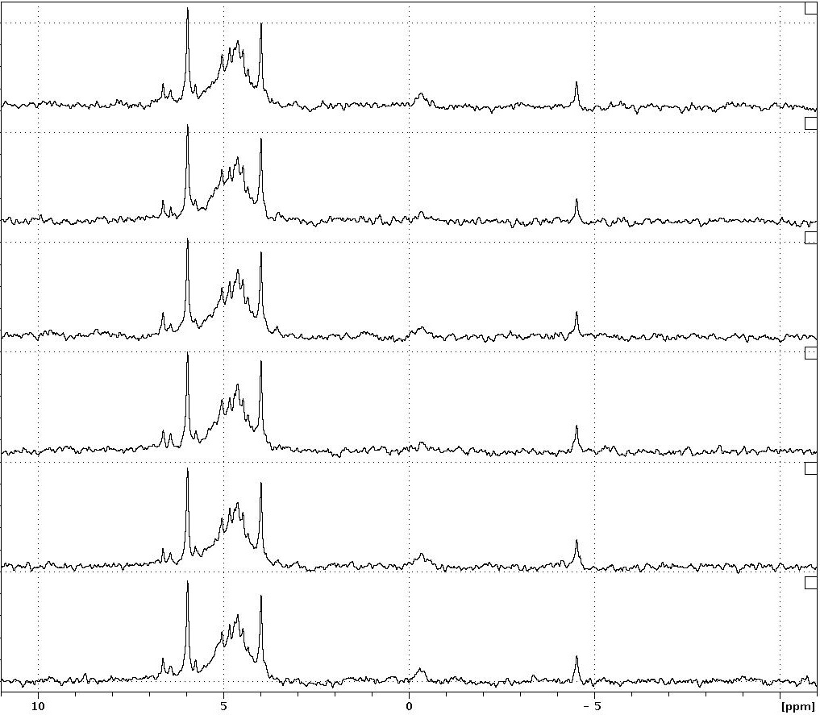
Fig. A.1: Testing sample degradation during solution ³¹P NMR of a calcareous grassland soil. Soil extract sample run for 48hr in 8hr increments: 8, 16, 24, 32, 40 & 48hr. The x-axis shows the chemical shift of 10 to -10ppm only as no peaks were seen outside this range.
Chemical shift (ppm)
8hr
16hr
24hr
32hr
40hr
48hr
Orthophosphate
Pyrophosphate
Diesters
Monoesters
Scyllo-inositol hexakisphosphate

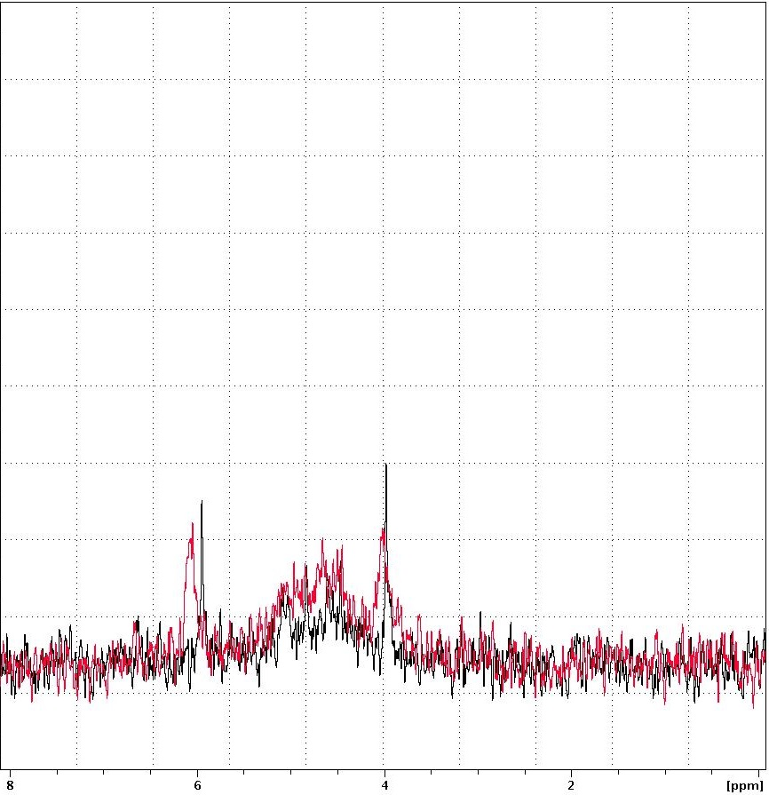
Chemical shift (ppm)
Orthophosphate
Scyllo-inositol hexakisphosphate
100mg
200mg
Monoesters
Fig. A.2: Testing the effect of sample concentration on spectral resolution in solution ³¹P NMR of a calcareous grassland soil. Red spectrum shows 200mg and black spectrum 100mg of freeze dried material dissolved into 1mL of which 0.5mL is in the NMR tube. The x-axis shows the chemical shift of 8 to 0ppm only as there were no peaks were seen outside this range.

Table A.1: Measured T1 from the inversion-recovery null method and calculated delay time of orthophosphate in a calcareous grassland soil. The spiked soil sample contained orthophosphate added to a final concentration of 5.3M. Delay time was calculated as T1*5. Standard deviation of curve fitting was calculated by Topspin software.
Sample | Calculated T1 (s) | Standard deviation | Calculated delay time
Orthophosphate spike in soil | 4.21 | 5.279x10⁻³ | 21.05

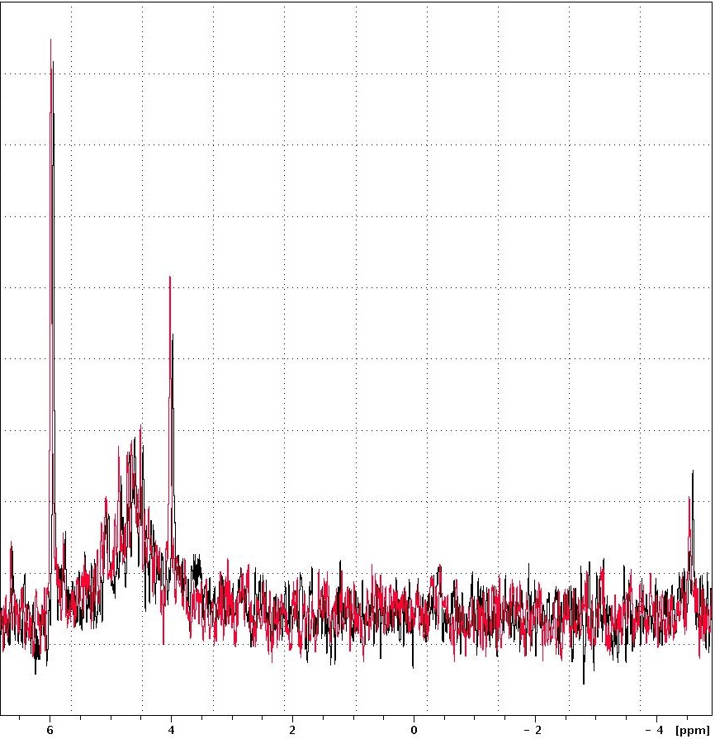
Pulse Program
zgig: no decoupling during delay

zgpg: decoupling during delay
Pyrophosphate
Monoesters
Scyllo-inositol hexakisphosphate
Orthophosphate
Chemical shift (ppm)
Fig. A.3: Testing the effect of different pulse programs on spectral resolution in solution ³¹P NMR of a calcareous grassland soil. The zgig pulse program did not apply decoupling during the delay (black spectrum) and the zgpg pulse program applied decoupling throughout (red spectrum). The x-axis shows the chemical shift of 7 to -3ppm only as no peaks were seen outside this range.

Discussion
The calcareous grassland soil showed no degradation, a 100mg NMR sample was more suitable than 200mg and decoupling during the delay did not change the spectrum produced. These results are similar to those for the arable soil analysed in Chapter 2. This suggests that the same NMR method would be suitable for both soils. However, the T1 of orthophosphate in the calcareous grassland soil (4.21s) is much shorter than that for orthophosphate in the arable soil (8.99s, Chapter 2 section 2.4.3). Full orthophosphate signal would, therefore, be seen with a shorter delay time in the calcareous grassland soil than the arable soil. This emphasises the need to optimise NMR for different soils, particularly to ensure use of a delay time that allows accurate quantification of orthophosphate.

³¹P NMR Spectra
The Spen Farm agricultural soil ³¹P NMR spectra (Fig. B.1, B.3 and B.4) from which P levels were obtained by integration (Chapter 3, Fig. 3.2, 3.4 and 3.6) and the Allerton Farm agricultural soil ³¹P NMR spectra (Fig. B.2) from which P levels were obtained by integration (Chapter 3, Fig. 3.) are shown. These spectra are included to show that visual inspection of the areas under peaks shows similar patterns to and confirms the absolute P level data. For materials and methods see Chapter 2 (section 2.3).

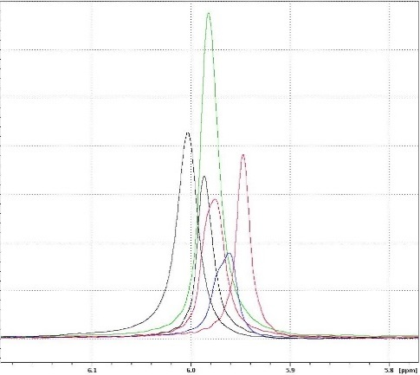
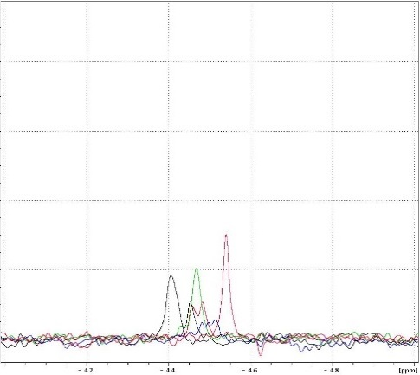
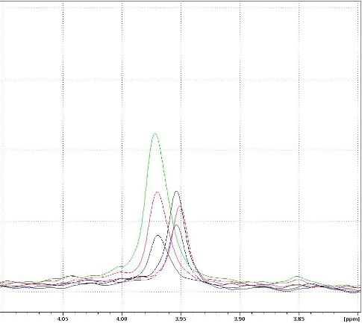
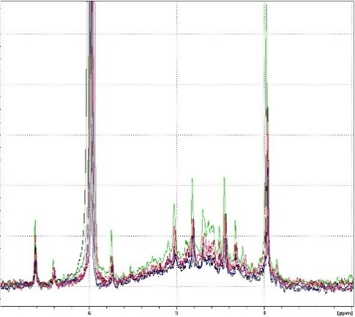
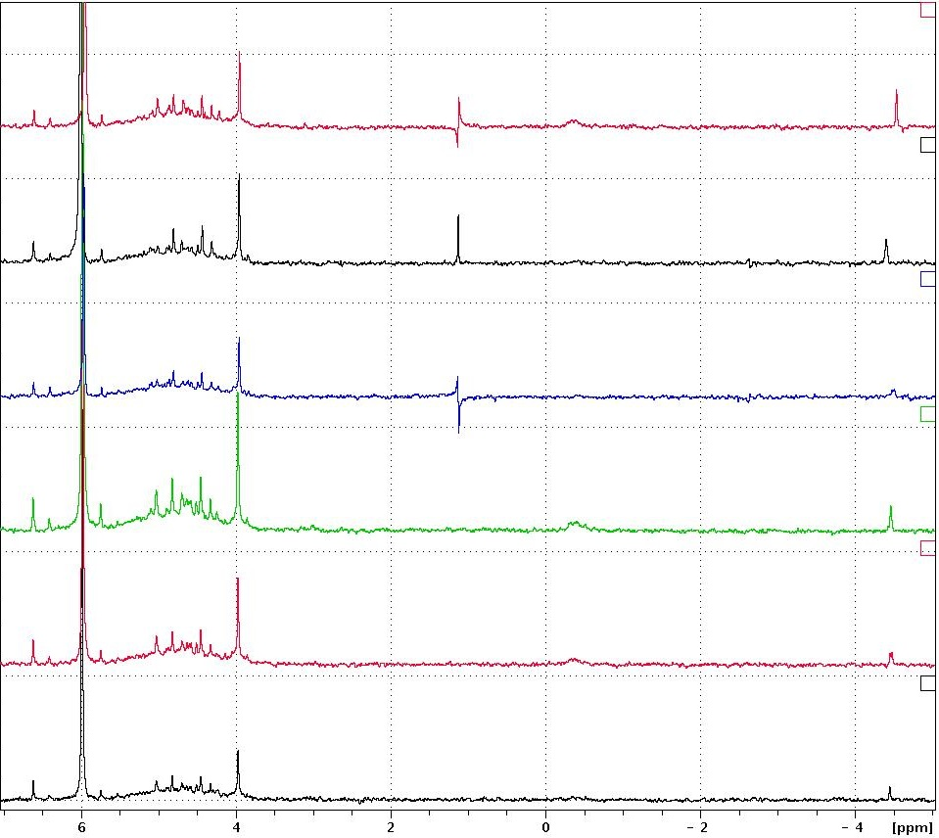
Key
# neo-IHP † D-chiro-IHP
● orthophosphate * myo-IHP
‡ D-chiro-IHP & unidentified ▪ scyllo-IHP
¶ pyrophosphate
Fig. B.1: Overlaid ³¹P NMR spectra of six agricultural soil samples from Spen Farm. Each spectrum is a sum of four replicate spectra. Spectra are labelled as follows: HARA = hedgerow of ARA, PtA = pasture to arable field, ARA = arable field, PAS = pasture field and AtP = arable to pasture field. IHP = inositol hexakisphosphate. (A), (B), (C) and (D) spectra overlapped. (E) all peaks with the six individual spectra spread out. The broad underlying humic acid associated phosphorus peak is shaded in blue on the HARA spectrum. The apparent peak at ≈1ppm is not a true peak but an artefact of the spectrometer. The x-axis only shows the chemical shift of ≈7 to -5 ppm as no peaks were seen outside this range. Panels are scaled differently.
Chemical shift (ppm)
A)
Orthophosphate
Chemical shift (ppm)
C)
Scyllo-inositol hexakisphosphate
E)
Chemical shift (ppm)
Chemical shift (ppm)
B)
Pyrophosphate
Chemical shift (ppm)
D)
Monoesters
*
*
*
*
#
●
†
‡
▪
#
●
▪
¶
*
*
‡
†
*
*
PAS
PtA
HARA
ARA
2014
ARA
2016
AtP
PAS
ARA 2014
HARA
AtP
PtA
2016 ARA
PAS
PtA
HARA
ARA
2014
ARA
2016
AtP
PAS
ARA
2014
HARA
AtP
PtA
ARA
2016
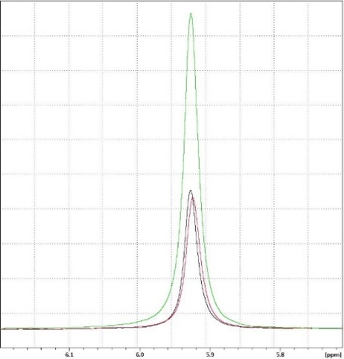
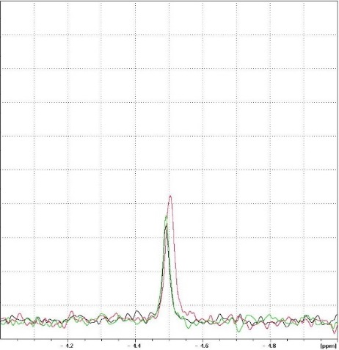
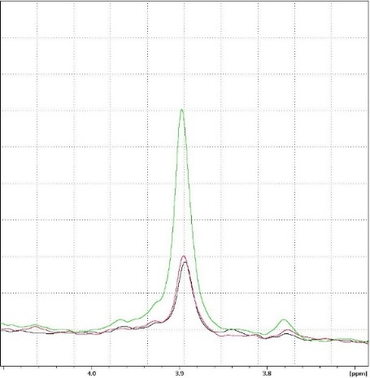
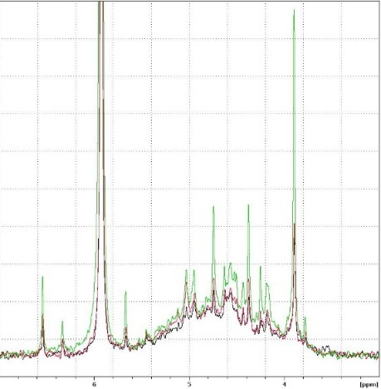
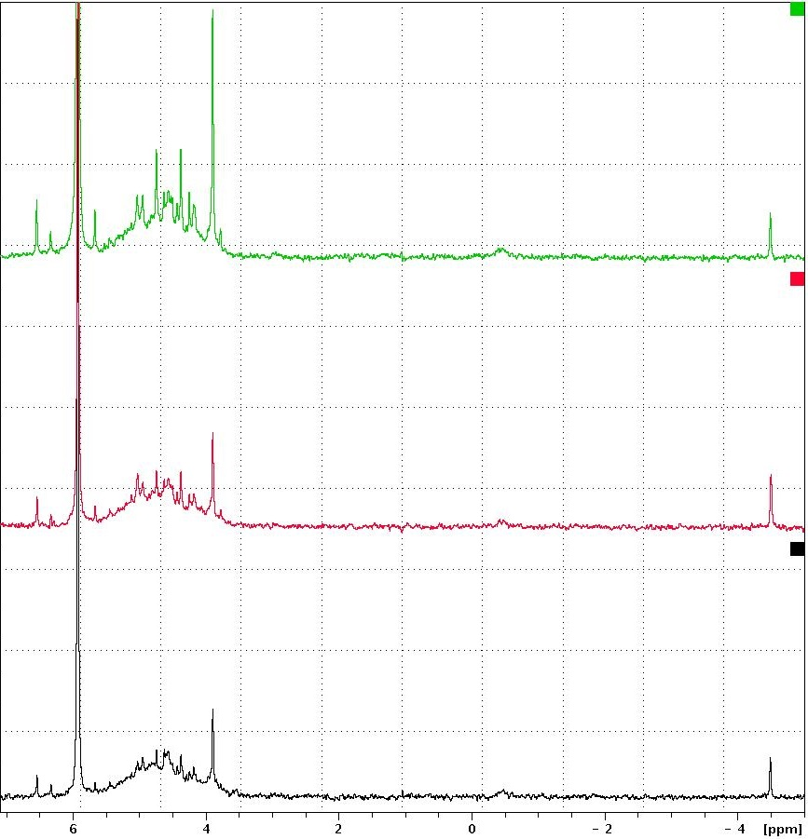
Fig. B.2: Overlaid ³¹P NMR spectra of three agricultural soil samples from Allerton Farm. ARA2 = a conventionally managed arable field soil, LTIL = a low-till field soil and HLTIL = the hedgerow of the low-till field. IHP = inositol hexakisphosphate. (A), (B), (C) and (D) spectra overlapped. (E) all peaks with the three individual spectra spread out. The broad underlying humic acid associated phosphorus peak is shaded in blue on the HLTIL spectrum. The x-axis only shows the chemical shift of ≈7 to -5 ppm as no peaks were seen outside this range. Panels are scaled differently.
Key
# neo-IHP † D-chiro-IHP
● orthophosphate * myo-IHP
‡ D-chiro-IHP & unidentified ▪ scyllo-IHP
◊ orthophosphate diester(s) ¶ pyrophosphate
Chemical shift (ppm)
A)
HLTIL
LTIL
ARA2
Orthophosphate
Chemical shift (ppm)
B)
HLTIL
ARA2
LTIL
Pyrophosphate
Chemical shift (ppm)
C)
HLTIL
LTIL
ARA2
Scyllo-inositol hexakisphosphate
Chemical shift (ppm)
D)
ARA2
LTIL
HLTIL
*
*
*
*
#
●
†
‡
▪
Monoesters
E)
HLTIL
LTIL
ARA2
Chemical shift (ppm)
#
†
*
*
*
‡
●
▪
◊
¶
*
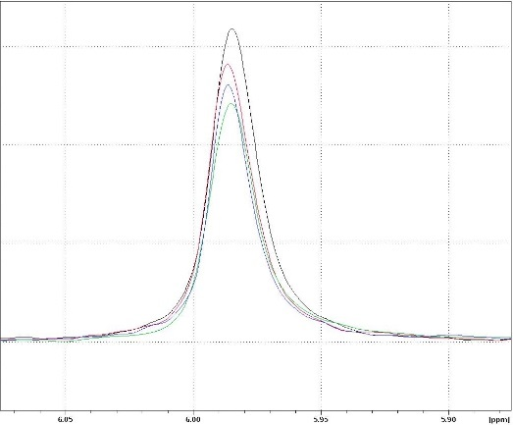
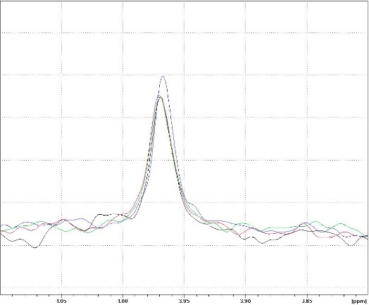
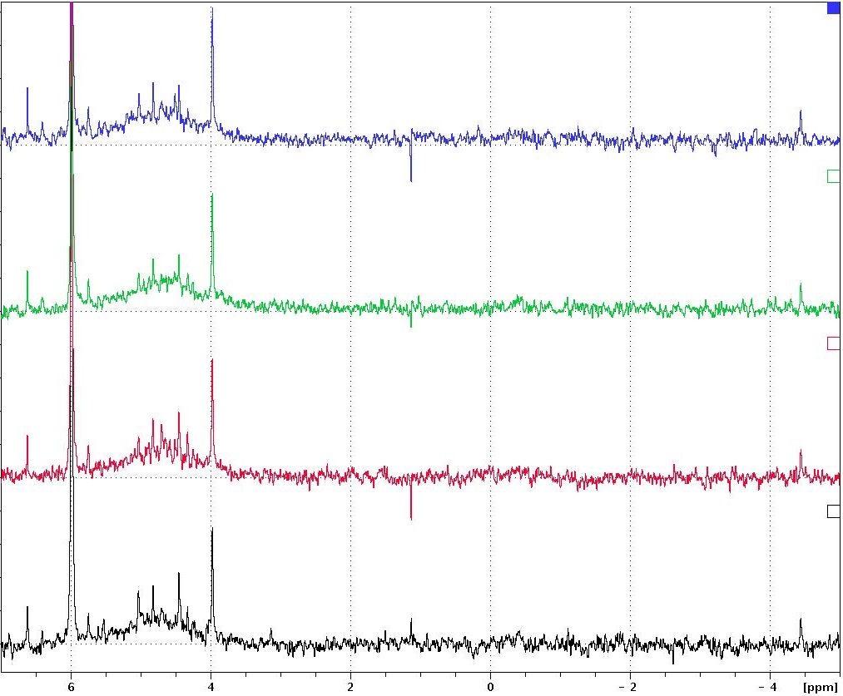
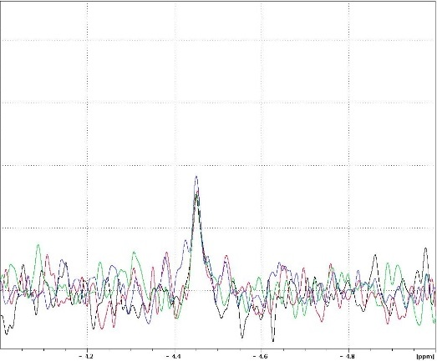
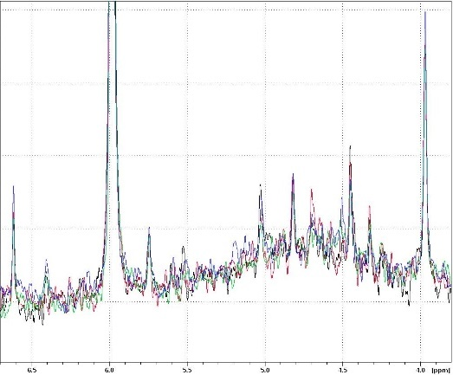
Fig. B.3: Overlaid ³¹P NMR spectra of four seasonal soil samples from an arable field (ARA) at Spen Farm. Each spectrum is a sum of four replicate spectra. IHP = inositol hexakisphosphate. (A), (B), (C) and (D) spectra overlapped. (E) all peaks with the four individual spectra spread out. The broad underlying humic acid associated phosphorus peak is shaded in blue on the AUG spectrum. The apparent peak at ≈1ppm is not a true peak but an artefact of the spectrometer. The x-axis only shows the chemical shift of ≈7 to -5 ppm as no peaks were seen outside this range. Panels are scaled differently.
Key
# neo-IHP † D-chiro-IHP
● orthophosphate * myo-IHP
‡ D-chiro-IHP & unidentified ▪ scyllo-IHP
¶ pyrophosphate
Chemical shift (ppm)
A)
Orthophosphate
Chemical shift (ppm)
C)
Scyllo-inositol hexakisphosphate
E)
Chemical shift (ppm)
#
●
▪
¶
*
*
*
*
‡
†
APR
AUG
JUN
FEB
Chemical shift (ppm)
B)
Pyrophosphate
Chemical shift (ppm)
D)
*
*
*
*
#
●
†
‡
▪
Monoesters
APR
AUG
JUN
FEB
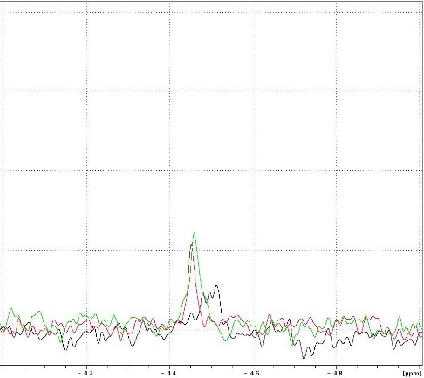
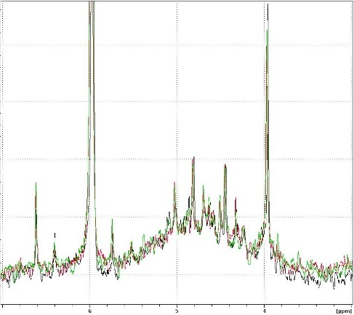
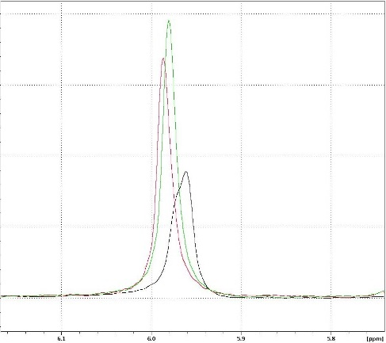
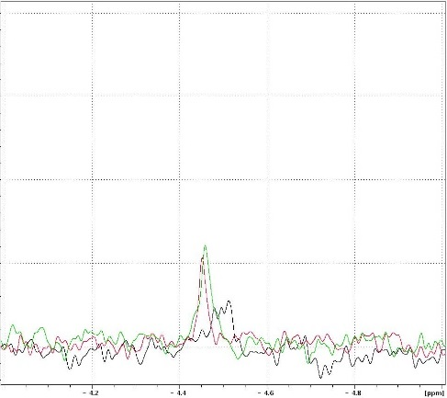
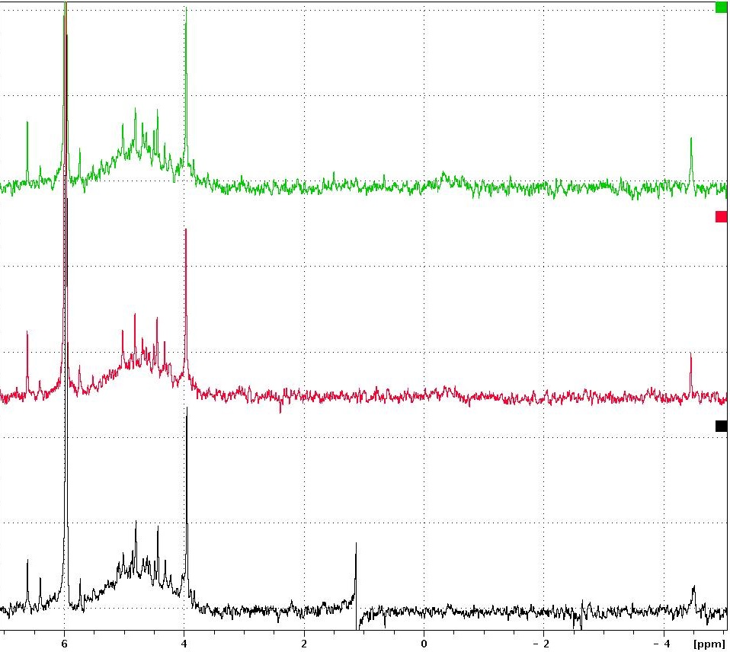
Key
# neo-IHP † D-chiro-IHP
● orthophosphate * myo-IHP
‡ D-chiro-IHP & unidentified ▪ scyllo-IHP
¶ pyrophosphate
Fig. B.4: Overlaid ³¹P NMR spectra of three temporal soil samples from an arable field (ARA) at Spen Farm. Each spectrum is a sum of four replicate spectra. IHP = inositol hexakisphosphate (A), (B), (C) and (D) spectra overlapped. (E) all peaks with the three individual spectra spread out. The broad underlying humic acid associated phosphorus peak is shaded in blue on the 2017 spectrum. The apparent peak at ≈1ppm in the 2014 spectrum is not a true peak but an artefact of the spectrometer. The x-axis only shows the chemical shift of ≈7 to -5 ppm as no peaks were seen outside this range. Panels are scaled differently.
Chemical shift (ppm)
A)
Orthophosphate
Chemical shift (ppm)
C)
Scyllo-inositol hexakisphosphate
E)
Chemical shift (ppm)
Chemical shift (ppm)
B)
Pyrophosphate
Chemical shift (ppm)
D)
Monoesters
*
*
*
*
#
●
†
‡
▪
#
●
▪
¶
*
*
‡
†
*
*
2017
2014
2016
2017
2016
2014

Chemical Synthesis of ³³P Radiolabeled Inositol Polyphosphates (IPP)

Introduction
To directly quantify P uptake a radiolabeled P source is required. ³³P radiolabeled inositol polyphosphates are not commercially available and so need to be synthesised. A simplified protocol to allow for use in laboratories which do not possess specialised chemical synthesis equipment or expertise was developed by Jean-Olivier Zirimwabagabo and Prof. Joe Harrity (Department of Chemistry, The University of Sheffield). The method and composition of the product produced by this protocol is detailed in this appendix.

Materials
All chemicals were obtained from Sigma-Aldrich Co. (St. Louis, MO, US) except radiolabelled phosphoric acid which was obtained from Hartmann Analytic (Braunschweig, Germany). The following chemicals were used in this method: myo-inositol (≥99.0%), H₃PO₄ (crystalline form, ≥99.999%), tributylamine (≥98.5%), N, N-Dimethylformamide (DMF, ≥99%), Ion-exchange resin (Cl¯ form, DEAE-Sepharose), ³³P orthophosphoric acid (2.5x10⁻⁶mmol/mL 148TBq/mmol), hydrochloric acid solution (HCl, 1M), methanol (HPLC grade) and ultra-pure water.

Method
All glassware was acid washed in 1M HCl prior to use. The following was added to a test tube, in order: 9mg (0.05mmol) of myo-inositol, 15mg (0.16mmol) of H₃PO₄, 100µL ³³P orthophosphoric acid (2.5x10⁻⁷mmol, 148TBq/mmol), 30µL of tributylamine and 300µL of DMF. The test tube was attached to a condensing column and refluxed at ≈200°C for 20h over a stirring and heating block.
After reflux the mixture was rinsed with methanol several times and transferred to a round bottomed flask. The mixture was fully dried using a rotary evaporator over an 80°C water bath. The ion-exchange resin was primed by adding ≈6mL of resin to a column and rinsing with 200mL of methanol. This was followed by rinsing with a 150mL mixture of HCL (100mL) and methanol (50mL). This made the resin into the H⁺ form. This was then followed by several methanol rinses. The dried mixture was then re-dissolved in a mixture of methanol and water (in a 2:1 ratio) and forced through the ion-exchange column. The column was rinsed with 150mL of methanol to remove impurities. To remove the product from the resin a 150mL mixture of HCl (100mL) and MeOH (50mL) was forced through the resin. The eluate was collected and fully dried using a rotary evaporator over an 80°C water bath.

Analysis of Synthesised Product by ³¹P NMR Spectroscopy

Materials and Methods
Product analysis was conducted on an identical run of the protocol without the use of ³³P. This meant the product could be easily assessed using solution ³¹P NMR spectroscopy which cannot run samples containing ³³P.
Dried product was dissolved in 5mL of ultra-pure water. Of this 0.8mL was taken and mixed with 0.1mL of 10M NaOH, 90µL D₂O and 10µL of 45mM methylene diphosphonic acid in D₂O. A 0.5mL sample of this was taken for NMR.
Spectra were obtained on a Bruker Avance 500 Spectrometer (Bruker, Germany) operating at 202.456MHz with a 5mm broadband probe for ³¹P. D₂O is included in samples as the signal lock. All samples were left for 5min in the spectrometer before analysis to allow the sample to reach the temperature of the spectrometer. Spectra were run with the following parameters: acquisition time = 0.403s, pulse angle = 90°, probe temperature = 298K (≈25°C), number of scans = 512 and delay time = 15s. As the delay time was long, percentages of P compounds were calculated directly from integration, assuming the majority of all signals were detected. Chemical shifts were relative to an external standard of 85% H₃PO₄ which was used to set 0ppm. Spectra were plotted using a line broadening of 2Hz. The proportions of the P compounds were calculated from the integrated areas under the peaks using the Topspin software. Integrated areas were calibrated to the MDP reference in each sample which was a known number of moles (4.5x10⁻⁷mol).

Results
From analysis of the inositol polyphosphate product by ³¹P NMR spectroscopy, it can be seen that samples contained contaminating orthophosphate (Fig. C.1). For the sample used in Chapter 4 this was likely to be approximately 20% orthophosphate. By the time the experiment in Chapter 5 was conducted the protocol had been refined further, and the produced product contained only approximately 8% orthophosphate. The rest of the P was contained in inositol polyphosphates. This method does not produce inositol hexakisphosphate due to steric hindrance which makes adding a sixth phosphate to the inositol ring difficult.
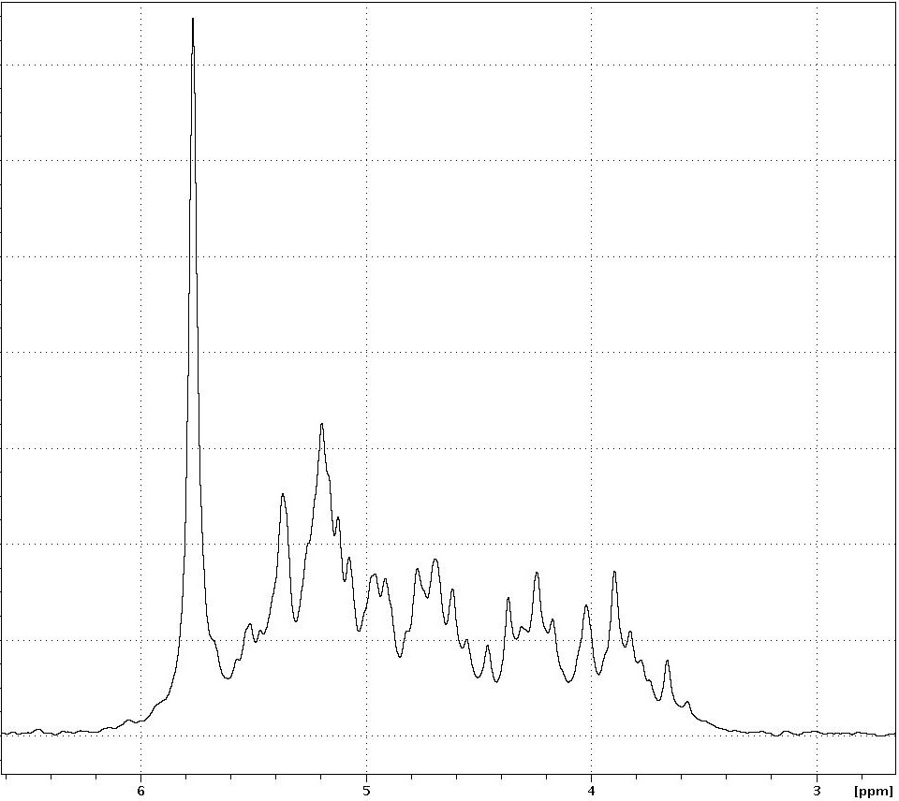
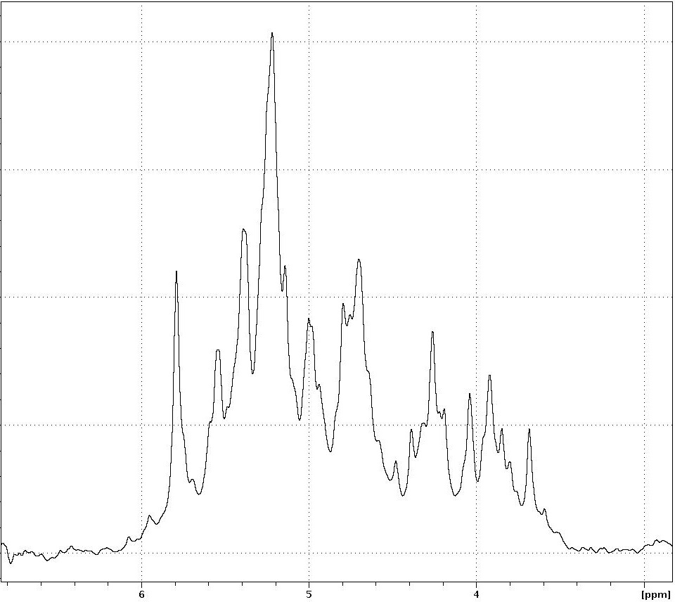
Orthophosphate, 19.75%
Inositol polyphosphates, 80.25%
A)
Chemical shift (ppm)
Orthophosphate,
8.25%
Inositol
polyphosphates, 91.75%
B)
Chemical shift (ppm)
Fig. C.1: ³¹P NMR spectra of inositol synthesis product. (A) product before refinement of the protocol and as used in Chapter 4. (B) product after refinement of the protocol and as used in Chapter 5. Percentages show the amount of P as a proportion of total extractable P.

Root Structure Correlation
In Chapter 5 root systems could not be analysed for total root length. Therefore, to provide a proxy for root length data from the root systems from Chapter 4 were used. In that data, it was seen that total root length correlated with dry root weight (Fig. D.1). Therefore, in Chapter 5, that correlation allowed total root dry weight to be used as a proxy for total root system size.
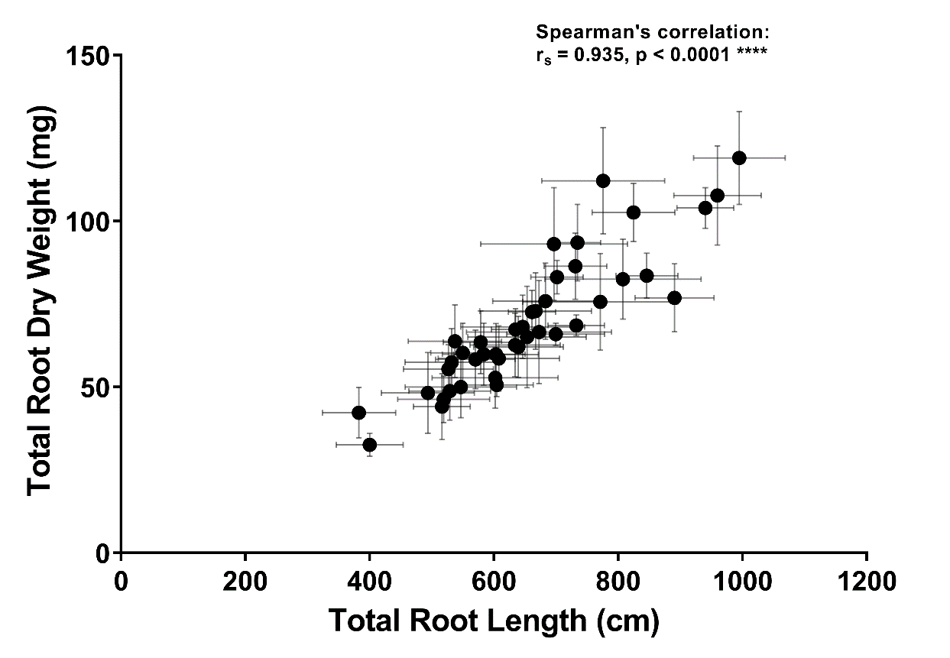
Fig. D.1: Total root dry weight and total root length in 21 wheat varieties. Points show means of each variety and error bars show standard error of the mean (n=4-6). The result of Spearman’s correlation is shown on the graph. Asterisks denote significance.

