
The Effect of Removable Partial Denture Material and Design on Load Distribution over the Supporting Structures
Abdurraouf A Ziglam
PhD Thesis
September/2017
University of Sheffield
The School of Clinical Dentistry

Supervised by

Dr David Patrick

Dr Duncan Wood

DEDICATION
To my mother Sabria Al-Tajuri
Brothers and Sisters
My wife Khuluod and children
Shefaa, Abdulghani, Talha
Najlaa, Refaa and Omar

ACKNOWLEDGEMENT
In the name of Allah (God), the Most Gracious, the Most Merciful
All praise is due to Allah, Lord of the world for the strength and blessings in completing this work. You give me the power to believe in my passion and pursue my dreams. I could never have done this without the faith I have in you, the Almighty.
A part from my efforts, the success of any project depends largely on the encouragement and guidance of many others. I take this opportunity to express my gratitude to the people who have been instrumental in the successful completion of this project.
I would like to express my sincere gratitude to my supervisors: Dr David Patrick, Dr Duncan Wood and Dr Anthony Johnson for their invaluable advice, guidance and support during the research and writing of this thesis.
My special thanks to Dr Rachel Tomlinson, the senior lecturer in the department of Mechanical Engineering, for her kind support, motivation, assistance and concern. I believe without her kind cooperation I could not learn the method of the study.
I cannot thank enough my best person in the world, the burning candle whom has illuminated my path; my Mother. I believe my life will not progress without her prayer. Thanks linked to my siblings who encourage me to carry on in my study.
I am forever indebted to my Wife and my six children for their understanding, endless patience and tolerance when it was most required.
Many thanks to Dr Robert Moorhead and Mr Richard Kay for their cooperation and help.
I would like to thank Dr Simon Hayes and Mr Michael Bell, the staff in the department of Material Engineering for support and cooperation.
Thanks to my colleagues; Dr Saja Muhsin, Dr Raad Al mirza, Dr Omar Alsaddon, Dr Ammar Al Tarhuni and Rayan Howsawi for their help, support and happy times during the period of the study.
Finally, many thanks for JUVORA company for providing the PEEK discs. Many thanks for Valplast International Corp for providing the Valplast flexible dentures were prepared specially for this project.

Synopsis

Problem: The number of partially edentulous patients is increasing, so the need for RPDs will increase in the clinical practice (Walmsley 2003). One of the most significant disadvantages of current RPDs affecting the health of the remaining oral structures is the unresolved issue of the load distribution between the supporting structures. This is dependent upon materials properties, design and fit of the RPD. A significant need exists to advance the knowledge surrounding this issue and the exploration of novel materials now available for this type of prosthetic treatment.
Purpose of study: The aim of this project was to evaluate the RPD frameworks produced from Polyetheretherketone (PEEK) and their load distribution to the supporting structures in comparison to the conventional RPD materials. Further, to enhance the design in order to take advantage of the polymer’s mechanical properties. Therefore, the design will then be adjusted to optimise the load distribution.
The objectives for this study were firstly, to use 3D stress freezing digital photoelasticity in dental applications and produce a photoelastic model composed of two materials that have properties representing that of dentin and bone.
Secondly, to compare the load distribution of PEEK with that of the conventional materials, and thirdly, to design a PEEK RPD framework for the optimised load distribution.
Method and Materials: A 3D digital photoelasticity technique was adapted for use in dentistry to analyse the load distribution of RPD frameworks. A novel photoelastic model was made with individual simulative materials for tooth structure, alveolar bone, PDL, and oral mucosa.

Photoelastic models were fabricated to represent two scenarios:
Scenario 1:
Upper Kennedy Class III modification 1
In total 8 denture designs were analysed for this pattern of tooth loss:
3 tooth supported designs: a CoCr denture and PEEK denture of conventional dimensions and design, and a PEEK optimized design.
5 tissue supported design: 3 different PMMA designs, one Nylon polyamide, and one PEEK design.
Scenario 2:
Lower Kennedy Class I.
In total 7 denture designs were analysed for this pattern of tooth loss:
4 tooth and tissue supported dentures: 3 CoCr dentures with different clasp designs, and one PEEK design.
3 tissue supported dentures: PMMA, Nylon polyamide and PEEK.
For each experiment the RPDs were placed on the photoelastic model and loaded by a modified dental surveyor in the stress freezing oven. The models then sectioned to produce sample slices 2mm in thickness at selected points. The data was collected using Catchsix and CoPA photoelastic softwares packages.
Results: Results of the resin model fabrication revealed that the ratio of the modulus of elasticity between Photoelastic materials PL1 and Araldite 2020 epoxy resins at Tg mimic that between dentin and bone.
3D digital photoelasticity was demonstrated to be a valuable technique which allows for viewing of the stresses in the model and the inclusion of digital technology in data processing advances photoelasticity to a modern technique of stress analysis.
Results of stress analysis revealed that:
- PEEK dimensions and designs should be tailored to the material properties to fulfil the objective of the supporting components
- Covering the palatal surfaces of the teeth above the height of the contour in acrylic denture designs assists in transferring some of the applied load to the teeth.
- PEEK dentures with a novel clasp design shows potential in comparison to the conventional tissue supported RPD materials.
- RPI assemblies are better in load distribution than circumferential and embrasure CoCr designs. This was found to be consistent with other studies.
- PEEK dentures with the novel clasp design are comparable in load distribution with that of the RPI assembly design.

Conclusion: PEEK is a promising RPD material. The flexibility of this material in combination with novel clasp design transfers the distribution of load in a favourable manner over the abutment teeth. However, further research is needed before it can be accepted as an option in RPD prosthodontics.

Table of Contents
Synopsis VI
List of figures XVI
List of Table XXII
List of Abbreviation XXIII
1 Introduction 1
2 Literature Review 6
2.1 Removable Partial Denture 7
2.1.1 Types of RPD 7
2.1.2 Classification of partially dentate arches 8
2.1.3 Biomechanical principles of the RPD 10
2.1.4 Support and force distribution 13
2.1.4.1 Tooth-supported RPD 13
2.1.4.2 Tooth-tissue supported RPD 14
2.1.4.3 Tissue-supported RPD 15
2.1.5 Partial denture components. 16
2.1.6 Demographics 19
2.1.7 Impact of RPDs on oral health 20
2.1.7.1 Dental caries 20
2.1.7.2 Gingivitis and periodontitis 22
2.1.7.3 Quality of life 24
2.1.7.4 Patient satisfaction 25
2.1.8 Clinic-laboratory communication 31
2.1.9 Indications for RPD 32
2.2 Design of CoCr material 35
2.2.1 History 35
2.2.2 Design and stress distribution 36
2.2.2.1 Rigid major connector 36
2.2.2.2 Rest and rest seats 37
2.2.2.3 Rest position 38
2.2.2.4 Clasps 40
2.2.2.5 RPI assemblies and modifications 45
2.2.2.6 Altered cast technique 46
2.2.2.7 Base extension and adaptation 47
2.2.2.8 Occlusal table and number of teeth 48
2.2.2.9 Resilient inner layer 48
2.2.2.10 Implant 49
2.3 Conventional materials properties 50
2.3.1 Polymethyl Methacrylate (PMMA) 50
2.3.1.1 Low mechanical properties 51
2.3.1.2 Sensitivity 52
2.3.1.3 Polymerization shrinkage 53
2.3.1.4 Radiopacity 54
2.3.2 Polyamide 54
2.3.3 Cobalt chromium 56
2.3.3.1 High modulus of elasticity 57
2.3.3.2 Fatigue and fracture components 58
2.3.3.3 Aesthetics 59
2.3.3.4 Longevity 60
2.3.3.5 Biocompatibility 61
2.3.3.6 Production drawbacks 62
2.3.3.7 Accuracy of fit 64
2.3.3.8 CAD/ CAM CoCr. 65
2.3.4 Titanium 65
2.3.4.1 Laboratory drawbacks 66
2.3.4.2 Clinical drawbacks of titanium 66
2.3.5 PEEK 69
2.3.5.1 Mechanical properties 70
2.3.5.2 Chemical resistance 72
2.3.5.3 Water solubility 72
2.3.5.4 Thermal stability 73
2.3.5.5 Radiation stability 73
2.3.5.6 Clinical application 77
2.4 Experimental stress analysis. 81
2.4.1 Finite element analysis 81
2.4.2 Strain gauge measurements 81
2.4.3 Photoelasticity 82
2.4.3.1 Theory of photoelasticity 85
2.4.3.2 Photoelastic model materials 86
2.4.3.3 Basic photoelasticity techniques 87
2.5 Summary and challenges 91
3 : Aim and Objectives 93
3.1 Aim 95
3.2 Objectives 95
3.3 Hypothesis 95
4 : Methodology Of Development of the Novel Resin Model 96
4.1 Resin model fabrication 97
4.1.1 Producing a photoelastic model to represent abutment teeth and bone 105
4.2 Master model making 112
4.2.1 Root formation 115
4.2.2 Periodontal ligament simulation 116
4.2.3 Mucosa simulation 123
4.3 Experimental method 125
4.3.1 Stress freezing 125
4.3.2 Sectioning 128
4.3.3 Data collection with digital technology 131
5 : Load Distribution for Upper Kennedy Class III modification 1 Tooth Supported Removable Partial Denture 139
5.1 The effect of the material properties on denture design 140
5.1.1 Materials and method 142
5.1.1.1 Designing the framework 142
5.1.1.2 Manufacturing of the RPD frameworks 144
5.1.1.3 Attaching the PMMA teeth 149
5.1.2 Results 153
5.1.3 Discussion 160
5.1.4 Conclusion 162
5.2 Optimising the design criteria to provide adequate tooth support for an RPD produced from PEEK 164
5.2.1 Material 168
5.2.2 Results 170
5.2.3 Discussion 178
5.2.4 Conclusion 180
6 : Load Distribution for Upper Kennedy Class III modification 1 Tissue Supported RPD. 181
6.1 Load distribution of an upper bounded saddle acrylic partial denture 182
6.1.1 Method 184
6.1.2 Results 186
6.1.3 Discussion 195
6.1.4 Conclusion 197
6.2 Load Distribution of the PEEK Denture in Comparison with Conventional Tissue Supported RPD Materials 198
6.2.1 Materials 200
6.2.2 Results 201
6.2.3 Discussion 209
6.2.4 Conclusion 211
7 : Load Distribution for Lower Kennedy Class I Tooth and Tissue Supported RPD. 212
7.1 Load distribution of the lower class I cobalt chromium partial denture 213
7.1.1 Method and Materials 215
7.1.2 Results 217
7.1.3 Discussion 222
7.1.4 Conclusion 224
7.2 Load distribution of PEEK RPDs in comparison to the RPI CoCr denture kennedy for class I lower denture. 225
7.2.1 Materials 226
7.2.2 Results 228
7.2.3 Discussion 231
7.2.4 Conclusion 233
8 : Load Distribution for Lower Kennedy Class I Tissue Supported RPD. 234
8.1 Introduction 235
8.2 Materials 237
8.3 Results 238
8.4 Discussion 243
8.5 Conclusion 245
9 : General Discussion 246
10 : Conclusion and Future Work 262
11 : References 264
12 : Appendices…………………………………………………………279

List of figures
Figure 1 : Branches of prosthodontics (Phoenix et al. 1992). 2
Figure 2: Types of RPD 8
Figure 3: Kennedy classification of partially dentate arches 9
Figure 4: Planes of potential partial denture movement and fulcrum lines at right angles to those planes. 11
Figure 5: Photoelastic study of the stress distribution around roots as a response to the force direction. (Glickman et al 1970) 13
Figure 6: Force distribution by Class III RPD (Phoenix et al. 1992) 14
Figure 7: Force distribution problem with the Class I RPD and the required remedy 15
Figure 8: Force distribution problem with the tissue supported RPD and the required remedy 16
Figure 9 : RPD components. 18
Figure 10: Visualization of stresses in the slice. 83
Figure 11: Light propagation through birefringent material (Cloud 2007) 85
Figure 12: Theory of photoelasticity (Cloud 2007) 86
Figure 13: PMMA Models 100
Figure 14: PL1 models shows the residual stresses 101
Figure 15: Araldite 2020 model free from any residual stresses 104
Figure 16: Specimens 106
Figure 17: Specimens in the DMA machine. 107
Figure 18: Tg and E of the selected materials. 108
Figure 19: The upper and lower resin models. 111
Figure 20: Modified Frasaco models represent the selected scenarios. 112
Figure 21: Prepared occlusal rests on the upper abutment teeth. 113
Figure 22: Prepared occlusal rests on the lower abutment teeth 113
Figure 23: Upper mater model. 114
Figure 24: Lower master model. 114
Figure 25: Upper abutment teeth to the full length. 115
Figure 26: Lower abutment teeth to the full length. 115
Figure 27: Steps of PDL Simulation 118
Figure 28: Different thickness of the material. 119
Figure 29: The teeth ready for slicing. 120
Figure 30: The sliced teeth showed the PDL space. 120
Figure 31: Thickness of the PDL space under the microscope 121
Figure 32: The abutment teeth with PDL simulation. 122
Figure 33: The reduced master model. 123
Figure 34: a. The duplicated upper model, b.The upper working resin model 124
Figure 35: a. The duplicated lower model, b. The lower working resin model 124
Figure 36: The stress freezing cycle. 126
Figure 37: The models under loading in the oven. 126
Figure 38: The calibration disc. 127
Figure 39: The resin model under slicing. 129
Figure 40: The upper resin model with the selected slices 129
Figure 41: The lower resin model with the selected slices 130
Figure 42: Assembled devices for data collection. 131
Figure 43: Steps of the Catchsix software 132
Figure 44: Steps of the COPA Software 133
Figure 45: The Isochromatic pattern. 134
Figure 46: The Isoclinic pattern. 135
Figure 47: Methods of data collection. a. Digital processing. b. Point by point technique. 137
Figure 48: Dental wing soft wear. 142
Figure 49: Steps of Designing RPD in the Bitewing software. 144
Figure 50: Roland DWX 50 milling machine. 145
Figure 51: PMMA and PEEK disks. 145
Figure 52: Steps of Denture Milling 146
Figure 53: The milled frameworks a. PEEK, b. PMMA. 146
Figure 54: CoCr framework, a. The sprued pattern, b. The framework in the electrolytic path, c. The metal framework ready for seating of the synthetic teeth 148
Figure 55: a. Modelling wax, b. PMMA teeth seated in the framework. 149
Figure 56: The putty index. 149
Figure 57: The teeth were glued to the index, and the saddle area was painted with pink opaque composite. 150
Figure 58: a. The putty index with the PMMA teeth in place, b. the CoCr RPD 151
Figure 59: The PEEK and CoCr dentures at the working model. 152
Figure 60: Isochromatic phase map (stress magnitude) a. CoCr, b. PEEK. 153
Figure 61: Isoclinic phase map (stress direction) a. CoCr, b. PEEK 154
Figure 62: Isochromatic phase map (stress magnitude) a. CoCr, b. PEEK. 155
Figure 63: Isoclinic phase map (stress direction) a. CoCr, b. PEEK. 156
Figure 64: Isochromatic phase map (stress magnitude) a. CoCr, b. PEEK. 156
Figure 65: Isoclinic phase map (stress direction) a. CoCr, b. PEEK. 157
Figure 66: Isochromatic phase map (stress magnitude) a. CoCr, b. PEEK. 158
Figure 67: Isoclinic phase map (stress direction) a. CoCr, b. PEEK. 159
Figure 68: Rib design principle (Ketaspire PEEK Design and Processing Guide). 165
Figure 69: Optimized PEEK design consists of a. the buccal retentive arm, b. the palatal stabilizing arm, c. the supporting occlusal rest. 167
Figure 70: a. Buccal view to the optimized PEEK clasp design. b. The milled clasp on the stone model. 167
Figure 71: Designing of the optimized PEEK framework 168
Figure 72: The milled optimized PEEK framework. 169
Figure 73: The optimized PEEK denture on the resin model. 169
Figure 74: Isochromatic phase map (stress magnitude) a. CoCr, b. PEEK1,c. PEEK2. 170
Figure 75: Isoclinic phase map (stress direction) a. CoCr, b. PEEK1, c. PEEK2. 171
Figure 76: Isochromatic phase map (stress magnitude) a. CoCr, b. PEEK1, c. PEEK2. 172
Figure 77: Isoclinic phase map (stress direction) a. CoCr, b. PEEK1, c. PEEK2. 173
Figure 78: Isochromatic phase map (stress magnitude) a.CoCr, b. PEEK1, c. PEEK2. 174
Figure 79: Isoclinic phase map (stress direction) a. CoCr, b. PEEK1, c. PEEK2. 175
Figure 80: Isochromatic phase map (stress magnitude) a. CoCr, b. PEEK1, c. PEEK2. 176
Figure 81: Isoclinic phase map (stress direction) a. CoCr, b. PEEK1, c. PEEK2. 177
Figure 82: PMMA designs used in the study. 185
Figure 83: Isochromatic phase map (Stress Magnitude) (a) Palatal Strap, (b) Full Palate, (c) Tooth Contact. 186
Figure 84: Isoclinic phase map (Stress Direction) (a) Palatal Strap, (b) Full Palate, (c) Tooth Contact. 188
Figure 85: Isochromatic phase map (Stress Magnitude) (a) Palatal Strap, (b) Full Palate, (c) Tooth Contact. 189
Figure 86: Isoclinic phase map (Stress Direction) (a) Palatal Strap, (b) Full Palate, (c) Tooth Contact. 190
Figure 87: Isochromatic phase map (Stress Magnitude) (a) Palatal Strap, (b) Full Palate, (c) Tooth Contact. 191
Figure 88: Isoclinic phase map (Stress Direction) (a) Palatal Strap, (b) Full Palate, (c) Tooth Contact. 192
Figure 89: Isochromatic phase map (Stress Magnitude) (a) Palatal Strap, (b) Full Palate, (c) Tooth Contact. 193
Figure 90: Isoclinic phase map (Stress Direction) (a) Palatal Strap, (b) Full Palate, (c) Tooth Contact. 194
Figure 91: Dentures used in this study a. PMMA, b. Polyamide, c. PEEK, d. Clasp design 200
Figure 92: Isochromatic phase map (Stress Magnitude) a. PMMA, b. Polyamide, c. PEEK. 201
Figure 93: Isoclinic phase map (Stress Direction) a. PMMA, b. Polyamide, c. PEEK. 202
Figure 94: Isochromatic phase map (Stress Magnitude) a. PMMA, b. Polyamide, c. PEEK. 203
Figure 95: Isoclinic phase map (Stress Direction) a. PMMA, b. Polyamide, c. PEEK 204
Figure 96: Isochromatic phase map (Stress Magnitude) a. PMMA, b. Polyamide, c. PEEK. 205
Figure 97: Isoclinic phase map (Stress Direction) a. PMMA, b. Polyamide, c. PEEK. 206
Figure 98: Isochromatic phase map (Stress Magnitude) a. PMMA, b. Polyamide, c. PEEK. 207
Figure 99: Isoclinic phase map (Stress Direction) a. PMMA, b.Polyamide, c. PEEK. 208
Figure 100: The designed dentures. a. Circumferential design, b. Embrasure design, c. RPI design. 215
Figure 101: a. The milled designs in PMMA, b. The designs for resin elimination, c. The dentures on the working models. 216
Figure 102: Isochromatic phase map (Stress Magnitude) a. Circumferential, b. Embrasure, c. RPI. 217
Figure 103: Isoclinic phase map (Stress Direction) a. Circumferential, b. Embrasure, c. RPI. 218
Figure 104: Isochromatic phase map (Stress Magnitude) a. Circumferential, b. Embrasure, c. RPI 219
Figure 105: Isoclinic phase map (Stress Direction) a. Circumferential, b. Embrasure, c. RPI. 220
Figure 106: Design of the PEEK denture frame work. 226
Figure 107: a. PEEK denture, b. PEEK and CoCr dentures on the resin models. 227
Figure 108: Isochromatic phase map (Stress Magnitude) a. CoCr, b. PEEK. 228
Figure 109: Isoclinic phase map (Stress Direction) a. CoCr, b. PEEK. 229
Figure 110: Isochromatic phase map (Stress Magnitude) a. CoCr, b. PEEK. 229
Figure 111: Isoclinic phase map (Stress Direction) a. CoCr, b. PEEK. 230
Figure 112: Mucosa born RPDs: PMMA (bottom right), Polyamide (bottom left), PEEK (top). 237
Figure 113: Isochromatic phase map (stress magnitude) a. PMMA, B. Polyamide, c. PEEK. 238
Figure 114: Isoclinic phase map (Stress Direction) a. PMMA, b. Polyamide, c. PEEK. 239
Figure 115: Isochromatic phase map (Stress Direction) a. PMMA, b. Polyamide, c. PEEK. 240
Figure 116: Isoclinic phase map (Stress Direction) a. PMMA, b. Polyamide, c. PEEK. 241
Figure 117: Isochromatic phase map (stress magnitude) a. CoCr, b. PEEK 257
Figure 118: Isochromatic phase map (stress magnitude) a. CoCr, b. PEEK 257
Figure 119: Isochromatic phase map (stress magnitude) a. CoCr distal rest circumferential clasp design. b. PEEK distal rest design. c. RPI design. 259

List of Table
Table 1: Factors related to patient satisfaction with RPDs. 30
Table 2: Clasp design and stress distribution 44
Table 3: Efforts to overcome the residual stresses in the PL1 models. 103
Table 4: Resin materials used in the study. 105
Table 5 : E (GPa) of materials VS temperature. 109
Table 6: Mechanical properties of Dentine and Spongy bone 110
Table 7: The six step schemes of digital photoelasticity. 131

List of Abbreviation

RPD Removable Partial Denture
PMMA Polymethylmethacrylate
CoCr Cobalt chromium
PEEK Polyetheretherketone
CAD CAM Computer-aided design and computer-aided
manufacturing
PDL Periodontal ligament
OHQoL Oral health quality of life
RPI Mesial rest, distal plate and I bar
2D Two dimensions
3D Three dimensions
Birefringent material the refractive index varies with the direction within the
material
Relative retardation the phase shift produce between two co-linear light
beam passing through a birefringent material

Polariser an optical component which filters light so that the
vectors of the light emitted are parallel to its axis
Polariscope a device consisting of a light source and two pairs of
Polarisers. The birefringent specimen is placed
between the pairs in order to observe the fringe
patterns

Tg Glass transition temperature
Isochromatic fringe fringes of constant colour observed when a material is
placed in a polariscope. Representing the intensity of the
stress
Isoclinic black fringes observed when a material is placed in a
polariscope. Representing the direction of the stresses
DMA Dynamic mechanical analysis

Introduction

The science of replacing lost parts is termed prosthetics, and the artificial part is called prosthesis. The terms Prosthodontics and dental prosthesis are used within the field of dentistry and the branch of dental science that deals with the replacement of missing teeth and oral tissues to restore and maintain oral form, function, appearance, and health. Removable prosthodontics, fixed prosthodontics, and maxillofacial prosthodontics are the major divisions of prosthodontics (Phoenix et al. 1992). Removable prosthodontics is designed to replace missing teeth with a denture that can be removed by the patient, including removable complete dentures that replace all the teeth in the jaw, and removable partial dentures.
Prosthodontics
FIXED
PROSTHODONTICS
REMOVABLE
PROSTHODONTICS
MAXILLOFACIAL
PROSTHODONTICS
REMOVABLE COMPLETE DENTURE

REMOVABLE
PARTIAL DENTURE

Figure 1 : Branches of prosthodontics (Phoenix et al. 1992).

Removable partial dentures restore function, appearance, and health of the remaining oral structures by replacement of missing oral tissues with artificial substitutes. The necessity for removable partial dentures is increasing (Douglass et al. 1988). Patient use has been high in the past and this trend is expected to continue in the future, with the increase in demand for removable partial dentures attributed to an increase in the life span of the population and the maintenance of oral health resulting in this category of population having special situation in their oral and general health conditions. This finding indicates the need to optimise the current status of the removable partial denture.
The general aims of providing a removable partial denture are to preserve the integrity of the remaining oral structures and, restore the oral functions, aesthetics and speech. Clinical studies have claimed that removable partial dentures are responsible for tissue damage that occurs to the remaining oral tissue (Nevalainen et al. 2004). However, other studies have indicated that provided a team approach is adopted, the treatment can be successful and oral health can be maintained (Ezawi et al. 2017). Nevertheless, the dental team’s efforts will be useless unless the patient appreciates the importance of proper oral hygiene.
The current removable partial denture framework designs and materials have many disadvantages. The most significant of these are reported cases of problems with biocompatibility, and the problems of teeth mobility and bone resorption under stresses. Since we want the remaining teeth and edentulous ridges to accept increased loads and sustain greater stresses than normal, our first aim should be to preserve these tissues. The ideal partial denture design should reduce the stresses over the supporting tissues, distribute the forces over as wide an area as possible, and influence the occlusal force direction (Kaires 1956a).
The most documented problem in the provision of RPDs is the effect of the difference in resilience between the supporting tissues in free end saddle situations, where the resultant rotary movement affects the distribution of force between the supporting structures. This may lead to mobility of an abutment tooth and residual ridge resorption. There has been extensive research (Pellizzer et al. 2010) on the importance of different aspects of design to the integrity of the supporting structures, including the importance of framework rigidity, good base adaptation, ridge angulation, clasp types, implants, and many other design variables.
In comparison with the number of literature studies that have focused on the design of RPDs fewer have focused on denture materials. No material demonstrates all of the ideal properties for a denture base material
The current materials include polymethylmethacrylate (PMMA), which has many drawbacks, including low mechanical properties, polymerisation shrinkage, poor biocompatibility, which prevent its use as a tooth supported partial denture. Cobalt chromium (CoCr) also has many disadvantages including high modulus of elasticity (stiffness) that can have a harmful effect on the health of the tooth, fatigue and component fracture, and the production method. Other materials used include Nylon polyamide, which has inferior flexural properties, colour deterioration and high water sorption. Meanwhile, Titanium also has problems related to the casting process and resulting porosity that affect the longevity of the clasps and their retentive force.
Polyetheretherketone (PEEK) is a relatively new semi-crystalline thermoplastic polymer that has good mechanical and physical properties with resistance to chemicals, wear, fatigue and creep, even at high operating temperature, and has low specific gravity. The biocompatibility of PEEK has been supported by much scientific evidence since the 1980s. In the medical field, PEEK was first used as a high performance material to substitute for metal implants, especially in orthopaedics and trauma cases (Brown et al. 1990).
The conventional procedure for removable partial denture production entails several steps ranging from waxing up to finishing and polishing, with each step having its own problems. Moreover, the procedure requires using different materials.
The use of computer aided design and computer aided manufacture (CAD CAM) technology can save time, materials and effort. The cast can be scanned, surveyed and designed digitally, and then the wax can be printed or milled to produce the denture framework. Similarly, the definitive material may be milled or laser sintered.
The scope of this study is to evaluate PEEK as a removable partial denture framework material. The stress distribution by this material will be compared with the stress distribution of PMMA, CoCr and Nylon materials currently used for denture bases.
The design will then be adjusted to optimise the load distribution. CAD CAM will be used where possible in design and production of the dentures used in this study.

Literature Review

Removable Partial Denture
This is the branch of dental prosthodontics relating to the restoration and maintenance of oral function, comfort, appearance and health of the patient’s mouth through restoration of natural teeth and the replacement of missing teeth and the craniofacial tissues with artificial substitutes designed to be removed by the wearer (Glossary of Prosthodontics)

Types of RPD
Removable partial dentures can be categorised into three types according to their means of support.
1) Tooth supported dentures: receive support from abutment teeth at each end of the edentulous space or spaces (Figure 2a). This type of RPD needs to be produced in metal for strength.
2) Tooth-tissue supported dentures: gain support from the teeth at one end of the edentulous space and the edentulous ridge in the saddle areas (Figure 2b).
3) Tissue supported dentures, receive support from the underlying tissue only and are often constructed of PMMA (Figure 2c).

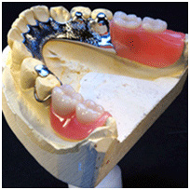
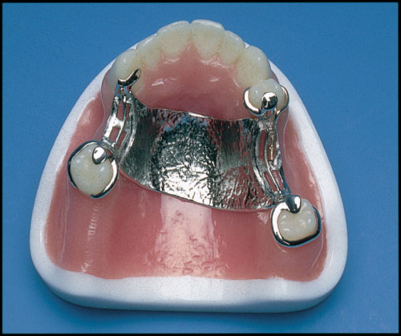
a) Tooth Supported RPD b) Tooth-tissue Supported RPD

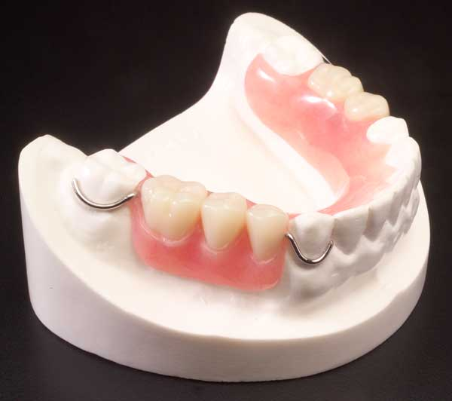
c) Tissue Supported RPD
Figure 2: Types of RPD

Classification of partially dentate arches
Significant variation in tooth loss distribution between partially dentate cases has been classified to describe the relationship of the natural teeth to the ridge. Classification enables communication with colleagues and the incidence of classes of removable partial denture can be compared (Curtis et al. 1992). There are many classification systems available; however, the most familiar is the Kennedy classification partially dentate arches into four basic classes, while other edentulous areas are designated as modification spaces (Figure 3).
Class I: bilateral edentulous areas located posterior to the natural teeth.
Class II: a unilateral edentulous area located posterior to the remaining natural teeth.
Class III: a unilateral edentulous area with natural teeth remaining both anterior and posterior to it.
Class IV: a single, but bilateral (crossing the midline), edentulous area located anterior to the remaining natural teeth. (Carr and Brown, 2011).

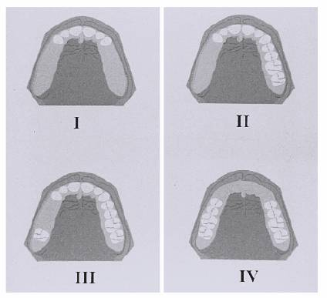
Figure 3: Kennedy classification of partially dentate arches
https://goo.gl/images/U1wmyj

Biomechanical principles of the RPD
In order to provide well-functioning removable dentures every effort must be made to maintain a stable prosthesis. The removable nature of the partial denture allows it to move in different planes and around different axes (fulcrums) that are perpendicular to the plane.
These movements may result in application of stresses over the teeth and underlying tissues which, if they exceed the tissue’s physiological tolerance, will lead to harmful effects.
Denture movements under applied forces
Removable dentures are subject to combined forces arising from three principal fulcrums. The first fulcrum (principal fulcrum line) is a horizontal line which extends through the occlusal rests of the principal abutments. The resulting rotational movements occur in the sagittal plane and the denture moves toward or away from the supporting ridge.
The second fulcrum horizontal line extends through the rest and the alveolar ridge on one side of the arch, and occurs in the frontal plane. Medio lateral movement of the denture occur relative to the edentulous ridge.
The third fulcrum is a vertical line located near the midline lingual to the anterior teeth, and occurs in the horizontal plane. Direct Medio lateral movements occur relative to the edentulous ridge. Every effort should be made to minimise these rotational movements around these three principal rotational axes (Phoenix et al. 1992).

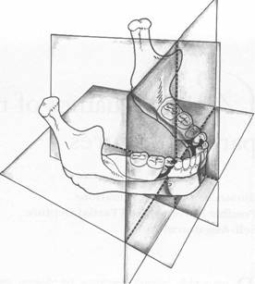 | Figure 4: Planes of potential partial denture movement and fulcrum lines at right angles to those planes.  https://goo.gl/images/E6sPSu

Periodontal response to occlusal forces.
Response to normal function
During mastication, the teeth and supporting periodontal structures are subjected to intermittent heavy loads of forces of occlusion. The incompressible tissue fluid prevents quick displacement of the tooth within the periodontal space. The force is transmitted to the alveolar bone by the periodontal fibres, which give a cushioning effect and act as a shock absorber. If the pressure is maintained, the fluid in the space rapidly escapes and the tooth displaces within the periodontal spaces, compressing the ligament against the bone (Proffrt et al. 2013).
Adaptive capacity of the periodontium to occlusal forces
The periodontium tries to accommodate the forces applied on the tooth. The effect of these forces is influenced by their magnitude, direction, and frequency (Carranza and Newman 1996).
The principal requirement for a healthy PDL is to control the direction of forces on the fibres. Changing the direction of occlusal forces causes a reorientation of the stresses within the periodontium (Figure 5), whereby more periodontal fibres are activated to resist and absorb axial forces than to resist lateral forces.
Horizontal force on a denture initiates two component torques: vertical rotation which is at right angles to the occlusal plane, and a horizontal rotation parallel to the plane of occlusion (Weinberg 1956).
This type of force may pinch the PDL, with a resultant harmful effect on the bone structure. This type is usually found in tipped teeth that have moved in a torqueing or anteroposterior direction (Kratochvil 1963). The response of the supporting bone is also affected by occlusal forces. The more frequent the application of an intermittent force, the more harmful the force to the periodontium.
Insertion of a prosthetic appliance that interferes with or alters the direction of the occlusal forces on the teeth may induce acute trauma from the occlusion (Carranza and Newman 1996).

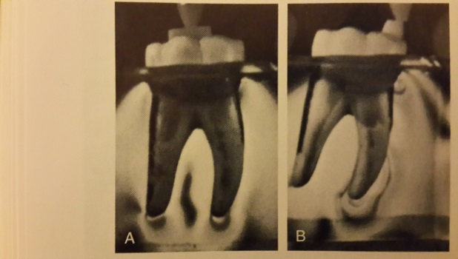

A. Forces directed to the tooth axis. B. Forces directed mesially
Figure 5: Photoelastic study of the stress distribution around roots as a response to the force direction. (Glickman et al 1970)

Support and force distribution

Tooth-supported RPD
As a class III RPD is completely supported by the abutment teeth, the forces of occlusion are directed within the long axes of the teeth. Limited non- axial loads result because the denture does not rigidly contact the abutment teeth. Quadrilateral placement of the clasps is considered ideal, and the rests should be positioned adjacent to the edentulous spaces. Special attention should be paid to the occlusion with the opposing dentition (Figure 6).

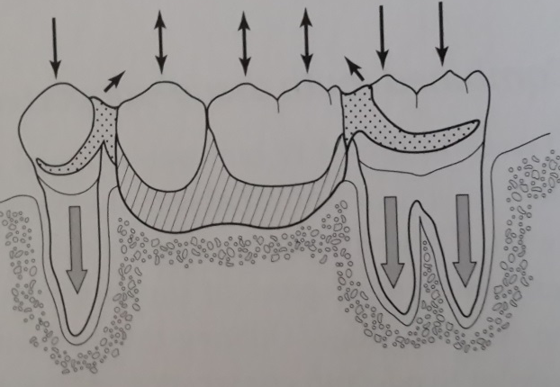

Figure 6: Force distribution by Class III RPD (Phoenix et al. 1992)

Tooth-tissue supported RPD
This type of restoration is the most challenging in terms of the removable denture as it derives its support from different tissues. Abutment teeth and supporting residual ridges have different degrees of compressibility.
Distortion in the tissues over the alveolar ridge of approximately 500 µm under 4N of force can be observed, while in abutment teeth only 20 µm of intrusion is observed under the same load (Carr and Brown 2011). The resulting non- axial loading can be very damaging and can lead to tooth mobility and restoration failure (Figure 7). Optimal tissue health, maximum tissue coverage and adaptation, proper use of clasp assemblies on the most posterior abutment, and placement of all components in the most beneficial positions are all important to control the applied force (Phoenix et al. 1992).

Ideally forces should be distributed evenly over the teeth and saddle area.

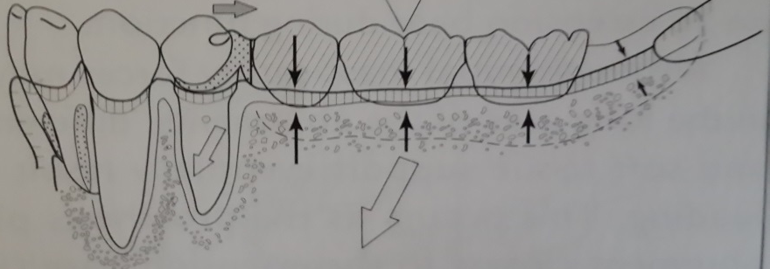

Differences in resiliency between the teeth and bone lead to uneven force distribution.

Figure 7: Force distribution problem with the Class I RPD and the required remedy

Tissue-supported RPD
The material most commonly used in the tissue supported partial denture is PMMA. However, due to its limited strength, it cannot be used on its own as a tooth-tissue or tooth supported partial denture.
Tissue supported dentures should be designed with particular care in order to prevent them from resulting in tissue damage (Figure 8).

Teeth should share the forces of occlusion.

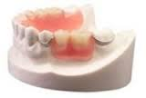

If all forces are transmitted to the saddle area this leads to tissue damage.

Figure 8: Force distribution problem with the tissue supported RPD and the required remedy

Partial denture components.
Direct retainer
Direct retainers are that part of the denture designed to resist movement of the restoration away from the teeth or tissue, providing retention to the prosthesis. Retainers can be intracoronal or extracoronal. A retentive clasp assembly is the most common method of extracoronal direct retention.
Requirements of a properly designed clasp:
1) Support. An occlusal rest should be provided in combination with a clasping arm to provide resistance to tissue- ward movement.
2) Bracing. Should resist the horizontal forces generated by occlusal contact and oral muscles. Bracing is provided by the rigid component of the clasp, occlusal rest, and minor connectors.
3) Retention. Resistance to dislodgement in an occlusal direction, provided by the flexible clasp tip.
4) Encirclement. It must engage more than half of the tooth circumference by means of three widely-spaced points of contact with the tooth.
5) Reciprocation. It should resist the horizontal forces exerted on the tooth by a clasp during insertion or removal of the denture. Reciprocation is provided by the bracing arm of the clasp or more effectively by a plate.
6) Passivity. There should be no force on the tooth when the denture is fully seated and the retentive function should be activated under dislodging forces only (Krol 1973). There are two types of clasp: occlusally approached and gingival approached, each with different forms and shapes.
Rests and rest seats
Rests provide resistance to denture movement toward the supporting structures, through occlusal, incisal, and cingulum forms. In addition to the principal rest function of transferring the vertical occlusal stresses to the abutment teeth, it has a bracing effect in distribution of horizontal forces, maintaining components in their correct position, protecting the denture/abutment teeth junction, reciprocation and providing indirect retention.
Major and minor connector
The major connector joins the component parts of one side of the arch to the other side, while the minor connector joins the small components such as rests and clasps to the saddles or to the major connector. In addition, connectors contribute to support and bracing, and help to retain the denture by providing indirect retention. There are different types and forms suitable for the specific case.
Indirect retention
This is the resistance of the denture to pivoting. It is useful in a tooth-mucosa denture in helping to prevent lifting of the saddle away from the mucosa. It is placed on the opposite side of the axis of rotation, and should be placed as far as possible from the distal extension base. Indirect retention may be provided in the form of an auxiliary occlusal rest, canine rest, continuous bar retainer or rugae support.
Saddles
Saddles are those parts of the RPD that rest on the alveolar ridge and include the artificial teeth and gum work.
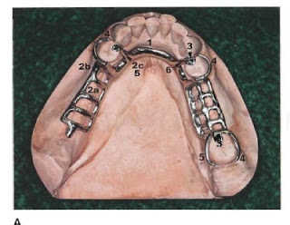 | Figure 9 : RPD components.  - Major connector  - a. ridge area. 2b. saddle  2c. Minor connector  3. Rest.  4. Retentive clasp arm  5. Reciprocal clasp arm
(Carr and Brown 2011)

Demographics
During the last 50 years, with the advances in preventive dentistry, patient attitudes have changed in favour of retaining teeth. This has led to a considerable decline in the rate of tooth loss in many industrialized nations (Mojon et al. 2004). A comparison of the mean number of teeth amongst US adults from 1988-1991 and from 1971-1974 suggests that in the later period adults had around three more teeth. The percentage of edentulous patients in England and Wales fell from 37% in 1968 to 6% in 2009 (NHSsurvey. 2009). Schneider et al. (2017) conducted a study aimed at alterations in oral health in Switzerland over the period between 1992 to 2012. The study concluded that the mean number of missing teeth was reduced to three, even in the oldest age groups, and more than 90% of the population had a functional dentition.
However, Douglass et al. (1988) reported that although the rate of tooth loss has decreased, the need for prosthodontic treatment has increased due to the increase in life span of the population. In a study investigating the impact of the falling rate of edentulous patients and the ageing population, the authors found that the need for complete dentures will decrease in favour of partial dentures options (Mojon et al. 2004). Furthermore, Zitzmann et al.(2007) searched the literature related to 13 European countries, to study the incidence of prosthodontic dental restorations. They found that removable partial dentures comprised between 13-29%, with 3-13% complete denture in both jaws. The higher percentage of RPDs among the older age group, people living in rural areas, and those of lower socioeconomic status. They concluded that there is an increasing trend toward RPDs and a reduction in demand for complete dentures. similarly, research by Hama (2016) on the prevalence of treatment options provided to partially dentate patients found that 57.77% of the patients included in the study had RPDs.
The term RPD covers many different types of device that may be mucosa or tooth supported and may replace a single tooth or 15. Consequently, using RPD classification to describe the edentulous areas of the arch not only aids communication among colleagues but also enables the incidence of classes of RPD to be compared. For example, (Curtis et al. 1992) compared the incidence of various classes of removable partial denture and found that the mandibular removable partial denture is more common than the maxillary partial denture and that the Class I mandibular partial denture is the most common type.
The percentages are as follows: Class I 40%, Class II 33%, Class III 18% and class IV 9%. Further studies support these findings, with Class I remaining the most common 38.4 % and Class III with 31.2% (Deo et al., 2011). In the review of the prevalence of partial edentulism (Jeyapalan and Krishnan 2015) concluded that it is more common in the mandible than the maxilla, and whereas young adults have more Class III, their elders have more Class I and II types.

Impact of RPDs on oral health

Dental caries
An increased risk of caries accompanying the wearing of a RPD has been reported by a number of studies. One 5-year study (Jorgensen and Isidor 1990) compared the treatment of edentulous elderly people with either a cantilever fixed bridge or RPD, 27 patients were treated with cantilever fixed bridges and a further 26 with a RPD. The authors found that caries was observed 6 times more frequently in the patients provided with a removable partial denture than in patients treated with fixed restorations, and that the remaining natural teeth were at greater risk of caries in the RPD group due to plaque accumulation.
In another study, among 60 patients with a lower shortened dental arch treated with either removable partial denture or bilateral cantilever resin bounded bridge, two years after restoration an important difference in the incidence of caries between the two groups. In the bridge group there had been incidence of caries in 11 patients in comparison to 51 in the removable partial denture group. However, at the 2 years recall, 20 of 27 bridge patients had no caries in comparison to 9 out of 23 from the removable partial dentures group (Jepson et al. 2001). This is supported by a further 5-year follow up study on the prosthodontic rehabilitation of elderly people which found that using removable partial dentures increased the risk of caries in those elderly patients, especially root caries (Nevalainen et al. 2004).
In contrast to the above finding, other studies have claimed that removable partial dentures per se do not increase the caries risk provided that adequate oral and denture hygiene is performed in combination with regular recall appointments. In a 6-year follow up of 28 patients treated with removable partial dentures and proper oral hygiene instruction, the number of newly registered caries lesions was low (Bergman et al., 1977). This finding was supported by a 10-year longitudinal study investigating the impact of removable partial dentures on oral health. The authors concluded that there was a low increase in caries occurrence during the decade (Bergman et al. 1982).
In a study intended to assess the effect of RPD on the supporting tissues after 5 years of placement, Janaina et al. concluded that removable partial dentures do not increase the prevalence of root caries (Janaina et al. 2010).
A systematic review of 570 articles by (Ezawi et al. 2017) attempted to test the hypothesis that insertion of RPD has a deterioration effect on the status of the oral tissues. The study concluded that in the absence of good oral hygiene measures and regular recall visits, RPDs may promote plaque accumulation.
From these studies we can conclude that RPDs may increase plaque retention on the teeth and increase the risk of caries. However, with good treatment planning, appropriate oral hygiene instruction and recall appointments, little or no damage will be caused to the remaining oral tissues.

Gingivitis and periodontitis
Removable partial dentures are suggested to be one of the local factors that encourage plaque accumulation and gingival inflammation especially around abutment teeth. Yusof and Isa (1994) concluded in their study that the wearing of a removable partial denture increases plaque indices, gingival indices and loss of attachment at abutment teeth compared with non abutment teeth, and these indices increase with denture age.
On the other hand, many studies have concluded that there is no clear evidence that wearing a removable partial denture increases the risk of periodontitis. The result of an 8-9 years study showed no significant difference between people wearing dentures and those who were not, despite the oral hygiene of the patients not being perfect (Chandler and Brudvic 1984). In a 6-year evaluation of periodontal health of patients with fixed and removable partial dentures the authors concluded that there were slight differences for plaque accumulation, pocket depth and gingival inflammation (Rissin et al. 1985).
Another cross-sectional study on the periodontal status of RPD found that with proper oral hygiene check-ups, recall appointments and good design of the denture, little or no damage resulted in the periodontal tissue (Bergman and Ericson 1989).
Kern and Wagner (2001) assessed 74 patients wearing removable partial dentures after 10 years of unsupervised service. They found that deterioration was high in the abutment teeth and the rate of extraction was high; however, they stated that with regular recall visits and proper oral hygiene practice the deterioration could be minimised.
Vanzeveren et al. (2002) evaluated the effect of RPDs on periodontal indices including gingival inflammation and pocket depth. Few differences appeared between patients who were recalled and those who were not recalled for 3 years. The values observed showed a low level of hygiene and little motivation toward cleaning techniques.
Lack of patient compliance toward oral and denture hygiene and lack of regular recall have been identified as the main causes of denture plaque formation (Wagner and Kern 2000). In a 10-year evaluation of 74 patients with removable partial dentures, only 36% were found to be free of hygiene problems. Without a proper cleaning habit, plaque can accumulate on the denture and lead to inflammation of the mucous membrane, an unpleasant tastes and periodontal disease. Dula et al. (2015) evaluated the effect of RPDs on the periodontal tissues of abutment teeth over a five-year worn period. The study concluded that with suitable denture design and adequate oral and denture hygiene periodontal diseases could be prevented.
Many studies have concluded that with continuous oral hygiene care, regular motivation, oral hygiene instruction and prophylactic care coupled with regular recall appointments, the incidence of caries and periodontal problems can be significantly reduced. The main cause of negative attitudes towards removable partial dentures has been poor awareness of the importance of good oral hygiene habits.

Quality of life
Rehabilitation of edentulous patients is aimed to improve physical and social aspects of the patient’s life, thus preventing problems such as functional limitation, psychological problems and social disability (Barreto et al. 2011). Interest in evaluating the consequences of diseases on the quality of life has led to the introduction of several tools to define the impact of oral health on the quality of life, based on the work of Locker (1988). He developed a module of oral health including 7 dimensions: functional limitation, physical pain, psychological discomfort, physical disability, psychological disability, social disability and incapacity (Fernandes et al. 2006).
Oral reconstruction with a removable partial denture re-establishes and maintains patients’ oral health and improves their quality of life. Fueki et al.(2011) studied the relationship between the masticatory function and oral health related quality of life (OHQoL) in patients with RPDs. They suggested that chewing ability is an important factor for oral health quality of life and that masticatory performance is important for chewing ability. This result is supported by the findings of (Brennan et al. 2008) who suggested that the association of chewing ability impacts on food choice and enjoyment of diet. The relationship between removable partial denture quality and oral health related quality of life was also investigated by (Inukai et al. 2008) and they suggested that oral health related quality of life is directly proportional to denture quality.
Furthermore, a study by (Allen et al. 2009) claimed that replacement of an old RPD leads to improvement in the oral health related quality of life. An improvement was reported in OHQoL in patients receiving restoration with telescopic crown retained partial dentures, double crown retained removable partial dentures and implant retained removable partial dentures.
Wostmann et al. (2008) compared the dental impact on patients’ daily living of having no prosthesis, a non-functioning prosthesis, and telescopic retained partial denture. They concluded that the telescopic retained partial denture improved oral health related quality of life. The same finding was reported by (Grossmann et al. 2007), who evaluated the change in oral health quality of life after patients had received double crown retained removable partial denture and concluded that there was a significant improvement in their quality of life. Similarly, (Gates et al. 2012) studied the effect of using an implant supported removable partial denture in improving support, stability and maintenance of alveolar bone. The authors concluded that using implants improves oral health related quality of life in comparison to conventional removable partial dentures. However, it is difficult to transfer and apply these results to conventional removable partial dentures in general.

Patient satisfaction
Due to the difference between dentist assessed need and patient demand, patients’ satisfaction with their denture not always what might be clinically expected. It has been found that 30%-50% of patients wear their dentures rarely or not at all (Graham et al. 2006) . The failure of a removable partial denture affects both the patient and their dentist, so it is useful to evaluate the factors associated with patient dissatisfaction with removable partial dentures and use this data to improve our understanding of the patient psychology and hence to proper treatment planning that will increase the rate of denture success (Frank et al. 1998).
Graham et al.(2006) studied factors affecting the difference between dentist assessed need for a removable partial denture and patient demand. They concluded that the dentist’s decision is affected by patient demand, function of the denture and cost. Two factors affect patient demand: first, the functional objective in seeking a prosthesis, and secondly, appearance issues relating to social function and identity. Researchers, meanwhile, tend to focus on factors related to the quality of the denture, such as vertical dimensions, centric relation, position of the artificial teeth, retention and ulceration (Bilhan et al. 2012).
Patient Factor
Koyama et al. (2010) studied the factors affecting the continuing use of removable partial denture and patient satisfaction 5 years after insertion. They suggested that the age of the patient plays a role in determination satisfaction. It was found that 71% of patients less than 65 years old wore their dentures, while only 37% of patients aged 65 years or older did so. The authors attribute these findings to factors associated with aesthetics and function among the first group and possibly poor adaptation and impaired oral motor factors among the second group. On the other hand, (Wakabayashi et al. 1998) claimed that young people who are more aware of the aesthetic factors are less satisfied than older people, and patients aged 55 years or older are generally more satisfied with their removable partial denture. Frank et al. (1998) supported the finding regarding young people being less satisfied than the older age group.
Patient satisfaction with lower removable partial dentures is generally affected by the type of opposing dentition (Frank et al. 1998), and satisfaction was found to be greater in the case of an opposing maxillary removable partial denture rather than the complete denture. This may be due to the maxillary removable partial denture having greater stability and less ridge resorption. In contrast, (Jepson et al. 1995) concluded that the type of opposing denture has no influence on removable partial denture acceptance and the difference in results might be attributed to the difference in percent types of opposing dentition used in the two studies. Location of the edentulous area greatly influences removable partial denture usage. Jepson et al. (1995) found that removable partial denture usage significantly increases in cases where aesthetics is important, such as Kennedy Class IV dentition. The number of occluding teeth also affects the usage of removable partial dentures. Patients with few occluding pairs of teeth have been found to wear their denture more often for masticatory function (Koyama et al.2010). This finding is also supported by (Meeuwissen et al. 1995).
Dissatisfaction was higher when there was no previous experience with removable partial dentures and this suggests the need for more patient education (Frank et al. 1998). However, people with previous denture experience should still be treated with caution as this is not a high predictor of future satisfaction as changes in expectation or the patient- dentist relationship could lead to a negative outcome even among those with previous positive experience. The previous finding is supported by (Weinstein et al. 1988), who concluded that patient satisfaction with removable partial dentures was more related to prior experience than to the age of the patient. On the other hand, (Koyama et al. 2010) found that there was no relation between satisfaction and previous experience and attributed the finding to the high percentage of subjects who had previously worn removable partial denture.
Denture Factor
Bilhan et al. (2012) concluded that the most frequent complication with wearing RPDs is loss of retention. Most patients in the study expressed the need to replace their dentures because of loss of retention, and the resulting problems of chewing difficulties, sore spots and phonetic complications. This finding supports the earlier conclusion drawn in the study by (Sheppard 1971) that loss of retention was the main cause of dissatisfaction among denture wearers, followed by pain.
Patient satisfaction may also be affected if the vertical dimension is wrong. Bilhan et al. (2012) found that 26.3% of patients in their study had an increased vertical dimension, while in the majority, 71.7%, the vertical dimension had decreased. Moreover, and the authors found that patient dissatisfaction was greater in the case of increased vertical dimension due to the complication of uncertain pain.
Frank et al. (2000) examined the relationship between the standard of design of the removable partial denture and patient satisfaction. They concluded that the rest form and number, base extension and stress distribution provides the most important design standards; however, these standards are unrelated to patient satisfaction. In contrast, (Koyama et al. 2010) concluded that there is a significant correlation between number of occlusal rests, patient satisfaction, and usage of the removable partial denture. Well prepared rest seats and good design are related to sound reaction of the supporting structures.
A review of the literature by (Freitas et al. 2012) suggested that using an implant in free end saddles decreases the problems associated with differences in resiliency between teeth and mucosa and hence patient satisfaction. Furthermore, (Mitrani et al. 2003) concluded that patient satisfaction increased significantly with the use of implants in free end saddle cases. Mean satisfaction increased from 1.2 before the new treatment to 5 after insertion of the implant supported prosthesis. The latter finding is supported by the work of (Bortolini et al. 2011), who concluded that the use of implants with removable partial dentures increases patient satisfaction, with mean satisfaction increasing from 1.3 before treatment to 4.59 one year after treatment.
In addition (Al-imam et al. 2016) found that the most common complications caused by RPD as related to OHRQoL were ill-fitting denture and inflammation of the oral mucosa (Table 1).

Table 1: Factors related to patient satisfaction with RPDs.
Factor | Satisfaction | Reference
Patient factors
Age | Dependent on age | Koyama et al. 2010
Lower denture/opposing denture | Increased with RPD compared to CD | Frank et al. 1998
Location of edentulous area | Increased with aesthetics | Jepson et al. 1995
Number of occluding teeth | Increased with low dentition | Koyama et al. 2010
Previous experience | Decreased with no experience | Frank et al. 1998
Denture factors
Retention | Decreased with loss of retention | Bilhanen et al. 2012
Pain | Decreased with pain | Sheppard et al. 1971
Vertical dimension | Decreased with faulty V.D | Bilhanen et al. 2012
Design of PD | Increased with appropriate rest form and number | Frank et al. 2000
Implant | Increased | Freitas et al. 2012

Clinic-laboratory communication
Production of a well-designed and produced removable partial denture depends on the satisfactory efforts of the clinician and the technician. The dentist is responsible for prescribing the RPD, and details of the design should take into account all the patient factors and fit in with the treatment plan. However, often dentists transfer the designing of an RPD to the technical staff. The latter do not have a clear picture of the clinical situation of the case, which may affect the quality of the final prosthesis provided to the patient (Benso et al. 2013).
Inadequate prescription of the removable partial denture is not a new problem; studies from as early as 1974 reveal this as a point of concern in many countries including Sweden, Canada, USA, South Africa and the UK (Lynch and Allen 2006). There have been many legal guide lines on the prescription of removable partial dentures. In 1993, the Medical Devices Directive introduced by EU required that the dental prescription “should provide written instruction when a prosthesis is being manufactured’’. In 1996 the British Society for the Study of Prosthetic Dentistry guideline stated “…design of a partial denture is the duty and responsibility of the clinician’’ (BSSPD). In 2007 the EU amended the MDD with respect to custom made device statements, this change coming into force on 21 March 2010 and stating that the manufacturers (Lab) should provide the patient with a copy of a statement containing all the required information regarding the prosthesis (Stewart 2011).
Despite the dentist’s responsibility for prescribing the removable partial denture design being approved by law, a number of studies have indicated that there has been little improvement in the procedure of removable partial denture prescription (Lynch and Allen 2006). Lynch and Allen (2003) conducted a study to assess whether change in the method of prescription of removable partial denture had occurred after introduction of the previously mentioned guidelines. The study analysed 122 written instructions in Ireland and found no improvement in the quality of removable partial denture prescriptions. A further study conducted by (Lynch and Allen 2005) to investigate the quality of written prescriptions and choice of impression trays and materials for fixed and removable partial dentures found that poor or no written instructions were provided with almost one half of the prescriptions, with 40% of cases using a diagram in the prescription, and there was limited provision 9% of surveying of cases. Lynch and Allen (2006) studied the influence of financial and educational factors on the quality of removable partial denture design by general dental practitioners. They concluded that educational factors have a more significant effect on the quality of prescription and formation of removable partial dentures than financial factors. General dental practitioner was found to provide fewer removable partial dentures than when they were at dental school, to have less teaching in this area and very little access to a surveyor.

Indications for RPD
No definitive list of indications for providing removable partial dentures to patients is provided in the literature, however; some guidelines have been reported (Wostmann et al. 2005).
- Number of missing teeth: The positive indication for the use of a removable partial denture rises with increase in number of missing teeth (Van waas et al. 1994), studied the effect of number of missing teeth on patient satisfaction and they concluded that provision of removable partial dentures should be limited to cases in which they will increase the number of occlusal units.
In addition, (Knezovic et al. (2003) concluded that the use of a removable partial denture is of little benefit in cases where there are few missing teeth and where it cannot improve the function or aesthetics, in contrast; it increases the discomfort experienced by the patient.
- Oral hygiene: Although removable partial dentures are a non- invasive method of treatment, they are associated with an increased risk of caries and periodontal diseases in long term use, especially in patients with poor oral hygiene (Jepson et al. 2001). With appropriate oral hygiene instruction, motivation and follow up the risk level could be reduced (Petridis and Hempton 2001).
- Temporomandibular disorder: Tallents et al. (2002) evaluated the prevalence of missing posterior teeth and intra articular temporomandibular disorders. They concluded that there was no evidence that replacement of missing posterior teeth prevents the development of temporomandibular disorders; however, it could accelerate the development of degenerative joint diseases. The removable partial denture is the preferred treatment option because of its reversibility. This result is supported by (Wang et al. 2009) who concluded that among patients with few posterior teeth there is higher prevalence of temporomandibular disorders.
- Second line of treatment: Sound abutment teeth in a healthy mouth increase the indication of using the removable partial denture (Watson and Gilmour 1994). If implantation is not possible, removable partial dentures are a valid alternative.
- Socioeconomic factor: Low socioeconomic status of the patient is a valid factor in favour of using a removable partial denture, as it is considered as a low-cost treatment option.

Prosthetic treatments face two particular challenges. Firstly, an increasing proportion of people are seeking prosthodontic treatment due to the aging process. This category of patient creates special problems as it includes people with compromised oral and general health, suggesting that these people are less able to have extensive tooth preparation or implant retained prostheses than young people and the focus has to be on preserving the integrity of the remaining oral structure.
Secondly, there is a particularly high percentage of free end saddle cases, which present the most challenging situation in terms of removable partial denture.
On the other hand, although conventional removable partial dentures provide a lower cost and non- invasive option compared to other forms of prosthodontics (Wostmann et al. 2005) there are negative attitudes toward removable partial dentures among both patients and dentists.

Design of CoCr material

History
The ideas behind most removable partial denture components, such as clasps, rest seats and major connectors, were developed by dentists based on their primitive observations in practice before 1950. The first recorded trials of removable partial denture were by Heister in 1711and used blocks of bone that were carved to fit the mouth.
Fauchard documented the first report of a lower removable partial denture in 1728. He used Ivory to form blocks that were then joined by metal labial and lingual connectors. The first discussion of retentive clasps is attributed to Mouton in 1746. Later, in 1819 Gardette described the use of the wrought band clasp, while the use of 'hooks" (clasps) and 'little spurs" (occlusal rests) was referred to by Delabarre in 1817. The use of a palatal connector in a maxillary removable partial denture was mentioned by Balkwell in 1880. Then in 1899, Bonwill described his technique of clasping the tooth using a gold circumferential clasp soldered to a plate (major connector) and "lugs" (rest seats). The first mention of wrought wire circumferential clasp is attributed to Roach in 1913, while the bar clasp was first referred to by Henrichsen in 1914. Weinstein and Roth designed the first instrument developed specifically to survey models in 1921 (Becker et al. 1994). During the 1930s and 1940s there was controversy over how to treat the free end saddle because of the difference in resilience between the supporting structures. Then (Steffle 1951) summarised the planning and designing of removable partial dentures into three groups: the first group was based on the idea of stress breaking as means of stress distribution between the teeth and ridge area, the second group used the idea of equalizing the stresses through physiological basing of the denture, and the third group used the theory of broadly distributing the forces to prevent tissue overloads.
The first scientific evaluation of the ideas of the previous decades started in the 1950s. Several studies identified inflammation in the periodontium and increased risk of caries in patients wearing removable partial dentures (Becker et al. 1994). In 1956, Kaires emphasised the importance of rigidity and broad coverage of the ridge in distribution of forces across the arch to reduce the forces to abutment teeth. In 1956, Frechette stated the importance of multiple occlusal rests in force distribution over the supporting structures. Applegate was, the first to present the altered cast technique, and the importance of this technique in reducing the movement of the denture base. Krol then developed an RPI design (mesial rest, proximal plate, I bar) to reduce the force in the abutment in the distal extension removable partial denture (Becker et al. 1994).

Design and stress distribution
Several studies were conducted with the aim of testing different ways to provide better biomechanical functioning for RPDs, so that the stress would be distributed between abutment teeth and residual ridge. Ideas studied included rigidity of the major connector, rest seat design and position, clasp types, RPI assemblies and modification, altered cast technique, base extension and adaptation, occlusal table and number of teeth, inserting of a resilient inner layer and using denture supported implants; however, there are no conclusive answers to the problem.

Rigid major connector
Rigidity is considered an important factor in redistribution of the occlusal forces across the arch (Ben-ur et al. 1999), (Bhojaraju et al. 2014). A non-rigid major connector affects the distribution of the masticatory loads and changes in their strength could have a detrimental effect on the supporting structures (Kaires 1956a). However, there is little evidence regarding the physical requirements of the framework and its effect on the integrity of the oral tissues. Likewise there is little evidence to provide guidance on the appropriate amount of bulk and geometry that will give the required rigidity that is compatible with the health of the oral tissue (Walter et al. 2010).
Ben-ur et al. (1999) investigated which design and cross-sectional shape of the major connector would offer the best rigidity and flexibility. They tested analogue shapes of major connectors using an Instron testing machine and concluded that the major connector was stiffer in the horizontal plane than in the vertical plane, that the cross-sectional shape of the major connector was the most the most important factor in achieving rigidity, and the most rigid cross section was the half pear shaped version.
Walter et al. (2010) compared in vitro the effect of load deflection of five clinically used mandibular major connectors in the vertical and horizontal planes. They came to the same conclusion as the previous study in that all frameworks were more rigid in the horizontal than in the vertical plane, and there were significant differences in the amount of deflection between the geometric cross sectional designs.
Pienkos et al. (2007), in their study to determine the minimum major connector dimensions that would offer suitable strength and improve patient comfort and tissue health, suggested that the occluso-gingival dimension of the lingual bar could be reduced to 3-2.5mm. Bhojaraju et al. (2014) compared the rigidity and deflection of different upper major connectors using finite element analysis. The study concluded that among these connectors the anteroposterior palatal strap underwent the least deflection.

Rest and rest seats
The rest seat is the concavity prepared on the abutment tooth on which the occlusal rests are to be placed. Its purpose is to accept the rest portion of the removable partial denture framework. Preparation of the rest seat is important in distributing the occlusal forces through the long axis of the tooth in order to avoid the detrimental horizontal forces (Aquino et al., 2011). Another function is to prevent the prosthesis from apical movement during use by acting as indirect retainers.
The rest seat should be prepared in such a way that the occlusal rest is of adequate thickness to prevent distortion under functional loading and avoid interference with the occlusion (Culwick et al. 2000). There are four factors that determine the function of the occlusal rest: fit, size, shape, and location (Sato et al. 2008). Causes of ill-fitting occlusal rests including projection on the fit surface, resin interference, deformation of the clasp or rest, and displacement of the clasp. According to (Sato et al. 2003) who evaluated the effects of occlusal rest size and shape on yield strength using 3-D finite element analysis, the occlusal rest seat should be a saucer or spoon shaped depression. The authors also suggested a buccolingual width of 2-4 mm and thickness of 0.7-1.5 mm. The mesio-distal length should be one-third to one-half that of the crown, and recommended an inclination of the horizontal axis of the occlusal rest of less than 90’ to the long axis of the tooth. They found that, a lingually shifted rest causes lack of support, while buccal shift increases the support (Sato et al. 2008).

Rest position
Basker and Davenport (1978) investigated the quality of dentists’ prescriptions to technicians; they found that out of 21 free-end removable partial denture cases, the occlusal rests were placed mesially in 2 cases and distally in 19. Ten years later, a greater number of occlusal rests were placed mesially rather than distally (Baskeer et al. 1988). Nassani et al. (2011) evaluated the quality of written prescriptions sent to dental laboratories, and found that there was a greater tendency to use mesial rather than distal placement of rests with free-end removable partial dentures.
Many authors reported on the importance of mesial placement of rests from the biomechanical view. Kratochvil (1963) concluded that mesial rest placement provides better support than distal rest placement. This finding is supported by(DeBoer 1988), who concluded that using the mesial rest position is a good way of reducing unfavourable forces acting on the abutment teeth. Thompson et al. (1997) conducted a photo-elastic evaluation of stress patterns produced by several designs of free-end saddle removable partial dentures and concluded that retainers designed with distal rests tend to move the crown distally, while using mesial rest leads to more favourable distribution of the applied forces. On the other hand, other studies have indicated that there is no significant difference regarding distal or mesial placement of the rests and that factors other than load distribution should be taken into consideration (Joregensen and Bochet 1998).
Muraki et al. (2004) used finite element analysis to study the influence of the occlusal rest position on tooth mobility. The authors found that neither mesial nor distal rests were likely to cause serious damage if displaced in apical direction, and the restriction of the horizontal movement of the rests is more effective in reducing horizontal abutment movement than the rest location.
Pellizzer et al. (2010) used photoelasticity to study the effect of ridge form (horizontal, descending, ascending, descending ascending) and rest position on stress distribution. The authors found that the rest showed similar behaviour in all locations except when placed on the distal descending ridge.
Multiple occlusal rests improve the force distribution to more of the abutment teeth and, hence, reduce forces to the terminal abutments (Frechette 1955). Frechette found that the greatest increase in abutment teeth movement occurred after removal of the double rests or when the continuous lingual rest was made flexible. This finding was confirmed by (Pezzoli et al. 1986) in their evaluation of load transmission by different retainers with free-end saddles using reflection photoelasticity. They concluded that the continuous clasp removable partial denture distributes occlusal forces better than circumferential clasps or stress breaker prostheses.

Clasps
In addition to retention, clasps also provide stabilization of the abutments and transmission of lateral forces. The position of the clasp components on the tooth sides is related to the clasp force on the abutment tooth under lateral stresses(Kabcenell 1962). While the flexible end of the retentive arm is best located in the gingival third of the crown, the reciprocal arm should be positioned at the junction of the gingival and middle third of the crown, to permit better resistance to horizontal and torqueing forces (Carr and Brown 2011). If reciprocation is not provided in the clasp design, the clasp will apply a horizontal force as it moves in the vertical direction and tilt the tooth (Davenport et al. 2001).
In the early 1960s Kratchovil replaced the reciprocal arm with the now well accepted design of a combined mesial rest and distal guide plane. This combination provides the same reciprocating effect if the guide plane is extended slightly beyond the line angles and the rest is spoon shaped (Brudvic and Palacios 2007).
Circumferential and bar type retainers are universally used. Cast circumferential clasps are relatively rigid and are therefore best used with strong abutment teeth, so are often used with tooth-borne partial dentures. (Aljudy 2009) used finite element analysis to identify half round shape and 0.6mm dimension as the preferred circumferential clasp design. Bar clasps are more flexible and used with weaker abutment teeth. However, others have warned against the use of bar clasps as they transmit too much tilting stress to the abutment (Krol 1973). Surely the factors of undercut depth, material and length of the clasp need to be considered.
Clayton and Jaslow (1971) compared the clasp forces exerted on the abutment teeth by wrought wire and cast bar clasps, and concluded that the bar clasp was more flexible than the 18 gauge wrought wire clasp of equal length. On the other hand, (Frank et al. 1983) compared the flexibility of different forms of cast nickel-chrome and cobalt-chrome clasps to that of wrought wire clasp. The study concluded that the 18-gauge cast clasp was less flexible than the wrought wire clasp, and the flexibility of the 19 and 20 gauge cast clasps was similar to that of the 18-gauge wrought wire clasp.
The aims of provision of a removable partial denture are to preserve the integrity of the remaining oral structures and restoration of the lost part. However, when the functional forces exceed the threshold of the physiological movement of the abutment tooth, there will be an increase in tooth mobility (Mizuuchi et al. 2002). Their study evaluated the degree and amount of abutment movement, as influenced by the type of direct retainer and the location of functional loading using a simulated model and strain gauge system. The study found that type of direct retainer had an effect on tooth movement magnitude, while the loading point location influenced both the magnitude and the abutment movement direction.
There have been many studies aimed at determining the design of direct retainer that would result in the least tooth mobility. The main design aims for the ideal RPD are to guard the abutment teeth and reduce damage to the residual ridge by achieving favourable distribution of the occlusal forces. ErLee et al. (2008) used photoelasticity technique to compare different retainer designs based on two different design philosophies, namely stress breaker and rigid support. Six designs were studied: wrought wire clasp, RPI system, conical crown telescopic retainer, RPI system, ring clasp and circumferential clasp. The studies concluded that retainers based on a rigid design philosophy exert more stress on the abutment teeth and less stress at the residual ridge than retainers based on a flexible design philosophy.
Cecconi et al. (1971) stated that there are other factors that influence tooth movement besides the clasp design: load direction, type of load, ridge shape and fit of the casting. Cecconi et al. (1972) studied the effect of ridge inclination and type of loading on abutment tooth movement and concluded that the ridge inclination alters the direction and magnitude of abutment tooth movement. This finding is supported by the findings of (Feingold et al. 1988) in their study of the effect of different alveolar crest angulation on movement of the abutment teeth. They found that in addition to the clasp design, alveolar crest inclination affected the direction and degree of abutment tooth movement. Mizuuchi et al. (2002) indicated that the position of the loading point is another factor influencing tooth mobility. They studied the effect of direct retainer design and load location on the movement of the abutment teeth and found abutment tooth displacement to be less with the mesial clasp design than with a distal rest design and that the direct retainer influenced the magnitude of abutment tooth displacement.
Thompson et al. (1997) used photoelasticity to compare the forces applied by four direct retainer designs and two occlusal rest positions on the supporting structures, and concluded that retainers with a mesial rest position distribute the applied force more favourably than those with a distal rest location. Cecconi (1974) studied different types of rests to identify which design would transmit forces more favourably to the abutment teeth, but concluded that the depth of the rest is more important than the rest type. Taylor et al. (1982) compared the effects of two clasp assemblies: RPI and circumferential clasp with a distal rest, using two denture base conditions, firstly, relieved and under extended, then well adapted with maximum extension. They concluded that although the RPI system causes less abutment tooth displacement, good base extension and adaptation are more important than the clasp design. Costa et al. (2009) used photo elasticity stress analysis to identify the most favourable stress distribution to the supporting structures using three retainers: T bar, RPI system and circumferential clasp with mesial rest. They found that the RPI clasp system was the most favourable clasp for force distribution followed by the T-bar and finally the circumferential clasp.
Park and Kay (2009) compared the magnitude and distribution of stress produced by clasp, konus crown, resilient attachment, and flexible resin on the mandibular free-end RPD using photoelasticity. They concluded that konus crown showed the most equal stress distribution to the supporting structure and that flexible resin can be applied to cases where the state of the residual ridge is better than that of the abutment teeth.

Table 2: Clasp design and stress distribution
Test purpose | Method and material | Result | Reference
Assess effect of ridge inclination and type of loading on tooth movement | Mandibular cl I test model with different ridge angulation and load direction on testing machine. | Ridge angulation alter the direction and magnitude of tooth movement | Cecconi et al 1971
Determine the effect of rest type on tooth movement | Two rest types, precision attachment and deep rest were tested on mandibular cl I. Gauges reading was mounted to record tooth movement while loading | As related to force transmission, the rest depth in gingival direction is more significant than rest type | Cecconi et al 1974
Assess effect of two clasping assemblies on arch integrity as modified by base adaptation | RPI assemblies and circumferential clasp were tested on mandibular cl 1 under Instron machine | RPI system causes less distal displacement than circumferential clasp with distal rest | Taylor et al 1982
Assess effect of different residual ridge angle on abutment tooth movement | Model simulating a mandibular free-end saddle was loaded at known distance from the teeth | Ridge inclination affects direction and magnitude of tooth movement. | Feingold et al 1988
Compare the forces exerted on the supporting structures of abutment teeth | Photoelastic study of seven different designs | Retainers with mesial rest and buccal I bar showed the most favourable stress distribution | Thompson et al 1997
Compare different retainers with different design philosophies | Photoelastic study of cl II mod 1 of six retainers based on stress breakers and rigid support | Rigid designs exert more stress at teeth and less at residual ridge in contrast to flexible design. | ER-Lee et al 2008
Analyse the most favourable stress distribution between the supporting structures | Photelastic study of the effect of T bar, RPI, and circumferential with mesial rest. | RPI system showed the best load distribution | Costa et al 2009
Evaluate the magnitude and stress distribution by different RPD design | Photoelastic study of konus crown, clasp, resilient attachment, and flexible resin on cl 2 | Konus crown showed the most equalized stress distribution, and flexible resin can be used when residual ridge better than abutment teeth | Park and Kay 2009
Assess influence of ridge type on free end saddle | Photoelastic study to analyse the effect of ridge type( horizontal, distal ascending, distal descending, and descending- ascending) on stress distribution. | Rest location showed similar behaviour exept on the distal descending ridge. | Pellizzer et al 2010

RPI assemblies and modifications
Basker et al. (1988) investigated the quality of clinical prescriptions to the dental laboratory, and found that out of 118 cases only 2 prescribed a RPI system. Similarly, in a survey conducted by (Nassani et al. 2011), only 2 out of 91 prescriptions included a request for an RPI system, in the design of free-end saddle removable partial dentures. RPI, with a mesial rest, proximal plate, and I bar can have various modifications: RPL, with an L clasp, RPA, with an Aker's clasp and RPH, with a horizontal retentive arm, all of which are designed to release stress on the clasped abutment teeth by giving the denture base some freedom of movement toward the tissue to compensate for the difference in resiliency between the supporting tissue (Krol 1973).
Taylor et al. (1982) evaluated the effect of 2 clasp assemblies: the RPI system and circumferential clasp arm with distal rest. They found that the RPI clasp design causes less displacement of the abutment. This is supported by the findings of (Thompson et al. 1997), in their photoelastic analysis of different clasp designs. They found that the RPI system provides the most favourable load distribution. On the other hand, (Cecconi et al. 1971) in their evaluation of the effect of different clasp assemblies on tooth movement, concluded that the RPI causes significantly greater movement of the abutment than the other assemblies they assessed. However, their procedure did not indicate relieving the distal guiding planes of the frameworks, which is essential to successful implementation of the concept (Thompson et al. 1997). Arafa (2014) compared the load distribution of different clasp designs (RPI, wrought wire, and RPL) using finite element analysis. The study concluded that RPI design caused the least tooth movement.

Altered cast technique
The altered cast technique is used in removable partial denture fabrication to optimise the support of the prosthesis. Several advantages this procedure have been highlighted by different studies (Leupold and Kratochvil 1965), (Sajjan, 2010). These advantages include excellent stability over the denture base, reduced stresses on the abutment teeth, reduced follow up appointments for adjustment, and good occlusion. However, (Taylor et al. 1984) reported in their survey of prosthodontic prescriptions to the laboratory that the procedure was seen by the technician in only 6.2% of surveyed laboratories. Moreover, (Cotmore et al. 1983) conducted a survey of how dentists dealt with removable partial denture cases. They found that 95% of surveyed dentists either never or only occasionally used this technique. Altered cast technique is avoided by many dentists because of the additional time, cost, possibility of technical problems (Frank et al. 2004). Kumar et al. (2012) used an altered cast technique to treat a clinical case using supernumerary teeth as abutments to removable partial dentures, and reported that the altered cast technique allowed the ridge to be recorded in functional form, so that when the denture is seated it gains support from the teeth and ridge area. Leupold et al. (1992) compared the vertical movement of free end saddle prostheses made using 3 dissimilar impression methods: the altered cast technique, border moulded custom tray and stock tray with irreversible hydrocolloid. The conclusion was that the altered cast impression provided the least amount of vertical movement and the mean difference was 0.19mm. It is doubtful whether this difference is clinically significant and it is time consuming and technique sensitive.
This is supported by (Frank et al. 2004) in their clinical comparison between the outcome of altered cast technique and one piece cast. They concluded that the altered cast technique has no important benefits over the one-piece cast provided the impression is completely extended, with a completely seated framework and coverage all of the denture -bearing area.

Base extension and adaptation
Maximum coverage of the denture-bearing area by denture bases that extend to cover all the anatomical area, is one of the most important factors in resisting the occlusal forces. This was the conclusion of (Kaires 1956b), who studied the effect of different denture designs on the load distribution to the supporting tissues. By reducing the size of the denture base, he showed that the size of the denture base markedly influenced the stress distribution. This finding supported the finding of (Frechette 1955) in an investigation of the magnitude of force applied to the abutment teeth using various denture designs. When the size of the denture base was reduced, forces were applied on different points from different directions. Igarashi et al. (1999) studied the shearing ratio for a denture base loaded on a free-end saddle, using different retainers. They found that mucosal support has a significant role in sharing the occlusal load, with the greatest increase in movement observed after reduction of the denture base size. The level of tissue support depends on the quality of the residual ridge, the total load applied the accuracy of fit of the denture base and the accuracy of the impression registration (McCracken 1958).
Good base adaptation is of utmost importance for a well- fitting removable denture. However, over time bone resorption will result in the base adaptation being lost and then the clasp design may have a detrimental effect on the abutment teeth (Taylor et al. 1982). This study looked at two clasping assemblies, namely, RPI and circumferential direct retainers, on arch integrity as altered by base adaptation, and found that when the denture base is well adapted and fully extended, the influence of clasp design is minimised. Maxfield et al. (1979) measured the force transferred to the abutment teeth of the RPD and concluded that base adaptation to the ridge area is an effective means for providing valuable support and reduced force on abutment teeth. Wada et al. (2013) studied the influence of base adaptation on load distribution to abutment teeth for two different retainer designs. They used a metal mandibular model with partially edentulous arch and found that the denture base fit influenced the stress distribution and displacement of the abutment teeth. Periodic rebasing is advocated to compensate for bone resorption of the residual alveolar ridge, so the occlusal stresses are distributed more favourably to the supporting structures (Preiskel 1971).

Occlusal table and number of teeth
Reducing the occlusal table size decreases the occlusal forces applied on the partial denture and reduces the stresses on the abutment teeth as demonstrated by (Kaires 1956). Kaires used strain gauges to measure the average stress induced by different partial denture designs with varying plate design, lingual bar rigidity, and ring clasp design. All designs were tested under two conditions: large occlusal table and small occlusal table. McCracken (1957) stated that the occlusal load applied to the residual ridge can be modified by decreasing the occlusal surface through the use of fewer and narrower teeth. Roedema (1976) investigated the effect of decreasing the occlusal size of a complete denture on pressure over the supporting structures. He concluded that the amount of the load at the residual ridge varies directly with the size of the occlusal table.

Resilient inner layer
Resilient resin filler (silicone material) can be sandwiched between the two layers of a hard denture base to absorb the occlusal forces and reduce stresses transmitted to the ridge area (ElCharkawi and ElMahdy 1988). From their laboratory studies they concluded that using a resilient resin layer decreases abutment tooth movement, decreases stresses surrounding the teeth and reduces stresses transmitted to the alveolar bone area. These findings are supported by (Aydinlik and Akay 1980) who used finite element analysis to study the effect of a resilient layer in the denture base on load distribution to the alveolar bone. The study compared conventional denture bases with a denture base incorporating a resilient layer, and found that the load distribution was more uniform and vertical resorption of the alveolar bone far less with the use of resilient inner layer. Elcherkawi and Elmahdy (1988) investigated clinically the influence of the resilient layer on the supporting structures in complete denture patients. A radiographic and clinical evaluation of the influence of the resilient layer on the ridges of 17 patients was carried out. The result showed that the rate of ridge resorption was much less with inclusion of a resilient layer in the denture base rather than the conventional denture base, and recommended the use of this layer as a mean of reducing the occlusal stresses over the supporting structures.

Implant
Implant supported removable partial dentures were used for the first time in the early 1970s. The studies revealed an increase in patient satisfaction, improved chewing ability and enhanced denture support and stability. However, there were many reported complications, such as screw and healing caps loosening and fractures of the framework and acrylic denture bases (Shahmiri et al. 2013). Moreover, the ideal implant position for achieving the best biomechanical results is still unclear, and further studies of implants with free end saddles are needed, based on long-term controlled and randomized clinical trials, to validate the performance of this type of treatment (Freitas et al. 2012).

Conventional materials properties
The practice of dentistry is believed to have begun in about 3000 BC. The first dental prosthesis believed to have been constructed in Egypt in about 2500 BC (Tandon et al., 2010). Early prostheses were constructed by carving denture bases from a natural material such as wood, because it was available, inexpensive and could be carved to the desired shape. Wooden dentures often cracked in the oral environment, were aesthetically and hygienically unacceptable, and subject to degradation in the mouth. Later bone was used for its availability and carvability, and it is reported that Fauchard constructed dentures by measuring the arches with a compass and cutting the bone accordingly. Aesthetics and hygiene were the main concerns (Kumar et al. 2010). Ivory was also used as it could be carved to the desired shape. Ivory dentures were relatively stable in the oral environment, and better than wood and bone in terms of aesthetic and hygienic properties. However, ivory was not readily available and was expensive.
Since the second half of the nineteenth century, polymers have been the dominant denture materials. Vulcanite, polymethylmethacrylate, polystyrenepoly (vinyl acrylic) and polyamide have been used (Kumar et al. 2010). Vulcanite was introduced as a denture base material in 1855, and use of this material led to the development of self-retaining dentures, the first functional and durable dentures. The disadvantages of this material were its colour and hygiene problems due to saliva absorption (Tandon et al. 2010).

Polymethyl Methacrylate (PMMA)
In 1937 PMMA was introduced and rapidly replaced Vulcanite material. It provided better physical properties, was inexpensive, easily manipulated, and allowed addition and adjustment (Kumar et al. 2010). Many other polymeric materials were also introduced as denture base materials, such as Vinyl acrylic and polyamides, however, none has proved to be a substitute for polymethyl methacrylate and it still remains the dominant denture base material after more than 50 years (Kumar et al. 2010). Nevertheless, polymethyl methacrylate has many disadvantages as a denture base material

Low mechanical properties
Good mechanical properties are one of the most important requirements of a successful denture base material. Although polymethyl methacrylate is the most common denture base material, it fails to meet these important criteria (Jagger et al. 1999). Many studies have investigated the incidence of denture fracture. Hargreaves (1969) reported that 63% of dentures broke within 3 years in use, and the percentage of breaking was greater for partial than for full dentures. In a related study, fracture of acrylic partial dentures was reported to occur after 3 years in clinical use (Vallitu et al. 1993), (EL Sheikh and AL Zahrani 2006). Mid line fracture of maxillary complete dentures were found often to occur after 15-30 months of denture use (Smith 1961).
Two different forces may lead to denture fracture: flexural fatigue that occurs in the mouth due to repeated flexing of the denture by the occlusal forces of mastication, and impact failure when the denture is accidentally dropped on the floor (Smith 1961). Many factors that cause denture fracture are related to design errors and to the material itself. These factors lead to denture base deformation, areas of stress concentration such as a large fraenum, inappropriate extended flanges, poorly fitted dentures, dentures with locked occlusion and previously repaired dentures (Jagger et al., 1999). Midline fractures are of special concern, leading some to recommend increasing the denture bulk in certain areas in the denture. However, thickening the denture can lead to other problems such as gagging, speech problems and interference with the coronoid process when the mandible moves, and restricts choice of a design that will allow the gingival margins to be left uncovered (Meng and Latta 2005). Many attempts have been reported to improve the mechanical properties of acrylic material, such as embedding metal wires in the base, carbon fibre addition, use of glass fibres, use of nanoparticles (Takahashi et al. 2017). However, most of the reinforcement method involve processing difficulties or high cost (Jagger et al. 1999)

Sensitivity
Traces of monomer remain in the denture bases after processing, potentially causing biological complications for patients. These monomers diffuse into the oral tissues and may result in allergic reactions such as burning mouth sensation (Lung and Darvell 2005). Many studies have been conducted on the biological effect of this monomer. Although allergy to acrylic monomer is rare, it should be a consideration with vulnerable patients, especially those wearing dentures (Koutis and Freeman 2001). Moreover, the processing of PMMA has resulted in a few cases of occupational asthma, respiratory tract and eye problems among dental technicians (Liljelind et al. 2005).
A case was reported of a female dental technician with a 13- year exposure to acrylic monomer who experienced symptoms of dyspnoea, wheezing and coughing six to eight months after exposure to the monomer (Laggat et al. 2003).
In addition (Mesquita et al. 2017) reported a case of a 33 year old male who reported discomfort and pain after placement of an acrylic resin temporary restoration.
Post polymerization treatments have been used to reduce the level of residual monomer in dentures, including water bath immersion and microwave treatment post polymerization. However, (Jorge et al. 2007) reported that these measures have little effect in reducing cytotoxicity

Polymerization shrinkage
One of the problems with PMMA is the dimensional change exhibited during processing, as a result of polymerization shrinkage. This shrinkage is sufficiently high to cause problems with the appliances (Patel et al. 1987). Polymerization shrinkage has many effects on the denture including instability of the denture due to poor fitting clinically. Pain may then result due to occlusal inaccuracies (Parvizi et al. 2004).
Microbiological resistance
In the pathogenesis of denture stomatitis, one of the most important factors is the growth of Candida albicans on the fitting surface of the acrylic denture material. Candida albicans adhere to the polymeric surface via attractive van der Waals and electrostatic forces resulting in the fungus acting as a reservoir of microorganisms. Factors contributing to this adhesion are the presence of other microorganisms, a diet rich in sucrose and significantly, the roughness of the denture material (Karaagaclioglu et al., 2008). Statistically higher numbers of Candida albicans adhere to a rough fitting surface than to a smooth surface that is either polished conventionally or glazed with a surface-finishing resin cured with UV light (Radford et al. 1999).
Formations of biofilms in the cracks and imperfections of the denture bases are difficult to remove by brushing and ideally necessitate regular recall appointments for corrections and repair. A study concluded that the most effective denture cleanser, Dentural, would reduce the biomass by greater than 90% after 20 minutes, however, residual biofilm retention was observed that require alternative mechanical removal. (Jose et al. 2010).

Radiopacity
One of the disadvantages of PMMA is the radiolucent nature of this material. In combination with its low mechanical properties which make it liable to fracture when dropped or during function, this is considered disadvantageous when investigating where the material may be located if ingested. This can be remedied by adding materials such as BaSO2 to the PMMA, however, addition of these materials affect the aesthetic and mechanical properties of the material (Lang et al. 2000).
A denture made entirely from acrylic cannot be used as a tooth supported partial denture due to its low strength and the increased likelihood of tissue damage with the mucosa supported denture. Hence the current reliance on the cast metal framework, veneered with acrylic.
Moreover, it is difficult to take advantage of retentive elements of the mouth due to the rigidity of the material (Maurice 2007). Relining of this material in many cases leads to better patient comfort at the expense of chewing efficiency, with some patients trying to solve this problem by using denture adhesive, which creates its own problems.

Polyamide
Polyamides originated in 1930 through research done by Wallace Hume Carothers (1896-1937) of the DuPont Company, and his associates. Some of the earliest uses include the nylon bristled tooth brush and nylon stocking. In 1953 nylon polyamide material made its way into dentistry as a denture base material in response to the high demand to replace metal and provide better aesthetics for removable partial dentures.
Valoplast (USA) and Flexiblast (Germany) were the first to introduce the material into dentistry (Negrutiu et al., 2005). This flexible material is primarily indicated in cases of acrylic allergy; however, the following are also indications:
- Repeated denture fractures occur
- Presence of large tori make the use of rigid materials challenging
- Engagement of deeper undercut in which optimal flange height and thickness can be achieved
- Cases where patients reject the appearance of metal clasps
- Single maxillary denture
- Cases of severely limited mouth opening such as scleroderma and following surgery in oncology cases, where a flexible denture may enable access (Luca et al. 2012).
The advantages of this material include:
- Toughness resulting in the dentures being unbreakable
- Similar coloured to the mucosa
- Thinner than conventional materials
- Non-allergenic
- No metal clasps
- Can be used in areas of deep undercut (Tandon et al. 2010)
- Ease of insertion because of the flexibility the denture can be heated in hot water , adjusted and inserted in the undercut (Thakral et al. 2012).
The disadvantages include:
- Creep of polyamide clasps and resultant loss of retention with long -term use
- Colour deterioration
- Staining
- High water sorption
- Has been reported to have inferior flexural properties when compared with PMMA material processed with different polymerization methods (Yunus et al. 2005).
Porwal et al., (2017) evaluated the effect of different denture cleansers on colour stability of heat cure resin, high impact resin, and polyamide resin. The study concluded that the colour changes in polyamide resin were significantly greater than in the other resins. Parvizi et al. (2004) compared the linear dimensional accuracy of chemically different injection moulded materials (PMMA, nylon, and styrene) to that of conventional PMMA and reported that the greatest distortion occurred with nylon.
Lower flexural modulus (higher flexibility) is often a disadvantage clinically because of uneven force distribution. This makes it difficult to replace fallen teeth or broken clasps. Repairing or relining the denture is not possible, and therefore making a new denture is therefore more viable than trying to repair a flexible denture (Ucar et al. 2012).

Cobalt chromium
Cobalt chromium alloys have been used as a removable partial denture framework material since 1929, because of their lower cost and density compared to gold alloys (Cheng et al. 2010). As a result of this low density; dentures constructed from CoCr are light. Also, these alloys it have good corrosion resistance (Nairn 1974).

High modulus of elasticity
The natural tooth should not be improperly stressed during function and any RPD should provide aesthetic results (Kotake et al. 1997). Cobalt chromium alloys have a high modulus of elasticity, which may be disadvantageous in relation to tooth health (Bates 1980). The stiffness of cobalt chromium alloy makes the material unsuitable for deep undercut, as it increases the stresses on the tooth or alternatively leads to permanent deformation of the clasp (Bridgeman et al. 1997).
Bridgeman compared the cast clasp behaviour of titanium alloy with that of cobalt chromium by measuring the clasp retention in two undercuts for a simulated 3 years of clinical use. The study found that titanium clasps exhibited less loss of retention than cobalt chromium alloy in deep undercuts.
Ghani and Mahood (1990) examined the effect of denture wearing on clasp performance by testing tapered and non-tapered clasps of two lengths 12mm and 20mm. They concluded that the forces required to displace a 12mm long clasp by 0.25mm deflection are very high, and in the interests of tooth health not recommended. Casting the base metal alloys in round and half round cross sections makes them unsuitable for use in short retentive arms with a standard 0.25mm undercut because the material’s stiffness is high (VandenBrink et al. 1993). Different clasp materials were tested in a force displacement machine. The results suggested that the stiffness and proportional limit data can serve as a tool for clasp material selection.
Morris et al. (1983) concluded that the forces noted for clasp deflection were really high when compared with forces required for tooth movement. They studied the clasp pattern dimensions and their influence on clasp behaviour. The force needed to deflect the 10mm long samples by 0.25mm was around 400 gm, which is considered sufficient to cause tooth movement (Brudvik and Morris 1981). Two gauges of different metals materials were evaluated using stress relaxation testing.
Increasing the deflection in the 10mm length from 0.25mm to 0.50mm results in doubling the force to clasp deflection. Arafa (2016) conducted a non-randomized clinical –controlled trial to study the effect of titanium alloy and cobalt chromium on tooth mobility, bone loss and tissue reaction. It was concluded that titanium is superior to chrome cobalt in terms of tissue reactions.

Fatigue and fracture components
One of the important considerations in selection of the metal for a removable partial denture frame work is maintenance of the mechanical properties after repeated loading of the denture. Reduction in retention of RPDs may be caused by permanent distortion of clasps (Vallittu and Kokkonen 1995). Permanent deformation and fatigue fracture are the most common mechanical complications in RPD clasps. These problems result in reduced retention and stability of the denture, which affect the patient’s comfort and lead to time consuming and expensive repairs (Mahmoud et al. 2007).
Function of the abutment tooth and clasp system concern the natural condition of the tooth surface and influenced by the repeated displacement of the clasp arm (Kasperski et al. 2013).
Vallittu and Kokkonen (1995) studied the fatigue resistance of the cast clasps of different removable partial denture materials using deflection fatigue testing. Retentive clasp arms should have adequate elasticity to deflect out of the retentive undercut, adequate stiffness for retention and adequate strength to resist accidental damage (Kotake et al. 1997). Cobalt chromium alloys have a high modulus of elasticity which is a poor feature for clasp design, in conjunction with low ductility (brittle material) making the clasps more likely to fracture if bent, while the high yield strength means that the stress generated due to deflection can easily cause damage or permanent deformation (Van Noort and Lamb 1984).
Al Awady and Al Nakkash (2012) compared the mechanical properties of cobalt chromium alloys, flexite supreme and nylon materials. They concluded that the failure fracture of CoCr clasps subjected to cyclic bending is likely to occur even in the minimum deflection of 0.25mm. This finding is supported by (Cheng et al. 2010), who studied the residual retentive force of cast CoCr alloy clasp in relation to their proportional limits. The authors concluded that permanent deformation would occur even in the clasps engaged in a 0.25mm undercut.
Arda and Arikan (2005) used insertion-removal testing to compare the retentive force and deformation of CoCr alloy and acetal resin after 36 months of simulated clinical. They found that CoCr showed significant deformation by the end of the period. Loss of retention of the denture after some time in service raises the question of whether its constant deflection during use could fatigue the clasp (Vallittu and Kokkonen 1995). Ghani and Mahood (1990) also found that loss of retention of a clasp due to permanent deformation and tooth mobility was apparent with reduction of the force required for the clasp to engage the undercut. This explains the subsiding of pain and tightness after some time in use.

Aesthetics
Fabricating an aesthetically acceptable CoCr RPD without the clasp showing often presents a test to the dentist. The appearance of the prosthesis is of utmost important nowadays, and visible metal clasps are no longer regarded as acceptable (Lekha et al. 2012).
Many methods have been used to overcome the aesthetic drawbacks of CoCr RPDs. Hidden clasps have been recommended for Kennedy class IV cases, however, this creates problems in relation to both the complex design and, permanent deformation after repeated flexure and abutment displacement as no reciprocation is provided (Khan 2005). Flexible lingual clasps have the disadvantage of high cost due to the necessity for crowns and their use is limited to the mandible only.
Combining aesthetic clasp materials with the framework is both possible and practised. Acetal resin, which has high flexibility and good aesthetics, is used, however it has disadvantages in terms of its bulkiness, lack of adjustability and increased cost (Lekha et al. 2012). Nylon polyamide clasps are also combined with conventional frameworks to improve aesthetics and patient satisfaction, however, this material tends to have a rough surface as it is difficult to polish, and it suffers from discoloration (Ito et al. 2013). Although it is possible to eliminate clasps by using methods such as creating a rotational path of insertion, this is difficult to achieve and, in addition, the rigid retainer cannot be adjusted and tooth preparation is extensive (Khan 2005).

Longevity
According to longitudinal studies, the half-life of conventional RPDs with a cast cobalt chromium alloy framework is about 10 years. Chandler and Brudvik (1984) concluded that the reasonable period of service for removable partial dentures was 8-9 years, thereby making use of CoCr acceptable.
Bergman et al. (1982) conducted a 10-year longitudinal study on 27 patients with RPDs. At the beginning of the treatment oral hygiene instruction and motivation as well as periodontal treatment were given as indicated. Motivation and, scaling operative procedures were conducted at yearly intervals. The finding was that there was no significant periodontal deterioration, and only a low increase in the frequency of decayed and filled tooth surfaces during the 10 year follow ups. In the 10 years evaluation of removable partial dentures they concluded that the conventional removable partial denture survival rates were 75% after 5 years and 50% after 10 years (Vermeulen et al. 1996). This finding is supported by (Bergman et al. 1995) in a 25 year study on patients who had been wearing removable partial dentures since 1969. Examination and oral hygiene motivation were carried out at yearly intervals during the first 10 years, and the same follow up pattern was continued after that. They concluded from their 10-year control that an RPD is a trusted treatment for partially dentate people.
Other studies suggested that the half-life of the CoCr RPD is less than 10 years. Yeung et al. (2002) describe the usage of RPDs for a 5-6 year period by patients and found that the results from 189 patients showed that 50% of the dentures were discarded or replaced after delivery. Sandu et al. (2007) studied the stress distribution of cast circumferential clasps and the behaviour of the clasp over time using 3-dimensional finite element analyses. They found that the clasps fatigued over a period of 5.5 years. The site of greatest fracture risk was the junction of the clasp arm with the body. Saito et al. (2002) studied the effectiveness of denture designs and defined the rates of component failure and complications. They found that retainer failure in the form of fracture or deformation occurred within 4-6 years and connector failure increased suddenly after 6 years.

Biocompatibility
Cobalt is carcinogenic because it inhibits the repair of damaged DNA (Kawanishi et al., 2002). Muhamed and Abdul Kadir (2010) analysed the Co and Cr released from CoCr MO using an inductively coupled plasma mass spectrometer. Their study showed that cobalt was released in cell cultures. As a result, it would produce metal cobalt which is toxic to the human body.
Stenberg (1982) studied cobalt release in the oral cavity by assessing cobalt concentration in saliva and tongue scrapings before and after CoCr denture insertion. The results showed that cobalt concentration increased after denture insertion, with the highest level found in the first 2 days after insertion.
In another study, (Leghissa et al. 1994) monitored Co and Cr levels in the urine of 31 dental technicians working in five laboratories. The results showed that cobalt levels in the urine were nearly twice as high (range 1.3-1.9 CoUug/1) as the standard limits for healthy unexposed people (CoU0.5-0.1CoUug/1) in all the recordings.

Production drawbacks
Laboratory intensive process
The production of the cast frameworks involves several stages:
- Study and duplication of the plaster model
- Wax pattern production
- Investing
- Burnout
- Metal casting
- Finishing of the framework
The first stage consists of the design of the framework through the study of the cast using a surveyor. The subsequent stage is the duplication of the model with hydrocolloid and/or silica at 50°C to produce a refractory model. The refractory model is then used to support the wax pattern which is applied manually to produce the prosthesis directly on the refractory model by means of modelling wax. This is then covered with refractory investment material to create a mould.
The next step is to place the mould in the furnace at 1030C° to compensate for the contraction of the metal during cooling. The mould is left to heat soak for approximately 90 minutes.
The melting point of the chrome-cobalt alloy is between 1330 and 1500°C. After melting, the alloy is cast into the mould using centrifugal or vacuum casting pressure. The alloy is then allowed to cool for 30 minutes before removing the framework from the mould. The refractory material is removed by striking it with a hammer and the residues and the oxide are then removed by sandblasting with aluminium oxide. Finishing of the framework is done by means of laboratory hand pieces with burs of different shapes, dimensions and materials installed on the head (Leghissa et al. 1994), operated at variable speeds from 4000 to 20 000 /rpm.
Drawbacks of the casting process
The primary disadvantage of CoCr alloys is the risk of clasp fracture during adjustment due to internal micro porosity (Dhamar and Rathnasamy 1993). Dhamar et al conducted a radiographic study that showed internal defects in different parts of the framework. One of the main factors leading to these defects was the way in which the casting force was exerted on the molten metal (Hero et al. 1993). The results show that increasing pressure from 50 mmHg to 400 mmHg caused a marked raise in internal defects.
Improper manipulation procedures such as overheating the alloy or using the oxidizing zone of the flame during casting (Bezzon et al. 2004) may also contribute to such damage.
Finishing and polishing
Roughness of the dental prosthesis encourages adhesion of bacterial plaque and development of dental caries, gingivitis and periodontitis (Borchers et al. 1999). The authors investigated the surface roughness after polishing. The hardness of these alloys requires special devices for cleaning the casting and this difficulty is increased with chair side procedures (Kueh and Raza 2012). During clasp polishing, two possible changes could affect their properties: thinning of the clasp and work hardening of the alloy (Morris and Brudvik 1986). This study indicates that thinner clasps are more influenced by the finishing procedure than thicker rigid ones. Technician skills, fatigue, equipment deficiencies, could all contribute to creating a wider range of clasp contours. Yuuji (1999) reported that a considerable loss of metal from the framework occurred during the finishing procedure, resulting in poor fit of the retentive clasp arm, thus affecting the RPD’s retention and stability.

Accuracy of fit
CoCr partial denture frameworks rarely fit in the mouth accurately without further adjustment after the work already done in the laboratory. Such miss-fitting reflects the dimensional inaccuracies that occur during different clinical and laboratory construction stages (Ali et al. 1997). Several studies investigated the fit of the framework and reported lack of contact between denture components and the teeth, although the denture was considered as having a clinically acceptable fit. Murray and Dyson (1988) conducted a clinical study to evaluate the fit of CoCr clasps for new dentures and others worn for periods of 6,12 and 24 months. They concluded that while many clasps appeared clinically to have a good fit to the teeth, the fit was defective on insertion. These findings were supported by (Stern et al. 1985) who evaluated clinically the degree of adaptation between occlusal rests and their rest seats. They found that the marginal ridge was better adapted than the rest area, and this adaptation existed on a random basis. Moreover, one fifth of the occlusal rests did not contact the corresponding rest seat at any point.

CAD/ CAM CoCr.
Computer aided design and computer aided manufacture (CAD/CAM) has been increasingly introduced into dentistry. This method can now be used for production of cobalt chromium removable partial dentures (Segbaya et al. 2013). Electronic surveying, wax printing, and milling technique have been used to produce the framework as reported by (Williams et al. 2006) in a case of fitting CoCr partial dentures produced by CAD CAM technology. The cast was scanned, surveyed and designed digitally. The digital design was then produced via selective laser melting for direct framework fabrication. They concluded that the framework produced showed an accuracy of fit at least comparable to the conventional way of production. The advantages of this technique include: omission of the casting phase, saving of time and, material, inherent repeatability and elimination of inter-operator variation (Bibb and Eggbeer 2006). However, the finishing and polishing of the framework is performed using conventional procedures with their subsequent drawbacks.

Titanium
This is a substitute for CoCr when making a metal framework. Titanium began to be used in dental prostheses in the early 1980s because of its high corrosion resistance due to formation of stable oxide layers on its surface, its good fit accuracy due to its ability to be formed into thin plates while maintaining high strength, and its low density which makes it light in weight and therefore more comfortable for the patient. In addition, it is more flexible than cobalt chrome alloy and therefore provides good elastic recovery (Oluwajana and Walmsley 2012). Other advantages include excellent biocompatibility and good mechanical properties comparable with those of gold alloy (Ohkubo et al. 2008).

Laboratory drawbacks
The high melting point results in a long burn-out procedure and porosity may occur in the cast if the alloy is inadequately melted or insufficient pressure is used. A high rate of casting porosity has been reported in radiograph studies of the titanium framework that may lead to breaking of the clasp. Furthermore, strong alkaline denture cleansers cause surface discoloration and plaque to accumulate much more easily on titanium than conventional denture alloys (Oluwajana and Walmsley 2012).

Clinical drawbacks of titanium
A permanent distortion or reduction in retentive force may occur in titanium clasps as a result of frequently observed cracking and defects. An in vitro study by (Shimpo 2007) revealed that the retentive stability of titanium grade 2 was less than that for conventional alloys up to 10000 cycles.
Ohshima (2004) also reported that the commercially pure titanium was less retentive when compared with CoCr because of the clasp surface wear and permanent deformation. Discoloration is another problem affecting titanium. Sutton and Rogers (2001) reported that use of a denture cleaner once day caused titanium denture frameworks to turn to a medium brown colour just one month after delivery. While removing this discoloration was easy it appeared again within one week.
In a clinical survey conducted by (Yamamoto et al. 1999) on 101 titanium frameworks, during 5- year follow-ups slight and severe discolorations were observed in the frameworks. Plaque adheres more easily to titanium frameworks than those constructed using conventional alloys, as the high electrostatic binding ability of TiO2 with the rough surface causes a colonization of bacteria(Ichikawa et al. 1998).
Denture base acrylic separation from the framework has frequently been detected. Denture deflection on mastication results in de-bonding of the denture base from the framework and may result in fracture (Ohkubo et al. 2008).
In a study that compared the wear resistance of titanium teeth with that of conventional gold alloy teeth, the maximum wear was found in cases where grades 2 or 3 titanium were used for both jaws (Ohkubo et al. 2008).
A search of the literature suggested that hypersensitivity could be induced in patients in contact with titanium and positive findings were mainly discovered with skin testing (Vasantha et al. 2012). Sicilia et al. (2008) used cutaneous and epicutaneous testing along with examination to evaluate allergic reactions to titanium in patients who had received dental implants
Of the 35 subjects selected for this test, 16 showed allergic symptoms after implant placement and 19 had a history of other allergies. The author concluded that allergy to titanium in dental implants was low (0.6). Harloff et al. (2010) on the other hand used spectral analysis for analysing different titanium implant alloys to determine the percentage of alloy components known to cause allergic reactions. The study concluded that all the tested implant materials contained components- causing allergies and classified as impurities. These small amounts may be enough to cause an allergic reaction in patients allergic to elements such as nickel or chrome.
Thomas et al. (1997) documented a case of titanium allergy in an osteosynthesis plate inserted in a fractured hand. The patient reported eczema on his hand within weeks of the plate’s insertion. A blood test proved positive, although the patch test for TiO2 was negative. The same test was negative after the plate’s removal, and the eczema disappeared. Moreover,(Lalor et al. 1991) examined 5 patients who had experienced failed hip replacement operations and found large quantities of particulate titanium.
Need for innovation in RPD materials and design
The review of current RPD status reveals that the conventional materials and design can be problematic for the patients, and there is a significant need to advance the materials and designs associated with this device, in particular regarding the following aspects:
- Biocompatibility
- Strength
- Comfort
- Retention (long term)
- Support and load distribution
The introduction of new polymers with ideal properties of biocompatibility, durability, and elasticity offers significant advances for RPD prosthodontics. The ideal RPD framework polymer should have good mechanical properties in order to incorporate components such as occlusal rests and clasp arms, and it should have sufficient elastic deformation and recovery to resist permanent deformation (Bhola et al. 2010).
The advent of new polymers with improved mechanical properties may enable reconsideration of fundamental partial denture design principles that have been used for the past 80 years, largely based on the properties of cobalt chromium.
Polyetheretherketone (PEEK) is a promising polymer based framework material introduced in the dental field that allows inclusion of an important denture components such as occlusal rests. This novel material offers potential design innovations, including improvement in the load distribution (Campbell et al. 2017).

PEEK
PEEK is the abbreviation of Polyetheretherketone, a Polymer or Plastic. Its scientific name is poly (oxy-1, 4-phenylene-oxy-1, 4-phenylenecarbonyl-1, 4-phenylene) ( (Rea et al., 2007). PEEK belongs to a family of high-performance thermoplastic polymers known as PAEK polymers, occasionally referred to as polyehterketones (PEKs) or polyketones. PEK and polyetherketoneketone (PEKK) are the other members of the PAEK polymer family (Kurtz (2012). PAEK materials are produced primarily for industrial uses, such as turbine blades, because of their stability at high temperature, resistance to chemical and radiation damage, and their strength.
Its mechanical properties, biocompatibility and radiolucency make PEEK an appropriate material for medical use (Kurtz 2012). By the end of the 1999s, PEEK had begun to be used as a high performance material to substitute for metal implants, especially in orthopaedics and trauma. In 1998 Victrex launched PEEK-OPTIMA for long- term implantable applications.
Then in 2001, Victrex established Invibio Biomaterial solutions to offer grades of PEEK suited to long- term implantation (Kurtz and Devine, 2007).
Optima LT1 (standard grade) is the commonly used grade. Other grades are labelled as PF (fine powder), P (powder), or G (granulated). Powder grades are suggested for compounding, while granulated PEEK is the favourite for injection moulding. The powder grades are produced for manufacturing applications, whereas the granulated grade is the only commercially available implantable type, marketed as PEEK OPTIMA. To guarantee the cleanliness and biocompatibility of PEEK-OPTIMA, it is put through a melt filtration step before the powder is granulated into cylindrical pellets. The material is then milled or ground into granules to obtain powder of the required particle size.
PEEK’s glass transition temperature is 143°C and its melting point is 334°C. These properties give PEEK a high temperature performance. It has specific gravity of 1.320. PEEK, as a thermoplastic, can undergo many of the processing methods required to produce engineering components, and therefore has many applications such as aerospace, automotive, bearing and electrical industries (Jones et al. 1985). Highly crystalline PEEK materials have excellent mechanical, thermal and chemical properties so can be used in different environments.

Mechanical properties
Strain rate, temperature, molecular weight and size and crystalline orientation influence the mechanical properties of PEEK (Rea et al. 2007). Rea et al. described the stress-strain behaviour of PEEK, and found that at small strains (0.03), in room temperature PEEK showed a linear relationship between stress and strain in tension and compression. However, with increase in strain a yield transition developed and it was 30-40% higher in compression than in tension. Beyond that PEEK showed different post yield hardening (or softening) criteria depending on the temperature and strain rate.
Although the mechanical properties of PEEK decreased with high temperature of above 150°C (Rea et al. 2007), within the biomaterial uses this is not significant as the expected thermal environment is around 37°C (Kurtz and Devine 2007). Schwitalla et al. (2015) studied the flexural properties of 11 different PEEK compounds. All the materials tested in this study showed very high flexural strength values despite the temperature changes.
Tensile
The mechanical properties of semicrystalline thermoplastics are influenced by the crystalline structure of the polymer (Talbott et al. 1987). It is possible to gain a wide range of crystallinities by adjusting the thermal processing conditions. Amorphous products can be obtained by quenching PEEK from melting temperature so that crystallization does not occur. On the other hand, a slow cooling cycle from the melt leads to crystallization of the material. Talbott et al. (1987) studied the tensile properties of PEEK 150P at different crystallinities, from 0-40 weight percent. They found that the tensile strength increased with increased crystallization. The same finding was reported by (Chivers and Moore 1994). They used samples of injection moulded PEEK subjected to different temperature annealing, they found that crystallinity was increased by annealing the specimens and the tensile modulus and yield strength increased with increasing crystallinity. Alberola et al. (1997) concluded that the tensile properties of PEEK controlled by the amorphous to crystalline ratio. They studied the tensile mechanical properties of PEEK at different thermal degrees at room temperature over a wide strain rate range.

Compression
Rea et al. (2007) studied the compressive properties of PEEK 450G under low and large strain. They found that the trend is linear over the temperature range with non-linearity at around Tg. It has been shown that at modest strains (20-40%) PEEK has an almost constant flow stress at quasi-static rates.

Chemical resistance
PEEK’s structure is the key to its chemical resistance. The aryl rings are interrelated by ketone and ether groups located at opposite ends of the ring, making it exceptionally unreactive to chemical and thermal degradation. PEEK cannot be damaged by solvents except for sulfuric acid (Kurtz and Devine 2007).

Water solubility
PEEK has been found to have a water solubility of 0.5w/w% (Boinard et al., 2000).The authors studied the effects of distilled water and brine on the properties of semi-crystalline PEEK. Changes in the samples properties were monitored as a function of time, using different measurements such as DMTA and DSC. They found that the water uptake influenced the degree of crystallinity and the small number of destroyed crystallites did not reform when the samples were dried.
PEEK in itself is not affected by hydrolysis; however, there is concern regarding the boundary between the PEEK and the reinforcement, such as carbon fibre used in biomechanical composite materials for implants. Hence, many studies have exposed the specimens to fluid prior to conducting mechanical testing. Soaking the specimens for 30 days has been assessed as accounting for 98% of fluid absorption by PEEK prior to mechanical testing (Zhang et al. 1996). Many studies conducted in high temperature saline environment have concluded that no important variations occur to the mechanical properties of PEEK.
Brown et al. (1990), studied the use of three thermoplastic materials: polysulphone, polybutylene terephthalate and PEEK, as fracture fixation devices.
The procedures followed included sterilization, heat contouring and saline soaking. The three materials were soaked in sterile physiological saline (0.9% NaCl) at 37°C for 3 weeks, and it was found that only the PEEK material exhibited no degradation in mechanical properties. In recent study, (Heimer et al. 2016) assessed the discoloration of PEEK, PMMA, and composite by storing the specimens in different cleaning products for 7 days. The study concluded that PEEK suffered the least discoloration compared the other two materials.

Thermal stability
Thermal degradation of PEEK does not occur in normal clinical usage around 37°C (Kurtz and Devine 2007). In separate studies (Buggy and Carew 1994) investigated the effects of long- term thermal cyclic treatments on the crystallinity and mechanical properties of carbon fibre-reinforced PEEK at between 120°C and 310°C for up to 76 weeks. They found that negligible change occurred in the flexural properties of the material below their glass transition temperature, while at 250°C mechanical degradation was detected after 16 weeks, and at 310°C fast degradation in the flexural properties was detected.

Radiation stability
PEEK shows resistance to gamma radiation, again because of the unique chemical structure. No indication of residual free radicals was observed in a study that exposed the PEEK structure to up to 600 kGy of gamma radiation (Li et al. 1999). The investigators found that if any radicals were formed in the gamma irradiated PEEK they had a life time of 20 minutes.
No important alterations were observed to the mechanical properties of PEEK, after frequent sterilization with up to four 25-40 kGy doses of gamma radiation in air (Kwarteng and Stark 1990). As a consequence, PEEK can be sterilized by gamma radiation in air.
PEEK stem sterilization
Autoclaving is a common method of medical device sterilization. Godara et al. (2007) investigated the effect of sterilization on the structural integrity of PEEK reinforced fibres. The results showed that neither form of radiations had a significant effect on the mechanical properties of the tested material. However, minor changes in the interphase region were noted, especially with the steam method of sterilization and appeared to increase in widths from 3 to 5 um in the interphase zone.
Biocompatibility
Cytotoxicity studies
The biocompatibility of PEEK and PEEK composite has been supported by considerable scientific evidence since the 1980s. Williams and McNamara (1987) described the first animal studies of PEEK. Unfilled PEEK and carbon fibre-reinforced PEEK samples were subcutaneously implanted in rabbits for 6 months and submuscularly implanted in rats for 30 weeks. Capsules developed around the implants which were formed of collagen fibres, the few observed cells having with levels of vascularity. There was little cellular infiltration beyond the capsules with some fat deposition, with no sign of important tissue irritation. The authors suggest that the potential of PEEK as an implant should be seriously considered by future studies.
A study conducted by (Hunter et al. 1995) on the proliferation of osteoblasts and fibroblasts on PEEK material for orthopaedic use came to the same conclusion as the previous study, namely that PEEK had no deadly effect on the cells used in the study. Ti and CoCr alloys were used as a control. Cells from rat osteogenic sarcoma (osteoblast), rat-tail tendon (fibroblast), and human foetal lung, were obtained and measured using tritiated thymidine into total DNA.
Sagomonyants et al., (2008) studied the response of human osteoblasts to PEEK and commercially pure titanium. PEEK and CFR-PEEK were evaluated with polished and rough titanium. They found that PEEK showed excellent bony fusion with good cytocompatibility and mineralization, suggesting that PEEK provides good bio compatibility properties. Utzschneider et al. (2010) came to the same conclusion when they compared PEEK’s inflammatory response against those of CFR-PEEK and UHMWPE in an vivo study after injection into the left knee joint of mice. Evaluation of the synovial microcirculation and histology 7 days after particles injection revealed no difference between the tested biomaterials, however, the PEEK material was considered superior because of its mechanical and chemical behaviour. Moreover, there is no evidence of mutagenic activity of PEEK on human organisms (Katzer et al. 2002).
The result of incubation of PEEK material with seven types of genotype of salmonella bacterium revealed no mutagenic activity.
Soft tissue response
As stated previously, the intramuscular tissue response to PEEK was examined over a period of 30 weeks and showed minimal response with no sign of important tissue irritation (Williams and McNamara, 1987). Petillo et al. (1994) investigated the inflammatory response of an unspecified grade of PEEK, using a stainless steel cage implant system in rats after 4, 7 and 14 days. The maximum number of exudate cells and Ia-positive macrophages was found on day 7, and then decreased up to 14 days.
In another study PEEK material was found to promote fracture healing (Jockish et al., 1992). The researchers implanted cylinders of PEEK (Victrex 450G) and CFR-PEEK (Victrex 450CA30) into a rabbit’s muscles. Histopathological examination showed normal muscle and mild chronic inflammatory response with macrophages and foreign bodies.
Bacterial adhesion
Bacterial adhesion is of critical clinical importance, as it is the factor that initiates infection. In spite of the wide use of PEEK material in the medical field, few studies have explored bacterial adhesion to this material. The attraction of bacteria to a material’s surface is affected by the structure and surface chemistry of the material (Rochford et al., 2014). Barton et al. (1996) studied bacterial adhesion to different orthopaedic implant polymers including the adhesion of S. epidermidis, P. aeruginosa, and E. coli to PEEK, polyorthoester, polysulfone, and polyethylene in saline and bacterial growth media solutions. The study concluded that the surface chemistry of PEEK encourages bacterial adhesion in the same as the other materials. Volpe et al., (2008) compared the bacterial colonization on PEEK and titanium healing abutments. The study found no differences in total bacterial load between PEEK and titanium healing abutment surfaces or their adjacent peri-implant pockets/sulci. The results support the use of PEEK as an abutment material in implantology.
Rochford et al. (2014) investigated the adhesion of Staphylococcus aureus and Staphylococcus epidermidis adhesion to injection, machined PEEK, medical grade titanium, Thermanox, and oxygen plasma modified PEEK. The materials were examined in physiological saline and in human blood plasma. In the physiological saline model, bacterial adhesion to machined PEEK was twice that to injection moulded PEEK for all of the organisms examined. In the human blood plasma model, bacterial adhesion to machined PEEK was approximately twice that to injection moulded PEEK for all of the organisms investigated. Further studies and investigation will be necessary to identify the relationship between PEEK and bacterial adhesion.

Clinical application
Due to the high performance of thermoplastic material employed in the aerospace industry, by the mid-1980 orthopaedic researchers were starting to explore their use in medical manufacturing applications, especially in trauma and hip stems (Brown et al. 1990).
In the 1990s the majority of published literature was concerned with the use of PEEK in the field of spine implants. Carbon fibre reinforced PEEK is especially applied as a bearing material, and now is considered as a material of choice for fusion cages (Kurtz and Devine 2007).
PEEK in Medical applications
Spinal implants
Over a period of a decade and half PEEK developed a positive clinical history in spinal applications. Its property of radiolucency and its biomechanical success encourage the use of this material in other applications (Kurtz and Devine 2007).
PEEK interbody cages have achieved huge commercial and clinical success in the US. Their production increased from 0.6 billion US$ in 2004 to 1.5 billion in 2010 and by 2010 PEEK cages accounted for 65% of interbody devices, while metal cages constructed from titanium accounted for only 10% of the interbody market(Mendenhall, 2010).
The majority of interbody fusion using recombinant human bone morphogenetic protein-2 (BMP) is done with PEEK rather than metal cages (Boden et al. 2002). In the 1990s AcroMed introduced PEEK for use in spinal cages, to overcome Titanium’s drawbacks of stiffness and radiopacity that hinder diagnosis of bone growth.
Brentigan and Steffee (1993) evaluated PEEK and PEKEKK in a 2-year pilot study on the treatment of limber fusion in 26 human patients. Both materials were reinforced with 68% by weight of carbon fibres before being machined to the final shape. In total 31/32 cages survived 2 years of follow-up. The clinical results were good in 21/26 patients and the poor results were attributed to causes other rather than the cages.
Videbaek et al. (2006) compared the treatment outcomes of patients treated with circumferential lumber fusion using a CR-PEKEKK cage with those of patients treated with instrumented posterolateral lumber fusion. They found positive fusion in 176/178 (98.9%) patients who reached 2-year follow-up. Five to nine year follow up data for the Brantigan cage in 360 fusions have also been reported. In a retrospective review of 35 patients at 6 month follow-up (Kasliwal and O'Toole 2014), confirmed the good clinical results of the PEEK intervertebral structural cage.
Trauma implants
Metal materials for fixation of internal fractures have been used for more than 100 years. Corrosion and insufficient strength were the initial problems; however, these were overcome by the use of stainless steel. An additional concern regarding using metallic fixation devices was the reduction in bone quality adjacent to the implant, due to stress shielding (Uhthoff et al. 2006). Semi-rigid carbon fibre epoxy polymers were therefore developed in the 1980s as a substitute for the rigid stainless steel fixation devices (Bradley and Hastings 1980). Epoxy resin has been chosen for fixation plates, and it shows better flexural and fatigue strength than stainless steel and about one third of its bending stiffness. However, the disadvantage of epoxy resin is its incapacity to be contoured to the bone fragments of the fracture, making it less clinically suitable than metallic fixators.
As already stated regarding PEEK’s properties, it has many advantages that make it suitable for certain trauma applications, including biocompatibility, high chemical resistance, good stiffness and strength properties, radiolucency and thermal stability at sterilization temperature, and the fact that it does not degrade during electron beam or gamma irradiation. However, in spite of the documentation of CFR-PEEK as an appropriate material for fracture fixation in the peer-reviewed literature, its use has been considered as a research topic rather than through clinical application (Kurtz and Devine, 2007). Reilly et al. (2015) conducted a 6 year retrospective review of cranioplasty procedures in 19 patients receiving 22 CT-based PEEK cranioplasty. The investigators found that the use of CAD/CAM plate for cranial reconstruction provided ease of insertion with exceptional anatomic accuracy and visual results.

PEEK in Dental applications
PEEK material has many possible uses in dentistry. Due to its biocompatibility, implant healing abutments can be constructed using PEEK. Hahnel et al., (2014) investigated the formation of biofilm on the surface of PEEK, titanium, and zirconia abutments, with the results suggesting that biofilm formation on the surface of PEEK is equal to or lower than that on the surface of the other materials.
Tannous et al. (2012) evaluated the retentive force of clasps made from CoCr, PEEK, PEKK, and POM materials when used for RPDs. The authors concluded that the retentive force of the thermoplastic materials was lower than that of the CoCr clasp. in addition (Stawarczyk et al. 2015) compared the fracture resistance of three unit PEEK fixed bridges manufactured by CAD-CAM, using pressed PEEK. The study concluded that the fracture resistance of the CAD-CAM milled bridge was much higher than that of the pressed bridge. Further research and clinical trials are required to investigate the behaviour of this material and its possible application in the dental field (Najeeb et al., 2016).

Experimental stress analysis.
Biomechanical studies are important to medical material sciences. Interaction of living tissues with external forces requires specific research techniques and presents a challenge for existing measurement techniques. Although various techniques are available to predict tissues interaction, no single technique meets all the requirements for carrying out such a task.

Finite element analysis
Finite element analysis was developed in the 1960s as a prediction tool to solve structural problems in the aerospace industry. Since then, it has been used widely for medical and dental applications. The many advantages of finite element analysis include the following: non- invasiveness as a technique, it enables static and dynamic analyses, non-homogeneous structures can be studied as well as complex geometry.
On the other hand, it has the following disadvantages: the high amount of computer memory needed, clinical conditions may not be completely replicated, sensitivity of the solution to the geometry of the element, the solution obtained can only be realistic if the physical properties of the tissues are precisely known, there are long processes involved with different soft wares that introduces errors in conversion of mathematical models to solid models, discretisation errors and solution errors (Mohammed and Desai 2014), Bhojajau et al. 2014).

Strain gauge measurements
A strain gauge consists of a conducting material deposited on a plastic backing film. It is attached to the object by an adhesive. The electrical resistance of the conductor depends on its cross-sectional area. Under tensile or compressive forces, the conductivity is altered, resulting in a different electric current that is measured using a Wheatstone bridge configuration, which is integrated in a measurement amplifier.
Strain gauges can be used for quantitative comparisons and as a basis for finite element analysis calculations, and can be used for in vivo applications. However, the gauge size makes them difficult to use for small object applications. Hence, a common source of error is the limited area over which the strains are measured, which may not be located in the precise region of interest. Moreover, different forces that may lead to similar readings of unidirectional strain gauges and temperature changes should be considered as they affect the strain gauge signal recording (Karl et al. 2009).

Photoelasticity
This is one of the oldest and most valuable experimental techniques for stress and strain analysis, especially for complicated geometry, and loading condition. While stress studies of two-dimensional problems are now largely dominated by analytical methods, three-dimensional geometry, multiple- component assemblies, and dynamic loading cases may be awkward or impossible to study by analytical technique and it is usually more effective to adopt experimental analysis (Doyle and Phillips 1989). Photoelasticity is a word composed of two parts; photo refers to the use of light rays and optical methods, while elasticity indicates the study of stresses and distortions in elastic bodies. In other words, this technique uses polarized light to represent the stress state in a loaded clear model (Cloud 2007).
The method principally provides the differences in principal stresses/strains and their direction in the model field. It is the only experimental method which can study the interior of a three dimensional model.
Developments in digital photoelasticity have made photoelastic analysis more useful and dependable for resolving engineering problems. With advances in rapid prototyping and finite element results, the technique is ideally suited for hybrid analysis of difficult problems (William 2008).
Advantages
Photoelasticity provides reliable full-field measurement, is easy to use and inexpensive, requires only a modest investment in equipment and materials for ordinary work, displays loading conditions within an object, and provides a general idea of a mechanical problem, visualization of internal tensions that can be both measured and photographed (Figure 10), and the load applied from a real object for example a real denture.
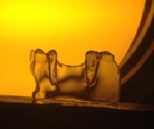

Fringes of 0 stresses

Figure 10: Visualization of stresses in the slice.

Disadvantages
The technique requires that a model of the actual part be made, requires calculation, is time-consuming and requires a new model for each study using the three-dimensional technique. The technique cannot be applied in- vivo and cannot simulate the different tooth structures and different bone types. Likewise, it can simulate centric occlusion only and not the other jaw movements.
History
The principle of photoelasticity was discovered by Brewster in 1816, and the method grew in popularity in the 1930s due to the works of Coker and Filon in the UK. Oppel in Germany, presented the idea of stress freezing technique to analyse 3D models. With the availability of epoxy resins in the 1950s, the use of photoelasticity for analysis of models came into being (William 2008). Subsequent to the introduction of the finite element analysis technique in the late 1950s, the use of photoelasticity was variable. However, there are signs that the popularity of photoelasticity is currently rising again due to the application of digital processing.
There are two aspects to digital technology:
- Advances in stereolithography for making epoxy resin models
- Automation of fringe analysis (Patterson 2002).
Photoelasticity was first introduced into dentistry by Noonan (1949). He used two-dimensional photoelasticity to study amalgam restoration and cavity design. Many studies in the field of partial dentures have subsequently used photoelasticity technique (Macgregor and Farah 1978; Thompson et al. 1997; Er Lee et al. 2008; Woo park and Kay 2009; Costa et al 2009; Pellizzer et al. 2010)
Light propagation through birefringent materials (core of photoelasticity)
When a single light ray is passed at normal incidence through a birefringent material, the light coming out is shown as consisting of two separate plane-polarized components that are perpendicular to one another, called the principal directions. Moreover, these components are out of phase, indicating that they passed through the plate at different speeds, which is called relative retardation (Cloud G 2007), as shown in (Figure 11).
Figure 11: Light propagation through birefringent material (Cloud 2007)

Theory of photoelasticity
The polariscope consists of a light source, which may be white or monochromatic, a polarizer element capable of producing a degree of polarization of the field, the subject of the study, the analyser, and two quarter-wave plates: one between the polarizer and the model and the other between model and analyzer.
The source of light radiates light waves with no specific orientation; the polarizer allows passage of waves that lie in a single plane, at the slab, as described, the wave is resolved into two components perpendicular to each other which travel at different speeds, as the waves exiting the birefringent model have been retarded. As with the polarizer the analyzer allows passage of components of the waves that are parallel to its transmission axis (Figure 12).

Figure 12: Theory of photoelasticity (Cloud 2007)

Photoelastic model materials
Selection of the proper material for model fabrication is one of the most important factors in photoelasticity. The ideal photoelastic material does not exist, so it is the investigator’s job to select the most appropriate polymer to that suit the test needs.
Ideally a photoelastic material should have the following qualities:
- Be transparent to light
- Be sensitive to stresses
- Show mechanical and optical isotropy and homogeneity
- Have a high modulus of elasticity and a high proportional limit
- Be free of residual stresses
- Be available at reasonable cost (Dally and Riley 1991)
Two other requirements should be added to this list for materials used for three-dimensional photoelasticity, namely that the material should be castable in large size and to a final shape and should be cementable (Dally and Riley 1991). There are many materials available for this purpose, including polycarbonate, glass, celluloid urethane rubber and epoxy resin.

Basic photoelasticity techniques
Two-dimensional photoelasticity
In conventional two-dimensional photoelasticity, a model is fabricated, loaded, and placed in a polariscope, and the fringe order is examined and photographed. If a 3D model is to be loaded and viewed in a polariscope, the analyst is presented with an integral view of the fringes throughout the thickness of the model that could not be resolved.
Three-dimensional photoelasticity
- Stress freezing
In order to overcome the problem of the integration effect on the results of 3D models, the stress freezing method was developed by G Oppel in 1936. The method locks stress into a 3D model, allowing the stresses at any point within the structure to be analysed through careful slicing of the model into a series of 2D models, and then viewing of the slices under the polariscope.
Stress freezing relies on bi-phase properties of polymers such as epoxy resin. Most polymers contain two types of molecular bond: strong primary bonds, and a large number of weaker secondary bonds.
Below the glass transition temperature Tg of the polymer, both bonds resist any load applied to the structure. However, as the glass transition temperature is reached, the secondary bonds within the material break down, and the polymer moves from the glassy phase to the rubbery phase, where the entire load is resisted only by the primary bonds. As a large proportion of the polymer consists of secondary bonds, the deformations within the rubbery phase are large yet elastic in behaviour.
If the load is maintained during the cooling of the material to below the Tg, the secondary bonds will re-form in the material, thus holding it in its deformed state even after the removal of the load. Thus the deformation and resulting birefringence will be locked into any small slice taken from the structure (Dally and Riley 1991).
Three-dimensional photoelasticity method
- After model fabrication, it is heated uniformly up the glass transition temperature, when it becomes rubbery and the birefringence is frozen.
- The model is loaded and slowly cooled.
- The model is sliced into thin sections so that the stress directions and magnitude are constant through the slice.
- The slices are then analysed in the polariscope as in the two-dimensional method.
- The birefringence order is measured and the stress is evaluated (Cloud 2010).
- Model slicing
The model is sliced in the planes of interest to define the stress states at certain points. The model is sectioned into slices of 2 mm thickness using a diamond blade and a coolant (water), in order to prevent stresses forming from the cutting.
- Data collection.
- Old technique using point by point method
- Digital photoelasticity
Wide use of digital computers together with development of cost-effective image processing systems have significantly transformed photoelasticity to the level that it is now able to quantitatively evaluate the information at every pixel over the model (Ramech et al. 2011).
The process is composed of three steps using two software packages.
I) Phase-shifting
This is a procedure for shifting the amount of light present in the image seen through the polariscope by means of inserting a device in the optical path. It includes the capture of images by orienting the polarized plate by known different angles, in order to change the light strengths on the specimen. In this particular project, the six-step phase-stepping process developed by Patterson, and Wang is applied (Patterson and Wang 1991). The intensity is recorded at each step using software called Catchsix.

II) Catchsix
Catchsix is a software program developed at the University of Sheffield, which is able to take images and transform them into a single file that can be processed using another software package.
III) Computer Aided Photoelastic Analysis (CoPA).
CoPA is software established by Philip Siegmann and Eann Patterson at the University of Sheffield to process the file produced by Catchsix software.
The software is able to present a fringe map, defines the fringe values through the whole fringe map and allows exporting of the collected data as files for analysis via standard database software.
Photoelasticity as a predictor
A correlation has been confirmed between three- dimensional technique and histologic specimens of root tipping in a cat’s canine. There was an area of pressure in the model corresponding to widening of periodontal ligaments. This area of pressure in the model matched the compression of the periodontal ligaments histologically. Where high fringe orders were present in the model, hyalinization appeared in the histologic material (Brodsky et al. 1975).
Correlation was also found between the results of three-dimension technique and the effects of orthodontic class III mechanisms on the bone of the jaws. The stress freezing technique showed that class III elastics affected various sutures of the photoelastic skull. Agreement was shown by computerized cephalometrics in the analysis of ten treated cases (de Alba et al. 1979). These examples showed the significance of using photoelasticity to forecast the effects of stress in biologic systems. A sound modelling procedure makes the photoelastic technique very useful in explaining the biomechanical principles of clinical dentistry (Angelo 1987).

Summary and challenges
RPDs are a common treatment option available for the restoration of partially dentate patients. Many studies indicate that the need for RPDs will increase, and this is attributed to the increased life span of the population. Fixed bridges and implant supported prostheses may be unsuitable due to the poor health of the remaining oral structures.
Reviewing the current status of RPDs has demonstrated many drawbacks of the current materials used in their construction, probably the most important of which are the reported material incompatibility and harmful consequences of stress distribution over the supporting structures. A properly designed RPD should reduce the stresses applied over the supporting structure, distribute the forces over as wide an area as possible and direct this force along the long axis of the tooth. The difference in resiliency between abutment teeth and the alveolar ridge in Kennedy class I and II cases will result in a rotary movement of RPD around the fulcrum of the terminal abutments.
There has been extensive research on different aspects of denture design in attempts to solve the problems related to stress distribution. Less attention has been given to the evaluation of new materials as removable partial denture framework materials. Polyetheretherketone is a semi-crystalline thermoplastic material which has good mechanical, physical and biological properties. The challenge is then to evaluate PEEK as an RPD framework material and investigate the force distribution over the supporting structures, in comparison with current RPD materials. Photoelasticity is a useful full field stress analysis technique, especially for complicated geometries with complicated loading conditions. This new technology will be used in the design and production of PEEK as a removable partial denture framework material.

: Aim and Objectives

The primary aim in providing removable partial dentures is not to replace the missed teeth, but rather to preserve the integrity of what remains of the oral structures. If the stress magnitude and direction exerted upon the oral supporting structures during functioning and non-functioning movement not restricted within their physiologic limits, then we support the Layman’s definition of a removable partial denture who said ‘’ A partial denture is a device for losing one’s teeth slowly, painfully, and expensively. ’Many of removable partial dentures which were constructed to give lengthy service became temporary appliances because the biomechanical principles were ignored in their designing or the material properties caused progressive movement of the abutment teeth and resorption of the alveolar ridge (Devan 1956).
Model resin making is of extreme important for a better accuracy. The photoelastic material type, model size and thickness, and the applied load must be chosen properly. Moreover, the stresses/strain will be in the model, not in the real object, and for better accuracy this requires a similarity in properties between the model and the real object, as well as the application of loads on the model related with those applied to the real object (Fernandez 2011). The aim is to use two epoxy resins with different properties for model fabrication. One for the abutment teeth, while the other one for the rest of the model. These materials have been chosen to achieve the same ratio between the modulus of elasticity of the model materials as there is between the subject materials of dentine and bone.
The mechanical properties of a material for a particular product should fulfil the functional requirements for its intended use. In this case it is necessary to apply the knowledge of the material’s properties to denture design. PEEK is a thermoplastic material. The property profile of polymers can be completely altered and therefore design of appliances should not continue to be reliant on conventional designs for metal parts.

Aim
The aim of this project is to evaluate the PEEK frameworks when designed as an RPD and their load distribution to the supporting structures in comparison to the conventional RPD materials. The design will then be adjusted to optimise the load distribution.

Objectives
- To produce a resin model for photoelasticity technique composed of two materials that has some properties close to that of dentine and bone.
- To compare the PEEK load distribution with that of conventional materials and the load distribution assessed.
- To design of PEEK removable partial denture framework as related to the optimised load distribution.

Hypothesis
PEEK material and design will significantly improve the occlusal load distribution over the supporting structures, making it an appealing option as removable partial denture framework material.

: Methodology for Development of the Novel Resin Model

To compare the stress distribution of RPDs produced from Cobalt chromium, Polymethylmethacrylate, Nylon polyamide and Polyetheretherketone materials, models were produced for different patterns of tooth support. The selected scenarios were
Cl III modification 1: RPDs for this pattern of tooth loss with two bounded saddles, could be tooth supported or tissue supported.
Cl I: RPDs for this pattern of tooth loss with two free end saddles could be tissue supported or tooth and tissue supported.
For each scenario, duplicates of the master model were required in the appropriate photoelastic material.

Resin model fabrication
Photoelastic resin model- making is a fundamental step for the accurate use of the 3D photoelasticity technique. Ideally, the model material should simulate the behaviour of the clinical situation; however, due to complexity of the oral cavity, it would be impossible to provide representation of all tissues and environment in a model. Therefore, some simplification of the factors that act in the oral environment is required.
In this technique, the stresses are not directly measured on the real object (the oral cavity) but on a photoelastic model, therefore care must be taken to ensure that similarity in the properties between the model and the object that is being simulated.
When considering the mechanical operating range for all the dental structures and any restorations, all will operate before the onset of permanent deformation. Therefore, the most significant property in the modelling is that of modulus of elasticity (Angelo 1987) Moreover, the modulus of elasticity is important in the material selection, as it controls the distortion of the model resulting from the applied loads. If the boundary geometry changes due to distortion, the photoelastic solution will be in error (Dally and Riley 1991).
The technique used in this study was the stress freezing where the model is heated above the glass transition temperature, the load applied and then the model is cooled to lock in the stress for observation. Generally, the modulus of elasticity data for the photoelastic materials only covers room temperature behaviour. Therefore, for this project the modulus of elasticity for the materials at their glass transition temperature needed to be determined.
Selection of resin material for the photoelastic model (Pilot study)
A key to observe a sharp and well defined photoelastic data is the choice of suitable material for the photoelastic model, which must provide specific properties
- Transparency to the light of the polariscope.
- Absence of residual stresses that are superimposed on the true stresses produced by loading the model.
- High modulus of elasticity to make sure that the model will not distort under loading.
- Good sensitivity to the load applied.
Four commercial brands of resin were chosen from which to produce the resin model. The epoxy resin brands were chosen because of their extensive use in the literature in the photoelasticity technique, polymethylmethacrylate also widely used in dentistry.
Araldite 2020 is a two components, watery white adhesive, and room temperature curing epoxy resin, designed specifically for glass bonding. The two components should be mixed at a ratio of 100:35 by weight until they form a homogeneous mix, and then cured at room temperature for 16/ h.
PL1 is a room temperature curing resin/hardener system for making contourable PhotoStress plastic sheets, yellowish in colour. The two components should be heated separately in an oven at least to 32C° but never higher than 43C° to lower materials viscosity and facilitate a uniform mixing. Then add the hardener to the resin at a ratio of 100:20 by weight and stir slowly to achieve a homogenous mix free of air bubbles, and then cured at room temperature for the rest of the day.
PL2 is a room temperature curing resin/hardener system for making contourable PhotoStress plastic sheet. The two components should be heated separately in an oven at 46-52C°, then mixed at a ratio of 1:1, and then stir slowly to achieve a uniform mix. Then lift to cure at room temperature for the rest of the day.
PMMA used in this study is a cold cure powder and liquid components used as a denture base material. Ideal mixing ratio is 30g powder: 20 ml liquid. Mix the components thoroughly for approx. 20-30 seconds, then pour the mix in the mould and place it in a hydroflask for 15min at a temperature of 40C° and a pressure of 2 /bar.
Pilot study.
Four models were prepared.
1x PMMA.
1X PMMA with teeth in PL1.
1X PL1.
1X Araldite 2020.
. Each resin was poured in a silicon mould presenting the shape of Cl III modification 1 scenario. Care was taken to avoid the formation of bubbles. After complete setting of the material, they were held and examined, under pressure in the polariscope.
PMMA: showed a very poor sensitivity to light. It was hard to observe any fringes in the model fabricated totally in PMMA even with high amount of load applied, while it was easy to observe fringes in the teeth made on PL1 at the second PMMA model (Figure 13).

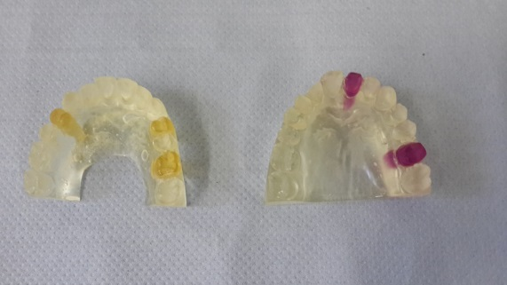

Figure 13: PMMA Models

PL1: as the material is cured by exothermic reaction, viewing the model under the polariscope showed a high amount of residual stresses, which introduced serious errors into the photoelastic analysis (Figure 14).

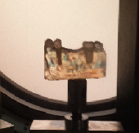 | 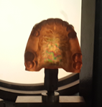
Residual stresses
Figure 14: PL1 models shows the residual stresses

To overcome this disadvantage, there were several efforts, through changing the condition of model making, and through using different annealing cycles (Table 4.1).
Model 1: produced in full arch size, poured in a mould, then cured in hydroflask at 2/bar for 20 min. To remove the residual stresses, the model subjected to three different annealing cycles; 1) heating the model in the stress freezing oven for 2/h up to it is Tg, then 1h soaking at Tg, then cooling down for 2/h. 2) heating the model up to Tg at a rate of 3C/h for 22/h, soaking for 2/h, then cooling down at the same rate of heating that took 22/h too. 3) Heating up the model to 80C° in a water bath, soaked for 2/h and then left to cool overnight.
Model 2: 2 models produced, one in full arch and one half arch, the models left to cure at room temperature. The models subjects to three different annealing cycles; 1) Heating up to 70C° at a rate of 2C/h, soaking for 1h, then cooling at a rate of 2C/h. 2) Heating to 85C° in a water bath. 3) Heating up to 100C° at a rate of 2C/h at an oven.
Model 3: 2 models produced in half arch, one full in PL1, and one with spaces in teeth positions. The moulds heated to 10 min and then the material poured in them and then left to cure at room temperature.
Model 4: produced in full arch, the material mixed in the oven and then poured in a warmed mould, then left to cure in the oven at a cycle of heating up to 50C°, soaking for an hour, then left to cool at a rate of 3C/h.
All the previous efforts failed in removing the residual stresses.

Model No | Model making |  |  |  | Annealing
 | Model size | Mould heating | Curing | Residual stresses | Method | Result
Model 1 | Full | X | Hydroflask 2bar/20min | √ | 1.2h heating to Tg-1h soaking-2h cooling(oven) | X
 |  |  |  |  | 2.22h heating to Tg (3c/h)-2h soaking-22h cooling (3c/h) oven. | X
 |  |  |  |  | 3.Heating to 80c-2h soaking-cooling overnight (water bath) | X
Model 2 | Full  Sectional. | X | Room temperature | √ | 1.Heating to 70c (2h/h)-1h soaking-cooling2c/h (oven) | X
 |  |  |  |  | 2.Heating 85c water bath. | X
 |  |  |  |  | 3.heating to 100c at a rate of 2c/h (oven). | X
Model 3 | Sectional with no teeth / sockets | 10 min | Room temperature | √ |  | X
Model 4 | Full | 10 min | Heating to 50c-soaking 1h-cooling 3c/h (oven). | √ |  | X
Table 3: Efforts to overcome the residual stresses in the PL1 models.

Araldite 2020: resin is the suitable material for the model construction for the photoelastic analysis. Viewing the model made in Araldite 2020 reveals no residual stresses, and it showed a good sensitivity to light (Figure 15).

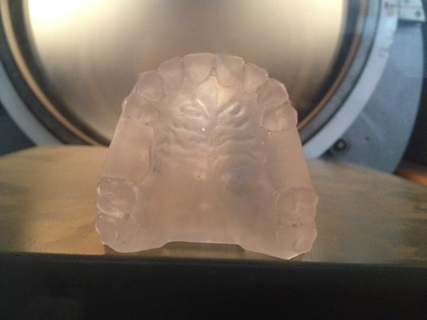

Figure 15: Araldite 2020 model free from any residual stresses

Producing a photoelastic model to represent abutment teeth and bone
Aim
The aim of this study was to fabricate of a dental model using two photoelastic resins with different stiffness, one to simulate the abutment teeth, while the other one for the bone.
Objectives
- Define the glass transition temperature of the selected photoelastic materials.
- Define the modulus of elasticity at the glass transition temperature.
- Define the modulus of elasticity of each material at the glass transition temperature of the other materials.
- Establish the two materials which will best simulate the ratio between bone and tooth.
Materials
Material | Manufacturer
Polymethylmethacrylate (PMMA). | Candulor AG, Germany.
Araldite 2020 (epoxy resin). | Huntsman advanced materials, Swiss.
PL1 (epoxy resin). | Vishay precision group, USA.
PL2 (epoxy resin). | Vishay precision group, USA.

Table 4: Resin materials used in the study.

Three samples of each material were prepared according to manufacturer’s instructions. A silicon mould was used to produce samples of approximate dimensions of 40x 4x2mm (Figure 16).
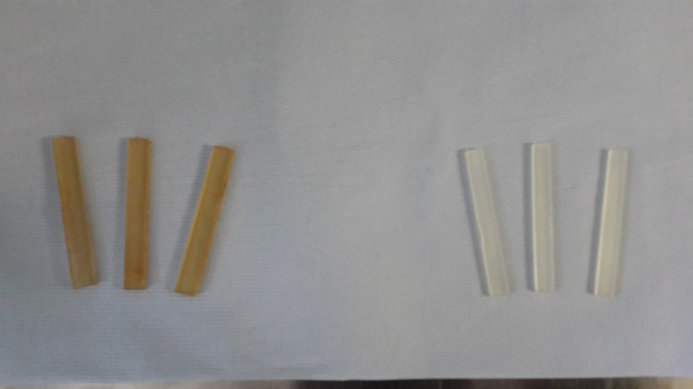

Figure 16: Specimens

Dynamic mechanical analysis (DMA), or dynamic mechanical thermal analysis (DMTA), is a useful technique that can offer a sensitive and rapid determination of thermos-mechanical properties using only small amount of the material to define the glass transition temperature and the corresponding modulus of elasticity. Various fixtures can be used such as single/dual-cantilever, three-point bend, and tension/compression and shear sandwich.
A dynamic mechanical analyser (Perkin Elmer DMA 8000) was used for measuring the temperature-dependant elastic moduli of the materials selected (Figure 17).
The test was conducted with three-point bending mode, which involved three loading pins with knife edges, which fitted onto the DMA- two were placed at the edges facing upwards to support the test specimens, whilst the third one was secured in the centre, above the specimens. The supported span was 30 mm, temperatures scanning from low at -100° to high at 200° were performed with a heating rate of 2C/min at an oscillation frequency of 0.05mm.
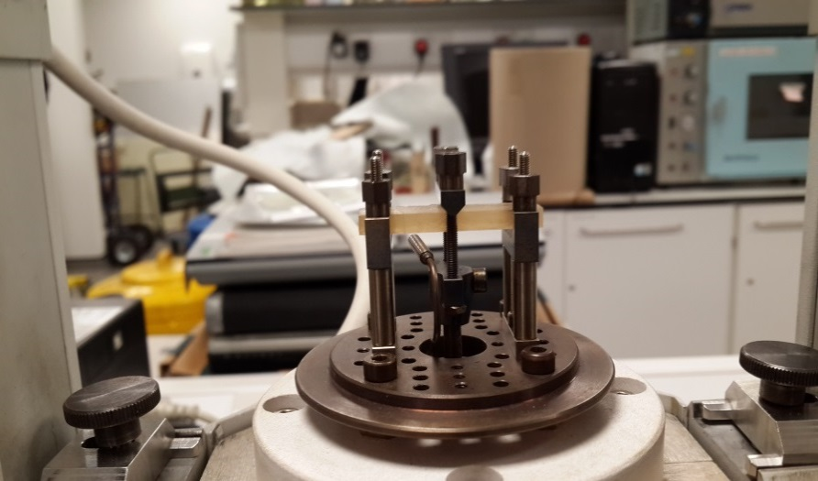

Figure 17: Specimens in the DMA machine.

Results

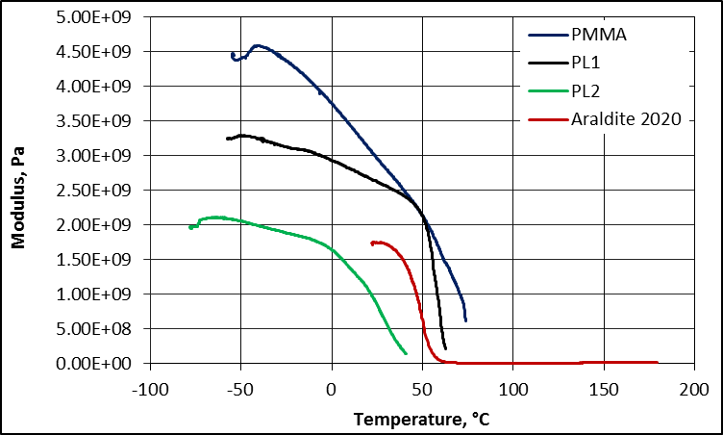
Figure 18: Tg and E of the selected materials.

properties | PL2 | PL1 | PMMA | Araldite 2020
Tg°C | 40 | 62.6 | 73.9 | 60.2
(E)atTg | 0.167 | 0.214 | 0.624 | 0.043
(E)atTg PL2 (40) | 0.167 | 2.422 | 2.498 | 1.472
(E)atTgPL1 (62) | - | 0.214 | 1.458 | 0.027
(E)atAraldite 2020 (60.2) | - | 0.597 | 1.613 | 0.043

Table 5 : E (GPa) of materials VS temperature.

In the current study the objective was to select two materials which exhibited a ratio between the modulus of elasticity that mimic that between bone and dentine.
Four materials were chosen that are extensively cited in the literature as materials used for dental studies. Three epoxy resins PL1, PL2 and Araldite 2020, and PMMA. PL1 and PL2 are widely used materials in dental studies using photoelasticity technique. The ratio of modulus of elasticity between these materials is mimic that between bone and dentine at room temperature which is suitable for 2D and integrated photoelasticity techniques.
This study aims to use 3D photoelasticity in which loading of the materials took place at an elevated temperature above the Tg of the materials used. For this reason, the Tg and modulus of elasticity required defining for the selected materials at their Tg and at the Tg of each other.
Determination of the modulus of elasticity for any material is normally determined by a standard tensile test on a specimen of the material under different temperatures to determine temperature dependent properties, although such test is reliable and straightforward, it is costly in both materials and time (Dang et al., 2007).
DMA are used only for screening material properties for the purposes of quality control, research and development, and establishment of optimum processing conditions (Deng et al. 2007). Three-point bending mode where chosen as it can eliminate the clamping effects and provide the most analogous approach to normal mechanical testing. The chosen oscillation frequency was 0.05mm to simulate the static occlusion, which is the way of loading the specimens in this study.
Tooth tissue | Elastic modulus (GPa)
Dentine | 18 | (Wojciech et al 2017)
Spongy bone | 1.3 | (RHO et al 2018)

Table 6: Mechanical properties of dentine and spongy bone

When applying in the equation of similarity between the real structures and their analogue to find out the E of the tooth analogue at the Tg of the bone analogue.
Where E of tooth material is 18 GPa, bone 1.3GPa, and the E of the bone analogue at Tg is 0.043 GPa.
$$\frac{E Tooth}{E Bone}=\frac{E tooth analogue at Tg of bone analogue}{E bone analogue at Tg}$$
E tooth analogue=$\frac{E tooth x E bone analogue}{E bone}$
= $\frac{18 X 0.043}{1.3}$
= 0.595 GPa
This experiment showed that the ratio between PL1/Araldite adequately mimics the tooth/ bone ratio of modulus of elasticity.
Araldite 2020 has (E) 0.043 GPa at Tg, and to be used as the bone analogue. PL1 has (E) of 0.597 GPa at the Tg of Araldite 2020, and therefore will be use as tooth analogue as the ratio between the two at Tg is 0.597/0.043 = 13.88 which mimic that between bone and teeth.

Therefore, this combination will be used as a dental model to evaluate the load distribution of the dental prosthesis (Figure 19).

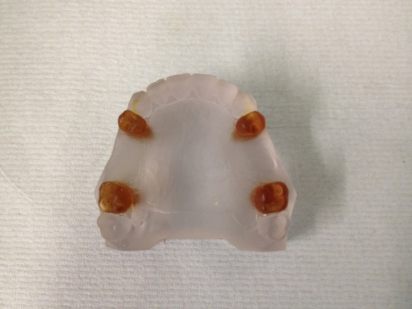
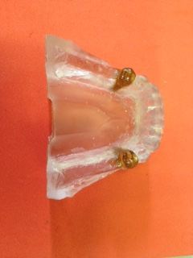

Upper model Lower model

Figure 19: The upper and lower resin models.

Master model making
To fabricate class III modification1 model, a Frasaco upper model was modified by removing the second premolar and first molar on both sides. The abutment teeth were first premolar and second molar. The Class I fabrication was produced in a similar manner for a lower model removing the molar teeth in both sides. The abutment teeth were the first and second premolars (Figure 20).
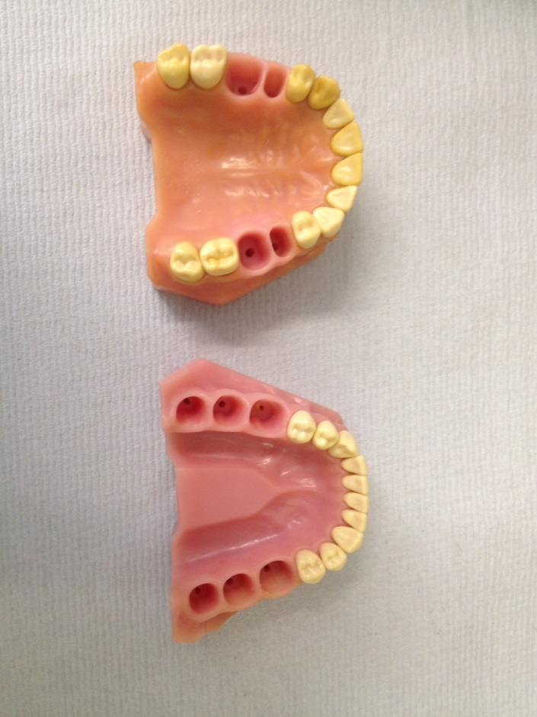

Figure 20: Modified Frasaco models represent the selected scenarios.

The abutment teeth were duplicated by fixing them to the base of a duplicating flask, and then silicon duplicating material (Metrosil Plus, Metrodent limited, UK) was poured in. After setting of the duplicating material, the abutment teeth were removed, and then stone material poured in the mould. The abutment teeth in stone were then removed from the mould, and the occlusal rest seats were prepared. For the upper scenario the occlusal seats were prepared on the distal surface of the first premolar, and on the mesial surface of the second molar, while for the lower scenario, the seats were prepared on the mesial and distal surfaces of the first and second premolar. Occlusal rest seats were prepared according to the dimension recommended by (Sato 2003) which are 3mm length, 3mm width, and, 1mm depth using round bur (Figure 21and 22).

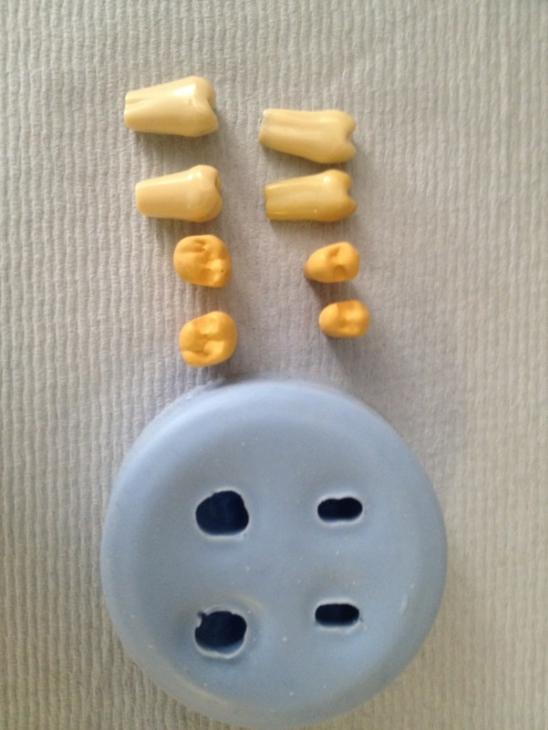

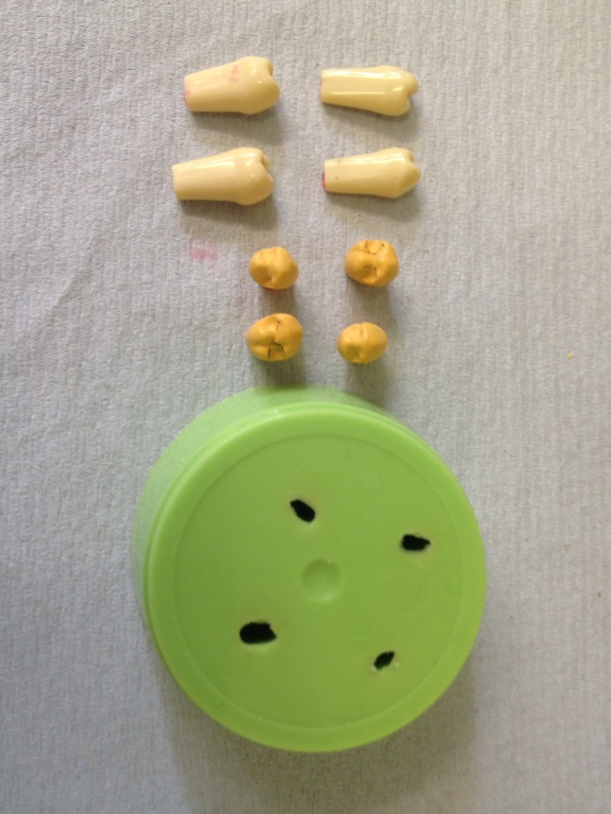
Figure 21: Prepared occlusal rests on the upper abutment teeth.

Figure 22: Prepared occlusal rests on the lower abutment teeth

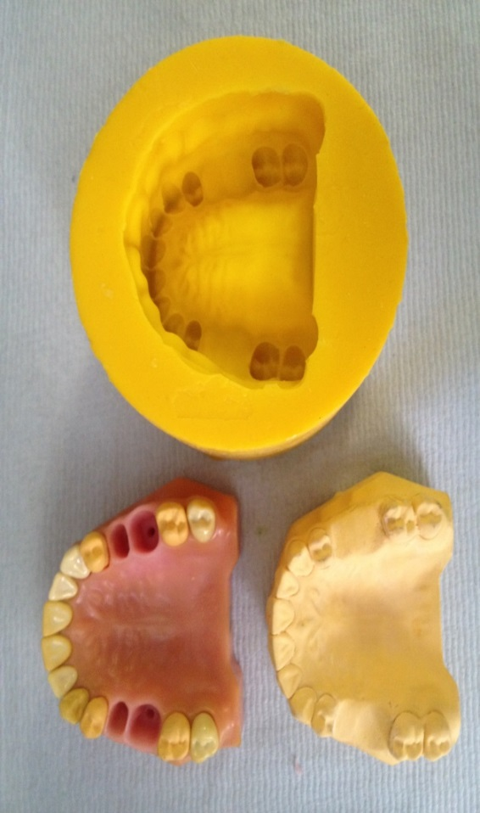
The modified abutment teeth returned in the Frasaco model, the sockets of the removed teeth were blocked, and the model then duplicated to form a mould. Dental stone then poured in the mould to produce the master cast (Figure 23 and 24).

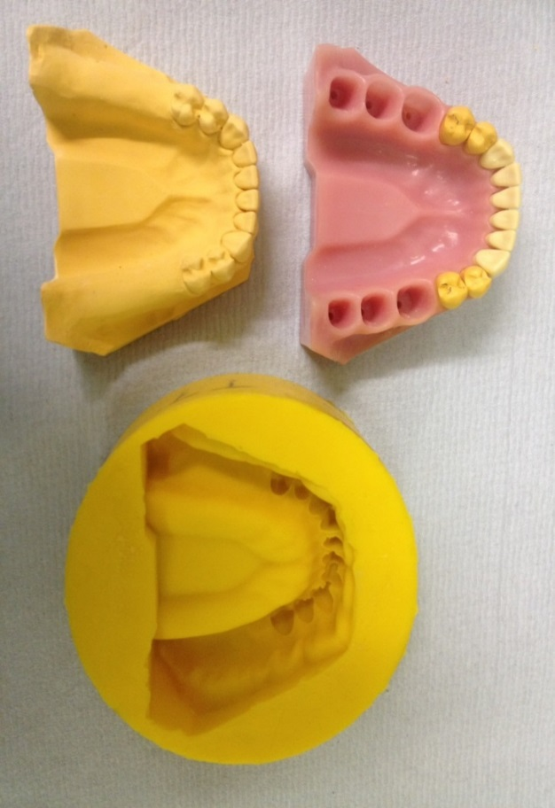
Figure 23: Upper mater model.

Figure 24: Lower master model.

Root formation
The abutment teeth were removed from the Frasaco model, and apexes were added to the actual teeth length using Thowax modelling wax (YETI, Engen Germany). The modified abutment teeth were duplicated, after setting it removed from the mould, then PL1 was mixed according to the manufacturer’s instructions, while holding the moulds in a dry oven to reduce the incidence of air formation, then poured in the mould and left to set (Figure 25 and 26).
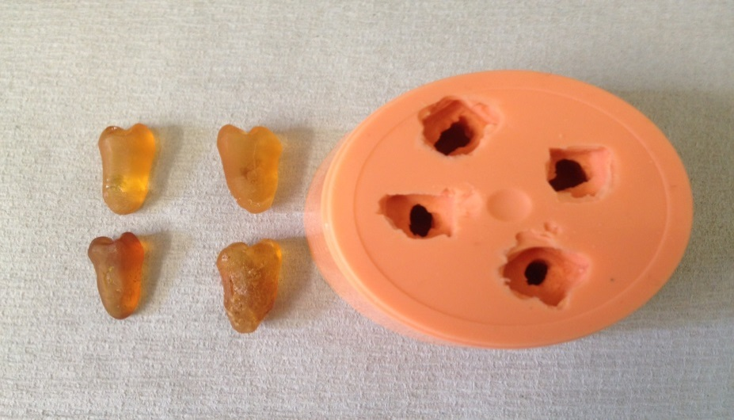

Figure 25: Upper abutment teeth to the full length.
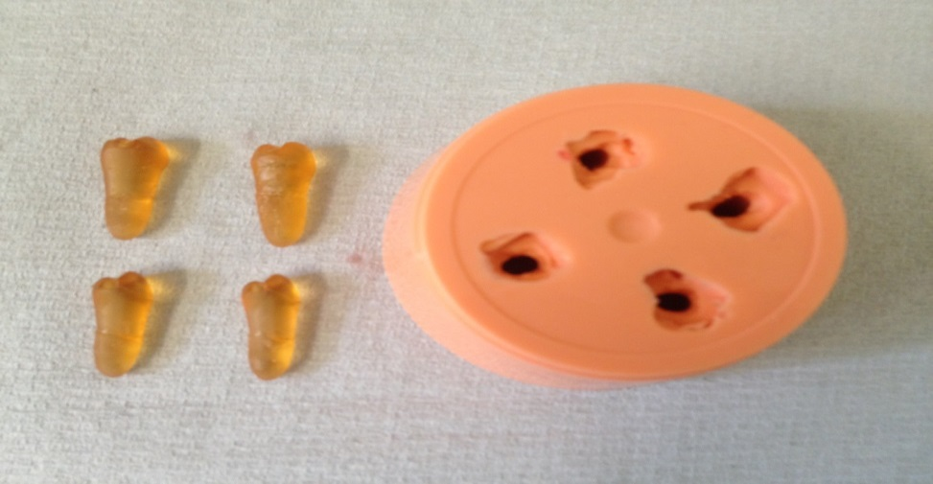

Figure 26: Lower abutment teeth to the full length.

Periodontal ligament simulation
Pilot study
The teeth were embedded upside down in a square shape made from boxing wax and filled with Coltene light body up to the Cementoenamel junction. A copper band has used to cover the root portion, and then another mix of the light body poured in the square shape. The copper band was removed after setting of the second mix (Figure 27 a, b, c and d).
The roots of the abutment teeth were covered with a 3 layers of 0.07mm PTFE thread seal tape to the CEJ with an approximate final thickness of 0.21mm and inserted in the mould. White model resin material (RHINO ROCK, DP lab supplies limited, Silsden, UK) was mixed and pored over the root of the tooth. After mould setting the tooth was removed from the mould and the tap layers removed from the root surface (Figure 27 e, f, and g). The mould lubricated with a separating medium while the root surface painted with an adhesive material.
President Plus light body (Coltene, Switzerland) is the most suitable material for PDL simulation due to it is matched resilience to PDL (Broch et al 2011). The mould was filled with light body material and the tooth was inserted in the mould. After the setting of the light body, the tooth was removed (Figure 27 h, I, j).
There were many problems encountering in PDL making by this way. It is very difficult to have an intact PDL which covers the full root surface, thickness usually thicker at the apex, and slicing the model lead to tearing of the PDL material and hole formation in the slice.

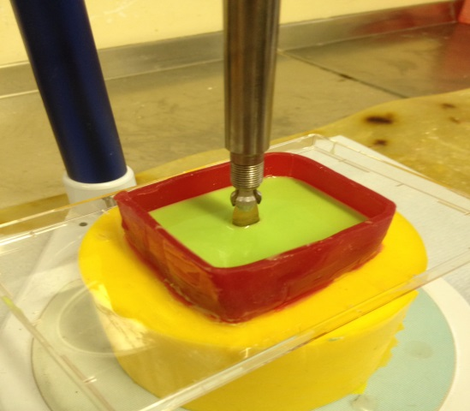
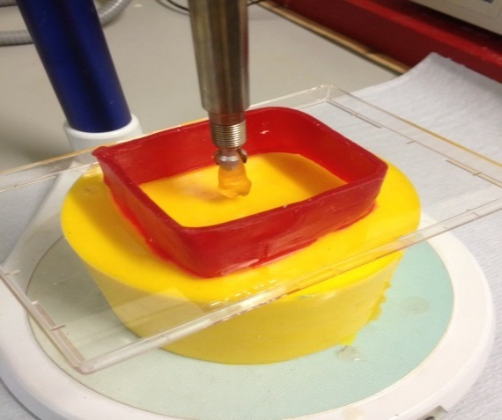

a b
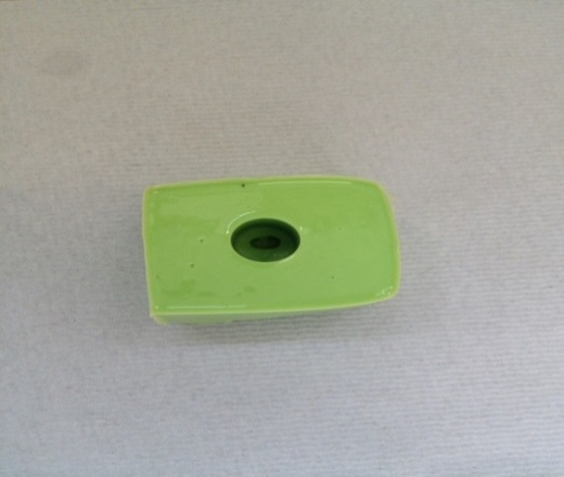
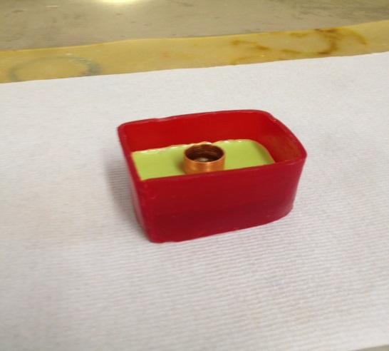

c d
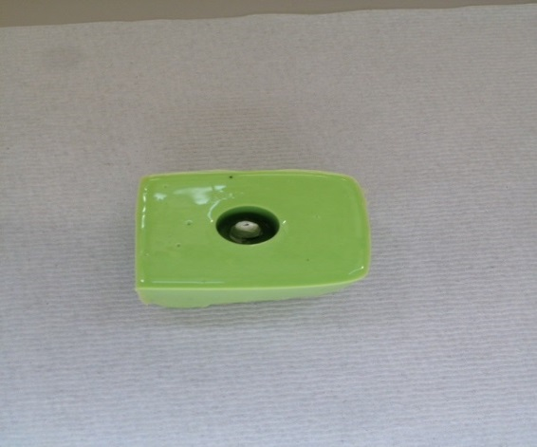
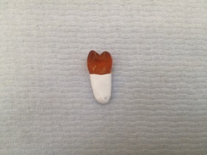

e f

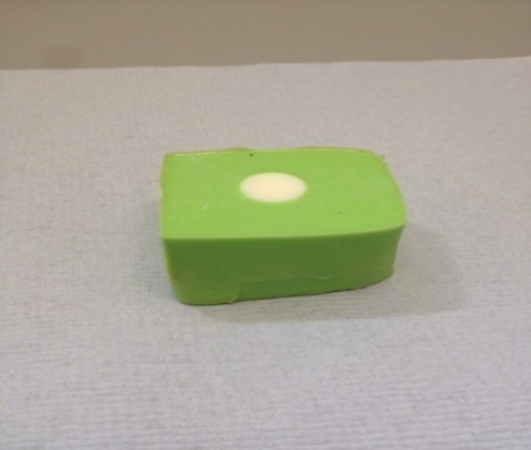
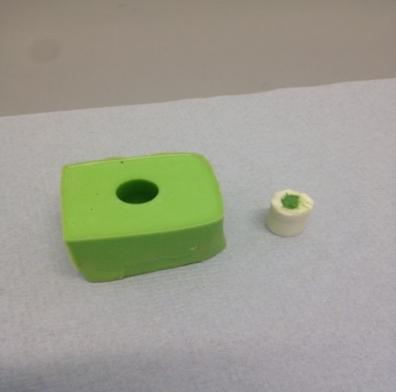

g h
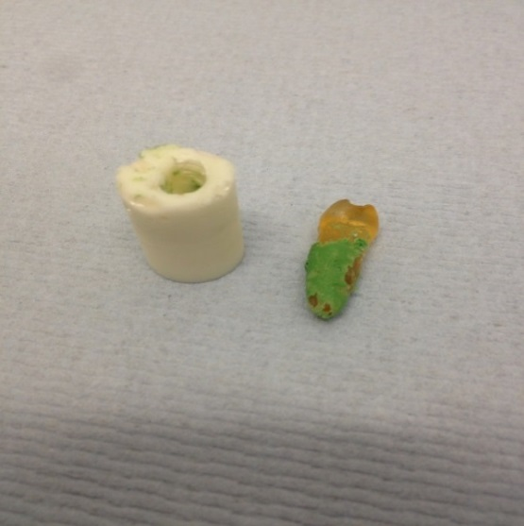
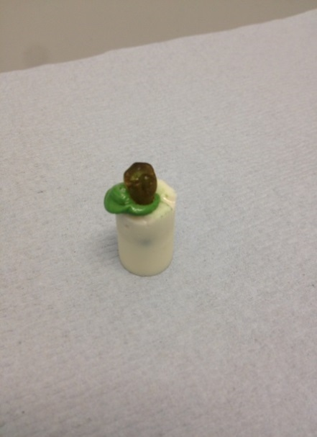

i j

Figure 27: Steps of PDL Simulation

Several photoelastic studies have used the adhesive materials to simulate the PDL (Park and Kay 2009). To define the thickness required from the adhesive material to give 0.2mm, four abutment teeth were produced in stone. The root surfaces were covered with adhesive material (Permlastic adhesive, Italy) with either 3,4, or 5 layers by dipping the roots in the material (Figure 28).

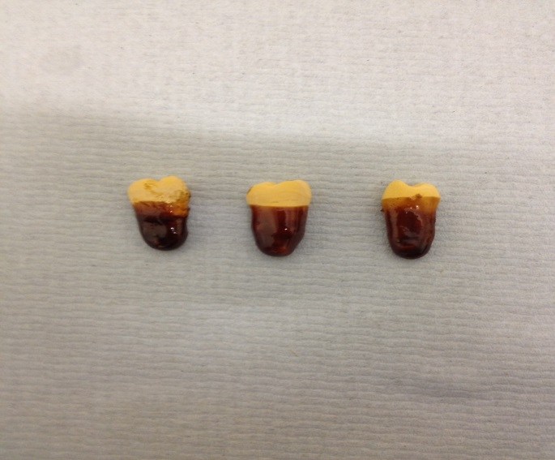

Figure 28: Different thickness of the material.

After material setting the teeth was inserted in the mould forming square box used in the first method, stone was poured in copper ring (Figure 29). The teeth, PDL and base were sectioned using Isomet 1000 (Buehler, USA) sectioning machine (Figure 30)

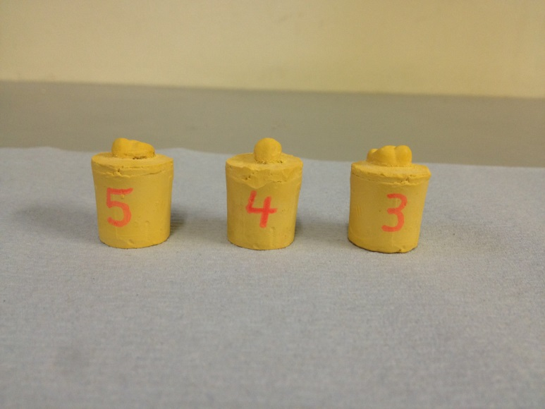

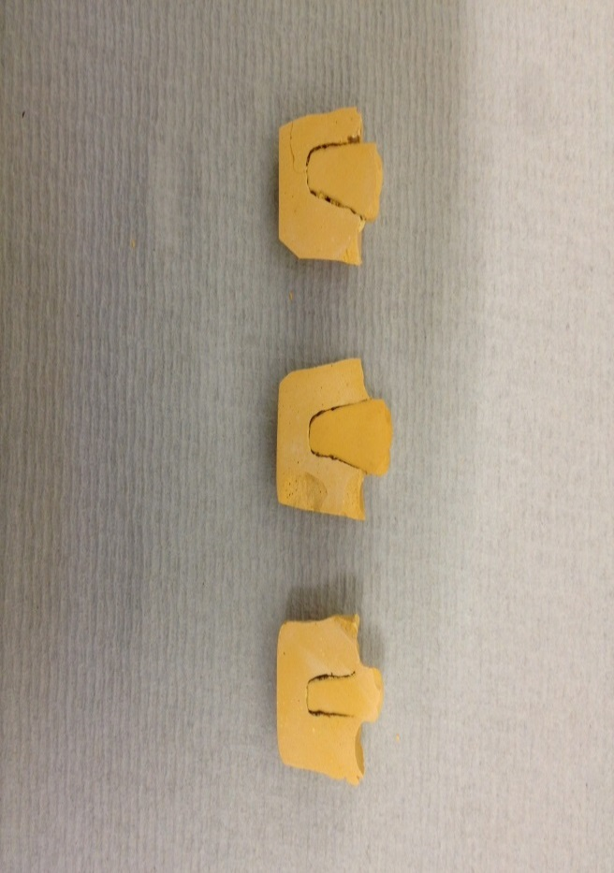
Figure 29: The teeth ready for slicing.

Figure 30: The sliced teeth showed the PDL space.

The sectioned parts were examined under ZEISS- Discovery V8 light microscope to measure the space between the base and the root surface. Measuring the space showed that 5 layers of the adhesive material gave the average thickness of 0.2mm (Figure31).

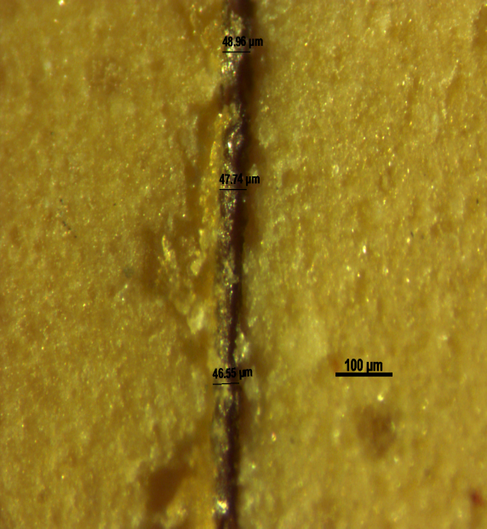

3layers

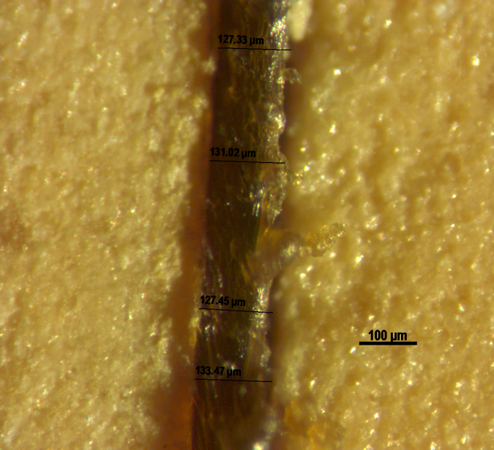

4layers

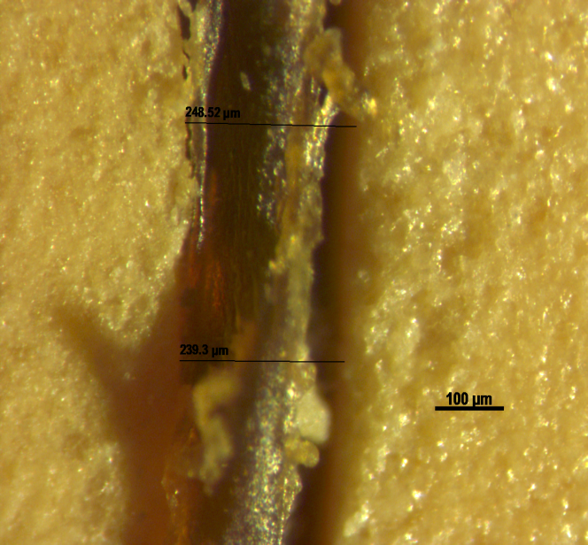

5layers

Figure 31: Thickness of the PDL space under the microscope

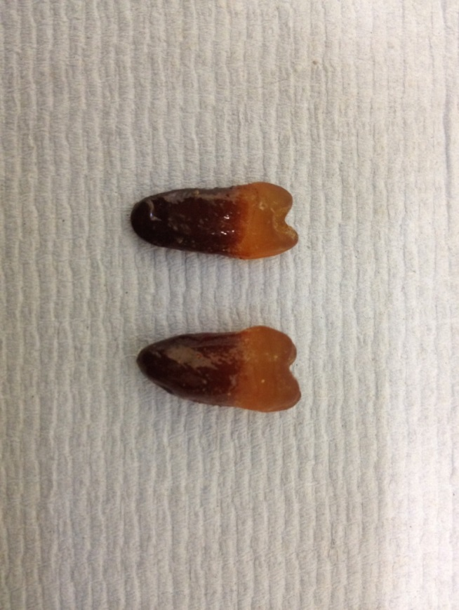

Figure 32: The abutment teeth with PDL simulation.

Mucosa simulation
The surface of the saddle area and the palate of the master cast were reduced by about 2mm overall to represent the thickness of the mucosa (Kydd et al., 1971). The master model was divided to many areas so the reduction will be equal (Figure 33).
The cast then duplicated by positioning in a duplicating flask, and using Metrosil Plus silicon duplicating material poured over it.
The model parts then assembled by inserting the abutment teeth with PDL simulation in the mould. The Araldite 2020 has mixed according to the manufacturer’s instructions by mixing 100g resin to 30g of the hardener for about 10 min, and then poured in the mould. After setting of the resin model it removed from the mould and the light body applied to the reduced area using President Plus light body (Coltene, Switzerland) (Figure 34 and 35).

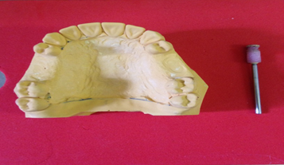

Figure 33: The reduced master model.

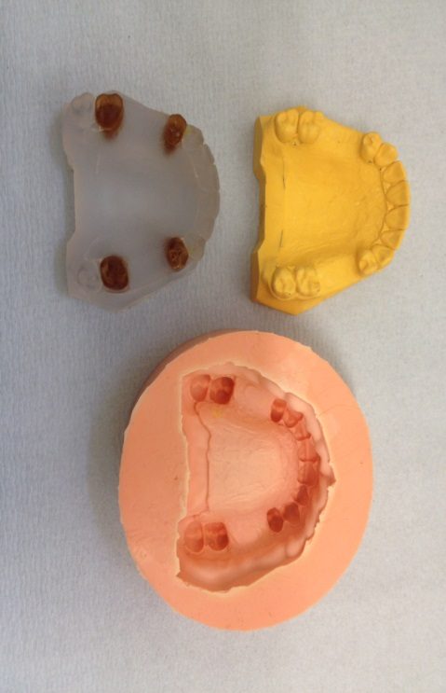
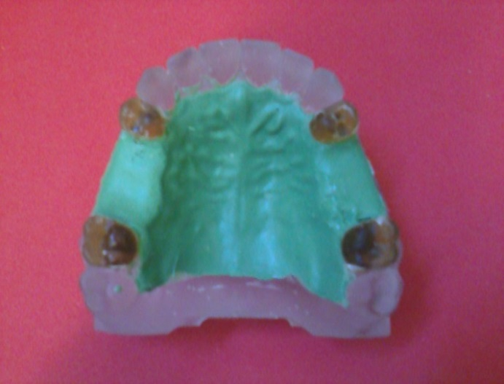

a b

Figure 34: a. The duplicated upper model, b.The upper working resin model

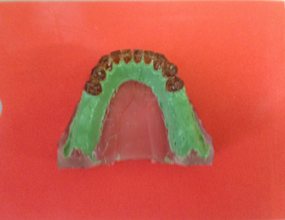
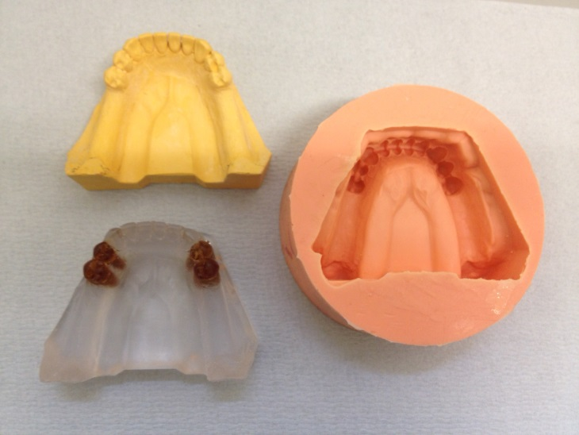

a b

Figure 35: a. The duplicated lower model, b. The lower working resin model

Experimental 3D photoelasticity method
Photoelasticity was first used in dental research by Noonan in (1949), and since that time it has been used extensively for different dental applications; nowadays there is a focus on implantology research. However most of the published studies, use live loaded, integrated photoelastic analysis at room temperature where little can be concluded regarding the internal state of stress, thus only providing qualitative or comparative data.
3D photoelasticity using stress freezing allows the quantitative study of the internal load transfer between dental prostheses and the oral tissues, which cannot be analysed experimentally in any other practical, economic way. In stress freezing a model made of a bi-phase polymeric material is loaded during a thermal cycle in order to lock-in strains and then is sectioned to allow 2D photoelastic analysis of the internal structure. Digital photoelastic methods allow full-field quantitative analysis and are well established in engineering fields, however in dental research very few applications have been published using these advances.

Stress freezing
The stress freezing oven LTE (Laboratory Thermal Equipment- Greenfield Oldham) was used to carry out the stress freezing technique. Heating to stress freezing temperature (62°C) from the base temperature of 25°C was carried out at 3°C/h. This was followed by a five hours soak at stress freezing temperature in order to achieve thermal equilibrium throughout the model. Cooling to 25°C was at 2°C/hr in order to maintain a constant temperature throughout the material for the duration of the process, thus avoiding possible problems of residual thermal stress being locked into the sample (Figure 36).
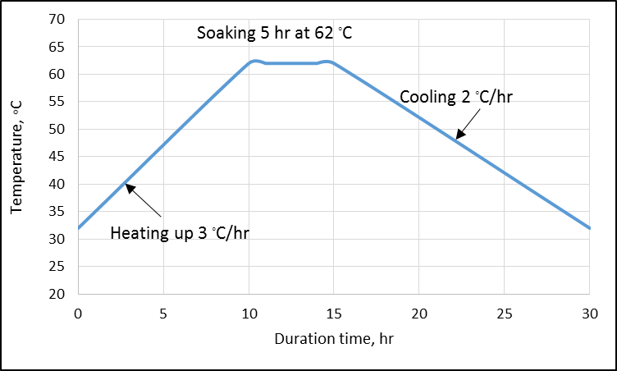
Figure 36: The stress freezing cycle.
The specimens were loaded at the occlusal surfaces of the denture’s teeth using an adapted dental surveyor. A metal plate form attached on the superior end of it is analysing rod, to allow weight placement. On the inferior end, a device in the form of a pin was adapted to allow the load application. Bilateral loading was obtained by means of a metal bar positioned over the upper second premolar and first molar on both sides. A vertical load of 5 Kg was delivered on the notch at the centre of the bar (Figure 37).

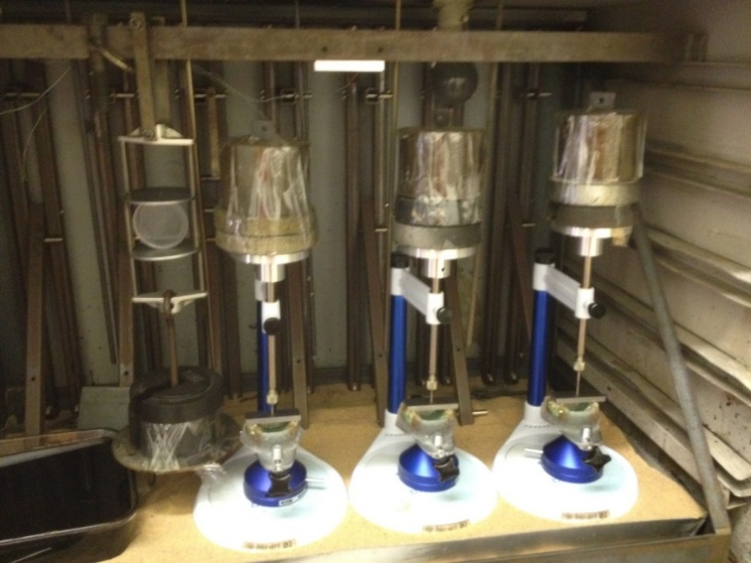

Figure 37: The models under loading in the oven.

A Calibrating disc made from Araldite 2020, also known as a Brazilian disc, which is a component used to define the optical properties of the photoelastic material, was loaded in the oven by load of 3.243 kg (Figure 38).

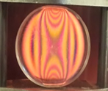

Figure 38: The calibration disc.

To find the optical constant of the material, apply in the following equation:
$f=\frac{8P}{DN}$
Where f = optical constant, P= load, D = diameter of the disc, and N= fringe order at the centre of the disc.
$f=\frac{8x 3.243x9.81}{55x{10}^{-3}x3}$
= 491 (N/$m^{2}$/fringe/m).

Sectioning
Two-millimetre-thick section samples were taken from the models at selected points.
For the upper CL III modification 1 scenario four slices chosen:
Slice I: Sectioning in a sagittal plane through the right abutment teeth and surrounding supporting bone and the saddle area.
Slice II: Sectioning in a coronal plane through the upper left 1st premolar and the corresponding palate.
Slice III: Sectioning in a coronal plane through the saddle area of the left side and the corresponding palate.
Slice IV: Sectioning in a coronal plane through the upper left 2nd molar and the corresponding palate.
For the lower CL I scenario two slices chosen:
Slice I: Sectioning in a sagittal plane through the left 1st and 2nd premolars and the distal saddle area.
Slice II: Sectioning in a coronal plane through the right second premolar and the supporting bone.
Sectioning was carried out using a diamond blade under coolant to prevent heating of the model and residual stress formation (Figure 39). The slices were then coated with silicon based oil in order to improve their optical qualities through the smoothing of any machining marks.

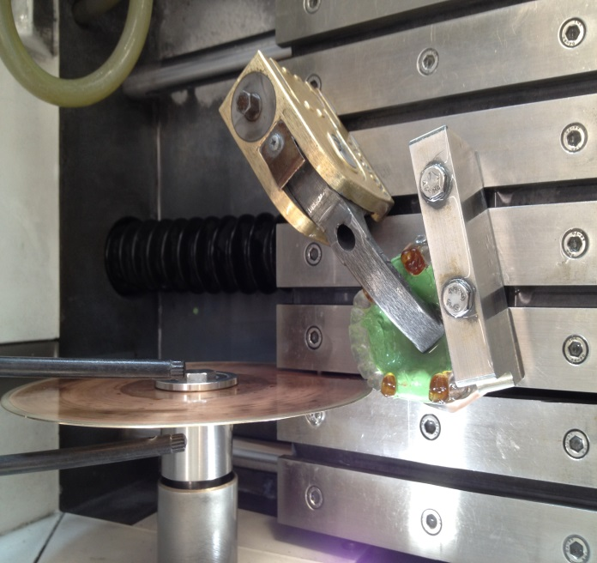

Figure 39: The resin model under slicing.
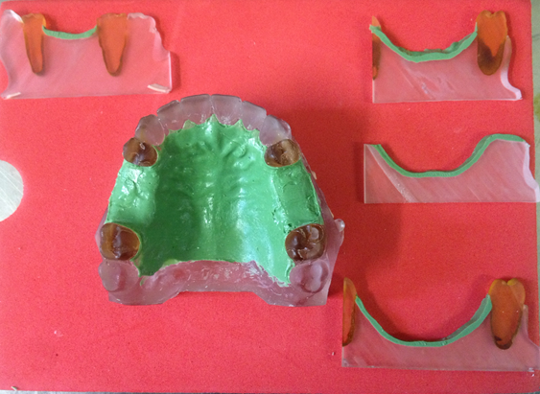
I
II
III
IV

Figure 40: The upper resin model with the selected slices

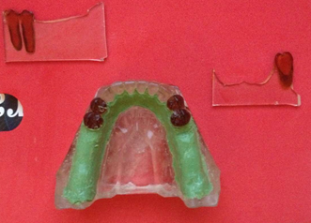
I
II

Figure 41: The lower resin model with the selected slices

Data collection with digital technology
The sectioned samples were viewed in a polariscope under monochromatic sodium light. A six-step phase stepping technique was used to capture six images of the slice at different light intensities (Table 4.2).

Table 7: The six step schemes of digital photoelasticity (Patterson and Wang 1991)

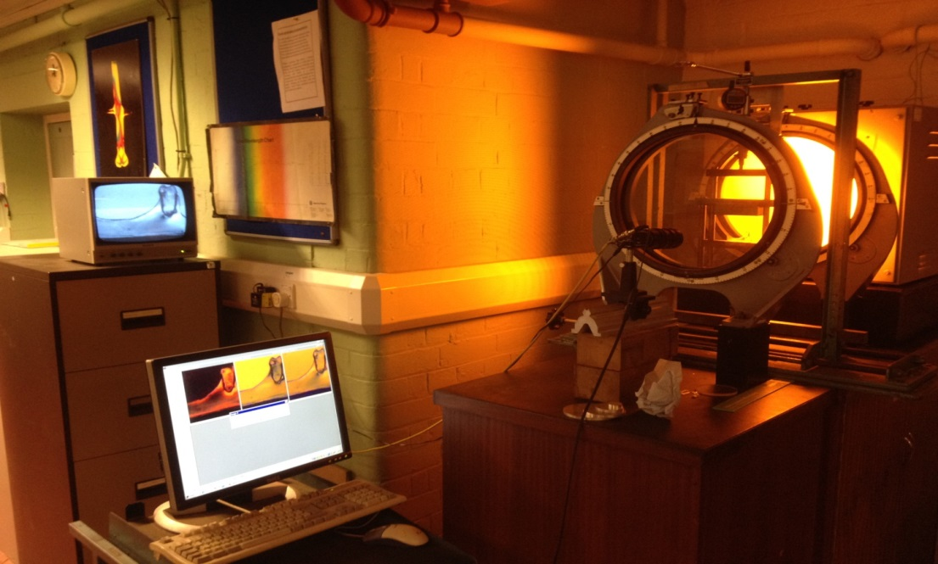
Figure 42: Assembled devices for data collection.
The images taken were then loaded into the Catch Six software in order to convert them to a single file (Figure 43).

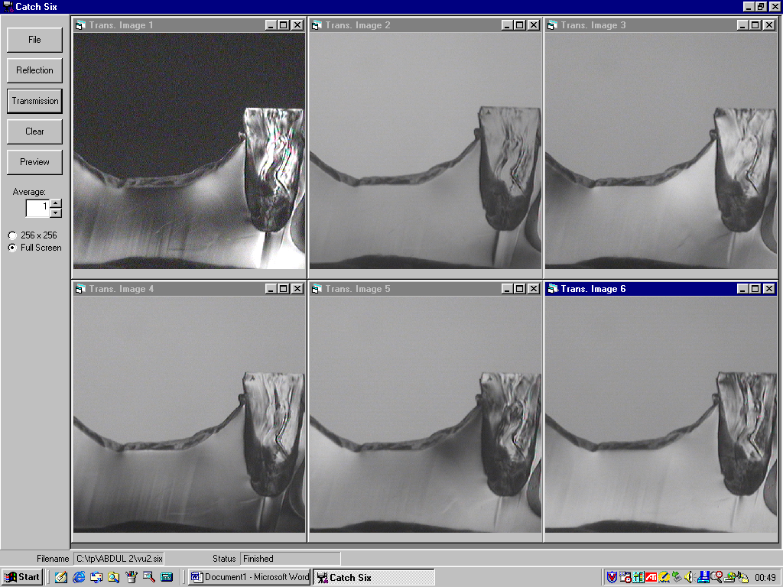

e
Figure 43: The single file produced in Catch Six software

Using the file generated by the Catch Six program, Computer aided Photoelastic Analysis (CoPA) reads the combined images and outputs the resulting isoclinic phase map.
Following the determination of the isoclinic angle, the algorithms within the program enable the isochromatic phase map to be generated as periodic functions, and hence unwrapping procedures will generate a continuous map of fringe order.
Due to its ease of use and efficiency in solving the photoelastic problem, CoPA was seen to be ideal in obtaining the fringe information for the experimental calibration analyses (Figure 44).

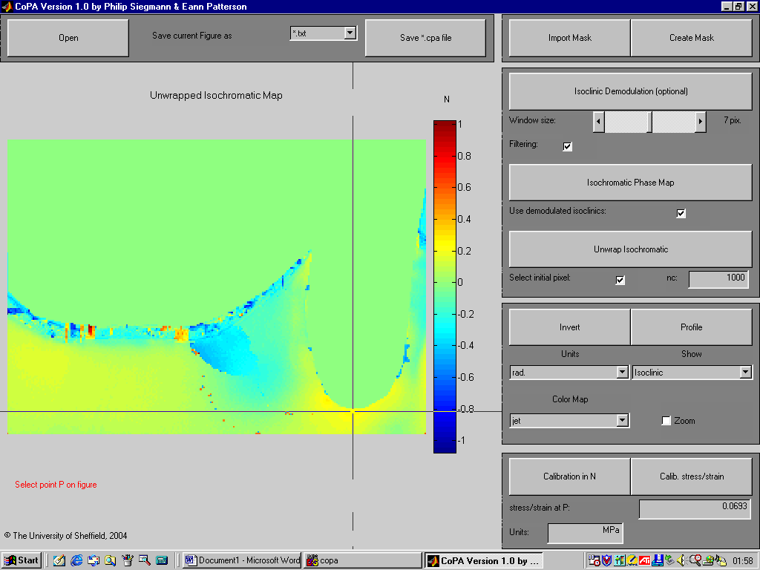

Figure 44: The COPA Software

The Isochromatic patterns are presented to demonstrate the comparative intensity among designs. The intensity of stresses is indicated by a colour scale, where the blue areas represent a small amount of stress, while the red represent areas of higher stress (Figure 45).
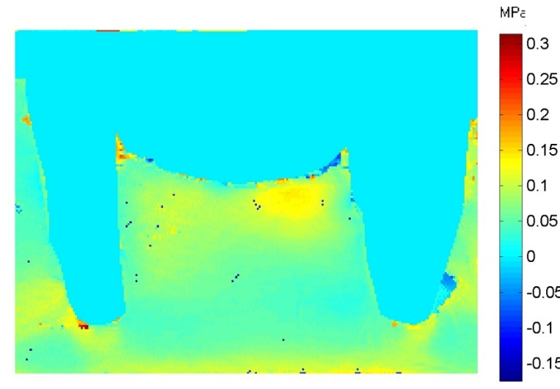

Figure 45: The Isochromatic pattern.

The Isoclinic fringe pattern provides a map of principal stress directions over the slice. In general, the direction of principal stresses varies continuously from point to point in a photoelastic model. When the principal stress directions are parallel to the axes of the polarizer and analyzer the angel equal to$0^{0}$, and this is coincident with the long axes of tooth. ${40}^{0}$ angle, means the stress direction angle as related to the polarizers axes (0°) and directed distally or buccaly. - 40° angle directed to the mesial or palatal side (Figure 46).

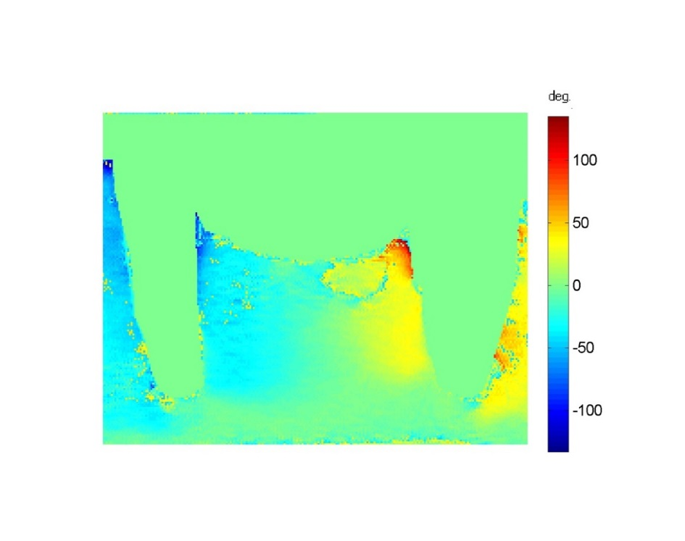
40°
Stress directed distally
Stress directed mesially
-40°
0°

Figure 46: The Isoclinic pattern.

The resin model fabricated for this study has some limitations same as resin models used in the previous studies, it cannot simulate the different tooth structures; dentine, enamel, cementum, and different bone types; spongy and compact bone, so we cannot study the intensity and the directions of the stresses in this structures. However, in RPDs the applied load act as orthodontic forces leading to tooth movement where the main effect will be on the supporting bone. This study used similarity in mechanical properties between the model and the real object. The resin model is fabricated from two photoelastic resins with different stiffness, and has modulus of elasticity of the same ratio as that of tooth to bone while loading. Another drawback is that the applied load should not exceed the limit of the material resistance, because of the model distortion. Furthermore, the applied load is simulating the centric occlusion only and not the other jaw movement, which could affect the results.

Most of the published studies using photoelasticity to investigate RPD and load paths have used live loaded, integrated photoelastic analysis at room temperature. Some of these studies used one material to present the whole model, or use two materials; one as tooth analogue and the other as bone analogue and the ratio of modulus of elasticity mimic that between the real structures (Pellizzer et al. 2010). However, with such techniques little can be concluded regarding the internal state of stress, because when a 3 dimensional model is loaded and viewed in a polariscope, the stresses would be presented as an integral view of the fringes throughout the thickness of the model and it is not practical to relate the integrated effect to the stress in the model, thus only providing qualitative or comparative data.

3D photoelasticity using stress freezing allows the quantitative study of the internal load transfer between dental prostheses and the oral tissues. The disadvantages of the stress freezing technique are it would demand a new model for each study, and it is a time-consuming technique. The process of model fabrication and the steps of the 3D photoelasticity take about 10 days. However, the technique advantages outweigh it is drawbacks. The live loading integrated technique allows qualitatively studies the stresses in the mesiodestal direction only, while the stress freezing technique allows studies any region of interest. Moreover, to my knowledge no previous study describes the stress distribution in the supporting structures around the abutment teeth in the buccopalatal or buccolingual plane, or studies the stress distribution over the palate externally and internally
Most of the published photoelastic studies use point by point techniques to collect data rather than full-field digital technology. With developments in image processing techniques, digital photoelasticity is capable of providing full-field maps of the stress magnitude (isochromatics) and direction (isoclinics) and has now matured to the level of being able to quantitatively evaluate information at every pixel in a field of view (Figure 47). Despite these advantages and the fact that these methods are well established in engineering fields, very few applications have been published in dental research using these advances.
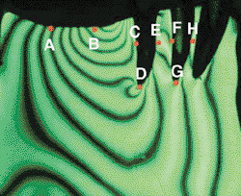
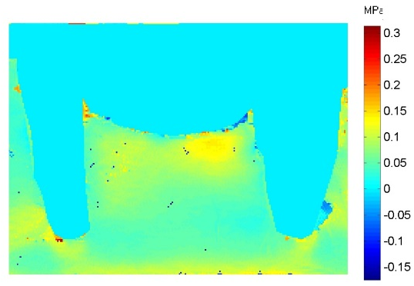

a b
Figure 47: Methods of data collection. a. Digital processing. b. Point by point technique.

The design and dimension of PEEK material was the same as the current materials at the beginning of the project to see how this material will behave at the same dimension and design. Optimisation of the design will be carried out after analysis of the stress distribution, to replicate/ improve the stress distribution of RPD in tooth borne, mucosa borne and tooth mucosa borne scenarios. After creating the master models, the dentures of the different materials will be produced using digital technology. The photoelastic test model will be produced, the load will be applied, and the stress analysis will be carried out using a 3D photoelasticity technique.

: Load Distribution for Upper Kennedy Class III modification 1 Tooth Supported Removable Partial Denture

The effect of the material properties on denture design
Removable partial dentures (RPD) can be made from different materials, including acrylics, metals, metals and acrylic combinations or more flexible thermoplastics. Expectations of how the framework may improve functional performance are related to the properties of the material and design. In order to achieve the best results with these materials it is important to understand their properties and the effects that these have on RPD design.
The mechanical properties of a material for a particular product should fulfil the functional requirements for its intended use. In this case it is necessary to apply the knowledge of the material’s properties to denture design.
A simple example which is well established is the modulus of elasticity of cobalt chromium, which is much higher than that of gold alloy. Therefore, the cast cobalt chromium clasp will be stiffer and much more rigid than that of a gold alloy. This indicates that when designing a clasp using the gold alloy, the location of the tip of the retentive arm needs to be in a deeper location in order to achieve comparable retentive force.
When a cobalt chromium alloy is used for the retentive arm, the design has to be narrower or reduced for greater flexibility in comparison to gold alloy. This may increase the chance of fracture or permanent deformation, so the depth of undercut used for retention must be reduced when a cobalt chromium alloy is the chosen material.
Titanium is a further option which is becoming more popular with the advent of selective laser melting of the RPD framework. The typical modulus of elasticity of titanium is half that of cobalt chromium, and just slightly higher than that of gold alloy. This would require a different approach to clasp design than is used with cobalt chromium alloys. Essop et al. (2000) studied the flexibility of titanium clasps and indicated that as a result of the modulus of elasticity, it can be used in deeper undercuts.

PEEK is a thermoplastic material and like other plastics has properties which can vary over a wider range through the addition of reinforcing materials and modifiers. The property profile of polymers can be completely altered and therefore design of appliances should not continue to be reliant on conventional designs for metal parts.
Understanding the properties of a material helps in manipulating the material in a way that is consistent with the vision of material design. Plastics sometimes exhibit completely different behaviour from that of metals under the same service conditions. For this reason, a functionally efficient design in cast metal can easily fail if repeated in plastic. Designers of plastic RPDs must therefore be familiar with the properties of this group of materials.
AIM
To evaluate the load distribution of an RPD produced from PEEK material, when using conventional design criteria for cobalt chromium material.
Objectives
- To design an RPD and produce two RPDs, one produced in CoCr and one in PEEK to the same dimensions.
- To evaluate and compare the load distribution using Digital photoelasticity.
- To identify the load distribution problems related to the PEEK material properties.
- To inform the design requirements for a PEEK RPD.
- To optimise the design of an RPD for use with PEEK

Materials and method

Designing the framework
To produce the RPD frameworks for CoCr and PEEK materials from the same design, the master cast was scanned, surveyed, and the design produced using Dental Wings software and a Dental Wings 3 Series Scanner (Figure 48).
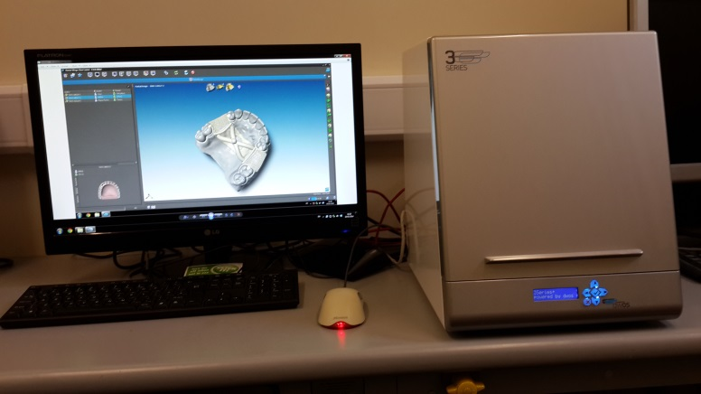

Figure 48: Dental wing soft wear.

A conventional CoCr framework design was produced with typical dimensions including:
- Conventional circumferential clasp on each abutment.
- Distal occlusal rests on the first premolar abutments on both sides
- Occlusal rest seats on the premolars with dimensions of 3 mm length, 3 mm width, and 1 mm thickness.
- On the second molar there was a mesial occlusal rest.
- The retentive clasp crosses the survey line engaging the undercut, while the reciprocal clasp arm goes in line with the contour, with the dimension of 1 mm.
- The palatal major connector was a palatal strap (Figure 49 a-m).
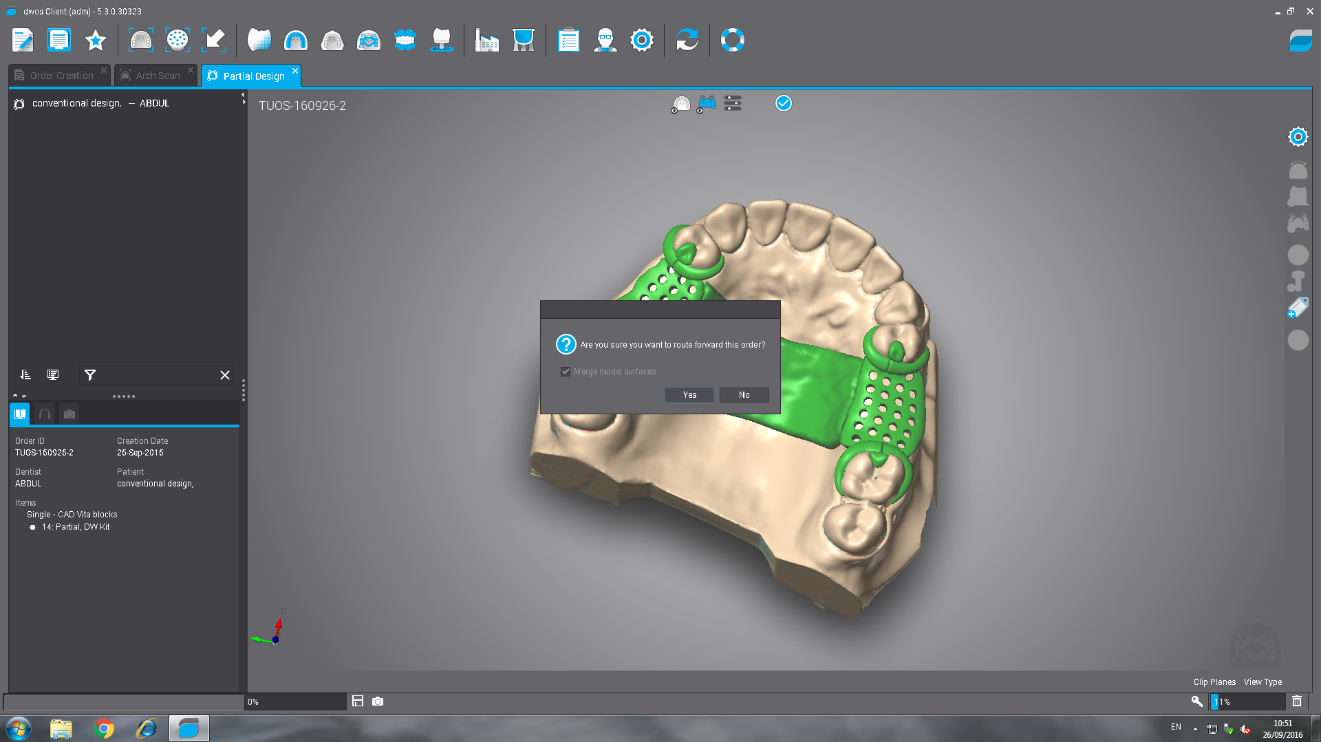
The finished RPD design.

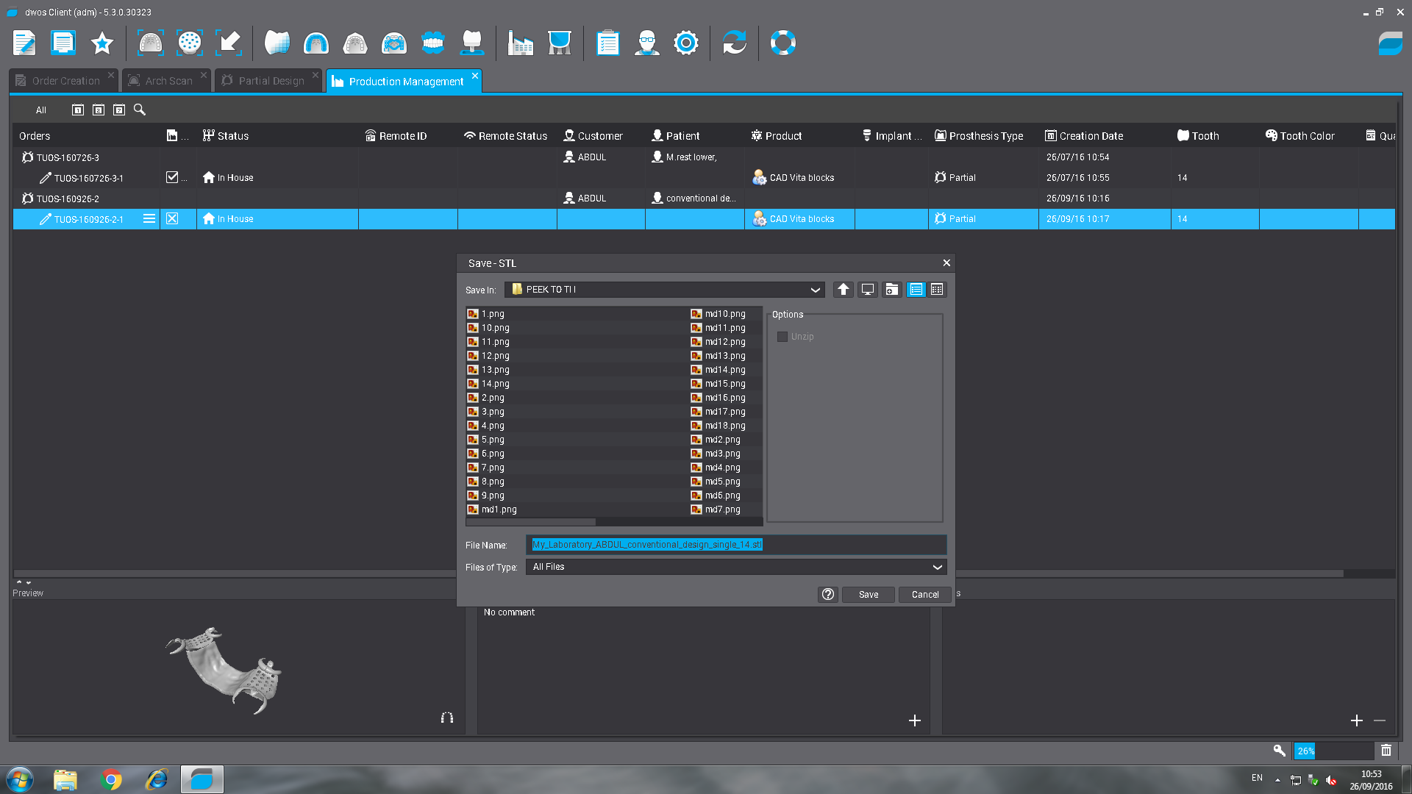
The converted STL file ready for loading into the milling machine.

Figure 49: Designing RPD in the Bitewing software.

Manufacturing of the RPD frameworks
The completed design file was loaded into Sum3D software for milling on a Roland DWX 50 (Figure 50) milling machine for milling of a PMMA pattern for CoCr framework to be produced via lost wax casting, and PEEK frameworks directly.
A 25 mm thick JUVORA Dental Disc manufactured from Invibio PEEK-OPTIMA LT 1 Polymer was used to fabricate the PEEK framework. A 25 mm thickness PMMA disk (Talladium, Langley UK) was used to fabricate the CoCr framework pattern (Figure 51).
Milling of the pattern in wax led was first attempted but distortion occurred when try in over the master cast. The steps of framework milling are shown in (Figures 52 a-k).
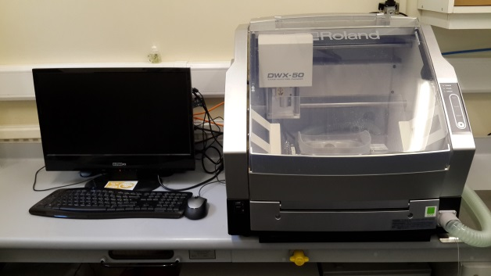

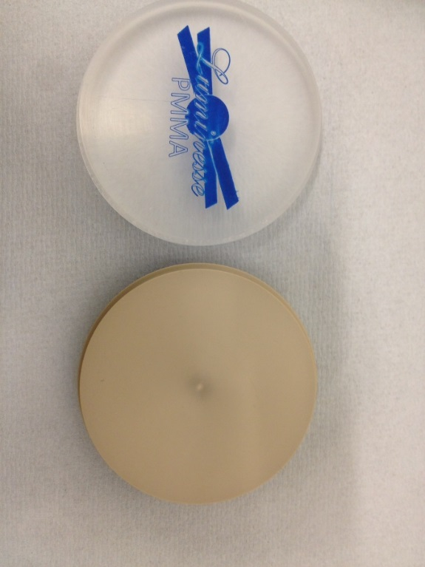
Figure 50: Roland DWX 50 milling machine.

Figure 51: PMMA and PEEK disks.

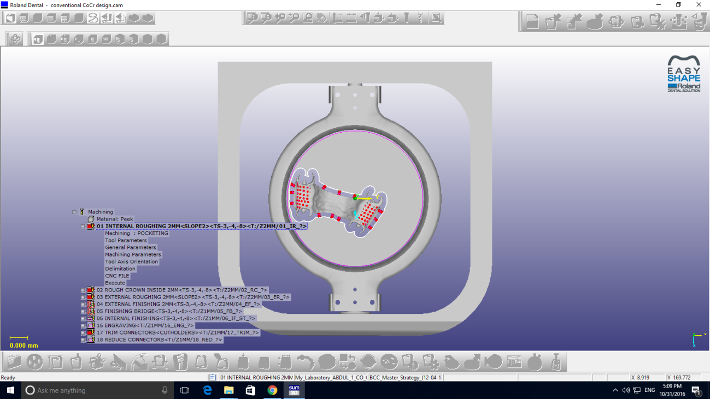

Figure 52: Denture Milling in Roland DWX 50
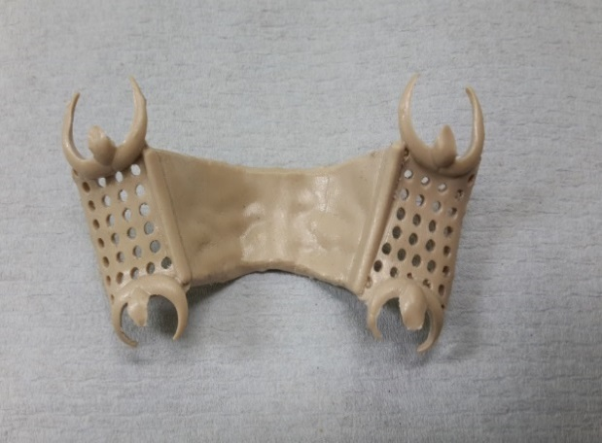
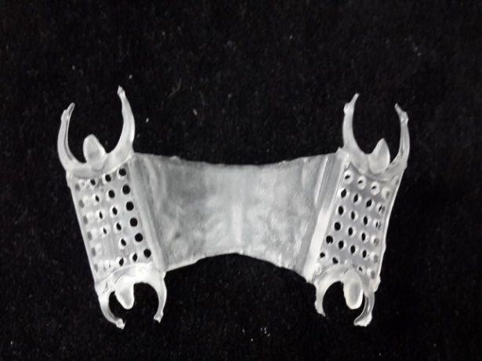

a.PEEK framework b. PMMA framework.

Figure 53: The milled frameworks a. PEEK, b. PMMA.

Producing the Cast Metal Framework via the Lost Wax Casting Process
The PMMA pattern was used in a conventional manner, to cast a CoCr framework using the lost wax process. The pattern was directly sprued to a sprue former ( Figure 54 a) and invested using SHERA cast investment material (Werkstoff- technologie- Deutschland) which was mixed according to the manufacurer’s instructions and poured into the ring former , and left to set.
The ring former was removed and the mould placed in a burnout furnace at a 900° C for 2 hours. The CoCr was cast at 1300° C using a GALINI- MODULAR 3 S induction centrifugal cast machine. After cooling the metal casting was devested and shot blasted using 50 microns Al ₂O3.
The framework was then inserted in an electroplating bath and finished by hand using abrasive stone and rotating cutters. Burs of different shapes, dimensions and materials were used. Starting from the points are made of corundum, through burs made of rubber covered with abrasive paste or pumice and with fabric or bristle points. Finally, the framew\ork has polished in electrolytic bath for further polishing (Figure 54 b)

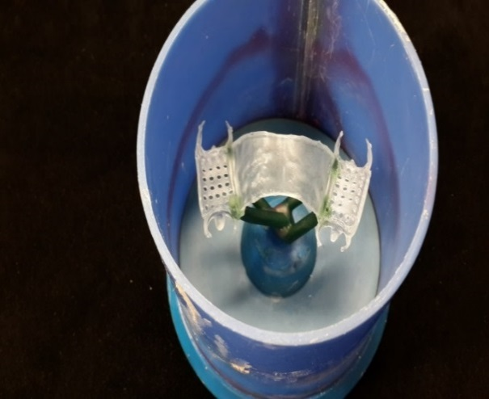
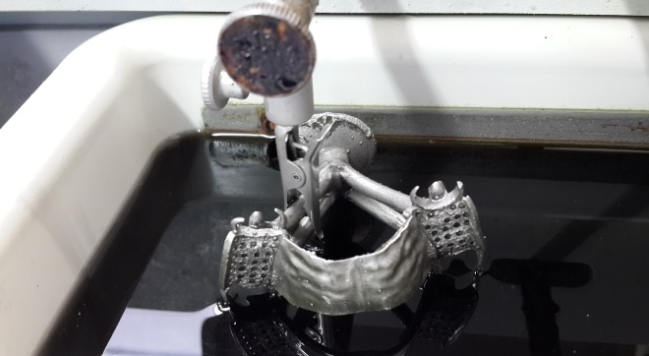

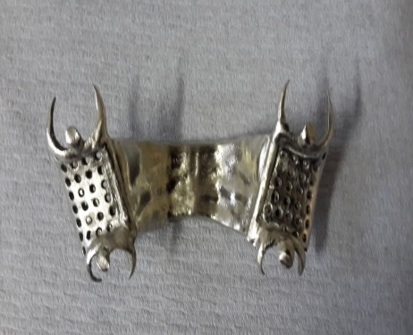
a b

c

Figure 54: CoCr framework, a. The sprued pattern, b. The framework in the electrolytic path, c. The metal framework ready for seating of the synthetic teeth

Attaching the PMMA teeth
The designs were placed on the master models and modelling wax (Henry Schein, Germany) was used to hold the acrylic teeth (Natura, Letch worth, UK) to the saddle area. (Figure 55).
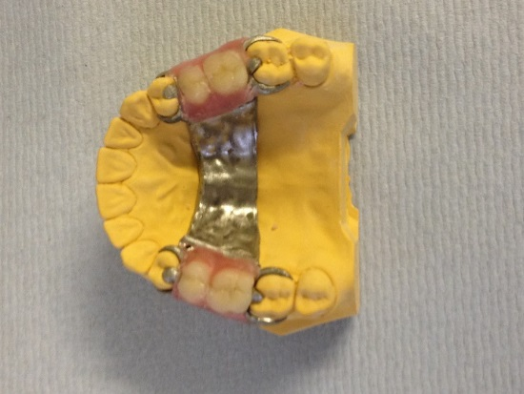
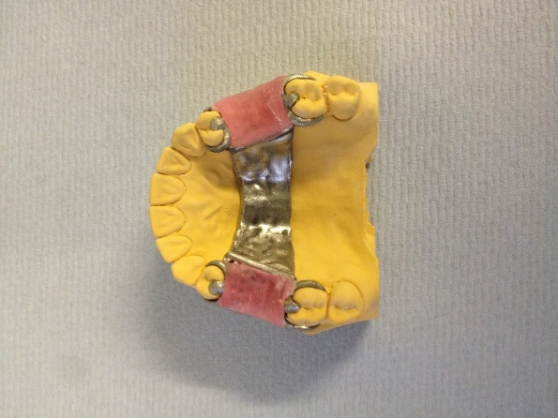
a b
Figure 55: a. Modelling wax, b. PMMA teeth seated in the framework.
A putty impression material (Heraeus, Germany) was used to produce an index by adapting the material over the occlusal and buccal surface of the teeth (Figure 56). The index was used to position the teeth in the same location during application of the composite material.
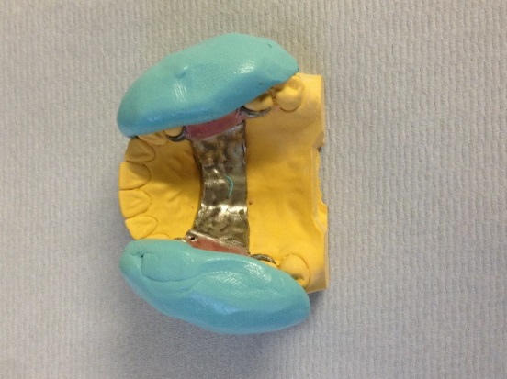
Figure 56: The putty index.

Once set the index material was removed, the teeth were removed from the framework, then the teeth and the framework cleaned with oil free air. A thin layer of 3M ESPE Sil silane materials was applied and left to dry for 5 minutes.
GRADIA (Gum Shades G22) composite was used to reproduce the gum tissue and attach the teeth to the frameworks. A thin and even layer of pink coloured opaque composite was first applied which masks the colour of the frame works and forms the bond to the frameworks. This was polymerised for 3 min using Coltolux 75 light curing unit (Figure 57).

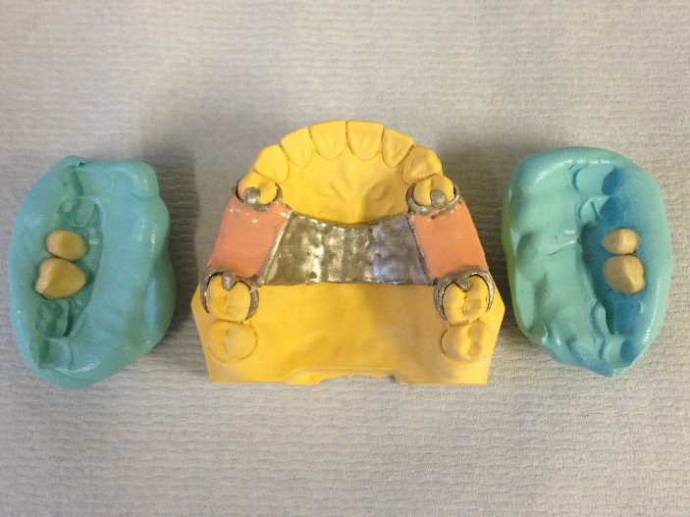

Figure 57: The teeth were glued to the index, and the saddle area was painted with pink opaque composite.

The teeth were adhered lightly to the silicon material of the index and the index repositioned in place. The Gingiva composite material was applied to fill the void under the teeth. This was followed by a period of polymerization for 10 minutes due to the thickness of the layer. The silicon index was removed and the final polymerisation was completed (Figure 58).

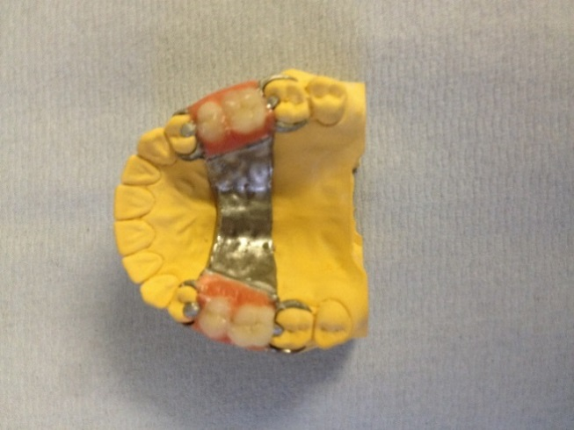
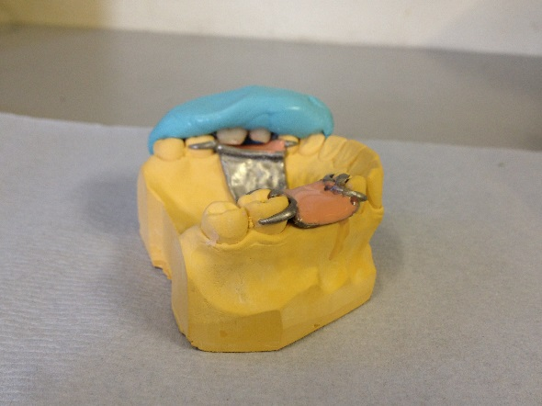

a
b

Figure 58: a. The putty index with the PMMA teeth in place, b. the CoCr RPD

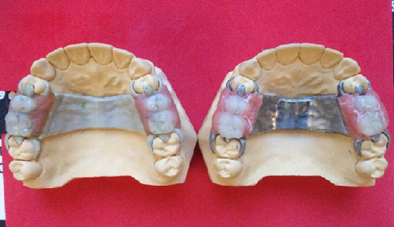

Figure 59: The PEEK and CoCr dentures at the working model.

Results
Stress Magnitude and Direction for Right Sagittal Section (Slice I).
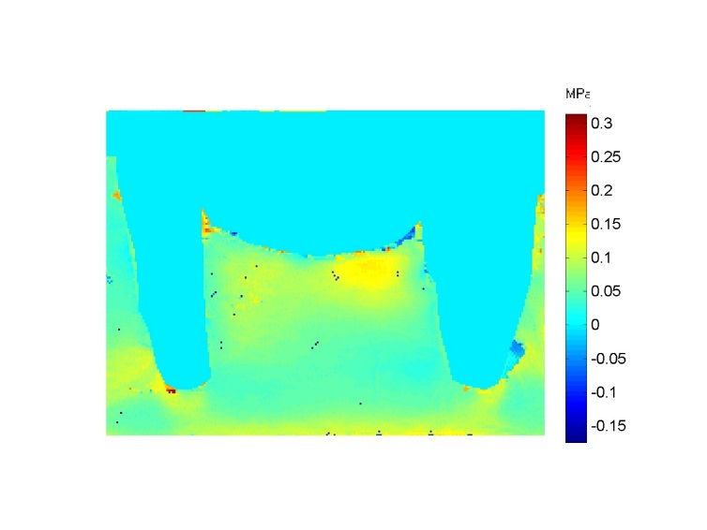
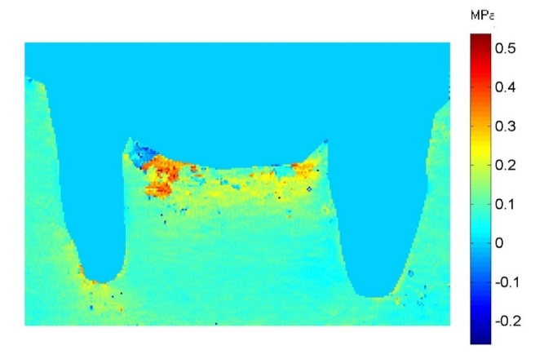
Figure 60 shows the stress distribution in a sagittal plane through the abutment teeth upper right 4 and 7 and the surrounding supporting bone and to the saddle area in the slice I.
  - CoCr b. PEEK
Figure 60: Isochromatic phase map (stress magnitude) a. CoCr, b. PEEK.
The maps show that the force distributions to the supporting structures were different between the two designs. Generally, the highest stress was observed on the saddle area of the PEEK denture while the cast metal CoCr denture showed more uniform and lower stress.
The PEEK denture resulted in stresses concentrated near the crest of the ridge with a tendency to increase in intensity mesially adjacent to the premolar abutment tooth. The internal stresses in the saddle area were fairly uniform. The first premolar showed a little stress near the apex of the root which extended mesially. The molar tooth showed no stresses under loading.
The cast CoCr denture loading distribution was distributed between the edentulous ridge and the abutment teeth. The occlusal load was a uniform on the ridge area with an increase in intensity distally. The stress internally was a uniform. The phase map demonstrates that the abutment teeth and supporting structures shared the occlusal loads.
It can be observed that the stress was localized apical and distal to the root of the molar abutment tooth which may cause the tendency to drift distally.
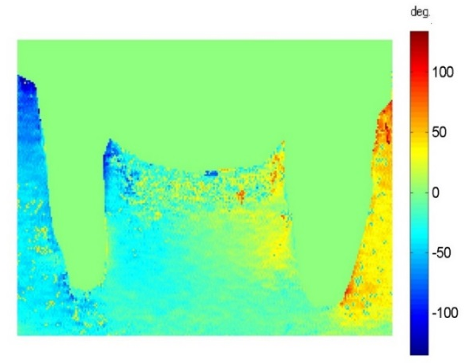
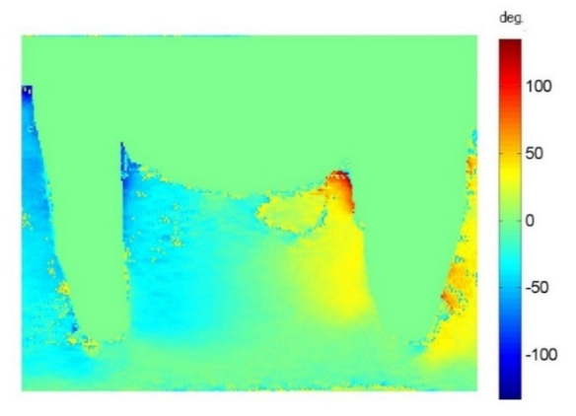
Figure 61 shows the stress direction in a sagittal plane through the abutment teeth and in the ridge area in the slice I.

a.CoCr b. PEEK
Figure 61: Isoclinic phase map (stress direction) a. CoCr, b. PEEK
Stress direction around the supporting structures is similar on both designs.
The PEEK denture stress direction showed interaction in the saddle area between the stresses, 50° directed distally and -50° to the opposite side. The direction of the stresses at the internal area of the edentulous area was a complete separation between the two directions. The direction of the stresses in the alveolar bone of the premolar is -50° increased to -100° at the crest, while that around the molar is 50°.
The cast metal denture showed a 0° of stresses at the apical end of the abutment teeth indicating an apical response. There was a similarity in the overall map of the slice between the right and the left side.
Stress Magnitude and Direction for Coronal Section (Slice II).
Figure 62 shows the stress distribution in a coronal plane through the upper left 1rst premolar and the corresponding palate in the slice II.
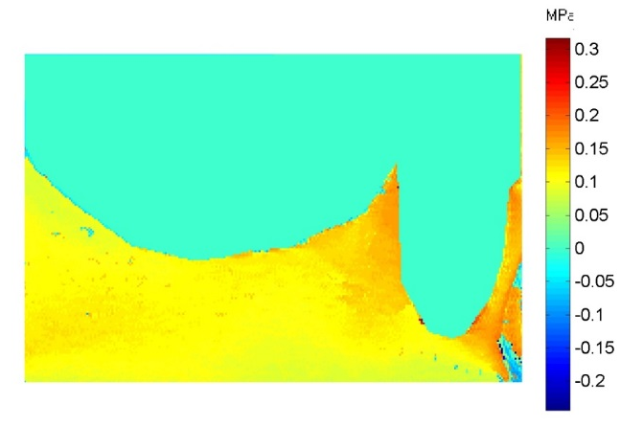 | 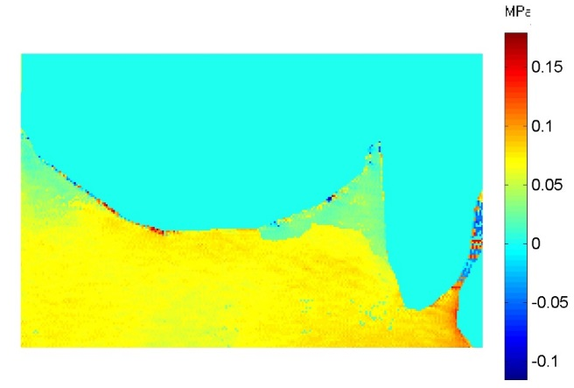
a.CoCr | b.PEEK
Figure 62: Isochromatic phase map (stress magnitude) a. CoCr, b. PEEK.

Generally, the stress intensity around the abutment tooth buccolingual was higher with the cast metal denture than that of the PEEK denture.
The PEEK denture concentrated the load near the deepest point of the palate and internally at the buccal side of the lower third of the root. Very low stresses were seen at the palatal and buccal surfaces of the abutment teeth with stresses concentrated buccally at the apex area. A map of uniform, moderate stress on the bone of the palate extended internally and, tends to reduce at the sides of the palate.
With the cast metal denture, the pressure that developed in the palatal region was a uniform in distribution that extended internally, with an increase in intensity near the palatal part of the abutment tooth. The highest stresses were observed at the buccal and palatal surfaces of the supporting bone, that reduced in intensity at the tooth apex.
Figure 63 shows the stress direction around the abutment tooth and the corresponding palate in the slice II.
Stress directions were different between the two designs. For the PEEK denture the stress directions around the tooth and the palate were directed buccally. While that for the traditional metal denture was directed palataly.
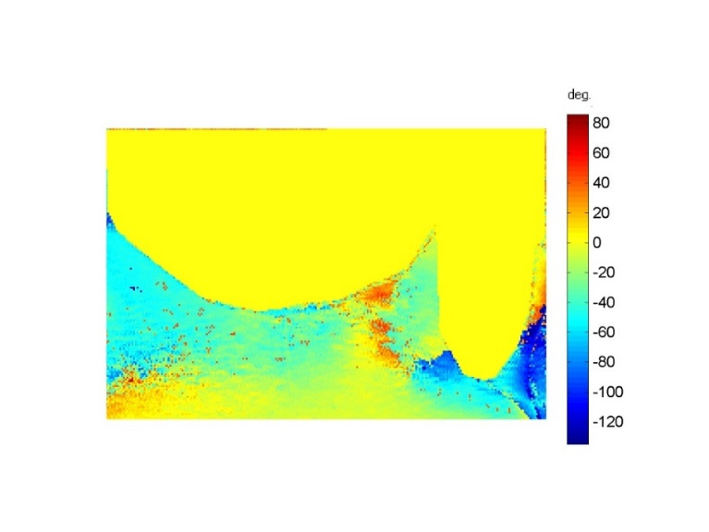
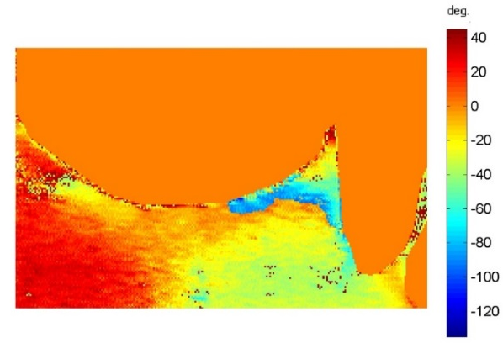

a. CoCr b. PEEK
Figure 63: Isoclinic phase map (stress direction) a. CoCr, b. PEEK.

Stress Magnitude and Direction for Coronal Section (Slice III).
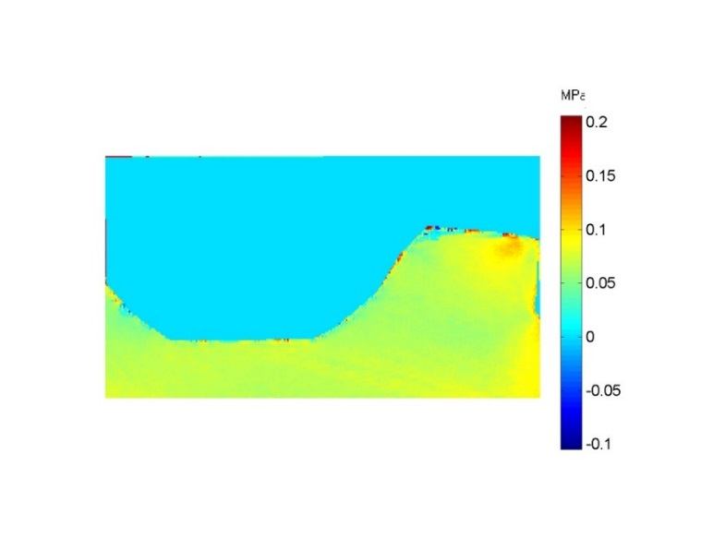
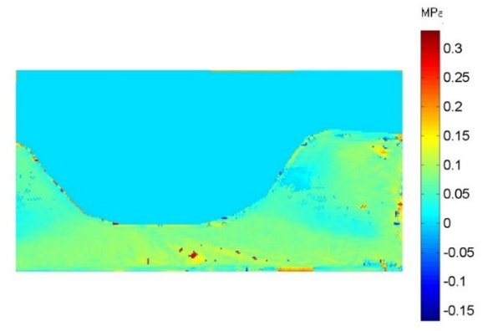
Figure 64 shows the stress distribution in a coronal plane through the saddle area of the left side and the corresponding palate in the slice III.
a.CoCr | b.PEEK
Figure 64: Isochromatic phase map (stress magnitude) a. CoCr, b. PEEK.

Generally, the stress intensity was higher with PEEK denture than that of the metal denture.
The PEEK denture stress patterns tend to concentrate at the crest of the saddle area. The situation is similar to that existed in the saddle area of the right side. The stresses concentrated buccally then extended at a more uniform manner internally toward the palate with less intensity.
The metal denture produces a similar stress distribution pattern as that of the PEEK denture, but with lesser intensity. The stress concentrated at the buccal side of the saddle area and at the base of the palate with a negligible stress pattern at the sides of the palate.
Figure 65 shows the stress direction on the saddle area of the left side and the corresponding palate in the slide III.
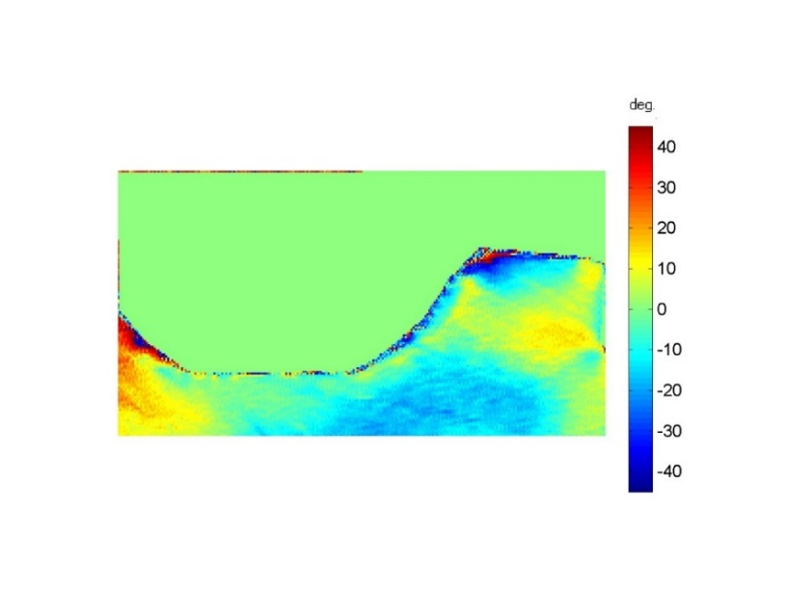
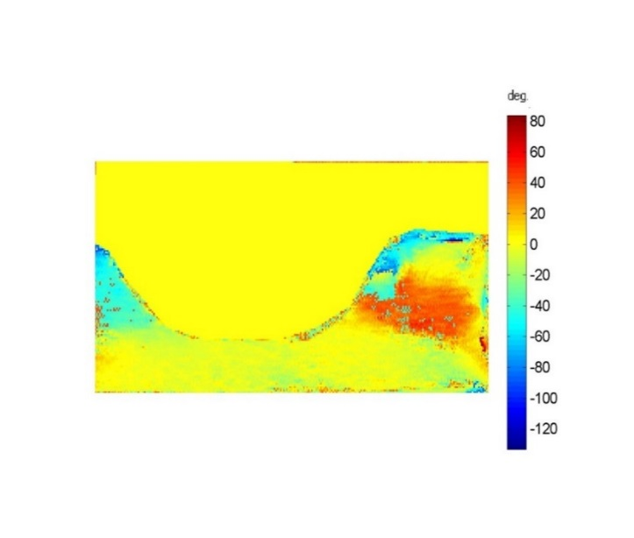
a.CoCr b.PEEK
Figure 65: Isoclinic phase map (stress direction) a. CoCr, b. PEEK.

The PEEK denture load direction generally directed around -15° palatally, with an area of stresses directed 15° mesially internally in the saddle area and at the most buccal point. The metal denture stress direction was generally toward the buccal side with an angle of 15°.
Stress Magnitude and Direction for Coronal Section (Slice IV).
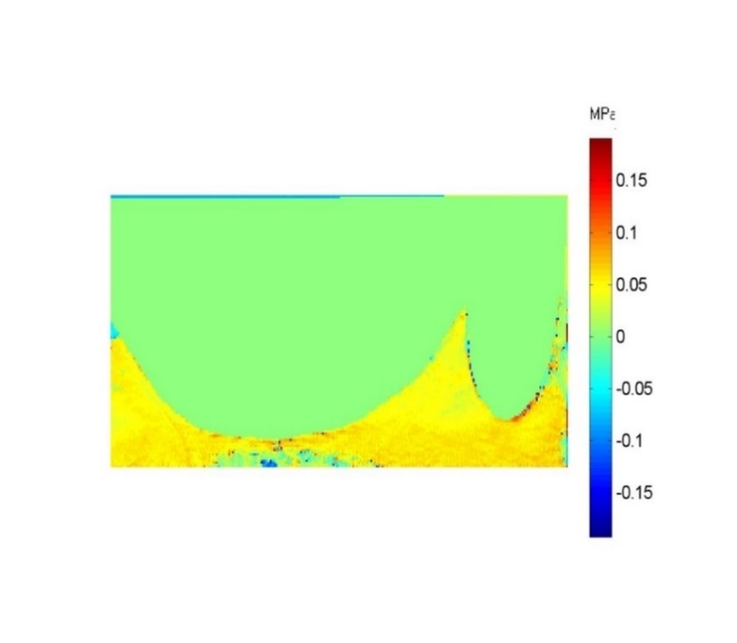
Figure 66 shows the stress distribution in a coronal plane through the upper left 2nd molar and the corresponding palate in the slice IV.
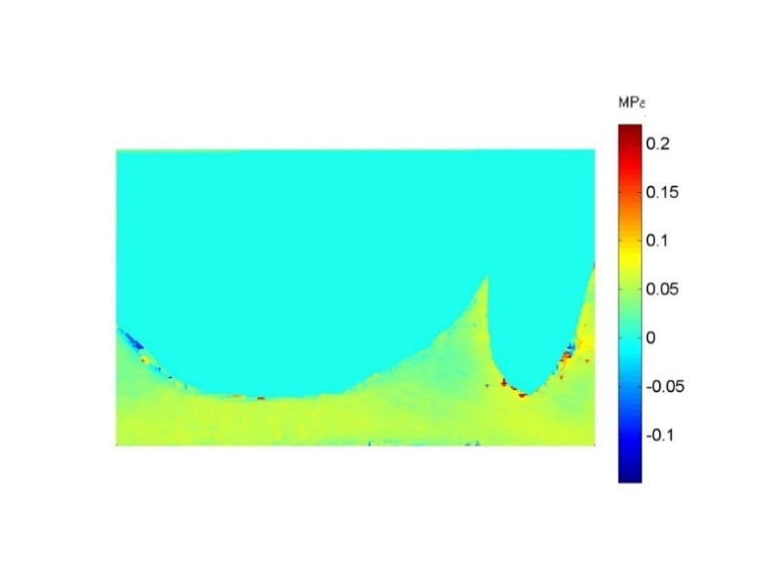

a.CoCr b.PEEK
Figure 66: Isochromatic phase map (stress magnitude) a. CoCr, b. PEEK.

Generally, the distribution of stress in this slice was similar to that which existed in the slice II in that the stress intensity around the abutment teeth was higher with traditional denture than that of the PEEK denture.
The PEEK denture showed low- level quite uniform stress pattern concentration mainly around the abutment tooth, and in the deepest part of the palate, the intensity was reduced at the sides of the palate. The metal denture showed a higher stress intensity specially at the base of the palate, and extended buccaly toward the apex of the abutment tooth, and to the buccal supporting bone. Sides of the palate showed a lower level of stress intensity.
Figure 67 shows the stress direction around the abutment tooth and the corresponding palate in the slice IV.
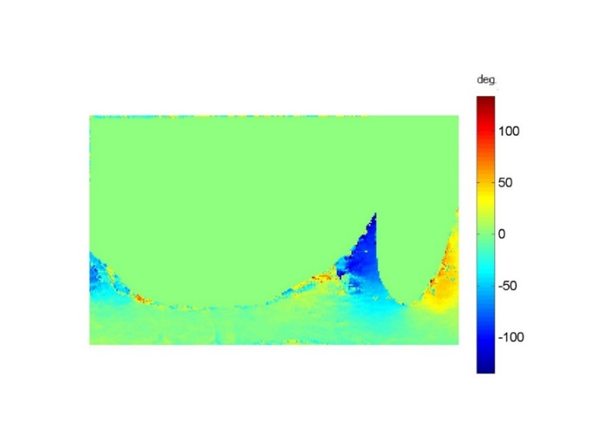
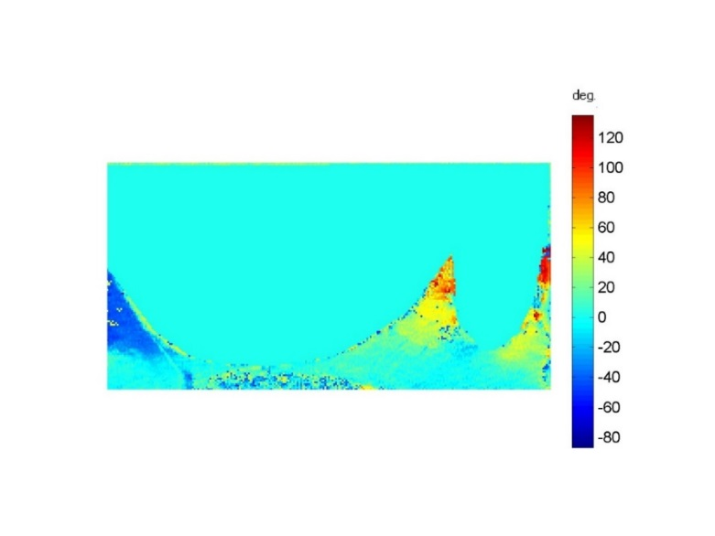
a.CoCr b.PEEK
Figure 67: Isoclinic phase map (stress direction) a. CoCr, b. PEEK.

For the PEEK denture the stress direction was different between the buccal and palatal surfaces of the tooth, indicating some bending within the root.
The metal denture showed a 0° of the stresses at the apical end of the tooth, and around 60° on the buccal and palatal surfaces indication buccal tendency of drifting.

Discussion
The aim of a tooth supported denture is to direct the occlusal load to the abutment teeth via occlusal rests, whilst the main functions of the properly designed and located occlusal rest are, to transfer the occlusal forces along the long axes of the abutment teeth and to provide vertical support to prevent movement toward the mucosa.
One of the significant differences between the properties of PEEK material and those that of CoCr is the material’s stiffness. The modulus of elasticity of the PEEK material is 4GPa, making it a relatively flexible material, whereas to CoCr had a modulus of elasticity of 211GPa.
Two Class III modification 1 RPDs were prepared for stress analysis produced from the same design, one denture using CoCr and the other one using PEEK material, with the aim of comparing the resulting stress distribution.
A correctly designed major connector distributes forces throughout the arch and prevents loading to any one area. Failure to achieve this may manifest as trauma to the residual ridges, and impingement of the underlying tissue. Itoh et al. (2008) studied the effects of direct retainer and major connector designs on RPD and abutment tooth movement. The study found that rigid components decreased both RPD mobility and tooth mobility.
The results revealed that the material properties had considerable influence on the stress distribution. In this study the PEEK denture displayed higher stresses over the ridge area and the palate than the abutment teeth. This is due to bending of the material under the applied load with a much lower modulus of elasticity. The CoCr denture, meanwhile, displayed a uniformity of stress distribution between the ridge area and under the apex of the abutment teeth as a result of the stiffness of the material, which supports the importance of rigidity in distributing the occlusal force throughout the arch and acting to reduce the load to any one area (Jiao et al. 2009).
The map of the stress directions of the PEEK design showed that the stresses directed laterally from the ridge area and this may be related to the movement of the abutment teeth through the effect of the deflected saddle area on the ridge. The map of the stress direction of the CoCr denture was directed laterally and apically, indicating that the denture exerts pressure apically along the long axes of the teeth and laterally as well. This finding is inconsistent with the results of (Itoh et al. 2008) in that both the RPD and abutment teeth were generally displaced in the buccal, distal, and apical directions by the applied force. This map of stress directions necessitates further study on the occlusal rest to determine whether it really directs the stresses apically or accompanied by lateral direction.
It was not possible to locate other literature that had compared these two materials. The flexibility of the PEEK RPD makes it insufficiently rigid to mimic the results seen from the cast metal RPD when using design criteria for the occlusal rests and other components based on the traditional design parameters. The effect of the lower stiffness of PEEK was clearly observed in this study using 3D photoelasticity. The applied load was observed to be directly transmitted to the residual ridge, resulting in higher stress magnitude than seen with the CoCr removable partial denture. The CoCr denture transferred the occlusal loads to the abutment teeth through the occlusal rests, with lower level stress developing over the ridge area.
The preliminary results obtained from this study could be used as a basic data starting point for considering different design aspects at a later stage. The high stress concentration at the ridge area with the PEEK denture necessitates that the PEEK denture is designed to be stiff enough to resist deflection, and to allow the abutment teeth to make a greater contribution toward carrying the occlusal loads.
3D digital photoelasticity allows visualization of stresses at more planes than with the conventional Integrated photoelasticity. It allows a complete analysis of the area around the root of the abutment tooth mesio-distally and bucco-palataly, and allows study of the area of the palate to reflect the behaviour of the major connector at different points at the surface and internally. Moreover, the map of stress direction allows the effects of the occlusal stresses on tooth movements to be studied. However, the limitations of the study in its present form include its inability to represent complex conditions of the oral cavity, such as different types of bone, and the complex movements of the mandible. All these factors have influence on the magnitude and directions of the stresses.
The main finding of this study was that providing PEEK dentures for patients using the same design as for conventional CoCr dentures, especially regarding the support components, means that wearers receive a tissue supported RPD, although their teeth are subjected to occlusal seat preparation.
It can be said that the results of this study were in agreement with the hypothesis that the design of any object should be tailored to its material properties.

Conclusion
The 3D photoelasticity method allows stress distribution to be clearly observed. Differences in material properties and their effect on the resultant removable partial denture can be observed.
RPDs produced from PEEK following the same design criteria as for cast metal demonstrate significantly different load transmission.
PEEK RPDs produced to these design criteria do not full fill the support principle and should be redesigned to provide adequate support.

Optimising the design criteria to provide adequate tooth support for an RPD produced from PEEK

Plastics differ from metals in their physical and mechanical properties. For example, in a direct comparison, metals have higher density, rigidity, strength, and modulus of elasticity, whereas the thermal expansion, elongation at break, and toughness of thermoplastics are greater by orders of magnitude.
PEEK has a density of 1.3 g/cm³, while the corresponding figure is 8.3 g/cm³ for CoCr, making the former lighter in weight. Zoidis et al. (2015) clinically compared two lower Class I RPDs, one made with CoCr and the other with PEEK. The weight of the PEEK denture was 27.5% less than that of the CoCr denture, although a lingual plate was used for the PEEK denture and a lingual bar for the CoCr denture.
The modulus of elasticity of PEEK material is 4GPa, in comparison to 211 GPa for CoCr. This low modulus of elasticity produces greater flexibility and in the previous analysis resulted in failure of the occlusal rest to transfer the forces of occlusion to the abutment teeth, and therefore to provide vertical support for the partial denture to resist vertical movement toward the tissue, where the applied load was directly transmitted to the residual ridge.
According to structural mechanics, the deflection of the part is inversely proportional to the modulus of elasticity. That means that the deflection of a plastic part would be greater than the deflection of a metal part in the same design and dimensions.
$Stiffness=\frac{Load}{Deflection}$

There are two ways to enhance the stiffness of the plastic part by altering the design rather than the material properties:
1. Increase the cross-sectional thickness to increase stiffness. The wall thickness can be increased until the desired rigidity is achieved. Wall thickness should be uniform, as too thick a wall or variation in its thickness can lead to warping or cracking of the part.
2. The second method that can improve the stiffness of the plastic part without increasing the overall volume of material is to use Ribs.
The rib thickness should be at least 2.5-3 times the wall thickness (Figure 68). In the case of dentures using ribs over the saddle area will occupy the space required for seating the artificial teeth.
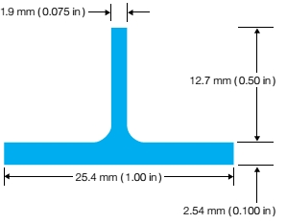

Figure 68: Rib design principle (Ketaspire PEEK Design and Processing Guide).

Design changes used to enhance the stiffness and the support function of the PEEK RPD:
First, to increase the stiffness of the denture, the thickness of the framework was increased to 2 mm, and the length of the clasp was reduced to include the part of the tooth close to the saddle area up to the buccal groove.
Secondly, to optimise the support function of the clasp, the clasp arms were extended to cover the buccal and lingual surfaces of the tooth above the height of the contour, making it shorter and wider than the CoCr clasp (Figure 69). The material above the survey line would act as a supporting element in addition to the occlusal rest.
In order to increase the cross sectional area of the major connector, an antero-posterior palatal strap maxillary major connector was used instead of a palatal strap as the former gives a greater degree of rigidity due to its circular form, an L- beam effect and on different planes (Ben-Ur Z et al. 1999; Noriyuki M et al. 2002; Bhojaraju et al. 2014)

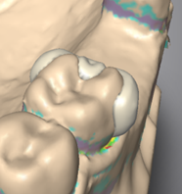
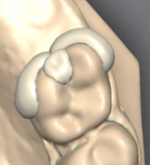
a b
Figure 69: Optimized PEEK design consists of a. the buccal retentive arm, b. the palatal stabilizing arm, c. the supporting occlusal rest.

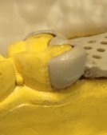
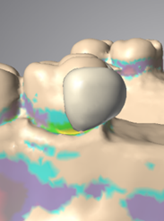

a b
Figure 70: a. Buccal view to the optimized PEEK clasp design. b. The milled clasp on the stone model.

Material
The optimized PEEK removable partial denture was designed in the Dental Wing software (Figure 71), milled in Roland DWX 50 milling machine (Figure 72) and teeth were added as previously described in section 5.1.1.3 (Figure 73).

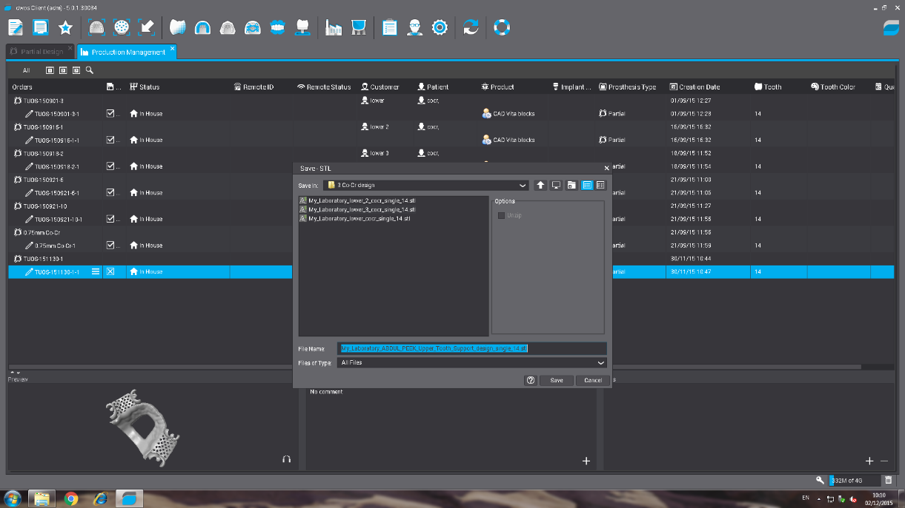

Figure 71: Designing of the optimized PEEK framework

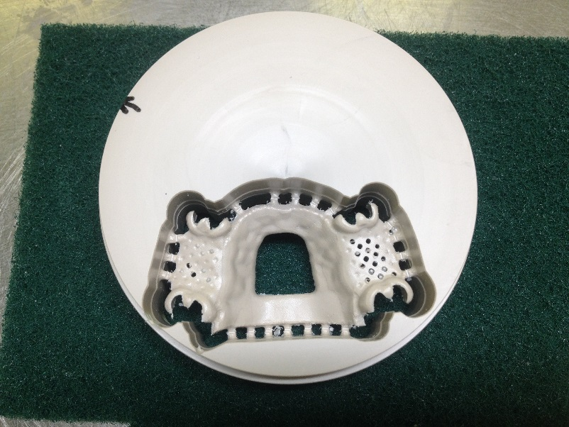

Figure 72: The milled optimized PEEK framework.

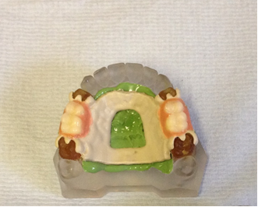

Figure 73: The optimized PEEK denture on the resin model.

Results
Stress Magnitude and Direction for Right Sagittal Section (Slice I).
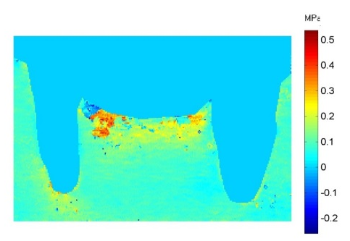
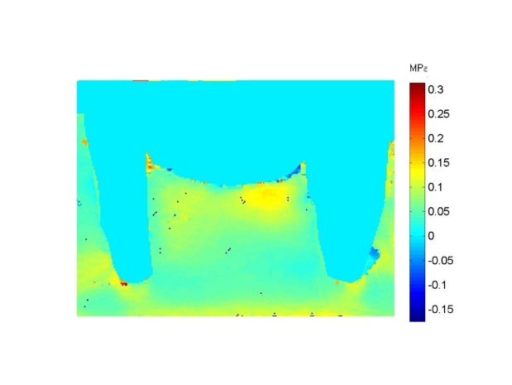
Figure 74 shows the stress distribution in a sagittal plane through the right abutment teeth and surrounding cortical bone and to the saddle area in the slice I.
a.CoCr b.PEEK1
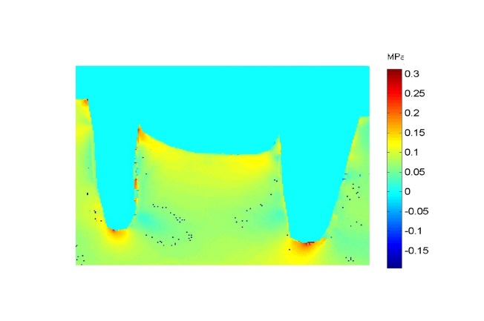

c.PEEK2
Figure 74: Isochromatic phase map (stress magnitude) a. CoCr, b. PEEK1,c. PEEK2.

Generally, the force distribution to the supporting structures were different between the optimized PEEK denture and PEEK denture under conventional design, while produce similar distribution pattern as the traditional metal denture with difference in stress intensity. In contrast to the PEEK denture under conventional design, the optimized PPEK denture concentrates the stresses under the apices of the abutment teeth with highest stresses under the molar teeth. The occlusal loads were uniform on the crest of the ridge area, internally and around the sides of the roots.
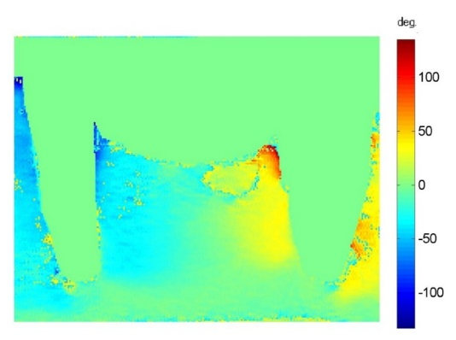
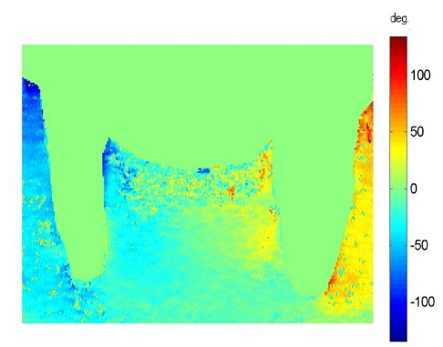
Figure 75 shows the stress direction around the abutment teeth and in the ridge area in the slice I.

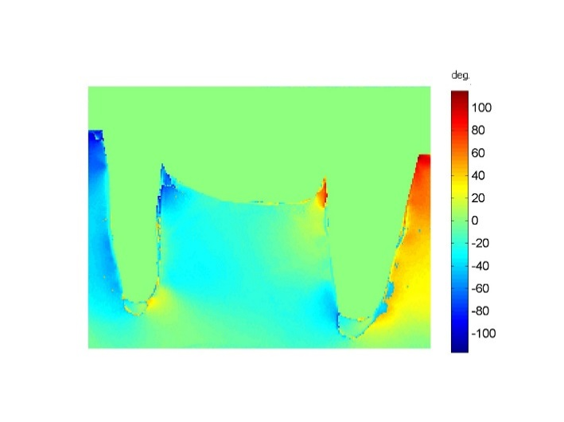
a.CoCr b.PEEK1

c.PEEK2
Figure 75: Isoclinic phase map (stress direction) a. CoCr, b. PEEK1, c. PEEK2.

Generally, the stress direction around the supporting structures of the optimized PEEK denture was nearly similar to the PEEK and metal dentures under the conventional design. The optimized PEEK denture shows a more uniform map with 0° stress direction under the apices of the teeth indicating that some of the load is along the long axes of the teeth, in contrast to the PEEK denture under conventional design, however, the same situation existed in the traditional metal denture.
Stress Magnitude and Direction for Coronal Section (Slice II).
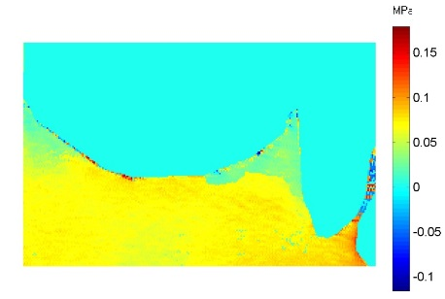
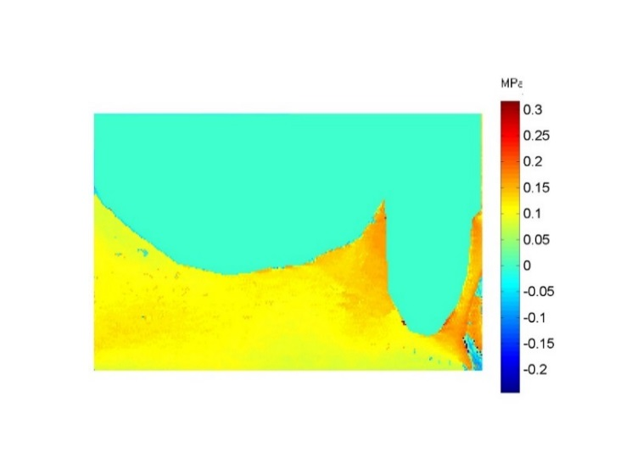
Figure 76 shows the stress distribution in a coronal plane through the upper left first premolar and the corresponding palate in the slice II.

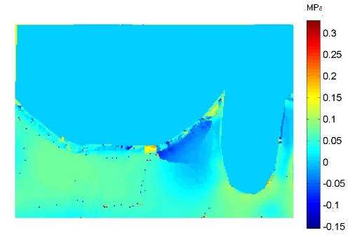
a.CoCr b.PEEK1

c.PEEK2
Figure 76: Isochromatic phase map (stress magnitude) a. CoCr, b. PEEK1, c. PEEK2.

Generally, the stress distribution of the optimized denture produces a similar map of that for the PEEK denture under the conventional design, with obvious difference in intensity. The stresses concentrated on the apical third of the root and on the distal part of the palate.
Figure 77 shows the stress direction around the abutment tooth and the corresponding palate in the slice II.
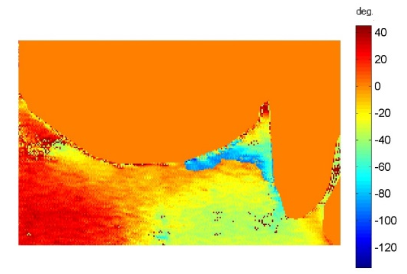
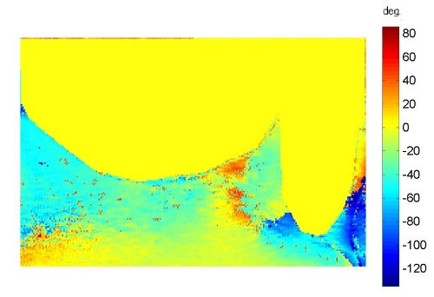
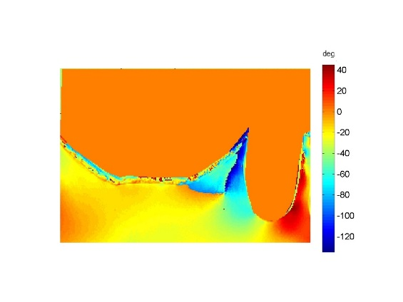
a.CoCr b.PEEK1

c.PEEK2
Figure 77: Isoclinic phase map (stress direction) a. CoCr, b. PEEK1, c. PEEK2.

Generally, the stress direction in the optimized PEEK denture was similar to the stress direction produced by the PEEK denture using the conventional design. The direction of the stresses directed buccally, however, the direction of the stresses in the palatal side directed palataly indicating bending of the tooth.
Stress Magnitude and Direction for Coronal Section (Slice III).
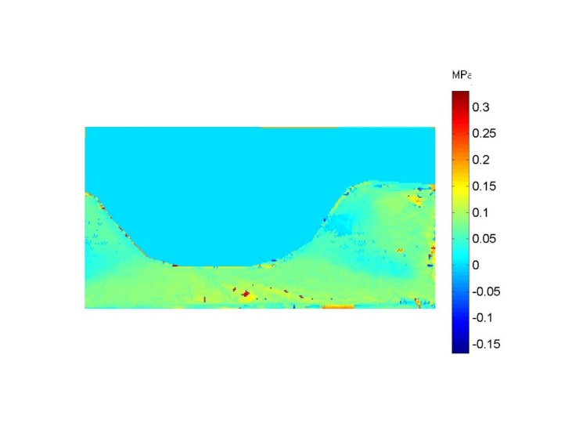
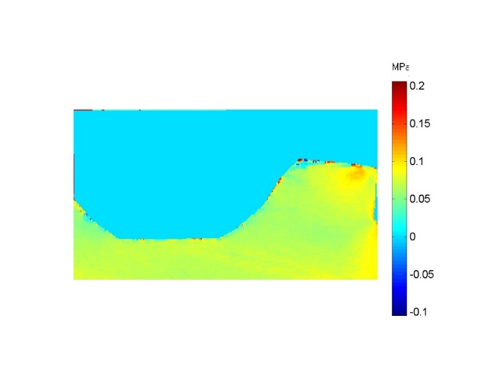
Figure 78 shows the stress distribution in a coronal plane through the saddle area of the left side and corresponding palate in the slice III.

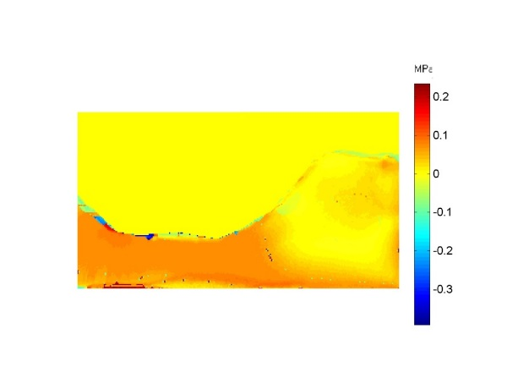
a.CoCr b.PEEK1

c.PEEK2
Figure 78: Isochromatic phase map (stress magnitude) a.CoCr, b. PEEK1, c. PEEK2.
Generally, the optimized PEEK denture produces higher stress intensity than those of the conventional designs. The PEEK optimized design stress pattern tends to concentrate the stress over the palate, then extend at a lower intensity under the saddle area, which is in contrast to that for the PEEK using conventional design.

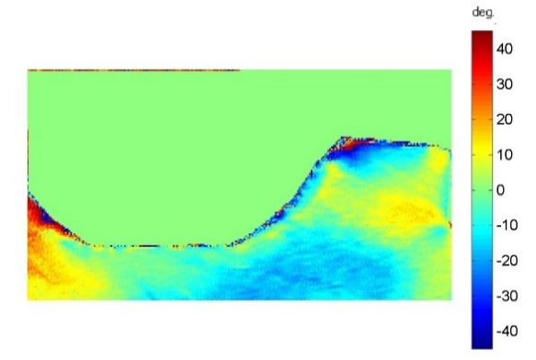
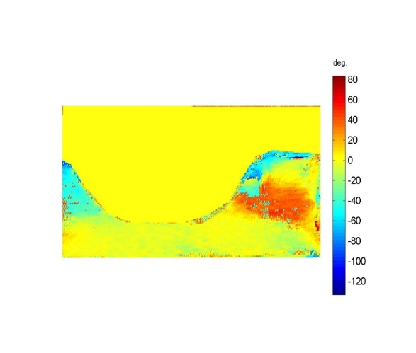
Figure 79 shows the stress direction on the saddle area of the left side and the corresponding palate in the slide III.

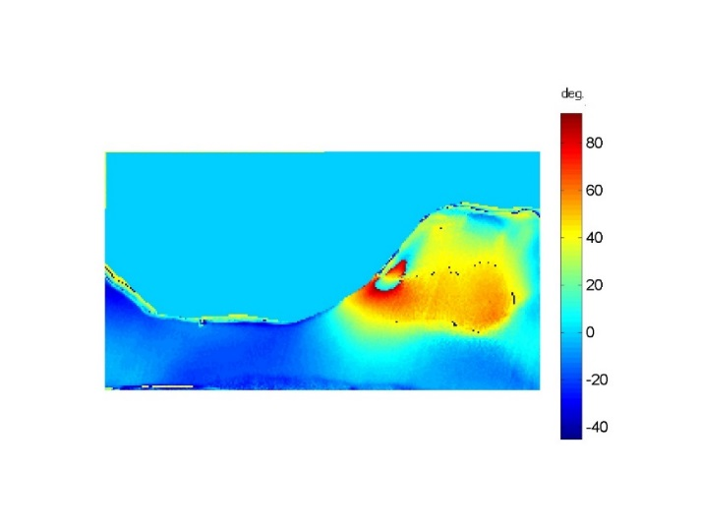
a.CoCr b.PEEK1

c.PEEK2
Figure 79: Isoclinic phase map (stress direction) a. CoCr, b. PEEK1, c. PEEK2.
Generally, the optimized PEEK denture stress direction is almost similar to that of PEEK using conventional design, with differences in inclination degree. The optimized PEEK denture stress distribution around -15° to the left side on the palate, while the direction varies over the saddle area between around 45° buccally, then changed to around 10° internally.

Stress Magnitude and Direction for Coronal Section (Slice IV).
Figure 80 shows the stress distribution in a coronal plane through the upper left 2nd molar and the corresponding palate in the slice IV.
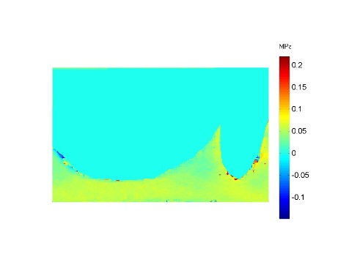
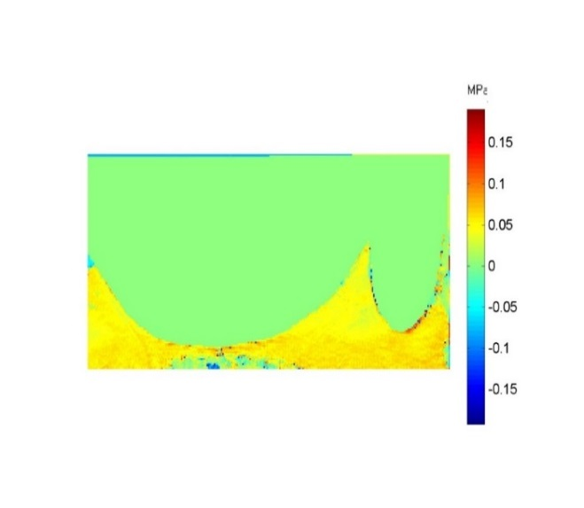
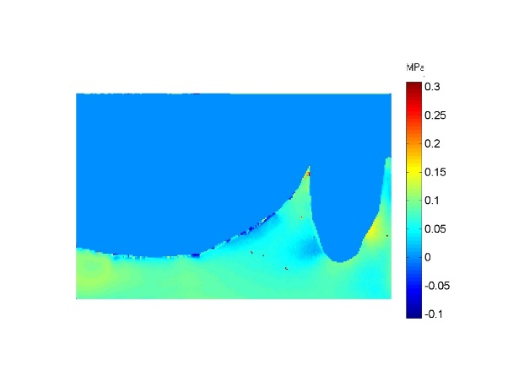
a.CoCr b.PEEK1

c.PEEK2
Figure 80: Isochromatic phase map (stress magnitude) a. CoCr, b. PEEK1, c. PEEK2.
Generally, the optimized PEEK denture produce a stress pattern similar to that existed in the slice II. The stress intensity is lower than the stress pattern in the conventional design.
The stress in the optimized PEEK denture concentrated under the tooth and distally on the palate area, in similar situation with PEEK using conventional design with difference in stress intensity. The situation, however, differs from that for the cast metal denture.
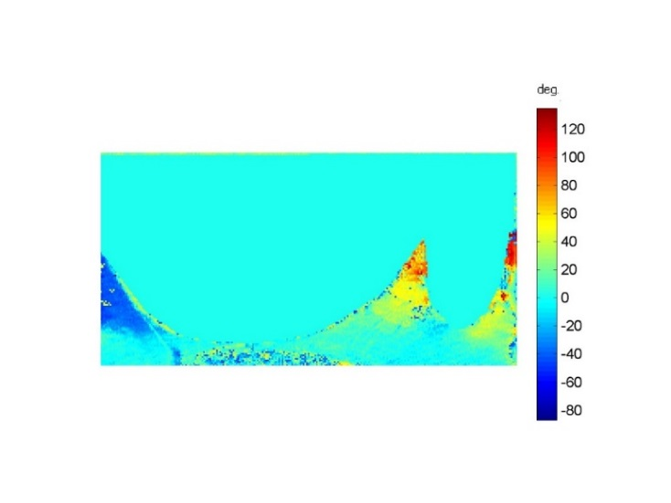
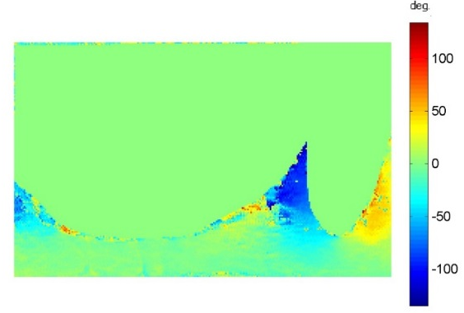
Figure 81 shows the stress direction around the abutment tooth and corresponding palate in the slice IV.

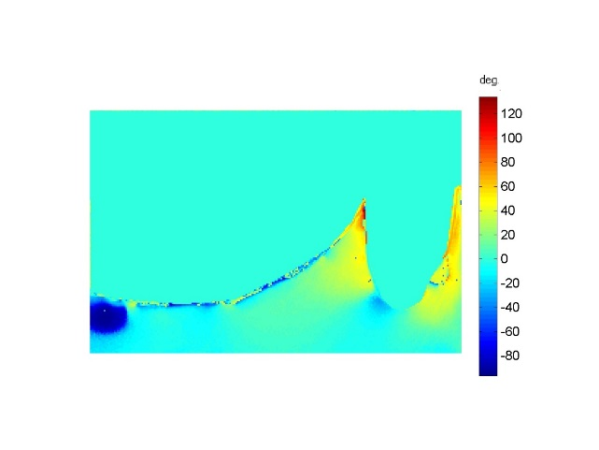
a.CoCr b.PEEK1

c.PEEK2
Figure 81: Isoclinic phase map (stress direction) a. CoCr, b. PEEK1, c. PEEK2.

The optimized PEEK denture stress direction around the abutment tooth showed 0° at the apical area indicating that the stresses directed apically, with 45° at the buccal and lingual surfaces indicating buccal tilt, in contrast to PEEK under conventional design where the stress direction differs between the buccal and lingual side. The situation is almost similar to that for the cast metal denture.

Discussion
The functional requirements of a product are directly determined by the material properties and design. Results of the first experiment showed that designing PEEK RPDs under the conventional parameters applied for CoCr RPDs lead to uneven load distribution as the load is concentrated over the ridge area, because of the flexibility of PEEK material. Moreover, designing the support component under the conventional parameters fails in transferring stresses to the abutment teeth, thus the denture act as a tissue supported RPD.
The high stress concentration at the ridge area with the PEEK denture necessitates that the PEEK denture is designed to be stiff enough to resist deflection, and to allow the abutment teeth to make a greater contribution to carrying the occlusal loads in a healthy way.
This study aimed to optimise the support function of the PEEK material when designed as a removable partial denture by changing the design of the support component and increasing the material thickness to reduce deflection of the saddle area. According to structural mechanics, the deflection of the part is inversely proportional to the modulus of elasticity. That means the deflection of the PEEK denture will be reduced, and hence the stiffness will be increased by increasing the cross-sectional thickness, and including the buccal and palatal wall of the tooth above the height of the contour to support the function of the occlusal rest.
3D digital photoelasticity allows visualization of full field stresses at more planes than with the conventional integrated photoelasticity. It allows a complete analysis of the area around the root of the abutment tooth mesio-distally and bucco-palataly to study the effect of the direct retainer design, and allows study of the area of the palate to reflect the behaviour of the major connector at different points at the surface and internally.
The results of optimising the PEEK denture revealed that the support functions of the occlusal rest, to transfer the occlusal forces to the abutment teeth and prevent tissue ward movement, were enhanced in the new clasp design. Data from slice I show that the highest stress was under the abutment teeth and extended toward the edentulous area with less intensity for the optimised PEEK design. The stresses were mainly apical to the long axes of the abutment teeth. The map of the stress direction of the optimised PEEK denture was similar to that of the CoCr denture. The stress directions were 0° under the apex of the abutment teeth, indicating that the stresses were parallel to their long axes. Meanwhile, the stresses all over the slice were directed laterally, indicating lateral abutment teeth movement.
The results of slice III for the optimised PEEK denture revealed that there was high stress concentration over the deepest part of the palate region opposite to the ridge area, while the palatal region corresponding to the abutment teeth showed lower stresses. These high stresses may have been because of distortion of the major connector. This may be considered a weak point in the design that need further study and optimisation. Finite element analysis technique could give a prediction of the appropriate thickness and design for the major connector.
For the designs tested, the most severe stresses were produced by the PEEK denture under the conventional support design and dimensions. The applied loads were more directly transmitted to the residual ridge, resulting in the highest observed stresses in the supporting structures. The traditional metal design produces a similar distribution pattern to that for the optimised design, however, with a more uniform and lower intensity map.
The main finding of this study supports the finding of the first experiment, in that the design of the PEEK denture should be optimised and tailored to the material properties to optimise and enhance the support function and thus improve the load distribution. The load distribution of the optimised PEEK denture is comparable with that of the CoCr denture. The abutment teeth’s contribution to the occlusal load is very high, and this may be influenced by the new clasp shape, size, and design.
It can be said that the results of this study were in agreement with the hypothesis that ‘’ ’the design of any object should be tailored to its material properties ‘’

Conclusion
1. Designing PEEK material as an RPD related to it is properties enhance the support function of the denture and optimize the load distribution.
2. The new clasp design enhances the support function of the PEEK denture, and transfer the forces of occlusion in healthy way to the abutment teeth.

: Load Distribution for Upper Kennedy Class III modification 1 Tissue Supported RPD.

Load distribution of an upper bounded saddle acrylic partial denture
The providing of removable partial dentures (RPDs) constructed from acrylic resin is common in everyday dental practice (Walmsley 2003). Though textbooks advocate the provision of tooth supported dentures, it remains a clinical fact that dentists are providing more tissue supported dentures, mainly due to the lower cost of the acrylic denture when compared to other treatment options. In a National Health Survey conducted over a 9 -year period (1992 to 2001) in the UK, it was found that for every metal-based partial denture constructed, five acrylic partial dentures were made.
One of the main drawbacks of acrylic partial dentures is that they are typically designed and constructed as tissue supported dentures rather than tooth supported. Consequently, as the supporting bone becomes resorbed, they slowly become ill-fitting. An ill-fitting denture may result in trauma to the gingival tissues which can be physically stripped away from the teeth, leading to loss of attachment (Wilson 2009).
Dentists and technicians tend to design and construct acrylic partial dentures without adequate tooth support and retention. It was confirmed by a National Health Survey that a large percentage of acrylic dentures are mucosa-supported instead of tooth supported. Patel et al. (2001) conducted a survey of Removable Partial Dentures manufactured by dental laboratories and found that tissue supported dentures were regularly provided for patients.
All removable partial dentures should utilise the existing teeth for support and retention as teeth have a much better response to loading when compared to soft tissue and bone (Wilson 2009).
When designing the denture, the clinician should look to increase the tooth borne support of the denture and not rely exclusively on mucosal support. This may be obtained by finishing the denture above the survey line in those places where the acrylic components contact the tooth.

Aim
- To compare the load, distribute of three differently designed acrylic dentures for a Class III modification 1 pattern of tooth loss.
- Compare the most favourable design with Polyamide and PEEK partial dentures.
Objectives
Find the optimal design for a PMMA Class III modification 1, using 3D stress freezing digital photoelasticity technique.

Method
Three different designs for PMMA dentures where produced using the following design principles:
Palatal strap: The anterior finishing edge extending from the distal surface of the first premolar, and the posterior finishing edge extending from the mesial surface of the second molar covering the ridge areas and the corresponding palate.
Full palate: The anterior finishing line contacting the palatal surfaces of the anterior teeth, and the posterior finishing line at the posterior palatal seal covering the ridge areas and the whole palate (gum stripper).
Tooth contact: the anterior finishing line extending from the canines behind the incisive papilla, and the posterior finishing line at the distal surfaces of the second premolar covering the residual areas, the palate, and the palatal surfaces of the abutment teeth (Figure 82).

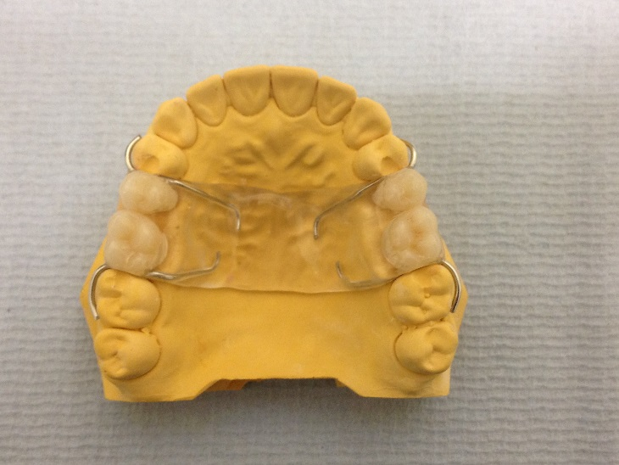
Palatal Strap

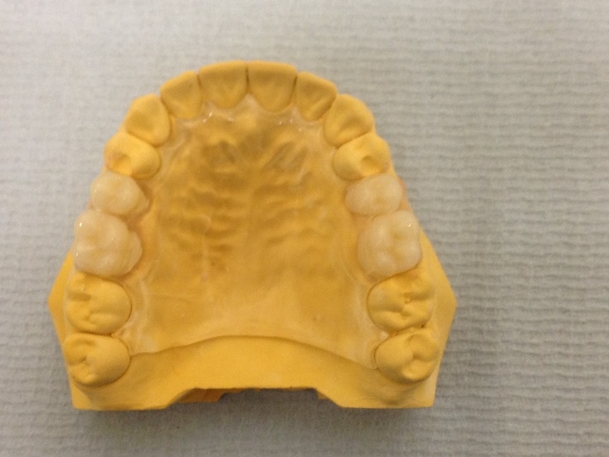
Full Palate
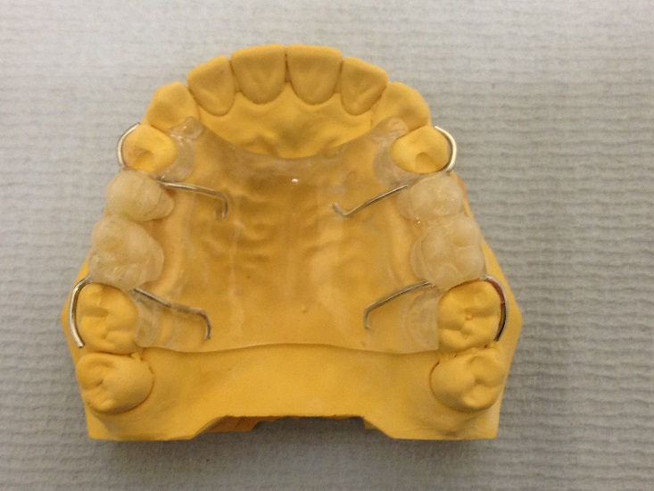
Tooth Contact

Figure 82: PMMA designs used in the study.

Results
Stress Magnitude and Direction for Right Sagittal Section (Slice I).
Figure 83 shows the stress distribution in a sagittal plane through the abutment teeth upper right 4 and 7 and the surrounding supporting bone and saddle area in the slice I.
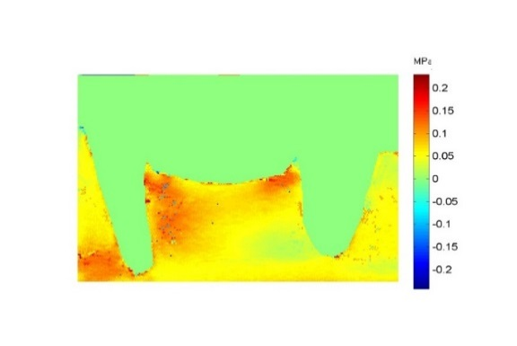
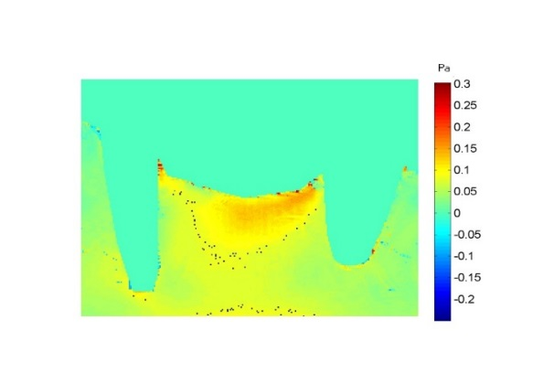

a: Palatal Strap. b: Full Palate
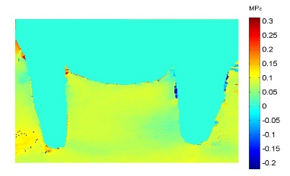

c: Tooth Contact.

Figure 83: Isochromatic phase map (Stress Magnitude) (a) Palatal Strap, (b) Full Palate, (c) Tooth Contact.

The phase map shows the force distribution to the supporting structures to be different between the dentures. Generally, the applied loads were directly and completely transmitted to the ridge area in the Palatal Strap design. The Tooth Contact design showed relatively uniform and low stress intensity across palate and teeth. The Palatal Strap design with the connector of the design localized to the ridge area, concentrates the stresses over the saddle area with an increase in intensity distally mesial to the molar abutment tooth, and extended to the internal area.
The Full Palate results in a stress pattern mainly on the distal aspect, and the mesio-apical region of the first premolar indicating distal tipping. The stresses then extend toward the edentulous span with increase in intensity toward the mesial side of the second premolar. Less stress intensity is observed distal to this tooth.
When the denture has Tooth Contact, a uniform map of load intensity between the edentulous ridge and around the abutment teeth is observed.
Figure 84 shows the stress direction in a sagittal plane through the abutment teeth upper right 4 and 7 and the surrounding supporting bone and saddle area in the slice I.

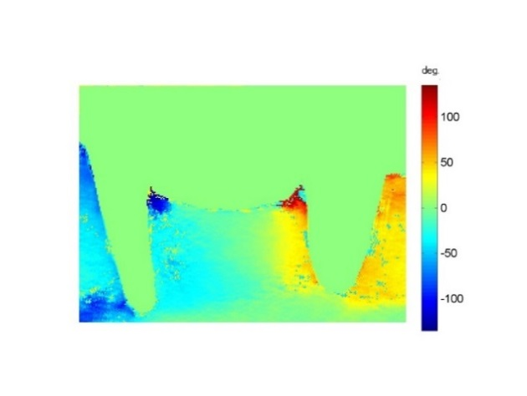
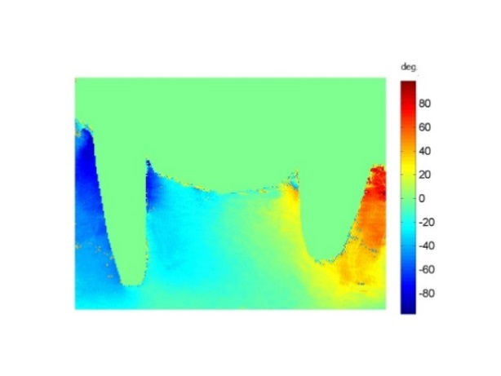

a.Palatal Strap b.Full palate
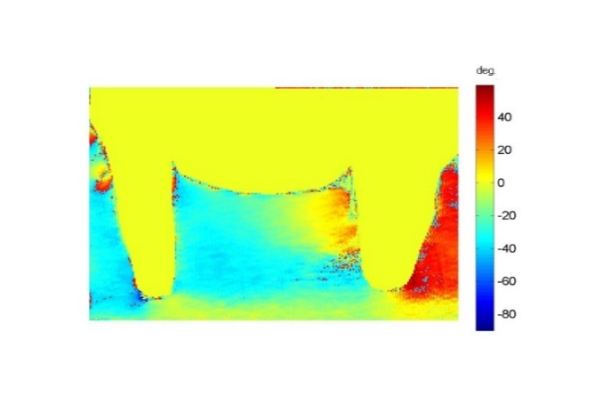

c.Tooth Contact
Figure 84: Isoclinic phase map (Stress Direction) (a) Palatal Strap, (b) Full Palate, (c) Tooth Contact.

Generally, there was a similarity between the Palatal Strap and Full Palate designs in stress direction. Both designs showed a -40° directed mesially at half of the slide, and 50° directed distally on the right side of the slice. However, the Tooth Contact design showed a -30° directed mesially on most of the slice, and stresses direction of about 40° on the distal surface of the root of the second premolar. It showed also a stress direction of about 0° under apexes of the abutment teeth indicating some of the stresses directed along the long axis of the teeth.
Stress Magnitude and Direction for Coronal Section (slice II).
Figure 85 shows the stress distribution in a coronal plane through the upper left first premolar and the corresponding palate in the slice II.
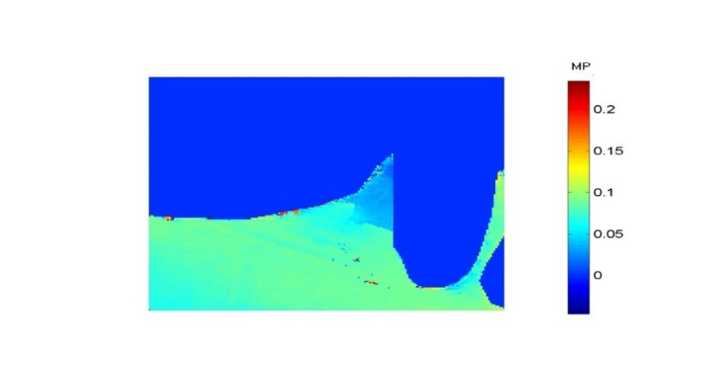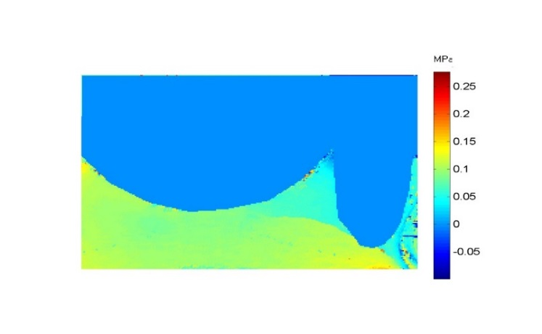
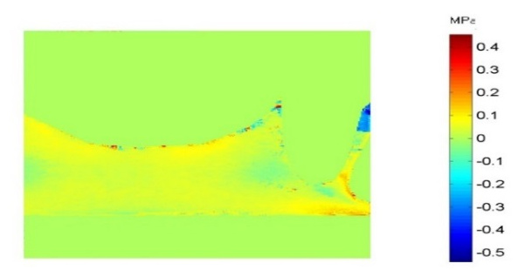
a.Palatal Strap b. Full Palate

c. Tooth Contact.
Figure 85: Isochromatic phase map (Stress Magnitude) (a) Palatal Strap, (b) Full Palate, (c) Tooth Contact.

Generally, a negligible stress was observed with Palatal Strap design, Full Palate design generate intermediate stress intensity, while Tooth contact design showed the higher stresses among the group.
Palatal Strap design showed a negligible intensity of stresses over the palate and around the abutment teeth, because of the borders extension of the design. Full Palate design showed a uniform map of stresses over the palate and under the apex of the abutment tooth, while showed a negligible stress on the sides. The stress intensity of the Tooth Contact design was higher over the palate area, also it generates a higher stress on the palatal and buccal sides of the root.
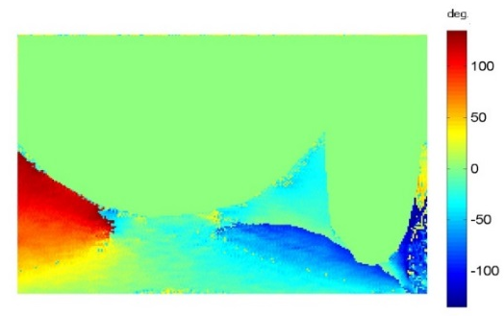
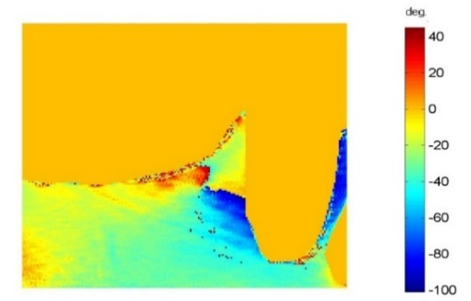
Figure 86 shows the stress direction in a coronal plane through the upper left premolar abutment tooth and the corresponding palate in the slice II. Generally, the direction of stresses varies between the group, and varies from point to point in the same denture design.

a. Palatal Strap b. Full Palate
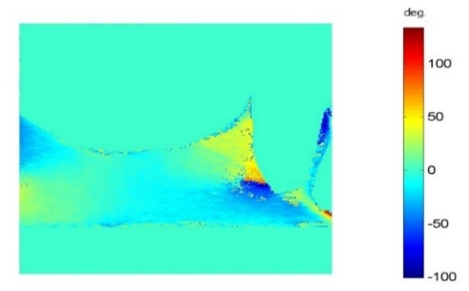

C. Tooth Contact
Figure 86: Isoclinic phase map (Stress Direction) (a) Palatal Strap, (b) Full Palate, (c) Tooth Contact.

Stress Magnitude and Direction for Coronal Section (Slice III).
Figure 87 shows the stress distribution in a coronal plane through the saddle area of the left side and the corresponding palate in the slide III.
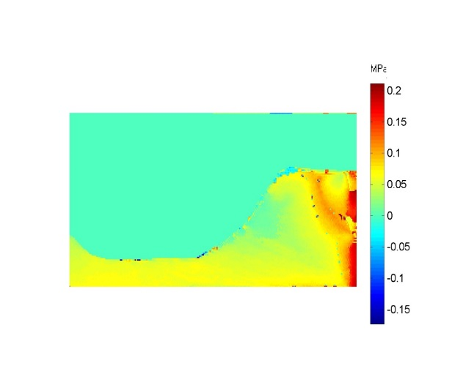
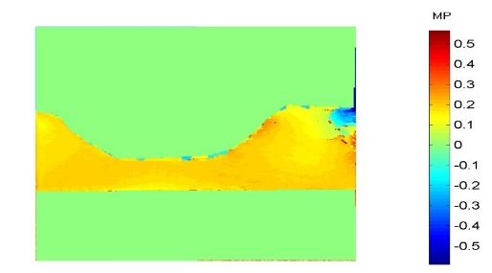

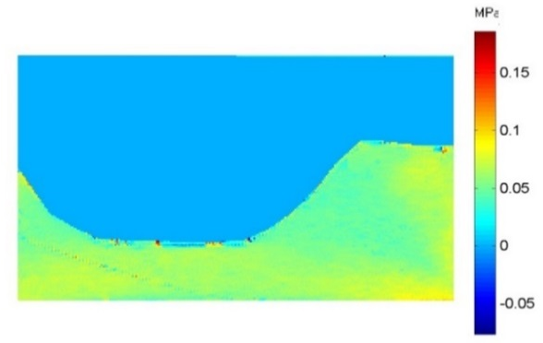
a. Palatal Strap b. Full Palate

c.Tooth Contact
Figure 87: Isochromatic phase map (Stress Magnitude) (a) Palatal Strap, (b) Full Palate, (c) Tooth Contact.

Generally, the highest stress intensity was observed with Palatal Strap design. The Full Palate design generated intermediate stress intensities, while Tooth Contact design showed more uniform and low stress.
In the Palatal Strap design, the stresses localized mainly over the palate with a uniform intensity, with a tendency to decrease over the ridge area. Full Palate design, showed uniform stress intensity over the palate and the ridge area. The stresses dropped to about 0 at the sides of the palate.
The Tooth Contact design showed a very low stress intensity that localized over the deepest point of the palate and the most buccal point of the ridge area, sides of the palate showed a little contribution to the load.
Figure 88 showed the stress direction in a coronal plane through the saddle area of the left side and the corresponding palate in the slide III.
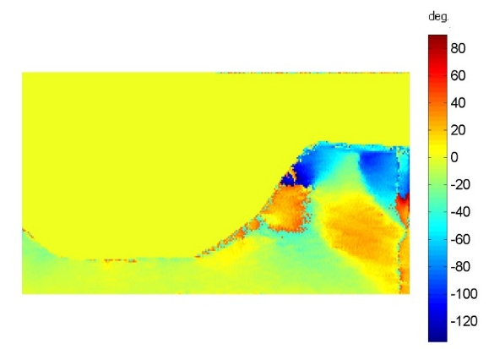
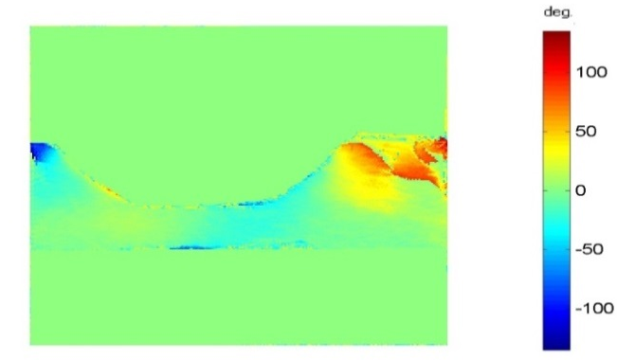
Generally, the direction of stresses varies among the group, and varies from point to point in the same denture design.

a. Palatal Strap b.Full palate
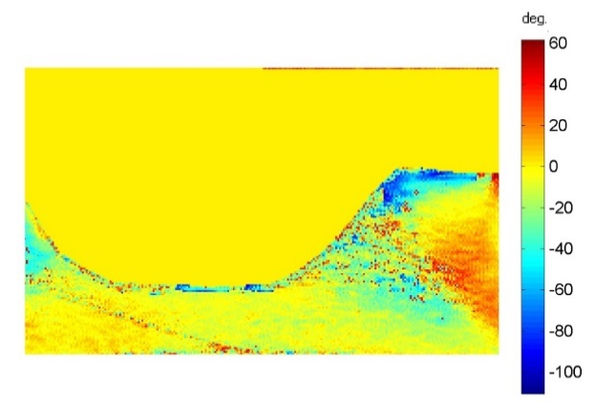

c.Tooth Contact
Figure 88: Isoclinic phase map (Stress Direction) (a) Palatal Strap, (b) Full Palate, (c) Tooth Contact.
Stress Magnitude and Direction for Coronal Section (Slice IV).
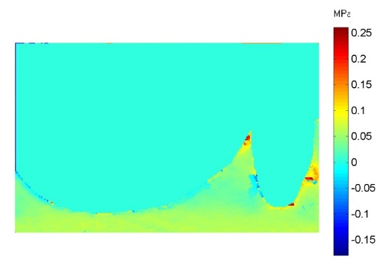
Figure 89 shows the stress distribution in a coronal plane through the upper left 2nd molar and the corresponding palate in the slice IV.
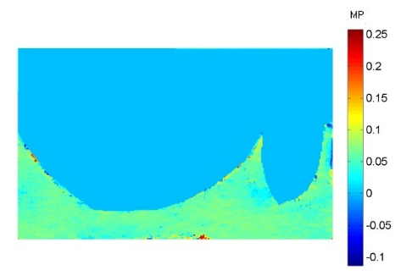
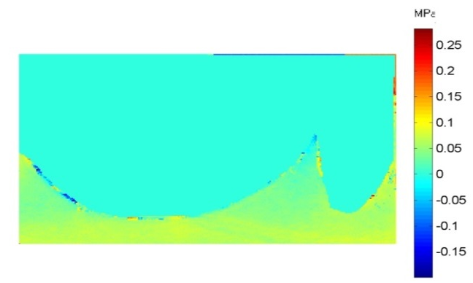
a. Palatal Strap b. Full Palate

c. Tooth Contact
Figure 89: Isochromatic phase map (Stress Magnitude) (a) Palatal Strap, (b) Full Palate, (c) Tooth Contact.

Generally, the stress intensity was very low for the three designs. The Palatal Strap design showed a negligible stress due to the boundary of the design extension.
There was a similarity in the stress distribution pattern in the Full Palate, and Tooth Contact design. The stress map was a uniform over the palate with a tendency to increase in intensity on the buccal side of the abutment root than that in the palatal side especially in the Full Palate design.
Figure 90 show the stress direction in a coronal plane through the upper left 2nd molar abutment tooth and the corresponding palate in the slice IV.
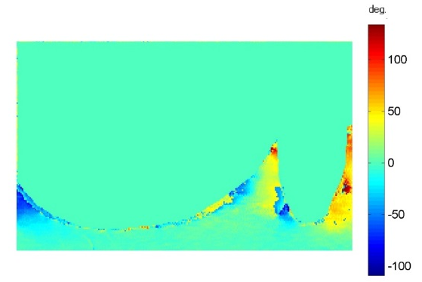
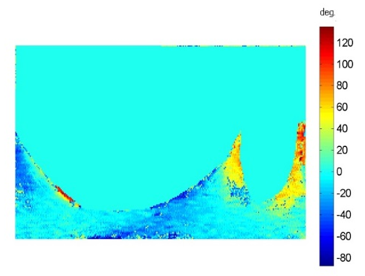
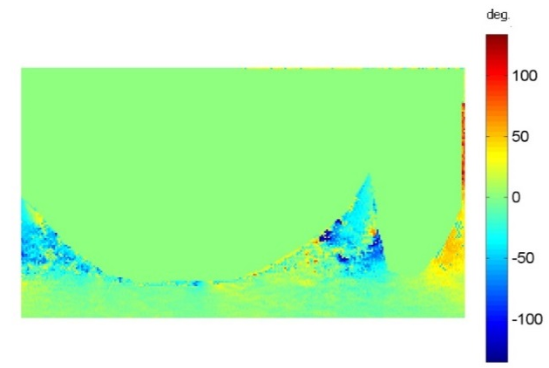
a. Palatal Strap b. Full Palate

c. Tooth Contact
Figure 90: Isoclinic phase map (Stress Direction) (a) Palatal Strap, (b) Full Palate, (c) Tooth Contact.

Generally, the direction of stresses varies between the group. The Palatal Strap design directed stresses to the left side over the palate, while directed to the buccal side around the tooth at different degrees.
The Full palate and Tooth Contact designs showed a similar stress direction over the palate. While the stress around the root directed buccally on the Full Palatal design, it differs from buccal and left side in the Tooth Contact design.

Discussion
Dentists should take responsibility for designing the acrylic partial denture with sufficient care to ensure its success biologically and mechanically. Although the acrylic RPD is the type of removable denture most commonly prescribed for patients, there is little evidence of research activity in the literature to study its design and construction.
The aim of this experiment was to study the load distribution of three different upper CL III modification 1 acrylic denture designs. Two were totally supported by the tissue side of the jaw using different denture sizes. One of these was limited to the ridge areas and the corresponding palate (Palatal Strap), while the other covered the whole tissue side of the jaw (Full Palate). The third design was extended to cover the palatal surfaces of the abutment teeth above the height of the contour (Tooth Contact). Moreover, the intention was to support the principles of correct design, minimise damage, and to improve the longevity of the remaining tissues.
3D digital photoelasticity experimental technique enables the researcher to study the whole map of stresses’ magnitude and directions at different points around the roots of the abutment teeth, saddle areas, and the palatal area, internally and at the surface.
The results of this work showed the importance of including the surfaces of the tooth above the height of the contour where the denture contacts the teeth. This assists in transferring part of the occlusal load to the teeth, thus preventing transfer of the whole load to the bone, to maintain better soft tissue and bone health. The higher load intensity was observed with the Palatal Strap design, as the whole occlusal load was transferred to a small area of the tissue side of the jaw. Although the Full Palate design distributed the applied load to the whole tissue side of the jaw, the map of the stress intensity on slice I showed a concentration of stresses around the 1st premolar, indicating distal drift. The stress pattern of the Tooth Contact design clarifies the importance of including the side of the teeth above the height of the contour in order to achieve better support design. Uniformly low stresses were obvious in all the slices. A low level uniform map of load distribution was observed between the ridge area and the abutment teeth, and at different points on the palatal surface.
Clinically, covering the abutment teeth surfaces above the survey line provides additional strength to the acrylic, and prevents sinking into the tissues and the resultant stripping of the gingiva from the abutment teeth. The Full Palate design produced lateral forces that were seen in the slice I around the first premolar, and this may have been caused by the wedged acrylic material interdentally.
However, extending the acrylic to cover the tooth surface palatally leads to loading of the tooth from that side only and could lead to buccal tilting. Furthermore, this practice is considered risky as the resin may fracture (Walmsley 2003).
It was not possible to locate other literature that had studied the load distribution of the most common type of RPD. The results of this study supports the finding by (Walmesly 2003) in his review of acrylic denture design, in terms of his suggestions to clinicians for minimising the acrylic denture damage. They also support the work (Wilson 2009) who in her review of acrylic denture design stressed the importance of extending the acrylic denture designs to include the tooth surface.
The results of this study could be used as preliminary data for carrying out more work on the design and construction of the acrylic partial denture, using the advantages of 3D digital Photoelasticity in studying the stresses’ magnitude and direction.
The main finding of this experiment is that Acrylic denture design should follow the same support principle as CoCr denture design, by increasing the tooth borne support of the denture and not relying only on the soft tissue side, keeping under consideration the biological aspects related to this design. It can be said that the results of this study were in agreement with the hypothesis ‘’extending the denture to cover the tooth surface improves the acrylic denture load distribution’’.

Conclusion
- Increase the tooth borne of the denture by including the tooth surfaces above the height of the contour, will lead to well supported denture that reduces the possible harm to the hard and soft tissue.
- Design 3 will be used for next comparison on load distribution with PEEK, and Polyamide flexible dentures.

Load Distribution of the PEEK Denture in Comparison with Conventional Tissue Supported RPD Materials
One of the advantages of the tooth supported denture over the tissue supported partial denture materials is that it enables the use the material as clasp denture. Removable partial dentures supported only by the mucosa covering the residual ridge tends to sink into the tissue and damage the periodontal tissue of the remaining teeth over time.
Good mechanical properties are among the most important requirements of a successful denture base material. Although polymethyl methacrylate is the most common denture base material, it fails to meet these important criteria (Jagger et al. 1999). Two different forces may lead to denture fracture: flexural fatigue that occurs in the mouth due to repeated flexing of the denture by the occlusal forces of mastication, and impact failure when the denture is accidentally dropped on the ground (Smith 1961). PMMA is a non rigid material that can be made stronger by increasing its thickness. However, thickening of the denture can increase the chance of tissue damage, and limits the choice of a design that will allow the gingival margins to be left uncovered (Meng and Latta, 2005). Engagement of deep undercuts is difficult because of the rigidity of the material.
Although it is possible to make an acrylic partial denture that is partially tooth supported by covering the palatal surface of the tooth above the height of the contour, extending the acrylic to cover the tooth surface palatally leads to loading of the tooth from that side only and could lead to buccal tilting. Moreover, this practice is considered risky as the resin may fracture (Walmsley 2003). Acrylic material is unsuitable for use as clasp denture as it has high rigidity and low elasticity, making it susceptible to fracture. As the clasp passes through the height of the contour to reach the undercut area, a low elastic modulus is preferable (Iwata 2016).
Polyamide resin is a flexible material used when there is a contraindication to acrylic material (Ucar et al. 2012). It is however susceptible to plastic deformation if the load on the base and clasp is excessive, which may damage the mucosa and reduce denture retentive force. (Fittin et al. 1994) concluded that the modulus of polyacetal resin is lower than that of PMMA, which is insufficiently rigid to be used as a supporting element for RPDs. Nylon has been reported to have inferior flexural properties in comparison with PMMA material processed with different polymerization methods. (Parvizi et al., 2004) compared the dimensional accuracy of different injection moulded materials (PMMA, nylon, and styrene) with that of conventional acrylic resin (PMMA) and stated that greatest distortion occurred with nylon. Materials with lower flexural modulus are often disadvantageous clinically because of their uneven force distribution, moreover, repair of the denture is difficult (Ucar et al. 2012).
Aim
To Evaluate the load distribution by PEEK removable partial denture in comparison to conventional tissue supported removable partial denture materials.
Objective:
- Comparing the load distribution of PEEK material, Acrylic material and Polyamide flexible denture (Valplast).
- Comparison by digital photoelasticity

Materials
Valplast denture was provided by (RDT technology ltd, west Sussex, UK), according to their design to a Cl III modification 1 cases. The PEEK denture was produced by milling the same design as that used in Chapter 5 section 5.2.1, but grinding of the occlusal rests (Figure 91).
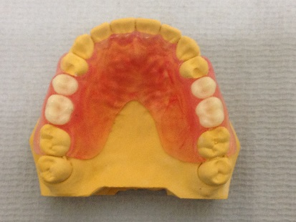
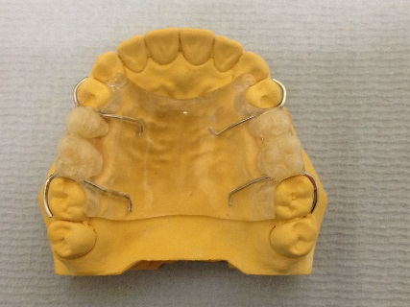

- PMMA. b. Polyamide.
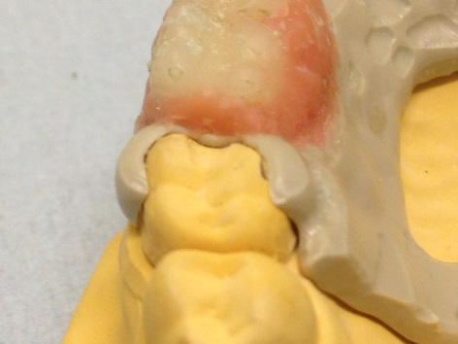
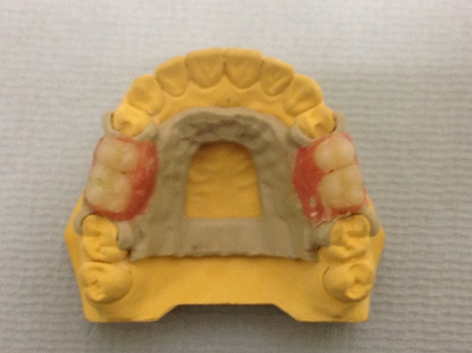

c. PEEK. d. The new clasp design.

Figure 91: Dentures used in this study a. PMMA, b. Polyamide, c. PEEK, d. Clasp design

Results
Stress Magnitude and Direction for Right Sagittal Section (Slice I).
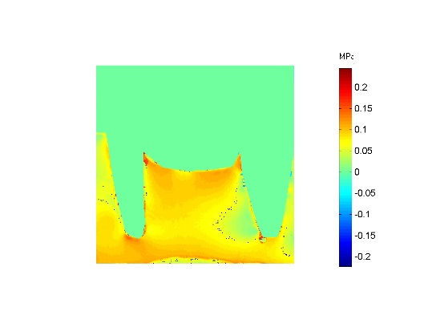
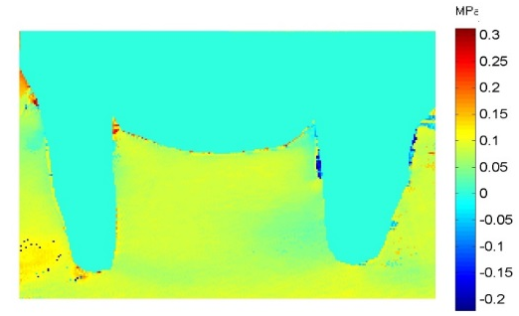
Figure 92 shows the stress distribution in a sagittal plane through the abutment teeth upper right 4 and 7 and the surrounding supporting bone and saddle area in the slice I.

a. PMMA b. Polyamide
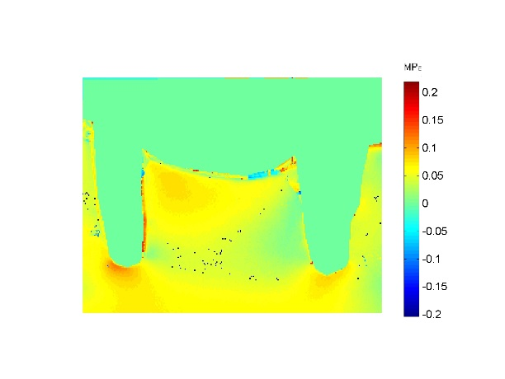

c.PEEK
Figure 92: Isochromatic phase map (Stress Magnitude) a. PMMA, b. Polyamide, c. PEEK.

Force distribution to the supporting structures was different among the designs. Generally, the highest stresses were observed on the ridge area of the Polyamide denture, PMMA denture showed more uniform and lower map of stress, PEEK denture concentrate stresses mainly under the apexes of the abutment teeth.
Polyamide denture distributes the force of occlusion to the ridge area, with a tendency to decrease toward the internal area. Stresses under the apex of the first premolar indicating tilting of the tooth mesially.
PEEK denture concentrate stresses under the apexes of the abutment teeth with highest intensity under the 1st premolar. The pressure that developed in the edentulous region was uniform in distribution with an increase in intensity mesially.
PMMA denture showed a uniform map of stress intensity on the ridge area, internally, and around the root of the abutment teeth.
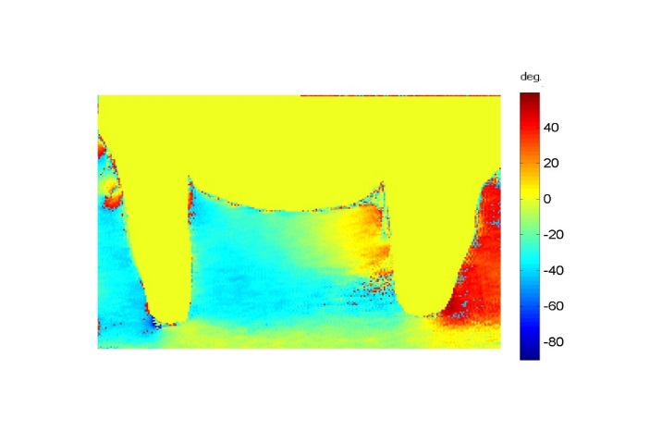
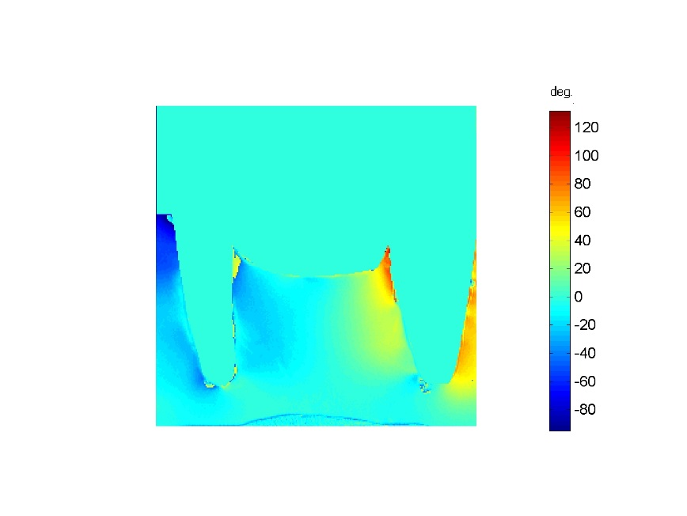
Figure 93 Shows the stress direction in a sagittal plane through the abutment teeth upper right 4 and 7and the surrounding supporting bone and the saddle area in the slice I.

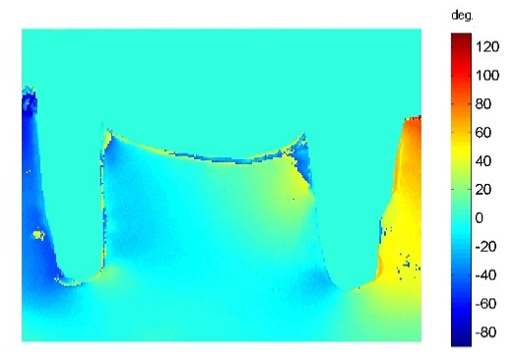
- PMMA b.Polyamide.

c.PEEK
Figure 93: Isoclinic phase map (Stress Direction) a. PMMA, b. Polyamide, c. PEEK.
Generally, the stress direction in the ridge area and around the teeth was nearly the same for Polyamide and PEEK dentures. Stresses over the ridge area directed mesially by a -15°mesial to the 2nd molar to distal to the 1st premolar, direction changed to -50° mesial to the premolar. Stresses directed by about 50° distally distal to the 2nd molar.
PMMA denture the stresses directed about 40° on the distal surface of the 2nd molar and -30° at the rest of the slice. Stress direction of about 0° under the apexes of the abutment teeth in the 3 dentures.
Stress Magnitude and Direction for Coronal Section (Slice II).
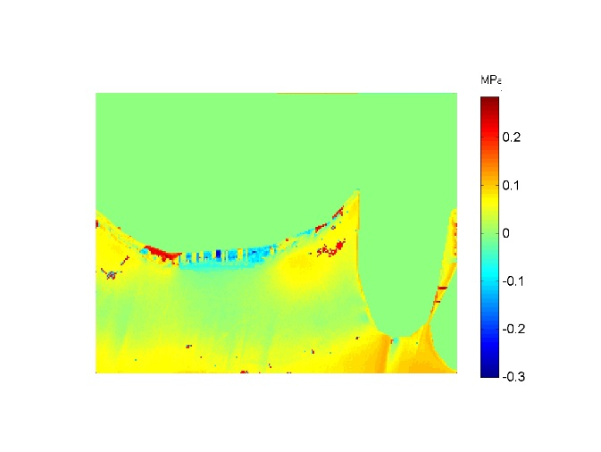
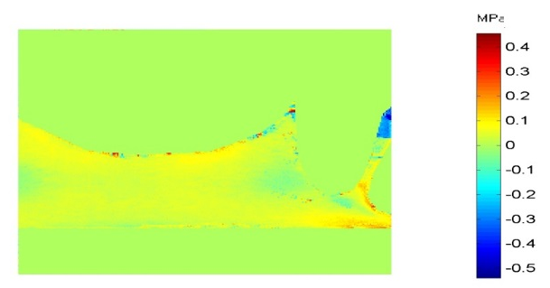
Figure 94 shows the stress distribution in a coronal plane through the upper left 1st premolar and the corresponding palate in the slice II.

- PMMA b. Polyami
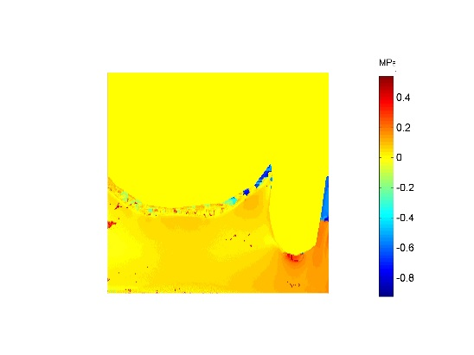

c.PEEK
Figure 94: Isochromatic phase map (Stress Magnitude) a. PMMA, b. Polyamide, c. PEEK.
Generally, PEEK denture produce the highest stress intensity, while there was a close similarity in the stress pattern between the Polyamide and the PMMA dentures. PEEK denture concentrate stresses mainly around the root of the abutment tooth that tend to increase in intensity under the apex. Stresses then extended toward the palate with less intensity. PMMA denture concentrate stresses over the palatal surfaces, and on the buccal side of the root. This map of stress extended with less intensity apically and toward the palatal surface. Polyamide denture generates a similar stress pattern as PMMA, however, the stress concentrate over the sides of the palate at higher degree than the deep part.
Figure 95 shows the stress direction in a coronal plane through the upper left first premolar and the corresponding palate in the slice II.
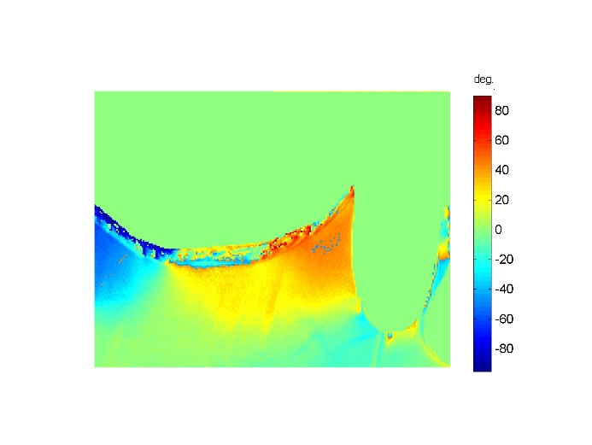
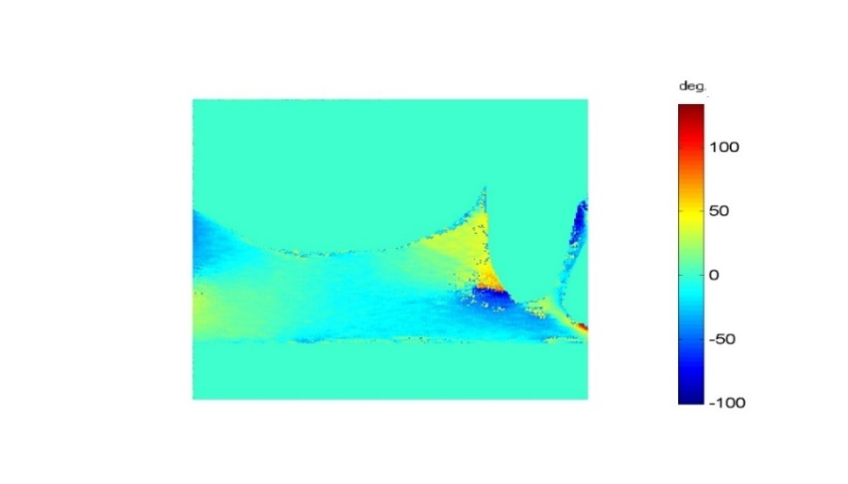

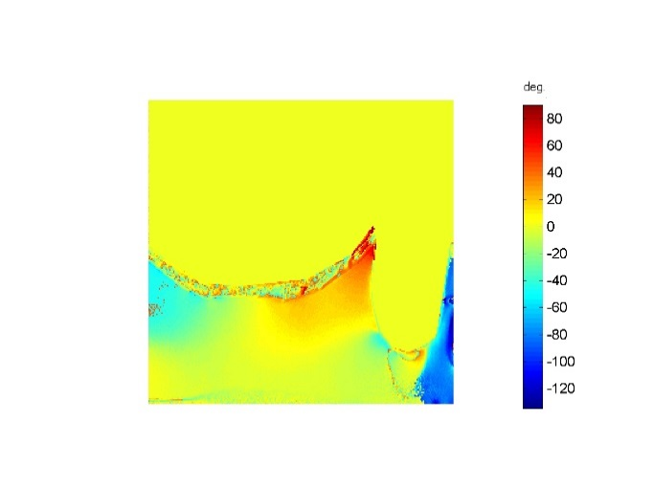
a. PMMA b.Polyamide

c.PEEK
Figure 95: Isoclinic phase map (Stress Direction) a. PMMA, b. Polyamide, c. PEEK
Generally, there was a similarity in the map of stress direction between Polyamide and PEEK dentures. The direction of stress on the palatal aspect of the root on both dentures directed toward buccally by around 40°, while the stress on the left side of the slice directed toward the left side. However, stress direction is about -80° directed palatally on the buccal surface of the root in the PEEK denture, while it was about 0° in the Polyamide denture.
Stress Magnitude and Direction for Coronal Section (Slice III).
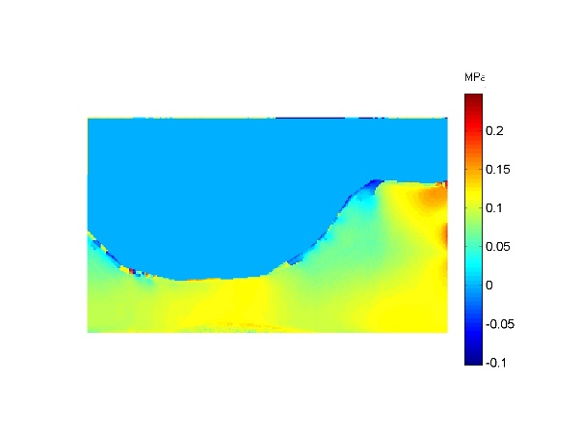
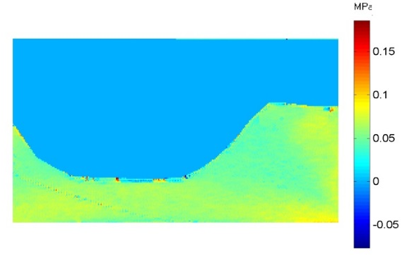
Figure 96 shows the stress distribution in a coronal plane through the saddle area of the left side and the corresponding palate in the slice III.

a.PMMA b.Polyamide
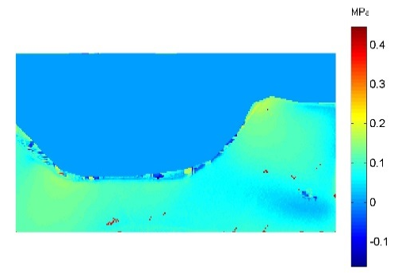

c.PEEK
Figure 96: Isochromatic phase map (Stress Magnitude) a. PMMA, b. Polyamide, c. PEEK.

Generally, the Polyamide denture produces the highest stress intensity among the group, while the PEEK denture produces the lowest stress intensity.
The Polyamide denture produces a similar stress distribution pattern as the PMMA denture. Both localize stresses mainly on the ridge area, with tendency to decrease toward the sides of the palate, then increase at the base of the palate. However, the stress intensity with Polyamide denture was higher than PMMA denture especially at the most buccal point of the ridge.
Low map of stress intensity produced by PEEK denture concentrate stresses on the palate.
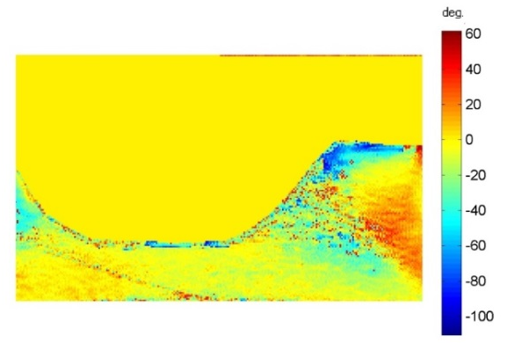
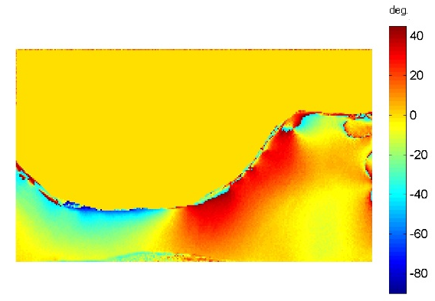
Figure 97 showed the stress direction in a coronal plane through the saddle area of the left side and the corresponding palate in the slice III.

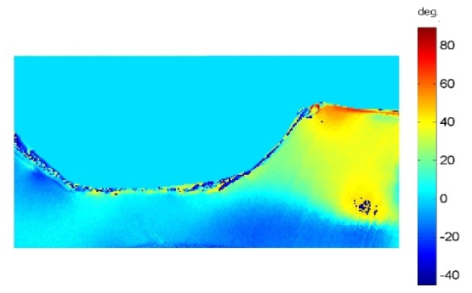
a.PMMA b Polyamide

c.PEEK
Figure 97: Isoclinic phase map (Stress Direction) a. PMMA, b. Polyamide, c. PEEK.
Stress direction produced from loading of the Polyamide denture directed buccally at different degree, except the outer surface of the palate were directed to the left side. Pressure produced by PEEK denture directed buccally at different degree over the ridge area, and 0° of stress in the palate. Stress pattern produced by PMMA denture varies from point to point in the slice.
Stress Magnitude and Direction for Coronal Section (Slice IV).
Figure 98 shows the stress distribution in a coronal plane through the upper left 2nd molar and the corresponding palate in the slice IV.
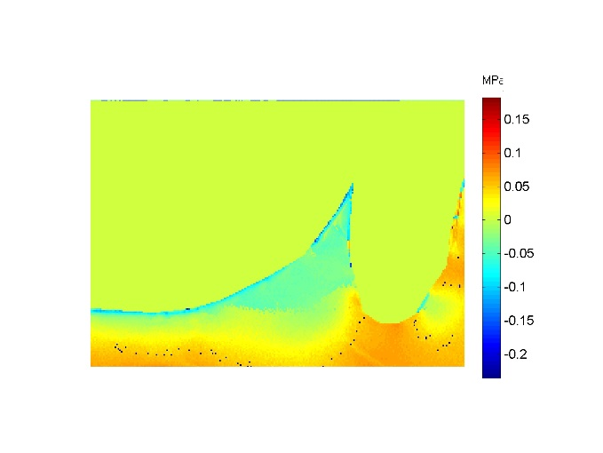
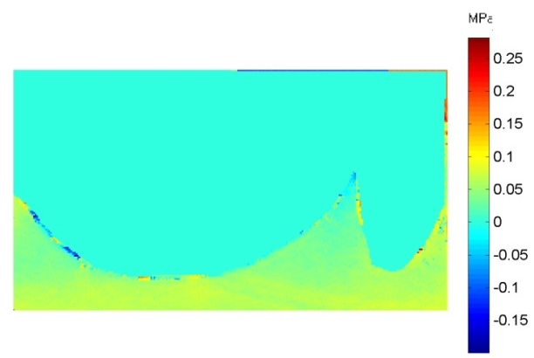

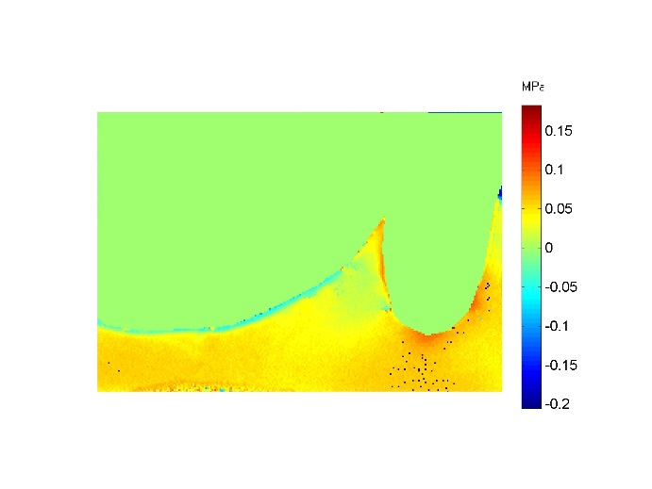
a.PMMA b.Polyamide

c.PEEK
Figure 98: Isochromatic phase map (Stress Magnitude) a. PMMA, b. Polyamide, c. PEEK.
Generally, the PEEK denture produce a stress pattern similar to that existed in the slice II, then extended toward the rest of the slice with less stress intensity. Polyamide denture concentrates stresses on the apical and buccal aspects of the root indicating tendency to buccal drift. The stresses on the palatal area showed almost negligible amount. PMMA showed a uniform low level of stress intensity all-over the slice.
Figure 99 shows the stress direction in a coronal plane through the upper left 2nd molar and the corresponding palate in the slice IV.
The stresses directed bucally on the buccal surface of the abutment tooth, while directed to the palatally on the palatal side in the PEEK and Polyamide dentures.
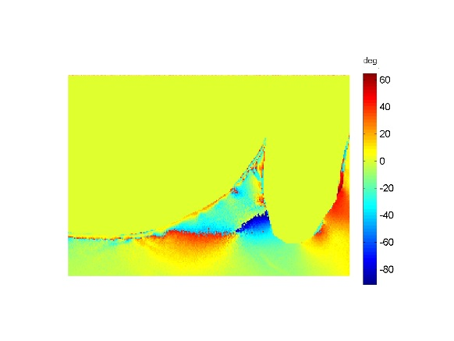
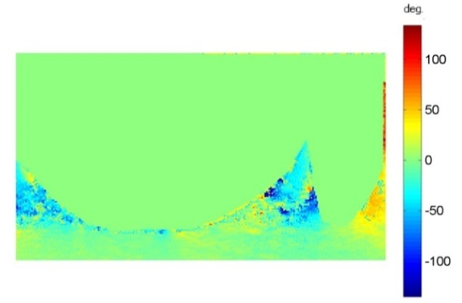

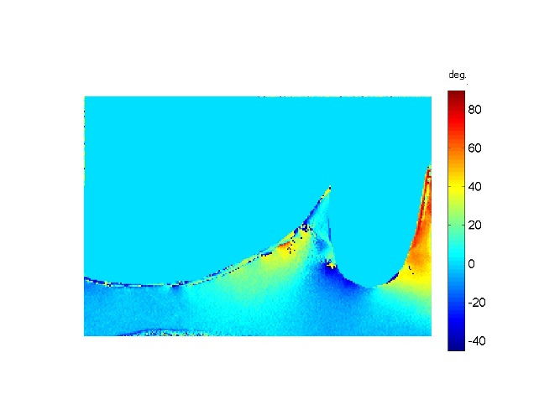
a.PMMA b.Polyamide

c.PEEK
Figure 99: Isoclinic phase map (Stress Direction) a. PMMA, b.Polyamide, c. PEEK.

Discussion
The support function of the removable partial denture following loading is achieved far better by natural teeth than the oral mucosa. As the patient occludes, the teeth are subjected to axial loading. Support is gained from the periodontal ligaments. The mucosa shows a movement about 13 fold higher than that allowed by the tooth in its alveolus (Costa et al. 2009). One of the important disadvantages of the conventional tissue support removable partial denture materials is the unsuitability of these materials to be used as clasps, because of the materials’ inadequate properties.
The aim of this study was to evaluate the load distribution of the upper CL III modification 1 PEEK denture with that of the conventional tissue support RPD. The acrylic denture was supported by the soft tissue, and the palatal surface of the abutment teeth above the height of the contour. The Polyamide flexible denture was supported totally by the soft tissue. The PEEK denture was supported by the new design clasp that extended to cover the axial walls of the abutment teeth buccally and palatally, and by the soft tissue.
The results of this study identified differences in the load distribution between the different dentures. The acrylic denture produced a uniform map of low level load distribution between the ridge area and the abutment teeth, and at a different points at the palatal surfaces. Meanwhile, the Polyamide flexible denture generated the least favourable load distribution. As the denture is totally tissue supported, all the applied load is directed to the ridge and the palate, and this tends to tilt the abutment teeth buccaly.
In agreement with previous studies, the Polyamide flexible denture generated the highest and the least favourable load distribution. Jiao et al. (2009) compared the load distribution of the flexible denture, conventional metal framework, and a hybrid design. It was concluded that the flexible denture was the least favourable denture in terms of load distribution. Park and Kay (2009) compared the load distribution of four unilateral free end removable partial denture using clasps, crown, resilient attachment, and flexible denture. They found that the flexible denture showed the maximum fringe order at the residual ridge. An effect resulting from the lower modulus of elasticity was observed in this study. The material was distorted more under the occlusal forces and produced a further stress on the soft tissue. The Polyamide flexible material tends to tilt the abutment teeth buccally, while, clinically, repeated buccal tipping of the abutment teeth may lead to periodontal problems. Hence, this material should be applied in cases where the state of the residual ridge is better than that of the abutment teeth (Park and Kay 2009).
The PEEK denture transfers the load applied to the abutment teeth in a favourable way. Results from slices I, II, and IV showed that the stresses mainly transferred apically to the abutments, indicating that the stresses extended along the long axis. This map of load distribution around the abutment teeth may be attributed to the shape and extension of the clasp design in a hand like shape. Slices II and IV showed that the intensity of the stresses created by the PEEK denture was higher than with the PMMA denture, and this may be attributed to the material flexibility.
The preliminary result of this work are encouraging for further research on this material as another option for RPDs. The support function of the hand like clasp design transfers the applied load in a favourable way to the abutment teeth without the need to prepare a seat for the occlusal rest, thereby preserving the tooth structure. Moreover, with such a clasp design it is possible to avoid contact with the gingiva and to prevent gingival tissues from being physically stripped. It has good mechanical properties to resist fracture, yet is sufficiently flexible to pass a deep undercut. However, the clasp covers a large area of the tooth surface, which can enhance plaque accumulation. According to the literature, patient’s lack of compliance with good oral and denture hygiene habits and regular recall requirements are the main causes of denture plaque formation (Wagner and Kern 2000).

Conclusion
Under the limitation of this work, the following conclusions:
- The Polyamide flexible denture generated the highest unfavourable load distribution and tends to tilt of the teeth.
- PEEK denture showed a favourable load distribution over the supporting structures.
- The new clasp design distributes the applied load in healthy way.

: Load Distribution for Lower Kennedy Class I Tooth and Tissue Supported RPD.

Load distribution of the lower class I cobalt chromium partial denture
The design of the distal- extension type of RPD may well be the chronic problem in terms of removable prosthodontics. Lower free end saddle cases remain the most common type of removable partial denture (Deo et al. 2011). There is also the documented problem of the effect of the difference in resilience between the supporting tissues. On one hand, the abutment teeth exhibit limited movement, whereas the mucosa exhibits more movement. This results in a rotary movement of the prosthesis due to the difference in distribution of force between the abutment teeth and residual alveolar ridges. These adverse forces may lead to abutment tooth mobility and residual ridge resorption if physiologic tolerance is exceeded.
CoCr alloy is the material most commonly used around the world to construct tooth tissue supported RPD frameworks. Several studies have been carried out to find the best design criteria for this material, with the aim of optimising the load distribution between the abutment teeth and the residual ridge. Consideration has been given to: reduction of the occlusal surfaces of the artificial teeth, use of long saddle areas, making functional impressions, periodic rebasing, using a large base within the physiological limitations of each patient, and variation of retainer design.
Non- rigid clasp assemblies have been applied to the abutment teeth adjacent to the distal extension base, which are designed to have a stress releasing effect. The mesial rest, proximal plate, I- bar system is designed to favour the abutment teeth. Rigid system advocators point out that the more rigid the connection for the retainer, the less denture mobility, however, little has been done to investigate other tooth tissue supported RPD frameworks materials.

Aim
The purpose of this work was to compare the effect of different CoCr denture clasp assemblies on the load distribution to the supporting structures.
Objectives
To use 3D photoelasticity to compare three different CoCr dentures; Circumferential clasp, Embrasure clasp, and RPI clasp to find the optimal design for lower Class I RPD.

Method and Materials
Three different designs for CoCr dentures where produced using the same design of lingual bar major connector, but differencing in clasping and supporting components as listed below:
Design 1: Circumferential clasp on the first and second premolars.
Design 2: Embrasure clasp on the first and second premolars.
Design 3: RPI clasp; mesial rest, I bar, distal plate.
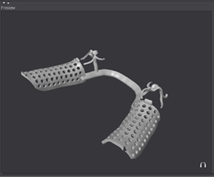
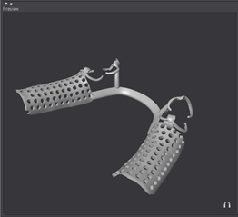

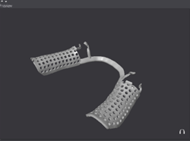
a. Circumferential b. Embrasure

c.RPI
Figure 100: The designed dentures. a. Circumferential design, b. Embrasure design, c. RPI design.
The dentures were designed in the Dental Wings software (Figure 100). The STL file was exported to the Roland DWX 50 milling machine and a 25 mm thickness PMMA disc was used to fabricate pattern for the CoCr frameworks.
The PMMA patterns then went through the conventional steps of resin elimination and casting. Synthetic teeth where then attached to the frameworks and the completed RPD placed on the working resin model (Figure 101).
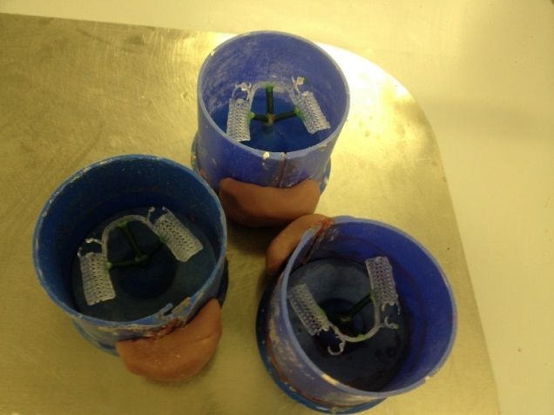
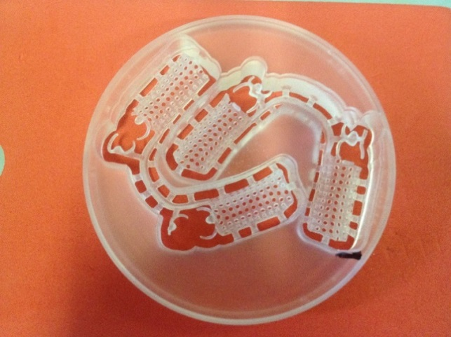

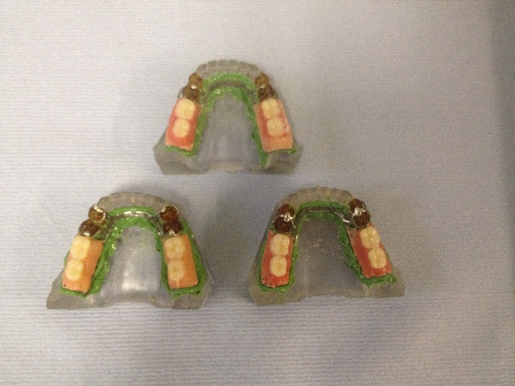
a. The milled designs in PMMA. b. PMMA elimination

c.The dentures on the resin models.
Figure 101: a. The milled designs in PMMA, b. The designs for resin elimination, c. The dentures on the working models.

Results
Stress Magnitude and Direction for Left Sagittal Section (Slice I).
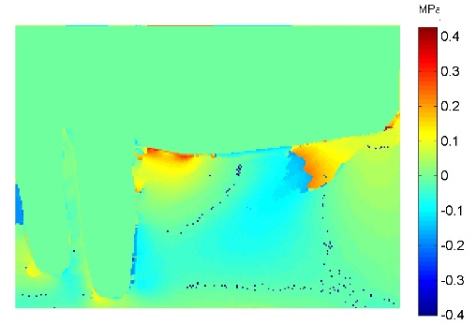
Figure 102 shows the stress distribution in a sagittal plane through the abutment teeth lower left 4 and 5 and the surrounding supporting bone and ridge area.
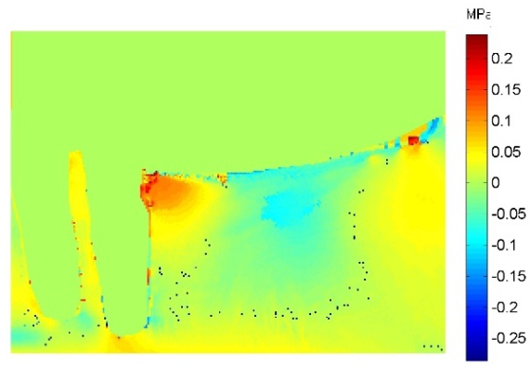

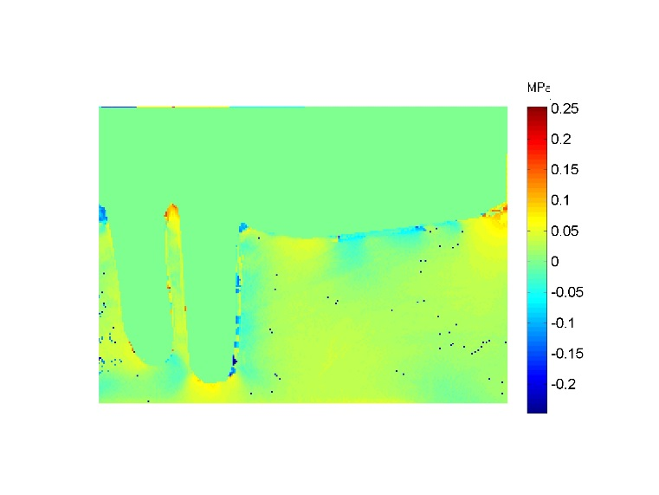
a.Circumferential b.Embrasure

c.RPI
Figure 102: Isochromatic phase map (Stress Magnitude) a. Circumferential, b. Embrasure, c. RPI.
Force distribution to the supporting structures was different among the designs. Generally, the RPI design showed the most favourable load distribution, while circumferential design showed the least favourable design in load distribution.
The circumferential design showed the highest overall stress concentration distal to the abutment tooth indicating a distal drift. The occlusal load concentrated stresses near the crest of the ridge in the distal area. Stresses then decreased in intensity mesially.
The embrasure clasp design concentrated stresses on the crest of the ridge distal to the abutment tooth and on the distal area of the ridge. The stresses then extended with very low intensity internally. The stresses observed apical to the abutment teeth was less than that observed with circumferential design.
The RPI design can be seen to distribute the load of occlusion in a fairly uniform manner as shown on the map with uniform intensity over the ridge area. Stresses in the supporting bone localized apically and mesially, while it showed a negligible stress distally.
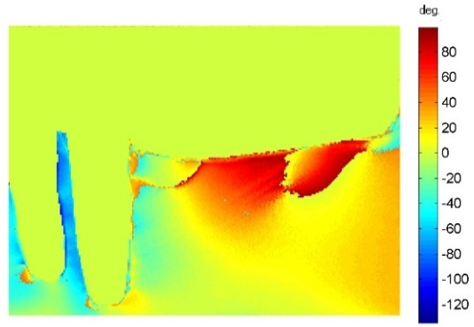
Figure 103 shows the stress direction in a sagittal plane through the abutment teeth lower left 4 and 5 and the supporting bone and ridge area.
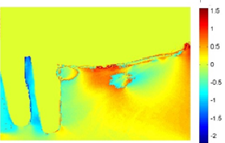
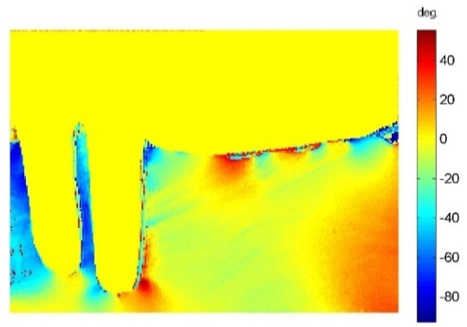
a.Circumferential b.Embrasure

c.RPI

Figure 103: Isoclinic phase map (Stress Direction) a. Circumferential, b. Embrasure, c. RPI.
Generally, the stresses direction around the abutment tooth and in the ridge area is almost similar between the three designs. The stress direction directed distally in the ridge area, and mesially in the supporting structures around the abutment teeth.
Stress Magnitude and Direction Coronal plan (Slice II).
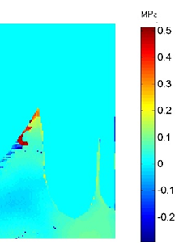
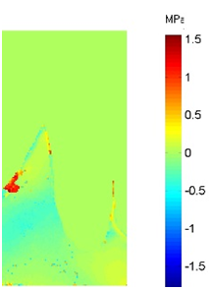
Figure 104 show the stress distribution in a coronal plane through the lower right second premolar and the supporting bone.

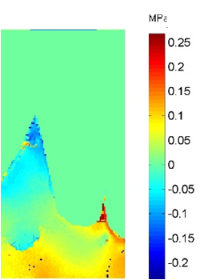
a.Circumferential b.Embrasure

c.RPI
Figure 104: Isochromatic phase map (Stress Magnitude) a. Circumferential, b. Embrasure, c. RPI
Force distribution to the supporting structures was similar in the Embrasure clasp design and the RPI design. Both designs concentrated stresses under the apex of the abutment tooth, with buccal tendency. The circumferential clasp design showed a negligible stress under the apex of the abutment tooth, with a tendency to concentrate stresses lingually, near the crest of the lingual plate.
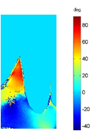
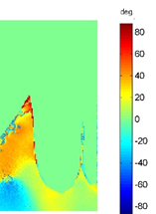
Figure 105 shows the stress directions in a coronal plane through the lower right second premolar and the supporting bone.

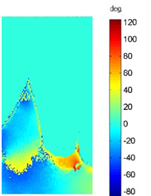
a.Circumferential b.Embrasure

c.RPI
Figure 105: Isoclinic phase map (Stress Direction) a. Circumferential, b. Embrasure, c. RPI.

Generally, the stresses directions were different among the three designs. Circumferential design directed stresses toward the buccal side in the lingual plate, while directed stresses to the lingual side around the apical third of the root. RPI design directed stresses toward the lingual side except under the apex of the tooth. Embrasure clasp design directed stresses toward the buccal side at different degrees.

Discussion
Ideally the design of the RPD should protect the abutment teeth and minimise damage to the residual ridge by favourably distributing the occlusal loads. This aim may be more difficult to achieve in distal extension RPDs due to the differences in the support structures’ response to the occlusal loads.
The type of clasp plays a significant role in force transmission to the supporting structures, especially in free end RPD cases. The mechanical influence of three different direct retainers and occlusal rest assemblies was evaluated in relation to their load distribution: 1. Circumferential clasp with distal rest on the 2nd premolar and mesial rest on the 1st premolar, 2. Embrasure clasp with mesial rest on the 2nd premolar and distal rest on the 1st premolar, 3. RPI design (mesial rest, distal plate, I bar).
These designs were chosen as they are all common designs and were evaluated in a similar study conducted by Nakamura et-al (2014) in which a 3D non-linear method of finite element analysis was used to compare the designs.
The results of this study show that RPI design demonstrated the most favourable distribution of forces on the supporting structures. The map of the stress concentration is uniform and even in intensity over the residual ridge, and concentrated apically and mesially on the abutment tooth with no stresses distal to it.
This behaviour is in accordance with the objectives of the retainer idealised by Kratochvil and later modified by Krol. The circumferential clasp design showed the least favourable load distribution. There was a high concentration of stress distal to the abutment tooth, indicating distal tipping.
The embrasure clasp design distributed the load mainly to the abutment teeth, while the residual ridge received stresses distal to the last tooth and at the most distal point at the ridge.
The results of this study using 3D stress freezing digital photoelasticity were consistent with those of other studies using different methods of stress analysis. Taylor et al. (1982) studied the effects of two different clasp designs on abutment tooth movement by using strain gauge experimental technique. The authors reported that the RPI clasp design causes less distal displacement to the abutment tooth than the circumferential clasp design. Thompson et al. (1997) compared the forces exerted on the supporting structures of the abutment tooth by different RPD designs using an integrated type of photoelasticity. Their study showed that RPI design achieved the most favourable distribution of the applied load. Nakamura et al. (2014) evaluated the behaviour of three different clasp designs: embrasure, circumferential, and RPI, on load distribution over the supporting structures using a 3D non-linear method of finite element analysis technique. The study revealed that the RPI design showed the most favourable stress distribution to the supporting structures, whereas the circumferential clasp design led to distal movement of the abutment tooth.
3D digital photoelasticity offers the advantage of viewing the load distribution in different planes, for example bucco-lingually in slice II. The circumferential clasp design showed almost no stresses in the buccal and lingual plate, while the embrasure clasp design showed stresses in the buccal plate and under the last abutment. The RPI clasp design showed stresses mainly under the distal abutment. The map of the stress direction in slice II indicated a tendency to buccal drift in the embrasure and RPI designs.
The limitation of this technique lies in its inability to represent the complex conditions of the oral cavity, such as different types of bone, different mandibular movements in occlusion leading to different magnitude and direction of forces. In this study the applied force evaluated was in a vertical direction only, while lateral forces are likely to result in different stress patterns.
Chou et al. (1989) compared different RPD designs using photoelasticity under different load directions: vertical, distal, mesial, lingual and buccal. They found that the RPI system showed the most favourable distribution of forces regardless of their direction of application.
The finding of this study using 3D photoelasticity is consistent with the results using other stress analysis techniques. Moreover, this method allows analysis of the stresses in the buccolingual view in addition to analysis of the stresses directions.

Conclusion
- 3D digital photoelasticity shows the same results as with other techniques, moreover, it allows interpretation of the stresses in different planes, and gives a full field of stress directions.
- RPI clasp assembly shows the most favourable load distribution over the residual ridge and on the supporting structures of the abutment tooth. While the circumferential clasp shows a distal displacement of the abutment tooth.
- RPI design will be used for comparison with PEEK clasp design.

Load distribution of PEEK RPDs in comparison to the RPI CoCr denture kennedy for class I lower denture.
The main objective of a denture is to maintain equilibrium between the health and function of the supporting structures. Free end saddle removable partial dentures are devices of great complexity and, therefore, constitute a challenge to achieving such an aim. The difficulties are due to the differences in the response of the supporting structures to the occlusal loads.
Practically all cast frameworks for removable partial dentures are made from Co-Cr alloys. Cobalt chromium alloys have a high modulus of elasticity, which is useful in ensuring the load can be transmitted through the framework; however, it is a drawback in relation to tooth health. The stiffness of cobalt chromium alloy makes the material unsuitable for deep undercuts, as it increases the stresses on the tooth or alternatively leads to permanent deformation of the clasp. Permanent deformation and fatigue fracture are the most common mechanical complications of RPD clasps. These problems result in reduced retention and stability of the denture, which affect the patient’s comfort and require time consuming and expensive repairs.
The results of the experiments in section 7.1, in agreement with other studies showed that the RPI clasp assembly achieved the most favourable load distribution over the supporting structures. However, (Costa et al. 2009) analysed the load distribution of different clasp designs using integrated photoelasticity technique and concluded that the RPI retainer was the best design in force distribution with a long saddle, and there was significantly more tension intensity on the residual ridges with short saddles.
AIM: To evaluate the effect of flexibility of PEEK material on load distribution on the supporting structures.
Objectives: To compare the RPI clasp design with PEEK denture using 3D digital photoelasticity.

Materials
The PEEK removable partial denture was designed in the Dental Wings software (Figure 106). The new clasp design was fitted on the second premolar on both sides, with the occlusal rest seated on the distal occlusal seats. The major connector was a lingual bar with a dimension of 2mm thickness x 5mm width. The STL file was exported for milling in the Roland DWX 50 milling machine. The synthetic teeth were attached to the framework, and the denture was placed on the working model (Figure 107).
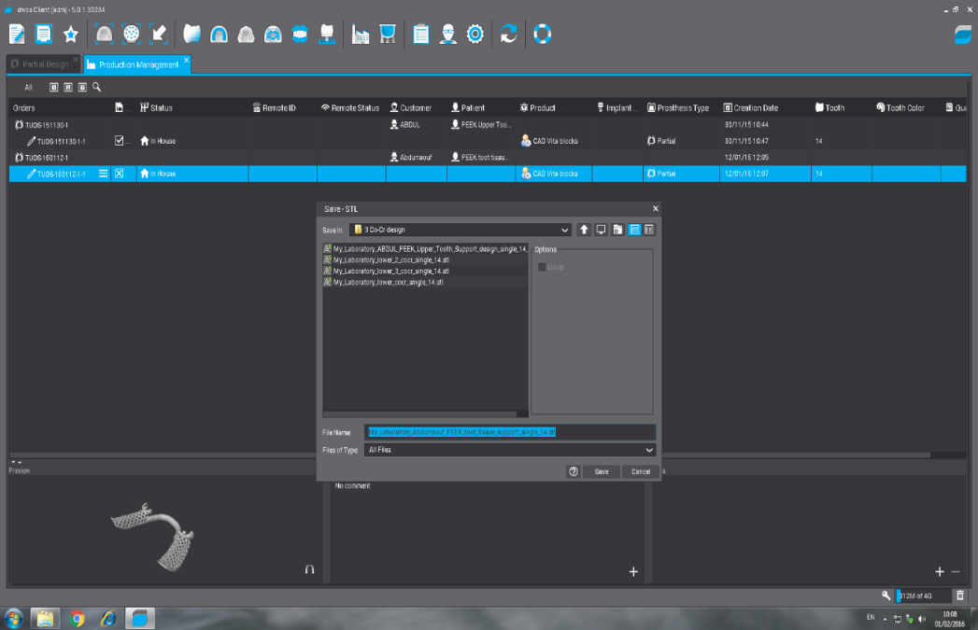

Figure 106: Design of the PEEK denture frame work.

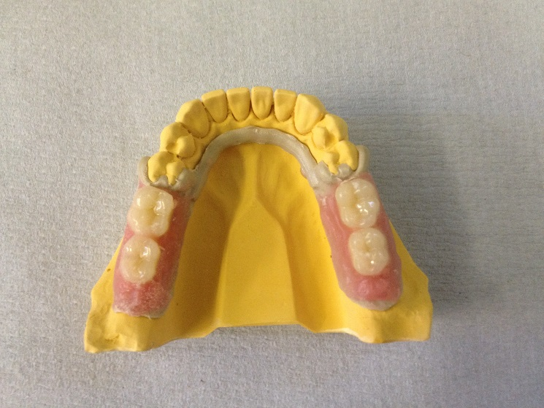

a
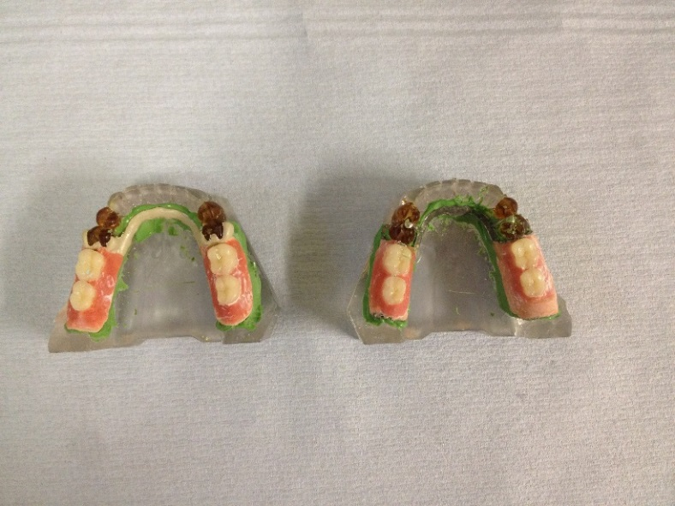

b
Figure 107: a. PEEK denture, b. PEEK and CoCr dentures on the resin models.

Results
Stress Magnitude and Direction for Left Sagittal Section (Slice I).
Figure 108 shows the stress distribution in a sagittal plane through abutment teeth lower left 4 and 5 and the surrounding supporting bone and ridge area.
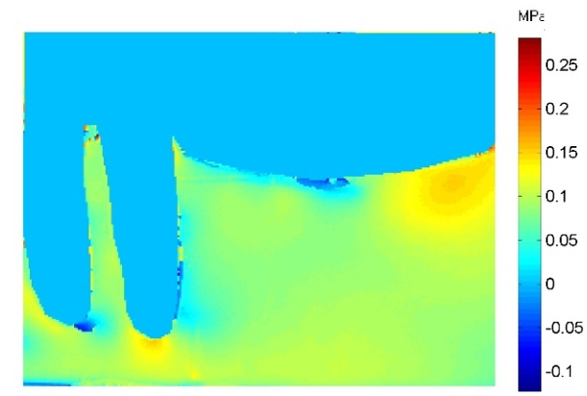

a.CoCr b.PEEK
Figure 108: Isochromatic phase map (Stress Magnitude) a. CoCr, b. PEEK.

The PEEK design produced a similar stress distribution pattern as the RPI clasp design. The PEEK design concentrates the occlusal loads on the distal end of the residual ridge and under the apex of the abutment tooth. Stresses then distributed to cover the whole residual ridge, and between the premolars with an even fairly uniform lower map of intensity.
Figure 109 shows the stress direction in a sagittal plane through the abutment teeth lower left 4 and 5 and ridge area.

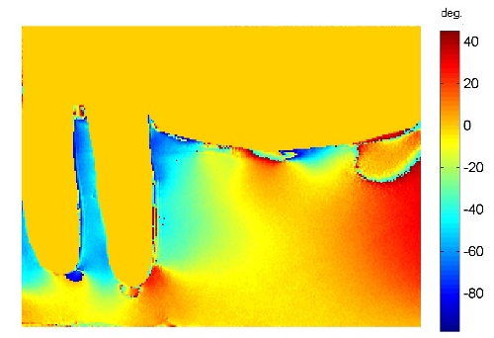
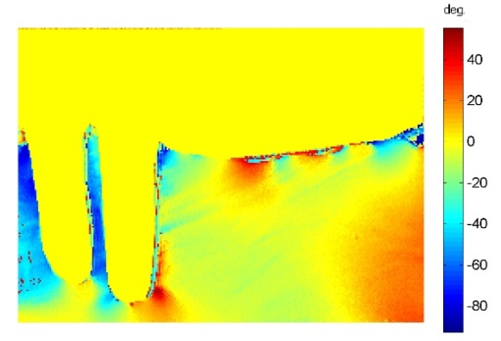

a.CoCr b.PEEK
Figure 109: Isoclinic phase map (Stress Direction) a. CoCr, b. PEEK.
Generally, the stresses direction around the abutment tooth and in the ridge area is similar between the two designs. The stress direction directed toward the distal side in the ridge area, and to the mesial side in the supporting structures around the abutment teeth.
Stress Magnitude and Direction for Coronal Section (Slice II).
Figure 110 shows the stress distribution in the coronal plane through the lower right second premolar and the supporting bone.
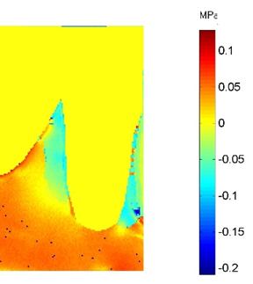
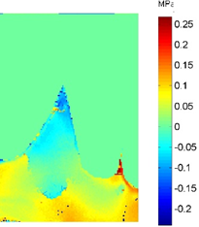

a.CoCr b.PEEK
Figure 110: Isochromatic phase map (Stress Magnitude) a. CoCr, b. PEEK.
Force distribution to the supporting structures were similar for the two designs, both designs concentrated stresses under the apex of the abutment tooth. However, the RPI design shows a buccal tendency of the apical map, followed by a band of zero stress. The PEEK design concentrated the stresses apically with fairly uniform map of intensity that extended internally.
Figure 111 shows the stress directions in a coronal plane through the lower second premolar and the surrounding bone.
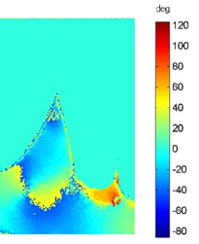
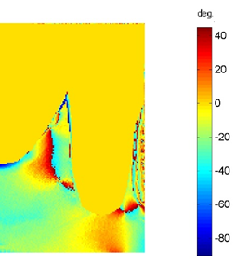

a.CoCr b.PEEK
Figure 111: Isoclinic phase map (Stress Direction) a. CoCr, b. PEEK.

Generally, the stresses directions were different between the two designs. RPI design directed stresses toward the lingual side except under the apex of the tooth were directed stresses to the buccal side at a 60°. PEEK design directed stresses at different degrees and directions, with stresses directed toward the buccal side under the apex of the abutment tooth with a 0° indicating stresses were parallel to the long axes of the tooth.

Discussion
The basic objective of RPD design is to restore and maintain the health of the remaining oral structures. Free end saddle dentures constitute a challenge to the professionals, because of the differences in resilience between the supporting structures. The abutment teeth exhibit movement of around 0.1 mm, while the mucosa has an average resiliency of 1.3mm³. This means movement of the mucosa approximately 13 fold higher than that allowed by the tooth in its alveolus (Costa et al. 2009).
Practically all cast frameworks for removable partial dentures are made from Cr-Cr alloy, which has a high modulus of elasticity. There has been extensive research on the design of this material, aimed to dealing with it is stiffness property and optimising its load distribution between the abutment teeth and the residual ridge, through three major strategies. The first these is, use of a stress breaker design, the second is use of a functional base for the denture, and the third is broad distributions of the forces.
PEEK has a low modulus of elasticity that could reduce the stresses on the abutment teeth, and reduce the denture rotation due to the differences in resiliency between the supporting tissues.
The purpose of this study was to evaluate the mechanical behaviour of two RPDs that were different in their materials and designs, in relation to their load distribution in the free end saddle. One was an RPI design using CoCr, and the other was a PEEK design using the same distal rest clasp design as used in section 6.1
The results showed that the PEEK denture with the new clasp design and a distal rest showed the same map of load distribution as the RPI assemblies made from stiff material. Both designs showed a uniform distribution of the applied load over the residual ridges and between the apices of the abutment teeth.
The intensity of stresses under the abutment tooth was higher in the PEEK denture than with the CoCr denture, and this may be attributed to the capacity of the new design in transferring the applied load to the abutment tooth. The map of stress intensity distal to the distal abutment was the same as in the rest of the slice, with no evidence of higher stresses, indicating a distal torque such as that seen in the circumferential clasp denture and embrasure denture discussed in section 7.1.2
The PEEK denture showed a higher stress intensity at the distal end of the base than CoCr denture, and this may be because of the material’s flexibility it could therefore need more stiffness.
The stress freezing photoelastic technique allows the researcher to view the map of stresses around the distal abutment tooth in a buccolingual direction. this showed that the stresses under the abutment tooth were higher with the PEEK denture than the CoCr denture, as could be seen in the sagittal plane (slice I). Moreover, the map of the stress direction under the abutment tooth was 0°, indicating that the stress was distributed along the long axis of the tooth.
Interestingly, in this experiment the map of the stress intensity showed considerable differences between the PEEK denture with a distal rest and the CoCr circumferential clasp with distal rest discussed in section 7.1.2.
The circumferential clasp with distal rest showed a high concentration of stress distal to the abutment tooth, indicating a distal tipping, while the map of the PEEK denture with distal rest showed a uniform stress intensity distal to the abutment tooth. This could be attributed to the flexibility of the material acting as a stress breaker.
The preliminary results obtained from this study are interesting and encouraging for further study on PEEK designs as a solution to the chronic problem of the free end saddle RPD denture.

Conclusion
The load distribution of PEEK denture for lower Class I with distal rest was comparable to the load distribution by RPI CoCr denture design.

: Load Distribution for Lower Kennedy Class I Tissue Supported RPD.

Introduction
One of the main problems with conventional tissue supported RPDs is that their clasps cannot be made from the same denture base material because of the material’s unsuitable properties.
Acrylic is unsuitable as a clasp as it has high rigidity and low elasticity, making it susceptible to fracture. As clasps pass through the height of the contour to reach the undercut area, a low elastic modulus is preferable.
Polyamide resin is a flexible material that is used when there is a contraindication to acrylic material, e.g allergy to PMMA. It is susceptible to plastic deformation if the load on the base and clasp is excessive, which may lead to damage of the mucosa and reduce denture retention.
Removable partial dentures supported only by mucosa covering the residual ridge tend to sink into the tissue, which may with time result in damage to the periodontal tissue of the remaining teeth.
Upper RPDs benefit from support gained from the palate. An area of 5 cm² in the centre of the palate does not resorb and offers some support. Where such support is not available, then support from the teeth is required.
It is possible to make mucosa borne partial dentures partially tooth supported by covering the surface of the tooth to above the height of the survey line. However, extending the acrylic to cover the tooth surface palatally may lead to loading of the tooth from that side only and could lead to buccal tilting. Moreover, this practice is considered risky as the resin may fracture (Walmsley 2003).
The other important drawback with the PMMA material is its lack of good mechanical properties, making it susceptible to fracture. Engagement of the deep undercut is also difficult because of the rigidity of the material.
The polyamide flexible denture has a lower flexural modulus which is a drawback from the clinical standpoint because of uneven force distribution, moreover, repair of the denture is difficult.
AIM
Evaluation the effect of the PEEK material properties on load distribution over the supporting structures.
Objective
Compare the load distribution of PEEK dentures with the conventional tissue support removable partial denture.

Materials
The polyamide denture was provided by (RDT technology Ltd, west Sussex, UK), according to their design for lower Kennedy Class I cases.
The PEEK denture was produced by milling the same design used in Chapter 7 section 7.2.1, but removing the occlusal rest as shown in (Figure 112).

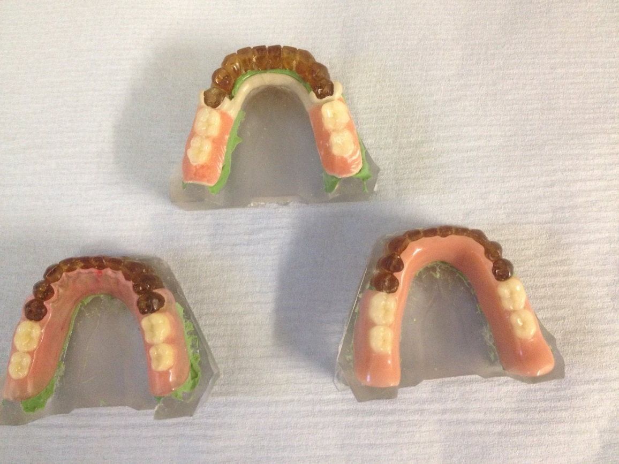
Figure 112: Mucosa born RPDs: PMMA (bottom right), Polyamide (bottom left), PEEK (top).

Results
Stress Magnitude and Direction for Left Sagittal Section (Slice I).
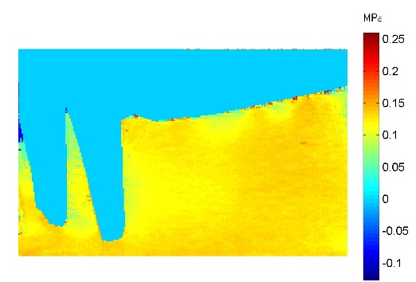
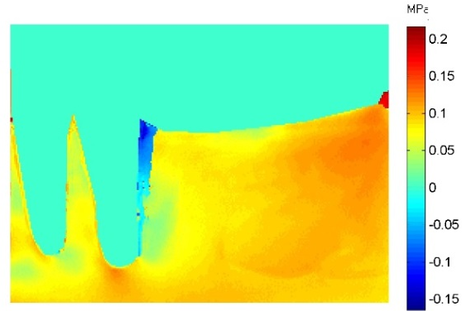
Figure 113 shows the stress distribution in a sagittal plane through the abutment teeth lower left 4 and 5 and the surrounding supporting bone and residual ridge.

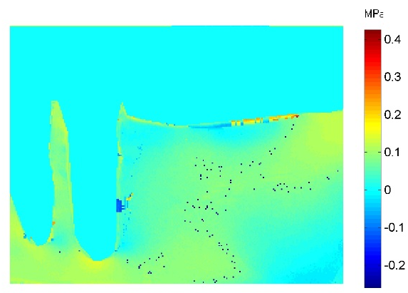
a.PMMA b.Polyamide

c.PEEK
Figure 113: Isochromatic phase map (stress magnitude) a. PMMA, B. Polyamide, c. PEEK.

Force distributions to the supporting structure were different between the dentures. Generally, the PMMA denture showed the most favourable load distribution, while the Polyamide denture showed the least favourable load distribution.
The PMMA denture concentrated stresses over the ridge area and under the teeth in the sagittal plane with an almost uniform map of stress intensity at the crest and internally. The stress intensity reduced distal to the root of the 2nd premolar, and in between the roots of the teeth.
The Polyamide denture concentrated the applied load at the distal point of the residual ridge, stresses extended in reduced intensity mesially until almost zero distal to the last distal tooth. The stress under the last tooth was higher in intensity than that in the PMMA denture, both indicating buccal tendency of movement.
The PEEK denture distributed the applied load over the distal end of the residual ridge and under the apexes of the teeth. The intensity of the stress was almost zero at the crest of the residual ridge and distal to the 2nd premolar.
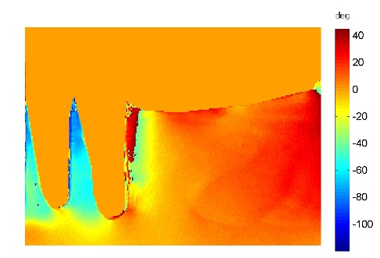
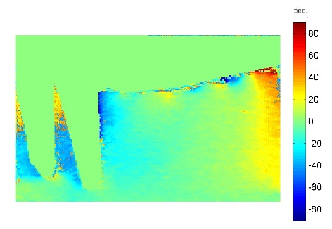
Figure 114 shows the stress direction in a sagittal plane through the abutment teeth lower left 4 and 5 and ridge area.

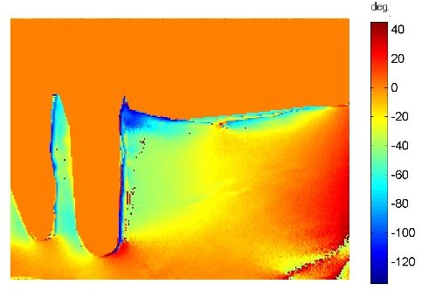
a.PMMA b.Polyamide

c.PEEK
Figure 114: Isoclinic phase map (Stress Direction) a. PMMA, b. Polyamide, c. PEEK.
Generally, there was similarity between the Polyamide denture and the PEEK denture in the stress direction. Polyamide denture directed stresses 40° distally all over the ridge area, while PEEK denture directed stresses at the same degree at the distal side of the ridge. Both designs then directed stresses at different degrees and direction around the teeth. However, PMMA denture directed stress of the applied load generally mesially.
Stress Magnitude and Direction for Coronal Section (Slice II).
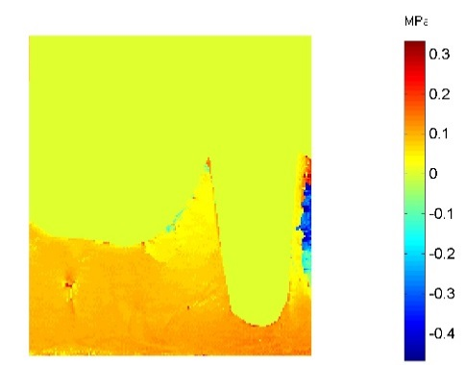
Figure 115 shows the stress distribution in a coronal plane through the lower right second premolar and the supporting bone in the slice II.
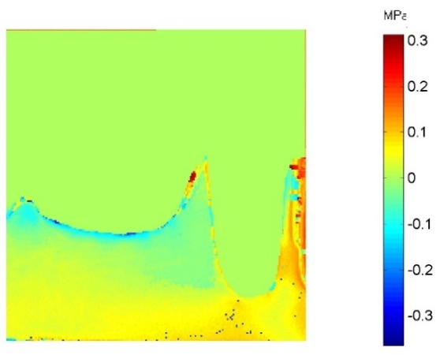

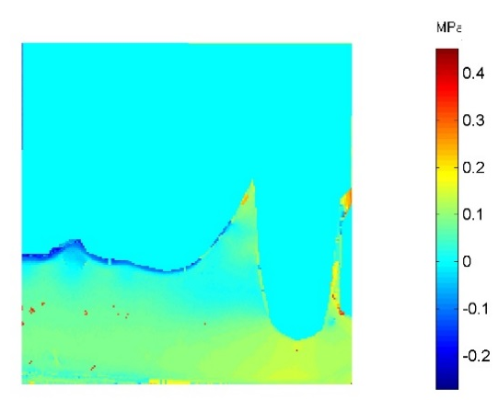
a.PMMA b.Polyamide

c.PEEK
Figure 115: Isochromatic phase map (Stress Direction) a. PMMA, b. Polyamide, c. PEEK.

Force distribution to the supporting structures was similar between the three dentures.
All dentures concentrated the applied stress under the apex of the teeth, and zero stresses in the lingual plate. The buccal plate in the Polyamide denture showed a higher stress than the rest of the slice indicating buccal tilting. While the PEEK denture concentrated stresses under the apex of the tooth, the PMMA denture concentrated the stress around the apical third of the root.
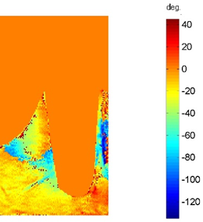
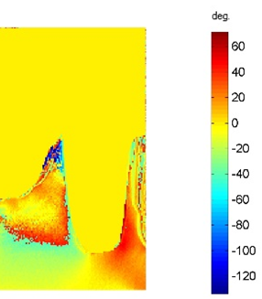
Figure 116shows the stress directions in a coronal plane through the lower second premolar and the surrounding bone.

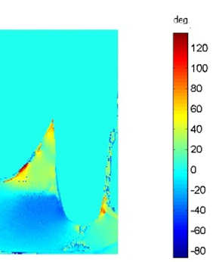
a.PMMA b.Polyamide

c.PEEK
Figure 116: Isoclinic phase map (Stress Direction) a. PMMA, b. Polyamide, c. PEEK.

Generally, the Polyamide dentures directed stresses toward the buccal side at different degrees, PEEK denture directed stresses toward the buccal side in the upper two third of the lingual plate and under the apex extending buccaly. While to the lingual side at the apical third lingually, and the PMMA denture directed the stresses at different degrees and direction.

Discussion
Using the hard tissue structure for denture support is considered better than using soft tissue support because the resiliency of the hard tissue structure limits the tissue ward movement. Conventional tissue supported materials cannot offer rest tooth support, because they lack the necessary mechanical properties. As discussed previously, removable partial dentures supported only by the mucosa covering the residual ridge tend to sink into the tissue and damage the periodontal tissue of the remaining teeth over time.
Another important drawback with the PMMA material is that its lack of good mechanical properties makes it susceptible to fracture. In addition, achieving sensitivity and engagement of a deep undercut is difficult because of the rigidity of the material. The polyamide flexible denture has a lower flexural modulus (higher flexibility) which is a disadvantage from the clinical standpoint because of uneven force distribution: moreover, repairs are difficult, in cases of, dropped teeth or clasps, fractures, or the need to reline the denture.
PEEK material has a low modulus of elasticity that could reduce the stresses on the abutment teeth, and reduce the denture rotation due to the differences in resiliency between the supporting tissues.
The purpose of this study was to evaluate the mechanical behaviour of three RPDs differing in their material properties, in relation to their load distribution in the free end saddle: a PMMA design, a Nylon polyamide flexible denture, and a denture using PEEK material and the same design as used in section 7.2 but excluding the occlusal rest.
The results of this study revealed that the differences in the map of stress distribution relate to the material properties. PMMA is a rigid material that distributes the applied load favourably over the residual ridge and around the abutment teeth; however, it covers the lingual surface above the height of the contour, directing the teeth toward the buccal side.
Polyamide flexible denture is a flexible material with a modulus of elasticity of 1.7 GPa. It distributes most of the applied load over the residual ridge, under the distal tooth and at the buccal plate of the supporting bone, indicating a buccal tilting of the teeth, a finding consistent with the work of (Jiao et al. 2009).
PEEK is a flexible material and has a modulus of elasticity of 4 GPa. The map of load distribution reflects the flexible behaviour of this material, the stresses seen mainly over the distal area of the residual ridge and under the abutment teeth, however at almost the same intensity.
The use of stress freezing photoelastic technique the digital technology allows viewing of the full map of stresses in the supporting bone of the distal abutment tooth in a buccolingual direction in the coronal plane (slice II). The map shows that in the PEEK denture the stresses were located under the apex of the distal teeth, indicating that the stresses were directed along their long axis, while in the case of conventional materials the stresses were located buccally, indicating the possibility of buccal tilting, especially in the flexible denture.
Clinically, the conventional tissue supported dentures, typically made from PMMA, present an additional problem: the surface area is much smaller compared to an upper denture and there can be no relief of the gingival margins. The acrylic major connector has to cover all the abutment surfaces to provide additional strength to the acrylic and support must be gained from the remaining teeth
otherwise the denture will tend to “sink” into the tissues with a resultant stripping of the gingivae. This type of major connector design enhances plaque accumulation. The lingual bar major connector in the PEEK denture does not cover the gingival margin and therefore better for the health of the gingiva.

Conclusion
1) The PEEK clasp design without occlusal rest has the advantages of saving the hard tooth tissue.
2) The advantages of the PEEK material properties that allows making clasp from the same material, allow transferring part of the applied load to the abutment teeth, moreover, in healthy way with no distal torque.
3) Under limitation of this study, and lack of clinical and laboratory studies, the PEEK material could be an alternative RPD to the conventional tissue supported materials.

: General Discussion

Current status of the RPD
RPDs are a common treatment option available for the restoration of partially dentate patients. Many studies indicate that the demand for RPDs is increasing, and this is attributed to the increased life span of the population. The more elderly patients now requiring RPDs often present with compromised oral and general health. In combination with this age related increase in tooth retention, the same population are also suggested to be less appropriate for extensive tooth preparation or implant retained prostheses than young people. Further, the proportion of cases presenting with free end saddles, which is the most challenging situation with the removable partial denture, is higher.
Although conventional removable partial dentures provide a low cost and non- invasive option compared to other forms of prosthodontics (Wostmann et al. 2005), there are negative attitudes toward removable partial dentures among patients and dentists alike.
Review of the current RPD status has demonstrated drawbacks of the current materials used in construction of RPDs. PMMA is the RPD material most commonly provided to patients. It is limited to use in tissue supported cases, and it has many shortcomings including, its lack of good mechanical properties that leads to fractures either through repeated flexing of the denture in the mouth or when the denture is dropped on a hard surface. Sensitivity to the residual monomer in the denture base after processing, polymerization shrinkage and its effect on the stability of the denture are other challenges that arise in using such a material. Acrylic is also unsuitable as a clasp material as it has high rigidity and low elasticity, making it susceptible to fracture.
Practically all cast frameworks for tooth supported and tooth tissue supported RPDs are made from CoCr alloys. This material has drawbacks too; it has a very high modulus of elasticity leading to the most common complications of permanent deformation and fatigue fracture of the clasp.
Flexible dentures produced from nylon are a further choice for tissue supported RPDs where PMMA is contraindicated such as in cases of hypersensitivity and deep undercuts. Again it is not a perfect solution; complications can include creep of nylon clasps and resultant loss of retention with long -term use, tendency to colour deterioration, staining, and high water sorption. The lower flexural modulus and susceptibility to plastic deformation if the load on the base and clasp is excessive, may lead to damage of the mucosa and reduce the denture’s retentive forces.
Bearing in mind that the aims of the RPD are to restore the oral function and preserve the integrity of the remaining oral structures, the ideal partial denture design should:
- reduce the stresses over the supporting tissues
- distribute the forces over as wide an area as possible
- influence the direction of the occlusal forces and direct these forces along the long axis of the tooth.

The conventional RPD material’s properties have been reported to be detrimental to the remaining structures, particularly regarding distribution of forces between teeth and the residual ridges. In relation to the tooth health, cobalt chromium alloys, due to their high modulus of elasticity (Bates 1980), increase the stresses on the tooth or alternatively lead to permanent deformation of the clasp.

The difference in resiliency between abutment teeth and the alveolar ridge in Kennedy Class I and II cases results in a rotary movement of the RPD around the fulcrum of the terminal abutments.

Several studies have been conducted to test different ways to provide better biomechanical functioning for RPDs, by reducing or more adequately distributing the stress between the abutment teeth and residual ridge. This has included investigating:
- the rigidity of the major connector
- rest seat and position
- clasp types
- RPI assemblies
- altered cast techniques
- base extension and adaptation
- occlusal table and number of teeth
- resilient inner layer
- using of denture supported implants
However, there are no definitive answers to the problem

One of the main problems with PMMA material is that it is often designed and constructed as a tissue supported denture, whereas a tooth supported denture would be more appropriate. Consequently, as bone resorption occurs, the denture slowly becomes ill-fitting, resulting in trauma to the gingival tissues, which sometimes become physically stripped away from the teeth, leading to loss of attachment (Wilson, 2009).

Flexible nylon dentures also tend to be tissue supported. The lower flexural modulus (higher flexibility) is considered a disadvantage from the clinical standpoint because of uneven force distribution (Ucar et al. 2012).
While there has been extensive research on different aspects of denture design to try to solve the problems related to stress distribution, the new of high performance polymer materials with different mechanical properties have yet to be evaluated for use as removable partial denture framework.
Polyetheretherketone is a semi-crystalline thermoplastic material which has good mechanical, physical and biological properties. It has many advantages that make it suitable for certain trauma applications, including, biocompatibility, high chemical resistance, good stiffness and strength properties, radiolucency and thermal stability at sterilization temperature, and the fact that it does not degrade during electron beam or gamma irradiation.
Although PEEK has many attractive properties, there is little evidence to support its use in RPD applications. The aim of this project was to evaluate PEEK’s material properties when fabricated as RPD framework, investigate its load distribution over the supporting structures, in comparison with current RPD materials and designs, and hence to design the support components to optimise the load distribution. The objective was to identify an appropriate material and design combination that could provide another RPD framework option by meeting many of the ideal requirements.
The intention was to use 3D Digital Photoelasticity, which combines the advantages of the stress freezing technique with advancements in technology in data collection, to compare the stress distribution of RPDs produced from Cobalt chromium, Polymethylmethacrylate, Valplast (Nylon polyamide) and Polyetheretherketone materials.
Models were produced for different patterns of tooth loss.
- Upper Class III modification 1 which could be tissue supported or tooth supported.
- Lower Class I which could be a tissue supported or tooth-tissue supported RPD.
Digital technology was used to design and produce the dentures where applicable.
For each scenario, duplicates of the master model were required in the appropriate photoelastic material.
Method of study
As analytical solutions are not possible for complex geometry, it is necessary to use experimental or numerical procedures. Photoelasticity directly provides stress field information and hence was chosen for analysis of the stress distribution in this project. The greatest advantage of this technique is the visualization of the stresses that enables them to be measured. It represents a real stress in a transparent model as a response to a load from a real object.
Resin model-making is the most important and fundamental step for the accurate use of the photoelasticity technique. The biggest challenge for this project was fabricating the resin model. The key to observing sharp and well- defined photoelastic data is the choice of suitable material to represent the main body of the photoelastic model.
In order to analyse the stresses, the material must provide specific properties:
- Transparency
- Absence of residual stresses
- High modulus of elasticity
- Good sensitivity to the load applied
Selection of the appropriate resin material suitable for the project and definition of the physical properties according to the calculated ratio required in house testing of the materials at the appropriate temperature. This is a time consuming and challenging process, but once the appropriate materials are defined multiple models can be made.
The aim was to fabricate dental models using two photoelastic resins with different stiffnesses, i.e. having moduli of elasticity of the same ratio as that of tooth to bone in order to carry out photoelastic experiments. Thus the modulus of elasticity between the two resins at their glass transition temperature is at the same ratio as bone to teeth. At this temperature the RPD framework could be loaded to lock-in the strains.
PL1 (Vishay precision group, USA) epoxy resin was chosen because of its proven track record and extensive use in the literature in photoelasticity studies. The material is cured by exothermic reaction resulting in a high amount of residual stress. Viewing the model under the polariscope showed this stress, which introduces errors into any photoelastic analysis. In order to overcome this, different annealing cycles were trialled; however, none proved completely successful in removing the residual stresses.
Araldite 2020 resin was selected due to its appropriate mechanical properties and colour. Viewing the fabricated model under the polariscope revealed no residual stresses, and it showed good sensitivity to light.
As a proposed technique in this project was stress freezing, where the photoelastic model is heated close to its glass transition temperature, the moduli at a range of temperatures had to be determined. A dynamic mechanical analyser (Perkin Elmer DMA 8000) was used for measuring the temperature-dependent elastic moduli selected. This enabled the definition of the glass transition temperature of the material. Accordingly, PL1 was selected to simulate the abutment teeth, while the Araldite 2020 was selected to simulate the rest of the model.
To simulate the PDL, and according to the study by (Broch et al. 2011), the light body silicon impression material President Plus light body (Coltene, Switzerland) proved the most effective due to its resilience matching that of natural PDL.
The difficulty in producing this layer is maintaining an intact PDL which covers the full root surface with an even thickness. The result is usually thicker at the apex. Sectioning the model can also lead to tearing of the PDL material or hole formation in the section.
Several photoelastic studies have used adhesive materials to simulate the PDL. To define the number of layers of adhesive material required to give a 0.2mm thickness, four abutment teeth were produced in stone. The root surfaces were covered with adhesive material (Permlastic adhesive, Italy), applying 3,4, or 5 layers of adhesive by dipping the roots in the material. The models were then sectioned and examined under a light microscope to measure the space. The results showed that 5 layers of the adhesive material gave the required thickness of 0.2mm.
The surface of the saddle area and the palate of the master cast were reduced by about 2mm overall by removing the dental stone to allow representation of the mucosa (MacGregor et al. 1978).
The 3D stress freezing technique was selected for this project. Although it has disadvantages of being time consuming and requiring a new model for each observation, it does allow study of the stress fields in multiple planes. This allows the supporting structures of the teeth in the coronal plane and the palate at the points of interest to be observed
Using digital means to collect data has revolutionised photoelastic analysis to the level of being able to quantitatively evaluate the information at every pixel over the model. Moreover, it allows study of the direction of the stresses affecting the abutment teeth movement and the direction of the expected movement.
Experimental results
The aim of the first experiment in section 5.1 was to define the load distribution from a PEEK denture designed conventionally with an occlusal rest with a 1 mm thickness, and hence, to define the efficiency of the conventional support component in fulfilling the support function.
A PEEK denture was provided based on a CoCr design, but the occlusal rest seat on the abutment teeth was prepared to a deeper thickness than the conventional rest seat to receive a thicker occlusal rest.
The results of the experiment 5.1 revealed important information regarding the stress pattern of the PEEK denture under conventional support design.
Firstly, providing a PEEK denture under such circumstances, even with increased occlusal rest thickness, actually results in a tissue supported and not a tooth supported prosthesis. Flexibility of the material leads to deflection of the saddle area, and the occlusal rest with a 1 mm thickness fails in transferring the occlusal load to the abutment teeth. The applied load is transferred as a whole to the ridge area.
Secondly, the stiffness of the material had an influence on the load distribution and consequently the design should be changed to enable supporting components to provide adequate support.
According to structural mechanics, the deflection of the part is inversely proportional to the modulus of elasticity. This means the deflection of the PEEK denture will increase, and hence the stiffness must be increased by increasing the cross-sectional thickness. To optimise the support function of the clasp and the rest component, the clasp arms were extended to cover the buccal and lingual surfaces of the tooth above the survey line. The result was a component that is shorter and wider than the conventional CoCr clasp assembly. The material above the survey line acts as a supporting element in addition to the occlusal rest. The results of the study in section 5.2 revealed that the support function of the optimised PEEK denture was enhanced by the new clasp design.
The results of all the PEEK dentures produced in this project revealed that the new support design enhanced the support function of the RPD. The highest stress was under the abutment teeth, and the stresses were mainly apical to the long axes of the abutment teeth, indicating a healthy force direction: moreover, the intensity of the stresses on the sides of the root were very low, indicating the absence of lateral forces.
Although the literature on the subject of removable partial prostheses places great stress on the design and construction of metal-based removable prostheses and very little on the acrylic mucosa born type, it remains a clinical fact that dentists are providing more mucosal borne acrylic dentures than the metal dentures. To my knowledge no previous research has specifically studied the load distribution aspect of the acrylic denture design, even though, the harmful effects of the tissue supported RPD on the supporting structure are clear.
The aim of the experiment in section 6.1 was to study the effects of 3 differently designed upper Class III modification 1 acrylic partial dentures on load distribution over the supporting structures. The results of this work showed the importance of including the surfaces of the tooth above the height of the contour where the denture contacts the teeth. This area of the denture assists in transferring part of the occlusal load to the teeth, thus preventing transfer of the whole load to the bone.
One of the main drawbacks of the acrylic tissue supported RPDs is their unsuitability as clasp material because of the material’s disadvantageous properties.
The results of the experiments in section 6.2 and section 8 revealed the advantages of the PEEK when used for an RPD. PEEK properties allow the production of clasps from the same material as the saddle area. The support function of the hand like clasp design transfers the applied load in a favourable way to the abutment teeth without need to prepare a seat for the occlusal rest, preserving the tooth structure; moreover, with such a clasp design it is possible to avoid contact with the gingiva and thereby to prevent gingival tissues from being physically stripped. It has good mechanical properties to resist fracture, yet is sufficiently flexible to pass a deep undercut.
Results of the experiments in sections 5.1, 6.2, and 8 support the concept of the importance of rigidity to proper load distribution. Results in section 5.1, revealed that the load distribution by the CoCr denture which had a modulus of elasticity of 211GPa, over the supporting structures was better than that by PEEK denture which had a modulus of 4GPa, under the same dimensions and design (Figure 117).
CoCr PEEK
Figure 117: Isochromatic phase map (stress magnitude) a. CoCr, b. PEEK

Results of the experiments in section 5.1, and 8 revealed that the Valplast material with a modulus of elasticity of 1.7GPa, consistent with previous studies showed the least favourable load distribution between (Jiao et al., 2009).
The effect of the flexibility of the PEEK material is clear in it is behaviour over the ridge area.
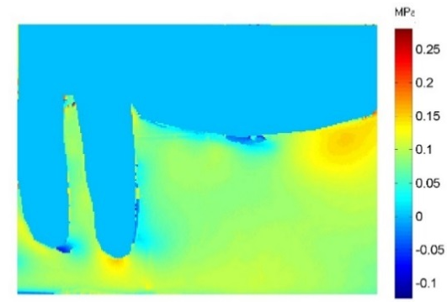
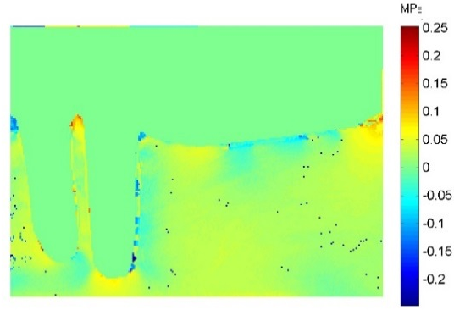

CoCr PEEK
Figure 118: Isochromatic phase map (stress magnitude) a. CoCr, b. PEEK

Further changes to the design and dimension of the free end saddle are necessary to optimise the load distribution. Results of section 7.2 and 8 revealed that the saddle area dimensions and design showed higher load concentration at some points over the ridge area than on the rest of the ridge, while the PMMA design in section 8 showed even load distribution all over the ridge.
The documented problem in free end saddle cases is the effect of the difference in resilience between the supporting tissues. Several studies have been conducted to explore the best design for CoCr material, with the aim of optimising the load distribution between the abutment teeth and the residual ridge.
The CoCr denture design chosen in the experiment in section 7.1 was the same as that used by (Nakamura et al. 2014), namely the use of a 3D nonlinear method of finite element analysis. The aims of this part of the study were first, to define the most favourable load distribution between the 3 designs; Second, to validate the results of the 3D photoelasticity technique with the other previous methods: strain gauge technique, Integrated photoelasticity, and finite element analysis.
The study showed that the RPI design produces the most favourable stress distribution to the supporting structures, and that the distal circumferential clasp design leads to distal movement of the abutment tooth.
The results of this study using 3D stress freezing digital photoelasticity are consistent with those from other studies that using different stress analysis techniques.
Interesting results from Chapter 7 include:
- The PEEK denture incorporating a new clasp design with distal rest produced almost the same load distribution as the RPI assemblies made from a stiff material. Both designs showed a uniform distribution of the applied load over the residual ridges and between the apices of the abutment teeth
2. The map in section 7.1.2 showed that the stress intensity of the PEEK denture with a distal rest was completely different from that of the CoCr circumferential clasp with distal rest. The circumferential clasp with a distal rest showed a high concentration of stress distal to the abutment tooth indicating a distal tipping, while the PEEK denture with distal rest showed a uniform map of stress intensity distal to the abutment tooth. This could be attributed to the flexibility of the material acting as a stress breaker. (Figure 119).
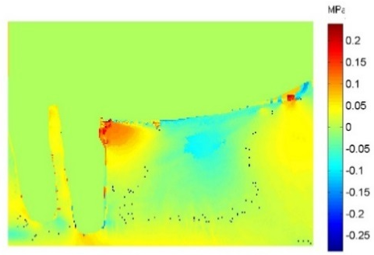

Circumferential CoCr design PEEK design

RPI CoCr design

Figure 119: Isochromatic phase map (stress magnitude) a. CoCr distal rest circumferential clasp design. b. PEEK distal rest design. c. RPI design.

Clinical Implications
It is too early to consider PEEK as an alternative RPD framework material. The material should be subjected to long term laboratory and clinical research covering all aspects of the clinical and material properties in order to base its potential use on sound scientific data. However, the results of this project show that the material has the following suitable attributes for use as a RPD:
1) The new clasp design proved to be unique in transferring the occlusal loads to the supporting structures in a healthy way. Zoidis et al. (2015) report a clinical case of a lower Class I RPD where CoCr material was compared with PEEK material. The authors suggested that the elasticity of the material might reduce the distal torque and the stress on the abutment teeth. The results of the current project supported this suggestion based on implementation of the new clasp design. There were no stresses on the proximal surfaces of the abutment teeth and all the load was transferred to the abutment teeth via transmission down the long axis.
As the main support action of the new clasp design is based on extension of the clasp above the height of the contour, provision may be limited by patient occlusion, morphology of the abutment teeth and the inclination of the tooth above the height of the contour, length of the tooth, and interdental space.
Although the extent and the shape of the clasp may promote plaque accumulation, many studies attribute this harmful effect of the RPD to patients’ poor oral hygiene and infrequency of visits to the clinic (Ezawi et al. 2017).
2) The PEEK denture is lighter than the CoCr denture, which will increase patients’ satisfaction.
3) In comparison to the conventional tissue supported RPD, the PEEK denture could be made with a clasp. there is also, potential to design smaller, more hygienic dentures which would avoid covering the gingival tissue.
4) The flexibility of PEEK reduces the stresses on the abutment teeth caused by the stiffness of the CoCr material.
5) The demonstrated biocompatibility of the PEEK material makes it a suitable material for use in situations where allergies to the conventional materials presents a problem.

:Conclusion and Future Work
- 3D stress freezing in combination with digital photoelasticity is a very useful technique that allows visualization and quantitative study of the stress distribution and direction throughout the supporting structures.
- 3D stress freezing enables interpretation of planes not possible with the conventional photoelastic techniques.
- Results of this investigation show that:
a. Providing tooth supported removable partial denture made in PEEK based on the conventional CoCr designs is not ideal. The denture acts as a tissue supported denture, b. The preparation of the occlusal tooth surface to receive the occlusal rest is scarifying the tooth surface with little benefit to the mechanics of the denture.
- PEEK material is a viable alternative to conventional tissue supported materials due to:
- Its ability to produce reliable clasps from the same material.
- Strength allow a hygienic design to be produced avoiding covering the gingiva.
- Biocompatibility
- PEEK has greater flexibility which could avoid the major drawbacks of the CoCr material which are applying a high stress due to the material stiffness, and could avoid the fatigue fracture.

Future work
- Finite element analysis techniques could help in predicting the areas of high stresses in the denture and therefore assist in further design optimization.
- Plastic materials are subject to creep under applied load. To consider the long term effects of the applied load the fatigue stress must be assessed.
- Modification to the basic new clasp design could be considered such as a clasp with mesial rest.
- Studying the new clasp design without an occlusal rest is an interesting point in preserving the tooth structure.
- A randomized clinical trial may be considered to assess new PEEK RPD dimensions and designs in comparison to the current PEEK denture with relation to function of the denture and how it may affect the patients’ satisfaction and quality of life.

:References

AL AWADY, A. & AL NAKKASH, W. 2012. Comparison of certain mechanical properties including deflection fatigue resistance of cobalt chromium alloy and nylon tooth colored clasping materials. J Bagh College Dentistry, 24, 6-10.
AL-IMAM, H., OZHAYAT, B., BENETTI, A., PEDERSEN, A. & GOTFREDSEN, K. 2016. Oral health-related quality of life and complications after treatment with partial removable dental prosthesis. Journal of Oral Rehabilitation, 43, 23-30.
ALBEROLA, N., MELE, P. & BAS, C. 1997. Tensile mechanical properties of PEEK films over a wide range of strain rates. II. Int J Appl Polym Sci, 64, 1053-1059.
ALI , M., NAIRN, R., SHERRIFF, M. & WATERS, N. 1997. The distortion of cast cobalt chromium alloy partial denture frameworks fitted to a working cast. J prosthet Dent, 78, 19-24.
ALJUDY, H. 2009. Studying the effect of the circumferential clasp arm design on stress distribution using three-dimensional finite element analysis. MDJ, 6, 55-60.
ALLEN, P., O'SULLIVAN, M. & LOCKER , D. 2009. Determining the minimally important difference for the oral health impact profile-20. Eur J Oral Sci, 117, 129-134.
ANGELO, A., CAPUTO, P., JON, P. 1987. Biomechanics in Clinical Dentistry, Berlin., Quintessence Publishing Co.
AQUINO, A., BARRETO, A., AQUINO, L., FERREIRA, A. & CARREIRO, A. 2011. Longitudinal clinical evaluation of undercut areas and rest seats of abutment teeth in removable partial denture. J of prosthodontics, 20, 639-642.
ARAFA, K. 2014. Effect of Three Different Clasp Designs on the Abutment Tooth Supporting Structures. Life Science Journal, 11, 725-728.
ARAFA, K. 2016. Comparing the effects of titanium alloy and chrome cobalt in removable partial denture connectors on tooth mobility, bone loss and tissue reaction. The Saudi Journal for Dental Research, 7, 112-117.
ARDA, T. & ARIKAN, A. 2005. An in vitro comparison of retentive force and deformation of acetal resin and cobalt-chromium clasps. J prosthet Dent, 94, 267-74.
AYDINLIK, E. & AKAY, H. 1980. Effect of a resilient layer in a removable partial denture base on stress distribution to the mandible. J of Prosthetic Dentistry, 44, 17-20.
BARRETO, A., AQUINO, L., AQUINO, A., RONCALLI, A., AMARAL, B. & CARREIRO, A. 2011. Impact on quality of life of removable partial denture wearers after 2 years of use. Braz J Oral Sci, 10, 50-54.
BARTON, A., SAGERS, R. & PITT, W. 1996. Bacterial adhesion to orthopedic implant polymers. J of Biomedical Materials Research., 30, 403-410.
BASKEER, M., HARRISON, A., DAVENPORT, J. & MARSHALL, J. 1988. Partial denture design in general dental practice-10 years on. British dental journal, 165, 245-7.
BASKER, R. & DAVENPORT, C. 1978. A survey of partial denture design in general dental practice. J of Oral Rehabilitation, 5, 215-222.
BATES, F. 1980. Retension of partial denture. British Dental Journal, 149, 171-4.
BECKER, C., KAISER, D. & GOLDFOGEL, M. 1994. Evolution of Removable Partial Denture Design. J of prosthodontics, 3, 158-166.
BEN-UR, Z., MIJIRITSKY, E., GORFIL, C. & BROSH, T. 1999. Stiffness of different designs and cross-sections of maxillary and mandibular major connectors of removable partial dentures. J Prosthet Dent, 81, 526-32.
BENSO, B., KOVALIK, A., JORGE, J. & CAMPANHA, N. 2013. Failure in the rehabilitation treatment with removable partial dentures. Acta Odontologica Scandinavica, 1-5.
BERGMAN, B. & ERICSON, G. 1989. Cross-sectional study of the periodontal status of removable partial denture patients. J Prosthet Dent, 61, 208-11.
BERGMAN, B., HUGOSON, A. & OLSSON, C. 1977. Caries and periodontal status in patients fitted with removable partial dentures. Journal of clinical periodontology, 4, 134-146.
BERGMAN, B., HUGOSON, A. & OLSSON, C. 1982. Caries,periodontal and prosthetic finding in patients with removable partial dentures: Aten-year longitudinal study. J of prosthetic dentistry, 48, 506-514.
BERGMAN, B., HUGOSON, A. & OLSSON, C. 1995. A 25 year longitudinal study of patients treated with removable partial dentures. J of Oral Rehabilitation, 22, 595-599.
BEZZON, O., PEDRAZZI, H., ZANIQUELLI, O. & DA SILVA, B. 2004. Effect of casting technique on surface roughness and consequent mass loss after polishing of NiCr and CoCr base metal alloys: A comparative study with titanium. J Prosthet Dent, 92, 274-7.
BHOJARAJU, N., SRILAKSHMI, J. & VISHWANATH, G. 2014. Study of Deflections in Maxillary Major Connectors: A Finite Element Analysis. J Indian Prosthodont Soc, 14, 50-60.
BHOLA, R., BHOLA, S., LIANG, H. & MISHRA, B. 2010. Biocompatible Denture Polymers- A Review. Trends Biomater. Artif. Organs, 23, 129-136.
BIBB, R. & EGGBEER, D. 2006. Rapid manufacture of removable partial denture framework. Rapid prototyping J, 12, 95-99.
BILHAN, H., ERDOGAN, O., ERGIN, S., CELIK, M., ATES, G. & GECKILI, O. 2012. Complication rates and patient satisfaction with removable dentures. J Adv Prosthodont, 4, 109-15.
BODEN, S., ZDEBLICK, T., SANDHU, H. & HEIM, S. 2002. The use of rhBMB-2 in interbody fusion cages. Definitive evidence of osteoinduction in humans; A preliminary report. Spin, 25, 376-81.
BOINARD, E., PETHRICK, R. & MACFARLANE, C. 2000. The influence of thermal history on the dynamic mechanical and dielectric studies of PEEK exposed to water and brine. polymer, 41, 1063-1076.
BORCHERS, L., TAVASSOL, F. & TSCHERNITSCEK, H. 1999. Surface quality achieved by polishing and by varnishing of temporary crown and fixed partial denture resins. J Prosthet Dent, 82, 550-6.
BORTOLINI, S., NATALI, A., FRANCHI, M., COGGIOLA, A. & CONSOLO, U. 2011. Implant-retained removable partial dentures: An 8-year retrospective study. J of Prosthodontics, 20, 166-172.
BRADLEY, J. & HASTINGS, G. 1980. Carbon fibre reinforced epoxy as a high strength, low modulus material for internal fixation plates. Biomaterials, 1, 38-40.
BRENNAN, D., SPENCER, A. & ROBERTS, K. 2008. Tooth loss, chewing ability and quality of life. Qual life Res, 17, 227-235.
BRENTIGAN, J. & STEFFEE, A. 1993. A carbon fiber implant to aid interbody lumber fusion. Two-year clinical results in the first 26 patients. Spine, 18, 2106-7.
BRIDGEMAN, J., MARKER, V., HUMMEL, S., BENSON, B. & PACE, L. 1997. Comparison of titanium and cobalt-chromium removable partial denture clasps. J Prosthet Dent, 78, 187-93.
BRODSKY, J., CAPUTO, A. & FURSTMAN, L. 1975. Root tipping: A photoelastic-histopathologic correction. Am. J. Orthod, 67.
BROWN, S., HASTINGS, R., MASON, J. & MOET, A. 1990. Characterization of short fibre reinforced thermoplastics for fracture fixation devices. Biomaterials, 11, 541-547.
BRUDVIC, J. & PALACIOS, R. 2007. Lingual retention and the elimination of the visible clasp arm. J of Comilation, 19, 247-254.
BRUDVIK, J. & MORRIS, H. 1981. Stress relaxation testing. Part III: Influence of wire alloys, gauges, and lengths on clasp behavior. J Prosthet Dent, 46, 374-379.
BUGGY, M. & CAREW, A. 1994. The effect of thermal ageing on carbon fibre-reinforced PEEK. J of Materials Science, 29, 1925-1929.
CAMPBELL, S., COOPER, L., CRADDOCK, H., HYDE, P., NATTRESS, B., PAVITT, S. & SEYMOUR, D. 2017. Removable partial dentures: The Clinical need for innovation. The Journal Of Prosthetic Dentistry.
CARR, A. & BROWN, D. 2011. McCracken's Removable Partial Prosthodontics, ELSEVIER MOSBY.
CARRANZA, F. & NEWMAN, M. 1996. Clinical Periodontology., USA, W.B.Saunders Company.
CECCONI, B. 1974. Effect of rest design on transmission of forces to abutment teeth. J Prosthet Dent, 32, 141-151.
CECCONI, B., ASGAR, K. & DOOTZ, E. 1971. Removable partial denture abutment tooth movement as affected by inclination of residual ridges and type of loading. J Prosth Dent, 25, 357-381.
CECCONI, B., ASGAR, K. & DOOTZ, E. 1972. Clasp assembly modifications and their effect on abutment tooth movement. J Prosthet Dent, 27.
CHANDLER, J. & BRUDVIC, J. 1984. Clinical evaluation of patients eight to nine years after placement of removable partial dentures. J Prosthet Dent, 51.
CHENG, H., XY, M., ZHANG, H., WU, W., ZHENG, M. & LI, X. 2010. Cyclic fatigue properties of cobalt-chromium alloy clasps for partial removable dental prostheses. J Prosthet Dent, 104, 389-396.
CHIVERS, R. & MOORE, D. 1994. The effect of molecular weight and crystallinity on the mechanical properties of injection moulded poly(aryl-ether-ether-ketone). polymer, 35, 110-116.
CHOU, T., CAPUTO, A. & MOORE, D. 1989. Photoelastic analysis and comparison of force transmission characteristics of intracoronal attachments with clasp distal-extension removable partial dentures. J Prosthet Dent, 62.
CLAYTON, J. & JASLOW, C. 1971. A measurement of clasp forces on teeth. J Prosth Dent, 25, 21-43.
CLOUD, G. 2007. Optical methods in Experimental mechanics. Society of Experimental Mechanics.
CLOUD, G. 2010. Optical methods in Experimental mechanics. Society of Experimental Mechanics.
COSTA, M., DE SILVA, M., OLIVEIRA, S., GOMES, V., CARVALHO, P. & LUCAS, B. 2009. Photoelastic study of the support structures of Distal-extension removable partial dentures. J of prosthodontics, 18, 589-595.
COTMORE, J., MINGLEDORF, E., POMERANTZ, J. & GRASSO, J. 1983. Removable partial denture survey : clinical practice today. J of prosthetic dentistry, 49.
CULWICK, P., HOWELL, P. & FAIGENBLUM, M. 2000. The size of occlusal rest seats prepared for removable partial dentures. British Dental Journal, 189, 318-322.
CURTIS, D., CURTIS, T., WAGNILD, G. & FINZEN, F. 1992. Incidence of various classes of removable partial dentures. J Prosthet Dent, 67, 664-7.
DALLY, J. W. & RILEY, W. F. 1991. Experimental Stress Analysis, Singapore.
DANG, S., HOU, M. & YE, L. 2007. Temperature-dependent elastic moduli of epoxies measured by DMA and their correlations to mechanical testing data. Polymer testing, 26, 803-813.
DAVENPORT, J., BASKER, R., HEATH, J., RALPH, J., GLANTZ, P. & HAMMOND, P. 2001. Clasp design. British Dental Journal, 190, 71-81.
DE ALBA, J., CAPUTO, A. & CHACONAS, S. 1979. Effects of orthodontics intermaxillary class lll mechanica on craniofacial structures: l. Photoelastic analysis. Angle Orthod, 49.
DEBOER, J. 1988. The effect on function of distal-extension removable partial dentures as determined by occlusal rest position. J of Prosthetic Dentistry, 60, 693-696.
DEO, K., WALISZEWSKI, M., WALISZEWSKI, K. & BERZINS, D. 2011. Survey of partial removable dental prosthesis types in a distinct patient population. J prosthet Dent, 106, 48-56.
DEVAN, A. 1956. The nature of partial denture foundation: suggestion for its preservation. J Pros Dent, 2, 210-18.
DHAMAR, S. & RATHNASAMY, J. 1993. Radiographic and metallographic evaluation of porosity defects and grain structure of cast chromium cobalt removable partial dentures. J Prosthet Dent, 69, 369-373.
DOUGLASS, C., GAMMON, M. & ATWOOD, A. 1988. Need and effective demand for prosthetic treatment. J of prosthetic dentistry, 59, 94-104.
DOYLE, J. & PHILLIPS, J. 1989. Manual on Experimental Stress Analysis. 5th edition ed.: Society of Experimental Mechanics.
DULA, L., AHMEDI, E., KRASNIQI, Z. & SHALA, K. 2015. Clinical Evaluation of Removable Partial Dentures on the Periodontal Health of Abutment Teeth: A Retrospective Study. The Open Dentistry Journal, 9, 132-139.
EL SHEIKH, A. & AL ZAHRANI, S. 2006. Causes of denture fracture: A survey. Saudi dental journal, 18, 149-154.
ELCHARKAWI, H. & ELMAHDY, A. 1988. The effect of resilient layer and occlusal reactive complete dentures on the residual alveolar ridge. J of Prosthetic Dentistry, 59, 598-602.
ERLEE, H., HUI WU, J., HSIANG WANG, C., HSUN LAN, T. & KANG DU, J. 2008. Biomechanical analysis of distal extension removable partial dentures with different retainers. J Dent Sci, 3, 133-139.
ESSOP, A., SALT, S., SYKES, L., CHANDLER, H. & BECKER, P. 2000. The Flexibility of Titanium clasps compared with Cobalt-Chromium clasp. Journal of the South African Dental Association, 55, 672-677.
EZAWI, A., GILLAM, D. & TAYLOR, P. 2017. The Impact of Removable Partial Dentures on the Health of Oral Tissues: A Systematic Review. International Journal of Dentistry and Oral Health, 3.
FEINGOLD, G., GRANT, A. & JOHNSON, W. 1988. The effect of variation of residual ridge angle on partial denture abutment tooth movement. J of Oral Rehabilitation, 15, 379-384.
FERNANDES, M., RUTA, D., OGDEN, G., PITTS, N. & OGSTON, S. 2006. Assessing oral health-related quality of life in general dental practice in scotland: validation of the OHIP-14. Community Dent Oral Epidemiol, 34, 53-62.
FERNANDEZ, M. 2011. Metrological study for the optimal selection of the photoelastic model in transmission photoelasticity. Appl.Opt, 50, 5721-5727.
FITTIN, J., DAVIES, E., HOWLETT, J. & PEARSON, G. 1994. The physical properties of a polyacetal denture resin. Clin Mater, 17, 125-9.
FRANK, R., BRUDVIK, J. & NICHOLLS, J. 1983. A comparison of the flexibility of wrought wire and cast circumferential clasps. J prosthetic Dentistry, 49, 471-476.
FRANK, R., BRUDVIK, J. & NOONAN, C. 2004. Clinical outcome of the cast impression procedure compared with use of a one-piece cast. J Prosthet Dent, 91, 468-76.
FRANK, R., MILGROM, P. & LEROUX, B. 1998. Treatment outcomes with mandibular removable partial dentures: A population-based study of patient satisfaction. J Prosthet Dent, 80, 36-45.
FRECHETTE, A. 1955. The influence of partial denture design on distribution of force to abutment teeth. J Pros Dent, 6, 195-212.
FREITAS, R., DIAS, C., CARREIRO, F., BARBOSA, G. & FERREIRA, M. 2012. Mandibular implant-supported removable partial denture with distal extension: a systematic review. J of Oral Rehabilitation, 39, 791-798.
FUEKI, K., YOSHIDA, E. & IGARASHI, Y. 2011. Astructural equation model relating objective and subjective masticatory function and oral health-related quality of life in patients with removable partial dentures. J of Oral Rehabilitation, 38, 86-94.
GATES, W., COOPER, L., SANDERS, A., RESIDE, G. & DE KOK, I. 2012. The effect of implant-supported removable partial dentures on oral health quality of life. Clin Oral Imp Res, 00, 1-7.
GHANI, F. & MAHOOD, M. 1990. A laboratory examination of the behaviour of cast cobalt-chromium clasps. J of Oral Rehabilitation, 17, 229-237.
GODARA, A., RAABA, D. & GREEN, S. 2007. The influence of sterilization processes on the micromechanical properties of carbon fiber-reinforced PEEK composites for bone implant applications. Acta Biomaterials, 3, 209-220.
GRAHAM, R., MIHAYLOV, S., JEPSON, N. & BOND, S. 2006. Determining need for a removable partial denture: a qualitative study of factors that influence dentist provision and patient use. British Dental Journal, 200, 155-158.
GROSSMANN, A., HASSEL, A., SHILLING, O., LEHMANN, F. & KOOB, A. 2007. Treatment with double crown- retained removable partial dentures and oral health related quality of life in middle and high aged patients. Int J prosth, 20, 576-8.
HAHNEL, S., WIESER, A., LANG, R. & ROSENTRITT, M. 2014. Biofilm formation on the surface of modern implant abutment materials. Clin.Oral Impl.Res, 26, 1297-1301.
HAMA, A. 2016. Rehabilitation Prosthesis Provided To The Partially Edentulous Patients Visiting Piramerd Dental Center. International Journal of Information and Review., 3, 2633-2635.
HARGREAVES, A. 1969. The prevalence of fractured dentures. A survey. British Dental Journal, 126, 451-455.
HARLOFF, T., HONLE, W., HOLZWARTH, U., BADER, R., THOMAS, P. & SCHUH, A. 2010. Titanium allergy or not? Impurity of titanium implant materials. Health, 2, 306-310.
HEIMER, S., SCHMIDLIN, P. & STAWARCZYK, B. 2016. Discoloration of PMMA, Composite, and PEEK. Clin Oral Invest.
HERO, H., SYVERUD, M. & WAARLI, M. 1993. Mold filling and porosity in casting of titanium. Dent Mater, 9, 15-18.
HUNTER, A., ARCHER, C., WALKER, P. & BLUNN, G. 1995. Attachment and proliferation of osteoblasts and fibroblasts on biomaterials for orthopaedic use. Biomaterials, 16, 287-295.
ICHIKAWA, T., HIROTA, K., KANITANI, H. & MIYAKE, Y. 1998. In vitro adherence of Streptococcus constellatus to dense hydroxyapatite and titanium. 25, 125-127.
IGARASHI, Y., OGATA, A., KUROIWA, A. & WANG, C. 1999. Stress distribution and abutment tooth mobility of distal-extension removable partial dentures with different retainers: an in vivo study. J of Oral Rehabilitation, 26, 111-116.
INUKAI, M., BABA, K., JOHN, M. & IGARASHI, Y. 2008. Does removable partial denture quality affect individuals oral health? J Dent Res, 87, 736.
ITO, M., WEE, A., MIYAMOTO, T. & KAWAI, Y. 2013. The combination of a nylon and traditional partial removable dental prosthesis for improved esthetics: A clinical report. J prosthet Dent, 109, 5-8.
ITOH, H., BABA, K., ARIDOME, K., OKADA, D., TOKUDA, A., NISHIYAMA, A., MIURA, H. & IGARASHI, Y. 2008. Effect of direct retainer and major connector designs on RPD and abutment tooth movement dynamics. Journal of Oral Rehabilitation, 35, 810-815.
IWATA, Y. 2016. Assessment of clasp design and flexural properties of acrylic denture base materials for use in non-metal clasp dentures. J of Prosthodontic Research, 114-122.
JAGGER, D., HARRISON, A. & JANDT, K. 1999. The reinforcement of dentures. J of Oral Rehabilitation, 26, 185-194.
JEPSON, N., MOYNIHAN, P., KELLY, P., WATSON, W. & THOMASON, M. 2001. Caries incidence following restoration of shortened lower dental arches in a randomized controlled trial. British Dental Journal, 191, 140-144.
JEPSON, N., THOMASON, M. & STEELE, J. 1995. The influence of denture design on patient acceptance of partial dentures. BDJ, 178, 296-300.
JEYAPALAN, V. & KRISHNAN, C. 2015. Partial Edentulism and its Correlation to Age,Gender,Socio-economic Status and Incidence of Various Kennedy's Classes- A Literature Review. Journal of Clinical and Diagnostic Research, 9, 14-17.
JIAO, T., CHANG, T. & CAPUTO, A. 2009. Load transfer characteristics of unilateral distal extension removable partial dentures with polyacetal resin supporting components. Australian Dental Journal, 54, 31-37.
JOCKISH, K., BROWN, S., BAUER, T. & MERRITT, K. 1992. Biological response to chopped-carbon-fibre-reinforced PEEK. J Biomed Mater Res, 26, 4871-9.
JONES, D., LEACH, D. & MOORE, D. 1985. Mechanical properties of poly(ether-ether-ketone) for engineering applications. Polymer, 26, 1385-1393.
JOREGENSEN, E. & BOCHET, G. 1998. Alternate framework designs for removable partial dentures. J Prosthet Dent, 80, 58-66.
JORGE, J., GIAMPAOLO, E., VARGANI, C., MACHADO, A., PAVARINA, A. & CARLO, I. 2007. Biocompatibility of denture acrylic resins evaluated in culture of L929 cells. Effect of polymerisation cycle and post-polymerisation treatments. Gerodontology, 24, 52-57.
JORGENSEN, E. & ISIDOR, F. 1990. A 5-year longitudinal study of cantilevered fixed partial dentures compared with removable partial dentures in a geriatric population. J Prosthet Dent, 64, 42-7.
JOSE, A., COCO, B., MILLIGAN, S., YOUNG, B., LAPPIN, D., BAGG, J., MURRAY, C. & RAMAGE, G. 2010. Reducing the incidence of denture stomatitis: Are denture cleansers sufficient? J of Prosthodontics, 19, 252-257.
KABCENELL, J. 1962. Effective clasping of removable partial dentures. J Pros Dent, 12, 104-110.
KAIRES, A. 1956a. Effect of partial denture design on bilateral force distribution. J Pros. Dent, 6, 373-385.
KAIRES, A. 1956b. Partial denture design and its relation to force distribution and masticatory performance. J Pros Den, 6, 672-683.
KARAAGACLIOGLU, L., CAN, G., YILMAZ, B., AYHAN, N., SEMIZ, O. & LEVENT, H. 2008. The adherence of candida albicans to acrylic resin reinforced with different fibers. J Mater Sci: Mater Med, 19, 959-963.
KARL, M., DICKINSON, A., HOLST, S. & HOLST, A. 2009. Biomechanical Methods Applied in Dentistry: A Comparative Overview of Photoelastic Examinations, Strain Gauge Measurements, Finite Element Analysis and Three-Dimensional Deformation Analysis. Eur J Prosthodont Restor Dent, 17, 50-57.
KASLIWAL, M. & O'TOOLE, J. 2014. Clinical experience using Polyetheretherketone (PEEK) intervertebral structural cage for anterior cervical corpectomy and fusion. Journal of clinical Neuroscience, 21, 217-220.
KASPERSKI, J., CHLADEK, G. & PLONKA, L. 2013. The analysis of the effect of wrought wire clasps on the conditions of abutment teeth. Acta of bioengineering and biomechanics, 15, 27-33.
KATZER, A., MARQUARDT, H., WESTENDORF, J., WENING, J. & FOERSTER, G. 2002. Polyetheretherketone-cytotoxicity and mutagenicity in vitro. Biomaterials, 23, 1749-1759.
KAWANISHI, S., HIRAKU, Y., MURATA, M. & OIKAWA, S. 2002. The role of metals in site-specific DNA damage with reference to carcinogenesis. Free radical biology and medicine, 32, 822-832.
KERN, M. & WAGNER, B. 2001. Periodontal findings in patients 10 years after insertion of removable partial dentures. Journal of Oral Rehabilitation, 28, 991-997.
KHAN, S. 2005. Aesthetic clasp design for removable partial dentures: A literature review. SADJ, 60, 190-194.
KNEZOVIC, Z., CELEBIC, A., VALENTIC, M. & JERELIMOV, V. 2003. A Survey of treatment outcomes with removable partial denture. J Oral Rehabil, 30, 847-854.
KOTAKE, M., WAKABAYASHI, N., ALI, M., YONEYAMA, I. & HAMANAHA, H. 1997. Fatigue resistance of Ti-Ni alloy cast slasps. Int J of Prosthodontics, 10, 547-52.
KOUTIS, D. & FREEMAN, S. 2001. Allergic contact stomatitis caused by acrylic monomer in a denture. Australian J of Dermatology, 42, 203-206.
KOYAMA, S., SASAKI, K., YOKOYAMA, M., SASAKI, T. & HANAWA, S. 2010. Evaluation of factors affecting the continuing use and patient satisfaction with removable partial dentures over 5 years. J of Prosthodontic Research, 54, 97-101.
KRATOCHVIL, F. 1963. Influence of occlusal rest position and clasp design on movement of abutment teeth. J Pros Dent, 13, 114-124.
KROL, A. 1973. Clasp design for extension-base removable partial dentures. J Prosthet Dent, 29, 408-415.
KUEH, T. & RAZA, F. 2012. Evaluation of physical properties and casting accuracy of chrome cobalt alloys with different systems and investments. J of physical science, 23, 91-102.
KUMAR, M., BHAGATH, S. & BRINTHA, J. 2010. Historical interest of denture base materials. SRM university J of Dental Sciences, 1, 103-105.
KUMAR, S., GUPTA, G., RAO, H., SHARMA, A., KUMAR, R. & GARG, P. 2012. Oral rehabilitation using supplementary tooth supplement and enhance stability and support in case of non-syndromic multiple supernumerary teeth- A case report. Int J Dent, 2, 46-50.
KURTZ, S. 2012. PEEK Biomaterials Handbook, USA, ELSEVIER.
KURTZ, S. & DEVINE, J. 2007. PEEK biomaterials in trauma, orthopedic, and spinal implants. Biomaterials, 28, 4845-4869.
KWARTENG, K. & STARK, C. 1990. Carbon fiber reinforced PEEK (APC-2/AS-4) composites for orthopedic implants. SAMPE Q, 10.
KYDD, W., DALLY, C. & WHEELER, J. R. 1971. The Thickness Measurement of Masticatory Mucosa in Vivo. Int Dent J, 21, 430-441.
LAGGAT , P., AUSTRALLIA, T., KEDJARUNE, U. & THAILAND, H. 2003. Toxicity of methyl methacrylate in dentistry. Int Dental J, 53, 126-131.
LALOR, P., REVELL, P., GRAY, A., WRIGHT, S., RAILTON, G. & FREEMAN, M. 1991. Sensitivity to Titanium: A cause of failure? The J of bone and joint surgery, 73, 25-28.
LANG, L., MATTIE, P. & RAWIS, H. 2000. The effect of triphenylbismuth on radiopacity and performance properties of compression- and injection-molded denture resins. J Prosthodont, 9.
LEGHISSA, P., FERRARI, M., PIAZZOLLA, S., CAIRONI, M., PARIGI, P. & LEOBBOLO, E. 1994. Cobalt exposure evaluation in dental prostheses production. Sci total Environ, 150, 253-257.
LEKHA, K., SAVITHA, N., ROSELINE, M. & NADIGER, R. 2012. Acetal resin as an esthetic clasp material. J of Interdisciplinary Dentistry, 2, 11-14.
LEUPOLD, R., FLINTON, R. & PFEIFER, D. 1992. Comparison of vertical movement occurring during loading of distal- extension removable partial denture bases made by three impression techniques. J Prosthet Dent, 68, 290-3.
LEUPOLD, R. & KRATOCHVIL, F. 1965. An altered-cast procedure to improve tissue support for removable partial dentures. J Pros Dent, 15, 672-678.
LI, H., FOURACRE, A., GIVEN, M., BANFORD, H., WYSOCKI, S. & KAROLCZAK, S. 1999. The effects on polyetheretherketone and polyethersulfone on electron and irradiation. IEEE, 6, 295-303.
LILJELIND, I., ERIKSSON, K., NILSSON, L., BIRGITTA, I., JONSSON, M. & BURSTROM, Y. 2005. A method for measuring the potential dermal exposure to methylmethacrylate during two different dental technical work tasks. Royal Society of Chemistry, 7, 519-523.
LUNG, C. & DARVELL, B. 2005. Minimization of the inevitable residual monomer in denture base acrylic. Dental Materials, 21, 119-1128.
LYNCH, C. & ALLEN, P. 2003. Survey of chrome cobalt removable partial denture design in Ireland. Int J Prosth, 16, 362-4.
LYNCH, C. & ALLEN, P. 2006. Why do dentists struggle with removable partial denture design? An assessment of financial and educational issues. British Dental Journal, 200, 277-281.
LYNCH, D. & ALLEN, P. 2005. Quality of written prescriptions and master impressions for fixed and removable prosthodontics: a comparative study. British Dental Journal, 198, 17-21.
MACGREGOR, A., MILLER, T. & FARAH, J. 1978. Stress analysis of partial dentures. Journal of Dentistry, 6, 125-132.
MAHMOUD, A., WAKABAYASHI, N. & TAKAHASHI, H. 2007. Prediction of permanent deformation in cast clasps for denture prostheses using a validated nonlinear finite element model. Dental Materials, 23, 317-324.
MAXFIELD, J., NICHOLLS, J. & SMITH, D. 1979. The measurement of forces transmitted to abutment teeth of removable partial dentures. J of Prosthetic Dentistry, 41.
MCCRACKEN, W. 1958. Contemporary partial denture designs. J Pros Dent, 8, 71-84.
MEEUWISSEN, J., VAN WAAS, M., MEEUWISSEN, R. & KAYSER, A. 1995. Satisfaction with reduced dentitions in elderly people. J of Oral Rehabilitation, 22, 397-401.
MENDENHALL, S. 2010. Spinal industry update. Orthopedic Network News., 21, 3-6.
MENG, T. & LATTA, M. 2005. Physical properties of four acrylic denture base resins. J of contemporary dental practice, 6, 1-5.
MESQUITA, A., SILVA, J., KOJIMA, A., MOURA, R., GIOVANI, E. & OZCAN, M. 2017. Allergic reaction to acrylic resin in a patient with a provisional crown: case report. Brazilian Dental Science, 20, 115-118.
MITRANI, R., BRUDVIK, J. & PHILLIPS, K. 2003. Posterior implants for distal extension removable prostheses: A retrospective study. Int J Periodontics Restorative Dent, 23, 353-359.
MIZUUCHI, W., YATABE, M., SATO, M., NISHIYAMA, A. & OHYAMA, T. 2002. The effect of loading locations and direct retainers on the movements of the abutment tooth and denture base of removable partial dentures. J Med Dent Sci, 49, 11-18.
MOHAMMED, S. & DESAI, H. 2014. Basic Concepts of Finite Element Analysis and its Applications in Dentistry; An Overview. Oral Hyg Health, 2, 2-5.
MOJON, P., THOMSON, J. & WALLS, A. 2004. The impact of falling rates of edentulism. Int J prosthodont, 17, 434-40.
MORRIS, H., ASGAR, K., BRUDVIK, J., WINKLER, S. & ROBERTS, E. 1983. Stress relaxation testing. Part IV: clasp pattern dimensions and their influence on clasp behaviour. J of Prosthet Dent, 50, 319-326.
MORRIS, H. & BRUDVIK, J. 1986. Influence of polishing on cast clasp properties. J Prosthet Dent, 55, 75-77.
MUHAMED, N. & ABDUL KADIR, M. 2010. Toxic element releases from high and low carbon CoCrMo alloy In vitro.
MURAKI, H., WAKABAYASHI, N., PARK, I. & OHYAMA, T. 2004. Finite element contact stress analysis of the RPD abutment tooth and periodontal ligament. J of Dentistry, 32, 659-665.
MURRAY, M. & DYSON, J. 1988. A study of the clinical fit of cast cobalt chromium clasps. Journal of Dentistry, 16, 135-9.
NAIRN, R. 1974. The design of the partial denture framework. J of Dentistry, 9, 157-170.
NAJEEB, S., ZAFER, M., KHURSHID, Z. & SIDDIQUI, F. 2016. Applications of Polyetheretherketone (PEEK) in oral implantology and prosthodontics. Journal of Prosthetic Research, 60, 12-19.
NAKAMURA, Y., KANBARA, R., OCHIAI, K. & TANAKA, Y. 2014. A Finite Element Evaluation of Mechanical Function for 3 Distal Extension Partial Dental Prosthesis Designs with A 3-Dimentional Nonlinear Method for Modeling Soft Tissue. J Prosth Dent, 112, 972-980.
NASSANI, M., DELVIN, H., TARAKJI, B. & MCCORD, J. 2011. Designing cobalt chromium removable partial dentures for patients with shortened dental arches-a pilot survey. J of Oral Rehab, 38, 608-614.
NEGRUTIU, M., SINESCU, C., ROMANU, M., POP, D. & LAKATOS, S. 2005. Thermoplastic resins for flexible framework removable partial dentures. TMJ, 55, 295-299.
NEVALAINEN, M., NARHI, T. & AINAMO, A. 2004. A5-year follow-up study on the prosthetic rehabilitation of the elderly in Helsinki, Finland. Journal of Oral Rehabilitation, 31, 647-652.
OHKUBO, C., HANATANI, S. & HOSOI, T. 2008. Present status of titanium removable dentures- a review of the literature. J of Oral Rehabilitation, 35, 706-714.
OHSHIMA, A. 2004. A fundamental study on retentive force of titanium cap clasp. Tsurmi Univ Dent J., 30, 41-51.
OLUWAJANA, F. & WALMSLEY, A. 2012. Titanium alloy removable partial denture framework in a patient with a metal allergy: a case study. British dental journal, 213, 123-124.
PARK, C. & KAY, K. 2009. photoelastic stress analysis of the mandibular unilateral free-end removable partial denture according to the design. J Kep, 47.
PARVIZI, A., LINDQUIST, T., SCHNEIDER, R., WILLIAMSON, D., BOYER, D. & DAWSON, D. 2004. Comparision of the dimensional accuracy of injection-molded denture base materials to that of conventional pressure-pack acrylic resin. J Prosthodont, 13, 83-89.
PATEL, M., BRADEN, M. & DAVY, K. 1987. Polymerization shrinkage of methacrylate esters. Biomaterials, 8, 53-56.
PATEL, N., BREDENKAMP, B. & YENGOPAL, V. 2001. A survey of Removable Partial Dentures produced by Commercial Laboratory. IADR-South African Division. South Africa.
PATTERSON, E. 2002. Digital Photoelasticity: Principles, Practice and Potential. Strain, 38, 27-39.
PATTERSON, E. & WANG, Z. 1991. Towards full-field automated photoelastic analysis of complex components. Strain, 27, 49-56.
PELLIZZER, E., FERRACO, R., TONELLA, B., OLIVEIRA, B., SOUZA, F. & FALCON-ANTENUCCI, R. 2010. Influence of ridge type on mandibular distal extension removable partial denture. Acta Odontol. Latinoam, 23, 68-73.
PETILLO, O., PELUSO, G., AMBROSIO, L. & NICOLAIS, L. 1994. In vivo induction of macrophage Ia antigen (MHC class II) expression by biomedical polymers in the cage implant system. J Biomed Mater Res, 28, 635-46.
PETRIDIS, H. & HEMPTON, T. 2001. Periodontal consideration in removable partial denture treatment: A review of the literature. Int J Prostho, 14, 164-172.
PEZZOLI, M., ROSSETTO, M. & CALDERALE, P. 1986. Evaluation of load transmission by distal-extension removable partial dentures by using reflection photoelasticity. J of prosthetic dentistry, 56, 329-337.
PHOENIX, R., CAGNA, D. & DEFREEST, C. 1992. Stewart's Clinical Removable Partial Prosthodontics., China, Quintessence Publishing Co, Inc.
PIENKOS, T., MORRIS, J., GRONET, P., CAMERON, S. & LOONEY, S. 2007. The strength of multiple major connector designs under simulated functional loading. J Prosthet Dent, 97, 299-304.
PORWAL, A.,, KHANDELWAL, M., PUNIA, V. & SHARMA, V. 2017. Effect of denture cleansers on color stability, surface roughness, and hardness of different denture base resins. J Indian Prosthodont Soc, 61-67.
PREISKEL, H. 1971. Impression technique for attachment-retained distal extension removable partial dentures. J of Prosth Dent, 25.
PROFFRT, W., FIELDS, H. & SARVER, D. 2013. Contemporary Orthodontics, Mosby.
RADFORD, D., CHALLACOMB, S. & WALTER, J. 1999. Denture plaque and adherence of candida albicans to denture-base materials in vivo and in vitro. Oral Biol Med, 10, 99-116.
RAMECH, K., KASIMAYAN, T. & NEETHI, B. 2011. Digital Photoelasticity-A comprehensive review. J Strain Analysis, 46, 245-266.
REA, P., BROWN, E. & ORLER, E. 2007. The mechanical properties of poly(ether-ether-ketone) (PEEK) with emphasis on the large compressive strain response. polymer, 48, 589-615.
REILLY, E., BARNETT, S., MADDEN, C., WELCH, B., MICKEY, B. & ROZEN, S. 2015. Computed-tomography modeled Polyetheretherketone (PEEK) implants in revision cranioplasty. Journal of Plastic,Reconstructive and Aesthetic surgery, 68, 329-338.
RISSIN, L., FELDMAN, R., KAPUR, K. & CHAUNCEY, H. 1985. Six-year report of the periodontal health of fixed and removable partial denture abutment teeth. J of prosthetic Dentistry, 54, 461-467.
ROCHFORD, E., POULSSON, A., VARELA, J., LEZUO, P., RICHARDS, R. & MORIARTY, T. 2014. Bacterial adhesion to orthopedic implant materials and a novel oxygen plasma modified PEEK surface. Biointerfaces, 113, 213-222.
ROEDEMA, W. 1976. Relationship between the width of the occlusal table and pressure under denture during function. J Prosthet Dent, 36, 24-34.
SAGOMONYANTS, K., JARMAN-SMITH, M., DEVINE, J., ARONOW, M. & GRONOWICZ, G. 2008. The in vitro resonse of human osteoblasts to PEEK substrates compared to commercially pure titanium. Biomaterials, 29, 1563-1572.
SAITO, M., NOTANI, K., MIURA, Y. & KAWASAKI, T. 2002. Complications and failure in removable partial dentures: a clinical evaluation. J of Oral Rehabilitation, 29, 627-633.
SAJJAN, C. 2010. An altered cast procedure to improve tissue support for removable partial denture. Contemp Clin Dent, 1, 103-106.
SANDU, L., FAUR, N. & BORTUN, C. 2007. Finite element stress analysis and fatigue behavior of cast circumferential clasps. J prosthet Dent, 97, 39-44.
SATO, Y., SHIMODAIRA, O. & KITAGAWA, N. 2008. Systematic clinical evaluation and correction procedures for support of removable partial denture. J of Prosthodontics, 17, 228-232.
SATO, Y., SHINDOI, N., KORETAKE, K. & HOSOKAWA, R. 2003. The effect of occlusal rest size and shape on yield strength. J Prosthet Dent, 89, 503-7.
SCHNEIDER, C., ZEMP, E. & ZITZMANN, N. 2017. Oral Health Improvements in Switzerland Over 20 years. European Journal of Oral Sciences, 55-62.
SCHWITALLA, A., SPINTIG, T., KALLAGE, I. & MULLER, W. 2015. Flexural behavior of PEEK materials for dental application. Dental materials, 31, 1377-1384.
SEGBAYA, F., FOLEY, P. & WILLIAMS, R. 2013. The corrosive effects of artificial saliva on cast and rapid manufacture produced cobalt chromium alloys. Rapid prototyping J, 19, 95-99.
SHAHMIRI, R., AARTS, J., BENNANI, V., DAS, R. & SWAIN, M. 2013. Strain distribution in a kennedy class I implant assisted removable partial denture under various loading conditions. Int J of Dentistry, 1-11.
SHEPPARD, I. S., IR. SHEPPARD SM. 1971. Oral status of edentulous and complete denture-wearing patients. Am Dent Assoc, 83, 614-620.
SHIMPO, H. 2007. Retentive force of titanium clasps with different retentive arm design. J Prosthodont.
SICILIA, A., CUESTA, S., COMA, G., ARREGUI, I., GUISASOLA, C., RUIZ, E. & MAESTRO, A. 2008. Titanium allergy in dental implant patients: a clinical study on 1500 consecutive patients. Clin Oral Impl Res, 19, 823-835.
SMITH, D. 1961. The acrylic denture, mechanical evaluation, midline fracture. British Dental Journal, 110.
STAWARCZYK, B., EICHBERGER, M., UHRENBACHER, J., WIMMER, T., EDELHOFF, D. & SCHMIDLIN, P. 2015. Three-unit reinforced Polyetheretherketone composite FDPs: Influence of fabrication method on load-bearing capacity and failure types. Dental Materials Journal, 34, 7-12.
STEFFLE, V. 1951. Fundamental principles involved in partial denture design. J of American dental association, 42, 543-544.
STENBERG, T. 1982. Release of cobalt from cobalt chromium alloy constructions in the oral cavity of man. Scand J Dent Res, 90, 472-479.
STERN, M., BRUDVIK, J. & FRANK, R. 1985. Clinical evaluation of removable partial denture rest seat adaptation. J Prosthet Dent, 53.
STEWART, C. 2011. An audit of dental prescriptions between clinics and dental laboratories. British Dental Journal, 1-5.
SURVEY., A. D. H. 2009. National health service information centre for health and social care (UK).
SUTTON, A. & ROGERS, P. 2001. Discoloration of a Titanium alloy removable partial denture: A clinical report. J Prosthodont, 10, 102-104.
TAKAHASHI, T., GONDA, T., MIZUNO, Y., FUJINAMI, Y. & MAEDA, Y. 2017. Reinforcement in removable prosthodontics: a literature review. Journal of Oral Rehabilitation, 133-143.
TALBOTT, M., SPRINGER, G. & BERGLUND, L. 1987. The effects of crystallinity on the mechanical properties of PEEK polymer and graphite fiber reinforced PEEK. J of composite materials, 21, 1056.
TALLENTS, R., MACHER, D., KYRKANIDES, S., KATZBERG, R. & MOSS, M. 2002. Prevalence of missing posterior teeth and intraarticular temporomandibular disorders. J prosthet Dent, 87, 45-50.
TANDON, R., GUPTA, S. & AGARWAL, S. 2010. Denture base materials: From past to future. Indian J of Dental Sciences, 2.
TANNOUS, F., STEINER, M., SHAHIN, R. & KERN, M. 2012. Retentive forces and fatigue resistance of thermoplastic resin clasps. Dental Materials, 28, 273-278.
TAYLOR, D., PFLUGHOEFT, F. & MCGIVNEY, G. 1982. Effect of two clasping assemblies on arch integrity as modified by base adaptation. J of Prosthetic Dentistry, 47, 120-124.
TAYLOR, T., MATTHEWS, A., AQUILINO, S. & LOGAN, N. 1984. Prosthodontic survey. Part 1:Removable prosthodontics laboratory survey. J of prosthetic dentistry, 52.
THAKRAL, G., AERAN, H., YADAV, B. & THAKRAL, R. 2012. Flexible partial dentures-A hope for the challenged mouth. People's J of scientific research, 5, 55-59.
THOMAS, C., LECHNER, S. & MORI, T. 1997. Titanium for removable dentures. II. Two-year clinical observations. J Oral Rehabilitation., 24, 414-418.
THOMPSON, W., KRATOCHVIL, J. & CAPUTO, A. 1997. Evaluation of photoelastic stress patterns produced by various designs of bilateral distal-extension partial dentures. J Prosthet Dent, 38, 261-73.
UCAR, Y., AKOVA, T. & AYSAN, I. 2012. Mechanical properties of polyamide versus different PMMA denture base materials. J of Prosthodontics, 00, 1-4.
UHTHOFF, H., POTTRAS, P. & BACKMAN, D. 2006. Internal plate fixation of fracture:short history and recent development. J Orthop Sci, 11, 118-126.
UTZSCHNEIDER, S., BECKER, F., GRUPP, T., BIRTE, S., ALEXANDER, P., GOTTSCHALK, O. & JANSSON, V. 2010. Inflammatory response against different carbon reinforced PEEK wear particles compared with UHMWPE in vivo. Acta Biomaterialia, 6, 4296-4304.
VALLITTU, P. & KOKKONEN, M. 1995. Deflection fatigue of cobalt-chromium, titanium, and gold alloy cast denture clasp. J Prosthet Dent, 74, 412-9.
VALLITU, P., LASSILA, V. & LAPPALAINEN, R. 1993. Evaluation of damage to removable dentures in 2 cities of Finland. Acta Odontol Scand, 51, 363-9.
VAN WAAS, M., MEEUWISSEN, J., MEEUWISSEN, R., KAYSER, A., KALK, W. & VAN 'T, H. 1994. Relationship between wearing a removable partial denture and satisfaction in the alderly. Community Dent Oral Epidemol, 22, 315-8.
VANDENBRINK, J., WOLFAARDT, J. & FAULKNER, M. 1993. A comparison of various removable partial denture clasp materials and fabrication procedure for placing clasps on canine and premolar teeth. J Prosthet Dent, 70, 180-8.
VANZEVEREN, C., D'HOORE, W. & BERCY, P. 2002. Influence of removable partial denture on periodontal indices and microbiological status. Jof Oral Rehabilitation, 29, 232-239.
VASANTHA, V., SABANA, A. & TEJAS, K. 2012. Hypersensitivity to Titanium: A less explored area of research. J Ind Prosth Soc, 12, 201-7.
VERMEULEN, A., KELTJENS, A., VANT HOF, M. & KAYSER, A. 1996. Ten year evaluation of removable partial dentures: survival rates based on retreatment, not wearing and replacement. J prosth dent, 76, 267-72.
VIDEBAEK, T., CHRISTENSEN, F., SOEGAARD, R., HANSEN, E., HOY, K., HELMIG, P., NIEDERMANN, B., EISKJOER, S. & BUNGER, C. 2006. Circumferential fusion improves outcome in comparison with instrumented posterolateral fusion: long term results of randomized clinical trial. spine, 31, 2875-2880.
VOLPE, S., VERROCCHI, D., ANDERSSON, P., GOTTLOW, J. & SENNERBY, L. 2008. Comparison of early bacterial colonization of PEEK and titanium healing abutments using real-time PCR. Applied Osseointegration Research, 2008, 54-56.
WADA, T., SAITO, M., MIURA, Y. & YOKOYAMA, A. 2013. Influence of changes in denture-base fit and connecting rigidity on the load distribution of abutment teeth and the displacement of abutment teeth and denture base in mandibular distal-extension removable partial dentures. 33, 153-159.
WAGNER, B. & KERN, M. 2000. Clinical evaluation of removable partial dentures 10 years after insertion: success rates, hygienic problems, and technical failures. Clin Oral Invest, 4, 74-80.
WAKABAYASHI, N., YATABE, M., SATO, M. & NAKAMURA, K. 1998. The influence of some demographic and clinical variables on psychosomatic traits of patients requesting replacement removable partial dentures. J of Oral Rehabilitation, 25, 507-512.
WALMSLEY, A. 2003. Acrylic Partial Dentures. Dental Update, 30, 424-429.
WALTER, R., BRUDVIK, J., RAIGRODSKI, A., MANCL, L. & CHANG, K. 2010. A comparison of the rigidity of five mandibular major connectors for partial removable dental prosthese via load deflection. J Prosthet Dent, 104, 182-190.
WANG, M., XUE, F., HE, J., CHEN, J., CHEN, C. & RAUSTIA, A. 2009. Missing posterior teeth and risk of temporomandibular disorders. J Dent Res, 88, 942.
WATSON, R. & GILMOUR, A. 1994. A Modern solution for limited tooth loss in the dental arch. Eur J Prosth Resto Dent, 2, 171-177.
WEINBERG, A. 1956. Lateral force in relation to the denture base and clasp design. J Pros Dent, 6, 785-799.
WEINSTEIN, M., SCHUCHMAN, J., LIEBERMAN, J. & ROSEN, P. 1988. Age and denture experience as determinants in patient denture satisfaction. J of Prosthetic Dentistry, 99, 327-329.
WILLIAM, N. 2008. Photoelasticity. Springer handbook of experimental solid mechanics. New York.
WILLIAMS, D. & MCNAMARA, A. 1987. Potential of PEEK and carbon fibre reinforced PEEK in medical applications. J of materials science letters, 6, 188-190.
WILLIAMS, R., BIBB, R., EGGBEER, D. & COLLIS, J. 2006. Use of CAD/CAM technology to fabricate a removable partial denture framework. J prosthet Dent, 96, 96-9.
WILSON, V. 2009. Acrylic partial dentures-interim or permanent prosthesis? Journal of the South African Dental Association, 64, 430-436.
WOSTMANN, B., BALKENHOL, M., KOTHE, A. & FERGER, P. 2008. Dental impact on daily living of telescopic crown-retained partial dentures. Int J Prostho, 21, 419-21.
WOSTMANN, B., JORGENSEN, E., JEPSON, N., MUSHIMOTO, E., PALMQVIST, S., SOFOU, A. & OWALL, B. 2005. Indications for Removable Partial Dentures: A Literature Review. Int J Prosthodont.
YAMAMOTO, A., HANATANI, S., OHKUBO, C. & MIURA, E. 1999. clinical consideration on the tarnish of cast titanium denture. 12th society for titanium alloys in dentistry., 44-54.
YEUNG, A., LO, E., CLARK, R. & CHOW, T. 2002. Usage and status of cobalt chromium removable partial dentures 5-6 years after placement. J of Oral Rehabilitation, 29, 127-132.
YUSOF, Z. & ISA, Z. 1994. Periodontal status of teeth in contact with denture in removable partial denture wearers. J of Oral Rehabilitation, 21, 77-86.
YUUJI, S. 1999. Clinical methods of adjusting retention force of cast clasp. J Prosthet Dent, 82.
ZHANG, G., LATOUR, R. & KENNEDY, J. 1996. Long-term compressive property durability of carbon fibre-reinforced PEEK composite in physiological saline. Biomaterials, 17, 781-789.
ZITZMANN, N., HAGMANN, E. & WEIGER, R. 2007. What is the prevalence of various types of prosthetic dental restorations in Europe? Clin.Oral impl.Res, 18, 20-33.
ZOIDIS, P., PAPATHANASIOU, L. & POLYZOIS, G. 2015. The use of a Modified Poly-Ether-Ether-ketone (PEEK) as an Alternative Framework Material for Removable Dental Prosthesis. A Clinical Report. Journal of Prosthodontics, 1-5.

12: Appendices

Appendix I: Steps of Catch six software.
The images taken were then loaded into the Catch Six software in order to convert them to a single file (Figure A I, a-e).
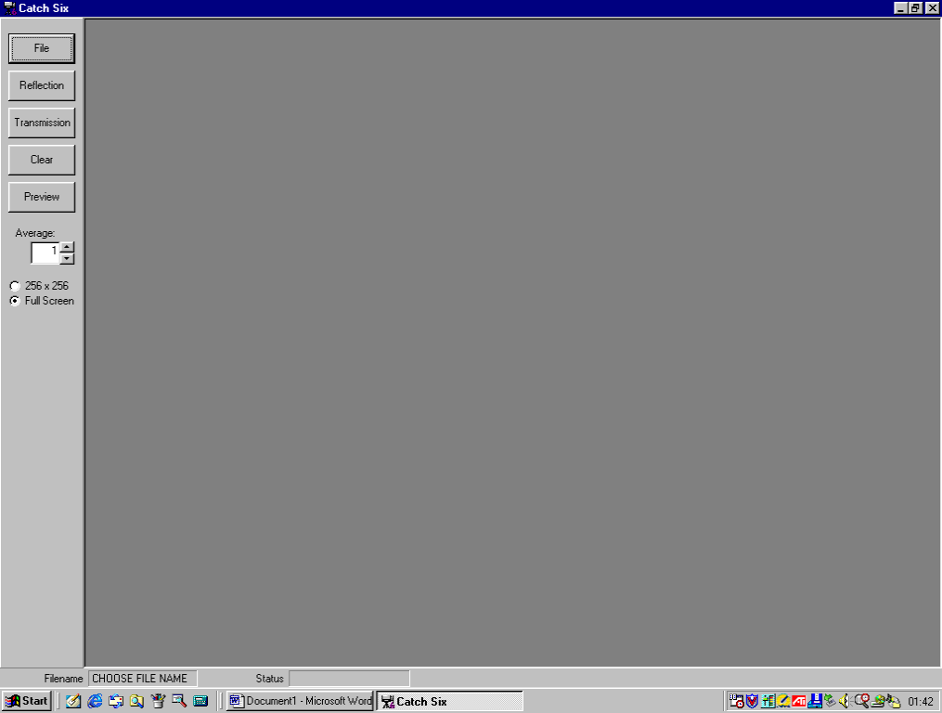

a
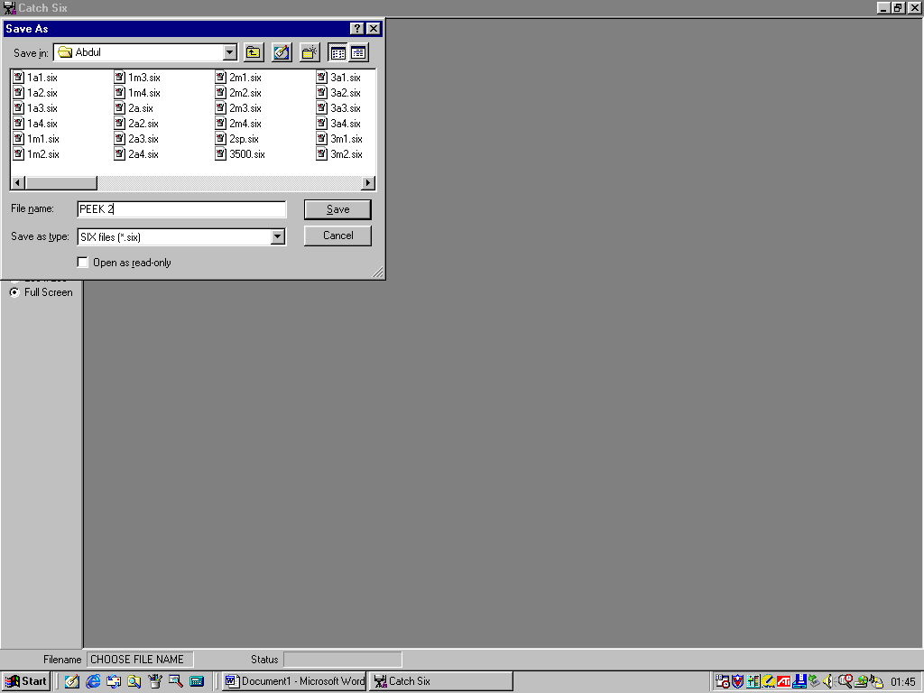

b

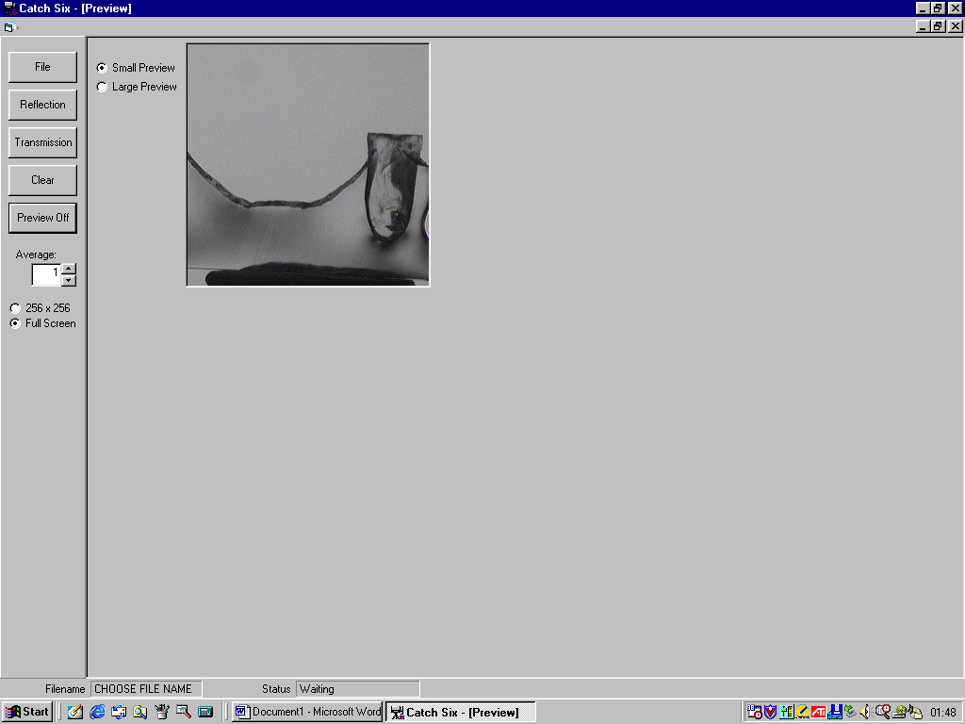

c
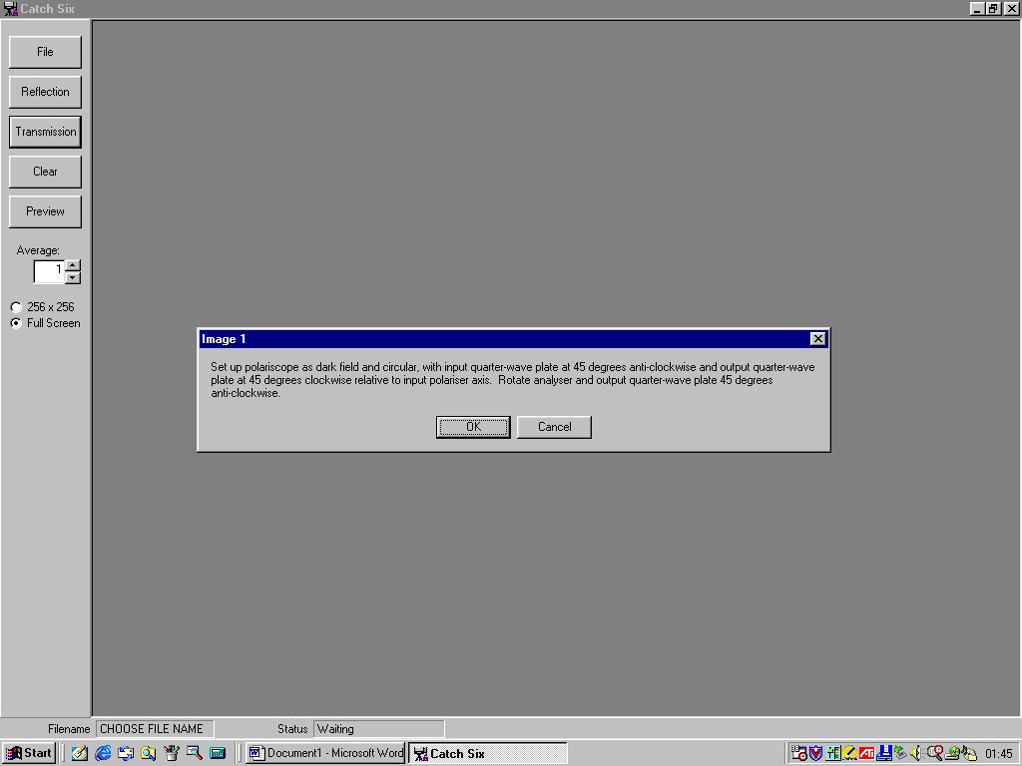

d

e

Figure A I: Steps of Catch six software.

Appendix II: Steps of CoPA software.
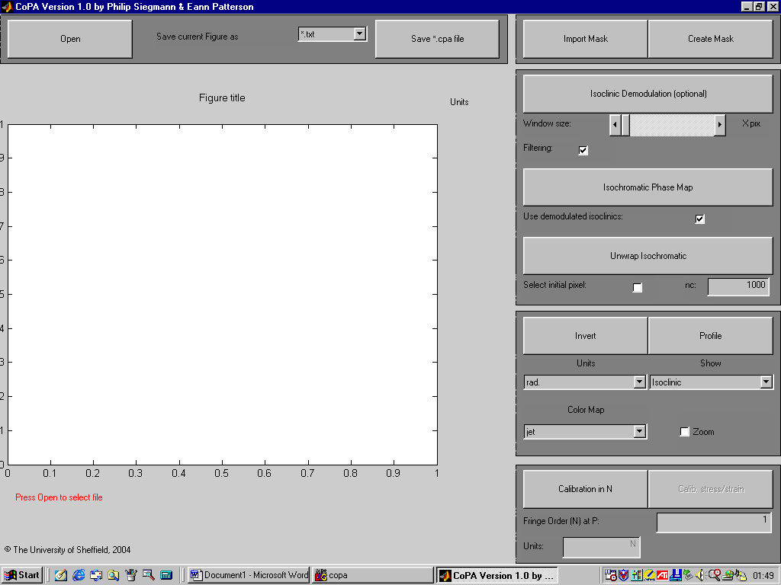

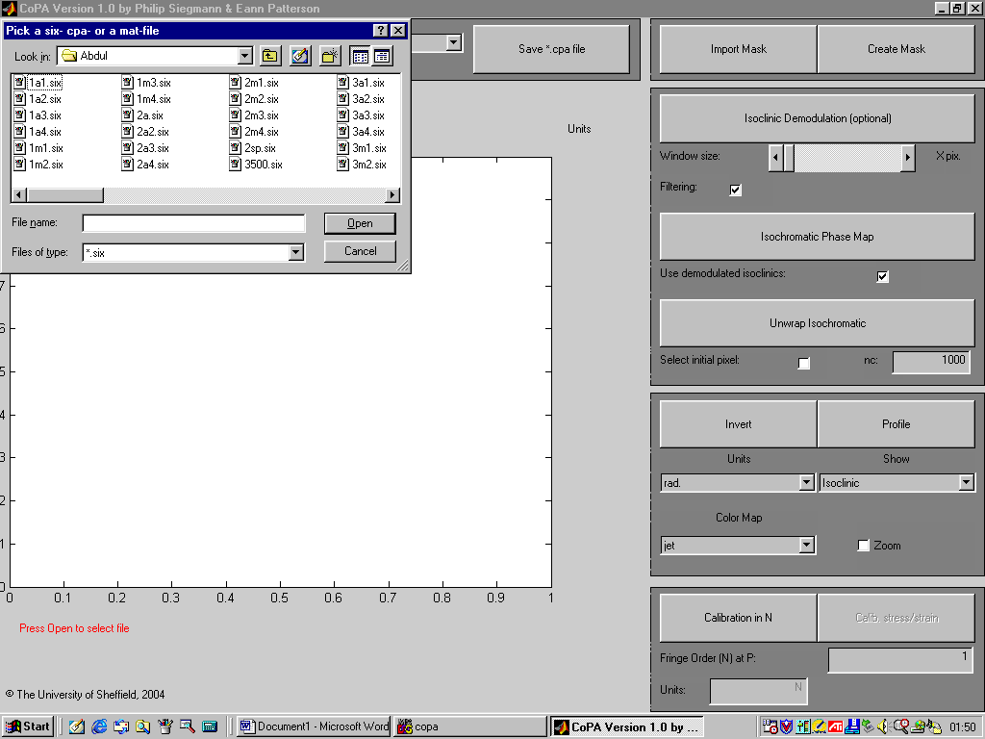
a

a

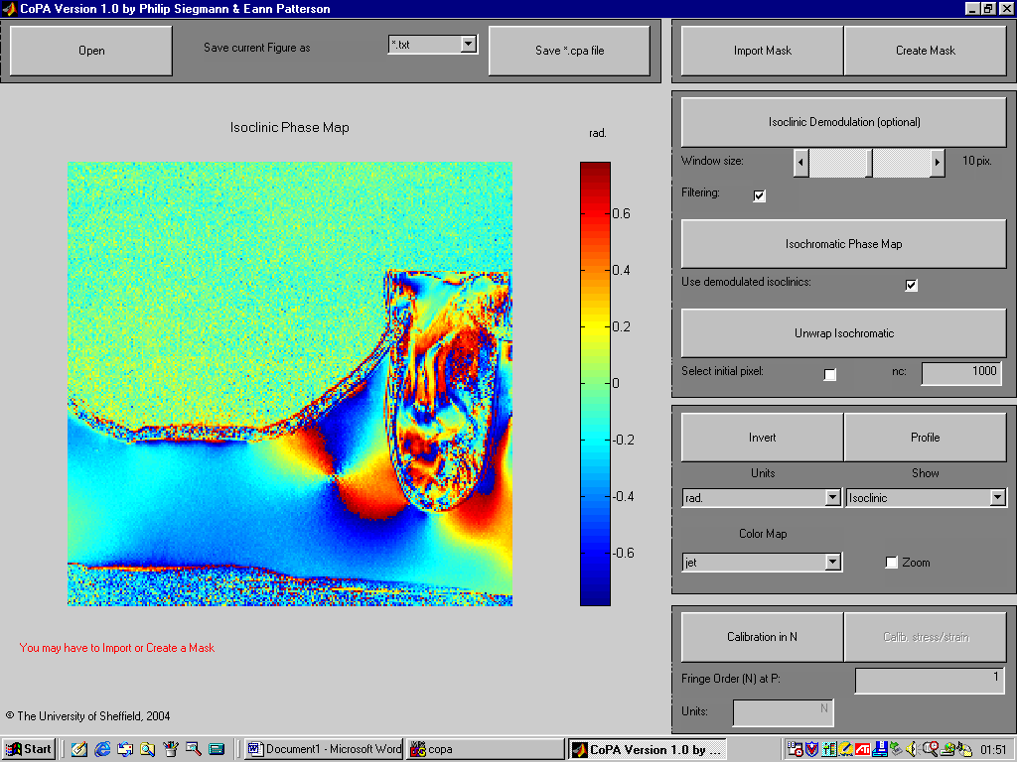

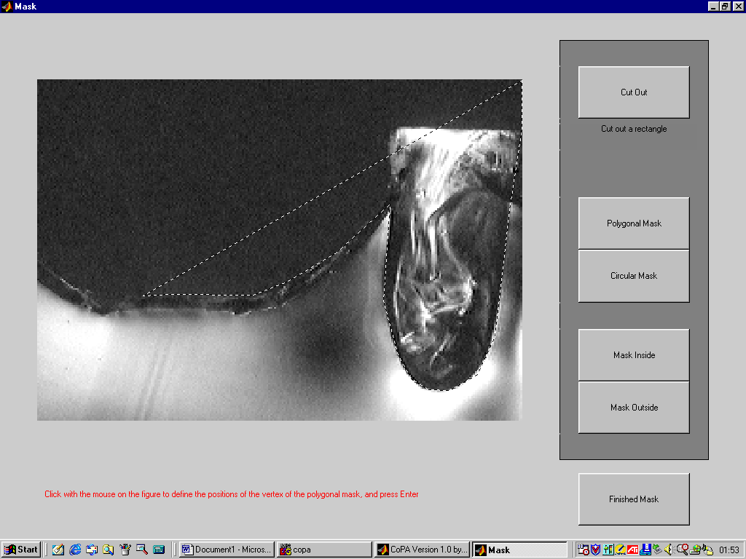
c

d

b
d
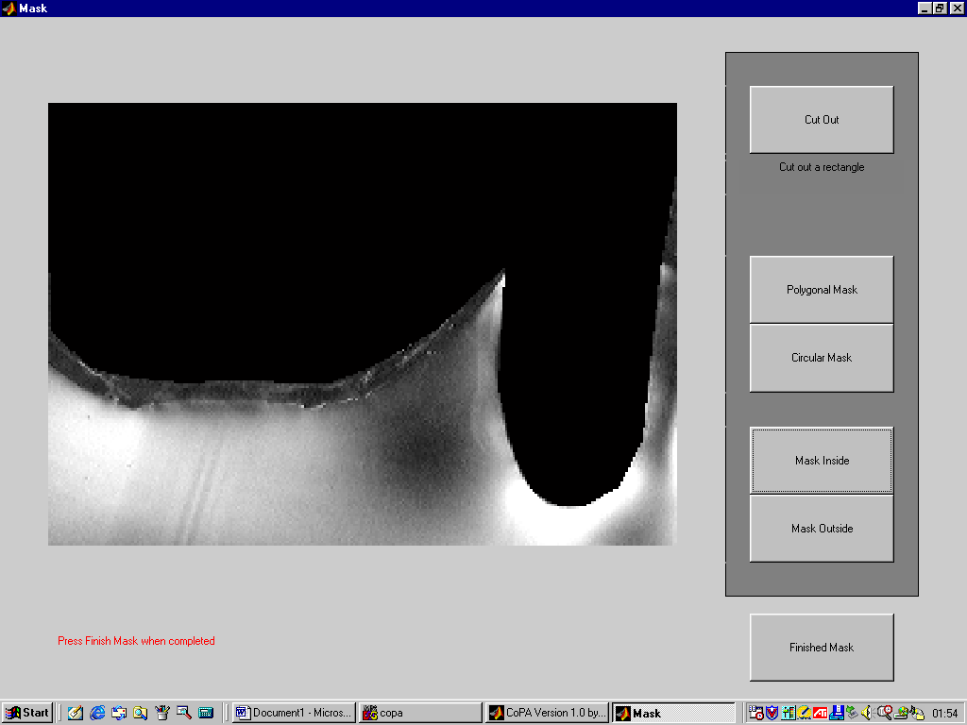

e
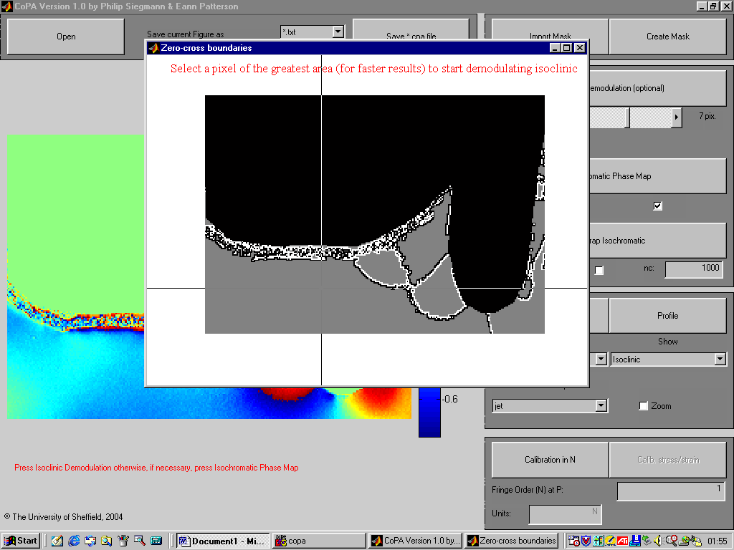
e

f

g
f
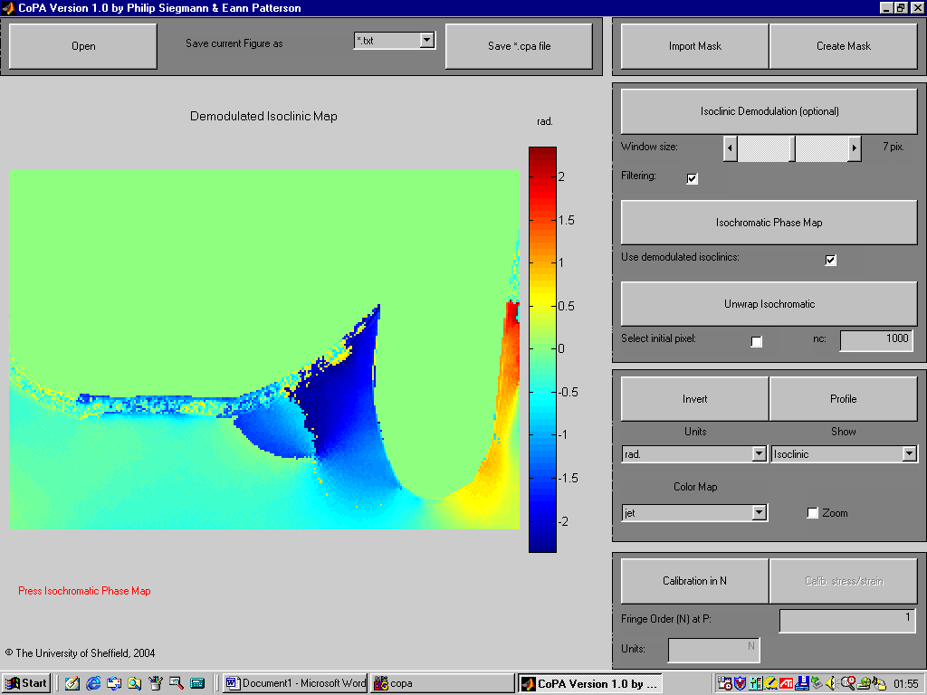

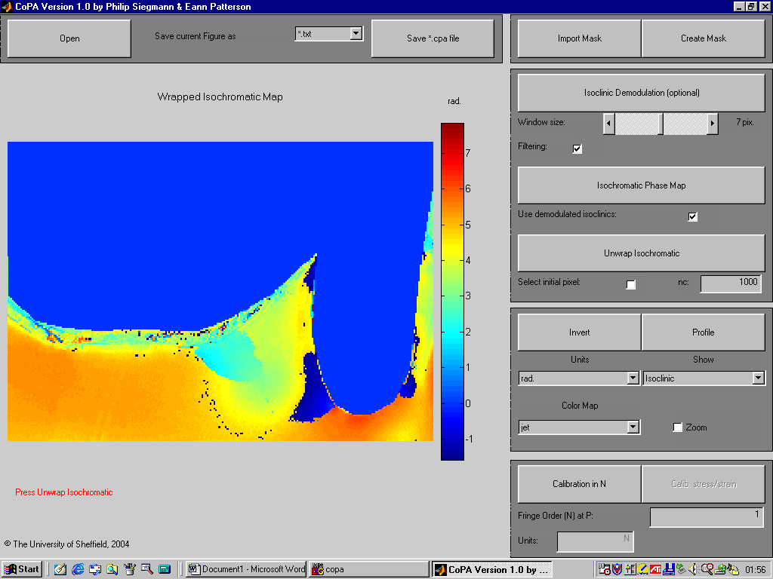
g

h

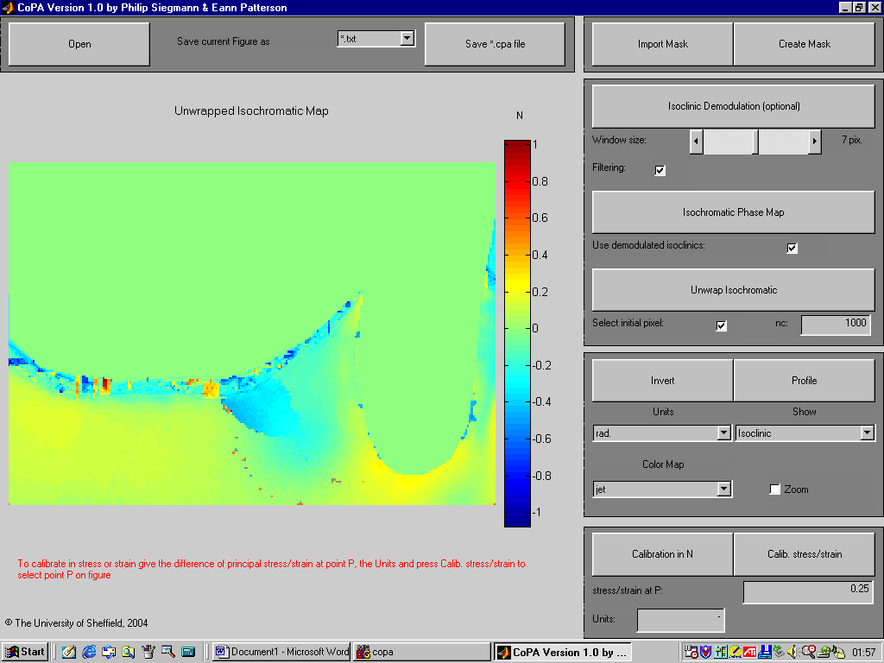

i
The stress optic low is used to find the stress magnitude at a point:
$$ơ1-ơ2=\frac{N x f}{t}$$
where N= fringe order at a point, f= material fringe constant, t= slice thickness.
$=\frac{0.25 x 491}{2 x {10}^{-3}}$
= 0.0693 MPa

j

Figure A II: Steps of CoPA software

Appendix III: Steps of scanning and designing dentures in Bitewing software
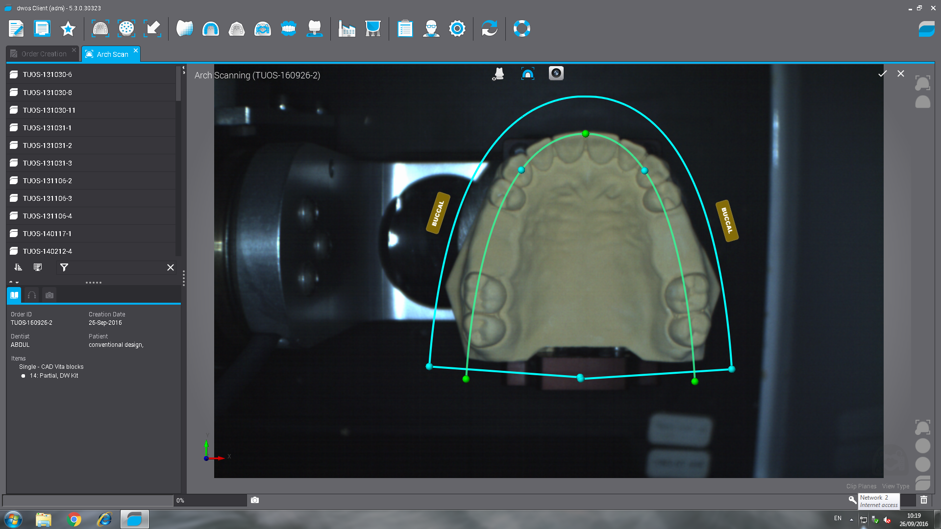
a: Model scan parameters.
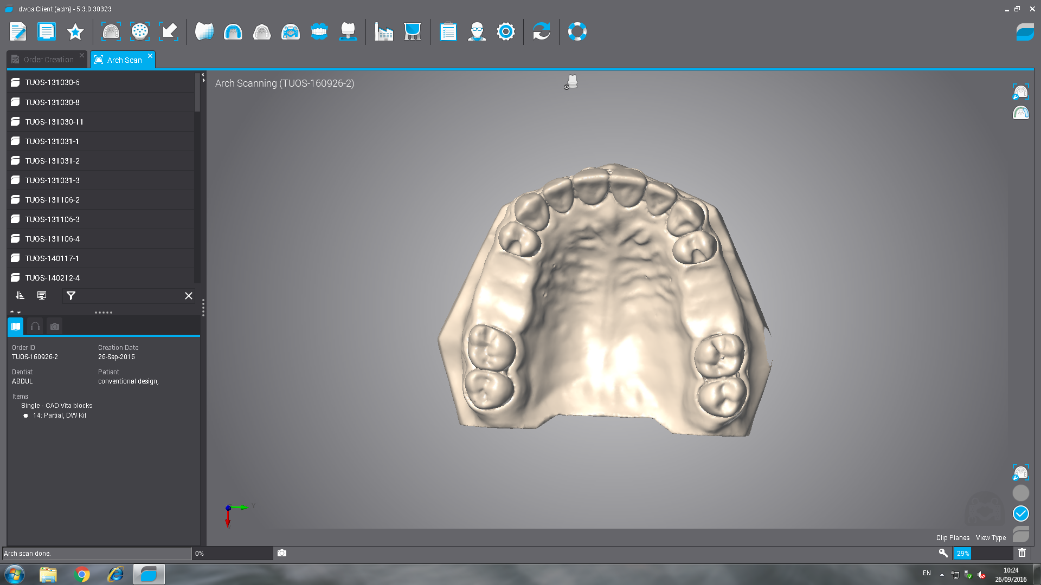
b: The scanned master model.

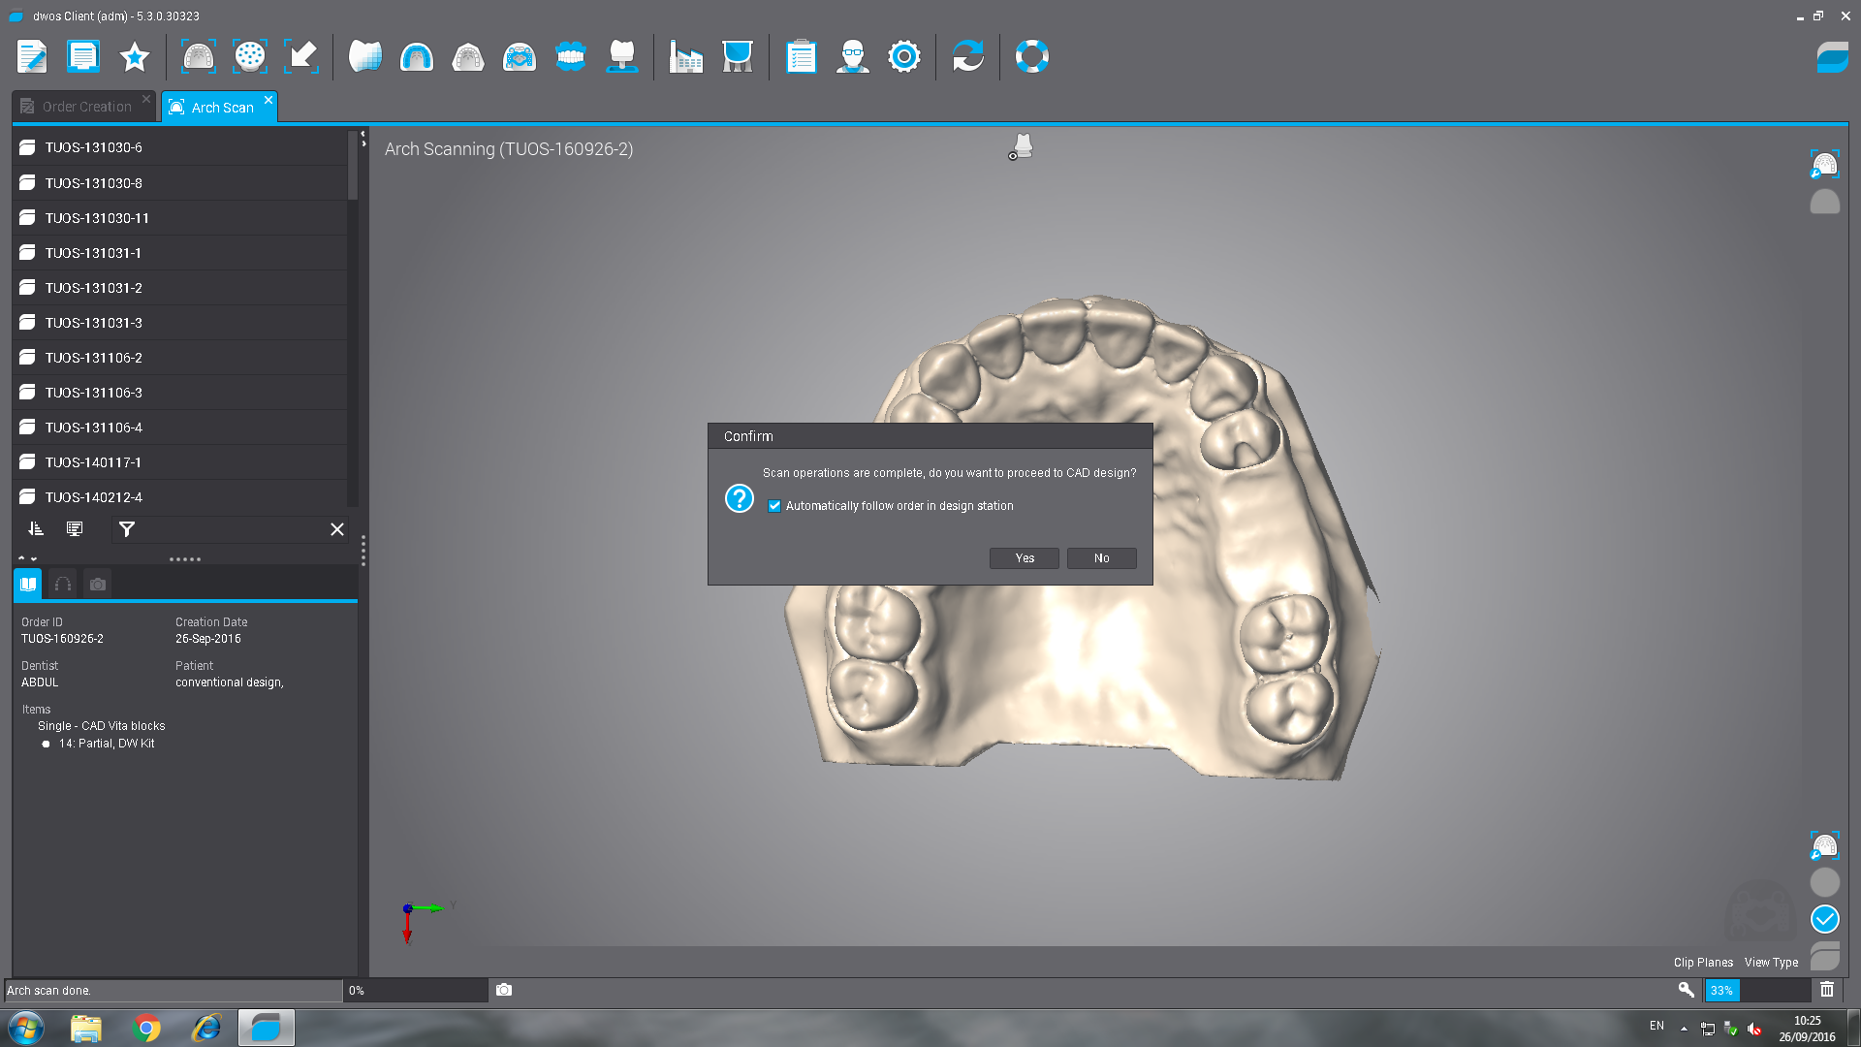
c: Follow the order in the design station.

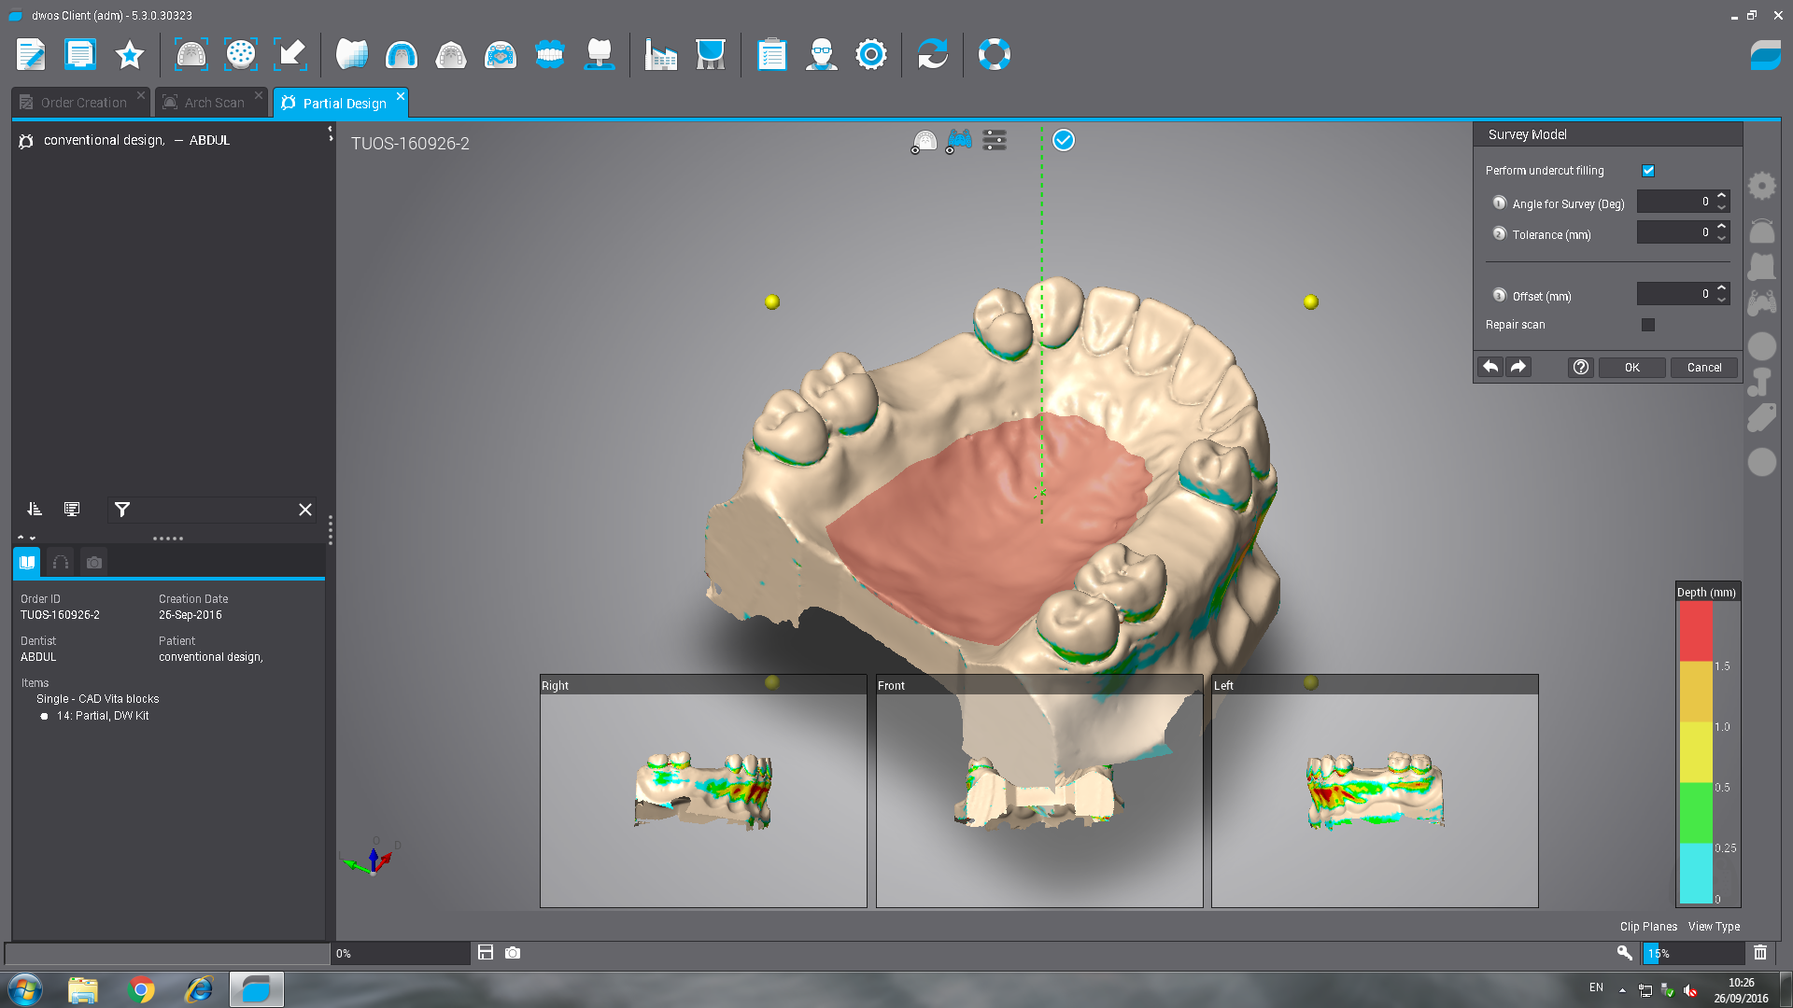
d: Determination of the path of insertion.

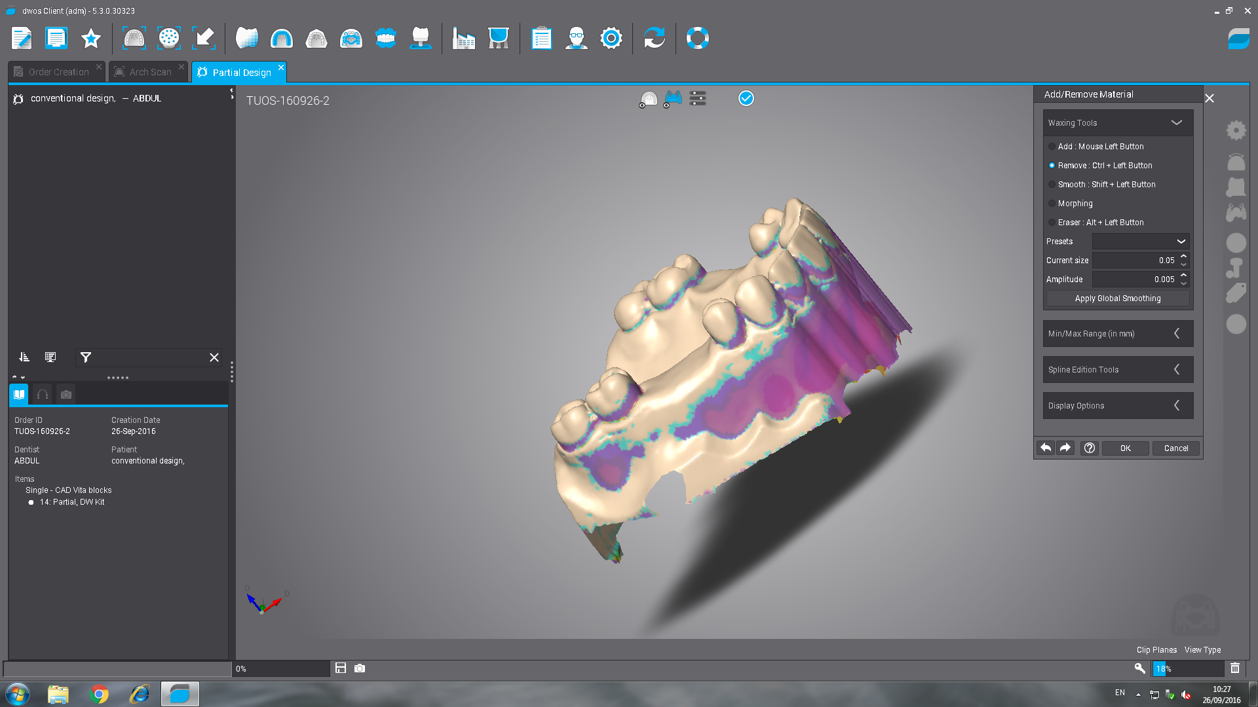
e: Blocking out of undesirable undercut.

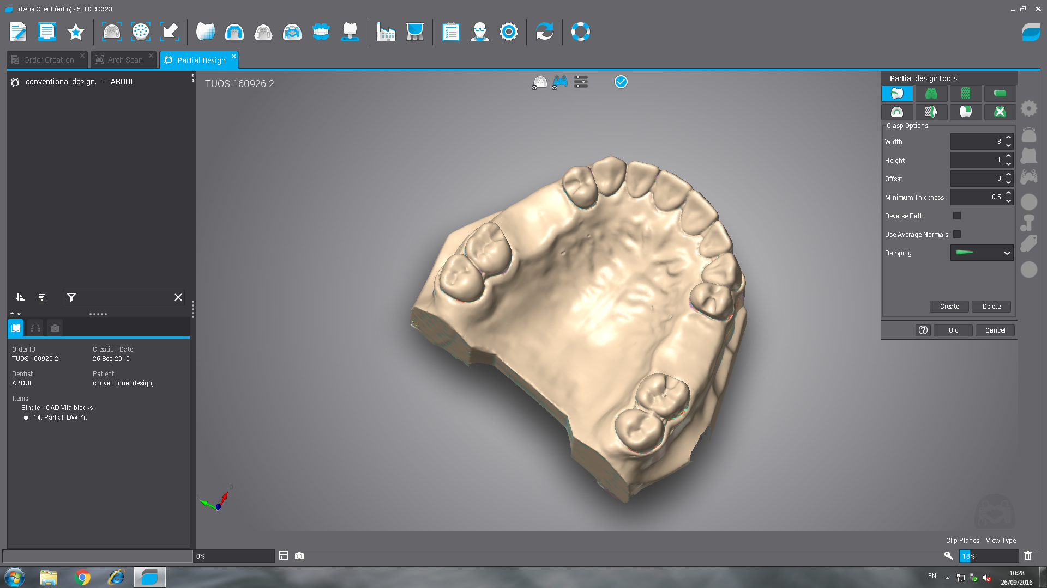
f: The surveyed model ready for denture design.

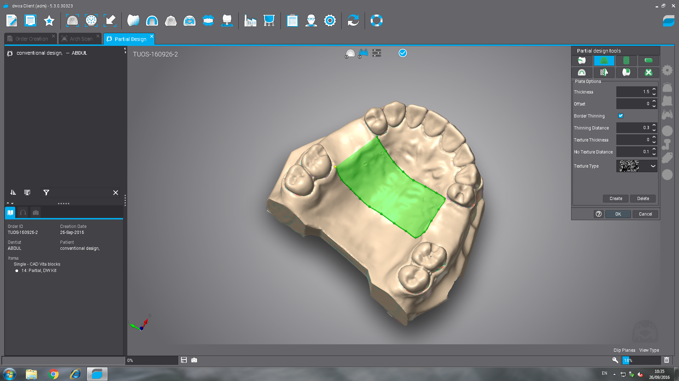
g: Designing of the palatal strap major connector.

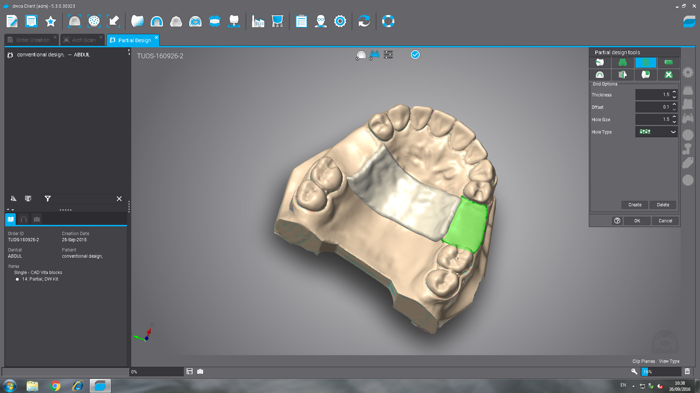
h: Designing of the denture base.

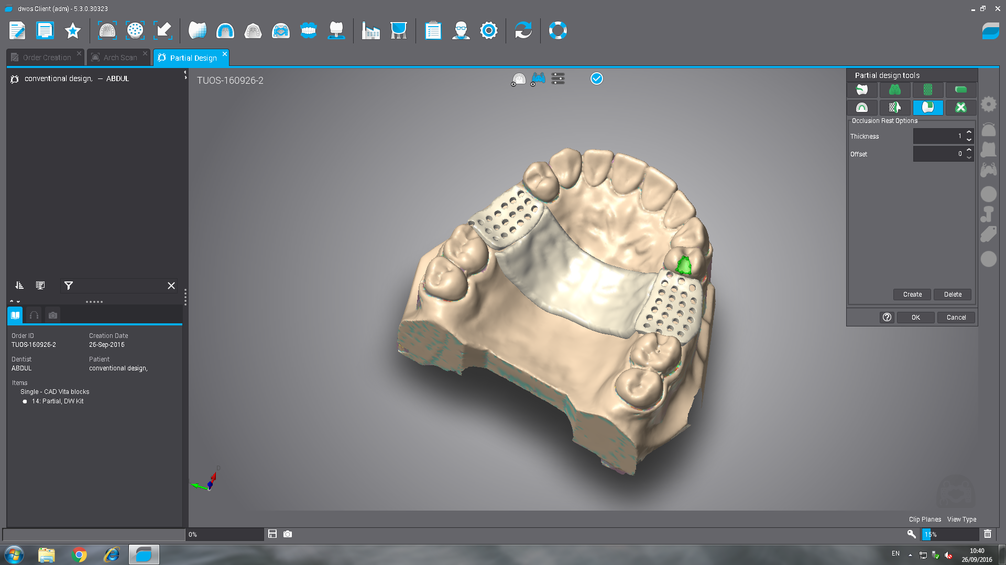
i: Occlusal rest design.

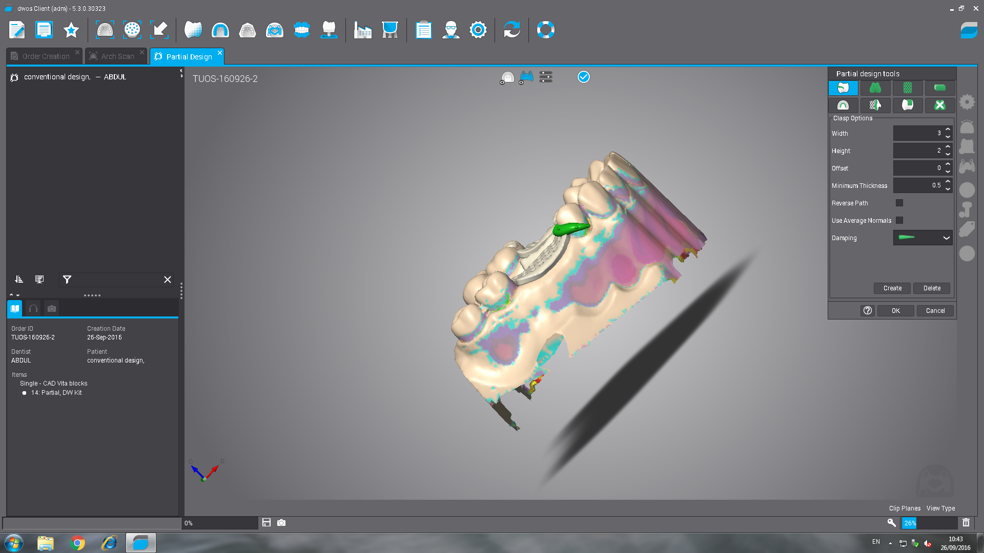
j: Retentive arm clasp design.

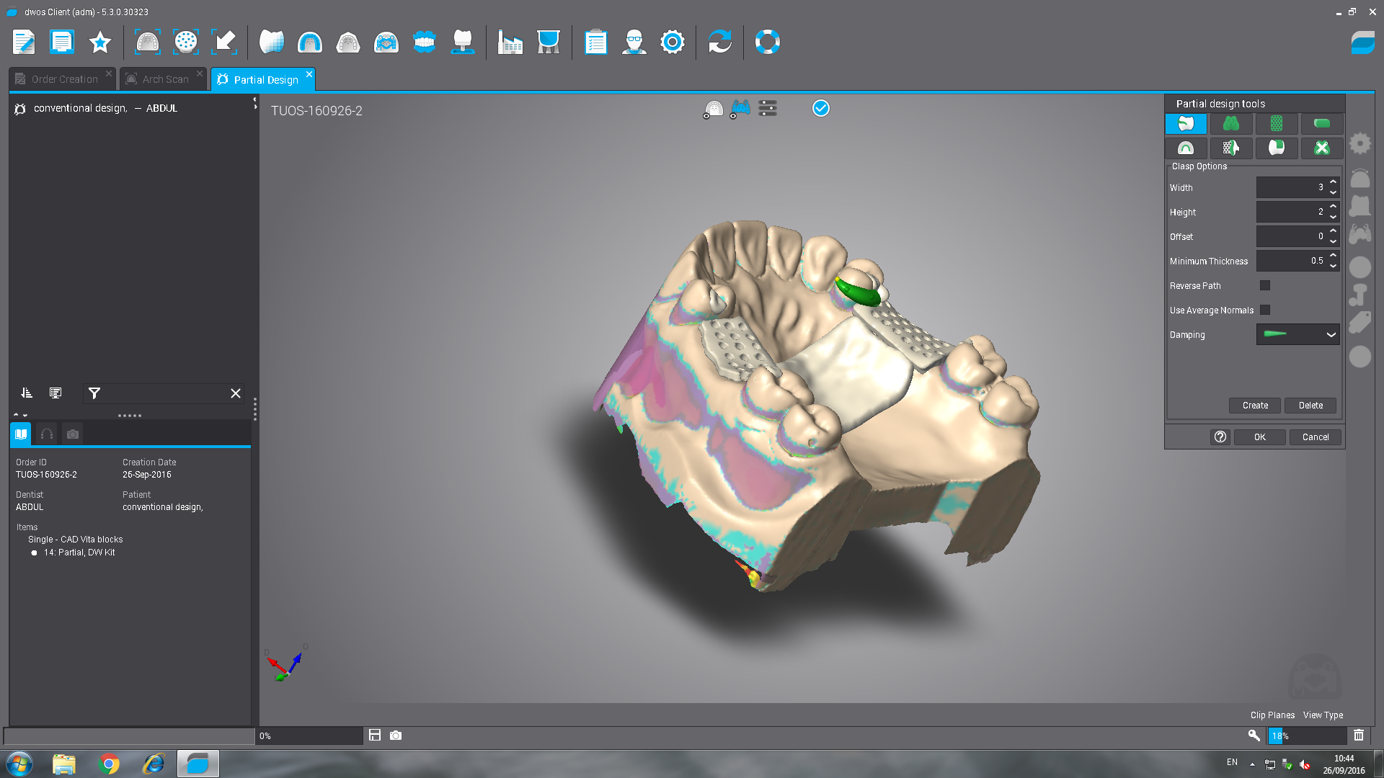
k: Reciprocal arm clasp design.
l: The finished RPD design.
m: The converted STL file ready for loading into the milling machine.
Figure A III: Steps of designing dentures in Bitewing software

Appendix VI: Steps of denture milling in Roland CAD CAM machine
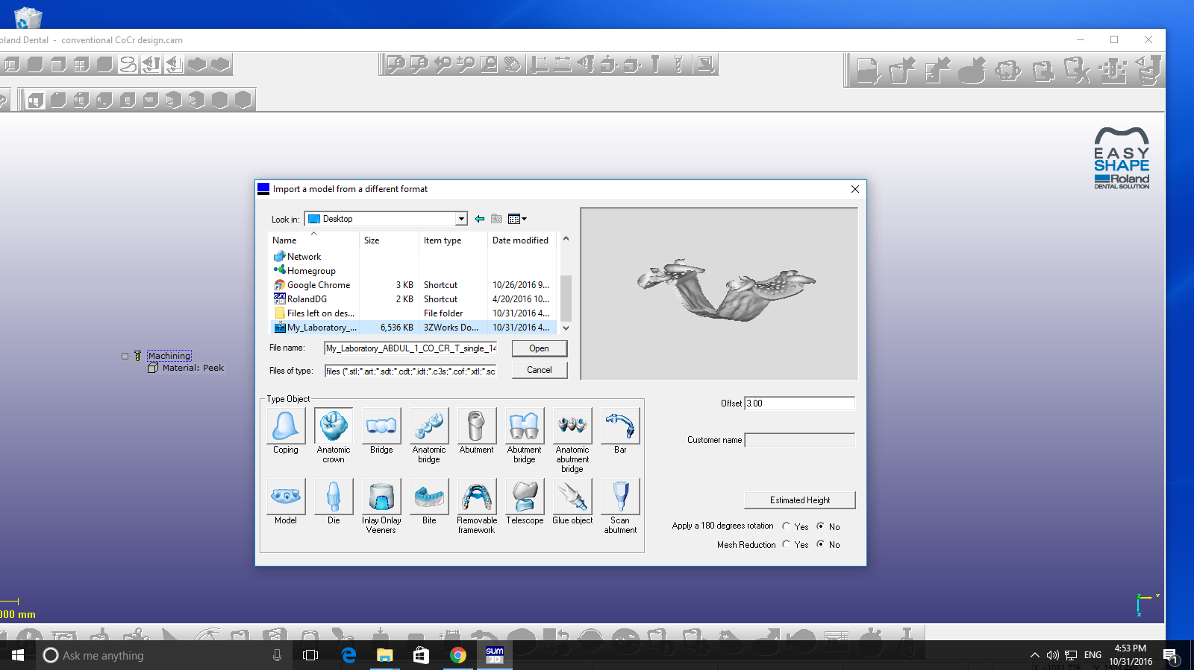
a: Import the STL file
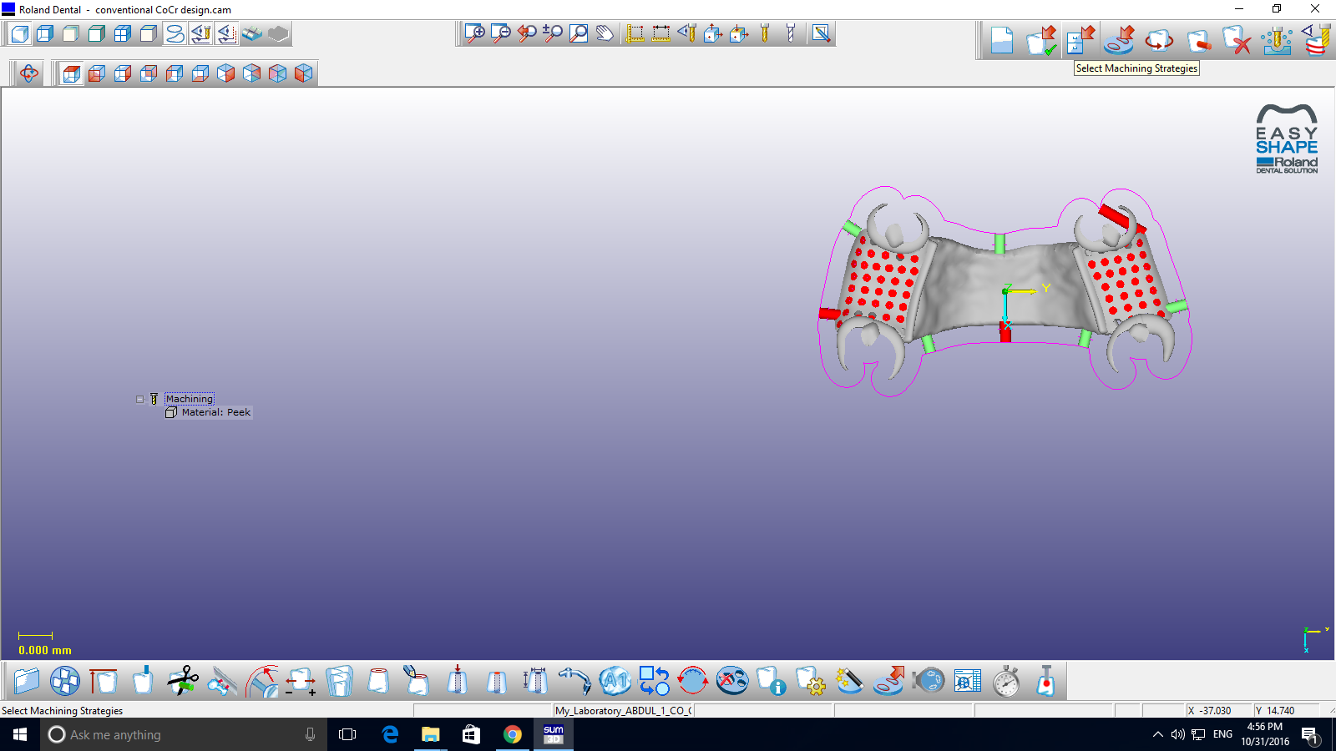
b: The imported design.

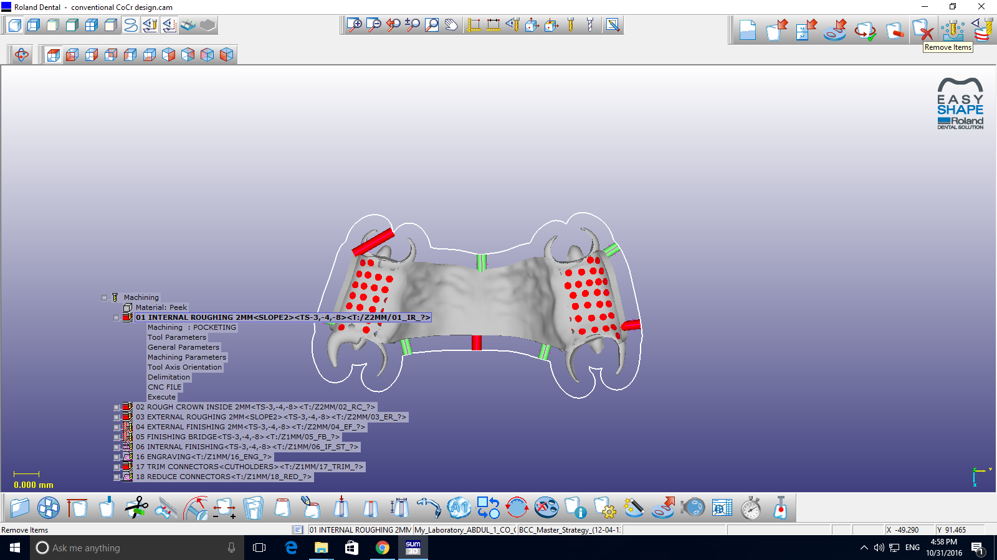 c: Select machining strategies.

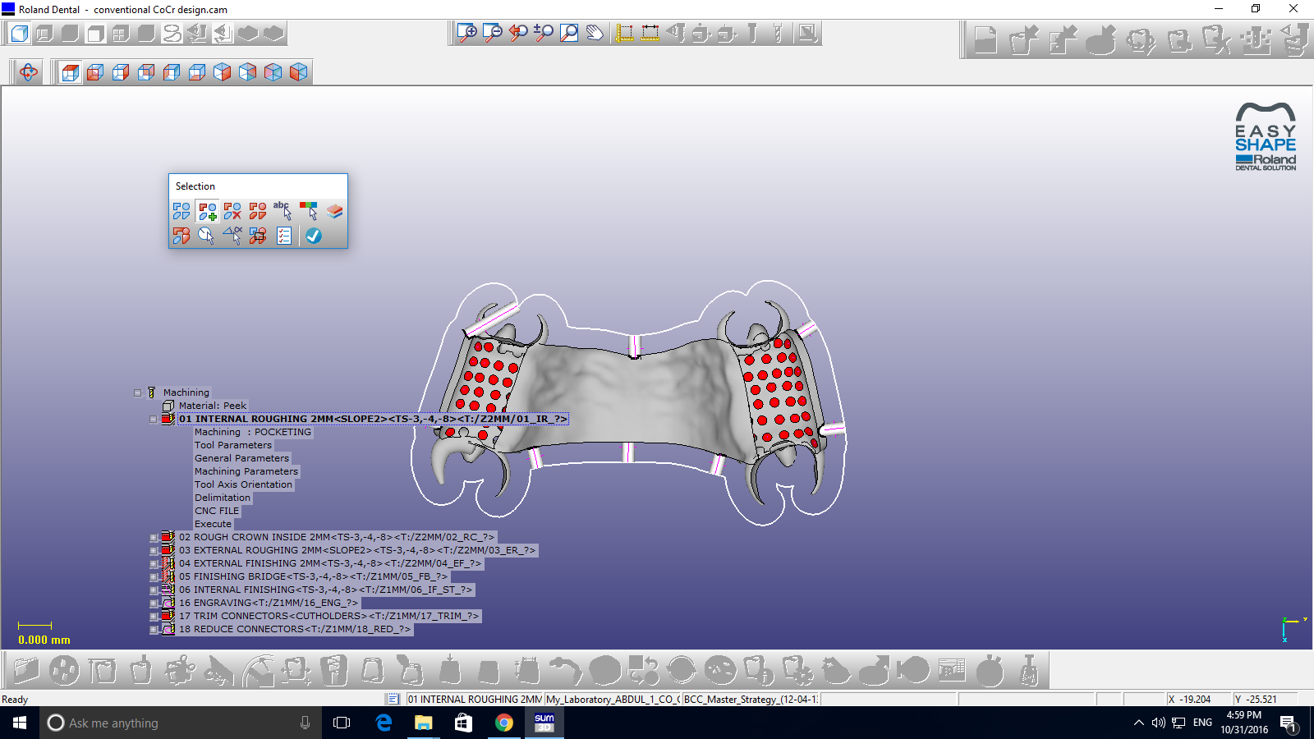
d: Remove the pins.

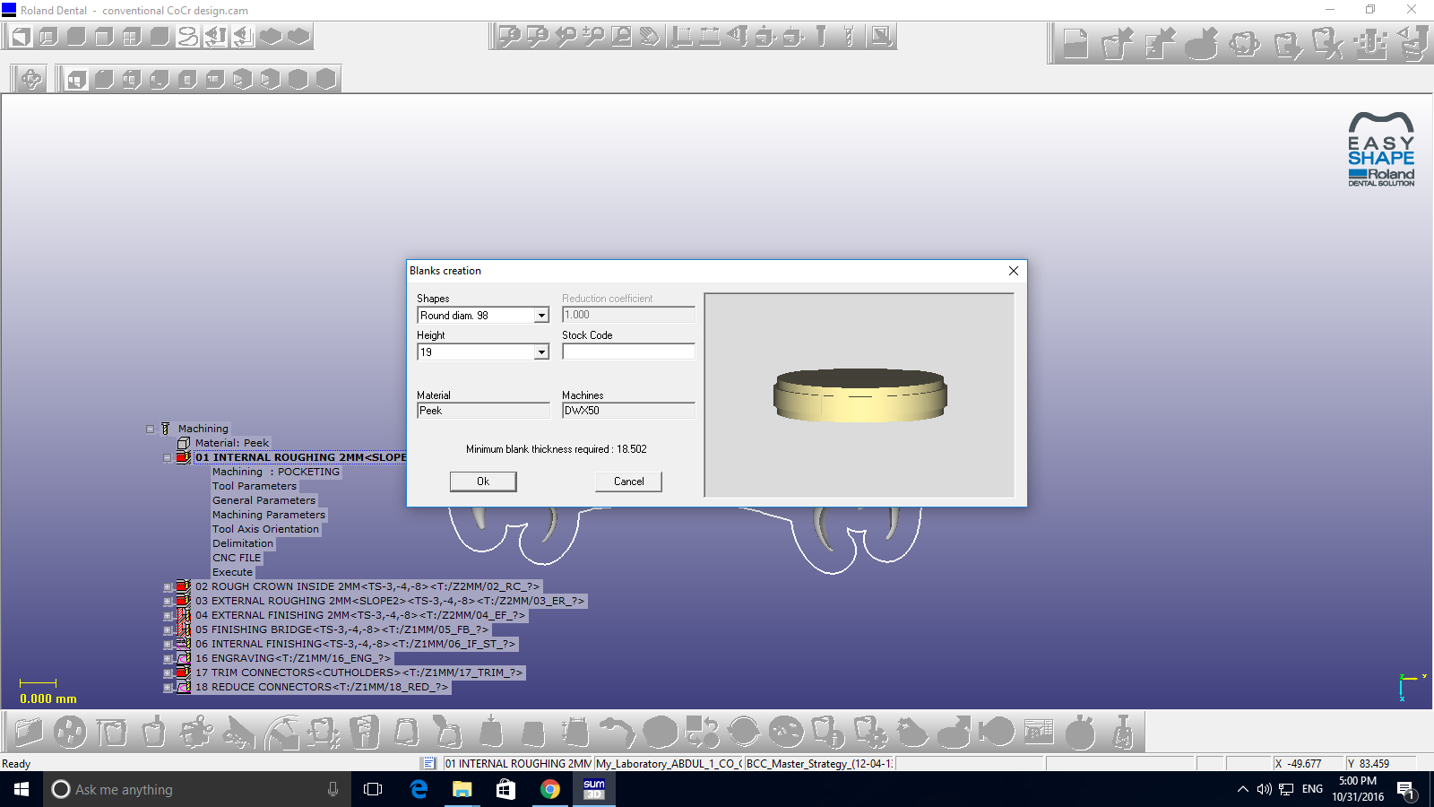
e: Creation a blank.

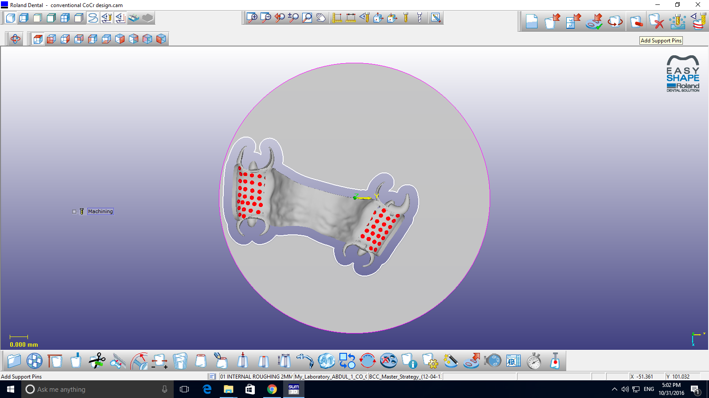
f: Design position in the disc.

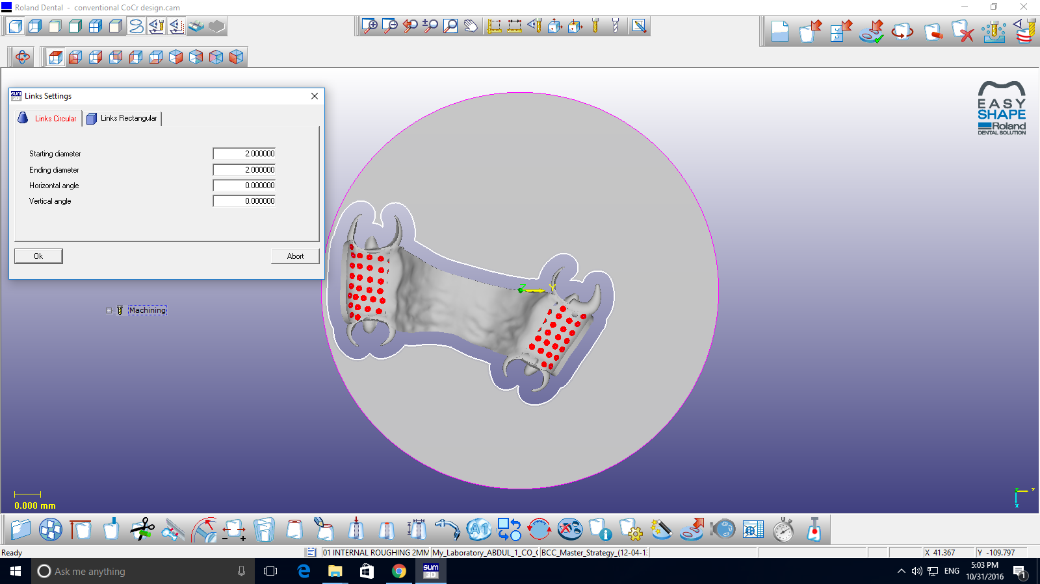
g : Select pins dimension

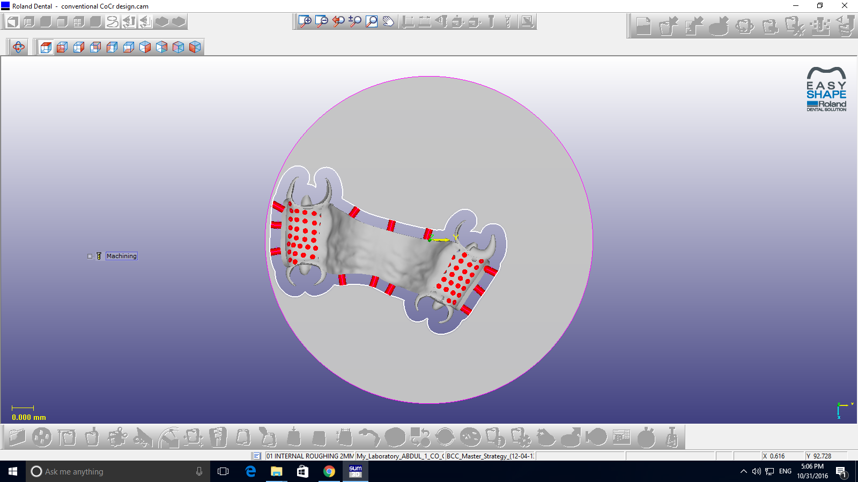
h: Add support pins.

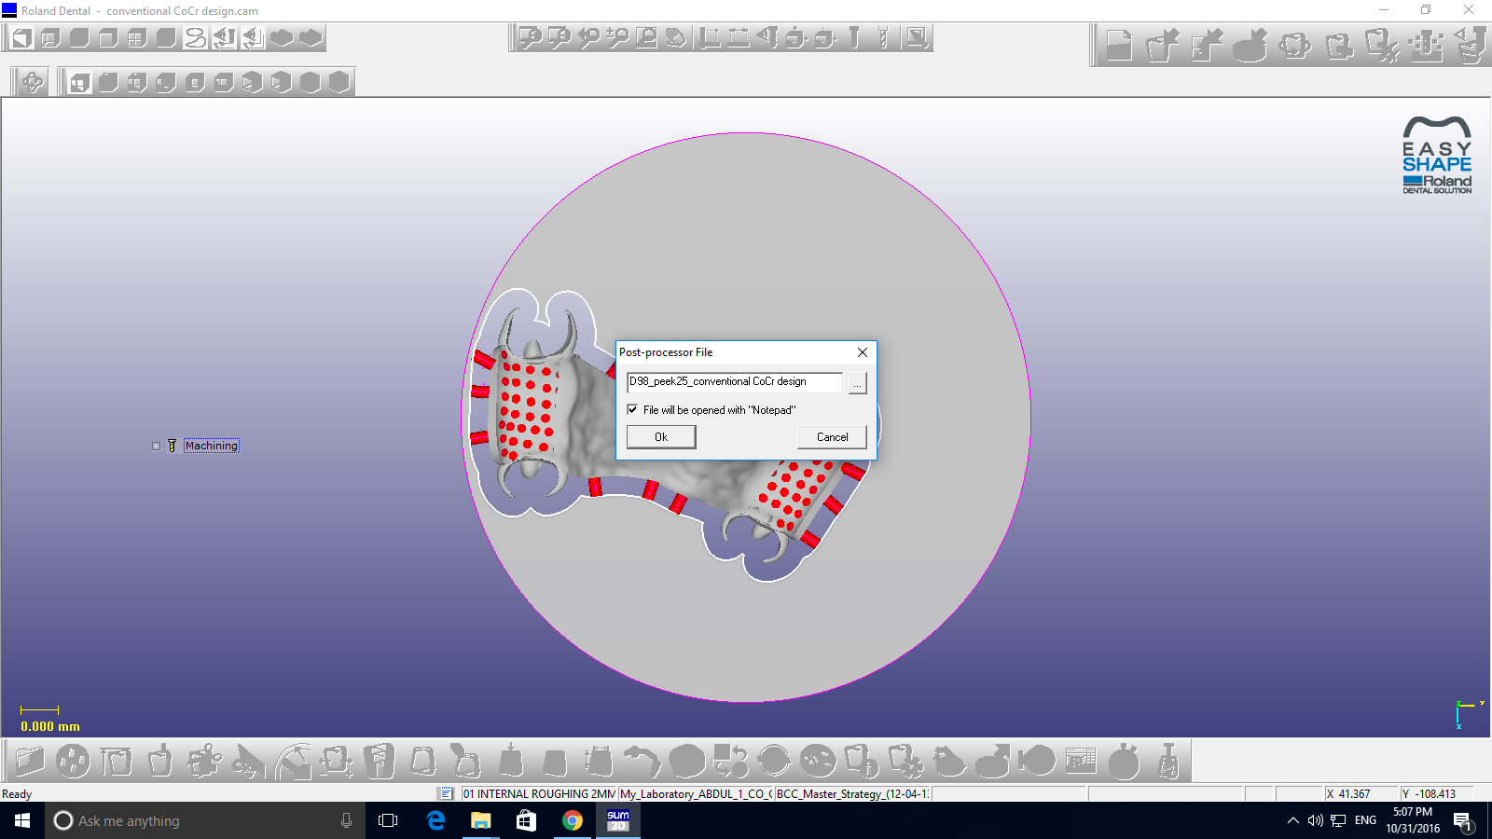
i: Creates milling programme.

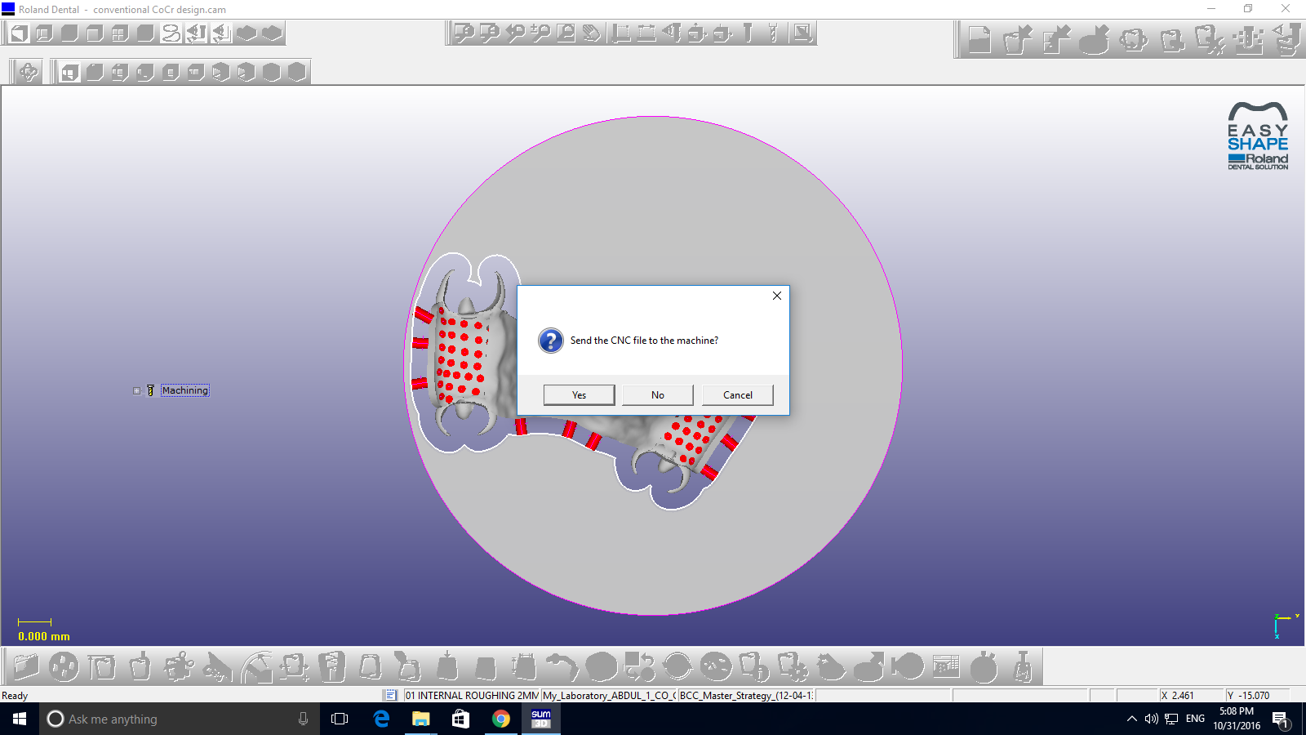
j: Send the design to the milling machine.
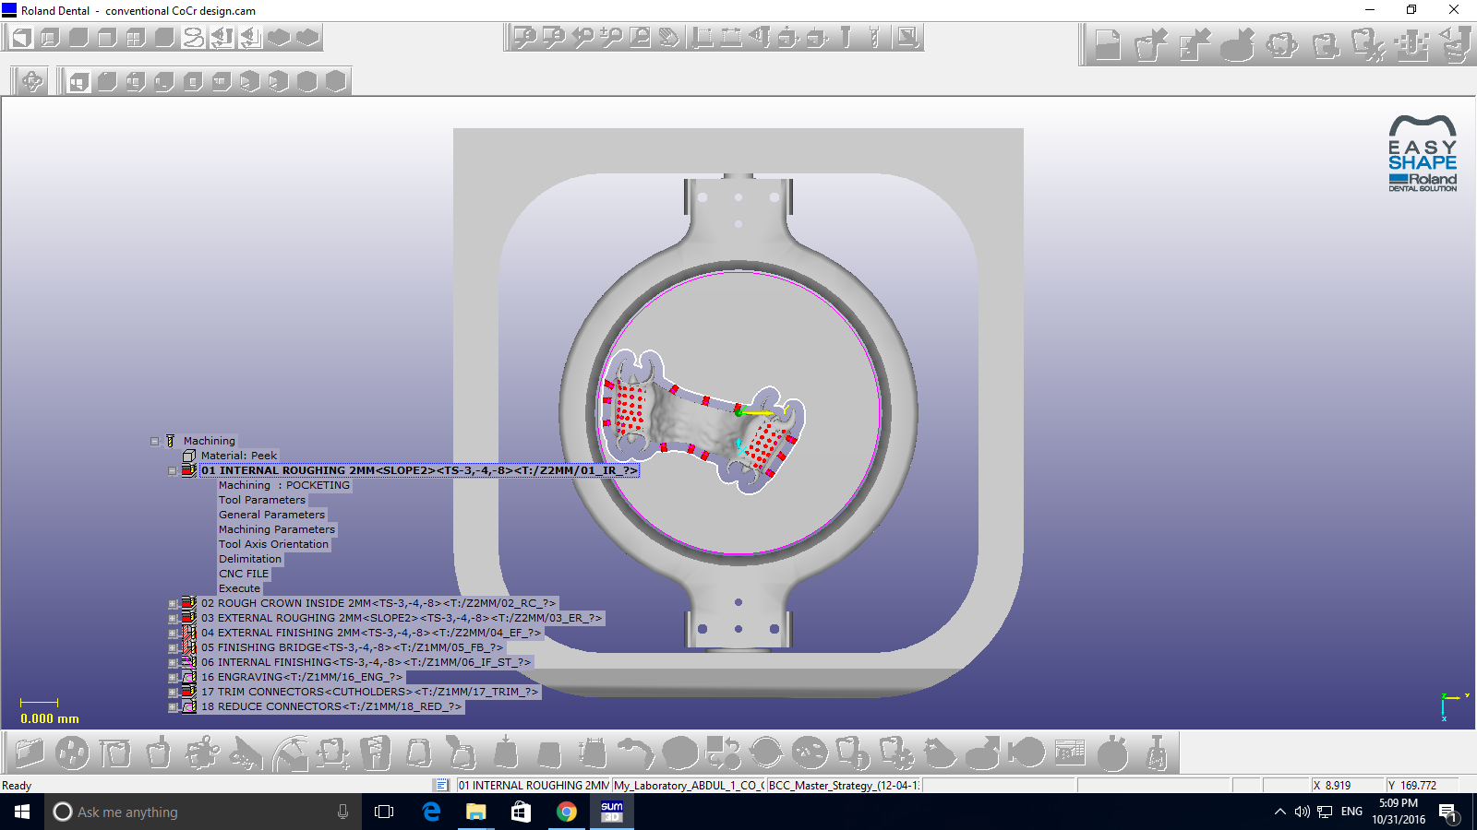
Figure 120 VI: Steps of Denture Milling in Roland machine.

