Acknowledgments iii
Abbreviations iv
Abstract 1
Fluorine and Fluorination 3
Fluorinated Molecules and Their Applications 3
Fluorination Reagents and Methods 5
Nucleophillic Fluorine 5
Electrophilic Fluorine 12
Radical Fluorination 17
Unnatural Amino Acids Synthesis 22
Synthesis of γ-Fluoroleucine 28
Organometallic Reactions in the Context of Synthesising Amino Acids 34
Cathepsin S And Its Inhibition 44
Results and Discussion 47
Aims and Strategy 48
Progress Towards Alkynyl Amino Acids 51
Future Work, Directly Functionalizing Terminal Alkynes 60
Unsaturated Amino Acid Syntheses 63
Reactions of Organozinc Reagent 69 With Cyclic Vinyl Triflates 64
Reactions with Vinyl Bromides 67
Reactions with Allyl Chlorides 73
Radical Hydrofluorination of Unsaturated Amino Acids 74
Has Amino Acid Stereochemistry Been Preserved Throughout The Synthesis? 77
Probing The Diastereoselectivity of Radical Hydrofluorination 78
Would Addition of NaBH₄ By Syringe Pump Lead to Increased Yields with Other Substrates? 87
Summary of Fluorinated Protected Amino Acids 90
Use of a fluorinated amino acid in the synthesis of a Cathepsin inhibitor 91
Using Alternative Radical Traps In The Functionalistaion of Unsaturated Amino Acids 96
Hydroxyl Amino Acid Synthesis, Introduction 97
Hydroxyl Amino Acid Synthesis, Results 101
Hydroazidation of Unsaturated Amino Acid Precursors, Introduction 103
Radical Hydroazidation Results 107
Subsequent Transformations of Azides 110
Click Reactions Between Azido Amino Acids and Acetylenes 111
Synthesis of Lactams By Azide Reduction And Cyclisation 114
Azide Reduction Results 116
Click Chemistry Future Work 118
Conclusion 119
Experimental 122
General Points of Interest 122
Preparation of zinc reagent 69 122
General Procedure A, Triflate Synthesis 122
General Procedure B, Coupling of 69 To Vinyl Triflates And Halides 123
General Procedure C, Reaction of 69 With Allyl Chlorides 124
General Procedure D, Radical Fluorination 124
General Procedure E, NHBoc Deprotection 125
General Procedure F, Radical Hydroxylation 125
General Procedure G, Radical Hydroazidation 126
General Procedure H, Azide Reduction 126
Synthesis of N-(tert-butoxycarbonyl)-β-iodoalanine methyl ester 65 127
Synthesis of Propargylic Alcohols 131
Synthesis of Haloallenes/Propargyl Halides and The Synthesis of 127 137
Synthesis of Coupling Partners: Triflates And Cyclobutenyl Bromide 142
Synthesis of Unsaturated Amino Acids 149
Synthesis of Fluorinated Amino Acids 166
Deprotection of Fluorinated Amino Acids 182
Synthesis of Hydroxyl Amino Acids 184
Synthesis of Azido Amino Acids 186
Reduction and click reactions of Azido Amino Acids 191
Appendix 197
Crystallographic data 197
References 209

Acknowledgments
I would firstly like to thank Professor Richard Jackson and the Jackson group members past and present who have accompanied me through my PhD. Secondly, for both funding and support, the staff at Medivir. Their contributions can not be understated and their facilitation of my summer placement in Stockholm, a place I now hold a great deal of fondness for, have allowed me to achieve everything contained in this thesis. Thirdly, I would like to thank the members of teaching staff in the chemistry department at The University of Sheffield and all the members of the Graduate Teaching Assistant scheme and postgraduate demonstrators I have worked with. I would also like to thank all the members of support staff in the department. I would like to acknowledge all the chemistry climbers and footballers and Tuesday Goals footballers. I would like to thank the Reeves, Stringers and Wylams for their love and support.

Finally, I would especially like to thank Jaimee Reeve for her love and support throughout my PhD and into the future.
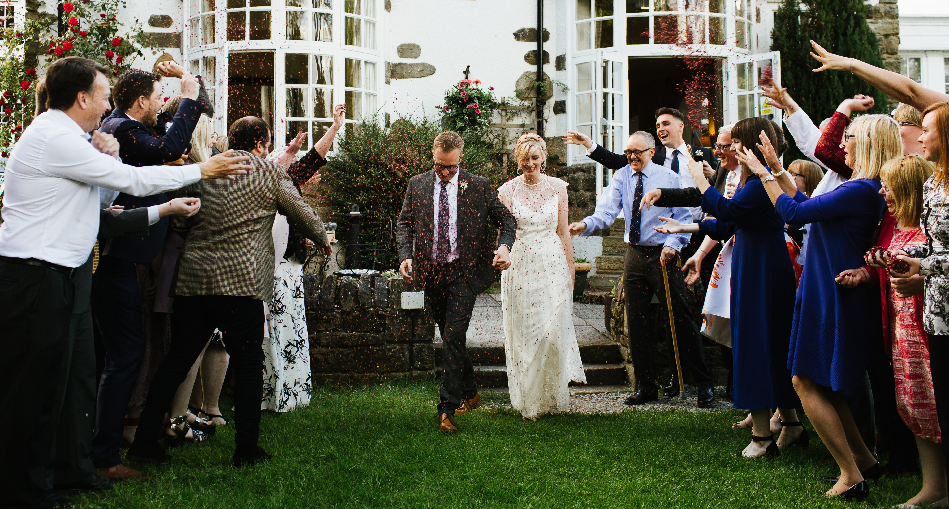
‘100 years, Phil and Jaimee adventures!’

Abbreviations
- COMU, (1-Cyano-2-ethoxy-2-oxoethylidenaminooxy)dimethylamino-morpholino-carbenium hexafluorophosphate
- CPD, Composite-Pulse Decoupling
- DABCO, 1,4-diazabicyclo[2.2.2]octane
- DAST, Diethylaminosulfur Trifluoride
- Dba, dibenzylideneacetone
- de, diastereoisomeric excess
- Deoxofluor, Bis(2-methoxyethyl)aminosulfur Trifluoride
- DMA, Dimethylacetamide
- DMDO, Dimiethyldioxirane
- DME, dimethoxyethane
- DMF, N,N-dimethylformamide
- DMS, Dimethyl sulfide
- EDC, 1-Ethyl-3-(3-dimethylaminopropyl)carbodiimide
- EDCl, N-(3-Dimethylaminopropyl)-N′-ethylcarbodiimide hydrochloride
- ee, enantiomeric excess
- equiv, equivalents
- FDG, Fluorodeoxyglucose
- FGI, Functional Group Interconversion
- HATU, N-[(Dimethylamino)-1H-1,2,3-triazolo-[4,5-b]pyridin-1-ylmethylene]-N-methylmethanaminium hexafluorophosphate N-oxide
- HFIP, Hexafluoroisopropanol
- HMPA, Hexamethylphosphoramide
- HPLC, High Performance Liquid phase Chromatography
- HRMS, High Resolution Mass Spectrometry
- IR, Infrared
- LDA, Lithium diisopropylamide
- LiHMDS, Lithium bis(trimethylsilyl)amide
- MRI, Magnetic Resonance Imaging
- MTBE, Methyl tert-butyl ether
- NBS, N-Bromosuccinimide
- NDHPI, N,N-Dihydroxypyromellitimide
- NFOBS, N-Fluoro-o-benzenedisulfonimide
- NFSI, N-Fluorobenzenesulfonimide
- NHPI, N-Hydroxyphthalimide
- NMM, N-Methyl morpholine
- NMR, Nuclear Magnetic Resonance
- NSFI, N-fluorobenzenesulfonimide
- PET, Positron Emission Tomography
- phen, Phenanthroline
- Selectfluor®, 1-Chloromethyl-4-fluoro-1,4-diazoniabicyclo[2.2.2]octane bis(tetrafluoroborate
- SEM, 2-(Trimethylsilyl)ethoxymethyl
- SPhos, 2-Dicyclohexylphosphino-2′,6′-dimethoxybiphenyl
- T3P, Propylphosphonic Anhydride
- TBSCl, Tributylsilyl Chloride
- t-BuBrettPhos, 2-(Di-tert-butylphosphino)-2′,4′,6′- triisopropyl-3,6-dimethoxy-1,1′-biphenyl
- TFA, Trifluoroacetic Acid
- THF, Tetrahydrofuran
- TMEDA, Tetramethylethylenediamine

Abstract
It has been established as recently as 2012¹ that amino acid iodide 65 can be transformed to the corresponding zinc reagent 69 and used in C-C bond forming reactions with haloallenes under Cu^{I} catalysis and with cyclic vinyl triflates using Pd⁰ catalysis (Scheme 1). These reactions are important steps in the synthesis of unnatural amino acids, which are themselves used in the synthesis of protein inhibitors.
Scheme 1. Previously reported syntheses of alkynyl and vinyl amino acids.
In this thesis, the reaction of zinc reagent 69 with tetrasubstituted haloallene electrophiles was investigated. It has been shown that the synthesis of tetrasubstituted haloallenes is challenging and propargylic halides were also formed as a by-product. When zinc reagent 69 is treated with a mixture of haloallene and propargylic halide under Cu^{I} catalysis, there is a preferential reaction between 69 and the propargylic halide (Scheme 2).
Scheme 2. Copper(I) catalysed reaction of zinc reagent 69 with a mixture of chloroallene and propargylic chloride.
The synthesis of unsaturated amino acids has been achieved by treatment of zinc reagent 69 with cyclic vinyl triflates or vinyl bromides under Pd⁰ catalysis and with allyl chlorides under Cu^{I} catalysis (Scheme 3).
Scheme 3. Example syntheses of unsaturated amino acids.
The unsaturated amino acid substrates that were synthesized underwent radical functionalisations at the double bond by treatment with Fe₂(ox)₃, NaBH₄ in the presence of a radical trap. Fluoro, azido and hydroxyl amino acids were successfully synthesized in good to excellent yields using this method (Scheme 4).
Scheme 4. Radical functionalisations of an unsaturated amino acid.

Fluorine and Fluorination

Fluorinated Molecules and Their Applications
Fluorinated molecules, specifically amino acids, are the main focus of the work in this thesis. Despite its scarcity in natural products, fluorine is prevalent in synthetic biologically active compounds. For an account of fluorine’s occurrence in natural products, one should consult the review by Harper and O’Hagan.² Fluorine, specifically the ¹⁸F isotope, is the source of positron emission in PET imaging. One often-quoted statistic is that 20 % of pharmaceuticals and 30 % of agro-chemicals contain fluorine. Two up to date summaries on the subject of fluorine in pharmaceuticals are the 2007 review by Purser et al.³ and the 2016 review by Zhou et al.⁴ Some of the most commercially successful fluorinated molecules are shown, Maraviroc⁵ and Efavirenz^{6,7} are antiretroviral drugs, Fluorithromycin is an antibiotic, Prozac is an antidepressant; the compounds [¹⁸F] Fluorodeoxyglucose⁸ and [¹⁸F] Gefitinib⁹ are compounds used in PET imaging.
For further accounts of the importance of fluorine in a biological context reviews by O’Hagan and Rzepa in 1999,¹⁰ Neil and Marsh in 2000,¹¹ Yoder and Kumar in 2002¹² Cobb and Murphy in 2009¹³ are illuminating. For one of the most up to date reviews on fluorination methodology, the 2013 publication by Liang et al. is comprehensive.¹⁴

Fluorination Reagents and Methods

Nucleophillic Fluorine
An early example of the use of fluoride as a nucleophile was published by Gottlieb in 1936. In which, aromatic chloride 1 is treated with KF at high temperature in an S_{N}Ar reaction to give aromatic fluoride 2 (Scheme 5).¹⁵
Scheme 5. Fluorination of 1-chloro-2,4-dinitrobenzene using KF.
In the 80 years since, the methodology has become more sophisticated and fluorination can now be achieved at or around room temperature. However, metal fluorides still hold a place in contemporary synthesis. In 2009 Watson et al. reported the effective fluorination of aryl triflates with CsF under palladium catalysis. For example, indole 3 was treated with CsF in the presence of Pd^{II} and a phosphine ligand to give 4 (Scheme 6).¹⁶
Scheme 6. Fluoriantion of aryl triflates as reported by Watson et al.
Since molecular fluorine is a reactive, toxic gas, handling is not trivial and its use is not too common. However, there are some nice examples of its use. In the 1970s Kollonitstch et al. reported the fluorodesulfurization of cysteine 5. In this reaction the thiol of 5 reacts with fluorine to form an SF₃ group. The SF₃ group is then displaced by fluoride to give β-fluoro alanine 6 (Scheme 7),^{17,18}
Scheme 7. Reaction of cysteine with F₂ gas in HF/HBF₄.
Kollonitsch and co-workers subsequently reported the synthesis of fluorinated amino acids by solvolysis of amino acid alcohols 7 and 8 in liquid HF at -78 ºC. It was suggested that the presence of different diastereoisomeric ratios of 9 and 10 in the product mixture was a result of both S_{N}1 and S_{N}2 pathways operating simultaneously (Scheme 8).¹⁸
Scheme 8.
In the late 1970s, Wade et al. reported the synthesis of fluorinated amino acids by ring opening of aziridines using HF.pyridine. In this process the nitrogen is protonated allowing the attack of fluoride on the aziridinium cation at the benzylic carbon (Scheme 9).¹⁹
Scheme 9.
Wade et al. also achieved bis-fluorination by treating azirines with HF.pyridine. Again, the nitrogen is protonated followed by two nucleophilic fluoride attacks at the iminium carbon (Scheme 10).^{19–22}
Scheme 10. Ring opening of azirines to generate gem-difluoro amino acids.
A more recent application of HF.py was reported by Buckingham et al. in 2015.²³ In this method of fluorination an aniline derivative was first oxidized by PhI(OAc)₂, which generated a cationic intermediate, allowing for nucleophillic attack of fluoride. TFA then facilitated the removal of t-Bu⁺ and rearomatiziation to generate the fluorinated product (Scheme 11).²³
Scheme 11. Oxidative fluorination of N-arylsulfonamides.
Another widely used fluorinating reagent is DAST. DAST was first reported in 1975 by Middleton as an alternative to sulfur tetrafluoride (Scheme 12).²⁴
Scheme 12. Synthesis of DAST reported by Middleton.
DAST and its variants are used predominantly in the transformation of alcohols to fluorides. Indeed, in the 1975 publication Middleton reported several examples of this transformation, one of which was the synthesis of fluorocyclooctane from cyclooctanol (Scheme 13).²⁴
Scheme 13. A transformation of alcohol to fluoride using DAST, as reported in 1975 by Middleton.
DAST and its variants work by nucleophilic attack on the SF₃ group, by a nucleophilic alcohol, displacing fluoride. Fluoride then attacks the carbon bonded to oxygen, breaking the C-O bond and forming the C-F bond (Scheme 14).
Scheme 14. Plausible mechanism for the reaction of an alcohol with DAST.
DAST has been modified in the 40 years since to generate a family of fluorinating reagents. Modifications include: Yarovenko’s reagent,²⁵ Ishikawa’s reagent,²⁶ deoxofluor,²⁷ and more recently PyFluor,²⁵ to name a few.
In 2011 Kiss et al. reported two related fluorinations using Deoxo-Fluor and DAST on NHBoc, CO₂Et containing cyclohexyl alcohols. The protecting group tolerance, namely of alkyl esters and carbamates, made these examples of particular interest to us (Scheme 15 and Scheme 16).^{28,29}
Scheme 15. Fluorination of an alcohol using Deoxo-Fluor.
Scheme 16. Fluorination of an allylic alcohol with DAST.
Phenols have also been fluorinated by substitution of the hydroxyl group for fluorine. The conversion of phenols to aryl fluorides was reported by Tang et al. using PhenoFluor (Scheme 17).³⁰
Scheme 17. General scheme for the conversion of phenols to aryl fluorides.
A more recent publication reported the use of a more easily handled version of PhenoFluor in PhenoFluorMix.³¹
PhenoFluorMix was used successfully in the fluorination of a range of phenols, one such example is shown (Scheme 18).
Scheme 18. Fluorination of a phenol using PhenoFluorMix.
It was found that the phenols react with PhenoFluor to form an intermediate, 11, which was isolated and characterized crystallographically when the reaction was carried out without CsF present (Scheme 19).
Scheme 19.
Based on intermediate 11 (Scheme 19), the mechanism of fluorination by PhenoFluor was proposed by Neumann et al. in 2016 (Scheme 20).³²
Scheme 20.
Nucleophilic fluorine and its derivatives are widely used in synthetic organic chemistry but there is also the option of using sources of electrophilic fluorine. An interesting process that used both nucleophilic fluoride and a source of electrophilic fluorine was reported by Bloom et al. in 2014 (Scheme 21).³³
Scheme 21. A combination of nucleophilic and electrophilic fluorinating reagents used by Bloom et al, in 2014.
Bloom et al. proposed that the AgF and PhSeCl reacted to form AgCl and PhSeF. PhSeF then reacted with the alkene to form a phenylselenyl alkyl fluoride. The NFPy.BF₄ then facilitates the removal of the selenium in an oxidative elimination (Scheme 22).
Scheme 22.

Electrophilic Fluorine
One of the most widely used electrophilic fluorinating reagents, and the one of most importance in this thesis, is Selectfluor®.
Selectfluor® was first reported in 1993³⁴ after the synthesis of electrophilic N-F salts was previously reported in 1992.³⁵ It was demonstrated to be an electrophilic source of fluorine by reaction with, amongst other things, stable enolates (Scheme 23) and steroid derived silyl enol ethers (Scheme 24).
Scheme 23. Fluorination of a sodium malanate using Selectfluor®.
Scheme 24. Fluorination of a steroid derived silyl enol ether using Selectfluor®.
There are other electrophilic fluorinating reagents available, for example Yamada and Knochel reported the synthesis of fluorinated aromatic compounds by reaction of organometallic reagents with (PhSO₂)₂NF (NFSI) (Scheme 25).³⁶
Scheme 25. Trapping of an aryl Grignard reagent with NFSI reported by Yamada and Knochel.
The synthesis of NFOBS, another electrophilic fluorinating reagent, was reported in 1995 by Davis et al.³⁷ NFOBS, an electrophilic source of fluorine, was shown to react with sodium enolates (Scheme 26).
Scheme 26. Fluorination of an enolate by NFOBS as reported by Davis et al.
¹⁸F labeled analogues of some of these fluorinating reagents have been synthesized, for example ¹⁸F-Selectfluor^{®38} and ¹⁸F labeled NFSI.³⁹

The examples of electrophilic fluorination shown so far have been reactions between electrophilic fluorine sources and enolates or preformed organometallic reagents. However, the same electrophilic fluorinating reagents have also been reacted with pronucleophiles using transition metal catalysis. For example, Suzuki et al. used chiral palladium catalysis to direct fluorination on lactams and lactones (Scheme 27).⁴⁰
Scheme 27. Palladium catalysed fluorination of lactones.
In this process, a palladium enolate intermediate is generated, which can then react with NFSI to stereoselectively produce the fluorinated derivative with excellent ee (Scheme 28).
Scheme 28.
In another example, Hull et al. reported fluorination using a palladium-mediated C-H activation process, using a pyridyl group as a directing group and an accompanying source of F⁺ (Scheme 29).⁴⁸
Scheme 29. Pd catalysed fluorination of aromatic C-H bonds
In 2014 Emer et al. also reported the use of palladium catalysis to fluorinate styrene derivatives by sequential additions of H⁻ then F⁺ (Scheme 30).⁴³
Scheme 30. Palladium catalysed fluorination of a styrene using Et₃SiH and Selectfluor®.
The mechanism for this process was proposed to proceed by addition of a Pd^{II} hydride species to the styrene double bond, whereby the hydrogen is delivered to the least substituted position and palladium binds at the benzylic position. There is then an oxidative addition of fluorine from Selectfluor® to generate a Pd^{IV} species, which then undergoes reductive elimination regenerating the catalyst and giving the fluorinated product (Scheme 31).
Scheme 31.
For more examples of the use of palladium catalysis in fluorination methodology the review by Furuya, KamLett and Ritter provides a good synopsis.⁴¹

Radical Fluorination
The synthesis of fluorinated amino acids by radical methods was introduced in the 1970s.⁴⁴ In 1970 Kollonitsch et al. reported the photofluorination of L-azetidine-carboxylic acid generating cis-3-fluoro-L-azeitidine-2-carboxylic acid. This is one of the earlier examples of radical fluorination (Scheme 32).⁴⁵
Scheme 32. Photofluorination of an amino acid.
In 2013, Sibi and Landais published a discussion of some of the methods used in the synthesis of (sp³) C-F bonds using radical methods.⁴⁶ In 2015 Chatalova-Sazepin et al. published a short review that gives an introduction to radical fluorination methods.⁴⁷ In 2012, Rueda-Becerril et al. reported the transfer of fluorine to alkyl radicals. In this work lauroyl peroxides were heated in deuterated benzene to generate an alkyl radical. The alkyl radical then abstracted fluorine from NFSI. This led to the successful synthesis of primary, secondary and tertiary alkyl fluorides (Scheme 33). In this work Rueda-Becerril et al. also identified that other fluorinating reagents such as Selectfluor® and N-fluoropyridinium salts could be used in a similar fashion.
Scheme 33. Example of the syntheses carried out by Rueda-Becerril et al.
In 2012, Barker et al. used an excess of Fe₂(ox)₃ and NaBH₄ to generate an alkyl radical in the presence of Selectfluor®. This led to sequential addition of hydrogen and fluorine to alkenes, where fluorine is added to the more substituted end of the alkene (Scheme 34).⁴⁸
Scheme 34. Radical fluorination of an amino acid reported by Barker et al.
Barker et al. explored the diastereoselectivity of the fluorination process using other alkenes and found it to be modest in most cases (Scheme 35).⁴⁸
Scheme 35. Examples reported by Barker et al. that show stereochemical outcomes of the hydrofluorination process.
This method is important, as it is the fluorination method used in the synthesis of the key group of compounds in this thesis. Whilst the mechanism has not been fully established, the reaction does not proceed without NaBH₄ or Fe^{III} and when NaBD₄ is used, there is complete deuterium incorporation. This indicates NaBH₄ in conjunction with Fe₂(ox)₃ is responsible for the introduction of a single hydrogen atom from NaBH₄. Two mechanistic possibilities have been proposed. Firstly, there is the possibility of an Fe-H species, generated by reaction of Fe^{III} and NaBH₄, carrying out a Markovnikov addition to the alkene, followed by homolytic cleavage to produce the alkyl radical which may then react with Selectfluor®. Secondly, the Fe^{III} may carry out an oxidation of NaBH_{4,} to produce an intermediate that can act as a hydrogen atom donor (Scheme 36).⁴⁸.
Scheme 36. Two proposed mechanisms at work in the radical hydrofluorination reported by Barker et al.
Xia et al. achieved fluorination of a protected derivative of phenylalanine using photocatalysis to generate an alkyl radical in the presence of an F• source.⁴⁹ The photocatalyst used was 9-fluorenone, which brought about abstraction of a benzylic C-H. The source of F• used was Selectfluor®. Successful photoinduced mono-fluorination was achieved by treatment of 12 in the presence of 9-fluorenone and Selectfluor® (Scheme 37).⁴⁹
Scheme 37. Radical C-H fluorination of a benzylic amino acid.
Xia et al. proposed the following mechanism for the photofluorination, in which photoexcited 9-fluorenone abstracts a benzylic hydrogen to form an alkyl radical. The alkyl radical then abstracts fluorine from Selectfluor® to form an alkyl fluoride and a radical DABCO derived cation. The DABCO derived radical cation then abstracts hydrogen from the hydroxyl radical of 9-fluorenone to form the protonated derivative of DABCO and regenerating 9-fluorenone (Scheme 38).
Scheme 38. Mechanism for photofluorination using 9-fluorenone and Selectfluor®.
Cantillo et al. reported a similar method using xanthone instead of 9-fluorenone.⁵⁰ In this work the benzylic proton of an ester was abstracted by photoexcited Xanthone. The benzylic radical then abstracted fluorine from Selectfluor® (Scheme 39).
Scheme 39. Photocatalytic fluorination of a benzylic ester reported by Cantillo et al.
Another example of photofluorination with an organic photocatalyst was reported by Amaoka et al., using NDHPI as a photocatalyst and Selectfluor® as a source of F•. The majority of the substrates reported were benzylic, however fluorination of cycloalkyl and adamantyl compounds was also achieved under these conditions. An amino acid example is shown below (Scheme 40).⁵¹
Scheme 40. NDHPI mediated radical fluorination at the benzylic position of an amino acid.
Bloom et al. have shown that radical conditions can affect aliphatic C-H to C-F transformations, specifically the copper catalyzed fluorination of seemingly unactivated C-H bonds (Scheme 41).⁵²
Scheme 41. Copper catalysed fluorination of cycloheptane.
This work was followed up in 2014 when Bloom et al. reported the organic photocatalysed fluorination of cyclohexane, by C-H abstraction in the presence of Selectfluor® (Scheme 42).⁵³
Scheme 42. Photocatalytic synthesis of fluorocyclohexane from cyclohexane.

Unnatural Amino Acids Synthesis
The synthesis of amino acids has been long established and many strategies exist. For reviews on the subject of amino acid synthesis consult the 1994 review by Duthaler⁵⁴ and the 1997 review by Easton.⁵⁵ The book ‘Handbook on Syntheses of Amino Acids’ by Blaskovich also comprehensively covers methods of amino acid synthesis.⁵⁶

One of the key features of amino acids is the stereochemistry present at the α-position. In the synthesis of amino acids, this stereochemistry can be controlled a number of ways; by chiral catalysis or building the amino acid using chiral auxiliaries, or by using starting materials from the chiral pool.

One of the oldest syntheses of α-amino acids can be found in the 1850 publication by Strecker.⁵⁷ This method involves the conversion of an aldehyde, or carbonyl equivalent, to a nitrile amine by treatment with ammonia and a source of cyanide. The nitrile group is then converted to the carboxylic acid generating the racemic amino acid (Scheme 43).⁵⁸
Scheme 43. General Strecker amino acid synthesis.
With some modifications of the reaction conditions the reaction can be rendered enantioselective. For example Abell and Yamamoto used an aluminium-based catalyst to achieve cyanide addition to imines with high ee (Scheme 44).⁵⁹
Scheme 44. A contemporary example of a stereoselctive Strecker synthesis with a chiral catalyst.
Tanaka et al. used a chiral BINOL auxiliary to induce stereoselectivity by synthesizing a chiral lithium enolate which reacts with an electrophile stereoselectively (Scheme 45).⁶⁰
Scheme 45. Amino acid synthesis using a chiral auxiliary.
There are a multitude of examples of the use of BINOL groups as chiral auxiliaries and the 2005 review by Brunel covers this subject in detail.⁶¹ Amino acids can also be used as chiral auxiliaries in unnatural amino acid synthesis, a method used by Schöllkopf.⁶² Two amino acids are coupled together with two amide bonds; the product is then transformed into a bis-lactim ether 13, which can be treated with strong base to generate a chiral amino acid-derived organometallic nucleophile.

Once the enantioselective nucleophilic substitution by the bis-lactim ether has been completed, the resulting substituted bis-lactim ether 14 can be hydrolysed under acidic conditions to generate the desired amino acid along with esterified amino acid starting material. In 1979 Schöllkopf et al. reported the synthesis of several α-methyl amino acid derivatives in high ee by this method, the synthesis of α-methyl phenylalanine 15 is shown (Scheme 46).⁶²
Scheme 46. General scheme for the synthesis of a chiral Schöllkopf lithium reagent.
Schöllkopf reagents have since become very popular and derivatives of 13 have been synthesized on 100-1000 g scale (Scheme 47).⁶³
Scheme 47. An example of a large-scale synthesis of a Schollkopf chiral auxiliary for enantioselective amino acid synthesis.
Seebach also explored using chiral auxiliaries to control stereochemical outcomes in amino acid synthesis. In 1981 Seebach and Naef reported the stereoselective synthesis of α-heterosubstituted carboxylic acids.⁶⁴ Pivaldehyde was reacted with lactic acid to give 16 in high yield and de. This heterocycle was then treated with LDA to produce lithium enolate 17. 17 was then reacted with a range of electrophiles, the outcome of treatment with iodoethane is shown. The α-substituted heterocycle 18 could then be hydrolysed with NaOH to produce an α-heterosubstituted carboxylic acid (Scheme 48).
Scheme 48.
This publication was followed by several reports of enantioselective syntheses of amino acids from chiral starting materials. A more recent example from 1998 by Seebach and Hoffmann used imino ether 19. Imino ether 19 was treated with LDA and the resultant chiral organolithium reagent was reacted with 3-bromocyclopentene to give the substituted imino ether 20. Substituted imino ether 20 was deprotected using TMSOTf and the ring hydrolyzed with TFA/H₂O. The amine was protected using CbzCl and the product 21 isolated as the NHCbz methyl ester (Scheme 49).
Scheme 49.
In the previous examples from Schöllkopf⁶² and Seebach and Hoffmann,⁶⁵ the stereochemical outcome for the addition of amino acid side chains was controlled by a stereocentre elsewhere in the molecule.
In an example of using the chiral pool, Xing et al. used an amino acid derived aldehyde 22, which already possessed the desired amino acid stereochemistry, in the synthesis of 5,5,5,5’,5’,5’-hexafluoroleucine 24. Oxazolidine 22 is converted to the bis-trifluoromethyl olefin 23 by a Wittig reaction. Treatment of olefin 23 with TsOH in methanol cleaved the oxazolidine ring, giving the Boc protected amino alcohol. Oxidation with PDC then introduced the carboxylic acid. Finally, the Boc protecting group was removed by treatment with TFA, addition of HCl allowed the isolation of the 5,5,5,5’,5’,5’-hexafluoroleucine salt 24 in high optical purity (Scheme 50).⁶⁶
Scheme 50. Synthesis of hexafluoroleucine by Xing et al.
Using optically pure amino acid derivatives as reagents in amino acid syntheses is discussed further in a later section.

Synthesis of γ-Fluoroleucine
One target that illustrates both methods of fluorination and amino acid synthesis can be found in the progress made in the synthesis of γ-fluoroleucine. For more detailed reviews on fluorinated amino acid syntheses, the 2000 review by Sutherland and Willis,⁶⁷ and the 2004⁶⁸ and 2011⁶⁹ reviews by Qiu et al. provide comprehensive summaries of the literature.

γ-Fluoroleucine is a component of a Cathepsin K inhibitor, 25, developed by Merck.^{70,71} There have been several syntheses of γ-fluoroleucine reported.
γ-Fluoroleucine-OEt 31 was first synthesized in 1994 by Papageorgiou and co-workers at Sandoz Pharma in their synthesis of a T-cell proliferation inhibitor.⁷² The synthesis of 31 was achieved by treating epoxide 26 with HF.py in a nucleophilic ring opening reaction to form alcohol 27. Alcohol 27 was treated with Tf₂O to generate the electrophile 28. Bis-lactim ether 29 was treated with n-BuLi to generate the corresponding chiral alkyl lithium reagent, which was reacted with 28 to give 30. Compound 30 was hydrolyzed using HCl to give 31 (Scheme 51).⁷²
Scheme 51. Synthesis of γ-fluoroleucine OEt.
Merck’s first generation synthesis of fluoroleucine used DAST and required some involved protecting group chemistry. Starting from protected aspartic acid derivative 32, the carboxylic acid was reduced to the alcohol 33 and protected as a silyl ether to give 34. Ester 34 was treated with an excess of MeMgBr and the resulting alcohol 35 was fluorinated using DAST to give 36. However, cyclic carbamate 37 was also formed by the intramolecular attack of the Boc protecting group on the likely carbocation intermediate (Scheme 52).⁷³
Scheme 52. Synthesis of a γ-fluoroleucine derivative.
To avoid the by-product 37 formed in the final step, the protecting group strategy was modified. Instead of using the Boc protecting group, the amine and the carboxylic acid were simultaneously protected as an oxazolidinone 38. The benzyl ester 38 was treated with MeMgBr to give 39, which was treated with DAST to give γ-fluoroleucine derivative 40. However, this approach still suffered from the problem of elimination during the DAST fluorination and alkene 41 was also isolated (Scheme 53).
Scheme 53. Synthesis of a γ-fluoroleucine derivative using an alternative protecting group strategy.
The second-generation synthesis of γ-fluoroleucine used HF.py as the fluorinating reagent in a reaction with hydroxy ester 43. Ethyl glyoxylate 42 reacted with isobutene in an asymmetric titanium-catalysed ene reaction, using (R)-BINOL as a ligand. Hydroxy ester 43 was treated with HF.py to form 44. Hydroxy ether 44 was tosylated and treated with benzylamine, followed by hydrogenation with H₂ Pd/C to give 31 in 95 % ee and 25 % overall yield (Scheme 54).⁷⁴
Scheme 54. The second generation Merck synthesis of fluoroleucine.
The third generation synthesis of γ-fluoroleucine involved chemoenzymatic synthesis. Imino ester 45 was deprotonated with KOt-Bu and treated with triflate 28. The racemic product 46 was treated with HCl to hydrolyze the imine. The resultant amine was treated with benzoyl chloride to form the amide and the remaining ester group hydrolyzed with NaOH to generate racemic 47. Racemate 47 was then treated with EDCl to form azlactone 48. This was treated with Novozyme-435 in the presence of NEt₃ to generate the γ-fluoroleucine derivative 49 in high ee (Scheme 55).⁷⁵
Scheme 55. Synthesis of γ-fluoroleucine derivative 49.
In 2014 Halperin et al. reported the photocatalytic fluorination of unactivated C-H bonds in which a photoexcited tungsten species abstracts the tertiary C-H from 50, forming an alkyl radical which abstracts fluorine from NFSI (Scheme 56).⁷⁶
Scheme 56.
This work is the basis for the most recent synthesis of γ-fluoroleucine which was subsequently reported in 2015 by Halperin et al.⁷⁷ Using the radical fluorination process reported in 2014,⁷⁶ fluorination was achieved by photochemically cleaving the tertiary C-H bond of leucine derivative 51 in the presence of the F• source NFSI. This synthesis takes place inside a flow reactor and achieves 90 % isolated yield of 52 (on a scale of 46.5 g of starting material). (Scheme 57).⁷⁷
Scheme 57. Fluoroleucine synthesis using light to cleave the tertiary C-H bond in the presence of the F• source NSFI.
Halperin et al. proposed the following mechanism for the radical fluorination using W₁₀O₃₂.4Bu₄N (Scheme 58).⁷⁶
Scheme 58. Proposed mechanism for radical photofluorination.
A photochemical synthesis of γ-fluoroleucine was also reported earlier in 2007 by Padmakshan et al.⁷⁸ In this work leucine, protected as the Phth-Leu-OMe derivative 53. 53 was treated with NBS in a photochemical bromination reaction. Bromide 54 was then treated with AgF to give fluoroleucine derivative 57 in 30 % yield from bromide 54, this process also produced the eliminated product 56 and the lactone 55 (Scheme 59).
Scheme 59.

Organometallic Reactions in the Context of Synthesising Amino Acids
In 1977 Negishi showed that aryl zinc halides undergo cross coupling reactions with aryl halides, using either palladium or nickel catalysis.⁷⁹ This chemistry has since become a mainstay of organic synthesis, transforming the field of organic synthesis and earning a shared Nobel Prize. A generic example of the C-C bond forming cross coupling reactions reported by Negishi et al. is shown below (Scheme 60).
Scheme 60. A general scheme for the palladium catalysed Negishi cross coupling with an organozinc reagent and an aryl halide.
Almost a decade later in 1986, Nakamura and Kuwajima reported the reaction of aryl and vinyl halides with an ester containing organozinc reagent 58 under palladium-catalyzed conditions. Below is the result of the palladium catalyzed reaction of 58 with 1-bromocyclooctene (Scheme 61).⁸⁰
Scheme 61. Vinylation of propionate homoenolate reported by Nakamura et al.
In 1987 Nakamura applied this approach to chiral organozinc reagents.⁸¹ Chiral bromo ester 59 was treated with sodium and TMSCl to generate 60. When 60 was subsequently treated with ZnCl₂ organozinc reagent 61 was formed. This reagent underwent palladium catalyzed coupling with 1-bromocyclooctene to give 62 (Scheme 62).
Scheme 62. Formation of a chiral vinyl ester by reaction of an organozinc homoenolate with 1-bromocyclooctene under palladium catalysis.
In 1988 Knochel reported the preparation of a new class of copper-zinc reagents by generation of the zinc reagent then reaction with a copper(I) source. These organozinc cuprates were shown to react with enones to give the conjugate addition product (Scheme 63).⁸²
Scheme 63. General scheme for the reaction of organocuprates with enones to generate ketones, as reported by Knochel et al.
In a later publication similar organocuprates were prepared from zinc halides and were shown to react with allylic halides as well as enones (Scheme 64).⁸³
Scheme 64. Reaction of a zinc-copper reagent with allyl bromide.
The use of organozinc reagents is particularly relevant as Jackson et al. recognized that an iodoalanine derived zinc reagent was a synthetic equivalent for β-anionic alanine. The 2005 publication by Rillat provides a comprehensive review of reactions involving amino acid derived organometallic reagents (Figure 1)⁸⁴.
Figure 1. ß-anion of alanine and the zinc iodide equivalent.
In 1989 Jackson et al. showed that both D- and L- serine derived organozinc reagents could be used in coupling reactions with a range of acid chlorides under palladium catalysis in high yields. For example, 63 was treated with activated zinc to form an organozinc reagent, which then underwent a palladium catalyzed reaction with acetyl chloride to form 64 (Scheme 65).⁸⁵
Scheme 65. An example of one of the syntheses reported by Jackson et al. in 1989.
In a more recent example from 2010, Negishi couplings to aryl halides were explored by Ross et al.⁸⁶ Ross et al. explored numerous combinations of palladium pre-catalysts and phosphine ligands. For example, synthesis of phenylalanine derivative 66 was reported by treatment of 65 with activated zinc, followed by phenyl iodide, Pd₂dba₃ and SPhos (Scheme 66).
Scheme 66.
In 1992 Dunn et al. treated organozinc copper reagent 67, which is derived from 63, with propyn-2-yl bromide obtaining allene 68 (Scheme 67).⁸⁷
Scheme 67. Synthesis of the allene containing amino acid 68 from zinc copper reagent 67 and propyn-2-yl bromide.
In 1993 Dunn et al. expanded on this work by introducing functionalized alkynes into unnatural amino acids by the reaction of an alkynyl bromide with 67 (Scheme 68).⁸⁸
Scheme 68. Reaction scheme for the incorporation of an ester functionalised alkynyl group, as reported by Dunn et al.
Later, in 2000, Deboves et al. carried out a series of allylic substitution reactions between organozinc reagent 69, which is derived from 65, and allylic chlorides, tosylates and bromides.⁸⁹ When 69 was treated with 1-chloro-2-methylbut- 2-ene in a copper catalyzed reaction, the two isomers 70 and 71 were isolated in a combined yield of 90 % (55 : 45, 70 : 71) (Scheme 69).
Scheme 69. One of the routes reported by Deboves et al.
The ability for amino acid derived organozinc reagents to participate in palladium catalyzed cross coupling reactions and copper mediated reactions is central to the results reported later in this thesis. In the 2005 publication by Carrillo-Marquez et al., organozinc reagent 69 was used in the synthesis of a series of compounds that were commercially interesting. These compounds consisted of hydrophobic cyclic β-alkyl alanine derivatives. The approaches to these compounds used 69 in both palladium catalyzed vinylation reactions and copper catalyzed allylation reactions.⁹⁰
In one approach to 72-75, allyation reactions between organozinc cuprate 82, derived from 69, and allylic phosphates were explored. Allylic alcohols 78/79 were treated with (EtO)₂P(O)Cl to give vinyl phosphates 80/81 respectively. 80/81 underwent reactions with organozinc cuprate 82 to give a mixture of diastereoisomers 83/84 respectively. Unsaturated compounds 83/84 were each reduced with Pd/C and H₂ to give 73/74 respectively (Scheme 70). Unfortunately this approach could not be extended to produce a viable route to 72, due to the instability of the required cyclopentenyl phosphate.
Scheme 70. Synthesis involving a reaction between 82 and cyclic allyl phosphates.
In another approach to 72-75, Negishi couplings between 69 and vinyl triflates 85-88 were used to synthesise unsaturated amino acids 89-92. After successful coupling, 89-92 were treated with Pd/C catalyst and H₂ to afford the saturated cycloalkyl, protected derivatives of free amino acids 72-75 (Scheme 71).⁹⁰
Scheme 71. Syntheses of 72-75 by Negishi coupling followed by hydrogenation.
For the synthesis of compound 77, 3-methyl-2-cyclohexenyl-1-ol 93 was treated with thionyl chloride, which gave a mixture of 94 and 95 in a ratio of 2.5 : 1. The mixture was reacted with 82, which gave the products 96 and 97, which were found to be inseparable. 96 and 97 were hydrogenated to give 77 and 98, at this point the two isomers were separable and 77 was isolated in an overall yield of 56 % (Scheme 72).
Scheme 72. Forward route for the synthesis of 77.
The approach used in Scheme 72 could not be used to synthesize 76, as it was not possible to prepare the cyclopentenyl analogue of 94. Instead, 82 was reacted with geranyl diethyl phosphate 99 to give three products; the diastereoisomers of 100 and the product of direct substitution 101 in a ratio of 88 : 12 respectively and in a combined yield of 47 %. The mixture of 100 and 101 underwent metathesis by treatment with Grubbs catalyst. This gave a mixture of the diastereoisomers 102 and 103 (the product of metathesis between 101 and a Grubbs species). This mixture was treated with H₂, Pd/C to give the hydrogenated products 76 and 104, which were separable, allowing the isolation of 76 in a yield of 84 %.
Scheme 73. Synthesis of 76.
In 2012 Wuttke et al. employed the same Negishi coupling strategy (Scheme 71) to synthesise 89-92. However, the conditions used were the optimized conditions for Negishi cross-couplings with aryl halides (Scheme 66) reported by Ross et al. in 2010.⁸⁶ A comparison of the 2005 results reported by Carrillo-Marquez et al. and the 2012 results reported by Wuttke et al. is shown (Table 1).

Table 1. Comparison of conditions and yields from 2005 and 2012 publications.
Triflate | Product | Conditions | Yield
 |  | A | 43 %
 |  | B | 70 %
 |  | A | 41 %
 |  | B | 70 %
 |  | A | 45 %
 |  | B* | 62 %
 |  | A | 46 %
 |  | B* | 63 %
A = Pd(PPh₃)₂Cl₂ (5 mol %), DMF, 50 ºC, 16 h
B = Pd₂(dba)₃ (2.5 mol %), SPhos (5 mol %), DMF, rt, o/n
* = with LiCl (1.8 equiv) additive

Wuttke et al. also reported the synthesis of three alkynyl amino acids.¹ First, bromoallenic electrophiles were synthesized by treatment of propargylic alcohols with Cu and CuBr in a heterogeneous mixture of HBr and pentane (Scheme 74).^{91–94}
Scheme 74. Syntheses of bromoallenes from propargyl alcohols.
The bromoallenic electropihles were then reacted with organozinc reagent 69 under copper (I) catalysis to form a mixture of alkynyl amino acids 105-107 and allenic products 108-110 (Scheme 75).¹

Scheme 75. Results reported by Wuttke et al. for the reactions of bromoallenes with 69 giving both alkynes 105-107 and allenic side products 108-110.

Cathepsin S And Its Inhibition
Cathepsin S is a cysteine protease, and is responsible for the hydrolysis of amide bonds.^{95,96} The unregulated over-activity of Cathepsin S is linked to neuropathic pain. Chronic pain like this is difficult to treat with opiates due to the problems of dependency with long-term use of such drugs. So, inhibition of Cathepsin S offers a potential alternative treatment.

In cysteine proteases, there is a thiol residue in the active site of the enzyme. Along with assistance of a proximal histidine, this thiol brings about effective amide hydrolysis (Scheme 76).^{97,98}
Scheme 76. Catalytic cycle for the hydrolysis of an amide bond in the active site of a cysteine protease.
Paecilopeptin is a Cathepsin S inhibitor isolated from the fungus, paecilomyces carneus.⁹⁹
The lead compound of a Cathepsin S inhibitor 111, which is patented by the Swedish pharmaceutical company Medivir, is shown below.¹⁰⁰ This compound, like Paecilopeptin, also contains an electrophilic carbonyl group, although in 111 it is adjacent to an amide. The inhibitor also has hydrophobic groups in the place of valine and leucine side chains and the N-acyl amide.¹⁰⁰
The incorporation of the hydrophobic cyclopentyl group promotes the binding of the inhibitor to the Cathepsin S active site. The fluoride on the cyclopentyl ring is important as, compared to the related C-H derivative, it showed increased binding affinity and resistance to metabolism.¹⁰¹ These factors considered, the synthesis of amino acids analogous to that of the central fluorinated cyclopentyl-containing section of the lead compound is of significant interest to Medivir. Varying the identity of the R group has been investigated as well as the size and structure of the hydrocarbon substituent (Figure 2).
Figure 2. Highlighting the general structure of the central amino acid in compounds like 111.
The 2005 publication by Carrillo-Marquez et al.⁹⁰ and 2012 publication by Wuttke et al.¹ were the result of collaboration between Medivir and workers at The University of Sheffield. Cyclic unsaturated amino acids like those synthesized in these publications (Table 1) were recently identified as precursors for fluorinated amino acids. Hydrofluorination has been achieved for one example, 89, which was reported by Wuttke et al.¹ This was done by treating 89 with HF.py, resulting in Markovnikov addition of HF to the alkene. After reintroduction of the Boc group, 112 was isolated in 30 % yield (Scheme 77).
Scheme 77. Synthesis of the protected fluorocyclopentyl amino acid 112.
This was a forward step in the synthesis of a lead compound for Medivir. However, the use of HF.py, the deprotection of the Boc amine and the relatively low yield meant a more efficient approach to fluorinated amino acids was required.

Results and Discussion

Aims and Strategy
Medivir’s pursuit of the best compound for Cathepsin S inhibition has led to collaboration between Medivir and The University of Sheffield. The goal of this PhD thesis is to synthesise amino acids relating to the central unnatural amino acid in the inhibitor discussed in the prior section (Figure 2).

When considering the identity of R (Figure 2) alkynyl groups and fluorine were identified as potential targets. Alkynyl amino acids were of interest, as the active site of Cathepsin S possesses a small hydrophobic channel, which an alkyne may interact with to improve binding of the inhibitor. It was also proposed that the end of the alkyne would be protruding into the solution around the protein, so polar X groups (CO₂Me, CO₂H, CONH₂) were highlighted as possible targets as well as hydrophobic groups (cyclopropyl, CF₃) (Figure 3).
Figure 3.
It was proposed these alkynyl amino acids (Figure 3) could be synthesized by the same method reported by Wuttke et al. (Scheme 75).¹ The retrosynthetic strategy for alkynyl amino acids involves a disconnection at the β,γ-position. The synthetic equivalents for the synthons produced are an organocuprate, derived from 65, and a tetrasubstituted allene. Allenes can be synthesized from propargyl alcohols, which in turn can be made by reacting lithium acetylides with ketones. The amino acid synthetic equivalent is an organocuprate, which can be synthesized from an amino acid iodide (Scheme 78).
Scheme 78. Retrosynthesis for the route towards substituted alkynyl amino acids.
With respect to fluorine incorporation, Wuttke et al. reported the synthesis of 112 (Scheme 77). However, this was only a single example. Another aim of this work is to synthesize other γ-fluorinated and δ-fluorinated amino acids. These targets have two synthetic strategies. FGI, removal of HF to produce an unsaturated amino acid, which leads to two possible routes (Scheme 79). In route A a δ,ε-unsaturated amino acid is one possible consequence of the FGI. Disconnection at the β,γ C-C bond gives an allyl halide and an amino acid derived cuprate as a synthetic equivalent. In route B a γ,δ-unsaturated amino acid is the other outcome of the initial FGI. Disconnection at the β,γ C-C bond gives a vinyl halide and amino acid derived organopalladium species as synthetic equivalents. Both the amino acid derived oganocuprate and organopalladium species can be made from amino acid iodide 65 (Scheme 79).
Scheme 79. Retrosynthetic strategy for the synthesis of lipophilic amino acids using an organozinc reagent derived from protected iodoalanine 65 and a suitable electrophile.
Before the synthesis of unsaturated amino acids could be carried out, the bulk synthesis of 65 was necessary. This synthesis is well established and was achieved according to literature methods (Scheme 80).^{102,103}
Scheme 80. Synthetic scheme for the synthesis of β-iodo, N-Boc, OMe alanine 65.
The opposite enantiomer of 65 was also synthesized by the same method, using D-serine as the starting material.

Progress Towards Alkynyl Amino Acids
Wuttke et al. previously reported the synthesis of three alkynyl amino acids by the reaction of organozinc reagent 69 with bromoallenes under copper catalyzed conditions (Scheme 75).¹ At the beginning of the project the synthesis of 107 was repeated. It was found that 107 was a crystalline solid, where as Wuttke et al. had reported it to be a colourless oil.¹ A crystal structure of 107 has since been acquired (Figure 4).
Figure 4. Crystal structure of 107.
When considering the synthesis of substituted derivatives of 105-107 by the strategy outlined earlier (Scheme 78), the first objective was synthesizing tetrasubstituted haloallenes for reactions with 69.¹ For reviews on the chemistry of allenes, one should consult the 1967 review by Taylor¹⁰⁴ and the 2007 review by Marshall.¹⁰⁵

The first step was to synthesise the appropriate propargylic alcohols (Scheme 78), since those used previously by Wuttke et al. were commercially available. This synthesis was achieved by deprotonation of an alkyne by treatment with n-BuLi then nucleophilic attack of the acetylide on a ketone, using the conditions reported by Midland et al. in 1980 (Table 2).¹⁰⁶
Table 2. Results for the synthesis of propargyl alcohols.
Ketone | Acetylene | Product | Yield  (Based on ketone)
 |  |  | 89 %
 |  |  | 88 %
 |  |  | 94 %
 |  |  | 91 %
 |  |  | 93 %

In the reactions involving methyl propiolate there was a side product, which was identified as the product of two n-Bu⁻ additions to the ester carbonyl (Scheme 81).
Scheme 81. Side reaction of n-BuLi with H(CC)CO₂Me to form dibutyl propargyl alcohol 118.
Both compounds 114 and 116, with cyclohexyl groups, were crystalline solids. The crystal structures of both 114 and 116 show the adoption of a chair conformation with an axial alkyne and equatorial hydroxyl group (Figure 5).
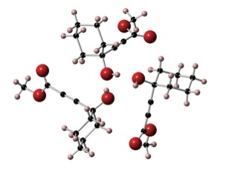
Figure 5. Crystal structure of 114.
The conformation of the cyclohexyl ring is analogous where the alkyne substituent is a cyclopropyl ring, however the alcohol substituents take part in differing hydrogen bonding. The hydrogen bonding for the ester compound 114 forms a three-point helix. For the cyclopropyl-containing compound 116 four hydroxyl groups form square-shaped hydrogen bond cycle (Figure 6).
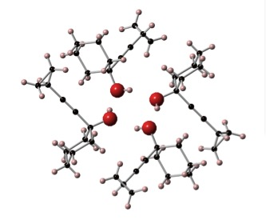
Figure 6. Crystal Structire of 116.
Attention was turned to converting the propargylic alcohols to haloallenes. It was apparent early on that the conditions published by Black et al. in 1963 and used successfully by Wuttke et al. in 2012 were not suitable.^{94,107} ¹H NMR analysis of the crude reaction mixture showed no evidence of either starting material or the allene. It was concluded the starting material had decomposed under the reaction conditions (Scheme 82).

Scheme 82. Unsuccessful application of the previously reported bromoallene synthesis.
Fortunately, there are other methods of haloallene synthesis from propargyl alcohols. In 1959 Bhatia, Landor and Landor reported the synthesis of chloroallenes from the propargyl alcohols by treatment with SOCl₂ and pyridine. These reactions also gave some of the eliminated cyclohexenyl acetylene (Scheme 83).^{92,93}
Scheme 83. Mechanisms for haloallene syntheses involving sulfonyl ester or sulfinyl chloride intermediates.
Treatment of propargylic alcohol 114 under conditions similar to those reported by Bhatia et al.⁹³ gave the eliminated product 119 (Scheme 84).
Scheme 84. Results for the treatment of cyclohexyl propargyl alcohols with thionyl chloride and NEt₃.
The next method explored for haloallene synthesis was to treat propargyl alcohols 113-117 with sulfonyl chlorides followed by treatment with halide salts. For example, Feldmann et al. used this method in the synthesis of (±)-panacene by treating propargylic alcohol 120 with MsCl and treating the product with LiCuBr₂ (Scheme 85).¹⁰⁸
Scheme 85.
Crimmins et al. treated propargylic alcohol 121 with 2,4,6-i-Pr₃C₆H₂SO₂Cl and reacted the product with LiCuBr₂ to synthesise a bromoallene as part of the synthesis of isolaurallene (Scheme 86).¹⁰⁹
Scheme 86.
Propargyl alcohol 114 was successfully treated with MsCl to form mesylate 122, with none of the eliminated product observed. Mesylate 122 was then treated with CuCl and LiCl to give a mixture of 123 and 124 in a ratio of 1 : 1.6, respectively. 123 and 124 were inseparable by flash chromatography; a yield is not quoted as there was also residual MsCl present in the mixture (Scheme 87).
Scheme 87.
The product ratios were calculated from the integral values of the ¹H NMR chemical shifts for the four cyclohexyl protons vicinal to the allene in 123 and the chloride in 124 (Figure 7).¹¹⁰
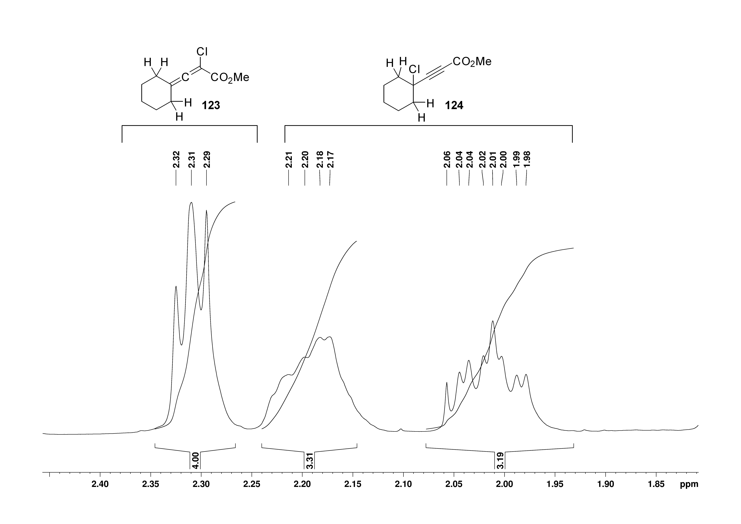
chemical shift
Figure 7.
In 1978 Muscio et al. reported it was possible to isomerise propargyl halides using CuCl₂ and (Bu)₄NCl (Scheme 88).¹¹¹ An attempt was made to isomerise the mixture isolated (Scheme 89). However this did not change the ratio of haloallene : propargyl halide.
Scheme 88. Synthesis of a propargyl chloride followed by isomerisation in order to obtain a chloroallene.
To see if the halide source altered the ratio of haloallene and propargyl halide, mesylate 122 was also treated with CuBr and LiBr instead of CuCl and LiCl. This led to a marked increase in the ratio of 125 to 126, which were also inseparable by flash chromatography. Again, no yield is quoted as there was some MsCl present in the mixture (Scheme 89).
Scheme 89. Attempted synthesis of haloallene electrophiles.
The ratio of 125 : 126 was also calculated from the integral values of the ¹H NMR chemical shifts for the four cyclohexyl protons vicinal to the allene in 125 and the bromide in 126 (Figure 8).¹¹⁰
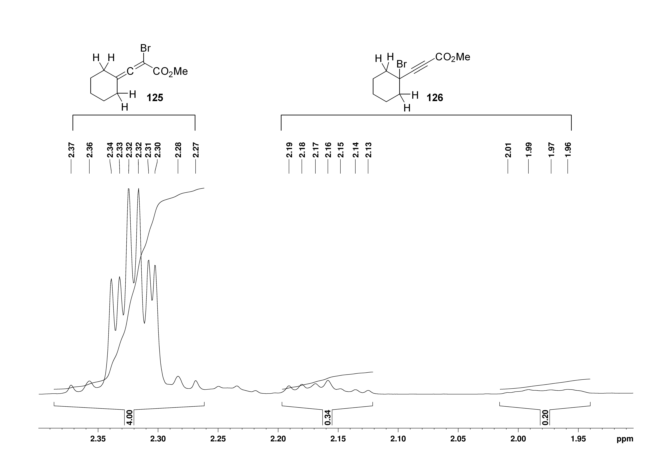
chemical shift
Figure 8.
Both mixtures of 123/124 and 125/126 were reacted with organozinc reagent 69. When the chloride mixture 123/124 was reacted with 69 under copper catalyzed conditions only one product was seen. This was allene 127, which is believed to be the product of S_{N}2’ addition of 69 to the propargylic chloride 124 (Scheme 90).
Scheme 90. Reaction of a mixture of allenic chloride and propargyl chloride with organozinc reagent 69 under copper catalyzed conditions.
When the mixture of 125/126 (7.4 : 1) was reacted with organozinc reagent 69 under the same conditions, no products of reactions between 69 and 125 or 126 were isolated. Instead protected alanine 128 was the major product. This indicated that zinc insertion was successful and there was no reaction of 69 with either 125 or 126 (Scheme 91).
Scheme 91.
The synthesis of substituted alkynyl amino acids was not explored further.

Future Work, Directly Functionalizing Terminal Alkynes
As Wuttke et al. had already established a route for the synthesis of unnatural alkynyl amino acids, these compounds could be functionalized further to reach the targets of interest (Scheme 92).
Scheme 92. An alternative approach to alkynyl amino acids.
There are several ways of directly functionalizing terminal alkynes. For reviews on the subject of oxidative carbonylation reactions, one should consult the 2011 review by Liu et al.¹¹² and the 2013 review by Wu et al.¹¹³ However, some specific examples of how the carbonyl, cyclopropyl and trifluoromethyl groups could be introduced are discussed.

For example, Gooßen et al. reported the synthesis of a range of propiolic acids by copper catalyzed insertion of CO₂ into the terminal alkyne C-H bond (Scheme 93).¹¹⁴
Scheme 93. Synthesis reported by Gooßen et al.
An example of introducing a cyclopropyl group to a terminal alkyne was reported in 2009. Coleridge et al. reported the palladium catalyzed coupling of aryl halides with cyclopropylzinc bromide (Scheme 94).¹¹⁵
Scheme 94. Negishi coupling of cyclopropyl zinc bromide with an aromatic bromide.
Clearly this would require a brominated terminal alkyne, but fortunately methodology for alkyne bromination has been reported. The 2012 publication by Melnes et al. used two methods. First, the deprotonation of the alkyne with strong base and subsequent reaction with Br₂. Second, the silver catalyzed bromination in the presence of NBS (Scheme 95).¹¹⁶
Scheme 95. Two methods of bromination reported by Melnes et al.
For an example of introducing a trifluoromethyl group, in 2010 Chu and Qing reported the trifluoromethylation of alkynes with Me₃SiCF₃ using stoichiometric amounts of copper (Scheme 96).¹¹⁷
Scheme 96. Copper mediated funtionalisation of terminal alkynes with CF₃ groups.
These examples are representative of the sort of chemistry that could be used to obtain the target molecules from the substrates synthesized by Wuttke et al.¹

Unsaturated Amino Acid Syntheses
Attention turned to the synthesis of fluorinated amino acids. In order to investigate the applicability of the radical fluorination of alkenes reported by Barker et al. (Scheme 34),⁴⁸ a pool of unsaturated amino acids would have to be synthesized. There were three techniques used to achieve this. Firstly, the Negishi coupling of organozinc reagent 69 to vinyl triflates, as reported by Carillo-Marquez et al.⁹⁰ and optimized by Wuttke et al (Scheme 97).¹
Scheme 97.
Secondly, the Negishi coupling of organozinc reagent 69 with vinyl bromides. This could feasible be achieved under the same conditions reported by Wuttke et al (Scheme 98).¹
Scheme 98.
Thirdly, the copper catalyzed allylation reaction between organozinc reagent 69 and allyl chlorides (Scheme 99).
Scheme 99.

Reactions of Organozinc Reagent 69 With Cyclic Vinyl Triflates
A selection of γ,δ-unsaturated amino acids were synthesized by Negishi coupling between organozinc reagent 69 and cyclic vinyl triflates. The triflates were all synthesized from the corresponding ketones and successfully coupled in yields higher than that reported by Wuttke et al.¹ The differences in the conditions reported by Wuttke et al. and those used in this thesis are: leaving out LiCl as an additive and the reaction time. The reactions in this thesis were carried out for three days whereas Wuttke et al. carried out the reactions overnight. Two new examples 131 and 132 have also been synthesized by this method (Table 3).
Table 3. Results for Negishi couplings with vinyl triflates
Entry | Vinyl Triflate | Product | Yield
1 |  |  | 83 % (70 %)¹
2 |  |  | 92 % (70 %)¹
3 |  |  | 81 % (62 % with LiCl additive)¹
4 |  |  | 61 % (63 % with LiCl additive)¹
5 |  |  | 52 %
6 |  |  | 90 %
Literature yields reported by Wuttke et al. are shown in brackets
Triflate 130 used in entry 6 was the only example not known in the literature. However, the gem difluoro group did not hamper triflate synthesis or the subsequent coupling. Triflate 129 in entry 5 was synthesized and used in a coupling to an aryl borane in the work by Jana et al. (Scheme 100)¹¹⁸
Scheme 100.
There was a discrepancy in the ¹³C NMR data for the cylooctenyl derivative 92 in entry 4 (Table 3). Carillo-Marquez et al. reported the synthesis with full characterization in 2005.⁹⁰ The ¹³C NMR data was reported as:

¹³C NMR (CDCl₃, 100 MHz), δ_{C} 173.6, 155.8, 135.8, 128.8, 80.0, 52.5, 52.1, 40.5, 29.8, 28.7, 28.5, 26.6, 26.5, 26.3, 22.8

When repeating the synthesis of the same amino acid, the ¹³C NMR data acquired did not have the signal at ~22.8 ppm:

¹³C NMR (CDCl₃, 100 MHz), δ_{C} 173.4, 155.2, 135.6, 128.7, 79.8, 52.1, 52.0, 40.3, 29.7, 28.5, 28.3, 26.4, 26.3, 26.2

It is reasonable to suggest that the peak at 22.8 ppm reported by Carillo-Marquez et al. was not from the cyclooctenyl amino acid but from an impurity. In order to explore this possibility, an HSQC NMR experiment was carried out to show direct H-C correlation (Figure 9).

In the ¹H NMR, the signal at 2.15-2.05 corresponds to four protons and this correlates to two carbon environments, one of which is part of the three signals close together around 26 ppm. The other carbon signal that corresponds to the four protons at 2.15-2.05 ppm appears at ~28 ppm, this is also the region in which the peak for the three CH₃ groups of the Boc t-Bu group is seen. Thus, the Boc signal masks one of the CH₂ signals in the octenyl ring.
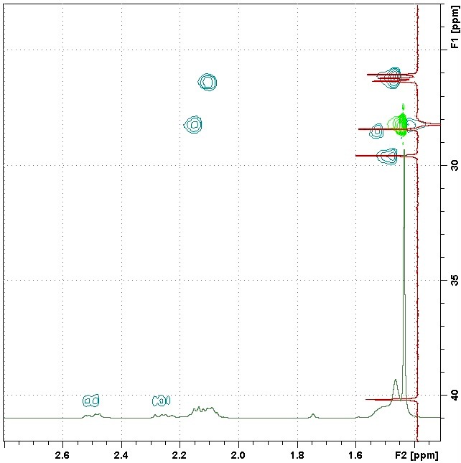
Figure 9. HSQC plot with ¹H and ¹³C NMR overlayed showing the overlap of ¹³C environments producing a spectrum with seemingly too few ¹³C environments.
The data reported by Carrillo-Marquez contains 15 carbon environments, which is the number of unique carbon environments in the molecule. However, it seems a signal from an impurity was incorrectly attributed to the amino acid molecule. The characterization data reported in this thesis has only 14 environments but the HSQC experiment has shown that one of the CH₂ groups is masked by the CH₃ peak for the Boc group, so 14 environments is in fact correct.

Reactions with Vinyl Bromides
Organozinc reagent 69 underwent Negishi couplings with several vinyl bromides. Using the optimized conditions based on those reported by Wuttke et al. the unsaturated amino acids shown were synthesized in good yields (Table 4).
Table 4. Yields of Negishi couplings with vinyl bromides and 65, yields are quoted using 65 as the limiting reagent.
Entry | Vinyl Bromide | Product | Yield
1 |  |  | 84 %
2 |  |  | 95 %
3 |  |  | 68 %
4 |  |  | 72 %
5 |  |  | 88 %
6 |  |  | 79 %*
*Yield calculated with 1-bromocyclobutene as the limiting reagent

The vinyl bromides required in entries 1-6 were purchased commercially and used without any purification. In entries 1-5, there were approximately 1.6 equivalents of vinyl bromide to 1 equivalent of 65.

The synthesis of 138 was previously reported in 1994 by Papageorgiou et al.⁷² In their route a bis-lactim ether was treated with n-BuLi and reacted with 3,3-dimethyl allyl bromide. The bis-lactim ether was then hydrolysed to generate 138 (Scheme 101).
Scheme 101.
Elaridi et al. also reported the synthesis of 138 in 2005 by a metathesis reaction between protected allyl glycine and isobutene or 2-methylbut-2-ene, catalyzed by Grubbs II (Scheme 102).¹¹⁹
Scheme 102.
When the Negishi cross-coupling reaction was carried out between organozinc reagent 69 and a mixture of vinyl bromides (E/Z)-135 (Table 4, entry 5) 3.2 equivalents of vinyl bromide were used to 1 equivalent of 65. This was to elucidate if (E)-139 or (Z)-139 would be formed preferentially. It was determined that the product mixture was 7 : 1 in favour of (E)-139 : (Z)-139 (Scheme 103).
Scheme 103.
The ratio of (E)-135 : (Z)-135 (1.9 : 1) was determined by comparing the integral values of the vinyl protons (Figure 10).¹¹⁰ The ratio of (E/Z)-139 (7 : 1 respectively) was also determined from the distinct ¹H NMR chemical shifts of the two methyl groups on the alkene (Figure 11) (the calculation used is shown in the appendix).
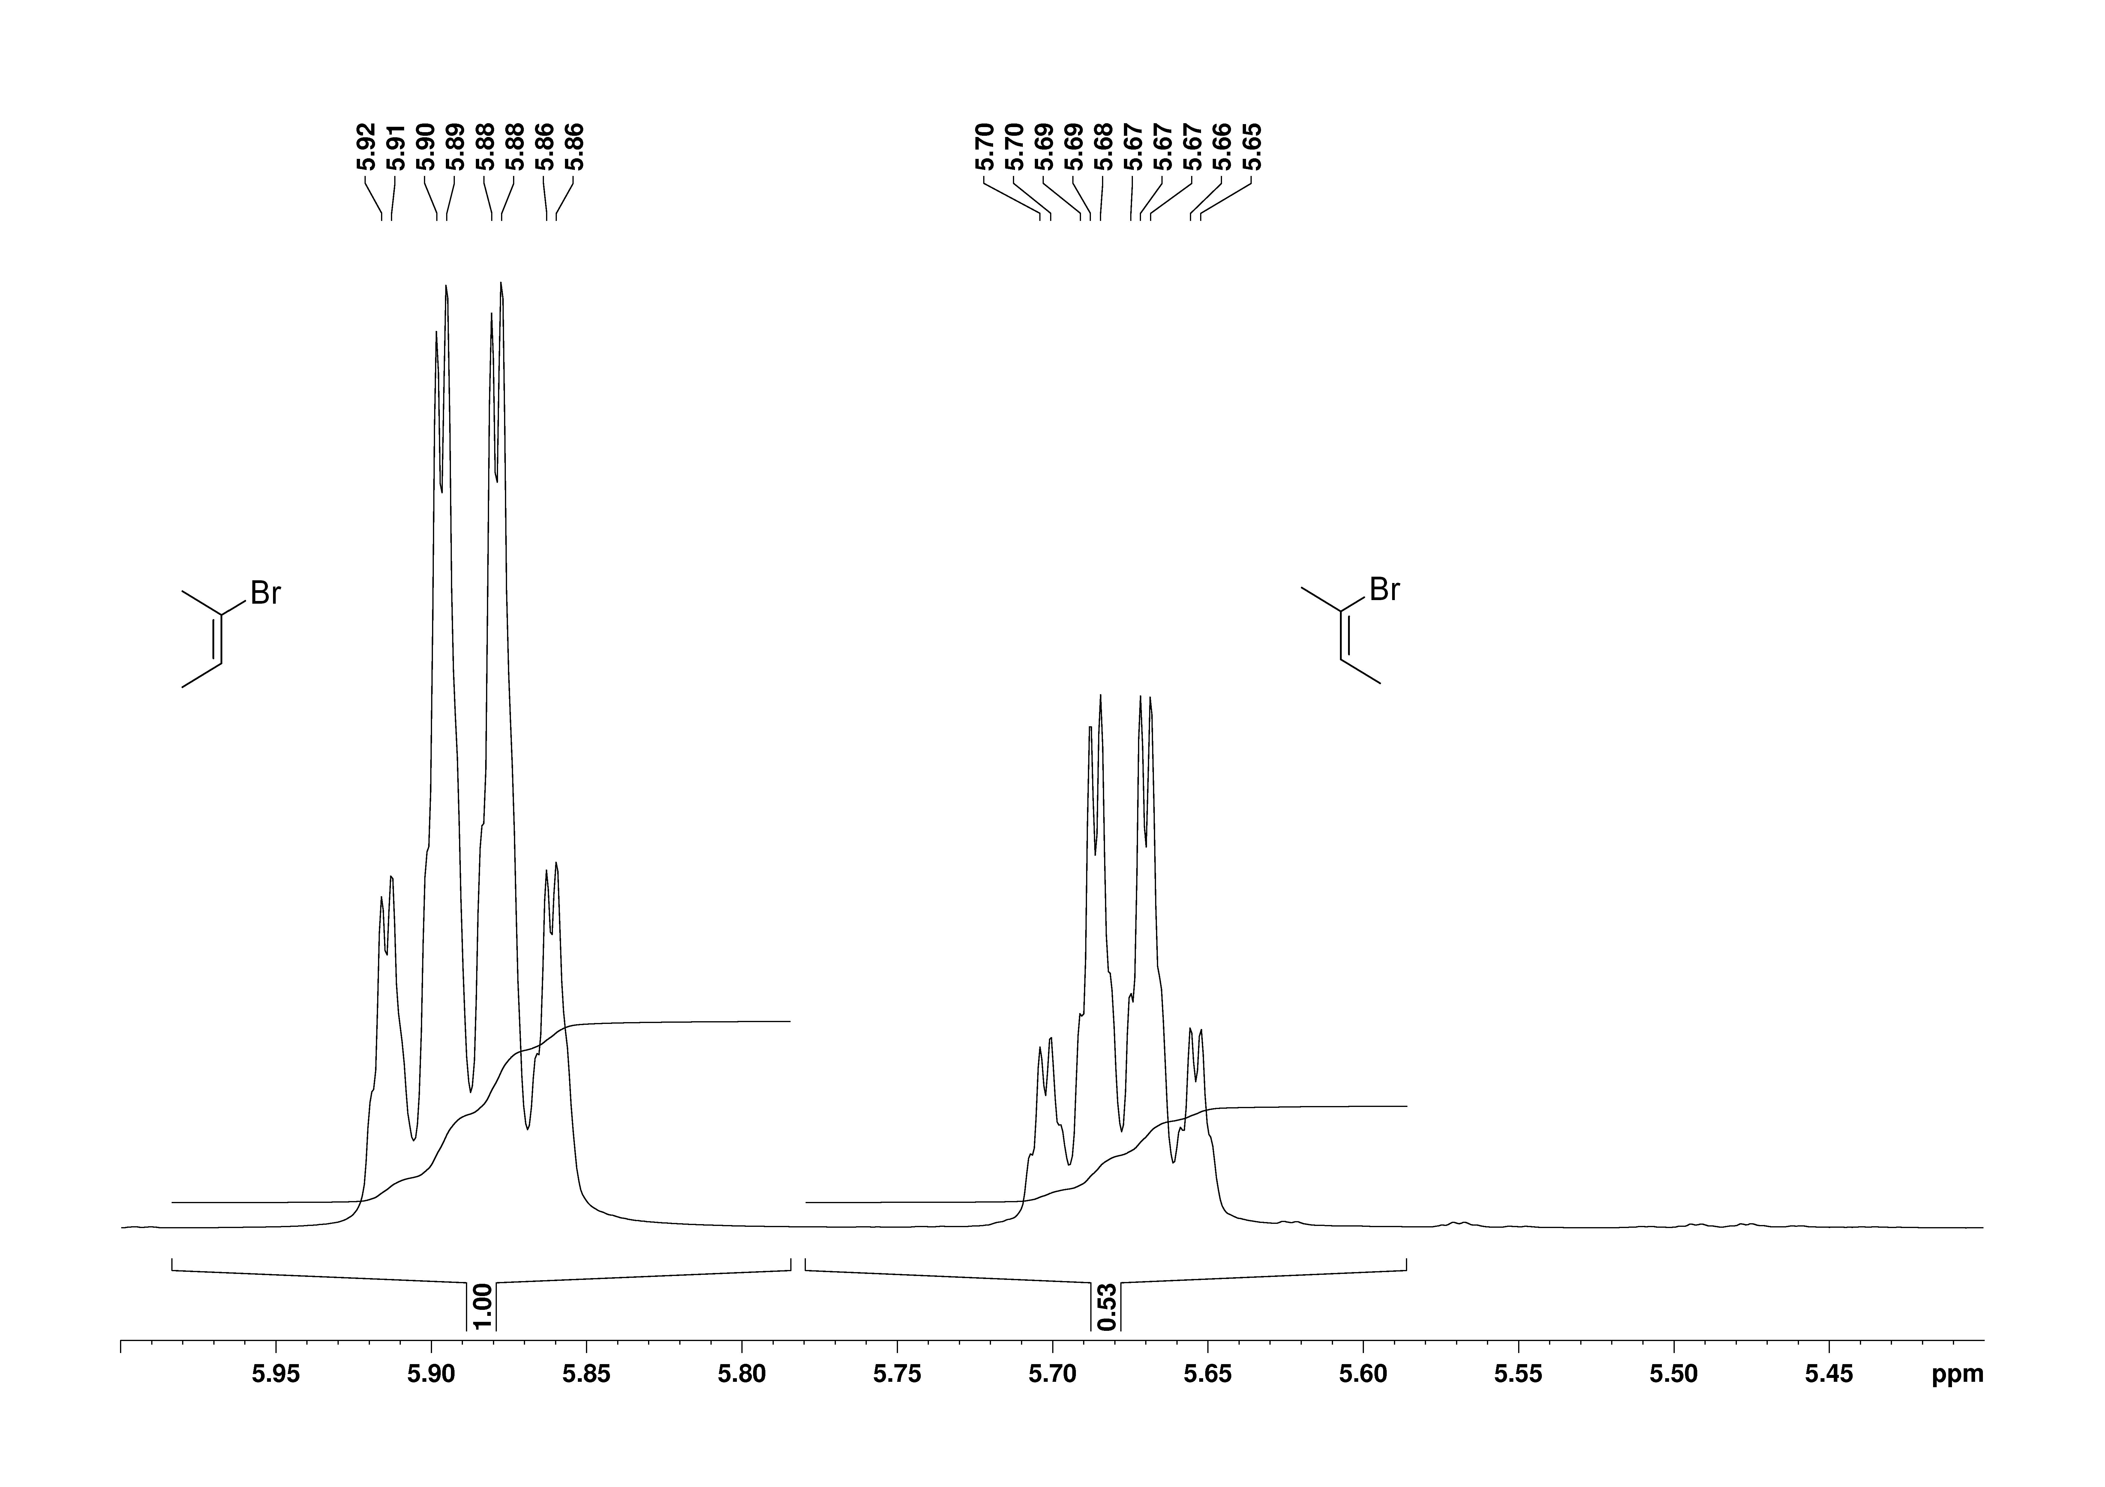
chemical shift
Figure 10.

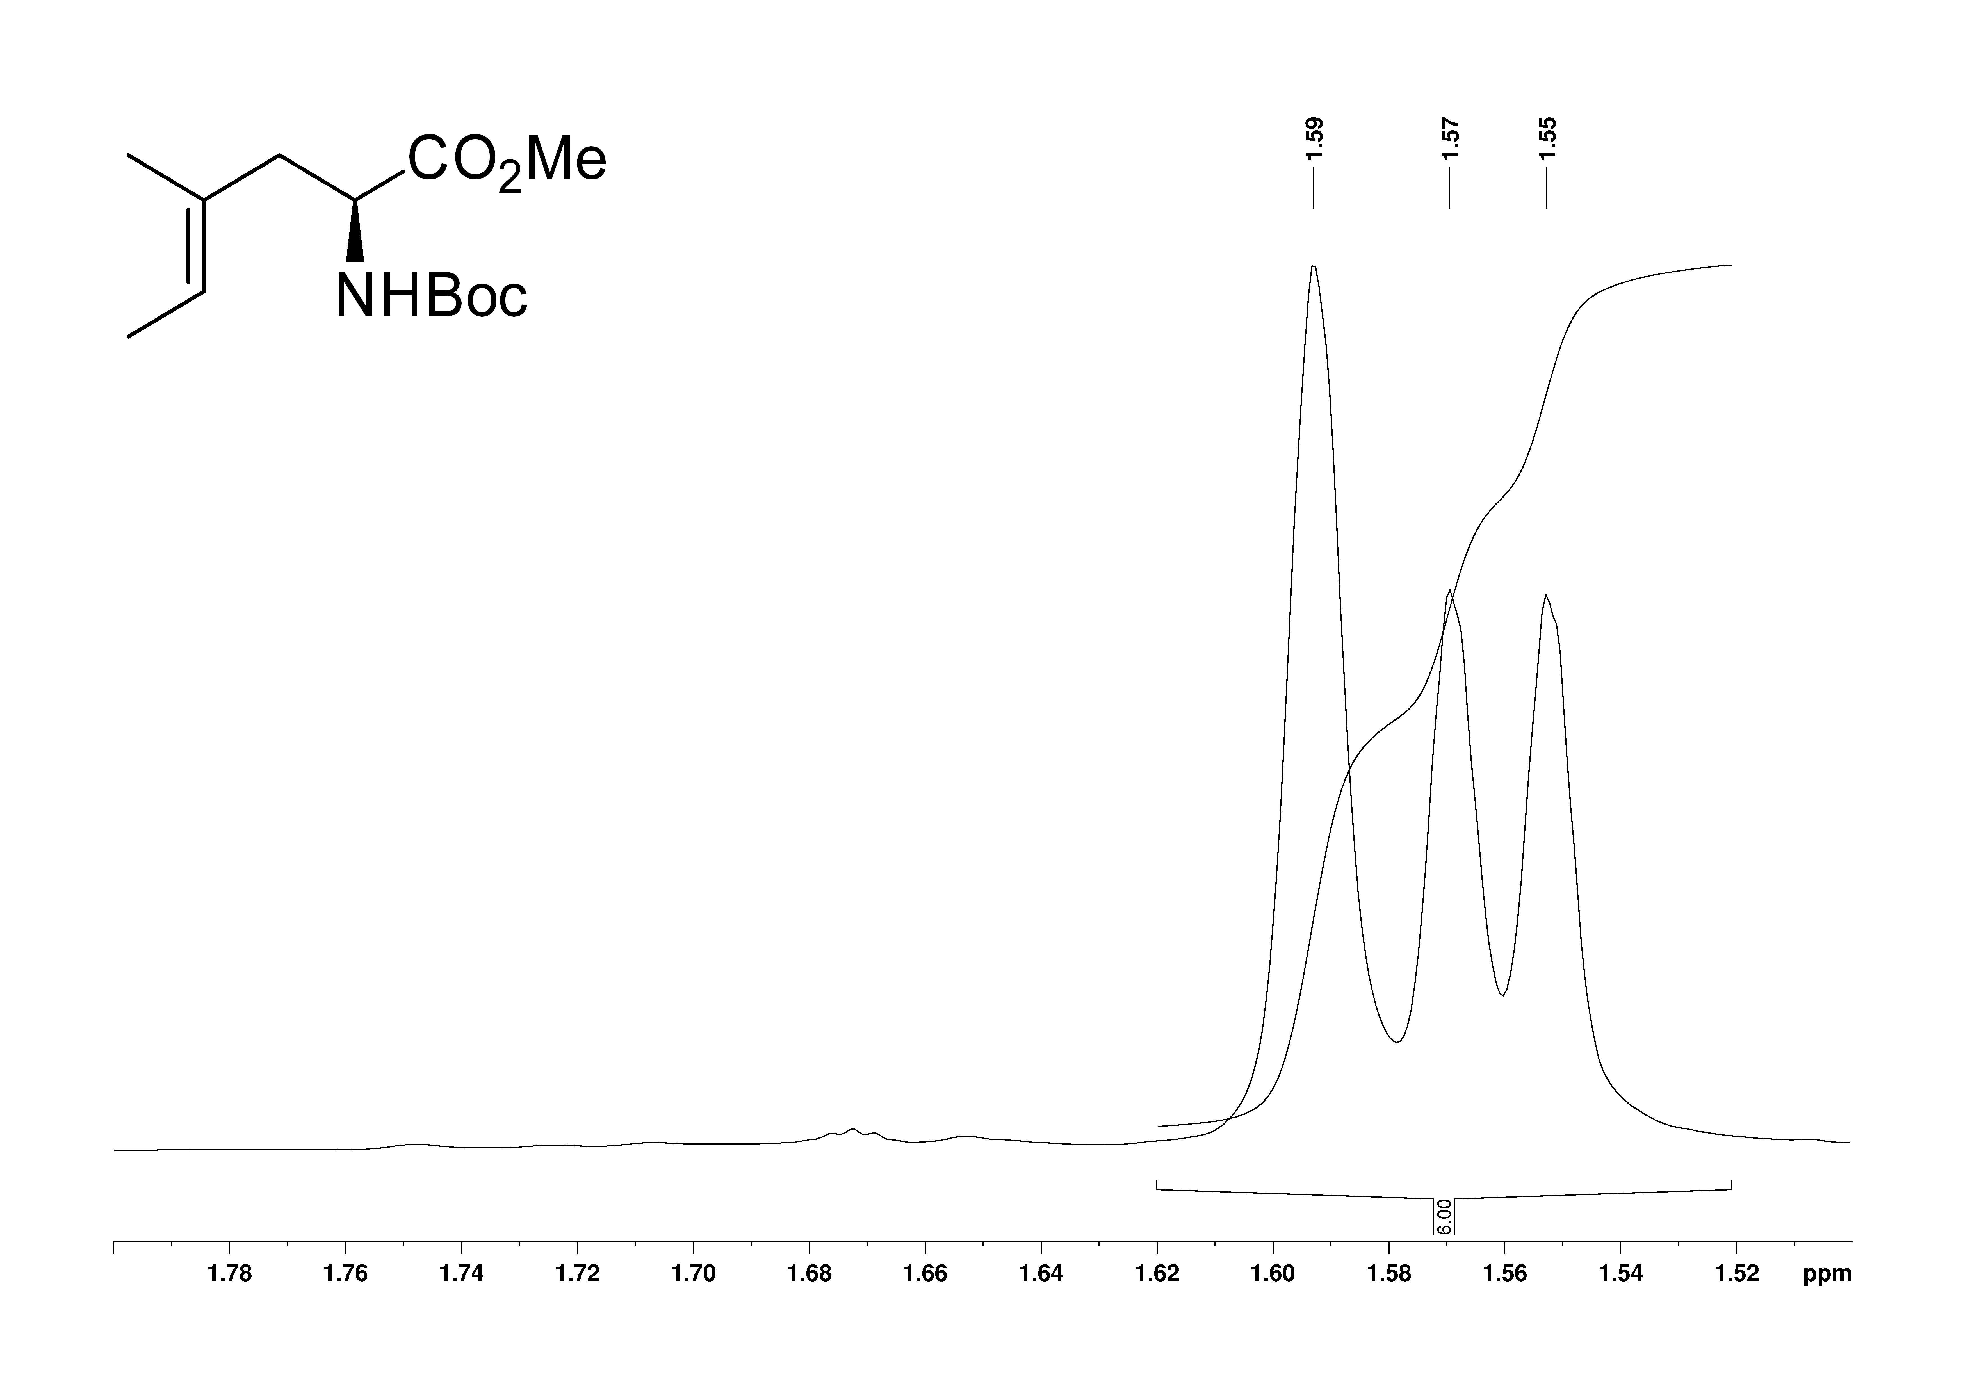
chemical shift
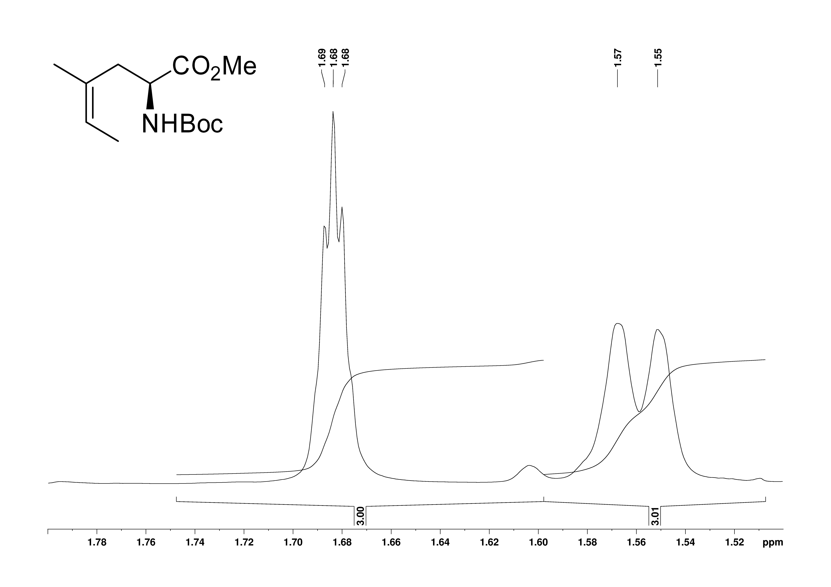
chemical shift
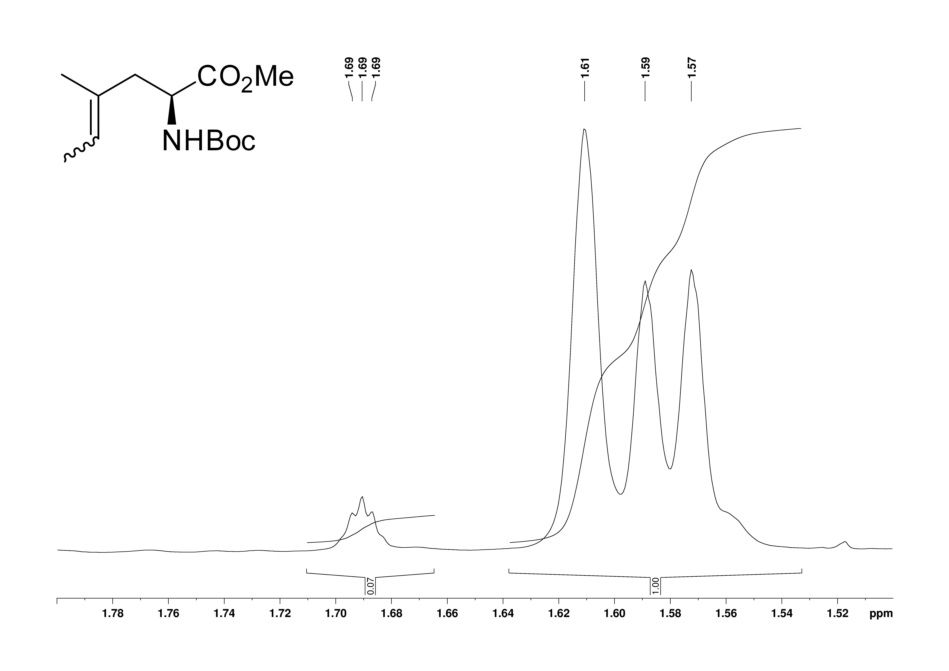
chemical shift
Figure 11.

Whilst selectivity is somewhat modest, one plausible explanation lies in the relative rates of vinyl bromide oxidative addition to Pd⁰ (Scheme 104).
Scheme 104. Oxidative addition of Z-bromobutene and E-bromobutene leading to different vinyl palladium(II) species.
Of all the unsaturated examples synthesized, compound 140 proved most challenging. Jayathilaka et al. reported the synthesis of 136 by first treating allyl chloride with a dibromo carbene formed by treatment of bromoform with NaOH to form 141. Treating compound 141 with MeLi led to lithium-halogen exchange and cyclisation to give 142. Finally, acid mediated isomerization using TFA afforded 1-bromocyclobutene 136 as a solution in Et₂O (Scheme 105).¹²⁰
Scheme 105. Synthesis of cyclobutenyl bromide.
Jayathilaka et al. then used a solution of 136 in Et₂O in the synthesis of cyclobutenyl glycine 143 (Scheme 106).¹²⁰
Scheme 106. Synthesis of cyclobutenyl glycine as reported by Jayathilaka et al.
When repeating this procedure, the solution of 136 in Et₂O was found to be acidic, probably due to residual TFA. When this solution was used in a Negishi coupling reaction with zinc reagent 69 as the limiting reagent all that was observed was the product of protonation 128. Instead of an excess of 136, an excess of zinc reagent 69 was used, 3.2 equivalents. The increase in equivalents of zinc reagent 69 meant any residual TFA was consumed by protonation of 69 to form protected alanine 128, ultimately giving cyclobutenyl alanine 140 in 79 % yield with respect to vinyl bromide 136.

Reactions with Allyl Chlorides
Three unsaturated amino acids were synthesized by copper catalyzed allylation reactions between iodide 65 and allyl chlorides (Table 5).
Table 5. Results for copper catalysed allylations.
Entry | Allyl Chloride | Molar Ratio  (chloride : 65) | Product | Yield
1 |  | 6.1 : 5.1 |  | 84 %
2 |  | 11.5 : 5.0 |  | 78 %
3 |  | 0.9 : 2.5 |  | 92 %

Deboves et al.¹²¹ previously reported the synthesis of the NHFmoc Ot-Bu derivative of 144 (Entry 1). The bis-amino acid 146 has been synthesized previously by workers at The University of Sheffield but is not reported in the literature.¹²²

Radical Hydrofluorination of Unsaturated Amino Acids
With a set of unsaturated amino acids for HF addition prepared, the method for radical HF addition reported by Barker et al. was explored.⁴⁸ Applying these conditions, treatment of unsaturated amino acids with NaBH₄ (added as a solid in two portions) and Fe₂(ox)₃ in the presence of Selectfluor® resulted in the formation of the HF addition products 147-158 in good to excellent yields (Table 6).
Table 6. Results for radical hydrofluorinations,
*Denotes a deviation in the equivalents of reagents and the standard synthetic protocols, which is discussed in the following section.
The only substrate that proved to be challenging was the bis-fluoro derivative 132 leading to tris-fluoro compound 152. When the method reported by Barker et al.⁴⁸ was applied there was incomplete conversion from the starting material to the tris-fluoro product 152. The starting material and product in this case were inseparable by flash chromatography. Instead of optimizing the purification, efforts were focused on increasing conversion. Initial experiments involved an increase in the number of equivalents of reagents, but this did not substantially affect the extent of conversion. A solution was eventually found by increasing the number of equivalents of reagents and by slowly adding the NaBH₄ as a solution over six hours by syringe pump, instead of as portions of NaBH₄ pellets (Scheme 107).
Scheme 107. Reaction scheme for the synthesis of 152, where NaBH₄ (dissolved in 30 mL 0.1 M NaOH) was added over six hours by syringe pump.
Crystal structures for compounds 147 and 152 were acquired. The packing of both the crystalline solids shows hydrogen bond from the Boc carbamate N-H to a neighboring Boc carbamate C=O as well as the cyclic C-F bonds aligning favourably with the δ- F pointing towards the δ+ of the adjacent ring’s C^{δ+}-F^{δ-} bond. The extra C-F interaction for 152 compared to 147 is manifested in the difference in melting points, 67-69 ºC and 43-46 ºC respectively (Figure 12).
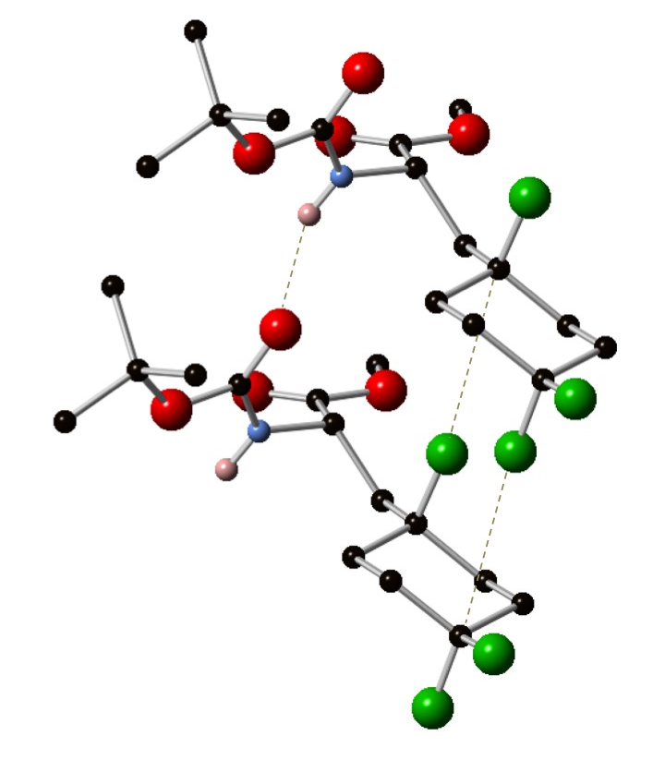
Figure 12.
The crystal structure for 147 is shown below with the relevant intermolecular interactions highlighted (Figure 13).
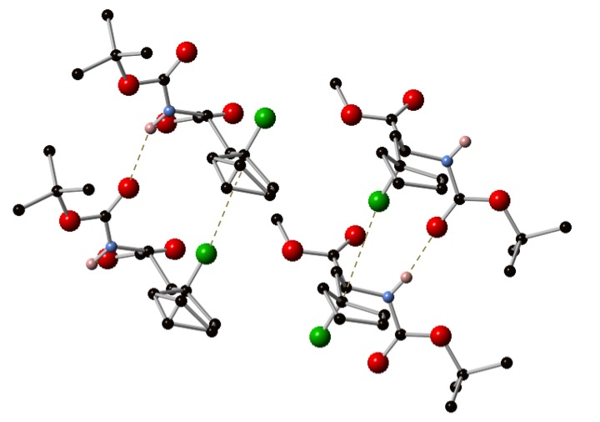
Figure 13.
The melting points of 153 and ent-153 are 38-40 ºC. It is feasible a crystal structure of these may too be acquired in the future however suitable conditions in which they can be crystallised have yet to be determined.

Has Amino Acid Stereochemistry Been Preserved Throughout The Synthesis?
Barker et al. reported one amino acid example in their 2012 publication (Scheme 34, page 18).⁴⁸ However there was no comment on whether there was any racemization of the amino acid. In order to establish whether the stereochemistry of the amino acid had remained unaffected from L-serine to the final fluorinated amino acid derivatives, the ee of one example, namely 153/ent-153 was determined. The reaction of zinc reagent 159, derived from D-serine, with 2-bromopropene 133 was carried out giving ent-137 in 96 % yield. The treatment of ent-137 under the same HF addition conditions as 137 gave ent-153 in 88 % yield (Scheme 108).
Scheme 108.
A 2 : 1 mixture of the two enantiomers was prepared and HPLC conditions were found that provided baseline separation. When ent-153 was analysed under the same conditions the ee was determined to be 98.4 %. Likewise, the ee for 153 was determined to be 99.6 %, so there was essentially no racemization. The chiral HPLC traces are included in the Experimental section.

Probing The Diastereoselectivity of Radical Hydrofluorination
There were two compounds in which a new stereogenic centre was formed, 155 and 156. It was a point of interest to see if there was any diastereoselectivity during the HF addition process. The NMR spectra for 155 and 156 were used for de determination.

Beginning with 156, this compound possesses a proton in the position geminal to fluorine. This proton seemingly also had an NMR signal that had baseline separation from other proton signals (Figure 14). The presence of two peaks of similar integration could have been an indication that there were two distinct diastereoisomers in equal amounts. However, the proton is coupling to fluorine, so there may actually be two overlapping proton signals of similar chemical shift in which the large J_{HF} value gives the appearance of two separate environments. The latter possibility was the case, as confirmed by carrying out a ¹⁹F decoupled ¹H NMR experiment and seeing only one signal (Figure 14). It was clear that ¹H NMR was an inappropriate technique for establishing whether there was any discernable de as the protons geminal to fluorine may have similar chemical shifts in both diastereoisomers. Another possible conclusion from this experiment may have been that there was in fact only one diastereoisomer present. ¹⁹F NMR was used in an attempt to establish de more effectively.
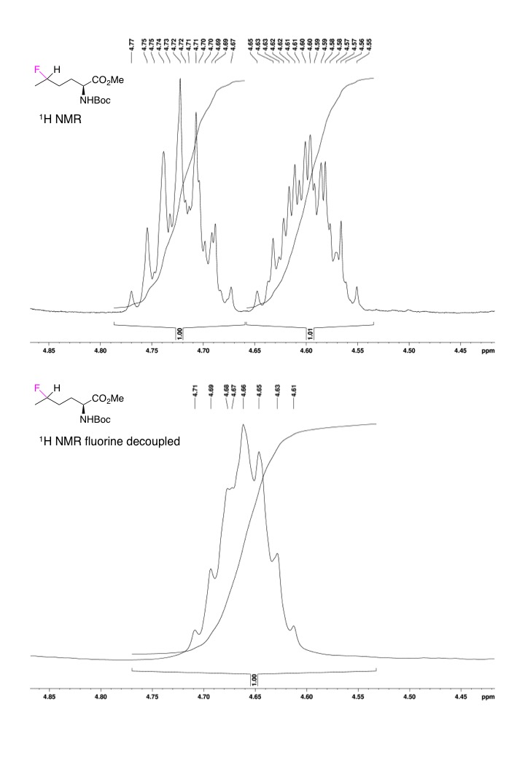
Figure 14. ¹H (top) and ¹H fluorine decoupled (bottom) NMRs showing the signal for the proton geminal to the fluorine of compound 156.

When considering ¹⁹F NMR it was apparent immediately that proton coupled ¹⁹F NMR was not a viable solution as the H-F coupling produced a multiplet with no baseline separation. The ¹⁹F CPD NMR spectrum provided more promise (Figure 15). The proton decoupled ¹⁹F NMR was closer to baseline separation, however there was a small shoulder to the right of the signal at -174.36 ppm, likely due to rotameric behavior of the molecule. This is difference of ~0.3 ppm from the signal at -174.07 ppm. This is almost the same difference between the peak at -173.73 ppm and that at -174.07 ppm. It is feasible that the peak at -173.73 ppm also has an analogous shoulder, which is under the peak at -174.07 ppm. If this were the case it would also contribute to the integral of the peak at -174.07 ppm. If the shoulders were both of the same magnitude then it is reasonable to suspect that the de is effectively 0 %. If there was a rotameric shoulder associated with the peak at -173.73 ppm underneath the peak at -174.04 ppm and it was the same size as the shoulder at -174.36 ppm, then corrected integral value would be 1.06, a much more modest difference to that of 1.00 : 1.39. This does suggest that the de is effectively 0 % however there is still some ambiguity. The best way to remove this rotameric behavior is the removal of the Boc protecting group, as this is the presumed source of the rotameric shoulders. This was achieved simply by treatment of 156 with TFA to give the salt 160 (Scheme 109).
Scheme 109. Boc deprotection of 156.

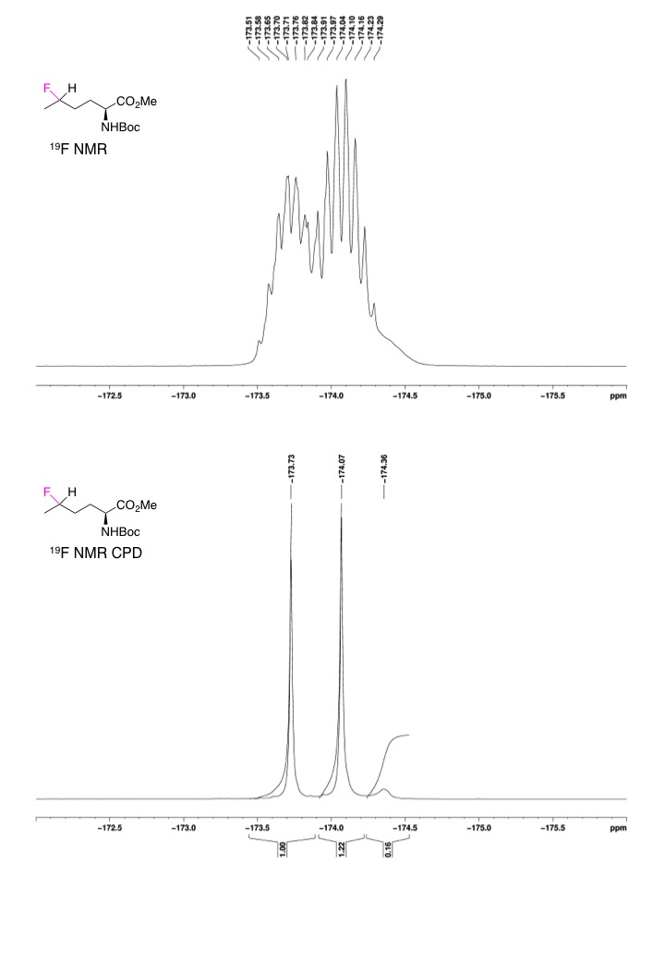
Figure 15. ¹⁹F (top) and ¹⁹F CPD (bottom) NMRs for 156.

The TFA salt 160 was then analyzed by ¹⁹F NMR. This time no rotameric peaks were seen and the ¹⁹F CPD NMR spectrum was sufficient to determine the ratio of the two diastereoisomers by their unique proton decoupled ¹⁹F NMR chemical shifts (Figure 16). The ratio of the two peaks was 0.46 : 0.49, giving a de of approximately 3 %. So there is essentially no diastereoselectivity.

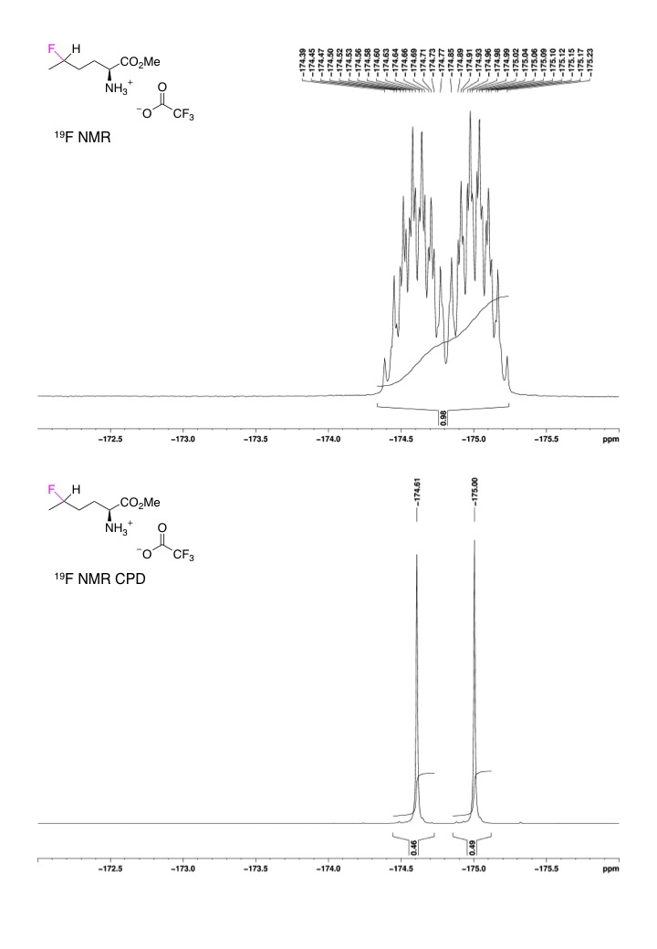
Figure 16. ¹⁹F (top) and ¹⁹F CPD (bottom) NMRs for the TFA salt 160.

For 155 there was again a lack of baseline separation in the ¹⁹F NMR and the same rotameric behavior in the ¹⁹F CPD NMR spectra was also observed (Figure 17). 155 was treated with TFA to remove the Boc group and eliminate the effect of any rotamers on the integral values for the ¹⁹F chemical shifts. Upon deprotection of 155 the chemical shifts of both ¹⁹F environments become distinct in both the ¹⁹F NMR experiment and in the CPD ¹⁹F NMR, so either could be used to estimate the de (Figure 18). Both ¹⁹F and ¹⁹F CPD spectra for 161 give a de value of approximately 2 %. Again, there is effectively no diastereoselectivity.
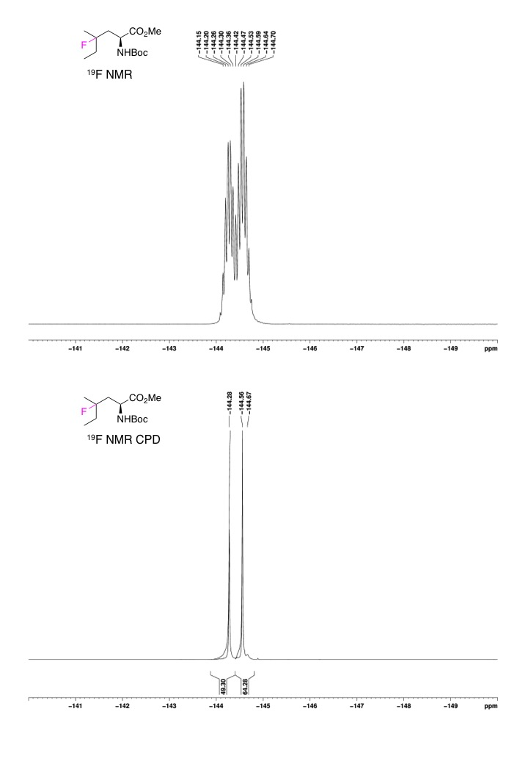
Figure 17. ¹⁹F (top) and ¹⁹F CPD (bottom) NMRs for 155.

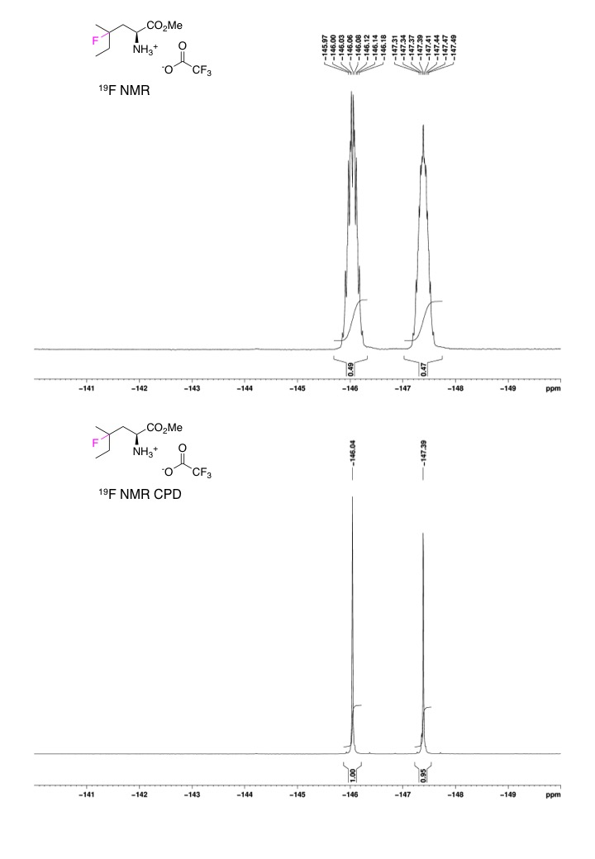
Figure 18. ¹⁹F (top) and ¹⁹F CPD (bottom) NMRs for the TFA salt 161.

Would Addition of NaBH₄ By Syringe Pump Lead to Increased Yields with Other Substrates?
In the synthesis of 152 it was observed that slow addition of NaBH₄ was responsible for increased conversion of starting material to product and consequently increased the yield. This method of addition was also used effectively at Medivir by D. Wiktelius in the late stage fluorination of a precursor to their lead compound 111 (Scheme 110).¹²³
Scheme 110. The late stage radical hydrofluorination in the synthesis of lead compound 111.
As adding the NaBH₄ by syringe pump had proven successful in the syntheses of lead compound 111 and tris-fluoro amino acid 152, the possibility this technique might provide universally higher yields was explored. The results are summarized in Table 7.

Table 7. Comparison of methods for radical HF addition
Entry | Fluorinated product | Yield, addition of solid NaBH₄ | Yield, slow addition of NaBH₄ in solution
1 |  | 75 % | 70 %
2 |  | 84 % | 66 %
3 |  | 63 % | 29 %
4 |  | 65 % | 61 %
5 |  | 70 % | 50 %
6 |  | 58 % | 61 %
7 |  | 73 % | 50 %
8 |  | 91 % | 84 %
9 |  | Isolated as a mixture of 132 and 152 | 64 %

The result highlighted in green is that which gave the highest yield. Generally speaking the solid addition of NaBH₄ worked better than the slow addition of NaBH₄ in solution. The interesting entries are 6 and 9; the slower addition of NaBH₄ brings about a slight improvement in yield. The precise effect of the ether and gem-difluoro groups is not obvious but perhaps an inductive effect alters the reactivity of the starting material. This alternative method finds its value in situations where conversion cannot be improved simply by increasing the equivalents of NaBH₄ or Fe₂(ox)₃.

Summary of Fluorinated Protected Amino Acids

Use of a fluorinated amino acid in the synthesis of a Cathepsin inhibitor
With all the examples synthesized, during a brief placement at Medivir AB two Cathepsin S inhibitors were synthesized incorporating 154 (Scheme 111 and Scheme 112).

The first three steps in the synthesis of both inhibitors were the same, 154 was saponified with LiOH to give 162, which was then coupled with 163 using HATU to give 164. 163 was synthesized from the corresponding Boc protected compound by deprotection with TFA. 164 was then deprotected using TFA to form the salt 165. 165 was coupled with one of two carboxylic acids, 167 or 170, using an amide coupling reagent, COMU and T3P were used respectively. The final step was a Moffatt oxidation, which oxidized the hydroxyl group generating the active inhibitor. The yields are quoted after the final oxidation step, this is because only cursory purifications were carried out up to this point and minor impurities were seen at all stages. The final inhibitor was isolated by HPLC to ensure >95 % purity for the biological assay.

The difference in yields is likely due to differing efficiency in the amide coupling between 165 and 167 (Scheme 111) and 170 (Scheme 112). Each synthesis was only carried out once, it is not clear as to whether the discrepancy is a result of the carboxylic acids 167 and 170 having differing reactivities, or due to the different coupling reagents used.

Scheme 111. Synthesis of Cathepsin S inhibitor 169.

Scheme 112. Synthesis of the Cathepsin S inhibitor 172.

The two inhibitors were assayed at Medivir and the following K_{i} values were obtained. They are shown alongside Medivir’s lead compound (Table 8). The inhibition values for 169 and 172 are modest compared to 111; 169, 172 and 111 are comparably selective to Cathepsin S. Importantly, an outcome of this piece of work is that it shows the tertiary fluoro groups are compatible with deprotections using hydroxide and TFA as well as a range of amide coupling reagents.

Table 8. K_{i} values for Cathepsin S, K and L inhibition
Inhibitor | K_{i} Cathepsin S, (nM) | K_{i} Cathepsin K, (nM) | K_{i} Cathepsin L, (nM)
 | 3700 | >1 x 10⁵ | >1 x 10⁵
 | 1300 | >1 x 10⁵ | >1 x 10⁵
 | 7.8 | 1800 | 11000

A recent publication by Fanelli et al. has also taken the approach of this thesis in the synthesis of fluoroleucine.¹²⁴ The same radical fluorination used by Barker et al.⁴⁸ was employed on a substrate analogous to those used here and also in the synthesis of a peptide, similar to the work carried out at Medivir. The unsaturated amino acid synthesis differs in that it uses the chiral phase transfer catalysis methodology reported by Lygo et al.¹²⁵ in the addition of the unsaturated side chain (Scheme 113).
Scheme 113. The Fanelli synthesis of fluoroleucine.
The work described in this chapter does establish that the approach is in fact general for the synthesis of a wide range of fluorinated amino acids.

Using Alternative Radical Traps In The Functionalistaion of Unsaturated Amino Acids
In a publication from 2012 Leggans et al. reported the radical functionalization of unsaturated compounds using NaBH₄, sources of iron and several radical traps.¹²⁶ Two further radical traps were identified of interest; O₂ and NaN₃. Leggans et al. showed that the treatment of β-citronellol with iron(II)phthalocyanine and NaBH₄ under an atmosphere of oxygen led to hydroxylated product 173 (Scheme 114).
Scheme 114.
Leggans et al. also carried out radical hydroazidation of β-citronellol by treatment with Fe₂(ox)₃, NaBH₄ and NaN₃ (Scheme 115).
Scheme 115.
This transformation was high yielding and the azide group can be used in further transformations.

Hydroxyl Amino Acid Synthesis, Introduction
The radical hydroxylation process was attractive in that it would allow an alternative approach to the product of the direct addition of a β-anion equivalent to a ketone (Scheme 116).
Scheme 116. Retrosynthetic analysis of a γ-hydroxyl amino acid.
Work has previously been done to use β-anion equivalents of amino acids in the form of alkyllithium reagents. This approach also requires some involved redox chemistry of the amino acid starting material. In 2004 Kenworthy et al. reported the synthesis of tetrasubstituted γ-hydroxyl amino acids. Starting from serine, the amino acid was protected as the NHBoc, OMe derivative 175. The alcohol of the amino acid side chain was then converted to the chloride by treatment with C₂Cl₆ and PPh₃, followed by reduction of the methyl ester to the alcohol using LiBH₄ forming compound 176. The hydroxyl group of 176 was protected by reaction with SEMCl to give compound 177. Compound 177 then underwent deprotonation of the NHBoc group and Li-Cl exchange to generate a β-anionic reagent 178, which reacted with cyclohexanone to give the adduct 179 (Scheme 117).¹²⁷
Scheme 117. Scheme reported by Kenworthy et al. for the addition of an amino acid derived organolithium reagent to a ketone.
Other syntheses of hydroxy amino acids have involved the hydroxylation of amino acid derived reagents. In 1994 Easton et al. carried out direct hydroxylation of the benzylic C-H in phenylalanine derivatives. This route took advantage of the cyclisation of the Boc protecting group (Scheme 118).¹²⁸
Scheme 118. Radical C-H hydroxylation reported by Easton et al.
In 1997 Mezzetti et al. reported the hydroxylation of NBoc-Leu-OMe using DMDO which gave the lactone 180 (Scheme 119).¹²⁹
Scheme 119. Hydroxylation of a leucine derivative using DMDO.
Subsequently, Saladino et al. reported the results of oxidation of leucine-containing peptides with DMDO (Scheme 120).¹³⁰
Scheme 120. Reaction of Boc-Leu-Leu-OMe with DMDO.
Interestingly when three leucine residues were present, the internal residue was hydroxylated preferentially (Scheme 121).
Scheme 121. Selective hydroxylation of Boc-Leu-Leu-Leu-OMe by DMDO.
The insertion of oxygen into C-H bonds has been studied by Murray et al. In 1995¹³¹ and 1996¹³² Murray and co-workers discussed how the rates of oxygen insertion by DMDO were influenced by hydrogen bond donating groups within the molecule. The substrates in Scheme 120 and Scheme 121 have multiple hydrogen bond donors, which undoubtedly have an impact on the selectivity observed.

The application of the radical hydroxylation method reported by Leggans et al.¹²⁶ to the unsaturated amino acids synthesized previously (Table 3, page 64; Table 4, page 67; Table 5, page 73) would give access to substrates like those reported by Kenworthy et al. (Scheme 118, page 98)¹²⁷ without the need for further modification of the amino acid starting material. Radical hydroxylation of unsaturated amino acids would also not be limited to naturally occurring amino acids like serine (Scheme 119, Scheme 120, Scheme 121).

Hydroxyl Amino Acid Synthesis, Results
When the method reported by Leggans et al. was applied to amino acid 138 only starting material was observed (Scheme 122).
Scheme 122.
Instead of using iron(II)phthalocyanine, an excess of Fe₂(ox)₃ was explored. Furthermore, instead of placing the reaction mixture under an atmosphere of O₂, a positive pressure of air was applied through the reaction mixture. This was done by attaching a Pasteur pipette to a compressed air line and placing this in the reaction mixture. This modified method allowed the successful synthesis of one example, 181 in 48 % yield from compound 138. Unfortunately, this method was not successfully applied to compound 137 (Scheme 123).
Scheme 123.
In an attempt to further increase the yield of alcohol 181 and to synthesize more examples of hydroxylated amino acids, two further modifications to the method were made. The number of equivalents of Fe₂(ox)₃ and NaBH₄ were increased and a change was made to the way air was introduced to the reaction mixture. Instead of the compressed air line being attached to a pipette, a sintered inlet was made (Figure 19). This sintered inlet produced a greater quantity of smaller air bubbles than the pipette. This also made controlling the air input practically easier.
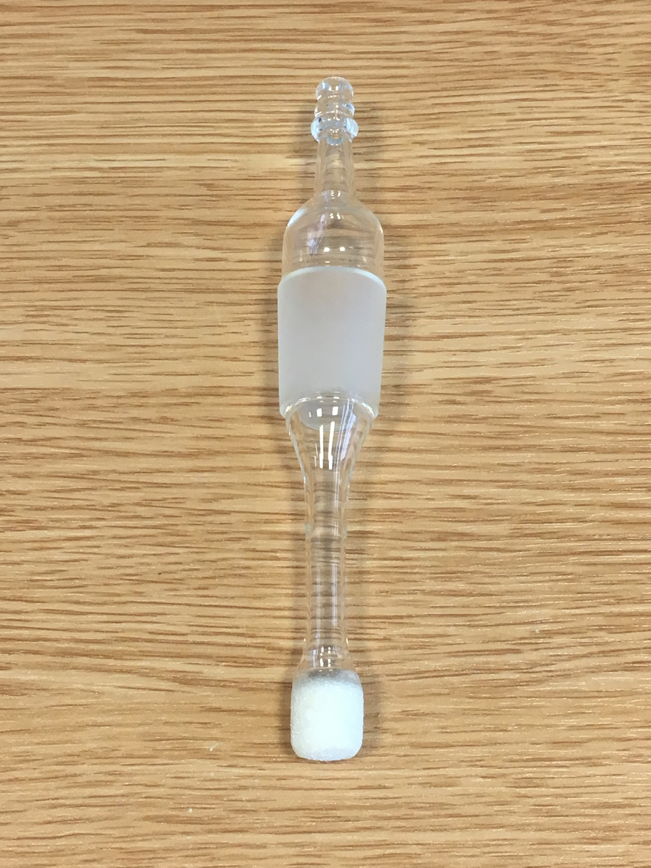
Figure 19.
The outcome of these optimizations was an increase in yield of 181 from compound 138 and successful reaction of compound 137. The reaction of compound 137 did not give alcohol 182 but instead the lactone 180. There was some evidence for lactone 183 by LCMS, however none was isolated after purification (Scheme 124). The reactions of cyclopentenyl compound 89 and cyclohexenyl compound 90 yielded no discernable products; no starting material, hydroxylated amino acid or lactones were seen in analyses of the crude reaction mixtures. This could indicate that the cyclic substrates showed a preference for isomerization instead of hydroxylation.
Scheme 124.

Hydroazidation of Unsaturated Amino Acid Precursors, Introduction
The other functional group incorporated by Leggans et al. that was of interest was an azide (Scheme 115, page 96). Barry Sharpless remarked that azides were unattractive substrates and their usefulness had not been fully explored due to ‘azidophobia’.¹³³ Azides, along with azido groups were first described in the 19th century.¹³⁴ These compounds found uses in the dyeing and colouring industries. In the 1903s Pauling deduced the bonding of azides.^{135,136} There was something of a cooling in interest with azides and their chemistry until their usefulness in organic synthesis was explored in the mid 20th century. For reviews of the chemistry that was being used in the mid 20th century, the 1954 review by Boyer and Canter,¹³⁷ the 1964 review by Abramovitch and Davis¹³⁸ and the 1969 review by L’abbe¹³⁹ collectively comprehensively cover the transformations being used at the time. Azides are also used as amine precursors in amino acid synthesis.¹⁴⁰

The incorporation of azide groups can be achieved in several ways, the most obvious of these is to use the nucleophilic azide anion. The nucleoophilic attack of N₃⁻ with a suitable leaving group, such as halides or OMs is an effective way of introducing azides. Baran et al. used this approach in the total synthesis of sceptrin (Scheme 125).¹⁴¹
Scheme 125. Total synthesis of Sceptrin, involving an alkyl azide as a precursor for an amide group.
Marinescu et al. reported the radical azidation of aldehydes by treatment with IN₃, followed by decomposition of the acyl azide to generate isocyanates, an example of this approach is shown (Scheme 126).¹⁴²
Scheme 126. Radical azidation of a benzyl compound reported by Marinescu et al.
Another example of a radical azidation reaction was reported in 1991 by Tingoli et al. in which (PhSe)₂ and NaN₃ react with olefins to generate azido selenides (Scheme 127).¹⁴³
Scheme 127. Radical azidation reaction reported by Tingoli et al.
Panchaud et al. also used PhSO₂N₃ as a source of N₃•. Di-tert-butyl-hyponitrite (DTBHN) was used as an initiator, cleaving the C-I bond of 184 to generate a radical, which reacts with the alkene generating a new C-C bond and a radical in the tertiary position. This radical then abstracts azide from PhSO₂N₃ (Scheme 128).¹⁴⁴
Scheme 128. Radical azidation using PhSO₂N₃ as a source of radical azide.
There are some examples of direct radical azidation of amino acids. A recent example of a radical azido leucine synthesis from Zhang et al. published in 2015 (Scheme 129).¹⁴⁵
Scheme 129. A transition metal free radical synthesis of azido leucine.
Zhang et al. proposed the reaction proceeded by the following mechanism. S₂O₈²⁻ was heated to give 2SO₄^{•-} which abstracts the tertiary hydrogen atom from protected leucine derivative 53. The resultant alkyl radical then abstracts N₃• from 185 to give azido leucine derivative 186 (Scheme 130).
Scheme 130.
The aryl sulfonyl azides used in Scheme 128 and Scheme 129 are structurally similar to fluorinating reagents mentioned earlier, such as Pyfluor. More recently in 2016 Wang et al. synthesized an azido leucine derivative from protected leucine 53.¹⁴⁶ In this process, the combination of light and Ru(II) abstracts azide from 187. The iodine based radical then abstracts the tertiary C-H from 53. The radical generated then reacts with the remaining 187 forming a new C-N₃ bond. The chlorinated by-product 188 is purported to form from reaction of the leucine derived alkyl radical and the product of the substitution reaction between chloride and 187 (Scheme 131).¹⁴⁶
Scheme 131. Radical synthesis of azido leucine using visible light.
Successful application of the method reported by Leggans et al.¹²⁶ to the unsaturated amino acids synthesized previously (Table 3, page 64; Table 4, page 67; Table 5, page 73) would provide a general route to azido amino acids without the requiring proteinogenic amino acid side chains as sites of functionalization.

Radical Hydroazidation Results
The following unsaturated precursors were chosen to investigate azide incorporation.
The first unsaturated amino acid to be investigated was 138. When the conditions reported by Leggans et al.¹²⁶ were applied, azido amino acid 189 was formed but in the crude mixture some starting material 138 was also seen (Scheme 132).
Scheme 132.
Despite the presence of some starting material 138, the isolated yield of 75 % for 189 was still good. The same conditions were then applied to the mixture of isomers (E/Z)-139 and to compound 132. In these reactions there was a considerable amount of unreacted starting material still remaining so the reaction conditions were optimized to improve conversion of starting material to product (Scheme 133).
Scheme 133.
By treating the amino acids with Fe₂(ox)₃ (4 equiv.), NaBH₄ (13 equiv. in approx. 12 portions) in the presence of NaN₃ (4 equiv.) five azido amino acids were synthesized from six unsaturated amino acid derived starting materials. The amino acids 145 and 138 (Entry 4 and 5) led to the same azide product 189 (Table 9).

Table 9. Optimised yields for hydroazidation reactions.
Entry | Starting Material | Product | Yield
1 |  |  | 88 %
2 |  |  | 65 %
3 |  |  | 71 %
4 |  |  | 69 %
5 |  |  | 86 %
6 |  |  | 63 %

Unfortunately, even with extra equivalents of regents and with the NaBH₄ administered as a solution by syringe pump, the product for the reaction of the gem-difluoro derivative 132 was an approximate 1:1 mixture of azide and vinyl starting material. It is likely this compound could be accessed by this method, however due to limited access to 4,4-difluorocyclohexanone this compound was not pursued further.

Subsequent Transformations of Azides
For reviews on organic azides, their synthesis and broad range of transformations they undergo, the 1988 review by Scriven and Turnbull¹⁴⁷ and the review 2005 by Bräse et al. is comprehensive.¹⁴⁸

Two aspects of azide reactivity were investigated, namely the potential for azido amino acids to be used in click reactions and the reduction of the azide group to an amine. Click chemistry is a useful transformation and the reduction of the azide to an amine would produce analogues of lysine.
There was also interest as to whether the amines would cyclise to form lactams, similar to some of the results observed during radical hydroxylation (Scheme 124). An example of the transformations investigated is shown below (Scheme 134).
Scheme 134.

Click Reactions Between Azido Amino Acids and Acetylenes
With the synthesis of azido compounds working on several examples, thought was given to how these compounds may be further utilized. A widely used transformation of azides is click reactions. For a review of the applications of click chemistry, the 2001 review from Kolb, Finn and Sharpless¹⁴⁹ and the 2008 review by Tron et al. are both excellent.¹⁵⁰ The azide group possesses a 1,3-dipole, which allows for azides to undergo cyclisation reactions with suitable dipolarophiles.

More often than not, the alkyl azide is primary, and the regents used are CuSO₄ and sodium ascorbate.¹⁵¹ The 2012 micro review by Johansson and Pedersen covers both the methods of azide incorporation into amino acids and further transformations, including click reactions.¹⁵²

There are relatively few examples of tertiary azides undergoing click reactions. However, Himo et al. reported that an adamantyl azide underwent a high yielding click reaction with phenylacetylene (Scheme 135).¹⁵³
Scheme 135. Click reaction reported by Himo et al involving adamantyl azide and phenylacetylene.
This gave some hope that a tertiary azide on an amino acid may also be able to undergo click reactions. Although the tertiary azide of the adamantyl group is one of the more sterically hindered substrates reported the alkyl groups adjacent to the azide are somewhat ‘pinned back’ by being bonded to the cyclohexyl ring.

The method reported by Himo et al. (Scheme 135) was first applied to 189. The reaction was monitored by LCMS and after 24 hours the reaction had stopped. At this point more CuSO₄ and sodium ascorbate was added and an increase in the rate of product formation was seen. After several further additions of CuSO₄ and sodium ascorbate and 13 days reaction time 195 was isolated in excellent yield. The regiochemistry of the click reactions has not been determined. However, it has been established in the literature that copper catalyzed click reactions lead to the 1,4-disubstituted regioisomer. For example, the publication by Rostovtsev et al. reported the synthesis of triazoles by copper catalyzed click reactions, all substrates were the 1,4-regioisomer.¹³³ For the 1,5-regioisomer, ruthenium catalysis is used. For example Boren et al. reported numerous examples of triazoles formed by ruthenium catalyzed click chemistry, all giving the 1,5-regioisomer.¹⁵⁴ Heating of azides and alkynes does lead to a mixture of both regioisomers, so it is possible this may be occurring. However, given the catalyst used and the steric hinderence in place on the azide, the formation of the 1,5-regioisomer seems unlikely.
(Scheme 136).
Scheme 136. Click reaction with protracted timescales.
One explanation for the long reaction times and increased equivalents of copper and sodium ascorbate is that the degradation of the catalyst occurred faster than the click reaction. This is supported by LCMS data, since the rate of conversion of starting material to product was observed to slow and increase once again when more copper and sodium ascorbate were added. One further observation is that the decrease in conversion was accompanied by a colour change of the reaction mixture. At first, the reaction mixture appears bright yellow, then after some time the reaction mixture becomes turquoise, the turquoise reaction mixture shows no further conversion of starting material to product (Figure 20). Upon addition of more copper and sodium ascorbate, the yellow colour was restored and an increase in conversion was again observed by LCMS.

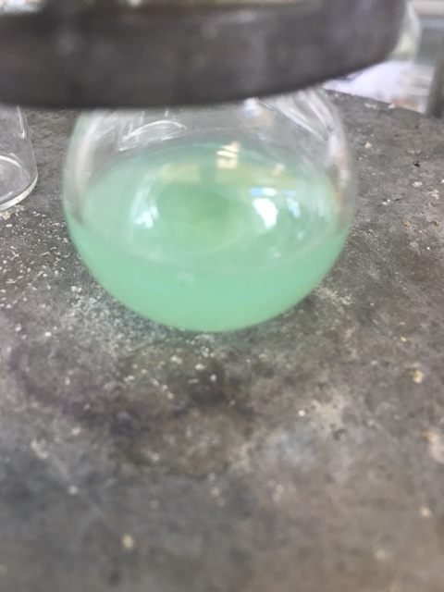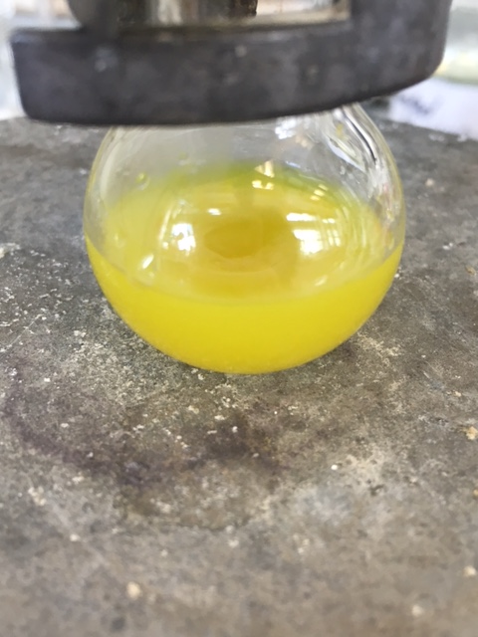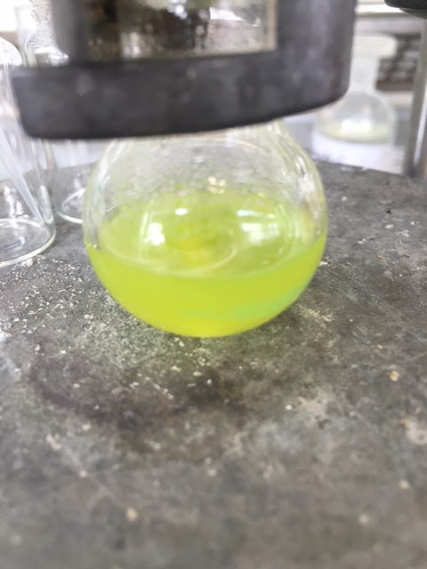
0 days
1 day
3 days
Figure 20. Various colours of the copper catalysed click reaction.
Eventually the yields of click reactions were improved by using stoichiometric quantities of CuSO₄ and sodium ascorbate in conjunction with heating at 55 ºC. The reaction time was cut to two days with increased conversions observed over this time. Whilst a small quantity of starting material remained evident by ¹H NMR and LCMS the more polar phenyl triazoles and comparatively less polar azides were separable by flash chromatography.

The click methodology was successfully applied to two highly substituted amino acid azides, 189 and 194 to form 195 and 196 (Scheme 137).
Scheme 137. Results for click reactions using azido amino acids.

Synthesis of Lactams By Azide Reduction And Cyclisation
As already proposed, the reduction of azides to amines would provide substrates analogous to the products of the radical hydroxylation. The introduction of an amine group would also provide a route to analogues of lysine. In 1992 Corey and Link quantitatively reduced azides with Pd/C and H₂.¹⁵⁵ The approach below was proposed with the aim of establishing whether the azide group acted as a suitable intermediate for the amine and whether the products would be isolated as the cyclic lactam or the acyclic amine (Scheme 138).
Scheme 138. Proposed route for the reduction of azides.
There are examples where an azide is reduced in a molecule that also contains an electrophile. For example, in 1984 work Fleet et al. synthesized an imino sugar derivative by azide reduction and subsequent cyclisation (Scheme 139).¹⁵⁶
Scheme 139. Reduction of an azide and subsequent cyclisation.
As well as the example above from Fleet et al., in 1997 Mazzini, reduced an alkyl azide within molecules that also contained a methyl ester or an aldehyde. Upon reduction with Pd/C and H₂, the resultant amine reacted with the ester or aldehyde in the synthesis of proline derivatives (Scheme 140).¹⁵⁷
Scheme 140. Reduction of an azide to an amine followed by cyclisation by nucleophilic attack of an ester or aldehyde.

Azide Reduction Results
Treatment of a range of amino acid azides with Pd/C and H₂ successfully reduced the azide groups to the amines. The amine reacted with the methyl ester forming the lactam. The products isolated are shown below (Table 10). Cyclisations are either 5-exo-trig and 6-exo-trig and obey Baldwin’s Rules.^{158,159}

Table 10. Results for the reduction of azides to amines using Pd/C and H₂ and their subsequent intramolecular cyclisations.
Entry | Starting Material | Product | Yield
1 |  |  | 99 %
2 |  |  | 92 %
3 |  |  | 91 %
4 |  |  | 98 %

199 was crystallised and a crystal structure was obtained (Figure 21).
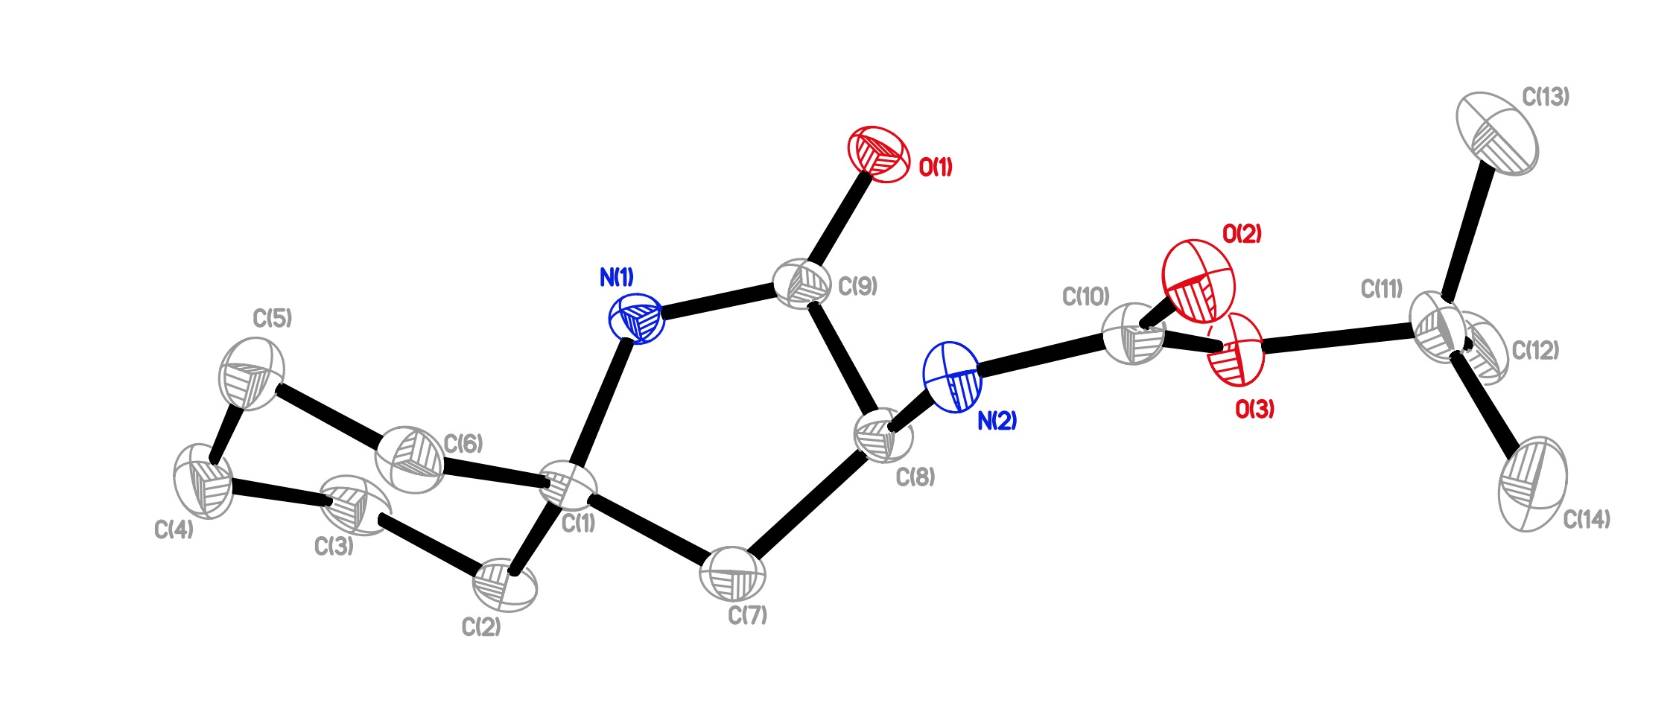
Figure 21. Crystal structure for 199.
The structure shows the chair conformation of the cyclohexyl and the orthogonal lactam ring. This crystal structure also confirms the regiochemical outcome of the addition of H-N₃ to the alkene in the unsaturated starting material as the nitrogen of the amide is in the tertiary position.

Click Chemistry Future Work
Preliminary scope has been established with phenylacetylene, other acetylides may also be appropriate for click reactions with azido amino acids. In 2010 Grimes et al. reported click reactions between aryl azides and methyl propiolate.¹⁶⁰ In 2008 Fletcher et al. reported click reactions between aryl and alkyl azides with TMS acetylene.¹⁶¹ These may also be viable substrates to be used in such reactions.

Reductions of azides have been carried out in the presence of amine protecting reagents to trap the amine and prevent cyclisation. Reddy et al. carried out reductions of azides in the presence of Boc₂O and isolated the Boc protected amines as the product. Use of Lindlar’s catalyst also prevented the removal of the benzyl protecting group, something that would be important in exploring orthogonal amine protection (Scheme 141).¹⁶²
Scheme 141. One-pot reduction of an azide to an amine, which is then protected.
Although this wasn’t explored in this research it would be interesting to see the outcome of various protection/cyclisation competition reactions.

Conclusion
Amino acid derived iodide 65 has been repeatedly transformed into organozinc reagent 69 and used successfully in C-C bond forming reactions with unsaturated coupling partners. Initially, work targeting the synthesis of substituted analogues of alkynyl amino acids reported by Wuttke et al.¹ was undertaken. It was found that the synthesis of tetrasubstituted haloallenes, which were to be reacted with zinc reagent 69, was not only difficult but when haloallenes could be synthesized they would not react with 69 under Cu^{I} catalysis. Instead the propargyl halide analogue, which was present alongside haloallenes after synthesis, reacted preferentially with organozinc reagent 69 under Cu^{I} catalysis.

Using the conditions reported by Wuttke et al.¹ cyclic vinyl triflates were obtained in good to excellent yields. Analogues of the compounds originally made by Wuttke et al.¹ namely the cyclic vinyl ether 131 and bis-fluoro compound 132 were successfully synthesized. The ether and bis-fluoro groups in triflates 129 and 130 respectively did not affect the coupling process.

The same Negishi coupling conditions that were used in the synthesis of unsaturated cyclic amino acids were also used for the synthesis of other vinyl amino acids. Organozinc reagent 69 was successfully treated with commercially available vinyl bromides in Negishi coupling reactions. Cyclobutenyl bromide 136 was also synthesized and reacted successfully with organozinc reagent 69. The reaction between organozinc reagent 69 and cyclobutenyl bromide 136 was initially hampered by a side reaction, the protonation of 69 by residual TFA from the synthesis of cyclobutenyl bromide 136. By treating the acidic solution of cyclobutenyl bromide 136 with an excess of organozinc reagent 69 vinyl amino acid 140 was synthesized in 79 % yield with respect to cyclobutenyl bromide 136. Organozinc reagent 69 was also treated with different isomers of 2-bromobut-2-ene, (E)-135 and (Z)-135. The Negishi couplings between zinc reagent 69 and pure (E)-135 and (Z)-135 proceeded effectively to give vinyl amino acids (E)-139 and (Z)-139 without any isomerization of the alkene. When organozinc reagent 69 was treated with a mixture of (E/Z)-135, where both vinyl bromides were in excess, there was a preference for the formation of (E)-139 over (Z)-139, which is suggested to be a result of differing rates of oxidative addition of (E)-135 and (Z)-135 to the Pd⁰.SPhos catalytic species.

A further three unsaturated amino acids were also synthesized by the reaction of organozinc reagent 69 with a number of allyl chlorides under Cu^{I} catalysis, using the same conditions reported by Wuttke et al.¹

Unsaturated amino acids were then used in three different radical functionalization reactions using conditions reported by Barker et al.⁴⁸ and Leggans et al.¹²⁶. In these reactions unsaturated amino acids were treated with a combination of iron, NaBH₄ and a radical trap, which brought about transformations at the alkene. The radical traps used were Selectfluor®, to achieve hydrofluorination, air, for radical hydroxylation and NaN₃ which was used in hydroazidation reactions. The radical hydrofluorination was highly effective and led to the synthesis of several fluorinated amino acids. The synthesis of tris-fluoro amino acid 152 by treatment of unsaturated bis-fluoro 132 with Fe₂(ox)₃, NaBH₄ and Selectfluor® was the only example that required significant modification of the literature method reported by Barker et al.⁴⁸ There was poor conversion of 132 to 152 when the literature method was applied. To overcome this, the equivalents of Fe₂(ox)₃, NaBH₄ and Selectfluor® were increased and NaBH₄ was administered slowly by syringe pump as a solution in 0.1 M NaOH. This permitted the synthesis of tris-fluoro 152 in 64 % yield. The method of adding NaBH₄ as a solution also found success in the penultimate step in the synthesis of the Cathepsin S inhibitor 111. Fluorinated amino acid 152 was used in the synthesis of two Cathepsin S inhibitors 169 and 172. The potency of inhibitors 169 and 172 was analysed and found to be markedly lower than lead compound 111. It was also established that there was no racemization in the synthesis of fluorinated amino acids by analysis of the optical purity of 153 and ent-153 by chiral HPLC. The hydrofluorination process was also shown to have negligible diastereoselectivity for amino acids where a new stereogenic centre was established.

The radical hydroxylation of unsaturated amino acids proved to be a more capricious transformation. Modification of the literature method reported by Leggans et al.¹²⁶ was required. Ultimately, only two examples of hydroxyl amino acids were synthesized by this method, the linear alcohol 181 and the lactone 180. Lactone 180 was formed by the synthesis of the hydroxylated derivative of 137, followed by cyclisation of the hydroxyl group onto the methyl ester of the hydroxyl intermediate.

The hydroazidation of unsaturated amino acids was explored. Again, the literature method reported by Leggans et al.¹²⁶ required some modification. An increase in equivalents of Fe₂(ox)₃, NaBH₄ and NaN₃ gave a method by which several azido amino acids were synthesized. The azide group was used as a point of further transformation in the synthesis of lactams and click reactions. The reduction of the azide group to amines was achieved in excellent yields by treatment of azido amino acids with Pd/C and H₂. In all cases the product isolated was the lactam, the product of amine cyclisation onto the ester of the amino acid. Click reactions between phenylacetylene and azido amino acids was achieved by treatment with CuSO₄ and sodium ascorbate. The literature method reported by Himo et al.¹⁵³ called for catalytic quantities of CuSO₄ and sodium ascorbate. However, when this was applied to azido amino acid 189 the rate of reaction was slow and observed to stop after a few hours. Click reactions between azido amino acid 189 and phenylacetylene as well as azido amino acid 194 and phenylacetylene were achieved by treatment with an excess of phenylacetylene, CuSO₄ and sodium ascorbate at 55 ºC for two days.

Experimental

General Points of Interest
All ¹H and ¹³C NMRs were recorded using either a Bruker Avance 400 NMR spectrometer or a Bruker Avance 400 III HD NMR spectrometer. All ¹⁹F NMRs were recorded using a Bruker Avance 400 III HD NMR spectrometer. All optical rotation values were recorded using an Optical Activity Ltd. AA-10 Automatic Polarimeter with a 1 dm path length. All IR spectra were recorded using a Perkin Elmer Spectrum100 FT-IR Spectrometer.

Synthesis of NBoc-β-I-Ala-OMe was accomplished by the literature method.^{102,103}

Preparation of zinc reagent 69
A 10 mL round bottom flask was charged with a magnetic stirrer bar; flame dried and back filled with nitrogen three times. Zinc powder (3 equiv.) was added and the flask flame dried and back filled once more. The reaction vessel was allowed to cool to room temperature under a flow of nitrogen. Once cooled to room temperature dry DMF (3 mL) was added followed immediately by iodine (9 crystals). A change in colour from colourless to dark brown and back to colourless again was observed. Once the observed colour change had occurred, NBoc-β-I-Ala-OMe 65 (1 equiv.) was added followed immediately by a further portion of iodine (3 crystals), the aforementioned colour change was observed once more and the insertion process was allowed to proceed for 30 min with vigorous stirring and under nitrogen.

General Procedure A, Triflate Synthesis
All triflates were prepared by methods analogous to that in the literature, from the corresponding ketones, by the following method.

A 250 mL round bottom flask equipped with a magnetic stirrer bar was flame dried and back filled with nitrogen three times and allowed to cool to room temperature under a positive pressure of nitrogen. Ketone was added to the flask followed by dry THF (30 mL). The mixture was cooled to -78 ºC. With vigorous stirring under a flow of nitrogen LiHMDS (1.0 M in THF, 1 equiv.) was added and the resulting solution was stirred for 60 minutes at -78 ºC. After 60 minutes PhN(Tf)₂ (1 equiv.) was added dropwise as a solution in dry THF (30 mL). The solution was allowed to warm to room temperature and stirred overnight. The reaction was quenched by addition of sat. NH₄Cl solution (40 mL) and stirred for 5 min. The mixture was transferred to a separating funnel and extracted with Et₂O (2 x 50 mL). The organic phases were combined, washed with sat. NaHCO₃ (100 mL), dried with Na₂SO₄, filtered and concentrated under reduced pressure without heating to give the crude product. Acceptable purification was achieved by flash column chromatography (petroleum ether (40-60) over silica) to give the product as a colourless oil which was confirmed by proton NMR only and used without further purification.

General Procedure B, Coupling of 69 To Vinyl Triflates And Halides
These reactions were typically carried out on approx. 3 mmol scales. Immediately after successful preparation of 69, Pd₂(dba)₃ (2.5 mol %) and SPhos (5.0 mol %) were added to the reaction vessel along with vinyl halide/triflate (approx. 1.5 equiv.). The reaction mixture was stirred under a gentle flow of nitrogen for 3 days. The reaction mixture was then filtered through a silica plug eluting with EtOAc. The organic phase was washed with water (2 x 50 mL) and brine (50 mL). The organic phase was dried with Na₂SO₄, filtered, and the solvent removed by rotary evaporation to afford the crude product. The product was purified by column chromatography (EtOAc in petroleum ether (40-60) mixtures over silica).

General Procedure C, Reaction of 69 With Allyl Chlorides
These reactions were typically carried out on approx. 3 mmol scales. A 25 mL round bottom flask was flame dried and back-filled with nitrogen three times. CuBr.DMS (10 mol %) was then added. The flask again was placed under vacuum and the light grey powder was heated until there was a colour change from light grey to light green. The flask was then placed under a flow of nitrogen and allowed to cool to room temperature. The flask was again placed under vacuum and heated gently until the same colour change was observed. The flask was again placed under a nitrogen atmosphere and allowed to cool as zinc insertion proceeds. Immediately after successful zinc insertion stirring was stopped and the suspension allowed to settle for a few seconds. The solution of 69 in DMF is transferred away from the solid zinc and into a flame dried 25 mL round bottom flask containing CuBr.DMS. The zinc was washed with two portions of dry DMF (2 x 2 mL) and the washings transferred into the flask containing CuBr.DMS. With vigorous stirring allylic chloride (1.5 equiv.) was added and the reaction stirred for 3 days at room temperature. The reaction mixture was then filtered through a silica plug eluting with EtOAc. The organic phase was washed with water (2 x 50 mL) and brine (50 mL). The organic phase was dried with Na₂SO₄, filtered, and the solvent removed under reduced pressure to afford the crude product. The product was purified by flash column chromatography, (EtOAc in petroleum ether (40-60) over silica).

General Procedure D, Radical Fluorination
These reactions were typically carried out on approx. 0.5 mmol scale. A 100 mL round bottom flask was charged with a magnetic stirrer bar placed under an atmosphere of nitrogen. To the flask was added the unsaturated amino acid (1 equiv.) and MeCN (20 mL). The solution was cooled to 0 °C. Fe₂(ox)₃ was added as a 15 % wt. solution (2 equiv.) followed by deionised water (18 mL), Selectfluor® (2 equiv.) was then added. The mixture was allowed to cool to 0 °C under nitrogen before NaBH₄ (1.2 equiv.) was added. The reaction was stirred for two min before another portion of NaBH₄ (1.2 equiv.) was added. The reaction was stirred for 45 min at 0 °C, after which time conc. NH₄OH solution (4 mL) was added. The reaction mixture was stirred for a further 1 min before being transferred to a separating funnel. The aqueous layer was extracted with CH₂Cl₂ (3 x 50 mL), the combined organic layers were dried with Na₂SO₄, filtered and the solvent removed under reduced pressure. The product was isolated by column chromatography (EtOAc in petroleum ether (40-60) mixtures over silica).

General Procedure E, NHBoc Deprotection
Approximately 0.1 mmol of amino acid was dissolved in CH₂Cl₂ (3 mL) and TFA (3 mL) was added, the solution was stirred overnight. The mixture was concentrated under reduced pressure and the residue redissolved in 1 : 1 toluene : MeOH (6 mL) which was removed under reduced pressure; this process was repeated twice more to afford the product as the TFA salt without further purification.

General Procedure F, Radical Hydroxylation
A 100 mL, two necked round bottom flask was equipped with a magnetic stirrer bar and fitted with a sintered air inlet adaptor (pictured in the Results and Discussion section), which was then attached to a compressed air line. The unsaturated amino acid (~0.50 mmol) was dissolved in MeCN (20 mL) and added to the flask. Fe₂(ox)₃.6H₂O (15 % wt. solution, 4 equiv.) was added to the flask followed by deionized water (18 mL). The mixture was stirred and a steady flow of compressed air was passed through the solution. NaBH₄ was added in 8 portions each approximately 0.80 mmol, with approximately 2 min between each addition. The reaction mixture was stirred for 45 min with a steady flow of compressed air passing through the mixture. After 45 min conc. NH₄OH solution (4 mL) was added and the reaction mixture stirred for a further 1 min. The reaction mixture was transferred to a separating funnel and the aqueous phase extracted with 5 % MeOH in CH₂Cl₂ (3 x 50 mL). The combined organic phases were dried with Na₂SO₄, filtered and concentrated under reduced pressure. The product was purified by flash column chromatography (30-100 % EtOAc in petroleum ether (40-60) over silica).

General Procedure G, Radical Hydroazidation
These reactions were typically carried out on approx. 0.5 mmol scale. A 100 mL round bottom flask was equipped with a magnetic stirrer bar and a nitrogen line. To the flask was added the unsaturated amino acid (1 equiv) and MeCN (20 mL). The solution was cooled to 0 °C. Fe₂(ox)₃ was added as a 15 % wt. solution (4 equiv.) followed by deionised water (18 mL), NaN₃ (4 equiv.) was then added followed by NaBH₄, which was added in 8 portions of approximately 0.8 mmol each, with approximately 2 min between each addition. The reaction was stirred for 45 min at 0 °C, after which time conc. (30 mL) was added. The reaction mixture was stirred for a further 1 min before being transferred to a separating funnel. The aqueous layer was extracted with CH₂Cl₂ (3 x 50 mL), the combined organic layers were dried with Na₂SO₄, filtered and the solvent removed under reduced pressure. The product was isolated by flash column chromatography (EtOAc in petroleum ether (40-60) mixtures over silica).

General Procedure H, Azide Reduction
Approximately 0.5 mmol of azido amino acid was dissolved in EtOAc, 10 % wt. Pd on carbon was added (~20 % wt.), the reaction vessel was fitted with a balloon of hydrogen and the mixture was vigorously stirred overnight. The product was purified by flash column chromatography (EtOAc in petroleum ether (40-60) mixtures over silica).

Synthesis of N-(tert-butoxycarbonyl)-β-iodoalanine methyl ester 65

Methyl (2S)-2-(chloroamino)-3-hydroxypropanoate
A 500 mL three-necked round-bottomed flask, equipped with a dropping funnel and a reflux condenser, was charged with methanol (300 mL) and then cooled under nitrogen with an ice-water bath. Acetyl chloride (46 mL, 647 mmol) was added drop-wise over a period of 20 min. L-serine (24 g, 228 mmol) was added and the resulting solution was heated to reflux for 2 h. The solution was then cooled to room temperature and the solvent was removed under reduced pressure. The resulting white crystalline solid was used without further purification.

Methyl (2S)-2-{[(tert-butoxy)carbonyl]amino}-3-hydroxypropanoate 173
A three-necked round-bottomed flask was equipped with a dropping funnel and a reflux condenser. L-serine methyl ester hydrochloride (34 g, 228 mmol) was placed in the flask and suspended in THF (400 mL) and triethylamine (67 mL, 276 mmol). The resulting suspension was cooled to 0 ºC. A solution of di-tert-butyl dicarbonate (48.77 mL, 228 mmol) in THF (355 mL) was added dropwise over 1 h, the suspension was then stirred overnight at room temperature after which time the reaction was heated at 50 °C for 4 h. The solvent was then removed under reduced pressure. To the residue, diethyl ether was added (400 mL) and saturated NaHCO₃ solution (500 mL). The aqueous phase was extracted with Et₂O (3 x 100 mL). The combined organic phases were dried with Na₂SO₄, filtered and concentrated under reduced pressure. The resulting colourless oil was dried under high vacuum to give 173 without further purification (48.46 g, 222 mmol, 97 %).
Characterisation data for the product was concordant with that previously reported.¹⁶³

Methyl (2S)-2-{[(tert-butoxy)carbonyl]amino}-3-[(4-methylbenzenesulfonyl)oxy]propanoate
A one-necked round-bottomed flask was charged with 173 (24.3 g, 111 mmol) and CH₂Cl₂ (200 mL). This solution was cooled to 0 °C and 4-DMAP (716 mg, 5.86 mmol), trimethylamine hydrochloride (1.46 g, 11.99 mmol) and recrystallised p-toluenesulfonyl chloride (23.0 g, 110.5 mmol) were added. Triethylamine (17 mL, 122 mmol) in CH₂Cl₂ (50 mL) was added dropwise to the reaction mixture over 45 min then the reaction was stirred for 2 h. The resulting slurry was poured into in to an ice (100 mL), water (100 mL) and 2 M HCl (50 mL) mixture. The aqueous layer was extracted with CH₂Cl₂ (2 x 100 mL) and the combined organic layers are washed with brine (2 x 100 mL). the organic phase was dried with MgSO₄, filtered and the solvent was removed under reduced pressure. The resulting yellow solid was recrystallised from hot Et₂O. The resulting white solid was collected by vacuum filtration and then air-dried (19.61 g, 53 mmol, 48 %).

Methyl (2R)-2-{[(tert-butoxy)carbonyl]amino}-3-iodopropanoate 65
Methyl (2S)-2-{[(tert-butoxy)carbonyl]amino}-3-[(4-methylbenzenesulfonyl)oxy]propanoate (19.61 g, 53 mmol) was dissolved in acetone (140 mL). Sodium iodide (9.73 g, 64.91 mmol) was added in one portion and the reaction mixture was stirred in the dark at room temperature for 3 d. A further portion of sodium iodide (2.7 g, 17.97 mmol) was added and stirring was continued for 1 day. The reaction mixture was filtered and the solid residue was washed with acetone until white. The filtrate was concentrated under reduced pressure. The resulting yellow oil was partitioned between diethyl ether (150 mL) and saturated Na₂S₂O₃ (60 mL). The organic layer was washed with saturated Na₂S₂O₃ (40 mL) and brine (50 mL), dried over MgSO₄, filtered, then concentrated under reduced pressure. The resulting colourless oil was recrystallised from hot petroleum ether (40-60). The white precipitate was collected by suction filtration, washed with cold petroleum ether (40-60) and air dried to afford 65 as a colourless to yellow solid (12.87 g, 39.1 mmol, 74 %).
Characterisation data was consistent with that previously reported.¹⁰³

Synthesis of Propargylic Alcohols

Methyl 3-(1-hydroxycyclopentyl)prop-2-ynoate 113
Methyl propiolate (1.719 g, 20.45 mmol) was dissolved in dry THF (40 mL). The mixture was cooled to -100 ºC. With vigorous stirring n-BuLi (2.5 M in hexanes) was added dropwise (8 mL, 20 mmol) and the reaction was stirred for 60 min. Cyclopentanone (0.860 g, 10.22 mmol) was dissolved in dry THF (20 mL) and added to the reaction mixture dropwise, the reaction was stirred for 5 h at -100 °C. After 5 hours stirring saturated NH₄Cl solution (20 mL) was added. The aqueous phase was extracted with EtOAc (2 x 50 mL). The combined organic phases were washed with deionized water (2 x 100 mL) and brine (2 x 100 mL). The organic phase was dried with MgSO₄, filtered and the solvent removed under reduced pressure to give crude product as a red oil. The crude product was purified by flash column chromatography (25 % EtOAc in petroleum ether (40-60), over silica) to give 113 as a colourless oil (1.536 g, 9.13 mmol, 89 %); ν_{max}(ATR)/cm⁻¹ 3413, 2958, 2877, 2235, 1715, 1437, 1376, 1257, 1089, 1028, 1002, 979, 944, 915 and 863; ¹H NMR (CDCl₃, 400 MHz) δ_{H} 3.78 (s, 3 H), 2.65 (s, 1 H), 2.03-1.99 (m, 4 H), 1.91-1.81 (m, 2 H), 1.80-1.71 (m, 2 H); ¹³C NMR (CDCl₃, 100 MHz), δ_{C} 154.2, 91.2, 74.7, 73.9, 52.8, 42.0, 23.5.

5-ethynylnonan-5-ol 118
118 was also isolated as a colourless oil (0.988 g, 5.87 mmol; 59 %); ν_{max}(ATR)/cm⁻¹ 3397, 3309, 2954, 2867, 2109, 1470, 1379, 1299, 1257, 1144, 1037, 999 and 902; ¹H NMR (CDCl₃, 400 MHz) δ_{H} 2.45 (s, 1 H), 1.98 (s, 1 H), 1.68-1.63 (m, 4 H), 1.54-1.46 (m, 4 H), 1.41-1.32 (m, 4 H), 0.94 (t, J = 7.5 Hz, 6 H); ¹³C NMR (CDCl₃, 100 MHz), δ_{C} 87.0, 72.1, 71.1, 41.6, 26.3, 22.9, 14.1.

Methyl 3-(1-hydroxycyclohexyl)prop-2-ynoate 114
Methyl propiolate (1.471 g, 17.50 mmol) was dissolved in dry THF (40 mL) The mixture was cooled to -100 ºC. With vigorous stirring n-BuLi (2.5 M in hexanes) was added dropwise (8 mL, 20 mmol) over 1 min. Cyclohexanone (0.987 g, 10.05 mmol) was dissolved in dry THF (20 mL) and added dropwise. The reaction was stirred for a further 4 h at -100 °C. Saturated NH₄Cl solution (20 mL) was then added. The aqueous phase was extracted with Et₂O (2 x 50 mL), the combined organic phases were washed with deionized water (2 x 50 mL) and brine (50 mL), the organic phases were dried with MgSO₄, filtered and the solvent removed under reduced pressure to give the crude product as an oily solid. The product was purified by recrystallization from hot pentane to give 114 as a crystalline solid (1.421 g, 7.80 mmol, 78 %); M.p. 59-61 °C; ¹H NMR (CDCl₃, 400 MHz) δ_{H} 3.80 (s, 3 H), 2.39 (s, 1 H), 1.99-1.96 (m, 2 H), 1.81-1.51 (m, 7 H), 1.33-1.24 (m, 1H); ¹³C NMR (CDCl₃, 100 MHz), δ_{C} 154.0, 90.8, 75.7, 68.5, 52.8, 39.1, 24.9, 22.8; m/z (EI): Found: MH⁺ 182.0951. C₁₀H₁₄O₃ requires MH⁺ 182.0943.

5-ethynylnonan-5-ol 118
118 was also isolated as a colourless oil (0.373 g, 2.20 mmol, 22 %).

1-(2-cyclopropylethynyl)cyclopentan-1-ol 115
Cyclopropylacetylene (1.156 g, 17.48 mmol) was dissolved in dry THF (100 mL). The mixture was cooled to -78 ºC and n-BuLi (2.5 M in hexanes) was added dropwise (7 mL, 17.5 mmol) over 1 min. The mixture was stirred for 60 min then cyclohexanone was added (0.986 g, 10.05 mmol). The reaction was stirred for a further 4.5 h at -78 °C. Saturated NH₄Cl solution (20 mL) was then added. The aqueous phase was extracted with Et₂O (2 x 50 mL). The organic phase was washed with water (50 mL) and brine (50 mL). The organic phase was dried with Na₂SO₄, filtered and the solvent removed under reduced pressure to give 115 as a colourless oil (1.444 g, 9.61 mmol, 94 %); ¹H NMR (CDCl₃, 400 MHz) δ_{H} 1.92 (s, 1 H), 1.89-1.82 (m, 4 H), 1.82-1.66 (m, 4 H), 1.28-1.21 (m, 1 H), 0.78-0.72 (m, 2 H), 0.70-0.64 (m, 2 H); ¹³C NMR (CDCl₃, 100 MHz), δ_{C} 86.5, 79.2, 74.6, 42.6, 23.4, 8.2, -0.6; m/z (EI): Found: MH⁺ 150.1048. C₁₀H₁₄O requires MH⁺ 150.1045.

1-(2-cyclopropylethynyl)cyclohexan-1-ol 116
Cyclopropylacetylene (1.156 g, 17.48 mmol) was dissolved in dry THF (100 mL) and cooled to -78 ºC. n-BuLi (2.5 M in hexanes, 7 mL, 17.5 mmol) was added dropwise over 1 min. The mixture was stirred for 1 h then cyclohexanone (0.986 g, 10.05 mmol) in dry THF (10 mL) was added dropwise over 1 min. The reaction was stirred for a further 4.5 hours at -78 °C. Saturated NH₄Cl solution (20 mL) was then added. The aqueous phase was extracted with Et₂O (2 x 50 mL), the combined organic phases were washed with deionized water (2 x 50 mL) and brine (50 mL), the organic phases were dried with MgSO₄, filtered and the solvent removed under reduced pressure to give 116 as a crystalline solid (1.498 g, 9.12 mmol; 91 %); M.p. 68-70 °C; ν_{max}(ATR)/cm⁻¹ 3351, 3012, 2928, 2858, 2231, 1444, 1393, 1344, 1260, 1186, 1062, 963, 910, 852 and 814; ¹H NMR (CDCl₃, 400 MHz) δ_{H} 1.92 (s, 1 H), 1.86-1.80 (m, 2 H), 1.70-1.64 (m, 2 H), 1.57-1.50 (m, 5 H), 1.30-1.23 (m, 2 H), 0.80-0.75 (m, 2 H), 0.69-0.65 (m, 2 H); ¹³C NMR (CDCl₃, 100 MHz), δ_{C} 87.8, 79.0, 68.7, 40.2, 25.2, 23.4, 8.3, -0.6; m/z (ES) Found MH⁺ 165.1283. C₁₁H₁₆O requires MH⁺ 165.1279.

1-(2-cyclopropylethynyl)cycloheptan-1-ol 117
Cyclopropylacetylene (1.320 g, 19.97 mmol) was dissolved in dry THF (100 mL) and cooled to -78 ºC. was added. n-BuLi (2.5 M in hexanes, 8 mL, 20 mmol) was added dropwise over 1 min. The mixture was stirred for 1 h then cycloheptanone (1.683 g, 15.00 mmol) was added. The reaction was stirred for a further 2.5 hours at -78 °C. Saturated NH₄Cl solution (20 mL) was then added. The aqueous phase was extracted with Et₂O (2 x 50 mL), the combined organic phases were washed with deionized water (2 x 50 mL) and brine (50 mL), the organic phase was dried with MgSO₄, filtered and the solvent removed under reduced pressure to give 117 as a colourless oil (2.496 g, 14.00 mmol, 93 %); ν_{max}(ATR)/cm⁻¹ 3367, 3092, 3011, 2930, 2858, 2235, 1460, 1446, 1390, 1356, 1283, 1246, 1208, 1184, 1122, 1026, 912, 886 and 812; ¹H NMR (CDCl₃, 400 MHz) δ_{H} 2.22 (s, 1 H), 1.94-1.89 (m, 2 H), 1.78-1.72 (m, 2 H), 1.63-1.46 (m, 8 H), 1.25-1.18 (m, 1 H), 0.75-0.70 (m, 2 H), 0.63-0.60 (m, 2 H); ¹³C NMR (CDCl₃, 100 MHz), δ_{C} 86.9, 80.1, 71.8, 43.3, 27.9, 22.2, 8.2, -0.6; m/z (ES) Found MH⁺ 179.1439. C₁₂H₁₉O requires MH⁺ 179.1436.

Synthesis of Haloallenes/Propargyl Halides and The Synthesis of 127
Mixture of methyl 2-chloro-3-cyclohexylideneprop-2-enoate 123 and methyl 3-(1-chlorocyclohexyl)prop-2-ynoate 124
114 (0.371 g, 2.04 mmol), was dissolved in CH₂Cl₂ (30 mL). The solution was cooled to 0 °C under an atmosphere of nitrogen. MsCl (0.285 g, 2.49 mmol) was added followed by dropwise addition of Et₃N (0.252 g, 2.49 mmol). The solution was stirred for 90 minutes at 0 °C. MsCl (0.214 g, 1.87 mmol) was then added and the reaction mixture stirred for 60 minutes at 0 °C. The reaction was acidified by addition of HCl (1 M, 20 ml). The aqueous phase was extracted with CH₂Cl₂ (2 x 20 mL), the combined organic phases were washed with deionised water (2 x 50 mL) and brine (50 mL). The organic layers were combined and dried with Na₂SO₄, filtered and the solvent removed under reduced pressure to give mesylated 114 as a colourless oil which was used without further purification. The mesylate was dissolved in THF (120 mL) and LiCl (0.887 g, 20.92 mmol) and CuCl (2.060 g, 20.81 mmol) were added. The reaction was stirred overnight at room temperature under nitrogen. Saturated NH₄Cl solution (50 mL) was added and the aqueous phase extracted with EtOAc (2 x 10 mL). The combined organic phases were extracted with deionised water (2 x 50 mL) then brine (50 mL). The organic layers were combined and dried with Na₂SO₄, filtered and the solvent removed under reduced pressure to give a mixture of 123 and 124 (ratio identified as discussed in the Results and Discussion section), which was used without further purification (0.310 g, 1.54 mmol, 76 %); ν_{max}(ATR)/cm⁻¹ 2938, 2859, 2235, 2210, 1953, 1733, 1436, 1257, 1202 and 1040; ¹H NMR (CDCl₃, 400 MHz) δ_{H} 3.81 (s, 3 H), 2.33-2.30 (m, 2 H), 2.23-2.15 (m, 1 H), 2.05-1.98 (m, 1 H), 1.75-1.60 (m, 6 H); m/z (ES): Found: MH⁺ 201.0687. C₁₀H₁₄O₂Cl requires MH⁺ 201.0682
Mixture of methyl 2-bromo-3-cyclohexylideneprop-2-enoate 125 and methyl 3-(1-bromocyclohexyl)prop-2-ynoate 126
114 (0.328 g, 1.80 mmol), was dissolved in CH₂Cl₂ (40 mL). The solution was cooled to 0 °C under nitrogen. MsCl (0.257 g, 2.24 mmol) was added followed by dropwise addition of Et₃N (0.223 g, 2.21 mmol). The reaction was stirred for 90 minutes at 0 °C. MsCl (0.128 g, 1.12 mmol) and Et₃N (0.112 g, 1.10 mmol) were added and the reaction mixture stirred for a further 60 minutes at 0 °C. The reaction was then acidified by addition of HCl (1 M, 20 mL). The aqueous phase was extracted with CH₂Cl₂ (2 x 20 mL), the combined organic phases were extracted with deionised water (2 x 50 mL) and brine (50 mL). The organic layers were dried with Na₂SO₄, filtered and the solvent removed under reduced pressure to give the product mesylate of 114 as a colourless oil which was used without further purification. The mesylate was dissolved in THF (40 mL), LiBr (0.347 g, 4.00 mmol) and CuBr (0.593 g, 4.13 mmol) were added. The reaction was stirred overnight at room temperature under nitrogen. Saturated NH₄Cl solution (20 mL) was added and the aqueous phase extracted with EtOAc (2 x 10 mL). The combined organic phases were extracted with deionised water (2 x 50 mL) then brine (50 mL). The organic phase was dried with Na₂SO₄, filtered and the solvent removed under reduced pressure to give a mixture of 125 and 126 (ratio identified as discussed in the Results and Discussion section), which was used without further purification (0.464 g, 1.89 mmol, 105%); ν_{max}(ATR)/cm⁻¹ 3413, 2958, 2877, 2235, 1715, 1437, 1376, 1257, 1089, 1028, 1002, 979, 944, 915 and 863; ¹H NMR (CDCl₃, 400 MHz) δ_{H} 3.80 (s, 3 H), 2.34-1.96 (m, 4 H), 1.74-1.68 (m, 4 H), 1.62-1.57 (m, 2 H); ¹³C NMR (CDCl₃, 100 MHz), δ_{C} 202.9, 163.1, 114.4, 90.8, 80.2, 53.4, 39.0, 30.3, 26.7, 25.5; m/z (ES) Found MH⁺ 245.0188. C₁₀H₁₄O₂ requires MH⁺ 245.0177.

Methyl 3-(cyclohex-1-en-1-yl)prop-2-ynoate 119
114 (0.366 g, 2.01 mmol) was dissolved in 1,4-dioxane (30 mL). SOCl₂ (3.608 g, 30.3 mmol) was added slowly at room temperature with vigorous stirring. The resulting mixture was heated to reflux for 1 hour 45 minutes. The heating was stopped and pyridine (2.77 g, 34.62 mmol) was added and the reaction was allowed to cool to room temperature with stirring over 40 minutes. The reaction was poured over a mixture HCl (1 M, 50 mL) and ice (50 mL). The aqueous layer was washed with 10 % EtOAc in petroleum ether (40-60) (2 x 20 mL). The organic layer was then washed with saturated NaHCO₃ (20 mL), deionized water (20 mL) and brine (20 mL). The organic layers were combined and dried with Na₂SO₄, filtered and the solvent removed under reduced pressure to give the product 119 as a light yellow oil (0.301 g, 1.83 mmol, 91 %); ν_{max}(ATR)/cm⁻¹ 2983, 2861, 2211, 1711, 1626, 1435, 1358, 1281, 1259, 1192, 1152, 1002, 9321, 873, 847, 800, 748 and 568; ¹H NMR (CDCl₃, 400 MHz) δ_{H} 6.46 (m, 1 H), 3.78 (s, 3 H), 2.19-2.13 (m, 4 H), 1.69-1.57 (m, 4 H); ¹³C NMR (CDCl₃, 100 MHz), δ_{C} 154.7, 142.3, 118.4, 88.8, 78.3, 52.6, 28.1, 26.0, 21.9, 21.1

1,5-dimethyl (2S)-2-{[(tert-butoxy)carbonyl]amino}-4-(cyclohexylidenemethylidene)pentanedioate 127
A 10 mL side-armed round bottom flask was charged with a magnetic stirrer bar; evacuated, flame dried and back filled with nitrogen three times. CuBr.DMS (28 mg, 0.01 mmol) was added to the flask. The vessel was flame dried under vacuum until the light grey powder became light green in colour. Dry DMF (1 mL) was added and the mixture cooled to -10 °C using a cryostat and ethanol bath. Organozinc reagent 69 was prepared from 65 (0.333 g, 1.01 mmol) using the general method. Zinc insertion was complete after 50 min, stirring of the solution was stopped and the zincate solution transferred to the flask containing CuBr.DMS, ensuring there was no zinc transferred. The flask containing the zincate solution was washed with dry DMF (1 mL) and the solution once again transferred to the flask containing CuBr.DMS. The mixture of chlorides 125/126 (0.239 g, 1.46 mmol total, 0.36 mmol 125, 0.90 mmol 126) was added and the reaction mixture was stirred at -10 °C for 3 d. The reaction mixture was diluted with deionised water (20 mL) and the aqueous phase was extracted with EtOAc (3 x 10 mL), the combined organic phases were washed with deionized water (3 x 20 mL) and brine (30 mL). The organic phase was dried with Na₂SO₄, filtered and the solvent removed under reduced pressure to give the crude product as a yellow oil. The product was purified by flash column chromatography (5 % EtOAc in toluene, over silica) to give 127 as a clear oil (0.172 g, 0.48 mmol, 49 %); ν_{max}(thin film, NaCl plates)/cm⁻¹ 3375, 2932, 2853, 1959, 1746, 1714, 1504, 1438, 1367, 1256, 1168, 1112, 1025, 918 and 854; ¹H NMR (CDCl₃, 400 MHz) δ_{H} 5.23 (d, J = 8.0 Hz, 1 H), 4.45-4.40 (m, 1 H), 3.74 (s, 3 H), 3.73 (s, 3 H), 2.77 (dd, J = 14.5 Hz, 5.0 Hz, 1 H), 2.63 (dd, J = 14.5 Hz, 7.5 Hz, 1 H), 2.26-2.17 (m, 4 H), 1.70-1.53 (m, 6 H), 1.14 (s, 9 H); ¹³C NMR (CDCl₃, 100 MHz), δ_{C} 205.7, 172.5, 168.2, 155.2, 128.2, 107.3, 92.8, 79.7, 52.3, 52.2, 31.8, 30.4, 28.3, 26.8, 25.7; m/z (ES) Found MH⁺ 368.2079. C₁₈H₂₉NO₆ requires MH⁺ 368.2073.

Synthesis of Coupling Partners: Triflates And Cyclobutenyl Bromide
Cyclopent-1-en-1-yl trifluoromethanesulfonate 85
Synthesis was achieved by general procedure A using cyclopentanone (1.37 mL, 1.302 g, 15.45 mmol), LiHMDS (1.0 M in THF, 15 mL, 15 mmol), PhN(Tf)₂ (5.395 g, 15.10 mmol). Acceptable purification was achieved by flash column chromatography (petroleum ether (40-60) over silica) to give 85 as a colourless oil which was confirmed only by proton NMR only and used without further purification (1.099 g, 5.08 mmol, 34 %); ¹H NMR (CDCl₃, 400 MHz) δ_{H} 5.65 (m, 1 H), 2.62-2.57 (m, 2 H), 2.47-2.41 (m, 2 H), 2.09-2.02 (m, 2 H).
Characterization data was consistent with that of the literature.¹

Cyclohex-1-en-1-yl trifluoromethanesulfonate 86
Synthesis was achieved by general procedure A using cyclohexanone (1.60 mL, 1.517 g, 15.45 mmol), LiHMDS (1.0 M in THF, 14 mL, 14 mmol), PhN(Tf)₂ (5.002 g, 14.00 mmol). Acceptable purification was achieved by flash column chromatography (petroleum ether (40-60) over silica) to give 86 as a colourless oil which was confirmed by proton NMR only and used without further purification (1.2831 g, 5.57 mmol, 36 %); ¹H NMR (CDCl₃, 400 MHz) δ_{H} 5.78 (m, 1 H), 2.36-2.31 (m, 2 H), 2.22-2.17 (m, 2 H), 1.83-1.77 (m, 2 H), 1.65-1.59 (m, 2H).
Characterization data was consistent with that of the literature.¹

Cyclohept-1-en-1-yl trifluoromethanesulfonate 87
Synthesis was achieved by general procedure A using cycloheptanone (1.685 g, 15.02 mmol), LiHMDS (1.0 M in THF, 15 mL, 15 mmol), PhN(Tf)₂ (5.324 g, 14.90 mmol). Acceptable purification was achieved by flash column chromatography (petroleum ether (40-60) over silica) to give 87 as a colourless oil which was confirmed by proton NMR only and used without further purification (2.3569 g, 9.65 mmol, 65 %); ¹H NMR (CDCl₃, 400 MHz) δ_{H} 5.90 (t, J = 6.4 Hz, 1 H), 2.55-2.53 (m, 2 H), 2.20-2.16 (m, 2 H), 1.76-1.63 (br m, 6 H).
Characterization data was consistent with that of the literature.¹

Cyclooct-1-en-1-yl trifluoromethanesulfonate 88
Synthesis was achieved by general procedure A using cyclooctanone (1.871 g, 14.82 mmol), LiHMDS (1.0 M in THF, 15 mL, 15 mmol), PhN(Tf)₂ (5.317 g, 14.88 mmol). Acceptable purification was achieved by flash column chromatography (petroleum ether (40-60) over silica) to give 86 as a colourless oil which was confirmed only by proton NMR and used without further purification (3.0376 g, 11.76 mmol, 79 %); ¹H NMR (CDCl₃, 400 MHz) δ_{H} 5.71 (t, J = 8.7 Hz, 1 H), 2.51-2.48 (m, 2 H), 2.21-2.16 (m, 2 H). 1.77-1.71 (m, 2 H), 1.67-1.55 (m, 6 H).
Characterization data was consistent with that of the literature.¹

3,6-dihydro-2H-pyran-4-yl trifluoromethanesulfonate 129
Synthesis was achieved by general procedure A using tetrahydropyranone (1.519 g, 15.17 mmol), LiHMDS (1.0 M in THF, 16 mL, 16.00 mmol), PhN(Tf)₂ (5.3723 g, 15.04 mmol). Purification was achieved by filtering the crude mixture through a silica plug (eluting with 0-40 % EtOAc, petroleum ether (40-60)), the eluent was concentrated and further purified by flash column chromatography (8-15 % EtOAc in petroleum ether (40-60) over silica) to give 129 as a colourless oil which was confirmed by proton NMR only and used without further purification (2.620 g, 11.28 mmol, 34 %); ¹H NMR (CDCl₃, 400 MHz) δ_{H} 5.84 (m, 1 H), 4.29 (m, 2 H), 3.92 (m, 2 H), 2.51-2.46 (m, 2 H).
Characterization data was consistent with that of the literature.¹¹⁸

4,4-difluorocyclohex-1-en-1-yl trifluoromethanesulfonate 130
Synthesis was achieved by general procedure A using 4,4-difluorocyclohexanone (2.458 g, 18.33 mmol), LiHMDS (1.0 M in THF, 18 mL, 18.00 mmol), PhN(Tf)₂ (6.4305 g, 18.00 mmol). Acceptable purification was achieved by flash column chromatography (0-5 % EtOAc in hexane) to give 130 as a colourless oil which was confirmed by proton NMR only and used without further purification (2.655 g, 9.97 mmol, 54 %); ¹H NMR (CDCl₃, 400 MHz) δ_{H} 5.69 (m, 1 H), 2.75-2.67 (m, 2 H), 2.64-2.59 (m, 2 H), 2.27-2.17 (m, 2 H).

1,1-dibromo-2-(chloromethyl)cyclopropane 141
141 was prepared and standardised as a solution in diethyl ether by the literature method.¹²⁰
Allyl chloride (9.191 g, 120.11 mmol), NaOH powder (35 g, 875 mmol), bromoform (20.943 g, 82.87 mmol) and TEBA-Cl (0.036 g, 0.16 mmol) were dissolved in CH₂Cl₂ (100 mL). The flask was immersed in a sonic bath and the reaction vessel was fitted with a condenser. The reaction was sonicated for 2 h, upon beginning sonication there was an exotherm and the white suspension became black. After 2 h of sonication the reaction mixture was filtered through a silica plug with washing copiously with CH₂Cl₂. The filtrate was discarded and the organic solution concentrated under reduced pressure without heating. The crude light yellow liquid was purified by flash chromatography (petroleum ether (40-60) over silica) to give 141 as a colourless oil. ¹H NMR showed 141 to be the major component in the product mixture (10.075 g, 40.57 mmol, 50 %); ¹H NMR (CDCl₃, 400 MHz) δ_{H} 3.71-3.61 (m, 2 H), 2.10-2.02 (m, 1 H), 1.95 (dd, J = 10.2 Hz, J = 7.6 Hz, 1 H), 1.50 (t, J = 7.5 Hz, 1 H).

1-bromocyclobutene 136
141 (10.075 g, 40.57 mmol) was dissolved in dry Et₂O (25 mL). The solution was cooled to -78 ºC using an acetone dry ice bath. Once cool, MeLi (1.6 M in Et₂O, 26 mL, 41.6 mmol) was added and with vigorous stirring the reaction mixture was allowed to reach -40 ºC. Once the solution had reached -40 ºC the intermediate 142 was isolated by evaporating and condensing in a trap under reduced pressure (20 mbar) using the apparatus shown below, which was adapted from the equipment used in the synthesis of DMDO (Figure 22).
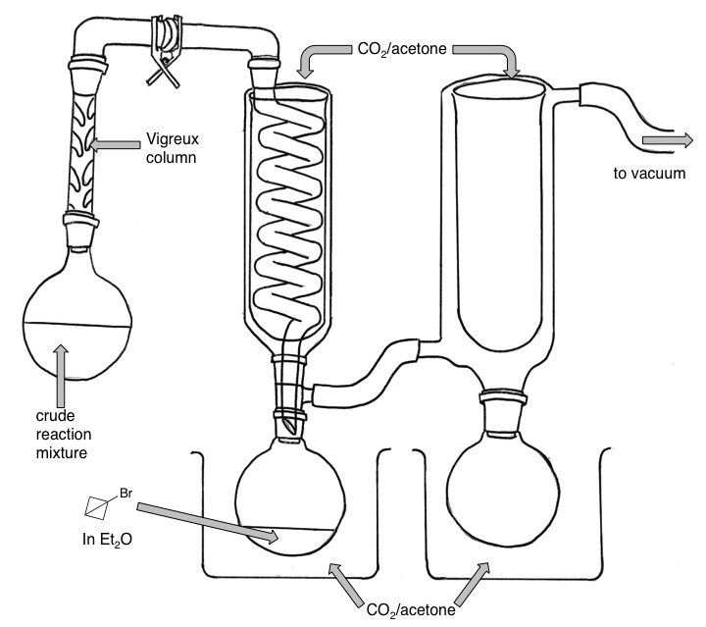
Figure 22. Apparatus used for the isolation of 142.
Once complete, the flask containing 142 was removed from the condensing apparatus, fitted with a stirrer bar and flushed with N₂ for 5 min. To the solution was then added TFA (0.6 mL). The acid mediated isomerization to cyclobutenyl bromide was then allowed to proceed overnight. The solution was washed with saturated NaHCO₃ (50 mL) then saturated NaHSO₃ (50 mL). The organic phase was dried with MgSO₄, filtered and concentrated by distillation at 34 ºC. The molarity of the Et₂O/cyclobutenyl bromide solution was deduced by ¹H NMR using mesitylene as a standard (Figure 23).
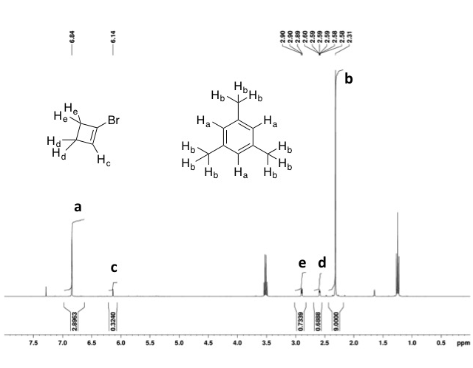
Figure 23. ¹H NMR used in the molarity calculation for the cyclobutenyl bromide, Et₂O solution with the integral values shown to four decimal places.
The molarity was calculated in the following way:
10 µl of mesitylene and 10 µl of the cyclobutenyl bromide solution were added to CDCl₃ and the ¹H NMR was recorded. Using the mesitylene integral values and knowing that 10 µl of mesitylene = 72.2 µmol of mesitylene the µmol proton can be calculated:
$\text{µmol proton} \text{=} \frac{\left(\frac{\text{∫}{\text{H}}_{\text{a}}}{\text{12}}\right)\text{+}\left(\frac{\text{∫}{\text{H}}_{\text{b}}}{\text{12}}\right)}{\text{72.2 µmol}} \text{=} \frac{\left(\frac{\text{2.8963}}{\text{12}}\right)\text{+}\left(\frac{\text{9.000}}{\text{12}}\right)}{\text{72.2 µmol}} \text{=} {\text{0.01373 µmol}}^{\text{-1}}$

Applying this value to the integral value for one cyclobutenyl bromide proton gives the number of moles of cyclobutenyl bromide present:
$$\text{µmol of cyclobutenyl bromide = }\frac{\left(\frac{\text{∫}{\text{H}}_{\text{c}}}{\text{5}}\right)\text{+}\left(\frac{\text{∫}{\text{H}}_{\text{e}}}{\text{5}}\right)\text{+}\left(\frac{\text{∫}{\text{H}}_{\text{d}}}{\text{5}}\right)}{\text{0.01373 }{\text{µmol}}^{\text{-1}}} \text{=} \frac{\left(\frac{\text{0.3240}}{\text{5}}\right)\text{+}\left(\frac{\text{0.7339}}{\text{5}}\right)\text{+}\left(\frac{\text{0.6888}}{\text{5}}\right)}{\text{0.01373 }{\text{µmol}}^{\text{-1}}}$$
$$\text{= 25}\text{ µmol}$$
As there are 25 µmol in 10 µl the concentration of the solution was therefore presumed to be 2.5 M cyclobutenyl bromide 136 in Et₂O.

Synthesis of Unsaturated Amino Acids

Methyl (2S)-2-{[(tert-butoxy)carbonyl]amino}-3-(cyclopent-1-en-1-yl)propanoate 89
The synthesis of 89 was achieved by general procedure B using zinc dust (0.217 g, 3.32 mmol), iodine (2 crystals, then 1 crystal), 65 (0.325 g, 0.99 mmol), Pd₂(dba)₃ (0.024 g, 0.03 mmol), SPhos (0.023 g, 0.06 mmol) and 85 (0.375 g, 1.73 mmol). Purification by flash column chromatography (10 % EtOAc in petroleum ether (40-60), over silica) gave 89 as a light orange oil (0.220 g, 0.82 mmol, 83 %); [α]_{D}²⁵ +17.0 (c 2.00, CHCl₃), [lit. [α]_{D}²² +13.9 (c 2.09, CHCl₃)]⁹⁰; ν_{max}(ATR)/cm⁻¹ 3371, 2974, 2951, 2932, 2848, 1744, 1713, 1501, 1436, 1392, 1365, 1248, 1211, 1160, 1056, 1020, 860, 778 and 759; ¹H NMR (CDCl₃, 400 MHz) δ_{H} 5.47 (s, 1 H), 4.98 (d, J = 7.8 Hz, 1 H), 4.41 (m, 1 H), 3.73 (s, 3 H), 2.59 (dd, J = 14.2 Hz, 4.8 Hz, 1 H), 2.49 (dd, J = 14.4 Hz, 7.5 Hz, 1 H), 2.33-2.16 (m, 4 H), 1.86 (apparent quin, J = 7.4 Hz, 2 H), 1.44 (s, 9 H); ¹³C NMR (CDCl₃, 100 MHz), δ_{C} 173.2, 155.2, 139.0, 128.3, 79.8, 52.2, 52.1, 34.7, 34.2, 32.5, 28.3, 23.6; m/z (ES) Found MNa⁺ 292.1523, C₁₄H₂₃NO₄ requires MNa⁺ 292.1519.
The characterisation data was found to be consistent with that reported in the literature.⁹⁰

Methyl (2S)-2-{[(tert-butoxy)carbonyl]amino}-3-(cyclohex-1-en-1-yl)propanoate 90
The synthesis of 90 was achieved by general procedure B using zinc dust (0.606 g, 9.27 mmol), iodine (6 crystals, then 4 crystals), 65 (1.013 g, 3.08 mmol), Pd₂(dba)₃ (0.068 g, 0.07 mmol), SPhos (0.069 g, 0.17 mmol) and 86 (1.283 g, 5.57 mmol). Purification by flash column chromatography (10 % EtOAc in petroleum ether (40-60), over silica) gave 90 as a light orange oil (0.798 g, 2.82 mmol, 92 %); [α]_{D}²⁴ +14.1 (c 0.99, CHCl₃), [lit. [α]_{D}²² +14.5 (c 1.68, CHCl₃)]⁹⁰; ν_{max}(ATR)/cm⁻¹ 3355, 2976, 2929, 2859, 2838, 1744, 1713, 1504, 1437, 1391, 1365, 1275, 1258, 1215, 1161, 1084, 1048, 1020, 920 and 863; ¹H NMR (CDCl₃, 400 MHz) δ_{H} 5.48 (s, 1 H), 4.92 (d, J = 7.6 Hz, 1 H), 4.39 (m, 1 H), 3.74 (s, 3 H), 2.43 (dd, J = 13.5 Hz, 5.2 Hz, 1 H), 2.26 (dd, J = 13.5 Hz, 8.6 Hz, 1 H), 2.00-1.88 (m, 4 H), 1.68-1.52 (m, 4 H), 1.45 (s, 9 H); ¹³C NMR (CDCl₃, 100 MHz), δ_{C} 173.4, 155.2, 132.7, 125.7, 79.8, 52.1, 51.9, 41.4, 28.3, 27.8, 25.3, 22.7, 22.1; m/z (ES) Found MNa⁺ 306.1676, C₁₅H₂₅NO₄ requires MNa⁺ 306.1681.
The characterisation data was found to be consistent with that reported in the literature.⁹⁰

Methyl (2S)-2-{[(tert-butoxy)carbonyl]amino}-3-(cyclohept-1-en-1-yl)propanoate 91
The synthesis of 91 was achieved by general procedure B using zinc dust (0.791 g, 12.10 mmol), iodine (12 crystals, then 5 crystals), 65 (1.330 g, 4.04 mmol), Pd₂(dba)₃ (0.094 g, 0.10 mmol), SPhos (0.112 g, 0.27 mmol) and 87 (1.609 g, 6.59 mmol). Purification by flash column chromatography (10 % EtOAc in petroleum ether (40-60), over silica) gave 91 as a light orange oil (0.981 g, 3.30 mmol, 82 %); [α]_{D}²⁴ +8.4 (c 1.08, CHCl₃), [lit. [α]_{D}²² +7.8 (c 1.15, CHCl₃)]⁹⁰; ν_{max}(ATR)/cm⁻¹ 3367, 2975, 2919, 2846, 1744, 1712, 1498, 1438, 1389, 1365, 1248, 1212, 1159, 1050, 1022, 994 and 852; ¹H NMR (CDCl₃, 400 MHz) δ_{H} 5.62 (t, J = 6.2 Hz, 1 H), 4.93 (d, J = 7.1 Hz, 1 H), 4.34 (m, 1 H), 3.73 (s, 3 H), 2.46 (dd, J = 13.2 Hz, 5.6 Hz, 1 H), 2.27 (dd, J = 13.3 Hz, 8.3 Hz, 1 H), 2.14-2.06 (m, 4 H), 1.76-1.70 (m, 2 H), 1.44-1.35 (m, 13 H); ¹³C NMR (CDCl₃, 100 MHz), δ_{C} 173.4, 155.2, 139.3, 131.0, 79.8, 52.1, 52.0, 43.4, 32.4, 32.3, 28.5, 28.3, 27.0, 26.5; m/z (ES) Found MNa⁺ 320.1833, C₁₆H₂₇NO₄ requires MNa⁺ 320.1838.
The characterisation data was found to be consistent with that reported in the literature.⁹⁰

Methyl (2S)-2-{[(tert-butoxy)carbonyl]amino}-3-(cyclooct-1-en-1-yl)propanoate 92
The synthesis of 92 was achieved by general procedure B using zinc dust (0.596 g, 9.11 mmol), iodine (9 crystals, then 5 crystals), 65 (0.990 g, 3.01 mmol), Pd₂(dba)₃ (0.074 g, 0.08 mmol), SPhos (0.066 g, 0.16 mmol) and 88 (1.311 g, 5.08 mmol). Purification by flash column chromatography (10 % EtOAc in petroleum ether (40-60), over silica) gave 92 as a light orange oil (0.572 g, 1.84 mmol, 61 %); [α]_{D}²⁴ +7.8 (c 1.15, CHCl₃), [lit. [α]_{D}²² +9.5 (c 0.53, CHCl₃)]⁹⁰; ν_{max}(ATR)/cm⁻¹ 3365, 2977, 2923, 2851, 1745, 1714, 1501, 1469, 1436, 1391, 1365, 1248, 1216, 1160, 1057, 1023, 894 and 861; ¹H NMR (CDCl₃, 400 MHz) δ_{H} 5.42 (t, J = 8.0 Hz, 1 H), 4.90 (d, J = 7.2 Hz, 1 H), 4.35 (m, 1 H), 3.73 (s, 3 H), 2.50 (dd, J = 13.8 Hz, 4.9 Hz, 1 H), 2.26 (dd, J = 13.7 Hz, 9.1 Hz, 1 H), 2.15-2.08 (m, 4 H), 1.54-1.47 (m, 8 H), 1.44 (s, 9 H); ¹³C NMR (CDCl₃, 100 MHz), δ_{C} 173.4, 155.2, 135.6, 128.7, 79.8, 52.1, 52.0, 40.3, 29.7, 28.5, 28.3, 26.4, 26.3, 26.2; m/z (ES) Found MH⁺ 312.2183, C₁₇H₂₉NO₄ requires MH⁺ 312.2175.

Methyl (2S)-2-{[(tert-butoxy)carbonyl]amino}-3-(3,6-dihydro-2H-pyran-4-yl)propanoate 131
The synthesis of 131 was achieved by general procedure B using zinc dust (1.484 g, 22.69 mmol), iodine (12 crystals, then 6 crystals), 65 (2.507 g, 7.62 mmol), Pd₂(dba)₃ (0.168 g, 0.18 mmol), SPhos (0.153 g, 0.37 mmol) and 129 (2.620 g, 11.28 mmol). Purification by flash column chromatography (25 % EtOAc in petroleum ether (40-60), over silica) gave 131 as a colourless oil (1.132 g, 3.97 mmol, 52 %); [α]_{D}²⁵ +18.6 (c 1.02, CHCl₃); ν_{max}(ATR)/cm⁻¹ 3340, 3003, 2977, 2930, 2853, 1743, 1709, 1511, 1436, 1391, 1365, 1249, 1215, 1160, 1126, 1054, 1024, 1000, 849 and 752; ¹H NMR (CDCl₃, 400 MHz) δ_{H} 5.52 (m, 1H), 5.00 (d, J = 7.7 Hz, 1H), 4.42 (m, 1H), 4.11 (m, 2H), 3.77 (m, 5H), 2.50 (dd, J = 13.9 Hz, 4.6 Hz, 1H), 2.32 (dd, J = 14 Hz, 8.5 Hz, 1H), 2.08 (m, 2H), 1.44 (s, 9H); ¹³C NMR (CDCl₃, 100 MHz), δ_{C} 173.1, 155.2, 130.9, 124.1, 80.0, 65.4, 64.3, 52.3, 51.7, 40.44, 28.3, 27.9; m/z (ES) Found MNa⁺ 308.1485, C₁₄H₂₃NO₅ requires MNa⁺ 308.1474.

Methyl (2S)-2-{[(tert-butoxy)carbonyl]amino}-3-(4,4-difluorocyclohex-1-en-1-yl)propanoate 132
The synthesis of 132 was achieved by general procedure B using zinc dust (0.615 g, 9.41 mmol), iodine (10 crystals, then 3 crystals), 65 (1.046 g, 3.18 mmol), Pd₂(dba)₃ (0.066 g, 0.07 mmol), SPhos (0.075 g, 0.18 mmol) and 130 (1.313 g, 4.93 mmol). Purification by flash column chromatography (10 % EtOAc in petroleum ether (40-60), over silica) gave 132 as a colourless oil (0.914 g, 2.86 mmol, 90 %); [α]_{D}²⁴ +25.6 (c 1.02, CHCl₃); ν_{max}(ATR)/cm⁻¹ 3353, 2980, 1744, 1711, 1504, 1437, 1365, 1264, 1250, 1216, 1160, 1108, 1069, 1014, 971, 889, 860 and 777; ¹H NMR (CDCl₃, 400 MHz) δ_{H} 5.36 (m, 1H), 4.97 (br d, J = 7.9 Hz 1H), 4.46 (m, 1H), 3.75 (s, 3H), 2.51 (m, 3H), 2.38-2.25 (m, 3H), 2.09-1.98 (m, 2H), 1.45 (s, 9H); ¹³C NMR (CDCl₃, 100 MHz), δ_{C} 172.9, 155.1, 132.7, 122.7 (t, J = 240 Hz), 120.4, 80.0, 52.3, 51.8, 40.6, 34.7 (t, J = 27 Hz), 30.3 (t, J = 24 Hz), 28.3, 26.1 (t, J = 5 Hz); ¹⁹F CPD NMR (CDCl₃, 377 MHz) δ_{F} -95.7 (d, J = 235 Hz, 1 F), -97.3 (d, J = 235 Hz, 1 F); m/z (ES) Found MH⁺ 320.1679, C₁₅H₂₃F₂NO₄ requires MH⁺ 320.1673.

Methyl (2S)-2-{[(tert-butoxy)carbonyl]amino}-4-methylpent-4-enoate 137
The synthesis of 137 was achieved by general procedure B using zinc dust (1.966 g, 30.07 mmol), iodine (15 crystals, then 6 crystals), 65 (3.292 g, 10.00 mmol), Pd₂(dba)₃ (0.229 g, 0.25 mmol), SPhos (0.211 g, 0.51 mmol) and 2-bromopropene (0.9 mL, 1.226 g, 10.13 mmol). Purification by flash column chromatography (10 % EtOAc in petroleum ether (40-60), over silica) gave 137 as a light orange oil (2.051 g, 8.43 mmol, 84 %); [α]_{D}²⁴ +10.5 (c 1.05, CHCl₃); ν_{max}(ATR)/cm⁻¹ 3379, 2977, 2956, 2932, 1744, 1713, 1500, 1437, 1365, 1247, 1215, 1160, 1046, 1020, 895, 861, 779 and 759; ¹H NMR (CDCl₃, 400 MHz) δ_{H} 4.96 (d, J = 6.6 Hz, 1 H), 4.86 (s, 1 H), 4.76 (s, 1 H), 4.41 (m, 1 H), 3.73 (s, 3 H), 2.52 (dd, J = 13.8 Hz, 5.4 Hz, 1 H), 2.37 (dd, J = 13.8 Hz, 8.3 Hz, 1 H), 1.74 (s, 3 H), 1.44 (s, 9 H); ¹³C NMR (CDCl₃, 100 MHz), δ_{C} 173.1, 155.3, 140.5, 114.5, 79.9, 52.2, 51.8, 40.7, 28.3, 21.8; m/z (ES) Found MNa⁺ 266.1365, C₁₂H₂₁NO₄ requires MNa⁺ 266.1363.

Methyl (2R)-2-{[(tert-butoxy)carbonyl]amino}-4-methylpent-4-enoate ent-137
The synthesis of ent-137 was achieved by general procedure B using zinc dust (0.607 g, 9.28 mmol), iodine (9 crystals, then 3 crystals), (S)-NBoc-β-I-Ala-OMe (1.027 g, 3.12 mmol), Pd₂(dba)₃ (0.076 g, 0.08 mmol), SPhos (0.067 g, 0.16 mmol) and 2-bromopropene (0.45 mL, 0.613 g, 5.07 mmol). Purification by flash column chromatography (10 % EtOAc in petroleum ether (40-60), over silica) gave ent-137 as a light orange oil (0.729 g, 3.00 mmol, 96 %); [α]_{D}²⁴ -10.1 (c 1.48, CHCl₃); ν_{max}(thin film, NaCl plates)/cm⁻¹ 3372, 2978, 2953, 2933, 1747, 1717, 1503, 1438, 1392, 1367, 1280, 1250, 1216, 1170, 1065, 1047, 1022, 897, 861, 780 and 760; ¹H NMR (CDCl₃, 400 MHz) δ_{H} 4.97 (d, J = 7.2 Hz, 1 H), 4.86 (s, 1 H), 4.77 (s, 1 H), 4.42 (m, 1 H), 3.74 (s, 3 H), 2.53 (dd, J = 13.9 Hz, 5.5 Hz, 1 H), 2.37 (dd, J = 13.8 Hz, 8.3 Hz, 1 H), 1.75 (s, 3 H), 1.44 (s, 9 H); ¹³C NMR (CDCl₃, 100 MHz), δ_{C} 173.1, 155.3, 140.5, 114.5, 79.9, 52.2, 51.9, 40.7, 28.3, 21.8; m/z (ES) Found MNa⁺ 266.1368, C₁₂H₂₁NO₄ requires MNa⁺ 266.1363.

Methyl (2S)-2-{[(tert-butoxy)carbonyl]amino}-5-methylhex-4-enoate 138
The synthesis of 138 was achieved by general procedure B using zinc dust (0.594 g, 9.08 mmol), iodine (6 crystals, then 3 crystals), 65 (1.006 g, 3.06 mmol), Pd₂(dba)₃ (0.070 g, 0.08 mmol), SPhos (0.065 g, 0.16 mmol) and 1-bromo-2-methyl-1-propene (0.614 g, 4.55 mmol). Purification by flash column chromatography (10 % EtOAc in petroleum ether (40-60), over silica) gave 138 as a light orange oil (0.748 g, 2.91 mmol, 95 %); [α]_{D}²⁴ +28.6 (c 1.05, CHCl₃); ν_{max}(ATR)/cm⁻¹ 3358, 2976, 2918, 1744, 1702, 1498, 1437, 1366, 1352, 1273, 1248, 1208, 1162, 1111, 1059, 1023, 860 and 754; ¹H NMR (CDCl₃, 400 MHz) δ_{H} 5.02 (m, 2 H), 4.34 (m, 1 H), 3.72 (s, 3 H), 2.53 (m, 1 H), 2.41 (m, 1 H), 1.70 (d, J = 0.8 Hz, 3 H), 1.6 (s, 3 H), 1.43 (s, 9 H); ¹³C NMR (CDCl₃, 100 MHz), δ_{C} 172.9, 155.3, 136.3, 117.6, 79.8, 53.3, 52.2, 30.9, 28.3, 25.9, 17.8; m/z (ES) Found MNa⁺ 280.1524, C₁₃H₂₃NO₄ requires MNa⁺ 280.1519.
This reaction was also carried out on a larger scale using 65 (3.292 g, 10.00 mmol) and analogous equivalents of reagents, giving the same product (2.310 g, 8.98 mmol, 90 %).

Methyl (2S,4E)-2-{[(tert-butoxy)carbonyl]amino}-4-methylhex-4-enoate (E)-139
The synthesis of (E)-139 was achieved by general procedure B using zinc dust (0.233 g, 3.56 mmol), iodine (4 crystals, then 2 crystals), 65 (0.339 g, 1.03 mmol), Pd₂(dba)₃ (0.026 g, 0.03 mmol), SPhos (0.023 g, 0.06 mmol) and (E)-2-bromo-2-butene (0.12 mL, 0.159 g, 1.18 mmol). Purification by flash column chromatography (10 % EtOAc in petroleum ether (40-60), over silica) gave (E)-139 as a light orange oil (0.181 g, 0.70 mmol, 68 %); [α]_{D}²⁴ +10.0 (c 1.20, CHCl₃); ν_{max}(thin film, NaCl plates)/cm⁻¹ 3443, 3372, 2978, 2930, 2862, 1747, 1718, 1503, 1438, 1366, 1250, 1218, 1170, 1060 and 1019; ¹H NMR (CDCl₃, 400 MHz) δ_{H} 5.26 (q, J = 6.0 Hz, 1 H), 4.91 (d, J = 7.4 Hz, 1 H), 4.34 (m, 1 H), 3.70 (s, 3 H), 2.45 (dd, J = 13.4 Hz, 5.3 Hz, 1 H), 2.27 (dd, J = 13.4 Hz, 8.5 Hz, 1 H), 1.6 (m, 3 H), 1.57 (d, J = 6.7 Hz, 3 H), 1.41 (s, 9 H); ¹³C NMR (CDCl₃, 100 MHz), δ_{C} 173.3, 155.2, 130.7, 123.2, 79.7, 52.1, 52.0, 42.7, 28.3, 15.3, 13.5; m/z (ES) Found MNa⁺ 280.1521, C₁₃H₂₃NO₄ requires MNa⁺ 280.1519.

Methyl (2S,4E)-2-{[(tert-butoxy)carbonyl]amino}-4-methylhex-4-enoate (Z)-139
The synthesis of (Z)-139 was achieved by general procedure B using zinc dust (0.623 g, 9.53 mmol), iodine (10 crystals, then 3 crystals), 65 (1.000 g, 3.04 mmol), Pd₂(dba)₃ (0.072 g, 0.08 mmol), SPhos (0.068 g, 0.17 mmol) and (Z)-2-bromo-2-butene (0.50 mL, 0.666 g, 4.93 mmol). Purification by flash column chromatography (10 % EtOAc in petroleum ether (40-60), over silica) gave (Z)-139 as a light orange oil (0.564 g, 2.19 mmol, 72 %); [α]_{D}²³ +13.7 (c 1.38, CHCl₃); ν_{max}(thin film, NaCl plates)/cm⁻¹ 3445, 3373, 2977, 2930, 2865, 1747, 1717, 1505, 1453, 1438, 1367, 1278, 1251, 1208, 1169, 1086, 1052, 1021, 861 and 779; ¹H NMR (CDCl₃, 400 MHz) δ_{H} 5.39 (q, J = 6.6 Hz, 1 H), 4.97 (d, J = 7.7 Hz, 1 H), 4.40 (m, 1 H), 3.72 (s, 3 H), 2.52 (dd, J = 13.6 Hz, 6.2 Hz, 1 H), 2.42 (dd, J = 13.2 Hz, 7.8 Hz, 1 H), 1.68 (m, 3 H), 1.56 (d, J = 6.6 Hz, 3 H), 1.42 (s, 9 H); ¹³C NMR (CDCl₃, 100 MHz), δ_{C} 173.3, 155.2, 130.5, 123.5, 79.8, 52.2, 52.0, 34.3, 28.3, 23.3, 13.4; m/z (ES) Found MNa⁺ 280.1520, C₁₃H₂₃NO₄ requires MNa⁺ 280.1519.

Methyl (2S)-2-{[(tert-butoxy)carbonyl]amino}-4-methylhex-4-enoate (E/Z)-139
A 10 mL round bottom flask was charged with a magnetic stirrer bar; flame dried and back filled with nitrogen three times. Zinc powder (0.622 g, 9.51 mmol) was added and the flask flame dried and back filled once more. The reaction vessel was allowed to cool to room temperature under a positive pressure of nitrogen. Dry DMF (5 mL) was added followed immediately by iodine (10 crystals). A change in colour from colourless to dark brown and back to colourless was observed. Once the observed colour change had occurred, 65 (1.004 g, 3.05 mmol) was added followed immediately by iodine (3 crystals), the aforementioned colour change was observed once more and the insertion process was allowed to proceed for 45 min with vigorous stirring and under nitrogen. Pd₂(dba)₃ (0.072 g, 0.08 mmol) and SPhos (0.0671 g, 0.16 mmol) were then added to the reaction vessel along with 2-bromo-2-butene (1.9 : 1, E : Z, 0.50 mL, 0.666 g, 4.93 mmol). The reaction mixture was stirred under a flow of nitrogen for 3 d. The reaction mixture was then filtered through a silica plug eluting with EtOAc. The organic phase was washed with water (2 x 50 mL) and brine (50 mL). The organic phase was dried with Na₂SO₄, filtered, and the solvent removed under reduced pressure. Purification by flash column chromatography (10 % EtOAc in petroleum, ether (40-60), over silica) gace the mixture of (E/Z)-139 as a light orange oil (0.693 g, 2.69 mmol, 88 %)

Calculation for the ratio of E/Z amino acids:
The methyl group vicinal to the vinyl proton has approximately the same chemical shift in both ¹H NMRs, so this was not used for comparison. In the Z derivative, the methyl group geminal to the vinyl proton has a signal separate to those of the E derivative. Using this peak at 1.69 in the mixture of E/Z, the ratios of products was determined from the integral values. As the Z isomer contributes three protons to the multiplet at 1.61-1.57, this integral needed to be corrected (1.00 – 0.07 = 0.93). This value was equivalent to six protons from the E isomer, so the final ratio was calculated as:

(0.93/2)/0.07 = 7 (to 1 significant figure)

Methyl (2S)-2-{[(tert-butoxy)carbonyl]amino}-3-(cyclobut-1-en-1-yl)propanoate 140
The synthesis of 140 was achieved by general procedure B using zinc dust (0.5923 g, 9.06 mmol), iodine (9 crystals, then 6 crystals), 65 (0.9883 g, 3.00 mmol), Pd₂(dba)₃ (0.0696 g, 0.08 mmol), SPhos (0.0626 g, 0.17 mmol) and 136 (2.6 M in THF, 0.38 mL, 0.99 mmol). Purification by flash column chromatography (8 % EtOAc in petroleum ether (40-60), over silica) to give the product and NBoc-Ala-OMe as a mixture. Further purification by flash column chromatography (CH₂Cl₂, over silica) gave 140 as a colourless oil (0.2009 g, 0.79 mmol, 80 %); [α]_{D}²⁴ +20.2 (c 1.19, CHCl₃); ν_{max}(thin film, NaCl plates)/cm⁻¹ 3362, 2978, 2953, 2929, 1745, 1716, 1512, 1438, 1392, 1367, 1250, 1219, 1166, 1052, 1024 and 858; ¹H NMR (CDCl₃, 400 MHz) δ_{H} 5.82 (s, 1 H), 5.08 (d, J = 7.8 Hz, 1 H), 4.42 (m, 1 H), 3.75 (s, 3 H), 2.54-2.36 (br, m, 6 H), 1.45 (s, 9 H); ¹³C NMR (CDCl₃, 100 MHz), δ_{C} 172.9, 155.2, 144.5, 131.6, 79.9, 52.3, 51.9, 34.0, 31.5, 28.3, 27.1; m/z (ES) Found MNa⁺ 278.1363, C₁₃H₂₁NO₄ requires MNa⁺ 278.1363.

Methyl (2S)-2-{[(tert-butoxy)carbonyl]amino}hex-5-enoate 144
The synthesis of 144 was achieved by general procedure C using zinc dust (0.993 g, 15.19 mmol), iodine (11 crystals, then 5 crystals), 65 (1.665 g, 5.06 mmol), CuBr.DMS (0.064 g, 0.31 mmol), and allyl chloride (0.5 mL, 0.470 g, 6.14 mmol). Purification by flash column chromatography (10 % EtOAc in petroleum ether (40-60), over silica) gave 144 as a colourless oil (1.030 g, 4.23 mmol, 84 %); [α]_{D}²⁴ +20.0 (c 1.05, CHCl₃); ν_{max}(ATR)/cm⁻¹ 3352, 2978, 2953, 2930, 1742, 1697, 1504, 1437, 1392, 1366, 1247, 1214, 1159, 1049, 1023, 994, 913, 858 and 778; ¹H NMR (CDCl₃, 400 MHz) δ_{H} 5.80 (m, 1 H), 5.04 (m, 3 H), 4.34 (m, 1 H), 3.75 (s, 3 H), 2.12 (m, 2 H), 1.92 (m, 1 H), 1.73 (m, 1 H), 1.45 (s, 9 H); ¹³C NMR (CDCl₃, 100 MHz), δ_{C} 173.3, 155.3, 136.9, 115.7, 79.9, 53.0, 52.3, 32.0, 29.5, 28.3; m/z (ES) Found MNa⁺ 266.1369, C₁₂H₂₁NO₄ requires MNa⁺ 266.1363.
This characterisation data is consistent with that previously reported.¹⁶⁴

Methyl (2S)-2-{[(tert-butoxy)carbonyl]amino}-5-methylhex-5-enoate 145
The synthesis of 144 was achieved by general procedure C using zinc dust (1.033 g, 15.80 mmol), iodine (15 crystals, then 6 crystals), 65 (1.648 g, 5.00 mmol), CuBr.DMS (0.105 g, 0.51 mmol), and 3-chloro-2-methyl-1-propene (1.038 g, 11.46 mmol). Purification by flash column chromatography (10 % EtOAc in petroleum ether (40-60), over silica) gave 145 as a colourless oil (1.009 g, 3.92 mmol, 78 %); [α]_{D}²⁴ +21.6 (c 1.11, CHCl₃); ν_{max}(ATR)/cm⁻¹ 3358, 2978, 2160, 1978, 1743, 1713, 1506, 1450, 1365, 1276, 1258, 1212, 1163, 1051, 1023 and 888; ¹H NMR (CDCl₃, 400 MHz) δ_{H} 5.07 (d, J = 7.9 Hz, 1 H), 4.75 (br s, 1 H), 4.70 (br s, 1 H), 4.33 (m, 1 H), 3.75 (s, 3 H), 2.09-1.88 (br m, 3 H), 1.79-1.72 (br m, 4 H), 1.45 (s, 9 H); ¹³C NMR (CDCl₃, 100 MHz), δ_{C} 173.3, 155.3, 144.3, 110.7, 79.9, 53.2, 52.2, 33.3, 30.7, 28.3, 22.5; m/z (ES) Found MH⁺ 258.1710, C₁₃H₂₃NO₄ requires MNa⁺ 258.1705.

1,9-dimethyl (2S,8S)-2,8-bis({[(tert-butoxy)carbonyl]amino})-5-methylidenenonanedioate 146
The synthesis of 146 was achieved by general procedure C using zinc dust (0.495 g, 7.57 mmol), iodine (10 crystals, then 5 crystals), 65 (0.828 g, 2.52 mmol), CuBr.DMS (0.058 g, 0.28 mmol), and 3-Chloro-2-chloromethyl-1-propene (0.125 mL, 0.116 g, 0.93 mmol). Purification by flash column chromatography (25 % EtOAc in petroleum ether (40-60), over silica) gave 146 as a colourless oil (0.393 g, 0.86 mmol, 92 %); [α]_{D}²² +27.5 (c 1.09, CHCl₃); ν_{max}(ATR)/cm⁻¹ 3358, 2976, 2933, 1739, 1694, 1647, 1513, 1452, 1437, 1392, 1365, 1273, 1248, 1213, 1160, 1049, 1025, 892 and 864; ¹H NMR (CDCl₃, 400 MHz) δ_{H} 5.08 (d, J = 8.0, 2 H), 4.77 (s, 2 H), 4.31-4.26 (m, 2 H), 3.72 (s, 6 H), 2.07-1.90 (m, 6 H), 1.76-1.67 (m, 2 H), 1.43 (s, 18 H); ¹³C NMR (CDCl₃, 100 MHz), δ_{C} 173.2, 155.3, 146.5, 110.6, 79.9, 53.1, 52.2, 31.6, 30.8, 28.3; m/z (ES) Found MH⁺ 459.2690, C₂₂H₃₈N₂O₈ requires MH⁺ 459.2706.
The characterisation data was consistent with that previously reported.^{122,165}

Synthesis of Fluorinated Amino Acids

Methyl (2S)-2-{[(tert-butoxy)carbonyl]amino}-3-(1-fluorocyclopentyl)propanoate 147
The synthesis of 147 was achieved by general procedure D using 89 (0.128 g, 0.48 mmol), Fe₂(ox)₃.6H₂O (15 % wt. solution) (3.283 g, 1.02 mmol), Selectfluor® (0.367 g, 1.04 mmol) and NaBH₄ (0.069 g, 1.82 mmol; 0.066 g, 1.74 mmol). Purification by flash column chromatography (10 % EtOAc in petroleum ether (40-60), over silica) gave 147 as a colourless oil (0.088 g, 0.30 mmol, 63 %); crystals were obtained by dissolving in hot pentane and leaving the solution to slowly evaporate; M.p. 43-46 ºC; [α]_{D}²³ +5.0 (c 1.20, CHCl₃); ν_{max}(ATR)/cm⁻¹ 3355, 2972, 1752, 1685, 1531, 1438, 1391, 1366, 1337, 1318, 1289, 1205, 1161, 1130, 1055, 1028, 996, 960, 866, 792, 778 and 761; ¹H NMR (CDCl₃, 400 MHz) δ_{H} 5.26 (d, J = 6.0 Hz, 1 H), 4.44 (m, 1 H), 3.73 (s, 3 H), 2.32-1.96 (br m, 4 H), 1.79 (m, 2 H), 1.69-1.52 (br m, 4 H), 1.43 (s, 9 H); ¹³C NMR (CDCl₃, 100 MHz), δ_{C} 173.1, 155.2, 105.9 (d, J = 173 Hz), 79.9, 52.3, 51.3, 39.9 (d, J = 23 Hz), 37.8 (d, J = 24 Hz), 37.7 (d, J = 24 Hz), 28.3, 23.6, 23.5; ¹⁹F CPD NMR (CDCl₃, 377 MHz) δ_{F} -142.8 (s); m/z (ES) Found MNa⁺ 312.1573, C₁₄H₂₄FNO₄ requires MNa⁺ 312.1582.

Methyl (2S)-2-{[(tert-butoxy)carbonyl]amino}-3-(1-fluorocyclohexyl)propanoate 148
The synthesis of 148 was achieved by general procedure D using 90 (0.155 g, 0.55 mmol), Fe₂(ox)₃.6H₂O (15 % wt. solution) (3.318 g, 1.03 mmol), Selectfluor® (0.365 g, 1.03 mmol) and NaBH₄ (0.066 g, 1.74 mmol; 0.070 g, 1.85 mmol). Purification by flash column chromatography (8 % EtOAc in petroleum ether (40-60), over silica) gave 148 as a colourless oil (0.107 g, 0.35 mmol, 64 %); [α]_{D}²⁴ +2.0 (c 1.13, CHCl₃); ν_{max}(ATR)/cm⁻¹ 3367, 2936, 2866, 1746, 1710, 1504, 1437, 1392, 1366, 1276, 1257, 1212, 1160, 1114, 1049, 1023, 965, 946, 917, 865 and 827; ¹H NMR (CDCl₃, 400 MHz) δ_{H} 5.20 (d, J = 4.6 Hz, 1 H), 4.43 (m, 1 H), 3.74 (s, 3 H), 2.16-1.87 (br m, 4 H), 1.64-1.24 (m, 17 H); ¹³C NMR (CDCl₃, 100 MHz), δ_{C} 173.3, 155.3, 95.7 (d, J = 170 Hz), 79.9, 52.4, 50.2, 41.4 (d, J = 22 Hz), 35.6 (d, J = 22 Hz), 34.7 (d, J = 22 Hz), 28.3, 25.1, 21.8; ¹⁹F NMR (CDCl₃, 377 MHz) δ_{F} -153.7 (br s); m/z (ES) Found MNa⁺ 326.1736, C₁₅H₂₆FNO₄ requires MNa⁺ 326.1744.

Methyl (2S)-2-{[(tert-butoxy)carbonyl]amino}-3-(1-fluorocycloheptyl)propanoate 149
The synthesis of 149 was achieved by general procedure D using 91 (0.148 g, 0.50 mmol), Fe₂(ox)₃.6H₂O (15 % wt. solution) (3.236 g, 1.00 mmol), Selectfluor® (0.368 g, 1.04 mmol) and NaBH₄ (0.061 g, 1.61 mmol; 0.063 g, 1.67 mmol). Purification by flash column chromatography (10 % EtOAc in petroleum ether (40-60), over silica) gave 149 as a colourless oil (0.112 g, 0.35 mmol, 70 %); [α]_{D}²⁴ +1.8 (c 1.14, CHCl₃); ν_{max}(ATR)/cm⁻¹ 3362, 2931, 2858, 1744, 1712, 1502, 1458, 1438, 1389, 1365, 1252, 1204, 1159, 1050, 1022, 961, 861 and 836; ¹H NMR (CDCl₃, 400 MHz) δ_{H} 5.21 (m, 1 H), 4.41 (m, 1 H), 3.75 (s, 3 H), 1.72 (br m, 23 H); ¹³C NMR (CDCl₃, 100 MHz), δ_{C} 173.3, 155.3, 100.1 (d, J = 169 Hz), 80.0, 52.4, 50.6, 42.4 (d, J = 22 Hz), 39.2 (d, J = 24 Hz), 38.0 (d, J = 24 Hz), 29.55, 29.51, 28.3, 22.1 (d, J = 7 Hz), 22.0 (d, J = 5 Hz); ¹⁹F CPD NMR (CDCl₃, 377 MHz) δ_{F} -137.7; m/z (ES) Found MNa⁺ 340.1913, C₁₆H₂₈FNO₄ requires MNa⁺ 340.1900.

Methyl (2S)-2-{[(tert-butoxy)carbonyl]amino}-3-(1-fluorocyclooctyl)propanoate 150
The synthesis of 150 was achieved by general procedure D using 92 (0.171 g, 0.55 mmol), Fe₂(ox)₃.6H₂O (15 % wt. solution) (3.320 g, 1.03 mmol), Selectfluor® (0.367 g, 1.04 mmol) and NaBH₄ (0.070 g, 1.85 mmol; 0.065 g, 1.72 mmol). Purification by flash column chromatography (10 % EtOAc in petroleum ether (40-60), over silica) gave 150 as a colourless oil (0.120 g, 0.36 mmol, 65 %); [α]_{D}²⁵ +3.8 (c 1.58, CHCl₃); ν_{max}(ATR)/cm⁻¹ 3363, 2921, 2857, 1747, 1713, 1504, 1475, 1436, 1391, 1366, 1276, 1248, 1213, 1160, 1048, 1026, 917, 864 and 829; ¹H NMR (CDCl₃, 400 MHz) δ_{H} 5.24 (d, J = 4.2 Hz, 1 H), 4.40 (m, 1 H), 3.74 (s, 3 H), 1.71 (br m, 25 H); ¹³C NMR (CDCl₃, 100 MHz), δ_{C} 173.3, 155.3, 99.8 (d, J = 167 Hz), 79.9, 52.4, 50.6, 40.3 (d, J = 21 Hz), 34.7 (d, J = 24 Hz), 33.2 (d, J = 24 Hz), 28.3, 28.0, 27.8, 24.9, 21.9 (d, J = 8 Hz), 21.8 (d, J = 8 Hz); ¹⁹F CPD NMR (CDCl₃, 377 MHz) δ_{F} -137.2; m/z (ES) Found MNa⁺ 354.2067, C₁₇H₃₀FNO₄ requires MNa⁺ 354.2057.

Methyl (2S)-2-{[(tert-butoxy)carbonyl]amino}-3-(4-fluorooxan-4-yl)propanoate 151
The synthesis of 151 was achieved by general procedure D using 131 (0.144 g, 0.50 mmol), Fe₂(ox)₃.6H₂O (15 % wt. solution) (3.247 g, 1.01 mmol), Selectfluor® (0.355 g, 1.00 mmol) and NaBH₄ (0.061 g, 1.61 mmol; 0.067 g, 1.77 mmol). Purification by flash column chromatography (15-25 % EtOAc in petroleum ether (40-60), over silica) gave 151 as a colourless oil (0.090 g, 0.29 mmol, 58 %); [α]_{D}²⁴ +7.0 (c 1.42, CHCl₃); ν_{max}(ATR)/cm⁻¹ 3347, 2958, 2930, 2867, 1747, 1710, 1513, 1436, 1392, 1366, 1280, 1249, 1214, 1160, 1102, 1048, 1014, 985, 838, 780 and 758; ¹H NMR (CDCl₃, 400 MHz) δ_{H} 5.17 (d, J = 6.7 Hz, 1 H), 4.50 (m, 1 H), 3.65-3.69 (m, 7 H), 2.23-1.62 (m, 6 H), 1.46 (s, 9 H); ¹³C NMR (CDCl₃, 100 MHz), δ_{C} 173.0, 155.2, 92.7 (d, J = 172 Hz), 80.1, 63.4, 52.5, 49.7, 41.9 (d, J = 21 Hz), 35.6 (d, J = 22 Hz), 35.1 (d, J = 22 Hz), 28.3; ¹⁹F CPD NMR (CDCl₃, 377 MHz) δ_{F} -159.8; m/z (ES) Found MNa⁺ 328.1551, C₁₄H₂₄FNO₅ requires MNa⁺ 328.1536.

Methyl (2S)-2-{[(tert-butoxy)carbonyl]amino}-3-(1,4,4-trifluorocyclohexyl)propanoate 152
The synthesis of 152 was achieved by general procedure D with the modifications discussed in the results and discussion section using 132 (0.161 g, 0.50 mmol), Fe₂(ox)₃.6H₂O (15 % wt. solution) (3.289 g, 1.02 mmol), Selectfluor® (0.905 g, 2.55 mmol) and NaBH₄ (0.305 g, 8.06 mmol) in 0.1 M NaOH solution (30 mL) added over 6 h. Purification by flash column chromatography (13 % EtOAc in petroleum ether (40-60), over silica) gave the product as a colourless oil that solidified on standing gave 152 as a white solid. Recrystallised from hot pentane (0.110 g, 0.32 mmol, 64 %); M.p. 67-69 ºC; [α]_{D}²⁴ +1.9 (c 1.03, CHCl₃); ν_{max}(ATR)/cm⁻¹ 3378, 3010, 2970, 2936, 2862, 2339, 1763, 1689, 1530, 1442, 1389, 1367, 1343, 1316, 1270, 1256, 1221, 1162, 1122, 1095, 1053, 1022, 992, 963, 913, 893, 865 and 844; ¹H NMR (CDCl₃, 400 MHz) δ_{H} 5.16 (d, J = 7.5 Hz, 1 H), 4.48 (m, 1 H), 3.76 (s, 3 H), 2.20-2.00 (br m, 8 H), 1.82-1.65 (br m, 2 H), 1.45 (s, 9 H); ¹³C NMR (CDCl₃, 100 MHz), δ_{C} 172.9, 155.2, 122.6 (dd, J = 243 Hz, 238 Hz), 93.5 (d, J = 173 Hz), 80.2, 52.6, 50.1, 41.3 (d, J = 21 Hz), 31.8 (dd, J = 10 Hz, 10 Hz), 31.5 (dd, J = 10 Hz, 10 Hz), 29.2 (apparent t, J = 25 Hz), 28.3; ¹⁹F CPD NMR (CDCl₃, 377 MHz) δ_{F} -93.4 (d, J = 238 Hz, 1 F), -105.0 (d, J = 238 Hz, 1 F), -162.6 (s, 1 F); m/z (ES) Found MNa⁺ 362.1541, C₁₅H₂₄F₃NO₄ requires 362.1555.

Methyl (2S)-2-{[(tert-butoxy)carbonyl]amino}-4-fluoro-4-methylpentanoate 153
The synthesis of 153 was achieved by general procedure D using 137 (0.119 g, 0.49 mmol), Fe₂(ox)₃.6H₂O (15 % wt. solution) (3.247 g, 1.01 mmol), Selectfluor® (0.357 g, 1.01 mmol) and NaBH₄ (0.066 g, 1.74 mmol; 0.059 g, 1.56 mmol). Purification by flash column chromatography (10 % EtOAc in petroleum ether (40-60), over silica) gave 153 as a colourless oil which solidifies on standing (0.107 g, 0.41 mmol, 84 %); M.p. 37-40 ºC; [α]_{D}²⁴ -2.5 (c 1.18, CHCl₃); ν_{max}(ATR)/cm⁻¹ 3373, 2980, 2957, 2917, 2849, 1746, 1712, 1505, 1438, 1390, 1366, 1249, 1206, 1161, 1049, 1027, 990, 889, 866, 849, 797 and 781; ¹H NMR (CDCl₃, 400 MHz) δ_{H} 5.20 (d, J = 6.2 Hz, 1 H), 4.41 (m, 1 H), 3.73 (s, 3 H), 2.17-1.94 (br m, 2 H), 1.43 (s, 9 H), 1.41 (d, J = 21.5 Hz, 6 H); ¹³C NMR (CDCl₃, 100 MHz), δ_{C} 173.1, 155.3, 95.0 (d, J = 166 Hz), 80.0, 52.4, 50.8, 42.6 (d, J = 22 Hz), 28.3, 27.1 (d, J = 25 Hz), 26.5 (d, J = 25 Hz); ¹⁹F CPD NMR (CDCl₃, 377 MHz) δ_{F} -136.6 (s); m/z (ES) Found MNa⁺ 286.1427, C₁₂H₂₂FNO₄ requires MNa⁺ 286.1425.

Methyl (2R)-2-{[(tert-butoxy)carbonyl]amino}-4-fluoro-4-methylpentanoate ent-153
The synthesis of ent-153 was achieved by general procedure D using ent-137 (0.124 g, 0.51 mmol), Fe₂(ox)₃.6H₂O (15 % wt. solution) (3.330 g, 1.03 mmol), Selectfluor® (0.379 g, 1.07 mmol) and NaBH₄ (0.058 g, 1.54 mmol; 0.064 g, 1.69 mmol). Purification by flash column chromatography (10 % EtOAc in petroleum ether (40-60), over silica) gave the ent-153 as a colourless oil which solidifies on standing (0.118 g, 0.45 mmol, 88 %); M.p. 38-40 ºC; [α]_{D}²⁴ +3.1 (c 1.31, CHCl₃); ν_{max}(thin film, NaCl plates)/cm⁻¹ 3372, 2981, 2917, 2849, 1748, 1716, 1512, 1439, 1391, 1368, 1282, 1252, 1211, 1167, 1050, 1028, 867 and 760; ¹H NMR (CDCl₃, 400 MHz) δ_{H} 5.19 (d, J = 6.1 Hz, 1 H), 4.43 (m, 1 H), 3.75 (s, 3 H), 2.19-1.96 (br m, 2 H), 1.45 (s, 9 H), 1.43 (d, J = 21.5 Hz, 6 H); ¹³C NMR (CDCl₃, 100 MHz), δ_{C} 173.1, 155.3, 95.0 (d, J = 165.9 Hz), 80.0, 52.4, 50.8, 42.6 (d, J = 22.1 Hz), 28.3, 27.1 (d, J = 24.5 Hz), 26.5 (d, J = 24.5 Hz); ¹⁹F CPD NMR (CDCl₃, 377 MHz) δ_{F} -136.6 (s); m/z (ES) Found MNa⁺ 286.1430, C₁₂H₂₂FNO₄ requires MNa⁺ 286.1425.

Chiral HPLC was carried out using a Lux-3u Cellulose-1 250 x 4.6 mm column at room temperature in 3 % isopropanol in hexane with a flow rate of 1 mL min⁻¹. The traces for the 1 : 2 mixture of (R)-153 : (S)-153 (Plot 1), enantiomerically pure (R)-153 (Plot 2) and enantiomerically pure (S)-153 (Plot 3) are shown.

Plot 1. HPLC trace for a 1 : 2 mixture of (R)-152 : (S)-153.
Plot 2. Chiral HPLC trace for (R)-153.
Plot 3. Chiral HPLC trace for (S)-153.

Table 11. Values for the chiral HPLC of a 1 : 2 mixture of (R)-152 : (S)-153.
Retention Time | Peak Area (%) | Compound
7.46 | 33.9
8.01 | 66.1

Table 12. Values for the chiral HPLC of (R)-153.
Retention Time | Peak Area (%) | Compound
7.30 | 99.2
8.06 | 0.8

Table 13. Values for the chiral HPLC of (S)-153.
Retention Time | Peak Area (%) | Compound
7.50 | 0.2
7.88 | 99.8

Methyl (2S)-2-{[(tert-butoxy)carbonyl]amino}-5-fluoro-5-methylhexanoate 154
The synthesis of 154 was achieved by general procedure D using 145 or 138 in yields of (0.090 g, 0.32 mmol, 63 %) and (0.104 g, 0.38 mmol, 75 %) respectively; [α]_{D}²⁴ +14.0 (c 1.07, CHCl₃); ν_{max}(ATR)/cm⁻¹ 3358, 3004, 2980, 2933, 1743, 1712, 1512, 1454, 1438, 1389, 1366, 1276, 1260, 1210, 1160, 1053, 1027 and 875; ¹H NMR (CDCl₃, 400 MHz) δ_{H} 5.08 (d, J = 8.0 Hz, 1 H), 4.30 (m, 1 H), 3.75 (s, 3 H), 2.00-1.91 (br m, 1 H), 1.78-1.59 (br m, 3 H), 1.43 (s, 9 H), 1.34 (d, J = 21.3 Hz, 6 H); ¹³C NMR (CDCl₃, 100 MHz), δ_{C} 173.1, 155.4, 94.9 (d, J = 166 Hz), 79.9, 53.3, 52.3, 36.78 (d, J = 23 Hz), 28.3, 27.14 (d, J = 5 Hz), 26.7 (d, J = 24 Hz), 26.5 (d, J = 24 Hz); ¹⁹F CPD NMR (CDCl₃, 377 MHz) δ_{F} -139.5 (s); m/z (ES) Found MH⁺ 278.1756, C₁₃H₂₄FNO₄ requires MH⁺ 278.1768.

Methyl (2S)-2-{[(tert-butoxy)carbonyl]amino}-3-(1-fluorocyclobutyl)propanoate 157
The synthesis of 157 was achieved by general procedure D using 140 (0.135 g, 0.53 mmol), Fe₂(ox)₃.6H₂O (15 % wt. solution) (3.289 g, 1.02 mmol), Selectfluor® (0.378 g, 1.07 mmol) and NaBH₄ (0.068 g, 1.80 mmol; 0.066 g, 1.74 mmol). Purification by flash column chromatography (8 % EtOAc in petroleum ether (40-60), over silica) gave 157 as a colourless oil which solidifies on standing (0.118 g, 0.43 mmol, 81 %); M.p. 52-54 ºC; [α]_{D}²⁵ +7.6 (c 1.19, CHCl₃); ν_{max}(ATR)/cm⁻¹ 3362, 2982, 2941, 1755, 1686, 1510, 1457, 1440, 1393, 1365, 1291, 1250, 1219, 1158, 1124, 1093, 1048, 1021, 980, 949, 909, 862, 874, 790, 777 and 758; ¹H NMR (CDCl₃, 400 MHz) δ_{H} 5.22 (d, J = 7.0 Hz, 1 H), 4.43 (m, 1 H), 3.73 (s, 3 H), 2.39-2.13 (m, 6 H), 1.91-1.82 (m, 1 H), 1.60-1.52 (m, 1 H), 1.43 (s, 9 H); ¹³C NMR (CDCl₃, 100 MHz), δ_{C} 173.0, 155.2, 96.8 (d, J = 210 Hz), 79.9, 52.4, 50.5, 38.7 (d, J = 22 Hz), 33.9 (d, J = 22 Hz), 33.7 (d, J = 22 Hz), 28.3, 12.1 (d, J = 12 Hz); ¹⁹F CPD NMR (CDCl₃, 377 MHz) δ_{F} -132.3 (s); m/z (ES) Found MNa⁺ 298.1425, C₁₃H₂₂FNO₄ requires MNa⁺ 298.1425.

Methyl (2S)-2-{[(tert-butoxy)carbonyl]amino}-4-fluoro-4-methylhexanoate 155
The synthesis of 155 was achieved by general procedure D using (E/Z)-139 (7 : 1, E : Z) (0.132 g, 0.51 mmol), Fe₂(ox)₃.6H₂O (15 % wt. solution) (3.460 g, 1.07 mmol), Selectfluor® (0.358 g, 1.01 mmol) and NaBH₄ (0.062 g, 1.64 mmol; 0.061 g, 1.61 mmol). Purification by flash column chromatography (8 % EtOAc in petroleum ether (40-60), over silica) gave 155 as a colourless oil which is a mixture of diastereoisomers (0.114 g, 0.41 mmol, 80 %); ν_{max}(thin film, NaCl plates)/cm⁻¹ 3371, 2979, 2937, 2889, 1750, 1716, 1513, 1456, 1438, 1386, 1367, 1280, 1249, 1208, 1167, 1056, 1026, 865 and 781; ¹H NMR (CDCl₃, 400 MHz) δ_{H} 5.19 (m, 1 H), 4.40 (m, 1 H), 3.73 (s, 3 H), 2.01 (m, 2 H), 1.66 (m, 2 H), 1.43 (s, 9 H), 1.36 (d, J = 21.9 Hz, 1.5 H), 1.36 (d, J = 21.9 Hz, 1.5 H), 0.93 (td, J = 7.5 Hz, 1.4 Hz, 3 H); ¹³C NMR (CDCl₃, 100 MHz), δ_{C} 173.2, 155.3, 97.2 (d, J = 168 Hz), 97.1 (d, J = 168 Hz), 79.9, 52.4, 50.6 (d, J = 24 Hz), 40.8 (d, J = 22 Hz), 40.3 (d, J = 22 Hz), 33.1 (d, J = 23 Hz), 32.3 (d, J = 23 Hz), 28.3, 23.7 (d, J = 25 Hz), 23.2, (d, J = 25 Hz), 8.0 (d, J = 7 Hz), 7.8 (d, J = 7 Hz); ¹⁹F CPD NMR (CDCl₃, 377 MHz) δ_{F} -144.3 (s), -144.6 (s); m/z (ES) Found MNa⁺ 300.1586, C₁₃H₂₄FNO₄ requires MNa⁺ 300.1582.

Methyl (2S)-2-{[(tert-butoxy)carbonyl]amino}-5-fluorohexanoate 156
The synthesis of 156 was achieved by general procedure D using 144 (0.123 g, 0.51 mmol), Fe₂(ox)₃.6H₂O (15 % wt. solution) (3.253 g, 1.01 mmol), Selectfluor® (0.363 g, 1.02 mmol) and NaBH₄ (0.064 g, 1.69 mmol; 0.061 g, 1.61 mmol). Purification by flash column chromatography (10 % EtOAc in petroleum ether (40-60), over silica) gave 156 as a colourless oil which is a mixture of diastereoisomers (0.097 g, 0.37 mmol, 73 %); [α]_{D}²⁴ +10.0 (c 1.75, CHCl₃); ν_{max}(ATR)/cm⁻¹ 3346, 2978, 2933, 1743, 1705, 1508, 1451, 1391, 1366, 1296, 1247, 1214, 1159, 1049, 1020, 923, 838 and 780; ¹H NMR (CDCl₃, 400 MHz) δ_{H} 5.09 (d, J = 6.6 Hz, 1 H), 4.76-4.54 (br m, 1 H), 4.32 (m, 1 H), 3.74 (s, 3 H), 2.07-1.51 (br, m, 4 H), 1.44 (s, 9 H), 1.32 (dd, J = 23.9 Hz, 6.2 Hz, 3 H); ¹³C NMR (CDCl₃, 100 MHz), δ_{C} 173.1, 155.4, 90.0 (d, J = 165 Hz), 90.3 (d, J = 166 Hz), 79.9, 53.2, 52.9, 52.33, 52.31, 32.7 (d, J = 21 Hz), 32.6 (d, J = 21 Hz), 28.4 (d, J = 4 Hz) 28.3, 21.0 (d, J = 23 Hz), 20.9 (d, J = 23 Hz); ¹⁹F CPD NMR (CDCl₃, 377 MHz) δ_{F} -173.7 (s), -174.1 (s); m/z (ES) Found MH⁺ 264.1621, C₁₂H₂₂FNO₄ requires MH⁺ 264.1611.

1,9-dimethyl (2S,8S)-2,8-bis({[(tert-butoxy)carbonyl]amino})-5-fluoro-5-methylnonanedioate 158
The synthesis of 158 was achieved by general procedure D using 146 (0.251 g, 0.55 mmol), Fe₂(ox)₃.6H₂O (15 % wt. solution) (3.231 g, 1.00 mmol), Selectfluor® (0.361 g, 1.02 mmol) and NaBH₄ (0.065 g, 1.72 mmol; 0.064 g, 1.69 mmol). Purification by flash column chromatography (20 % EtOAc in petroleum ether (40-60), over silica) gave 158 as a colourless oil (0.237 g, 0.50 mmol, 91 %); [α]_{D}²⁵ +17.8 (c 1.01, CHCl₃); ν_{max}(ATR)/cm⁻¹ 3358, 2978, 2937, 2159, 2031, 1978, 1740, 1694, 1514, 1454, 1438, 1392, 1365, 1276, 1255, 1211, 1158, 1049, 1024, 881 and 856; ¹H NMR (CDCl₃, 400 MHz) δ_{H} 5.10 (d, J = 8.1 Hz, 2 H), 4.29 (m, 2 H), 3.74 (s, 6 H), 1.91 (br m, 2 H), 1.63 (br m, 6 H), 1.44 (s, 18 H), 1.27 (d, J = 21.6 Hz, 3 H); ¹³C NMR (CDCl₃, 100 MHz), δ_{C} 173.0, 155.4, 95.9 (d, J = 170 Hz), 80.0, 53.3, 52.4, 35.2 (d, J = 23 Hz), 35.0 (d, J = 23 Hz), 28.3, 26.82 (d, J = 6 Hz), 26.76 (d, J = 6 Hz), 23.9 (d, J = 25 Hz); ¹⁹F CPD NMR (CDCl₃, 377 MHz) δ_{F} -147.1 (s); m/z (ES) Found MH⁺ 479.2774, C₂₂H₃₉FN₂O₈ requires MH⁺ 479.2769.

(2S)-N-[1-(carbamoylcarbonyl)cyclopropyl]-5-fluoro-5-methyl-2-(3,3,3-trifluoro-2,2-dimethylpropanamido)hexanamide 172
The synthesis of 172 was prepared by the procedure outlined in the Results and Discussion section. Full details cannot be reported here as the experimental data is owned and stored by Medivir. Characterization is as follows;
[α]_{D}²³ -27.3 (c 0.70, CHCl₃); ν_{max}(thin film, NaCl plates)/cm⁻¹ 3303, 3062, 2986, 2942, 1682, 1652, 1532, 1483, 1452, 1404, 1376, 1286, 1204, 1153, 1128, 1066, 1026 and 878; ¹H NMR (CDCl₃, 400 MHz) δ_{H} 7.55 (s, 1 H), 6.8 (s, 1 H), 6.77 (d, J = 7.6 Hz, 1 H), 6.03 (s, 1 H), 4.57 (q, J = 6.8 Hz, 1 H), 2.01-1.94 (br m, 4 H), 1.85-1.76 (br m, 1 H), 1.69-1.62 (br m, 2 H), 1.45-1.31 (br m, 13 H); ¹³C NMR (CDCl₃, 100 MHz), δ_{C} 195.4, 173.0, 170.0, 163.3, 127.0 (q, J = 282.5 Hz), 95.5 (d, J = 165.3 Hz), 52.8, 48.3 (q, J = 25.2 Hz), 40.3, 36.3 (d, J = 22.3 Hz), 26.9 (d, J = 24.7 Hz), 26.5 (d, J = 3.8 Hz), 26.2 (d, J = 24.7 Hz), 20.7, 20.4, 19.8, 19.6; ¹⁹F CPD NMR (CDCl₃, 377 MHz) δ_{F} -74.3 (s, 3 F), -138.7 (s, 1 F); m/z (ES) Found MH⁺ 412.1856, C₁₇H₂₅F₄N₃O₄ requires MH⁺ 412.1854.

Deprotection of Fluorinated Amino Acids

Methyl (2S)-2-amino-5-fluorohexanoate; trifluoroacetic acid 160
The synthesis of 160 was achieved by general procedure E using 156 (0.030 g, 0.11 mmol), CH₂Cl₂/TFA (1 : 1, 6 mL) and isolated without further purification gave 160 as a colourless oil (0.031 g, 0.11 mmol, >99 %); ν_{max}(thin film, NaCl plates)/cm⁻¹ 3445, 2962, 2666, 1751, 1675, 1631, 1533, 1441, 1384, 1240, 1203, 1138, 1034, 927, 838 and 800; ¹H NMR (CDCl₃, 400 MHz) δ_{H} 8.42 (br s, 3 H), 4.78-4.58 (br m, 1 H), 4.07-4.00 (br m, 1 H), 3.82 (s, 3 H), 2.19-1.68 (br m, 4 H), 1.34 (dd, J = 24.0 Hz, 5.6 Hz, 3 H); ¹³C NMR (CDCl₃, 100 MHz), δ_{C} 169.9, 162.3 (q, J = 36.8 Hz), 90.2 (d, J = 165.6 Hz), 89.9 (d, J = 165.7 Hz), 53.3, 52.9, 52.7, 32.0 (d, J = 21.3 Hz), 31.6 (d, J = 21.1 Hz), 26.4 (d, J = 3.8 Hz), 26.1 (d, J = 3.8 Hz), 20.6 (d, J = 22.4 Hz), 20.5 (d, J = 22.4 Hz); ¹⁹F CPD NMR (CDCl₃, 377 MHz) δ_{F} -76.0 (s, 3 F), -174.6 (s, 0.46 F), -175.0 (s, 0.49 F); ¹⁹F NMR (CDCl₃, 377 MHz) δ_{F} -76.0 (s, 3 F), -174.7 (m, 0.98 F); m/z (ES) Found M⁻ 112.9851, C₂F₃O₂ requires M⁻ 112.9856, Found M⁺ 164.1081, C₇H₁₅FNO₂ requires 164.1081.

Methyl (2S)-2-amino-4-fluoro-4-methylhexanoate; trifluoroacetic acid 161
The synthesis of 161 was achieved by general procedure E using 155 (0.019 g, 0.07 mmol), CH₂Cl₂/TFA (1 : 1, 6 mL) and isolated without further purification gave 161 as a colourless oil (0.020 g, 0.07 mmol, 96 %); ν_{max}(thin film, NaCl plates)/cm⁻¹ 3423, 2980, 1754, 1678, 1533, 1442, 1385, 1299, 1237, 1204, 1137, 1055, 997, 949, 886, 838 and 801; ¹H NMR (CDCl₃, 400 MHz) δ_{H} 7.39 (br m, 3 H), 4.26 (m, 1 H), 3.81 (s, 3 H), 2.44-2.14 (m, 2 H), 1.84-1.59 (m, 2 H), 1.43 (d, J = 22.0 Hz, 1.5 H), 1.41 (d, J = 22.3 Hz, 1.5 H), 0.96 (t, J = 7.4 Hz, 3 H); ¹³C NMR (CDCl₃, 100 MHz), δ_{C} 169.9, 169.7, 97.9 (d, J = 166.6 Hz), 97.6 (d, J = 166.8 Hz), 53.5, 53.4, 50.0, 49.8, 38.9 (d, J = 20.8 Hz), 38.8 (d, J = 20.5 Hz), 33.2 (d, J = 23.0 Hz), 31.6 (d, J = 23.4 Hz), 23.6 (d, J = 24.2 Hz), 22.5 (d, J = 24.8 Hz), 7.8 (d, J = 7.9 Hz), 7.6 (d, J = 7.3 Hz); ¹⁹F CPD NMR (CDCl₃, 377 MHz) δ_{F} -75.8 (s, 3 F), -146.0 (s, 0.5 F), -147.4 (s, 0.48 F); ¹⁹F NMR (CDCl₃, 377 MHz) δ_{F} -75.8 (s, 3 F), -146.1 (m, 0.49 F), -147.4 (m, 0.47 F); m/z (ES) Found M⁺ 178.1240, C₈H₁₆FNO₂ requires 178.1238.

Synthesis of Hydroxyl Amino Acids

Tert-butyl N-[(3S)-5,5-dimethyl-2-oxooxolan-3-yl]carbamate 180
The synthesis of 180 was achieved by general procedure F using 137 (0.133 g, 0.55 mmol), Fe₂(ox)₃.6H₂O (15 % wt. solution) (7.701 g, 2.39 mmol) and NaBH₄ (0.027 g, 0.71 mmol; 0.0306 g, 0.81 mmol; 0.0228 g, 0.60 mmol; 0.039 g, 1.03 mmol; 0.031 g, 0.82 mmol; 0.036 g, 0.95 mmol; 0.025 g, 0.66 mmol; 0.037 g, 0.98 mmol). Purification by flash column chromatography (15-30 % EtOAc in petroleum ether (40-60), over silica) gave 180 as a white fluffy solid (0.055 g, 0.24 mmol, 44 %); M.p. 110-113 ºC; [α]_{D}²⁴ +20.0 (c 0.95, CHCl₃); ν_{max}(thin film, NaCl plates)/cm⁻¹ 3317, 2981, 2937, 1759, 1708, 1531, 1453, 1375, 1368, 1307, 1272, 1249, 1207, 1158, 1109, 1001, 973, 952, 923, 885 and 809; ¹H NMR (CDCl₃, 400 MHz) δ_{H} 5.12 (br s, 1 H), 4.57 (br m, 1 H), 2.67 (apparent t, J = 10.2 Hz, 1 H), 1.97 (apparent t, J = 11.9 Hz, 1 H), 1.50 (s, 3 H), 1.46 (s, 9 H), 1.43 (s, 3 H); ¹³C NMR (CDCl₃, 100 MHz), δ_{C} 174.6, 155.5, 82.4, 80.5, 51.3, 42.6, 29.0, 28.3, 26.9; m/z (ES) Found MNa⁺ 252.1209, C₁₁H₁₉NO₄ requires 252.1206.

Methyl (2S)-2-{[(tert-butoxy)carbonyl]amino}-5-hydroxy-5-methylhexanoate 181
The synthesis of 181 was achieved by general procedure F using 138 (0.149 g, 0.58 mmol), Fe₂(ox)₃.6H₂O (15 % wt. solution) (7.117 g, 2.21 mmol) and NaBH₄ (0.031 g, 0.82 mmol; 0.035 g, 0.93 mmol; 0.031 g, 0.82 mmol; 0.032 g, 0.85 mmol; 0.032 g, 0.85 mmol; 0.039 g, 1.03 mmol; 0.038 g, 1.00 mmol; 0.027 g, 0.71 mmol). Purification by flash column chromatography (30-100 % EtOAc in petroleum ether (40-60), over silica) gave 181 as a colourless oil (0.099 g, 0.36 mmol, 62 %); [α]_{D}²⁴ +10.1 (c 1.09, CHCl₃); ν_{max}(thin film, NaCl plates)/cm⁻¹ 3439, 3373, 2975, 2934, 1738, 1712, 1521, 1455, 1437, 1392, 1367, 1273, 1252, 1208, 1165, 1054, 1028, 914 and 858; ¹H NMR (CDCl₃, 400 MHz) δ_{H} 5.20 (br m, 1 H), 4.32 (br m, 1 H), 3.74 (s, 3 H), 1.98-1.67 (br m, 3 H), 1.55-1.44 (br m, 11 H), 1.21 (s, 6 H); ¹³C NMR (CDCl₃, 100 MHz), δ_{C} 173.4, 155.4, 79.9, 70.4, 53.6, 52.3, 38.8, 29.4, 29.2, 28.3, 27.6; m/z (ES) Found MNa⁺ 298.1626, C₁₃H₂₅NO₅ requires 298.1625.

Synthesis of Azido Amino Acids

Methyl (2S)-4-azido-2-{[(tert-butoxy)carbonyl]amino}-4-methylhexanoate 190
The synthesis of 190 was achieved by general procedure G using (E/Z)-139 (7 : 1, E : Z) (0.131 g, 0.51 mmol), Fe₂(ox)₃.6H₂O (15 % wt. solution) (7.627 g, 2.37 mmol), NaN₃ (0.126 g, 1.94 mmol) and NaBH₄ (0.060 g, 1.59 mmol; 0.074 g, 1.96 mmol; 0.075 g, 1.98 mmol; 0.078 g, 2.06 mmol). Purification by flash column chromatography (10 % EtOAc in petroleum ether (40-60), over silica) gave 190 as a colourless oil which is a mixture of diastereoisomers (0.096 g, 0.32 mmol, 63 %); ν_{max}(thin film, NaCl plates)/cm⁻¹ 3361, 2977, 2935, 2883, 2105, 1748, 1716, 1514, 1458, 1437, 1390, 1367, 1255, 1205, 1166, 1056, 1025, 862 and 779; ¹H NMR (CDCl₃, 400 MHz) δ_{H} 5.20 (d, J = 7.8 Hz, 1 H), 4.39 (m, 1 H), 3.75 (s, 3 H), 1.95 (m, 1 H), 1.76 (m, 1 H), 1.65 (m, 2 H), 1.44 (s, 9 H), 1.33 (s, 3 H), 0.95 (t, J = 7.4 Hz, 3 H); ¹³C NMR (CDCl₃, 100 MHz), δ_{C} 173.2, 155.2, 80.1, 63.1, 52.5, 50.7, 50.6, 41.0, 40.5, 32.8, 32.4, 28.3, 22.6, 22.4, 8.4, 8.3; m/z (ES) Found MH⁺ 301.1872, C₁₃H₂₄N₄O₄ requires MH⁺ 301.1870.

Methyl (2S)-5-azido-2-{[(tert-butoxy)carbonyl]amino}-5-methylhexanoate 189
The synthesis of 189 was achieved by general procedure G using 145 (0.134 g, 0.52 mmol), Fe₂(ox)₃.6H₂O (15 % wt. solution) (7.585 g, 2.35 mmol), NaN₃ (0.130 g, 2.00 mmol) and NaBH₄ (0.061 g, 1.61 mmol; 0.074 g, 1.96 mmol; 0.066 g, 1.74 mmol; 0.076 g, 2.01 mmol). Purification by flash column chromatography (10 % EtOAc in petroleum ether (40-60), over silica) gave the product as a colourless oil (0.108 g, 0.36 mmol, 69 %). Synthesis was also achieved by general procedure G using 138 (0.128 g, 0.50 mmol), Fe₂(ox)₃.6H₂O (15 % wt. solution) (6.733 g, 2.09 mmol), NaN₃ (0.125 g, 1.92 mmol) and NaBH₄ (0.066 g, 1.74 mmol; 0.058 g, 1.53 mmol; 0.060 g, 1.59 mmol; 0.066 g, 1.74 mmol). Purification by flash column chromatography (10 % EtOAc in petroleum ether (40-60), over silica) gave 189 as a colourless oil (0.130 g, 0.43 mmol, 86 %); [α]_{D}²⁴ +17.4 (c 1.09, CHCl₃); ν_{max}(thin film, NaCl plates)/cm⁻¹ 3359, 2977, 2935, 2098, 1745, 1718, 1512, 1454, 1440, 1392, 1368, 1255, 1209, 1166, 1056, 1029, 867, 853 and 780; ¹H NMR (CDCl₃, 400 MHz) δ_{H} 5.11 (d, J = 7.9 Hz, 1 H), 4.29 (m, 1 H), 3.74 (s, 3 H), 1.91 (br m, 1 H), 1.68 (br m, 1 H), 1.53 (br m, 2 H), 1.43 (s, 9 H), 1.25 (s, 6 H); ¹³C NMR (CDCl₃, 100 MHz), δ_{C} 173.0, 155.3, 79.9, 61.0, 53.3, 52.4, 36.8, 28.3, 27.5, 26.0, 25.8; m/z (ES) Found MNa⁺ 323.1692, C₁₃H₂₄N₄O₄ requires MNa⁺ 323.1690.

Methyl (2S)-4-azido-2-{[(tert-butoxy)carbonyl]amino}-4-methylpentanoate 192
The synthesis of 192 was achieved by general procedure G using 137 (0.127 g, 0.52 mmol), Fe₂(ox)₃.6H₂O (15 % wt. solution) (7.698 g, 2.39 mmol), NaN₃ (0.125 g, 1.92 mmol) and NaBH₄ (0.066 g, 1.74 mmol; 0.078 g, 2.06 mmol; 0.067 g, 1.77 mmol; 0.073 g, 1.93 mmol). Purification by flash column chromatography (10 % EtOAc in petroleum ether (40-60), over silica) gave 192 as a colourless oil (0.133 g, 0.46 mmol, 88 %); [α]_{D}²⁴ +11.6 (c 0.86, CHCl₃); ν_{max}(thin film, NaCl plates)/cm⁻¹ 3364, 2978, 2932, 2851, 2100, 1747, 1716, 1512, 1456, 1438, 1392, 1368, 1252, 1218, 1167, 1051, 1028, 994, 863 and 760; ¹H NMR (CDCl₃, 400 MHz) δ_{H} 5.21 (d, J = 7.7 Hz, 1 H), 4.40 (m, 1 H), 3.74 (s, 3 H), 1.97 (dd, J = 14.5 Hz, 4.4 Hz, 1 H), 1.78 (dd, J = 14.5 Hz, 8.4 Hz, 1 H), 1.43 (s, 9 H), 1.36 (s, 6 H); ¹³C NMR (CDCl₃, 100 MHz), δ_{C} 173.1, 155.2, 80.1, 60.3, 52.4, 50.9, 43.0, 28.3, 26.3, 26.0; m/z (ES) Found MNa⁺ 309.1536, C₁₂H₂₂N₄O₄ requires MNa⁺ 309.1533.

Methyl (2S)-3-(1-azidocyclopentyl)-2-{[(tert-butoxy)carbonyl]amino}propanoate 193
The synthesis of 193 was achieved by general procedure G using 89 (0.141 g, 0.52 mmol), Fe₂(ox)₃.6H₂O (15 % wt. solution) (7.371 g, 2.37 mmol), NaN₃ (0.109 g, 1.68 mmol) and NaBH₄ (0.071 g, 1.77 mmol; 0.065 g, 1.72 mmol; 0.066 g, 1.74 mmol, 0.071 g, 1.88 mmol). Purification by flash column chromatography (10 % EtOAc in petroleum ether (40-60), over silica) gave 193 as a colourless oil (0.107 g, 0.34 mmol, 65 %); [α]_{D}²⁵ +15.1 (c 1.33, CHCl₃); ν_{max}(thin film, NaCl plates)/cm⁻¹ 3364, 2968, 2919, 2880, 2102, 1748, 1717, 1513, 1451, 1438, 1393, 1367, 1254, 1208, 1166, 1055, 1023, 864 and 779; ¹H NMR (CDCl₃, 400 MHz) δ_{H} 5.21 (d, J = 7.6 Hz, 1 H), 4.44 (m, 1 H), 3.75 (s, 3 H), 2.18 (dd, J = 14.6 Hz, 4.9 Hz, 1 H), 1.98 (dd, J = 14.3, J = 7.2 Hz, 1 H), 1.92 (m, 2 H), 1.82-1.66 (br m, 4 H), 1.65-1.54 (br m, 2 H), 1.44 (s, 9 H); ¹³C NMR (CDCl₃, 100 MHz), δ_{C} 173.1, 155.1, 80.0, 71.7, 52.5, 51.5, 40.8, 37.3, 37.2, 28.3, 23.4, 23.3; m/z (ES) Found MNa⁺ 335.1688, C₁₄H₂₄N₄O₄ requires MNa⁺ 335.1690.

Methyl (2S)-3-(1-azidocyclohexyl)-2-{[(tert-butoxy)carbonyl]amino}propanoate 194
The synthesis of 194 was achieved by general procedure G using 90 (0.142 g, 0.50 mmol), Fe₂(ox)₃.6H₂O (15 % wt. solution) (7.371 g, 2.29 mmol), NaN₃ (0.145 g, 2.23 mmol) and NaBH₄ (0.068 g, 1.80 mmol; 0.059 g, 1.56 mmol; 0.075 g, 1.98 mmol, 0.070 g, 1.85 mmol). Purification by flash column chromatography (10 % EtOAc in petroleum ether (40-60), over silica) gave 194 as a colourless oil (0.116 g, 0.36 mmol, 72 %); [α]_{D}²⁴ +4.4 (c 1.59, CHCl₃); ν_{max}(thin film, NaCl plates)/cm⁻¹ 3363, 2977, 2934, 2861, 2103, 1747, 1717, 1513, 1450, 1438, 1390, 1367, 1254, 1211, 1164, 1051, 1024, 864 and 779; ¹H NMR (CDCl₃, 400 MHz) δ_{H} 5.18 (d, J = 7.8 Hz, 1 H), 4.42 (m, 1 H), 3.74 (s, 3 H), 2.06 (dd, J = 14.8 Hz, 4.5 Hz, 1H), 1.83 (dd, J = 14.8 Hz, 8.1 Hz, 1 H), 1.72 (m, 2 H), 1.59-1.24 (br m, 17 H); ¹³C NMR (CDCl₃, 100 MHz), δ_{C} 173.2, 155.1, 80.0, 62.8, 52.5, 50.2, 41.5, 34.8, 34.3, 28.3, 25.1, 22.0; m/z (ES) Found MNa⁺ 349.1851, C₁₅H₂₆N₄O₄ requires MNa⁺ 349.1846.

Reduction and click reactions of Azido Amino Acids

Tert-butyl N-[(3S)-5,5-dimethyl-2-oxopyrrolidin-3-yl]carbamate 197
The synthesis of 197 was achieved by general procedure H using 192 (0.138 g, 0.48 mmol), EtOAc (4 mL), Pd/C 10 % wt. (0.037 g, ~20 % wt.). Purification by flash column chromatography (50 % EtOAc in petroleum ether (40-60), over silica) gave 197 as a white solid (0.109 g, 0.48 mmol, >99 %); M.p. 121-123 ºC; [α]_{D}²⁵ +27.4 (c 1.09, CHCl₃); ν_{max}(thin film, NaCl plates)/cm⁻¹ 3284, 2975, 2933, 2883, 1705, 1528, 1455, 1420, 1392, 1368, 1327, 1292, 1247, 1169, 1056, 1028, 1001, 979, 885, 835 and 755; ¹H NMR (CDCl₃, 400 MHz) δ_{H} 7.11 (br s, 1 H), 5.24 (br d, J = 4.3 Hz, 1 H), 4.35 (br m, 1 H), 2.54 (br t, J = 8.3 Hz, 1 H), 1.75 (br t, J = 11.1 Hz, 1 H), 1.43 (s, 9 H), 1.31 (s, 3 H), 1.27 (s, 3 H); ¹³C NMR (CDCl₃, 100 MHz), δ_{C} 174.2, 155.9, 79.8, 53.9, 52.1, 44.2, 29.9, 28.5, 28.3; m/z (ES) Found MNa⁺ 251.1366, C₁₁H₂₀N₂O₃ requires MNa⁺ 251.1366.

Tert-butyl N-[(3S)-2-oxo-1-azaspiro[4.4]nonan-3-yl]carbamate 198
The synthesis of 198 was achieved by general procedure H using 193 (0.161 g, 0.52 mmol), EtOAc (4 mL), Pd/C 10 % wt. (0.038 g, ~20 % wt.). Purification by flash column chromatography (50 % EtOAc in petroleum ether (40-60), over silica) gave 198 as a colourless oil (0.121 g, 0.48 mmol, 92 %); [α]_{D}²⁵ +13.9 (c 1.22, CHCl₃); ν_{max}(thin film, NaCl plates)/cm⁻¹ 3276, 2967, 2874, 1702, 1523, 1454, 1391, 1366, 1323, 1285, 1248, 1168, 1062, 1028, 1007, 839 and 753; ¹H NMR (CDCl₃, 400 MHz) δ_{H} 7.57 (br s, 1 H), 5.28 (br s, 1 H), 4.29 (m, 1 H), 2.61 (br t, J = 9.4 Hz, 1 H), 1.86-1.63 (br m, 9 H), 1.42 (s, 9 H); ¹³C NMR (CDCl₃, 100 MHz), δ_{C} 174.6, 160.0, 79.7, 64.0, 52.2, 42.8, 39.4, 38.4, 28.3, 23.5, 22.7; m/z (ES) Found MNa⁺ 277.1525, C₁₃H₂₂N₂O₃ requires MNa⁺ 277.1523.

Tert-butyl N-[(3S)-2-oxo-1-azaspiro[4.5]decan-3-yl]carbamate 199
The synthesis of 199 was achieved by general procedure H using 194 (0.106 g, 0.32 mmol), EtOAc (5 mL), Pd/C 10 % wt. (0.023 g, ~20 % wt.). Purification by flash column chromatography (40 % EtOAc in petroleum ether (40-60), over silica) gave 199 as a colourless oil that solidifies on standing. 199 was recrystallized by dissolving in hot 50 : 50 Et₂O : pentane and left to evaporate slowly (0.079 g, 0.29 mmol, 91 %); M.p. 160-163 ºC; [α]_{D}²⁴ +24.1 (c 1.14, CHCl₃); ν_{max}(thin film, NaCl plates)/cm⁻¹ 3231, 3029, 3006, 2978, 2932, 2857, 1702, 1501, 1453, 1391, 1366, 1332, 1293, 1280, 1246, 1170, 1064, 973, 854 and 760; ¹H NMR (CDCl₃, 400 MHz) δ_{H} 7.49 (br s, 1 H), 5.24 (br s, 1 H), 4.29 (br m, 1 H), 2.67 (br t, J = 9.7 Hz, 1 H), 1.62-1.49 (br m, 11 H), 1.43 (s, 9 H); ¹³C NMR (CDCl₃, 100 MHz), δ_{C} 174.3, 156.0, 79.8, 56.8, 51.5, 41.7, 39.4, 37.3, 28.3, 25.0, 23.0, 22.7; m/z (ES) Found MNa⁺ 291.1679, C₁₄H₂₄N₂O₃ requires MNa⁺ 291.1679.

Tert-butyl N-[(3S)-6,6-dimethyl-2-oxopiperidin-3-yl]carbamate 200
The synthesis of 200 was achieved by general procedure H using 191 (0.180 g, 0.60 mmol), EtOAc (3 mL), Pd/C 10 % wt. (0.037 g, ~20 % wt.). Purification by flash column chromatography (50 % EtOAc in petroleum ether (40-60), over silica) gave 200 as a white solid (0.144 g, 0.59 mmol, 98 %); M.p. 124-127 ºC; [α]_{D}²⁵ +47.8 (c 1.36, CHCl₃); ν_{max}(thin film, NaCl plates)/cm⁻¹ 3285, 3230, 2974, 2935, 1705, 1665, 1490, 1459, 1416, 1367, 1344, 1312, 1249, 1164, 1076, 1054, 1024, 971, 831 and 756; ¹H NMR (CDCl₃, 400 MHz) δ_{H} 5.82 (br s, 1 H), 5.46 (br s, 1 H), 3.96 (m, 1 H), 2.40 (m, 1H), 1.75 (m, 3 H), 1.46 (s, 9 H), 1.29 (s, 3 H), 1.27 (s, 3 H); ¹³C NMR (CDCl₃, 100 MHz), δ_{C} 170.8, 156.0, 79.4, 53.1, 51.4, 34.4, 31.6, 29.7, 28.3, 25.3; m/z (ES) Found MH⁺ 243.1703, C₁₂H₂₂N₂O₃ requires MH⁺ 243.1705.

Methyl (2S)-2-{[(tert-butoxy)carbonyl]amino}-5-methyl-5-(4-phenyl-1H-1,2,3-triazol-1-yl)hexanoate 195
Azide 191 (0.108 g, 0.36 mmol) was dissolved in 1 : 1 ^{t}BuOH, water (6 mL). The solution was heated to 55 ºC, phenylacetylene (0.2 mL, 0.186 g, 1.82 mmol), CuSO₄.5H₂O (1 mL, 0.3 M in water, 0.30 mmol) and sodium ascorbate (0.3 mL, 1 M in water, 0.30 mmol) were added and the reaction mixture stirred at 55 ºC for 48 hours, at which time the reaction was deemed complete by LCMS. The reaction mixture was partitioned between brine (50 mL) and EtOAc (50 mL), then the aqueous phase was extracted with EtOAc (2 x 50 mL); the organic phases were combined and washed with brine (50 mL). The combined organic phases were dried with Na₂SO₄, filtered and concentrated under reduced pressure. Purification by flash column chromatography (25 % EtOAc in petroleum ether (40-60) over silica) gave 195 as a colourless oil (0.091 g, 0.23 mmol, 61 %); [α]_{D}²³ +21.8 (c 1.10, CHCl₃); ν_{max}(thin film, NaCl plates)/cm⁻¹ 3355, 2979, 2934, 1743, 1711, 1517, 1484, 1455, 1408, 1393, 1367, 1329, 1274, 1250, 1218, 1165, 1076, 1056, 1038, 1027 and 764; ¹H NMR (CDCl₃, 400 MHz) δ_{H} 7.84 (d, J = 7.2 Hz, 2 H), 7.81 (s, 1 H), 7.42 (t, J = 7.5 Hz, 2 H), 7.32 (tt, J = 7.4 Hz, 1.2 Hz, 1 H), 5.12 (d, J = 7.6 Hz, 1 H), 4.27 (m, 1 H), 3.70 (s, 3 H), 2.12-1.99 (m, 2 H), 1.81-1.63 (m, 7 H), 1.51-1.36 (m, 10 H); ¹³C NMR (CDCl₃, 100 MHz), δ_{C} 172.7, 155.4, 147.2, 130.8, 128.8, 128.0, 125.6, 117.3, 80.1, 61.4, 53.1, 52.5, 38.1, 28.4, 28.3, 27.4, 27.0; m/z (ES) Found MH⁺ 403.2341, C₂₁H₃₀N₄O₄ requires MH⁺ 403.2340.
Methyl (2S)-2-{[(tert-butoxy)carbonyl]amino}-3-[1-(4-phenyl-1H-1,2,3-triazol-1-yl)cyclohexyl]propanoate 196
Azide 194 (0.107 g, 0.33 mmol) was dissolved in 1 : 1 ^{t}BuOH, water (5 mL). The solution was heated to 55 ºC; phenylacetylene (0.1 mL, 0.093 g, 0.91 mmol), CuSO₄.5H₂O (1 mL, 0.3 M in water, 0.30 mmol) and sodium ascorbate (0.3 mL, 1 M in water, 0.30 mmol) were added and the reaction mixture stirred at 55 ºC for 24 hours, at which time the reaction was deemed complete by LCMS. The reaction mixture was partitioned between brine (50 mL) and EtOAc (50 mL) then the aqueous phase was extracted with EtOAc (2 x 50 mL) and the combined organic phase washed with brine (50 mL). The organic phase was dried with Na₂SO₄, filtered and concentrated under reduced pressure. Purification by flash column chromatography (20 % EtOAc in petroleum ether (40-60) over silica) gave 196 as a colourless oil (0.128 g, 0.30 mmol, 91%); [α]_{D}²⁴ 0 (c 1.02, CHCl₃); ν_{max}(thin film, NaCl plates)/cm⁻¹ 3364, 2936, 2864, 1742, 1709, 1518, 1455, 1438, 1409, 1392, 1366, 1285, 1250, 1230, 1167, 1077, 1047, 1026, 863 and 765; ¹H NMR (CDCl₃, 400 MHz) δ_{H} 7.88 (s, 1 H), 7.85 (d, J = 7.3 Hz, 2 H), 7.41 (t, J = 7.6 Hz, 2 H), 7.31 (t, J = 7.5 Hz, 1 H), 4.65 (m, 1 H), 4.29 (m, 1 H), 3.61 (s, 3 H), 2.57-2.27 (br m, 4 H), 2.00 (m, 2 H), 1.73-1.22 (br m, 15 H); ¹³C NMR (CDCl₃, 100 MHz), δ_{C} 172.6, 155.1, 147.0, 130.9, 128.7, 128.0, 125.7, 118.5, 79.9, 63.0, 52.5, 49.7, 43.1, 36.7, 34.5, 28.0, 25.0, 21.6, 21.5; m/z (ES) Found MH⁺ 429.2504, C₂₃H₃₂N₄O₄ requires MH⁺ 429.2496.

Appendix

Crystallographic data
Empirical formula C10 H14 O3
Formula weight 182.21
Temperature 97(2) K
Wavelength 0.71073 Å
Crystal system Trigonal
Space group P3(2)
Unit cell dimensions a = 11.941(2) Å a= 90°.
b = 11.941(2) Å b= 90°.
c = 5.9165(16) Å g = 120°.
Volume 730.6(3) Å3
Z 3
Density (calculated) 1.242 Mg/m3
Absorption coefficient 0.091 mm-1
F(000) 294
Crystal size 0.32 x 0.10 x 0.05 mm3
Theta range for data collection 1.97 to 27.70°.
Index ranges -15<=h<=15, -15<=k<=15, -7<=l<=7
Reflections collected 5920
Independent reflections 2079 [R(int) = 0.0927]
Completeness to theta = 27.70° 97.5 %
Absorption correction Semi-empirical from equivalents
Max. and min. transmission 0.9955 and 0.9715
Refinement method Full-matrix least-squares on F2
Data / restraints / parameters 2079 / 1 / 120
Goodness-of-fit on F2 0.875
Final R indices [I>2sigma(I)] R1 = 0.0514, wR2 = 0.1120
R indices (all data) R1 = 0.0785, wR2 = 0.1208
Absolute structure parameter ?
Largest diff. peak and hole 0.283 and -0.348 e.Å-3
Figure 24. Ortep plot for compound 114.

Empirical formula C11 H16 O
Formula weight 164.24
Temperature 100(2) K
Wavelength 0.71073 Å
Crystal system Monoclinic
Space group P2(1)/c
Unit cell dimensions a = 11.9689(4) Å a = 90°.
b = 8.7312(3) Å b = 91.526(2)°.
c = 18.4186(6) Å g = 90°.
Volume 1924.11(11) Å3
Z 8
Density (calculated) 1.134 Mg/m3
Absorption coefficient 0.070 mm-1
F(000) 720
Crystal size 0.43 x 0.38 x 0.38 mm3
Theta range for data collection 1.70 to 27.63°.
Index ranges -15<=h<=15, -11<=k<=11, -23<=l<=24
Reflections collected 40830
Independent reflections 4469 [R(int) = 0.0768]
Completeness to theta = 27.63° 99.6 %
Absorption correction Semi-empirical from equivalents
Max. and min. transmission 0.9738 and 0.9704
Refinement method Full-matrix least-squares on F2
Data / restraints / parameters 4469 / 0 / 219
Goodness-of-fit on F2 0.899
Final R indices [I>2sigma(I)] R1 = 0.0426, wR2 = 0.1177
R indices (all data) R1 = 0.0508, wR2 = 0.1271
Largest diff. peak and hole 0.344 and -0.269 e.Å-3
Figure 25. Ortep plot for 116.
Empirical formula C17 H27 N O4
Formula weight 309.39
Temperature 100(2) K
Wavelength 1.54178 Å
Crystal system Orthorhombic
Space group P2₁2₁2₁
Unit cell dimensions a = 7.07380(10) Å a= 90°.
b = 24.5616(5) Å b= 90°.
c = 10.1439(2) Å g = 90°.
Volume 1762.44(6) Å3
Z 4
Density (calculated) 1.166 Mg/m3
Absorption coefficient 0.666 mm-1
F(000) 672
Crystal size 0.180 x 0.120 x 0.040 mm3
Theta range for data collection 3.599 to 72.476°.
Index ranges -8<=h<=8, -30<=k<=30, -8<=l<=12
Reflections collected 13790
Independent reflections 3465 [R(int) = 0.0353]
Completeness to theta = 67.679° 99.7 %
Absorption correction Semi-empirical from equivalents
Max. and min. transmission 0.67 and 0.54
Refinement method Full-matrix least-squares on F2
Data / restraints / parameters 3465 / 0 / 203
Goodness-of-fit on F2 1.066
Final R indices [I>2sigma(I)] R1 = 0.0344, wR2 = 0.0844
R indices (all data) R1 = 0.0375, wR2 = 0.0864
Absolute structure parameter 0.01(8)
Extinction coefficient n/a
Largest diff. peak and hole 0.234 and -0.253 e.Å-3
Figure 26. Ortep plot for 107.
Empirical formula C14 H24 F N O4
Formula weight 289.34
Temperature 100(2) K
Wavelength 1.54178 Å
Crystal system Monoclinic
Space group P2₁
Unit cell dimensions a = 16.1257(6) Å a = 90°.
b = 5.0821(2) Å b = 97.582(2)°.
c = 19.3075(6) Å g = 90°.
Volume 1568.46(10) Å3
Z 4
Density (calculated) 1.225 Mg/m3
Absorption coefficient 0.806 mm-1
F(000) 624
Crystal size 0.320 x 0.120 x 0.120 mm3
Theta range for data collection 2.308 to 66.651°.
Index ranges -15<=h<=19, -6<=k<=6, -22<=l<=22
Reflections collected 22527
Independent reflections 5386 [R(int) = 0.1030]
Completeness to theta = 67.679° 97.2 %
Absorption correction Semi-empirical from equivalents
Max. and min. transmission 0.86 and 0.65
Refinement method Full-matrix least-squares on F2
Data / restraints / parameters 5386 / 13 / 379
Goodness-of-fit on F2 1.019
Final R indices [I>2sigma(I)] R1 = 0.0571, wR2 = 0.1104
R indices (all data) R1 = 0.1062, wR2 = 0.1295
Absolute structure parameter 0.00(15)
Extinction coefficient n/a
Largest diff. peak and hole 0.352 and -0.324 e.Å-3
Figure 27. Ortep plot for 147.
Empirical formula C15 H24 F3 N O4
Formula weight 339.35
Temperature 100(2) K
Wavelength 1.54178 Å
Crystal system Orthorhombic
Space group P2₁2₁2₁
Unit cell dimensions a = 5.20190(10) Å a= 90°.
b = 11.2334(3) Å b= 90°.
c = 28.6154(6) Å g = 90°.
Volume 1672.14(7) Å3
Z 4
Density (calculated) 1.348 Mg/m3
Absorption coefficient 1.016 mm-1
F(000) 720
Crystal size 0.400 x 0.130 x 0.100 mm3
Theta range for data collection 3.089 to 66.605°.
Index ranges -6<=h<=5, -13<=k<=13, -34<=l<=34
Reflections collected 20183
Independent reflections 2951 [R(int) = 0.0271]
Completeness to theta = 67.000° 99.1 %
Absorption correction Semi-empirical from equivalents
Max. and min. transmission 0.87 and 0.54
Refinement method Full-matrix least-squares on F2
Data / restraints / parameters 2951 / 0 / 212
Goodness-of-fit on F2 1.092
Final R indices [I>2sigma(I)] R1 = 0.0260, wR2 = 0.0646
R indices (all data) R1 = 0.0271, wR2 = 0.0656
Absolute structure parameter 0.00(4)
Extinction coefficient n/a
Largest diff. peak and hole 0.118 and -0.265 e.Å-3
Figure 28, Ortep plot for 152.
Empirical formula C14 H24 N2 O3
Formula weight 268.35
Temperature 100(2) K
Wavelength 1.54178 Å
Crystal system Monoclinic
Space group P2₁
Unit cell dimensions a = 5.8929(4) Å a = 90°.
b = 9.6349(6) Å b = 95.355(4)°.
c = 13.2171(9) Å g = 90°.
Volume 747.16(9) Å3
Z 2
Density (calculated) 1.193 Mg/m3
Absorption coefficient 0.678 mm-1
F(000) 292
Crystal size 0.120 x 0.100 x 0.020 mm3
Theta range for data collection 5.691 to 66.384°.
Index ranges -7<=h<=6, -11<=k<=11, -15<=l<=15
Reflections collected 9664
Independent reflections 2594 [R(int) = 0.0559]
Completeness to theta = 66.384° 99.5 %
Absorption correction Semi-empirical from equivalents
Max. and min. transmission 0.7528 and 0.6631
Refinement method Full-matrix least-squares on F2
Data / restraints / parameters 2594 / 1 / 176
Goodness-of-fit on F2 1.046
Final R indices [I>2sigma(I)] R1 = 0.0381, wR2 = 0.0788
R indices (all data) R1 = 0.0489, wR2 = 0.0828
Absolute structure parameter 0.02(16)
Extinction coefficient 0.012(2)
Largest diff. peak and hole 0.153 and -0.144 e.
Figure 29. Ortep plot for 199.

References
1 C. Wuttke, R. Ford, M. Lilley, U. Grabowska, D. Wiktelius and R. F. W. Jackson, Synlett, 2012, 243–246.
2 D. B. Harper and D. O’Hagan, Nat. Prod. Rep., 1994, 11, 123–133.
3 S. Purser, P. R. Moore, S. Swallow and V. Gouverneur, Chem. Soc. Rev., 2008, 37, 320–30.
4 Y. Zhou, J. Wang, Z. Gu, S. Wang, W. Zhu, J. L. Aceña, V. A. Soloshonok, K. Izawa and H. Liu, Chem. Rev., 2016, 116, 422–518.
5 D. A. Price, S. Gayton, M. D. Selby, J. Ahman, S. Haycock-Lewandowski, B. L. Stammen and A. Warren, Tetrahedron Lett., 2005, 46, 5005–5007.
6 T. A. Bedell, G. A. B. Hone, J. Du Bois and E. J. Sorensen, Tetrahedron Lett., 2015, 56, 3620–3623.
7 M. E. Pierce, R. L. Parsons, L. A. Radesca, Y. S. Lo, S. Silverman, J. R. Moore, Q. Islam, A. Choudhury, J. M. D. Fortunak, D. Nguyen, C. Luo, S. J. Morgan, W. P. Davis, P. N. Confalone, C. Chen, R. D. Tillyer, L. Frey, L. Tan, F. Xu, D. Zhao, A. S. Thompson, E. G. Corley, E. J. J. Grabowski, R. Reamer and P. J. Reider, J. Org. Chem., 1998, 63, 8536–8543.
8 J. S. Fowler and T. Ido, Semin. Nucl. Med., 2002, 32, 6–12.
9 T. Läppchen, M. L. H. Vlaming, E. Custers, J. Lub, C. F. Sio, J. DeGroot and O. C. Steinbach, Appl. Radiat. Isot., 2012, 70, 205–209.
10 M. Alajarin, C. Conesa and H. S. Rzepa, J. Chem. Soc. Perkin Trans. 2, 1999, 7, 1811–1814.
11 E. Neil and G. Marsh, Chem. Biol., 2000, 7, R153–R157.
12 N. C. Yoder and K. Kumar, Chem. Soc. Rev., 2002, 31, 335–341.
13 S. L. Cobb and C. D. Murphy, J. Fluor. Chem., 2009, 130, 132–143.
14 T. Liang, C. N. Neumann and T. Ritter, Angew. Chemie Int. Ed., 2013, 52, 8214–8264.
15 H. B. Gottlieb, J. Am. Chem. Soc., 1936, 58, 532–533.
16 D. A. Watson, M. Su, G. Teverovskiy, Y. Zhang, J. Garcia-Fortanet, T. Kinzel and S. L. Buchwald, Science (80-. )., 2009, 325, 1661–1664.
17 J. Kollonitsch, L. Barash, F. M. Kahan and H. Kropp, Nature, 1973, 243, 346–347.
18 J. Kollonitsch, S. Marburg and L. M. Perkins, J. Org. Chem., 1979, 44, 771–777.
19 T. N. Wade, F. Gaymard and R. Guedj, Tetrahedron Lett., 1979, 20, 2681–2682.
20 T. N. Wade and R. Guedj, Tetrahedron Lett., 1979, 20, 3953–3954.
21 T. N. Wade, J. Org. Chem., 1980, 45, 5328–5333.
22 T. N. Wade and R. Kheribet, J. Org. Chem., 1980, 45, 5333–5335.
23 F. Buckingham, S. Calderwood, B. Checa, T. Keller, M. Tredwell, T. L. Collier, I. M. Newington, R. Bhalla, M. Glaser and V. Gouverneur, J. Fluor. Chem., 2015, 180, 33–39.
24 W. J. Middleton, J. Org. Chem., 1975, 40, 574–578.
25 M. K. Nielsen, C. R. Ugaz, W. Li and A. G. Doyle, J. Am. Chem. Soc., 2015, 137, 9571–9574.
26 A. Takaoka, H. Iwakiri and N. Ishikawa, Bull. Chem. Soc. Jpn., 1979, 52, 3377–3380.
27 K. C. Caster, N. S. Zefirov, S. A. Lermontov and R. Filler, in Encyclopedia of Reagents for Organic Synthesis, John Wiley & Sons, Ltd, Chichester, UK, 2009.
28 L. Kiss, E. Forro, S. Fustero and F. Fulop, Org. Biomol. Chem., 2011, 9, 6528–6534.
29 L. Kiss, E. Forró, S. Fustero and F. Fülöp, European J. Org. Chem., 2011, 2011, 4993–5001.
30 P. Tang, W. Wang and T. Ritter, J. Am. Chem. Soc., 2011, 133, 11482–11484.
31 T. Fujimoto and T. Ritter, Org. Lett., 2015, 17, 544–547.
32 C. N. Neumann, J. M. Hooker and T. Ritter, Nature, 2016, 534, 369–373.
33 S. Bloom, J. L. Knippel, M. G. Holl, R. Barber and T. Lectka, Tetrahedron Lett., 2014, 55, 4576–4580.
34 G. S. Lal, J. Org. Chem., 1993, 58, 2791–2796.
35 R. E. Banks, V. Murtagh and E. Tsiliopoulos, J. Fluor. Chem., 1991, 52, 389–401.
36 S. Yamada and P. Knochel, Synthesis (Stuttg)., 2010, 2010, 2490–2494.
37 F. A. Davis, W. Han and C. K. Murphy, J. Org. Chem., 1995, 60, 4730–4737.
38 H. Teare, E. G. Robins, A. Kirjavainen, S. Forsback, G. Sandford, O. Solin, S. K. Luthra and V. Gouverneur, Angew. Chemie Int. Ed., 2010, 49, 6821–6824.
39 H. Teare, E. G. Robins, E. Arstad, S. K. Luthra and V. Gouverneur, Chem. Commun., 2007, 2330–2332.
40 T. Suzuki, T. Goto, Y. Hamashima and M. Sodeoka, J. Org. Chem., 2007, 72, 246–250.
41 T. Furuya, A. S. Kamlet and T. Ritter, Nature, 2011, 473, 470–477.
42 K. L. Hull, W. Q. Anani and M. S. Sanford, J. Am. Chem. Soc., 2006, 128, 7134–7135.
43 E. Emer, L. Pfeifer, J. M. Brown and V. Gouverneur, Angew. Chemie Int. Ed., 2014, 53, 4181–4185.
44 J. T. Welch and S. Eswarakrishnan, Recl. des Trav. Chim. des Pays-Bas, 1991, 391–391.
45 J. Kollonitsch, L. Barash and G. A. Doldouras, J. Am. Chem. Soc., 1970, 92, 7494–7495.
46 M. P. Sibi and Y. Landais, Angew. Chemie - Int. Ed., 2013, 52, 3570–3572.
47 C. Chatalova-Sazepin, R. Hemelaere, J. F. Paquin and G. M. Sammis, Synth., 2015, 47, 2554–2569.
48 T. J. Barker and D. L. Boger, J. Am. Chem. Soc., 2012, 134, 13588–13591.
49 J.-B. Xia, C. Zhu and C. Chen, J. Am. Chem. Soc., 2013, 135, 17494–17500.
50 D. Cantillo, O. de Frutos, J. A. Rincón, C. Mateos and C. O. Kappe, J. Org. Chem., 2014, 79, 8486–8490.
51 Y. Amaoka, M. Nagatomo and M. Inoue, Org. Lett., 2013, 15, 2160–2163.
52 S. Bloom, C. R. Pitts, D. C. Miller, N. Haselton, M. G. Holl, E. Urheim and T. Lectka, Angew. Chemie Int. Ed., 2012, 51, 10580–10583.
53 S. Bloom, J. L. Knippel and T. Lectka, Chem. Sci., 2014, 5, 1175.
54 R. O. Duthaler, Tetrahedron, 1994, 50, 1539–1650.
55 C. J. Easton, Chem. Rev., 1997, 97, 53–82.
56 M. A. Blaskovich, Handbook on Syntheses of Amino Acids, 2010.
57 A. Strecker, Justus Liebigs Ann. Chem., 1850, 75, 27–45.
58 A. Baeza, C. Nájera and J. M. Sansano, Synthesis (Stuttg)., 2007, 1230–1234.
59 J. P. Abell and H. Yamamoto, J. Am. Chem. Soc., 2009, 131, 15118–15119.
60 K. Tanaka, M. Ahn, Y. Watanabe and K. Fuji, Tetrahedron: Asymmetry, 1996, 7, 1771–1782.
61 J. M. Brunel, Chem. Rev., 2005, 105, 857–898.
62 U. Schöllkopf, W. Hartwig and U. Groth, Angew. Chemie Int. Ed. English, 1979, 18, 863–864.
63 J. Chen, S. P. Corbin and N. J. Holman, Org. Process Res. Dev., 2005, 9, 185–187.
64 D. Seebach and R. Naef, Helv. Chim. Acta, 1981, 64, 2704–2708.
65 D. Seebach and M. Hoffmann, European J. Org. Chem., 1998, 1998, 1337–1351.
66 X. Xing, A. Fichera and K. Kumar, Org. Lett., 2001, 3, 1285–1286.
67 A. Sutherland and C. L. Willis, Nat. Prod. Rep., 2000, 17, 621–631.
68 X.-L. Qiu, W.-D. Meng and F.-L. Qing, Tetrahedron, 2004, 60, 6711–6745.
69 X.-L. Qiu and F.-L. Qing, European J. Org. Chem., 2011, 2011, 3261–3278.
70 Google Patents, 2013.
71 2013.
72 C. Papageorgiou, X. Borer and R. R. French, Bioorg. Med. Chem. Lett., 1994, 4, 267–272.
73 V. L. Truong, J. Y. Gauthier, M. Boyd, B. Roy and J. Scheigetz, Synlett, 2005, 1279–1280.
74 C. Nadeau, F. Gosselin, P. D. O’Shea, I. W. Davies and R. P. Volante, Synfacts, 2006, 2006, 363.
75 J. Limanto, A. Shafiee, P. N. Devine, V. Upadhyay, R. A. Desmond, B. R. Foster, D. R. Gauthier, R. A. Reamer and R. P. Volante, J. Org. Chem., 2005, 70, 2372–2375.
76 S. D. Halperin, H. Fan, S. Chang, R. E. Martin and R. Britton, Angew. Chemie Int. Ed., 2014, 53, 4690–4693.
77 S. D. Halperin, D. Kwon, M. Holmes, E. L. Regalado, L.-C. Campeau, D. A. DiRocco and R. Britton, Org. Lett., 2015.
78 D. Padmakshan, S. Bennett, G. Otting and C. Easton, Synlett, 2007, 1083–1084.
79 E. Negishi, A. O. King and N. Okukado, J. Org. Chem., 1977, 42, 1821–1823.
80 E. Nakamura and I. Kuwajima, Tetrahedron Lett., 1986, 27, 83–86.
81 E. Nakamura, K. Sekiya and I. Kuwajima, Tetrahedron Lett., 1987, 28, 337–340.
82 P. Knochel, M. C. P. Yeh, S. C. Berk and J. Talbert, J. Org. Chem., 1988, 53, 2390–2392.
83 S. C. Berk, P. Knochel and M. C. P. Yeh, J. Org. Chem., 1988, 53, 5789–5791.
84 I. Rilatt, L. Caggiano and R. F. W. Jackson, Synlett, 2005, 18, 2701–2719.
85 R. F. W. Jackson, K. James, M. J. Wythes and A. Wood, J. Chem. Soc., 1989, 644–645.
86 A. J. Ross, H. L. Lang and R. F. W. Jackson, J. Org. Chem., 2010, 75, 245–8.
87 M. J. Dunn and R. F. W. Jackson, J. Chem. Soc., Chem. Commun., 1992, 4, 319–320.
88 M. J. Dunn, R. F. W. Jackson and J. Pietruszka, Synlett, 1993, 499–500.
89 H. J. C. Deboves, U. Grabowska, A. Rizzo and R. F. W. Jackson, J. Chem. Soc. Perkin Trans. 1, 2000, 24, 4284–4292.
90 T. Carrillo-Marquez, L. Caggiano, R. F. W. Jackson, U. Grabowska, A. Rae and M. J. Tozer, Org. Biomol. Chem., 2005, 3, 4117.
91 S. R. Landor, A. N. Patel, P. F. Whiter and P. M. Greaves, J. Chem. Soc. C Org., 1966, 1223–1226.
92 P. D. Landor and S. R. Landor, J. Chem. Soc., 1956, 1015.
93 Y. R. Bhatia, P. D. Landor and S. R. Landor, J. Chem. Soc., 1959, 24, 24.
94 D. Black, S. Landor, A. Patel and P. Whiter, Tetrahedron Lett., 1963, 4, 483–486.
95 H.-H. Otto and T. Schirmeister, Chem. Rev., 1997, 97, 133–172.
96 V. Turk, V. Stoka, O. Vasiljeva, M. Renko, T. Sun, B. Turk and D. Turk, Biochim. Biophys. Acta - Proteins Proteomics, 2012, 1824, 68–88.
97 E. Erez, D. Fass and E. Bibi, Nature, 2009, 459, 371–378.
98 J. J. Neitzel, Nat. Educ., 2010, 3, 21.
99 K. Shindo, H. Suzuki and T. Okuda, Biosci. Biotechnol. Biochem., 2002, 66, 2444–2448.
100 PCT/GB2005/050243, 2006.
101 E. Hewitt, T. Pitcher, B. Rizoska, K. Tunblad, I. Henderson, B.-L. Sahlberg, U. Grabowska, B. Classon, C. Edenius, M. Malcangio and E. Lindstrom, J. Pharmacol. Exp. Ther., 2016, 358, 387–396.
102 A. Dondoni and D. Perrone, Org. Synth., 2000, 77, 64.
103 R. F. W. Jackson and M. Perez-Gonzalez, Org. Synth., 2005, 81, 77.
104 D. R. Taylor, Chem. Rev., 1967, 67, 317–359.
105 J. A. Marshall, J. Org. Chem., 2007, 72, 8153–8166.
106 M. M. Midland, A. Tramontano and J. R. Cable, J. Org. Chem., 1980, 45, 28–29.
107 S. R. Landor, A. N. Patel, P. F. Whiter and P. M. Greaves, J. Chem. Soc. C Org., 1966, 1223–1226.
108 K. S. Feldman, C. C. Mechem and L. Nader, J. Am. Chem. Soc., 1982, 104, 4011–4012.
109 M. T. Crimmins and K. A. Emmitte, J. Am. Chem. Soc., 2001, 123, 1533–1534.
110 M. Badertscher, P. Bühlmann and E. Pretsch, Structure Determination of Organic Compounds, Springer Berlin Heidelberg, Berlin, Heidelberg, 2009.
111 O. J. Muscio, Y. M. Jun and J. B. Philip, Tetrahedron Lett., 1978, 19, 2379–2382.
112 Q. Liu, H. Zhang and A. Lei, Angew. Chemie Int. Ed., 2011, 50, 10788–10799.
113 X.-F. Wu, H. Neumann and M. Beller, ChemSusChem, 2013, 6, 229–241.
114 L. J. Gooßen, N. Rodríguez, F. Manjolinho and P. P. Lange, Adv. Synth. Catal., 2010, 352, 2913–2917.
115 B. M. Coleridge, C. S. Bello and A. Leitner, Tetrahedron Lett., 2009, 50, 4475–4477.
116 S. Melnes, A. Bayer and O. R. Gautun, Tetrahedron, 2012, 68, 8463–8471.
117 L. Chu and F.-L. Qing, J. Am. Chem. Soc., 2010, 132, 7262–7263.
118 N. Jana, Q. Nguyen and T. G. Driver, J. Org. Chem., 2014, 79, 2781–2791.
119 J. Elaridi, W. R. Jackson and A. J. Robinson, Tetrahedron: Asymmetry, 2005, 16, 2025–2029.
120 L. P. Jayathilaka, M. Deb and R. F. Standaert, Org. Lett., 2004, 6, 3659–3662.
121 H. J. C. Deboves, C. A. G. N. Montalbetti and R. F. W. Jackson, J. Chem. Soc. Perkin Trans. 1, 2001, 1876–1884.
122 V. Gulati, PhD Thesis, 2008.
123 D. Wiktelius, Unpublished Work, 2012.
124 R. Fanelli, J. Martinez and F. Cavelier, Synlett, 2016, 27, 1403–1407.
125 B. Lygo and B. I. Andrews, 2004, 37, 518–525.
126 E. K. Leggans, T. J. Barker, K. K. Duncan and D. L. Boger, Org. Lett., 2012, 14, 1428–1431.
127 M. N. Kenworthy, J. P. Kilburn and R. J. K. Taylor, Org. Lett., 2004, 6, 19–22.
128 C. J. Easton, C. A. Hutton, P. D. Roselt and E. R. T. Tiekink, Tetrahedron, 1994, 50, 7327–7340.
129 M. Mezzetti, E. Mincione and R. Saladino, Chem. Commun., 1997, 1063–1064.
130 R. Saladino, M. Mezzetti, E. Mincione, I. Torrini, M. P. Paradisi and G. Mastropietro, J. Org. Chem., 1999, 64, 8468–8474.
131 R. W. Murray and H. Gu, J. Org. Chem., 1995, 60, 5673–5677.
132 R. W. Murray and H. Gu, J. Phys. Org. Chem., 1996, 9, 751–758.
133 V. V. Rostovtsev, L. G. Green, V. V. Fokin and K. B. Sharpless, Angew. Chemie Int. Ed., 2002, 41, 2596–2599.
134 S. V. Heines, J. Chem. Educ., 1958, 35, 187.
135 L. Pauling and L. O. Brockway, J. Am. Chem. Soc., 1937, 59, 13–20.
136 L. O. Brockway and L. Pauling, Proc. Natl. Acad. Sci., 1933, 19, 860–867.
137 J. H. Boyer and F. C. Canter, Chem. Rev., 1954, 54, 1–57.
138 R. A. Abramovitch and B. A. Davis, Chem. Rev., 1964, 64, 149–185.
139 G. L’abbe, Chem. Rev., 1969, 69, 345–363.
140 N. Halland, A. Braunton, S. Bachmann, M. Marigo and K. A. Jørgensen, J. Am. Chem. Soc., 2004, 126, 4790–4791.
141 P. S. Baran, A. L. Zografos and D. P. O’Malley, J. Am. Chem. Soc., 2004, 126, 3726–3727.
142 L. Marinescu, J. Thinggaard, I. B. Thomsen and M. Bols, J. Org. Chem., 2003, 68, 9453–9455.
143 M. Tingoli, M. Tiecco, D. Chianelli, R. Balducci and A. Temperini, J. Org. Chem., 1991, 56, 6809–6813.
144 P. Panchaud, C. Ollivier, P. Renaud and S. Zigmantas, J. Org. Chem., 2004, 69, 2755–2759.
145 X. Zhang, H. Yang and P. Tang, Org. Lett., 2015, 17, 5828–5831.
146 Y. Wang, G.-X. Li, G. Yang, G. He and G. Chen, Chem. Sci., 2016, 7, 2679–2683.
147 E. F. V. Scriven and K. Turnbull, Chem. Rev., 1988, 88, 297–368.
148 S. Bräse, C. Gil, K. Knepper and V. Zimmermann, Angew. Chemie Int. Ed., 2005, 44, 5188–5240.
149 H. C. Kolb, M. G. Finn and K. B. Sharpless, Angew. Chemie Int. Ed., 2001, 40, 2004–2021.
150 G. C. Tron, T. Pirali, R. A. Billington, P. L. Canonico, G. Sorba and A. A. Genazzani, Med. Res. Rev., 2008, 28, 278–308.
151 B. R. Buckley, S. E. Dann and H. Heaney, Chem. A Eur. J., 2010, 16, 6278–6284.
152 H. Johansson and D. S. Pedersen, European J. Org. Chem., 2012, 2012, 4267–4281.
153 F. Himo, T. Lovell, R. Hilgraf, V. V Rostovtsev, L. Noodleman, K. B. Sharpless and V. V Fokin, J. Am. Chem. Soc., 2005, 127, 210–216.
154 B. C. Boren, S. Narayan, L. K. Rasmussen, L. Zhang, H. Zhao, Z. Lin, G. Jia and V. V Fokin, J. Am. Chem. Soc., 2008, 130, 8923–8930.
155 E. J. Corey and J. O. Link, J. Am. Chem. Soc., 1992, 114, 1906–1908.
156 G. W. J. Fleet, M. J. Gough and T. K. M. Shing, Tetrahedron Lett., 1984, 25, 4029–4032.
157 C. Mazzini, L. Sambri, H. Regeling, B. Zwanenburg and G. J. F. Chittenden, J. Chem. Soc. Perkin Trans. 1, 1997, 22, 3351–3356.
158 J. E. Baldwin, J. Chem. Soc. Chem. Commun., 1976, 18, 734.
159 J. E. Baldwin, R. C. Thomas, L. I. Kruse and L. Silberman, J. Org. Chem., 1977, 42, 3846–3852.
160 K. Grimes, A. Gupte and C. Aldrich, Synthesis (Stuttg)., 2010, 9, 1441–1448.
161 J. T. Fletcher, S. E. Walz and M. E. Keeney, Tetrahedron Lett., 2008, 49, 7030–7032.
162 P. G. Reddy, T. V. Pratap, G. D. K. Kumar, S. K. Mohanty and S. Baskaran, European J. Org. Chem., 2002, 2002, 3740–3743.
163 A. Dondoni and D. Perrone, Org. Synth., 2004, 320.
164 M. J. Dunn, R. F. W. Jackson, J. Pietruszka and D. Turner, J. Org. Chem., 1995, 60, 2210–2215.
165 M. Abdelsalam, PhD Thesis, Rep. as a Byprod., 2013.

