

Chiral Ruthenium Imaging Probes for Duplex
and Quadruplex DNA

By:

Caroline Louise Glover

A thesis submitted in partial fulfilment of the requirements for the degree of
Doctor of Philosophy

The University of Sheffield
Faculty of Science
Department of Chemistry

2017

Abstract
The initial aim of this thesis was to develop methods to chirally resolve luminescent Ru(II) systems developed by the Thomas group that bind reversibly to DNA in vitro. Column chromatography methods were developed to successfully isolate the three diastereosisomers of [(Ru(phen)₂)₂tpphz]⁴⁺ (RuPhen) and [(Ru(bpy)₂₎₂tpphz]⁴ (RuBpy), this enabled meso compounds of each complex to be isolated for the first time. Once resolved, the cellular internalisation and DNA targeting of the diastereoisomers was investigated, using live cell conditions to evaluate the staining, cytotoxicity and uptake of the complexes, and the effect that chirality has on these properties. Using confocal laser scanning microscopy, the diastereosisomers of the RuPhen compound were all shown to be internalised by MCF-7 cells. Although there is no difference in staining or cytotoxicity displayed between the three compounds, cell uptake studies, on a range of cell types, revealed that the chirality of the compound has a significant effect on uptake rates, with Λ-RuPhen being internalised more rapidly than the other diastereoisomers. Additional studies on Λ-RuPhen, showed the complex acts as a marker for different DNA structures, including quadruplex DNA and as such showed potential as a tool for measuring and visualising telomere length. Using co-culture and conditional media studies, RuPhen was revealed to act as a preferential stain for cancer cells, over primary non-cancerous cells. Confocal microscopy studies on a broad series of metal complexes revealed preliminary results for the use of such complexes as cell staining agents. The work in this thesis has established that chirality governs the uptake and staining behaviour of such complexes.

Table of Contents
Abstract 2
Table of Contents 3
Acknowledgements 9
Abbreviations 10
Chapter 1 Introduction 12
1.1 DNA 12
1.1.1 Structure of DNA 12
1.1.2 Cellular DNA 14
1.1.3 Cell division and the cell cycle 14
1.1.4 DNA replication 15
1.1.5 Telomeres 16
1.1.6 Telomerase and cancer cells 17
1.1.7 Quadruplex DNA 17
1.1.8 The significant of quadruplex DNA in telomeres 18
1.2 Binding of metal complexes to DNA 19
1.2.1 Duplex DNA 19
1.2.2 Quadruplex DNA 24
1.3 Metal complexes in cellular imaging applications 27
1.3.1 MLCT luminescent metal complexes 29
1.3.2 Non MLCT luminescent metal complexes 30
1.3.3 Lanthanide complexes 31
1.3.4 Time-resolved fluorescent imaging probes 31
1.3.5 Optical probes for quadruplex DNA 32
1.4 Aims 33
Chapter 2 Synthesis and Isolation of Pure Diastereoisomers of Dinuclear Quadruplex Probes 35
2.1 Introduction 35
2.2 Ligand synthesis 36
2.3 Synthesis of precursor building blocks 36
2.4 Synthesis of chirally resolved bimetallic ruthenium complexes 37
2.5 Chiral cation exchange chromatography of ruthenium complexes 41
2.5.1 Diastereoisomeric separation 42
2.5.2 Chiral resolution 43
2.6 Summary 45
Chapter 3 Cell Studies Using Chirally Resolved Complexes 47
3.1 Live Cell Staining 48
3.1.1 Effects of serum 48
3.1.2 Staining Conditions 49
3.1.3 Cytotoxicity 52
3.2 Cell Uptake 56
3.2.1 MCF-7 cell line 56
3.2.2 L5178-R cell line 57
3.3 Structure sensitive DNA imaging agent 59
3.3.1 Introduction 59
3.3.2 MCF7 cell line 59
3.3.3 L5178-R cell line 62
3.4 Summary 69
Chapter 4 Preferential Staining 72
4.1 Co-Culture Studies 72
4.1.1 Effect of chirality 78
4.1.2 Alternative Cell Types 78
4.2 Transwell Co-Culture 81
4.3 Conditioned media 83
4.3.1 Dilution effects 86
4.4 Summary 88
Chapter 5 Additional Cell Staining Agents 90
5.1 RuPhenBpy 90
5.1.1 Live Cell Uptake and Imaging 91
5.2 Iridium compounds 94
5.2.1 Live cell uptake and imaging 95
_{5.3} [Ru(tpm)(dppz)(L^{OMe})]Cl₂ 98
5.3.1 Staining conditions 100
5.3.2 Dual luminescence 102
5.4 Summary 103
Chapter 6 Conclusions and Future Work 105
6.1 Conclusions 105
6.2 Future Work 106
6.2.1 Chiral cation-exchange chromatography 107
6.2.2 Telomere length 107
6.2.3 Soluble factor identification and cellular uptake mechanism 107
Chapter 7 Experimental 109
7.1 General 109
7.1.1 Chemicals 109
7.1.2 Nuclear magnetic resonance (NMR) spectroscopy 109
7.1.3 Mass spectometry 109
7.2 Synthesis 110
7.2.1 1,10-phenanthroline-5,6-dione (DPQ)¹⁶⁵ 110
7.2.2 Tetrapyrido [3,2-a:2’,3’-c:3’’,2’’-h:2’’’,3’’’-j]phenazine (tpphz)¹⁴⁵ 110
7.2.3 [Ru(phen)₂(Cl)₂]⁸⁷ 111
7.2.4 [Ru(phen)₂(py)₂]Cl₂¹⁰⁴ 111
7.2.5 Sodium arsenyl (-) tartrate⁹⁹ 112
7.2.6 Sodium arsenyl (+) tartrate⁹⁹ 112
7.2.7 Resolution of (±) [Ru(phen)₂(py)₂]Cl₂.¹⁰⁴ 112
7.2.8 Alternative resolution of (±) [[Ru(phen)₂(py)₂]Cl₂ ¹⁰⁵ 113
7.2.9 Preparation of chirally resolved ΔΔ and ΛΛ [(phen)₂Ru(tpphz)Ru(phen)₂][PF₆]₄ ¹⁰⁸ 114
7.2.10 Preparation of racemic [(phen)₂Ru(tpphz)Ru(phen)₂][PF₆]₄⁸⁶ 114
7.2.11 Anion Metathesis 115
7.3 Chiral resolution 116
7.3.1 Guard column preparation 116
7.3.2 Diastereoisomeric separation 116
7.3.3 Resolution of the racemic form 116
7.4 Cellular studies 118
7.4.1 Complex preparation for cellular studies 118
7.4.2 Cell Culture 118
7.4.3 Cytotoxicity (MTT assay) 118
7.4.4 IC₅₀ Values 119
7.5 Microscopy 120
7.5.1 Sample preparation for live cell microscopy 120
7.5.2 Sample preparation for fixed cell microscopy 120
7.5.3 Co-staining 120
7.5.4 Image acquisition 120
Chapter 8 References 122

Acknowledgements
I would like to thank my supervisor Prof. Jim Thomas, for his unconditional enthusiasm and support, as well as my co-supervisor Dr Nicola Green for teaching this chemist cell culture and imaging techniques! I have loved my time in Sheffield and am very grateful to the EPSRC for the opportunity to undertake a project that I have enjoyed.

In the lab, a special thanks to Mike, Sasha, Sam, Tom, Hiwa, Stuart, Simon and all other members, past and present, of the Thomas group. Thank you for keeping me vaguely sane, and for making the lab and office an exciting and interesting place to work. A special mention to the Great Thomas Group Bake Off Fridays, and the vast quantity of equally delicious and quirky cakes (Chess cake anyone?) consumed over my time in E35. I’ll also never forget the great Thomas Group pilgrimage to Hawaii, you really learn a lot about your colleagues after 36 hours travelling together.

The Chemistry class of 2013 deserve a special mention: Helen, Dan and Stephen. For their continued friendship, support and encouragement that has extended beyond our undergraduate days.

Out of the lab, major thanks to a Mr (soon to be Dr!) PJ Taylor. You have completely been my rock throughout this whole process, and I don’t believe I could have done it without you. We did it!

Finally, I would like to thank my parents for their continued love and support. Thank you for making this possible. You’re great.

Abbreviations
Abbreviation | Meaning
A | Adenine
a.u | arbitrary units
bpy | 2,2’-bipyridine
C | Cytosine
carboplatin | Cis-diammine(cyclobutane-1,1-dicarboxylate-O,O’)platinum(II)
cisplatin | Cis-diaminedichloroplatinum(II)
CLSM | Confocal laser scanning microscopy
CT-DNA | Calf thymus DNA
DAPI | 4’,6-diamidino-2-phenylindole
DIP | 4,7-diphenyl-1,10-phenanthroline
DMEM | Cell media, Dulbecco’s modified Eagle’s medium
DMSO | Dimethyl sulphoxide
DNA | Deoxyribonucleic acid
dppz | Dipyrido(3,2-a:2’,3’-c)phenazine
dpq | 1,10-phenanthroline-5,6-dione
ER | Endoplasmic reticulum
FCS | Foetal calf serum
G | Guanine
G₁,G₂,G₀ | Cell phases, gap
GS | Ground state
HDF | Primary cells, origin: human dermal fibroblast
HeLa | Cell line, origin: human cervical carcinoma
HPLC | High performance liquid chromatography
hrs | Hours
IC₅₀ | Half maximal inhibitory time
ISC | Intersystem crossing
L5178-R | Cell line, origin: mouse lymphoma
M | Cell phase, mitosis
MCF-7 | Cell line, origin: human breast carcinoma
MLCT | Metal-to-ligand charge-transfer
mins | Minutes
MS | Mass spectrometry
MTT | 3-(4,5-dimethylthiazol-2-yl)-2,5-diphenyltetrazoliumbromide
NMR | Nuclear magnetic resonance
N^N | Nitrogen-coordinating bidentate ancillary ligand
PBS | Phosphate buffered saline
PDT | Photodynamic therapy
phen | 1,10-phenanthroline
PI | Propidium iodide
py | Pyridine
RNA | Ribonucleic acid
RPMI | Cell media, RPMI-1640 (Roswell Park Memorial Institute)
S | Cell phase, synthesis
T | Thymine
tpphz | Tetrapyrido(3,2-a:2’,3’-c:3’’,2’’-h:2’’’,3’’’-j)phenazine
UV-vis | Ultraviolet-visible

Introduction

DNA
The genetic information of a cell is contained within its deoxyribonucleic acid (DNA). DNA is therefore the blueprint of the cell and the human body. Since the importance of DNA was discovered, interest in understanding its structure and organisation within a cell nucleus has rapidly increased. DNA provides all the information required for the formation of ribonucleic acid (RNA) and proteins, which make up the structure of any organism and enable it to function. The process of the flow of genetic information within a biological system was formalised by Francis Crick as the ‘Central Dogma of Molecular Biology’ (Figure 1.1).¹ The process of transcription transfers genetic information encoded as DNA to ribonucleic acid (RNA), before translation results in the information from RNA being expressed in protein molecules that are then responsible for carrying out cellular functions. This process of DNA replication ensures that hereditary information remains unchanged as it is copied and transmitted multiple times through the life of an organism.

Figure 1.1 The central dogma of biology.

Structure of DNA
DNA is a linear polymer composed of repeating nucleotide units, each compromising of a nitrogen heterocyclic base (adenine, cytosine, guanine or thymine), a pentose sugar, and a phosphate group. The sequence of these four bases determines the genetic information of the organism through the processes of translation and transcription. Covalent phosphodiester bonds between the 3’ and 5’ carbon atoms on adjacent sugar rings result in an alternating sugar-phosphate backbone, with the sequences of DNA being written in the 5’ to 3’ direction (Figure 1.2).²
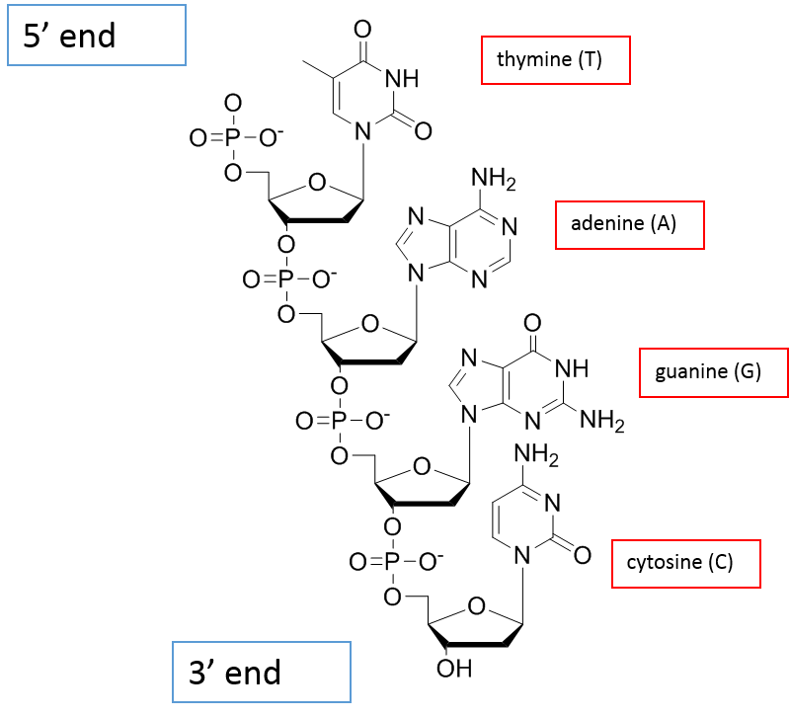
Figure 1.2 The chemical structure of a single strand of DNA, containing all four bases. The directionality of the strand can be seen with 5’ end ending with an alcohol and the 3’ end with a phosphate.

The interactions between the bases of DNA are specific with hydrogen bonds forming the complimentary base-pairing within A-T and G-C steps. The most common form of DNA is the double helical structure ‘B DNA’, which was first described by Watson and Crick.³ The helix is formed through hydrogen bonds between the complimentary bases of the two separate polynucleotide strands running antiparallel to each other. The most efficient packing formation is when the backbones twist around one another, resulting in one complete turn every ten base pairs to give the classical double helix of DNA. The aromatic base pairs also π-stack with each other, providing further stabilisation. The helical nature of B-DNA yields two grooves: the major and minor groove (Figure 1.3).
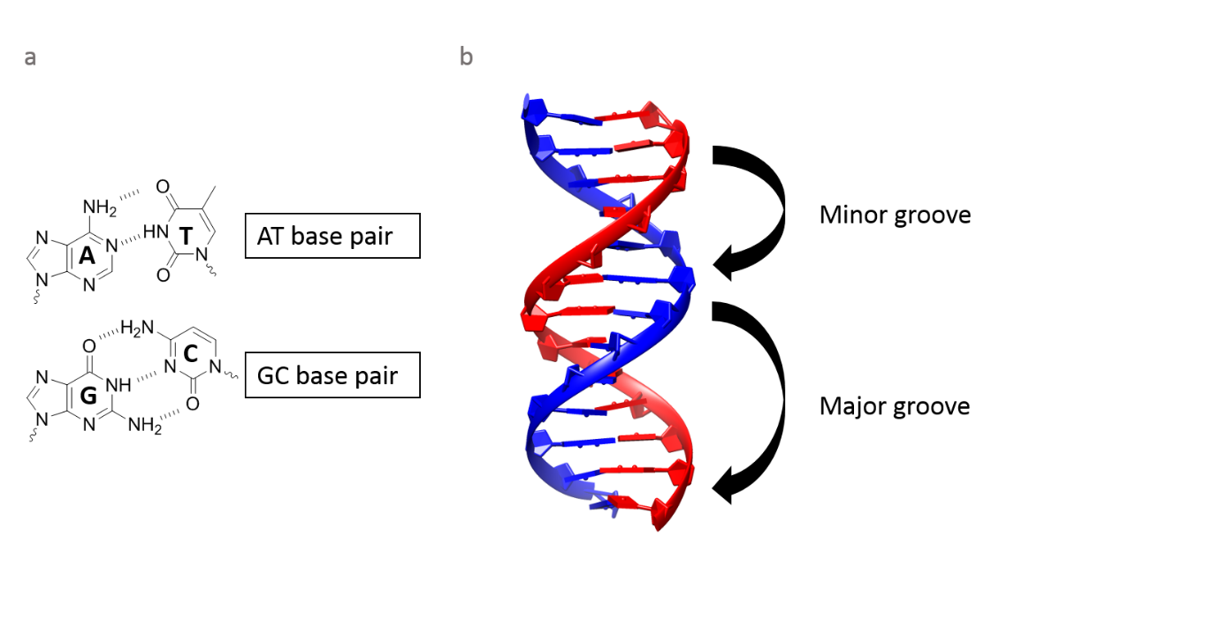
Figure 1.3 (a) GC and AT complementary base pairs with hydrogen bonding shown. (b) a representation of DNA, emphasising the minor and major grooves (Figure taken from RCSB Protein Data Bank ID:2VAI).

Cellular DNA
The coiled DNA in human eukaryotic cells is typically organised into 23 individual chromosomes located in the cell nucleus. To allow the large amount of DNA to fit into the relatively small cell nucleus, DNA is compressed with the help of nucleosomes, which are complexes of positively charged histone proteins that strongly adhere to the negatively charged DNA. DNA winds around a single nucleosome (composed of 8 histone proteins), 1.65 times. Nucleosomes then fold up forming a chromatin fibre, this is then compressed into a series of loops and coils in the chromatid of a chromosome.
In addition to the chromatin found in the nucleus, mitochondrial DNA also exists within the cell. This form of DNA however, is present in a close circular double helix rather than in a chromosome structure. This difference in structure opens the possibility for direct molecular targeting of these different forms of DNA within a cell.⁴

Cell division and the cell cycle
The ability of cells to divide and multiply is fundamental to the growth and maintenance of an organism. During eukaryotic cell division, chromosomes are duplicated through DNA replication, before pairs of chromosomes condense and then separate using a mitotic spindle into two identical sets, located in opposite regions of the cell (mitosis). Two daughter cells are formed through division of the parent cell (cytokinesis), each of which contains one set of the duplicated chromosomes and is thus a copy of the parental DNA (Figure 1.4). The cell cycle descries the events that lead to cell division. This consists of four distinct phases: G₁, S (DNA synthesis), G₂ and M (mitotic phase). G₁, S and G₂ phases are collectively known as interphase (Figure 1.4). In addition to these phases, there is the resting phase G₀, where cells remain viable but do not proliferate. The cell cycle is strictly regulated by numerous proteins and monitored by checkpoints which operate within S-phase, between S and M phase as well as at the G_{1/}S and G₂/M phase boundaries.⁵ In addition, a spindle checkpoint ensures that segregation of sister chromatids cannot occur unless all chromosome pairs are attached to the mitotic spindle, thus preventing an abnormal number of chromosomes (known as aneuploidy). The condensed chromosome and mitotic spindle structures can be used to identify the different stages of mitosis whereas interphase chromosomes exist in an extended form, compartmentalised into discrete areas in the nucleus.²
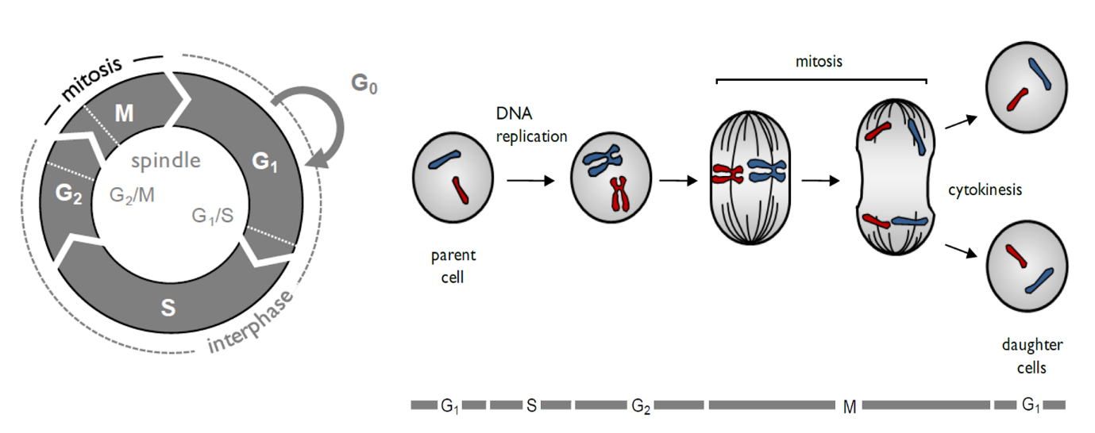
Figure 1.4 (a) The cell cycle with checkpoint location indicated in dotted lines (b) mitotic cell division showing DNA content. Bar indicates cell cycle phase. Reproduced from The Molecular Biology of the Cell.²

DNA replication
As previously discussed, the ability of the cells of an organism to replicate their DNA is essential for the growth and proliferation of that organism. DNA exists as a double stranded molecule. Each of the individual strands can act as a template to produce a complimentary strand as a consequence of Watson-Crick base pairing. This ensures that two identical copies of the DNA molecule are formed.
The process begins with the double helix of DNA being unwound by topoisomerase and helicases to form a replication fork. An 8-12 base segment of RNA is required to act as a primer for DNA polymerase to start synthesising DNA in the 5’-3’ direction. The primer is then removed and DNA polymerase fills in the remaining gaps (Figure 1.5).
While the leading strand (5’ to 3’ direction) synthesis is continuous, the synthesis of the lagging strand (3’ to 5’) occurs in short Okazaki fragments, each requiring an RNA primer. When the last RNA primer attaches, a repair synthesis compromised of RNA nuclease and DNA ligase convert the RNA (of the primer) to DNA, sealing the gaps between each fragment. This fails to happen at the site of the last RNA primer, due to the need for another DNA strand after the primer. Ultimately the RNA is destroyed by specific enzymes, thus meaning that a section of DNA is lost during each cycle of replication at the 5’ end of the lagging strand.²
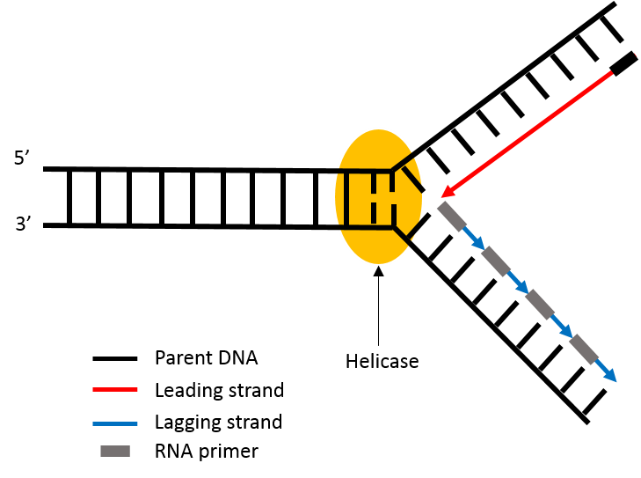
Figure 1.5 DNA replication fork showing helicase unwinding the DNA double helix, and the synthesis of the new leading and lagging strand.

Telomeres
The telomere is a specialised functional DNA protein structure found at the ends of all eukaryotic linear chromosomes.⁶ Human telomeres consist of repeats of the 5’TTAGGG sequence.⁷ Telomeres are essential in eukaryotic cell division, mainly by acting as protection at the ends of chromosomes. Without telomeres, every time DNA undergoes the replication process, eukaryotic chromosomes would shorten with each division cycle and hence genetic information would be lost. Telomeres can vary in repeat sequence and length, but typically they are rich in guanine and are between 2-15 kb in humans.^{8,9} The telomeric overhang of cells is reduced each time the cell divides (by around 50-200 nucleotides per round), and this shortening serves as a control for the life cycle of cells, by placing a limit - known as the Hayflick Limit - upon the number of divisions each cell can undergo. When the telomere becomes too short, the cells enter replicative senescence (cell death), and this is one of the reasons that normal non-germline cells do not proliferate indefinitely.^{10,11}

Telomerase and cancer cells
Cancer cells display uncontrollable growth along with the ability to invade neighbouring tissues. They form a tumour by clustering together, which can spread to multiple areas around the body. Cancer is a result of multiple genetic changes, which may originate from DNA mutation within a single abnormal cell. Research focusing on curing and preventing cancer is an area of intense interest and funding.
One property of cancer cells that may be exploited in treatments is that they possess shorter telomeres.¹² They also exhibit high activity of a specific ribonucleoprotein, called telomerase. In cancer cells telomerase maintains telomeres at a relatively constant length by adding the telomeric repeat sequence onto telomere ends.¹³ This evades the normal telomeric shortening found in non-cancerous cells and therefore removes this mechanism of cell death. This enables cancer cells to proliferate uncontrollably. For this reason, the inhibition of telomerase is viewed as an attractive target for cancer therapeutics.

Quadruplex DNA
G-quadruplex DNA are non-duplex DNA structures formed from nucleic acid sequences that are rich in guanine. Four guanine bases are able to arrange themselves into a structure called a G-tetrad held together through planar Hoogsteen hydrogen bonding.¹⁴ A G-quadruplex is formed through stacking of two or more G-tetrads with π-π stacking interactions (Figure 1.6). These structures can be further stabilised by cations such as Na⁺ or K⁺. In vitro formation of G- quadruplex from guanine rich DNA occurs readily in the presence of such ions, but it is thought that in vivo formation is more complicated.
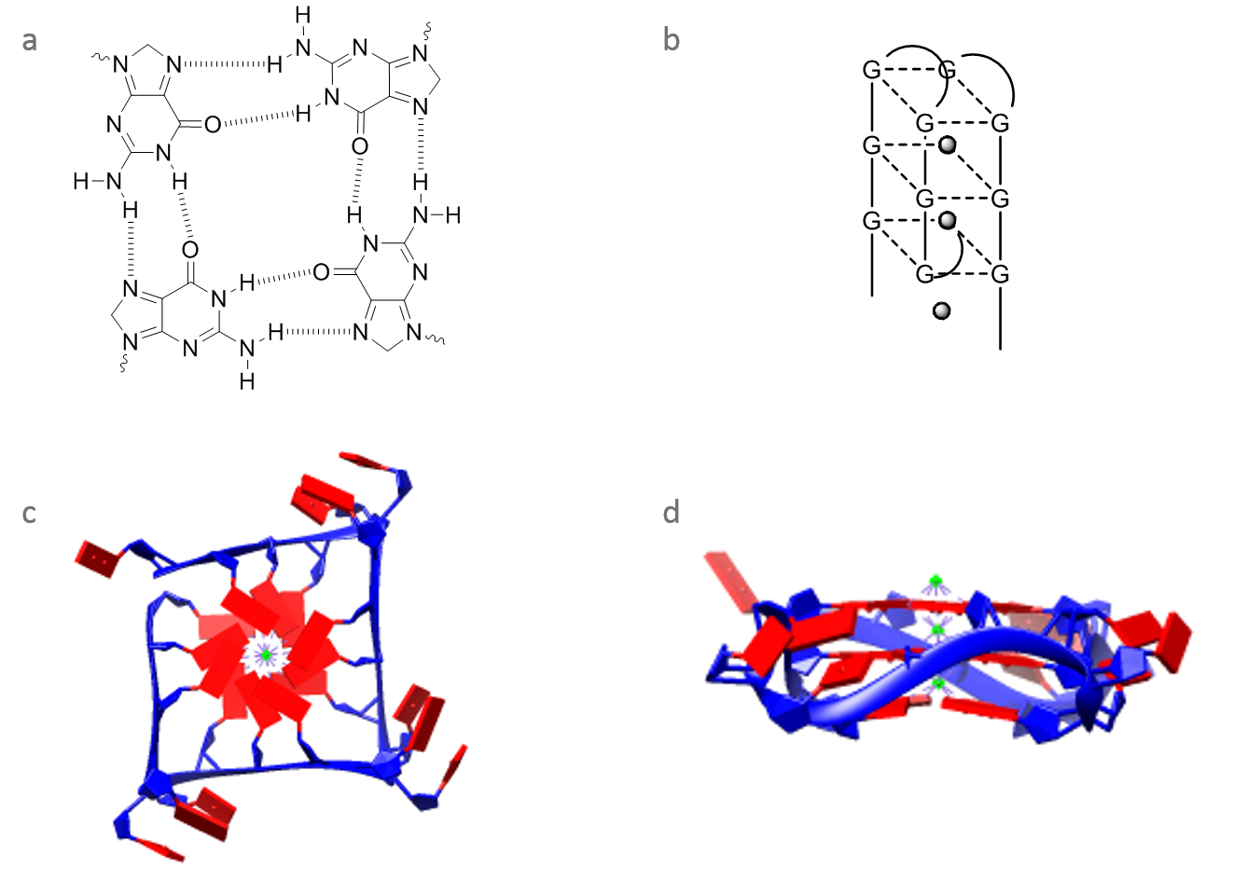
Figure 1.6 (a) chemical structure of a G tetrad (b) quadruplex structure formed by stacking of G tetrads (c) and (d) crystal structures of quadruplex DNA. (Figure taken from Nucleic Acid Database ID:UD0017).

Any structure containing two or more G-tetrads is a G-quadruplex, as a result there is considerable structural variation between quadruplexes. These differences are a result of a variation in strand length, strand orientation (parallel or antiparallel) and nucleotide sequence.¹⁵

The significant of quadruplex DNA in telomeres
Telomeric repeats in a variety of organisms have been shown to form quadruplex structures in vitro, and they have also been shown to form in vivo in some cases.¹⁶ The human telomeric repeats consists of many repeats of the sequence d(GGTTAG), making them prime candidates for quadruplex formation. The quadruplexes formed by this structure have been well studied by NMR and X-ray crystal structure determination.^{17,18} The formation and stabilization of these quadruplexes in telomeres have been shown to decrease the activity of the enzyme telomerase, which is responsible for maintaining the length of telomeres and is active in about 85% of cancers.¹⁹ This is because, as a reverse transcriptase, telomerase can only extend single stranded DNA. Thus targeting the telomerase/telomere relationship is a current anti-cancer strategy and, as part of this approach, it is thought that the induction/stabilisation of quadruplex DNA using small molecules may halt tumour growth while exhibiting minimal cytotoxicity towards normal cells.^{14,16,20}

Binding of metal complexes to DNA

Duplex DNA
The study of metal complexes and their ability to bind to DNA has been vastly studied in the literature. Metal complexes offer many advantages over organic molecules, mainly due their higher degree of selectivity towards various biological targets. This stems from the degree of variability of the metal, oxidation state, coordination ligands and overall size and shape of the molecules. They also possess the ability to bind to and cleave DNA, meaning there is a potential to develop these complexes as therapeutics. Their photophysical properties are extensive and means these complexes have the potential to act as luminescent probes, vide infra.

Irreversible binding
Metal complexes can often irreversible bind to DNA, most famously seen in cisplatin.²¹ Irreversible binding of metal complexes to DNA commonly occurs by the formation of coordination bonds between the Lewis acid metal centre and the complex to the lone pairs of the nitrogen or oxygen atoms of the DNA molecule, which function as the Lewis base.

Platinum based anti-cancer drugs
As mentioned above, Cisplatin is the most clinically successful DNA covalent binder and was originally developed by Rosenberg et al.²¹ Its binding is dependent on the hydrolysis of its labile chloride ligands, this is followed by the formation of covalent bonds between the complex and the purine bases in DNA at the N7 position.²² This binding results in the unwinding and bending of the double helix and has been suggested to inhibit DNA replication and transcription, ultimately leading to apoptosis or cell cycle arrest. ^{23,24} Cisplatin unfortunately displays severe side effects, such as high toxicity. In addition to this, resistance to cisplatin - which can occur either intrinsically or acquired throughout treatment – can develop. These drawbacks led to research focused on developing cisplatin derivatives that retain anti-cancer activity, specifically square planar platinum(II) complexes with the generic formula cis-[PtX₂(NH₂R)₂], where NH₂R is an inert amine and X is an anion leaving group, for example carboplatin, which has a bidentate carboxylate leaving group (Figure 1.7).^{25,26}
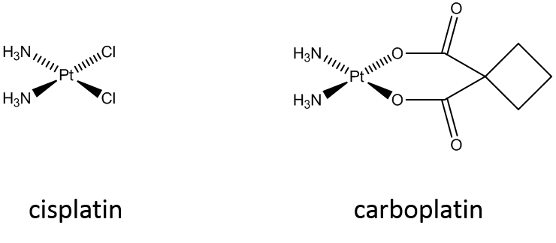
Figure 1.7 Chemical structures of platinum based anti-cancer drugs cisplatin and carboplatin.

Despite immense research in this area, only five drugs have actually gained approval for clinical use.²⁷ This is due to problems mostly arising from off-target toxicity and drug resistance. To address these issues, work in recent years has instead focused on platinum and other metal complexes with structures that are very different to the structure of cisplatin.²⁸

Non-platinum-based anti-cancer drugs
The limitations of cisplatin and similar platinum based drugs, have meant that the potential of alternative metal-based cancer therapeutics have been explored. In this context, the biological effects of ruthenium(II) and (III) complexes are increasingly being recognised as showing promise. This is due to their stable, well characterised structures that can be produced through the design of different ligands.²⁹ NAMI-A (imidazolium trans-[tetrachloride(imidazole)(dimethylsulfoxide)ruthenate(III) and KP1019 (indazolium trans-[tetrachloridobis(1H-indazole)ruthenate(III), are two such drugs which have been progressed to enter clinical trials (Figure 1.8).³⁰ Both are less toxic than cisplatin, and are thought to be inert until activated by reduction within hypoxic cancerous cells.²⁹ A phase I/II study however, found that use of NAMI-A in patients with Non Small Cell Lung Cancer, was only midly tolerated and less active than the gold standard treatment.
Figure 1.8 Chemical structures of non-platinum based complexes which show interesting anticancer properties. (a) NAMI-A (b) KP1019.

Reversible binding
Metal coordination complexes are also able to reversibly bind to DNA. This can occur by two main mechanisms, groove binding and intercalation, with contributions from electrostatic interactions also taking place.

Intercalation
The insertion of a positively charged planar polycyclic aromatic molecule between two adjacent base pairs of DNA is known as intercalation.³¹ Stabilisation of this interaction is by π-π stacking between the base pairs and the intercalated molecule, as well as van der Waals and electrostatic interactions. ^{32,33} While there are examples of platinum and other metal complexes intercalating into DNA, it is ruthenium(II) polypyridyl complexes that form the basis of many well-established metal complex-based DNA intercalators.^{34,35} Ru(II) complexes exhibit low toxicity, chemical stability and have interesting luminescent properties including intense metal-to-ligand-charge-transfer (MLCT) band in the visible spectrum.^{36,37} Early work focused on the polypyridine ligands; 2,2’-bipyridine (bpy), 4,7-diphenyl-1,10-phenanthroline (DIP) and 1,10-phenanthroline (phen) (Figure 1.9). The complexes [Ru(phen)₃]²⁺ and [Ru(DIP)₃]²⁺ were found to demonstrate both electrostatic and intercalative binding modes.³⁸
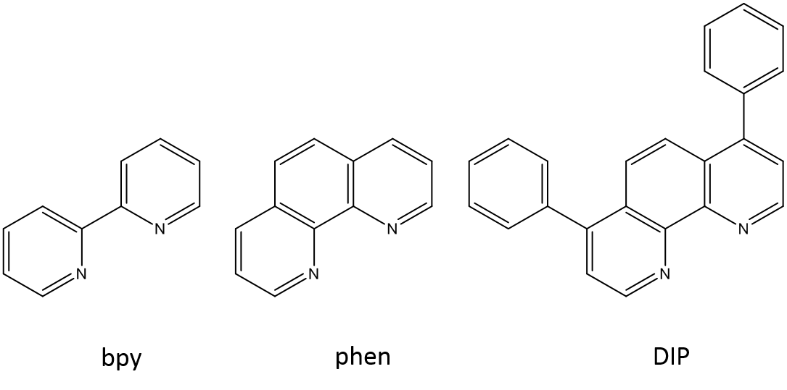
Figure 1.9 Octahedral Ru(II) tris(phenanthroline) ligand derivatives.

Octahedral ruthenium(II) complexes can exist as optical isomers (Δ/Ʌ) and their chirality can affect their biological activity. This makes sense since DNA itself is a helical molecule with a right-handed screw, making it naturally chiral. Barton and co-workers originally synthesised and compared the binding modes of Ʌ- and Δ- [Ru(phen)₃]²⁺ (Figure 1.10) that suggested only one form intercalated.^{36,39,40} However, subsequent work in 1999 by the Rodger group using detailed spectroscopy and computer modelling revealed the true binding modes of these systems.³⁸ Ʌ- [Ru(phen)₃]²⁺ partially inserts in the major groove, whilst Δ-[Ru(phen)₃]²⁺demonstrates concentration dependant non-intercalative binding, preferring the minor or major groove at low and high concentrations respectively.
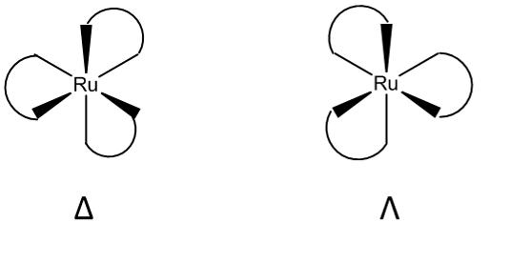
Figure 1.10 Illustration of the enantiomers of a tris-ruthenium complex.

Work then focused on the large aromatic surface area of the dipyrido[3,2-a:2’,3’-c]phenazine (dppz) ligand in particular the complex of [Ru(bpy)₂(dppz)]²⁺. The large aromatic surface enables intercalation, making DNA binding favourable. [Ru(bpy)₂(dppz)]²⁺ produces a relatively strong binding affinity with DNA (>10⁶M⁻¹), which is around a thousand times higher than that of [Ru(phen)₃]²⁺.⁴¹

MLCT DNA light switch effect
Barton et al first reported the DNA binding of [Ru(bpy)₂(dppz)]²⁺, showing that it can act as a spectroscopic reporter of duplex DNA.⁴¹ (Figure 1.11) Upon binding to DNA, the complex displays intense MLCT luminescence on the addition of DNA as a direct result of intercalation, shielding the phenazine nitrogen atoms from any potential hydrogen bonding. Whereas luminescence of the unbound complex is quenched. This is termed the DNA ‘light switch’ effect and has been used to study a wide variety of metal complexes as potential biological probes.
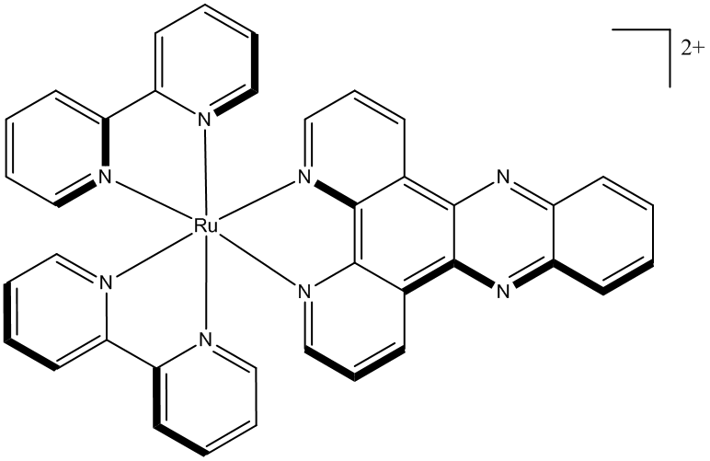
Figure 1.11 Chemical structure of the metallo-intercalator [Ru(bpy)₂(dppz)]²⁺

Sauvage et al originally characterised the MLCT luminescence of [Ru(bpy)₂(dppz)]²⁺. Upon absorption, charge transfer occurs from the ruthenium ion to a π* orbital primarily located on the dppz ligand.⁴² This ¹MLCT state decays rapidly via intersystem crossing, to a ³MLCT state, primarily localised on the phenazine nitrogen atoms (Figure 1.12). This excited state is quenched in aqueous conditions, with water hydrogen bonding with the phenazine nitrogen atoms. During intercalation however, the dppz ligand is shielded from the water molecules which activates the luminescence, enabling the complex to act as though it is in organic solvent.⁴³
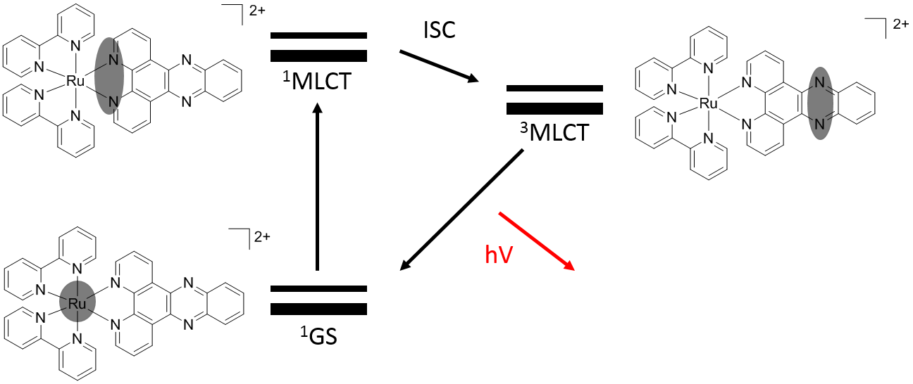
Figure 1.12 Simplified Jablonski diagram illustrating the light switch effect. Corresponding molecular structures show the localisation of the relative electron orbital throughout the process.

This research prompted exploration into similar dppz based complexes and alternative ancillary ligands.
Intercalation into DNA has been thought of as the only way in which molecules may demonstrate the DNA light switch effect. However, Turro et al reported that [(bpy)₂Ru(tpphz)Ru(bpy)₂]⁴⁺ is a non-intercalating light switch metal complex, despite the large aromatic tpphz unit.⁴⁴

Quadruplex DNA
The structure of quadruplex DNA is very different to duplex DNA, so the binding of complexes to it is also very different. Quadruplex DNA possesses several distinct features that may be targeted by compounds. These include: a large intercalative surface area, four grooves which vary greatly depending on the nature of the particular quadruplex and a negative channel of electrostatic potential running through the core of the quadruplex.

Irreversible (covalent) binding
Current cancer drug therapies are mostly based on irreversible binding to duplex DNA. Irreversible binding to duplex DNA occurs by covalent linkages to either the phosphodiester backbone, sugar residues or bases of the DNA. This leads to strand cleavage which can lead to cell death. This technique forms the basis of “classical chemotherapy”, as rapidly dividing cells, like cancer cells, are preferentially targeted by this approach.
For quadruplex DNA however, often the aim is to stabilise the DNA structure rather than to cleave it, so as a result there is minimal research into irreversible ligand binding to quadruplex DNA. Teulade-Fichou et al however, had little success with synthesising a class of cisplatin based compounds, such as BOQ₁ (Figure 1.13), that bind irreversibly to DNA, but also incorporate extended quinacridine ligands that can interact in a non-covalent manner as well.⁴⁵ However, they have been successful in designing compounds that both stabilise quadruplex structures and bind quadruplex structures preferentially to duplex structures.
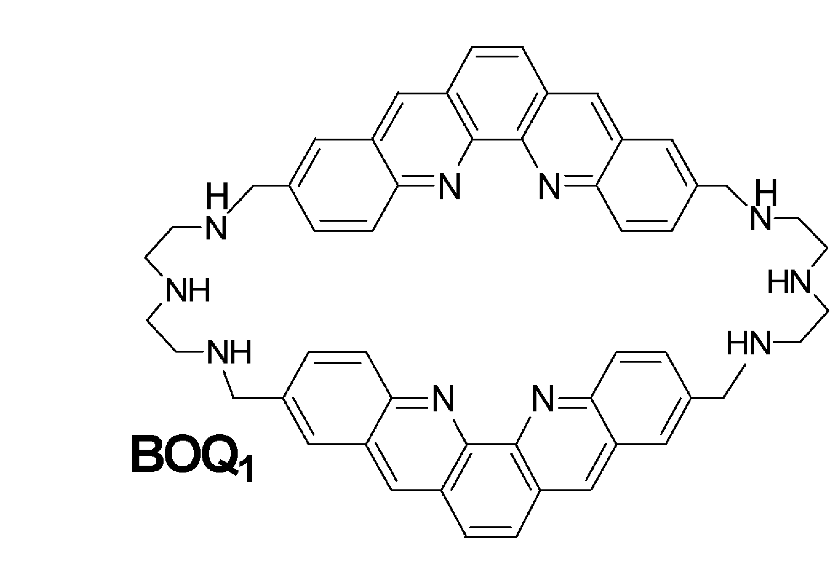
Figure 1.13 Structure of BOQ₁, a macrocyclic compound possessing two dibenzophenanhroline (quinacridine) subunits, capable of binding to G-quadruplex DNA. Developed by Teulade-Fichou et al⁴⁵. Reprinted (adapted) with permission from Teulade-Fichou et al. Copyright 2003 American Chemical society.

Reversible binding
A molecule may reversibly bind with loops, grooves, end stack or intercalate between successive G-tetrads.

Groove and loop binding
Quadruplex groove binding is a promising target, since there is a variety of groove shapes and size within the different forms of quadruplex DNA and some studies have been able to use groove binding as a way of distinguishing between types of quadruplex strucuture.^{46,47}
Loop binding is also a possible exploitable feature for designing structure specific molecule design. As with grooves, quadruplex DNA can contain and different number of loops, and these loops vary in their length and base composition.⁴⁸

End-stacking
G-tetrad possess large planar features, enabling terminal end-stacking to take place. It is this design feature that potentially enables new compounds and drugs to be developed that favour quadruplex binding over typical duplex binding. However, since all quadruplex have similar G- tetrad ends, it may be difficult to discriminate between different types of quadruplex structures using this binding motif. Nevertheless, there have been reports of several complexes being found that bind preferentially to quadruplex DNA over duplex DNA through an end-stacking mechanism. Work by Ma et al, focused on the platinum complex [Pt^{II}(dppz-COOH)(N^C)]CF₃SO₃, which was found to bind to G-quadruplex DNA through an external end-stacking mode with a binding affinity of ~10⁷ dm³ mol⁻¹.^{49,50}

Intercalation
Although intercalation is a common binding method of small molecules to duplex DNA., there is little in the literature regarding an intercalation with quadruplex DNA. Porphyrins were thought to be able to intercalate between the G-tetrads of quadruplex DNA structures,^{51,52} but it was also suggested that as a model of binding to quadruplex DNA intercalation is unlikely. This is due to the structure of quadruplex DNA being very stable, and that the distortion of that stable structure in order to accommodate small molecule intercalation is improbable.⁵³ Additionally for intercalation to occur, the templating alkali metal will have to be removed, destabilising the quadruplex structure, thus end-stacking is seen as a more liekly interaction.

Metal complexes and quadruplex DNA
Extensive research has focused on metal complexes as quadruplex DNA-binding agents. Metal complexes possess well defined, modifiable geometries, a positively charged centre which can associate with the centre of the G-tetrad, charged terminal groups that can bind with the grooves and loops of the quadruplex, and also ligands containing delocalised π systems that are able to stack on the face of the quadruplex.⁵³ The first crystal structure of a metal complex- quadruplex DNA, arose from the end-stacking of nickel and copper salphen complexes to human telomeric quadruplexes (Figure 1.14).⁵⁴ It was found that the complexes were cytotoxic and were capable of inhibiting telomerase activity. The binding affinity to quadruplex DNA of a nickel complex was found to be more than that of a copper complex, this was found to be due to the relative bending of the two complexes, with the Ni²⁺ being less. The effect of this difference in bending changes the degree of stacking of the phenyl rings of the complex which in turn leads to the difference in binding affinities of the complexes.⁵⁵
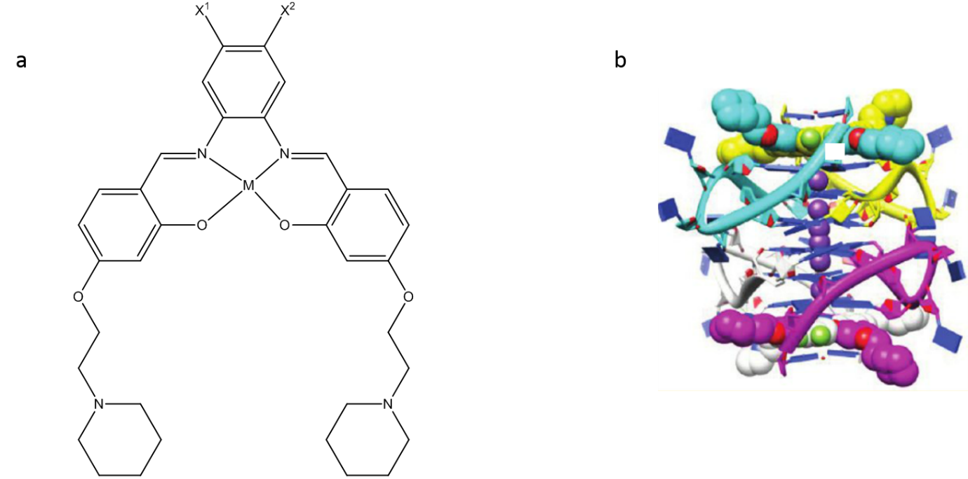
Figure 1.14 (a) Generic chemical structure of nickel(II) and copper(II)–salphen complexes able to bind via end stacking to quadruplex DNA (b) X-ray crystal structure of nickel(II) and copper(II) metal complexes bound to quadruplex DNA. The crystal structure shows the two salphen-metal complexes to bind to human telomeric quadruplexes by end-stacking, with the metal almost in line with the potassium ion channel. Reprinted (adapted) with permission from Campbell et al.⁵⁴ Copyright 2012 American Chemical Society.

Numerous such complexes have been developed, which preferentially bind to quadruplex over duplex DNA, such as luminescent water-soluble alknylplatinum(II) terpyridyl complex developed by Yu et al, which was proved to be capable of detecting the intermolecular formation of DNA quadruplex from unfolded DNA. The addition of K⁺ ions and assembly of the G-quadruplex results in complex aggregation through Pt-Pt and π-stacking interactions. This aggregation gives rise to a MMLCT band, serving as a read-out that indicates quadruplex formation (Figure 1.15).^{56,57}With potential for some compounds to act as optical probes for quadruplex DNA, which this work will focus on.^{55,58,59}
Figure 1.15 Luminescent alkynylplatinum(II) terpyridyl complex capable of detecting quadruplex formation

Metal complexes in cellular imaging applications
The majority of current commercial compounds used for bio-imaging are small molecule, low molecular weight, cell membrane permeable organic luminophores. However, despite their popularity, these compounds experience problems with photo-bleaching, poor water stability, high toxicity and poor Stokes shift values.⁶⁰
For compounds to interact with DNA in living organisms they must be able to achieve cellular uptake. Several intercalating dyes such as ethidium bromide (EB) and propidium iodide (PI) require permeabilisation or membrane disruption to label the DNA effectively, if this is not possible then the molecules will only bind to DNA in dead, perforated cell (Figure 1.15).⁶¹

Figure 1.16 Structure of ethidium bromide (EB) and propidium iodide (PI).

DAPI and Hoechst are examples of minor groove binding dyes, which emit blue fluorescence under UV light when bound to DNA. Since UV light damages cellular DNA and other cell components, the use of these compounds in live cell microscopy is restricted to short time exposures (Figure 1.16). Both groove binding agents have a preference for A/T rich DNA sequences, so only highlight a subset of the genome.⁶²

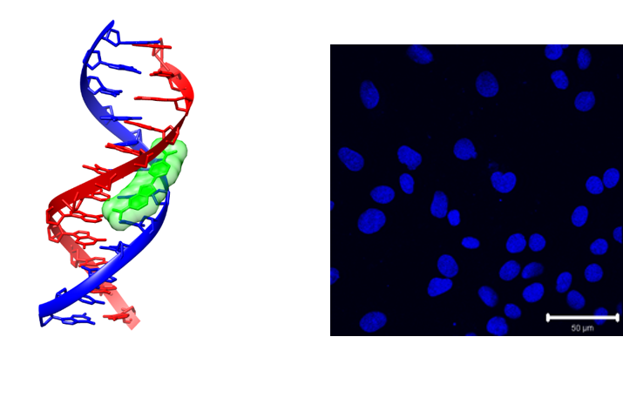
Figure 1.17 (a) Crystal structure of DAPI binding to DNA. (Figure taken from Protein Database ID:1D30) (b) confocal image of RN22 cells stained with DAPI. Image donated by Paul Taylor.

Heavy metal complexes have previously been shown to reversibly bind to DNA in vitro and their application in biological systems is currently a highly active research area. Advantages of metal complexes over organic dyes are; high luminescent efficiencies and tuneable emission profiles over a wide range of wavelengths. They also offer flexible chemistry, allowing the ligands on the metal centre to be interchanged and functionalised. Specifically, for cellular imaging, metal complexes benefit from several attractive optical properties including: photostability, low MLCT excitation energies in the visible region of the spectrum and high Stokes shifts. The significant Stokes shift (the difference between excitation and emission energies), is due to efficient phosphorescence, this eliminates self-quenching processes and helps eliminate “crosstalk” with auto fluorescence due to endogenous fluorophores.
Heavy metal complexes of d⁶, d⁸ and d¹⁰ can all exhibit efficient intersystem crossing from the singlet to triplet excited state, resulting in an intense phosphorescent emission. Specifically complexes of Re(I), Ru(II), Os(II), Rh(III), Ir(III), Pt(II), Au(I) and Cu(I) possess luminescent decay times long enough to be viable for bioimaging, and have subsequently received attention as an alternative to organic dyes.^{63–66}

MLCT luminescent metal complexes
Since the discovery of the light switch effect, numerous recent studies have focused on the cellular internalisation of this class of metal complexes.
The Barton group, focused on the cellular uptake properties of their dppz DNA-binding systems, using the MLCT light switch emission of the complexes to assess cellular uptake and localisation.⁶⁷ A series of dppz complexes of Ru(II) were examined by flow cytometry. By substituting the ancillary ligands, variation in the overall complex charge, size and hydrophobicity was achieved. In HeLa cells, it was found that cellular uptake was more efficient when more hydrophobic ancillary ligands such as DIP were used, in the case of Ru(DIP)₂dppz²⁺. Interestingly, while cytoplasmic luminescence was observed, no nuclear MLCT luminescence was apparent (Figure 1.17). This was attributed to the complexes demonstrating limited membrane permeability. Given that these complexes are large, positively charge and relative hydrophilic, it is not surprising that they display poor cellular uptake.
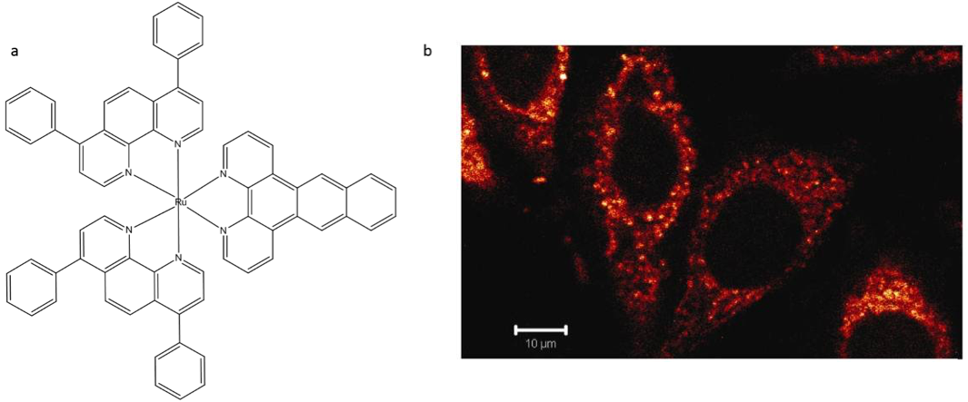
A
B
Figure 1.18 (a) Chemical structure of [Ru(DIP)₂(dppz)]²⁺ (b) CLSM image showing cellular uptake of [Ru(DIP)₂(dppz)]²⁺ in HeLa cells. Reprinted (adapted) with permissions from Barton et al. Copyright 2017 American Chemical Society.⁶⁷

In the attempt to produce membrane-permeable DNA-binding metal systems, the use of hydrophobic ancillary ligands such as DIP, the addition of alkyl chains, conjugation to biological molecules such as peptides or steroids or attachment to nanoparticles as methods of delivery have all been evaluated.^{68–70} However while changes in hydrophobicity can enable membrane permeability, it can also affect the cellular localisation of the complex, and often leads to cell structures other than the nucleus being targeted. For example, Lincoln and co-workers demonstrated that Ru(dppz) based complexes substituted with alkyl ether chains of differing length, localise in various intracellular regions depending on the length of the alkyl chain, where they are observable by CLSM and fluorescence lifetime imaging techniques. The least hydrophobic complex was found to exclusively stain the nucleus whereas the more hydrophobic ones predominantly stain membrane structures within the cytoplasm.⁷¹

Non MLCT luminescent metal complexes
While the “light switch” effect is an excellent property towards potentially improved fluorescence imaging, similar success has been found in complexes without such an effect.
Williams et al have reported neutrally charged platinum complexes with the general formula [PtLCl] (where HL=1,3-di(2-pyridyl)benzene and derivatives), that display low cytotoxicity, microseconds lifetimes and high emission quantum yields.⁷² These complexes were found to stain nucleoli of live cells, and rapidly accumulate in a range of live cell types (Figure 1.18). Interestingly, due to their long lifetimes, these systems provided the first example of time-resolved fluorescent imaging using metal complexes.
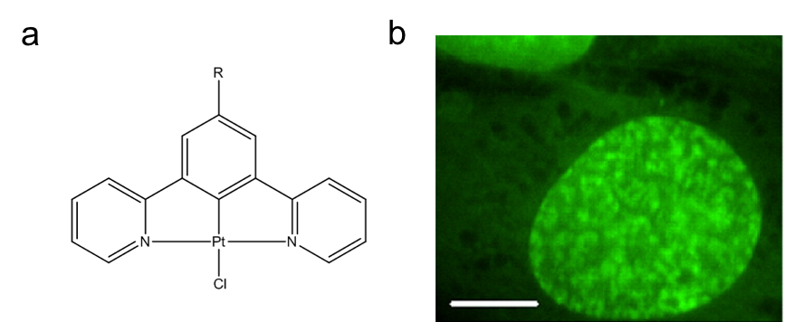
Figure 1.19 (a) Pt(II) based imaging agent b) agent demonstrating nuclear staining in CHO Chinese hamster cells. Image adapted from Williams et al.⁷²

Iridium(III) polypyridyl complexes have received attention due to their highly tuneable luminescent properties over the entire visible spectrum. Many interesting luminescent biological probes have exploited iridium’s photophysics.^{73–75} Specifically, Li and co-workers reported the complex [(ppy)₂Ir(DMSO)₂]⁺ as a reaction based fluorescence-turn-on agent for imaging nuclei of living cells.⁷⁶ In vitro studies showed the luminescence of the complex do not increase upon interaction with DNA. Upon exposure to live cells, nuclear accumulation occurs, interactions with histidine-containing proteins then cause an activation of luminescence (200-fold).

Lanthanide complexes
Cellular imaging using metal complexes isn’t solely limited to transition metals, and lanthanide complexes have successfully displayed their capability as bio-molecular probes. Lanthanide probes offer several advantages over organic dyes and fluorescent proteins, much like the transitional metal complexes previously discussed, including tuneable emission, and large Stokes shifts. Most notably emission lifetimes are long (0.1-2 ms), allowing for time-gated detection strategies to be utilised (further discussed in Section 1.3.4), eliminating scattering and short-lifetime fluorescence background signals.
Due to the forbidden nature of the f-f electronic transitions, a general design strategy to increase the brightness of a lanthanide complex, is to complex a lanthanide cation with a multidentate ligand bearing an energetically match chromophore (typically referred to as an “antenna”). Energy transferred from the excited antenna to the metal ion can then be dissipated through photon emission or nonradiative decay.⁷⁷
For example, work in the Parker group has focused on europium and terbium macrocyclic complexes which are emissive and localise within various intracellular regions, including lysosomes, nucleoli and mitochondria (Figure 1.19). The complexes consist of a lanthanide metal centre, into a seven or nine-coordinate ligand which acts as the sensitising chromophore. Fast energy transfer between the two then results in the luminescence emission of the lanthanide.^{78,79}
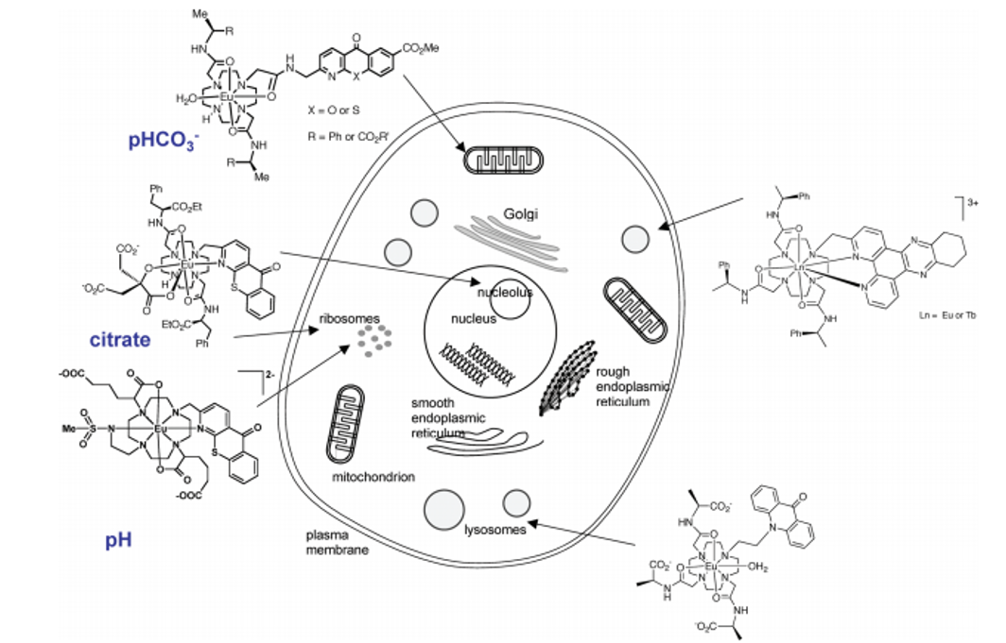
Figure 1.20 Schematic illustration of numerous Eu and Tb based metal complexes developed by Parker et al, which can demonstrate different localisation points within the cell. Image reproduced from Montgomery et al.⁸⁰

In other work on lanthanide-based systems, the Bünzil group have developed highly luminescent lanthanide bimetallic helicates that consist of the three ligand strands self-assembles around two metallic centres as potential cellular imaging probes. These systems offer tuneable chemical and photophysical properties, intense luminescence and low cytotoxicity. ⁸¹

Time-resolved fluorescent imaging probes
The metal compounds discussed in previous sections are typically emissive probes and sensors for cell imaging using what is traditionally termed steady state imaging. Lifetime-based imaging techniques, such as fluorescent and phosphorescent lifetime imaging microscopy (FLIM and PLIM respectively). FLIM and PLIM are imaging techniques that produce an image based on the differences in the exponential rate of decay of the fluorescence or phosphorescence from a sample. The signal lifetime rather than intensity, is used to create an image. This offers advantages over conventional emission-based steady state imaging, mainly by minimising the effect of photon scattering in thick layers of sample. PLIM is of particular interest as it removes problems arising from auto-fluorescence during image collection. This is because PLIM employs probes that emit on the ns to µs timescale, while bio-molecular auto florescence typically has a lifetime on a ps to ns scale. As previously mentioned the Williams group developed platinum complexes that were suitable for the application of time-resolved emission imaging microscopy (TREM) for non-invasive imaging and mapping of live cells.⁷²
Work in the Thomas group showed that the ruthenium complex [(Ru(phen₂)₂)tpphz]⁴⁺ is a PLIM probe for nuclear DNA in both live and fixed cells. Lifetimes of around 160ns in live cells were displayed, with shorter-lived cytoplasmic emission also being observed (Figure 1.20).⁸²
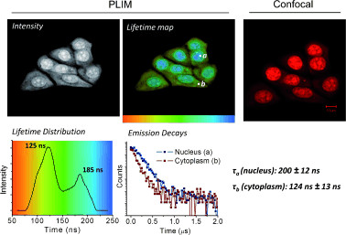
Figure 1.21 PLIM images of fixed, permeabilised MCF7 cells treated with [(Ru(phen₂)₂)tpphz]⁴⁺, showing a lifetime of 185ns and 125ns in the nucleus and cytoplasm respectively. Image adapted with permissions from Baggaley et al.⁸²

Optical probes for quadruplex DNA
Molecules that change their optical properties upon binding to quadruplex DNA are becoming an increasingly popular research target, as this can lead to probes for the study of quadruplexes and their biological functions. Platinum complexes with aromatic diamine ligands have been reported as luminescent probes of quadruplexes, showing a 300- fold photoluminescence enhancement upon binding to a DNA quadruplex.⁴⁹ A zwitterionic member of this series was used as a fluorescent dye to stain quadruplex DNA on an electrophoretic gel. Additionally, Yu et al reported on a luminescent alkynylplatinum(II) terpyridyl complex which has been shown to detect the intermolecular formation of DNA quadruplex from unfolded DNA.⁸³
Ruthenium complexes based on [Ru(bipy)₃]²⁺ have also demonstrated potential as optical probes for quadruplex DNA. In the case of [{Ru(bipy)₂}₂(4-azo)]⁴⁺]²⁺, an immediate colour change is observed when the complex is mixed with telomeric quadruplex DNA (Figure 1.21).⁸⁴ The Thomas group have also produced somewhat related dinuclear ruthenium complexes that are capable of spectroscopically differentiating between duplex and quadruplex structures. When binding quadruplex DNA, these complexes display a significant enhancement of their luminescent signal that is 2.5 times larger and blue shifted compared to their interaction with duplex DNA (Figure 1.21).⁵⁸

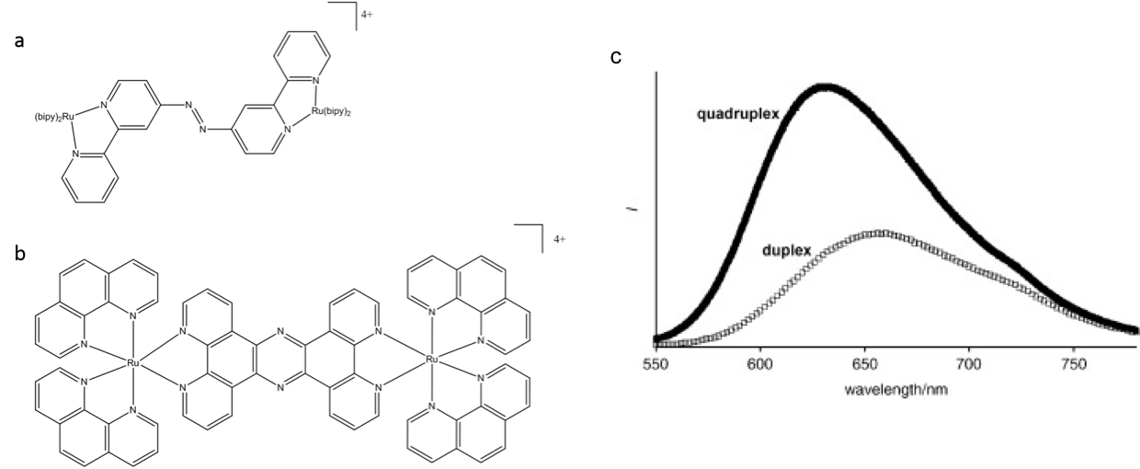
Figure 1.22 (a) The [{Ru(bipy)₂}₂(4-azo)]⁴⁺ complex which can act as an optical probe of DNA quadruplex (b) Quadruplex binding metal complex [(Ru(phen)₂)₂tpphz]⁴⁺ (c) accompanied by a comparison of emission observed for 5µM solution of compound in the presence of G3 Quadruplex and duplex DNA. ⁵⁸

Aims
The aim of this thesis was to develop methods to chirally resolve luminescent Ru(II) systems developed by the Thomas group that bind reversibly to DNA in vitro. Once resolved, the cellular internalisation and DNA targeting of the diastereoisomers were to be investigated, using live cell conditions to evaluate the staining, cytotoxicity and uptake of the complexes, and the effect that chirality has on these properties. The ability of such complexes to act as molecular light switches for DNA means that in vitro DNA binding and cellular uptake may be examined using confocal laser scanning microscopy.
Additionally, the unique property of such complexes to distinguish between different DNA structures in solution, means that they could potentially be used as structure specific imaging probes, and so the application of these chiral complexes in distinguishing between different DNA structures was explored.
The parent racemic Ru(II) system containing the phen ligand, has shown preference in the staining of cancer cells over non-cancer cell types. This was further explored through the use of co-culture and conditioned media techniques.
Finally, using the staining and imaging methods developed in this work, a broad series of metal complexes developed by the Thomas group, were then analysed for their specific staining properties and evaluated for their potential in further applications.

Synthesis and Isolation of Pure Diastereoisomers of Dinuclear Quadruplex Probes

Introduction
Previous work conducted by the Thomas group focussed on dinuclear Ru(II)tpphz complexes with both phenanthroline (phen) or bipyridine (bpy) as the ancillary ligands Figure 2.1.

Figure 2.1 [(Ru(phen)₂)₂tpphz]⁴⁺ (Ruphen) and[(Ru(bpy)₂₎₂tpphz]⁴⁺ (Rubpy)

Both dinuclear complexes bind to duplex DNA with a higher affinity than any known mono-intercalating complex with binding constants (K_{b}) 1.1 x 10⁷ and 3.3 x 10⁸ M⁻¹ for phen and bpy respectively. Additionally, the dinuclear complexes display higher affinity for the G3 (TTAGGG)3 sequence, which is a form of the Human Telomere Sequence (HTS), folded as quadruplex DNA with binding constants of 4.4 x 10⁶ and 9.6 x 10⁶ M⁻¹ respectively.⁵⁸
The light-switch effect was observed with both forms of DNA upon MLCT excitation with a large luminescence enhancement (> 60 times for duplex ~ 150 for quadruplex) and, intriguingly binding to quadruplex results in blue-shifted emission and greater emission lifetime compared to duplex binding.⁵⁸ This indicated that the complex has potential to spectroscopically discriminate between different DNA structures.
In vitro studies on the Ruphen and RuBpy complexes demonstrated that RuPhen can be internalised by the MCF-7 cell line and bind to DNA in vitro RuBpy displayed significantly lower cellular uptake, but was shown to be an effective dead cell stain.⁸⁵
Both complexes contain two asymmetric Ru(II) centres, meaning three stereoisomers of each complex exist: ΔΛ (meso), ΔΔ (delta) and ΛΛ (lambda). 2D NMR binding studies on the resolved stereoisomers with HTS have provided evidence that the primary binding mode of these complexes to quadruplex DNA is by end stacking, with the central tpphz ligand of the complex bound to both the lateral and diagonal loop ends of the quadruplex structures.^{86,87} The high affinity for quadruplex DNA is of particular interest as small molecules can induce and stabilise this non-duplex form of DNA. This makes it a potentially interesting molecular target for new anti-cancer therapeutics as well as a selective imaging probe.
Further studies on the stereoisomers, found that the ΔΔ and ΛΛ stereoisomers bind to duplex DNA with similar affinity (with binding constants of 1.99 x 10⁶ and 6.73 x 10⁶ respectively). However, ΛΛ demonstrated up to 40 times higher binding affinity to quadruplex DNA than the ΔΔ isomer.^{86,87}
In a continuation of the work, using two different methods, the two diastereoisomers (ΔΔ- [(Ru(phen)₂)₂tpphz]⁴⁺ and ΛΛ -[(Ru(phen)₂)₂tpphz]⁴⁺ have been isolated and characterised for cellular studies. The aim of this work was to further understand how these compounds interact with cells and to distinguish the differences, if any, between the two relative compounds.

Ligand synthesis
The tpphz ligand was first synthesised by a method described by Bolger et al (Figure 2.2).⁸⁸
Figure 2.2 – Synthetic route towards TPPHZ.

Synthesis of precursor building blocks
Initially, previously reported enantiopure synthetic building blocks were used to synthesize each of the diastereomers directly. These were prepared from the precursor complex Ru(phen)₂Cl₂, which was synthesized using the method described by Sullivan et al, in which RuCl₃.3H₂O is reacted with phenanthroline in dry DMF Figure 2.3a.⁸⁹ Lithium chloride was added to prevent substitution of all the chloride ligands. Racemic [Ru(phen)₂(py)₂]²⁺ was then synthesised through the reaction of Ru(phen)₂Cl₂ with pyridine for 3 hours Figure 2.3b. As explained in the next section, it was this complex that was used as a building block in the chiral syntheses.

Figure 2.3 a, Synthesis of Ru(phen)₂Cl₂]²⁺, yields ranged from 63-83%. b, Synthesis of [Ru(phen)₂(py)₂]²⁺, yields ranged from 45-67%.

Synthesis of chirally resolved bimetallic ruthenium complexes
Although the octahedral ruthenium complexes illustrated above are chiral, in a typical synthesis the complex is produced as a racemic mixture.¹ Therefore a bimetallic ruthenium compounds will be produced as a mixture of diastereomers in a ratio of 2:1:1 (meso, ΔΔ and ɅɅ) Figure 2.4. These diastereoisomers can be identified in NMR with the use of chiral lanthanide shift reagents such as europium tris[3-(trifluoromethylhydroxymethylene)-(+)-camphorate].^{90–92} However, it has been shown to be a rather unreliable and complex method.⁹³ More reliably, the diastereoisomers (ΔΔ and ɅɅ) can be effectively identified by circular dichroism (CD), and this method of characterisation will be used in this work.^{94–99}
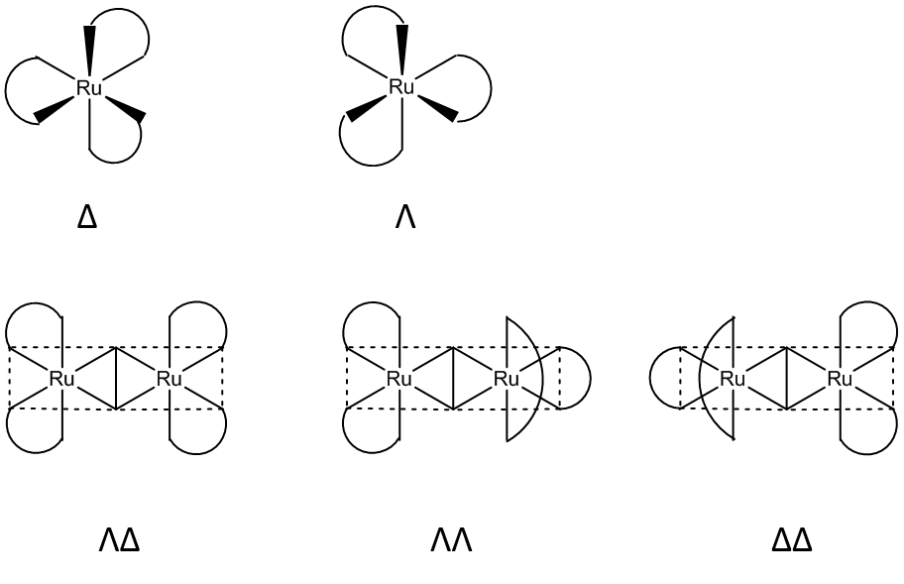
Figure 2.4 Top, Enantiomer of monometallic ruthenium complexes containing bidentate ligands. Bottom, diastereomeric and enantiomeric dimeric ruthenium complexes.

Several diastereoselective selective synthesis methods have previously been employed to obtain enantiopure polypyridyl complexes. These include complicated chromatographic methods typically using chiral cation-exchange stationary phases with the addition of non-chiral anionic species to the mobile phase.⁹⁹ Separation has also been achieved using capillary zone electrophoresis and also via HPLC with chiral stationary phases.^{100,101} However, electrophoresis is considered to be unreliable, while the use of HPLC on a preparatory scale is very expensive and time consuming.^{102,103}
A common method of isolating diastereoisomers of oligonuclear polypyridyl ruthenium complexes is using enantiomerically pure monometallic starting materials. These synthons have been successfully resolved by enantiomerically-selective precipitation with chiral anions such as [As₂((+)-tart)₂]²⁺.¹⁰¹ These arsenic-based dianion, contain tartaric acid units forming a quadridentate tetranegative ligand with the four oxygen atoms of the tartrates bridging two arsenic atoms.¹⁰⁴
The dd and ll form of these dimeric complexes can be readily synthesised from arsenics(III) oxide and d- or l- tartaric acid respectively. A synthesis method adapted from Henderson et al and Sun et al was used to prepare the tartaric acids.¹⁰¹ With the tartaric acid and metal oxide being refluxed in water in the presence of sodium hydroxide.
Zalkin et al showed the crystal structure of Ʌ-[Fe(phen)₃]²⁺ with bis(antimony (III) d-tartrate), demonstrating that the closer ion pairing of Ʌ-[Fe(phen)₃]²⁺ with the d tartrate, and the Δ-[Fe(phen)₃]²⁺ with the l tartrate leads to their selective co-precipitations.¹⁰⁵ The use of these tartrate salts has been shown to be effective in the enantiomeric resolution of many monometallic ruthenium complexes.
Enantiomerically pure samples of [Ru(phen)₂(py)₂]²⁺ were obtained by serial co-crystallisations with the appropriate arsenyl tartrate salt. Two protocols were trialled, the first being a technique described by Dwyer et al, in which the enantiomers proceeded through a nitrate salt intermediate.¹⁰⁶ This method proved to be unreliable and time consuming with a large loss of product occurring with each crystallisation. A second procedure was adapted from Hiort et al, in which subsequent additions of the appropriate tartrate salt were added after the initial separation step and utilised longer precipitation times, which proved more convenient and led to better quality resolutions.¹⁰⁷
The enantiomeric purity of the complexes was monitored using circular dichroism after co- crystallisation with the appropriate tartrate. For the method by Dwyer et al, literature methods indicated that a high level of purity was achieved after two serial crystallisations of [(phen)₃Ru]²⁺, but we found that for [(phen)₂Ru(py)₂]²⁺ three crystallisations were required. No further increase in chirality was obtained after further crystallisation, indicating a chirally pure product. On occasion during the crystallisation process the compound racemised. Several possibilities such as exposure to light or impurity within the crystallisation process may be cause this effect. Consequently, special care was taken to ensure that the process was conducted in the dark.
For the method by Hiort et al it was found that the same degree of chiral purity was achieved through one crystallisation with the appropriate tartrate salt, with the resultant CD spectrum being shown in Figure 2.5.

Figure 2.5 Circular dichroism spectra of Λ and Δ- [Ru(phen)₂(py)₂]²⁺ prepared using Hiort et al adapted method, shows the presence of two enantiomers, identified by their equal and opposite CD spectrum.

Attempts to chirally resolve RuBpy using the method described by Dwyer have proven to be unsuccessful in this lab.⁸⁷ An alternative method in the form of a protocol outlined by Hua et al using dibenzoyltartrate salts was also explored.^{108,109} A 0.5 M aqueous solution of O,O’-dibenzoyl-(R,R’)-tartrate was added to [Ru(bpy)₂(py)₂]²⁺, and crystals were obtained after 8-10 days. However due to the development of a chiral column (see Section 2.5) this method of resolution was not fully pursued.
Using the cations isolated by this fractional crystallization method, chirally pure [Ru(phen)₂(py)₂]²⁺ was reacted with tpphz to yield Ʌ and Δ- [(Ru(phen)₂)₂tpphz]⁴⁺ as brown solids (Figure 2.6).

Figure 2.6 Synthesis of ɅɅ- and ΔΔ-[(Ru(phen)₂)₂tpphz)]⁴⁺.

Both compounds were synthesised as hexafluorophosphate salts and characterised by NMR spectroscopy and mass spectrometry. Next, the compounds were converted into their water-soluble chloride salts by counter-ion metathesis using solutions of tetrabutylammonium chloride in acetone.
As expected from previous studies, circular dichroism analysis of the final chloride complexes indicated retention of the original stereochemistry of the starting material Figure 2.7.¹¹⁰

Figure 2.7 Circular dichroism spectra of ΛΛ- and ΔΔ- [(Ru(phen)₂)₂tpphz)]⁴⁺, demonstrating a retention of stereochemistry.

Chiral cation exchange chromatography of ruthenium complexes
As the project progressed, thanks to the visit of Prof F Richard Keene to the Thomas lab, an opportunity to utilise column chromatography methods to resolve the compound arose. Following literature procedures developed by Keene. et al cation exchange chromatographic methods were employed for the first time to separate the complexes RuPhen and RuBpy. This method also enables the meso compounds of the complexes to be conveniently isolated for the first time.^{97,98,111–113}
In this procedure, SP Sephadex C-25, was used as the cation-exchange support. Sephadex has been employed successfully in the literature to separate individual geometric isomers, diastereoisomers and enantiomer of mixtures typically produced in structurally uncontrolled synthesis.^{114–117}
SP Sephadex is composed of a cross-linked dextran matrix functionalised with strongly acidic propyl sulfonate groups. The cations to be separated are absorbed onto the anionic stationary phase, and separation is achieved as a result of differential ion-exchange equilibria involving the components of the mixture and the cations of the eluting electrolytic solutions. The lowest charged cations move faster relative to the other species introduced onto the column with columbic forces dominating the equilibria leading to the separation.
Keene et al demonstrated that the solvent plays a part in successful separations, specifically the anion which can associate with the complex cations, effectively reducing their overall charge and causing increased rate of travel down the column. The different geometries of the stereoisomers of the cations and the choice of anion has a profound effect on the strength of these anion interaction, facilitating the separations.¹¹³
Before all cation-exchange chromatography took place, all complexes were purified using a Sephadex guard column, to remove impurities. Complexes were eluted using increasing concentrations of sodium chloride, with the purified compounds eluting at 2M NaCl, due to being a highly charged cation. Early fractions eluting at lower NaCl concentrations were confirmed by NMR to be lower charged species such as unreacted [Ru(L)₂(Cl)₂]²⁺.

Diastereoisomeric separation
Chiral resolution was a two- step process owning to the dinuclear nature of the compounds. The first step involved the diastereoisomeric separation of the rac and meso forms.
Rac and meso separation is made possible due to their difference in geometries. Ruthenium (II) complexes containing polypyridyl ligands exist as rigid structures with well-defined clefts between the ligands, which provide hydrophobic cavities into which the organic entities present in the bulk polar solvent environment may insert. The meso form has a cleft above and below the bridge, formed by the orthogonal orientation of the terminal ligands. In the rac from the terminal ligands lie parallel to each other above and below the plane of the bridging ligand, and do not provide such a well-defined cleft, and consequently do not allow as good an associated with the organic anions.⁹⁷

Diastereoisomeric separation of RuPhen
Through trial and error using several eluent mixtures, it was found that successful diastereoisomeric separation of RuPhen could be achieved using 0.06 M aqueous sodium octanoate as an eluent, within a passage of two rotations of the 1 metre column length. Separation was found to be dependent on eluent concentration and the type of solvent used. Other eluent mixtures were tried unsuccessfully, including sodium toluene-4-sulfonate at various concentrations. Sodium toluene-4-sulfonate was found to move the cation around the column, but it led to very poor separation of stereoisomers. Although high concentrations (up to 2 M) of sodium octanoate increased the rate of travel of the compound down the column, this concentration resulted in extreme spreading of the complex and no obvious resolution. Gratifyingly, slower transport rates led to well-resolved separation, which - thanks to the colour of the complexes - could be observed visually.
The meso band was eluted first due to the shape of the complex and the stronger interaction with the anions of the solvent, the rac band followed, as per the trend within the literature. It should be noted that no analysis of fractions was taken at this point, as results would have been inconclusive. This is due the symmetry and respective point groups of the complex, meaning NMR or CD would yield the same results from both fractions.

Diastereoisomeric separation of RuBpy
The diastereoisomeric separation of RuBpy proceeded in the same way, using a slightly lower concentration of sodium octanoate at 0.05 M. RuBpy experienced reduced spreading compared to RuPhen meaning excellent separation was achieved after one passage of the metre column, leading to the isolation of pure samples of both the meso and rac form.

Chiral resolution

RuPhen
The second band from the diasterisomeric separation column was taken forward (assumed rac) to carry out the chiral resolution
The chiral resolution of rac- Ruphen was achieved using 0.15M sodium (-)-dibenzoyl-L-tartrate with two clear bands separated before the complexes had reached the end of the column. Once collected, ΛΛ-RuPhen was identified as the first band, with ΔΔ-RuPhen being identified as the second. Visual separation was observed, as demonstrated in Figure 2.8. CD spectroscopy and literature data was used to confirm the enantiomers identity (Figure 2.9).⁸⁶
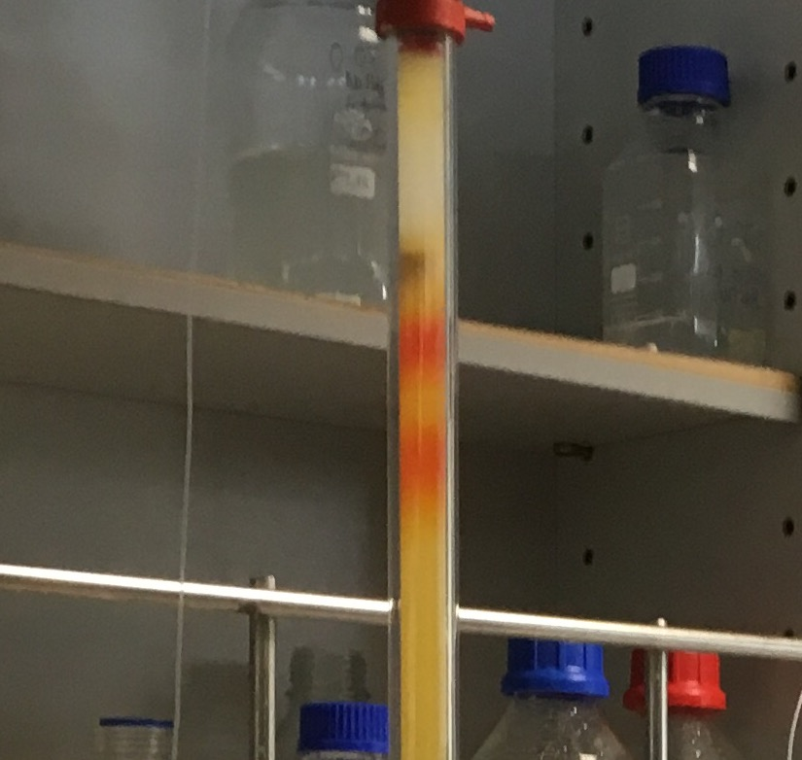
Figure 2.8 Photo of the column used for enantiomeric separation of compounds. Orange bands depict the two enantiomers.

Figure 2.9 Circular dichroism spectra of ΛΛ-,ΔΔ- and meso- [(Ru(phen)₂)₂tpphz)]⁴⁺, resolved using cation-exchange chromatography. Confirming the separation of the diasterisomers.

RuBpy
The same conditions described in section 2.5.2.1 were used for the chiral resolution of RuBpy. Two distinct bands formed within 25 cm³ of passage down the column. CD once again confirmed the first band to be ΛΛ-RuBpy and the second to be ΔΔ-RuBpy.
Figure 2.10 Circular dichroism spectra of ΛΛ-, ΔΔ- and meso- [(Ru(bpy)₂)₂tpphz)]⁴⁺, resolved using cation-exchange chromatography.

The CD clearly shows the presence of two enantiomers, identified by their equal and opposite CD spectrum. As expected, the meso compound showed no CD signal. NMR and mass spec analysis was carried out on all diasteriosomers of both complexes. This confirmed that the column had preserved the structure of each complex with no product degradation seen. Thus, these chiral chromatography procedures provide a successful method for the separation and isolation of the three diasteriosmers of both RuPhen and RuBpy. Enabling the meso forms of both complexes to be isolated for the first time.
For all cellular studies, the complexes were first converted to their water-soluble chloride salts. This was achieved by anion metathesis where the PF₆ salt was dissolved in acetone and tetrabutylammonium chloride was added to precipitate the chloride complex, which was used in all subsequent cell based experiments.

Summary
Literature methods of the chiral resolution of RuPhen and RuBpy were explored using enantiomerically pure monometallic starting materials. For RuBpy these methods proved to be unsuccessful, and for RuPhen methods were found to be unreliable and time consuming. Instead, chiral chromatography methods were undertaken and developed to successfully, and importantly, reproducibly chirally resolve both RuPhen and RuBpy. For the first time, meso diasteriosmers of both complexes were isolated.
The compounds chirally resolved here in this chapter were then explored in vitro.

Cell Studies Using Chirally Resolved Complexes
In Chapter 2, individual ΔΔ,ΛΛ and ΔΛ(meso), diastereomers of the complexes [(Ru(phen)₂)₂tpphz]⁴ and [(Ru(bpy)₂)₂tpphz]⁴ were synthesised, and isolated through cation-exchange chromatography. This chapter will focus on the behaviour of these diastereomers in cells.
Previous work conducted by the Thomas Group have focused on the ability of racemic [(Ru(phen)₂)₂tpphz]⁴ to function as a nuclear imaging agent for confocal laser scanning microscopy (CLSM). Gill, et al confirmed this, through co-localisation studies of RuPhen with DAPI (4',6-diamidino-2-phenylindole), a minor groove binder which binds strongly to A-T regions in DNA, and SYTO 9, a general nucleic acid stain. Furthermore, RuPhen visualises characteristic structural changes in nuclear DNA as the cells progress through the cell cycle (Figure 3.1).⁸⁵
Figure 3.1 Image adapted with permissions from Gill et al.⁸⁵ All staining on MCF7 cells. a, Co-staining of RuPhen (red, left) with DAPI (blue, right) and the overlay image (right). b, co-staining of RuPhen (red, left) with general nuclear acid dye SYTO 9 (green, centre) and overlay image (right). c, Asynchronous cell imaging shows mitotic cell stained by RuPhen visualising chromosome aggregation through progression of mitosis.

The uptake mechanism has not yet been formally identified, but it was found to be concentration- dependent and through a non-endocytic mechanism of active transport.¹¹⁸
Conversely in the same study, RuBpy was found to display significantly lower live cell uptake, however, the complex was shown to effectively stain DNA in fixed cells.
In parallel, additional cell-free studies by the Thomas group have focussed on the two enantiomers of RuPhen, ΔΔ and ΛΛ.⁸⁶ As previously mentioned, Λ-RuPhen has a greater binding affinity to quadruplex DNA than Δ-RuPhen.
This chapter aims to focus on using live cell conditions to evaluate the staining and uptake of the three diastereoisomers of RuPhen and determine if quadruplex binding can be observed in vitro using microscopy techniques.
The diastereoisomers of RuBpy will not be looked at in detail, due to preliminary experiments showing the inability of the compounds to stain live cells.

Live Cell Staining
To examine the cellular uptake of the complexes, MCF-7 cells were incubated with solutions of ΔΔ-RuPhen, ΛΛ-RuPhen and ΔΛ-RuPhen, and then imaged using CLSM. The excitation wavelength used was 458 nm and the emission was measure at 670-700 nm, corresponding to conditions reported in literature.^{64,82,85} Further experimental details can be found in Chapter 6.

Effects of serum
During preliminary staining experiments, it was determined RuPhen and its diasteroisomers displayed increased staining capabilities when diluted and applied in serum-free media. An example of which is seen in Figure 3.2, with the ΔΛ-RuPhen isomer. When serum is present in the staining solution, the emission displayed as a result of RuPhen is reduced, and the percentage of cells stained is reduced. This is in line with literature reports for similar inorganic DNA stains.^{119–122}
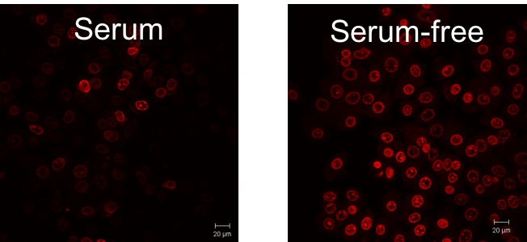
Figure 3.2 CSLM images of live MCF-7 cells incubated with a 500 μM solution of ΔΛ-RuPhen for 1 hour.

Serum proteins are active biological molecules that are important in cell growth. However, they interact with numerous compounds, including lipophilic cationic metal complexes, and receptors in cell biology which may cause adverse effects in staining experiments by, binding to the probe, or impeding mechanism of action /cellular uptake.¹²⁰

Staining Conditions
The first course of action was to assess whether the three diastereoisomers display the same staining abilities as the parent racemic compound as reported by Gill et al.
Using the same reported optimised conditions (500 μM, 1 hour, serum- free RPMI media), strong nuclear staining was seen in live MCF-7 cancer cells, with secondary cytoplasmic staining seen in some individual cells (Figure 3.3a). Emission was collected at 670-700 nm, which corresponds to activation of the well-documented “light switch” effect upon reversible binding to DNA.¹²³
Throughout all sets of experiments, imaging settings were kept consistent to enable the differences between the diastereoisomers to be evaluated. It was found that the staining intensity was constant across all three diastereoisomers as demonstrated in Figure 3.3b. Two-way ANOVA using Graph Pad software determined that there was no significant difference between the three data sets.
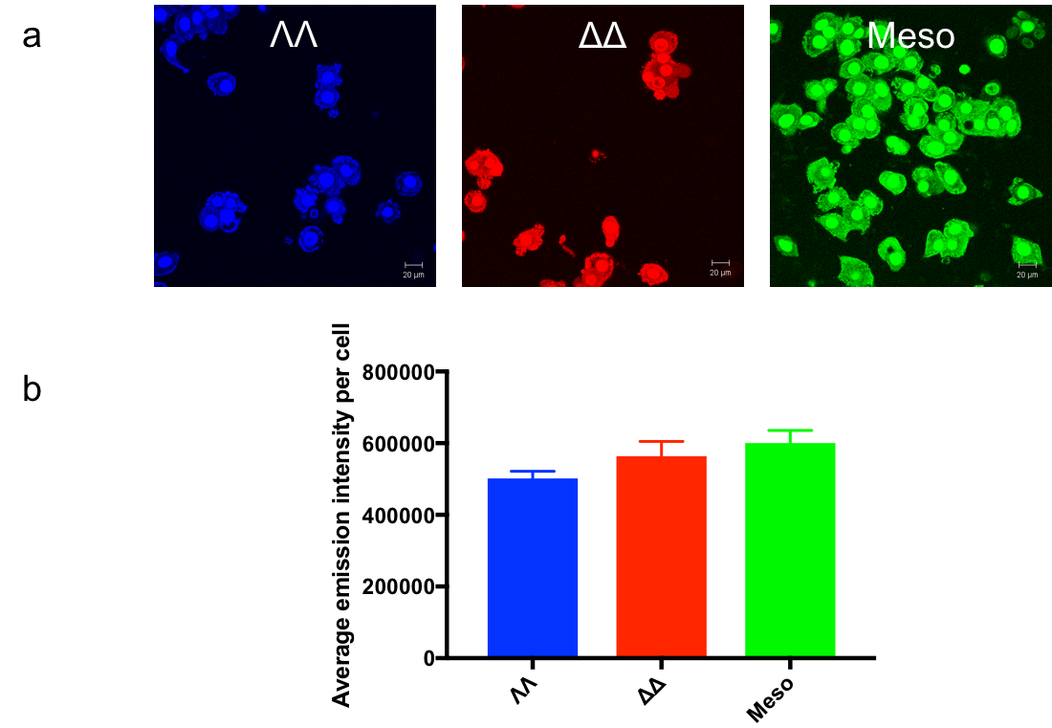
Figure 3.3 a, CSLM images of ΛΛ-RuPhen (blue, left), ΛΛ-RuPhen (red, centre) and ΔΛ-RuPhen (green, right). b, Average emission intensity per cell for the three diastereoisomers.

Additionally, primary Human Dermal Fibroblasts (HDF) were stained with the three diastereoisomers. In the first instance, live HDF cells were stained with 500 μm complexes for 1 hour in serum-free DMEM media. DMEM is the preferred media for the culture of primary fibroblast cells (Figure 3.4).¹²⁴
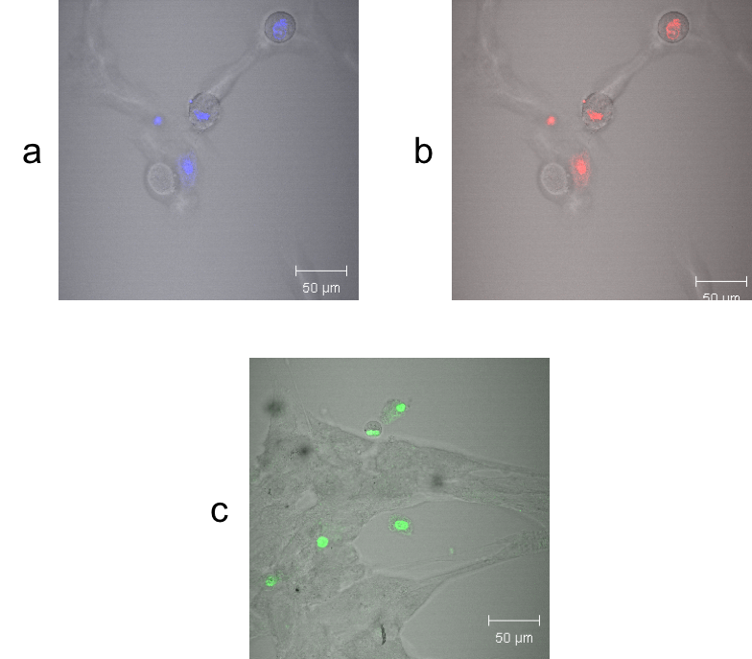
Figure 3.4 Live HDF cells treated with 500 μm a) ΛΛ-RuPhen b) ΔΔ-RuPhen c) ΛΔ-RuPhen as an overlay of Differential Interference Contrast (DIC) and luminescence (458 nm excitation and 670-700 m emission collected).

In all cases, sub-optimal staining was seen, with only a small percentage (average of 26%) of cells displaying nuclear staining. This incomplete staining was confirmed by differential interference contrast (DIC) image overlay. These results are in line with work conducted on the racemic complex.¹¹⁸
Subsequently, HDF cells were stained using serum-free RPMI media, to confirm if the cell line or media was responsible for the poor cellular uptake. Interestingly, upon changing the media, HDF cell staining was found to increase (Figure 3.5). Further studies on this issue are detailed in Chapter 4.
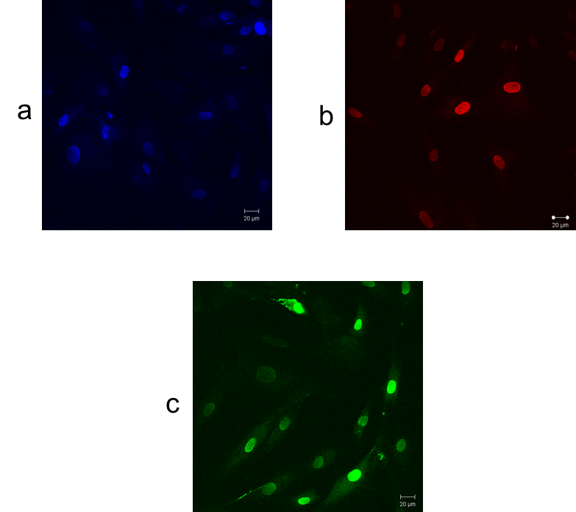
Figure 3.5 Live HDF cells treated with 500 μm a) ΛΛ-RuPhen b) ΔΔ -RuPhen c) ΛΔ-RuPhen (458 nm excitation and 670-700 m emission collected).

Cytotoxicity

MCF-7 cells
As all the stereoisomers of RuPhen successfully demonstrate live cell staining, the next step was to investigate the cytotoxic properties of its diastereoisomers to discover if stereochemistry elicits a change in the toxicity to a cell. The chirality of a molecule may play a part, as there is potential for interference with cellular processes such as DNA repair, replication and transcription. All of which may result in cell death.⁹⁶ In toxicology, the different toxic effects of chiral drugs can reside in one enantiomer only, or both. Svenson et al reported that the enantiomeric complexes of [μ-bipb(phen)₄Ru₂]⁴⁺ (bib= bis(imidazo [4,5-f]-1,10-phenanthrolin-2-yl)benzene) display no differences in uptake into live cells or cytoxicity.¹²⁵ Alternatively, work conducted by Zeng et al on the enantiomeric complexes of [Ru(bpy)₂(p-BEPIP)](ClO₄)₂] (p-BEPIP= 2-(4-phenyacetylenephenyl)-1H-imidazo[4,5f] demonstrated that only the lambda complex was taken up into the cell nucleus, and differences in toxicity between the two enantiomers were a direct result of this. ¹²⁶
A commonly used reference for cytotoxicity is the half maximal inhibitory concentration, the IC₅₀ value, which is the concentration of a complex required to inhibit cellular processes in half of the treated population. This was determined by way of an MTT assay- a colorimetric assessment of cellular metabolic activity. The basis of the MTT assay is that yellow MTT (3-(4,5- dimethylthiazol-2-yl)-2,5-diphenyltetrazolium bromide) is reduced to a purple formazan product in the mitochondria of living cells by reductase enzymes.¹²⁷
MCF-7 cells were exposed to treatment by ΔΔ-RuPhen, ΛΛ-RuPhen and ΔΛ-RuPhen for 24 and 72 hours respectively. Additionally, HDF cells were also treated for 24 hours. An example of a viability curve, measuring cell viability vs increasing concentration for each diastereoisomer against each cell type and time point can be seen below in Figure 3.6. All IC₅₀ data is additionally summarised as an average of three experiments in Table 1. Published IC₅₀ data of Cisplatin against the MCF-7 cells line was included in the experiment as a point of reference towards cytotoxicity.

Figure 3.6 Cell viability data.

Complex | MCF-7 24 hr IC₅₀/ μM | MCF-7 72 hr IC₅₀/ μM | HDF 24 hr IC₅₀/ μM
ΛΛ-RuPhen | 131±6 | 7±2 | 149±2
ΔΔ-RuPhen | 141±3 | 11±3 | 154±3
ΔΛ-RuPhen | 134±4 | 22±2 | 169±4
Cisplatin | 13±3 | 6±2 | 9±2
Table 1 IC₅₀ values displayed as an average of three experiments.

IC₅₀ experiments show that each diastereoisomer demonstrates low toxicity towards the MCF-7 cell line over 24 hours (131-141 μM range, comparable to 13 μM of cisplatin). ΛΛ-RuPhen and ΔΛ-RuPhen show a slight increase in toxicity over ΔΔ-RuPhen, but all values are within error. This low toxicity agrees with the potential application as a staining agent for microscopic analysis.
The incubation time was next increased to 72 hours. This was to allow the effect of the complexes on the division ability of the cells to be examined. The doubling time of MCF-7 cells is around 35 hours (as determined from standard cell doubling experiments). The increase in incubation time to 72 hours in turn increased the cytotoxicity (p value <0.0001). No significant differences between ΛΛ-RuPhen and ΔΔ-RuPhen were found.
When HDF cells were studied over a 24-hour period, low toxicity was observed. A general trend showed the IC₅₀ values for HDF cells to be higher than those of MCF-7 cells, signifying a lower toxicity from RuPhen towards the non-cancer cell line. This result was found to be statistically different with p values calculated of 0.0079, 0.0061 and 0.0004 for ΛΛ-RuPhen, ΔΔ-RuPhen and ΔΛ-RuPhen respectively. From earlier results in this chapter, it was observed that HDF display reduced emission in comparison to MCF-7 cells when exposed to RuPhen. This may be responsible for the lower toxicity. To confirm this, the intracellular concentration of each complex in each cell type would need to be determined. In future studies this could be accomplished by ICP-MS. Alternatively, if this were not the case, the higher toxicity to a cancer cell line may be exploited in further work developing a potential cancer therapeutic.

Cell Uptake

MCF-7 cell line
Having established that the chirality of RuPhen has minimum impact on the cellular localisation or emission intensity of the stain, the possible effect of chirality on the cellular uptake of the complexes was investigated.
To study uptake rates in MCF-7 cells, CLSM images were recorded at 2 minute intervals, with observations starting immediately after treatment in an environmental chamber to allow a constant temperature of 37 degrees to be maintained until experiment completion. The complex concentration used was 500 µM, this remained constant for all diastereoisomers to obtain a basic qualitative comparison of cellular uptake. The same microscope settings (excitation wavelength, laser power, pinhole size and detector gain) were employed throughout the experiment. All data was produced in a single experiment to limit any possible varying factors, such as discrepancies in laser performance. CLSM images are shown in Figure 3.7.
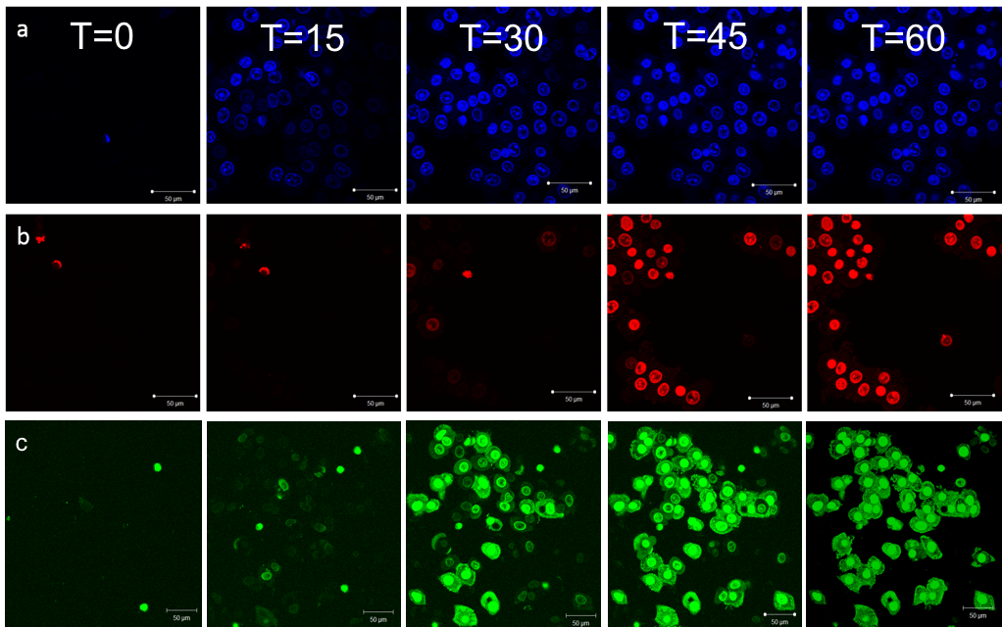
Figure 3.7 MCF-7 cells treated with 500 μM a) ΛΛ-RuPhen b) ΔΔ -RuPhen c) ΛΔ-RuPhen at time points of (L-R) 0, 15, 30, 45 and 60 minutes

To interpret the data further, a fluorescence intensity profile was obtained for each diastereoisomer, FIJI image J software was used to determine average intensity per cell in a field of view, accounting for background luminescence. Data was further analysed using Prism Graph Pad software to determine the significance between the three data sets (Figure 3.8).

Figure 3.8 Fluorescence intensity profiles of each diastereoisomer against the MCF-7 cell line.

By studying the fluorescent profiles, interesting observations can be made. While all three diastereoisomers reach the same emission intensity at ∼60 minutes, the rate of uptake is markedly different. At this stage, we are unable to identify methods of uptake, but results strongly suggest that the efficiency of uptake differs across the diastereoisomers. ΛΛ -RuPhen, is seen to permeate the cell membrane more rapidly, leading to accumulation in the cell nucleus where DNA binding occurs producing luminescence. Interestingly, there is a sharp increase in intensity from approximately 10 minutes onwards, indicating rapid cellular accumulation. Conversely, ΔΔ-RuPhen, shows a more gradual increase in intensity over approximately 35 minutes. Perhaps not unsurprisingly the cellular uptake rate of ΔΛ-RuPhen lies between the two enantiomers.
It seems that - while the uptake mechanism is yet to be identified - chirality is significant factor, with the lambda cation being more effectively internalised by the cancer cells.

L5178-R cell line
It was at this point that an alternative cell line was used to investigate whether the trend in uptake is cell specific, and the experiment was repeated. To simplify this experiment, and to focus solely on the enantiomers, ΛΔ-RuPhen form was not included in these studies.
L5178-R is a mouse lymphoma cell line which, unlike the MCF-7 cell line, is non-adherent and grown in suspension. CLSM images of uptake experiment with this cell line are detailed in Figure 3.9, further interpretation of the images is shown in Figure 3.10.

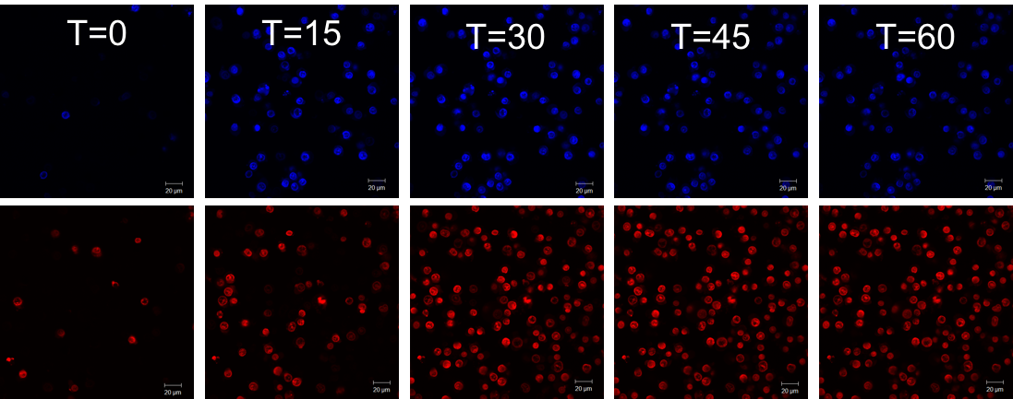
Figure 3.9 L5178-R cells treated with 500 μM top) ΛΛ-RuPhen bottom) ΔΔ -RuPhen at time points of (L-R) 0, 15, 30, 45 and 60 minutes

Figure 3.10 Fluorescence intensity profiles of each enantiomer against the L5178-R cell line.

Intriguingly, the same uptake trend was presented by the mouse lymphoma cell line, with the lambda enantiomer demonstrating a more rapid and effective uptake. In comparison to the MCF-7 cell line (60 minutes), both complexes had reached an emission intensity maximum at ∼ 40 minutes. The properties of a suspension cell line may account for this increased uptake. Suspension cells have a larger surface area in contact with the media, and the homogenous suspension enables a greater opportunity for uptake.
The results from both cell lines indicate that the interactions that mediate the uptake of RuPhen are sensitive to the structural variations between the diastereoisomers, with the left- handed structure of Λ-RuPhen being preferred. It is proposed that this is due to the structural orientation of the complex enabling an increased interaction.
.

Structure sensitive DNA imaging agent

Introduction
One application in using such systems as cellular DNA probes is their ability to display a high degree of sensitivity in their DNA binding. This can be exploited to provide in-depth information about specific DNA structures. For example, there is currently a great deal of interest in four stranded DNA structures, such as quadruplexes. Especially as the induction and stabilisation of quadruplex DNA in G-rich sequences of DNA located in telomeres, at the ends of chromosomes, represents a potential anti-cancer strategy.^{15,18,56} Previous studies in solution have shown that RuPhen binds to both duplex and quadruplex DNA with a high affinity. Thus, displaying a distinctive blue-shifted “light switch” emission for quadruplex binding in comparison to the analogous duplex effect (maxima of 630 nm and 660 nm respectively).¹ Having confirmed that RuPhen can discriminate between different DNA structures. Gill et al demonstrated this function in live cells showing intense non-uniform 630-640 nm emission, corresponding to blue shifted emission due to quadruplex bound RuPhen,² indicating that this complex could be used as a structure sensitive DNA imaging agent towards identifying quadruplex DNA.
Using chirally resolved Ʌ-RuPhen and Δ-RuPhen complexes this issue was further investigated. As detailed in Section 2.1, Ʌ-RuPhen binds to quadruplex DNA with an affinity that is up to 40 times greater than Δ-RuPhen. Experiments were conducted to investigate whether this phenomenon is replicated in cell studies, and if any differences between the two resolved compounds could be identified with regards to quadruplex binding.

MCF7 cell line
Preliminary results on MCF-7 cells agree with Gill et al, showing the MLCT emission to be composed of two separate emission peaks. Lambda stack profiles enable emission to be measured from a specific cell over a range of wavelengths using this procedure two separate maxima at approximately 640 and 680 nm respectively were identified. (Figure 3.11)
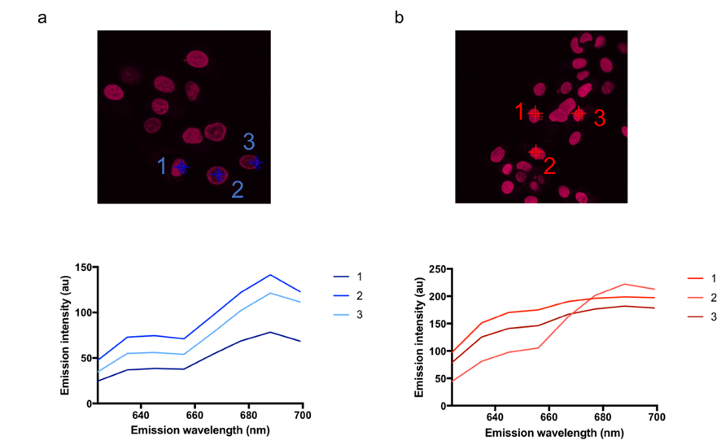
Figure 3.11 Lambda stacking experiments show the emission profile of a) Δ-RuPhen and b) Λ-RuPhen in live MCF-7 cells. The emission profile of three separate cellular regions are shown for each compound.

MCF- 7 cells were treated with both stereoisomers and lambda stack experiments were conducted. A lambda stack is a three-dimensional dataset that consists of an image collection using the same specimen field acquired at different wavelength bands. Analysis of lambda stacks can display unique spectral data from specific luminescent compounds in cells. A representative lambda stack of Δ-RuPhen in MCF-7 cells, shows that the 640 nm corresponding to quadruplex DNA is proportional to the 680 nm peak for duplex DNA. This was achieved by analysing 3 points within cells at random. The ratio of the two peaks doesn’t alter between different cells in the field of view. An average peak ratio of 1:2 is present between the 630 and 680 nm.
Conversely, for Λ-RuPhen, although there is an average ratio of 2:3 between the signals associated with quadruplex and duplex DNA shown by three randomly chosen points, a comparison of the intensity of the 640 nm quadruplex peak within individual cells shows a non-uniform distribution in comparison with the major 680 nm duplex peak. This is specifically demonstrated in locations labelled 1 and 3, with location 2 showing similar behaviour to Δ-RuPhen. Furthermore, the contribution from high energy signal is on average more significant that that demonstrated by Δ-RuPhen. This indicates that Λ-RuPhen may be able to discriminate between different DNA structures when in a live cell culture.
To observe the cellular localisation of each of the signals, the image acquisition process was calibrated by defining separate 670-700 nm (red) and 630-640 nm (yellow) confocal channels (Figure 3.12). In the case of both complexes, the red channel clearly shows the expected duplex DNA staining as reported earlier in this chapter. An additional, weaker emission is seen in the yellow channel for both complexes, with Λ-RuPhen in particular displaying seemingly localised yellow emission within the nuclei.
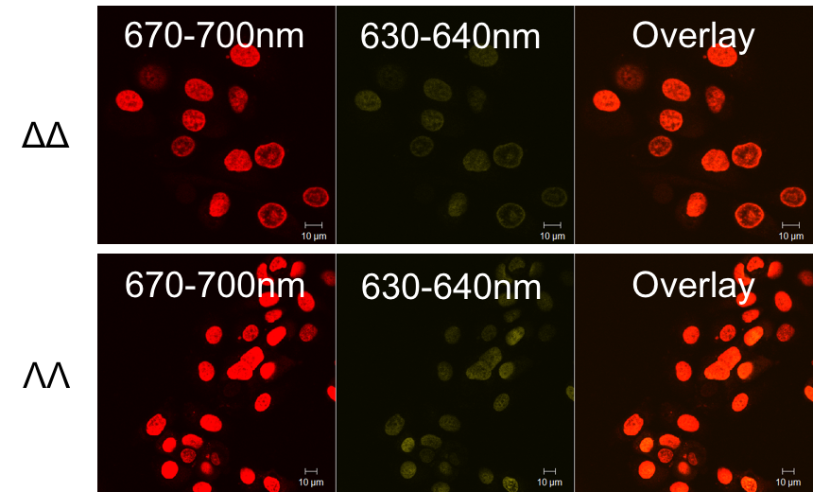
Figure 3.12 CLSM using two separate detection channel 670-700 nm (red) and 630-640 nm (yellow) show the multiple emission profile of nuclear luminescence of Δ-RuPhen (top) and Λ-RuPhen (bottom) bound to DNA and the specific localisation of the 630-640 nm emission.

While signal in the yellow channel was identified, further quantification was required to establish if the two complexes were behaving differently. This was achieved by analysing the degree of the relationship, if any, between the red and yellow emission displayed by each complex. A lack of relationship showing that the emission in the two channels is not related, and hence born from different areas in the cell.
Emission intensities for each cell were calculated, for each of the two confocal emission channels (red and yellow). The two data sets were plotted against each other. This data is shown in Figure 3.13.
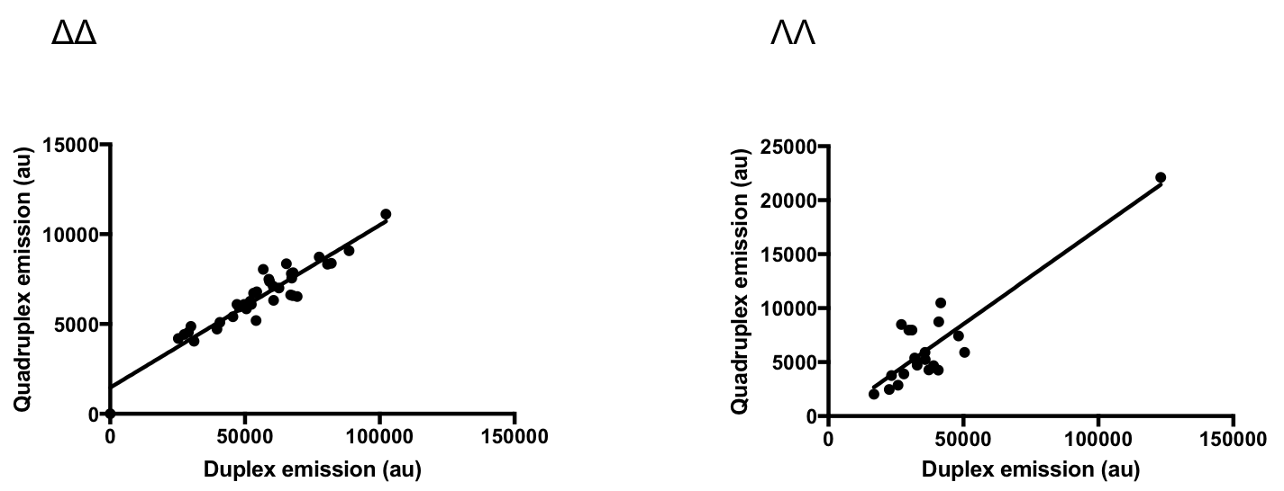
Figure 3.13 Relationship between the two emission maxima representing duplex and quadruplex DNA, of Δ-RuPhen (R) and Λ-RuPhen (L). Data is compared to a straight line producing an R² value for a linear relationship.

A clear linear relationship is presented between the two separate emission data for Δ-RuPhen in Figure 3.13. This is confirmed by a high R² value for a straight of 0.9621 (average of three separate experiments). Demonstrating that duplex DNA is responsible for both regions and that the high energy emission is simply a shoulder of the main signal. This is consistent with cell free studies on the quadruplex DNA binding properties of the Δ-RuPhen stereoisomer.
For Λ-RuPhen, the relationship is less established, with the data from the red and yellow emission, showing a non-linear relationship, confirmed by a lower average R² value of 0.7683. These results are in line with previous lambda stack experiments and suggest that upon staining MCF-7 cells Λ-RuPhen demonstrates two separate and clearly defined emission peaks at 640 and 680nm that can be identified by confocal microscopy. The non-uniformity of these peaks suggests Λ-RuPhen can not only stabilise and bind to quadruplex DNA, but can be used to identify quadruplex DNA in a live cell experiment.
The experiment was repeated using the meso RuPhen complex (ΛΔ-RuPhen). An average R₂ value of 0.8895 for a straight line was calculated when the two data sets were compared to a linear relationship. This result is inconclusive and as such, no conclusions can be made regarding the capacity of ΛΔ-RuPhen in identifying quadruplex DNA.

L5178-R cell line
To further define the nature of 630 nm emission, the L5178-R mouse lymphoma cell line was looked at in similar experiments as described in Section 3.3.2. This cell line was chosen due in possessing a large average length of G-rich telomere DNA (80 kb compared to 2 kb in MCF-7 cells), as determined by work by Canela et al, where fluorescence in situ hybridisation techniques were used to measure telomere length in certain cell lines.⁸ A greater length telomere means there is a greater potential for quadruplex formation.
Lambda stack experiments were conducted using the mouse cell line and the two enantiomeric complexes. Results were in line with experiments on the MCF-7 cell line, with Λ-RuPhen showing non-uniform specificity between the two emission peaks at 640 and 680 nm, with Δ-RuPhen exhibiting a weaker, more uniform 640 nm emission peak (Figure 3.14).
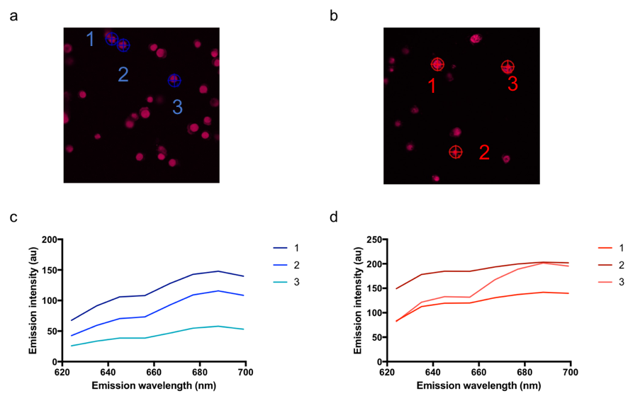
Figure 3.14 Lambda stacking experiments show the emission profile of a) Δ-RuPhen and b) Λ-RuPhen in live L5178-R cells. The emission profile of three separate cellular regions are shown for each compound.

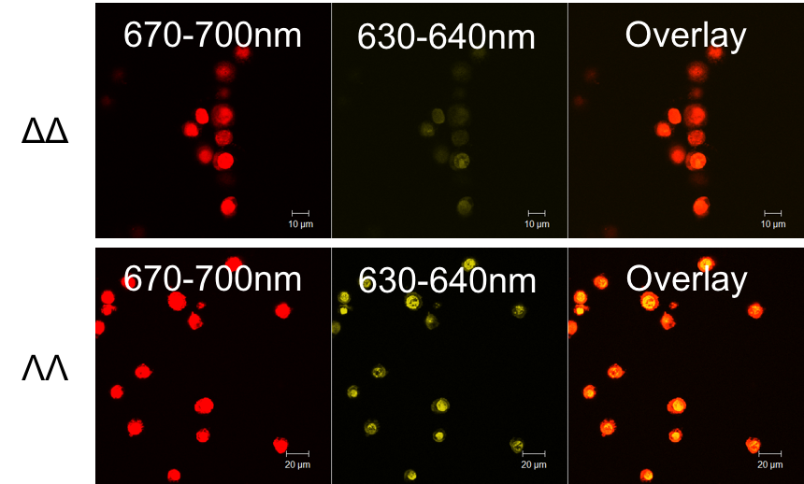
Figure 3.15 CLSM using two separate detection channel 670-700 nm (red) and 630-640 nm (yellow) show the multiple emission profile of nuclear luminescence of Δ-RuPhen (top) and Λ-RuPhen (bottom) bound to DNA.

Figure 3.16 CLSM demonstrating the specific localisation of the 630-640 nm emission in live L5178-R cells when treated with Λ-RuPhen.

Interestingly, staining of L5178-R cells by Λ-RuPhen results in a large increase in the yellow 630-640 nm emission compared, not only to Δ-RuPhen, but also when MCF-7 cells were stained by Λ-RuPhen (Figure 3.15). In addition, specific emission localisation can be identified in the yellow channel (Figure 3.16). As for the previous experiment, data from each channel was analysed and the relationship between the two investigated. The data population from Λ-RuPhen proved to be randomly distributed and non-linear, more so than from the MCF-7 cell line. An average R² value of 0.5788 was calculated, conversely an average R² value for Δ-RuPhen was calculated to be 0.9032 (Figure 3.17), again representing that Δ-RuPhen is unable to stabilise/identify quadruplex DNA even in a cell line with a longer telomere.

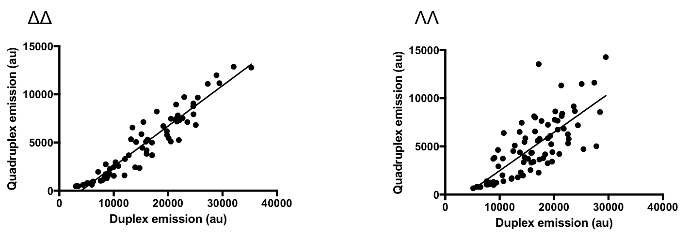

Figure 3.17 Relationship between the two emission maxima representing duplex and quadruplex DNA, of Δ-RuPhen (R) and Λ-RuPhen (L). Data is compared to a straight line producing an R² value for a linear relationship.

This data agrees with Λ-RuPhen functioning as a luminescent marker for quadruplex DNA. Also, these interesting results open the possibility of development of a probe that can be used to directly measure and compare telomere length.

Cell fixation
To further determine whether the results observed with Λ-RuPhen are caused by binding to, and stabilization of, non-duplex DNA structures, formaldehyde fixation techniques were examined. Formaldehyde fixation creates DNA-protein crosslinks and has the effect of ‘freezing’ DNA structure, preserving the cell. Using the novel imaging properties of the complex as a marker stain, fixed cell experiments were conducted.
Lambda stack experiments are detailed in Figure 3.18. The incubation of fixed, permeabilised L5178-R cells with Λ-RuPhen resulted in a reduced 640 nm emission peak in comparison to when the stain is added to live cells. As well as being reduced in intensity, the 630 nm peak now demonstrates uniformity with the prominent 680 nm peak, bearing a resemblance to the behaviour of Δ-RuPhen in live cells.
Figure 3.18 a) Lambda stacking experiment of Ʌ-RuPhen fixed L5178-R cell displaying a reduced 640 nm emission peak. B) CLSM imaging experiment for fixed L5178-R cells showing reduced emission in the 630-640 nm wavelength.

Data analysis as seen in Figure 3.19 confirms that by fixing the cells prior to treatment, Λ-RuPhen presents a reduced quadruplex binding signal, and a strong linear relationship is now shown between both the red and yellow emission channels. Fixing of cells failed to cause a change in the behaviour of Δ-RuPhen. this observation is unsurprisingly as we have shown here in this chapter that even in live cells, Δ-RuPhen shows very weak quadruplex binding, lacking the ability to induce quadruplex structures.

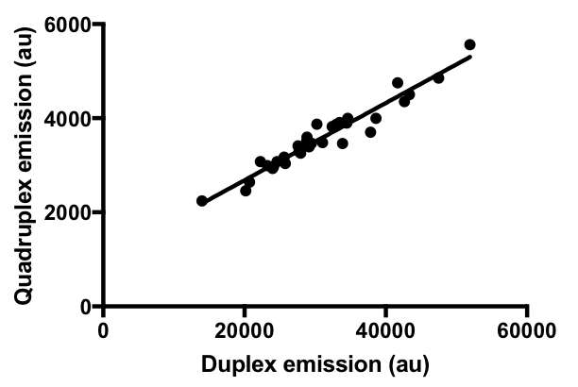
Figure 3.19 Relationship between the two emission maxima representing duplex and quadruplex DNA, of Λ-RuPhen in fixed L5178-R cells. Data is compared to a straight line producing an R² value for a linear relationship.

These data are summarised in Figure 3.20. A comparison of the relative emission maxima from each individual cell establishes that Λ-RuPhen not only images quadruplex DNA through emission in the 630- 640 nm range, but also stabilizes these structures in live cells. It is also notable that the yellow emission has greater intensity in L5178-R cells, and it seems likely that this is because L5178-R cells possess longer telomeres. Therefore, Λ-RuPhen has potential applications for analysis of telomere length in cells.

Complex | Live MCF-7 cells | Live L5178-R cells | Fixed L5178-R cells
Δ-RuPhen | 0.9621 | 0.9032 | 0.9263
Λ-RuPhen | 0.7683 | 0.5788 | 0.9371
ΛΔ-RuPhen | 0.8895 | 0.7982 | 0.9365
Figure 3.20 Summary of data in the form of R² values calculated from the comparison of the two emission maxima responsible from the diastereoisomer of RuPhen binding to duplex and quadruplex DNA respectively. A high R² value signifies a linear relationship, and in turn limited quadruplex binding.

Ageing of HDF cells
Section 3.3.3 revealed the possibility for Λ-RuPhen to act as an indicator of telomere length. To continue investigation into this, primary human fibroblasts were exposed to Λ-RuPhen at early and late passage numbers. Human fibroblasts are known to decrease in mean telomere length by around 2 kilobases (kb) with every population doubling. Moreover, the total amount of telomeric DNA also decreases.¹⁰ Longer telomeric DNA is more likely to form quadruplex structures, as there is an opportunity for a greater number of consecutive guanine units.
This experiment aimed to investigate the application of Λ-RuPhen as a monitor of telomere length in ageing cells. Due to its lack of capacity to identify quadruplex DNA, discussed earlier in this chapter, Δ- RuPhen was used as a control throughout.
Figure 3.21 displays CLSM images of HDF cells at passage number 2 (P2) treated with Λ-RuPhen. The yellow quadruplex emission is seen to be localised within specific areas of nuclei, but is not co-localised with the red duplex emission. This lack of co-localisation is apparent when we compare the emission from the two separate channels. A lack of uniformity is seen, confirmed by a low R₂ value of 0.7403. In contrast, a control experiment using Δ- RuPhen yielded an R² value of 0.958.
Figure 3.21 a) CLSM imaging experiment for HDF cells at P2, showing localised emission in the yellow channel b) Relationship between the two emission maxima representing duplex and quadruplex DNA, of Λ-RuPhen.

The untreated cells were passaged as normal through to passage 14 (P14), where they were treated with Λ-RuPhen. In contrast to the behaviour of P2 HDF cells, a decrease in the luminescence from the yellow quadruplex channel is seen (Figure 3.22), a higher uniformity is also seen between the duplex and quadruplex emission channel assessed by a higher R² value of 0.8895. These results indicate that Λ-RuPhen has the exciting potential to function as a quick and efficient tool to analyse telomere length in live cells.
Figure 3.22 a) CLSM imaging experiment for HDF cells at P14, showing decreased localised emission in the yellow channel b) Relationship between the two emission maxima representing duplex and quadruplex DNA, of Λ–RuPhen, showing an increase in uniformity.

Summary

In this chapter, the cellular DNA binding properties of the diasterisomers of the dinuclear Ru(II) tpphz light switch complex [(Ru(phen)₂)₂tpphz]⁴⁺ were investigated using confocal microscopy techniques.
The three diasterisomers were found to be internalised and demonstrated similar emission intensity upon binding to DNA across a range of cell types. Differences in the speed of uptake into cells was found, with the lambda compound permeating cells quickest and reaching emission saturation first. This strongly indicates that the chirality of the molecule plays a factor in the cellular uptake ability of these compounds. Limitations of this work include that the method of cellular uptake is not yet known for this family of complexes, and as such further work is required to identify this mechanism, and to further study any differences in this mechanism across the diasterisomers.
Cell viability studies show that the three diasterisomers display a low toxicity towards the MCF-7 cell line after 24 hours incubation, but when the incubation time is increased to 72 hours, the toxicity of the complexes is equal to that of the anticancer drug cisplatin. Additionally, the complexes demonstrated a similarly low toxicity towards HDF cells over a 24 hours period.
Λ-RuPhen interestingly, was found to be a potential luminescent marker of quadruplex DNA within cells demonstrating the ability to discriminate between different telomere lengths, with preliminary experiments in HDF cells, revealing the promising capability of Λ-RuPhen in measuring changing telomere length in aging primary cells. In this work, standard confocal microscopy was used, which has its limitations with regard to resolution, so data analysis was required to further demonstrate the quadruplex binding. Further work by Sreejesh Sreedharan in the Thomas group, will seek to investigate super-resolution optical microscopy methods on these complexes. Alongside this, further work to determine the effectiveness of Λ-RuPhen as a measure of telomere length will be undertaken, by comparing the results yielded by Λ-RuPhen, with the current gold standard of measuring telomere length (FISH).

Preferential Staining
In a previous single study in the Thomas group it was found that MCF-7 breast cancer cells appeared to display increased staining by RuPhen compared to HDF primary human skin cells when both cell types were grown together as a co-culture in DMEM media.^{85,128}
However, the studies detailed in Chapter 3 showed that HDF cells staining by RuPhen increased in serum-free RPMI media, an issue that was not explored in the original work. This chapter describes further investigations into this behaviour, aimed to establish if RuPhen exhibits cell-specific uptake.

Co-Culture Studies
Several co-culture methods were employed to directly investigate the uptake behaviour of RuPhen in cancer and non-cancer cell lines. A co-culture involves the growing of two sets of cells in the same well plate, ensuring they are both exposed to identical conditions, in direct contact, thus facilitating the study of natural or synthetic interactions between cell populations.¹²⁹ Furthermore - since cancer tissue consists of both carcinoma cells and stromal cells which can be composed of various cell types such as fibroblasts, adipocytes and endothelial cells¹³⁰ - co-cultures can be used to evaluate the interaction of RuPhen with the different cells types often present in real cancer tissue.
MCF-7 and HDF cells were seeded at equal densities and allowed to grow for 24 hours. HDF cells had been pre-treated with 5 μM Green Cell Tracker (GCT) for 30 minutes prior to seeding. A cell tracker stain was employed so the two different cell types could be easily identified. Further details of co-culture protocols can be found in Chapter 6. The growth media was removed and a 500 μM solution of RuPhen in serum-free RPMI media was added. After an hour, the stain was removed and the co-culture was analysed by confocal imaging. For comparison, mono-cultures of both MCF-7 and HDF cells were exposed to the same conditions and analysed in the same way (Figure 4.1).
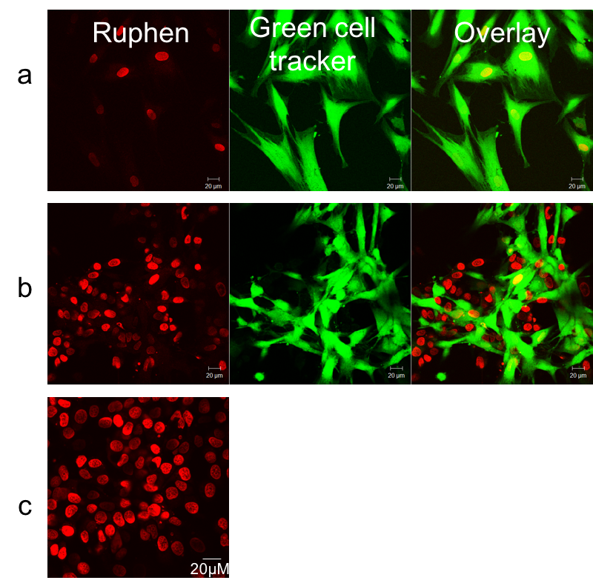
Figure 4.1 CLSM of a) HDF cells b) 50:50 ratio co-culture of MCF-7 and HDF cells c) MCF-7 cells incubated with 500 μM RuPhen in serum free RPMI media for 1 hour(left). HDF cells co-stained with GCT showing location of HDF cells in the co-culture (middle). Overlay image of Ru(II) and cell tracker emission (right).
Figure 4.2 Mean emission intensity average per cell between separate mono-cultures of HDF and MCF-7 cells in comparison with when they are present in a 50:50 co-culture. A decrease in emission from HDF cells is observed when grown in co-culture with MCF-7 cells as opposed to when they are cultured independently.

Figure 4.3 Average emission intensity displayed over a prolonged 4 hours staining experiment to observe if an increase in the time RuPhen was exposed to the cells affected the emission intensity from HDF cell in a co-culture environment.

As seen in the images, which were further quantified through confocal image analysis (Figure 4.2), in a co-culture environment only MCF-7 cells show clear nuclear staining. Notably, co-cultured HDF cells show much reduced staining compared to single HDF cultures. The emission intensity per cell for HDF cells is almost reduced by half, while the emission displayed by the MCF-7 cells remains constant from mono- to co-culture.
One of the main properties of cancer cells is their high metabolic rate, PET scans exploit this trait to visualise cancer within the body.^{131–134} In addition, classic chemotherapy is based on the rapid multiplication of cancer cells, with drugs specifically affecting cells which undergo a faster replication process such as cancer cells. To identify if differences in metabolic rates were responsible for the observed effect, staining time was increased to 4 hours. This allowed time for the HDF cells to take up the complex. Remarkably, no change in uptake was observed even after staining times were increased from 1 hour to 4 hours, Figure 4.3, as the emission intensity from the HDF cells was once again more than half reduced when they are grown in the same environment as cancer cells. This is further confirmed by the results on mono-cultures shown in Figure 4.4, which demonstrate that RuPhen staining of both cell types are fully saturated within 1 hour. It should be noted that, even when RuPhen, is applied to a mono-culture of HDF cells, it does not stain with the same intensity as it does MCF-7 cancer cells.
In all cases, the same high concentration of RuPhen (500 μM) and the same total seeding density is used, hence the possibility that there is simply not enough complex available to stain both cell types simultaneously can be discounted.

Figure 4.4 Fluorescence intensity profiles of RuPhen again HDF and MCF-7 cells. In both cases emission saturation is reached by 60 minutes.

An additional experiment was carried out concerning the doubling time of the two cell sets (the time taken for the cell cycle to complete). It should be noted that the replication rate for human dermal fibroblasts varies from donor to donor; the doubling time for HDF cells used in these experiments was found to be 18-24 hours. For MCF7, doubling time was measured at 25 hours, which is in line with literature records.^{135,136} These results imply that RuPhen isn’t discriminating between the two cell sets on the basis of cell doubling time.
Given these fascinating results, the effect of cancer cells on the uptake of RuPhen by HDF cells was investigated in more detail. Treated cultures were studied in which the ratio of MCF-7: HDF cells were varied. As before, when exposed to the complex, cultures that solely contained HDF cells displayed nuclear staining. However, as soon as a small percentage of MCF-7 cells were added to the culture, uptake of RuPhen by the primary cells was noticeably supressed (Figure 4.5).
A threshold effect seems to take place, above a 50:50 co-culture, an increase in the percentage of cancer cells in the culture fails to influence the uptake of RuPhen by the primary cells, and the staining of HDF reaches a minimum. (Figure 4.6)
Figure 4.5 CLSM of a) 100 % HDF cells b) 75:25 HDF: MCF-7 cells c) 50:50 HDF: MCF-7 cells d) 25:75 HDF: MCF-7 cells e) 100% MCF-7 cells incubated with 500 μM RuPhen in serum free RPMI media for 1 hour(left). HDF cells co-stained with GCT (middle). Overlay image of Ru(II) and GCT emission (right).
Figure 4.6 Mean emission intensity average per cell between separate mono-cultures of HDF and MCF-7 cells in comparison with when they are present in varying ratios of co-cultures.

To confirm that GCT wasn’t responsible for the differences in uptake between the two cell lines conditions were switched, in which the MCF-7 cells were pre-treated with GCT and the HDF cells were left unstained. As can be seen in Figure 4.7, no difference from previous experiments is apparent, confirming that GCT isn’t responsible for the reduced uptake of RuPhen by HDF cells. This is unsurprising, as the HDF cells in a mono-culture exhibit high staining, even when co-stained with GCT.
Figure 4.7 Mean emission intensity average per cell between a mono-culture of HDF cells and HDF cells when present in a co-culture of pre-treated (GCT) MCF-7 cells. A decrease in emission is observed.

Effect of chirality
To evaluate the effect of chirality, a basic co-culture experiment was conducted using the two enantiomers of RuPhen successfully isolated in Chapter 3. In the previous chapter, we report a difference in uptake between Λ-RuPhen and Δ-RuPhen, and highlight the ability of Λ-RuPhen to stabilise and identify quadruplex DNA in cells. The enantiomers were considered against the racemic version of RuPhen studied in this chapter.
In a co-culture, it was found that Λ-RuPhen and Δ-RuPhen display the same behaviour. Both enantiomers were found to preferentially stain MCF-7 cells, and there was no significant difference in the uptake by HDF cells. Results are shown in Figure 4.9.
Figure 4.8 Comparison of the effect of the diasterisomers of RuPhen on staining of mono-cultures and co-cultures of HDF and MCF-7 cells

Alternative Cell Types
To further investigate whether the phenomenon of preferential staining towards cancer cells is cell specific, alternative cancer cells and fibroblast cells were looked at in subsequent experiments.

OE33 Cancer Cells
OE33 cells are an oesophageal cancer cell line. CLSM images can be seen in Figure 4.9, when OE33 cells are introduced into the HDF culture and the resultant co-culture is treated with RuPhen, emission from the HDF cells is almost non-existent apart from a selected few cells while the OE33 line is itself preferentially stained at a level comparable to MCF-7 cells. This is confirmed in Figure 4.10. This mirrors results obtained using MCF-7 cells, indicating that RuPhen preferentially stains epithelial derived cancer cells, when in a co-culture with primary cells.
Figure 4.9 CLSM of a) 100 % HDF cells b) 50:50 co-culture HDF: OE33 cells incubated with 500 μM RuPhen in serum free RPMI media for 1 hour (left). HDF cells co-stained with Green CellTracker (middle). Overlay (right)

Figure 4.10 Mean emission intensity average per cell between separate mono-cultures of HDF and OE33 cancer cells, in comparison with when they are present in a 50:50 co-culture.

NIH 3T3 Fibroblast Cells
NIH 3T3 cells are an immortalised mouse fibroblast cell line, unlike the primary HDF cells they have the ability to proliferate virtually indefinitely. So, while they share similar characteristics to the HDF cells, in the fact that they are a fibroblast cell type, they are not directly isolated from tissue. Similar to the MCF-7 line, they are an immortalised cell type, this took place though a spontaneous mutation as opposed to exposure to a carcinogen as is the case with cancer cells.¹³⁷
3T3 cells in a mono-culture display good nuclear staining, demonstrating an efficient uptake mechanism of RuPhen (Figure 4.11 and Figure 4.12). Uniquely, this emission and therefore uptake is maintained when the cells are stained in the presence of cancer cell types. This offers an insight into the properties of RuPhen, as it suggests that it preferentially stains immortalised cells over primary cells. Additionally, these results suggest that using 3T3 cells as normal fibroblasts in staining and uptake experiments is problematic, due to their different behaviour and may not provide an accurate representation of how the studied drug or compound behaves with normal cells.
Figure 4.11 6 CLSM of a) 100 % HDF cells b) 50:50 co-culture HDF: OE33 cells incubated with 500 μM RuPhen in serum free RPMI media for 1 hour (left). HDF cells co-stained with GCT (middle). Overlay (right)

Figure 4.12 Mean emission intensity average per cell between separate mono-cultures of 3T3 fibroblasts and MCF-7 cancer cells, in comparison with when they are present in a 50:50 co-culture.

Transwell Co-Culture
It is known that the complex RuPhen does not passively diffuse into cells, but is taken up through an energy dependent mechanism. Since cancer cells are more metabolically active it was postulated that they could take up the complex at a faster rate than the HDF cells, leading to localised drops in its concentration and reduced staining of HDF cells. Although, following the investigations involving longer staining times, this possibility seems unlikely. Nevertheless, experiments to investigate this possibility were carried out. Initially, these involved transwell co-cultures in which the two cell lines were kept separated but immersed in the same growth medium which contained an excess concentration of complex RuPhen. This is accomplished by employing a permeable insert which allows for the transfer of secreted soluble factors.¹³⁸ A schematic of the experiment is detailed in Figure 4.13. In this way, transwell cultures can be used to evaluate communication between cell types, when the opportunity for cell-cell contact has been removed. ¹³⁹
Figure 4.13 The equipment set up for a transwell co-culture experiment. CorningTM Transwell multiple well plate with permeable polyester membrane inserts with a 3μM pore size were used.

First, HDF cells were allowed to grow in a 6 well plate. To this an insert containing attached MCF-7 cells was added. After allowing the cells to grow for 24 hours, the culture media (RPMI) was removed and a staining solution of RuPhen added. After treatment, the HDF cells were analysed by confocal microscopy. The adherent positions of the cells were also switched (HDF in insert, MCF-7 in well plate), so that the MCF-7 cells could also be analysed.
As can be seen from the resultant emission data in Figure 4.14, even in these conditions, where there is a lack of contact between the two cell lines, MCF-7 cells supress the uptake of RuPhen by HDF. This confirms that differential uptake is not just due to changes in local concentrations and further reveals that cell-to-cell contact is not required for this effect to be observed. Taken together, these observations suggest that the absorption of complex RuPhen induces MCF-7 cells to release a soluble factor preventing its uptake by primary cells.
Figure 4.14 Mean emission intensity average per cell between separate mono-cultures of HDF and MCF-7 cancer cells, in comparison with when they are present in a 50:50 co-culture, with and without the use of a cell insert.

The release of soluble factors by cells in not uncommon in the literature, and the role of secreted soluble factors causing a modification of cellular responses is well studied, especially with keratinocytes and fibroblasts, where they have been found to massively influence each other’s behaviour.^{140,141} Interactions between cancer and non-cancer cells are also much reported, as it has been found that cells can exchange information via the secretion of soluble compounds. ^{142–144} With this information, it appears reasonable to hypothesize that RuPhen stimulates a response from MCF-7 cancer cells, which is then communicated to the HDF cells, who in turn respond by failing to take up the stain. Further evidence for this can be found in section 4.3.
To our knowledge, this is potentially the first example of a cell releasing a factor that blocks the uptake of a transition metal complex in another cell type.

Conditioned media
To further explore this hypothesis conditioned media experiments were then carried out. Conditioned media requires the transfer of the supernatant of one cells type, to wells containing another population of cells. Compared to the use of a transwell co-culture this method only facilitates one direction of communication as the option for feedback signalling is removed.^{138,145,146}
Parallel mono-cultures of MCF-7 cells were prepared; one of these cultures was treated with complex RuPhen (conditioned media 1), while the other was left untreated (conditioned media 2) (Figure 4.15). All other conditions were kept constant. After one hour, the media from both cultures was removed and added to parallel monocultures of HDF cells which were then exposed to RuPhen.
Figure 4.15 Schematic demonstrating the two different types of conditioned media used.

After following this protocol, the culture in media exposed to untreated MCF-7 cells took up RuPhen just as well as any other monoculture of HDF (Figure 4.16 and Figure 4.17). Contrastingly, HDF cells in the media that had previously been exposed to the treated MCF-7 culture behaved like cells in the previously studied co-cultures, with HDF cells displaying minimal cell staining.

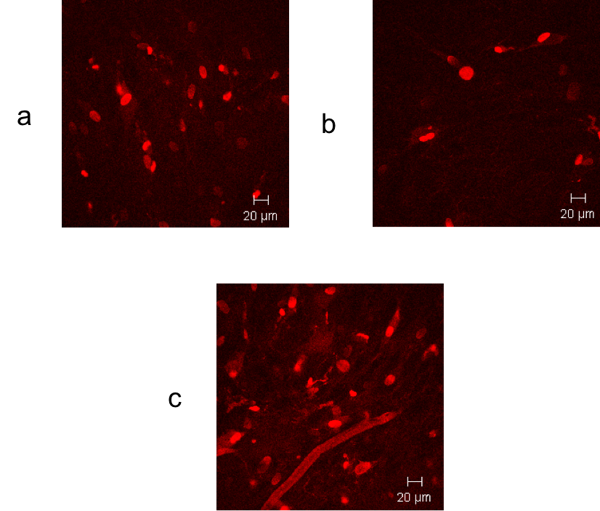
Figure 4.16 HDF cells treated with 500 μM RuPhen a) in serum free RPMI media b) Conditioned media 1 (CM1) c) conditioned media 2 (CM2). A decrease in emission is evident when CM1 is used.

Figure 4.17 The average emission intensity of HDF and MCF-7 cells when exposed to two different variations of conditioned media, in comparison to emission from mono- and co-cultures of both cells.

In contrast, as control experiments shown in Figure 4.17 and highlighted in CLSM images in Figure 4.18 indicate, the addition of conditioned media from either of these treatments to new MCF-7 cells produce the same levels of uptake as was previously observed. No change or decrease in emission was seen, even after the stain has previously been applied to another MCF-7 well plate. This provides additional evidence that the reduction in emission is not due to a finite concentration of the RuPhen stain being exhausted, as MCF-7 are still able to display preserved uptake and emission.
These conditioned media results offer further proof that an epithelial cancer line treated with RuPhen releases a soluble factor that inhibits the uptake of the complex by primary cells, whereas the same treatment on cancer cells offers no effect.

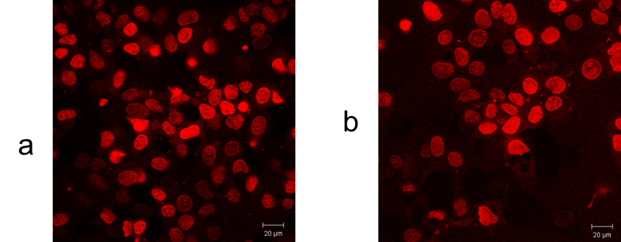
Figure 4.18 MCF-7 cells treated with 500 μM RuPhen a) in serum free RPMI media b) in Conditioned media1 from stained MCF-7 cells. Emission intensity is seen to be preserved.

Dilution effects
The next step was to explore the effect of dilution on conditioned media 1, and in turn the dilution of the proposed soluble factor responsible for inhibiting uptake of RuPhen into primary cells. We have already described results earlier in the chapter in Section 4.1 that demonstrated that the concentration of cancer cells in a co-culture, directly effects the extent that HDF cells intake RuPhen.
Conditioned media was prepared using methods previous described by pre-staining MCF-7 cells, once again HDF cells were pre-treated with GCT prior to seeding to enable clear visualisation of all cells. The stain/media was removed and further diluted to varying extents with freshly prepared RuPhen stain. CLSM images are highlighted in Figure 4.19.
Figure 4.19 CLSM of HDF cells stained with a) 100% CM1 b) 75% CM1 c) 50% CM1 d) 25% CM1 e) 0% CM1. Ru(II) emission (left). GCT emission (middle). Overlay image of Ru(II) and cell tracker emission (right).
Figure 4.20 Effects of diluting conditioned stained media with fresh stain. No significant difference in uptake by HDF cells is present when staining media is made up of 100-50% conditioned media.

The results displayed here show that diluting conditioned media from cancer cells, has a direct effect on the uptake of RuPhen by HDF cells. A 100% solution of conditioned media, as before, substantially causes a decrease in emission from HDF cells. This decrease is preserved, even when the conditioned media is diluted by half, and supplemented with fresh stain. Only when the staining solution contains 25% conditioned media is a difference observed, with an increase in emission intensity and therefore uptake. The plateau experienced between 50-100% conditioned media, replicates data from Figure 4.6, where a similar plateau was obtained by altering the ratio of cancer cells in a co-culture.
These results point towards a soluble factor that demonstrates a dose-dependent nature. Its effect can be decreased by supplementing with freshly prepared stain, and uptake by RuPhen by HDF cells can be increased/decreased as necessary.

Summary

In this chapter, we have shown RuPhen to act as a preferential marker for cancer cells. While there is a reduction in staining in mono-culture of non-cancer cells compared to cancer cells, this difference is increased 10-fold when in a co-culture, more akin to in vivo situations where cancer cells and non-cancer cells exist alongside each other. We have provided evidence that this phenomenon is due to a phenomenological effect, whereby upon staining with RuPhen, cancer cells release a soluble factor that in turn blocks uptake by non-cancerous cells. This soluble factor demonstrates a dilution effect, which may be utilised in the future in a dose-form system. The rationale for this being that pending the identification of this soluble factor, it would be able to be added to common chemotherapy treatments, seeking the production of a more targeted chemotherapy, whereby the negative side effects on normal healthy cells would be reduced. Additionally, taking the cytotoxic properties exhibited by RuPhen over a 72-hr period into consideration, there is potential for development of a cancer therapeutic using this complex. Future work in this area, will further investigate the toxicity of RuPhen towards a range of cancer and non-cancer cell lines, in mono- and co-cultures. It is imperative in cancer therapeutics to develop drugs that target cancer cells but largely spare normal cells. Future work will work towards the identification of the blocking factor as descried here, with the long aim of employing such a factor alongside chemotherapeutic drugs to deliver targeted therapies.

Additional Cell Staining Agents
In the previous chapter, the staining capabilities of a dinuclear Ru(II) complex with a ditopic tpphz bridging ligand and phen ancillary ligands was investigated, it was found that chirality affected the behaviours of these molecules in cells.
To further explore the effect of metal complexes as a cell stain, a broad series of alternative metal complexes were studied and their staining properties were analysed.

RuPhenBpy
Work in the Thomas group has focused on the complex of [{Ru(ligand)₂}₂tpphz]⁴⁺. It was discovered that when the ligand used is phen, the compound is internalised by a range of live cell types, and can be utilised as a cell staining agent. When the bpy ligand is used, the compound fails to successfully stain live cells.
To further explore the effect of ancillary ligand on this complex, Stuart Archer in the Thomas group synthesised and supplied a mixed ligand ruthenium complex with both phen and bpy ligands (Figure 5.1). The results the complex cells staining capabilities, are discussed here.
Figure 5.1 Series of dinuclear Ru(II) complexes.

RuPhenBpy was synthesised by a condensation reaction between [(phen)₂Ru(1,10-phenanthroline-5,6-dione]²⁺ and [(bpy)₂(5,6-diamino-1,10-phenanthroline]²⁺ and purified by silica gel chromatography using acetonitrile, water and saturated potassium nitrate in the ratio 14:4:1. The addition of NH₄PF₆ yielded the hexafluorophosphate salt as a crystalline orange solid. (Figure 5.2)¹⁴⁷ Structure was confirmed by NMR spectroscopy and mass spectrometry.
Figure 5.2 Synthetic route for preparation of [(phen)₂Ru(tpphz)Ru(bpy)₂]⁴⁺.

Live Cell Uptake and Imaging
Firstly, to examine the potential of the mixed ligand Ru(II) complex, RuPhenBpy, to act a luminescent probe of cellular DNA, MCF-7 human breast cancer cells were incubated with a solution of the complex, and the cellular uptake and in cellulo DNA binding was examined during CLSM (confocal laser scanning microscopy). For biological imaging, cells are usually labelled with organelle or macromolecule specific fluorescent dyes, although unlabelled samples may be viewed directly using phase contrast bright field imaging.¹⁴⁸
For comparison, the two single ligand systems were evaluated. In each case, the Ru(II) complex was excited at 458 nm using a He-Ne laser and the luminescence emission at 650-700 nm was recorded. The staining solution concentration used throughout was 500 μM for 1 hour, having previously been optimised for the phen and bpy complexes and was found here to work well for the mixed ligand system.
As shown by Figure 5.13 incubation of MCF-7 cells with RuPhenBpy results in CLSM-observable in vitro luminescence. The complex displays similar behaviour to the parent complex of racemic RuPhen with clear cell nucleus staining by the complex, providing a priori evidence of successful cellular uptake. These interesting observations are in striking contrast to the results obtained using complex RuBpy, where very limited and low nuclear uptake is presented.
Figure 5.3 MCF-7 cancer cells stained with 500 μM a) RuPhenBpy for 1 hour b) RuPhen for 1 hour c) RuBpy for 1 hour. Ru(II) emission and DIC is displayed as an overlay emission to show cell uptake of complex.

Additionally, a comparison of RuPhenBpy and RuPhen shows that the intensity of their nuclear staining is comparable. Indeed, after one hour treatment with both complexes, the emission displayed by MCF-7 cells between 670-700 nm shows no significant difference between RuPhenBpy and RuPhen (Figure 5.4).

Figure 5.4 Comparison of staining intensity of RuPhenBpy compared to RuPhen.

After the demonstration of live cell internalisation, the uptake behaviour of RuPhenBpy was investigated and directly compared to RuPhen. RuBpy was excluded from this experiment as it shows limited cell uptake. MCF-7 cells were treated with both complexes, respectively, and emission was measured over an 80 minute period. Figure 5.5 shows both complexes are fully internalised by the cells by ∼ 70 minutes. RuPhen displays a faster uptake mechanism, reaching saturation by ∼ 50 minutes.

Figure 5.5 Uptake behaviour of RuPhenBpy (blue) in comparison with RuPhen (red) over an 80 minute period on the MCF-7 cell line.

This study provides further evidence of a dependence on ancillary ligand for the uptake of a Ru(II) complex, strongly suggesting a role for specific receptor-based binding events being involved in nuclear uptake. It seems that in this receptor binding event, phen is able to fulfil a role, while bpy is unable to. This proposition is supported by the differences in uptake rates demonstrated by RuPhen and RuPhenBpy. Perhaps positioning/orientation of the complex is required for the uptake mechanism to proceed.
Further ongoing work is focusing on the identification of the uptake mechanism for these compounds, aimed at ascertaining whether a specific protein is responsible. If protein-mediated transport is responsible, this can be cell-type or tissue-type specific. Allowing for the development of targeted staining complexes.¹⁴⁹ Going forward, work will focus on use of inhibitors of specific transport proteins, to identify the target.

Iridium compounds
Of the platinum group metal complexes, iridium complexes have received the most interest in the past 10 years. This is because the rich photo-physical properties of iridium complexes are highly tuneable.⁷⁵ The high spin orbit coupling of iridium allows mixed MLCT and LLCT states. This mixing of excited states means that the excited states of iridium complexes are especially tuneable by small alteration of the ancillary ligands. Typical MLCT states are broad and featureless, whereas mixed states are well defined.⁷⁶ Luminescent iridium (III) polypyridine complexes have been utilised as probes for multiple chemical and biological molecules- including protons, small molecules, nucleic acids, proteins and hormones.^{148–151} Often these complexes have unusual properties- for example Lo, et al. reported an iridium system which fully exploited the mixing of ligand states to produce a dual emissive biological sensor at room temperature.⁶³
Most recently, work by Sasha Stimpson in the Thomas group has focused on a series of Ir (III) complexes that are effectively isostructural with well-established [Ru(NN)₂(dppz)]²⁺ systems, Irdppzphen and Irdppzbpy. (Figure 5.6)
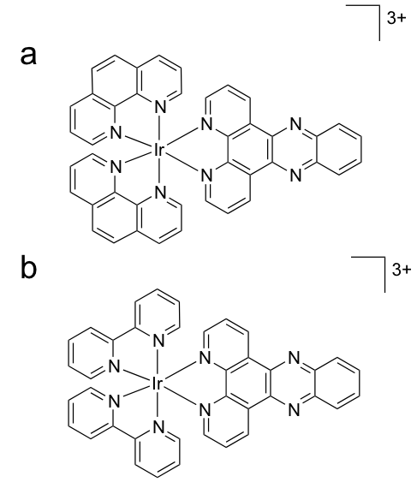
Figure 5.6 Schematic of a) Ir(phen)₂dppz³⁺ and b) Ir(bpy)₂dppz³⁺. Both complexes were used as their chloride salts.

Both of the complexes bind to duplex DNA with affinities that are two orders of magnitude higher than previously reported Ir(dppz)-based systems and are comparable with Ru(II)(dppz) analogues.¹⁵⁴ Given the well-established tuneable nature of the excited stated of polypyridyl Ir (III) complexes, the potential of these systems and their derivatives for a range of applications, including as sensitizers for photodynamic therapy, is apparent.

Live cell uptake and imaging
To first start exploring the possibility of these compounds as stains or therapeutics, initial preliminary staining experiments were conducted.
To examine the cellular internalisation of each complex, MCF-7 cells were incubated with the complexes at a range of concentrations for 1 hour and 24 hours. CLSM was used to evaluate the extent of cellular internalisation. For all cases, the excitation wavelength used was 458 nm and the emission collected between 500- 550 nm.
Figure 5.7 MCF-7 cells stained with a) 100 μM for 1 hour b) 200 μM for 1 hour c) 100 μM for 24 hours. Results using phen ancillary ligand is can be seen in the left column, and the bpy on the right.

Figure 5.7 demonstrates that there is little difference between the two complexes. At 1 hour staining times using 100 μM, poor staining is demonstrated by the two iridium complexes. When the staining concentration is increased to 200 μM, non-nuclear staining is seen. When the cells are exposed to the iridium complexes for 24 hours, the same non-nuclear staining is present, but the cells morphology appears more circular. A morphology change in cells can be indicative of both necrosis and apoptosis, suggesting toxicity of the complexes.^{155–157} Further work would be needed to investigate this in detail.
Interestingly, focussing on the result from the phen iridium complex, the compound is almost structurally identical to [Ru(phen)₂dppz]²⁺, the well-studied light switch compound, which is not taken up by live cells.¹⁵⁸ The iridium complex, as shown here, clearly shows structure specific cell staining. Suggesting that by changing the metal from iridium to ruthenium in a complex, we can create a complex that is able to cross the cell membrane.
To further investigate the location of the emission, co-localisation studies were carried out. The non-nuclear luminescence was hypothesised to be centralised in the mitochondria of the cell. To confirm this hypothesis, cells were additionally treated with MitoTracker Red (25μM, 30 minutes) before treatment with Irdppzphen. (Figure 5.8)
Figure 5.8 a CLSM of MCF-7 cells incubated with 200 μM Irdppzphen in serum-free media for 1 hr b magnified image to demonstrate staining of non-nuclear structures. From left to right: luminescence image of Ir complex (green), MitoTracker Red (red) and overlay.

To confirm co-localisation, the Colac 2 program, using ImageJ software was used to calculate a value for the Pearson for Mitotracker Red and Irdppzphen emission was calculated. A typical co-localisation profile is shown in Figure 5.9, yielding a coefficient of 0.93, with a value of 1 represent perfect co-localisation.¹⁵⁹ This test confirms the two emission signals show a high degree of co-localisation, showing that Irdppzphen is acting as a structure specific cell stain, specifically targeting the mitochondria of cells.

Figure 5.9 a Overlay CLSM of MCF-7 cells incubated with IrDppz (200 μM, 1hr) and MitoTracker Red b Co-localisation of IrDppz and MitoTracker Red signals, demonstrating a high correlation.

The cytotoxicity of Irdppzphen towards the MCF-7 cell line was assessed using a MTT assay. Cells were exposed to solutions of the complex for 24 hours in serum-containing media. Cisplatin was used as a positive control. From the data, an IC₅₀ value of 148 μM was calculated, comparable to RuPhen as previously described in Chapter 2. (Figure 5.10)
Figure 5.10 Cytotoxicity of IrDppz towards the MCF-7 cell line (24 hours)

The cytotoxicity of the complex was found to be relatively low in comparison to the cytotoxic standard of cisplatin (22 μM), showing the potential for Irdppzphen to be developed as a mitochondria specific confocal imaging stain.

[Ru(tpm)(dppz)(L^{OMe})]Cl₂
Work within the Thomas Group has recently focused on a range of complexes of the formula [Ru(tpm)(NN)(L^{OMe})]Cl₂, where NN = bpy, phen, dppz and dppn. Photophysical studies showed that all compounds were dual emissive at 550 nm and 650 nm from a single excitation wavelength. DFT calculations on the dppz derivative revealed that one component of the dual emission is a result of ligand to ligand charge transfer (LLCT) from the L^{OMe} ligand onto the dppz component of the molecule. The second emissive state is a result of Ru(II)-dppz based metal to ligand charge transfer (MLCT). Biophysical and photo physical studies on the interaction of these complexes with CT-DNA were carried out. It was found that when the ligand dppz was employed, the complex exhibited interesting luminescence behaviour. ¹⁶⁰ (Figure 5.11)
Figure 5.11 Structure of [Ru(tpm)(dppz)(L^{OMe})]Cl₂

When NN = dppz, light switch behaviour is seen in the presence of CT_DNA, with the complex also demonstrating ratiometric sensing. The emission spectra of [Ru(tpm)(dppz)(L^{OMe})]²⁺ (RuL^{OMe}) differs from the classic light switch effect because instead of being either on or off in solution, it shows one form of dominant emission in organic solutions (660 nm) and another in aqueous solutions (540 nm). Studies have shown that upon the addition of calf thymus DNA (CT-DNA), the emission of the complex noticeably increased at around 660 nm, while, the water based emission at around 540 nm remains almost constant. (Figure 5.12)
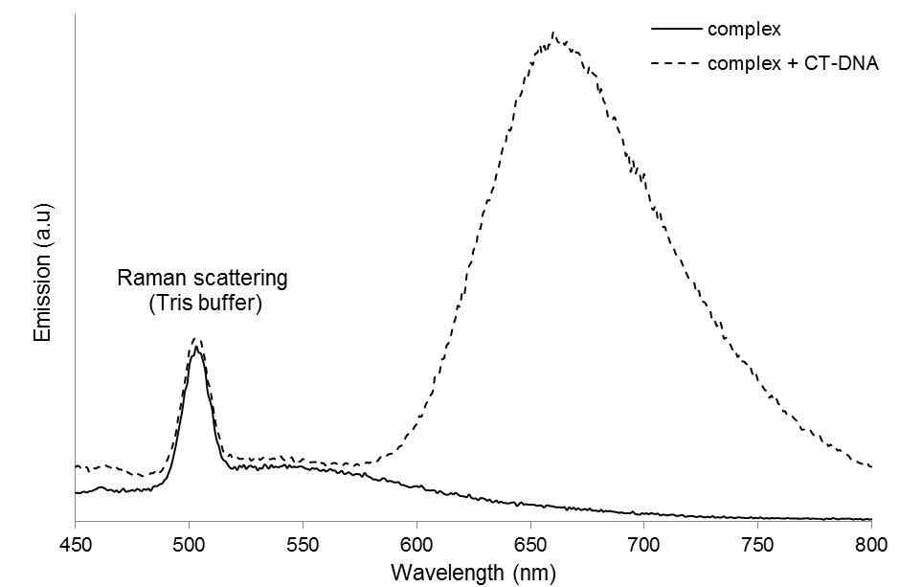
Figure 5.12 Luminescence spectrum at start and end of titration of CT-DNA into for [Ru(tpm)(dppz)(L^{OMe})]Cl_{2.}¹⁵⁸

By displaying dual luminescence at one excitation wavelength while maintaining the light switch effect, there is opportunity for [Ru(tpm)(dppz)(L^{OMe})]Cl₂ to be employed as a novel metallo-intercalative ratiometric probe for DNA.¹⁶⁰
Studies within this work focus on whether the ratiometric behaviour could be observed in vitro. Currently, in vitro bio imaging studies by fluorescent probes involve unknown concentrations and potentially inhomogeneous localisation inside the cell making it difficult to interpret fluorescent signals quantitatively. Consequently, sensing involving the simultaneous measurement of two fluorescent signals offers benefits over a typical single signal.

Staining conditions
RuL^{OMe} (100μM, 1 hour, serum free RMPI media) was applied to MCF-7 cancer cells, in similar methods applied to RuPhen in chapter 3 and 4. Some nuclear emission was observed, with weak secondary cytoplasmic staining seen in a minority of cells. Emission was collected at 620- 680 nm, corresponding the emission profile of RuL^{OMe} in the literature.¹⁶⁰ When the concentration of complex was increased to 500 μM, more intense nuclear staining was observed. With distinct structures within the nucleus observed. (Figure 5.13) These results not only show that RuL^{OMe} is able to permeate cells, but demonstrates potential as a structure specific imaging agent.
Figure 5.13 Live MCF-7 cells stained with a) 100 μM RuL^{OMe} for 1 hour b) 500 μM RuL^{OMe} for 1 hour,

To further characterise the nature of the RuL^{OMe} emission, co-staining experiments were employed using DAPI, a well characterised nuclear acid stain.¹⁶¹ (Figure 5.14) Interestingly, co-staining experiments were inconclusive, with DAPI and RuL^{OMe} acting as competing stains, with no single cell demonstrating emission from both compounds. This is perhaps not surprising as DAPI binds to DNA in the minor groove, and studies on RuL^{OMe} strongly suggest that it too also binds to DNA via groove binding.¹⁶²
Figure 5.14 top. Zoom image of MCF-7 cells stain with 500 μM RuL^{OMe} for 1 hour, followed by fixing and DAPI staining. Bottom As above, without increased zoom. Both sets of images show competition staining between RuL^{OMe} and DAPI.

Dual luminescence
As previously explained in section 5.3, RuL^{OMe} displays dual luminescence at one excitation wavelength while maintaining the light switch effect. This effect was further studied in vitro. (Figure 5.15).
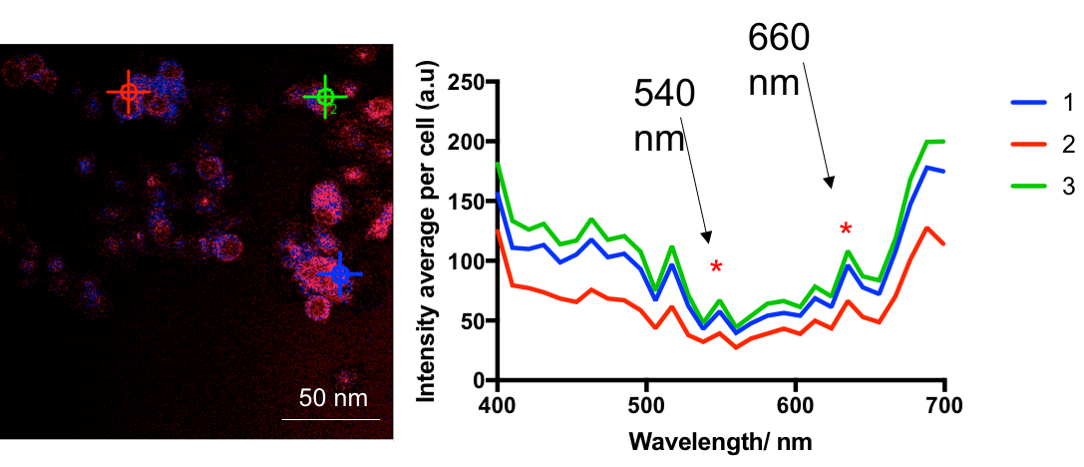
Figure 5.15 Lambda stacking experiments show the emission profile of [Ru(tpm)(dppz)(L^{OMe})]²⁺ in live MCF-7 cells to be composed of two emission maxima peaks at 540 and 660 nm, as demonstrated in the solution studies. Brightness and contrast of the image have been increased.

A representative lambda stack displaying the emission profile of three separate regions in cells demonstrate the two maxima emission peaks at 540 nm and 660 nm. The ratio of these peaks appears unchanged cell to cell. Studies have shown that upon the addition of CT-DNA, the emission of the complex noticeably increased at around 660 nm, while, the water based emission at around 540 nm remains almost constant, yet in cells there appears to be no such change in the 660 nm emission displayed. The two emission peaks, show seemingly proportional increases with one another. I.e. when the 660 nm peak is high, as is the 540 nm peak. At this stage, using solely these results, we are unable to comment on the ability of ruthenium compound to act as ratiometric sensor. Although dual luminescence can clearly be identified, the two emission peaks do not seem to be independent of each other.
The limitation of the equipment at this stage need to be considered, and further work will utilise more detailed imaging techniques, as well as evaluating different staining conditions and cell lines and the effects of this.
In addition to lambda stack experiments, the two emission signals were visualised by calibrating the image acquisition process, as described in Chapter 3, by defining separate 620-680 nm (red) and 500- 550 nm (yellow) channels. Figure 5.16 shows that, using this setup, two separate emissions can be identified. The localisation of the yellow emission, seems to independent of the red emission, and is localised in specific areas outside the nuclei of cells and is not co-localised with the red emission. Further studies will define the nature of this yellow emission, at this stage, results suggest that RuL^{OMe} is binding to alternative locations within cells.
Figure 5.16 CLSM using two separate detection channels 620-680 nm (red) and 500- 500 nm (yellow) show the multiple emission profile of cell luminesce of RuL^{OMe} and the specific localisation of the 500-550 nm emission.

Summary
This chapter looked to investigate a range of metal complexes and their potential to be developed at cell staining agents.
A dependence on ancillary ligand for the uptake of a Ru(II) complex was found through comparing the cell uptake of RuPhen, RuBpy and RuPhenBpy, strongly suggesting a role for specific receptor-based binding events being involved in nuclear uptake. A difference in uptake rates between the two compounds was found, indicating that a specific orientation of the complex required for the uptake mechanism to proceed.
Studies on a series of Ir (III) complexes, containing the dppz ligand, found that the compounds were internalised by cells. Co-localisation with Mitotracker Red, showed the complex containing phen to be a mitochondria structure specific stain. This complex is similar to the well-studied light switch effect compound of [Ru(phen)₂dppz]²⁺, which doesn’t permeate cells, so the findings here in this chapter that the iridium compound does, demonstrates the effect changing the metal has.
Dual luminescence was observed when MCF-7 cells were incubated with a solution of[Ru(tpm)(dppz)(L^{OMe})]²⁺, in line with solution data. The two emissions didn’t appear to be co-localised within the cell, the red emission demonstrated nuclear staining, while the yellow emission was specifically located in alternative cell structures.
The chapter has identified the potential of a range of metal complexes in cell staining techniques, however future works needs to be undertaken to exploit and refine their unique properties in vitro.

Conclusions and Future Work

Conclusions
By addressing the original aims of this project, the studies presented in this thesis have produced interesting results that span the interface of chemistry and cell biology.

The synthesis and chiral resolution of RuPhen was achieved through the development of chiral cation exchange chromatography methods, using SP Sephadex C-25 as the cation-exchange support This resulted in the three diastereoisomers of the compound being successfully prepared for the first time. The chiral resolution was confirmed using circular dichroism spectroscopy.

The interdisciplinary nature of the investigation led to in vitro studies being undertaken on the chirally resolved complexes, this established that all three diastereoisomers were capable of staining the nucleus of live MCF-7 cancer cells, with a similar staining intensity displayed. Uptake studies revealed that the chirality of the complex influences the efficiency of uptake. With Λ-RuPhen seemingly permeating the cell membrane more rapidly, leading to accumulation in the cell nucleus. While the uptake mechanism remains unknown, there is evidence that it is through a specific molecule-complex interaction, in which the lambda enantiomer is more efficient at completing.

Further cell staining experiments using Λ-RuPhen demonstrated the ability of the compound to identify different DNA structures in vitro, with strong evidence displayed for quadruplex binding. This finding provides the starting point for the development of a specific compound that is able to measure and visualise telomere length in live cells. This has benefits over current methods, which are time consuming and require specialist equipment and training.

Toxicity studies revealed that all diastereoisomers exhibited similar toxicities on the MCF-7 cancer cell line and HDF cells. In all cases, when the incubation time was increased to 72 hours, the toxicity drastically increased. The benefits for this are twofold, while low toxicities lend themselves to efficient cell staining agents, high toxicities at longer timeframes mean there is a possibility for RuPhen to be developed for use as an anti-cancer therapeutic agent.
Co-culture techniques were employed to further investigate the cell specific uptake of racemic RuPhen, which had been highlighted in earlier work. RuPhen was shown to preferentially stain cancer cells, when applied to a co-culture containing both non-cancer and cancer cells. Strong evidence was provided, that this was due to a phenomenological effect, whereby upon staining with RuPhen, cancer cells release a soluble factor that in turn blocks uptake by non-cancerous cells. This soluble factor demonstrates a dilution effect, which may be utilised in the future in a dose- form system. This preferential staining ability of RuPhen, combined with its cytotoxic behaviour, shows potential for the complex to be used as a targeted anti-cancer therapeutic agent.

In additional work, to further explore the effect of metal complexes as a cell stain, a broad series of alternative metal complexes were studied and their staining properties were analysed. The mixed ligand ruthenium(II) complex RuPhenBpy was found to be an effective nucleus stain, with staining intensity comparable to RuPhen displayed. Furthermore, the uptake was found to be less efficient than for RuPhen. This study provides further evidence of a dependence on ancillary ligand for the uptake of a Ru(II) complex, strongly suggesting a role for specific receptor-based binding events being involved in nuclear uptake. It seems that in this receptor binding event, phen is able to fulfil a role, while bpy is unable to. This proposition is supported by the differences in uptake rates demonstrated by Λ-RuPhen and Δ-RuPhen Perhaps positioning/orientation of the complex is required for the uptake mechanism to proceed.

Further work, described below, will increase the impact of the results and ideas developed in this thesis.

Future Work
This work has shown the potential biological applications of Ru(II) DNA light switch complexes. In the next steps on this project a range of chemical synthesis and cell biology approached will be used to i) extend the use of chiral separation methods developed in this work, to other metal complexes, to further investigate the effect of chirality on behaviour in cells, ii) further develop Λ-RuPhen as a tool to determine telomere length, iii) identification of the soluble factor released by cancer cells, blocking the uptake of RuPhen by primary non-cancerous cells, iv) further examine the cellular DNA binding properties of the range of complexes discussed in Chapter 5.

Chiral cation-exchange chromatography
Work in this thesis has established the use of a chiral cation-exchange column as an effective method of chirally resolving the diastereoisomers of RuPhen. Future work will extend the use of these methods and apply them to a range of metal complexes, to further explore the effect of chirality on cellular behaviour.
Possible targets include a) Ir(phen)₂dppz³⁺, where in Chapter 5 we established the racemic compound to act as a mitochondria stain in live MCF-7 cancer cells, b) [{Ru(DIP)₂}(tpphz)]⁴⁺ (DIP=4,7-diphenyl-1,10-phenanthroline), where in related research Gill et al demonstrated the lipophilic complex to target the endoplasmic reticulum of eukaryotic cells, functioning as an imagining agent for this organelle.¹⁶³

Telomere length
In Chapter 4, Λ-RuPhen demonstrates an affinity to different DNA structures, and preliminary studies have revealed potential to act as a determinant of telomere length in vitro. However, further development is required. RuPhen in tandem work has shown potential as a high resolution imaging probe. It would be predicted that, using high resolution imaging, the specific location of binding could be determined.

Soluble factor identification and cellular uptake mechanism
An exciting finding which emerges from studies in this thesis, is the observation of cell-specific uptake of RuPhen, whereby cancer cells display increased staining by the complex compared to primary non-cancer cells when grown together in co-culture. This raises the question of the type of factor that is being secreted by the cancer cells that effectively blocks the uptake by the no- cancer cells, along with how the molecule itself enters cells. We have demonstrated how chirality also effects the efficiency of uptake, suggesting the involvement of a specific (most likely, protein) receptor and internalisation pathway.
Live cells continually communicate with their surrounding by the secretion of biomolecules, so it can be reasoned that the release of a biomolecule, is response for this phenomenon. Proteins/ peptides make up an important class of biomolecules, so future work in the first instance will focus on employing proteomic approaches on media from cancer cells treated with RuPhen to identify any specific proteins that are released by the cells upon staining. This may take the form of mass spectrometry based methods.^{164–166}

Experimental

General

Chemicals
All chemicals were obtained from commercial sources: Sigma Aldrich, Alfa Aesar, Acros Organics, Fluorochem, Fisher Scientific or VWR and were used without further purification unless stated otherwise.

Nuclear magnetic resonance (NMR) spectroscopy
¹H NMR spectra were recorded on a Bruker AV2-400 machine working in Fourier transform mode. More complex ¹H NMR experiments were performed by Sue Bradshaw of the University of Sheffield; these spectra were recorded on a Bruker DRX500 machine. The following abbreviations are used in the annotation of ¹H spectra: s = singlet, d = doublet, dd = doublet of doublets, t = triplet and m = multiplet. J coupling constants are expressed in Hertz (Hz).

Mass spectrometry
ES mass spectra were recorded on a Micromass LCT ES-TOF machine. All spectra were run by either Simon Thorpe or Sharon Spey of the University of Sheffield Mass Spectrometry Service.

Synthesis

1,10-phenanthroline-5,6-dione (DPQ)¹⁶⁷
1,10-phenanthroline (2.73 g, 15.16 mmol) was added into a solution of 60% sulphuric acid (70 mL). After the solid compound was dissolved, potassium bromate (2.75 g, 16.47 mmol) was added in batches over a period of an hour. The mixture was stirred at room temperature for 20 h. The solution was poured over ice and was carefully neutralized to pH 7 using a saturated solution of sodium hydroxide. The solution was then filtered, extracted with CH₂Cl₂ and evaporated to dryness. The crude product was recrystallized from methanol to produce a canary yellow solid (2.09 g, 9.95 mmol, 67 %).
¹H NMR (400 MHz, CDCl₃) δ: 9.07 (dd, J= 1.5, 4.5 Hz, 2H), 8.47 (dd, J= 1.5, 8.0 Hz, 2H), 7.56 (dd, J=4.5, 8.0 Hz, 2H).
MS(ESI)- m/z (%) 211 (100) [MH⁺].

Tetrapyrido [3,2-a:2’,3’-c:3’’,2’’-h:2’’’,3’’’-j]phenazine (tpphz)¹⁴⁷
A mixture of 1,10-phenanthroline-5,6-dione (0.88 g, 4.19 mmol), ammonium acetate (4.56 g, 59.16 mmol) and sodium sulphite (0.091 g, 0.72 mmol) in ethanol (15 mL) was heated to reflux under nitrogen for 2 hours with stirring. Upon cooling to room temperature, 20 mL of water was added, and the precipitate was collected by filtration and washed well with water, methanol and acetone. The product was triturated in refluxing ethanol (100 mL), hot filtered, washed with ethanol, and dried under vacuum to give a pale yellow solid (0.194 g, 0.50 mmol, 24 %).
¹H NMR (400 MHz, TFA-d⁶) δ 10.5 (dd, J= 1.0, 8.0 Hz, 4H), 9.55 (dd, J= 1.0, 5.0 Hz, 4H), 8.6 (dd, J= 5.0, 8.0 Hz, 4H).
MS(ESI)- m/z (%): 385 (100) [M⁺].

[Ru(phen)₂(Cl)₂]⁸⁹
RuCl₃.3H₂O (3 g, 11.53 mmol), 1,10-phenanthroline (4.1 g, 22.7 mmol) and LiCl (3.12 g, 73.8 mmol) were heated at reflux in dimethylformamide (30 mL) for 8 hours under nitrogen. After cooling to room temperature, 200 mL of acetone was added and then the solution was stored at 4°C for 16 hours. The precipitate was collected by filtration and washed with water and ether before drying in vacuo to give a black solid (3.75 g, 7.05 mmol, 62 %).
MS m/z (%): 532 (65) [M]+.

[Ru(phen)₂(py)₂]Cl₂¹⁰⁶
Cis-[Ru(phen)₂(Cl)₂] (0.5 g, 9.3 mmol) was refluxed for 3 hours in a solution of water (10 mL) and pyridine (5 mL), during which the colour changed from brown/purple to dark orange. The filtered solution was evaporated to dryness, the brown residue was taken up in methanol (10 mL), and the complex precipitated as orange needles by the addition of ether. After standing for 1 hr. the crystals were collected and washed with ether.
The hexafluorophosphate was prepared by dissolving the above salt in water containing a little methanol and adding excess ammonium hexaflurophosphate. The methanol was allowed to evaporate overnight forming crystals. The solution was filtered and the orange crystals of [Ru (phen)₂(py)₂]PF₆ were collected and dried (0.72 g, 7.9 mmol, 84 %).
¹H NMR (D₂O) δ: 9.44 (dd, J= 1.0, 8.0 Hz, 2H), 8.79 (dd, J= 1.0, 8.0 Hz, 2H), 8.46-8.56 (m, 6H), 8.10-8.29 (m, 8H), 7.81-7.89 (m, 2H), 7.51-7.58 (m, 2H), 7.25-7.31 (m, 4H).

Sodium arsenyl (-) tartrate¹⁰¹
D(-)-tartaric acid (20 g, 0.133 mol) and NaOH (5.33 g, 0.133 mol) were dissolved in water (150 mL), and the solution was heated to reflux. As₂O₃ (13.1 g, 0.066 mol) was added, and the resulting slurry refluxed for 45 min, during which the solution became clear. The solution was filtered while hot, and 300 mL ethanol was added to the filtrate, which resulted in some precipitation. The resulting mixture was cooled to 4 °C for 20 hours, upon which a large mass of white crystals formed. The crystals were isolated by filtration, washed with cold ethanol, and air-dried (25.1g, 0.102 mmol, 76 %) M.P.>200°C

Sodium arsenyl (+) tartrate¹⁰¹
L(+)-tartaric acid (20 g, 0.133 mol) and NaOH (5.33 g, 0.133 mol) were dissolved in water (150 mL), and the solution was heated to reflux. As₂O₃ (13.1 g, 0.066 mol) was added, and the resulting slurry refluxed for 45 min, during which the solution became clear. The solution was filtered while hot, and 300 mL ethanol was added to the filtrate, which resulted in some precipitation. The resulting mixture was cooled to 4 °C for 20 hours, upon which a large mass of white crystals formed. The crystals were isolated by filtration, washed with cold ethanol, and air-dried (26.3 g 0.106 mmol, 80 %). M.P.> 200°C

Resolution of (±) [Ru(phen)₂(py)₂]Cl₂.¹⁰⁶
A solution of sodium arsenyl-(+)-tartrate (0.61 g) in warm water (10 mL) was added to a solution of cis—[Ru(phen)₂(py)₂]Cl₂ (0.63 g) in water (10 mL). On scratching the sides of the beaker an orange diastereoisomer precipitated, and after cooling the solution slowly to 5°C, the crystals were collected, washed with water (5 mL), followed by acetone (Yield 0.5g).
To the filtrate, excess ammonium nitrate was added and the mixture was allowed to stand at 0°C for fifteen minutes. The orange crystals of the laevo nitrate thus precipitated were filtered, washed with ice cold water, and dried at the pump. The optically active nitrate was recrystallized from acetone by the addition of ether, yielding (-) – [Ru(phen)₂(py)₂](NO₃)₂.H₂O.
The diastereoisomer was suspended in a solution of water (5 mL) containing nitric acid (0.75 mL). The mixture was stirred and warmed to 40°C, whereupon the solid dissolved to give an orange solution which deposited the dextro nitrate when excess solid ammonium nitrate was added. After collecting the solid, it was recrystallized from acetone by the addition of ether.
The procedure was repeated using sodium arsenyl-(+)-tartrate to produce cis+[Ru(phen)₂(py)₂]Cl₂ as the major product.
This was repeated two or three times until there was no change in the CD signal after entire process indicating a pure enantiomer. Yield: ~ 80 %.CD: Δ λ_{min/max} (Mol. CD) 470 (- 10), Λ λ_{min/max} (Mol. CD) 470 (+ 10).

Alternative resolution of (±) [[Ru(phen)₂(py)₂]Cl₂ ¹⁰⁷
Cis—[Ru(phen)₂(py)₂]Cl₂ (0.5 g) was dissolved in 20 mL of water and heated to boiling, Sodium arsenyl-L(+)-tartrate (0.1 g) dissolved in 5 mL of hot water was added. Crystallisation of the Ʌ-arsenyl-L(+)-tartrate diastereoisomer, initiated by scratching with a glass rod, was allowed to proceed overnight with slow cooling to 4°C. The brown crystals were removed by filtration and washed with ice-cold water. The Δ-enriched hexaflurophosphate was obtained from the mother liquor by precipitation with aqueous ammonium hexafluorophosphate, converted to the chloride form, and treated with sodium arsenyl-D(-)-tartrate as described above.
For purification, each enantiomeric salt with arsenyltartrate was dissolved in 5 mL of hot DMSO and filtered. The filtrate was diluted with 15 mL of boiling water before 2mL of a hot aqueous solution of 0.2 g of the appropriate sodium arsenyltartrate enantiomer was added.
Crystallisation was initiated by scratching and the mixture was slowly cooled overnight. Each recrystallised sample was dissolved in 20 mL of hot 20% acetic acid and the filtered solutions were precipitated with an ammonium hexafluorophosphate solutions. The precipitates were collected by filtrated, washed with water, and recrystallised from acetone/water to give the Δ enantiomer and the Ʌ enantiomer as orange crystals.

Preparation of chirally resolved ΔΔ and ΛΛ [(phen)₂Ru(tpphz)Ru(phen)₂][PF₆]₄ ¹¹⁰

[Ru(phen)₂(py)₂](NO₃)₂ (0.0633 g, 0.09 mmol) and tpphz (0.0134 g, 0.04 mmol) were added to a 1:1 solution of EtOH/water (5mls) and heated at reflux for 72 hours under nitrogen. The solution was cooled to room temperature then for a further 16 hours at 4°C. The brown solution was filtered and the ethanol removed by rotary evaporation. The addition of NH₄PF₆ caused the formation of a dark brown precipitate which was collected by filtration, washed with water, recrystallized in acetonitrile by addition of diethyl ether and dried in vacuo (0.0212g, 0.011 mmol, 12%) orange/brown solid.
¹H NMR (CD₃CN) δ 7.65 (dd, J= 5.0, 8.0 Hz, 8H), 7.90 (dd, J= 5.0, 8.0 Hz, 4H), 8.00 (dd, J= 5.0, 8.0 Hz,4H), 8.25-8.30 (m, 16H), 8.65 (dd, J= 1.0, 8.0 Hz, 8H), 9.95 (dd, J= 5.0, 8.0 Hz, 4H).
MS; m/z (%): 799 (15) [M-2(PF₆)] ^{2+,} 484 (100) [M-3(PF₆)] ³⁺.
CD: ΔΔ λ_{min/max} (Mol. CD) 470 (- 17), ΛΛ λ_{min/max} (Mol. CD) 470 (+ 33).

Preparation of racemic [(phen)₂Ru(tpphz)Ru(phen)₂][PF₆]₄⁸⁸
[Ru(phen)₂(Cl)₂](Cl)₂ (0.0633 g, 0.09 mmol) and tpphz (0.0134 g, 0.04 mmol) were added to a 1:1 solution of EtOH/water (5 mL) and heated at reflux for 72 hours under nitrogen. The solution was cooled to room temperature then stored for 16 hours at 4°C. The brown solution was filtered and the ethanol removed by rotary evaporation. The addition of NH₄PF₆ caused the formation of a dark brown precipitate which was collected by filtration, washed with water, and dried in vacuo. The crude product was dissolved in acetonitrile and re-precipitated on addition of diethyl ether, collected by filtration, washed with diethyl ether and dried in vacuo to give a red solid (0.1090 g, 0.041 mmol, 91 %).
¹H NMR (400 MHz, CD₃CN) δ: 9.98 (dd, J= 5.0, 8.0 Hz, 4H), 8.58 (dd, J= 1.0, 8.0 Hz, 8H), 8.28-8.32 (s, 16H), 8.08- 8.01 (m, 4H), 7.90 (dd, J= 5.0, 8.0 Hz, 4H), 7.29-7.77 (m, 8H).
MS; m/z (%): 799 (15) [M-2(PF₆)] ^{2+,} 484 (100) [M-3(PF₆)] ³⁺.

Anion Metathesis
For cellular studies, the chloride complex of [(phen)₂Ru(tpphz)Ru(phen)₂]⁴⁺ was used. The hexafluorophosphate salt of each complex was dissolved in the minimum volume of acetone and a saturated solution of ammonium chloride in acetone added. The resultant precipitated chloride salt was collected by filtration, washed with cold acetone and dried in vacuo.

Chiral resolution

Guard column preparation
Before diastereoisomeric separation all compounds were run through a short SP Sephadex C-25 column (dimensions 26 x 25 mm). This a guard column removes any impurities which may cause damage to the main cation-exchange column, enhancing its lifespan. Compounds were eluted using sodium chloride at increasing concentrations (up to 4M), until the required main complex band eluted (between 1M and 2M for all compounds, confirmed by NMR and mass spectrometry analysis). Compounds were precipitated by the addition of aqueous PF₆ salt.

Diastereoisomeric separation
The diastereoisomeric mixture of [(phen)₂Ru(tpphz)Ru(phen)₂][PF₆]₄ (250 mg) were converted into the chloride salts by metathesis with tetrabutyl ammonium chloride in acetone solution. The resultant precipitate chloride salt was collected by filtration and washed with cold acetone and dried in vacuo. The resultant dark orange precipitate was dissolved in the minimum amount of water and introduced onto a one metre SP Sephadex C-25 column (dimensions 26 x 100 mm). Eluent flow was regulated by the use of a peristaltic pump. On elution with 0.06M sodium octanoate solution, the initial fast-moving pale red bands were rejected. To increase the effective length of the column, once the Sephadex had equilibrated with the eluent a plunger was lowered onto the surface of the support and the system was allowed to recycle. After the third passage down the column definitive resolution had been achieved, and the two individual bands were collected. Meso (first band) and rac (second band) compounds were precipitated by the addition of aqueous KPF₆ solution. The solids were extracted with dichloromethane, and the organic extracts dried with anhydrous Mg₂SO₄. Following filtration, the solvent was evaporated and the residues dried in vacuo. Yields: meso, 80 mg; rac 100 mg. These products were converted to the chloride salts by metathesis.

Resolution of the racemic form
Using a similar method to that described above, rac-[(phen)₂Ru(tpphz)Ru(phen)₂][Cl]₄ was introduced onto a column (dimensions 16 x 1000 mm). Upon elution with (0.05M) sodium (-) – dibenzoyl- L-tartrate, two distinct bands were collected and isolated as the hexaflurophosphate salts. Band 1, ΔΔ complex: CD λ_{max}/nm (CH₃CN) 256 (Δε/dm³ mol⁻¹ cm⁻¹ +330.1), 269 (-471.3). Band 2, ɅΛ complex: CD λ_{max}/nm (CH₃CN) 256 (Δε/dm³ mol⁻¹ cm⁻¹ -328.3), 269 (+471.7).

Cellular studies

Complex preparation for cellular studies
Stock solutions of the chloride salts of each complex were made in phosphate buffered saline (PBS) (typically 5 mM). Sonication and gentle heating were used to aid dissolution as required. Stock solutions were filter sterilised with a 0.2µm filter.

Cell Culture
MCF-7 (human breast carcinoma) cell lines, purchased from Sigma Aldrich, were cultured in RPMI-1640 medium. Primary HDF (human dermal fibroblast) cells, isolated from oesophageal tissue according to Green et al were cultured in Dulbecco’s modified Eagle’s medium (DNEM).¹⁶⁸ L5178-R cells, purchased from Sigma Aldrich, were cultured in RPMI-1640 medium. All growth media was supplemented with 100 IU ml⁻¹ penicillin, 100 µg ml⁻¹ streptomycin and 10% fetal calf serum (FCS). MCF-7 and HOF cells were grown as monolayers and maintained at 37°C in a humidified atmosphere of 5 % CO₂. Cultures were sub-cultured using trypsin (0.1% v/v in PBS), routinely every 4 days once 80-95% confluence was achieved, and the media replaced every 2 days. L5178-R cells were grown as a suspension culture, at a seeding density of 0.1 x 10⁶/mL and maintained in a humidified 37°C atmosphere with the shaker platform set to 110 rpm. Cultures were sub-cultured using trypsin (0.1% v/v in PBS) every 2-3 days to maintain cultures at 300,000- 900,000 cells/ml.

Cytotoxicity (MTT assay)
The basis of the MTT assay is that yellow MTT (3-(4,5-dimethylthiazol-2-yl)-2,5-diphenyltetrazolium bromide) is reduced to a purple formazan product in the mitochondria of living cells by reductase enzymes. As the reduction of MTT can only occur within active mitochondria, this amount of formazan produced is directly related to the number of viable cells within a sample. The amount of formazan may be quantified by absorbance between 500-600 nm and the toxicity of a sample may be deduced by comparison of the formazan content for cells exposed to the sample to that of an untreated control. Different cell culture samples can show different relationships between enzyme activity and cell number, the assay is only valid for comparative purposes within the same sample of cells.

IC₅₀ Values
Cell cultures were seeded at a density of 1 x 10⁵ on a 24 well plate and allowed to grow for 24 hours. Cell cultures were then treated with solutions of a complex at various concentrations (10% PBS: 90% medium) for the given incubation time in triplicate. Solutions were removed and the cells incubated with 0.5 mg ml⁻¹ MTT dissolved in PBS for 30-40 minutes. The formazan product was eluted using 200 µl per well of acidified propan-2-ol, 150 µl of this was transferred to a 96 well plate and the absorbance quantified by spectrophotometer (540 nm, referenced at 640 nm). An average absorbance for each concentration was obtained and cell viability was determined as a percentage of untreated negative control wells (10 % PBS; 90% medium). Using GraphPad Prism 6 software, a 3 parameter sigmoidal curve was used to fit each date set (R² > 0.97 for each fit) and the IC₅₀ value (the concentration corresponding to 50% viability) calculated by interpolation.

Microscopy

Sample preparation for live cell microscopy
For adherent cell lines, cells were first seeded at a density of 3 x10⁵/well in a 6 well plate and incubated for 24 hours to allow adherence before staining. All media was removed from the well plates, and the cells were washed with PBS. Cells were then incubated with stain at varying times and concentrations dependant on the experiment. Following treatment with the complex, cells were washed with PBS and imaged immediately.
For suspension cell lines, cells underwent centrifugation to remove the growth media, ensuring 300,000 cells/vessel. The cells were stained using the required conditions and following treatment were centrifuged, washing with PBS and imaged immediately.

Sample preparation for fixed cell microscopy
For fixed cell experiments monolayers were treated with 10% formaldehyde (10 minutes) before incubation with ruthenium complexes (500 µM in PBS for 10 minutes). After incubation, the solution was removed and the cells were washed twice with PBS.

Co-staining
Where stated, co-staining was performed using the following commercially available stains (Invitrogen), which were dissolved in PBS unless otherwise indicated: DAPI (500 nM, 2 minutes), Mitotracker Red (1 µM, 20-45 minutes, serum- free culture medium) and Cell Tracker Green (5 µM 15-45 minutes, serum-free culture medium). After co-staining, cells were washed with PBS twice before imaging.

Image acquisition
Following treatment with the complex, cell cultures were fluorescently imaged on Zeiss LSM510 META upright and Zeiss LSM 510META inverted confocal laser scanning microscopes equipped with Argon (λ_{ex}= 458nm, 488nm, 514nm), He-Ne (λ_{ex} = 543nm, 643nm) and class 4 tuneable Ti-Sapphire two-photon laser (λ_{ex} =690-1040nm). Objectives used were: 40x long-range water dipping lens (upright microscope) or 40x oil-immersion lens (inverted microscope). Ruthenium complexes were excited with an Ar-ion laser at 458 nm and emission was detected between 600- 700 nm in 10 nm increments, specific experiments contain details of the precise emission range. For two-photon imaging, Ru complexes were excited with a Ti-Sapphire two-photon laser at 800nm and emission was collected within a 600-700nm range. DAPI was excited using the 2-photon mode-locked wavelength tuneable Ti- Sapphire laser (Chameleon Ultra III, Coherent Inc., USA) set at 780 nm, emission was detected at 460 nm. Mitotracker Red was excited at 543 nm (He-Ne) and emission detected using META detection at 580-620 nm. Cell-Tracker Green was excited at 480 nm and emission collected within a 500-550 nm range. Image data acquisition and processing was performed using Zeiss LSM Image Browser and FIJI (Image J) software.^{169,170} Co-localisation studies were performed using Coloc 2, FIJI’s plugin for co-localisation analysis. The two channels to be compared were split into two separate images and a region of interest selected prior to the running of the analysis. The standard settings of the program were used for all experiments.

References
1 F. H. C. Crick, Nature, 1970, 227, 561–563.
2 B. Alberts, A. Johnson, J. Lewis, M. Raff, K. Roberts and P. Walter, Molecular Biology of the Cell, Garland Science, 4th editio., 2002.
3 J. D. Watson and F. H. Crick, Nature, 1953, 171, 737–738.
4 L. Hood and D. Galas, Nature, 2003, 421, 444–448.
5 G. H. Williams and K. Stoeber, J. Pathol., 2012, 226, 352–364.
6 E. M. Rezler, J. Seenisamy, S. Bashyam, M.-Y. Kim, E. White, W. D. Wilson and L. H. Hurley, J. Am. Chem. Soc., 2005, 127, 9439–47.
7 E. H. Blackburn, Nature, 1991, 569–573.
8 A. Canela, E. Vera, P. Klatt and M. a Blasco, Proc. Natl. Acad. Sci. U. S. A., 2007, 104, 5300–5.
9 U. M. Martens, J. M. J. M. Zijlmans, S. S. S. Poon, W. Dragowska, J. Yui, E. A. Chavez, R. K. Ward and P. M. Lansdorp, Nat. Genet., 1998, 18, 76.80.
10 C. B. Harley, B. Futcher and C. W. Greider, Lett. to Nat., 1990, 345, 458–460.
11 J. Nandakumar and T. R. Cech, Nat. Rev. Mol. Cell Biol., 2013, 14, 69–82.
12 M. A. Jafri, S. A. Ansari, M. H. Alqahtani and J. W. Shay, Genome Med., 2016, 8, 69.
13 N. W. Kim, M. A. Piatyszek, K. R. Prowse, C. B. Harley, M. D. West, P. L. Ho, G. M. Coviello, W. E. Wright, S. L. Weinrich and J. W. Shay, Science, 1994, 266, 2011–5.
14 H. Han and L. H. Hurley, Trends Pharmacol. Sci., 2000, 21, 136–142.
15 S. Burge, G. N. Parkinson, P. Hazel, A. K. Todd and S. Neidle, Nucleic Acids Res., 2006, 34, 5402–15.
16 G. N. Parkinson, M. P. H. Lee and S. Neidle, Lett. to Nat., 2002, 417, 3–7.
17 M. Li, Z. Wang, M. H. Kuo, S. D. Hsu and T. Chang, J. Phys. Chem. B, 2014, 931–936.
18 A. Ambrus, D. Chen, J. Dai, T. Bialis, R. a Jones and D. Yang, Nucleic Acids Res., 2006, 34, 2723–35.
19 D. Sun, B. Thompson, B. E. Cathers, M. Salazar, S. M. Kerwin, J. O. Trent, T. C. Jenkins, S. Neidle and L. H. Hurley, 1997, 2623, 2113–2116.
20 J. L. Huppert, Philos. Trans. A. Math. Phys. Eng. Sci., 2007, 365, 2969–84.
21 B. Rosemberg, L. Vancamp, J. E. Trosko and V. H. Mansour, Nature, 1969, 385–386.
22 Dong Wang & Stephen J. Lippard, Nat. Rev. Drug Discov., 2005, 4, 307–320.
23 E. R. Jamieson and S. J. Lippard, Chem. Rev., 1999, 99, 2467–98.
24 V. Cepeda, M. A. Fuertes, J. Castilla, C. Alonso, C. Quevedo and J. M. Pérez, Anticancer. Agents Med. Chem., 2007, 7, 3–18.
25 E. Wong and C. M. Giandomenico, Chem. Rev., 1999, 99, 2451–2466.
26 B. A. Pashi and F. Zunino, Angen. CIiem. lnt. Ed. Engl, 1987, 26, 615–624.
27 N. J. Wheate, S. Walker, G. E. Craig and R. Oun, Dalton Trans., 2010, 39, 8113–8127.
28 M. J. Piccart, H. Lamb and J. B. Vermorken, Ann. Onc., 2001, 12, 1195–1203.
29 A. Bergamo, C. Gaiddon, J. H. M. Schellens, J. H. Beijnen and G. Sava, J. Inorg. Biochem., 2012, 106, 90–99.
30 C. G. Hartinger, S. Zorbas-Seifried, M. a. Jakupec, B. Kynast, H. Zorbas and B. K. Keppler, J. Inorg. Biochem., 2006, 100, 891–904.
31 L. S. Lerman, J. Mol. Biol., 1961, 3, 18–IN14.
32 G. Arena, L. M. Scolaro, R. F. Pasternack and R. Romeo, Inorg. Chem., 1995, 34, 2994–3002.
33 E. C. Long and J. K. Barton, Acc. Chem. Res., 1990, 23, 271–273.
34 B. J. Pages, D. L. Ang, E. P. Wright and J. R. Aldrich-Wright, Dalton Trans., 2015, 44, 3505–26.
35 A. D. Richards and A. Rodger, Chem. Soc. Rev., 2007, 36, 471–83.
36 J. K. Barton, A. Danishefsky and J. Goldberg, J. Am. Chem. Soc., 1984, 106, 2172–2176.
37 T. W. Johann and J. K. Barton, Philos. Trans. R. Soc. A Math. Phys. Eng. Sci., 1996, 354, 299–324.
38 D. Z. M. Coggan, I. S. Haworth, P. J. Bates, A. Robinson and A. Rodger, Inorg. Chem., 1999, 38, 4486–4497.
39 C. V. Kumar, J. K. Barton and N. J. Turro, J. Am. Chem. Soc., 1985, 107, 5518–5523.
40 J. K. Barton, J. J. Dannenberg and A. L. Raphael, J. Am. Chem. Soc., 1982, 104, 4967–4969.
41 A. E. Friedman, J. C. Chambron, J. P. Sauvage, N. J. Turro and J. K. Barton, J. Am. Chem. Soc., 1990, 112, 4960–4962.
42 E. Amouyal, A. Homsi, J. C. Chambron and J. P. Sauvage, J. Chem. Soc. Dalt. Trans., 1990, 1841.
43 C. Turro, S. H. Bossmann, Y. Jenkins, J. K. Barton and N. J. Turro, J. Am. Chem. Soc., 1995, 117, 9026–9032.
44 D. A. Lutterman, A. Chouai, Y. Liu, Y. Sun, C. D. Stewart, K. R. Dunbar and C. Turro, J. Am. Chem. Soc., 2008, 130, 1163–1170.
45 M.-P. Teulade-Fichou, C. Carrasco, L. Guittat, C. Bailly, P. Alberti, J.-L. Mergny, A. David, J.-M. Lehn and W. D. Wilson, J. Am. Chem. Soc., 2003, 125, 4732–40.
46 L. Zhang, J. C. Er, K. K. Ghosh, W. J. Chung, J. Yoo, W. Xu, W. Zhao, A. T. Phan and Y.-T. Chang, Sci. Rep., 2014, 4, 1–6.
47 Y. P. Kumar, S. Bhowmik, R. N. Das, I. Bessi, S. Paladhi, R. Ghosh, H. Schwalbe and J. Dash, Chem. - A Eur. J., 2013, 19, 11502–11506.
48 L. Yu, Q. Yang, J. Xiang, H. Sun, L. Wang, Q. Li, A. Guan and Y. Tang, Analyst, 2015, 140, 1637–1646.
49 D.-L. Ma, C.-M. Che and S.-C. Yan, J. Am. Chem. Soc., 2009, 131, 1835–46.
50 J. M. Nicoludis, S. T. Miller, P. D. Jeffrey, S. P. Barrett, P. R. Rablen, T. J. Lawton and L. a. Yatsunyk, J. Am. Chem. Soc., 2012, 134, 20446–20456.
51 A. Siddiqui-Jain, C. L. Grand, D. J. Bearss and L. H. Hurley, Proc. Natl. Acad. Sci. U. S. A., 2002, 99, 11593–11598.
52 A. Ali, M. Bansal and S. Bhattacharya, J. Phys. Chem. B, 2015, 119, 5–14.
53 A. Arola-Arnal, J. Benet-Buchholz, S. Neidle and R. Vilar, Inorg. Chem., 2008, 47, 11910–11919.
54 N. H. Campbell, N. H. A. Karim, G. N. Parkinson, M. Gunaratnam, V. Petrucci, A. K. Todd, R. Vilar and S. Neidle, J. Med. Chem., 2012, 55, 209–222.
55 N. H. Abd Karim, O. Mendoza, A. Shivalingam, A. J. Thompson, S. Ghosh, M. K. Kuimova and R. Vilar, RSC Adv., 2014, 4, 3355–3363.
56 S. N. Georgiades, N. H. Abd Karim, K. Suntharalingam and R. Vilar, Angew. Chemie - Int. Ed., 2010, 49, 4020–4034.
57 S. Gama, I. Rodrigues, F. Mendes, I. C. Santos, E. Gabano, B. Klejevskaja, J. Gonzalez-Garcia, M. Ravera, R. Vilar and A. Paulo, J. Inorg. Biochem., 2016, 160, 275–286.
58 C. Rajput, R. Rutkaite, L. Swanson, I. Haq and J. a Thomas, Chemistry, 2006, 12, 4611–4619.
59 K.-H. Leung, H.-Z. He, V. P.-Y. Ma, H. Yang, D. S.-H. Chan, C.-H. Leung and D.-L. Ma, RSC Adv., 2013, 3, 1656.
60 R. M. Martin, H. Leonhardt and M. C. Cardoso, Cytometry. A, 2005, 67, 45–52.
61 T. Suzuki, K. Fujikura, T. Higashiyama and K. Takata, J. Histochem. Cytochem., 1997, 45, 49–53.
62 R. E. Durand and P. L. Olive, J. Histochem. Cytochem., 1982, 30, 111–116.
63 K. K.-W. Lo, S. P.-Y. Li and K. Y. Zhang, New J. Chem., 2011, 35, 265–287.
64 M. R. Gill and J. A. Thomas, Chem. Soc. Rev., 2012, 41, 3179–92.
65 E. Baggaley, J. A. Weinstein and J. A. G. Williams, Coord. Chem. Rev., 2012, 256, 1762–1785.
66 K. K.-W. Lo, A. W.-T. Choi and W. H.-T. Law, Dalton Trans., 2012, 41, 6021–47.
67 C. A. Puckett and J. K. Barton, J. Am. Chem. Soc., 2007, 129, 46–7.
68 J. Brunner and J. K. Barton, Biochemistry, 2006, 45, 12295–302.
69 K. K.-W. Lo, T. K.-M. Lee, J. S.-Y. Lau, W.-L. Poon and S.-H. Cheng, Inorg. Chem., 2008, 47, 200–208.
70 P. Ghosh, G. Han, M. De, C. K. Kim and V. M. Rotello, Adv. Drug Deliv. Rev., 2008, 60, 1307–15.
71 F. R. Svensson, M. Matson, M. Li and P. Lincoln, Biophys. Chem., 2010, 149, 102–6.
72 S. W. Botchway, M. Charnley, J. W. Haycock, A. W. Parker, D. L. Rochester, J. A. Weinstein and J. A. G. Williams, 2008, 105.
73 M. S. Lowry, W. R. Hudson, R. A. Pascal and S. Bernhard, J. Am. Chem. Soc., 2004, 126, 14129–35.
74 K. K.-W. Lo, K. Y. Zhang, S.-K. Leung and M.-C. Tang, Angew. Chemie Int. Ed., 2008, 47, 2213–2216.
75 K. K.-W. Lo, D. C.-M. Ng and C.-K. Chung, Organometallics, 2001, 20, 4999–5001.
76 C. Li, M. Yu, Y. Sun, Y. Wu, C. Huang and F. Li, J. Am. Chem. Soc., 2011, 133, 11231–9.
77 U. Cho, D. P. Riordan, P. Ciepla, K. S. Kocherlakota, J. K. Chen and P. B. Harbury, Nat. Chem. Biol., 2018, 14, 15–21.
78 S. Pandya, J. Yu and D. Parker, Dalt. Trans., 2006, 2757.
79 J. Yu, D. Parker, R. Pal, R. A. Poole and M. J. Cann, J. Am. Chem. Soc., 2006, 128, 2294–9.
80 C. P. Montgomery, B. S. Murray, E. J. New, R. Pal and D. Parker, Acc. Chem. Res., 2009, 42, 925–37.
81 E. Deiters, B. Song, A. Chauvin, C. D. B. Vandevyver, F. Gumy and J. G. Bünzli, Chem. Eur. J, 2009, 15, 885–900.
82 E. Baggaley, M. R. Gill, N. H. Green, D. Turton, I. V Sazanovich, S. W. Botchway, C. Smythe, J. W. Haycock, J. a Weinstein and J. a Thomas, Angew. Chem. Int. Ed. Engl., 2014, 53, 3367–71.
83 C. Yu, K. H.-Y. Chan, K. M.-C. Wong and V. W.-W. Yam, Chem. Commun. (Camb)., 2009, 3756–8.
84 V. Gonzalez, T. Wilson, I. Kurihara, A. Imai, J. A. Thomas and J. Otsuki, Chem. Commun. (Camb)., 2008, 1868–70.
85 M. R. Gill, J. Garcia-Lara, S. J. Foster, C. Smythe, G. Battaglia and J. a Thomas, Nat. Chem., 2009, 1, 662–7.
86 T. Wilson, M. P. Williamson and J. a Thomas, Org. Biomol. Chem., 2010, 8, 2617–21.
87 T. Wilson, 2012.
88 J. Bolger, A. Gourdon and J. Launay, J. Chem. Soc., Chem. Commu., 1995, 20, 1799–1800.
89 B. P. Sullivan, D. J. Salmon and T. J. Meyer, Inorg. Chem., 1978, 17, 3334–3341.
90 G. Bruylants, C. Bresson, A. Boisdenghien, F. Pierard, A. Kirsch-De Mesmaeker, J. Lacour and K. Bartik, New J. Chem., 2003, 27, 748–751.
91 H. Yeh, S. Balani, H. Yagi, R. Greene, N. Sharma, D. Boyd and D. Jerina, J. Org. Chem., 1986, 51, 5439–5443.
92 J. K. Barton and J. S. Nowick, J. Chem. Soc., Chem. Commu., 1984, 1650–1652.
93 T. J. Wenzel, Discrimination of Chiral Compounds Using NMR Spectroscopy, 2007.
94 A. K. F. Mårtensson and P. Lincoln, Dalt. Trans., 2015, 44, 3604–13.
95 H. Jiang, S. Joong Lee and W. Lin, J. Chem. Soc., Dalt. Trans., 2002, 3429–3433.
96 Q. Yu, Y. Liu, C. Wang, D. Sun, X. Yang, Y. Liu and J. Liu, PLoS One, 2012, 7, 1–13.
97 N. C. Fletcher, P. C. Junk, D. A. Reitsma and F. R. Keene, J. Chem. Soc. Trans., 1998, 2, 133–138.
98 T. J. Rutherforda, P. A. Pellegrini, J. Aldrich-Wright, P. C. Junk and and F. R. Keene, Eur.
99 T. J. Rutherford, P. a. Pellegrini, J. Aldrich-Wright, P. C. Junk and F. R. Keene, Eur. J. Inorg. Chem., 1998, 1998, 1677–1688.
100 J. E. Harris, N. Desai, K. E. Seaver, R. T. Watson, N. a Kane-Maguire and J. F. Wheeler, J. Chromatogr. A, 2001, 919, 427–436.
101 P. Sun, A. Krishnan, A. Yadav, S. Singh, F. M. Macdonnell and D. W. Armstrong, 2007, 46, 3448–3454.
102 H. Leek and S. Andersson, Molecules, 2017, 22, 158.
103 S. C. Moldoveanu and V. David, Essentials in Modern HPLC Separations, 2012.
104 D. Marcovich and R. E. Tapscott, J. Am. Chem. Soc., 1980, 5712–5717.
105 A. Zalkin, D. H. Templeton and T. Ueki, Inorg. Chem., 1973, 12, 1641–1646.
106 B. Bosnich and F. P. Dwyer, Aust. J. Chem, 1966, 19, 2229–2233.
107 C. Hiort, P. Lincoln and B. Norden, J. Am. Chem. Soc., 1998, 115, 3448–3454.
108 X. Hua and A. G. Lappin, Inorg. Chem., 1995, 34, 992–994.
109 X. Hua and A. G. Lappin, Inorg. Chem., 1995, 34, 5791–5797.
110 X. Hua and A. von Zelewsky, Inorg. Chem., 1995, 34, 5791–5797.
111 T. J. Rutherford and F. R. Keene, Inorg. Chem., 1997, 1669, 3580–3581.
112 B. T. Patterson and F. R. Keene, Inorg. Chem., 1998, 37, 645–650.
113 F. Richard Keene, Chem. Soc. Rev., 1998, 27, 185.
114 H. Yoneda, J. Chromatogr. A, 1984, 313, 59–91.
115 H. Amouri and M. Gruselle, Chirality in Transition Metal Chemistry: Molecules, Supramolecular Assemblies and Materials, 2008.
116 Y. Nakano, T. Kawaguchi and Y. Yoshikawa, J. Coord. Chem., 1998, 43, 193–197.
117 P. Shi, B. J. Coe, S. Sánchez, D. Wang, Y. Tian, M. Nyk and M. Samoc, Inorg. Chem., 2015, 54, 11450–11456.
118 M. R. Gill, 2009.
119 J. Iida, E. T. Bell-Loncella, M. L. Purazo, Y. Lu, J. Dorchak, R. Clancy, J. Slavik, M. Lou Cutler and C. D. Shriver, J. Transl. Med., 2016, 14, 48.
120 A. Wragg, M. R. Gill, L. McKenzie, C. Glover, R. Mowll, J. a. Weinstein, X. Su, C. Smythe and J. a. Thomas, Chem. - A Eur. J., 2015, 21, 11865–11871.
121 C. A. Puckett and J. K. Barton, Bioorganic Med. Chem., 2010, 18, 3564–3569.
122 A. Wragg, 2014.
123 D. A. Lutterman, A. Chouai, Y. Liu, Y. Sun, C. D. Stewart, K. R. Dunbar and C. Turro, J. Am. Chem. Soc., 2008, 130, 1163–70.
124 L. Rittié and G. J. Fisher, in Methods in molecular medicine, 2005, vol. 117, pp. 83–98.
125 F. R. Svensson, J. Andersson, H. L. Å Mand and P. Lincoln, J. Biol. Inorg. Chem., 2012, 17, 565–571.
126 Z.-P. Zeng, Q. Wu, F.-Y. Sun, K.-D. Zheng and W.-J. Mei, Inorg. Chem., 2016, acs.inorgchem.6b00824.
127 T. L. Riss, A. L. Niles and L. Minor, in Assay Guidance Manual, 2004, pp. 1–23.
128 X. Tian, M. R. Gill, I. Cantón, J. A. Thomas and G. Battaglia, 2011, 548–551.
129 Y. Miki, K. Ono, S. Hata, T. Suzuki, H. Kumamoto and H. Sasano, J. Steroid Biochem. Mol. Biol., 2012, 131, 68–75.
130 L. Goers, P. Freemont and K. M. Polizzi, J. R. Soc. Interface, 2014, 11, 20140065-.
131 C. Plathow and W. A. Weber, J. Nucl. Med., 2008, 49, 43S–63S.
132 R. Cairns, I. Harris and T. Mak, Nat Rev Cancer, 2011, 11, 85–95.
133 B. a Chabner and T. G. Roberts, Nat. Rev. Cancer, 2005, 5, 65–72.
134 W. M. Motswainyana and P. A. Ajibade, Adv. Chem., 2015, 2015, 1–21.
135 M. Samoszuk, J. Tan and G. Chorn, Breast Cancer Res., 2005, 7, R274-83.
136 R. Sutherland, R. Hall and I. Taylor, Cancer Res, 1983, 9, 3998–4006.
137 Z. Wang, E. Sugano, H. Isago, T. Hiroi, M. Tamai and H. Tomita, Dev. Growth Differ, 2011, 53, 357–365.
138 J. Renaud and M. Martinoli, J. Visuaized Exp., 2016, 113, 1–12.
139 D. J. Holt, L. M. Chamberlain and D. W. Grainger, Biomaterials, 2011, 31, 9382–9394.
140 T. Sun, P. McMinn, M. Holcombe, R. Smallwood and S. MacNeil, PLoS One, 2008, 3.
141 T. Sun, M. Higham, C. Layton, J. Haycock, R. Short and S. MacNeil, Wound Repair Regen., 2004, 12, 626–634.
142 A. Burtey, M. Wagner, E. Hodneland, K. O. Skaftnesmo, J. Schoelermann, I. R. Mondragon, H. Espedal, A. Golebiewska, S. P. Niclou, R. Bjerkvig, T. K??gel and H. H. Gerdes, FASEB J., 2015, 29, 4695–4712.
143 A. V. Suhovskih, V. I. Kashuba, G. Klein and E. V. Grigorieva, Cell Adhes. Migr., 2016, 11, 1–15.
144 K. Kami, C. Szczylik, Z. F. Bielecka, E. Bartnik, C. Porta, F. Lian and A. M. Czarnecka, J. Cell. Mol. Med., 2015, 19, 283–296.
145 K. E. Sung, X. Su, E. Berthier, C. Pehlke, A. Friedl and D. J. Beebe, PLoS One, 2013, 8, 1–13.
146 L. Tóth, G. Pásti, A. Sárváry, M. Balázs and R. Ádány, Cancer Lett., 2000, 151, 57–61.
147 J. Bolger, A. Gourdon, E. Ishow and J. Launay, J. Chem. Soc., Chem. Commu., 1995, 20, 1799–1800.
148 J. Jonkman and C. M. Brown, J. Biomol. Tech., 2015, 26, 54–65.
149 A. C. Komor and J. K. Barton, Chem. Commun., 2013, 49, 3617–3630.
150 B. Lou, Z. Chen, Z. Bian and C. Huang, New J. Chem., 2010, 34, 132–136.
151 M. Ho, Y. Cheng, L. Wu, P. Chou and G. Lee, Polyhedron, 2007, 26, 4886–4892.
152 Q. Zhao, S. Liu, M. Shi, F. Li, H. Jing and T. Yi, Organometallics, 2007, 26, 5922–5930.
153 K. K. Lo, S. P. Li and K. Y. Zhang, New J. Chem., 2011, 35, 265–287.
154 S. Stimpson, D. R. Jenkinson, A. Sadler, M. Latham, A. Wragg, A. J. H. M. Meijer and J. A. Thomas, Angew. Chemie - Int. Ed., 2015, 54, 3000–3003.
155 S. Fulda, A. M. Gorman, O. Hori and A. Samali, Int. J. Cell Biol., 2010, 2010.
156 M. Imajoh, H. Sugiura and S. I. Oshima, Virology, 2004, 322, 220–230.
157 Y. Liu and B. Levine, Cell Death Differ., 2015, 22, 367–76.
158 M. G. Walker, American Chemical Society, 2013.
159 K. W. Dunn, M. M. Kamocka and J. H. McDonald, Am J Physiol Cell Physiol, 2011, 300, 723–742.
160 J. A. Thomas, M. G. Walker, V. Ramu, A. J. H. M. Meijer and A. Das, Dalt. Trans., 2017, 6079–6086.
161 J. Kapuscinski, BlOTECHNfC& HlSTOCHEMlSTRY, 1979, 70, 220–233.
162 F. A. Tanious, J. M. Veal, H. Buczak, L. S. Ratmeyer and W. D. Wilson, Biochemistry, 1992, 31, 3103–3112.
163 M. R. Gill, D. Cecchin, M. G. Walker, R. S. Mulla, G. Battaglia, C. Smythe and J. a. Thomas, Chem. Sci., 2013, 4, 4512.
164 I. Finoulst, P. Vink, E. Rovers, M. Pieterse, M. Pinkse, E. Bos and P. Verhaert, J. Proteomics, 2011, 75, 23–33.
165 M. Gek, S. Yap, Y. P. Lim, L. Goh and S. K. Ng, J. Proteome Res., 2013, 12, 3496–3510.
166 N. Williams and I. Turcanu, Nat. Med., 2001, 7, 373–376.
167 R. H. Zheng, H. C. Guo, H. J. Jiang, K. H. Xu, B. B. Liu, W. L. Sun and Z. Q. Shen, Chinese Chem. Lett., 2010, 21, 1270–1272.
168 N. Green, Q. Huang, L. Khan, G. Battaglia, B. Corfe, S. MacNeil and Jonathan P. Bury, TISSUE Eng. Part A, 2009, 122, 1917–1921.
169 C. A. Schneider, W. S. Rasband and K. W. Eliceiri, Nat. Methods, 2012, 9, 671–675.
170 J. Schindelin, I. Arganda-Carreras, E. Frise, V. Kaynig, M. Longair, T. Pietzsch, S. Preibisch, C. Rueden, S. Saalfeld, B. Schmid, J.-Y. Tinevez, D. J. White, V. Hartenstein, K. Eliceiri, P. Tomancak and A. Cardona, Nat. Methods, 2012, 9, 676–82.

