Advances in super-resolution microscopy and their application to photosynthesis

Samuel Fardell Hastings Barnett

A thesis submitted for the degree of Doctor of Philosophy

The University of Sheffield
Faculty of Science
Department of Molecular Biology and Biotechnology
September 2017

Summary
In recent years, microscopy has undergone a revolution that has made it much more powerful and able to achieve sub-diffraction resolutions that have in the past been the absolute limit of the optical microscope. These novel techniques, collected under the umbrella term “Super-resolution” have advanced the resolving power of an optical imaging system to the nanometre level, allowing a much deeper insight into biological problems in near native conditions. These techniques have differing levels of enhancement but typically lower the temporal resolution in favour increasing the spatial resolution.
This thesis concerns both the advancement, through the development of a novel camera architecture and testing of a previously unknown label, and application of super-resolution microscopy to studying photosynthetic systems.
How accurately each molecule can be located limits localisation microscopy in building a coordinate map. Here is demonstrated a camera that has the potential to increase that accuracy by discarding the concept of traditional images in favour of a continuous exposure. The camera is shown to outperform a traditional imaging regime, boosting the signal-to-noise ratio by two.
Photosynthesis is a system that has been tuned over billions of years to produce proteins capable of absorbing and transferring photonic energy to create extended light harvesting arrays. We investigate the capabilities of one of these light-harvesting proteins, CpcA from the phycobilisome of the cyanobacterium Synechocystis sp. PCC6803, as a super-resolution label. CpcA is tested both in vitro, in the form of a nanopatterned surface; and in vivo, expressed in Escherichia coli.
Additionally, the work presented here focusses on the investigation of photosynthesis with advanced microscopy techniques, notably hyperspectral confocal microscopy, localisation microscopy and structured illumination microscopy. These techniques are applied to investigate the in vivo protein distributions of many proteins known to be functionally involved in photosynthesis such as photosystem I, YidC, CURT1A, FtsH1, FtsH2 and FtsH4.
Finally, the investigation of chloroplast thylakoid structure with structured illumination microscopy is demonstrated, showing morphological changes to the ultrastructure under different light conditions. These changes are further examined in mutants of proteins involved in regulation and adaption of the system to different light conditions.

Acknowledgements
I would like to thank my supervisors, particularly Professor C. Neil Hunter FRS for his support and guidance throughout my PhD, always having the time to make sure I was on the right track. Dr Ashley Cadby for being instrumental in understanding the physics of optics and constructing microscopes. And finally, Dr Matthew Johnson who has always taken a keen interest in my research and helped tremendously with Chapter 6.
A warm thanks has to be extended to the people that have helped me through these four years, especially to Dr Andrew Hitchcock for endlessly preparing mutants for me. Dr Cvetelin Vasilev for being ever helpful with the nanopatterning and James Morby for teaching me about STORM microscopy in my first year. Dr Will Wood has always been available when I have needed some help with maths over the years. Thanks to Dr Amanda Brindley for keeping the lab going , running a tight ship and helping with the protein purification! A big thanks to the rest of the Hunter lab past and present that have made it a thoroughly enjoyable four years, especially the regular Friday drinks, pool, football and meals. Thanks Craig, Dave A, Dave F, Dave M, Dave S, George, Guangyu, Guy, Jack, Katie, Lizzie, Matt, Nate, Paul, Phil, Qian, Sarah and Xia.
The physics group have been a constant source of advice and many a great night at the pub. Thanks to Adrien, Amy, Dan, Lin, Liyana, Mary, Nicola C, Nicola R, Raveen and Tanya.
Thanks to Jeri Timlin and Meghan Daily for inviting me to visit their lab in Albuquerque and making me feel so welcome, I thoroughly enjoyed the trip and learned so much.
I would also like to thank the Imagine: Imaging Life project, part of the 2022 Futures initiative with the University of Sheffield for funding the project, and the Imagine PhD cohort students who have all understood the difficulties of interdisciplinary research.
Thanks to Mum, Dad, and Matt, who have been ever supportive during this period, despite the repeated sarcasm about when I will get a real job (hopefully soon!). Also to my grandparents, I’ve lost some of you along the way, but you’ve always had confidence in me.
Finally, I would like to extend a special thanks to my dearest Yulia for keeping me going throughout this project and checking this thesis for my exceptionally bad spelling and grammar. You have endlessly supported me and without your help I’m not sure I could have completed this work.
Table of Contents
Summary i
Acknowledgements ii
List of Figures vii
List of Tables x
Abbreviations xi
Chapter 1 Introduction 1
1.1 Microscopy Theory 1
1.1.1 An early history of microscopy 1
1.1.2 Diffraction and resolution of optical microscopes 1
1.2 Fluorescence and Fluorescence Microscopy 3
1.2.1 Discovery of fluorescence 3
1.3 Improvements to Microscopy 5
1.3.1 Electron microscopy 5
1.3.2 Deconvolution microscopy 6
1.3.3 Confocal microscopy 7
1.3.4 Total internal reflection fluorescence microscopy 8
1.4 Super Resolution Microscopy 9
1.4.1 Imaging beyond the diffraction limit 9
1.4.2 Super-resolution optical fluctuation imaging 10
1.4.3 Scanning near-field optical microscopy 10
1.4.4 Stimulated emission depletion microscopy 12
1.4.5 Structured illumination microscopy 13
1.4.6 Localisation microscopy 14
1.4.7 Localisation microscopy and resolution 18
1.4.8 Analysis of localisation microscopy data 19
1.4.9 Fluorescent probes used in super-resolution microscopy 19
1.5 Photosynthesis 20
1.5.1 Introduction to photosynthesis 20
1.5.2 Photosynthesis in cyanobacteria 21
1.5.3 Purple bacteria: organisms that carry out a non-oxic form of photosynthesis 23
1.5.4 Multicellular photosynthesis in plants 24
1.5.5 Applications of imaging to photosynthetic research 26
1.6 Aims of this study 27

Chapter 2 Materials and methods 28
2.1 Standard buffers, reagents, and media 28
2.2 Cleaning of glassware 28
2.3 SDS-PAGE 28
2.4 STORM microscope 28
2.5 Reconstruction of STORM datasets 29
2.6 Non-destructive readout imaging 29
2.7 Analysis suite for single molecule localisation with NDR data 31
2.8 Simulation of single-particle tracking data captured by NDR 33
2.9 Transformation of E. coli with heat shock 33
2.10 Overexpression of phycocyanin alpha in E. coli 34
2.11 Purification of His-tagged CpcA 34
2.12 Protein nanopatterning onto a glass substrate 35
2.13 Sensitivity of CpcA to pH 36
2.14 Structured illumination microscopy 36
2.15 Radial measurements of Synechocystis 37
2.16 Synechocystis growth conditions and preparation 37
2.17 Preparation of plant thylakoid membranes 38
2.18 Hyperspectral confocal microscopy 38
Chapter 3 The application of non-destructive readout to microscopy 39
3.1 Summary 39
3.2 Introduction 40
3.3 Results 42
3.3.1 Analysis of NDR data collected in the absence of light 42
3.3.2 Observing single molecules with NDR 45
3.3.3 Analysing the detected single molecules 47
3.3.4 Reconstruction of NDR localisation microscopy data 49
3.3.5 Overlapping emitters in NDR 54
3.3.6 Single-particle tracking with NDR 56
3.4 Discussion 59
3.4.1 Quantifying camera performance in the dark 59
3.4.2 Limitations of the camera 60
3.4.3 Super-resolution imaging and NDR 60
3.4.4 Further work 62

Chapter 4 Repurposing a photosynthetic antenna protein as a super-resolution microscopy label 64
4.1 Summary 64
4.2 Introduction 65
4.3 Results 67
4.3.1 Overexpression and purification of CpcA-PCB and CpcA-PEB 67
4.3.2 Calculation of molar extinction coefficients of CpcA-PEB and CpcA-PCB 68
4.3.3 Spectroscopic properties of CpcA-PCB and CpcA-PEB 70
4.3.4 Sensitivity of CpcA to pH 72
4.3.5 Nanopatterning of CpcA onto glass coverslips 75
4.3.6 In vivo imaging of CpcA in E. coli with STORM 78
4.3.7 In vivo imaging of CpcA in E. coli with SIM 80
4.4 Discussion 82
4.4.1 Overexpression and purification of CpcA 82
4.4.2 Performance of CpcA on a glass substrate 82
4.4.3 Performance of CpcA as a fluorophore 83
4.4.4 Distribution of CydB within the E. coli cytoplasmic membrane 84
4.4.5 Future work 85
4.4.6 Acknowledgement 86
Chapter 5 Super-resolution and hyperspectral imaging of the photosynthetic apparatus of the cyanobacterium Synechocystis 87
5.1 Summary 87
5.2 Introduction 88
5.3 Results 91
5.3.1 Hyperspectral imaging of YFP labelled photosystem I 91
5.3.2 STORM imaging of PSI-YFP in Synechocystis 96
5.3.3 Structured illumination microscopy of PSI-YFP 97
5.3.4 Structured illumination of WT and periplasmic YFP strains 99
5.3.5 Structured illumination of Slr1471-YFP and Slr0483-YFP 101
5.3.6 Structured illumination of the transmembrane metalloproteases FtsH1, FtsH2 and FtsH4 102
5.4 Discussion 106
5.4.1 Distribution of PSI inside the Synechocystis thylakoid membrane 106
5.4.2 Location of Slr1471 in Synechocystis 108
5.4.3 Location of Slr0483 in Synechocystis 109
5.4.4 Subcellular location of the FtsH family of metalloproteases 109
5.4.5 Conclusions 110
5.4.6 Acknowledgements 111
Chapter 6 Structured illumination microscopy for studying state transitions in plant chloroplasts 112
6.1 Summary 112
6.2 Introduction 113
6.3 Results 116
6.3.1 Comparison of light and dark adapted spinach chloroplasts 116
6.3.2 Structured illumination microscopy of wild-type Arabidopsis 118
6.3.3 Arabidopsis chloroplasts trapped in state I or state II 119
6.3.4 Chloroplasts from a chlorophyll b deletion mutant 121
6.3.5 Thylakoid curvature mutants of Arabidopsis chloroplasts imaged by SIM 122
6.4 Discussion 124
6.4.1 Light and dark adaption of chloroplasts 124
6.4.2 Imaging of chloroplasts with structured illumination microscopy 124
6.4.3 Chloroplasts locked in state I or state II 125
6.4.4 Chloroplasts with thylakoid curvature mutants 125
6.4.5 Conclusions 125
Chapter 7 Concluding Remarks 126
References 129
Appendix 1 – NDR analysis of STORM data 146
Appendix 2 – Source code for simulating single-particle tracking with NDR and pCMOS 155
Appendix 3 – Source code for radial analysis of Synechocystis 158

List of Figures

Chapter 1
1.1: The Airy disk function 2
1.2: Jablonski diagram demonstrating the possible transitions of a fluorophore 4
1.3: Schematic of a confocal microscope 7
1.4: Total internal reflection fluorescence microscopy 9
1.5: Principle behind near-field imaging 11
1.6: Decreasing the illumination area increases the resolution 12
1.7: Examples of moiré fringes that are used in SIM to increase the resolution 14
1.8: Super-resolution by localisation microscopy 16
1.9: The light harvesting pigment chlorophyll 21
1.10: Reaction scheme of photosynthesis in cyanobacteria 22
1.11: The phycobilisome megacomplex attached to PSII 23
1.12: Atomic structural model of an intracytoplasmic membrane vesicle from Rhodobacter sphaeroides 24
1.13: A schematic representation of the light-induced electron chain from water oxidation to the reduction of NADP⁺ in purplebacteria 25

Chapter 2
2.1: Workflow for analysing NDR data 32

Chapter 3
3.1: Analysis of NDR dark data 44
3.2: Thermal noise in NDR 45
3.3: Presence of a single molecule event within NDR time data 46
3.4: Standard deviation maps of the sensor with time 47
3.5: Single molecules as analysed with NDR 49
3.6: Reconstructions of NDR and pCMOS data and the SNR differences between them 51
3.7: Demonstration of the additional events detected by NDR 52
3.8: Exponential fit of the event durations as detected by NDR 53
3.9: Overlapping emitters differentiated by NDR 55
3.10: Multiemitter fitting of pcmos data from AF647 labelled actin in a mouse 3t3 cell 56
3.11: Single-particle tracking data via conventional and NDR imaging modes 57
3.12: Simulated uncertainty in NDR single-particle tracking 59

Chapter 4
4.1: The light harvesting phycobilisome 66
4.2: Purification of recombinant CpcA 68
4.3: Extinction coefficients of CpcA-PCB and CpcA-PEB 69
4.4: Photophysical analysis of purified CpcA-PCB and CpcA-PEB 71
4.5: Absorbance as a function of pH for CpcA-PCB 73
4.6: Absorbance as a function of pH for CpcA-PEB 74
4.7: Nanopatterning of CpcA to glass 75
4.8: STORM and epifluorescent imaging of CpcA nanopatterned onto a glass surface 77
4.9. Silicon master template imaged by AFM 78
4.10: Storm imaging of CpcA-PEB and CpcA-PCB expressed in E. coli 79
4.11: Structured illumination microscopy of CpcA-PEB and CpcA-PCB 81
4.12: CpcA and YFP intensity decay curves under a SIM imaging regime 82

Chapter 5
5.1: Proteins investigated in this study 90
5.2: Membrane ultrastructure of Synechocystis and YFP labelled photosystem I 91
5.3: Hyperspectral confocal microscopy of PSI-YFP in Synechocystis 92
5.4: Controls for hyperspectral confocal microscopy of PSI-YFP 93
5.5: Sum concentrations per cell of the different fluorescent components extracted from hyperspectral confocal microscopy 94
5.6: Radial measurements of Synechocystis spectral components 95
5.7: Reconstruction of WT blinks from Synechocystis 96
5.8: SIM reconstructions of PSI-YFP Synechocystis cells 97
5.9: Width of PSI sheets in the thylakoid membrane 99
5.10: WT and TorA-YFP fluorescence of Synechocystis 100
5.11: Slr1471-YFP imaged by SIM 101
5.12: Slr0483-YFP in the Synechocystis thylakoid membrane 102
5.13: SIM reconstructions of FtsH1 and FtsH2 labelled with GFP 103
5.14: Radial intensity measurements of the FtsH1 and FtsH2 GFP tagged proteins 103
5.15: Structured illumination microscopy of FtsH4-GFP 104
5.16: Structured illumination of FtsH4 under different conditions 105

Chapter 6
6.1: Model of the grana and stromal lamellae 114
6.2: Model of state transitions in plants 115
6.3: Structured illumination of dark and light adapted chloroplasts 117
6.4: SIM of a wild-type Arabidopsis chloroplast 118
6.5: Maximum intensity projections of state I and state II trapped chloroplasts 120
6.6: Axial sections of a chloroplast harvested from the ch1 mutant 122
6.7: SIM imaging of CURT1A grana mutants 123
6.8: Grana sizes in structural mutants 123

List of Tables

Chapter 2
2.1: Setup options for the Da Vinci NDR camera 30
2.2: Plasmids used in this study 34
2.3: Synechocystis strains used in this study 38
Chapter 3
3.1: Comparison of a Da Vinci 2k sensor to an Andor Zyla 5.5 sCMOS 42
Chapter 5
5.1 Sum concentration of multivariate components by strain 94

Abbreviations

1D | one dimensional
2D | two dimensional
3D | three dimensional
AFM | atomic force microscopy
APC | allophycocyanin
Arabidopsis | Arabidopsis thaliana
Chl | chlorophyll
Cm | chloramphenicol
CMOS | complementary metal-oxide semiconductor
CpcA | phycocyanin alpha subunit
E. | Escherichia
EMCCD | electron multiplying charge coupled device
EM | electron microscopy
FLIM | fluorescent lifetime imaging microscopy
fPALM | fluorescence photoactivated localisation microscopy
FPN | fixed pattern noise
FRC | Fourier ring correlation
FRET | Förster resonance energy transfer
FWHM | full width at half maximum
GFP | green fluorescent protein
GLOX | glucose oxidase
HCM | hyperspectral confocal microscopy
HEPES | 4-(2-hydroxyethyl)-1-piperazineethanesulfonic acid
HL | high light
HOMO | highest occupied molecular orbital
HT | His₆-tagged
Km | kanamycin
LB | lysogeny broth
LL | low light

LM | localisation microscopy
LUMO | lowest unoccupied molecular orbital
MPTMS | (3-Mercaptopropyl)trimethoxysilane
NA | numerical aperture
NDR | non-destructive readout
NL | normal light
OD | optical density
PAINT | point accumulated for imaging in nanoscale topography
PALM | photoactivated localisation microscopy
PB | phytochromobilin
PBS | phosphate buffered saline
PC | phycocyanin
PCB | phycocyanobilin
pCMOS | pseudo complementary metal-oxide semiconductor
PEB | phycoerythrobilin
PQ | plastoquinone
PSF | point-spread function
PSI | photosystem I
PSII | photosystem II
PUB | phycourobilin
PVB | phycoviolobilin
QE | quantum efficiency
QY | quantum yield
RC | reaction centre
rpm | revolutions per minute
sCMOS | scientific complementary metal-oxide semiconductor
SDS-PAGE | sodium dodecyl sulphate polyacrylamide gel electrophoresis
SIM | structured illumination microscopy
SMCC | succinimidyl 4-(N-maleimidomethyl)cyclohexane-1-carboxylate
SNOM/NSOM | scanning near-field optical microscopy
SNR | signal to noise ratio
SP | stationary phase
Synechocystis | Synechocystis sp. PCC6803
SOFI | super-resolution optical fluctuation imaging
Sp | spectinomycin
SPAD | single-photon avalanche diode
SPT | single-particle tracking
STED | stimulated emission depletion
STORM | stochastic optical reconstruction microscopy
TIRF | total internal reflection fluorescence
TRIS | tris(hydroxymethyl)aminomethane
UV | ultraviolet
YFP | yellow fluorescent protein
WT | wild type

Chapter 1 Introduction

1.1 Microscopy Theory
1.1.1 An early history of microscopy
In the 17th century, a whole new biological world was being revealed by the revolutionary work of two scientists; Robert Hooke and Anton Van Leeuwenhoek. The two scientists, through the use of magnifying lenses, discovered that there was life beyond the smallest perceivable objects by the human eye (Gest, 2004).
Prior to these developments, the existence of “burning glasses” had been described in antiquity by Aristophanes, however these lenses had low magnifying power and contained many defects, limiting their application. The technological innovations that allowed Hooke and Van Leeuwenhoek to see smaller objects came from careful grinding and polishing of their lenses.
Robert Hooke is credited with coining the term “cell” after looking down his microscope; observing the internal structure of cork (Hooke, 1665) and likening it to a monk’s cell in a monastery. Van Leeuwenhoek however was much more concerned with the small, active creatures that he found on the other side of his lenses – his “animalcules”.
This opened a whole new world of organisms and began microbiology as a new field of study. Since this time microscopy as a field has expanded greatly, with modern instruments taking many different forms and being capable of making different types of measurement that shed light on the processes of biology.

1.1.2 Diffraction and resolution of optical microscopes
The traditional optical microscope has a fundamental resolution limit due to the wave nature of light. Whenever light passes through an aperture of a similar size to the wavelength it undergoes diffraction, spreading out whilst propagating away from the aperture. Diffraction limits the ability of lenses to focus light originating from a point-source back to a similarly sized point. Instead a microscope, when observing a point source such as a single molecule, will observe a spot several hundreds of nanometres in size. This vast increase in size is described by the point-
spread function (PSF) of the microscope and represents the fundamental inability to focus light from a point source back to similar dimensions. The shape of the PSF was described by George Airy (see Figure 1.1) for stars observed by a telescope but is applicable to any point source imaged by an optical system (Airy, 1835).
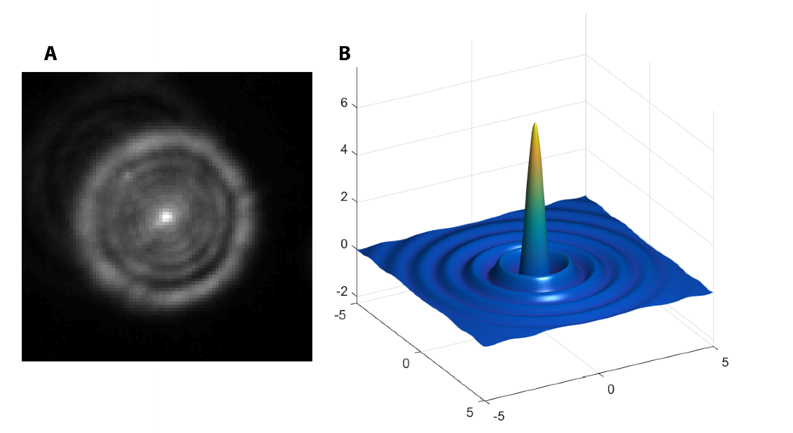
Figure 1.1: The Airy disk function. The point spread function of a microscope is described by an Airy function that maps the spread of light from a point source. (A) A recorded Airy disk from a defocused fluorescent bead and (B) a computationally generated Airy model.
The inability to focus light from a point source back to a similar sized point has implications for the attainable resolution of a microscope. If two point sources are located at a distance of less than half the size of the PSF from one another, then the system is referred to as diffraction-limited and the points cannot be differentiated. Ernst Abbe first developed the following definition for the resolution of an optical system, expressed as:
 | $$d=\frac{λ}{2NA}=\frac{λ}{2n sinθ}$$ | (1.1)
where λ is the wavelength of the imaging light, and $n sin$ is the numerical aperture (NA) of the objective lens. The numerical aperture is a function of the collection angle of the lens, θ, describing how much of the light from a sample can be gathered by the microscope and is roughly equivalent to 1-1.5 for high-end glass lenses. This is defined as the Abbe limit; alternate treaties on the definition of resolution were also given by Lord Rayleigh and Sparrow but are subtle variants of one another, offering different criteria of when two objects become differentiable by changing the denominator scaling factor (Lauterbach, 2012). The equation above implies that when imaging structures with visible wavelengths of light (400 - 700 nm) the smallest distinguishable structures must be at least 200 nm apart. Thus, there are two methods of increasing the resolution of a microscope: 1) decrease the wavelength of light, and 2) increase the numerical aperture of the lens. Lowering the wavelength of light to below 400 nm runs into the issue that these wavelengths become highly damaging to biological systems, and is therefore impractical. Furthermore, the dimensions of a glass objective lens limit the NA to 1.5, although gallium phosphide solid immersion lenses have been able to achieve a numerical aperture of 2.0 (Wu et al., 1999).
The observable image resulting from capture with a microscope is a convolution of the sample with the PSF of the microscope. The Fourier transform of the PSF gives the optical transfer function, a description of the spatial frequencies that the microscope passes. The PSF is acting as a low-pass filter, removing the high spatial frequencies from the image and ultimately limiting the achievable resolution.

1.2 Fluorescence and Fluorescence Microscopy
1.2.1 Discovery of fluorescence
The term “Fluorescence” originates from the initial investigations into the emission of fluorspar (fluorite) after it has been exposed to a light source. Fluorescence was then used more generally as the emission of light from a source that has been excited by absorbed light. A fluorophore in this case is one single unit capable of undergoing fluorescence. Fluorescence occurs when an electron in the highest occupied molecular orbital (HOMO) is excited by a photon and jumps to the lowest unoccupied molecular orbital (LUMO), the electron then drops back down to the HOMO state, emitting a photon. The fluorophore transitions from the ground state (S₀) to the excited state (S₁) where the energy difference is equivalent to that of the absorbed photon. The distinct energy states (in addition to the vibronic sub-states) and the transition energies between them result in the characteristic absorption and fluorescence emission spectra of a particular molecule. If the molecule has been excited to a higher energy state than S₁, i.e. S₂, then there is internal conversion to the S₁ state, on timescales faster than fluorescence emission. Due to this rapid internal conversion, emission predominantly occurs from S₁ (known as Kasha’s rule), consequently S₂→S₁ transitions produce only heat (Klán and Wirz, 2009). Once in S₁ the molecule can either emit a photon (fluorescence) or undergo intersystem crossing to the triplet state (T₁) where the spins of the ground-state and excited electrons are matched (up-up or down-down). Leaving the T₁ state can happen through one of two ways; either through a dark pathway, non-radiative relaxation; or a light pathway, phosphorescence (El-Sayed, 1968; Lewis and Kasha, 1944). This is encapsulated in the Jablonski diagram (Figure 1.2) that demonstrates the various transitions (Jabłoński, 1933).
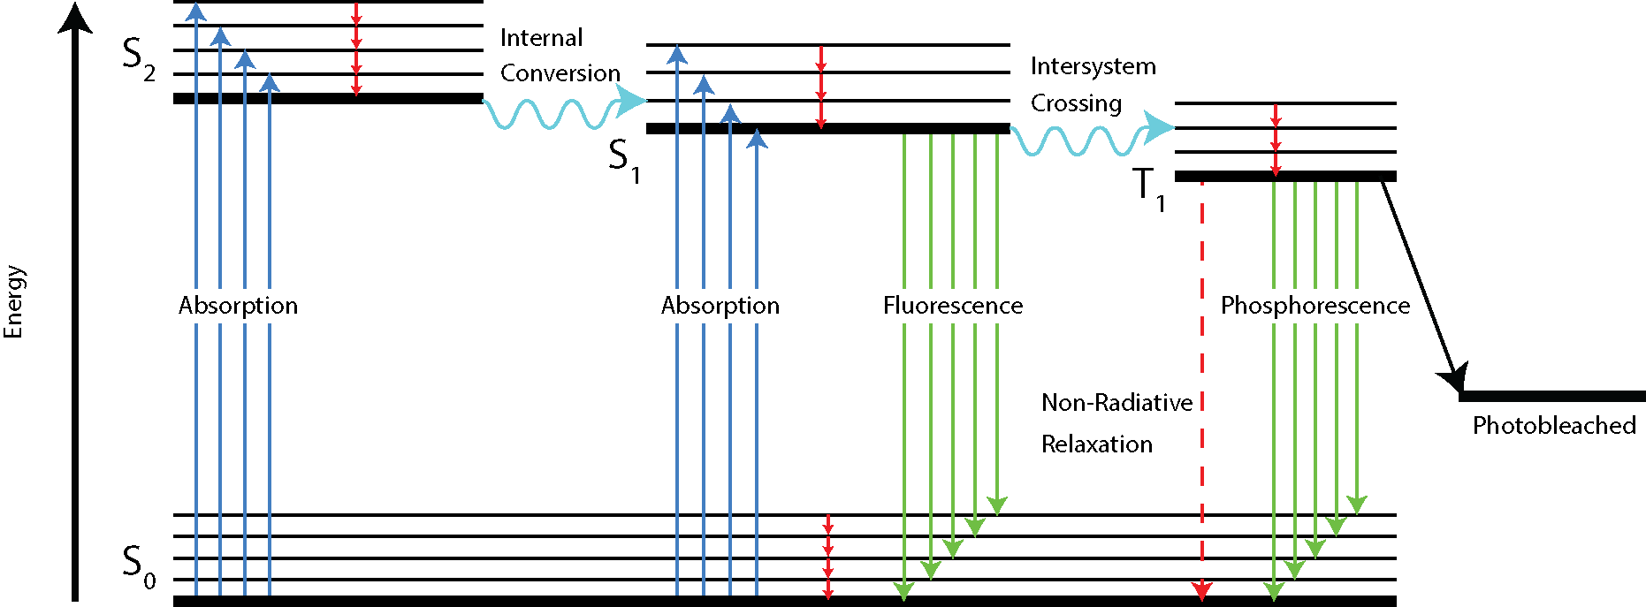
Figure 1.2: Jablonski diagram demonstrating the possible transitions of a fluorophore. Fluorophores can exist in many different states and there is an associated energy difference between them. Transitions between the different states are possible through absorption/emission of photons and changes in electronic and molecular structure.
Once in the triplet state, the fluorophore becomes exceptionally sensitive to molecular oxygen which itself exists in a triplet state (Borden et al., 2017). Oxygen is capable of covalently bonding to the fluorophore, neutralising it and leaving it in a permanently dark state. This process is known as photobleaching and causes the bulk fluorescent signal of a sample to decrease over time. Many buffering systems have been developed to lower the rate of photobleaching, such as by lowering the concentration of oxygen radicals, allowing for longer imaging periods (Aitken et al., 2008).
When a fluorophore transitions from S₀ to one of the several vibrational states of S₁ or S₂, it absorbs a photon of energy equivalent to the size of the band gap, depicted by the lengths of the blue arrows in Figure 1.2. The existence of vibrational energy sub-states causes a widening of the absorption spectrum. As the fluorophore goes through internal conversion and relaxation to the lowest vibrational state of S₁ it loses energy. Additionally, the transition from S₁ to S₀ can go to any of the vibrational states of the ground state. Both of these factors cause the emitted photon to be of a lower energy than the absorbed photon. This is known as the Stokes Shift and leads to the disparity between absorbance and emission spectra. The typical mirroring of the absorption and emission spectra is a result of the reflection between the molecule being excited from the lowest S₀ state to any S₁ vibrational state and emission occurring from lowest S₁ state to any S₀ vibrational state.
It was not until the discovery of a bioluminescent protein, known then as aequorin but later as the Green Fluorescent Protein (GFP), in the jellyfish Aequorea victoria (Shimomura et al., 1962) that fluorescence became widely applicable to the field of biological microscopy. Previously, fluorescence microscopy relied only on dyes, broadly targeted to subcellular compartments such as the nucleus or mitochondria, sometimes made more specific through the use of labelled antibodies (Coons and Kaplan, 1950; Russell et al., 1975). By expressing GFP freely in the cytoplasm or genetically fusing it to a target protein of interest it became possible for scientists to observe gene expression and localise a specific protein within the wider cellular structure (Chalfie et al., 1994). The development of spectrally different fluorescent proteins additionally allowed colocalisation of two or more proteins within a cell (Dunn and Kamocka, 2011).
Various properties arise from the different energetic states of a fluorophore. For instance, the quantum yield is the ratio of emitted to absorbed photons and is indicative of how bright a fluorophore will be (Würth et al., 2013). The extinction coefficient signifies how strongly a system absorbs and scatters light at a given wavelength and is described by the Beer-Lambert law. The triplet state can also house a long-lived dark variant of the fluorophore excited state that allows occupation of either ‘on’ or ‘off’ states on observable timescales, leading to blinking (Ha and Tinnefeld, 2012). The brightness of an individual blink is then how many photons it emits whilst occupying the on state, whilst also depending on the time spent in the S₁ state before decay. The duty cycle is the ratio of the amount of time that a fluorophore spends in the off vs on states. Photostability is how resistant the fluorophore is to becoming inactivated and many studies have focused on how to create more resilient fluorophores that can withstand intense imaging regimes (Zheng and Lavis, 2017).

1.3 Improvements to Microscopy
1.3.1 Electron microscopy
The limitations of the light microscope are due to diffraction and are fundamentally related to the wavelength of the light source used for imaging as shown in Equation 1.1. It is therefore logical to assume that by lowering the wavelength of light produced by the imaging source that the effects of diffraction can be minimised and finer structures could be resolved. However, this introduces a new problem in that sub-400 nm photons are highly phototoxic, damaging DNA through the dimerisation of thymine pairs to cyclobutane pyrimidine dimers (Nakajima et al., 2004). Ultraviolet light also contains enough energy to be absorbed by the cyclic tryptophan residues which are typically located in proximity to disulphide bonds, leading to the formation of a reactive disulphide species that ultimately leads to cleavage of the bond (Abaskharon and Gai, 2016; Neves‐Petersen et al., 2002).
Electrons have a much shorter wavelength, and the wavelength is easily tuneable by altering the energy of the electron. Consequently, Electron Microscopy (EM) has been developed as a high-resolution technique capable of studying the fine structure of biological systems. For instance, an electron that has the same energy as a photon of wavelength 621 nm (2 electron volts) has a wavelength of 0.87 nm.
Whilst the advantages in terms of pure resolution increase are strong, EM suffers from a number of shortcomings. Firstly, there is a lack of contrast when looking at heterogeneous structures. Secondly, EM bombards the sample with high-doses of high-energy electromagnetic radiation, which displaces electrons and progressively damages the sample. A further point is that the sample is held in a vacuum, which has been shown to affect ultrastructure (Jonge and Ross, 2011). The large amounts of radiation and exposure to vacuum prohibits live-cell imaging, and the limited molecular specificity of labelling reduces the effectiveness of EM as an imaging technique.

1.3.2 Deconvolution microscopy
If the structure of the PSF is known, it can be possible to enhance a microscope image through a process known as deconvolution (McNally et al., 1999). During image capture the light is convolved with the PSF of the microscope, leading to blurring in the final structure. By calculating the inverse PSF and convolving it with the captured image it is possible to reduce the impact of these distortions in the final image. However, the presence of noise in the image limits the effectiveness and can introduce artefacts. For instance, shot noise resulting from the fluorescence emission introduces variability not accounted for by the PSF. Other sources of noise also introduce inconstancies within the deconvolution process, and completing the sharpening process whilst limiting the effects of noise is important. Where confocal microscopy limits this blurring by restricting the source from which the light is observed, deconvolution algorithms subtract the blur or reassign it in the case of a three-dimensional (3D) image stack. This requires precise knowledge of the shape of the microscope’s PSF as deviations between the model and reality can lead to artefacts in the final image (Wallace et al., 2001).
1.3.3 Confocal microscopy
Confocal microscopy is a technique that increases the contrast and spatial resolution of an optical microscope (Minsky, 1961). A pinhole is introduced at a confocal plane within the optical system to remove a proportion of the out of focus light originating from excited fluorophores above and below the imaging plane (see Figure 1.3). Removing the out of focus light sharpens the image, reduces blurring caused by structures not from the focal plane and increases the contrast from the plane of interest within the sample. The resolution of the final image can be increased by using pinholes smaller than an Airy disk (Luca et al., 2013), however this dramatically reduces the signal that passes through the pinhole and is quite limited in practice when studying fluorescently labelled biological structures.
The pinhole also restricts the observable structures in the lateral dimension and so a laser point source is used as the illumination. By raster scanning the illumination across the sample, an image can be reconstructed of the focal plane. This process is easily adaptable to 3D by altering the focal position of the microscope and scanning again. Repeating this process multiple times allows a volume to be constructed from the data. As imaging of 3D volumes involves multiple excitations of the same area to obtain the required number of sections, photo-bleaching can be problematic when analysing the resultant reconstruction.
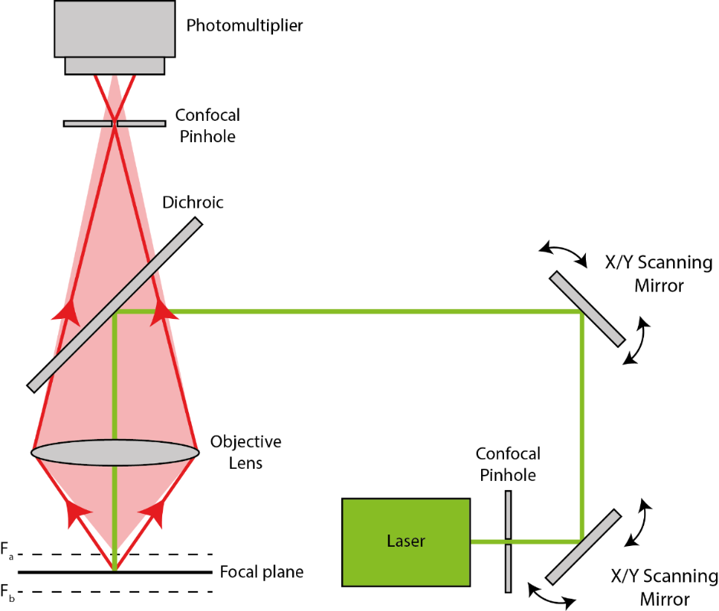
Figure 1.3: Schematic of a confocal microscope. The two pinholes restrict the illumination and detection volume, limiting out of-focus light from the F_{a} and F_{b} focal planes from accessing the sensor and thus increasing the contrast.
1.3.4 Total internal reflection fluorescence microscopy
In widefield microscopy, where the light source is directly transmitted through the sample, a large amount of the signal collected by the microscope is a result of excited fluorophores above and below the focal plane. This out-of-focus fluorescence decreases the signal-to-noise ratio (SNR) of the focal plane as 3D information is compressed down to two dimensions (2D) with an additional decrease in sharpness as distance from the plane increases. Total Internal Reflection Fluorescence, TIRF, microscopy increases the SNR by restricting the excitation to a small volume of sample that is in contact with the coverslip (see Figure 1.4).
In TIRF imaging, the laser is offset from the centre of the objective causing the laser to strike the coverslip at such an angle that leads to reflection (Stout and Axelrod, 1989). As the laser becomes increasingly offset from the centre, the beam meets the coverslip at greater angles until the critical angle (which is defined as the ratio of the refractive indexes between two media) is achieved and the laser passes parallel to the coverslip surface. At even more extreme angles the laser achieves total internal reflection, with the beam not even entering the coverslip but passing back in the direction of origin. At angles that are greater than or equal to the critical angle, photons propagate along the interface for a certain distance, creating an evanescent field into the medium. This evanescent field decays exponentially with distance from the source and selectively excites fluorophores in proximity to the interface, typically within 100 nm. A secondary form of TIRF involves placing a prism on the opposite side of the coverslip to the objective lens, and using the interface it provides to create an evanescent field (Axelrod, 1981). This is not often used however, as it is more difficult to achieve.
As TIRF excites the volume directly in contact with the coverslip it has been preferentially employed to investigate features on the exterior of cells, such as focal adhesions (Partridge and Marcantonio, 2006) and receptor interactions (Piehler, 2005).
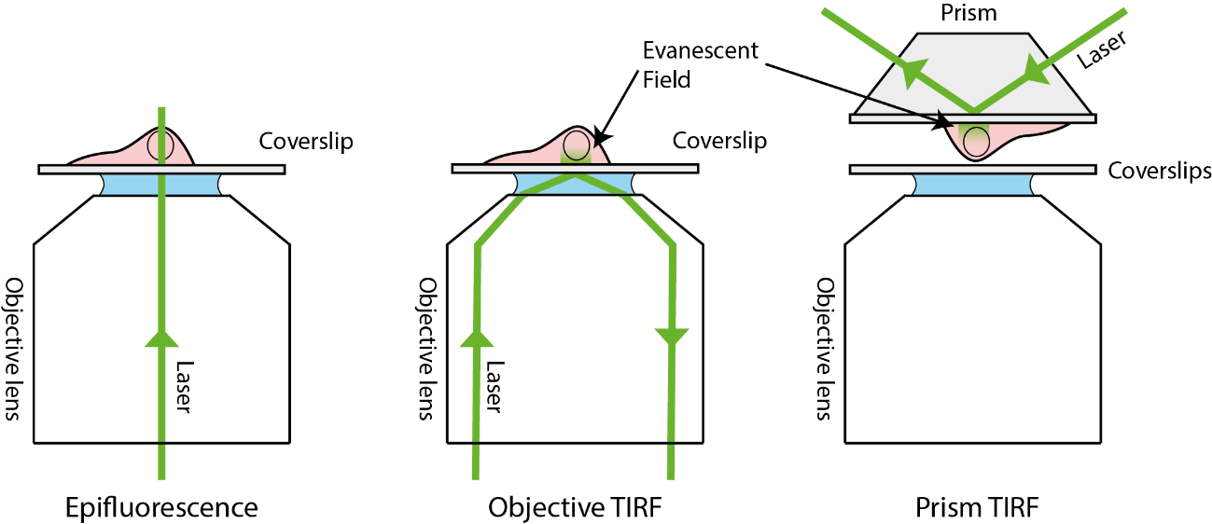
Figure 1.4: Total internal reflection fluorescence microscopy. In epifluorescence imaging the laser passes straight through the sample illuminating the entire volume. In objective TIRF the laser is reflected off the back of the coverslip creating an evanescent field that restricts the illumination volume. In prism TIRF the sample is between two coverslips and a laser reflected of the base of a prism on the top coverslip.

1.4 Super Resolution Microscopy
1.4.1 Imaging beyond the diffraction limit
Until recently the resolution achievable by optical microscopy has been limited by the diffraction barrier. As mentioned in the previous section there exists methods of improving the resolution through increasing the contrast, such as confocal microscopy, which removes out of focus light originating from above and below the focal plane through the use of a pinhole, and TIRF, which limits the volume that can be excited to close to the coverslip. Software approaches to increase contrast include deconvolution, which applies algorithms to lower the distortions introduced as the light is collected by the microscope. Although these methods do not approach the achievable resolution of EM, they do have the advantage of imaging samples in more native-like environments.
If it were possible to subvert the diffraction limit as described by the Abbe criterion, one could imagine being able to image small structures on sub-diffraction length scales with the specificity afforded by fluorescence labelling. Samples could then be imaged with nanometre resolution at higher contrast, and in conditions that are more native-like when compared to EM. This is the rationale of super-resolution microscopy, which represents a suite of optical techniques that circumvent the diffraction barrier when imaging with visible light. The development of super-resolution microscopy allows imaging of biological systems with enhanced levels of resolution, providing new insights; this advance led to several of the developers of super-resolution methodologies sharing the 2014 Nobel Prize in Chemistry (Möckl et al., 2014).

1.4.2 Super-resolution optical fluctuation imaging
Super-resolution optical fluctuation imaging (SOFI) takes advantage of molecules that independently switch between two states, either on or off, or have sufficiently different emission intensities (Dertinger et al., 2009). Typically used on ultra-high density samples of blinking fluorophores, SOFI is capable of taking a stack of images containing fluctuating fluorophores and creating a super-resolved image. By investigating the pixel time-trace and the time periods between pixel intensities it is possible to extract the temporal correlation between independently fluctuating fluorophores. The final pixel value becomes the integral over the correlation function where a group of adjacent pixels containing a fluorophore will have a higher correlation than a group of pixels located on the edge of a fluorophore’s PSF. The pixel and its neighbours can then be split and the traces correlated to calculated higher order cumulants, leading to a super-resolved image. Ultimately there is no limit to the cumulant order and thus the achievable resolution, however in practice increasing orders can lead to loss of signal and are significantly affected by the blinking rate and signal intensity (Dertinger et al., 2013). Advantages include high contrast and background-free super-resolution images. Additionally, SOFI can be used in combination with single molecule techniques such as photoactivated localisation microscopy (see Section 1.4.6) to obtain a compromise between high spatial resolution and high temporal resolution (Deschout et al., 2016).

1.4.3 Scanning near-field optical microscopy
Diffraction occurs over distances that are greater than the wavelength of light, so if imaging can be performed at distances smaller than 400 nm, with an extremely small aperture, then a sub-diffraction image can be created. This is the principle of Scanning Near-Field Optical Microscopy (SNOM/NSOM) which applies an evanescent field as the imaging source (Pohl et al., 1984). To create the evanescent field, a sharp tip structure capable of carrying a laser source is coated with a series of metals to make the tip opaque and corrosion resistant. Next the apex of the tip is gently scraped to create an aperture < 20 nm in diameter (Lewis et al., 1984). Now when a laser is passed down the tip the aperture is illuminated, creating an evanescent field propagating away from the illumination source (see Figure 1.5). This field can then excite a small volume and an image is reconstructed through raster scanning the tip across the sample surface. Fluorescence emission from the sample is then captured by an objective lens opposing the tip that is coupled to a photomultiplier tube allowing accurate detection of the local fluorescence intensity. In practice this limits SNOM to 2D imaging, as the focus cannot be tuned to examine structures deeper within the sample. The instrument is analogous to an atomic force microscope (AFM), and may be thought of as an optical variant of the technique. Being optical in nature, SNOM has a greater contrast for fluorescently labelled structures than the similar atomic force microscopy (Binnig et al., 1986), although the resolution is lower.
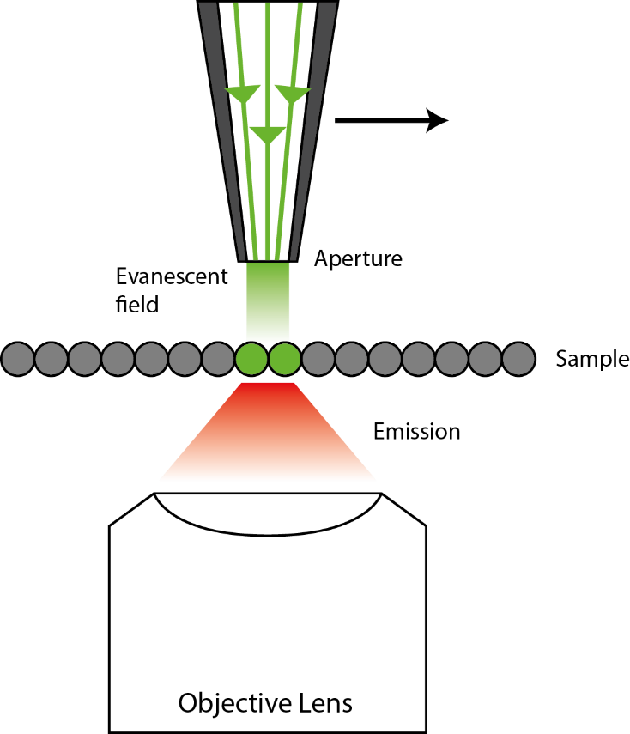
Figure 1.5: Principle behind near-field imaging. In SNOM the illumination volume is restricted to a sub-diffraction area, effecting a resolution increase. The tip can then be raster scanned across the surface to create a super-resolution image. The emission is collected by an objective lens positioned opposite to the tip, the lens is many orders of magnitude larger than the tip and does not need to be scanned in parallel.

1.4.4 Stimulated emission depletion microscopy
Decreasing the area that is fluorescing so it becomes smaller than the diffraction barrier and scanning across a sample can create a super-resolved image. This is the principle behind Stimulated Emission Depletion Microscopy (STED) (Hell and Wichmann, 1994). A focussed laser is used to excite a circular area of the sample and start the fluorophores emitting. A secondary red-shifted laser (referred to as the STED laser) with a toroidal profile is used to cause stimulated emission of the fluorophores closest to the edge of the excitation beam. Stimulated emission causes these fluorophores to relax back to the S₀ ground state with an emitted photon in the propagation direction of the incident STED beam, thus away from the collection optic. This effectively narrows the excitation volume below the diffraction limit and increases the resolution. The two beams are then raster scanned across the sample to build up an image in a manner similar to that of a confocal microscope (see Figure 1.6).
The effective resolution of the microscope becomes proportional to the intensity of the STED laser. Higher intensity lasers more completely deplete the area around centre of the excitation beam, shrinking the area that detected fluorescence can originate from. However, with higher intensity beams additional problems occur such as reduced signal from the area of interest, with photobleaching and phototoxicity also becoming limiting factors.
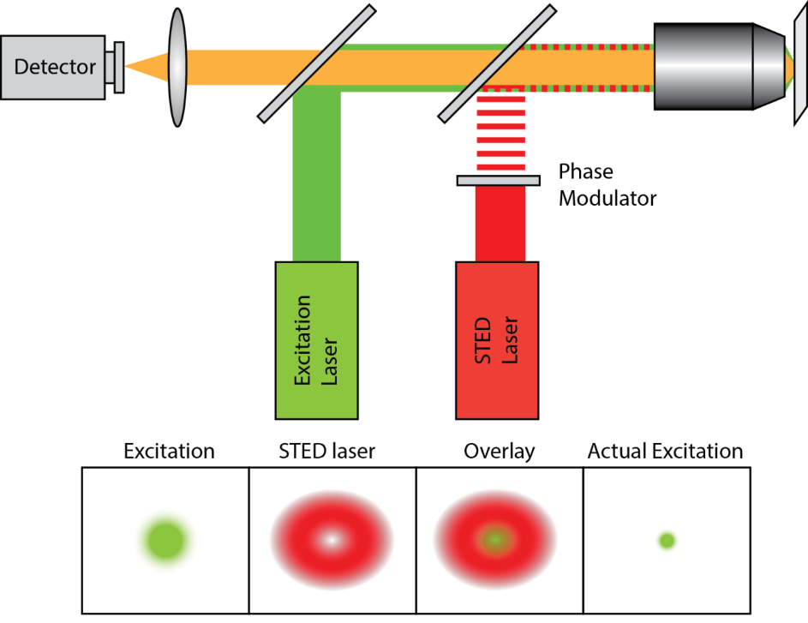
Figure 1.6: Decreasing the illumination area increases the resolution. Microscopy set-up of a STED system demonstrating the effective shrinkage of a diffraction limited excitation laser spot. The excitation laser and STED laser are pulsed so that the fluorophores in the area of interest are activated, and then rapidly depleted, respectively, to reduce the area of emitting fluorophores.
1.4.5 Structured illumination microscopy
Resolution gains can be made through manipulation of the illumination source in a technique known as Structured Illumination Microscopy (SIM). SIM achieves a resolution increase through the mixing of two signals to create a third, with one of the original functions being the illumination pattern (Gustafsson, 2000). When two patterns are overlaid they can produce an effect known as moiré fringes where a third pattern occurs as a convolution of the original two (see Figure 1.7). Moiré fringes occur at a lower frequency than the original two patterns; shifting information from outside the frequency range of the microscope into view. In SIM, a pattern (typically a sinusoidal series of lines) is projected onto the sample to increase the accessible information and increase the resolution by a factor of two. As only fluorophores that are located within the illuminated sections of the pattern are observed, the pattern must be phase-shifted multiple times to capture information from the dark sections. To completely sample the image, five separate phases are captured. The strength of this effect is dependent on the angular offset of the two patterns. This is especially apparent when one of the patterns is radial in nature (see Figure 1.7C) and the pattern propagates parallel to the projection direction. Thus, it is necessary to take a series of images, rotating the projected pattern to capture three separate angles and rotationally sample the specimen. The final image, with a higher resolution can then be constructed by fitting the higher-resolution components in Fourier space before performing an inverse Fourier transform to convert the data back into Euclidean space.

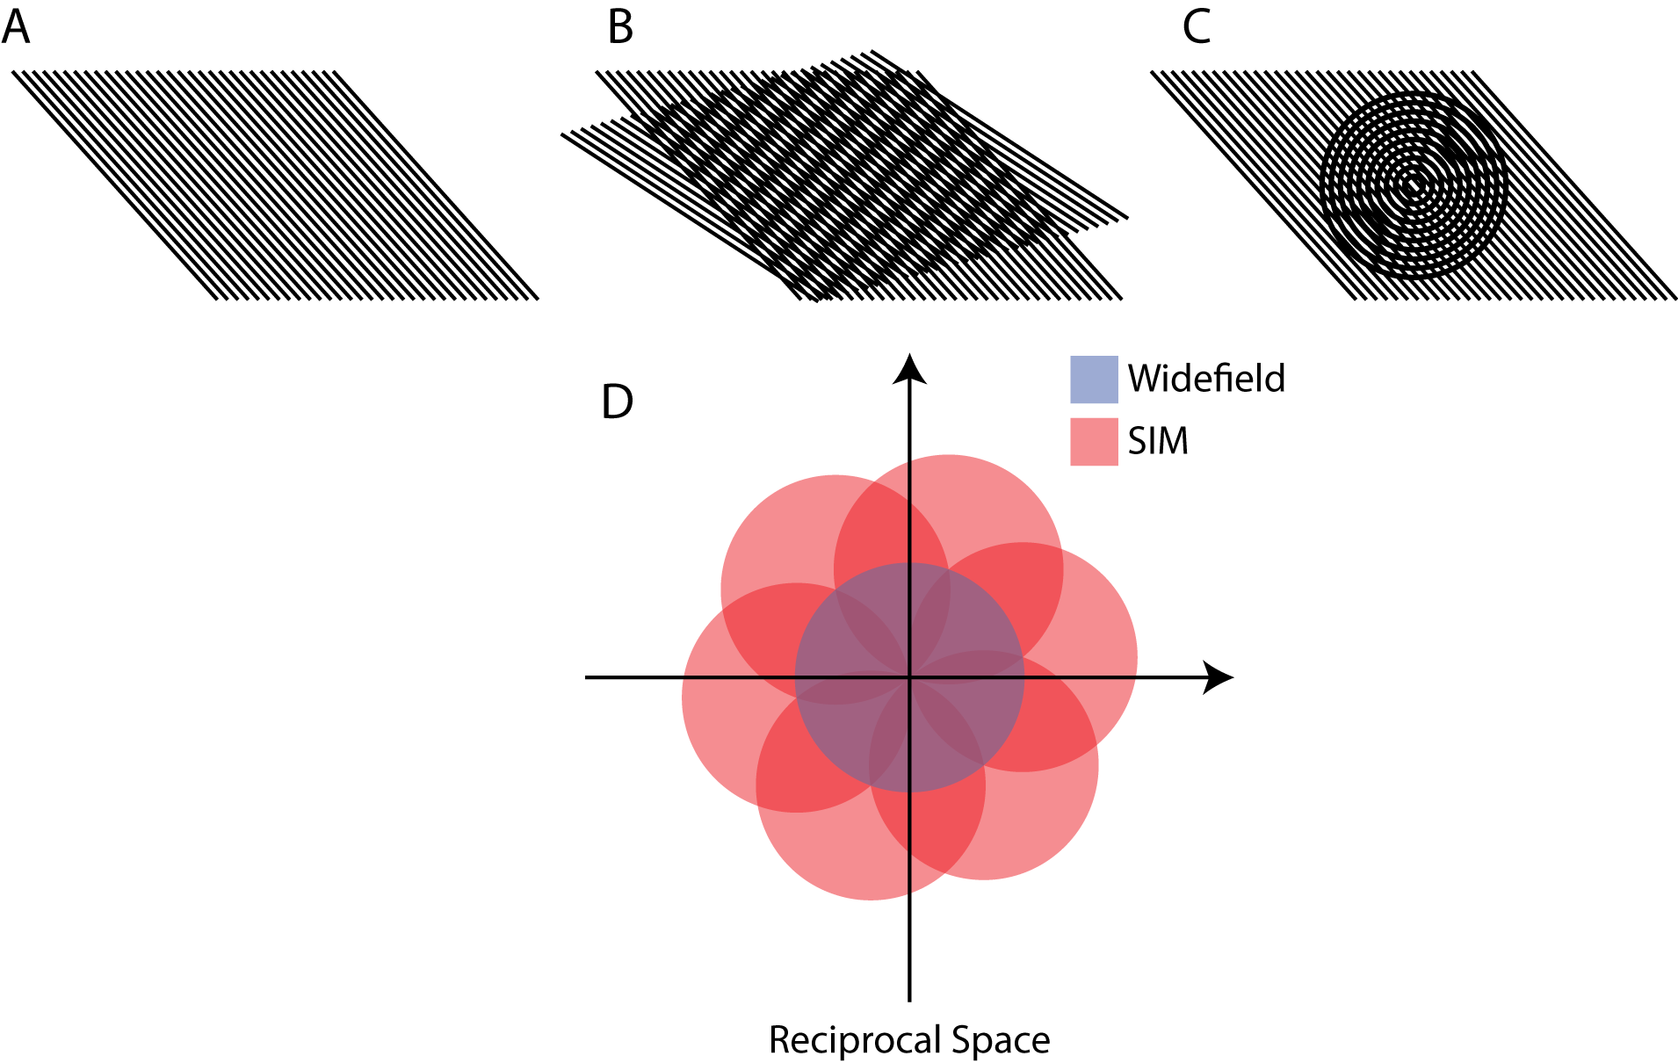
Figure 1.7: Examples of moiré fringes that are used in SIM to increase the resolution. In SIM, a pattern (A) is projected onto an unknown pattern (B and C) creating a moiré fringe pattern. SIM uses Fourier mixing to increase the accessible resolution as demonstrated in reciprocal space. This is demonstrated by the orange circles in (D) where each circle’s orientation is a result of the illumination pattern propagation direction. The structured illumination effectively doubles the diameter of the accessible area in Fourier space resulting in a doubling of the resolution.
As SIM requires a high level of computation to reconstruct the high-resolution image various, the technique can be vulnerable to artefacts and users must be wary of misinterpreting the data (Demmerle et al., 2017). To make SIM more approachable to general users; Ball et al., (2015) developed a comprehensive suite of tools for analysing the quality of the raw data and reconstructions with 2D and 3D SIM. Extending SIM to 3D is non-trivial but has been achieved (Gustafsson et al., 2008), allowing the rapid acquisition of 3D super-resolution images. Further increases to the resolving power can be made by driving the system at high intensities so that the fluorophores emit nonlinearly in response to the illumination intensity, allowing higher spatial frequencies to be accessed (Gustafsson, 2005).

1.4.6 Localisation microscopy
The final and most common breed of super-resolution microscopy techniques is that of Localisation Microscopy (LM). There are several different variants of this technique such as Stochastic Optical Reconstruction Microscopy (STORM) (Rust et al., 2006), Photoactivated Localisation Microscopy (PALM) (Betzig et al., 2006), Fluorescence Photoactivated Localisation Microscopy (fPALM) (Hess et al., 2006) and Points Accumulation for Imaging in Nanoscale Topography (PAINT) (Sharonov and Hochstrasser, 2006). However, they all make use of the same principle; lowering the number of actively emitting molecules in a single frame to the point that the subset can be individually localised. Every fluorophore in the field of view can be localised by repeatedly switching subsets of the ‘on’ and ‘off’ molecules whilst retaining the low emissive density, this typically requires many thousands of frames (see Figure 1.8).
It is possible to locate a single molecule by fitting the observed PSF to an approximation of the PSF, typically taken to be a Gaussian function. The Gaussian profile is chosen for its similarity to a microscope PSF and its computational ease, as this process has to be performed thousands of times to build up a coordinate map (Deschout et al., 2014). By stochastically switching the subset of molecules that are in the emissive state with those that are in the dark state, whilst minimising the number of molecules emitting at any one time, it is possible to image each emitter whilst it is isolated from all others. This switching of fluorophores is attained using specific buffers and high laser powers to drive the fluorophores into either the triplet state, or into a charged reduced state that stops the molecules from fluorescing. Once many frames have been collected, the data can be processed and each single molecule fitted. In this way, an image can be reconstructed in a pointillistic manner.
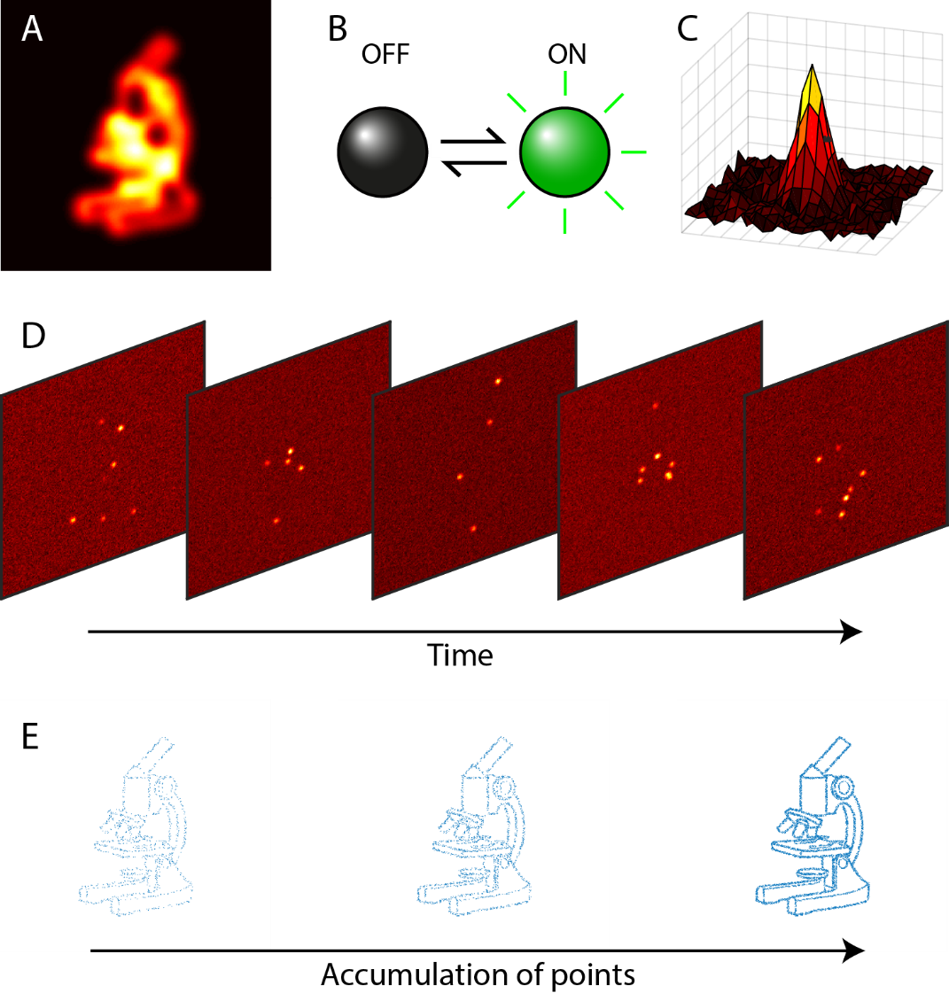
Figure 1.8: Super-resolution by localisation microscopy. (A) Diffraction limited image. (B) Switching of fluorophores between an emissive and dark state. (C) Single molecule point-spread function. (D) Stochastic switching of populations. (E) Different stages throughout the reconstruction process demonstrating the benefits of accumulating additional locations that is the result of collecting more frames.
LM can also be extended to capture axial information. This is typically achieved by placing a cylindrical (astigmatic) lens in the light path between the objective and camera (Huang et al., 2008). The cylindrical lens has the effect of distorting the PSF of the microscope laterally in two directions that are perpendicular to each other. With prior calibration through mapping the known axial location of a marker to the ratio of these two aberrations it is possible to do the reverse and look-up a z position from the distortions, typically giving an axial range of +500 nm to -500 nm. Alternative methods of obtaining axial information pertaining to emitters include double-helix fitting (Pavani et al., 2009) and biplane imaging (Juette et al., 2008). In double-helix imaging the point-spread function is distorted by a quarter phase plate such that the PSF becomes two spots laterally that rotate around each other axially, forming a double helix structure. In biplane imaging the light is split by a 50:50 beamsplitter positioned in front of a camera. Both beams are then focused on to the camera in such a manner that one has a longer path-length than the other, and thus the two images originate from different sample planes. Whilst the double-helix and biplane methods allow a greater axial depth, the approaches are more complicated than cylindrical astigmatism and therefore less common.
Additionally, LM can be extended to multicolour imaging. Two different fluorescent species will have different emission spectra, and if these are suitably different they can be separated with a carefully positioned dichroic filter (Shroff et al., 2007). The two fluorophore species can then be separated and focused onto different sections of the sensor. This process has been further extended to differentiate five separate fluorophore species through colour unmixing (Testa et al., 2010). Once a calibration has been performed with several beads, the two images can be registered on top of each other using an affine transformation with high precision. Further methodologies have involved passing the light through a prism or diffraction grating to create a spectrum for each photoswitchable event (henceforth simply remarked as event) that can be used to classify the fluorophore, without the requirement for multiple filters and image registration steps (Bongiovanni et al., 2016; Mlodzianoski et al., 2016; Zhang et al., 2015).
As a single imaging experiment typically takes a timescale of minutes, large amounts of drift can be incurred over the course of data capture. Drifts are typically caused by thermal perturbations and air currents in the room which can be limited by enclosing and thermally isolating the microscope (Betzig et al., 2006). This precaution rarely removes all drift and so methods are required that return localisations from later in the experiment to the original coordinate system. Of the two common methods used, the first is the most accurate and involves the use of fiducial markers, sub-diffraction constant emitters, that can be used to build a trajectory of the drift which can consequently be reverted (Lee et al., 2012; Metcalf et al., 2013). Alternatively, the localisations can be grouped in a time dependent fashion into bins; by calculating the cross-correlation between the bins a drift vector can be approximated for each step (Mlodzianoski et al., 2011).
Work has also focussed on decreasing the long acquisition time of LM datasets so that dynamic processes might be observed. This typically involves increasing the density of active fluorophores within each frame and taking this into account during the fitting process. DAOSTORM (Holden et al., 2011) for example, classifies possible overlapping events and then tries to model each as two separate events that would match the observations. Other algorithms have taken this much further, with the 3B software package performing Bayesian modelling of ultra-high dense data to create a model of the underlying fluorophore structure that most likely represents the data (Cox et al., 2012).

1.4.7 Localisation microscopy and resolution
The pointillistic nature of localisation microscopy makes reporting the image resolution difficult. In the early years of localisation imaging the resolution was often reported as the mean uncertainty of the localisations. Due to the inherent shot noise resulting from the photon arrival times and locations, in addition to the discrete pixels and background noise, the localisation has an associated error. This was first formalised for unweighted least squares fitting (Thompson et al., 2002) and expanded on by Mortensen et al., (2010) to show that maximum likelihood fitting is optimally close to the Cremer-Rao lower bounds, the highest performance of a fitting algorithm based on data.
Further hindrances of a definition of resolution come from the ideas of sampling and Nyquist-Shannon Theorem (Shannon, 1949). To have a defined structure at a resolution of x nm the structure must be sampled to the point where there is a molecule every $\frac{x}{2}$ nm along that structure (Shroff et al., 2008). Due to the stochastic nature of LM each molecule is randomly switched rather than being processively imaged, leading to a non-unity probability that each molecule will be imaged over the course of the experiment. The stochastic blinking, combined with the possibility of not fully labelling a structure, leads to a sampling-orientated idea of resolution. Nieuwenhuizen et al., (2013) proposed a solution to the resolution problem by suggesting the reported resolution should be the point where the Fourier Ring Correlation (FRC) falls to 1/7th of its original intensity. As this is an image-wide metric based upon frequencies, it takes into account the Nyquist-Shannon sampling theorem in its value. Whilst this definition is helpful for quantifying labelling density, the FRC becomes less relevant when attempting to quantify non-extended pointillistic structures. An example of this can be seen when the underlying structure is known but sparsely labelled, but the labelling density is sufficient to fit the structure to points (Weisenburger et al., 2017). A further example would be colocalization studies between two low copy number populations where the distance between the two sets (and the accuracy of the measurement) is more important that the density of labels.
Thus, the definitive definition of resolution for LM is hardly a solved problem despite the technique being over ten years old. There are several different ways of quantifying the measurements of an LM experiment and the method chosen depends upon the measurements being performed. For instance, pointillistic-based measurements depend more on the localisation accuracy and structural based measurements depend more on the labelling density.

1.4.8 Analysis of localisation microscopy data
As the results of STORM analysis are point coordinates the traditional methods of analysis are either no longer applicable or non-optimal. For instance, clustering can be indicative of a protein’s function and so several approaches have looked at identification of clustering by Voronoi tessellation (Andronov et al., 2016; Levet et al., 2015). Additionally, care must be taken in analysing STORM reconstructions due to the various aberrations that can occur. For instance, two molecules that are in a sub-diffraction area and emit at the same time will be localised to the midpoint between their actual locations. Extrapolating this to a pair of clusters this will lead to a false connecting structure between the two clusters (Rees et al., 2013). Furthermore, sample preparation is an integral part of producing accurate and representative data as issues such as low labelling density can hinder analysis (Whelan and Bell, 2015).

1.4.9 Fluorescent probes used in super-resolution microscopy
Vital to the underlying quality of the final super-resolution image is the fluorophore species used and the properties that it holds. Organic dyes are common in imaging experiments as their large photon outputs and photostabilities make them reliable and yield large amounts of signal (Vaughan et al., 2013). However, targeting the probes to the correct location can encounter problems such as lack of specificity, leading to low labelling density or mislabelling of other structures. Protein fluorophores that are genetically fused to a target of interest have a much higher specificity of labelling, however they suffer from lower photon outputs than organic dyes and can be rapidly bleached.
The specific type of imaging intended has dramatic implications on the type of dye required for imaging. Localisation microscopy requires that the fluorophores are capable of being placed in a long-lived dark state that can switch to a relatively short bright-state. This in contrast to STED and SIM and that require fluorophores to maintain stable emission as depleting molecules from the bright state reduces image quality. Thus, there is no ideal fluorophore and a toolbox of fluorophores must be collated for use in different scenarios.
There is a high demand for fluorophores capable of emission towards the red end of the emission spectrum due to a typical reduced autofluorescence and increased penetration depth for imaging tissue samples (Fu et al., 2008). Red fluorophores typically suffer from lower quantum yields however, reducing their photon outputs. Exploring new species of fluorophore for probes with desirable characteristics is important for maximising the effectiveness of super-resolution techniques. Presently proteins of the photosynthetic apparatus have not been investigated as potential super-resolution probes despite covering the entire visible spectrum with excitation/emission profiles and having evolved for harvesting light.

1.5 Photosynthesis
Microscopy has played an important role in studying photosynthesis, with electron microscopy providing high resolution information about the organisation of photosynthetic membranes and fluorescence microscopy providing locational information of specific components. Conventional fluorescence microscopy is diffraction-limited, as discussed in the previous sections; however novel super-resolution techniques could bridge the gap between specificity and resolution, providing information not attainable with EM or conventional fluorescence microscopy.

1.5.1 Introduction to photosynthesis
Throughout the development of life on Earth over the last four billion years, one process for acquiring energy has dominated all others: photosynthesis. This process involves the absorption of light, originating primarily from the sun, and converting it into a chemical form that can be used as an on-demand energy source. There are two forms of photosynthesis: oxygenic performed by cyanobacteria and plants, and anoxygenic performed by purple bacteria. Dioxygen is formed as a by-product of oxygenic photosynthesis which, approximately two billion years ago, led to the oxygenation of the atmosphere (see Equation 1.2). With the introduction of an oxic environment, a greater number of high energy molecules such as sugars and carbohydrates could be created and used as energy sources, increasing the diversity of life.
 | $$2H_{2}O+CO_{2}\underset{→}{light}\left(CH_{2}O\right)+O_{2}+H_{2}O$$ | (1.2)
Photons have an implicit energy associated with them that can be captured by molecular arrangements of suitably absorbing chromophores. The most common of these molecules in light harvesting are chlorophyll (plants and cyanobacteria) and bacteriochlorophyll (purple bacteria), cyclic tetrapyrroles with a chelated bivalent magnesium ion coordinated by the four pyrrole rings, see Figure 1.9 (Chen et al., 2014). Extending away from the tetrapyrrole is a phytyl tail involved with anchoring the molecule inside the host protein. There are several different variants of the basic chlorophyll molecule with varying side-chains, although chlorophyll a is by far the most common (Björn et al., 2009). Chlorophyll a has two main absorption peaks at 450 nm and 665 nm whereas bacteriochlorophyll absorbs at 360 nm and 770 nm. In photosynthesis only a small proportion of the chlorophylls are actively involved in the light dependent reactions, the rest, known as accessory chlorophylls, act as a funnel, leading the exciton of light towards the special pair of chlorophylls in the reaction centre (Webber and Lubitz, 2001).
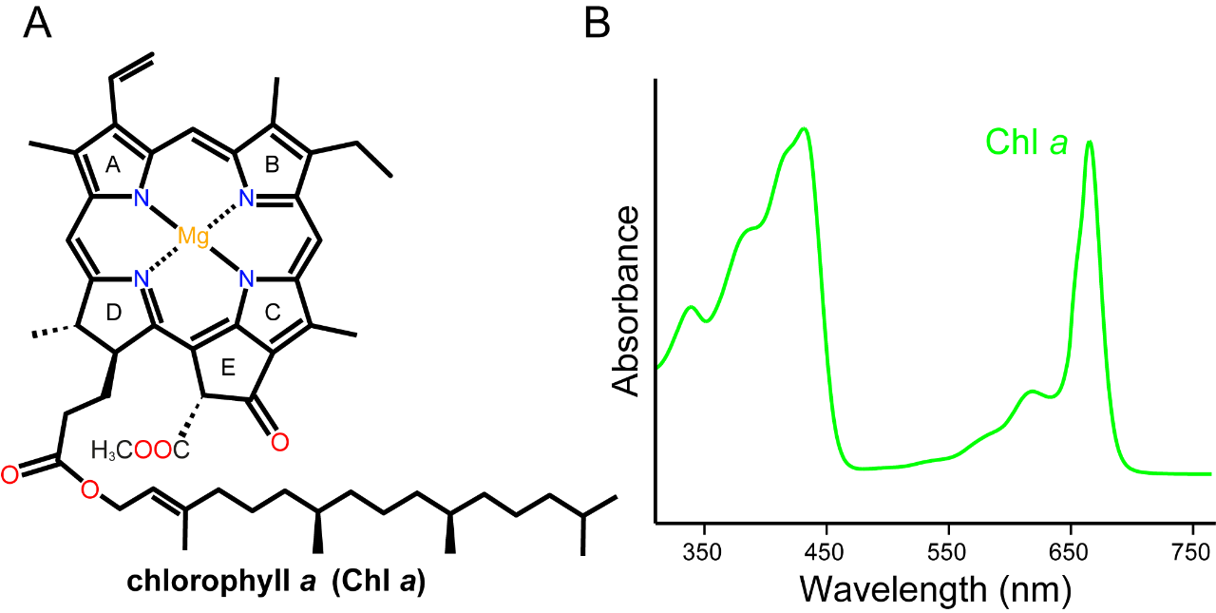
Figure 1.9: The light harvesting pigment chlorophyll. (A) Molecular structure of Chlorophyll a and (B) its absorption spectrum showing to major peaks in the blue and red regions.

1.5.2 Photosynthesis in cyanobacteria
Photosynthesis in cyanobacteria is restricted to the thylakoid membranes that are localised proximally to the cell membrane. In the model organism Synechocystis sp. PCC 6803 (henceforth known as Synechocystis), the thylakoid membrane runs parallel to the cell membrane in loops, converging on anchor points at the inner cell membrane known as thylakoid centres (Hinterstoisser et al., 1993). In Synechocystis, photonic energy is trapped by the integral membrane protein photosystem II (PSII) which is used to split water into oxygen and hydrogen at the oxygen evolving complex (Nelson and Yocum, 2006). This splitting liberates an electron which is used to reduced plastoquinone (PQ) to plastoquinol (PQH₂) which is part of an extra step for creating a larger proton gradient known as the Q-cycle. Plastoquinol passes the electron to cytochrome b₆f which acts as an intermediary to the shuttle protein plastocyanin. Plastocyanin transfers the electron to photosystem I (PSI) which absorbs an additional photon to excite the electron to a higher energy state that is capable of reducing NADP⁺ to NADPH, taking place at ferrodoxin-NADP⁺-oxidoreductase that is docked to PSI. This process serves to create a proton gradient between the two sides of the membrane by depleting H⁺ ions on the cytoplasmic side increasing the density in the thylakoid lumen. The gradient can then be used to store energy in a chemical form by converting ADP to ATP via ATP synthase, an enzyme acting as a turnstile between the two sides of the membrane (see Figure 1.10).
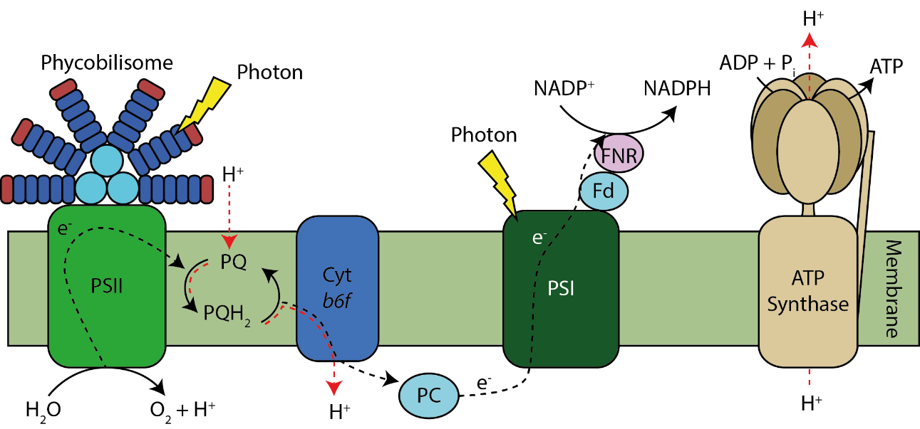
Figure 1.10: Reaction scheme of photosynthesis in cyanobacteria. Photosynthetic reactions occurring in the thylakoid membrane. The labels are as follows. PSII: Photosystem II; PQ: Plastoquinone; PQH₂: Plastoquinol; Cyt b₆f: Cytochrome b₆f; PC: Plastocyanin; PSI: Photosystem I; Fd: Ferrodoxin; FNR: Ferrodoxin-NADP⁺ reductase.
The phycobilisome is an extramembranous light harvesting complex that extends the spectral absorption into the green wavelengths untouched by chlorophyll (see Figure 1.11). This complex is anchored to Photosystem II and consists of a range of phycobiliproteins, proteins that bind chromophores known as bilins. The phycobilisome consists of a core of 3-6 allophycocyanin cylinders with rods of phycocyanin extending outwards (Glazer, 1989). Under certain growth conditions these rods can be tipped with a further phycobiliprotein, phycoerythrin, which absorbs higher energy light. The phycobilisome acts as an energy funnel channelling high energy light to lower wavelengths at photosystem II via Förster resonance energy transfer (FRET).
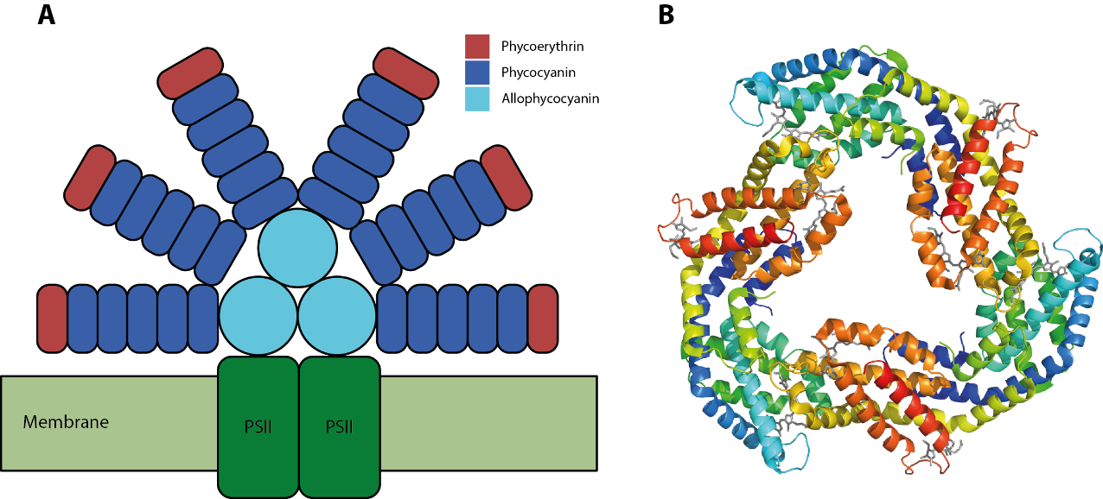
Figure 1.11: The phycobilisome megacomplex attached to PSII. (A) The phycobilisome is a large protein complex that absorbs light in the green range of the spectral and funnels energy down towards the reaction centres of photosystem II and photosystem I. (B) Also shown is a hexameric ring of phycocyanin that stacks to form the protruding rods.
Phycobilins are formed through linearisation of a haem molecule by haem oxygenase to form biliverdin IXα, the precursor of the bilins. Further processing is achieved by several ferredoxin-dependent bilin reductases to produce either PCB, PEB (Frankenberg et al., 2001). Bilins are attached to their respective holo-protein via a thioesterification reaction to a cysteine residues, typically at positions 84 and 155, by bilin ligase pairs such as CpcE/CpcF (Zhou et al., 1992) and can, in some cases, perform isomerisation reactions in parallel such as the PCB to phycoviolobilin (PVB) attachment by PecE/PecF (Zhao et al., 2000).

1.5.3 Purple bacteria: organisms that carry out a non-oxic form of photosynthesis
The purple bacteria perform anoxygenic photosynthesis and, instead of water, use alternate electron donors such as sulphur or hydrogen. The primary photon-absorbing pigment is bacteriochlorophyll which, when incorporated within light harvesting complexes, absorbs light in the near infrared section of the spectrum between 800 and 900 nm. Carotenoids act as auxiliary light absorbing pigments, in the 400-550 nm region of the spectrum.
Rather than the large thylakoid membranes found in cyanobacteria and plants, the interior of purple bacteria such as Rhodobacter contains hundreds of chromatophores, 50 nm diameter vesicles containing all the required proteins for converting solar energy to ATP (Figure 1.12; Cartron et al., 2014). Each reaction centre (RC), where charge separation takes place, is surrounded by an LHI antenna ring, which passes excitation energy directly to the RC. Many LH2 surround RC-LHI complexes, collecting photonic energy and directing it towards the RC via LHI (Sener et al., 2016).
Figure 1.12: Atomic structural model of an intracytoplasmic membrane vesicle from Rhodobacter sphaeroides. The vesicle comprises 67 LH2 complexes (green), 11 LH1-RC-PufX dimers and 2 RC-LH1-PufX monomers (blue/red), 4 cyt bc₁ dimers (magenta), and 2 ATP synthases (orange). Used with permission from Cartron et al., (2014), Biochimica et Biophysica Acta.

1.5.4 Multicellular photosynthesis in plants
Eukaryotic plant cells harbour specialised organelles for compartmentalising photosynthesis known as chloroplasts. Similar to mitochondria, chloroplasts have their own DNA encoding many, but not all, of the proteins involved in photosynthesis (Daniell et al., 2016). Chloroplasts are thought to have evolved from cyanobacteria through endosymbiosis, whereby a cyanobacterial cell was engulfed by a secondary cell and the two proceeded to coevolve (McFadden, 2001). Hence the photosynthetic reaction scheme is very similar to that of cyanobacteria and is shown in Figure 1.13, with the major difference being the lack of phycobilisomes. Structurally, the chloroplast consists of stacks of roughly circular membrane disks, known as grana which are interconnected with membrane bridges known as stromal lamellae (Staehelin, 2003). This structure, known as the thylakoid membrane, is encapsulated in a double phospholipid membrane giving an ellipsoidal chloroplast structure typically 3-5 µm in width.
Photosynthesis in green plants is divided into the light and dark reactions. The light reactions are driven by two main photosynthetic proteins, photosystem I (PSI) and photosystem II (PSII), that are localised to the stromal lamellae and grana respectively. Interactions between PSII proteins of different sides of the grana lumen, controlled by phosphorylation states, aids the stacking of the sheets (Fristedt et al., 2010). PSI, a ferredoxin-NADP⁺ reductase, is localised to the stromal lamellae and it supplies the electron used for formation of NADPH. Proton transport by PSII from the stroma into the thylakoid lumen as a result of the light reactions builds up a gradient which is utilised by ATP synthase in the creating of ATP. ATP synthase, too large to fit in the stacked grana, is localised to exposed areas of the thylakoid membrane (Andersson and Anderson, 1980).
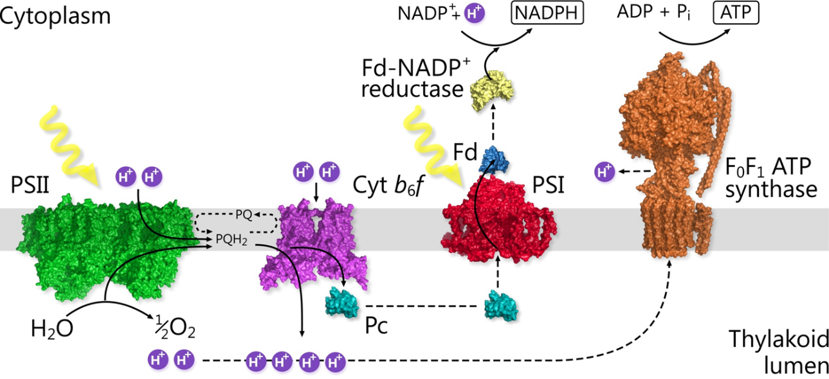
Figure 1.13: A schematic representation of the light-induced electron chain from water oxidation to the reduction of NADP⁺ in purplebacteria. Energy harvested by LHCII complexes (not shown) migrates to the PSII complex (green). Electrons and protons (as PQH₂) are transferred from PSII to the cytochrome b₆f complex (magenta), which generates a proton gradient and passes electrons to PSI (red) using the electron-carrier molecule plastocyanin (cyan). At PSI, absorbed photons result in the excitation of the primary electron donor, the dimeric chlorophyll P700, which is then reduced by plastocyanin. The electron from P700 is rapidly transferred step-wise through a series of acceptors to iron-sulphur proteins and finally to ferredoxin, which in turn reduces NADP⁺ to NADPH in a reaction catalysed by ferrodoxin-NADP⁺-reductase. NADPH enables the cell to synthesize its molecular components. The resulting proton gradient across the membrane powers the generation of ATP by the ATP synthase (orange).
The NADPH and ATP created from the light reactions are used by the Calvin-Benson-Bassham cycle to fix CO₂ (Bassham et al., 1950). The enzyme ribulose bisphosphate carboxylase (RuBiSCO) catalyses the formation of two molecules of 3-phosphogycerate from CO₂ and ribulose-1,5-bisphosphate. A phosphoglycerate kinase and glyceraldehyde-3-phosphate dehydrogenase use the ATP and NADH from the light reactions to form glyceraldehyde-3-phosphate, the primary product of photosynthesis. The cycle is closed by the reforming of ribulose-1,5-bisphosphate from glyceraldehyde-3-phosphate.
1.5.5 Applications of imaging to photosynthetic research
Photosynthetic systems employ chlorophyll and bacteriochlorophyll to capture light and so cells contain thousands of these molecules aggregated into protein scaffolds. Chlorophylls are also fluorescent at ~680 nm, which allows native imaging of the photosynthetic apparatus using visible light without the requirement of labelling any of the complexes, albeit at low resolution.
The large number of light-interacting complexes present in the cell leads to complications when trying to image photosynthetic organisms. Whilst the aim of photosynthesis is to capture light and convert it to a chemical energy source, many of the photons are reemitted from the cells. Each of the light harvesting and reaction centre complexes has an associated fluorescence spectrum that whilst unique, overlaps with those of the other complexes. Thus, deciphering the signal from any one complex is a difficult task. The hyperspectral confocal microscope has been used to demix individual components from a bulk spectrum, assigning ratios to the relative amounts of each fluorophore (Sinclair et al., 2006). By decreasing the imaging size to obtain a spectrum from a diffraction limited area, as in confocal, and raster imaging a cell, the different components can be picked out relative to their location (Collins et al., 2012).
Fluorescent lifetime imaging microscopy (FLIM) is a good technique for studying light-absorbing photosynthetic systems. Excitation of a chlorophyll fluorophore with a short pulse of light (typically femtosecond duration) raises the molecules to the S₁ state from which the relaxation to S₀ is monitored as a fluorescence signal by an avalanche photodiode, which records to arrival times of the photons (Becker, 2012). The resulting histogram is fitted to an exponential model to calculate the mean lifetime of the fluorophore in the S₁ state. If a molecule with an absorption spectrum overlapping the emission spectrum of the excited state is located within a proximity of 1-10 nm then Förster energy resonance transfer can occur and the lifetime will decrease (Grayson et al., 2017). This allows the probing of the connectivity of the photosynthetic apparatus.
EM has shed much light on the membrane architecture of photosynthetic systems, allowing the reconstruction of entire membrane structures. With the use of gold nanoparticle immunolabelling in conjunction with EM, several studies have been able to localise small populations of the important photosynthetic proteins such as plastocyanin (Haehnel and Robenek, 1989) and the cytochrome bc₁ complex (Cartron et al., 2014). However, EM is limited in its ability to image biological samples within their native environment, to which they are usually quite sensitive.
A further technique that has been shown to have strengths in investigating photosynthesis is atomic force microscopy (AFM). This technique uses a sharp needle-like probe attached to a cantilever to measure displacements as the probe moves across the surface (Binnig et al., 1986). A laser is reflected off the top of the cantilever on to a sensor that measures the offset from the centre as the tip changes height relative to surface features. AFM has been used to study protein distributions in the photosynthetic membrane of purple bacteria (Sturgis et al., 2009) and cyanobacteria (MacGregor-Chatwin et al., 2017) as well as plants (Johnson et al., 2014) due to its strong ability to discriminate on objects based on small differences in height.

1.6 Aims of this study
Super-resolution is a new and emerging field of microscopy and as such many improvements are yet to be made before this technique becomes entrenched within the scientific community. In terms of resolution it has the capacity of reaching the level of a low-end electron microscope whilst still holding the contrast and naturality of a fluorescence microscope. In Chapter 3 I will present a novel camera architecture for use in STORM that has the capacity of maximising the signal-to-noise ratio of every individual molecule. Chapter 4 will focus on the properties and implementation for both SIM and STORM of a new in vivo fluorescent probe based on a component of the cyanobacterial phycobilisome. Chapter 5 will be more biologically focused by applying hyperspectral confocal microscopy and structured illumination to study the photosynthetic apparatus of the cyanobacterium Synechocystis PCC 6803. Chapter 6 builds on this study and involves the investigation of the photosynthetic system of higher plants with SIM. These chapters develop the field of super-resolution microscopy, whilst at the same time also focusing on applications to study biological systems.

Chapter 2
Materials and methods

2.1 Standard buffers, reagents, and media
All buffers and culture media were prepared with Milli-Q ultra-pure water. Growth media, buffers and solutions were sterilised either through autoclaving (15 PSI, 121°C for 20 minutes) or by filtration through 0.2 µm filters. Heat sensitive solutions such as antibiotics were filter sterilised and only added to growth media once the solution had cooled below 50°C.

2.2 Cleaning of glassware
Coverslips, diffraction gratings for nanopatterning and silicon wafers were all cleaned with piranha solution (also known as Caro’s acid) prior to use. Piranha solution is a mixture of >95% v/v sulphuric acid and 30% v/v hydrogen peroxide in a 3:1 ratio. The substrates were placed into glass borosilicate containers and with the appropriate volume of sulphuric acid prior to the correct amount of chilled hydrogen peroxide. The mixture was left for 2 hours to reach equilibrium before disposal of the spent solution and washing of the substrates with copious quantities of ultrapure double deionised water (18.2 MΩ).

2.3 SDS-PAGE
Purification was trialled by SDS-PAGE on a 14% w/v NuPAGE (Invitrogen) linear gradient polyacrylamide gel. Proteins were denatured in sodium dodecyl sulphate (SDS) sample buffer and incubated at 120 °C for 15 minutes. Samples were loaded into the wells and run at 185 V for 55 minutes. Once completed, the gel was stained with Coomassie Blue and imaged.

2.4 STORM microscope
All STORM imaging was performed on a Nikon TiEclipse microscope mounted on a ThorLabs optical bench for stability. Imaging was performed with either a 60x or 100x Nikon apo-TIRF 1.49
NA oil objective lens, dependent on the camera pixel size, and Nikon NF immersion oil (refractive index 1.515) was used as the interface oil between the coverslip and the lens. Freespace coupled into the microscope for illumination is a 100 mW, 514 nm laser (Coherent Sapphire), collimated 405 nm light-emitting diode (Thorlabs), 480/532/647 nm (500 mW each line) multiwavelength laser (Necsel) and an Intensilight mercury fibre transilluminator (Nikon). The microscope is equipped with a PerfectFocus system (Nikon) installed for dampening axial drift by locking in the focal plane through the detection of a totally internally reflected infrared laser. Images were captured with either an Andor iXon 888 electron multiplying charge coupled device (EMCCD), Andor Zyla 4.2 scientific composite metal-oxide semiconductor (sCMOS) or Hamamatsu Flash 4.0 V3 sCMOS cameras.

2.5 Reconstruction of STORM datasets
All STORM fitting was performed with the ThunderSTORM fitting plugin for ImageJ (Ovesný et al., 2014) unless stated otherwise. In the case of data acquired with the Andor Zyla 4.2 sCMOS and Hamamatsu Flash 4.0 V3 cameras the settings were: pixel size; 108.3 nm, Analog-to-digital conversion; 1.0, EM Gain; N/A, Base offset; 90.0 (Zyla), 350 (Hamamatsu). The raw data were filtered with a wavelet filter (B-spline) of order 2 and scale 3.0. The approximate location was found with by local maximum with a peak threshold determined on a dataset-by-dataset level as determined by the level of autofluorescence from the sample. Sub-diffraction localisation was achieved by fitting the data to an integrated Gaussian point-spread function model with a maximum likelihood algorithm. The reconstruction was plotted as a series of normalised Gaussians, one for each fitted molecule, with a standard deviation set to the uncertainty of the respective fit. Where resolution is shown as the result of analysis by Fourier Ring Correlation the data were analysed with the plugin for ImageJ (Nieuwenhuizen et al., 2013).

2.6 Non-destructive readout imaging
The Da Vinci SciMeasure non-destructive readout (NDR) camera was attached to the Nikon TiE camera port via a Cairn TwinCam splitter. Attached to the second TwinCam port was an Andor Zyla sCMOS 4.2 camera for focusing the microscope, as imaging in NDR mode is not optimal for this process. The camera is operated in one of the eight pre-set setups listed in Table 2.1 with the number of frames between resets tuneable in the software (NDR mode only). The collected data are transferred via four custom 10-tap camera-link cables to a RAM-ring buffer on the operating computer before being written to the hard disk drive.
Frame Rate (Hz) | Sensor Size (width x height) | Mode
100 | 2048 x 2048 | CDS
200 | 2048 x 1024 | CDS
450 | 2048 x 1024 | NDR
500 | 2048 x 920 | NDR
900 | 2048 x 512 | NDR
1000 | 2048 x 456 | NDR
2000 | 2048 x 224 | NDR
2500 | 2048 x 180 | NDR
Table 2.1: Setup options for the Da Vinci NDR camera. The table shows the current options for frame rates and modes of the camera, however additional settings can be created by updating the firmware.
Localisation microscopy was performed on Staphylococcus aureus cells in which newly synthesised peptidoglycan, present in de novo cell wall areas, was labelled with Alexa Fluor 647 (Thermo Fisher). Cells were mounted in standard STORM buffer for Alexa Fluor 647 consisting of 0.5 mg/ml glucose oxidase, 10% (w/v) glucose, 40 µg catalase and 100 mM β-mercaptoethylamine (Dempsey et al., 2011). Illumination was achieved with a 642 nm laser at a power density of 3 kW/cm² and a standard Cy5 Nikon filter set (590-650 nm excitation filter, 660 nm dichroic beamsplitter, 663-738 nm emission filter) with light focused onto the sample with a Nikon ApoTIRF 100x 1.49 NA objective lens for an effective pixel size of 150 nm. Imaging with the camera was performed at 2,500 Hz with a reset frequency of 100 frames.
Data were processed with a custom suite of MATLAB (MathWorks) functions (tested on 64-bit versions 2016a, 2016b and 2017a) attached in Appendix 1 and described below. The suite requires the Parallel Computing, Imaging Processing, and Optimization toolboxes to function.
For the single-particle tracking, a dilute solution (1:1,000,000) of 505/515 nm FluoSpheres (Thermo Fisher) was connected to a syringe pump via a flow cell microfluidic device with two outputs and one input. The microfluidic device was initially filled with buffer before connection of the FluoSphere solution and reversal of flow direction with a flow rate of 0.1 µl per minute. Beads were imaged on the Nikon TiE STORM microscope detailed above.
2.7 Analysis suite for single molecule localisation with NDR data
As the data collected from the NDR camera are in a unique format, a custom analysis suite had to be developed to perform the reconstruction process (see Appendix 1 and Figure 2.1). The data are written by the camera control software to a single ‘.tsm’ file via four custom 10 tap camera-link cards where the first 2,880 bytes contains the pertinent metadata such as image width, height and the number of frames. The first part of the analysis process involves extracting the metadata so that the image sequence can be properly parsed, as it is stored as a continuous stream of data within the .tsm file. Whilst the period between resets can been defined prior to the acquisition, there is an unknown offset of frames before the initial reset occurs that constitutes an incomplete block. The size of the offset is not stored in the metadata so this is calculated by loading a subset of the data and finding the mean pixel value for each frame. As NDR is a summative process the average value increases by an amount proportional to the combined signal and noise. When the mean frame value decreases by an above threshold amount that frame is classified as a reset and future resets can be extrapolated from two sequential positions.
As each block of data is independent from the others processing can be performed in parallel, taking advantage of multi-core central and graphical processing units and decreasing the amount of time the analysis requires. For each block the data are loaded and the initial frame is subtracted from all subsequent frames, removing fixed pattern-noise present in the sensor and normalising the pixel offsets to the same starting value. To highlight the events, the cardinal pixels (north, east, south, west) and the central pixel were binned for each pixel. The standard deviation was then calculated over 4 ms periods (equivalent to 10 NDR frames) as emission events will cause a larger deviation in the pixel value with time.
The standard deviation map highlights pixels with high intensity variations with time. The map was top-hat filtered with a square kernel of radius five, larger than the size of the PSF, to remove low-frequency variations across the image such as those resulting from the illumination source. Pixels highlighted by a high standard deviation were selected for further processing as candidates for containing single molecules as an event would increase the variation in the pixel time-trace. The time-traces of the central pixel and those of the adjacent cardinal pixels (North, East, South and West) were summed together to create a single time-series of the five pixels between reset frames. The combined time trace was then filtered with a Chung-Kennedy filter (Chung and Kennedy, 1991; Rhoades and Gussakovsky, 2003), a process designed for detecting short pulsed signals amongst noisy data, and differentiated by subtracting i^{th} pixel value from the i^{th}+1 pixel’s value for each time point. The resultant trace was thresholded to locate the start and end points of an event, with events shorter than five NDR frames discarded to lower the probability of false positives that are the result of noise being selected. Now that the spatial and temporal location of an event is known, the appropriate section of the image is cropped and the first frame of that event is subtracted from the last, giving a perfectly matched exposure. The sub-pixel location is acquired by least-squares fitting the data to a Gaussian function to obtain the parameters of the best fit, and thus the location.
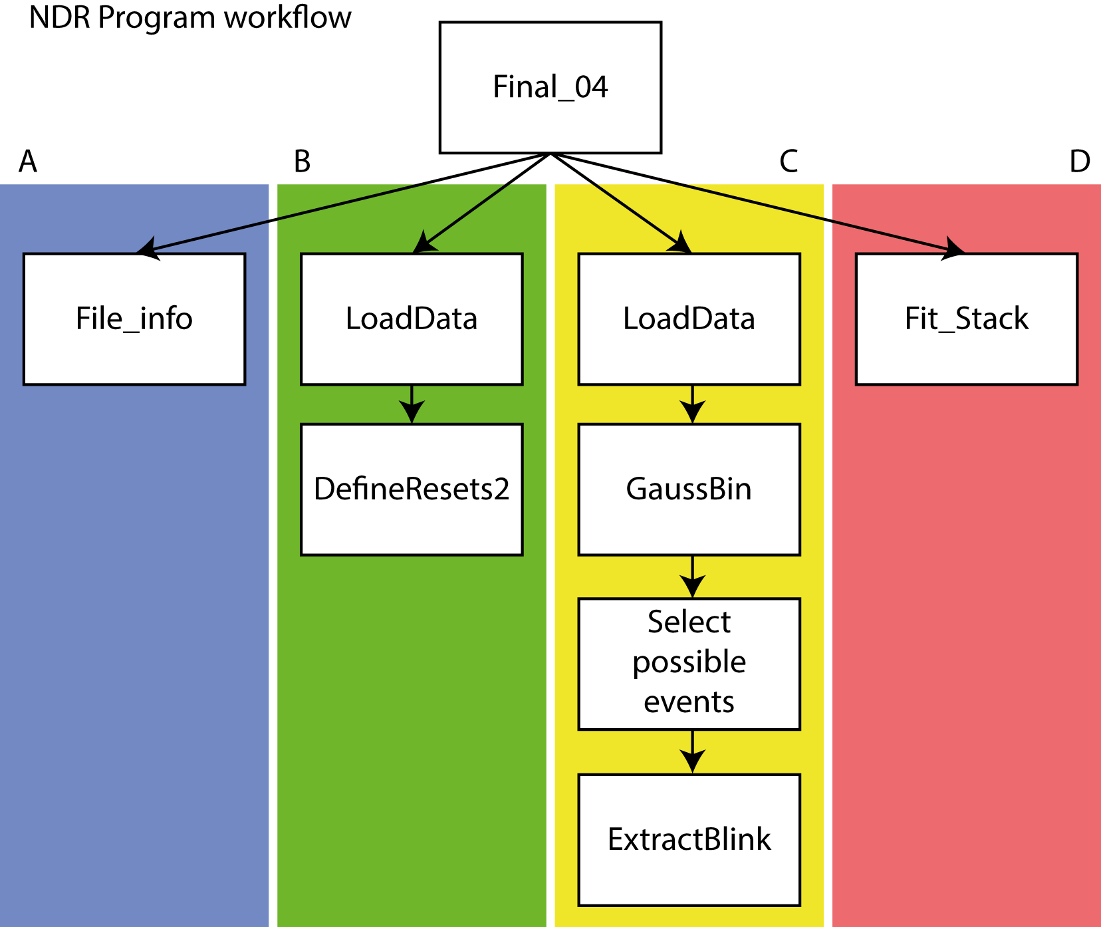
Figure 2.1: Workflow for analysing NDR data. The main analysis program for analysing the NDR data can be split into four separate streams consisting of sequential sub-routines that perform different tasks. (A) takes a file and parses the metadata of the file, loading in the relevant information. (B) loads a subset of the data and uses it to locate the reset positions. (C) occurs in parallel over the entire file and involves loading in a block of image data, pre-processing it and extracting the single molecule events. (D) is the final stream that fits the found molecules to achieve sub-diffraction resolution.

2.8 Simulation of single-particle tracking data captured by NDR
The functions used to create the following data is attached in Appendix 2 with the exception of the ‘NDR_fit_stack.m’ function that is included in Appendix 1. A 140 x 140 array representing a camera sensor was generated in MATLAB with a single particle positioned slightly off-centre (50,50). A molecule was simulated with a diffusion constant, D, of 7 µm²/s and the simulation with a time period,$∆t$, of 0.4 ms where the molecular coordinates were updated from a normal distribution (simulating an unrestrained random walk such as that of Brownian motion) with a standard deviation of $4D∆t$. With each iteration, an emitter was simulated at the molecules’ coordinates by a Gaussian function with a standard deviation of 141 nm. This simulation includes motion blur as each iteration the Gaussian function at the new molecular coordinates is added on to the old image. Thus, by taking two frames far apart and subtracting them captures all the molecular motion between the two bookend frames. To compare NDR to pCMOS, both datasets are created from the same data with the same noise statistics for each frame. The simulation was carried out for 5,000 frames (equivalent to two seconds) with each iteration summing the newly generated frame onto the previous one.
pCMOS data (see Section 3.3.3) were created from the sensor stack by subtracting, in steps of E, the i^{th} frame from the i+E^{th} where E is the exposure length in frames. On the other hand, NDR sliding window were created by subtracting, in steps of 1, the i^{th} frame from the i+E^{th}, where E is the size of the exposure. For the comparison, the pCMOS data were generated with an exposure of 40 ms and the NDR data were generated with two different exposures, 40 ms and 20 ms, highlighting the ability to alter the exposure post-acquisition. These images were then fit to a Gaussian approximation of the PSF with a least-squares algorithm to generate a molecular trajectory for each of the datasets.

2.9 Transformation of E. coli with heat shock
Plasmids were introduced into E. coli cells for expression via the heat shock procedure. Chemically competent cells (50 µl) were thawed on ice and approximately 100 ng of the appropriate plasmids (see Table 2.2) was introduced and the combination gently mixed. The cell-plasmid mix was incubated on ice for 20 minutes before being subjected to a heat-shock consisting of 42°C for 45 seconds. The cells were then placed back on ice for two minutes before being diluted with 200 µl Super Optimal Broth (Hanahan, 1983) and incubation at 37°C with 230 rpm shaking for 45 minutes. The cell solution was spread on a Lysogeny Broth (LB) agar plate containing the appropriate antibiotic and incubated overnight at 37°C to allow the formation of single colonies.
Name | Proteins produced | Parent Vector | Antibiotic^{b} | Reference
pPcyA | HoxI, HTª-PcyA | pACYC Duet | Cm 34 µg/ml | Alvey et al., 2011; Biswas et al., 2010
pCOLADuet-  cpcEF-pebS-HO1 | CpcE, PebS, CpcF, HoxI | pCOLAduet-1 | Km 50 µg/ml | †
pBS405v | HT-CpcA | pBS350v | Sp 50 µg/ml | Tooley et al., 2001
pBS414v | HT-CpcA, CpcE, CpcF | pBS350v | Sp 50 µg/ml | Tooley et al., 2001
pAH171 | CydB-CpcA, CpcE, CpcF | pBS414v | Sp 50 µg/ml | †
pAH173 | CydB-CpcA | pBS405v | Sp 50 µg/ml | †
Table 2.2: Plasmids used in this study.
ª HT: His₆-tagged. ^{b} Antibiotic concentration used to select for the plasmid: Cm: Chloramphenicol; Km: kanamycin; Sp: spectinomycin.
† Plasmids prepared by Dr Andrew Hitchcock

2.10 Overexpression of phycocyanin alpha in E. coli
Single colonies were selected from the LB-agar plates and used to inoculate 5 ml starter cultures, which were incubated overnight at 37°C and shaken at 230 rpm in the presence of the relevant antibiotics. The starter cultures were used to inoculate 500 ml of LB in 2 litre baffled flasks containing the appropriate antibiotics, which were then incubated at 37°C and shaken at 230 rpm until reaching an OD₆₀₀ of 0.6. Then the cultures were induced with filter-sterilised isopropyl β-D-1-thiogalactopyranoside to a final concentration of 0.4 mM and incubated overnight at 18°C with shaking at 230 rpm.

2.11 Purification of His-tagged CpcA
Cells were harvested by centrifugation at 4,000 rpm for 30 minutes. The supernatant was discarded and the cells were resuspended in buffer O (50 mM Tris-HCl, 150 mM NaCl, pH 8.0). The cell suspension was broken with a Vibra-Cell sonicator (Sonics) for 6 minutes at 80% amplitude with a 30 second on/ 30 seconds off cycle and the resulting solution spun at 21,000 rpm, 4°C for 30 minutes. The supernatant was separated from the cell debris and was purified on a 5 ml nickel affinity column charged with 70 mM NiSO₄ pH 5.5. The column was prepared by washing with a column volume of binding buffer (0.5 M NaCl, 20 mM Imidazole, 20 mM Tris-HCl pH 7.4), the supernatant was then loaded onto the column and left to bind before two passages of one column volume of wash solution (0.5 M NaCl, 50 mM Imidazole, 20 mM Tris-HCl pH 7.4). The protein was eluted through washing the column with a column volume of elution buffer (0.1 M NaCl, 0.5 M Imidazole, 20 mM Tris-HCl pH 7.4).
Further purification was achieved through ion-exchange chromatography on a HiTrap Q sepharose column (GE Healthcare), eluting with a linear gradient of 0-1 M NaCl over 30 column volumes in 50 mM Tris pH 7.4, followed by size-exclusion chromatography on a S200 Superdex column (GE Healthcare) in 50 mM Tris-HCl pH 7.4 with 200 mM NaCl.

2.12 Protein nanopatterning onto a glass substrate
Nanopatterning was achieved through two separate methods, as detailed in (Vasilev et al., 2014). To produce a template mask, an offcut diffraction grating (303 nm on/ 303 nm off or 200 nm on/ 2000 nm off) which acts as the master pattern was obtained from LightSmyth Technologies and cleaned with piranha solution (3:1 H₂SO₄:H₂O₂). The template was spin-coated at 2,000 rpm with 58 mg ml⁻¹ polystyrene dissolved in anhydrous toluene until dry. The mask was lifted from the template by gentle submersion in ultrapure deionized water (resistivity = 18.2 MΩ) using surface tension and floated onto a piranha cleaned silicon wafer with the mask’s channels running perpendicular to one of the wafer’s crystallographic axes. To open the channels, the mask was dried under vacuum before the wafer was cracked along an axis, making a clean break across the template. The polystyrene masks were then lifted from the silicon wafer using the surface tension of water and the polystyrene was floated onto piranha cleaned coverslips and dried under vacuum to remove any remaining water. For the two separate protein variants, different processes were used to create the nanopattern. For CpcA-PCB, a self-assembled monolayer was created in the channels by vapour deposition; the coverslips were positioned under an inert anhydrous (nitrogen/argon) atmosphere with 35 µl (3-mercaptopropyl)trimethoxysilane (MPTMS) (Sigma-Aldrich) before being placed into a vacuum. Once the monolayer had formed the masks were removed and the coverslips submerged in 10 µl ml⁻¹ 2[methoxy(polyethyleneoxy)6-9 propyl]trichlorosilane in toluene for 90 minutes to coat the exposed glass, reducing non-specific binding of the protein to the negatively charged surface.
Alternatively, for CpcA-PEB 20 µl of 1H,1H,2H,2H-Perfluoro-octyltriethoxysilane were vapour deposited under vacuum from an inert anhydrous (nitrogen/argon) atmosphere. This procedure created a negative of the template which was then removed using the surface tension of water; then, the coverslip was thoroughly dried with nitrogen. The exposed non-fluorinated substrate was incubated in 15 mM MPTMS dissolved in toluene to create the nanopattern ready for protein attachment. For both patterns, Succinimidyl 4-(N-maleimidomethyl)cyclohexane-1-carboxylate (SMCC) was dissolved in anhydrous dimethyl sulfoxide to form a 1 mM solution which was used as a linker to bind the MPTMS monolayer through exposure for 90 minutes. CpcA was buffer exchanged into phosphate buffered saline (PBS) using a PD10 desalting column (GE Healthcare), as Tris-HCl can compete for the SMCC linker. CpcA (1 µM) in PBS was incubated on the surface for 30 minutes and allowed to bind to the SMCC-MPTMS pattern. PBS was used to wash the coverslip and remove non-bound protein, which was then sealed to a slide.

2.13 Sensitivity of CpcA to pH
A range of 1x PBS at varying pH values was created from a pH 7.4 stock adjusted with 5 M sodium hydroxide or 7 M hydrochloric acid. To create the protein solutions for testing, 30 µl of CpcA were diluted into 970 µl of each the buffer conditions and thoroughly mixed before being allowed to equilibrate for an hour at room temperature. Absorption spectra were recorded between 300 nm and 750 nm on the Cary 60 UV-Vis spectrophotometer (Agilent Technologies) with each spectrum baseline corrected against its respective buffer. Data were collected in triplicate and the mean spectra calculated. Spectra were normalised to zero using the 740 – 750 nm region so that the height of each peak could be compared.

2.14 Structured illumination microscopy
Cells were washed in PBS before being incubated on either a poly-L-lysine coverslip or an agarose pad for 20 minutes. Samples were then mounted in either Vectashield (Vector Laboratories) or SlowFade Diamond antifade (Thermo Fisher). Slides were imaged on a DeltaVision V4 microscope (GE Healthcare) with the OMX Blaze SIM module for structured illumination. Illumination of YFP and GFP was achieved with a 488 nm laser coupled to a 60x 1.42 NA planapochromat lens with emission collected through a 528/48 bandpass filter. Illumination of the native chlorophyll pigments was achieved with a 642 nm laser with emission collected through a 683/40 nm bandpass filter that primarily selects for chlorophyll b. For each two-dimensional SIM plane a total of 15 images were acquired (five pattern phases for each of three angles). This was extended to 3D by imaging multiple planes 125 nm apart for a minimum of nine planes per three-dimensional image. Reconstruction of the raw data into the super-resolution images was performed with the DeltaVision OMX softWoRx 6.0 software suite (GE Healthcare). For analysis, the negative intensities were removed with the threshold and 16-bit conversion tool from the SIMcheck plugin in ImageJ (Ball et al., 2015).

2.15 Radial measurements of Synechocystis
To investigate the location of signal intensity from hyperspectral confocal and SIM data of Synechocystis, the mean signal as a function of distance from the cell centre was calculated using the script ‘Radial.m’ in Appendix 3. The script allows the user to choose a cell of interest in a field and then more accurately dictate the position of the cellular midpoint on an enlarged version. The values are then summed based on the Euclidean distance from the selected central location. The program displays the profile for each current measurement as well as a running average of all the cells measured. For this analysis, cells actively undergoing division at the point of image capture were excluded from the measurement as the non-spherical morphology would have distorted the measured radiality.

2.16 Synechocystis growth conditions and preparation
For initial growth on plates, Synechocystis was grown on BG-11 medium (Rippka et al., 1979) supplemented with 10 mM N-Tris(hydroxymethyl)methyl-2-aminoethanesulphonic acid, 5 mM glucose, 1.5% (w/v) agar, 0.3% (w/v) sodium thiosulphate and appropriate antibiotics (PSI-YFP 34 µg/ml chloramphenicol, and for YFP/TorA-YFP, 40 µg kanamycin). Strains were then grown as 1 litre cultures in BG-11 under a white light intensity of 60 µmol photons/m²/s (normal light) at 30°C in a rotary shaker set to 150 rpm. Cells grown at high and low light levels were exposed to intensities of 300 µmol photons/m²/s and 5 µmol photons/m²/s respectively. For imaging, cells were harvested during logarithmic phase at 10,000 x g for 5 minutes, the supernatant was discarded and the cells resuspended in phosphate buffered saline. The exception to this is an FtsH4 culture that was harvested during stationary phase. The strains, label, name in the text, and techniques are all detailed in Table 2.3.

Target | Label | Name in text | Technique
None | None | WT | HCM, SIM
None | YFP | Cytoplasmic YFP | HCM, SIM
Photosystem I (PsaF subunit) | YFP | PSI-YFP | HCM, SIM
TorA | YFP | TorA-YFP | HCM, SIM
Slr0483 | YFP | Slr0483-YFP | SIM
Slr1471 | YFP | Slr1471-YFP | SIM
FtsH1 | GFP | FtsH1-GFP | SIM
FtsH2 | GFP | FtsH2-GFP | SIM
Ftsh4 | GFP | FtsH4-GFP | SIM
Table 2.3: Synechocystis strains used in this study.

2.17 Preparation of plant thylakoid membranes
Arabidopsis thaliana and Spinacia oleracea (spinach) plants were grown in 200 µmol photons/m²/s of light with a 12 hour on/off cycle at 21°C. Once plants had reached maturity a leaf was removed and ground in ice cold buffer consisting of 50 mM HEPES pH 7.4, 5 mM MgCl₂, 300 mM sucrose and 10 mM NaF. Dark adapted chloroplasts were produced by subjecting the plants to darkness for one hour before harvesting, whereas light-adapted were harvested straight from the growth environment. The appropriate dilution in the same buffer was then applied to an agarose pad and allowed to settle. The samples were then mounted in VectaShield (Vector Laboratories) and imaged.

2.18 Hyperspectral confocal microscopy
Synechocystis cells were incubated on a scratched agarose-coated slide and allowed to settle before being mounted in PBS. The hyperspectral confocal microscope was calibrated with three autofluorescent plastic slides (Chroma) imaged with a 488 nm laser and focused onto an Andor Ixon EMCCD camera. Samples were imaged by raster scanning the laser across the sample and recording a spectrum for each location. The raw data were then processed by Dr Jerilyn Timlin (Sandia National Laboratories) through multivariate curve fitting to extract the individual spectral components for each pixel, assigning weights to represent how much each component contributes to the pixel spectra.

Chapter 3
The application of non-destructive readout to microscopy

3.1 Summary
This chapter reports the first usage of a non-destructive readout camera to observe single molecules and a complete algorithm for localisation microscopy, using the novel data structure that the camera outputs. Non-destructive readout allows near-perfect exposure lengths to be calculated for each single molecule, maximising the signal-to-noise ratio by supressing temporally associated noise and lowering the occurrence of signal being split over multiple frames. This is achieved through selectively emptying the pixel wells after a series of reads, as opposed to after every read. It is shown that tailoring the exposures leads to an increase in the number of detected events by a factor of two and an increase in the signal-to-noise ratio by a factor of two when compared to CMOS equivalent data. Through non-destructive readout it was possible to distinguish between temporally separated events that are located within a sub-diffraction region and what would have been a single frame in standard imaging. Additionally, a brief investigation into the practicalities of single-particle tracking with NDR are given through computational simulation and show NDR leads to a smoother trajectory that more accurately represents the molecule’s motion.
The work presented in this chapter has been published as follows:
Samuel F. H. Barnett, Mary Snape, C. Neil Hunter, Miguel Juárez, Ashley J. Cadby. (2017). A Novel Application of Non-Destructive Readout Technology to Localisation Microscopy. Scientific Reports. 7, 42313-42319.
Chun X. Bleau, Jeremy Graham, Ashley Cadby, Samuel F. H. Barnett, Charles Bleau. (2017). Playing fast and dim. https://www.labnews.co.uk/features/playing-fast-dim-04-07-2017/. Accessed 04/07/2017.
Samuel F. H. Barnett, Mary Snape, C. Neil Hunter, Miguel Juárez, Ashley J. Cadby. (2017). Super resolution microscopy from non-destructive readout data. Scientific Data. [SUBMITTED]
The scripts and functions created for analysing the novel data format and simulating single-particle tracking are attached in Appendix 1 and Appendix 2 respectively.
3.2 Introduction
Localisation Microscopy (LM) is a branch of super-resolution imaging that increases the resolution of the microscope far beyond the diffraction limit. This is achieved through temporal separation of a field of fluorophores so that they can be individually localised by fitting the data to a model of the point-spread function. The accuracy of localisation microscopy strongly depends on the signal-to-noise ratio (SNR) of the individual measurements that build up the final coordinate map (Thompson et al., 2002). Thus, a great deal of effort has been made to increase the SNR of these measurements such as through optimising buffers (Dempsey et al., 2011; Olivier et al., 2013a, 2013b), optimising laser intensity (Lin et al., 2015), brighter dyes and proteins (Vaughan et al., 2012) to name a few. Alternatively, the SNR can be increased by reducing the levels of noise through better camera technology, high-fidelity filters, and sample preparation (Kaplan and Ewers, 2015).
Currently there are two types of camera sensor that are primarily used for detecting single molecules: the electron multiplying charge coupled device (EMCCD) (Gould et al., 2009; Shroff et al., 2013) and the complementary metal-oxide semiconductor (CMOS) (Saurabh et al., 2012). Of these, EMCCD based cameras are typically more popular because they have a more uniform noise profile and higher sensitivity. However they typically have low acquisition rates, capable of only a few tens of frames per second, whereas cameras based on CMOS technology are capable of acquiring data at much faster rates, at thousands of frames per second, due to additional electronics associated with the pixel that allows each to be addressed individually. This increased rate comes at a cost to uniformity across the sensor as every pixel now has its own offset and gain statistics (Souza et al., 2016). Another advantage of CMOS sensors is their low and flat noise floors, making the detection of variances resulting from a signal easier; thus, CMOS cameras are rapidly becoming comparable to EMCCDs for localisation microscopy (Long et al., 2012).
The problem with the discrete serialised exposures that occur in traditional cameras is that the emission length, also known as the on-time, of single molecules is independent of the frame length. The emission length is not a static number and can take on a continuum of values that can be affected by many factors such as the local environment (Vogelsang et al., 2009) and laser intensity (Heilemann and Linde, 2008). Additionally, the starting point of the emission is typically unknown (but not always, in the case of pulsed activation lasers). As such, it is impossible to match the exposure of a frame to the start and length of all the single molecule emissions in an LM experiment and there will be an associated dead-time where the camera is exposing but no signal is being collected, leading to a decrease in the SNR.
A further camera architecture that has not been explored for LM is Non-Destructive Readout (NDR) (Ackland et al., 1996). This architecture is based on the CMOS design of sensor with the individually addressable pixels but instead of reading out the electrons collected within the pixel well during the exposure, it measures the voltage across the well (Matsumoto et al., 1985). The pixel can then be read multiple times without removing the signal acquired during the collection period, hence the process is non-destructive as the signal survives the measurement. This yields a series of values for the pixel that constitutes a history of the photon flux into the well during the exposure. As the pixels have a finite well depth they must at some point be emptied of charge before saturation and loss of additional signal occurs. This is performed as a reset frame at which point the sensor acts as a normal CMOS imager and reads out the electrons from the well, readying the pixel to begin another exposure. The number of frames between resets can be set by the experimenter prior to acquisition allowing flexibility based around the brightness of a given sample and is equivalent to altering the exposure on a typical camera. Throughout the rest of this chapter the data between two reset frames will be referred to as a ‘block’.
The Da Vinci 2K CMOS sensor is capable of NDR measurements and has been embedded in a prototype camera by the company; SciMeasure. In comparison to a current top-of-the-range CMOS imager, the Da Vinci 2K CMOS sensor is of lower overall specification having both a smaller well depth and quantum efficiency (QE). However, the lack of micro-lenses increases the uniformity for the Da Vinci 2K and the sensor is capable of NDR imaging (see Table 3.1). It is also worth noting that the SciMeasure camera is the first of its kind, and does not have the advantage of generations of improvement (Bleau and Bleau, 2017).
This chapter deals with testing the Da Vinci 2K imaging sensor embedded in a camera created by the company SciMeasure for super-resolution microscopy and single-particle tracking (SPT). Specifically, I investigated the improvements of running the camera in NDR mode as opposed to in a traditional imaging scheme. Initially the chapter focusses on the performance of NDR in the dark, characterising the camera. The chapter then proceeds onto observing single molecules in NDR mode as transient events before focusing on reconstruction of a whole localisation microscopy dataset. NDR also shows promise for single-particle tracking, which is similar in principle to LM and is an important methodology for understanding molecular dynamics.

Parameter | Da Vinci 2K | ZYLA 5.5 sCMOS
Type | Non-Pinned Photodiode CMOS | Pinned Photodiode  CMOS
Imaging array size | 2048 x 2048 | 2048 x 2048
Pixel size | 15 x 15 µm² | 6.5 x 6.5 µm²
Micro-lenses | NO | YES
Non-destructive readout (NDR) | YES | NO
Max frame rate @ full frame Non-CDS | 228 fps | NA
Well capacity | 18,000e- | 30,000e-
Read noise | 2.8e- | 1.9e-
Quantum Efficiency | 65% @ 600nm | <80% @ 600nm
Dark current -10°C | 1.6e- /pixel/sec | 0.5e- /pixel/sec
Table 3.1: Comparison of a Da Vinci 2K sensor to an Andor Zyla 5.5 sCMOS. The Zyla is a top of the line camera and has better specifications, however it is not capable of NDR mode imaging.

3.3 Results
3.3.1 Analysis of NDR data collected in the absence of light
Unlike in EMCCD cameras, where the noise follows a Poisson-Gaussian Mixture Model, the noise in CMOS type cameras is pixel-dependent and typically follows a Poisson distribution. In localisation algorithms designed for CMOS type cameras it is common to take account of the read noise and fixed pattern noise by calculating the mean dark frame from a series of dark images and subtracting it from each LM frame (Huang et al., 2013). Pixel-dependent amplifier gain is also accounted for by calculating the photon-to-count conversion ratio that corrects for different pixel sensitivities. These corrections remove any bias that a pixel may have incurred as a result of subtly different mean offset values and amplifier gains; consequently, the algorithm was shown to achieve the theoretical uncertainty at the limit. NDR allows the reduction of both fixed pattern noise and reset noise by sampling both at the beginning of the exposure so that the offset for each individual pixel can be subtracted; the requirement for a dark frame is removed and the sensor can be normalised in a much more accurate fashion. Figure 3.1D shows that the mean dark frame subtraction results in a standard deviation of 55.9 and the NDR reset subtraction from NDR frame two results in a standard deviation of 8.6. Correction using the pixel offsets completely removes the fixed-pattern noise resulting from the resets (Figure 3.1A-C).
Even when no photons are striking the sensor, charge will build up in the wells due to noise sources such as dark-current (Figure 3.1G). The charge value of an individual pixel will increase with the length of the exposure. Additionally, due to the stochastic nature of noise, the change will not be uniform across the sensor. When combined with differences in the amplifiers for each pixel there is a consequent widening of the distribution as a function of the exposure length, visible in Figure 3.1E with the histograms of the second frame values and the 100th frame values demonstrating a mean pixel shift of 23 counts. This rate is independent of the number of the NDR frames between resets tested at 100 (24.21 ± 1.38), 500 (23.62 ± 1.06), 1,000 (23.89 ± 1.08), 2,500 (24.20 ± 0.85) frames between resets, which represents the mean increase ± the standard deviation per 100 frames. However, as the total length of the exposure increases, the distribution transitions from a Gaussian distribution to that of a skewed Gaussian distribution (see Figure 3.1F), which is due to temporal noise such as from dark current and differences in gain amplifiers widening the disparity between pixels and increasing with the length of the exposure. Whilst the distribution transition is a result of the different pixel gains, this occurs over longer exposure periods than a typical LM event and so for this investigation was ignored, however future investigation could account for the pixel gains.
To quantify the measurement noise, which is a combination of read noise and temporal noise, the stack was differentiated with respect to time to yield the change per pixel per frame for each time point. The root mean square was taken for each pixel over the differentiated time-trace giving a median value of 7.7 counts, as is common in reporting the error of camera measurements. The analogue-to-digital conversion rate for the NDR camera is 0.8 which gives a final measurement error of 6.1 e⁻ root mean square. This is exemplified in Equation 3.1 where P(i,t) is the t^{th} time-point of the i^{th} pixel, n is the number of frames and t is the frame number.
 | $$error=median(RMS)=median\left(\sqrt{\frac{1}{n-1}\sum_{t=1}^{n-1}{{\left(P_{\left(i,t+1\right)}-P_{\left(i,t\right)}\right)}^{2}}}\right)$$ | (3.1)
In NDR the pixel is read repeatedly without emptying the charge. Each measurement incurs read-noise, but this occurs non-cumulatively over the length of the NDR sequence. Using the specifications provided by the supplier (Table 3.1) defining an exposure of a particular length thus incurs a read noise of $2.8×\sqrt{2}=\sim 4e^{-}$ as the frames will be correlated. This value differs from the measurement noise reported here and the remaining 2.1e⁻ most likely originates from dark current as a result of the high operating temperature.
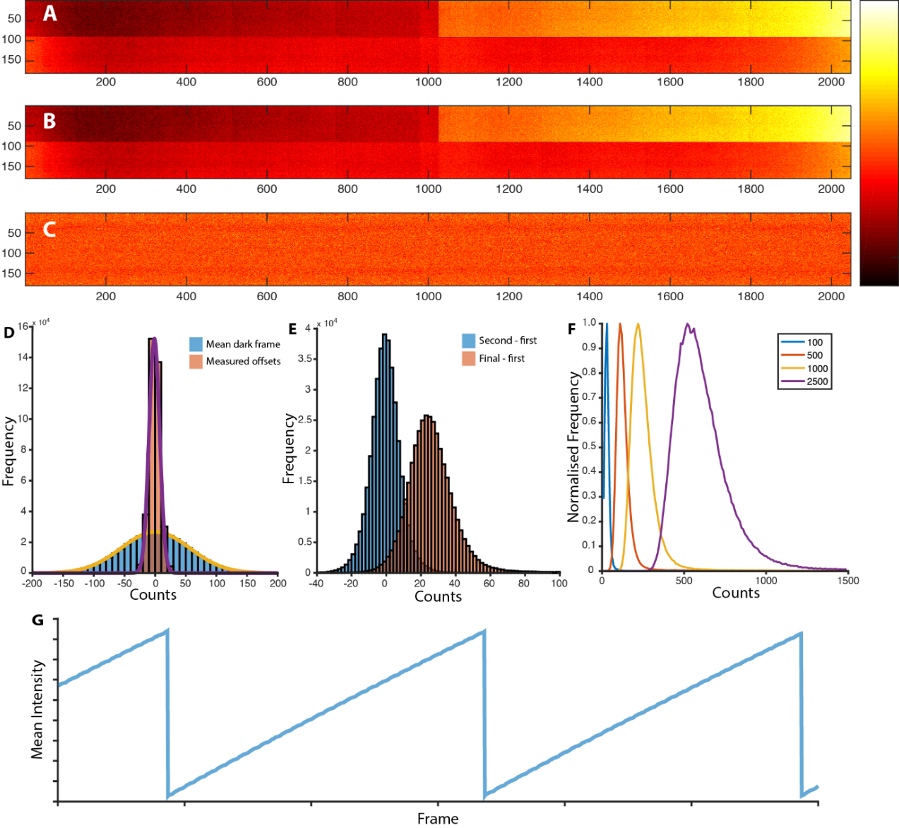
Figure 3.1: Analysis of NDR dark data. Removal of fixed pattern noise and minimising read-noise is achieved by subtracting the first frame (A) from the second (B) in a sequence of frames taken in the absence of light, resulting in image (C). (D) Comparison of subtracting the mean dark frame (as is common in localisation algorithms for CMOS data) and subtracting the offsets from the first NDR frame. As the length of the exposure increases, noise accumulates across the sensor resulting in the shifted Gaussian distribution in (E). (F) Effects of increasing the number of frames before a reset. (G) Mean intensity change of a frame with time demonstrating the resets.
Whilst CMOS cameras can achieve similar frame-rates to the NDR camera, albeit with a more windowed-down sensor, summing many CMOS frames together vastly increases the noise when compared to NDR. With each frame summation, the resulting image acquires an extra penalty of read-noise that quickly adds up. This does not occur with NDR as the signal is summed in an analogue fashion on chip meaning that an image only ever incurs two bouts of reset noise, one for each bookend frame in a subtraction.
Investigating the temporal noise present in the camera was achieved by collecting NDR time-series data with differing exposure lengths (2 ms, 1.11 ms, 1 ms, 0.5 ms and 0.4 ms). The sensor was isolated from any light sources and 500 frames of NDR data were collected with a reset frequency of 100. The mean value per frame for a 180-pixel squared area in the centre of the sensor was calculated for each of the five exposure lengths and the data for one block is shown in Figure 3.2A. The final values after 100 reads for each of the exposures are plotted in Figure 3.2B and fitted to a linear model. This linear model reveals a base noise value of 2.447 photoelectrons and a gradient of 209.2 e⁻/s as the measurements were made over a 100-frame period. The model does not cross the y-axis at zero as would be expected for a temporal noise component, which is a result of the inclusion of read-noise in these values.
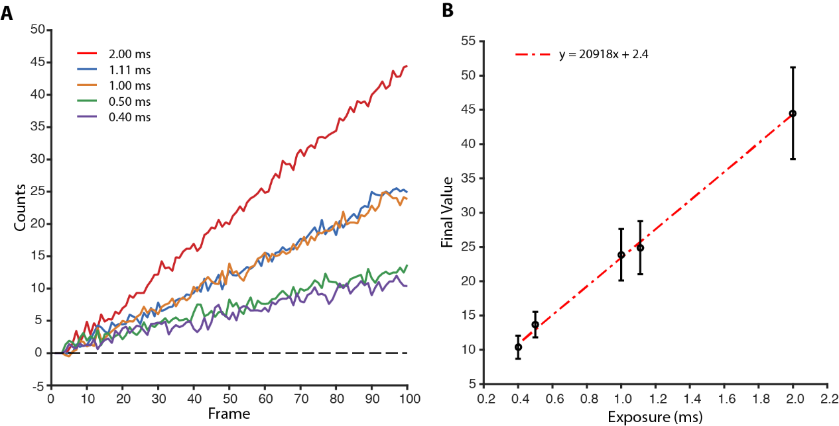
Figure 3.2: Thermal noise in NDR. (A) Mean value of a 180-pixel square area over time demonstrating an increase in gradient with longer exposures. (B) Linear fit of the final values for the different exposures showing the linear effect of temporal noise within the sensor. Error bars indicate standard deviation.

3.3.2 Observing single molecules with NDR
In NDR data, the value of a pixel increases proportionally with the length of an exposure even when there is no light falling on the sensor due to temporally-based noise sources within the system; this is signified as a constantly increasing pixel value representing the change in the number of photoelectrons held within the well with time. As single molecule events (or simply “events”) are transient bursts of photons concentrated over a small number of pixels that can be observed within an NDR pixel time-trace as a sudden increase in gradient that returns to the previous rate once the molecule has ceased emitting (Figure 3.3). Photons from the single molecule event can end up being a small proportion of a pixel’s value in the final frame; the additional electrons from noise during the emissive dead-time degrades the final SNR of the exposure. For the molecule shown in Figure 3.3, the contribution of the single molecule to the final pixel value is 12.5%. If two pixels are chosen, one containing an event and the other solely noise from a nearby region, subtracting the noise trace will remove the majority of the noise effects, leaving the only changing region as the location of the event. The measurements that encompass a pixel’s time-trace allow any one time-point to be subtracted from another; thus, the exposure length of the frame can be chosen to match the emission period with the dramatic effect of removing the vast amount of noise associated with the periods of the frame when the event is not emissive.
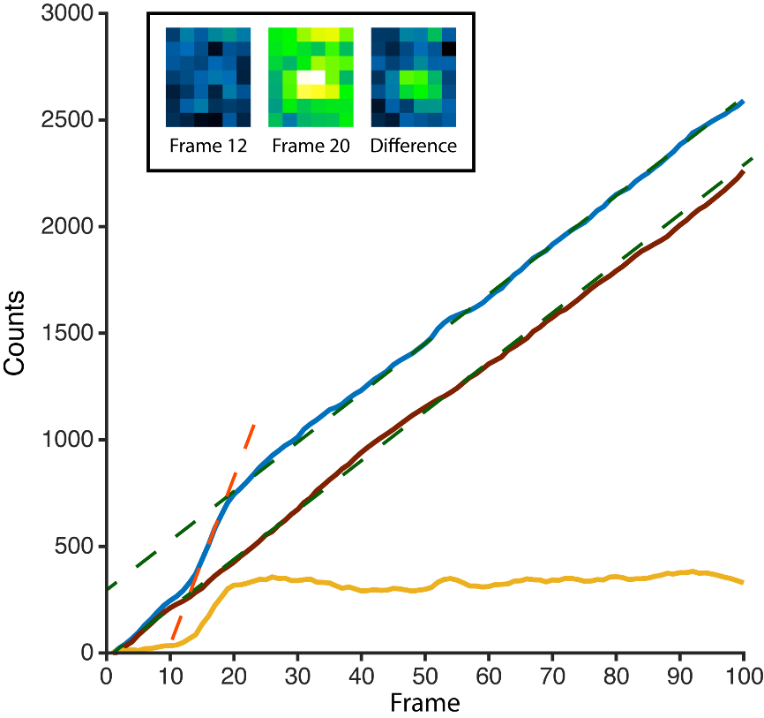
Figure 3.3: Presence of a single molecule event within NDR time data. The traces of two pixels, one of solely noise (solid brown) and one containing a single molecule (solid blue) are given. The gradients of the two pixels when detecting noise are denoted by the green-dashed line. The increase in gradient denoted by the orange dashed line signifies the increased photon input due to the emission of a single molecule. The yellow line signifies the effects of subtracting the noise from the signal. The inset demonstrates the absence of the event in frame 12 followed by its presence in frame 20, the difference between the two frames gives the minimum exposure period containing just the event.
As events are associated with an increase in photoelectrons being collected in the pixel well, the standard deviation with respect to time of that pixel will be higher. To lower the computational search time for pixels that contain an emission event the standard deviation was calculated over 10 NDR frame periods (4 ms); see Figure 3.4. Frames were thereby created in the more traditional sense of LM that could be filtered and thresholded to identify candidate pixels for further processing, in a manner that takes advantage of the NDR super-sampling.
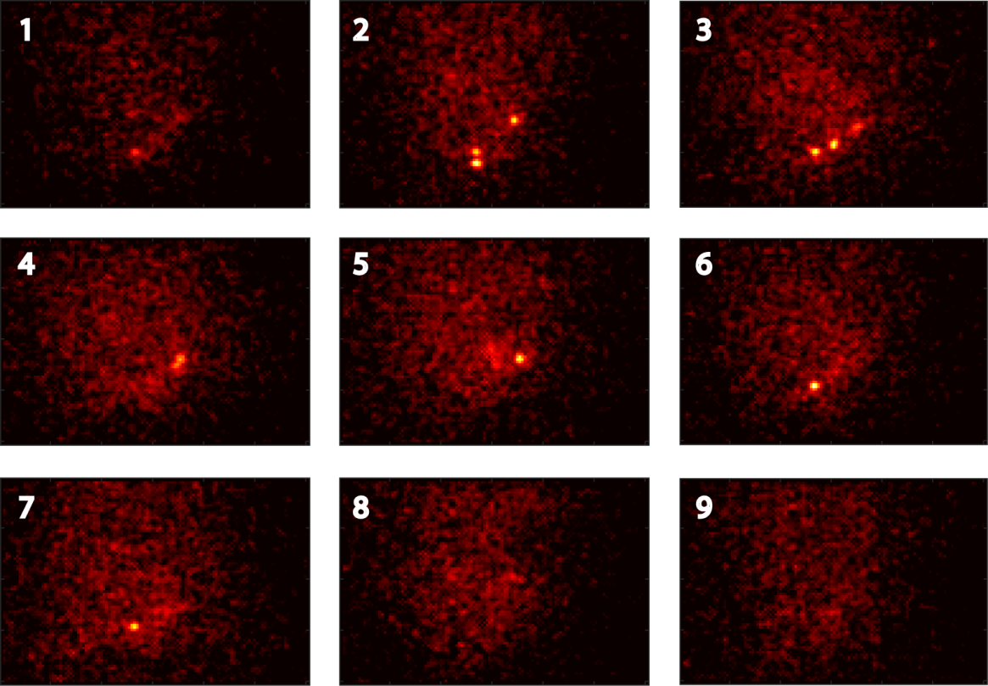
Figure 3.4: Standard deviation maps of the sensor with time. The standard deviation of each pixel was calculated over a 10 NDR frame period (4 ms) yielding the series above of 9 consecutive frames over 90 NDR frames.
Once the candidate pixels were determined, the history of that pixel and of the cardinal pixels were integrated to create a potential history for the event. Location of the event within the time trace was performed by differentiating the time-trace and a user defined threshold which identified the start and end frames. The start frame was subtracted from the end frame and the result was stored for least-squares fitting to determine the molecules’ location.

3.3.3 Analysing the detected single molecules
From the starting point of an emission, a series of frames can be created that map the progression of an event with increasing exposure e.g. frame 0-1, 0-2, 0-3 etc. An entire history of an event can be extracted (Figure 3.5A) and the SNR calculated throughout the progression (see Figure 3.5B). The SNR in this scenario is defined as the ratio between the brightest pixel of an event and the mean value of a square border of pixels at a distance greater than the PSF (in this case five from the centre pixel). Prior to the start of the emission event, the SNR oscillates around 1 before a sharp increase at frame 32 highlighted by the region in green when the molecule is emitting. Once the emission has ceased at frame 52, the SNR begins decreasing due to accumulation of temporal noise which degrades the SNR over time. To compare NDR data with data taken in a typical fashion i.e. sequential frames of the same length, the 100th frame of the NDR was subtracted from the first, normalising the offsets. This is equivalent to a CMOS camera running at 25 fps and shall be referred to henceforth as pseudo-CMOS (pCMOS). The maximum SNR is not given as the maximum of the SNR trace at 5.1 as this is calculated relative to the start of the series, incurring noise between the start of the sequence and the start of the emission (from frames 1 to 31). The maximum can therefore be found by taking only the data from the region highlighted in green, boosting the SNR from 4.2 in the case of pCMOS data up to 6.6 for NDR. The calculated uncertainty in x using Equation 3.2 for the pCMOS event is 146 nm, the uncertainty in x for the 1-52 period is 97 nm and the exposure optimised uncertainty in x is 64 nm. In Equation 3.2, $s$ is the standard deviation of the fitted PSF, $a$ is the pixel size, $N$ is the number of photons and $b$ is the standard deviation of the background.
 | $$〈σ〉=\sqrt{\frac{s^{2}+{a^{2}}/{12}}{N}+ \frac{4\sqrt{π}s^{3}b^{2}}{aN^{2}}}$$ | (3.2)
As an exposure of an arbitrary start time and length can be defined it is now possible to investigate the effects of varying the number of signal containing frames.
The cumulative distance travelled by the localisation for each molecule as a function of exposure length was calculated as the fit relative to the addition of each successive frame; this can be seen in the trajectory of the localisations of a single molecule as it becomes more accurate with increasing photon numbers (see Figure 3.5C). The cumulative distance travelled by the localisation as a function of exposure was then fit for each molecule to the model $y=ax^{b}$. The median value for the exponent, $b$, was 0.58, effectively a square root and in close agreement with the Thompson model that the uncertainty decreases as a factor $N^{\frac{1}{2}}$, where N is the total number of photons (Thompson et al., 2002). The median value was chosen because of the strong effect of outlier values, caused by incorrect assignment of the start frame which leads to large levels of movement in the localisation. Here we can observe empirical evidence that the uncertainty is directly proportional to the square root of the number of photons. Mismatch between the model and the data arises from shot noise and the stochastic timing and arrival location of photons.
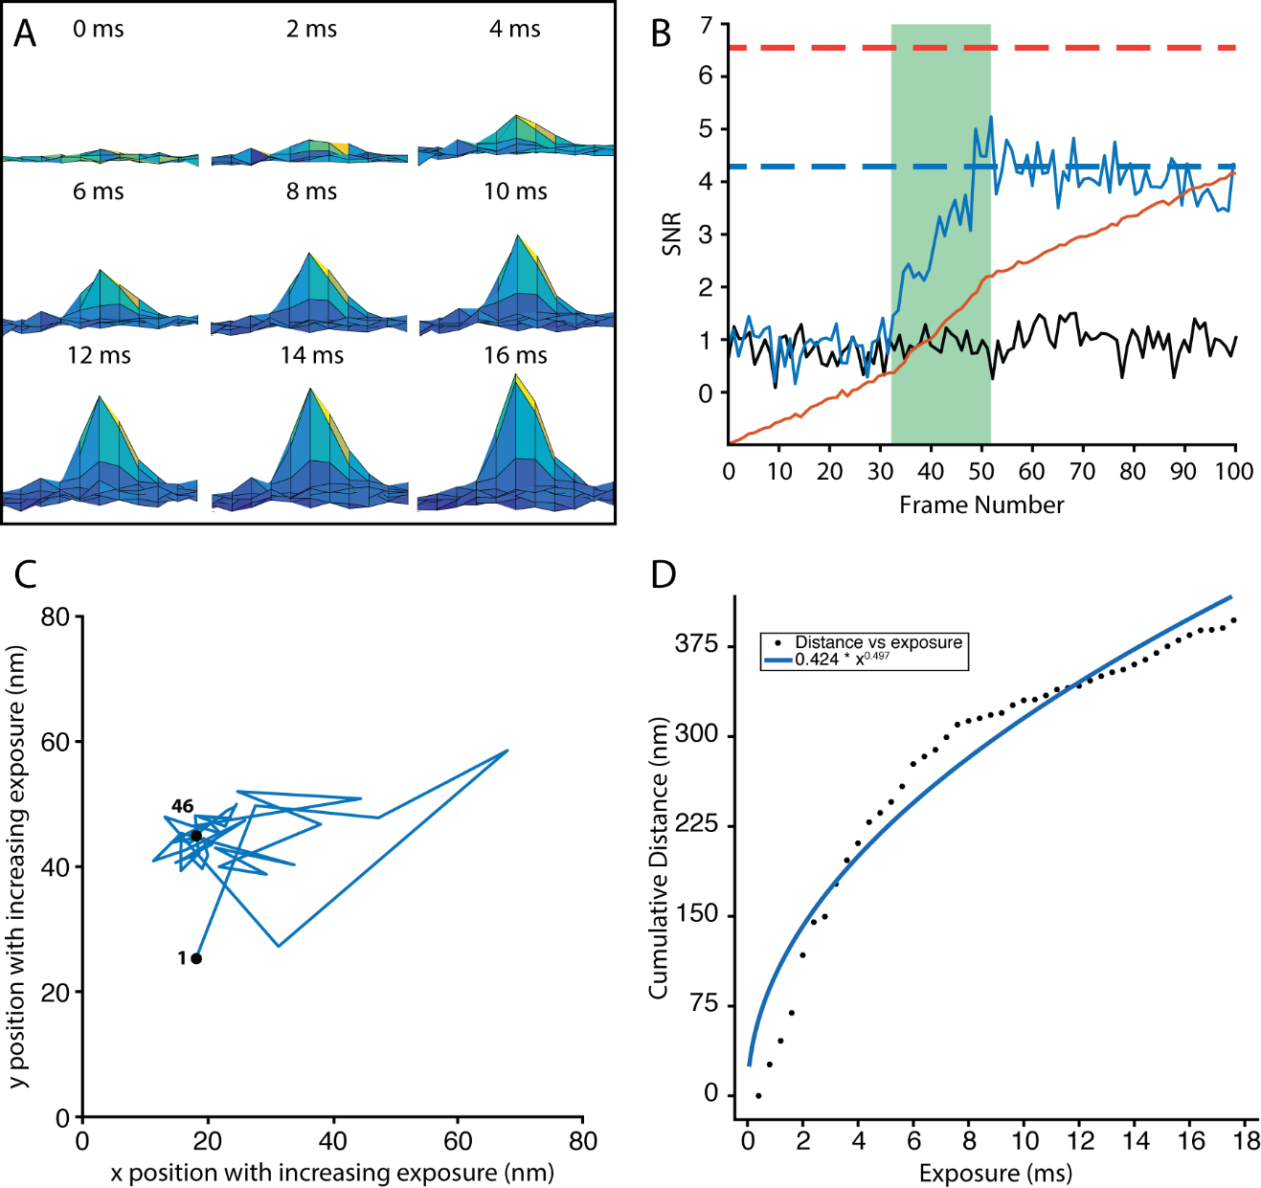
Figure 3.5: Single molecules as analysed with NDR. (A) A single molecule event with increasing lengths of exposure where each image is 2 ms (5 NDR frames) apart. (B) Analysis of the SNR of an event (blue solid line) for the pixel time-trace given by the red solid line. The black solid line is the SNR of a nearby pixel that does not contain an event. The blue dashed line is the SNR after the full 100 NDR frames and the red dashed line is SNR from the area highlighted in green. (C) Trajectory of a single molecule fit under increasing levels of exposure. (D) Cumulative sum of the apparent motion of the molecule as a function of increasing exposure, fit to a single term exponential.

3.3.4 Reconstruction of NDR localisation microscopy data
To reconstruct the raw data and build a super-resolution image of the fluorophores, transient single molecule events found by the algorithm were fit with a least-squares Gaussian model to determine the molecules’ position with sub-diffraction precision. From the result of this fitting process, a coordinate map of the recorded events could be constructed to rebuild the underlying structure of the imaged sample. To fit the single molecules, each event was placed into a false frame with the dimensions of the original data and noise statistics based on an area greater than the width of the PSF. The frames were then processed with ThunderSTORM and the resultant reconstruction is displayed in Figure 3.6A with each molecule represented as a Gaussian function with a standard deviation equal to the uncertainty. Comparison of NDR localisation microscopy to traditional imaging was achieved by converting the dataset to pCMOS. From the 40,000 frames of NDR data, 399 frames of pCMOS data were created from the NDR given a 1:100 sampling rate. The initial 60 frames do not constitute a full block and were thus ignored. Data were reconstructed with ThunderSTORM and the resultant image is displayed in Figure 3.6B. The brightness and contrast of Figure 3.6B has been adjusted to be on the same scale as 3.6A, highlighting the difference in uncertainty resulting from the SNR boosted NDR fits between the two analyses. Additionally, a broadening of the ring structure can be observed as a result of the lower SNR.
The SNR for events from both NDR and pCMOS was calculated as the ratio between the fitted intensity and the mean background value at a distance greater than the size of the PSF (five pixels) and is shown as a histogram in Figure 3.6C. From the histogram, it becomes apparent that there is both an increase in the SNR and the number of events localised by approximately a factor of two. The increase in the number of detected events observed in moving from pCMOS to NDR analysis is a result of the combination of a higher temporal sensitivity for events that are located spatially and temporally close, and a greater reduction in the noise that can obscure events.
To assess the global image resolution, the Fourier Ring Correlation (FRC) was calculated for the coordinate maps of both images with the values for NDR and pCMOS being 220 nm and 230 nm respectively. However, due to the low collection time it is probable that the data are under the requisite Nyquist sampling rate required for achieving higher resolutions. Twice as many events were detected in NDR as compared to the pCMOS data reconstructed through ThunderSTORM. A gallery showing a series of events detected by NDR but not by pCMOS is given in Figure 3.7 to confirm these events as actually being present and not a result of artefacts in the reconstruction process. Noticeably, several of the additional events originate from temporal discrimination from another event within close proximity, in agreement with other work that has shown that applying a higher temporal sensitivity by running the camera at greater frame rates leads to a greater number of detected events (Lin et al., 2015).
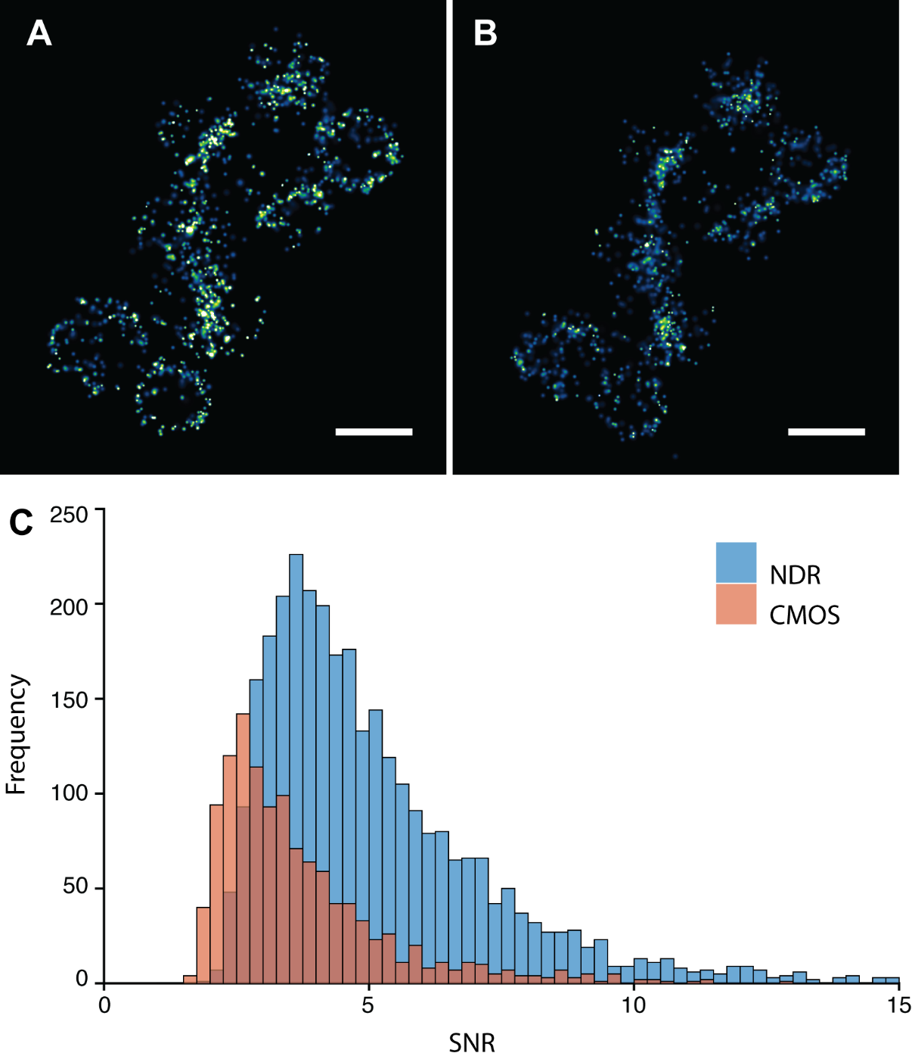
Figure 3.6: Reconstructions of NDR and pCMOS data and the SNR differences between them. (A) Reconstruction of data taking advantage of the NDR subsampling. (B) Reconstruction from pCMOS data via ThunderSTORM. (A) and (B) are both on the same scale, where a higher intensity represents a lower uncertainty. (C) Comparison of the SNR of events from NDR and pCMOS.
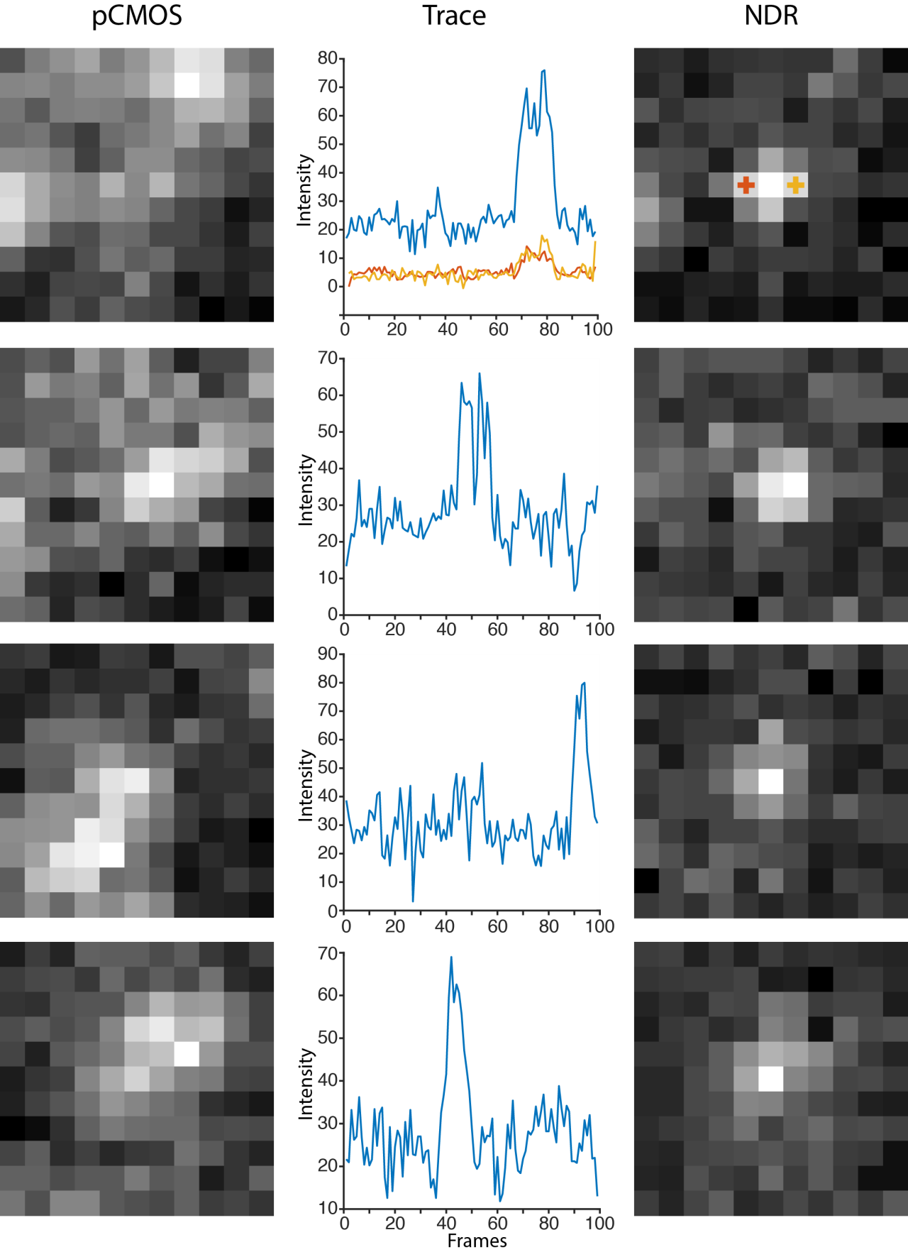
Figure 3.7: Demonstration of the additional events detected by NDR. Images comparing events obscured by pCMOS data (left column) that are detectable when imaging in NDR mode (right column). Also shown is the integrated, differentiated time trace of the central pixel and the four cardinal pixels (middle column).
Additionally, NDR returns very precise start and end times for an event which gives a direct measure of the blinks duration. Thus, NDR facilitates a much more accurate method for obtaining the molecules’ emission duration than traditional technologies that must interpolate on-times due to the discrete binning of the time series. From the Staphylococcus data, a histogram of the molecules’ on-times was plotted (see Figure 3.8) which could be fit to an exponential distribution $y=ax^{b}$ with a rate of 0.2, yielding a mean on-time of 5.12 ms. The exponential fit is also consistent with a Poisson law.
Figure 3.8: Exponential fit of the event durations as detected by NDR. The histogram of event times was fit to a first order exponential model to give a mean on-time of 5.12 ms.
To try and extract additional information from the time-based measurements, a series of simulated NDR images was created based on the noise and blink statistics of the Staphylococcus dataset. The trajectory for each pixel during the emission period was calculated by fitting the values to a linear regression model with the aim of dampening down measurement noise. This process is known as an up-the-ramp reconstruction and has been used previously in the creation of high-dynamic range sensors (Kachatkou and van Silfhout, 2008; Scott et al., 2009). Up-the-ramp reconstruction has been shown to reduce the reset noise by a factor of $\sqrt{n/{12}}$ which for a large number of frames can lead to a significant lowering of the reset noise (Glendinning et al., 1990). However, the accuracy of the fits in the simulated data was improved by only 2 nm when compared to the ground truth (the known molecular positions), probably as the low number of frames leads to an overall small reduction in reset noise. Similar effects of fixed pattern noise on localisation algorithms were demonstrated in sCMOS algorithms (Long et al., 2014) and are probably due to the relatively low number of counts due to noise relative to the signal.

3.3.5 Overlapping emitters in NDR
In LM the number of actively emitting fluorophores is reduced to the level that the sample displays a single molecule density. Each fluorophore has associated “On” and “Off” probabilities that leads to independent stochastic switching used to create the super-resolution image. As each molecule is independently switching there is a chance that two fluorophores located closer to each other than the diffraction-limit emit during the same frame, overlapping and appearing as a single event. Fitting the resultant PSF yields a falsely localised molecule that is positioned between the two real molecules. As the density of the emitters and/or the on/off ratio increases, the probability of overlapping emitters also increases so that the single molecule fitting model no longer becomes an accurate representation of the data, especially so with 3D methods (see section 1.4.6) where the effective density is increased (Barsic et al., 2014). Currently, algorithms take account of high-emitter density either by discarding possible multi-emitter events, as classified by their intensity or width and height properties, or by fitting them to multiple-emitter based models (Holden, 2011). However, there is an associated probability of false positives or false negatives when classifying multiple emitters that can lead to mislocalisations if the parameters are not stringent enough. The most accurate method is having the temporal resolution to separate them, which is the principle behind LM in the first place.
NDR has the capability of distinguishing between two molecules with a higher temporal precision than current camera technology. As long as two spatially overlapping molecules are temporally separated and within a reset, they can be differentiated. This can be seen in Figure 3.9 where the time-traces of five adjacent pixels are shown. In the time-traces it can be seen that two, possibly even three, emissions occur between frames 6-37 and frames 44-73. These events are from two separate molecules as during the first emission period the two green traces show a minimal response (12% and 16% of the total signal), whereas during the second emission period these pixels demonstrate a much higher signal (21% and 18% of total signal). The separate emission periods can be extracted as shown in Figure 3.9B and Figure 3.9C, and the image that results from a pCMOS exposure is visible in 3.9D as an apparent diffraction limited spot. The three images were fitted to reveal that the two molecules are 170 ± 50 nm apart.
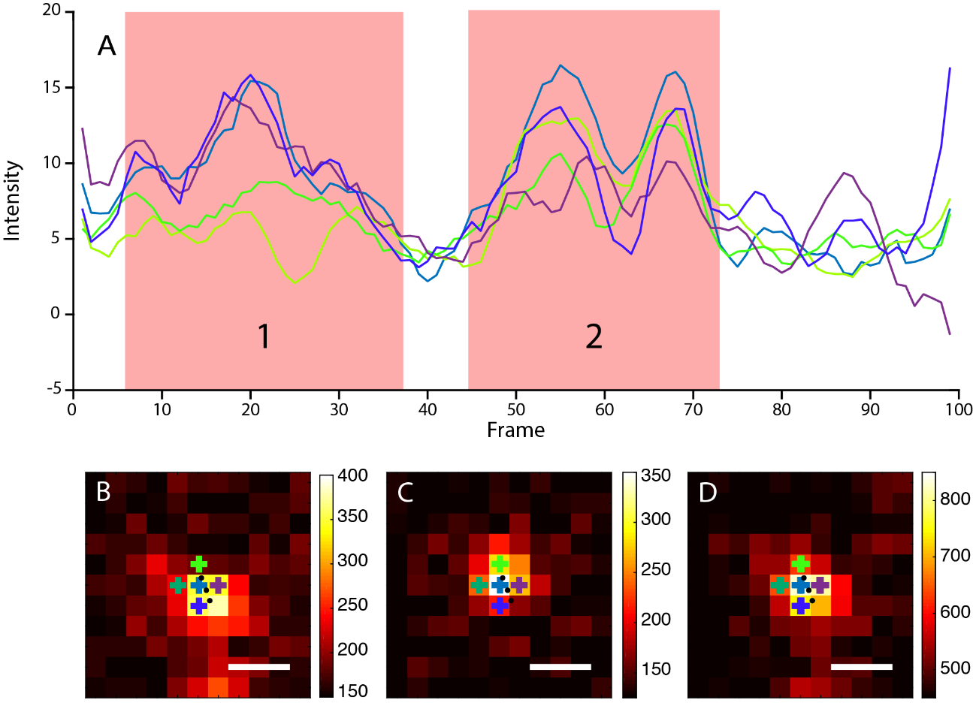
Figure 3.9: Overlapping emitters differentiated by NDR. (A) Time-trace of the five central pixels in the cut-out image. (B) Highlighted molecule number one. (C) Highlighted molecule number two. (D) Image as seen in pCMOS. In each of the three images the black dots represent the three fits. Scale bars represent 500 nm.
Despite the increased temporal resolution offered by NDR for differentiating spatially overlapping and temporally close molecules, ultrahigh density imaging is still an issue as running the camera faster cannot differentiate molecules overlapping in both time and space. Actin labelled with phalloidin conjugated Alexa Fluor 647 in NIH-3T3 cells were imaged with the SciMeasure camera in NDR mode with an exposure of 0.4 ms and a reset rate of 500 for a total of 80,000 frames. This led to STORM imaging with emitters at high densities for which the NDR algorithm failed to reconstruct the data as it was impossible to accurately distinguish start and end points of the individual molecules. However, a reconstruction of the data was still feasible through conversion to pCMOS data with an effective exposure length of 40 ms and analysing with ThunderSTORM’s multiemitter algorithm (see Figure 3.10) which yielded a Fourier ring correlation (1/7) of 217 nm.
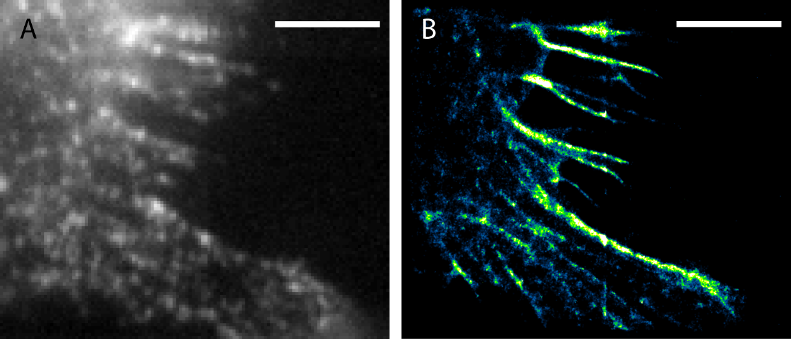
Figure 3.10: Multiemitter fitting of pCMOS data from AF647 labelled actin in a mouse 3T3 cell. (A) 100th frame (40 ms) in an NDR sequence showing the high density of emitters. (B) Reconstruction of the NDR data with multiemitter fitting after pCMOS conversion. The scale bar is 5 µm.

3.3.6 Single-particle tracking with NDR
Single-particle tracking (SPT) is an important technique for monitoring the location of a molecule as a function of time with the aim of understanding molecular dynamics of individual particles (Shen et al., 2017). Single-particle tracking follows similar principles to LM in that a single emitter in a diffraction limited area is fitted to model of the PSF to obtain its location. However, where SPT differs is that the molecule is mobile, typically constantly emitting, and is repeatedly fitted with a dot-to-dot trajectory constructed from the resulting localisations. NDR has the capacity of creating trajectories with a higher temporal resolution of the particles using the same experimental conditions by subsampling the discrete camera frames and applying a sliding window exposure. The same exposure (composed of many NDR frames) can be defined as in a standard experiment but rather than acquiring a new independent frame for the next image a single NDR frame can be dropped from the beginning and a new one attached to the end. This development allows a much smoother molecular path to be constructed.
To test how NDR might improve SPT, a series of data was simulated with noise statistics gained from the camera in which a fluorescent molecule was moving in two-dimensions as if on a surface (explanation in Section 2.8). Take for example a freely expressed molecule of the fluorescent protein eYFP that has an apparent diffusion constant in the E. coli cytoplasm of 7 µm²/s (Kumar et al., 2010). For a camera running with an exposure of 20 ms the two-dimensional mean square displacement of the eYFP fusion protein would be 560 nm; thus, between two sequential frames the protein could move a large distance inside the cell. Using the sliding window approach and removing the final frame and appending the subsequent frame the mean square displacement becomes 11 nm between images (see Figure 3.11). This does not also include the molecular motion that would be present during the length of the window itself.
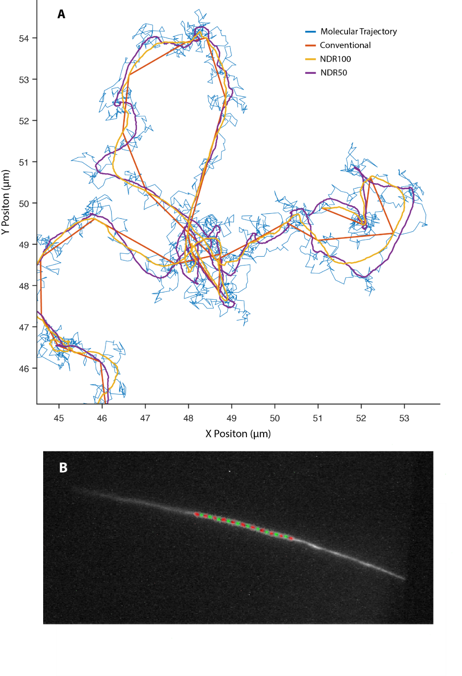
Figure 3.11: Single-particle tracking data via conventional and NDR imaging modes. (A) Reconstruction of a ground-truth molecular trajectory (blue) given by conventional imaging (red) with an exposure of 40 ms, NDR sliding window with an exposure of 40 ms/100 frames but an increment of 0.4 ms (yellow – NDR100) and NDR sliding window with an exposure of 20 ms/50 frames but an increment of 0.4 ms (purple – NDR50). (B) A single-particle trajectory as captured by continuous NDR imaging and separated into individual consecutive frames indicated by the alternating red and green single molecules.
Movements that are of a distance that distorts the very shape of the PSF can lead to inaccurate interpretation of molecular dynamics, so it is important to choose a timestep that maximises the photon counts and minimises the distance moved. In a localisation microscopy measurement, the uncertainty of a measurement can be calculated using Equation 3.2. Given a camera acquires many images of the particle moving, N can be replaced with a photon rate multiplied by time, $nt$(Equation 3.4). Diffusion can also be mapped to some subset of time as shown in Equation 3.3. As the molecule is diffusing the PSF is distorted by the movement increasing the uncertainty as the sum of two variances in a Euclidean fashion (Equation. 3.5).
 | $$σ=\sqrt{\frac{s^{2}+{a^{2}}/{12}}{N}+ \frac{4\sqrt{π}s^{3}b^{2}}{aN^{2}}}$$ | (3.2)
 | $$S_{diffusion}=4DT=4D(kt)$$ | (3.3)
 | $$N=nt$$ | (3.4)
 | $$σ=\sqrt{\frac{s^{2}+{a^{2}}/{12}}{nt}+ \frac{4\sqrt{π}s^{3}b^{2}}{a{(nt)}^{2}}+ {(4Dkt)}^{2}}$$ | (3.5)
Using Equation 3.5 it is possible to model how diffusion affects the uncertainty. A value of 7 was used for the number of photons per camera frame, n, as calculated from the mean photons per event per frame in the Staphylococcus data. The PSF size was 225 nm in width, the average from the Staphylococcus dataset. Using the diffusion constant of eYFP, 7 µm²/s, it is possible to see how the uncertainty of the hypothetical molecule evolves with time (see Figure 3.12). Although these investigations so far have not included the effects of resetting the camera.
As can be seen from Figure 3.12, choosing a particular exposure length is non-trivial and having the capacity to specify this post-acquisition allows much more freedom in obtaining the highest precision from each measurement. During the initial frames the fitting of the molecule is photon-limited and more frames decrease the uncertainty. However, with increasing numbers of frames diffusion takes over as the main factor and leads to an increase in the uncertainty. Increasing the number of photons collected per frame shifts the uncertainty minimum towards smaller number of frames, allowing a shorter exposure. Interestingly with more photons present it becomes disadvantageous to run more slowly, as the effects of diffusion are more readily apparent when compared to the best overall uncertainty. This effect is due to the fit being more accurate and a deviation beyond the uncertainty becomes apparent in a shorter time-period.
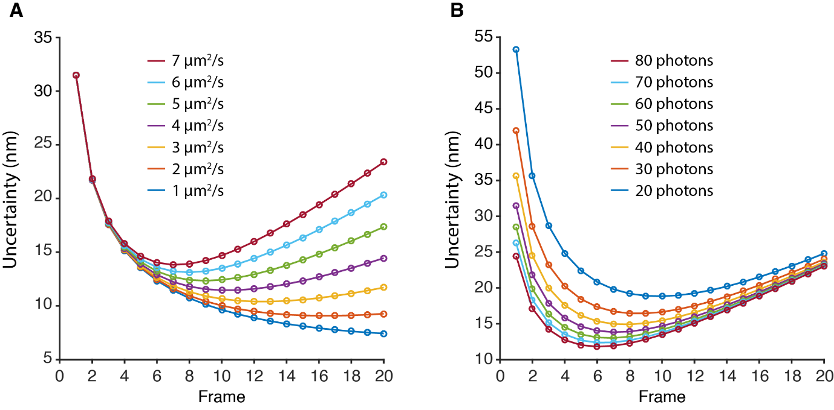
Figure 3.12: Simulated uncertainty in NDR single-particle tracking. (A) The calculated uncertainty for a molecule with different diffusion constants as a function of time. (B) The calculated uncertainty of a molecule diffusing at the same rate but emitting different numbers of photons per timestep.

3.4 Discussion
3.4.1 Quantifying camera performance in the dark
In LM, the SNR directly maps onto the spatial resolution of the microscope and determines the accuracy of the fitting procedure. Many studies have therefore focused on boosting the signal with brighter dyes and conditions that provide larger number of photons per switching event for dyes already in use. Demonstrated here is a prototype camera architecture that takes advantage of NDR, a hardware design that allows signal to be measured without removal from the pixel wells.
Fixed pattern noise (FPN) has negative effects on the quality of the recorded image affecting the values of individual pixels in a consistent fashion. FPN can originate from two sources in CMOS images, either from imperfections in the pixel or from the differences between the column amplifiers (Gamal et al., 1998). FPN can be supressed by measuring the pixel value before and after exposure in a process known as correlated double sampling (CDS) (Mendis et al., 1997; Nixon et al., 1996). It is due to CDS that FPN has a minimal effect on LM, introducing a bias of only 2 nm to the measurements and not affecting precision (Long et al., 2014). The NDR camera does not have on-chip CDS and so the first stage of the analysis is to perform this compensation, demonstrably improving the uniformity of the sensor. Long et al. (2014) suggested that high read-noise pixels have a greater effect on CMOS localisation experiments than FPN, however this effect is minimised by restricting the exposure length to the relevant period.

3.4.2 Limitations of the camera
The measurement noise of the NDR system was calculated as 6.1 e⁻ which is relatively high in comparison to the read-noise of modern sCMOS cameras such as the Andor Zyla 5.5 (read-noise = 1.8 e⁻). However, this camera was run without any form of cooling and as is demonstrated in Figure 3.2 there can be a large amount of dark current present across the sensor. Introduction of a cooling system, such as a Peltier, could dramatically reduce the levels of noise allowing for more accurate reconstructions.
One of the primary issues with this technique is the extremely large amounts of data that are created in a short period of time. In the 180x2048 windowed down mode used in these experiments the camera was set to a 0.4 ms exposure length, so that frames were accumulated at a rate of 2 GB/s. The size of a dataset was 40,000 frames and is equivalent to 16 seconds of data but requires 32 GB of storage. Presently the camera spools data straight to the computer random access memory (RAM), limiting the length of the experiment. However, when windowed down further and in combination with PCIe solid state drives it should be possible to spool directly to the disk, limiting experiment size to the hard-drive size rather than the size of the RAM and allowing for longer datasets. Furthermore, image compression algorithms should be able to reduce the size of the datasets for storage (Balázs et al., 2017).

3.4.3 Super-resolution imaging and NDR
The quality of an LM image is dependent on the quality of the fit that localises each molecule. Maximising the signal and minimising the noise will increase how well the model matches each fit. One of the major contributors to the noise is temporal noise in the camera resulting from sources such as autofluorescence, laser bleed-through, and dark current. From NDR data, only the valuable part of the exposure is collected which minimises the effects of hot-pixels, autofluorescence from the sample and non-signal related photons such as those originating from the illumination source. NDR therefore becomes very useful for identifying transient low-single events on high backgrounds which with other cameras could be lost due to the predetermined start position and length of the exposure (Barnett et al., 2017).
Whilst running a traditional CMOS camera at a higher frame rate can also give accurate start and end points for an event (Lin et al., 2015), the photons become split over multiple frames, incurring a read-noise error with every frame. The frames can be summed together, however this leads to an increased read-noise scaled with the square root of the number of frames summed. This is ideal for understanding fluorophore photophysics, but the additional errors will lower the localisation accuracy. NDR avoids this by only involving two frames to achieve an accurate exposure for each individual molecule incurring a read noise of square-root of two. Additionally, the CMOS summation is digital in nature whereas each frame in NDR is a digital measurement of an analogue summation, maintaining the analogue signal across the exposure period. Recently work into applying single-photon avalanche diodes (SPADs) has demonstrated superb temporal accuracy when detecting photons from a single molecule event (Gyongy et al., 2016). However, due to the lower quantum efficiency and fill-factor, this technology is limited in its detection capability.
As a method, NDR should have very interesting implications for single molecule tracking and time-course experiments. Currently a series of images of single molecules is fitted to find the molecular locations in each frame, then these points are then joined together, dot-to-dot, to form a trajectory. This process is not too dissimilar to the trajectory created in Figure 3.5C. NDR has the possibility of providing much more sensitive tracking as a particular exposure length can be defined and then run over the image stack as a sliding window. For example, starting with a series of pCMOS long exposures it is possible to imagine reducing the length of that exposure a single frame at a time until the uncertainty of the localisation is greater than the distance moved. It would then be possible to use the sliding-window approach to create a smooth, optimal trajectory. Additionally, variable exposure could be applied to an image stack to obtain more accurate trajectories through correlation as shorter exposures are more temporally sensitive and longer exposures are more spatially accurate, although this is dependent on the velocity of the molecule in question. This leads to an interesting trade-off between temporal resolution and the distance moved by a particle that for optimal tracking would be maximum of a function of the localisation uncertainty. Single molecule tracking is one of the primary methods for drift correction in STORM imaging and minimising this variable increases the accuracy of the final reconstruction.
As a continuous exposure is achieved, much more subtle changes between frames could be observable. Additionally, there would be a much higher correlation between exposures as most of the signal making up the frame between two neighbouring time points would be the same. This development could lead to some interesting noise-suppression techniques as the frames can form a partial average, and when combined with statistical approaches that can address the relative confinement of a molecule, it could lead to a more accurate description of molecular environments (Burov et al., 2013).

3.4.4 Further work
A further experimental direction would be low light experiments for observing growth. Phototoxicity is a major issue when performing time-courses on live cells to observe processes in living cells (Wagner et al., 2010). There is interest in observing cells in their most native environment, so any damage that is occurring from the experiment should be minimised. Previous work has demonstrated novel algorithms for suppressing noise, increasing the SNR and allowing imaging of biological samples at low illumination intensities (Carlton et al., 2010), enabling imaging of cells below the threshold where phototoxicity begins to affect cell viability. As the biological relevance of many studies is linked to the effects of phototoxicity, achieving a high SNR with low illumination is important. NDR technology however gives a tuneable exposure that allows low-light long imaging to create a time-lapse series with a sliding window exposure; this could be performed in concert with super-resolution algorithms that already take advantage of low-light illumination (Gustafsson et al., 2016).
The camera used in this study is the first iteration of cameras applying NDR for super-resolution, thus it is expected that the overall resolution would be lower than with top of the range sCMOS and EMCCD cameras. For instance, currently the camera is only under passive cooling from a heat sink on the camera’s exterior. It is known that the dark current in a camera roughly halves with every 10°C decrease in temperature, with most EMCCDs running at -70°C and sCMOS cameras running at sub 0°C (Bigas et al., 2006; Gamal and Eltoukhy, 2005). With the addition of cooling to the camera, such as from a Peltier, the levels of noise resulting from thermal electrons being captured in the wells should be drastically reduced, lowering the noise gradients of the pixels. With a larger difference between the noise and signal gradients, determining the on and off times of a molecule will be more accurate.
Finally, the algorithm created for analysing the data is simplistic and can be improved in a number of ways. Currently, finding the start and end points of the emissions is a crude threshold that will lose signal from the start and end of the emission if the fluorescence response is not instantaneous; additionally deviations in the photon flux from the emitter can cause the emission to drop below the threshold. This problem can be solved through better classification of the start and endpoints of an emitter, for instance through change-point analysis (Watkins and Yang, 2005) which has already been demonstrated for segmenting a fluorescence trajectory.

Chapter 4
Repurposing a photosynthetic antenna protein as a super-resolution microscopy label

4.1 Summary
The quality of fluorescence microscopy is strongly reflected by the robustness of the label used for imaging and as such the discovery of novel probes is important for improving the image quality of such investigations. This chapter concerns the development of a novel fluorophore from the photosynthetic light-harvesting antenna of the cyanobacterium Synechocystis for applications in super-resolution microscopy by STORM and SIM.
The phycocyanin alpha subunit (CpcA) of the phycobilisome is a biliprotein capable of binding different linear tetrapyrroles (known as bilins) for light-harvesting. Here, it is shown that CpcA with a covalently attached bilin, phycoerythrobilin (PEB) or phycocyanobilin (PCB), is suitable for super-resolution imaging. CpcA was over-expressed, purified and nanopatterned onto glass for localisation microscopy. To assess the utility of CpcA-PEB or CpcA-PCB for super-resolution imaging in vivo, Escherichia coli cells producing soluble proteins in the cytoplasm or a translational fusion to the CydB subunit of the cytochrome bd₁ ubiquinol oxidase in the cytoplasmic membrane were studied by both SIM and STORM reconstructions. Both variants of CpcA were found to have a high brightness when compared to other proteins and were stable across the range of physiologically relevant pH values. The stability, ease of expression, high extinction coefficients and fluorescence quantum yield of CpcA-PEB and CpcA-PCB all contribute to their great potential of this hitherto unexplored protein family as novel probes for super-resolution microscopy.
The work presented in this chapter has been submitted for publication:
Barnett, S.F.H., Hitchcock, A., Vasilev, C., Yuen, J.M., Mandal, A.K., Morby, J., Brindley, A.A., Holten, D., Bryant, D.A., Cadby, A.J. & Hunter, C.N. (2017) Repurposing a photosynthetic antenna protein as a super-resolution microscopy label. Scientific Reports. [Submitted]

4.2 Introduction
The success of super-resolution microscopy has been heavily dependent on the probes used for investigation. For example, STORM/PALM requires fluorophores that possess suitable blinking dynamics and SIM/STED require fluorophores that are resilient to photobleaching (Lukinaviciius et al., 2014). However, the current toolbox of fluorophores that can be used for these imaging modalities is incomplete and the search continues for ideal fluorophores that can be used in these systems.
Typically, there are two classes of fluorophore that are used in biological imaging; organic dyes that are small and have to be chemically conjugated to the protein of interest, and proteins that can be genetically fused to a target. Organic dye molecules tend to be more robust for super-resolution being bright and having simple photophysics, however they have a number of shortcomings such as the labelling efficiency and reporter-ligand distance. These downsides can be minimised through genetic fusions when using protein fluorophores; the target protein and the fluorophore are expressed as a single polypeptide chain which leads to a labelling efficiency of unity and a minimised reporter-ligand distance. Protein fluorophores on the other hand have their own short-comings such as a lower photon yield and complex blinking behaviours relative to the organic dyes (Wang et al., 2014). Thus, the search for brighter protein fluorophores is essential for greater accuracy.
Photosynthetic organisms have undergone billions of years of evolution to develop systems that are optimised and tuned for interacting with light. As such they are good candidates for discovery of novel fluorophores and in the past have been used for imaging systems purely from the autofluorescence signal (Rumak et al., 2012). The cyanobacterial phycobilisome is a large multimeric protein complex designed for funnelling photonic energy towards photosystem I and photosystem II involved in the light-dependent photosynthetic reactions (MacColl, 1998). The phycobilisome is organised in such a manner so that high energy photons (480-580 nm) are absorbed near the exterior of the protein and stepped downwards in energy toward core with intermediate energy (560-640 nm) photons being absorbable at stages along the way (see Figure 4.1). This stepping method is a highly efficient way of transferring energy towards the core through FRET, whilst also allowing a large degree of sampling of the electromagnetic spectrum.
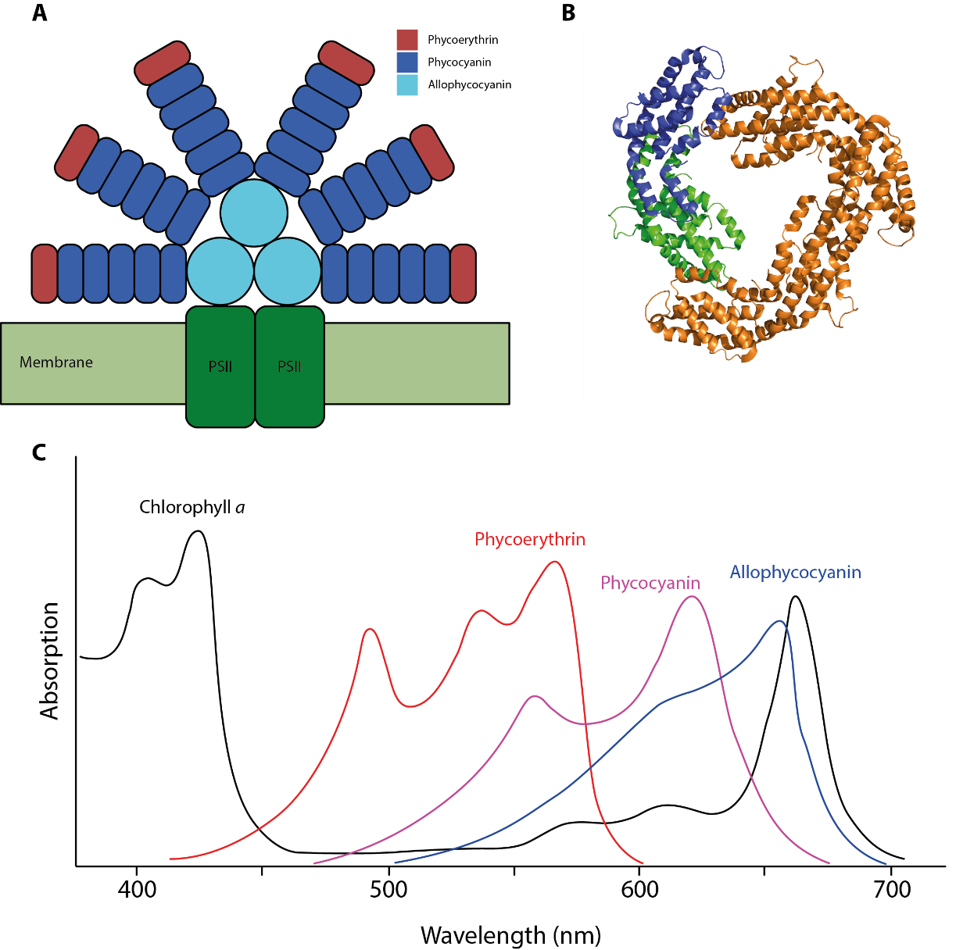
Figure 4.1: The light harvesting phycobilisome. (A) Diagram of the structure of the phycobilisome that draws light towards PSII. (B) Trimer of phycocyanin-α (green) and phycocyanin-β (blue) that makes up the extended rods. (C) Absorption spectra of phycobilisome components that allows FRET of energy to chlorophyll.
The phycobilisome consists of a core of three-five allophycocyanin cylinders with rods of trimeric phycocyanin extending outwards that can, in some growth conditions, be extended with a further phycobiliprotein, phycoerythrin (Marsac, 1977). Phycocyanin is a heterodimer consisting of CpcA and CpcB that bind one and two bilin chromophores respectively. Recent work has demonstrated the capability of the ~18 kDa CpcA to bind not just its native chromophore phycocyanobilin (PCB), but phycoerythrobilin (PEB), phycoviolobilin (PVB), phycourobilin (PUB) and phytochromobilin (PφB) when the proteins are expressed in E. coli, increasing the potential spectral range of this protein (Alvey et al., 2011). The bilin tetrapyrrole ligands are formed through the linearization of haem by haem oxygenase (HO1) to form biliverdin IXα. Further processing is capable of producing the separate bilin molecules by several possible ferredoxin-dependent bilin reductases (Blot et al., 2009; Frankenberg et al., 2001). The specialized light-harvesting and energy-transfer functions of phycobiliproteins have practical applications. These proteins form a range of stable, soluble, vividly coloured and highly fluorescent complexes used as fluorescent probes in epifluorescent imaging (Bermejo et al., 2002; Glazer, 1994a; Rodriguez et al., 2016).
This chapter outlines the overexpression, purification and testing of the α-subunit of phycocyanin, CpcA, bearing either a PCB or PEB chromophore, showing that it represents a novel, photo-switchable probe for super-resolution microscopy. Photo-switching behaviour has been established both in vitro using surface-attached, nanopatterned CpcA-PCB and CpcA-PEB arrays and in vivo by using CpcA as a reporter of membrane protein distribution in the bacterial cytoplasmic membrane. We also demonstrate the potential for using CpcA-labelled systems for SIM imaging in vivo.

4.3 Results
4.3.1 Overexpression and purification of CpcA-PCB and CpcA-PEB
Two plasmid systems were used for overexpression of both His₆-tagged (HT) CpcA-PCB and CpcA-PEB. The E. coli strain BL21 (DE3) was cotransformed via heat shock with either pPcyA and pBS414v for CpcA-PCB or pCOLADuet-cpcEF-pebS-HO1 and pBS405v for CpcA-PEB as detailed in Section 2.9. Protein overexpression was performed as detailed in Section 2.10 and after overnight induction the cultures were noticeably either pink (HT-CpcA-PEB) or blue (HT-CpcA-PCB) as shown in Figure 4.2A. Processing of the proteins was relatively straightforward due to their intense colour and is detailed in Section 2.11. Impurities were still present after the metal affinity chromatography as shown by SDS-PAGE in Figure 4.2B.
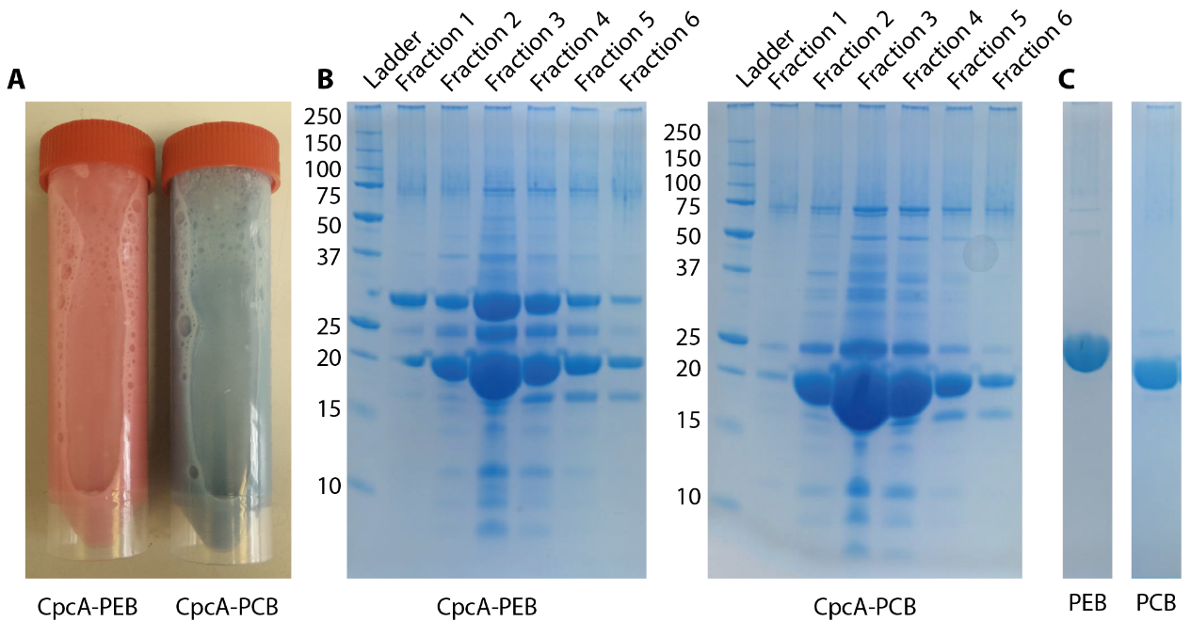
Figure 4.2: Purification of recombinant CpcA. (A) Cell suspension of post-induction E. coli expressing CpcA-PEB or CpcA-PCB. (B) SDS-PAGE gels of CpcA-PEB and CpcA-PCB fractions collected from His-tag purification. (C) Final purification products showing pure CpcA-PEB and CpcA-PCB.
Whilst metal affinity purification produced an excess of CpcA there were contaminants in the elution. To increase the purity, the protein containing fractions were pooled and passed through a size-exclusion column. To further remove contaminants such as other proteins involved in the overexpression (CpcE/F, HOX, PcyA, PebS), the solution was purified by ion-exchange chromatography and the final pure protein is demonstrated in Figure 4.2C.

4.3.2 Calculation of molar extinction coefficients of CpcA-PEB and CpcA-PCB
Calculation of the native molar extinction coefficients at the absorption maximum was carried out through comparison of the native absorption spectrum to that of the denatured protein. The extinction coefficients for CpcA-PCB/PEB have previously been reported at 663 nm and 555 nm in acidic urea as 33,200 and 43,300 respectively (Glazer and Fang, 1973; Glazer and Hixson, 1975). Additionally, the extinction coefficients of the minor peaks at 352 nm and 308 nm for PCB and PEB were 32,600 and 18,300 respectively. Purified CpcA was diluted 30 µl into 970 µl in either PBS (native) or 8 M urea pH 1.9 with 10 mM β-mercaptoethanol (denatured) and incubated at room temperature for 15 minutes to reach equilibrium. The absorption spectra were measured from 300 nm to 800 nm on a Cary 60 spectrophotometer in triplicate (Figure 4.3). As the concentrations are equal, the native extinction coefficient can be found ratiometrically from the absorbance and the rearranged Beer-Lambert relationship (Equations 4.1 and 4.2).
 | $$A= εcl$$ | (4.1)
 | $$\frac{ε_{native}}{A_{native}}= \frac{ε_{denatured}}{A_{denatured}}$$ | (4.2)
Where A is the absorbance, ε is the molar extinction coefficient, c is the concentration and L is the pathlength. Native CpcA-PCB has an extinction coefficient of 100,265 at 624 nm whereas CpcA-PEB has an extinction coefficient of 112,590 at 556 nm. The extinction coefficients of the secondary peaks were lower in native conditions and were 17,702 at 352 nm for PCB and 14,796 at 308 nm for PEB.

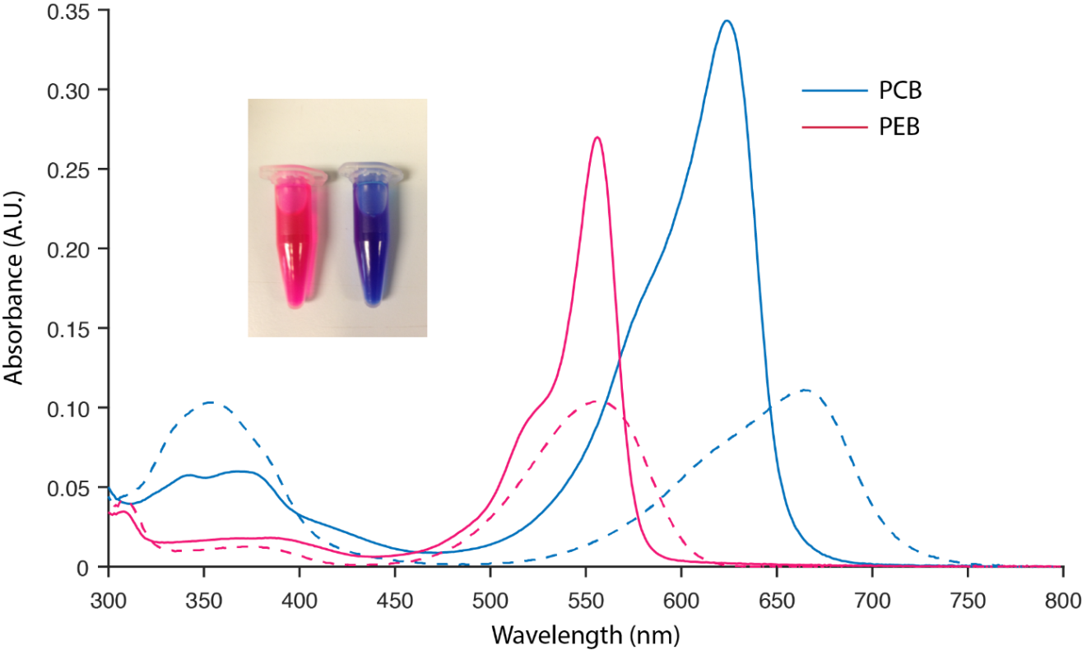
Figure 4.3: Extinction coefficients of CpcA-PCB and CpcA-PEB. The absorption spectra in arbitrary units of native (solid lines) and denatured (dashed lines) PCB-conjugated/PEB-conjugated CpcA used to calculate the extinction coefficients. The displayed spectra are the average of 3 replicate traces and were normalised at 790 nm. The inset panel shows the intensely coloured purified protein preparations.

4.3.3 Spectroscopic properties of CpcA-PCB and CpcA-PEB
Purified CpcA-PCB and CpcA-PEB proteins were analysed by steady-state and time-resolved fluorescence spectroscopy. Absorption and fluorescence emission spectra (Figure 4.4A) revealed that these pigment-proteins occupy different but overlapping spectral regions, in total spanning 500-650 nm for absorption and 560-760 nm for emission.
The singlet excited state lifetimes of CpcA-PCB and CpcA-PEB were measured by fluorescence decay (Figure 4.4B) and transient absorption (Figure 4.4C) studies. The average values for CpcA-PCB and CpcA-PEB are 1.3 and 1.9 ns, respectively. The fluorescence quantum yields were determined by relative and absolute measurements. The average values are 0.23 for CpcA-PCB and 0.67 for CpcA-PEB; both are lower than those reported previously, 0.39 and 0.98 (Alvey et al., 2011), but have the same relative ordering. The transient absorption studies also allow measurement of the yield of intersystem crossing from the lowest singlet to triplet excited state, also known as the triplet yield. Representative spectra as a function of time after excitation with a 100 fs flash for CpcA-PCB (Figure 4.4D) are dominated by bleaching of the ground state absorption band at ~640 nm due to formation of the lowest singlet excited state. This bleaching (and the rest of the absorption difference spectrum) decays to zero by 6 ns. This observation shows that the (fluorescent) lowest singlet excited state decays virtually completely to the ground state and thus that the yield of intersystem crossing to the lowest triplet excited state is virtually zero. The same conclusion is drawn for CpcA-PEB given that the bleaching of the ground state absorption band at ~570 nm for the lowest singlet excited state decays to zero by 7.5 ns (Figure 4.4D). Thus, for both variants the yield of intersystem crossing is zero and the yield of internal conversion of the singlet excited state to the ground state can be obtained from the fluorescence yield. In particular, the internal-conversion yield is 1− 0.23 = 0.77 for CpcA-PCB and 1− 0.67 = 0.33 for CpcA-PEB. Thus, these proteins do not produce long-lived triplet states that in the presence of O₂ would produce reactive oxygen species that could lead to degradation of the fluorescence probe (or other entities nearby). This characteristic likely contributes substantially to their photostability.

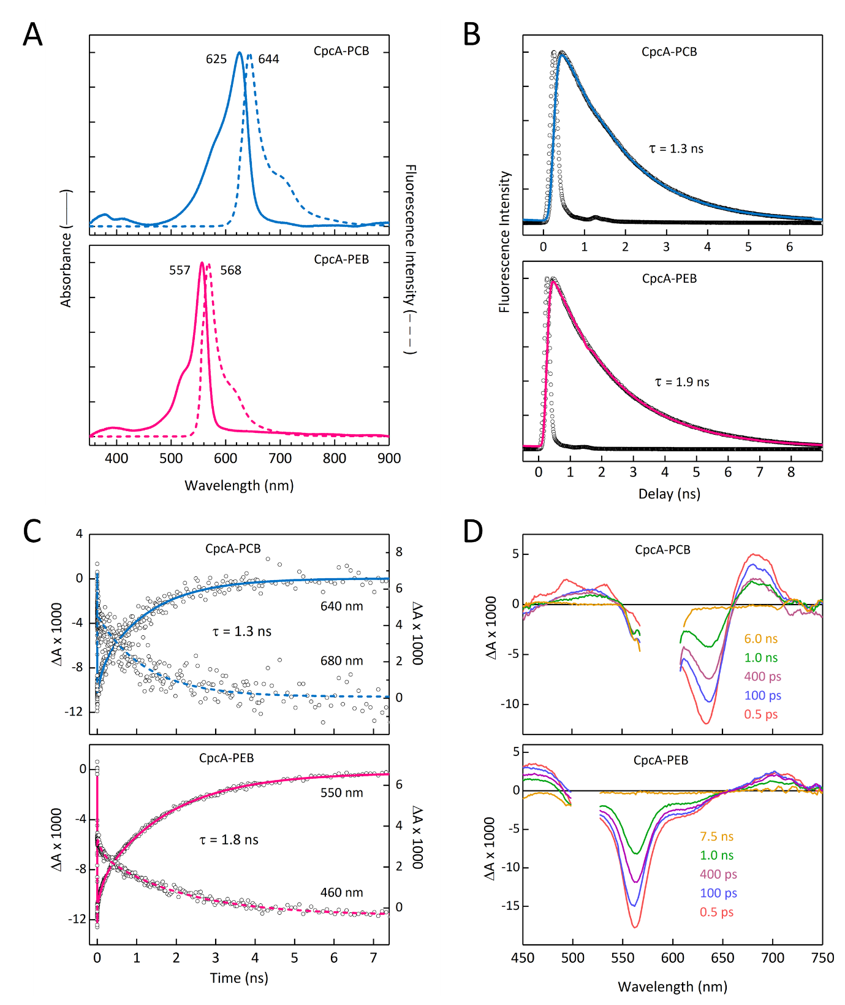
Figure 4.4: Photophysical analysis of purified CpcA-PCB and CpcA-PEB. (A) Room temperature absorption and fluorescence emission spectra, normalised for comparison. The same fluorescence spectra were observed for a number of different excitation wavelengths for CpcA-PCB (500, 525, 550, 572 and 625 nm) and CpcA-PEB (490, 510, 525 and 557 nm). (B) Fluorescence decay profiles (solid black circles) and dual-exponential fits (solid blue or red lines) of CpcA-PCB using excitation at 582 nm and detection at 644 nm and CpcA-PEB using excitation at 530 nm and detection at 568 nm. The open black circles give the instrument response function, which is approximatly a Gaussian with a full width at half maximum of 200 ps. (C) Representative time profiles (circles) and fits (solid lines) for decay of ground state bleaching (solid lines) or excited state absorption (dashed lines) from the transient absorption data depicted in (D). (D) Time-resolved absorption difference spectra using 100-fs excitation flashes at 590 nm for CpcA-PCB and or 510 nm for CpcA-PEB. The data in the region of each spectrum that contains scattered excitation light has been removed. Work conducted by Dr Jonathan M. Yuen, Dr Amit K. Mandal, and Professor Dewey Holten (Washington University in St Louis).
The values for fluorescence lifetime and quantum yield compare favourably with those for variants of the enhanced yellow fluorescent protein (EYFP), for example, which are 3 ns and 0.76 respectively (Kremers et al., 2006). The extinction coefficients (M⁻¹ cm⁻¹) were calculated to be 100,265 M⁻¹ cm⁻¹ at 624 nm for CpcA-PCB and 112,590 M⁻¹ cm⁻¹ at 556 nm for CpcA-PEB. The overall brightness of these proteins is the product of the quantum yield and extinction coefficient, expressed in units of mM⁻¹ cm⁻¹, which yields values of 23 and 75 for CpcA-PCB and CpcA-PEB, respectively, and compares well to EYFP, which has a brightness of 55.

4.3.4 Sensitivity of CpcA to pH
To test the effect of pH on the absorption spectra of CpcA, 30 µl of protein was diluted into 1 ml of PBS at a range of pH values from 3 to 11. The protein was left for one hour to equilibrate to the new pH conditions and allow for any changes in conformation to occur. The spectrum was measured with a Cary 60 spectrophotometer previously baselined to the constituent buffer and the solution was scanned from 300 nm to 750 nm. CpcA-PCB showed visible changes to the 625 nm and 350 nm peaks with the red peak decreasing and the ultraviolet (UV) peak increasing at more extreme pH values (see Figure 4.5). The absorbance was stable over the range of 4 to 10 but drastically decreased outside of this range indicating unfolding. CpcA-PEB was more stable across a wider pH range (4 to 11) and there was no decrease in absorbance at the 556 nm maximum at the alkali pH of 11 (see Figure 4.6). There was also an increase in UV absorbance, in acidic conditions. The difference between these two constructs, with different chromophores but identical protein scaffolds, is suggestive that the bilin chromophore is involved in the structural integrity of the CpcA.
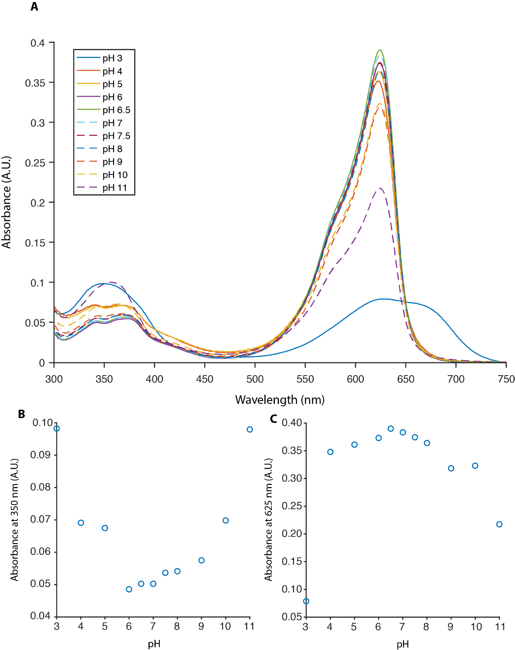
Figure 4.5: Absorbance as a function of pH for CpcA-PCB. (A) The absorption spectra of CpcA-PCB measured from 300-750 nm against various pH values. (B) The absorbance values of CpcA-PCB at 350 nm showing a clear increase in both low and high pH’s. (C) The absorbance values of CpcA-PCB at 625 nm showing a max value at pH 7.

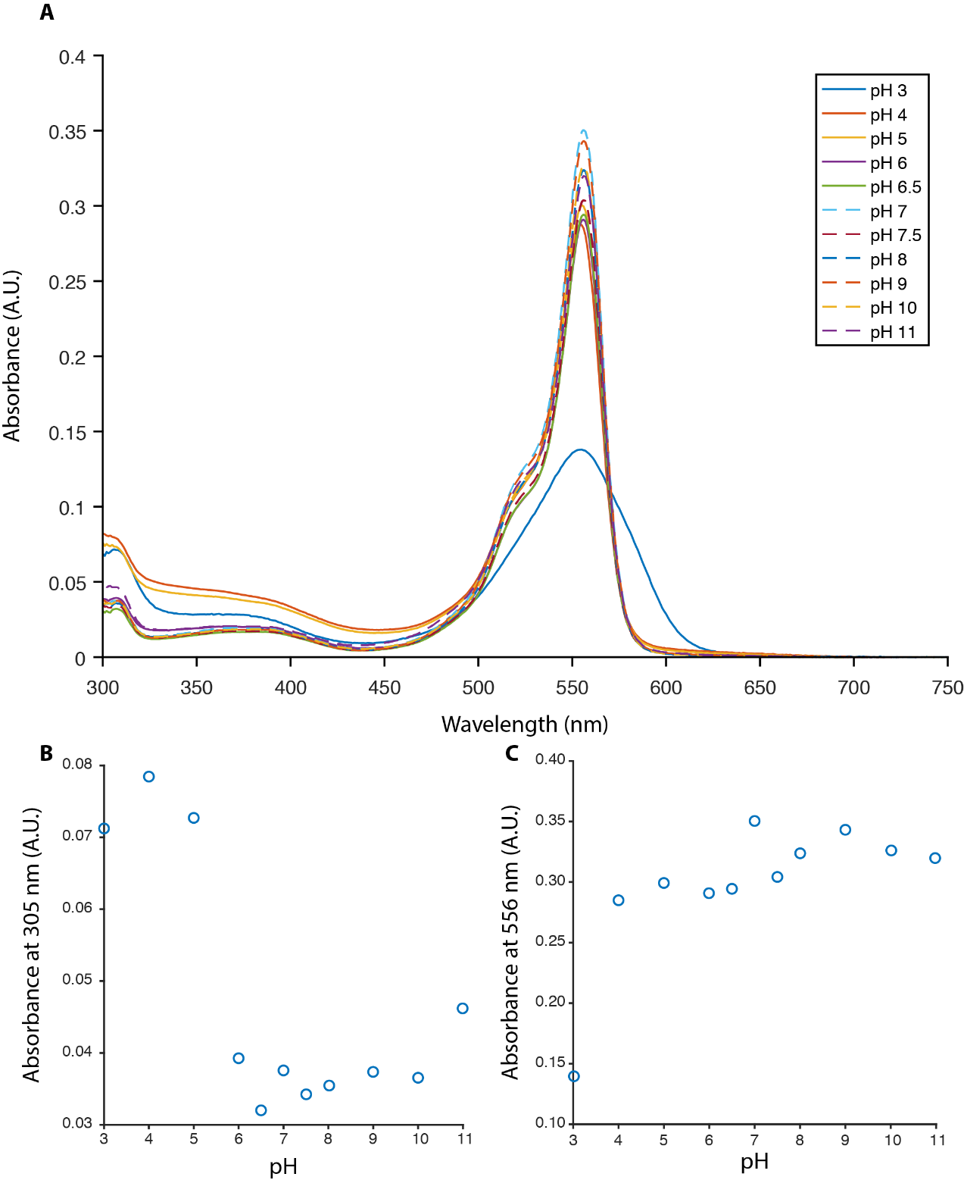
Figure 4.6: Absorbance as a function of pH for CpcA-PEB. (A) The absorption spectra of CpcA-PCB measured from 300-750 nm against various pH values. (B) The absorbance values of CpcA-PCB at 305 nm showing a clear increase at low pH. (C) The absorbance values of CpcA-PCB at 556 nm showing a max value at pH 7.

4.3.5 Nanopatterning of CpcA onto glass coverslips
To test the capabilities of the protein, CpcA was patterned onto a self-assembled monolayer on a piranha cleaned glass substrate, in a process shown in Figure 4.7 and more fully detailed in Section 2.12, and imaged via STORM. The linker molecule, SMCC, binds on one side to the sulfhydryl group of the MPTMS via the protruding maleimide group and to exposed lysine residues on the exterior of the protein via an amine reactive NHS ester (Mattson et al., 1993). Prior to linking CpcA to the pattern, the protein was desalted into PBS using a PD10 desalting column to remove the Tris buffer as Tris contains an amine group that would compete for the SMCC linker. The Tris buffer is present in a much higher concentration than the CpcA and so the pattern would be sparsely labelled with the protein, inhibiting reconstruction of the complete pattern. CpcA-PEB was patterned with a 200 nm on, 1800 nm off cycle with a total period of 2 µm and CpcA-PCB was patterned with a 303 nm on, 303 nm off cycle with a total period of 606 nm.
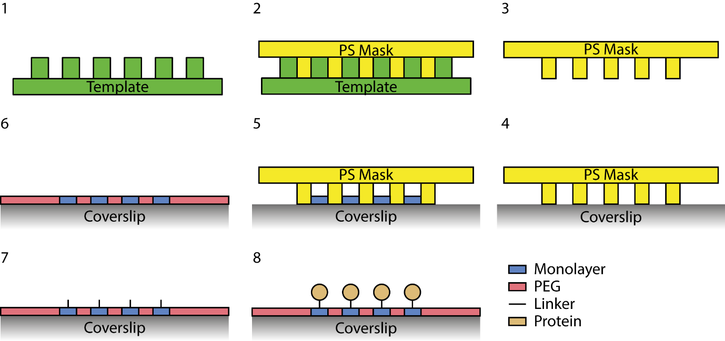
Figure 4.7: Nanopatterning of CpcA to glass. (1) A silicon template is spin coated with polystyrene to make a negative mask as shown in (2). (3) The mask is separated from the template and (4) attached to a coverslip. (5) A monolayer is created on the exposed areas of the coverslip through vapour deposition. (6) The mask was removed and the rest of the coverslip backfilled with PEG. The monolayer was functionalised with a linker (7) which was then exposed to protein (8).
The samples were excited with either 514 nm (CpcA-PCB) or 532 nm (CpcA-PEB) lasers, which caused each of these pigmented proteins to undergo spontaneous photo-switching without the requirements of an activation laser. CpcA-PCB and CpcA-PEB settle into an on-off equilibrium with little evidence of photobleaching after an initial illumination period, a property required for photoswitchable fluorescent proteins.
CpcA-PEB nanopatterns had been fabricated with 200 nm wide lines and 2 µm periodicity. The reconstruction process was performed with ThunderSTORM (Ovesný et al., 2014), and the resulting image consisting of 66,780 events is shown in Figure 4.8. Analysis of the reconstructions by Fourier transform yielded a periodicity of 1.95 µm, in good agreement with the template used for lithography, and a linewidth (full-width half-maximum) of 200 nm. CpcA-PCB nanopatterns were created using a template with lines 303 nm wide and with a 606 nm periodicity. A reconstruction of the data obtained from recording 27,392 blinking events is shown in Figure 4.8; Fourier transform analysis yields a periodicity of 610 nm. These measurements are consistent with the dimensions from AFM topographs (Figure 4.9), which gave linewidths of 303 nm. The linewidths obtained from reconstructions in Figure 4.8 are compared with the broader linewidths from the epifluorescence images in Figure 4.8.
As is common with fluorescent proteins, the photon yield of each protein is lower than conventional dyes used in single molecule experiments. Single exponential fits of the photon counts for each protein (Figures 4.8E and Figure 4.8F) give a mean number of photons for each blink as 296 (CpcA-PEB) and 91 (CpcA-PCB).

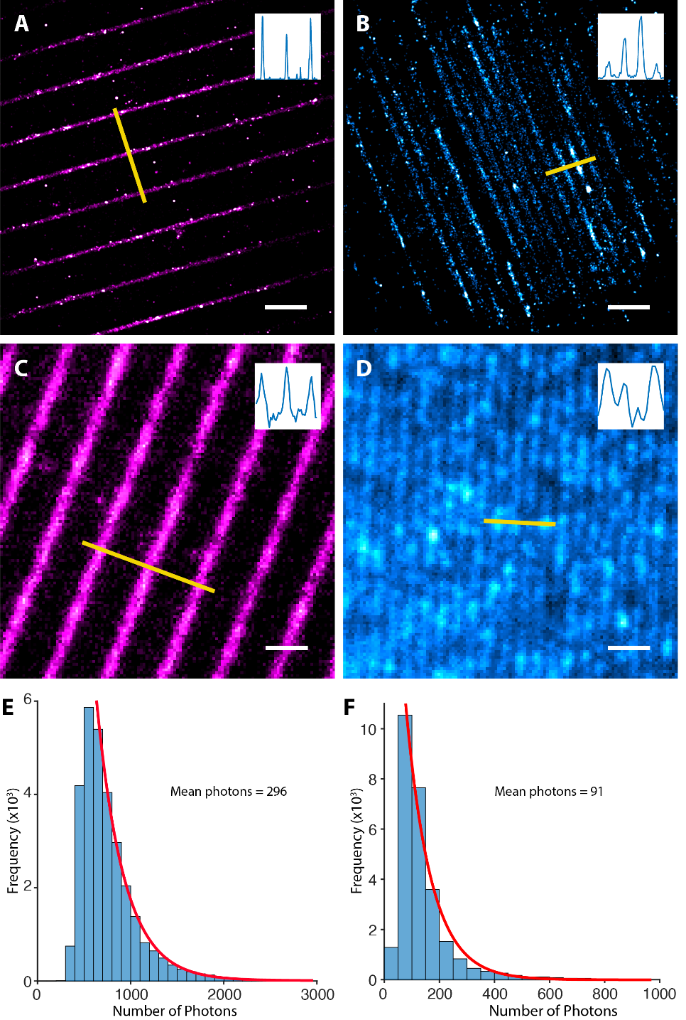
Figure 4.8: STORM and epifluorescent imaging of CpcA nanopatterned onto a glass surface. Reconstructions of STORM imaging of CpcA-PEB (A) and CpcA-PCB (B) nanopatterns. (C, D) Epi-fluorescent images of CpcA-PEB and CpcA-PCB nanopatterns respectively. Inset in the top-right corner of each image is the orthogonal line profile shown in yellow. Scale bar in bottom right of each image is 2 μm. (E, F) Mean number of photons as calculated by a single-term exponential fit of CpcA-PEB and CpcA-PCB respectively.
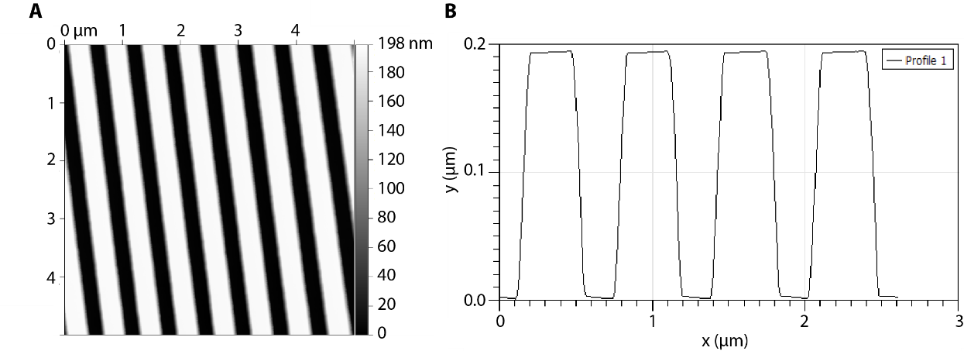
Figure 4.9. Silicon master template imaged by AFM. Top down image of the silicon template used to produce the nanopattern (A) and line profile demonstrating the dimensions of the pattern to be 300 nm on, 300 nm off (B).

4.3.6 In vivo imaging of CpcA in E. coli with STORM
To test their utility in vivo, CpcA-PCB and CpcA-PEB variants were separately expressed in E. coli, either freely in the cytoplasm or as translational fusions to the CydB subunit of the cytochrome bd quinol oxidase, which is localised in the cytoplasmic membrane. Cells were harvested, washed and mounted on clean coverslips in PBS for imaging. Photo-switching behaviour was observed for both bilin variants of the proteins, using 514 nm excitation. The reconstructions of the STORM images show a heterogeneous distribution of CydB-CpcA-PEB/PCB fusions in the E. coli cytoplasmic membrane (Figure 4.10). The PEB variant of the fusion protein demonstrated 6638 ± 2331 localizations per cell (n=8) whilst the PCB variant had 3501 ± 1577 localizations per cell (n=6) In contrast to the heterogeneous membrane distribution of CydB-CpcA-PEB/PCB, free CpcA showed a uniform distribution in the cytoplasm, as expected.
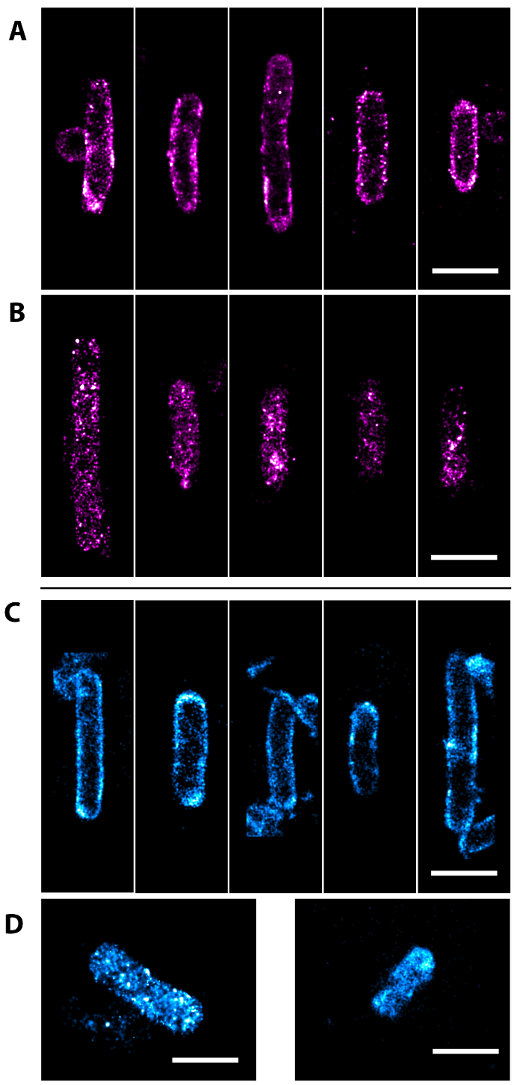
Figure 4.10: STORM imaging of CpcA-PEB and CpcA-PCB expressed in E. coli. (A) CydB-CpcA-PEB localized to the cytoplasmic membrane demonstrating a heterogenous distribution. (B) Reconstructions of CpcA-PEB as expressed freely into the cytoplasm showing a more even distribution. STORM imaging of (C) CydB-CpcA-PCB and (D) cytoplasmic CpcA-PCB. Images were rotated with bilinear interpolation and the scale bar represents 1 μm.
4.3.7 In vivo imaging of CpcA in E. coli with SIM
Structured illumination microscopy is a further super-resolution technique that is capable of sub-diffraction imaging, increasing the resolution by a factor of two in both lateral directions and axially leading to a volumetric increase of eight times. CpcA-PCB and CpcA-PEB were both tested for their capabilities as fluorophores of surviving a SIM imaging regime which is intensive and leads to large levels of photobleaching. For each single 2D SIM image a series of 5 images must be captured for each of 3 angles for a total of 15 images, photobleaching over this image series can lead to the presence of artefacts in the final image (Schaefer et al., 2004). Cells co-transformed with the required plasmids for CpcA production grown to an OD₆₀₀ of 0.6 and induced with 0.4 mM IPTG. Cells were transferred to 18°C and incubated for two hours to allow protein production. Cells were incubated on a poly-L-lysine coverslip for 30 minutes before being mounted in SlowFade Diamond antifade.
Samples were imaged on a DeltaVision OMX V4 microscope with PCB illuminated with a 647 nm laser and emission collected with a 683/40 bandpass filter. CpcA was illuminated with a 568 nm laser and the emission was collected with a 609/37 bandpass filter. Super-resolution images were reconstructed with the OMX softWoRx 6.0 software package (shown in Figure 4.11).
3D-SIM imaging was conducted on the CydB-CpcA and cytoplasmic expression strains and 2D reconstructions are demonstrated in Figure 4.11. Image stacks were analysed with the SIMcheck plugin to quantify fluorophore performance (Ball et al., 2015). CpcA-PEB was particularly susceptible to photobleaching from 3D-SIM with cytoplasmically located ‘free’ protein undergoing an 89.3% ± 2.4 intensity variation and a mean decay of 61.4% ± 2.2 over the course of acquisition (number of cells = 14). The CydB fusion had a 97.7% ± 0.4% intensity variation and a mean decay of 73% ± 1.4 (number of cells = 12). The high levels of photobleaching suggests that PEB is not suitable for 3D SIM, however its starting brightness makes it suitable for single 2D reconstructions. CpcA-PCB was much more robust to imaging (see Figure 4.12), especially when located in the cytoplasm where it exhibited very little evidence of photobleaching with an intensity variation 28.2 % ± 8.6 and a mean decay of 18.4% ± 9.75 (number of cells = 16). This stability was slightly reduced in the CydB fusion with a 52.1% ± 5.3 intensity variation and 22.1% ± 9.5 mean decay.

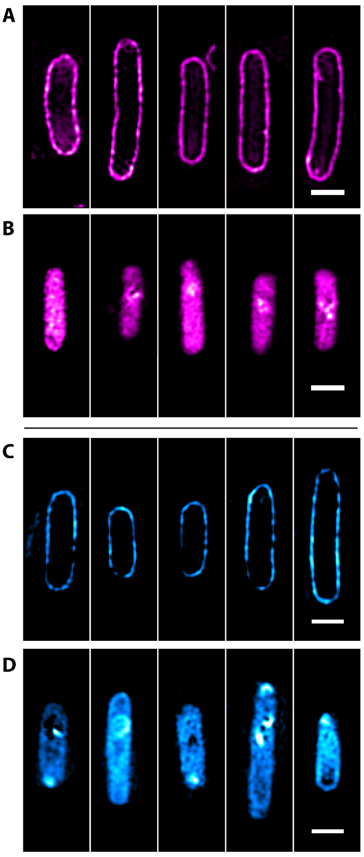
Figure 4.11: Structured illumination microscopy of CpcA-PEB and CpcA-PCB. (A) SIM imaging of CydB-CpcA-PEB localized to the cytoplasmic membrane. (B) Reconstructions of free CpcA-PEB in the cytoplasm. SIM imaging of (C) CydB-CpcA-PCB and (D) cytoplasmic CpcA-PCB. Images were rotated with bilinear interpolation and the scale bar represents 1 μm.
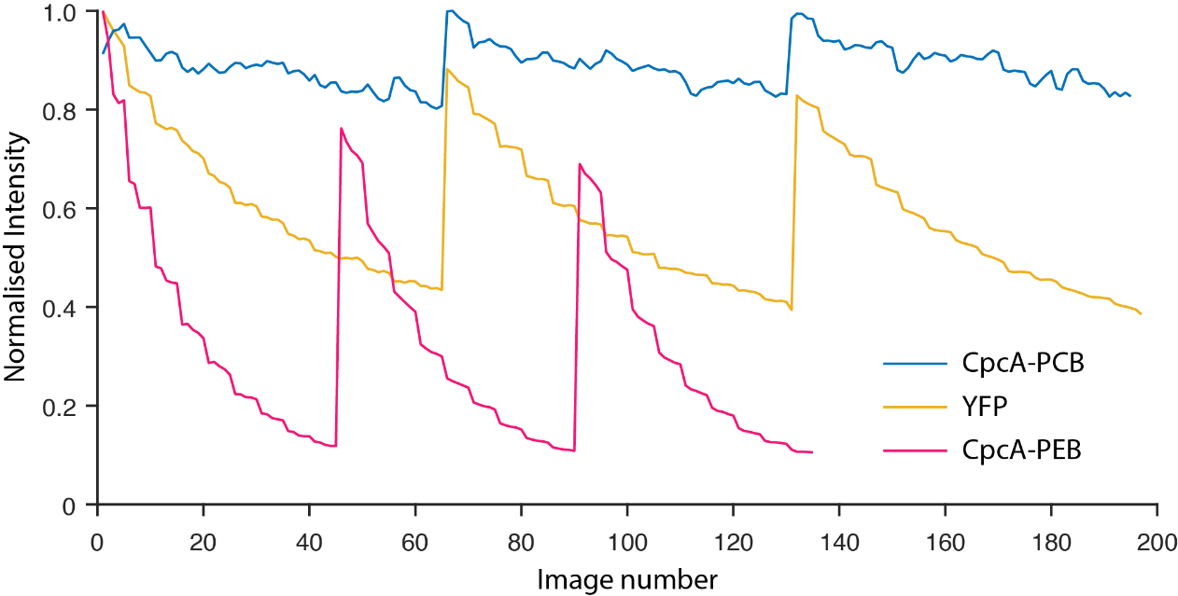
Figure 4.12: CpcA and YFP Intensity decay curves under a SIM imaging regime. Normalised intensity profiles across a SIM stack in relation to the pattern angle. CpcA-PEB shows a dramatic decrease in fluorescent intensity whereas CpcA-PCB is more robust to the imaging regime.

4.4 Discussion
4.4.1 Overexpression and purification of CpcA
Both CpcA-PCB and CpcA-PEB were successfully overexpressed in E. coli as demonstrated by the coloured cell suspensions in Figure 4.2. The proteins were purified from the soluble fraction of broken cells indicating that the proteins are not aggregating and forming inclusion bodies within the cells. Furthermore, little protein was observed to be present in the pellet as demonstrated by SDS-PAGE also confirming the solubility of the protein. Purification from the soluble fraction through metal-affinity, size exclusion and ion exchange chromatographies created solutions of highly pure protein (see Figure 4.2).

4.4.2 Performance of CpcA on a glass substrate
Nanopatterned CpcA-PCB and CpcA-PEB underwent spontaneous blinking with stimulation from a 514 nm laser in a regime matching that of direct STORM (dSTORM) (van de Linde et al., 2011). In dSTORM, a single laser is able to excite the fluorophore whilst spontaneous photophysical changes are able to transition the label between the ON and OFF states. This application varies from the original STORM imaging where stochastic dimerization of two probe components caused the necessary fluctuations (Rust et al., 2006). CpcA requires no additional buffering components such as thiols required for cyanine dyes (Dempsey et al., 2009). Additionally, once the protein had reached a stable equilibrium there was little evidence of photobleaching, as seen by the slow decay in the number of events per frame. Further evidence for the stability of CpcA is provided by the spectroscopy that shows a limited occupation of the triplet state. This is suggestive that the blinking of CpcA is not a result of triplet blinking but perhaps more likely either redox blinking or a conformational change in the chromophore. This imaging was performed in a widefield setup, so as the protein is directly in contact with the coverslip, brighter events could be detected by switching to a TIRF style illumination pattern.

4.4.3 Performance of CpcA as a fluorophore
The CpcA protein is derived from the light-harvesting antenna, the phycobilisome, of the cyanobacterium Synechocystis sp. PCC 6803, and binds its weakly absorbing and fluorescing linear tetrapyrrole (bilin) ligands within a sterically defined site, which transforms these pigments into highly coloured and strongly fluorescent chromophores (Alvey et al., 2011). Free bilin chromophores, as well as those of denatured proteins, adopt a cyclo-helical conformation that is only very weakly fluorescent (Falk, 2012; Scheer et al., 2015). Thus, there is almost no background signal from unattached bilins, and the only localisation signals observed are from the native, CpcA-bound form of the pigment.
Transient absorption studies of the triplet yield (Figure 4.4) show the basis for the photostability of CpcA-PCB in particular (Figure 4.12), which arises from nearly complete decay of the lowest singlet excited state to the ground state, with almost no formation of long lived triplet states that could produce reactive oxygen species. The brightness values for CpcA-PCB and CpcA-PEB, 23 mM⁻¹cm⁻¹ and 75 mM⁻¹cm⁻¹ respectively, lie within the range of most fluorescent proteins that emit maximally up to 600 nm. For fluorescent proteins in the 630-720 emission range and classed as far-red and near-infra red the low quantum yield of fluorescence lowers the brightness; only mKate2 (emission maximum 633 nm; brightness 25; Shcherbo et al., 2009) compares with CpcA-PCB (emission maximum 644 nm; brightness 21) and whilst a photoactivatable variant known as PAmKate has been developed (emission maximum 628; brightness 8.6; Gunewardene et al., 2011), the protein has a lower brightness.
The brightness of CpcA is comparable with many currently available in vivo fluorophores, and CpcA-PCB is the brightest red fluorophore yet reported. Both labels have the advantage of tunable fluorescence. The location of a protein of interest under native conditions, can be established using a fusion of CpcA and the target, under native promoters within the host genome. Simply by growing the cells and imaging them under the localisation microscopy regime the proteins can be visualised at high-resolution in under natural conditions. However, care has to be taken to ensure that the fusion is as close to the native protein as possible, and that the protein label does not aberrantly form dimers or other higher order aggregates or indeed sterically hinder the protein from its native location or partners.
The emission filters that were used to collect the fluorescence from the sample are not ideal for each of the CpcA types and could not be altered for more suitable wavelengths. As such much of the signal from the emission is blocked by the bandpass filters. The level of signal gathered from the protein is sufficient to perform SIM however the process would have a higher fidelity if more photons were collected; this would also facilitate faster imaging.
Given the wide variety of bilins in nature, the ability to engineer new bilin biosynthetic pathways (Alvey et al., 2011; Scheer et al., 2015), and the potential for spectral tuning by reconfiguring their binding sites within CpcA, these pigment proteins have great potential for super-resolution imaging. Additionally, as CpcA does not exhibit photochromic switching it does not occupy two spectral windows like EosFP (Ivanchenko et al., 2005) more easily facilitating multicolour imaging.

4.4.4 Distribution of CydB within the E. coli cytoplasmic membrane
A previous PALM imaging study used CydB labelled with mMaple, revealing clusters of localizations on 50-200 nm length scales (Llorente-Garcia et al., 2014). This work was conducted with the tagged CydB produced from the native promoter, whereas here we used a plasmid-based over-expression system that probably results in much higher levels of CydB being inserted into the membrane. Thus, we cannot draw conclusions about the localisation of the bd quinol oxidase from our data; however, the purpose of our study was to demonstrate the applicability of CpcA-PCB and CpcA-PEB for super-resolution imaging in vivo rather than to gain any biologically relevant insight. As a side observation, it is apparent that the bilin ligation to the apoprotein is feasible when the fluorophore is fused to a secondary protein of interest.

4.4.5 Future work
CpcA is one of a family of phycobiliproteins that could be a wealth of new super-resolution fluorophores, especially if they are capable of binding multiple different chromic ligands like CpcA. Exploration of this family as putative fluorophores should be the next step in the search for better fluorescent labels. Additionally, directed evolution could be applied to enhance the brightness of this family and create even more potent proteins. Furthermore, some phycobiliproteins, such as CpcB, are capable of binding multiple phycobilin ligands, so experiments could investigate whether such an arrangement is advantageous as a fluorophore (Wu et al., 2013).
Furthermore, it has been shown that directed evolution is a potential method for enhancing a fluorophores’ abilities including stability and photon yield (Kiss et al., 2009). Neither of the CpcA variants has yet been put through this regime and as the protein is the result of millennia of evolution to accept and donate energy as part of a light harvesting system, mutagenesis of the individual monomer could yield a more desirable fluorophore. Recent developments offer further possibilities for this group of chromophoric proteins. The smURFP proteins incorporate PCB into the α-allophycocyanin of the cyanobacterium Trichodesmium erythraeum, and the extinction coefficient and quantum yield makes this homodimeric FP suitable for intracellular imaging (Rodriguez et al., 2016). Further spectral expansion of biliproteins for imaging is made possible by the recent discovery of cyanobacteria that can grow in infrared light, above 700 nm (Gan et al., 2014a, 2014b; Li et al., 2016). These bacteria synthesise a red-shifted chlorophyll, Chl f, and they also modify their phycobilisomes accordingly. Recombinant expression in E. coli of variants of the ApcE2 protein from Synechococcus sp. PCC7335 yields phycobiliproteins with absorption maxima at 711 nm and emission maxima at 726 nm (Ho et al., 2017; Miao et al., 2016). Furthermore, expression of variants of the ApcF2 phycobiliprotein with an emission maxima of 710 nm from the thermophilic cyanobacterium Chroococcidiopsis thermalis has been demonstrated in mammalian cells (Ding et al., 2017), providing more scope for varying CpcA-based LM.
Furthermore, as CpcA is capable of binding different chromophores in spectrally different windows it should be possible to produce two separate bilins that ligate to the same fusion construct. This would create a structure labelled with two different chromophores that can be imaged simultaneously on two separate cameras and the combined. This could especially useful with localisation microscopy as points could simultaneously be captured in two separate spectral channels, halving the imaging time required.
4.4.6 Acknowledgement
I would like to thank Dr Jonathan M Yuen, Dr Amit K Mandal and Professor Dewey Holten (University of Washington in St. Louis) for the spectroscopic work characterising the quantum yields and triplet state of CpcA.

Chapter 5
Super-resolution and hyperspectral imaging of the photosynthetic apparatus of the cyanobacterium Synechocystis

5.1 Summary
Photosynthesis results from the complex interplay of multiple proteins that creates a functioning system capable of efficiently capturing light energy and converting it to usable, chemical energy. Whilst many of the individual proteins have been identified and characterised little is known about the organisation of the system as a whole.
This chapter details the imaging of a range of YFP labelled mutants in the cyanobacterium Synechocystis PCC 6803. Initial experiments using stochastic optical reconstruction microscopy (STORM) had limited success in imaging these mutants due to several sources of autofluorescence from the photosynthetic apparatus that inhibited the capability to detect the single YFP molecules. Hyperspectral Confocal Microscopy (HCM) was used to image the cellular distribution of photosynthetic components; multivariate curve fitting localised YFP-labelled photosystem I to microdomains in the thylakoid membrane. HCM is a powerful technique that allows simultaneous imaging of many fluorescent components but is diffraction-limited. Higher resolution imaging was provided by Structured Illumination Microscopy (SIM), which proved to be more informative than STORM. With SIM, the bulk fluorescence signal from YFP is easier to detect than from single YFP molecules against the high background of autofluorescence from both bulk and photoswitching sources. Further SIM imaging of YFP/GFP-labelled proteins that are known to be involved in the regulation and assembly of photosynthetic membranes; Slr0483, FtsH2, FtsH4 and Slr1471, showed that they are localised to the thylakoid membrane, although Slr1471 also demonstrated a response from the cytoplasmic membrane. FtsH1 labelled YFP was localised to the cell membrane and the cell cytoplasm.
Subsections of this work has been published as follows:
MacGregor-Chatwin, C., Sener, M., Barnett, S.F.H., Hitchcock, A., Barnhart-Dailey, M.C., Maghlaoui, K., Barber, J., Timlin, J.A., Schulten, K., Hunter, C.N. (2017). Lateral Segregation of photosystem I in cyanobacterial thylakoids. The Plant Cell. 29, 1119–1136.
5.2 Introduction
Cyanobacteria are one of the largest groups of photosynthetic organisms on the planet; accounting for almost 50% of the photosynthetic production in the oceans (Ting et al., 2002). Understanding how these organisms are so successful at capturing sunlight and converting it into a usable form is important for both food and energy security. Currently, there are many unknowns about how the photosynthetic apparatus is organised, and understanding the locations of the components can provide valuable insights into the how energy is captured and ultimately converted to a chemical format. For instance, photosynthesis is often shown ordered in a linear fashion, such as in Figure 1.10, but is this representative of organisation or is the system a homogenous mix of the proteins, or is there an active segregation of the components from one another? Answers to these questions would provide valuable insights into how the cells regulate photosynthesis and how these proteins interact with one another to create an efficient energy capturing system.
Previous studies attempting to discern membrane organisation have utilised electron microscopy (EM) in conjugation with gold nanoparticle labelled antibodies that have high contrast (Stengel et al., 2012). Whilst offering impeccable resolution of the thylakoid structure such as in the Chlamydomonas chloroplast (Engel et al., 2015), EM and immunolabelling are harsh protocols that can damage the fragile biological systems potentially introducing artefacts (Baker and Rubinstein, 2010). Furthermore, the labelling efficiency of immunogold can be low (Spence et al., 2003) and immunogold labelling is cannot be used for multichannel imaging.
Whilst the primary proteins that are involved in light harvesting are important aspects, the structure of the membrane should not be neglected. Across the many photosynthetic organisms, membrane takes on many different structures and alterations to these structures can drastically alter the efficiency of photosynthesis (Nordhues et al., 2012).
In addition to the primary photosynthetic apparatus there exists an abundance of accessory proteins without which photosynthesis could not occur. The photosystems are multisubunit, multichromophoric complexes proteins which require a multitude of cofactors for correct assembly and the thylakoid membrane requires proteins for the adoption and maintenance of the correct topology (Yang et al., 2015). Anchoring of the thylakoid membrane and creating the signature structures such as grana, chromatophores and curved membranes of cyanobacteria requires further proteins (Heinz et al., 2016; Pribil et al., 2014).
As a specific example, the FtsH family of transmembrane zinc metalloproteases that are universally conserved in bacteria, chloroplasts and mitochondria are essential to protein turnover and processing, and maintaining a cellular homeostasis. In many bacteria, they are crucial for cell viability (Ito and Akiyama, 2005). In various eukaryotic organisms, defects in genes encoding mitochondrial FtsH proteases cause pleiotropic phenotype including morphology defects and respiratory deficiencies (Arlt et al., 1998; Korbel et al., 2004). In plants, they are also key players in ongoing photosynthesis, specifically in quality control of Photosystem II (PSII) (Boehm et al., 2012; Kato and Sakamoto, 2009). The effects of FtsH mutants depends on the developmental stage and environmental conditions with the fate of cells determined at an early stage of plastid development (Zaltsman et al., 2005). However, most of the mechanisms by which FtsH proteins control these cellular processes remain to be clarified. In Synechocystis sp. PCC 6803 (henceforth referred to as Synechocystis) there are four FtsH homologues: FtsH1-FtsH4 (see Figure 5.1). It is known that they form two types of hetero-oligomer, the essential FtsH1/3 complex and the nonessential FtsH2/3 complex with FtsH4 creating its own homo-oligomeric complex (Boehm et al., 2012). The essential role of FtsH1/3 revolves around the acclimatisation to varying environmental stresses whereas the FtsH2/3 complex is involved in Photosystem II repair and maintenance (Nixon et al., 2010; Silva et al., 2003). Little is known on the function of the FtsH4 homologue.
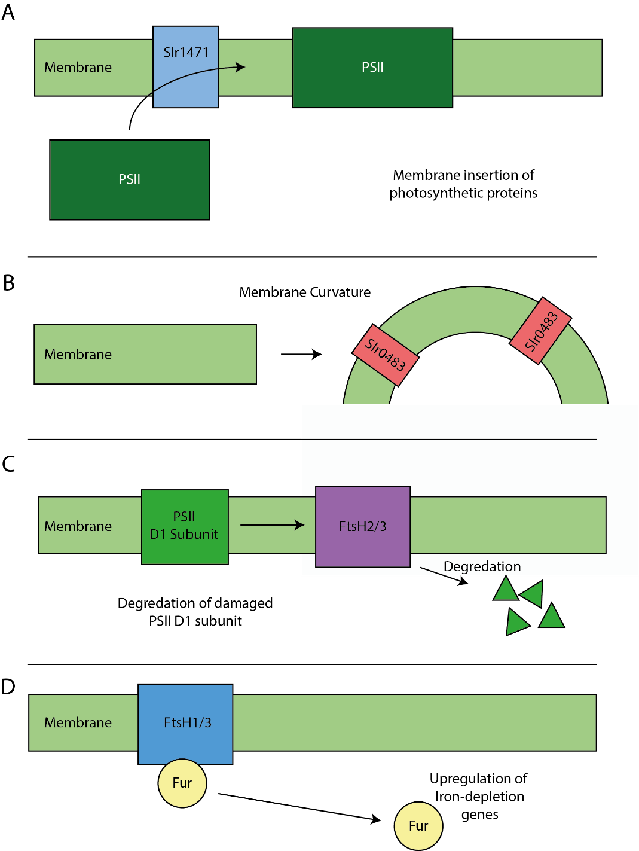
Figure 5.1: Proteins investigated in this study. (A) Slr1471 is a membrane insertase responsible for introducing photosynthetic proteins into the membrane. (B) Slr0483 creates the distinctive curved thylakoid membranes in Synechocystis. (C) FtsH2 degrades the PSII D1 subunit after photodamage. (D) FtsH1 sequesters the Fur transcription regulator responsible for iron-depletion.
This chapter demonstrates that a multifaceted approach to imaging cyanobacteria is optimal for understanding the organisation of fluorescently labelled proteins within the cell. The primary technique for investigation is Structured Illumination Microscopy (SIM) that is used in conjunction with Hyperspectral Confocal Microscopy (HCM) and Atomic Force Microscopy (AFM) to understand the location of photosystem I in the cyanobacteria Synechocystis sp. PCC 6803. Additionally, SIM was used to study the location of several other proteins important for photosynthesis, namely slr0483, slr1471, FtsH1, FtsH2 and FtsH4.

5.3 Results
5.3.1 Hyperspectral imaging of YFP labelled photosystem I
To investigate the distribution of PSI within Synechocystis, cells expressing the PsaF subunit of PSI labelled on the C-terminus with an sYFP2 fusion (henceforth referred to as PSI-YFP, see Figure 5.2B) were imaged with a custom hyperspectral confocal microscope (HCM) equipped with a 488-nm excitation laser (Sinclair et al., 2006). HCM differs from a typical confocal microscopy by passing the emitted light through a prism that spreads the light as a function of its wavelength and focussing it onto an EMCCD to obtain a spectrum for each pixel, rather than recording the number of photons with a photomultiplier tube. Each pixel of the resulting image then contains the fluorescence spectral response from the sample at that point and the different components can be extracted through multivariate curve fitting with custom MATLAB scripts. The final image can then be rendered as a composite of the relative intensities of the spectral components with the pixel a reflection of the component concentrations.
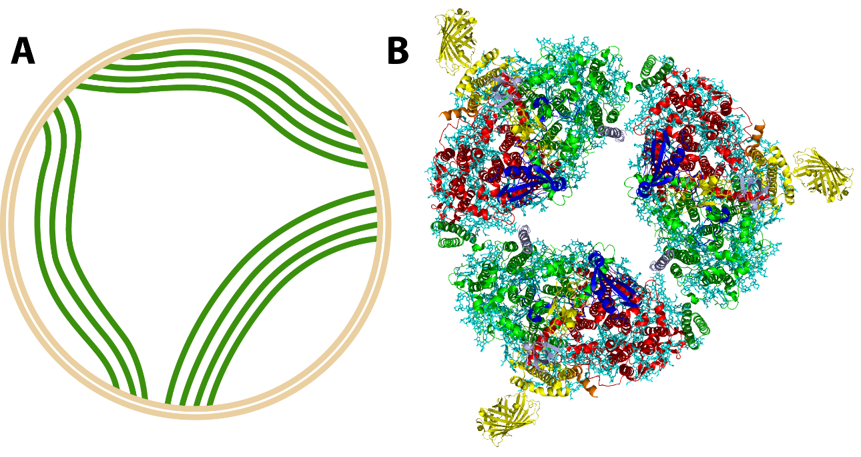
Figure 5.2: Membrane ultrastructure of Synechocystis and YFP labelled Photosystem I. (A) The thylakoid membranes (green) protrude into the cytoplasm from the inner cell membrane (beige). (B) Synechocystis photosystem I trimer (protein data bank: 4KT0) with YFP labelled PsaF subunit (yellow).
From the raw data collected on the HCM of PSI-YFP the multi-variate curve fitting was able to extract components that were assigned to YFP, phycocyanin (PC), allophycocyanin (APC), chlorophyll (Chl) and the detector offset (see Figure 5.3). By comparing separate strains and the signals collected against one another it is possible to tease apart the different components. Fitting additional components did not lead to an improvement to the quality of the fits. The images were rendered with phycocyanin in blue, Chl from photosystems I and II in red and YFP in green. The cells show clear patches of PSI-YFP highlighted in green within the photosynthetic membrane that can also be observed as a continuous ring towards the exterior of the cell consistent with the location of the thylakoid membrane. The magenta within the image results from overlap between the phycocyanin and PSI/PSII signal, indicating that the phycobilisomes and PSII are spread uniformly across the rest of the thylakoid membrane. Interestingly the phycocyanin response also seems to be quite concentrated in the cytoplasm as well as being localised to the thylakoid membrane. Whilst there are differences in the spectra of PSI and PSII due to the bound chlorophylls, and these have been separated in the past, the differences are small and require a strain expressing a substantially different amount of either to be able to distinguish between these photosystem complexes.
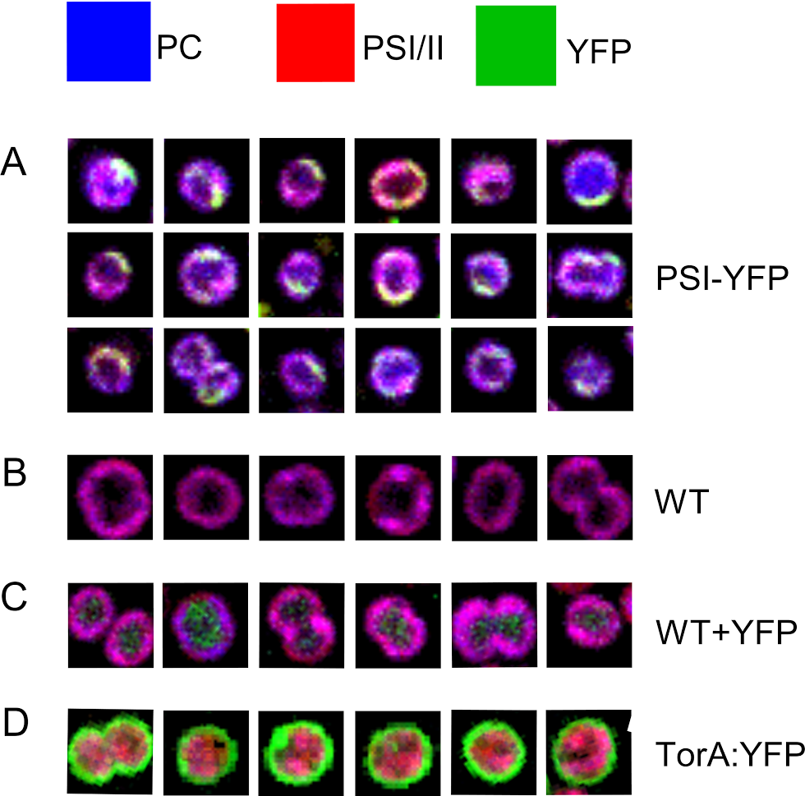
Figure 5.3: Hyperspectral confocal microscopy of PSI-YFP in Synechocystis. Cells imaged by HCM and rendered as a composite image with phycocyanin (blue), PSI/PSII (red) and YFP (green). Each box is 2 µm across.
To confirm accurate detection and assignment of the YFP signal originating from the PSI-YFP fusion we performed hyperspectral imaging of three other strains as controls; wild-type (WT), YFP expressed into the cytoplasm, and TorA-YFP (see Figure 5.4). The TorA-YFP strain expresses YFP attached to a Twin-Arginine Translocase signal sequence (TorA) that targets the protein for export into the periplasm (Blaudeck et al., 2001). In the WT, no YFP signal is detectable and the combined chlorophyll and phycocyanin signals leads to a uniform magenta signal across the thylakoid membrane with little PC signal originating from the cytoplasm. The strain with YFP in the cytoplasm has detectable, although low, levels of YFP located throughout the interior of the cell. The TorA-YFP cells showed high levels of YFP exported into the cell periplasm indicating successful export of the functional fluorophore in addition to the correct assignment of the spectral components in each case.
Figure 5.4: Controls for hyperspectral confocal microscopy of PSI-YFP. WT cells showing an even distribution of phycocyanin and PSI/PSII across the thylakoid membrane (Top). Cells expressing YFP into the cytoplasm (Middle). Cells expressing YFP with a TorA signal sequence into the periplasm (Bottom). Each box is 2 µm across and the colour scheme is the same as in Figure 5.3.
The sum intensity of the different fluorescent components (e.g. YFP, chlorophyll etc.) can be extracted on a per cell basis; thus, the differences between the components to be compared to other components in the same strain and to itself in other strains (see Figure 5.5). The mean and standard deviation for each component in each strain can then be calculated (Table 5.1) allowing quantitative differences, such as the variations in APC signal, to be observed. From the images and the component graphs, it is apparent that in the PSI-YFP strain there is a disturbance in the levels and location of the allophycocyanin light-harvesting protein.

 | Offset | YFP | APC | Chl | PC
WT | 483 ± 220 | 308 ± 151 | 6271 ± 3161 | 14900 ± 6,972 | 6247 ± 2883
PSI-YFP | 368 ± 190 | 1541 ± 873 | 10917 ± 6667 | 12917 ± 7353 | 7032 ± 4282
TorA-YFP | 638 ± 235 | 2759 ± 1612 | 10851 ± 4115 | 21937 ± 8045 | 8819 ± 3112
YFP | 548 ± 257 | 1288 ± 576 | 11995 ± 6342 | 23189 ± 10148 | 8612 ± 3707
Table 5.1 Sum concentration of multivariate components by strain. Mean Intensity values with standard deviation for each fluorescent species present in the cells imaged by hyperspectral confocal microscopy. The detected components are: the camera offset, YFP, allophycocyanin (APC), chlorophyll (Chl) and phycocyanin (PC).

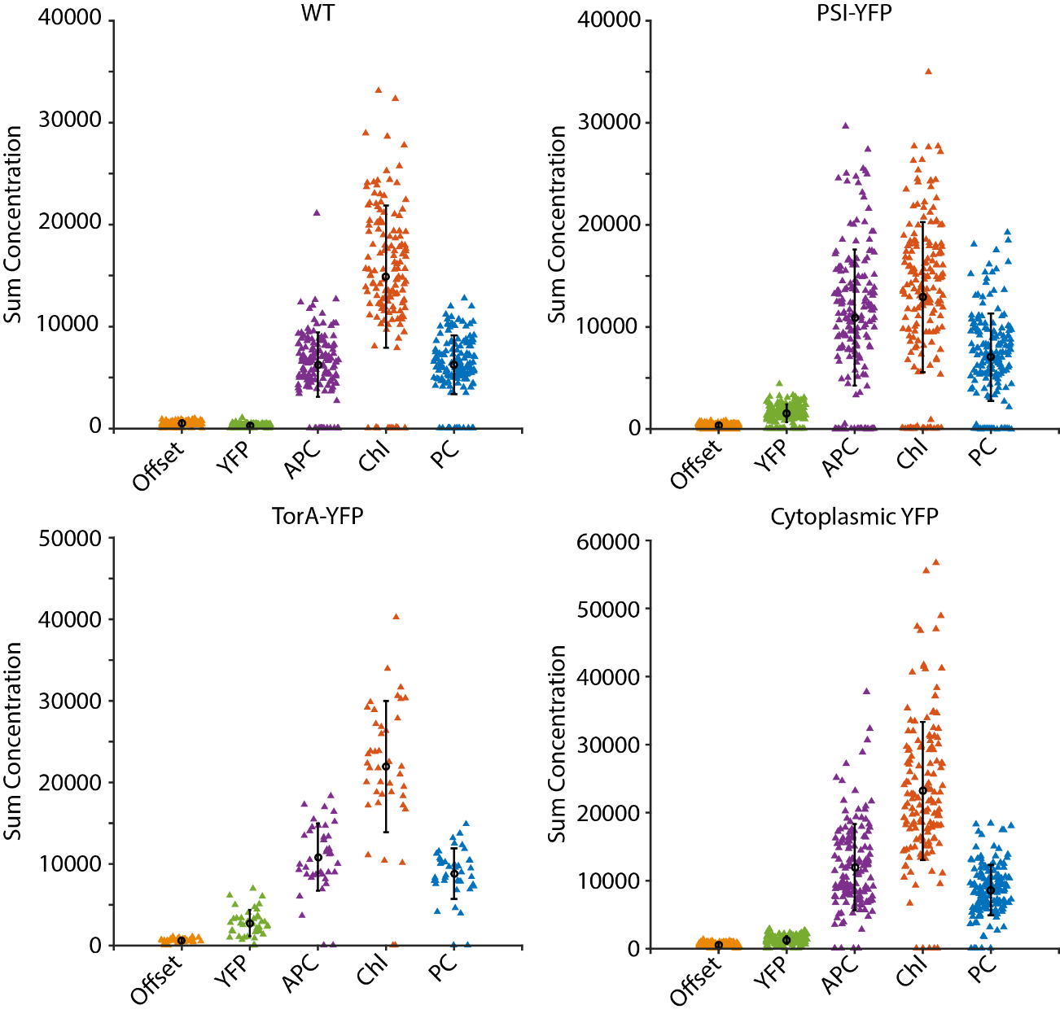
Figure 5.5: Sum concentrations per cell of the different fluorescent components extracted from hyperspectral confocal microscopy. Integrated component values for the detector offset, YFP, allophycocyanin (APC), chlorophyll (Chl) and phycocyanin (PC) in the strains WT (n=146), PSI-YFP (n=184), TorA-YFP (n=41) and cytoplasmically expressed YFP (n=150). Error bars indicate standard deviations from the mean.
To investigate the effects of YFP labelling photosystem I on the levels and location of allophycocyanin and phycocyanin, the average radial values of the two components in the YFP-PSI strain and the WT were plotted for cells with a spherical morphology (Figure 5.6). The script attached in Appendix 3 was used to calculate radial values by identifying centre of a cell at the axial midpoint and determining the mean intensity of pixel circles radiating from the centre of the cell. Strains expressing YFP had consistently higher levels of APC and PC as shown in Table 5.1. The PSI-YFP strain had increased levels of PC towards the centre of the cell that the WT strain lacked. In the WT, the signal originating from the allophycocyanin and phycocyanin at the centre of the cell is close to zero at 4.4 ± 4.3 (n=28) and 5.1 ± 4.2 (n=28) respectively (Figure 5.6) whereas in the PSI-YFP mutant the signal is much higher at 55.8 ± 47.7 (n=43) and 44.6 ± 33.4 (n=43). In addition, there were larger variations between cells leading to the much larger standard deviations demonstrated by the error bars in the figure. In the WT, the mean standard deviation for APC was 4.8 and for PC was 5.2, which increased to 18.3 and 12.2 respectively in the YFP labelled strain.
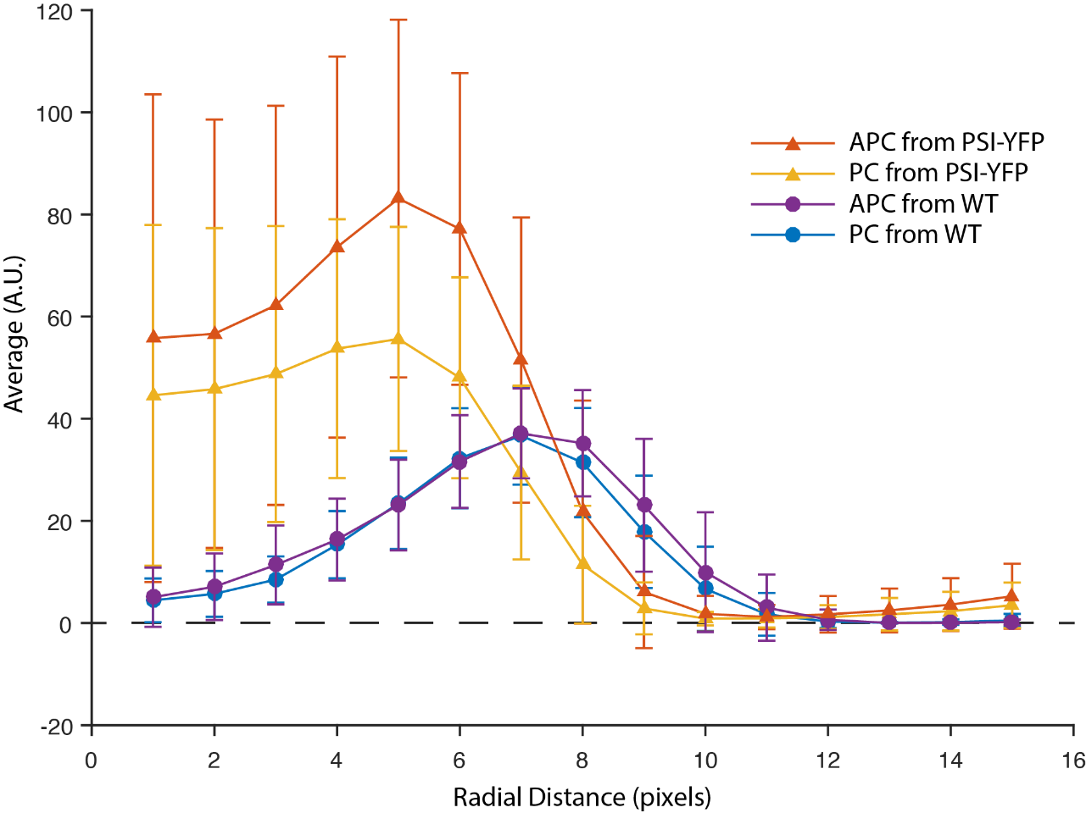
Figure 5.6: Radial measurements of Synechocystis spectral components. The mean intensity (arbitrary units) of the APC and PC components from Synechocystis in both the PSI-YFP and WT strains. Labelling of PSI with YFP leads to a large displacement of the phycobiliproteins from their native locations and concentrations. Error bars represent the standard deviation of each point.
5.3.2 STORM imaging of PSI-YFP in Synechocystis
Localisation microscopy has the capability to increase the resolution by a factor of ten over that of confocal microscopy. YFP has previously been shown to be suitable for STORM (Biteen et al., 2008), a form of localisation microscopy. YFP gives the best performance with a standard STORM buffer consisting of a GLOX system (glucose oxidase, catalase) and a thiol such as β-mercaptoethanol (Jusuk et al., 2015). Synechocystis cells expressing PSI-YFP were grown and incubated on poly-L-lysine coated coverslips for 20 minutes before being mounted in GLOX buffer with cysteamine as the thiol. Imaging was performed with a 514 nm laser and emission collected through a 542/27 bandpass filter.
Imaging of WT Synechocystis in phosphate buffered saline (PBS) without the GLOX and thiol buffer revealed that the cells also demonstrated spontaneous blinking that are consistent with single molecules in terms of PSF size. Inside the cells is an unknown species that stochastically switches under illumination with 514 nm light with emission collected through a 542/27 bandpass filter. To try and bypass this problem, the cells were immunostained with an Alexa Fluor 647 conjugated anti-GFP nanobody capable of binding YFP, however upon imaging there was no signal indicating cell permeability to the label was limited. A reconstruction from the autofluorescent events in the WT strain resulting from 10,000 frames is shown in Figure 5.7 and it is apparent from the images that the events are associated with the thylakoid membrane. Given the number of events present, it is difficult to image YFP strains of Synechocystis as the WT events interfere with interpretation of the results.
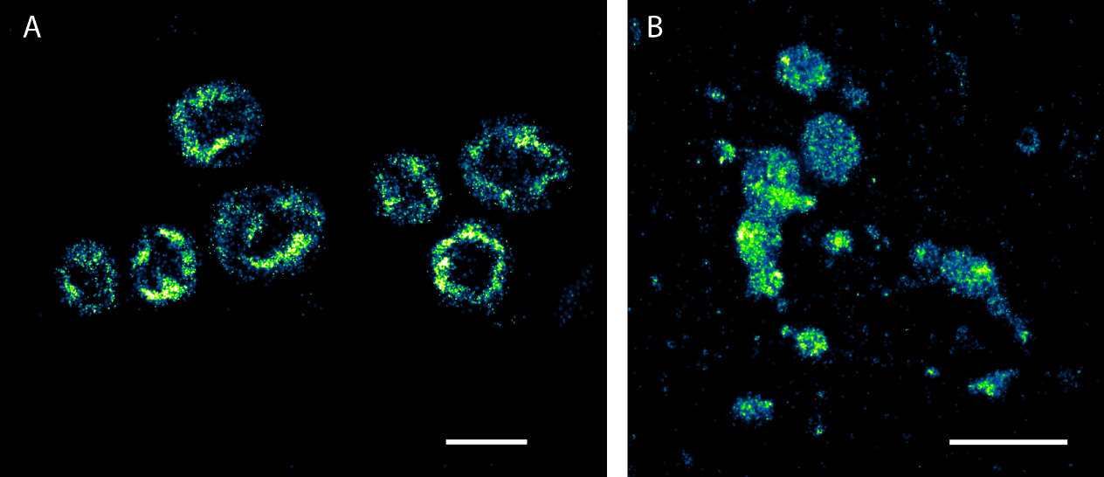
Figure 5.7: Reconstruction of WT blinks from Synechocystis. An unknown species inside the cells undergoes spontaneous photoswitching that is localised towards the exterior of the cell where the thylakoid membranes are located (A). This is further exemplified with imaging of purified thylakoid membranes (B). Scale bars are 2 µm.
Further STORM imaging of membranes prepared from the WT labelled strains showed large numbers of events in the YFP channel that would obscure YFP related signal. The unknown species appeared to be ubiquitously spread throughout the membranes with regions of high density also being present. Identification of the blinking species could prove useful both as a new fluorophore and as a deletion target to facilitate STORM imaging in Synechocystis.

5.3.3 Structured illumination microscopy of PSI-YFP
Structured illumination imaging increases the resolution of the optical microscopy beyond the diffraction limit by a factor of two both laterally and axially. Bulk fluorescence imaging of the PSI-YFP strain was performed on an OMX Deltavision V4 microscope with 488 nm illumination. Cells were settled on agarose pads and mounted in Vectashield. Images were reconstructed with the OMX softWoRx 6.0 software package (shown in Figure 5.8) and for analysis were thresholded and converted to 16-bit images with the ImageJ plugin SIMcheck (Ball et al., 2015).
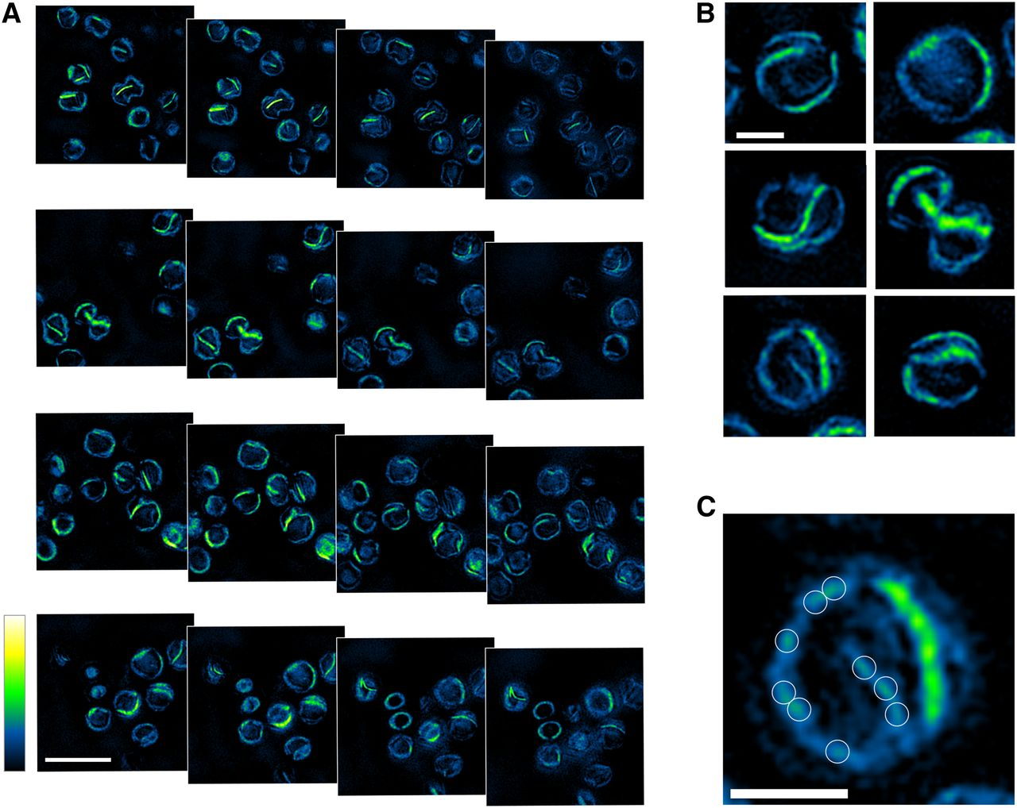
Figure 5.8: SIM reconstructions of PSI-YFP Synechocystis cells. (A) Axial slices through Synechocystis cells with a 125 nm step. (B) Zoomed images of single Synechocystis cells showing PSI-YFP patches within the thylakoid membrane, also present is a more dispersed level of YFP. (C) Single cell showing low-levels of PSI-YFP in the membrane demonstrated by the white circles. Scale bar in A is 2 µm, in B and C is 750 nm.
The patches of PSI-YFP are clearly confirmed through SIM and the bulk of the protein is confined to large sections of the thylakoid membrane as microdomains. The number of separate domains per cell ranged from zero to four and followed a Poisson distribution and was fitted to a Poisson model with a mean of 1.45 microdomains per cell (n=140). Separate to the microdomains, a consistent low-level amount of protein is interspersed throughout the membrane. Whilst the length of the microdomains varied from cell to cell their thickness was consistent across the population.
Interestingly, SIM also revealed that some of the cells entirely lacked these continuous PSI patches. Calculation of the sum intensity of the patch vs non-patch cell types gave values of 2966 ± 1011 (n=59) and 2686 ± 953 (n=38), indicating the accumulation of patches is the result of aggregation of PSI within the membrane, and that the no-patch sub-type has a dispersed PSI population. Application of the Student’s T-test gave a p-value of 0.18, suggesting that there is no difference between the intensities of the two populations. Furthermore, AFM of purified membranes prepared from disrupted cells showed that PSI is present both in patches and in low level amounts across the thylakoid membrane, surrounded by other complexes (MacGregor-Chatwin et al., 2017). In the population of cells that were undergoing division, signified by a pinch in the thylakoid membrane at the centre of the cell, 55% (n=31) contained microdomains. This is in comparison to the population of cells not undergoing division that had a microdomain occurrence of 93% (n=57).
The thickness of the PSI patches was investigated to see if they extend across multiple thylakoid layers; the height profile was recorded perpendicular to the direction of the membrane propagation at the cellular midpoint to prevent broadening resulting from thylakoid curvature in the axial dimension. The line profile was then fit to a 1D Gaussian function to find the full-width half-maximum (FWHM) that will serve as the measure of width of the thylakoid membrane. From the resulting histogram (see Figure 5.9), two peaks are observable that are representative of either a single sheet of PSI or two sheets (n=172). The histogram was fit to model consisting of two Gaussian functions that have a midpoint at 103 nm wide and 145 nm wide and sigma values of 19.7 nm and 22.9 nm respectively, leading to an inter-thylakoid distance of 42 nm that is in close agreement with prior research showing it to be approximately 40-50 nm (Collins et al., 2012). Integrating the two Gaussian functions shows that the majority of the PSI microdomains appear as single sheets however there is sub-population that is consistent in width of double sheets and is present as approximately 27% of the microdomains. It is feasible that there is a further sub-population that is three sheets thick, however presently this is undetectable and would constitute a very small proportion of the microdomains.
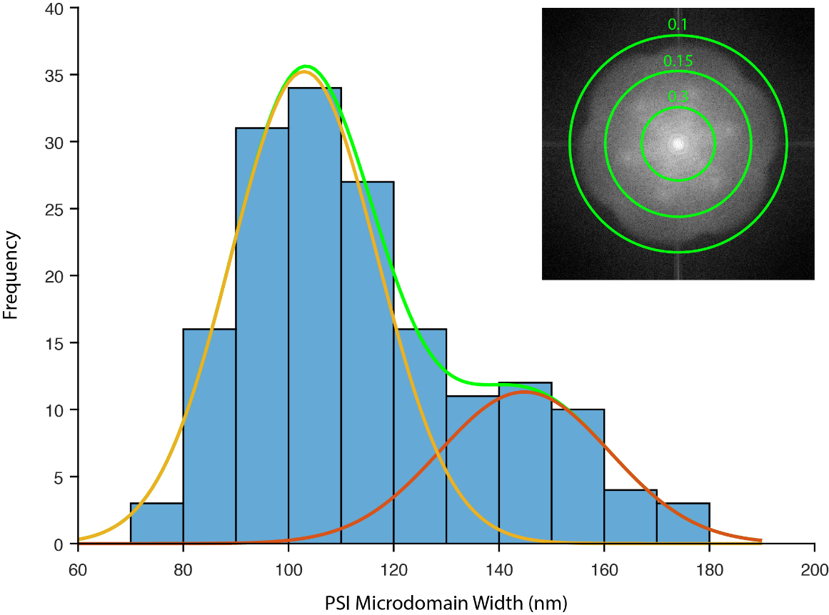
Figure 5.9: Width of PSI sheets in the thylakoid membrane. The distribution was fit to a double Gaussian model with the individual components in orange and red and the combined fitted distribution in green. The inset is the Fourier transform of a single image plane showing the microscope resolution to be between 100 and 150 nm.

5.3.4 Structured illumination of WT and periplasmic YFP strains
To ensure the microdomains are a result of the YFP fluorescence and not the result of autofluorescence from the photosynthetic proteins, the WT strain of Synechocystis was imaged by SIM under the same conditions as the YFP-PSI mutant. Reconstructions show that the thylakoid membrane is observable in the YFP channel resulting from autofluorescence even though this is at the minimum for whole cell fluorescence within the visible range (Vermaas et al., 2008). This weak emission likely comes from either the carotenoids that have low quantum yields, or the phycobilisome, a component from which has been shown to exhibit blinking in Chapter 4. Although the fluorescence is persistent in the absence of any labelling, the level of thylakoid emission is exceptionally low. The images also show the lack of microdomains confirming their result of the YFP labelling of PSI. Multicolour SIM was performed on TorA-YFP with emission collected in both the YFP channel and chlorophyll channel (see Figure 5.10). The images showed a clear halo around the cells originating in the 528/40 channel that could be assigned to the periplasm. A small fraction of the signal could also be assigned to the thylakoid membrane confirming previous work that has also suggested that the TorA signal sequence can direct small proportions of protein to the thylakoid membrane (Aldridge et al., 2008; Spence et al., 2003). The images were thresholded to remove low intensity noise and the radial intensity of the chlorophyll and YFP signal measured (see Figure 5.10C).
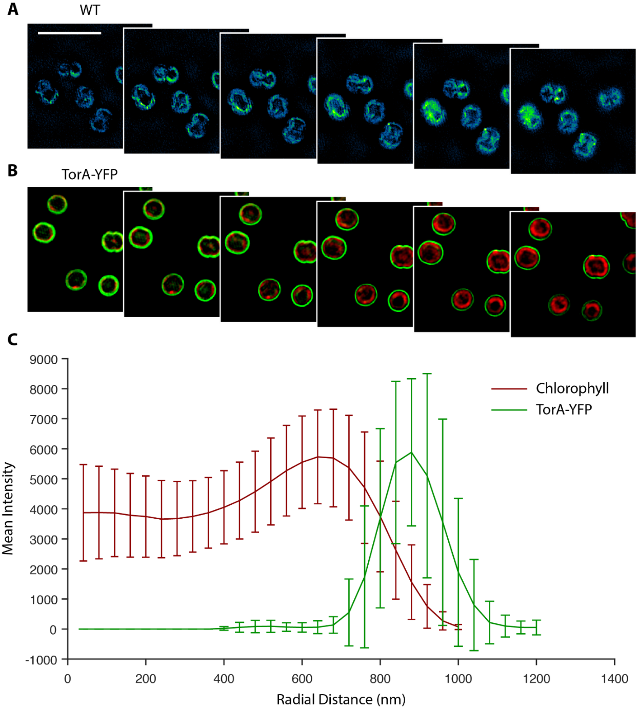
Figure 5.10: WT and TorA-YFP fluorescence of Synechocystis. (A) WT cells were imaged by SIM through a bandpass filter for YFP emission that demonstrates the autofluorescence present in this window. These images have been scaled to show the location of the autofluorescence and is much weaker than the YFP signal shown. (B) Multicolour SIM fluorescence from TorA-YFP expressed diffusely into the periplasm (green) and chlorophyll (red). (C) Radial measurements made of the TorA-YFP and Chlorophyll SIM images. Scale bar is 5 µm.
Additionally, to confirm the assignment of the high intensities to the YFP labelled PSI, Synechocystis expressing YFP into the cytoplasm was imaged by SIM. Fluorescence was localised all throughout cell and whilst expression levels were again low the images are consistent with expectation and the images shown by hyperspectral confocal microscopy.

5.3.5 Structured illumination of Slr1471-YFP and Slr0483-YFP
The YidC/Alb3/Oxa1 family of proteins encode a series of membrane insertases that are involved in protein integration to the cellular membrane systems and correct folding to the native conformation (Hennon et al., 2015). Structured illumination microscopy was performed on a YFP labelled putative member of this family, Slr1471, that has been found in Synechocystis (see Figure 5.1A). Images appear to show the presence of Slr1471 in both the thylakoid membrane and the cytoplasmic membrane (see Figure 5.10).
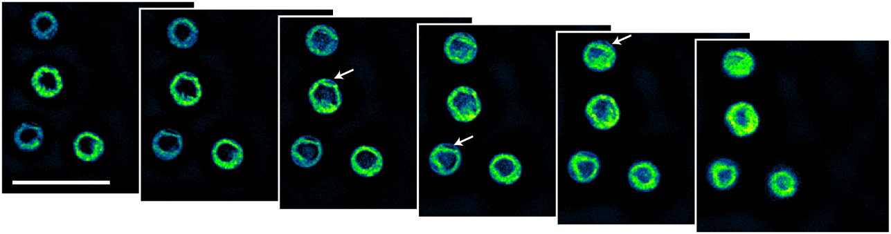
Figure 5.11: Slr1471-YFP imaged by SIM. Images show the location of Slr1471-YFP in Synechocystis, slices. The arrows show the presence of signal in the cytoplasmic membrane. The scale bar is 5 µm and the images are axial sections with a 125 nm spacing.
Slr0483 is theorized to be involved with forming the curvature of the thylakoid membrane (see Figure 5.1B) and is a homologue of the thylakoid curvature protein CURT1A that performs this task in plants (Armbruster et al., 2013). Imaging of a YFP labelled Slr0483 variant with SIM shows the distribution of Slr0483 is consistently present within sections of the thylakoid membrane, both as continuous sheets and as low area hotspots (see Figure 5.12). Composite images with the chlorophyll autofluorescence included show that Slr0483 is located in areas where the chlorophyll fluorescence is much lower. This decrease in fluorescence is suggestive of dedicated regions for formation of thylakoid morphology.
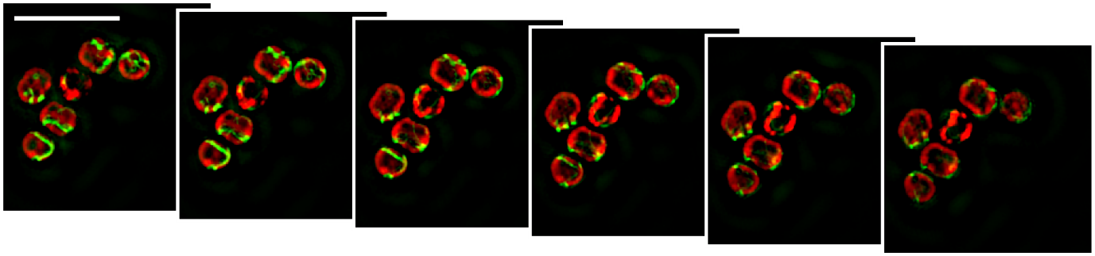
Figure 5.12: Slr0483-YFP in the Synechocystis thylakoid membrane. Axial slices of Synechocystis expressing Slr0483-YFP by 3D-SIM imaging with chlorophyll (red) and YFP (green). From left to right is increasing in the axial dimension with a step size of 125 nm and the scale bar is 5 µm.

5.3.6 Structured illumination of the transmembrane metalloproteases FtsH1, FtsH2 and FtsH4
The FtsH family of metalloproteases are involved in photosystem II repair and have previously been labelled with GFP and imaged by confocal microscopy (Sacharz et al., 2015). Shown here are the same strains imaged by SIM that offers an increase in signal-to-noise and resolution in the reconstructed images. Observable from the images is the sequestering of FtsH1 in the cytoplasmic membrane both as a persistent presence throughout and as a single, or several clusters (see Figure 5.13). The radial intensity maximum position of FtsH1 is approximately 800 nm from the centre of the cell, this positions FtsH1 between the periplasmic TorA-YFP signal at 830 nm in Figure 5.10C and the chlorophyll signal that has a maximum at 630 nm. The measured location of FtsH1 is line with its position in the cytoplasmic membrane. The large variations observable of FtsH1 towards to centre of the cell in Figure 5.13 are a result of large amounts of signal originating from the centre of some cells but not others. The origin of this signal is unknown as it does not fit with previous images showing FtsH1 location solely in the membrane (Sacharz et al., 2015).
FtsH2 is differentially dispersed throughout the thylakoid membrane occurring as centres of high concentration. Radial intensity measurements of the two strains reveals that the FtH1 occurs mainly at a distance of 800 nm from the cell centre whereas FtsH2 is present at a distance of 680 nm (see Figure 5.14). This distance is consistent with the association with the cytoplasmic membrane and the thylakoid membrane respectively.
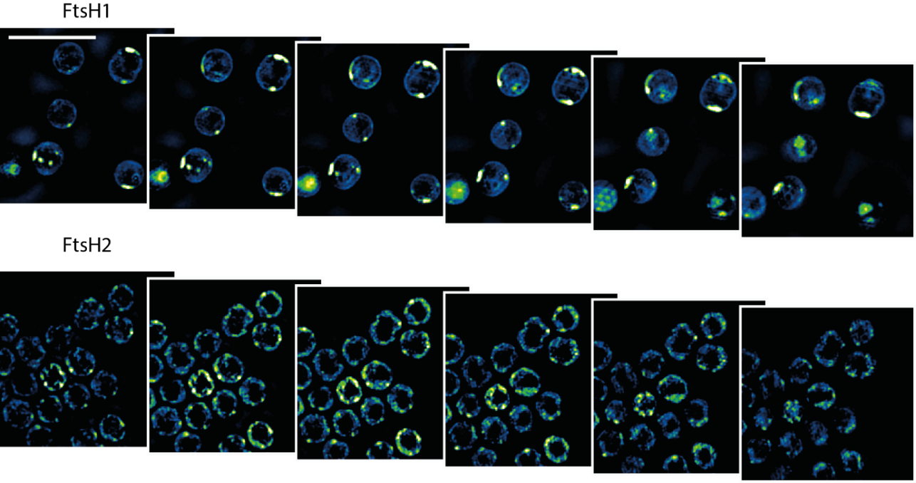
Figure 5.13: SIM reconstructions of FtsH1 and FtsH2 labelled with GFP. FtsH1 primarily localises to the cytoplasmic membrane with large islands. FtsH2 is localised entirely to the thylakoid membrane and is diffuse around the membrane, with areas of higher intensity. Descending axial slices are 125 nm apart and the scale bar is 5 µm.
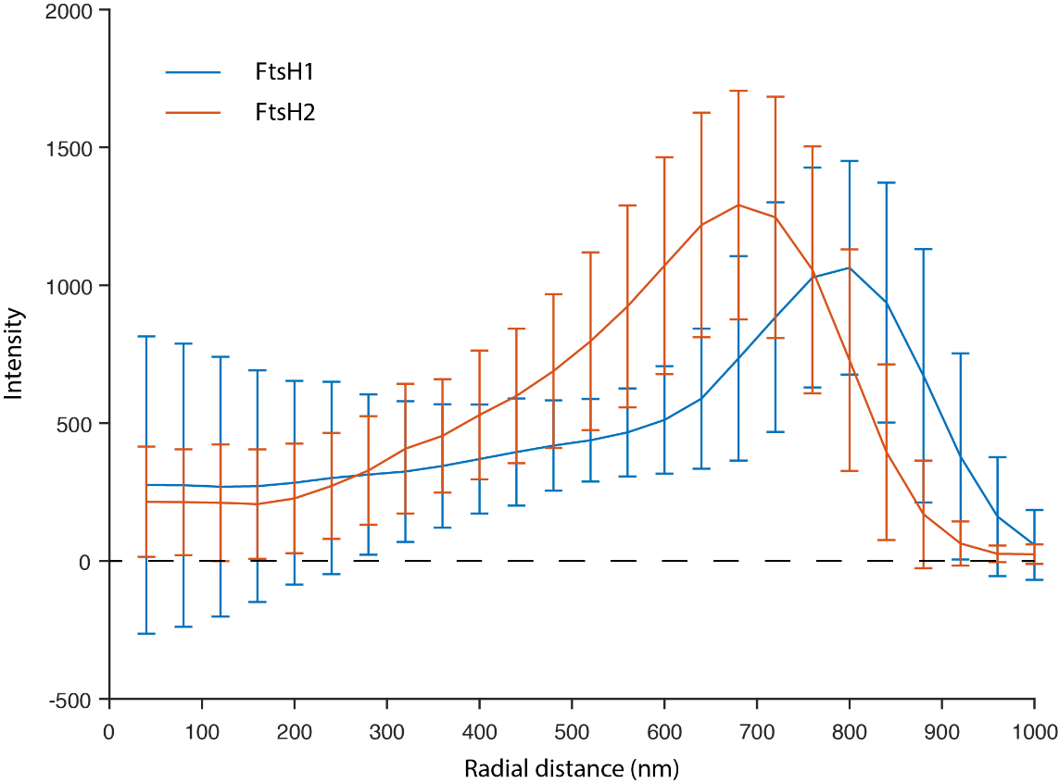
Figure 5.14: Radial intensity measurements of the FtsH1 and FtsH2 GFP tagged proteins. FtsH1 is associated with the cytoplasmic membrane and appears at a greater displacement from FtsH2 that is associated with the thylakoid membrane. Intensity measured in arbitrary units.
FtsH4 has been theorised to be involved in biogenesis rather than quality control of photosynthetic systems. We imaged a strain expressing a FtsH4-GFP fusion with SIM in both the GFP and chlorophyll windows. Imaging demonstrates the presence of spots of FtsH4 in the thylakoid membrane signifying that FtsH4 clusters within the membrane, and furthering the idea that FtsH4 forms homo-oligomers (see Figure 5.15A). Analysis shows cells contained on average 9.76 ± 3.1 distinct spots above a low continuous background in the thylakoid membrane. Interestingly, when comparing the mean radial intensity of GFP-FtsH4 and chlorophyll within the same cells the GFP signal (n=15), whilst localised to the thylakoid membrane, is slightly shifted towards the exterior of the cell (see Figure 5.15B). The values were normalised to compare the distributions as the intensity of the chlorophyll signal was much greater than that of GFP.
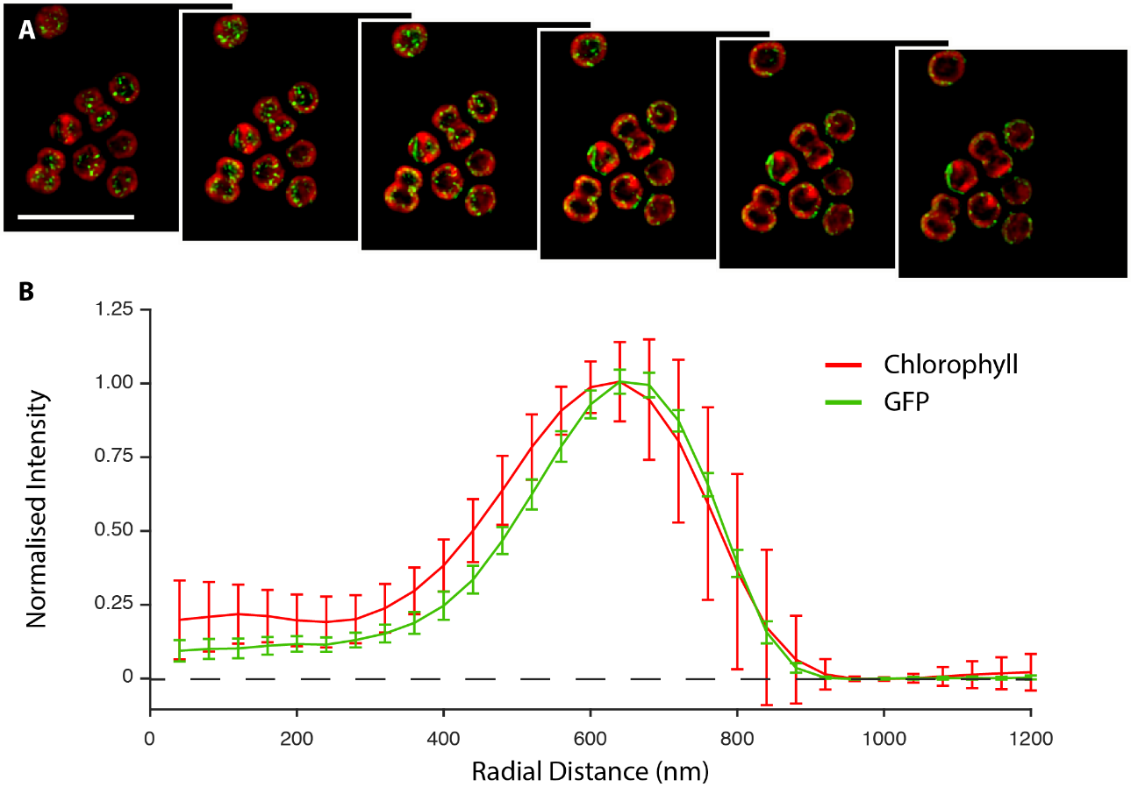
Figure 5.15: Structured illumination microscopy of FtsH4-GFP. (A) Axial slices of Synechocystis cells with GFP in green and chlorophyll in red. The axial slices are 125 nm apart and the scale bar is 5 µm. (B) Normalised radial mean intensity of chlorophyll and GFP-FtsH4.
Synechocystis expressing FtsH4-GFP was grown and acclimatised to four conditions: normal-light (NL), stationary-phase (SP), high-light (HL), and low-light (LL). The cells were then imaged with SIM (see Figure 5.16) to study the location of FtsH4 under different environmental situations. In the figure, all images have been scaled to the same intensity range as the normal-light sample. Under normal-light conditions, FtsH4 was sequestered as clusters in the thylakoid membrane. This was also true of the stationary phase cells and the low-light cells although they contained more and fewer clusters respectively. High-light cells by contrast exhibited few/no clusters of FtsH4.
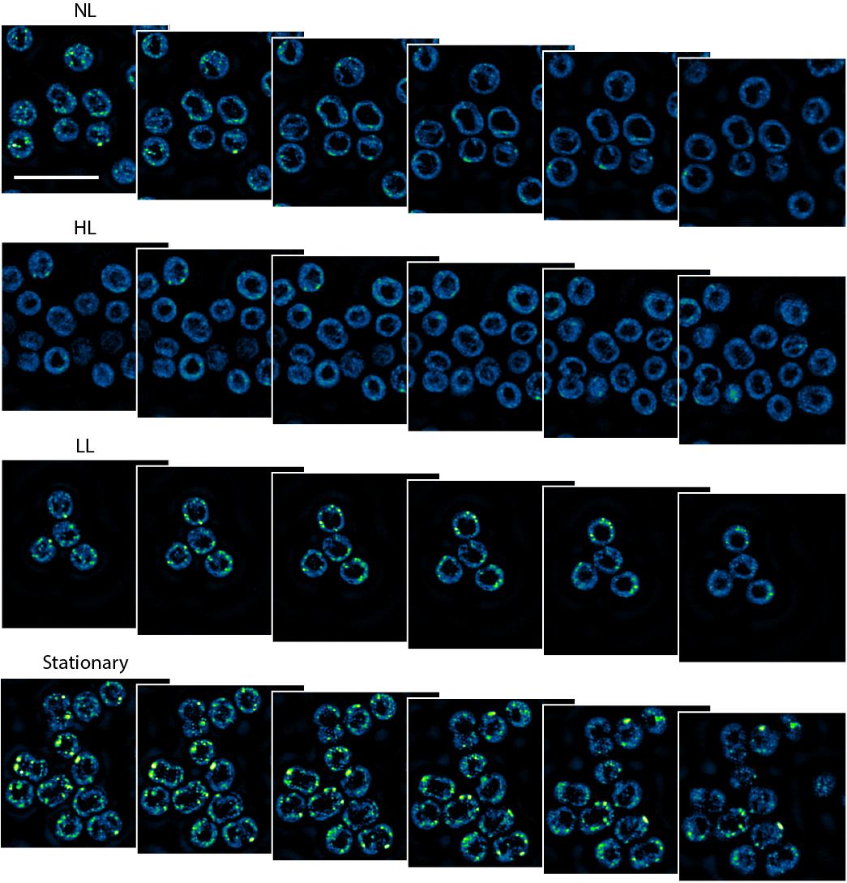
Figure 5.16: Structured Illumination of FtsH4 under different conditions. FtsH4 was imaged after acclimatisation to four conditions: normal light (NL), stationary, low light (LL), and high light (HL). The images have been placed on the same scale as the normal-light condition. The images are 125 nm apart axially and the scale bar represents 5 µm.
Calculations of the mean intensity in each of the four conditions (n=56) gave values of 716 ± 85 (HL), 761 ± 73 (NL), 866 ± 127 (LL) and 912 ± 90 (SP) demonstrating an increase in expression with decreasing light intensity. Whilst there is a moderate increase in whole-cell intensity between high-light and low-light (13.8%), most of the visual difference occurs from the appearance of clusters. The presence of clusters signifies an increase in heterogeneity across the cell and can be investigated by calculating the standard deviation of the pixel values representing the thylakoid membrane. Calculation of the cellular standard deviation yielded 317 ± 49 (high-light), 411 ± 60 (normal-light), 557 ± 108 (low-light) and 697 ± 165 (stationary) demonstrating the increasing non-uniformity across the samples.

5.4 Discussion
5.4.1 Distribution of PSI inside the Synechocystis thylakoid membrane
The hyperspectral imaging of the PSI-YFP strain shows domains within the thylakoid membrane resulting from the YFP signal. Several controls were performed to confirm that the YFP signal was accurately being distinguished from the other spectral components and that the results were not an artefact. These controls were hyperspectral imaging of the WT, a strain freely expressing YFP into the cytoplasm and a strain expressing TorA-YFP, targeting the fluorophore to the periplasm. In the WT, there is no YFP signal observed across the cell as expected and the level of the YFP component is similar to that of the detector offset as shown by the single cell analysis. In a strain expressing free YFP, the signal attributed to YFP is localised to the cytoplasm and even though it is low-level expression compared to the bulk of the PSI/PSII signal it is observable, as shown by the single cell analysis. The TorA-YFP signal was clearly assigned to the periplasm, past the thylakoid membrane at the exterior of the cytoplasm with single cell analysis showing the high signal from YFP present in each cell. The high levels of the TorA-YFP signal present in the periplasm also demonstrate that the YFP is successfully transported across the inner membrane in a functional form.
Photosystem I forms collated patches within the thylakoid membrane, not having a uniform distribution throughout. The single cell analysis shows that the sum fluorescence intensity of the phycocyanin component is moderately increased in the PSI-YFP strain and has a larger standard deviation across the population. Allophycocyanin, however, which is the core component of the phycobilisome and is involved in the interactions to PSI/II, has a higher sum fluorescence intensity in the PSI-YFP mutant. Furthermore, comparison of the WT and PSI-YFP strains imaged by hyperspectral confocal shows that the addition of the YFP tag affects the localising of the phycobilisome components allophycocyanin and phycocyanin to the thylakoid membrane. Radial intensity measurements have previously been used to investigate fluorescent signal origins in the spherical Synechocystis cell (Sacharz et al., 2015) and here shows that a much greater proportion of the APC and PC signal originates from the cell cytoplasmic region than in the wild-type. This displacement could indicate that the cell is recognising that the phycobilisome is not coupling to PSI and is upregulating the core protein, APC, that holds the phycobilisome-PSI complex together, hence the increase in APC concentration across the PSI-YFP population. However, this theory does not account for the increase in allophycocyanin expression in the other YFP expressing strains.
The cytoplasmic phycobilisome signal could be a result of YFP hindering the attachment of the APC core component to PSI and phycobilisome formation. Docking has been postulated to occur at the PsaA and PsaD subunits that are located proximally to PsaF, the site of YFP attachment (Liu et al., 2013). The YFP label is fused to the C-terminus of PsaF facing into the cytoplasm (Jordan et al., 2001), the same side of the membrane as phycobilisome attachment (Mullineaux, 2008). This is especially likely given that PsaF is on the exterior of the PSI monomer complex and has been implicated as the location of the PBS energy transfer to PSI (Fromme et al., 2001). A steric interaction is further suggested by the fact that PsaF can be deleted without any effect on photoautotrophic growth when compared to the wild-type (Chitnis et al., 1991) and the PSI complex has still been shown to form (Kouřil et al., 2003).
Further experimentation could focus on whether the attached YFP molecule is able to transfer energy to PSI and increase the spectrally available window available to Synechocystis. This has already been demonstrated for a YFP molecule attached to the reaction centre of the purple bacteria Rhodobacter sphaeroides (Grayson et al., 2017). However, the apparent hindrance of PSI-phycobilisome interaction might lead to a decrease in the ability of Synechocystis to adapt to varying environmental conditions, as control of the flow of energy from the phycobilisomes to either PSI or PSII is an adaption to light levels.
Previous work in the filamentous cyanobacterium Anabaena has shown the segregation of PSI and PSII (Steinbach et al., 2015). Given the presence of large aggregations of PSI-YFP in the SIM images of Synechocystis it is likely that the remaining chlorophyll signal detected by HCM is the result of PSII fluorescence, as PSII is the other major chlorophyll containing protein in the cell, and it exhibits a higher level of Chl fluorescence than PSI.
SIM imaging of the PSI-YFP strain shows that on a cell by cell basis there is little similarity between the size and location of the PSI domains, other than they are restricted to the thylakoid membrane. Indeed, some cells even lack the large domain entirely, with low levels of signal originating from across the thylakoid membrane. Those cells containing the large volumes of PSI also contain signal from across the remaining thylakoid membrane, confirmed by AFM which has shown single PSI trimers to be dispersed across the thylakoid (MacGregor-Chatwin et al., 2017). It also appeared that the cells that were undergoing division appeared less likely to contain microdomains, possibly to increase the probability of daughter cells getting an equal proportion of PSI upon division.
The resolution of the SIM images is much improved in comparison to the hyperspectral confocal images and allows a better description of the number of microdomains per cell. The detailed images allow a more accurate description of the thickness of the microdomains as they can be assigned as either one or two sheets based on their FWHM. The sheet thickness could be described with a double Gaussian function that put the ratio of one to two sheets as 3:1 respectively. In Synechocystis the thylakoid sheets are typically 4-5 layers thick indicating that the microdomains do not occupy the entire section of thylakoid membrane (Fuhrmann et al., 2009).
Consistent with the microdomains of PSI shown by SIM and hyperspectral confocal microscopy AFM images have demonstrated crystalline arrays of PSI in Synechocystis thylakoid membranes that have been prepared by French press (MacGregor-Chatwin et al., 2017). Whilst these arrays do not entirely exclude all other proteins, the majority of the space is occupied by PSI in a paracrystalline arrangement.

5.4.2 Location of Slr1471 in Synechocystis
Proteins typically required specialised membrane insertases for integration into the cellular lipid membrane structures and folding due to the large energy requirement in overcoming the hydrophobic effect (Cymer et al., 2014). Investigations into the YidC/Alb3/OxaI family has shown the proteins to be involved in this process, both in combination with the Sec system and independently (Kol et al., 2008; Samuelson et al., 2000). Previous work has demonstrated that Slr1471, a YidC family homologue, is essential for cell segregation in Synechocystis and a knockout mutant led to a loss of thylakoid organisation (Spence et al., 2004). The disruption of thylakoid organisation is an interesting effect as other work that applied immunostaining showed that Slr1471 is present solely in the cytoplasmic membrane (Sven et al., 2008) although further investigation with purified membranes showed the majority of the YidC protein is localised to the thylakoid membrane (Pisareva et al., 2011). Structured illumination microscopy of a YFP-Slr1471 mutant in Synechocystis presented here demonstrates the presence of Slr1471 in both the thylakoid and cytoplasmic membranes suggesting that the previous immunostaining was incomplete, probably due to the dense packing of the thylakoid membrane. Furthermore, SIM showed that the majority of the signal appeared to be associated with the thylakoid membrane, with low levels present in the cytoplasmic membrane in agreement with previous work (Pisareva et al., 2011).

5.4.3 Location of Slr0483 in Synechocystis
Correct formation of the thylakoid membrane morphology is important for optimum levels of photosynthesis. In chloroplasts, the formation of the stacked grana thylakoid membrane is a result of the THYLAKOID CURVATURE1 family of proteins, CURT1 (Armbruster et al., 2013). Four proteins, CURT1A-D, belong to this family and disruption to which leads to morphological changes of the thylakoid membrane. CURT1A is the most abundant of these proteins and appears to act as a regulator of the other three. A homologue of this protein exists in Synechocystis known as Slr0483 and a putative function of this protein is the formation of curvature in the Synechocystis thylakoid membrane. Previous studies have shown that by replacing Slr0483 with the Arabidopsis CURT1A protein leads membranes to have a crumpled appearance and lowering of the lumen width, however it has also been shown that the CURT1A protein can partially replace Slr0483. Whilst this hints at a similar function, it is important to note that the study did not also produce a knockout of Slr0483 showing a lack of thylakoid structure as was performed in the Arabidopsis chloroplast.
Imaging of YFP-Slr0483 with SIM shows that it does localise to the thylakoid membrane as expected. Images appear to show small locations of high density in additional to extended regions of signal around the exterior of the cytoplasm. Additionally, the labelled Slr0483 protein appeared to occur in regions of low chlorophyll fluorescence. Previous imaging by confocal microscopy has shown similar results that CURT1A is present at minima compared to thylakoid autofluorescence (Heinz et al., 2016).

5.4.4 Subcellular location of the FtsH family of metalloproteases
The family of FtsH zinc metalloproteases is important for cell survival and photosynthesis repair. Insertional deactivations of the FtsH1 and FtsH3 prevented the cells from segregating (Mann et al., 2000) whereas FtsH2 deactivation became light sensitive, suggesting its involvement with PSII repair (Silva et al., 2003). SIM imaging of FtsH1 revealed the presence of high density regions of labelled protein as well as a low-density prevalence throughout the plasma membrane that was confirmed through radial measurements, in agreement with previous studies (Pisareva et al., 2007; Sacharz et al., 2015). Meanwhile, FtsH2 was found to exist in the thylakoid membrane through imaging with SIM and analysis of the radial position in the cell, again in line with previous results (Komenda et al., 2006; Sacharz et al., 2015).
From these measurements, limited conclusions can be made that FtsH3 is similarly located either in both cytoplasmic and thylakoid membrane or else at the junction between these two systems. Whilst FtsH3 protein was not imaged, it has been previously shown through pull-down experiments to associate with both FtsH1 and FtsH2 (Boehm et al., 2012). FtsH2 seemed restricted to the thylakoid membrane however and was thoroughly interspersed throughout with no high-density regions.
Currently little is known about the FtsH4 homologue however the complex co-purifies with the PSII reaction centre during early stages of assembly, hinting at its function. Further analysis of FtsH4 null-mutants has shown that the protein is involved in the control of the high-light inducible proteins HliB and HliC that are involved in the early stages of PSII assembly (Komenda and Sobotka, 2016). Imaging with SIM has shown that the protein localises into many defined clusters under lower light-intensities and prolonged growth conditions, with the occasional extended patch also observed. If FtsH4 is truly involved assembly of photosystem II then these spots could represent centres of assembly within the thylakoid membrane. Previous studies have shown that under high-light intensities the amount of PSI and PSII is reduced (Kopečná et al., 2012), consequently it follows that the assembly proteins would also be downregulated in this scenario and this is reflected in the SIM images of high-light, normal-light and low-light adapted cells. Interestingly however, cells harvested during stationary phase exhibited the highest levels of FtsH4. This high expression is not consistent with the PSII assembly model as during stationary phase little growth should be occurring within the cells. Perhaps this difference indicates a further unknown function for FtsH4.

5.4.5 Conclusions
Discovering the organisation of the photosynthetic membrane is essential to understanding the highly efficient systems of solar energy capture that will have wide ranging implications to food and energy security. To date, electron tomography of negatively stained cell sections has provided unparalleled new views of thylakoid membranes structure (Meene and Hohmann-Marriott, 2006; Meene et al., 2012), but this technique is damaging to the sample and limited in its ability to identify proteins. AFM offers a high level of detail for 2D structures such as membranes but requires cell disruption to prepare the samples for imaging. Optical microscopy, especially that relying on fluorescence, has a very high contrast between differentially labelled proteins but has until recently been unable to gain information below the diffraction limit. Presented here is the use of the super-resolution technique SIM for imaging photosynthetic organisms below the diffraction limit and with a higher contrast than confocal microscopy. This is all supporting information for a multifaceted approach for studying biology that takes into account the specific advantages of each individual technique. Indeed, combining these techniques into a single instrument is a current target of research such as bringing fluorescence level contrast to EM images via correlative light microscopy and electron microscopy (Boer et al., 2015).

5.4.6 Acknowledgements
I would like to thank Dr Jerilyn Timlin and Dr Meghan Dailey, Sandia National Laboratories, for processing the hyperspectral confocal data.

Chapter 6
Structured illumination microscopy for studying state transitions in plant chloroplasts

6.1 Summary
Chloroplasts are large organelles present in the cells of plants and algae that represent specialised compartments for the light-driven fixation of carbon dioxide into metabolites. In the natural environment, terrestrial plants experience rapid fluctuations in light intensity and spectral quality as a result of the diurnal cycle and shading by clouds and other organisms. To adapt to their changeable environment plants have developed a complex palette of regulatory responses that seek to integrate the output of the photosynthetic light reactions with downstream metabolic need, maintaining cellular homeostasis and avoiding photo-oxidative stress. One particularly well studied light response mechanism in plants is the state transition, an adaptation of the photosynthetic apparatus in the chloroplast thylakoid membrane to changes in light quality. The state transition regulates the excitation energy balance between the photosystems by controlling the phosphorylation state of PSII and LHCII complexes and so the distribution of LHCII complexes between them. The redistribution of LHCII between PSI and PSII leads to changes in the amount of stacking of the thylakoid membranes within the chloroplast and the organisation of proteins therein. These changes have previously been investigated with electron microscopy, as until recently light microscopy has lacked the appropriate resolving power. Here I use the super-resolution technique SIM to investigate chloroplast structure in both wild-type and mutants of Arabidopsis thaliana and in light and dark adapted Spinacia oleracea. SIM reveals clear alterations to chloroplast structure resulting from conditions that stimulate the state transition. Through careful analysis of a range of Arabidopsis mutants I show the influence of the thylakoid/ PSII kinase/ phosphatase systems and the thylakoid curvature proteins and LHCII on these dynamics.
Part of this work is to be published as follows:
Wood W.H.J., MacGregor-Chatwin, C., Barnett, S.F.H., Mayneord, G.E., Huang, X., Hobbs, J.K., Hunter, C.N., and Johnson, M.P. (2017). LHCII phosphorylation alters the nanoscale structure of spinach thylakoids. Nature Plants. [Under revision]
6.2 Introduction
Plants are the branch of life forming the vast majority of multicellular photosynthetic organisms on Earth. Plants are theorised to have developed photosynthesis from an endosymbiotic event involving the engulfment of a proto-cyanobacterium that then coevolved to form the modern chloroplast. During the coevolution process the majority of the cyanobacterial genome was either lost or transferred to the host cell and there was adaption of the system into an organelle optimised solely for light-harvesting, energy trapping and CO₂ fixation (Cullis et al., 2008).
Plants can thrive in a wide variety of conditions, but unlike animals they are unable to change location if conditions in their immediate vicinity change adversely. Thus, plants must be able to adapt to a wide variety of conditions to maximise their survival chances. Chloroplasts, being the primary location of plant photosynthesis, are capable of undergoing adaption in response to changes in conditions. Photosystem I (PSI) and Photosystem II (PSII) reaction centres have different absorption spectra because of the different pigment compositions, sensitising each to separate parts of the electromagnetic spectrum. LHCII is a further light-harvesting protein that extends the physical area for light collection, and the absorbed energy migrates towards PSI and PSII (Croce and Amerongen, 2014). As different wavelengths of light penetrate the leaf tissue to different depths, chloroplasts in different layers have to be able to adapt to the differing spectral composition (Smith and McAusland, 2017; Sun et al., 1998). Moreover, movements of other leaves in the canopy and the diurnal cycle can further dynamically alter the spectral quality of light incident on particular chloroplasts. Plants have evolved mechanisms to balance the flow of energy to the two photosystems under various conditions, aided by the physical separation of the proteins in the chloroplast (see Figure 6.1).

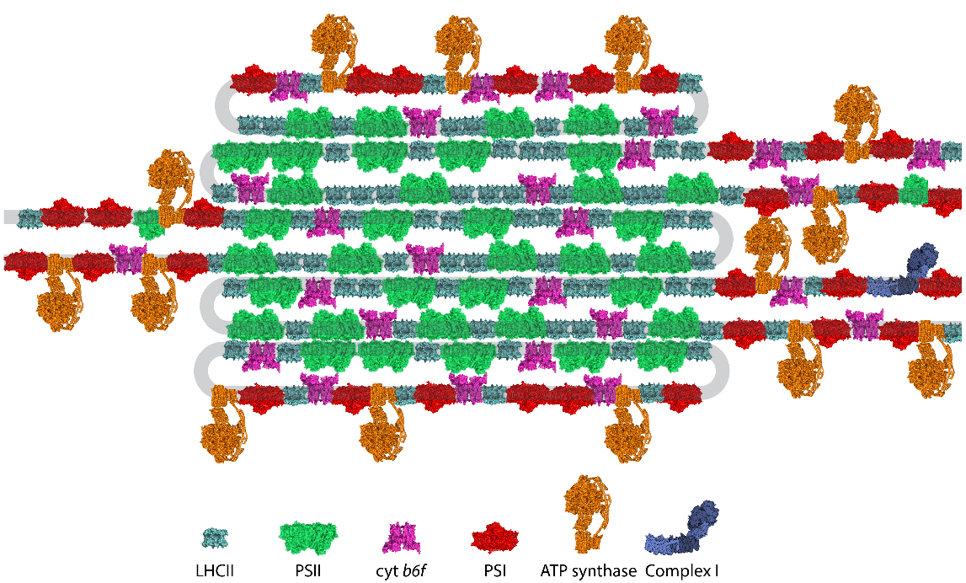
Figure 6.1: Model of the grana and stromal lamellae. Current model of the protein composition of grana and stromal lamellae showing the distribution of photosynthetic complexes throughout the membrane. The two bookend grana layers consist of both grana and stromal lamellae domains.
A process known as state transitions (Figure 6.2) is responsible for correcting any mismatch in excitation level between PSI and PSII by redistributing LHCII between them (Ruban and Johnson, 2009). The mismatch in excitation level is sensed by the redox state of the electron carrier plastoquinone (PQ) that is an intermediary between PSII and cytochrome b₆f in electron transfer. Overexcitation of PSII is sensed by the reduction of the PQ pool and causes the activation of the STN7 and STN8 kinases leading to the phosphorylation of the LHCII Lhcb1 and 2 subunits and PSII D1, D2 and CP43 subunits (Bellafiore et al., 2005; Bonardi et al., 2005). Overexcitation of PSI in contrast is sensed by the oxidation of the PQ pool and leads to inactivation of the kinases and through the constitutive action of the TAP38 and PBPC phosphatases LHCII and PSII are dephosphorylated (Pribil et al., 2010; Shapiguzov et al., 2010). The phosphorylation of PSII and LHCII leads to the movement of a portion of the LHCII antenna from the PSII-rich grana to the PSI-rich stromal lamellae, and an overall decrease in the amount of thylakoid stacking (Kyle et al., 1983). More recently it was shown that Arabidopsis mutants lacking STN7 or STN8 or both kinases show an increased amount of thylakoid stacking and larger grana, while those lacking the phosphatases possessed smaller grana and less stacking (Armbruster et al., 2013; Fristedt et al., 2010). The crucial importance of LHCII and PSII phosphorylation has been demonstrated since plants lacking such regulation suffer a reduction in growth and enhanced photo-oxidative stress in fluctuating light environments (Frenkel et al., 2007; Tikkanen et al., 2010).
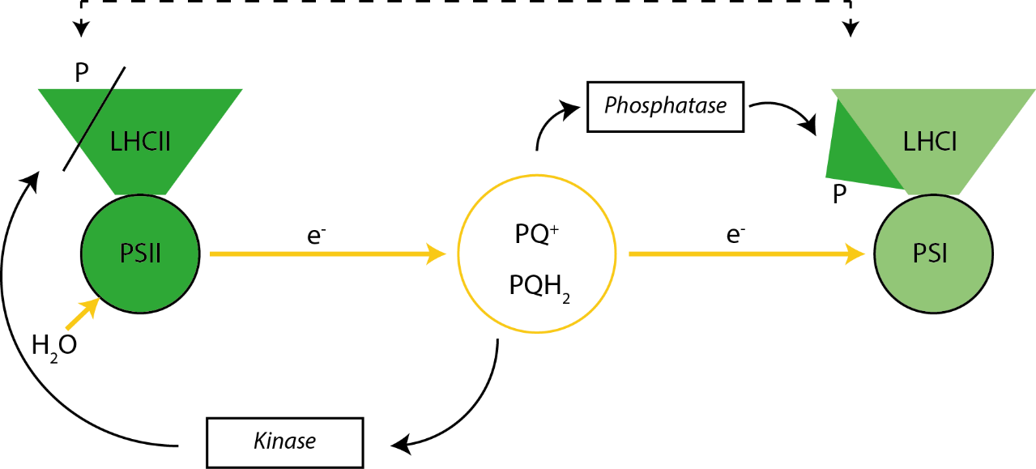
Figure 6.2: Model of state transitions in plants. Under conditions leading to reduction of the PQ pool the kinase is activated, phosphorylating LHCII and causing part of it to migrate from PSII to PSI, changing their relative antenna sizes. Oxidation of the PQ leads to inactivation of the kinase, allowing the phosphatase to reverse the change.
Recently it was shown that the distinctive organisation of the thylakoid membrane into grana and stromal lamellae is controlled by the THYLAKOID CURVATURE family of proteins (CURT1) that exist in the grana margins (Armbruster et al., 2013). The proteins sit in the membrane and physically cause curvature. Deletion of any of the four proteins CURT1A-D results in a distinctive morphological change to the grana network, with their absence leading to grana with fewer layers but enlarged diameter, while overexpression of the CURT proteins led to grana with more layers but narrower diameter. The chlorophyll b less mutant Ch1 lacks the major population of Lhcb1 and 2 containing LHCII trimers and shows a strong reduction in grana stacking (Simpson, 1979) . These mutants were therefore examined as extremes of grana stacking for comparison with the wild-type and state transitions mutants.
Thin-section EM and 3D confocal microscopy has been used to study the dynamics of chloroplast structure in the past; however, EM relies on fixatives and is performed under vacuum on dehydrated material, and confocal microscopy is very limited in terms of resolution. This chapter investigates the first use of SIM to probe the changes in membrane structure associated with state transitions and grana stacking in the native and mutant chloroplasts in Arabidopsis thaliana (henceforth referred to as Arabidopsis) and Spinacia oleracea (spinach).

6.3 Results
6.3.1 Comparison of light and dark adapted spinach chloroplasts
Chloroplasts are capable of undergoing changes in response to different climatic conditions, such as variations in the light levels resulting from the day/night cycle and shading. The chloroplasts must adjust light harvesting appropriately to avoid damage in high light or to increase efficiency in low light. Chloroplasts that have adapted to growth in the dark are in state I with LHCII dephosphorylated and providing energy to PSII whereas chloroplasts that have been adapted to growth in the light the opposite is true with the system being in state II and phosphorylated LHCII providing energy to PSI. In the dark-adapted system (state I) more LHCII is present with PSII and the grana are larger to accommodate the increased level of protein. In the light adapted system (state II) the opposite is true with phosphorylated LHCII exiting the grana for the stroma and leading to a smaller granal disk. Although these structural changes have been observed using EM, they have not been imaged in intact, functional chloroplasts under liquid and at room temperature; here, chloroplasts that had been adapted to either a light or dark conditions were imaged by SIM (see Figure 6.3).
Light and dark adapted chloroplasts were imaged on a DeltaVision V4 microscope with the Blaze 3D-SIM module and excitation performed with a 642 nm laser and emission collected at 680 ± 20 nm. The majority of chlorophyll b is tied up in the LHCII protein typically located proximal to PSII as a supercomplex (Bezouwen et al., 2017; Su et al., 2017). Whilst there are also LHCII proteins associated with PSI, these are fewer in number and they are quenched efficiently by PSI which has a much shorter lifetime than PSII when in the closed state (Wientjes et al., 2017). The location of LHCII, and the higher volumetric density of the grana stacks, leads to a greater signal (see Figure 6.3).
To compare the differences in grana widths of the two conditions, the FWHM of the granal fluorescence intensity was calculated for 2D cross-sections in the middle of the grana stack with the measurements taken over multiple separate chloroplasts (Figure 6.3C). The FWHM was used as a proxy for width, as grana are larger than the SIM resolution the effects of the differences in intensity are minimised although not completely removed. The histograms were fit to a Gaussian function yielding a mean dark-adapted grana diameter of 396 ± 78 nm (n=239), compared with a light-adapted grana diameter of 353 ± 85 nm (n=239). Applying Student’s T-test to the two populations demonstrated that two populations are significantly different from each other ($p=1×{10}^{-13})$.

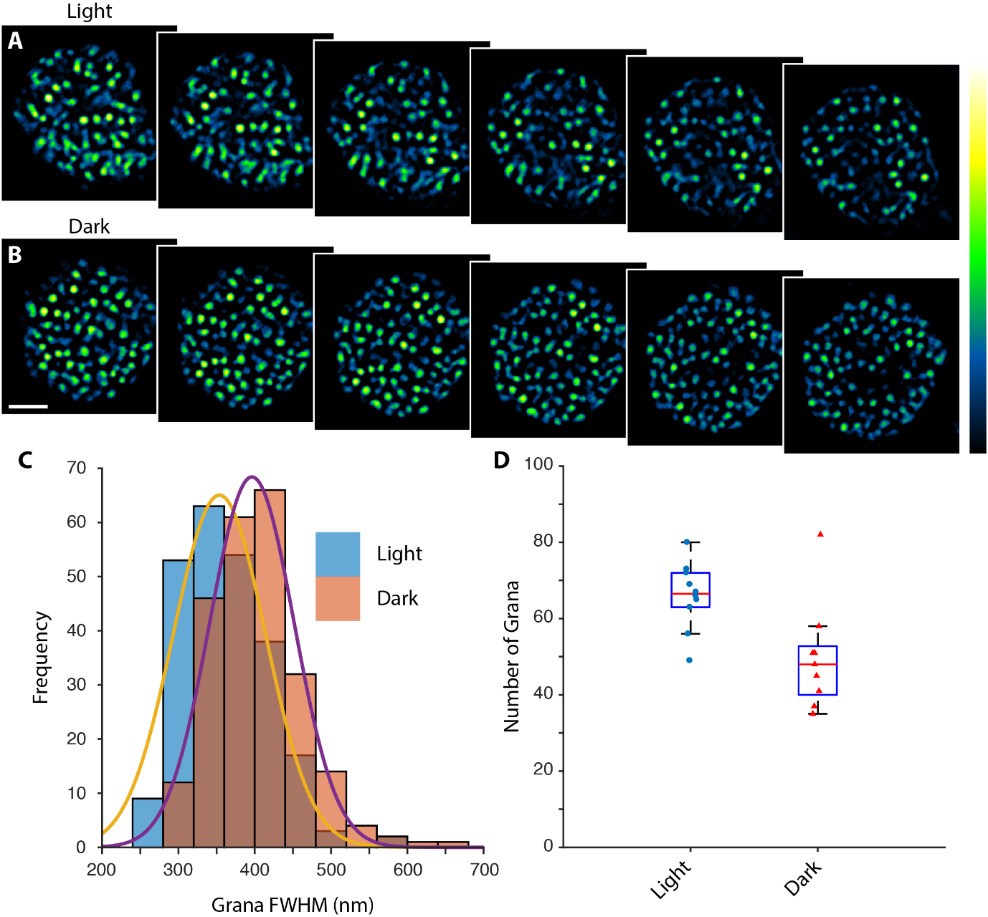
Figure 6.3: Structured illumination of dark and light adapted chloroplasts. (A) Light adapted chloroplast. (B) Dark adapted chloroplast. In both (A) and (B) there are six consecutive and sequential, axial slices through the chloroplast. The scale bar represents 2 µm and the axial step is 125 nm. (C) The blue histogram represents the light-adapted grana sizes and the orange histogram represents dark-adapted grana sizes. The yellow and purple profiles show the respective fits of a Gaussian function to the histogram. (D) Box plots showing the number of grana in light and dark adapted chloroplasts.
The area of the chloroplasts did not significantly differ between the two conditions with light adapted chloroplast encompassing 16.9 ± 6 µm² (n=15) and dark adapted chloroplasts encompassing 16.3 ± 5.2 µm² (n=11) at the midpoint. The mean number of grana stacks per chloroplast was 66 ± 8.8 for light adapted chloroplasts (n=11) and 49.8 ± 14.1 for dark adapted chloroplasts (n=10), see Figure 6.3D. Applying the Student T-test yielded a p-value of 0.0073. The mean intensity of the grana, measured at the axial midpoint of each stack, in each condition was the same with values of 7190 ± 1612 per granum for light adapted (n=175) and 7090 ± 2457 per midpoint granal disc for dark adapted chloroplasts (n=175). These measurements support the transition model of LHCII moving out of the grana and into the stromal lamellae, allowing the chloroplast to redress the energy imbalance between PSI and PSII and leading to a decrease in diameter of the grana.
Whilst chloroplasts from spinach are easy to prepare and are a valuable model system, the lack of spinach genetics prevents the construction of an extensive mutant library, which is available in Arabidopsis. Consequently, the following sections focus on mutants in Arabidopsis that affect the capacity of the chloroplasts to adapt to different conditions.

6.3.2 Structured illumination microscopy of wild-type Arabidopsis
Wild-type chloroplasts from Arabidopsis thaliana were imaged with SIM to study the native structure. The excitation wavelength led to the predominant excitation of the native chlorophyll b over chlorophyll a, leading to a larger signal originating from the grana stacks than the stromal lamellae. A single, axially sectioned chloroplast is shown in Figure 6.4A and demonstrates the clear grana structures that are propagating axially. There is a far greater signal originating from the stacks than the stromal lamellae, however the inter-granal stromal lamellae are visibly connecting the stacks (Figure 6.4B).
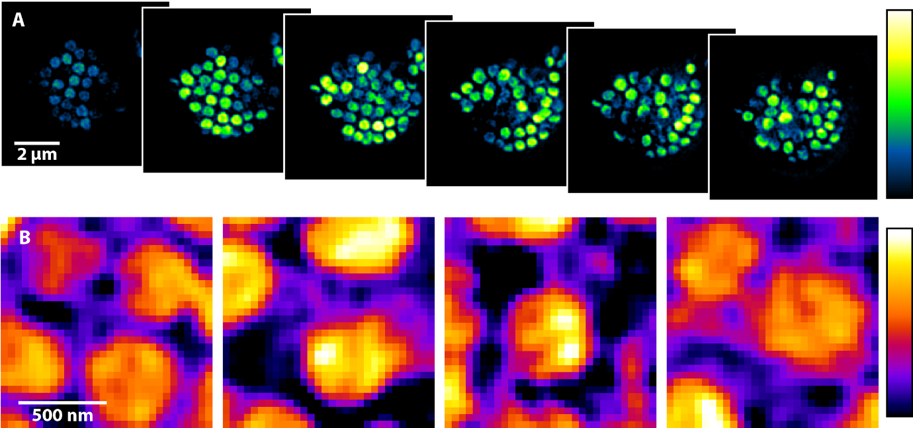
Figure 6.4: SIM of a wild-type Arabidopsis chloroplast. (A) Clearly visible are the characteristic grana that contain high densities of chlorophyll owing to being many membrane layers thick. (B) The stroma lamellae are typically a single membrane layer thick, however they are still visible. The scale bar in (A) represents 2 µm and the axial step is 125 nm, the scale bar in (B) is 500 nm.
From these SIM images, it is possible to survey grana dimensions with the mean grana width as calculated as the full-width half-maximum (FWHM) being 467.5 ± 68 nm (n = 41). Additionally, the grana do not appear to have a uniform intensity with variation occurring across the membrane. AFM and EM studies have shown that PSII and LHCII in grana membranes can occur as both as crystalline uniform arrays and as disordered structures (Johnson et al., 2014; Kouřil et al., 2012; Onoa et al., 2014). Previous investigations have also shown that under conditions of excess light there is a dissociation of LHCII from PSII, accompanied by aggregation by the LHCII complexes, which could lead to the inhomogeneity and apparent structure in the grana seen in the SIM images (Johnson et al., 2011). However, the low axial resolution of SIM leads to the sampling of many grana layers that would obscure any inhomogeneities in any individual grana slice, thus the cause at present is unknown.

6.3.3 Arabidopsis chloroplasts trapped in state I or state II
Chloroplasts that have been genetically trapped in states I or II were harvested from Arabidopsis leaves and imaged with SIM (see Figure 6.5). State I chloroplasts are created with a deletion of the STN7 and STN8 kinases (henceforth referred to as stn7stn8), which are responsible for LHCII and PSII phosphorylation respectively. Conversely state II chloroplasts were generated with the deletion of the TAP38 phosphatase responsible for dephosphorylating LHCII (henceforth referred to as tap38). Grana sizes were measured in both conditions and yielded sizes of 375 ± 45 nm for tap38 (n=40) and 647 ± 72 nm for stn7stn8 (n=40). Whilst the measured sizes are approximately 100 nm lower than previously reported, probably a result of the lower precision of fluorescence images due to diffraction, they have the same relative ordering (Armbruster et al., 2013). The measurements of grana size support the trend shown in light and dark adapted spinach in Section 6.3.1 but in a more extreme circumstance. Whilst state I and state II are associated with a transition of greater LHCII activity in the grana and stromal lamellae respectively, there is no associated difference in fluorescence intensity, possibly due to the PSI quenching the additional excitons.
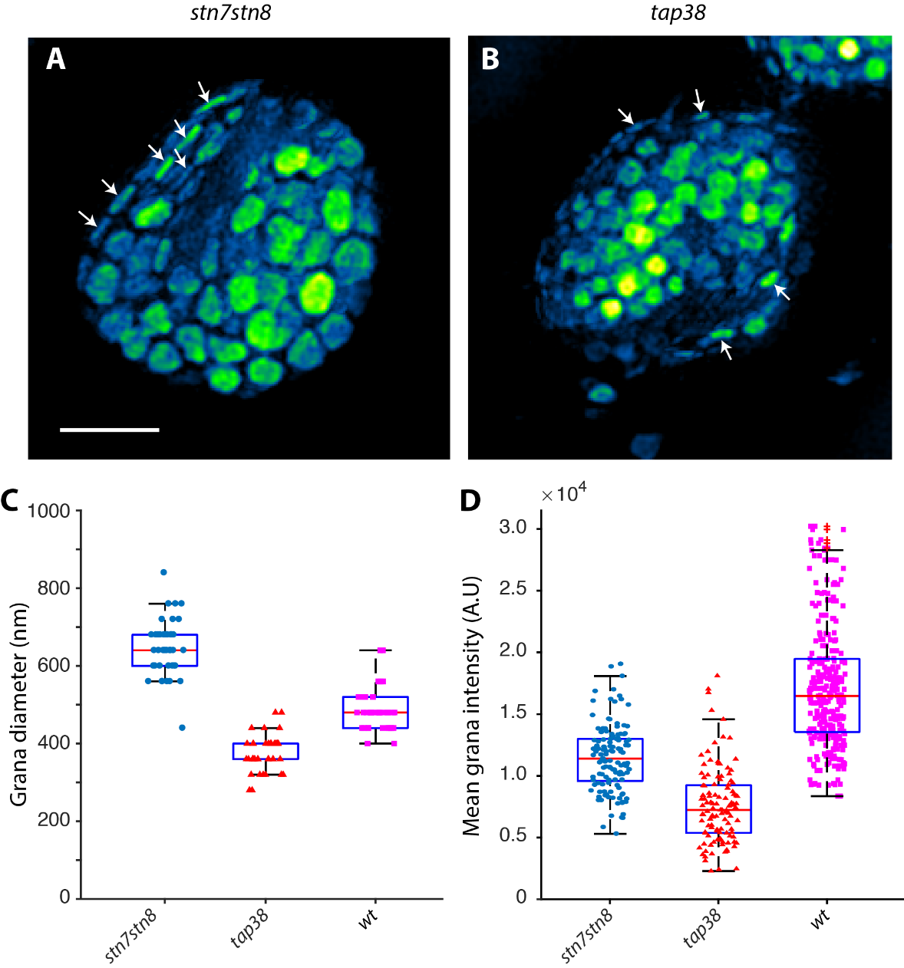
Figure 6.5: Maximum intensity projections of state I and state II trapped chloroplasts. 2D SIM slices of the stn7stn8 (A) and tap38 (B) mutants. Arrows highlight grana stacks that propagate laterally rather than axially and the scale bar represents 2 µm. (C) Boxplot showing the grana lengths for tap38 and stn7stn8. (D) Boxplot showing the grana intensities for tap38 and stn7stn8 in arbitrary units.
The height of the grana stacks in the tap38 mutant was 478 ± 108 nm (n=40) whereas for the stn7stn8 mutant the height was 466 ± 140 nm (n=40) yielding a p-value of 0.66. Previously, EM has demonstrated a difference in stack height for the two mutants (Armbruster et al., 2013) indicating that the axial resolution of SIM is limiting the measurements. Fourier analysis using the SIMCheck plugin showed the axial resolution to be approximately 400 nm and the lateral resolution to be approximately 150 nm. To take advantage of the increased lateral resolution available in SIM, measurements of grana that were layered in the lateral direction of the SIM stack were made, although the laterally oriented grana are rarer so more data are required for a more accurate analysis. These grana measurements were more in line with those published previously with stn7stn8 having a stack FWHM of 133 ± 27 nm (n=40) and tap38 having a stack FWHM of 150 ± 31 nm (n=40) with a p-value of 0.008 (Armbruster et al., 2013) .
Investigation of the mean intensities of the two mutants showed that the stn7stn8 mutant locked in state I had a lower emission from the grana regions. Histograms of the intensities were fit to Gaussian distributions revealing a mean intensity of 7002 ± 3842 for the stn7stn8 mutant (n=125) and 11390 ± 3558 for the tap38 mutant (n=125).
The counteracting phosphatase to STN8, involved in dephosphorylating PSII, is known as PBCP (Samol et al., 2012). Unfortunately, a combined TAP38/PBCP deletion strain does not exist and so a fully state I strain could not be imaged.

6.3.4 Chloroplasts from a chlorophyll b deletion mutant
The 642 nm absorbing chlorophyll b is preferentially excited over chlorophyll a and as such, imaging an Arabidopsis mutant known as chlorina1 (ch1) that lacks the chlorophyll b pigment (Espineda et al., 1999) shows a much-reduced intensity compared with the WT (see Figure 6.6). The mean intensity value for grana was 1150 ± 416 (n=40) in ch1 compared to 15980 ± 2861 (n=40) in the WT when imaged under the same intensity regime. Structurally, the chloroplasts are much smaller than in the wild-type with an average cross-sectional area of 15.9 ± 3.7 µm² (n=10), approximately half that of the wild-type 33.3 ± 13 µm² (n=11).
As can be seen in Figure 6.6 the grana have lost their characteristic morphology and are on a similar intensity level to the stromal membranes. The number of grana per chloroplast was quite reduced when compared to wild type with a mean 35.2 ± 8.6 grana (n=10) in the ch1 mutant compared to 51.6 ± 11 grana (n=6) in the WT (p = 0.0075). However, it was difficult to detect the grana in the chlorophyll b mutant above the general background of the stromal membranes. Interestingly the ratio of the grana stacks to the cross-sectional area at the midpoint was increased, with a mean density of 1.55 ± 0.69 and 2.21 ± 0.75 grana stacks per micrometre squared for the WT for ch1 mutant respectively.
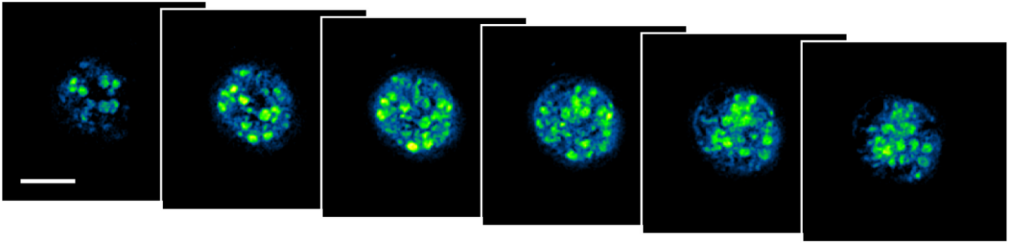
Figure 6.6: Axial sections of a chloroplast harvested from the ch1 mutant. The mutant is smaller than the wild-type and the grana are less pronounced as a result of the lack of chlorophyll b. The scale bar represents 2 µm and the axial step is 125 nm.

6.3.5 Thylakoid curvature mutants of Arabidopsis chloroplasts imaged by SIM
Chloroplasts have a distinctive morphology for optimising light collection with stacked grana membranes and stromal lamellae. Creation and maintenance of the structure is achieved with several proteins. One such protein that is essential for correct morphological structure is the thylakoid curvature protein, CURT1A. We performed SIM on two different mutants of the CURT1A protein, a deletion, ΔCURT1A, and an overexpression mutant, OECURT1A (see Figure 6.7). Dramatic changes in the ΔCURT1A mutant are clearly visible, namely the small number of enlarged grana. Equally visible are the smaller grana in the OECURT1A mutant that also demonstrates an increased number in individual grana within the chloroplast.
The ΔCURT1A strain exhibited a mean grana length of 1112 ± 229 nm (n=37), much larger than the WT as demonstrated in Figure 6.8. Furthermore, the ΔCURT1A appeared to lack control of grana size with dimensions differing by nearly a micrometre between the smallest and largest observed. By contrast, the overexpressed CURT1A mutant exhibited grana that had a mean diameter length of 258 ± 27 nm (n=40), much shorter than the WT with a mean length of 466 ± 65 nm (n=40); thus, the ΔCURT1A mutant had a mean increase in grana size of 139% compared to WT and the OECURT1A mutant had a mean decrease in grana size of 45%. Additionally, the number of grana is visibly increased with the 148.5 ± 17 grana stacks (n=6) for the OECURT1A strain.
Whilst these mutants are capable of growing in well-regulated conditions which maintain homeostasis, the plants sicken and die in more native environments with fluctuating light-levels. These mutations affect the lateral heterogeneity of the photosystems, making it impossible for the plants to use state transitions to regulate energy flow between PSI and PSII.
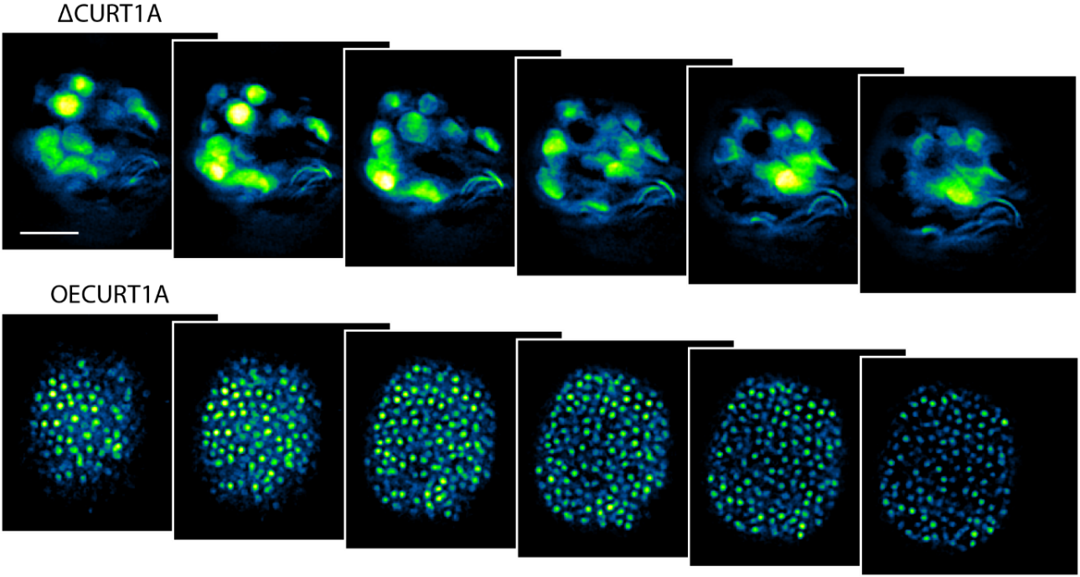
Figure 6.7: SIM imaging of CURT1A grana mutants. Clearly visible is the distinct morphological changes between CURT1A deletion and overexpression mutants. The scale bar represents 2 µm and the axial step is 125 nm.
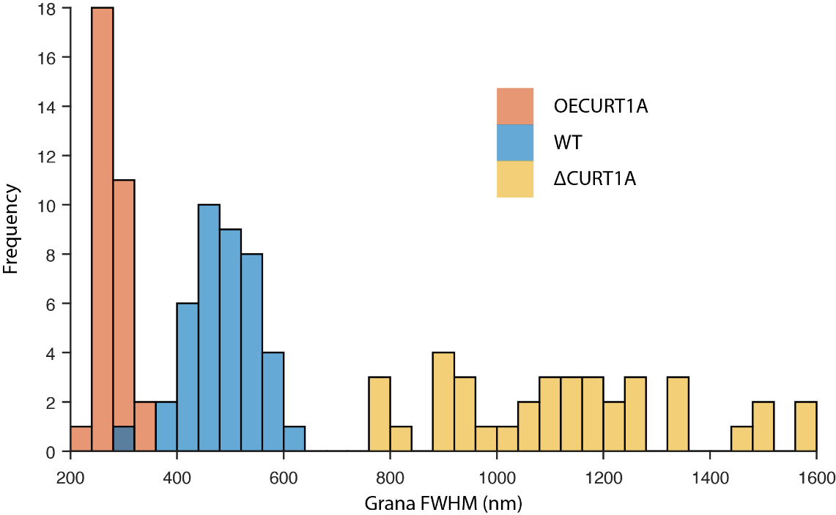
Figure 6.8: Grana sizes in structural mutants. Chloroplasts overexpressing CURT1A had much smaller grana compared to WT. The CURT1A knockout by contrast had enlarged grana with a high variation in lengths.

6.4 Discussion
6.4.1 Light and dark adaption of chloroplasts
Whilst these measurements still suffer the effects of diffraction and also differ from the more accurate measurements obtained by EM, the different light conditions can be compared to make general conclusions. Chloroplasts that had undergone adaption to light or dark conditions were differentiated by a 40 nm decrease in grana size, i.e. the diameter of the granal disc, under the higher light condition. The mean cross-sectional area of the chloroplasts was the same, but an increase in the number of grana stacks was observed in the light-adapted chloroplasts. The increased stack size is logical as under low-light/dark conditions PSII requires a larger antenna size due to the scarcity of light (Ballottari et al., 2014). The larger antenna size leads to an increased grana size to accommodate the additional LHCII proteins feeding PSII. Conversely, under high light conditions PSII becomes saturated and the LHCII population moves to PSI, lowering the stack diameter. Changes in protein density can also affect the result by altering the cross-sectional profile, however the grana are a very protein-rich medium (70-80% protein), and changes to the density are likely to have a limited effect. Furthermore, these alterations in membrane size have also been observed by both AFM in and EM.

6.4.2 Imaging of chloroplasts with structured illumination microscopy
Imaging demonstrated the ability to use the autofluorescent properties of chloroplasts for three-dimensional structured illumination microscopy. The thinness of the stromal lamellae and the preferential excitement of chlorophyll b over chlorophyll a that is mostly localised to the grana stacks means that stromal lamellae are difficult, although not impossible, to detect. When chloroplasts harvested from the strain ch1 that does not produce chlorophyll b were imaged, a distinct lack of intensity was observed to the point that even the formerly distinct grana were difficult to detect. Under the same imaging conditions the ch1 mutant demonstrated a decrease in emission intensity by a factor of 10 indicating the excitation of chlorophyll b preferentially to chlorophyll a.
Structured illumination allows the sub-diffraction imaging of the 3D thylakoid ultrastructure in non-fixed samples. Thus, the technique offers the advantages of higher resolution images than standard optical imaging methods, and imaging of hydrated material under atmosphere, unlike EM.
6.4.3 Chloroplasts locked in state I or state II
The intensity levels of the state I and state II grana as measured by SIM might at first glance appear to be reversed with a higher intensity of signal originating from the grana in the tap38 mutant, even though there should be more LHCII attached to stromal PSI. In plants, only 15-20% of the LHCII proteins transition to the stroma (Allen, 1992). However, in the grana without the TAP38 phosphatase the LHCII and PSII proteins remain phosphorylated under all conditions. Phosphorylation decreases the connectivity between LHCII and PSII, lowering the rate of FRET and increasing the time the protein stays in the excited state (Kyle et al., 1982). This in turn leads to an increase in fluorescence from the sample as the exciton is no longer trapped by PSII before being re-emitted.

6.4.4 Chloroplasts with thylakoid curvature mutants
Chloroplasts have a distinctive structure of the thylakoid membrane with two distinct regions; the stacked grana, housing PSII, and the stromal lamellae, housing PSI. The CURT1 family of proteins have been demonstrated to be vitally important in creating the chloroplast structure and these proteins are localised to the grana margins, a region devoid of other proteins (Armbruster et al., 2013; Daum et al., 2010). The present work shows the effects of altering the expression levels of one of the CURT1 proteins, CURT1A, either through deletion or an overexpression. From the results, it is clear that CURT1A plays an active part in determining the grana dimensions as overexpression leads to smaller grana and deletion leads to larger grana. In the overexpressed strain, there is also an increase in the number of grana stacks present indicating that the overall amount of membrane is the same between the two mutants.

6.4.5 Conclusions
Plants use the mobility of the LHCII light harvesting antenna protein to adapt to various environmental conditions in a process known as state transitions. This chapter has used SIM to investigate these adaptions, demonstrating the ability of this technique to obtain quantitative information on state transitions at higher resolutions that traditional optical microscopy and in a more native environment than electron microscopy. This allows for more precise three-dimensional investigation of the photosynthetic apparatus without fixatives or vacuum that could interfere with the in vivo structure.

Chapter 7
Concluding Remarks

This thesis has dealt with the advancement and application of advanced optical techniques with the aim of understanding photosynthetic systems. The 2014 Nobel prize was awarded for the development of super-resolution microscopy, which has revolutionised the field of microscopy, and has allowing new insights into systems that were previously inaccessible using standard optical techniques. Super-resolution microscopy is a rapidly expanding field that from its onset has spawned a multitude of different techniques and methodologies, each effective in different conditions. The work presented here has focused on several different aspects of microscopy from the development of new tools such as a novel camera design and imaging using a novel fluorescent protein, to the application of these techniques to furthering the understanding of a biological system, namely photosynthesis in cyanobacteria and plants.
Chapter 3 focused on the potential of a new camera architecture that takes advantage of non-destructive measurements to improve, by a factor of two, the signal-to-noise ratio and detected number of localisation microscopy events. Additionally, the potential for defining the camera exposure post-acquisition and the possibility of overlapping exposures to observe small differences between frames are major advantages for low signal-to-noise measurements. This technology shows promise within the field of single-particle tracking that studies molecular dynamics, as the continuous exposure allows a more accurate trajectory to be constructed. Ultimately, this technology could have wide ranging effects on many separate fields, ranging from microscopy to astronomy, although the camera in its current form is a prototype. This technology could provide a further application to solve the issue of the unknown photoswitching species in Chapter 5. The ability to accurately characterise emission duration that NDR camera allows could allow separation of the native events and the YFP species within the species if the emission lifetimes are suitably different. Thus by extension, this camera can provide an alternate way of performing multi-colour LM imaging, with probes separated on their on-lifetimes rather than their spectral properties.
The quality of super-resolution microscopy images is strongly correlated with the capabilities of the label used; thus, there has been a great effort in developing new probes. Chapter 4 demonstrated the application of a novel fluorescent protein, CpcA, together with bound bilin chromophores such as PEB and PCB, for STORM and SIM that shows promise for these modalities. CpcA-bilin complexes have several properties that make them good candidates for super-resolution labels, for instance their stability, wide spectral range, ease of production, small size and the ability to change the chromophore ligand to alter the spectroscopic properties. CpcA is one instance of a large family of proteins that can be explored for novel fluorophores. Given that CpcA from Synechocystis has been demonstrated to undergo photoswitching it is possible that this protein is responsible for the native blinking demonstrated in Chapter 5. Future work should focus on producing a knock-out of the phycobiliproteins to investigate whether this reduces the levels of autofluorescence to allow LM imaging of cyanobacterial cells.
Although many of the super-resolution techniques have existed for over a decade, their application to studying photosynthetic systems has been almost non-existent. Chapter 5 involves the imaging of the cyanobacterium Synechocystis sp. PCC6803 with the technique SIM, to provide high-resolution images of several of the proteins involved in photosynthesis. These images are complemented by hyperspectral data that allows the imaging of multiple fluorescent, spectroscopically-different components simultaneously. This has allowed the localisation of YFP/GFP labelled PSI, Slr0843, FtsH2 and FtsH4 to the thylakoid membrane, FtsH1 to the cytoplasmic membrane, and Slr1471 to both. The natural autofluorescent nature of the thylakoid membrane allows components to be easily localised relative to the photosynthetic apparatus. Given the near diffraction-limit dimensions of cyanobacterial cells and the lack of understanding of protein interactions within the photosynthetic apparatus, super-resolution imaging of these systems can provide much needed clarity. For instance, only one CURT protein has been labelled in this experiment whereas there are three other homologs also expressed in Synechocystis. Furthermore, how do knockouts of the proteins imaged here, such as the CURT protein, affect thylakoid architecture in the cell.
Chapter 6 demonstrated how powerful these novel optical techniques can be in analysing photosynthetic systems; applying structured illumination microscopy to study thylakoid structure in the chloroplast. Previously, only electron microscopy has been able to provide sub-diffraction information but is limited by its reliance on fixatives and being performed under vacuum. Structured illumination microscopy has proven to be a viable tool for investigating the internal membrane structure of functional chloroplasts in near-native conditions, showing subtle structural differences in light and dark adapted chloroplasts, as well as the more substantial changes of mutants trapped in state I or state II. Overexpression and deletion mutants of the thylakoid curvature protein, CURT1A, showed even more drastic changes to membrane ultrastructure. These measurements should be taken with care as diffraction is still prevalent in the values, however when combined with other experiments SIM allows imaging of the chloroplast in its native environment to confirm measurements made by more accurate yet destructive techniques such as EM.
The chloroplast is a specialised light-harvesting organelle with an alterable, complex ultrastructure, that is yet to be fully understood. This work and future studies can shed light on the functions of structural proteins such as CURT1A, as well as adaptive changes to differing environmental conditions. Food and energy security is vitally important and increasing the yield of crops by altering the photosynthetic apparatus. This line of research could allow crops to grow more efficiently in traditionally non-arable land, increasing the amount of crop-land for both foodstuffs and biofuels.
Photosynthesis is an incredible and complicated process, capable of harvesting solar energy and converting it into biomass. Despite centuries of research this system is not fully understood and so continuing research is required, utilising the most recent and advanced techniques such as super-resolution microscopy as has been demonstrated in Chapters 5 and 6. As new technologies become available, such as the NDR camera demonstrated in Chapter 3, their applications should be fully explored. One such potential application being teasing out the unknown emitter in Chapter 5 that hindered LM imaging of Synechocystis. Whilst understanding photosynthesis is an important field of research the capacity for new tools that can originate from the photosynthetic apparatus should not be understated, with Chapter 4 demonstrating a photosynthetic protein as a novel fluorophore used for super-resolution microscopy.

References
Abaskharon, R.M., and Gai, F. (2016). Direct measurement of the tryptophan-mediated photocleavage kinetics of a protein disulfide bond. Physical Chemistry Chemical Physics 18, 9602-9607.
Ackland, B.D., Dickinson, A.G., Eid, E., and Inglis, D.A. (1996). Imaging active pixel device having a non-destructive read-out gate. US Patent 5,541,402.
Airy, G.B. (1835). On the diffraction of an object-glass with circular aperture. Transactions of the Cambridge Philosophical Society 5, 283-291.
Aitken, C.E., Marshall, R.A., and Puglisi, J.D. (2008). An oxygen scavenging system for improvement of dye stability in single-molecule fluorescence experiments. Biophysical Journal 94, 1826-1835.
Aldridge, C., Spence, E., Kirkilionis, M.A., Frigerio, L., and Robinson, C. (2008). Tat-dependent targeting of Rieske iron-sulphur proteins to both the plasma and thylakoid membranes in the cyanobacterium Synechocystis PCC6803. Molecular Microbiology 70, 140–150.
Allen, J.F. (1992). Protein phosphorylation in regulation of photosynthesis. Biochimica et Biophysica Acta 1098, 275-335.
Alvey, R.M., Biswas, A., Schluchter, W.M., and Bryant, D.A. (2011). Attachment of noncognate chromophores to CpcA of Synechocystis sp. PCC 6803 and Synechococcus sp. PCC 7002 by heterologous expression in Escherichia coli. Biochemistry 50, 4890–4902.
Andersson, B., and Anderson, J.M. (1980). Lateral heterogeneity in the distribution of chlorophyll-protein complexes of the thylakoid membranes of spinach chloroplasts. Biochimica et Biophysica Acta 593, 427-440.
Andronov, L., Orlov, I., Lutz, Y., Vonesch, J.L., and Klaholz, B.P. (2016). ClusterViSu, a method for clustering of protein complexes by Voronoi tessellation in super-resolution microscopy. Scientific Reports 6, 24084-24093.
Arlt, H., Steglich, G., Perryman, R., and Guiard, B. (1998). The formation of respiratory chain complexes in mitochondria is under the proteolytic control of the m‐AAA protease. The EMBO Journal 17, 4837-4847.
Armbruster, U., Pribil, M., Viola, S., Xu, W., Scharfenberg, M., Hertle, A.P., Rojahn, U., Jensen, P.E., Rappaport, F., Joliot, P., et al. (2013). Arabidopsis CURVATURE THYLAKOID1 proteins modify thylakoid architecture by inducing membrane curvature. The Plant Cell 25, 2661–2678.
Axelrod, D. (1981). Cell-substrate contacts illuminated by total internal reflection fluorescence. The Journal of Cell Biology 89, 141–145.
Baker, L.A., and Rubinstein, J.L. (2010). Radiation damage in electron cryomicroscopy. Methods in Enzymology 481, 371–388.
Ball, G., Demmerle, J., Kaufmann, R., Davis, I., Dobbie, I.M., and Schermelleh, L. (2015). SIMcheck: a toolbox for successful super-resolution structured illumination microscopy. Scientific Reports 5, 15915–15926.
Ballottari, M., Alcocer, M.J., D’Andrea, C., Viola, D., Ahn, T.K., Petrozza, A., Polli, D., Fleming, G.R., Cerullo, G., and Bassi, R. (2014). Regulation of photosystem I light harvesting by zeaxanthin. Proceedings of the National Academy of Sciences 111, E2431–E2438.
Balázs, B., Deschamps, J., Albert, M., Ries, J., and Hufnagel, L. (2017). A real-time compression library for microscopy images. BioRxiv doi: 10.1101/164624.
Barnett, S.F.H., Snape, S., Hunter, C.N., Juárez, M., and Cadby, A.J. (2017). A novel application of non-destructive readout technology to localisation microscopy. Scientific Reports 7, 42313-42319.
Barsic, A., Grover, G., and Piestun, R. (2014). Three-dimensional super-resolution and localization of dense clusters of single molecules. Scientific Reports 4, 5388-5396.
Bassham, J.A., Benson, A.A., and Calvin, M. (1950). The path of carbon in photosynthesis VIII. The role of malic acid. Journal of Biological Chemistry 185, 781-787.
Becker, W. (2012). Fluorescence lifetime imaging–techniques and applications. Journal of Microscopy 247, 119-136.
Bellafiore, S., Barneche, F., Peltier, G., and Rochaix, J.D. (2005). State transitions and light adaptation require chloroplast thylakoid protein kinase STN7. Nature 433, 892-895.
Bermejo, R., Fernández, E., Alvarez-Pez, J.M., and Talavera, E.M. (2002). Labeling of cytosine residues with biliproteins for use as fluorescent DNA probes. Journal of Luminescence 99, 113–124.
Betzig, E., Patterson, G.H., Sougrat, R., Lindwasser, O.W., Olenych, S., Bonifacino, J.S., Davidson, M.W., Lippincott-Schwartz, J., and Hess, H.F. (2006). Imaging intracellular fluorescent proteins at nanometer resolution. Science 313, 1642–1645.
Bezouwen, L.S., Caffarri, S., Kale, R.S., Kouřil, R., Thunnissen, A.W.H., Oostergetel, G.T., and Boekema, E.J. (2017). Subunit and chlorophyll organization of the plant photosystem II supercomplex. Nature Plants 3, 17080-17811.
Bigas, M., Cabruja, E., Forest, J., and Salvi, J. (2006). Review of CMOS image sensors. Microelectronics Journal 37, 433-451.
Binnig, G., Quate, C.F., and Gerber, C. (1986). Atomic force microscope. Physical Review Letters 56, 930-934.
Biswas, A., Vasquez, Y.M., Dragomani, T.M., Kronfel, M.L., Williams, S.R., Alvey, R.M., Bryant, D.A., and Schluchter, W.M. (2010). Biosynthesis of cyanobacterial phycobiliproteins in Escherichia coli: chromophorylation efficiency and specificity of all bilin lyases from Synechococcus sp. strain PCC 7002. Applied and Environmental Microbiology 76, 2729–2739.
Biteen, J.S., Thompson, M.A., Tselentis, N.K., Bowman, G.R., Shapiro, L., and Moerner, W.E. (2008). Super-resolution imaging in live Caulobacter crescentus cells using photoswitchable EYFP. Nature Methods 5, 947–949.
Björn, L.O., Papageorgiou, G.C., and Blankenship, R.E. (2009). A viewpoint: why chlorophyll a? Photosynthesis Research 99, 85-98.
Blaudeck, N., Sprenger, G., Freudl, R., and Wiegert, T. (2001). Specificity of signal peptide recognition in Tat-dependent bacterial protein translocation. Journal of Bacteriology 183, 604–610.
Bleau, C., and Bleau, C. (2017). SciMeasure The High Performance Camera Company. https://www.scimeasure.com/. Accessed 13th of September 2017.
Blot, N., Wu, X.J., Thomas, J.C., Zhang, J., Garczarek, L., Böhm, S., Tu, J.M., Zhou, M., Plöscher, M., Eichacker, L., et al. (2009). Phycourobilin in trichromatic phycocyanin from oceanic cyanobacteria is formed post-translationally by a phycoerythrobilin lyase-isomerase. Journal of Biolodical Chemistry 284, 9290–9298.
Boehm, M., Yu, J., Krynicka, V., Barker, M., Tichy, M., Komenda, J., Nixon, P.J., and Nield, J. (2012). Subunit organization of a Synechocystis hetero-oligomeric thylakoid FtsH complex involved in photosystem II repair. The Plant Cell 24, 3669-3683.
Boer, D.P., Hoogenboom, J.P., and Giepmans, B.N.G. (2015). Correlated light and electron microscopy: ultrastructure lights up! Nature Methods 12, 503-513.
Bonardi, V., Pesaresi, P., Becker, T., Schleiff, E., Wagner, R., Pfannschmidt, T., Jahns, P., and Leister D. (2005). Photosystem II core phosphorylation and photosynthetic acclimation require two different protein kinases. Nature 437, 1179-1182.
Bongiovanni, M.N., Godet, J., Horrocks, M.H., Tosatto, L., Carr, A.R., Wirthensohn, D., Ranasinghe, R., Lee, J.E., Ponjavic, A., Fritz, J.V., et al. (2016). Multi-dimensional super-resolution imaging enables surface hydrophobicity mapping. Nature Communications 7, 13544-13553.
Borden, W.T., Hoffmann, R., Stuyver, T., and Chen, B. (2017). Dioxygen: what makes this triplet diradical kinetically persistent? Journal of the American Chemical Society 139, 9010-9018.
Burov, S., Tabei, S.M.A., Huynh, T., Murrell, M.P., Philipson, L.H., Rice, S.A., Gardel, M.L., Scherer, N.F., and Dinner, A.R. (2013). Distribution of directional change as a signature of complex dynamics. Proceedings of the National Academy of Sciences 110, 19689–19694.
Carlton, P.M., Boulanger, J., Kervrann, C., Sibarita, J.B., Salamero, J., Gordon-Messer, S., Bressan, D., Haber, J.E., Haase, S., Shao, L., et al. (2010). Fast live simultaneous multiwavelength four-dimensional optical microscopy. Proceedings of the National Academy of Sciences 107, 16016–16022.
Cartron, M.L., Olsen, J.D., Sener, M., Jackson, P.J., Brindley, A.A., Qian, P., Dickman, M.J., Legget, G.J., Schulten, K., and Hunter, C.N. (2014). Integration of energy and electron transfer processes in the photosynthetic membrane of Rhodobacter sphaeroides. Biochimica et Biophysica Acta 1837, 1769-1780.
Chalfie, M., Tu, Y., Euskirchen, G., Ward, W.W., and Prasher, D.C. (1994). Green fluorescent protein as a marker for gene expression. Science 263, 802–805.
Chen, X., Wang, X., Feng, J., Chen, Y., Fang, Y., Zhao, S., Zhao, A., Zhang, M., and Liu L. (2014). Structural insights into the catalytic mechanism of Synechocystis magnesium protoporphyrin IX O-methyltransferase (ChlM). Journal of Biological Chemistry 289, 25690-25698.
Chitnis, P.R., Purvis, D., and Nelson, N. (1991). Molecular cloning and targeted mutagenesis of the gene psaF encoding subunit III of photosystem I from the cyanobacterium Synechocystis sp. PCC 6803. Journal of Biological Chemistry 266, 20146-20151.
Chung, S.H., and Kennedy, R.A. (1991). Forward-backward non-linear filtering technique for extracting small biological signals from noise. Journal of Neuroscience Methods 40, 71-86.
Collins, A.M., Liberton, M., Jones, H.D.T., Garcia, O.F., Pakrasi, H.B., and Timlin, J.A. (2012). Photosynthetic pigment localization and thylakoid membrane morphology are altered in Synechocystis 6803 phycobilisome mutants. Plant Physiology 158, 1600-1609.
Coons, A.H., and Kaplan, M.H. (1950). Localization of antigen in tissue cells. Journal of Experimental Medicine 91, 1-13.
Cox, S., Rosten, E., Monypenny, J., Jovanovic-Talisman, T., Burnette, D.T., Lippincott-Schwartz, J., Jones, G.E., and Heintzmann, R. (2012). Bayesian localization microscopy reveals nanoscale podosome dynamics. Nature Methods 9, 195–200.
Croce, R., and Amerongen, V.H. (2014). Natural strategies for photosynthetic light harvesting. Nature Chemical Biology 10, 492-501.
Cullis, C.A., Vorster, B.J., Vyver, V.C. and Kunert K.J. (2008). Transfer of genetic material between the chloroplast and nucleus: how is it related to stress in plants? Annals of Botany 103, 625-633.
Cymer, F., von Heijne, G., and White, S.H. (2014). Mechanisms of integral membrane protein insertion and folding. Journal of Molecular Biology 427, 999–1022.
Daniell, H., Lin, C.S., Yu, M., and Chang, W.J. (2016). Chloroplast genomes: diversity, evolution, and applications in genetic engineering. Genome Biology 17, 134-163.
Daum, B., Nicastro, D., Austin, J., McIntosh, J.R., and Kühlbrandt, W. (2010). Arrangement of photosystem II and ATP synthase in chloroplast membranes of spinach and pea. The Plant Cell 22, 1299–1312.
Demmerle, J., Innocent, C., North, A.J., Ball, G., Müller, M. Miron, E., Matsuda, A., Dobbie, I.M., Markaki Y., and Schermelleh, L. (2017). Strategic and practical guidelines for successful structured illumination microscopy. Nature Protocols 12, 988-1010.
Dempsey, G.T., Bates, M., Kowtoniuk, W.E., Liu, D.R., Tsien, R.Y., and Zhuang, X. (2009). Photoswitching mechanism of cyanine dyes. Journal of the American Chemical Society 131, 18192-18193.
Dempsey, G.T., Vaughan, J.C., Chen, K.H., Bates, M., and Zhuang, X. (2011). Evaluation of fluorophores for optimal performance in localization-based super-resolution imaging. Nature Methods 8, 1027–1036.
Dertinger, T., Colyer, R., Iyer, G., Weiss, S., and Enderlein, J. (2009). Fast, background-free, 3D super-resolution optical fluctuation imaging (SOFI). Proceedings of the National Academy of Sciences 106, 22287-22292.
Dertinger, T., Pallaoro, A., Braun, G., Ly, S., Laurence, T.A., and Weiss, S. (2013). Advances in superresolution optical fluctuation imaging (SOFI). Quarterly Reviews of Biophysics 46, 210-221.
Deschout, H., Lukes, T., Sharipov, A., Szlag, D., Feletti, L., Vandenberg, W., Dedecker, P., Hofkens, J., Leutenegger, M., Lasser, T., and Radenovic A. (2016). Complementarity of PALM and SOFI for super-resolution live-cell imaging of focal adhesions. Nature Communications 7, 13693-13704.
Deschout, H., Zanacchi, F.C., Mlodzianoski, M., Diaspro, A., Bewersdorf, J., Hess, S.T, and Braeckmans, K. (2014). Precisely and accurately localizing single emitters in fluorescence microscopy. Nature Methods 11, 253–266.
Ding, W.L., Miao, D., Hou, Y.N., Jiang, S.P., Zhao, B.Q., Zhou, M., Scheer, H., and Zhao, K.H. (2017). Small monomeric and highly stable near-infrared fluorescent markers derived from the thermophilic phycobiliprotein, ApcF2. Biochimica et Biophysica Acta – Molecular Cell Research 1864, 1877-1886.
Dunn, K.W., Kamocka, M.M., and McDonald, J.H. (2011). A practical guide to evaluating colocalization in biological microscopy. American Journal of Physiology - Cell Physiology 300, C723–C742.
El-Sayed, M.A. (1968). Triplet state. Its radiative and nonradiative properties. Accounts of Chemical Research 1, 8-16.
Engel, B.D., Schaffer, M., Cuellar, L.K., Villa, E., Plitzko, J.M., and Baumeister, W. (2015). Native architecture of the Chlamydomonas chloroplast revealed by in situ cryo-electron tomography. eLife 4, e04889-e04918.
Espineda, C.E., Linford, A.S., Devine, D., Brusslan, J.A. (1999). The AtCAO gene, encoding chlorophyll a oxygenase, is required for chlorophyll b synthesis in Arabidopsis thaliana. Proceedings of the National Academy of Sciences 96, 10507-10511.
Falk, H. (2012). The chemistry of linear oligopyrroles and bile pigments (Vienna: Springer).
Frankenberg, N., Mukougawa, K., Kohchi, T., and Lagarias, J.C. (2001). Functional genomic analysis of the HY2 family of ferredoxin-dependent bilin reductases from oxygenic photosynthetic organisms. The Plant Cell 13, 965–978.
Frenkel, M., Bellafiore, S., Rochaix, J.D., and Jansson, S. (2007). Hierarchy amongst photosynthetic acclimation responses for plant fitness. Physiologia Plantarum 129, 455-459.
Fristedt, R., Granath, P., and Vener, A.V. (2010). A protein phosphorylation threshold for functional stacking of plant photosynthetic membranes. Plos One 5, e10963-e10975.
Fromme, P., Jordan, P., and Krauß, N. (2001). Structure of photosystem I. Biochimica et Biophysica Acta 1507, 5-31.
Fu, M., Xiao, Y., Xian, X., Zhao, D. and Xu Y. (2008). A design concept of long-wavelength fluorescent analogs of rhodamine dyes: replacement of oxygen with silicon atom. Chemical Communications 0, 1780-1782.
Fuhrmann, E., Gathmann, S., Rupprecht, E., Golecki, J., and Schneider, D. (2009). Thylakoid membrane reduction affects the photosystem stoichiometry in the cyanobacterium Synechocystis sp. PCC 6803. Plant Physiology 149, 735–744.
Gamal, E.A., and Eltoukhy, H. (2005). CMOS image sensors. IEEE Circuits and Devices Magazine 21, 6-20.
Gamal, E.A., Fowler, B.A., Min, H., and Liu X. (1998). Modeling and estimation of FPN components in CMOS image sensors. Proceedings of SPIE 3301, 168-177.
Gan, F., Shen, G., and Bryant, D.A. (2014a). Occurrence of far-red light photoacclimation (FaRLiP) in diverse cyanobacteria. Life 5, 4–24.
Gan, F., Zhang, S., Rockwell, N.C., Martin, S.S., Lagarias, J.C., and Bryant, D.A. (2014b). Extensive remodeling of a cyanobacterial photosynthetic apparatus in far-red light. Science 345, 1312–1317.
Gest, H. (2004). The discovery of microorganisms by Robert Hooke and Antoni Van Leeuwenhoek, fellows of the Royal Society. Notes and Records of the Royal Society of London 58, 187–201.
Glazer, A.N. (1994). Phycobiliproteins—a family of valuable, widely used fluorophores. Journal of Applied Phycology 6, 105-112.
Glazer, A.N. (1989). Light guides. Directional energy transfer in a photosynthetic antenna. Journal of Biological Chemistry 264, 1–4.
Glazer, A.N., and Fang, S. (1973). Chromophore content of blue-green algal phycobiliproteins. Journal of Biological Chemistry 248, 659-662.
Glazer, A., and Hixson, C. (1975). Characterization of R-phycocyanin. Chromophore content of R-phycocyanin and C-phycoerythrin. Journal of Biological Chemistry 250, 5487-5495.
Glendinning, R., Beard, S.M., Mountain, C.M., Pettie, D.G., Pickup, D.A., and Wade, R. (1990). Implementation of a charge integration system in a low-background application. Proceedings of SPIE 1235, 34-42.
Gould, T.J., Verkhusha, V.V., and Hess, S.T. (2009). Imaging biological structures with fluorescence photoactivation localization microscopy. Nature Protocols 4, 291–308.
Grayson, K.J., Faries, K.M., Huang, X., Qian, P., Dilbeck, P., Martin, E.C., Hitchcock, A., Vasilev, C., Yuen, J.M., Niedzwiedzki, D.M., et al. (2017). Augmenting light coverage for photosynthesis through YFP-enhanced charge separation at the Rhodobacter sphaeroides reaction centre. Nature Communications 8, 13972-13984.
Gunewardene, M.S., Subach, F.V., Gould, T.J., Penoncello, G.P., Gudheti, M.V., Verkhusha, V.V., and Hess, S.T. (2011). Superresolution imaging of multiple fluorescent proteins with highly overlapping emission spectra in living cells. Biophysical Journal 101, 1522–1528.
Gustafsson, M.G.L. (2000). Surpassing the lateral resolution limit by a factor of two using structured illumination microscopy. Journal of Microscopy 198, 82–87.
Gustafsson, M.G.L. (2005). Nonlinear structured-illumination microscopy: Wide-field fluorescence imaging with theoretically unlimited resolution. Proceedings of the National Academy of Sciences 102, 13081–13086.
Gustafsson, M.G.L., Shao, L., Carlton, P.M., Wang, R.C., Golubovskaya, I.N., Cande, Z.W., Agard, D.A., and Sedat, J.W. (2008). Three-dimensional resolution doubling in wide-field fluorescence microscopy by structured illumination. Biophysical Journal 94, 4957–4970.
Gustafsson, N., Culley, S., Ashdown, G., Owen, D.M., Pereira, P.M., and Henriques, R. (2016). Fast live-cell conventional fluorophore nanoscopy with ImageJ through super-resolution radial fluctuations. Nature Communications 7, 12471-12480.
Gyongy, I., Davies, A., Dutton, N., Duncan, R.R., Rickman, C., Henderson R.K., and Dalgarno, P.A. (2016). Smart-aggregation imaging for single molecule localisation with SPAD cameras. Scientific Reports 6, 37349-37358.
Ha, T., and Tinnefeld, P. (2012). Photophysics of fluorescent probes for single-molecule biophysics and super-resolution imaging. Annual Review of Physical Chemistry 63, 595-617.
Haehnel, W., Ratajczak, R., and Robenek, H. (1989). Lateral distribution and diffusion of plastocyanin in chloroplast thylakoids. The Journal of Cell Biology 108, 1397-1405.
Hanahan, D. (1983). Studies on transformation of Escherichia coli with plasmids. Journal of Molecular Biology 166, 557-580.
Heilemann, M., Linde, V.S., Schüttpelz, M., Kasper, R., Seefeldt, B., Mukherjee, A., Tinnefeld, P., and Sauer, M. (2008). Subdiffraction‐resolution fluorescence imaging with conventional fluorescent probes. Angewandte Chemie 47, 6172-6176.
Heinz, S, Rast, A, Shao, L, Gutu, A, and Gügel, IL (2016). Thylakoid membrane architecture in Synechocystis depends on CurT, a homolog of the granal CURVATURE THYLAKOID1 proteins. The Plant Cell 28, 2238-2260.
Hell, S.W., and Wichmann, J. (1994). Breaking the diffraction resolution limit by stimulated emission: stimulated-emission-depletion fluorescence microscopy. Optics Letters 19, 780–782.
Hennon, S.W., Soman, R., Zhu, L., and Dalbey, R.E. (2015). YidC/Alb3/Oxa1 family of insertases. Journal of Biological Chemistry 290, 14866–14874.
Hess, S.T., Girirajan, T.P.K., and Mason, M.D. (2006). Ultra-high resolution imaging by fluorescence photoactivation localization microscopy. Biophysical Journal 91, 4258–4272.
Hinterstoisser, B., Cichna, M., Kuntner, O., and Peschek, G.A. (1993). Cooperation of plasma and thylakoid membranes for the biosynthesis of chlorophyll in cyanobacteria: the role of the thylakoid centers. Journal of Plant Physiology 142, 407-413.
Ho, M.Y., Gan, F., Shen, G., and Bryant, D.A. (2017). Far-red light photoacclimation (FaRLiP) in Synechococcus sp. PCC 7335. II. Characterization of phycobiliproteins produced during acclimation to far-red light. Photosynthesis Research 131, 187-202.
Holden, S.J., Uphoff, S., and Kapanidis, A.N. (2011). DAOSTORM: an algorithm for high-density super-resolution microscopy. Nature Methods 8, 279–280.
Hooke, R. (1665). Micrographia (Royal Society).
Huang, B., Wang, W., Bates, M., and Zhuang, X. (2008). Three-Dimensional Super-Resolution Imaging by Stochastic Optical Reconstruction Microscopy. Science 319, 810–813.
Huang, F., Hartwich, T.M.P., Rivera-Molina, F.E., Lin, Y., Duim, W.C., Long, J.L., Uchil, P.D., Myers, J.R., Baird, M.A., Mothes, W., et al. (2013). Video-rate nanoscopy using sCMOS camera-specific single-molecule localization algorithms. Nature Methods 10, 653–658.
Ito, K., and Akiyama, Y. (2005). Cellular functions, mechanism of action, and regulation of FtsH protease. Annual Reviews of Microbiology 59, 211-231.
Ivanchenko, S., Röcker, C., Oswald, F., Wiedenmann, J., and Nienhaus, G.U. (2005). Targeted green-red photoconversion of EosFP, a fluorescent marker protein. Journal of Biological Physics 31, 249–259.
Jabłoński, A. (1933). Efficiency of anti-stokes fluorescence in dyes. Nature 131, 839–840.
Johnson, M.P., Goral, T.K., Duffy, C.D.P., Brain, A.P.R., Mullineaux, C.W., and Ruban, A.V. (2011). Photoprotective energy dissipation involves the reorganization of photosystem II light-harvesting complexes in the grana membranes of spinach chloroplasts. The Plant Cell 23, 1468-1479.
Johnson, M.P., Vasilev, C., Olsen, J.D., and Hunter, CN (2014). Nanodomains of cytochrome b₆f and photosystem II complexes in spinach grana thylakoid membranes. The Plant Cell 26, 3051-3061.
Jonge, N., and Ross, F.M. (2011). Electron microscopy of specimens in liquid. Nature Nanotechnology 6, 695-704.
Jordan, P., Fromme, P., Witt, H.T., and Klukas, O., Saenger, W., and Krauß, N. (2001). Three-dimensional structure of cyanobacterial photosystem I at 2.5 angstrom resolution. Nature 411, 909-917.
Juette, M.F., Gould, T.J., Lessard, M.D., Mlodzianoski, M.J., Nagpure, B.S., Bennett, B.T., Hess, S.T., and Bewersdorf, J. (2008). Three-dimensional sub-100 nm resolution fluorescence microscopy of thick samples. Nature Methods 5, 527–529.
Jusuk, I., Vietz, C., Raab, M., Dammeyer, T., and Tinnefeld, P. (2015). Super-resolution imaging conditions for enhanced yellow fluorescent protein (eYFP) demonstrated on DNA origami nanorulers. Scientific Reports 5, 14075-14083.
Kachatkou, A., and van Silfhout, R. (2008). Dynamic range enhancement algorithms for CMOS sensors with non-destructive readout. IEEE International Workshop on Imaging Systems and Techniques 132–137.
Kaplan, C., and Ewers, H. (2015). Optimized sample preparation for single-molecule localization-based superresolution microscopy in yeast. Nature Protocols 10, 1007-1021.
Kato, Y., and Sakamoto, W. (2009). Protein quality control in chloroplasts: a current model of D1 protein degradation in the photosystem II repair cycle. The Journal of Biochemistry 146, 463-469.
Kiss, C., Temirov, J., Chasteen, L., Waldo, G.S., and Bradbury A.R.M. (2009). Directed evolution of an extremely stable fluorescent protein. Protein Engineering, Design & Selection 22, 313-323.
Klán, P., and Wirz, J. (2009). Kasha and Vavilov Rules. In Photochemistry of organic compounds: from concepts to practice. (Michigan: Wiley-Blackwell) 41–44.
Kol, S., Nouwen, N., and Driessen, A.J.M. (2008). Mechanisms of YidC-mediated insertion and assembly of multimeric membrane protein complexes. Journal of Biological Chemistry 283, 31269-31273.
Komenda, J., and Sobotka, R. (2016). Cyanobacterial high-light-inducible proteins—protectors of chlorophyll–protein synthesis and assembly. Biochimica et Biophysica Acta 1857, 288–295.
Komenda, J., Barker, M., Kuviková, S., de Vries, R., Mullineaux, C.W., Tichy, M., and Nixon, P.J. (2006). The FtsH protease slr0228 is important for quality control of photosystem II in the thylakoid membrane of Synechocystis sp. PCC 6803. Journal of Biological Chemistry 281, 1145–1151.
Kopečná, J., Komenda, J., Buinská, L., and Sobotka, R. (2012). Long-term acclimation of the cyanobacterium Synechocystis sp. PCC 6803 to high light is accompanied by an enhanced production of chlorophyll that is preferentially channeled to trimeric photosystem I. Plant Physiology 160, 2239–2250.
Korbel, D., Wurth, S., Käser, M., and Langer, T. (2004). Membrane protein turnover by the m‐AAA protease in mitochondria depends on the transmembrane domains of its subunits. EMBO Reports 5, 698-703.
Kouřil, R., Yeremenko, N., D’Haene, S., Yakushevska, A.E., Keegstra, W., Matthijs, H.C.P., Dekker, J.P., and Boekema, E.J. (2003). Photosystem I trimers from Synechocystis PCC 6803 lacking the PsaF and PsaJ subunits bind an IsiA ring of 17 units. Biochimicha et Biophysica Acta 1607, 1-4.
Kouřil, R., Dekker, J.P., and Boekema, E.J. (2012). Supramolecular organization of photosystem II in green plants. Biochimica et Biophysica Acta 1817, 2-12.
Kremers, G.J., Goedhart, J., van Munster, E.B., and Gadella Jr, T.W. (2006). Cyan and yellow super fluorescent proteins with improved brightness, protein folding, and FRET Förster radius. Biochemistry 45, 6570–6580.
Kumar, M., Mommer, M.S., and Sourjik, V. (2010). Mobility of cytoplasmic, membrane, and DNA-binding proteins in Escherichia coli. Biophysical Journal 98, 552–559.
Kyle, D.J., Haworth, P., and Arntzen, C.J. (1982). Thylakoid membrane protein phosphorylation leads to a decrease in connectivity between photosystem II reaction centers. Biochimica et Biophysica Acta 680, 336-342.
Kyle, D.J., Staehelin, L.A., and Arntzen, C.J. (1983). Lateral mobility of the light-harvesting complex in chloroplast membranes controls excitation energy distribution in higher plants. Archives of Biochemistry and Biophysics 222, 527-541.
Lauterbach, M.A. (2012). Finding, defining and breaking the diffraction barrier in microscopy–a historical perspective. Optical Nanoscopy 1, 1-8.
Lee, S.H., Baday, M., Tjioe, M., Simonson, P.D., Zhang, R., Cai, E., and Selvin, P.R. (2012). Using fixed fiduciary markers for stage drift correction. Optics Express 20, 12177-12183.
Levet, F., Hosy, E., Kechkar, A., Butler, C., Beghin, A., Choquet, D., and Sibarita, J.B. (2015). SR-Tesseler: a method to segment and quantify localization-based super-resolution microscopy data. Nature Methods 12, 1065-1063.
Lewis, G.N., and Kasha, M. (1944). Phosphorescence and the triplet state. Journal of the American Chemical Society 66, 2100-2116.
Lewis, A., Isaacson, M., Harootunian, A., and Muray, A. (1984). Development of a 500 Å spatial resolution light microscope: I. light is efficiently transmitted through λ/16 diameter apertures. Ultramicroscopy 13, 227-232.
Li, Y., Lin, Y., Garvey, C.J., Birch, D., Corkery, R.W., Loughlin, P.C., Scheer, H., Willows, R.D., and Chen, M. (2016). Characterization of red-shifted phycobilisomes isolated from the chlorophyll f-containing cyanobacterium Halomicronema hongdechloris. Biochimica et Biophysica Acta 1857, 107–114.
Lin, Y., Long, J.J., Huang, F., Duim, W.C., Kirschbaum, S., Zhang, Y., Schroeder, L.K., Rebane, A.A., Grace, M., Velasco, M., et al. (2015). Quantifying and optimizing single-molecule switching nanoscopy at high speeds. PloS One 10, e0128135-e0128154.
van de Linde, S., Löschberger, A., Klein, T., Heidbreder, M., Wolter, S., Heilemann, M., and Sauer, M. (2011). Direct stochastic optical reconstruction microscopy with standard fluorescent probes. Nature Protocols 6, 991–1009.
Liu, H., Zhang, H., Niedzwiedzki, D.M. Prado, M., He, G., Gross, M.L., and Blankenship, R.E. (2013). Phycobilisomes supply excitations to both photosystems in a megacomplex in cyanobacteria. Science 342, 1104–1107.
Llorente-Garcia, I., Lenn, T., Erhardt, H., Harriman, O.L., Liu, L., Robson, A., Chiu, S., Matthews, S., Willis, N.J., Bray, C.D., et al. (2014). Single-molecule in vivo imaging of bacterial respiratory complexes indicates delocalized oxidative phosphorylation. Biochimica et Biophysica Acta 1837, 811–824.
Long, F., Zeng, S.Q., and Huang, Z.L. (2014). Effects of fixed pattern noise on single molecule localization microscopy. Physical Chemistry Chemical Physics 16, 21586–21594.
Long, F., Zeng, S., and Huang, Z.L. (2012). Localization-based super-resolution microscopy with an sCMOS camera Part II: Experimental methodology for comparing sCMOS with EMCCD cameras. Optics Express 20, 17741–17759.
Luca, G., Breedijk, R., Brandt, R., Zeelenberg, C.H.C., Jong, B.E., Timmermans, W., Azar, L.N., Hoebe R.A., Stallinga, S., and Manders, E.M.M. (2013). Re-scan confocal microscopy: scanning twice for better resolution. Biomedical Optics Express 4, 2644-2656.
Lukinaviciius, G., Reymond, L., D’Este, E., Masharina, A., Göttfert, F., Ta, H., Güther, A., Fournier, M., Rizzo, S., Waldmann, H. et al. (2014). Fluorogenic probes for live-cell imaging of the cytoskeleton. Nature Methods 11, 731–733.
MacColl, R. (1998). Cyanobacterial phycobilisomes. Journal of Structural Biology 124, 311–334.
MacGregor-Chatwin, C., Sener, M., Barnett, S.F.H, Hitchcock, A., Barnhart-Dailey, M.C., Maghlaoui, K., Barber, J., Timlin, J.A., Schulten, K., and Hunter, C.N. (2017). Lateral segregation of photosystem I in cyanobacterial thylakoids. The Plant Cell 29, 1119–1136.
Mann, N.H., Novac, N., Mullineaux, C.W., Newman, J., Bailey, S., Robinson, C. (2000). Involvement of an FtsH homologue in the assembly of functional photosystem I in the cyanobacterium Synechocystis sp. PCC 6803. FEBS Letters 479, 72-77.
Marsac, N.T. (1977). Occurrence and nature of chromatic adaptation in cyanobacteria. Journal of Bacteriology 130, 82–91.
Matsumoto, K., Nakamura, T., Yusa, A., and Nagai, S. (1985). A new MOS phototransistor operating in a non-destructive readout mode. Japanese Journal of Applied Physics 24, L323-L325.
Mattson, G., Conklin, E., Desai, S., Nielander, G., Savage, M.D., and Morgensen, S. (1993). A practical approach to crosslinking. Molecular Biology Reports 17, 167-183.
McFadden, G.I. (2001). Primary and secondary endosymbiosis and the origin of plastids. Journal of Phycology 37, 951-959.
McNally, J.G., Karpova, T., Cooper, J., and Conchello, J.A. (1999). Three-dimensional imaging by deconvolution microscopy. Methods 19, 373-385.
Meene, A., Hohmann-Marriott, M.F., Vermaas, W.F.J., and Roberson, R.W. (2006). The three-dimensional structure of the cyanobacterium Synechocystis sp. PCC 6803. Archives of Microbiology 184, 259-270.
Meene, A., Sharp, W.P., McDaniel, J.H., Friedrich, H., Vermaas, W.F.J., and Roberson, R.W. (2012). Gross morphological changes in thylakoid membrane structure are associated with photosystem I deletion in Synechocystis sp. PCC 6803. Biochimica et Biophysica Acta 1818, 1427-1434.
Mendis, S.K., Kemeny, S.E., Gee, R.C., Pain, B., Staller, C.O., Kim, Q., and Fossum, E.R. (1997). CMOS active pixel image sensors for highly integrated imaging systems. IEEE Journal of Solid-State Circuits 32, 187-197.
Metcalf, D.J., Edwards, R., Kumarswami, N., Knight, A.E. (2013). Test samples for optimizing STORM super-resolution microscopy. JoVE 79, e50579-e50595.
Miao, D., Ding, W.L., Zhao, B.Q., Lu, L., Xu, Q.Z., Scheer, H., and Zhao, K.H. (2016). Adapting photosynthesis to the near-infrared: non-covalent binding of phycocyanobilin provides an extreme spectral red-shift to phycobilisome core-membrane linker for Synechococcus sp. PCC7335. Biochimica et Biophysica Acta 1857, 688–694.
Minsky, M (1961). Microscopy apparatus. US Patent 3,013,467.
Mlodzianoski, M.J., Schreiner, J.M., Callahan, S.P., Smolková, K., Dlasková, A., Šantorová, J., Ježek, P., and Bewersdorf, J. (2011). Sample drift correction in 3D fluorescence photoactivation localization microscopy. Optics Express 19, 15009–15019.
Mlodzianoski, M.J., Curthoys, N.M., Gunewardene, M.S., Carter, S., and Hess, S.T. (2016). Super-resolution imaging of molecular emission spectra and single molecule spectral fluctuations. PLoS ONE 11, e0147506- e0147517.
Mortensen, K., Churchman, S., Spudich, J., and Flyvbjerg, H. (2010). Optimized localization analysis for single-molecule tracking and super-resolution microscopy. Nature Methods 7, 377–381.
Mullineaux, C.W. (2008). Phycobilisome-reaction centre interaction in cyanobacteria. Photosynthesis Research 95, 175-182.
Möckl, L., Lamb, D.C., and Bräuchle, C. (2014). Super‐resolved fluorescence microscopy: Nobel Prize in Chemistry 2014 for Eric Betzig, Stefan Hell, and William E. Moerner. Angewandte Chemie 53, 13972-13977.
Nakajima, S., Lan, L., Kanno, S., Takao, M., Yamamoto, K., Eker, A.P., and Yasui, A. (2004). UV light-induced DNA damage and tolerance for the survival of nucleotide excision repair-deficient human cells. Journal of Biological Chemistry 279, 46674–46677.
Nelson, N., and Yocum, C.F. (2006). Structure and function of photosystems I and II. Annual Reviews of Plant Biology 57, 521-565.
Neves‐Petersen, M.T., Gryczynski, Z., Lakowicz, J., Fojan, P., Pedersen S., Petersen E., and Petersen, S.B. (2002). High probability of disrupting a disulphide bridge mediated by an endogenous excited tryptophan residue. Protein Science 11, 588-600.
Nieuwenhuizen, R., Lidke, K., Bates, M., Puig, D.L., Grünwald, D., Stallinga, S., and Rieger, B. (2013). Measuring image resolution in optical nanoscopy. Nature 10, 557-567.
Nixon, P.J., Michoux, F., Yu, J., Boehm, M., Komenda, J. (2010). Recent advances in understanding the assembly and repair of photosystem II. Annals of Botany 106, 1-16.
Nixon, R.H., Kemeny, S.E., Pain, B., Staller, C.O., and Fossum, E.R. (1996). 256× 256 CMOS active pixel sensor camera-on-a-chip. IEEE Journal of Solid State Circuits 31, 2046–2050.
Nordhues, A., Schöttler, M.A., Unger, A.K., Geimer, S. Schönfelder, S., Schmollinger S., Rütgers M., Finazzi, G., Soppa, B., Sommer, F., et al. (2012). Evidence for a role of VIPP1 in the structural organization of the photosynthetic apparatus in Chlamydomonas. The Plant Cell 24, 647-659.
Olivier, N., Keller, D., Rajan, V.S., Gönczy, P., Manley, S. (2013a). Simple buffers for 3D STORM microscopy. Biomedical Optics Express 4, 885-899.
Olivier, N., Keller, D., Gönczy, P., and Manley, S. (2013b). Resolution doubling in 3D-STORM imaging through improved buffers. PloS ONE 8, e69004-e69012.
Onoa, B., Schneider, A.R., Brooks, M.D., Grob, P., Nogales, E., Geissler P.L., Niyogi, K.K., and Bustamante, C. (2014). Atomic force microscopy of photosystem II and its unit cell clustering quantitatively delineate the mesoscale variability in Arabidopsis thylakoids. PloS ONE 9, e101470-e101481.
Ovesný, M., Křížek, P., Borkovec, J., Švindrych, Z., and Hagen, G.M (2014). ThunderSTORM: a comprehensive ImageJ plug-in for PALM and STORM data analysis and super-resolution imaging. Bioinformatics 30, 2389–2390.
Partridge, M.A., and Marcantonio, E.E. (2006). Initiation of attachment and generation of mature focal adhesions by integrin-containing filopodia in cell spreading. Molecular Biology of the Cell 17, 4237–4248.
Pavani, S.R., Thompson, M.A., Biteen, J.S., Lord, S.J., Liu, N., Twieg, R.J., Piestun, R., and Moerner, W.E. (2009). Three-dimensional, single-molecule fluorescence imaging beyond the diffraction limit by using a double-helix point spread function. Proceedings of the National Academy of Sciences 106, 2995–2999.
Piehler, J. (2005). New methodologies for measuring protein interactions in vivo and in vitro. Current Opinion in Structural Biology 15, 4-14.
Pisareva, T., Kwon, J., Oh, J., Kim, S., Ge, C., Wieslander, A., Choi, J.S., Norling, B. (2011). Model for membrane organization and protein sorting in the cyanobacterium Synechocystis sp. PCC 6803 inferred from proteomics and multivariate sequence analyses. Journal of Proteome Research 10, 3617-3631.
Pisareva, T., Shumskaya, M., Maddalo, G., Ilag, L., and Norling, B. (2007). Proteomics of Synechocystis sp. PCC 6803. FEBS Journal 274, 791–804.
Pohl, D.W., Denk, W., and Lanz, M. (1984). Optical stethoscopy: Image recording with resolution λ/20. Applied Physics Letters 44, 651–653.
Pribil, M., Pesaresi, P., Hertle, A., Barbato, R., and Leister, D. (2010). Role of plastid protein phosphatase TAP38 in LHCII dephosphorylation and thylakoid electron flow. PLoS Biology 8, e1000288-e1000299.
Pribil, M., Labs, M., and Leister, D. (2014). Structure and dynamics of thylakoids in land plants. Journal of Experimental Botany 65, 1955-1972.
Rees, E.J., Erdelyi, M., Schierle, G., Knight, A. and Kaminski C.F. (2013). Elements of image processing in localization microscopy. Journal of Optics 15, 094012-094018.
Rhoades, E., Gussakovsky, E., and Haran, G. (2003). Watching proteins fold one molecule at a time. Proceedings of the National Academy of Sciences 100, 3197-3202.
Rippka, R., Deruelles, J., Waterbury, J.B., Herdman, M., and Stanier R.Y. (1979). Generic assignments, strain histories and properties of pure cultures of cyanobacteria. Journal of General Microbiology 110, 1-61.
Rodriguez, E.A., Tran, G.N., Gross, L.A., Crisp, J.L., Shu, X., Lin, J.Y., and Tsien, R.Y. (2016). A far-red fluorescent protein evolved from a cyanobacterial phycobiliprotein. Nature Methods 13, 763–769.
Ruban, A.V., and Johnson, M.P. (2009). Dynamics of higher plant photosystem cross-section associated with state transitions. Photosynthesis Research 99, 173-183.
Rumak, I., Mazur, R., Gieczewska, K., Kozioł-Lipińska, J., Kierdaszuk B., Michalski, W.P., Shiell B.J., Venema, J.H., Vredenberg, W.J., Mostowska A., and Garstka M. (2012). Correlation between spatial (3D) structure of pea and bean thylakoid membranes and arrangement of chlorophyll-protein complexes. BMC Plant Biology 12, 72-89.
Russell, W.C., Newman, C., and Williamson, D.H. (1975). A simple cytochemical technique for demonstration of DNA in cells infected with mycoplasmas and viruses. Nature 253, 461-462.
Rust, M.J., Bates, M., and Zhuang, X. (2006). Sub-diffraction-limit imaging by stochastic optical reconstruction microscopy (STORM). Nature Methods 3, 793–795.
Sacharz, J., Bryan, S., Yu, J., Burroughs, N., Spence, E., Nixon, P.J., and Mullineaux, C.W. (2015). Sub-cellular location of FtsH proteases in the cyanobacterium Synechocystis sp. PCC 6803 suggests localised PSII repair zones in the thylakoid membranes. Molecular Microbiology 96, 448–462.
Samol, I., Shapiguzov, A., Ingelsson, B., Fucile, G., Crèvecoeur, M., Vener, A.V., Rochaix, J.D., and Goldschmidt-Clermont, M. (2012). Identification of a photosystem II phosphatase involved in light acclimation in Arabidopsis. The Plant Cell 24, 2596–2609.
Samuelson, J.C., Chen, M., Jiang, F., Möller, I., Wiedmann, M., Kuhn, A., Phillips, G.J., and Dalbey, R.E. (2000). YidC mediates membrane protein insertion in bacteria. Nature 406, 637–641.
Saurabh, S., Maji, S., and Bruchez, M.P. (2012). Evaluation of sCMOS cameras for detection and localization of single Cy5 molecules. Optics Express 20, 7338-7349.
Schaefer, L.H., Schuster, D., and Schaffer, J. (2004). Structured illumination microscopy: artefact analysis and reduction utilizing a parameter optimization approach. Journal of Microscopy 216, 165-174.
Scheer, H., Yang, X., and Zhao, K.H. (2015). Biliproteins and their applications in bioimaging. Procedia Chemistry 14, 176–185.
Scott, P.F.I., Kachatkou, A.S., Frost, A.L., and van Silfhout, R.G. (2009). A high dynamic range camera with a non-destructive readout complementary metal–oxide–semiconductor sensor. Measurement Science and Technology 20, 104004–104012.
Sener, M., Strumpfer, J., Singharoy, A., Hunter, C.N., and Schulten, K. (2016). Overall energy conversion efficiency of a photosynthetic vesicle. eLIFE 5, e09541-e09570.
Shannon, C. (1949). Communication in the presence of noise. Proceedings of the IRE 37, 10–21.
Shapiguzov, A., Ingelsson, B., Samol, I., Andres, C., Kessler, F., Rochaix, J. D., Vener, A., and Goldschmidt-Clermont, M. (2010). The PPH1 phosphatase is specifically involved in LHCII dephosphorylation and state transitions in Arabidopsis. Proceedings of the National Academy of Sciences 107, 4782–4787.
Sharonov, A., and Hochstrasser, R.M. (2006). Wide-field subdiffraction imaging by accumulated binding of diffusing probes. Proceedings of the National Academy of Sciences 103, 18911–18916.
Shcherbo, D., Murphy, C.S., Ermakova, G.V., Solovieva, E.A., Chepurnykh, T.V., Shcheglov, A.S., Verkhusha, V.V., Pletnev, V.Z., Hazelwood, K.L., Roche, P.M., et al. (2009). Far-red fluorescent tags for protein imaging in living tissues. Biochemical Journal 418, 567–574.
Shen, H., Tauzin, L.J., Baiyasi, R., and Wang, W., Moringo N., Shuang, B., and Landes C.F. (2017). Single particle tracking: from theory to biophysical applications. Chemical Reviews 117, 7331-7376.
Shimomura, O., Johnson, F.H., and Saiga, Y. (1962). Extraction, purification and properties of aequorin, a bioluminescent protein from the luminous hydromedusan, Aequorea. Journal of Cellular and Comparative Physiology 59, 223–239.
Shroff, H., Galbraith, C.G., Galbraith, J.A., White, H., Gillette, J., Olenych, S., Davidson, M.W., and Betzig, E. (2007). Dual-color superresolution imaging of genetically expressed probes within individual adhesion complexes. Proceedings of the National Academy of Sciences 104, 20308–20313.
Shroff, H., Galbraith, C.G., Galbraith, J.A., and Betzig, E. (2008). Live-cell photoactivated localization microscopy of nanoscale adhesion dynamics. Nature Methods 5, 417–423.
Shroff, H., White, H., and Betzig, E. (2013). Photoactivated localization microscopy (PALM) of adhesion complexes. Current Protocols in Cell Biology 4-21.
Silva, P., Thompson, E., Bailey, S., Kruse, O., Mullineaux C.W., Robinson, C., Mann, N.H. and Nixon, P.J. (2003). FtsH is involved in the early stages of repair of photosystem II in Synechocystis sp PCC 6803. The Plant Cell 15, 2152-2164.
Simpson, D.J. (1979). Freeze-fracture studies on barley plastid membranes. III. Location of the light-harvesting chlorophyll-protein. Carlsberg Research Communications 44, 305-336.
Sinclair, M.B., Haaland, D.M., Timlin, J.A., and Jones, H.D.T. (2006). Hyperspectral confocal microscope. Applied Optics 45, 6283–6291.
Smith, H.L., McAusland, L., and Murchie E.H. (2017). Don’t ignore the green light: exploring diverse roles in plant processes. Journal of Experimental Botany 68, 2099-2110.
Souza, R.A., Ventura, L., Reis, L.P., de Monteiro, D., and Salles, L.P. (2016). CMOS image sensor with FPN reduction by correlated double sampling in current mode. Microelectronics Technology and Devices 1–4.
Spence, E., Sarcina, M., Ray, N., Møller, S.G., Mullineaux, C.W., and Robinson C. (2003). Membrane‐specific targeting of green fluorescent protein by the Tat pathway in the cyanobacterium Synechocystis PCC6803. Molecular Microbiology 48, 1481-1489.
Spence, E., Bailey, S., Nenninger, A., Møller, S.G., and Robinson, C. (2004). A homolog of Albino3/OxaI is essential for thylakoid biogenesis in the cyanobacterium Synechocystis sp. PCC6803. Journal of Biological Chemistry 279, 55792-55800.
Staehelin L.A. (2003). Chloroplast structure: from chlorophyll granules to supra-molecular architecture of thylakoid membranes. Photosynthetic Research 76, 185-196.
Steinbach, G., Schubert, F., and Kaňa, R. (2015). Cryo-imaging of photosystems and phycobilisomes in Anabaena sp. PCC 7120 cells. Journal of Photochemistry and Photobiology B: Biology 152, 395–399.
Stengel, A., Gügel, I.L., Hilger, D., Rengstl, B., Jung, H., and Nickelsen, J. (2012). Initial steps of photosystem II de novo assembly and preloading with manganese take place in biogenesis centers in Synechocystis. The Plant Cell 24, 660-67.
Stout, A.L., and Axelrod, D. (1989). Evanescent field excitation of fluorescence by epi-illumination microscopy. Applied Optics 28, 5237–5242.
Sturgis, J.N., Tucker, J.D., Olsen, J.D., Hunter, C.N., and Niederman R.A. (2009). Atomic force microscopy studies of native photosynthetic membranes. Biochemistry 48, 3679-3698.
Su, X., Ma, J., Wei, X., Cao, P., Zhu, D., Chang, W., Liu, Z., Zhang. X., and Li, M. (2017). Structure and assembly mechanism of plant C₂S₂M₂-type PSII-LHCII supercomplex. Science 357, 815-820.
Sun, J., Nishio, J.N., and Vogelmann, T.C. (1998). Green light drives CO₂ fixation deep within leaves. Plant and Cell Physiology 39, 1020-1026.
Sven, G., Eva, R., Uwe, K., and Schneider, D. (2008). A conserved structure and function of the YidC homologous protein Slr1471 from Synechocystis sp. PCC 6803. Journal of Microbiology and Biotechnology 18, 1090-1094.
Testa, I., Wurm, C.A., Medda, R., Rothermel, E., von Middendorf, C., Fölling, J., Jakobs, S., Schönle, A., Hell, S.W. and Eggeling C. (2010). Multicolor fluorescence nanoscopy in fixed and living cells by exciting conventional fluorophores with a single wavelength. Biophysical Journal 99, 2686-2694.
Thompson, R.E., Larson, D.R., and Webb, W.W. (2002). Precise Nanometer Localization Analysis for Individual Fluorescent Probes. Biophysical Journal 82, 2775–2783.
Tikkanen, M., Grieco, M., Kangasjärvi, S., and Aro, E.M. (2010). Thylakoid protein phosphorylation in higher plant chloroplasts optimizes electron transfer under fluctuating light. Plant Physiology 152, 723-735.
Ting, C.S., Rocap, G., King, J., and Chisholm, S.W. (2002). Cyanobacterial photosynthesis in the oceans: the origins and significance of divergent light-harvesting strategies. Trends in Microbiology 10, 134–142.
Tooley, A.J., Cai, Y.A., and Glazer, A.N. (2001). Biosynthesis of a fluorescent cyanobacterial C-phycocyanin holo-alpha subunit in a heterologous host. Proceedings of the National Academy of Sciences 98, 10560–10565.
Vasilev, C., Johnson, M.P., Gonzales, E., Wang, L., Ruban, A.V., Montano, G., Cadby, A.J., and Hunter, C.N. (2014). Reversible switching between nonquenched and quenched states in nanoscale linear arrays of plant light-harvesting antenna complexes. Langmuir 30, 8481–8490.
Vaughan, J.C., Jia, S., and Zhuang, X. (2012). Ultrabright photoactivatable fluorophores created by reductive caging. Nature Methods 9, 1181–1184.
Vermaas, W.F.J., Timlin, J.A., Jones, H.D.T., Sinclair, M.B., Nieman, L.T., Hamad, S.W., Melgaard D.K., and Haaland D.M. (2008). In vivo hyperspectral confocal fluorescence imaging to determine pigment localization and distribution in cyanobacterial cells. Proceedings of the National Academy of Sciences 105, 4050-4055.
Vogelsang, J., Cordes, T., Forthmann, C., Steinhauer, C., and Tinnefeld, P. (2009). Controlling the fluorescence of ordinary oxazine dyes for single-molecule switching and superresolution microscopy. Proceedings of the National Academy of Sciences 106, 8107–8112.
Wagner, M., Weber, P., Bruns, T., Strauss, W.S., Wittig, R., and Schneckenburger, H. (2010). Light dose is a limiting factor to maintain cell viability in fluorescence microscopy and single molecule detection. International Journal of Molecular Sciences 11, 956–966.
Wallace, W., Schaefer, L.H., and Swedlow, J.R. (2001). A workingperson’s guide to deconvolution in light microscopy. Biotechniques 31, 1076-1097.
Wang, S., Moffitt, J.R., Dempsey, G.T., Xie, X.S., and Zhuang, X. (2014). Characterization and development of photoactivatable fluorescent proteins for single-molecule–based superresolution imaging. Proceedings of the National Academy of Sciences 111, 8452–8457.
Watkins, L.P., and Yang, H. (2005). Detection of intensity change points in time-resolved single-molecule measurements. Journal of Physical Chemistry B 109, 617–628.
Webber, A.N., and Lubitz, W. (2001). P700: the primary electron donor of photosystem I. Biochimica et Biophysica Acta 1507, 61-79.
Weisenburger, S., Boening, D., Schomburg, B., Giller, K., Becker, S., Griesinger, C., and Sandoghdar, V. (2017). Cryogenic optical localization provides 3D protein structure data with Angstrom resolution. Nature Methods 14, 141–144.
Whelan, D.R., and Bell, T.D.M. (2015). Image artifacts in single molecule localization microscopy: why optimization of sample preparation protocols matters. Scientific Reports 5, 7924-7933.
Wientjes, E., Philippi, J., Borst, J.W., and van Amerongen, H. (2017). Imaging the Photosystem I/Photosystem II chlorophyll ratio inside the leaf. Biochimica et Biophysica Acta 1858, 259-265.
Wu, Q., Feke, G.D., Grober, R.D., and Ghislain, L.P. (1999). Realization of numerical aperture 2.0 using a gallium phosphide solid immersion lens. Applied Physics Letters 75, 4064-4066.
Wu, X.J., Chang, K., Luo, J., Zhou, M., Scheer, H., and Zhao K.H. (2013). Modular generation of fluorescent phycobiliproteins. Photochemical & Photobiological Sciences 12, 1036-1040.
Würth, C., Grabolle, M., Pauli, J., Spieles, M., and Resch-Genger, U. (2013). Relative and absolute determination of fluorescence quantum yields of transparent samples. Nature Protocols 8, 1535-1550.
Yang, H., Liu, J., Wen, X., and Lu, C. (2015). Molecular mechanism of photosystem I assembly in oxygenic organisms. Biochimica et Biophysica Acta 1847, 838-848.
Zaltsman, A., Feder, A., and Adam, Z. (2005). Developmental and light effects on the accumulation of FtsH protease in Arabidopsis chloroplasts–implications for thylakoid formation and photosystem II maintenance. The Plant Journal 42, 609–617.
Zhang, Z., Kenny, S.J., Hauser, M., Li, W., and Xu, K. (2015). Ultrahigh-throughput single-molecule spectroscopy and spectrally resolved super-resolution microscopy. Nature Methods 12, 935-940.
Zhao, K.H., Deng, M.G., Zheng, M., Zhou, M., Parbel, A., Storf, M., Meyer, M., Strohmann, B., and Scheer, H. (2000). Novel activity of a phycobiliprotein lyase: both the attachment of phycocyanobilin and the isomerization to phycoviolobilin are catalyzed by the proteins PecE and PecF encoded by the phycoerythrocyanin operon. FEBS Letters 469, 9–13.
Zheng, Q., and Lavis, L.D. (2017). Development of photostable fluorophores for molecular imaging. Current Opinion in Chemical Biology 39, 1-7.
Zhou, J., Gasparich, G.E., Stirewalt, V.L., de Lorimier, R., and Bryant, D.A. (1992). The cpcE and cpcF genes of Synechococcus sp. PCC 7002. Construction and phenotypic characterization of interposon mutants. Journal of Biological Chemistry 267, 16138–16145.

Appendix 1 – NDR analysis of STORM data
Final_04.m
%Final version 1.4
%This script is for analysing data from a SciMeasure NDR camera
%The script brings up a dialog for selecting your file and will
%automatically detect the reset frame locations.
%
%Important variables for changing:
% level - the value used to determine pixels of interest on an image
% threshold - the value used to determine if a blink is present in the
% trace
%
%Important outputs:
% fits - locations of events, column 2 is the x value, column 4 is the y
% value
%
%Example:
% plot(fits(:,2),fits(:,4), '.')
%
%Authors: Dr Ashley Cadby and Sam Barnett
%Date: 29/06/2016
%%
%------------------ BEGIN CODE ----------------------

clear
%Open parallel pool if one isn't already open
if isempty(gcp('nocreate'))
parpool('local', 4)
end

%Open file and retreive header information
[filename, Path] = uigetfile('*.tsm');
file = strcat(Path,filename);
fileInfo = NDR_FileInfo(file);

%initialise important variables
level=50; % threshold value for the Standard Deviation
cut_size = 5; % crop value for a blink for further analysis
threshold = 30; % Threshold value for locating blink in a time trace
blink_store = []; % store all the blinks
bounding_boxa = []; % store locations for blinks in the wider image
frames_founda = [];
cut = [];
blinka=zeros((cut_size*2)+1,(cut_size*2)+1,1);
holder = zeros((cut_size*2)+1,(cut_size*2)+1,100,100);
%holder2 = zeros((cut_size*2)+1,(cut_size*2)+1,100,100);
f = 1;

%Find the locations of the reset frames within the file
[chunk_pos fileInfo] = NDR_DefineResets2( file, fileInfo );
disp(['Loaded in ', int2str(size(chunk_pos,1)), ' chunks'])
%%
%Monitor how far through the data
fprintf('Progress:\n');
fprintf(['\n' repmat('.',1,100) '\n\n']);
%Cropping to lower memory requirements
fileInfo.cwidth = 120;
fileInfo.cheight = 80; % 80

parfor i = 1:size(chunk_pos,1)-1 %-1 because last chunk is also not a full chunk
chunk = NDR_LoadData( file, chunk_pos(i,2), chunk_pos(i+1,2), fileInfo);
chunk = chunk(10:90,980:1100,:); %crop center, significantly reduces memory issues

[ blink{i},frames_found{i}, bounding_box{i},holder2{i} ] = NDR_gaussbin( chunk,fileInfo,level,cut_size,threshold,frames_founda,blinka,bounding_boxa,i);

if rand < 100/size(chunk_pos,1)
fprintf('\b|\n');
end
end
%%
%Unpack the events
blink_store = [];
num = 0;
string = strcat('Number of points unpacked: ', int2str(num));
fprintf(string)
for i = 1:size(blink,2)
a = cell2mat(blink(i));
for j = 2:size(a,3)
blink_store(:,:,end+1) = a(:,:,j);
num = num + 1;
fprintf(repmat('\b',1,length(string)));
string = strcat('Number of points unpacked: ', int2str(num));
fprintf(string)
end
end
fprintf('\n')
%first event is blank
blink_store = blink_store(:,:,2:end);
%unpack the region locations
bounding_boxa = [];
num2 = 0;
string = strcat('Number of points unpacked: ', int2str(num2));
fprintf(string)
for i = 1:size(blink,2)
a = cell2mat(bounding_box(i));
for j = 1:size(a,1)
bounding_boxa(end+1,:) = a(j,:);
num2 = num2+1;
fprintf(repmat('\b',1,length(string)));
string = strcat('Number of points unpacked: ', int2str(num2));
fprintf(string)
end
end
fprintf('\n')

%Fit events
[fits, res_norm,resd] = NDR_fit_stack(blink_store);
fits(:,2) = bounding_boxa(:,3) + fits(:,2);
fits(:,4) = bounding_boxa(:,1) + fits(:,4);
fits(:,7) = on;
%Filter out false fits that are exactly on a pixel edge
fits(:,8) = mod(fits(:,4),1);
ind = find(fits(:,8) < 0.999 & fits(:,8) > 1e-05);
fits = fits(ind,:);
fits(:,8) = mod(fits(:,2),1);
ind = find(fits(:,8) < 0.999 & fits(:,8) > 1e-05);
fits = fits(ind,:);

FileInfo.m
function [ fileInfo ] = NDR_FileInfo( file )
%NDR_FileInfo, loads relevant information from file
% reads in the file as little-endian uint8, stores the data as a
% structure

fileID = fopen(file);
fseek(fileID, 266, 'bof'); %bof = beginning of file
width = char(fread(fileID,4, 'uint8',0,'ieee-le'));
width = str2num(strcat(width'));
fseek(fileID, 347, 'bof');
height = char(fread(fileID,4, 'uint8',0,'ieee-le'));
height = str2num(strcat(height'));
fseek(fileID, 424, 'bof');
nframes = char(fread(fileID,6, 'uint8',0,'ieee-le'));
nframes = str2num(strcat(nframes'));
fclose(fileID);
fileInfo = struct('width', width, 'height', height, 'nframes', nframes);

end

DefineResets2.m

function [ resets_out, fileInfo ] = NDR_DefineResets2( filename, fileInfo )
%---------------

Start_frame=1;
End_frame=1000;
index=1;
m = 0;
test = zeros(fileInfo.height, fileInfo.width, End_frame);
for Q=Start_frame:End_frame
framenumber=(2*(Q-1))+1;
[ test ] = uint16(NDR_load_frame( filename,framenumber,fileInfo.width,fileInfo.height));
index=index+1;

m(index) = mean2(test);
end

resets = [1];
m2 = [];
for i = 1:size(m, 2)
if i > 1
if m(i) - m(i-1) < -15
resets(end+1) = i-1;
end
end
end

tempresets = resets;
manager = 0;
for i = 1:size(tempresets,2)
if i > 1
if tempresets(i) - tempresets(i-1) == 1
resets(i-manager) = [];
manager = manager+1;
end
end
end

plot(m)
hold on
plot(resets, m(resets), 'ro')

if size(resets,2) > 2
disp([int2str(resets(2)), ' frames dropped to first reset']);
reset_freq = resets(3) - resets(2);
fileInfo.frequency = reset_freq;
disp(['Reset frequency is: ', int2str(reset_freq)])
resets = resets';
for i = 1:fileInfo.nframes/reset_freq
resets_out(i,1) = i;
resets_out(i,2) = (i-1)*reset_freq+resets(2);
end
else
disp(['ERROR: Not enough resets found!'])
error('ERROR: Not enough resets found!')
return
end
end

Loadframe.m

function [ frame_data ] = NDR_load_frame( filename,framenumber,width,height)
%-------------

offset =2880;

startposition=offset+(height*width*(framenumber-1));
frame_size=height*width;

fileID = fopen(filename,'r');
%fseek(fileID,0,'bof');
fseek(fileID,startposition,'bof');

A = fread(fileID, frame_size, 'ubit16',0, 'ieee-le');
fclose(fileID);
if length(A) / height == width
frame_data=reshape(A,width,height)';
else
frame_data = zeros(height, width);
end
end

LoadData.m

function [ chunk ] = NDR_LoadData( filename, Start_frame, End_frame, fileInfo )
%NDR_LoadData: Takes the filepath, frame start number, end frame number and
%file info to load the data into memory
% fileInfo is a structure containing the following elements:
% -width || Width of frame
% -height || Height of frame
% -nframes || Number of frames in file
% -frequency || How often reset frames occure in frames

index=1;

chunk = zeros(fileInfo.height, fileInfo.width, End_frame-Start_frame);
for Q=Start_frame:End_frame-1
framenumber=(2*(Q-1))+1;
[ chunk(:,:,index) ] = uint16(NDR_load_frame( filename,framenumber,fileInfo.width,fileInfo.height));
index=index+1;
end
end

Gaussbin.m
function [ blink,frames_found, bounding_box,holder ] = NDR_gaussbin( chunk, fileInfo, level, cut_size, threshold,frames_found,blink,bounding_box, i )
%-------------

%Correct for reset noise
for i = 1:size(chunk, 3)
chunk2(:,:,i) = chunk(:,:,i) - chunk(:,:,1);% dark_im;
end
chunk = chunk2;

im = zeros(size(chunk));
for x = 1:size(chunk,1)
for y = 1:size(chunk,2)
check = 1;
trace = [];
if x == 1
check = 0;
elseif x == size(chunk,1)
check = 0;
elseif y == 1
check = 0;
elseif y == size(chunk,2)
check = 0;
end
if check == 1
trace(:,1) = squeeze(chunk(x,y,:));
trace(:,2) = squeeze(chunk(x+1,y,:));
trace(:,3) = squeeze(chunk(x-1,y,:));
trace(:,4) = squeeze(chunk(x,y+1,:));
trace(:,5) = squeeze(chunk(x,y-1,:));

im(x,y,:) = squeeze(sum(trace,2));
end
end
end
holdall = [];
first = 0;

for i = 1:size(chunk,3)/10
if first == 0
stout(:,:,i) = NDR_STDDEV(im(:,:,1:10), fileInfo);
first = 1;
else
stout(:,:,i) = NDR_STDDEV(im(:,:,(i-1)*10:i*10), fileInfo);
end
%cleaned_image = stout(:,:,i);
%[ cleaned_image ] = NDR_Select_points( stout, 1, 4 );
a(:,:,i) = imtophat(stout(:,:,i),strel('ball', 15, 5));
b(:,:,i) = imtophat(stout(:,:,i),strel('square',5));
cleaned_image = b(:,:,i);
[ holdalltemp ] = NDR_select_possible_events( cleaned_image, level, i);
holdall = [holdall; holdalltemp];
end
holdall(:,3) = 1;

if size(holdall,1) > 0
holdall(:,4) = 1;
for f = 1:size(holdall,1)
if holdall(f,1) + cut_size > fileInfo.cwidth
holdall(f,4) = 0;
elseif holdall(f,1) - cut_size < 1
holdall(f,4) = 0;
elseif holdall(f,2) + cut_size > fileInfo.cheight
holdall(f,4) = 0;
elseif holdall(f,2) - cut_size < 1
holdall(f,4) = 0;
end
end
holdall = holdall(find(holdall(:,4) == 1),:);
holdall = unique(holdall, 'rows');
filtered = [];
for I=1:size(holdall,1)
% Crop out area around coordinates
cut(:,:,1:fileInfo.frequency) = chunk(holdall(I,2)-cut_size:holdall(I,2)+cut_size,holdall(I,1)-cut_size:holdall(I,1)+cut_size,1:fileInfo.frequency);
%bounding box = [upper lower left right]
bounding_box_temp = [holdall(I,2)-cut_size holdall(I,2)+cut_size holdall(I,1)-cut_size holdall(I,1)+cut_size];
%actual pixel and north, west, south, east pixels
trace(:,1) = squeeze(chunk(holdall(I,2),holdall(I,1),:));
trace(:,2) = squeeze(chunk(holdall(I,2)-1,holdall(I,1),:));
trace(:,3) = squeeze(chunk(holdall(I,2),holdall(I,1)-1,:));
trace(:,4) = squeeze(chunk(holdall(I,2)+1,holdall(I,1),:));
trace(:,5) = squeeze(chunk(holdall(I,2),holdall(I,1)+1,:));

for z = 1:size(trace,2)
filtered(:,z) = smooth(double(trace(:,z)));
%[filtered(:,z), BK, FK] = CKfilteredit( double(trace(:,z)), 3, 1 );
end
plot(diff(sum(filtered,2)))
[blink,frames_found, bounding_box,holder] = NDR_ExtractBlink(filtered, cut, threshold,frames_found, blink, bounding_box, bounding_box_temp);

end
end
end

Select_possible_events.m
function [ coordinates ] = NDR_select_possible_events( cleaned_image,level, chunk_pos)
%Long shot here, going to take the brighest pixels and look for
%discontinuiteis (sp) in time for those pixels.
temp_matrix=zeros(size(cleaned_image));

max_positions=find(cleaned_image > level); %gets all the points above level

temp_matrix(max_positions)=1;

CC=bwconncomp(temp_matrix);

selected_areas=regionprops(CC,'Centroid','PixelList');
coordinates = [];

for I=1:size(selected_areas,1)
temp=selected_areas(I).PixelList;
linearpos=sub2ind(size(cleaned_image),temp(:,2),temp(:,1));
indy=find(cleaned_image(linearpos)==max(cleaned_image(linearpos)));
try
[coordinates(I,2),coordinates(I,1)]=ind2sub(size(cleaned_image),linearpos(indy));
catch
% size(cleaned_image)
% indy
end
end

if size(coordinates,1) ~= 0
coordinates(:,3) = chunk_pos;
end
end

Extract_Blink.m
function [ blink,frames_found, boundingbox ] = NDR_ExtractBlink( filtered, cut, threshold,frames_found, blink, boundingbox, boundingboxtemp )
%-----------------

filtered2 = sum(diff(filtered),2) > threshold;
temp = diff(filtered2); %+1 = 'turn on', -1 = 'turn off'
indexon = find(temp == 1);
indexoff = find(temp == -1);
if length(indexon) > length(indexoff)
indexoff(end+1) = size(cut,3);
end

for k = 1:size(indexon,1)
if indexoff(k) - indexon(k) > 5
blink(:,:,end+1) = cut(:,:,indexoff(k)) - cut(:,:,indexon(k));
frames_found=[frames_found;indexon(k),indexoff(k)];
boundingbox = [boundingbox; boundingboxtemp];
end
end
%if isempty(blink)
% blink=0;
%end
end

Fit_stack.m
function [ fits, res_norm,resd ] = NDR_fit_stack( Image_stack )
%-------------

[Xs,Ys,Zs]=size(Image_stack);

XY = Xs;
[X,Y]=meshgrid(1:XY,1:XY); %your x-y coordinates
x(:,1)=X(:); % x= first column
x(:,2)=Y(:); % y= second column
fits = [];
res_norm = [];
resd = [];
string = strcat('fitting: ', int2str(0), '/', int2str(Zs), '\n');
fprintf(string)
for point_to_use=1:Zs
fprintf(repmat('\b',1,length(string)-1));
string = strcat('fitting: ', int2str(point_to_use), '/', int2str(Zs), '\n');
fprintf(string)
Z=reshape(Image_stack(:,:,point_to_use),Xs,Xs);
options=optimset('Display','off','TolFun',1e-8,'TolX',1e-8,'MaxFunEvals',500);
%
%First is scaling
%Second is X pos
%Third is X width
%Fourth is Y pos
%Fith os Y width
%6 is off set
%
lower=[1,1,1,1,1,0];
%The widths need to be better done

upper=[1000,Xs,1000,Xs,1000,1000];
guesses=[max(max(Image_stack(:,:,point_to_use))),Xs/2,3,Xs/2,3,min(min(Image_stack(:,:,point_to_use)))];

[bestfit,res,resdd,~]=lsqcurvefit(@Gaussian2D,double(guesses),double(x),double(Z(:)),lower,upper,options);

fits = [fits; bestfit];
res_norm = [res_norm; res];
resd = [resd;resdd];
end
disp(['Fitting Complete'])
%fits=[];

end

Appendix 2 – Source code for simulating single-particle tracking with NDR and pCMOS
MainSPT.m
nframes = 5000; %number of frames
coords = [50,50];%create a molecule

%sensor info
sensorwidth = 140;
sensorheight = 140;
reset = 10000; %Camera reset period
pixel = 100;
diffusion = 7; %um^2/s | YFP tagged small protein (total 40kDa)
time = 0.0004; %s | time for each iteration

maxA = 5; %height of central gaussian generated

[ sensor,coords ] = Sensor_spt2( sensorwidth, sensorheight, coords, nframes, maxA, reset, diffusion, time, pixel); %create data

[ a, posa ] = NDR_spt( 50, sensor ); %create NDR trajectory
[ c, pos ] = Zyla_spt( 100, sensor ); %create CMOS trajectory
%Display trajectories
plot(coords(70:end-50,2),coords(70:end-50,1))
hold on
plot(c(:,2)+pos(:,2)-6.5,c(:,4)+pos(:,1)-6.5)
plot(a(:,2)+posa(:,2)-6.5,a(:,4)+posa(:,1)-6.5)

Sensor_spt2.m
function [ sensor, coords] = Sensor_spt2( sensorwidth, sensorheight, coords, nframes, maxA, reset, diffusion, time, pixel )
%------------

NDR_floor = 3500;
NDR_noiseInc = 10/100; % calculated for 0.4 ms frame
NDR_rms = 2; % STDev of a single frame at the start of a reset

sensor = round((randn(sensorwidth, sensorheight)*NDR_rms)+NDR_floor); %first frame based on noise
[R,C] = ndgrid(1:11, 1:11);
reset_tracker = 1;

for j = 1:nframes
%j
% calculate new frame based on old, plus gaussian noise (not really
% sure but it seems to work)
if reset_tracker == reset
sensor(:,:,j+1) = round((randn(sensorwidth, sensorheight)*NDR_rms)+NDR_floor);
reset_tracker = 1;
else
sensor(:,:,j+1) = sensor(:,:,j) + round((randn(sensorwidth, sensorheight)*NDR_rms+NDR_noiseInc));
reset_tracker = reset_tracker+1;
end

valmat = GaussC(R,C,1, [coords(end,1), coords(end,2)], maxA); % caluclate blink
left = uint16(floor(coords(end,1))-size(R,1)/2); %blink position on surface
right = uint16(floor(coords(end,1))+size(R,1)/2-1);
top = uint16(floor(coords(end,2))-size(C,1)/2);
bottom = uint16(floor(coords(end,2))+size(R,1)/2-1);
sensor(left:right, top:bottom,j+1) = sensor(left:right, top:bottom,j+1) + valmat; %update sensor
coords(end+1,1) = coords(end,1) + normrnd(0,4*diffusion*time*(1000/pixel)); %update coords, 4*D*deltat*magnification
coords(end,2) = coords(end-1,2) + normrnd(0,4*diffusion*time*(1000/pixel));
end
end

GaussC.m
function [ valmat ] = GaussC(R,C, sigma, center, A )
%--------------

xc = size(R,1)/2+mod(center(1),1); %calculate center of molecule
yc = size(C,1)/2+mod(center(2),1);

exponent = ((R-xc).^2 + (C-yc).^2)./(2*sigma^2);

valmat = A*exp(-exponent);
end

NDR_spt.m
function [ a, posa ] = NDR_spt( exposure, sensor )

sensorwidth = size(sensor,1);
sensorheight = size(sensor,2);
ns = zeros(sensorwidth,sensorheight,round(size(sensor,3)/exposure));

%convert data to NDR with certain exposure
for i = 1:size(sensor,3)-exposure;
ns(:,:,i) = sensor(:,:,i+exposure)-sensor(:,:,i);
end

cuts = zeros(11,11,round(size(sensor,3)/exposure));
for i = 1:size(sensor,3)-exposure %extract single molecule
h = ns(:,:,i);
[m,n] = max(h(:));
[m,n] = ind2sub([140,140],n);
cuts(:,:,i) = ns(m-5:m+5,n-5:n+5,i);
posa(i,1) = m+1;
posa(i,2) = n+1;
end
a = NDR_fit_stack(cuts); %fit
end

Zyla_spt.m
function [ c, pos ] = Zyla_spt( exposure, sensor )
%-----------

sensorwidth = size(sensor,1);
sensorheight = size(sensor,2);
ns = zeros(sensorwidth,sensorheight,round(size(sensor,3)/exposure));

%convert data to CMOS with certain exposure
for i = 1:size(sensor,3)/exposure;
ns(:,:,i) = sensor(:,:,exposure*i)-sensor(:,:,exposure*(i-1)+1);
end

cuts = zeros(11,11,round(size(sensor,3)/exposure));
for i = 1:size(sensor,3)/exposure%extract single molecules
h = ns(:,:,i);
[m,n] = max(h(:));
[m,n] = ind2sub([140,140],n);
cuts(:,:,i) = ns(m-5:m+5,n-5:n+5,i);
pos(i,1) = m+1;
pos(i,2) = n+1;
end
c = NDR_fit_stack(cuts); %fit
end

Appendix 3 – Source code for radial analysis of Synechocystis
Radial.m

%Initialise variable 'Profile' before running, images need to be called
%'stack'

imagesc(stack)
axis tight equal
set(gcf, 'Units', 'Normalized', 'OuterPosition', [0 0 1 1]);
set(gcf, 'Toolbar', 'none', 'Menu', 'none');
drawnow;
[x,y] = ginput(1);
x = round(x);
y = round(y);
c = 50; %radius of radiality measurement
cut = stack(y-c:y+c,x-c:x+c);

img = uint16(cut);
[rows, cols] = size(img);
img = cut;
subplot(2, 2, 1);
imagesc(img);
colormap('jet');
axis equal tight;

set(gcf, 'Units', 'Normalized', 'OuterPosition', [0 0 1 1]);
set(gcf, 'Toolbar', 'none', 'Menu', 'none');
drawnow;

Message = sprintf('Click at the centre');
Caption = 'Continue?';
Text = questdlg(Message, Caption, 'OK', 'Quit', 'OK');
if strcmpi(Text, 'Quit')
return;
end
[xcoord,ycoord] = ginput(1);

d2UL = sqrt((1-ycoord)^2 + (1-xcoord)^2)
d2UR = sqrt((1-ycoord)^2 + (cols-xcoord)^2)
d2LL = sqrt((rows-ycoord)^2 + (1-xcoord)^2)
d2LR= sqrt((rows-ycoord)^2 + (cols-xcoord)^2)
maxDist = ceil(max([d2UL, d2UR, d2LL, d2LR]))

subplot(2, 2, 2);
imshow(img, []);
axis on square tight;
hold on;
line([xcoord, xcoord], [1, rows], 'Color', 'r', 'LineWidth', 2);
line([1, cols], [ycoord, ycoord], 'Color', 'r', 'LineWidth', 2);
sum = zeros(1, maxDist);
count = zeros(1, maxDist);

%Find radial averages
for col = 1:cols
for row = 1:rows
theDistance = round(sqrt((row-ycoord)^2 + (col-xcoord)^2));
if theDistance <= 0
continue;
end
sum(theDistance) = sums(theDistance) + double(img(row, col));
count(theDistance) = counts(theDistance) + 1;
end
end
Profile(end+1,1:length(sums)) = sum ./ count;
subplot(2, 2, 3);
plot(1:length(Profile(end,:)), Profile(end,:), 'b-', 'LineWidth', 3);

grid on;

%Draw circles for checking accuracy
ax = gca;
xTickNums = ax.XTick;
xTickNums(xTickNums == 0) = [];
radii = xTickNums;
centres = repmat([xcoord, ycoord], length(radii), 1);
subplot(2, 2, 2);
hold on;
viscircles(centres,radii);
%Plot radiality
subplot(2,2,4)
plot(1:size(Profile,2), mean(Profile(2:end,:),1), 'b-', 'LineWidth', 3);

