Neutron Diffraction Studies of Lithium-based Battery Materials

Submitted for the Degree of Doctor of Philosophy

Bo Dong

Supervisor: Professor Anthony R West
Professor Stephen Hull

The Department of Materials Science and Engineering
The University of Sheffield
10/2013 – 10/2017

Declaration
This synthesis is submitted in consideration for the award of Doctor of Philosophy. It is believed to be completely original, except where references have been made.

Bo Dong
September 2017

Acknowledgements
First and foremost, I would like to express my great gratitude to Professor Anthony R West for his continuous support, guidance and dedication to make the PhD thesis possible. Secondly, I would like to thank Professor Stephen Hull for his support and direction of in-situ neutron diffraction work in Polaris, ISIS. In addition, I would like to thank Dr Nik Reeves-McLaren and Dr Jordi Jacas Biendicho for sharing the knowledge of Rietveld refinement and electrochemical testing.

I would like to thank my colleagues from the Electroceramics Research Group, Department of Materials Science and Engineering for their support, discussion and interaction: Andrew Mould, Dr Linhao Li, Yen-Ju Wu, Yun Dang, Wan Fareen Shazli, Dr Xavier Vendrell, Dr Fan Yang, Dr Dawei Wang, Dr Brant Walkley, Dr Whitney Schmidt, Dr Di Zhou, Dr Rebecca Boston, Dr Christopher Handley, Philip Foeller, Emilio Velázquez, Shunsuke Murakami, Sinan El-Faouri, Laurence Middlemiss, Julia Ramirez and others that have already left the department: Gordon Brown, Dr Yang Liu, Dr Rouzbeh Jarkaneh, Dr Kuang-Che Hsiao, Dr Zhilun Lu, Dr Adil Alshoaibi, Dr Nouf Alotaibi, Dr Abtsam Alagdl, Dr Amir Khesro, Dr Fayaz Hussain, Dr Simon Nicholls. I would also like to thank instrumental scientists from ISIS for their help with neutron diffraction work: Dr Ron Smith, Dr Kevin Knight and Dr Helen Playford.

Most of all, I would like to thank my family, especially my parents, Mr Liangcai Dong and Mrs Huiping Yao for their love, understanding and care.

Publications
1. Bo Dong; Rouzbeh Jarkaneh; Stephen Hull; Nik Reeves-Mclaren; Jordi Jacas Biendicho; Anthony R. West. Synthesis, Structure and Electrical Properties of N-doped Li₃VO₄. J Mater Chem A. 2016, 4, 1408.
2. Bo Dong; Jinhui Yan. Stephen Hull; Anthony R. West. Synthesis and Characterisation of Li₅SiO₄F. In preparation.
3. Bo Dong; Stephen Hull, Anthony R. West. Synthesis and Characterization of lithium manganese silicates. In preparation.
4. Bo Dong; Jordi Jacas Biendicho; Stephen Hull; Anthony R. West. New electrochemical cell for in-situ neutron diffraction studies of lithium ion batteries. In preparation.

Abstract
N-doped Li₃VO₄ of general formula Li_{3+x}VO_{4-x}N_{x} was prepared by solid state reaction of Li₃N, V₂O₅ and either Li₂CO₃ or LiOH·H₂O. A solid solution based on the low temperature β polymorph of Li₃VO₄ was obtained with composition 0 ≤ x ≤ 0.2. Structural studies by X-ray and neutron powder diffraction confirmed the partial replacement of oxygen on the O(1) sites by N together with creation of an equal number of Li⁺ ions which are located off-centre in adjacent octahedral Li(3) sites. Electrical property measurements on sintered pellets using impedance spectroscopy showed that the solid solutions are modest conductors of Li⁺ ions, consistent with the partial occupancy of Li⁺ ions in the interstitial octahedral sites. The activation energy for conduction of samples prepared using LiOH·H₂O, 1.91 eV, is much greater than for samples prepared at higher temperature, using Li₂CO₃, 0.78 eV; it is speculated that this is due to ion trapping in defect clusters [1].

F-doped Li₄SiO₄ compositions were studied in the ternary system Li₂O-SiO₂-LiF. Appropriate reaction conditions to avoid loss of fluoride on heating mixtures of Li₂CO₃, LiF and SiO₂ have been determined. On the join Li₄SiO₄-LiF, a new phase, Li₅SiO₅F, stable to ~ 800 º C has been prepared; XRF analysis confirmed its composition and showed that F loss did not occur during synthesis. Li₅SiO₅F is monoclinic, a = 7.900(11) (Å), b = 13.506(12) (Å), c = 13.041(15) (Å), β = 97.39(6) (º) and V = 1379.8(42) (Å³). Impedance measurements showed that the conductivity of Li₅SiO₅F at 50 ºC, ~ 1x10⁻⁷ S cm⁻¹, is several orders of magnitude higher than that of undoped Li₄SiO₄ and has a small activation energy, 0.51(1) eV. Li₅SiO₅F is stable in contact with Li metal and may find possible application in thin film solid state battery development.

Non-stoichiometric compositions related to Li₂MSiO₄ (M = Mn, Zn) in the Li₄SiO₄ – Li₂MSiO₄ (M = Mn, Zn) systems with formula, Li_{2+2x}M_{1-x}SiO₄ (M = Mn, Zn), have been synthesised by solid state reaction. A partial phase diagram of Li₄SiO₄ – Mn₂SiO₄ vs temperature was determined: A limited range of β-Li₂MnSiO₄ solid solution was obtained with composition 0 ≤ x ≤ 0.1; A new phase at x = 0.5 with formula, Li₃Mn_{0.5}SiO₄, was discovered and indexed with orthorhombic unit cell with a = 10.722(3) (Å), b = 6.239(2) (Å), c = 5.052(3) (Å), V = 337.97(11) (Å³); A limited range of ordered Li₄SiO₄ was found with composition 0.7 ≤ x ≤ 1, and the ordered Li₄SiO₄ transferred to disordered Li₄SiO₄ at high temperature. In the Li₄SiO₄ – Zn₂SiO₄ system, a similar phase Li₃Zn_{0.5}SiO₄, was indexed with orthorhombic unit cell with a = 10.6687(5) (Å), b = 6.2089(4) (Å), c = 5.0590(3) (Å), V = 335.11(5) (Å³). The conductivity of Li₃M_{0.5}SiO₄ (M = Zn, Mn) increased 5-7 orders compared to that of their parent materials Li₂MSiO₄ (M = Zn, Mn) with decreased activation energies from 0.88 to 0.93 eV. By changing the ratio of Li/M ratio, poor Li₂MnSiO₄ electronic conducting materials became Li₃Mn_{0.5}SiO₄ ionic conducting materials.

A new electrochemical cell has been successfully designed and built for in-situ neutron diffraction studies of lithium ion batteries on the Polaris diffractometer, ISIS. The new cell with a coin cell geometry consists of 15 cm diameter, circular disk-type components and can be assembled easily by stacking the components together and clamping tight with 16 polyetheretherketone (PEEK) screws. The background issue associated with the hydrogen from organic electrolyte was addressed by replacing normal electrolyte with deuterated electrolyte since the signal-to-noise ratio of in-situ neutron data improved considerably. Initial in-situ studies showed clear structural evolution of LiCoO₂ during charge in a half-cell with Li metal as counter electrode, which agrees with previous studies. Atomic coordinates, thermal parameters and occupancies of each atom of Li_{x}CoO₂ at different state of charge were refined to give good goodness (CHI² = ~ 2.5) of fit and R_{wp} and R_{p} values. The cell now can be used to monitor in situ phase transitions of Li electrode materials.

Reference:
[1] Bo Dong; Rouzbeh Jarkaneh; Stephen Hull; Nik Reeves-Mclaren; Jordi Jacas Biendicho; Anthony R. West. Synthesis, Structure and Electrical Properties of N-doped Li₃VO₄. Journal of Materials Chemistry A. 2016, 4, 1408.
Content
Chapter 1 Literature Review 1
Introduction 1
1.1 Lithium ion batteries 2
1.2 Cathode 4
1.2.1 Layered transition metal oxides 4
1.2.2 Polyanion compounds 8
1.3 Anode 11
1.3.1 Li₄Ti₅O₁₂ (LTO) 11
1.4 Solid Electrolyte 12
1.5 Ionic conduction mechanisms 13
1.6 Anionic substitution 16
1.7 In situ measurements of LIBs 17
1.7.1 In situ neutron diffraction (ND) measurements 18
1.8 Aims 20
1.9 References 21
Chapter 2 Experimental Procedures 29
2.1 Solid State Synthesis 29
2.2 X-ray diffraction (XRD) 29
2.3 Neutron powder diffraction (ND) 30
2.4 Rietveld Refinement 32
2.5 Battery Tester 35
2.5.1 Electrode and cell preparation 35
2.5.2 Battery testing 35
2.6 Differential Scanning Calorimetry (DSC) 37
2.7 X-ray Fluorescence (XRF) 37
2.8 Impedance Spectroscopy (IS) 37
2.9 References 41
Chapter 3 Synthesis and characterisation of nitrogen doped lithium vanadate[1] 43
3.1 Introduction 43
3.2 Experimental 45
3.3 Results and Discussion 47
3.4 Conclusions 63
3.5 References 64
Chapter 4 Synthesis and characterisation of fluorine-doped lithium silicate 66
4.1 Introduction 66
4.2 Experimental 68
4.3 Results and discussion 69
4.3.1 Ternary phase diagram of the Li₂O-SiO₂-LiF system 69
4.3.2 Impedance spectroscopy (IS) 82
4.3.3 X-ray fluorescence (XRF) 92
4.3.4 Stability with Li metal 92
4.4 Conclusions 93
4.5 References 94
Chapter 5 Synthesis and characterisation of lithium manganese (zinc) silicate 95
5.1 Introduction 95
5.2 Experimental 96
5.3 Results and Discussion 97
5.3.1 Li_{2+2x}Mn_{1-x}SiO₄ 97
5.3.2 Li_{2+2x}Zn_{1-x}SiO₄ 118
5.3.3 Li₃M_{0.5}SiO₄ (M = Zn, Mn) series 128
5.4 Conclusion 131
5.5 References 132
Chapter 6 New electrochemical cell for in-situ neutron diffraction studies of lithium ion batteries 133
6.1 Introduction 133
6.2 Experimental 135
6.2.1 Design of the cell 135
6.2.2 Electrode and separator fabrication 138
6.2.3 Electrolyte preparation 138
6.2.4 Electrochemical Tests 139
6.2.5 In-situ Neutron Diffraction Set-up 140
6.3 Results and discussion 146
6.3.1 Electrochemical performance of in-situ cells 146
6.3.2 In situ neutron diffraction of LiCoO₂/C with normal electrolyte 148
6.3.3 In situ neutron diffraction of LiCoO₂/C with deuterated electrolyte 158
6.4 Conclusion 163
6.5 References 164
Chapter 7 Conclusions and future work 166
7.1 Conclusions 166
7.1.1 N-doped Li₃VO₄ [1] 167
7.1.2 F-doped Li₄SiO₄ 168
7.1.3 Non-stoichiometric Li₂MSiO₄ (M = Mn and Zn) 169
7.1.4 New electrochemical cell for in-situ neutron diffraction study of lithium ion batteries 171
7.2 Future work 172
7.3 Reference 172
Appendices 173
Part 1. N-doped Li₄SiO₄ 173
1.1 Introduction and experimental 173
1.2 Results and discussion 174
1.3 Conclusions 179
1.4 References 180
Part 2 Conductivity in spinel Li₄Ti₅O₁₂ under a small dc bias 181
1.1 Introduction and experimental 181
1.2 Results and discussion 182
1.3 Conclusions 189
1.4 References 190
Part 3 Indexing Schemes 191
Part 4 IS data of Phase J quenched from 700 ºC in Chapter 4. 192
Part 5 The XRD patterns and Arrhenius plots in Chapter 5. 194

Chapter 1 Literature Review

Introduction
Energy demands are likely to double to 28 TW (1TW = 10¹² W) in 2050 because of the global population growth (figure 1.1) [1]. In order to suppress the CO₂ emission and global warming effect, such increased energy must be provided from greener resources, like solar, wind energy, rather than fossil fuels, and this requires development of sustainable energy storage technology.

Figure 1.1 Projected total energy needs in the world over time. TOE: ton of oil equivalent (Figure 1 in the paper)[1].

Since the invention of the first commercial lithium ion batteries (LIBs), C/LiCoO₂, by Sony in 1991, LIBs have attracted great interest from both industry and government for about three decades because of their unmatchable combination of high specific energy and specific power among portable energy storage systems (figure 1.2). LIB is a suitable energy storage technology to contribute to an energy sustainable economy, not only for portable electronics, but also for electric vehicles (EV) and grid applications of energy harvesting. To cope with the increasing demands from the market, one major challenge is to explore electrode materials with high energy and power density, long cycle life, environmental friendliness and low cost. Also, the safety issue arising from the flammable organic electrolyte requires a much safer solid electrolyte for use in all solid state batteries[2].

Figure 1.2 Specific energy and specific power for different battery systems (Figure 2 in the paper)[3].

Aging (capacity decrease) and failure phenomena in LIBs are detrimental to long-term stability and cycle life of LIBs. The reasons for degradation are complicated as they come from interrelated processes, such as chemical reactions at the solid electrolyte interface (SEI), structural changes at electrode materials and so on. To understand such complex mechanisms, the “state of health” of batteries must be monitored continuously during the operation of LIBs. Thus it is necessary to develop and utilise operando / in-situ techniques to get deep explanation of capacity aging or cell failure and pave new ways to develop greener and safer LIBs[4].

1.1 Lithium ion batteries
An electrochemical battery is made up of two electrodes, a cathode and an anode which are separated by an electrolyte. For LIBs system, both the cathode and anode are soaked in an electrolyte solution and segregated by a separator (e.g. polypropylene) which allows the penetration of Li⁺ ions but blocks electrons. During operation, Li⁺ ions are intercalated/deintercalated between the two electrodes through a separator while electrons are forced to transport within the external circuit, thus doing work. This process is reversible so that LIBs can store/release energy during charge/discharge processes. The reactions during operation of a C/electrolyte/LiCoO₂ cell are shown below (figure 1.3):
Cathode: LiCoO₂ ⇋ Li_{1-a}CoO₂ + a Li⁺ + a e⁻ (1.1)
Anode: a Li⁺ + 6 C +a e⁻ ⇋ Li_{a}C₆ (1.2)
Overall: LiCoO₂ + 6 C ⇋ a C₆ + Li_{1-a}CoO₂ (1.3)

Figure 1.3 Schematic charge/discharge mechanisms of Lithium ion batteries (LiCoO₂ /Electrolyte/ Graphite) (Figure 1 in the paper)[5].

The open circuit voltage (V_{oc}) of a cell is the difference between the electrochemical potential of cathode and anode:

V_{oc} = (μ_{Anode} – μ_{Cathode)}/nF (1.4)

Where: μ_{Anode} = electrochemical potential of anode
μ_{Cathode} = electrochemical potential of cathode
n = number of transferred electrons
F = 96485.33 C/mole (Faraday’s constant)

As shown in figure 1.4, the values of μ_{Anode} and μ_{Cathode} should be within the electrolyte window which is the energy gap between the HOMO (highest occupied molecular orbital) and LUMO (the lowest unoccupied molecular orbital) of the liquid electrolyte. Any electrochemical potentials that are outside the electrolyte window will either oxidise or reduce the electrolyte unless it is blocked by a solid electrolyte interface (SEI). The SEI that forms during the initial cycling of a battery, is a solid protective passivation layer adhering to the surface of the electrode and plays a key role in its cycle life[6].

Figure 1.4 Schematic illustration of energy levels in a Lithium ion battery. HOMO and LUMO represent the highest occupied molecular orbital and the lowest unoccupied molecular orbital respectively. μ : the chemical potential. V_{oc} : the open circuit voltage of the cell (Figure 1B in the paper)[7].

Various strategies that are used to enable improved and new electrode or electrolyte materials are listed in figure 1.5, such as dimension reduction, composite formation, coating and the like[8]. In summary, it is necessary to achieve three major objectives in terms of electrode materials: (1) fast electronic/ionic conductivities (2) a good structural stability and reversibility (3) a stable solid electrolyte interface. At the University of Sheffield, we studied electrode and electrolyte materials for LIBs focusing on doping strategy.

Figure 1.5 General strategies for improving the performance of lithium ion batteries (Figure 3 in the paper)[8]

1.2 Cathode
Current LIBs use intercalation materials as electrode materials for insertion redox reactions. Figure 1.6 shows the crystal structures of representative intercalation cathodes, such as layered, spinel, olivine and tavorite[8]. In summary, they all have a solid host framework which can store Li⁺ ions. The Li⁺ ions can be intercalated or removed from the host framework during operation of LIBs. The current start-of-the-art cathodes use either LiCoO₂[9] or its derivatives, spinel LiMn₂O₄[10] or polyanionic LiFePO₄[11] taking into account the combination of power density, rate capability, safety and cost. Specific capacities and average working potential for different commercialised cathodes materials are summarised in table 1.1[8]. In order to develop high power density LIBs, it is necessary to develop cathodes with higher working potential or capacities.

Figure 1.6 Crystal structure of representative intercalation cathodes: (a) LiCoO₂ (layerd), (b) LiMn₂O₄ (spinel), (c) LiFePO₄ (olivine), (d) LiFeSO₄F (tavorite) (Figure 4(a)(b)(c)(d) in the paper)[8].

Table 1.1 Properties of commercialised cathode compounds for lithium ion batteries (Table 1 in the paper)[8].

1.2.1 Layered transition metal oxides
LiCoO₂, introduced by Goodenough in 1980[9], is the first and most successful commercialized layered transition metal oxide cathode for lithium ion batteries. Because of the high cost of Co, low thermal stability and limited capacity of LiCoO₂, continuous work focusing on mixed transition metal oxides has resulted in LiNi_{x}Mn_{y}Co_{z}O₂ (NMC) and LiNi_{x}Co_{y}Al_{z}O₂ (NCA) which show improved thermal stability and electrochemical performance (170 and 199 mAh/g). However, the capacities of these materials are limited by the available transition metal ions. Nowadays, Li-rich NMC with excess Li in the transition metal layers showing a capacity more than 280 mAh/g associated with both cationic and anionic redox has attracted great interest and became one of the possible next generation cathode materials, as shown in figure 1.7[12].

Figure 1.7 Evolution of layered LiCoO₂ chemistry. Yellow and Red balls represent Li and O atoms (Figure 1 in the paper)[12].

1.2.1.1 LiCoO₂ and Li_{x}CoO₂
Derived from α-NaFeO₂, LiCoO₂ has a rock salt structure in which Li⁺ and Co³⁺ ions occupy octahedral sites between alternating (111) layer within Face Centered Cubic (FCC) O²⁻ network (figure 1.8)[13]. The delithiation of LiCoO₂/C cell must be restricted to 0.5 Li because of an irreversible phase transition that occurs with greater amount of delithiation, leading to half (140 mAh/g) of its theoretical capacity[8].

The crystal structure evolution of LiCoO₂ during delithiation was studied by Dahn et al. (1992)[14] and Tarascon et al. (2001)[15] using in-situ X-ray diffraction. The phase evolution on removal of Li from Li_{x}CoO₂ is as follows: (a) LiCoO₂ has a single phase rhombohedral structure (R1, also named as O3-type) over a small range of x values from 1 to 0.93. (b) A mixture of R1 and R2 phases (R2 is similar to R1, but differs in its c lattice parameter value) coexists at x from 0.93 to 0.72. (c) A single R2 phase forms over the x = 0.72 – 0.55 composition range. (d) Transformation of R2 into a monoclinic phase (M1) occurs around x = 0.5 and M1 single phase forms over a small range 0.45 ＜ x ＜ 0.55. (e) The M1 phase transformed into the R’2 phase which is isotypic with R2 at x values from 0.45 to 0.2. (f) Another phase appears after x = 0.2 with difficulties to determine its structure. (g) Finally, CoO₂ with a Rhombohedral structure (P-3m1) forms at x = 0. The structural parameters of the different phases of Li_{x}CoO₂ are summerised in table 1.2.

A metastable, O2-type LiCoO₂, was made through ion-exchange from P2-Na_{0.7}CoO₂ by Delmas et al.[16]. In this O2’ phase (x from 0.72 to 0.52), two extra lines (111) and (113) in the XRD pattern due to the gliding of every second CoO₂ slab by (1/3, 1/6, 0) were confirmed by structural refinement of XRD and ND data. The stacking arrangement leads to distorted tetrahedral Li and was named as T#2. The letters T, P and O describe the Tetrahedral, Prismatic or Octahedral alkali ion site respectively and the numbers 1, 2 and 3 indicate the number of slabs within the hexagonal cell.[17].

Figure 1.8 Two different oxygen packing sequences of LiCoO₂ (Figure 1 in the paper)[16].

LiCoO₂ still dominates the market of LIBs; however, limitations such as high cost, fast capacity fading at high rates and low thermal stability call for new safe, high capacity and low cost materials.

Table 1.2 Structural parameters of different phases of Li_{x}CoO₂ from in-situ XRD study (Table 1 in the paper) [15].

1.2.1.2 Li-rich NMC
Currently, the layered materials attracting most attention are Li-rich layered oxides with formula (1-x)LiMO₂ – xLi₂MnO₃ (M = Co, Mn, Ni) which show a large capacity (280 mAh/g) with affordable cost[18]. Interestingly, a long plateau at the end of the first cycle is commonly observed for Li-rich NMC, and it is greater than the theoretical redox capacities of the transition metal ions. This controversial phenomenon was explained by some early work, such as O₂ gas evolution, formation/deformation of carbonates or direct electrochemical oxidation of organic electrolyte. Recently, operando mass spectroscopy proved that there is no O₂ evolution during the charging of Li_{1.2}(Ni_{0.13}Co_{0.13}Mn_{0.54})O₂ and combined soft X-ray absorption spectroscopy, resonant inelastic X-ray scattering spectroscopy, X-ray absorption near edge structure spectroscopy and Raman spectroscopy demonstrated that the large capacity is due to the formation of localized electron holes on oxygen atoms coordinated by Mn⁴⁺ and Li⁺ ions which served to promote the localization (figure 1.9) by Peter et al.[19].

Figure 1.9 (a) Honeycomb-type cation ordering in the transition metal layer in Li_{1.2}(Ni_{0.13}Co_{0.13}Mn_{0.54})O₂, viewed along c axis. (b) Oxygen coordinated by Mn⁴⁺ and Li⁺ in the ordered honeycomb structure. (Figure 6(b)(c) in the paper) [19].

The commercialisation of Li-rich layered oxides still has a long way to go because poor kinetics and a large voltage decay during cycling hindered their practical application. Nevertheless, the reversible anionic redox mechanism has provided exciting perspectives to develop high energy cathode materials for LIBs[20].

1.2.2 Polyanion compounds
Polyanion compounds consisting of transition metals and large (XO₄)^{n-} (X = S, P, Si, Ge) polyanions have suitable structures for the lithiation/delithiation of Li⁺ ions but also limited rate capability. LiFePO₄ (LFP), reported in 1997[21] as a potential cathode material with an olivine structure (figure 1.6c), is a representative polyanion material because of its good electrochemical property (170 mAh/g) and thermal stability[8]. Drawbacks of LFP, such as its low electronic conductivity and relatively low potential (3.4 V vs Li), call for alternative materials with higher power density and high rate capability. LiFeSO₄F (LFSF) with a tavorite structure (figure 1.6d) was first synthesised in 2010 and shows a high cell voltage (3.6V vs Li) with a reasonable capacity (150 mAh/g)[22]. Because of its good ionic/electronic conductivity, carbon-coating or/and synthesised to nanoparticles is not necessarily required, which dramatically lowers the cost. However, the potential environmental impact of the toxic element (F) and accelerated aging of the material upon storage cause concerns[8].

1.2.2.2. Li₂MnSiO₄
As an alternative to phosphates, LiMPO₄ (M = Mn, Fe, Co, Ni), orthosilicates with general formula Li₂MSiO₄ (M = Fe, Mn, Co) were proposed as possible cathodes for lithium ion batteries due to their high theoretical capacity (333 mAh/g) based on the assumption that two Li⁺ ions can be (de)intercalated per formula during charge/discharge reactions[23,24,25].

As shown in figure 1.10, the theoretical voltages for Mn²⁺/Mn³⁺ and Mn³⁺/Mn⁴⁺ redox steps are in the range from 4.1 to 4.5 V which is favorable for high energy cathode materials while those of Fe³⁺/Fe⁴⁺ and Co³⁺/Co⁴⁺, 4.8 to 5 V, are outside the voltage stability window of usual electrolytes[26,27]. Thus Li₂MnSiO₄ is the most promising orthosilicate material to utilise the 2-electron redox reaction.

Figure 1.10 Calculated lithium deinsertion voltages (Figure 5 in the paper)[26].

Li₂MnSiO₄ shows a wide range of polymorphs due to the different distribution and orientation of Li, Mn and Si tetrahedra. There are four main polymorphs of Li₂MnSiO₄ which are shown in figure 1.11: orthorhombic phases, Pmn2₁ (a) and Pmnb (b) and monoclinic forms, P2₁/n (c) and Pn (d)[28]. They are all related to the β or γ phases of Li₃PO₄ with tetrahedral Li, Mn and Si arranged within the distorted hexagonally close-packed oxygen array.

Li₂MnSiO₄ with the Pmn2₁ structure was first reported by Dominko et al. through a sol-gel method in 2006[24]. Li-Mn anti-site disorder was observed and predicted to block the Li-diffusion pathways and therefore influence the electrochemical behavio[29]. Politaev et al. reported a high temperature monoclinic P2₁/n polymorph of Li₂MnSiO₄ by solid state reaction at 1150 ºC in 2007[30]. The Pmnb form of Li₂MnSiO₄ was firstly reported from computational simulation by Arroyo-deDompablo et al[31]. Density functional theory (DFT) work showed the similar formation energy of Pmn2₁ and Pmnb forms of Li₂MnSiO₄, which makes it difficult to separate them by heat treatment[31]. A metastable Pn polymorph of Li₂MnSiO₄ was prepared by ion-exchange with Na₂MnSiO₄ at 300 ºC by Davidson et al. in 2011[32]. The space group and lattice parameters of Li₂MnSiO₄ polymorphs are summerised in table 1.3.

Table 1.3 The space group and lattice parameters of the Li₂MnSiO₄ polymorphs (Table 1 in the paper)[28].

The Pmn2₁ and Pn structures are related to β Li₃PO₄, in which all the tethahedra point in the same direction. In the Pmn2₁ form, chains of LiO₄ tetrahedra are parallel to the a-axis and alternating chains of SiO₄ and MnO₄ tetrahedra. In the Pn form, alternating chains of LiO₄ and MnO₄ tetrahedra are parallel to the alternating chains of SiO₄ and MnO₄ tetrahedra. The P2₁/n and Pmnb polymorphs are isostructural with γ Li₃PO_{4,} in which half the tetrahedra point in opposite directions[33]. In the P2₁/n form, LiO₄/MnO₄ and LiO₄/LiO₄ edge-sharing tetrahedra exist while Pmnb contains groups of three Li-Li-Mn edge-sharing tetrahedra[33].

Figure 1.11 Crystal structures of four polymorphs of Li₂MnSiO₄ (a) Pmn2₁, (b) Pn, (c) Pmnb and (d) P2₁/n. Green, purple and blue tetrahedra represent LiO₄, MnO₄ and SiO₄ respectively and red spheres stand for oxygen atoms (Figure 1 in the paper)[28].

Besides of their high potential capacity and high energy density, these materials are attractive because of their environmental friendliness, low cost and safety which arise from the stable tetrahedral (SiO₄)⁴⁻ polyanion in the structure, but which also limit the electronic conductivity of Li₂MnSiO₄ (about 10⁻¹⁶ S/cm at RT), leading to poor electrochemical performance[23]. In addition, both theoretical and experimental results imply that Li₂MnSiO₄ undergoes amorphisation easily during delithiation, which causes severe capacity fading and a short cycle life[34]. Carbon coating[35], reduction in particle size[36] and doping[37,38] have been used to enhance its physical and/or chemical properties and enable a high conductivity and long cycle life.

1.3 Anode
Nowadays, commercialised anode materials include graphitic carbons, hard carbons and Li₄Ti₅O₁₂ (LTO). Graphitic materials show good mechanical stability, electrical conductivity and specific capacities of 300-360 mAh/g which are close to their theoretical capacities (372 mAh/g)[8]. But an anode with higher density, higher rate capability and longer cycle life are always needed to feed the increasing demand from the market.

As alternatives to carbons, Si and Sn alloys materials are proposed as anode materials for LIBs because of their extremely high volumetric and gravimetric capacities and low working potentials (below 1V)[39]. But they suffered from colossal volume changes which may cause fracture of particles and breakdown of electrical contact[39]. Another interesting inorganic intercalation anode, LTO, shows several advantages over other materials and is summerised in the next section.

1.3.1 Li₄Ti₅O₁₂ (LTO)
Li₄Ti₅O₁₂ has a spinel structure with a cubic Fd3m space group and lattice parameter a around 8.368(3) Å (figure 1.12). The cations within the cell of 56 atoms can be depicted as:
(Li)_{8a}(Li_{1/3}Ti_{5/3})_{16d}O₄
Where 8a and 16d represented tetrahedral and octahedral sites respectively. 75% Li ions are located on tetrahedral 8a sites while the remaining Li ions and Ti ions are located on octahedral 16d sites.

During lithiation, the 8a Li is also displaced into neighbouring 16c octahedral sites to form a rock-salt phase:
(Li₂)_{16c}(Li_{1/3}Ti_{5/3})_{16d}O₄
The (Li_{1/3}Ti_{5/3})_{16d}O₄ framework is considerably stable and provides a 3D space for Li transport between face-shared tetrahedral 8a and octahedral 16c sites[40].

Figure 1.12 Unit cells of (a) Li₄Ti₅O₁₂ and (b) Li₇Ti₅O₁₂, where the Li ions at 8a site (green tetrahedral), Li ions at 16d site (green octahedral), Li/Ti ions at 16d site (blue octahedral), and O at 32e site (red spheres)are shown in the figure (Figure 1 in the paper) [41].

Despite its poor electronic conductivity, Li₄Ti₅O₁₂ is a promising candidate as anode for LIBs because it has several unique merits. It has an outstanding safety with a 1.55 V voltage plateau versus Li⁺/Li and a superior cycling reversibility with no structure change (zero-strain insertion materials) during electrochemical operation[42]. Both surface modification[43] and doping[44] methods were used to increase its electronic conductivity, and consequently achieve a higher capacity or a faster rate capability.

1.4 Solid Electrolyte
LiPF₆ in EC/DEC organic liquid electrolyte is the most widely used electrolyte for lithium ion batteries due to its relatively high Li ion conductivity (~10⁻² S/cm) (figure 1.13)[45]. However, the high cost and safety issues arising from the flammable organic solvent impede the utilisation of organic liquid electrolyte for long lifetime and high power density storage systems[2]. Replacement of liquid electrolytes by much cheaper and safer solid electrolytes will not only overcome the persistent problems of liquid electrolytes, but also enable the development of possible all-solid-state batteries (ASSBs). Several important challenges still need to be addressed before practical applications of ASSBs, such as large electrode/electrolyte interfacial resistance, volume change of electrode materials during cycling, and the most important thing: exploration of new and improved solid electrolytes with high ionic conductivities.

Figure 1.13 Arrhenius plots of solid state electrolytes, organic liquid electrolyte, polymer electrolytes, ionic liquid electrolyte and gel electrolyte (Figure 3 in the paper)[45].

The main inorganic solid electrolytes (figure 1.14) that have attracted intensive interests include LISICON-type (lithium superionic conductor), garnets, NASICON-type, perovskites and the like[46]. LISICON was named after the discovery of Li₁₄Zn(GeO₄)₄ with a conductivity of 0.125 S/cm at 300 °C by Hong et al. in 1978[47]. Solid solutions formed by aliovalent substitution between Li₃YO₄ (X=P, As, V and Cr) and Li₄XO₄ (X=Si, Ge and Ti), with formula Li_{3+x}X_{x}Y_{1-x}O₄, can dramatically increase the ionic conductivities (10⁻⁶ S/cm of Li_{3.4}Si_{0.4}P_{0.6}O₄ at room temperature) because of the creation of interstitial Li⁺ ions and consequently short adjacent lithium-lithium ion hopping distances[48]. Substitution of O by S to form the thio-LISICON family can further enhance the ionic conductivities by 3 orders of magnitude (6 x 10⁻⁴ S/cm of Li_{3.4}Si_{0.4}P_{0.6}S₄ at room temperature)[49]. However, sensitivity to moisture and the poor chemical stability severely impede its applications[50]. A new family, Li₁₀MP₂S₁₂ (M = Si, Ge, Sn) shows the highest lithium ion conductivities above 10⁻² S/cm at room temperature which is even higher than those of organic electrolyte (LiPF₆ in EC/PC)[45]. In addition, garnet-type materials with high conductivities (10⁻³ S/cm of Li_{6.5}La₃Zr_{1.75}Te_{0.25}O₁₂ at room temperature) also show the potential to empower practical all-solid-state batteries[51].

Figure 1.14 Summary of selected total conductivity of Li ion conductors at room temperature (Figure 5(a) in the paper)[46].

1.5 Ionic conduction mechanisms
This section is modified from the book “Solid State chemistry and its applications” [52]. Ions are trapped on their lattice sites for most ionic solids and they will escape and move into adjacent sites when they absorb enough thermal energy. This long range migration process is referred to as ionic conduction, hopping, migration or diffusion. Defects generally exist in crystals and play an important role in the electrical properties of ionic solids. Schottky and Frenkel defects are the most common point defects in solids and have the lowest energy of formation[52]. Figure 1.15 shows the conduction mechanism of cation vacancies (Schottky) and interstitials (Frenkel). In the case of NaCl, hopping occurs through random jumps of Na⁺ ions between vacancy sites. When Frenkel defects dominate, e.g. in AgCl, interstitial Ag⁺ ions either jump into empty interstitial sites or knock another Ag⁺ in the normal sites to the empty interstitial site and occupy the normal Ag⁺ site[52].

The conductivities σ of materials is given by:
σ = n · e · μ (1.5)

Where n = number of carriers
e = charge of carriers
μ = mobility of carriers

Since the number of carriers in ionic conductors is difficult to be estimated, it takes into account the concentration of the mobile species, c_{i}:
σ = c_{i} · e · μ (1.6)

Figure 1.15 Conduction mechanism of (a) cation vacancies. (b) interstitials (Figures 8.14 and 8.19 in the book)[52].

The temperature dependence of conductivity is given by an Arrhenius plot (figure 1.16) with formulae:
σ =σ₀exp (-E_{a}/kT) (1.7)
Where

σ = conductivity (S/m)
σ₀ = the pre-exponential factor
T = temperature (K)
E_{a} = activation energy (ev)
k =1.3806505×10⁻²³ J/k = the Boltzmann constant

The activation energy for conduction in solids depends on two factors: the energy of defect formation E_{f} and the energy of defect migration E_{m}[52]. Figure 1.16 (a) and (b) illustrates the idealized and real ionic conductivity of NaCl, as a function of reciprocal temperature, respectively[52]. In figure 1.16(a), in the extrinsic region (low temperature region), the concentration of extrinsic vacancies is much more than the thermally generated intrinsic vacancies and dominates the ionic conductivity. The impurity level which dominates the concentration of vacancies influences the conductivity of NaCl. With increase in temperature, the thermally-generated intrinsic vacancy concentration increases and exceeds the concentration of extrinsic vacancies; a change from extrinsic to intrinsic occurs[52].

Stages I and II in figure 1.16(b) represent the intrinsic and extrinsic regions in figure 1.16(a). The deviation in stage I’ occurs close to melting and is attributed to either the increasingly mobile anion vacancies or the long-range Debye-Huckel interactions between cation and anion vacancies at high temperature, which has the effect of reducing E_{f}[52]. The deviation in stage III is associated with the formation of defect complexes (short-range attraction between defects of opposite charge)[52].

Figure 1.16 Ionic conductivity of NaCl as a function of reciprocal temperature. (a) The conductivity in the extrinsic region is controlled by the extrinsic vacancies which is related to the concentration of impurities while in the intrinsic region, it is dominated by the thermally generated vacancies. The extrinsic and intrinsic transition happens when thermally generated vacancies is much more than the extrinsic vacancies. (b) I and II stages represent for the extrinsic and intrinsic regions in 1.16(a) respectively. I’ and III region are caused by the long-range Debye-Huckel interactions between cation and anion vacancies at high temperatures and short-range attraction between defects of opposite charge at low temperatures respectively (Figures 8.16 and 8.18 in the book) [52].

A general strategy to increase c_{i} is to dope materials with aliovalent cations or anions to create interstitials or vacancies by charge compensation and form a non-stoichiometric solid[52]. Figure 1.17 shows the solid solution mechanisms involving substitution of aliovalent cations or anions: substitution of lower valence cations will create either cation interstitials or anion vacancies while substituting higher valence cations will generate either cation vacancies or anion interstitials.

In summary, to achieve fast ionic conductivities, the following conditions should be satisfied: (1) there are enough available sites for mobile ions to hop into. (2) migration barrier is small for mobile ions to diffuse easily from one site to another. (3) these available sites are linked continuously to form an open diffusion channel[51].

Figure 1.17 Solid solution mechanisms involving substitution of aliovalent cations or anions modified from reference (Figure 1 in the paper) [53].

1.6 Anionic substitution
Cationic substitution has been intensively studied to change the structural, physical and chemical properties of oxide materials. Anionic substitution, the replacement of oxygen by other atoms has rarely been investigated as the high stability of the metal-oxygen bond, which makes the anionic substitution less straightforward[54]. Considering the geometrical reasons, only a few elements are suitable for substitution of oxygen (R_{O}²⁻ = 1.4 Å): fluorine (R_{F}⁻ = 1.3 Å) and nitrogen (R_{N}³⁻ = 1.5 Å)[55]. The aliovalent substitution of N³⁻ or F⁻ with O²⁻ must meet the charge compensation mechanism. Basically, substitution of lower valence anions (F⁻) will create either O²⁻ interstitials, cation vacancies or reduced cation ions while substitution of higher valence anions (N³⁻) will generate either O²⁻ vacancies, cation interstitials or oxidised cation ions.

Because of the strong triple bonds (N≡N) of N₂, direct reaction between N₂ and oxides requires a high activation energy. Ammonolysis which uses NH₃ as the nitrogen source is the most common way to make oxynitrides. The N/O ratio can be modified by changing the temperature, flow rate and nitriding time and consequently alters the chemical/physical properties of oxynitrides[56]. A major disadvantage of ammonolysis is the difficulty in controlling stoichiometric compositions. Instead, reactions between oxides and solid nitrides, such as P₃N₅[57] and Si₃N₄[58], have been reported to create stoichiometric compounds. Because of the sensitivity of most nitrides to air and water, high quality inert atmosphere (such as N₂ and vacuum) for reactions is needed. In 1990s, lithium phosphorus oxynitride (LiPON) was prepared by sputtering Li₃PO₄ in N₂ at Oak Ridge National Laboratory[59]. The advantages of LiPON, include good contact with Li metal and high conductivity of 2.5 x 10⁻⁶ S/cm at room temperature, which enable it to be used as an electrolyte for thin-film batteries[59].

Unlike oxynitrides, the formation of oxyfluorides is more straightforward, through solid state reactions, using LiF, due to the good stability of LiF under ambient atmosphere. F-containing materials are expected to improve the redox potential due to the stronger ionic character of M-F (metal to fluorine bond) bond[60]. Indeed, various fluorophosphates (LiVPO₄F and Li₂MPO₄F: M = Co, Fe, Mn, Ni) and fluorosulphates (LiMSO₄F: M = Fe, Mn, Co) have been reported to show enhanced electrochemical performance[61]; for instance, LiFeSO₄F shows a voltage of 3.6 V vs Li, and has good ion mobility and discharge/charge properties[22]. A disordered lithium-rich oxyfluoride anode, with the formula Li₂VO₂F, has been reported to exhibit good capacity retention and minor increase in polarisation at fast charging/discharging rates (a capacity of 300 mAh/g at 1c rate at 40 ºC)[62].

Mixed anion systems provide an extensive chemistry, in the search for new electrodes and electrolytes for lithium ion batteries[56]. The design of new oxyfluorides or oxynitrides, based on structures and phases of known oxides, could be a useful way to modify chemical and physical properties of possible materials for lithium ion batteries and all-solid-state batteries.

1.7 In situ measurements of LIBs
The operation of LIBs are complicated systems where various physical and chemical processes take place, such as SEI formation, volume changes, phase transitions etc. The direct observation of the dynamic electrochemical reactions and structural evolution of active materials during operation of LIBs is crucial for understating the lithiation/delithiation processes and the mechanism of charge transfer[63]. In situ and also in operando measurements allow continuous monitoring of these phenomena and attract increasing interest for developing and designing new and improved materials for LIBs.

“In situ” literally means “in position” and refers to measurements on materials inside the device (whole assembled batteries) at particular states of charge[64]. In contrast, “ex situ” measurements represent single component studies where materials are disassembled from the batteries and examined as a function of temperature or composition. “In operando” measurements, are a particular case of in situ studies, in which the instantaneous states of materials are monitored during the charging/discharging of real batteries[64].

Various spectroscopic and microscopic in situ techniques have been used to study the dynamic electrochemical processes in LIBs, such as Raman spectroscopy (RS), nuclear magnetic resonance spectroscopy (NMR), transmission electron microscopy (TEM), scanning electron microscopy (SEM), atomic force microscopy (AFM) and X-ray absorption spectroscopy[64]. Powder diffraction techniques, including X-ray diffraction (XRD) and neutron diffraction (ND), are the most powerful methods to study structural evolutions of LIBs. In order to conduct in situ experiments, specially designed batteries must be developed which not only fit requirements of characterisation tools, but also operate as close as real batteries[63]. The following section summarises the development and applications of in situ neutron power diffraction for LIBs.

1.7.1 In situ neutron diffraction (ND) measurements
Neutron diffraction, as a complimentary tool to X-ray diffraction, is crucial to study light elements (such as Li⁺, O²⁻) in the presence of heavier atoms (such as Mn²⁺, Fe²⁺) because neutrons interact with nuclei (neutron scattering length does not change systematically with atomic number) rather than electrons for X-rays (scattering factor increased with Z)[65]. The penetration length of neutron is larger than X-rays due to the weak interaction of neutrons with matter, which allows the simultaneous investigation of anode and cathode materials in commercial LIBs.

The objectives of in situ experiments are to collect high quality diffraction patterns from target electrode materials inside a battery during charging /discharging. Commercial cells are usually packed in one of three arrangements: cylindrical, prismatic and Pouch type cells (figure 1.18)[66]. Cylindrical batteries have a rolled cathode-separator-anode-separator which is wound around a central lead while prismatic/pouch batteries contain multiple sheets of cathode-separator-anode layers which are encased inside a flexible-shaped container[63].

Commercial cells are suitable for neutron diffraction studies due to the high content of active materials. However, the limited choices of cathode and anode materials from commercial cells limit the experiment and additional Bragg reflections from non-electrode components may overlap with the main patterns of the interest phases and make the analysis complicated[63]. Moreover, ND is very sensitive to hydrogen due to its large incoherent neutron scattering length. The high content of hydrogen from liquid electrolytes and separators of commercial cells gives rise to a large background component and further impedes its study with in situ techniques. A general strategy to lower the background is to use the deuterated electrolyte, although it is very expensive (1g deuterated PC costs £320) and may lead to different diffusion mechanisms because of the heavier deuterium[63].

Figure 1.18 Three representative structures for commercial cells. (a) Cylindrical type cell; (b) Prismatic type cell. (c) Pouch type cell (Figure 1 in the paper)[66].

Figure 1.19 shows schematic designs of cells used for in situ neutron diffraction studies. Custom-made cells are based on coin, cylindrical or pouch geometries, which generally consist of the main body (which also serves as current collector), spring, cathode, separator and anode. The major issue of these cells arises from the large amount of active materials that are needed to obtain good diffraction patterns; however, it also leads to long collection time and poor electrochemical properties. The latest cell design (figure 1.19g) with a pouch cell geometry seems to be increasingly popular and can be easily assembled in a standard laboratory, although it suffers from similar problems to commercial cells.

Figure 1.19 The schematic cells for in situ neutron diffraction studies designed by (a) Bergstom et al., Sweden, 1998 (Figure 1 in the paper)[67]; (b) Bianchini et al., Frence, 2008 (Figure 1 in the paper)[68]; (c) Rosciano et al., swizerland, 2012 (Figure 1 in the paper)[69]; (d) Godbole et al., Germany, 2013 (Figure 1 in the paper)[70]; (e) Roberts et al., Sweden, 2013 (Figure 2a in the paper)[71]; (f) Vadlamani et al., USA, 2014 (Figure 1 in the paper)[72]. (g) Pang et al., Australia, 2015 (Figure 1 in the paper)[73].

Currently, it is difficult to obtain high quality full pattern in situ ND data for carrying out Rietveld refinement at the same time as good electrochemical performance of a real battery[64]. It is necessary to design new batteries which could combine satisfactory neutron diffraction data quality and good electrochemical behaviour.

1.8 Aims
The aim of this thesis is to explore and search for new/improved ionic, electronic or mixed ionic/electronic conductors for possible lithium ion batteries, which includes two major objectives: (1) Synthesis and characterisation of new oxynitrides or oxyflurides for LIBs. (2) Design and construct an electrochemical cell for in-situ neutron diffraction studies of the structural evolution of LIBs.

Although anionic substitutions of electrode and electrolyte materials are rarely studied, some oxynitrides (LiPON) and oxyfluorides (LiFeSO₄F) have already shown potential application for LIBs. In chapters 3 and 4, LISICON-type (such as Li₃VO₄ and Li₄SiO₄) oxynitrides or oxyfluorides, which may have potential applications for LIBs, will be synthesised by solid state reaction using Li₃N or LiF as nitrogen or fluorine sources respectively in order to facilitate the control of compositions. In addition, although Li₂MnSiO₄ attracts great interest, its related non-stoichiometric compositions are rarely studied. In chapter 5, possible solid solutions or new phases within the binary diagram Li₂MnSiO₄-Li₄SiO₄ will be explored.

Impedance spectroscopy will be used to study the electrical properties of potential electronic or mixed ionic/electronic candidates; Combined X-ray powder diffraction /neutron powder diffraction will be used for structural determination. The structure–composition–property relation will be investigated using combined characterisation techniques.

A good interpretation of the electrochemical performance of LIBs depends on the structural evolution during the operation of batteries. In chapter 6, the design and construction of a special cell prior to neutron studies will be discussed, with the aim to monitor in situ structural changes that occur inside a lithium battery during cycling.

1.9 References
1. Larcher, D. and Tarascon, J. M., Towards greener and more sustainable batteries for electrical energy storage, Nature Chemistry, 2015: 7(1), 19-29.
2. Tarascon, J.-M. and Armand, M., Issues and challenges facing rechargeable lithium batteries, Nature, 2001: 414, 359-367.
3. Dunn, B., Kamath, H., and Tarascon, J. M., Electrical Energy Storage for the Grid: A Battery of Choices, Science, 2011: 334, 928-935.
4. Grey, C. P. and Tarascon, J. M., Sustainability and in situ monitoring in battery development, Nature Materials, 2016: 16(1), 45-56.
5. Goodenough, J. B. and Park, K. S., The Li-ion rechargeable battery: a perspective, Journal of the American Chemical Society, 2013: 135(4), 1167-1176.
6. Peled, E. and Menkin, S., Review-SEI: Past, Present and Future, Journal of the Electrochemical Society, 2017: 164(7), A1703-A1719.
7. Palacin, M. R. and de Guibert, A., Why do batteries fail?, Science, 2016: 351(6273), 1253292.
8. Nitta, N., Wu, F.X., Lee, J.T., and Yushin, G., Li-ion battery materials: present and future, Materials Today, 2015: 18(5), 252-264.
9. Mizushima, K., Jones, P.C., Wiseman, P.J., and Goodenough, J.B., Li_{x}CoO₂ (0<x≤l): A new cathode material for batteries of high energy density, Materials Research Bulletin, 1980: 15, 783-789.
10. Thackeray, M.M., Johnson, P.J., Picciotto, L.A.D., Bruce, P.G., and Goodenough, J.B., Electrochemical extraction of lithium from LiMn₂O₄, Materials Research Bulletin, 1984: 19, 179-187.
11. Chung, S. Y., Bloking, J. T., and Chiang, Y. M., Electronically conductive phospho-olivines as lithium storage electrodes, Nature Materials, 2002: 1(2), 123-128.
12. Rozier, P. and Tarascon, J. M., Review—Li-Rich Layered Oxide Cathodes for Next-Generation Li-Ion Batteries: Chances and Challenges, Journal of the Electrochemical Society, 2015: 162(14), A2490-2499.
13. Orman, H. J. and Wiseman, P. J., Cobalt(Ill) Lithium Oxide, CoLiO₂: Structure Refinement by Powder Neutron Diffraction, Acta Crystallographica, Section C, 1984: 40, 12-14.
14. Reimers, J.N. and Dahn, J.R., Electrochemical and In Situ X-Ray Diffraction Studies of Lithium Intercalation in Li_{x}CoO₂, Journal of the Electrochemical Society, 1992: 139(8), 2091-2097.
15. Morcrette, M., Chabre, Y., Vaughan, G. , Amatucci, G., Leriche, J.B., Patoux, S., Masquelier, C. , and Tarascon, J.M., In situ X-ray diffraction techniques as a powerful tool to study battery electrode materials, Electrochimica Acta, 2001: 47, 3137-3149.
16. Carlier, D., Saadoune, I. , Croguennec, L., Menetrier, M., Suard, E., and Delmas, C., On the metastable of O2-type LiCoO₂, Solic State Ionics, 2001: 144, 263-276.
17. Carlier, D., Croguennec, L., Ceder, G., Menetrier, M., Shao-Horn, Y., and Delmas, C., Structural Study of the T#2-Li_{x}CoO₂ (0.52 < x ≤ 0.72) Phase, Inorganic Chemistry, 2004: 43, 914-922.
18. Croguennec, L. and Palacin, M. R., Recent achievements on inorganic electrode materials for lithium-ion batteries, Journal of the American Chemical Society, 2015: 137(9), 3140-3156.
19. Luo, K., Roberts, M. R., Hao, R., Guerrini, N., Pickup, D. M., Liu, Y. S., Edstrom, K., Guo, J., Chadwick, A. V., Duda, L. C., and Bruce, P. G., Charge-compensation in 3d-transition-metal-oxide intercalation cathodes through the generation of localized electron holes on oxygen, Nature Chemistry, 2016: 8(7), 684-691.
20. Grimaud, A., Hong, W. T., Shao-Horn, Y., and Tarascon, J. M., Anionic redox processes for electrochemical devices, Nature Materials, 2016: 15(2), 121-126.
21. Chamnan-Arsa, S., Uthaichana, K. , and Kaewkham-Ai, B., Modeling of LiFePO₄ battery state of charge with recovery effect as a three-mode switched system, 13th International Conference on Control Automation Robotics and Vision, 1997: 1712-1717.
22. Recham, N., Chotard, J. N., Dupont, L., Delacourt, C., Walker, W., Armand, M., and Tarascon, J. M., A 3.6 V lithium-based fluorosulphate insertion positive electrode for lithium-ion batteries, Nature Materials, 2010: 9(1), 68-74.
23. Kokalj, A., Dominko, R., Mali, G., Meden, A., Gaberscek, M., and Jamnik, J., Beyond One-Electron Reaction in Li Cathode Materials: Designing Li₂Mn_{x}Fe_{1-x}SiO₄, Chemistry of Materials, 2007: 19, 3633-3640.
24. Dominko, R., Bele, M., Gaberšček, M., Meden, A., Remškar, M., and Jamnik, J., Structure and electrochemical performance of Li₂MnSiO₄ and Li₂FeSiO₄ as potential Li-battery cathode materials, Electrochemistry Communications, 2006: 8(2), 217-222.
25. Dominko, R., Li₂MSiO₄ (M=Fe and/or Mn) cathode materials, Journal of Power Sources, 2008: 184(2), 462-468.
26. Arroyo-de Dompablo, M. E., Armand, M., Tarascon, J. M., and Amador, U., On-demand design of polyoxianionic cathode materials based on electronegativity correlations: An exploration of the Li₂MSiO₄ system (M=Fe, Mn, Co, Ni), Electrochemistry Communications, 2006: 8(8), 1292-1298.
27. Saracibar, A., Van der Ven, A., and Arroyo-de Dompablo, M. E., Crystal Structure, Energetics, And Electrochemistry of Li₂FeSiO₄ Polymorphs from First Principles Calculations, Chemistry of Materials, 2012: 24(3), 495-503.
28. Gummow, R. J. and He, Y., Recent progress in the development of Li₂MnSiO₄ cathode materials, Journal of Power Sources, 2014: 253, 315-331.
29. Kuganathan, N. and Islam, M. S., Li₂MnSiO₄ Lithium Battery Material: Atomic-Scale Study of Defects, Lithium Mobility, and Trivalent Dopants, Chemistry of Materials, 2009: 21(21), 5196-5202.
30. Politaev, V. V., Petrenko, A. A., Nalbandyan, V. B., Medvedev, B. S., and Shvetsova, E. S., Crystal structure, phase relations and electrochemical properties of monoclinic Li₂MnSiO₄, Journal of Solid State Chemistry, 2007: 180(3), 1045-1050.
31. Arroyo-deDompablo, M.E., Dominko, R., Gallardo-Amores, J.M., Dupont, L., Mali, G., Ehrenberg, H., Jamnik, J., and Moran, E., On the Energetic Stability and Electrochemistry of Li₂MnSiO₄ Polymorphs, Chemistry of Materials, 2008: 20, 5574-5584.
32. Hugues, D., Abhinay, K., Patrick, H.J.M., Yvon, L.G., Yaser, A.L., Martin, C., Pamela, S.W., and Isobel, J.D., Novel Pn Polymorph for Li₂MnSiO₄ and Its Electrochemical Activity As a Cathode Material in Li-Ion Batteries, Chemistry of Materials, 2011: 23(24), 5446-5456.
33. Islam, M. S., Dominko, R. , Masquelier, C., Sirisopanaporn, C., Armstrong, A.R., and Bruce, P.G., Silicate cathodes for lithium batteries: alternatives to phosphates?, Journal of Materials Chemistry, 2011: 21(27), 9811-9818.
34. Lee, H., Park, S.D., Moon, J., Lee, H.K., Cho, K., Cho, M., and Kim, S.Y., Origin of Poor Cyclability in Li₂MnSiO₄ from First-Principles Calculations: Layer Exfoliation and Unstable Cycled Structure, Chemistry of Materials, 2014: 26(13), 3896-3899.
35. Aravindan, V., Karthikeyan, K., Kang, K. S., Yoon, W. S., Kim, W. S., and Lee, Y. S., Influence of carbon towards improved lithium storage properties of Li₂MnSiO₄ cathodes, Journal of Materials Chemistry, 2011: 21(8), 2470.
36. Choi, J.J., Kim, S., Im, W.B., Chang, W.Y., Cho, B.W., Kim, J.H., Choi, H.L., and Chung, K.Y., Synthesis of nanostructured Li₂MnSiO₄/C using a microwave assisted sol–gel process with water as a base solvent, Journal of Electroceramics, 2013: 31, 176-180.
37. Wang, M., Yang, M., Ma, L.Q., and Shen, X.D, The high capacity and excellent rate capability of Ti-doped Li₂MnSiO₄ as a cathode material for Li-ion batteries, RSC Advances, 2015: 5(2), 1612-1618.
38. Saracibar, A., Wang, Z., Carroll, K. J., Meng, Y. S., and Dompablo, M. E. Arroyo-de, New insights into the electrochemical performance of Li₂MnSiO₄: effect of cationic substitutions, Journal of Materials Chemistry A, 2015: 3(11), 6004-6011.
39. Subrahmanyam, G., Ermanno, M., Francesco, D.A., Enzo, D.F., Remo, P.Z., and Claudio, C., Review on recent progress of nanostructured anode materials for Li-ion batteries, Journal of Power Sources, 2014: 257, 421-443.
40. Pang, W.K., Peterson, V.K., Sharma, N., Shiu, J.J., and Wu, S.H., Lithium Migration in Li₄Ti₅O₁₂ Studied Using in situ Neutron Powder Diffraction, Chemistry of Materials, 2014: 26(7), 2318-2326.
41. Tsai, P.C., Hsu, W.D., and Lin, S.K., Atomistic Structure and Ab Initio Electrochemical Properties of Li₄Ti₅O₁₂ Defect Spinel for Li Ion Batteries, Journal of the Electrochemical Society, 2014: 161(3), A439-A444.
42. Zaghib, K., Simoneau, M., Armand, M., and Gauthier, M., Electrochemical study of Li₄Ti₅O₁₂ as negative electrode for Li-ion polymer rechargeable batteries, Journal of Power Sources, 1999: 81-82, 300-305.
43. Park, K. S., Benayad, A., Kang, D.J., and Doo, S.G., Nitridation-Driven Conductive Li₄Ti₅O₁₂ for Lithium Ion Batteries, Journal of the American Chemical Society, 2008: 130, 14930-14931.
44. Zhao, Z., Xu, Y.L., Ji, M.D., and Zhang, H., Synthesis and electrochemical performance of F-doped Li₄Ti₅O₁₂ for lithium-ion batteries, Electrochimica Acta, 2013: 109, 645-650.
45. Kamaya, N., Homma, K., Yamakawa, Y., Hirayama, M., Kanno, R., Yonemura, M., Kamiyama, T., Kato, Y., Hama, S., Kawamoto, K., and Mitsui, A., A lithium superionic conductor, Nature Materials, 2011: 10(9), 682-686.
46. Bachman, J. C., Muy, S., Grimaud, A., Chang, H. H., Pour, N., Lux, S. F., Paschos, O., Maglia, F., Lupart, S., Lamp, P., Giordano, L., and Shao-Horn, Y., Inorganic Solid-State Electrolytes for Lithium Batteries: Mechanisms and Properties Governing Ion Conduction, Chemical Reviews, 2016: 116(1), 140-162.
47. Hong, H.Y.P., Crystal Structure and ionic conductivity of Li_{l4}Zn(GeO₄)₄ and other new Li⁺ superionic conductors, Materials Research Bulletin, 1978: 13, 117-124.
48. Rodger, A.R., Kuwano, J., and West, A.R., Li⁺ ion conducting solid solutions in the systems Li₄XO₄-Li₃YO₄: X = Si,Ge,Ti; Y = P, As,V; Li₄XO₄-LiZO₂: Z = AI,Ga, Cr AND Li₄GeO₄-Li₂CaGeO₄, Solic State Ionics, 1985: 15, 185-198.
49. Murayama, M., Synthesis of New Lithium Ionic Conductor Thio-LISICON-Lithium Silicon Sulfides System, Journal of Solid State Chemistry, 2002: 168(1), 140-148.
50. Sun, C.W., Liu, J., Gong, Y.D., Wilkinson, D.P., and Zhang, J.J., Recent advances in all-solid-state rechargeable lithium batteries, Nano Energy, 2017: 33, 363-386.
51. Manthiram, A., Yu, X.W., and Wang, S.F., Lithium battery chemistries enabled by solid-state electrolytes, Nature Reviews Materials, 2017: 2(4), 16103.
52. West, A.R., Solid State Chemistry and Its Applications, Wiley, 2014.
53. West, A.R., Phase Diagrams of Inorganic Materials: Applications to Complex Solid-solution Systems, Site Substitutions and Stoichiometry-Property Correlations, Journal of Materials Chemistry, 1993: 3(5), 433-440.
54. Fuertes, A., Chemistry and applications of oxynitride perovskites, Journal of Materials Chemistry, 2012: 22(8), 3293.
55. Ebbinghaus, S.G., Abicht, H.P., Dronskowski, R., Müller, T., Reller, A., and Weidenkaff, A., Perovskite-related oxynitrides – Recent developments in synthesis, characterisation and investigations of physical properties, Progress in Solid State Chemistry, 2009: 37(2-3), 173-205.
56. Fuertes, A., Syntheses and characterization of some solid-state actinide (Th, U, Np) compounds, Dalton Transactions, 2010: 39(26), 5949-5964.
57. Senevirathne, K., Day, C.S., Gross, M.D., Lachgar, A., and Holzwarth, N. A. W., A new crystalline LiPON electrolyte: Synthesis, properties, and electronic structure, Solid State Ionics, 2013: 233, 95-101.
58. Bialoglowski, M., Jastrzebski, D., Wrzecionek, M., Brzuska, D., Matyszczak, G., and Podsiadlo, S., Formation and thermal decomposition of oxynitride germanium compounds, Crystal Research and Technology, 2015: 50(9-10), 769-772.
59. Bates, J.B. , Dudney, N.J., Gruzalski, G.R. , Zuhr, R.A., Choudhury, A., and Luck, C.F., lectrical properties of amorphous lithium electrolyte thin films, Solic State Ionics, 1992: 53-56, 647-654.
60. Melot, B.C. and Tarascon, J. M., Design and Preparation of Materials for Advanced Electrochemical Storage, Accounts of Chemical Research, 2013: 46(5), 1226-1238.
61. Khasanova, N.R., Drozhzhin, O.A., Storozhilova, D.A., Delmas, C., and Antipov, E.V., New Form of Li₂FePO₄F as Cathode Material for Li-Ion Batteries, Chemistry of Materials, 2012: 24(22), 4271-4273.
62. Chen, R.Y., Ren, S.H., Knapp, M., Wang, D., Witter, R., Fichtner, M., and Hahn, H., Disordered Lithium-Rich Oxyfluoride as a Stable Host for Enhanced Li⁺ Intercalation Storage, Advanced Energy Materials, 2015: 5(9), 1401814.
63. Sharma, N., Pang, W.K., Guo, Z.P., and Peterson, V.K., In Situ Powder Diffraction Studies of Electrode Materials in Rechargeable Batteries, Chem Sus Chem, 2015: 8, 2826-2853.
64. Harks, P. P. R. M. L., Mulder, F. M., and Notten, P. H. L., In situ methods for Li-ion battery research: A review of recent developments, Journal of Power Sources, 2015: 288, 92-105.
65. Sharma, N. and Peterson, V.K., In situ neutron powder diffraction studies of lithium-ion batteries, Journal of Solid State Electrochemistry, 2011: 16(5), 1849-1856.
66. Choi, J.W. and Aurbach, D., Promise and reality of post-lithium-ion batteries with high energy densities, Nature Reviews Materials, 2016: 1(4), 16013.
67. Bergstom, O., Andersson, A.M., Edstrom, K., and Gustafsson, T., A neutron diffraction cell for studying lithium-insertion processes in electrode materials, Journal of Applied Crystallography, 1998: 31, 823-825.
68. Rosciano, F., Holzapfel, M., Scheifele, W., and Novák, P., A novel electrochemical cell for in situ neutron diffraction studies of electrode materials for lithium-ion batteries, Journal of Applied Crystallography, 2008: 41(4), 690-694.
69. Godbole, V.A., He, M., Villevieille, C., Kaiser, H., Colin, J.F., and Novák, P., Circular in situ neutron powder diffraction cell for study of reaction mechanism in electrode materials for Li-ion batteries, RSC Advances, 2013: 3(3), 757-763.
70. Bianchini, M., Leriche, J.B., Laborier, J.L., Gendrin, L., Suard, E., Croguennec, L., and Masquelier, C., A New Null Matrix Electrochemical Cell for Rietveld Refinements of In-Situ or Operando Neutron Powder Diffraction Data, Journal of the Electrochemical Society, 2013: 160(11), A2176-A2183.
71. Roberts, M. R., Biendicho, J.J., Hull, S., Beran, P., Gustafsson, T., Svensson, G., and Edström, K., Design of a new lithium ion battery test cell for in-situ neutron diffraction measurements, Journal of Power Sources, 2013: 226, 249-255.
72. Vadlamani, B., An, K., Jagannathan, M., and Chandran, K.S.R., An In-Situ Electrochemical Cell for Neutron Diffraction Studies of Phase Transitions in Small Volume Electrodes of Li-Ion Batteries, Journal of the Electrochemical Society, 2014: 161(10), A1731-A1741.
73. Pang, W.K. and Peterson, V.K., A custom battery foroperandoneutron powder diffraction studies of electrode structure, Journal of Applied Crystallography, 2015: 48(1), 280-290.

Chapter 2 Experimental Procedures

2.1 Solid State Synthesis
Samples were prepared by solid-state reaction where reagents were dried at appropriate temperatures which are shown in table 2.1. Stoichiometric amounts of reagents were weighed with a balance and mixed with mortar and pestle for 30 minutes using acetone. Powder was pressed into pellets, placed into a gold/platinum boat inside a muffle/boat furnace and heated with 5 ºC/ min rate at 400 to 1100 ºC in Air/N₂/H₂ atmosphere.

Table 2.1 Drying temperature, purity and source of reagents
Reagent | Drying Temperature (ºC) | Purity | Company
Li₂CO₃ | 180 | 99% | Sigma-Aldrich
LiOH·H₂O | / | 99% | Alfa Aesar
Li₃N | / | 99.5% | Sigma-Aldrich
LiF | 180 | 99% | Alfa Aesar
SiO₂ | 180 | 99.5% | Alfa Aesar
V₂O₅ | 180 | 99.5% | Sigma-Aldrich
MnO | 180 | 99% | Sigma-Aldrich
ZnO | 600 | 99.5% | Sigma-Aldrich
TiO₂ | 900 | 99% | Sigma-Aldrich
Fe(C₂O₄)·₂H₂O | / | 99% | Sigma-Aldrich
LiCoO₂ | 180 | 99.99% | Sigma-Aldrich

2.2 X-ray diffraction (XRD)
XRD is widely used in inorganic chemistry, for phase identification, structure determination and lattice parameter calibration. According to Bragg’s law,

2dsinθ = nλ (2.1)
where: d = d-spacing,
n = order of reflection,
θ = Bragg angle,
λ = wavelength of incident beam.
Constructive interference occurs when reflected beams are in phase, which is shown in figure 2.1.

Figure 2.1 Derivation of Bragg’s law

As shown in table 2.2, four diffractometers were used for phase identification and structure determination in this study: STOE STADI P X-ray diffractometer with Cu Kα₁ (λ=1.5406 Å) or Mo Kα₁ radiation (λ= 0.70926 Å) and a linear position sensitive detector (PSD), Cu Kα (λ=1.541 Å) desktop Bruker D2 Phaser and STOE STADI P IP. Patterns were collected in the range from 15° to 80° and 5° to 40° using Cu PSD and Mo PSD respectively with a scan rate of 0.2°. Internal standard Si was added for lattice parameter calibration.

Table 2.2 Purpose and model of XRD machines
Model | Radiation | Purpose
STOE STADI P PSD | Cu Kα₁ (λ=1.5406 Å) | Lattice parameter calibration, structure determination
STOE STADI P PSD | Mo Kα₁(λ= 0.70926 Å) | Lattice parameter calibration, structure determination
STOE STADI P IP | Cu Kα (λ=1.541 Å) | Phase analysis
Bruker D2 | Cu Kα (λ=1.541 Å) | Phase analysis

2.3 Neutron powder diffraction (ND)
As a complementary tool to XRD, ND is a key atomic-scale technique to study crystal structures. Unlike XRD, neutrons interact with atomic nuclei instead of electrons which interact with X-rays. The neutron scattering length does not change systematically with atomic number as shown in figure 2.2. Consequently, light elements (such as Li, O) respond much more strongly to neutrons and can be detected using neutrons; atoms with comparable atomic numbers can usually be distinguished easily [1].

Figure 2.2 Coherent scattering length as a function of atomic number.

Neutron diffraction is very expensive as it needs either a nuclear reactor neutron source or a pulsed spallation neutron source. ISIS, Rutherford-Appleton laboratories has a high power accelerator that bombards a tungsten target with high energy protons to produce neutrons for time-of-flight analysis [2]. In the time of flight method, λ and d-spacing are variable with fixed θ.

From Bragg’s Law 2dsinθ = λ (2.2)
With the de Broglie equation λ = h / mv = ht /mL (2.3)
To give the expression t = 2mLdsinθ / h (2.4)

Where
h = Planck’s constant = 6.62607 x 10⁻³⁴ J/s,
t = the total time of flight,
m = the neutron mass = 1.67492 x 10⁻²⁷ kg,
L = the total flight path from moderator to sample and detector,
d = the d-spacing,
θ = Bragg angle.

The Polaris instrument is a high intensity, medium resolution powder diffractometer. A large detector solid angle with the intense neutron beam provides a high count rate which is beneficial to do kinetic experiments, such as on phase transitions or chemical reactions during the operation of batteries [3]. The maximum beam dimensions are 40 mm x 20 mm and can be reduced if needed. Polaris has five separate banks: three at low angles, one at 90º and one at backscattering angles. The HRPD, High Resolution Powder Diffractometer, is the highest resolution neutron powder diffractometer of its type in the world.

In this work, The ND data of in-situ cells were collected with Polaris diffractometer while the neutron diffraction patterns of Li_{3+x}VO_{4-x}N_{x} as well as Li_{2+2x}Zn_{1-x}SiO₄ were collected with HRPD instrument. The neutron diffraction was collected in time of flight, TOF, mode with incident wavelength in the range 0.5 to 8,7 and 0.5 to 12$Å$ for Polaris and HRPD respectively.

2.4 Rietveld Refinement
The Rietveld refinement method was first reported in 1966 and has been widely used since for structural analysis of crystalline materials [4]. Rietveld refinement is a whole pattern refinement using least squares calculations, in which the experimental data are compared with calculated data. A starting model of a crystal structure which is close to the final structure is required to commence the refinement and generate the calculated patterns.

The straightforward statistical measurement of the calculated and observed data are R factors:

R-factor (2.5)

Weighted R-factor (2.6)

Expected R-factor (2.7)

Goodness of fit (2.8)

where

y_{i} (obs) = intensities of observed data at step i
y_{i} (calc) = intensities of calculated data at step i
w_{i} = weighting factor at step i
N = number of data points
P = number of least squares parameters

R_{p} and R_{wp} indicate the difference between calculated and observed data. R_{wp} is more important as it considers the standard deviation of the background and peak intensities. R_{exp} represents the quality of the data. During refinement, χ² starts to decrease and it should always be equal to or more than 1. Ideally, χ² should equal 1 but it is seldom the case. Basically, a reasonable χ² value is less than 5 and R_{wp} value is less than 10%. The EXPGUI interface of the GSAS suite of software was used to carry out Rietveld refinement in this thesis. Several variable parameters are shown below:

a. Scale factor:
There are two types of scale factor: histogram scale factor and phase scale factor. Histogram scale factor is used to adjust the calculated peak intensities to the observed intensities while phase scale factor is applied for quantitative phase analysis of multi-phase samples.

b. Background:
The Rietveld refinement method deals with the whole pattern which includes the background data. The background parameter is used to fit the background regions which exclude Bragg peaks. The Shfited Chebyschev with 6 number of terms function was used.

c. Lattice parameters:
Unit cell parameters determine the position of peaks. They have to be refined to make sure the observed and calculated patterns have similar d-spacings.

d. Peak shape parameters:
A Pseudo-Voight function which combines Gaussian and Lorentzian components determines the widths and shapes of diffraction pattern peaks. The equations of Gaussian and Lorentzian functions are shown below:

Gaussian: FWHM² = Utan²θ + Vtanθ + W (2.9)
Lorentzian: FWHM = Xtanθ +Y/cosθ (2.10)

Where U, V, W, X, Y are related to strain broadening, crystallite size broadening etc.

e. Atomic positions:
The atomic coordinates (x, y, z) of each atom can be refined to adjust the positions of different atoms. Basically, atomic coordinates of atoms with higher scattering length (ND) or scattering power (XRD) should be refined first and their occupancies should perhaps be refined later.

f. Fractional occupancies:
The fractional occupancies of each site can be refined to check the possibility of site vacancies or partial replacement by other atoms. Constraints may be applied if one site is shared with two atoms whose thermal displacement parameters and atomic positions must be kept the same while the sum of the occupancies should be 1 in the assumption that this site is fully occupied.

g: Thermal displacement coefficient:
The thermal parameter, U_{iso} (Å), is a measure of vibration and/or displacement of atoms on a particular site. It could be described as 1 isotropic or 6 anisotropic U values. The default U_{iso}s for XRD and ND are 0.025 and 0.01 Å respectively. U_{iso}s should always be positive but some negative U_{iso}s within 1 or 2 esds of zero are acceptable as they cannot be distinguished from small positive values.

2.5 Battery Tester

2.5.1 Electrode and cell preparation
In this study, a ratio of 85:10:5 wt% LiCoO₂, Carbon black and PVDF (binder) were mixed as the cathode materials. Porous polypropylene (PP) soaked in 1M LiPF₆ in propylene carbonate (PC) as well as deuterated propylene carbonate (PC) was used as separator while lithium metal ribbon (thickness × W 0.38 mm × 23 mm, 99.9% trace metal basis, SIGMA- ALDRICH) was used as anode material. The LiCoO₂ cells were cycled at C/20 or C/10 rates in a 3.0-4.3V potential range.

Both coin cells and the in-situ cell were assembled under Ar atmosphere in the glove box. Figure 2.3 and 2.4 shows the schematic diagram of coin cell and in-situ cell respectively. For the in-situ cell, pieces 1, 2, 3 and 4 were assembled first with 3 screws before transferring into the glove box. Then, it was placed horizontally on a flat surface in the glove box and cathode, PP separator (soaked in PC electrolyte) and anode were placed on the aperture of piece 4 in turn. Finally, pieces 5 to 10 were placed onto piece 4 before assembling them tightly with another 12 screws to make sure the chamber of the in-situ cell has an Ar atmosphere.

Figure 2.3 schematic diagram of coin cell.

Figure 2.4 3-D diagram of In-situ cell. (Piece 1 and 9) Alloy clamp rings. (Piece 2, 5 and 8) Ni metal window. (Piece 3 and 7) Ni metal thin sheet. (Piece 4 and 6) separator (Piece 10) Boron nitride shield.

2.5.2 Battery testing
Battery testing was performed on a Perkin-Elmer VMP (Variable Multichannel Potentiostat) or a Bio-Logic SP-240 linked with a computer. EC-Lab software was used to control and analyse the electrochemical data.

(a) Cyclic Voltammetry (CV)

Cyclic Voltammetry was commonly used to study redox process within a scanned potential window. The potential ramps linearly with time in the cyclic voltammetry experiment and the current is recorded during the potential sweep.

(b) Galvanostatic Cycling with Potentiostatic Limitation (GCPL)

Constant current with voltage limitation was widely used to test the performance of batteries. To calculate the current with different charging/discharging rates, the theoretical capacity (Q) is needed first. The theoretical capacity of batteries can be obtained using the following formula:

Q = F·n_{e}/M·3.6 (2.11)
Where
Q = theoretical capacity (mAh/g)
F = 96490 C/mol (Faraday’s constant)
n_{e} = the number of transferred electrons
M = molecular weight of the active materials (g/mol)

Also
Q = I · t (2.12)
Where I is the current (mA) and t is time (h). Combining equations 2.11 and 2.12:
I = F·n_{e}/M·t·3.6 (2.13)

C-rate is commonly used to describe the charging/discharging rate. By definition, C-rate is the rate at which a battery is charged/discharged to its maximum capacity. For example, a C/20 rate will fully charge/discharge a battery in 20 hours.

2.6 Differential Scanning Calorimetry (DSC)
DSC can be used to study possible phase transitions, check their reversibility during cooling/heating and investigate the thermal stability of materials. DSC data were collected using a NETZSCH 404C instrument at 10 to 20 ºC/min heating/cooling rate from 25 to 850 ºC under 50/50 Ar/Air atmospheres. Proteus Analysis software was used for data analysis.

2.7 X-ray Fluorescence (XRF)
XRF belongs to the family of X-ray emission techniques, which use high-energy electrons to bombard a solid sample and record the emission spectrum. The spectra of each element are different because of the difference in energy between energy levels, thus producing characteristic peak positions for each atom. XRF can be used for chemical analysis of bulk materials. In this thesis, XRF measurements were carried out with a PANalytical Zetium Spectrometer using rhodium X-ray tube. Either powder or pellet sample was used for the experiment.

2.8 Impedance Spectroscopy (IS)
Impedance spectroscopy is a powerful technique for studying electrical properties of ceramics, especially the electrical characterisation of different components, such as grain, grain boundaries and surface layer. The resistance and capacitance values as a function of temperature, time, oxygen partial pressure and dc bias can be extracted by IS [5].

Different regions of ceramic materials can be characterised by a parallel resistance and capacitance, which is shown in figure 2.5.
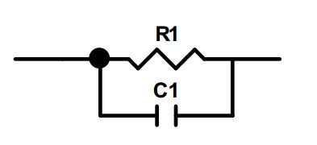
Figure 2.5 Parallel RC element

Time constant, τ, of each parallel RC element is given as:
τ = RC (2.13)
ω_{max}RC = 1 (2.14)
ω = 2πf (2.15)

At ω_{max}, equal amounts of current will flow through both arms of the circuit. As shown in figure 2.6, two parallel RC elements in series may be used to represent bulk and grain boundary components of simulated materials. The resistances of R_{b} and R_{gb} can be read from x axis while their corresponding capacitances can be calculated from the resistance at ω_{max}.

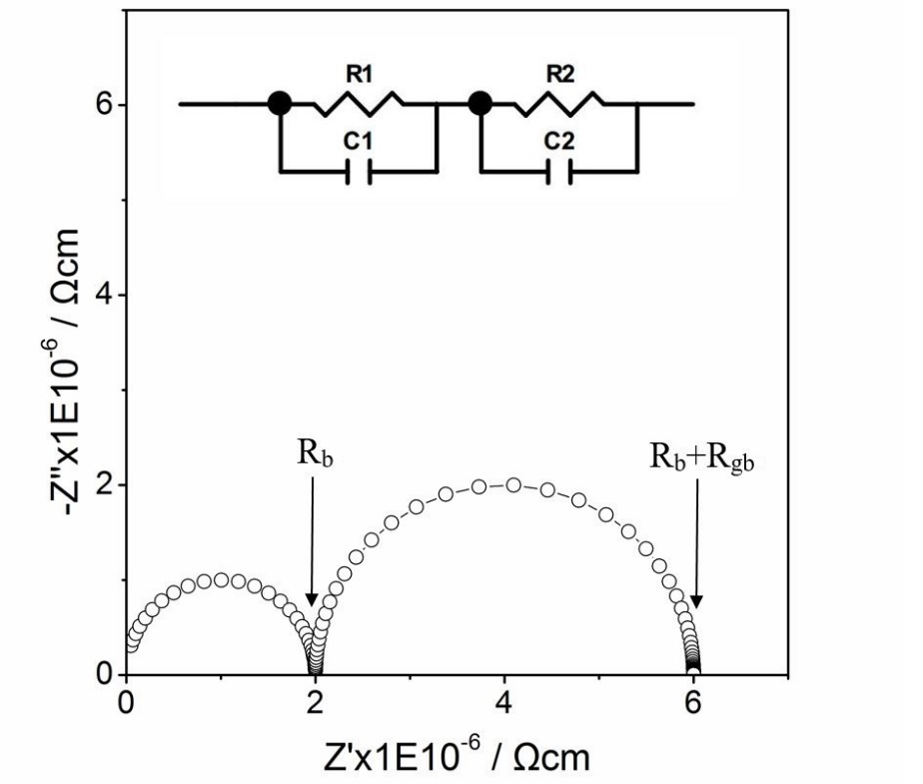
Figure 2.6 Simulated Z* plot of bulk and grain boundary responses. The correction of a geometry factor, A(area of the pellet)/d (thickness of the pellet), gives a unit of Ωcm of resistance.

Brickwork layer model (BLM) has been used to illustrate the ideal ceramic with grains and grain boundaries [5]. As shown in figure 2.7, the ceramic is made of cube-shaped grains of thickness L1, grain boundaries of dimensions L2 and surface-electrode interface of thickness L3 in BLM. From the capacitance equation:
C = ε’e⁰ (A/l) (2.16)
The inverse relation between thickness and capacitance is given by:
C_{b}/C_{gb} = L₂/L₁ (2.17)
Different regions have unique capacitances which can be used to identify different regions of ceramics. In practice, the possible capacitances of different regions are as summarised in table 2.3.

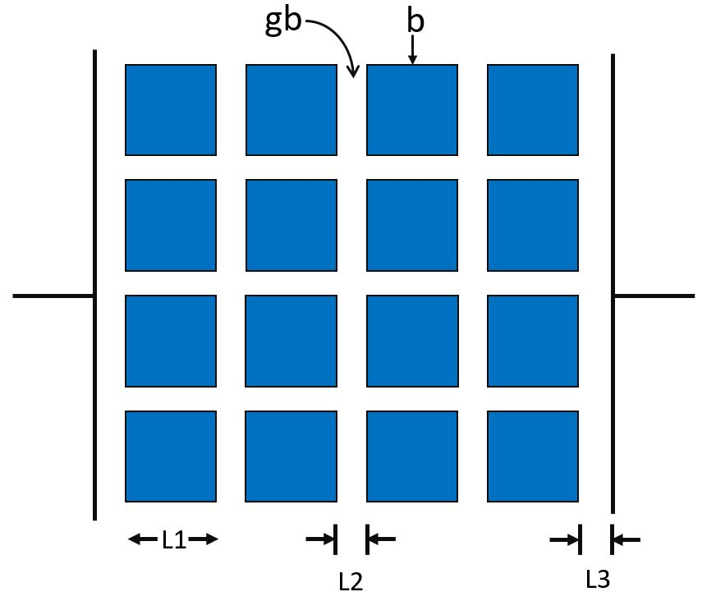
Figure 2.7 Brickwork layer model (BLM) of bulk and grain boundary regions in a ceramic between electrodes.

Table 2.3 Capacitance values and their possible interpretation (Table 1 in the paper) [5].

Impedance data can be plotted in different ways: impedance Z*, admittance Y*, permittivity ε* and electric modulus M*. The relationships of these terms are shown below:
Y* = 1/Z* (2.18)
M* = jωC₀Z* (2.19)
ε* = 1/M* (2.20)
The equation for Z’’ and M’’ are given by 2.21 and 2.22. Simulated Debye peaks of Z’’ and M’’ spectroscopic plots against log f are shown in figure 2.8. From equation 2.21 and 2.22, assuming Cb ‹‹ Cgb and Rgb ›› Rb, M’’ is dominated by the bulk response and Z’’ is controlled by the grain boundary of the sample. The homogeneity of the sample can be illustrated from the coincidence of M’’ and Z’’ frequency maxima. The homogeneity of the sample represents the homogeneous distribution of the bulk which does not contain any core-shell structure or local constrains, and the current flows isotropically rather than through a certain direction in the bulk of materials
(2.21)
(2.22)
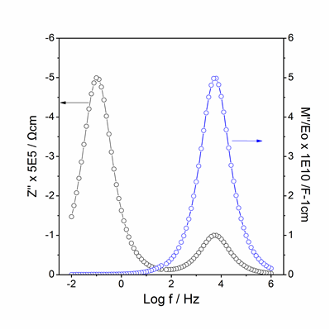
Figure 2.8 Simulated spectroscopic of –Z’’ and M’’ as a function of log f.

In the work reported in this thesis, pellets were pressed with 0.6 tons pressure and heated at corresponding reaction temperatures for 2 h. Either gold or silver paste were painted on both sides of the pellets and heated to 850 ºC and 600 ºC for 2h respectively to drive off the organic component. Impedance data were collected with a SI 1260 Solartron analyser at 100 mV ac with a sweep frequency from 10⁻² to 10⁶ Hz in Air or N₂.

2.9 References
1. Furrer A., Mesot H. and Strassle T., Neutron Scattering in Condensed Matter Physics, 2009: World Scientific.
2. West A.R., Solid State Chemistry and its Applications, 2014: Wiley.
3. Hull S., Smith R.I., David W.I.F., Hannon A.C., Mayers J. and Cywinski R., The Polaris powder diffractometer at ISIS, Physica B: Condensed Matter, 1992: 181, 1000 -1002.
4. Young, R.A., The Rietveld Method, 1995: Oxford Science Publications.
5. Irvine J.T.S., Sinclair D.C., West A.R., Electroceramics: Characterization by Impedance Spectroscopy, Advanced Materials, 1990: 3, 132 - 138.

Chapter 3 Synthesis and characterisation of nitrogen doped lithium vanadate[1]

3.1 Introduction
Li₃VO₄ has been proposed as a possible anode material, since it shows a reversible capacity of about 300 mA h g⁻¹ in the potential range from 0.2 to 3.0 V [2]. Its theoretical energy density is 2.5 times greater than that of Li₄Ti₅O₁₂ which is widely used as a lithium intercalation anode [2]. Li₃VO₄ has also been used as a surface coating on LiCoO₂ which is the cathode in many lithium ion batteries [3].

Li₃VO₄ shows temperature-dependent polymorphism with a low temperature β polymorph that is isostructural with β Li₃PO₄, an intermediate temperature, T polymorph whose structure is not known and a high temperature γ polymorph isostructural with γ Li₃PO₄ [4]. At the highest temperatures, prior to melting, a fourth polymorph has been identified from thermal analysis but no structural information is available. The β and γ polymorphs belong to the family of tetrahedral structures; the β structures are ordered wurtzite superstructures derived from ZnO in which cations occupy one set of tetrahedral sites within a hexagonal close packed, HCP, oxide ion array [5]. The γ structures are related to the β structures but cations are now distributed over both sets of tetrahedral sites leading to edge-sharing of some tetrahedra. The oxide array is derived from HCP but the layers are more buckled than in the β structures. The oxide packing arrangement in the γ structures may also be regarded as tetragonal packed, TP, which in its ideal form is characterised by four fold symmetry, as in the case of rutile, TiO₂ [6]. The γ family of tetrahedral structures, including Li₃YO₄: Y = P, As, V, Cr and Li₂MXO₄: M = Mg, Zn; X = Si, Ge are the parent structures for a range of materials known as “lisicons” which have high Li⁺ ion conductivity that are generated by forming solid solutions with phases Li₄ZO₄: Z = Si, Ge, Ti. More recently, there has been much interest in new cathode materials,
Li₂MSiO₄: M = Mn, Fe in the same structural family since it is possible to de-intercalate Li⁺ ions and activate redox couples associated with Mn and Fe [7]. There is also much recent interest in a new family of sulphur-based analogues of the
lisicons known as thio-lisicons which are characterised by high levels of Li⁺ ion conductivity at room temperature, giving possibilities for use as electrolytes in all-solid-state Li batteries [8].

Most studies on lisicon materials as either Li⁺ ion conductors or as mixed conducting electrodes, focus on compositional modification by cation doping within a fixed oxide ion sublattice. Our interest here is to investigate the possibility of anion, specifically N, doping, with creation of interstitial Li⁺ ions for charge compensation. It follows on from work by the Oak Ridge group on LIPON materials which are nominally N doped Li₃PO₄ but which are often glassy materials containing condensed phosphate anions rather than the isolated PO₄ tetrahedra of Li₃PO₄ [9].

In this chapter, a first study on the possible N doping of crystalline Li₃VO₄ and the structural and electrical properties of the products are investigated. For the syntheses, two sources of Li were used: Li₂CO₃ and LiOH·H₂O; LiOH·H₂O has the potential advantage that reaction occurs at significantly lower temperature than using Li₂CO₃.

3.2 Experimental
Reagents used were Li₃N, Li₂CO₃, LiOH·H₂O and V₂O₅. Li₂CO₃ and V₂O₅ were dried at 180ºC before use; other reagents were used directly from the bottle. When using LiOH·H₂O, this was mixed with V₂O₅ in the required amounts and the mixture was heated at 150ºC in N₂ to remove water. For the preparation of N-containing samples, the dried mixtures were returned to the glovebox to continue with the preparations. All weighing, mixing and pellet-pressing was carried out in the glovebox; weighed powders were mixed dry with an agate mortar and pestle and then pressed into pellets using a small hand press. Samples were reacted in molybdenum boats since it was found that there was some evidence of reaction of the Li₃N if gold foil boats were used. Mixed powders were placed in the Mo boats which were inserted into glass tubes closed at one end. The other end was sealed with scotch tape and the tubes, with contents, were removed from the glovebox and placed in a horizontal tube furnace in flowing N₂. After purging the furnace atmosphere for 30 mins, the furnace temperature was increased at 5ºC/min to either 650ºC if Li₂CO₃ was used as the source of lithium or 450ºC using LiOH and held at that temperature for 10h. During heating, at ~ 150ºC the scotch tape cover of the glass tubes decomposed. At the end of the heat treatment, the furnace was cooled at 5ºC/min, still under flowing N₂. In order to prepare samples for impedance measurements, pellets were reheated at 750ºC for 10h under N₂.

Samples for x-ray powder diffraction, XRD, were prepared in air and analysed using CuKα₁ radiation using a linear position sensitive detector on a Stoe Stadi P diffractometer. Patterns were recorded over the 2$θ$ range from 15º to 80º with a 0.02º scan rate. For powder neutron diffraction, ND, the HRPD diffractometer at the Rutherford-Appleton Laboratory, U.K was used in time of flight, TOF, mode with incident wavelength in the range 0.5 to 12$Å$. Rietveld refinement was carried out using the EXPGUI interface of the GSAS suite of programmes [10, 11].
For impedance measurements, pellets were coated on opposite faces with Au paste which was dried and hardened by heating at 800ºC for 2h. Impedance data were collected with a Solartron analyser at 100 mV ac over the frequency range 10⁻² to 10⁶Hz in N₂ atmosphere.

3.3 Results and Discussion
Samples of Li₃VO₄ and N-doped solid solutions of formula Li_{3+x}VO_{4-x}N_{x}: 0 ≤ x ≤ 0.2 appeared to be single phase by XRD after synthesis at either 450ºC using LiOH·H₂O or 650ºC using Li₂CO₃ as shown in Fig. 3.1 Patterns were fully indexed on the unit cell of β Li₃VO₄ with slightly smaller lattice parameters for N-doped Li₃VO₄. Compositions with higher nitrogen content contained small amounts of Li₂CO₃, Fig. 3.1 From these data, we estimate the solid solution limit to be x = ~0.2. Similar results were obtained using either LiOH·H₂O or Li₂CO₃ as the source of Li₂O but reaction was achieved at significantly lower temperatures using LiOH·H₂O, primarily because of the thermal stability of Li₂CO₃.

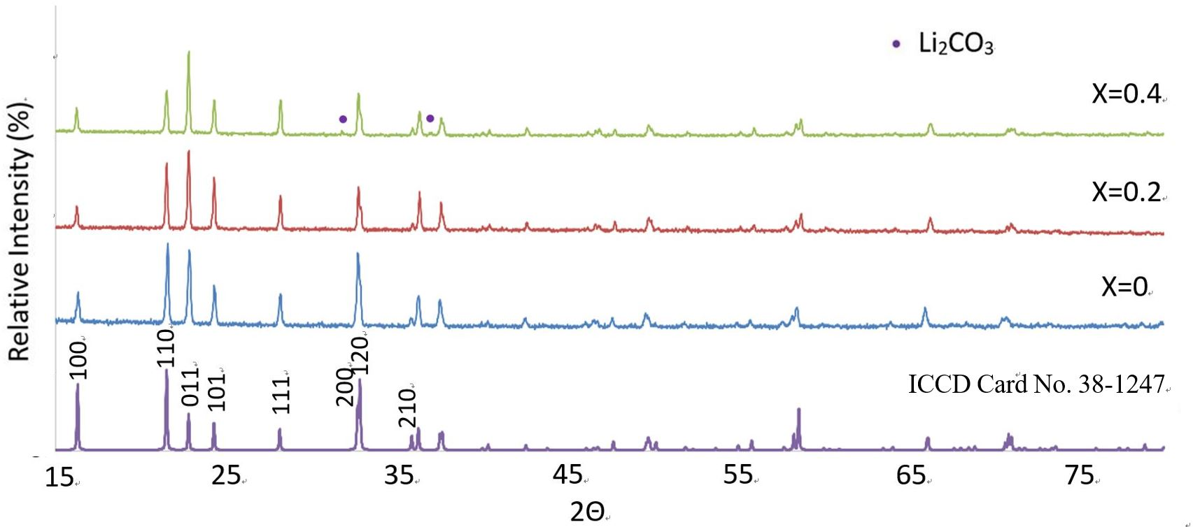
Figure 3.1 X-ray diffraction patterns of Li_{3+x}VO_{4-x}N_{x}: x= 0, 0.2, 0.4. Samples used Li₂CO₃ as source of Li and were reacted at 750 ºC for 10 h in N_{2.} XRD patterns were collected by CuPSD with λ = 1.5406 Å.

Structure refinement on two compositions x = 0 and x = 0.2 prepared using Li₂CO₃ was carried out using a combination of XRD and ND data. Initially, the thermal parameter, or U_{iso} for each atom was set to a default value (0.025 Å² for V and 0.01 Å² for other atoms). The background (6 terms of shifted Chebyshev function), scale factor and lattice parameters were refined first followed by zero point and peak profile coefficient which were fixed after convergence. Then, the atomic coordinates of V were refined using XRD data and those of other atoms using ND data; these were fixed after convergence. Finally, the thermal parameters of all atoms were refined. The starting model was the reported structure of β Li₃VO₄ with space group Pmn2₁. Results for stoichiometric Li₃VO₄, x = 0, Table 3.2, were similar to those reported in the literature (Table 3.1)[12] and gave reasonable U_{iso} values for all positions with full site occupancy.

Table 3.1 Structural Parameters of Li₃VO₄ [11].
Li₃VO₄, Pmn2₁, a = 6.3259 Å, b = 5.4460 Å, c = 4.9469 Å
Atom | Type | X | Y | Z | Mult | Occupancy | Uiso x 100
Li1 | Li⁺ | 0.2470 | 0.3315 | 0.9872 | 4 | 1 | 0.03
Li2 | Li⁺ | 0.5 | 0.8326 | 0.9848 | 2 | 1 | 0.03
O1 | O²⁻ | 0.2239 | 0.6804 | 0.8910 | 4 | 1 | 0.03
O2 | O²⁻ | 0 | 0.1296 | 0.8952 | 2 | 1 | 0.03
O3 | O²⁻ | 0.5 | 0.1736 | 0.8478 | 2 | 1 | 0.03
V1 | V⁵⁺ | 0 | 0.8296 | 0 | 2 | 1 | 0.03

For the refinement of composition x = 0.2, scale factor, cell parameter, zero point, instrumental parameters and atomic positions were refined in turn. It was assumed initially that the sample contained no nitrogen or interstitial lithium ions; occupancies of oxygen sites were refined giving a value for site O(1) significantly greater than unity, which was a strong indicator that oxygen may be partially replaced by nitrogen on that site since nitrogen is a stronger scatterer of neutrons (scattering length 9.37) than oxygens (scattering length 5.78). At this stage, χ² = 5.248, R_{wp} = 9.54% for ND and 3.38% for XRD. The occupancy of site O(1) was therefore refined allowing mixed occupancy by oxygen and nitrogen within a constraint of full occupancy, giving occupancy values of 0.12(2) for N and 0.88(2) for O with improved statistical parameters: χ² = 4.933, R_{wp} = 9.50% for ND. The occupancies of sites O(2) and O(3) remained as unity within errors and therefore, there is no indication of significant nitrogen occupancy on these sites. In order to look for the presence of interstitial lithium ions, Fourier difference maps were constructed and a site Li(3) identified, Table 1. Its occupancy was set to 0.2, consistent with the value x = 0.2 in the starting composition and the value of the nitrogen content determined from the O(1) site occupancy and remained at 0.19(2) on refinement. The atomic coordinates of Li(3) were refined followed by occupancy of Li(3) to give a value of 0.19(3) when convergence was reached (χ² = 4.916, R_{wp} = 9.48% for ND). Then, U_{iso}s of all atoms except Li(3) were refined (χ² = 4.618, R_{wp} = 7.95% for ND and 3.56% for XRD). In the final refinement, using combined ND and XRD data, the occupancies of O(1), N(1), Li(3) and the atomic coordinates of O(1), N(1), O(2), O(3), V, Li(1) and Li(2) were refined with fixed U_{iso} values (χ² = 4.210, R_{wp} = 7.95% for ND and 3.25% for XRD). A subsequent refinement check of the U_{iso} values with fixed atomic coordinates and occupancies gave either small positive values or values of 0 within 2 esds for all atoms. Final refined parameters are listed in Table 1 for compositions x = 0 and 0.2, together with selected bond lengths and bond angles.

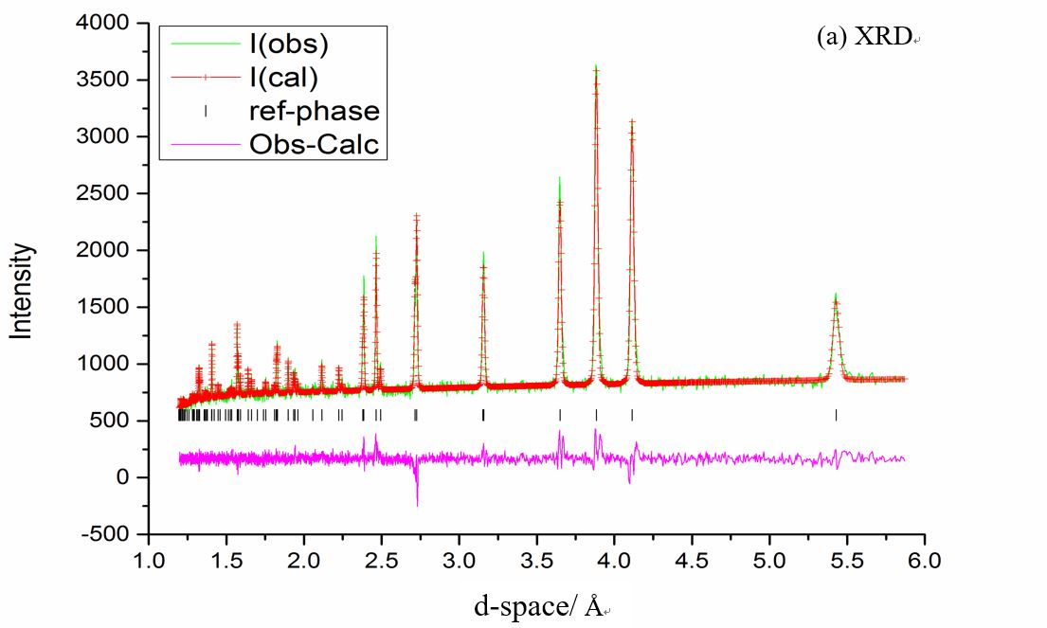
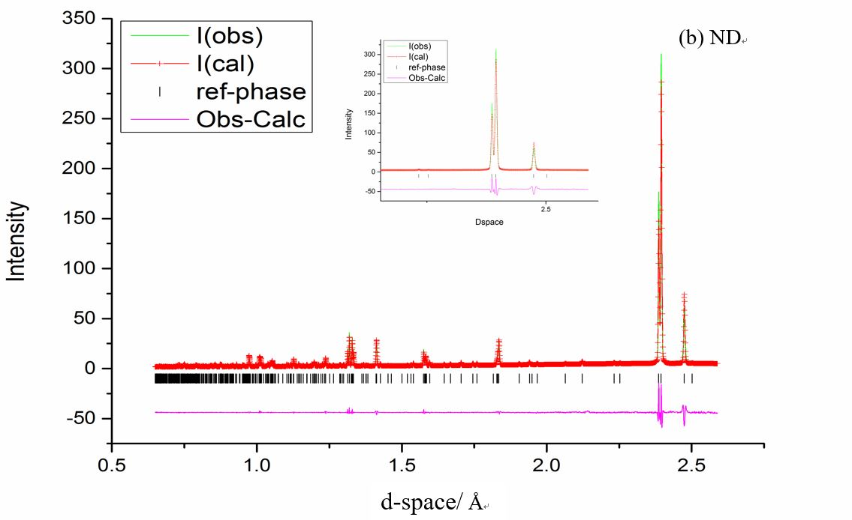
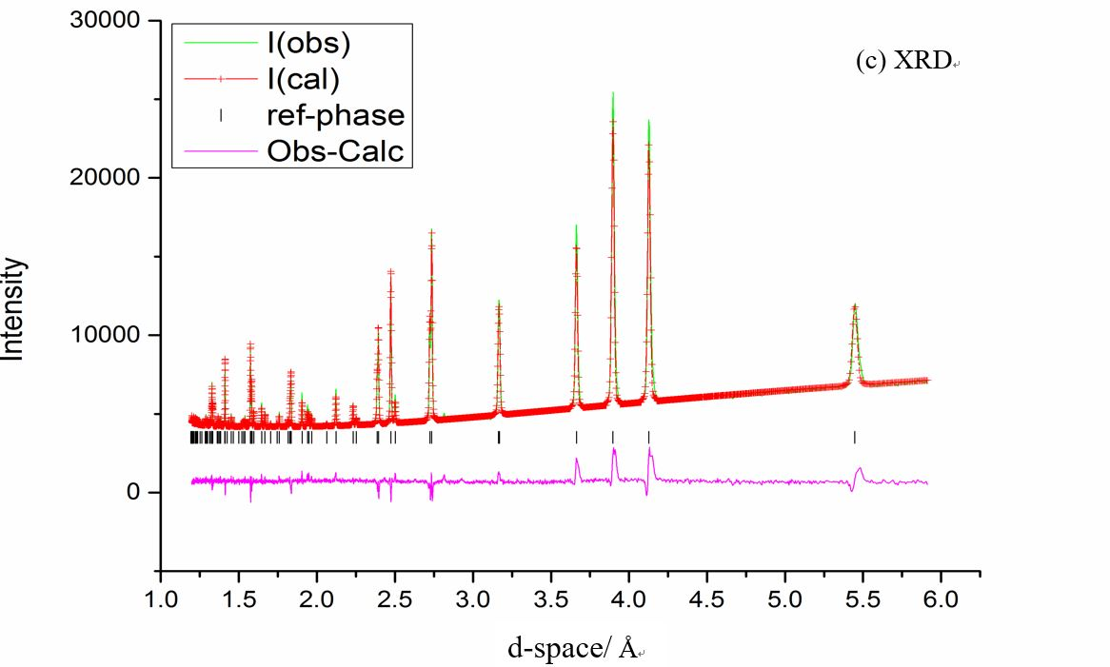
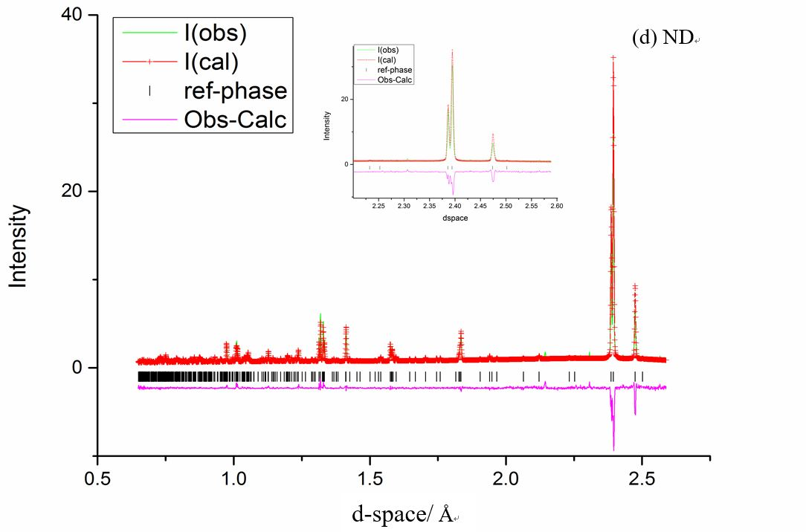
Figure 3.2 Observed, calculated and difference profiles from refinement of (a, b) Li₃VO₄ and (c, d) Li_{3.2}VO_{3.8}N_{0.2} using XRD and ND data. Inserts in (b) and (d) show expanded d-space region from 2.2 to 2.6 Å.

Table 3.2(a) Refined structural parameters, (b) Bond lengths, (c) Bond angles.

(a)
Atom and multiplicity | Parameter | Li₃VO₄ (x=0)ª | Li_{3.2}VO_{3.8}N_{0.2} (x=0.2)^{b}
Li(1), 4 | x | 0.246(1) | 0.247(1)
 | y | 0.331(1) | 0.331(2)
 | z | 0.986(6) | 0.991(2)
 | Occupancy | 1 | 1
 | U_{iso} x 100 / Å² | 1.50(8) | 0.24
Li(2), 2 | x | 0.5 | 0.5
 | y | 0.836(1) | 0.832(3)
 | z | 0.985(6) | 0.995(2)
 | Occupancy | 1 | 1
 | U_{iso} x 100 / Å² | 1.8(1) | 1.39
Li(3), 2 | x | -- | 0.5
 | y | -- | 0.523
 | z | -- | 0.235
 | Occupancy | -- | 0.19(3)
 | U_{iso} x 100 / Å² | -- | 1.0
V, 2 | x | 0 | 0
 | y | 0.828(1) | 0.829(1)
 | z | 0 | 0
 | Occupancy | 1 | 1
 | U_{iso} x 100 / Å² | 2.4(2) | 2.67
O(1), 4^{c} | x | 0.224(1) | 0.224(1)
 | y | 0.680(1) | 0.679(1)
 | z | 0.888(6) | 0.896(1)
 | Occupancy | 1 | O1 0.88(2)  N1 0.12(2)
 | U_{iso} x 100 / Å² | 1.36(2) | 0.01
O(2), 2 | x | 0 | 0
 | y | 0.123(1) | 0.129(1)
 | z | 0.890(6) | 0.899(1)
 | Occupancy | 1 | 1
 | U_{iso} x 100 / Å² | 1.39(3) | 0.13
O(3), 2 | x | 0.5 | 0.5
 | y | 0.174(1) | 0.175(1)
 | z | 0.843(6) | 0.847(1)
 | Occupancy | 1 | 1
 | U_{iso} x 100 / Å² | 1.27(4) | 0.34
ªa=6.3288(1) Å, b=5.4475(1) Å, c=4.9483(1) Å, V=170.602(4) Å3, χ2= 2.920, Rwp=5.90%, Rp=6.88% for ND, Rwp=4.59%, Rp=3.35% for XRD.
^{b}a=6.3271(1) Å, b=5.4470(1) Å, c=4.9478(1) Å, V=170.518 (2) Å³, χ²= 4.093, Rwp=7.88%, Rp=8.47% for ND, Rwp=3.21%, Rp=2.04% for XRD.
^{c}For Li_{3.2}VO_{3.8}N_{0.2}, the O(1) site contained a disordered mixture of 12% N and 88% O.

(b)
 | Li₃VO₄ | Li_{3.2}VO_{3.8}N_{0.2} |  | Li₃VO₄ | Li_{3.2}VO_{3.8}N_{0.2}
Vector | Length (Å) | Length (Å) | Vector | Length (Å) | Length (Å)
Li1-O1 | 1.968(5) | 1.958(8) | V1-O1 | 1.720(10) | 1.713(2)
Li1-O1 | 2.004(4) | 2.013(7) | V1-O2 | 1.730(10) | 1.712(4)
Li1-O2 | 1.961(4) | 1.963(7) | V1-O3 | 1.70(3) | 1.717(4)
Li1-O3 | 1.952(4) | 1.952(7) | Li3-O1 | -- | 1.965(3)
Li2-O1 | 2.000(3) | 1.994(7) | Li3-O1 | -- | 1.965(3)
Li2-O1 | 2.000(3) | 1.994(7) | Li3-O2 | -- | 2.062(2)
Li2-O2 | 2.013(6) | 2.008(13) | Li3-O1 | -- | 2.565(2)
Li2-O3 | 1.973(7) | 2.007(13) | Li3-O1 | -- | 2.565(3)
V1-O1 | 1.720(10) | 1.713(2) | Li3-O3 | -- | 2.699(4)

(c)
Angle | Degree(º) | Degree(º)
O1-Li1-O1 | 106.2(2) | 105.8(4)
O1-Li1-O2 | 115.1(2) | 115.6(4)
O1-Li1-O3 | 113.2(2) | 113.2(4)
O1-Li1-O2 | 107.3(2) | 106.8(4)
O1-Li1-O3 | 105.6(2) | 105.9(3)
O2-Li1-O3 | 108.8(2) | 108.8(4)
O1-Li2-O1 | 121.8(3) | 122.1(7)
O1-Li2-O2 | 106.1(2) | 106.9(4)
O1-Li2-O3 | 108.0(2) | 107.3(4)
O1-Li2-O2 | 106.1(2) | 106.9(4)
O1-Li2-O3 | 108.0(2) | 107.3(4)
O2-Li2-O3 | 105.7(3) | 105.4(6)
O1-V1-O1 | 110.9(1) | 111.8(2)
O1-V1-O2 | 110.2(1) | 111.4(1)
O1-V1-O3 | 108.5(1) | 107.2(2)
O1-V1-O2 | 110.2(1) | 111.4(1)
O1-V1-O3 | 108.5(1) | 107.2(2)
O2-V1-O3 | 108.6(1) | 107.5(3)
O1-Li3-O1 | -- | 92.4(1)
O1-Li3-O2 | -- | 110.89(1)
O1-Li3-O2 | -- | 110.89(1)

The partial substitution of N for O on the O(1) sites has little effect on the overall atomic coordinates of the crystal structure of x = 0.2 compared with x = 0. The new site for Li(3) is a distorted octahedral site with 3 short Li-O bonds typical of usual Li-O bond distances and 3 longer bonds in the range 2.56 to 2.70Å, Fig. 3.3 In the β structure of Li₃VO₄, one set of tetrahedral sites, T⁺, pointing “up” in Fig. 3(a), are occupied whereas those pointing “down”, T⁻, are empty. The off-centre displacement of Li(3) in octahedral sites, (b), reduces the repulsions from cations in the adjacent occupied T⁺ tetrahedral sites since the Li(3) ions are displaced towards the empty T⁻ tetrahedral sites.

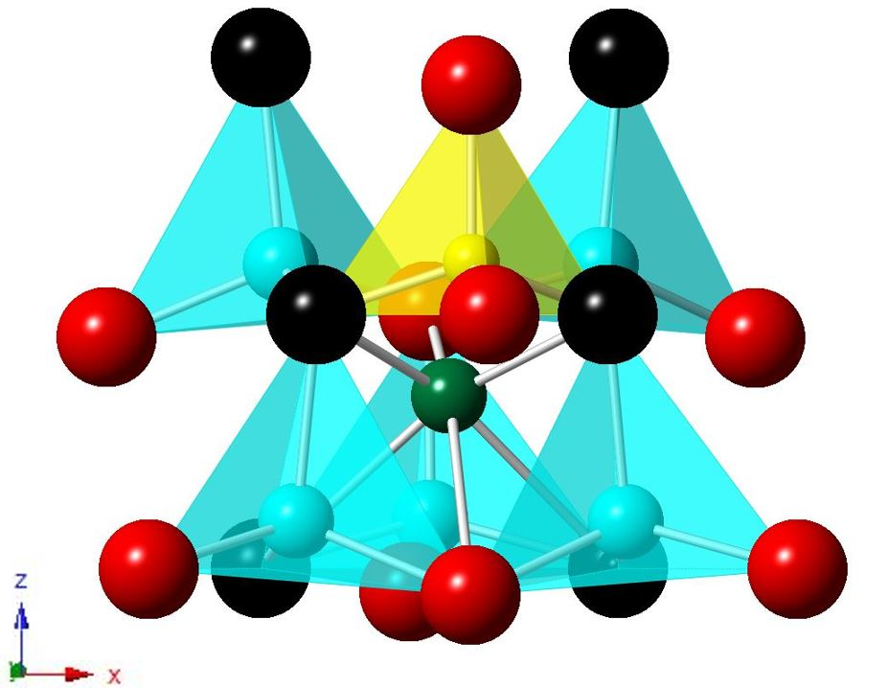
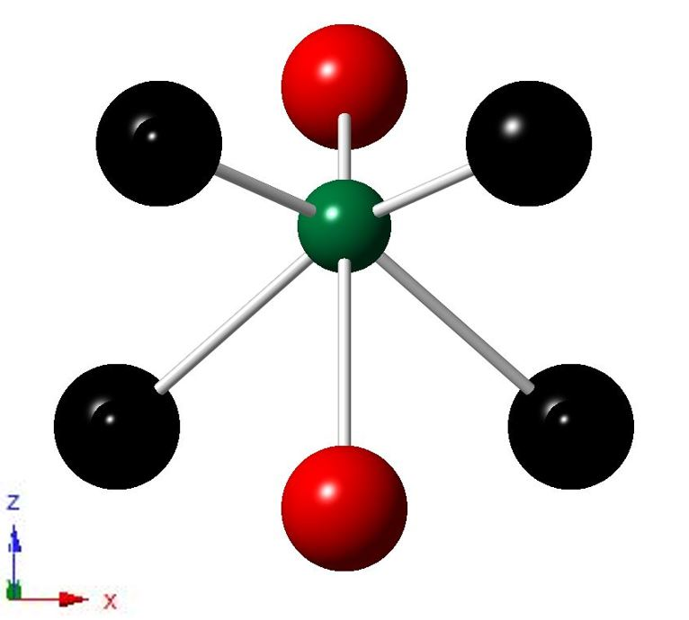

Figure 3.3 Polyhedral structure of Li_{3.2}VO_{3.8}N_{0.2}. Blue and yellow tetrahedra are Li(1,2)O₄ and VO₄ respectively; green spheres are Li(3) in off-centre octahedral sites. Black and red spheres are O, N(1) and O(2, 3) respectively.

The preference of N to substitute for O on the O(1) sites may be understood by considering the coordination environments of the three oxygen sites, Table 3.3. Bond lengths to the four tetrahedrally-coordinated atoms V, Li(1), Li(1)’ and Li(2) are comparable for all three O sites and the difference is therefore associated with the possible coordination to Li(3). The O(1) site is coordinated to Li(3) with a reasonable Li – O, N bond length of 1.965 Å. However the corresponding O(2) bond to Li(3) length is significantly greater, 2.062 Å and O(3) is not coordinated at a reasonably short distance to Li(3). Given the higher nominal charge on nitrogen, 3⁻,compared with that on oxygen, 2⁻, the extra positive charge associated with Li(3) is balanced by substitution of N on adjacent O(1) sites. Consequently, coupled substitution of N on O(1) sites with an equivalent occupancy of adjacent Li(3) sites occurs leading to defect association.

Table 3.3 Bond lengths to O, N(1), O(2) and O(3).
Bond Length(Å) | O, N(1) | O(2) | O(3)
V(1) | 1.713(2) | 1.712(4) | 1.717(4)
Li(1) | 1.958(8) | 1.963(7) | 1.952(7)
Li(1)’ | 2.013(7) | 1.963(7) | 1.952(7)
Li(2) | 1.994(7) | 2.008(13) | 2.007(13)
Li(3) | 1.965(3) | 2.062(2) | --
Li(3) | 2.565(2) | -- | 2.699(4)

A typical impedance dataset for N-doped Li₃VO₄ is shown in Fig. 3.4 Data are presented in four different complementary formats. In (a), impedance complex plane plots show a high frequency arc, which passes through the origin and a low frequency spike which becomes an arc at high temperatures. Using the same data, plots of capacitance, C’ against frequency, (b), show a high frequency plateau with value ~ 1-2pFcm⁻¹ which is a typical value for a bulk capacitance with an associated permittivity in the range 10 – 20. At lower frequencies, the C’ data increase to values as high as 10$μ$F at a frequency of 10⁻² Hz; such a high capacitance is indicative of electrode double layer phenomena, such as would be associated with ionic conduction of, in this case, Li⁺ ions. Plots of log conductance, Y’ against log f, (c), show a frequency independent plateau over a wide frequency range; at lower frequencies a dispersion to much lower conductivities occurs and is associated with the charge blocking at the sample-electrode interface. At high frequencies, a second dispersion to higher conductivity values is observed and is attributable to Jonscher power law [13] behaviour of the sample bulk conductivity.

Combined spectroscopic plots of Z’’/M’’, (d), show overlapping peaks at high frequencies which are attributable to the sample bulk response and the tail of a large peak at low frequencies in the Z’’ spectrum associated with the blocking electrodes. The conclusion from these results is that the sample is electrically homogeneous with no evidence of a significant grain boundary impedance and that the sample is an ionic conductor whose bulk conductivity is given either from the intercept on the Z’ axis (a) or from the frequency-independent Y’ plateau in (c).

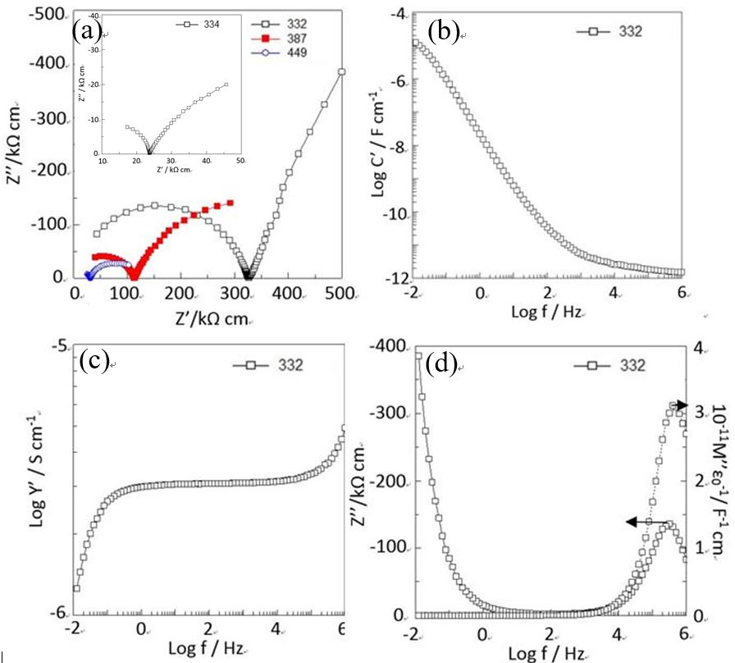
Figure 3.4 Impedance data for Li_{3.2}VO_{3.8}N_{0.2}, prepared using Li₂CO₃. (a) Impedance complex plane plots at 332, 387, 449 ºC. Spectroscopic plots of C’ (b), Y’ (c), –Z’’ and M’’ (d). Inset in (a) shows impedance data prepared using LiOH·H₂O.

For undoped Li₃VO₄, the impedance data are similar to those for N-doped Li₃VO₄ but with the main difference being that the low frequency electrode spike is much less pronounced. Overall conductivity values are also 1-2 orders of magnitude lower. Pure Li₃VO₄ is expected to be an ionic and electronic insulator and the measured conductivity may therefore be attributed to either residual Li⁺ conduction associated with slight departure from stoichiometry or the presence of, as-yet unidentified, electronic impurities.

Bulk conductivity data are presented in Arrhenius format in Fig 3.5 for both undoped and doped Li₃VO₄, prepared using the two different sources of Li₂O. In both cases, the conductivity of Li₃VO₄ increased by 1-2 orders of magnitude on doping with N and the creation of interstitial Li⁺ ions. However the conductivities of both undoped and doped Li₃VO₄ are somewhat higher for materials prepared using LiOH·H₂O; this is attributed to the presence of unidentified electronic impurities in the LiOH·H₂O starting materials. An additional difference between the two sets of N-doped Li₃VO₄ samples is the activation energy for Li⁺ ion conduction, which is much greater for samples prepared using LiOH·H₂O. We attribute this to the strong defect association, involving Li(3) and N, leading to a higher activation energy for Li⁺ ion conduction, in materials prepared using LiOH·H₂O. Possibly this is because the higher synthesis temperature which was necessary using Li₂CO₃, led to reduced defect association and therefore, easier Li⁺ ion conduction. If we assume that the activation energy of 0.78 eV for the sample prepared using Li₂CO₃ represents the activation energy for Li⁺ ion migration, then that for the sample prepared using LiOH·H₂O, 1.74 eV, contains an additional 0.96 eV that may represent the dissociation energy of Li(3)-N defect complexes.
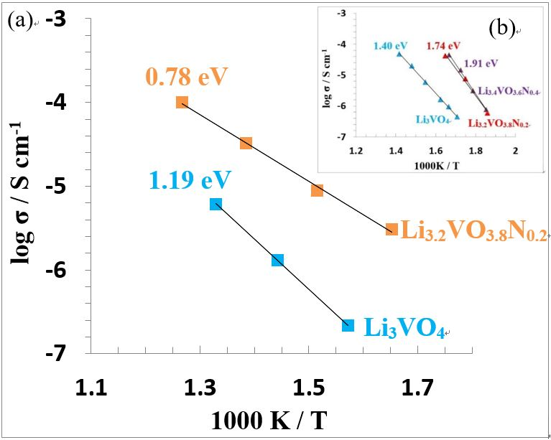
Figure 3.5 Arrhenius plots of Li_{3+x}VO_{4-x}N_{x}: x= 0, 0.2; Sample prepared using (a) Li₂CO₃, (b) LiOH·H₂O. Activation energies are noted beside each data set.

The impedance data clearly show an increase in Li⁺ ion conductivity on doping Li₃VO₄ with N. This correlates well with the crystallographic data which, for composition Li_{3.2}VO_{3.8}N_{0.2}, show the presence of an additional 0.2 Li⁺ ions on the Li(3) site and the substitution of 0.2 N atoms on the O(1) site, in accordance with the expected composition and assuming that no loss of Li and/or N occurs during synthesis.

The possible Li⁺ ion migration passways of Li_{3.2}VO_{3.8}N_{0.2} are shown in Fig 3.6. The mechanism of Li⁺ ion migration may involve direct interstitial migration between adjacent Li(3) sites, either in the ac plane or in adjacent ac planes, or an interstitial (or knock-on) mechanism involving the displacement of Li(1) or Li(2) ions from their regular lattice sites. In the ac plane, adjacent Li(3) sites are separated by empty tetrahedral, T₋ sites, through which a migrating Li⁺ ion must pass. These T₋ sites share faces with occupied LiO₄ or VO₄ tetrahedra and strong cationic repulsions would prevent simultaneous occupation of adjacent T₋ and T₊ sites, especially if one of these contains vanadium. The T₋ sites, therefore, represent a saddle position in the Li⁺ ion migration pathway between adjacent Li(3) sites. Alternatively, an interstitial or knock-on mechanism may operate which requires the ejection of a Li⁺ ion from its occupied T₊ site which is then occupied by the incoming Li⁺ ion.

In the c direction, direct interstitial migration between, face-sharing octahedral sites appears to be possible, as one step in the migration pathway between Li(3) sites in adjacent ac planes. We conclude that 3D conduction of Li⁺ ions in N-doped Li₃VO₄ should be feasible although there may be a certain degree of anisotropy between conduction in the b direction and within the ac plane. It could be useful to probe the details of the migration mechanism and pathway by modelling studies.

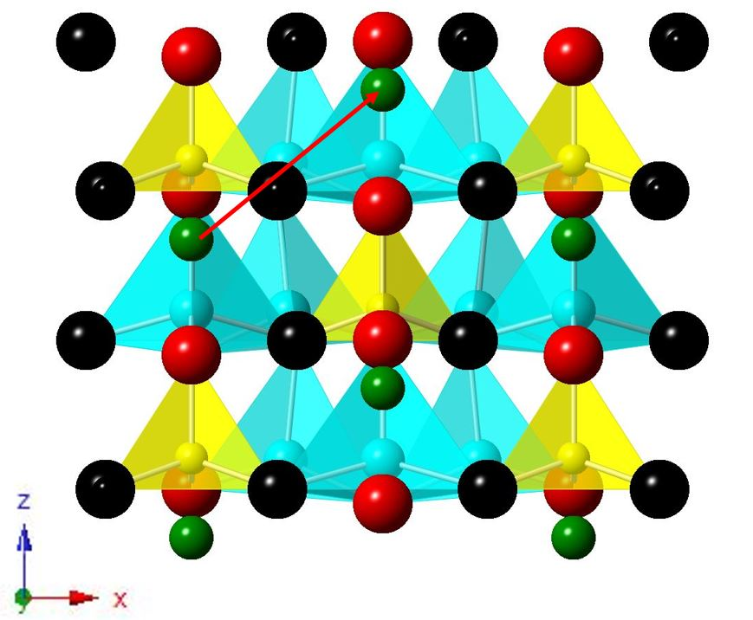
(a)
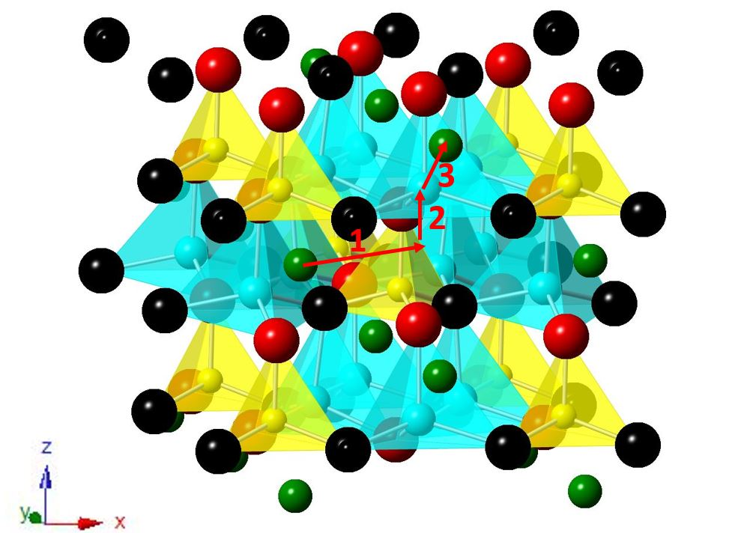
(b)
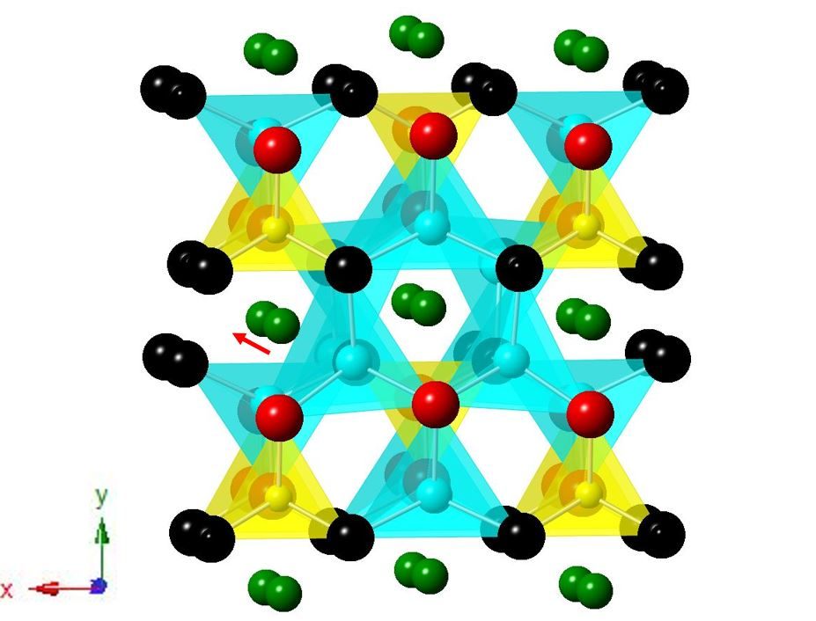
(c)
Figure 3.6 The possible mechanism of Li⁺ ion migration of Li_{3.2}VO_{3.8}N_{0.2}. (a) direct migration between adjacent Li(3) sites in the ac plane. (b) knock on migration between adjacent Li(3) and Li(1)/Li(2). (c) direct migration between adjacent Li(3) sites in the c direction.

3.4 Conclusions
Many examples of Li⁺ conductivity in “lisicon” materials are known but, to date, these all involve solid solutions based on the parent γ polymorph of end-member phases, such as Li₃PO₄ and Li₂ZnGeO₄, and contain either Li⁺ vacancies or interstitial Li⁺ ions that are generated by aliovalent cation doping. The present study concerns the β polymorph of Li₃VO₄ and is the first example of a Li⁺ ion conducting solid solution based on a β tetrahedral structure.

Combined ND/XRD studies confirm the substitution of O by N together with the creation of an equal number of interstitial Li⁺ ions; defect pairs form by electrostatic attraction between N located on O(1) sites and occupied adjacent Li(3) interstitial sites. The composition determined by refinement of XRD/ND data matches that expected from the target stoichiometry and indicates the usefulness of the synthetic procedure developed for N-doping.

Impedance data show enhanced Li⁺ ion conductivity in the N-doped materials. Variation in activation energy between different samples may indicate whether or not the Li(3) ions are trapped by adjacent nitrogen atoms. Although anion doping, by N, represents a relatively untried method of modifying the Li content of a structure, trapping of interstitial Li⁺ ions within defect complexes, and the associated increase in activation energy for conduction, may limit the usefulness of this method for generating a high level of Li⁺ ion conductivity. Further studies on the general applicability of this doping method are needed.

3.5 References
1. Dong, B.; Jarkaneh, R.; Hull, S.; Reeves-Mclaren, N.; Biendicho, J.J.; West, A.R.. Synthesis, Structure and Electrical Properties of N-doped Li₃VO₄. Journal of Materials Chemistry A. 2016, 4, 1408.
2. Li, H. Q.; Liu, X. Z.; Zhai, T. Y.; Li D.; Zhou, H. S., Li₃VO₄: A Promising Insertion Anode Material for Lithium-Ion Batteries, Advanced Energy Materials, 2013: 3, 428.
3. Pu X.; Yu, C. G., Enhanced overcharge performance of nano-LiCoO₂ by novel Li₃VO₄ surface coatings, Nanoscale, 2012: 4, 6743.
4. West, A. R.; Glasser, F.P. J., Preparation and Crystal Chemistry of Some Tetrahedral Li₃PO₄-Type Compounds, Journal of Solid State Chemistry, 1972: 4, 20.
5. West, A. R., Z. Krist. 1975: 141, 1.
6. West, A. R.; Bruce, P. G., Tetragonal-packed crystal structures, Acta Crystallographica, 1982: 38, 1891.
7. Dominko, R. J., Li₂MSiO₄ (M = Fe and/or Mn) cathode materials, Journal of Power Source, 2008: 184, 462.
8. Knauth, P., Inorganic solid Li ion conductors: An overview, Solid State Ionics, 2009: 180, 911.
9. Bates, J. B.; Dudney, N. J.; Gruzalski, G. R.; Zuhr, R. A.; Choudhury, A.; Luck, C. F., Electrical properties of amorphous lithium electrolyte thin films, Solid State Ionics, 1992: 53-56, 647.
10. Larson, A.C., Von Dreele, R.B., "General Structure Analysis System (GSAS)", Los Alamos National Laboratory Report LAUR, 2000: 86, 748.
11. Toby B.H., EXPGUI, a graphical user interface for GSAS, Journal of Applied Crystallography, 2001: 34, 210-213.
12. Shannon, R. D.; Calvo, C. J., Refinement of the Crystal Structure of Low Temperature Li₃VO₄ and Analysis of Mean Bond Lengths in Phosphates, Arsenates, and Vanadates, Journal of Solid State Chemistry, 1973: 6, 538.
13. Almond, D. P.; West, A.R., Complex impedance plane plots and the determination of conductivities of “real” dispersive conductors, Journal of Electroanalytical Chemistry and Interfacial Electrochemistry, 1985: 186, 17.

Chapter 4 Synthesis and characterisation of fluorine-doped lithium silicate

4.1 Introduction
Li₄SiO₄ has two polymorphs which are separated by a broad transition region between 600 ºC and 725 ºC [1]. The high temperature form is still unknown as it cannot be conserved to ambient temperature while the low temperature form has a LISICON-type related structure with a sevenfold supercell and a monoclinic P2₁/m space group where a = 11.5469(3) Å, b =6.090(2) Å, c = 16.645(3) Å, β = 99.5º. The structure is made up of isolated SiO₄⁴⁻ tetrahedra and LiO_{n}: n = 4, 5, 6 polyhedra where Li⁺ ions are ordered and occupy 19 sets of crystallographic sites [1,2].

Stoichiometric Li₄SiO₄ is a poor ionic conductor (2 x 10⁻⁵ at 300 ºC) while Li₄SiO₄ solid solutions have been proven to be a potential solid state electrolyte due to their easy synthesis route, high air stability, relatively cheap price and high ionic conductivity (10⁻⁶ S/cm at room temperature for Li_{3.4}Si_{0.4}P_{0.6}O₄) [3,4]. The Li₄SiO₄ solid solution usually shows a dome-shaped composition-dependent conductivity, which can be exemplified by the Li_{4-3x}Al_{x}SiO₄ solid solution [5]. Both Li₄SiO₄ (x=0) and Li_{2.5}Al_{0.5}SiO₄ (x=0.5) are poor ionic conductors, and their conductivities increase dramatically when x approaches 0.25. This could be explained by the term of expression of pre-exponential factor for conductivity, c·(c-1), where c is the fraction of occupied mobile ions. As c goes up to either 1 (Li₄SiO₄) or 0 (Li_{2.5}Al_{0.5}SiO₄), the product c·(c-1) becomes very tiny, which determines the low conductivity in these compositions. The highest conductivity is achieved when c·(c-1) optimizes at c = 0.5. When c decreases to negative values, conductivity increases again because of the creation of new mobile species: lithium ion vacancies, as shown in figure 4.1 [6].

Figure 4.1 Conductivity of Li_{4-3x}Al_{x}SiO₄ solid solution at selected temperatures (Figure 1 in the paper) [5].

Molecular dynamics (MD) simulations reveal 3D conduction pathways within the mixed Si/P composition (Li_{3.5}Si_{0.5}P_{0.5}O₄) and a cooperative knock-on type mechanism [7].

Many cationic elements doped on the Si sites of Li₄SiO₄ have been studied; however, anionic replacement of O is rarely considered. In this chapter, a first investigation on possible fluorine-doped lithium silicate was studied. Electrical properties of F-doped Li₄SiO₄ were investigated and a new phase Li₅SiO₄F at x = 1 was found and indexed with a monoclinic space group.

4.2 Experimental
Lithium carbonate, silica and lithium fluoride were chosen as starting materials. The powders were weighed with a balance, ground with mortar and pestle using acetone for 30 minutes inside a fume hood, pressed into pellets and placed onto a gold boat. Then, it was transferred into a muffle furnace and heated to 400 ºC for 2h and 600 ºC to 800 ºC for 10h with intermediate grinding.

For phase analysis, a Bruker D2 X-ray diffractometer with Cu Kα radiation (λ= 1.5418 Å) was used. Patterns were recorded with a scan rate of 0.02° in the 2θ range from 15° to 80°. For indexing, a STOE STADI P X-ray diffractometer with Cu Kα₁ (λ=1.5406 Å) and a linear position sensitive detector (PSD) was used with a scan rate of 0.02° in the 2θ range from 15° to 80°. Indexing and phase identification were carried with WinXpow and PDF software.

DSC data were collected using a NETZSCH 404C instrument at 10 ºC/min heating/cooling rate under 50/50 Ar/Air atmosphere. Data was analysed using Proteus Analysis software.

Pellets of F-Li₄SiO₄ were heated at their synthesis temperature for 4 h before coating with Au paste electrode. Impedance data were recorded with Solartron with a 100 mV of ac and sweep frequency from 10⁻² to 10⁶ Hz.

X-ray fluorescence (XRF) measurement was carried out with a PANalytical Zetium Spectrometer using rhodium X-ray tube. PANalytical measurement and analysis software [8] was used for data analysis.

For electrochemical testing, the new phase Li₅SiO₄F, labelled phase J, was pressed into a 1 mm thick pellet and heated at 750 ºC for 4h. A half-cell Li/Li₅SiO₄F/Li was constructed using a Swagelok test cell. Cyclic voltammetry was carried out from 0 V to 6V with 10 mV ramp rate for two cycles using a Perkin-Elmer VMP tester.

4.3 Results and discussion

4.3.1 Ternary phase diagram of the Li₂O-SiO₂-LiF system
Selected compositions were studied in this ternary system. The effects of heating temperature and cooling rate were studied by varying the heating temperature followed by either slow cool or quench of the samples to room temperature. Table 4.1 shows the XRD results of different compositions with different heating temperatures from which a partial ternary phase diagram of the Li₂O-SiO₂-LiF system, figure 4.2, was constructed.

Composition 1 was used to test the possible reaction between SiO₂ and LiF. The XRD pattern showed a mixture of Li₂SiO₃, LiF, SiO₂ at 700 ºC and Li₂SiO₃, LiF, SiO₂ and Li₂Si₂O₅ at 800 ºC, which indicated the formation of Li₂O during reaction as the products of heating LiF and SiO₂ should not contain any phases on the line of SiO₂- Li₂O, such as Li₂Si₂O₅ or Li₂SiO₃. The possible reactions might be:
4LiF + SiO₂ → 2Li₂O + SiF₄ ↑ (4.1)

Li_{2+x}SiO₃F_{x}

Because of the reaction between LiF and SiO₂, compositions 2 and 3 with general formula Li_{2+x}SiO₃F_{x} which are on the line of Li₂SiO₃–LiF were prepared in order to study possible solid solution formation as well as the reactivity between LiF and SiO₂ when adding some Li₂CO₃. As shown in figure 4.3, the XRD patterns of both compositions 2 and 3 showed a mixture of Li₂SiO₃ and LiF at 800 ºC, which is an indication that Li₂CO₃ may suppress the reaction between SiO₂ and LiF due to the high reactivity of Li₂O itself. Thus, the ternary phase diagram was divided into two parts separated by the tie line on the join between of Li₂SiO₃ and LiF.

Li_{4-x}SiO_{4-x}F_{x}

To study possible solid solution formation on the join between Li₄SiO₄ and Li₂SiO₂F₂, compositions 4, 5 and 6 were prepared. The XRD patterns showed a mixture of either Li₂SiO₃ or Li₄SiO₄ with an unknown phase (named as phase B) in figure 4.4. Afterwards, compositions 7 and 8 were made in order to find out the position of pure phase B; however, the XRD pattern of both compositions 7 and 8 also depicted a mixture of phases (phase B and lithium silicates) at various temperatures.

Li_{4+x}SiO₄F_{x}

Another join between Li₄SiO₄ and LiF with general formula Li_{4+x}SiO₄F_{x} was investigated to discover possible solid solutions. Compositions 9 to 19 were made at various temperatures in order to study the phases on this join and find out the optimum conditions for reaction. As shown in figure 4.5, the XRD results showed a single phase of Li₄SiO₄ with x up to 0.1, which revealed the solid solution limit of Li_{4+x}SiO₄F_{x} is around 0.1. In addition, an unknown phase came out when x is more than 0.1 and its intensity increased with increasing F content. At x equals 1 (composition 17), all the peaks of Li₄SiO₄ disappeared and an unknown phase was detected (Li₅SiO₄F named as phase J); when x is more than 1, shown in figure 4.6, XRD patterns showed a mixture of LiF and Li₅SiO₄F for composition 18 and LiF, phase J and Li₂CO₃ for composition 19.

The new phase, Li₅SiO₄F was heated at different temperatures to study its thermal stability and thermodynamic status. XRD data for samples heated between 650 ºC and 775 ºC, figure 4.7, show that Li₅SiO₄F is polymorphic with low-temperature form at 650 ºC and 700 ºC and high temperature form at 750 ºC and 775 ºC. The transition from low to high temperature polymorphs was not reversible on subsequently reheating the high form at 600 and 650 ºC for 10 h. On heating Li₅SiO₄F to 800 ºC, a pelleted sample decomposed completely, with some evidence of partial melting, to give a mixture of phases including, LiF, Li₄SiO₄, Li₂O as well as XRD lines belonging to an unknown phase. DSC results, figure 4.8, show a sharp exotherm at 800 ºC on heating followed by an endotherm at 750 ºC on cooling, consistent with partial melting and recrystallisation.

It is concluded that, as shown in table 4.2, a new phase with formula Li₅SiO₄F was found in the ternary system and was indexed with a monoclinic unit cell where a = 7.900(11) (Å), b = 13.506(12) (Å), c = 13.041(15) (Å), β = 97.39(6) (º) and V = 1379.8(42) (Å³).

Figure 4.2 Ternary phase diagram of Li₂O-SiO₂-LiF system.
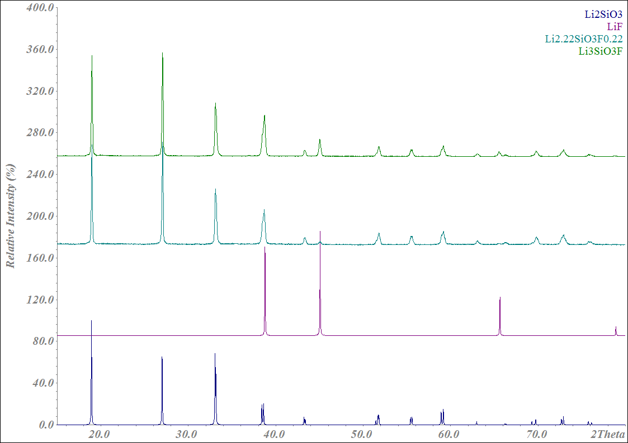
Composition 3
Composition 2
Figure 4.3 The XRD pattern of compositions 2 and 3 after heating at 800 ºC for 10 h and ICDD data of LiF and Li₂SiO₃. XRD patterns were collected by D2 with λ = 1.541 Å.
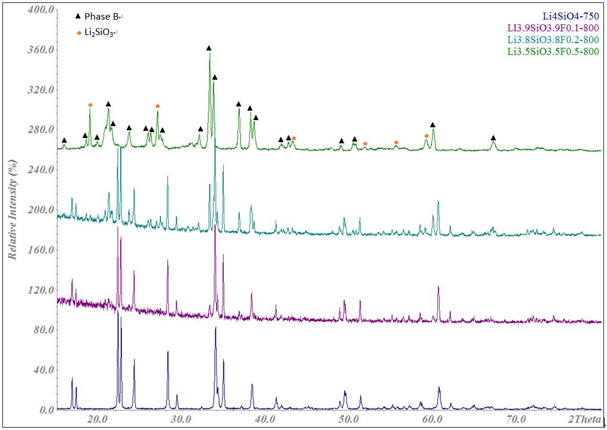
Composition 6
Composition 5
Composition 4
Figure 4.4 The XRD pattern of Li_{4-x}SiO_{4-x}F_{x}: x = 0, 0.1, 0.2, 0.5. Black triangle and orange diamond marks represent for Phase B and Li₂SiO₃ respectively. XRD patterns were collected by Cu IP with λ = 1.541 Å.
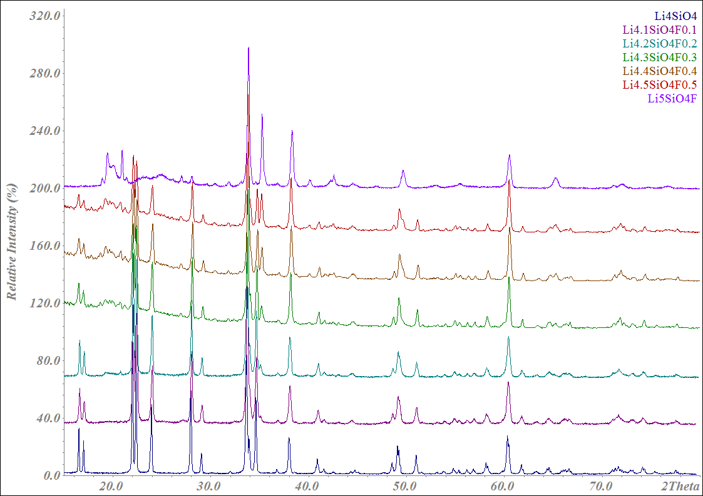
Composition 17
Composition 16
Composition 15
Composition 14
Composition 13
Composition 11
Composition 9
Figure 4.5 The XRD pattern of Li_{4+x}SiO₄F_{x}: x = 0, 0.1, 0.2, 0.3, 0.4, 0.5, 1. XRD patterns were collected by Cu IP with λ = 1.541 Å.

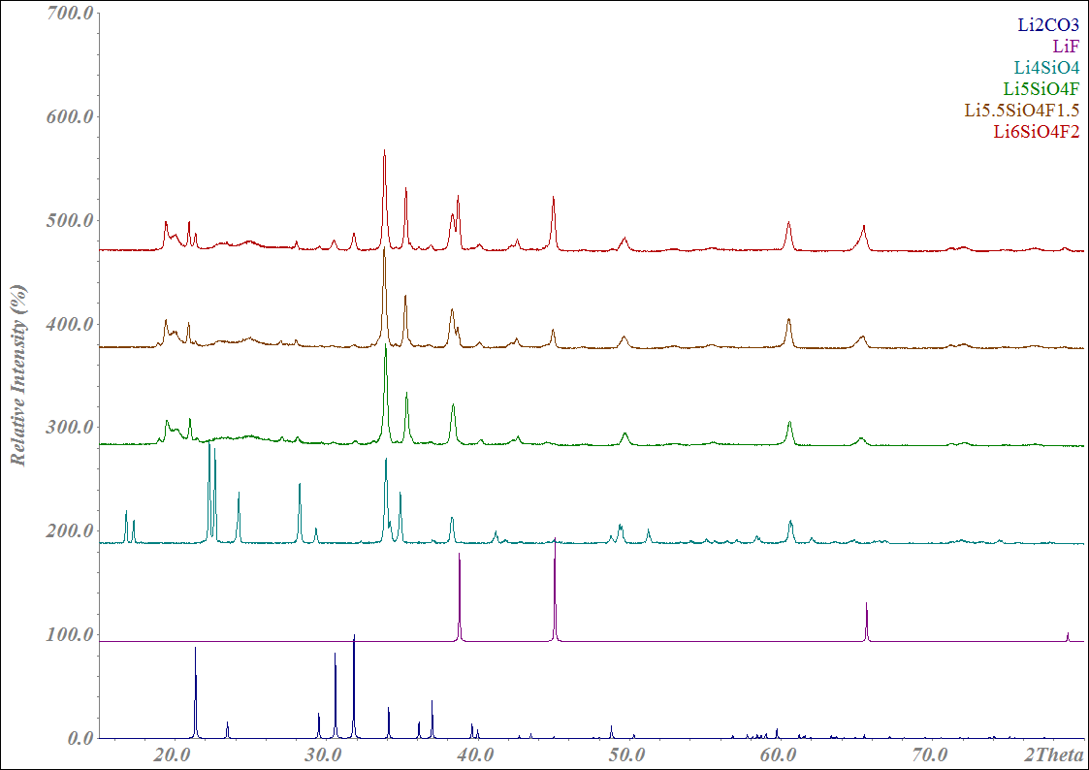
Composition 9
Composition 17
Composition 19
Composition 18
ICDD 04-007-9630
ICDD 04-010-7186
Figure 4.6 The XRD pattern of Li_{4+x}SiO₄F_{x}: x = 0, 1, 1.5, 2 after heating at 650 ºC for 10 h and ICDD data of LiF and Li₂CO₃. XRD patterns were collected by D2 with λ = 1.541 Å.
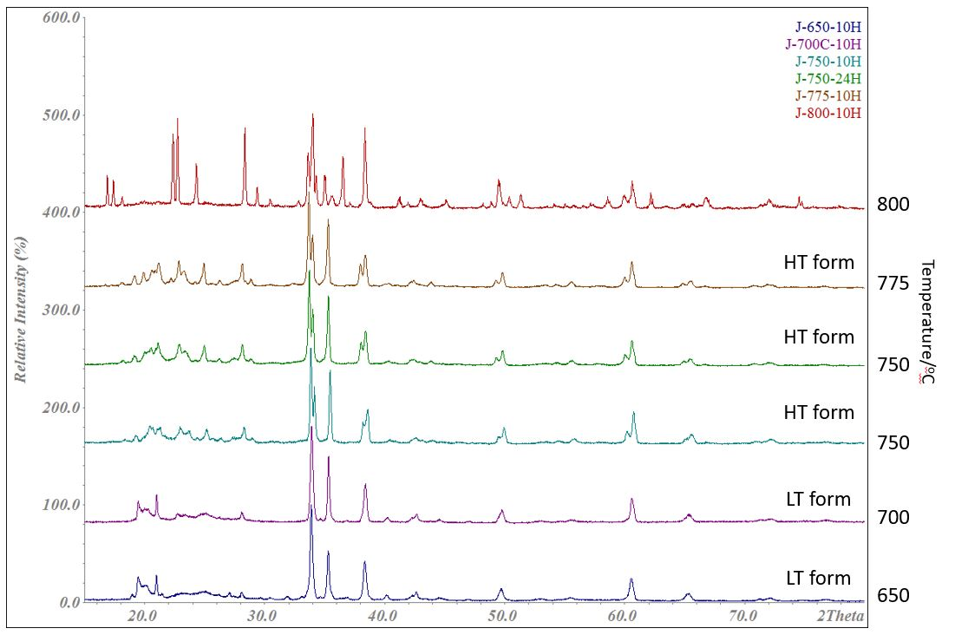
Figure 4.7 The XRD pattern of composition J after heating at different temperatures. From the bottom to the top, heating at 650 ºC for 10 h, 700 ºC for 10h, 750 ºC for 10h, 750 ºC for 24h, 775 ºC for 10h and 800 ºC for 10h. XRD patterns were collected by D2 with λ = 1.541 Å.
LT and HT represent for low temperature and high temperature respectively.
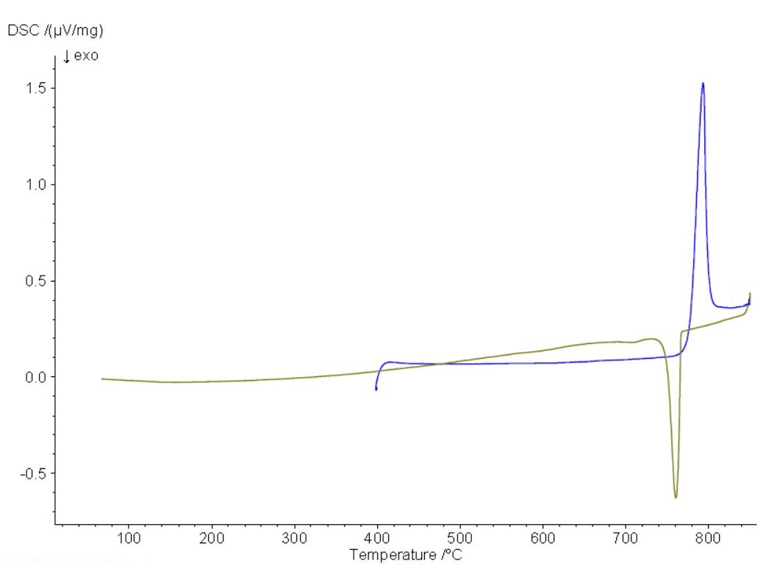
Figure 4.8 DSC results of Li₅SiO₄F

Table 4.1 XRD results of different compositions with different heating temperatures.
Number | Formulae | Time (hours) | Temperature (ºC) | Detected phases
1 | LiSiO₂F | 10 | 700 | Li₂SiO₃, LiF and SiO₂
1 | LiSiO₂F | 10 | 800 | Li₂SiO₃, LiF, SiO₂ and Li₂Si₂O₅
2 | Li₂O:SiO₂:LiF = 4.5:4.5:1 | 10 | 700 | Li₂SiO₃ and LiF
2 | Li₂O:SiO₂:LiF = 4.5:4.5:1 | 10 | 800 | Li₂SiO₃ and LiF
3 | Li₃SiO₃F | 10 | 800 | LiF and Li₂SiO₃
4 | Li_{3.9}SiO_{3.9}F_{0.1} | 10 | 700 | Li₄SiO₄ and Li₂SiO₃
4 | Li_{3.9}SiO_{3.9}F_{0.1} | 10 | 800 | Li₄SiO₄ and unknown phase B
5 | Li_{3.8}SiO_{3.8}F_{0.2} | 10 | 750 | Li₄SiO₄, Li₂SiO₃ and unknown phase B
5 | Li_{3.8}SiO_{3.8}F_{0.2} | 10 | 800 | Li₄SiO₄ and unknown phase B
6 | Li_{3.5}SiO_{3.5}F_{0.5} | 10 | 800 | Li₂SiO₃ and unknown phase B
7 | Li₂O:SiO₂:LiF = 5:3:2 | 10 | 650 | Li₂SiO₃ and unknown peaks
7 | Li₂O:SiO₂:LiF = 5:3:2 | 10 | 700 | Li₂SiO₃ and unknown peaks
7 | Li₂O:SiO₂:LiF = 5:3:2 | 10 | 800 | Unknown phase B and Li₂SiO₃
7 | Li₂O:SiO₂:LiF = 5:3:2 | 24 | 800 | Unknown phase B and Li₂SiO₃ and Li₄SiO₄
8 | Li₂O:SiO₂:LiF = 4:3:3 | 10 | 650 | Li₂SiO₃, LiF and unknown phase B’
8 | Li₂O:SiO₂:LiF = 4:3:3 | 10 | 700 | Li₂SiO₃, LiF and unknown phase B’
8 | Li₂O:SiO₂:LiF = 4:3:3 | 10 | 800 | Li₂SiO₃, LiF and unknown phase B’
9 | Li₄SiO₄ | 10 | 750 | Li₄SiO₄
10 | Li_{4.05}SiO₄F_{0.05} | 10 | 650 | Li₄SiO₄
11 | Li_{4.1}SiO₄F_{0.1} | 10 | 650 | Li₄SiO₄
12 | Li_{4.15}SiO₄F_{0.15} | 10 | 650 | Li₄SiO₄ and phase J.
13 | Li_{4.2}SiO₄F_{0.2} | 10 | 650 | Li₄SiO₄ and phase J
14 | Li_{4.3}SiO₄F_{0.3} | 10 | 650 | Li₄SiO₄ and phase J
15 | Li_{4.4}SiO₄F_{0.4} | 10 | 650 | Li₄SiO₄ and phase J
16 | Li_{4.5}SiO₄F_{0.5} | 10 | 650 | Li₄SiO₄ and phase J
17 | Li₅SiO₄F | 10 | 650 | Phase J
17 | Li₅SiO₄F | 10 | 750 | Phase J
17 | Li₅SiO₄F | 10 | 775 | Phase J
17 | Li₅SiO₄F | 10 | 800 | Li₄SiO₄, Li₂O, LiF and unknown peaks
18 | Li_{5.5}SiO₄F_{1.5} | 10 | 650 | Phase J and LiF
19 | Li₆SiO₄F₂ | 10 | 650 | Phase J, Li₂CO₃ and LiF

Table 4.2 Indexing results of Li₅SiO₄F slow cooled from 775 ºC (J)
Final 2θ window: 0.05, Symmetry: monoclinic, a = 7.900(11) (Å), b = 13.506(12) (Å), c = 13.041(15) (Å), β = 97.39(6) (º), V = 1379.8(42) (Å³).
N | 2θ_{obs}(º) | h | k | l | 2θ_{calc}(º) | Δ2θ(º) | Int. | d_{obs}(Å) | d_{calc}(Å)
1 | 18.134 | -1 | 2 | 1 | 18.092 | 0.0413 | 14.1 | 4.8881 | 4.8991
2 | 19.183 | 1 | 2 | 1 | 19.173 | 0.0098 | 17.5 | 4.623 | 4.6254
3 | 19.956 | 1 | 1 | 2 | 19.991 | -0.035 | 21.5 | 4.4458 | 4.4381
4 | 20.619 | 0 | 0 | 3 | 20.587 | 0.0321 | 20.5 | 4.3042 | 4.3108
5 | 20.891 | 0 | 3 | 1 | 20.877 | 0.014 | 20 | 4.2488 | 4.2517
6 | 21.206 | -1 | 2 | 2 | 21.206 | -0.0005 | 27.5 | 4.1863 | 4.1862
7 | 22.219 | -1 | 0 | 3 | 22.204 | 0.0151 | 15 | 3.9976 | 4.0003
8 | 22.872 | -2 | 0 | 1 | 22.841 | 0.0301 | 27.4 | 3.8851 | 3.8902
9 | 23.335 | -1 | 3 | 1 | 23.361 | -0.0255 | 19.9 | 3.809 | 3.8049
10 | 24.209 | 1 | 3 | 1 | 24.217 | -0.0078 | 10.9 | 3.6734 | 3.6723
11 | 24.760 | 1 | 0 | 3 | 24.802 | -0.0422 | 13.4 | 3.593 | 3.587
12 | 24.963 | -2 | 0 | 2 | 24.998 | -0.0353 | 25.7 | 3.5642 | 3.5592
13 | 26.265 | 2 | 2 | 0 | 26.282 | -0.0165 | 11.1 | 3.3903 | 3.3882
14 | 27.529 | 0 | 0 | 4 | 27.567 | -0.0378 | 10.1 | 3.2375 | 3.2331
15 | 28.146 | 1 | 2 | 3 | 28.147 | -0.0009 | 28.7 | 3.1679 | 3.1678
16 | 28.894 | 2 | 1 | 2 | 28.871 | 0.0237 | 11.7 | 3.0875 | 3.09
17 | 33.687 | 0 | 4 | 3 | 33.691 | -0.0039 | 100 | 2.6584 | 2.6581
18 | 34.009 | 1 | 2 | 4 | 33.998 | 0.0108 | 58.4 | 2.634 | 2.6348
19 | 35.312 | 0 | 1 | 5 | 35.303 | 0.0091 | 68.4 | 2.5397 | 2.5403
 |  | -3 | 0 | 2 | 35.347 | -0.0349 |  |  | 2.5373
20 | 38.010 | 1 | 0 | 5 | 37.981 | 0.0289 | 28.2 | 2.3654 | 2.3671
21 | 38.460 | -3 | 1 | 3 | 38.49 | -0.0303 | 33.4 | 2.3388 | 2.337
22 | 40.391 | 1 | 2 | 5 | 40.343 | 0.0488 | 6.7 | 2.2313 | 2.2339
23 | 42.468 | 0 | 1 | 6 | 42.434 | 0.0338 | 9 | 2.1269 | 2.1285
 |  | 0 | 6 | 2 | 42.489 | -0.0215 |  |  | 2.1258
24 | 43.903 | 3 | 3 | 2 | 43.867 | 0.0362 | 8.2 | 2.0606 | 2.0622
25 | 49.325 | 0 | 0 | 7 | 49.283 | 0.0421 | 11.7 | 1.846 | 1.8475
 |  | 0 | 6 | 4 | 49.288 | 0.0374 |  |  | 1.8473
 |  | 1 | 7 | 1 | 49.325 | 0 |  |  | 1.846
26 | 49.846 | 4 | 2 | 1 | 49.802 | 0.0441 | 24 | 1.828 | 1.8295
 |  | -1 | 6 | 4 | 49.836 | 0.0091 |  |  | 1.8283
 |  | -2 | 3 | 6 | 49.848 | -0.0026 |  |  | 1.8279
 |  | -3 | 4 | 4 | 49.872 | -0.0263 |  |  | 1.8271
27 | 54.304 | -1 | 6 | 5 | 54.259 | 0.0449 | 5.3 | 1.688 | 1.6892
 |  | 4 | 1 | 3 | 54.261 | 0.0423 |  |  | 1.6892
 |  | 0 | 8 | 0 | 54.295 | 0.0091 |  |  | 1.6882
28 | 55.597 | 4 | 2 | 3 | 55.628 | -0.0301 | 8 | 1.6517 | 1.6509
29 | 60.020 | -4 | 5 | 3 | 59.983 | 0.0366 | 16.9 | 1.5401 | 1.541
 |  | -1 | 7 | 5 | 60.03 | -0.0102 |  |  | 1.5399
 |  | 3 | 4 | 5 | 60.047 | -0.0271 |  |  | 1.5395
30 | 60.644 | -2 | 2 | 8 | 60.612 | 0.0316 | 42.3 | 1.5258 | 1.5265
 |  | 5 | 2 | 0 | 60.623 | 0.0205 |  |  | 1.5262
 |  | 3 | 2 | 6 | 60.642 | 0.0021 |  |  | 1.5258
 |  | -2 | 8 | 2 | 60.663 | -0.0198 |  |  | 1.5253
 |  | 0 | 5 | 7 | 60.681 | -0.0375 |  |  | 1.5249
31 | 64.913 | 4 | 4 | 4 | 64.863 | 0.05 | 8 | 1.4354 | 1.4363
 |  | -1 | 7 | 6 | 64.88 | 0.0329 |  |  | 1.436
 |  | 2 | 8 | 3 | 64.892 | 0.0218 |  |  | 1.4358
32 | 65.542 | -5 | 0 | 5 | 65.512 | 0.0302 | 11.4 | 1.4231 | 1.4237
 |  | -5 | 4 | 2 | 65.529 | 0.0124 |  |  | 1.4233
 |  | 2 | 1 | 8 | 65.555 | -0.0129 |  |  | 1.4229
33 | 66.726 | 2 | 9 | 0 | 66.692 | 0.034 | 4.6 | 1.4007 | 1.4013
 |  | -2 | 1 | 9 | 66.694 | 0.0322 |  |  | 1.4013
 |  | -2 | 9 | 1 | 66.759 | -0.0327 |  |  | 1.4001
 |  | 4 | 3 | 5 | 66.771 | -0.0446 |  |  | 1.3999

4.3.2 Impedance spectroscopy (IS)
(i) Li₄SiO₄ and Li_{4+x}SiO₄F_{x}: x varied from 0 to 0.2.

Complex plane, Z* plots of Li₄SiO₄ with silver paste at different temperatures in air are shown in Figure 4.9. At 165 ºC, a nearly ideal semicircle at higher frequency and a spike at lower frequency are observed. Specifically, the corresponding capacitance of the semicircle, 3.3 x 10⁻¹² Fcm⁻¹, is calculated from ωRC = 1. With increasing temperature, the semicircle shifted out of the frequency window while the slope of the spike increased from 30º at 165 ºC to 45º at 306 ºC, which manifests a stronger blockage of charge carriers on the sample – electrode interface.

The capacitance (C’) as a function of frequency at different temperatures is shown in figure 4.10. A plateau with value 6∙10⁻¹² Fcm⁻¹ at higher frequency is attributed to the bulk response, a broad dispersion associated with power law at intermediate frequencies and a capacitance of about 10⁻⁵ to 10⁻⁴ Fcm⁻¹ at lower frequency which indicates the sample – electrode interface response and a double layer phenomenon.

The conductivity (Y’) versus frequency at different temperatures is shown in figure 4.10. The Y’ plot shows a dispersion at higher frequencies, a nearly frequency independent plateau at intermediate frequency and a curvature at lower frequency. At 306 ºC, the dispersion at higher frequency almost shifted out of the frequency window.

Combined Z’’/M’’ spectroscopic plots show a coincidence of peak maxima of M’’ and Z’’ at higher frequencies, which implies the electrically homogeneity of the sample. A tail at lower frequencies with Z’’ plot may be associated with the sample – electrode effect.

Similar results are also observed with Li_{4.1}SiO₄F_{0.1} (x = 0.1) as shown in figure 4.11 and 4.12. The difference is the electrode used for Li_{4.1}SiO₄F_{0.1} is gold paste. In the complex Z* plot, a much sharper spike with 70º is found which is probably attributed to the stronger blocking effect of Au than that of Ag with Li⁺ ions.

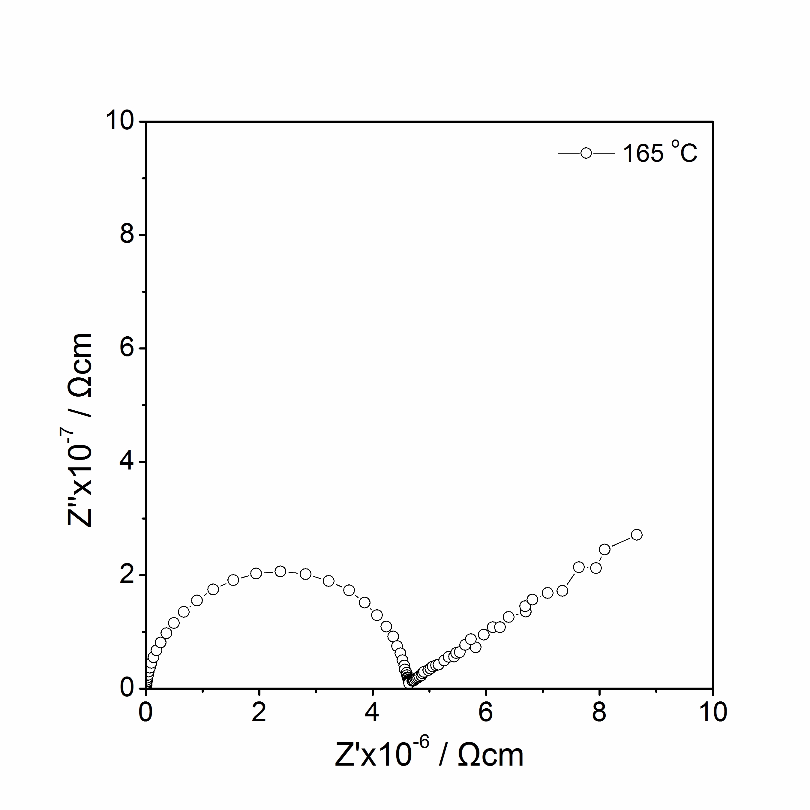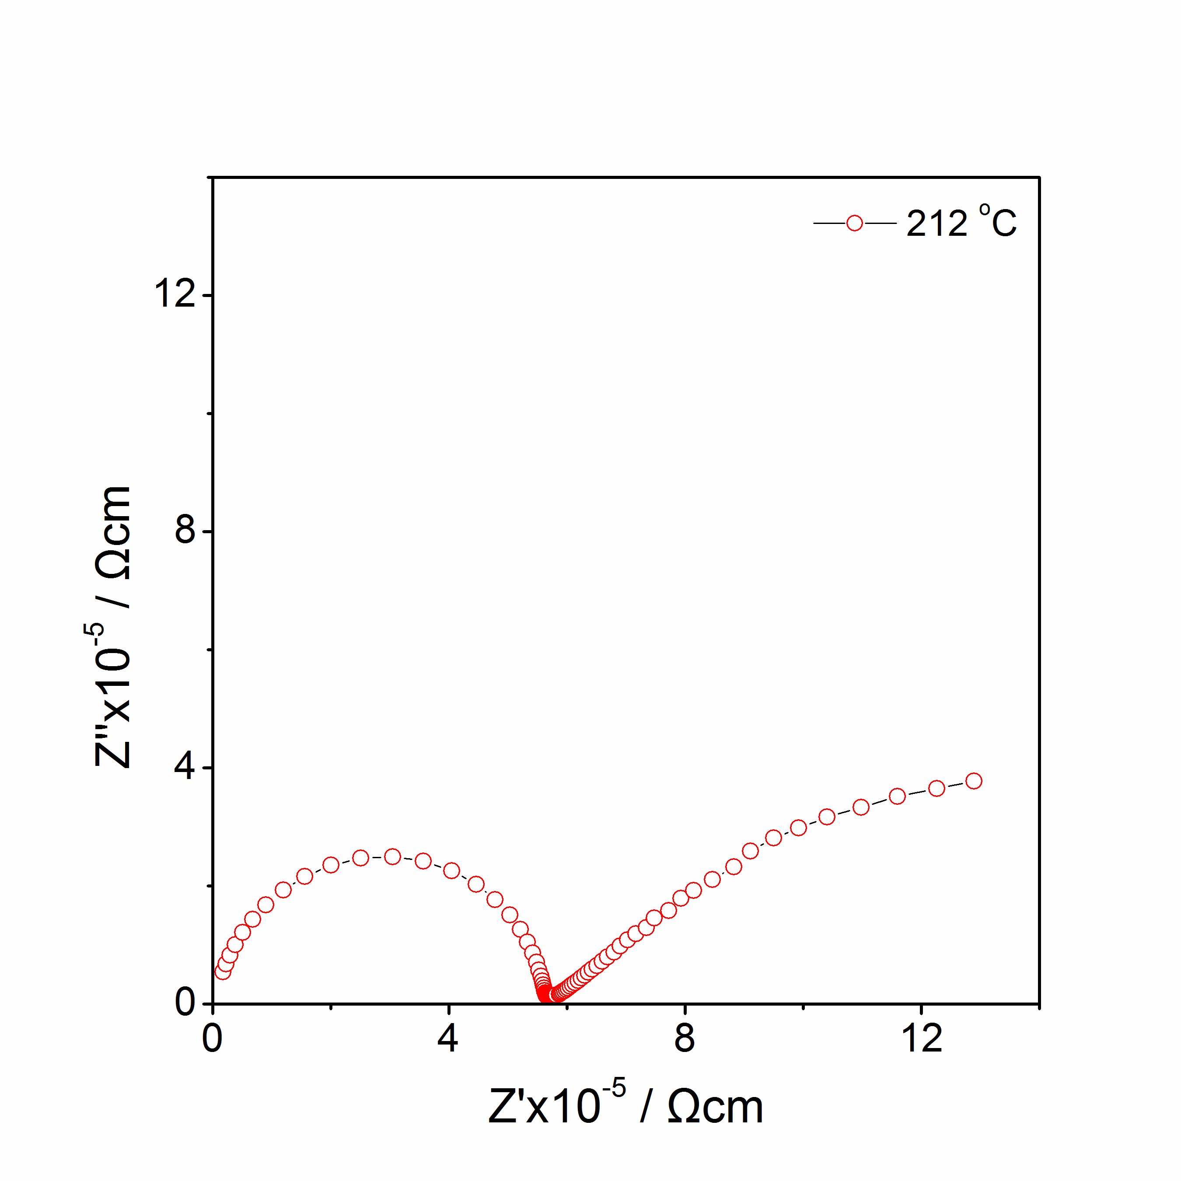
(a)
(b)
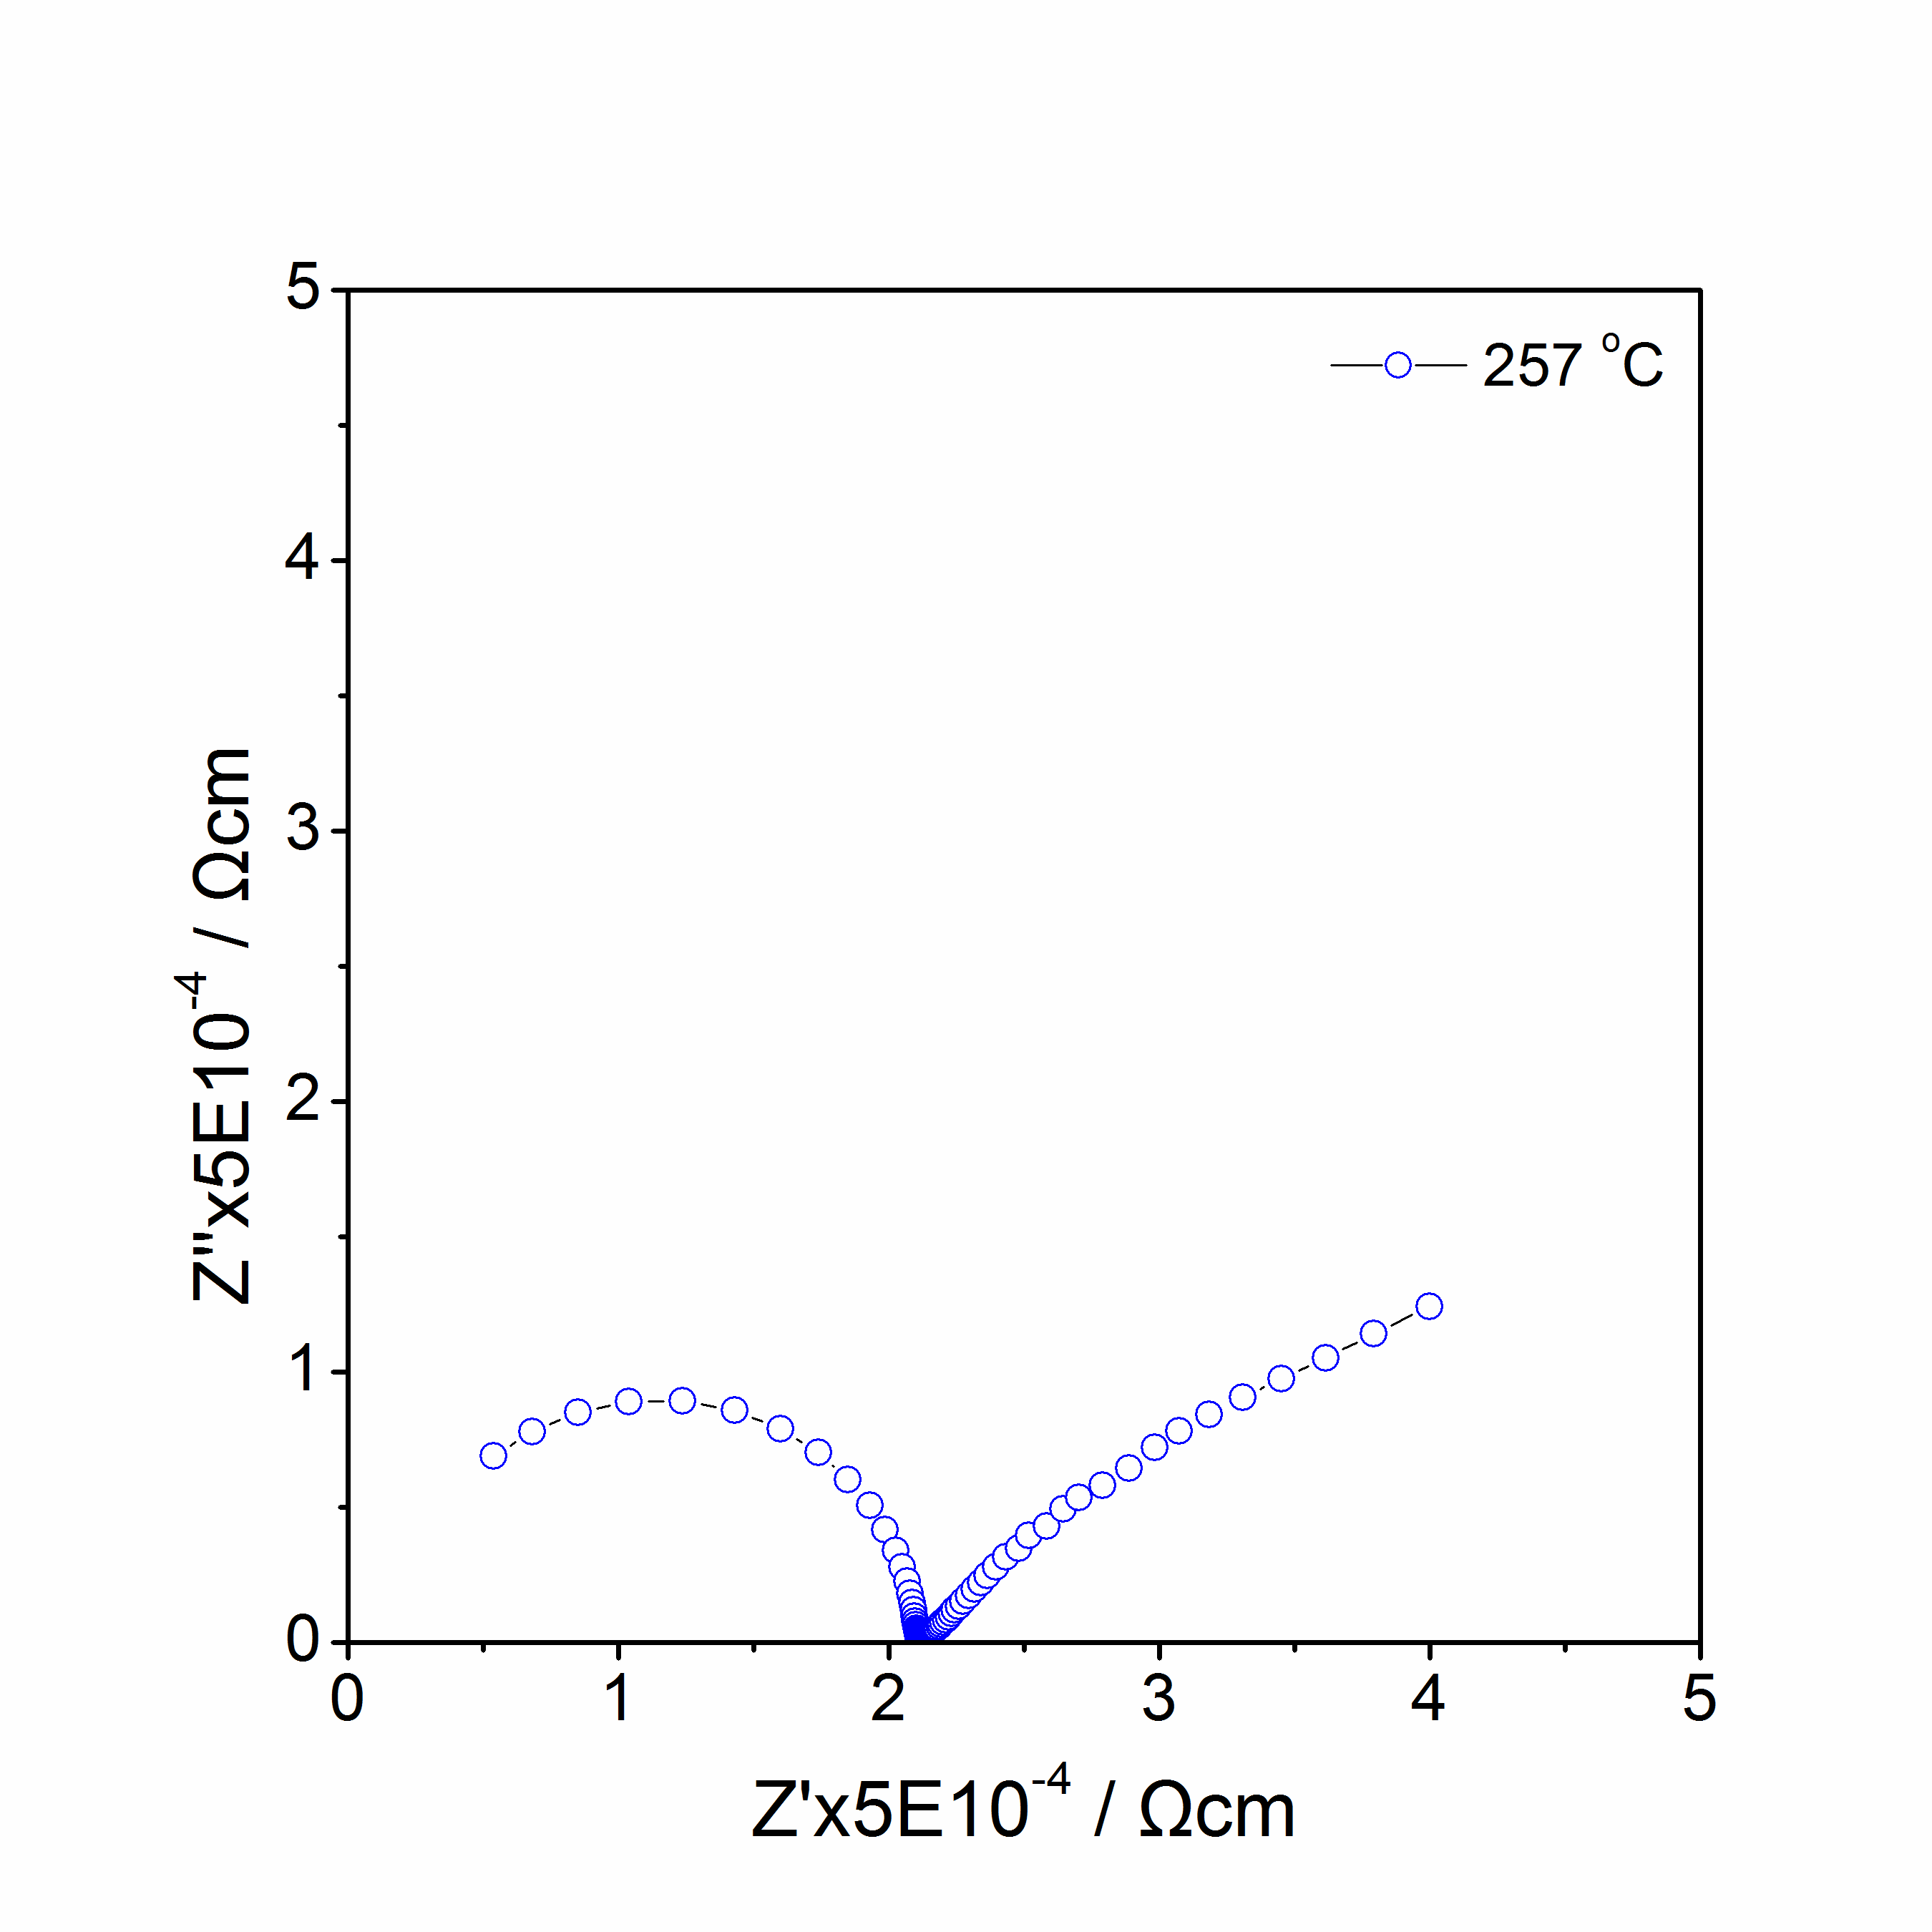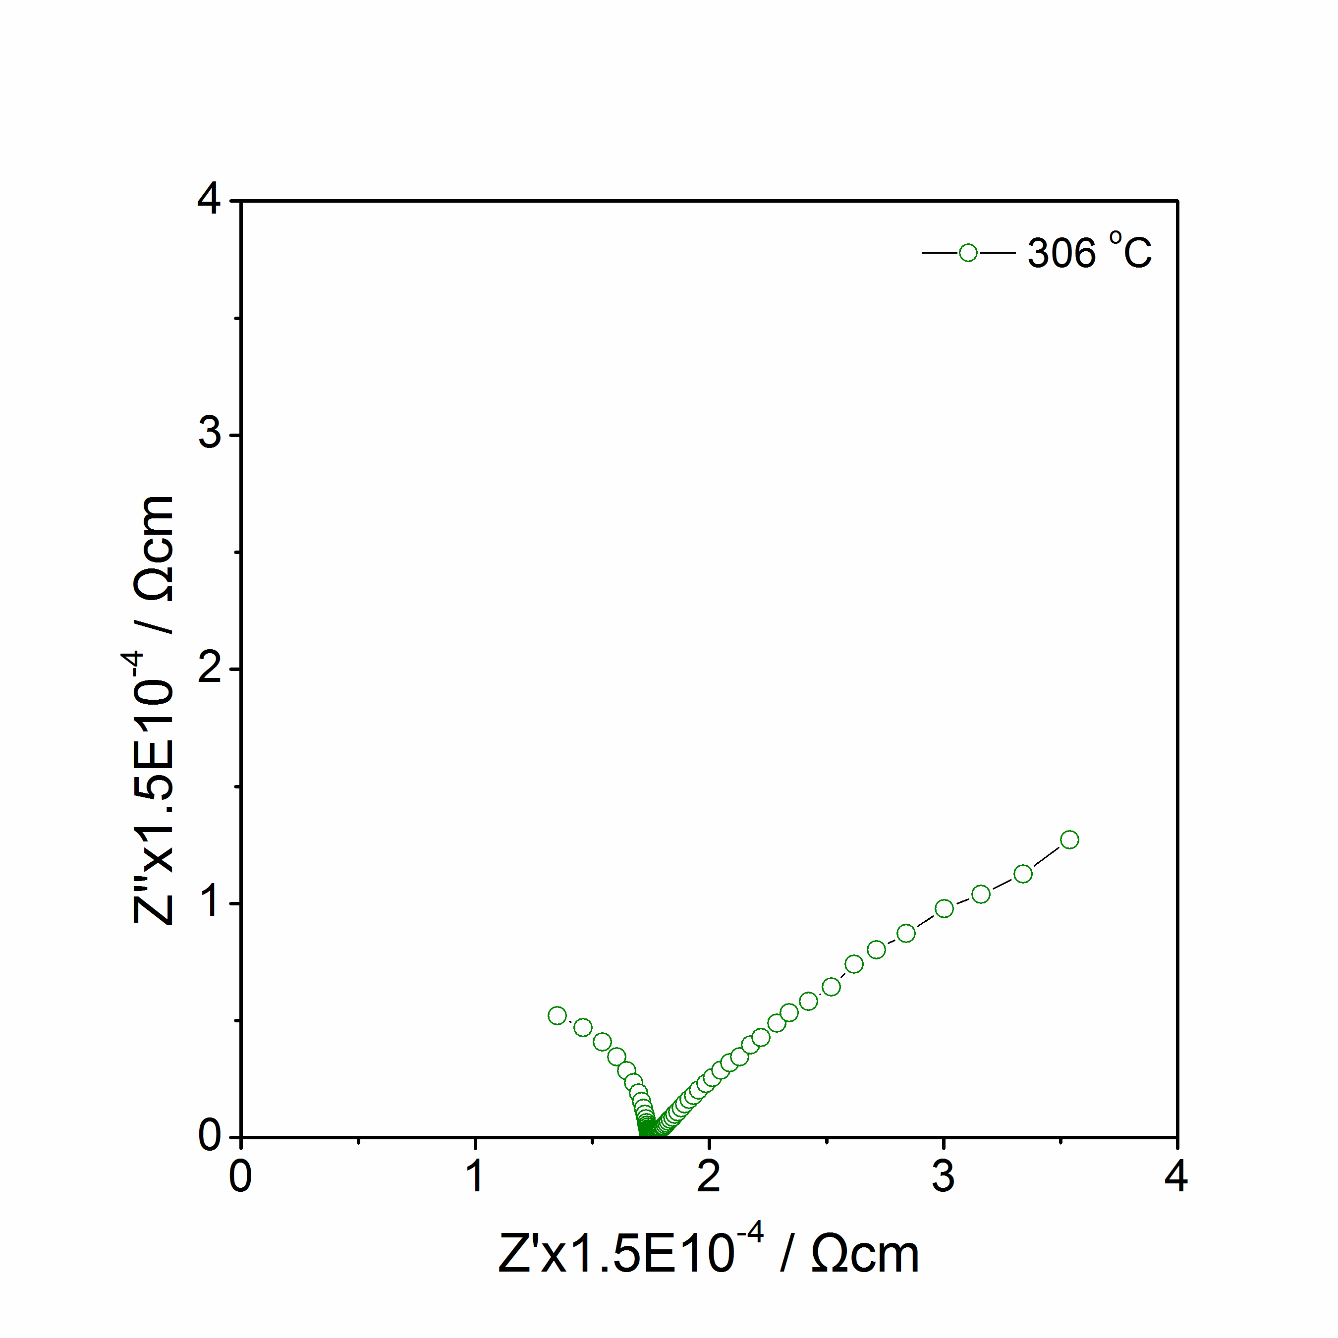
(c)
(d)
Figure 4.9 Li₄SiO₄: Impedance complex plane plots Z* at 165 ºC to 306 ºC in Air.

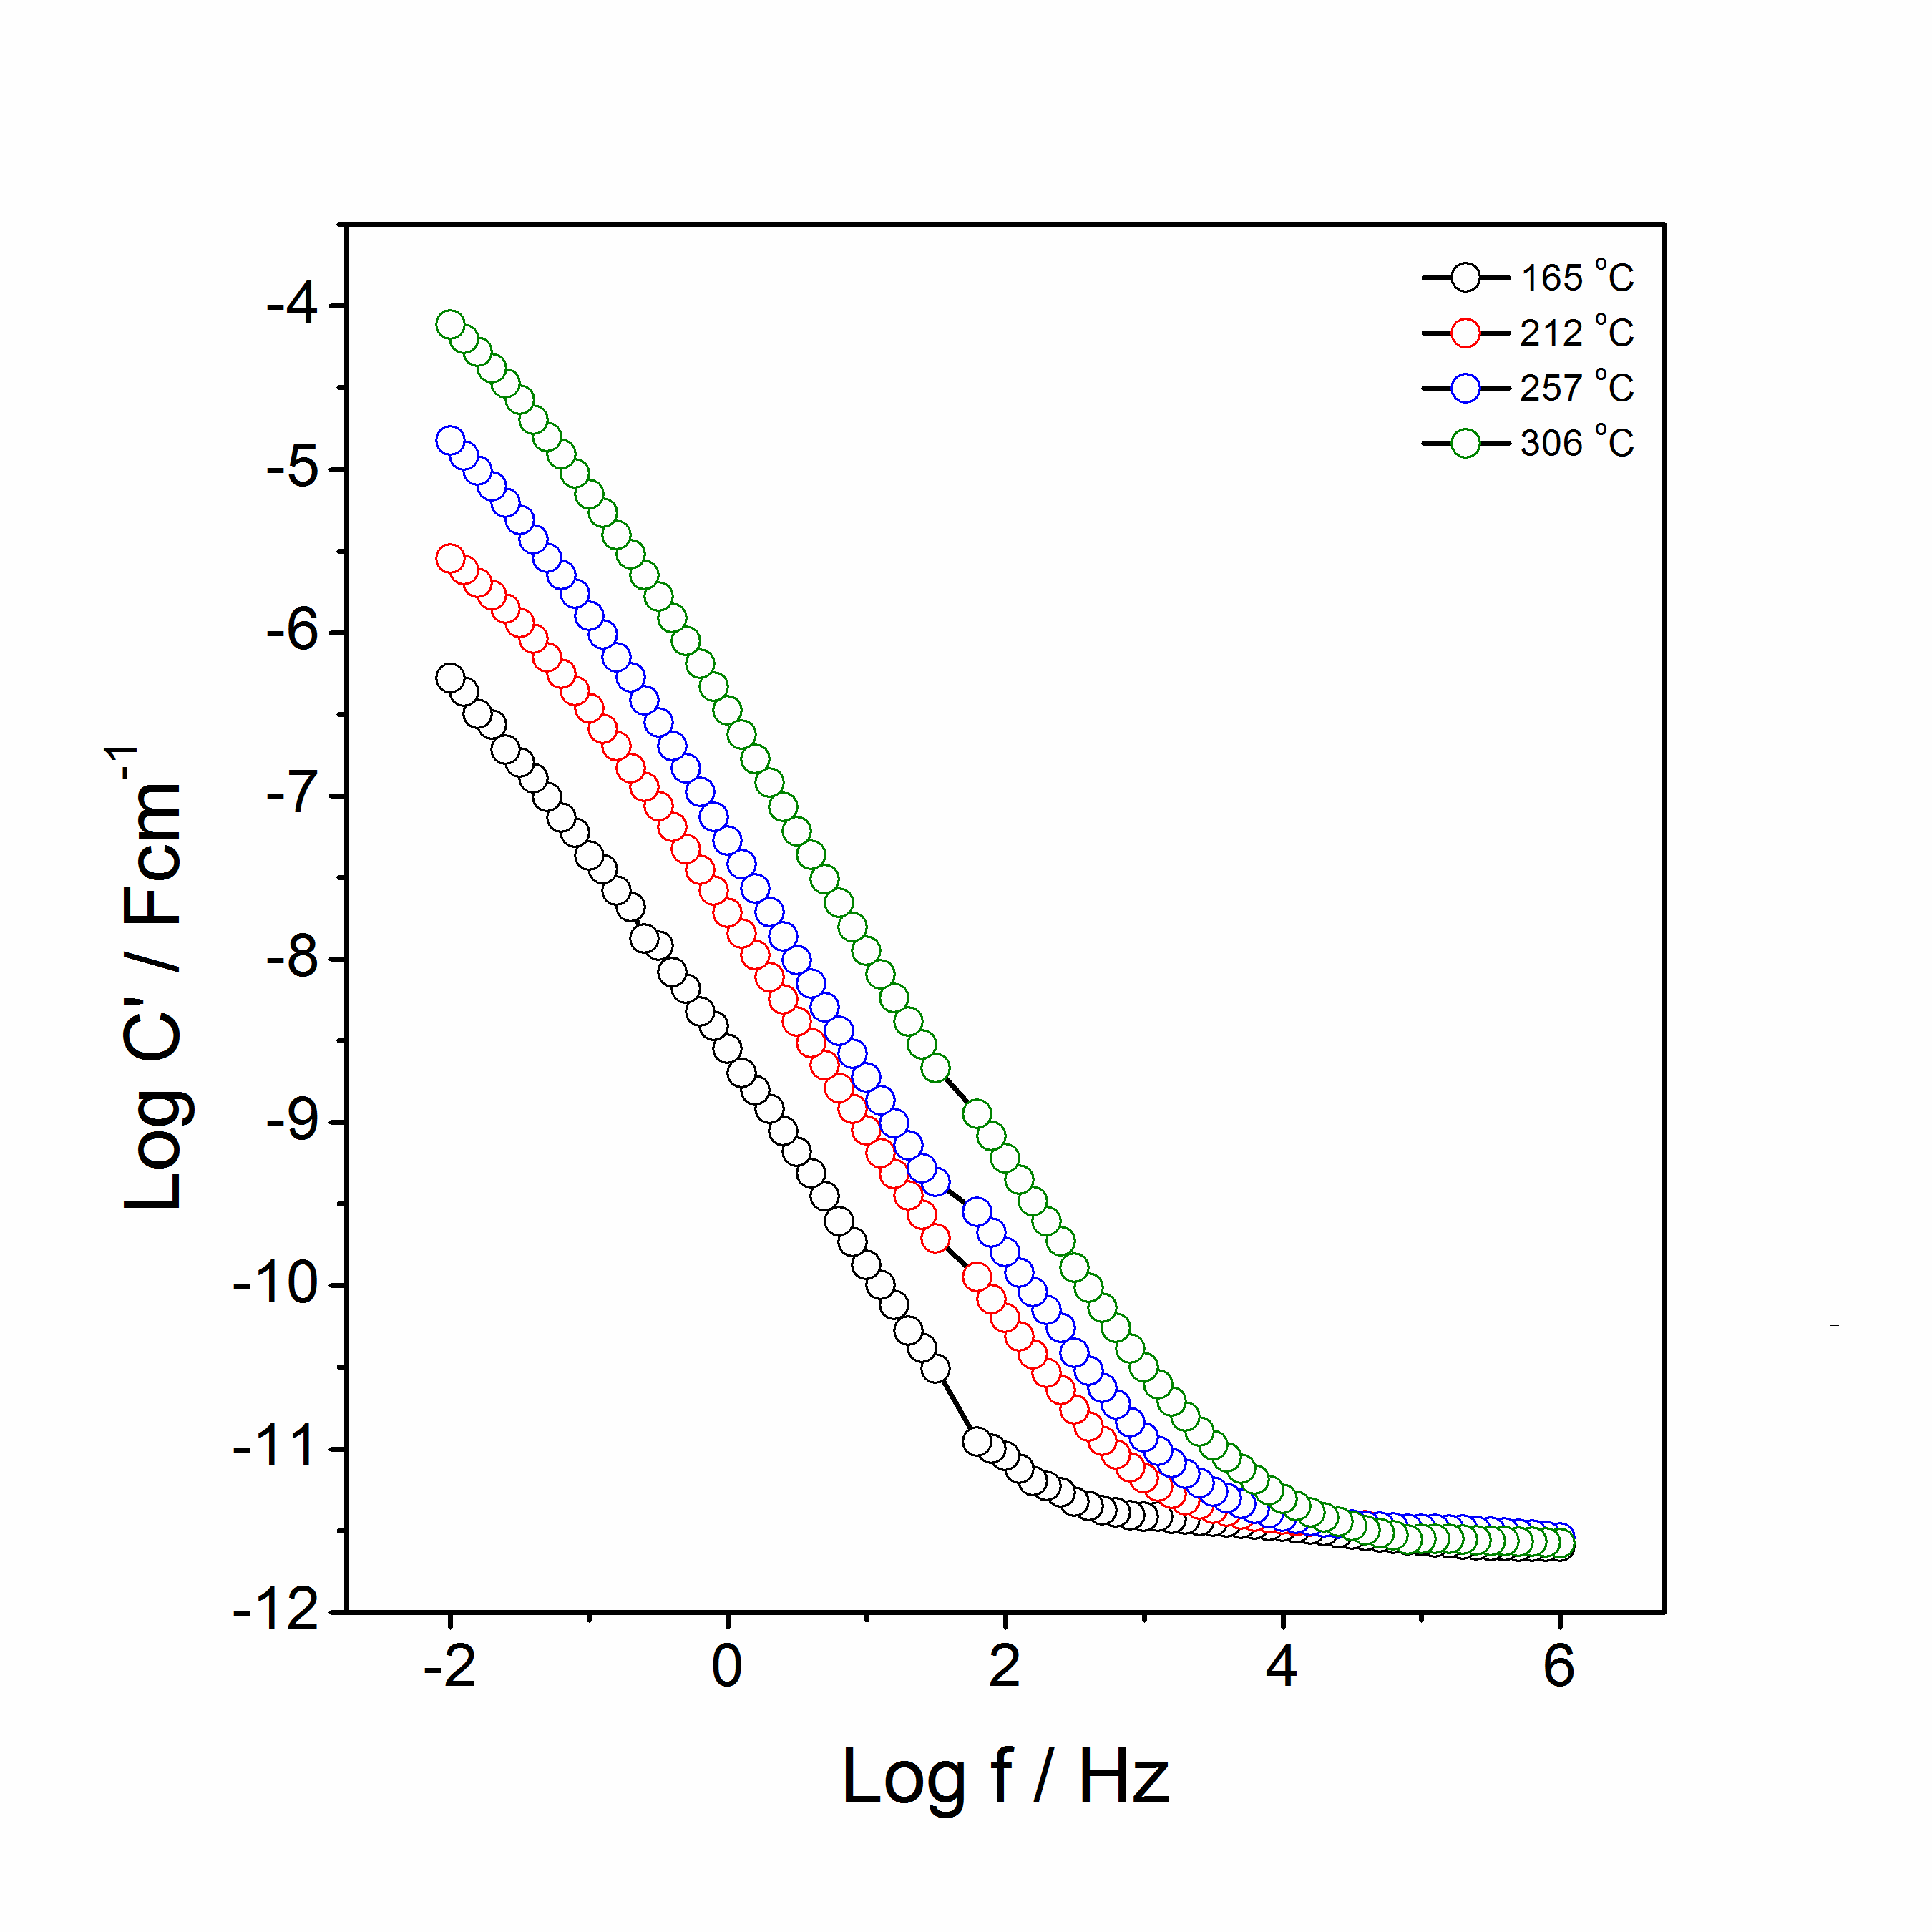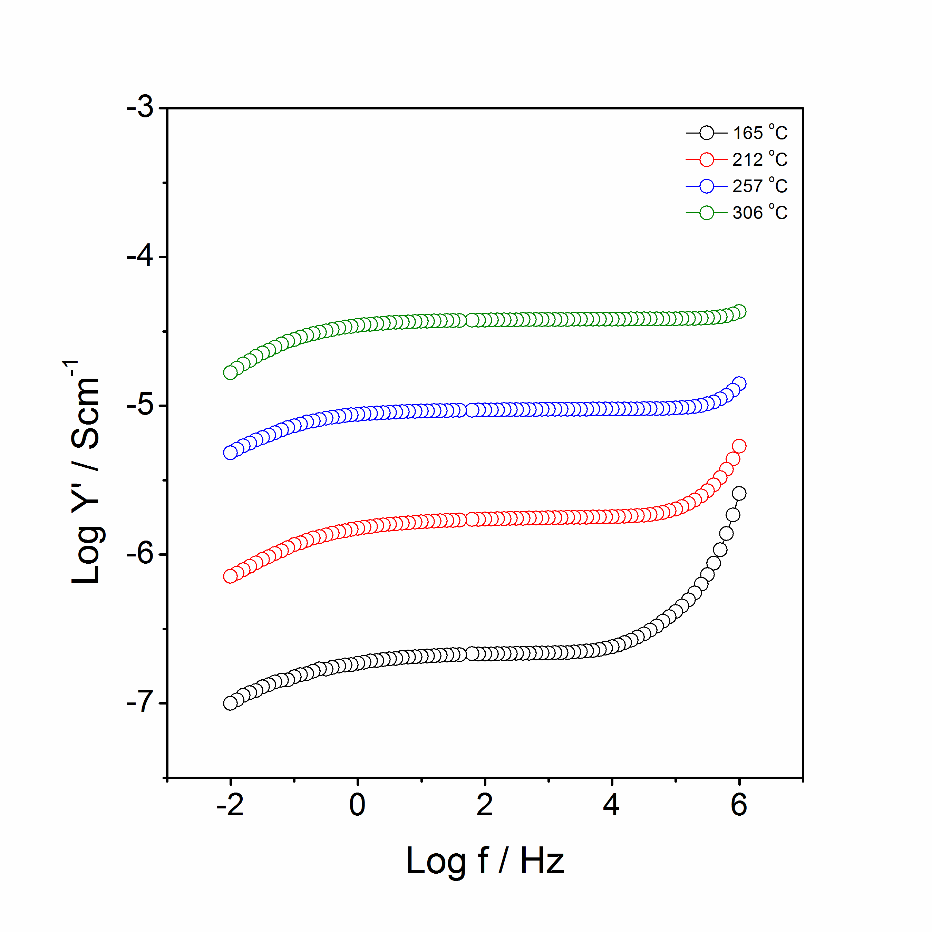
(b)
(a)
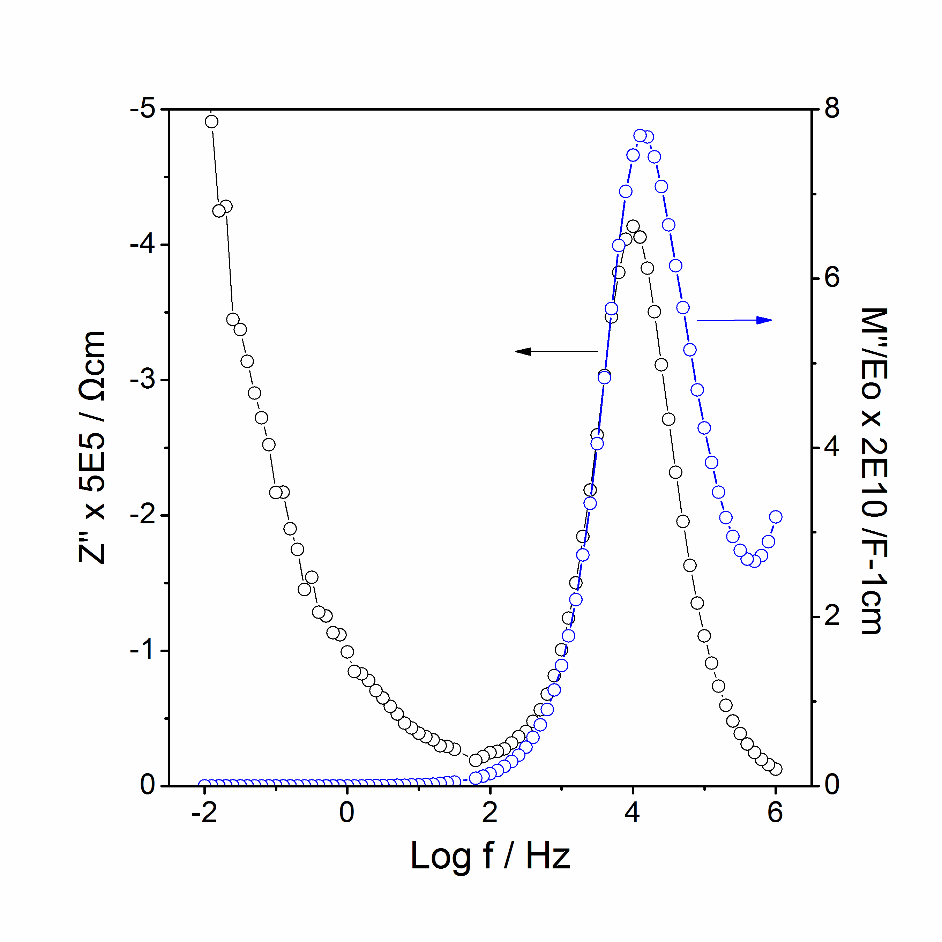
(c)
Figure 4.10 Li₄SiO₄: spectroscopic plots of C’ (a), Y’ (b), –Z’’ and M’’ at 165 ºC (c).
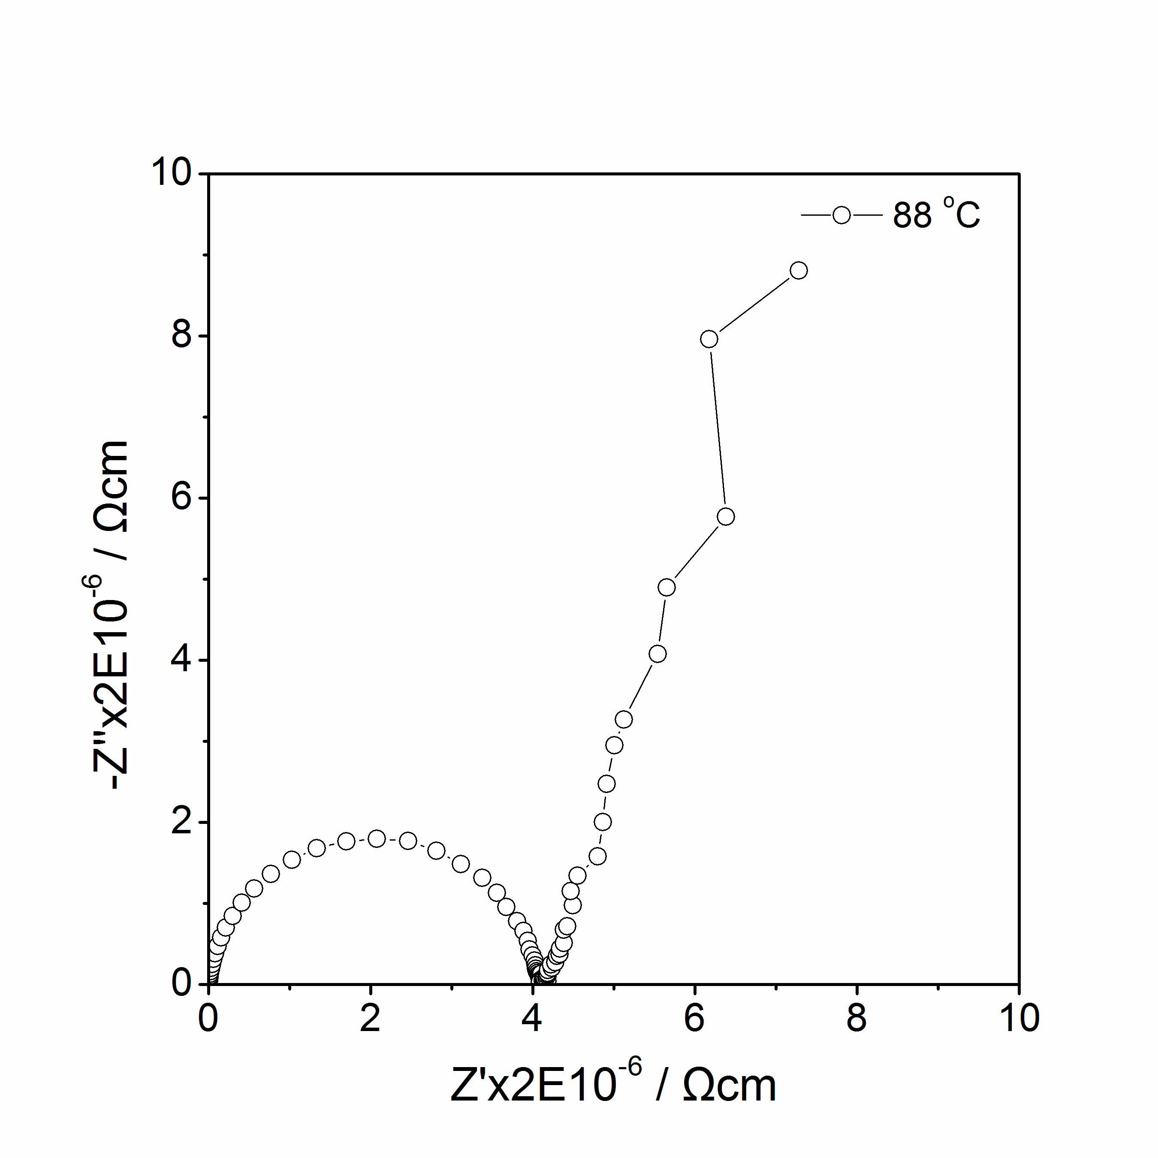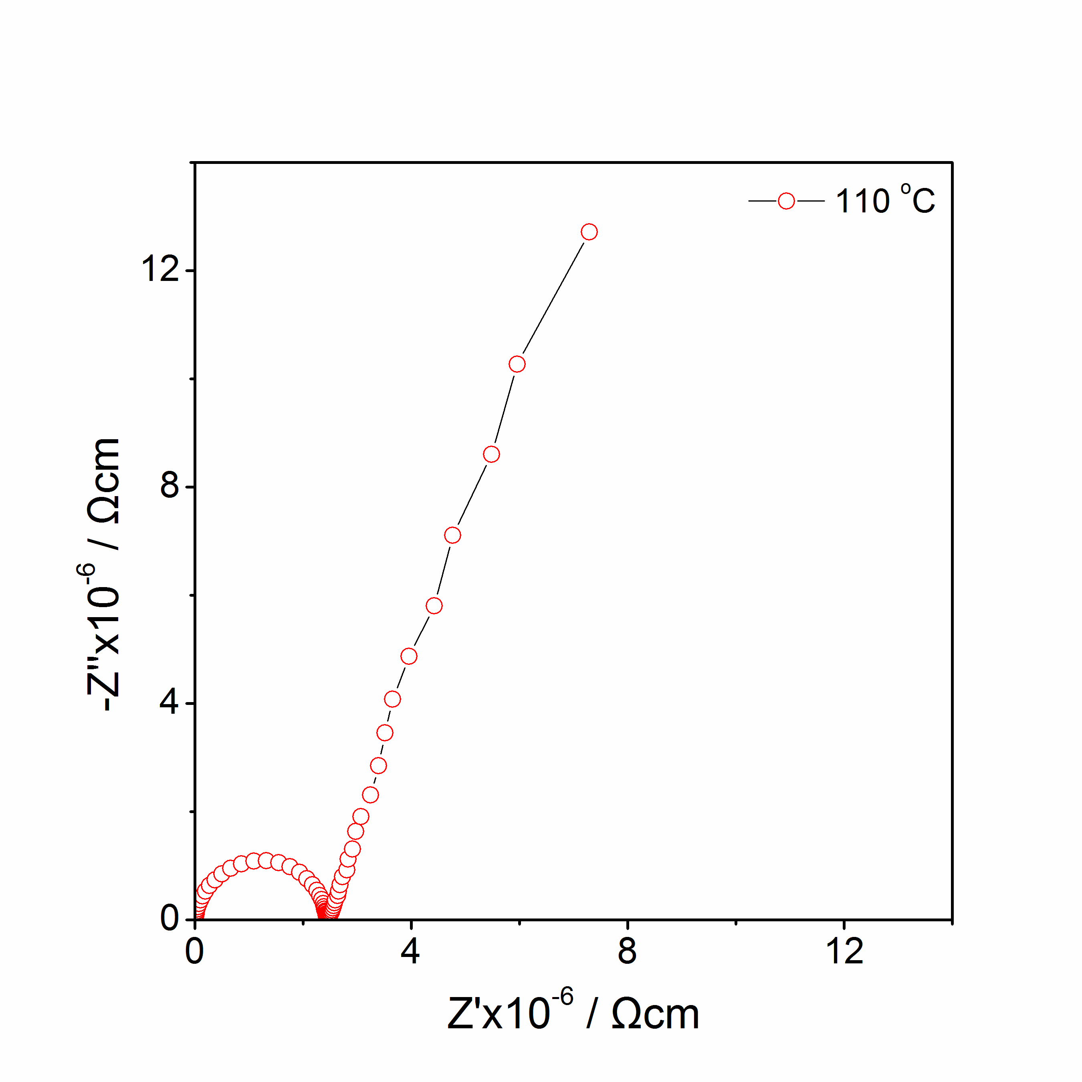
(a)
(b)
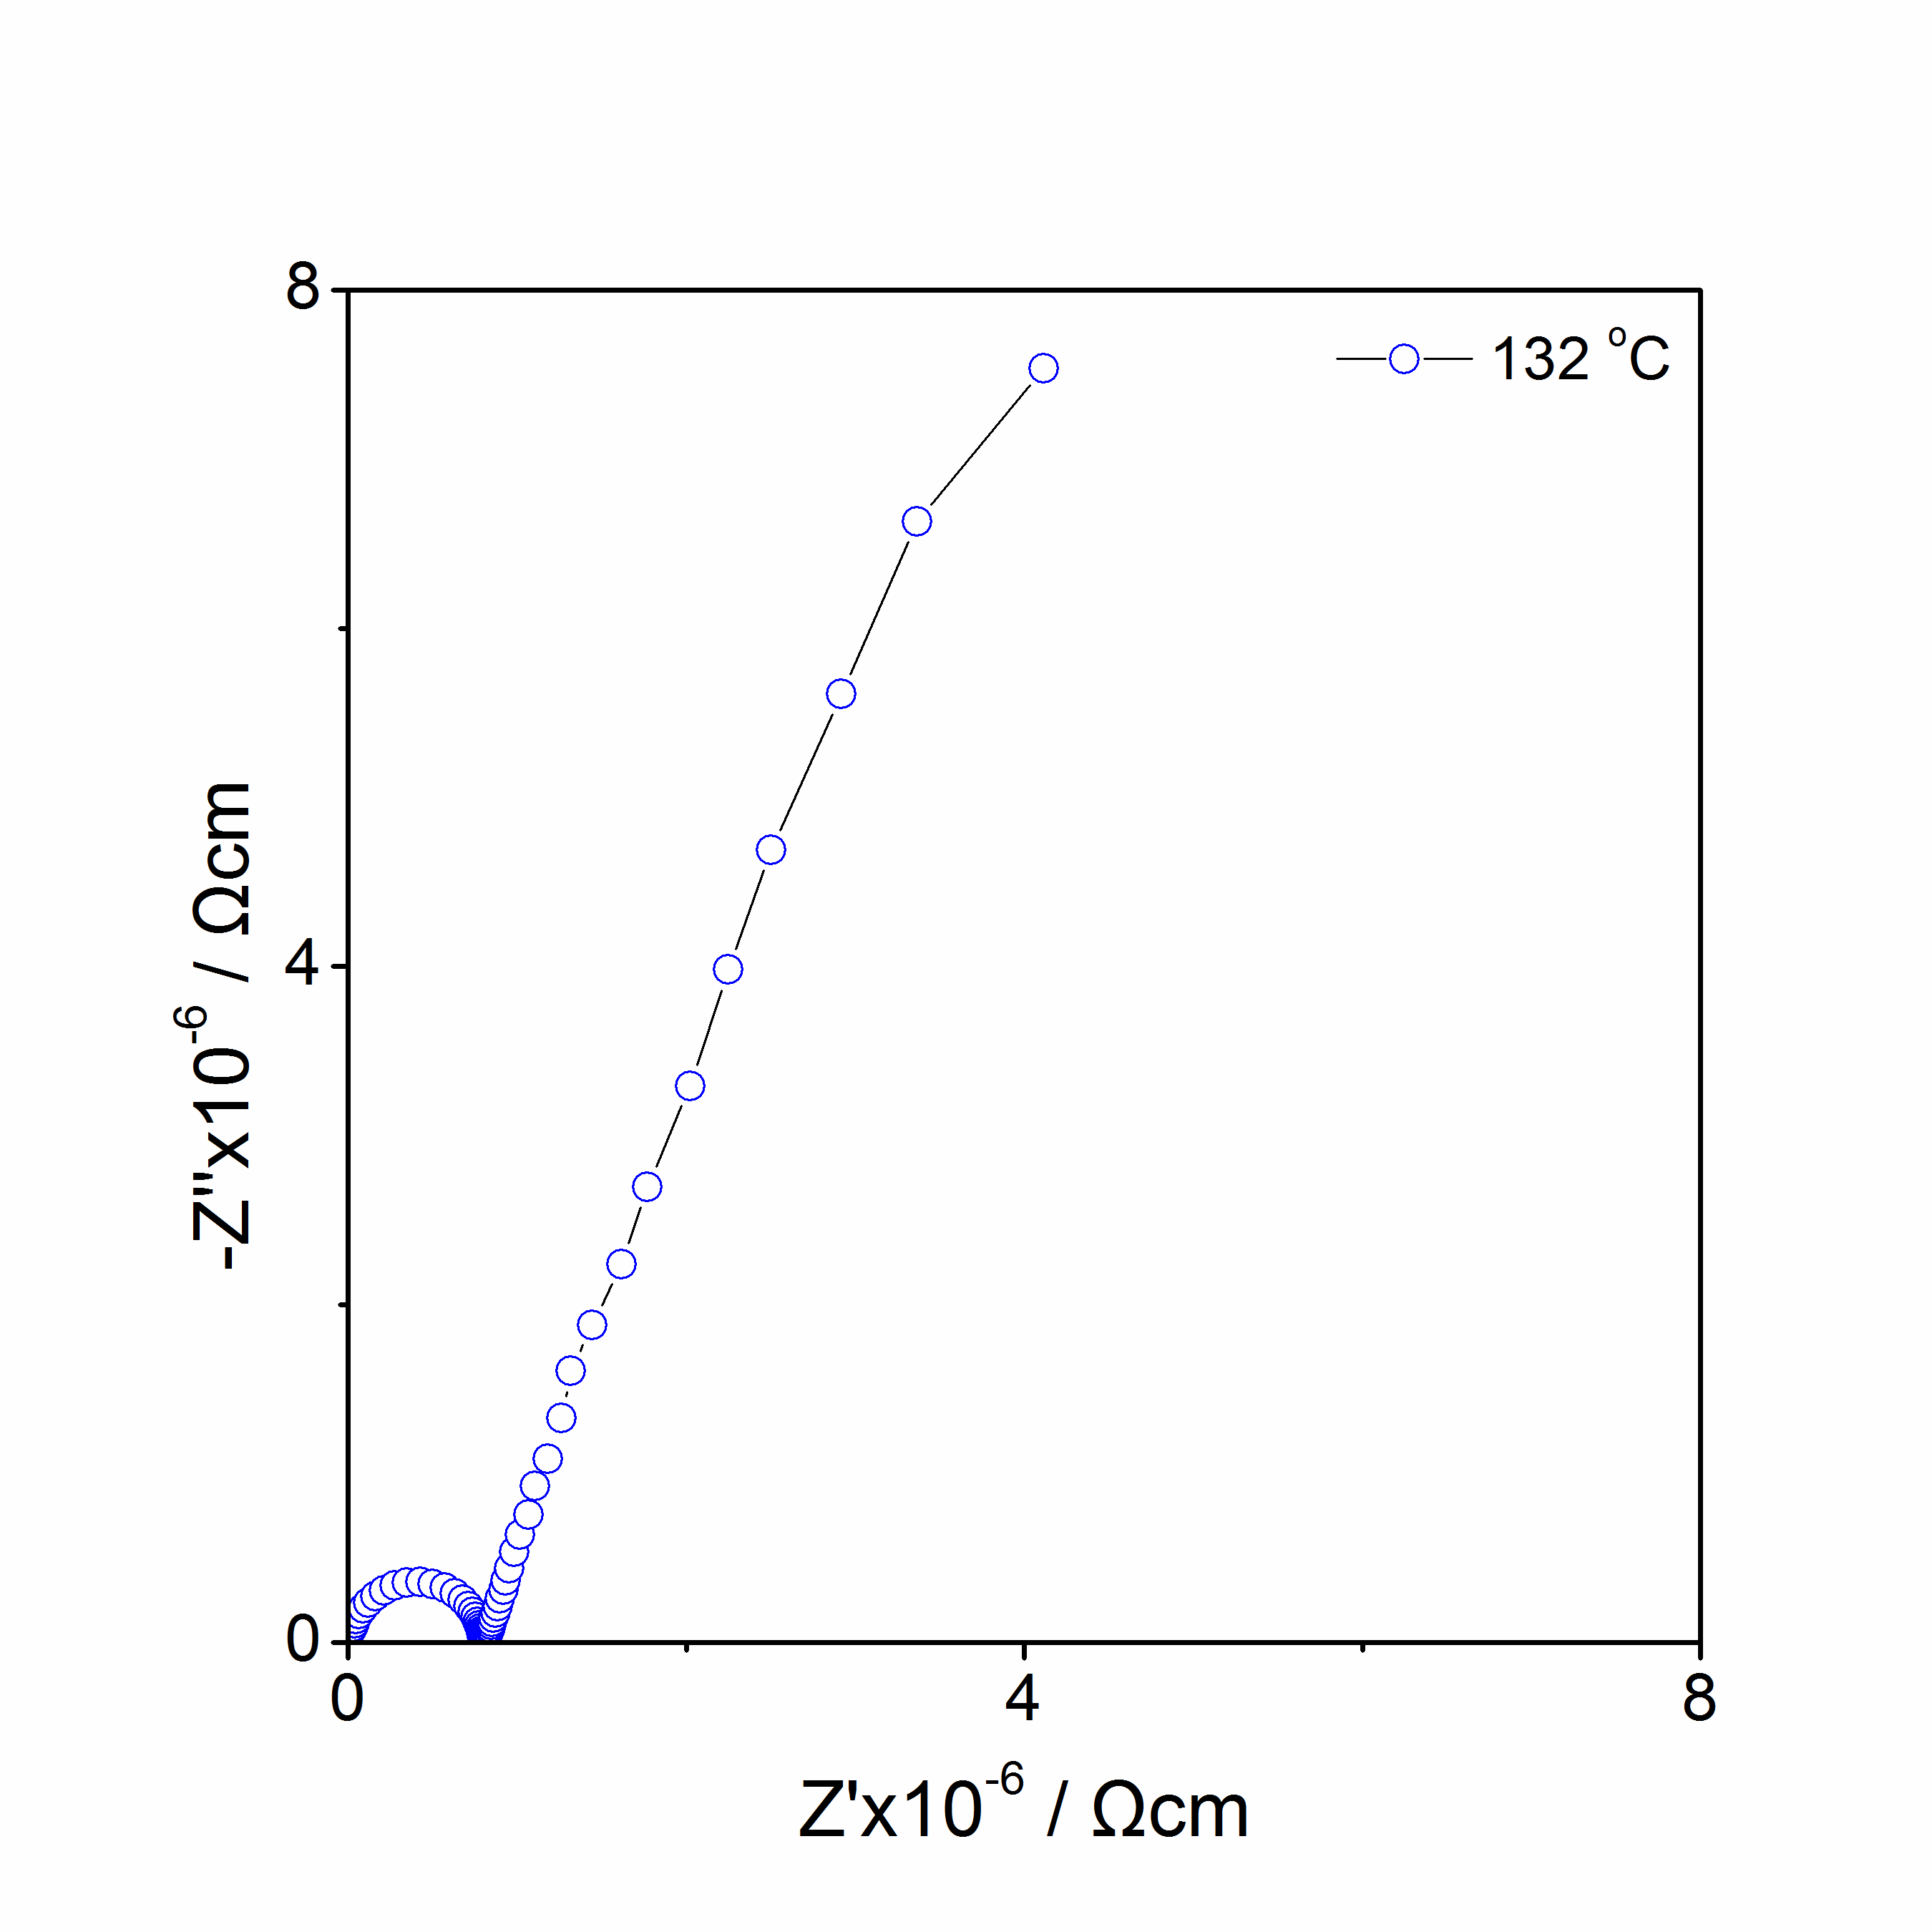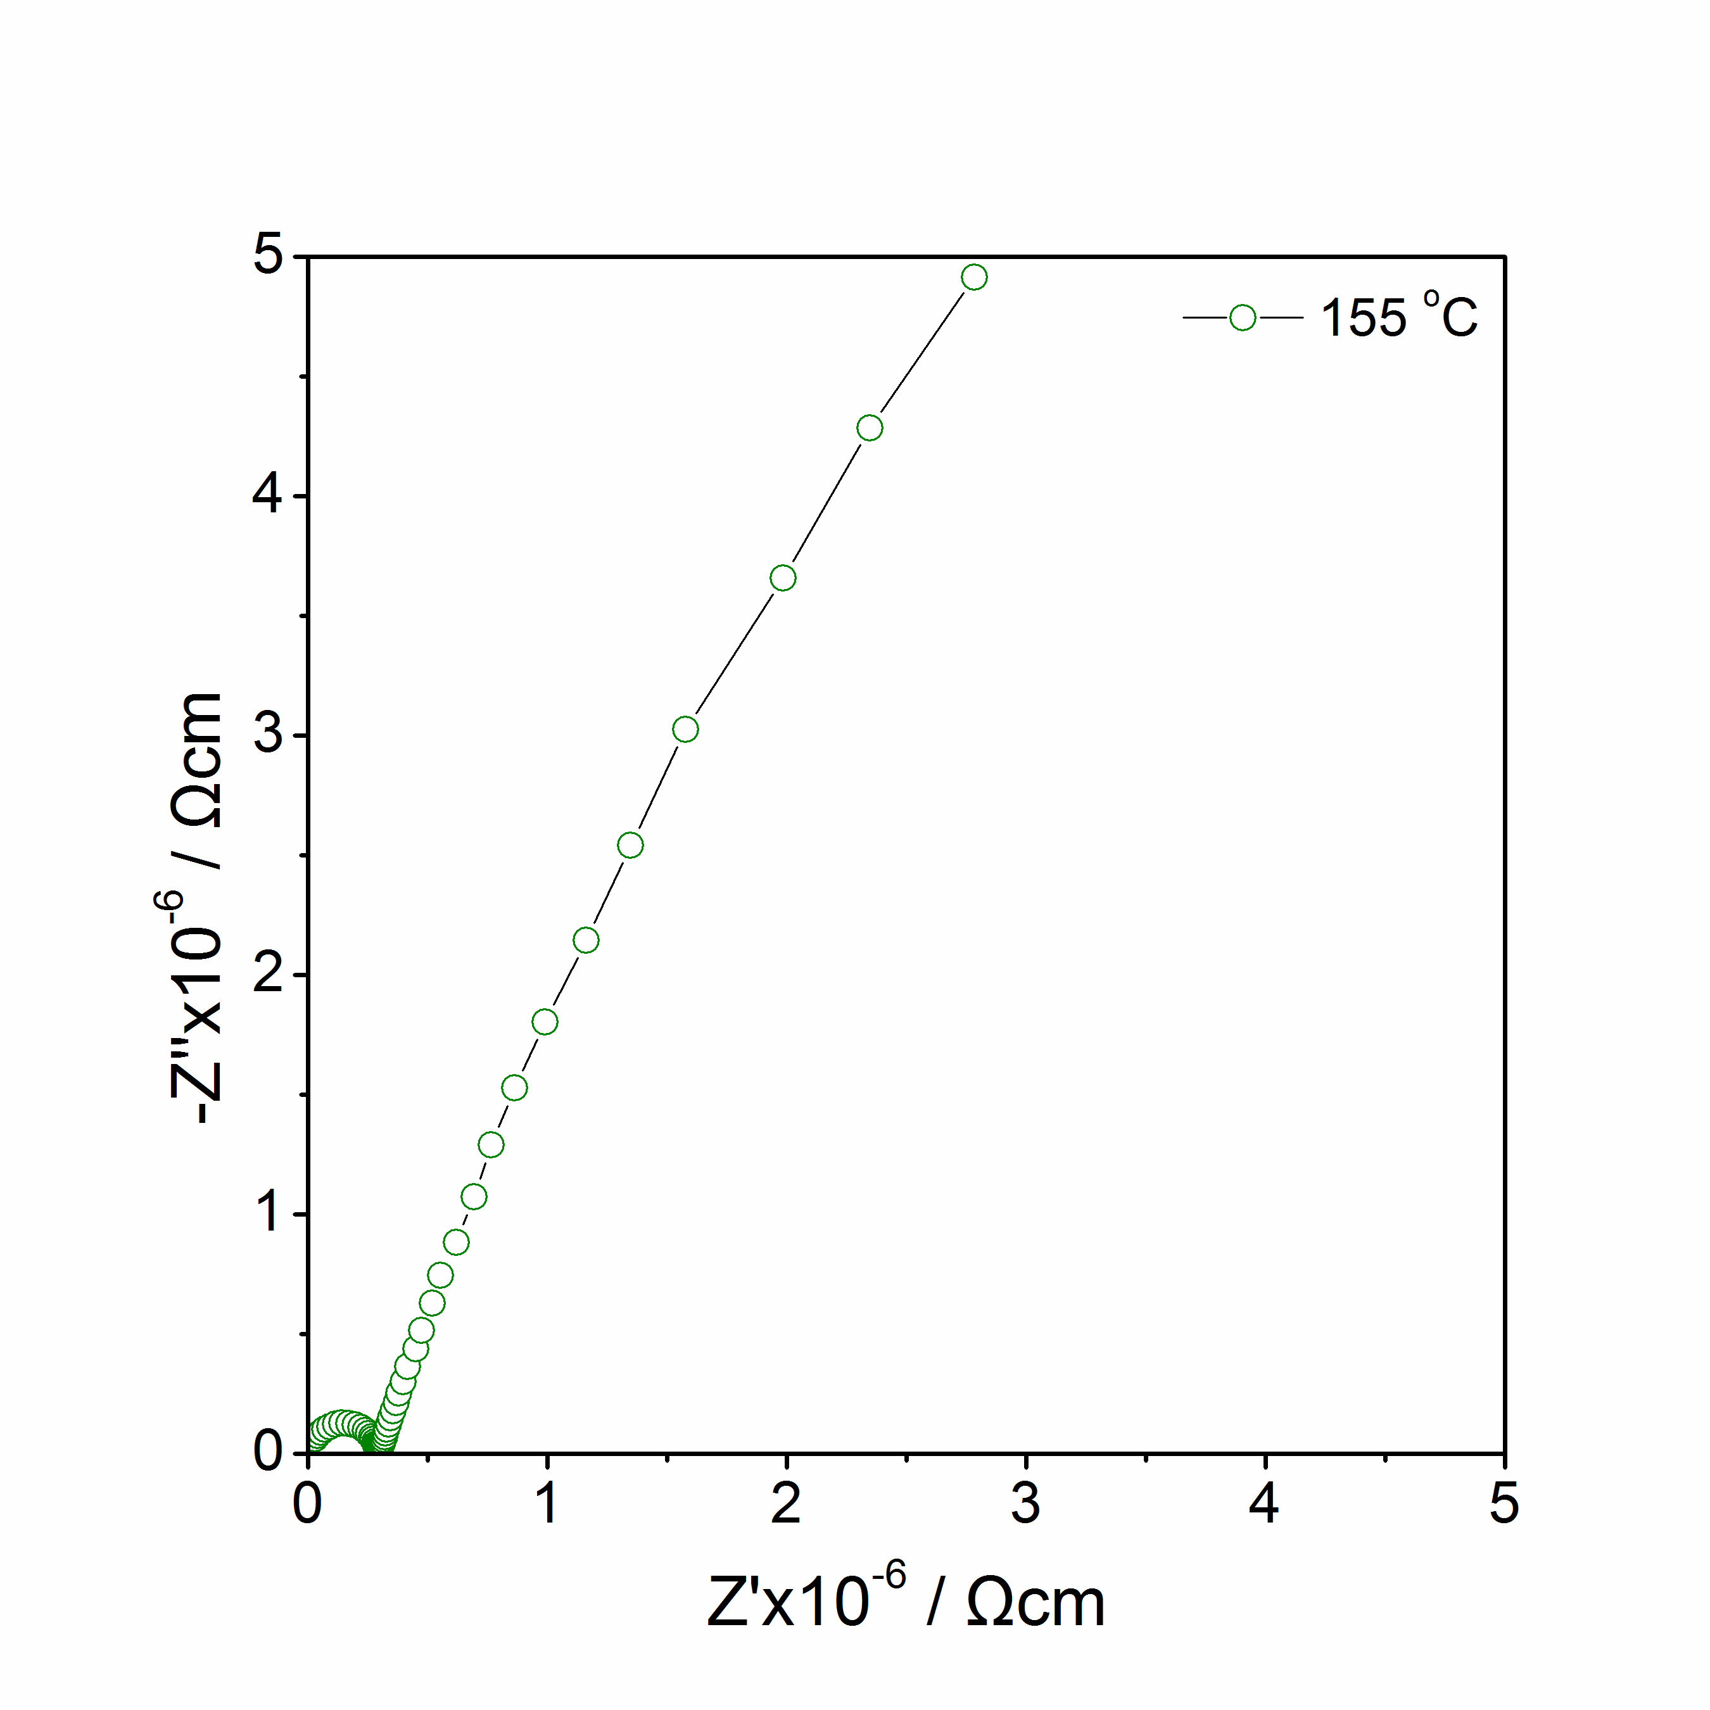
(c)
(d)

Figure 4.11 Li_{4.1}SiO₄F_{0.1}: Impedance complex plane plots Z* at 88 ºC to 155 ºC in Air.

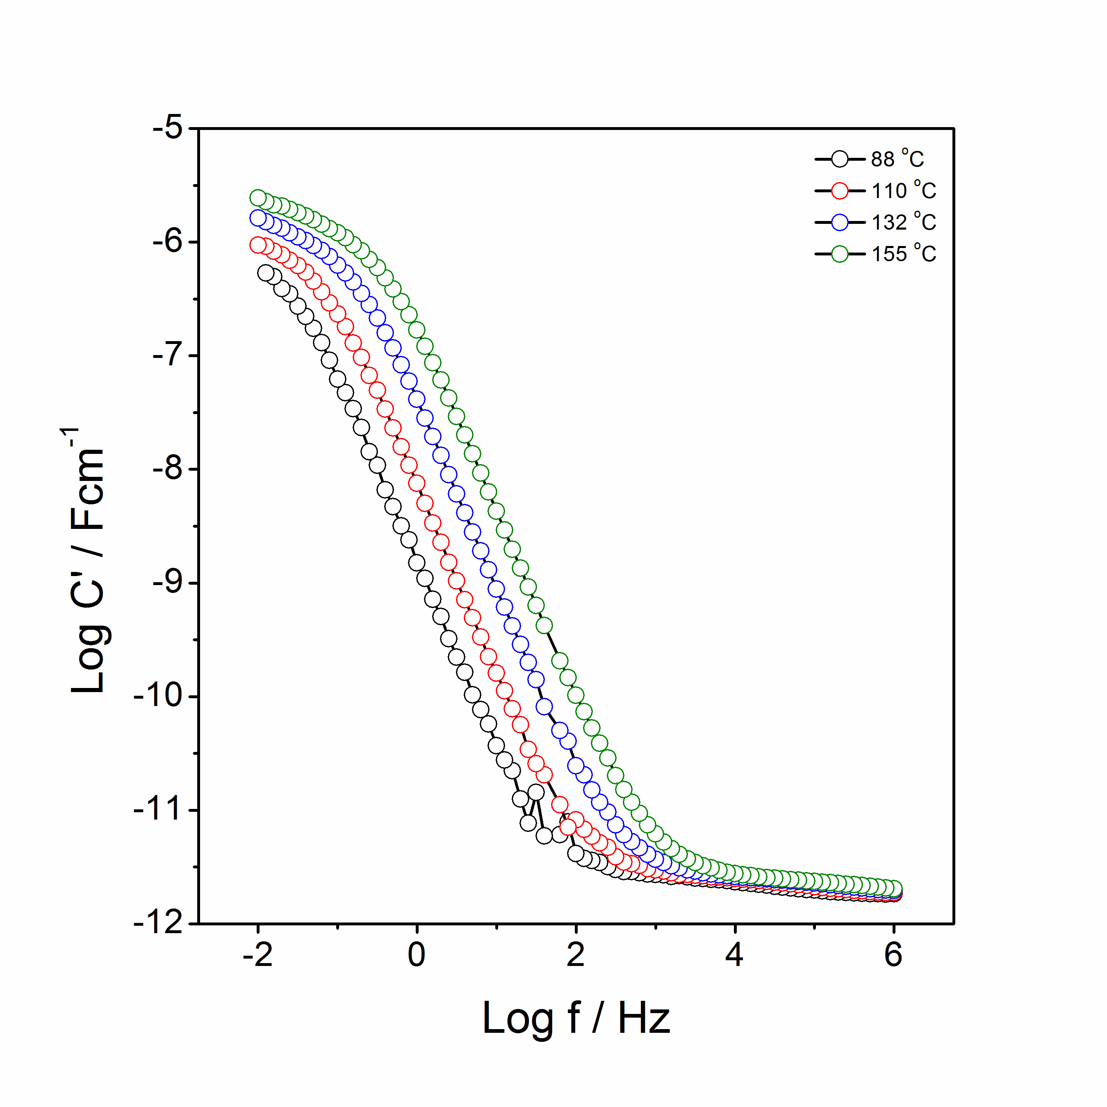
(a)
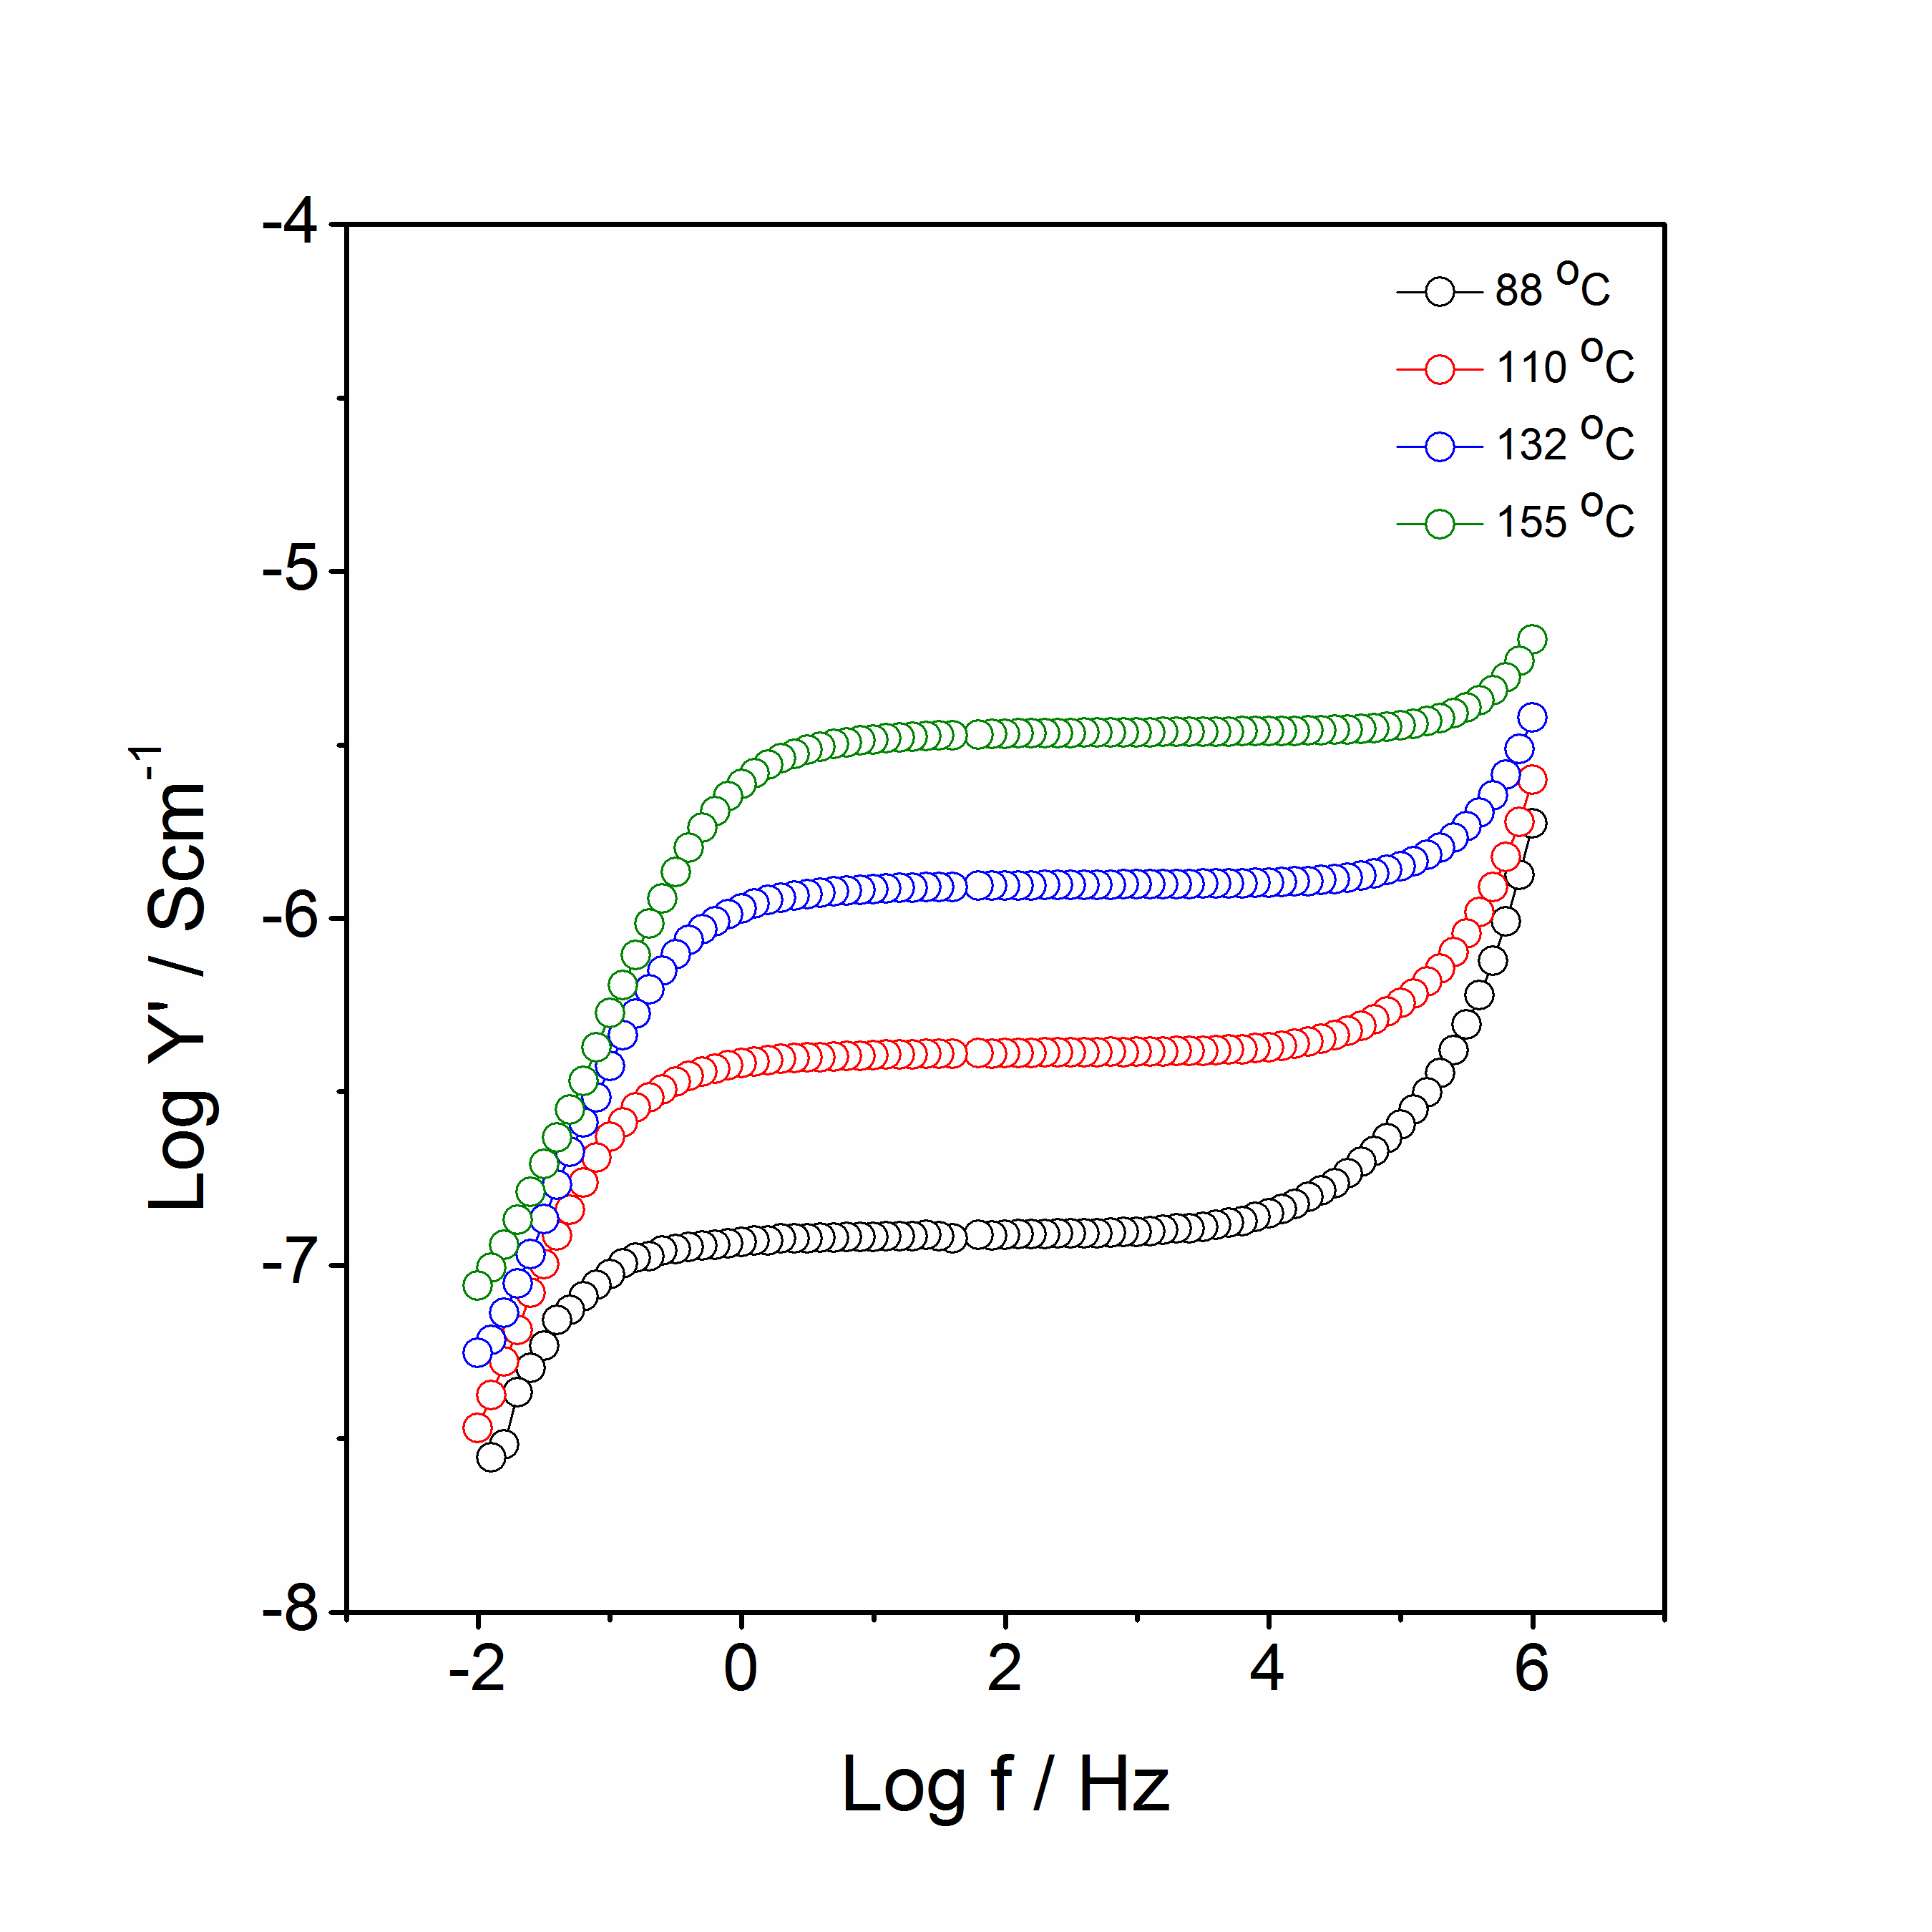
(b)
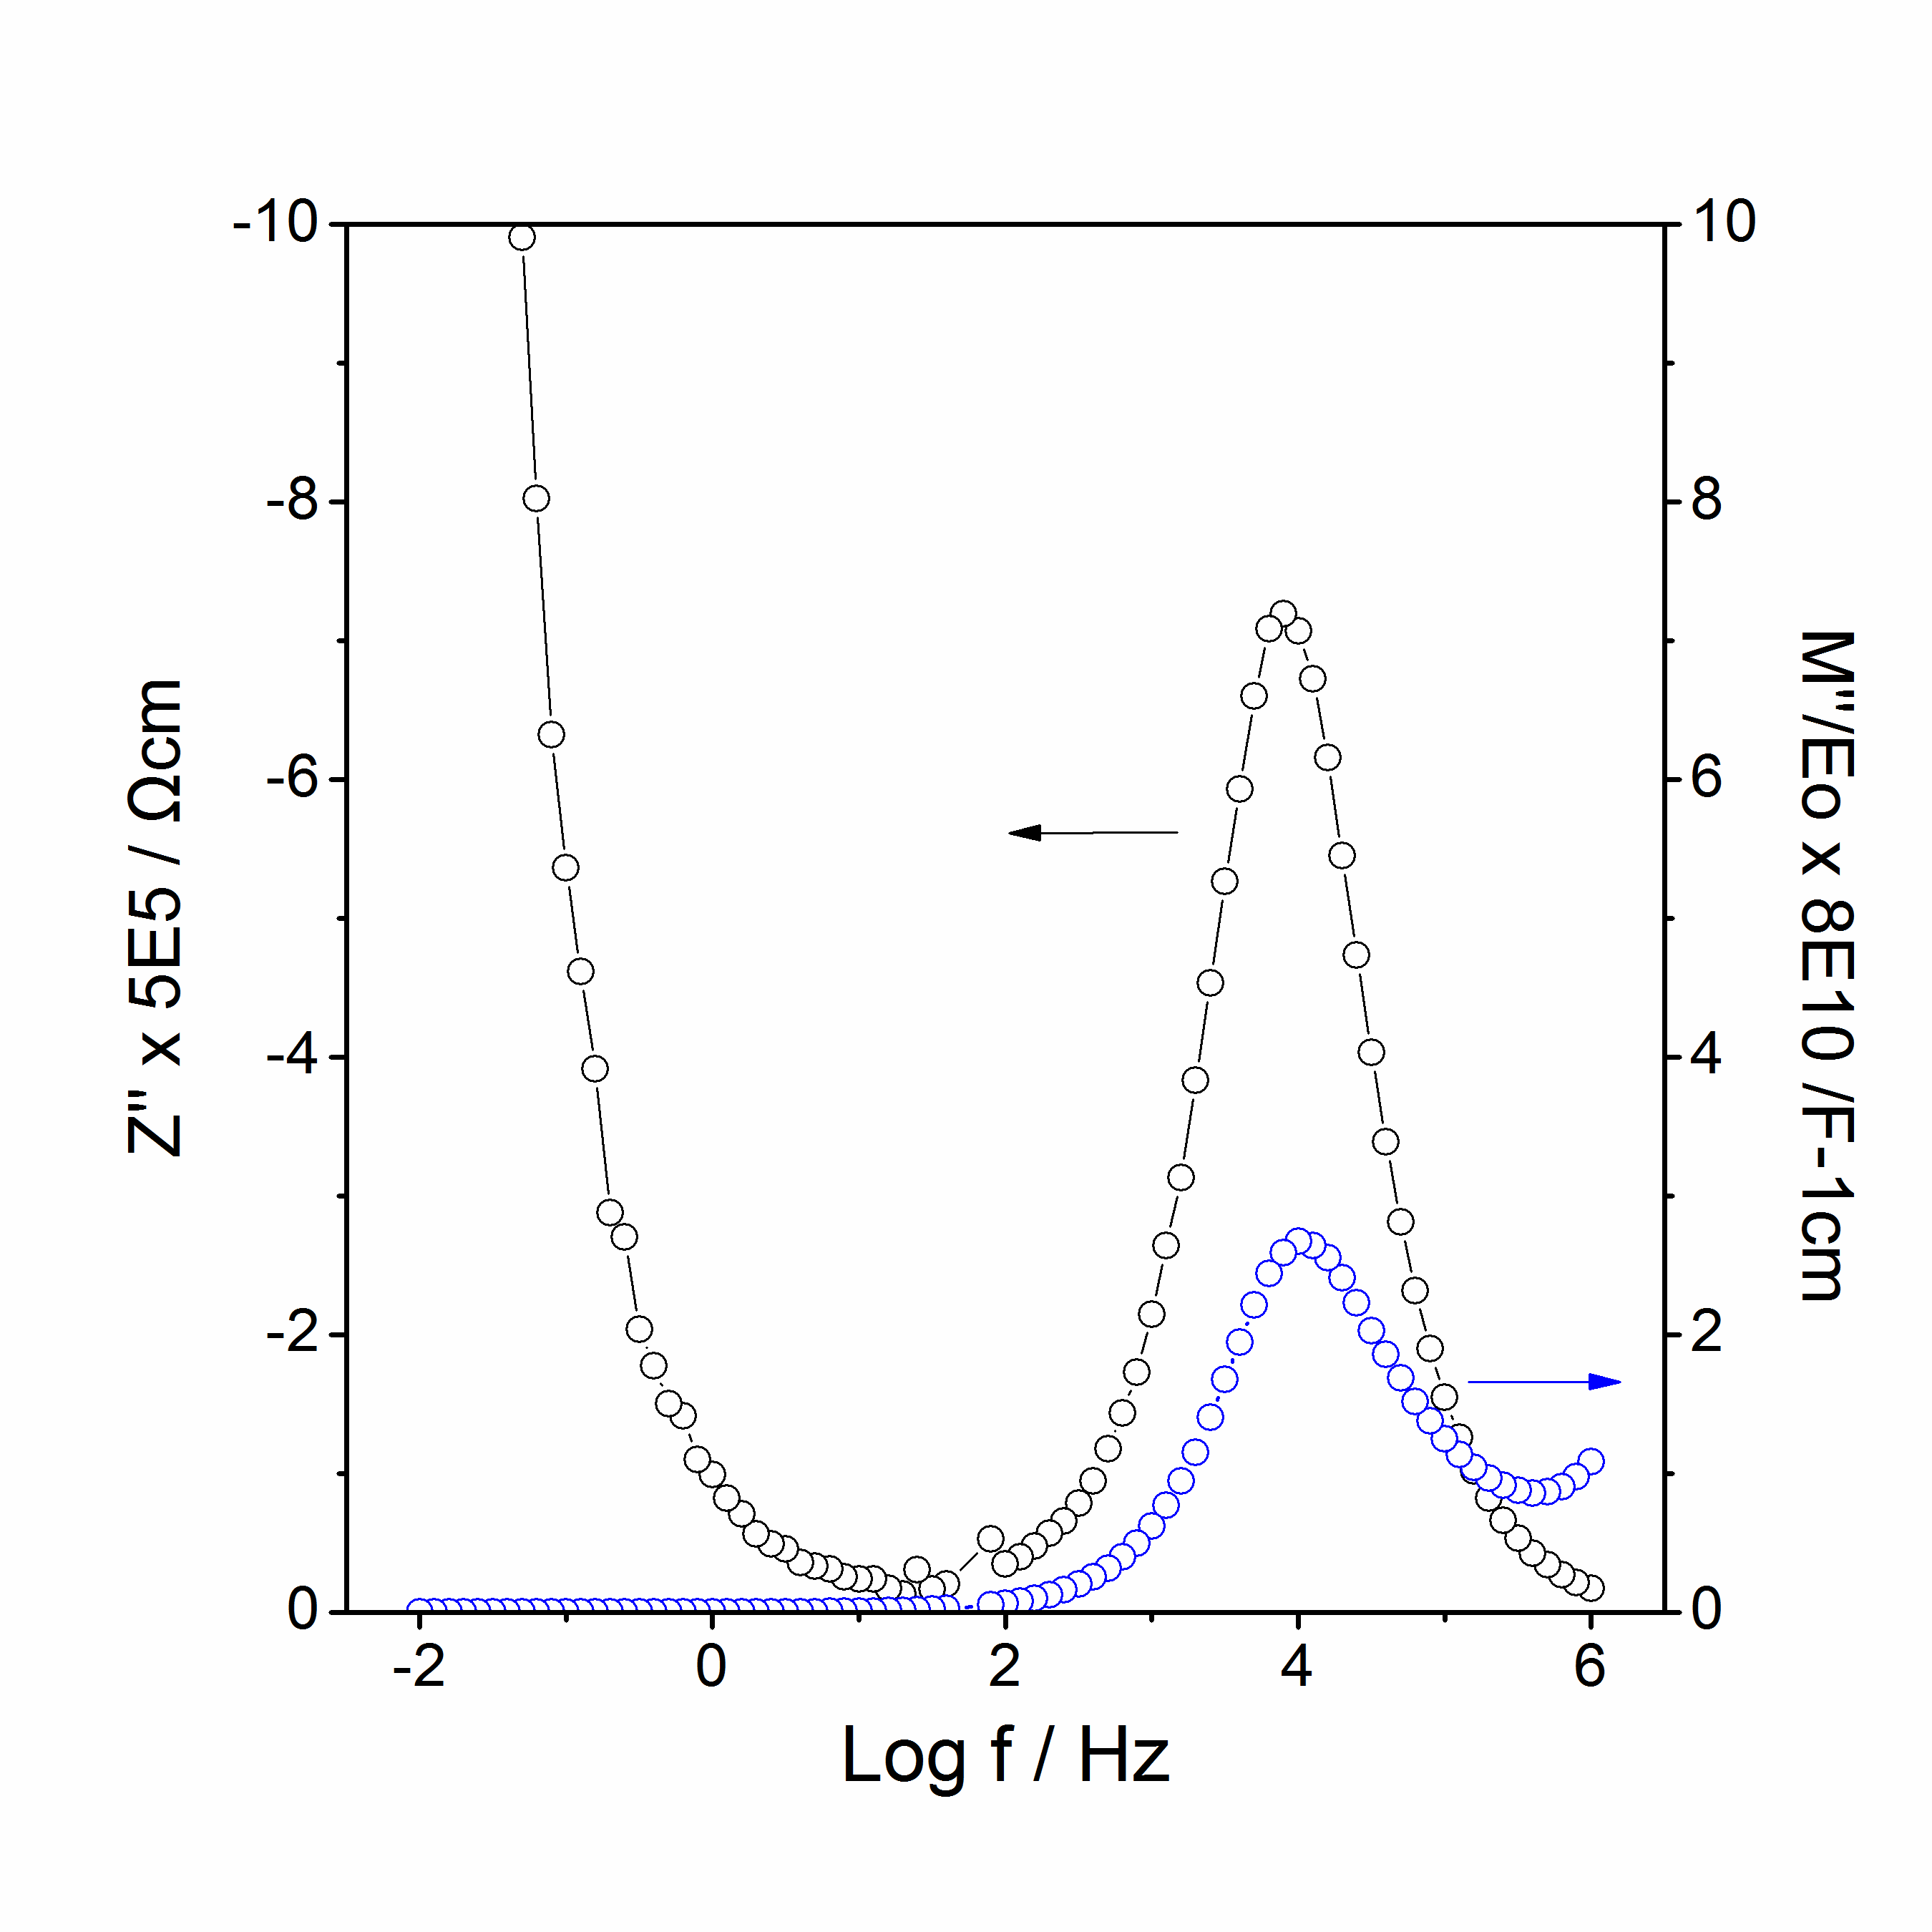
(c)
Figure 4.12 Li_{4.1}SiO₄F_{0.1}: spectroscopic plots of C’ (a), Y’ (b), –Z’’ and M’’ at 88 ºC (c).
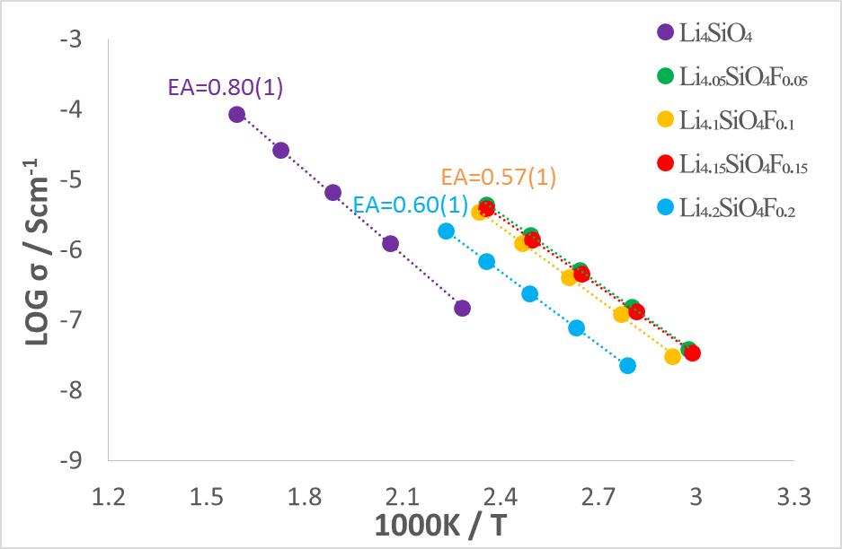
Figure 4.13 Arrhenius plots of Li_{4+x}SiO₄F_{x}: x= 0, 0.05, 0.1, 0.15, 0.2.

Figure 4.13 shows the Arrhenius plots of Li_{4+x}SiO₄F_{x} solid solutions. Conductivities of compositions at x = 0.05, 0.1, 0.15 increased by about 2 orders of magnitude compared with undoped Li₄SiO₄; however, conductivities of composition at x = 0.2 decreased by one order, which is similar to the dome-shaped composition-dependent effect in the literature [6]. The activation energy of F-doped samples decreased from 0.80 eV (Li₄SiO₄) to about 0.60 eV.

(ii) Li₅SiO₄F

Impedance complex plane, Z* plots of Li₅SiO₄F with gold electrodes at different temperatures in air are shown in figure 4.14. They consist of a high frequency arc that is broader than expected for a component represented by a single parallel RC element and a sharp low frequency spike that become more prominent with increasing temperature, illustrating blocking of the ionic species at the sample-electrode interface.

The C’ spectroscopic plots as a function of frequency for the same data are shown in figure 4.15. Three features can be seen: first, a high frequency plateau, C’͚, with capacitance 4·10⁻¹² Fcm⁻¹ is attributed to the bulk response of the sample. The high frequency permittivity ε͚’ of the sample can be calculated using ε͚’ = C’͚/e₀ where e₀ = 8.854 Fcm⁻¹ and ε͚’ = 45.2. Second, a partially-resolved intermediate frequency plateau, 8·10⁻¹² Fcm⁻¹, is seen, which may represent a grain boundary contribution to the impedance, although its value is much smaller than expected for a typical grain boundary whose capacitance, based on geometric consideration, is usually 1-2 orders of magnitude larger than the bulk capacitance. Third, a dispersion at lower frequencies leading to a plateau with a capacitance of ~ 6·10⁻⁶ Fcm⁻¹ is seen and is attributed to a sample - electrode interfacial capacitance.

The Y’ spectroscopic plots as a function of frequency for the same data are shown in figure 4.15. At 72 ºC, a dispersion at high frequency which is associated with power law and an almost frequency independent plateau at lower frequencies were noticed. At higher temperature, a curvature at lower frequency was found which reveals the ionic blocking phenomenon and double layer effect. When it increased to 143 ºC, the high frequency dispersion shifted toward high frequencies and approximately out of the frequency window.

Combined Z’’/M’’ spectroscopic plots show a coincidence of peak maxima of M’’ and Z’’ at higher frequencies, which implies the electrically homogeneity of the sample. A tail at lower frequencies with Z’’ plot may be associated with the sample – electrode effect.

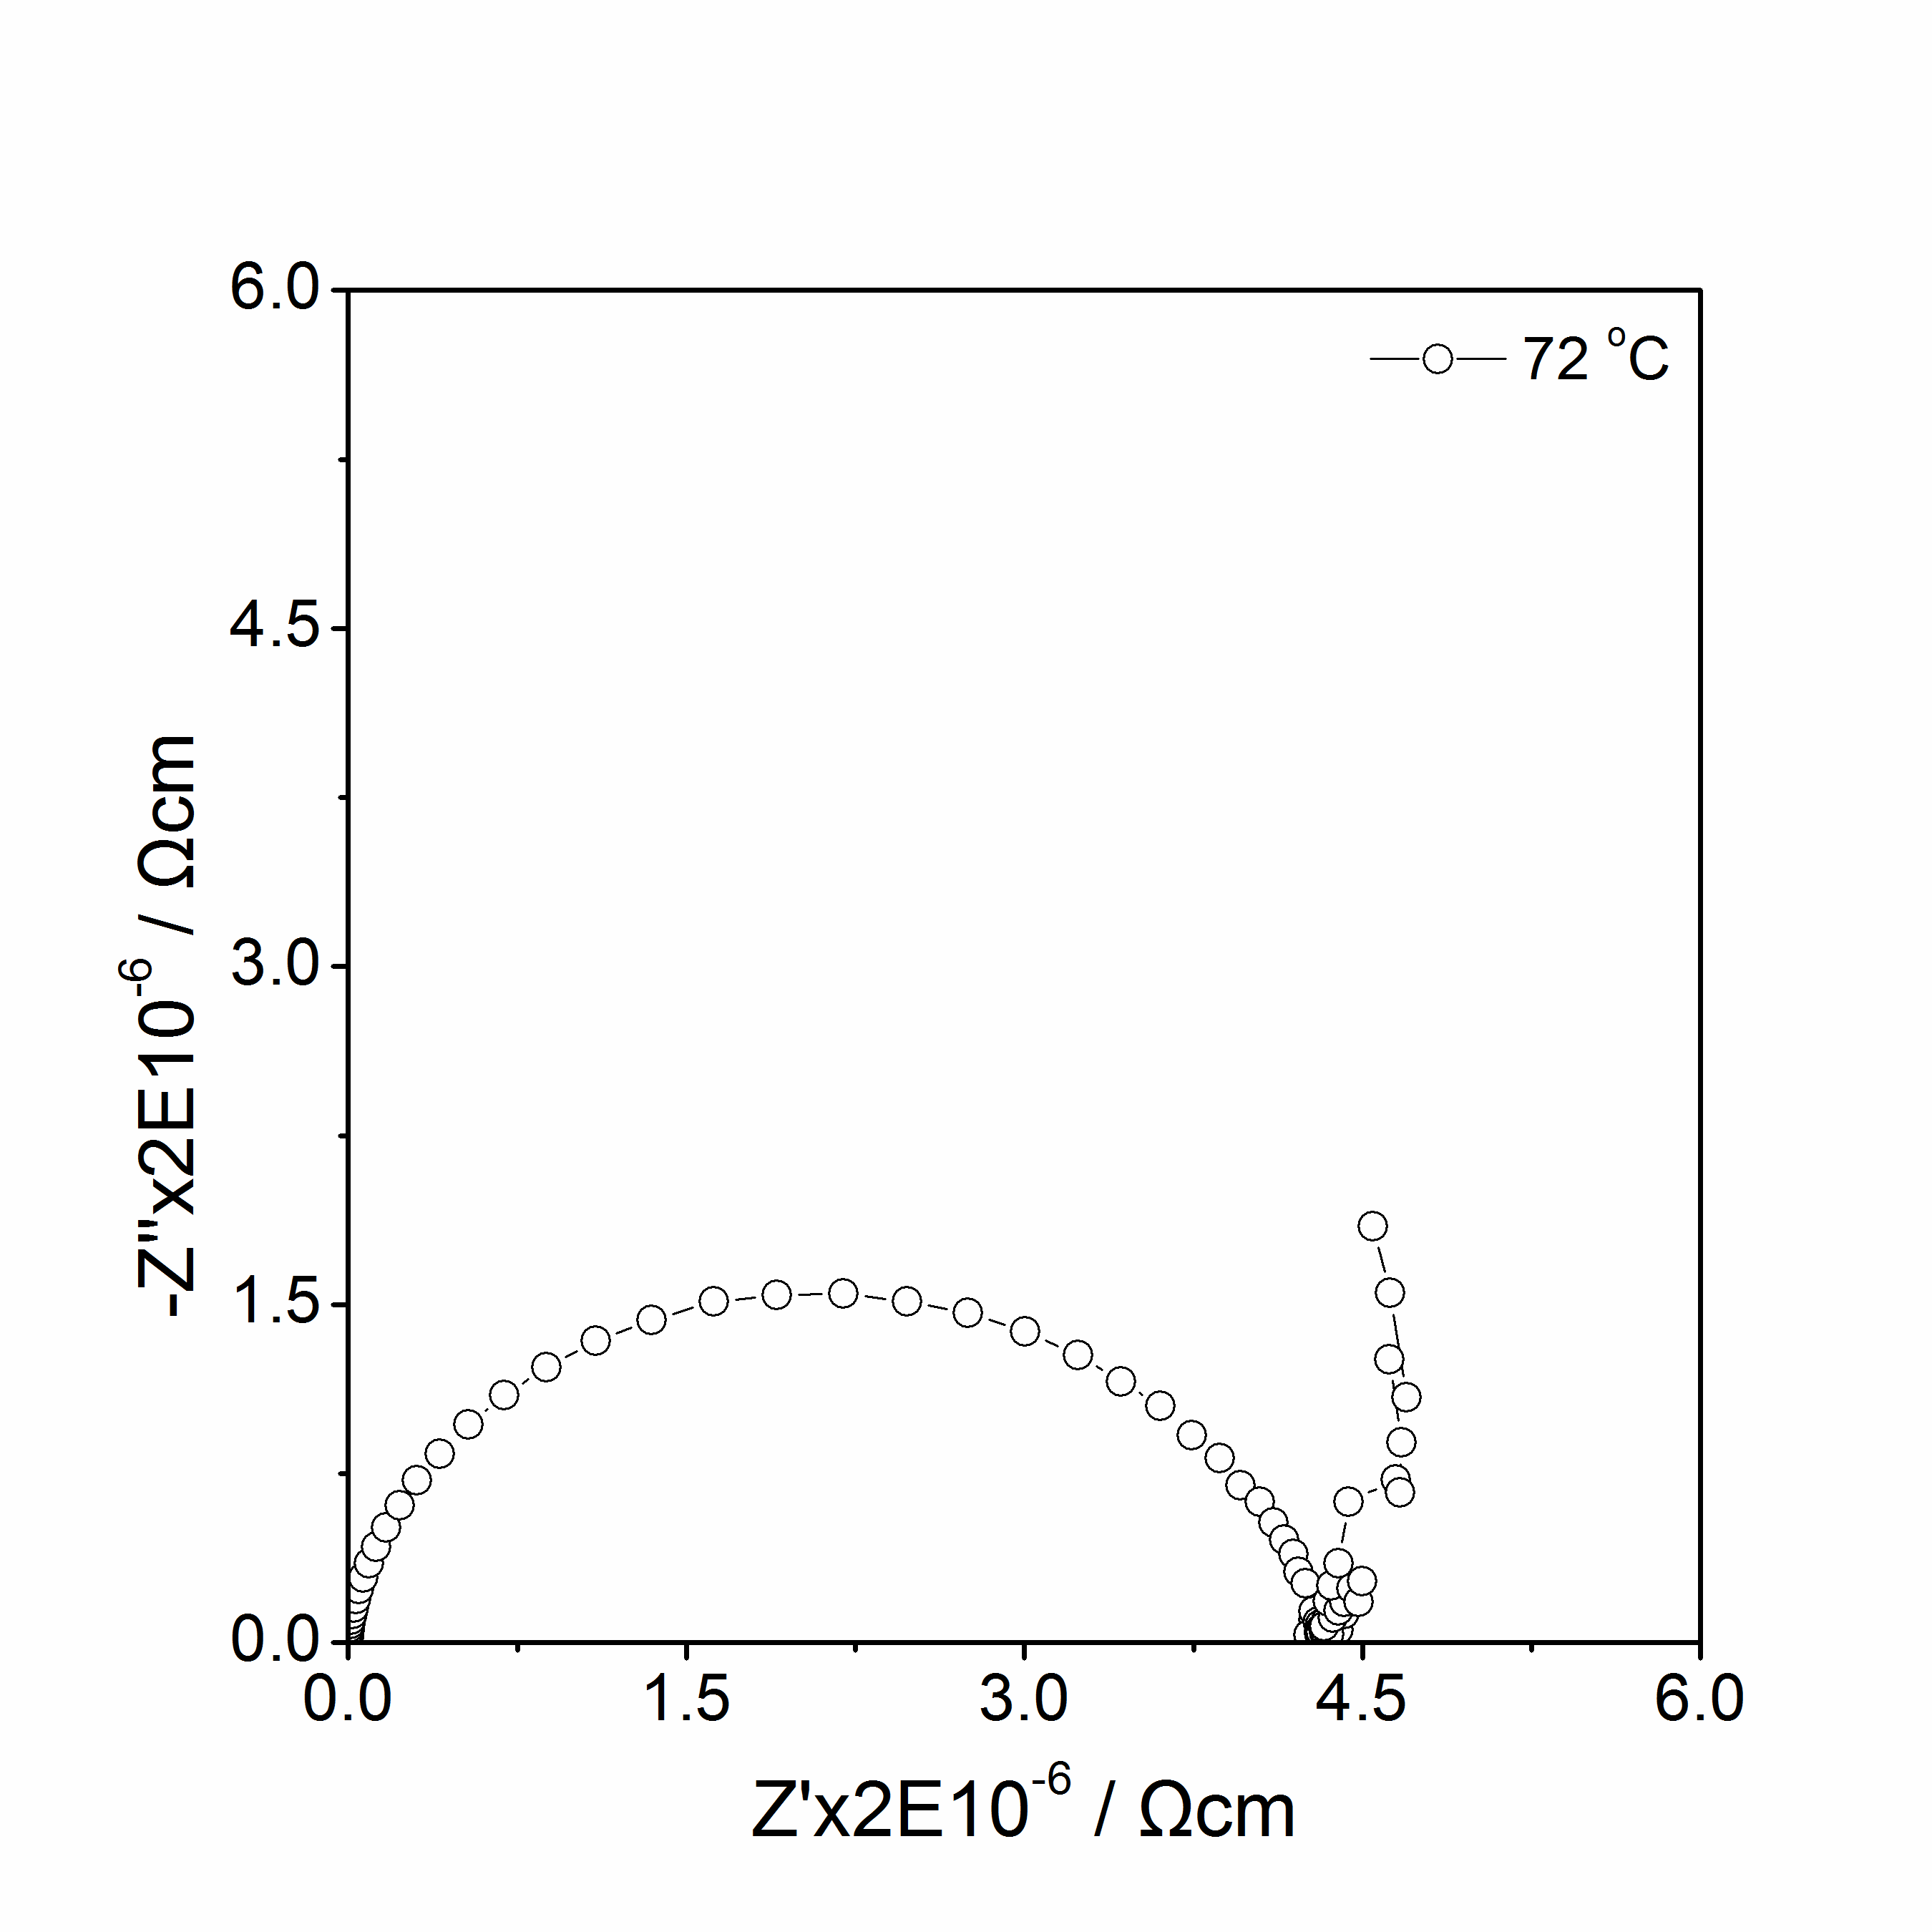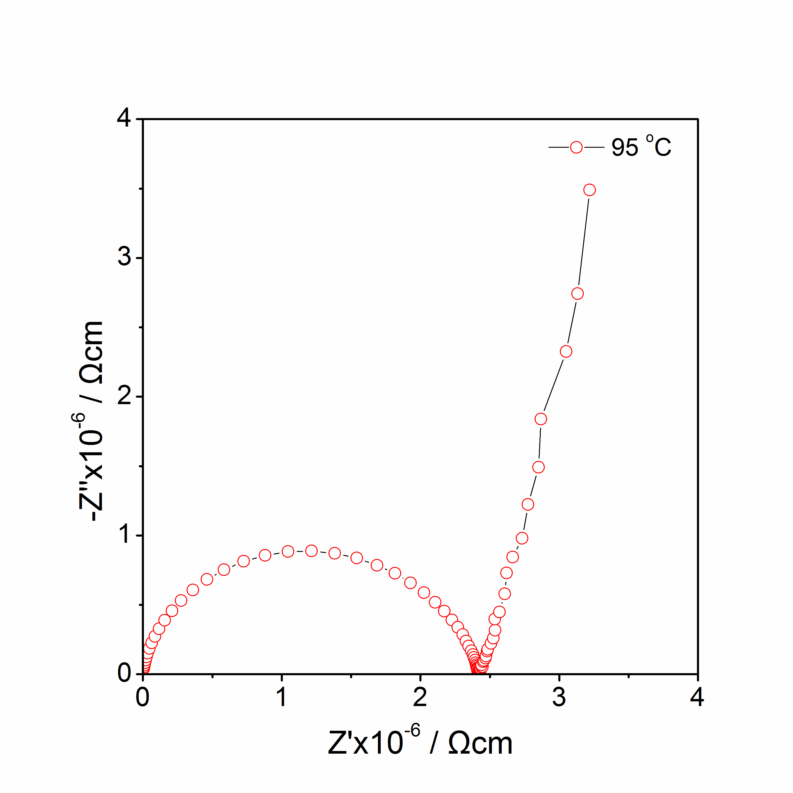
(a)
(b)
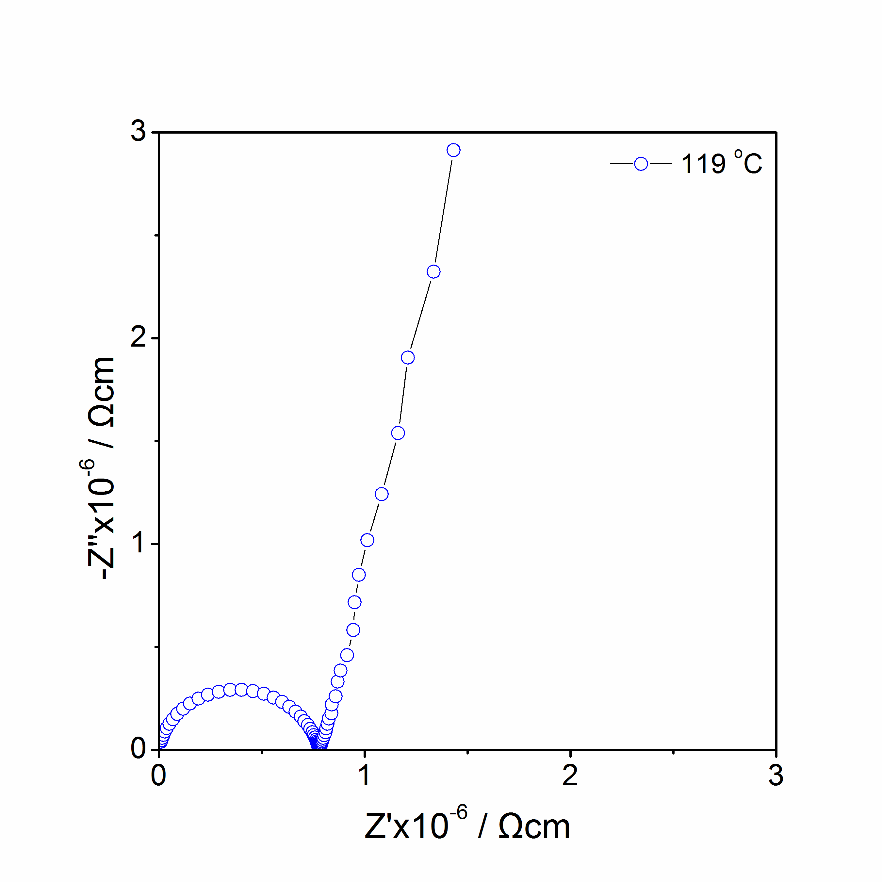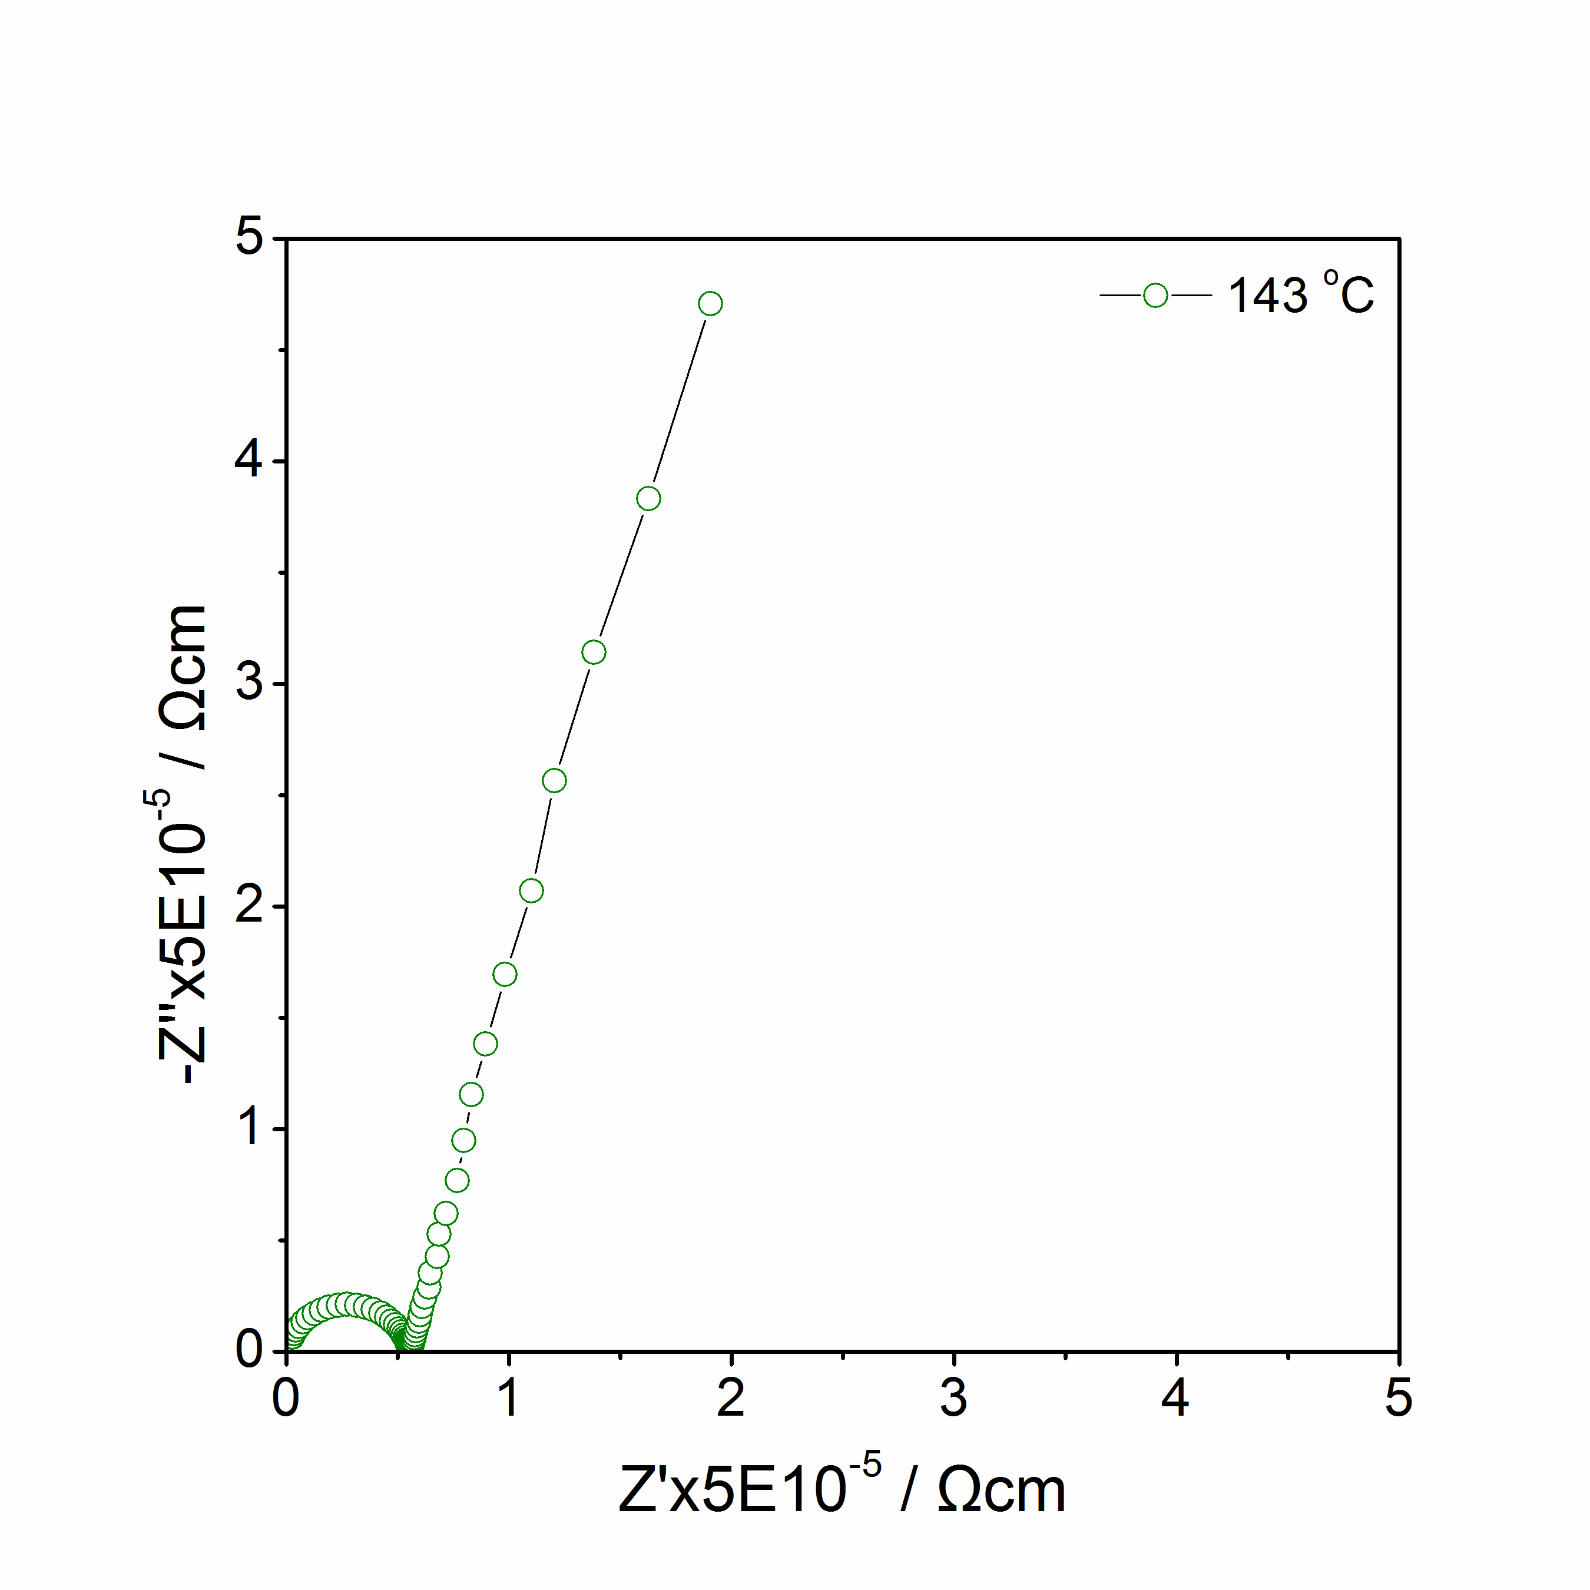
(c)
(d)
Figure 4.14 Li₅SiO₄F: Impedance complex plane plots Z* at 72 ºC to 143 ºC in Air.

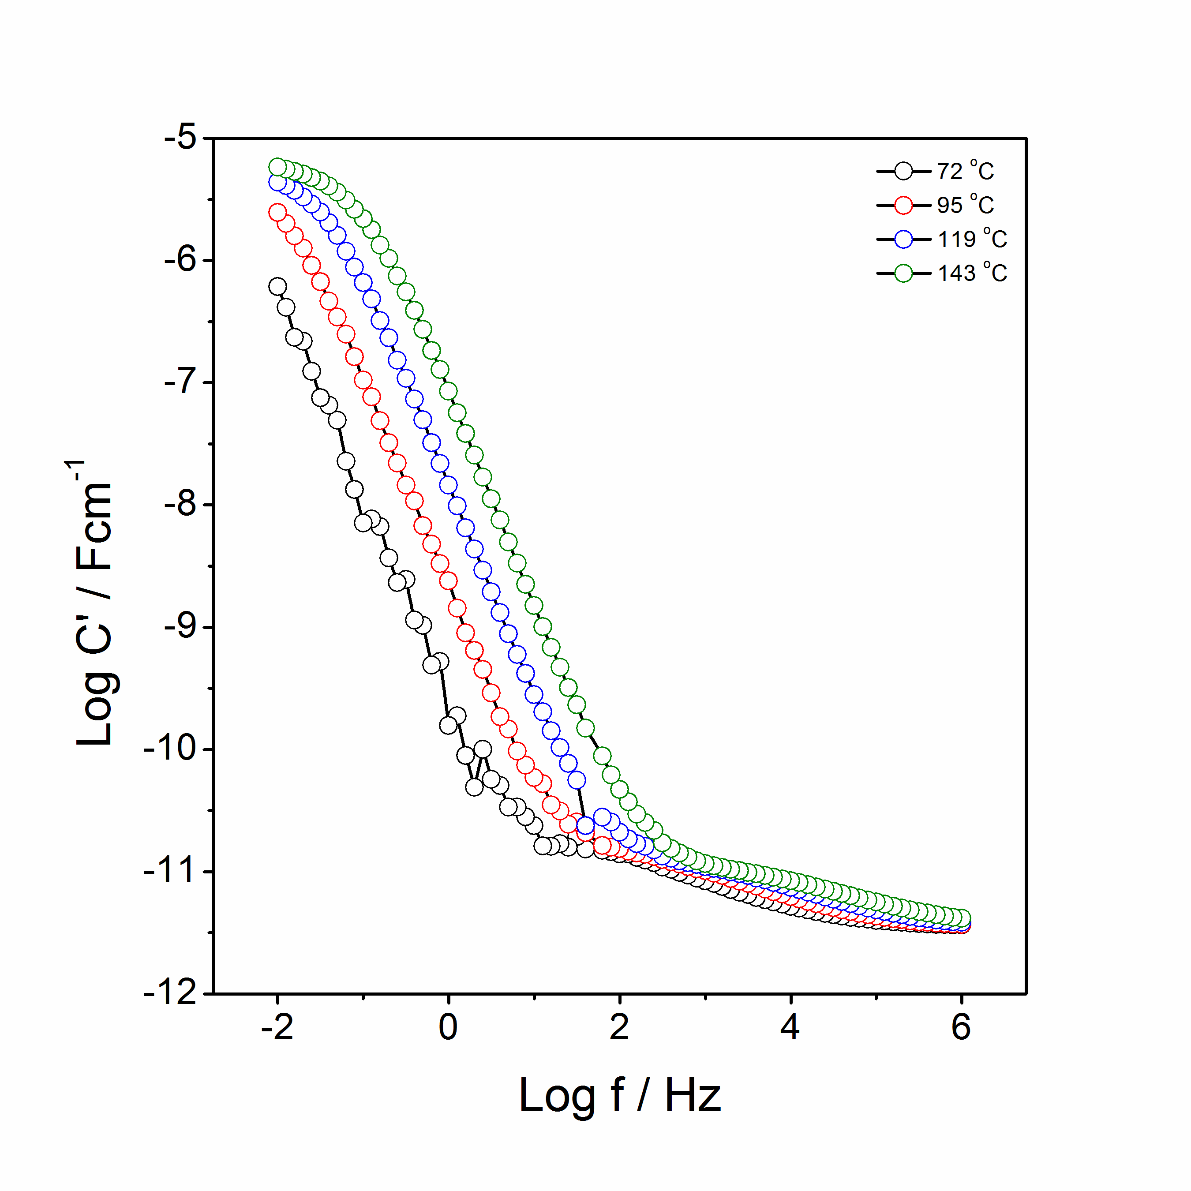
(a)
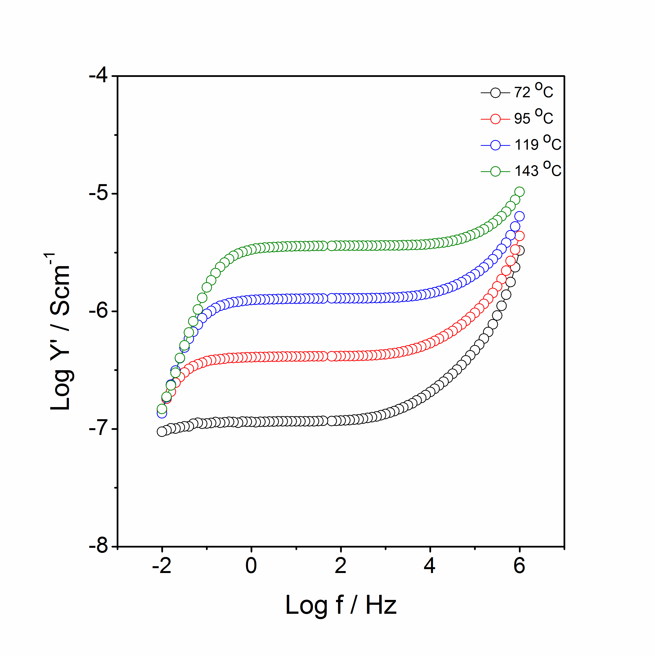
(b)
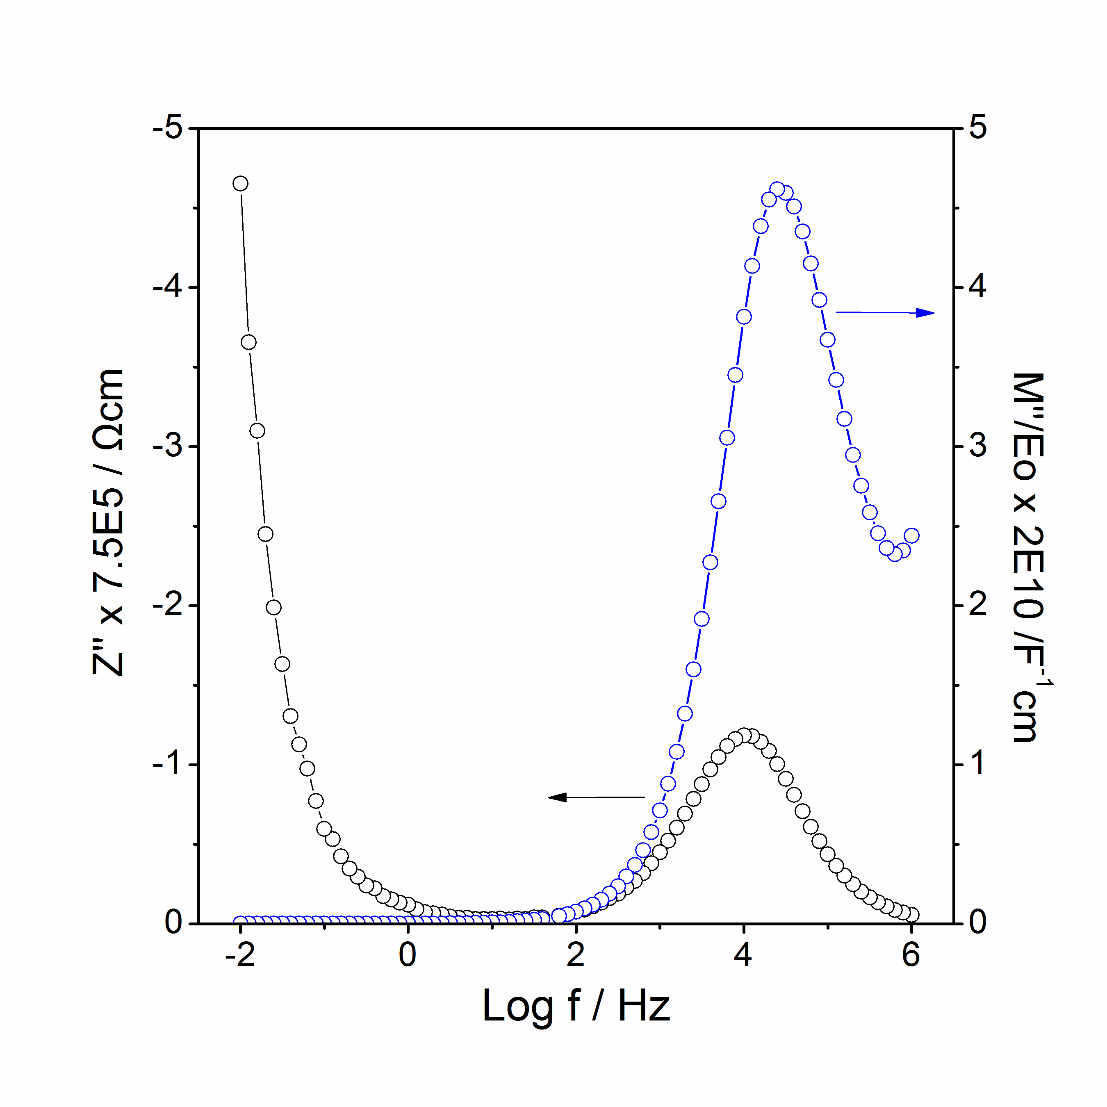
(c)
Figure 4.15 Li₅SiO₄F: spectroscopic plots of C’ (a), Y’ (b), –Z’’ and M’’ at 95 ºC (c).
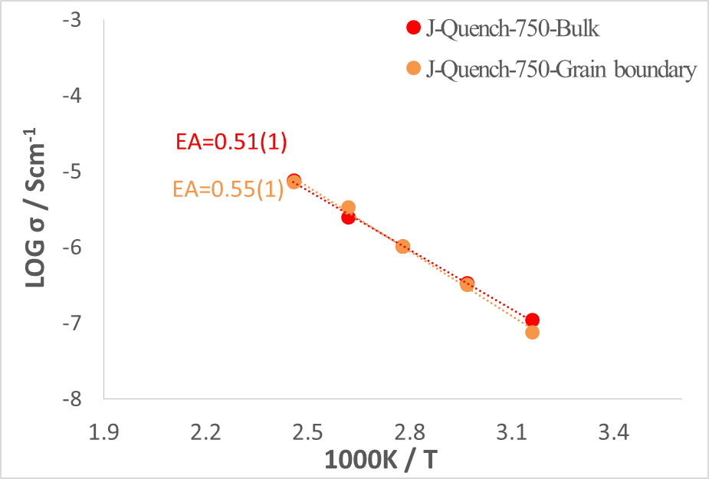
Figure 4.16 Arrhenius plot of bulk and grain boundary conductivities of Li₅SiO₄F.

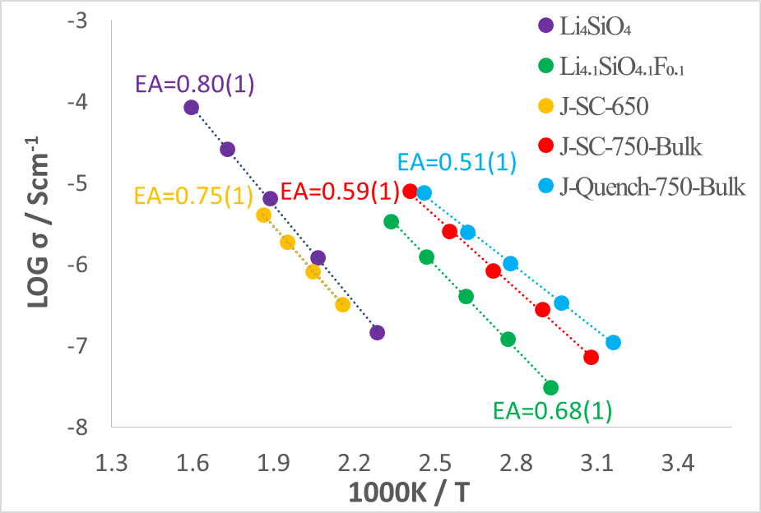
Figure 4.17 Arrhenius plot of Li₄SiO₄ and slow cooled as well as quenched Li₅SiO₄F.

Figure 4.16 illustrates Arrhenius plots of bulk and grain boundary conductivities of Li₅SiO₄F. Both conductivities and activation energy differs slightly between bulk and grain boundary of Li₅SiO₄F. Figure 4.17 shows Arrhenius plot of Li₄SiO₄ and slow cooled or quenched Li₅SiO₄F. Conductivities of Li₅SiO₄F at 650 ºC are similar to those of Li₄SiO₄; however, a huge increase in conductivity of Li₅SiO₄F was discovered when the sample was heated to 750 ºC. The activation energy of the bulk conductivity of Li₅SiO₄F is about 0.59 eV which is lower than that of Li₄SiO₄ (0.80 eV).

4.3.3 X-ray fluorescence (XRF)
The intensity as a function of energy is collected by XRF. The elements present in the sample are identified by locating the peak positions, and the net intensity of peak is converted into concentration by calibration of the standard reference material. Table 4.3 shows the XRF results of Li₅SiO₄F. The analysised concentrations (weight %) of Si, F and O are in good agreement with their theoretical concentrations (weight %) within errors. The errors of F (2%) and O (6%) are higher than for Si as XRF is less sensitive to light elements.

Table 4.3 X-ray fluorescence results of phase J at 775 ºC.
Element | Calibration status | Measured (kcps) |  | Used (kcps) | Calculated  Concentration(w%) | Theoretical concentration(w%)
Si | Calibrated | 3.728 |  | 3.812 | 18.75 (0.8)% | 19%
F | Calibrated | 0.014 |  | 0.013 | 11.09 (2)% | 13%
O | Calibrated | 0.023 |  | 0.022 | 44.55 (6)% | 43.90%

4.3.4 Stability with Li metal
Although no significant current was observed during the 40 mins CV test, the colour of Li₅SiO₄F still retained white and the XRD pattern of Li₅SiO₄F did not change after the CV test, which is a good indication that Li₅SiO₄F is stable in contact with Li metal.

4.4 Conclusions
Appropriate reaction conditions to avoid loss of fluoride on heating mixtures of Li₂CO₃, LiF and SiO₂ have been determined. In the phase diagram Li₂O-LiF-SiO₂, the tie-line Li₂SiO₃-LiF separates those compositions that contain more SiO₂, and do lose fluoride on heating in air at e.g. 800ºC, from those that are stable under similar reaction conditions.

On the join Li₄SiO₄-LiF, a new phase, Li₅SiO₅F, stable to ~ 800 º C has been prepared; XRF analysis confirmed its composition and showed that F loss did not occur during synthesis. Li₅SiO₅F is monoclinic, a = 7.900(11) (Å), b = 13.506(12) (Å), c = 13.041(15) (Å), β = 97.39(6) (º) and V = 1379.8(42) (Å³).

Impedance measurements on sintered pellets of Li₅SiO₅F showed bulk and grain boundary arcs in impedance complex plane plots with a sharp, low frequency spike characteristic of ion blocking at the sample – electrode interface and therefore, Li⁺ ion conduction. The conductivity of Li₅SiO₅F at 50 ºC, ~ 1x10⁻⁷ S cm⁻¹, is several orders of magnitude higher than that of undoped Li₄SiO₄ and has a small activation energy, 0.51(1) eV. The crystal structure of Li₅SiO₅F is not known, but from its powder XRD pattern, it is clearly different from that of Li₄SiO₄. It therefore represents an entirely new Li⁺ ion conductor, which is stable in contact with Li metal and may find possible application in thin film solid state battery development.

4.5 References
1. West, A.R., Ionic conductivity of oxides based on Li₄SiO₄, Journal of Applied Electrochemistry, 1973: 3, 327.
2. Tranqui, D., Shannon, R.D., Chen, H.Y., Crystal structure of ordered Li₄SiO₄, Acta Crystallographica, 1979: B35, 2479.
3. Robertson, A.D., West, A.R., Ritchie, A.G., Document Review of crystalline lithium-ion conductors suitable for high temperature battery applications, Solid State Ionics, 1997: 104, 1.
4. Hu, Y.W., Raistrick, I.D., Huggins, R.A., Ionic conductivity of lithium phosphate-doped lithium orthosilicate, Materials Research Bulletin, 1976, 11, 1227.
5. Garcia, A., Torres-Trevino, G., West, A.R., New lithium ion conductors based on the γ-LiAlO₂ structure, Solid State Ionics, 1990: 40-41, 13.
6. Quintana, P., Velasco, F., West A.R., Lithium ion conducting solid solutions in the system Li₂OGa₂O₃SiO₂, Solid State Ionics, 1989: 34, 149.
7. Deng, Y., Eames, C., Chotard, J., Lalere, F., Seznec, V., Emge, S., Pecher, O., Grey, C.P., Masquelier, C., Islam, M.S., Structural and Mechanistic Insights into Fast Lithium-Ion Conduction in Li₄SiO₄–Li₃PO₄ Solid Electrolytes, Journal of the American Chemical Society, 2015: 137, 9136.
8. Available from http://www.panalytical.com.

Chapter 5 Synthesis and characterisation of lithium manganese (zinc) silicate

5.1 Introduction
Li₂MnSiO₄ attracts great interest as the next generation cathode materials for LIBs because of its high theoretical capacity (333 mAh/g) which involves a two electron transfer process [1]. Because of the high freedom of arrangement of Li, Mn and Si, Li₂MnSiO₄ shows a variety of polymorphs, such as β-form Pmn2₁, Pmnb and γ-form P2₁/n, Pn (isostructural to β or γ Li₃PO₄, see chapter 1, table 1.3 for more details). A phase transition of Li₂MnSiO₄ from β to γ occurs at ~ 750 ºC [2]. The electrochemical property of Pmn2₁ Li₂MnSiO₄/C composites is much better than the P2₁/n phase (figure 5.1) because of the differences in activation energies and hopping distances [3], which is consistent with theoretical calculations [4,5].

Figure 5.1 Electrochemical properties between Pmn2₁ and P2₁/n (Figure 5(c)(d) in the paper) [3].

Both experimental and theoretical work mainly focus on the chemical and physical properties of different polymorphs of Li₂MnSiO₄. However, the related non-stoichiometric compositions of Li₂MnSiO₄ are rarely studied. The objective of this chapter is to study the Li₄SiO₄ –Li₂MnSiO₄ and Li₄SiO₄ –Li₂ZnSiO₄ binary phase diagrams and in particular characterise any solid solutions and new phases, which could be beneficial for Li ion conduction.

5.2 Experimental
For Li_{2+2x}Zn_{1-x}SiO₄, lithium carbonate, silica and zinc oxide were chosen as starting materials and dried at 180 °C, 180 °C and 600 °C respectively. The powders were ground with a mortar and pestle and placed in gold or platinum boats. The mixtures were heated to 650 ºC to decompose the lithium carbonate and to 850 ºC to 1150 ºC to promote reaction. Li_{2+2x}Zn_{1-x}SiO₄: x = 0, 0.2, 0.4, 0.5, 0.6 were prepared and studied. A two-step synthesis route was also used, which synthesised Li₄SiO₄ and Zn₂SiO₄ first, followed by reaction of these precursors at 1100 ºC.

For Li_{2+2x}Mn_{1-x}SiO₄, manganese(Ⅱ) acetate tetrahydrate, lithium carbonate and silica were used as reagents. A H₂/N₂ atmosphere was used to prevent oxidation of Mn²⁺. A tube furnace was used and flushed with H₂/N₂ for 30 minutes before any heating. The mixtures of reagents were heated slowly to 400 ºC to decompose the acetate hydrate and 800 ºC for the final reaction. Similar to Zn materials, Li_{2+2x}Mn_{1-x}SiO₄: x = -0.2, -0.1, 0, 0.1, 0.2, 0.3, 0.4, 0.5, 0.6, 0.7, 0.8, 0.9, 1 were studied. Li₄SiO₄ and Mn₂SiO₄ were synthesised and reacted to make the final product.

A Bruker D2 X-ray diffractometer with Cu Kα radiation (λ_{avg} = 1.5418 Å) was used for phase analysis. A STADI P X-ray diffractometer with Cu Kα₁ (λ=1.5406 Å) or Mo Kα₁ (λ= 0.70926 Å) linear position sensitive detector (PSD) was used to collect powder X-ray diffraction data for indexing and lattice parameter calculation.

Pellets of Li_{2+2x}Zn_{1-x}SiO₄ were heated at 900 ºC to 1100 °C for 4h in air while pellets of Li_{2+2x}Mn_{1-x}SiO₄ were heated at 800 ºC to 1000 ºC for 4h in H₂/N₂. Au paste electrode was printed on Li_{2+2x}Zn_{1-x}SiO₄ pellets and dried at 800 °C for 2 h while Au was sputtered onto Li_{2+2x}Mn_{1-x}SiO₄ pellets. Impedance data were collected using a Solartron with 100 mV of ac in the sweep frequency from 10⁻² to 10⁶ Hz.

5.3 Results and Discussion

5.3.1 Li_{2+2x}Mn_{1-x}SiO₄

5.3.1.1 Binary phase diagram of Li₄SiO₄ –Li₂MnSiO₄ system
Selected compositions were studied in this binary system as shown in figure 5.2. Table 5.1 and 5.2 show the XRD results of slow cooled or quenched compositions respectively. Figure 5.3 shows the partial phase diagram of Li₄SiO₄–Li₂MnSiO₄. XRD Patterns of Li_{2+2x}Mn_{1-x}SiO₄: x from -0.2 to 1, slow cooled from 800 ºC are shown in figure 5.4. From the literature, Li₄SiO₄ experiences a phase transition with a long transition range from 600 ºC to 725 ºC. The high temperature phase structure is still unknown, but its XRD pattern is similar to the low temperature phase and their structures may be closely related [6].

Solid solutions of formula Li_{2+2x}Mn_{1-x}SiO₄: 0 ≤ x ≤ 0.1 (compositions 1 and 2, Li₂MnSiO₄ and Li_{2.2}Mn_{0.9}SiO₄) were found to be single Pnmb β phase. At x = 0.5 (composition 6), a new phase with formula, Li₃Mn_{0.5}SiO₄, was found and indexed with an orthorombic unit cell, a = 10.722(3) (Å), b = 6.239(2) (Å), c = 5.052(3) (Å), V = 337.97(11) (Å³), shown in table 5.3. A phase mixture of Li₃Mn_{0.5}SiO₄ and β-Li₂MnSiO₄ were detected at 0.5 < x < 0.1 (composition 3, 4 and 5, Li_{2.4}Mn_{0.8}SiO₄, Li_{2.6}Mn_{0.7}SiO₄ and Li_{2.8}Mn_{0.6}SiO₄). When x at 0.7, 0.8 and 0.9, XRD patterns (compositions 8, 9 and 10, Li_{3.4}Mn_{0.3}SiO₄, Li_{3.6}Mn_{0.2}SiO₄ and Li_{3.8}Mn_{0.1}SiO₄) showed a single phase of ordered Li₄SiO₄ with super-lattice peaks. The ordered phase at x = 0.75 (Li_{3.5}Mn_{0.25}SiO₄) was indexed with a monoclinic unit cell, a = 6.430(4) (Å), b = 11.088(7) (Å), c = 8.232(4) (Å), β = 108.39(5), V = 557.0(4) (Å³), table 5.4, which is approximately half of those of disordered Li₄SiO₄ where a = 11.546(3) (Å), b = 6.090(2) (Å), c = 16.645(3) (Å), β = 99.5 (1), V = 1154.34 (Å³). A phase mixture of ordered Li₄SiO₄ and Li₃Mn_{0.5}SiO₄ was found at x = 0.6 (composition 7, Li_{3.2}Mn_{0.4}SiO₄).

XRD patterns of Li_{2+2x}Mn_{1-x}SiO₄: x from -0.1 to 1, quenched from 1000 ºC are shown in figure 5.5. After quenching from 1000 ºC, the XRD pattern of composition 1 (x = 0, Li₂MnSiO₄) changed from Pnma β phase to P2₁/n γ phase and composition 6 (x = 0.5, Li₃Mn_{0.5}SiO₄) remained the same as slow cooled sample. The XRD patterns of compositions 2 to 5 (x = 0.1, 0.2, 0.3 and 0.4, Li_{2.2}Mn_{0.9}SiO₄, Li_{2.2}Mn_{0.9}SiO₄, Li_{2.2}Mn_{0.9}SiO₄ and Li_{2.2}Mn_{0.9}SiO₄) show a mixture of γ Li₂MnSiO₄ and Li₃MnSiO₄. When x is more than 0.5, the XRD patterns of compositions 8, 9 and 10 (x = 0.7, 0.8 and 0.9, Li_{3.4}Mn_{0.3}SiO₄, Li_{3.6}Mn_{0.2}SiO₄ and Li_{3.8}Mn_{0.1}SiO₄) show an order-disorder transition and composition 7 (x = 0.6, Li_{3.2}Mn_{0.4}SiO₄) shows a mixture of disordered Li₄SiO₄ with Li₃MnSiO₄.

On the other side of Li₂MnSiO₄, the XRD patterns of Li_{1.6}Mn_{1.2}SiO₄ and Li_{1.8}Mn_{1.1}SiO₄ showed a mixture of β Li₂MnSiO₄ and Mn₂SiO₄ while it changed to γ Li₂MnSiO₄ and Mn₂SiO₄ after quenching from 1000 ºC. From the literature, P2₁/n solid solutions Li_{2+2x}Mn_{1-x}SiO₄: -0.2 ≤ x ≤ 0 were reported by quenching samples from 1150 ºC in N₂ atmosphere [7].

In order to find out the thermodynamic stability of Li₃Mn_{0.5}SiO₄ (x = 0.5, composition 6), the sample was heated to 900, 1000 and 1150 ºC for 10h with intermediate grinding. As shown in figure 5.6, the unknown peaks disappeared, accompanied by increased crystallinity of Li₃Mn_{0.5}SiO₄ when the sample was heated to 1000 ºC.

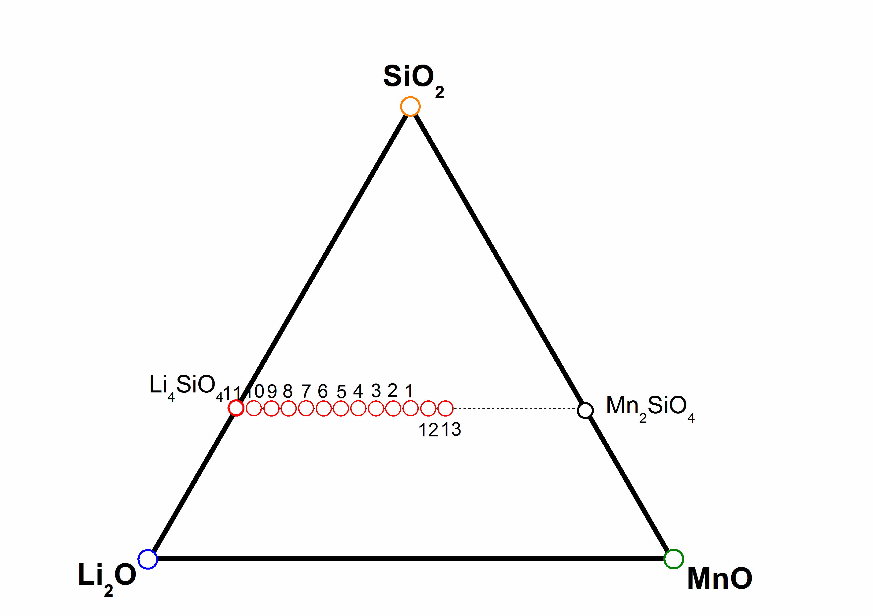
Figure 5.2 Ternary composition triangle of Li₂O-SiO₂-MnO system, showing the compositions studied.
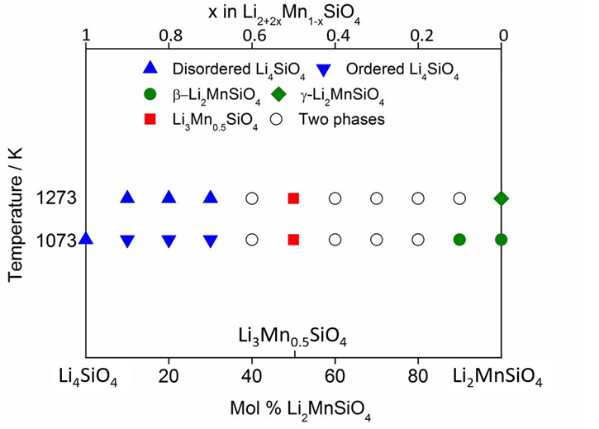
Figure 5.3 The partial phase diagram of Li₄SiO₄ – Li₂MnSiO₄.

Table 5.1 XRD results of slow cooled compositions in the Li₄SiO₄ – Mn₂SiO₄ system with formula Li_{2+2x}Mn_{1-x}SiO₄
No. | x | Formulae | Time (hours) | Temperature (ºC) | Detected phases
1 | 0 | Li₂MnSiO₄ | 10 | 800 | β - Li₂MnSiO₄
2 | 0.1 | Li_{2.2}Mn_{0.9}SiO₄ | 10 | 800 | β - Li₂MnSiO₄
3 | 0.2 | Li_{2.4}Mn_{0.8}SiO₄ | 10 | 800 | β - Li₂MnSiO₄ and Li₃Mn_{0.5}SiO₄
4 | 0.3 | Li_{2.6}Mn_{0.7}SiO₄ | 10 | 800 | β - Li₂MnSiO₄ and Li₃Mn_{0.5}SiO₄
5 | 0.4 | Li_{2.8}Mn_{0.6}SiO₄ | 10 | 800 | β - Li₂MnSiO₄ and Li₃Mn_{0.5}SiO₄
6 | 0.5 | Li₃Mn_{0.5}SiO₄ | 10 | 800 | Li₃Mn_{0.5}SiO₄ and unknown peaks
6 | 0.5 | Li₃Mn_{0.5}SiO₄ | 10 | 900 | Li₃Mn_{0.5}SiO₄ and unknown peaks
6 | 0.5 | Li₃Mn_{0.5}SiO₄ | 10 | 1000 | Li₃Mn_{0.5}SiO₄
6 | 0.5 | Li₃Mn_{0.5}SiO₄ | 10 | 1150 | Li₃Mn_{0.5}SiO₄
7 | 0.6 | Li_{3.2}Mn_{0.4}SiO₄ | 10 | 800 | Ordered Li₄SiO₄ and Li₃Mn_{0.5}SiO₄
8 | 0.7 | Li_{3.4}Mn_{0.3}SiO₄ | 10 | 800 | Ordered Li₄SiO₄
9 | 0.8 | Li_{3.6}Mn_{0.2}SiO₄ | 10 | 800 | Ordered Li₄SiO₄
10 | 0.9 | Li_{3.8}Mn_{0.1}SiO₄ | 10 | 800 | Ordered Li₄SiO₄
11 | 1 | Li₄SiO₄ | 10 | 800 | Disordered Li₄SiO₄
12 | 1.1 | Li_{1.8}Mn_{1.1}SiO₄ | 10 | 800 | β - Li₂MnSiO₄ and Mn₂SiO₄
13 | 1.2 | Li_{1.6}Mn_{1.2}SiO₄ | 10 | 800 | β - Li₂MnSiO₄ and Mn₂SiO₄

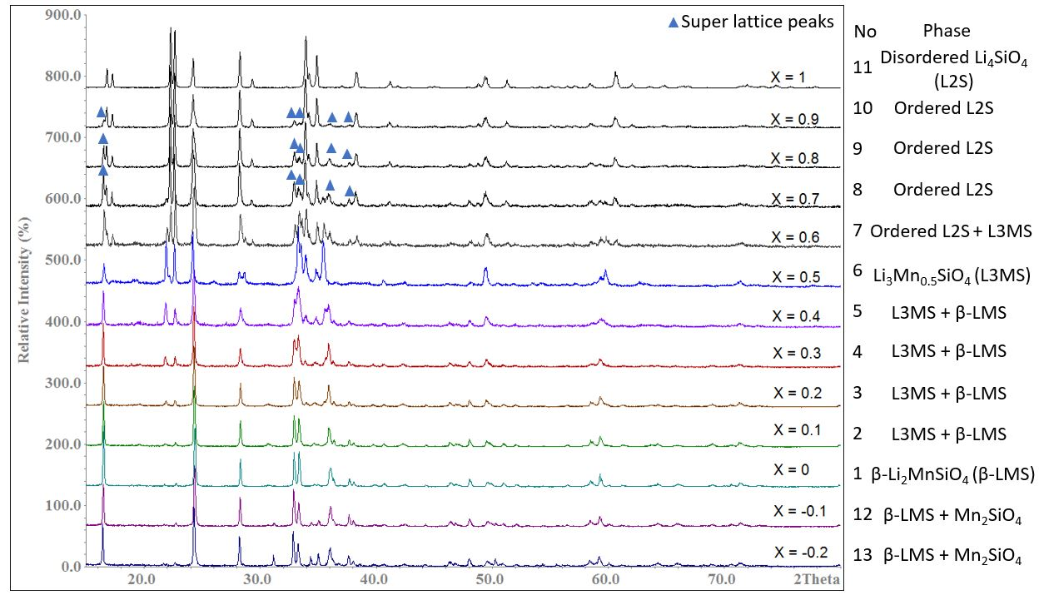
Figure 5.4 XRD patterns of Li_{2+2x}Mn_{1-x}SiO₄: x from -0.2 to 1, slow cooled from 800 ºC. XRD patterns were collected by D2 with λ = 1.541 Å.

Table 5.2 XRD results of quenched compositions in the Li₄SiO₄ – Mn₂SiO₄ system with formula Li_{2+2x}Mn_{1-x}SiO₄
No. | x | Formulae | Time (hours) | Temperature (ºC) | Detected phases
1 | 0 | Li₂MnSiO₄ | 0.5 | Q1000 | γ - Li₂MnSiO₄
2 | 0.1 | Li_{2.2}Mn_{0.9}SiO₄ | 0.5 | Q1000 | γ - Li₂MnSiO₄ and Li₃Mn_{0.5}SiO₄
3 | 0.2 | Li_{2.4}Mn_{0.8}SiO₄ | 0.5 | Q1000 | γ - Li₂MnSiO₄ and Li₃Mn_{0.5}SiO₄
4 | 0.3 | Li_{2.6}Mn_{0.7}SiO₄ | 0.5 | Q1000 | γ - Li₂MnSiO₄ and Li₃Mn_{0.5}SiO₄
5 | 0.4 | Li_{2.8}Mn_{0.6}SiO₄ | 0.5 | Q1000 | γ - Li₂MnSiO₄ and Li₃Mn_{0.5}SiO₄
6 | 0.5 | Li₃Mn_{0.5}SiO₄ | 0.5 | Q1000 | Li₃Mn_{0.5}SiO₄
7 | 0.6 | Li_{3.2}Mn_{0.4}SiO₄ | 0.5 | Q1000 | Li₃Mn_{0.5}SiO₄ and Disordered Li₄SiO₄
8 | 0.7 | Li_{3.4}Mn_{0.3}SiO₄ | 0.5 | Q1000 | Disordered Li₄SiO₄
9 | 0.8 | Li_{3.6}Mn_{0.2}SiO₄ | 0.5 | Q1000 | Disordered Li₄SiO₄
11 | 1 | Li₄SiO₄ | 0.5 | Q1000 | Disordered Li₄SiO₄
12 | 1.1 | Li_{1.8}Mn_{1.1}SiO₄ | 0.5 | Q1000 | γ - Li₂MnSiO₄ and Mn₂SiO₄

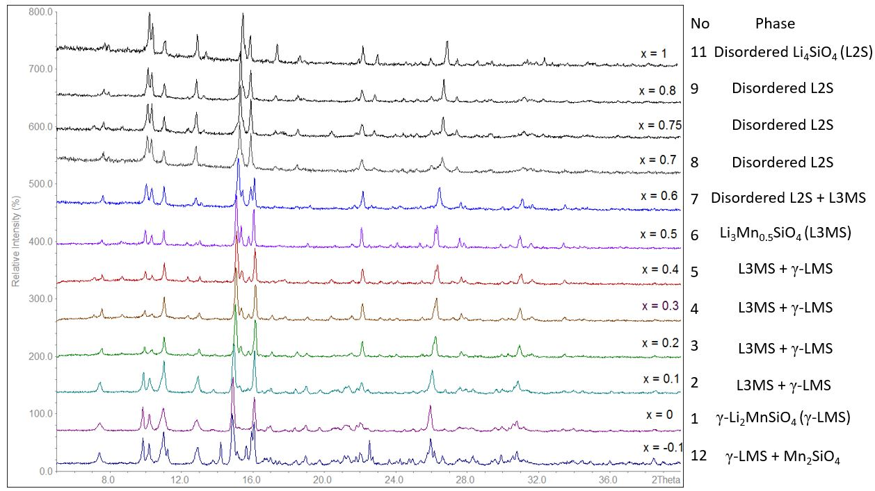
Figure 5.5 XRD patterns of Li_{2+2x}Mn_{1-x}SiO₄: x from -0.1 to 1, quenched from 1000 ºC. XRD patterns were collected by MoPSD with λ = 0.7093 Å.
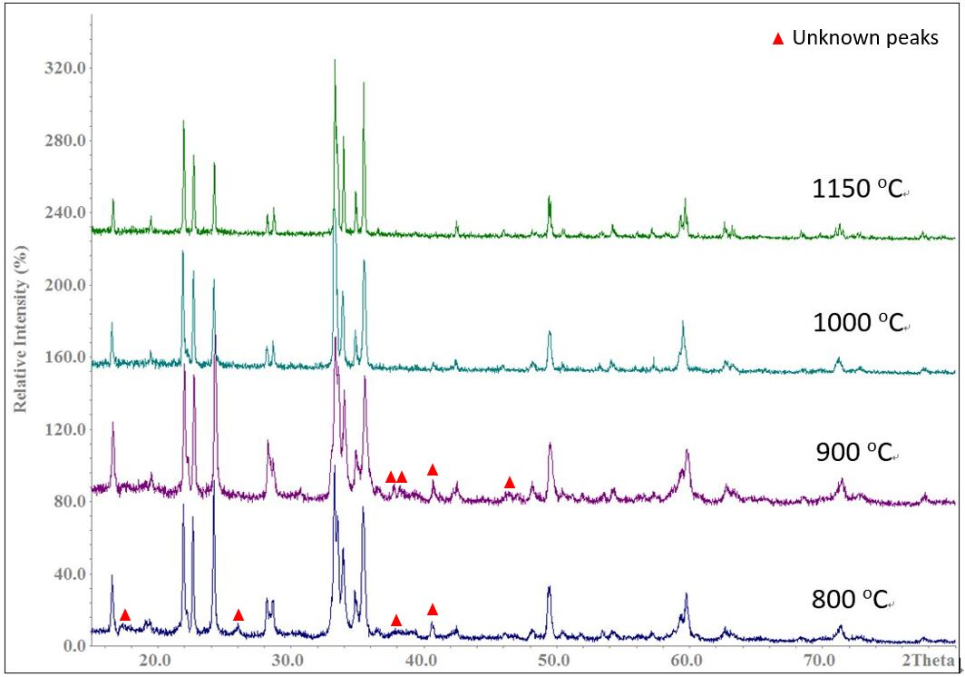
Figure 5.6 XRD patterns of Li₃Mn_{0.5}SiO₄ at 800, 900, 1000 and 1150 ºC. XRD patterns were collected by D2 with λ = 1.541 Å.

Table 5.3 Indexing results of Li₃Mn_{0.5}SiO₄
N | 2Th[obs] | H | K | L | 2Th[calc] | obs-calc | Int. | d[obs] | d[calc]
1 | 7.601 | 2 | 0 | 0 | 7.586 | 0.0144 | 33.4 | 5.3509 | 5.361
2 | 8.89 | 1 | 0 | 1 | 8.901 | -0.0114 | 24.8 | 4.5762 | 4.5704
3 | 10.02 | 2 | 1 | 0 | 10.008 | 0.0127 | 47 | 4.0609 | 4.0661
4 | 10.373 | 0 | 1 | 1 | 10.365 | 0.0086 | 38.5 | 3.9231 | 3.9264
5 | 11.083 | 2 | 0 | 1 | 11.07 | 0.0128 | 53.7 | 3.6726 | 3.6768
6 | 12.887 | 2 | 1 | 1 | 12.857 | 0.0309 | 23.2 | 3.1601 | 3.1677
7 | 13.047 | 0 | 2 | 0 | 13.056 | -0.0092 | 27 | 3.1216 | 3.1194
8 | 15.132 | 2 | 2 | 0 | 15.117 | 0.0154 | 100 | 2.6935 | 2.6962
9 | 15.422 | 3 | 1 | 1 | 15.423 | -0.0003 | 42.3 | 2.6431 | 2.643
10 | 15.827 | 1 | 2 | 1 | 15.824 | 0.0039 | 29.6 | 2.5759 | 2.5765
11 | 16.156 | 0 | 0 | 2 | 16.141 | 0.0151 | 73.3 | 2.5239 | 2.5262
12 | 17.872 | 1 | 1 | 2 | 17.837 | 0.0345 | 15.4 | 2.2832 | 2.2876
 |  | 2 | 0 | 2 | 17.856 | 0.0155 |  |  | 2.2852
13 | 18.404 | 4 | 1 | 1 | 18.437 | -0.0331 | 16.1 | 2.2178 | 2.2138
14 | 19.153 | 3 | 2 | 1 | 19.161 | -0.0073 | 17.9 | 2.1317 | 2.1309
15 | 20.708 | 5 | 0 | 1 | 20.7 | 0.0079 | 14.9 | 1.9732 | 1.974
16 | 21.6 | 1 | 3 | 1 | 21.598 | 0.002 | 17.5 | 1.8927 | 1.8929
17 | 22.188 | 2 | 2 | 2 | 22.184 | 0.0047 | 43 | 1.8431 | 1.8435
18 | 22.593 | 2 | 3 | 1 | 22.597 | -0.004 | 17 | 1.8105 | 1.8101
19 | 23.194 | 5 | 2 | 0 | 23.155 | 0.0387 | 14.4 | 1.7642 | 1.7671
 |  | 4 | 1 | 2 | 23.204 | -0.0104 |  |  | 1.7635
20 | 23.838 | 6 | 1 | 0 | 23.828 | 0.0101 | 15.9 | 1.7172 | 1.7179
21 | 24.183 | 3 | 3 | 1 | 24.177 | 0.0064 | 19.3 | 1.6931 | 1.6935
22 | 24.931 | 4 | 3 | 0 | 24.93 | 0.001 | 14 | 1.643 | 1.6431
23 | 25.472 | 1 | 1 | 3 | 25.49 | -0.0187 | 16.6 | 1.6087 | 1.6076
 |  | 2 | 0 | 3 | 25.504 | -0.0323 |  |  | 1.6067
24 | 26.287 | 0 | 4 | 0 | 26.286 | 0.0009 | 36.7 | 1.5597 | 1.5597
25 | 26.441 | 6 | 2 | 0 | 26.443 | -0.0023 | 48.6 | 1.5507 | 1.5506
26 | 26.921 | 3 | 0 | 3 | 26.923 | -0.0015 | 12.9 | 1.5235 | 1.5235
27 | 27.729 | 0 | 2 | 3 | 27.692 | 0.0371 | 24.7 | 1.48 | 1.4819
 |  | 3 | 1 | 3 | 27.73 | -0.0005 | 1.48
28 | 27.954 | 1 | 2 | 3 | 27.961 | -0.0063 | 18.9 | 1.4683 | 1.468
29 | 28.76 | 3 | 4 | 0 | 28.729 | 0.031 | 14.2 | 1.428 | 1.4295
 |  | 2 | 2 | 3 | 28.753 | 0.0075 |  |  | 1.4284
 |  | 7 | 1 | 1 | 28.781 | -0.0211 |  |  | 1.427
30 | 30.037 | 3 | 2 | 3 | 30.03 | 0.0073 | 16.3 | 1.3686 | 1.3689
31 | 30.49 | 4 | 4 | 0 | 30.505 | -0.0154 | 15.9 | 1.3488 | 1.3481
32 | 31.128 | 6 | 2 | 2 | 31.134 | -0.0066 | 31.3 | 1.3218 | 1.3215
33 | 31.696 | 1 | 3 | 3 | 31.684 | 0.0119 | 16.8 | 1.2987 | 1.2991
34 | 33.529 | 1 | 1 | 4 | 33.522 | 0.0073 | 19.1 | 1.2295 | 1.2298
 |  | 2 | 0 | 4 | 33.532 | -0.0032 |  |  | 1.2294
 |  | 3 | 3 | 3 | 33.545 | -0.0161 |  |  | 1.229
Final 2θ window: 0.04, Symmetry: orthorhombic, a = 10.722(3) (Å), b = 6.239(2) (Å), c = 5.052(3) (Å), V = 337.97(11) (Å³).

Table 5.4 Indexing results of Li_{3.5}Mn_{0.25}SiO₄
N | 2Th[obs] | H | K | L | 2Th[calc] | obs-calc | Int. | d[obs] | d[calc]
1 | 7.577 | 1 | 1 | 0 | 7.608 | -0.0307 | 51.5 | 5.3674 | 5.3458
2 | 7.907 | -1 | 1 | 1 | 7.943 | -0.0364 | 24.8 | 5.1439 | 5.1204
3 | 10.18 | -1 | 2 | 1 | 10.177 | 0.0034 | 89.1 | 3.9973 | 3.9987
4 | 10.35 | 1 | 1 | 1 | 10.345 | 0.0055 | 79 | 3.9318 | 3.9339
5 | 11.095 | 0 | 1 | 2 | 11.049 | 0.0459 | 99 | 3.6687 | 3.6839
 |  | -1 | 1 | 2 | 11.077 | 0.0173 |  |  | 3.6744
6 | 12.882 | 1 | 3 | 0 | 12.882 | -0.0006 | 89.4 | 3.1615 | 3.1614
7 | 13.349 | 2 | 0 | 0 | 13.351 | -0.0021 | 21.9 | 3.0514 | 3.0509
8 | 14.986 | -1 | 0 | 3 | 14.954 | 0.0313 | 61.1 | 2.7197 | 2.7254
9 | 15.176 | 0 | 3 | 2 | 15.182 | -0.0067 | 43.3 | 2.6858 | 2.6846
 |  | -1 | 3 | 2 | 15.203 | -0.0277 |  |  | 2.6809
10 | 15.417 | -1 | 1 | 3 | 15.402 | 0.0156 | 100 | 2.6439 | 2.6466
11 | 15.849 | 2 | 0 | 1 | 15.806 | 0.0439 | 64 | 2.5723 | 2.5794
 |  | 1 | 2 | 2 | 15.865 | -0.0153 |  |  | 2.5699
12 | 16.341 | -1 | 4 | 1 | 16.318 | 0.0224 | 45.9 | 2.4955 | 2.4989
13 | 17.087 | -2 | 0 | 3 | 17.088 | -0.0016 | 25.9 | 2.3873 | 2.3871
14 | 17.338 | 0 | 2 | 3 | 17.309 | 0.0295 | 42.1 | 2.3529 | 2.3569
 |  | 2 | 3 | 0 | 17.338 | -0.0001 |  |  | 2.3529
15 | 18.019 | 0 | 4 | 2 | 18.052 | -0.0335 | 13 | 2.2648 | 2.2606
16 | 18.392 | 0 | 5 | 0 | 18.404 | -0.013 | 21.3 | 2.2192 | 2.2177
17 | 18.621 | -1 | 3 | 3 | 18.609 | 0.0116 | 22 | 2.1922 | 2.1935
 |  | -2 | 2 | 3 | 18.618 | 0.0028 |  |  | 2.1925
18 | 18.905 | 1 | 0 | 3 | 18.888 | 0.0166 | 13.2 | 2.1595 | 2.1614
19 | 19.147 | 0 | 5 | 1 | 19.138 | 0.0089 | 13.5 | 2.1324 | 2.1334
 |  | 0 | 3 | 3 | 19.181 | -0.0337 |  |  | 2.1287
20 | 20.27 | 1 | 2 | 3 | 20.287 | -0.0174 | 12.2 | 2.0155 | 2.0138
21 | 20.869 | 1 | 5 | 1 | 20.83 | 0.0392 | 20.1 | 1.9582 | 1.9619
 |  | -3 | 2 | 2 | 20.852 | 0.0163 |  |  | 1.9597
22 | 21.069 | -1 | 4 | 3 | 21.029 | 0.0401 | 15.1 | 1.9398 | 1.9434
23 | 21.582 | 0 | 4 | 3 | 21.54 | 0.0421 | 24.7 | 1.8942 | 1.8979
 |  | -3 | 1 | 3 | 21.563 | 0.0191 |  |  | 1.8959
24 | 21.904 | 1 | 3 | 3 | 21.915 | -0.0114 | 19.2 | 1.8667 | 1.8658
25 | 22.202 | 0 | 2 | 4 | 22.202 | 0.0004 | 45.5 | 1.8419 | 1.842
26 | 22.957 | 3 | 3 | 0 | 22.96 | -0.0024 | 26.3 | 1.7821 | 1.7819
27 | 23.264 | 1 | 5 | 2 | 23.228 | 0.0368 | 13.7 | 1.7589 | 1.7617
 |  | -1 | 6 | 1 | 23.249 | 0.0154 |  |  | 1.7601
 |  | -2 | 5 | 2 | 23.27 | -0.005 |  |  | 1.7585
28 | 24.149 | -3 | 4 | 1 | 24.171 | -0.0222 | 11.9 | 1.6954 | 1.6939
 |  | 1 | 6 | 1 | 24.198 | -0.0486 |  |  | 1.692
29 | 24.561 | 0 | 6 | 2 | 24.515 | 0.0464 | 14.2 | 1.6674 | 1.6705
 |  | -1 | 6 | 2 | 24.528 | 0.0331 |  |  | 1.6696
30 | 24.803 | -1 | 4 | 4 | 24.787 | 0.0155 | 11.6 | 1.6514 | 1.6524
 |  | 2 | 2 | 3 | 24.809 | -0.0067 |  |  | 1.6509
31 | 25.146 | -3 | 2 | 4 | 25.175 | -0.0295 | 15.6 | 1.6292 | 1.6273
32 | 25.413 | -2 | 0 | 5 | 25.416 | -0.0026 | 14 | 1.6123 | 1.6122
33 | 25.968 | -3 | 4 | 3 | 25.93 | 0.0381 | 35.2 | 1.5785 | 1.5807
 |  | 2 | 6 | 0 | 25.931 | 0.0373 |  |  | 1.5807
 |  | -4 | 1 | 1 | 25.967 | 0.0018 |  |  | 1.5786
34 | 26.3 | 1 | 6 | 2 | 26.306 | -0.0058 | 32.8 | 1.5589 | 1.5585
 |  | -2 | 6 | 2 | 26.343 | -0.043 |  |  | 1.5564
35 | 26.85 | -1 | 6 | 3 | 26.814 | 0.036 | 54.5 | 1.5275 | 1.5296
 |  | 3 | 4 | 1 | 26.831 | 0.019 |  |  | 1.5286
 |  | -1 | 7 | 1 | 26.849 | 0.0007 |  |  | 1.5276
 |  | 2 | 5 | 2 | 26.872 | -0.0227 |  |  | 1.5263
 |  | 4 | 0 | 0 | 26.887 | -0.0376 |  |  | 1.5254
36 | 27.42 | 3 | 5 | 0 | 27.372 | 0.0487 | 19.2 | 1.4963 | 1.499
37 | 28.066 | -4 | 3 | 1 | 28.032 | 0.034 | 13.8 | 1.4626 | 1.4643
 |  | -2 | 5 | 4 | 28.054 | 0.0129 |  |  | 1.4632
 |  | -2 | 6 | 3 | 28.091 | -0.0248 |  |  | 1.4613
38 | 28.324 | -3 | 4 | 4 | 28.302 | 0.0225 | 16.7 | 1.4495 | 1.4506
 |  | 2 | 0 | 4 | 28.312 | 0.0121 |  |  | 1.4501
39 | 28.533 | 0 | 3 | 5 | 28.535 | -0.0019 | 16.6 | 1.4391 | 1.439
 |  | 2 | 1 | 4 | 28.559 | -0.0256 |  |  | 1.4379
40 | 29.08 | -1 | 4 | 5 | 29.061 | 0.0184 | 15.9 | 1.4126 | 1.4135
 |  | 3 | 5 | 1 | 29.081 | -0.0015 |  |  | 1.4126
 |  | 1 | 0 | 5 | 29.128 | -0.0484 |  |  | 1.4103
41 | 29.404 | 1 | 1 | 5 | 29.368 | 0.0359 | 16 | 1.3974 | 1.3991
 |  | -3 | 6 | 1 | 29.378 | 0.0265 |  |  | 1.3986
 |  | -4 | 2 | 4 | 29.421 | -0.0165 |  |  | 1.3966
42 | 30.175 | -1 | 0 | 6 | 30.138 | 0.0366 | 12.8 | 1.3625 | 1.3641
 |  | 2 | 5 | 3 | 30.147 | 0.028 |  |  | 1.3638
 |  | -2 | 0 | 6 | 30.171 | 0.0037 |  |  | 1.3627
 |  | 0 | 4 | 5 | 30.208 | -0.0334 |  |  | 1.361
43 | 30.809 | 4 | 4 | 0 | 30.777 | 0.0314 | 17.1 | 1.3351 | 1.3365
44 | 31.133 | -2 | 2 | 6 | 31.091 | 0.0416 | 25.3 | 1.3216 | 1.3233
 |  | 4 | 3 | 1 | 31.125 | 0.0077 |  |  | 1.3219
 |  | -1 | 5 | 5 | 31.164 | -0.0316 |  |  | 1.3203
 |  | -2 | 7 | 3 | 31.174 | -0.0409 |  |  | 1.3199
45 | 31.362 | 3 | 3 | 3 | 31.383 | -0.021 | 23.1 | 1.3122 | 1.3113
46 | 31.848 | 0 | 1 | 6 | 31.837 | 0.0108 | 17.2 | 1.2926 | 1.2931
47 | 32.337 | -3 | 7 | 1 | 32.349 | -0.0115 | 17.7 | 1.2736 | 1.2732
 |  | -2 | 8 | 1 | 32.374 | -0.0369 |  |  | 1.2722
48 | 32.77 | 1 | 4 | 5 | 32.776 | -0.0057 | 12.1 | 1.2572 | 1.257
 |  | 4 | 5 | 0 | 32.781 | -0.0108 |  |  | 1.2568
 |  | 4 | 2 | 2 | 32.798 | -0.0284 |  |  | 1.2562
49 | 33.603 | 3 | 0 | 4 | 33.564 | 0.0396 | 12.5 | 1.2269 | 1.2283
 |  | -1 | 6 | 5 | 33.573 | 0.0301 |  |  | 1.228
 |  | 0 | 3 | 6 | 33.573 | 0.0301 |  |  | 1.228
50 | 34.399 | -5 | 3 | 3 | 34.358 | 0.0412 | 13.2 | 1.1994 | 1.2007
 |  | -5 | 3 | 1 | 34.391 | 0.0084 |  |  | 1.1996
 |  | 3 | 2 | 4 | 34.403 | -0.0034 |  |  | 1.1992
 |  | -2 | 8 | 3 | 34.42 | -0.0211 |  |  | 1.1986
 |  | 1 | 0 | 6 | 34.426 | -0.0269 |  |  | 1.1984
 |  | 3 | 7 | 1 | 34.429 | -0.0297 |  |  | 1.1983
51 | 34.795 | -4 | 1 | 6 | 34.778 | 0.0174 | 17.1 | 1.1861 | 1.1867
 |  | -4 | 6 | 3 | 34.805 | -0.0093 |  |  | 1.1858
 |  | 3 | 5 | 3 | 34.818 | -0.0226 |  |  | 1.1854
Final 2θ window: 0.05, Symmetry: monoclinic, a = 6.430(4) (Å), b = 11.088(7) (Å), c = 8.232(4) (Å), β = 108.39(5), V = 557.0(4) (Å³).

5.3.1.2 Impedance spectroscopy (IS)
(a) Li₂MnSiO₄

Impedance complex plane, Z* plots of Li₂MnSiO₄ with Ag paste electrodes from 502 ºC to 575 ºC in N₂ atmosphere are shown in figure 5.7. A non-ideal semicircle and a noisy tail were detected for all temperatures.

The C’ spectroscopic plots as a function of frequency are shown in figure 5.8(a). A plateau with a capacitance of 2.5 ·10⁻¹² Fcm⁻¹ representing the bulk at high frequencies and a noisy dispersion at low frequencies were found.

The Y’ spectroscopic plots as a function of frequency are shown in figure 5.8(b). A frequency-independent dc conductivity plateau at low frequencies and a curvature at high frequencies were noticed.

As shown in figure 5.8(c), combined spectroscopic plots of Z’’/M’’ illustrate high frequencies overlapping peaks associated with the bulk response. In conclusion, as the Z and M peaks are within at one order of magnitude, it is assumed that the sample is electronically homogeneous and is an electronic conductor.

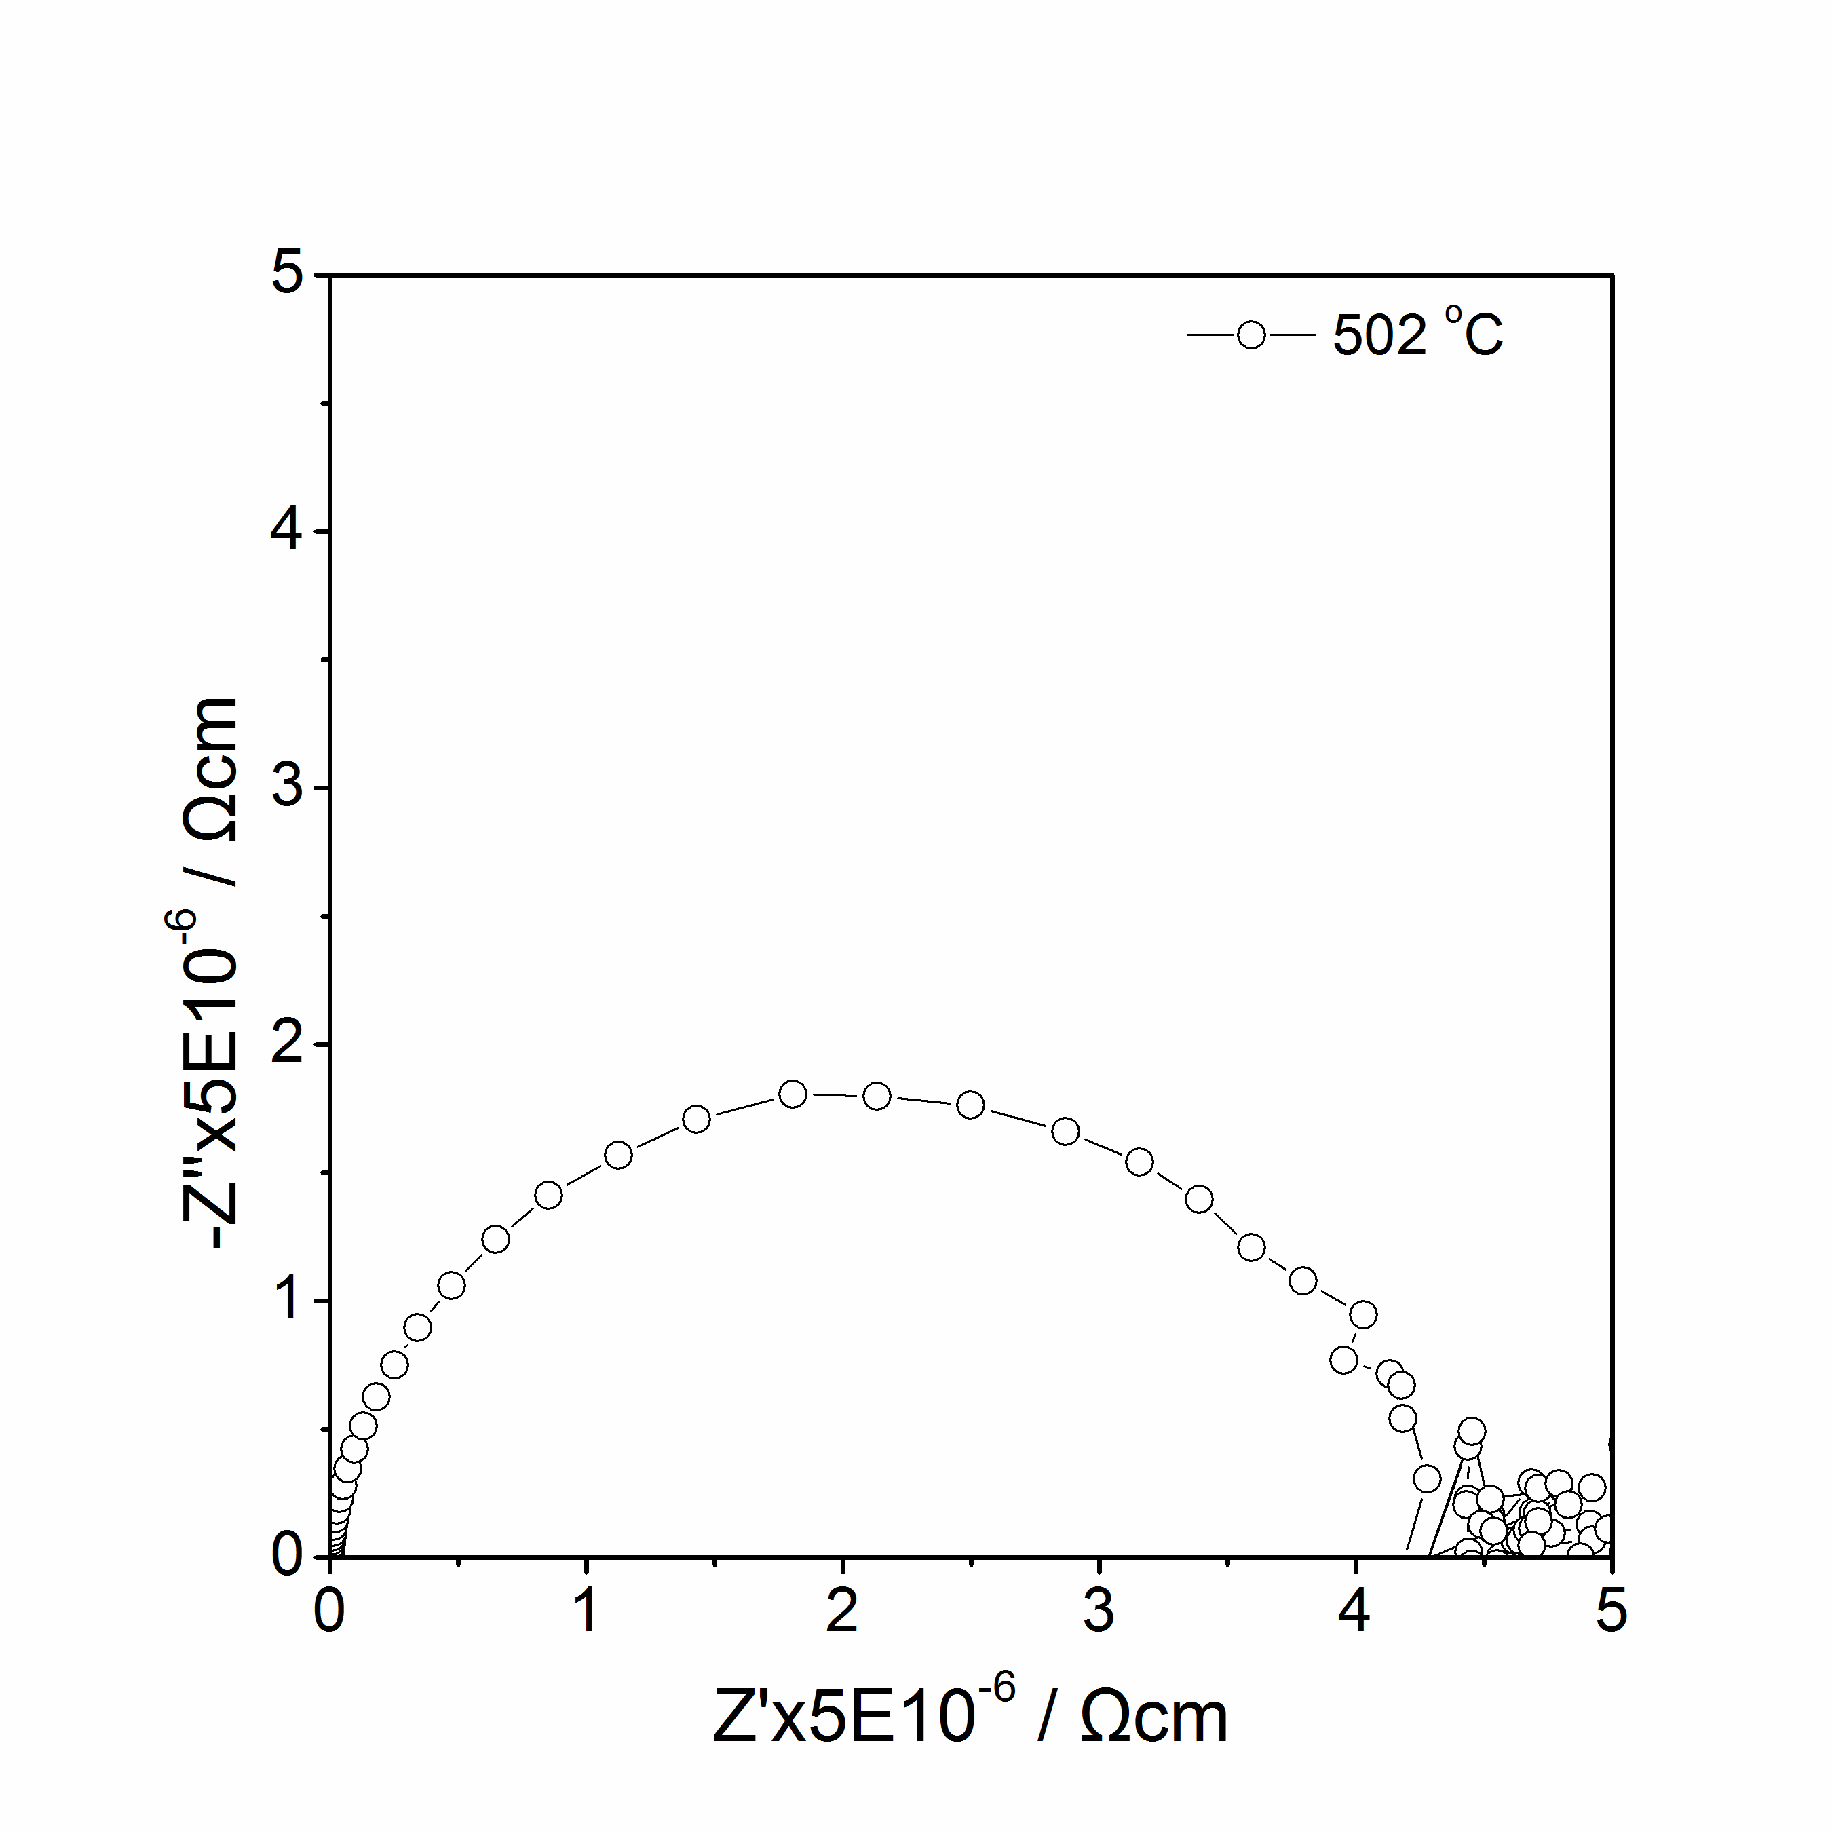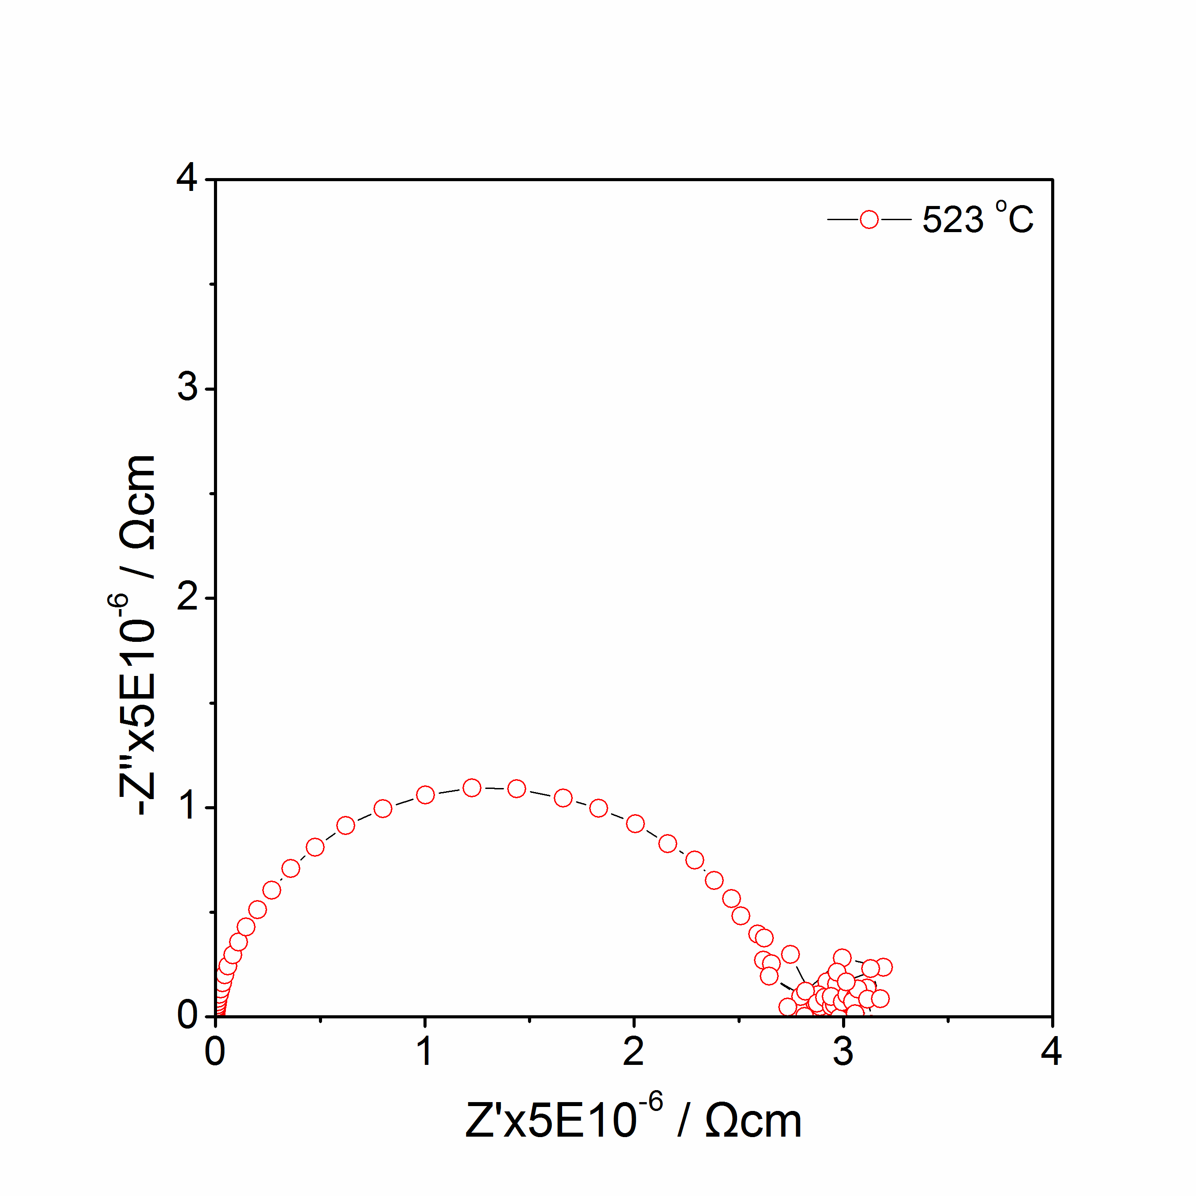
(a)
(b)
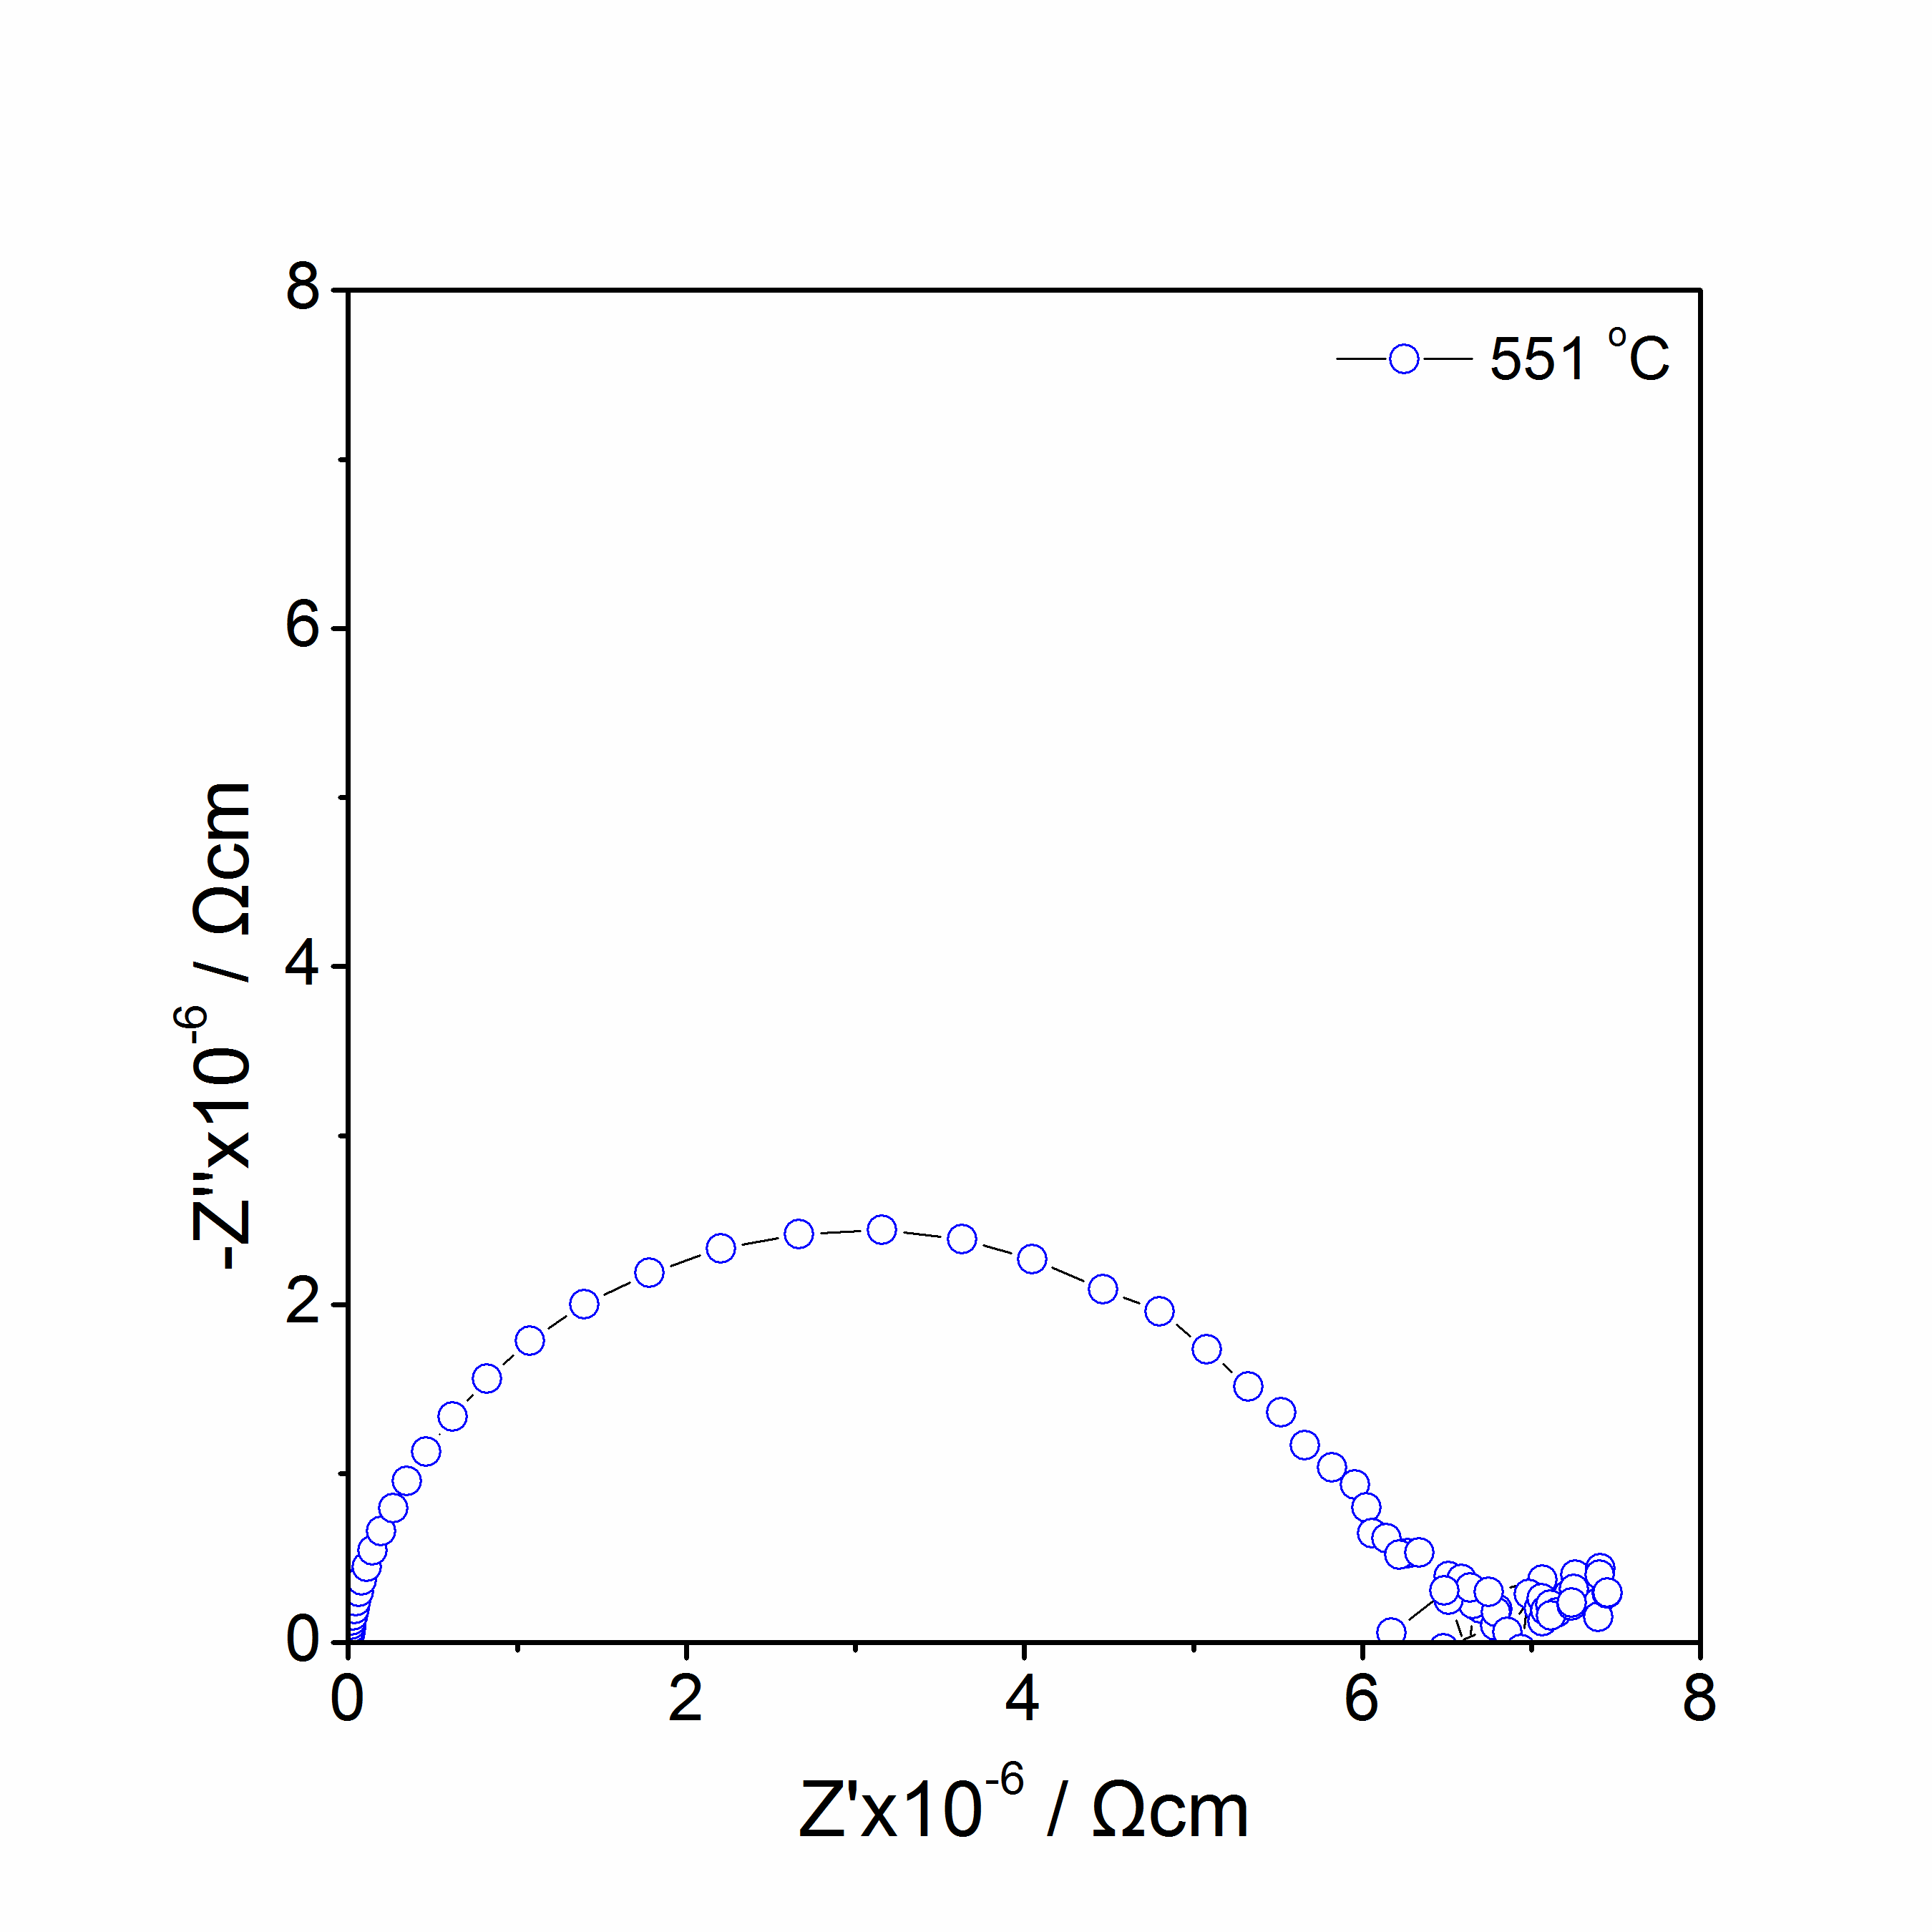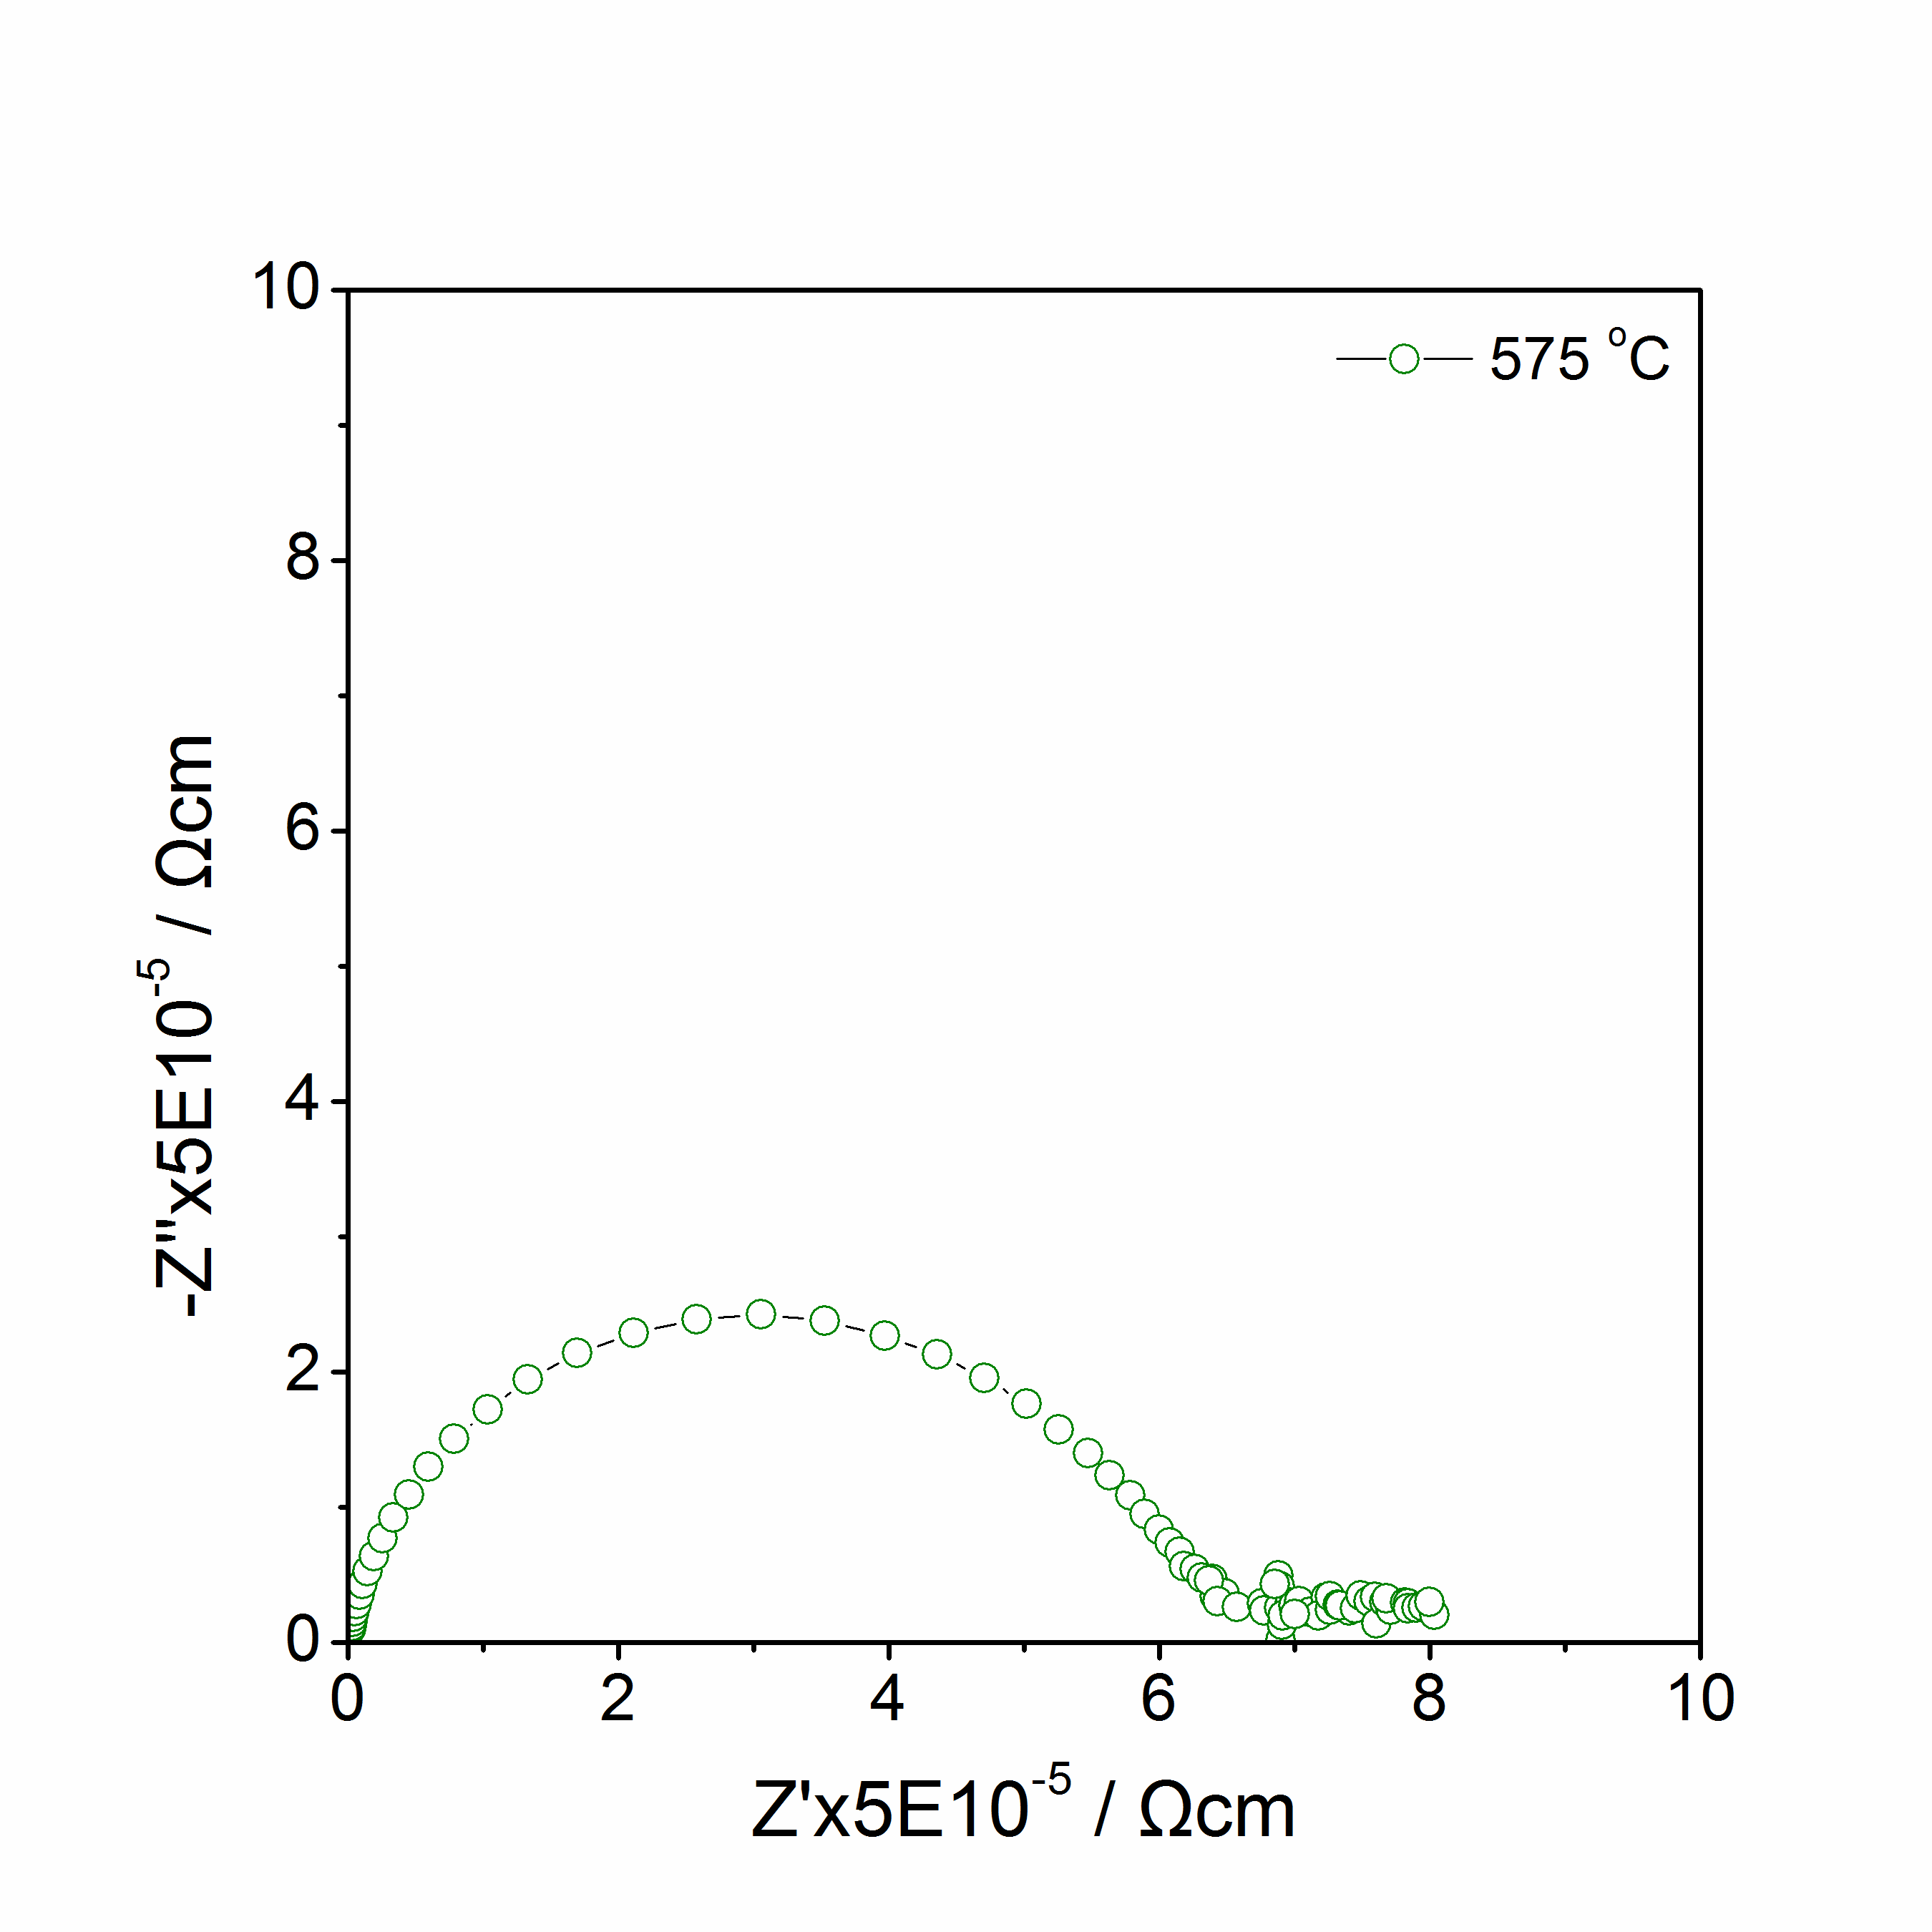
(c)
(d)
Figure 5.7 Li₂MnSiO₄: Impedance complex plane plots Z* at 502 ºC to 575 ºC in N₂.

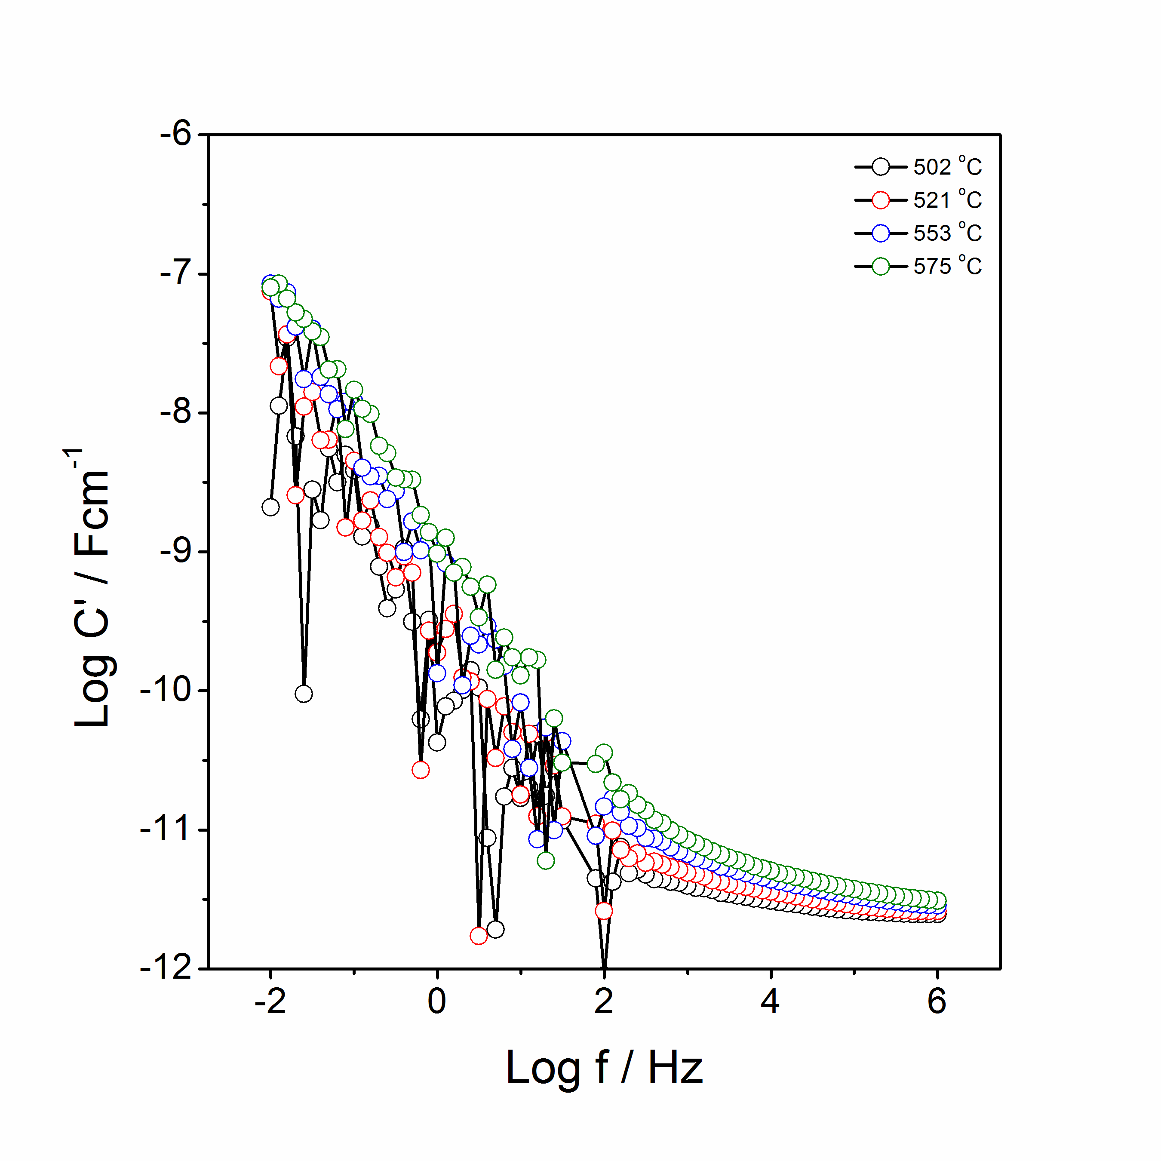
(a)
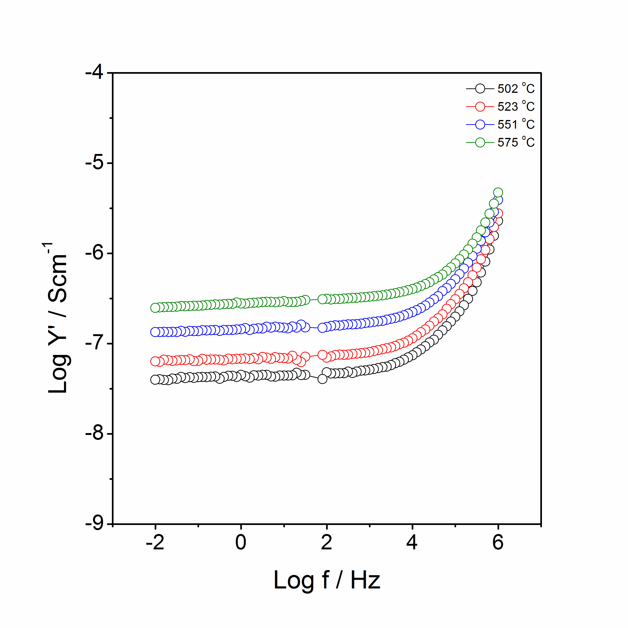
(b)
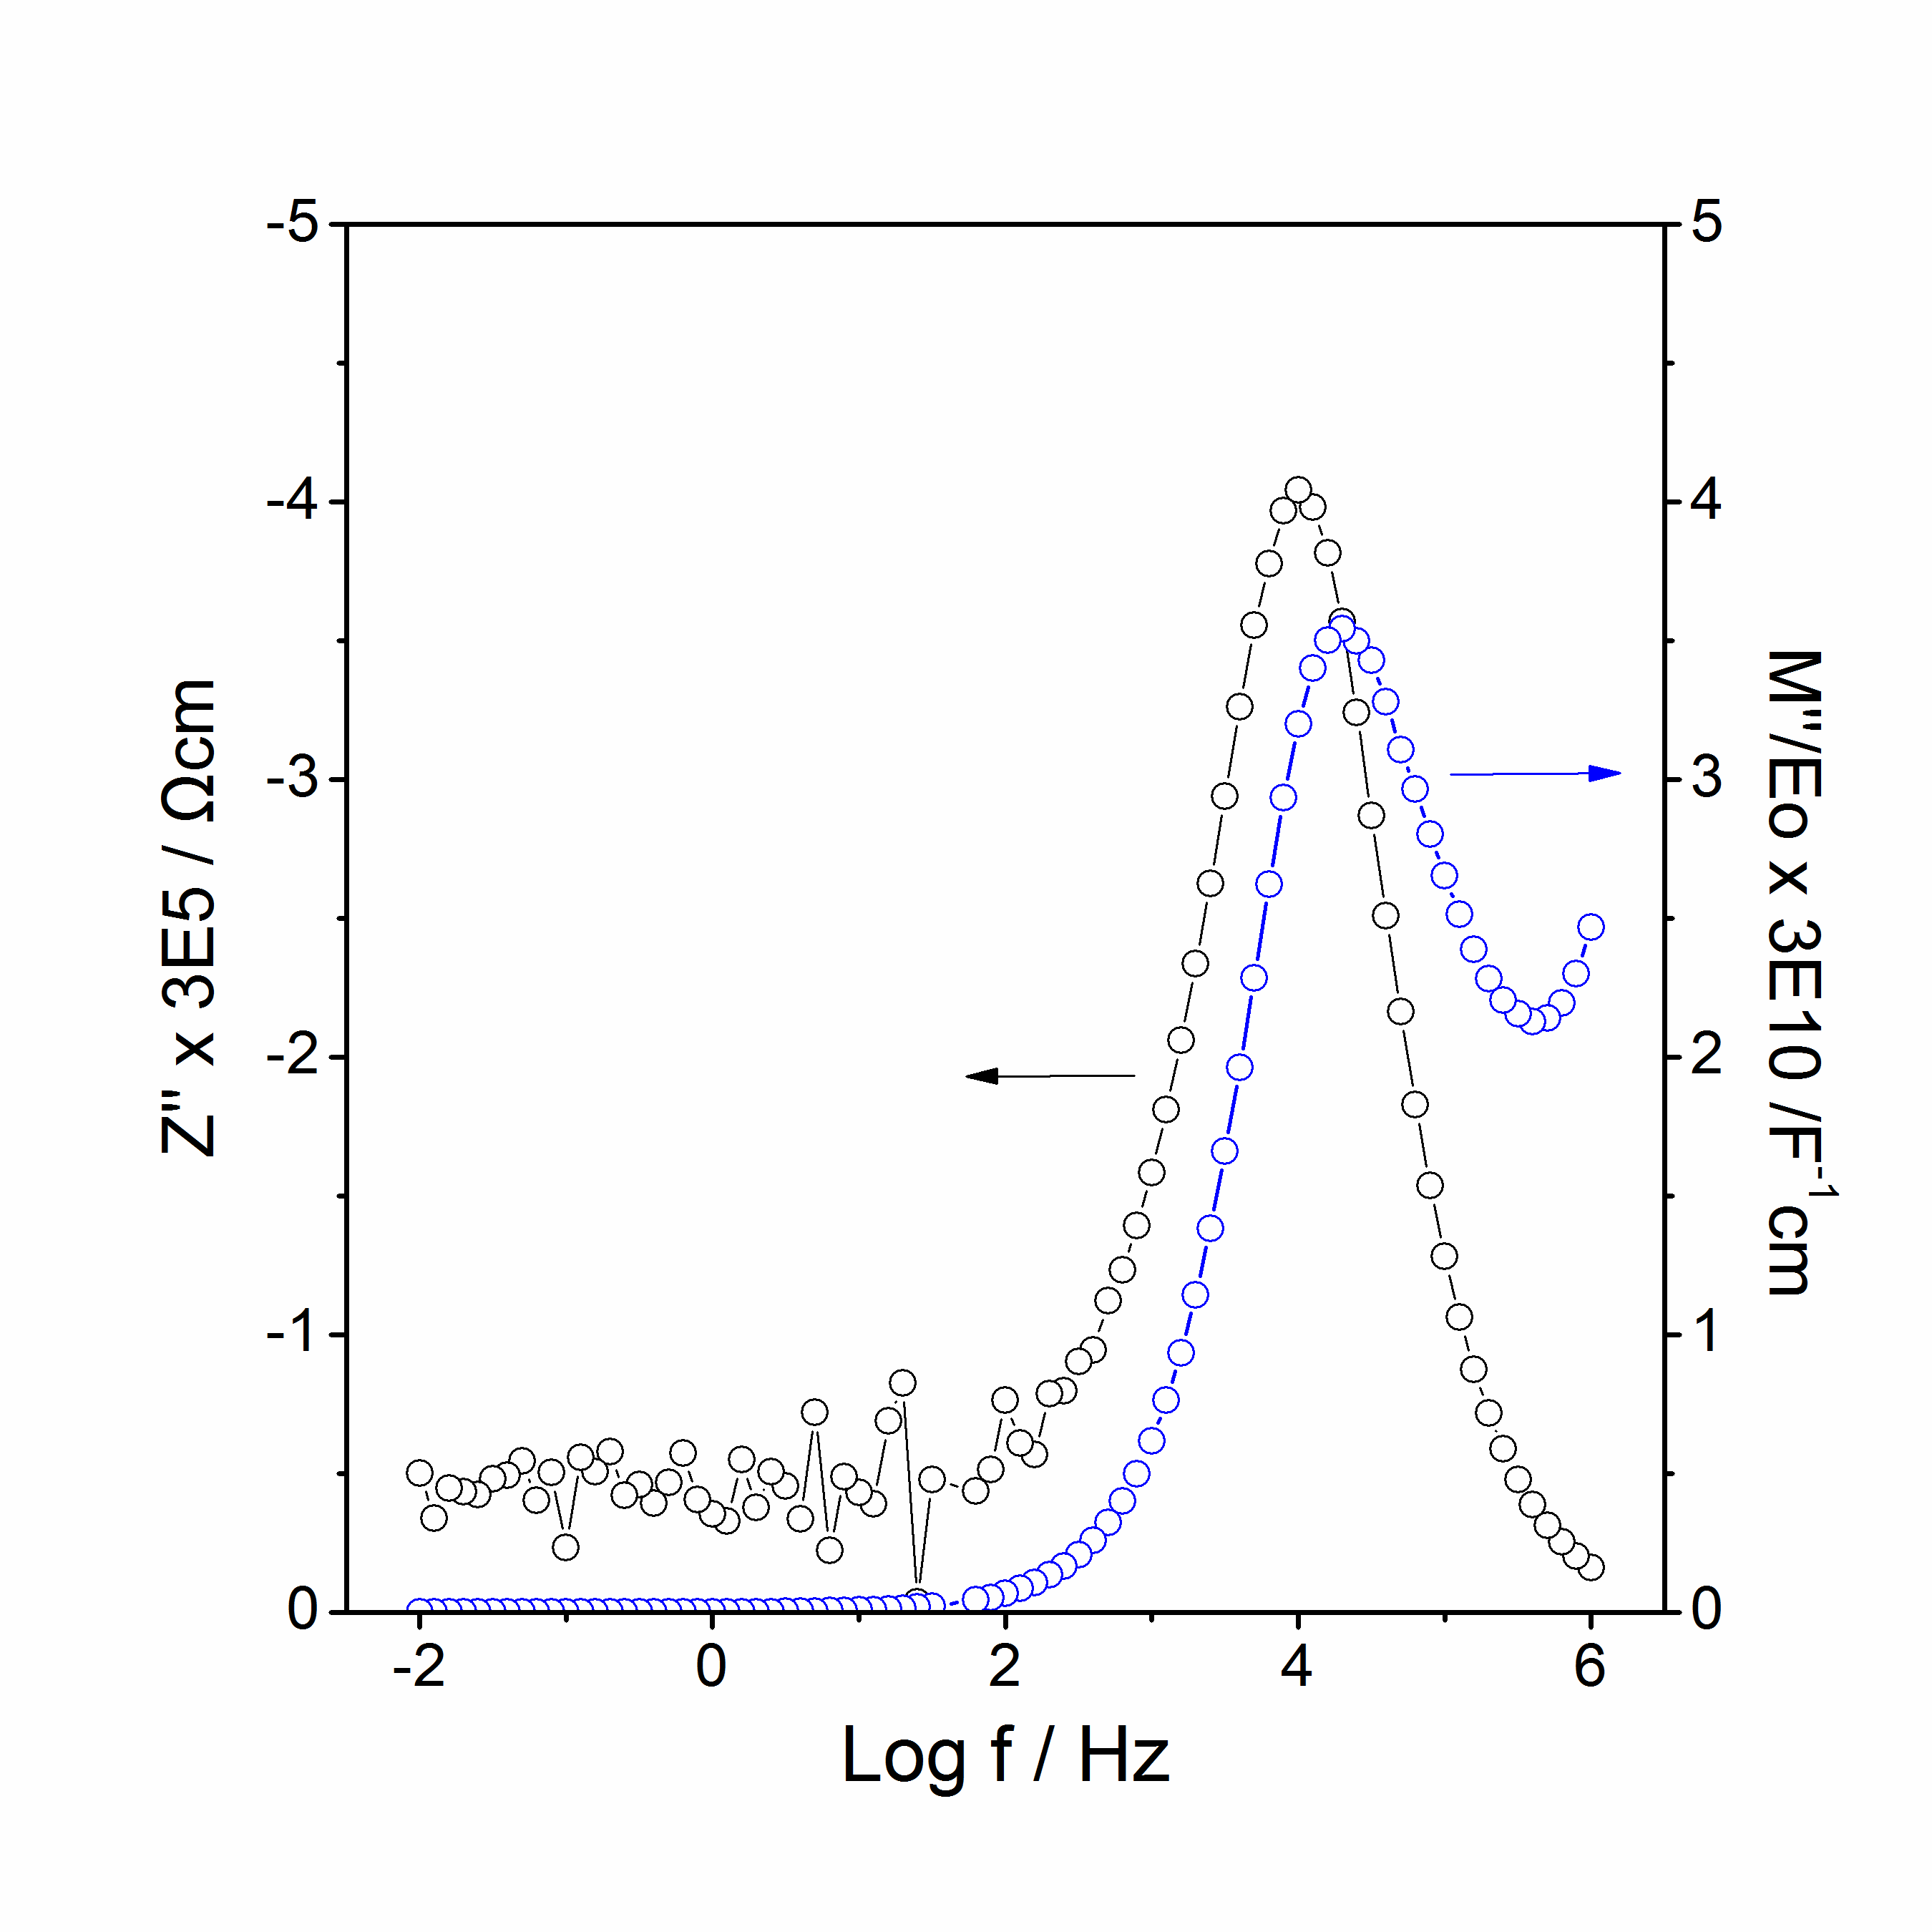
(c)
Figure 5.8 Li₂MnSiO₄: spectroscopic plots of C’ (a), Y’ (b), –Z’’ and M’’ at 502 ºC (c).

(b) Li₃Mn_{0.5}SiO₄

Z* plots of Li₃Mn_{0.5}SiO₄ with sputtered gold electrodes at different temperatures are shown in figure 5.9. A semicircle and a noisy tail were detected at 89 ºC. At temperatures of 114 and 139 ºC, a high frequency semicircle and a low frequency 45º spike were found. At higher temperature, 164 ºC, as the measured window shifted to lower frequencies, only half of the semicircle with a low frequency spike can be identified.

C’ plots as a function of frequency are shown in figure 5.10(a). A high frequency plateau with a capacitance of 2·10⁻¹² Fcm⁻¹ and a broad dispersion to 10⁻⁵ to 10⁻⁴ Fcm⁻¹ which represents the double layer capacitor phenomenon and indicates the Li⁺ ion conduction.

Y’ plots as a function of frequency are shown in figure 5.10(b). At 89 and 114 ºC, a frequency-independent dc plateau at low frequencies and a curvature at high frequencies were observed. When the temperature increased to 139 and 164 ºC, a low frequency dispersion to lower conductivity associated with the blockage of Li⁺ ions at the sample-electrode interface was detected.

As shown in figure 5.10(d), Combined Z’’/M’’ spectroscopic plots show an excellent coincidence of peaks of Z’’ and M’’ at high frequencies, which indicates electrical homogeneity of the sample.

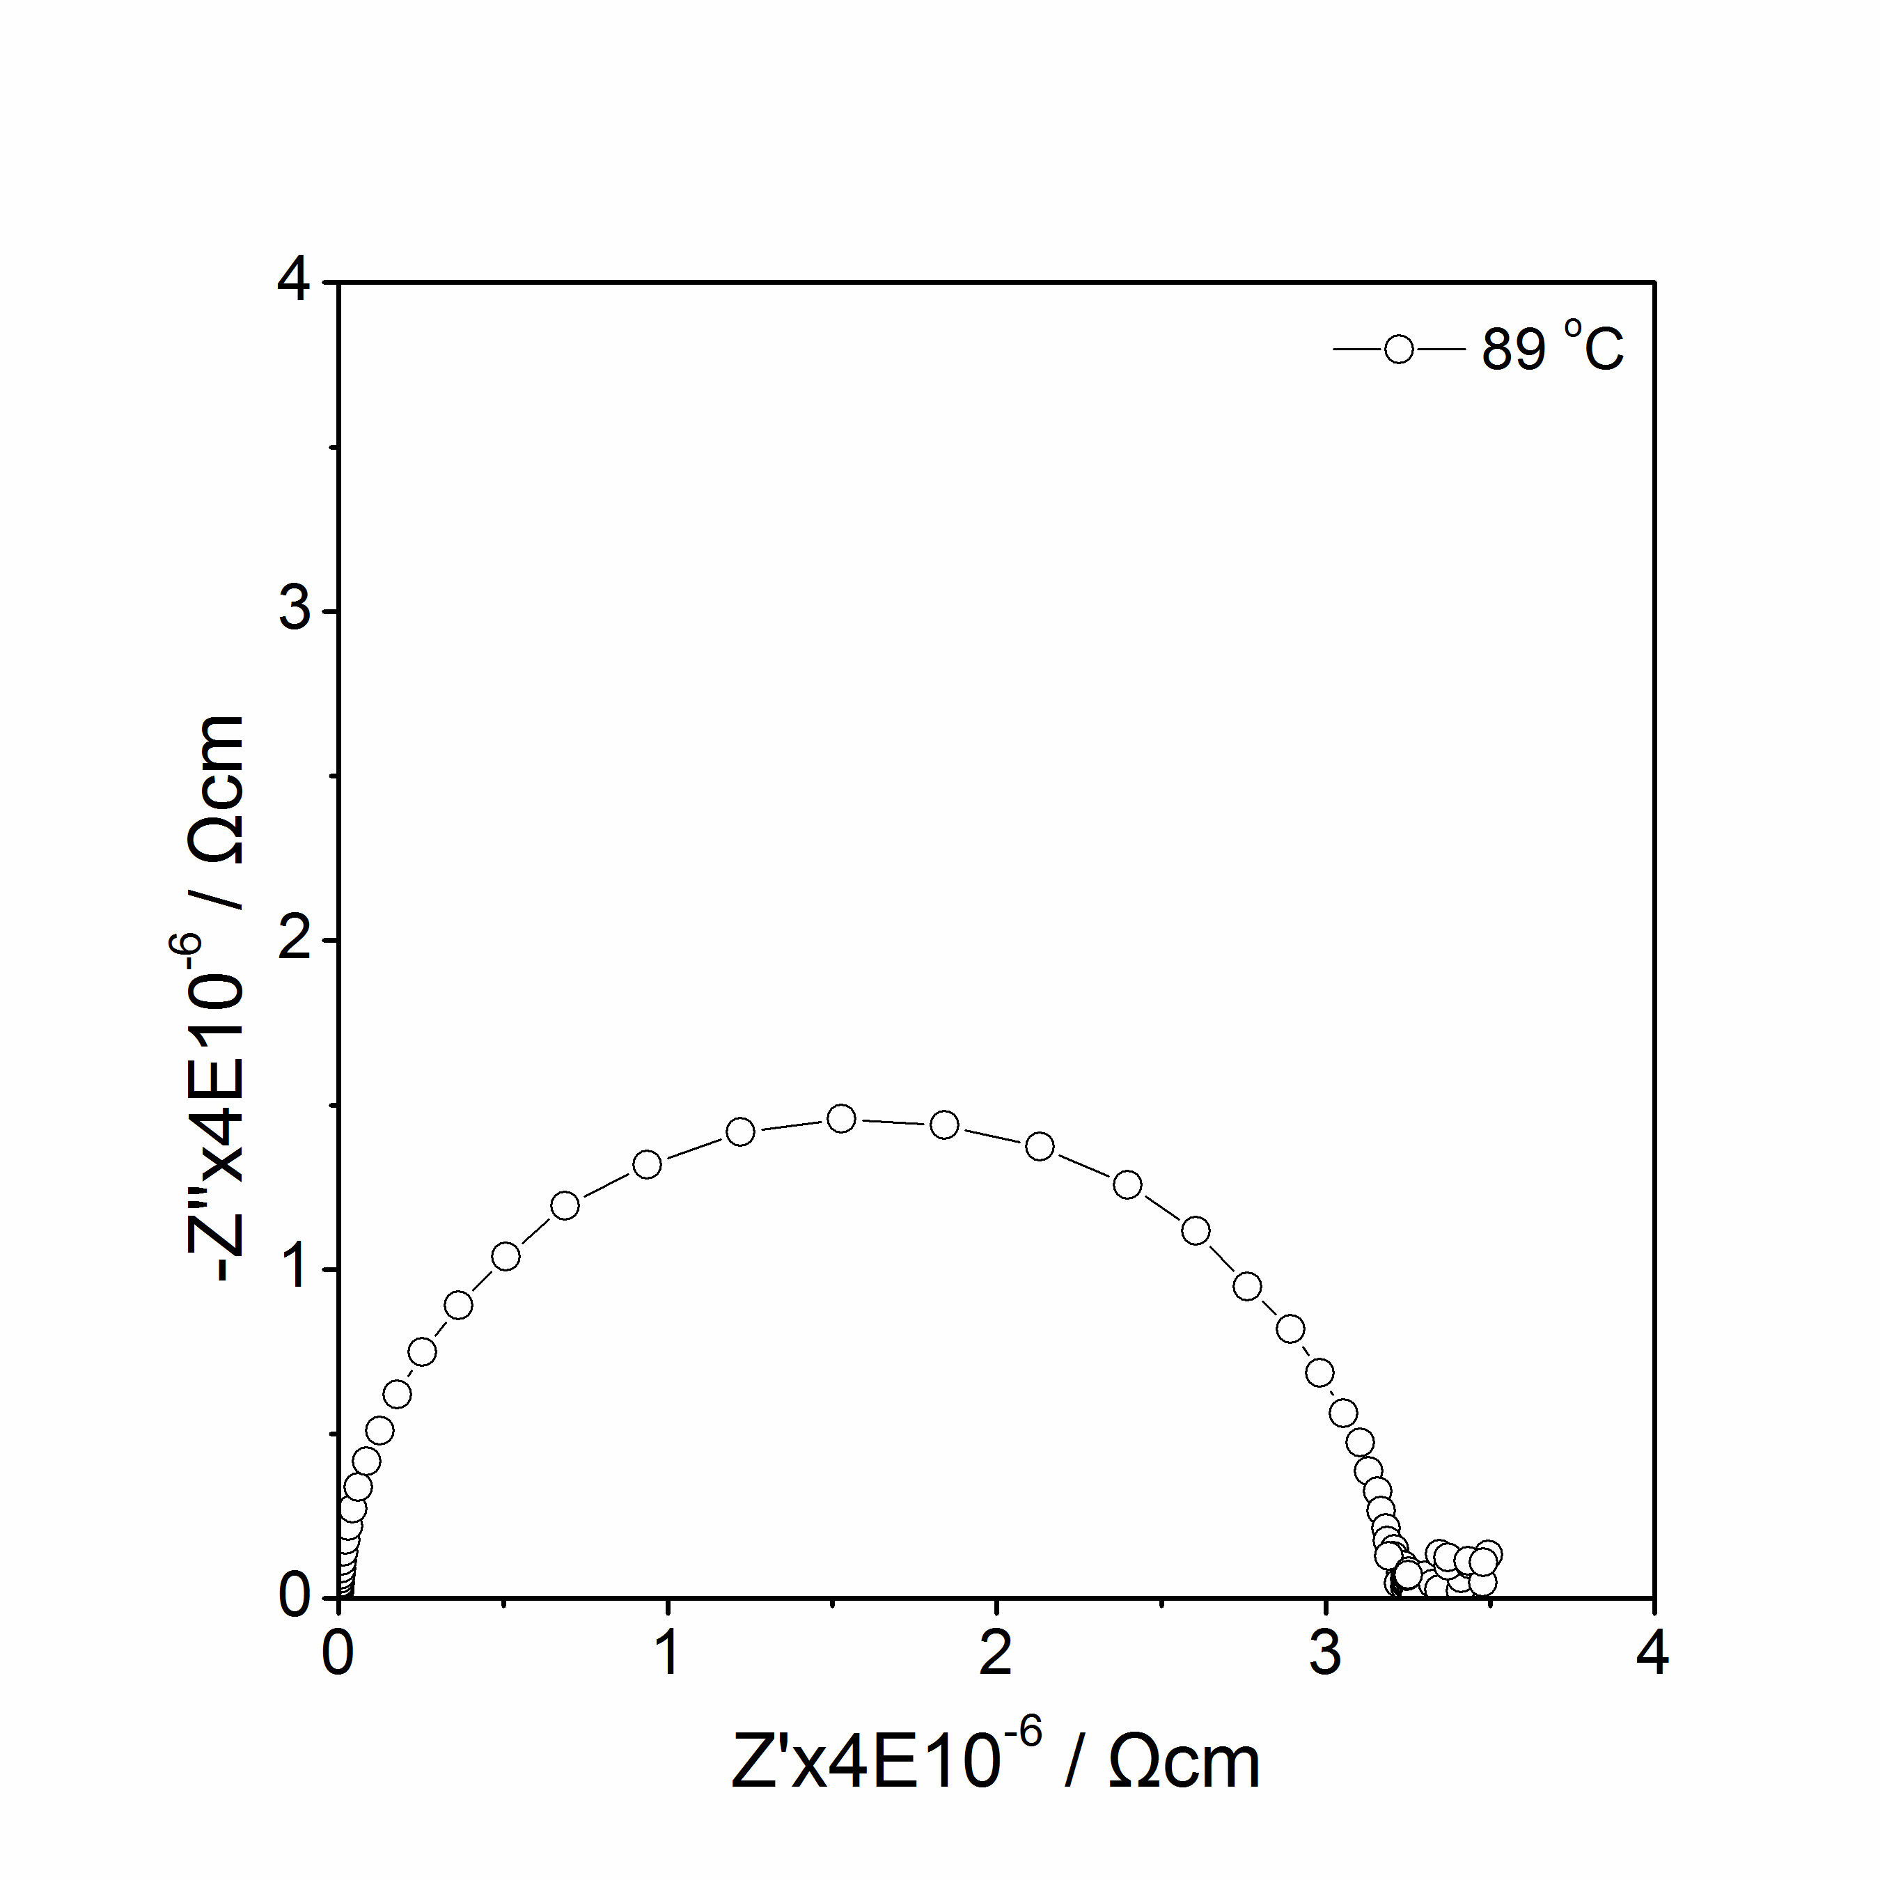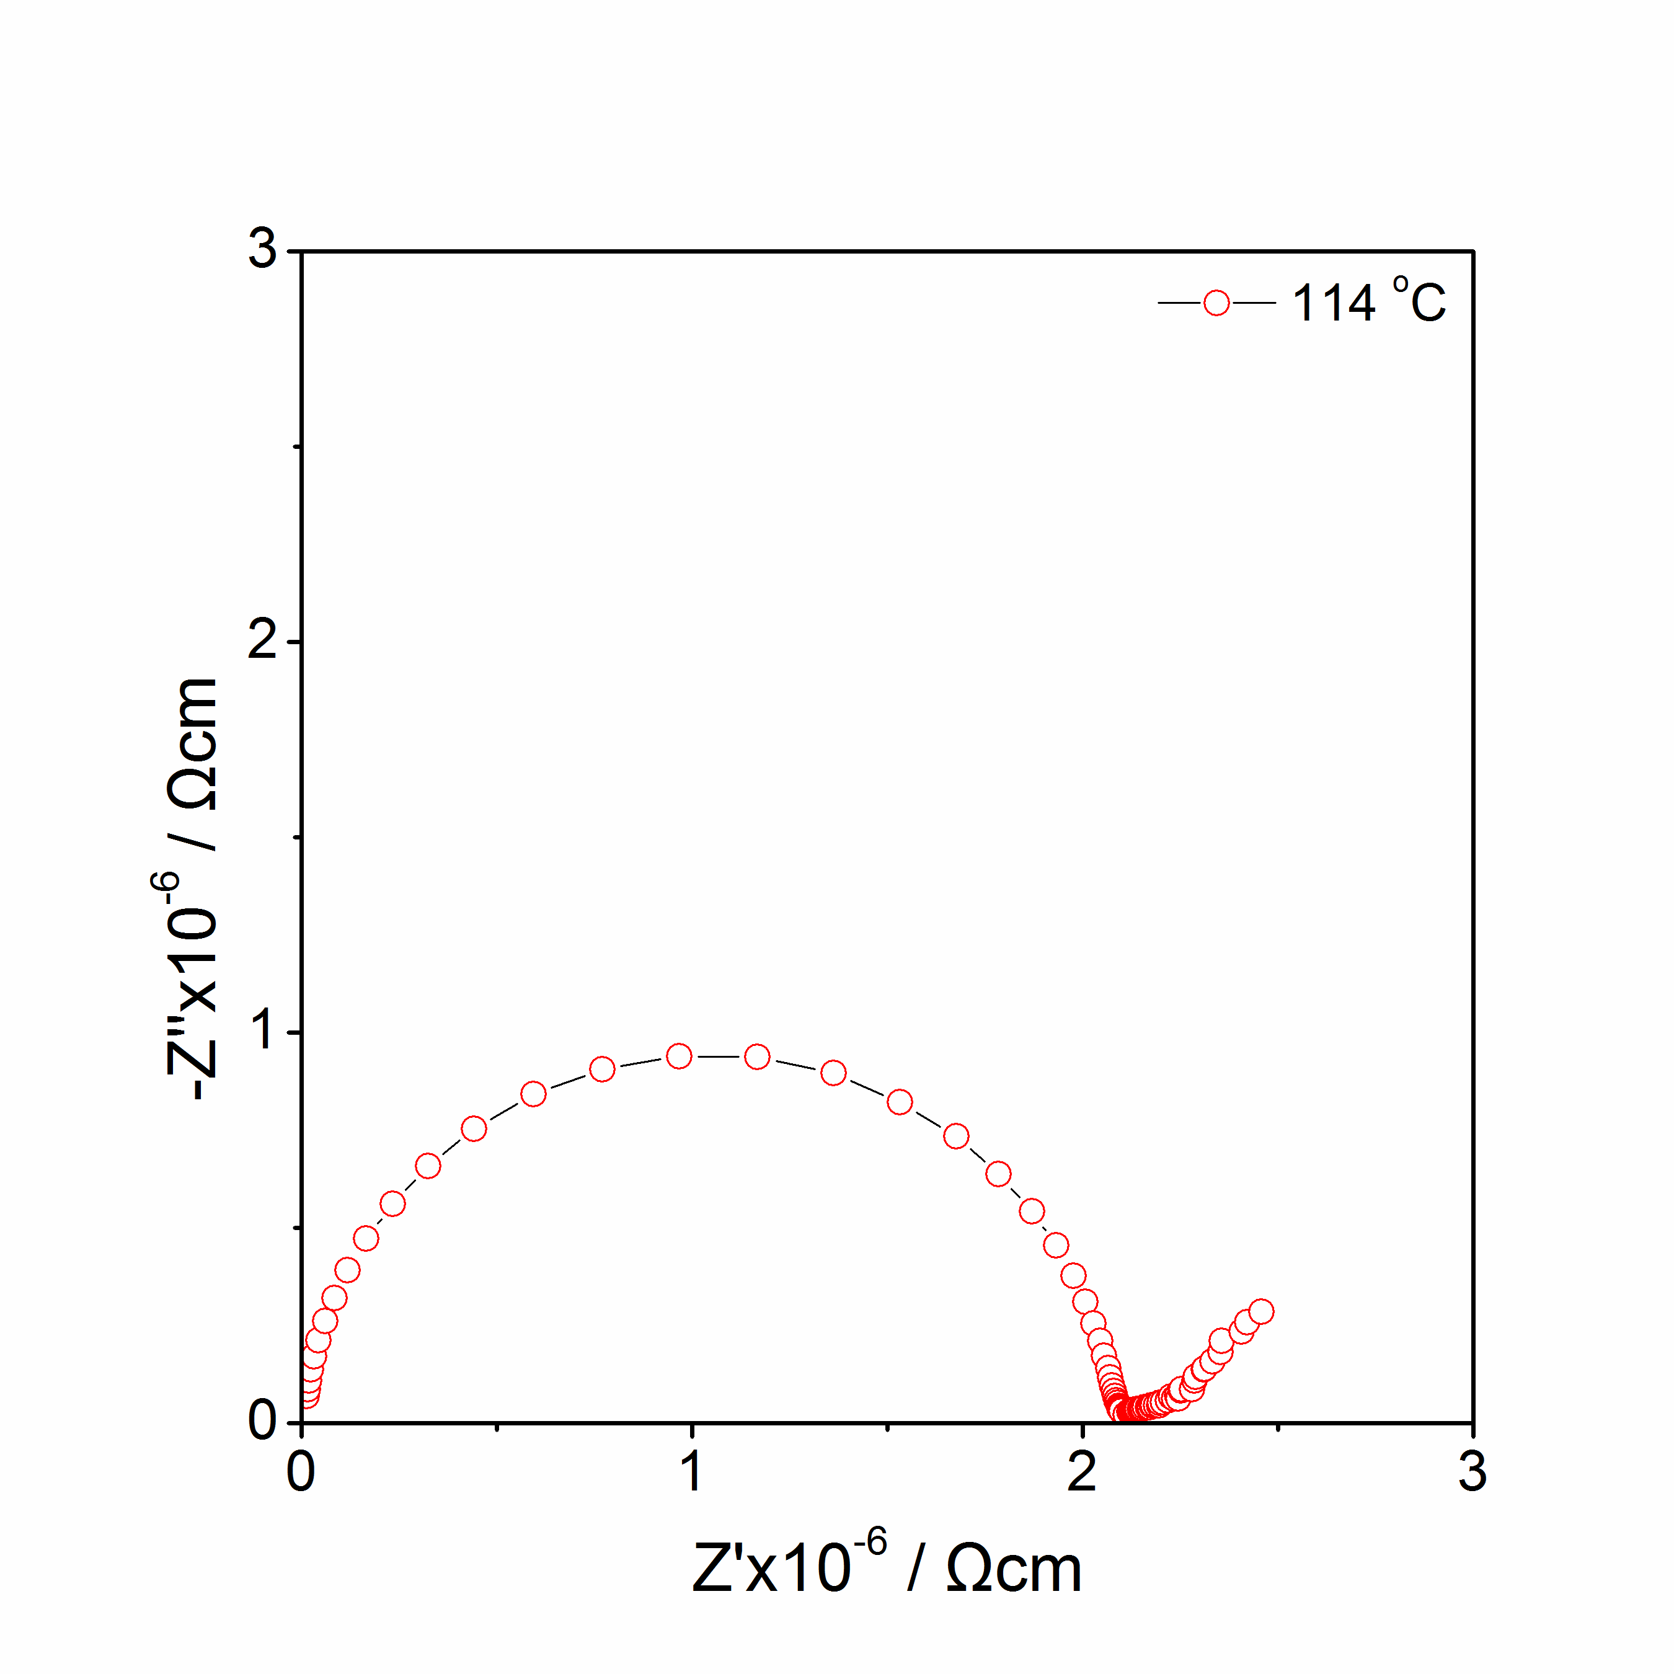
(a)
(b)
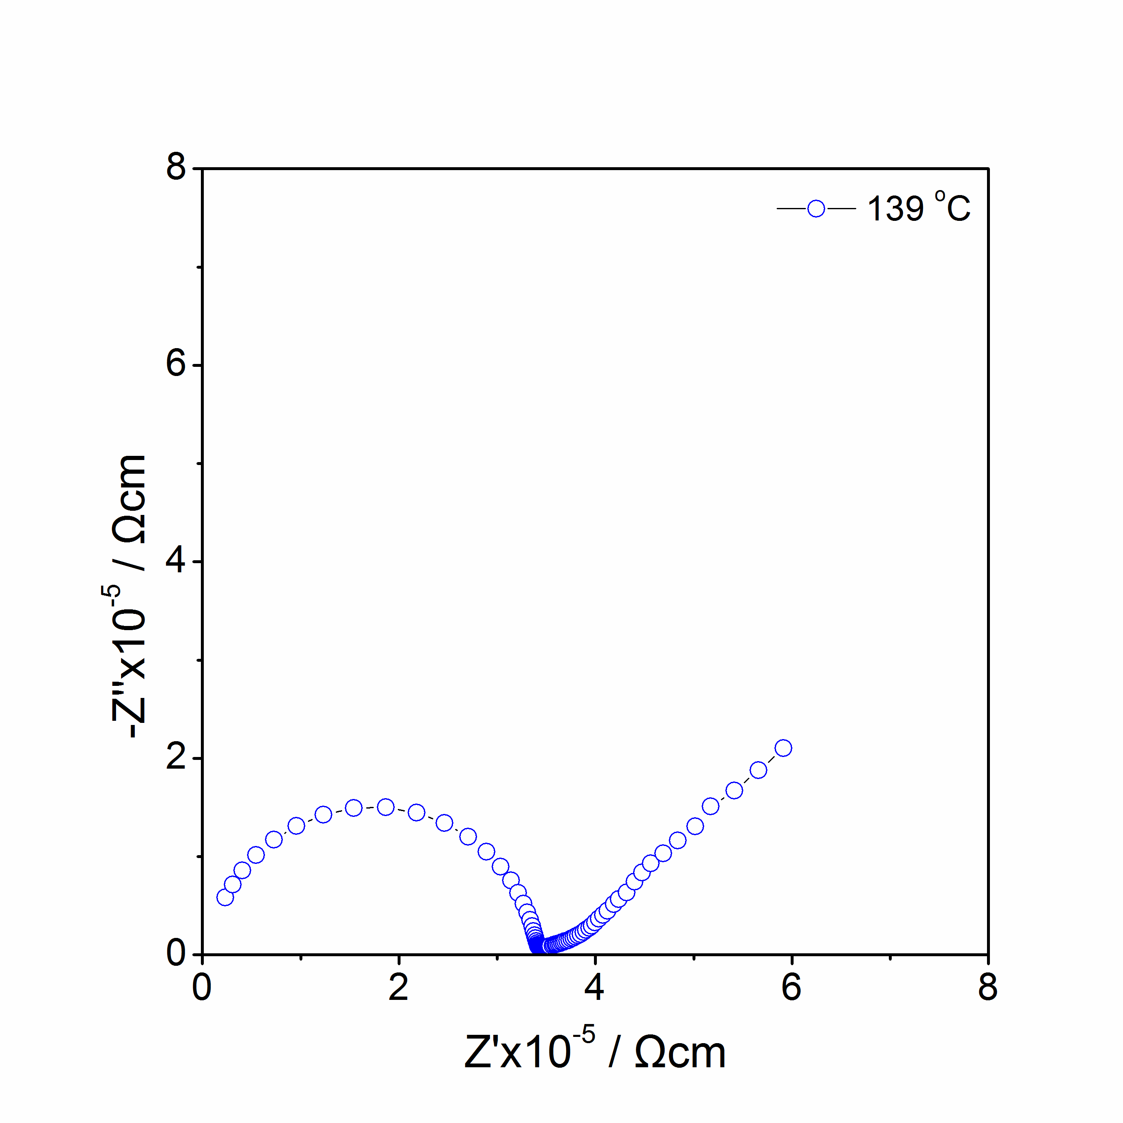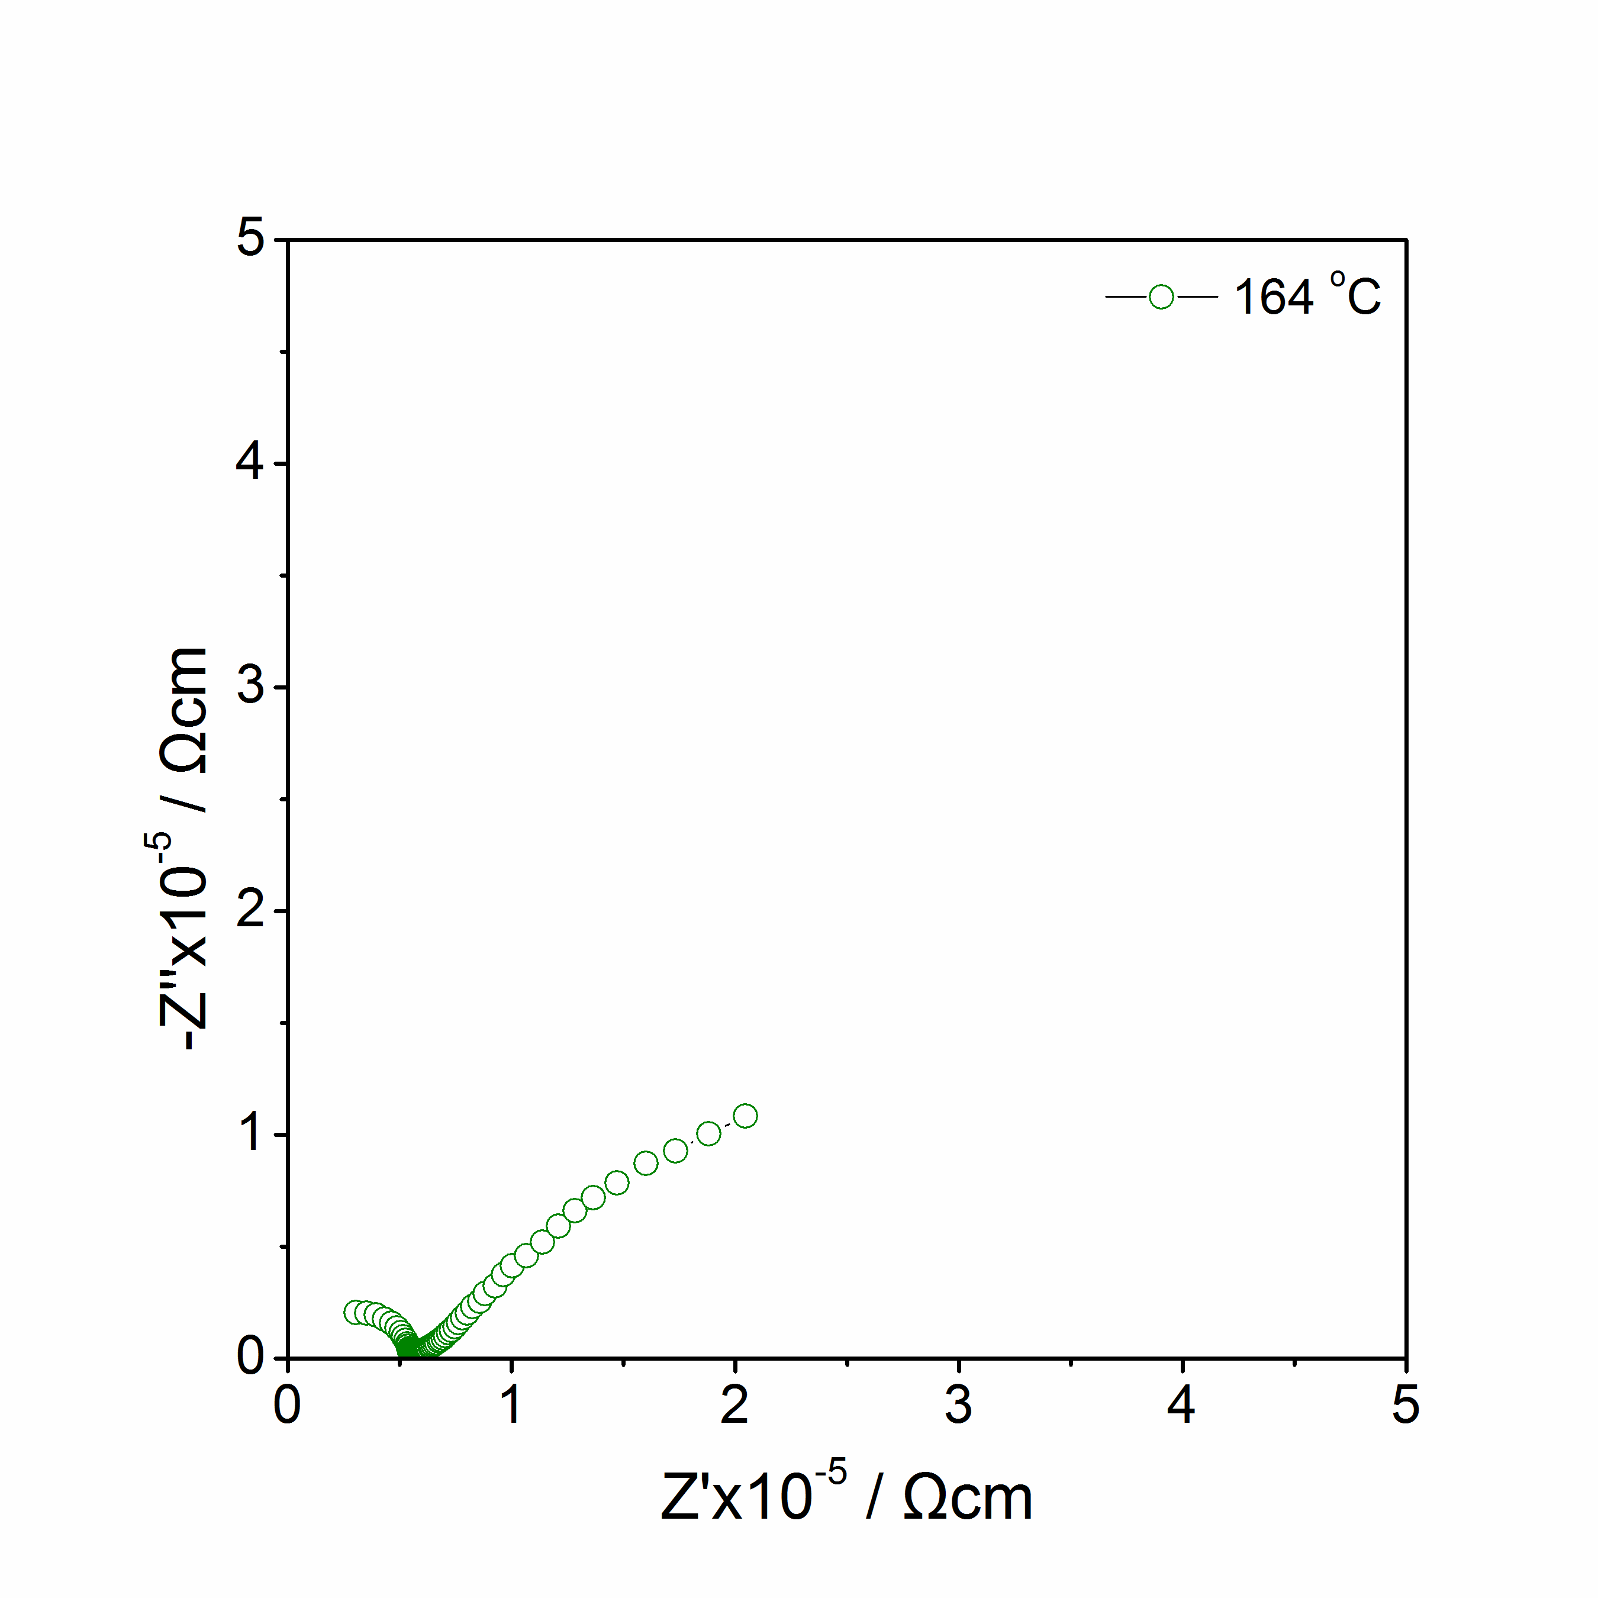
(c)
(d)
Figure 5.9 Li₃Mn_{0.5}SiO₄: Impedance complex plane plots Z* at 89 ºC to164 ºC in N₂.

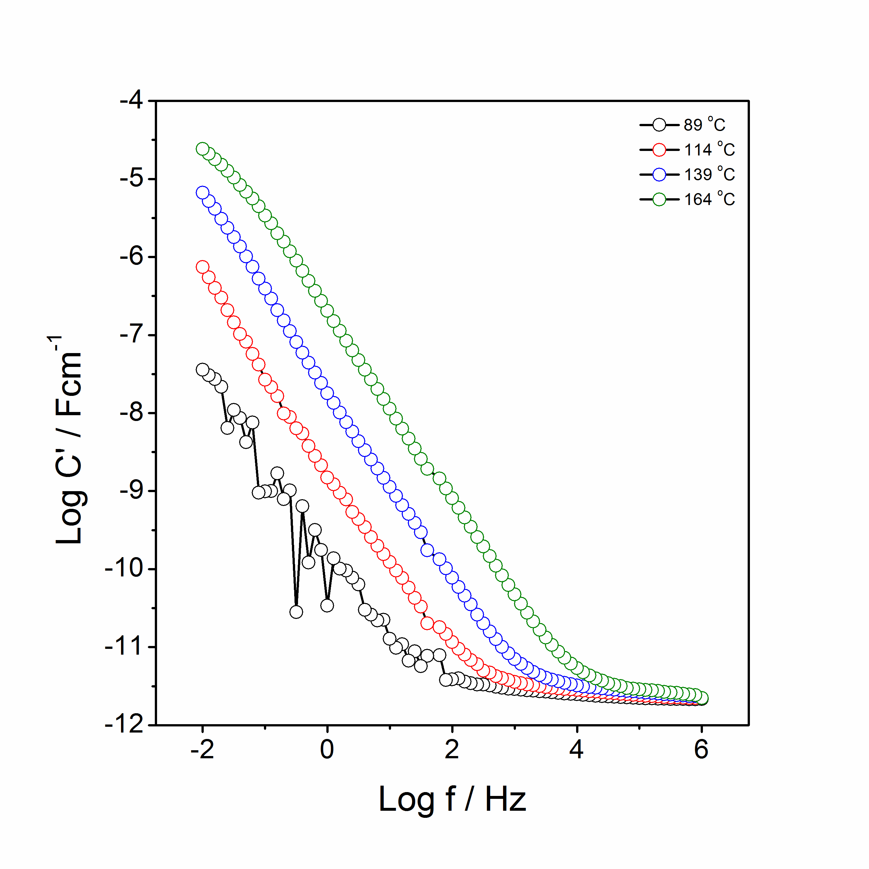
(a)
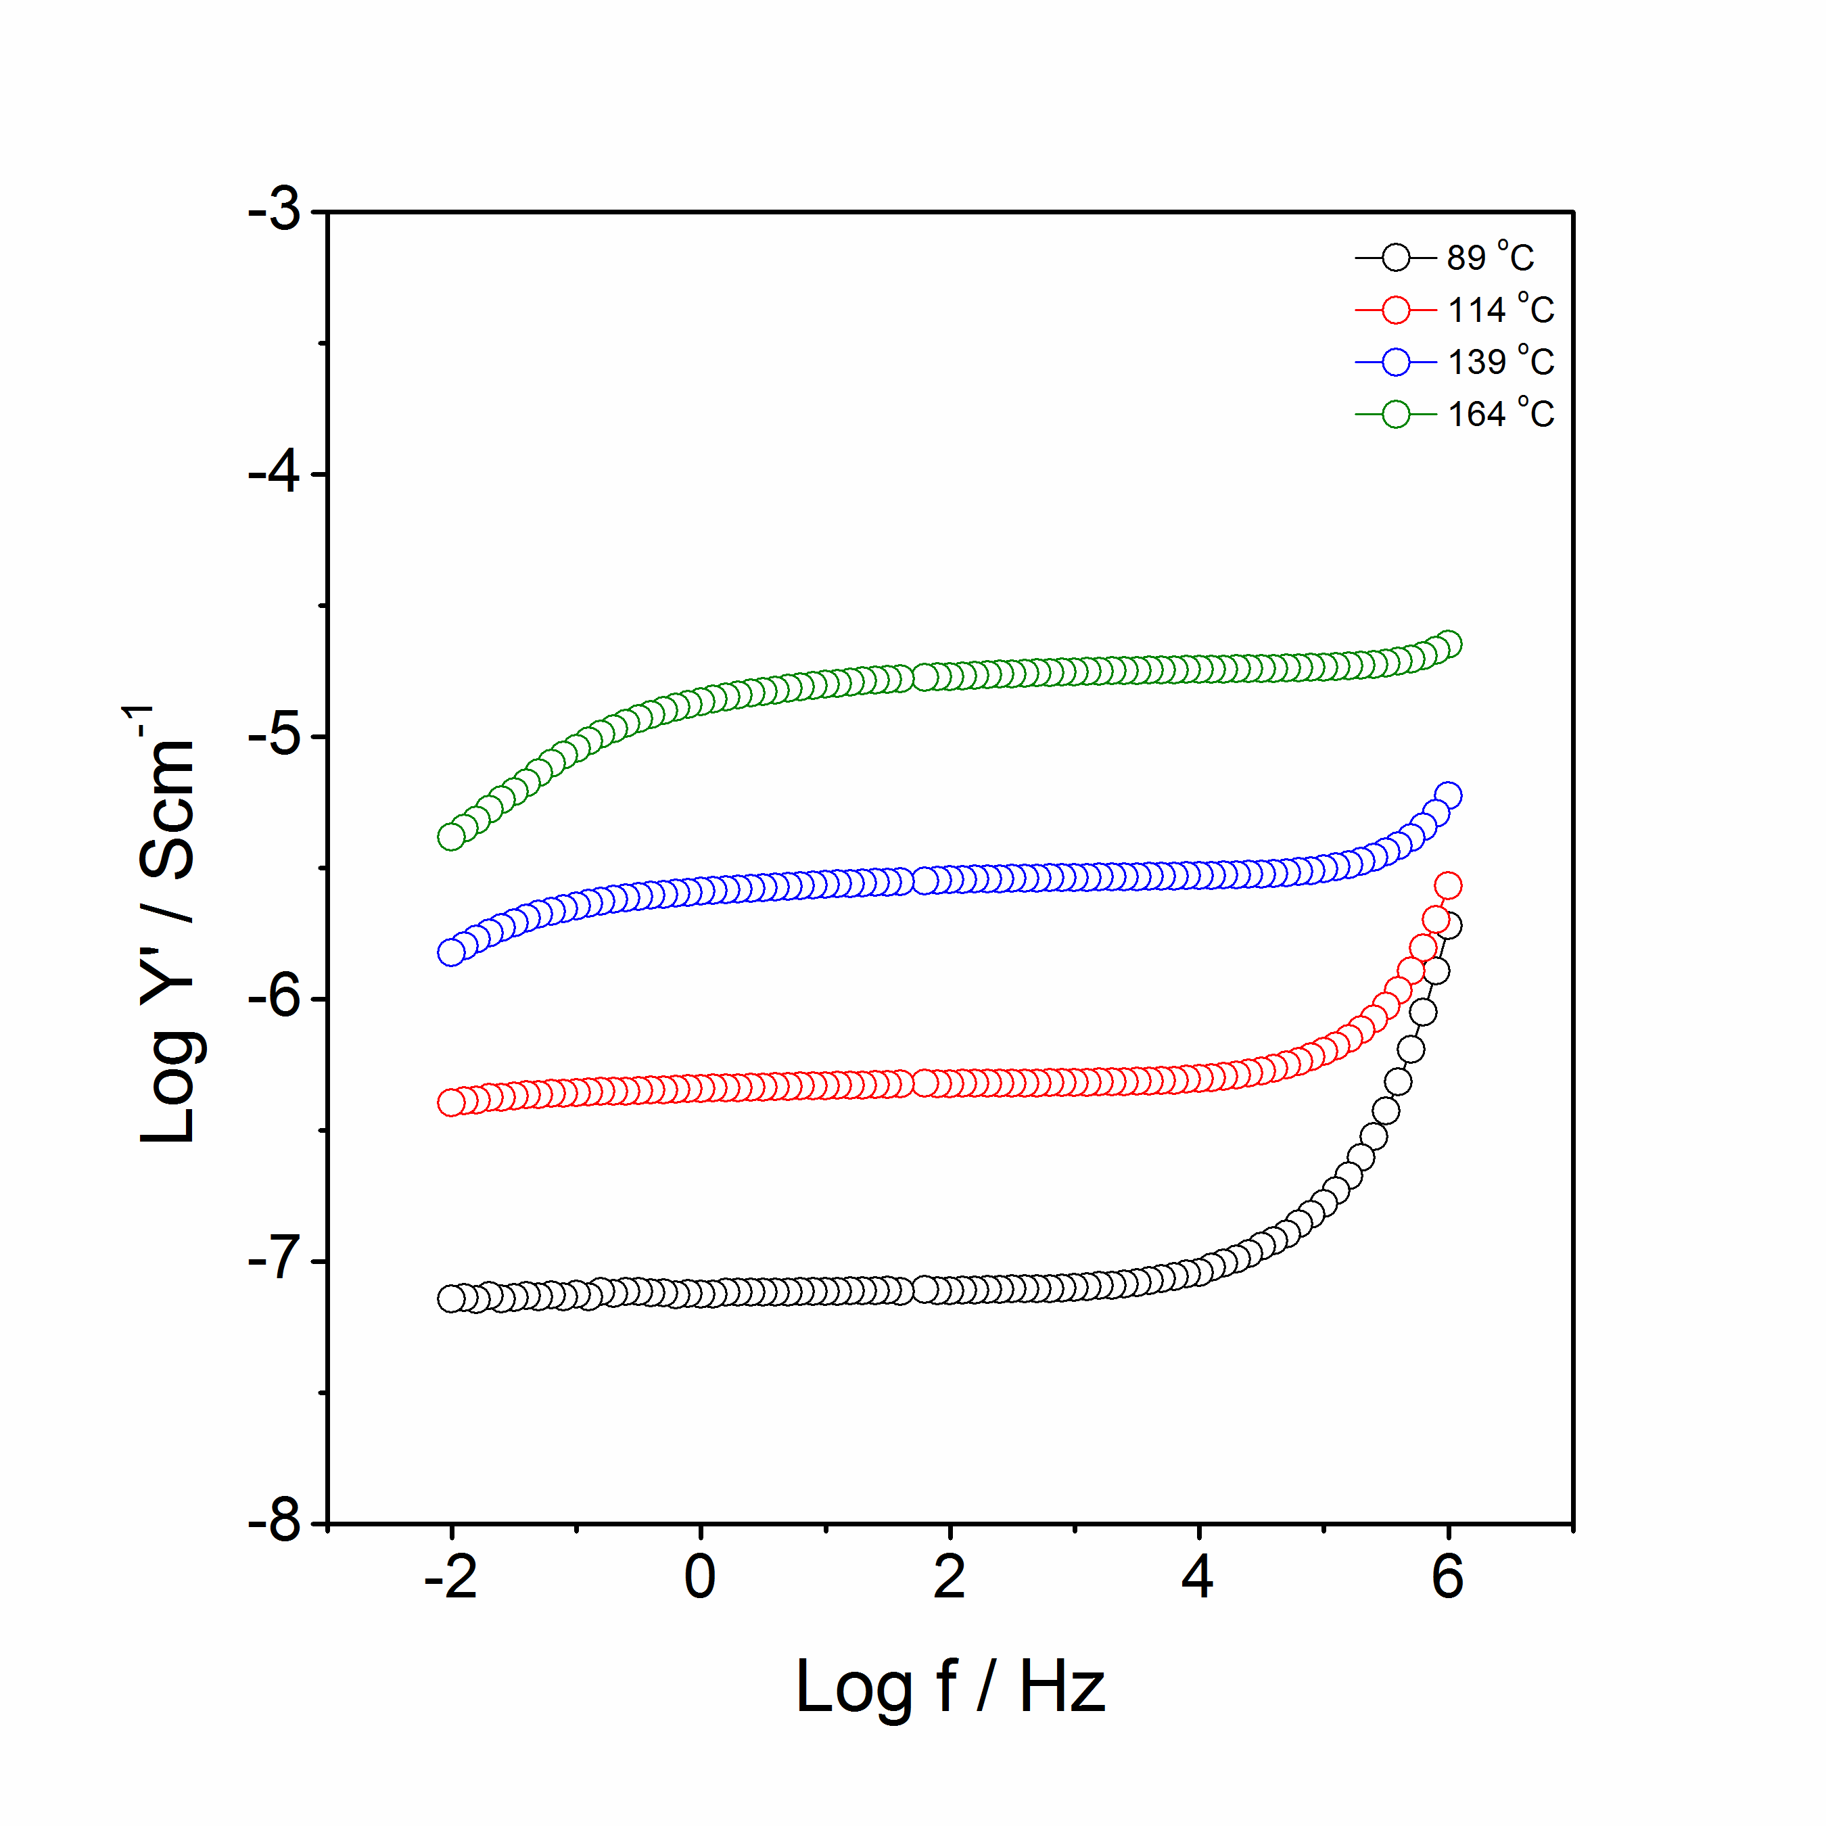
(b)
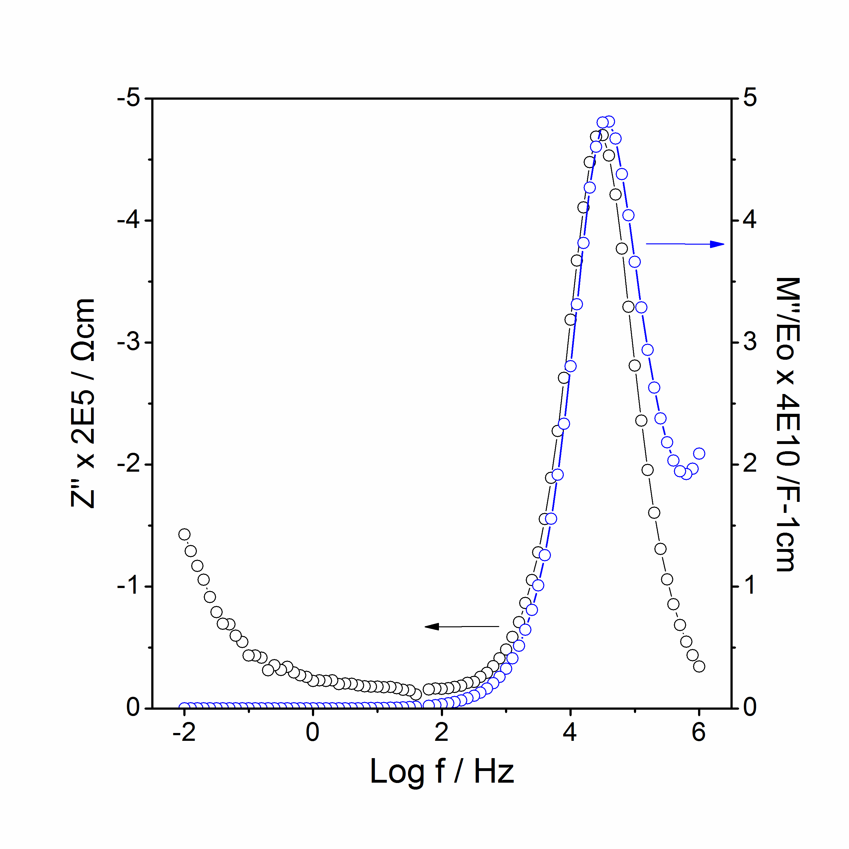
(c)
Figure 5.10 Li₃Mn_{0.5}SiO₄: spectroscopic plots of C’ (a), Y’ (b), –Z’’ and M’’ at 114 ºC (c).
Figure 5.11 shows Arrhenius plots of Li_{2+2x}Mn_{1-x}SiO₄: x = 0, 0.5. The conductivities of Li₃Mn_{0.5}SiO₄ increased by 5 – 6 orders more than those of Li₂MnSiO₄. The activation energy of Li₃Mn_{0.5}SiO₄ is 0.93 eV which is lower than that of Li₂MnSiO₄ (1.39 eV).

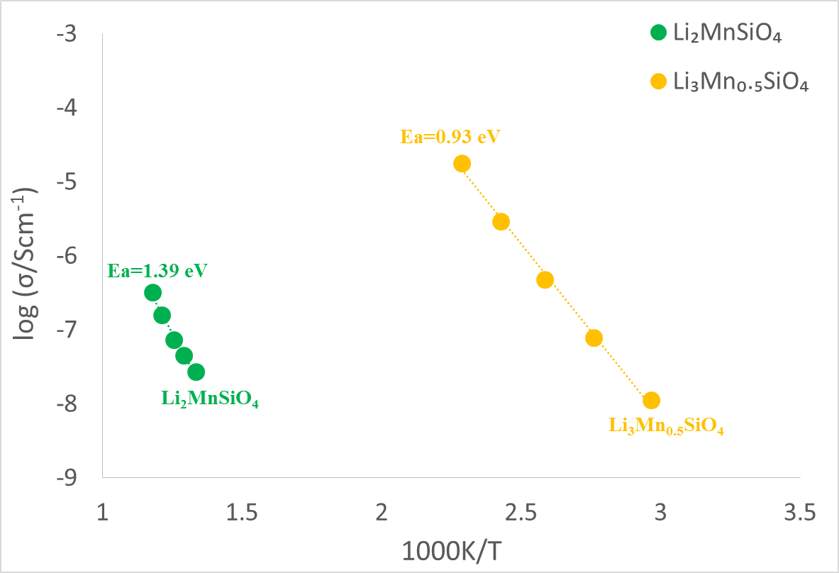
Figure 5.11 Arrhenius plot of Li_{2+2x}Mn_{1-x}SiO₄: x = 0, 0.5.

5.3.2 Li_{2+2x}Zn_{1-x}SiO₄

5.3.2.2 Binary phase diagram Li₄SiO₄-Li₂ZnSiO₄ system
Selected compositions were studied in this binary system. Table 5.5 summarises the XRD results of Li_{2+2x}Zn_{1-x}SiO₄: x = 0, 0.2, 0.4, 0.5, 0.6. Single phase Li₂ZnSiO₄ was only obtained when the sample was heated to 1150 ºC due to the low reactivity of ZnO. From the literature, β_{І} and γ₀ Li₂ZnSiO₄ polymorphs co-exist when ~0.18＜x＜~0.28 [8]. As shown in figure 5.13, the XRD pattern of composition 2 (x = 0.2, Li_{2.4}Zn_{0.8}SiO₄) shows β_{І} Li₂ZnSiO₄ phase and one extra peak at ~33º, which might be the result of overlapping of β_{І} and γ₀ phases. The XRD pattern of composition 3 (x = 0.4, Li_{2.8}Zn_{0.6}SiO₄) also shows β_{І} Li₂ZnSiO₄ phase and more extra peaks. The single γ₀ Li₂ZnSiO₄ phase exists at ~0.28＜x＜~0.5 below 1000 ºC [8], which may be an indication that γ₀ Li₂ZnSiO₄ transform to β_{І} Li₂ZnSiO₄ at higher temperature and is an irreversible process.

The XRD patterns of composition 4 and 5 (x = 0.5 and 0.6, Li₃Zn_{0.5}SiO₄ and Li_{3.2}Zn_{0.4}SiO₄) at 1100 ºC show a mixture of Li₄SiO₄ and unknown phases. As reported in the literature, Li-excess samples could be made at lower temperatures [9]. Composition 4 (x = 0.5, Li₃Zn_{0.5}SiO₄) was synthesised again at lower temperature, 850 ºC, and the XRD patterns of composition 4 at 850 and 1100 ºC were quite different (figure 5.14). As shown in table 5.6, similar to Li₃Mn_{0.5}SiO₄, Li₃Zn_{0.5}SiO₄ at 850 ºC was indexed with orthorhombic system, a = 10.6687(5) (Å), b = 6.2089(4) (Å), c = 5.0590(3) (Å), V = 335.11(5) (Å³).

Table 5.5 XRD results of different compositions in the Li₄SiO₄ – Zn₂SiO₄ system with formula Li_{2+2x}Zn_{1-x}SiO₄.
Composition | x | Formulae | Temperature (ºC) | Time (h) | Detected phases
1 | 0 | Li₂ZnSiO₄ | 1150 | 20 | γ₀₋Li₂ZnSiO₄
2 | 0.2 | Li_{2.4}Zn_{0.8}SiO₄ | 1100 | 10 | γ₀₋Li₂ZnSiO₄ and unknown peaks
3 | 0.4 | Li_{2.8}Zn_{0.6}SiO₄ | 1100 | 10 | γ₀₋Li₂ZnSiO₄ and unknown peaks
4 | 0.5 | Li₃Zn_{0.5}SiO₄ | 850 | 10 | New phase
4 | 0.5 | Li₃Zn_{0.5}SiO₄ | 1100 | 10 | Li₄SiO₄ and unknown phase
5 | 0.6 | Li_{3.2}Zn_{0.4}SiO₄ | 1100 | 10 | Li₄SiO₄ and unknown phase

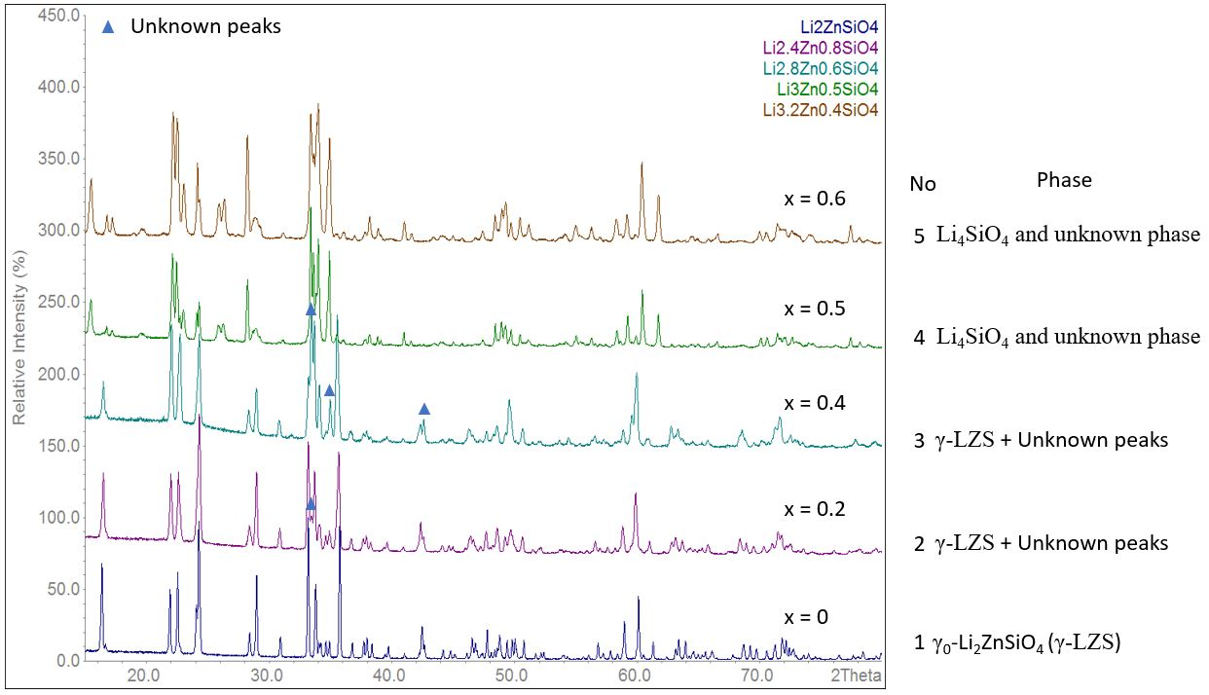
Figure 5.13 XRD patterns of Li_{2+2x}Zn_{1-x}SiO₄: x = 0, 0.2, 0.4, 0.5, 0.6. XRD patterns were collected by CuPSD with λ = 1.5406 Å.
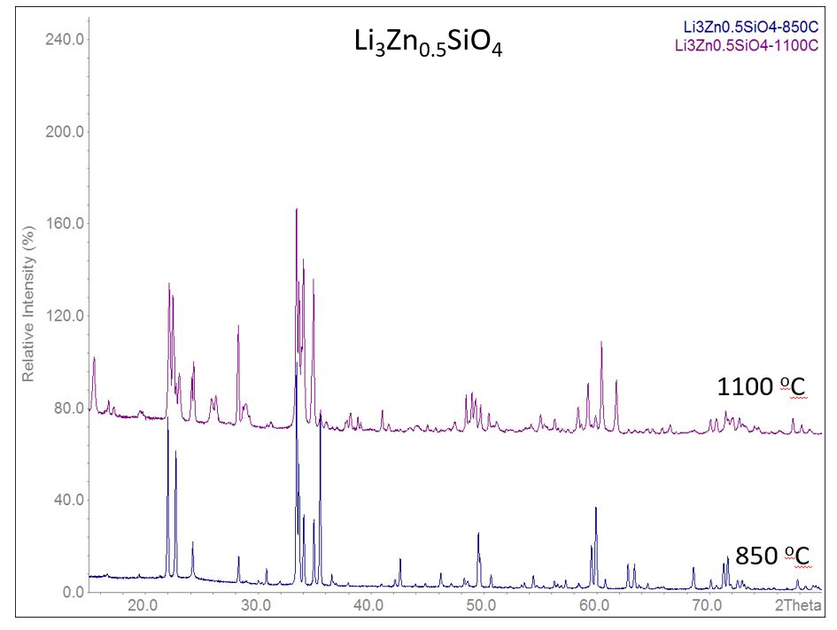
Figure 5.14 XRD patterns of Li₃Zn_{0.5}SiO₄ at 850 and 1100 ºC. XRD patterns were collected by CuPSD with λ = 1.5406 Å.

Table 5.6 Indexing results of Li₃Zn_{0.5}SiO₄
N | 2θ_{obs}(º) | h | k | l | 2θ_{calc}(º) | Δ2θ(º) | Int. | d_{obs}(Å) | d_{calc}(Å)
1 | 16.608 | 2 | 0 | 0 | 16.606 | 0.0026 | 8 | 5.3335 | 5.3343
2 | 19.39 | 1 | 0 | 1 | 19.403 | -0.0133 | 7.6 | 4.5742 | 4.5711
3 | 21.955 | 2 | 1 | 0 | 21.95 | 0.0056 | 75.7 | 4.0451 | 4.0461
4 | 22.658 | 0 | 1 | 1 | 22.654 | 0.0045 | 61.2 | 3.9212 | 3.922
5 | 24.166 | 1 | 1 | 1 | 24.158 | 0.0079 | 21.9 | 3.6799 | 3.6811
6 | 28.224 | 2 | 1 | 1 | 28.219 | 0.0049 | 15.9 | 3.1593 | 3.1598
7 | 28.905 | 3 | 1 | 0 | 28.91 | -0.0054 | 4.9 | 3.0865 | 3.0859
8 | 30.01 | - | - | - | - | - | 5.3 | 2.9753 | -
9 | 30.714 | 3 | 0 | 1 | 30.706 | 0.0078 | 10.4 | 2.9086 | 2.9093
10 | 33.369 | 2 | 2 | 0 | 33.367 | 0.002 | 100 | 2.683 | 2.6831
11 | 33.568 | 4 | 0 | 0 | 33.573 | -0.0055 | 55.8 | 2.6676 | 2.6672
12 | 34.005 | 3 | 1 | 1 | 34.003 | 0.0022 | 33.4 | 2.6343 | 2.6345
13 | 34.909 | 1 | 2 | 1 | 34.908 | 0.0005 | 31.8 | 2.5681 | 2.5682
14 | 35.46 | 0 | 0 | 2 | 35.459 | 0.0007 | 77.8 | 2.5295 | 2.5295
15 | 36.485 | 1 | 0 | 2 | 36.476 | 0.0089 | 7.8 | 2.4607 | 2.4613
16 | 36.639 | 4 | 1 | 0 | 36.64 | -0.0019 | 4.7 | 2.4507 | 2.4506
17 | 37.923 | 2 | 2 | 1 | 37.927 | -0.0042 | 4.2 | 2.3706 | 2.3704
18 | 40.879 | 4 | 1 | 1 | 40.885 | -0.0054 | 3.6 | 2.2058 | 2.2055
19 | 42.098 | 2 | 1 | 2 | 42.095 | 0.0038 | 5.5 | 2.1447 | 2.1449
20 | 42.551 | 3 | 2 | 1 | 42.552 | -0.0016 | 14.6 | 2.1229 | 2.1228
21 | 43.885 | 3 | 0 | 2 | 43.888 | -0.0033 | 3.6 | 2.0614 | 2.0613
22 | 44.762 | 4 | 2 | 0 | 44.761 | 0.0006 | 3.9 | 2.023 | 2.0231
23 | 46.134 | 5 | 0 | 1 | 46.134 | 0.0004 | 8.6 | 1.966 | 1.966
24 | 47.076 | 2 | 3 | 0 | 47.059 | 0.0166 | 3.7 | 1.9289 | 1.9295
 |  | 1 | 2 | 2 | 47.081 | -0.0049 |  |  | 1.9287
25 | 48.222 | 1 | 3 | 1 | 48.229 | -0.0076 | 6.2 | 1.8857 | 1.8854
26 | 48.53 | 5 | 1 | 1 | 48.533 | -0.0027 | 4.9 | 1.8744 | 1.8743
27 | 49.483 | 2 | 2 | 2 | 49.482 | 0.0011 | 25.4 | 1.8405 | 1.8405
28 | 49.627 | 4 | 0 | 2 | 49.631 | -0.0036 | 14.9 | 1.8355 | 1.8354
29 | 50.588 | 2 | 3 | 1 | 50.589 | -0.0013 | 7.6 | 1.8029 | 1.8028
30 | 53.296 | 3 | 2 | 2 | 53.305 | -0.009 | 3.2 | 1.7175 | 1.7172
31 | 53.565 | 6 | 1 | 0 | 53.568 | -0.003 | 4.1 | 1.7095 | 1.7094
32 | 54.352 | 3 | 3 | 1 | 54.356 | -0.0038 | 7.2 | 1.6866 | 1.6864
 |  | 0 | 0 | 3 | 54.36 | -0.0076 |  |  | 1.6863
33 | 54.673 | 6 | 0 | 1 | 54.67 | 0.0037 | 3 | 1.6774 | 1.6775
34 | 55.255 | 5 | 2 | 1 | 55.261 | -0.0056 | 2.7 | 1.6611 | 1.661
35 | 56.219 | 4 | 3 | 0 | 56.212 | 0.0075 | 5 | 1.6349 | 1.6351
36 | 56.497 | 0 | 1 | 3 | 56.502 | -0.0054 | 3.7 | 1.6275 | 1.6274
37 | 56.8 | 6 | 1 | 1 | 56.804 | -0.0044 | 3 | 1.6196 | 1.6194
38 | 57.218 | 1 | 1 | 3 | 57.216 | 0.0023 | 5.3 | 1.6087 | 1.6088
39 | 58.368 | 4 | 2 | 2 | 58.36 | 0.0072 | 3.9 | 1.5797 | 1.5799
40 | 59.504 | 0 | 4 | 0 | 59.505 | -0.0008 | 20.3 | 1.5522 | 1.5522
41 | 59.898 | 6 | 2 | 0 | 59.899 | -0.0009 | 37.2 | 1.543 | 1.5429
42 | 60.728 | 7 | 0 | 0 | 60.718 | 0.0108 | 5.7 | 1.5239 | 1.5241
 |  | 3 | 0 | 3 | 60.735 | -0.0064 |  |  | 1.5237
43 | 62.732 | 7 | 1 | 0 | 62.721 | 0.0113 | 12.5 | 1.4799 | 1.4802
 |  | 3 | 1 | 3 | 62.737 | -0.0055 |  |  | 1.4798
44 | 63.31 | 1 | 2 | 3 | 63.312 | -0.0019 | 12.4 | 1.4678 | 1.4677
45 | 63.717 | 7 | 0 | 1 | 63.721 | -0.0035 | 3.2 | 1.4594 | 1.4593
46 | 64.485 | 5 | 2 | 2 | 64.486 | -0.0002 | 3.9 | 1.4438 | 1.4438
47 | 65.898 | 6 | 1 | 2 | 65.896 | 0.0023 | 2.5 | 1.4163 | 1.4163
48 | 68.546 | 7 | 2 | 0 | 68.532 | 0.0135 | 10.8 | 1.3679 | 1.3681
 |  | 3 | 2 | 3 | 68.548 | -0.0026 |  |  | 1.3678
49 | 70.087 | 4 | 4 | 0 | 70.084 | 0.0031 | 5.7 | 1.3415 | 1.3416
50 | 70.572 | 8 | 0 | 0 | 70.566 | 0.0059 | 2.9 | 1.3335 | 1.3336
51 | 71.218 | 5 | 0 | 3 | 71.214 | 0.004 | 12.5 | 1.323 | 1.323
 |  | 0 | 4 | 2 | 71.217 | 0.0014 |  |  | 1.323
52 | 71.581 | 6 | 2 | 2 | 71.576 | 0.0049 | 15.4 | 1.3172 | 1.3172

Final 2θ window: 0.02, Symmetry: orthorhombic, a = 10.6687(5) (Å), b = 6.2089(4) (Å), c = 5.0590(3) (Å), V = 335.11(5) (Å³).

5.3.2.2 Impedance spectroscopy (IS) of Li₃Zn_{0.5}SiO₄
Z* plots of Li₃Zn_{0.5}SiO₄ with gold paste electrodes at 84 to 152 ºC in air are shown in figure 5.15. At 84 and 105 ºC, a high frequency semicircle and a sharp spike with 60º angle were detected, which is a good indication that ionic species were blocked at the interface of sample and electrode. At higher temperatures, 128 and 152 ºC, the semicircle moved out of the measured window.

The capacitance (C’) versus frequency at different temperatures is shown in figure 5.16(a). A high frequency plateau with a value of 2.5∙10⁻¹² F/cm associated with bulk of the sample, a dispersion at intermediate frequencies and a low frequency plateau, 7∙10⁻⁶ F/cm, which represented Li⁺ ion accumulation at the sample-electrode interface.

The conductivity (Y’) as a function of frequency at different temperatures is shown in figure 5.16(b). Two dispersions at low and high frequencies with an intermediate frequency independent plateau were observed at 84 and 105 ºC. At higher temperatures, the high frequency dispersion shifted out of the measured window.

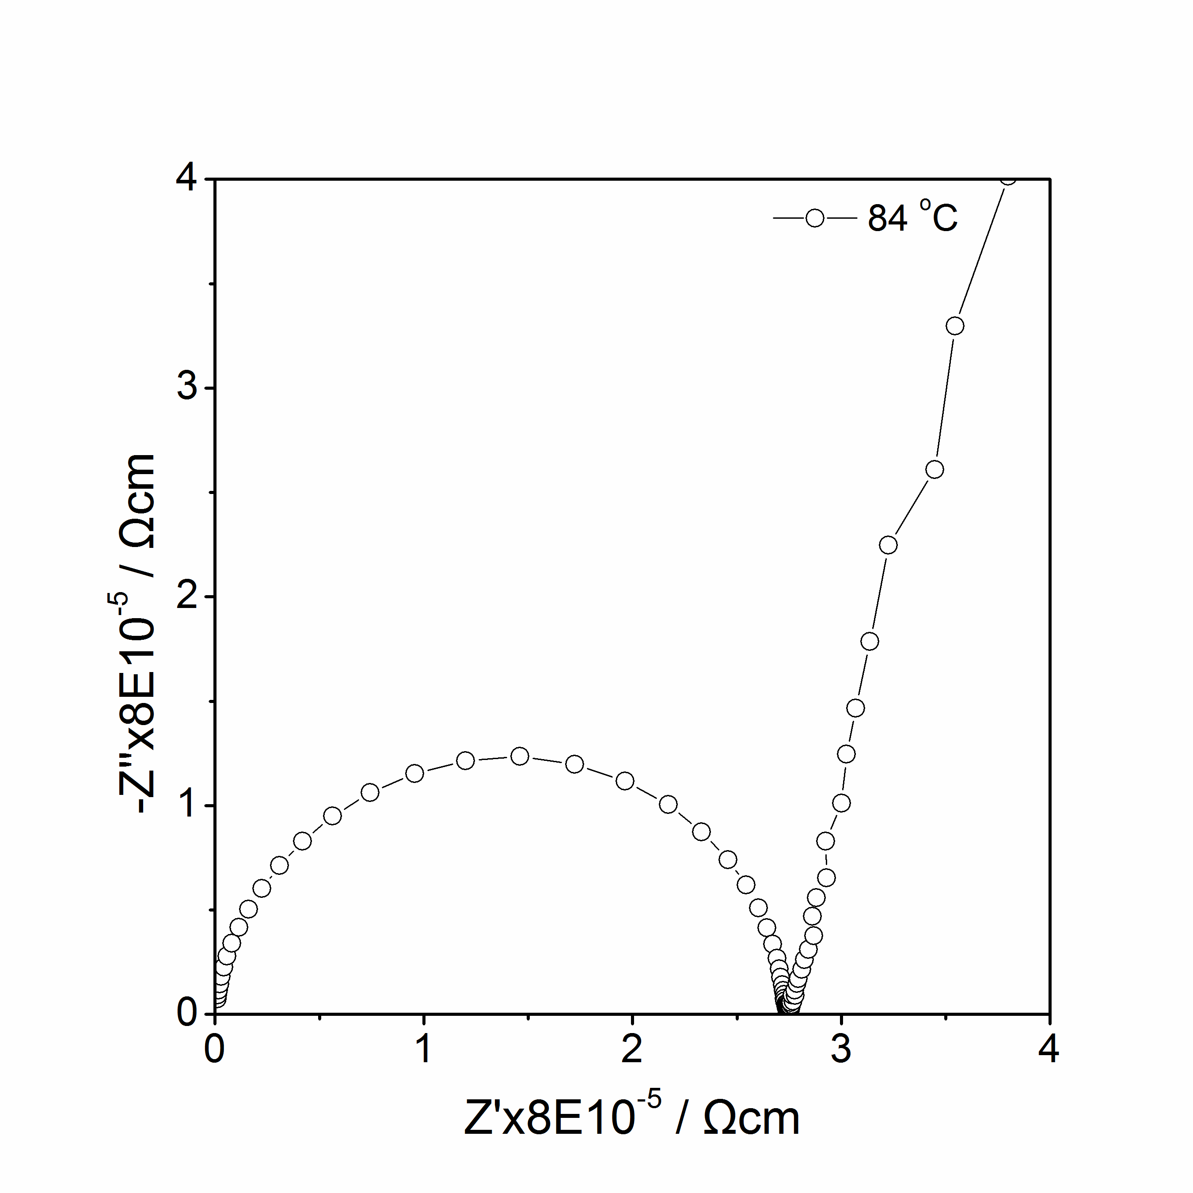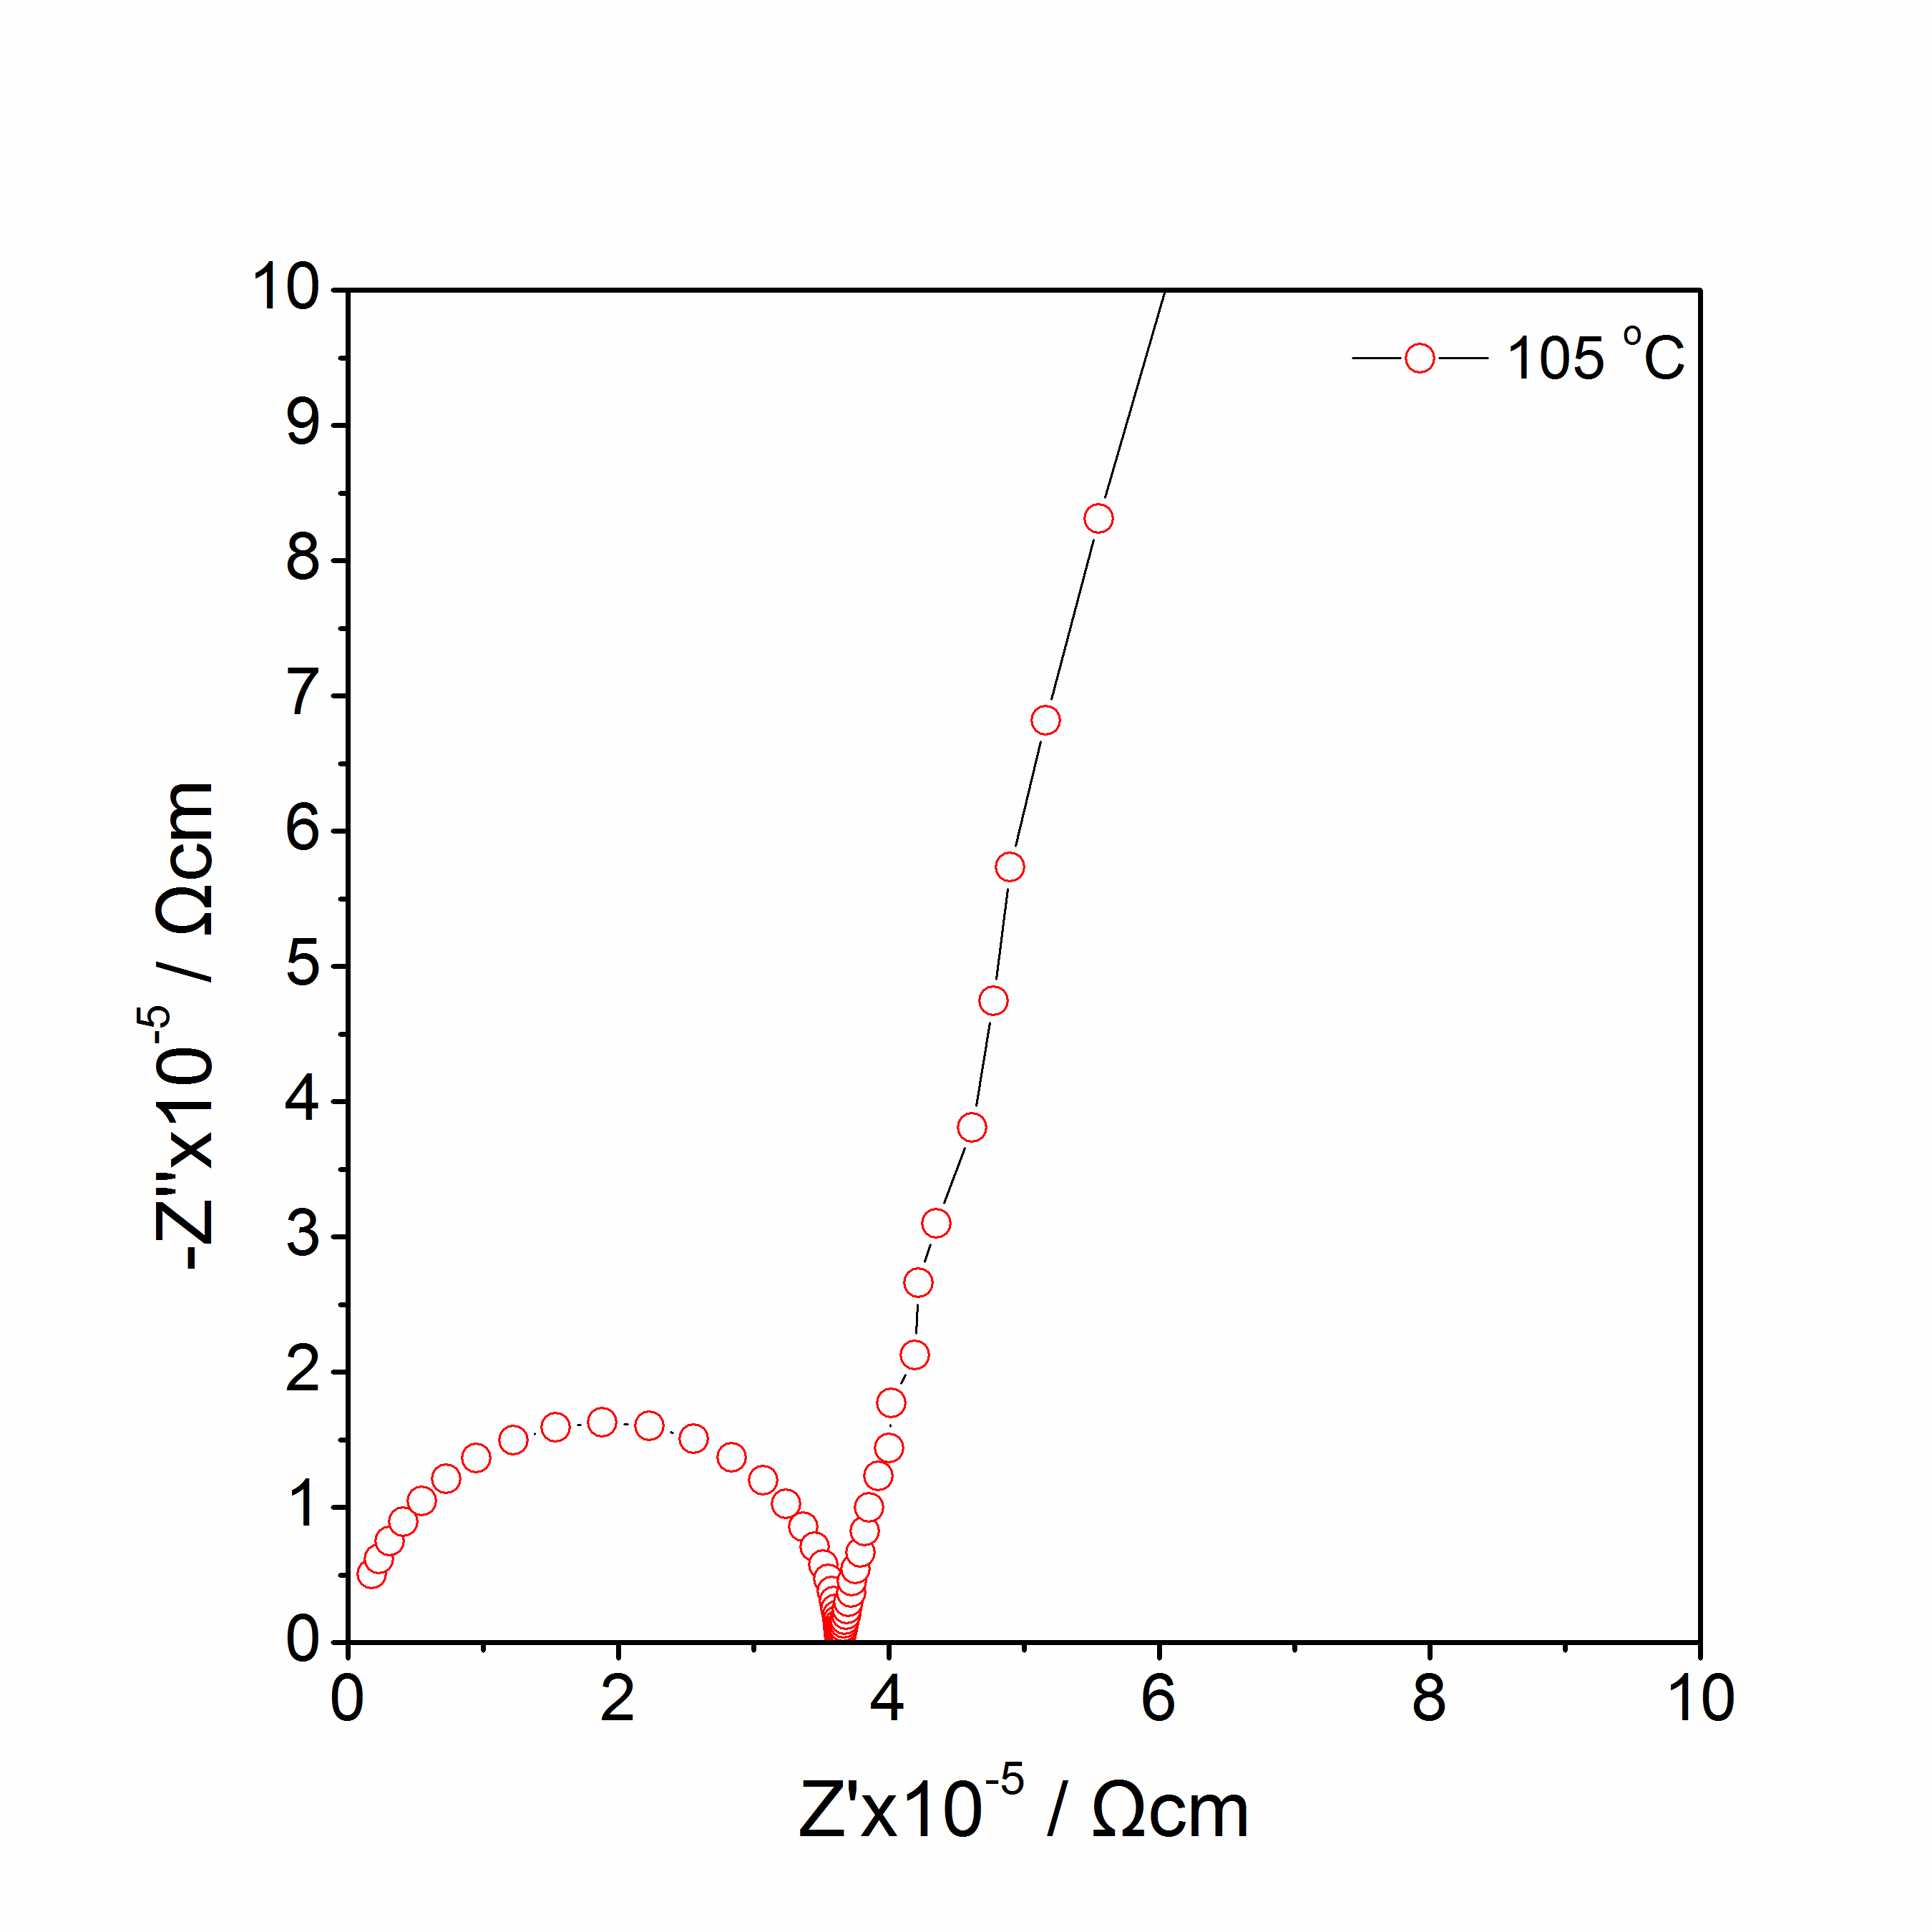
(a)
(b)
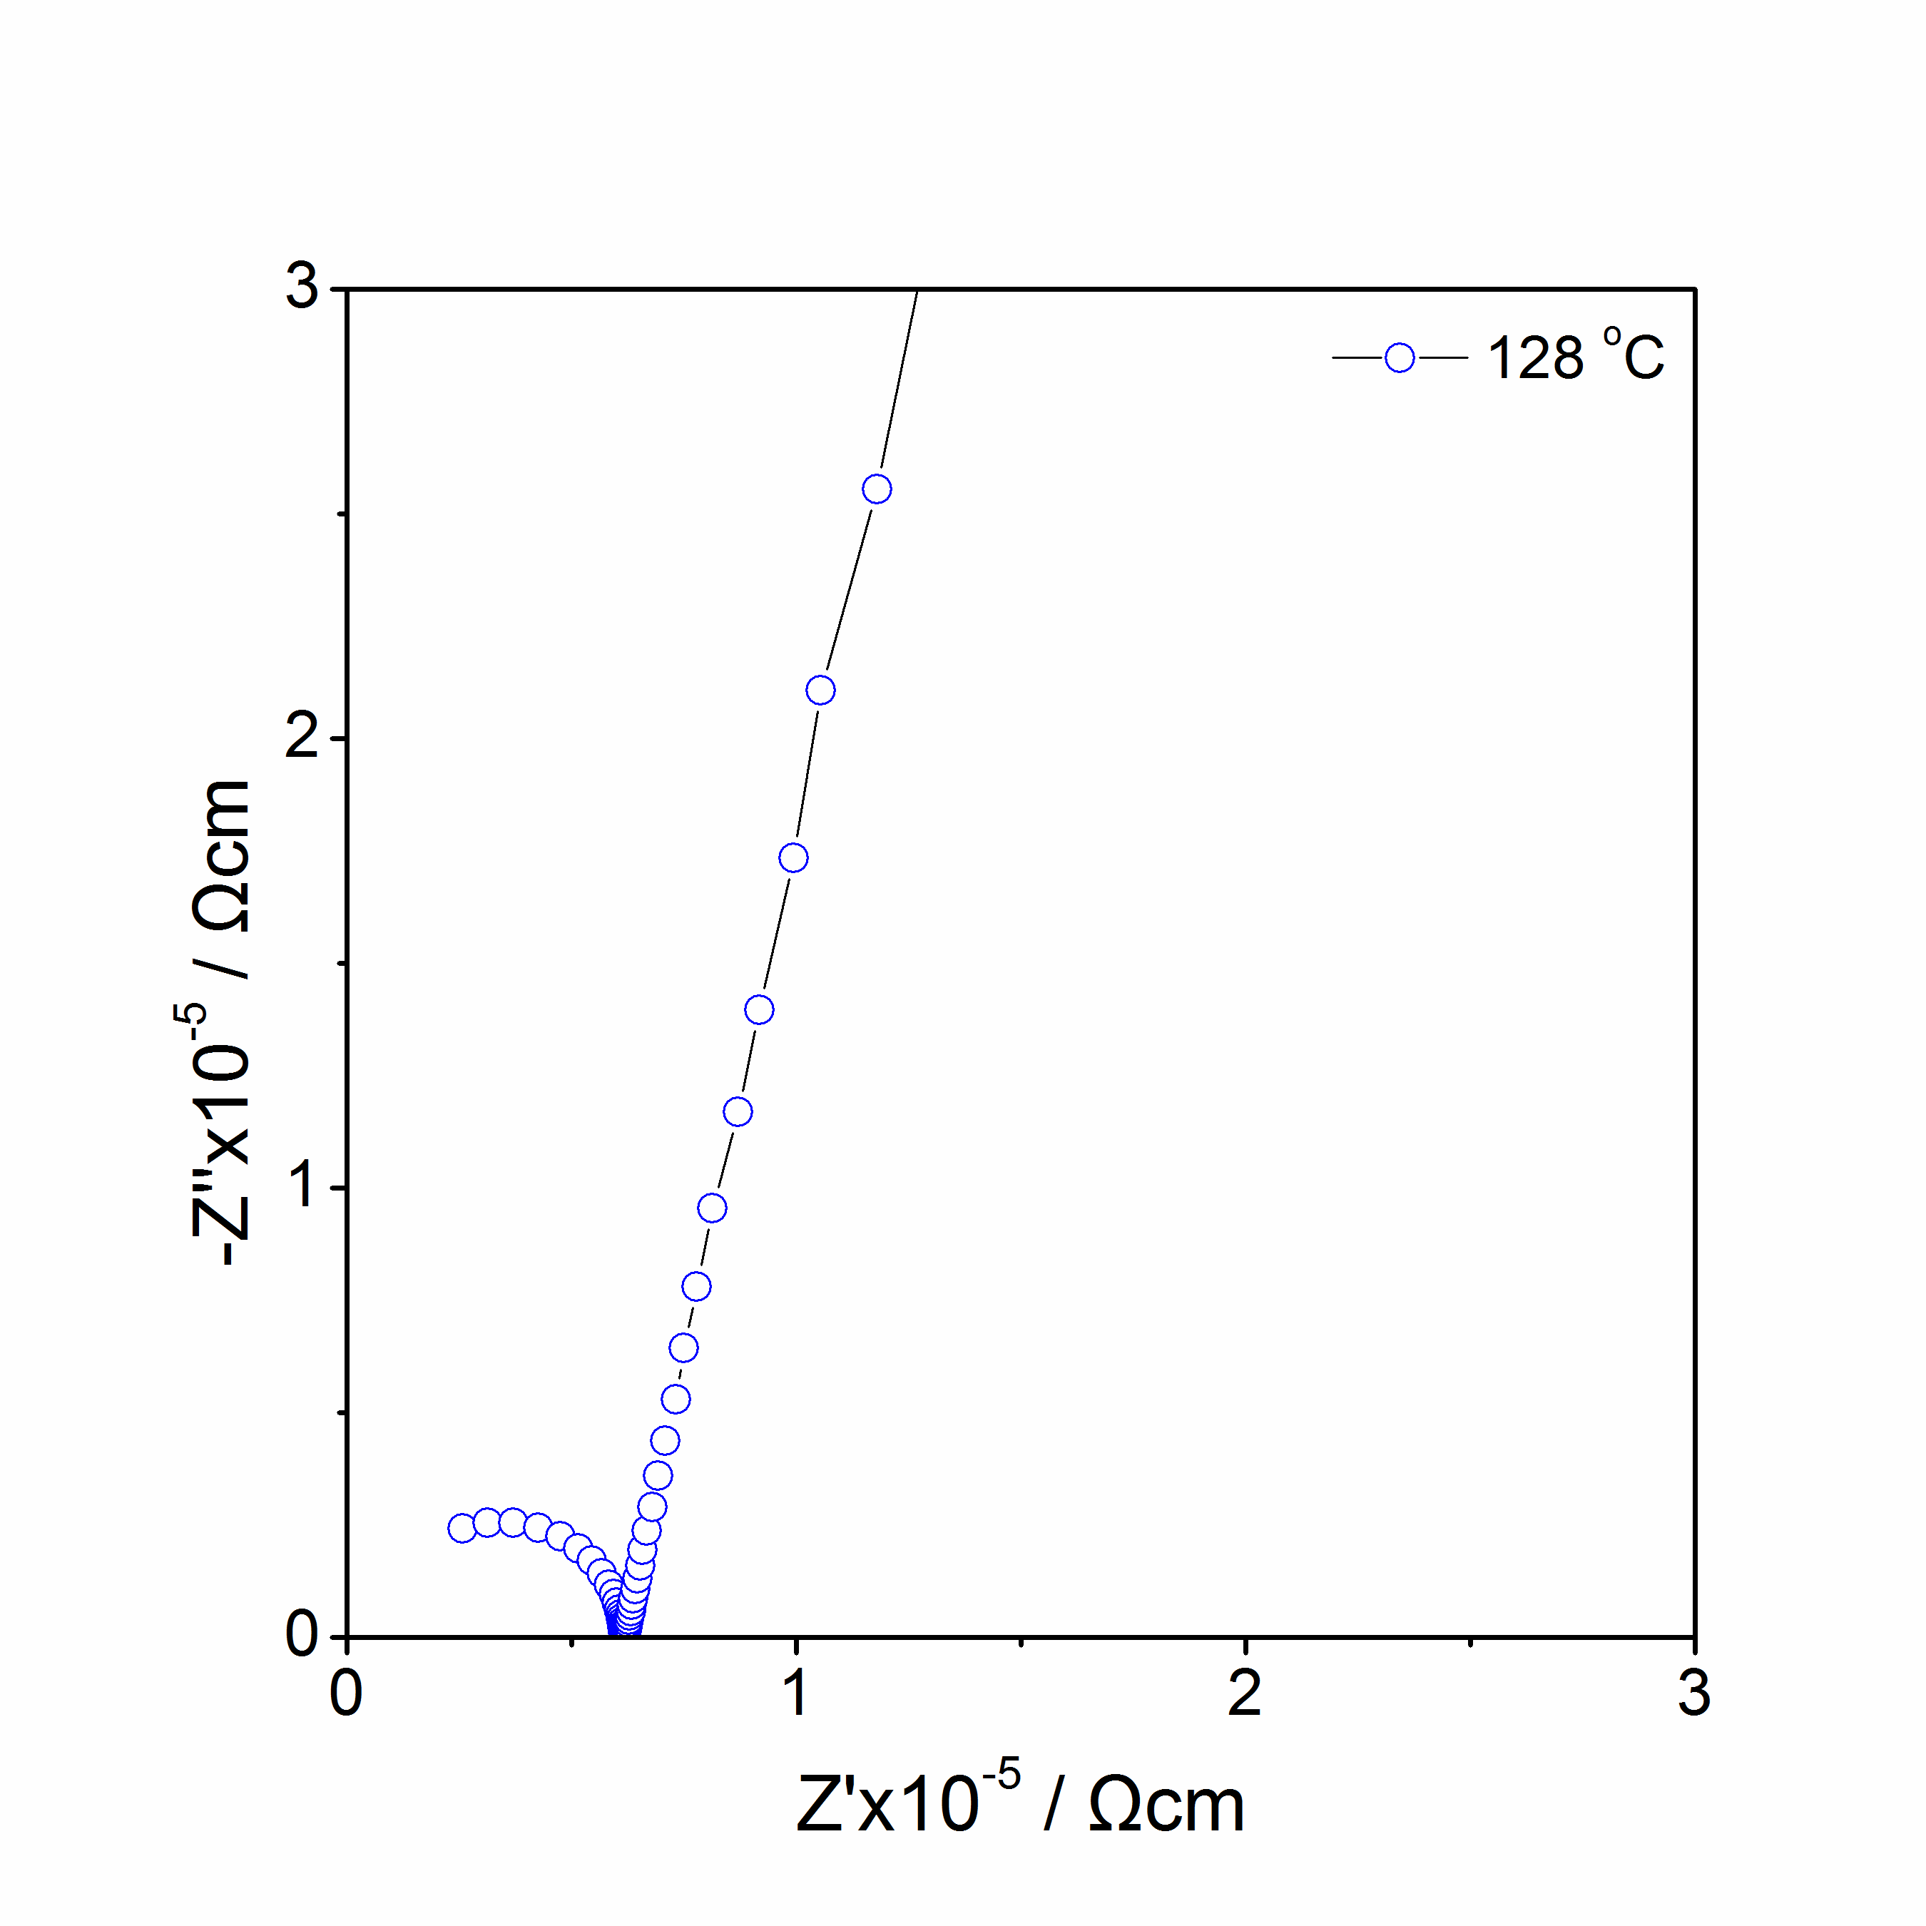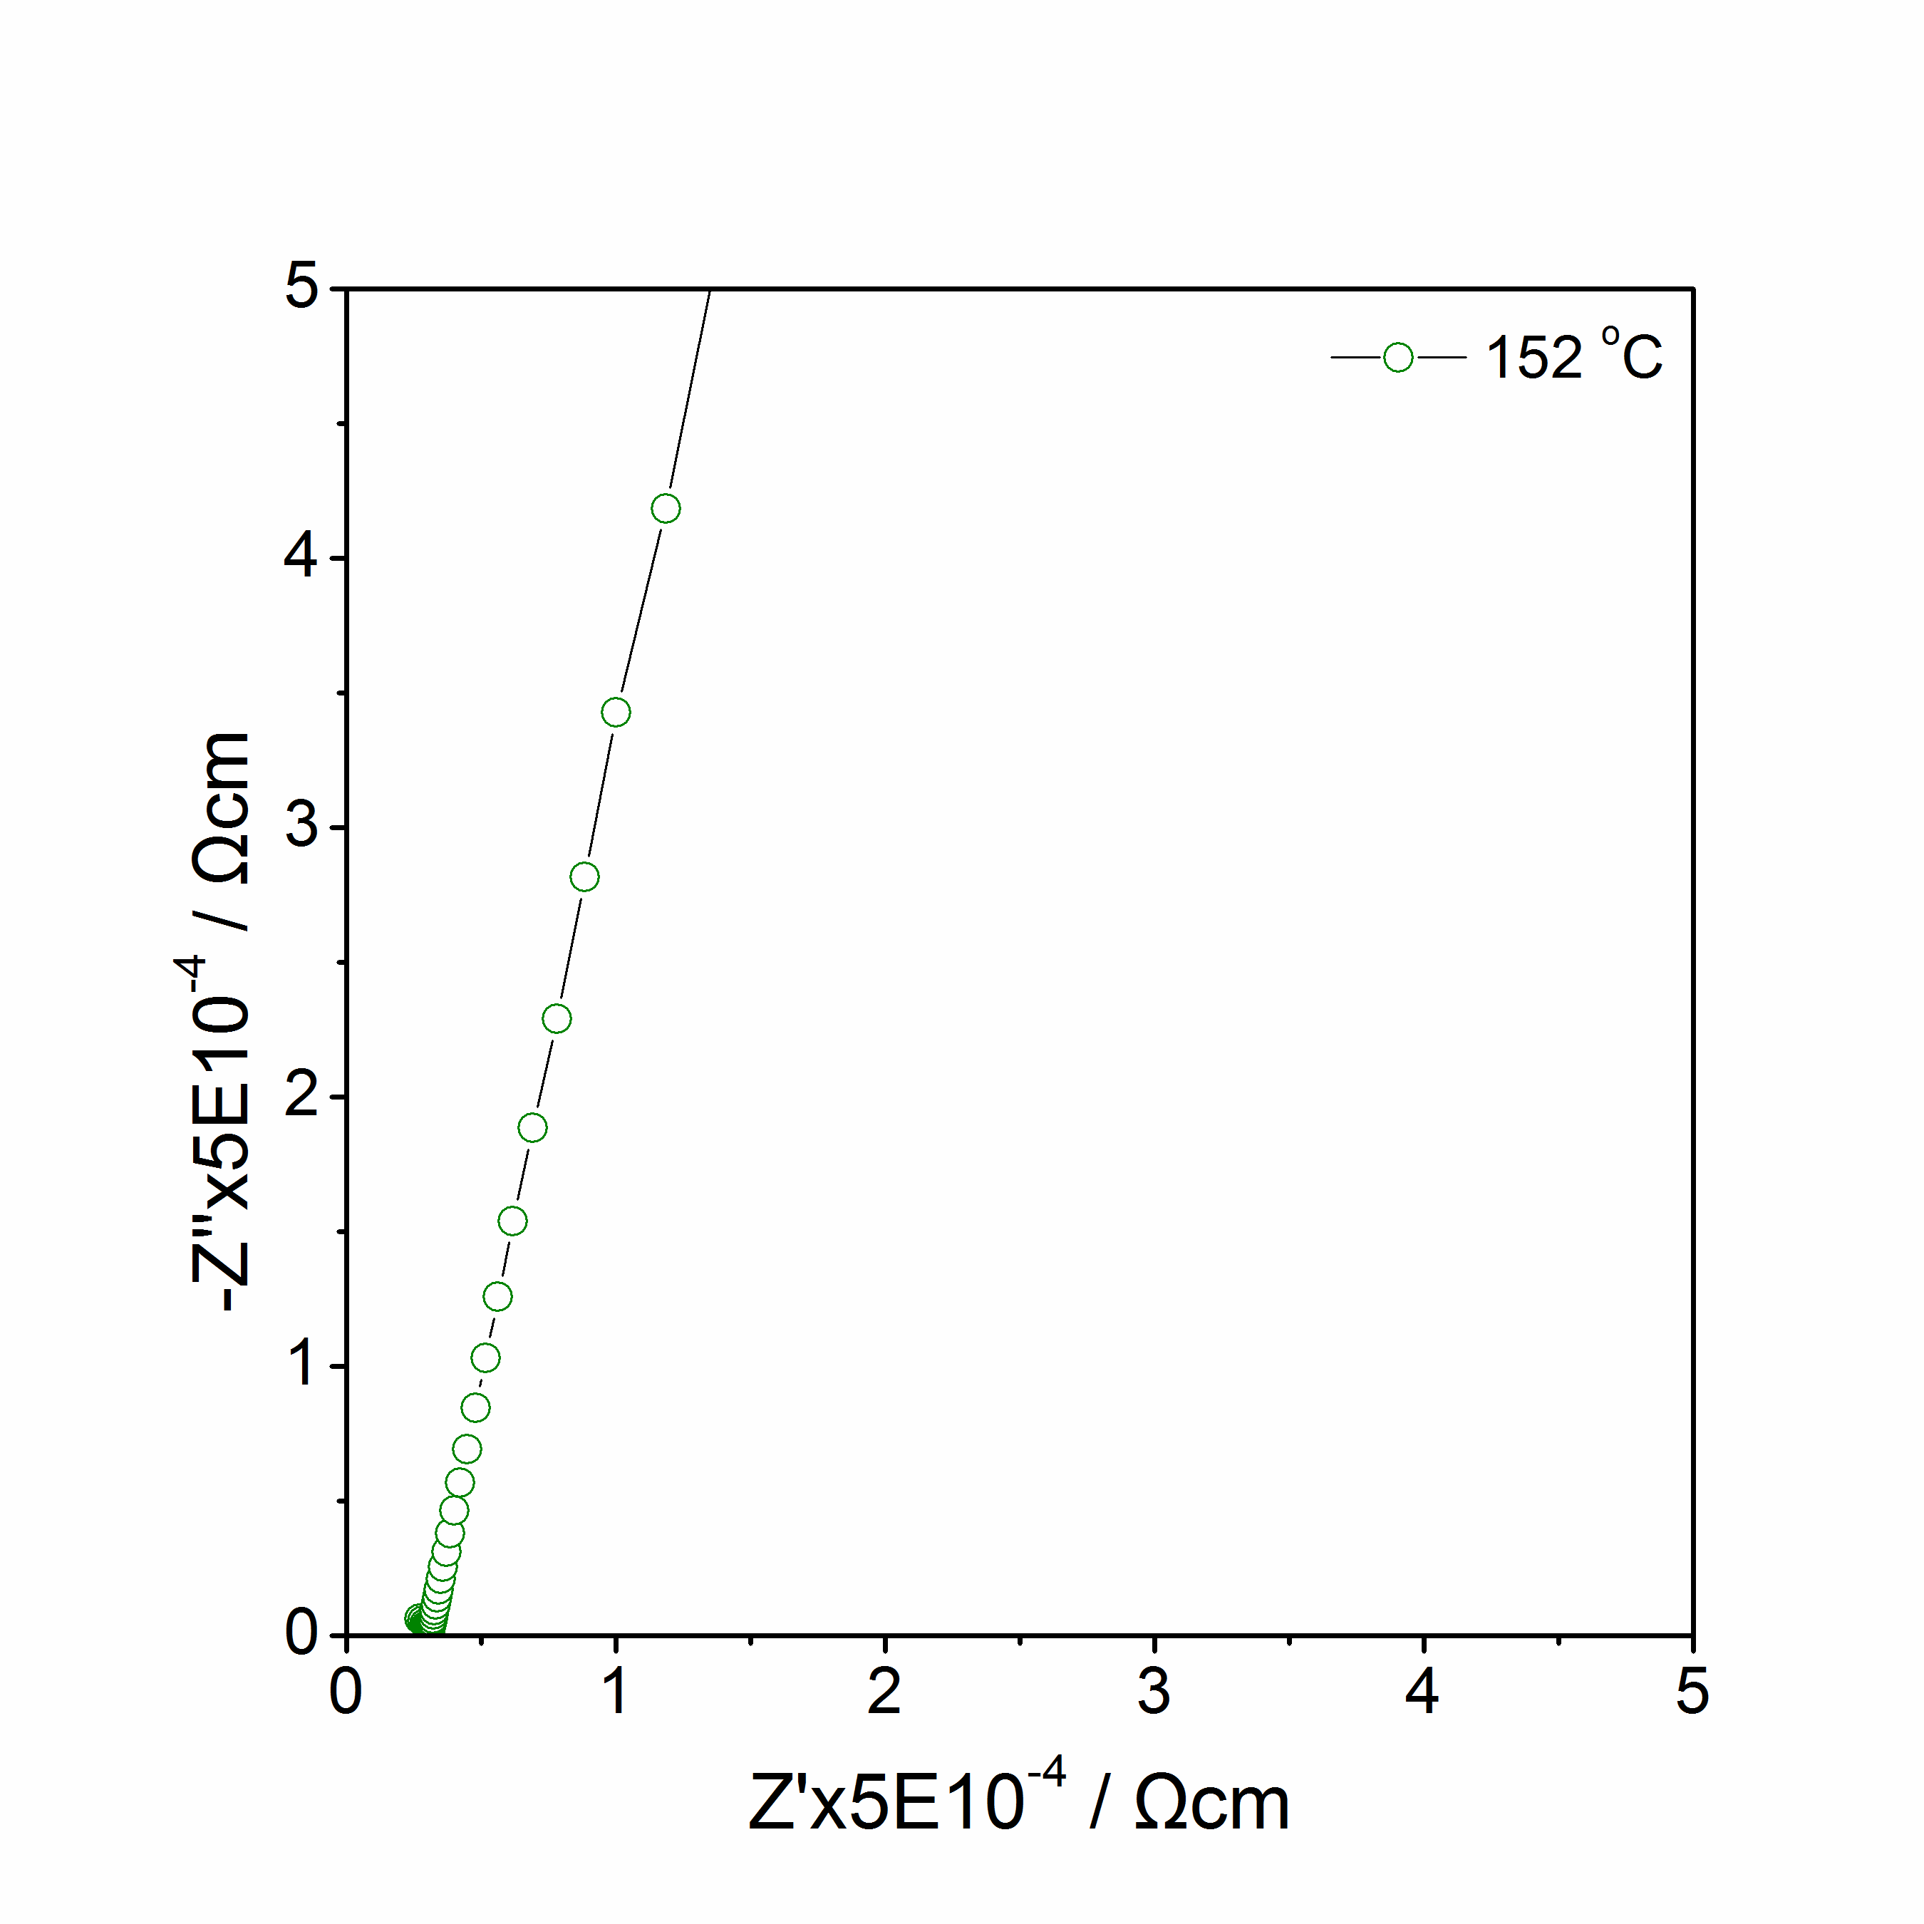
(c)
(d)
Figure 5.15 Li₃Zn_{0.5}SiO₄: Impedance complex plane plots Z* at 84 ºC to152 ºC in N₂.

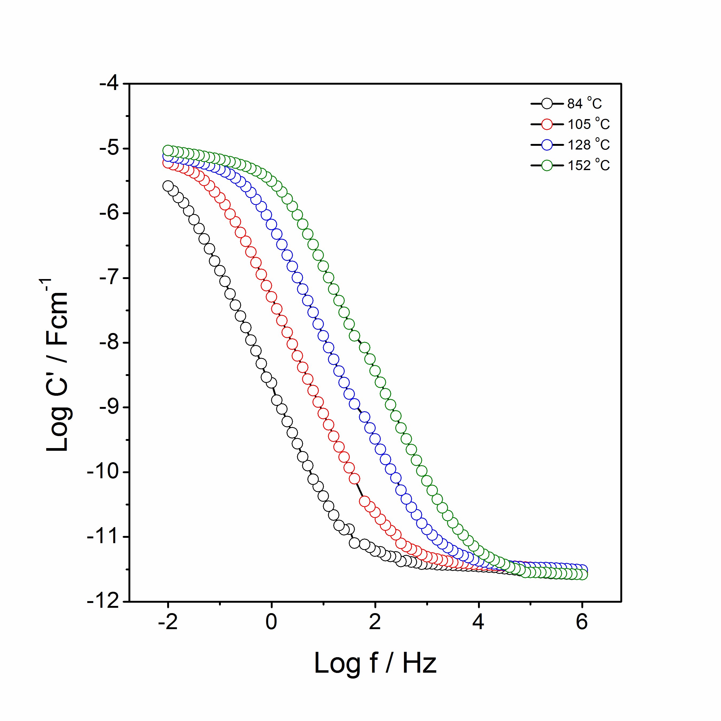
(a)
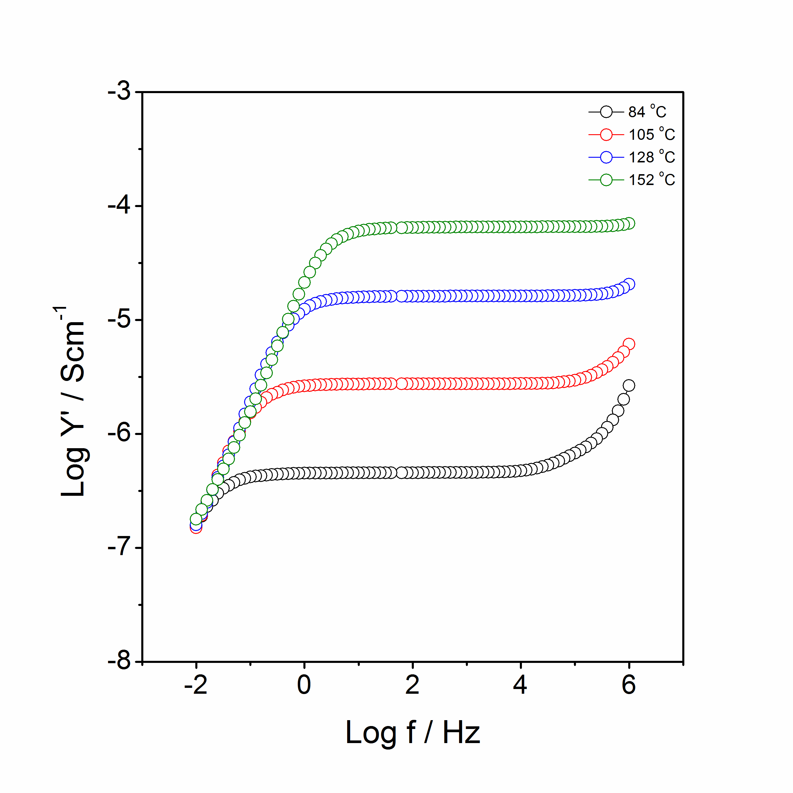
(b)
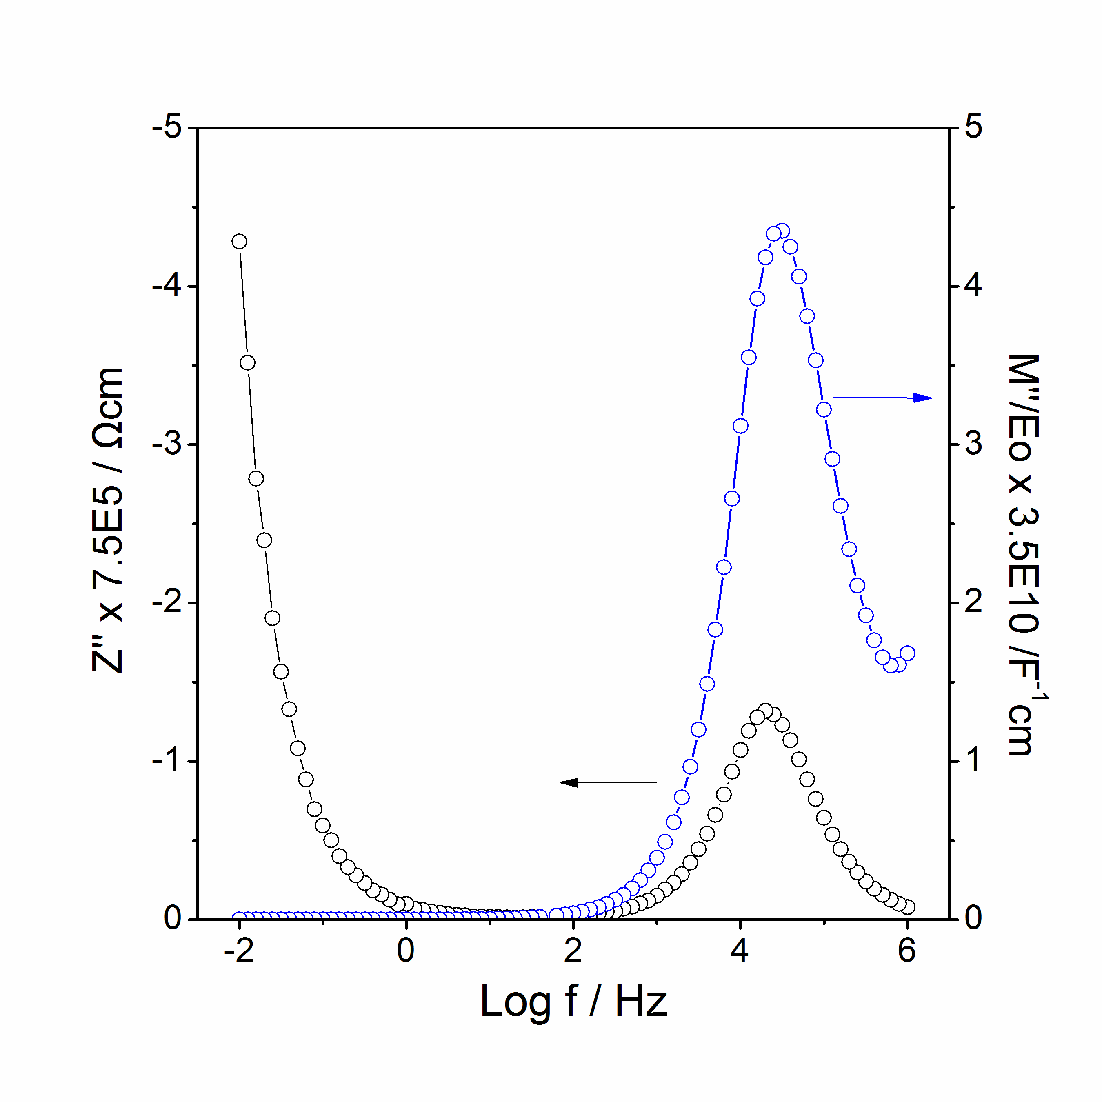
(c)
Figure 5.16 Li₃Zn_{0.5}SiO₄: spectroscopic plots of C’ (a), Y’ (b), –Z’’ and M’’ at 84 ºC (c).
The conductivity data, log σ as a function of T⁻¹ are shown in figure 5.17. Several parallel lines are observed with Ea in the range between 0.88 to 1.06 eV. Li₃Zn_{0.5}SiO₄ shows the highest conductivity, 3.5·10⁻⁹ Scm⁻¹, which is 7 to 8 orders more than that of Li₂ZnSiO₄ at room temperature.

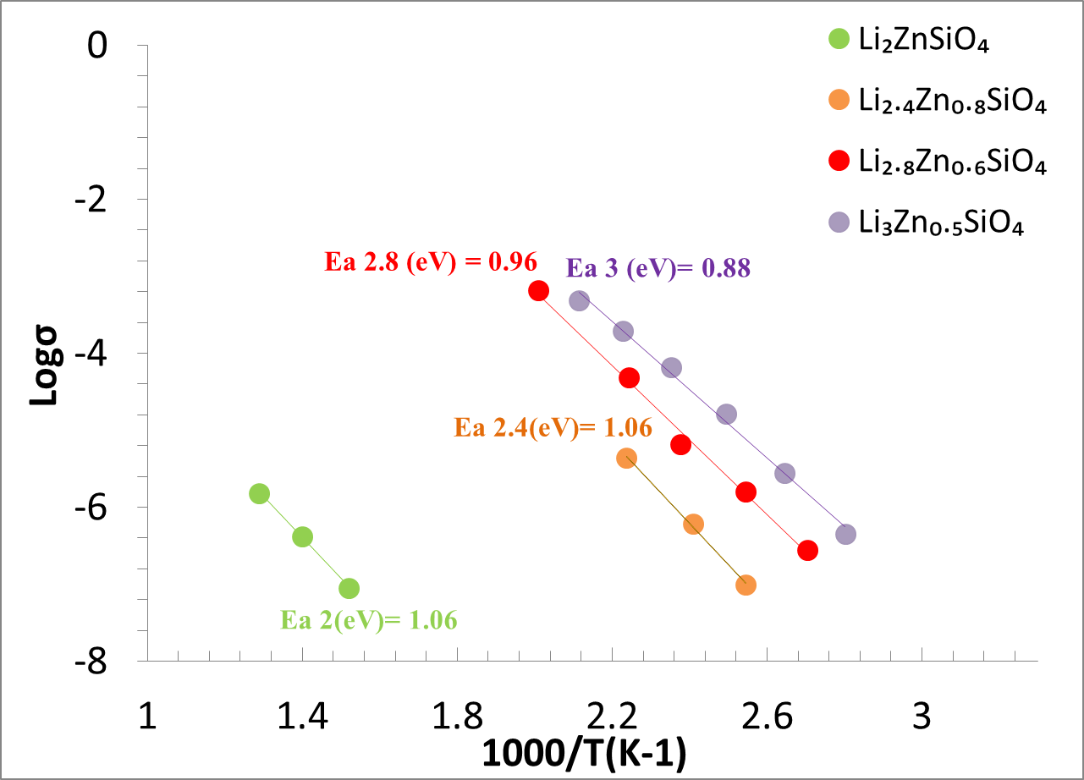
Figure 5.17 Arrhenius plot of Li_{2+2x}Zn_{1-x}SiO₄: x = 0, 0.2, 0.4, 0.5.

5.3.3 Li₃M_{0.5}SiO₄ (M = Zn, Mn) series
As shown in figure 5.18, the XRD patterns of Li₃M_{0.5}SiO₄ (M = Zn, Mn) series look similar to each other. The XRD pattern of experimental Li₃Zn_{0.5}SiO₄ and calculated Li₃Zn_{0.5}SiO₄ using Li₃Zn_{0.5}GeO₄ model is shown in figure 5.19. Missing peaks (e.g. peak at 16º) might be associated with Li-Zn cation exchange or the different polymorphism of Li₃Zn_{0.5}SiO₄ and Li₃Zn_{0.5}GeO₄. The lattice parameters of the Li₃M_{0.5}SiO₄ (M = Zn, Mn) series and Li₃Zn_{0.5}GeO₄ are summerised in table 5.7.

Impedance spectroscopy shows the poor electronic conductor Li₂MnSiO₄ changed to the Li ionic conductor Li₃Mn_{0.5}SiO₄. From the Arrhenius plot in figure 5.20, the conductivities of Li₃M_{0.5}SiO₄ (M = Zn, Mn) increased 5-7 orders compared to their parent materials Li₂MSiO₄ (M = Zn, Mn). The activation energy of Li₂MSiO₄ (M = Zn, Mn) decreased from 1.06 - 1.39 eV to 0.88 - 0.93 eV of Li₃M_{0.5}SiO₄ (M = Zn, Mn).

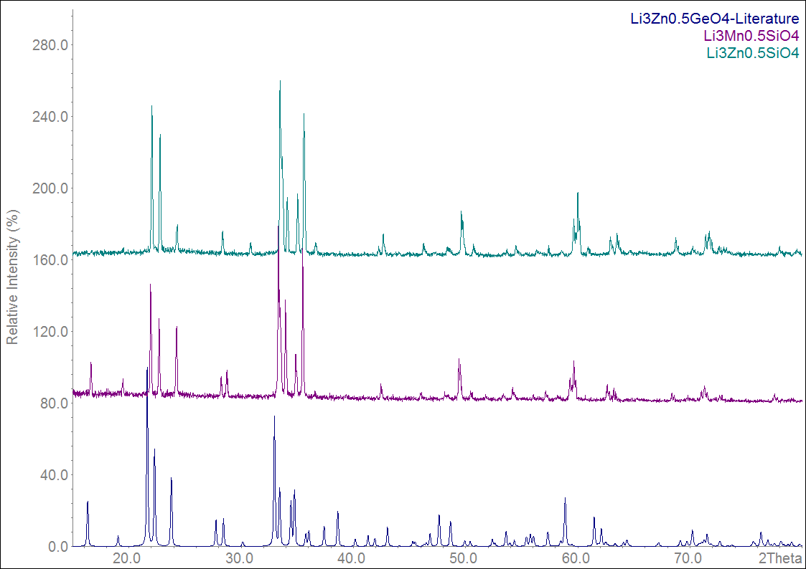
Figure 5.18 XRD patterns of Li₃Zn_{0.5}GeO₄, Li₃Mn_{0.5}SiO₄ and Li₃Zn_{0.5}SiO₄.
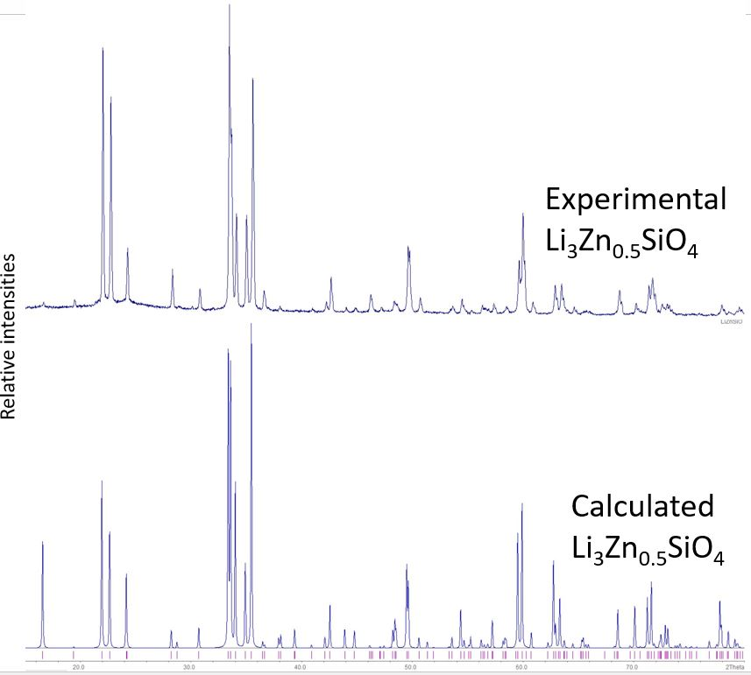
Figure 5.19 XRD pattern of experimental Li₃Zn_{0.5}SiO₄ and calculated Li₃Zn_{0.5}SiO₄ using Li₃Zn_{0.5}GeO₄ model.

Table 5.7 The lattice parameters of the Li₃M_{0.5}SiO₄ (M = Zn, Mn) series and Li₃Zn_{0.5}GeO₄.
Formula | Space Group | a | b | c | V
Li₃Zn_{0.5}GeO₄ [10] | Pnma | 10.8720(5) | 6.2882(3) | 5.1696(2) | 351.47(29)
Li₃Mn_{0.5}SiO₄ | n/a | 10.722(3) | 6.239(2) | 5.052(3) | 337.97(11)
Li₃Zn_{0.5}SiO₄ | n/a | 10.6687(5) | 6.0289(4) | 5.0590(3) | 335.11(5)

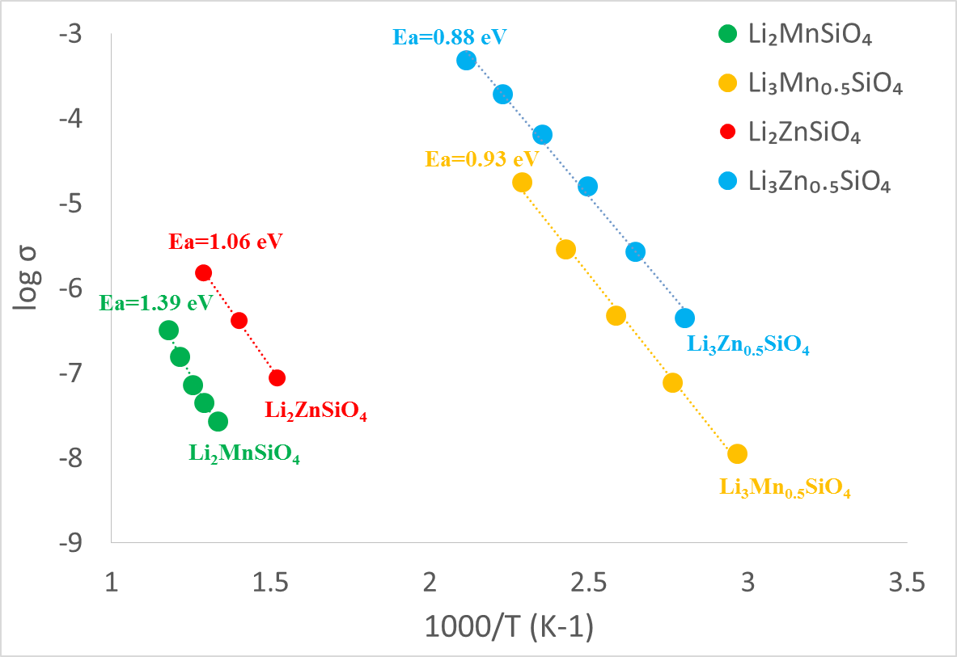
Figure 5.20 Arrhenius plot of Li₂MnSiO₄, Li₂ZnSiO₄, Li₃Mn_{0.5}SiO₄ and Li₃Zn_{0.5}SiO₄.

5.4 Conclusion
Lithium manganese (zinc) silicates with formula Li_{2+2x}M_{1-x}SiO₄: M = Mn, Zn, have been synthesised via a solid state method. A limited range of β-Li₂MnSiO₄ solid solution was obtained with composition 0 ≤ x ≤ 0.1; A new phase at x = 0.5 with formula, Li₃Mn_{0.5}SiO₄, was discovered and indexed with orthorhombic unit cell with a = 10.722(3) (Å), b = 6.239(2) (Å), c = 5.052(3) (Å), V = 337.97(11) (Å³); A limited range of ordered Li₄SiO₄ was found with composition 0.7 ≤ x ≤ 1, and the ordered Li₄SiO₄ transformed to disordered Li₄SiO₄ at high temperature. The ordered phase at x = 0.75, with formula Li_{3.5}Mn_{0.25}SiO₄ was indexed with a monoclinic unit cell, a = 6.430(4) (Å), b = 11.088(7) (Å), c = 8.232(4) (Å), β = 108.39(5), V = 557.0(4) (Å³).In the Li₄SiO₄ – Li₂ZnSiO₄ system, a similar phase Li₃Zn_{0.5}SiO₄, was indexed with orthorhombic unit cell with a = 10.6687(5) (Å), b = 6.2089(4) (Å), c = 5.0590(3) (Å), V = 335.11(5) (Å³).

Electrical properties of Li_{2+2x}Mn(Zn)_{1-x}SiO₄ were studied by impedance spectroscopy. By changing the ratio of Li/M ratio, poor Li₂MnSiO₄ electronic conducting materials became Li₃Mn_{0.5}SiO₄ ionic conducting materials. The conductivity of Li₃M_{0.5}SiO₄ (M = Zn, Mn) increased 5-7 orders compared to that of their parent materials Li₂MSiO₄ (M = Zn, Mn) while the activation energy of Li₂MSiO₄ (M = Zn, Mn) decreased from 1.06 to 1.39 eV to 0.88 to 0.93 eV of Li₃M_{0.5}SiO₄ (M = Zn, Mn). Therefore, Li₃Mn_{0.5}SiO₄ may find application to be used as a new cathode materials for lithium ion batteries.

5.5 References
1. Dominko, R., Li₂MSiO₄ (M = Fe and/or Mn) cathode materials, Journal of Power Sources, 2008: 184(2), 462-468.
2. Armstrong, A.R., Sirisopanaporn, C., Adamson, P., Billaud, J., Dominko, R., Masquelier, C., Bruce, P.G., Z., Polymorphism in Li₂MSiO₄ (M = Fe, Mn): A Variable Temperature Diffraction Study, Zeitschrift für Anorganische und Allgemeine Chemie, 2014: 640(6), 1043-1049.
3. Ramar, V., Balaya, P., The effect of polymorphism on the lithium storage performance of Li₂MnSiO₄, Journal of Power Sources, 2016: 306, 552-558.
4. Fisher, C.A.J., Kuganathan, N., Islam, M.S., Defect chemistry and lithium-ion migration in polymorphs of the cathode material Li₂MnSiO₄ Journal of Materials Chemistry A, 2013: 1, 4207-4214.
5. Kalantarian, M.M., Asgari, S., Mustarelli, P., Theoretical investigation of Li₂MnSiO₄ as a cathode material for Li-ion batteries: a DFT study, Journal of Materials Chemistry A, 2013: 1, 2847-2855.
6. West, A.R., Ionic conductivity of oxides based on Li₄SiO₄, Journal of Applied Electrochemistry, 1973: 3, 327-335.
7. Politaev, V. V., Petrenko, A. A., Nalbandyan, V. B., Medvedev, B. S., and Shvetsova, E. S., Crystal structure, phase relations and electrochemical properties of monoclinic Li₂MnSiO₄, Journal of Solid State Chemistry, 2007: 180(3), 1045-1050.
8. West, A.R., Glasser F.P., Crystallisation of lithium zinc silicates - Part 2 Phase equilibria in the system Li₄SiO₄-Zn₂SiO₄, Journal of Materials Science, 1970:5, 676.
9. West, A.R., Glasser F.P., Crystallisation of lithium zinc silicates - Part 1 Phase equilibria in the system Li₄SiO₄-Zn₂SiO₄, Journal of Materials Science, 1970:5, 557.
10. Abrahams, I., Bruce, P.G., West, A.R., Structure Determination of LISICON Solid Solutions by Powder Neutron Diffraction, Journal of Solid State Chemistry, 1988:75, 390.

Chapter 6 New electrochemical cell for in-situ neutron diffraction studies of lithium ion batteries

6.1 Introduction
To conduct in-situ neutron diffraction studies of lithium ion batteries, two main requirements need to meet: (1) the electrochemical performance of the in-situ cell needs to be as close to that of a real battery as possible. (2) neutron diffraction patterns collected should have a good signal-to-noise ratio and usable for full pattern Rietveld refinement. In order to gain good neutron diffraction patterns, the high background scatter associated with the separator and electrolyte needs to be addressed while unwanted Bragg diffraction peaks from other components, such as Al or the Cu current collector, need to be minimised.

A very early cell design for in-situ neutron diffraction studies was made from a Pyrex tube with gold-plated inner surface, rod-shaped lithium anode and binder-free cathode composite [1]. The neutron diffraction data looked good, but suffered from the slow electrochemical reaction because of the large amount of active materials in the cell. In order to improve the electrochemical performance, mechanical pressure using a spring was applied to the assembled cells and lesser amounts of active materials was used [2-5]. Despite the noisy neutron diffraction data and relatively long collection time (~30 min), the electrochemical performance of these cells looked satisfactory. In addition, a modified cylindrical cell design with anode, cathode, current collector and separator wound laminate, sealed inside a vanadium/aluminium tube, was constructed [6-7]. This cell could, in principle, combine good electrochemical performance with reliable neutron diffraction data; however, it was impeded by difficulties in construction associated with short circuits and disconnect problems.

In this chapter, the design of a new electrochemical cell for in-situ neutron diffraction is presented. The cell can be handled easily and combines good neutron diffraction data with modest electrochemical performance.

6.2 Experimental

6.2.1 Design of the cell
As previously shown in chapter 2 (figure 2.6), the new electrochemical cell is designed to fit the geometry of the Polaris diffractometer, ISIS spallation source, Rutherford Appleton Laboratory, Science and Technology Facilities Council (STFC), U.K. The Polaris instrument has a large detector angle with an intense neutron beam, which provides a high count rate and is good for kinetic experiments [1]. Basically, there are two types of neutron diffractometers with either fixed wavelength of incident beams or fixed scattering angle of detector banks. The fixed wavelength neutron diffraction from reactor neutron sources is similar to the lab-scale X-ray diffraction. In contrast, the diffraction patterns generated from pulsed neutron sources can be collected at fixed scattering angle detector banks by the time-of-flight (ToF) method and avoid the need to access a wide range of scattering angles.

The cell has a coin cell geometry and is based on a design developed previously for neutron diffraction studies of nickel-metal-hydride battery systems [8]. It consists of 15 cm diameter circular disk-type components (figure 6.1a): two stainless steel alloy clamp rings (2 and 8), two nickel metal windows (3 and 7), two thin nickel metal sheets (4 and 6), one separator module (5) and one boron nitride shield (1). The cell is assembled and stacked using the sequence from right hand to left hand (figure 6.1a). Rear, front and lateral views of the assembled cell in respect of incident neutron beam are shown in figure 6.1 (e, f, g).

The main body of the cell is made of Ni because of its simple neutron diffraction pattern. The stainless alloy clamp rings can be tightly clamped on each side of the cell with 16 polyetheretherketone (PEEK) screws (figure 6.1c). Next to this ring is a nickel metal window (1mm thick, 99.99% purity) which has an aperture of 20 mm width x 40 mm height (same as dimensions of neutron flux at Polaris) that allows the neutron beam to go through. Afterwards, ~ 0.1 mm thin nickel metal sheets are used to hold the electrode materials and act as current collectors. The thickness of these sheets is minimized in order to decrease the unwanted diffraction peaks from nickel. The central part of the cell is a 2mm separator module (decreased from 2.5 mm of previous cell for nickel-metal-hydride battery) with an aperture the same dimensions as the nickel window that separates the nickel sheets so as to avoid a short circuit. It is made of polyoxymethylene because of its good chemical resistivity to most of the commonly-used electrolytes. The free space acts as the main chamber of the cell to be filled with cathode, anode, separator and spring. Besides, O-rings (figure 6.1d) are adhered to circular grooves on each side of the separator module to eliminate leakage of the organic electrolyte. Finally, a boron nitride shield is placed at the front of the cell to collimate the incident neutron beam due to the high thermal neutron absorption cross-section of boron [2]. Different from the previous design, two channels from the inside void of the separator module which was used to fill the liquid electrolyte is removed.

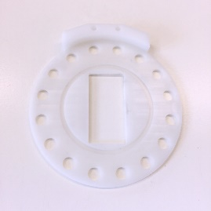
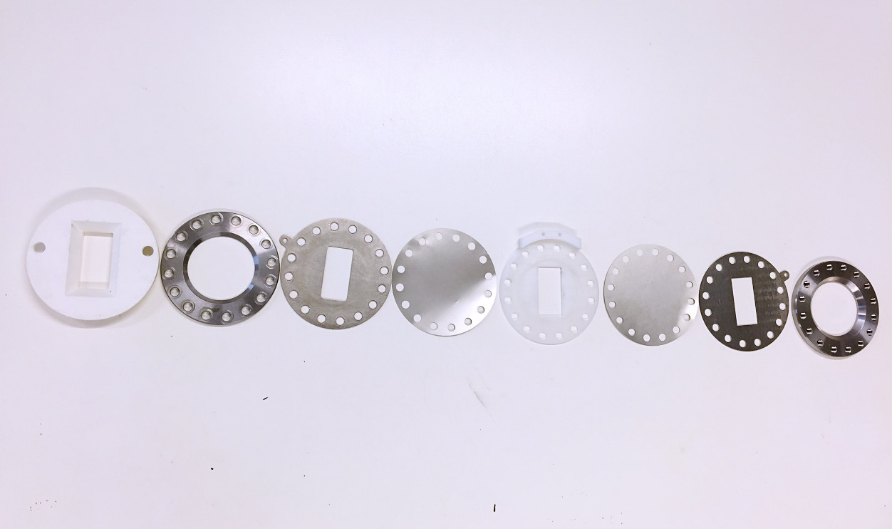
(1) (2) (3) (4) (5) (6) (7) (8)
(a)
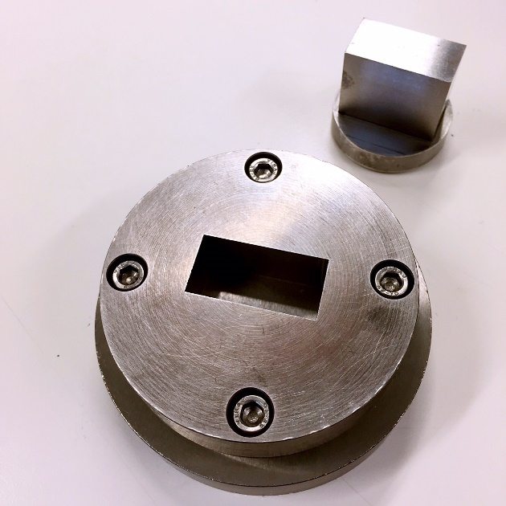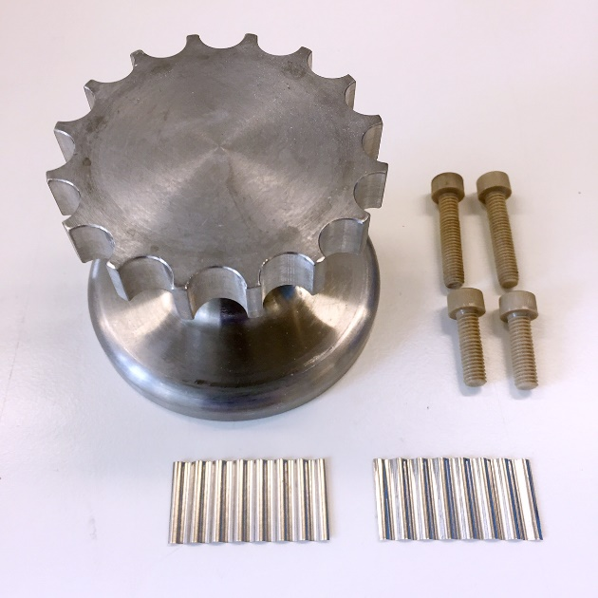
Stand
Screws
Springs
(c)
(b)
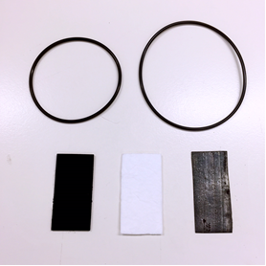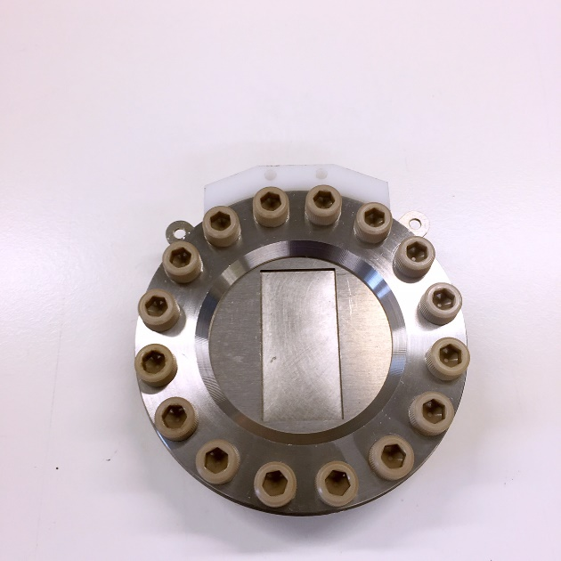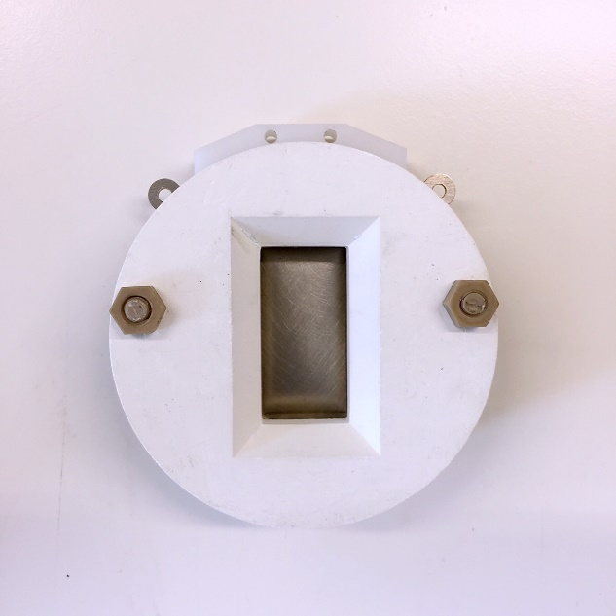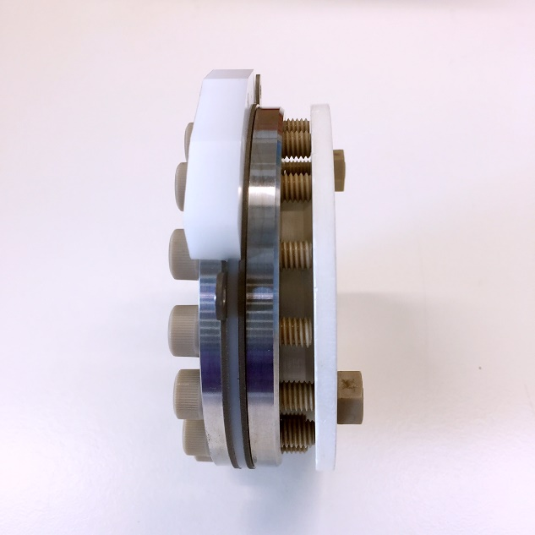
Boron nitride shield in front
(g)
(f)
LiCoO₂
Li metal
Glass fiber
O-rings
Neutron
beam
(d)
(e)

Figure 6.1 (a) Components of the in-situ cell. (b) Rectangular die to press electrode materials. (c) Stand to assemble in-situ cells. (d) O-rings, pressed LiCoO₂ pellet, cut glass fiber film and Li metal. (e, f, g) Rear, front and lateral views of the assembled cell relative to the incident neutron beam.

6.2.2 Electrode and separator fabrication
The chemicals that were used for electrochemical tests are summarised in table 6.1. Cathode materials were made in three different ways:

(1) PVDF binder was dissolved into 1-Methyl-2-Pyrrolidinone (NMP) using a magnetic stirrer at 80 ºC for 2 h before the transfer of LiCoO₂ and carbon into NMP to form the slurry. The slurry was printed onto Al foil or Ni Mesh and dried in a vacuum oven at 120 ºC for 10 h.

(2) LiCoO₂, carbon and PVDF were mixed using a mortar and pestle for 30 mins before pressing into a pellet using either 10 mm round die or 18mm x 36mm rectangular die (figure 6.1b). The pellets were dried in a vacuum oven at 120 ºC for 10 h.

(3) LiCoO₂ and carbon were dissolved in isopropanol and ball-milled for 12 h to achieve homogeneity before drying in a vacuum oven at 80 ºC to evaporate the isopropanol. The powder was then pressed into pellets and dried in a vacuum oven at 120 ºC for 10 h.

The separator foils were cut into 26 mm x 46 mm (PP, PTFE) and 20 mm x 40 mm (glass fiber) pieces (figure 6.1d), and lithium metal anode was cut into 20 mm x 0.38 mm pieces and scratched to get a shiny surface inside a glove box.

6.2.3 Electrolyte preparation
Electrolyte preparation was carried out inside the glove box. Stoichiometric LiPF₆ and LiFSI were weighed with a balance while corresponding normal or deuterated Propylene Carbonate (PC)/ Ethylene Carbonate (EC)/ Dimethyl Carbonate (DMC)/ Ethyl Acetate (EA) were added with a needle. Lithium salts and organic solvent were transferred into a plastic jar and mixed using a magnetic stirrer for 24 h. One commercial and five different electrolytes were prepared and used in the experiment:

(1) Conventional 1 M LiPF₆ in Propylene Carbonate (PC).
(2) Commercial LP30: 1 M LiPF₆ in 50:50 (v/v) Ethylene Carbonate (EC)/ Dimethyl Carbonate (DMC).
(3) Conventional 1:2 (n/n) of Lithium Bis(fluorosulfonyl) imide (LiFSI) and Ethyl Acetate (EA).
(4) Deuterated 1 M LiPF₆ in Propylene-d₆ Carbonate (PC).
(5) Deuterated 1 M LiPF₆ in 50:50 (v/v) Ethyl Acetate-d₈ (EC)/ Dimethyl-d₆ Carbonate (DMC).
(6) Deuterated 1:2 (n/n) of Lithium Bis(fluorosulfonyl) imide (LiFSI) and Ethyl Acetate-d₈ (EA).

6.2.4 Electrochemical Tests
In-situ cells were assembled and left for 10 h inside the glove box before tests. The cut-off voltage was set between 3.0 V and 4.8 V and in-situ cells were tested at different constant rate C/40, C/30, C/20 and C/10 for 1 to 5 cycles. Electrochemical tests were carried out with either a versatile multichannel potentiostat (VMP, Perkin-Elmer, U.K.) in Sheffield or a Bio-Logic SP-240 in ISIS. EC-Lab software was used to control and analyse the collected electrochemical data.

Different Li metals, separators, amount of carbons, graphite and carbon black ratios, amount of active materials, amount of electrolytes, and the effect of Ni mesh, spring, pressure, PVDF and different cathode fabricating methods were set as variables in order to optimise the electrochemical performance of the cell. A summary of cells prepared for electrochemical tests is shown in table 6.2.

6.2.5 In-situ Neutron Diffraction Set-up
The in-situ cells were mounted onto the position of neutron powder diffractometer Polaris at ISIS, Rutherford Appleton Laboratory. The neutron diffraction were collected in the detector banks at two low angle banks (40º ＜ 2θ ＜ 67 º, d_{max} = 7 Å and 19º ＜ 2θ ＜ 34º, d_{max} = 8.7 Å) and backscattering angles (135º ＜ 2θ ＜ 168 º, d_{max} = 2.7 Å)

Table 6.1 Summary of chemicals used.
Material | Specification | Company
Lithium Cobalt(III) Oxide | 99.5% trace metals basis | Alfa Aesar
Lithium Cobalt(III) Oxide | 99.8% trace metals basis | Sigma-Aldrich
Li Ribbon | Thickness × Width 0.75 mm×19 mm, 99.9% trace metals basis | Sigma-Aldrich
Li Ribbon | Thickness × Width 0.38 mm×19 mm, 99.9% trace metals basis | Sigma-Aldrich
Propylene Carbonate | Anhydrous, 99.7% | Sigma-Aldrich
Ethylene Carbonate | Anhydrous, 99% | Sigma-Aldrich
Dimethyl Carbonate | Anhydrous, 99% | Sigma-Aldrich
Ethyl Acetate | anhydrous, 99.8% | Sigma-Aldrich
Ethyl Acetate-d₈ | 99.5 atom % D, 99% | Sigma-Aldrich
Propylene-d₆ Carbonate | 99.5 atom % D, 99% | Qm_{x}
Ethyl Acetate-d₈ | 99.5 atom % D, 99% | Qm_{x}
Dimethyl-d₆ Carbonate | 99.5 atom % D, 99% | Qm_{x}
LP30 electrolyte | 1 M LiPF₆ in 50:50 (v/v) Ethylene Carbonate (EC)/ Dimethyl Carbonate (DMC). | Sigma-Aldrich
Lithium Hexafluorophosphate | battery grade, 99.99% trace metals basis | Sigma-Aldrich
Lithium Bis(fluorosulfonyl) imide | 95% | Fluorochem
Lithium Bis(fluorosulfonyl) imide | 99.8% | HSC Corporation
Glass Microfiber Filters | Hi-Sep | Raman FibreSicence
Glass Microfiber Filters | Grade GF/D | Whatman
2325 PP/PE/PP Trilayer Membrane | Thickness of 25 μm | Celgard
3501 PP Microporous Monolayer Membrane | Thickness of 25 μm | Celgard
2500 PP Microporous Monolyaer Membrane | Thickness of 25 μm | Celgard
PTFE Membrane
SUPER C65 Conductive Carbon Black |  | TIMICAL
C-NERGY™ KS 6L Graphite |  | TIMICAL
Polyvinylidene Fluoride (PVDF) binder | 99% | Sigma-Aldrich
1-Methyl-2-Pyrrolidinone (NMP) | anhydrous, 99.5% | Sigma-Aldrich
Nickel Mesh | nominal aperture 0.73mm, wire diameter 0.25mm | Sigma-Aldrich
Aluminum Mesh | nominal aperture 0.38mm, wire diameter 0.25mm | Sigma-Aldrich
Aluminum Foil | thickness 0.25 mm, 99.999% trace metals basis | Sigma-Aldrich

Table 6.2 Summary of in-situ cells prepared for electrochemical tests.
No. | Cathode | Charging Rate | Separator | Electrolyte | Anode
1 | 0.01g LiCoO₂:C:PVDF:=8:1:1 on aluminum foil | C/40 | 2 pieces of Celgard 3501 PP | LiPF₆ in PC | 0.38 mm Li Metal, Ni mesh
2 | 1g LiCoO₂:C: PVDF = 8:1:1 on nickel mesh | C/40 | 2 pieces of Celgard 3501 PP | LiPF₆ in PC | 0.38 mm Li Metal
3 | 1g LiCoO₂:C: PVDF = 8:1:1 on aluminum mesh | C/40 | 2 pieces of Celgard 3501 PP | LiPF₆ in PC | 0.38 mm Li Metal
4 | *1g LiCoO₂:C: PVDF = 8:1:1 | C/40 | 2 pieces of Celgard 3501 PP | LiPF₆ in EC/DMC | 0.38 mm Li Metal
5 | 1g LiCoO₂:C: PVDF = 8:1:1 | C/40 | 2 pieces of Celgard 3501 PP | LiPF₆ in EC/DMC | 0.38 mm Li Metal
6 | 1g LiCoO₂:C = 8:1 | C/40 | 2 pieces of Celgard 3501 PP | LiPF₆ in EC/DMC | 0.38 mm Li Metal
7 | 1g LiCoO₂:C = 8:1 | C/40 | PTFE Membrane | LiPF₆ in EC/DMC | 0.38 mm Li Metal
8 | 1g LiCoO₂:C = 8:1 | C/40 | 2 pieces of Celgard 2500 PP | LiPF₆ in EC/DMC | 0.38 mm Li Metal
9 | 1g LiCoO₂:C = 8:1 | C/40 | 2 pieces of Celgard 2325 PP/PE/PP Trilayer Membrane | LiPF₆ in EC/DMC | 0.38 mm Li Metal
10 | 1g LiCoO₂:C = 8:1 | C/40 | Raman fibrescience Hi-Sep glass fiber | LiPF₆ in EC/DMC | 0.38 mm Li Metal
11 | 1g LiCoO₂:C = 8:1 | C/40 | Whatman GF/D glass fiber | LiPF₆ in EC/DMC | 0.38 mm Li Metal
12 | 1g LiCoO₂:C = 8:1 | C/20 | Whatman GF/D glass fiber | LiPF₆ in EC/DMC | 0.38 mm Li Metal
13 | 1g LiCoO₂:C = 8:1 | C/10 | Whatman GF/D glass fiber | LiPF₆ in EC/DMC | 0.38 mm Li Metal
14 | 0.75g LiCoO₂:C = 8:1 | C/20 | Whatman GF/D glass fiber | LiPF₆ in EC/DMC | 0.38 mm Li Metal
15 | 1.25g LiCoO₂:C = 8:1 | C/20 | Whatman GF/D glass fiber | LiPF₆ in EC/DMC | 0.38 mm Li Metal
16 | 1.5g LiCoO₂:C = 8:1 | C/20 | Whatman GF/D glass fiber | LiPF₆ in EC/DMC | 0.38 mm Li Metal
17 | 1g LiCoO₂:C = 8:1 | C/20 | Whatman GF/D glass fiber | LiPF₆ in EC/DMC | 0.38 mm Li Metal and pressing
18 | 1g LiCoO₂:C = 8:1 | C/20 | Whatman GF/D glass fiber | LiPF₆ in EC/DMC | 0.38 mm Li Metal and Ni mesh
19 | 1g LiCoO₂:C = 8:1 | C/20 | Whatman GF/D glass fiber | LiPF₆ in EC/DMC | 0.38 mm Li Metal and spring
20 | 1g LiCoO₂:C = 85:15 | C/20 | Whatman GF/D glass fiber | LiPF₆ in EC/DMC | 0.38 mm Li Metal
21 | 1g LiCoO₂:C = 95:5 | C/20 | Whatman GF/D glass fiber | LiPF₆ in EC/DMC | 0.38 mm Li Metal
22 | 1g LiCoO₂: G:C  = 80:5:5 | C/20 | Whatman GF/D glass fiber | LiPF₆ in EC/DMC | 0.38 mm Li Metal
23 | 1g LiCoO₂: G:C  = 80:2.5:7.5 | C/20 | Whatman GF/D glass fiber | LiPF₆ in EC/DMC | 0.38 mm Li Metal
24 | 1g LiCoO₂: G:C  = 80:7.5:2.5 | C/20 | Whatman GF/D glass fiber | LiPF₆ in EC/DMC | 0.38 mm Li Metal
25 | 1g LiCoO₂: G:C  = 80:2.5:7.5 | C/20 | Whatman GF/D glass fiber | 0.5 ml LiPF₆ in EC/DMC | 0.38 mm Li Metal
26 | 1g LiCoO₂: G:C  = 80:2.5:7.5 | C/20 | Whatman GF/D glass fiber | 1 ml LiPF₆ in EC/DMC | 0.38 mm Li Metal
27 | 1g LiCoO₂: G:C  = 80:2.5:7.5 | C/20 | Whatman GF/D glass fiber | 1.5 ml LiPF₆ in EC/DMC | 0.38 mm Li Metal
28 | *1g LiCoO₂: C: PVDF = 8:1:1 | C/20 | 2 pieces of Celgard 3501 PP | LiPF₆ in d₆-PC | 0.38 mm Li Metal
29 | 1g LiCoO₂:C  = 8:1 | C/20 | Whatman GF/D glass fiber | LiPF₆ in d₈-EC/d₆-DMC | 0.38 mm Li Metal
30 | 1g LiCoO₂: G:C  = 80:2.5:7.5 | C/25 | Whatman GF/D glass fiber | LiFSI in EA | 0.38 mm Li Metal
31 | 1g LiCoO₂: G:C  = 80:2.5:7.5 | C/25 | Whatman GF/D glass fiber | LiFSI in d₈-EA | 0.38 mm Li Metal
G: TIMCAL C-NERGY™ KS 6L Graphite; C: TIMICAL SUPER C65 Conductive Carbon Black. * Cathode materials were mixed with mortar and pestle.

6.3 Results and discussion

6.3.1 Electrochemical performance of in-situ cells
1g cathode materials were used in in-situ cells in order to get good neutron diffraction data. Because of the large amount of cathode materials that have been used in in-situ cells, initial electrochemical measurements were carried out at slow C-rate (C/40). At first, slurry electrode materials printed on Al foil (0.008 g totally active materials), which are typically used for coin cells in the lab, were tested (table 6.2, cell 1). Ni mesh was used to fill the aperture gap (thickness x width x length = 2 x 20 x 40 mm) and act as the spring to maintain an inner pressure and avoid bad contacts. The electrochemical result of cell 1 was the same as that of the coin cell, which indicates that the geometry of the in-situ cell can work for lithium battery tests.

To collect in-situ neutron diffraction patterns, it was necessary to increase the amount of active material to improve the signal-to-noise ratio of neutron data. Thus a 1g slurry was printed onto Al foil layer by layer (0.05 mm per layer), but the slurry cracked and dropped from the Al foil during drying. Instead, 1g slurries were printed on Ni or Al mesh (thickness x width x length = 1.5 x 20 x 40 mm), dried using a heat gun for 5 mins and transferred to a vacuum oven at 120 ºC for 8 hours (table 6.2, cell 2 and 3). Electrochemical properties of these cells were not reliable; they showed noisy plateaus and stopped around x =0.5 (Li_{x}CoO₂). After that, electrodes mixed with either a mortar and pestle or zirconium balls (described in section 6.2.2) were prepared in replacement for the slurry. The cell with ball-milled electrode (table 6.2, cell 5) showed the best electrochemical properties. Thus ball-milled electrodes were used in the following electrochemical tests.

As an important component for the permeation of Li⁺ ions between electrode materials, different kinds of separator were tested. Celgard 3501 Polypropylene (PP), Celgard 2500 Polypropylene (PP), Celgard 2325 Polypropylene (PP)/ Polyethylene (PE)/ Polypropylene (PP) Trilayer Membrane, Raman fibrescience Hi-Sep glass fiber and Whatman GF/D glass fiber were assembled and tested under the same conditions (table 6.2, cell 6 - 10). The Celgard 2325 cannot be wetted by LiPF₆ in EC/DMC electrolyte and didn’t work at all. PTFE membrane is a moisture-sensitive separator which is detrimental to the electrochemical performance of in-situ cells. Whatman GF/D glass fiber separator has advantages, such as easy-handling, binder-free (less H) and good compression resistance, over Polypropylene (PP) separator, and therefore was chosen as the standard separator for in-situ cells.

The inner pressure is another important factor in the electrochemical performance of cells since most electrode materials experience volume changes during charge/discharge processes. Because of this, cells 17, 18 and 19 were made with, as variables, hand pressing, 1 piece of Ni mesh or 0.05 mm spring. The performance of cell 17 was even worse while cell 18 and 19 didn't show an obviously enhanced performance, which may indicate that homogeneous pressure from 16 screws is enough to maintain the good contact.

The C rate (C/40, C/20 and C/10), amount of cathode materials (0.75g, 1g, 1.25g, 1.5g), carbon content (5%, 11%, 15%), ratio of graphite to carbon black (1:3, 1:1, 3:1) and amount of electrolyte (0.5 ml, 1 ml, 1.5ml and 2ml) were all tested while other variables were fixed. The cell with best electrochemical performance was found to be 1g LiCoO₂: Graphite: Carbon black = 80:2.5:7.5/ Whatman GF/D glass fiber/0.38 mm Li metal with 1.5 ml electrolyte cycled at C/20 (Table 6.2, cell 23).
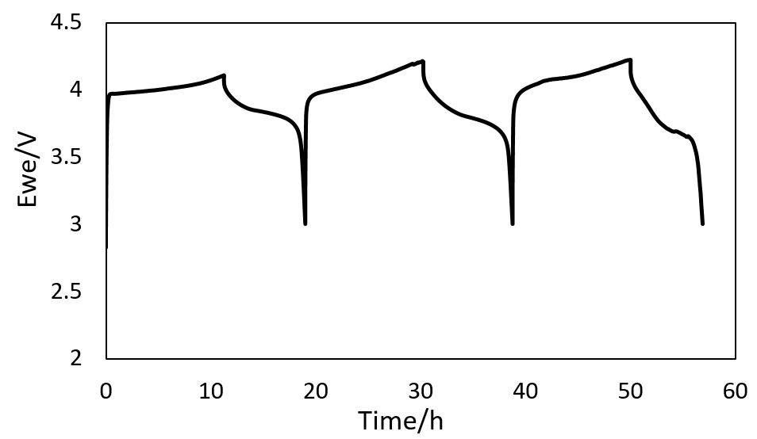
Figure 6.2 The electrochemical performance of cell 23 cycled galvanostatically at C/20.

6.3.2 In situ neutron diffraction of LiCoO₂/C with normal electrolyte

6.3.2.1 Electrochemical performance
The in-situ cell was assembled as shown in table 6.2 (cell 29) using 1M LiPF₆ EC/ DMC electrolyte. The cell was set to charge to x = 0 (Li_{x}CoO₂) in order to observe as much structural transformation as possible. The galvanostatic cycling with the Potential Limitation (GVPL) technique was used at C/20 rate with a cut-off voltage from 3 to 4.8 V. The neutron diffraction patterns were recorded every 10 min/ 0.00833 Li⁺ during charging of the cell. As shown in figure 6.4, a long flat plateau versus voltage from 4 V to 4.5 V was observed, which is slightly higher than that of a standard coin cell. The increased potential might arise from the larger amount of cathode material (1g) associated with higher resistance.

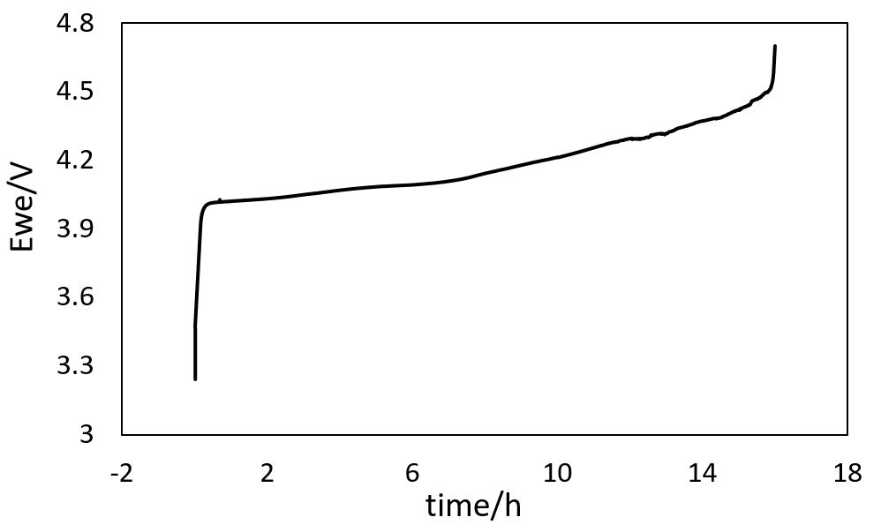
Figure 6.4 The variation of voltage versus time with Li counter electrode cycled galvanostatically at C/20 to x =0.

6.3.2.2 Phase transitions
Figure 6.5 reveals the phase transitions in the LiCoO₂/separator/Li half-cell charged to x = ~ 0.22. From in-situ X-ray diffraction by Reimers et al [9] and Tarascon et al [10], LiCoO₂ experienced multiple phase transitions on removal of Li⁺ from Li_{x}CoO₂: (1) A single phase (Rhombohedral structure, named R1) over a small range for x = 1-0.93. (2) R1 transformed into a two-phase mixture of R1 and R2 (R2 is similar to R1, but differs in its c lattice parameter value) for x = 0.93-0.73. (3) A single R2 phase forms over the composition range x = 0.73-0.55. (4) Transformation of R2 into a monoclinic phase (named M1) occurs around x = 0.5 and M1 single phase forms over x = 0.45-0.55. (5) The M1 phase transformed to a R’2 phase at x values from 0.45 to 0.13 (R’2 is similar to R2, but its structure is still unknown).

From this in-situ experiment, phase transitions of LiCoO₂ during charging can be clearly identified from the neutron diffraction patterns shown in figure 6.6 and 6.7. The d-spacing of the (110) peak shifted to the left (figure 6.7) while the d-spacing of (003) peak shifted to the right (figure 6.8) on removal of Li⁺ from LiCoO₂; using equation 6.1, these indicate an increase in lattice parameter a and a decrease in lattice parameter c during charging, which is consistent with XRD work by Reimers et al. [9] and ND work by Chandran et al [5]. The d-spacing of (102) and (113) stayed the same during charging (figure 6.6 and 6.7) which might be due to the compensation of decreased c and increased a lattice parameters.

1/d² = 4/3 (h² +hk +k²)/ a² +l²/ c² (6.1)

Structural information on the phase transitions can be obtained from the (006), (104), (107) and (108) Bragg peaks. During charging, the intensity of (006) decreased and it vanished at x = ~ 0.62, which is in good agreement with the simulated neutron diffraction patterns (figure 6.9) showing that the (006) and (101) peaks overlap due to the similar d-spacings in the R2 phase. The (101) peak shifted to the right after x = ~ 0.54, in spite of the decreased a parameters, which indicates a further increase in c parameter during the transition from M1 to R’2 phases. In addition, different phases of LiCoO₂ on removal of Li⁺ can be distinguished by the (104) peak. From the beginning, a single (104) peak of R1 phase was observed around 2.005 Å at x = 1, and it became broader after x = ~ 0.89 associated with the phase transition from R1 to a R1 and R2 phase mixture. A new (104) peak of R2 at ~ 2.014 Å arose after x = ~ 0.8, whose intensity increased with decrease in intensity of (104) peak (R1) during charging. The intensity ratio of (104) peaks at 2.005 and 2.014 Å decreased with decreasing x and reached 0 at x = ~ 0.5 which corresponds to the M1 single phase region. The potential at x =0.5 was ~ 4.2 v which also agrees well with previous work [5]. The single peak at 2.014 Å can be indexed as (111) of M1 phase, and it became broader at x = ~ 0.37 which is attributed to the phase transition of M1 to R’2. Finally, a new peak appeared at ~ 2.021 Å which can be indexed as (104) of R’2 and indicates the formation of the R’2 single phase. It is also supported by the evolution of (107) and (108) peaks which look similar to that of (104) peak.

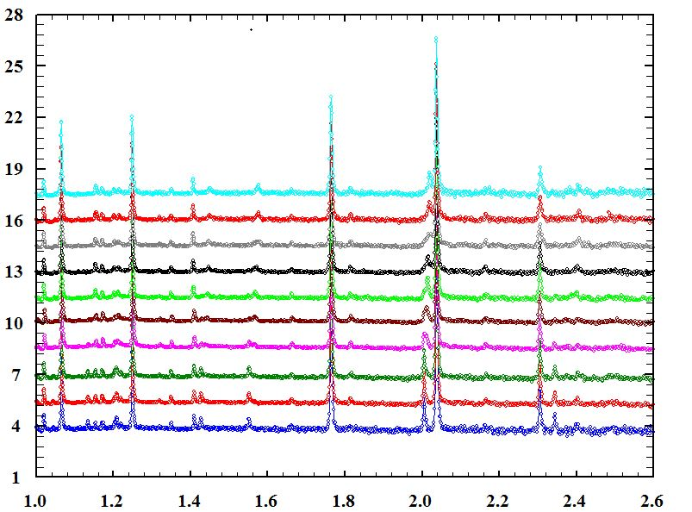
Relative intensities
Å
x = 0.22
x = 0.29
x = 0.37
x = 0.46
x = 0.54
x = 0.62
x = 0.71
x = 0.80
x = 0.89
x = 0.98

Ni
Ni
Ni
Ni
Figure 6.5 In-situ neutron diffraction patterns of LiCoO₂/separator/Li cell during charging.
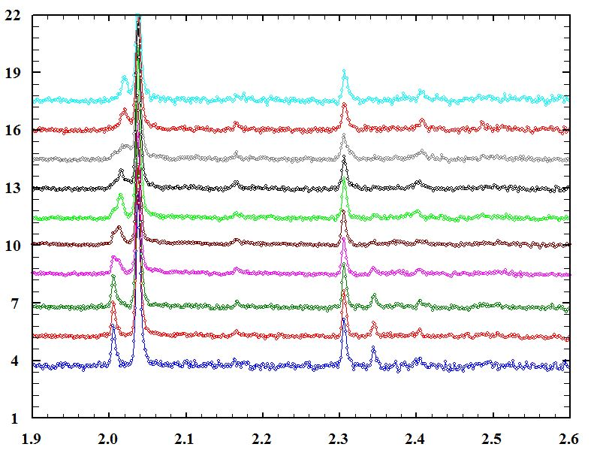
Relative intensities
Å
R1
R1+R2
x = 0.22
x = 0.29
x = 0.37
x = 0.46
x = 0.54
x = 0.62
x = 0.71
x = 0.80
x = 0.89
x = 0.98
R’2
M1
(101)
(102)
(104)
(-102)
(111)
(-201)
(104)
(102)
(101)
(106)
Figure 6.6 In-situ neutron diffraction patterns of LiCoO₂/separator/Li cell during charging in the range 1.9 – 2.6 Å.

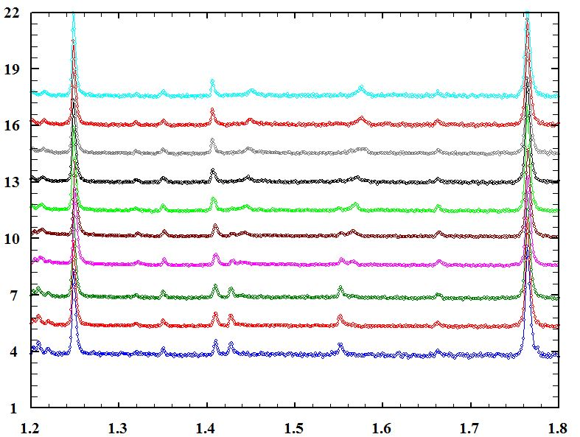
Relative intensities
Å
R1
R1+R2
x = 0.22
x = 0.29
x = 0.37
x = 0.46
x = 0.54
x = 0.62
x = 0.71
x = 0.80
x = 0.89
x = 0.98
R’2
M1
(107)
(108)
(110)
(113)
(202)
(020)
(021)
(112)
(113)
(110)
(108)
(107)
Figure 6.7 In-situ neutron diffraction patterns of LiCoO₂/separator/Li cell during charging in the range 1.2 – 1.8 Å.
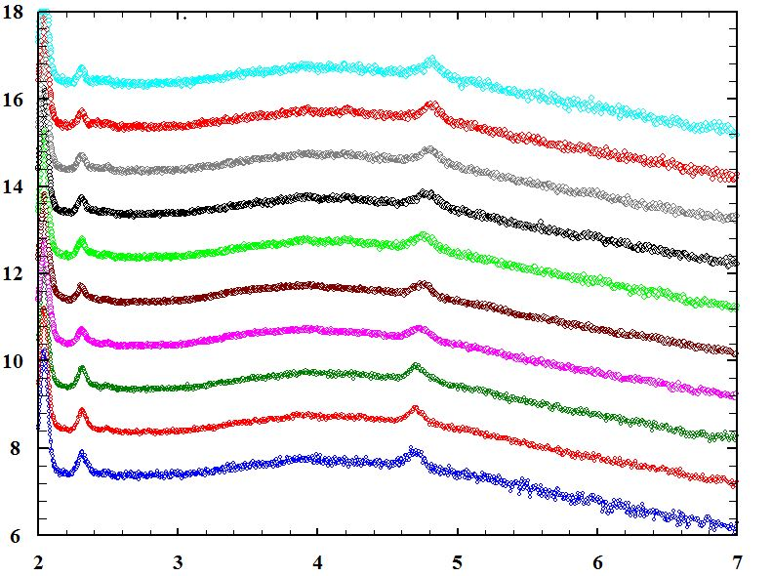
Relative intensities
Å
(003)
(003)
x = 0.22
x = 0.29
x = 0.37
x = 0.46
x = 0.54
x = 0.62
x = 0.71
x = 0.80
x = 0.89
x = 0.98
Figure 6.8 In-situ neutron diffraction patterns of LiCoO₂/separator/Li cell during charging in the range 2 – 7 Å.

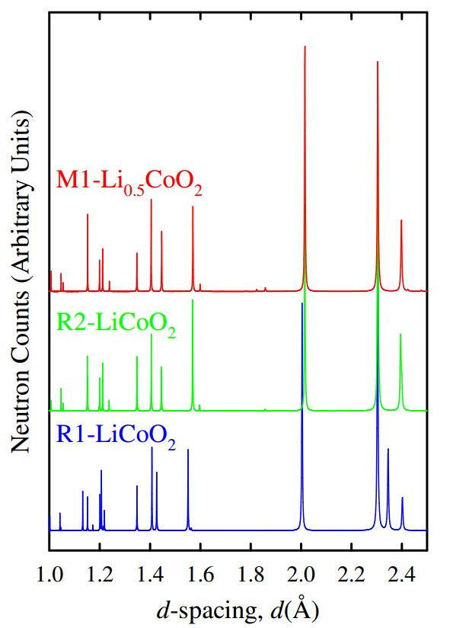
(111)
(107)
(107)
(104)
(104)
(106)
(101)
(101)
Figure 6.9 Simulated neutron diffraction patterns of R1-LiCoO₂, R2-Li_{x}CoO₂ and M1-Li_{0.5}CoO₂.

6.3.2.3 Rietveld Refinements
To evaluate the quality of the collected in-situ neutron data, Rietveld refinements were carried out using the neutron diffraction data of R1, M1 and R’2 single phases at x = 1, 0.48 and 0.31 respectively. The starting models for Rietveld refinement are listed in table 6.4. Ni current collector was dealt with first due to its simple Bragg peaks and relatively high intensities. The lattice parameter of Ni was calculated using the d-spacing formula and set to be 3.5276 Å, and the background (6 terms of shifted Chebyshev function), scale factor and lattice parameters were refined first followed by peak profile coefficients (sig-1, sig-2, gam-1, gam-2) and thermal parameters (U_{iso}) which were fixed after convergence. The lattice parameter of Ni was then fixed and the thermal parameter of each atom set to be 0.01 Å² before the refinement of LiCoO₂ (x=1).

The background (6 terms of shifted Chebyshev function), scale factor and lattice parameters was refined followed by peak profile coefficients (sig-1, sig-2, gam-1, gam-2) which were refined and fixed after convergence. The atomic coordinates of O were then refined and fixed after convergence, and occupancies of Co and Li was refined in order to check the Li/Co exchange. The refined results didn’t indicate any obvious exchange between Co and Li; thus the occupancies of Co and Li were fixed as 1 and thermal parameters of O, Co and Li were refined in sequence because of the large scattering length of O (5.803) compared to Co (2.49) and Li (-1.90). Finally, the thermal parameters of O, Co and Li and the atomic coordinates of O were refined together. The refined structural parameters and observed, calculated and difference profiles from refinement of LiCoO₂ are given in table 6.5 and figure 6.10.

For Li_{0.48}CoO₂, a monoclinic starting model was used, but atomic coordinates became divergent during refinement, and a rhombohedral structure was then used to attempt refinement. The thermal parameter of each atom was set to be 0.01 Å², and the background (6 terms of shifted Chebyshev function), scale factor and lattice parameters were refined first followed by peak profile coefficients (sig-1, sig-2, gam-1, gam-2) which were fixed after convergence. Atomic coordinates of O, thermal parameters of O and Co were refined in turn followed by the occupancy of Li whose thermal parameter was fixed as default value (0.01 Å). Finally, the atomic coordinates of O, the thermal parameters of O and Co, and the occupancy of Li were refined together. The refined occupancy of Li was 0.40(12) which, within errors, is in good agreement with its expected value (0.48) taking errors into account. The refinement strategy for Li_{0.31}CoO₂ was the same for Li_{0.48}CoO₂, and the refined results showed reasonable Li occupancy, 0.25(12) considering the quality of the data. The refined structural parameters and observed, calculated and difference profiles from refinement of Li_{0.48}CoO₂ are given in table 6.5 and figures 6.11, 6.12. The goodness of fit χ² of these refinements are within ~ 2.5, and the weighted R-factor and R-factor which are within 7.3 % and 6.1 % can be considered as good refinement results in terms of refining a total of 15 independent refinable parameters.

The lattice parameter a (=b) decreased from 2.8181(2) Å for LiCoO₂, to 2.8118(4) Å for Li_{0.48}CoO₂ to 2.8103(3) Å for Li_{0.31}CoO₂ while c increased from 14.0618 (19) Å for LiCoO₂, to 14.3638 (43) Å for Li_{0.48}CoO₂ to 14.4455 (30) Å for Li_{0.31}CoO₂, which are comparable to previous work [5]. The increased c parameter can be explained by the removal of Li⁺ ions, which increases the repulsion between adjacent O²⁻ layers along the c axis. Table 6.6 shows the bond lengths of Co-O, Li-O and Co-Li of LiCoO₂, Li_{0.48}CoO₂ and Li_{0.31}CoO₂. The decrease of Li-O bond length is caused by oxidation of Co³⁺ to Co⁴⁺ during charging, which is associated with the higher repulsion force between Co⁴⁺ and O²⁻.

Table 6.4 Space group, atomic positions and lattice parameters of starting models.
Phase | Space group | Atomic positions | Lattice parameters (Å)
Ni | F m -3 m | Ni (0,0,0) | a = b = c = 3.45 Å
LiCoO₂ | R -3 m | Co (0,0,0.5)  Li (0,0,0)  O (0.0.0.2392) | a = b = 2.8146 Å  c = 14.0537 Å
Li_{0.5}CoO₂ | P 2/m | Co (0.5, 0, 0.5)  Co (0, 0.5, 0.5)  Li (0, 0, 0)  O (0.2336, 0, 0.7065)  O (0.7354, 0.5, 0.7057) | a = 4.865 Å, b = 2.809 Å  c = 5.063 Å, β = 108.68º

Table 6.5 Refined structural parameters of LiCoO₂, Li_{0.48}CoO₂ and Li_{0.31}CoO₂.
LiCoO₂, R-3m, a = 2.8181(2) Å, b = 2.8181(2) Å, c = 14.0618 (19) Å, CHI² = 2.566, wRp = 7.32%, Rp = 5.86%
Atom | Type | X | Y | Z | Mult | Occupancy | Uiso X 100
Li1 | Li⁺ | 0 | 0 | 0 | 3 | 1 | 2.6(7)
Co1 | Co³⁺ | 0 | 0 | 0.5 | 3 | 1 | 0.6(3)
O1 | O²⁻ | 0 | 0 | 0.2385(4) | 6 | 1 | 0.1(1)
Li_{0.48}CoO_{2,} R-3m, a = 2.8118(4) Å, b = 2.8118(4) Å, c = 14.3638 (43) Å, CHI² = 2.475, wRp = 7.33%, Rp = 6.10%
Atom | Type | X | Y | Z | Mult | Occupancy | Uiso X 100
Li1 | Li⁺ | 0 | 0 | 0 | 3 | 0.40(12) | 1
Co1 | Co³⁺ | 0 | 0 | 0.5 | 3 | 1 | 1.2(5)
O1 | O²⁻ | 0 | 0 | 0.2353(6) | 6 | 1 | 0.1(1)
Li_{0.31}CoO₂, R-3m, a = 2.8103(3) Å, b = 2.8103(3) Å, c = 14.4455 (30) Å, CHI² = 2.420, wRp = 6.94%, Rp = 5.92%
Atom | Type | X | Y | Z | Mult | Occupancy | Uiso X 100
Li1 | Li⁺ | 0 | 0 | 0 | 3 | 0.25(12) | 1
Co1 | Co³⁺ | 0 | 0 | 0.5 | 3 | 1 | 1.0(6)
O1 | O²⁻ | 0 | 0 | 0.2340(7) | 6 | 1 | 0.1(1)

Table 6.6 Bond length of LiCoO₂, Li_{0.48}CoO₂ and Li_{0.31}CoO₂.
Bond length  /Composition | Li - O | Co – O | Li - Co
LiCoO₂ | 2.103(4) | 1.916(3) | 2.853(3)
Li_{0.48}CoO₂ | 2.149(6) | 1.899(5) | 2.893(1)
Li_{0.31}CoO₂ | 2.165(4) | 1.892(3) | 2.903(1)

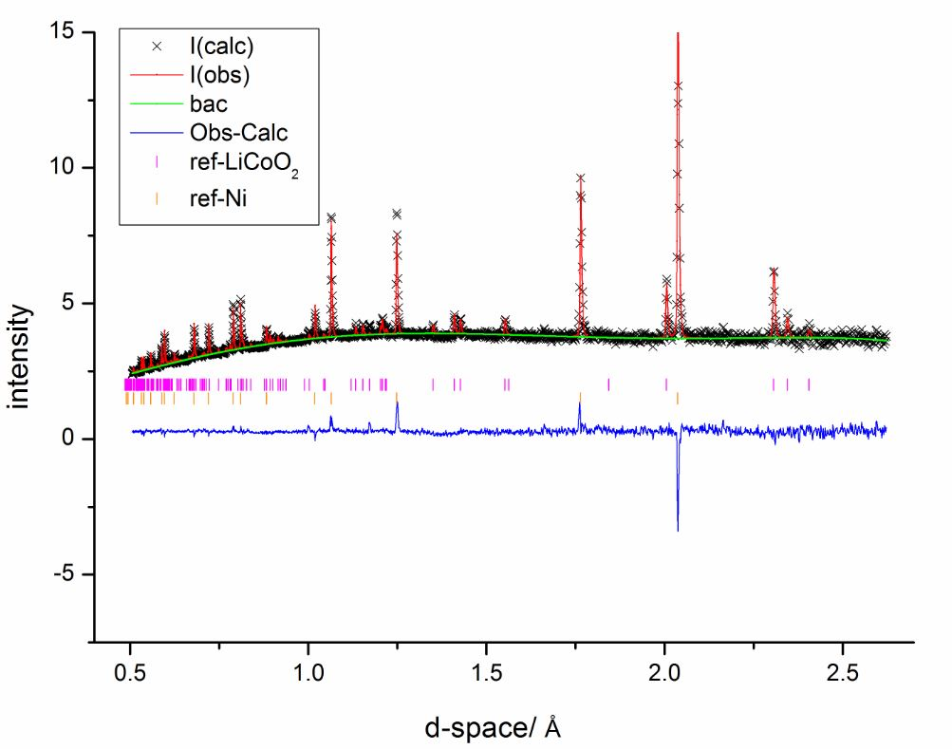
Figure 6.10 Observed, calculated and difference profiles from refinement of LiCoO₂. The purple and orange ticks represent the Miller indices of LiCoO₂ and Ni respectively.
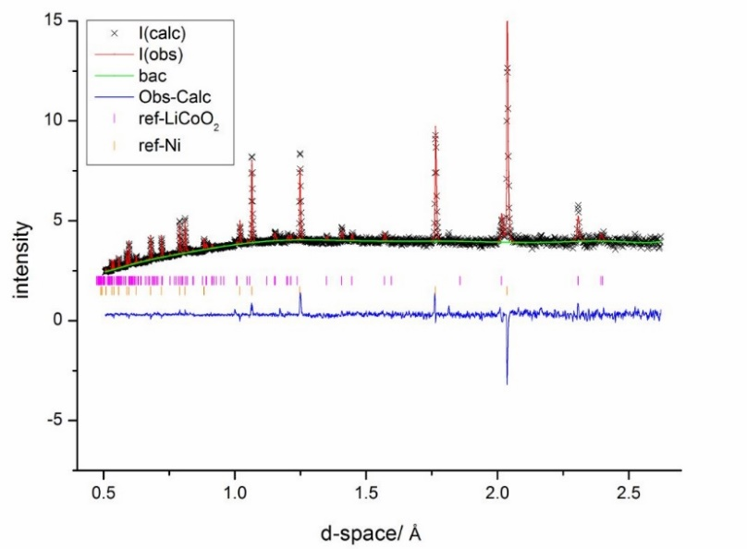
Figure 6.11 Observed, calculated and difference profiles from refinement of Li_{0.48}CoO₂. The purple and orange ticks represent the Miller indices of LiCoO₂ and Ni respectively.
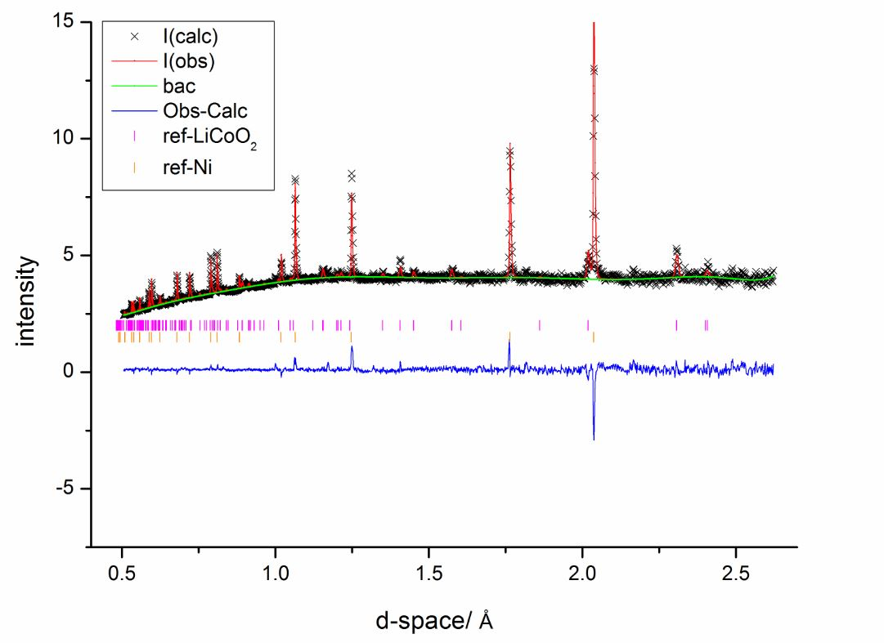
Figure 6.12 Observed, calculated and difference profiles from refinement of Li_{0.31}CoO₂. The purple and orange ticks represent the Miller indices of LiCoO₂ and Ni respectively.

6.3.3 In situ neutron diffraction of LiCoO₂/C with deuterated electrolyte

6.3.3.1 Electrochemical performance
The in-situ cell was assembled as described in table 6.2 (cell 31) using LiFSI in d₈-EA electrolyte. In order to compensate for the lower conductivity of deuterated electrolyte compared to the normal one, the in-situ cell was charged/discharged at slightly lower C-rate (C/25) with a cut-off voltage from 3V to 4.8V. The neutron diffraction patterns were recorded every 10 min/ 0.00667 Li⁺ during operation of the cell. Similar to cell 29, a wide plateau region between 4.0 V and 4.5 V was observed during charging, but the voltage increased more quickly than that of cell 29 (figure 6.14) which might be associated with its higher resistance.

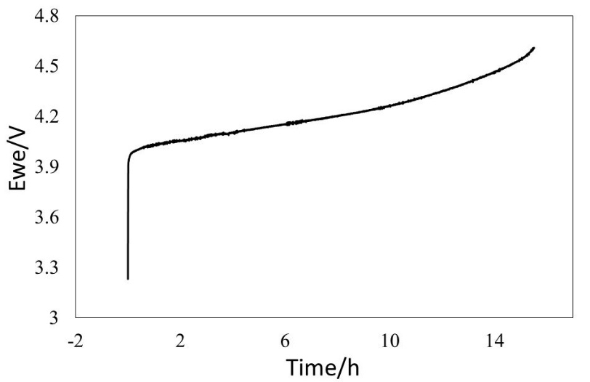
Figure 6.13 Electrochemical performance of cell 31 (table 6.2).
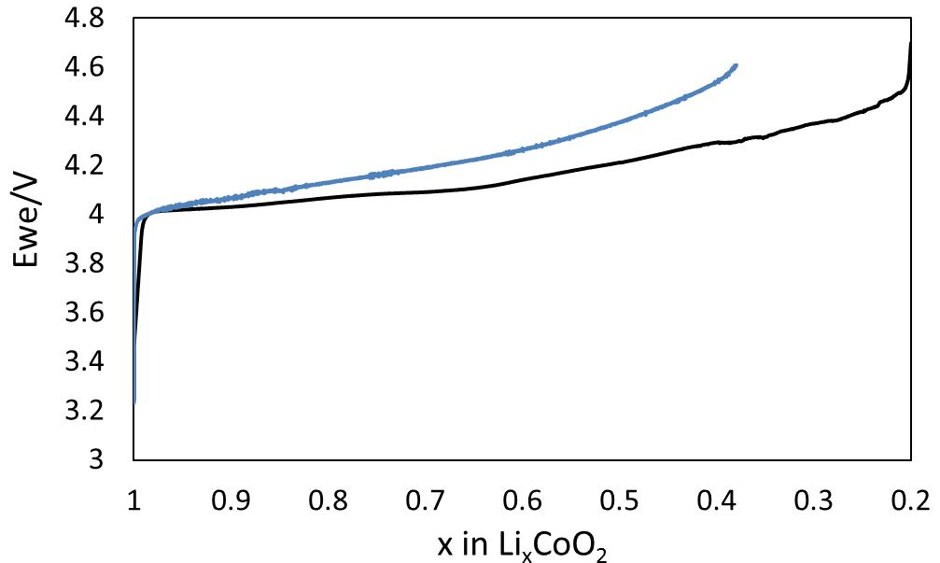
(a)
(b)
Figure 6.14 The variation of voltage versus x in Li_{x}CoO₂: (a) with normal electrolyte cycled galvanostatically at C/20, (b) with deuterated electrolyte cycled galvanostatically at C/25.

6.3.3.2 Phase transitions and Rietveld refinements
Figure 6.15 shows the comparison of neutron diffraction data collected on a sample of LiCoO₂ containing in a vanadium can, the in-situ cell containing normal electrolyte and the in-situ cell containing deuterated electrolyte. The deuterated electrolyte dramatically decreased the background, and the signal-to-noise ratio of in-situ cell with deuterated electrolyte is even comparable to that of LiCoO₂ from vanadium can.

The phase transitions observed in the case of deuterated electrolyte were similar to the ones using normal electrolyte and, therefore both experiments were reproducible. The colour contour plot of cell 31 during charging is shown in figure 6.17, which acts as a good indicator for distinguishing the phase transitions of LiCoO₂ on removal of Li. Three distinct peaks observed at both ~1.55 Å and ~2.0 Å during charging show the previouslymentioned phase transitions. The (006) peak at 2.33 Å disappeared when it changed to R2 phase, which is similar to that observed with normal electrolyte. Because of the better signal-to-noise ratio of deuterated electrolyte, another peak to the right of (006) peak was observed when it changed to another single phase at x = 0.38 (corresponding to R’2 phase by XRD work [10]) in the last few rounds. The phase at x = 0.38 was indexed with a monoclinic unit cell which is different to R’2 phase but similar to M1 phase, which may be associated with the rearrangement of atomic configurations. The indexing results are shown in table 6.8. Finally, a Rietveld refinement of LiCoO₂ was conducted and the refined structural parameters are shown in table 6.9.

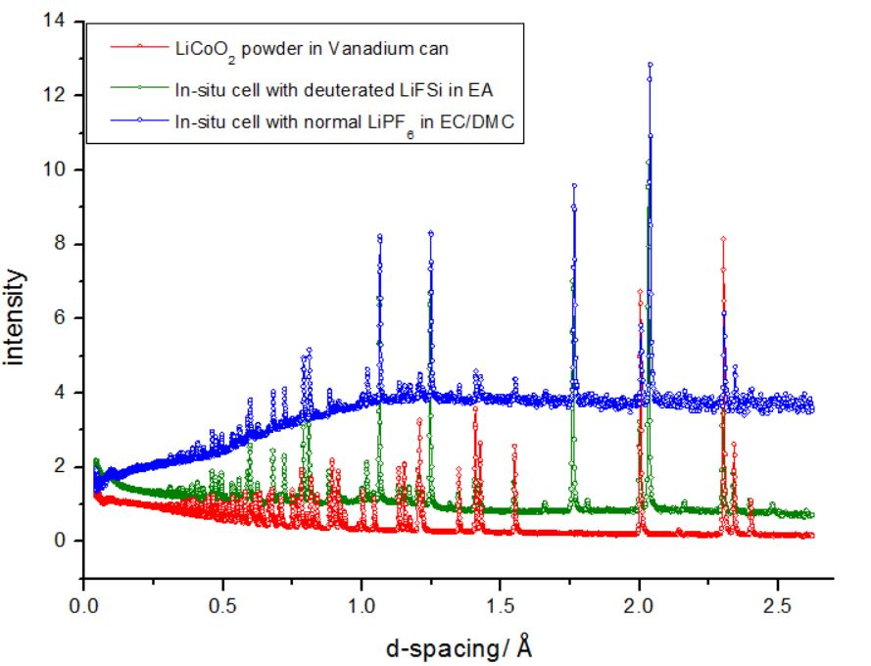
(110)
Ni Cell
V can, Li metal, carbon, electrolyte or separator
(b)
(101)
(113)
(108)
(107)
(104)
(102)
(006)
(a)
(c)
(b)
(a)
(c)
Figure 6.15 Neutron diffraction patterns of (a) LiCoO₂ in Vanadium can; (b) LiCoO₂/Li in-situ cell with deuterated electrolyte; (c) LiCoO₂/Li in-situ cell with normal electrolyte.
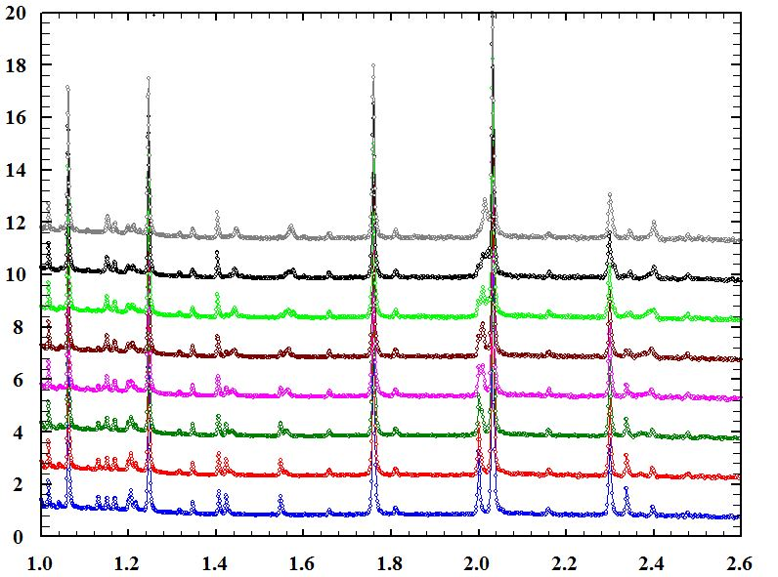
Relative intensities
Å
x = 0.38
x = 0.5
x = 0.58
x = 0.66
x = 0.74
x = 0.82
x = 0.90
x = 0.98
Figure 6.16 In-situ neutron diffraction patterns of LiCoO₂/Li cell during charging.

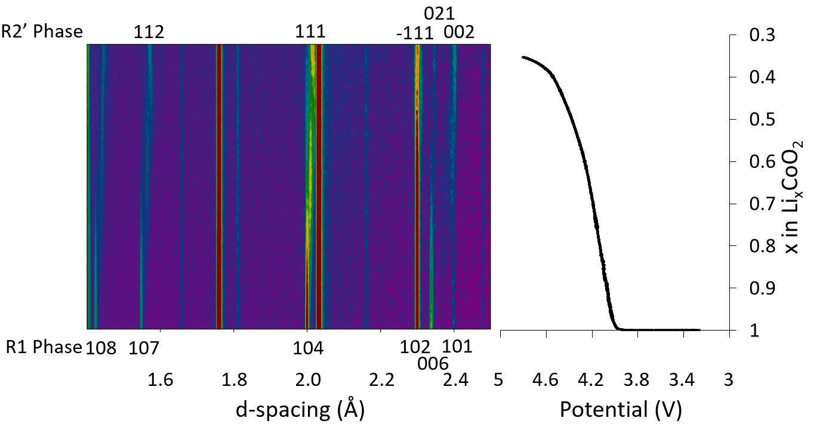
Figure 6.17 Colour contour plot of LiCoO₂/Li cell during charging.

Table 6.8 Indexing results of R’2 phase
N | H | K | L | 2Th[obs] | 2Th[calc] | obs-calc | d[obs] | d[calc]
1 | 0 | 0 | 1 | 18.499 | 18.461 | 0.038 | 4.7924 | 4.8022
2 | 0 | 0 | 2 | 37.445 | 37.424 | 0.0212 | 2.3998 | 2.4011
3 | 0 | 2 | 1 | 38.322 | 38.284 | 0.038 | 2.3469 | 2.3491
4 | -1 | 1 | 1 | 39.115 | 39.137 | -0.0218 | 2.3011 | 2.2999
5 | 1 | 1 | 1 | 44.968 | 44.967 | 0.0011 | 2.0142 | 2.0143
6 | 1 | 1 | 2 | 58.71 | 58.73 | -0.0206 | 1.5713 | 1.5708
7 | -1 | 1 | 3 | 64.387 | 64.4 | -0.0129 | 1.4458 | 1.4455
8 | 1 | 2 | 2 | 66.606 | 66.648 | -0.0426 | 1.4029 | 1.4021
9 | 0 | 4 | 0 | 69.758 | 69.779 | -0.0207 | 1.347 | 1.3467
10 | 1 | 3 | 2 | 78.967 | 78.937 | 0.0304 | 1.2114 | 1.2118
11 | 2 | 2 | 0 | 80.109 | 80.088 | 0.0214 | 1.197 | 1.1973
a = 2.7198(13) Å, b = 5.3868(22) Å, c = 4.8858(23) Å, β = 100.62(4) o, V = 70.36(4) Å³
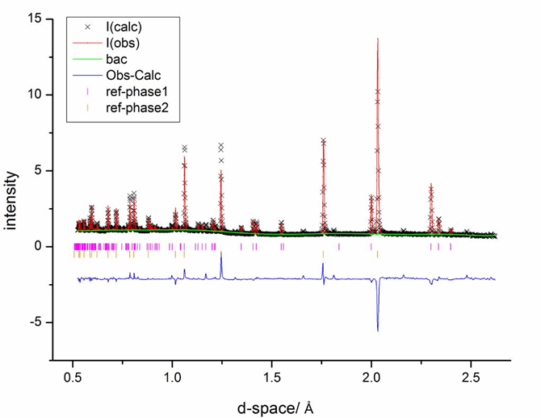
LiCoO₂
Ni
Figure 6.18 Observed, calculated and difference profiles from refinement of LiCoO₂.

Table 6.7 Refined structural parameters of LiCoO₂.
Atom | Type | X | Y | Z | Mult | Occupancy | Uiso x 100
Li1 | Li⁺ | 0 | 0 | 0 | 3 | 1 | 2.1(5)
Co1 | Co³⁺ | 0 | 0 | 0.5 | 3 | 1 | 0.4(2)
O1 | O²⁻ | 0 | 0 | 0.2385(3) | 6 | 1 | 0.1(1)
CHI² = 5.478, wRp = 13.01%, Rp = 15.05%, a = 2.8096(1), b = 2.8096(1), c = 14.0183 (13)

6.4 Conclusion
A new electrochemical cell has been successfully designed and built for in-situ neutron diffraction studies of lithium ion batteries on the Polaris diffractometer, ISIS. The effects of different separators, binders, amount of carbons, graphite and carbon black ratios, amount of active materials, amount of electrolytes, cathode fabricating methods were investigated in order to optimise the electrochemical performance of the cell. The cell with best electrochemical properties was found to be 1g LiCoO₂: Graphite: Carbon black = 80:2.5:7.5/ Whatman GF/D glass fiber/0.38 mm Li metal with 1.5 ml electrolyte cycled at C/20.

Initial in-situ studies showed clear structural evolution of LiCoO₂ during charging in a half-cell; Li metal as a counter electrode, which agrees with previous studies [5,10]. The background issue was addressed by replacing normal electrolyte with deuterated electrolyte and the signal-to-noise ratio of in-situ neutron data improved considerably. Several stages during Li deintercalation from LiCoO₂ were identified and correlated with electrochemical charge/discharge data: a R1 single phase was observed from the beginning to x = ~ 0.9, after which the (104) peak of R2 (d = 2.014 Å) grew in intensity and a mixture of R1 and R2 phases coexist. A single M1 phase was identified at x = ~0.5 with the disappearance of (104) and (106) peaks of R1 phase. After the phase transition region between x = ~0.45 to x = ~0.37, a new (104) peak at d = ~2.021 Å grew in intensity with the formation of a R’2 single phase.

Atomic coordinates, thermal parameters and occupancies of each atom of Li_{x}CoO₂ at different state of charge can be refined to give good goodness (~ 5.4) of fit and R_{wp} and R_{p} values. Overall, the cell, as shown in the case of LiCoO₂, can be used to monitor in situ phase transitions of Li electrode materials.

6.5 References
1. Bergstom, O., Andersson, A.M., Edstrom, K., and Gustafsson, T., A neutron diffraction cell for studying lithium-insertion processes in electrode materials, Journal of Applied Crystallography, 1998: 31, 823-825.
2. Rosciano, F., Holzapfel, M., Scheifele, W., and Novák, P., A novel electrochemical cell for in situ neutron diffraction studies of electrode materials for lithium-ion batteries, Journal of Applied Crystallography, 2008: 41(4), 690-694.
3. Godbole, V.A., He, M., Villevieille, C., Kaiser, H., Colin, J.F., and Novák, P., Circular in situ neutron powder diffraction cell for study of reaction mechanism in electrode materials for Li-ion batteries, RSC Advances, 2013: 3(3), 757-763.
4. Bianchini, M., Leriche, J.B., Laborier, J.L., Gendrin, L., Suard, E., Croguennec, L., and Masquelier, C., A New Null Matrix Electrochemical Cell for Rietveld Refinements of In-situ or Operando Neutron Powder Diffraction Data, Journal of The Electrochemical Society, 2013: 160(11), A2176-A2183.
5. Vadlamani, B., An, K., Jagannathan, M., and Chandran, K.S.R., An In-situ Electrochemical Cell for Neutron Diffraction Studies of Phase Transitions in Small Volume Electrodes of Li-Ion Batteries, Journal of The Electrochemical Society, 2014: 161(10), A1731-A1741.
6. Roberts, M. R., Biendicho, J.J., Hull, S., Beran, P., Gustafsson, T., Svensson, G., and Edström, K., Design of a new lithium ion battery test cell for in-situ neutron diffraction measurements, Journal of Power Sources, 2013: 226, 249-255.
7. Brant, W.R., Schmid, S., Du, G.D., Brand, H.E.A., Pang, W.K., Peterson, V.K., Guo, Z.P., Sharma, N., In Situ Neutron Powder Diffraction Using Custom-made Lithium-ion Batteries, Journal of Visualized Experiments, 2014: 93, e52284.
8. Biendicho, J.J., Roberts, M., Offer, C., Noréus, D., Widenkvist, E., Smith, R.I., Svensson, G., Edström, K., Norberg, S.T., Eriksson, S.G., and Hull, S., New in-situ neutron diffraction cell for electrode materials, Journal of Power Sources, 2014: 248, 900-904.
9. Reimers, J.N. and Dahn, J.R., Electrochemical and In Situ X-Ray Diffraction Studies of Lithium Intercalation in LixCoO2, Journal of Electrochemical Society, 1992: 139(8), 2091-2097.
10. Morcrette, M., Chabre, Y., Vaughan, G. , Amatucci, G., Leriche, J.B., Patoux, S., Masquelier, C. , and Tarascon, J.M., In situ X-ray diffraction techniques as a powerful tool to study battery electrode materials, Electrochimica Acta, 2001: 47, 3137-3149.

Chapter 7 Conclusions and future work

7.1 Conclusions
Novel, aliovalent, anion-doped (N³⁻ or F⁻) Li ion conduction materials were successfully synthesised by solid state reaction using Li₃N and LiF as N or F sources. N-doped solid solutions of formula, Li_{3+x}VO_{4-x}N_{x}: 0 ≤ x ≤ 0.2, and a new phase Li₅SiO₄F were isolated. Impedance spectroscopy (IS) was used to study the electrical properties, and both N-doped and F-doped materials show enhanced conductivities and decreased activation energies compared with the corresponding undoped materials.

Non-stoichiometric Li₂MSiO₄ (M = Mn or Zn) phases with different Li/M ratios in the binary system Li₄SiO₄-Li₂MSiO₄ (M = Mn or Zn) were studied, and a new series with formula, Li₃M_{0.5}SiO₄ (M = Mn or Zn), was discovered. By changing Li/Mn ratio, Li₂MnSiO₄ electronically conducting materials became Li₃Mn_{0.5}SiO₄ ionically conducting materials.

A new electrochemical cell for in-situ neutron diffraction has been designed, built and successfully tested on lithium ion batteries. The background issue was addressed by replacing normal electrolyte with deuterated electrolyte since the signal-to-noise ratio of in-situ neutron data improved considerably. Initial in-situ studies showed clear structural evolution of LiCoO₂ during charge in a half-cell with Li metal as a counter electrode.

7.1.1 N-doped Li₃VO₄ [1]
A relatively new method for doping Li⁺ ions into a structure by aliovalent anion doping was explored. N-doped solid solutions of formula Li_{3+x}VO_{4-x}N_{x}: 0 ≤ x ≤ 0.2 were synthesised successfully at either 450ºC using LiOH·H₂O or 650ºC using Li₂CO₃ with Li₃N as nitrogen source.

Structure refinements on two compositions x = 0 and x = 0.2, prepared using Li₂CO₃, were carried out using a combination of XRD and ND data. Combined ND/XRD studies confirmed the substitution of O by N together with the creation of an equal number of interstitial Li⁺ ions; defect pairs may form by electrostatic attraction between N located on O(1) sites and occupied adjacent Li(3) interstitial sites. The composition determined by refinement of XRD/ND data matched that expected from the target stoichiometry and indicates the usefulness of the synthetic procedure developed for N-doping.

Impedance data showed enhanced Li⁺ ion conductivity in the N-doped materials. Variation in activation energy between different samples may indicate whether or not the Li(3) ions are trapped by adjacent nitrogen atoms. Although anion doping, by N, represents a relatively untried method of modifying the Li content of a structure, trapping of interstitial Li⁺ ions within defect complexes, and the associated increase in activation energy for conduction, may limit the usefulness of this method for generating a high level of Li⁺ ion conductivity.

7.1.2 F-doped Li₄SiO₄
An initial study of compound formation was carried out in the Li₂O-SiO₂-LiF system. LiF and SiO₂ were found to react at 800 ºC with possible reactions such as: 4LiF + SiO₂ → 2Li₂O + SiF₄. Appropriate reaction conditions, to avoid loss of fluoride on heating mixtures of Li₂CO₃, LiF and SiO₂, have been determined. In the phase diagram Li₂O-LiF-SiO₂, the tie-line Li₂SiO₃-LiF separates those compositions that contain more SiO₂, and do lose fluoride on heating in air at eg 800 ºC, from those that are stable under similar reaction conditions.

On the Li₄SiO₄-LiF join, a new phase, Li₅SiO₅F, stable to ~ 800 º C has been prepared; XRF analysis confirmed its composition and showed that F loss did not occur during synthesis. Li₅SiO₅F was indexed with a monoclinic unit cell where a = 7.900(11) (Å), b = 13.506(12) (Å), c = 13.041(15) (Å), β = 97.39(6) (º) and V = 1379.8(42) (Å³).

Impedance measurements on sintered pellets of Li₅SiO₅F showed bulk and grain boundary arcs in impedance complex plane plots with a sharp, low frequency spike characteristic of ion blocking at the sample – electrode interface and therefore, Li⁺ ion conduction. The conductivity of Li₅SiO₅F at 50 ºC, ~ 1x10⁻⁷ S cm⁻¹, is several orders of magnitude higher than that of undoped Li₄SiO₄ and has a small activation energy, 0.51(1) eV. The crystal structure of Li₅SiO₅F is not known, but from its powder XRD pattern, it is clearly different from that of Li₄SiO₄. It therefore represents an entirely new Li⁺ ion conductor, which is stable in contact with Li metal and may find possible application in thin film solid state battery development.

7.1.3 Non-stoichiometric Li₂MSiO₄ (M = Mn and Zn)
Non-stoichiometric compositions of Li₂MSiO₄ (M = Mn, Zn) on the joins Li₄SiO₄ – Li₂MSiO₄ (M = Mn, Zn) with formula, Li_{2+2x}M_{1-x}SiO₄ (M = Mn, Zn), have been synthesised by solid state reaction. A β-Li₂MnSiO₄ solid solution with limit to x = 0.1 was discovered in the Li₄SiO₄-Mn₂SiO₄ system. A new phase with formula, Li₃Mn_{0.5}SiO₄, was discovered and indexed on an orthorhombic unit cell with a = 10.722(3) (Å), b = 6.239(2) (Å), c = 5.052(3) (Å), V = 337.97(11) (Å³); A limited range of ordered Li₄SiO₄ was found with composition 0.7 ≤ x ≤ 1, and the ordered Li₄SiO₄ transformed to disordered Li₄SiO₄ at high temperature. The ordered phase at x = 0.75, with formula Li_{3.5}Mn_{0.25}SiO₄ was indexed with a monoclinic unit cell, a = 6.430(4) (Å), b = 11.088(7) (Å), c = 8.232(4) (Å), β = 108.39(5), V = 557.0(4) (Å³) which is roughly half the unit cell volume of disordered Li₄SiO₄. In the Li₄SiO₄ – Li₂ZnSiO₄ system, a similar phase Li₃Zn_{0.5}SiO₄, was indexed with orthorhombic unit cell with a = 10.6687(5) (Å), b = 6.2089(4) (Å), c = 5.0590(3) (Å), V = 335.11(5) (Å³).

Impedance spectroscopy was used to study the electrical properties of Li_{2+2x}M_{1-x}SiO₄ (M = Mn, Zn). By changing the ratio of Li/Mn, electrical properties of Li_{2+2x}Mn_{1-x}SiO₄ changed dramatically and the poor electronic conductor, Li₂MnSiO₄, changed to the Li ionic conductor Li₃Mn_{0.5}SiO₄. In addition, conductivity of Li₃M_{0.5}SiO₄ (M = Zn, Mn) increased by 5-7 orders compared to that of their parent materials Li₂MSiO₄ (M = Zn, Mn) while the activation energy of Li₂MSiO₄ (M = Zn, Mn) decreased from 1.06 to 1.39 eV to 0.88 to 0.93 eV of Li₃M_{0.5}SiO₄ (M = Zn, Mn). Therefore, Li₃Mn_{0.5}SiO₄ could perhaps be used as a new cathode material for lithium ion batteries because of its high ionic conductivity.

The Arrhenius plots of samples in the present study are summarised in figure 7.1.

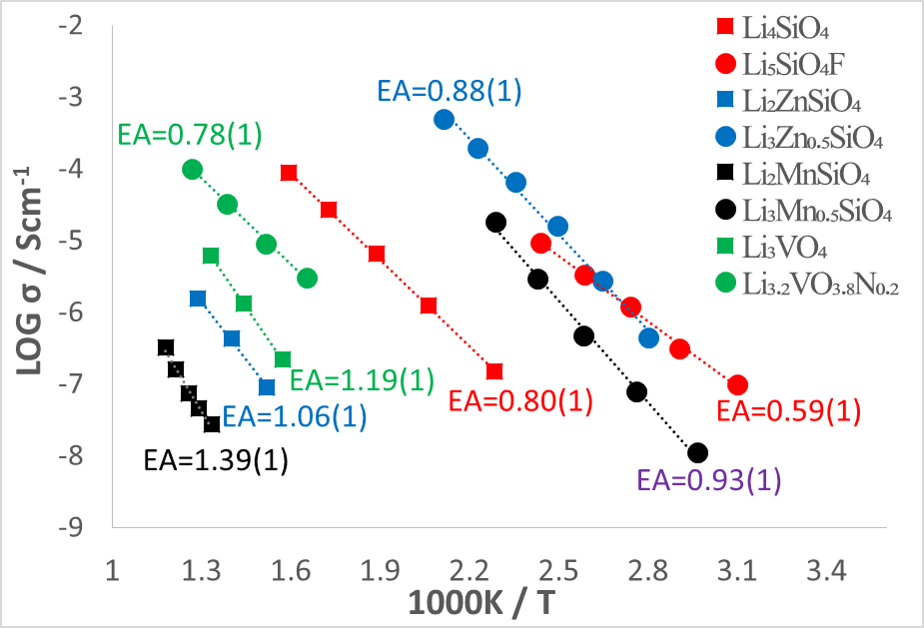
Figure 7.1 Arrhenius plots of samples in the present study.

7.1.4 New electrochemical cell for in-situ neutron diffraction study of lithium ion batteries
A new electrochemical cell has been successfully designed and built for in-situ neutron diffraction studies of lithium ion batteries on the Polaris diffractometer, ISIS. The cell with best electrochemical properties was found to be 1g LiCoO₂: Graphite: Carbon black = 80:2.5:7.5/ Whatman GF/D glass fiber/0.38 mm Li metal with 1.5 ml electrolyte cycled at C/20.

The new cell has a coin cell geometry, and consists of 15 cm diameter circular disk-type components: two stainless steel alloy clamp rings, two nickel metal windows, two thin nickel metal sheets, one separator module and one boron nitride shield. The main body of the cell is made of Ni because of its simple neutron diffraction patterns, and it can be easily assembled by stacking the components together and clamping tight with 16 polyetheretherketone (PEEK) screws

Initial in-situ studies showed clear structural evolution of LiCoO₂ during charge in a half-cell with Li metal as counter electrode, which agrees with previous studies [5,9]. Several stages during Li deintercalation from LiCoO₂ were identified and correlated with electrochemical charge/discharge data. The background issue was addressed by replacing normal electrolyte with deuterated electrolyte and the signal-to-noise ratio of in-situ neutron data improved considerably.

Atomic coordinates, thermal parameters and occupancies of each atom of Li_{x}CoO₂ at different state of charge can be refined to give good goodness of fit (~5.4) and R_{wp} and R_{p} values. Therefore the cell, as shown in the case of LiCoO₂, can be used to monitor in situ phase transitions of Li electrode materials.

7.2 Future work
Use alternative synthesis routes which provide strict inert or vacuum atmosphere and require lower reaction temperature, such as mechanical synthesis in vacuum atmosphere or sol-gel method, to reduce nitrogen loss and synthesis novel oxynitride materials.

Synthesise and characterise other Li-rich oxynitrides or Li-deficient oxyfluorides to look for new/improved Li⁺ ion conductors only for the LISICON-related materials, such as Li₅SiO₃N, Li₅GeO₃N and Li_{3-x}PO_{4-x}F_{x}, but also for other materials which shows good ionic conductivity, such as garnet, perovskite and thio-LISICON materials. Replace oxygen by other bigger halide anions, such as Cl or Br, to form either solid solution or new phase for possible Li⁺ ion conductors,

Carry out sol-gel synthesis and electrochemical test of Li₂MnSiO₄, Li_{2.2}Mn_{0.9}SiO₄ and Li₃Mn_{0.5}SiO₄ with reduced particle size. Synthesise and characterise of possible new phases of the series Li₃M_{0.5}SiO₄: M = Fe, Co and Ni. Conduct structure determination of these new phases using combined neutron diffraction and x-ray diffraction data.

Test the new electrochemical cell for in-situ studies of other cathode or anode materials to gain Li diffusion mechanism as well as structural evolution during the operation of the battery which could help to design and optimise new/improved materials for lithium ion batteries. Test the cell on other battery systems, e.g. Na ion battery.

7.3 Reference
1. Bo Dong; Rouzbeh Jarkaneh; Stephen Hull; Nik Reeves-Mclaren; Jordi Jacas Biendicho; Anthony R. West. Synthesis, Structure and Electrical Properties of N-doped Li₃VO₄. Journal of Materials Chemistry A. 2015, 4, 1408.

Appendices

Part 1. N-doped Li₄SiO₄

1.1 Introduction and experimental
It is reported that lithium silicon(germanium) oxynitrides, Li₅SiO₃N, Li₃SiO₂N, LiSiNO, Li₅GeO₃N, Li₃GeO₂N and LiGeNO, were synthesised by solid state reaction of Si₂N₂O with Li₂O, SiO₂ with Li₃N, Ge₂N₂O with Li₂O or GeO₂ with Li₃N by Podsiadlo et al [1-3]. Li₅Si(Ge)O₃N which has one more interstitial Li⁺ compared to its parent compound Li₄Si(Ge)O₄ has the potential to be a good Li⁺ ionic conductor. In this section, the synthesis of Li_{4+x}SiO_{4-x}N_{x} was studied using solid state reaction with Li₃N or Si₃N₄ as N source.

Li₂CO₃, LiOH·H₂O, SiO₂, Li₃N and Si₃N₄ were chosen as reagents. Li₂CO₃ and SiO₂ were dried at 180 ºC for 24 h in a drying oven and LiOH·H₂O was heated to 150ºC in N₂ to remove water before use. Stoichiometric amounts of Li₂CO₃/ LiOH·H₂O, SiO₂ and Li₃N were weighed, mixed with a mortar and pestle and pressed into pellets with a 10 mm circular die in a glove box due to the sensitivity of Li₃N to air. The pellets were then transferred onto a Molybdenum boat inside the glass tube, and scotch tape was used to seal both ends of the tube to retain a N₂ atmosphere. The glass tube was then transferred into a horizontal tube furnace with flowing N₂ for 30 min before heating at 5 ºC/ min to 650 ºC for 10h and then 750 ºC for 10h with intermediate grinding (Li₂CO₃) and 450 ºC for 4h (LiOH·H₂O). Samples with general formula, Li_{4+x}SiO_{4-x}N_{x}: x = 0, 0.2, 0.4, 0.6, 1, were synthesised by solid state reaction:

(2-x)Li₂CO₃ + SiO₂ + xLi₃N = Li_{4+x}SiO_{4-x}N_{x} + CO₂↑ (1.1)
(4-2x)LiOH·H₂O + SiO₂ + xLi₃N = Li_{4+x}SiO_{4-x}N_{x} + CO₂↑ (1.2)

Also, Li₅SiO₃N was prepared with Li₂CO₃, SiO₂ and Si₃N₄ at 650 ºC for 10h and 750 ºC for 10h with intermediate grinding in air with reaction:

2.5 Li₂CO₃ + 0.25 SiO₂ + 0.25 Si₃N₄ = Li₅SiO₃N + CO₂↑ (1.3)

For phase analysis, a Bruker D2 X-ray diffractometer with Cu Kα radiation (λavg = 1.5418 Å) was used. Patterns were recorded with a scan rate of 0.02° in the range from 15° to 80°. For impedance measurement, pellets of N-Li₄SiO₄ were heated at their synthesis temperature for 4 h before coating with Au paste electrode. Impedance data were recorded with Solartron with a 100 mV of ac and sweep frequency from 10⁻² to 10⁶ Hz in N₂.

1.2 Results and discussion
Because of the concern that Li₃N may decompose at high temperature, LiOH·H₂O was used to replace Li₂CO₃ as lithium source because of its high reactivity and consequently low reaction temperature. Figure 1.1 shows the XRD patterns of Li₄SiO₄ made from LiOH·H₂O at different temperatures. A single Li₄SiO₄ phase was achieved at ~ 450 ºC for 4h which is approximately the decomposition temperature of LiOH [4] and 300 ºC lower than the reaction temperature of Li₂CO₃.

Li_{4+x}SiO_{4-x}N_{x}: x = 0, 0.2, 0.4, 0.6, 1, were synthesised with LiOH·H₂O, SiO₂ and Li₃N at 450 ºC for 4h. The XRD patterns of Li_{4+x}SiO_{4-x}N_{x}: x = 0.2, 0.4, 0.6, show a mixture of Li₄SiO₄, Li₈SiO₆, low-temperature Li₄SiO₄ and Li₂CO₃ (figure 1.2). It is speculated that nitrogen may go into the low-temperature Li₄SiO₄ phase, and the results of impedance spectroscopy show similar conductivities and activation energies of Li_{4+x}SiO_{4-x}N_{x}: x = 0.2, 0.4, 0.6 and Li₄SiO₄. For Li₅SiO₃N (x=1), the XRD result which is different from other N-doped samples, was a mixture of Li₄SiO₄, SiO₂, Li₂CO₃, Li₂O and Li₈SiO₆. When reheating Li_{4.2}SiO_{3.8}N_{0.2} and Li_{4.4}SiO_{3.6}N_{0.4} to 650 ºC for 4h, the low-temperature Li₄SiO₄ phase disappeared and the XRD patterns show a mixture of Li₄SiO₄, Li₈SiO₆ and Li₂CO₃ (figure 1.3).

Li₂CO₃ SiO₂ and Si₃N₄ were used to make Li₅SiO₃N (x=1) in air, and XRD results shows a mixture of Li₄SiO₄ and Li₂CO₃ at 750 ºC and a mixture of Li₄SiO₄, Li₂CO₃ and Li₈SiO₆ at 800 ºC (figure 1.4). Another synthesis route using Li₂CO₃, SiO₂ and Li₃N as regents was used to make Li_{4+x}SiO_{4-x}N_{x}: x = 0.1, 0.2 0.4. Limited solid solution formed to x = ~ 0.1 and Li₂O impurity was found with Li_{4+x}SiO_{4-x}N_{x} : x = 0.2 0.4.

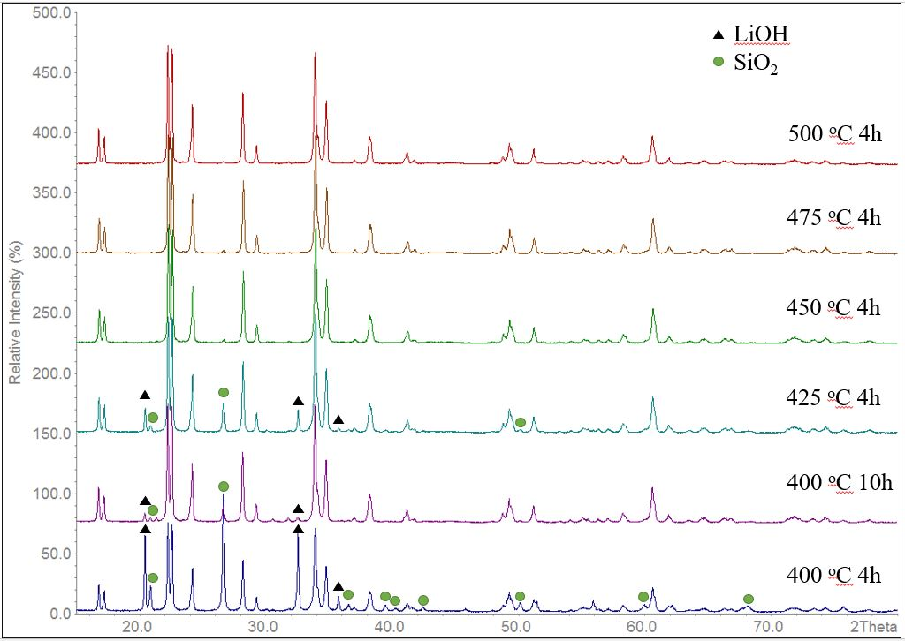
Figure 1.1 XRD patterns of Li₄SiO₄ (made from LiOH·H₂O) after heating at 400 ºC for 4h, 400 ºC for 10h, 425 ºC for 4h, 450 ºC for 4h, 475 ºC for 4h and 500 ºC for 4h.

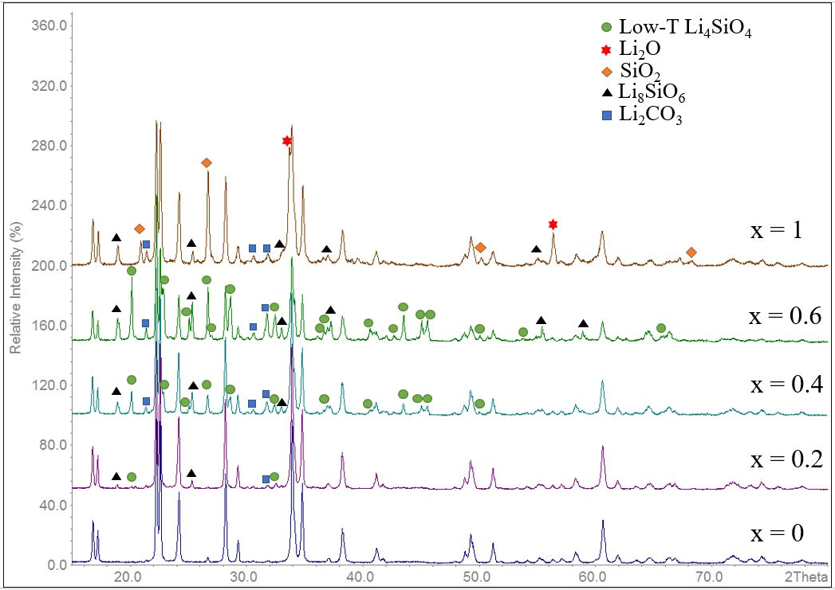
Figure 1.2 XRD patterns of Li_{4+x}SiO_{4-x}N_{x}: x = 0, 0.2, 0.4, 0.6, 1, made from LiOH·H₂O, SiO₂ and Li₃N at 450 ºC for 4h.

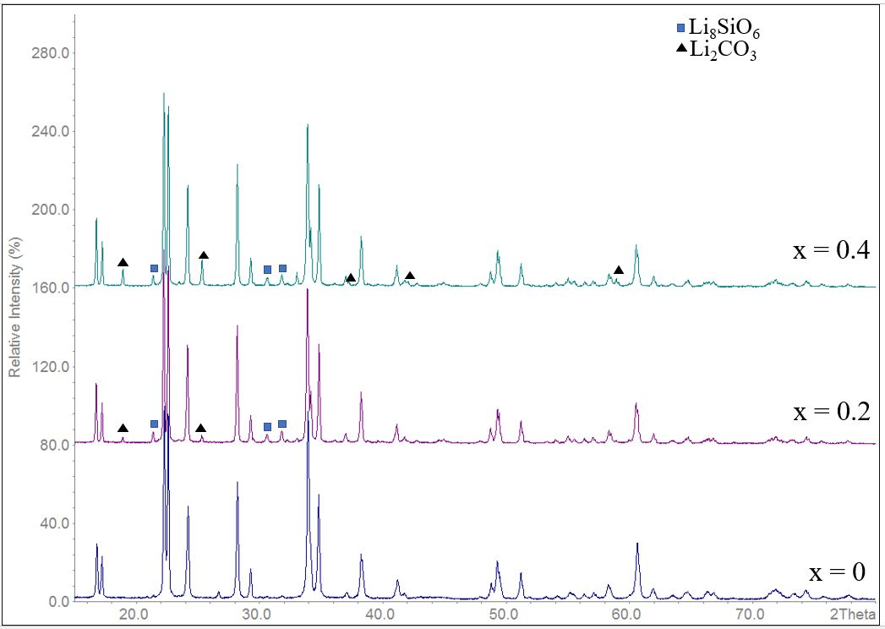
Figure 1.3 XRD patterns of Li_{4+x}SiO_{4-x}N_{x}: x = 0, 0.2, 0.4, made from LiOH·H₂O, SiO₂ and Li₃N at 650 ºC for 4h.

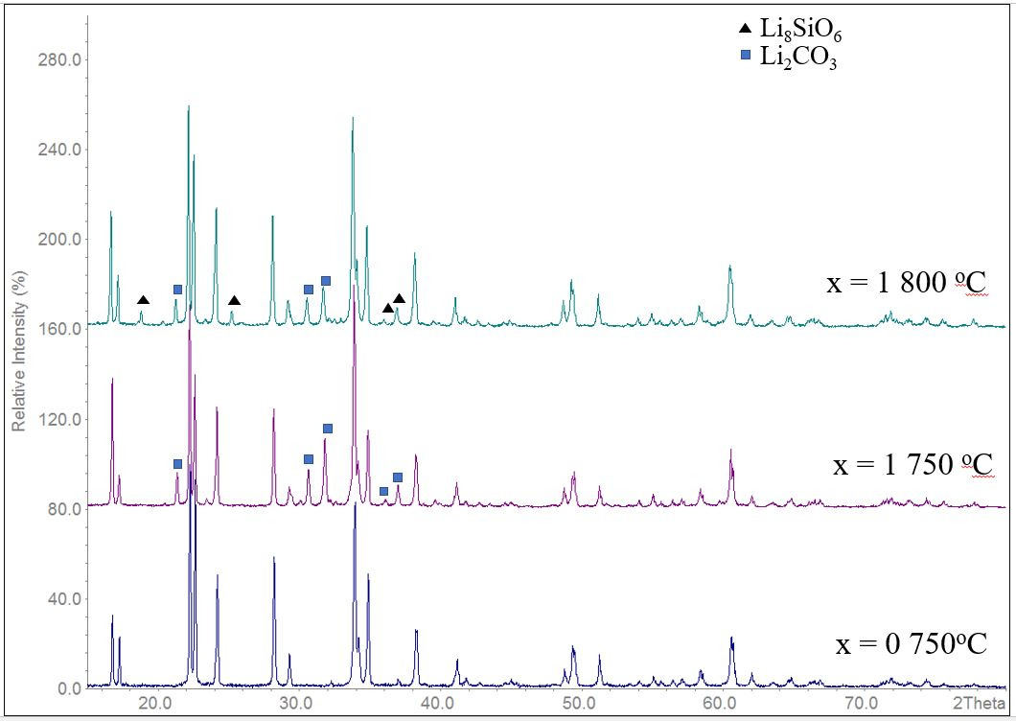
Figure 1.4 XRD patterns of Li₄SiO₄ and Li₅SiO₃N made from Li₂CO₃, SiO₂ with/without Si₃N₄ at 750 ºC and 800 ºC in air.

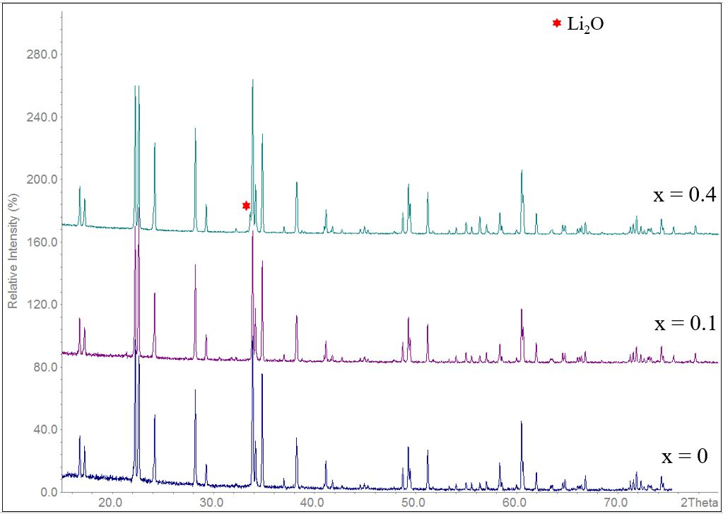
Figure 1.5 XRD patterns of Li_{4+x}SiO_{4-x}N_{x}: x = 0, 0.1, 0.4, made from Li₂CO₃, SiO₂ and Li₃N at 750 ºC for 10h.

Impedance spectroscopy results of Li_{4.1}SiO_{3.9}N_{0.1} with gold electrodes at different temperatures in N₂ are shown in figure 1.6. Z* plots consist of a high frequency arc represented by a single parallel RC element and a sharp low frequency spike which is attributed to a sample - electrode interfacial capacitance. C’ spectroscopic plots showed a high frequency plateau, capacitance ~ 2·10⁻¹² Fcm⁻¹ which is attributed to the bulk response of the sample and a dispersion at lower frequencies with a capacitance of ~ 1·10⁻⁵ Fcm⁻¹ (200 ºC) illustrating blocking of the ionic species at the sample-electrode. Combined Z’’/M’’ spectroscopic plots show a coincidence of peak maxima of M’’ and Z’’ at higher frequencies, which implies the electrically homogeneity of the sample. Figure 1.7 shows the Arrhenius plot of Li₄SiO₄ and Li_{4.1}SiO_{3.9}N_{0.1} in N₂. Conductivity of Li_{4.1}SiO_{3.9}N_{0.1} is slightly higher than that of Li₄SiO₄ with similar activation energies.
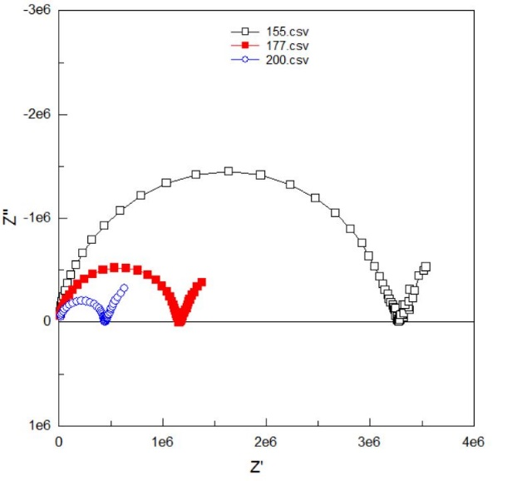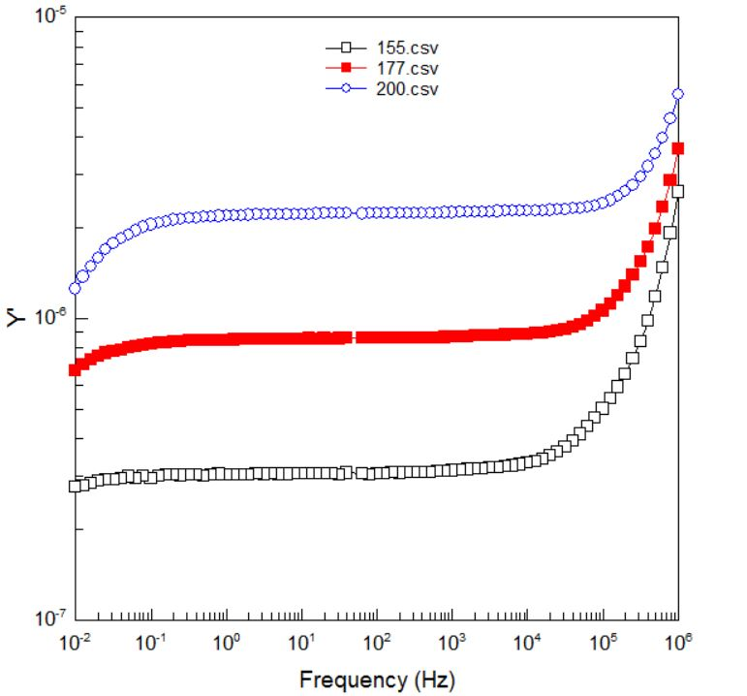
(b)
(a)
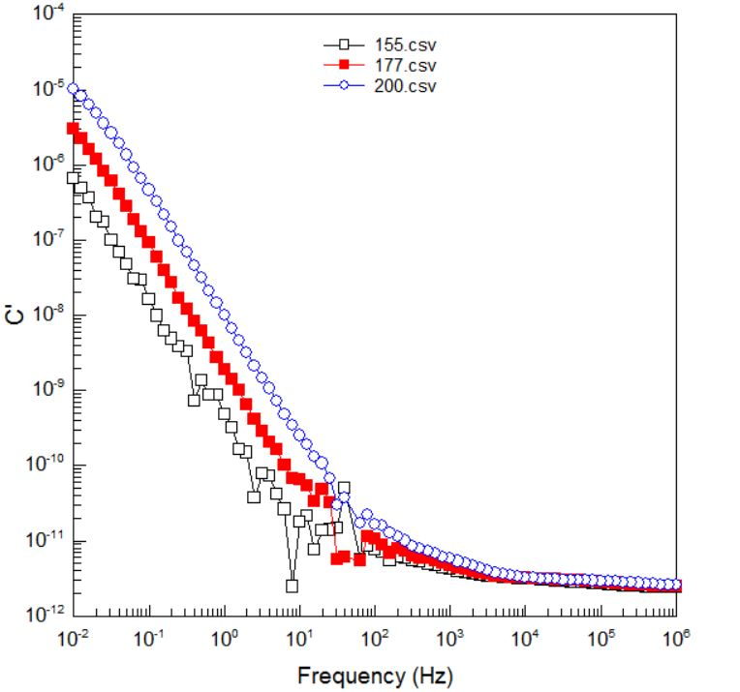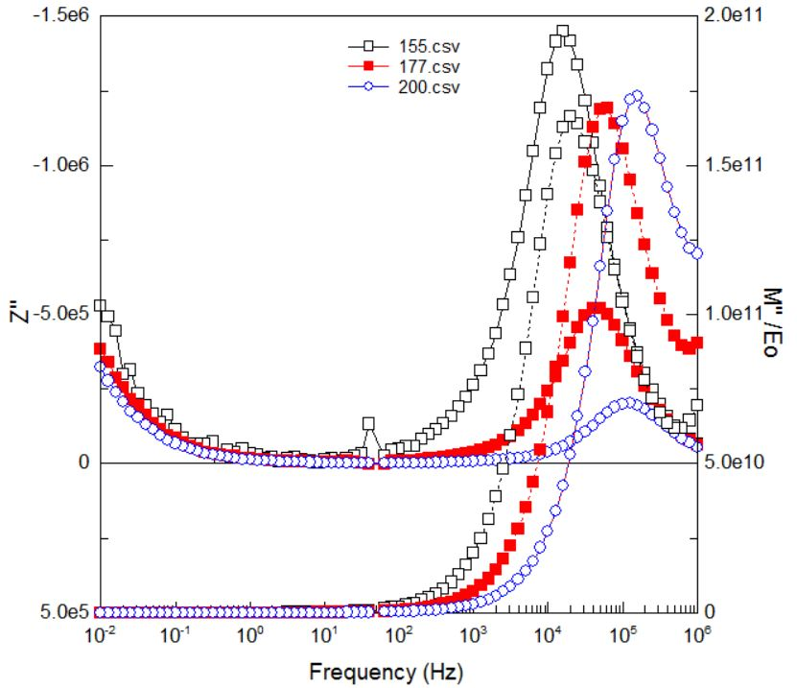
(d)
(c)
Figure 1.6 Impedance data for Li_{4.1}SiO_{3.9}N_{0.1}, prepared using Li₂CO₃. (a) Impedance complex plane plots at 155, 177, 200 ºC. Spectroscopic plots of Y’ (b), C’ (c), –Z’’ and M’’ (d).
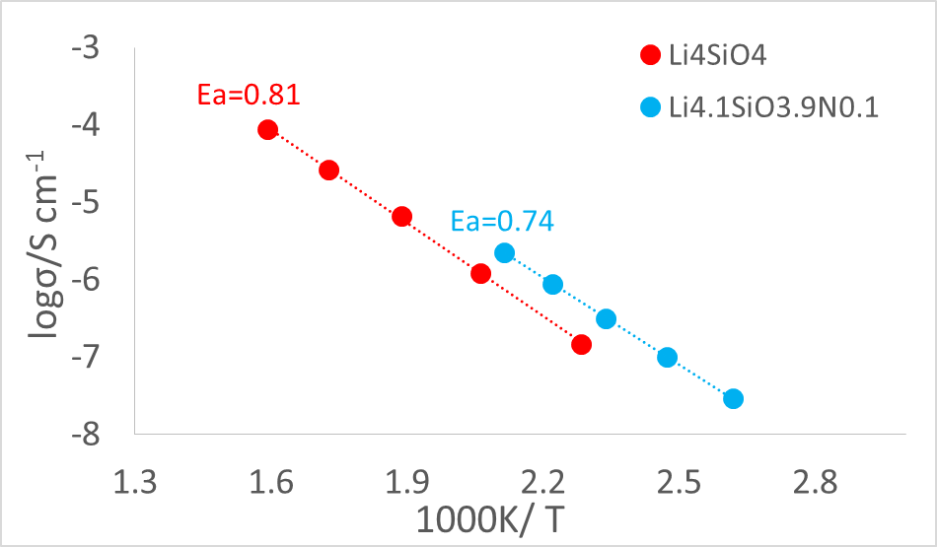
Figure 1.7 Arrhenius plot of Li₄SiO₄ and Li_{4.1}SiO_{3.9}N_{0.1} in N₂.

1.3 Conclusions
LiOH·H₂O was found to effectively lower the reaction temperature, and Li₄SiO₄ can be synthesised at 450 ºC using LiOH·H₂O which is 300 ºC lower than the reaction with Li₂CO₃. Three different routes were tried to synthesise N-doped Li₄SiO₄ with formula, Li_{4+x}SiO_{4-x}N_{x}, using either Li₃N or Si₃N₄ as nitrogen sources. A limited solid solution was formed to x = ~ 0.1 when using Li₂CO₃, SiO₂ and Li₃N as reagents, and impedance measurements show enhanced conductivity of N-doped Li₄SiO₄ compared to that of N-free Li₄SiO₄. Z* plots showed a low frequency spike with corresponding capacitances ~ 1·10⁻⁵ Fcm⁻¹ (200 ºC) which is response of the sample - electrode interface, and therefore Li⁺ ion conduction.

1.4 References
1. Podsiadlo, S. Formation and thermal decomposition of silicon oxynitride compounds I, Journal of Thermal Analysis, 1987: 32, 43 – 47.
2. Podsiadlo, S. Formation and thermal decomposition of silicon oxynitride compounds II, Journal of Thermal Analysis, 1987: 32, 445-449.
3. Bialoglowski, M., Jastrzebski, D., Wrzecionek, M., Brzuska, D., Matyszczak, G, Podsiadlo, S., Crystal Research & Technology, 2015: 50 (9-10), 769-772.
4. Masquelier, C., Tabuchi, M., Takeuchi, T., Soizumu, W., Nakamura, O., Solid State Ionics, 1995: 79, 98-105.

Part 2 Conductivity in spinel Li₄Ti₅O₁₂ under a small dc bias

1.1 Introduction and experimental
Li₄Ti₅O₁₂ is a commercialised anode material for LIBs, but it is a poor electronic and ionic conductor; doping and surface modification are generally used to improve its conductivity and electrochemical performance. It is reported that TiO₂ was transformed from an insulator to a good electronic conductor after quenching from high temperatures [1] and electronic conduction of yttria-stabilized zirconia was introduced under a small dc bias [2]. Inspired by these interesting findings, in this section, (i) the effect of quenching on the conductivity Li₄Ti₅O₁₂ and (ii) the conductivity of quenched Li₄Ti₅O₁₂ under different Po₂ pressure or with a small dc bias were studied.

Rutile TiO₂ and Li₂CO₃ were dried at 900 ºC and 180 ºC for 12 h respectively to drive off water. Stoichiometric amounts of TiO₂ and Li₂CO₃ were weighed, mixed with a mortar and pestle with acetone for 30 min and pressed into 10 mm pellets. The mixture was heated at 650 ºC for 10 h to decompose CO₂ and reheated to 800 to 900 ºC to complete reaction with intermediate grinding. After heating at 650 ºC, some powders from the reaction mixture were covered over the pellet as a sacrificer to prevent Li lose at high temperatures. The final product, Li₄Ti₅O₁₂, was pressed into pellets and heated at 900 ºC for 4 h before printing with gold paste electrodes and heating at 850 ºC for 2 h. These pellets were packed into a small Pt envelope, placed in a vertical tube quench furnace and held at 900 or 1000 ºC for 30 min before quenching. Higher temperatures were not applied as a phase transition occurs at ~ 1015 ºC from spinel single phase to Li₂TiO₃ and Li₂Ti₃O₇ phase mixture.

For phase analysis, a Bruker D2 X-ray diffractometer with Cu Kα radiation (λavg = 1.5418 Å) was used. Patterns were recorded with a scan rate of 0.02° in the range from 15° to 80°. Impedance data were recorded using a Solartron with a 100 mV of ac and sweep frequency from 10⁻² to 10⁶ Hz or an Agilent with 100 mV of ac and sweep frequency from 1 to 10⁶ Hz with/without small dc bias.

1.2 Results and discussion

1.2.1 Temperature-dependent measurement
Impedance spectroscopy results of quenched Li₄Ti₅O₁₂ at different temperatures in air are shown in figure 2.1. Z* plots consist of a high frequency arc, an intermediate frequency arc and a low frequency spike. In the corresponding C’ spectroscopic plots, a high frequency plateau, capacitance ~ 3·10⁻¹² Fcm⁻¹ which is associated with the bulk response of the sample, an intermediate plateau, capacitance ~ 5·10⁻¹¹ Fcm⁻¹ which might represent the surface layer of the sample and a dispersion at lower frequencies with a capacitance of ~ 1·10⁻⁶ Fcm⁻¹ which is attributed to the blockage of the ionic species at the sample-electrode interface. The Impedance spectroscopy results of slow-cooled Li₄Ti₅O₁₂ are similar to those of quenched Li₄Ti₅O₁₂, but with a worse homogeneity.

Figure 2.2 shows the Arrhenius plot of Li₄Ti₅O₁₂ quenched from 900 ºC, 1000 ºC and slow-cooled from 900 ºC. Total conductivity of quenched Li₄Ti₅O₁₂ was 3-4 orders higher than that of slow-cooled Li₄Ti₅O₁₂ at room temperature. The activation energy of quenched samples, 0.38-0.40 eV is half of that of the slow-cooled sample, 0.84 eV, which might be attributed to oxygen lose at high temperature and the formation mixed Ti³⁺/Ti⁴⁺ of quenched samples.

Figure 2.1 Impedance data for Li₄Ti₅O₁₂ quenched from 900 ºC. (a) Impedance complex plane plots. Spectroscopic plots of Y’ (b), C’ (c), –Z’’ and M’’ (d).

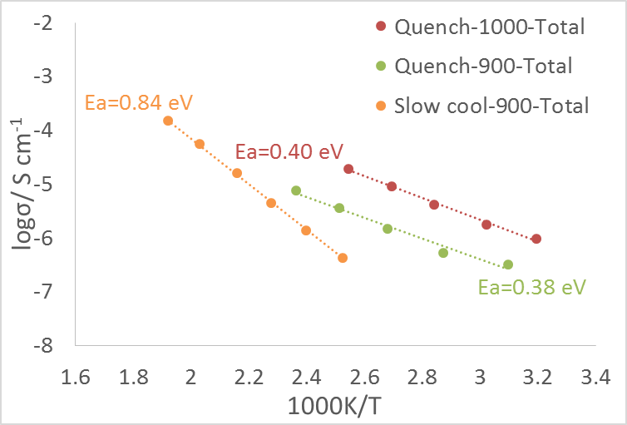
Figure 2.2 Arrhenius plot of quenched and slow-cooled Li₄Ti₅O₁₂.

1.2.2 P_{O2} measurement
The impedance measurements of Li₄Ti₅O₁₂ quenched from 900 ºC were carried out after stabilised in air, O₂, N₂ and air after 30 min at 300 ºC. From the Z* complex plane plot, the resistance of Li₄Ti₅O₁₂ decreased in O₂ and increased in N₂ compared with that in air, which indicates that the quenched Li₄Ti₅O₁₂ is a p-type conductor. Electron holes are generated with increasing P_{O2} pressure by the mechanism:
1/2O₂ →O²⁻ + 2h
Figure 2.3 Impedance data for Li₄Ti₅O₁₂ quenched from 900 ºC in air, O₂ and N₂ atmosphere at 300 ºC.

1.2.3 dc-bias measurement
1.2.3.1 Voltage-dependence

Small 1, 2 and 3v dc bias were applied during the impedance measurement of quenched Li₄Ti₅O₁₂ from 900 ºC. As shown in figure 2.4, the spike in Z* complex plane collapsed and the resistivity of Li₄Ti₅O₁₂ decreased with increasing dc bias from 0 to 3 V; the spike recovered and the resistivity of Li₄Ti₅O₁₂ approximately increased to its origin value when the dc bias decreased from 3 to 0 V (Figure 2.5). The quenched Li₄Ti₅O₁₂ is expected to be an n-type conductor, and the reasons that it became a p-type conductor is still unknown.

Figure 2.4 Impedance data for Li₄Ti₅O₁₂ quenched from 900 ºC with 0, 1, 2 and 3 V dc bias at 300 ºC.
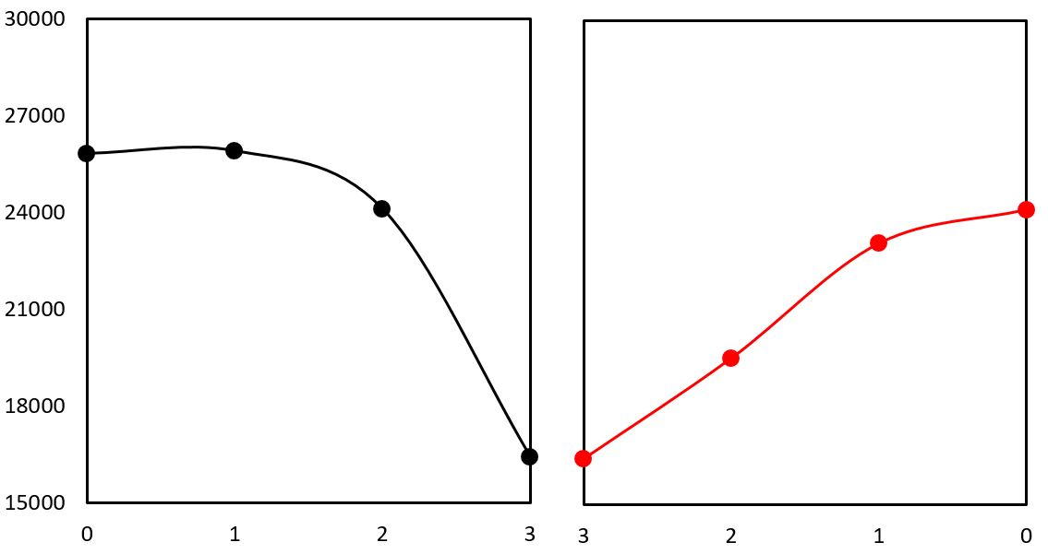
R_{total} / Ω cm
dc bias/ V
Figure 2.5 Total resistance of Li₄Ti₅O₁₂ vs dc bias at 300 ºC.

1.2.3.2 Time-dependent

The time-dependent of the dc bias was studied with Agilent by applying continuous dc bias for different time. Similar to the results from Solartron, the resistivity of Li₄Ti₅O₁₂ quenched from 900 ºC decreased and the spike collapsed with increasing dc bias from 0 to 2 V at 400 ºC. Figure 2.7 shows the resistance as a function of time on application and after removal of 1 and 2 v dc bias. The resistivity of Li₄Ti₅O₁₂ was fully recovered on application/ removal of 1 V dc bias after 16 min; however, the resistivity of Li₄Ti₅O₁₂ only partially recovered after the removal of 2 V dc bias for an hour, which may indicate that recovery is a long and slow process and it needs more time.

Figure 2.6 Impedance data for Li₄Ti₅O₁₂ quenched from 900 ºC on application of 0, 1 and 2 v dc bias at 400 ºC.

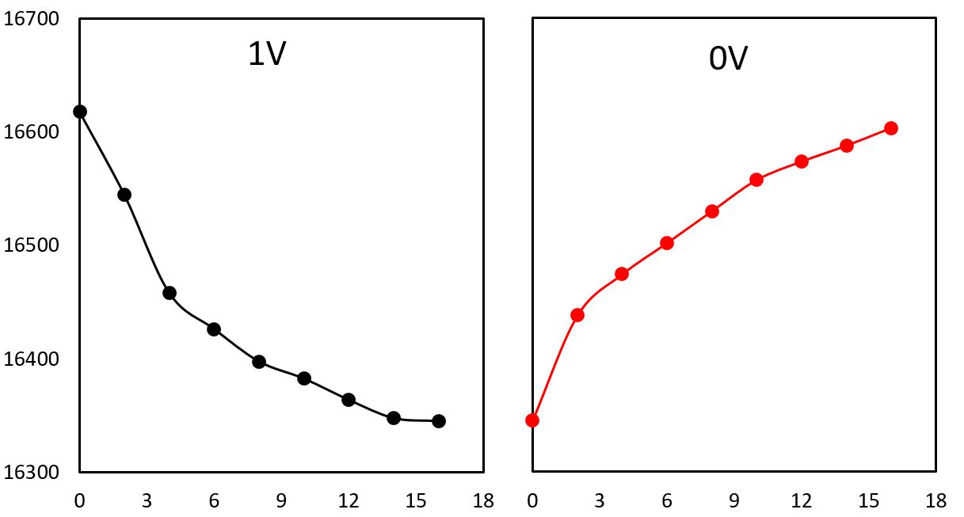
R_{total} / Ω cm
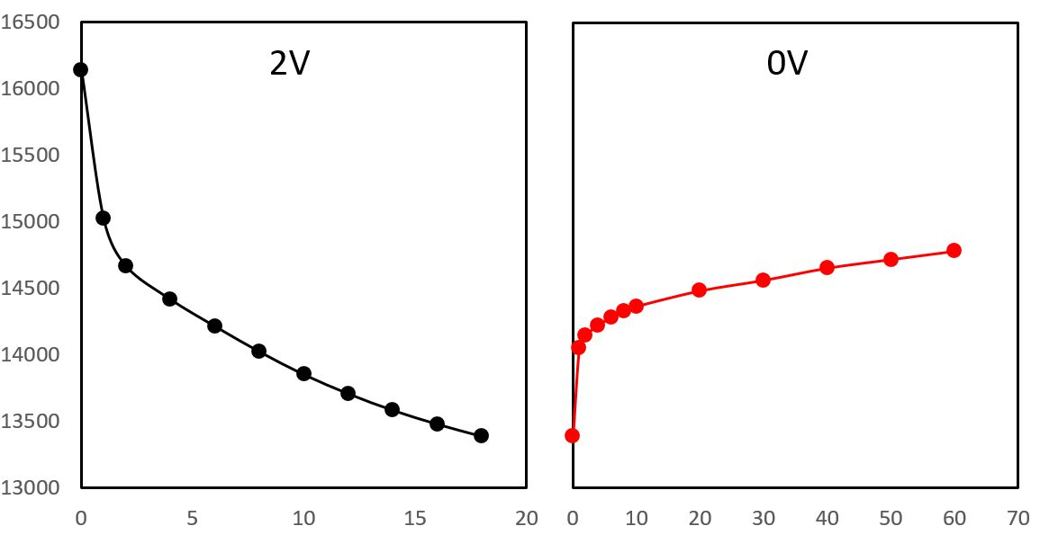
Time / min
Figure 2.7 Resistance vs time on application and after removal of 1 and 2 v dc bias at 400 ºC.

1.3 Conclusions
Impedance measurement with different P_{O2} pressure indicates the quenched Li₄Ti₅O₁₂ is a p-type conductor, which is consistent with the results of applying small dc bias. When applying a small dc bias (1-3 V), the resistivity of Li₄Ti₅O₁₂ decreased and the spike collapsed, and the process was partially reversible. The reasons for the p-type conduction of quenched Li₄Ti₅O₁₂ is still unknown, more work needs to be done.

1.4 References
1. Yang, L., West, A.R., Semiconductor-insulator transition in undoped rutile, TiO₂ ceramics, Journal of the American Ceramic Society, 2013: 96(1), 218-222.
2. Maso, N., West, A.R., Electronic conductivity in Yttria-Stabilized Zirconia under a Small dc Bias, Chemistry of Materials, 2015: 27, 1552-1558.

Part 3 Indexing Schemes
According to Bragg’s Law
2dsinθ = nλ (A3.1)
where: d = d-spacing,
n = order of reflection,
θ = Bragg angle,
λ = wavelength of incident beam.

According to interplanar spacing formula of a cubic system
1/d² = (h²+k²+l²)/a² (A3.2)
where d = d-spacing,
a = lattice parameter
h, h, l = Miller indices

Combined equation A3.1 and A3.2,
sin²θ/(h²+k²+l²)=n²λ²/4a² (A3.3)

Since λ and a are constant and Miller indices are integer numbers (h²+k²+l² must be an integer number as well), the ratio of sin²θ/(h²+k²+l²) values can be used to determine the correct Miller indices for reflections.

For example, for a face centered cubic, h, k and l are all odd and all even.
No | sin²θ | hkl | h²+k²+l² | sin²θ/( h²+k²+l²)
1 | 0.140 | 111 | 3 | ~0.0467
2 | 0.185 | 200 | 4 | ~0.0467
3 | 0.369 | 220 | 8 | ~0.0467
4 | 0.503 | 311 | 11 | ~0.0467
5 | 0.548 | 222 | 12 | ~0.0467

Part 4 IS data of Phase J quenched from 700 ºC in Chapter 4.
(a)
(b)
(c)
(d)
Figure 4.18 Phase J quenched from 700 ºC: Impedance complex plane plots Z* at 71 ºC to 137 ºC in Air.

(a)
(b)
(c)
Figure 4.19 Phase J quenched from 700 ºC: spectroscopic plots of C’ (a), Y’ (b), –Z’’ and M’’ (c).

Part 5 The XRD patterns and Arrhenius plots in Chapter 5.
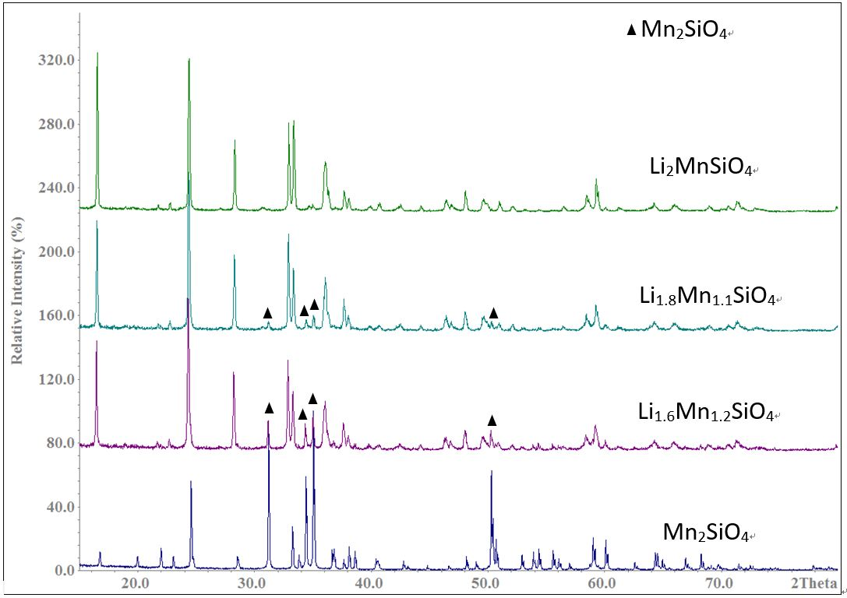
Figure 1a XRD patterns of Li_{2+2x}Mn_{1-x}SiO₄: x = 0, -0.1 and -0.2.

The XRD patterns of Li_{1.6}Mn_{1.2}SiO₄ and Li_{1.8}Mn_{1.1}SiO₄ slow cooled from 800 ºC showed a mixture of β Li₂MnSiO₄ and Mn₂SiO₄.

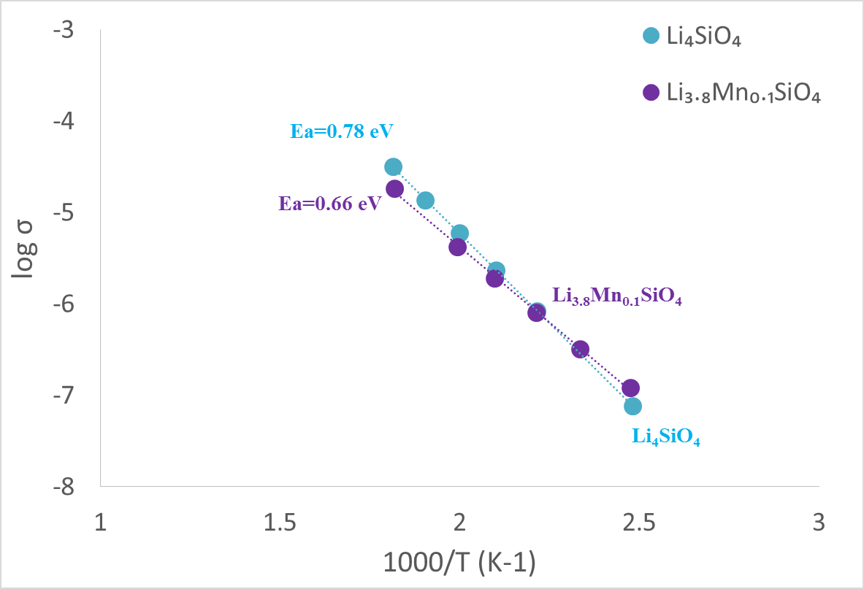
Figure 1b Arrhenius plot of Li₄SiO₄ and Li_{3.8}Mn_{0.1}SiO₄ slow cooled from 800 ºC.

The activation energies change slightly between Li₄SiO₄ (0.78 eV) and Li_{3.8}Mn_{0.1}SiO₄ (0.66 eV) with similar conductivities.

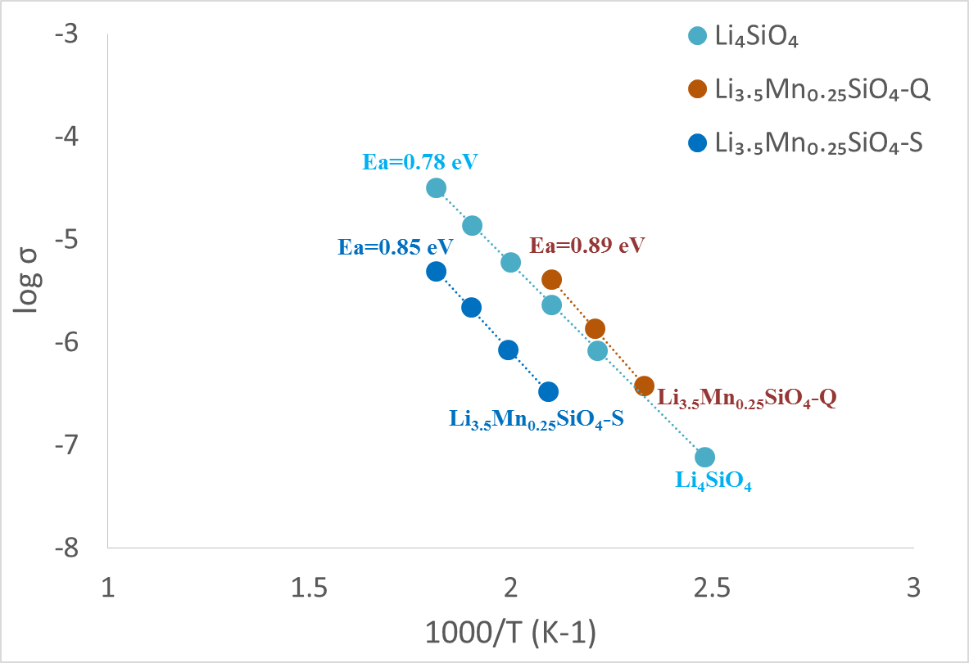
Figure 1c Arrhenius plot of Li₄SiO₄ and Li_{3.5}Mn_{0.25}SiO₄ quenched from 1000 ºC in N₂ and slow cooled from 800 ºC.

The activation energies increase from 0.78 eV (Li₄SiO₄) to 0.89 eV (slow cooled Li_{3.5}Mn_{0.25}SiO₄) with similar conductivities. The conductivity of quenched sample (quenched Li_{3.5}Mn_{0.25}SiO₄) decreased ~ one order compared with the slow cooled one.

