

Ecological Implications of Using Rivers to
Generate Low-Head Micro-Hydropower

By:

Catherine Anna Leonard
BSc.(Hons.) (Aberystwyth)

Thesis submitted for the degree of
Master of Philosophy

The University of Sheffield
Faculty of Science
Department of Animal and Plant Sciences

August 2017
Ecological Implications of Using Rivers to
Generate Low-Head Micro-Hydropower

Catherine Leonard

Run-of-river micro-hydropower schemes are an increasingly attractive option for future local-scale renewable energy generation, particularly as concerns about climate change increase. The possible large-scale adoption of micro-hydropower raises the question of whether such installations can have significant ecological effects on the rivers and streams into which they are installed. This study uses a case study approach, recognising the wide variety of situations and types of micro-hydropower installations, to assess if, and to what extent, ecological impacts arise from the use of low-head micro-hydropower schemes in rivers. The focus of the investigation is on the key feature common to most run-of-river micro-hydropower installations: the creation of a depleted flow reach between the abstraction point and return of water used for generation from the river channel.

Data were collected from a paired depleted reach and upstream reference reach at five different study sites. I investigated whether any changes in habitat conditions were detected as a result of a low-head micro-hydropower scheme. Decreased velocity in the depleted reach was an effect consistently evident at all sites. Reduced heterogeneity of substrate and flow habitats and a dominance of slow-flow types were also consistent patterns in the depleted reach. The responses of other parameters were more varied and site-specific.

The second part of the study addressed whether changes in the benthic macroinvertebrate community were evident and the extent to which these might be a result of the habitat changes recorded. Changes in community structure were evident in analyses of community composition, but generally site-specific and not as significant as changes recorded in habitat variables. Mean LIFE score decreased in the depleted reach at all sites, indicating a link between habitat change and flow preferences of the impacted invertebrate communities.

The results indicate that low-head micro-hydropower schemes have the potential to significantly alter habitat conditions in the depleted reach. However, these impacts may not always directly translate to a significant ecological impact on the benthic macroinvertebrate community. It is also clear that the nature and magnitude of impact is affected by the site specific features of the hydropower installation. Further research is required to determine whether more subtle changes are evident at species level, whether there is evidence of impact on ecological function or evidence of implications over the longer term.

ACKNOWLEDGEMENTS
This research was funded by NERC and CASE sponsorship from the Environment Agency.
Many people have supported me over the years producing this MPhil. Firstly I would like to say thank you to Professors Phil Warren and Lorraine Maltby for your guidance, advice and patience with the various different, extended, stages of my studies.
Thank you to all the various people who have helped with data collection and fieldwork, particularly Dan, Chih-Wei & Gustavo. I definitely could not have done it without you. Thank you for your hard work and cheery company, despite me dragging you out in the early hours of the morning to spend long days in cold rivers in random parts of the country. A special thank you to Marian for your kindness and friendship in the E-floor lab, where many hours were spent organising field kit, sorting through invertebrate samples and not to forget sewing with Bernina(!).
It has been nearly six and a half years since I began this process. My parents and close friends have been through the ups and downs of it with me. Their support has been unwavering throughout and I am sincerely grateful. I will never forget finding Dad at the sewing machine on Christmas Day with a glass of ginger wine, sitting between a pile of half-completed mesh leaf-litter bags and a bin bag full of dried alder leaves... sorry they didn’t make it into the thesis. Thank you Maya for your invaluable friendship, reminding me of the positive things in life and keeping me going. Most of all, thank you to Mum for your understanding and for supporting me no matter what the outcome while I’ve been contending with job relocations (twice), house purchases (twice), house renovations (one and a half) and crises of confidence (many) during the course of this research.



© Cathy Wilcox

CONTENTS

ABSTRACT I
ACKNOWLEDGEMENTS II
CONTENTS IV
LIST OF FIGURES VII
LIST OF TABLES VIII
GLOSSARY OF ABBREVIATIONS IX

CHAPTER 1: INTRODUCTION 1
1.1 The issue – micro-hydropower 1
1.1.1 Use of micro-hydropower in the UK 3
1.1.2 Micro-hydropower potential in the UK 4
1.2 Components of micro-hydropower schemes & how rivers are used 6
1.2.1 Water abstraction 7
1.2.2 Power generation - turbines 8
1.2.2.1 High rotational speed 8
1.2.2.2 Low rotational-speed 10
1.2.3 Nature of installation 12
1.3 Current regulation and ecological considerations associated with micro-hydropower planning & operation 13
1.4 Existing evidence & identification of potential sources of ecological change through the use of low-head micro-hydropower 14
1.4.1 Direct research on ecological effects of low-head micro-hydropower schemes 15
1.4.2 Flow alteration 21
1.4.2.1 Water abstraction 21
1.4.2.2 Water impoundment 26
1.4.3 Turbine function & water discharge 29
1.5 Summary 30
1.6 Thesis aims & objectives 31

CHAPTER 2: STUDY SITES 32
2.1 Study site selection 32
2.1.1 Criteria 32
2.1.2 Site contexts & implications 34
2.1.3 Study approach 36
2.2 Site profiles 37
2.2.1 Bonfield Ghyll 37
2.2.2 Lowna Mill 44
2.2.3 New Mills 51
2.2.4 Settle 58
2.2.5 Alport Mill 65
2.3 Sites summary 73

CHAPTER 3: THE EFFECT OF LOW-HEAD MICRO-HYDROPOWER ON IN-STREAM HABITAT 74
3.1 Introduction 74
3.1.1 The potential for micro-hydropower to affect in-stream habitat 74
3.1.2 Aims and objectives 75
3.2 Methods 76
3.2.1 Sampling strategy 76
3.2.2 Data analyses 77
3.3 Results 78
3.3.1 Water quality variables 78
3.3.2 Habitat variables 80
3.3.3 Within-site variation 87
3.3.4 Across-site variation 97
3.4 Discussion 100
3.4.1 The effect of micro-hydropower on water quality variables 100
3.4.2 The effect of micro-hydropower on habitat variables 101
3.4.3 Across-site patterns 105
3.4.4 Potential for ecological effects 107
3.5 Conclusion 108

CHAPTER 4: THE EFFECT OF LOW-HEAD MICRO-HYDROPOWER ON MACROINVERTEBRATE COMMUNITY STRUCTURE 109
4.1 Introduction 109
4.1.1 Role & importance of freshwater macroinvertebrate communities in river ecosystems 109
4.1.2 Community structure as an indicator of river ecosystem condition 110
4.1.3 Evidence of link between in-stream conditions & invertebrate community 110
4.1.4 Aims & objectives 113
4.2 Methods 113
4.2.1 Sampling strategy 113
4.2.2 Data analyses 114
4.3 Results 116
4.3.1 Community metrics 116
4.3.2 Individual taxa 118
4.3.3 Community structure – within-sites 124
4.3.4 Overall community structure – across-sites 134
4.3.5 Correspondence of habitat & invertebrate patterns 136
4.3.6 Trait-based analysis 143
4.4 Discussion 144
4.4.1 Additional influences on community structure 145
4.5 Conclusion 148

CHAPTER 5: DISCUSSION 150
5.1 Introduction 150
5.2 Site-level comparisons 150
5.2.1 Bonfield Ghyll 150
5.2.2 Lowna Mill 151
5.2.3 New Mills 152
5.2.4 Settle 153
5.2.5 Alport 154
5.3 Assessment of results & further work 156
5.4 Summary of thesis conclusions 161

APPENDIX X
REFERENCES XVIII

FIGURES

Figure 1.1 Potential opportunities for small hydropower in England & Wales 5
Figure 1.2 Generic micro-hydropower scheme plan 7
Figure 1.3 Discharge & head ranges for a number of impulse and reaction turbines 9
Figure 1.4 Reverse Archimedean Screw at New Mills, Derbyshire, UK 11
Figure 1.5 Example of a Tyson in-stream turbine 12
Figure 1.6 Summary of the effects of decreased stream flow on habitat conditions & invertebrate community abundance, diversity & composition 22
Figure 2.1 Location of the five study sites 34
Figure 2.2 Location of the two sample reaches at a generic micro-hydropower site 36
Figure 2.3 Site map of Bonfield Ghyll 39
Figure 2.4 Aerial photo of Bonfield Ghyll 40
Figure 2.5 Bonfield Ghyll - a) reference & b) depleted reach sample point locations 41
Figure 2.6 Bonfield Ghyll - hydromorphology in the reference reach 42
Figure 2.7 Bonfield Ghyll - ‘weir’ & associated impoundment 42
Figure 2.8 Bonfield Ghyll - hydromorphology in the reference reach 43
Figure 2.9 Bonfield Ghyll - depleted reach and turbine 43
Figure 2.10 Site map of Lowna Mill 46
Figure 2.11 Lowna Mill - a) reference & b) depleted reach sample point locations 47
Figure 2.12 Lowna Mill - hydromorphology in the reference reach 48
Figure 2.13 Lowna Mill - weir & associated impoundment 48
Figure 2.14 Lowna Mill - sluice gate 49
Figure 2.15 Lowna Mill - hydromorphology in the depleted reach 49
Figure 2.16 Lowna Mill - hydromorphology in the depleted reach 50
Figure 2.17 Site map of New Mills 53
Figure 2.18 New Mills - a) reference & b) depleted reach sample point locations 54
Figure 2.19 New Mills - site overview on day of sampling 55
Figure 2.20 New Mills - site overview during higher flow conditions 55
Figure 2.21 New Mills - hydromorphology in the reference reach 56
Figure 2.22 New Mills - depleted reach on day of sampling 56
Figure 2.23 New Mills - depleted reach during higher flow conditions 57
Figure 2.24 Site map of Settle 60
Figure 2.25 Settle - a) reference & b) depleted reach sample point locations 61
Figure 2.26 Settle - hydromorphology in the reference reach 62
Figure 2.27 Settle - hydromorphology in the reference reach 62
Figure 2.28 Settle - impoundment reach 63
Figure 2.29 Settle - hydromorphology in the depleted reach on day of sampling 63
Figure 2.30 Settle - hydromorphology in the depleted reach during higher flow conditions 64
Figure 2.31 Site map of Alport Mill 67
Figure 2.32 Alport Mill - a) reference & b) depleted reach sample point locations 68
Figure 2.33 Alport Mill - hydromorphology in the reference reach 69
Figure 2.34 Alport Mill - hydromorphology in the reference reach 69
Figure 2.35 Alport Mill - impoundment reach 70
Figure 2.36 Alport Mill - impoundment reach 70
Figure 2.37 Alport Mill - hydromorphology in the depleted reach 71
Figure 2.38 Alport Mill - hydromorphology in the depleted reach 71
Figure 2.39 Alport Mill - impoundment reach during higher flow conditions 72
Figure 3.1 Mean values of (a) velocity, (b) depth & (c) wetted width in reference & depleted reaches 81
Figure 3.2 Mean substrate composition at reference & depleted reaches 83
Figure 3.3 Mean flow habitat composition at reference & depleted reaches 86
Figure 3.4 PCA analysis of Bonfield Ghyll habitat data 88
Figure 3.5 PCA analysis of Lowna Mill habitat data 90
Figure 3.6 PCA analysis of New Mills habitat data 92
Figure 3.7 PCA analysis of Settle habitat data 94
Figure 3.8 PCA analysis of Alport Mill habitat data 96
Figure 3.9 PCA analysis of five study sites using mean habitat variable data from reference & depleted reaches 99
Figure 4.1 Difference in log₁₀(x+1) mean proportional abundance at reference & depleted reach at Bonfield Ghyll 119
Figure 4.2 Difference in log₁₀(x+1) mean proportional abundance at reference & depleted reach at Lowna Mill 120
Figure 4.3 Difference in log₁₀(x+1) mean proportional abundance at reference & depleted reach at New Mills 121
Figure 4.4 Difference in log₁₀(x+1) mean proportional abundance at reference & depleted reach at Settle 122
Figure 4.5 Difference in log₁₀(x+1) mean proportional abundance at reference & depleted reach at Alport Mill 123
Figure 4.6 PCA analysis of Bonfield Ghyll invertebrate data 125
Figure 4.7 PCA analysis of Lowna Mill invertebrate data 127
Figure 4.8 PCA analysis of New Mills invertebrate data 129
Figure 4.9 PCA analysis of Settle invertebrate data 131
Figure 4.10 PCA analysis of Alport Mill invertebrate data 133
Figure 4.11 PCA analysis of five study sites invertebrate data 135
Figure 4.12 Invertebrate community LIFE scores at reference & depleted reaches 143

TABLES

Table 1.1 Head categories for micro-hydropower schemes 1
Table 1.2 Impulse & Reaction turbine head classifications 9
Table 1.3 Water wheel design & site suitability 10
Table 2.1 Similarities & differences between study sites 34
Table 3.1 Mean (±SD) values of water quality variables at reference & depleted reaches 79
Table 3.2 Mean phi size at reference & depleted reaches 84
Table 3.3 Shannon Diversity & Evenness of substrate composition at reference & depleted reaches 84
Table 3.4 Shannon Diversity & Evenness of flow habitat at reference & depleted reaches 85
Table 3.5 Main differences in habitat variables between reference & depleted reaches 106
Table 4.1 Community structure variables (±SD) at reference & depleted reaches 117
Table 4.2 Total macroinvertebrate abundance at reference & depleted reaches at fice study sites 118

GLOSSARY OF ABBREVIATIONS
BACI – Before-After-Control-Impact
CPOM – Coarse Particulate Organic Matter
DO – Dissolved Oxygen
EA – Environment Agency
EU – European Union
FFG – Functional Feeding Group
FPOM – Fine Particulate Organic Matter
HOF – Hands-off Flow
LIFE – Lotic-invertebrate Index for Flow Evaluation
NIEA – Northern Ireland Environment Agency
NRW – Natural Resources Wales
PSI – Proportion of Sediment-sensitive Invertebrates
RICT – River Invertebrate Classification Tool
SAC – Special Area of Conservation
SEPA – Scottish Environment Protection Agency
SHP – Small Hydropower Plant
SSSI – Site of Special Scientific Interest
WFD – Water Framework Directive

Chapter 1 – Introduction
1.1 The Issue – Micro-Hydropower
Evidence of the use of rivers to provide power generation comes from as early as 85BC, with the early Greek poet Antipater making reference to the use of waterwheels to grind corn (Kealey, 1987). However it was not until 1882 that waterwheels were first used to generate electricity. Hydropower is now considered as the most important renewable energy resource and is currently thought to contribute 86% of global renewable energy production (IEA, 2001; WEC 2010), with predictions that worldwide hydropower production will nearly double between 2004 and 2030 (IEA, 2001). Considered to be the most efficient, reliable and cost-effective source of electricity (IEA, 2010), hydropower is becoming an increasingly attractive option for future energy generation, particularly as concerns about climate change increase.
“Low-head micro-hydropower” in particular has seen a resurgence of interest in recent years (EA, 2009). While there is currently no general consensus on the definition of different sizes of hydropower, micro-hydropower generally falls within one of the three categories covered by the term “small-scale” – mini (<1 MW), micro (<100 kW) and pico (<5 kW) (Moriere & Poole, 1993; Dragu et al., 2001; Ansel & Robyns, 2006). An 80 kW scheme can produce around 310,000 kWh per year (Sheffield Renewables, 2012), which in turn could be enough to power around 80 houses over the course of a year (based on data for an average UK household in 2014 – WEC, 2015). Micro-hydropower is further categorised according to “head” – head being the height difference between the water intake down to the lowest point of the turbine (i.e. the outflow). Typical head categories are shown in Table 1.1.

Table 1.1: Head categories for microhydro schemes (Paish, 2002a and Bacon & Davison, 2004)
Micro-hydropower head category |  | Height
 | High | >50m
 | Medium | 10 - 50m
 | Low | <10m
 | Ultra-Low | <3m

Low-head micro-hydropower schemes are primarily “run-of-river” – meaning relatively little water storage is required and the scheme operates according to the natural flow available in the river (Baxter, 1977; Shaw, 2004). This is in contrast with large-scale hydropower with large storage reservoirs and resultant hydro-peaking regimes (large variations in water levels caused by sudden drainage of stored water); the environmental and social implications of which have been the subject of much discussion in recent years.
The main social issues arising from large scale hydroelectric power production are population displacement, introduction of waterborne diseases and loss of downstream water resources for human use (Adams, 2000; Sims, 2001). Three fundamental biological effects of hydroelectric dams are the alteration of natural downstream flow and sediment fluctuations, the alteration of water temperatures, and fragmentation of both organism and nutrient connectivity caused by the physical barrier of a dam (Poff & Hart, 2002). Impoundment of water behind a dam changes the upstream habitat from lotic (actively moving water) to lentic (slow moving water) habitats, altering species composition (Bednarek, 2001). Regulated discharge (reduction, stabilisation and changed seasonality of peak flows) and decreased velocity downstream of large hydroelectric facilities reduces fish spawning frequency and population densities as a result of decreased availability and quality of living and spawning habitat (Baran et al., 1995; Ligon et al., 1995; Zhong & Power, 1997; Gao et al., 2009; García et al., 2011). Decreased flow volume from dams homogenises habitats and changes sediment loads, which are important habitat features affecting the distribution and abundance of periphyton, macrophytes, macro-invertebrates and fish (Kondolf, 1997; Rempel et al., 2000; Madsen et al., 2001; Growns & Growns, 2001a; Flinders & Hart, 2009). Release of cold hypolimnetic water downstream as a result of thermal stratification in impounded areas can affect critical life-cycle phases for organisms downstream (e.g. thermal spawning or migration cues for fish - Bednarek, 2001; Preece & Jones, 2002), resulting in removal of species adapted to the natural downstream water temperature.
Other associated environmental effects of large dams include augmented greenhouse gas emissions from decomposing organic material in large reservoirs (St. Louis et al., 2000). Longitudinal connectivity, critical to the function of river ecosystem catchments (Ward, 1989), is disrupted by hydroelectric facilities, despite attempted mitigation measures in the form of fish passes (Kottelat & Whitton, 1996). Both diadromous and potadromous species are affected by the barrier effects of dams, isolating populations and altering community compositions (Larinier, 2000; Bednarek, 2001).
The perceived reduction of environmental impacts in contrast to larger hydropower schemes has led to micro-hydropower being considered one of most “clean” and environmentally-friendly forms of energy generation (Zolotov et al., 1991; Rosenberg et al., 1995; Egré & Milewski, 2002; Bhattacharjee, 2005; Anagnostopoulos & Papantonis, 2007; Hatch Energy, 2008; Kosnik, 2008; Khan et al., 2009; Williams & Simpson, 2009; Renöfält et al., 2010), and has even been described as “environmentally benign” (Paish, 2002a; Langley & Curtis, 2004). This widespread perception has encouraged recent development of micro-hydropower schemes. However, somewhat surprisingly, no widespread empirical evidence exists to confirm whether or not these general assumptions are valid (Copeman, 1997; Shaw, 2003; Khan, 2008, EA, 2009, Abbasi & Abbasi, 2011; Robson et al., 2011, Anderson et al., 2015).

1.1.1 Use of micro-hydropower in the UK
There are various reasons for the significant rise in low-head micro-hydropower applications seen by the Environment Agency (EA), Natural Resources Wales (NRW) and the Scottish Environment Protection Agency (SEPA) in the UK. Firstly, the EU Renewable Energy Directive commits the UK to producing at least 15% of total energy consumption from renewable resources by 2020. To encourage investment in small-scale renewable energy projects such as micro-hydropower and help achieve these targets, the UK Government introduced a number of financial incentives for developers in April 2010. These Feed-In-Tariffs (FITs) provide high payment rates for units of renewable electricity generated and also for any surplus exported to the National Grid, guaranteed for up to 20 years. This financial support, combined with rising costs of fossil fuels and continual improvements in turbine efficiency and design allow modern micro-hydro schemes to produce economically-viable amounts of energy from relatively low heads and water flow rates, with long infrastructure lifespan and little maintenance (Dragu et al., 2001; Chiras, 2006; BERR 2008a). This relative cost-effectiveness of micro-hydropower development greatly increases the potential site availability, as suitable low-head sites are currently largely unexploited (Paish, 2002a; BERR, 2008b; Hatch Energy, 2008).
Secondly, existing structures from historic mill systems such as leats (open channels directing water from the river to the mill), wheel pits and weirs present opportunities to reinstate old systems with new technology, further reducing the economic cost by taking advantage of existing historical infrastructure (Müller & Kauppert, 2002) and prompting a revival of interest in the historic value of old mills. For this reason old mill sites present the majority of micro-hydropower opportunities in the UK (Environment Agency, 2009a). Micro-hydropower also presents the opportunity for individual home-owners and local communities to become energy self-sufficient (Chiras, 2006). This may be particularly important in less developed countries, where power generation in dispersed populations could stimulate the local and national economy (Fritz, 1984; Chandy et al., 2012).

1.1.2 Micro-hydropower potential in the UK
To assess the potential for micro-hydropower schemes in England and Wales, a report was produced by the EA in 2010 which provides a national overview of small-scale hydropower opportunities (EA, 2010). It also highlights key environmental sensitivities that would “need to be addressed to unlock this potential” for small-scale hydropower sites.
A total of 25,935 barriers were identified as potential candidates for development (including natural and artificial barriers such as waterfalls and weirs). Using a combination of estimated height and flow data, the potential total power capacity from these sites was an estimated 1178 MW, with an average power potential of 45 kW per site. The study then coarsely evaluated “environmental sensitivities” by identifying barriers located in Special Areas of Conservation (SACs). Fish data were also used to classify rivers in terms of probability of species presence and their migratory requirements. Barriers were classified with high, medium or low sensitivity to these environmental criteria.
After environmental considerations were taken into account, the number of barriers with low environmental sensitivity but with high kW (100 kW<10 MW) output (“win-win” situations) was reduced to 4,000. This represents nearly 50% of the total power potential, leaving an estimated potential for 580 MW to be generated by small-scale hydropower in England and Wales. Regions with the greatest potential for these “win-win” schemes are highlighted in Figure 1.1. The greatest potential distribution of medium-output (50 <100 kW) hydropower with low environmental sensitivity is concentrated in the North-West of England (the Yorkshire Dales, Pennines and Lancashire) with additional opportunities in Central England. The greatest concentration of low output (<50 kW), low-sensitivity schemes are also located in similar areas, with additional opportunities identified in Shropshire , Western Kent and the London Thames area. Overall, Figure 1.1 demonstrates that the distribution of potential opportunities for micro-hydropower schemes in England and Wales is regionally variable.
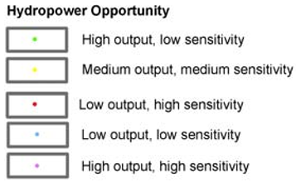

Figure 1.1: Potential opportunities for small hydropower in England & Wales (Environment Agency, 2010). “Win-win” micro-hydropower (<100 kW) potential is represented by the low (<50 kW) and medium (50<100 kW) output indicators (circled in red)

In summary, micro-hydro is widely regarded as a clean, renewable technology that, in design and placement, avoids many of the social and environmental problems of large-scale hydropower. Micro-hydropower has been highlighted as a key contributor to future energy supply (DTI, 2006). Given these strong incentives for extensive implementation of micro-hydropower, it is vital that the potential environmental impacts - or the often assumed lack of them - are subject to thorough investigation.
1.2 Components of micro-hydropower schemes & how rivers are used
The basic principle of hydropower is to convert the potential or kinetic energy in a body of water to mechanical, and then electrical, energy. The energy produced is proportional to the flow and head available. For a scheme to function, two critical elements of design are needed – methods to deliver water to the turbine (usually by abstraction from a river) and a method to generate mechanical power from it. Whether in large-scale or micro-hydro projects, these elements both have the potential to affect riverine ecology (Section 1.3). Due to the variation of head availability and flow rate at each site, the design of micro-hydropower schemes is highly site-specific (Graham, 1998; Thake, 2000, cited by Phommachanh et al., 2006). This is reflected in the high diversity of micro-hydro components and the combinations in which these are used to create the most economically-viable scheme at a given site. However, Figure 1.2 shows a generic scheme design; the essential components of which are represented in most micro-hydro schemes.

A | Abstraction point  Usually involving limited water storage (i.e. impoundment by weir)
B | Delivery of water to turbine  Can be open channels, culverts or penstocks (closed pipes)
C | Turbine
D | Tailrace  Water directed back to main river channel. Can be open channels, culverts or penstocks
E | Depleted reach  Deprived of natural flow state. Length is variable - dependent on scheme design
D
Depleted flow
E

Natural flow

Natural flow

Weir
A
B
C
Figure 1.2: Generic micro-hydropower scheme plan

1.2.1 Water Abstraction
Micro-hydropower installations involve the non-consumptive abstraction of surface water (water is taken for use and returned to the main channel downstream); with the exception of some in-stream turbines (see Section 1.2.2.2). Water can be abstracted from the main river channel for use in a number of ways. If there is sufficient head and flow volume for the type of turbine desired water can be removed from the open-flowing channel. Alternatively, if the head availability is low or there are large variations in flow, a weir (low-head dam) may be used to increase the height of the water drop and provide a certain amount of water storage to enable regulation of the water supply at the intake (Paish, 2002a). This is a common approach, particularly for existing water mills (Langdon, 2000).

1.2.2 Power Generation - Turbines
Turbines convert the kinetic energy in water to mechanical energy, which in turn is transferred to a generator that provides an electrical output. There are many different designs of water turbines (see Paish, 2002a,b). The mode of turbine function can have different potential ecological effects (see Section 3.3). In order to achieve the greatest mechanical efficiency, the type of turbine selected for installation at a micro-hydropower site is primarily dependent on the head and discharge available (US DoE, 2009). In addition to categorising turbines by head suitability or power capacity, further differences exist in their mode of operation. Turbines can be grouped by their relative rotational speed – high (100 - 1000s rpm [revolutions per minute]) or low (10s rpm).
1.2.2.1 High Rotational Speed
Two primary categories of turbines with high rotational speeds are 1) impulse and 2) reaction.
Impulse Turbines
Impulse turbine runners (wheels) operate in air. Water pressure is transformed to kinetic energy as it is expelled through pistons directed at the blades, hitting the runner in the form of a high-speed water jet. Water remains at atmospheric pressure during and after contact with the runner blades. Impulse turbines are usually suited to sites with high-head and low flow. Three principal types of impulse turbines are the Pelton, Turgo and Cross-Flow (see Table 1.2 and Fig. 1.3 for different applied situations).
Reaction Turbines
The runners of a reaction turbine are submersed in water and the pressure of the oncoming flow of water is used to generate a force on the runner blades. The blades are pitched at specific angles to generate hydrodynamic lift forces to propel the rotor (Paish, 2002a). In contrast to impulse turbines, reaction runners operate under pressure, encased in a turbine housing. Water is discharged from the runner into a “draft tube” which slows the water down & reduces the pressure below the runner. Reaction turbines are applicable to situations with higher flow and low- to medium-head. The propeller (including Kaplan) and Francis turbines are the two main types of reaction turbine (Table 1.2 and Fig. 1.3).
The power capacity and operating ranges of a turbine are determined by each manufacturer’s specifications. Table 1.2 summarises general head ranges applicable to the more common types of high rotation turbine, and the nomograph (Fig. 1.3) demonstrates the range of power outputs given dependent on the head and flow availability at a site.
Table 1.2: Impulse and Reaction turbine head classifications (from Paish, 2002b)
 |  | Head Classification
Turbine type | High (>50 m) | Medium (10-50 m) | Low (<10 m)
Impulse | Pelton | Cross-flow | Cross-flow
 | Turgo | Turgo
 | Multi-jet Pelton | Multi-jet Pelton
Reaction |  | Francis (spiral-case) | Francis (open flume)
 |  |  | Propeller
 |  |  | Kaplan

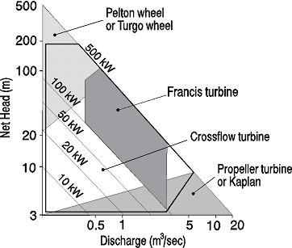
Figure 1.3: Discharge and head ranges for a number of impulse and reaction turbines (from Paish, 2002a)

1.2.2.2 Low Rotational Speed
Wheels
Water wheels have been used since antiquity (Reynolds, 1983). Unlike most other reaction turbines, water wheels operate at normal atmospheric pressure. There are four design principles of water wheels – undershot, overshot and breastshot (Table 1.3). Stream wheels are also available, particularly for low-head fast flow situations, although both past and current designs are relatively mechanically inefficient (Müller et al., 2007, cited by Hathway, 2009).
Table 1.3: Water wheel design & site suitability
Wheel type | Description | Approx. head requirement (m) | Approx. flow requirement
Undershot Wheel | Rotor in centre of wheel. Water underneath, direct contact with panels & wheel spins. Gain no advantage from greater head. May be suitable for floating platforms. | 0.5 - 2.5 | 0.5 - 0.95 m³s⁻¹ per m width
Overshot | Water released over top of wheel, falls in direction of rotation. Additional energy from gravity force. High head requirement. | 2.5 - 10 | 0.1 - 0.2 m³s⁻¹ per m width
Breastshot | Angle of head & top section of waterwheel create an equal plane (water enters at height of wheel axis – Müller & Wolter, 2004). Narrow flow range. | 1.5 - 4 | 0.35 - 0.65 m³s⁻¹ per m width
Stream | Used in low-head situations with fast flowing water. | 0.5 - 3 | 2.5 – 8 m³s⁻¹

Archimedean Screws
The use of inverted Archimedes screws to generate power at low-head sites is a relatively recent development, despite such screws having been used as an uphill water pump for centuries (Müller & Senior, 2009). The pressure of falling water is used to turn the screw blades (Fig. 1.4). Archimedean, or hydraulic, screws are thought of as the most “fish-friendly” micro-hydro turbine, after a number of studies have shown that the low rotational speeds and lack of critical pressure changes allow for relatively successful fish and eel passage downstream (Fishtek Consulting, 2007 & 2009 – see Section 3.1). Their design also allows movement of debris and other small in-stream objects downstream (Müller & Kauppert, 2002). Hydraulic screws are usually installed alongside a weir, water being diverted from the impounded water to the screw, before being returned to the main river channel immediately below the weir. In other cases a longer leat may instead be used (e.g. River Dart Country Park micro-hydro installation - Bard, 2007).
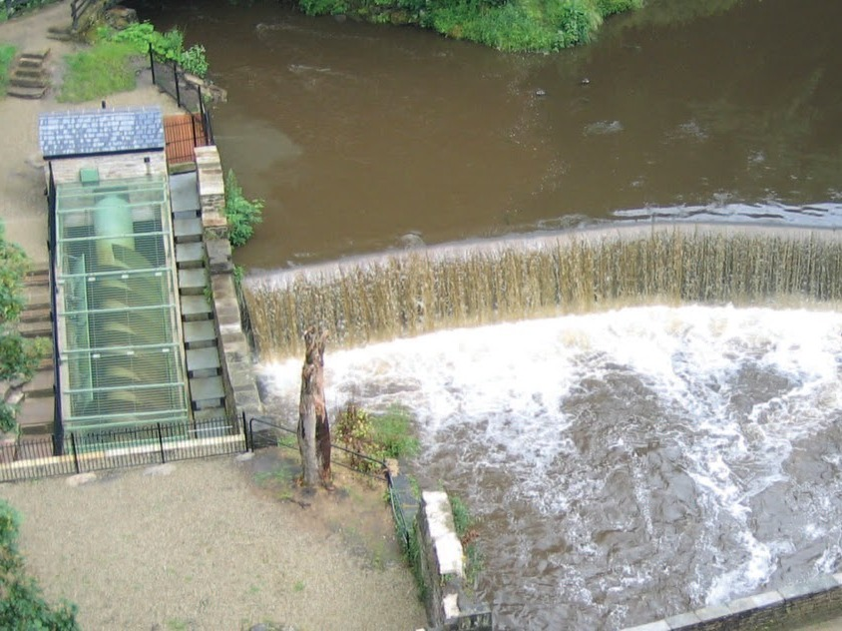
Abstraction point
Archimedean screw turbine
Discharge point
Figure 1.4: Reverse Archimedean Screw at New Mills, Derbyshire, UK (Peak Digital Ltd.)

The generation capacity of Archimedean screws is dependent on the screw blade diameter and the angle of installation. Typical approximate head and flow rate specifications are <10m and between 0.35–5.50m³s⁻¹ respectively (Ritz Atro, 2009).
In-Stream Turbines
In-stream turbines have very little to no head requirement. They are also referred to in the literature as river current energy conversion systems (RCECS), Tyson (Fig. 1.5), zero head-, hydro kinetic-, water current-, ultra-low-head and free flow- turbines (Khan et al., 2008; Hathway, 2009). Although there are numerous terms, the underlying design principle is that power is generated from the kinetic energy from the water flow velocity directly in-channel rather than potential energy derived from head difference (Verdant Power Canada, 2006; Hatch Energy, 2008). This removes the need for water storage or artificial head creation that can be associated with other turbines. In-stream turbines are very much a developing technology, with little applied research (Wiemann et al., 2007).

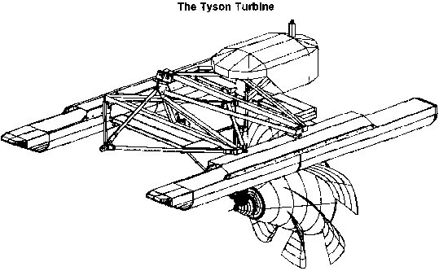
Figure 1.5: Example of a Tyson in-stream turbine (Shannon, 1996)

1.2.3 Nature of installations
As mentioned at the beginning of Section 1.2 the design of a micro-hydropower scheme is highly site-specific. The turbine component is also very variable due to the different types of turbine designs available for different site characteristics, as demonstrated in Section 1.2.2. Most schemes using high or low-rotation turbines will require a weir (to ensure a more constant flow of water) and leat (to deliver the water to the turbine). The leat length will depend on the site head availability and requirements of the turbine.
However, Archimedean screw turbines can be installed directly alongside a weir, reducing the need for a long leat. Water is abstracted from the impounded water behind the weir to the screw, before being returned to the main river channel immediately below the weir (e.g. New Mills Archimedean screw, Fig. 1.4). In other cases a longer leat may instead be used (e.g. River Dart Country Park micro-hydro installation - Bard, 2007), as with the other turbine types.

1.3 Current regulation and ecological considerations associated with micro-hydropower planning & operation
In England and Wales proposed micro-hydropower schemes are primarily regulated by the Environment Agency and Natural Resources Wales respectively. Other environmental bodies may be involved in a consultative capacity, notably Natural England, particularly when sites are located in SSSIs, SACs, National Parks or other protected areas. Abstraction of surface water from rivers at a rate of 20 m³ per day or more requires a surface-water abstraction licence from the EA (Water Act, 2003). Similarly, new impoundments of water or modifications to existing impoundments (e.g. raising the height of an existing weir) can require an impoundment licence. Licensing aims to avoid persistent over-abstraction and impediment of flow, enabling better management of water resources and protection of the natural environment (Environment Agency, 2008). Issuing a licence is based on a number of environmental considerations – maintenance of “safe passage for fish” and of “sufficient water flow for the ecology, fishery and its amenity” (Environment Agency, 2009b). Additional permits from the EA required before installation begins may include land drainage and flood defence consents.
In addition to these licences, planning permission must be granted from the Local Planning Authority under the Town and Country Planning (Assessment of Environmental Effects) Regulations 1999. The scheme must be deemed an ‘acceptable’ use of land and it must be assured that environmental risks or effects will be managed. Appraisal of environmental risks is presented by the developer in the format of a standard Environment Impact Assessment.
The publication of the Good Practice Guidelines (GPG) in 2009 (Environment Agency, 2009a) – updated in 2012 and 2013 – and the most recent publication of “Guidance for run-of-river hydropower development (Lit 4122)” (Environment Agency, 2016) highlight a number of environmental considerations relevant to the installation of micro-hydropower. These are considered during the technical assessment in the abstraction licencing process. The environmental considerations are based on the “main environmental functions” of a river and include the presence of a flow-depleted weir or main river channel, existing local abstractions, biological status of the affected reach, the impact on fish passage and the cumulative impact of proposals on issues such as flood risk and land drainage. Many of the considerations outlined in these documents are intended as baseline indicators only and it is clearly stated that certain site-specific issues will require further investigation (e.g. scheme proposal in a SAC).
The environmental considerations are based on general scientific knowledge – for example ‘adequate’ flow must be maintained in a river channel to enable fish passage during migratory seasons. However, the guidelines also clearly state that little scientific study specific to ecological impacts resulting from micro-hydropower schemes currently exists.

1.4 Existing evidence & identification of potential sources of ecological change through the use of low-head micro-hydropower
Although the general consensus is that micro-hydropower impacts the environment to a lesser extent than large-hydropower, if at all, very little direct scientific research on micro-hydropower has been undertaken to investigate this claim. Large and small hydropower schemes operate on different scales, yet the same basic components are still used – e.g. some level of impoundment, abstraction of water, turbine – so while the scale of operation is different the impacts may not necessarily be removed. The following section reviews the current research into the environmental effects of micro-hydropower schemes, supplemented by the consideration of studies which have looked at one or more of the basic components of hydropower schemes (e.g. weirs, abstraction, etc.) separately in other contexts.
As outlined in Figure 1.2, five components form a generic micro-hydropower scheme. Potential impacts from the abstraction of water include flow alteration represented by changes of velocity and volume of water in the main channel. This may then have secondary effects on habitat availability and subsequent tertiary effects on the biotic community in the main channel. Diversion of water via abstraction may also create issues for downstream migration and movement of biota and in-stream material.
A leat used for delivery of water to a micro-hydropower turbine may cause delays to migration as organisms find themselves being diverted with the water from the main channel to the turbine and unable to find their way back to the main channel without difficulty.
The presence of a mechanical moving object in the form of a turbine has the potential to cause physical harm to organisms passing through it while in the water column. Water pressure is likely to be altered. The kinetic energy created by the turbine may be transferred to heat and noise energy which may disrupt chemical and biotic processes in the channel, altering the freshwater ecological communities.
Delivery of the abstracted water back to the main channel via a tailrace will result in flow alteration, again in the form of altered velocities and increased volume of water in the main channel. The presence of an alternative route from the main channel has the potential to cause issues for upstream migratory organisms.
The depleted reach created by the abstraction of water is likely to experience changed conditions compared with a non-abstracted stretch of river. These may include flow alteration in terms of changed velocities and volume of water reaching this reach. This depletion in flow may reasonably be expected to shift the flow conditions of this stretch from “normal” to “drought” conditions. This would alter the habitat and biotic community composition from organisms that are adapted to normal flows to organisms that can cope with these “drought” conditions.
The discussion above provides a sense of effects that may reasonably be expected to be caused by the installation of a micro-hydropower scheme. However, the following sections reveal how little has been done to determine what the actual effects are.

1.4.1 Direct Research on Ecological Effects of Low-Head Micro-Hydropower Schemes
Fish
Empirical evidence of the consequences of low-head micro-hydropower to fish populations comes mostly from a small number of studies regarding coarse fish and eel passage through low-rotation turbines (Spah, 2001 and Merkx & Vriese, 2007, both cited by Fishtek Consulting, 2007, 2008, 2009). Spah studied the passage of 158 fish through an Archimedean Screw turbine. Of these, 4.4 % suffered “limited” and “minor” scale damage (Fishtek, 2007), with no visible damage present on the remaining 95.6 %. The studies by Fishtek Consulting on the River Dart in 2007 and 2008, and on the River Derwent in 2009 involved a number of experiments at an Archimedes screw site, using a range of different fish species, sizes and life stages. The 2007 and 2008 studies concluded that the vast majority of fish were able to pass downstream through the turbine undamaged – a low percentage (2.9%) of the 377 test individuals were observed to have limited and recoverable scale loss at three ranges of turbine speed (slow, medium and fast). However the study concluded that passage was more difficult for eels – one of 12 individuals tested suffered severe damage (Fishtek, 2008). This was thought to be because eels enter the turbine at the base of the blades, in contrast to other fish which are dispersed in the water column and less likely to be hit by the leading edge of the blade. A change in eel behaviour while in the turbine chamber was also observed; rather than positioning themselves in the water column horizontally with heads facing upstream, eels were seen in a vertical position, with tail close to the water surface and head towards the base of the turbine chamber. The implication of this change in behaviour on eel life span was not studied.
Kubečka et al. (1997) reviewed fish data from 23 “small” (not “micro”) low-head hydropower plants (SHPs) in the Czech Republic. Neither specific kW capacities of individual stations nor turbine types are provided. The range of turbine flow capacity from the 23 study sites was 0.011 – 3 m³s⁻¹. It was found that entrainment of fish in turbines was rare and short-term data collection indicated fish avoided the turbine intake. However, longer-term data (two months) at one site showed 46 fish, including one eel, were entrained and killed. It was also found that mean body size decreased from more larger-bodied species (e.g. adult brown trout [Salmo trutta], chub [Squalius cephalus], dace [Leuciscus leuciscus]) in the natural reference reaches to more small-bodied species (European minnow [Phoxinus phoxinus], stone loach [Barbatula barbatula]) in the depleted stretch at 20 of 23 sites. This was attributed to decreased volume of water in the depleted stretch resulting in reduced number of habitats suitable to larger-bodied species, including fewer places to hide from predators. Mean individual fish weight and total fish biomass were also “consistently” four times lower in the depleted stretch. A significant negative correlation between percentage of stream discharge abstracted by the turbine and fish biomass was found across all sites and a higher magnitude of effect observed in smaller-discharge streams compared with those carrying larger discharges.
The Kubečka et al. (1997) study also concluded that fish migration was delayed as a result of the hydropower schemes, principally as a result of a physical barrier rather than the operation of a hydropower scheme. A review of fish migration at small-scale hydropower plants in France by Larinier (2008) also highlighted that schemes caused a delay in migration for many migratory fish species; mainly from physical obstruction at the weir, insufficient ecological flows downstream and insufficient fish pass measures, including poor maintenance and debris blockages.
Although not limited to low-head schemes, Bilotta et al. (2016) used existing routine fish monitoring data within a 1 km radius in a multi-site BACI study to assess 23 run-of-river schemes in the UK. Turbine design was variable and capacity ranged from micro (< 100 kW) up to 450 kW. A small but statistically significant effect on species richness was detected on fish communities within a 1 km radius of the weir - significantly lower species richness at hydropower weir sites in the “after” construction and operation period compared to control weir sites in the same period. However, no other of the five fish community composition metrics such as species richness or abundance were statistically different.
A BACI study of a 700 kW “small” hydropower plant (SHP) in a first-order stream in Spain found a decrease in fish species density by 50 % and decreased biomass by 43% downstream the plant (Almodovar & Nicola, 1999). The hydropower scheme caused hydropeaking, resulting in “frequent and strong” daily flow fluctuations. The authors indicated the altered flow regime caused a loss of suitable habitat and sudden increased velocities removed juvenile fish from the area downstream the dam. However, no habitat data were collected in this study to provide strong evidence.
Santos et al. (2006) studied fish populations at sites upstream and downstream 18 SHPs with outputs ranging from 0.3 MW to 8.7 MW. Weir heights ranged from 1.5 m to 10.7 m. The aim of the study was to evaluate effectiveness of fish passage at the sites. Differences in size structure of three of ten species were found between the upstream and downstream sites at SHPs, with a greater number of smaller individuals upstream. This was linked to poor efficacy of fish passage facilities for target species. Despite this, differences in size structure of two species were also found at the remaining sites classed with “suitable” fish passage. Population assemblages did not differ significantly at any of the sites. Although not directly compared, this was thought to be due to suitable maintenance of habitat heterogeneity between upstream and downstream sites, with cover and coarse substrate shown to be the most important variables affecting habitat suitability. The study concluded that effects of SHP regulation on fish assemblages was not directly comparable with those seen at large hydropower schemes.
A literature review of impacts of hydropower on fish populations was undertaken by Robson et al. (2011). Using findings from primary and grey literature (primarily on large impoundment schemes), the impacts of small scale run-of-river small hydropower schemes on fish populations were classed into five categories: impoundment structures impeding migration; altered flow regime in the depleted reach associated with diversion of water for a turbine; risks of entrainment through turbine, and associated mortality / damage; loss of weir pool fish spawning and nursery habitat; and potential cumulative impacts of multiple schemes on the same river.
The same authors then carried out empirical studies of fish populations at 10 high-head small hydropower schemes in Scotland (Robson et al., 2013). Again, these were not limited to low-head micro-hydropower schemes - scheme capacities ranged from 680 kW to 3 MW. Using a BACI study design, data indicated no statistically significant differences between fish communities within depleted and control sites before and after hydropower installation. Observed reduction in juvenile salmon density (age classes ≥1+ and 0+) at two sites were attributed to abstraction and reduction of suitable habitat at impact sites after scheme commissioning. The perceived “lack of impact” was attributed to high inter-annual variation in salmonid densities, reducing the power to conclude whether changes were due to natural variability in populations or as a response to hydropower schemes.
Macroinvertebrates
There is currently one known existing study of macroinvertebrates specifically at a low-head micro-hydropower scheme. Anderson et al. (2017) sampled macroinvertebrates from three distinct sampling areas at one installation in the Peak District, UK in May 2012. The sampling areas consisted of a) hydropower tailrace, b) depleted reach above tailrace confluence and c) downstream the confluence of both the depleted reach and tailrace. No clear differences in family-level invertebrate communities were detected between the three sample areas, including no significant differences in richness, Shannon-Weiner diversity or % EPT (Ephemeroptera, Plecoptera and Trichoptera) taxa. However, a reduction in the depleted reach area of filter-feeding taxa in favour of elevated collector-gatherer and shredder families suggests an alteration in community function, although this was not significant. The study was unable to separate observed changes in invertebrate taxa from underlying influences other than the micro-hydropower scheme and concluded any impacts were likely to be localised to the particular site rather than consistent across micro-hydropower schemes in general.
The Kubečka et al. (1997) study (referenced in the previous section) also sampled macroinvertebrates at four of the 23 low-head SHPs. Wetted width decrease, reduced depth and decrease in velocity in the depleted stretch compared to natural reference reaches were observed at all sites. Invertebrate abundance, biomass, diversity and similarity were calculated for upstream and depleted stretch samples. Abundance decreased in the depleted stretch compared with natural reference stretches. Total biomass was similar between the different stretches during spring samples, but in summer samples there was a substantial stretch increase in biomass in the depleted stretch compared with natural reaches at two of the four sites. Community diversity increased in the depleted stretch compared with the reference but community similarity was not significantly different between the two reaches. The authors suggested that the increased biomass in the depleted stretch could be due to the shift to smaller-bodied fish species, thus reducing the predation risk for the invertebrates.
Copeman (1997) assessed the impact of a small (<1 MW) high-head hydropower project (a 600 kW Turgo turbine with weir intake and abstracted reach of 1 km) on the hydrological regime and benthic macroinvertebrate community. The hydrological impact of this scheme was primarily due to the abstraction of up to half the annual flow. This reduced the amplitude of medium flows, changing the flow regime of the abstracted reach from a natural flashy river with high spate flows to a steady minimum (residual) flow with occasional spates. However, no significant changes in macroinvertebrate community at sites above the abstraction point compared with sites both in the depleted reach and below the tailrace were found.
The hydropower scheme was “run-of-river”, thus allowing the high spate flows to continue to affect the morphology of the abstracted reach by maintaining substrate heterogeneity through periodic sediment removal. It was suggested that this restored the natural balance of the invertebrate community, particularly because the resident invertebrate community would already be adapted to highly variable flows that are characteristic of high-order streams such as the one used in the study. The study highlighted some interesting questions – whether the effect of a similar hydropower scheme on rivers with less variable natural flow regimes would have a greater impact on physical and ecological features, and whether a substantial loss in wetted area (and consequent biotic effects – Allan & Castillo, 2007) would occur in rivers with a more variable bed geomorphology.
The Almodóvar and Nicola (1999) paper (referenced in the previous section) also collected invertebrate community data in their BACI study of a 700 kW scheme in Spain. No significant change in abundance, total density or biomass was found. Riffle habitats were sampled upstream and downstream the hydropower dam. The main impact of the dam and flow regulation was described by the authors as repeated flood and loss of marginal habitat. No location of these riffle areas in relation to the bankside habitat is provided; there is a possibility these riffle areas would not be representative of the main effect of the dam. The paper also does not provide full analysis of the invertebrate community in terms of loss and gain of individual taxa, despite evidence of this in the presentation of their raw invertebrate data.
A study of a “medium” hydropower scheme (3.7 MW with a 7.5 m-high dam, although these figures are not mentioned in the paper) in a mountainous river in Spain indicated that although the hydropower scheme did not change water quality variables, the natural hydrological regime was altered downstream the scheme (Jesus et al., 2004). This resulted in homogenised habitat conditions and accumulation of fine sediment downstream. The invertebrate community structure was altered, with decreased diversity, species richness and percentage EPT taxa downstream.
Bilotta et al. (2017) repeated the same multi-site BACI design as used for the 2016 fish paper, using routine macroinvertebrate monitoring data within a 1 km radius of a study weir as opposed to fish data. The 2017 study incorporated 22 run-of-river schemes in the UK. Turbine design was variable and capacity ranged from micro (< 100 kW) up to 314 kW. Head heights ranged from 1 – 80 m. BACI ordination indicated a slight significant difference in macroinvertebrate community family evenness following hydropower scheme construction and operation (decrease in impacted before/after pairs, an increase in evenness in control before/after pairs). Statistically significant effects were not detected on the four other metrics of community composition; family richness, the Lotic-invertebrate Index for Flow Evaluation (LIFE), the Empirically-weighted Proportion of Sediment-sensitive Invertebrates (E-PSI) and the Walley-Hawkes-Paisley-Trigg (WHPT) indices. The author does however draw to attention the statistical power of this, and other studies. Caution must be taken in the interpretation of this study as existing, opportunistic, invertebrate data were used in the analyses. This brought the advantages of having a long-term dataset readily available which helped reduce the error in natural spatial and temporal variability of the invertebrate data. However, there was no control over the selection of study sites and no knowledge whether these sites were specifically set up to monitor other stressors on rivers (e.g. organic pollution incidents, or outputs). The study addressed whether there was evidence of a local impact on macroinvertebrate communities. “Local” was defined as within 1 km of the weir and no attempt was made to ensure these were co-located within the depleted reach of a hydropower scheme. No empirical evidence currently exists to indicate any extent of effect from hydropower schemes; it seems imprudent to base a modelled study on the assumption effects will reach as far as 1 km away on invertebrate communities when there are so many other variables involved.
Flow reduction over weirs has recently been the subject of some discussion in grey literature (Robson et al., 2011; Mould et al., 2015). Although no empirical studies currently exist, Robson et al. (2011) suggests that the presence of an on-weir hydropower scheme has the potential to alter patterns of energy dissipation and flows, morphology and aquatic communities in the area immediately downstream a weir (the weir pool). Mould et al. (2015) states there could be changes to spatial variation of water velocities and depth, but the overall available habitat would remain similar across a range of flows. The report used 2D hydraulic modelling over three weirs in the UK (Rivers Thames and Avon) to create a range of flow scenarios. The modelling concluded that any changes in flow and secondary geomorphological processes were not ecologically significant. However, these conclusions were based on expert opinion. This lack of direct evidence weakens the claims that modelled changes are not significant, particularly in such site-specific scenarios. However, the authors do concede that there is little information (published research or anecdotal) linked to the importance of weir pools for macroinvertebrates and aquatic plants. They also note that effective interpretation of ecological impacts from a 2D hydraulic modelling scenario, plus the ability to answer the initial question of whether a weir pool habitat is ecologically important to the specific river system, requires collection of site-specific ecological and sediment data.
Current literature provides little direct information of the ecological impacts of low-head micro-hydropower (Robson et al., 2011; Mould et al., 2015; Anderson et al., 2015 & 2017). This clearly indicates that assumptions on the lack of environmental impact are based on very limited examination of such schemes in action. However, some of the significant elements of a typical micro-hydropower scheme do occur in other contexts, and studies of these may provide useful insight into the possible environmental effects of micro-hydropower. The key elements to consider are the two principal components of micro-hydropower – flow alteration during abstraction and impoundment, and additional features of micro-hydropower systems such as turbine function and discharge method.

1.4.2 Flow Alteration
1.4.2.1 Water Abstraction
Most micro-hydropower schemes involve the non-consumptive abstraction of water (Section 1.2.1).
The primary effect of surface water abstraction from the main river channel is a change in flow regime (Boon, 1988). Flow regime is a key determinant of a river’s physical habitat (Walker et al., 1995; Bunn & Arthington, 2002) and subsequently affects fundamental ecological structures and processes (Poff et al., 1997; Puckridge et al., 1998; Kennan et al., 2010; Poff & Zimmerman, 2010). Five critical components of flow - magnitude, duration, timing, frequency and rate of change (flashiness) - are major determinants of ecological integrity (Poff et al., 1997). This is either directly through affecting specific life-cycle cues or indirectly through the change of physical parameters such as hydraulic alteration, temperature variation, dissolved oxygen and other chemical properties of water, sedimentation (the composition of which is highly important to benthic macroinvertebrates – Giller & Malmqvist, 1998) and channel morphology (Statzner & Higler, 1986; Poff & Ward, 1989; Bunn & Arthington, 2002; McKay & King, 2006; Chinnayanahalli et al., 2010).
It is evident that flow alterations from anthropogenic influences such as abstraction are likely to result in altered ecosystems (Richter, et al., 2003; James et al., 2009; Renöfält, 2010). Resultant ecological changes in the biota include shifts in taxonomic abundance and diversity, changed community composition, biomass and densities, and altered life-histories (Armitage, 1978; Degani et al., 1993; Rader & Belish, 1999; Bunn & Arthington, 2002; McIntosh et al., 2003; Tiemann et al., 2004; McIntosh et al., 2008; Death et al., 2009). Figure 1.6 outlines the direction of effects on biotic and abiotic conditions found after a literature review (Dewson et al. 2007a) and highlights the variation in type of changes caused by flow reduction.
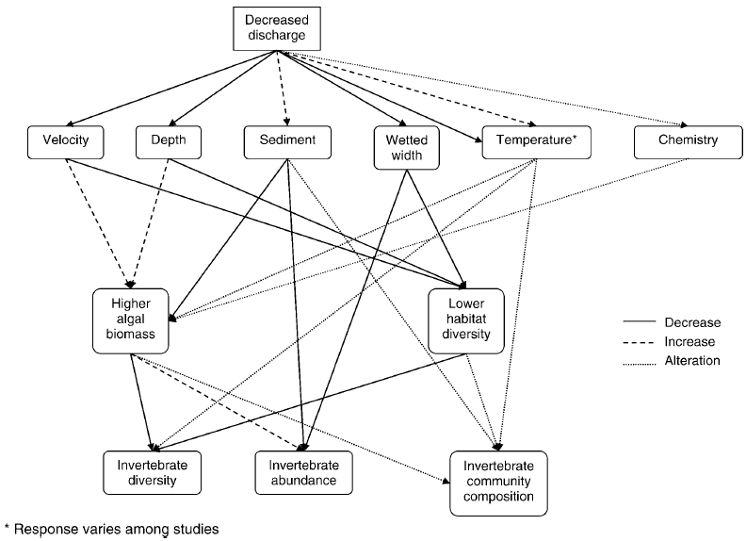Figure 1.6: Summary of the effects of decreased stream flow on habitat conditions and invertebrate community abundance, diversity and composition. Taken from Dewson et al. (2007a)

Previous studies often show an inconsistent pattern of invertebrate community response to artificial flow reduction; thought to reflect the variability between studies in terms of experimental design, stream characteristics, prevailing invertebrate communities and other variables (James & Suren, 2009). Despite this hypothesis, a review of published literature in 2007 showed velocity, channel depth and wetted width consistently decreased after flow reduction; although two studies of 13 found no significant change in wetted width (Dewson et al., 2007a). Changes in these parameters are often much quicker when caused by artificial reductions compared with natural low flow causes (Dewson et al., 2007a). Wesche et al. (1988) found sites with a gradient <1.5% had significant reductions in mean channel depth, mean bank-full area and capacity in areas downstream a diversion compared with upstream. Conversely, sites in higher gradient reaches (slope >1.5%) did not respond as strongly to flow depletion as lower-gradient sites (14 sites tested, no significant changes).
Patterns of response of physicochemical variables such as temperature and pH to flow reduction are also inconsistent, based on the same 2007 literature review; with studies reporting increases, decreases and ‘no change’ responses to flow reductions (Dewson et al., 2007a). Three studies reported no significant change in dissolved oxygen and a consistent increase in electrical conductivity in the four papers that studied this parameter. A strong effect of flow reduction is evident in the consistent increase in sedimentation – nine of 10 studies reported an increase, and one of 10 reported no change.
A clear understanding of the ecological effects of reduced discharge is relatively limited as, although relatively well-studied, the response of ecologically-important elements of low flow is inconsistent and complex. The ecological tolerances and both response and resilience of different taxa to altered hydrological conditions is also, understandably, highly varied.
Despite this, Dewson et al. (2007a) found a number of studies showing that the general response of periphyton communities to low discharge was an increase in biomass. A decrease in periphyton biomass was observed by Kinzie et al. (2006) only in particularly severe low-flow scenarios due to insufficient water. Suren & Riis (2010) used a review of available studies to model the response of macrophyte biomass during increased duration of low flows. The model indicated a positive relationship between macrophyte biomass and the duration of low flow event. In addition, it suggested the greater the nutrient content of the stream, the greater the change in macrophyte community. This was also predicted to have a greater effect on the invertebrate community through a direct link between macrophyte biomass and in-stream habitat condition. However, the authors were unable to provide further information on the direction of invertebrate community change due to site-specific nature of flow-reduction events.
Englund and Malmqvist (1996) compared regulated and flow-reduced sites with non-regulated (control) sites. In comparison to control sites, sample areas with regulated flow regimes had larger short-term flow variations, characterised by greater reductions in flow. The regulation allowed for significant changes in flow on shorter than typical natural timescales. Regulated sites also had lower monthly variation in the long-term (300 days) – thought to be due to the retention of spring flood water by impoundment behind the dams. Sites with flow reduction were also sampled (reduction between 86 - 99.8 %). These were characterised by long periods of stable flow, often interrupted by short-term flow increases that were highly variable and consisted of much greater magnitude than the preceding flow. The increased flow variability at these flow-reduced sites was linked to significantly lower abundance and species richness of macroinvertebrates compared to unregulated sites. Abundance and species richness at regulated sites did not significantly differ from unregulated sites. However, functional feeding group (FFG) analysis indicated significantly lower species richness of grazers and significant decreases in abundance of collectors, grazers and predators at regulated compared to unregulated sites. Regulated sites had a lower abundance of collectors than unregulated sites, but no significant changes in other FFGs (including filter feeders and shredders). The authors suggested food availability for grazing invertebrates was lower at sites with reduced flows.
In a study by Dewson et al. (2007b), controlled experimental flow reduction in three streams (each with paired control and impact sites) was attributed to decreases in water discharge, velocity, wetted width and mean depth in impacted sites below a weir and diversion compared with the control site above the low-head structures. No consistent changes in the impact site relative to the control site across the three streams were observed in conductivity, pH, percentage change in either maximum daily temperature or temperature range, and periphyton biomass. Macroinvertebrate drift density increased in the impact sites, peaking during the first few days of flow reduction. It was hypothesised that invertebrate taxonomic richness and density would decrease in response to the expected decrease in habitat suitability with flow reduction. However, local invertebrate densities increased at impact sites compared to the paired upstream controls. This was attributed to the loss of wetted width and thus suitable habitat caused by reduced discharge, causing a concentration of invertebrates in the remaining wetted area. Significant changes in the invertebrate community composition were observed at one of three streams – increased densities of Potamoprygus antipodarum (Hydrobiidae snails), Delatidium sp. (Leptophlebiidae mayfly), Oligochaeta and the two Chironomidae sub-families Orthocladiinae and Chironominae in the impact site (interestingly, all these taxa belong to the collector functional feeding group; although this is not mentioned in the paper). It was suggested that increased duration of discharge reduction would result in more substantial change in community composition due to an expected effect on invertebrate life-cycles. This is consistent with a number of other studies citing an increase in invertebrate density during flow reduction (see Dewson et al., 2007a). It should be noted, however, that numerous other studies have also reported inconsistent responses – increases, decreases and no change in invertebrate density in response to flow reduction have all been reported (see James & Suren, 2009).
Habitat diversity and invertebrate richness are positively correlated – a low but continued presence of areas of habitat more severely decreased by flow reduction (e.g. riffles, gravel substrate) maintain suitable conditions and refugia for certain invertebrate taxa (Armitage & Petts, 1992; Wood & Petts, 1999; Wright & Symes, 1999). Ecological niches and tolerance of certain habitat and conditions results in a varied effect on taxa abundance in invertebrate communities. For example, after two months of experimental flow reduction in a lowland stream, Ostracoda, Cladocera and Oxythira albiceps (Hydroptilidae) abundances significantly increased in the depleted area (James & Suren, 2009). Ostracods and cladocrerans are tolerant of pool habitats and O. albiceps is an algal piercer, known to proliferate in areas of high biomass of filamentous algae and habitats without direct connection to running water (Towers, 1996; Collier et al., 1997; MacFarlane, 2004; Ruiz et al., 2013). However, abundance and density of the most common taxa pre-flow reduction decreased significantly in the depleted area over the two-month experiment, thought to be due a decrease in the availability of their hydraulic habitat preferences. The decrease in density was reported as “roughly in proportion to the magnitude of flow reduction”. Algal biomass increased in the downstream area after flow reduction and results suggested the change in invertebrate community from pre- to post-flow reduction were most strongly linked to chlorophyll-a and water discharge data.
A change in stream flow has been linked to shifts in food availability and quality, with subsequent effects on invertebrate communities (Sweeney & Vannote, 1986). Sheldon & Walker (1997) found links between reduced flow and flood frequency and the type of food resource available to aquatic snails. With reduced flows, the epilithic food source changed from mostly microbial (high nutritional value) to algal (low nutritional value) dominance (McIntosh et al., 2003), to which the authors linked a decline in snail populations. Flow reduction was found to have a significant impact on body size of the caddisfly, Hydroptila potasina (Hydroptilidae) (McIntosh et al., 2003). Body size was significantly smaller in this caddisfly in areas downstream a diversion compared to upstream. The change in body size was suggested to be a consequence of reduced food availability and/or quality in the downstream impact area. In addition, life stages of the same caddisfly species were found to differ between upstream and downstream the diversion. Upstream, similar proportions of the five instar stages were represented in samples. In flow reduced areas downstream however, the proportions were more uneven – including an absence of lower instars at the beginning and absence of higher instars further into the study, despite continued presence of all instars in the upstream reach during this time.
Non-consumptive abstraction requires the return of the abstracted water back to the main channel. In micro-hydropower schemes the abstracted water will have been passed through a turbine. The discharge of water into the main river channel from high and low rotation turbines is likely to be point source and of highly concentrated velocities and turbulence, due to kinetic energy remaining from the head fall and turbine movement. Current knowledge of the effects of turbulence include increased disorientation of organisms and increase of startle response time – an important function for predator avoidance (Hale, 2000). Turbulence can influence sediment distribution (Armitage, 1978) – higher turbulence positively correlated with reduced silt loads – and shifts in benthic macroinvertebrate community composition and function (Degani et al., 1993).
Through the abstraction of water, micro-hydropower schemes have the potential to alter a number of critical components of flow that are of importance to the ecology of a river. However, although several studies assess the impact of abstraction on a range of biotic and abiotic conditions, the impact of abstraction for the use of micro-hydropower is currently unknown.
1.4.2.2 Water Impoundment
A large number of micro-hydropower schemes involve the use of on-line impoundment in the form of weirs; particularly on-weir Archimedean screws and systems installed at old mill sites - both of which hold great potential for future development (Section 1.2). The presence of weirs at most micro-hydropower installations has the potential to alter river habitat and ecology aside from any effects of the turbine or abstraction. There are two principal elements to the effect of weirs: the ‘pool’ created upstream of the weir, and the physical barrier across the channel provided by the weir itself.
Weirs have been shown to significantly affect water depth, chemistry and velocity, dissolved oxygen, temperature patterns and substrate morphology (Wesche et al., 1988; Helfrich et al., 1999; Tiemann et al., 2004; Santucci et al., 2005; Hester et al., 2009; Mueller, 2011). A study of two low-head dams (2.3 m and 3.7 m high) found significantly deeper channel depth and slower velocities at upstream ‘treatment’ sites affected by the presence of the weir compared with upstream reference sites (outside the influence of the weir) (Tiemann et al., 2004). Sites downstream of the weirs (‘treatment’) were consistently shallower and had faster velocities than expected when compared with the downstream reference sites. Both upstream and downstream sites closest to each weir had significantly greater substrate compaction and mean substrate size compared with the reference sites. These effects at the downstream sites were thought to be caused by scouring of finer substrates by flows coming over the weirs. Physicochemistry in impounded reaches compared with free-flowing reaches in a study by Santucci et al. (2005) were found to have much more variable daily fluctuations of dissolved oxygen (DO) and pH. Less extreme daily fluctuations were observed in free-flowing reaches. Santucci also found habitat variables in impounded areas (e.g. depths, velocities and substrate types) were more homogenous compared to free-flowing reaches, with slower and more even water velocities and “substrates dominated by fine silts and sands”.
These chemical and morphological changes can have consequences for the biota; including reduced richness, diversity, density and abundance of fish and invertebrate communities in weir pools (Porto et al., 1999; Arle, 2005; Santucci et al., 2005; Alexandre & Almeida, 2010, Mueller, 2011). Poulet (2007) found significantly higher numbers of limnophilic fish species in weir pool sites compared with reference sites further upstream, where rheophilic species dominated the community. Sites in the weir pools were deeper, wider and with lower velocities and finer sediments compared with upstream reference sites which were characterised by a more heterogeneous and coarse substratum. This was linked to the presence of significantly higher number of invertivorous species in the reference sites compared to both immediately upstream and downstream the weir sites. The abundance of omnivorous fish species was significantly greater in the weir pool compared with reference sites. An explanation could be that in response to the velocity and channel morphology changes in the weir pool, the macroinvertebrates shifted from a lentic to a lotic community. This is also supported by Mueller et al., 2011, with significantly increased depth, decreased velocity and substrate particle size, and distinctly different populations of periphyton, macroinvertebrate and fish in weir impoundments compared to downstream reference reaches. The impoundments were also characterised by decreased percentage of rheophilic macroinvertebrate and fish species – for example, a shift from lentic oligochaete and chironomidae in impoundments to lotic Leuctra and Rhyacophilidae in the downstream reaches was recorded across five study sites.
Exchanges of material, energy and organisms are integral to the connectivity and biodiversity of rivers (Vannote et al., 1980; Ward et al., 1999) and weirs can fragment these important processes through the presence of a physical structure across the river channel (Morita & Yamamoto, 2002). These structural barriers to fish, eel and lamprey migration or invertebrate drift (Benstead et al., 1999; O’Connor et al., 2006; Lucas et al., 2009) reduce access to and availability of suitable feeding, refuge and spawning habitats further upstream (Odeh, 1999b, cited by O’Connor et al., 2006), subsequently reducing reproduction and population recruitment (Lucas & Batley, 1996; Gosset et al., 2006). Population demographics and characteristics such as diet, densities, body size and trophic position are also altered by connectivity fragmentation (Baumgartner, 2007; Letcher et al., 2007; Takamura, 2009). A study of fish populations and gut contents upstream and downstream a weir found downstream species had a greater proportion of empty stomachs and significantly different diet composition compared with the same species upstream the weir (not influenced by the weir impoundment (Baumgartner, 2007). The fish community had a greater rate of dietary overlap between species in the downstream versus upstream areas, potentially indicating increased levels of competition. In addition to these findings, significantly greater abundances of certain species were found below the weir compared to upstream – thought to have been obstructed during migration. Body size is negatively correlated with increased fragmentation (Letcher et al., 2007).
In addition to connectivity for organisms, weirs may alter transport of materials. The delivery and processing of materials from upland to lowland reaches is an important energy source in rivers (Giller & Malmqvist, 1998). Weir presence encourages sediment deposition (Anderson et al., 2008) and has been shown to alter coarse and fine particulate organic matter ratios (CPOM:FPOM) in areas around weirs, with more CPOM retention in slower flows (Wagner, 2003; Death et al., 2009). These impacts can consequently change ecological communities as decreased particle size has been linked to decreased diversity of benthic organisms (Magilligan & Nislow, 2001; Harrison et al., 2008). Invertebrate drift densities can increase with increased fine sediment deposition (Wood & Armitage, 2004; Death et al., 2009) and changed ratios of CPOM:FPOM, particularly in upper river reaches, can alter the biotic community structure and functions of a river (Cummins, 1975; James et al., 2009).
Weirs clearly have the potential to create environmental and physical conditions that impact on the structure and function of the ecological system. However, in comparison to large-scale dam studies, the ecological consequences of weirs are poorly understood (Bensted et al., 1999; Poff & Hart, 2002; Santucci et al., 2005; Harford & Mclaughlin, 2007, Loot et al., 2007; Poulet, 2007; Alexandre & Almeida, 2010; Mould, 2015), particularly in relation to the movement of macroinvertebrates (Pringle, 2003). More empirical research is of particular importance as the prevalence and magnitude (e.g. raising weirs to create a greater head) of impoundment is likely to rise as micro-hydropower development increases.
1.4.3 Turbine Function & Water Discharge
High rotation turbines, such as Francis and Kaplan, are currently used at both micro- and large hydropower sites, with size designed accordingly. Ecological impacts of these turbines operating at high speeds have been documented for fish, including eels. The main causes of injuries and mortality include rapid water pressure changes, turbulence, low turbine efficiency and mechanical injuries such as blade-strike (direct contact between fish and the turbine blade (see Cada, 1997; Odeh, 1999a; Coutant & Whitney, 2000). It is thought that higher rotation speeds are related to greater fish mortality rates (Larinier, 2008). Impact is also dependent on fish structure, for example species, length, and mass (Cada, 1997). Eel mortality has been shown to be at least 50% even through smaller turbines used at small hydroelectric facilities, due to their greater length (Larinier, 2000). Concerns over this, perhaps most obvious, possible impact of hydropower systems has meant that research into the “biological performance” (Deng et al., 2007) of high rotation turbines is supported by various Government agencies (see Cada, 1997; Odeh, 1999a), illustrating the increasing importance of the issue.
No current studies exist on the impact of hydropower turbines on other freshwater taxa other than fish (including eels). It is likely that, due to their smaller size, macroinvertebrates are unlikely to be affected by mechanical injuries. The risk of pressure changes and turbulence from hydropower schemes to macroinvertebrate communities and function are not currently documented. A direct correlation has been found between increased turbulence and increased invertebrate drift. If this is the case in micro-hydropower systems then continued turbulence would cause an exodus of invertebrates from that area, with subsequent detrimental effects on invertebrate populations in the river and effects reaching higher up the trophic levels.
Although sites with the highest potential use (low-head sites – Section 1.2) generally involve low rotation turbines, the environmental and ecological impacts of any turbine used in the context of micro-hydropower are not well understood.

1.5 Summary
The number of micro-hydropower schemes in the UK is likely to increase as the pressure to achieve renewable energy targets grows. It is currently assumed that micro-hydropower has limited environmental impacts, primarily due to the decreased magnitude of scale from large-hydropower schemes (Egré & Milewski, 2002, Shaw, 2003 & 2006) and mitigation measures available (Paish, 2002a). Yet despite their projected importance in providing a valuable resource of renewable energy, there is a paucity of research that addresses the actual scale and magnitude of environmental and ecological effects that may occur from these schemes.
The ecological implications of large hydropower schemes have been well studied and the numerous detrimental effects are now well-documented. A considerable amount of research has also been conducted on the environmental impacts from components of large hydropower schemes, namely water abstraction and impoundment. Micro-hydropower is at a smaller scale to these larger, better-studied schemes and the current consensus is that the decreased magnitude of scale results in negligible ecological effects from micro-hydropower schemes. However, there is a distinct lack of information and evidence regarding the ecological implications of these micro schemes. Existing research from large schemes has indicated issues arising from common components are relevant at this smaller scale and it is reasonable to expect a number of abiotic and biotic changes to result from micro-hydropower schemes.
It is important to consider these possible impacts because there is potential to cause local detrimental effects to rivers, affecting the ability of the UK to conform to the EU Water Framework Directive (WFD 2000/60/EC) target of achieving good ecological status in every waterbody by 2027 and prevent deterioration of current status. The number of micro-hydropower schemes in the UK is likely to increase as the pressure to achieve renewable energy targets grows. This also brings the potential for cumulative changes to arise from multiple micro-hydropower schemes, leading to catchment-wide effects. This study will address this knowledge gap within the context of environmental and ecological factors affected by the installation of micro-hydropower in rivers.

1.6 Thesis aims & objectives
The central aim of this work was to address the lack of knowledge about the ecological effects of micro-hydropower installations by investigating the direct and indirect effects of several such schemes on key elements of habitat conditions and macroinvertebrate communities in small rivers. The study specifically focused on the effects of water abstraction and the creation of the depleted stretch below in five case study micro-hydropower installations, and on the extent of which any effects were consistent across the different schemes.
Chapter Two introduces the study sites and provides background information common to all the chapters that follow. Chapters Three and Four then address the two main objectives of the study:
- To test whether there were any consistent differences in the habitat (channel dimensions, flow characteristics, bed conditions, water chemistry) between the depleted stretch of a channel and reference conditions (upstream of the weir impoundment) at each micro-hydropower installation (Chapter Three).

- To test whether there were differences in the structure of macroinvertebrate communities between depleted and reference sections of the river at each micro-hydropower installation, and to what extent habitat changes (Chapter Three) might be related to any effects (Chapter Four).

Chapter 2 – Study Sites
2.1 Study site selection
Selection and assessment of potential sites took place in March and April 2010. Using data from various sources including the Environment Agency (2010a,b), the British Hydropower Association (2010), LaTene Maps (2008) and Ofgem (2008a,b), sites were mapped using GIS. High-resolution satellite images from Google Earth (Google Inc., 2011a) and Google Streetview (Google Inc., 2011b) images were used in a desk-based study to visually assess sites according to strict initial criteria (see Section 2.1.1). Site visits to shortlisted sites were made and the final study sites selected.

2.1.1 Criteria
The initial criteria consisted of the presence of a functioning micro-hydropower scheme with an abstraction point and a discharge point further downstream (i.e. consumptive abstractions not permitted). Schemes were required to be low-head (<5 m) “run-of-river” types and generating <100 kW electricity. The site was required to have been permitted an abstraction licence (and impoundment licence if required) by the Environment Agency, the regulatory authority in England. It was essential that a preliminary visual assessment indicated that the river was likely to be suitable for access to and working in water, for example no excessively steep-sided banks, or on very wide rivers where it was likely the river would be very deep. Sites did not have any known water quality or other issues likely to affect the river habitat and biota.
From the sites mapped originally, 24 passed the initial screening. Schemes located in North and Central England were then prioritised to minimise travel time and to ensure that sites could be sampled at roughly the same period of time. Ten of these sites were visited between May and June 2010. To ensure the site assessment visit replicated sampling conditions during future data collection as much as possible, sites were not visited during or after periods of heavy rain when sites would be in a state of high flow. Biological sampling is not possible when rivers are in spate (SEPA, 2015).
Further criteria were applied during the site visit. In addition to a depleted reach, it was essential that a comparable reference reach upstream of any influence from the weir impoundment was present. The impoundment area behind the weir was visually assessed as having a very high percentage of laminar flow plus an increased and less variable depth in comparison to the channel further upstream. The reference reach was judged as out of the influence of the impoundment when a greater variety of flow habitats and depths were present (for example, glide, run and riffle rather than just glide) and evidence of deposition and erosion was present (i.e. indicators that variation in natural river processes were able to take place; something very unlikely in an impoundment behind a weir).
A ranging pole was used in-stream to assess water depth and assess whether the site was suitable for safe working in water. Sampling of benthic macroinvertebrate communities is more effective in water depths no greater than waist height, and safe wading requires water depth no greater than chest height. Vehicular access to within 0.5 miles of the general site was necessary for the safe and effective movement of sampling equipment. Finally, sites were only considered for inclusion in this study if consent from landowners was obtained.

2.1.2 Site contexts and implications
As a result of using the criteria set in 2.1.1 the five study sites selected (Fig. 2.1) represent a sub-sample of micro-hydropower schemes installed in the UK, as of 2010. Table 2.1 indicates the similarities and differences between the selected study sites, and highlights categories not represented by the set.
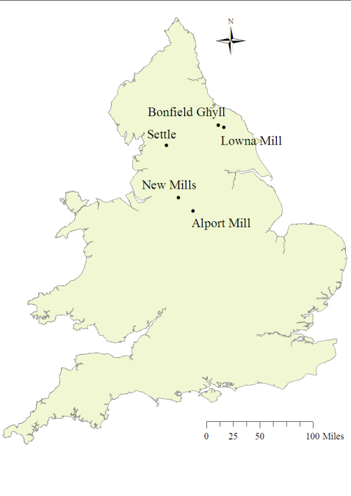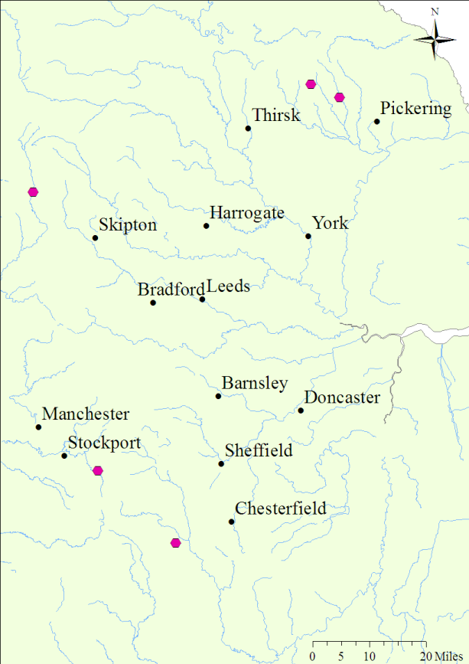
New Mills
Settle
Alport Mill
Bonfield Ghyll
Lowna Mill
Figure 2.1: Location of the five study sites (pink circles)
Table 2.1: Similarities and differences between study sites
Name | Max. kW | Turbine | Depleted stretch length* (m) | Installation year | Head (m) | Design flow  (m³s⁻¹) | Mean river width at abstraction point (m) | Land use
Alport Mill | 30 | Crossflow | 92 | 2009 | 4 | - | 10 | Rural
Bonfield Ghyll | 1 | Archimedes Screw | 70 | 2007 | 2 | 0.15 | 4.5 | Rural
Lowna Mill | 2.6 | Overshot Waterwheel | 113 | 2008 | 2 | 0.31 | 14 | Rural
New Mills | 63 | Archimedes Screw | 18 | 2008 | 3 | 3.00 | 23 | Urban
Settle | 45 | Archimedes Screw | 26 | 2009 | 2.1 | 2.86 | 32 | Rural
* Length of the depleted reach also determined the length of the reference reach (Section 2.1.3)
The study sites represent a range of kW outputs resulting from different head and flow combinations. Depleted reach lengths varied from relatively short (18 m) to relatively long (113 m) and the range of river widths at the abstraction point was also varied. The land use around most sites was rural, with only New Mills situated in an urban environment. Three different types of turbines were represented. The Archimedean screws and waterwheel are low rotation, and the crossflow is a high-rotation turbine. All study sites were installed in the previous four years prior to sampling (>2006).
Many existing low-head micro-hydropower sites use waterwheels due to the prevalence of old mill sites and the relative ease of renewing old infrastructure. More recent installations and feasibility studies involve a greater proportion of the more modern Archimedean screw turbines. High-rotation turbines such as the cross-flow are not as common as the waterwheel or screw in low-head situations due to their poor suitability to the lower range of low-head conditions. Most UK micro-hydropower schemes are currently located in rural rather than urban areas due to the propensity of upland rivers with higher head availabilities in rural areas. Higher heads and less flow volume are often associated with better economic viability of a scheme.
This selection of sites provides a fair representation of sites generating around 50 kW or less installed in the UK as of 2010 (Ofgem, 2008a). Schemes with higher kW outputs are generally associated with higher head and water volumes, leading to increased river depth and width. These then failed the site selection criteria and so are not generally represented by these chosen study sites.

2.1.3 Study Approach
Data were collected from two reaches within each site – the reference and depleted reach. The depleted reach represents the core element of unknown impacts at micro-hydropower schemes, and the upstream reach was used as a reference. The reference reach was determined by the length of the depleted stretch; therefore both reaches were equal in length.
Discharge zone
Reference reach
Depleted reach
Sluice gate
Turbine
Leat / tailrace
Natural flow conditions
Weir
(small dam)

Weir impoundment
Figure 2.2: Location of the two sample reaches (bold) at a generic micro-hydropower site

Prior to sampling, each study reach was divided to a 1 m² grid format, using length and maximum width measurements. Sampling points within each area were then determined by generating random grid coordinates using a random number generating code in R (ver. 2.14.0) (R Core Team, 2013).

2.2 Site Profiles
2.2.1 Bonfield Ghyll
Location: | Bonfield Ghyll Farm, nr. Helmsley,  North York Moors National Park
River: | Bonfield Ghyll (trib. of River Riccall)
NGR: | SE 60683 94715
Altitude: | 260 m AOD
Slope: | 22.6 m/km
Distance from Source: | 4 km
Turbine Type: | Archimedean Screw
Installed Capacity (Output): | 1 kW
Max. quantity of abstraction: | 0.15 m³s⁻¹
Hands Off Flow (HOF)* | : Not subject to any flow or level restrictions
Date(s) of sampling: | 09 & 10/06/2010
Flow conditions: | Normal
Total / mean / range rainfall preceding five days**: | 15 mm / 3 mm / 0 – 6.8 mm
Sampling conditions: | Cloudy with showers
* Abstraction must cease when river level is at or below the HOF
** Rainfall data from EA Hawnby rainfall gauge
Summary
Bonfield Ghyll Farm is a relatively isolated National Trust property located in the North York Moors. An Archimedean screw was installed by MannPower Consulting Ltd. in 2007 on the small moorland beck adjacent to the farm. It provides 1 kW of energy from a head of 2 m. This is used to charge batteries for use in this off-grid privately rented property. The turbine is in near-constant use. No Hands-Off Flow (HOF) – the level of the river at which the abstraction must cease – exists on the 2006 abstraction licence.
Before the installation of this scheme the beck flowed in one channel (pre-2004). A large flood event in 2004 created a second parallel channel to the west of the original channel, through which the river diverted its course. This created the opportunity for a makeshift weir to be constructed by the farm owner and water diverted down the original channel for use by the turbine. An additional braided channel off the original channel also formed. Current ordnance survey maps do not show these new channels – site maps (Fig. 2.3 & 2.5a,b) have used a mix of recent aerial footage (Fig. 2.4) and available ordnance survey maps to indicate the location of these channels.
The length of the depleted reach is approximately 70 m and no fish pass is present. The turbine was in operation when the site was sampled.
Hydromorphological features
Bonfield Ghyll is typical of a first-order (Strahler, 1957) upland moorland watercourse, draining a small peat moorland catchment in the North York Moors, UK. The catchment is a mix of shale, sandstone and limestone. Overall, the Ghyll is characterised by natural pool/riffle sequences. Limited physical modification is present within the Bonfield Ghyll study site – partly due to its rural location. The only true artificial features are the Archimedean screw turbine and leat, reinforced with brick within 0 - 10 m of the turbine. A footbridge crosses the stream just downstream the turbine location and has associated bank reinforcement. However, none of these areas were part of the study reaches. The weir pool has been derived from a naturally deepened meander, with the “weir” a collection of small boulders and large cobbles loosely stacked across the steepest of the two channel exit points. This channel was cut during a peak flood event a number of years ago, and is now the depleted reach.
In both the reference and depleted reaches, channel features include exposed bedrock, exposed boulders and exposed tree roots along the course of the study area. Marginal and bank features include stable and eroding cliffs due to the highly responsive nature of the catchment. Side bars are also present, primarily in the depleted reach (e.g. Figure 2.8).
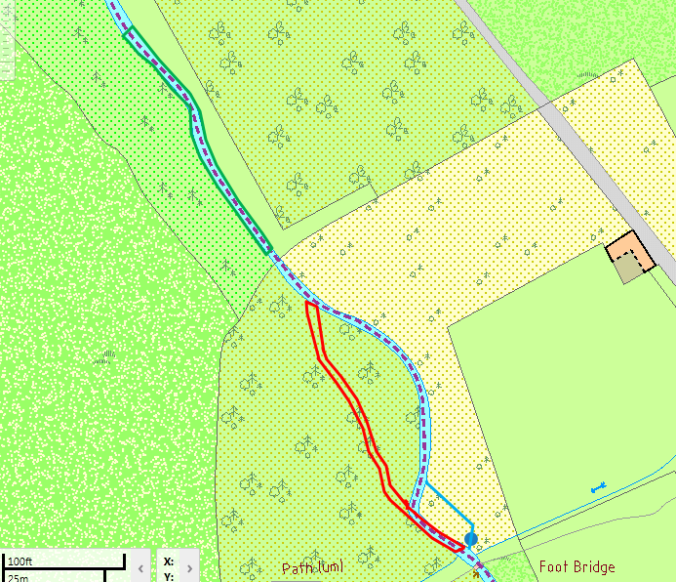
N
Direction of flow
Figure 2.3: Site map of Bonfield Ghyll study area. Red = Depleted reach. Green = Reference reach. Blue circle = turbine location

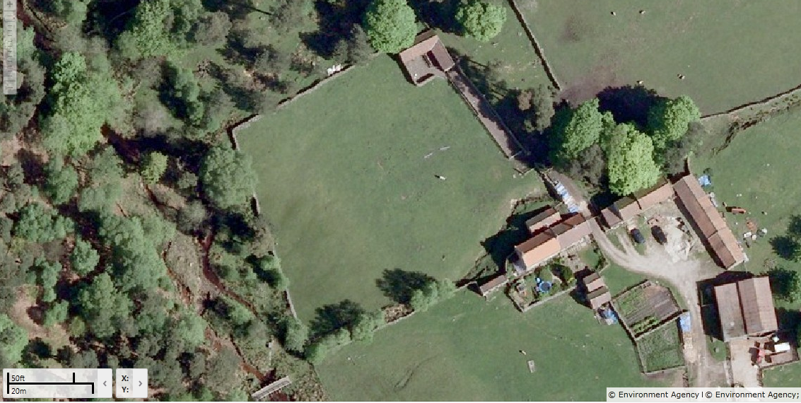Figure 2.4: Recent aerial footage (2017) showing the newly-cut channel (in 2004) that now acts as the depleted reach
New channel
(now depleted reach)
Original channel (now leat)
Braided channel (from leat)
Turbine
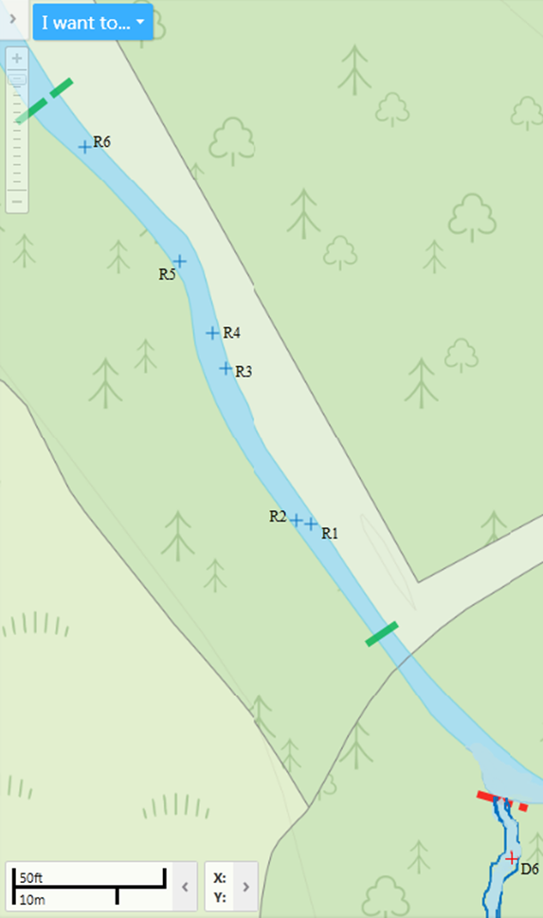
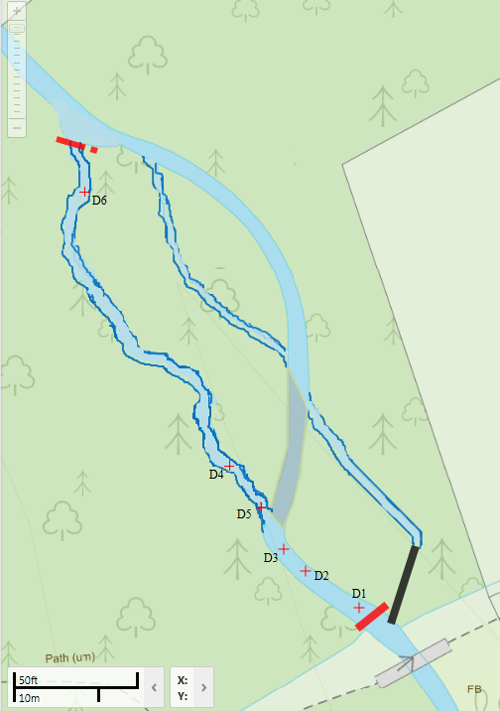
Figure 2.5: a) Bonfield Ghyll reference reach and associated sample points b) Bonfield Ghyll depleted reach and associated sample points

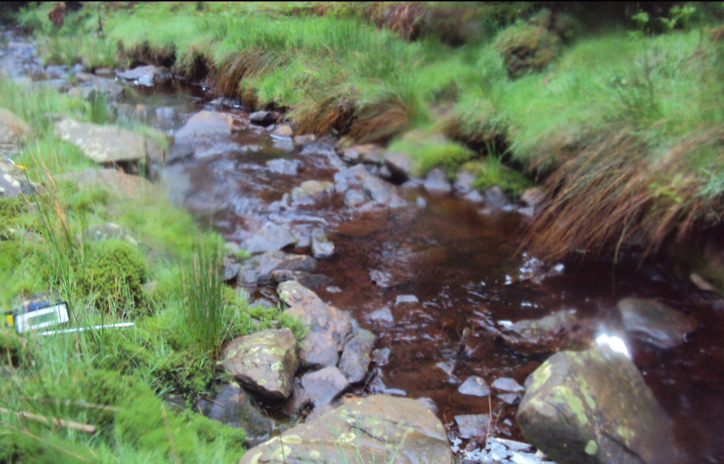
Figure 2.6: Typical channel hydromorphology in the reference reach
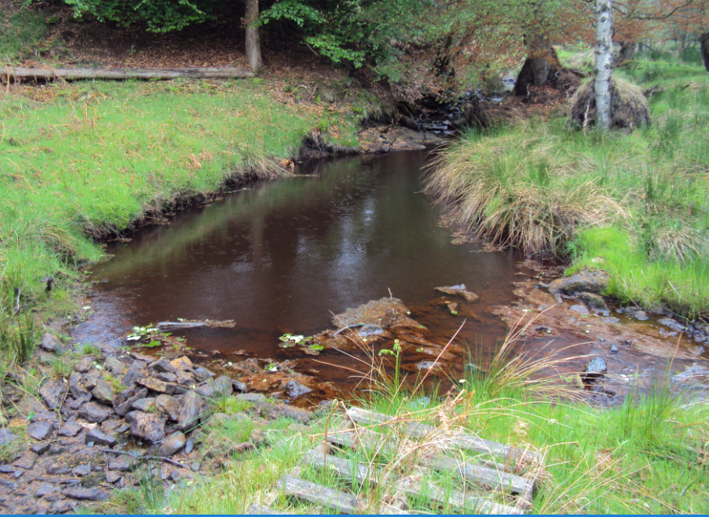Figure 2.7: The ‘weir’ and associated impoundment upstream

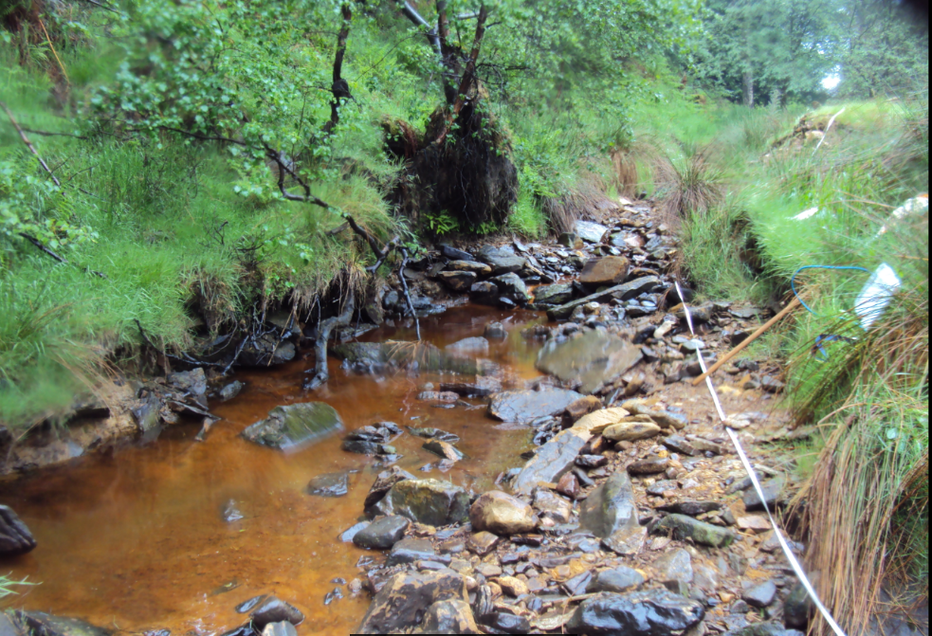
Figure 2.8: Typical channel hydromorphology in the depleted reach
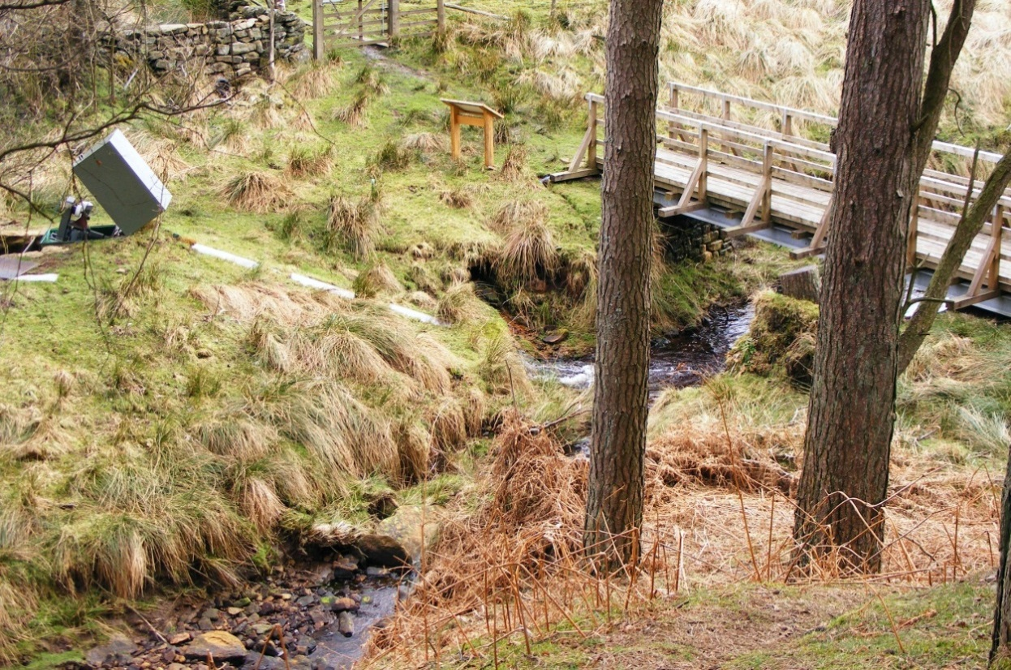Figure 2.9: Depleted reach (foreground) and turbine

2.2.2 Lowna Mill
Location: | Lowna Farm, Kirkbymoorside,  North York Moors National Park
River: | Dove
NGR: | SE 68748 90977
Altitude: | 78 m AOD
Slope: | 5.6 m/km
Distance from Source: | 20.4 km
Turbine Type: | Overshot waterwheel
Installed Capacity (Output): | 2.6 kW
Max. quantity of abstraction: | 0.31 m³s⁻¹
HOF | : Not subject to any flow or level restrictions
Date(s) of sampling: | 25 & 26/06/2010
Flow conditions: | Normal/low
Total / mean / range rainfall preceding five days: | 0 mm / 0 mm / 0 mm
Sampling conditions: | Fair & dry
* Rainfall data from EA Normanby rainfall gauge
Summary
The disused waterwheel at Lowna Mill was replaced by a new overshot wheel in 2008 by MannPower Consulting Ltd. Channels from the original mill were reopened and abstraction restarted. A head of 2 m provides 2.6 kW of power to three privately owned farms buildings, now holiday cottages. The scheme generally runs continually throughout the year (Ruth Wass, pers. comm.).
A large shallow-sloping weir creates the impoundment and marks the start of the 113 m long depleted reach. A small channel cut through the weir provides the residual flow down the depleted reach in times of lower flow. No fish pass is present as it is thought that fish can pass across the weir. No HOF exists on the 2007 abstraction licence. The turbine was in operation when the site was sampled.

Hydromorphological features
Lowna Mill is located on the River Dove in the North York Moors, UK. The Dove drains a rural catchment with moorland headwaters, formed on Jurassic limestone, clays and sandstone. Similarly to Bonfield Ghyll, the Dove is characterised by natural pool/riffle sequences typical of a second-order stream.
Limited physical modification is present in the Dove catchment – partly due to its rural location. Within the study area, historical modification in the form of the old mill and associated weir and mill leat pre-dates 1790 (Ruth Wass, pers. comm.). No modification or reinforcement exists in the reference reach. The weir is stone built (Figs. 2.13 & 2.14). In the depleted reach the left bank is reinforced with a stone wall from the weir to approximately 10 m downstream, footed by natural substrate (see Figure. 2.16). Bank reinforcement is present in the lower 20 m of the depleted reach on the right bank, forming a stable bank for farm buildings. Again, the stone wall is footed by natural substrate.
Channel features include submerged bedrock, submerged boulders and submerged tree roots along the course of the study reaches. Exposed bedrock, boulders and tree roots are present in the depleted reach. Marginal and bank features in both reaches include stable and eroding cliffs, due to the flashy nature of the catchment. Side bars are also present in both reaches (e.g. Figure 2.16). A mid-channel island is present in the depleted reach, approximately 5 m downstream the weir.
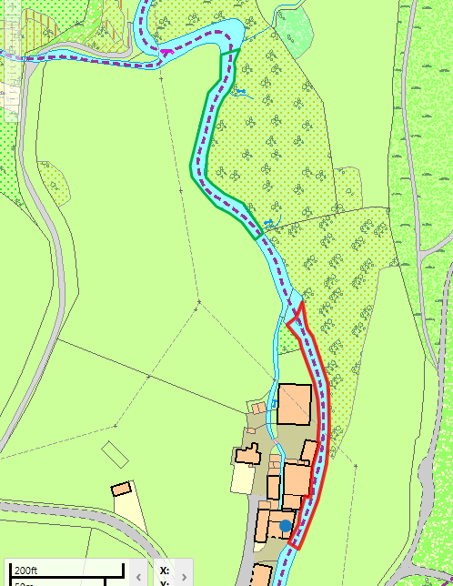
Direction of flow
N
Figure 2.10: Site map of Lowna Mill study area. Red = Depleted reach. Green = Reference reach. Blue circle = turbine location

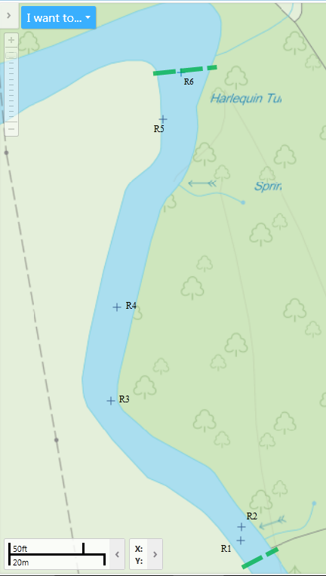
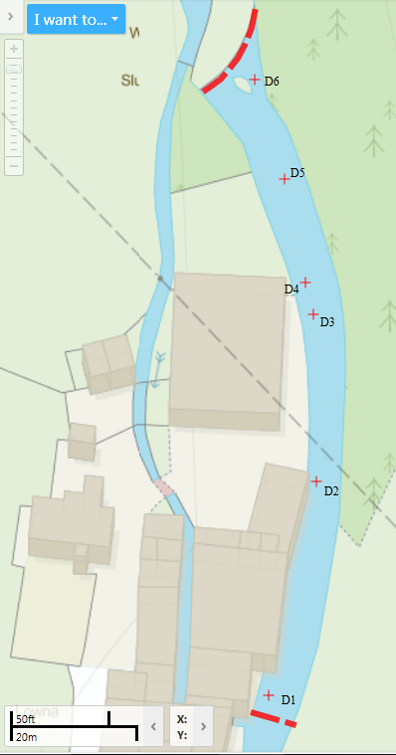
Figure 2.11: a) Lowna Mill reference reach and associated sample points b) Lowna Mill depleted reach and associated sample points
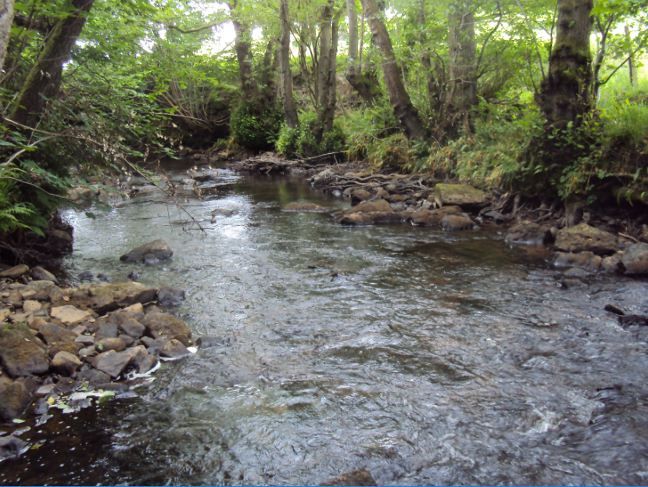
Figure 2.12: Typical channel hydromorphology in the reference reach at Lowna Mill (facing upstream)
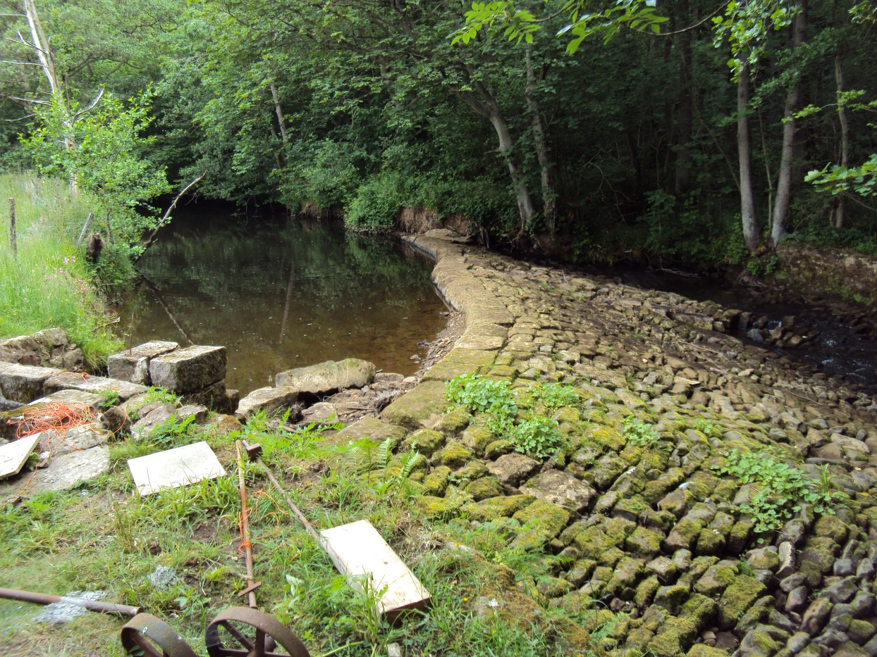
Figure 2.13: Lowna Mill weir and associated impoundment upstream
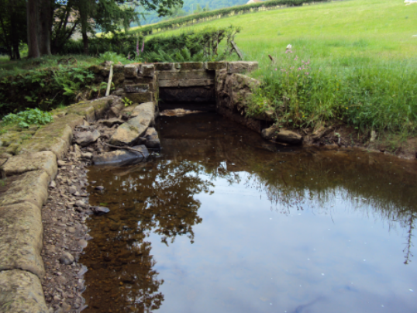
Figure 2.14: Sluice gate leading the leat off from the weir
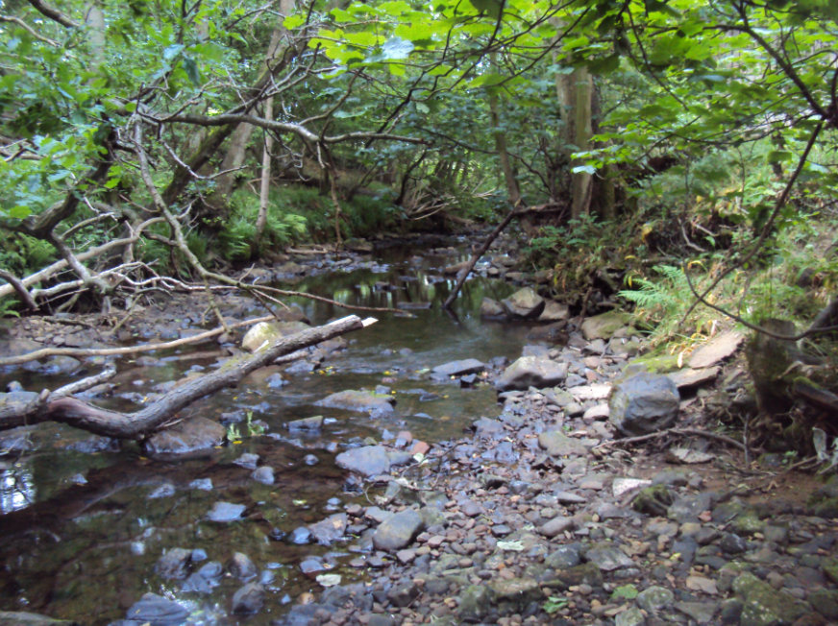
Figure 2.15: Typical channel hydromorphology in the depleted reach at Lowna Mill (facing downstream)
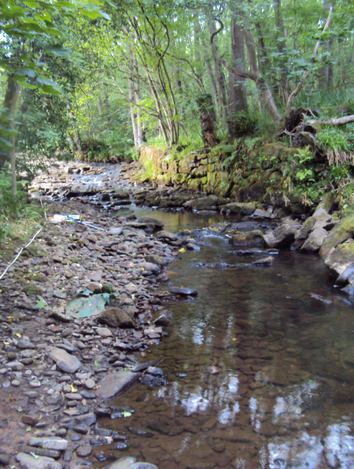
Figure 2.16: Typical channel hydromorphology in the depleted reach at Lowna Mill (facing upstream)

2.2.3 New Mills
Location: | Torrs Hydro New Mills, High Peak, Derbyshire
River: | Goyt/Sett confluence
NGR: | SK 00099 85235
Altitude: | 135 m AOD
Slope: | 3.4 m/km
Distance from Source: | 21.7 km
Turbine Type: | Archimedean screw
Installed Capacity (Output): | 63 kW
Max. quantity of abstraction: | 3 m³s⁻¹
HOF: | 72 m³s⁻¹
Date(s) of sampling: | 26 & 27/07/2010
Flow conditions: | Normal/low
Level of abstraction: | 0 m³s⁻¹ (turbine not abstracting on day of sampling)
Total / mean / range rainfall preceding five days: | 4 mm / 0.8 mm / 0 – 2.4 mm
Sampling conditions: | Cloudy with patchy drizzle
* Rainfall data from EA Kinder Filters rainfall gauge
Summary
The Archimedean screw turbine at New Mills is located immediately downstream the confluence of the Goyt and Sett rivers in Derbyshire, set within a 30 m deep sandstone/gritstone gorge. The town has a strong industrial heritage and five water-powered mills were historically located along the river in the gorge. Torr Mill was built in 1794 as a small water-powered cotton mill and converted to a steam-powered five-storey mill in 1846. It was destroyed in 1912. The micro-hydropower scheme is “on-weir” – the screw was retrofitted to the existing Torr weir and does not have an extensive tailrace. The depleted reach is 18 m, split in half by the presence of the 3 m-high weir.
It was installed in 2008 by Western renewable Energy and MannPower Consulting Ltd. It is managed by the Torrs Hydro New Mills community project, a volunteer-led society. Power produced is used by the local Co-operative store, and any surplus is sold back to the National Grid. The resulting funds are used to finance future renewable projects.
The micro-hydropower scheme typically runs continually throughout the year, with more intermittent use in the summer months when flows fall below the HOF level of 72 m³s⁻¹. The abstraction licence dictates that a minimum of 3.7 cm depth of water must be kept over the weir at all times. An Alaskan fish pass is installed parallel to the turbine between the turbine and the river channel. The turbine was not in operation when the site was sampled due to the river being below the HOF.
The River Goyt is a much larger river than the Sett, which joins the Goyt approximately five metres upstream the abstraction point. At each site visit it was evident that the flow from the Goyt was being pulled across the top of the weir and directed to the hydropower intake. The Goyt was much more similar in character to the river downstream the weir than the Sett. The very close proximity of the confluence, lack of mixing zone before the weir and the much greater relative contribution the Goyt contributed to the site, combined with the closer similarity between the Goyt and rest of the river downstream informed the decision that the reference reach would be located in the Goyt rather than the Sett.
Hydromorphgological Conditions
New Mills is located at the confluence of the Rivers Goyt and Sett in Derbyshire, UK. The catchment rises in the Pennines. The headwaters are rural moorland peat-covered slopes; the lower catchment geology is predominantly a mix of millstone grit and boulder clay. The catchment is primarily rural with industrial towns lower down the valley (including New Mills). The Errwood and Fernless potable water supply reservoirs are located on the Goyt approximately 11 km upstream the New Mills site, which stabilise the natural moorland flow. Limited physical modification is present above these reservoirs due to the rural moorland nature of the catchment.
Physical modification in the reference reach includes reinforcement and resectioning by a tall stone wall on the left hand bank (Fig. 2.21 – although the wall is covered by bankside vegetation). A footpath runs parallel to the right hand bank - the bank material is natural boulder clay at the base of the gorge with no reinforcement. The depleted reach includes stone reinforcement and resectionining on the right-hand bank, as well as the presence of the weir as a modification and artificial feature. Left hand bank material in the depleted reach is formed from fallen boulders from the gorge. Channel features in both the depleted and reference reaches include exposed and vegetated boulder at the time of sampling. Both reaches were predominantly unshaded.

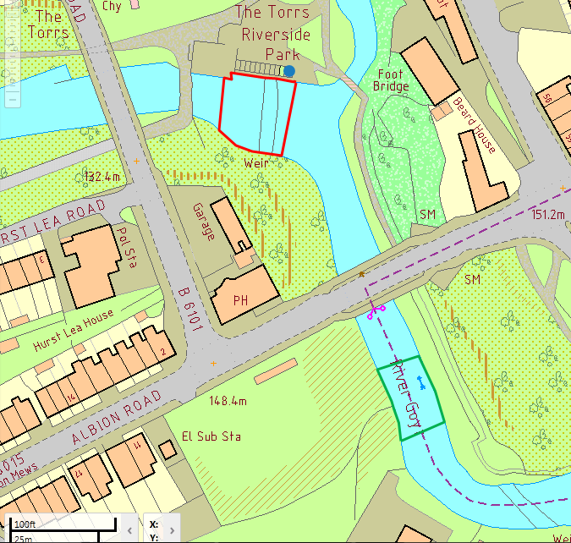 Figure 2.17: Site map of New Mills study area. Red = Depleted reach. Green = Reference reach. Blue circle = turbine location
Direction of flow
N

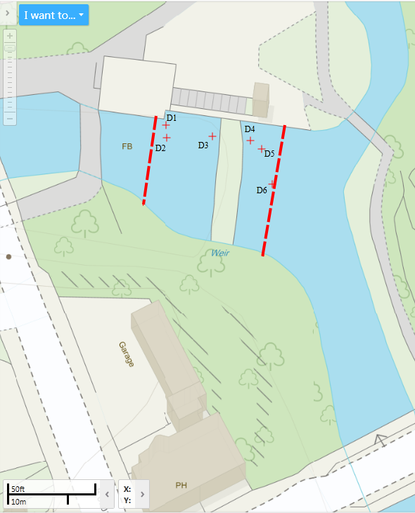
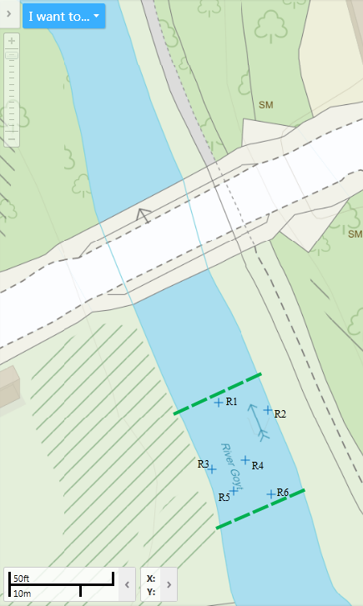
Figure 2.18: a) New Mills reference reach and associated sample points b) New Mills depleted reach and associated sample points
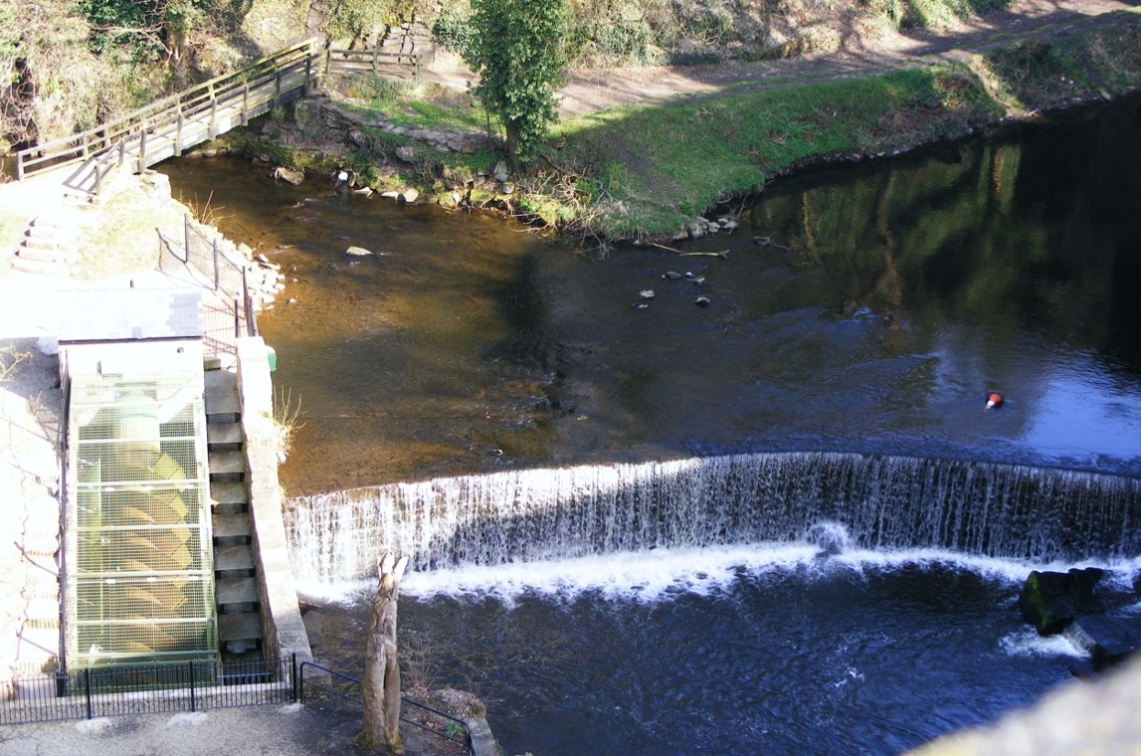
Impoundment
Turbine
Depleted reach
Abstraction point
Figure 2.19: New Mills, facing upstream (day of sampling)
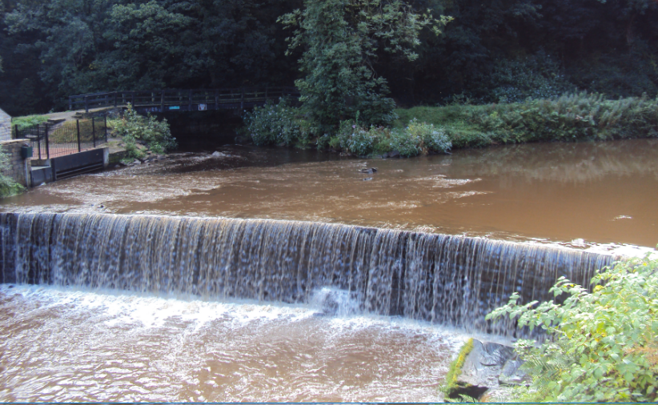
Figure 2.20: New Mills, facing upstream (during higher flow conditions - not on day of sampling)

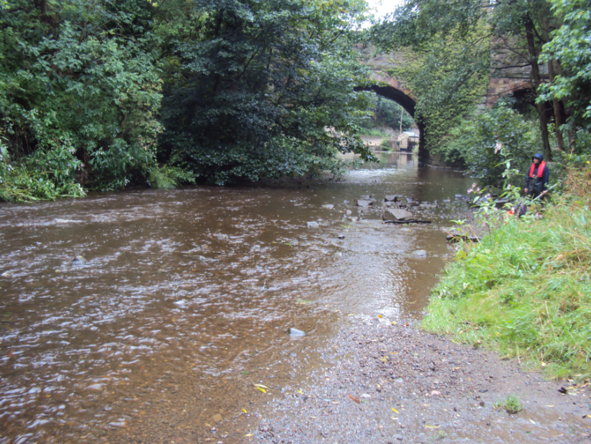
Figure 2.21: Typical channel hydromorphology in the reference reach at New Mills (day of sampling)
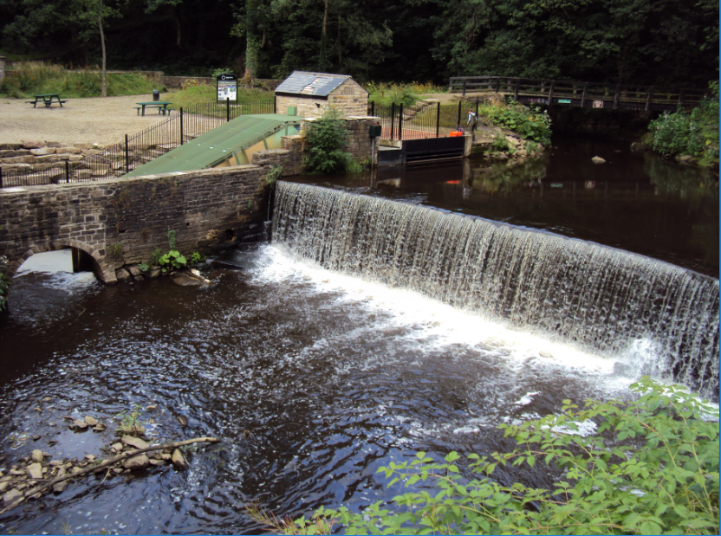
Figure 2.22: Depleted reach at New Mills (day of sampling)
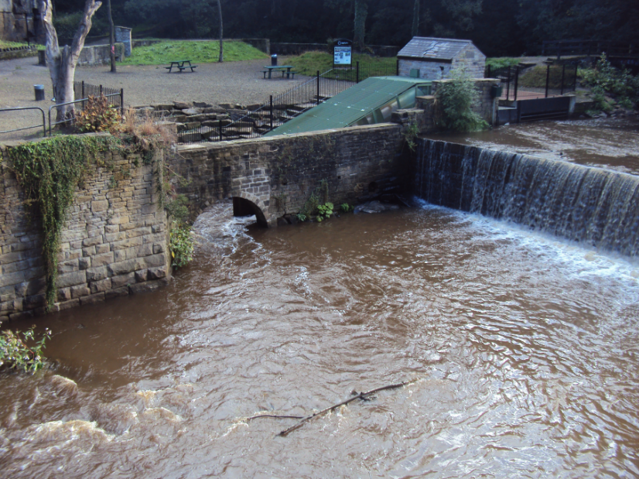
Figure 2.23: Depleted reach and tailrace when turbine active
(during higher flow conditions - not day of sampling)

2.2.4 Settle
Location: | Bridge End Mill weir, Settle,  Yorkshire Dales National Park
River: | Ribble
NGR: | SD 81745 64128
Altitude: | 145 m AOD
Slope: | 6.5 m/km
Distance from Source: | 30 km
Turbine Type: | Archimedean screw
Installed Capacity (Output): | 45 kW
Max. quantity of abstraction: | 2.86 m³s⁻¹
HOF: | 0.90 m³s⁻¹
Date(s) of sampling: | 05 & 06/07/2010
Flow conditions: | Normal/low
Level of abstraction: | 0 m³s⁻¹ (turbine not abstracting on day of sampling)
Total / mean / range rainfall preceding five days: | 6.2 mm / 1.24 mm / 0 – 6.2 mm
Sampling conditions: | Cloudy & dry
* Rainfall data from EA Stainforth rainfall gauge
Summary
The 45 kW capacity Archimedean screw was installed in December 2009 by MannPower Consulting Ltd. and Water Power Enterprises. The scheme is a community-based project, managed by Settle Hydro Ltd. The River Ribble is a fast-flowing and highly responsive upland river with a catchment size of 124 km². It is primarily a salmonid river and supports an excellent juvenile and spawning habitat in the headwaters (Kibel, 2008).
The existing Bridge End Saw Mill (now disused) weir, leat and abstraction point were utilised in the micro-hydropower scheme, with a new discharge point created further upstream than the original. The depleted reach is approximately 26 m long. A pool and weir fish pass has existed on the 2.1 m high weir since the 1960s. Due to the necessity of maintaining at least 100 L/s of water flowing down the fish pass, the HOF is set at 900 L/s. Below this level the scheme must cease operation. The turbine was not in operation when the site was sampled due to low flow conditions.

Hydromorphological conditions
The River Ribble catchment drains part of the Yorkshire Dales National Park, UK, in a predominantly moorland catchment (including Pen-y-Ghent). The geology in the stretch upstream Settle is predominantly limestone. The Ribble at this location is typical of a fourth-order upland river, relatively wide and shallow with heterogeneic flow and channel bed habitats. Primary land use of the area upstream of Settle is grassland, used for improved pasture (sheep grazing).
Relatively limited physical modification exists between Settle and the upstream source in the Yorkshire Dales. Land use to the right hand side of the reference reach is a football pitch and the right bank has historically been resectioned and partially reinforced with a stone retaining wall (Fig. 2.27) to reduce loss of bankside material. No other physical modification exists in the reference reach. The left hand bank has been poached by sheep grazing, leading to collapsed terraces. Modification in the depleted reach includes resectioning and reinforcement on both sides – the right hand bank is supported by a small stone wall and the left hand bank comprises of the concrete walls of the fish pass plus the wall containing the Archimedean screw channel (Figs. 2.29 & 2.30).
Channel features in the reference reach include exposed boulders and cobbles, plus a side bar on the left hand bank (Fig. 2.26). Depleted reach features include exposed bare and vegetated bedrock.

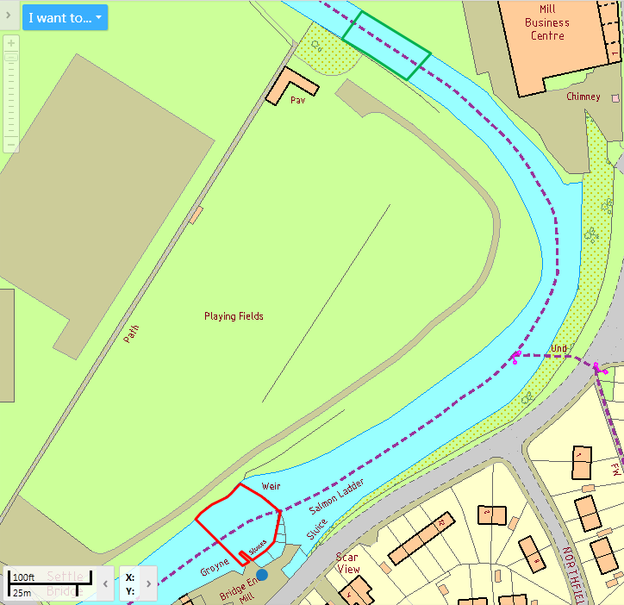
Direction of flow
N
Figure 2.24: Site map of Settle study area. Red = Depleted reach. Green = Reference reach. Blue circle = turbine location

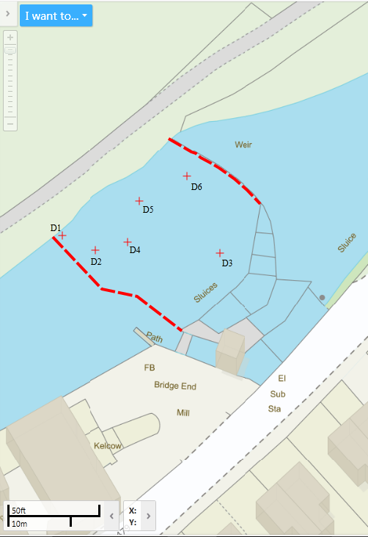
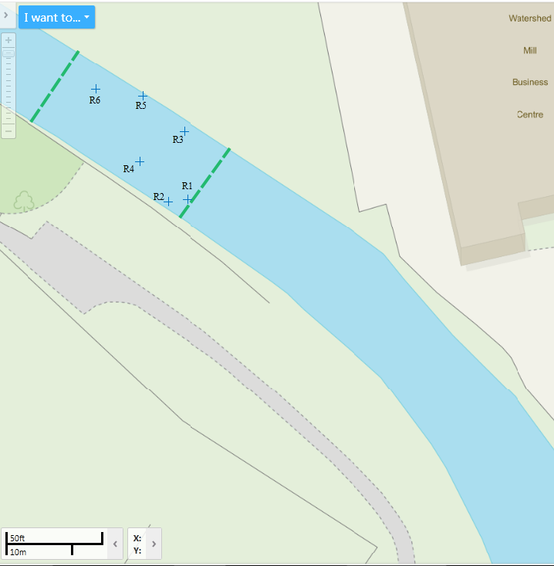
Figure 2.25: a) Settle reference reach and associated sample points b) Settle depleted reach and associated sample points
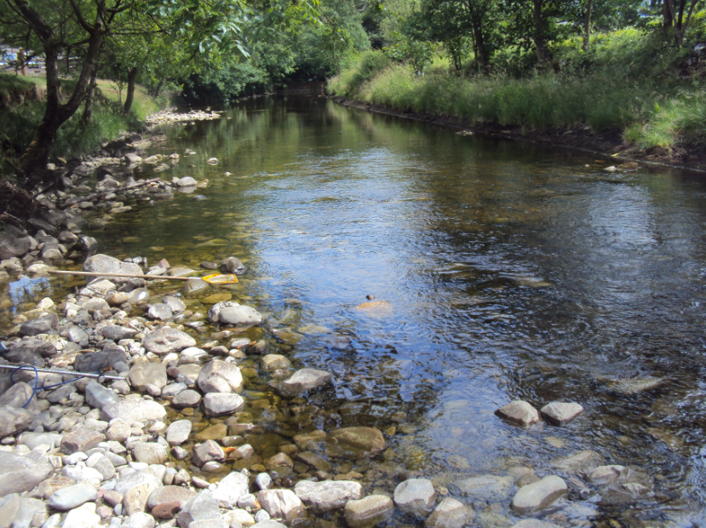
Figure 2.26: Typical channel hydromorphology in the reference reach at Settle (facing downstream)
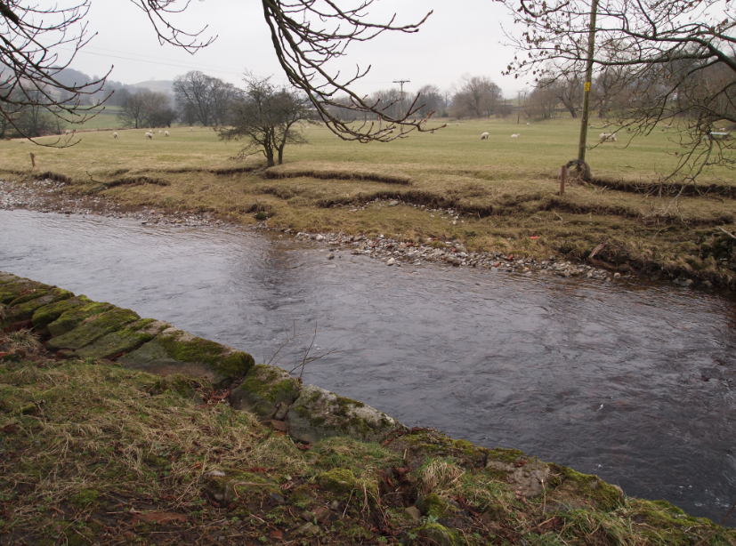Figure 2.27: Typical channel hydromorphology in the reference reach at Settle (facing upstream)
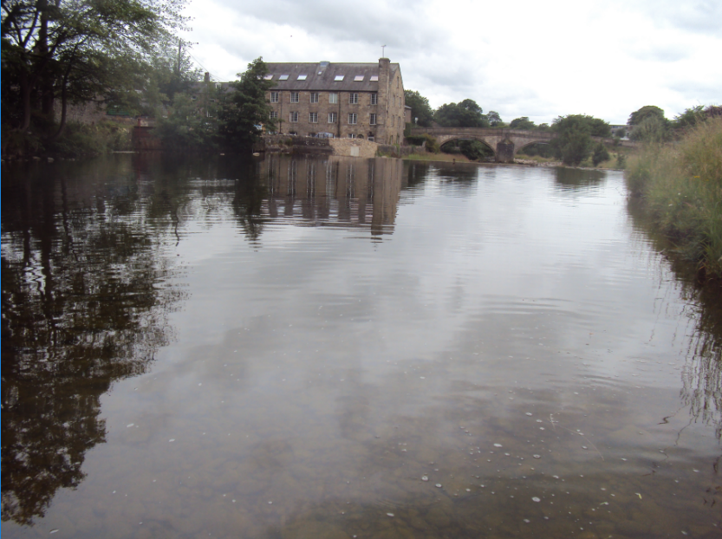
Figure 2.28: Weir impoundment at Settle, facing downstream (white dashed line denotes position of weir crest)
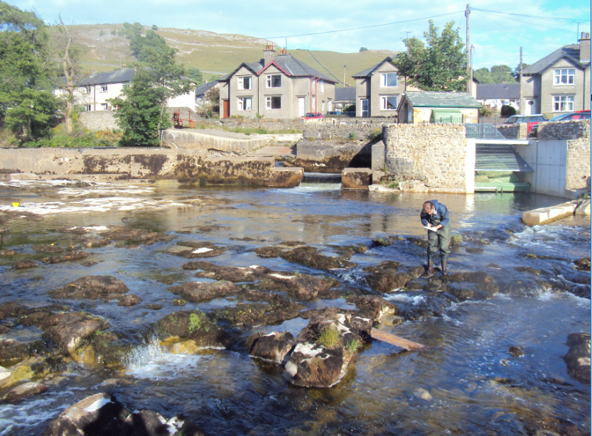
Weir
Turbine
Fish pass
Figure 2.29: Typical channel hydromorphology in the depleted reach at Settle (facing upstream) (day of sampling)
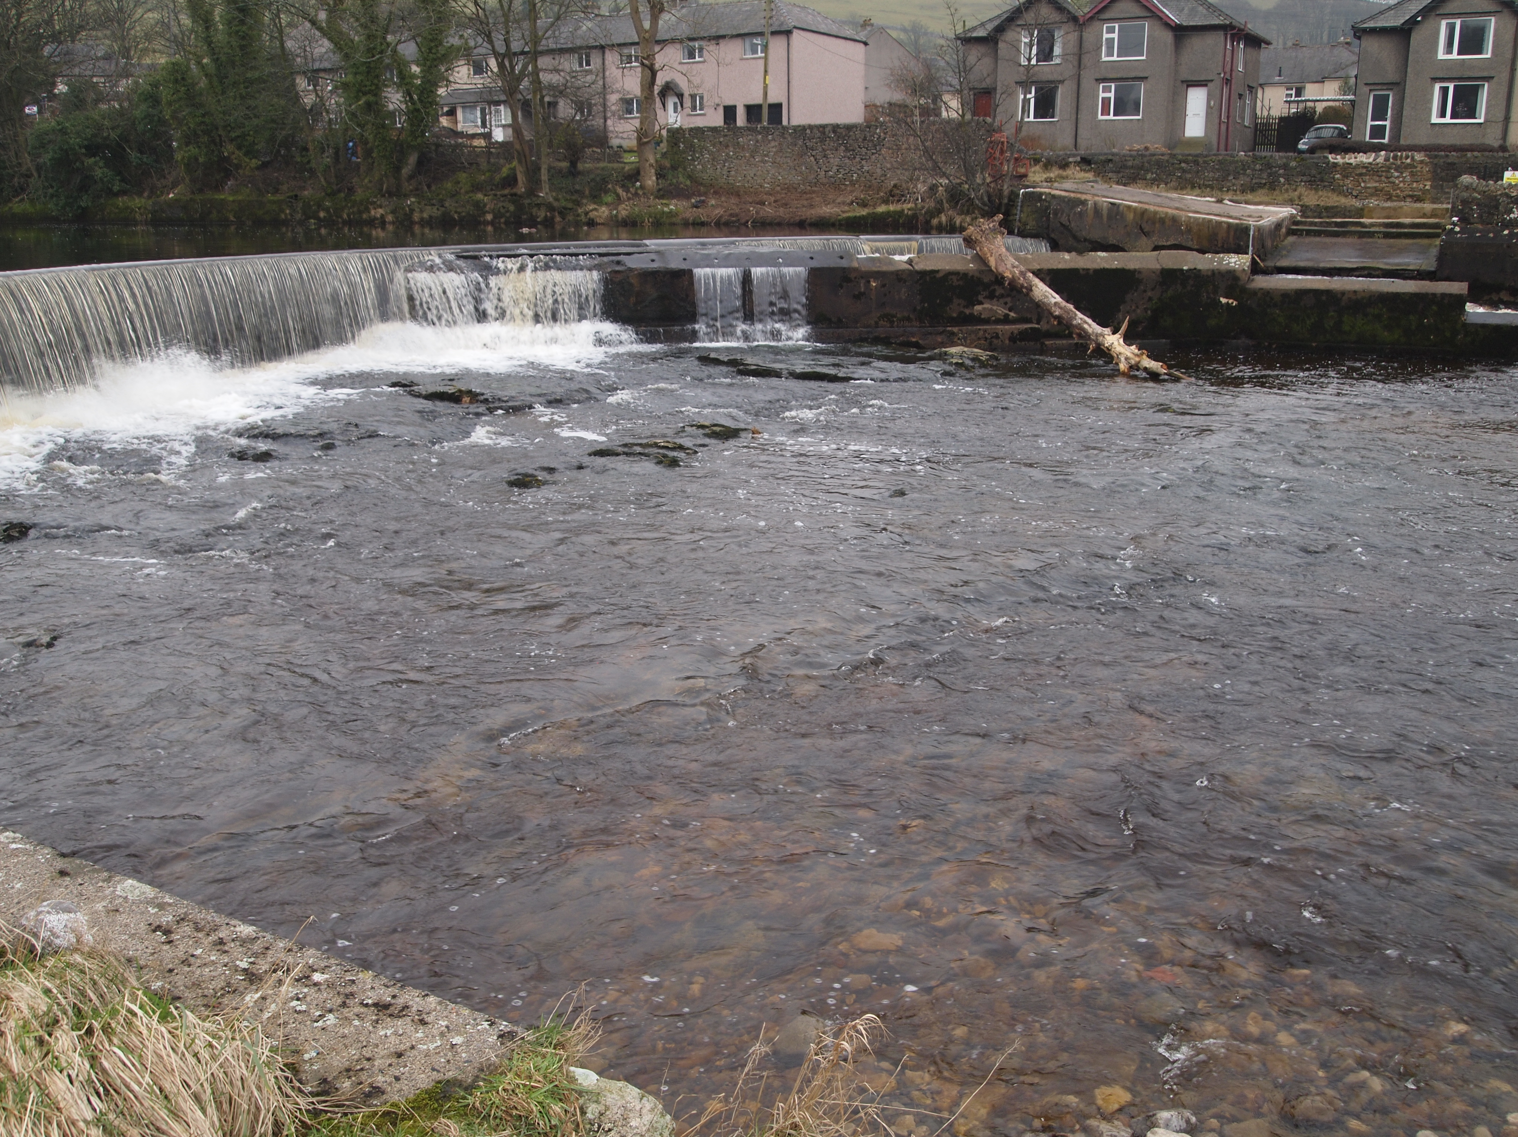 Figure 2.30: Typical mid-high flow channel hydromorphology in the depleted reach at Settle (Feb. 2011 - not on day of sampling)

2.2.5 Alport Mill
Location: | Alport, near Bakewell, Peak District National Park
River: | Lathkill
NGR: | SK 22226 64654
Altitude: | 120 m AOD
Slope: | 15.2 m/km
Distance from Source: | 7.2 km
Turbine Type: | Crossflow
Installed Capacity (Output): | 30 kW
Max. quantity for abstraction: | None specified
HOF: | 120 l/s
Date(s) of sampling: | 12 & 13/07/2010
Flow conditions: | Normal/low
Level of abstraction: | 0 m³s⁻¹ (turbine not abstracting on day of sampling)
Total / mean / range rainfall preceding five days: | 5.6 mm / 1.12 mm / 0 – 2.8 mm
Sampling conditions | : Cloudy with light rain
* Rainfall data from EA Ashford Hall rainfall gauge
Summary
The crossflow turbine at Alport Mill was installed in June 2009 by Derwent Hydro Ltd. It has a 30 kW per hour installed capacity (output) from a head of 4.2 m. The River Lathkill has a predominantly limestone catchment. It is joined by the River Bradford approximately 250 m above the abstraction point. Substrate primarily consists of tufa, a precipitate of calcium-carbonate in running water.
The new micro-hydropower scheme was built on the site of an old watermill used for corn-grinding until the 1970s (Haddon Estates, 2011) and is owned by Haddon Estates. Water is abstracted from behind the weir, channelled through a 36 m buried pipe and passed through the turbine before being discharged to the river via a 46 m-long open tailrace. The resultant depleted stretch is approximately 88 m long.
The HOF for the scheme is set at 120 l/s – when the river flow falls below this level the abstraction must cease. In previous years this has usually resulted in continued use for most of the year except the summer months, namely June-August (Warren Slaney, pers. comm.). The turbine was not in operation when the site was sampled due to low flow conditions.
The economically and historically important Haddon Estate fisheries is located immediately downstream of the abstraction, but due to the tall height of the weir (4 m) the scheme does not require a fish pass – it is assumed this is a barrier to both upstream and downstream passage. Instead, a self-cleaning fine screen (1 mm mesh) is located at the abstraction point.
Hydromorphological conditions
The Lathkill rises is groundwater fed from a spring in the White Peak area of the Peak District National Park, UK. It rises from carboniferous limestone and flows through Lathkill Dale (part of the Derbyshire Dales National Nature Reserve). The slope flattens out as the river reaches Alport and is joined by the River Bradford. Some reaches of the Lathkill and Bradford are seasonally intermittent due to natural fissures in the limestone bedrock but also due to historical lead mining activity in the area, creating drainage channels and soughs. The study area, however, is not directly subject to these impacts and flow remains perennial.
The study area at Alport is downstream the Bradford and Lathkill confluence. The reference reach is typical of a second-order rural stream, relatively wide and shallow with heterogenic flow habitats including riffle and run sequences, and heterogeneic substrates.
In both the reference and depleted reaches, channel features include exposed and vegetated tufa boulders and submerged tree roots. Large macrophyte beds are present in the depleted reach (Figs. 2.37 & 2.38). Stone wall bank reinforcement is present at locations in both reaches; primarily on the right hand bank in the upstream section of the reference reach and in the upstream half of the depleted reach. Two very small weirs (<50 cm) are present in the middle reaches of the depleted reach (Fig. 2.37). These are present to keep a sufficient depth of water for the fish populations in the reach – the fishing of which generates income for the land-owner (Warren Slaney, pers. comm.). A small arched stone bridge exists just downstream of the upstream reach but this did not form part of the study area.

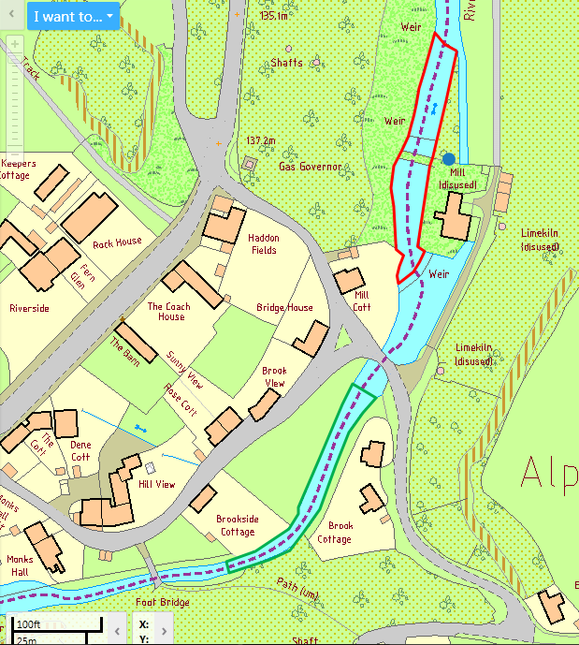
Direction of flow
N
Figure 2.31: Site map of Alport Mill study area. Red = Depleted reach. Green = Reference reach. Blue circle = turbine location

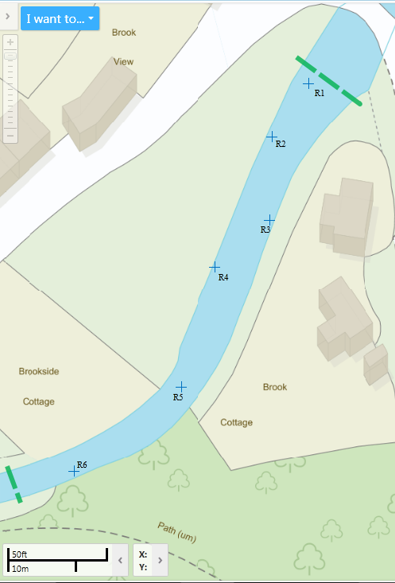
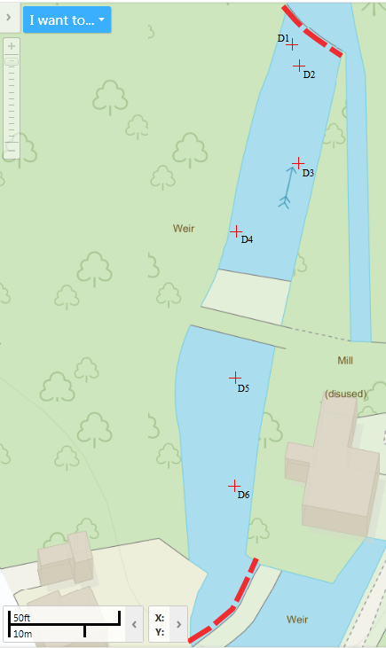
Figure 2.32: a) Alport Mill reference reach and associated sample points b) Alport Mill depleted reach and associated sample points
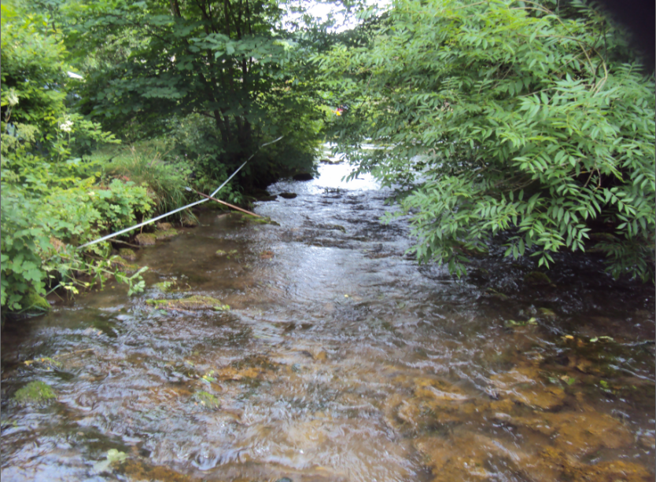
Figure 2.33: Typical channel hydromorphology in the reference reach at Alport Mill (facing upstream)
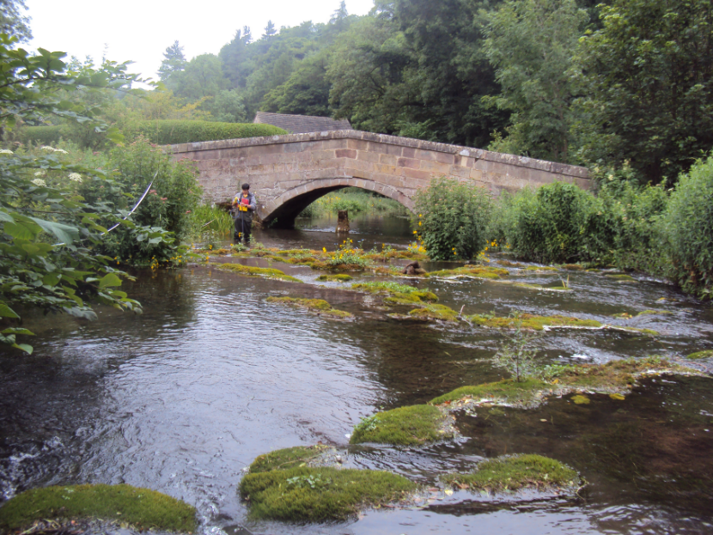
Figure 2.34: Typical channel hydromorphology in the reference reach at Alport Mill (facing downstream). The weir impoundment is the downstream side of the bridge
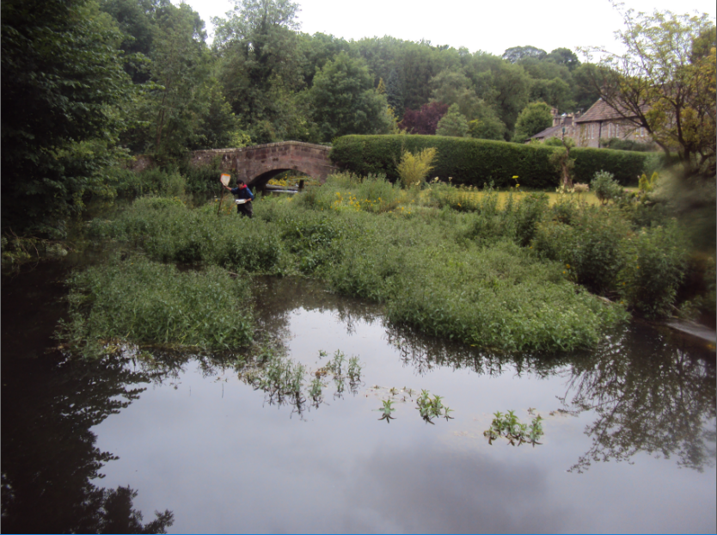
Figure 2.35: Weir impoundment at Alport Mill (facing downstream). White dashed line denotes position of weir crest

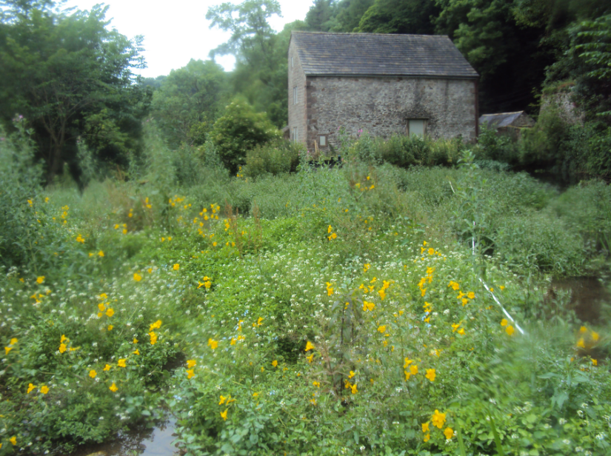
Figure 2.36: Weir impoundment at Alport Mill (facing downstream). White dashed line denotes position of weir crest

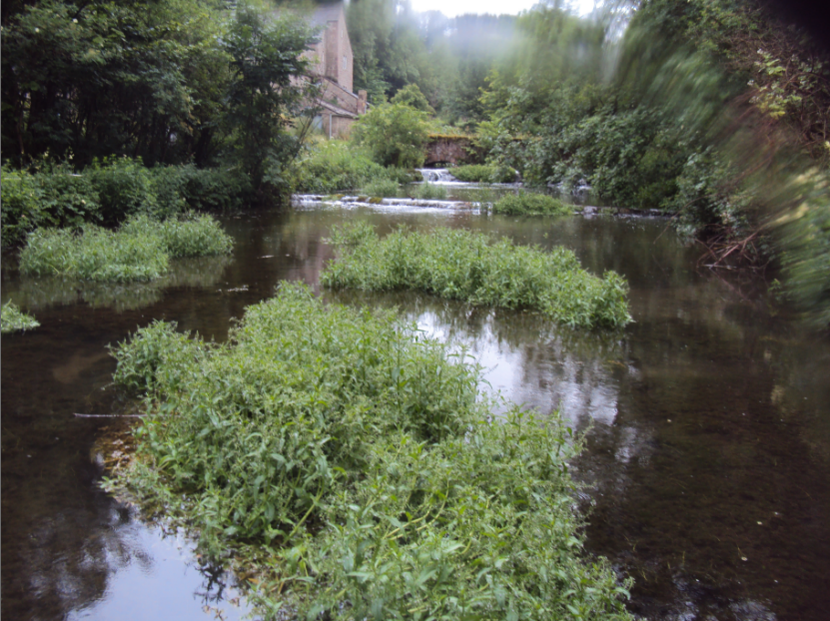
Figure 2.37: Typical channel hydromorphology in the depleted reach at Alport Mill (facing upstream)
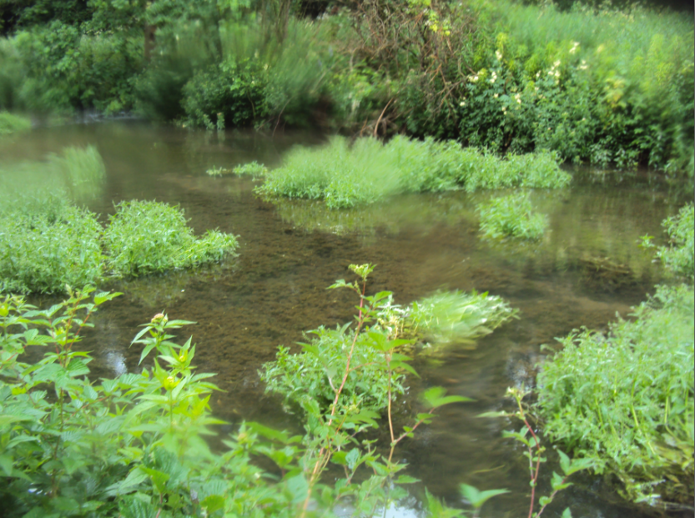
Figure 2.38: Typical channel hydromorphology in the depleted reach at Alport Mill (facing upstream)

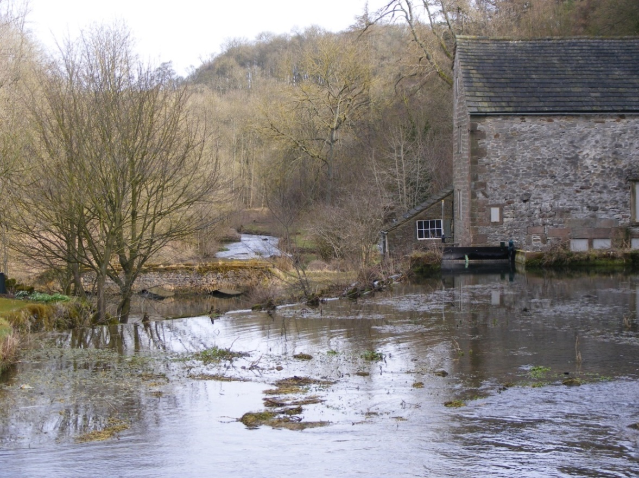 Figure 2.39: Weir impoundment at Alport Mill (facing downstream) during winter months. White dashed line denotes position of weir crest
Impoundment
Abstraction point
Depleted reach
Weir crest

2.3 Summary
The five sites selected for this study are all micro-hydropower schemes in England and installed between 2007 and 2009. Head heights range from two to four metres, although maximum kW output range is much wider (from one to 63 kW) and depleted reach lengths range from 17 to 113 metres. Four turbines are low-rotation – three Archimedean screws and one wheel. The remaining site has a high-rotation crossflow turbine. Four different sites are situated in rural areas, with one in an urban setting.
Bonfield Ghyll, New Mills and Settle all share the same type of turbine; therefore it could be reasonable to expect that these sites would have similar types of ecological impact. The same consultant was involved in the design and installation of these three sites (MannPower Consulting Ltd.). However, New Mills is located in an urban area, which may alter any potential impacts when compared to the other two Archimedean screw sites. The two sites most similar to each other biogeographically are Bonfield Ghyll and Lowna – both are situated in upland rivers in the North York Moors National park. The maximum kW outputs from these schemes are similar to each other and substantially lower compared with the other three sites.
The study sites represent a range of locations, turbine types and conditions of use (HOF variations, design flow, kW output etc.). This assessment of whether any ecological implications arise from the use of micro-hydropower schemes is unique, and a range of study sites provide a good basis on which to investigate any impact. There are also different permutations of similarities between sites, which may help further highlight any consistent impacts that may occur.
Chapter 3 – The effect of micro-hydropower on in-stream habitat
3.1 Introduction
The role of flow as a key determinant of river habitat and its resultant effects on biodiversity was reviewed in Chapter One (Section 1.4.2). The link between flow, in-stream habitat variables and ecological structure and functioning of freshwater ecosystems has been widely researched and discussed (Poff et al., 1997; Bunn & Arthington, 2002; Growns, 2008). However, there is a major gap in the information available on the effects of micro-hydropower on in-stream habitat and flow variables (Chapter 1). The present study aims to address this knowledge gap by comparing in-stream river habitat between upstream and depleted reaches of river associated with micro-hydro schemes.

3.1.1 The potential for micro-hydropower to affect in-stream habitat
The two key components of micro-hydropower likely to cause ecological change are abstraction and impoundment (Section 1.4). The impacts of these two separate pressures on habitat and flow morphology are current research themes, detailed below.
Results from the few existing studies of abstraction and impoundment from diversions or low-head dams suggest a number of changes to measures of habitat and flow in the depleted reach or downstream of a dam. Decreased water depth, velocity, wetted width and substrate sizes have been identified as consistent responses to reduced flow from various causes (Dewson et al., 2007a). However, the variable nature of river channel morphology means changes are not always consistent. Both Tiemann et al. (2004) and Alexandre & Almeida (2010) examined habitat responses to the presence of either weirs or low-head dam-type structures. Along with decreased depth which corresponds with previous work, both studies found an increase in velocity downstream of the structures compared with upstream reference reaches which is contrary to other work. Changes in physicochemical properties were also much more variable and inconsistent than physical habitat and flow conditions in the studies reviewed by Dewson et al. (2007a).
Recent work by Baker et al. (2011) found diversion of water in low-head streams caused significantly decreased velocity and wetted width, and increased slow flow habitat and fine sediment deposition downstream of diversions in comparison to upstream reference reaches at ten study sites. A strong positive correlation between percentage water diversion and slow flow habitat in this study supports the suggestion that although micro-hydropower may operate at a smaller magnitude to larger scale hydropower and the resultant habitat changes are on a smaller scale, these changes are still significant.
Arle (2005) demonstrated that a low-head dam significantly decreased water depth, velocity and resulted in less variation in velocity downstream. Substrate was more homogenous downstream of the dam in comparison to the upstream reference reach, and was dominated by silt and fine sand. The study confirmed that due to the decreased size of the dam (<3.10 metres, exact size not stated), impacts on habitat and flow were localised rather than having implications reaching far-downstream, as has been found at larger dams.
No previous studies have specifically addressed the response of habitat and flow variables to the presence of micro-hydropower schemes. A key unknown is the impact on the depleted reach. Although the above work by Arle (2005) suggests there is a greater potential for a localised impact from the smaller scale of micro-hydropower than from larger hydropower schemes, previous studies have nonetheless shown there is still potential for significant disruption to natural processes.

3.1.2 Aims and Objectives
The aim of the work described in this chapter was to determine whether there were consistent differences in the habitat (water chemistry, flow characteristics, bed conditions) between the depleted reach of the channel and reference conditions (upstream of the weir pool) at each micro-hydropower installation.
The questions were:
- Is there any evidence that habitat conditions in the depleted reach created by the micro-hydropower and the upstream reference reach are significantly different?
- To what extent are any changes consistent across different micro-hydropower schemes?

3.2 Methods
3.2.1 Sampling strategy
The five study sites and the river and operating condition of the micro-hydropower turbine at the time of sampling are outlined in Chapter Two.
In-stream habitat and water quality were characterised in the depleted reach and reference area upstream of the weir pool at all five study sites in June/July 2010 (Section 2.2). Samples were collected on a single occasion temporally. This was deemed sufficient in order to answer the initial question of whether there was any evidence that habitat conditions were different between the upstream reference and the depleted reach at each site. Repetitive samples would have provided more data to answer whether there was evidence that habitat conditions were different over a period of time, but that was not the focus of this Chapter. Despite being collected from different study sites on different days and sampling conditions, all were taken within a six and a half week period in the summer months. This short time period was relatively stable with no notable peak flow events between sampling dates, ensuring data are comparable.
Study reaches ranged between 18 m and 113 m length, dependent on paired depleted stretch length at each different study site. Percentage substrate composition, flow type composition and wetted width were recorded at six different randomly-assigned sampling points (1 m² grid squares – see Section 2.1.3) at each area using visual assessment. Substrate and flow composition were estimated using RICT (River Invertebrate Classification Tool) guidelines (SEPA, 2015) by assigning either substrate or flow within the 1 m² sampling area to one of seven substrate or flow categories (Tables A1 and A2 in Appendix). Descriptive substrate categories were assigned a relevant phi size using the standard algorithm provided in RICT (WFD-UKTAG, 2008). See Table A3 (Appendix) for substrate categories and corresponding sizes (millimetres and phi).
Depth and velocity measurements were taken from three locations selected within each 1 m² sampling point. Velocity measurements were taken at 60% depth from the surface and calculated to a resolution of 0.001 ms⁻¹ using the mean of a 30 second reading at each individual point within the 1 m² area, with a Valeport Electromagnetic flow meter (model no. 801). The minimum depth for velocity measurements was 4 cm.
Mean temperature (± 0.1 °C), conductivity (± 0.1 mScm⁻¹), pH (± 0.01 units) and dissolved oxygen (± 0.01 mgL⁻¹or %) data were collected in triplicate at three equidistant locations in each study reach before any other sampling commenced. Hand-held meters were used: temperature and pH data collected with Hanna Meter H1991300, conductivity data using Hanna Meter HI9033 and dissolved oxygen data using Hanna Meter HI9146.
After a reach had been sampled, hydromorphology data were collected using a modified River Habitat Survey (RHS) form (Environment Agency, 2003). This method incorporated elements of the spot-checks and sweep-up techniques used in RHS in order to capture the hydromorphological variation of the reach – the full reach was visually assessed for overall substrate composition, flow habitats, shading, macrophyte cover, bed stability, channel modification, channel features, marginal and bank features (material, types of bars / cliffs etc.) and presence of artificial features (weirs, bridges etc.). These data were used to inform the site descriptions in Chapter 2.
3.2.2 Data analyses
Analyses were carried out comparing depleted versus reference area comparisons at all five study sites individually and the relative differences at each site were compared to allow a cross-site evaluation.
Mean velocity, depth and wetted width data were loge(+1) transformed before any statistical analysis. Substrate proportions were arcsin transformed before mean phi sizes were calculated and t-tests were performed.
Two-sample t-tests were used on water quality, habitat (velocity, depth and wetted width), mean proportional abundance of substrate types, mean phi size and mean proportional abundance of flow composition data to test the null hypothesis that no difference exists between these variables in the depleted reach created as a consequence of the micro-hydropower and upstream reference conditions.
Diversity and evenness of substrate and flow types were calculated using the Shannon Diversity and Shannon Evenness descriptive indices.
Similarities between mean velocity, depth, wetted width and phi size data from the reference and depleted reach areas for all the sites were analysed using principal components analysis (PCA).
3.3 Results
3.3.1 Water quality variables
Water temperature was reduced in the depleted reach in four of the five rivers (Table 3.1). Statistical analysis was not possible at three of these sites due to identical temperature values at one or both of the two study reaches. The reduction was slight (between 0.1 to 0.3°C) at two sites, with a more substantial decrease of 0.8°C at New Mills. Conversely, water temperature in the depleted reach was significantly higher than the reference reach at Settle.
Water pH was unchanged in the depleted reach compared with the reference reach at three sites. A significant decrease in pH in the depleted reach was evident at Settle but the opposite was true at Lowna. Conductivity was also unchanged at three sites of the four investigated. It was not possible to collect conductivity or dissolved oxygen data at Bonfield Ghyll due to equipment failure. Conductivity data were identical in reference reach of Settle so statistical analysis was not possible. However, these data indicate no substantial change in conductivity between these areas at this site.
No significant differences between dissolved oxygen data at reference and depleted reaches were evident at three of the four sites tested. Only one reading was taken at Settle reference reach so statistical analysis was not possible – however the data suggest a substantial decrease of dissolved oxygen in the depleted reach compared to reference reach.

Table 3.1: Mean (±SD) values of water quality variables at reference and depleted reaches at the five study sites. Two-tailed t-test results are also indicated.
Site | Bonfield Ghyll | Lowna | New Mills | Settle | Alport
Temperature Reference (°C) | 11.5 ± 0.00 | 16.7 ± 1.00 | 15.9 ± 0.00 | 16.9 ± 0.12 | 16.3 ± 0.00
Temperature Depleted | 11.2 ± 0.10 | 15.9 ± 0.10 | 15.1 ± 0.52 | 17.3 ± 0.06 | 16.2 ± 0.00
t-test | †² | t₂=1.44,p=0.285 | †² | t₂=5.37,p=0.033 | †¹
pH Reference | 4.86 ± 0.05 | 7.69 ± 0.05 | 7.70 ± 0.12 | 8.60 ± 0.01 | 8.28 ± 0.01
pH Depleted | 5.11 ± 0.22 | 7.86 ± 0.04 | 7.27 ± 0.61 | 8.45 ± 0.06 | 8.28 ± 0.01
t-test | t₂=1.85,p=0.205 | t₃=4.86,p=0.017 | t₂=1.20,p=0.352 | t₂=4.74,p=0.042 | t₃=0.50,p=0.651
Conductivity Reference (μS cm⁻¹) | NR | 199 ± 17.0 | 199 ± 0.58 | 292 ± 0.00 | 567 ± 2.89
Conductivity Depleted | NR | 221 ± 3.0 | 205 ± 4.36 | 287 ± 14.73 | 566 ± 1.00
t-test | --- | t₂=2.18,p=0.161 | t₂=2.49,p=0.130 | † ² | t₂=0.38,p=0.742
Dissolved O₂ Reference (mg L⁻¹) | NR | NR | 8.4 ± 0.21 | 19.8 | 17.0 ± 0.15
Dissolved O₂ Depleted | NR | NR | 8.5 ± 0.21 | 16.0 ± 0.20 | 17.4 ± 1.76
t-test | --- | --- | t₄=0.59,p=0.588 | †³ | t₂=0.39,p=0.733
Dissolved O₂ Reference (%) | NR | 78.0 ± 0.15 | NR | NR | NR
Dissolved O₂ Depleted | NR | 77.7 ± 1.76 | NR | NR | NR
t-test | --- | t₃=0.04,p=0.972 | --- | --- | ---
NR = Not recorded. † = Statistical analysis not possible due to identical data within each area. ¹=Identical readings depleted reach. ²=Identical readings reference reach. ³= Only one data reading reference reach

3.3.2 Habitat variables
Mean water velocity at all study sites was consistently lower in the depleted reach than reference reach (Fig. 3.1(a)). This difference was significant at Bonfield Ghyll (t₁₀=2.42,p=0.036) , New Mills (t₉=2.40,p=0.040) and Lowna (t₆=3.05,p=0.023). The greatest percentage decrease in velocity from reference to depleted reach was 99% (Bonfield Ghyll) and the lowest percentage decrease was 35% (Settle).
Mean depth was lower in the depleted reach than the reference at Bonfield, Lowna and Settle (Fig. 3.1(b)), but this was only significant at Settle (t₇=2.90,p=0.023). Conversely, mean depth in the depleted reach increased at Alport by 15 cm, while at New Mills an increase in the same area was also observed, although not as great as at Alport (mean depth was 4.9 cm higher in the depleted than reference reach).
Mean wetted width was greater in the depleted reach compared with the reference reach at three sites but was smaller in the depleted reach compared with the reference reach at two sites (Fig. 3.1(c)). The increase in depleted reach width at New Mills and Settle was significant (t₉=11.41,p<0.001 and t₅=4.83,p=0.005 respectively). The decreased width in the depleted reach at Bonfield Ghyll and Lowna was also significant (t₈=3.62,p=0.007 and t₈=3.17,p=0.013 respectively).

*
)
*
*
(a)
*
*
(b)
*
*
*
(c)
Figure 3.1: Mean values of (a) velocity, (b) depth & (c) wetted width in reference and depleted reaches at five study sites. Dark grey = Reference. Light grey = Depleted. * indicates significant difference at <0.05. Error bars ±SD
Substratum
Change in mean proportional abundance of substrate types are shown in Figure 3.2. Boulder, cobble and gravel substrate categories were the most common substrates found at sites overall. The same substrates tended to have a greater proportional abundance upstream than in the depleted reach – at Bonfield the decrease in boulders in the depleted reach compared to the reference reach was significant (t₇=2.44,p=0.045). Sand was proportionally more abundant in the depleted than the reference reach at each site except Settle (t₅=3.50,p=0.017). Silt was also proportionally higher in abundance in the depleted reach than reference, but at two sites only – the increase in silt in the depleted reach at Alport was significantly different from the reference reach (t₇=3.43,p=0.011). However, at Bonfield silt in the reference reach was markedly higher than in the depleted reach and a similar pattern is evident at New Mills.
Mean substrate composition of the reference and depleted reaches did not show a consistent pattern of change across all study sites (Fig. 3.2).

†
*
*
†
†
Figure 3.2: Mean substrate composition at reference (dark grey horizontal line) and depleted (light grey horizontal line). Difference in % composition (reference minus depleted) represented by dark grey bars (greater % reference reach) & light grey bars (greater % depleted reach) at five study sites. * Significant difference (<0.05). † Significant change very likely but not tested due to 0% presence in a reach

*
†
*

Analyses of mean phi size in reference compared with depleted reaches indicate significant differences in phi size in these two areas at Settle and Alport only (Table 3.2). At both Settle and Bonfield Ghyll the substrate size was larger in the depleted reach compared with the reference reach. The opposite was observed at Alport, Lowna and New Mills – substrate size was smaller in the depleted reach compared with the reference at these three sites. At Alport the smaller substrate size in the depleted reach was significant.
Table 3.2: Mean phi (Φ) size at reference and depleted reaches ¹. More positive phi value indicates smaller substrate size.
Site | Mean Φ Reference | Mean Φ Depleted | Change in substrate size from ref. to dep. reach | t-test
Bonfield Ghyll | -4.09 | -5.04 | increase | t₈=1.02,p=0.336
Lowna | -3.51 | -3.08 | decrease | t₇=0.38,p=0.718
New Mills | -3.93 | -3.38 | decrease | t₉=0.46,p=0.656
Settle | -5.63 | -7.60 | increase | t₆=4.09,p=0.006
Alport | -1.30 | 2.42 | decrease | t₉=3.36,p=0.008
¹ Bedrock is not included in the RICT Φ size classification so was combined with boulders & cobbles classification.

Substrate diversity in reference reaches was either greater than or equal to substrate diversity in the depleted reaches (Table 3.3). This is a consistent pattern, suggesting substrate is more homogenous in the depleted reach at all sites. Substrate evenness did not display a consistent pattern across all sites. However, the greatest difference in substrate evenness was at Settle, with a much higher value of evenness in the reference than in depleted reach.

Table 3.3: Shannon Diversity Index and Evenness values of substrate composition at reference and depleted reaches. Bold numbers indicate the area with the highest value (i.e. greatest diversity / evenness)
 | Shannon Index Evenness (E_{H})
Site | Reference | Depleted | Reference | Depleted.
Bonfield Ghyll | 0.61 | 0.51 | 0.72 | 0.86
Lowna | 0.62 | 0.62 | 0.89 | 0.80
New Mills | 0.73 | 0.64 | 0.86 | 0.91
Settle | 0.53 | 0.19 | 0.88 | 0.32
Alport | 0.57 | 0.47 | 0.68 | 0.78

Flow types
Changes in mean proportional abundance of flow categories are shown in Fig. 3.3. All sites show a general reduction in higher flows and a greater proportion of slower flow types in the depleted reach compared to the reference reach.
All sites where pool habitat was present had a greater proportional abundance of pool habitat in the depleted reach compared to reference reach (significant increase at Bonfield Ghyll - t₇=3.34,p=0.012).
The ‘no flow’ and’ marginal deadwater’ flow types were only observed at Bonfield Ghyll and Lowna, and were more abundant in the depleted reach (marginal deadwater and no flow constituted nearly 30% of flow habitat at Bonfield depleted reach). Where present, riffle and run were consistently more abundant in the reference reach, with the exception of a relatively smaller increase in the depleted reach at Settle. The ‘glide’ flow type was more abundant in the reference reach at three sites and more abundant in the depleted reach at one site (New Mills). Differences in these flow types at a number of sites could not be tested statistically but the observed differences are substantial (Fig. 3.3).
Flow composition in reference reaches at all five sites was more diverse and more even than in the depleted reach (Table 3.4), suggesting that there was a greater spread of flow types but each were more fairly represented in the depleted reach at all sites. The exception was Alport where evenness was greater in the depleted reach. The smallest change in diversity and evenness between the two areas was at New Mills. Diversity difference at Bonfield Ghyll and Alport were very similar, and reference reaches had the same degree of greater evenness at both Bonfield Ghyll and Lowna.
Table 3.4: Shannon Diversity Index and Evenness values of flow habitat at reference and depleted reaches of five study sites. Bold numbers indicate the area with the highest value (i.e. greatest diversity / evenness)
 | Shannon Index Evenness (E_{H})
Site | Reference | Depleted | Reference | Depleted
Bonfield Ghyll | 0.51 | 0.39 | 0.88 | 0.65
Lowna | 0.58 | 0.50 | 0.96 | 0.72
New Mills | 0.29 | 0.28 | 0.98 | 0.92
Settle | 0.40 | 0.33 | 0.84 | 0.70
Alport | 0.42 | 0.29 | 0.87 | 0.95

*
†
†
†
†
†
†

Figure 3.3: Mean flow habitat composition at reference (dark grey horizontal line) and depleted (light grey horizontal line) reaches. Difference in % composition (reference minus depleted) represented by dark grey bars (greater % reference reach) & light grey bars (greater % depleted reach) at five study sites. * Significant difference (<0.05). † Significant change very likely but not tested due to 0% presence in a reach
ind

†
†

3.3.3 Habitat variables – within-site variation
PCA analysis of logged wetted width, mean velocity, mean and mean phi size data from the reference and depleted reach areas at each the sites are shown in Figures 3.4 – 3.8.

Bonfield Ghyll
The first two components explain 82% of the variation in the data.
Figure 3.4 biplot shows a distinct difference in habitat variables between the reference and depleted reaches at Bonfield Ghyll. Reference reach samples are more closely associated with low (negative) PC1 values, while depleted reach samples are more closely associated with high (positive) PC1 values. Samples are distributed in a similar pattern within their reach group; samples from each reach are equally split between positive and negative PC2 values (three each).
The loading vectors indicate all are driven in the same direction as the reference samples (negative PC1 value). Depleted samples correspond with decreases in all habitat variables. This indicates that both groups of samples (reference and depleted) are formed of six sites with responses to habitat change more similar within-reach than across-reach.

Figure 3.4: PCA Analysis of Bonfield Ghyll using log proportional percentage habitat data. Left: biplot for the first two components showing site scores & loading values of the four habitat variables. Right: sample scores for the first two components, with minimum enclosing polygon in each case - black = reference reach, grey = depleted reach.

Lowna Mill
The first two components explain 73% of the data variance.
Figure 3.5 shows a difference between sample sites in reference and depleted reaches at Lowna Mill. All reference reach samples are associated with positive PC1 values, while most reference reach samples are associated with negative PC1 values. There is more variation between the depleted reach samples than between the reference reach samples. Two samples in the depleted reach seem to be more distinct from the others (D3 and D6).
A degree of similarity is evident between depleted reach samples D4 and D5, with reference samples R3. These are the only samples of 12 that are associated with negative PC2 values. The loadings suggest these three sample points have a lower phi size (increase particle size), lower mean depth and increased width relative to the other sample points, irrespective of reach.
The loadings indicate that the reference reach samples R1-5 share similar responses to the measured habitat variables of increased mean depth, mean velocity and width. Half of the depleted reach samples share the similar response of increased mean phi size (decreased particle size) relative to the rest of the nine samples.

Figure 3.5: PCA Analysis of Lowna Mill using log proportional percentage habitat data. Left: biplot for the first two components showing site scores & loading values of the four habitat variables. Right: sample scores for the first two components, with minimum enclosing polygon in each case - black = reference reach, grey = depleted reach.
New Mills
The first two components explain 84% of the variation in the data.
Figure 3.6 shows a distinct difference between reference and downstream groups of samples. All reference samples are associated with positive PC2 values and all downstream samples are associated with negative PC2 values. Negative PC2 values are directly associated with increased width, indicating increased width in the depleted reach.
Samples are distributed in a similar pattern within their reach group; both reaches mostly have negative PC1 values with the exception of two samples per reach (reference or depleted) – with positive values on the same axis (PC1). The two most distinct samples in the depleted reach are D1 and D2 which both share similar characteristics of lower velocity and greater depth compared to all other samples. Depleted reach samples have little variability in their PC2 values – values are between -0.7 to 1.3. Conversely, variation between reference samples PC2 values is greater than those of the depleted reach.
The loadings indicate PC2 values within the range of depleted reach samples are similar with increased mean phi size (decreased particle size). The two most different samples in the reference reach (R1 and R3) are distinctly different from the majority of depleted reach samples as they are mainly driven by decreased mean phi size (increased mean particle size).
Overall, the two reaches are predominately split by different widths, with mean depth having the least effect on the sample habitat.

Figure 3.6: PCA Analysis of New Mills using log proportional percentage habitat data. Left: biplot for the first two components showing site scores & loading values of the four habitat variables. Right: sample scores for the first two components, with minimum enclosing polygon in each case - black = reference reach, grey = depleted reach
Settle
The first two components explain 83% of variation in the data.
Figure 3.7 shows samples in the reference and depleted reaches at Settle are distinctly split – reference samples have negative PC1 values and all depleted reach samples have positive PC1 values. The loadings in the biplot indicate the positive/negative split is driven by both increased mean depth (negative PC1) and increased width (positive PC1). This axis accounts for 61% of the variance.
Reference samples are much more similar to each other than to depleted reach samples. The reference samples have very similar PC1 values, associated with greater mean phi size (smaller particle size), greater depth and greater mean velocity at each sample site. Depleted reach samples have more variance between the samples within the reach
Samples are distributed in a similar pattern within their site group; both reaches have an equal distribution of positive and negative PC2 values. Loading vectors indicate there is more similarity within mean phi size and mean velocity distribution over the two reaches than width and mean depth.
The most distinct sample is D3 which is associated with a much higher value of PC2 than the other 11 samples. The loadings indicate this is primarily driven by decreased mean velocity in this sample.
Overall, the two reaches at Settle are clearly influenced by different width and mean depth data.
Figure 3.7: PCA Analysis of Settle using log proportional percentage habitat data. Left: biplot for the first two components showing site scores & loading values of the four habitat variables. Right: sample scores for the first two components, with minimum enclosing polygon in each case - black = reference reach, grey = depleted reach.
Alport Mill
The first two components explain 90% of the variation in data.
The variability of the six samples within each reach is similar in both reaches (Fig. 3.8). Both reaches have a fairly even distribution of samples across PC1 and PC2 associations. The polygons highlight a split on PC1 with reference reaches associated with more negative PC1 values and depleted reaches associated with more positive PC1 values. Loadings indicate negative PC1 values (i.e. reference reach) are driven by increased mean velocity at a sample site, while more positive PC1 values (i.e. depleted reach) are associated with increase mean phi size (decreased particle size). This suggests a degree of sedimentation in the depleted reach compared to the reference reach.
Reference reach samples R4 and R5 have extremely similar associations on both axes, indicating habitat variables were extremely similar at these sites compared to the other ten sample sites at Alport. The main driver of this similarity is similar values of mean depth that are decreased compared to all other sites. Other sites sharing relatively decreased depth are associated with reference reach samples (e.g. R2 and R3).
Alport is the only site with overlap between site reaches polygons. This suggests greater similarity between both reaches than at the other four study sites.

Figure 3.8: PCA Analysis of Alport Mill using log proportional percentage habitat data. Left: biplot for the first two components showing site scores & loading values of the four habitat variables. Right: sample scores for the first two components, with minimum enclosing polygon in each case - black = reference reach, grey = depleted reach

3.3.3 Across-site variation
PCA analysis of mean velocity, depth, wetted width and phi size data from the reference and depleted reach areas across all five sites are shown in Figure 3.4(a). Loadings plot for the first two components is shown in Figure 3.4(b). The first two components account for 80% of the variation.
The loadings plot indicates all four habitat variables have a relatively similar scale of influence on the two reaches at each of the five study sites. The PCA in Figure 3.4(a) indicates more similarity of the reference samples to each other across all five study sites. The depleted reaches across all five study sites are more dissimilar to each other compared with the reference reaches. The reference/depleted reach pair most similar to each other on both components within one site are Bonfield Ghyll and New Mills. The other three site pairs are more dissimilar to each other on both components.
The reference reach at New Mills is the most negative on PC2 and the most different from the reference reaches of the other four sites – these consistently have positive PC2 values (with the exception of Settle, which is very slightly negative on PC2). When compared with the reference reach, the depleted reaches at Bonfield Ghyll, Lowna, New Mills and Alport consistently move in the same direction on PC2 – more positive PC2 values compared with each corresponding reference reach. Settle is the only site with the reference reach more negative on PC2 compared with the reference reach. Figure 3.4(b) loadings indicate the main driver for a more negative value of PC2 is increased width, and increased velocity when also combined with more positive PC1 values.
The depleted reaches at Bonfield Ghyll, Lowna and Settle move in the same direction on PC1 (more negative PC1 values compared with the PC1 values of the corresponding reference reach). However, the depleted reach at Alport has a more positive value on PC1 compared with the reference reach; this is also true to a lesser extent at New Mills. More positive values on PC1 are associated with increased depths (Fig. 3.4(b)).
The location of Alport depleted reach relative to the reference reach seems to correlate parallel to an increase in Phi size (smaller substrate particle size in the depleted reach). The same pattern is seen at Settle, although moves in an opposite direction to Alport and relates to a decrease in phi size (larger particle size in the depleted reach).
Overall, the PCA of the four habitat variables indicates consistent direction of change between reference and depleted reaches at Bonfield Ghyll and Lowna. The changes at Settle and Alport seem to be in opposite directions. New Mills is the most distinct from the group although the direction of change at this site is most comparable with Alport.

a) b)

Figure 3.9: PCA analysis of five study sites using mean habitat variable data from reference and depleted reaches at each site. a) Measurements on component 1 and component 2, with minimum enclosing polygon in each case. Black = reference reach, grey = depleted reach. Red arrows indicate direction of change from reference reach to depleted reach. b) Loading plot for the first two components

3.4 Discussion
The aim of this chapter was to test whether there were consistent differences in the habitat between the depleted and reference reaches at each of the five micro-hydropower installations. Data collected were analysed in terms of both within-site patterns (i.e. depleted vs. reference) and across-site comparisons. Overall, the depleted reach showed consistent reductions in velocity, reduced abundance of faster flow types and reduced heterogeneity of substrate and flow conditions. Other habitat variables were site-dependent in response and produced no consistent pattern across all sites.

3.4.1 The effect of micro-hydropower on water quality variables
There was no consistent change in water quality variables between reference and depleted reaches. Significant changes in pH at Settle and Lowna were in opposite directions. The only other significant change – an increase in temperature in the depleted reach (Settle) – was contrary to the general pattern of lower temperature in the depleted reach at other sites. The contrasting and significant result at Settle could be due to the shallower and wider flow channel in the depleted reach, coupled with reduced velocity; the combination of which may have caused a general increase in temperature (Table 3.1) in this area compared with the reference reach. None of the depleted reaches at the other five sites were recorded as becoming both shallower and wider (see Section 3.4.2). Bedrock formed the majority of substrate composition in the depleted reach at Settle (Fig. 3.2), a unique feature compared to the five other study sites. It is possible this homogenous bedrock provided more solar reflection through the shallow water than a more heterogenic substrate composition of smaller substrate sizes would have had in other reaches, an effect that has been found in other studies (Comer & Grenney, 1977; Johnson, 2004). The corresponding decrease in dissolved oxygen at Settle (Table 3.1) may be linked to the above conditions due to the close relationship between increased water temperature and decreased capacity to dissolve oxygen, although the difference recorded was not significant.
The more consistent pattern of slightly cooler temperatures in the depleted reach at the other four study sites does not seem to be consistent with the theory of increased shade correlated with decreased water temperatures (Johnson, 2004; Allan & Castillo, 2007; Webb et al., 2008) – all sites except Bonfield had greater percentage mean shade cover in the reference reach than the depleted reach (Table A11, Appendix). The greatest decreases in temperature from reference to depleted reach were at both New Mills and Lowna. However, these results were not significant. A possible reason for the slight decrease in temperature could be that sampling commenced at the most downstream point of the study site and moved sequentially upstream over the course of about five hours. At sites with larger study areas (i.e. larger depleted reach lengths and / or weir impoundments resulting in greater distances to cover on-site) it could be that if there was a general tendency for the stream to warm slightly over the course of the day (Allan & Castillo, 2007; Environment Agency, 2007) the depleted reach was sampled when it was slightly cooler and the reference reach, sampled later in the day, was slightly warmer.
The low within-site variability and non-significant changes in water quality variables were likely due to the continued delivery of flow discharge from the reference reach to the depleted reach. These findings are in accordance with previous studies on low flow or low-head dams in the literature (Tiemann et al., 2004; Dewson et al., 2007a; Dewson et al., 2007b). The high across-site variability in magnitude of effect reflects the differing nature of the rivers on which these five micro-hydropower schemes were built.

3.4.2 The effect of micro-hydropower on habitat variables
A number of physical habitat variables differed between the reference and depleted reaches. Notably, velocity decreased at all sites. A significant decrease at Bonfield Ghyll is very likely due to no flow coming over the weir during the time of sampling. Any water in the depleted reach would have remained pooled (Fig. 3.3). This is reflected in the “zero” velocity recordings at Bonfield Ghyll and Lowna in particular (Fig. 3.1(a)).. Velocity is also the main driver for differences between groups of reference sites compared to depleted sites in Figs. 3.4 – 3.8. As river discharge and velocity are inextricably linked, it is unsurprising that at each site the removal of water for the micro-hydropower scheme caused a decrease in velocity in the depleted reach. The same patterns have been found in numerous other decreased flow studies (see Dewson et al., 2007a). However, at Settle and New Mills the hydropower turbine was not running at the time of velocity data collection, and therefore no active abstraction of water for the turbine was occurring. The data may still show a decrease in velocity in the depleted reach compared with the reference as water continues to be abstracted for the fish pass that runs parallel to the turbine, independent of whether the turbine is running or not. At Settle it has been suggested that the fish pass accounts for up to a third of the water that should otherwise be passing over the weir into the depleted reach (Fishtek Consulting, 2008). The turbine at Alport was not active at the time of sampling, but a decrease in velocity was still evident in the data. This is likely due to the physical modifications in the presence of a couple of very small weirs across the depleted reach width and the ponded nature of the reach in the upper part of the depleted reach. The ponded conditions will be associated with lower velocities. It can be assumed that during times of higher flow when active abstraction is permitted, the lack of extra flow coming over the turbine will only exacerbate these slow velocity conditions in the depleted reach.
Depth or wetted widths did not change consistently between reference and depleted reach at every site, nor did these variables have the same divisive effect between reference and depleted sites at each site (Figs. 3.4 – 3.8). A number of previous studies have shown that varied levels of water abstraction cause reductions in wetted width and / or depth downstream (Brasher, 1997; Miller et al., 2007; Dewson et al., 2007a, Dewson et al., 2007b; Alexandre & Almeida, 2010). Bonfield Ghyll and Lowna follow this expected pattern, with decreased depths and significant decreases in wetted width in the depleted reach. However, Alport and New Mills both became wider and deeper below the micro-hydropower abstraction although only New Mills width changed significantly.
The depleted reach at New Mills was different from the other four study sites as the micro-hydropower was “on-weir” – i.e. the depleted reach was very limited (17 m) and consisted mostly of the weir and weir pool below. The deep weir pool is reflected in the increased depth measurements in the depleted reach compared with the reference reach (Fig. 3.1(b)) despite decreased amounts of water flowing over the weir. The increased width is due to the adjacent confluence at the abstraction site with a tributary of the River Goyt meaning the channel below the abstraction is nearly doubled in width from the upstream reference reach.
The wider and deeper depleted reach at Alport was associated with a greater proportion of pool habitat (63%) compared with the reference reach and loss of all riffle habitat. The channel below the depleted reach forms a large pool before narrowing and picking up velocity as the tailrace discharges the water diverted for the micro-hydropower. Any flow coming over the weir during micro-hydropower function is collected in this large pool and unable to move quickly away down the reach as with other study sites.
Castella et al. (1995) and Rader & Belish (1999) also found varied responses to depth and width after water abstraction. It is suggested that specific site conditions resulted in the unexpected depleted reach characteristics named above.
A consistent increase of slower flow types in the depleted reach was observed across all sites. Again, a shift from faster flow types dominating the upstream reference conditions to slower flow types in the depleted reach is unsurprising considering the velocity reductions in all depleted reaches. More homogenised and less even flow types in the depleted reach (Table 3.4) indicate that the reduced mean in-channel flow speed affects the diversity and representation of flow habitats. Faster flow habitats are less likely to be present if water speeds in the channel are mostly reduced. Additionally, the decreased water discharge available in-channel will promote the presence of slower flow habitats such as pools, as water will tend to collect in deeper sections of the river bed.
Patterns in substrate distribution between the reference and depleted reaches across the five sites are less clear. It was expected that reduced velocity in the depleted reach would cause an increase in sedimentation or a clear shift to smaller substrate particle sizes (Kondolf, 1997; Wood & Armitage, 1997; Baker et al., 2011). This expectation is reinforced by the higher proportion of pool habitats in the depleted reach at all sites (Fig. 3.3). However, mean substrate size actually increased in the depleted reach at two of the five sites (Table 3.2) and the mean proportion of silt was greater in the reference reach than the depleted reach at one of these sites, Bonfield Ghyll. Specific site features are likely to explain this variability. Characteristics of the depleted reach compared with reference conditions include a significant decrease in velocity and significant increase in pool habitat which was the dominant flow type (69%). Baker et al. (2011) state that silt deposition will be triggered by two main factors: 1) change in sediment load and 2) altered stream hydrology. Bonfield Ghyll is an upland moorland site that is susceptible to ‘flashy’ flows. There is also a deep pool immediately upstream the small stone weir. This is relatively very deep (mean depth 57 cm; maximum 95 cm) and slow flowing (mean velocity 0.008 m³s⁻¹) compared with the upstream reference reach and it is likely this causes a drop of sediment when water reaches this area. The characteristics of the micro-hydropower scheme at the site restrict sediment supply to the depleted reach and fine sediment that is deposited in this area is vulnerable to scouring during spates.
Increased mean substrate size in the depleted reach at New Mills and the dominance of boulder (33%) and cobble (30%) is likely due to the weir and weir pool at this site. Although mean velocity was significantly reduced in the depleted reach, no evidence of reduced substratum size was found below the weir. This is likely to be a result of scouring from the force of water over the weir, leaving a dominant composition of large boulders and stones. Sand, silt and gravel were present in the depleted reach between the abstraction and the weir crest, where slow glides dominated the flow habitat. Without the influence of the micro-hydropower scheme the increase in median substrate size in the depleted reach is likely to be greater, as higher velocities would prevent the same proportion of siltation found in the upper parts of the depleted reach.
It should be noted that the significant decrease in substrate size in the Settle depleted reach does not consider the large proportion of bedrock in this area (Table 3.2). The larger composition of bedrock is however represented in the phi size analysis. The greatest difference in substrate diversity and evenness between reference and depleted reach was observed at Settle (Table 3.3). It appears that during times of higher flows when the water level eventually rises over the weir during abstraction, water coming in to the depleted reach from the weir has scoured finer substrates, leaving exposed bedrock which may account for the increased bedrock cover in the depleted reach compared with upstream (Tiemann et al., 2004).
Substrate diversity was lower in the depleted reach than reference reaches at all sites (Table 3.3). This correlates with the same pattern of consistently lower diversity of flow habitat in the depleted reach. As velocities and faster flow types (e.g. riffles) decrease, sediment falls out of suspension and deposition increases (Kondolf, 1997). This is represented in the greater proportion of sand and silt in the depleted reach at four of five sites (Fig. 3.2). Substrate evenness has a more varied response indicating although deposition of finer substrates increases in the depleted reach; it either becomes the dominant substrate type (e.g. Alport) or reduces the dominance of larger substrate types when compared with upstream. Reasons for the substantial decrease in evenness in the depleted reach at Settle (contrary to other sites) have been discussed above.

3.4.3 Across-site patterns
The PCA in Figure 3.9 corresponds with the findings at each individual site. For example, the depleted reach at Bonfield Ghyll, Lowna and Settle move in similar directions on PC1 compared to Alport and New Mills. These three sites all have decreased depths in the depleted reach compared with the reference reach, while at Alport and New Mills the depth in the depleted reach increases compared with the reference reach. This is supported by Figure 3.1(b). Table 3.5 summarises the main differences in measured habitat variables found between reference and depleted reaches, allowing comparison of similarities across each of the five study sites.
The PCA indicates that, using these four measures, there is no consistency in the differences between reference and depleted reach across all five study sites. However, it is interesting that the reference reach samples from the five study sites are more similar to each other than the depleted reach samples. This indicates increased dissimilarity across the four measures in the depleted reach. This may be caused by a number of factors.
It would be reasonable to expect a degree of dissimilarity between the five study sites. However, it is less clear why there would be more difference among the depleted reach samples than there is among the reference reach samples. All five reference reaches were different rivers, and assumed to be subject to a range of different influences (e.g. impoundment, heavy shading, dominant substratum etc.). It would be fair to assume the depleted reaches would display a similar degree of variation, being subject to similarly diverse influences. However, in the depleted reach there is a common factor: the presence of a micro-hydropower scheme, and this common influence might be expected to result in increased similarity.
The greater variation between the depleted reaches compared with the lesser variation between the reference reaches could be attributed to the low number of replicates (five). To remove this effect, more study sites would have to be used, which was beyond the scope of this study.

Table 3.5: Main differences in habitat variables between reference and depleted reaches per site
Site | Variable(s) | Greater in Reference Reach | Greater in Depleted Reach
Bonfield Ghyll | Substrate | Boulder, bedrock, silt, peat/other, sand | Cobble, gravel
Bonfield Ghyll | Flow | Run, glide, riffle | Pool, no flow, marginal deadwater
Bonfield Ghyll | Velocity, Depth, Width | Velocity, depth & width | -
Lowna | Substrate | Boulder | Bedrock, cobble, gravel, sand, silt
Lowna | Flow | Glide | Pool, no flow, riffle
Lowna | Velocity, Depth, Width | Velocity, depth & width | -
New Mills | Substrate | Gravel, cobble, bedrock | Boulder, sand, silt, peat/other
New Mills | Flow | Run | Glide
New Mills | Velocity, Depth, Width | Velocity | Depth & width
Settle | Substrate | Sand, boulder, cobble, gravel | Bedrock
Settle | Flow | Glide | Run, riffle, pool
Settle | Velocity, Depth, Width | Velocity & depth | Width
Alport | Substrate | Cobble, gravel, peat/other | Bedrock, sand, silt
Alport | Flow | Run, glide | Pool, riffle
Alport | Velocity, Depth, Width | Velocity | Depth & width

3.4.4 Potential for ecological effects
The link between in-stream habitat availability / suitability and aquatic biota is an important and long-standing research topic in freshwater ecology. Many studies have considered the correlation between habitat variables and macroinvertebrate communities (Stalnaker, 1979; Vannote et al., 1980; Covich, 1988; Poff & Ward, 1989; Norris & Thoms, 1999; Boon, 1992; Townsend et al., 1997; Bunn & Arthington, 2002; Lloyd et al., 2003; Tiemann et al., 2004; Dewson et al., 2007b) and much effort has been focused on to what extent increased habitat heterogeneity correlates with increased biotic diversity (Schlosser, 1982; Munn & Brusven, 1991; Palmer et al., 2010).
The consistent decreases in velocity, flow and substrate heterogeneity and availability in the current study raises the question of whether there are any associated consequences for in-stream biota. Minshall and Winger (1968) found experimental reductions in velocity of between 44 and 69% caused increased densities of invertebrate drift. These reductions are comparable with the velocity reductions in this current study, where five sites recorded velocity reductions of between 35 and 99% (Section 3.3.2). Jowett (2003) found a strong correlation between decreased substrate size and decreased relative benthic invertebrate abundance across four different rivers, using three substrate categories of <32mm, 32-64mm and >64mm. The changes in substrate categories are comparable with changes in substrate categories observed in this current study (Table 3.2). Jowett (2003) also assessed invertebrate change across these substrate categories under similar velocity ranges to those used in this current study (Section 3.3.2). Decrease in sediment size is also correlated with reduced invertebrate taxonomic density, diversity and altered community structure (Nuttall & Bielby, 1973; Rosenberg & Wiens, 1978; Gray & Ward, 1982; Richards et al., 1993; Wood & Petts, 1994, Moerke et al., 2004). Wood and Armitage (1997) reviewed over 30 studies that linked suspension and deposition of fine sediments (<2mm) with poorer habitat quality. Similarly, hydraulic conditions, water chemistry, depth and temperature have all been shown to influence biotic communities, both directly and indirectly (Hynes, 1970; Jowett & Richardson, 1990; Quinn & Hickey, 1990; Rabeni & Jacobsen, 1993; Barquin & Death, 2004). For example, high sediment deposition reduced periphyton, macrophyte and bryophyte growth and distribution (Edwards, 1969; Lewis, 1973; Brookes, 1986), in turn reducing primary production.
Poor water quality can decrease the species richness of macroinvertebrates (Lenat, 1984; Clements, 1989) and the abundance and diversity of macrophytes (Friday, 1987). In-stream abiotic conditions also negatively affect fish populations, as habitat heterogeneity, suitability and quality, hunting efficacy and food availability have been shown to be affected by sedimentation and low flows (Gorman & Karr, 1978; Turnpenny & Williams, 1980; Gray & Ward, 1982; Schlosser, 1982; Ryan, 1991).
Macroinvertebrate communities found in rivers are adapted to the overlying hydraulic, chemical and physical habitat conditions and may be used as indicators of the overall ecological condition of a river (Scrimgeour & Winterbourn, 1989; Quinn & Hickey, 1990; Richards et al., 1997; Extence et al., 1999; Davy-Bowker & Furse, 2006; Jones, 2013). Although much research has been directed at macroinvertebrate responses to particular environmental disturbance such as drought and flood (Niemi et al., 1990; Clausen & Biggs, 1997; Humphries & Baldwin, 2003; Lake, 2003; Barquin & Death, 2004; Suren & Jowett, 2006; Bond et al., 2008), extremely little research exists on the consequences of micro-hydropower schemes for macroinvertebrate community diversity and structure (Anderson et al., 2015).

3.5 Conclusion
In summary, these micro-hydropower installations have resulted in consistent reduction and homogenisation of velocity, substrate diversity, flow habitat and flow diversity at all five study sites. A number of other habitat parameters were varied and site-specific in their response to micro-hydropower use, reflected by the lack of overall consistent change across the five study sites.
This is in accordance with previous work on the effect of low flow or low-head dams on physical habitat variables. The findings are also similar to impacts highlighted in large-scale dam studies, although at a smaller scale and magnitude. This concurrence demonstrates that it is necessary to consider the likelihood of ecological effects arising from the operation of micro-hydropower schemes.

Chapter 4 – The Effect of Micro-hydropower on Macroinvertebrate Community Structure
4.1 Introduction
Chapter Three concluded that at five micro-hydropower study sites there were differences in a number of habitat variables between the upstream reference reaches and the depleted reaches. Some of these changes were evident at individual sites only (site-specific) while others were evident across all five sites. The question addressed in Chapter Four was whether these changes in habitat variables have any consequences for the macroinvertebrate communities at these micro-hydropower sites.

4.1.1 Role and importance of freshwater macroinvertebrate communities in river ecosystems
Freshwater macroinvertebrates are found in nearly all freshwater environments – lakes, ponds, ditches, wetlands, springs, rivers and streams. Due to their ubiquity, diversity and abundance, they play a crucial role in the energy dynamics of freshwater systems and can have important regulatory influences on primary productivity, decomposition and nutrient cycling (Gore, 1985; Cummins, 1993; Feminella & Hawkins, 1995; Wallace & Webster, 1996; Giller & Malmqvist, 1998; Vaughn & Hakenkamp, 2001; Graça, 2001; Strayer, 2006). They also provide a key link in food webs by providing a food source for higher trophic levels, such as fish, amphibians, bats & insectivorous birds (Hynes 1970; Gray, 1993; Richardson, 1993; Gerking, 1994; Krusic et al., 1996; Covich et al., 1999).
While the widespread distribution and ubiquitous presence of invertebrates in a wide range of freshwater habitats means they play a key role in the functioning of these ecosystems, it also means they must experience and cope with variety of different conditions. Macroinvertebrates have very diverse ecological requirements and many species are highly specialised and have high sensitivity to particular habitat characteristics. As a group, macroinvertebrates have a wide range of sensitivities and responses to environmental stressors such as organic pollution, nutrient enrichment, toxic substances (e.g. heavy metals, chemicals, insecticides) (Richardson & Kiffney, 2000; Mason, 2002; Allan, 2004; Beketov, 2004; ) and habitat changes (Hynes, 1970; Malmqvist, 2002; Allan & Castillo, 2007; Dewson et al., 2007; Palmer et al., 2010). This variation in tolerance values allows their relative abundance to be used to infer information about the environmental conditions in their local habitat (Cairns & Pratt, 1993; Rosenberg & Resh, 1993; Norris & Thoms, 1999). In addition, life cycles of most species are sufficiently long so as to reflect the effects of environmental stresses that have occurred over an extended period (e.g. months) (Hellawell, 1986; Clark et al., 2003; Lear et al., 2009). These features of macroinvertebrate communities have led to the widespread use of macroinvertebrates – from individuals to total invertebrate community level – as useful indicators of ecological quality (Hellawell, 1986; Cairns et al., 1993; Resh et al., 1996; Norris & Thoms, 1999; Mason, 2002; Clarke, et al., 2003).

4.1.2 Community structure as an indicator of river ecosystem condition
Macroinvertebrate data may be analysed on a number of different levels, including individual organisms, populations or the total invertebrate community, dependent on the stressor being investigated. At a higher level of organisation, community data has the benefit of representing broader responses to physical, chemical and biological environmental characteristics (Hodkinson & Jackson, 2005) than individual- or species-level analysis, although it is also recognised that no individual biological tool used alone is adequate for all analyses (Armitage et al., 1983; Mason, 2002). Several metrics are currently used as community structure bioindicators in studies. These include taxonomic richness, species diversity, evenness and similarity, relative abundance, and presence of important species (e.g. keystone species or those used as proxies for the whole community, such as EPT (Ephemeroptera, Plecoptera and Trichoptera) species richness or percentage composition). Functional feeding groups can be used as indicators of community function. These primarily refer to the morpho-behavioural characteristics related to their food acquisition. The relative abundance of functional groups can further indicate the invertebrate community response to ecological condition (Cummins et al., 2005).

4.1.3 Evidence of link between in-stream conditions and invertebrate community
On a meso-habitat scale, flow type and velocity is thought to be the most important hydraulic variable affecting benthic invertebrate community structure (Statzner et al., 1988; Poff & Ward, 1989). This is due to the strong correlation of velocity with other variables such as substrate composition, substrate stability and water temperature, (Jowett & Duncan, 1990). Greater habitat heterogeneity, including surface flow types, is associated with increased ecological habitat availability, and therefore, increased invertebrate abundance, density and species richness (Garcia et al., 2012). Velocity preference curves were developed by Gore and Judy (1981), resulting in the ability to predict the optimal flow and habitat suitability for invertebrates, based on velocity and depth tolerances. Kemp et al. (2000) found Froude number (an indicator of surface flow type (Wadeson, 1994)) was a good predictor of functional habitat type (cobble / sand etc.), which in turn support a characteristic assemblage of invertebrates (Pardo & Armitage, 1997). In a study of EPT community structure and flow types, Pastuchova et al. (2008) found a significant correlation between flow type and velocity. Flow type was also the most important variable linked to EPT distribution in the study reach. There was a significant greater abundance of Ephemeroptera in the “rippled” flow type – characterised by “a wide range of current velocities” (Pastuchova et al., 2008), plus riffle and scour habitats. Plecoptera were significantly associated with riffle, run, scour and edgewater habitats, avoiding extremes of fast or slow flows, while Trichoptera were most abundant in edgewater and run habitats. They also demonstrated evidence of a link between habitat preferences and functional groups – for example, passive filter feeders, grazers and scrapers had significant positive correlations with velocity, while shredders and active filter feeders had the opposite relationship.
These types of studies provide evidence that different species are able to cope with different flow habitat conditions, and it would be reasonable to expect changes in flow habitat and velocity conditions to lead to a change in invertebrate community structure.
Numerous papers studying environmental variables and community structure have concluded that substrate composition is a primary factor of change in community structure (Wright et al., 1984; Richards et al., 1993; Beisel et al., 1998; Garcia et al., 2012). As with flow types, increased substrate heterogeneity is associated with more varied microhabitats and greater abundance of food resources (e.g. coarse and fine particulate organic matter trapped between interstitial spaces of different substrate sizes, plus increased growth of periphyton on stone surfaces). These conditions support more diverse invertebrate communities (Hynes, 1970; Beisel et al., 1998; Cardinale et al., 2002; Death & Joy, 2004; Garcia et al., 2012). Manipulation studies have recorded a variety of responses from benthic invertebrate community structure to changes in relative abundance of different substrate types. Different responses under differing flow conditions have been reported – Lenat et al. (1981) demonstrated that under higher flow conditions the addition of finer substratum caused a decrease in density of invertebrate taxa present, but the community structure was little altered. However, under low flow conditions, finer substrates such as stable sand supported high densities of certain taxa, resulting in demonstrable changes in community structure. Nuttall & Bielby (1973) found high sediment deposition (>2000ppm in this study) caused a loss of rooted vegetation and reduced density of Simuliidae larvae. Increased density of invertebrates has been shown to be significantly positively associated with gravel and cobble, and negatively with sand and boulders (Bourassa & Morin, 1995). Quinn and Hickey (1990a) surveyed 88 rivers at sites within specified velocity and depth ranges (0.40-0.80 ms⁻¹ and 0.3 - 0.6 m respectively - comparable to the sites used in Chapter Three of this thesis). The study found a negative relationship between invertebrate abundance and taxonomic richness with the presence of sand/silt substrates, or cobbles overlain with silt. Further analyses (Quinn & Hickey, 1990b) linked these changed communities to taxa with strong substrate preferences.
These types of studies provide evidence that different species prefer conditions in different substratum, and it would be reasonable to expect changes in substratum composition to lead to a change in invertebrate community structure.
Responses of macroinvertebrate community structure to in-stream biotic and abiotic factors have been recorded at catchment, mesohabitat and microhabitat scales. Potential responses at the smaller scale rather than catchment scale are more relevant to this study as this is the level at which habitat changes in Chapter Three were recorded.
The results of the previous chapter suggested that micro-hydropower installations can alter particular habitat conditions, and it is clear from the examples above that a range of habitat variables can have significant effects on invertebrate abundance, species composition and community structure. However, no research (bar one small study – Anderson et al., 2017) currently exists that assesses whether macro-invertebrate community composition is altered as a consequence of the presence of a micro-hydropower installation – i.e. is there an ecological effect as well as a habitat effect? Whilst there are various ways in which micro-hydropower installations might affect invertebrates, the biggest impacts in terms of the amount of habitat affected, and potential alteration of key variables for invertebrate ecology, are likely to be caused by the reduction of water in the depleted reaches – areas with altered flow regime as a consequence of water being taken out of the channel for the micro-hydropower generation and returned a distance downstream. To assess this effect, I sampled the macroinvertebrate communities in depleted reaches and upstream reference reaches at the five different micro-hydropower installations described previously (Chapters 2 & 3).

4.1.4 Aims and Objectives
The aim of the work described in this chapter was to determine whether there were consistent differences in macroinvertebrate community structure and associated metrics between the depleted reach of the channel and reference conditions (upstream the weir impoundment pool) at each micro-hydropower installation.
The questions were:
- Is there any evidence that the structure of macroinvertebrate communities in the depleted reach created by the micro-hydropower and the upstream reference reach is significantly different?
- To what extent are any changes consistent across different micro-hydropower schemes?
- Are any changes linked to any patterns observed in the instream habitat characteristics (Chapter 3)?

4.2 Methods
4.2.1 Sampling strategy
The study was conducted in the depleted reach and reference reach upstream the weir impoundment at all five study sites (Chapter 2, Sect. 2.2) in June 2010. Benthic macroinvertebrates were collected at each of the six randomly selected locations within either the depleted or reference area with a 30-second kick sample using a 1 mm mesh net (i.e. a total of 3 minutes kick sampling per area). A 3-minute kick sample corresponds with BT001 guidelines used in RICT (SEPA, 2015). Each sample was preserved with 90 % IMS and stored in the laboratory for later sorting and enumeration.
In the laboratory invertebrate samples were rinsed through a series of Endecott sieves (10 mm, 2 mm and 500 μm) and identified to family level.

4.2.2 Data analyses
Analyses were carried out comparing depleted versus reference area comparisons at all five study sites individually and then the relative differences at each site were compared to allow a cross-site evaluation.
Mean invertebrate abundance, taxonomic richness, Shannon diversity and Shannon evenness were calculated to describe the invertebrate communities for each area (Table 4.1). Two-sample t-tests were used on these data to test the null hypothesis that no difference exists between community variables in the depleted reach created as a consequence of the micro-hydropower and upstream reference conditions. Sørensens similarity index (Magurran, 2004) was calculated using the following formula:
$$S_{s}=\frac{2C}{A+B} x 100$$
where A is the number of macroinvertebrate families in the reference reach, B is the number of families in the depleted reach and C is the number of families that are present in both reaches. Calculated above as a percentage, the SSI value was between 0% and 100%, with 100% indicating an exact match between the two reaches (Table 4.1).
Similarities between assemblages of invertebrates for each area were analysed using principal components analysis (PCA). The correlation matrix was used in the PCA to investigate links between reach type and invertebrate taxa at each site. Taxon abundances were log₁₀(x+1) transformed prior to ordination to avoid bias towards highly abundant taxa. Taxa occurring in less than 2 % of all samples in one area (i.e. contributing less than 2 % proportion of the six samples taken in one area) were excluded from PCA analyses to reduce bias towards rare taxa. Community composition similarity across sites was also calculated using the relative percentage of taxa occurring most frequently in each reach. All analyses were carried out in in R (ver. 2.14.0) (R Core Team, 2013).
In order to test for evidence that compositional changes between areas might be related to flow alteration, data were also examined using the Lotic-invertebrate Index for Flow Evaluation (LIFE) scoring system (Extence et al., 1999). This methodology is based upon the recognised range of water velocity preferences of benthic macroinvertebrate species and families. Taxa are assigned to an abundance-weighted flow group and the community is summarised by the average score, representing the community sensitivity to the antecedent hydraulic conditions and dynamics (Dunbar et al., 2010). Higher LIFE scores indicate higher prevailing velocities. It is important to note that ubiquitous taxa such as Chironomidae and Oligochaeta are not assigned to any flow groups due to the lack of a clear relationship with flows at this level of taxonomic resolution, and therefore are not included in the LIFE score methodology.

4.3 Results
4.3.1 Community metrics
Macroinvertebrate community structure was characterised by a number of metrics. A summary of mean abundances of taxa, taxonomic richness, Shannon diversity and evenness plus Sørensen’s similarity between upstream and depleted reaches at all five sites is given in Table 4.1. Overall, contrasting patterns of change in these metrics were found across all sites.
In the depleted reach abundance was lower at Settle, New Mills and Alport, richness was lower at Bonfield Ghyll and Settle, diversity lower at Bonfield, Settle and Alport and evenness lower at the same three sites. Macroinvertebrate taxonomic similarity between reference and depleted reaches was also most different at Bonfield, Settle and Alport (ranging from 0.52 to 0.57).
Strength of change also varied across sites – differences in mean abundance at Lowna and New Mills were weak but abundance changes at the remaining three sites were relatively strong (Table 4.1).
These analyses of community metrics indicate differences between reference and depleted reach areas are generally site-specific.

Table 4.1: Community structure variables (±SD) at Reference & Depleted Reach areas at the five study sites. Two-tailed t-test results are indicated, with significant differences (p<0.05) in bold. Values of d) range from 0 (no similarity of abundance between all species) to 1 (same abundances between all species). Values of e) range from 0% (no similarity between the two reaches) to 100% (maximum similarity between the two reaches)
 | Site | Bonfield Ghyll | Lowna | New Mills | Settle | Alport
a) | Mean Abundance
 | Reference | 64 ± 29.0 | 301 ± 134.1 | 162 ± 92.5 | 261 ± 216.3 | 747 ± 823.4
 | Depleted | 109 ± 73.0 | 307 ± 70.9 | 141 ± 92.1 | 106 ± 119.1 | 614 ± 374.4
 | t-test | t_{9,79}=1.39,p=0.195 | t_{7,35}=0.40,p=0.703 | t_{9,52}=0.49,p=0.639 | t_{9,45}=2.44,p=0.036 | t_{9,81}=0.09,p=0.937
b) | Mean Taxonomic Richness
 | Reference | 6.2 ± 3.1 | 12.3 ± 2.1 | 12.3 ± 4.0 | 16.3 ± 2.0 | 21.7 ± 1.5
 | Depleted | 4.8 ± 1.9 | 15.5 ± 3.5 | 13.0 ± 4.4 | 10.3 ± 3.7 | 21.8 ± 3.9
 | t-test | t_{9,41}=0.88,p=0.402 | t_{9,37}=1.86,p=0.095 | t_{10,00}=0.25,p=0.808 | t_{6,41}=3.41,p=0.013 | t_{6,40}=0.05,p=0.960
c) | Shannon Diversity (H’)
 | Reference | 0.35 ± 0.16 | 0.55 ± 0.15 | 0.65 ± 0.11 | 0.67 ± 0.15 | 0.76 ± 0.16
 | Depleted | 0.14 ± 0.04 | 0.68 ± 0.12 | 0.73 ± 0.22 | 0.51 ± 0.22 | 0.73 ± 0.48
 | t-test | t_{7,68}=2.96,p=0.019 | t_{9,05}=1.79,p=0.106 | t_{7,68}=0.59,p=0.573 | t_{6,5}=1.36,p=0.219 | t_{6,50}=0.70,p=0.511
d) | Shannon Evenness (E_{H})
 | Reference | 0.47 ± 0.23 | 0.51 ± 0.13 | 0.61 ± 0.08 | 0.55 ± 0.13 | 0.57 ± 0.12
 | Depleted | 0.22 ± 0.06 | 0.58 ± 0.08 | 0.67 ± 0.19 | 0.51 ± 0.22 | 0.56 ± 0.38
 | t-test | t_{7,91}=2.68,p=0.028 | t_{8,18}=1.24,p=0.250 | t_{7,02}=0.54,p=0.608 | t_{6,71}=0.69,p=0.514 | t_{6,43}=0.66,p=0.534
e) | Similarity (SSI)
 | Reference : Depleted | 55% | 85% | 67% | 52% | 57%

4.3.2 Individual taxa
For a summary of invertebrate taxa sampled in the reference and depleted areas at each of the five sites see Tables A5 – A9 in the Appendix.
Patterns of absolute abundance between reference and depleted reaches were not consistent across all five sites (Table 4.2). A number of abundance differences between reference and depleted reach were observed across sites (see following sections for details) but none of these were observed at all five sites.
Table 4.2: Total macroinvertebrate abundance in reference & depeleted reaches at five study sites
Site | Reference reach total abundance | Depleted reach total abundance | Difference (Ref. - Dep.)
Bonfield Ghyll | 383 | 655 | -272
Lowna Mill | 1805 | 1841 | -36
New Mills | 974 | 848 | 126
Settle | 1567 | 634 | 933
Alport | 4484 | 2955 | 1529
See Table A4 in Appendix for further raw abundance data
Total numbers of Chironomidae were greater in the reference than depleted reach at all sites except Bonfield Ghyll. Empididae abundance at Bonfield, New Mills and Alport was consistently higher in the reference reach than depleted reach (significantly at New Mills and Alport; unable to be tested statistically at Bonfield (12 individuals observed in reference, zero observed in the depleted reach)).
At New Mills depleted reach, significantly higher numbers of the molluscs Hydrobiidae and Lymnaeidae were present. It was not possible to test differences for the Sphaeriidae but total abundance of zero in the reference and 57 in the depleted reach suggest a likely significant difference in these molluscs too.
However some dissimilarity in invertebrate abundance patterns were also seen; for example Lymnaeidae abundance was significantly higher in the depleted reach at New Mills, but higher in the reference reach at Settle (not statistically tested due to zero total abundance in the depleted reach at Settle).
Since the absolute abundance differences between sites were clearly not consistent for taxa across sites, it is useful to look at the compositional differences (using log₁₀(x+1) proportional abundance) for each site individually.
Bonfield Ghyll
The total number of taxa found at Bonfield Ghyll was 17. Of these, three were exclusive to the reference reach and six were found in the depleted reach only.
Generally there was no great change in many of the invertebrate families between the reference and depleted reach at Bonfield Ghyll and two-sample t-tests showed no families changed significantly (Fig. 4.1). The greatest difference was a much higher abundance of Chironomidae in the depleted reach than reference (difference of 340 individuals). Simuliidae were present in the reference (65 individuals) but not observed in the depleted reach (non-tested due to no observations in the depleted reach).
Figure 4.1: Difference in log₁₀(x+1) mean proportional abundance (%) at reference and depleted reach at Bonfield Ghyll. Diagonal line represents no difference in abundance between the two reaches. Error bars represent S.E. Open symbol = no statistically significant difference. Closed symbol = statistically significant difference. See Table A10 in Appendix for taxon codes

Lowna Mill
A total of 33 different taxa were found at Lowna. Of the 22 families that were present in both areas, 12 families decreased in abundance in the depleted reach compared with the reference. Three taxa were exclusive to the reference reach (Brachycentridae, Ancylidae and Dixidae), while eight were exclusive to the depleted reach (including Odontoceridae, Leptophlebiidae, Planariidae, Ephemeridae and Sialidae).
Two-sample t-tests showed only Oligochaeta abundance changed significantly (t₉=2.74,p=0.023) with greater abundance in the depleted reach (Fig. 4.2). Similarly to Bonfield Ghyll, the greatest difference was a much higher abundance of Chironomidae although, contrary to Bonfield, the greatest total abundance at Lowna was in the reference rather than depleted reach (by 208 individuals).
Figure 4.2: Difference in log₁₀(x+1) mean proportional abundance (%) at reference and depleted reach at Lowna. Diagonal line represents no difference in abundance between the two reaches. Error bars represent S.E. Open symbol = no statistically significant difference. Closed symbol = statistically significant difference.

New Mills
The total number of taxa found at New Mills was 17. Of the 20 families that were present in both areas, 11 families decreased in abundance in the depleted reach compared with the reference reach. Seven families increased in abundance in the depleted reach and two were equal in both areas. Families that increased in the depleted reach included Ephemerellidae, Asellidae, Hydrobiidae and Elmidae. Those that decreased from the reference to the depleted reach include Leuctridae, Chironomidae and Limoniidae (Fig. 4.3).
Five taxa were exclusive to the depleted reach (including Sphaeriidae) while six taxa were found only in the reference reach (including Rhycophilidae). Two-sample t-tests indicate Leuctridae (t₈=2.73,p=0.026), Empididae (t₈=3.36,p=0.010) and the gastropods Hydrobiidae (t₇=3.04,p=0.019) and Lymnaeiidae (t₆=3.67,p=0.010) abundance changed significantly from the reference to the depleted reach.
All Gastropoda had a greater abundance in the depleted than the reference reach, similarly with Ephemeroptera. All Diptera taxa were more abundant in the reference than depleted reach (with the exception of Psychodidae).
Figure 4.3: Difference in log₁₀(x+1) mean proportional abundance (%) at reference and depleted reach at New Mills. Diagonal line represents no difference in abundance between the two reaches. Error bars represent S.E. Open symbol = no statistically significant difference. Closed symbol = statistically significant difference.
Settle
A total of 35 invertebrate families were found at Settle – 15 of these were present at both, 13 exclusive to the reference reach (including Polycentropodidae, Gammaridae, and Lymnaeidae) and seven families exclusive to the depleted reach (including Hydrophilidae and Tipuliidae).
Figure 4.4 shows the majority of families had a greater abundance in the reference reach than depleted reach. Of those with a greater abundance in the depleted reach rather than the reference (11 families), seven belonged to the Diptera order. Two-sample t-tests showed both Ephemerellidae and Leuctridae abundance changed significantly between the reference and depleted reach (t₅=2.94,p=0.032 and t₅=3.04,p=0.029 respectively).
The greatest difference was a much higher abundance of Chironomidae in the reference than depleted reach (difference of 460 individuals). Ephemerellidae also had a much greater abundance in the reference reach – 393 individuals compared to 41 in depleted reach.
Figure 4.4: Difference in log₁₀(x+1) mean proportional abundance (%) at reference and depleted reach at Settle. Diagonal line represents no difference in abundance between the two reaches. Error bars represent S.E. Open symbol = no statistically significant difference. Closed symbol = statistically significant difference.

Alport Mill
A total of 43 families were found at Alport. Of these, 27 were present in both areas, four in the depleted reach only (including Hydrobiidae and Sphaeriidae), and 12 exclusive to the reference reach (including Hydrophiliidae, Planariidae and Psychodidae).
Abundances of a number of taxa changed significantly between the two areas (Fig. 4.5). Limnephilidae (t₈=3.86,p=0.005), Ephemeridae (t₈=3.15,p=0.014), Oligochaeta (t₇=3.93,p=0.006) and Ceratopogonidae (t₆=2.59,p=0.041) were significantly different with greater abundance in the depleted reach, while only Empididae had a significantly higher abundance in the reference reach with a significance of t₈=3.16,p=0.013 (two-sample t-tests).
Figure 4.5: Difference in log₁₀(x+1) mean proportional abundance (%) at reference and depleted reach at Alport. Diagonal line represents no difference in abundance between the two reaches. Error bars represent S.E. Open symbol = no statistically significant difference. Closed symbol = statistically significant difference.

4.3.3 Community structure – within-sites
Bonfield Ghyll
In the PCA four components accounted for 78% of the variation in the data at Bonfield Ghyll. The first two components explain 49% of the variance.
Figure 4.6 suggests the reference and depleted reach at Bonfield Ghyll are generally similar. However, samples from the reference reach are more similar to each other in terms of the first component (PC1) than the samples from the depleted reach (depleted reach is more variable). Most samples (reference = 4, depleted = 4) are clustered to neutral values on PC1 and negative values on PC2.
Loadings calculated from the same data indicate common taxa between both reaches which share neutral PC1 values and negative PC2 values include Polycentropodidae, Leuctridae and Hydrophillidae.
Of the six samples taken in both reaches, two samples (one per area – R3 and D6) are clearly more different than their corresponding counterparts. Taxa more distinctly associated with the most different sample in the reference reach (i.e. more positive PC2 values) include Limnephilidae and Oligochaeta. Taxa associated with the most distinct depleted reach sample (i.e. more positive PC1 values) include Hydrobiidae, Ceratopogoniidae and Curculionidae (all with very similar loading values on both axes) and Psychodidae.
Overall, there is not a distinct difference between the taxa sampled in the two reaches at Bonfield Ghyll.

Figure 4.6: PCA Analysis of Bonfield Ghyll using log(invertebrate abundance) data. Left: sample scores on component 1 and component 2, with minimum enclosing polygon in each case - black = reference reach, grey = depleted reach. Right: loading plot for the first two components (See Table A10 in Appendix for taxon codes)

Lowna Mill
Five components accounted for 79% of variability in the data at Lowna Mill. The first two axes explain 47% of the variation.
Figure 4.7 suggests the reference and depleted reach are not distinctly different from each other at Lowna Mill; three samples (R5, D3 and D6) overlap each other. Two samples from the depleted reach (D4 and D5) are associated with very negative PC2 values and consequently are the furthest distance away from all other samples on the plot. Samples from the reference reach tend to be more positively associated with PC2, while samples from the depleted reach have more variable PC2 values than reference samples.
Taxa associated more with the reference reach include Rhyacophilidae, Dixidae, Limnephilidae, Hydracarina and Ancylidae. Taxa with loading values associated with the depleted reach include Sialidae (the most influential taxon), Gammaridae, Leptophlebiidae and Hydrophilidae (both with very similar loading values), Oligochaeta, Chloroperlidae, Ephemeridae and Dytiscidae.
Overall, the samples in the reference and depleted reach are not markedly different from each other. The primary compositional differences exist by there being more Trichoptera and Diptera in the reference reach while the depleted stretch is characterised by more Ephemeroptera, Coleoptera and Crustacea.

Figure 4.7: PCA Analysis of Lowna Mill using log(invertebrate abundance) data. Left: sample scores on component 1 and component 2, with minimum enclosing polygon in each case - black = reference reach, grey = depleted reach. Right: loading plot for the first two components. See Table A10 in Appendix for taxon codes

New Mills
Five components explained 78% of the variation. The first two components explain 49% of the variation.
A distinct difference between reference and depleted reach samples is apparent in Figure 4.8 All reference reach samples are negative along PC1 and equally split between negative (R4, 5 & 6) or slightly positive (R1, 2 & 3) on PC2. Conversely, depleted reach samples are equally split between all positive on PC2 and either positive (D1, 2 & 4) or slightly negative (D3, 5 & 6) on PC1.
The loading plot (Fig. 4.8) shows a pattern of general spread on PC1 with a tendency for more positive than negative association. Over two-thirds (68%) of taxa are negatively associated on PC2. Loading values indicate Limoniidae (-0.181), Rhyacophilidae (-0.167), Hydroptilidae (-0.157) and Dytiscidae (-0.084) have the most negative values on PC1, though the loadings are relatively small. This indicates these taxa are more associated (albeit rather weakly) with the reference rather than the depleted reach at New Mills. Heptageneiidae (0.311), Asellidae (0.308), Limnephilidae (0.290), Elmidae (0.271) and Lymnaeidae (0.261) have the most positive values on PC1, suggesting these taxa are more associated with the depleted than the reference reach.
Taxa with negative PC1 values and more negative/neutral PC2 values are those more distinctly associated with the reference reach than the depleted reach. These taxa include Leptoceridae, Empididae, Tipuliidae, Leuctridae and Chironomidae. Taxa with positive PC2 values combined with more neutral/positive PC1 values are associated with the depleted reach more than the reference reach. These taxa are the most dissimilar from taxa associated with the reference reach. These include Ephemeridae, Heptageneidae, Elmidae, Lymnaeidae, Hydrobiidae and Sphaeriidae.
Overall, reference reach samples are predominantly comprised of Tricoptera, Plecoptera and Diptera. The depleted reach at New Mills is more characterised by Ephemeroptera, Gastropoda, Bivalvia and Coleoptera.

Figure 4.8: PCA Analysis of New Mills using log(invertebrate abundance) data. Left: sample scores on component 1 and component 2, with minimum enclosing polygon in each case - black = reference reach, grey = depleted reach. Right: loading plot for the first two components. See Table A10 in Appendix for taxon codes

Settle
The first four components explain 67% of the variation in the data. The first two components explain 43% of variance.
Figure 4.9 shows a distinct difference between the relative abundances of taxa in the reference and depleted reach, with reference reach samples being more closely associated with low (negative) PC1 values, and depleted reach samples being more closely associated with high (positive) PC1 values. Samples are distributed in a similar pattern within their site group, for examples, most samples have positive PC2 values with the exception of one sample each per area (R6 and D4) – with very low negative values on the same axis.
Loading values suggest the majority of the taxa have a negative value on PC1 (Fig. 4.9). This would suggest these taxa tend to be more abundant in the reference reach. Taxa with the lowest values on PC1 include Ephemerellidae (-0.301), Polycentropodidae* (-0.290), Gammaridae* (0.28), Baetidae (-0.266) and Lepidostomatidae* (-0.261) (*found exclusively in the reference reach). The highest values on PC1 (i.e. those taxa more abundant in the depleted reach) include Hydrophilidae (0.178), Dugesiidae (0.157), Micronectidae (0.157) and Tipuliidae (0.131) (all four exclusively found in the depleted reach).
PC2 affects Lymnaeidae (0.215) the most positively, while Limoniidae (-0.330), Psychodidae (-0.329), Simuliidae (-0.271), Elmidae (-0.271), Chironomidae (-0.248), Tipuliidae (-0.249) and Brachycentridae (-0.243) are associated with negative values on this component.
Overall, taxa characterising the differences between the two reaches are predominantly Ephemeroptera, Trichoptera and Crustacea in the reference reach while the depleted stretch is more characterised by Diptera, Coleoptera, Hemiptera and Tricladia.

Figure 4.9: PCA Analysis of Settle using log(invertebrate abundance) data. Left: sample scores on component 1 and component 2, with minimum enclosing polygon in each case - black = reference reach, grey = depleted reach. Right: loading plot for the first two components. See Table A10 in Appendix for taxon codes

Alport Mill
Five components accounted for 73% of variability in the data at Alport. The first two components explain 39% of the data variation.
Figure 4.10 shows a substantial difference between samples from the reference reach and samples from the depleted reach, with only one sample from each reach relatively close together (R1 & D3). Reference reach samples have more varied component values than the depleted reach (particularly R3).
The loading plot shows an even spread between effects of both PC1 and PC2 (Fig. 4.10). Taxa with more positive values on PC1 include Dugesiidae (0.260), Planariidae (0.250), Empididae (0.228), Perlidae (0.221), unidentified Tricladia (0.221) and Psychodidae (0.180). These taxa are more associated with the reference reach. The abundances of Ephemeridae (-0.265), Leuctridae (-0.246), Oligochaeta (-0.256), Limnephilidae (-0.255), Asellidae (-0.221), Lymnaeidae (-0.174) and Hydrobiidae (-0.163) families have negative PC1 and positive/neutral PC2 values and are more associated with the depleted reach.
Overall, the reference reach is strongly associated with increased numbers of Tricladia, plus Diptera and a predatory Plecoptera family. The depleted reach is more associated with Ephemeroptera, Gastropoda, Trichoptera, an herbivorous Plecoptera family, Crustacea and Oligochaeta.

Figure 4.10: PCA Analysis of Alport Mill using log(invertebrate abundance) data. Left: sample scores on component 1 and component 2, with minimum enclosing polygon in each case - black = reference reach, grey = depleted reach. Right: loading plot for the first two components. See Table A10 in Appendix for taxon codes

4.3.4 Overall community structure – across-sites
In order to examine differences in composition between depleted and reference reaches within the context of site to site differences, a PCA was carried out on the log of the mean proportional abundance in the reference and depleted reach at all five study sites (Fig. 4.11). The first two components of the PCA account for 53% of the variation.
There are clearly differences between sites but, interestingly, for each site the shift between reference and depleted stretches tends to be in a similar direction: positively on PC2. Three of the five sites (Bonfield Ghyll, New Mills and Alport) depleted stretch have more negative PC1 values compared with their comparative reference reach samples. The combined direction of change for the reach pairs at New Mills and Alport are very similar. Taxa affecting these combined value changes of the depleted reach at these three sites include Hydrobiidae, Lymnaeidae, Asellidae and Limoniidae and, to a lesser extent, Leuctridae and Sphaeriidae (pea mussels). Loading values, combined with Figures 4.1 (Bonfield Ghyll), 4.3 (New Mills) and 4.5 (Alport) indicate that the reference reach at these three sites (i.e. more positive PC1 values and more negative PC2 values than the reference reach) are characterised by:

- Bonfield Ghyll: relative increase in Chironomidae and Psychodidae plus decrease in numbers of Dytiscidae, Simuliidae, Limnephilidae and Empididae.
- New Mills: relative increase of Lymnaeidae, Sphaeriidae, Asellidae and decrease in Empididae and Leuctridae in the depleted reach.
- Alport Mill: relative increase of Oligochaeta and Ephemeridae, and relative decrease of Elmidae in the depleted reach.

Settle and Lowna differ slightly from the sites above in that the depleted reach has greater positive values on PC2 (a consistent pattern across all five study sites), but the depleted reach has more positive PC1 values than the reference reach at these two sites (Settle to a greater extent than Lowna). In terms of composition this difference represents a decrease in Ephemerellidae and Ephemeridae mayflies, Elmidae and Ostracoda in the depleted reach at Settle, and a reduction in the number of Sericostomatidae and Heptagenidae plus an increase in Oligochaeta and Hydrophilidae in the depleted reach at Lowna.
The pattern between the two groups represents shared compositional decreases in the depleted reach of caddisfly families and Elmidae beetles, plus increases in proportional abundance of Oligochaeta.

Figure 4.11: PCA analysis of five study sites using log(proportional abundance) data from the upstream and reference reach at each site. Left: sample scores on component 1 and component 2, with minimum enclosing polygon in each case - black = reference reach, grey = depleted reach. Right: loading plot for the first two components. See Table A10 in Appendix for taxon codes

4.3.5 Correspondence of habitat and invertebrate patterns
Chapter Three identified a number of consistent changes to the physical environment from which the invertebrate communities discussed in this chapter were sampled. Here I consider the extent to which any differences in the invertebrate communities might reflect the habitat changes documented in Chapter Three. The differences in invertebrate communities between the reference and depleted stretches were rather less marked and less consistent than the habitat effects, so possible links are discussed on a site by site basis.

Bonfield Ghyll
At Bonfield Ghyll, the most marked habitat effects were a change from large and small substrate types in the reference reach to a greater proportional composition of cobble and gravel in the depleted reach (Chapter 3, Fig. 3.2, Tables 3.2, 3.3 & 3.5). Flow composition showed a change from faster flow types to much slower flow types (Chapter 3, Sect. 3.3.2; Figs. 3.3 & 3.4, Table 3.4). Velocity, depth and width were all greater in the reference than depleted reach (Chapter 3, Sect. 3.3.2; Fig. 3.1 a-c, Fig. 3.4). Invertebrate differences at Bonfield Ghyll however were not pronounced (Sect. 4.3.2, Sect. 4.3.3; Figs. 4.1 & 4.6). Limnephilidae caddis and Oligochaeta seemed to be associated with the most distinctly different samples in the reference stretch (R3, Fig. 2.4a), while those associated with the most distinct depleted reach sample included Hydrobiidae, Ceratopogoniidae and Curculionidae (D6, Fig. 2.4b).
Interestingly, both habitat and invertebrate PCAs seem to reflect similar polygon distributions (Figs. 3.4 & 4.6), particularly for the reference reach. However, the same individual sample points are not located in the same location on each PCA and the compositional differences (which are slight) do not seem to obviously reflect habitat changes. Invertebrate habitat preferences are not fully reflected in the distinct change of habitats and no significant differences in invertebrate abundances were found between the two reaches.
For example, D6 was the most distinct sample on the invertebrate PCA. It is also geographically located much further upstream in the depleted reach than the other five randomised samples. However, the habitat PCA (Fig. 3.4) does not reflect this sample point as isolated from the rest of the depleted reach samples. The sample point is associated with decreased velocity and width on the habitat loadings. Increased abundance of Hydrobiidae snails are heavily associated with D6 (Fig. 4.6). The overall depleted reach was shallower and narrower than the reference reach, and the increase in Hydrobiidae snails (a grazer of periphyton) may reflect the expected correlation between shallower, slower water and increased algae growth. Yet the habitat and invertebrate PCAs do not fully support this reasoning in the specific sample D6.
However, samples R5 and R6 in Fig. 3.4 are clearly associated with increased velocity and width. The invertebrate PCA (Fig. 4.7) suggests the location of these two sample points are driven by less chironomidae, tipulidae and psychodidae. All three of these diptera larvae prefer slower flow habitats, supporting the correspondence of habitat and invertebrate patters.
Altogether, the main interest is the broad differences between impacted and non-impacted reaches rather than variation of the micro-habitat within areas. Given that there is confounding evidence for invertebrate communities reflecting / not reflecting both specific and broad habitat changes, there is limited evidence at this site of a clear habitat-taxon association.

Lowna Mill
At Lowna Mill, the most obvious habitat effects were a change from dominance of larger substrate to a more diverse composition of mixed substrate types. Flow composition changed from dominance by one medium flow type to a more diverse mix of fast and slow flow types. Velocity, depth and width were all greater in the reference than depleted reach. Invertebrate difference at Lowna was not particularly distinct, although 24% of taxa (eight of 33 sampled overall) were exclusive to the depleted reach. Baetidae, Simuliidae, Rhyacophilidae and Dixidae seemed to be associated with the most distinctly different sample in the reference reach. Those associated with the most distinct samples in the depleted reach (D4 and D5) included Goeridae, Odontoceridae, Taeniopterygidae, Chloroperlidae, Sialidae, Leptophlebiidae, Hydrophilidae and Ephemeridae. Ryacophilidae are typical of faster-flowing habitats with stony substratum, while Baetidae and Simuliidae also prefer stony substratum and are intolerant of fine sediment (Wood & Armitage, 1999). The presence of Dixidae may indicate more steady-flowing marginal habitat present in the reference reach. Many taxa found exclusively in the depleted reach are characteristic of the substrate and flow characteristics found there. For example, Odontoceridae caddisflies prefer slower flowing depositional zones, and bury in sandy substratum. Goeridae, Ephemerellidae and Leptophlebiidae are also associated with smaller substrate sizes, and cling to cobbles, moss and algae. Sialidae prefer silt and slow-flowing water, and most Hydrophilidae beetles tend to be found in more shallow, still waters (although some species can tolerate faster and deeper water).
Specific (randomised) locations of physical habitat and corresponding invertebrate sample points are shown in Figure 2.11 (a & b). In the reference reach a number of samples were geographically located relatively close to each other (R1 and R2 both within 6 m of the downstream end of the reach, R5 and R6 within the top 15 m of the upstream end of the reach). There is some evidence of these specific sample “pairs” being co-associated in the PCAs, especially the habitat ordination (Figs. 3. 5 and 4.7). R1 and R2 have the most similar PC1 values to each other within this reach, likely driven by similar numbers of Dytisicdae, Limnephilidae Chironomidae and Hydracarina (Table A6). Raw habitat data indicate substrate and mean depth were very similar for these samples. However, the flow habitats were quite different (100% pool at R1; 80% riffle and 20% run at R2). This indicates that of the similar taxa found in these samples, depth, substrate composition and associated habitat availability was a more important factor than flow conditions.
There was more variation within depleted reach samples than between reference reach samples. The invertebrate community in samples D4 and D5 was the most dissimilar from the rest of the depleted reach (Fig. 4.7). This pair were not particular closely located together geographically; if anything, D3 and D4 were “paired” together (however there is no evidence from the either the habitat or invertebrate PCA to show that D3 and D4 shared extremely similar habitats or invertebrate community). D4 and D5 are split from the rest of the depleted samples primarily by the presence of Sialidae beetles and Chloroperlidae stonefly (not present in any other depleted reach samples). They have slightly different substrate compositions and mean depths (10 cm D4, 31 cm D5), but the same flow habitats were recorded at these two sites (run:glide:pool 10:70:20). They are the only two sites with a slow glide forming the majority of the flow (70% each – only other point that has glide is D1, at 10%). As previously observed, Sialidae prefer slow-flowing water; it is possible that the flow habitat was an overriding factor for Sialidae at these two sample sites.
There is some evidence at this site of habitat-taxon association. These similarities are primarily driven by substrate and depth at one reference pair, and flow habitat in the similar pairs in within the depleted reach. The evidence of association seem to be between specific samples rather than characteristic of the areas as a whole.

New Mills
The most marked habitat changes at New Mills were a change from medium/large-sized substratum to boulders with sand and silt. Flow type was generally uniform at both reaches, but the dominant flow type was slower in the depleted reach. This may be linked to the increased depth and width (significant) in the depleted reach. Invertebrate differences at New Mills were distinct (Section 4.3.2, Sect. 4.3.3; Figs. 4.3 & 4.8). Leuctridae, Empididae and Tipuliidae seem to be associated with the most distinct reference reach samples (R4, 5 & 6), of which Leuctridae and Empididae are associated with stony substratum and faster-flowing water. These same three samples are directly associated with increased velocity in the habitat PCA (Fig. 3.6). Tipuliidae are also associated with small gravels/pebbles and are often found in areas of detrital deposition and moss in shallower water. This correlates with the shallower mean depth in the reference reach. The molluscs Lymnaeidae, Hydrobiidae and Sphaeriidae were all more abundant in the depleted reach and are associated with slower flowing, shallower water with finer sediments, reflecting the dominant habitat variables found in this reach.
Samples D3 and D6 are not geographically closely located together within the depleted reach, but are both paired together on the two PCAs (Fig. 3.6 & 4.8). Ephemeridae and Heptagenidae mayfly and Elmidae beetle are most associated with these two samples. Ephemeridae mayfly burrow in soft sediment and while Heptagenidae and Elmidae both have a preference for shallower water. Both D3 and D6 are associated with smaller sediment size in the habitat PCA, and although the general trend for the depleted reach was increased depth, these two particular samples are the shallowest of all the depleted reach samples. This is reflected in the taxon association.
Within the depleted reach there was an additional split of habitats – different substrate and flow habitats were recorded below the weir compared to above the weir within this reach, and depth below the weir was nearly double the depth from samples above the weir (D4, 5 & 6). Interestingly, the habitat PCA isolates two of the three samples away from the other three samples above the weir (D1 & D2). The invertebrate community in samples D1 and D2 are relatively closely located near reference reach samples R1, 2 and 3. Samples D1, D2 and R1, R3 are all driven by increased mean depth (Fig. 3.6); suggesting some linkage between similar habitats and more similar invertebrate communities.
Overall, both the habitat variables and invertebrate communities are relatively distinct at between the reaches at New Mills, and there is evidence of habitat-taxon association.
Settle
The habitat changes at Settle were the most distinct of all the five study sites. Substrate changed from a diverse mix of sizes to a dominance of bedrock. Contrary to substrate, flow type was dominated by glide in the reference reach to a more diverse mix of fast and slow flow types. Velocity was greater in the reference reach but the depleted reach was significantly wider and more shallow (Fig. 3.7). Invertebrate differences at Settle were also distinct. Of the 35 families found between both sites, 37% (13) were unique to the reference reach, while 20% (seven) were exclusive to the depleted reach. Taxa characterising the reference reach were more diverse than those in the depleted: including Sericostomatidae, Lymnaeidae, Leuctridae, Heptageneiidae, Ephemerellidae, Polycentropodidae, Gammaridae and Lepidostomatidae (all exclusive to the reference reach except Leuctridae). This group have a variety of habitat preferences. For example, Lymnaeidae and Ephemerellidae prefer softer sediments, while Sericostomatidae, Leuctridae and Polycentropodidae prefer stony substrates (Hynes, 1977). Lepidostomatidae are often associated with organic matter, which may correlate with the greater amount of shade in the reference reach compared with zero percent in the depleted reach (Table A11, Appendix). Invertebrates in the depleted reach were characterised by the loss of a diverse community compared with upstream. There is a shift to dominance by Diptera families, including Simuliidae, Limoniidae, Tipuliidae and Dolichopodidae, plus Hydrophilidae and Micronectidae, Coleoptera and Dugesiidae. Simuliidae larvae are commonly associated with clean substrate (Fredeen (1959) found attachment of Simuliidae larvae to larger substratum was negatively affected by siltation), and can be found fixed to smooth bedrock in faster flows. This corresponds with the dominance of bedrock in this area but is slightly contrary to the drop in mean velocity, although there were areas of greater velocity within the depleted reach overall.
Three Diptera were exclusive to the depleted reach and are associated with slow/slack flow, sand, silt and detritus. Psychodidae were present in the most distinctly different invertebrate community sample in the depleted reach (D4), although it was not distinctly different from the rest of the depleted reach in terms of habitat (Fig. 3.7). Psychodidae are tolerant of ephemeral conditions, correlating with the presence of shallow pool areas of hollowed bedrock (often with overlying layers of silt/sand present). These micro-habitats would be prone to drying out, considering any increase in water volume in the channel is prioritised to the micro-hydropower scheme rather than passing over the weir and covering the depleted reach area.
Overall, there is a strong difference in habitats between the two reaches. There are a relatively high percentage of unique taxa to each area, and these are spread out among the six samples taken per reach. These differences reflect the habitat changes, providing a strong indication of habitat-taxon association.

Alport Mill
At Alport Mill the most marked habitat effects were a change from medium-sized substrate types in the reference reach to a greater proportional composition of bedrock and finer substrate in the depleted reach, with a loss of cobbles. Flow composition changed from more uniform types to a mix of slow and fast flow types. Velocity was greater in the reference reach while the depleted reach was deeper and wider.
Invertebrate differences at Alport were similarly pronounced. Similarly to Settle, the reference reach supported a more diverse community than the depleted reach. The more diverse community in the reference reach was characterised by a number of different flatworms plus Diptera and Perlidae. These represent a mix of habitat preferences; for example Dugesiidae and Planariidae flatworms are associated with stony, shallower habitats, Perlidae are associated with stony substrate but can tolerate faster flow areas, while Psychodidae prefer slower flow and fine substratum (Hynes, 1977). Both substrate and flow composition were more diverse in the reference reach at Alport (Chapter 3, Sect. 3.3.2; Tables 3.3 & 3.4).
Rhyacophilidae, Elmidae and Polycentropodidae seemed to be associated with the most distinctly different sample in the reference reach (R3). Although the specific site R3 was not distinctly different in habitat from the rest of the reference reach samples, these taxa are likely to be found in faster flow areas with stony substrate, reflecting the higher proportional composition of these habitats in the reference reach. Ephemeridae, Leuctridae, Oligochaeta, Limnephilidae, Hydrobiidae and Sphaeriidae are the main taxa associated with the depleted reach. The majority of these taxa prefer finer sediment in which to burrow, plus can tolerate pool habitats. Ephemeridae and Leuctridae are the main drivers of samples D2 and D5. Interestingly, these two samples are located at different ends of the habitat PCA (Fig. 3.8), with D2 driven by increased depth compared to most other samples and D4 driven by increased width. However, both samples share similar loadings values for decrease sediment size. This correlates with the habitat preferences of the two main invertebrates at this location.
Sample sites that shared similar habitat characteristics (R1, D1 and D3) were also similar in invertebrate community composition (Fig. 3.8 & 4.10), providing further evidence that habitat-taxon links are present at Alport.

4.3.6 Trait-based analysis
Family-level LIFE scores were calculated for each reach using combined taxa from the six samples collected within each reach. This is consistent with the method described original Extence et al. (1999). This approach was chosen as calculating LIFE scores separately for each of the six sample replicates within a reach would give additional weight to more abundant species.
LIFE scores were higher in the reference reach and lower in the depleted reach at all sites (Fig. 4.12). This trait-based analysis based on flow preferences indicate that invertebrate communities in the depleted reach have a preference for lower flows and resultant in-stream habitats compared to the communities in the corresponding upstream reaches at all five study sites.
Figure 4.12: Invertebrate community LIFE scores in reference & depleted reaches at five study sites
(dark grey = upstream, light grey = depleted reach)

A paired-sample t-test was used to test whether there are consistent differences between the upstream and depleted reach LIFE scores across the five sites. These relative differences are significantly different from hypothesis of “0” difference (t₄=6.75,p=0.003), indicating the observed pattern of decreased LIFE score across all depleted reaches is significant.

4.4 Discussion
The aim of this chapter was to test whether there were consistent differences in the macroinvertebrate community structure between the depleted and reference reaches at each of the five micro-hydropower installation. Data collected were analysed for both within-site patterns (i.e. depleted vs. reference) and across-site comparisons.
The results indicate that while macroinvertebrate community structure can differ between upstream reference areas and the depleted stretch associated with the installation of a micro-hydropower scheme, these changes seem to be of small magnitude and, in this study, relatively difficult to detect. Changes were generally greater within-site (site specific) – no consistent change of various metrics used to describe community structure was detected across all five study sites. However, multivariate analysis of all sites together indicates a correlation along one axis of the depleted reach at all five study sites.
Chapter Three identified a number of consistent changes to the physical environment from which the invertebrate communities discussed in this chapter were sampled. Although consistent patterns in the invertebrate community structure have been modest, further analyses indicate some evidence of the more marked compositional differences in the invertebrate community being reflective of habitat changes. Not unexpectedly, this relationship is generally site-specific, dependent on the nature of the habitat changes and, in cases of the most modest community changes, more sample specific (for example, Bonfield Ghyll and Lowna).
Trait-based (LIFE score) analysis supports the patterns described in the previous study (Chapter 3) of a reduction in higher flows and a greater proportion of slower flows in the depleted reach compared with the reference reach across four of the five study sites. Significantly lower LIFE scores in the depleted reach across all sites provides evidence that long-term flow condition is likely to be influencing invertebrate community structure between the two reaches. This provides evidence that low-head micro-hydropower schemes can cause significant changes to invertebrate community flow scores in the depleted reach in response to abstraction and flow habitat alteration.

4.4.1 Additional influences on community structure
It is important to note that although there is some evidence of community structure change being linked to concurrent habitat changes, freshwater invertebrate community structure may be influenced by other factors. The most pertinent factor to discuss in relation to micro-hydropower is the presence of in-stream barriers. Barriers such as weirs and culverts can disrupt longitudinal and lateral dispersal of both larval and adult freshwater invertebrates. Movement of benthic invertebrates is regarded as a critical influence on local population dynamics (Palmer et al.; 1996; Rawer-Jost et al., 1999; Bilton et al., 2001). The presence of a weir is a common part of each micro-hydropower installation at the five study sites. As discussed in Chapter One (Sect. 1.4.2.2), weirs have been shown to disrupt invertebrate drift, reduce both upstream and downstream access to optimum habitats, plus cause accumulation of high numbers of upstream-moving invertebrates such as shrimp, potentially increasing predation rates (Bensted et al., 1999). These effects have the potential to alter invertebrate community composition between the reference and depleted reaches.
Larger weirs can have greater effects on flow intermittency and hydraulic conditions than lower weirs, as more water storage is created behind a larger barrier. The positive association between increased weir height and greater abstraction volumes by the micro-hydropower scheme has the potential to cause disruptions to natural flow regime through dampened flow variation and longer intervals between drought and flood conditions in the depleted reach.
At the study sites in this thesis, the weir size varied (Chapter 2). The smallest weir – and so benefitting from the most connectivity between the reference and depleted reach – was at Bonfield Ghyll. This site also had the smallest operating hydropower turbine (1 kW Archimedean screw). Alport had the tallest weir which, coupled with the relatively large volume of the impoundment pool between the weir and reference reach, is the site most likely to have the least connectivity between reference and depleted reach. A 30 kW Crossflow turbine operates at this site. The invertebrate results may reflect these differences, as the invertebrate community at the reach pairs at Bonfield Ghyll were relatively similar compared to the greater dissimilarity between the reach pairs at Alport (Figs. 4.6 and 4.10).
Other factors with the potential to affect community composition at reference and depleted reaches rather than pure habitat changes include: land use, degree of urbanisation, availability of riparian habitat, presence of organic pollution / toxins such as metals, availability of organic matter and decomposition rates, extent and volume of periphyton growth, flood plain connectivity and predation from fish, birds and other predators (Clements, 1994; Ward & Stanford, 1995; Winter & Duthie, 1998; Malmqvist, 2002; Suren et al., 2003; Wang et al., 2007; Rodríguez-Pérez & Green, 2012). The study design meant that as far as possible, many of these factors were comparable between the reference and depleted reach (e.g. flood plain connectivity – no sites had one reach connected to a flood plain and other reach not). For factors such as input of organic / other pollutants, potential micro-hydropower study sites with permitted sewage discharge points from water companies within the depleted or reference reach were deemed unsuitable. However, long-term low-level inputs from urban drainage / misconnections / unpermitted septic tanks and land run-off were not able to be accounted for. Conversely, no samples of invertebrate communities taken at site reach pairs (reference / depleted) were obviously indicative of impacts from organic, chemical or metals pollution. Another factor unable to be controlled was the effect of man-made materials and loss of natural bank features. Aside from the presence of a weir, the depleted reach at all study sites was impacted to some degree by man-made features, the most common being bank reinforcement and channelization. Conversely, the reference reach at all sites, (excluding Bonfield Ghyll, but including New Mills which flowed through a heavily urbanised area) were noticeably less impacted by man-made influences (see Chapter 2 – Figs. 2.4 to 2.13). This may be linked to increased habitat and flow heterogeneity in the reference reaches, and subsequent reflection in the invertebrate community composition.
Sites may have responded differently in community composition primarily because they were distinct from each other on a biogeographical scale (altitude, slope, catchment size, etc.). Bonfield Ghyll and Lowna were located in upland moorland and Alport is on a spring-fed stream affected by historical mining shafts. Settle was close to the river source in an agricultural limestone catchment in the Yorkshire Dales, resulting in a flow regime that is highly responsive to rainfall, while New Mills is an urban lowland river sourced from a number of small reservoirs. Invertebrate taxa will be representative of the typology of river in which they are found (for example, taxa at Bonfield Ghyll and Lowna were relatively restricted due to the acidic nature of the catchment).
Macroinvertebrates are widely used as a bioassessment tool. Yet although the link between environmental condition and the usefulness of invertebrates as an indicator of environmental change or “river health” are widely recognised, there are numerous factors which can affect macroinvertebrate community data. If sample collection is restricted to one or two specific types of habitat (e.g. pool, or riffle), the macroinvertebrate community is likely to be representative of those types of habitat only. This can be a useful indicator of how taxa specific to these habitats may change in a study, and is often used in studies of targeted habitats or taxa (Chessman et al., 2007). However, sampling across a multitude of available habitat, or reach-wide sampling, has been shown to produce assessments and classifications of data that are consistent with selective habitat sampling (Rehn et al., 2007). The reach-wide approach was used in this study as one of the questions was whether the changes in habitat variation were reflected by taxonomic changes and it was important to sample different habitats rather than focus on one type only. Sampling effort was also reflective of this, as the data were a composite of samples taken across multiple habitats. However, taxonomic changes were not as distinctive as habitat changes recorded above and below the micro-hydropower schemes.
One hypothesis for this is that within a community, different taxa have different life histories and different sensitivities to disruption (Poff, 1997). The naturally wide biological variability of community assemblage can be variable dependent on time of the year, resulting in differing results of metrics, indices and other interpretation applied to sample data dependent on season. Macroinvertebrate sampling took place in one season in one year. Replicating the sampling in multiple seasons and/or multiple years would confirm the validity of patterns found from this one sample season. It may also help explore the possibility of whether micro-hydropower has an effect on patterns of natural temporal variation in invertebrate communities. On the other hand, Armitage et al. (1983) investigated the use of Biological Monitoring Working Party (BMWP) Average Score Per Taxon (ASPT) as an index of invertebrate community and found there was no significant difference when calculating ASPT from the combination of six replicates sampled in a single season compared with the combined data taken over three seasons.
Another possible reason why taxonomic changes were not as distinctive as the habitat changes is the level of taxonomic resolution used. Macroinvertebrates were identified to family level as this was the only tractable approach for this study based on the main aim and objectives, analyst experience with some species taxa and time constraints.
There is an argument that at a higher resolution such as species level, more detailed information can be inferred from the data (Furse et al., 1984; Lenat, 1988; Jones, 2008; Monk et al., 2012). For example, Turley et al. (2014) found that using species level data increased the strength of relationship with the PSI metric used to assess the relationship between biological traits in the macroinvertebrate community and fine sediments. Contrary to this is the finding that there was no significant difference between using family or species-level data to detect impacts by pesticides using the SPEAR index, despite the index having originally been developed and validated using species-level data (Beketov et al., 2009).
A high correlation between family and species-level datasets and an ability to distinguish the same patterns in species-level data from less detailed family-level datasets have also been found by many studies (Growns & Growns, 1997; Melo, 2005; Marshall et al., 2006; Chessman et al., 2007; Leonard, unpublished). It has been suggested by Lenat & Resh (2001) that family-level data is appropriate when differences between sites are large, but is less able to distinguish between sites that differ only slightly – in this case species-level data may be more appropriate. To address the impact of micro-hydropower schemes it seems that species-level resolution would be the most appropriate next approach, particularly considering the fact that changes in habitat have already been detected

4.5 Conclusion
In summary, it has been possible to detect changes in macroinvertebrate communities at reference and impacted reaches at micro-hydropower schemes, although these changes are primarily site-specific and not considered to be ecologically significant in terms of community structure. Changes in family-level invertebrate community structure across all five sites are evident but not as distinct as changes in habitat variables found in the previous chapter. This is slightly unexpected as previous research indicates there is great potential for invertebrate community structure to be altered by the type of habitat changes observed previously.
Micro-hydropower at these five sites has not consistently caused the absence or presence of specific indicator species, but PCA analysis of combined sites indicates the structural changes are predominantly along one common axis. Further work is required to investigate drivers behind this change – significantly consistent decreases in LIFE score indicate changes between areas may be primarily linked to flow alteration. There may be scope for using differences in relation to LIFE scores to use as a measure of impact of micro-hydropower schemes in the future.
The implications when considering any ecological impact of micro-hydropower are that it is evident that further work may be required to look at community response in more detail. Based on findings in this study, further analysis using species-level data and investigation whether these community structure changes signify an impact on community function would be appropriate. It would be important to bear in mind that due to the diversity of micro-hydropower schemes (evident from the pattern of habitat changes seen here) it is likely any changes to the riverine ecology would be site-specific.

Chapter 5 – Discussion
5.1 Introduction
The aim of this study was to address the lack of knowledge of the ecological effects of micro-hydropower installations in the freshwater environment. The aim was addressed by investigating the direct and indirect effects of several such schemes on key elements of habitat conditions (Chapter 3) and benthic macroinvertebrate communities (Chapter 4) in small rivers. Micro-hydropower schemes are highly variable by nature, each dependent on the head height and flow availability at each site. A case study approach was used, with five sites representing a variety of situations and types of schemes in central and Northern England. Despite the inherent differences, common to all micro-hydropower schemes is the creation of a depleted reach. The depleted reach was paired with an upstream reference reach for comparison at each site.
Section 1.4 (Chapter One) discussed potential impacts on habitat and invertebrate community structure as a result of micro-hydropower. A review of existing work on large-scale hydropower and research from flow alteration and impoundment presented the conclusion that both habitat conditions and invertebrate community changes would be likely to occur as a result of decreased flow discharge. A summary of expected impacts was presented in a flow diagram from Dewson et al. (2007a) (Fig. 1.6, page 22).
The next section discusses the evidence and extent to which site-level observations and data support the expected impacts described in Chapter One.

5.2 Site-level comparisons
5.2.1 Bonfield Ghyll
The site was an Archimedean screw with an installed capacity of 1 kW from a 2 m head, on a small headwater stream in the North York Moors. The depleted reach was approximately 70 m long. The upstream reference reach was typical of a first-order headwater stream with pool and riffle sequences (Fig. 2.6). Hydromorphological features in the reference reach include substrate dominated by boulder (33% mean proportional) and cobble (26%) with all other substrate categories recorded. Flow was heterogeneous with glide (38%), run (23%), riffle (22%) and pool (15%) categories forming the majority of flow habitats within this reference reach. Invertebrate sampling found the community was typical of an acidic moorland headwater stream, with relatively limited diversity across all six samples. The reach was dominated by Chironomidae (73% of overall reference reach community composition), followed by Simuliidae (17%) and Dytiscidae (3%).
In contrast, there was little evidence of a pool-riffle sequence in the depleted reach. Substrate and flow habitats were dominated by slow/no flow habitats (mean proportional abundance of pool, marginal deadwater and no flow totalled 98%), and the substrate was more homogenous (cobble/gravel totalled 79%). Mean velocity was significantly decreased in this reach compared to the reference, and mean depth and width both decreased. These hydromorphological changes are consistent with expected impacts from decreased discharge in the depleted reach (Fig. 1.6). The depleted reach was also dominated by Diptera families (Chironomidae 93%, Psychodidae and Tipulidae 2% total) with Polycentropodidae caddisfly having the second largest proportional abundance (2%).
At this site, hydromorphological changes seen in the habitat and flow data were not reflected in any changes in invertebrate community abundance or richness and there was no systematic shift in invertebrate community composition, but diversity and evenness both decreased significantly between upstream and downstream sites (supporting Figure 1.6). The nature of the stream is likely to have limited the natural invertebrate community in the reference reach to those that are able to survive the low pH, intermittent drying out and flash flooding, resulting in limited scope for community change at least at the family level. There is, however, some suggestion of subtle functional change indicated by the decreased LIFE score for the depleted reach, corresponding with the change in flow habitats. Overall at this site the data suggest that while the small size and headwater nature of the stream results in clear hydromorphological effects, there is a limited faunal response due to the restricted range of species characteristics in this upland system.

5.2.2 Lowna Mill
The site was an overshot water wheel with an installed capacity of 2.6 kW from a head of 2 m on a small river in the North York Moors. The depleted reach was approximately 113 m long. The upstream reference reach was typical of a second-order upland stream with pool and riffle sequences, and a variety of natural channel features such as erosion, deposition, coarse woody debris and exposed tree roots (Fig. 2.12). Hydromorphological features in the upstream reach include substrate dominated by boulders (43%) and cobbles (21%). Flow was heterogeneous with glide, riffle and run forming the majority (83% of flow habitats within this reference reach. Invertebrate sampling found the community was indicative of an upland trout stream, with a range of oxygen- and flow-sensitive mayfly, stonefly and caddisfly families present.
The depleted reach at Lowna Mill was characterised by a similar mix of substrate but decreased overall mean phi size, and a shift to just pool and glide contributing to 81% of the mean proportional flow habitat (54% and 27% respectively). Channel features were similar to the reference reach but with an obvious increase in exposed substrate. Velocity and width were both significantly decreased and mean width was nearly half that of the reference reach – all expected responses to decreased discharge (Fig. 1.6). Previous expectations (Chapter 1) were that lower diversity of flow habitat, significantly decreased velocity and decreased sediment size, combined with the loss of habitat space (loss of wetted width and depth) would cause a decrease in invertebrate abundance, diversity and alter community composition. However, despite significant changes in certain measures of habitat in the depleted reach, community structure was not distinctly different from the reference reach (aside from two specific sample locations).
Like at Bonfield Ghyll, hydromorphological changes seen in the habitat and flow data at Lowna were not reflected by a systematic shift in invertebrate community composition. Decreased LIFE scores for the depleted reach again correspond with the change in flow habitat to increased dominance by a slower flow type, suggesting a functional change in the invertebrate community. The data suggest that despite decreased discharge and velocity in the depleted reach, the increased diversity of substrate types compared to the dominance of larger substrates and one medium flow type in the reference reach is an important factor in the maintenance of a comparable invertebrate community structure in the depleted reach.

5.2.3 New Mills
The site was an Archimedean screw with an installed capacity of 63 kW on a river in the High Peaks area. The depleted reach was approximately 18 m long, starting approximately 6 m above and ending approximately 12 m from the base of a 3 m-high weir.
The reference reach was relatively straight - characteristic of a 3rd-order lowland river of this size. There was evidence of historical bank modification, and reinforcement on the left-hand side to the downstream end of the reference reach, now covered by vegetation.
Hydromorphological features in this reach include a heterogenous substrate; dominated by cobbles (34%) followed by a fairly even distribution of gravel, sand and bedrock. Due to the size and lowland location of the river the flow structure was not diverse - just two flow habitats were recorded (run 58%, glide 42%). The invertebrate community was typical of a semi-urban lowland river, with Leuctridae stoneflies, Ephemerellidae mayflies and the ubiquitous Chironomidae present in all six samples taken in this reach.
The banks of the depleted reach were historically modified with reinforcement on both sides, and the reach was intersected by the 3 m high weir. This created a shallow, impounded habitat above the weir (but downstream the abstraction) and a deeper, more chaotic area below the weir, dominated by boulders. Substrate was less diverse in this reach and dominated by boulder (33%) and cobble (30%), followed by sand (21%). The same two flow habitats were recorded but this time slower glide dominated the reach (67%) with run only recorded downstream the weir. Velocity significantly decreased in this reach although depth and wetted width (significantly) increased as a consequence of the historical channel modifications associated with the weir.
There were no significant changes in abundance, richness, diversity or evenness of communities between the two reaches but a distinct difference from the reference community was evident. A number of taxa were exclusive to either the reference or depleted reach (e.g. Rhyacophilidae, Sphaeriidae, respectively), and there were significant differences for a number of taxa between the two reaches (e.g. Leuctridae, Hydrobiidae). At this site, hydromorphological changes in the habitat and flow data are reflected by altered invertebrate community composition, supporting the expectations of Figure 1.6. This is further supported by the decreased LIFE score in the depleted reach.

5.2.4 Settle
The site was an Archimedean screw with an installed capacity of 45 kW on a river in the Yorkshire Dales. The depleted reach was approximately 26 m long. Hydromorphological features in the upstream reach include substrate dominated by boulders (41%), with a fairly even mix of cobbles and gravel (totalling 54%). Sand was present in interstitial spaces between cobbles. Flow was fairly typical of a river of this type with glide (50%), run (42%) and to a lesser extent, pool (8%) features. The invertebrate community was as expected for an upland river in a highly responsive limestone catchment and dominated by Chironomidae (55%), Ephemerellidae (25%) and Baetidae (3%) mayfly, Leuctridae stonefly (2%), Elmidae (riffle) beetles (3%), and Psycomyiidae caddisfly (2%).
The depleted reach was significantly wider and shallower than the upstream reach as a consequence of the weir and historical channel modifications. Water was spread out over a much wider area and velocity was decreased. Substrate in the depleted reach was dominated by bedrock with only one other substrate type recorded. Flow was evenly split between pool and run – riffle was the only other flow habitat recorded (2%). The consequence of the more homogenous substrate and flow habitats in the depleted reach was reflected, as expected, in the invertebrate community. Mean abundance and richness significantly decreased - abundance was nearly 60% less than the reference reach. Most invertebrates (345 of 634) were sampled in just one sample area (“D4”). This is the only sample area that was recorded as having riffle habitat, and boulders were covered by bryophytes (98% bryophyte coverage in boulder habitats). The invertebrate community in the depleted reach was composed of similar taxa (Chironomidae, Psycomyiidae, Ephemerellidae, Elmidae etc.) but a number of taxa were missing in the reach (Polycentropodidae, Gammaridae, Heptageneiidae, Lymnaeidae) and diversity decreased. LIFE scores also decreased for the depleted reach.
At this site, hydromorphological conditions in the depleted reach were quite distinct from the reference reach – as a consequence of the weir and hydropower operations. Although not a focus of this study, it is likely that the absence of regular variable flows and a move to polarisation of dominance of summer low-flow conditions followed by extreme of flash flooding during times of rainfall on the limestone catchment have created distinctive habitat conditions. This is reflected in a distinctly changed community composition and altered function. The fact that the one sample (from six) in the depleted reach that captured over half of the total abundance of invertebrate community also recorded the most diversity of flow habitat and smaller substrate size (as well as shelter in the form of bryophyte coverage) suggests that these were important features affecting the invertebrate community.

5.2.5 Alport Mill
The site was a crossflow turbine with an installed capacity of 30 kW on a small river in the Peak District. The depleted reach was approximately 92 m long. Hydromorphological data show heterogeneous substrate and flow habitats in the reference reach with glide and riffle sequences typical of a river of this size and in this location in the catchment. Gravel-sized tufa dominated the substrate upstream (48%), followed by a relatively equal proportion of cobble and sand, with only 9% silt cover. Over half of the flow habitat recorded in the reference reach was run, followed by 36% glide and 12% riffle. Invertebrate sampling found the community was typical of a limestone river of this size and location; Alport had the greatest taxonomic richness of all the five study sites. Aside from Chironomidae (51%), the community in the reference reach was composed of Ephemerellidae caddisflies (12%), Elmidae (riffle) beetles (10%), and Gammaridae shrimp (5%).
The depleted reach at Alport was characterised by a higher proportion of fine substrate (silt 40%, sand 30% and gravel 25%), and flow habitats were either pool (63%) or glide (37%). This is partially attributable to the presence of a small number of low weirs in this reach. Mean velocity decreased, but in contrast to expected impacts outlined in Figure 1.6, mean depth and width both increased; likely as a result of pooling of water behind the small weirs.
Invertebrate community data showed decreased variability in abundance in the depleted reach samples compared to reference reach. This mirrors the decreased habitat diversity in the depleted reach. Contrary to Figure 1.6 however, taxon diversity and evenness was similar in both reaches (Table 4.1). This suggests that invertebrate communities downstream the hydropower scheme supported similar numbers of taxon types, but they were a different community and in less abundance than those in the reference reach. Decreased LIFE scores of the depleted reach again correspond with the decrease in velocity and change in flow habitats, suggesting a functional change in the invertebrate community.
Data suggest that at Alport the impact of micro-hydropower is a shift to a deeper and wider channel, with more homogenous flow and substrate habitats. There is evidence of a corresponding shift in the invertebrate community structure and function.

5.3 Assessment of results and further work
The first objective of this study was to investigate whether there was evidence that habitat conditions in the depleted reach created by the micro-hydropower and the upstream reference reach are significantly different, and to what extent any changes were consistent across all sites. Features of the depleted reach at all sites were decreased mean velocity, reduced heterogeneity of substrate and flow habitats and a shift from an even variety of flow habitats to a dominance of slow-flow types. However, not all variables changed consistently across sites, and instead were limited to site-specific differences. This means that although highly variable in their installation and situation, micro-hydropower schemes have the potential to significantly alter in-stream habitat conditions in the depleted reach. These results are in accordance with studies from large-scale hydropower schemes, although occur on a much smaller scale. The results also support results from wider issues of current interest in freshwater ecology, recognising that abstraction of water and associated flow reduction is likely to result in consequences for in-stream habitat. Although one recent study has been published that addresses the hydraulic and invertebrate community changes at depleted reach compared to the tailrace (Anderson et al., 2017), this study is the first demonstration that such changes can, and do, occur in the context of the depleted reach versus a comparable reference reach at micro-hydropower schemes.
This study provides evidence that flow reduction from micro-hydropower schemes has the potential to significantly alter certain in-stream habitat conditions, albeit at a smaller magnitude than large-scale hydropower. These changes and the overall decrease in habitat heterogeneity recorded in all depleted reaches is supported by many previous studies of flow depletion (see below) but contrary to the findings of Copeman (1997) at a 600 kW scheme in rural Wales. The intrinsic link between reduced discharge and resultant changes in associated habitat conditions such as velocity, substrate composition and stability, and channel morphology are well documented (Statzner & Higler, 1986; Poff & Ward, 1989; Bunn & Arthington, 2002, Dewson et al., 2007a). Previous studies have also shown wetted width and depth to consistently decrease in response to flow reduction (Dewson et al., 2007b; Miller et al., 2007; Alexandre & Almeida, 2010; Baker et al., 2011). Mean velocity decreased in the depleted reach at all sites but, despite being expected, decreased depth and width was not a consistent response to flow reduction in this study (both decreasing together at two sites only). The most likely reason for these patterns is the channel morphology specific to each site.
Measurements of depth and wetted width at the three sites that do not fit the expected pattern - New Mills, Settle and Alport – are likely to have been affected by more than just decreased volume and speed of water in the depleted reach. A series of small weirs (<50 cm) are present in the depleted reach at Alport. These cause a series of small impounded areas to be present in the reach, leading to artificially increased depth despite a smaller volume of water being available. The high variation in the width measurements at Alport also reflects the site-specific channel morphology; the presence of a wider impoundment downstream the weir, followed by a narrower channel with more natural-looking habitat (Leonard, pers. obvs.) and decreased wetted width. At New Mills the depleted reach is downstream a relatively tall weir (3 m) with a great degree of urban channel modification compared to the reference reach. It is also immediately downstream the confluence of the main channel and a tributary. This was not ideal, but the site was used to answer the question of whether an effect from abstracted flow could be found in the depleted reach at this site, despite the input of another volume of water. The velocity decreased in the limited depleted reach at this site, despite the input of more water from another channel contributing to the depleted reach. The weir and thus the channel below it is much wider than the reference reach due to the channel and bank modifications when the weir was built, represented by the increase in depleted reach width at New Mills. The difference in depths between the two reaches was not significant, and the variances overlap (Fig. 3.1(b)). The variance in depth in the reference reach is due to natural variation and reflects the heterogeneity of the substrate and flow habitats (Tables 3.3 & 3.4), but the channel modification of the weir in the depleted reach caused very shallow depths on top of the weir (just downstream the impoundment pool and abstraction), but much increased depth downstream the weir (in the weir pool) where water has scoured the channel bed due to the height it falls, before become very shallow again due to decreased volume of water and wide channel. The weir would not be present without the association of an abstraction (e.g. a historic relic that links to a previous hydropower scheme, albeit not for electricity), and channel morphology changes like this are likely to be present at other retro-fitted schemes. At Settle, the depth significantly decreased in the depleted reach at Settle, rather than increased as at New Mills and Alport. The depleted reach downstream the weir was mainly bedrock, devoid of medium and small substrate sizes (Table A1 in Appendix). Channel morphology at Settle was representative of a “flashy” river – in response to rainfall the depleted reach is scoured by fast flows and high volumes of water. However, at other times the flow is depleted by the hydropower abstraction and a small volume of water passes over the weir to the depleted reach. The wetted channel covers a wide area (significantly wider than the reference reach) but is very shallow, creating isolated pools in the lower parts of the channel. In the depleted reach above the weir there is a greater mix of substrate and greater volume of flow present for longer, allowing a greater heterogeneity of different depths and flow habitats to be created.
In contrast to the three sites considered above, Bonfield Ghyll and Lowna were much more rural sites, less impacted by anthropogenic impacts (e.g. additional impoundments, bank reinforcement and relatively large weir height) and the river allowed to behave more naturally in response to abstraction in terms of flow distribution in the depleted channel than at the other three sites. It is possible that the results from these two sites, consistent with effects of flow depleted in other studies, represent a greater impact of micro-hydropower operation on in-stream habitat on the more “natural”, upland sites, compared to sites with greater anthropogenic modification.
The second objective of this study was to address whether changes in the benthic macroinvertebrate community were evident and to the extent to which these might be a result of the in-stream habitat changes recorded. Subtle community differences were found to be linked to site-specific changes rather than a strong consistent community response across all schemes - community response was not as significant as changes recorded in habitat variables. Significant differences in mean abundance, richness, diversity and evenness did occur at some sites but the same changes were not evident across all sites. Changes in relative abundance of taxa were observed across sites but not in consistent directions, with different groups of taxa driving change.
The ecological integrity of freshwater ecosystems in indisputably linked to in-stream habitat in numerous ways (Townsend, Hildrew & Schofield, 1987; Poff & Ward, 1989; Boon, 1992; Bunn & Arthington, 2002). Evidence from current research indicates that the flow alteration and morphological changes evident in Chapter Three would lead to a response in community structure. Ecological changes were detected in this study, but were more subtle than expected based on the nature of response of the habitat conditions. Although habitat conditions changed between the two reaches, it is likely they were of inconsequential magnitude to cause significant change in macroinvertebrate composition. This hypothesis is in concordance with the variable responses to habitat changes as a result of flow alteration found in published literature (Jowett, 2000; Dewson et al., 2007b; Suren & Jowett, 2009).
Another hypothesis is that more factors influence invertebrate community between the two reaches at micro-hydropower sites than just velocity and habitat alteration. The natural flow regime of a river is strongly linked to biotic community composition (Resh, 1988; Poff & Ward, 1989; Poff et al., 1997; Hart & Finelli, 1999; Poff & Zimmerman, 2010). Duration of high- or low-flow events and how the natural flow regime is affected by micro-hydropower schemes were not assessed in this study. However, abstraction alters the natural flow regime by increasing the duration of low-flow events which has been associated with decrease in invertebrate richness and biomass, altered community composition (Englund & Malmqvist, 1996; Rader & Belish, 1999) and even decreased body size (Walters & Post, 2011), thought to be driven by decreased resources and increased competition due to decreased habitat availability. It has been suggested that the magnitude of flow alteration is directly linked to the magnitude of ecological change (Miller et al., 2007; Poff & Zimmerman, 2010). This may be important to consider in the differing ecological responses recorded at micro-hydropower schemes with different operating conditions.
Calculations of the LIFE score – used to indicate overall community flow preference – suggested a shift at all sites in overall community preference for slower velocities in the depleted reach. This consistency contrasts slightly to the analysis of community composition through descriptive community metrics, and raw and proportional abundances, with no consistencies – evidence of biotic change and habitat-taxon links are only found in descriptive analyses of both habitat and individual taxon at sites. Trait-analyses of invertebrate communities using indices such as the LIFE score are increasingly being recognised as useful biomonitoring tools to focus on different aspects of community structure that might not necessarily be clear through more generalised analyses such as richness and abundance (Turley et al., 2014). Analysis of functional feeding groups (FFGs) can provide evidence of community changes in response to ecological condition (Cummins et al., 2005), although was not applied in this study. This approach was used in the one other existing study of invertebrate community at a micro-hydropower scheme (Anderson et al., 2017). Despite changes in hydraulic conditions there was limited evidence of change in community structure. However, FFG analysis indicated a shift from collector-filterers (filter FPOM from the water column) to collector-gatherers. Availability of suspended FPOM in areas of slower velocities and slower, more homogenous flow habitats (such as those recorded in the depleted reaches in this study) decreases due to reduction in the carrying capacity of the water column (Ryan, 1991). The PSI (Proportion of Sediment-sensitive Invertebrates) index offers another alternative to quantifying the biotic response to sediment deposition other than visual assessment and may be appropriate for evaluating biotic response to micro-hydropower schemes. Compared to non-sediment-specific indices, the PSI was better correlated with fine sediment metrics (Turley et al., 2014). Measuring biotic response in this way may offer a more relevant approach to analysing community response related to tolerance and sensitivity to the increased proportions of fine sediment found in the depleted reach at micro-hydropower schemes in this study.
The relatively weak response of invertebrate community structure in response to consistent habitat changes were recorded using samples from one point in time (Summer 2010). The implications of this approach were discussed in Chapter Four (Sect. 4.4.1). This study provides evidence that a direct change from the presence of a micro-hydropower scheme with an installation period of at least three years is a change of in-stream habitat conditions. There is little evidence for such a direct effect on community structure but it is worth considering that the biotic community may respond on a longer timescale than abiotic variables (Extence, 1981; Petts et al., 1994; Dewson et al., 2007a). The study design does not allow for monitoring of any responses that may occur over a longer-term than the installation period of the schemes in this study. Temporal replicates will provide more certainty of whether changes that take longer to manifest in community composition analysis, such as reduced body size in response to flow reduction (Walters & Post, 2011; McIntosh et al., 2003), and other life-history responses are of concern in relation to micro-hydropower schemes.

5.3 Conclusion
The lack of empirical evidence linked to whether there are ecological implications from the installation of low-head micro-hydropower schemes make environmental regulation of such schemes very difficult. The implications of the findings in this study mean that empirical evidence exists from five “typical” low-head micro-hydropower schemes in Northern and Central England, using comparable reference and depleted reaches. The study enhances the understanding of potential environmental and ecological impacts of low-head micro-hydropower schemes on flowing water systems. In addition to increasing the body of knowledge of potential impacts of such schemes, the results are useful to both industry and regulatory authorities.
The findings indicate the nature and magnitude of impact is affected by site-specific features and location of the hydropower installation. Regulatory authorities such as the EA, Natural Resources Wales (NRW), SEPA and the Northern Ireland Environment Agency (NIEA) can use this information when assessing the ecological risk posed by these schemes. The consistent decrease in velocity and homogenisation of substrate and flow habitats at all study sites will mean regulators can be more certain of the effects of flow reduction for the purpose of micro-hydropower, independent from the site-specific nature of the scheme. The study raises the question of whether these habitat changes are acceptable, despite these sites being constructed within regulatory guidelines to ensure minimal environmental impact. Industry may use the findings from this study to aid the design and operation of micro-hydropower schemes in low-head temperate rivers.
The second part of the study highlights that the magnitude of impacts on in-stream habitats observed at these sites does not cause a detectable significant impact on measured variables of benthic macroinvertebrates community structure. This implies that current methods for determining residual flow in the depleted reach (the HOF) at these five particular sites may be sufficient so as not to have overall significant effects on invertebrate community composition. However, the observed changes in habitat do raise the question of whether fisheries would be affected through the loss of potential spawning and nursery habitats which fish community composition is dependent upon.
Further exploration and evidence of conclusions from this study needs to be gathered to confirm whether the current regulatory approach is a) ecologically acceptable and b) comprehensive enough to apply to all low-head sites, given the inherent variation in schemes. The observed alterations in habitat and macroinvertebrates are from one season of sampling. Further work is required to assess the temporal nature of both habitat and any resultant invertebrate changes as these are highly variable over time and different riverine conditions (e.g. low flow years or particularly warm winters can disrupt invertebrate life cycles and communities). Collection and evaluation of long term datasets (including discharge monitoring and cross-season/annual invertebrate sampling) will help dispel some of the inter-variation within sites. Pre-and post-monitoring data will also strengthen study designs, providing stronger evidence on responses of abiotic and biotic conditions to micro-hydropower installation.

APPENDIX

 | Bonfield Ghyll |  | Lowna Mill |  | New Mills |  | Settle |  | Alport
 | Ref. | Dep. | Ref. | Dep. | Ref. | Dep. | Ref. | Dep. | Ref. | Dep.
Bedrock | 8 | 0 | 0 | 9 | 17 | 0 | 0 | 66 | 0 | 5
Boulders | 33 | 12 | 43 | 19 | 10 | 33 | 41 | 33 | 0 | 0
Cobbles | 26 | 49 | 21 | 34 | 34 | 30 | 29 | 0 | 18 | 0
Gravel | 16 | 30 | 13 | 5 | 19 | 8 | 25 | 0 | 48 | 25
Sand | 7 | 10 | 7 | 14 | 16 | 21 | 5 | 0 | 22 | 30
Silt / clay | 9 | 0 | 18 | 19 | 4 | 8 | 0 | 0 | 9 | 40
Peat / other | 2 | 0 | 0 | 0 | 1 | 0 | 0 | 0 | 3 | 0
Total (%) | 100 | 100 | 100 | 100 | 100 | 100 | 100 | 100 | 100 | 100
Table A1: Mean proportional substrate types (%) in reference (Ref.) and depeleted (Dep.) reaches at five study sites

Table A2: Mean proportional flow types (%)in reference (Ref.) and depeleted (Dep.) reaches at five study sites
 | Bonfield Ghyll |  | Lowna Mill |  | New Mills |  | Settle |  | Alport
 | Ref. | Dep. | Ref. | Dep. | Ref. | Dep. | Ref. | Dep. | Ref. | Dep.
Rapid | 0 | 0 | 0 | 0 | 0 | 0 | 0 | 0 | 0 | 0
Riffle | 22 | 0 | 25 | 12 | 0 | 0 | 0 | 2 | 12 | 0
Run | 23 | 2 | 20 | 7 | 58 | 33 | 42 | 48 | 53 | 0
Glide | 38 | 0 | 38 | 27 | 42 | 67 | 50 | 0 | 36 | 37
Pool | 15 | 69 | 17 | 54 | 0 | 0 | 8 | 50 | 0 | 63
M.deadwater | 3 | 16 | 0 | 0 | 0 | 0 | 0 | 0 | 0 | 0
No flow (dry) | 0 | 13 | 0 | 1 | 0 | 0 | 0 | 0 | 0 | 0
Total (%) | 100 | 100 | 100 | 100 | 100 | 100 | 100 | 100 | 100 | 100

Table A3: Substrate categories and corresponding sizes in mm and phi (Φ)
Category | Longest axis (mm) | RICT Φ size
Boulder / Cobble | >64 | -7.75
Pebble / Gravel | 2 - 64 | -3.25
Sand | 0.06 - 2 | 2
Silt / Clay | <0.06 | 8

Table A4: Sum of raw abundance of macroinvertebrate taxa in the reference & depleted reaches at five study sites
Site | Reference |  |  |  |  |  | Total abundance | Depleted |  |  |  |  |  | Total abundance
Site | 1 | 2 | 3 | 4 | 5 | 6 | Total abundance | 1 | 2 | 3 | 4 | 5 | 6 | Total abundance
Bonfield Ghyll | 59 | 74 | 87 | 100 | 40 | 23 | 383 | 105 | 248 | 107 | 71 | 35 | 89 | 655
Lowna Mill | 425 | 482 | 302 | 215 | 261 | 120 | 1805 | 327 | 206 | 233 | 368 | 376 | 331 | 1841
New Mills | 40 | 112 | 116 | 187 | 302 | 217 | 974 | 60 | 25 | 155 | 118 | 250 | 240 | 848
Settle | 144 | 184 | 188 | 258 | 103 | 690 | 1567 | 64 | 32 | 56 | 345 | 93 | 44 | 634
Alport | 258 | 306 | 2382 | 794 | 367 | 377 | 4484 | 194 | 1028 | 255 | 396 | 841 | 241 | 2955

Table A5: Macroinvertebrate taxon list & abundance at Bonfield Ghyll
Bonfield Ghyll | Reference |  |  |  |  |  | Depleted
Bonfield Ghyll | 1 | 2 | 3 | 4 | 5 | 6 | 1 | 2 | 3 | 4 | 5 | 6
Chironomidae | 56 | 64 | 64 | 41 | 34 | 10 | 101 | 233 | 96 | 66 | 33 | 80
Simuliidae | 0 | 1 | 2 | 49 | 4 | 9 | 0 | 0 | 0 | 0 | 0 | 0
Polycentropodidae | 1 | 2 | 1 | 0 | 1 | 0 | 1 | 1 | 6 | 2 | 1 | 0
Dytiscidae | 1 | 2 | 4 | 0 | 0 | 2 | 1 | 2 | 2 | 1 | 0 | 0
Tipuliidae | 0 | 1 | 1 | 1 | 0 | 0 | 0 | 8 | 0 | 2 | 0 | 1
Empididae | 0 | 1 | 2 | 8 | 1 | 0 | 0 | 0 | 0 | 0 | 0 | 0
Limnephilidae | 1 | 1 | 5 | 1 | 0 | 0 | 0 | 1 | 0 | 0 | 0 | 0
Psychodidae | 0 | 1 | 1 | 0 | 0 | 0 | 0 | 0 | 0 | 0 | 0 | 5
Oligochaeta | 0 | 0 | 4 | 0 | 0 | 0 | 0 | 1 | 0 | 0 | 0 | 0
Pediciidae | 0 | 0 | 2 | 0 | 0 | 2 | 0 | 1 | 0 | 0 | 0 | 0
Leuctridae | 0 | 0 | 0 | 0 | 0 | 0 | 0 | 0 | 3 | 0 | 0 | 0
Hydrophilidae | 0 | 0 | 0 | 0 | 0 | 0 | 2 | 0 | 0 | 0 | 1 | 0
Hydracarina | 0 | 1 | 1 | 0 | 0 | 0 | 0 | 0 | 0 | 0 | 0 | 0
Chloroperlidae | 0 | 0 | 0 | 0 | 0 | 0 | 0 | 1 | 0 | 0 | 0 | 0
Curculionidae | 0 | 0 | 0 | 0 | 0 | 0 | 0 | 0 | 0 | 0 | 0 | 1
Hydrobiidae | 0 | 0 | 0 | 0 | 0 | 0 | 0 | 0 | 0 | 0 | 0 | 1
Ceratopogonidae | 0 | 0 | 0 | 0 | 0 | 0 | 0 | 0 | 0 | 0 | 0 | 1

Table A6: Macroinvertebrate taxon list & abundance at Lowna Mill
Lowna | Reference |  |  |  |  |  | Depleted
Lowna | 1 | 2 | 3 | 4 | 5 | 6 | 1 | 2 | 3 | 4 | 5 | 6
Chironomidae | 327 | 300 | 32 | 53 | 173 | 15 | 143 | 143 | 79 | 126 | 88 | 113
Ephemerellidae | 40 | 106 | 115 | 119 | 54 | 85 | 108 | 27 | 95 | 90 | 198 | 132
Dytiscidae | 26 | 25 | 2 | 8 | 14 | 8 | 30 | 16 | 24 | 32 | 31 | 17
Leuctridae | 0 | 3 | 24 | 10 | 2 | 2 | 2 | 2 | 16 | 28 | 11 | 9
Baetidae | 0 | 0 | 50 | 0 | 1 | 1 | 0 | 0 | 1 | 24 | 0 | 13
Hydracarina | 14 | 23 | 2 | 3 | 6 | 2 | 8 | 7 | 3 | 1 | 17 | 2
Heptageniidae | 0 | 0 | 30 | 8 | 0 | 1 | 1 | 0 | 3 | 22 | 0 | 2
Elmidae | 2 | 1 | 22 | 0 | 1 | 1 | 1 | 1 | 5 | 20 | 1 | 2
Simuliidae | 0 | 0 | 11 | 4 | 5 | 0 | 1 | 0 | 0 | 0 | 2 | 24
Oligochaeta | 3 | 0 | 1 | 0 | 0 | 0 | 4 | 3 | 4 | 9 | 4 | 0
Empididae | 2 | 6 | 1 | 0 | 2 | 2 | 3 | 2 | 1 | 2 | 3 | 3
Rhyacophilidae | 0 | 0 | 6 | 8 | 1 | 1 | 0 | 0 | 0 | 2 | 1 | 5
Sericostomatidae | 3 | 5 | 0 | 2 | 0 | 0 | 9 | 1 | 0 | 0 | 2 | 0
Psychodidae | 1 | 2 | 0 | 0 | 0 | 0 | 1 | 1 | 0 | 0 | 6 | 4
Limnephilidae | 5 | 4 | 0 | 0 | 1 | 0 | 1 | 0 | 0 | 0 | 1 | 2
Gammaridae | 0 | 4 | 0 | 0 | 0 | 1 | 3 | 0 | 2 | 3 | 1 | 0
Sphaeriidae | 0 | 1 | 0 | 0 | 0 | 0 | 11 | 0 | 0 | 1 | 0 | 0
Pediciidae | 0 | 0 | 4 | 0 | 0 | 0 | 0 | 1 | 0 | 1 | 0 | 0
Chloroperlidae | 0 | 0 | 1 | 0 | 1 | 0 | 0 | 0 | 0 | 1 | 2 | 0
Leptophlebiidae | 0 | 0 | 0 | 0 | 0 | 0 | 0 | 0 | 0 | 0 | 4 | 0
Odontoceridae | 0 | 0 | 0 | 0 | 0 | 0 | 0 | 0 | 0 | 3 | 0 | 0
Planariidae | 0 | 0 | 0 | 0 | 0 | 0 | 0 | 0 | 0 | 0 | 0 | 3
Leptoceridae | 1 | 0 | 0 | 0 | 0 | 0 | 0 | 1 | 0 | 0 | 0 | 0
Ephemeridae | 0 | 0 | 0 | 0 | 0 | 0 | 1 | 0 | 0 | 0 | 1 | 0
Sialidae | 0 | 0 | 0 | 0 | 0 | 0 | 0 | 0 | 0 | 1 | 1 | 0
Ceratopogonidae | 1 | 0 | 0 | 0 | 0 | 0 | 0 | 1 | 0 | 0 | 0 | 0
Tipulidae | 0 | 1 | 0 | 0 | 0 | 0 | 0 | 0 | 0 | 0 | 1 | 0
Brachycentridae | 0 | 1 | 0 | 0 | 0 | 0 | 0 | 0 | 0 | 0 | 0 | 0
Goeridae | 0 | 0 | 0 | 0 | 0 | 0 | 0 | 0 | 0 | 1 | 0 | 0
Taeniopterygidae | 0 | 0 | 0 | 0 | 0 | 0 | 0 | 0 | 0 | 1 | 0 | 0
Hydrophilidae | 0 | 0 | 0 | 0 | 0 | 0 | 0 | 0 | 0 | 0 | 1 | 0
Ancylidae | 0 | 0 | 0 | 0 | 0 | 1 | 0 | 0 | 0 | 0 | 0 | 0
Dixidae | 0 | 0 | 1 | 0 | 0 | 0 | 0 | 0 | 0 | 0 | 0 | 0
Table A7: Macroinvertebrate taxon list & abundance at New Mills
New Mills | Reference |  |  |  |  |  | Depleted
New Mills | 1 | 2 | 3 | 4 | 5 | 6 | 1 | 2 | 3 | 4 | 5 | 6
Chironomidae | 9 | 54 | 75 | 78 | 129 | 142 | 14 | 7 | 51 | 92 | 165 | 61
Leuctridae | 19 | 11 | 1 | 46 | 77 | 25 | 0 | 2 | 9 | 1 | 3 | 6
Oligochaeta | 1 | 28 | 0 | 18 | 19 | 18 | 1 | 0 | 11 | 0 | 34 | 44
Ephemerellidae | 3 | 2 | 5 | 12 | 17 | 3 | 2 | 5 | 29 | 7 | 15 | 18
Hydracarina | 0 | 12 | 0 | 17 | 29 | 15 | 0 | 1 | 7 | 9 | 9 | 10
Asellidae | 1 | 0 | 0 | 1 | 2 | 1 | 0 | 1 | 5 | 0 | 5 | 53
Sphaeriidae | 0 | 0 | 0 | 0 | 0 | 0 | 28 | 2 | 8 | 2 | 3 | 14
Limoniidae | 2 | 0 | 25 | 3 | 5 | 4 | 3 | 0 | 1 | 2 | 1 | 0
Hydrobiidae | 2 | 0 | 0 | 0 | 1 | 0 | 8 | 2 | 10 | 0 | 4 | 7
Ancylidae | 0 | 0 | 0 | 4 | 5 | 2 | 0 | 0 | 7 | 0 | 2 | 5
Lymnaeidae | 0 | 1 | 0 | 0 | 0 | 0 | 2 | 0 | 3 | 3 | 3 | 7
Elmidae | 0 | 0 | 0 | 0 | 1 | 0 | 0 | 4 | 6 | 0 | 1 | 5
Empididae | 1 | 1 | 2 | 3 | 6 | 1 | 0 | 0 | 1 | 0 | 0 | 1
Hydroptilidae | 1 | 0 | 3 | 0 | 2 | 0 | 0 | 0 | 0 | 1 | 1 | 0
Rhyacophilidae | 1 | 0 | 5 | 0 | 2 | 0 | 0 | 0 | 0 | 0 | 0 | 0
Baetidae | 0 | 0 | 0 | 1 | 0 | 1 | 0 | 0 | 0 | 1 | 1 | 3
Limnephilidae | 0 | 0 | 0 | 0 | 1 | 0 | 0 | 0 | 2 | 0 | 0 | 3
Dytiscidae | 0 | 1 | 0 | 0 | 3 | 1 | 1 | 0 | 0 | 0 | 0 | 0
Psychodidae | 0 | 0 | 0 | 1 | 0 | 1 | 0 | 0 | 2 | 0 | 2 | 0
Simuliidae | 0 | 0 | 0 | 1 | 1 | 0 | 0 | 1 | 0 | 0 | 0 | 0
Leptoceridae | 0 | 0 | 0 | 0 | 1 | 1 | 0 | 0 | 0 | 0 | 0 | 0
Heptageniidae | 0 | 0 | 0 | 0 | 0 | 0 | 0 | 0 | 1 | 0 | 0 | 1
Hydrophilidae | 0 | 0 | 0 | 0 | 0 | 0 | 1 | 0 | 1 | 0 | 0 | 0
Tipuliidae | 0 | 0 | 0 | 1 | 1 | 0 | 0 | 0 | 0 | 0 | 0 | 0
Hydra | 0 | 0 | 0 | 0 | 0 | 1 | 0 | 0 | 0 | 0 | 1 | 0
Ceratopogonidae | 0 | 0 | 0 | 0 | 0 | 1 | 0 | 0 | 0 | 0 | 0 | 1
Ephemeridae | 0 | 0 | 0 | 0 | 0 | 0 | 0 | 0 | 0 | 0 | 0 | 1
Gammaridae | 0 | 0 | 0 | 1 | 0 | 0 | 0 | 0 | 0 | 0 | 0 | 0
Sialidae | 0 | 1 | 0 | 0 | 0 | 0 | 0 | 0 | 0 | 0 | 0 | 0
Stratiomyiidae | 0 | 1 | 0 | 0 | 0 | 0 | 0 | 0 | 0 | 0 | 0 | 0
Ostracoda | 0 | 0 | 0 | 0 | 0 | 0 | 0 | 0 | 1 | 0 | 0 | 0

Table A8: Macroinvertebrate taxon list & abundance at Settle
Settle | Reference |  |  |  |  |  | Depleted
Settle | 1 | 2 | 3 | 4 | 5 | 6 | 1 | 2 | 3 | 4 | 5 | 6
Chironomidae | 107 | 96 | 92 | 67 | 43 | 456 | 29 | 17 | 35 | 241 | 74 | 5
Ephemerellidae | 11 | 39 | 43 | 97 | 31 | 172 | 5 | 1 | 0 | 29 | 6 | 0
Psychomyiidae | 3 | 5 | 0 | 16 | 0 | 8 | 13 | 0 | 0 | 4 | 0 | 34
Elmidae | 6 | 5 | 6 | 7 | 4 | 15 | 2 | 2 | 2 | 31 | 2 | 0
Baetidae | 1 | 4 | 7 | 24 | 2 | 6 | 8 | 0 | 0 | 5 | 2 | 0
Leuctridae | 3 | 12 | 11 | 4 | 8 | 0 | 0 | 0 | 0 | 2 | 0 | 0
Hydroptilidae | 1 | 2 | 4 | 4 | 0 | 0 | 1 | 5 | 4 | 0 | 0 | 1
Hydracarina | 1 | 2 | 3 | 0 | 0 | 5 | 1 | 1 | 0 | 6 | 0 | 1
Polycentropodidae | 1 | 2 | 4 | 5 | 0 | 6 | 0 | 0 | 0 | 0 | 0 | 0
Hydrophilidae | 0 | 0 | 0 | 0 | 0 | 0 | 0 | 5 | 1 | 8 | 3 | 0
Gammaridae | 0 | 1 | 0 | 9 | 2 | 4 | 0 | 0 | 0 | 0 | 0 | 0
Hydrobiidae | 1 | 0 | 2 | 7 | 1 | 1 | 2 | 0 | 0 | 1 | 0 | 1
Rhyacophilidae | 1 | 1 | 0 | 6 | 0 | 3 | 1 | 0 | 0 | 3 | 0 | 0
Lymnaeidae | 1 | 1 | 6 | 1 | 5 | 0 | 0 | 0 | 0 | 0 | 0 | 0
Caenidae | 1 | 3 | 3 | 0 | 2 | 1 | 0 | 0 | 1 | 1 | 1 | 0
Limoniidae | 0 | 0 | 0 | 0 | 0 | 6 | 1 | 1 | 2 | 2 | 0 | 1
Heptageniidae | 1 | 2 | 3 | 4 | 0 | 0 | 0 | 0 | 0 | 0 | 0 | 0
Lepidostomatidae | 2 | 1 | 0 | 2 | 1 | 3 | 0 | 0 | 0 | 0 | 0 | 0
Dytiscidae | 1 | 0 | 2 | 0 | 2 | 0 | 0 | 0 | 1 | 2 | 1 | 0
Tipuliidae | 0 | 0 | 0 | 0 | 0 | 0 | 0 | 0 | 3 | 5 | 0 | 0
Sericostomatidae | 0 | 3 | 1 | 0 | 1 | 0 | 0 | 0 | 0 | 0 | 0 | 0
Psychodiidae | 0 | 0 | 0 | 0 | 0 | 1 | 0 | 0 | 2 | 2 | 0 | 0
Leptophlebiidae | 2 | 0 | 1 | 0 | 0 | 1 | 0 | 0 | 0 | 0 | 0 | 0
Oligochaeta | 0 | 4 | 0 | 0 | 0 | 0 | 0 | 0 | 0 | 0 | 0 | 0
Empididae | 0 | 0 | 0 | 1 | 0 | 0 | 0 | 0 | 0 | 0 | 2 | 1
Micronectidae | 0 | 0 | 0 | 0 | 0 | 0 | 0 | 0 | 3 | 0 | 0 | 0
Dolichopodidae | 0 | 0 | 0 | 0 | 0 | 0 | 0 | 0 | 0 | 1 | 2 | 0
Beraeidae | 0 | 0 | 0 | 2 | 0 | 0 | 0 | 0 | 0 | 0 | 0 | 0
Erpobdellidae | 0 | 0 | 0 | 1 | 1 | 0 | 0 | 0 | 0 | 0 | 0 | 0
Planorbiidae | 0 | 0 | 0 | 1 | 0 | 1 | 0 | 0 | 0 | 0 | 0 | 0
Dugesiidae | 0 | 0 | 0 | 0 | 0 | 0 | 0 | 0 | 2 | 0 | 0 | 0
Simuliidae | 0 | 0 | 0 | 0 | 0 | 0 | 0 | 0 | 0 | 2 | 0 | 0
Ceratopogoniidae | 0 | 1 | 0 | 0 | 0 | 0 | 0 | 0 | 0 | 0 | 0 | 0
Brachycentridae | 0 | 0 | 0 | 0 | 0 | 1 | 0 | 0 | 0 | 0 | 0 | 0
Pediciidae | 0 | 0 | 0 | 0 | 0 | 0 | 1 | 0 | 0 | 0 | 0 | 0

Table A9: Macroinvertebrate taxon list & abundance at Alport
Alport | Reference |  |  |  |  |  | Depleted
Alport | 1 | 2 | 3 | 4 | 5 | 6 | 1 | 2 | 3 | 4 | 5 | 6
Epherellidae | 94 | 118 | 178 | 131 | 13 | 57 | 21 | 64 | 83 | 70 | 140 | 58
Gammaridae | 58 | 23 | 95 | 36 | 32 | 4 | 15 | 53 | 15 | 34 | 118 | 24
Chironomidae | 21 | 48 | 1715 | 384 | 225 | 160 | 40 | 527 | 29 | 86 | 173 | 34
Baetidae | 12 | 27 | 30 | 12 | 2 | 3 | 2 | 126 | 30 | 14 | 2 | 7
Sericostomatidae | 12 | 2 | 13 | 4 | 1 | 0 | 0 | 12 | 3 | 12 | 25 | 12
Leuctridae | 11 | 16 | 21 | 10 | 1 | 10 | 18 | 39 | 7 | 14 | 14 | 22
Elmidae | 10 | 32 | 240 | 133 | 31 | 53 | 9 | 14 | 24 | 40 | 12 | 8
Empididae | 5 | 5 | 13 | 8 | 10 | 25 | 4 | 1 | 8 | 0 | 3 | 0
Oligochaeta | 5 | 2 | 2 | 4 | 1 | 1 | 31 | 75 | 8 | 3 | 100 | 26
Lepidostomatidae | 5 | 1 | 0 | 2 | 0 | 1 | 0 | 1 | 1 | 1 | 0 | 0
Ephemeridae | 5 | 0 | 11 | 3 | 0 | 0 | 8 | 7 | 10 | 45 | 22 | 7
Glossiphoniidae | 4 | 0 | 0 | 0 | 0 | 0 | 0 | 3 | 0 | 0 | 1 | 0
Hydroptilidae | 3 | 2 | 2 | 8 | 6 | 1 | 1 | 16 | 5 | 4 | 1 | 0
Limnephilidae | 3 | 1 | 1 | 0 | 0 | 1 | 9 | 2 | 2 | 11 | 16 | 19
Polycentropodidae | 2 | 0 | 9 | 8 | 4 | 3 | 2 | 1 | 2 | 0 | 1 | 0
Asellidae | 2 | 0 | 0 | 0 | 0 | 0 | 1 | 3 | 0 | 3 | 107 | 6
Hydracarina | 1 | 11 | 27 | 7 | 12 | 15 | 1 | 23 | 9 | 5 | 30 | 2
Limoniidae | 1 | 2 | 3 | 0 | 0 | 0 | 2 | 0 | 0 | 4 | 0 | 0
Simuliidae | 1 | 1 | 4 | 4 | 3 | 0 | 0 | 9 | 0 | 0 | 0 | 0
Caenidae | 1 | 0 | 4 | 2 | 0 | 3 | 2 | 1 | 2 | 0 | 0 | 1
Lymnaeidae | 1 | 0 | 0 | 1 | 0 | 0 | 7 | 27 | 1 | 7 | 0 | 0
Sialidae | 1 | 0 | 0 | 0 | 0 | 0 | 0 | 0 | 0 | 0 | 0 | 0
Psychodidae | 0 | 5 | 0 | 0 | 1 | 0 | 0 | 0 | 0 | 0 | 0 | 0
Dytiscidae | 0 | 2 | 0 | 0 | 0 | 1 | 0 | 5 | 2 | 0 | 0 | 0
Planariidae | 0 | 2 | 0 | 0 | 4 | 0 | 0 | 0 | 0 | 0 | 0 | 0
Psychomyiidae | 0 | 2 | 0 | 0 | 0 | 0 | 1 | 0 | 2 | 0 | 0 | 0
Ostracoda | 0 | 1 | 4 | 26 | 0 | 24 | 7 | 8 | 3 | 34 | 69 | 10
Dugesiidae | 0 | 1 | 0 | 0 | 10 | 6 | 0 | 0 | 1 | 0 | 0 | 0
Stratiomyiidae | 0 | 1 | 0 | 0 | 0 | 0 | 0 | 0 | 0 | 0 | 0 | 0
Anthomyiidae | 0 | 1 | 0 | 0 | 0 | 0 | 0 | 0 | 0 | 0 | 0 | 0
Ceratopogonidae | 0 | 0 | 3 | 2 | 0 | 4 | 3 | 4 | 2 | 4 | 6 | 4
Rhayacophilidae | 0 | 0 | 3 | 0 | 1 | 0 | 0 | 0 | 0 | 0 | 0 | 0
Pediciidae | 0 | 0 | 2 | 0 | 0 | 0 | 0 | 0 | 0 | 0 | 0 | 0
Erpobdellidae | 0 | 0 | 1 | 0 | 0 | 0 | 0 | 0 | 0 | 0 | 1 | 0
Planorbiidae | 0 | 0 | 1 | 0 | 0 | 0 | 0 | 0 | 0 | 0 | 0 | 0
Hydrobiidae | 0 | 0 | 0 | 0 | 0 | 0 | 5 | 3 | 5 | 3 | 0 | 1
Hydrophilidae | 0 | 0 | 0 | 7 | 1 | 0 | 0 | 0 | 0 | 0 | 0 | 0
Tricladia unident. | 0 | 0 | 0 | 0 | 5 | 0 | 0 | 0 | 0 | 0 | 0 | 0
Sphaeriidae | 0 | 0 | 0 | 0 | 0 | 0 | 4 | 0 | 1 | 0 | 0 | 0
Hydra | 0 | 0 | 0 | 0 | 0 | 4 | 0 | 0 | 0 | 0 | 0 | 0
Perlididae | 0 | 0 | 0 | 0 | 3 | 0 | 0 | 0 | 0 | 0 | 0 | 0
Nematoda | 0 | 0 | 0 | 0 | 0 | 0 | 1 | 1 | 0 | 1 | 0 | 0
Leptoceridae | 0 | 0 | 0 | 1 | 0 | 1 | 0 | 0 | 0 | 0 | 0 | 0
Haliplidae | 0 | 0 | 0 | 0 | 0 | 0 | 0 | 2 | 0 | 0 | 0 | 0
Caddis unident. | 0 | 0 | 0 | 1 | 0 | 0 | 0 | 0 | 0 | 0 | 0 | 0
Isopoda unident. | 0 | 0 | 0 | 0 | 1 | 0 | 0 | 0 | 0 | 0 | 0 | 0
Daphniidae | 0 | 0 | 0 | 0 | 0 | 0 | 0 | 1 | 0 | 0 | 0 | 0
Nematomorpha | 0 | 0 | 0 | 0 | 0 | 0 | 0 | 0 | 0 | 1 | 0 | 0

Table A10: Taxon codes used in Figures 4.1 – 4.5 and 4.6 – 4.10
Abbreviation | Taxon | Abbreviation | Taxon
Ancy | Ancylidae | Lepid | Lepidostomatidae
Anth | Anthomyiidae | Leptoc | Leptoceridae
Asel | Asellidae | Leptoph | Leptophlebiidae
Bae | Baetidae | Leuct | Leuctridae
Berae | Beraeidae | Limnep | Limnephilidae
Brach | Brachycentridae | Limon | Limoniidae
Cae | Caenidae | Lymn | Lymnaeidae
Cerat | Ceratopogonidae | Micron | Micronectidae
Chiro | Chironomidae | Odon | Odontoceridae
Chlor | Chloroperlidae | Oligo | Oligochaeta
Curc | Curculionidae | Ost | Ostracoda
Daph | Daphniidae | Pedi | Pediciidae
Dix | Dixidae | Perli | Perlidae
Dolicho | Dolichopodidae | Plana | Planariidae
Duges | Dugesiidae | Planor | Planorbiidae
Dytis | Dytiscidae | Polycn | Polycentropodidae
Elm | Elmidae | Psychod | Psychodidae
Empd | Empididae | Psychomy | Psychomyiidae
Epheml | Ephemerellidae | Rhya | Rhyacophilidae
Ephem | Ephemeridae | Seric | Sericostomatidae
Erpob | Erpobdellidae | Sial | Sialidae
Gam | Gammaridae | Sim | Simuliidae
Glosph | Glossiphoniidae | Sphaer | Sphaeriidae
Goe | Goeridae | Strat | Stratiomyiidae
Halipl | Haliplidae | Taen | Taeniopterygidae
Hepta | Heptageniidae | Tip | Tipuliidae
Hydrac | Hydracarina | Tricl | Tricladia
Hydrobii | Hydrobiidae
Hydrophl | Hydrophilidae
Hydropt | Hydroptilidae

Table A11: Difference in mean percentage shade cover from reference to depleted reach
Site | Shading Difference (%)
Bonfield | - 12
Lowna | 5
New Mills | 60
Settle | 23
Alport | 8

REFERENCES
Abbasi, T. & Abbasi, S.A. (2011) Small hydro and the environmental implications of its extensive utilisation. Renewable and Sustainable Energy Reviews, 15(4): 2134-2143.
Adams, A. (2000) The social impacts of large dams: Equity and distributional issues. Thematic Review I.1. World Commission on Dams, Cape Town, SA.
Alexandre, C. M. & Almeida, P. R. (2010) The impact of small physical obstacles on the structure of freshwater fish assemblages. River Research & Applications, 26: 977-994.
Allan, J.D. (2004) Landscapes and riverscapes: the influence of land use on stream ecosystems. Annual Review of Ecology, Evolution and Systematics, 35: 257-284.
Allan, J.D. & Castillo, M.M. (2007) Stream ecology: Structure and function of running waters. Springer Science and Business Media, Dordrecht, The Netherlands.
Almodóvar, A. & Nicola, G.G. (1999) Effects of a small hydropower station upon brown trout, Salmo trutta L., in the River Hoz Seca (Tagus basin, Spain) one year after regulation. Regulated Rivers: Research & Management, 15: 477–484.
Anagnostopoulos, J.S. & Papantonis, D.E. (2007) Optimal sizing of a run-of-river small hydropower plant. Energy Conversion and Management, 48(10): 2663-2670.
Anderson, E.P., Pringle, C.M. & Freeman, M.C. (2008) Quantifying the extent of river fragmentation by hydropower dams in the Sarapiqui River Basin, Costa Rica. Aquatic Conservation-Marine and Freshwater Ecosystems, 18: 408-417.
Anderson, D., Moggridge, H., Warren, P. & Shucksmith, J. (2015) The impacts of 'run-of-river' hydropower on the physical and ecological condition of rivers. Water and Environment Journal, 29(2): 268-276.
Anderson, D., Moggridge, H., Shucksmith, J.D. & Warren, P.H. (2017) Quantifying the impact of water abstraction for low-head “run of the river” hydropower on localised river channel hydraulics and benthic macroinvertebrates. River Research & Applications, 33: 202-213.
Ansel, A. & Robyns, B. (2006) Modelling and simulation of an autonomous variable speed micro hydropower station. Mathematics and Computers in Simulation, 71: 320-332.
Arle, J. (2005) The effects of a small low-head dam on benthic invertebrate communities and particulate organic matter storage in the Ilm stream (Thuringia/Germany). Ph.D Thesis. Friedrich Schiller University, Jena, Germany.
Armitage, P.D. (1978) Downstream changes in the composition, numbers and biomass of bottom fauna in the Tees below Cow Green Reservoir and in an unregulated tributary Maize Beck, in the first five years after impoundment. Hydrobiologia, 58: 145-156.
Armitage, P.D., Moss, D. Wright J.F. & Furse, M.T. (1983) The performance of a new biological water quality score system based on macroinvertebrates over a wide range of unpolluted running-water sites. Water Research, 17(3): 333-347.
Armitage, P.D. & Petts, G.E. (1992) Biotic score and prediction to assess the effects of water abstraction on river macroinvertebrates for conservation purposes. Aquatic Conservation: Marine and Freshwater Ecosystems, 2: 1-17.
Bacon, I. & Davison, I. (2004) Low-head hydropower in the South-East of England - A review of the resource & associated technical, environmental & socio-economic issues. April 2004 [online]. Available at http://www.tvenergy.org/ [Accessed 18 Jan 2011].
Baker, D.W., Bledsoe, B.P., Albano, C.M. & Poff, N.L. (2011) Downstream effects of diversion dams on sediment and hydraulic conditions of rocky mountain streams. River Research & Applications, 27: 388-401.
Baran, P., Delacoste, M., Dauba, F., Lascaux, J-M., Belaud, A. & Lek, S. (1995) Effects of reduced flow on brown trout (salmo trutta) populations downstream dams in French Pyrenees. Regulated Rivers: Research & Management, 10(2-4): 347-361.
Bard, N. (2007) River Dart Hydro Performance Assessment. Nick Bard Hydro Services – document prepared for Mannpower Consulting Ltd. June 2007.
Barquín, J. & Death, R.G. (2004) Patterns of invertebrate diversity in streams and freshwater springs in Northern Spain. Archiv für Hidrobiologie, 166(3): 329-349.
Baumgartner, L.J. (2007) Diet and feeding habits of predatory fishes upstream and downstream of a low-level weir. Journal of Fish Biology, 70: 879-894.
Baxter, R.M. (1977) Environmental Effects of Dams and Impoundments. Annual Review of Ecology and Systematics, 8: 255-283.
Bednarek, A.T. (2001) Undamming rivers: A review of the ecological impacts of dam removal. Environmental Management, 27: 803-814.
Beisel, J.N., Usseglio-Polatera, P., Thomas, S. & Moreteau, J.C. (1998) Stream community structure in relation to spatial variation: the influence of mesohabitat characteristics. Hydrobiologia, 389: 73-88.
Beketov, M. (2004) Different sensitivity of mayflies (Insecta, Ephemeroptera) to ammonia, nitrite and nitrate: linkage between experimental and observational data. Hydrobiologia, 528(1): 209-216.
Beketov, M., Foit, K., Schäfer, R.B., Schriever, C.A., Sacchi, A., Capri, E., Biggs, J, Wells, C., Lies, M. (2009) SPEAR indicates pesticide effects in streams – comparative use of species and family-level biomonitoring data. Environmental Pollution, 157(6): 1841-1848.
Benstead, J.P., March, J.G., Pringle, C.M. & Scatena, F.N. (1999) Effects of a low-head dam and water abstraction on migratory tropical stream biota. Ecological Applications, 9: 656-668.
BERR (2008a) Microgeneration strategy – progress report. The Department of Business, Enterprise and Regulatory Reform. HMSO, London, UK. June 2008.
BERR (2008b) UK Renewable Energy Strategy consultation. The Department of Business, Enterprise and Regulatory Reform. HMSO, London, UK. June 2008.
Bhattacharjee, C.R. (2005) Wanted an aggressive outlook on renewable energy. Ministry of Environment and Forests, Government of India, E-Newsletter on Renewable Energy and Environment 2(4) pg.6.
Bilotta, G.S., Burnside, N.G., Gray, J.C. & Orr, H.G. (2016) The effects of run-of-river hydroelectric power schemes on fish community composition in temperate streams and rivers. PLoS ONE, 11(5): e0154271.
Bilotta, G.S., Burnside, N.G., Turley, M.D., Gray, J.C. & Orr, H.G. (2017) The effects of run-of-river hydroelectric power schemes on invertebrate community composition in temperate streams and rivers. PLoS ONE, 12(2): e0171634.
Bilton, D.T., Freeland, J.R. & Okamura, B. (2001) Dispersal in freshwater invertebrates. Annual Review of Ecology & Systematics, 32: 159-181.
Bond, N.R., Lake, P.S. & Arthington, A.H. (2008) The impacts of drought on freshwater ecosystems: an Australian perspective. Hydrobiologia, 600(1): 3-16.
Boon, P.J. (1988) The impact of river regulation on invertebrate communities in the U.K. Regulated Rivers: Research & Management, 2: 389-409.
Boon, P.J. (1992) Essential elements in the case for river conservation. In: Boon, P.J., Calow, P. & Petts, G.E. Eds. River Conservation & Management. Chichester: Wiley, pp. 11-33.
Bourassa, N. & Morin, A. (1995) Relationships between size structure of invertebrate assemblages and trophy and substrate. Journal of the North American Benthological Society, 14(3): 393-403.
Brasher, A.M. (1997) Habitat use by fish (‘o’opu), snails (hihiwai), shrimp (‘opae) and prawns in two streams on the island of Moloka’i. Honolulu: Cooperative National Parks Resources Studies Unit. Technical Report 116.
Brookes, A. (1986) Response of aquatic vegetation to sedimentation downstream from river channelisation works in England and Wales Biological Conservation, 38(4): 351-367.
Bunn, S.E. & Arthington, A.H. (2002) Basic principles and ecological consequences of altered flow regimes for aquatic biodiversity. Environmental Management, 30: 492-507.
Cada, G.F. (1997) Shaken, not stirred: The recipe for a fish-friendly turbine. Oak Ridge National Laboratory. Presentation: Waterpower `97 Conference, Atlanta, USA, 5-8 August 1997.
Cairns, J.J., McCormick, P.V. & Niederlehner, B.R. (1993) A proposed framework for developing indicators of ecosystem health. Hydrobiologia, 263(1): 1-44.
Cairns, J. & Pratt, J.R. (1993) A history of biological monitoring using benthic macroinvertebrates. In: Rosenberg, D.M. & Resh, V.H., Eds. Freshwater Monitoring and Benthic Macroinvertebrates. Chapman and Hall, New York: pp.10-27.
Cardinale, B.J., Palmer, M.A., Swan, C.M., Brooks, S., Poff, N.L. (2002) The influence of substrate heterogeneity on biofilm metabolism in a stream ecosystem. Ecological Society of America, 83(2): 412-422.
Castella, E., Bickerton, M., Armitage, P.D. & Petts, G.E. (1995) The effects of water abstraction on invertebrate communities in UK streams. Hydrobiologia, 308: 167-182.
Chandy, T., Keenan, R.J., Petheram, J. & Shepherd, P. (2012) Impacts of hydropower development on rural livelihood sustainability in Sikkim, India: Community perceptions. Mountain Research and Development, 32(2): 117-125.
Chessman, B., Williams, S. & Besley, C. (2007) Bioassessment of streams with macroinvertebrates: effect of sampled habitat and taxonomic resolution. Journal of the North American Benthological Society, 26:546-565.
Chinnayakanahalli, K.J., Hawkins, C.P., Tarboton, D.G. & Hill, R.A. (2010) Natural flow regime, temperature and the composition and richness of invertebrate assemblages in streams of the western United States. Freshwater Biology, 56 (7): 1248-1265.
Chiras, D. (2006) The homeowner’s guide to renewable energy. New Society, Canada.
Clarke, Wright & Furse (2003) RIVPACS models for predicting the expected macroinvertebrate fauna and copper in outdoor experimental streams. Aquatic Toxicology, 14(3): 249-262.
Clements, W.H. (1994) Benthic invertebrate community responses to heavy metals in the Upper Arkansas River Basin, Colorado. Journal of the North American Benthological Society, 13(1): 30-44.
Collier, K. J., Smith, B. J. & Baillie, B. R. (1997) Summer light‐trap catches of adult Trichoptera in hill‐country catchments of contrasting land use, Waikato, New Zealand. New Zealand Journal of Marine and Freshwater Research, 31(5): 623-634.
Comer, L.E. & Grenney, W.J. (1977) Heat transfer processes in the bed of a small stream. Water Research, 11(8): 743-744.
Copeman, V.A. (1997) The impact of micro-hydropower on the aquatic environment. Water and Environment Journal, 11: 431-435.
Coutant, C.C. & Whitney, R.R. (2000) Fish behavior in relation to passage through hydropower turbines: A review. Transactions of the American Fisheries Society, 129: 351-380.
Covich, A.P. (1988) Geographical and historical comparisons of neotropical streams: biotic diversity and detrital processing in highly variable habitats. Journal of the North American Benthological Society, 7(4): 361-386.
Covich, A.P., Palmer, M.A. & Crowl, T.A. (1999) The role of benthic invertebrate species in freshwater ecosystems: Zoobenthic species influence energy flows and nutrient cycling. BioScience, 49(2): 119-127.
Cummins, K.W. (1975) The ecology of running waters: theory and practice. In: Baker, D.B., Jackson, W.B. & Prater, B.L. Eds. Proceedings of the Sandusky River Basin Symposium. pp. 277-293.
Cummins, K.W. (1993) Invertebrates. In: Calow, P. & G.E. Petts. Eds. Rivers Handbook. Oxford: Blackwell Scientific, pp. 234-250.
Cummins, K.W., Merritt, R.W. & Andrade, P.C.N. (2005) The use of invertebrate functional groups to characterise ecosystem attributes in selected streams and rivers in South Brazil. Studies on Neotropical Fauna and Environment, 40(1): 69-89.
Death, R.G. & Joy, M.K. (2004) Invertebrate community structure in streams of the Manawatu-Wanganui region, New Zealand: the roles of catchment versus reach scale influences. Freshwater Biology, 49(8): 982-997.
Davy-Bowker, J. & Furse M.T. (2006) Hydromorphology – major results and conclusions from the STAR project. Hydrobiologia, 566: 263-265.
Death, R.G., Dewson, Z.S. & James, A.B.W. (2009) Is structure or function a better measure of the effects of water abstraction on ecosystem integrity? Freshwater Biology, 54: 2037-2050.
Degani, G., Herbst, G.N., Ortal, R., Bromley, H.J., Levanon, D., Netzer, Y., Harari, N. & Glazman, H. (1993) Relationship between current velocity, depth and the invertebrate community in a stable river system. Hydrobiologia, 263: 163-172.
Deng, Z., Carlson, T.J., Ploskey, G.R., Richmond, M.C. & Dauble, D.D. (2007) Evaluation of blade-strike models for estimating the biological performance of Kaplan turbines. Ecological Modelling, 208: 165-176.
Dewson, Z.S., James, A.B.W. & Death, R.G. (2007a) A review of the consequences of decreased flow for instream habitat and macroinvertebrates. Journal of the North American Benthological Society, 26 (3): 401-415.
Dewson, Z.S., James, A.B.W. & Death, R.G. (2007b) Invertebrate responses to short-term water abstraction in small New Zealand streams. Freshwater Biology, 52: 357-369.
Dragu, C., Sels, T. & Belmans, R. (2001) Small hydro power – state of the art and applications. International Conference on Power Generation and Sustainable Development. Liège, Belgium, 8-9 October 2001.
DTI (2006) Our Energy Challenge: Energy Strategy. Department of Trade and Industry. HMSO, London, UK. July 2006.
Dunbar, M.J., Perdersen, M.L., Cadman, D., Extence, C., Waddingham, J., Chadd, R. & Larsen, S.E. (2010) River discharge and local-scale physical habitat influence macroinvertebrate LIFE score. Freshwater Biology, 55: 226-242.
Edwards, D. (1969) Some effects of siltation upon aquatic macrophyte vegetation in rivers. Hydrobiologia, 34(1): 29-38.
Englund, G. & Malmqvist, B. (1996) Effects of flow regulation, habitat area and isolation on the macroinvertebrate fauna of rapids in North Swedish rivers. Regulated Rivers: Research & Management, 12: 433-445.
Environment Agency (2003) River Habitat Survey in Britain and Ireland – Field Survey Guidance Manual: 2003. Bristol.
Environment Agency (2007) Climate change impacts and water temperature. June 2007 [online]. Available at https://www.gov.uk/government/publications/climate-change-impacts-and-water-temperature [Accessed 26 February 2016].
Environment Agency (2008) Abstracting water – A guide to getting your licence. November 2008 [online]. Available at http://publications.environment-agency.gov.uk/pdf/GEHO1108BOYR-E-E.pdf [Accessed 19 March 2009].
Environment Agency (2009a) Good practice guidelines annex to the Environment Agency hydropower handbook – The environmental assessment of proposed low-head hydro power developments. August 2009 [online]. Available at http://publications.environment-agency.gov.uk/pdf/GEHO0310BSCT-E-E.pdf [Accessed 16 December 2009].
Environment Agency (2009b) Are you ready for hydropower? [online]. Available at http://publications.environment-agency.gov.uk/pdf/GEHO1009BRET-E-E.pdf [Accessed 19 March 2009].
Environment Agency (2010) Mapping Hydropower Opportunities and Sensitivities in England and Wales: Technical Report Final Report. Environment Agency, Bristol.
Environment Agency (2016) Guidance for run-of-river hydropower development [LIT4122]. February 2016 [online]. Available at https://www.gov.uk/government/publications/good-practice-guidelines-to-the-environment-agency-hydropower-handbook [Accessed 24 February 2016].
Egré & Milewski (2002) The diversity of hydropower projects. Energy Policy, 30: 1225-1230.
EU Water Framework Directive 2000/60/EC of the European Parliament and of the Council of 23 October 2000: Establishing a Framework for Community Action in the field of Water Policy.
Extence, C.A. (1981) The effect of drought on benthic invertebrate communities in a lowland river. Hydrobiologia, 83(2): 217-224.
Extence, C.A., Balbi, D.M. & Chadd, R.P. (1999) River flow indexing using British benthic macroinvertebrates: a framework for setting hydroecological objectives. Regulated Rivers: Research & Management, 15: 543-574.
Feminella, J. W. & Hawkins, C.P. (1995) Interactions between stream herbivores and periphyton: A quantitative analysis of past experiments. Journal of the North American Benthological Society, 14: 465-509.
Fishtek Consulting (2007) Fish monitoring and live fish trials, Ritz Atro Archimedes Screw turbine – Phase I Report. River Dart, UK. September 2007.
Fishtek Consulting (2008) Archimedes screw turbine fisheries assessment – Phase II: Eels and Kelts. River Dart, UK. March 2008.
Fishtek Consulting (2008) Settle Bridgend Mill Fisheries Assessment [online]. Available at http://www.settlehydro.org.uk/ [Accessed 30 March 2010].
Fishtek Consulting (2009) Howsham Fish Monitoring – Assessment of fish passage through the Archimedes Turbine and associated by-wash. River Derwent, UK. August 2009.
Flinders, C. A. & Hart, D. D. (2009) Effects of pulsed flows on nuisance periphyton growths in rivers: a mesocosm study. River Research & Applications, 25: 1320-1330.
Fredeen, F.J.H. (1959) Rearing black flies in the laboratory (Diptera: Simuliidae). The Canadian Entomologist, 91(2): 73-83.
Friday, L.E. (1987) The diversity of macroinvertebrate and macrophyte communities in ponds. Freshwater Biology, 18: 87-104.
Fritz, J.J. (1984) Small and mini hydropower systems – Resource assessment and project feasibility. McGraw-Hill, New York.
Furse, M.T., Moss, D., Wright, J.F. & Armitage, P.D. (1984) The influence of seasonal and taxonomic factors on the ordination and classification of running-water sites in Great Britain and on the prediction of their macro-invertebrate communities. Freshwater Biology, 14: 257-280.
Gao, X., Brosse, S., Chen, Y., Lek, S. & Chang, J. (2009) Effects of damming on population sustainability of Chinese sturgeon, Acipenser sinensis: evaluation of optimal conservation measures. Environmental Biology of Fishes, 86: 325-336.
García, A., Jorde, K., Habit, E., Caamaño, D. & Parra, O. (2011) Downstream environmental effects of dam operations: changes in habitat quality for native fish species. River Research & Applications, 27: 312-327.
Garcia, X.-F., Schnauder, I. & Pusch, M.T. (2012) Complex hydromorphology of meanders can support benthic invertebrate diversity in rivers. Hydrobiologia, 685: 49-68.
Gerking, S.D. (1994) Feeding ecology of fish. Academic Press, San Diego.
Giller, P.S. & Malmqvist, B. (1998) The Biology of Streams and Rivers. Oxford University Press, Oxford. Feb 1999.
Google Inc. (2011a) Google Earth. [Online]. Google Inc., Mountain View, CA. Available at http://www.google.co.uk/intl/en_uk/earth/index.html [Accessed 18 December 2009].
Google Inc. (2011b) Streetview. [Online]. Google Inc., Mountain View, CA. Available at http://maps.google.com/help/maps/streetview [Accessed 18 December 2009].
Gore, J.A. (1985) The restoration of rivers and streams: Theories and experience. Butterworth Publishers, Stoneham, MA.
Gore, J.A. & Judy, R.D. (1981) Predictive models of benthic macroinvertebrate density for use in instream flow studies and regulated flow management. Canadian Journal of Fisheries & Aquatic Sciences, 38(11): 1363-1370.
Gorman, O.T. & Karr, J.R. (1978) Habitat structure and stream fish communities. Ecology, 59: 507-515.
Gosset, C., Rives, J. & Labonne, J. (2006) Effect of habitat fragmentation on spawning migration of brown trout (Salmo trutta L.). Ecology of Freshwater Fish, 15: 247-254.
Graham, R. (1998) Preliminary investigation into the hydropower potential on Scottish farms. Journal of Agricultural. Engineering Research, 70(3): 307-311.
Graça, M.A.S. (2001) The role of invertebrates on leaf litter decomposition in streams – A review. International Review of Hydrobiology, 86(4): 383-393.
Gray, L.J. & Ward, J.V. (1982) Effects of sediment releases from a reservoir on stream macroinvertebrates. Hydrobiologia, 96(2): 177-184.
Growns, I.O. (2008) The influence of changes to river hydrology on freshwater fish in regulated rivers of the Murray-Darling basin. Hydrobiologia, 596(1): 203-211.
Growns, I.O. & Growns, J.E. (2001a) Ecological effects of flow regulation on macroinvertebrate and periphytic diatom assemblages in the Hawkesbury-Nepean River, Australia. Regulated Rivers-Research & Management, 17: 275-293.
Growns, J.E. & Growns, I.O. (2001b) Predicting species richness for Australasian freshwater macroinvertebrates: do we want to know? Memoirs of Museum Victoria, 56(2): 483-490.
Haddon Estates (2009) Alport Mill hydropower scheme. [Press release]. Available at http://www.haddonestate.co.uk/pdf/alportpresssummary.doc [Accessed 23 November 2009].
Hale, M.E. (2000) Startle responses of fish without Mauthner Neurons: Escape behavior of the Lumpfish (Cyclopterus lumpus). Biological Bulletin, 199: 180-182.
Harford, W.J. & Mclaughlin, R.L. (2007) Understanding uncertainty in the effect of low-head dams on fishes of great lakes tributaries. Ecological Applications, 17: 1783-1796.
Harrison, E., Norris, R. & Wilkinson, S. (2008) Can an indicator of river health be related to assessments from a catchment-scale sediment model? Hydrobiologia, 600: 49-64.
Hart, D.D & Finelli. C.M. (1999) Physical biological coupling in streams: The pervasive effects of flow on benthic organisms. Annual Review of Ecology and Systematics, 30: 363-395.
Hatch Energy (2008) Low-head hydro market assessment. Natural Resources Canada, Ontario.
Hathway, A. (2009) Power generation from rivers. Unpublished report. University of Sheffield, Sheffield.
Helfrich, L.A., Liston, C., Hiebert, S., Albers, M. & Frazer, K. (1999) Influence of low-head diversion dams on fish passage, community composition, and abundance in the Yellowstone River, Montana. Rivers, 7: 21-32.
Hellawell, J.M. (1986) Biological indicators. In: Biological Indicators of Freshwater Pollution and Environmental. Management, pp. 45-77. Springer: Netherlands.
Hester, E.T., Doyle, M.W. & Poole, G.C. (2009) The influence of in-stream structures on summer water temperatures via induced hyporheic exchange. Limnology and Oceanography, 54: 355-367.
Hildrew, A.G., Townsend, C.R., Francis, J. & Finch, K. (1984) Cellulolytic decomposition in streams of contrasting pH and its relationship with invertebrate community structure. Freshwater Biology, 14: 323-328.
Hodkinson, I.D. & Jackson, J.K. (2005) Terrestrial and aquatic invertebrates as bioindicators for environmental monitoring, with particular reference to mountain ecosystems. Environmental Management, 35(5): 649-666.
Humphries, P. & Baldwin, D.S. (2003) Drought and aquatic ecosystems: an introduction. Freshwater Biology, 48: 1141-1146.
Hynes, H.B.N. (1970) The ecology of running waters. University of Toronto Press, Toronto.
Hynes, H.B.N. (1977) Adults and nymphs of British stoneflies (Plecoptera) a key. Scientific Publication of the Freshwater Biological Association no. 17. Freshwater Biological Association, Windermere, Cumbria.
IEA (2001) World Energy Outlook 2001 Insights: Assessing Today’s Supplies to Fuel. International Energy Agency. OECD, Paris.
IEA (2010) Renewable Energy Essentials: Hydropower. OECD, Paris [online]. Available at http://www.iea.org/publications/freepublications/publication/name,3930,en.html [Accessed 05 January 2014].
James, A.B.W., Dewson, Z.S. & Death, R.G. (2009) The influence of flow reduction on macroinvertebrate drift density and distance in three New Zealand streams. Journal of the North American Benthological Society, 28: 220-232.
James, A.B.W. & Suren, A.M. (2009) The response of invertebrates to a gradient of flow reduction – an instream channel study in a New Zealand lowland river. Freshwater Biology, 54: 2225-2242.
Jesus, T., Formigo, N., Santos, P. & Tavares, G. (2004) Impact evaluation of the Vila Viçosa small hydroelectric power plant (Portugal) on the water quality and on the dynamics of the benthic macroinvertebrate communities of the Ardena River. Limnetica, 23(3-4), 241-256.
Johnson, S.L. (2004) Factors influencing stream temperature in small streams: substrate effects and a shading experiment. Canadian Journal of Fisheries and Aquatic Sciences, 61: 913-923.
Jones, F.C. (2008) Taxonomic sufficiency: The influence of taxomnomic resolution on freshwater bioassessments using benthic macroinvertebrates. Environmental Reviews, 16: 45-69.
Jones, N.E. (2013) Spatial patterns of benthic invertebrates in regulated and natural rivers. River Research & Applications, 29 343-351.
Jowett, I.G. & Duncan, M.J. (1990) Flow variability in New Zealand rivers and its relationship to in‐stream habitat and biota. New Zealand Journal of Marine and Freshwater Research, 24(3): 305-317.
Jowett, I.G. & Richardson, J. (1990) Microhabitat preferences of benthic invertebrates in a New Zealand river and the development of instream flow habitat models for Deleatidium spp. New Zealand Journal of Marine and Freshwater Research, 24: 19-30.
Jowett, I.G. (2003) Hydraulic constraints on habitat suitability for benthic invertebrates in gravel-bed rivers. River Research & Applications, 19: 495–507.
Kealey, E. J. (1987) Harvesting the air: Windmill pioneers in twelfth-century England. University of California Press, Berkeley, CA
Kemp, J.L., Harper, D.M. & Crosa, G.A. (2000) The habitat-scale ecohydraulics of rivers. Ecological Engineering, 16(1): 17-29.
Kennan, J.G., Riva-Murray, K. & Beaulieu, K.M. (2010) Determining hydrologic factors that influence stream macroinvertebrate assemblages in the northeastern US. Ecohydrology, 3: 88-106.
Khan, M.J., Iqbal, M.T. & Quaicoe, J.E. (2008) River current energy conversion systems: progress, prospects and challenges. Renewable & Sustainable Energy Reviews, 12: 2177-2193.
Khan, M.J., Bhuyan, G., Iqbal, M.T. & Quaicoe, J.E. (2009) Hydrokinetic energy conversion systems and assessment of horizontal and vertical axis turbines for river and tidal applications: A technology status review. Applied Energy, 86: 1823-1835.
Kinzie III, R.A., Chong, C., Devrell, J., Lindstrom, D & Wolff, R. (2006) Effects of water removal on a Hawaiian stream ecosystem. Pacific Science, 60: 1-47.
Kondolf, G.M. (1997) Hungry water: effects of dams and gravel mining on river channels. Environmental Management, 21: 533-552.
Kosnik, L. (2008) The potential of water power in the fight against global warming in the US. Energy Policy, 36: 3252-3265.
Kottelat, M. & Whitton, T. (1996) Freshwater biodiversity in Asia: with special reference to fish. In: World Bank Technical Paper 343, p.28. World Bank Publications, Washington D.C.
Kubečka, J., Matena, J. & Hartvich, P. (1997) Adverse ecological effects of small hydropower stations in Czech Republic: 1. Bypass Plants. Regulated Rivers: Research and Management, 13(2): 101–113.
Lake, P.S. (2003) Ecological effects of perturbation by drought in flowing waters. Freshwater Biology, 48: 1161-1172
Langdon, J. (2000) Inland water transport in Medieval England – The view from the mills: A response to Jones. Journal of Historical Geography, 26: 75-82.
Langley, B.C & Curtis, D. (2004) Going with the flow: small scale water power. Centre for Alternative Technology, Machynlleth, Wales.
Larinier, M. (2000) Environmental Issues: Dams and Fish Migration. Thematic Review II.1. World Commission on Dams, Cape Town, SA.
Larinier, M. (2008) Fish passage experience at small-scale hydro-electric power plants in France. Hydrobiologia, 609: 97-108.
La Tene Maps (2008) Map of hydropower installation in the UKs. 1st edition, September 2008. Researched, produced and designed by La Tene Maps in association with the BHA.
Lear, G., Boothroyd, I.K.G., Turner, S.J., Roberts, K. & Lewis, G.D. (2009) A comparison of bacteria and benthic invertebrates as indicators of ecological health in streams. Freshwater Biology, 54: 1532-1543.
Lenat, D.R., Penrose, D.L. & Eagleson, K.W. (1981). Variable effects of sediment addition on stream bethos. Hydrobiologia, 79(2): 187-194.
Lenat, D.R. & Resh, V.H. (2001) Taxonomy and stream ecology: The benefits of genus- and species-level identifications. Journal of the North American Benthological Society, 20(2): 287-298.
Leonard, C.A. (2009) The Impact of Abstraction on a Chalk Stream - a study based on generating a relationship between the invertebrate community and the cross-sectional mean velocity of the River Itchen, Hampshire, UK. Unpublished BSc.(Hons) dissertation. University of Wales, Aberystwyth.
Letcher, B.H., Nislow, K.H., Coombs, J.A., O'Donnell, M.J. & Dubreuil, T.L. (2007) Population response to habitat fragmentation in a stream-dwelling brook trout population. PLoS One, 2(11): e1139.
Ligon, F.K., Dietrich, W.E. & Trush, W.J. (1995) Downstream ecological effects of dams. BioScience, 45: 183-192.
Lloyd, N., Quinn, G., Thoms, M., Arthington, A., Gawne, B., Humphries, P. & Walker, K. (2003) Does flow modification cause geomorphological and ecological response in rivers? A literature review from an Australian perspective. Technical Report 1 ⁄ 2004, CRCFE, Canberra.
Loot, G., Reyjol, Y., Poulet, N., Simkova, A., Blanchet, S. & Lek, S. (2007) Effects of small weirs on fish parasite communities. Parasitology Research, 101: 1265-1276.
Lucas, M.C. & Batley, E. (1996) Seasonal movements and behaviour of adult barbel Barbus barbus, a riverine cyprinid fish: Implications for river management. Journal of Applied Ecology, 33: 1345-1358.
Lucas, M.C., Bubb, D.H., Jang, M., Ha, K. & Masters, J.E.G. (2009) Availability of and access to critical habitats in regulated rivers: Effects of low-head barriers on threatened lampreys. Freshwater Biology, 54: 621-634.
MacFarlane, R.P. (2004) South West Christchurch Waterways: Habitat Assessment for Insects. Christchurch City Council Report. [online]. Available at http://ecan.govt.nz/publications/Consent %20Notifications/AdditionalInformation6RMacfarlaneSCHCHWAT.pdf [Accessed 07 March 2014].
Madsen, J.D., Chambers, P.A., James, W.F., Koch, E.W. & Westlake, D.F. (2001) The interaction between water movement, sediment dynamics and submersed macrophytes. Hydrobiologia, 444: 71-84.
Magilligan, F.J. & Nislow, K.H. (2001) Long-term changes in regional hydrologic regime following impoundment in a humid-climate watershed. Journal of the American Water Resources Association, 37: 1551-1569.
Magurran, A.E. (2004) Measuring Biological Diversity. Blackwell, Oxford.
Malmqvist, B. (2002) Aquatic invertebrates in riverine landscapes. Freshwater Biology, 47: 679-694.
Marshall, J.C., Steward, A.L. & Harch, B.D. (2006) Taxonomic Resolution and Quantification of Freshwater Macroinvertebrate Samples from an Australian Dryland River: The Benefits and Costs of Using Species Abundance Data. Hydrobiologia, 572(1): 171-194.
Mason,C.F. (2002) Biology of Freshwater Pollution, 4th Edn. Pearson, Harlow.
McIntosh, M.D., Benbow, M.E. & Burky, A.J. (2003) Effect of water removal on introduced caddisflies from a tropical mountain stream. Annales de Limnologie - International Journal of Limnology, 39: 297-306.
McIntosh, M.D., Schmitz, J.A., Benbow, M.E. & Burky, A.J., (2008) Structural and functional changes of tropical riffle macroinvertebrate communities associated with stream flow withdrawal. River Research & Applications, 24(8):1045-1055.
McKay, S.F. & King, A.J. (2006) Potential ecological effects of water extraction in small, unregulated streams. River Research & Applications, 22: 1023-1037.
Melo, A.S. (2005) Effects of taxonomic and numeric resolution on the ability to detect ecological patterns at a local scale using stream macroinvertebrates. Archiv Fur Hydrobiologie, 164(3): 309-323.
Merkx, J.C.A. & Vriese, F.T. (2007) Archimedean screw and fish passage study, Hooidonkse Mill. VisAdvies Report VA2006_41.
Miller, S.W., Wooster, D. & Li, J. (2007) Resistance and resilience of macroinvertebrates to irrigation water withdrawals. Freshwater Biology, 52: 2494-2510.
Minshall, G.W. & Winger, P.V. (1968) The effect of reduction in stream flow on invertebrate drift. Ecology, 43: 580-582.
Moerke, A.H., Gerard, K.J., Latimore, J.A., Hellenthal, R.A. & Lamberti, G.A. (2004) Restoration of an Indiana, USA, stream: Bridging the gap between basic and applied lotic ecology. Journal of the North American Bethological Society, 23(3): 647-660.
Monk, W.A., Wood, P.J., Hannah, D.M., Extence, C.A., Chadd, R.P. & Dunbar, M.J. (2012) How does macroinvertebrate taxonomic resolution influence ecohydrological relationships in riverine ecosystems? Ecohydrology, 5: 36-45.
Moreire, J.R. & Poole, A.D. (1993) Hydropower and its constraints. Johansson, T.B. et al. (Eds.). In: Renewable energy: sources for fuels and electricity.), pp.73-121. Island Press, Washington D.C.
Morita, K. & Yamamoto, S. (2002) Effects of habitat fragmentation by damming on the persistence of stream-dwelling charr populations. Conservation Biology, 16: 1318-1323.
Mould, D., Whitmore, J., Bently, S., Thomas, L. & Moggridge, H. (2015) Assessment of the impact of hydropower on weir pool features. Environment Agency Report SC120077/R1. Environment Agency, Bristol.
Mueller, M., Pander, J. & Geist, J. (2011) The effects of weirs on structural stream habitat and biological communities. Journal of Applied Ecology, 48: 1450–1461.
Müller, G. & Kauppert, K. (2002) Old watermills – Britain’s new source of energy? Proceedings of ICE – Civil Engineering, 150(12738): 178-186.
Müller, G. & Senior, J. (2009) Simplified theory of Archimedean screws. Journal of Hydraulic Research, 45(5): 666-669.
Müller, G., Denchfield, S., Marth, R. & Shelmerdine, B. (2007) Stream wheels for applications in shallow and deep water. In: 32nd IAHR Conference 2007, Venice, Italy, 1-6 Jul 2007.
Munn, M.D. & Brusven, M.A. (1991) Benthic macroinvertebrate communities in nonregulated and regulated waters of the clearwater river, Idaho, U.S.A. Regulated Rivers: Research and Management, 6: 1-11.
Norris, R.H. & Thoms, M.C. (1999) What is river health? Freshwater Biology, 41(2): 197-209
Nuttall, P.M. & Bielby, G.H., (1973) The effect of china-clay wastes on stream invertebrates. Environmental Pollution, 5(2): 77-86.
O'Connor, J.P., O'Mahony, D.J., O'Mahony, J.M. & Glenane, T.J. (2006) Some impacts of low- and medium-head weirs on downstream fish movement in the Murray-Darling Basin in Southeastern Australia. Ecology of Freshwater Fish, 15: 419-427.
Odeh, M. (1999a) A summary of environmentally friendly turbine design concepts. US Department of Energy, Idaho Operations Office, Idaho Falls, Idaho.
Odeh, M. (1999b) Fish passage innovation for ecosystem and fishery restoration. Innovations in Fish Passage Technology. American Fisheries Society, Bethesda, Maryland.
Ofgem (2008a) A list of stations under 50kW accredited for the RO and for the RO & CCL. [Online]. Available at https://www.ofgem.gov.uk/ofgem-publications/58406/accreditedless50kwroccl.xls [Accessed 13 November 2009].
Ofgem (2008b) A list of stations over 50KW accredited for the RO and for the RO & CCL. [Online]. Available at https://www.ofgem.gov.uk/ofgem-publications/58404/accreditationover50kw.xls [Accessed 13 November 2009].
Ofgem (2013) Feed-in Tariff scheme: Tariff Table 1 April 2013 to 31 March 2014 Non-PV Only. [online]. Available at https://www.ofgem.gov.uk/publications-and-updates/feed-tariff-scheme-tariff-table-1-april-2013-31-march-2014-non-pv-only [Accessed 05 January 2014].
Paish, O. (2002a) Micro hydro power: status and prospects. Journal of Power and Energy – Proceedings of the Institution of Mechanical Engineers, Part A, 216(1): 31-40.
Paish, O. (2002b) Small hydro power: technology and current status. Renewable and Sustainable Energy Reviews, 6: 537-556.
Palmer, M.A., Allan, J.D. and Butman, C.A. (1996) Dispersal as a regional process affecting the local dynamics of marine and stream benthic invertebrates. Trends in Ecology & Evolution, 11(8): 322-326.
Palmer, M.A., Menninger, H.L. & Bernhardt, E. (2010) River restoration, habitat heterogeneity and biodiversity: a failure of theory or practice? Freshwater Biology, 55(1): 205-222.
Pardo, I. & Armitage, P.D. (1997) Species assemblages as descriptors of mesohabitats. Hydrobiologia, 344: 111-128.
Pastuchová, Z., Milan Lehotský, M. & Grešková, A. (2008) Influence of morphohydraulic habitat structure on invertebrate communities (Ephemeroptera, Plecoptera and Trichoptera). Biologia, 63(5): 720-729.
Phommachanh, D., Kurokawa, J., Choi, Y.-D. & Nakajima, N. (2006) Development of a Positive Displacement Micro-Hydro Turbine. JSME International Journal Series B - Fluids and Thermal Engineering, 49: 482-489.
Poff, N.L. & Ward, J.V. (1989) Implications of streamflow variability and predictability for lotic community structure: a regional analysis of streamflow patterns. Canadian Journal of Fisheries and Aquatic Sciences, 46(10): 1805-1818.
Poff, N.L., Allan, J.D., Bain, M.B., Karr, J.R., Prestegaard, K.L., Richter, B.D., Sparks, R.E. & Stromberg, J.C. (1997) The natural flow regime. BioScience, 47: 769-784.
Poff, N.L. & Hart, D. (2002) How dams vary and why it matters for the emerging science of dam removal. Bioscience, 52(8): 659-668.
Poff, N.L. & Zimmerman, J.K.H. (2010) Ecological responses to altered flow regimes: a literature review to inform the science and management of environmental flows. Freshwater Biology, 55: 194-205.
Porto, L.M., McLaughlin, R.L. & Noakes, D.L.G. (1999) Low-head barrier dams restrict the movement of fishes in two Lake Ontario streams. North American Journal of Fisheries Management 19(4): 1028-1036.
Poulet, N. (2007) Impact of weirs on fish communities in a piedmont stream. River Research & Applications, 23: 1038-1047.
Preece, R.M. & Jones, H.A. (2002) The effect of Keepit Dam on the temperature regime of the Namoi River, Australia. Regulated Rivers: Research & Management, 18: 397-414.
Pringle, C., M. (2003) What is hydrologic connectivity and why is it ecologically important? Hydrological Processes, 17: 2685-2689.
Puckridge, J.T., Sheldon, F., Walker, K.F. & Boulton, A.J. (1998) Flow variability and the ecology of large rivers. Marine and Freshwater Research, 49: 55-72.
Quinn, J.M. & Hickey, C.W. (1990a) Characterisation and classification of benthic invertebrate communities in 88 New Zealand rivers in relation to environmental factors. New Zealand Journal of Marine and Freshwater Research, 24(3): 387-409.
Quinn, J.M. & Hickey, C.W. (1990b) Magnitude of effects of substrate particle size, recent flooding and catchment development on benthic invertebrate in 88 New Zealand rivers. New Zealand Journal of Marine and Freshwater Research, 24(3): 411-427.
Rabeni, C.F. & Jacobson, R.B. (1993) The importance of fluvial hydraulics to fish-habitat restoration in low-gradient alluvial streams. Freshwater Biology, 29: 211-220.
Rader, R.B. & Belish, T.A. (1999) Influence of mild to severe flow alterations on invertebrates in three mountain streams. Regulated Rivers: Research & Management, 15: 353-363.
Rawer-Jost, C., Kappus, B., Böhmer, J., Jansen, W. & Rahmann, H. (1999) Upstream movements of benthic macroinvertebrates in two different types of fishways in southwestern Germany. Hydrobiologia, 391: 47-61.
R Core Team (2013) R: A Language and environment for statistical computing. R Foundation for Statistical Computing. Vienna, Austria.
Rehn, A.C., Ode, P.R. & Hawkins, C.P. (2007) Comparisons of targeted-riffle and reach-wide benthic macroinvertebrate samples: implications for data sharing in stream-condition assessments. Journal of the North American Benthological Society, 26(2): 332-348.
Rempel, L.L., Richardson, J.S. & Healey, M.C. (2000) Macroinvertebrate community structure along gradients of hydraulic and sedimentary conditions in a large gravel-bed river. Freshwater Biology, 45: 57-73.
Renöfält, B.M., Jansson, R. & Nilsson, C. (2010) Effects of hydropower generation and opportunities for environmental flow management in Swedish riverine ecosystems. Freshwater Biology, 55: 49-67.
Resh, V.H., Myers, M.J. & Hannaford, M. (1996) Macroinvertebrates as biotic indicators of environmental quality. In: Hauer, F.R. & Lamberti, G.A. Eds. Methods in Stream Ecology. Academic Press, San Diego, pp. 647-667.
Reynolds, T.S. (1983) Stronger than a hundred men: A history of the vertical water wheel. Johns Hopkins University Press, Baltimore, USA.
Richards, C., Haro, R.J., Johnson, L.B. & Host, G.E. (1997) Catchment and reach-scale properties as indicators of macroinvertebrate species traits. Freshwater Biology, 37:219-230.
Richards, C., Host, G.E. & Arthur, J.W. (1993) Identification of predominant environmental factors structuring stream macroinvertebrate communities within a large agricultural catchment. Freshwater Biology, 29(2): 285-294.
Richardson, J.S. (1993) Limits to productivity in streams: evidence from studies on macroinvertebrates. In: Gibson, R.J & Cutting, R.E., Eds. Production of juvenile Atlantic Salmon, Salmo salar, in natural waters. Canadian Special Publication of Fisheries and Aquatic Sciences 118, pp. 9-15.
Richardson, J.S. & Kiffney, P.M. (2000) Responses of a macroinvertebrate community from a pristine, southern British Colombia, Canada, stream to metals in experimental mesocosms. Environmental Toxicology and Chemistry, 19(3): 736-743.
Richter, B.D., Mathews, R., Harrison, D.L. & Wigington (2003) Ecologically sustainable water management: managing river flows for ecological integrity. Ecological Applications, 13(1): 206-224.
Ritz Atro (2009) Hydrodynamic screws [online brochure]. Available at http://www.ritz-atro.de/2006/downloads/Wasserkraft_GB.pdf [Accessed 20 November 2009].
Robson, A. (2013) Implications of small-scale run-of-river hydropower schemes on fish populations in Scottish streams. Ph.D Thesis. University of Hull, Hull.
Robson, A., Cowx, I., & Harvey, J. (2011) Impact of run-of-river hydro-schemes upon fish populations: Phase 1 Literature review. SNIFFER report WFD114, 71pp.
Rodríguez-Pérez, H. & Green, A.J. (2012) Strong seasonal effects of waterbirds on benthic communities in shallow lakes. Freshwater Science, 31(4): 1273-1288.
Rosenberg, D.M., Bodaly, R.A. & Usher, P.J. (1995) Environmental and social impacts of large scale hydroelectric development: who is listening? Global Environmental Change, 5(2): 127-148.
Rosenberg, D.M. & Resh, V.H. (1993) Freshwater Monitoring and Benthic Macronvertebrates. Chapman and Hall, New York.
Rosenberg, D.M. & Wiens, A.P. (1978) Effects of sediment addition on macrobenthic invertebrates in a northern Canadian stream. Water Research, 12: 753-763.
Ruiz, F., Abad, M., Bodergat, A.M., Carbonel, P., Rodríguez-Lázaro, J., González-Regalado, M.L., Toscano, A., García, E.X. & Prenda, J. (2013) Freshwater ostracods as environmental tracers. International Journal of Environmental Science and Technology, 10(5): 1115-1128.
Ryan, P.A. (1991) Environmental effects of sediment on New Zealand streams: A review. New Zealand Journal of Marine and Freshwater Research, 25(2): 207-221.
Santos, J., Ferreira, M., Pinheiro, A. & Bochechas, J. (2006) Effects of small hydropower plants on fish assemblages in medium-sized streams in Central and Northern Portugal. Aquatic Conservation, 16(4): 373–388.
Santucci, J.V.J., Gephard, S.R. & Pescitelli, S.M. (2005) Effects of multiple low-head dams on fish, macroinvertebrates, habitat, and water quality in the Fox River, Illinois. North American Journal of Fisheries Management, 25: 975-992.
Schlosser, I.J. (1982) Fish community structure and function along two habitat gradients in a headwater stream. Ecological Monographs, 52: 395-414.
Scrimgeour, G.J. & Winterbourn, M.J. (1989) Effects of floods on epilithon and benthic macroinvertebrate populations in an unstable New Zealand river. Hydrobiologia, 171: 33-44.
SEPA (2015) Macroinvertebrate sampling protocol. [Online]. Available at http://rict.sepa.org.uk/ [Accessed 21 December 2015].
Sims, H. (2001) Moved, left no address: Dam construction, displacement and issue salience. Public Administration and Development, 21: 187-200.
Shaw, T.L. (2003) Environmental implications of upland run-of-river hydro schemes. Engineering Sustainability, 156: 201-207.
Shaw, T.L. (2004) The implications of modern hydro-electric power schemes for fisheries. Water and Environment Journal, 18(4): 207-209.
Shaw, T.L. (2006) Hydroelectric power without water storage. Engineering Sustainability, 159: 139-143.
Sheffield Renewables (2012) Community Share Offer for Sheffield Green Hydro Project Gets the Go-ahead. [Press release]. Available at http://www.sheffieldrenewables.org.uk/2012/08/14/press-release-community-share-offer-for-sheffield-green-hydro-project-gets-the-go-ahead/ [Accessed 22 December 2013].
Sheldon, F. & Walker, K.F., (1997) Changes in biofilms induced by flow regulation could explain extinctions of aquatic snails in the lower River Murray, Australia. Hydrobiologia, 347(1-3): 97-108.
Spah, H. (2001) Fishery biological compatability of the fish compatability of the patented hydraulic screw from Ritz Atro. Biefield, Germany.
St. Louis, V.L., Kelly, C.A., Duchemin, É., Rudd, J.W.M. & Rosenberg, D.M. (2000) Reservoir surfaces as sources of greenhouse gases to the atmosphere: a global estimate. BioScience, 50: 766-775.
Stalnaker, C.B. (1979) The use of habitat structure preferenda for establishing flow regimes necessary for maintenance of fish habitat. In: Ward, J.V. & Stanford, J.A., Eds. The Ecology of Regulated Streams. Plenum Press, London, pp. 321-327.
Statzner, B. & Higler, B. (1986) Stream hydraulics as a major determinant of benthic invertebrate zonation patterns. Freshwater Biology, 16: 127-139.
Statzner, B., Gore, J.A. & Resh, V.H. (1988) Hydraulic stream ecology: observed patterns and potential applications. Journal of the North American Benthological Society, 7(4): 307-360.
Strahler, A.N. (1957) Quantitative analysis of watershed geomorphology. Eos Transactions of the American Geophysical Union, 38(6): 913-920.
Strayer, D.L. (2006) Challenges for freshwater invertebrate conservation. Journal of the North American Benthological Society, 25(2): 271-287.
Suren, A.M., Biggs, B.J.F., Kilroy, C & Bergey, L. (2003) Benthic community dynamics during summer low-flows in two rivers of contrasting enrichment 1. Periphyton. New Zealand Journal of Marine and Freshwater Research, 37(1): 53-70.
Suren, A.M. & Jowett, I.G. (2006) Effects of floods versus low flows on invertebrate in a New Zealand gravel bed river. Freshwater Biology, 51: 2207-2227.
Suren, A.M. & Riis, T. (2010) The effects of plant growth on stream invertebrate communities during low flow: a conceptual model. Journal of the North American Benthological Society, 29(2): 711-724.
Sweeney, B.W. & Vannote, R.L. (1986) Growth and production of a stream stonefly: influences of diet and temperature. Ecology, 67: 1396-1410.
Takamura, K. (2009) Population structuring by weirs and the effect on trophic position of a freshwater fish Zacco platypus in the middle reaches of Japanese rivers. Fundamental and Applied Limnology, 174: 307-315.
Tiemann, J.S., Gillette, D.P., Wildhaber, M.L. & Edds, D.R. (2004) Effects of lowhead dams on riffle-dwelling fishes and macroinvertebrates in a midwestern river. Transactions of the American Fisheries Society, 133: 705-717.
Towers, D.J. (1996) Diet overlap between coexisting populations of native blue ducks (Hymenolaimus malacorhynchos) and introduced trout (family: Salmonidae): assessing the potential for competition. Unpublished Ph.D Thesis, Massey University, Auckland, New Zealand.
Townsend, C.R., Hildrew, A.G. & Schofield, K. (1987) Persistence of stream invertebrate communities in relation to environmental variability. Journal of Animal Ecology, 56(2): 597-613.
Townsend, C.R., Arbuckle, C.J., Crowl, T.A. & Scarsbrook, M. (1997) The relationship between land use and physicochemistry, food resources and macroinvertebrate communities in tributaries of the Taieri River, New Zealand: a hierarchically scaled approach. Freshwater Biology, 37: 177-191.
Turley, M.D., Bilotta, G.S., Extence, C.A. & Brazier, R.E. (2014) Evaluation of a fine sediment biomonitoring tool across a wide range of temperate rivers and streams. Freshwater Biology, 59: 2268-2277.
Turnpenny, A.W.H. & Williams, R. (1980) Effects of sedimentation on the gravels of an industrial river system. Journal of Fish Biology, 17: 681–693.
US DoE (2009) Energy efficiency and renewable energy - Wind and hydropower technologies program [Online]. Available at http://www1.eere.energy.gov/windandhydro/hydro_turbine_types.html [Accessed 23 November 2009].
Vannote, R.L., Minshall, G.W., Cummins, K.W., Sedell, J.R. & Cushing, C.E. (1980) The river continuum concept. Canadian Journal of Fisheries and Aquatic Sciences, 37: 130-137.
Vaughn, C.C. & Hakenkamp, C.C. (2001) The functional role of burrowing bivalves in freshwater ecosystems. Freshwater Biology, 46: 1431–1446.
Verdant Power Canada ULC (2006) Technology evaluation of existing and emerging technologies – water current turbines for river applications. Natural Resources Canada, Ontario.
Wadeson, R.A. (1994) A geomorphological approach to the identification and classification of instream flow environments. Southern African Journal of Aquatic Sciences, 20(1-2): 38-61.
Wagner, F. (2003) The impact of anthropogenic channel alteration on the retention of particulate organic matter (POM) in the third-order River Ilm, Germany. Ph.D Thesis. Friedrich Schiller University, Jena, Germany.
Walker, K.F., Sheldon, F. & Puckridge, J.T. (1995) A perspective on dryland river ecosystems. Regulated Rivers: Research and Management, 11: 85-104.
Wallace, J.B. & Webster, J.R. (1996) The role of macroinvertebrates in stream ecosystem function. Annual Review of Entomology, 41: 115-139.
Walters, A.W. & Post, D.M. (2011) How low can you go? Impacts of a low-flow disturbance on aquatic insect communities. Ecological Applications, 21(1): 163-174.
Wang, L., Robertson, D.M. & Garrison, P.J. (2007) Linkages between nutrients and assemblages of macroinvertebrates and fish in wadeable streams: Implication to nutrient criteria development. Environmental Management, 39(2): 194-212.
Ward, J.V. (1989) The four-dimensional nature of lotic ecosystems. Journal of the North American Benthological Society, 8: 2-8.
Ward, J.V. & Stanford, J.A. (1995) Ecological connectivity in alluvial river ecosystems and its disruption by flow regulation. Regulated Rivers: Research & Management, 2: 105-119.
Ward, J.V., Tockner, K. & Schiemer, F. (1999) Biodiversity of floodplain river ecosystems: Ecotones and connectivity. Regulated Rivers: Research & Management, 15: 125-139.
Water Act (2003) Water Act 2003, Chapter 37. 237pp. [online]. Available at http://www.legislation.gov.uk/ukpga/2003/37/contents [Accessed 14 May 2012].
Webb, B.W., Hannah, D.M., Moore, R.D., Brown, L.E. & Nobilis, F. (2008) Recent advances in stream and river temperature research. Hydrological Processes, 22: 902-918.
WEC (2010) Water for Energy [Online]. World Energy Council, London, UK. Available at https://www.worldenergy.org/ [Accessed 24 February 2016].
WEC (2015) Energy Efficiency Indicators [Online]. World Energy Council, London, UK. Available at https://www.wec-indicators.enerdata.eu/household-electricity-use.html [Accessed 25 February 2016].
Wesche, T.A., Skinner, Q.D., Hasfurther, V.R. & Wolff, S.W. (1988) Stream channel response to flow depletion. [Online]. In: WWRC-88-19 Proceedings of the Water and the West Symposium; Wyoming Division American Society of Civil Engineers. Wyoming Water Research Center, University of Wyoming. Available at http://library.wrds.uwyo.edu/ [Accessed 27 February 2014].
WFD-UKTAG (2008) UKTAG river assessment methods benthic invertebrate fauna: river invertebrate classification tool (RICT). [Online]. WFD-UKTAG, Edinburgh. Available at www.wfduk.org [Accessed 27 March 2017].
Wiemann, P., Müller, G. & Senior, J. (2007) Review of current developments in low-head, small hydropower. 32nd IAHR Conference Proceedings. Venice, 2007.
Winter, J.G. & Duthie, H.C. (1998) Effects of urbanisation on water quality, periphyton and invertebrate communities in a Southern Ontaario stream. Canadian Water Resources Journal, 23(3): 245-257.
Wood, P.J. & Armitage, P.D. (1997) Biological effects of fine sediment in the lotic environment. Environmental Management, 21(2): 203-217.
Wood, P.J. & Armitage, P.D. (1999) Sediment deposition in a small lowland stream – management implications. Regulated Rivers – Research & Management, 15(1-3): 199-210.
Wood, P.J. & Armitage, P.D. (2004) The response of the macroinvertebrate community to low-flow variability and supra-seasonal drought within a groundwater dominated stream. Archiv Fur Hydrobiologie, 161: 1-20.
Wood, P.J. & Petts, G.E. (1994) Low flows and recovery of macroinvertebrates in a small regulated chalk stream. Regulated Rivers: Research and Management, 9: 303-316.
Wood, P.J. & Petts, G.E. (1999) The influence of drought on chalk stream invertebrates. Hydrological Processes, 13: 387-399
Wright, J.F., Moss, D., Armitage, P.D. & Furse, M.T. (1984) A preliminary classification of running-water sites in Great Britain based on macro-in vertebrate species and the prediction of community type using environmental data. Freshwater Biology, 14: 221-256.
Wright, J.F. & Symes, K.L. (1999) A nine-year study of the macroinvertebrate fauna of a chalk stream. Hydrological Processes, 13: 371-385.
Zhong, Y.G. & Power, G. (1996) Environmental impacts of hydroelectric projects on fish resources in China. Regulated Rivers: Research & Management, 12, 81-98.
Zolotov, L.A., Usachev, I.N. & Istorik, B.L. (1991) New turbine for low-head hydroelectric stations. Power Technology and Engineering, 25: 5-8.

