The University of Sheffield

Investigation of Iron losses in Permanent Magnet Machines Accounting for Temperature Effect
By
Shaoshen Xue

A thesis submitted for the degree of Doctor of Philosophy
Department of Electronic and Electrical Engineering
The University of Sheffield
UK
September 2017

Abstract
This thesis is concerned with the iron loss models for electrical machines, focussing on permanent magnet (PM) electrical machines. Four common conditions for investigation of iron losses in PM electrical machines are considered, i.e. sinusoidal flux density, flux density with DC bias, flux density distortion and arbitrary flux density. In particular, the temperature effects on the iron loss are systematically investigated and modelled under each condition.
Four of the most commonly used iron loss models for sinusoidal flux density are initially introduced and the most accurate iron loss model is identified by utilising a steel lamination ring specimen test procedure. The temperature effect on the iron loss is then investigated. It is found that the existing iron loss models without temperature consideration will be inaccurate when the temperature varies. Therefore, an improved iron loss model considering temperature influence is developed.
For the influence of DC bias flux density, the combined influence of DC bias flux density and temperature is experimentally confirmed by a modified steel lamination ring specimen test procedure. An improved iron loss model is then proposed for the flux density with DC bias while considering the influence of temperature.
For the influence of flux density distortion, an improved iron loss model for considering the flux density distortion and temperature influence is also presented in this thesis.
In order to validate the effectiveness of improved models in electrical machines, iron loss tests are carried out on an interior PM (IPM) machine. The IPM machine is heated to different temperatures to evaluate the iron loss models for considering the temperature influence. Furthermore, in order to validate the improved model for DC bias flux density, ferrite magnets are installed into the rotor to generate DC bias flux density in the machine. Moreover, iron loss tests on the machine when fed by a pulse width modulation (PWM) inverter are carried out to evaluate the improved iron loss model for the influence of flux density distortion.
Finally, based on the above investigations on all the influential factors of iron loss, an iron loss model for arbitrary flux density accounting for the temperature influence is developed. The iron loss model is validated by iron loss tests on a variable flux reluctance machine.

Acknowledgements
This doctoral thesis concludes my project at the Electrical Machines & Drives Research Group of the University of Sheffield, which started in September 2014.
First of all, I would like to express my sincere thanks to my supervisor Prof. Zi-Qiang Zhu for his continuous support, guidance, patience, and enthusiasm to me during the course of the research and the writing of this thesis. I am extremely lucky to have a supervisor who cares so much about my work, and who responds to my questions and queries so promptly. During the research, Prof. Zhu can point out every mistake which I made, which makes me improve a lot. His attitude on the research and philosophy of life also taught me a lot and enormously broadened my horizons.
This project is financially funded by the CRRC Corporation Limited, which is gratefully acknowledged. I thank in particular Dr. Jianghua Feng, Mrs. Shuying Guo, Mr. Zhichu Chen and Mr. Jun Peng for the technical discussions and suggestions. Thank Dr. Wenqiang Chu for his great ideas, guidance and countless corrections on my paper writing.
I would also like to thank all the colleagues in our Electrical Machines and Drives Research Group. Thank Dr. Peilin Xu and Mr. Liren Huang for their valuable technical discussions and professional suggestions on my research and also the help during the test. Thank Dr. Di Wu, Dr. Hao Hua, Dr. Alexander Duke, Mr. Yanxin Li and Mr. Yu Wang for their valuable technical discussions during this project.
Last, but not least, I would like to thank my parents Mr. Ruilin Xue, Mrs. Guisheng Lu and parents-in-law Mr. Yushan Zhan, Mrs. Liying Zhang for their endless support, trust and love on me. Finally, my deepest gratitude goes to my lovely wife Mrs. Na Zhan for her love and support during my research, for her warm company on the way home in every dark and wet English winter night.
Shaoshen Xue
Sheffield, the United Kingdom
September 2017

Contents
Abstract i
Acknowledgements ii
Contents I
Nomenclatures V
List of Abbreviations VIII
Chapter 1 1
1.1 Background 1
1.2 Iron Loss in Electrical Machines 5
1.2.1 Loss Behaviour of Electrical Machines 5
1.2.2 Machine Topology 6
1.2.3 Slot and Pole Number Combination 7
1.2.4 Winding Arrangement 8
1.2.5 Temperature 12
1.2.6 PWM 13
1.2.7 Geometry 15
1.2.8 Manufacturing Process 16
1.2.9 Summary of Influential Factors 18
1.3 Iron Loss Models for Electrical Machines 20
1.3.1 Mathematical Hysteresis Models 20
1.3.2 Improvements Based on Mathematical Hysteresis Models 23
1.3.3 Empirical Models 24
1.3.4 Improvements Based on Empirical Models 28
1.3.5 Conclusions 36
1.4 Iron Loss Measurement 37
1.4.1 In Steel Laminations 37
1.4.2 In Electrical Machines 45
1.5 Research Scope and Thesis Outline 51
1.6 Contributions 52
Chapter 2 Comparison of Iron Loss Models for Alternating Sinusoidal Flux Density 54
2.1 Introduction 54
2.2 Iron Loss Measurement in Steel Laminations 55
2.3 Iron Loss Models for Alternating Sinusoidal Flux Density 60
2.4 Conclusions 69
Chapter 3 Iron Loss Calculation Considering Temperature Influence 70
3.1 Introduction 70
3.2 Temperature Dependency of Iron Loss 71
3.3 Iron Loss Model Considering Temperature Influence 77
3.3.1 Modelling Temperature Dependent Coefficients 80
3.3.2 Validation of Improved Iron Loss Model in Steel Laminations 86
3.4 Further Experimental Validation on an Electrical Machine 89
3.5 Conclusions 99
Chapter 4 Iron Loss Model under DC Bias Flux Density Considering Temperature Influence 101
4.1 Introduction 101
4.2 Iron Loss Measurement under DC Bias Flux Density in Steel Laminations 102
4.3 Existing Iron Loss Model Considering DC Bias Flux Density 109
4.4 Improved Iron Loss Model for DC Bias Flux Density Considering Temperature Influence 110
4.4.1 The Improved Iron Loss Model 110
4.4.2 Experimental Validation on Steel Lamination Ring Specimen 114
4.5 Further Validation of Improved Iron Loss Model on an Electrical Machine 118
4.6 Conclusions 122
Chapter 5 Iron Loss Model Considering Flux Density Distortion 123
5.1 Introduction 123
5.2 Iron Loss Model for Distorted Flux Density Considering Temperature Influence 124
5.3 Iron Loss Tests in Electrical Machine 127
5.4 Experimental Validation 135
5.5 Conclusions 139
Chapter 6 Iron Loss Model for Arbitrary Flux Density Waveform Considering Temperature Influence 140
6.1 Introduction 140
6.2 Iron Loss Model for Arbitrary Flux Density Waveform Considering Temperature Influence 140
6.3 Validation of the Iron Loss Model in an Electrical Machine 141
6.4 Conclusions 152
Chapter 7 General Conclusions and Future Work 153
7.1 General Conclusions 153
7.1.1 Iron Loss Models for Sinusoidal Flux Density 153
7.1.2 Iron Loss Models for Flux Density with DC Bias 154
7.1.3 Iron Loss Models for Flux Density Distortion 154
7.1.4 Iron Loss Models for Arbitrary Flux Density 155
7.1.5 Summary 155
7.2 Future work 156
Appendix 157
A.1 Simplified Model 157
A.2 Experimental Validation 160
A.3 Conclusions 163
Published work 164
References 165

Nomenclatures
A | Steel lamination ring specimen cross sectional area | m²
B_{bias} | DC bias flux density | T
B_{m} | Amplitude of flux density waveform | T
B_{major} | Flux density along the major-axis | T
B_{max} | Maximum flux density | T
B_{minor} | Flux density along the minor-axis | T
d | Thickness of steel lamination | m
D_{eddy} | Eddy current loss varying rate with temperature | %/°C
D_{hyst} | Hysteresis loss varying rate with temperature | %/°C
err | Relative prediction error | %
f | Frequency of flux density waveform | Hz
H | Field strength | A/m
H_{α} | Switch-on threshold of the operator of the Preisach model | A/m
H_{β} | Switch-off threshold of the operator of the Preisach model | A/m
I | RMS-value of the phase current | A
I_{DC} | DC current in the DC winding | A
k_{cl} | Classical loss coefficient
k_{e} | Eddy current loss coefficient
k_{exc} | Excess loss coefficient
k_{h} | Hysteresis loss coefficient
l_{eff} | Steel lamination ring specimen effective length | m
M | Total magnetisation | A/m
m | Number of phases of the electrical machine
M_{irr} | Magnetisation irreversible component of the Jiles-Atherton model
M_{rev} | Magnetisation reversible component of the Jiles-Atherton model
N | Number of turns of ring specimen excitation and measuring coils
n | Rotor speed | rpm
N₁ | Number of turns of primary winding of the Epstein frame
N₂ | Number of turns of secondary winding of the Epstein frame
p_{Fe} | Iron loss density | W/kg
p_{Fe,major} | Iron loss density of major-axis | W/kg
p_{Fe,Mea} | Measured iron loss | W
p_{Fe,minor} | Iron loss density of minor-axis | W/kg
p_{Fe,Pre} | Predicted iron loss | W
p_{Fe,x} | Iron loss density of x-axis | W/kg
p_{Fe,y} | Iron loss density of y-axis | W/kg
P_{in} | Input power | W
P_{m} | Reading of the wattmeter in Epstein test system | W
P_{mech} | Mechanical loss | W
P_{out} | Output power | W
P_{PM} | Magnet eddy current loss | W
p_{r} | Rotational loss when the flux density locus is a circle | W/kg
P_{wi} | Winding copper loss | W
R | Phase winding resistance | Ω
R_{i} | Resistance of the secondary winding of the Epstein frame | Ω
s | Stress | MPa
T | Temperature | °C
t | Time | s
U₂ | Average voltage of the secondary coil of the Epstein frame | V
V | Volume of the steel lamination ring specimen | $$m^{3}$$
ΔB_{i} | Amplitude of the fluctuated flux density | T
ρ | Resistivity of the steel lamination | Ω/m
σ | Electrical conductivity of steel laminations | S/m

List of Abbreviations
BLDC | Brushless DC machine
CSRM | Conventional switched reluctance machine
EMF | Electromagnetic force
EV | Electric vehicle
FEA | Finite element analysis
FPSRM | Fully pitched winding switched reluctance machine
GO | Grain-oriented
HEV | Hybrid electric vehicle
IM | Induction machine
IPM | Interior permanent magnet
LTCC | Low-temperature co-fired ceramic
MCSRM | Double-layer mutually coupled switched reluctance machine
MMF | Magneto motive force
NO | Non-oriented
PM | Permanent magnet
PMSM | Permanent magnet synchronous machine
PWM | Pulse width modulation
SLCSRM | Single-layer conventional switched reluctance machine
SLMCSRM | Single-layer double-layer mutually coupled switched reluctance machine
SRM | Switched reluctance machine
VFRM | Variable flux reluctance machine

Chapter 1
General Introduction
Due to environmental problems such as global warming and energy shortage, need for improving the efficiency of electrical machines is increasing. In electrical machines, iron loss is one of the major losses. In order to improve the efficiency of electrical machines, it is essential to predict the iron loss accurately. Furthermore, the iron loss prediction is also important for the evaluation of the thermal behaviour of electrical machines, which has significant influences on permanent magnet (PM) demagnetisation, temperature distribution, cooling, etc. However, the iron loss is one of the losses most difficult to predict and measure. In this chapter, iron loss natures, iron loss models and measurement techniques are comprehensively reviewed. The research scope and contributions of this thesis are described.

1.1 Background
According to previous studies, the iron loss originates from three loss contributions i.e. the hysteresis loss, the classical eddy current loss and the excess loss [BER85] [FIO90].
The hysteresis loss in soft magnetic materials is generated from the movement of domain walls [BER85] [JIL86] [BAR04] [CAL08]. As the magnetisation process shown in Fig.1.1, magnetic domains in soft magnetic material points in different directions without an external magnetic field. In this case, no magnetism shows from the external point of view. When a soft magnetic material is placed in the magnetic field with field strength H, the magnetic domains in the material tend to align with the magnetic field [KON11]. However, the aligning process occurs not simultaneously but with a phase delay. This is called the hysteresis process in soft magnetic materials. The phenomenon in soft magnetic materials can be demonstrated by the hysteresis loop shown in Fig.1.2. The hysteresis loop shows the relationship between the induced magnetic flux density B and the magnetic field strength H. The loop is generated by measuring B while H is changed. A soft magnetic material that has never been previously magnetized or has been demagnetized will follow the dashed line as H increases from the initial point “O”. The greater the amount of current applied, the stronger the magnetic field. At point “a” almost all the magnetic domains are aligned. An additional increase in the H will produce only slight increase in B. The material then becomes saturated. When H is reduced to zero, the curve will move from point “a” to point “b”. At this point, some B remains in the material although the H is zero. This indicates that some of the magnetic domains remain aligned while some have lost their alignment [JIL94]. In this case, the remaining of B when H is zero is defined as the remanent magnetisation B_{r}. As the H is reversed, the curve moves to point “c”, where the flux has been reduced to zero. This is called the point of coercive force H_{c}. It indicates that the reversed H is strong enough to remove the remaining of B in the material. In other words, the force required to remove the remanent magnetisation from the material is called the coercive force of the material. When H increases in the negative direction, the material will again become magnetically saturated in point “d” in the opposite direction. Reducing H to zero brings the curve to point “e”. It will have a level of remanent magnetisation equal to that achieved in the other direction. Increasing H back in the positive direction will return B to zero. It should be noted that the curve does not return to the initial point. The curve will take a path from point “f” back to the saturation point “a” and complete the loop if there is no magnetic strength fluctuation.
If there is a field strength fluctuation ΔH which occurs at point “g”, the curve will take a minor loop through point “h” and then back to “a”. This is called minor hysteresis loops.
In some circumstances, such as in an external magnetic field generated by permanent magnets, DC bias flux density exists in the soft magnetic material. The B-H loops will become asymmetric since the magnetisations of magnetic domains are changed by the bias. Fig.1.3 shows the B-H loops under different DC bias flux density B_{bias} but the same alternating flux density ΔB. It can be observed that the shape of B-H loop can be significantly influenced by the DC bias flux density.
The hysteresis loss originates from the magnetisation process described above at a microscopic scale. In other words, the hysteresis loss represents the power consumed by the magnetic domains for changing the magnetisation orientation or shape.
The classical eddy current loss is a type of resistance loss caused by the induced electromagnetic force (EMF) in the material. As shown in Fig.1.4, when the flux density changes with time, an EMF is induced in the material. Current and relevant loss are consequently produced if the material is conductive. This loss is termed as the classical eddy current loss [BER88] [BER91].
The excess loss is the dynamic loss of the Weiss domains when a variable magnetic field is applied to the magnetic material. In a simple point of view, this kind of loss is caused by the discontinue movement of the domain walls [BER85] [BOG03].
In some more recent studies, it is concluded that the contribution of classical eddy current loss and the excess loss cannot be separated. Therefore, a global eddy current loss is presented for an engineering approach [BOG03] [ION06]. Therefore, the iron losses can be considered as the sum of hysteresis and eddy-current contributions.
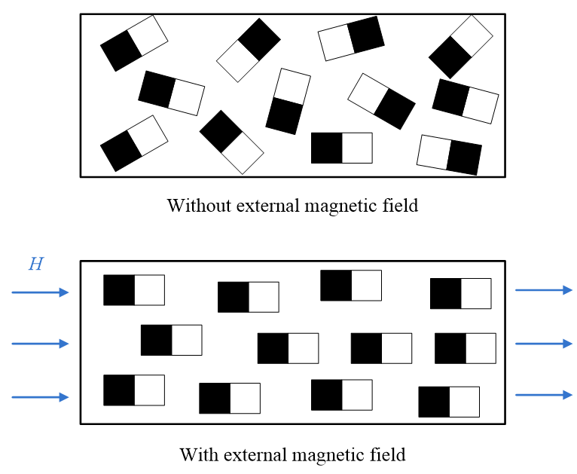
- The magnetisation of soft magnetic material.
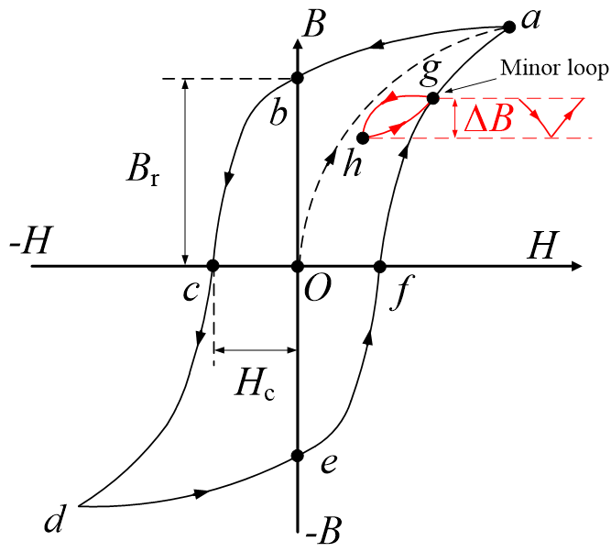
- B-H loops of soft magnetic material.
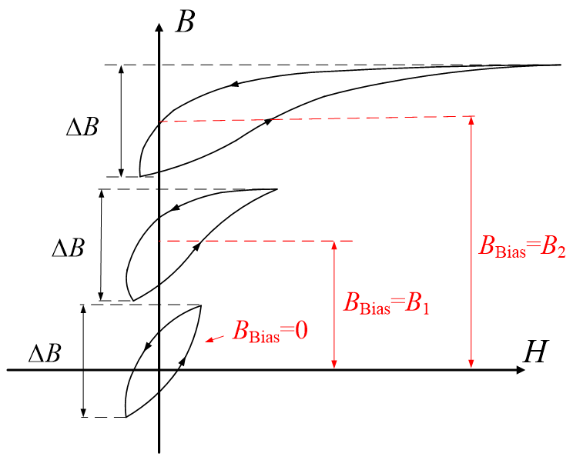
- B-H loops at different DC bias flux density.
- Eddy current circuit in steel sheets.

1.2 Iron Loss in Electrical Machines

1.2.1 Loss Behaviour of Electrical Machines
The loss behaviour of electrical machines varies from different machine topology, mechanical structure, operation conditions and manufacturing process. Fig.1.5 shows the typical loss percentages of three different electrical machines. The winding copper loss is the major loss for larger and lower speed electrical machines. The iron loss becomes dominating when the speed of electrical machine increases since the magnetic field in the machine changes fast. For most of the electrical machines, iron loss is one of the major losses. Therefore, it is very important to investigate the nature of iron loss in electrical machines. Generally, the iron loss is affected by many factors in electrical machines. Some of the major influential factors can be listed as [TAK12] [ZHU16] [MA16] [SCH14] [ROS05] [YAM13]:
- Frequency
- Machine topology
- Slot and pole number combination
- Winding arrangement
- Temperature
- PWM
- Geometry
- Manufacturing process
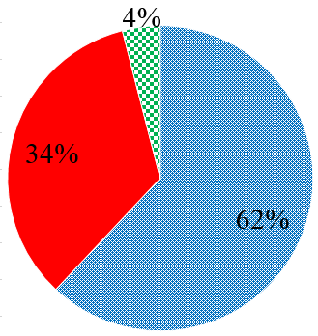 | 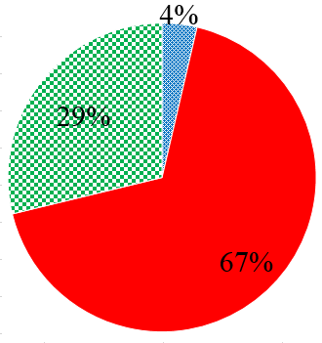 | 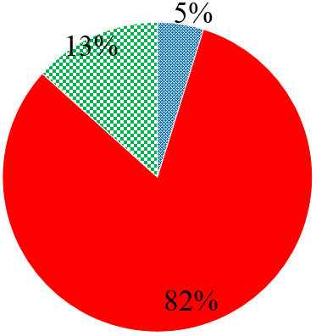 | 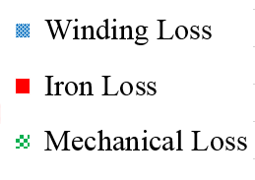
(a) | (b) | (c)
- Typical loss percentages of electrical machines. (a) 11kW, 1,470rpm induction machine (IM) [KRI12]. (b) 6kW, 8,200rpm permanent magnet synchronous machine (PMSM) [ZHA15]. (c) 5.1kW, 45,000rpm switched reluctance machine (SRM) [MIN12].

1.2.2 Machine Topology
The topology of electrical machines can influence the iron loss significantly. In [DOR10], the comparison of iron losses of three different machines is carried out. A 48-slot/8-pole interior permanent magnet (IPM) machine, a 48-slot/8-pole induction machine (IM) and an 18-stator-pole/12-rotor-pole switched reluctance machine (SRM) are compared, as shown in Fig.1.6. The iron losses at 1,500rpm 300Nm and at 6,000rpm 50Nm are presented in Fig.1.7. It can be observed that the iron losses of different machines vary significantly although their output powers keep constant. The SRM has the highest iron loss due to the relative higher frequency caused by the higher rotor pole number as well as more dramatic flux variation in the rotor. The iron loss of the IPM machine is higher than that of the IM at the same output torque and operating speed due to higher stator and rotor core volume. Generally, the topology influences on the iron loss can be concluded as some common factors as [SIT01] [MI03] [TAK12]:
- Flux density distribution of frequency and amplitude
- DC bias flux density caused by different excitation
- Flux density distortion caused by MMF harmonics
- Flux density rotational status
 |  | 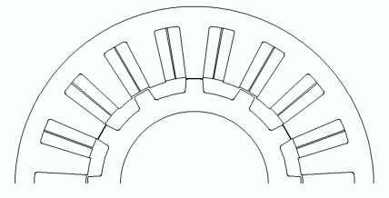
(a) | (b) | (c)
- Different topologies of electrical machines [DOR10]. (a) 48-slot/8-pole IPM. (b) 48-slot/8-pole IM. (c) 18 stator-pole/12-rotor-pole SRM.
(a) | (b)
- Iron losses of machines in [DOR10] with different topologies. (a) 1,500rpm, 300Nm. (b) 6,000rpm, 50Nm.

1.2.3 Slot and Pole Number Combination
The iron loss of electrical machines can be affected by the slot and pole number combination. On one hand, different slot and pole number combinations result in different MMF spatial harmonics. On the other hand, the flux density frequency in the electrical machine is determined by the pole number, which influences the iron loss significantly. The iron loss of IPM machines with different slot and pole number combinations is investigated in [HAN10] as shown in Fig.1.8. Both the stator and rotor iron losses vary with the slot number per pole pair. This is due to different flux distributions and different MMF harmonic contents. The slot and pole number combination influences on the iron loss can be concluded as common factors as [SEO09] [ZHU16]:
- Flux density distortion caused by MMF harmonics
- Flux density frequency
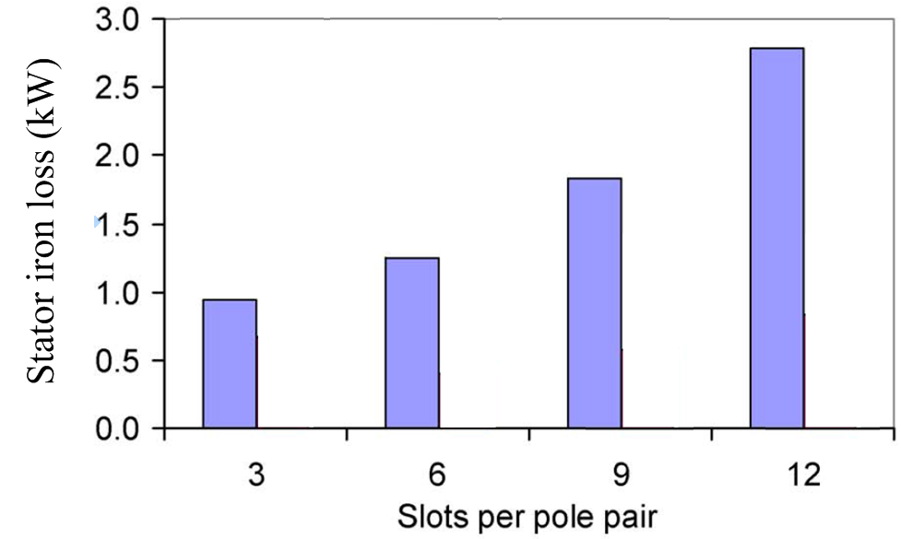
(a) | (b)
- Iron losses of IPM machines with different slot and pole number combinations at 7,200rpm, I=85.3A [HAN10]. (a) Stator iron loss. (b) Rotor iron loss.

1.2.4 Winding Arrangement
The iron loss of electrical machines with different windings is investigated in [MA16]. The different winding arrangements and iron losses are shown in Fig.1.9 and Fig.1.10. It can be seen from Fig.1.10 that the fully pitched winding switched reluctance machine (FPSRM) has the highest stator iron loss while the double-layer mutually coupled switched reluctance machine (MCSRM) has the lowest stator iron loss when the phase current is low. This is because the FPSRM has the most dramatic variation of both stator and rotor flux densities. However, with the increase of phase current, the iron loss increasing rates of machines vary with different windings, due to different saturations caused by different MMF spatial harmonics.
In [AZA10], 12-slot/10-pole PM machines with different rotor topologies and winding arrangements are compared in terms of iron losses. The iron losses are shown in Fig.1.11. It is concluded that the single-layer winding causes larger iron loss than the double-layer winding due to greater air gap flux density sub-harmonics. The harmonic analyses are shown in Fig.1.12. In [YAM09], iron losses of PM machines with concentrated and distributed windings are compared, as shown in Fig.1.13, and the different iron loss natures of PM machines with concentrated or distributed windings are caused by different MMF harmonics and the flux density distributions in the stator and rotor cores.
The influences of winding arrangements on the iron loss can be summarised as the following common factors [AZA10] [WU16]:
- Flux density distribution of frequency and amplitude
- Flux density distortion caused by MMF harmonics
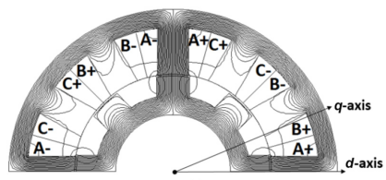 | 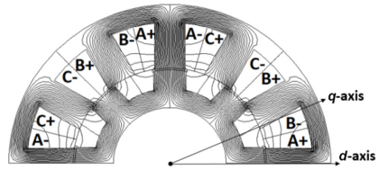 |  | 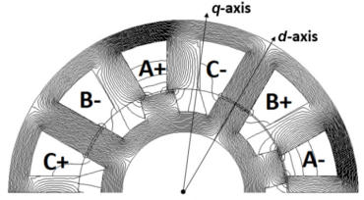
(a) | (b) |  | (c)
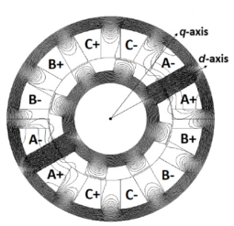 |  | 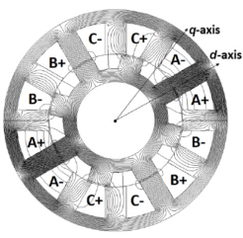
(d) |  | (e)
- Windings of SRMs [MA16]. (a) Conventional SRM (CSRM). (b) Double-layer mutually coupled SRM (MCSRM). (c) Fully pitched winding SRM (FPSRM). (d) Single-layer CSRM (SLCSRM). (e) Single-layer MCSRM (SLMCSRM).
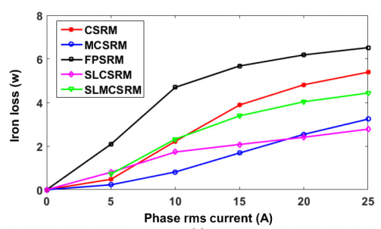
- Iron losses of machines with different windings [MA16].
(a)
(b)
(c)
- Iron losses of PM machines with different windings [AZA10]. (a) SPM. (b) I-shape IPM. (c) V-shape IPM.
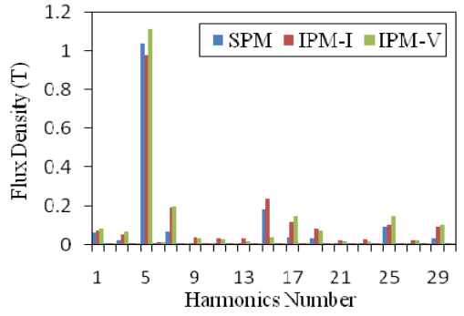 | 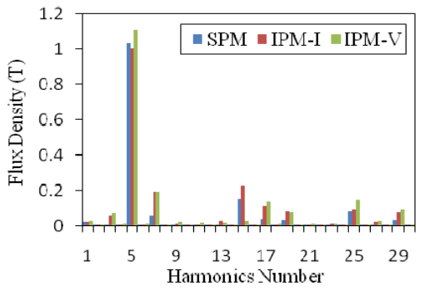
(a) | (b)
- Full load airgap flux density harmonics of PM machines with different windings [AZA10]. (a) Single-layer. (b) Double-layer.
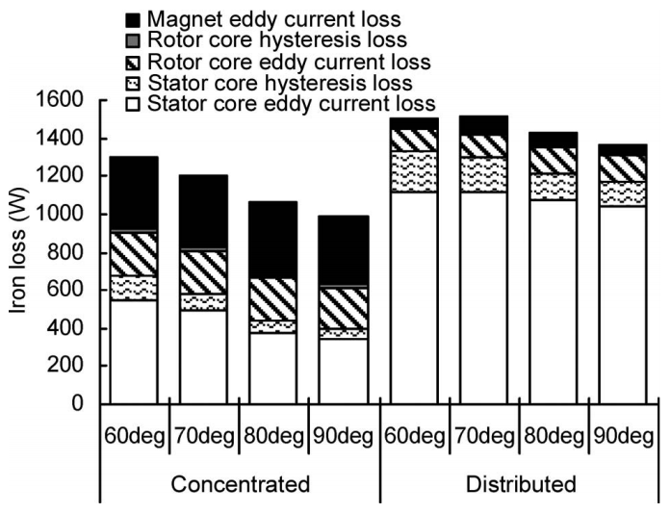
- Iron losses of PM machines with concentrated and distributed windings at 6,000rpm, I=300A [YAM09].

1.2.5 Temperature
In some applications, such as electric vehicles (EV) or hybrid electric vehicles (HEV), electrical machines usually operate in a wide temperature range from -40ºC to 120ºC [STU17] [ZHA17]. More importantly, it is widely reported that the iron loss varies with temperature significantly [LAR11] [MAT85] [FOS86] [LEH88] [SAI05] [MIY10] [SCH13].
By way of example, in [SCH13], the temperature dependency of iron loss of a 6.3kW synchronous machine is experimentally confirmed. The result shown in Fig.1.14 indicates that the iron loss decreases significantly with the temperature rise in the electrical machine. This is mainly due to the decrease of eddy current loss caused by increased resistivity of stator and rotor core laminations.
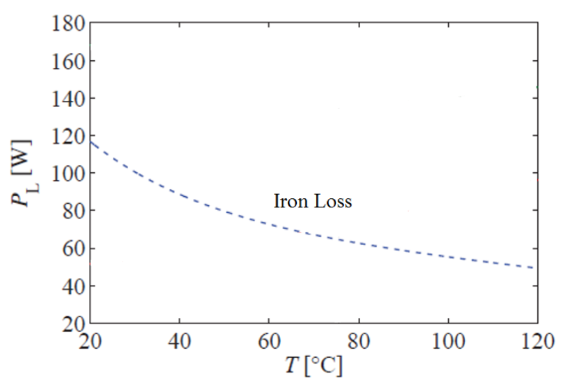
- Temperature dependency of iron loss of a 6.3kW synchronous machine [SCH13].

1.2.6 PWM
In actual drive systems, electrical machines are usually fed by pulse width modulation (PWM) inverters. In this case, the flux density waveform of electrical machines can be significantly distorted from sinusoidal as shown in Fig.1.15. On one hand, the minor hysteresis loops occur in the B-H loops as described in Section 1.1, which cause additional hysteresis loss in the stator and rotor cores. On the other hand, the flux density harmonics also result in the increase of eddy current loss [ROS05]. Fig.1.16 shows the iron losses of an electrical machine fed by a sinusoidal power source or a PWM inverter [UGA09]. It can be observed that the iron loss of the electrical machine fed by a PWM inverter is much higher than that by a sinusoidal power source. Furthermore, with the decrease of the inverter’s switching frequency, the iron loss increases dramatically as it investigated in [KRI13b] and shown in Fig.1.17. In some circumstances, the iron loss of an electrical machine fed by a PWM inverter can be over three times higher than that fed by a sinusoidal power source [CHA68]. According to the previous studies, the influences of PWM on the iron loss can be concluded as [NEW78] [MUR83] [BOG91] [BOG94] [SWA96] [YAM09b]:
- Flux density distortion caused by MMF harmonics
- Flux density waveform at different point of a 12-slot/10-pole PM machine fed by a PWM inverter, fundamental frequency f=100Hz, switching frequency f_{s}=1kHz [XUE17b].
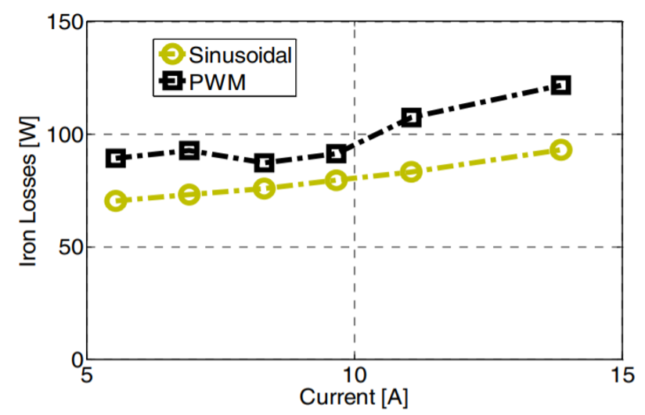
- Iron losses of an electrical machine fed by sinusoidal power source or by PWM inverter at switching frequency f_{s}=4kHz [UGA09].
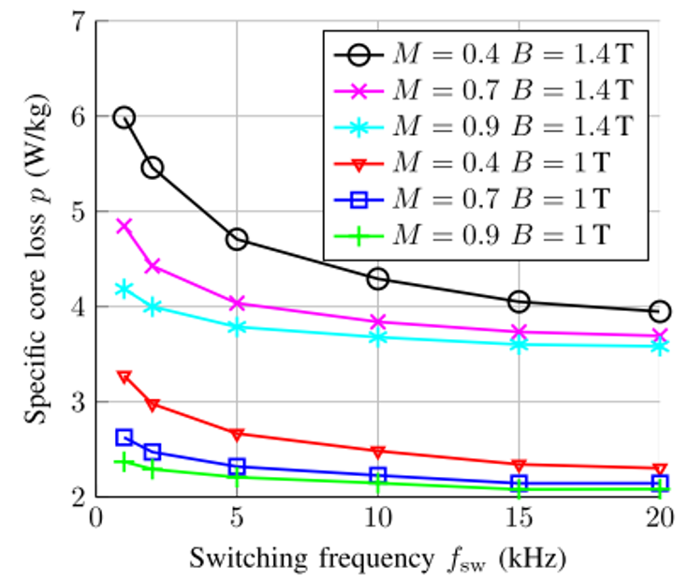
- Iron losses of a stator core at a fundamental frequency f=50Hz with different switching frequency [KRI13b].

1.2.7 Geometry
The flux density distribution and harmonic content can vary with different geometry of the stator or the rotor, and subsequently affect the iron loss. In [YAM13], a rotor structure optimization is carried out based on a 70kW IPM machine as shown in Fig.1.18. Fig.1.19 presents the iron losses of the machines with the initial or the optimized rotor structures. The stator iron loss caused by the magnet decreases dramatically with the optimization since the harmonic content of magnet MMFs is reduced. The mechanical structure influence on the iron loss is also reported in many previous studies [LEE02] [ALB12] [WU14] [WAN14]. It is concluded that the mechanical structure influences on the iron loss are due to some major common factors as:
- Flux density distortion caused by MMF harmonics
- Flux density distribution of frequency and amplitude
- Flux density rotational status
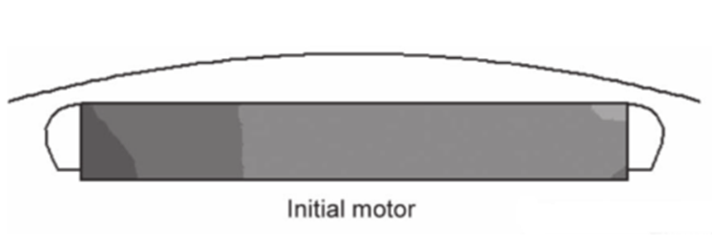 | 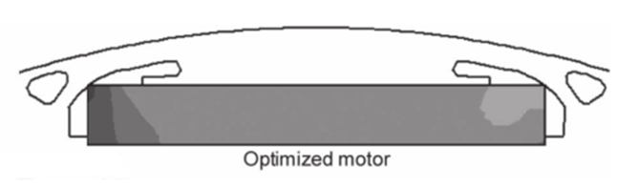
(a) | (b)
- Different rotor structures of 70kW interior permanent machines in [YAM13]. (a) Initial. (b) Optimized.
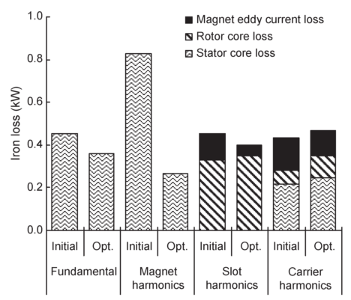
- Iron losses of machines with different rotor structure at 10,000rpm, I=300A [YAM13].

1.2.8 Manufacturing Process
According to the studies in [NAK92] [GRE08] [MIY09] [MAN14], the iron loss can be affected by the manufacturing process such as the housing method of machines or the cutting method of steel laminations. In [MIY09], the iron losses of machines with or without the shrink fitting house are investigated. It is concluded that large compressive stress is impressed to the back yoke caused by the shirk fitting house, which changes the iron loss distribution shown in Fig.1.20 and then causes the iron loss to increase as shown in Fig.1.21.
In [MAN14], two types of steel laminations manufactured by mechanical cutting and by laser cutting are compared as shown in Fig.1.22. The laser cutting leads to higher values of losses, because of the local thermal stresses that change the crystallographic texture at the edge of the strip [MAN14]. In some other studies, it also indicates that different cutting method for the steel laminations can affect the stress on the edge of the laminations, then influence the iron loss [BOZ51] [MOS79] [ALI97] [DAI06] [MIY09] [MIY10]. Therefore, the manufacturing process influences on the iron loss can be concluded as the common factor as:
- Mechanical stress on stator or rotor cores
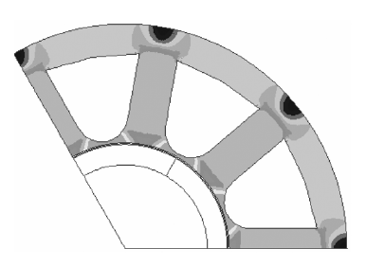 | 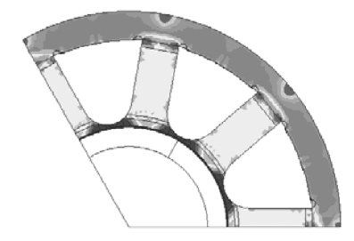 | 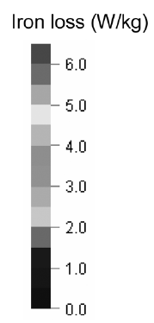
(a) | (b)
- Iron loss distributions with or without shrink fitting house outside the stator [MIY09]. (a) Without shirk fitting. (b) With shrink fitting.
- Iron losses with or without shrink fitting house [MIY09].
- Iron losses of steel laminations manufactured by mechanical cutting and laser cutting [MAN14].

1.2.9 Summary of Influential Factors
According to the review on the iron loss in electrical machines above. Different influential factors in electrical machines have some common influential factors on the iron loss. For example, both the slot and pole number combination and winding arrangement can influence the MMF harmonics and then the iron loss. On the other hand, one influential factor in electrical machine can also affect the iron loss in different ways. For example, the mechanical structure of the machine can influence the MMF harmonic, the flux density distribution of frequency and amplitude as well as the flux density rotational status. These influential factors in electrical machine can be summarised in Fig.1.23. The common influential factors can also be listed as:
- Temperature
- Flux density frequency
- Flux density amplitude
- DC bias flux density
- Flux density distortion
- Flux density rotational status
- Mechanical stress
For the iron loss calculation of electrical machines, the problem becomes how to define the common influential factors and then to model them by iron loss models. The modelling of these common factors will be introduced later in this chapter. Some of these major influential factors will also be modelled in the following chapters of this thesis.
- Summery on iron loss influential factors of electrical machines.

1.3 Iron Loss Models for Electrical Machines
In order to predict the iron loss accurately, proper iron loss models are required. According to the latest study on the iron loss modelling, there are two main methods to model the iron loss in soft magnetic materials i.e. the mathematical hysteresis models and the empirical models.

1.3.1 Mathematical Hysteresis Models
The aim of the mathematical hysteresis models is to directly express the shape of the B-H loop by mathematical equations, rather than calculate the losses according to their origins. The iron loss can be then obtained by calculate the area of the B-H loops. Different mathematical hysteresis models have been developed. The Preisach model [PRE35] and the Jiles-Atherton model [JIL86] [JIL94] are two of the most commonly used mathematical hysteresis models.

The Preisach Model
In the Preisach model, the magnetisation $M(t)$ at time $t$ is expressed as [PRE35]:
$$M\left(t\right)=\iint{μ\left(H_{α},H_{β}\right)γ_{H_{α}H_{β}}[H(t)]dH_{α}}dH_{β}$$ | (1.1)
where $μ\left(H_{α},H_{β}\right)$ is the weighting function which can be obtained by measurement results. $γ_{H_{α}H_{β}}[H(t)]$ is the hysteresis operator represented by the rectangular loop shown in Fig.1.24. The operator can be expressed as:
$$γ_{H_{α}H_{β}}\left[H\left(t\right)\right]=\left\{\begin{aligned}1 H\left(t\right)≥H_{α} \\ -1 H\left(t\right)≤H_{β} \\ k H_{β}<H\left(t\right)<H_{α}\end{aligned}\right.$$ | (1.2)
where $k=-1$ if the last time $H\left(t\right)$ was $H\left(t\right)≤H_{β}$ and $k=1$ if the last time $H\left(t\right)$ was $H\left(t\right)≥H_{α}$.
In different $H_{α}$ $H_{β}$ range, values of weighting function $μ\left(H_{α},H_{β}\right)$ are different. The idea of Preisach model is to calculate the output as a sum of weighted basis operators. The accuracy of the Preisach model can be guaranteed if proper weighting functions $μ\left(H_{α},H_{β}\right)$ are applied in each $H_{α}$ $H_{β}$ range and the partitions $dH_{α}$ and $dH_{β}$ are fine enough. However, large amount of experiments must be done to determine the weighting functions. The Preisach model also suffers from the complex modelling and the time-consuming calculation process, which could result in lack of applications [BAR04].
- Operator in the Preisach model.

The Jiles-Atherton Model
In the Jiles-Atherton model, the hysteresis function is separated into two parts, i.e. the reversible and the irreversible magnetisations [JIL86]. The total magnetisation $M$ can be obtained by the sum of contributions of irreversible $M_{irr}$ magnetisation and reversible magnetisation $M_{rev}$ components:
$$M=M_{irr}+M_{rev}$$ | (1.3)
The irreversible component $M_{irr}$ is caused by loss processes of domain walls. The reversible component $M_{rev}$ is due to lossless processes of domain walls. The two components of magnetisation can be expressed as:
$$M_{irr}=M_{an}-kδ\frac{∂M_{irr}}{∂H_{e}}$$ | (1.4)
$$M_{rev}=c(M_{an}-M_{irr})$$ | (1.5)
$$M_{an}=M_{s}(\coth\left(\frac{H+αM}{A}\right)-\frac{A}{H+αM})$$ | (1.6)
where $A$, $α$, $c$, $k$ and $M_{s}$ are the parameters determined by the experimental results. $δ$ is the directional parameter. $δ=1$ when $H$ increases and $δ=-1$ when $H$ decreases.
The Jiles-Atherton model links the parameters of the equations to the behaviour of soft magnetic material, which provides physical background. Furthermore, only five parameters should be determined in the Jiles-Atherton model instead of the large amount of weighting functions in the Preisach model. However, the determination process of the parameters in the Jiles-Atherton model is very complicated as reported in some studies [LED99] [TOM08], which makes it very difficult to implement.

Summary
According to the review on mathematical hysteresis models above, some features of different mathematical hysteresis models can be listed in Table 1.1. Although the mathematical hysteresis models benefit from good accuracy, some common limitations of the mathematical hysteresis models can be listed as follows:
- Time-consuming calculation process
- Plenty of parameters for the model must be identified
- The complicated process of determination of parameters
- Huge amount of experimental data is required
- Lack of physical background
All these limitations make the mathematical hysteresis models impractical in iron loss prediction for electrical machines.

Table 1.1. Features of mathematical hysteresis models
Models | Features
Models | Advantages | Disadvantages
Preisach Model | - Good accuracy if the partition is fine enough.  - Simple expression. | - Plenty of weighting functions for the model must be identified.  - Lack of physical background.  - Time-consuming calculation process.
Jiles-Atherton Model | - Good accuracy if parameters are determined well. | - Complicated process of determination of parameters.  - Time-consuming calculation process.

1.3.2 Improvements Based on Mathematical Hysteresis Models
Since good accuracies can be achieved if enough measurement data of the material is available by using mathematical hysteresis models, they have been evolved to many forms to consider different influential factors. The related references on improvements of mathematical hysteresis models are shown in Table 1.2. For the Preisach model, improvements are done on the influences of temperature [RUG98] [BER14][CIM06], DC bias flux density [FUZ03], flux density distortion [VAJ92] [PAR97] [BAR04], mechanical stress [BER91b] [KTE12] and flux density rotational status [ADL97] [HAN15]. On the other hand, many improvements also have been done based on the Jiles-Atherton model such as on the influence of temperature [WIL02] [RAG09] [RAG10], DC bias flux density [BI99] [DON10] [WAN16], flux density distortion [CAR91] [JIL92] [BAG15], mechanical stress [MIE11] [RAS17] and flux density rotational status [BER96] [LEI09] [COE13].

Table 1.2. Improvements on mathematical hysteresis models
Influential Factors | Preisach Model | Jiles-Atherton Model
Temperature | [RUG98]  [BER14]  [CIM06] | [WIL02]  [RAG09]  [RAG10]
DC Bias Flux Density | [FUZ03] | [BI99]  [DON10]  [WAN16]
Flux Density Distortion | [VAJ92]  [PAR97]  [BAR04] | [CAR91]  [JIL92]  [BAG15]
Mechanical Stress | [BER91b]  [KTE12] | [MIE11]  [RAS17]
Flux Density Rotational Status | [ADL97]  [HAN15] | [BER96]  [LEI09]  [COE13]

1.3.3 Empirical Models
The mathematical hysteresis models suffer from the complex modelling process and lack of physical background. Alternatively, empirical engineering approaches based on loss separation are widely investigated and applied. Instead of expressing the physical phenomena of the hysteresis process directly by complicated equations, the aim of empirical models is to find out the relationship between iron losses and variables such as flux density and frequency. In empirical models, the iron loss is separated into different loss contributions according to their origins (the hysteresis losses, classical eddy current losses and excess losses for example).
The first empirical model for the iron losses in soft magnetic materials was developed by Steinmetz over 100 years ago [STE92], who considered the iron loss as the combine contribution of the hysteresis loss and the classical eddy current loss. The prediction of the excess loss is discussed by Pry and Bean in [PRY58] for the first time. In spite of its remarkable achievements, the Pry and Bean model turns out to be of limited validity. This is mainly due to its highly idealized character [BER88]. Bertotti presented a new iron loss model including the hysteresis loss, classical eddy current loss and excess loss [BER88]. In [FIO90], the classical eddy current loss and the excess loss are expressed in differential form in order to adapt the non-sinusoidal flux density. In [BOG03], it is concluded that the contribution of the classical eddy current loss and the excess loss cannot be separated. Therefore, the classical eddy current loss and the excess loss are combined as a global eddy current loss in [BOG03]. A two-term iron loss model which including the hysteresis loss and the global eddy current loss is then presented. In this section, four of the most widely used iron empirical models are reviewed.

The Bertotti’s Model
In [BER88], iron loss is expressed by the three-term formula, which includes the hysteresis loss, the classical eddy current loss and the excess loss:
$$p_{Fe}=k_{h}fB_{m}^{α}+k_{cl}f^{2}B_{m}^{2}+k_{exc}f^{1.5}B_{m}^{1.5}$$ | (1.7)
where $B_{m}$ is the amplitude of the flux density. $k_{h}$ and $α$ are the hysteresis loss coefficients. $k_{cl}$ is the classical eddy current loss coefficient. $k_{exc}$ is the excess loss coefficient. The coefficients can be obtained by the curve fitting of the test results at different flux density and frequency.
In the Bertotti’s model, iron loss is separated into three components according to their origins, which provides a good physical background. The Bertotti’s model has been widely used, and some of the applications can be found in [ELL96], [NER02] and [KOW15]. However, the limitation of the Bertotti’s model is that four coefficients must be determined for applying it. Many iron loss test results are required to determine these coefficients.

The Fiorillo’s Model
In [FIO90], the hysteresis loss coefficient is obtained by fitting the hysteresis loss test result under a DC hysteresis test. The classical eddy current loss is calculated by the properties of the steel laminations. The excess loss coefficient can be obtained by the curve fitting of the test results. This iron loss model can be expressed as:
$$p_{Fe}=k_{h}fB_{m}^{α}+\frac{{σd}^{2}}{12}\frac{1}{T}\int_{0}^{T}{{\left(\frac{dB}{dt}\right)}^{2}}dt+\frac{k_{exc}}{T}\int_{0}^{T}{{\left|\frac{dB}{dt}\right|}^{1.5}}dt$$ | (1.8)
where $σ$ and $d$ are the electrical conductivity and the thickness of the lamination. $T$ is the time period of the flux density waveform.
The classical eddy current loss and the excess loss are expressed as integral form in the Fiorillo’s, which can consider the dynamic process of the eddy current. Some of the applications of the Fiorillo’s model can be found in [ATA92] [TOD05] and [ROD14]. However, special DC hysteresis test apparatuses are required to determine the hysteresis loss coefficient of this model. Furthermore, many AC iron loss tests are also required for the determination of $k_{exc}$. All these inconveniences restrict the potential usage of this model.

The Boglietti’s Model
It is concluded in [BOG03] that the contributions of the classical eddy current loss and the excess loss cannot be separated. Alternatively, a two-term iron loss model is developed, where the classical eddy current loss and excess loss in the three-term model are combined into a global eddy current loss. This model can be expressed as:
$$p_{Fe}=k_{h}fB_{m}^{2}+k_{e}f^{2}B_{m}^{2}$$ | (1.9)
Only two loss coefficients should be determined in this model. The coefficients can be obtained by the steel lamination test results at several sets of frequency $f$ and flux density $B_{m}$, which makes this model very easy to implement [YAM06] [YAM09].

The Ionel’s Model
The iron loss coefficients are very important for the empirical iron loss models. All the iron loss models described above assume that the loss coefficients are constant. However, it is reported in some recent studies that the coefficients are variable of flux density and frequency. Iron loss models with constant coefficients give rise to substantial error in specific frequency and flux density range [ION06] [ION07] [SEO09] [SEO10]. Therefore, in [ION07], variable hysteresis loss and eddy current loss coefficients are proposed. This model can be expressed as:
$$p_{Fe}=k_{h}(f,B_{m})fB_{m}^{2}+k_{e}(f,B_{m})f^{2}B_{m}^{2}$$ | (1.10)
where $k_{h}(f,B_{m})$ and $k_{e}(f,B_{m})$ are hysteresis and eddy current losses coefficients, which are variables with frequency $f$ and flux density $B_{m}$.
The Ionel’s model benefits from high accuracy with the help of variable coefficients, which makes it is widely used in [BOG09], [FEN09], [POP10] and [LI16]. However, more experimental results are required for modelling the variable coefficients compare to the Boglietti’s model.

Summary
According to the review on different empirical models above, some of their features can be summarised and listed in Table 1.3.
Table 1.3. Features of empirical models
Models | Features
Models | Advantages | Disadvantages
Bertotti’s Model | - Solid physical background. | - Five coefficients must be determined.  - Many test results are required.
Fiorillo’s Model | - Dynamic process of the eddy current is considered by the integral form expression. | - DC hysteresis tests and special test equipment are required.  - Many AC iron loss tests are also required.
Boglietti’s Model | - Only two coefficients should be determined.  - Very easy to implement. | - Relative low accuracy compares to three-term models.
Ionel’s Model | - High accuracy with the help of variable coefficients. | - More test results are required compare to the Boglietti’s model.

1.3.4 Improvements Based on Empirical Models
As it described in Section 1.2, there are many factors can influence the iron loss. Numerous studies have been done based on the empirical models for considering different influences factors. In this section, the investigations on modelling these influential factors based on empirical models are introduced.

Temperature
In [LAR11], the phenomena of the iron loss variation with temperature is presented. However, no further analysis or modelling is carried out. In some recent studies, the temperature influence on the iron loss are investigated in different material. In [WIL02] and [RAG09], the temperature dependency of iron loss in cobalt ferrite cores for switching power devices is investigated. The temperature influence of iron loss in Ni-Fe laminations is analysed in [KRI13]. In [ROU98], the temperature dependency of the iron loss in Mn-Zn ferrite material is experimentally confirmed. In the steel laminations for electrical machines, the temperature dependency of iron loss is investigated based on oriented silicon laminations [FOS86] and non-oriented silicon laminations [TAK10] [TAK11], respectively. However, none of the studies described above has modelled the temperature dependency of iron loss for steel laminations.
The modelling of temperature influence on the eddy current loss is discussed in [SAI05], [SCH13] and [CHE15] based on the Boglitti’s model. A temperature dependent resistivity is introduced to the eddy current loss, which makes the eddy current loss temperature dependent. The model can be expressed as:
$$p_{Fe,T}=k_{h}fB_{m}^{2}+\frac{k_{e}^{'}}{ρ(T)}f^{2}B_{m}^{2}$$ | (1.11)
$$ρ\left(T\right)=1+α\left(T-T_{0}\right)$$ | (1.12)
where $k_{e}^{'}$ is the modified eddy current coefficient. $ρ(T)$ is the resistivity of the steel lamination at temperature $T$. $α$ is the temperature coefficient provided by steel lamination manufacturers.
By applying the model (1.11) to the iron loss calculation, the predicted iron loss varies with the temperature. The temperature influence on iron loss can be partly considered. However, according to the previous study [TAK10] [TAK11], it has been experimentally confirmed that both the hysteresis and eddy current losses are influenced by temperature. Furthermore, the hysteresis and eddy current losses have different temperature dependencies. The temperature dependency of the hysteresis loss is not modelled in either [SAI05], [SCH13] or [CHE15]. None of the existing iron loss models can fully consider the temperature dependencies of both hysteresis and eddy current losses, which is necessary in order to predict the iron loss accurately.

DC Bias Flux Density
In actual electrical machines, the DC bias flux density exists in many types of electrical machines such as permanent magnet synchronous machines (PMSM), brushless DC machines (BLDC), switched reluctance machines (SRM) and variable flux reluctance machines (VFRM) etc. The shape of B-H loops is significantly influenced by the DC bias flux density as shown in Fig.1.3. This is due to the fact that the permeability of the soft magnetic materials is changed when DC bias flux density exists [WOO81] [ZHA95] [ENO00]. The iron loss is then influenced.
The first expression for the iron loss under DC bias flux density is reported in [WOO81]. Investigations on the DC bias flux density influence are carried out in different material such as Mn-Zn ferrite core [BAG12] and low-temperature co-fired ceramic (LTCC) ferrite material [MU13]. In the steel laminations for electrical machines, the iron loss under DC bias flux density is investigated and modelled in [LAN05]. However, since the iron losses under different DC bias flux densities are defined as independent with each other in this model, plenty of measurements must be done to calculate the coefficients at each condition. This makes the model developed in [LAN05] impractical. To make the iron loss model practical, a coefficient is introduced to describe the ratio between the iron losses with and without DC bias flux density in [SIM09], the model can be expressed as:
$$p_{Fe}=ε\left(B_{bias} \right)k_{h}fB_{m}^{2}+k_{e}f^{2}B_{m}^{2}$$ | (1.13)
$$ε\left(B_{bias} \right)=1+k_{DC}B_{bias}^{α}$$ | (1.14)
where $p_{Fe}$ is the iron loss density. $ε\left(B_{bias} \right)$ is the DC bias flux density dependent coefficient, which represents the ratio between hysteresis losses with and without DC bias flux density. $k_{DC}$ and $α$ are the DC bias coefficients and can be obtained by fitting the measured results.
In [ZHU14], a three-term DC bias dependent coefficient is introduced, the DC bias dependent coefficient can be expressed as:
$$ε\left(B_{bias} \right)=1+k_{DC1}B_{bias}^{α}+k_{DC2}B_{bias}^{2}$$ | (1.15)
where $k_{DC1}$, $k_{DC2}$ and $α$ are the DC bias coefficients.
According to the previous research on the DC bias flux density and temperature influence the iron loss. The permeability of soft magnetic material is affected by both the DC bias flux density and temperature [TAK10] [SIM09]. However, none of the existing iron loss models can consider the combine influence of DC bias flux density and temperature, which is desirable for the accurate prediction of iron loss.

Flux Density Distortion
In electrical machines, the flux density can be distorted from sinusoidal. The potential causes of the distortion can be MMF harmonics due to machine topology, slot and pole number combination, winding arrangement and current ripple caused by PWM inverters as described in Section 1.2. The flux density distortion can affect iron loss significantly. On one hand, distorted flux density causes hysteresis minor loops within the major loops as illustrated in Section 1.1, which introduces additional hysteresis loss [LAV78]. Furthermore, the presence of harmonic components of flux density will also introduce additional eddy current loss [NEW78].
The first study on the iron loss variation by the distorted flux density is reported in [THO21], where some test results and are shown. The influence of the flux density distortion on iron loss is also reported in [MOS83] [LAN01] [LAN05]. The relationship between hysteresis losses with and without minor loops is systematically investigated and modelled in [LAV78]. This method can be expressed as:
$$p_{Fe}={k_{minor}k}_{h}fB_{m}^{2}+\sum{k_{e}f^{2}B_{m}^{2}}$$ | (1.16)
$$k_{minor}=1+k\frac{1}{B_{m}}\sum_{i=1}^{N}{∆B_{i}}$$ | (1.17)
where $k_{minor}$ is the coefficient considering the influence of hysteresis minor loops. $k$ is the coefficient depending on lamination properties. $∆B_{i}$ is the amplitude of the fluctuated flux density as shown in Fig.1.25.
- Flux density distortions and hysteresis minor loops.

Mechanical Stress
In [ALI97], the mechanical stress influences on the hysteresis loss and the excess loss are modelled based on the Bertotti’s model. The classical eddy current loss is considered as independent from mechanical stress. The model can be expressed as:
$$p_{Fe}=k_{h}\left(s\right)fB_{m}^{a(s)}+k_{cl}{f^{2}B}_{m}^{2}+k_{exc}(s){f^{1.5}B}_{m}^{1.5}$$ | (1.18)
where $k_{h}\left(s\right)$, $k_{exc}\left(s\right)$ and $a\left(s\right)$ are the stress dependent coefficients and can be described by:
$$k_{h}\left(s\right)=k_{h}\left(0\right){(1+A_{h}s)}^{0.25}$$ | (1.19)
$$k_{exc}\left(s\right)=k_{exc}\left(0\right){(1+A_{exc}s)}^{0.25}$$ | (1.20)
$$a\left(s\right)=a\left(0\right){(1+A_{a}s)}^{-0.25}$$ | (1.21)
where $k_{h}\left(0\right)$, $k_{exc}\left(0\right)$ and $a\left(0\right)$ are the loss coefficients corresponding to the condition without stress. $A_{h}$, $A_{exc}$ and $A_{a}$ are the stress constants that can be determined by experimental data.
Many test results are required to determine the stress dependent coefficients of the model in [ALI97]. Furthermore, the test procedure is complicated, and special test apparatus are required as will be demonstrated in Section 1.4. It is very difficult to implement the model developed by [ALI97]. In [YAM13], a simplified model which requires less experimental measurement is proposed. Stress dependent coefficients are introduced to hysteresis and eddy current losses. The stress dependencies of the hysteresis and the eddy current losses are considered as the same, which makes this model much simpler. This model is expressed as:
$$p_{Fe}=k_{h}\left(s\right)p_{h0}+k_{e}\left(s\right)p_{e0}$$ | (1.22)
where $k_{h}\left(s\right)$, and $k_{exc}\left(s\right)$ are the stress dependent coefficients. $p_{h0}$ and $p_{e0}$ are the iron losses in the condition that the stress is zero.
This model provides a clear relationship between iron loss and mechanical stress. The typical variations of the stress dependent coefficients with stress and flux density are shown in Fig.1.26. In this model, the influence of tensile stress on the iron loss is neglected. This is due to the fact that the tensile stress has little effect on the B-H loops compared to the compressive stress as shown in Fig.1.27 [ZEZ12]. This phenomenon is also reported in [DAN17]. This assumption makes the model very easy to implement while having a good accuracy, it has been widely applied in [BER15] [PAR16] [DAN17] [RAS17].
- Typical variation of the coefficients with stress in [YAM03].
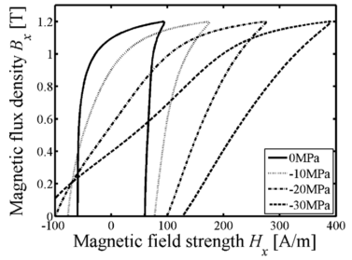 | 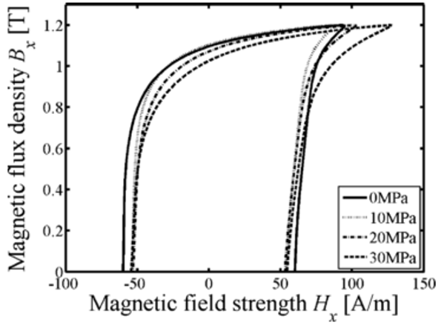
(a) | (b)
- Measured B-H loops of steel laminations under different stresses [ZEZ12]. (a) Compressive stress. (b) Tensile stress.

Flux Density Rotational Status
All the iron loss models described above are developed based on the assumption that the flux density is alternating. However, in actual electrical machines, flux density can be rotational. The iron loss models for alternating flux density will be inaccurate when applying to the electrical machines [ZHU93]. As it reported in [BER91], the predicted iron loss based on alternating flux density can be 20% lower than the measured losses.
In [STR62], an iron loss mode is proposed to consider the flux density rotation. A coefficient is introduced into the model for alternating flux density to express the iron loss increase caused by the flux density rotation. This modelling method is also used in [BER91]. In [FIN94], the rotational flux density is decomposed into x-axis and y-axis components as shown in Fig.1.28. The iron losses at each component can be calculated respectively. The total iron loss for rotational flux density is then obtained by the sum of iron losses at these two components. This model can be expressed as:
$$p_{Fe, Total}=p_{Fe, x}+p_{Fe, y}$$ | (1.23)
where $p_{Fe, Total}$ is the total iron loss. $p_{Fe, x}$ and $p_{Fe, y}$ are iron losses at $x$ and $y$ axes, respectively.
The accuracy of this model can be guaranteed when the locus of rotational flux density is circle. However, the loci of rotational flux density in electrical machines are usually ellipse. As reported in some studies, iron loss under rotational flux density is smaller than the sum of losses in x and y components in non-oriented (NO) steel laminations. Iron loss under rotational flux density is larger than the sum of losses in x and y components in grain-oriented (GO) steel laminations [ENO90].
In [ZHU98] and [GUO08], it is concluded that the hysteresis loss is dependent on the ellipticity of the locus of the rotational flux density. This dependency is then modelled as:
$$p_{Fe, Total}=R_{B}p_{r}+(1-R_{B})p_{alt}$$ | (1.24)
where $R_{B}=B_{minor}/B_{major}$ is the axis ratio of the flux density. $B_{major}$ and $B_{minor}$ are the major and minor axes of the flux density elliptical locus as shown in Fig.1.28. $p_{alt}$ is the alternating loss with flux density $B_{major}$. $p_{r}$ is the rotational loss when the flux density locus is a circle with a radius of $B_{major}$.
By using this model, the influence of flux density rotational status on the iron loss can be fully considered. However, special x-y axis test apparatuses and measuring procedures are needed to measure iron losses at different ellipticities. Furthermore, many test results are also required to apply this model.
In [MI03], the rotational flux density is decomposed into the major-minor axis as shown in Fig.1.28. The major-axis is aligned with the long side of the rotational flux density locus while the minor-axis is aligned with the short side of the rotational flux density locus. This model can be expressed as:
$$p_{Fe, Total}=p_{Fe, major}+p_{Fe, minor}$$ | (1.25)
where $p_{Fe, x}$ and $p_{Fe, y}$ are the iron loss components at major and minor axes, respectively.
Due to the good accuracy and feasibility, this method is widely used in iron loss prediction of electrical machines [DOM04] [CAL05] [YAM09].
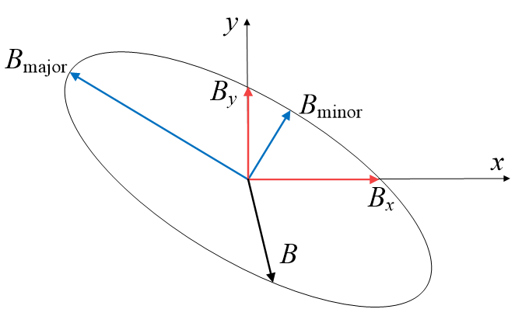
- Rotational flux density and its decompositions.

Summary
According to the review above, the empirical models have been evolved into many different forms to consider different influential factors. These studies based on empirical models can be summarised as Table 1.4.

Table 1.4. Improvements based on empirical models.
Influential Factors | Bertotti’s Model | Fiorillo’s Model | Boglietti’s Model | Ionel’s Model
Temperature on Eddy Current |  | [SCH13]  [CHE15]
DC Bias Flux Density |  |  | [CHA05]  [SIM09]  [ZHU14]
Flux Density Distortion | [CAL05]  [TAI15] |  | [BOG09]  [HAN10] | [BOG10]
Mechanical Stress | [ALI97]  [TAK08] |  | [YAM13]  [YAM14]
Flux Density Rotational Status | [CAL05] | [ZHU98]  [GUO08]

1.3.5 Conclusions
According to the review on the iron loss models for electrical machines in this section, comprehensive studies on the iron loss models have been done. However, some aspects of research based on empirical models are still open and desirable to be further investigated, which can be listed as:
- Comparison of iron loss models under different conditions
- The modelling of temperature dependency of the iron loss
- The combine influence of the DC bias flux density and temperature
- The effect of flux density distortion considering temperature influence
- Iron loss model for arbitrary flux density considering temperature influence

1.4 Iron Loss Measurement
For the investigation and further modelling of the iron loss, accurate measurement techniques are required. In this section, techniques for the iron loss measurement in steel laminations are reviewed at first. The methods for measuring the iron loss in electrical machines are also introduced in this section.

1.4.1 In Steel Laminations

Epstein Frame
The Epstein frame is designed for measuring the iron loss of steel lamination samples [IEC08]. The photo of a typical Epstein frame tester is shown in Fig.1.29. The Epstein frame contains a primary coil, a secondary coil and steel lamination samples as shown in Fig.1.30(a). The circuit diagram of the system is given by Fig.1.30(b). When the primary coil is powered by an AC power source, the iron loss of the steel lamination samples can be calculated by:
$$p_{Fe}=\frac{N_{1}}{N_{2}}P_{m}-\frac{{[1.111×\left|U_{2}\right|]}^{2}}{R_{i}}$$ | (1.26)
where $N_{1}$ and $N_{2}$ are the numbers of turns of primary and secondary windings, respectively. $P_{m}$ is the reading of the wattmeter shown in Fig.1.30(b). $R_{i}$ is the resistance of the secondary coil. $U_{2}$ is the average voltage of the secondary coil.
The test laminations must be manufactured strictly according to the required diameters for using the Epstein frame. Furthermore, it is complicated to insert test samples into the Epstein frame, which can take much time of users [YAM74].
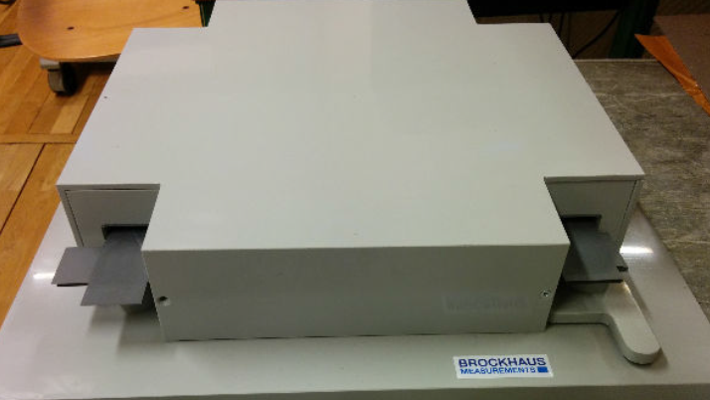
- Photo of Epstein frame [KRI15].
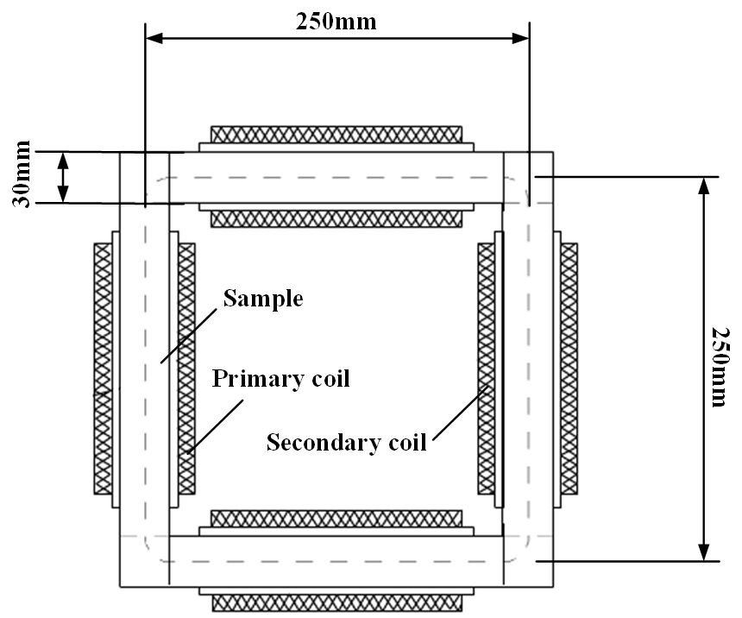 | 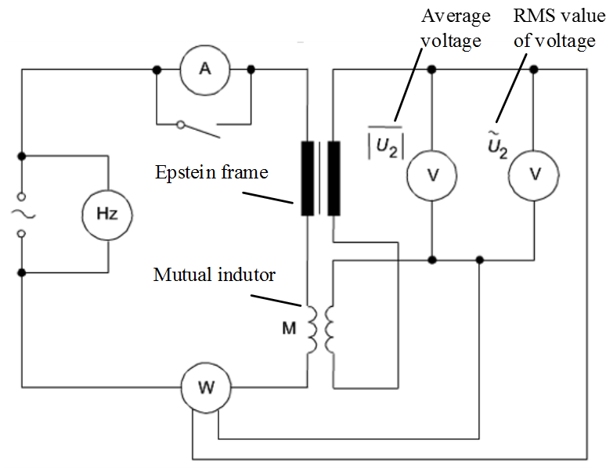
(a) | (b)
- Epstein frame and circuit diagram of the test system [IEC08].

Ring Specimen Test
In order to overcome the disadvantages of the Epstein frame, the ring specimen test is proposed in [AGA59]. The ring specimen test has the same principle with the Epstein frame test but much easier to implement. Therefore, the ring specimen test is widely used for measuring the iron loss in steel laminations [BOG03] [CHA05] [ROG14] [KRI15]. The comparisons of the Epstein frame and the ring specimen test are carried out in [MOS83], [ESP10] and [KRI15].
As shown in Fig.1.31, the ring specimen is wounded by the excitation coil and the measuring coil. The excitation coil is supplied by an AC power source. The measuring coil is wounded together with the excitation coil and connected to the oscilloscope to measure the induced voltage. Thus, the voltage drop on the excitation coil’s resistance is excluded in the measured induced voltage. The current in the excitation coil is measured by the current probe. The iron loss density $p_{Fe}$, the field strength $H\left(t\right)$ and the flux density$B\left(t\right)$ can be calculated as:
$$p_{Fe}=\frac{1}{TρV}\int_{0}^{T}{u\left(t\right)i\left(t\right)dt}$$ | (1.27)
where $p_{Fe}$ is the iron loss density. $u(t)$ is the instant induced voltage of the measuring coil.$i(t)$ is the instant current in the excitation coil. $T$ is the time period of the current and the voltage. $ρ$ and $V$ are the mass density and the volume of the ring specimen, respectively.
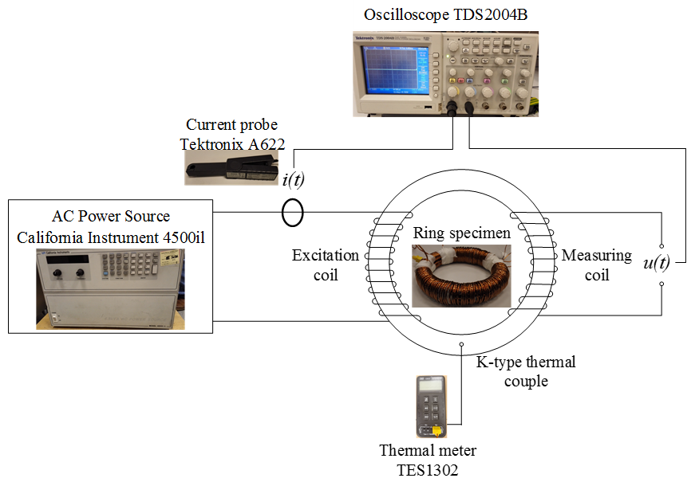
- Ring specimen test system [XUE16].

Measurement at Different Temperature
To investigate the temperature influence, iron loss should be measured at different temperature. The specimen can be put into a temperature chamber as shown in Fig.1.32. The specimen can be then heated to specific temperatures in the chamber. This method is also used in [SHE07] [MUH12] and [KRI13]. However, the heat transfer between the steel laminations and the environment in the chamber takes much time, which makes the test procedure very time consuming. The additional temperature chamber will also increase the cost and the inconvenience for setting up the test system.
In order to overcome the disadvantages of test solution based on temperature chambers, a test technique based on self-heating is introduced in [TAK10]. The iron loss is utilized to heat up the ring specimen to any designated temperature higher than the room temperature. A thermal couple is installed on the steel laminations to monitor the temperature. Iron loss can be measured when the designated temperature is reached. As the electromagnetic time constant is much smaller than the thermal time constant for this system. It only takes a few seconds to stabilize the voltage and current and record these on the oscilloscope. During this period, the change of temperature is so small that it can be neglected. This method is also used in [TAK11] [TAK12] and [XUE16].
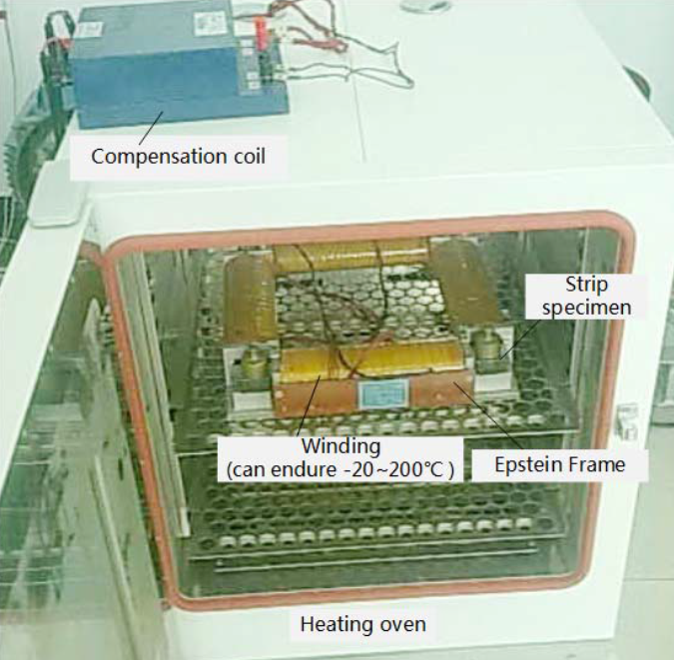
- Iron loss test rig and temperature chamber [CHE15].

DC Bias Flux Density Generation
In order to generate DC bias flux density in the steel lamination, an additional coil with DC current should be wounded to the ring specimen as shown in Fig.1.33. However, when the AC flux density alternates in the ring specimen, significant current ripple will be induced in the DC coil as shown in Fig.1.34. An inductor serially connected to the DC coil as shown in Fig.1.33 can slightly improve the current waveform. However, the current ripple can be still significant when the frequency or amplitude of the AC flux density is high. In this case, the DC biased flux density will be influenced significantly, the iron loss test result is then influenced.
For solving this problem, improvement on the test system must be done to guarantee the measurement accuracy. The improved measurement system is proposed in [ZHA95] and applied in [BAG08] and [XUE17a]. As shown in Fig.1.35, two identical ring specimens are used and each of them is wound with a set of AC and DC coils. The two AC coils have the same number of turns and connected in parallel with the same polarity. The two DC coils also have the same number of turns but connected in series with opposite polarity. In this case, the induced alternating voltages on the DC coils cancel each other. The AC and DC windings are then decoupled. Another open-circuit coil which is coupled with both ring specimens is used to measure the induced voltage. Fig.1.36 shows the DC currents in the DC coil at different AC frequencies by using the proposed measurement technique. The DC current keeps stable at different AC frequencies, the accuracy of DC flux density in the ring specimen can be then guaranteed.
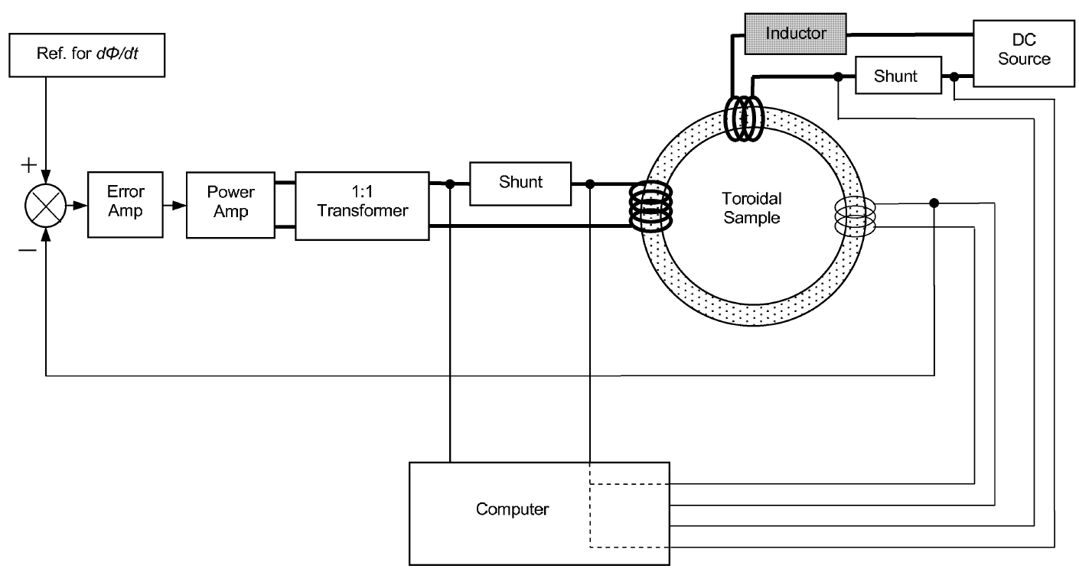
- Iron loss measurement method for DC bias flux density introduced in [CHA05].
(a) | (b)
- Current ripple in DC coil caused by AC flux density. (a) f=100Hz, B_{m}=1.0T, I_{DC}=2A. (b) f=1000Hz, B_{m}=1.0T, I_{DC}=2A [XUE17d].
- Diagram of iron loss test rig [XUE17a].
(a) | (b)
- Current in DC coil and voltage on AC coil of improved test system. (a) f=100Hz, B_{m}=1.0T, I_{DC}=2A. (b) f=1000Hz, B_{m}=1.0T, I_{DC}=2A [XUE17d].

Measurement under Mechanical Stress
To investigate the mechanical stress influence on the iron loss, specially designed test rig is required. Fig.1.37 shows the test rig proposed in [TAK07]. The flux density in the laminated specimen is detected by a B coil, which is wound around the specimen. The magnetic field strength H in the specimen is set by the magnetisation winding, which is wound on the surface of the specimen. The stress is applied by a hydraulic equipment. The application of this test solution can also be found in [MIY09] [MIY10]
- Iron loss test rig with mechanical stress influence in [MIY09].

Measurement under Rotational Flux Density
Improvement based on the existing test rig should be done to measure the iron loss under rotational flux density. Fig.1.38 shows the schematic diagram of the two-dimensional rotational iron loss test system developed in [ZHU98]. The magnetic field is generated by two sets of excitation coils arranged on the x- and y- axes. Different rotational flux densities can be generated by adjusting the excitation on x coil and the y coil. The x and y components of the flux density can be detected by the sensing coils wound on the specimen. This test method is used in [HUA12] [GUO14]. This measurement technique is also evolved to a three-dimensional rotational iron loss test system in [GUO06] as shown in Fig.1.39.
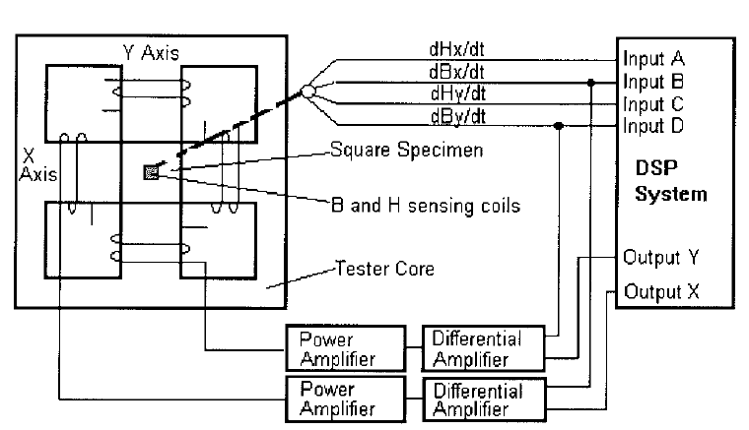
- Schematic diagram of a two-dimensional rotational iron loss test system [ZHU98].
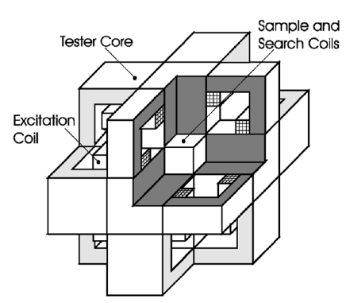
- Three-dimensional rotational iron loss test system [GUO06].

1.4.2 In Electrical Machines
In electrical machines, losses can be expressed as the difference between the input power $P_{in}$ and the output power $P_{out}$. The iron loss in electrical machines is expressed as:
$$P_{Fe}=P_{in}-P_{out}-P_{wi}-P_{mech}-P_{PM}$$ | (1.28)
where $P_{Fe}$ is the iron loss. $P_{wi}$ is the winding copper loss or copper loss. $P_{mech}$ is the mechanical loss. $P_{PM}$ is the magnet eddy current loss, and $P_{PM}=0$ if there is no PM in the machine.
It is very difficult to measure iron loss in the electrical machine directly. Therefore, the key of iron loss measurement in electrical machines is to separate iron loss from other losses. Therefore, the measurement techniques for the winding copper loss, the mechanical loss and the magnet eddy current loss are introduced. The iron loss can be then obtained by excluding these losses from the total loss according to (1.28).

Winding Copper Loss
The winding copper loss represents the loss produced by electrical currents in the conductors of electrical machine windings. When the AC effects (the skin effect and the proximity effect) are neglected, the winding copper loss can be considered as the DC copper loss. The DC copper loss can be calculated from the RMS-values of the currents and the winding resistances at operating temperature based on the Ohm’s law [BOI93] [FER94]:
$$P_{wi}(T)=mI^{2}R(T)$$ | (1.29)
where $m$ is the number of phases of the electrical machine. $I$ is the RMS-value of the phase current. $R(T)$ is the phase winding resistance at temperature $T$.
According to (1.29), temperature can influence the winding copper loss. By measuring the winding copper loss at different temperatures, the temperature dependent winding copper loss of the electrical machine can be obtained as shown in Fig.1.40 [SCH13]. The winding copper loss at any temperature within the temperature range can be then obtained by the interpolation or the curve fitting of the measurement results.
In electrical machines having high current frequency, AC effects on the winding copper loss cannot be neglected. The AC copper loss should be considered when calculate the winding copper loss [FER94]. The AC copper loss represents the total winding copper loss including the DC copper loss and additional losses caused by the skin effect and the proximity effect. However, it is very difficult to directly measure the AC copper loss in electrical machines. The AC copper loss is usually obtained by calculation based on FEA tools [IWA09] [GEE13] [MEL13]. In [GEE13], the AC copper loss of a 9-slot/6-pole high speed PM machine is investigated. The ratios of the AC and DC copper losses at different frequencies are shown in Fig.1.41. It can be seen that additional winding copper losses caused by the AC effects can be significant when the frequency is high. The increase of strands can significantly reduce the influence of AC effects, the AC copper losses are then decreased although attention should be paid to the potential increased DC loss due to low packing factor and also circulating currents amongst strands.
- Winding copper loss of a synchronous machine at 15Nm, 1,500rpm [SCH13].
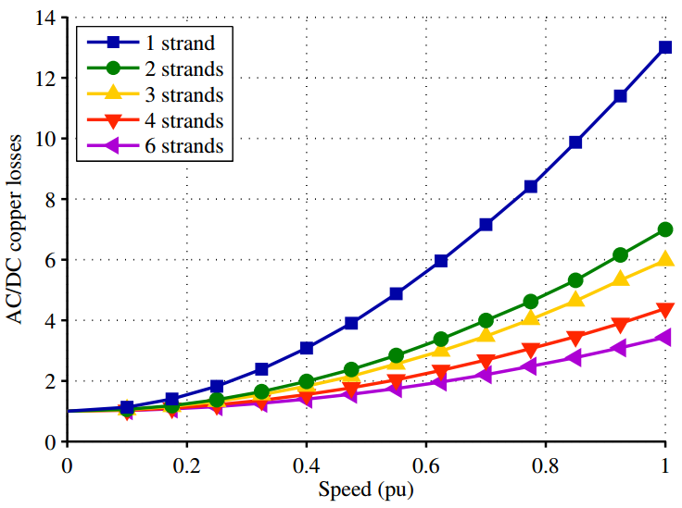
- Ratios of AC and DC copper losses of a 9-slot/6-pole PM machine at different speed (rated speed n=36,000rpm) [GEE13].

Mechanical Loss
A measurement technique for the mechanical loss is provided in [DOM04]. The test rig is shown in Fig.1.42. Firstly, the torque of the driving motor is measured by the torque meter when the measured motor is disconnected. The torque $τ_{1}(n)$ can be then measured at different rotor speed $n$. Secondly, the measured motor is connected to the torque meter and the torque $τ_{2}(n)$ can be measured at different rotor speed. Finally, the mechanical loss $P_{mech}$ of the measured machine is obtained by:
$$P_{mech}=\frac{n}{9.549}[τ_{2}\left(n\right)-τ_{1}\left(n\right)]$$ | (1.30)
In order to exclude the effect of the permanent magnets, all the permanent magnets in the measured machine should be removed during the test. Since this measurement technique is very easy to implement, it is widely used in mechanical loss measurement. Fig.1.43 shows the typical mechanical loss of a 6-slot/4-pole SRM [MIN12]. The mechanical loss at different rotor speed can be obtained by interpolation or curve fitting of the measured results.
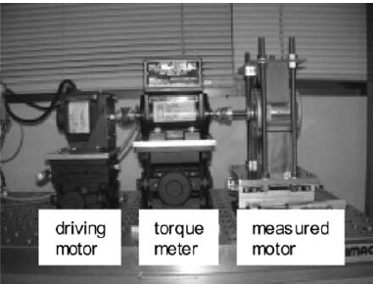
- Mechanical loss test rig [DOM04].
- Mechanical loss of a 6-slot/4-pole SRM [MIN12].

Magnet Eddy Current Loss
It is very difficult to directly measure the eddy current loss of magnets in PM machines. The magnet eddy current loss is usually obtained by finite element analysis (FEA) tools instead of measurements [CHU14] [CHO14]. Some studies have been carried out on the measurement techniques. In [YAM12], a measurement technique based on locked rotor tests is developed. The measuring system is shown in Fig.1.44.
The currents are supplied to the machine whose rotor is locked. In this case, both output power $P_{out}$ and mechanical loss $P_{mech}$ are zero. Therefore, the sum of the iron loss and the magnet eddy current loss $P_{Fe}+P_{PM}$ can be obtained by subtracting the winding copper loss $P_{wi}$ from the input power $P_{in}$. Furthermore, to separate magnet loss $P_{PM}$ and iron loss $P_{Fe}$, the same experiment is performed again on the machine without the magnets. In this case, the iron loss $P_{Fe}$ is obtained. The magnet eddy current loss $P_{PM}$ can be then obtained by subtracting $P_{Fe}$ from $P_{Fe}+P_{PM}$.
This measurement technique is easy to implement. The approximate magnet eddy current loss can be obtained. However, the iron loss can be different with or without magnets. The iron loss and the magnet eddy current loss cannot be decoupled directly by the method described in [YAM12].
Some measurement techniques are based on the temperature rise of the magnets [AOY05]. A relationship between the magnet eddy current loss and the temperature rise is investigated in [AOY05]. The magnet eddy current loss can be then obtained by:
$$P_{PM}(T)=P_{PM}(T_{0})\frac{ρ_{T}}{ρ_{T_{0}}}$$ | (1.31)
where $P_{PM}(T)$ and $P_{PM}(T_{0})$ are the magnet eddy current losses at temperature $T$ and $T_{0}$, respectively. $ρ_{T}$ and $ρ_{T_{0}}$ are the resistivities of magnets at temperature $T$ and $T_{0}$, respectively.
This technique is further developed and applied into an electrical machine [MAL15]. However, this technique suffers from poor accuracy and high difficulty of magnet temperature measurement in actual machines.
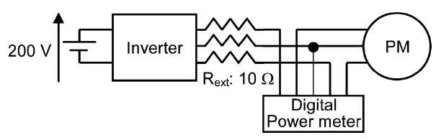
- Schematic diagram of measurement test bench [YAM12].

1.5 Research Scope and Thesis Outline
The aim of this thesis is to investigate the temperature effect on iron loss in electrical machines, and to model the temperature dependency based on empirical iron loss models at different conditions. Fig.1.45 shows the research scope and research structure of this thesis. This thesis is organized in 7 chapters with following content:
- Chapter 1 is the current chapter with a brief introduction about the scope of the thesis and the scientific contributions.
- Chapter 2 compares the existing iron loss models for sinusoidal flux density. Four of the most commonly used iron loss models for sinusoidal flux density at constant temperature are evaluated based on the steel lamination test. One of the most accurate iron loss model for sinusoidal flux density at constant temperature is then identified.
- Chapter 3 studies the temperature influence on the iron loss. The limitation of the existing iron loss models on considering the temperature influence is presented. An improved iron loss model for further consideration of temperature influence is proposed. The improved iron loss model is then validated by an electrical machine test.
- Chapter 4 discusses the combine influence of DC bias flux density and temperature. The temperature dependency of DC bias coefficients is modelled. An iron loss model for considering the combine influences of DC bias flux density and temperature is proposed. Electrical machine tests are also carried out to evaluate the iron loss model.
- Chapter 5 presents the additional iron loss caused by the flux density distortion. An iron loss model is developed for taking flux density distortion effect into account while considering the temperature influence. Iron losses of an electrical machine fed by a PWM inverter are measured, the iron loss model is then validated.
- Chapter 6 develops an iron loss model for arbitrary flux density waveform which takes temperature influence into account. The iron loss model for arbitrary flux density waveform is also validated by electrical machine tests at different operating conditions.
- Chapter 7 provides a summary of the main results and conclusions of this thesis and gives proposals for future studies on iron loss prediction in electrical machines.
- Research structure of this thesis.

1.6 Contributions
In this thesis, the temperature effect on the iron loss is explored. Some contributions of this thesis can be listed as follows:
- Different methods for measuring iron losses in steel laminations and electrical machines at different temperature are introduced.
- The most accurate iron loss model for sinusoidal flux density at constant temperature is identified.
- An improved iron loss model for sinusoidal flux density considering temperature influence on both hysteresis and eddy current losses is proposed.
- An improved iron loss model for considering the combine influence of DC bias flux density and temperature is developed.
- An improved iron loss model for electrical machines is presented. The flux density distortion caused by MMF harmonics in actual electrical machines can be considered by the improved model. The improved model also takes the temperature effect into account.
- An iron loss model for arbitrary flux density waveform which takes temperature influence into account is proposed.

Chapter 2 Comparison of Iron Loss Models for Alternating Sinusoidal Flux Density
In this chapter, iron loss models for alternating sinusoidal flux density are reviewed at first and then evaluated by the measured results of a steel lamination ring specimen. Based on these investigations, the iron loss model having the best prediction accuracy for alternating sinusoidal flux density at constant temperature is identified.

2.1 Introduction
According to the review on the iron loss models in Chapter 1, many different iron loss models have been developed in [BER88] [FIO90] [BOG03] [ION07] for alternating sinusoidal flux density. These iron loss models are widely used since they have solid physical basis while very easy to implement [FIO90] [BAR13] [COS15]. The iron loss models are also evolved to many different forms to adapt some specific conditions such as for the temperature consideration [CHE15] [XUE17c], for the flux density with DC bias [SIM09] [ZHU14] [XUE17a], and for flux density distortion when supplied by PWM inverter [LAV78] [XUE17b], etc. Although many iron loss models are evolved from the iron loss models for alternating sinusoidal flux density, rare study has been done to compare these iron loss models, which is essential for the further study on the iron loss prediction.
In this chapter, different iron loss models for alternating sinusoidal flux density are evaluated against the measured results. This chapter is organized as follows. In Section 2.2, the iron loss measurement technique of the steel lamination ring specimen is demonstrated in detail. Different iron loss models for alternating sinusoidal flux density are evaluated in Sections 2.3. Based on the iron loss test results, one of the most accurate iron loss model for alternating sinusoidal flux density is then identified for the further study.

2.2 Iron Loss Measurement in Steel Laminations
According to the review on the iron loss measurement techniques in Chapter 1, the steel lamination ring specimen test has been widely used to measure the iron loss of steel laminations under alternating flux density due to its high accuracy and feasibility. Therefore, the steel lamination ring specimen test is used in this chapter. The actual measurement system used in this chapter is shown in Fig. 2.1. The iron loss density $p_{Fe}$, the field strength $H\left(t\right)$ and the flux density$B\left(t\right)$ can be obtained by:
$$p_{Fe}=\frac{1}{TρV}\int_{0}^{T}{u\left(t\right)i\left(t\right)dt}$$ | (2.1)
$$H\left(t\right)=\frac{Ni(t)}{l_{eff}}$$ | (2.2)
where $p_{Fe}$ is the iron loss density. $u(t)$ is the instant induced voltage of the measuring coil.$i(t)$ is the instant current in the excitation coil. $T$ is the time period of the current and the voltage. $ρ$ and $V$ are the mass density and the volume of the steel lamination ring specimen, respectively. $N$ is the number of turns of the excitation coil and the measuring coil. $l_{eff}$ is the effective length of the steel lamination ring specimen.
Fig. 2.1 Schematic diagram of steel lamination ring specimen iron loss measuring.
Since the magnetic permeability of the lamination is much higher than the magnetic permeability of the air, the flux leakage is negligible. Also, the flux density can be treated as evenly distributed in the specimen since the specimen has a much bigger average radius than radial thickness. In order to support this, the flux density distribution is simulated by FEA when the average flux density in the ring is 1.70T. The maximum flux density is 1.72T while the minimum flux density is 1.68T in the ring specimen as shown in Fig. 2.2. It is shown that the difference between the maximum and minimum flux densities in the ring is < 3% of the average flux density. In this case, the flux density $B\left(t\right)$ in the lamination can be approximately obtained as:
$$B\left(t\right)=\frac{\int{u(t)dt}}{NA}$$ | (2.3)
where $A$ is the cross sectional area of the steel lamination ring specimen.
Fig. 2.2 FEA predicted flux density distribution of steel lamination ring specimen when average flux density is 1.70T.
In actual test rigs in this chapter, the steel lamination ring specimen is made of wire cut non-oriented 0.35mm thick V300-35A Si-Fe steel laminations. The excitation coil is made of Litz wire with a relatively large total conductor cross-section. The resistance of the excitation coil is 0.04Ω. Due to negligible voltage on the resistance, the flux density in the steel lamination ring specimen and the induced voltage from the measuring coil are sinusoidal, even when the excitation current is non-sinusoidal. This can be seen in Fig. 2.3, especially so when the flux density is high due to the nature of non-linear soft magnetic materials. A K-type thermal couple is equipped into the steel lamination ring specimen and connected to a thermal meter for monitoring the temperature. Fig.2.4 shows the measured B-H loops at 40°C when the frequency is 50Hz and 1000Hz, respectively. It can be seen that the B-H loops will be distorted when the flux density is high due to the saturation at both 50Hz and 1000Hz. The shape of B-H loops, which represents the iron losses in a time period, is frequency and flux density dependent. The excitation coil is powered by a California Instrument 4500iL power supply, whose maximum output voltage and current is 150V/30A RMS with an output frequency range of 45Hz-5kHz. The dimensions of the steel lamination ring specimen and the coil number of turns are specially designed and listed in Table 2.1 in order to cover the flux density and frequency ranges specified in Table 2.2.
Fig. 2.5 shows the measured iron loss in the steel lamination ring specimen at different frequencies and flux densities at 40°C. It can be seen that the iron loss varies with the frequency and flux density in an identical pattern. This pattern has been investigated and modelled widely in [BER88] [FIO90] [BOG03] [ION07].
(a)
(b)
Fig. 2.3 Typical waveforms for measured currents in excitation coil and voltages on measuring coil. (a) B_{m}=0.2T and f=50Hz. (b) B_{m}=1.73T and f=1000Hz.
Fig. 2.4 Measured B-H loops at 40°C when frequency is 50Hz and 1000Hz.
Table 2.1 Steel lamination ring specimen parameters
Type of silicon steel lamination |  | V300-35A
Thickness of single lamination | mm | 0.35
Outer diameter of steel lamination ring specimen | mm | 150
Inner diameter of steel lamination ring specimen | mm | 125
Effective thickness of steel lamination ring specimen | mm | 14
Number of turns for excitation and measuring coils N |  | 102

Table 2.2 Steel lamination ring specimen iron loss measuring system rest range
Maximum output voltage in RMS value | V | 150
Maximum output current in RMS value | A | 30
Frequency range | Hz | 50-1000
Temperature range | °C | 40-100
Fig. 2.5 Measured iron loss in the steel lamination ring specimen at different frequency and flux density at 40°C.

2.3 Iron Loss Models for Alternating Sinusoidal Flux Density
According to the review on iron loss models in Chapter1, the iron loss models presented in [BER88] [FIO90] [BOG03] [ION07] are the most widely used models for alternating sinusoidal flux density.
In [BER88], iron loss is calculated by the three-term formula including the hysteresis loss, the classical loss and the excess loss as:
$$p_{Fe}=k_{h}fB_{m}^{α}+k_{cl}f^{2}B_{m}^{2}+k_{exc}f^{1.5}B_{m}^{1.5}$$ | (2.4)
where $B_{m}$ is the amplitude of the flux density. $k_{h}$ and $α$ are the hysteresis loss coefficients. $k_{cl}$ is the classical loss coefficient. $k_{exc}$ is the excess loss coefficient. The coefficients can be obtained by the curve fitting of the test results at different flux density and frequency.
In [FIO90], The iron loss model can be expressed as:
$$p_{Fe}=k_{h}fB_{m}^{α}+\frac{{σd}^{2}}{12}\frac{1}{T}\int_{0}^{T}{{\left(\frac{dB}{dt}\right)}^{2}}dt+\frac{k_{exc}}{T}\int_{0}^{T}{{\left|\frac{dB}{dt}\right|}^{1.5}}dt$$ | (2.5)
where $σ$ and $d$ are the electrical conductivity and the thickness of the lamination. $T$ is the time period.
It is concluded in [BOG03] that the contributions of classical loss and excess loss cannot be separated. Alternatively, a two-term iron loss model is developed, where the classical loss and excess loss in the three-term model are combined into a global eddy current loss. This model can be expressed as:
$$p_{Fe}=k_{h}fB_{m}^{2}+k_{e}f^{2}B_{m}^{2}$$ | (2.6)
According to the investigation on the iron loss, the hysteresis loss and eddy current loss coefficients vary with frequency and flux density. Therefore, an iron loss model with variable coefficients is presented in [ION07]:
$$p_{Fe}=k_{h}(f,B_{m})fB_{m}^{2}+k_{e}(f,B_{m})f^{2}B_{m}^{2}$$ | (2.7)
The division of (2.7) by $fB_{m}^{2}$ yields the linear equation below,
$$\frac{p_{Fe}}{fB_{m}^{2}}=k_{h}(f,B_{m})+k_{e}(f,B_{m})f$$ | (2.8)
Coefficients $k_{h}(f,B_{m})$ and $k_{e}(f,B_{m})$ at specific frequency and flux density are identifiable from the y-axis crossing point and the slope of the line. The hysteresis loss and eddy current loss coefficients are then separated. Based on the two measured results having the same flux density and the adjacent frequencies, a set of $k_{h}(f,B_{m})$ and $k_{e}(f,B_{m})$ can be calculated based on (2.8). In the similar way, $k_{h}(f,B_{m})$ and $k_{e}(f,B_{m})$ can be obtained under different flux densities and frequencies using the measured data. Secondly, in order to simplify the modelling of the coefficients, the coefficients variation with the frequency is considered by using two sets of results representing the low and high frequency regions. In this chapter, the low frequency covers 50Hz, 200Hz and 400Hz whilst the high frequency covers 600Hz, 800Hz and 1000Hz. This method is also used in [ION07].
It can be seen from the iron loss models (2.4)-(2.7) that the coefficients are very important for the prediction accuracy. The iron loss coefficients are constants in models (2.4), (2.5) and (2.6) while the coefficients are variables in model (2.7). Table 2.3 lists the coefficients for iron loss models (2.4), (2.5) and (2.6). Fig. 2.6 shows the variable coefficients of iron loss model (2.7).

Table 2.3 Iron loss models (2.4), (2.5) and (2.6) coefficients
Parameters for iron loss model (2.4)
$$k_{h}$$ |  | $$k_{cl}$$ |  | $$k_{exc}$$ |  | $$α$$
3.25×10⁻² |  | 6.67×10⁻⁵ |  | 5.95×10⁻⁴ |  | 2
Parameters for iron loss Model (2.5)
$$k_{h}$$ | $d$ (mm) |  | $σ$ (S/m) |  | $$k_{exc}$$ |  | $$α$$
3.6×10⁻² | 3.5×10⁻⁴ |  | 2.0×10⁶ |  | 5.95×10⁻⁴ |  | 2
Parameters for iron loss Model (2.6)
$$k_{h}$$ |  |  |  | $$k_{e}$$
3.76×10⁻² |  |  |  | 8.03×10⁻⁵
(a)
(b)
Fig. 2.6 Iron loss model (2.7) coefficients. (a) $k_{h}$. (b) $k_{e}$.
Fig. 2.7 shows the predicted and measured results by the iron loss models (2.4)-(2.7). In order to compare the predicted and measured iron losses more clearly and comprehensively, the relative prediction error is employed,
$$err={{(p}_{Fe, Pre}-p}_{Fe, Mea})/p_{Fe,Mea}$$ | (2.9)
where $err$ is the relative prediction error. $p_{Fe, Pre}$ is the predicted iron loss density. $p_{Fe,Mea}$ is the measured iron loss density.
The relative prediction errors of the iron loss models are also shown in Fig. 2.8. Table 2.4 shows the numerical average relative prediction errors results. It can be seen that the prediction accuracies of iron loss models (2.4), (2.5) and (2.6) are close to each other while the prediction accuracy of (2.7) is much better. This is due to the fact that the iron loss models (2.4), (2.5) and (2.6) are based on constant coefficients, which cannot consider the coefficient variation with flux density and frequency. On the other hand, the prediction accuracy keeps good in the whole test range with the help of variable coefficients.
(a)
(b)
(c)
(d)
Fig. 2.7 Measured and predicted results of models at 40°C. (a) Model (2.4). (b) Model (2.5). (c) Model (2.6). (d) Model (2.7).
(a)
(b)
(c)
(d)
Fig. 2.8 Prediction relative errors of iron loss models at 40°C. (a) Model (2.4). (b) Model (2.5). (c) Model (2.6). (d) Model (2.7).

Table 2.4 Iron loss models’ average prediction relative errors at 40°C
Iron loss model | (2.4) | (2.5) | (2.6) | (2.7)
Relative error (%) | 11.3 | 10.3 | 10.7 | 2.4

2.4 Conclusions
In this chapter, the measurement procedure of the iron loss in the steel laminations is demonstrated. Iron losses are measured by a steel lamination ring specimen test. Four of the most commonly used iron loss models for alternating sinusoidal flux density are evaluated against the measured iron losses. The iron loss model (2.7) has the best accuracy when the flux density alternates sinusoidally at constant temperature with the help of variable coefficients.

Chapter 3 Iron Loss Calculation Considering Temperature Influence

3.1 Introduction
In Chapter 2, the most commonly used existing iron loss models for alternating sinusoidal flux density are evaluated against the test results. However, none of these existing iron loss models considers the influence of temperature. The iron loss can be influenced by the temperature significantly as reported in [WIL02] and [RAG09] on ferrite cores, [KRI13] on Ni-Fe laminations, [FOS86] on oriented silicon steel laminations, and [TAK10] [TAK11] [CHE15] on non-oriented silicon steel laminations.
In [CHE15], only the temperature dependency of the eddy current loss is considered while the hysteresis loss is assumed to be not influenced by the temperature. However, in [TAK10] and [TAK11], it has shown experimentally that the hysteresis and eddy current losses have different temperature dependencies.
The aim of this chapter is to develop an iron loss model which can consider the temperature dependencies of the hysteresis and the eddy current losses. The iron losses at different flux density, frequency and temperature in non-oriented Si-steel laminations are measured firstly by the steel lamination ring specimen test as will be described in Section 3.2. In Section 3.3, the influence of temperature on the iron loss is illustrated, the different temperature dependencies of hysteresis and eddy current losses are also investigated. The limitations of the existing model are demonstrated. An improved iron loss model considering the temperature dependencies of hysteresis and eddy current losses separately is developed and verified by the steel lamination ring specimen tests. In Section 3.4, the further experimental validation of the improved iron loss model on an electrical machine is presented.

3.2 Temperature Dependency of Iron Loss
Based on the measurement method and the test rig described in Chapter 2, the iron losses under different flux densities, frequencies and temperatures are measured. In order to illustrate the iron loss variation more clearly, the investigation in this chapter is carried out in two steps. Firstly, the existing iron loss model is evaluated at different temperature. The influence of temperature on the iron loss is investigated and modelled, the improved iron loss model for considering the temperature influence is then developed.
Fig. 3.1 shows the measured B-H loops at different temperatures and frequencies. It can be seen that the B-H loops vary with the temperature, the iron losses are then affected. In order to comprehensively investigate the influence of temperature on iron loss, the iron loss variations with the temperature at different combinations of frequencies and flux densities in steel laminations are measured, as shown in Fig 3.2. It can be seen that the iron loss in the steel laminations varies when the temperature rises across the whole test range. This is due to the fact that the hysteresis loss and eddy current loss are dominated by the permeability and resistivity respectively, which are influenced by temperature significantly. On the other hand, the variations of iron loss with temperature at different frequency and different flux density are shown in Fig 3.3. It can be seen that the iron loss varies almost linearly with the temperature rise. This is due to the fact that the permeability and conductivity of non-oriented steel laminations vary linearly between room temperature and 200°C, which has been experimentally confirmed in [TAK10]. This linear temperature dependency of iron loss in other types of steel laminations is also reported in [NAK14]. It should be noted that the temperature dependency of iron loss will be non-linear when the temperature is > 200°C [TAK11]. However, electrical machines from normal industrial and domestic applications typically operate with a maximum temperature of < 120°C [KRI13]. Therefore, the temperature dependency of iron loss can be considered as linear for this temperature range. Furthermore, as shown in Fig 3.4, the iron loss varies with temperature, with the amount of variation corresponding to different frequencies and flux densities. Taking the test results of lamination for instance, when the temperature increases from 40°C to 100°C, the iron loss at 1.73T and 1000Hz reduces by > 10% while the iron loss at 0.2T and 50Hz decreases by < 5%. This variation in the change of iron loss with temperature at different frequencies and flux densities will be investigated in this chapter.
(a)
(b)
Fig. 3.1 B-H loops at different frequencies and temperatures when flux density is sinusoidal. (a) 50Hz. (b) 1000Hz.
Fig. 3.2 Measured iron loss at different temperature.
(a)
(b)
(c)
Fig. 3.3 Measured iron loss variation with temperature. (a) B_{m}=0.2T. (b) B_{m}=1.0T. (c) B_{m}=1.73T.
According to the investigation in Chapter 2, the iron loss model (2.7) is experimentally confirmed to be the most accurate at constant temperature with the help of variable coefficients. Therefore, in this chapter, the iron loss model (2.7) is selected for further research. This iron loss model is expressed as:
$$p_{Fe}=k_{h}(f,B_{m})fB_{m}^{2}+k_{e}(f,B_{m})f^{2}B_{m}^{2}$$ | (3.1)
It should be noted that the temperature influence on iron loss is not considered in this model. The coefficients of this model are obtained based on the measurement iron loss when the temperature is constant. In Chapter 2, all coefficients of this model are obtained when the lamination temperature is 40°C.
Fig. 3.4 shows the comparison of the predicted iron loss by existing model (2.7) with the measured iron loss at different lamination temperatures. The existing model (2.7) is able to accurately predict the iron loss at different flux densities and different frequencies when the lamination temperature remains 40ºC. However, the iron loss could vary significantly when the temperature increases from 40ºC to 100°C, as shown in Fig 3.4. The predicted iron loss of existing model (2.7) cannot reflect this variation. Therefore, the prediction accuracies of this existing model can be significantly degraded when the temperature changes.
(a)
(b)
(c)
Fig. 3.4 Measured iron loss and predicted iron loss of existing model (2.7). (a) B_{m}=0.2T. (b) B_{m}=1.0T. (c) B_{m}=1.73T.

3.3 Iron Loss Model Considering Temperature Influence
According to the iron loss model (2.7), when the frequency $f$ and the flux density $B_{m}$ are determined, the hysteresis loss and the eddy current loss will be only determined by the coefficients $k_{h}(f,B_{m})$ and $k_{e}(f,B_{m})$, respectively. Since the flux density and frequency are not temperature dependent, the temperature influence on hysteresis and eddy current losses will be reflected directly by the loss coefficients $k_{h}(f,B_{m})$ and $k_{e}(f,B_{m})$. Therefore, the investigation on temperature dependencies of hysteresis loss and eddy current loss coefficients is necessary for further modelling.
In order to investigate the temperature dependencies of the hysteresis loss and the eddy current loss separately, the coefficients $k_{h}(f,B_{m})$ and $k_{e}(f,B_{m})$ in (2.7) are calculated respectively based on the measured iron loss at different temperatures and shown in Figs. 3.5 and 3.6. It can be seen that both the hysteresis loss $k_{h}(f,B_{m})$ coefficient and the eddy current loss $k_{e}(f,B_{m})$ coefficient vary not only with frequency and flux density but also with temperature. Therefore, the improved iron loss model is then developed and can be expressed as:
$$p_{Fe,T}=k_{h}(T,f,B_{m})fB_{m}^{2}+k_{e}(T,f,B_{m})f^{2}B_{m}^{2}$$ | (3.2)
where $p_{Fe,T}$ is the iron loss density at the actual temperature T. $k_{h}(T,f,B_{m})$ and $k_{e}(T,f,B_{m})$ are hysteresis loss and eddy current loss coefficients, respectively.
(a)
(b)
Fig.3.5 Hysteresis loss coefficient. (a) f=50Hz. (b) f=1000Hz.
(a)
(b)
Fig.3.6 Eddy current loss coefficient. (a) f=50Hz. (b) f=1000Hz.

3.3.1 Modelling Temperature Dependent Coefficients
According to the improved iron loss model (3.2), iron loss coefficients at any temperature, frequency and flux density among the test range can be calculated by interpolation $k_{h}(T,f,B_{m})$ and $k_{e}(T,f,B_{m})$ the coefficient shown in Figs. 3.5 and 3.6. The temperature dependency of the iron loss can be then fully considered. However, the coefficients have to be measured at many different temperatures to guarantee the accuracy of the interpolation, which is complicated and time consuming. Therefore, it is necessary to model the temperature dependent coefficients.
Based on the results shown in Figs. 3.5 and 3.6, it can be further seen that both the hysteresis and eddy current loss coefficients vary approximately linearly with temperature although the varying rate changes with flux density and frequency. These linear variations are also confirmed in [FOS86] and [TAK10]. Therefore, a simple linear relationship between the coefficients and the temperature can be considered for the typical operation temperature range of electrical machines. On the other hand, it should be noted from Figs. 3.5 and 3.6 that the varying rates of hysteresis and eddy current loss coefficients with the temperature are different even under the same flux density and frequency. By considering all these aspects, the temperature dependent iron loss coefficients can be modelled as:
$$k_{h}\left(T,f,B_{m}\right)=k_{th}\left(T,{f,B}_{m}\right)k_{h{,T}_{0}}(f,B_{m})$$ | (3.3)
$$k_{e}\left(T,f,B_{m}\right)=k_{te}\left(T,{f,B}_{m}\right)k_{e{,T}_{0}}(f,B_{m})$$ | (3.4)
where $k_{th}\left(T,{f,B}_{m}\right)$and $k_{te}\left(T,{f,B}_{m}\right)$ are the temperature dependent coefficients of hysteresis and eddy current losses. $k_{h{,T}_{0}}(f,B_{m})$ and $k_{e{,T}_{0}}(f,B_{m})$ are the hysteresis and eddy current loss coefficients when the temperature is $T_{0}$.
As demonstrated above, hysteresis and eddy current loss coefficients vary linearly with temperature with different rates. Therefore, the temperature dependent coefficients can be expressed as:
$$k_{th}\left(T,f,B_{m}\right)=1+(T-T_{0})D_{hyst}(f,B_{m})$$ | (3.5)
$$k_{te}\left(T,{f,B}_{m}\right)=1+\left(T-T_{0}\right)D_{eddy}{(f,B}_{m})$$ | (3.6)
where $D_{hyst}{(f,B}_{m})$ and $D_{eddy}{(f,B}_{m})$ are varying rates of the hysteresis and eddy current loss coefficients with temperature and can be calculated by measured hysteresis losses and eddy current losses at two different temperatures $T_{0}$. and $T_{1}$. for the same frequency and flux density as:
$$D_{hyst}({f,B}_{m})=\frac{k_{h{,T}_{1}}(f,B_{m})-k_{h{,T}_{0}}(f,B_{m})}{\left(T_{1}-T_{0}\right)k_{h{,T}_{0}}(f,B_{m})}$$ | (3.7)
$$D_{eddy}({f,B}_{m})=\frac{k_{e{,T}_{1}}(f,B_{m})-k_{e{,T}_{0}}(f,B_{m})}{\left(T_{1}-T_{0}\right)k_{h{,T}_{0}}(f,B_{m})}$$ | (3.8)
where $k_{h{,T}_{1}}(f,B_{m})$, $k_{h{,T}_{0}}(f,B_{m})$, $k_{e{,T}_{1}}(f,B_{m})$ and $k_{e{,T}_{0}}(f,B_{m})$ are the hysteresis and eddy current loss coefficients when the temperature is $T_{0}$ and $T_{1}$, respectively.
In this chapter, $T_{1}$ is 100ºC and $T_{0}$ is 40ºC. Positive $D_{hyst}({f,B}_{m})$ or $D_{eddy}({f,B}_{m})$ means that the loss increases with temperature rise while negative $D_{hyst}({f,B}_{m})$ or $D_{eddy}({f,B}_{m})$ means that the loss decreases with temperature rise. According to (3.7) and (3.8), the improved iron loss model has two advantages: First, the temperature dependencies of the hysteresis loss and the eddy current can be considered separately. Second, the temperature influence on the iron loss can be considered by the measured results at only two different temperatures $T_{0}$ and $T_{1}$.
In order to investigate the variation of $D_{hyst}({f,B}_{m})$ and $D_{eddy}({f,B}_{m})$ with the frequency, the whole frequency test range 50-1000Hz is simply divided into two segments, i.e., the low frequency 50-400Hz and the high frequency 400-1000Hz. Fig 3.7 shows the $D_{hyst}({f,B}_{m})$ and $D_{eddy}({f,B}_{m})$ at low frequency and high frequency, respectively. It can be seen from Fig 3.7 that the eddy current loss decreases with the temperature rise in the whole test range due to the increase of resistivity. The hysteresis loss has different dependencies with temperature (decrease or increase) at different flux density. This is due to the fact that the hysteresis loss depends on the permeability, which has a nonlinear relationship with temperature and flux density. It also can be observed that the eddy current loss is more sensitive with temperature when the flux density is higher. This phenomena is also reported in [TAK10] and [TAK11].
By applying $D_{hyst}({f,B}_{m})$ and $D_{eddy}({f,B}_{m})$ to (3.5) and (3.6) respectively, the temperature dependent coefficients can be then obtained. Fig 3.8 shows the predicted temperature dependent coefficients $k_{th}\left(T,{f,B}_{m}\right)$ and $k_{te}\left(T,{f,B}_{m}\right)$ at low frequency and high frequency, respectively. The temperature influences on the iron losses are then considered by substituting these temperature dependent coefficients to (3.3) and (3.4).
(a)
(b)
Fig. 3.7 Hysteresis loss varying rate D_{hyst} and eddy current loss varying rate D_{eddy} (a) Low frequency (50-400Hz). (b) High frequency (400-1000Hz).
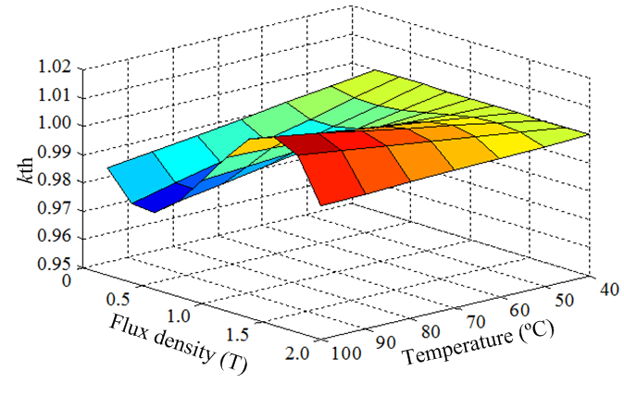
(a)
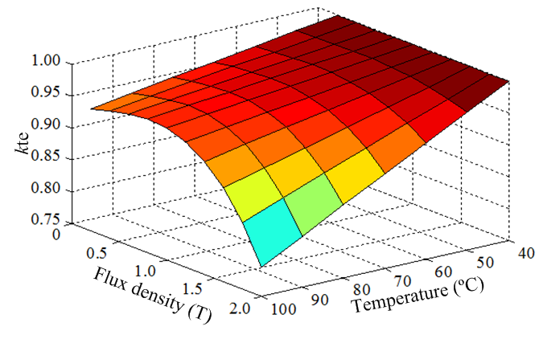
(b)
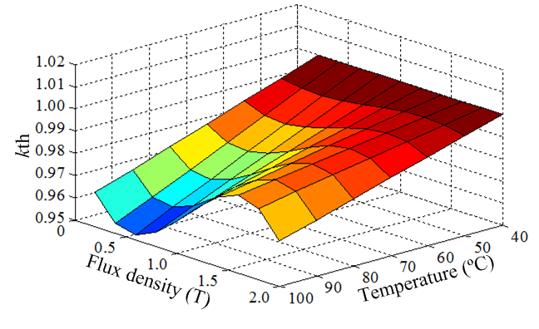
(c)
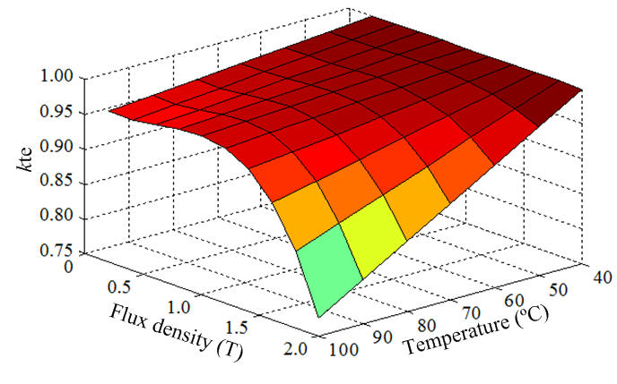
(d)
Fig. 3.8 Predicted temperature dependent coefficients of hysteresis loss and eddy current loss. (a) k_{th} in low frequency (50-400Hz). (b) k_{te} in low frequency (50-400Hz). (c) k_{th} in high frequency (400-1000Hz). (d) k_{te} in high frequency (400-1000Hz).

3.3.2 Validation of Improved Iron Loss Model in Steel Laminations
Fig. 3.9 shows the measured and predicted iron loss at different frequency and flux density when the temperature is 100°C. It can be seen that when the temperature changes to 100°C, the improved model can track the variation of iron loss more precisely. Fig 3.10 shows the comparison of relative prediction errors of existing and improved models at different flux density, frequency and temperature. It can be seen that the relative prediction errors of existing model (2.7) vary significantly with the temperature rise. This is due to the fact that the existing model (2.7) cannot reflect the temperature influence on iron losses. The prediction iron losses of the existing model keep constant while the actual iron losses vary significantly when temperature changes. On the other hand, the improved model (3.2) can predict the iron losses with low and stable relative prediction errors even when the temperature changes significantly. This is due to the fact that the improved model (3.2) can track the iron loss variation with temperature. This means that the improved model can consider the temperature influence on iron losses effectively.
(a)
(b)
(c)
Fig. 3.9 Predicted and measured iron loss at different frequency and flux density when the temperature is 100ºC. (a) B_{m}=0.2T. (b) B_{m}=1.0T. (c) B_{m}=1.73T.
(a)
(b)
(c)
Fig. 3.10 Relative prediction errors of existing and improved models at different temperature. (a) B_{m}=0.2T. (b) B_{m}=1.0T. (c) B_{m}=1.73T.

3.4 Further Experimental Validation on an Electrical Machine
In previous sections of this chapter, the accuracy of the improved iron loss model on predicting the iron loss considering temperature influence has been validated by the measured results of steel lamination ring specimen test. However, the flux density distribution and variation in electrical machines are uneven and much more complicated than the ones in the steel lamination ring specimen. In order to ensure that the improved iron loss model is useful for the iron loss prediction in electrical machines, it is important to evaluate the accuracy of the improved model in real electrical machines, which is carried out in this section.
The test system of iron loss in an electrical machine under different flux density, frequency and temperature is shown in Fig 3.11. A 12-slot/10-pole IPM machine is manufactured and employed for the test. In order to exclude the influence of mechanical stress, the wire cut steel laminations are used for the stator and rotor cores. Furthermore, in order to ensure that there is no stress between the housing and the stator core, the push fit method is used, i.e. the stator core is pushed into the housing and glued. The parameters of the electrical machine are listed in Table 3.1. The photos of the stator and the rotor are shown in Fig. 3.12. In order to exclude the mechanical loss and the magnet eddy current loss, the rotor is locked and there is no magnet in the rotor. The three-phase windings are powered by the three-phase AC power source. The measured iron loss of the electrical machine can be obtained by subtracting the winding copper loss from the total input power:
$$P_{Fe}=P_{in}-P_{wi}$$ | (3.9)
where $P_{Fe}$ is the total iron loss of the electrical machine. $P_{in}$ is the input power to the machine. $P_{wi}$ is the winding copper loss, which can be calculated by the measured winding resistance considering temperature dependency.
The winding copper loss of the 12-slot/10-pole IPM machine can be obtained as:
$$P_{wi}(T)=3I^{2}R(T)$$ | (3.10)
where $I$ is the RMS-value of the phase current. $R(T)$ is the phase winding resistance at temperature $T$.
For measuring the resistance of the winding, a DC current is input to the armature winding by a DC power source. The resistance can be calculated by the measured voltage on the winding and the current in the winding. Furthermore, in order to measure the resistance at different temperature, the winding is heated by the winding copper loss generated by itself. The temperature can be then measured by the thermal couple equipped in the electrical machine. The resistance is expressed as:
$$R\left(T\right)=\frac{U(T)}{I(T)}$$ | (3.11)
where $R\left(T\right)$, $U\left(T\right)$, $I\left(T\right)$ are the resistance of the winding, the DC voltage on the winding and the DC current in the winding when the temperature is $T$, respectively.
The phase resistance of the 12-slot/10-pole IPM machine at different temperature is shown in Fig. 3.13. The temperature dependent resistance is then obtained by fitting the measured resistances at different temperature as below:
$$R(T)=R_{T_{0}}+α(T-T_{0})$$ | (3.12)
where $R(T)$ is the resistance at the actual temperature T. $R_{T_{0}}$ is the resistivity at the base temperature T₀. $α$ is the temperature coefficient.
Fig. 3.11 Locked rotor test without magnets.
Table 3.1. 12-slot/10-pole IPM machine parameters
Slot number | 12 | Tooth body width (mm) | 7.1
Pole number | 10 | Slot opening (mm) | 2
Stator outer radius (mm) | 50 | Stack length (mm) | 50
Stator inner radius (mm) | 28.5 | Airgap length (mm) | 1
Rotor outer radius (mm) | 27.5 | No. turns per phase | 132
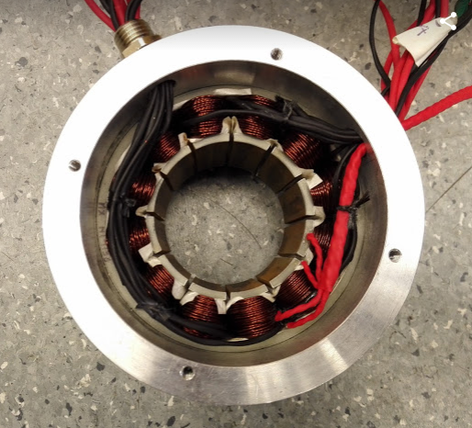
(a)
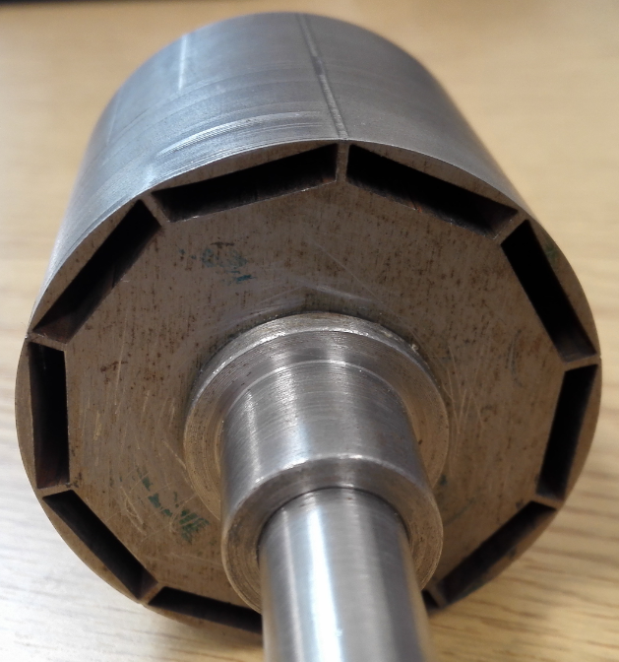
(b)
Fig. 3.12 Photos of 12-slot/10-pole IPM machine. (a) Stator. (b) Rotor.
Fig. 3.13 12-slot/10-pole IPM machine phase resistance variation with temperature.
In order to measure the temperature of different parts of the electrical machine, six thermal couples are installed at the stator yoke, the coil, the stator tooth, the tooth tip, the rotor magnet slot and the rotor yoke as shown in Fig 3.14. The electrical machine is heated to the target temperature by its own losses. Fig 3.15 shows the temperature variation in different parts of the electrical machine when the phase current is 2.16A and 3.11A at 1000Hz, respectively. It can be seen that after two hours heating on the machine, the heat transfer is almost completed and the temperatures of different parts tend to be stable. When the phase current is 2.16A, 1000Hz, the hottest part is the coil (71ºC) and the coolest part is the rotor yoke (68ºC) after 120 mins heating. The temperature difference between different parts is very small and the average temperature of different part is 69ºC. In this circumstance, the temperature of the electrical machine can be approximately considered as 69ºC. On the other hand, when the phase current is 3.11A, 1000Hz, the hottest part is the coil (103ºC) and the coolest part is the stator yoke (99ºC) after 120 mins heating, the average temperature of different part is 100ºC. The temperature of the electrical machine can be approximately considered as 100ºC. In order to ensure the thermal transferring is completed for each test, the machine is heated to the designated temperature by the long-term heating. Then, the losses are measured by applying the pre-tuned input. Since the measuring process will only take a few seconds, the temperature variation during the measurement can be neglected. The iron losses under different currents at 69ºC and 100ºC can be obtained by repeating the foregoing process.
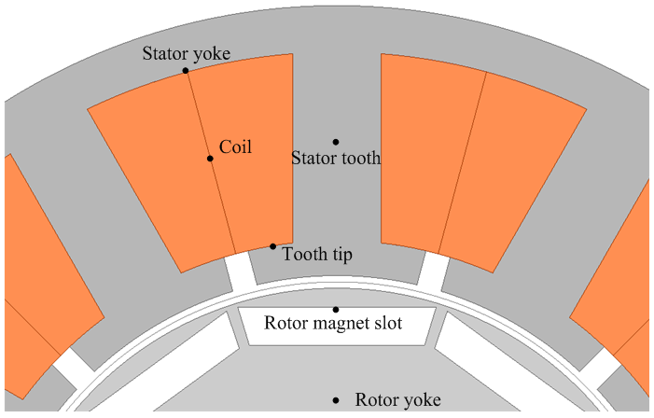
Fig. 3.14 Thermal couples in the electrical machine.
Fig. 3.15 Temperature variation of different parts of electrical machine when supplied by different phase currents.
To predict the iron loss, the electrical machine is modelled in the FEA software with the measured phase current waveforms shown in Fig 3.16. Fig 3.17 shows the simulated flux density distribution by FEA when the phase current I_{a}=0A, I_{b}=6.12A, I_{c}=-6.12A. Then, the iron loss is predicted from flux density variations in each FE element using the improved iron loss model. It should be noticed that the flux density in the electrical machine can be rotational. The rotational flux density can be decomposed into two alternating directions, the total iron loss under rotational flux density can be then obtained by the sum of iron losses at these two directions [ION07] [YAM09] [CAL05] [MI03]. In this thesis, the rotational flux density is decomposed into the major-axis and the minor-axis as shown in Fig. 3.18. The major-axis is aligned with the long side of the rotational flux density locus while the minor-axis is aligned with the short side of the rotational flux density locus. The temperature dependent losses coefficients for the core are obtained by the steel lamination ring specimen tests using the same lamination. The measured and predicted iron losses of the electrical machine are compared to evaluate the model accuracy.
Fig. 3.16 Measured phase current waveforms when temperature is 69°C and 100°C at different frequency.
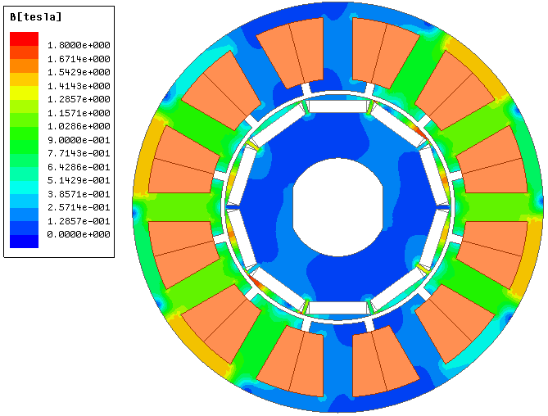
Fig. 3.17 FEA simulated flux-density distribution when I_{a}=0A, I_{b}=6.12A, I_{c}=-6.12A.
Fig. 3.18 Major and minor axes of the rotational flux density in electrical machines.
Fig 3.19 shows measured and predicted results at 69ºC and 100°C. The numerical results are listed in Table 3.2. It can be seen that when the temperature rises to 69ºC and 100ºC, the improved model (3.2) can reflect the variation of the iron loss while the existing model (2.7) cannot. The accuracy of the improved model (3.2) is therefore much better than that of the existing model (2.7) with the help of temperature dependent coefficients. The effectiveness of the improved model on iron loss prediction in the electrical machine is then confirmed.
Fig. 3.19 Measured and predicted results of 12-slot/10-pole IPM machine when the temperature is 69ºC and 100ºC.

Table 3.2 Measured and predicted results
 |  | 2A | 5A | 7A
50Hz | 69°C
50Hz | Measured (W) | 0.30 | 1.20 | 2.12
50Hz | Existing model (2.7) (W) | 0.73 | 1.55 | 2.20
50Hz | Improved model (2.7) (W) | 0.72 | 1.51 | 2.13
50Hz | 100°C
50Hz | Measured (W)  (Variation compare to 69°C) | 0.28  (-6.0%) | 1.18  (-1.6%) | 1.99  (-6.2%)
50Hz | Existing model (2.7) (W) | 0.73 | 1.55 | 2.20
50Hz | Improved model (3.2) (W)  (Variation compare to 69°C) | 0.71  (-1.4%) | 1.48  (-2.1%) | 2.06  (-3.3%)
100Hz | 69°C
100Hz | Measured (W) | 0.77 | 2.59 | 6.95
100Hz | Existing model (2.7) (W) | 1.23 | 3.42 | 5.62
100Hz | Improved model (3.2) (W) | 1.21 | 3.34 | 5.41
100Hz | 100°C
100Hz | Measured (W)  (Variation compare to 69°C) | 0.68  (-11%) | 2.39  (-7.7%) | 6.81  (-1.9%)
100Hz | Existing model (2.7) (W) | 1.23 | 3.42 | 5.62
100Hz | Improved model (3.2) (W)  (Variation compare to 69°C) | 1.19  (-1.7%) | 3.27  (-1.9%) | 5.20  (-3.9%)
500Hz | 69°C
500Hz | Measured (W) | 7.64 | 27.8 | 44.3
500Hz | Existing model (2.7) (W) | 7.36 | 30.1 | 48.4
500Hz | Improved model (3.2) (W) | 7.15 | 28.4 | 45.6
500Hz | 100°C
500Hz | Measured (W)  (Variation compare to 69°C) | 6.68  (-12%) | 25.7  (-7.6%) | 42.3  (-4.6%)
500Hz | Existing model (2.7) (W) | 7.36 | 30.1 | 48.4
500Hz | Improved model (3.2) (W)  (Variation compare to 69°C) | 6.94  (-2.9%) | 26.7  (-5.9%) | 42.8  (-6.2%)
1000Hz | 69°C
1000Hz | Measured (W) | 22.1 | 83.0
1000Hz | Existing model (2.7) (W) | 25.2 | 88.9
1000Hz | Improved model (3.2) (W) | 24.4 | 83.9
1000Hz | 100°C
1000Hz | Measured (W)  (Variation compare to 69°C) | 19.9  (-10%) | 77.6  (-6.6%)
1000Hz | Existing model (2.7) (W) | 25.2 | 88.9
1000Hz | Improved model (3.2) (W)  (Variation compare to 69°C) | 23.7  (-2.9%) | 78.8  (-6.0%)

3.5 Conclusions
In this chapter, the temperature dependencies of hysteresis and eddy current losses of non-oriented Si-steel laminations are investigated. It is found that both the hysteresis and eddy current losses vary with the temperature. An improved iron loss model considering temperature dependencies of the hysteresis loss and the eddy current loss separately is developed. It is also found that the variations of hysteresis and eddy current losses with temperature are almost linear for the typical operation range of electrical machines although the varying rate of hysteresis and eddy current losses are different. Based on these linear relationships, a modelling method of the temperature dependent loss coefficients is proposed, the improved iron loss model is then developed. Using the improved model, the temperature influence on iron loss can be fully considered by measured results at two different temperatures. The investigation is experimentally validated by both the steel lamination ring specimen test and the lock rotor no-PM electrical machine test. This iron loss model could be useful for electromagnetic-thermal coupled analyses to predict the iron loss as well as the temperature distribution in electrical machines.

Chapter 4 Iron Loss Model under DC Bias Flux Density Considering Temperature Influence
In this chapter, the temperature dependencies of iron loss under different flux densities, frequencies and DC bias flux densities are systematically investigated. The presence of DC bias flux density causes increase of the iron loss. Furthermore, the temperature dependency of the hysteresis loss varies significantly with the DC bias flux density while that of the eddy current loss is independent of the DC bias flux density. Based on these different characteristics of the hysteresis and the eddy current iron losses, an improved iron loss model is developed. The temperature dependency of iron loss under DC bias flux density can be considered by the improved iron loss model. The developed iron loss model is validated by tests on steel laminations and an electrical machine.

4.1 Introduction
The DC bias flux density exists in many types of electrical machines such as PMSM, BLDC and SRM, etc. More importantly, DC bias flux density can significantly influence the iron loss [BAG08]. Furthermore, the temperature influences the iron loss significantly. It is important to investigate the combined influence of DC bias flux density and temperature, which is desirable for the accurate prediction of iron loss in electrical machines.
The aim of this chapter is to develop an iron loss model which considers the combined influence of DC bias flux density and the temperature. In Section 4.2, the iron loss measurement technique in steel lamination ring specimen under different DC bias flux densities and temperatures is demonstrated. The iron losses under different flux density, frequency, DC bias flux density and temperature are then measured and presented. In Section 4.3, the existing iron loss model for flux density with DC bias is evaluated against the test results in the steel laminations. The limitation of the existing model is also demonstrated. In section 4.4, an improved iron loss model for flux density with DC bias which also takes the temperature dependency into account is developed. The iron loss model is validated by the steel lamination test results. The improved iron loss model is further validated by an electrical machine test in Section 4.5.

4.2 Iron Loss Measurement under DC Bias Flux Density in Steel Laminations
The steel lamination ring specimen test is carried out in this chapter to measure the iron loss under DC bias flux density. In order to generate the DC bias flux density, DC coils are wounded on the steel lamination ring specimen. The technique and test procedure for measuring the iron loss under DC bias flux density is introduced in Section 1.4. The schematic diagram of the test system is shown in Fig. 1.35. The test is carried out in two steps. First, the specimen is powered by the AC voltage and current without DC bias flux density. The field strength $H\left(t\right)$ and the flux density $B\left(t\right)$ can be obtained as:
$$H\left(t\right)=\frac{N_{1}i(t)}{l_{eff}}$$ | (4.1)
$$B\left(t\right)=\frac{\int{u(t)dt}}{N_{1}A}$$ | (4.2)
where $N_{1}$ is the number of turns of the AC winding and the measuring coil. $i(t)$ is the instantaneous current of the AC winding. $l_{eff}$ is the total effective length of the steel lamination ring specimen. $u(t)$ is the instantaneous voltage of the measuring coil. $A$ is the effective cross sectional area of the steel lamination ring specimen. $p_{Fe}$ is the iron loss density. The B-H curves can be then obtained by repeating the measurement at different field strengths, flux densities, frequencies and temperatures.
Second, when the DC bias current is input into the DC winding, hysteresis loops become asymmetric. The maximum field strength $H_{max}$ can be obtained by:
$$H_{max}=\frac{N_{2}I_{DC}}{l_{eff}}+max\left(\frac{N_{1}i(t)}{l_{eff}}\right)$$ | (4.3)
where $N_{2}$ is the number of turns of the DC winding. $I_{DC}$ is the DC current of the DC winding.
By referring $H_{max}$ to the B-H curve at the same frequency and temperature, the maximum flux density $B_{max}$ can be calculated. The DC bias flux density $B_{bias}$ is then obtained by subtracting the AC flux density amplitude $B_{m}$ from $B_{max}$:
$$B_{bias}=B_{max}-B_{m}$$ | (4.4)
For each test with or without DC bias flux density, the iron loss can be obtained by the integration of AC current and voltage:
$$p_{Fe}=\frac{1}{ρVT}\int_{0}^{T}{i\left(t\right)u\left(t\right)dt}$$ | (4.5)
where $ρ$ and $V$ are the mass density and the volume of the specimen respectively. $T$ is the time period of the current and voltage.
By applying the method described above, the iron loss under different DC bias flux densities can be measured. This method is also used in [ENO00] and [ZHU14].
The dimensions of the steel lamination ring specimen and the coil number of turns listed in Table 4.1 are specially designed according to the testing range and the capability of the power supply. Fig 4.1 shows the measured B-H loops at different DC bias flux densities when the amplitude of alternating flux density keeps constant and the temperature is 40°C. It can be seen that the shape of B-H loops is significantly influenced by the DC bias flux density. The iron loss under DC bias flux density is then influenced as the area of the B-H loops represents the iron loss. This influence will be discussed and modelled later in this chapter. Fig. 4.2 shows the measured iron loss at different AC flux densities, DC bias flux densities, frequencies and temperatures. The iron loss variations with temperature at different AC flux density, frequency and DC bias flux density are shown in Fig 4.3. It can be seen that the iron loss increases with the DC bias flux density rise. On the other hand, the temperature influences the iron loss significantly. This influence will be investigated systemically and modelled later in this chapter.

Table 4.1 Steel lamination ring specimen and coils parameters
General
Number of turns N1 | 204
Number of turns N2 | 35
Steel lamination type | V300-35A
Steel lamination thickness (mm) | 0.35
Steel lamination ring specimens
Outer diameter (mm) | 150
Inner diameter (mm) | 125
Effective thickness (mm) | 7
Layers of steel laminations | 20
Fig. 4.1 B-H loops at different DC bias flux densities, B_{m}=0.22T, f=100Hz, 40°C.
Fig. 4.2 Measured iron loss at different AC flux density, DC bias flux density and temperature.
(a)
(b)
(c)
(d)
(e)
(f)
Fig. 4.3 Iron loss variation with temperature at different DC bias flux density. (a) B_{m}=0.22T, f=100Hz. (b) B_{m}=0.22T, f=1000Hz. (c) B_{m}=0.42T, f=100Hz. (d) B_{m}=0.42T, f=1000Hz. (e) B_{m}=0.60T, f=100Hz. (f) B_{m}=0.60T, f=1000Hz.

4.3 Existing Iron Loss Model Considering DC Bias Flux Density
In order to consider the influence of DC bias flux density on the iron loss, a DC bias flux density dependent coefficient $ε\left(B_{bias} \right)$ is introduced to the existing iron loss model for the sinusoidal flux density in [SIM09]. The iron loss model for flux density with DC bias can be then expressed as:
$$p_{Fe}=ε\left(B_{bias} \right)k_{h}fB_{m}^{2}+k_{e}f^{2}B_{m}^{2}$$ | (4.6)
$$ε\left(B_{bias} \right)=1+k_{DC}B_{bias}^{α}$$ | (4.7)
where $p_{Fe}$ is the iron loss. $ε\left(B_{bias} \right)$ is the DC bias flux density dependent coefficient, which represents the ratio between hysteresis losses with and without DC bias flux density. $k_{h}$ and $k_{e}$ are the hysteresis and eddy current losses coefficients, respectively. $f$ is the frequency of AC flux density. $B_{m}$ is the amplitude of AC flux density.$k_{DC}$ and $α$ are the DC bias coefficients and can be obtained by fitting the measured results.
It can be seen from (4.6) that only the hysteresis loss is influenced by the DC bias flux density. This is due to the fact that the shape of the B-H loop is influenced by DC bias flux density significantly. On the other hand, the eddy current loss is independent with the DC bias flux density since the eddy current loss depends on the induced voltage on the laminations and the resistivity of the lamination, which are not affected by the DC bias flux density.
It should be noted from (4.6) that $k_{h}$ and $k_{e}$ are constants and the influence of temperature is not included. The coefficients are obtained by fitting the measured iron loss at a specific temperature (40ºC in this section). However, as it illustrated in Chapter 2 and Chapter 3, the coefficients $k_{h}$ and $k_{e}$ are flux density, frequency and temperature dependent [XUE16]. Furthermore, the DC bias flux density coefficient is also influenced by the temperature as shown in Fig 4.4. Therefore, it is necessary to consider all these influences for the accurate prediction of iron loss under DC bias flux density.
Fig. 4.4 Measured $ε\left(B_{bias} \right)$ at 40°C and 100°C.

4.4 Improved Iron Loss Model for DC Bias Flux Density Considering Temperature Influence

4.4.1 The Improved Iron Loss Model
According to the investigation in Section 4.3, the coefficient $ε\left(B_{bias} \right)$ is not only the DC bias flux density dependent but also the temperature dependent. Furthermore, the hysteresis and eddy current loss coefficients $k_{h}$ and $k_{e}$ are also flux density, frequency and temperature dependent as investigated in Chapter 3. Therefore, an improved iron loss model for the flux density with DC bias is developed to consider all these dependencies of iron loss as:
$$p_{Fe,T}=ε\left(B_{bias},T \right)k_{h}\left(f,B_{m},T\right)fB_{m}^{2}+k_{e}\left(f,B_{m},T\right)f^{2}B_{m}^{2}$$ | (4.8)
$$ε\left(B_{bias} ,T\right)=1+k_{DC}(T)B_{bias}^{α(T)}$$ | (4.9)
where $k_{DC}(T)$ and $α(T)$ are the DC bias flux density dependent coefficients at the actual temperature $T$.
By applying the iron loss model (4.8), the temperature dependency of the iron loss under DC bias flux density can be fully considered. Theoretically, the iron loss at specific temperature can be calculated by the measured coefficients at that temperature. However, numerous of measurement must be done in order to guarantee the accuracy of the iron loss model, which will make the iron loss model impractical. Therefore, in this chapter, an engineering modelling method is carried out to model the temperature dependent coefficients.
Fig 4.5 shows measured DC bias coefficients $k_{DC}$ and $α$ at different temperatures. It can be seen that both $k_{DC}$ and $α$ vary almost linearly with the temperature. Thus, with $k_{DC}$ and $α$ obtained based on measured iron losses at only two different temperatures, they can be used to predict the iron loss at the other temperatures, the iron loss model is then simplified. Furthermore, Figs. 4.6 and 4.7 shows $k_{h}$ and $k_{e}$ variation with flux density, frequency and temperature. By considering these, the temperature influence on the iron loss under DC bias flux density can be then considered in the improved iron loss model (4.8).
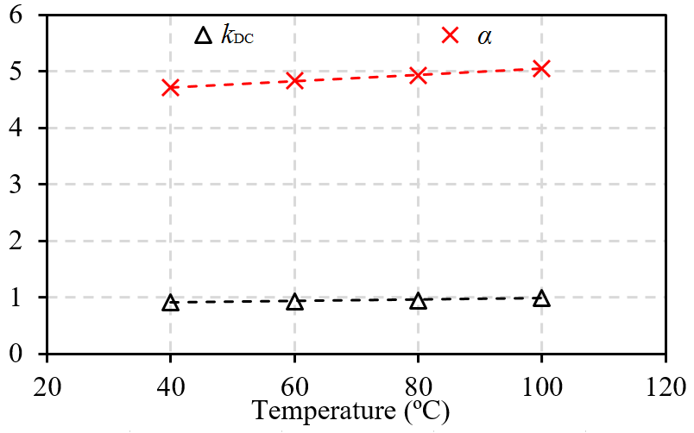
Fig. 4.5 DC bias coefficients variation with temperature.
(a)
(b)
Fig. 4.6 Hysteresis loss coefficient. (a) f=50Hz. (b) f=1000Hz.
(a)
(b)
Fig. 4.7 Eddy current loss coefficient. (a) f=50Hz. (b) f=1000Hz.

4.4.2 Experimental Validation on Steel Lamination Ring Specimen
In order to evaluate the improved iron loss model (4.8) in the steel laminations, the measured and predicted iron losses are compared in Fig 4.8. The numerical relative errors are listed in Table 4.2. It can be seen from the results that both the existing iron loss model (4.6) and the improved iron loss model (4.8) can predict the iron loss at 40°C at different AC flux density, frequency and DC bias flux density with relative high accuracies. However, it shows that the improved iron loss model can predict the iron loss accurately even when the temperature rises significantly with the help of the temperature dependent coefficients. On the other hand, the existing iron loss model is not able to predict the iron loss accurately at temperature other than 40ºC due to the lack of temperature considerations.
(a)
(b)
(c)
(d)
(e)
(f)
Fig. 4.8 Measured and predicted iron loss densities. (a) B_{m}=0.22T, f=100Hz. (b) B_{m}=0.22T, f=1000Hz. (c) B_{m}=0.42T, f=100Hz. (d) B_{m}=0.42T, f=1000Hz. (e) B_{m}=0.60T, f=100Hz. (f) B_{m}=0.60T, f=1000Hz.

Table 4.2 Iron loss models’ relative errors at different AC flux density, frequency, DC flux density and temperature
 | Relative errors (%)
Iron loss models | Existing iron loss model (4.6) |  | Improved iron loss model (4.8)
Temperature | 40°C | 100°C | 40°C | 100°C
B_{m}=0.22T, f=100Hz | 5.1 | 12.7 | 5.1 | 7.2
B_{m}=0.22T, f=400Hz | 2.0 | 7.1 | 1.9 | 2.8
B_{m}=0.22T, f=1000Hz | 1.6 | 8.5 | 1.2 | 1.5
B_{m}=0.42T, f=100Hz | 2.4 | 4.7 | 1.7 | 2.2
B_{m}=0.42T, f=400Hz | 6.1 | 8.2 | 6.0 | 3.9
B_{m}=0.42T, f=1000Hz | 9.5 | 16.6 | 9.0 | 9.7
B_{m}=0.60T, f=100Hz | 2.0 | 7.2 | 1.7 | 1.3
B_{m}=0.60T, f=400Hz | 1.9 | 6.6 | 1.8 | 1.9
B_{m}=0.60T, f=1000Hz | 2.1 | 8.2 | 2.0 | 3.2
Average | 3.6 | 8.9 | 3.4 | 3.8

4.5 Further Validation of Improved Iron Loss Model on an Electrical Machine
In order to further evaluate the improved iron loss model for DC bias flux density, iron loss tests on an electrical machine are carried out in this section. Fig 4.9 shows the actual electrical machine test rig. The 12-slot/10-pole IPM machine introduced in Chapter 3 is used in the test. The parameters of this electrical machine are listed in Table 3.1. In order to provide the DC bias flux density in the electrical machine, permanent magnets are installed into the rotor. Furthermore, in order to minimize the influence of eddy current of magnets, ferrite magnets are used in the test due to its high resistivity and negligible magnet eddy current loss.
The test is carried out in two steps. Firstly, the electrical machine is modelled in the FEA tools. In order to validate the FEA electrical machine model, the FEA predicted and measured back-EMFs at 900rpm are compared as shown in Fig 4.10. It can be seen that the predicted and measured back-EMFs match well. The FEA model of the IPM machine is then validated.
Secondly, as shown in Fig 4.11, a three-phase AC power source is connected to the electrical machine to supply three-phase sinusoidal current. Thermal couples are installed at different parts of the electrical machine to measure the temperatures. The rotor is also locked to exclude the influence of mechanical loss. The iron loss is then obtained by subtracting the winding copper loss from the total loss. The temperature dependency of the phase resistance should also be considered when calculating the winding copper loss. The iron losses at two different temperatures are investigated. One is the room temperature 19 ºC. The other one is 101°C. The electrical machine is slowly heated up by inputting 3.5A/1000Hz three-phase current. Thus, the temperature at each part of the machine is very close to each other since the heat transfer is completed. Then, the losses are measured by applying the pre-tuned input. Since the voltages and currents can be accurately recoded in less than a few seconds, the temperature variation during the measurement can be neglected. In order to predict the iron loss by the iron loss models, the electrical machine is simulated by FEA with the measured phase current waveforms. Please note that all coefficients in the iron loss models are obtained based on the measured iron losses of the lamination tests. The measured and predicted iron losses are then compared to evaluate the model. Furthermore, in order to consider the thermal effect on the permanent magnets, magnetic parameters of the ferrite permanent magnets at 19 ºC and 101°C are applied in the FEA, respectively.
Fig 4.12 shows the comparison of measured and predicted results using different iron loss models when the temperature varies. It can be seen that the iron loss varies significantly with the temperature rise from 19ºC to 101ºC. On one hand, the improved iron loss model (4.8) keeps good accuracy even when the temperature varies. On the other hand, the existing iron loss model (4.6) cannot track this variation of iron loss due to the lack of consideration of temperature. The effectiveness of the improved iron loss model (4.8) for the iron loss prediction in the electrical machine is then validated.
Fig. 4.9 Photo of electrical machine test system.
Fig. 4.10 Simulated and measured three-phase back EMF of 12-slot/10-pole IPM machine at 900rpm.
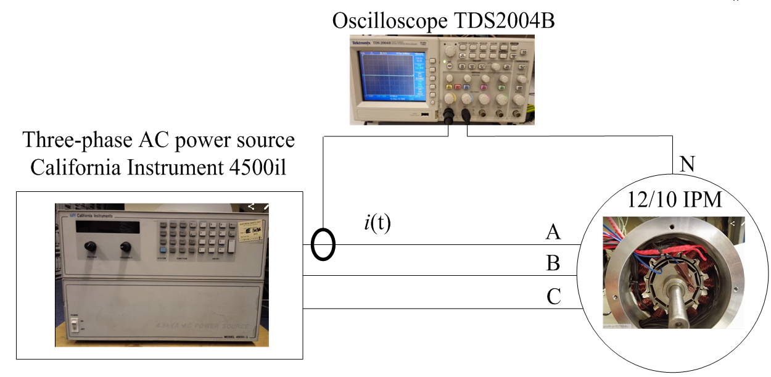
Fig. 4.11 Schematic diagram of electrical machine test system.
Fig. 4.12 Measured and predicted iron losses by different models.

4.6 Conclusions
In this chapter, the iron losses under different alternating flux densities, frequencies, DC bias flux densities and temperatures are measured. An improved model for the iron loss prediction under different DC bias flux density and temperature has been presented. The improved iron loss model is validated by tests on a steel lamination ring specimen as well as an electrical machine. The result show that the improved iron loss model (4.8) keeps good accuracy even when the temperature varies significantly with the help of temperature dependent coefficients.

Chapter 5 Iron Loss Model Considering Flux Density Distortion
As it described in Section 1.3, the flux density can be distorted from sinusoidal in electrical machines due to MMF harmonics. In this chapter, the investigation is focused on the iron loss model for distorted flux density. An improved iron loss model is developed after reviewing the existing iron loss models considering the influence of flux density distortion. In order to validate the improved iron loss model, iron loss tests are carried out on an electrical machine fed by a PWM inverter. The predicted iron loss results match well with the measured results, which shows that the improved iron loss model is able to predict iron loss even when the flux density distorted significantly from sinusoidal.

5.1 Introduction
Many studies on the iron loss prediction have been carried out since it is essential for the evaluation of efficiency, temperature distribution, cooling and demagnetization of electrical machines. Different iron loss models are developed in [STE92] [BER85] [BER88] [ION07]. These models are based on the assumption that the flux density alternates sinusoidally. However, in actual electrical machines, the flux density can be distorted from sinusoidal. The causes of the distortion can be MMF harmonics due to the influences of topology, slot and pole number combination or winding arrangement. Furthermore, in actual drive systems, electrical machines are usually powered by PWM inverters. The current waveform can be almost sinusoidal if the switching frequency is high enough, the flux density in the electrical machine can be then almost sinusoidal. However, for most electrical machine applications especially when the power is high, the switching frequency is usually limited to be very low to reduce the loss on the semi conductive devices and to increase the efficiency of the system [GNA16]. In this case, the current waveform of electrical machines can be significantly distorted from sinusoidal. This can result in significant distortion of flux density in electrical machines and then additional iron loss can be introduced [BOG96] [CHA68]. According to the investigation in [CHA68], the iron loss of electrical machines fed by a PWM inverter can be more than three times higher than those fed by sinusoidal currents.
The aim of this chapter is to develop an improved iron loss model considering the flux density distortion, which can consider the influence of flux density distortion as well as temperature. This improved iron loss model also should be easy to implement. This chapter is arranged as follows: In Section 5.2, the existing iron loss models are reviewed and the improved iron loss model is presented afterwards. In Section 5.3, iron loss tests in the 12-slot/10-pole IPM machine fed by a PWM inverter are carried out. In Section 5.4, the prediction results of the improved iron loss model are given. The improved iron loss model is then evaluated by comparing the predicted and measured iron losses.

5.2 Iron Loss Model for Distorted Flux Density Considering Temperature Influence
As illustrated in Chapter 3, the iron loss model (3.2) is the most accurate iron loss models when the flux density varies sinusoidally with the help of variable coefficients and the consideration of temperature influence. Therefore, in this chapter, iron loss model (3.2) is selected for the further investigation.
In actual electrical machines, the flux density can be significantly distorted from sinusoidal due to MMF harmonics. On one hand, the hysteresis minor loops occur in the hysteresis major loops consequently. The hysteresis minor loops are shown in Fig 5.1, these hysteresis minor loops result in additional hysteresis loss. Therefore, a coefficient $k_{minor}$ is introduced to describe the ratio of hysteresis losses with and without minor loops [LAV78]. On the other hand, the harmonics of the distorted flux density also cause additional eddy current iron loss. Thus, the eddy current loss should be calculated by summing all the eddy current losses caused by each harmonic. The iron losses can be then expressed as:
$$p_{hyst, nonsin}=k_{minor}p_{hyst,sin}$$ | (5.1)
$$k_{minor}=1+k\frac{1}{B_{m}}\sum_{i=1}^{N}{∆B_{i}}$$ | (5.2)
$$p_{eddy,nonsin}=\sum{p_{eddy,sin}}$$ | (5.3)
where $p_{hyst,nonsin}$ is the hysteresis loss when the flux density is distorted from sinusoidal. $k_{minor}$ is the coefficient considering the influence of hysteresis minor loops. $p_{hyst,sin}$ is the hysteresis loss under sinusoidal flux density. $k$ is the coefficient depending on lamination properties. $∆B_{i}$ is the amplitude of the fluctuated flux density shown in Fig 5.1. $p_{eddy,nonsin}$ is the eddy current loss including considering flux density distortion. $p_{eddy,sin}$ is the eddy current loss under sinusoidal flux density.
The temperature also affects the iron loss significantly. Fig. 5.2 shows measured B-H loops at different switching frequencies and temperatures at fundamental frequency 1Hz and flux density amplitude 1.20T. These test results are obtained when the ring specimen is powered by a PWM inverter as shown in Fig. 5.3. It can be seen that the shape B-H loops is influenced significantly by the switching frequency and the temperature. The iron loss is then affected. To fully consider the influence of flux density, frequency, flux density distortion and temperature, an improved iron loss model is developed as:
$$p_{Fe}={k_{minor}k}_{h}(f,B_{m},T)fB_{m}^{2}+\sum{k_{e}(f,B_{m},T)f^{2}B_{m}^{2}}$$ | (5.4)
Fig. 5.1 Flux density distortion in electrical machine caused by MMF harmonics.
(a)
(b)
Fig. 5.2 B-H loops at different switching frequencies f_{s} and temperatures when the fundamental frequency f=1Hz, B_{m}=1.20T. (a) f_{s}=500Hz. (b) f_{s}=10kHz.
Fig. 5.3 Schematic diagram of ring specimen measuring system under PWM.

5.3 Iron Loss Tests in Electrical Machine
In order to evaluate the improved iron loss model (5.4) on iron loss prediction in electrical machines, iron loss tests are carried out. The schematic diagram of the actual test system are shown in Fig 5.4. The tests are carried out on the 12-slot/10-pole IPM machine introduced in Chapter 3, whose main parameters are listed in Table 3.1. In order to investigate the influence of flux density distortion on iron loss, two sets of tests are carried out. One is conducted when the IPM machine is powered by a PWM inverter controlled by a dSPACE controller at different switching frequencies, as shown in Fig 5.4(a). The other one is carried out when the machine is powered by a three-phase current source California Instrument 4500il, as shown in Fig 5.4(b). For each iron loss test, the RMS value of the phase current is kept the same. In order to eliminate the influences of the magnet eddy current loss, the magnets are removed. Furthermore, the rotor of the machine is locked in order to eliminate the mechanical loss. In this case, the measured total iron loss can be obtained by subtracting the winding copper loss from the total losses
In order to measure the temperatures of different parts of the electrical machine, six thermal couples are equipped in the stator yoke, the coil, the stator tooth, the tooth tip, the rotor magnet slot and the rotor yoke as shown in Fig 5.5. The measured temperatures of each part during the test are shown in Table 5.1. It can be seen that the temperature difference between different stator parts is very small. Hence, the temperature distribution of the stator is approximated as evenly and the average temperature is used for considering the temperature influence, which eases the modelling. On the other hand, it can be seen that the temperature difference between different rotor parts is also very small. Therefore, the same approximation is adopted for the rotor temperature.
Fig 5.6 shows the measured phase current waveforms of the electrical machine at different fundamental frequency $f$ and switching frequency $f_{s}$ when the RMS value of the current is fixed to 2A. It can be seen that the current is distorted more significantly when the switching frequency is lower.
(a)
(b)
Fig. 5.4 Diagrams of iron loss test rig. (a) When powered by PWM inverter. (b) When powered by sinusoidal current supplier.
Fig. 5.5 Locations of thermal couples in the electrical machine.
(a)
(b)
(c)
(d)
Fig. 5.6 Measured current waveforms at different frequency f and switching frequency f_{s}, at 2A. (a) f=50Hz, f_{s}=1kHz. (b) f=50Hz, f_{s}=2kHz. (c) f=100Hz, f_{s}=1kHz. (d) f=100Hz, f_{s}=2kHz.
(a)
(b)
(c)
(d)
Fig. 5.7 FFT of current waveforms at different fundamental frequency $f$ and switching frequency f_{s}, at 2A. (a) f=50Hz, f_{s}=1kHz. (b) f=50Hz, f_{s}=2kHz. (c) f=100Hz, f_{s}=1kHz. (d) f=100Hz, f_{s}=2kHz.

Table 5.1. Different parts temperatures in 12-slot/10-pole IPM machine (°C)
Switching frequency | 1kHz | 2kHz | 5kHz | 10kHz | Sine
f=50Hz
Stator yoke | 26 | 22 | 21 | 18 | 18
Coil | 28 | 24 | 22 | 19 | 18
Stator tooth | 26 | 24 | 21 | 18 | 18
Tooth tip | 26 | 22 | 21 | 18 | 18
Stator average | 27 | 23 | 21 | 18 | 18
Rotor magnet slot | 20 | 19 | 19 | 18 | 18
Rotor yoke | 20 | 19 | 18 | 18 | 18
Rotor average | 20 | 19 | 19 | 18 | 18
f=100Hz
Stator yoke | 31 | 27 | 25 | 24 | 22
Coil | 31 | 28 | 25 | 25 | 22
Stator tooth | 30 | 27 | 25 | 24 | 22
Tooth tip | 30 | 27 | 25 | 24 | 22
Stator average | 31 | 27 | 25 | 24 | 22
Rotor magnet slot | 21 | 20 | 20 | 19 | 19
Rotor yoke | 20 | 20 | 19 | 19 | 19
Rotor average | 21 | 20 | 20 | 19 | 19

5.4 Experimental Validation
In order to validate the improved iron loss model, it is necessary to compare the measured and predicted iron losses by different iron loss models. On one hand, the iron losses at different switching frequencies are measured by the method demonstrated in Section 5.3. On the other hand, in order to predict the iron loss, the electrical machine is simulated by FEA with the measured current waveforms as shown in Fig 5.6. The flux density variation in the whole period of all elements can be then obtained and used for iron loss prediction. Fig 5.8 shows the predicted flux density waveforms at different parts of electrical machine when the fundamental frequency is 100Hz and the switching frequency is 1kHz. It can be seen that the flux density is distorted significantly from sinusoidal. The measured temperatures listed in Table 5.1 are also used in (3.2) and (5.4) to predict the iron loss considering the temperature influence.
For comparison, the predicted iron losses by (3.2), (5.4) and FEA (Ansoft/Maxwell) are all obtained and compared with the measured results in Fig 5.9. Please note that (3.2) does not consider the influence of hysteresis minor loops and the eddy current harmonics, while these influences are fully considered in (5.4).
It can be seen that the predicted iron losses of all these three methods are accurate when the phase current is sinusoidal. However, the actual iron loss in the electrical machine will be significantly influenced by the flux density distortion caused by PWM inverter. The iron loss increases dramatically when the inverter switching frequency reduces. In this case, the iron loss model (3.2) and FEA are no longer able to predict the iron loss accurately since the influence of hysteresis minor loops and eddy current harmonics are neglected. On the other hand, the improved iron loss model (5.4) remains accurate even when the switching frequency is as low as 1kHz.
(a)
(b)
(c)
(d)
Fig. 5.8 Flux densities when f=100Hz, f_{s}=1kHz. (a) Point 1. (b) Point 2. (c) Point 3. (d) Point 4. (B_{r}: radial flux density, B_{t}: tangential flux density).
Fig. 5.9 Comparison of measured and predicted results.

5.5 Conclusions
The flux density in electrical machine can be significantly distorted from sinusoidal, especially when the electrical machine is fed by a PWM inverter and the switching frequency is low. This distortion can cause significant increase of iron loss, which is experimentally confirmed in this chapter. Furthermore, the temperature influences the iron loss significantly. Therefore, an improved iron loss model is developed to consider the influences of additional iron loss caused by flux density distortion as well as the temperature. By using the improved iron loss model, the iron loss can be predicted accurately, even when the flux density significantly distorted from sinusoidal.

Chapter 6 Iron Loss Model for Arbitrary Flux Density Waveform Considering Temperature Influence
In this chapter, an iron loss model for arbitrary flux density waveform considering temperature influence is developed. An electrical machine test is carried out, the iron loss model is then validated in the electrical machine.

6.1 Introduction
When the flux density alternates non-sinusoidally, the iron loss will be influenced significantly. Improvements have to be done to adapt different conditions. As investigated in Chapter 4 and Chapter 5, two of the most common conditions in electrical machines are DC bias flux density and flux density distortion caused by MMF harmonics. In actual electrical machines, the flux density waveform can be arbitrary while the temperature varies significantly. None of the iron loss models considers all the different conditions in electrical machines, which is very important for the accurate prediction of iron loss in electrical machines.
The aim of this chapter is to develop an iron loss model for arbitrary flux density waveform while considering the temperature influence. This chapter is organized as follows: In Section 6.2, the improved iron loss model for arbitrary flux density waveform is developed based on experimental results of steel laminations. In Section 6.3, an electrical machine test is carried out, the improved iron loss model is then validated on the electrical machine.

6.2 Iron Loss Model for Arbitrary Flux Density Waveform Considering Temperature Influence
In electrical machines, the flux density waveform can be arbitrary while the temperature can vary significantly. As illustrated in Chapter 3, the temperature influences iron loss significantly. The hysteresis loss and eddy current loss coefficients are not only flux density and frequency dependent, but also temperature dependent. Furthermore, as investigated in Chapter 4, the DC bias flux density influences the iron loss. The DC bias coefficients are also influenced by temperature. Moreover, Chapter 5 investigated the iron loss influence of flux density distortion. In order to consider all these conditions described above, the iron loss model which considers all the influences of DC bias flux density, flux density distortion and the temperature can be developed as:
$$p_{Fe}=k_{minor}ε\left(B_{bias},T \right)k_{h}\left(f,B_{m},T\right)fB_{m}^{2}+\sum{k_{e}\left(f,B_{m},T\right)f^{2}B_{m}^{2}}$$ | (6.1)
$$k_{minor}=1+k\frac{1}{B_{m}}\sum_{i=1}^{N}{∆B_{i}}$$ | (6.2)
$$ε\left(B_{bias} ,T\right)=1+k_{DC}(T)B_{bias}^{α(T)}$$ | (6.3)
where $k_{minor}$ is the coefficient considering the influence of hysteresis minor loops. $ε\left(B_{bias},T\right)$ is the DC bias flux density dependent coefficient, which represents the ratio between hysteresis losses with and without DC bias flux density. $B_{bias}$ is the DC bias flux density. $k_{h}\left(f,B_{m},T\right)$ and $k_{e}\left(f,B_{m},T\right)$ are the hysteresis loss and eddy current coefficients, respectively. $k$ is the coefficient depending on lamination properties. $∆B_{i}$ is the amplitude of the fluctuated flux density shown in Fig 5.1. $k_{DC}(T)$ and $α(T)$ are the DC bias coefficients, which are also temperature dependent.

6.3 Validation of the Iron Loss Model in an Electrical Machine
In order to validate the improved iron loss model for arbitrary flux density, electrical machine tests are carried out in this section. A 6-stator-pole/7-rotor-pole variable flux reluctance machine (6s/7r VFRM) is used in the test as shown in Fig. 6.1. The specification of the 6s/7r VFRM is listed in Table 6.1. As shown in Fig. 6.2, the armature winding is fed by the PWM inverter, which is controlled by a dSPACE based controller. The field winding is powered by a DC power source. In this case, significant DC bias flux density as well as flux density distortions caused by PWM inverter exist in the stator and rotor cores [HUA17a] [HUA17b]. In order to exclude the influence of mechanical loss, the rotor is locked during the test. In this case, the total iron loss can be obtained by subtracting the winding copper loss from the total input power as:
$$P_{Fe}=P_{in}-P_{wi}$$ | (6.4)
where $P_{in}$ is the input power from the PWM inverter. $P_{wi}$ is the winding copper loss, which can be calculated by the phase current and resistance of the armature windings.
The winding copper loss of the 6s/7r VFRM can be obtained as:
$$P_{wi}(T)=3I^{2}R(T)$$ | (6.5)
where $I$ is the armature winding phase current RMS value of the 6s/7r VFRM. $R(T)$ is the phase resistance of the armature winding at temperature $T$.
DC power source is connected to the armature winding of the 6s/7r VFRM for measuring the phase resistance. The phase resistance $R(T)$ can be calculated by the measured voltage on the winding and the current in the winding. Furthermore, in order to measure the resistance at different temperature, the winding is heated by the winding copper loss generated by itself. The temperature can be then measured by the thermal couple equipped in the coil. The resistance is expressed as:
$$R\left(T\right)=\frac{U(T)}{I(T)}$$ | (6.6)
where $R\left(T\right)$, $U\left(T\right)$, $I\left(T\right)$ are the resistance of the winding, the DC voltage on the winding and the DC current in the winding when the temperature is $T$, respectively.
The phase resistance of the 6s/7r VFRM at different temperature is presented in Fig. 6.3. The temperature dependent resistance is then obtained by fitting the measured resistances at different temperature as below:
$$R(T)=R_{T_{0}}+α(T-T_{0})$$ | (6.7)
where $R(T)$ is the resistance at the actual temperature T. $R_{T_{0}}$ is the resistivity at the base temperature $T_{0}$. $α$ is the temperature coefficient.
The evaluation process is carried out as follows. Firstly, the measured iron loss and phase current waveform can be obtained by the electrical machine test. In order to consider the temperature influence on iron loss in the calculation, the temperature of the stator and the rotor are also measured by the thermal probes. The temperatures are listed in Table 6.2. Secondly, the electrical machine is modelled in the FEA software. Fig. 6.4 shows the measured and the calculated back EMFs when the rotor speed is 847rpm. The FEA model is then validated as the measured and calculated results agree well. Furthermore, the FEA model is simulated with measured phase current waveforms. The flux density of every finite element can be then recorded and extracted. The iron loss is then calculated from the flux density in each element using the iron loss models.
Fig. 6.1 6s/7r VFRM [HUA17b].

Table 6.1 6s/7r VFRM specification
Parameter | Unit | Value
Stator outer radius | mm | 45
Airgap length | mm | 0.5
Turns per coil (AC/DC) | - | 144/144
Stack length | mm | 25
Fig. 6.2 Iron loss test system.
Fig. 6.3 6s/7r VFRM phase resistance variation with temperature.
Table 6.2 Stator and rotor temperatures
Switching frequency f_{s} | 10kHz | 5kHz | 2kHz | 1kHz
f=50Hz
Stator temperature (°C) | 43 | 50 | 58 | 51
Rotor temperature (°C) | 26 | 27 | 27 | 27
f=100Hz
Stator temperature (°C) | 43 | 56 | 62 | 48
Rotor temperature (°C) | 26 | 27 | 27 | 27
f=200Hz
Stator temperature (°C) | 47 | 53 | 60 | 63
Rotor temperature (°C) | 26 | 27 | 27 | 27
Fig. 6.4 Measured and calculated back EMF by FEA at 847rpm, I_{DC}=2A.
Figs. 6.5 and 6.6 show the phase current waveforms and harmonic analyses when the fundamental frequency $f$ is 100Hz at different switching frequency$f_{s}$. It can be seen that the current waveform is almost sinusoidal when the switching frequency is 10kHz. When the switching frequency decreases, the current waveform is distorted significantly. This distortion causes significant fluctuation of the flux density in the electrical machine as shown in Fig. 6.7. On the other hand, it also can be seen in Fig. 6.7 that significant DC bias flux density exists in both of the stator and the rotor of the machine.
(a)
(b)
(c)
(d)
Fig. 6.5 Phase current waveforms at f=100Hz. (a) f_{s}=10kHz. (b) f_{s}=5kHz. (c) f_{s}=2kHz. (d) f_{s}=1kHz.
(a)
(b)
(c)
(d)
Fig. 6.6 Phase current waveform harmonic analyses at f=100Hz. (a) f_{s}=10kHz. (b) f_{s}=5kHz. (c) f_{s}=2kHz. (d) f_{s}=1kHz.
(a)
(b)
(c)
(d)
Fig. 6.7 Radial and tangential flux density waveforms at different positions when f=100Hz, f_{s}=1kHz. (a) Point 1. (b) Point 2. (c) Point 3. (d) Point 4. (B_{r}: radial flux density, B_{t}: tangential flux density).
Fig. 6.8 shows the measured and calculated results. It can be seen that the accuracy of the improved iron loss model (6.1) is good with the help of the consideration of the DC bias flux density, the flux density distortion and the temperature. The effectiveness of the improved iron loss model for arbitrary flux density waveform considering temperature influence is then confirmed.
Fig. 6.8 Measured and calculated iron losses, I_{DC}=2A.

6.4 Conclusions
In this chapter, an improved iron loss model (6.1) for arbitrary flux density waveform considering temperature influence is developed. In order to validate the improved model on iron loss prediction in electrical machines, an electrical machine test is carried out. The test results show that the improved iron loss model can predict the iron loss accurately in the electrical machine, even when there are significant DC bias flux density and flux density distortion, and the temperature varies significantly.

Chapter 7 General Conclusions and Future Work

7.1 General Conclusions

7.1.1 Iron Loss Models for Sinusoidal Flux Density
In this thesis, the measurement method of the iron loss in steel laminations for sinusoidal flux density is described. Iron losses are measured at different frequency, flux density and temperature. The coefficients for different iron loss models are obtained based on the measurement results.
Four of the most commonly used iron loss models for alternating sinusoidal flux density at constant temperature are compared based on experiment results of steel lamination ring specimen test. One of the most accurate iron loss model for sinusoidal flux density at constant temperature is then identified.
The temperature influence on the iron loss under sinusoidal flux density is systematically investigated. The variations of iron loss coefficients with temperature are modelled, an improved iron loss model is then developed. Electrical machine tests are also carried out to evaluate the improved iron loss model.
Based on the investigations in this thesis, some conclusions can be drawn as follows:
- The iron loss model (2.7) developed in [ION07] has the best accuracy when the flux density alternates sinusoidally at constant temperature with the help of variable hysteresis and eddy current losses coefficients.
- Both the hysteresis and eddy current losses vary with the temperature. The variations of hysteresis and eddy current losses with temperature are almost linear in the typical operation range of electrical machines although the varying rates of hysteresis and eddy current losses are different.
- An iron loss model (3.2) for sinusoidal flux density considering temperature influence is proposed in this thesis. Using the improved model, the temperature influence on iron loss can be fully considered by measuring the results simply at two different temperatures.

7.1.2 Iron Loss Models for Flux Density with DC Bias
In order to investigate the iron loss under flux density with DC bias, an improved iron loss measurement method of steel laminations for flux density with DC bias is used and developed in this thesis. The DC bias flux density influence on the iron loss is investigated based on the measurement results. Furthermore, the temperature dependency of the DC bias coefficients is investigated and modelled. An improved iron loss model for flux density with DC bias considering temperature influence is proposed in this thesis. An electrical machine test is carried out to evaluate the improved iron loss model. According to the investigations in this thesis, some conclusions can be drawn as follows:
- Additional iron loss will be introduced when DC bias flux density exists. DC bias coefficients are introduced to consider this influence. The DC bias coefficients are also temperature dependent.
- An improved model (4.8) for the iron loss prediction under different DC bias flux density and temperature has been developed. The improved iron loss model (4.8) keeps good accuracy even when the temperature varies significantly with the help of temperature dependent coefficients.

7.1.3 Iron Loss Models for Flux Density Distortion
In this thesis, iron loss models considering flux density distortion are reviewed. An improved iron loss model is developed with the consideration of temperature influence. Iron losses of an electrical machine fed by PWM inverter are measured at different switching frequency and temperature. The improved iron loss model is then validated by the comparison of calculated and measured results. Some conclusions can be summarised as follows:
- Flux density in electrical machines can be distorted from sinusoidal, especially when the electrical machine is fed by a PWM inverter and the switching frequency is low. The flux density distortion influences the iron loss significantly. This influence is experimentally confirmed in this thesis. Furthermore, the temperature influences the iron loss significantly.
- An improved iron loss model (5.4) is developed to consider the influence of the flux density distortion as well as the temperature. By using the improved iron loss model, the iron loss can be predicted accurately when the temperature varies and the switching frequency is as low as 1kHz.

7.1.4 Iron Loss Models for Arbitrary Flux Density
In real electrical machines, the flux density waveform can be arbitrary and the temperature varies. None of the iron loss models described above considers all the different conditions in electrical machines. In order to consider all these conditions, an improved iron loss model for arbitrary flux density waveform considering temperature influence is developed in this thesis. An electrical machine test is also carried out. The improved iron loss model is then validated in the electrical machine. The conclusion on the iron loss for arbitrary flux density can be summarised as:
- An improved iron loss model (6.1) for arbitrary flux density waveform considering temperature influence is developed in this thesis. The improved iron loss model (6.1) is validated by an electrical machine test.

7.1.5 Summary
The iron loss model (2.7) has the best accuracy when the flux density alternates sinusoidally at constant temperature. However, the temperature can significantly influence the iron loss of electrical machines. The existing iron loss models including the iron loss model (2.7) will be inaccurate when the temperature varies. In order to solve this problem, improved iron loss models with temperature considerations are developed for different conditions including sinusoidal flux density (3.2), flux density with DC bias (4.8), flux density distortions caused by MMF harmonics (5.4) and arbitrary flux density (6.1). Several steel lamination tests and electrical machine tests are carried out. The test results indicate that the improved iron loss models can effectively consider the temperature effect of the iron loss at each condition. In other word, the improved iron loss models have better accuracy than existing iron loss models.

7.2 Future work
The work presented in this thesis investigates the temperature effect on the iron loss. Different iron loss models have been developed in this thesis for different conditions. The purpose of the work has been achieved, as the developed iron loss models are validated by both the steel lamination test and electrical machine test. However, a few areas in this topic are still open for further investigation and improvement:
- The iron loss influenced by the temperature significantly according to the investigation in this thesis. The iron loss is also an important consideration in analyzing the electrical machine’s thermal behavior. Therefore, it will be useful to combine the loss analysis with the thermal analysis in electrical machine design process in the future. More accurate prediction result can be achieved by applying the thermal-electromagnetic analysis.
- The temperature dependencies of the iron losses are almost linear when the temperature is below 200°C as investigated in this thesis. However, temperature dependencies of the iron losses may become nonlinear when the temperature is above 200°C according to the measurement result in [TAK10]. The modelling of the nonlinear dependencies of iron loss should be considered in the future as the electrical machine will operate at temperature higher than 200°C in some special applications.
- In this thesis, Si-Fe steel laminations are investigated to illustrate and evaluate the iron loss models. More types of material need to be investigated to make the iron loss models practical to different applications which are made of different material.
- When the flux density is rotational, the hysteresis loss is dependent on the ellipticity of the locus of the rotational flux density. This dependency is investigated in [ZHU98] [GUO08]. The influence of rotational flux density may not be fully taken into account by decomposing the rotational flux density into two components. However, special x-y axis test apparatuses and measuring procedures are needed in order to fully account for the rotational flux density. Further studies on the combined effects of DC bias, flux density distortion, temperature and rotational flux density should be done in the future.

Appendix
A Simplified Iron Loss Model Considering Temperature Influence for Sinusoidal Flux Density
The modelling of the temperature dependency of iron loss is presented in Chapter 3 in this thesis. The aim of this section is to provide a simplified method considering the temperature influence for sinusoidal flux density. In order to obtain general conclusions, two typical non-oriented Si-Fe steel laminations, i.e. 0.35mm thick V300-35A and 0.5mm thick V470-50A, are investigated. The properties of V300-35A and V470-50A are shown in Table A.1.
Table A.1 V300-35A and V470-50A properties
 | V300-35A | V470-50A
Silicon content | 2.5% | 1.5%
Resistivity (40°C) | 5.36×10⁻⁷ Ω m | 4.02×10⁻⁷ Ω m
Resistivity (100°C) | 5.82×10⁻⁷ Ω m | 4.37×10⁻⁷ Ω m

A.1 Simplified Model
According to the investigation carried out in Chapter 3 of this thesis, it is necessary to take temperature dependency of both hysteresis and eddy current losses into account in order to achieve a good accuracy. In order to achieve a good accuracy while keeping the model very easy to implement, a temperature dependent coefficient $k_{t}(f,T)$ is introduced to the total iron loss as:
$$p_{Fe,T}=k_{t}(f,T)p_{Fe,T_{0}}$$ | (A.1)
where $p_{Fe,T}$ is the iron loss density at actual temperature T. $p_{Fe,{ T}_{0}}$ is the iron loss density at the base temperature $T_{0}$. $k_{t}(f,T)$ is the temperature coefficient representing the ratio of the iron loss when the temperature is $T$ and $T_{0}$..
By applying (A.1) to the existing iron loss (2.7), the simplified iron loss model considering temperature influence can be expressed as
$$p_{Fe,T}=k_{t}(f,T)[k_{h}\left(f,B_{m}\right)fB_{m}^{2}+k_{e}\left(f,B_{m}\right)f^{2}B_{m}^{2}]$$ | (A.2)
According to the investigation in Chapter 3, the iron loss variation with temperature can be approximately considered to be linear when the flux density and frequency are constant. Thus, the temperature coefficient $k_{t}(f,T)$ can be expressed as
$$k_{t}\left(f,T\right)=1-(T-T_{0})D$$ | (A.3)
$$D=\frac{{{(p}_{Fe, T_{0}}-p}_{Fe, T_{1}})}{p_{Fe, T_{0}}(T_{1}-T_{0})}$$ | (A.4)
where $p_{Fe,{ T}_{1}}$ is the iron loss density when the temperature is $T_{1}$. D is the iron loss varying rate per ºC. A positive value of D means that the iron loss decreases with temperature rise whilst a negative value of D indicates that the iron loss increases with temperature rise.
The values of D are obtained from the measured iron losses at two different temperatures when the frequency and flux density are fixed. By choosing T₀=40°C and T₁=100°C, the points in Fig. A.1 (a) and (b) show the variations of D measured in the V300-35A and V470-50A laminations. It can be seen that D varies with the flux density differently depending on whether the frequency is low or high. This variation is caused by the difference in temperature dependency of hysteresis loss and eddy current loss with flux density and frequency, which has also been experimentally confirmed in [SAI05] [TAK10] and [TAK11]. In order to ensure that the model is easy to implement, an engineering method is carried out to predict the values of D as follows. Firstly, the values of D are measured at several different flux densities and frequencies. Secondly, the values of D at each frequency are averaged, as shown in Fig. A.1. Finally, the value of D at any frequency can be predicted by utilizing curve fitting to the averaged values, as shown by the dashed lines in Fig. A.1.
Based on the foregoing method (A.1)-(A.4), a simplified iron loss model is developed. The iron loss at any operating point in the test range can be predicted by measuring the iron loss at several points.
(a)
(b)
Fig. A.1 Measured and calculated D at different flux density. (a) V300-35A. (b) V470-50A.

A.2 Experimental Validation
In order to evaluate the simplified iron loss model, the measured and predicted iron losses in V300-35A and V470-50A laminations when the temperature is 100°C are shown in Fig. A.2. It can be seen from Fig. A.2 that when the temperature changes to 100°C, the simplified model can track the variations of iron loss precisely.
The comparison of relative prediction errors of the existing model (2.7), the improved model (3.2) and the simplified model (A.2) in both V300-35A and V470-50 laminations are shown in Fig. A.3. It can be seen that the relative prediction errors of the existing model (2.7) increase significantly when the temperature increases. This is due to the coefficients of the existing model (2.7) being obtained at 40ºC. When the temperature rises, the prediction value is fixed, while the actual iron loss changes. The relative errors of both the improved model (3.2) and the simplified model (A.2) almost keep constant when the temperature varies significantly. The simplified model (A.2) is then validated.
(a)
(b)
(c)
(d)
Fig. A.2 Comparison of iron loss predicted by existing model (2.7) and simplified model (A.2) with measured iron loss at 100°C. (a) B_{m}=0.60T, V300-35A. (b) B_{m}=0.60T, V470-50A. (c) B_{m}=1.54 T, V300-35A. (d) B_{m}=1.54 T, V470-50A.
(a)
(b)
Fig. A.3 Relative prediction errors of existing model (2.7), improved model (3.2) and simplified model (A.2) at different frequencies and flux density. (a) V300-35A. (b) V470-50A.

A.3 Conclusions
In this Appendix, the temperature influences on iron loss is investigated. A simplified iron loss model considering temperature dependency of iron loss is developed. It shows that the simplified iron loss model (A.2) can predict iron loss with better and more stable accuracy compare to the existing iron loss model (2.7) when the temperature varies. Furthermore, the simplified iron loss model (A.2) remains simple and easy to implement comparing to the improved iron loss model (3.2) developed in Chapter 3.

Published work
- S. Xue, J. Feng, S. Guo, Z. Chen, J. Peng, W. Q. Chu, L. R. Huang, and Z. Q. Zhu, “Iron loss model under DC bias flux density considering temperature influence” IEEE Trans. Magn., vol. 53, no. 11, pp. 1-4, Nov. 2017.
- S. Xue, J. Feng, S. Guo, Z. Chen, J. Peng, W. Q. Chu, P. L. Xu, and Z. Q. Zhu, “Iron loss model for electrical machine fed by low switching frequency inverter” IEEE Trans. Magn., vol. 53, no. 11, pp. 1-4, Nov. 2017.
- S. Xue, W. Q. Chu, Z. Q. Zhu, J. Peng, S. Guo, and J. Feng, “Iron loss calculation considering temperature influence in non-oriented steel laminations,” IET Proc. Sci., Meas. Tech., vol. 10, no. 8, pp. 846-854, Nov. 2016.
- S. Xue, J. Feng, S. Guo, J. Peng, W. Q. Chu, and Z.Q. Zhu, “A new iron loss model considering temperature influences of hysteresis and eddy current losses separately in electrical machines”, IEEE Trans. Magn. In press.
- Z. Q. Zhu, S. Xue, J. Feng, S. Guo, Z. Chen, J. Peng, and W. Q. Chu, “Evaluation of iron loss models in electrical machines”, in International Conference on Electrical Machines and Systems (ICEMS) Sydney, Australia, 11-14 Aug. 2017.
- S. Xue, J. Feng, S. Guo, Z. Chen, J. Peng, and Z. Q. Zhu, “Iron loss model for arbitrary flux density waveform considering temperature influence” to be submitted to IEEE Trans on Energy Conversion.

References
[ADL97] | A. Adly and I. Mayergoyz, “Accurate modeling of vector hysteresis using a superposition of Preisach-type models,” IEEE Trans. Magn., vol. 33, no. 5, pp. 4155-4157, Sept. 1997.
[AGA59] | P. Agarwal, “Eddy-current losses in solid and laminated iron,” Trans Americ. Inst. Elect. Eng., Part I: Comm. Electron., vol. 78, no. 2, pp. 169-181, May 1959.
[AKA13] | R. Akaki, Y. Takahashi, K. Fujiwara, M. Matsushita, N. Takahashi, and M. Morita, “Effect of magnetic property in bridge area of IPM motors on torque characteristics,” IEEE Trans. Magn., vol. 49, no.5, pp. 2335-2338, May 2013.
[ALB12] | L. Alberti, E. Fornasiero, and N. Bianchi, “Impact of the rotor yoke geometry on rotor losses in permanent-magnet machines,” IEEE Trans. Ind. Appl., vol. 48, no.1, pp. 98-105, Jan./Feb. 2012.
[AOY05] | Y. Aoyama, K. Miyata, and K. Ohashi, “Simulations and experiments on eddy current in Nd-Fe-B magnet,” IEEE Trans. Magn., vol. 41, no. 10, pp. 3790-3792, Oct. 2005.
[ASL11] | B. Aslan, E. Semail, J. Korecki, and J. Legranger, “Slot/pole combinations choice for concentrated multiphase machines dedicated to mild-hybrid applications,” in IEEE Industrial Electronics Annual Conference (IECON), Melbourne, Australia, 7-10 Nov. 2011, pp. 3698-3703.
[ATA92] | K. Atallah, Z. Q. Zhu, and D. Howe, “An improved method for predicting iron losses in brushless permanent magnet DC drives,” IEEE Trans. Magn., vol. 28, no. 5, pp. 2997-2999, Sept. 1992.
[AZA10] | Z. Azar, L. J. Wu, D. Evans, and Z. Q. Zhu, “Influence of rotor configuration on iron and magnet losses of fractional-slot IPM machines,” in IET International Conference on Power Electronics, Machines and Drives (PEMD), Brighton, UK, 19-21 Apr. 2010, pp. 1-6.
[BAG08] | C. A. Baguley, B. Carsten, and U. K. Madawala, “An investigation into the impact of DC bias conditions on ferrite core losses,” IEEE Trans. Magn., vol. 44, no. 2, pp. 246-252, Feb. 2008.
[BAG12] | C. A. Baguley, U. K. Madawala, and B. Carsten, “The influence of remanence on magnetostrictive vibration and hysteresis in Mn-Zn ferrite cores,” IEEE Trans. Magn., vol. 48, no. 5, pp. 1844-1850, May 2012.
[BAG15] | A. P. S. Baghel, K. Chwastek, and S. V. Kulkarni, “Modelling of minor hysteresis loops in rolling and transverse directions of grain-oriented laminations,” IET Elect. Power Appl., vol. 9, no. 4, pp. 344-348, Apr. 2015.
[BAR04] | E. Barbisio, F. Fiorillo, and C. Ragusa, “Predicting loss in magnetic steels under arbitrary induction waveform and with minor hysteresis loops”, IEEE Trans. Magn., vol. 40, no. 4, pp. 1810-1819, Jul. 2004.
[BAR13] | O. Barriere, C. Appino, F. Fiorillo, C. Ragusa, M. Lecrivain, L. Rocchino, H. Ben Ahmed, M. Gabsi, F. Mazaleyrat, and M. LoBue, “Characterization and prediction of magnetic losses in soft magnetic composites under distorted induction waveform,” IEEE Trans. Magn., vol. 49, no. 4, pp. 1318-1326, Apr. 2013.
[BER14] | A. Bergqvist, D. Lin, and P. Zhou, “Temperature-dependent vector hysteresis model for permanent magnets,” IEEE Trans. Magn., vol. 50, no. 2, pp. 345-348, Feb. 2014.
[BER85] | G. Bertotti, “Physical interpretation of eddy current losses in ferromagnetic materials. II. Analysis of experimental results,” J. Appl. Phys., vol. 57, no. 6, pp. 2110-2117, Mar. 1985.
[BER88] | G. Bertotti, “General properties of power losses in soft ferromagnetic materials,” IEEE Trans. Magn., vol. 24, no. 1, pp. 621-630, Jan. 1988.
[BER91] | G. Bertotti, A. Boglietti, M. Chiampi, D. Chiarabaglio, F. Fiorillo, and M. Lazzari, “An improved estimation of iron losses in rotating electrical machines,” IEEE Trans. Mag., vol. 27, no. 6, pp. 5007-5009, Nov. 1991.
[BER91b] | A. Bergqvist and G. Engdahl, “A stress-dependent magnetic Preisach hysteresis model,” IEEE Trans. Magn., vol.27, no. 6, pp. 4796-4798, Nov. 1991.
[BER96] | A. J. Bergqvist, “A simple vector generalization of the Jiles-Atherton model of hysteresis,” IEEE Trans. Magn., vol. 32, no. 5, pp. 4213-4215, Sept. 1996.
[BI99] | Y. Bi and D. C. Jiles, “Measurements and modeling of hysteresis in magnetic materials under the action of an orthogonal bias field,” IEEE Trans. Magn., vol. 35, no. 5, pp. 3787-3789, Sept. 1999.
[BIA08] | N. Bianchi and M. Barcaro, “Iron losses reduction in synchronous motors with anisotropic rotor,” in IEEE Industrial Electronics Annual Conference (IECON), Orlando, USA, 10-13 Nov. 2008, pp. 1258-1263.
[BOG03] | A. Boglietti, A. Cavagnino, M. Lazzari, and M. Pastorelli, “Predicting iron losses in soft magnetic materials with arbitrary voltage supply: an engineering approach”, IEEE Trans. Magn., vol. 39, no. 2, pp. 981-989, Mar. 2003.
[BOG09] | A. Boglietti, A. Cavagnino, D. M. Ionel, M. Popescu, D. A. Staton, and S. Vaschetto, “A general model to predict the iron losses in inverter fed induction motors,” in IEEE Energy Conversion Congress and Exposition (ECCE), San Jose, USA, 20-24 Sept. 2009, pp. 560-567.
[BOG10] | A. Boglietti, A. Cavagnino, D. M. Ionel, M. Popescu, D. A. Staton, and S. Vaschetto, “A general model to predict the iron losses in PWM inverter-fed induction motors,” IEEE Trans. Ind. Appl., vol. 46, no. 5, pp. 1882-1890, Sept./Oct. 2010.
[BOG91] | A. Boglietti, P. Ferraris, M. Lazzari, and F. Profumo, “Iron losses in magnetic materials with six-step and PWM inverter supply”, IEEE Trans. Magn., vol. 27, no.6, pp.5334-5336. Nov. 1991.
[BOG94] | A. Boglietti, P. Feimris, M. Lazzari, “Induction motor iron losses measurement with a static converter supply using a slotless rotor test bench,” IEEE Trans. Magn., vol. 30, no.6, pp.4599-4601. Nov. 1994.
[BOG96] | A. Boglietti, P. Ferraris, M. Lazzari, and M. Pastorelli, “Influence of the inverter characteristics on the iron losses in PWM inverter-fed induction motors,” IEEE Trans. Ind. Appl., vol. 32, pp. 1190-1194, Sept./Oct. 1996.
[BOI93] | J. Boivie, “Iron loss model and measurements of the losses in a switched reluctance motor,” in IEEE International Electric Machines & Drives Conference (IEMDC), Oxford, UK, 8-10 Sept. 1993, pp. 219-222.
[CAL05] | S. Calverley, G. Jewell, and R. Saunders, “Prediction and measurement of core losses in a high-speed switched-reluctance machine,” IEEE Trans. Magn., vol. 41, no. 11, pp. 4288-4298, Nov. 2005.
[CAL08] | J. Cale, S. D. Sudhoff, and R. R. Chan, “A field-extrema hysteresis loss model for high-frequency ferrimagnetic materials,” IEEE Trans. Magn., vol. 44, no. 7, pp. 1728-1736, Jul. 2008.
[CAR05] | E. Cardelli, “Using the reduced Preisach vector model to predict the cut angle influence in Si-Fe steels,” IEEE Trans. Magn., vol. 41, no. 5, pp. 1560-1563, May 2005.
[CAR91] | K. H. Carpenter, “A differential equation approach to minor loops in the Jiles-Atherton hysteresis model,” IEEE Trans. Magn., vol. 27, no. 6, pp. 4404-4406, Nov. 1991.
[CHA05] | J. T. Charton, J. Corda, A. Hughes, J. M. Stephenson, and M. L. McClelland, “Modelling and prediction of iron loss with complex flux waveforms,” IEE Proc. Elect. Power Appl., vol. 152, no. 4, pp. 862-870, Jul. 2005.
[CHA68] | B. Chalmers and B. Sarkar, “Induction-motor losses due to nonsinusoidal supply waveforms,” Proc. Inst. Elect. Eng., vol. 115, no. 12, pp. 1777-1782, Dec. 1968.
[CHE15] | J. Chen, D. Wang, S. Cheng, Y. Wang. Y. Zhu, Q. Liu, “Modeling of temperature effects on magnetic property of nonoriented silicon steel lamination,” IEEE Trans. Magn., vol.51, no.11, pp. 1-4, Nov. 2015.
[CHO14] | Y. C. Chong, E. J. P. E. Subiabre, M. A. Mueller, J. Chick, D. A. Staton, and A. S. McDonald, “The ventilation effect on stator convective heat transfer of an axial-flux permanent-magnet machine,” IEEE Trans. Ind. Electron., vol. 61, no. 8, pp. 4392-4403, Aug. 2014.
[CHU14] | W. Q. Chu, Z. Zhu, X. Liu, D. A. Stone, and M. P. Foster, “Iron loss calculation in permanent magnet machines under unconventional operations,” IEEE Trans. Magn., vol. 50, no. 11, pp. 1-4, Nov. 2014.
[CIM06] | D. Cimpoesu, L. Spinu, and A. Stancu, “Temperature dependence of FORC diagrams in nanostructured materials,” IEEE Trans. Magn., vol. 42, no. 10, pp. 3165-3167, Oct. 2006.
[COE13] | L. S. Coelho, F. Guerra, N. J. Batistela, and J. V. Leite, “Multiobjective cuckoo search algorithm based on duffing's oscillator applied to jiles-atherton vector hysteresis parameters estimation,” IEEE Trans. Magn., vol. 49, no. 5, pp. 1745-1748, May 2013.
[COS15] | M. Cossale, A. Krings, J. Soulard, A. Boglietti, and A. Cavagnino, “Practical investigations on cobalt-iron laminations for electrical machines,” IEEE Trans. Ind. Appl., vol. 51, no. 4, pp. 2933-2939, Jul./Aug. 2015.
[DAN17] | L. Daniel, “An equivalent strain approach for magneto-elastic couplings,” IEEE Trans. Magn., vol. 53, no. 6, pp. 1-4, Jun. 2017.
[DOM04] | H. Domeki, Y. Ishihara, C. Kaido, Y. Kawase, S. Kitamura, T. Shimomura, N. Takahashi, T. Yamada, and K. Yamazaki, “Investigation of benchmark model for estimating iron loss in rotating machine,” IEEE Trans. Magn., vol. 40, no. 2, pp. 794-797, Mar. 2004.
[DON10] | X. Dong, Z. Liu, and B. Liu, “Calculation and simulation of single-phase transformer under DC bias,” in IEEE PES Asia-Pacific Power and Energy Engineering Conference (APPEEC), Chengdu, China, 28-31 Mar. 2010, pp. 1-4.
[DOR10] | D. G. Dorrell, A. M. Knight, M. Popescu, L. Evans, and D. A. Staton, “Comparison of different motor design drives for hybrid electric vehicles,” in IEEE Energy Conversion Congress and Exposition (ECCE), Atlanta, USA, 12-16 Sept. 2010, pp. 3352-3359.
[ELL96] | M. Elleuch and M. Poloujadoff, “A contribution to the modeling of three phase transformers using reluctances,” IEEE Trans. Magn., vol. 32, no. 2, pp. 335-343, Mar. 1996.
[ENO00] | M. Enokizono and Y. Takeshima, “Measurement system of alternating magnetic properties under DC-biased field,” J. Magn. Magn. Mater., vol. 215-216, pp. 704-707, Jun. 2000.
[ENO90] | M. Enokizono, T. Suzuki, J. Sievert, and J. Xu, “Rotational power loss of silicon steel sheet,” IEEE Trans. Magn., vol. 26, no. 5, pp. 2562-2564, Sept. 1990.
[ESP10] | A. Espíndola, F. Tristao, J. P. Schlegel, N. J. Batistela, N. Sadowski, P. Kuo-Peng, M. Rigoni, “Comparison of iron losses evaluations by different testing procedures,” in International Conference on Electrical Machines (ICEM), Rome, Italy, 6-8 Sept. 2010, pp. 1-4.
[FEN09] | Y. N. Feng, J. Apsley, S. Williamson, A. C. Smith, and D. M. Ionel, “Reduced losses in die-cast machines with insulated rotors,” IEEE Trans. Ind. Appl., vol. 46, no. 3, pp. 928-936, May/Jun. 2009.
[FER94] | J. A. Ferreira, “Improved analytical modeling of conductive losses in magnetic components,” IEEE Trans. Power Electron., vol. 9, no. 9, pp. 127-131, Jan.1994.
[FIO90] | F. Fiorillo, A. Novikov, “An improved approach to power losses in magnetic laminations under nonsinusoidal induction wave-form,” IEEE Trans. Magn., vol. 26, no. 5, pp. 2904-2910, Sept. 1990.
[FOS86] | K. Foster, “Temperature-dependence of loss separation measurements for oriented silicon steels,” IEEE Trans. Magn., vol. 22, no. 1, pp. 49-53, Jan. 1986.
[FUZ03] | J. Fuzi, “Analytical approximation of Preisach distribution functions,” IEEE Trans. Magn., vol. 39, no. 3, pp. 1357-1360, May 2003.
[GEE13] | M. van der Geest, H. Polinder, J. A. Ferreira, and D. Zeilstra, “Stator winding proximity loss reduction techniques in high speed electrical machines,” in IEEE International Electric Machines & Drives Conference (IEMDC), Chicago, USA, May 2013, pp. 340-346.
[GEE14] | M. van der Geest, H. Polinder, and J. A. Ferreira, “Influence of PWM switching frequency on the losses in PM machines,” in International Conference on Electrical Machines (ICEM), Berlin, Germany, 2-5 Spet. 2014, pp. 1243-1247.
[GNA16] | K. Gnanasambandam, A. Edpuganti, A. K. Rathore, D. Srinivasan, C. Cecati, and C. Buccella, “Optimal low switching frequency pulse width modulation of current-fed three-level converter for solar power integration,” IEEE Trans. Ind. Electon., vol. 63, no. 11, pp. 6877-6886, Nov. 2016.
[GRE08] | G. Crevecoeur, L. Dupré, L. Vandenbossche, and R. V. D. Walle, “Local identification of magnetic hysteresis properties near cutting edges of electrical steel sheets,” IEEE Trans. Magn., vol. 44, no. 6, pp. 1010-1013, Jun. 2008.
[GUO06] | Y. G. Guo, J. G. Zhu, Z. Lin, J. Zhong, H. Lu, and S. Wang, “Calibration of sensing coils of a three-dimensional magnetic property tester,” IEEE Trans. Magn., vol. 42, no. 10, pp. 3243-3245, Oct. 2006.
[GUO08] | Y. G. Guo, J. G. Zhu., J. Zhong, H. Lu, and J. Jin, “Measurement and modeling of rotational core losses of soft magnetic materials used in electrical machines: A review,” IEEE Trans. Magn., vol. 44, no. 2, pp. 279-291, Feb. 2008.
[HAN10] | S. H. Han, T. M. Jahns, and Z. Q. Zhu, “Analysis of rotor core eddy-current losses in interior permanent-magnet synchronous machines,” IEEE Trans. Ind. Appl., vol. 46, no. 1, pp. 196-205, Jan./Feb. 2010.
[HAN15] | P. Handgruber, A. Stermecki, O. Bíró, V. Goričan, E. Dlala, and G. Ofner, “Anisotropic generalization of vector preisach hysteresis models for nonoriented steels,” IEEE Trans. Magn., vol. 51, no. 3, pp. 1-4, Mar. 2015.
[HEM14] | A. Hemeida and P. Sergeant, “Analytical modeling of surface PMSM using a combined solution of Maxwell’s equations and magnetic equivalent circuit,” IEEE Trans. Magn., vol. 50, no. 12, pp. 1-13, Dec. 2014.
[HUA12] | Y. Huang, J. Dong, J. Zhu, and Y. Guo, “Core loss modeling for permanent-magnet motor based on flux variation locus and finite-element method,” IEEE Trans. Magn., vol. 48, no. 2, pp. 1023-1026, Feb. 2012.
[IEC08] | “Methods of measurement of the magnetic properties of electrical steel strip and sheet by means of an Epstein frame.” International Standard IEC 60404-2:2008.
[ION06] | D. M. Ionel, M. Popescu; S. J. Dellinger, T. J. Miller, E. R. J. Heideman, and M. I McGilp, “On the variation with flux and frequency of the core loss coefficients in electrical machines”, IEEE Trans. Ind. Appl., vol. 42, no. 3, pp.658-667, May/Jun. 2006.
[ION07] | D. M. Ionel, M. Popescu, M. I. McGilp, T. J. E. Miller, S. J. Dellinger, and R. J. Heideman, “Computation of core losses in electrical machines using improved models for laminated steel,” IEEE Trans. Ind. Appl., vol. 43, no. 6, pp. 1554-1564, Nov./Dec. 2007.
[IWA09] | S. Iwasaki, R. P. Deodhar, Y. Liu, A. Pride, Z. Q. Zhu, and J. J. Bremner, “Influence of PWM on the proximity loss in permanent-magnet brushless AC machines,” IEEE Trans. Ind. Appl., vol. 45, no. 4, pp. 1359-1367, Jul./Aug. 2009.
[JIL86] | D. C. Jiles and D. L. Atherton, “Theory of ferromagnetic hysteresis,” J. Magn. Magn. Mater., vol. 61, no. 2, pp. 48-60, Sept. 1986.
[JIL92] | D. C. Jiles, “A self consistent generalized model for the calculation of minor loop excursions in the theory of hysteresis,” IEEE Trans. Magn., vol. 28, no. 5, pp. 2602-2604, Sept. 1992.
[JIL94] | D. C. Jiles, “Modeling the effects of eddy-current losses on frequency-dependent hysteresis in electrically conducting media,” IEEE Trans. Magn., vol. 30, no. 6, pp. 4326-4328, Nov. 1994.
[KON11] | X. G. Kong, “Study on stator loss and temperature rise of high-speed PM machine,” PhD Thesis, Shenyang University of Technology, Shenyang, China, 2011.
[KOO16] | J. Kooning, J. Vyver, B. Meersman, and L. Vandevelde, “Maximum efficiency current waveforms for a PMSM including iron losses and armature reaction,” in International Conference on Electrical Machines (ICEM), Lausanne, Switzerland, 4-7 Sept. 2016, pp. 1875-1881.
[KOW15] | D. Kowal, P. Sergeant, L. Dupre, and L. Vandenbossche, “Comparison of iron loss models for electrical machines with different frequency domain and time domain methods for excess loss prediction,” IEEE Trans. Magn., vol. 51, no. 1, pp. 1-10, Jan. 2015.
[KRI10] | A. Krings and J. Soulard, “Overview and comparison of iron loss models for electrical machines,” J. Elect. Eng., vol. 10, no. 3, pp. 162-169, Jan. 2010.
[KRI12] | A. Krings, S. Nategh, A. Stening, H. Grop, O. Wallmark, and J. Soulard, “Measurement and modeling of iron losses in electrical machines,” in International Conference on Magnetism and Metallurgy (WMM), Ghent, Belgium, 20-22 Jun. 2012, pp. 101-119.
[KRI13] | A. Krings, S. A. Mousavi, O. Wallmark, and J. Soulard, “Temperature influence of NiFe steel laminations on the characteristics of small slotless permanent magnet machines,” IEEE Trans. Magn., vol. 49, no. 7, pp. 4064-4067, Jul. 2013.
[KRI13b] | A. Krings, “Influence of PWM switching frequency and modulation index on the iron losses and performance of slot-less permanent magnet motors,” in International Conference on Electrical Machines and Systems (ICEMS), Busan, South Korea, 26-29 Oct. 2013, pp. 26-29.
[KRI14] | A. Krings, S. Nategh, O. Wallmark, and J. Soulard, “Influence of the welding process on the performance of slotless PM motors with SiFe and NiFe stator laminations,” IEEE Trans. Ind. Appl., vol. 50, no. 1, pp. 296-306, Jan./Feb. 2014.
[KRI14b] | A. Krings, “Iron losses in electrical machines - influence of material properties, manufacturing processes, and inverter operation,” PhD Thesis, KTH Royal Institute of Technology, Stockholm, Sweden, 2014.
[KRI15] | A. Krings and J. Soulard, “Experimental characterization of magnetic materials for electrical machine applications,” in IEEE Workshop on Electrical Machines Design, Control and Diagnosis (WEMDCD), Torino, Italy, 26-27 Mar. 2015, pp. 85-89.
[KTE12] | A. Ktena and E. Hristoforou, “Stress dependent magnetization and vector Preisach modeling in low carbon steels,” IEEE Trans. Magn., vol. 48, no. 4, pp. 1433-1436, Apr. 2012.
[LAN01] | M. S. Lancarotte and A. D. Penteado, “Estimation of core losses under sinusoidal or non-sinusoidal induction by analysis of magnetization rate,” IEEE Trans. Energy Convers., vol. 16, no. 2, pp. 174-179, Jun. 2001.
[LAN05] | M. S. Lancarrotte, C. Goldemberg, and A. de A. Penteado, Jr., “Estimation of FeSi core losses under PWM or DC bias ripple voltage excitations,” IEEE Trans. Energy Convers., vol. 20, no. 2, pp. 367-372, Jun. 2005.
[LAR11] | M. M. Laren, “The effect of temperature upon the hysteresis loss in sheet steel,” American Inst. Electric. Eng. Proc., vol. 30, no. 4, pp. 537-551, Apr. 1911.
[LAV78] | J. Lavers, P. Biringer, and H. Hollitscher, “A simple method of estimating the minor loop hysteresis loss in thin laminations,” IEEE Trans. Magn., vol. 14, no.5, pp. 386-388, Sept. 1978.
[LED99] | D. Lederer, H. Igarashi, A. Kost, and T. Honma, “On the parameter identification and application of the Jiles-Atherton hysteresis model for numerical modelling of measured characteristics,” IEEE Trans. Magn., vol. 35, no. 3, pp. 1211-1214, May 1999.
[LEE02] | L. J. Ho, “Design solutions to minimize iron core loss in synchronous reluctance motor using Preisach model and FEM,” IEEE Trans. Magn., vol. 38, no. 5, pp. 3276-3278, Sept. 2002.
[LEH88] | K. N. Lehoczky, “Relationship between stator core buckling, core losses, vibration and local over-temperatures,” IEEE Trans. Energy Convers., vol. 3, no. 1, pp. 56-63, Mar. 1988.
[LEI09] | V. Leite, A. Benabou, N. Sadowski, and M. V. F. d. Luz, “Finite element three-phase transformer modeling taking into account a vector hysteresis model,” IEEE Trans. Magn., vol. 45, no. 3, pp. 1716-1719, Mar. 2009.
[LI16] | S. Li, Y. Li, W. Choi and B. Sarlioglu, “high-speed electric machines: challenges and design considerations,” IEEE Trans. Transport. Electrific., vol. 2, no. 1, pp. 2-12, Mar. 2016.
[MA16] | X. Y. Ma, G. J. Li, G. W. Jewell, Z. Q. Zhu, and H. L. Zhan, “Performance comparison of doubly salient reluctance machine topologies supplied by sinewave currents,” IEEE Trans. Ind. Electron., vol. 63, no. 7, pp. 4086-4096, Jul. 2016.
[MAL15] | A. C. Malloy, R. F. Martinez-Botas, and M. Lampérth, “Measurement of magnet losses in a surface mounted permanent magnet synchronous machine,” IEEE Trans. Energy Convers., vol. 30, no. 1, pp. 323-330, Mar. 2015.
[MAN14] | V. Manescu, G. Paltanea, H. Gavrila, and I. Peter, “The influence of punching and laser cutting technologies on the magnetic properties of non-oriented silicon iron steels,” in International Symposium Fundamentals of Electrical Engineering (ISFEE), Bucharest, Romania, 28-29 Nov. 2014, pp. 1-4.
[MAT85] | H. Matsuki and K. Murakami, “High-quality soft heating method utilizing temperature-dependence of permeability and core loss of low curie-temperature ferrite,” IEEE Trans. Magn., vol. 21, no. 5, pp. 1927-1929, Nov. 1985.
[MEL13] | P. Mellor, R. Wrobel, D. Salt, and A. Griffo, “Experimental and analytical determination of proximity losses in a high-speed PM machine,” in IEEE Energy Conversion Congress and Exposition (ECCE), Denver, USA, 15-19 Sept. 2013, pp. 3504-3511.
[MI03] | C. Mi, G. Slemon, and R. Bonert, “Modeling of iron losses of permanent-magnet synchronous motors,” IEEE Trans. Ind. Appl., vol. 39, no. 3, pp. 734-742, May/Jun. 2003.
[MI05] | C. Mi, G. Slemon, and R. Bonert, “Minimization of iron losses of permanent magnet synchronous machines,” IEEE Trans. Energy Convers., vol. 20, no. 1, pp. 121-127, Mar. 2005.
[MIE11] | L. Mierczak, D. C. Jiles, and G. Fantoni, “A new method for evaluation of mechanical stress using the reciprocal amplitude of magnetic Barkhausen noise,” IEEE Trans. Magn., vol. 47, no. 2, pp. 459-465, Feb. 2011.
[MIN12] | B. Minh Dinh and U. Schaefer, “Core losses measurement technique for high frequency and flux density of switched reluctance machines,” in International Conference on Electrical Machines (ICEM), Marseille, France, 2-5 Sept. 2012, pp. 1619-1624.
[MIY09] | D. Miyagi, N. Maeda, Y. Ozeki, K. Miki, and N. Takahashi, “Estimation of iron loss in motor core with shrink fitting using FEM analysis,” IEEE Trans. Magn., vol. 45, no. 3, pp. 1704-1707, Mar. 2009.
[MIY10] | D. Miyagi, D. Otome, M. Nakano, and N. Takahashi, “Measurement of magnetic properties of nonoriented electrical steel sheet at liquid nitrogen temperature using single sheet tester,” IEEE Trans. Magn., vol. 46, no. 2, pp. 314-317, Feb. 2010.
[MOS83] | A. Moses and S. Hamadeh, “Comparison of the Epstein-square and a single-strip tester for measuring the power loss of nonoriented electrical steels,” IEEE Trans. Magn., vol. 19, no. 6, pp. 2705-2710, Nov. 1983.
[MOS87] | A. Moses and G. Shirkoohi, “Iron loss in non-oriented electrical steels under distorted flux conditions,” IEEE Trans. Magn., vol. 23, no. 5, pp. 3217-3220, Sept. 1987.
[MU13] | M. Mu, F. Zheng, Q. Li, and F. C. Lee, “Finite element analysis of inductor core loss under DC bias conditions,” IEEE Trans. Power Electron., vol. 28, no. 9, pp. 4414-4421, Sept. 2013.
[MUH12] | J. Muhlethaler, J. Biela, J. W. Kolar, and A. Ecklebe, “Core losses under the DC bias condition based on Steimetz parameters,” IEEE Trans. Power Electron., vol. 27, no. 2, pp. 953-963, Feb. 2012.
[MUR83] | J. Murphy and M. Egan, “A comparison of PWM strategies for inverter-fed induction motors,” IEEE Trans. Ind. Appl., vol. 19, no. 3, pp. 363-369, May/Jun. 1983.
[NAK14] | M. Nakahara and K. Wada, “Analysis of hysteresis and eddy-current losses for a medium-frequency transformer in an isolated DC-DC converter,” in IEEE Applied Power Electronics Conference (IPEC), Hiroshima, Japan, 18-21 May 2014, pp. 2511-2516.
[NAK92] | T. Nakata, M. Nakano, and K. Kawahara, “Effects of stress due to cutting on magnetic characteristics of silicon steel,” IEEE Translation J. Magn. Japan, vol. 7, no. 6, pp. 453-457. Jun. 1992.
[NER02] | J. Nerg, M. Niemela, J. Pyrhonen, and J. Partanen, “FEM calculation of rotor losses in a medium speed direct torque controlled PM synchronous motor at different load conditions,” IEEE Trans. Magn., vol. 38, no. 5, pp. 3255-3257, Sept. 2002.
[NEW78] | R. Newbury, “Prediction of loss in silicon steel from distorted waveforms,” IEEE Trans. Magn, vol. 14, no. 4, pp. 263-268, Jul. 1978.
[PAR97] | M. Pardavi-Horvath and G. Vertesy, “Minor loop behavior in classical Preisach hysteretic systems,” IEEE Trans. Magn., vol. 33, no. 5, pp. 3975-3977, Sept. 1997.
[PFU91] | H. Pfutzner and P. Schonhuber, “On the problem of the field detection for single sheet testers,” IEEE Trans. Magn., vol. 27, no. 2, pp. 778-785, Mar. 1991.
[POP10] | M. Popescu, D. M. Ionel, A. Boglietti, A. Cavagnino, C. Cossar, and M. I. McGilp, “A general model for estimating the laminated steel losses under PWM voltage supply,” IEEE Trans. Ind. Appl., vol. 46, no. 4, pp. 1389-1396, Jul./Aug. 2010.
[PRE35] | F. Preisach, “About the magnetic aftereffect.,” Zeitschrift Fur Physik, vol. 94, pp. 277-302, May 1935.
[PRY58] | R. H. Pry and C. P. Bean, “Calculation of the energy loss in magnetic sheet materials using a domain model,” J. Appl. Phys., vol. 29, no. 3, pp. 532-533, Mar. 1958.
[RAG09] | A. Raghunathan, Y. Melikhov, J. Snyder, and D. Jiles, “Modeling the temperature dependence of hysteresis based on Jiles-Atherton theory,” IEEE Trans. Magn., vol. 45, no. 10, pp. 3954-3957, Oct. 2009.
[RAG10] | A. Raghunathan, Y. Melikhov, J. Snyder, and D. Jiles, “Theoretical model of temperature dependence of hysteresis based on mean field theory,” IEEE Trans. Magn., vol. 46, no. 6, pp. 1507-1510. Jun. 2010.
[RAS17] | P. Rasilo, S. Steentjes, A. Belahcen, R. Kouhia, and K. Hameyer, “Model for stress-dependent hysteresis in electrical steel sheets including orthotropic anisotropy,” IEEE Trans. Magn., vol. 53, no. 6, pp. 1-4, Jun. 2017.
[ROD14] | L. K. Rodrigues and G. W. Jewell, “Model specific characterization of soft magnetic materials for core loss prediction in electrical machines,” IEEE Trans. Magn., vol. 50, no. 11, pp. 1-4, Nov. 2014.
[ROS05] | W. Roshen, “Iron loss model for PM synchronous motors in transportation,” in Vehicle Power and Propulsion Conference (VPPC), Chicago, USA, 7 Sept. 2005. pp, 238-241.
[ROU98] | J. J. Rousseau, P. Tenant, L. Zegadi, D. Ligot, and B. Allard, “Modeling of core losses for soft ferrites,” in Power Electronics Specialists Conference (PESC), Fukuoka, Japan, 22 May 1998, pp. 1486-1491.
[RUG98] | P. Rugkwamsook and C. E. Korman, “Identification of magnetic aftereffect model parameters: Temperature dependence,” IEEE Trans. Magn., vol. 34, no. 4, pp. 1863-1865, Jul. 1998.
[SAI05] | T. Saito, S. Takemoto, and T. Iriyama, “Resistivity and core size dependencies of eddy current loss for Fe-Si compressed cores,” IEEE Trans. Magn., vol. 41, no. 10, pp. 3301-3303, Oct. 2005.
[SCH13] | J. Schutzhold and W. Hofmann, “Analysis of the temperature dependence of losses in electrical machines,” in IEEE Energy Conversion Congress and Exposition (ECCE), Denver, USA, 15-19 Sept. 2013, pp. 3159-3165.
[SEO09] | J. Seo, S. Kwak, S. Jung, C.-G. Lee, T. K. Chung, and H. K. Jung, “A research on iron loss of IPMSM with a frictional number of slot per pole,” IEEE Trans. Magn., vol. 45, no. 3, pp. 1824-1827, Mar. 2009.
[SEO10] | J. Seo, D. Woo, T. Chung, and H. Jung, “A study on loss characteristics of IPMSM for FCEV considering the rotating ﬁeld,” IEEE Trans. Magn., vol. 45, no. 3, pp. 3213-3216, Aug. 2010
[SHE07] | W. Shen, F. Wang, D. Boroyevich, and C. W. Tipton, “Loss characterization and calculation of nanocrystalline cores for high-frequency magnetics applications,” IEEE Trans. Power Electron., vol. 23, no. 1, pp. 475-484, Jan. 2008.
[SIM09] | C. Simao, N. Sadowski, N. J. Batistela, and J. P. A. Bastos, “Evaluation of hysteresis losses in iron sheets under DC-biased inductions,” IEEE Trans. Magn., vol. 45, no. 3, pp. 1158-1161, Mar. 2009.
[SIT01] | K. Sitapati and R. Krishnan, “Performance comparisons of radial and axial field, permanent-magnet, brushless machines,” IEEE Trans. Ind. Appl., vol. 37, no. 5, pp. 1219-1226, Sept./Oct. 2001.
[STE92] | C. P. Steinmetz, “On the law of hysteresis,” Trans. Amer. Inst. Elect. Eng., vol. 9, no. 1, pp. 3-64, 1892, Jan. 1892.
[STU17] | K. Stutenberg, M. C. Galassi, M. G. Otura, G. Trentadue, H. W. Scholz, M. Carriero, H. Lohse-Busch, “EU-US evaluation of range extended electric vehicle performance at varying ambient temperatures,” in Transportation Electrification Conference and Expo (ITEC), Chicago, USA, 22-24 Jun. 2017, pp. 534-539.
[SWA96] | J. P. Swan, O. Walti, and T. Belgrand, “Influence of PWM waveform parameters on the breakdown of harmonic losses in electrical steels,” J. Magn. Magn. Mater., vol. 160, no. 1, pp. 31-32, Jul. 1996.
[TAI15] | T. Taitoda, Y. Takahashi, and K. Fujiwara, “Iron loss estimation method for a general hysteresis loop with minor loops,” IEEE Trans. Magn., vol. 51, no. 11, pp. 1-4, Jun. 2015.
[TAK07] | N. Takahashi, T. Imahashi, M. Nakano, D. Miyagi, T. Arakawa, H. Nakai, S. Tajima, “Method for measuring the magnetic properties of high-density magnetic composites under compressive stress,” IEEE Trans. Magn., vol. 43, no. 6, pp. 2749-2751, Jun. 2007.
[TAK08] | N. Takahashi, H. Morimoto, Y. Yunoki, and D. Miyagi, “Effect of shrink fitting and cutting on iron loss of permanent magnet motor,” J. Magn. Magnet. Mater., vol. 320, no. 20, pp. E925-E928, Oct. 2008.
[TAK10] | N. Takahashi, M. Morishita, D. Miyagi, and M. Nakano, “Examination of magnetic properties of magnetic materials at high temperature using a ring specimen,” IEEE Trans. Magn., vol. 46, no. 2, pp. 548-551, Feb. 2010.
[TAK11] | N. Takahashi, M. Morishita, D. Miyagi, and M. Nakano, “Comparison of magnetic properties of magnetic materials at high temperature,” IEEE Trans. Magn., vol. 47, pp. 4352-4355, Oct. 2011.
[TAK12] | M. Takeno, A. Chiba, N. Hoshi, S. Ogasawara, M. Takemoto, and M. A. Rahman, “Test results and torque improvement of the 50-kW switched reluctance motor designed for hybrid electric vehicles,” IEEE Trans. Ind. Appl., vol. 48, no. 4, pp. 1327-1334, Jul./Aug. 2012.
[THO21] | S. Thomas, “Tooth frequency losses in rotating machines,” J. American Institute of Elect. Eng., vol. 40, no. 9, pp. 751-756, Sept. 1921.
[TOD05] | H. Toda, K. Senda, and M. Ishida, “Effect of material properties on motor iron loss in PM brushless DC,” IEEE Trans. Magn., vol. 41, no. 10, pp. 3937-3939, Oct. 2005.
[TOM08] | M. Toman, G. Stumberger, and D. Dolinar, “Parameter identification of the Jiles–Atherton hysteresis model using differential evolution,” IEEE Trans. Magn., vol. 44, no. 6, pp. 1098-1101, Jun. 2008.
[UGA09] | G. Ugalde, G. Almandoz, J. Poza, A. Gonzalez, “Computation of iron losses in permanent magnet machines by multi-domain simulations,” in European Conference on Power Electronics and Applications, Barcelona, Spain, 8-10 Sept. 2009, pp. 1-10.
[VAJ92] | F. Vajda and E. D. Torre, “Minor loops in magnetization-dependent Preisach models,” IEEE Trans. Magn., vol. 28, no. 2, pp. 1245-1248, Mar. 1992.
[WAN14] | K. Wang, Z. Q. Zhu, and G. Ombach, “Torque improvement of five-phase surface-mounted permanent magnet machine using third-order harmonic,” IEEE Trans. Energy Convers., vol. 29, no. 3, pp. 735-747, Sept. 2014.
[WAN16] | Y. Wang and Z. Liu, “Estimation model of core loss under DC bias,” IEEE Trans. Appl. Supercond., vol. 26, no. 7, pp. 1-5, Oct. 2016.
[WIL02] | P. R. Wilson, J. N. Ross, and A. D. Brown, “Simulation of magnetic component models in electric circuits including dynamic thermal effects,” IEEE Trans. Power Electron., vol. 17, no. 1, pp. 55-65, Jan. 2002.
[WOO13] | W. Choi, S. Li, and B. Sarlioglu, “Core loss estimation of high speed electric machines: An assessment,” in IEEE Industrial Electronics Annual Conference (IECON), Vienna, Austria, 10-13 Nov. 2013, pp. 2691-2696.
[WOO81] | E. J. Woods, “Eddy current losses in solid iron with DC offset,” IEEE Trans. Power App. Syst., vol. PAS-100, no. 5, pp. 2241-2248, May 1981.
[WU14] | L. Wu, R. Qu, and D. Li, “Reduction of rotor eddy-current losses for surface PM machines with fractional slot concentrated windings and retaining sleeve,” IEEE Trans. Magn., vol. 50, no. 11, pp. 1-4, Nov. 2014.
[WU16] | Z. Z. Wu, Z. Q. Zhu, and H. L. Zhan, “Comparative analysis of partitioned stator flux reversal pm machines having fractional-slot nonoverlapping and integer-slot overlapping windings,” IEEE Trans. Energy Convers., vol. 31, no. 2, pp. 776-788, Jun. 2016.
[XUE16] | S. Xue, W. Q. Chu, Z. Q. Zhu, J. Peng, S. Guo, and J. Feng, “Iron loss calculation considering temperature influence in non-oriented steel laminations,” IET Sci. Meas. Technol. vol. 10, no. 8 pp. 846-854, Nov. 2016.
[XUE17a] | S. Xue, J. Feng, S. Guo, Z. Chen, J. Peng, W. Q. Chu, L. R. Huang, and Z. Q. Zhu, “Iron loss model under DC bias flux density considering temperature influence,” IEEE Trans. Magn., Early access, DOI:10.1109/TMAG.2017.2703587.
[XUE17b] | S. Xue, J. Feng, S. Guo, Z. Chen, J. Peng, W. Q. Chu, P. L. Xu, and Z. Q. Zhu, “Iron loss model for electrical machine fed by low switching frequency inverter,” IEEE Trans. Magn., Early access, DOI:10.1109/TMAG.2017.2696360.
[XUE17c] | S. Xue, J. Feng, S. Guo, J. Peng, W. Q. Chu, and Z. Q. Zhu, “A new iron loss model considering temperature influences of hysteresis and eddy current losses separately in electrical machines,” IEEE Trans. Magn., (under review).
[XUE17d] | S. Xue, J. Feng, S. Guo, Z. Chen, J. Peng, and Z. Q. Zhu, “Iron loss model for arbitrary flux density waveform considering temperature influence” drafted.
[YAM06] | K. Yamazaki and Y. Seto, “Iron loss analysis of interior permanent-magnet synchronous motors-variation of main loss factors due to driving condition,” IEEE Trans. Ind. Appl., vol. 42, no. 4, pp. 1045-1052, Jul./Aug. 2006.
[YAM09] | K. Yamazaki, Y. Fukushima, and M. Sato, “Loss analysis of permanent-magnet motors with concentrated windings-variation of magnet eddy-current loss due to stator and rotor shapes,” IEEE Trans. Ind. Appl., vol. 45, no. 4, pp. 1334-1342, Jul./Aug. 2009.
[YAM09b] | K. Yamazaki and Y. Kanou, “Rotor loss analysis of interior permanent magnet motor using combination of 2-D and 3-D finite element method,” IEEE Trans.Magn., vol. 45, no. 5, pp. 1772-1775, May 2009.
[YAM10] | K. Yamazaki and Y. Kanou, “Shape optimization of rotating machines using time-stepping adaptive finite element method,” IEEE Trans. Magn., vol. 46, no. 8, pp. 3113-3116, Aug. 2010.
[YAM12] | K. Yamazaki, T. Fukuoka, K. Akatsu, and N. Nakao, “Investigation of locked rotor test for estimation of magnet PWM carrier eddy current loss in synchronous machines,” IEEE Trans. Magn., vol. 48, no. 11, pp. 3327-3330, Oct. 2012.
[YAM13] | K. Yamazaki, M. Kumagai, T. Ikemi, and S. Ohki, “A novel rotor design of interior permanent-magnet synchronous motors to cope with both maximum torque and iron-loss reduction,” IEEE Trans. Ind. Appl., vol. 49, no. 6, pp. 2478-2486, Nov./Dec. 2013.
[YAM15] | K. Yamazaki and W. Fukushima, “Loss analysis of induction motors by considering shrink fitting of stator housings,” IEEE Trans. Magn., vol. 51, no. 3, Mar. 2015.
[YAM17] | K. Yamazaki and H. Takeuchi, “Impact of mechanical stress on characteristics of interior permanent magnet synchronous motors,” IEEE Trans. Ind. Appl., vol. 53, no. 2, pp. 963-970, Mar./Apr. 2017.
[YAM74] | T. Yamamoto and Y. Ohya, “Single sheet tester for measuring core losses and permeabilities in a silicon steel sheet,” IEEE Trans. Magn., vol. 10, no. 2, pp. 157-159, Jun. 1974.
[ZEZ12] | S. Zeze, Y. Kai, T. Todaka, and M. Enokizono, “Vector magnetic characteristic analysis of a pm motor considering residual stress distribution with complex-approximated material modeling,” IEEE Trans. Magn., vol. 48, no .11, pp. 3352-3355, Nov. 2012.
[ZHA15] | N. Zhao and W. Liu, “Loss Calculation and Thermal Analysis of Surface-Mounted PM Motor and Interior PM Motor,” IEEE Trans. Magn., vol. 51, no. 11, pp. 1-4, Nov. 2015.
[ZHA17] | N. Zhao, N. Schofield, R. Yang, and R. Gu, “Investigation of dc-link voltage and temperature variations on EV traction system design,” IEEE Trans. Ind. Appl., vol. 53, no.4, pp. 3707-3718, Jun./Aug. 2017.
[ZHA95] | J. Zhang, G. Skutt, and F. C. Lee, “Some practical issues related to core loss measurement using impedance analyzer approach,” in Applied Power Electronics Conference and Exposition (APEC), Dallas, USA, 5-9 Mar. 1995, pp. 547-553.
[ZHU14] | S. Zhu, M. Cheng, J.N. Dong, and J. Du, “Core loss analysis and calculation of stator permanent-magnet machine considering dc-biased magnetic induction,” IEEE Trans. Ind. Electron., vol. 61, no. 10, pp. 5203-5212, Jan. 2014.
[ZHU16] | Z. Q. Zhu, D. Wu, and W. Q. Chu, “Influence of local magnetic saturation on iron losses in interior permanent magnet machines,” in International Conference on Electrical Machines (ICEM), Lausanne, Switzerland, 4-7 Sept. 2016, pp. 1822-1827.
[ZHU98] | J. G. Zhu and V. S. Ramsden, “Improved formulations for rotational core losses in rotating electrical machines,” IEEE Trans. Magn., vol. 34, no. 4, pp. 2234-2242, Jul. 1998.

